RELOCATING COMMUNITY TO THE VIRTUAL: SOUND KNOWLEDGE, AFFECTIVE LISTENING, AND THE (DIS)EMBODYING OF SOUND AND SPACE

A Thesis Presented for the
Master of Music
Degree
The University of Tennessee, Knoxville

Zachery Dean Coffey
August 2022

Copyright © by Zachery Dean Coffey
All rights reserved.

ACKNOWLEDGEMENTS
I have so many people to thank and not enough room or time. This project would never have happened if not for the people listed below. For those unnamed and unmentioned, you still hold a place in this project and in my heart. I see and listen to all the people in my life, regarding everyone as special in the ways all our interactions affect who I am and how I exist in the world.
First and foremost, I wish to thank St. Paul and its wonderful people for this project would never have happened if not for them. When I arrived at this congregation as a student on a church-funded scholarship program, I had decided to never commit myself to a church again. I planned on only attending for the monetary support. I grew to love the people of St. Paul as they welcomed and accepted me. Over the years, they have renewed my personal search for truth and spirituality. I love you all and pray that our paths continue to run alongside one another.
At St. Paul, I wish to thank the people who helped formulate my ideas. These people truly helped me in my own spiritual and musical journeys. First, to Krista, thank you for being a friend and always ready to listen to anything. You really helped me vocalize my thoughts in the early stages of this project, especially during that unconventional interview outside on a chilly day at a coffee shop—and all during a still-raging pandemic. Next, thank you, Dawn, for being a wonderful pastor and allowing me to interview you when we had just met. You have really renewed my faith in attending church. I will continue to work with you and others to make St. Paul a more welcoming, inclusive place. Lastly, I thank Sylvia and Jim who allowed me to interview them. The pandemic was still at its peak when I interviewed you over Zoom, Jim, and you on a windy day at a park, Sylvia. I miss you both and hope to see you soon!
I would be remiss without thanking the musicology professors at the University of Tennessee Knoxville (UTK). They have made me a better researcher, writer, thinker, and person. To Les, I thank you for making me a better writer and ethnomusicologist. I sometimes thought that I would never reach the point I have and I know that I would not have without your guidance. To Jacky, although I have spent less time with you than with the other professors, I knew that your door was always open (whether in-person or virtual) if I had any problems. To Rachel, thank you for being a wonderful advisor. Through a dark period of my life several years ago, you were so understanding and compassionate. If you had not been so supportive, I know I would never have finished this degree. Sometimes, I feel like you should have given up on me, but you were always available, ready to push me in the right direction. I deeply appreciate all you have done during this project and throughout my time as a graduate and undergraduate. I never thought that I would be in the musicology program at UTK. I came for a meeting to discuss possible places to apply and you offered me the chance at a graduate program of little cost to me. You helped me fulfill my dreams of learning more about as many people and musics as I can. Thank you all and I foresee our paths crossing in the future.
To Holly, you provided so much to the graduate office because of your personality, humor, and presence. I truly enjoyed all of our conversations and the few bachata lessons we had. Emily, without you, I would never have gotten through that first year. I felt so out of place and unprepared; you assured me that everyone feels that way and to keep working hard. I took that advice and achieved this major goal. Our times together in the office always consisted of discussing assignments and topics, writing, reading our own writing to each other, and, occasionally, crying. You made me a better scholar and I appreciate you more than I can explain. I am so excited to see what you will accomplish in the coming years—no pressure. To Ivy, you have become a wonderful friend and colleague. I believe that you will attain your dreams and I am always open to read your work, an offer that applies to Holly and Emily as well.
To my friend Anna, thank you for always listening to my crazy ideas and research about St. Paul. I know you are uncomfortable with anything Christian, but you were always willing to listen. I deeply appreciate that and I hope I can return the favor in the years to come.
I thank my brother, Logan. You helped me more than you will ever know during my breakdown almost two years ago. Your humor and unflinching presence encouraged me to find myself again and continue on a path of learning. To my Mamaw, I love you so much. I feel that at times we are the same person. You have supported me wholeheartedly in my pursuit of knowledge and spirituality. You also will never know how much you just being there helped me survive and recover from my experiences of two years ago. To Amber and Heather, thank you for being the best cousins anyone could ask for. I always know that I can rely on you for anything. You also helped me recover and neither of you probably know what little acts of love you did that made such a difference. To all the other family who have supported me in numerous ways, I thank and love you all.
Lastly, to quote my friend and colleague, Emily, “thank you to coffee and the many baristas across Knoxville that have made me countless vanilla lattes” (Williams, 2020, p. v).

ABSTRACT
Music within Protestant church communities frequently reduces the distinction between performers and audience, emphasizing the collective, participatory role of all congregation members, in manners of music making similar to those discussed by Thomas Turino. This dynamic helps establish individual and communal identities. With the onset of the COVID-19 pandemic, church communities saw changes in their services, music, and ways of life. Meeting in a physical building proved impossible due to the dangers of COVID-19 and many churches mitigated these dangers by streaming, recording, and posting services online. Between 2020 and 2022, I observed and participated in changes to technological production and mediation for church services at St. Paul, a Methodist church in Knoxville, Tennessee. Employing participant-observation and autoethnography, this study aims to understand, from musical, physical and social perspectives, how church members cope and are coping with these changes. At St. Paul, like at other churches, participatory music making and socialization with fellow congregation members are meaningful parts of the worship service. Christians create closeness to one another through collective hymn singing and other forms of communal music making. I argue that technology has affected Christian worship, communal singing, and the congregation’s sense of community in both positive and negative ways. This project reveals how St. Paul’s relocation of its community to the virtual realm during the COVID-19 pandemic reinforced the importance of sound knowledge and affective listening—which I define as the process of people listening to one another and acknowledging one another’s emotions, thereby experiencing and creating sound meaningfully together. I further demonstrate the limits of online services, due to varying access to and anxieties surrounding use of technology for some church members, and the importance of physical space in defining a sense of communal togetherness.
TABLE OF CONTENTS
Chapter One
“Love Looks Like an Empty Church”: An Introduction............................................................1
The 2020 Pandemic....................................................................................................................1
Scope and Methodology...........................................................................................................11
Ethnographic Model: Objectivity and Partial Truths...............................................................14
Sound Is All Around and Inside of Us......................................................................................19
Community Identity through Affective Listening and Music Making......................................22
Technological Modalities.........................................................................................................26
Other Literature and Need for This Study.................................................................................28
Chapter Outline........................................................................................................................33
An Empty Church Building Remains Full of Love and Hope...................................................35
Chapter Two
“The Tie that Binds” Community: Affective Listening, Presence, Absence, and Remembrance...............................................................................................................................38
Sound of the Pre-Pandemic Past.............................................................................................38
Affective and Active Listening...............................................................................................44
Presence, Absence, and Remembrance...................................................................................48
Charlie and Sainthood........................................................................................................49
Walter’s Funeral and Laughter...........................................................................................52
Methodist Hymn Singing........................................................................................................54
“The Tie that Binds”...............................................................................................................59

Chapter Three
“We Meet People Where They Are”: Anxiety, Technological Changes, and Realness...........61
Sounds during the Pandemic....................................................................................................61
St. Paul’s Phases of Video Production......................................................................................69
“Hope in a Time of Exile”: A Video of the First Phase.............................................................71
What is Technology? ...............................................................................................................74
Anxiety and a Digital Divide....................................................................................................79
“We Meet People Where They Are”.........................................................................................83
Chapter Four
There is No Replacement: A Conclusion....................................................................................86
Postscript ......................................................................................................................................93
List of References.........................................................................................................................95
Vita..............................................................................................................................................103

LIST OF FIGURES
Figure 1.1 Jo Christopher and St. Paul’s Recording Equipment (December 7, 2020) .....................2
Figure 1.2 Jo Christopher and Sound Equipment..............................................................................4
Figure 1.3 The Empty Sanctuary, Where the Congregation Had Not Met in Months.....................37
Figure 2.1 Choir Loft Where the Choir Normally Processes In......................................................39
Figure 2.2 “O for a Thousand Tongues to Sing” by John Wesley...................................................57
Figure 3.1 Stand with Pastor Dawn’s Belongings and the FM Transmitter (October 4, 2020)........62
Figure 3.2 Pre-Packaged, Little Cups of Juice and Wafers for Communion...................................62
Figure 3.3 Zach Coffey (Author) with Singing Mask.....................................................................63
Figure 3.4 Arriving Congregants....................................................................................................65
Figure 3.5 Acoustic Shell, Krista Jeffers in Bottom Left................................................................65
Figure 4.1 Post-Masking Service....................................................................................................87
CHAPTER ONE
“LOVE LOOKS LIKE AN EMPTY CHURCH”: AN INTRODUCTION

The 2020 Pandemic
In early August of 2020, I walked from my car and across the parking lot to enter St. Paul United Methodist Church in Knoxville, Tennessee, which I have attended since 2015. As I walked, I became aware of how strange it was to have permission to enter the building again. For months, regulations placed upon church members had prevented entry, intended to protect them from an invisible virus, COVID-19, that continued to threaten all of our lives. The church made the decision to go online in order to protect the vulnerable of our congregation, which included many elderly members. I understood why most churches moved services online, but I bitterly (and at the time of writing this, I remain bitter) acknowledged that something I enjoy immensely was now suspended. As the buzzer signaled my entrance into the church building, my feelings of discontent increased at the sight and silence of the empty halls that, before the pandemic, resonated with running and chattering children, elders smiling and asking about school and life, and members gathered in fellowship together at the main entrance. I associated such expressions of love, joy, and peace with this sacred space, and I felt their absence strongly. Until the COVID-19 pandemic ends, this reality continues.
The church needed new recordings of music and recitations of liturgical material for use in online services and my visit to the church on this day contributed to this effort. After corresponding with Jo Christopher through email, I had promised as much time as church leadership needed. Jo, a faithful member at St. Paul, had sacrificed her time, talent, and energy to help with the production of the online services (see figures 1.1 and 1.2). Building entrance

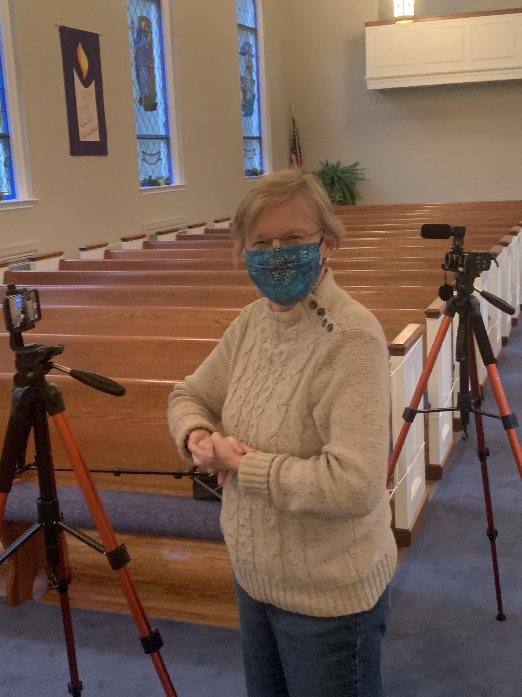
Figure 1.1 Jo Christopher and St. Paul’s Recording Equipment (December 7, 2020)

restrictions had forced us to meet less frequently. We therefore planned to record enough music to supply online services with new material for approximately a month’s worth of weekly services. With the possibility of the pandemic lasting for another year or more, we found occasional, ongoing need to meet and record new material. This material contributed to the high-quality and distinctive online services that contained music and liturgy familiar to the congregation.
St. Paul, as of the beginning of September 2020, continued online services to protect our members and share the ongoing love within all of our hearts. Despite the relaxed regulations emerging around the United States, many churches, including St. Paul, decided to maintain social-distancing and mask-wearing protocols, as well as restricting the size of group gatherings for any meetings within the church building. We have continued to hold services online to mitigate the risks to St. Paul’s congregants, especially those with compromised health, who remain at greater risk of catching COVID-19, becoming ill, and possibly dying. In a post that a friend shared with me on Facebook, Reverend Jim Lindus states perfectly what many churches around the United States have adopted as their moral stance, which also reflects my own position:
What will love look like as we seek the Common Good? What does love look like at this time? Love looks like an EMPTY CHURCH [sic]. Love is putting aside our own needs and sacrificing for others. Love looks like an empty church. That is why we closed our campus. The loving response to this crisis is to proceed with caution out of respect for our vulnerable neighbors. God is love. Love will lead us through. Love is patient. Love is kind. What does love look like? On this Sunday morning: Love looks like an empty church. (March 17, 2020)

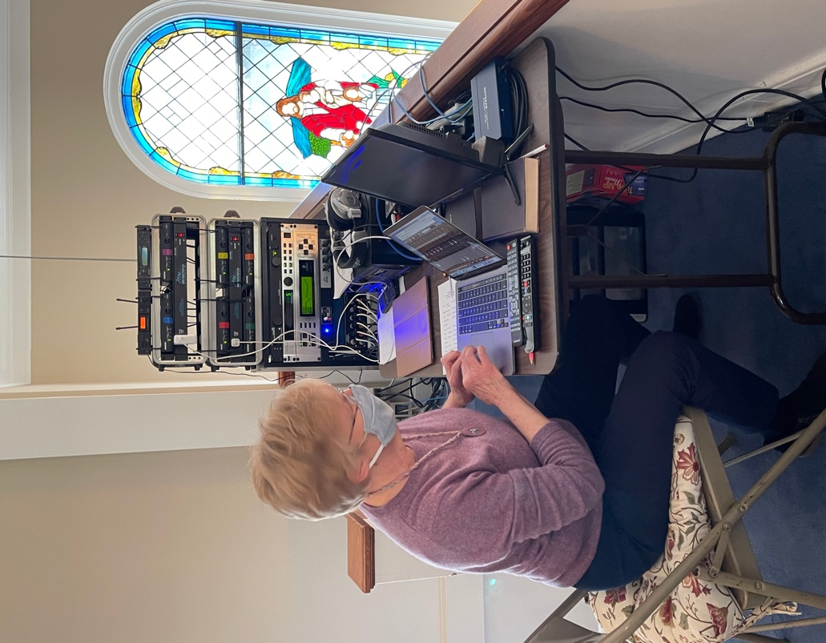
Figure 1.2 Jo Christopher and Sound Equipment

Many churches resist in person meetings because losing any member from a preventable illness would be a tragedy to all. In this way, members’ love for each other shows through the empty church building. An empty church means that church members strive to protect the vulnerable from possible contact with the virus. This striving to protect through an empty church eases the bitterness that some feel in the loss of meetings with fellow members in person. For me, protecting the people I care about remains worth the price of feeling separation, bitterness, and the anger of not meeting in person.
The coronavirus revealed the weaknesses of the governmental, healthcare, institutional, and religious systems in place in the United States that manage interactions between members of our individual and collective communities. With COVID-19, churches and educational institutions scrambled to make sense of a new normal that included an increased utilization of technology and new social protocols. The Centers for Disease Control and Prevention and governmental leaders dictated the physical space required between people that would ultimately help stop the spread of this virus (National Center for Immunization and Respiratory Diseases (NCIRD), Division of Viral Diseases, 2020). The healthcare system of the United States struggled under the load of cases and unavailable resources (Scott, 2020). Governmental leaders in many regions—Knoxville and the state of Tennessee included—were indecisive concerning mask-wearing and social-distancing mandates. The Knoxville News Sentinel frequently noted this, including on July 2, 2020: “At least 18 states require people to wear masks in some capacity, according to CNN. Tennessee Gov. Bill Lee has not issued a statewide mandate so far” (Hickman). Tennessee Governor Bill Lee did not and has not put a mask mandate in effect.
In the early spring of 2020, many churches closed their doors in response to the unknown nature of COVID-19, which seemed to attack the more vulnerable members of our communities, including the disabled, the elderly, children, and minority groups. According to National Public Radio (April 1, 2020),
As the coronavirus spreads across the country, millions of Americans already struggling with health and finances—especially those in minority communities—could bear the brunt of it. …The elderly are the hardest hit by the disease, accounting for about 80% of fatal cases in China and the U.S., according to CDC data. (Whyte and Zubak-Skees)
This statistic for the elderly pertains especially to my research, as St. Paul has a high elderly population.
When I first started thinking about a topic for my Master’s thesis, I immediately began sifting through all the musical channels and communities that I had ties with. A lot of my interests focus on East Asian traditions, peoples, and musics. I could have just as easily (if that word can even be applied to any form of writing) followed a path that displayed my interest in East Asia, specifically South Korea. However, I felt a real, immediate calling to pursue research that regards a current issue of relevance to local communities and beyond, and to bring attention to a situation concerning the more vulnerable in this pandemic. Further, I wanted to explore my personal connection to a vulnerable population that has had to change their lives drastically in light of the COVID-19 pandemic.
Colleagues and I immediately saw the dangers and effects that COVID-19 placed upon the vulnerable members of our societies worldwide. Whether discussing those of the disabled community or those suffering from preexisting conditions, many groups faced real and possibly deadly challenges from this virus. The decisions by national and local leaders to not enforce mask wearing or social distancing proved imprudent, dangerous options for the well-being of the United States. Concerning the national situation, David Leonhardt of the New York Times offers some critique although, in my view, an overly generous one:
Together, the national skepticism toward collective action and the Trump administration’s scattered response to the virus have contributed to several specific failures and missed opportunities, Times [sic] reporting shows: a lack of effective travel restrictions; repeated breakdowns in testing; confusing advice about masks; a misunderstanding of the relationship between the virus and the economy; and inconsistent messages from public officials. (August 6, 2020, emphasis added)
As I write, I am mindful of the deaths (over one million lives lost in the United States as of May 30, 2020) that have occurred and I feel sorrow at the unnecessary aspect of this tragedy. If we and our leaders had responded appropriately and actively, much of the death and danger to the vulnerable would have been avoided or at least reduced. In an article published by National Public Radio, Bob Bednarczyk states: “Many of the U.S. COVID-19 deaths likely would have been prevented by widespread use [and mandates] of face masks, social distancing and other measures” (as cited in Chappell, September 22, 2020). Mandates would likely have decreased the rate of COVID-19’s transmission. However, many national leaders either did not instigate mandates at all or eased them too soon.
To respond appropriately and actively, St. Paul, alongside many churches, made decisions concerning the health and safety of their congregations. These decisions included restricting access to buildings, maintaining social-distancing and mask-wearing regulations, supporting those of the community unable to care for themselves, and, ultimately, halting in-person services and utilizing technological media in order to provide an effective and continued connection between the congregation and decision makers. St. Paul decided early on to keep music an important component of the online services.
Music and sound, mediated through technological means, allows the congregation to continue a sense of community within the church services. Marc Leman writes about technological mediation’s impact on musical culture and, although he focuses his argument on recorded music on tapes and CDs, his ideas apply to the technologically mediated music and services of churches during the pandemic. Leman states, “Media technology, the infrastructure for sound production, sound distribution, and sound consumption, has had a very profound impact on musical culture and the associated signification practices” (2008, p. 22). Signification practices concern how people connect and respond to meaning from music and lyrics (p. 8). In online services, technological mediation permits sound to be produced, distributed, and consumed by church members as part of the musical and poetic cultures of their communities and, thereby, in ways that interrogate the meanings that people place onto voices, liturgy, and music.
Within church communities, collective and individual identities form through the significance of the voice in worship music and liturgies. In the United States, the liturgy, hymns, and choral music hold various cultural, ideological, and personal meanings for each given community and are common to Protestant worship services. Aaron Fox states that “the voice is a privileged medium for the construction of meaning and identity” (2004, p. 20). Although Fox discusses a different culture from the ones I explore here, his statement rings true across communities where the voice resides at the center of the construction of self and collective identity and significance. Fox focuses on working-class individuals in Lockhart, Texas, where vocal practices of song, speech, expression, and communication prove meaningful and unique. He further states, “Speech and singing were sutured and tangled in this community, comprising a dense and irreducible field of discursive practice that was also immanent in every vocalization” (p. 37). The liturgy, spoken and sung, within church communities formulates similarly the communication between the clergy and the congregation, and among congregation members. Hymns and choir anthems naturally prioritize the voices that “suture” and “tangle” together in church communities’ shared voice, knowledge, and values.
The vocal dynamics of music and liturgy within church communities usually reduce the distinction between performers and the audience, emphasizing the collective, participatory role of all congregation members. Thomas Turino refers to contexts in which no distinction between performer and audience are made as a “participatory performance,” which he defines as “a special type of artistic practice in which there are no artist-audience distinctions, only participants and potential participants performing different roles, and the primary goal is to involve the maximum number of people in some performance role” (2008, p. 26). The primary example of participatory music and liturgy within churches is hymn singing, a collective activity in which no one voice is valued over another. Through participatory hymn singing, as well as other church activities, congregation members experience socialization. This socialization revolves around musical, Christian fellowship with one another and emphasizes the group over a single person. Christian fellowship among members emerges through collective hymn singing and other forms of music (Syndor, 1960, p. 17). However, with the onset of the COVID-19 pandemic, church communities altered their services, music, and their way of life. The impossibility of meeting in a physical building, which makes participatory service elements impractical, and the dangers of COVID-19 demand a call to research how churches have mitigated these turbulent times. As a participant-observer, which Liz Przybylski calls a researcher who “engages in cultural practices as a participant while simultaneously observing the field with critical ears and eyes,” I existed as a part of the changes in technological production, distribution, and consumption within church services at St. Paul, and undertook to understand how members cope with this change (2021, p. 3).
I ultimately argue that, although technology exerts a positive influence, especially in allowing for interaction between members, Christian fellowship during the pandemic has been negatively affected by technology in some ways. I posit that the metaphorical line that divides the positions of the producer and the listener blurs within a church community. This proved true even before the pandemic. However, the introduction of and reliance on technology further blurs the line between producers and listeners by disrupting the normal association and socialization between members. At St. Paul, hymn singing constitutes an active participatory role for all church members, with sounds of the organ, singing of texts, and the voice qualities of others all combining as an involved process of musical consumption and production simultaneously. Online hymn singing remains an impossibility as the embodied processes present in an in-person service are lacking. Therefore, I examine the importance of the ways in which technology and the pandemic currently influence the interactions and vocal practices of St. Paul, especially those concerned with (1) the formation of affectivity among members and (2) the embodied component within religious settings.
As the novel COVID-19 pandemic remains active at the time of my writing this thesis, the current situation within church communities necessitates my interviewing of musicians, church leaders, congregation members, and production staff to discover fully the effects of offering and participating in services that take place in virtual spaces. I examine how St. Paul’s transition of their services from the church building to a fully online medium, the fear and threat of COVID-19, and the separation between fellow congregants (which is a main source and place of socializing) affect church members of these communities—through their music and vocal practices, everyday lives, and relationships with each other. I also reveal the importance of music and sound for these communities in forming and maintaining their self and communal identities. I hope to find new paths that help church members feel connected to one another again, whether through technological access, communication between church populations, or specific plans that allow for safe in-person worship. In tackling these concerns, I forefront the need to help ease the loneliness and the sense of separation that many people are experiencing in these communities.
Scope and Methodology
This research’s scope focuses on St. Paul United Methodist Church in Fountain City, an area within Knoxville, Tennessee. This community, which had no online presence prior to its response to the pandemic, was forced to adapt due to the effects of COVID-19. When I first started this project, I limited my research to the online platform of this local community because I would not risk spreading the virus into other regions of the country and state of Tennessee. Additionally, as cases in the United States increased in 2020, my research became more restricted due to personal commitments to safety of family, friends, and church members, as well as restrictions placed upon me by my academic institution. Although I am not sure of the future of the country and my own research during this COVID-19 pandemic, my project’s topic continues to be important in its focus on the more vulnerable members of St. Paul, such as individuals who are older, disabled, or immunocompromised (this includes family members of individuals who are any of the aforementioned), and how they are adjusting to changing geographies from a physical space to a virtual one.
St. Paul remains very active in the local community and in charity work. While a small congregation of about fifty members, the church and its members set music and the associated ministry (choir, handbells, and organ/piano accompaniment) as a priority, particularly as seen in the church’s program called the Friends of Music. This program has funds to hire extra singers and instrumentalists, who are mainly incorporated in special services around Christmas and Easter. It also includes a small monthly scholarship that pays for one or two college students to sing with the church’s choir. The scholarship is a moderate sum of money that really helps a student while in college, with students attending services and rehearsals on Sundays for a couple of hours. I have been a choral scholar at St. Paul since the spring of 2015 when a professor from Pellissippi State Community College recommended me for the position, which I am honored to hold.
For my research at St. Paul, I draw upon fellow musicians and congregants who especially support the music program. Sylvia Duquet, the pianist/organist; Jim Kennedy, the music director; Jo Christopher, who produces the church’s videos; and Dawn Chesser, the pastor, illuminate how difficult the switch to the virtual meetings was for church leaders. Jim Kennedy’s main task at St. Paul is to conduct the choir. However, in response to the pandemic and the church restriction of meetings to groups of six or less (who must maintain the social, minimum distance of six feet), the full choir has not met. The spacing of the choir is logistically impossible with the amount of space available in the choir loft. The inability for the entire choir to meet limits the available music for the virtual services. Sadly, the absence of the choir members’ familiar faces and voices that the congregation saw and listened to every Sunday detracts from the service. The choir also consists of many older members who performed as a service to the church and as a participatory, social activity with friends and fellow congregants. Many of these members have been unable to participate in church activities since the pandemic.
In my research, I collaborate with church musicians, leaders, and church members to discover how technology, sound, and music impact St. Paul and its members. I especially focus on older members who may not be as familiar or comfortable with the use of technology. I take music and the socialization within a church as a source of comfort, traditions, and familiarity that links members together. Familiar musicians, collective singing of traditional hymns, and the accustomed sounds of voices and instruments give members a sense of belonging and community. I offer my own narrative as reflexive ethnography, as I am a part of what is happening within St. Paul and the global pandemic. I experienced the sudden shift toward a reliance on technologies that are unfamiliar and often isolating. I physically witnessed the changes that churches have undergone during this global pandemic and my narrative adds to the narratives of the communities in which I am a part.
My research emphasizes the importance of technology in the ongoing existence and communal belonging of these churches and their members. According to Przybylski, community is often understood as “physically fixed,” but through my research, I challenge this position, and reveal how valuable technologies can be in times of demand (p. 78). There remains little doubt that these churches’ separate and shared communities have changed drastically to meet the threat of COVID-19. A relocation of community to the virtual demands a disembodying of physical space but an embodying of affective space, keeping in line with love and the safety of community remaining the ultimate goal during the pandemic. However, I argue in Chapter Three that, while online technologies exist as valuable resources for St. Paul, they do not replace the embodied experience of worship in-person.
Ethnographic Model: Objectivity and Partial Truths
Starting mostly in the 1970s, an examination of an author’s position within their ethnographic writing became increasingly important in the disciplines of anthropology and ethnomusicology, both fields that rely on interactions between a researcher and chosen participants. Such examinations considered significantly the researcher’s role within a fieldsite, the personal relations between the researcher and collaborators, and the ethnographic project’s subject. These considerations turned toward the age-old debate between subjectivity and objectivity, with the emotionality of subjectivity shunned and the scientific “reality” of objectivity favored. Speaking to this debate, Nicole Beaudry states,
Within the field of ethnomusicology, this [human] dimension of our work is infrequently discussed in detail, let alone analyzed. Perhaps this is so because it awakens raw emotions one hesitates to reveal publicly and perhaps it is also a consequence of our traditionally positivistic attitude toward scientific objectivity that forbids the emotional realm to enter the rational realm. (2008, p. 224)
Beaudry claims that early ethnographic writing ignored the human dimension that explores the participants’ lives, traditions, relationships, and environments. Many scholars, including Beaudry, view the formation of a personal relationship as expected and often even desired, due to the possibility of fully experiencing their collaborators’ cultures. However, the traditional positivistic attitude toward scientific objectivity marks any research as requiring rational justifications based on logical assertions. Many authors’ positions within their ethnographies has sought to reject personal relationships with collaborators in order to remain fully objective, which I deem an impossibility. True objectivity remains, and should remain, an impossibility.
Michelle Kisliuk (2008) addresses this impossibility while theorizing new paths that ethnographic writings can take, stating: “In the ethnography of musical performance we are particularly challenged, as writers, to present or re-present the experiential since performance is experience” (p. 183, emphasis in original). As one can tell, Kisliuk focuses on musical performance and experience in her ethnographic writing. Her challenging role as a researcher and writer becomes the task of (re)presenting musical performance experienced with her collaborators. She argues for ethnographic writing to align with field research, which depends on the relationships, personal as well as professional, between researchers and collaborators.
Clifford Geertz introduces a more realistic approach in describing the cultural analyses of researchers. He writes that “[c]ulture is most effectively treated, the argument goes, purely as a symbolic system (the catch phrase is, ‘in its own terms’), by isolating its elements, specifying the internal relationship among those elements, and then characterizing the whole system in some general way” (1973, p. 17). In other words, past cultural analyses within ethnographic writing often became similar to scientific research, ignoring the human dimension mentioned by Beaudry. Geertz’s move away from scientific objectivity toward ethnography relies on the human dimension involved with building rapport between researchers and their collaborators. Yet, he admits that his approach comes with the danger of “locking cultural analysis away from its proper object, the informal logic of actual life” (p. 17). An author’s position within their ethnographic writing, which concerns the human dimension, does not exist outside of real, everyday life. Therefore, it often entails informal logic in order to examine intimately their research’s proper object: humans in experiential relation to themselves.
I realized from the first day of “stepping into my researcher role” at St. Paul United Methodist Church that my experience meaningfully differs from those of my colleagues and many other ethnographers whose writings I have studied intensively. Three incidents made my experience as researcher evidently different and prompted my examination of exactly what that difference entailed. First, when I revealed that I would conduct research concerning St. Paul’s response to the COVID-19 pandemic, interviewing members of the congregation and church leaders, I received questions of: why would I do that, what was so important that needed researching, how long would it take, and who would the research include? I honestly did not know how to answer these because I made the initial decision quickly and did not yet know how my research would unfold. I simply saw a need in my church community that I must address, mainly in seeking ways to help communication and relieve some of the fear, isolation, and suffering caused by the COVID-19 pandemic. I realized that I never began as a typical researcher at St. Paul because the members would or could not view me as anything but as a valued member of the congregation, who often served as a musical leader during worship services. My donning of a formal researcher status—one that would mark me as an outside observer and not inside participant—did not happen. In this way, a truly objective perspective proved at best awkward and, at times, completely impossible. However, my subjective and inside perspectives proved beneficial in terms of insight into the music, worship, and social practices at St. Paul.
Second, my interviews with my “informants”—a term I still have trouble utilizing because I continually have issues of thinking anyone at St. Paul as anything other than a close friend—became highly informal every single time. As a non-binary, asexual, agnostic theist (I realize the irony), ethnomusicologist, and as a disabled, caregiving individual living in an often unaccepting world, St. Paul’s members have received me as one of their own and could see me as nothing more or less. In this congregation, I genuinely find a safe place to exist. These people have accepted without question my multiple identities and my true self. The only matter that they could not accept was my role as a researcher, an outside observer, asking questions and distancing myself for objectivity’s sake.
In a related topic, my final and third incident concerns my interviews with people of St. Paul that I remain close to not only at church but in other areas of life as well. For me, my interactions with two people—Jim and Krista—especially blurred the line in my identities of both researcher and friend. I knew Jim as a respected member in the larger musical community of Knoxville, Tennessee before he came to St. Paul. I had performed in a choir under his direction multiple times and even was a part of a male a cappella group with him for about a year. I view him as a friend, respected colleague, and fabulous musician. Krista became a close friend that I share my daily life and troubles with; we meet weekly, sometimes multiple times, outside of church as close friends capable of sharing anything and everything with one another. The interviews with Jim and Krista became hard to conduct (and even harder to transcribe) because I found it almost impossible to stay on topic and ask the ethnographic questions that I came to ask. When talking to either one of these individuals, the discussion also ventured beyond research topics, becoming more like friendly dialogue at a coffee shop. I realized when further analyzing my relationship and interviews with these two friends/informants that I had not only blurred the line between objectivity and subjectivity but that I never drew—or wanted to for that matter—a line as researcher between them and myself.
I faced many of the same difficulties as other ethnographic researchers, except that I faced them before my research even began and during a global pandemic. When I asked what changes in my research methodology would get better results, I came to the revelation of nothing, because my position at St. Paul encompasses friend, musician, and congregation member first and foremost; I do not wish to change that fact. Carol Babiracki discusses the shortcomings of the distinction between researcher and “subject”; she states: “the intersubjective and self-reflexive approaches tend to place the researcher [themselves] in the center of the story, potentially marginalizing the subject and subordinating [their] story to the method itself” (2008, p. 180). I remain a part of the narrative myself. Although Babiracki argues that research has issues concerning exploitation, manipulations, ethical questions of authority, inequality, and so forth, my strategy for ethnography avoids these and favors a narrative approach. I research, but also exist as a research subject myself. I maintain complete disclosure about everything I do within my research and writing.
In consideration of the global pandemic, I believe that my exploration of the church’s response has made my knowledge of and connection to St. Paul stronger. I have listened to the pain and joy found in congregation members’ lives and, in turn, grieved and rejoiced with them, becoming closer. Beaudry’s concept of the human dimension should inevitably be an integral part of ethnographic writing. Geertz writes that “sensible actuality…makes it possible to think not only realistically and concretely about them, but, what is more important, creatively and imaginatively with them” (p. 23). I wish to accomplish just this: to think conclusively about their actual, real lives, as well as my own, while also thinking creatively and imaginatively with them. This togetherness, to me, remains the whole point and main destination of ethnographic research.
My final thoughts on methodology pertain to partial truths, which concern our current situation within a global pandemic. Ethnographic writing contains a “partiality of cultural and historical truths, the ways they are systematic and exclusive,” which causes James Clifford to consider ethnographic writing as coherent fictions, or partial truths (1986, p. 6). Because ethnographic writings contain inherently partial truths, they are fictional, mainly due to the impossibility of expressing a people’s culture and lives in their entirety. As I conducted more in-depth research, I realized how much information about St. Paul’s history and cultural relevance that I did not know; the histories and interconnections at St. Paul have more far-reaching importance, meaning, and implications than I first imagined. Geertz claims that ethnographic research is “not a social reality but scholarly artifice” (p. 16). As I interviewed and heard more from my friends at St. Paul, I noted how my research would never be complete. Ultimately, the more I delve into this research, the more the process reveals how much I do not understand, in turn creating more questions. My ethnographic writing about St. Paul will remain partial with my researcher-writer status forcing me to include and exclude specific facts about a community I care about deeply. However, I welcome this role as researcher-friend as it provides me with future experiences to better know St. Paul’s people and express my own voice.
Sound Is All Around and Inside of Us
The title of this section, “Sound is all around and inside of us,” demands further explanation, primarily because the effects of sound are often ignored or not fully understood. Central to humanity’s experience of the physical world and its investigation, sound as a category of analysis offers a meaningful way to understand sound making, including liturgical and musical, within religious settings, communities, and experiences. Cultural anthropologist Charles Hirschkind states that “studies of religion that thematize the acoustic dimensions of religious knowledge have heightened our awareness of the material and embodied dimensions of religious practices and of the roles of both representational and nonrepresentational dimensions of sound within them” (2015, p. 166). This is to say that all sounds form the experiences, and thereby knowledge, of the people who are in the vicinity of its effectual vibrations. Further, all religious practices of liturgy, music, and even fellowship among members display the material and embodied aspects of sound. Voices, instruments, and the physical spaces of religious buildings intertwine with sonic elements and vibrations to reveal how community members interact with one another based on sensorial and cultural histories and knowledge, especially in the form of shared experiences. As sounds are literally vibrations that affect the physical world, such as the bodies of religious members (through the ear canal and the voice) and buildings, the phrase I adopt here, that sound is all around and inside of us, is literally accurate.
Sound and humans dwell in constant vibrational relationships that manifest in production of sound and listening to others’ productions of sound, as Nina Eidsheim explains:
In our relationship to sound we are both in and of vibrations. We simultaneously create and experience vibrations, sound, and music in the same moment, both as performers and as listeners. And it is precisely because vibrations do not exist separately from the materiality of the human body that we cannot objectify them. Sound, voices, music, and vibration are under our stewardship as long as we are part of their field of transmission (2015, p. 22).
Eidsheim states that, put simply, while we produce sounds, such as music, we exist simultaneously as producers and listeners. And because sound vibrations cause material effects on our bodies, we cannot regard sounds as mere objects, unworthy of study or full attention. Human transmission of sounds through any means, especially technological, place importance on how sound transmits between and within communities, as well as how sounds and their transmissions affect community members and their relationships with one another. Listening ultimately positions the producers and listeners of sounds as interconnected and involved with one another. For example, church communities consist of sounds that live as sonic, bodily productions of a collectiveness that binds the community together through affective attachment and a sense of belonging. Sounds allow congregation members to feel connected to other members through the collective singing of hymns and repetition of liturgical statements.
Because sounds produce reactions in the physical body and in the emotions of congregants, sound as a physical, human, and vibrational medium must be understood within the entire human sensorial experience. Deborah Kapchan gives her concept of the sound body that sonically, affectively, and tangibly exists within and alongside the physical space outside of the body. This body coexists alongside not only physical materials, such as metal, wood, and plastic, but alongside other bodies that are full of sound and that also exist sonically, affectively, and tangibly. Kapchan states, “The sound body is a material body that resonates (with) its environment, creating and conducting affect” (2015, p. 41, emphasis in original). I focus here on the idea of the body simultaneously resonating within itself and with its environment, a phenomenon that generates the embodied human experience. Our body is a sound body that creates sound that affects other people and things in relation to ourselves, while also being affected by the sounds of the environment around us. The other part of Kapchan’s definition of sound body states that material bodies create and influence their environment. These connective experiences involve the individual bodies of religious communities, wherein lies a collectiveness that centers on shared, affective knowledge of sensorial experiences. Kapchan calls this sound knowledge, which “becomes both a method and a state of being and awareness,” one based in both shared and individual identities (p. 42). This sound knowledge connects to the role of embodiment (which I discuss in Chapter Two).
Steven Feld’s notion of knowledge and concept of acoustemology resemble Kaphchan’s sound body and idea of sound knowledge. Knowledge, according to Feld, is the “ongoing cumulative and interactive process of participation and reflection,” which is “shaped by direct perception, memory, deduction, transmission, or problem solving” (2015, pp. 13-14). Acoustemology is a theory that “conjoins ‘acoustics’ and epistemology’” to view sound as another way of knowing the world around us (p. 12). All of these concepts and theories point to the fact that knowledge and sound are intrinsically linked to human experience within the physical world—living, nonliving, or technological. Everything produces, resonates, and internalizes sound; humans can simply experience sounds and react according to their social customs.
Community Identity through Affective Listening and Music Making
Community constitutes a collective of knowledge, sound, experience, memory, participation, affect, and environment, which aids in the development of individual and communal identities. As sound exists all around and inside of us, with the producing of and listening to sound occurring simultaneously in the human body, communal identity and shared ideology essentialize sounds within churches. Feld’s concept of acoustemology applies also to identity formation within communities in which music is a sociocultural, participatory activity. In relation to this, Feld states, “Acoustemology…is grounded in the basic assumption that life is shared with others-in-relation, with numerous sources of action…that are variously human, nonhuman, living, nonliving, organic, or technological” (2015, p. 15). To break this quote apart, especially since it pertains a great deal to my argument, acoustemological knowing constructs a path through which to view and investigate how the musical life of church communities share a relationship with the environment around them. Kapchan’s theory of sound knowledge parallels Feld’s acoustemology, both insisting that shared and collective identity forms around sounds, technologies, natural environment (e.g., trees, birds, water, etc.), and other humans.
Church members participate in services by singing and listening. As discussed earlier, the vibrational nature of sound blurs the distinction between human and nonhuman producers and consumers of sound. I assert that the consumption of sound (listening) and the production of sound (singing) shapes the processes of identity and community formations. John Blacking describes music as “humanly organized sound” and argues that researchers should look for “relationships between patterns of human organization and the patterns of sound produced as a result of organized interaction” (p. 32). The sounds produced by organized human interaction forge community between church members through shared knowledge of church history and ideology, which songs and liturgies often directly reflect. Further, the fact that church members listen to the sounds around them emerges as the foundation of my argument concerning communal identity formation and regulation.
The acts of listening and responding within musical practices—processes that cannot be divorced from one another—generate a sense of belonging that ultimately impacts the congregation’s bodily presence and emotional responses. As previously discussed, sound knowledge affectively transmits an ontological awareness, which results from acts of resonating with an environment through listening (Kapchan, 2015, pp. 41-42). According to Kapchan, “Sound affects: we feel it and it creates feeling” (p. 40). Sound affects the congregation through listening and feeling the physical vibrations of the music, which resonates within their bodies and minds. These resonations recall memories of place and sound, which produce perceptions of belonging and nostalgic connections between congregation members. In his anthropological study of sound, Tom Rice remarks that “listening can engage the whole of the listener’s body, and in some listening contexts, such as dancing, it is the physicality of listening and the fullness of the body’s response to sound…that is foregrounded” (2015, p. 103). Although most Protestant congregations in the southeastern United States do not dance within the service, listening and responding to sound constitutes a primary aspect of the experience, engaging the body of the listener physically and emotionally. For example, the organ customarily provides structure to church services by supplying material for affective listening within specific points of the church service. From my own experiences as a performing musician and congregant in a variety of church services around East Tennessee, the organist plays the offertory, voluntary, and introit to engender certain emotional responses from the congregation that fit the situation within the service. The voluntary supplies a time to be introspective and prepare one for the service ahead, while the offertory’s music typically attempts to evoke feelings of charity and giving. Through affective listening and responding, the sounds within the service serve as acts of communication between members, clergy, service leaders, and the divine.
Music making in churches prioritizes the voice above all and, within the voice, collective and individual identities form. In arguing that identity forms from the participatory nature of church music, I again draw upon Turino’s concept of participatory performance. Through their research, he and his students compiled a comparative list of features and performance practices of sound within different cultures. Turino concludes that “sound features (1) functioned to inspire or support participation; (2) functioned to enhance social bonding, a goal that often underlies participatory traditions; and (3) dialectically grew out of or were the result of participatory values and practices” (2008, p. 36). In my case, spoken, sung, or mechanical sounds produced in the church encourage participation and connect individual members through shared values and practices, which a church adopts by a dialectical process. This dialectical process of determining shared values and practices functions to make collective identity and to form a collective voice. According to Amanda Weidman, “Almost before we can speak of the sound itself, we attribute the voice to someone or something. Attributing voice to nonhuman entities (the collective, the mechanical, musical instruments) is a powerful way of making them intelligible, of endowing them with will and agency” (2015, p. 232). By attributing a voice to something or someone, we give the object identity, a way of relating to the world and to one’s self. Sounds of the community and their collective voice are “signal[s] of identity” (p. 232).
Also, regarding church practices, the interaction between conceptions of self and habits that articulate identity is important to my argument. To quote Turino further, he “conceptualize[s] the self as comprising a body plus the total sets of habits specific to an individual that develop through the ongoing interchanges of the individual with her physical and social surroundings. Identity involves the partial selection of habits and attributes used to represent oneself to oneself and to others by oneself and by others” (2008, p. 95, emphasis in original). Habits are the repetitious components of behaviors, thoughts, actions, and reactions (p. 95). Habitual practices, which form from an individual’s or a collective’s continual interactions with their physical and social environments, in turn, form self-identity and collective identity respectively. Referring back to Weidman’s idea of attributing someone or something with a voice, identity forms around the sound or music making in church, with each sound object having a voice.
Within church contexts, these notions pertain to people, voices, and instruments. For example, to refer to the organ once again, the instrument is mechanical, producing sounds by physical acts of an organist hitting switches and pressing keys with fingers and feet. Additionally, a church organist remains aware of and helps to facilitate the order of happenings within the service. One could say that the organ’s voice, which communicates the timing of the service and which leads the congregation in hymns and other musical responses, represents the collective’s voice. Therefore, music making in church services at its core articulates the voice of the church, wherein collective and individual identities are molded and expressed.
Technological Modalities
St. Paul, which had established very little online presence prior to the pandemic, switched its services to fully online, especially through the use of YouTube and Facebook Live, at the start of the COVID-19 pandemic. The church still sustains an online presence through the use of YouTube streaming. Within many churches that began using technologies unfamiliar to and forced upon them, production of videos that incorporate sounds of the liturgy and sound started off with an amateur quality. However, this soon developed into more musical and stylistic versions of original services, a situation that points to the normalization that results from continued use of newer technological modalities.
This move to online services represented a challenge to the musical traditions of churches that had little access to or familiarity with newer technologies. Raúl Romero states,
Tradition is usually challenged by modernization, a concept that assumes diverse meanings and stands for dissimilar practices. …[Modernization] is understood primarily as ‘progress,’ technological innovation, urban services (electricity, running water), global communications (trains, planes, and automobiles, fax machines, and the Internet), and, more broadly, the process of incorporation in the wider national context. (2001, p. 22)
Modernization, which includes all technological innovations, is often associated with progress and potentially allows for the tasks and jobs of everyday life to be more easily accomplished. Churches rely on technologies to reach more people than ever before through online media. However, for many St. Paul members, online, technological mediation to St. Paul members challenges musical traditions, which rely on in-person, communal singing. Technology does not possess the ability to fully realize and actuate said traditions. Zoom, YouTube, and Facebook do not currently, and mostly will not, allow for this type of interaction between congregation members.
Technology’s presence in Christian worship is not new and has been affecting the religious lives of contemporary people for many years. Here, I draw on the work of Susan White, who addresses this presence by offering “three distinct, but interpenetrating, levels”:
[First, t]he term technology refers to the artifacts resulting from a process of manufacturing. This can be anything from a simple tool to a complex information-management system. Anything that by its existence extends the range of human capabilities beyond its natural limitations falls within this definition. [Second, t]echnology also refers to the constellation of processes and structures by which such artifacts come into being. Assembly lines, automation, microprocessing, and robotics are included within this definition, as well as the kinds of human skills, techniques, and knowledge needed to accomplish the tasks related to manufacture. [Third, t]he term technology also is applied to the larger set of attitudes and presuppositions that support and advance the technological enterprise. This conceptual framework underlies the sense of a pervasive “technoculture.” (1994, p. 16)
I quote this at length to provide preliminary discussion of my argument concerning the question: What exactly constitutes technology? To respond to this question—which I address more fully in Chapter Three—I make use of my own observations of certain technologies being accepted by congregants at St. Paul, while other, newer technologies are considered too inaccessible, too unfamiliar, too difficult, or too troublesome to operate and therefore ignored by certain congregants.
While I wholeheartedly admit that technologies often make the everyday lives of modern humans easier, I came to hold an ambivalent attitude toward technological modalities due to the inconsistencies and problems associated with newer technologies. On one hand, I recognize that older technologies continue their helpfulness and presence in the lives of St. Paul’s congregation. On the other hand, the inaccessibility, cost, and failures of newer technologies had me reconsider my entire project in multiple occasions. I first started this ethnographic project with an absolute belief in the positive aspects of all technological modalities within our lives. However, after interviews and personal experiences as a worship leader, I quickly discovered how inaccessible and expensive certain modalities were for St. Paul’s congregants, especially those who are elderly. Some members could not afford or obtain technologies that offered an online presence, such as Zoom, Facebook Live, or YouTube; all of these modalities require access to, and facility with, wi-fi and a computer that can run such applications. Therefore, throughout my writing, I display conflicting thoughts and emotions towards various technological modalities, reflecting an awareness of the value of various technologies as well as a recognition of their negative aspects, including inaccessibility, cost, unavailability, user unfamiliarity, and real or perceived operational difficulty.
Other Literature and Need for This Study
My ethnographic research reveals how important music and belonging remain in communities, even during the threat of a virus and despite the reliance on technological mediation involved with offering and participating in online services. My research became and further becomes necessary due to the unprecedented pandemic that continues to affect religious communities, where traditions and social gatherings rely on practices that collectively are accomplished through embodied activities of singing and speaking. In overviewing related literature, I emphasize the uniqueness of this study, by way of comparison and contrast with the works of Monique Ingalls, Omri Elisha, and St. Paul’s own Dawn Chesser, all of whom played a role in the initial research of this thesis project. I then discuss three additional sources that became significantly helped me to formulate my own ideas of and experiences with changes in music and technology at St. Paul United Methodist Church during the COVID-19 pandemic.
In “Digital Devotion: Musical Multimedia in Online Ritual and Religious Practice” (2019), Ingalls asks these questions about the transference of religious practices and individual religious experimentation to online modalities:
how far can these activities themselves be considered rituals versus merely computer-mediated representations of rituals? Is taking part in a Buddhist ritual in Second Life a substitute for attending one offline? ...Can a Jewish worshipper joining a prayer group over Skype comprise part of the quorum of ten individuals necessary for corporate prayer? Are YouTube videos that juxtapose digital Qur’anic text with sacred sound a help or a hindrance to a believer’s devotion to the divine word? (pp. 151-152)
I quote Ingalls’ questions to reveal distinctive qualities about my own research on St. Paul’s people, music, and religious practices. I asked most of the same questions, although in a Methodist context, during initial research and prior to interviewing and writing about St. Paul’s congregation. I was personally concerned as to whether certain technologically-mediated religious practices could be translated to virtual spaces, like YouTube, Zoom, and Facebook Live, and what possible untranslatability meant for St. Paul’s congregation which was forced to move completely to the virtual due to the pandemic. This study happened in real time as I experienced alongside St.Paul’s people the translation of religious practices to virtual spaces.
After my initial research and questioning, I discovered (maybe through some act of destiny) through an interview with Pastor Dawn Chesser that her doctoral dissertation, “This Virtual Mystery: A Liturgical Theological Argument Against Celebrating Holy Communion on the Internet in the United Methodist Church,” pertained to my research questions. Dawn argued against, in the Methodist church at least, virtual settings of the religious practice of Communion. She argued that cyberspace does not provide the proper mechanisms to allow for the “embodied human interaction” that the religious practice supposedly demands (2014, p. 115).
Interestingly, Dawn eventually offered Communion to St. Paul’s members over virtual spaces, asking congregants to extend their hands and have their Holy Communion elements, bread and wine (or some other combination), ready from home. She blessed the elements and then guided them to receive Holy Communion. This act directly opposes her argument in her dissertation. In her defense, however, Dawn did mention within her dissertation that a global pandemic was an example of an event that could force the United Methodist Church to move religious practices online. I note Dawn’s dissertation to display another point that proves how unique this study, and the question it poses, becomes in relation to recent scholarship. Dawn altered her beliefs about Holy Communion while in the midst of the pandemic. Meanwhile I, through this study, align my research with not only ethnomusicological scholarship that addresses the COVID-19 pandemic, but also theological scholarship concerning major changes in religious practices and technological mediation.
Another useful point of contrast with my work comes from Elisha’s book Moral Ambition: Mobilization and Social Outreach in Evangelical Megachurches (2011), which ethnographically and analytically documents evangelical Protestants’ affiliation with megachurches and other religious ministries in Knoxville, Tennessee, the site of my own research. In contrast to my own project which focuses on a smaller, relatively more traditional church in the same city, Elisha discusses and focuses on how two megachurches in Tennessee promote charitable services that intend to socially engage local communities. His focus on megachurches often emphasized the use of recording technologies, instant messaging systems, and audiovisual systems. The Knoxville megachurches that he discusses utilized these technologies prior to the pandemic and, it seems to me, relied on them wholly during the pandemic.
Contrastingly, St. Paul, a small, more localized congregation, did not use such technologies prior to the COVID-19 outbreak. The congregation’s sudden shift to acquiring and utilizing such technologies during the pandemic created a unique situation, one that has not been readily explored in ethnographies in comparison to studies of megachurches. In this way, my research offers new insights to the field of musicology, based on a smaller and more traditional church context in East Tennessee.
Elisha’s concept of moral ambition, found in the book’s title, contains two ideas that he found important for the church he studied, and that form foundations for his argument: (1) an appropriate moral disposition to seek out people familiar with newer technological modalities and (2) a move away from the constraints of ideology and specific, institutional ways of facing church needs (2011, p. 2). In keeping with Elisha’s premise, St. Paul adopted major changes, which attempted to maintain religious grace and compassion toward fellow members. Unprecedented times call for unprecedented measures to meet demands of the church, even if tradition and ideologies need to be altered. Mainly, Elisha’s research parallels my own in the way that I ultimately attempt to show how compassion and love for fellow man stays at the heart of most churches. The pandemic has necessitated new, alternative, and exciting strategies in engaging fellow members at St. Paul, as seen in my discussion of the changes in technology in Chapter Three.
Jeff Titon’s book Powerhouse for God: Speech, Chant, and Song in an Appalachian Baptist Church (1988) provides an interesting viewpoint about the importance of song and speech in Protestant churches in Eastern Tennessee. My research about the changes in song and speech at St. Paul due to COVID-19 and technology complements this discussion as a new addition to this field. Titon’s work emerges as a consequential part of an ethnographic project that included disc recordings and a documentary film. Titon approaches this book as a researcher and interpreter of works in American culture and folklife. He based his research on Henry Glassie’s notion of affect or “the power to move people.”
Affect, Titon explains, is situated in performance, which is intentional, rule-governed, and marked as a performance by those in attendance (pp. 8-9). The notion of affect becomes paramount in my own research as musical traditions at St. Paul are performed in communal settings and situated within collective remembrance, which functions as community history. Through a lens of affect, my research reveals how, despite the new reliance on and isolating tendencies of technology, the religious music and traditions—even when technologically mediated– bind together the hearts and minds of the congregation through affective memory of shared history. Although technological mediation does not replace in-person services, it allows for affective attachment to continue among congregation members at St. Paul.
Deborah Kapchan’s research in sound studies has influenced me tremendously, especially her ideas of how sound, environment, and the human body interact to form the human experience. I discussed her concept of sound body above to communicate how sound is an important aspect of human existence. Further, her article “Listening Acts: Witnessing the Pain (and Praise) of Others,” aided my thinking about and articulation of community in this project. As discussed more in detail in Chapter Two, congregation members at St. Paul exist as witnesses to the pain and praise of other humans in relation to themselves. This article proved foundational to my ideas concerning the formation and maintaining of community.
Timothy Taylor’s book Strange Sounds: Music, Technology and Culture addresses the amazing yet sometimes anxiety-provoking quality associated with new technologies. Taylor mainly examines the technological revolution beginning in the early 1900s with the advent of World Wars, which drastically altered the way that humans existed in the world. Although the book deals with concerns of authenticity in electronic music, Taylor focuses more broadly on the social and emotional phases connected to new technologies: anxiety, ambivalence, acceptance, and then normalization. I examine these issues further in Chapter Three when discussing what one considers technological in the first place. An important aspect of this thesis project remains the ambivalent, and at times anxious, nature of my and congregation members’ feelings and reactions to the use of newer technological modalities. Taylor’s book aided my understanding of technology as an ambivalent source, illuminating the position of technology as at times both a positive and negative influence on St. Paul’s congregation.
Chapter Outline
This thesis project examines the changes in technology, music, and communal identity at St. Paul United Methodist Church; the following chapters focus on how community is formed and maintained at St. Paul and how said community changed drastically and irrevocably during and after COVID-19. Chapter Two describes St. Paul’s pre-pandemic services, in which I examine the interrelated roles and natures of sound, music, and community. I utilize this description as a baseline and in order to provide contrast to Chapter Three, which focuses on changes to sound, music, community, and technology during the COVID-19 pandemic and the transition to online services at St. Paul. Chapter Two primarily details the regularities within Methodist churches and hymnody nationally, while also revealing the irregular and unique practices involving communal singing and experiences of sound at St. Paul. Alongside interviews with congregants and leadership, my own observations, emotions, and experiences appear within this chapter as I cannot separate myself fully (as I am a worship leader at the time of writing this) from the happenings at St. Paul.
An important concept in this chapter is embodiment, which I employ to examine the bodily experience(s) of sound and the interplay of the senses within worship services. Further, I discuss the role of both physical and virtual space within embodiment and, within this, I assert that online worshipping cannot and will not replace the physical nature of in-person, embodied services held in St. Paul’s building. Physical space, touching, and memories of such remain an irreplaceable aspect of communal worship. Ultimately, the embodied interactivity and physical act of listening in and outside worship services is what creates and maintains affective attachment within St. Paul’s congregation.
Chapter Three displays many new uses and positionings of sound and technology from during the pandemic, as compared with pre-pandemic, in-person services. This chapter offers an alternate definition and additional expansion of what constitutes technology, which demonstrates how technology exists as an important tool during and after the transition to online services. This chapter also details more fully and clearly the ambivalence I hold toward technological modalities. I examine both positive and negative changes in the interactions that technologies provide for St. Paul. With this ambivalence, I include the anxiety, inability, and unfamiliarity faced by the elderly, as well as young, working families, at St. Paul. I conclude this chapter with words from my friend and informant, Krista, who articulates the role of congregants in navigating the personal and communal relationships experienced as part of the changes of technology, space, and sound during the pandemic.
I conclude with an overview of my argument, including a brief explanation of the key events and discoveries that occurred during and after my writing of this thesis. These events and discoveries reveal how the sense of community, the role of sound, and the utilization of technology within St. Paul’s worship services has permanently changed, whether for the better has yet to be seen or heard. However, I realize that my friends at St. Paul and I are constantly adapting and improving our communal and individual ways of continually achieving and managing our sense of togetherness. Due to the pandemic and the changes that the church made, an online presence and the use of newer technological modalities now survive as a permanent aspect of the St. Paul community. The leadership and congregation realize this and we remain dedicated to always improve our ways of reaching, helping, and loving one another and the larger community of Knoxville, Tennessee.
An Empty Church Building Remains Full of Love and Hope
In early August 2020, after I entered the St. Paul building, I continued down the hallway toward the sanctuary. Nervous energy radiated through my body due to the fact that I had not seen some of these people since March. What would I say? Why had I been so distant? Could I have made more of an effort to stay in touch? We all dealt with the pandemic in our own ways. Because of the fear for my own family members, who are high-risk individuals, getting sick, I coped in a way that further isolated me from the people I love and care about. St. Paul going online became unreal and it hurt me to watch the videos that seemed so empty of the essence of St. Paul. I mourned this emptiness until the moment that I heard the easily recognized, high-pitched laughter of Krista Jeffers and low-pitched, slightly rarer laughter of Jim Kennedy. I missed the joke, but I did not miss the laughter. I became very aware of my surroundings in that moment because I knew that St. Paul was important to me and that it was very likely I would conduct research in this space. I realized that I had missed the point of why St. Paul remained empty, or rather I should say temporarily empty (see figure 1.3). The point of an empty church remains not about the absence of people, laughter, signs of affection, joyful sounds of community, or musical events, but the presence of love and protection of fellow members. To quote Reverend Jim Lindus again, “Love looks like an EMPTY CHURCH [sic]. Love is putting aside our own needs and sacrificing for others.” An empty church building remains full of love for our fellow members. We hope to one day meet in our sanctuary again, hearing the laughter of friends and the running and chattering children.

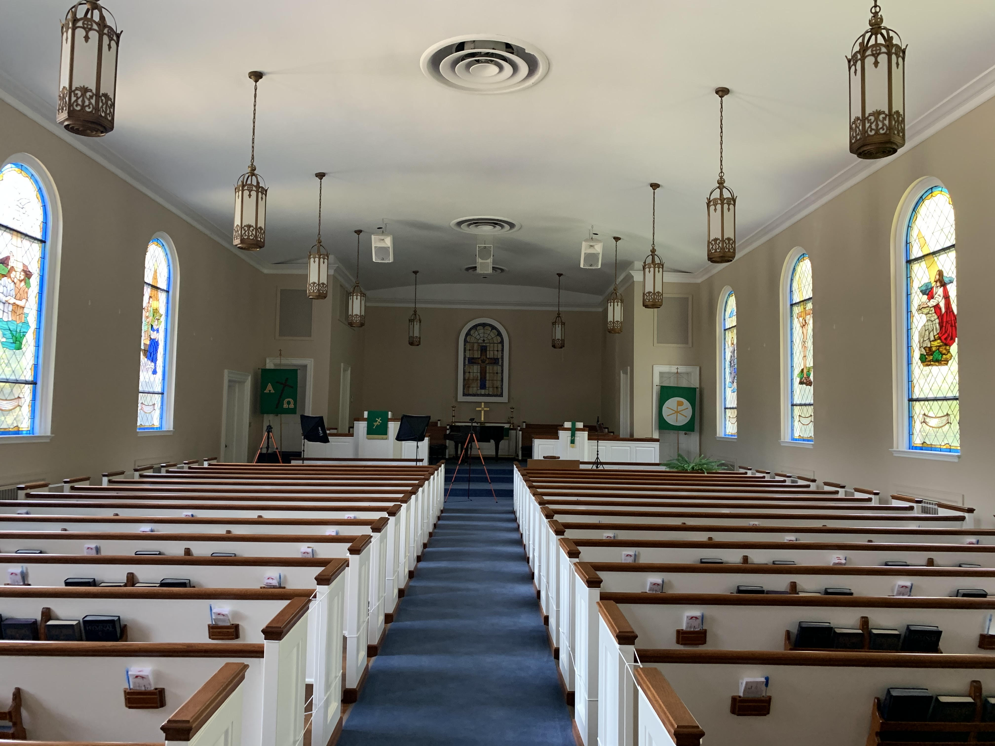
Figure 1.3 The Empty Sanctuary, Where the Congregation Had Not Met in Months

CHAPTER TWO
“THE TIE THAT BINDS” COMMUNITY: AFFECTIVE LISTENING, PRESENCE, ABSENCE, AND REMEMBRANCE

Sounds of the Pre-Pandemic Past
I watched Gayle, a fellow choir member, across the sanctuary from me to see when the other half of the choir was ready to enter. At St. Paul United Methodist Church, both halves of the choir always processed into the sanctuary together, dressed in dark blue, maroon-lined robes with accompanying stoles of different colors, which varied depending on the liturgical season. Smiling, Gayle gave me a thumbs up and we walked in, sopranos on one side of the choir loft and altos, tenors (or I should say tenor as I was the only one), and basses on the other. The music director, Jim, who sang with the choir as a bass, got everyone’s attention when we all reached our respective spots. With a nod, he motioned us to all sit together. The informality that exists at St. Paul reveals itself in this moment when, even with this cue from Jim, the choir members in fact sat at different moments and others started talking to one another. Indeed, these people, as a part of the choir, constitute an important aspect of the worship service, but they live in a social community first and foremost. Further, the entire worship service displays the communal beliefs that congregants hold in common, although the events that occur outside of the service in relation to eating together, talking, laughing, caring for one another, and sharing our lives are where the truest sense of community lies.
St. Paul’s pre-pandemic services always began with a Prelude played by Sylvia Duquet, the church’s organist, pianist, and accompanist. This instrumental prelude sets the mood for the remainder of the service and to prepare our hearts and minds for the words of biblical scripture

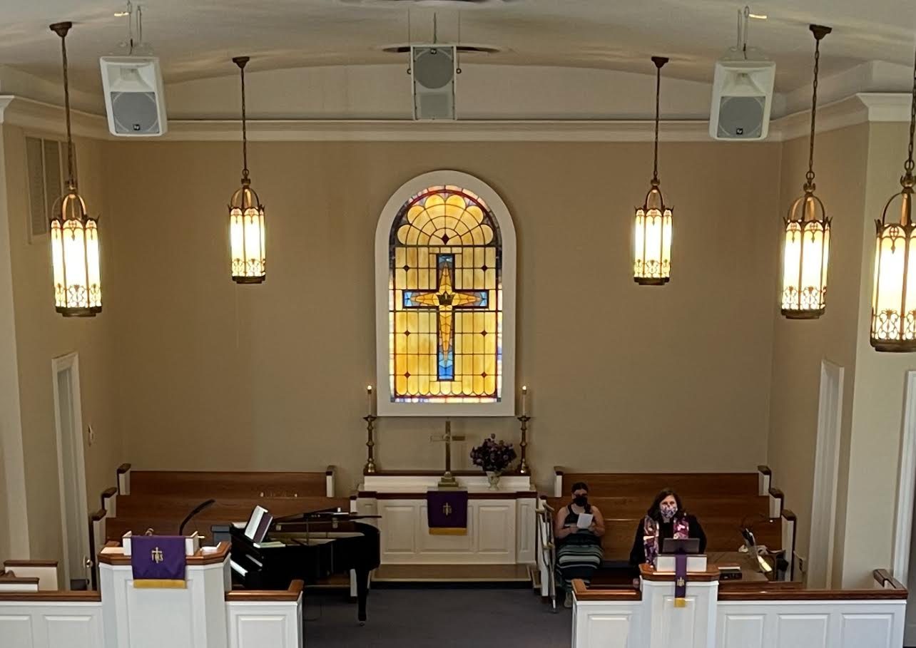
Figure 2.1 Choir Loft Where the Choir Normally Processes In

and liturgy voiced by the pastor and designated speakers. The Prelude primarily contains music that sounds upbeat and more contemporary, in contrast to St. Paul’s focus on traditional hymnody throughout most of the service. After the Prelude, the pastor officially opened the service with Words of Welcome. This opening statement before the pandemic consisted of prayers for sick church members and their families, as well as a foreshadowing of the scripture reading and sermon. Next, the pastor indicated for the congregation to “greet the saints and each other,” which is a time for those in the sanctuary to greet one another, hug, shake hands, and discuss their lives during the past week. This brief, informal moment within the service represents the community of St. Paul; it quickly ended with Sylvia’s introduction and an invitation to sing:
1. Blest be the tie that binds
our hearts in Christian love;
the fellowship of kindred minds
is like to that above.

2. Before our Father’s throne
we pour our ardent prayers;
our fears, our hopes, our aims are one,
our comforts and our cares.

3. We share our mutual woes,
our mutual burdens bear,
and often for each other flows
the sympathizing tear.

4. When we are called to part,
it gives us inward pain;
but we shall still be joined in heart,
and hope to meet again.

5. This glorious hope revives
our courage by the way;
while each in expectation lives
and waits to see the day.

6. From sorrow, toil, and pain,
and sin, we shall be free;
and perfect love and friendship reign
through all eternity. (Fawcett, 1989)
At this moment, the congregation typically only sings the first verse, but when the hymn is later placed elsewhere in the service, the congregation sings all verses.
This hymn, “Belst Be the Tie That Binds,” appears in many United Methodist churches and normally the entire congregation sings the first verse together. Michael Hawn draws connections to the hymn’s significance within Methodist theology and states, “its language connects well with congregations, identifying with the struggles of life and our unity in Christ. No doubt this hymn has been tearfully sung by more Christians upon parting than any other hymn” (“History of Hymns: ‘Blest Be the Tie That Binds,’” 2013). The hymn’s lyrics contain the spiritual message that Christians will meet again in the next life and that parting is only temporary. Further, “Blest be the Tie that Binds” reveals St. Paul’s views on community. The metaphor of a tie binding congregants together in Christian love and kindred minds references a sense of community that focuses on loving one’s neighbor as oneself and maintaining inclusivity and godlike qualities of compassion. Throughout this song and the following hymns, the voices of a unified congregation fill the room: individual sounds become a collective force that everyone within the sanctuary experiences. The congregants fully embody the sound of themselves and others singing, the sound of the organ, and the echoes of the music through their bodies. During the COVID-19 pandemic, this experience of embodiment was lost; thus, when the congregation finally sang the hymn together again, the “tie that binds” became even more meaningful than before.
This chapter examines the role and nature of sound and music within St. Paul’s services prior to the pandemic. I do this in order to establish the important physical and embodied natures of the in-person services, and to set the stage to explore fully how the coronavirus pandemic altered the church’s operation and the relationship to its congregants (discussed further in
Chapter Three). This examination also details further trends within the Methodist church and hymnody at large, especially concerning practices that involve communal singing and experiencing sound events. I include my own observations and emotions involved with my personal music making and the maintaining of a cherished community, to highlight how these experiential aspects of community were affected by the pandemic that closed St. Paul’s church building.
Alongside my thoughts, statements made by church leadership and fellow members prove the importance of the concept of embodiment, which connotes a corporeal, sensorial phenomenon experienced by a human body. The concept of embodiment describes the immersive experience of a human body within a physical space filled with visual and audible stimuli. Frances Dyson states, “Space implies the possibility of immersion, habitation, and phenomenal plenitude. Without space there can be no concept of presence within an environment; furthermore, there can be no possibility for a full-bodied—embodied—experience that interactivity…promises” (2009, pp. 1-2). She argues for the importance of physical space in relation to interactivity and immersion in an environment, all in order to have a fully embodied experience. The physical embodiment of sound within a shared space holds a primary role within religious communities, especially the Methodist denomination.
Methodist congregations encourage interactivity among members and embodied experiences relating to the physical nature of sound. To offer further context, I draw upon literature that reveals similar patterns regarding the importance of sound and singing found in Protestant churches within the United States. Music and speaking exist as physical activities that involve the processes of listening to and producing sounds alongside other animate and inanimate objects. This chapter deals with the normal, pre-pandemic aspects of St. Paul’s worship services within the larger context of the role of sound within Protestant Christianity in the United States. Especially in contrasting the differences in services before, during, and after the pandemic, the importance of sound, space, and embodiment becomes evident, as does the extent to which the church’s operation and focus were disrupted by the pandemic. Ultimately, I argue in this chapter that the embodiment of physical space and emotional attachment is situated within the acts of producing and affectively listening to one another’s sounds. Additionally, affective listening incorporates an emotional space that details the positive acknowledgement and remembrance of death experienced by the collective congregation. This emotional space deals with the literal physical and bodily loss of loved ones passing on to the next life and often appears in worship services throughout the year at St. Paul.
Affective and Active Listening
Affective listening, a process of people listening to one another, embraces the experience of creating sound together. This process demonstrates ways in which individual members of communities connect to one another through sharing space and sound. To fully understand how hymns and liturgies act as the collective embodiment of sound and form communal identity, I examine the significance of listening to and producing sounds in St. Paul’s pre-pandemic services. In my first chapter, I discussed the phrase sound is all around and inside of us. A large part of that phrase revolves around sound as an embodied aspect of humanity’s experience of the physical world. Within that experience, the knowledge of environment, history, culture, body, and other living beings forms and informs how we interact with other corporeal objects that (can) produce and listen to sounds. Therefore, when St. Paul’s congregation sings a hymn together, they affectively listen to (or hear) one another’s sounds and produce their own sounds simultaneously.
Sound studies, which explores why and how sound ultimately matters in our physical, sensorial world, further illuminates these issues. Many sound studies scholars examine how listening to or hearing one’s environment informs an understanding of one’s position within the myriad elements of said environment. My work focuses on the various interactions among music, environment, and technology, in ways that parallel the broad conception of soundscape and sonic studies developed by pioneer Murray Schafer. Schafer writes, “The soundscape of the world is changing. ...In one way or another researchers engaged on these various themes [sound studies] are asking the same question: what is the relationship between man and the sounds of his environment and what happens when those sounds change?” (1977, pp. 3-4). While Schafer considers the dangers of sound to human ears and psyche, I utilize his primary question about the relationship between human communities and environmental sounds more broadly. How does the congregation of St. Paul relate to the sounds of its environment and what happens when those sounds change in production or delivery? Ultimately, what role do those sounds play in creating affectivity between congregation members?
Further, Brandon LaBelle states that sounds associate with their “original sources, while also becoming their own thing, separate and constantly blending with other sounds, thereby continually moving in and out of focus and clarity” (2010, p. xix). I connect LaBelle’s statement to similarities and differences between the concepts of hearing and listening, as well the physical production of sound, which remains an important subject in sound studies. His argument also relates to St. Paul because all objects of an environment have the ability to create sounds of their own, whether through bodily anatomy that provides the means of sound production or through effects placed upon an object.
The concepts of hearing and listening to sounds often convey the same semantic meaning and many people utilize the two words synonymously. However, I demonstrate a distinction between the two concepts, especially concerning the role of sound to its object. According to Tom Rice, “listening is understood to involve a deliberate channeling of attention toward a sound” (2015, p. 99). Rice goes on to argue that distinctions between hearing and listening remain unclear and “are frequently equated or conflated” (p. 99). Therefore, listening to sound encompasses the act of attentive perception to sound(s), while hearing relates to the ability of auditory perception. Indeed, Jonathan Sterne writes, “The simple act of hearing implies a medium for sound, a body with ears to hear, a frame of mind to do the same, and a dynamic relation between hearer and heard that allows for the possibility of mutual effects” (2015, p. 65). Thus, while the two words seem interrelated, their similar objects of attention ultimately differ from the way in which hearing implies the physical means to perceive sound while listening involves a deliberate perception of sound(s). For the sake of my argument, I utilize listening as the most useful word, realizing the position of hearing as not fully separate from the act of listening.
The distinction that I emphasize between hearing and listening pertains to what I term affective listening. According to Deborah Kapchan, “Listening is an active conduit for the social transmission and transformation of affect” (2017, p. 277). In other words, through the modes of listening and being listened to, society forms itself. In particular, through affective listening, members of a community forge, sustain, and continually transform the emotional attachments between each other, which ultimately determine their behaviors and actions. Kapchan speaks about three “listening acts” that display the performative power of listening in her own research among Sufi Muslim communities in Morocco and France: “1) in its role as witness to the pain and praise of others, 2) as a political tactic, and 3) as a method of sound knowledge transmission that often involves lingering in the space of discomfort” (emphasis in original, p. 277).
These three acts of listening demonstrate how the community of St. Paul create and maintain relationships through affective listening. First, within St. Paul, each member holds the role of witnessing pain and praise within others’ personal lives. Second, listening acts within the church serve as ways to politically advocate for issues such as social injustice, racial inequality, poverty, and violence. In the case of the COVID-19 pandemic, listening acts often contain political, active advocacy, such as for mask wearing, social distancing, and vaccination, all in order to care for one another. Third, affective listening determines the processes of receiving and distributing certain sounds involved with discomfort. Such discomfort encompasses the life struggles involved with illness, death, family relations, poverty, foodlessness, and, more recently, the COVID-19 pandemic. On the other side of discomfort lies comfort, which contains the benefits of and solace found within community. St. Paul offers comfort by providing a space to share one’s life struggles through other congregants’ listening ears.
Affective listening also incorporates the required capacity to actively and attentively listen—I term this as active listening—to the people and objects around an individual or community. Steve Roden defines active listening as “being open to the possibilities of music” and “spaces outside of concert halls and car radios—for certainly music is everywhere” (2005, p. 216). While Roden writes about music, I apply his definition to sound and affective listening. Sound is all around and inside us; we actively and constantly listen to our many spatial surroundings, which contain myriad possible combinations of both animate and inanimate sounds. Active listening becomes affective when individuals listen to one another and then form and experience emotional bonds. This phenomenon is present in St. Paul in how congregants listen to one another’s daily struggles outside of worship.
Additionally, the act of praying includes the physical act of listening; it can also encompass memory, such as someone holding a fellow congregant in their heart and mind. In relation to the role of memory, Ferdi Kruger states that “active listening within worship is providing the opportunity for becoming silent in order for the memory (remembrance)…to flourish” (2019, p. 1). Silence, as the perceived absence of sound, becomes necessary in order to remember discomfort in communal spaces and memories, especially those relating to members who have passed away and who are remembered as holy. Kruger also writes that the “dynamic flow of actions” between liturgy, listening, and remembrance gives “the idea of the church as ecclesia audiens (i.e. a listening church)” (p. 1). St. Paul is a listening church because of the congregation members’ affective attachment to one another, a relationship that forms from actively and affectively listening to one another. Further, as a listening church, St. Paul’s continued use of prayer and memory that displays the importance of remembering past and current members of the congregation.
Presence, Absence, and Remembrance
A St. Paul member’s bodily presence and absence from a church space can evoke acts of remembrance that concerns (un)comfortable emotions and affective listening; these emotions and listening pertain directly to activities of witnessing people’s pain and praise. Additionally, bodily absence does not necessarily mean one is absent from the memories of others. In turn, these experiences often relate to the deaths of fellow congregation members and acts of remembering those members. Stephan de Beer states,
Memory…is the power to bring to the mind what is not before the mind, to find in the here the not-here and in the now the not-now. Remembering the poor in this sense would mean to bring to mind the most vulnerable of society that is not before the mind, to find in the here those who are not here and in the now those people, places and preferred future realities that are not with us now. (2013, p. 6)
Memory serves to bring to the mind that which is physically not present in one’s immediate environmental surroundings. De Beer writes about how the concepts of absence and presence situate memory in the physicality of human existence. He calls presence, and by relation absence, “mess[y]” (p. 2). Affective listening mobilizes acts of remembrance, which deal with witnessing the pain and praise of others. The bodily absence of a specific person from St. Paul, whether through changing one’s residence to a distant location, sickness, or death, can evoke emotional presence through acts of remembering, which draw from memories. When contrasting affective space (as evident in acts of remembrance) to physical space (as employed in tangible presence), the definitions of absence and presence, which seem to oppose one another strongly, become blurred by how both can occur simultaneously.
Below, I provide two portraits at St. Paul that display how absence and presence play an important role in acts of remembrance. These scenes convey how bodily absence contributes to emotional presence through remembrance. Hymns, communal singing, and affective listening continue to hold significant positions within all of these portraits. As I will demonstrate in Chapter Three, these aspects of bodily and emotional presence did not fully translate into virtual space. I conclude this section with a brief discussion of nostalgia, which directly relates to remembrance, presence, and absence.
Charlie and Sainthood
St. Paul has two unique traditions that I have never observed in other Methodist churches, mainly because they started with the influence of a church saint specific to Saint Paul. Prior to the pandemic and leadership changes, both traditions happened during every Communion Sunday service. First, a musical composition by Charles (Charlie) Sanders titled “Behold the Lamb” is performed at the beginning of the service by the choir. The contrapuntal composition contains two similar, alternating parts, one higher and lower, that respond to the opening line of the text: “Behold the Lamb of God which taketh away the sins of the world.” The piece mimics antiphonal musical settings of early psalmody and hymnody and contains no harmony until the final two pitches, which end on a major sixth. Charlie, born in 1925, was a former choir director at St. Paul who passed away in 2008. He taught and directed choirs locally at Central High School in Knoxville’s Fountain City area for thirty-three years. He remains an important influence in the lives of those who learned under his tutelage and direction.
Second, Charlie began a tradition that remains an integral component of Communion Sunday and that signals the service’s end. After the pastor has dismissed the congregation, Charlie—and now present choir directors, too, following a model established by Charlie—have the congregation stand together and sing “The Lord’s Prayer,” by American composer and pianist Albert Malotte (1895-1964). This song usually is performed in unison without written-out harmonies; however, the congregation often creates their own improvised four-part harmonies, filling the sanctuary with wonderful sounds of communal singing. The organ part in this composition provides basic harmonic structure, often only playing arpeggios; however, several times the organ part repeats or foreshadows the vocal line, giving the composition a sense of togetherness as all the parts relate to one another. During this song, the sound of the organ and individual voices create a physical, spiritual, and communal experience that unites the congregation in remembrance of Christ’s death, burial, and resurrection as well as a tradition of singing that began with Charlie.
Remembrance of Charlie is also important in relation to All Saints Day, a service normally held around the first of November that recognizes previous followers of Jesus—including fellow congregants—who have died as saints. Many United Methodist churches tend to overlook this holy day because it primarily acknowledges Catholic saints. However, sainthood in the Methodist tradition is given to all those who died while members of the denomination. Unlike many Protestant denominations across the United States, St. Paul always observes All Saints Day, recognizing past members of the church and dead loved ones as saints instead of the canonical Catholic saints.
On this day, the pastor delivers a sermon that normally focuses on acts of remembrance in their own life or within the lives of specific congregation members. After the sermon, a bell rings from the balcony and then members begin verbally listing the saints within their personal and church lives who have died. A sense of reverence descends upon the congregation during this time as they remember and voice the names of deceased loved ones. After the speaking of all the names ends, the bell rings again, concluding the service.
Here I return to Fox’s ethnographic research on working-class culture in Texas in order to highlight the role of the voice in this service (as discussed briefly in Chapter One). Fox argues for and emphasizes the importance of the human voice, including his own as a researcher, as well as his collaborators’ as musicians and consumers of music. Fox states,
the voice is a privileged medium for the construction of meaning and identity, and thus for the production of a distinctive ‘class culture.’ Song and singing comprise the expressive apotheosis of this valued vocality, and song, in turn, is locally understood as a consciously elaborated discourse about (the) voice. (p. 20, emphasis in original)
Fox fashions an argument that prioritizes an attention on expressive practices of talk and verbal art; these aspects remain significant in how working-class Texans construct their own individual and collective identities within their culture. Similarly, musical and liturgical practices at St. Paul exist as vocal expressions of remembrance that help to preserve a sense of community.
All Saints Day consists of a greater number of hymns that have subject matters of remembrance, grieving, and promises of new life beyond the grave. All Saints Day is very solemn, even more so than the Sundays in which the Eucharist happens, a fact that further demonstrates the importance of music and remembrance at St. Paul. This service and its contents hold an uncommon spot within St. Paul’s history and reveal the church’s core values, especially in comparison with other southern Protestant churches. This service showcases how bodily absence does not necessarily mean lack of presence. Every All Saints Day, without fail, someone lists Charlie’s name among those lost in this life and, while Charlie is bodily and physically absent, he remains present in the hearts, minds, and memories of the congregation. Additionally, although I never knew Charlie personally, I willingly inherit the call to remember his life and role in St. Paul’s history.
Walter’s Funeral and Laughter
Walter Adams’ family asked me to provide piano accompaniment at his funeral; I played for several hymns and accompanied a solo performed by Michelle Grimm, a new member at St. Paul that has blessed the church with her vocal talent. I have discussed “Blessed be the Tie that Binds” previously and the theme of its lyrics again applies here. Walter (1949-2022), a long-time, beloved member of St. Paul, died from illness that he had suffered from for many years. His death resounded throughout the church and I found myself grieving as I wrote this chapter. I had talked to Walter about interviewing for my thesis project early in 2021, but he had periods in and out of hospital units and rehabilitation centers. This situation made it difficult to ever find a convenient time to interview him and eventually he passed away before I could.
Walter was one of the first members at St. Paul that welcomed me with a huge smile and warm demeanor. His obituary reads, “He will be remembered as a ‘gentle giant’ who always had a smile, loved children (of any age), was slow to anger, and quick to crack a joke” (Knox News, February 3, 2022). Jim Kennedy, the former music director at St. Paul, wrote in the comment section from the funeral home’s obituary page: “Walter added joy to my life that will always be a part of me. I will miss seeing him but will never forget the love and laughter that he shared with me. I love you, my friend. ‘Amen’” (Dignity Memorial, February 3, 2022). Jim ended his comment with an “Amen,” which Walter was known for shouting during worship services. In the same comment section, Dorothy Moyers, a former member of St. Paul, wrote, “You brought so much joy to the lives of everyone you met. John [referring to her husband who passed away a year prior] and I loved anticipating what you might say next in church to get us laughing. I know John and you are enjoying each other's company again. Hallelujah! Amen!” (February 4, 2022). I agree with these statements completely, missing his smile and that same “Amen!”
I mention Walter’s funeral in association with how absence, presence, and remembrance played crucial parts in the grieving process during his death; I am also thinking about his upcoming inclusion in the next All Saints Day at St. Paul in November 2022, among the saints that St. Paul has lost. Walter’s memorial occurred in St. Paul’s sanctuary and was recorded and posted on YouTube in order to reach people who could not attend the physical service. The video’s title reads “A Service of Remembrance for Walter Adams” (St. Paul Worship, February 6, 2022). During the memorial, Dawn invited people sitting in the congregation, friends and family members alike, to come up to the podiums and share memories of their time with Walter. Walter’s close friends and children told stories that made us laugh continuously. If you knew Walter, laughter makes complete sense. Walter no longer had any physical presence during this service; however, he existed as an emotional presence in the memories spoken aloud for all to listen to. Remembrance is a powerful vehicle in the listening acts of human beings, especially those concerned with witnessing the pain and laughter of others. Our physical presence together crucially aided our affective listening and our sense of community, and it provided a means for us to process our remembrances.
During the 2022 Lenten season, a small bible study that I attended met every Wednesday night. This study focused on a book written by Amy-Jill Levine that detailed the Lenten journey by examining all the witnesses present at the crucifixion of Jesus Christ (2021, p. 7). In the last of the videos that accompanied the book, Levine says, “Some of the best funerals I’ve been to, I’ve laughed. ...[W]e tell stories about the person who has died. ‘Remember when she said this? Remember when he did that?’ And you start seeing people smile. And in those stories, and in those smiles, you know you can get by” (2021). Her words reverberated through me and brought memories of Walter to me once more. Mourning does concern itself with absence, loss, and death, but through acts of remembrance and laughter, healing and new life occurs. We must listen as witnesses to pain and laughter alike. During All Saints Day in 2022, St. Paul will call Walter’s name among the other members who have gained sainthood, such as Charlie. This service will provide future opportunities for remembering Waler and will create moments of affective listening to one another’s continued pain of his loss. I argue that, just as Walter sang with the entire congregation on Sunday mornings, remembering and listening to one another exist as a “tie that binds” our community together. We powerfully feel these experiences when they occur collectively in a shared physical space.
Methodist Hymn Singing
Although hymnody has a long progressive history, an important element of the Methodist denomination is how congregants remember hymn texts and melodies, affectively listening to one another while praising God with their unified voices. I argue that the functions of modern hymns within religious settings and lives have not substantially changed since early hymnody. Additionally, the role of affective listening and remembrance has remained an important aspect in current performance forms in southern Protestant churches, in particular St. Paul. Hymns, which literally mean “songs of praise,” connect to long histories of communal singing and sacred song. Although possible subject matter for hymns has obviously expanded since the original songs of praise, the effect of worshipping and praising the divine has remained the same, even in modern religious settings of southern Protestant churches. Arthur Stevenson argues for the importance of hymns, stating, “The singing of hymns often emotionalizes an abstract discourse, thus intensifying its effects” (1975, p. 142).
The emotionality of this genre reveals the affective attachment between community members that manifests through collective singing of hymns; collective singing increases the sense of community in that congregation members experience and share one another’s voices. Stevenson continues with an explanation of the significance of hymns in modern worship:
This is the chief reason why hymns have such a large place in religious programs, for the primary function of the Christian religion is not to impart truths, but to build character, not to increase knowledge but to improve conduct, not to get people to memorize Scriptural and sermonic phrases but to live in accord with the spirit they inculcate. (p. 142)
As I interpret Stevenson’s argument, the presence and relevance of hymns (or any collective singing) in religious settings is not to indoctrinate those of the Christian faith, but rather to instill affective attachment, spiritual growth, morality, acceptance, and love between members of community. In short, congregational singing that utilizes hymnody within any denomination serves as the vehicle in which the Christian faith maintains communal identity.
Hymnody within St. Paul’s adherence to Methodist tradition has important roots in and influences from John Wesley, the Church of England, and the Moravian Church. Wesley was an Anglican minister and theologian who began the Church of England’s revival movement, which became known as Methodism. Methodism further spread and grew into a separate denomination founded on Wesley’s newer ideological methods, including abolitionism and prison reformation (Outler, 1964, p. iii). Within the Anglican Church, congregational singing accompanied by the organ was a common feature in worship services. The importance of a choir reveals the reliance on communal singing that demonstrates the raising of voices together toward the divine. The Anglican Church also relied on the choir to perform for special moments in the service and parallel the liturgical material presented by the clergy. Wesley published a book in which he formulates the principles of congregational singing, which should be done collectively, with strength, modestly, and spiritually (1761). St. Paul church follows closely with the continued use of the organ, congregational singing through hymnody, and choral singing. All three of these elements constitute the core of St. Paul, which focuses on and emphasizes the importance of music within this specific church community.
Additionally, Wesley was influenced by members of the Moravian Church, as he and his brother Charles travelled with them from England to the Americas. According to David W. Stowe, “Wesley seems to have regarded the Moravians with a kind of awe, not simply for their music but for their spiritual gifts more generally. Devout as he was, Wesley was striving for a deeper level of piety, and felt stymied” (2004, p. 18). Wesley’s journey to the Americas began his own journey of renewing his devotion and faith to the divine. His interactions with members of the Moravian Church helped fuel his ideology concerning the role of hymnody within the Anglican Church’s revival, which continued and formed the Methodist denomination (Heitzenrater, 1995, pp. 59-60). Writing about the long Moravian history of hymn writing and publishing, Stowe continues by stating that “Moravian hymns were impassioned, full of vivid imagery of Christ, and their gripping emotional power appealed strongly to John [Wesley]” (Stowe, p. 19). Wesley loved Moravian hymnody and sought to emulate the style in the Anglican Church’s revival. He studied German intensively so that he had the ability to translate their hymns into the English idiom, which further influenced hymnody in the revival movement, which in turn became the Methodist denomination. German tunes and translated hymns still hold importance and residence in the official hymnal and supplemental materials published by the United Methodist Publishing House.
“O for a Thousand Tongues,” written in 1739, is a hymn of the Methodist tradition and reveals the ways in which the Wesley family influenced hymnody within the United States, including at St. Paul (see figure 2.2 for this hymn’s text and music [Wesley, 2003]). Charles Wesley, who aided the revival movement, which was set to a tune adapted by Lowell Mason and this hymn has importance within the Methodist church. This hymn’s tune, called “Azmon,” was originally composed in 1828 by Carl Gotthelf Gläser, who had connections to the Moravian Church in Germany. Additionally, the title line “O for a thousand tongues” came from Peter Böhler, a Moravian member, who was quoting from the German hymn “O dass ich tausend Zungen hätte” by Johann Mentzner (Hymnary.org, accessed October 24, 2021). The hymn has become a staple worship song throughout the Methodist tradition, mainly because of its lyrics, which detail praise to God for abolishing slavery, forgiving humanity, and fostering world peace. This hymn also calls for singing with a thousand voices if possible. This notion of the many in service of a single goal transfers to how St. Paul sings hymns collectively and fills the sanctuary with many individual voices. Together, these establish a unified message for, and a strong communal connection to, one another through affective listening and attachment. Thus, the bonds that St. Paul sings about collectively are solidified.

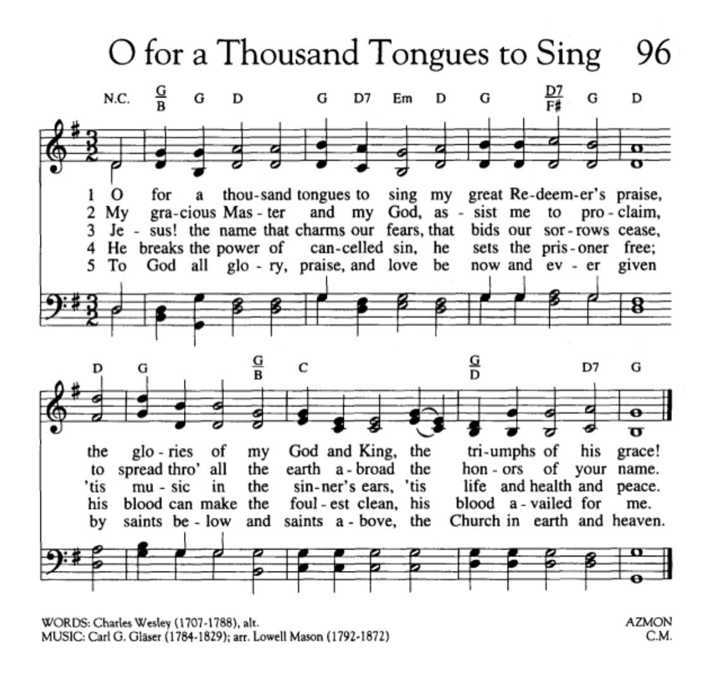
Figure 2.2 “O for a Thousand Tongues to Sing” by John Wesley

“The Tie That Binds”
St. Paul’s meaningful engagement in congregational singing and other music making establishes the community’s identity. The members of St. Paul realize and often comment on the importance of music and singing to their religious community. I believe that congregational and choral singing, which rose to prominence at St. Paul through the influence of Charlie Sanders, has become the aspect of worship and the community at large that fortifies communal ties between members. One hymn sticks out to me as its music and lyrics metaphorically describe the communal aspect of St. Paul. I return to the hymn “Blest Be the Tie that Binds,” which sounds at every service in most Methodist churches. The entire congregation always sings this hymn collectively, using memory rather than the hymnal (Hawn, 2013). The hymn affirms, “Blest be the tie that binds our hearts in Christian love; the fellowship of kindred minds is like to that above” (Fawcett, 1989, p. 557). The musical and lyrical metaphor of a tie binding congregants together in Christian love and kindred minds references a sense of community that focuses on affective attachment between members.
This hymn further places St. Paul in a larger role pertaining to the Christian faith in the United States and globally. For example, Beverly Patterson discusses congregational singing in Appalachian Baptist churches. She states that
[t]hese narratives and comments [of her informants] suggest that some, and perhaps many, Primitive Baptists invest the singing in their churches with meaning related to religious identity, identity not only as Primitive Baptists but even more as children of graces, members of the true church that is separate from the world and that transcends the boundaries set by denominations and nations. (1995, p. 29)
I believe that members of the St. Paul community would say much the same as Patterson’s informants within her ethnographic research. Similar to Primitive Baptists and other Protestant denominations, Methodist traditions maintain the core principle of serving others with Christian love in same manner that Jesus did. Additionally, “Blest Be the Tie that Binds” makes no references to Methodism or individualism. Rather, the hymn more broadly represents the characteristic of a collective, favoring the importance of community over the individual. The words “our,” “fellowship,” and “kindred” reference the value of communal relations.
Most importantly, acts of remembrance form a core aspect of the religious-musical life of the St. Paul community. Memory is important to the human experience. According to Titon, “affective performance in a community is situated in memory. …When a memory is made public and shared it can become community history” (p. 9). In this context, St. Paul observes traditions started by Charlie, All Saints Day, and the singing of hymns that remember and praise the divine for its goodness; all these traditions exist as acts of remembrance stored within the community’s experiences, including both past and present members. These experiences and acts of remembrance, I argue, form affective attachment between members and ultimately become the community’s collective identity and history. Importantly, this attachment happens, in part, physically, through shared singing, affective listening, movement and touch, and fellowship in a shared space. The resulting collective identity and history formulate the ties of community, which persist through acts of remembrance and affective attachment.

CHAPTER THREE
“WE MEET PEOPLE WHERE THEY ARE”: ANXIETY, TECHNOLOGICAL CHANGES, AND REALNESS

Sounds During the Pandemic
Due to anticipation and anxiety, I arrived a little too early on the property of St. Paul for the chilly, mid-October day’s worship of 2020. There, I saw Pastor Dawn, her husband Scott Danforth, and Jim Kennedy, the music director, setting up a table, music stands, microphones, a FM transmitter, and chairs outside in front of the church sanctuary’s steps. On the table, there lay a basket full of pre-packaged, little cups of juice and wafers for Communion (see figures 3.1 and 3.2). After the other singer, Krista Jeffers, arrived, we began reviewing what we would perform. According to the proposal St. Paul United Methodist Church had submitted to the Task Force of the Holston Conference (the division and jurisdiction of the United Methodist Church of which St. Paul was a part), only Jim, Krista, and I were approved to sing as part of this outdoor service: masks must be worn at all times and congregational singing was not permitted. Jo Christopher, who assisted us with recording and online operations, had made special “singing masks” for the service leaders (see figure 3.3). These masks had a metal piece in them that allowed the cloth to stay about an inch away from the singer’s face; this enabled the singer to breathe more easily and better enunciate words. I remain thankful for these masks as they allowed me to fully use my vocal and expressive abilities within the services.
Soon congregants began arriving, bringing lawn chairs to sit in the grass. Dawn had provided a yardstick that she used to make sure that everyone stayed six feet apart. Many of the older and disabled members, who were at higher risk of succumbing to COVID-19, remained in
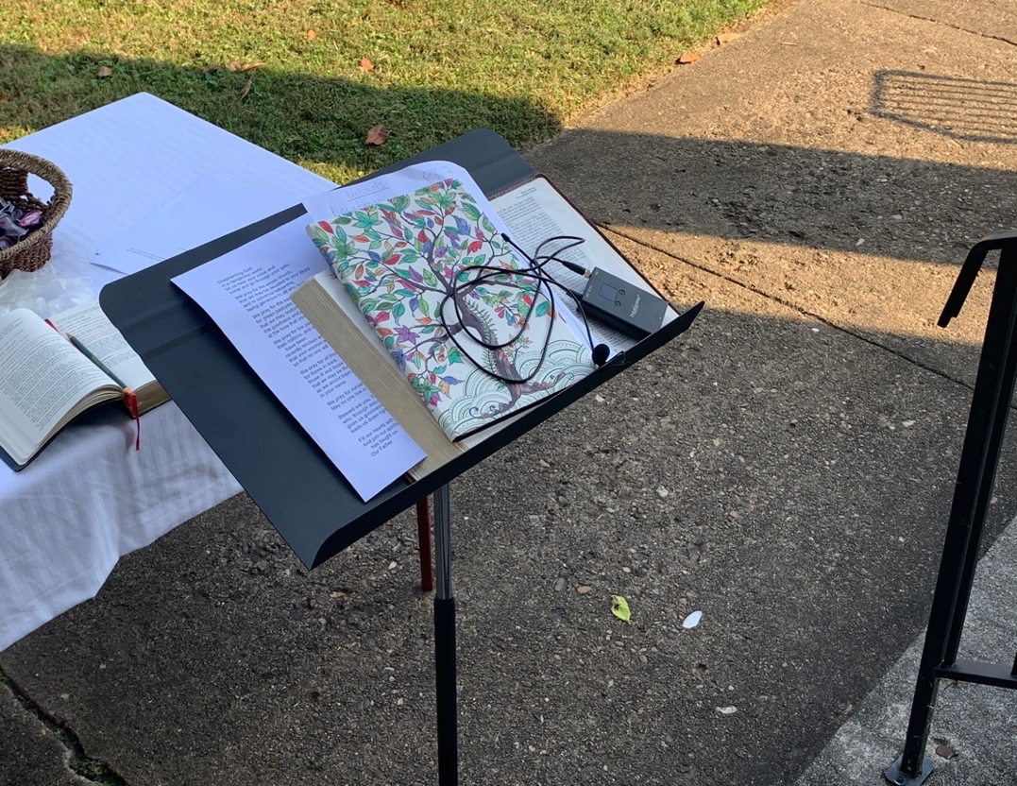
Figure 3.1 Stand with Pastor Dawn’s Belongings and the FM Transmitter (October 4, 2020)

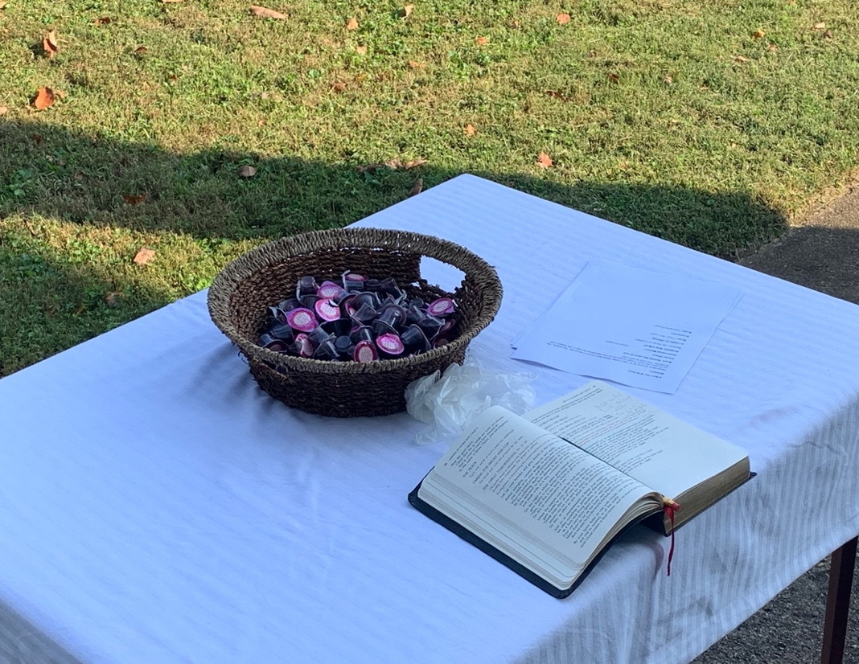
Figure 3.2 Pre-Packaged, Little Cups of Juice and Wafers for Communion

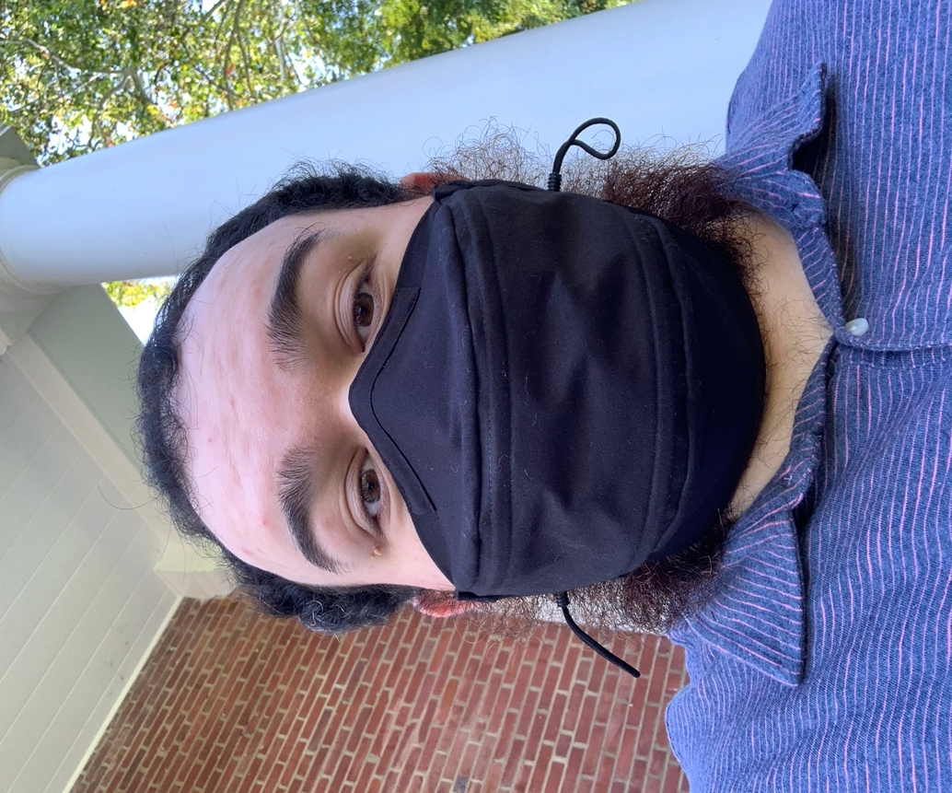
Figure 3.3 Zachery Coffey (Author) with Singing Mask

their automobiles (see figure 3.4). Dawn setup the FM transmitter, a device that granted the means for musicians, speakers, and the pastor to be heard from congregants’ car radios in real time. I honestly hated to see the separation of even six feet between members as, under normal circumstances, St. Paul was a space alive with hugging, hand shaking, talking, joking, and other intimate forms of affection. To have to maintain a distance of six feet apart after so many months, as this was still in the midst of the worst of the pandemic, left me with feelings of sorrow and a hopeful wish for the world to return to normal as soon as possible.
Krista and I had never sung outside the church like this and, as congregation members began spreading across the front lawn of the church, we worried about how well the congregation would hear our voices. Luckily, the front of the church has an arch upheld by pillars. The space between the sanctuary and the pillars conveniently created what Jim called an “acoustic shell” that sent our voices up and out; this phenomenon allowed for the congregation to hear us even without amplification (see figure 3.5). Krista and I carefully projected our voices through the singing masks to make sure that the FM transmitting receiver would pick up our singing. This service, filtering through the FM transmitting receiver and congregants’ car radios, filled in for personal intimacy in a way that allowed at-risk populations at St. Paul to finally see and hear other congregation members. Prior to this, many members had utilized certain older technologies that only supplied them with a vocal, sonic connection to other congregants, but not a physical one.
Throughout the service, Dawn’s message was one of hope and thankfulness. With tears in her eyes, she stated how happy she was to meet once again, even if we had to stay outside of the sanctuary. All church services at St. Paul had remained online since March 2020, with church leadership deciding to limit access to the building due to COVID-19. Although I had attended
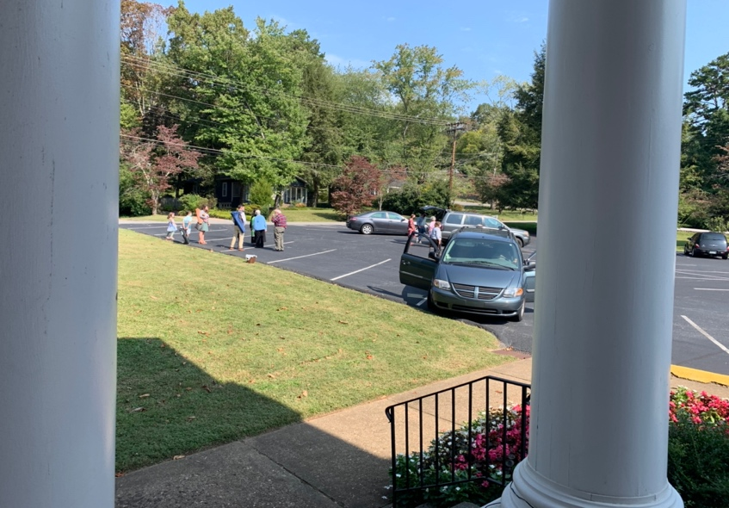
Figure 3.4 Arriving Congregants

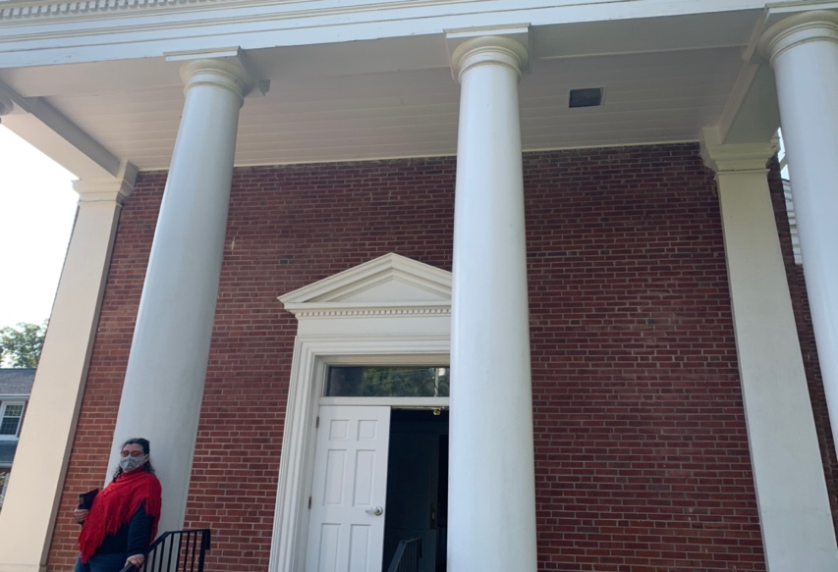
Figure 3.5 Acoustic Shell, Krista Jeffers in Bottom Left
sessions to record musical material for the online services, most of the congregation had not set foot in or even seen the church building for months. The hymns that Krista and I sang strengthened Dawn’s sermon. And after seven months, the church took Communion together. Although the process unfolded very differently from how it had previously, we happily participated in an important part of our shared faith.
After we had taken Communion, we honored two traditions that had started with Charlie Sanders (discussed in Chapter Two). Krista and I were programed to sing Sanders’ original composition “Behold the Lamb” at the beginning of the service, followed by Albert Hay Malotte’s arrangement of “The Lord’s Prayer” as a choral benediction to end the service. I was supposed to sing the last song with her, but when the time came for it, I nudged her to sing it as a solo. I had noticed during the first part of the service that the acoustic shell tended to accentuate higher frequencies and, therefore, the congregation on the lawn heard her voice more clearly than my own. Her a cappella version with her high, controlled soprano voice lifted our hearts together to the divine, just as the song did before the pandemic. The congregation stood and, although they did not sing because of the restrictions, they swayed and smiled with their eyes, behind their masks.
I was not, and I dare say that many were not, happy with the way life remained at this time, but at least we could meet and share our faith together through music and fellowship. Later, during interviews, Dawn disclosed how she saw this moment of Krista singing this beloved song as symbolic of how the pandemic had isolated church members into individual voices. She stated that Krista singing “The Lord’s Prayer” “was the highlight moment. …When the rest of us can’t sing, that [referring to my decision to have Krista sing alone] was probably a good decision in the moment. Just a single voice” (Chesser, personal communication, January 29, 2021). Dawn and I were hopeful that congregational singing would return and our voices would sound together once more.
As a church member asked to participate in the service, I additionally acted as an ethnographer and took notes during breaks in singing, focusing mainly on the congregation to see their reactions to and participation with the service. I knew many members were happy to at least see and hear fellow members. However, despite seeing and hearing people “in person,” I pondered how and if many members of the congregation felt about having to remain in their cars. I expect that this situation still felt isolating to some members.
As I thought about this first in-person service since March of 2020, I recognized some peculiar changes in technology, music, communal togetherness, ideas of space, and people’s time commitments as these had unfolded over the past several months. As the COVID-19 pandemic swept (and continues to sweep) across the nation, beginning in March 2020, churches like St Paul, as I established in Chapter One, closed their physical doors and moved their services online. I explore in this chapter the challenges that these changes posed for church leadership, congregants, and musicians of St. Paul.
First, the drastic change created a challenge for the leadership of St. Paul due to the time-consuming process of producing online services. The move to online services also left many members, especially the elderly, behind because of their unfamiliarity with and subsequent inability to work the technology on which online services depend. Additionally, church leadership wanted to and did include music in the online services to create a sense of familiarity for musicians and fellow church members. However, as discussed in Chapter Two, music, especially hymn singing, exists as a communal, embodied aspect of going to a Methodist church. At an in-person service, with the organist playing and everyone in the church singing at the same time, the practice of hymn singing especially allows a person to simultaneously hear the organ, themselves, and the persons next to them producing sound. This sound lives inside the church member, creating an affective, embodied experience. With services online, singing together in an affective, embodied manner simply is an impossibility, which proved alienating for some church members, as my ethnographic research shows. Methodist worship in particular entails the physical act of singing together in harmony, as dictated by Wesley (discussed in Chapter 2). When this becomes impossible, sorrowful, nostalgic, and wishful emotions of returning to pre-pandemic conditions reveal themselves.
In this chapter, I continue next with an ethnographic description of an online worship service; this description details the nature of online worship services as compared with pre-pandemic, in-person services. I demonstrate how technology proved an important tool in this transition, both offering both aid and hinderance to communication and community. Within that context, I explain two phases of online services that St. Paul explored before arriving at a third phase, which relied on newer, more expensive technologies, that functioned better for the congregation. Next, I provide an alternate definition for the concept of technology that better fits the changes that have occurred at St. Paul. Under my reinterpretation of technology, I examine the uses of technologies at St. Paul as, in part, positive influences on church services, both virtual and in-person. Included in this discussion, I briefly overview everyday uses of technological media and how changes have affected Christian worship practices, particularly in Methodist churches of East Tennessee.
This chapter also demonstrates the anxiety, inability, and unfamiliarity that the elderly within St. Paul have with newer technologies, such as Zoom, Facebook, YouTube, and recording devices (discussed in the next section), and their consequent alienation from church worship during the pandemic. I then move to the use and extension of a metaphor to further show the difficulties faced by the elderly concerning technologies. I end with an idea mentioned by my informant and friend, Krista, and show how Krista’s idea relates to the formation of community, as well as the way in which Christian peoples should experience life among other Christians and those outside their individual communities. What ways can St. Paul as a whole change to better serve our community? Ultimately, through this chapter, I propose pathways that St. Paul can take in order to help church members continually feel connected spiritually, bodily, musically, and organically to one another. My analysis reveals how the COVID-19 pandemic, and all its accompanying challenges, has affected the future of St. Paul and provided opportunities to further consider and find ways to realize our connections to fellow humans.
St. Paul’s Phases of Video Production
St. Paul underwent what I consider “three phases” of video production of worship services. Each of these phases was similar in technological mediation and utilization of newer technologies, yet different in the way that producers generated and disseminated online content. The first phase involved producers splicing together a variety of shorter videos—often from congregants performing certain worship roles (scripture reading, singing, preaching, praying, and the like) from their own homes. The producers aimed to create a continuity from these various segments that resembled worship services prior to the pandemic. They posted these videos on the church’s Facebook page for easy access and on the church’s rarely used—at least prior to the pandemic—YouTube channel. This first phase allowed for worship services to be produced and released quickly to the congregation while maintaining social distancing. All communication and exchange of data from different participants occurred virtually as St. Paul and the United Methodist Church as a whole were strictly prohibited physical contact. These videos required extensive time commitments from the producers, as did the second phase.
The second phase happened when the church was open, but no worship services could be held. Only essential staff could meet in the building and everyone was required to maintain the church’s mask-wearing and social-distancing mandates. While the first phase had utilized video segments created at people’s homes, the second began to mostly involve the church’s sanctuary, which provided a familiar setting. During this phase, the producers, like Jo Christopher and music director Jim Kennedy, recorded Pastor Dawn’s sermons every week. As for the music, Jim, Krista, Jo, and I met one day and recorded numerous videos that were utilized throughout the summer and some of autumn. Jim, Krista, and I sang masked and socially distanced, while Jo recorded us using cellular devices attached to tripods. The same splicing as the first phase occurred except the videos now had better quality. As mentioned earlier, these videos continued to be major time commitments for Jo and Jim, who were our primary producers. Toward the end of this phase, the church decided to post solely on YouTube, as Facebook received far fewer views according to statistical data provided by these platforms.
The third phase currently is where St. Paul currently resides. This phase mostly revolves around St. Paul’s investment in newer technologies that allow for recording and online streaming to YouTube. The equipment, with the direction of a technician, records the worship services in real time and posts them to St. Paul’s YouTube channel. Other technologies, such as higher quality microphones, have allowed the choir, piano, and organ to be heard online. These musical avenues and new technologies have ultimately created better quality videos for St. Paul’s online presence, encouraging more people, both local and distant, to watch.

“Hope in a Time of Exile”: A Video of the First Phase
The second phase is well represented by a YouTube video for the service of 5 July 2020. It begins with a dulcimer sounding “‘Tis a Gift to be Simple,” a Shaker folk song, while a photo materializes and zooms in closer to a stained-glass cross, which hangs in the front of St. Paul’s sanctuary (see figure 2.1 above to see the stained-glass cross). This service was Dawn’s first at St. Paul after the United Methodist Church transferred her to our church. The words “Welcome to the St Paul Family, Pastor Dawn” appear over the photo, followed by a photo slide show of congregants holding signs that welcome Dawn to St. Paul. Words of welcome by Jo Christopher receive Dawn and prepare the online attenders for worship. These parts of the video serve as St. Paul’s welcome to Dawn: the congregation had not yet seen her, since restrictions still remained in effect at this time.
The video cuts to a recording of Krista and me singing “Behold the Lamb of God,” which appeared in almost all of St. Paul’s online worship services during this time. For a song recorded by a cellphone, the quality of sound and visuals is good and the video fully captures my tenor voice and Krista’s bright and clear soprano. We have sung together long enough that we organically harmonize in a way that only comes from familiarity with one another. After the antiphonal duet, the video cuts to Dawn, who is standing inside the sanctuary, inviting the congregation to pray in call and response with the words “Hear our prayer,” which follows her line “Lord, in Your mercy.” The next part shows a child, with flowers in full bloom behind him, reading the scripture by the sanctuary’s outside steps. After the scripture reading, a recording of Dawn’s first sermon at St. Paul begins.
Dawn begins the sermon by mentioning three weddings, over which she was to preside, that were to have taken place in the summer of 2020, before the pandemic nearly cancelled them. The screen cuts to a photo of Dawn in a specially-made face mask for the first wedding. Dawn discusses the second wedding, her son’s, and how, since the wedding was to be held in Hawaii, travel restrictions during the pandemic caused a postponement. She watched the third wedding’s livestream from home, sobbing at people’s absence at her former church. She states,
Everyone worse masks. It [the wedding] was beautiful and done with such great care and dignity that it literally took my breath away, but I ached for the loss of what they [her friends] had imagined that day would be...It is incredibly emotional for me to see people finding ways to go ahead with plans, even in the midst of a global pandemic. Because to choose to go ahead and marry right now bears witness not just to a couple’s love and commitment to one another but to their trust in God’s promise of a future with hope. To marry someone is to publicly stake a claim for the future. It is to express a deep trust and belief that one day this current crisis that we find ourselves in is going to come to an end and to say, in the meantime, I’m going to navigate this with this person and walk with them into whatever the future holds. (St. Paul Worship, July 5, 2020)
I quote her at length to demonstrate how Dawn views her appointment to St. Paul in early 2020 as a marriage between a pastor and the congregation. Dawn was newly appointed to St. Paul in order to meet this community’s needs with her gifts, experiences, and skills, and she assumed this role with grace, even at the most difficult possible time.
Overall, her sermon, titled “Hope in a Time of Exile,” connects the COVID-19 pandemic to the bondage and oppression of Jews by Babylonia approximately from the years 598-538 BCE. She utilizes the analogy between marriage and her appointment to St. Paul during a global pandemic to refer back to the hope of overcoming the violence and bondage that the Israelites suffered. Dawn speaks to this same hope of overcoming times of difficulty during the ongoing pandemic. The weddings she references in the sermon further establish the importance of hope, togetherness, faith, and collaboration as forms of survival and positivity during periods of extreme challenges.
After Dawn’s sermon, the video cuts to Krista singing “Amazing Grace,” while accompanied by Jo on the dulcimer. The same stained-glass cross lights her performance. She sings the first verse fully and then repeats it in American Sign Language (ASL) as she mouths the words, which scrolls across the screen. Dawn invites the online attenders to donate whatever and whenever they can. The video then shows flowers, which had been seen during the scripture reading, while Krista and Jo’s performance repeats. Dawn then appears to ask people online to stand and receive the benediction, which is a blessing of peace, hope, and love. The video ends with the flowers and the words “See you next week!”
When examining the above video, I noticed the ways in which technology and familiar imagery were utilized. Imagery in the early videos at the start of the pandemic in 2020 focused on the familiarity of faces of congregation members and musicians, shots of specific locations on the church grounds, and music that held special meaning, such as “Behold the Lamb” (discussed previously in Chapter Two). Technology provided the means to make this necessary. However, as when Dawn mentioned the emotional “ache” of watching the wedding virtually and not in-person, one notices that newer technological modalities did and do not hold the same meaningful embodied aspect as do in-person, communal togetherness, which engages the entire sensorial and metaphysical nature of human existence. Dawn’s message details the anxiety and ambivalence toward newer technological modalities experienced by members of different age groups at St. Paul. Dawn speaks to the hope of prevailing over the absence of realness (a term a discuss later in this chapter) and returning to the ways prior to the pandemic in which technologies did not control or distract from what is real.
What is Technology?
A discussion of what constitutes technology is necessary, particularly in relation to how I noticed the willingness of congregants at St. Paul to utilize and accept certain forms of technological media over others. Cars, televisions, radios, email delivery systems, short message services (SMS), paper, writing utensils, and furniture, to name a few, exist as everyday objects that make human lives easier and are examples of technological media. Some of these older technologies have lost the designation of “technological” since humans have incorporated them into everyday life. In this section, I examine how people view older technologies in relation to newer ones, as these factors have important implications for participation in technologically-mediated worship services. My argument relies on a recontextualization and redefinition of technology, not only within the context of everyday use but also in terms of what one considers as technological in the first place.
To consider an object as technological, one normally thinks of wires, buttons, and flashing lights involved in a process of digitally transferring information. However, I define technology as any object or tool that aids humanity in accomplishing a task, either through a process, method, or acquired knowledge. This definition implies that a technological object serves to allow a human to more easily and efficiently accomplish a specific task or goal through applied, knowledgeable methods. For example, the singing masks and the pre-packaged combination of Communion juice and wafers become technological because they provide a mode of fulfilling the demands of a church affected by a pandemic. Singing masks became necessary in order to allow vocal music to be audible within St. Paul’s sanctuary. The combined packages of juice and wafers met the need of a congregation forced to remain six feet apart. Throughout history, all objects that help humanity to complete a task or need are technological.
René Lysloff and Leslie Gay, Jr. utilize “three methodological distinctions” to examine the sociocultural importance of technological modalities: the ontological, the pragmatic, and the phenomenological, which correspond with three kinds of “culturally determined [human] agency”: interaction, knowledge, and experience (2003, pp. 6-7). I utilize interaction (which engages the technology directly), knowledge (which involves understanding what the technology can do), and experience (which involves understanding the history of the technology) to explore how human agency during the pandemic changed the usage and meaning of technological modalities to St. Paul. They later state that
technologies may change in meaning as they cross national, linguistic, and cultural boundaries. ...Technologies are acculturated in societies through human agency—through their utilization by people—and, in turn, generate new needs and social spaces for those people. Without the meaning conferred through use, technologies become dead objects, empty artifacts: our books turn into useless scraps of paper, our homes into piles of wood, and our computers into bits of wire and plastic within hulks of metal. (p. 8)
In other words, people do not mark or identify certain technological modalities that exist in our everyday lives as “technological.” People often do not consider books, wood, or metal as acculturated technologies that have become normalized in sociocultural spaces, while simultaneously generating continued use and manufacturing newer needs for newer technologies. Within religious-musical settings, this is due mainly to a given modality, such as sound production equipment or the organ, achieving standardization and normalization through continued use. Timothy Taylor remarks that “[a]fter a period of use, most technological artifacts are normalized into everyday life and no longer seen as ‘technological’ at all, while whatever is new becomes viewed as ‘technological’” (2001, p. 6). In other words, the continued use of and reliance on newer technologies eventually cause people to accept them into their everyday lives, which results in the technologies being received as normalized, rather than as technological, by society.
Technological media prove an invaluable resource to people in that they can make the tasks, communications, and jobs of our everyday lives easier. For example, religious-musical communities use technology to amplify sound production to meet the demands of a large room or people who are hard of hearing; those communities also employ sound technologies to spread their ideologies across larger social and political spaces. According to Tong Soon Lee, “Communications technology has relativized spatial dimension in the contemporary world” (2004, p. 117). Technology gives people the ability to communicate across long distances, socializing with family members or friends around the world. This complicates the idea of space since, in the past, to communicate with other distant geographies necessitated traveling through modes of transportation or letter writing, which involves the postal service; communication across the world now happens with just a click of a button. Technology can also mitigate situations where meeting in person becomes impossible or dangerous, such as our current pandemic; technology provides a way to keep the vulnerable safe, while remaining connected to their communities.
However, despite the invaluable nature of technology to people, many hold ambivalent feelings, even fear and anxiety, toward newer technologies. Speaking to technology use post-World War II, Taylor argues that “anxiety and ambivalence were not new; American ambivalence toward technology has a long history and has been well documented. But the postwar era brought new machines to contend with, machines that were often used in the home” (p. 72). These feelings appeared with the advent of automobiles, telephones, radio, and the Internet. The creation of recording technology allowed for sound to be wirelessly circulated to large numbers of people, spreading music and information in mass quantities. All these technological advancements during the World Wars caused many people anxiety because of the rapid changes in societal values, which increasingly revolved around newer and newer technologies. Musician Jean-Jacques Perrey touches on this perfectly: “Technology has developed faster than the general consciousness; spiritual and moral values have not been preserved” (as cited in Taylor, p. 105, emphasis in original). Here, Taylor discusses a different type of anxiety, a “disillusionment with the promises of technology,” which concerns an affection for the ways of the past (p. 104). Older populations seemingly adjust to newer technologies more slowly than technologies advance; accordingly, such populations experience ambivalent feelings, rooted in a sense of not understanding the world around them. Technology promises to make life easier for individuals but often, due to the vast amount of information produced and consumed, makes life more complicated than ever before.
Older technologies have also lost their luster for modernized societies because of the presence of newer technologies. For example, automobiles now are everyday machines that many people own around the world. In many locations, automobiles are common household machines, with many families in the United States owning two or more per household. On the other hand, in the early 1900s, automobiles were heavily marketed because, according to Taylor, “they occupy an important role in American culture and are also the most expensive and technologically sophisticated machines anyone was likely to buy in this era” (2001, p. 77). The same remains true today, but we often do not think of automobiles as sophisticated technologies now because of their everyday commonality. Similarly, telephones, both landline and cellular, have undergone the process of normalization. These technologies became so common in American households that one does not think of telephones as devices that contain complex innerworkings of electromagnetic microtransmitters (Fisher, 2015, p. 151).
One important technology whose history encapsulates some of these issues is the radio. The radio developed from other former technologies, like the telegraph, that allowed for communication across distant locations. The technology eventually, according to Fisher, “came to signify mass culture, national publics, and the commercialization of audiences as market share” (p. 154). In other words, the radio allowed for the dissemination of massive amounts of information to be spread across national and local borders. The radio in the United States allowed the government and other institutions concerned with informational flows to broadcast messaging that involved politics, updates on ongoing wars, and important news from elsewhere in the country (p. 151). The radio often directly represents the voice of the political state in power within a nation. As the radio was utilized more and more widely, people lost the anxiety they had initially felt from not completely understanding the newer technology.
When technologies become a part of people’s everyday lives and are used regularly, the technologies become normalized within a society. This explains, in the event I described in this chapter’s opening, the way in which the elderly at St. Paul so readily accepted the FM transmitter supplying the sounds of the service to their car radios, even while these same people struggled to adapt to online services and computer use. I do not suggest that the older population at St. Paul have no anxiety concerning the church’s continued use and reliance of YouTube; however, I notice that some of this population continues to adapt to newer technologies. In the section below, I discuss anxious feelings and a digital divide that some of the older population, as well as younger populations, experience when confronted with unfamiliar technological modalities.
Anxiety and a Digital Divide
Even before the COVID-19 pandemic, researchers could not fully anticipate the ways that technology would advance or how cultural practices would come to rely on those advancements at a continually increasing rate. Leslie Gay, Jr. states,
Cultural practices tied to technologies cannot be predetermined, nor can specific cultural adaptations and transformations be predicted. The relations between technologies and their cultural use are complex and interrelated, with uses and meaning constructed and contested through the discourse of daily lives, through image schemata and metaphorical shifts… Technologies wielded faithfully to culturally delineated practices draw social insiders together and celebrate certain social groups while excluding and restricting others. (1998, p. 91)
With the increased reliance on and use of technology, cultural practices naturally adapt and transform to meet the needs of individual communities. Different technologies tend to address the needs of people’s daily lives, and to be used in practices where technology either augments or resolves an existing problem. However, as Gay mentions, these same technologies that draw individual and community insiders together may also exclude and restrict others from personal expression and communal connection. I have seen this very situation at St. Paul in the elderly’s inability to, unfamiliarity with, and anxiety about newer technological modalities, such as Zoom, YouTube, and Facebook. Like many congregations, St. Paul has had to contend with technological modalities functioning as both facilitators and, at times, barriers to worship during the COVID-19 pandemic.
Despite technology aiding the lives of some people by increasing their access to communication, continued technological advancement often leaves older generations behind and excludes them from participation within their communities. According to Björn Niehaves and Ralf Plattfaut, “the elderly lag behind in using and benefitting from IT [Information Technology] in general and the Internet in specific” (2014, p. 709). Countries around the world continue to have a “digital divide,” which means that “despite all potential advantages, the elderly are less likely to have access to and to exploit the potential of Internet usage and IT in general” (p. 709). They mention several socio-demographic variables for why technology adoption is difficult: age, income, and education, with all being anxiety-inducing issues. Alexander van Deursen and Ellen Helsper claim that many older adults consider themselves “too old” or fear “being perceived as too old,” which further hinders them from employing newer technologies (2015, p. 174). Older adults’ attitudes toward newer technologies also can stem from a deficit in relevant educational opportunities, “lack of Internet experience or Internet skills,” or not having someone to teach them the intricacies of these technologies (p. 174). The other major component in the technological anxiety of older adults is the matter of cost. In the United States, technologies simply remain too expensive for older adults whose incomes are predicated on retirement status or dependence on social security programs. The increasing incorporation of technologies within religious settings excludes and restricts older adult members because of anxieties surrounding being too old to learn, lack of Internet experience, and the affordability of the required technologies. This exclusion of elderly members reveals the ways in which the increased incorporation of technologies can alter how communities operate and interact among individual members.
Importantly, the digital divide also presents itself in younger populations at St. Paul through interactions between their personal, work, and church lives. Younger populations, such as students and working adults, during the COVID-19 pandemic expressed exhaustion over meeting colleagues online every day for months and even years. To continually move from Zoom meeting to Zoom meeting became mentally, emotionally, and physically draining to large numbers of populations worldwide. The topic of this exhaustion even became viral online and was termed “Zoom fatigue.” Hadar Shoshan and Wilken Wehrt state,
The COVID-19 pandemic is an unknown situation characterized by feelings of uncertainty and potentially different work-related strain processes with face-to-face interactions being an exception and remote work becoming the norm. As an extreme, unprecedented situation, the pandemic might have set the ground for “Zoom fatigue” to emerge. (2021, p. 2)
These feelings of uncertainly are, I argue, what made the global pandemic so difficult for elderly and younger populations alike. Even while students and working adults continued their activities online, these did not always translate fully to online media. Because of isolation, uncertainty, and continuous hours online (without receiving social connections to other individuals), “Zoom fatigue” became a term to express just how people suffered during the pandemic.
I often found the seemingly endless and frequent meetings of Zoom meetings exhausting. Zoom fatigue had not yet been termed by the online masses but described how I felt throughout various phases of the pandemic. My colleagues also felt this and I sympathize with the ones that left their educational programs or decided to delay their graduation due to Zoom fatigue. Psychological and sociological studies examining the phenomena of Zoom fatigue continue to be conducted and more research needs to done to detect long lasting effects possibly caused by physical and social isolation during the pandemic. Robby Nadler describes people who undergo long and frequent Zoom meetings as developing a “third skin” through online space devoid of physical elements. He states,
Recall physical space in the physical world is open ended in how users carve it. What makes these spaces so malleable is the ability for any presence (person or otherwise) to enter the space and recast it…In all these instances, one person’s space is invadable...But in a virtual context, neither party can influence the other’s space. (2020, p. 13)
I draw from Nadler’s understanding of Zoom fatigue in understanding how space formulates identity. I discovered my own interactions with professors and colleagues, which before I had loved, on Zoom became exhausting. A twelve-hour work day prior to the pandemic was not as exhausting as a three-hour class over Zoom. I realized that absence of physical embodiment within a physical space had changed my existence within and perception of virtual renderings of the world through online media.
The absence of physical embodiment and the fatigue concerned with online meetings emerged as central themes in my interviews with congregants and leaders of St. Paul. Krista Jeffers, a worship leader and choir member, stated,
So, there was just stress [from the pandemic] everywhere. In addition to that, church is closed and I didn't have my normal escape, so going out with my friends or going to church. So, I'd say the beginning of the pandemic really, really sucked. …It felt terrible to be away for as long as we were, even with online services. And I'll be honest, I rejected the notion that it was fine, that online services were fine and I couldn't get myself, in my, quite frankly, depression, to sit down and watch them. (Personal communication, November 21, 2020)
I then asked, “So, with the online services, overall, do you think that they were valuable for the church?” She answered,
I think they were. I think…for a certain population though. A lot of our members are older and don’t have access to the technologies that would allow them to watch these services. Some of them don’t own computers, a lot of them do not have access to Internet, so I think that it was something like a small shot in the dark, if you will, at what church was for us back before we closed but, does it have value? Yes. Is it as valuable as meeting in person? Absolutely not.
These statements by Krista summarize the difficulties placed upon and experienced by communities during the COVID-19 pandemic. At the age of 25, Krista witnessed firsthand the difficulties that even younger demographics experienced when jobs, churches, and everything else moved to the virtual. While these technological media were definitely valuable in maintaining some semblance of connection between individuals in their respective communities, they did not offer the physical embodiment so many populations seek. Ultimately, these newer technologies create a digital divide between individuals, whether elderly or younger, in the ways in which they limit physical, social interactions.
“We Meet People Where They Are”
Here, to consolidate my thoughts on why the elderly will not accept newer technologies, I draw upon a metaphor—that I take and deliberately turn into another metaphor—presented in Gay’s research on New York rock musicians and their use of sound processors for instruments. He writes, “For many New York rockers, fewer knobs—less processing of the musical sound—yields a more direct, more ‘real,’ communication between musician and audience” (p. 82). Therefore, “too many knobs” detracts and distracts from the realness of a musician’s communication with their audience. I twist and extend this metaphor to apply to the communication between the elderly and their communities. For the elderly, computers have too many buttons, too many steps, and not enough realness.
This absence of realness, familiarity, and physical embodiment of singing does not facilitate the elderly taking on the challenges of learning and obtaining new technologies. Currently, technology does not allow the type of embodiment that maintains physical intimacy and bodily experience occurring within in-person services; the absence of that embodiment in online services does not provide valuable connections between congregants. On the other hand, later, when in-person services resumed at St. Paul, technologies employed by leadership allowed for those not bodily present to remain in community with the church. Nonetheless, Methodist churches consist of musical and liturgical practices rooted in face-to-face participation, with examples being hymn singing and call and responses. Because of computer screens’ one-dimensionality and complexity, online services do not allow for the traditional type of participation and socialization that members seek and desire from church services. The Methodist church must confront the question of how the church has changed without the musical and liturgical traditions that members depend on for interpersonal participation within services.
I conclude by mentioning an idea brought to my attention by Krista. She stated that “We meet people where they are” (personal communication, October, 28, 2020). This statement comes from 1 Corinthians chapters 9 and 10, where Paul, the apostle and saint for whom St. Paul is named after, writes about not separating ourselves from people. We must join, love, serve, identify with, and become like them. I raise this idea of meeting people where they are to say that St. Paul must meet the digitally divided where they are. Church leadership and those more accustomed to newer technologies must continue to find ways to connect and relate to the congregants of St. Paul, who may not use Facebook, YouTube, or Zoom. They may not have the ability to or desire to watch the online services that stream on YouTube and Facebook. However, we can still find ways to incorporate them into our community. Mailing cards, providing copies of services and sermons, creating phone trees, and singing outside of their homes (at a safe distance) offer several ways to accomplish this. With older technologies—such as radio, paper, speakers, and stereos to name a few—more readily accepted, they do aid affected communities, but, in my opinion, only exist as temporary solutions due to the absence of the physical embodiment of community. As discussed above, older and newer technologies may be limiting to certain populations, such as both elderly and younger demographics. St. Paul must continue to explore ways in which technology can both aid and limit the sense of community within people, who remain an essential part of how St. Paul operates. A community’s strength exists in its people and we should celebrate all members. Even if technological modalities deprive the elderly of methods to connect to fellow members at St. Paul, older technologies more readily accepted and other approaches exist that can meet the elderly “where they are” and provide a little more realness.

CHAPTER FOUR
THERE IS NO REPLACEMENT: A CONCLUSION
The sanctuary was alive with sound and motion as people, mostly maskless, drifted from person to person, pew to pew, sharing recent happenings in their personal lives. Church leadership, choir members, congregants, and visitors of all ages mingled together, causing sounds of laughter, conversation, and excitement to resound through the sanctuary’s walls. Within the choir loft, which lies behind the podiums and at the front of the sanctuary, I join my own voice with this cacophony of social sound making. I discuss books, music, and other topics with my bench buddy, Scott Danforth. The sopranos sit in front of us and talk back and forth in much the same way that is happening in the congregation’s pews. The altos sit across from the benches of the sopranos and Scott and me; laughter and conversation occur between them, too, and, occasionally, the conversations drift across the little walkway between our benches to incorporate the sopranos, Scott, and me.
As the service nears its start, the music director Wendel Werner sits at the piano, ready to provide the opening music for the service. Pastor Dawn takes her place on the bench beside the main lectern. From the balcony, which is across the sanctuary and has all the sound, recording, and streaming equipment that St. Paul now utilizes since the COVID-19 pandemic, the technician gives a thumbs-up to signal that the time is 10:45 AM and that streaming has begun. When Wendel starts to play the piano, the sounds of laughter and talking slowly fade as people begin to find their seats (see figure 4.1). The service proceeds through the announcements and words of welcome, spoken by Dawn. Then, Wendel invites the congregation to stand and join the choir in singing the first hymn. He plays the introduction and the whole sanctuary is filled with the sounds of voices, harmonies, and music. The second hymn of the service supplies the same

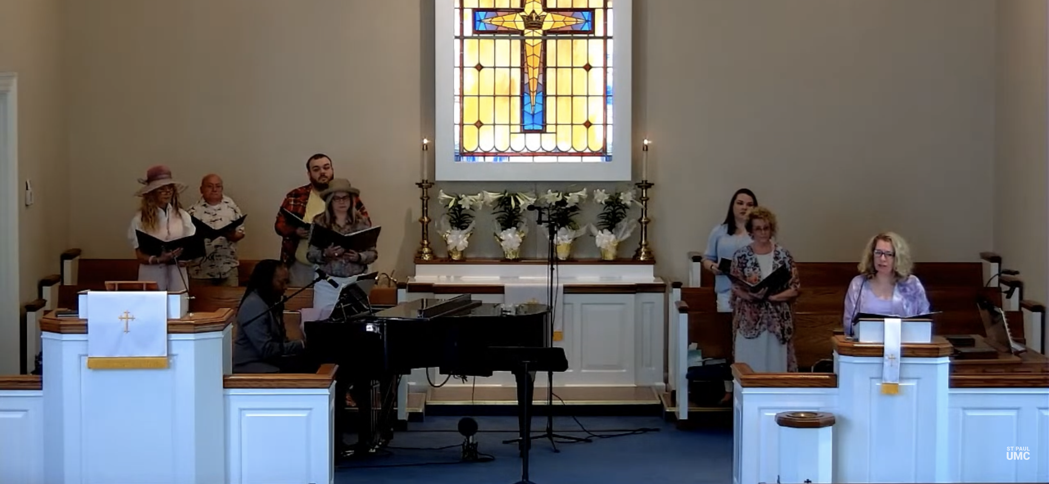
Figure 4.1 Post-Masking Service

phenomenon of togetherness and community, which I and others at St. Paul have sorely missed during the absence of the in-person services that allowed communal singing.
Patterson, as quoted in Chapter One, states that “congregational hymn singing is a powerful living tradition that is part of everyday life for a group of ordinary Americans. It is a tradition that continues to hold worlds of meaning” (p. 2). I quote this again to show how powerful congregation singing is for the people at St. Paul. We missed singing together when our services were completely online. I emphasized the importance and meaning of Methodist hymn singing in Chapter Two, as well as the results of the absence of communal singing in services at St. Paul. The translation of true communal singing to online media simply remains an impossibility and cannot replace the physicality and sense of community established and maintained with lifting our voices as one voice to the divine. The service I described above does not focus on any specific event, but supplies a general outline of all in-person gatherings in St. Paul’s church building. The absence of communal singing during the pandemic, the presence of the church through online media, and the re-united, in-person service described above reveals the conclusion to this thesis project.
In Chapter One, I began with how different St. Paul looked and sounded during the COVID-19 pandemic that started in 2020. St. Paul closed its doors to protect our members from the threat of the virus. The building was empty of the smiles, conversations, laughter, and running children, but St. Paul’s members were safe. I briefly described how quickly St. Paul’s services moved into the virtual realm and how difficult this was for leadership and members who had no or little online presence or experience. I provided statistics concerning the governmental, healthcare, institutional, and religious systems that managed the interactions between individuals and communities; I discussed how these systems played roles in St. Paul’s response to the pandemic.
Further, I overviewed how and why sound and music, albeit mediated through different technological modalities, changed within St. Paul’s online services. I was primarily interested in how or if the church altered their communal and individual identities in order to adjust better to virtual services. Additionally, I referenced Turino in how the vocal dynamics within church communities highlight the collective participation of congregation members and usually reduce a differentiation between performers and the audience.
Throughout this discussion, I have displayed the significance of the human voice in the listening to and production of sound. I argued in Chapter One and throughout this project that the introduction of and reliance on newer technological modalities further complicated and even ruptured the distinction between listeners and producers of sounds. I penned the phrase sound is all around and inside of us to show more clearly the complicated nature of sound in relation to listening and sound production. This phrase demonstrates how human beings exist simultaneously as listeners to and producers of sound, in physical, vibrational, and experiential relationship(s) to one another and our environments. I arrived at the conclusion that the way of existing in the world was, is, and will be formulated through the (sound) knowledge gained from the cumulative and interactive participation within the physical environment. To repeat a phrase written in Chapter One: everything produces, resonates, and internalizes sound; as humans experience sounds, they react according to their social customs.
Further, through the discussion of sound and music, I revealed how St. Paul expresses its collective, communal identity through the singing of hymns and the use of the human voice. Congregational identity, attachment, and sense of community emerge from the affect created through the interconnectedness of the sonic, haptic, and visual realms of human existence. To reference Titon again, I based my research on the notion of affect, which has “the power to move people” and I argued in Chapter One and throughout this project that sound and music played a significant role in this. When St. Paul’s congregants performed together hymns or honored certain choral or musical traditions, we were in essence performing our communal nature, identity, and history in communal settings, while relying on individual and collective memories and experiences. I ultimately displayed how communal acts of listening to and producing sounds generated a sense of belonging and togetherness, as also shown and heard when the church sings “Blest be the Tie that Binds.” Additionally, I began my examination of how the utilization of newer technological modalities changed the listening to and production of sound in virtual settings that did not allow for communal expressions of hymn singing and belonging.
Chapter Two addressed the operations of St. Paul prior to the COVID-19 pandemic, as well as the normal qualities found within Methodist traditions recognized at St. Paul. I provided a brief context for hymn singing to reveal how important the tradition has remained with the Methodist denomination in the formation of identity. I then defined the concept of affective listening, a term I penned to argue for the role of sound in generating affective attachment between congregants. This concept included the role of active listening, which details the active state of listening and responding to the pain and joy of others. The phrase sound is all around and inside of us appeared in Chapter Two to illustrate how sound, both when listening and producing, is an embodied aspect of human experience within the physical world. I have employed ideas from Kapchan within this project to reveal how the activities of affectively listening to and producing alongside others’ sounds exist as sonic witnesses to the “pain and praise of others” (p. 277).
Additionally, Chapter Two examined the interrelated nature of presence, absence, and remembrance in the congregation of St. Paul. These three concepts deal directly with the (un)comfortable emotions associated with witnessing pain and joy. Often, memory exists as a powerful vehicle in which affective listening occurs. Acts of remembrance offer ways for those physically present to recognize those physically absent yet affectively present. The concepts of absence and presence became blurred when I examined the role of sound and remembrance in certain services for certain people, whether those that have died or those who are separated by physical distance. I mentioned Charlie and Walter, both of whom reveal the importance of sound and music in acts of remembrance at St. Paul. Ultimately, I argued that acts of remembrance through sound and music, as exemplified in Chapter Two, exist as the “tie that binds” together the St. Paul community. Music can operate as the vehicle in which remembrance functions.
Chapter Three addressed the operation of St. Paul during and after COVID-19, especially in relation to changes in music and technology. I provided ethnographic descriptions of worship during and after St. Paul moved services online. With these, I displayed just how different sound and technology were from pre-pandemic, in-person services. I defined and expanded on what constitutes technology. Within this definition and expansion, I revealed various ways that technology was used at St. Paul. Older technologies were more readily accepted than newer technological modalities, such as Zoom, Facebook Live, and YouTube, which were implemented to meet the church’s need to move to the virtual realm.
Associated with technology, I explained how both younger and older generations at St. Paul had difficulty in adapting to the COVID-19 pandemic, which forced workplaces, churches, and schools online. I discussed the anxiety caused by our society moving most aspects of daily life online and how this anxiety caused an even larger divide between individuals and communities. Obviously, the use of online, technological modalities provided safer ways to protect ourselves, each other, and the most vulnerable from the virus; however, I argue that these modalities cannot and will not replace the physicality of human experience in relation to other humans and environments. A digital divide exists between the elderly and newer technology, but a divide, although differing in terms of accessibility and other factors, also exists between the same technologies and younger populations. Studies have shown and are continuing to show that a constant online presence induces anxiety and causes mental and emotional fatigue in ways that in-person presence in normal circumstances does not. This project, if anything, calls for more research into the effects of long-term usage of online presence in the mental and physical health of individuals and communities.
While technology does maintain a positive presence in the lives of humanity by aiding us in the way of more easily, readily, and safely accomplishing everyday tasks, I conclude that technology has negative aspects as well. Human existence is one of the physical realm; we cannot change that without changing our very nature. Technology can cause isolation, anxiety, division, fear, and uncertainty. For older and younger generations alike, the virtual realm cannot replace and offer the same connection and meaning as in-person occurrences that involve the sensorial, physical interaction with other humans and our environments. Ultimately, through this project, I argue that relocating St. Paul’s community was possible only temporarily because there is no replacement for in-person, human connections and experiences formed through sonic routes.

POSTSCRIPT
I wrote this document during the COVID-19 pandemic, which as of 2022, still affects the United States and most of the world. I struggled through many of the same experiences detailed in the interviews with my friends at St. Paul. Fear of becoming sick or dying, isolation, and an end to our sense of “normal” have affected all of us, both those at St. Paul and those reading this. Throughout, I have remained fully aware of keeping members of my community safe, especially the elderly or immunocompromised. That awareness at times hindered this project, but I would not change that for anything, as the health and safety of those I love are my priority. I realize that St. Paul, our local communities, and the world have changed dramatically and, I would argue, forever. When this pandemic first began, I mourned the change. I mourn(ed) especially the pain, suffering, and death caused by COVID-19 as experienced around the world and in the St. Paul community.
However, in some ways, I view the pandemic as having a positive influence, too. I faced my own mental and spiritual challenges during the pandemic that altered who I am as a person and how I interact with the world and the people in it. Through shared struggles, I became closer to friends, family, classmates, and St. Paul’s congregation. I learned to share more of myself and be true to how I feel. In relation to St. Paul, as the pandemic seemingly is slowing down, I believe members have become more aware of each other’s needs and voices; we have learned to listen more and suffer in isolation less. As music has returned to St. Paul, our community has grown strong again and I have felt myself come alive with communal singing and musicking. Life at St. Paul has definitely changed, but we have become better than before. We have become more willing to prioritize our relationships in shared space and sound, and endeavored to become more attuned to one another. Additionally, we as a church have committed ourselves to continuing an online presence. We now reach people we did not prior to the pandemic and we plan to carry on with meeting people where they are.
I conclude this postscript by referring back to the titles of my chapters. At the start of the pandemic, an “empty church” building looked like love in the way it represented the importance of the health, safety, and lives of St. Paul’s people. The ways in which St. Paul’s members affectively listen to one another’s pain and praise reveal the “tie that binds” our community together. St. Paul further attempted during the pandemic to “meet people” where they were in terms of technology and sociocultural changes. We will continue to do this, a factor that displays how the pandemic has positive aspects as well as negative ones. Ultimately, through this thesis project, I observed that a technologically mediated community cannot replace people’s in-person, embodied, sensorial experiences in relation to other humans. Surely, you, the reader, and I, the writer, have experienced this in our own lives during the COVID-19 pandemic, and we will continue to do so into the future. Ultimately, through this document, I individually and collectively vocalize the struggles, fear, isolation, and mourning that we all went through in both similar and different ways during the pandemic.

LIST OF REFERENCES
Ashton, J. N. (2001). Music in worship: The use of music in the church service. Fort Myers, FL: Wyndham Hall Press.
Babiracki, C. M. (2008). What's the difference?: Reflections on gender and research in village India. In G. F. Barz & T. J. Cooley (Eds.), Shadows in the field: New perspectives for fieldwork in ethnomusicology (2nd ed., pp. 167-182). New York: Oxford.
Beaudry, N. (2008) The challenges of human ethnographic relations in enquiry: Examples from Arctic and Subarctic fieldwork. In G. F. Barz & T. J. Cooley (Eds.), Shadows in the field: New perspectives for fieldwork in ethnomusicology (2nd ed., pp. 244-245). New York: Oxford.
Blacking, J. (1973). How musical is man? Seattle: University of Washington Press.
Breed, D. (2011). The history and use of hymns and hymn-tunes. Grand Rapids, MI: Fleming H. Revell Company.
Chappell, B. (2020, September 22). “Enormous and tragic”: U.S. has lost more than 200,000 people to COVID-19. National Public Radio. https://www.npr.org/sections/coronavirus-live-updates/2020/09/22/911934489/enormous-and-tragic-u-s-has-lost-more-than-200-000-people-to-covid-19
Chesser, D. (2014). This virtual mystery: A liturgical theological argument against celebrating Holy Communion on the internet in the United Methodist Church [Unpublished dissertation]. Garrett-Evangelical Theological Seminary.
Clifford, J. (1986). Introduction: Partial truths. In J. Clifford & G. E. Marcus (Eds.), Writing culture: The poetics and politics of ethnography. Berkeley: University of California Press.
De Beer, S. F. (2013). Absence, presence, remembrance: A theological essay on frailty, the university and the city. Verbum et Ecclesia, 34(1), Art. #855, 9 pages. http://dx.doi. org/10.4102/ve.v34i1.855
Dignity Memorial. (2022, February 2). Obituary: Walter Loyd Adams. https://www.dignitymemorial.com/obituaries/knoxville-tn/walter-adams-10559892
Dyson, F. (2009). Sounding new media: Immersion and embodiment in the arts and culture. Berkeley: University of California Press.
Eidsheim, N. S. (2015). Sensing sound: Singing and listening as vibrational practice. Durham, NC: Duke University Press.
Elisha, O. (2011). Moral ambition: Mobilization and social outreach in evangelical megachurches. Berkeley: University of California Press.
Fawcett, J. (1989). Blest be the tie that binds. In The United Methodist hymnal (p. 557). Nashville: The United Methodist Publishing House.
Feld, S. (2015). Acoustemology. In D. Novak & M. Sakakeeny (Eds.), Keywords in sound (pp. 12-21). Durham, NC: Duke University Press.
Fisher, D. (2015). Radio. In D. Novak and M. Sakakeeny (Eds.), Keywords in sound (pp. 151-164). Durham, NC: Duke University Press.
Fox, A. A. (2004). Real country: Music and language in working-class culture. Durham, NC: Duke University Press.
Gay, L. (1998). Acting up, talking tech: New York rock musicians and their metaphors of technology. Ethnomusicology 42(1), 81-98.
Geertz, C. (1973). The interpretation of cultures: Selected essays. New York: Basic Books.
Hawn, M. (2013). History of hymns: “Blest be the tie that binds.” Discipleship Ministries: The United Methodist Church. https://www.umcdiscipleship.org/resources/history-of-hymns-blest-be-the-tie-that-binds
Heitzenrater, N. P. (1995). Wesley and the people called Methodists. Nashville, TN: Abingdon Press.
Hickman, H. (2020, July 2). Knox County’s new mask mandate: What we know. Knoxville News Sentinel. https://www.knoxnews.com/story/news/2020/07/02/knox-county-cloth-face-mask-mandate-what-we-know/5362674002/
Hirschkind, C. (2015). Religion. In D. Novak & M. Sakakeeny (Eds.), Keywords in sound (pp. 165-174). Durham, NC: Duke University Press.
Ingalls, M. M. (2019). Digital devotion: Musical multimedia in online ritual and religious practice. In N. Cook, M. Ingalls, and D. Trippett (Eds.), The Cambridge companion to music in digital culture (pp. 150–167). Cambridge University Press.
Kapchan, D. (2015). Body. In D. Novak & M. Sakakeeny (Eds.), Keywords in sound (pp. 33-43). Durham, NC: Duke University Press.
Kapchan, D. (2017). Listening acts: Witnessing the pain (and praise) of others. In D. Kapchan (Ed.), Theorizing sound writing (pp. 277-293). Middletown, CT: Wesleyan University Press.
Kisliuk, M. (2008). (Un)doing fieldwork: Sharing songs, sharing lives. In G. F. Barz & T. J. Cooley (Eds.), Shadows in the field: New perspectives for fieldwork in ethnomusicology (2nd ed., pp. 183-205). New York: Oxford.
Knox News. (2022, February 3). Walter Loyd Adams: Obituary. https://www.knoxnews.com/obituaries/kns044723
Kruger, F. P. (2019). Remembrance as an optical mind-lens in the editing of memories by means of participatory listening in liturgy. Verbum et Ecclesia, 40(1), a2005. https://doi.org/10.4102/ve.v40i1.2005
LaBelle, B. (2010). Acoustic territories: Sound culture and everyday life. New York: Continuum.
Lee, T. S. (2003). Technology and production of Islamic space: The call to prayer in Singapore. In R. T. A. Lysloff & L. C. Gay, Jr. (Eds.), Music and technoculture (pp. 109-124). Middletown, CT: Wesleyan University Press.
Leman, M. (2008). Embodied music cognition and mediation technology. Cambridge, MA: MIT Press.
Leonhardt, D. (2020, August 6). The unique U.S. failure to control the virus. The New York Times. https://www.nytimes.com/2020/08/06/us/coronavirus-us.html
Levine, A. (2021). Witness at the cross: A beginner’s guide to Holy Friday. Portland, OR: Abingdon Press.
Levine, A. (2021). Witness at the cross: A beginner’s guide to Holy Friday [DVD]. Portland, OR: Abingdon Press.
Lindus, J. (Fauntleroy Church). (2020, March 17). Love looks like an empty church. Facebook. https://www.facebook.com/FauntleroyChurchUCC/posts/pfbid02TwkhwYBmDyE4rPfCbTzEKuWnsRkg5E9Gx2CY3DBh4dsZQZEmatSWXgs2y2YQeZuMl
Lysloff, R. T. A. & Gay, Jr., L. C. (2003). Introduction: Ethnomusicology in the twenty-first century. In R. T. A. Lysloff and L. C. Gay, Jr. (Eds.), Music and technoculture (pp. 1-22). Middletown, CT: Wesleyan University Press.
Nadler, R. (2020). Understand “Zoom fatigue”: Theorizing spatial dynamics as third skins in computer-mediated communication. Computers and Composition 58, 1-17.
National Center for Immunization and Respiratory Diseases (NCIRD), Division of Viral Diseases (2020, November). Social distancing. ,https://www.cdc.gov/coronavirus/2019-ncov/prevent-getting-sick/social-distancing.html
Niehaves, B, & Plattfaut, R. (2014). Internet adoption by the elderly: Employing IS technology acceptance theories for understanding the age-related digital divide. European Journal of Information Systems, 23(6), 708-726.
“O for a Thousand Tongues.” Hymnary.org. https://hymnary.org/text/o_for_a_thousand_tongues_to_sing_my
Outler, A. C. (1964). Preface. In A. C. Outler (Ed.), John Wesley (pp. iii-viii). New York: Oxford University Press.
Patterson, B. B. (1995). The sound of the dove: Singing in Appalachian primitive Baptist churches. Urbana, IL: University of Illinois Press.
Pierpoint, F. (1989). For the beauty of the earth. In The United Methodist hymnal (p. 92). Nashville, TN: The United Methodist Publishing House.
Przybylski, L. (2021). Hybrid ethnography: Online, offline, and in between. Thousand Oaks, CA: SAGE Publications.
Rath, R. C. (2003). How early America sounded. Ithaca, NY: Cornell University Press.
Rice, T. (2015). Listening. In D. Novak & M. Sakakeeny (Eds.), Keywords in sound (pp. 99-111). Durham, NC: Duke University Press.
Roden, S. (2011). Active listening. In C. Kelly (Ed.), Sound (pp. 216-217). Cambridge, MA: MIT Press.
Schafer, R. M. (1993). The soundscape: Our sonic environment and the tuning of the world. Rochester, VT: Destiny Books.
Scott, D. (2020). Coronavirus is exposing all of the weaknesses in the US health system. https://www.vox.com/policy-and-politics/2020/3/16/21173766/coronavirus-covid-19-us-cases-health-care-system
Shoshan, H., and Wehrt, W. (2021). Understanding “Zoom fatigue”: A mixed-method approach. Applied Psychology, 1-26.
St. Paul Worship. (2022, February 6). A service of remembrance for Walter Adams [Video]. YouTube. https://www.youtube.com/watch?v=afxwvhRbzVA
St. Paul Worship. (2020, July 5). St. Paul UMC Fountain City, July 5, 2020 [Video]. YouTube. https://www.youtube.com/watch?v=O68Qr7dSwlM&t=868s
Sterne, J. (2003). The audible past: Cultural origins of sound reproduction. Durham, NC: Duke University Press.
Stevenson, A. (1975). The story of Southern hymnology. New York: AMS Press.
Stowe, D. (2004). How sweet the sound: Music in the spiritual lives of Americans. Cambridge, MA: Harvard University Press.
Syndor, J. R. (1960). The hymn and congregational singing. Richmond, VA: John Knox Press.
Taylor, T. D. (2001). Strange sounds: Music, technology and culture. New York: Routledge.
Titon, J. T. (1988). Powerhouse for God: Speech, chant, and song in an Appalachian Baptist church. Knoxville, TN: University of Tennessee Press.
Titon, J. (2008). Knowing fieldwork. In G. F. Barz & T. J. Cooley (Eds.), Shadows in the field: New perspectives for fieldwork in ethnomusicology (2nd ed., pp. 25-41). New York: Oxford.
Turino, T. (2008). Music as social life: The politics of participation. Chicago: University of Chicago Press.
Weidman, A. (2015). Voice. In D. Novak & M. Sakakeeny (Eds.), Keywords in sound (pp. 232-245). Durham, NC: Duke University Press.
Wesley, J. (1761). Select hymns with tunes annexed: Designed chiefly for the use of the people called Methodists. Bristol: William Pine.
Wesley, J. (2003). O for a thousand tongues to sing. In Worship and Rejoice (p. 96). Carol Stream, IL: Hope Publishing Company.
White, S. J. (1994). Christian worship and technological change. Nashville, TN: Abingdon Press.
Whyte, L. E. & Zubak-Skees, C. (2020, April 1). Underlying health disparities could mean coronavirus hits some communities harder. National Public Radio. https://www.npr.org/sections/health-shots/2020/04/01/824874977/underlying-health-disparities-could-mean-coronavirus-hits-some-communities-harde
Williams, E. E. (2020). “Pull up a chair!”: Accommodation, participation, and disability in old-time and bluegrass jam sessions [Unpublished master’s thesis]. University of Tennessee.
Van Deursen, A., and Helsper, E. J. (2015). A nuanced understanding of internet use and non-use among the elderly. European Journal of Communication, 30(2), 171-187.

VITA
Zachery Dean Coffey (they/them/their) received an Associate of Arts, with a concentration in Voice, in 2015 from Pellissippi State Community College in Knoxville, TN. They then graduated from the University of Tennessee Knoxville (UTK) with a Bachelor of Arts, with a concentration in Applied Music, in 2018. They received the Master of Music, with a concentration in Musicology, from UTK in 2022.
Zach’s research interests include applied ethnomusicology, historical musicology, gender studies, critical race and ethnic studies, religio-musical participatory genres, and pre-1800’s organ music. They are engrossed in East Asian topics concerning musical genres, especially that of K-pop and J-pop. As an undergraduate at UTK, they wrote and presented on an ethnographic project titled “The Community Behind the K-pop Dance Crew, Kascade: An Ethnography.” At a university donor event at UTK, they presented research on how Dutch colonial control changed the society of Bali, particularly with respect to religion, music, narrative telling, and tourism. The paper was titled “Effects of Colonialism and Indonesia’s New Ideology (Pancasila) in Bali.”
Zach currently performs in: St. Paul’s chancel choir, where they also serve occasionally as a substitute pianist/organist; St. Paul’s handbell choir, the Resounding Ringers; and UTK’s Balinese Ensemble as a community member. In the past, they performed in a bluegrass ensemble (Hardin Valley Thunder) and a Baroque ensemble (the Baroque Studs [short for “students]) at Pellissippi. Additionally, Zach studied abroad in China while on a choral and cultural exchange program in the summer of 2014. They were given the honor of singing the national anthem for former president Barack Obama’s campus visit to Pellissippi in 2015.

