Synthesis and Characterization of Doped Mayenite as a Transparent Conducting Oxide

A Dissertation Presented

for the

Doctor of Philosophy Degree

The University of Tennessee, Knoxville

Sabina Nwamaka Ude

May 2013

Copyright © 2013 by Sabina N. Ude
All rights reserved.

DEDICATION

ACKNOWLEDGEMENTS

Thank you all for your help. However, this page is optional.

ABSTRACT

Base and doped mayenite (Ca₁₂Al₁₄O₃₃) samples were synthesized using both solid-state and citrate gel techniques. The samples were individually doped with Fe, Ti and V in varying concentrations and were fired in air and 4%H₂/96%N₂. The prepared samples were studied using neutron and x-ray diffraction at room temperature, in-situ high temperature XRD, differential thermal analysis (DTA), scanning electron microscopy (SEM), digital optical microscopy, BET surface area analysis. Electrically conductivity was measured on the Fe doped and Ti doped samples using a 2-point and 4-point probe respectively, after firing in a reducing atmosphere.

The high temperature x-ray diffraction data on undoped mayenite synthesized using citrate gel method and fired in air showed that the sample remained amorphous until around 750 degrees Celsius before crystallization started. The first observed phase was CaCO₃, as the temperature increased, other phases like Ca₃Al₂O₆, Ca₄Al₆O₈ and CaAl₂O₄ were observed but they disappeared with higher temperature while mayenite phase became stronger and was eventually the only phase at 900 deg. Celsius. The crystallization temperature of CaCO₃ was confirmed by DTA result conducted in compressed air. However, when the analysis was repeated in nitrogen environment, the presence of CaCO₃ was not observed. SEM results showed that sample prepared using citrate gel technique has more numerous but smaller pores compared the solid-state prepared sample.

Samples synthesized using the citrate gel method showed more incorporation of the dopants than samples prepared using solid-state technique. Equilibrium was reached at lower temperatures and shorter time during firing with the samples prepared using citrate acid compared to the samples prepared using solid-state method. Analyzed neutron diffraction data collected on the 0.3 atomic% Fe doped sample showed that Fe was replacing Al in the Ca₁₂Al₁₄O₃₃ framework and an increase in the lattice constant was also observed. X-ray diffraction data also confirmed the increase in lattice constant with Fe incorporation, and was observed to increase with increase in Fe concentration. The 2-point probe measurements on Fe samples showed increased resistance in the Fe doped samples compared to the undoped sample. The different Fe concentrations showed about the same amount of resistance.

PREFACE

This page is optional.

TABLE OF CONTENTS

CHAPTER I: Introduction 1
Transparent Conducting Oxides 2
Project Motivation 4
Scope of Work 5
Background 5
Mayenite 5
Crystal Structure of mayenite 6
Defects in mayenite 6
Reduction of mayenite 8
Kroger-Vink notation 10
References 13
Appendix A 15
Figures 16
Tables 20
CHAPTER II Experimental 21
CHAPTER III Mayenite Synthesized Using the Citrate Sol-Gel Method 22
Disclosure 23
Abstract 23
Introduction 23
Experimental 25
Synthesis 25
Characterization 26
Results and Discussion 27
Conclusions 30
Acknowledgements 30
References 32
Appendix C 34
Chart 35
Figures 36
Table 43
CHAPTER IV The Synthesis and Crystal Chemistry of Ca₁₂Al₁₄O₃₃ (Mayenite) doped with Fe 44
Disclosure 45
Abstract 45
Introduction 45
Experimental 46
Results and Discussion 48
Phase Identification 48
Lattice Paramter 49
Conductivity Results 51
Conclusions 52
Acknowledgement 53
References 54
Appendix D 56
Figures 57
Table 64
CHAPTER V: CONCLUSION 65
Conclusions 66
VITA 67

LIST OF TABLES

Table 1. Ionic radii of mayenite framework cations and dopants [23]. 20
Table 2. Summary of BET results. 43
Table 3. Phases identified using X-ray powder diffraction and refined wt%. 64

LIST OF FIGURES
Figure 1. Electronic bands structures in solids (Courtesy of Brian M. Tissue). 16
Figure 2. Crystal structure of mayenite [3] 17
Figure 3. Schematic of an electron energy diagram of stoichiometric mayenite. (Adapted and modify from Matsuishi et al.). 18
Figure 4. Schematic illustrations of electronic structures of (a) insulating C12A7, (b) low N limit, (c) intermediate, and (d) high N limit C12A7:e. (Adapted from Matsuishi). 19
Figure 5. DTA/TGA curves of mayenite synthesized using the citrate gel method collected in (a) a nitrogen environment and (b) compressed air environment. 36
Figure 6. Ex situ x-ray powder diffraction pattern collected on mayenite synthesized using the citrate gel method and fired in air at 800˚C, 900˚C, 1000˚C, or 1100˚C. 37
Figure 7. In-situ x-ray powder diffraction pattern of mayenite synthesized using the citrate gel method, fired in air (a) at room temperature, 600˚C, 750˚C and 800˚C, and (b) at 850˚C over time. 38
Figure 8. X-ray powder diffraction pattern of mayenite synthesized using the citrate gel method and fired in 4% H₂/96% N₂ at 800˚C, 850˚C and 900˚C. 39
Figure 9. Refined lattice parameter of mayenite synthesized using the citrate gel method and fired at various temperatures. 40
Figure 10. SEM micrographs of solid-state synthesized mayenite fired at 1350°C and taken at (a) 50X, (b) 100X, (c) 500X, and (d) 2500X. 41
Figure 11. SEM micrographs of citrate gel synthesized mayenite fired at 1100°C and taken at (a) 100X, (b) 500X, (c) 1000X, and (d) 20000. 42
Figure 12 CaO-Al₂O₃-Fe₂O₃ ternary phase diagram [1]. 57
Figure 13. Images of (a) Ca₁₂Al_{14-x}Fe_{x}O₃₃ where x = 0.1 (left) and 0.6 (right) synthesized using solid state techniques and fired in air and (b) Ca₁₂Al_{14-x}Fe_{x}O₃₃ where x = 0.1 (left) and 0.4 (right) synthesized using citrate gel techniques and fired in 4%H₂/96%Ar 58
Figure 14. Powder X-ray diffraction data of Ca₁₂Al_{14-x}Fe_{x}O₃₃ synthesized using the citrate gel method and fired at 1000˚C. 59
Figure 15. X-ray powder diffraction data of Ca₁₂Al_{14-x}Fe_{x}O₃₃ synthesized by solid-state techniques. 60
Figure 16. Plot of lattice constant versus Fe content for (a) solid state and (b) sol-gel samples. 61
Figure 17. Refined neutron diffraction data collected at room temperature (298 K) for undoped mayenite. 62
Figure 18. Graph of resistance versus voltage for citrate gel synthesized mayenite samples with x = 0, 0.05, 0.1 and 0.3. 63

CHAPTER I: Introduction

Transparent Conducting Oxides
Transparent conducting oxides (TCOs) are characterized by a unique combination of low electrical resistivity and high optical transparency in the visible range of the electromagnetic spectrum. They are an important class of inorganic materials found in nearly every thin film PV device. TCOs are used in a wide variety of applications in various devices including light-emitting diodes, energy efficient windows, solar cells, flat-panel displays, electrochromic mirrors and windows, oven windows, touch-panel controls, electromagnetic shielding, invisible security circuits, transparent radio antennas, etc [1].

Factors which may influence the choice of TCO material include chemical and physical durability, thermal stability, work function, deposition temperature, etchability, uniformity, toxicity, and cost [1]. Of great importance is the ratio of electrical conductivity (σ) to the optical absorption coefficient (α) of the transparent conducting material. This ratio is expressed in equation 1-1, and quantitatively measures the performance of these materials.
Eq. 1- 1

where R_{S} is the sheet resistance, T is the total visible transmission, and R is the total visible reflectance [1].

Transparent conducting oxides usually satisfy two conditions, (1) in order to transmit at least 85% of visible light the band gap should be more than 3.0 eV, and (2) there should be easy transition from transparent oxide semiconductor to metallic conductor [2]. The energy band gaps of different materials are shown in Figure 1 (Appendix A). In order to convert a material of high band gap to a metallic conductor, the oxide should undergo degenerate doping thereby increasing the free carrier density that will be enough to move the Fermi level into the conduction band. Doping to degeneracy requires donors in form of point defects or impurities with ionization energy close to the conduction band [3]. The product of free-electron concentration and the electron mobility influences the increase in conductivity. The highest number of electronically dopant atoms that can be accommodated in the lattice, determines the free-electron concentrations in semiconductors with wide band gaps [1].

Another important factor that affects the properties of TCOs is the preparation/deposition method. Some chemical preparative methods include chemical vapor deposition (CVD), chemical bath deposition, sol-gel, and electroplating; while the physical methods include evaporation, sputter deposition, and pulsed laser deposition [1, 4]. Spray pyrolysis is a type of CVD and has been commonly used in deposition of TCOs. Other methods include cathodic electro- deposition and anodic conversion [4].

Different material candidates are used for different applications and no one candidate might be suitable for all purposes and the method of fabrication might be dependent on application. Some of the common TCOs in use include SnO₂:F, ZnO, In₂O₃:Sn (ITO) ZnO:F, ZnO:Al, Cd₂SnO₄, SnO₂. ITO has been the choice of material as commonly used TCO, dominating the photovoltaic and display technologies. This is because no other TCO material presently has the performance and versatility of ITO. It has been easily deposited by sputtering, CVD, spray pyrolysis, and reactive evaporation; and shows the lowest resistivities of about 1 - 3 x 10⁻⁴ Ωcm [3, 5]. Doped SnO₂ has shown a resistivity of 6 x 10⁻⁴ Ωcm but the high process temperatures limit its use in certain applications. Doped ZnO has shown improved properties with resistivities of 4 - 5 x 10⁻⁴ Ωcm but still cannot completely replace ITO due to processing and performance issues [3].

Project Motivation

The expanding use of TCO materials, especially for the production of transparent electrodes for optoelectronic device applications, has developed into a huge worldwide economy that in general depends on the availability of indium tin oxide. Indium is a scarce and expensive metal, therefore the cost climbs as the supply is decreasing. In the U.S, 82% of the metal consumption is used in the production of ITO, and there are no adequate facilities to ensure enough recycle of indium [2]. The high and constant growth in electronic industries coupled with the natural scarcity of indium motivates the search for alternative TCO materials to replace ITO. Though a large number of alternative binary oxides have been under exploration for some time now, many of which have shown some improvement in properties, but none of them has shown sufficient overall properties to completely replace ITO [6]. Also, the realization that properties required of TCOs are dependent on the technology under consideration, is driving research into alternative materials and processes for manufacturing TCOs for the specific applications [7].

The demand for less expensive, earth abundant and environmentally friendly TCO materials capable of exhibiting high electrical conductivity and optical transmission is motivating further research. Mayenite type-TCOs are interesting for various reasons; they present a new method of achieving electrical conductivity and optical transmittance, and are based on some of the most earth abundant elements readily available. The band structure analysis of this material suggests the possibility of total transparency as well as high electrical conductivity [8]. The convectional TCO materials cannot be completely transparent because of the inter-band transitions from the partially occupied intra-band. Ti-treated mayenite has been reported to have a conductivity of 1500 S/cm at 300 K [9]. Though this value is little compared to the conductivity found in ITO which is in the range of 8000 - 22000 S/cm [2], ITO has been researched for decades in order to improve this property and with similar efforts on mayenite great improvement on the conductivity can be achieved. Sushko et al. [10] suggested cation substitution, which can reduce the inter-cage distances in the lattice thereby increasing conducting as well as optical gap.

Scope of Work

In this work, the focus will be on the crystal chemical engineering and synthesis of mayenite. Wet chemistry method will be used in preparing mayenite and be compared to solid-sate synthesis. The prepared mayenite will be studied using neutron and x-ray diffraction. High temperature x-ray diffraction and differential thermal analysis will be used to study the phase evolution of mayenite. Catalytic properties will be measured using the BET surface area method. Consequently, mayenite will be doped with cationic impurities with the intention of creating defects that could enhance conductivity. The electrical and optical properties will be measured.

Background

Mayenite
The mineral mayenite is been known for decades as a major constituent of calcium aluminate cements with the formula written as 12CaO • 7Al₂O₃ or C₁₂A₇ in the ‘cement-chemist notation’. It was originally reported from Eifel volcanic complex in Germany, and found in pyrometamorphic sites [11]. In recent years mayenite has been of interest to researchers given some reported properties as a TCO, a catalyst for the combustion of volatile organic compounds, an ionic conductor, etc.

The unusual display of electrical properties by mayenite were first reported by Lacerda et al. [12]. As-prepared mayenite exhibit oxide ion conductivity, at high temperature, not far below that of yttria-stabilized zirconia (YSZ). Hydrogen doped and subsequently UV irradiated mayenite has reported conductivity. Incorporation of electron anions into the structure has led to the discovering of TCO properties in this material [13]. Mayenite has also been discussed as an inorganic electride [14-16].

Crystal Structure of mayenite
Mayenite (Ca₁₂Al₁₄O₃₃) crystallizes in the cubic crystal system with the space group I-43d and has a cell dimension of about 12 Å. The structure is highly porous, with a theoretical density of about 2.63g/cm³ [11]. The crystal structure consists of a positively charged framework [Ca₁₂Al₁₄O₃₂]²⁺ and free oxygen O²⁻. The framework is made up of a 3-dimensional network of corner sharing [AlO₄] tetrahedra with seven-coordinated Ca ions resulting in six crystallographic cages of a sub-nanometer size [17]. The result is two types of oxide anions in mayenite: framework oxygens and the cage oxygen (free oxygen) where the latter is randomly distributed within the six cages of the framework and serves to maintain the charge neutrality of the entire crystal. The crystal structure of mayenite as suggested by Bartl et al. [18] is shown in Figure 2.

Defects in mayenite
The material exhibits interesting properties resulting from its unique crystal structure. Stoichiometric mayenite (C12A7) is a typical insulator having a fundamental band gap of 6-7 eV and gives no peaks in the reflection spectra from 0.3 to 5 eV [19]. Point defects can be introduced into mayenite and can be intrinsic or extrinsic. These defects result in ionic and electronic conductivity, and make up the total electrical transport properties.

Intrinsic Defect
The free oxygen ion randomly occupies one of the six chemically equivalent cages, inherently leaving five empty oxygen sites as structural vacancies. There is a distortion of the lattice resulting from the Coulomb attraction between the free O²⁻ ions and two Ca²⁺ ions on the cage wall the oxygen occupies [17]. The empty cages are not equivalent to the occupied cage.

In terms of Kroger-Vink notation, Lee et al [17] suggested that [Ca₁₂Al₁₄O₃₂]²⁺ framework might be regarded as a doubly charged pseudo-donor (D_{FW}**) with fixed concentration, and the six cages as neutral interstitial sites (V_{i}^{x}). The free cage oxygen may be regarded as doubly ionized interstitial oxygen, . The structure may be represented as in equation 1-2:

Eq. 1- 2

With five unoccupied cages, there is a possibility that a thermal excitation may cause some framework oxygen (O_{O}^{x}) to reside at the interstitial sites thereby creating a corresponding number of lattice oxygen vacancies (V_{O}**) as shown in equation 1-3.

Eq. 1- 3

Also, an electron (e/) – hole (h*) pair formation can be established by thermal excitation [17].

Reduction of mayenite
Figure 3 gives an illustration of the electron energy diagram of the insulating stoichiometric C₁₂A₇ simplified from the theoretical studies [14, 16, 20]. The large free space in the cage, about 0.4 nm in diameter, and the positive charge of the unoccupied cage form a quantum dot-like quantized state. Neighboring cage states couple with the quantized states forming conduction bands called “cage conduction band” (CCB) [21]. From theoretical calculation there is an indication that the CCB is located at 1-2 eV below the bottom of the framework conduction band (FCB) and the 2p levels of the free oxygen ions form the highest occupied state located at ∼5 eV below the FCB and ∼1 eV above the cage framework valence band (FVB) [21]. When the free oxygen ions are removed from the cages through reduction process, electrons are introduced to the cages to keep the charge neutrality of the crystal. Equations 1-4 and 1-5 express the reduction reactions
Eq. 1- 4

Eq. 1- 5

The reduced mayenite structure can now be represented as shown in equation 1-6:
Eq. 1- 6

The electron concentration and electronic states in C12A7: e⁻
For low electron concentration, N_{e} < 5 x 10²⁰ cm⁻³, there is a deformation in the cage occupied by an electron resulting from electron-lattice interaction, which is similar to the distortion in the cage occupied by free oxygen ions [14]. This deformation divides the CCB into empty bands and fully localized bands (F⁺ center bands), forming a semiconducting phase as shown in Figure 4. The electrons exhibit electronic transitions from the localized bands to the empty bands (inter-cage transitions), and a small transition to the excited states in the same cage beneath the FCB (intra-cage transitions) [14]. There is a strong interaction between the encaged electron and the cage framework and the electrons migrate as polarons from cage to the neighboring cage [21].

As the electron concentration (N_{e}) increases, the deformation of both the electron-encaging and empty cages becomes smaller [14]. For medium electron concentration, N_{e} = 5×10²⁰ - 1×10²¹ cm⁻³, the energy levels in the electron-encaging cages (F⁺ center states) and the empty cages becomes closer, and consequently forms hybridized bands of the F⁺ center bands and the CCB. The encaged electrons are still localized in the cages but with more electrons in a semi-occupied delocalized band. The electrons undergo inter-cage and intra-cage transitions, showing increased conductivity. The localized and delocalized bands form a continuous density of state in the CCB, with a mobility edge (Em) that separates the bands [21].

For maximum electron concentration, N_{e} = 2 × 10²¹ cm⁻³ (when 1/3 of the cages are occupied by electrons), an intra-cage transition is dominant and most of the electrons are delocalized over the cages. The cage deformation becomes very small because of increased number of encaged electrons, averaging out the cage deformation as the effect of the electron-lattice interaction increases. The averaging of the cage structure makes the energy levels of the occupied cages and the empty cages closer and forms more delocalized CCB, showing metallic conduction [21].

Extrinsic Defect
When impurities are introduced in Ca₁₂Al₁₄O₃₃ one of the framework elements can be replaced forming a solid solution. Dopants such as Fe, Ti, N, etc, can be added to mayenite and the defect chemical equation can be represented using Kroger-Vink notation as shown in the equations below. The defect equations should demonstrate the conservation of mass, charge and lattice ratios in order to obey the laws of defect equation. Dopant cations are divided into donor centers if their charge is greater than that of the framework cation they replace, and acceptor centers if their charge is less. The acceptor introduces extra negative charge(s) while the donor introduces extra positive charge(s) to the lattice. For a stoichiometric solid solution, the charge at the substitution site has to be compensated for by a lattice defect of the opposite charge in order to preserve charge neutrality of the bulk lattice. The extra negative charge of an acceptor can be compensated by either an oxygen vacancy or a cation interstitial, while a cation vacancy or an oxygen interstitial can compensate the extra donor positive charge. The choice is usually determined by factors such as the ionic radii and the charge on the defect [22]. For instance, when mayenite is doped with Fe³⁺, it is expected that Fe will go into Al site because the charge of the two are the same and their ionic radii are closer than ionic radii of Fe and Ca. Like wise, when doped with Ti⁴⁺, it is expected that Ti will replace Ca easily than Al based on their ionic radii. The ionic radii of mayenite framework cations and the possible dopants are summarized in Table 1.

Kroger-Vink notation
Some of the possible substitution reactions when Fe and Ti is introduced into mayenite are shown in equations 1-7 through 1-12.

Fe³⁺ in Al position
Eq. 1- 7

Fe²⁺ in Al position
Eq. 1- 8

Fe³⁺ in Ca position
Eq. 1- 9

Fe²⁺ in Ca position
Eq. 1- 10

Ti⁴⁺ in Ca position
Eq. 1- 11

Ti⁴⁺ in Al position
Eq. 1- 12

In a reducing atmosphere, there is a shift from stoichiometric solid solution to a non-stoichiometric one, accompanied by a shift from the compensation by a lattice defect to compensation by an electronic defect. For a donor dopant compensated by oxygen interstitials, the excess oxygen is lost leaving behind the charge equivalent of electrons. For the acceptor donor, low oxygen activity creates lattice deficiency of oxygen, but in an oxidizing atmosphere the vacancies are filled and replaced by the charge equivalent of holes. The replacement of compensating ionic defects by electrons or holes (electronic compensating defects) restores the perfect lattice. These electronic defects can bring about conductivity in a material if they are not strongly trapped by the oppositely charged impurity centers. Even when a dopant is compensated by an electronic defect, it is not certain that the electrons or holes will result in high conductivities, the dopant and its compensating defect have opposite charges and there is always the possibility that the electrons or holes will be electrostatically bound to the impurity center [22]. However, the presence of the extrinsic lattice defects helps the reduction/oxidation reactions under conditions where these reactions can consume some of the defects instead of creating them. Therefore, in a reducing environment, the reduction of the interstitial or lattice oxygen proceeds as follow in equation 1-13 and 1-14 respectively, thereby changing some of the above equations as shown in equations 1-15 and 1-16.
Eq. 1- 13

Eq. 1- 14

Ti⁴⁺ in Al position becomes
Eq. 1- 15

Ti⁴⁺ in Ca position becomes
Eq. 1- 16

References
[1] R.G. Gordon, MRS Bulletin, 25 (2000) 52.
[2] C.A. Hoel, T.O. Mason, J.-F.o. Gaillard, K.R. Poeppelmeier, Chemistry of Materials, 22 (2010) 3569-3579.
[3] E. Fortunato, D. Ginley, H. Hosono, D.C. Paine, Mrs Bulletin, 32 (2007) 242-247.
[4] C.G. Granqvist, Solar Energy Materials and Solar Cells, 91 (2007) 1529-1598.
[5] G. Frank, H. Köstlin, Applied Physics A: Materials Science & Processing, 27 (1982) 197-206.
[6] Z. Zhao, M. Vinson, T. Neumuller, J. McEntyre, F. Fortunato, A. Hunt, G. Ganguly, Photovoltaic Specialists Conference, 2002. Conference Record of the Twenty-Ninth IEEE, IEEE, 2002, pp. 1282-1285.
[7] A. Slaoui, R.T. Collins, MRS bulletin, 32 (2007).
[8] J. Medvedeva, A. Freeman, EPL (Europhysics Letters), 69 (2007) 583.
[9] S.W. Kim, S. Matsuishi, T. Nomura, Y. Kubota, M. Takata, K. Hayashi, T. Kamiya, M. Hirano, H. Hosono, Nano Letters, 7 (2007) 1138-1143.
[10] P.V. Sushko, A.L. Shluger, K. Hayashi, M. Hirano, H. Hosono, Thin solid films, 445 (2003) 161-167.
[11] R.C. Ropp, Encyclopedia of the Alkaline Earth Compounds, Elsevier.
[12] M. Lacerda, J. Irvine, F. Glasser, A. West, (1988).
[13] S. Matsuishi, Y. Toda, M. Miyakawa, K. Hayashi, T. Kamiya, M. Hirano, I. Tanaka, H. Hosono, Science, 301 (2003) 626-629.
[14] P.V. Sushko, A.L. Shluger, K. Hayashi, M. Hirano, H. Hosono, Physical review letters, 91 (2003) 126401.
[15] J. Medvedeva, A. Freeman, Applied physics letters, 85 (2004) 955-957.
[16] Z. Li, J. Yang, J. Hou, Q. Zhu, Angewandte Chemie International Edition, 43 (2004) 6479-6482.
[17] D.-K. Lee, L. Kogel, S.G. Ebbinghaus, I. Valov, H.-D. Wiemhoefer, M. Lerch, J. Janek, Physical Chemistry Chemical Physics, 11 (2009) 3105-3114.
[18] H. Bartl, T. Scheller, Neues Jahrb. Mineral. Monatsh, 35 (1970) 547-552.
[19] K. Hayashi, P.V. Sushko, D.M. Ramo, A.L. Shluger, S. Watauchi, I. Tanaka, S. Matsuishi, M. Hirano, H. Hosono, The Journal of Physical Chemistry B, 111 (2007) 1946-1956.
[20] P.V. Sushko, A.L. Shluger, M. Hirano, H. Hosono, Journal of the American Chemical Society, 129 (2007) 942-951.
[21] S. Matsuishi, S.W. Kim, T. Kamiya, M. Hirano, H. Hosono, The Journal of Physical Chemistry C, 112 (2008) 4753-4760.
[22] D. Smyth, Solid State Ionics, 129 (2000) 5-12.
[23] R. Shannon, Acta Crystallographica Section A: Crystal Physics, Diffraction, Theoretical and General Crystallography, 32 (1976) 751-767.

Appendix A

Figures

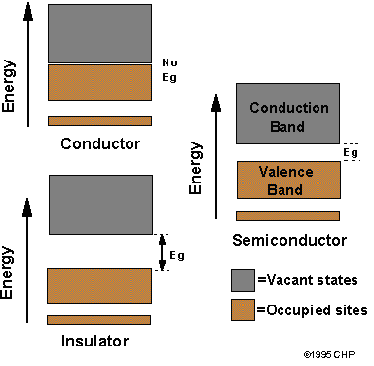

Figure 1. Electronic bands structures in solids (Courtesy of Brian M. Tissue).

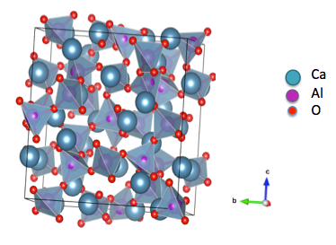
Figure 2. Crystal structure of mayenite [3]

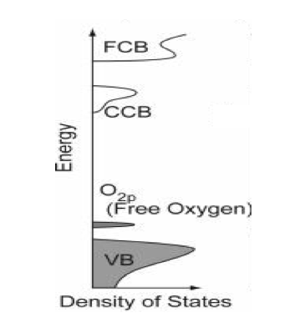
Figure 3. Schematic of an electron energy diagram of stoichiometric mayenite. (Adapted and modify from Matsuishi et al.).

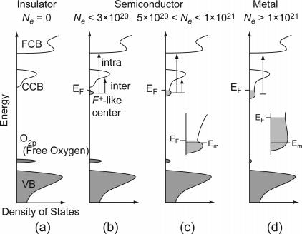
Figure 4. Schematic illustrations of electronic structures of (a) insulating C12A7, (b) low N limit, (c) intermediate, and (d) high N limit C12A7:e. (Adapted from Matsuishi).

Tables

Table 1. Ionic radii of mayenite framework cations and dopants [23].
Element | Charge | Coordination Number | Crystal Radius (A) | Effective Radius (A)
Al | 3+ | 4  6 | 0.53  0.675 | 0.39  0.535
Ca | 2+ | 6  8 | 1.14  1.26 | 1.00  1.12
Fe | 2+ | 4  6 | 0.77 hs  0.75 ls 0.92 hs | 0.63 hs  0.61 ls, 0.78 hs
Fe | 3+ | 4  6 | 0.63 hs  0.69 ls, 0.785 hs | 0.49 h  0.55 ls, 0.645 hs
Ti | 2+ | 6 | 1.00 | 0.86
Ti | 3+ | 6 | 0.81 | 0.67
Ti | 4+ | 4  6  8 | 0.56  0.745  0.88 | 0.42  0.605  0.74
V | 5+ | 6 |  | 0.54

*hs – high spin, ls – low spin.

CHAPTER II
Experimental

CHAPTER III
Mayenite Synthesized Using the Citrate Sol-Gel Method

Disclosure
This chapter is based on the manuscript submitted to the Journal of the Materials Research Bulletin. The full list of authors includes Sabina Ude, Claudia J Rawn, Roberta A Peascoe, Gregory L Jones; Melanie J Kirkham, Edward A Payzant. The role of Sabina Ude was to perform all experiments, process and analyze all data, and prepare the manuscript for submission. The rest of the authors provided intellectual support during the experiments and/or data analysis.

Abstract
A citrate sol-gel method has been used to synthesize mayenite (Ca₁₂Al₁₄O₃₃). X-ray powder diffraction data show that samples were single phase when fired at 900°C and above. High temperature x-ray diffraction data collected in-situ, in air, at temperatures of 600°C and below show only amorphous content; however, data collected at higher temperatures indicate the first phase to crystallize is CaCO₃. High temperature x-ray diffraction data collected in 4% H₂/96% N₂ does not show the presence of CaCO₃, and Ca₁₂Al₁₄O₃₃ starts to form around 850°C. DTA/TGA data collected either in a nitrogen environment or air suggest the complete decomposition of meta-stable phases and the formation of mayenite at 900°C although the phase evolution is very different depending on the environment. BET measurements show a slightly higher surface area in the citrate gel synthesized samples compared to a solid-state synthesized sample. SEM analysis was also conducted on the prepared samples.

Keywords: B. sol-gel chemistry, C. electron microscopy, C. thermogravimetric analysis (TGA), C. X-ray diffraction, D. surface properties.

Introduction

The mineral mayenite (Ca₁₂Al₁₄O₃₃), historically studied as a common phase present in Portland cement, has recently enjoyed renewed research interest due to the discovery of oxygen mobility [1-4], ionic conductivity [5-8], and catalytic properties [9, 10]. The physical properties observed in mayenite are related to its crystal structure. The crystal structure is cubic with a unit cell edge of approximately 12 Å and has Z (formula unit) of 2 [5] and is comprised of both nano-pores and polyhedra that form cages (similar to zeolites). The formula Ca₁₂Al₁₄O₃₃ refers to a unique feature of the anion diffusion process, 64 of the 66 oxygen ions per unit cell are fixed in a Ca-Al-O framework forming 12 “cages”[11] while the other two oxygen ions are distributed within the cages, the formula can be written as in equation 3-1.
[Ca₁₂Al₁₄O₃₂] + O⁻² Eq. 3 - 1

The cages are approximately 5 Å in diameter and the openings between them are approximately 3.5 Å. It has been suggested that these openings control the mass transport between the inner cages and the outside [11]. On average each cage has a mean effective charge of +1/3. The free oxygen anions compensate for this positive charge of the framework and are loosely bound to the framework. There is flexibility for the substitution of the free O²⁻ ions with other anions such as fluoride, chloride, hydroxides or hydride, as well as electrons, forming electrides [2, 12-17]. Another application, in addition to being an electride, is the generation of negative O⁻ used in chemical syntheses and materials modifications [18, 19].

Mayenite has been prepared in various ways, with solid-state synthesis being the commonly used method. Wet chemistry routes are becoming popular especially sol-gel synthesis. Sol-gel technique involves the conversion of a solution of molecular precursors by a chemical reaction into a sol or a gel, which is subsequently transformed into a crystalline material upon drying and subsequently firing [20]. Synthesis steps are performed under ambient conditions, involving no difficult technical challenges in terms of instrumentation or special environment. In this work, citrate sol-gel method, which is simple and cost-effective, has been used to prepare bulk mayenite at a lower temperature and shorter time.

Experimental

Synthesis

The starting materials for the solid-state synthesis were powders of CaCO₃ (Fisher Chemicals, 99%) and γ-Al₂O₃ (Alfa Aesar, 99.5%). The powders were appropriately weighed out and thoroughly mixed with an agate mortar and pestle, using methanol. After drying the powder was pressed into a pellet using a 13 mm die. The pellet was fired in an alumina crucible at 1200 ˚C for 16 hours, and then reground in the agate mortar and pestle, re-pressed, and fired at 1350˚C for 23.5 hours then air quenched. The starting materials for the citrate gel technique included Ca(NO₃)₂•4H₂O (Fisher Chemical, 99.5%), Al(NO₃)₃•9H₂O (Fisher Chemical, 98.9%), and citric acid (C₆H₈O₇) (Alfa Aesar, 99%). The citric acid is a type of weak alpha-hydroxycarboxylic acids that have the ability to form polybasic acid chelates with various cations [21]. This ensures cations to be uniformly distributed in the mixture. Appropriate amounts of nitrates were measured and dissolved in de-ionized water; the solution was heated on a hot plate up to 60˚C before pouring in the citric acid. The citrate-nitrate mixture was heated and vigorously stirred with magnetic stir bar at 90 ˚C until a gel was formed (about 4-7 hours). The resulting gel was placed in a drying oven slightly above 100 ˚C to dry off the H₂O, and the gel transformed into a cake-like structure, which was subsequently crushed into powder using an agate mortar and pestle. The powder was then divided for the ex-situ and in-situ firing. The samples for the ex-situ experiment were pressed into four pellets. The pellets were each fired at various temperatures (T = 1100, 1000, 900 and 800 ˚C) for 4 hours in alumina crucibles. All samples were air quenched and ground by hand in the agate mortar and pestle for subsequent phase identification using x-ray powder diffraction. The powder for the in-situ experiments was pre-calcined at 450/600 ˚C. Chart 1 illustrates the steps of the citrate gel synthesis.

Characterization
X-ray powder diffraction was used to characterize the resulting powders. The data were collected on a X’Pert PRO MPD θ-θ diffractometer [PANalytical, Inc.] equipped with an X’celerator Real Time Multiple Strip (RTMS) detector that allows ultrafast data collection. The system was operated at 45 kV and 40 mA using Cu Kα radiation. The data were collected over a range of 10˚-75˚ 2θ with a 0.017° step size and a count time set so that each data collection lasted approximately 12 minutes. Data for Rietveld refinements were collected using longer count times. A platinum strip heater furnace chamber [Anton Paar HT16] was used for the in-situ studies. Due to thermal gradients along the strip (both ends of the strip heater are water-cooled), thermal gradients between the sample and the strip due to interfacial thermal contact resistance, and the thermal conductivity of the sample, a temperature calibration was performed using Al₂O₃ and MgO standards in order to verify the accurate temperature readings. Additionally, an optical pyrometer was used to determine the temperature of the powder during the study. Data were collected in both air and flowing 4%H₂/96% N₂. Quantitative phase amounts were determined from Rietveld refinements performed using the EXPGUI graphical interface [22] for the General Structure Analysis System (GSAS) [23]. Jade [Jade 6.0, Materials Data Inc.] and HighScore [X’Pert HighScore Plus 3.0, PANalytical, Inc.] software packages were used for phase identification.

Differential Thermal Analysis (DTA) and Thermal Gravimetric Analysis (TGA) were conducted using a TA Instruments SDT Q600 (simultaneous TGA/DSC) at a rate of 5˚C/minute with either nitrogen or compressed air as the purging gas. Scanning Electron Microscopy (SEM) analysis was conducted on the solid-state sample fired at 1350 ˚C and the citrate gel sample fired at 1100 °C using a LEO 1525 Field Emission Scanning Electron Microscope. Specific surface area and porosity were measured using a Micromeritics' ASAP 2020 Accelerated Surface Area and Porosimetry Analyzer.

Results and Discussion
Qualitative physical observations of the pellets after firing included size and color changes. As expected the pellet size decreased, with the citrate gel samples showing a significant reduction in size due, in part, to the loss of evolved gaseous compounds like NO₂, CO₂, NO, etc. This observation is confirmed from the temperature analysis of the citrate gel powder, as shown in Figure 3 - 1a (Appendix C), with about 34 wt% remaining after the analysis. All samples synthesized using the citrate gel technique and fired in air were white after firing at temperatures above 800˚C, and the sample fired at 800˚C was grey suggesting that at this temperature the sample did not reach equilibrium. Firing the pellets in a reducing atmosphere resulted in a black color. The citrate gel samples were easier to grind by hand compared to the solid-state samples.

The TGA/DTA data collected on mayenite, synthesized using the citrate gel method, in a nitrogen environment are shown in Figure 5a. Three areas of major weight changes are observed. The first peak is at approximately 100 ˚C resulting from the evaporation of water; the second peak is at approximately 400 ˚C, possibly resulting from the decomposition of the nitrates and burning off of other organic compounds, and the third peak is at approximately 900˚C suggesting the complete decomposition of all meta-stable phases and formation of mayenite. The DTA data collected on mayenite synthesized using the citrate gel method, in air, are shown in Figure 5b and show a more complicated reaction. Water evaporates above 100 ˚C followed by decomposition of citric acid into CO and CO₂ around 175 ˚C. Al(NO₃)₃ decomposes into Al₂O₃ and NO₂ around 400 ˚C, while Ca(NO₃)₂ decomposes into CaO and NO₂ around 561˚C. The exothermic peak around 750 ˚C indicates the transition of amorphous to crystalline phase, this was also observed in the x-ray results discussed later. The peaks below and above 900 ˚C suggest decomposition of CaCO₃ initially formed from CO₂ from the citric acid and CaO from calcium nitrate, and complete decomposition of all meta-stable phases and formation of mayenite.

Ex-situ x-ray powder diffraction data collected on the citrate sol-gel sample fired in air at 800˚C showed a high background suggesting the presence of amorphous content. Crystalline phases present included Ca₁₂Al₁₄O₃₃ (64.9wt%), CaAl₂O₄ (21.9wt%) and CaCO₃ (13.2wt%) – note that the calculated fraction of each phase does not consider any amorphous phase. After re-firing at 800˚C in air for four hours, the x-ray data collected showed improved background and change in fraction of each phase, Ca₁₂Al₁₄O₃₃ (79.6wt%), CaAl₂O₄ (14.0wt%) and CaCO₃ (6.4wt%) confirming that several firings at that temperature are necessary to reach equilibrium. The ex-situ x-ray powder diffraction data, collected on the samples synthesized by the citrate gel method and fired in air at 900˚C and above, all showed single-phase mayenite indicating that the approximate minimum temperature to obtain a single phase is 900 ˚C. Figure 6 compares the ex-situ x-ray powder diffraction data for all the citrate gel samples fired in air and clearly shows that all samples are single phase except for the sample fired at 800 ˚C.

In-situ x-ray diffraction data collected in air at temperatures of 600˚C and below show only amorphous content; however, data collected at higher temperatures indicate the first phase to crystallize is CaCO₃ around 750 ˚C, while the alumina content remains amorphous. Figure 7a compares the in-situ x-ray powder diffraction data for citrate gel samples at room temperature, 600, 750 and 800 ˚C. Figure 7b shows in-situ x-ray data collected at 850˚C over time. At 850 ˚C, Ca₁₂Al₁₄O₃₃, Ca₃Al₂O₆ and CaAl₂O₄ are present. The CaAl₂O₄ phase disappeared over time leaving mayenite as the dominant phase with a minor amount of Ca₃Al₂O₆ present. Data collected in 4% H₂/96% N₂ does not show the presence of CaCO_{3,} and Ca₁₂Al₁₄O₃₃ is the first phase to form around 850 ˚C. The minor amount of Ca₃Al₂O₆ detected in samples fired in both air and 4% H₂/96% N₂ is most likely due to slight errors of the starting ratios (e.g. either when weighing out the samples or from excess H₂O in the precursors since the nitrates are highly hygroscopic). At these low temperatures only a minor amount of Ca₅Al₆O₁₄ has been observed. Figure 8 compares in-situ x-ray powder diffraction data of citrate gel synthesis samples when in 4% H₂/ 96% N₂ at 800˚C, 850 ˚C and 900 ˚C.

Figure 9 shows the lattice parameters refined from the x-ray powder diffraction data collected on mayenite synthesized using the citrate sol-gel method and fired in-situ in air. The lattice constant was found to be 11.978 Å at room temperature, close to the literature value [5], and it increased linearly with increasing temperature. The linear thermal expansion coefficient was calculated to be 6.12 x 10⁻⁶ K⁻¹ and is in good agreement with value reported by Boysen et al [24].

Figure 10 and Figure 11 show SEM images collected at different magnifications for the solid-state and citrate sol-gel samples, respectively. The micrographs show randomly shaped particles from samples synthesized using both techniques, however, particles produced using the citrate sol-gel technique were more rounded than the particles produced using solid-state synthesis. The particles produced using the citrate sol-gel technique were smaller and displayed more collapsed and smaller pores compared to particles produced using the solid-state synthesis.

BET surface area analysis results are summarized in Table 3. 1. A pore size of 34.39 nm and a surface area of 1.61(2) m²/g were determined for the sample produced using solid-state synthesis and fired at 1350°C. In comparison, a pore size of 7.99 nm and a surface area of 2.99(4) m²/g were determined for the sample produced using the citrate sol-gel technique and fired at 1100 °C. It has been established that solid-state synthesis does not produce mayenite with high surface area [25], and the low surface area reported for the citrate sol-gel produced samples (i.e. less than 10 m²/g) suggests that this technique is not producing mayenite with a high surface area either. The sample fired at 800 °C shows the maximum surface area of 7.4(1) m² /g while the sample fired at 1100 °C has the lowest surface area of 2.99(4) m²/g. The sample fired at 1100 °C also has the smallest pore size proving that the pores collapse at higher temperatures similar to what is observed in the solid-state sample fired at 1350 °C.

Conclusions
Samples synthesized using the citrate gel technique were phase pure when fired in air at 900 ˚C or above. Citrate gel samples fired at 800 ˚C showed multiple phases including calcite. Particles produced by the citrate gel method show more and tinier pores compared to particles synthesized using the solid-state technique. The citrate gel synthesis does not produce mayenite with high surface area. Citrate sol-gel synthesis proves to be a good technique for producing mayenite requiring less time and lower temperatures, without subsequent firings in order to reach equilibrium. It also guarantees homogenous mixing of the raw materials.

Acknowledgements
SNU was partly supported by Pipeline Engineering Diversity Program under DOE grant DE-FG02-05ER25717, and partly sponsored by the Center for Materials Processing (CMP) at the University of Tennessee. X-ray powder diffraction data were collected at the High Temperature Materials Laboratory at Oak Ridge National Laboratory, which is sponsored by the U.S. Department of Energy, Office of Energy Efficiency and Renewable Energy, Vehicle Technologies Program. A portion of this research was conducted at the Center for Nanophase Materials Sciences, sponsored at Oak Ridge National Laboratory by the Scientific User Facilities Division, Office of Basic Energy Sciences, U.S. Department of Energy. The authors would like to thank Austin Albert for his help with the BET data collection and analysis.

References

[1] S. Fujita, M. Ohkawa, K. Suzuki, H. Nakano, T. Mori, H. Masuda, Chemistry of Materials, 15 (2003) 4879-4881.
[2] Z. Li, J. Yang, J.G. Hou, Q. Zhu, Angewandte Chemie International Edition, 43 (2004) 6479-6482.
[3] A.L.S. Peter V. Sushko*, Katsuro Hayashi, Masahiro Hirano, Hideo Hosono Phys. Rev. B, 73 (2006) 014101.
[4] K. Hayashi, N. Ueda, S. Matsuishi, M. Hirano, T. Kamiya, H. Hosono, Chemistry of Materials, 20 (2008) 5987-5996.
[5] S. Matsuishi, Y. Toda, M. Miyakawa, K. Hayashi, T. Kamiya, M. Hirano, I. Tanaka, H. Hosono, Science, 301 (2003) 626-629.
[6] Y. Toda, S. Matsuishi, K. Hayashi, K. Ueda, T. Kamiya, M. Hirano, H. Hosono, Advanced Materials, 16 (2004) 685-689.
[7] T. Kamiya, S. Aiba, M. Miyakawa, K. Nomura, S. Matsuishi, K. Hayashi, K. Ueda, M. Hirano, H. Hosono, Chemistry of Materials, 17 (2005) 6311-6316.
[8] O. Trofymluk, Y. Toda, H. Hosono, A. Navrotsky, Chemistry of Materials, 17 (2005) 5574-5579.
[9] S. Fujita, H. Nakano, K. Suzuki, T. Mori, H. Masuda, Catal Lett, 106 (2006) 139-143.
[10] C. Li, K. Suzuki, J Therm Anal Calorim, 98 (2009) 261-266.
[11] H. Boysen, I. Kaiser-Bischoff, M. Lerch, Diffusion Fundamentals, 8 (2008) 2.1-2.8.
[12] P.V.S. Sushko, A.L; Hayashi, K;, Hirano,, H. M; Hosono, Phys. Rev. Lett, 91 (2003).
[13] J.E. Medvedeva, A.J. Freeman, Applied Physics Letters, 85 (2004) 955-957.
[14] J.L. Dye, Inorganic Chemistry, 36 (1997).
[15] K. Hayashi, S. Matsuishi, T. Kamiya, M. Hirano, H. Hosono, Nature, 419 (2002) 462-465.
[16] K. Hayashi, M. Hirano, S. Matsuishi, H. Hosono, Journal of the American Chemical Society, 124 (2002) 738-739.
[17] K. Hayashi, S. Matsuishi, N. Ueda, M. Hirano, H. Hosono, Chemistry of Materials, 15 (2003) 1851-1854.
[18] Q.X. Li, K. Hayashi, M. Nishioka, H. Kashiwagi, M. Hirano, Y. Torimoto, H. Hosono, M. Sadakata, Applied Physics Letters, 80 (2002) 4259-4261.
[19] A.S. Tolkacheva, S.N. Shkerin, S.V. Plaksin, E.G. Vovkotrub, K.M. Bulanin, V.A. Kochedykov, D.P. Ordinartsev, O.I. Gyrdasova, N.G. Molchanova, Russ J Appl Chem, 84 (2011) 907-911.
[20] A.K. Cheetham, C.F. Mellot, Chemistry of Materials, 9 (1997) 2269-2279.
[21] X. Yuan, Y.B. Xu, Y. He, Materials Science and Engineering: A, 447 (2007) 142-145.
[22] B. Toby, Journal of Applied Crystallography, 34 (2001) 210-213.
[23] A. Larson, R. Von Dreele, J. Appl. Crystallogr, 34 (2000) 210.
[24] H. Boysen, M. Lerch, A. Stys, A. Senyshyn, Acta Crystallographica Section B, 63 (2007) 675-682.
[25] S.G. Yoon, S.W. Kim, M. Hirano, D.H. Yoon, H. Hosono, Crystal Growth & Design, 8 (2008) 1271-1275.

Appendix C

Chart

Chart 1. Flow chart of the citrate gel synthesis of mayenite.

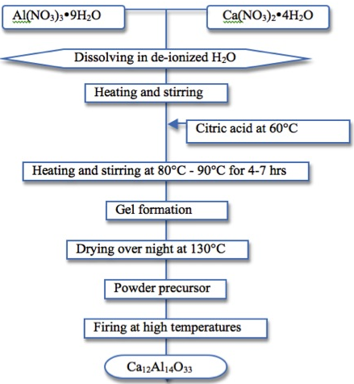
Figures

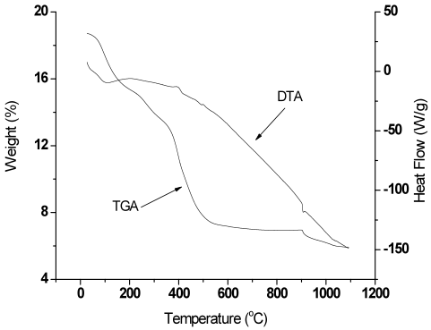

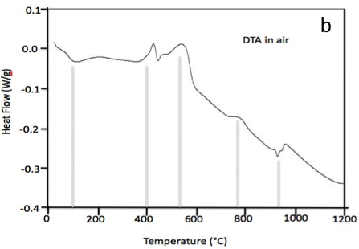
Figure 5. DTA/TGA curves of mayenite synthesized using the citrate gel method collected in (a) a nitrogen environment and (b) compressed air environment.

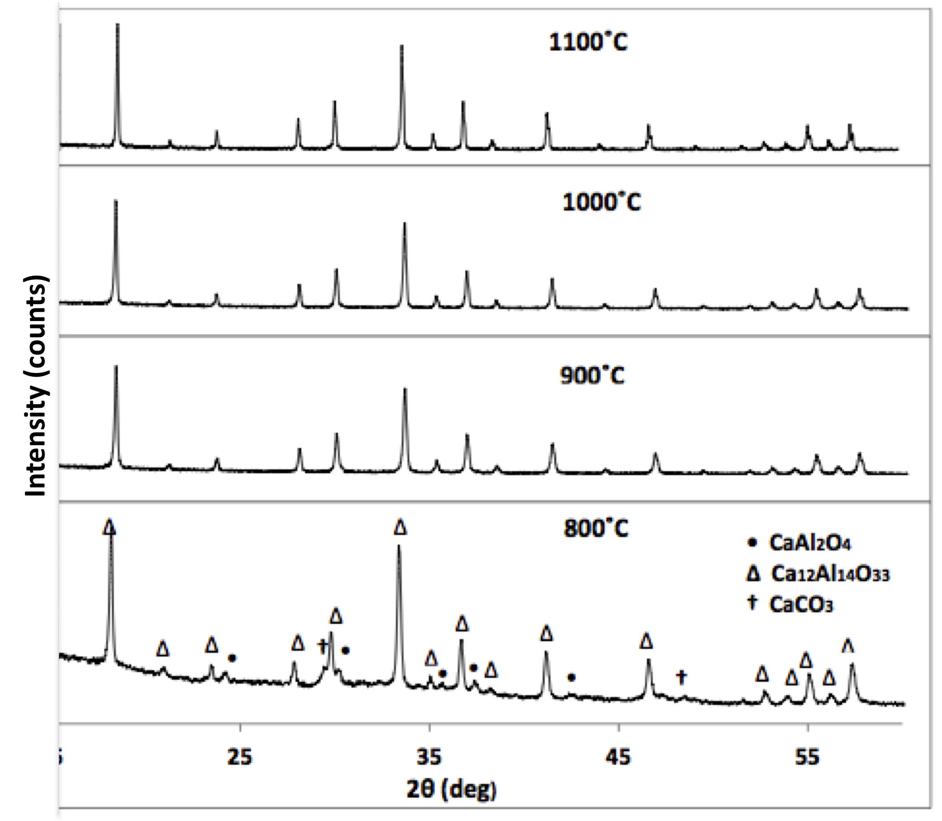
Figure 6. Ex situ x-ray powder diffraction pattern collected on mayenite synthesized using the citrate gel method and fired in air at 800˚C, 900˚C, 1000˚C, or 1100˚C.

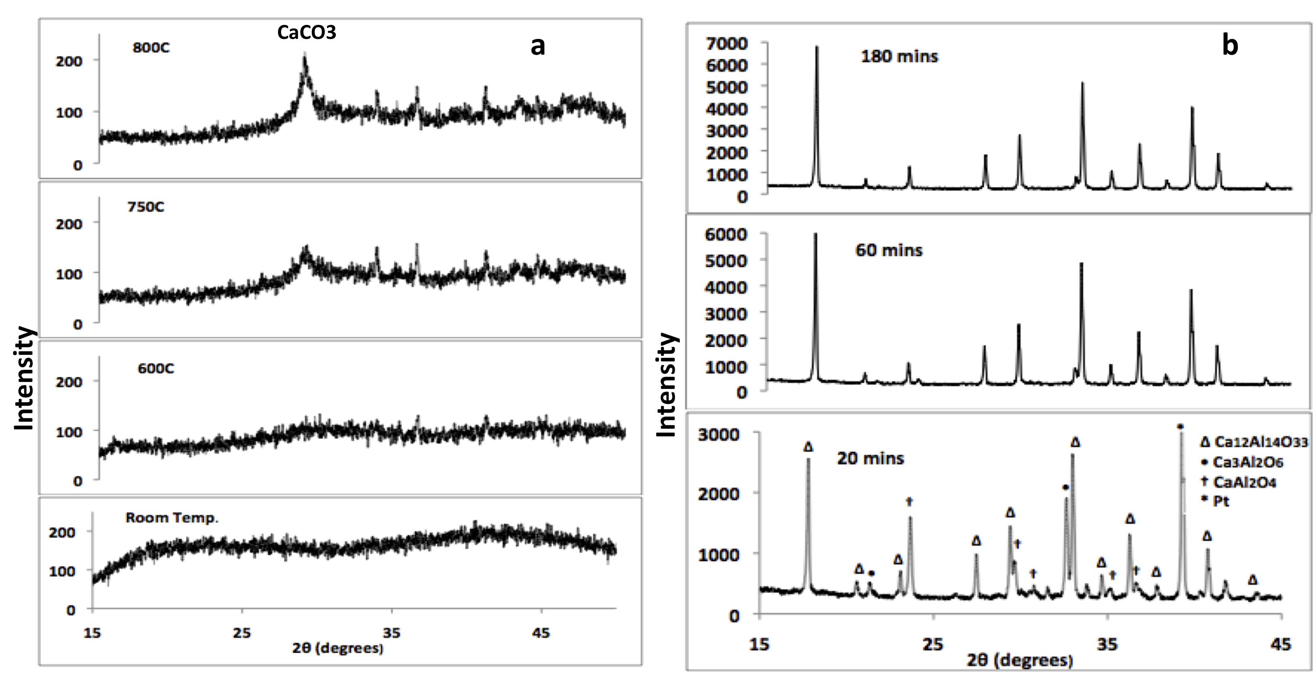
Figure 7. In-situ x-ray powder diffraction pattern of mayenite synthesized using the citrate gel method, fired in air (a) at room temperature, 600˚C, 750˚C and 800˚C, and (b) at 850˚C over time.

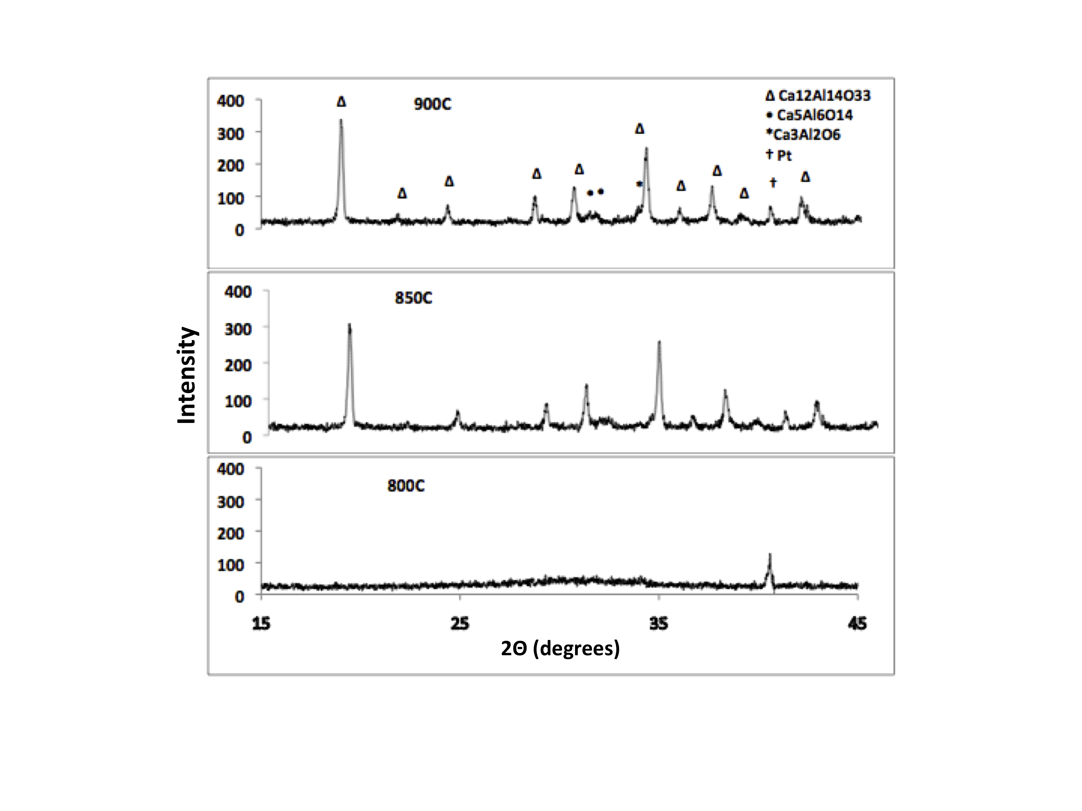
Figure 8. X-ray powder diffraction pattern of mayenite synthesized using the citrate gel method and fired in 4% H₂/96% N₂ at 800˚C, 850˚C and 900˚C.

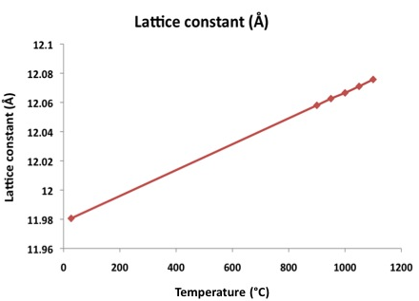
Figure 9. Refined lattice parameter of mayenite synthesized using the citrate gel method and fired at various temperatures.
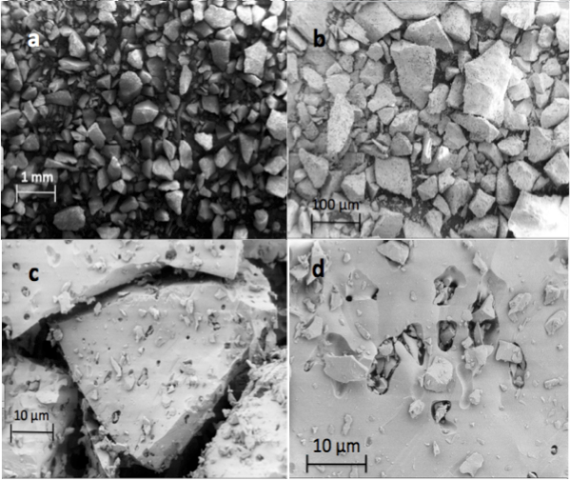
Figure 10. SEM micrographs of solid-state synthesized mayenite fired at 1350°C and taken at (a) 50X, (b) 100X, (c) 500X, and (d) 2500X.
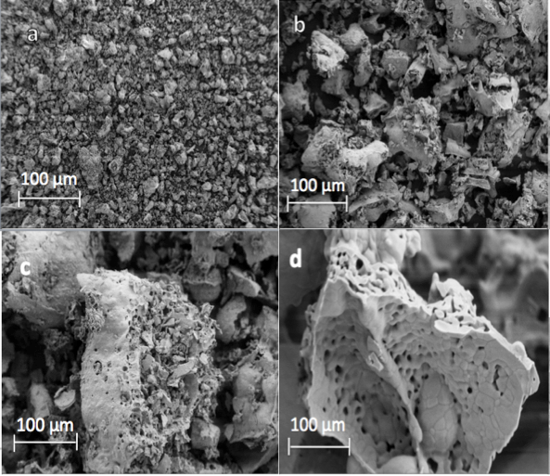
Figure 11. SEM micrographs of citrate gel synthesized mayenite fired at 1100°C and taken at (a) 100X, (b) 500X, (c) 1000X, and (d) 20000.

Table

Table 2. Summary of BET results.
Technique | Temperature (˚C) | BET Surface Area (m²/g) | Pore Volume (cm³/g) | Pore Size (nm)
Citrate gel | 1100 | 2.99 ± 0.04 | 0.006 | 7.99
Citrate gel | 900 | 6.1 ± 0.2 | 0.069 | 44.81
Citrate gel | 800 | 7.4± 0.1 | 0.083 | 44.71
Solid state | 1350 | 1.61 ± 0.02 | 0.014 | 34.39

CHAPTER IV
The Synthesis and Crystal Chemistry of Ca₁₂Al₁₄O₃₃ (Mayenite) doped with Fe

Disclosure
This chapter is based on the manuscript prepared for submission to a peer reviewed Journal. The full list of authors includes Sabina Ude, Claudia J Rawn, Ashfia Huq and Thomas Meek. Ashfia Huq collected the neutron data, Claudia analyzed neutron data, and Thomas Meek helped in analyzing the electrical measurements. While Sabina Ude performed the experiments, processed and analyzed the rest of the data, and prepared the manuscript for submission.

Abstract
X-ray and neutron powder diffraction have been used to study the crystal chemistry of Fe doped mayenite (Ca₁₂Al_{14-x}Fe_{x}O₃₃). Solid-state synthesis was used to prepare Ca₁₂Al_{14-x}Fe_{x}O₃₃ where x = 0, 0.1, 0.2, 0.5 and 0.6 and the citrate gel route was used to prepare Ca₁₂Al_{14-x}Fe_{x}O₃₃ where x = 0, 0.05, 0.1, 0.2, 0.3 and 0.4. Based on characterization using X-ray powder diffraction, it was found that samples with the same composition but synthesized by the citrate gel route were more likely to be phase pure than samples obtained by traditional solid-state synthesis. The refined lattice parameters were observed to increase with increasing Fe concentration, irrespective of the synthesis method. Refined neutron data showed that Fe is going into Al site rather than Ca site. A 2-point probe was used to measure the electrical properties of the citrate gel synthesized samples, the result showed that Fe doped samples have higher resistance than the undoped mayenite.

Introduction
The mineral mayenite, Ca₁₂Al₁₄O₃₃, has been traditionally known as a constituent of Portland cements. It has a body centered cubic crystal structure belonging to the I-43d (number 220) space group with a = 11.989 Å with 2 formula units per unit cell [1]. In recent decades mayenite’s interesting electrical, optical, and catalytic properties have been discovered [2-11]. These interesting physical properties result from its unique framework structure that allows various anions to be distributed among the cages formed by the framework [6, 12, 13].

Since many interesting physical properties are a result of point defects, it is of interest if cation substitutions can be made in the framework of mayenite and how these defects would affect the anion distribution inside the cages and ultimately the conductivity of mayenite. Will the conductivity change by introducing point defects replacing either Ca²⁺ or Al³⁺ by Fe²⁺/Fe³⁺ and if so how much of the Ca and/or Al can be replaced by Fe? A phase diagram of the CaO-Al₂O₃-Fe₂O₃ ternary phase diagram (Figure 12) shows there is a limited range of Fe incorporation into the mayenite structure [14]. Boysen et al. used neutron powder diffraction to characterize samples with 0.1 and 2.5 mol% Fe synthesized using sol-gel method, and indicated that doping mayenite with Fe suppressed the incorporation of extra anions while exhibiting large disorder in the crystal [15]. Boysen predicted high anionic conductivity due to an observed large disorder at room temperature and extreme delocalization at high temperatures; however, the effect of Fe on the electrical property of mayenite has not been reported.

In this present work, pure and Fe substituted mayenite have been synthesized using both solid state and citrate gel techniques, and characterized using x-ray and neutron powder diffraction. The electrical property has been measured using a 2-point probe.

Experimental
Samples of Fe doped (Ca₁₂Al_{14-x}Fe_{x}O₃₃) mayenite were produced by both solid-state and citrate gel syntheses. Starting powders of CaCO₃ (Fisher Chemicals, 99%), Al₂O₃, (Alfa Aesar, 99.5%) and Fe₂O₃ (Alfa Aesar, 99.95%) were used as precursors for the solid-state synthesis where x = 0, 0.1, 0.2, 0.5 and 0.6. The synthesis was carried out as described by Ude et al. [16]. The samples underwent initial firing at 1200˚C for 16 hours. The final firing of the undoped mayenite was at 1350˚C for 23.5 hours, while the Fe doped samples were fired at 1350˚C for 18 hours. Final firing of samples where x = 0.2 and 0.6 were also tried separately at 1200˚C and 1300˚C for 18 hours to see if Fe can lower the final firing temperature of mayenite.

Ca(NO₃)₂•4H₂O (Fisher Chemical, 99.5%), Al(NO₃)₃•9H₂O (Fisher Chemical, 98.9%), Fe(NO₃)₃•9H₂O (Acros, 98%) and citric acid (C₆H₈O₇) (Alfa Aesar, 99%) were used as precursors for the citrate gel synthesis where x = 0, 0.05, 0.1, 0.2, 0.3 and 0.4. The synthesis also followed the route as described by Ude et al. [16]. The resulting powder was divided in half and one half was used to press pellets and that were subsequently fired at 1000˚C for 4 h in air while the other half were pre-calcined at 600˚C as loose powder and then pressed into pellets and fired in flowing 4%H₂/96%Ar at 1200˚C for 6 h.

Samples used in x-ray and neutron diffraction measurements were ground into fine powders. For the x-ray powder diffraction measurements, the powders were back loaded into deep welled sample holders and spun during the data collection to improve sampling statistics. The data were collected on a PANalytical X’Pert PRO MPD θ-θ diffractometer. The diffractometer was equipped with an X’celerator Real Time Multiple Strip (RTMS) detector that allows ultrafast data collection. The system was operated at 45KV and 40mA and data were collected using Cu Kα radiation over a 2θ range of 5˚-140˚ with a count time set so that each data collection lasted approximately 20 minutes. X-ray powder diffraction data were analyzed using Jade [Jade 6.0, Materials Data Inc.] and HighScore [X’Pert HighScore Plus 3.0, PANalytical, Inc.] software packages for phase identification; and Rietveld refinements were performed using the EXPGUI graphical interface [17] for the General Structure Analysis System (GSAS) [18].

Neutron powder diffraction data were collected on samples synthesized using the citrate gel method where x = 0 and 0.3. The diffraction measurements were carried out using the high resolution powder diffractometer (POWGEN) at the Spallation Neutron Source at Oak Ridge National Laboratory [19]. Samples were loaded in 6 mm diameter vanadium cans and data were collected at room-temperature, using wavelength bands centered at 1.066 and 1.599Å covering a d spacing range of 0.3 – 4.3Å. Rietveld refinements on the collected data were performed using the GSAS software package and the EXPGUI interface.
Electrical resistance measurements were carried on a probe station using a 2-point Probe. The measurements were from 0 to 20 V at a step size of 0.5 and 0.1 compliance.

Results and Discussion
General physical observations of the pellets after firing included color changes. For both synthesis techniques the sample without Fe was white after firing in air compared to the samples containing Fe which were light green and became darker with increasing Fe content. Figure 13a shows an image samples synthesized using solid-state method where x = 0.1 and 0.6. The samples fired in flowing 4%H₂/96%Ar turned black, and are shown in Figure 13b. As the Fe content was increased the samples were easier to grind. It has been noted that Fe increases the porosity in sinters thereby reducing their strength [20].

Phase Identification
Figure 14 compares the X-ray powder diffraction data for the samples prepared using the citrate gel route. Samples with x = 0, 0.05, 0.1, and 0.3 were single phase while the samples where x = 0.2 and 0.4 contained a minor amount (less than 0.1wt%) of the meta-stable phase Ca₅Al₆O₁₄ present as a secondary phase. The double peaks belonging to Ca₅Al₆O₁₄ are seen at 2θ = positions 30.58° and 31.02°. Ca₅Al₆O₁₄ is a meta-stable phase of mayenite whose production is favored in oxygen deficient environment and also by high temperature [21].

Figure 15 compares X-ray powder diffraction data for the samples prepared using solid-state synthesis. Only the sample without Fe was single phase, all samples with Fe contained Ca₃Al₂O₆ as a secondary phase and their weight fractions are given in table 1. The Ca₃Al₂O₆ major peak position is at 2θ = 33.21°. The sample where x = 0.5 and 0.6 had small amounts of an extra phase in addition to Ca₃Al₂O₆ with two major peaks located at 2θ = 45.5° and 34.1°. The peaks from the extra phase were found to match the phase Ca₂Fe_{0.7}Al_{1.3}O₅ [22]. The presence of Ca₂Al_{1.38}Fe_{0.62}O in both samples, suggests that incorporation of Fe beyond x = 0.4 cannot yield single-phase solid solution of mayenite. Furthermore, samples with x = 0.2 and 0.6 fired at various temperatures (1200, 1300 and 1350˚C) showed similar x-ray patterns for each Fe content at the various temperatures, proving that equilibrium can be reached at a lower temperature (1200˚C) when mayenite is doped with Fe as compared to 1350˚C when undoped.

Lattice Paramter
Figure 16 compares the lattice parameters, obtained from the Rietveld refinements of x-ray data, for the samples synthesized by both techniques. The mayenite structure reported by Bartl et al [23] was used as the model during refinement. For both synthesis techniques the lattice parameter showed a slight increase with increasing Fe concentration. For CN of 6, the ionic radius for Al is 0.54, 0.65 for Fe and 1 Å for Ca. It will be easier for Fe to replace Al since their radii are closer compared to that of Ca. The increase in lattice parameter then suggests that Fe is replacing Al since Fe has larger ionic radius than Al. The defect reaction of Fe³⁺ in mayenite represented by Kroger-Vink notation would be as shown below. Also, the presence of the secondary phase Ca₃Al₂O₆ in some of the samples as Fe increase shows that the quantity of Al was reducing while Ca is increasing as the reaction moves towards CaO rich region in the CaO – Al₂O₃ binary phase. Also, during refinement, with addition of Fe on Ca site, the sof was over 1 while that of Fe was negative, yet another evidence that Fe does not go into Ca site. This will be discussed in details with the neutron powder diffraction data.

Figure 17 shows the neutron powder diffraction data (I_{obs}) collected at room temperature (298 K) for the citrate gel base mayenite (x = 0), the calculated neutron powder diffraction pattern (I_{calc}), and the difference pattern (I_{obs} – I_{calc}). The structure proposed by Bartl and Scheller [24], with only one Ca site (24d) and where the O atom located on the 24d site is only partially occupied, was first used to model the calculated pattern. Full refinement on both the atomic positions and atomic displacement parameters was not possible. Next the structure proposed by Boysen et al. [24], with two partially occupied Ca atoms on different 24d sites and the O atom, that Bartl and Scheller [24] suggested was on the 24d site, was moved slightly to occupy a 12a site, was used to model the calculated pattern. The refinements using the two partially occupied Ca positions resulted in one of the Ca’s atomic displacement parameters going non-positive definite, however, moving the O from the 24d site to the 12a site and having only one Ca position resulted in improved fit. A total of 36 variables were refined including all atomic positions, atomic displacement parameters, the site occupancy for the O on the 12a site and resulted in a χ² = 1.704 (wRp = 4.8% and Rexp = 3.71%). Refining on the site occupancy factor (sof) of the O atom in the 12a site revealed the site was about ¼ occupied resulting in a chemistry of Ca₂₄Al₂₈O_{67,} slightly oxygen rich.

The samples were synthesized according to Ca₁₂Al_{14-x}Fe_{x}O₃₃ indicating the Fe was substituting for the Al as suggested by Boysen [16]. To confirm this, neutron powder diffraction data were collected on a sample with x = 0.3. The calculated diffraction pattern was originally modeled with the one Ca position and the partially occupied O in the 12a position and then a series of additional patterns were calculated with the Fe in all of the different framework cation sites. Without adding Fe to the structure and refining on 34 variables including all the atomic positions and atomic displacement parameters resulted in a c² = 1.593 (wRp = 5.71% and Rexp = 4.55%). Next the site occupancy factors of all atoms were refined and resulted in a slightly lower χ² and statistically significant vacancies on sites with the exception of the Al on the 16c site. Creating a model where the Ca and Fe shared a site and the atomic positions and the atomic displacement parameters were constrained to be equal, and refining on the site occupancies resulted in negative sof for Fe and a value greater than one for Ca and the refinement diverged. When Fe was placed on the Al sites separately the refinements did not diverge and slightly lower χ²s were obtained (χ² = 1.587 when Fe replaced the Al on the 16c position and χ² = 1.592 when Fe replaced the Al on the 12b site). Based on the refined compositions a more significant amount of Fe was located on the 16c position. Two additional refinements were attempted one with Fe substituting on both Al sites and one with Fe substituting on all three cation sites. Both of these refinements resulting in slightly lower but not significantly lower χ²s, especially given the fact that more variables were introduced using these models. Based on all these refinements it appears that Fe is substituting on to the Al 16c site, however the calculated formula based on the refinement results was slightly low in Al and high in Fe. For the samples with x = 0 and x = 0.3 the refined lattice constants were a = 11.9884(3) and 11.9934(3) Å, respectively, agreeing with the results determined from refinements on the x-ray powder diffraction data.

Conductivity Results
A graph of resistance versus voltage of the measured samples is shown in Figure 18. The undoped sample showed a resistance of about 1.0 x 10⁶ Ω, which was fairly constant at increased voltage. The contact resistance arising between the metal probe and the sample may have contributed to the somewhat high resistance observed in this sample. This is usually the case when using a 2-point probe. However, when compared to the Fe doped samples, they showed even higher resistance, which linearly increases with the voltage. It is assumed that the higher resistance observed in the Fe doped samples is as a result of mobile electrons being trapped by the oppositely charged impurity centers created by Fe. The crystal structure of mayenite consists of a positively charged framework [Ca₁₂Al₁₄O₃₂]²⁺ and free oxygen O²⁻ distributed randomly within the cages of the framework to maintain the charge neutrality of the entire crystal. When the free oxygen ions are removed from the cages through reduction process, electrons are introduced to the cages to keep the charge neutrality of the crystal. These electrons bring about conductivity and the conductivity changes from ionic to metallic as the electron concentration goes from low to high. But in a case where a dopant creates a dopant center or well that is deep, the electrons became electrostatically bound to these centers and become immobile. This is assumed to be the reason why the Fe doped samples showed higher resistance when compared to the undoped sample.

Conclusions
Fe was introduced into mayenite using both solid-state synthesis and citrate gel synthesis. Samples prepared using citrate gel were able to incorporate more Fe while maintaining phase purity while solid-state samples showed multiple phases. It was observed that beyond 0.4 atomic %, Fe started to precipitate out. The lattice parameter of mayenite was observed to increase with increased Fe content as a result of the lager ionic radius in Fe than the Al it is replacing. There was a decrease in conduction from the undoped to the doped mayenite, suggesting that Fe is not an appropriate dopant in enhancing the electrical properties of mayenite.

Acknowledgement
SNU was partly supported by Pipeline Engineering Diversity Program under DOE grant DE-FG02-05ER25717, and partly sponsored by the Center for Materials Processing (CMP) at the University of Tennessee. Characterization data were collected at User Facilities at Oak Ridge National Laboratory (ORNL), ORNL is managed by UT-Battelle LLC, for the US Department of Energy. The X-ray powder diffraction data were collected at the High Temperature Materials Laboratory at ORNL. The neutron powder diffraction data were collected at the Spallation Neutron Source at ORNL and sponsored by the Scientific User Facilities Division, Office of Basic Energy Sciences, U. S. Department of Energy.

References
[1] A.E. W. Bussem, Z. Kristallogr., Kristallgeom., Kristallphys, Kristallchem, 95 (1936).
[2] S. Fujita, M. Ohkawa, K. Suzuki, H. Nakano, T. Mori, H. Masuda, Chemistry of materials, 15 (2003) 4879-4881.
[3] Z. Li, J. Yang, J. Hou, Q. Zhu, Angewandte Chemie International Edition, 43 (2004) 6479-6482.
[4] P.V. Sushko, A.L. Shluger, K. Hayashi, M. Hirano, H. Hosono, Physical Review B, 73 (2006) 014101.
[5] K. Hayashi, N. Ueda, S. Matsuishi, M. Hirano, T. Kamiya, H. Hosono, Chemistry of Materials, 20 (2008) 5987-5996.
[6] S. Matsuishi, Y. Toda, M. Miyakawa, K. Hayashi, T. Kamiya, M. Hirano, I. Tanaka, H. Hosono, Science, 301 (2003) 626-629.
[7] Y. Toda, S. Matsuishi, K. Hayashi, K. Ueda, T. Kamiya, M. Hirano, H. Hosono, Advanced Materials, 16 (2004) 685-689.
[8] T. Kamiya, S. Aiba, M. Miyakawa, K. Nomura, S. Matsuishi, K. Hayashi, K. Ueda, M. Hirano, H. Hosono, Chemistry of materials, 17 (2005) 6311-6316.
[9] O. Trofymluk, Y. Toda, H. Hosono, A. Navrotsky, Chemistry of materials, 17 (2005) 5574-5579.
[10] S. Fujita, H. Nakano, K. Suzuki, T. Mori, H. Masuda, Catalysis letters, 106 (2006) 139-143.
[11] C. Li, Y. Yamamoto, M. Suzuki, D. Hirabayashi, K. Suzuki, Journal of thermal analysis and calorimetry, 95 (2009) 991-997.
[12] H. Boysen, I. Kaiser-Bischoff, M. Lerch, Diffusion Fundamentals, 8 (2008) 2.1-2.8.
[13] J.L. Dye, Inorganic Chemistry, 36 (1997) 3816-3826.
[14] C. Domínguez, R. Torrecillas, Journal of the European Ceramic Society, 18 (1998) 1373-1379.
[15] H. Boysen, I. Kaiser-Bischoff, M. Lerch, S. Berendts, A. Börger, D. Trots, M. Hoelzel, A. Senyshyn, Zeitschrift für Kristallographie Supplements, 2009 (2009) 323-328.
[16] C.J.R. S. N. Ude, R. A. Peascoe, M. J. Kirkham, G. L. Jones, and E. A. Payzant, 2013.
[17] A. Larson, R. Von Dreele, J. Appl. Crystallogr, 34 (2000) 210.
[18] B. Toby, Journal of Applied Crystallography, 34 (2001) 210-213.
[19] A. Huq, J.P. Hodges, O. Gourdon, L. Heroux, Zeitschrift für Kristallographie Proceedings, 2011 (2011) 127-135.
[20] G. Meunier, Sintering in an Experimental Pot-Grate CRM Metallurgical Review, (1971) 5-16.
[21] M. Vincent, J. Jeffery, Acta Crystallographica Section B: Structural Crystallography and Crystal Chemistry, 34 (1978) 1422-1428.
[22] G.J. Redhammer, G. Tippelt, G. Roth, G. Amthauer, American Mineralogist, 89 (2004) 405-420.
[23] H. Bartl, T. Scheller, Neues Jahrb. Mineral. Monatsh, 35 (1970) 547-552.
[24] H. Boysen, M. Lerch, A. Stys, A. Senyshyn, Acta Crystallographica Section B: Structural Science, 63 (2007) 675-682.

Appendix D

Figures

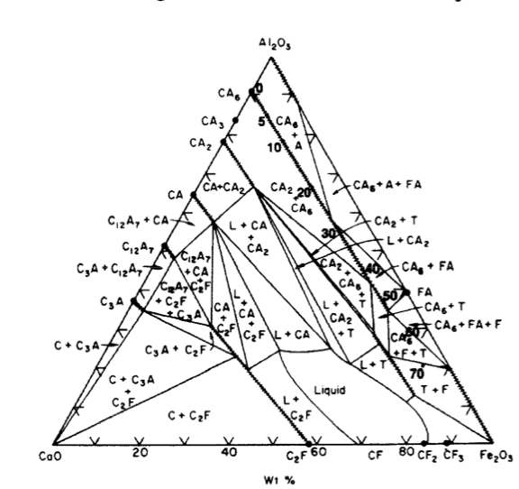

Figure 12 CaO-Al₂O₃-Fe₂O₃ ternary phase diagram [1].

a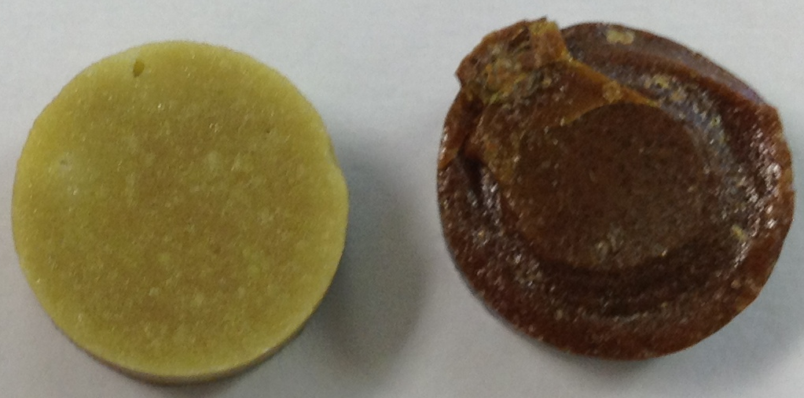
b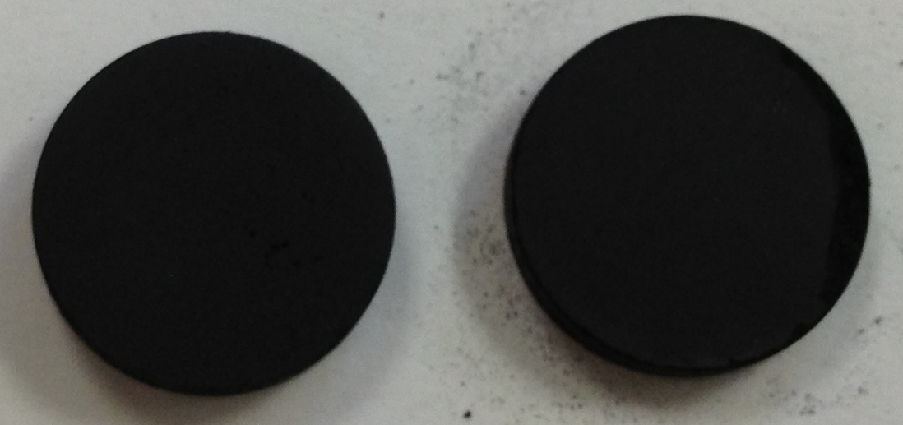

Figure 13. Images of (a) Ca₁₂Al_{14-x}Fe_{x}O₃₃ where x = 0.1 (left) and 0.6 (right) synthesized using solid state techniques and fired in air and (b) Ca₁₂Al_{14-x}Fe_{x}O₃₃ where x = 0.1 (left) and 0.4 (right) synthesized using citrate gel techniques and fired in 4%H₂/96%Ar

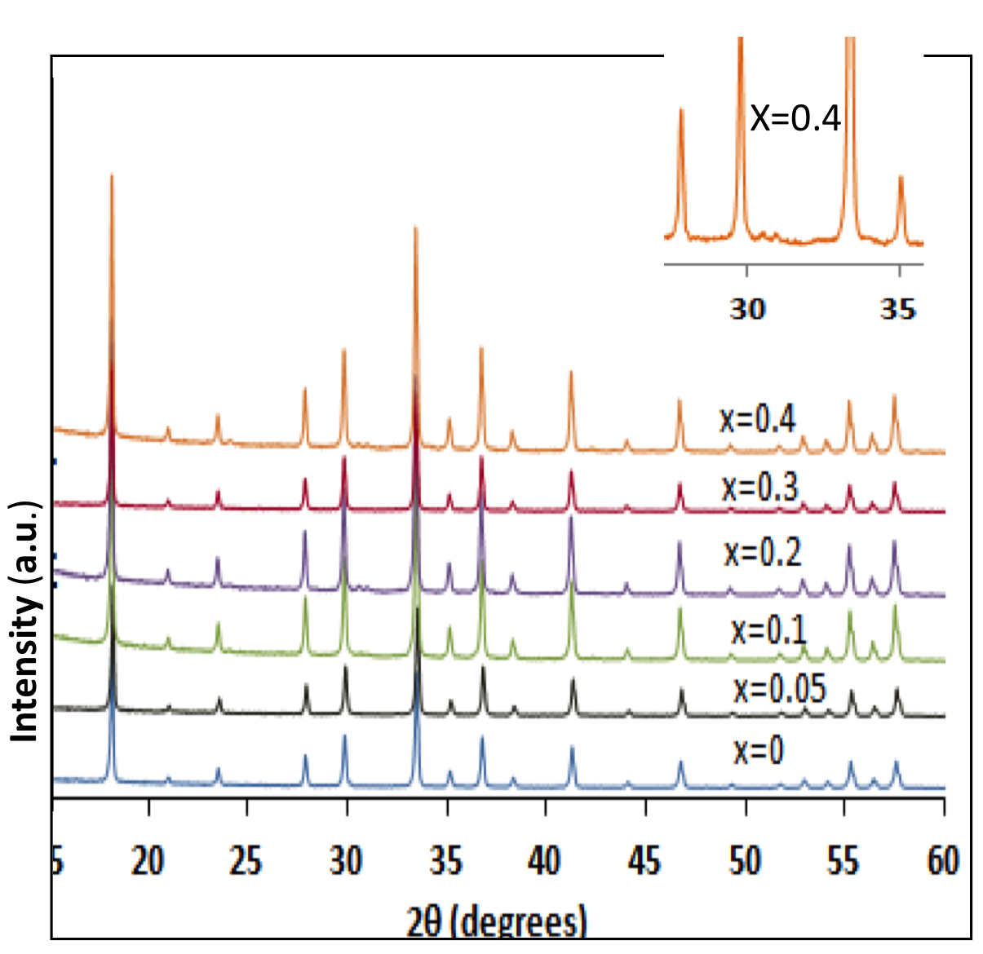

Figure 14. Powder X-ray diffraction data of Ca₁₂Al_{14-x}Fe_{x}O₃₃ synthesized using the citrate gel method and fired at 1000˚C.

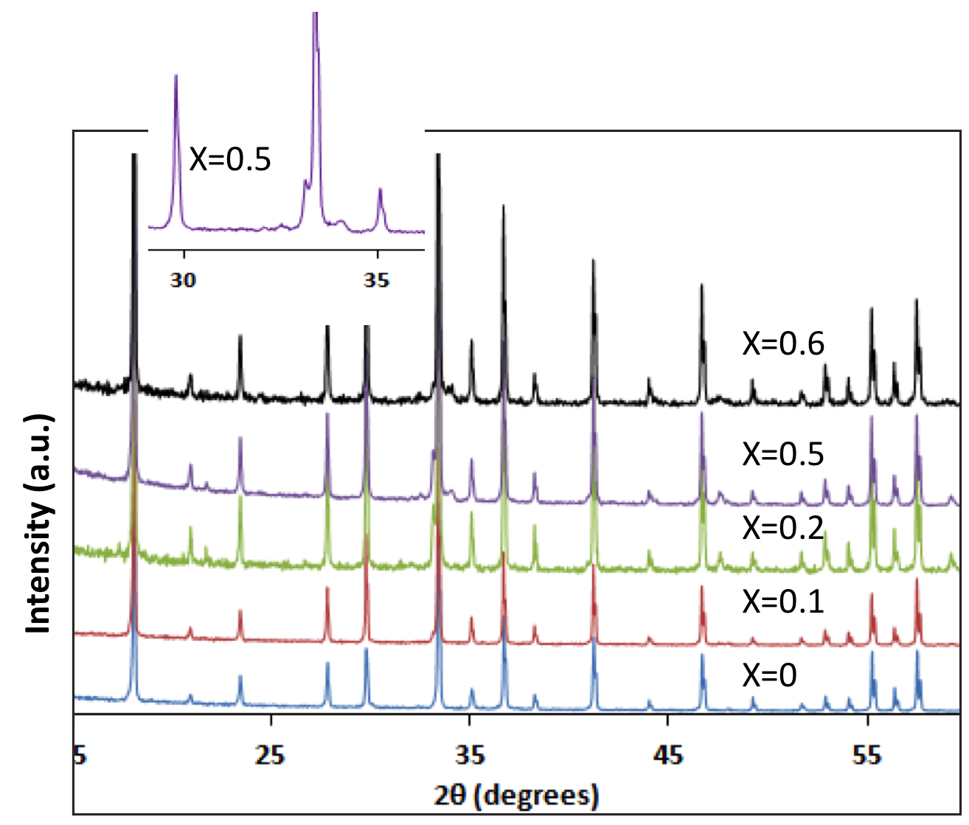

Figure 15. X-ray powder diffraction data of Ca₁₂Al_{14-x}Fe_{x}O₃₃ synthesized by solid-state techniques.

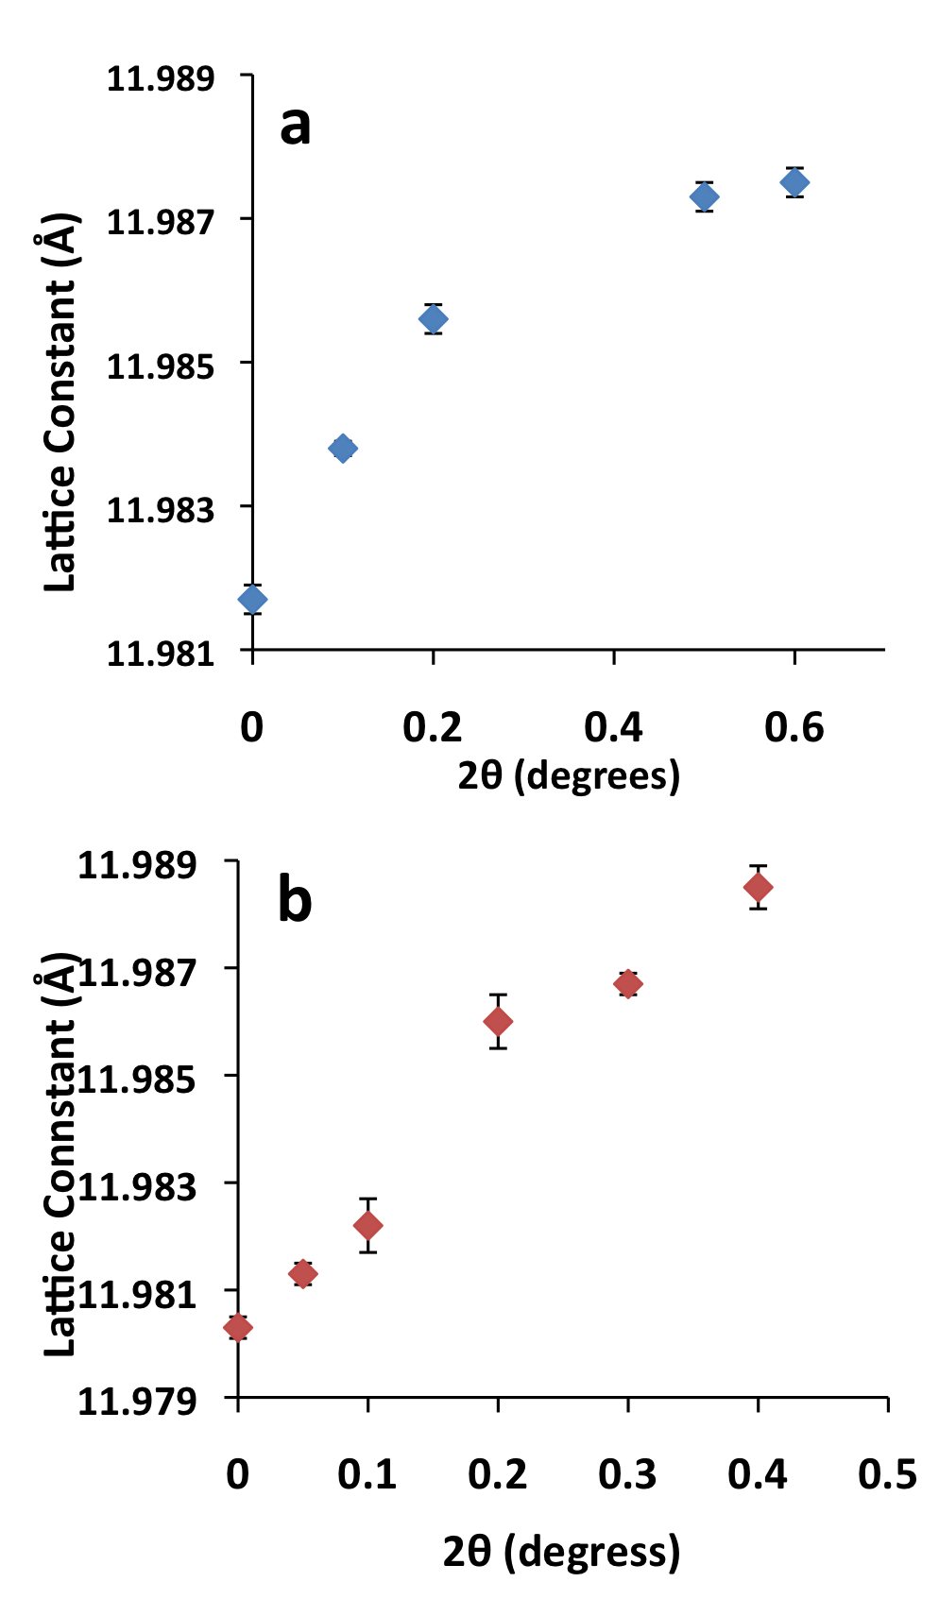

Figure 16. Plot of lattice constant versus Fe content for (a) solid state and (b) sol-gel samples.

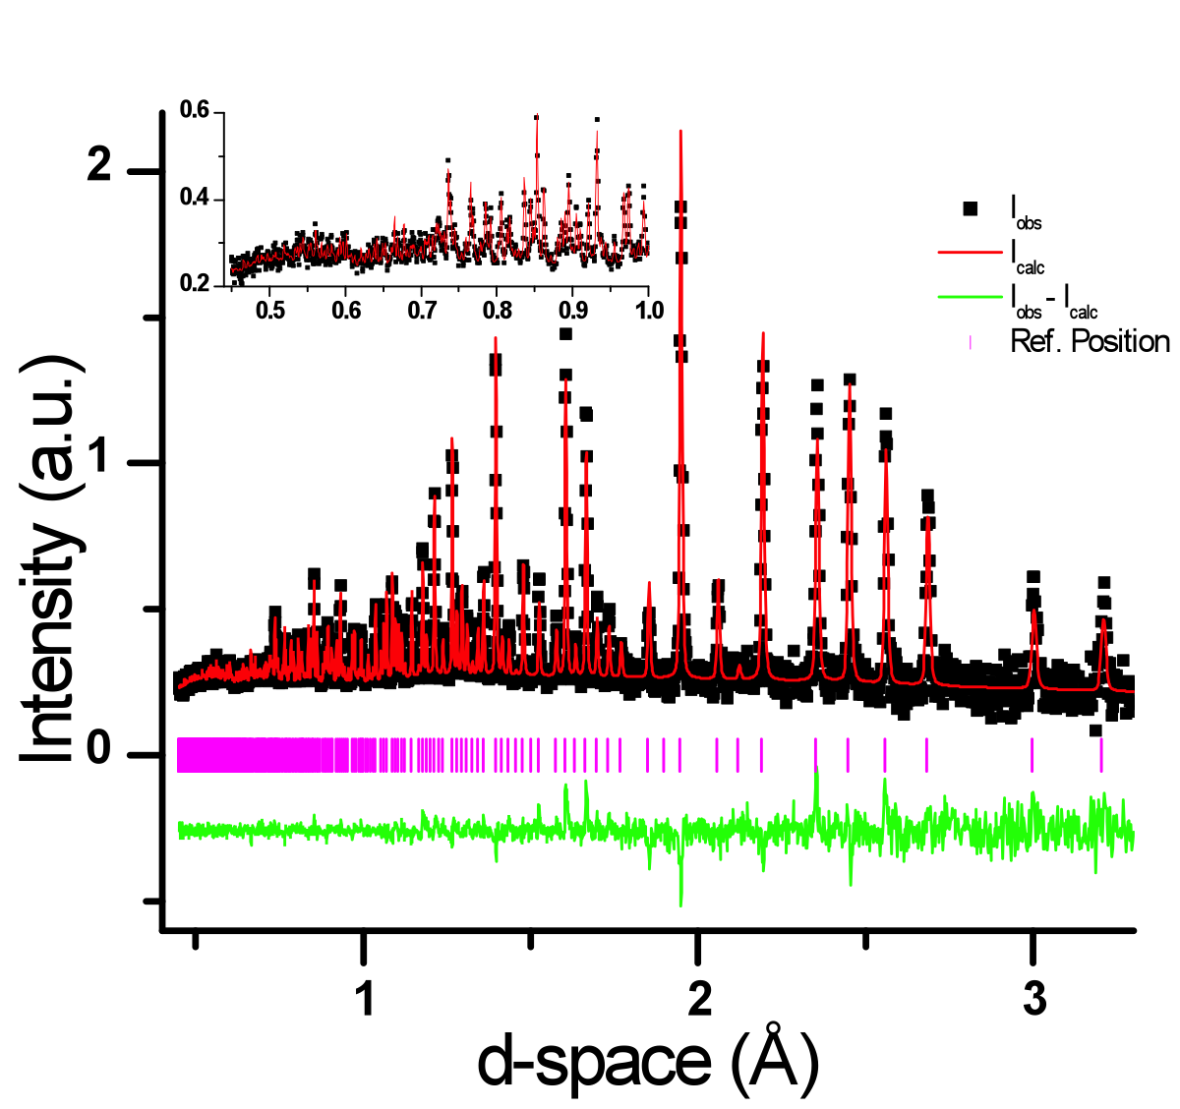

Figure 17. Refined neutron diffraction data collected at room temperature (298 K) for undoped mayenite.

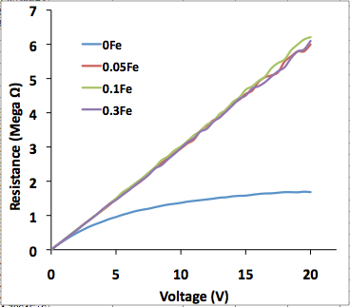

Figure 18. Graph of resistance versus voltage for citrate gel synthesized mayenite samples with x = 0, 0.05, 0.1 and 0.3.

Table

Table 3. Phases identified using X-ray powder diffraction and refined wt%.
Synthesis Technique | Fe (x) | Phases Present (wt %)
Solid-State | 0 | C₁₂A₇
Solid-State | 0.1 | C₁₂A₇ (99.7), C₃A (0.3)
Solid-State | 0.2 | C₁₂A₇ (96.4), C₃A (3.6)
Solid-State | 0.5 | C₁₂A₇ (95.9), C₃A (3.4), C₂AF (0.7)
Solid-State | 0.6 | C₁₂A₇ (96.6), C₃A (<0.1), C₂AF (3.4)
Citrate Gel | 0 | C₁₂A₇
Citrate Gel | 0.05 | C₁₂A₇
Citrate Gel | 0.1 | C₁₂A₇
Citrate Gel | 0.2 | C₁₂A₇
Citrate Gel | 0.3 | C₁₂A₇
Citrate Gel | 0.4 | C₁₂A₇ (>99.9), C₅A₃ (< 0.1)

CHAPTER V: CONCLUSION

Conclusions
Doped and undoped mayenite samples were successfully synthesized using both solid-state and citrate gel techniques. Samples prepared using the citrate gel method took less time during firing and reached equilibrium at lower temperatures when compared to solid-state synthesized samples.

VITA

Sabina N. Ude was born in Enugu, Enugu State in Nigeria. She is married with children. Sabina obtained her Bachelors degree in Metallurgical and Materials Engineering in 2000 from Enugu State University of Science and Technology in Nigeria. Her Masters degree in Materials Science and Engineering was received from the University of Tennessee Knoxville in 2010. She acquired her Ph.D degree in Materials Science and Engineering in 2013 from the University of Tennessee Knoxville. After twelve years in the United States, Sabina hopes to return to Nigeria and become a teacher.

