PHYSICAL ACTIVITY ASSESSMENT IN WHEELCHAIR USERS

A Dissertation
Presented for the
Doctor of Philosophy Degree
The University of Tennessee, Knoxville

Scott Alexander Conger
August 2011

DEDICATION
This dissertation is dedicated to my wife, Summer, for your love, support, encouragement, and friendship. I would not be at this point without you. Thank you for always being there for me.
ACKNOWLEDGEMENTS
First, I’d like to thank all of my committee members for their willingness to serve on my committee. I would like to thank my advisor and mentor, Dr. David Bassett, Jr. Your guidance, advice, and friendship over the past 10+ years have been invaluable to me. Thanks to Dr. Dixie Thompson for your knowledge and support during both of my “tours of duty” at UT. My experiences in exercise physiology were shaped by both of your perspectives and I’m grateful to have had the opportunity to learn from you. I would also like to thank to Drs. Eugene Fitzhugh and Paul Erwin for the knowledge that I gained from you in the classroom. Thanks to Dr. Gene Hayes for providing your insight into this study.
This research project would not have been possible without the time and effort of all of the study participants. I would like to acknowledge everyone who assisted with recruiting. Specifically, thanks to Al Kaye, Carly Waugh, and Dennis Clark for your help with spreading the word. Thank you to Stacy Scott, Jenny Flynn, and Dana Wolff for all of your help during data collection. Having knowledgeable and dependable colleagues helping me during data collection was a luxury that I never took for granted. Special thanks to Elaine Adams and Brian Tyo for logistical support with locating testing locations and assistance with data collection during study activities in Chattanooga, TN and Columbus, GA. I’m indebted to Richard Sawiris for providing a “loaner” PowerTap and making many of the modifications needed to adapt it to a wheelchair. Thanks to Pam Andrews for logistical support and Cary Springer for statistical advice. I'd also like to thank all of the faculty, staff, and students of the Department of Kinesiology, Recreation, and Sport Studies. Whether good or bad, every day was memorable!

ABSTRACT
Purpose: To examine the relationship between hand rim propulsion power and energy expenditure during wheelchair locomotion. Methods: Fourteen individuals who used manual wheelchairs were included in this study. Each participant performed five different locomotion activities in a wheelchair with a PowerTap hub built into the rear wheel. The activities included wheeling on a level surface that elicited a low rolling resistance at three different speeds (4.5, 5.5, and 6.5 km∙hr⁻¹), wheeling on a rubberized 400m track that elicited a higher rolling resistance at one speed (5.5 km∙hr⁻¹), and wheeling on a sidewalk course that included uphill and downhill segments at their self-selected speed. Energy expenditure was measured using a portable indirect calorimetry system. In addition, each subject wore an Actical and a SenseWear activity monitor on the right wrist and upper arm, respectively. Stepwise, linear regression was performed to predict energy expenditure from power output variables. A repeated measures ANOVA was used to compare the measured energy expenditure to the estimates from the power models, the Actical, and the SenseWear. Bland-Altman plots were used to assess the agreement between the criterion values and the predicted values. Results: The relationship between energy expenditure and power was significantly correlated (r = 0.694, p < 0.001). Stepwise, linear regression analysis yielded three significant prediction models utilizing measured power; measured power and speed; and measured power, speed, and heart rate. A repeated measures ANOVA demonstrated a significant main effect between measured energy expenditure and estimated energy expenditure (p < 0.01). There were no significant differences between the criterion method and the power models or the Actical. The SenseWear significantly overestimated energy expenditure when wheeling at 4.5 km·hr⁻¹, 5.5 km·hr⁻¹, 6.5 km·hr⁻¹, and during self-paced sidewalk wheeling (p < 0.05). Conclusion: Energy expenditure can be accurately and precisely estimated based on wheelchair propulsion power. These results indicate that wheelchair power could be used as a method to assess physical activity in people who use wheelchairs.
TABLE OF CONTENTS

CHAPTER I: INTRODUCTION 1
Statement of the Problem 5
Statement of the Purpose 5
Significance of this Study 6
CHAPTER II: REVIEW OF LITERATURE 7
Disability Prevalence 8
Wheelchair Prevalence 8
Physical Activity among Individuals with Disabilities 10
History of the Wheelchair 13
Subjective Physical Activity Assessment of People who use Wheelchairs 18
BRFSS 21
PADS 21
PASIPD 24
PARA-SCI 28
Objective Physical Activity Assessment of People who use Wheelchairs 30
Early Research using Activity Monitors in Wheelchair Populations 30
Data Logger 31
Accelerometer-based Activity Monitors 32
Summary 38
CHAPTER III: MANUSCRIPT 39
Abstract 40
Introduction 42
Methods 44
Participants 44
Procedures 44
Indirect Calorimetry 45
PowerTap 46
Motion Sensors 47
Data Analysis 48
Results 49
Estimations of Energy Expenditure 49
Discussion 53
REFERENCES 62
APPENDICIES 76
APPENDIX A: Informed Consent - University of Tennessee 77
APPENDIX B: Informed Consent - Columbus State University 80
APPENDIX C: Informed Consent - Chattanooga Parks and Recreation 83
APPENDIX D: Health History Questionnaire 86
APPENDIX E: Oxycon Mobile Data 89
APPENDIX F: PowerTap Hub Data 91
APPENDIX G: Actical Data 93
APPENDIX H: SenseWear Data 95
VITA 97

LIST OF TABLES

Table 1 - Participant Characteristics 49
Table 2 - Metabolic costs, power variables, and heart rate for each activity 50
Table 3 - Regression equations to predict gross energy expenditure (kcal·kg⁻¹·hr⁻¹) for all activities 52

LIST OF FIGURES

Figure 1 - PowerTap hub adapted for use on a wheelchair 46
Figure 2 - Regression line for mean measured energy expenditure (kcal·kg⁻¹·hr⁻¹) and power output (W) for rest and each activity (r = 0.694). 51
Figure 3 - Influence of different wheelchair activities on estimated energy expenditure by different prediction methods. * Significantly different than Oxycon mobile (p < 0.05), † Significantly different than Power Model 1, Power Model 2, Power Model 3 (p < 0.05), ‡ Significantly different than Actical (p < 0.05). 52
Figure 4 - Bland-Altman plots depicting error scores for (A) Power Model 1 (W·kg⁻¹) and (B) Power Model 2 (W·kg⁻¹, km·h⁻¹). Bold line represents the mean difference, dashed line represents the 95% confidence interval, solid line represents the line of perfect agreement. 54
Figure 5 - Bland-Altman plots depicting error scores for (A) Power Model 3 (W·kg⁻¹, km·h⁻¹, beats·min⁻¹) and (B) Actical. Bold line represents the mean difference, dashed line represents the 95% confidence interval, solid line represents the line of perfect agreement. 55
Figure 6 - Bland-Altman plots depicting error scores for (A) SenseWear and (B) SenseWear - Hiremath. Bold line represents the mean difference, dashed line represents the 95% confidence interval, solid line represents the line of perfect agreement. 56

CHAPTER I

INTRODUCTION
It has been well established that physical activity is an important contributor to good health [1-4]. In general, people with disabilities are less physically active than those without disabilities [5]. People who use wheelchairs tend to have lower physical activity levels than a number of able-bodied populations, including adolescents, college students, blue-collar workers, and older women [6]. Physical inactivity in people who use wheelchairs is associated with an increase in hypokinetic conditions, such as cardiovascular disease (CVD) [7-10] and diabetes [11-13]. However, many of these risks can be reduced for people who use wheelchairs by increasing their levels of physical activity [10, 14-16]. Even small increases in physical activity have been shown to reduce the cardiovascular risk in this population [17].
Many organizations have developed physical activity recommendations for the general population [18-20]. In 2008, the United States Department of Health and Human Services published the Physical Activity Guidelines for Americans [20]. This publication provided specific physical activity recommendations for disabled adults. These recommendations specified that disabled adults should accumulate 150 min·wk⁻¹ of moderate-intensity aerobic activity, 75 min·wk⁻¹ of vigorous-intensity aerobic activity or an equivalent combination of moderate- and vigorous-intensity aerobic activity [20]. The addition of recommendations specifically for disabled populations is encouraging, however these recommendations are the same as those for able-bodied adults [20]. It is unclear if these recommendations are based upon research on populations with disabilities or the assumption that all adults should accumulate the same minimal amount of physical activity. Additionally, these recommendations by the Department of Health and Human Services cover the broad scope of all disabilities, ranging from those with audio-impairments to individuals with locomotive impairments, such as spinal cord injury and multiple sclerosis [20]. Additional research is needed to be able to provide specific recommendations for people with specific types of disabilities.
To determine if individuals who use wheelchairs are meeting these recommendations, a method that can accurately estimate physical activity for this population is needed. The type of movement associated with locomotion for individuals who use wheelchair is very different than that of able-bodied adults. Because of this, physical activity methods used in able-bodied populations may not accurately estimate physical activity for individuals who use wheelchairs. In recent years, several physical activity self-report and interview format questionnaires have been developed specifically for use with individuals who use wheelchairs [21-24]. In general, these questionnaires are valid and reliable tools for estimating physical activity for individuals who use wheelchairs and they capture many of the low intensity activities that are common in this population [21, 23, 25]. Subjective methods such as self-report physical activity questionnaires are often preferred because they are relatively inexpensive, easily administered to a large number of people, unobtrusive, and require little effort from the participants [26-28]. However, people's ability to accurately recall daily physical activity, in particular low intensity and lifestyle activities, limits the accuracy of these instruments [26, 29-31]. This is of special concern for individuals who use wheelchairs because they often spend a considerable amount of time in low level activities [25].
Due to the unique characteristics associated with wheelchair locomotion, measuring wheel revolutions or arm movements may provide improved physical activity energy expenditure (PAEE) estimates during this activity. One method that has been used in the past is a wheel revolution counter [32-33]. Similar to pedometers, these devices are limited in that they are only able to account for the total volume of activity, with limited information on the intensity. An approach that has become more common for measurement of physical activity is to use objective methods that utilize motion sensors that measure the acceleration of the trunk or limbs [34-38]. The first-generation devices were waist-mounted accelerometer-based devices with the logic being that this position is the closest to the center of the body mass and will provide the best estimate of whole body physical activity [37]. This location is not well suited for individuals who use wheelchairs due to the limited vertical movement of the torso during locomotion. Recent research has evaluated the wrist and arm as alternative locations for accelerometer-based devices for the assessment of daily physical activity related energy expenditure [39-42]. These locations have been used in physical activity assessment during wheelchair activities with some success [43-45]. However, it is unknown if activity monitors in these locations are able to detect the increased PAEE that is associated with wheeling uphill or on surfaces that are rough or textured [46].
Bicycle-mounted power meters have become a popular method for measuring power output during cycling in the field setting [47-48]. These devices measure mechanical power output by assessing torque and angular velocity at the crank axle or in the hub of the rear wheel [48-50]. Previous studies have demonstrated that the increased power output associated with uphill cycling can be accurately and reliably assessed using a hub-mounted power meter [50-51]. Applying this methodology to a wheelchair could lead to an improvement in estimating PAEE during wheelchair locomotion. Similar to accelerometer-based activity monitors used in able-bodied populations, wheelchair power measurement would improve on existing methodologies by providing an objective assessment of the intensity that is associated with wheelchair propulsion on different surfaces and grades.

Statement of the Problem
A valid method for estimating PAEE during wheelchair locomotion is needed. Current methods of assessing PAEE in individuals who use wheelchairs have limitations: wheel counters only assess the total volume of activity and accelerometer-based activity monitors may not accurately account for the intensity of wheelchair movement. The application of a power meter to a wheelchair wheel is a promising option for estimating PAEE. To date, there have been no published studies that describe the relationship between power output and PAEE during wheelchair activities. Studies that examine the validity of this method against the criterion method of measured energy expenditure during wheelchair locomotion are needed.

Statement of the Purpose
The purpose of this dissertation research is to examine the relationship between hand rim propulsion power output and PAEE during manual wheelchair propulsion. The relationship between the two variables will be used to create a prediction equation for energy expenditure based on power output. A secondary purpose is to compare the energy expenditure estimates from this method to other methods that appear in the literature. These methods include heart rate, accelerometer-based activity monitors, and variables related to wheelchair locomotion such as cadence, speed, and distance.

Significance of this Study
As physical activity research has progressed, the application of this research to disabled populations has lagged behind. People who use wheelchairs recruit less muscle mass during locomotion than able-bodied populations, and thus they are at greater risk for hypokinetic diseases. This study will be the first to use wheelchair propulsion power as a method of estimating PAEE. The results of this study will yield new information for estimating PAEE in people who use wheelchairs, and potentially provide a new method for assessing physical activity in people who use wheelchairs.

CHAPTER II

REVIEW OF LITERATURE

Disability Prevalence
A disability is defined as a persistent limitation in any activity due to a physical, mental, or emotional problem that lasts 6 months or more. It is estimated that 20% of United States citizens currently live with a disability [52-54]. A disability has also been classified as any type of disorder that limits a person's ability to perform a normal daily routine [55]. This broader definition could include a person with arthritis who has difficulty carrying groceries, a child with asthma who is unable to participate in running activities during a physical education class, or an obese individual who is unable to complete job that typically involves walking or standing continuously. With this broad definition, a conservative estimate is that 30% of the United States population have at least one disability [55].
Part of the reason for this staggering figure is that, due to advances in medicine and technology, the longevity of the United States population has increased [56]. As the age distribution of the population shifts to the right, the number of people living with disabilities will continue to grow. An inactive lifestyle compounds the effects of many disabilities [5]. Addressing the physical activity needs of individuals with disabilities is an important issue to improve their quality of life and to maximize their potential for independence [55].

Wheelchair Prevalence
Mobility-limiting impairments are the most prevalent type of disability reported in the United States [57-60]. When the ability to walk is compromised by a physical impairment, a wheelchair may serve as a means to maintain some degree of mobility [61-62]. In many cases, a wheelchair provides individuals with mobility that enables their continued participation in activities related to independence, work, and social engagement [61, 63]. Some individuals prefer to use a manual wheelchair to maintain their physical independence and fear that the transition to a power chair may diminish their health [64]. However, other individuals who are capable of using a manual wheelchair chose to use a power wheelchair for most of their daily activities.
Wheelchair use can be divided into three groups: (1) persons who have lost some or all of their lower limb function (i.e. spinal cord injury (SCI), arthritis, cerebral palsy, poliomyelitis, multiple sclerosis, muscular dystrophy, stroke/brain trauma, bilateral amputation), (2) persons with insufficient postural stability (i.e. brain damage, cerebral palsy, cancer of the spine), or (3) persons with general debilitation (i.e. aging, obesity, temporary illness) [65]. The most common reasons for physical activity limitations reported by individuals who use wheelchairs include arthritis (25.5% of all individuals who use wheelchairs), back or spine problems (17.3%), diabetes (13.5%), heart troubles (13.1%), and lung or respiratory problems (10.7%) [55, 60]. SCI is the 14th most common reason for wheelchair activity limitations, accounting for 3.3% of the wheelchair population [60].
Using data collected in 2005 from the U.S. Census Bureau’s Survey of Income and Program Participation (SIPP), there was an estimated 3.3 million Americans who used some type of wheelchair (manual, power, or scooter) [60]. Power wheelchair/scooter users comprise about 17% of the total wheelchair population (~560,000) [60, 66-67]. The prevalence of wheelchair use increases substantially with age [68]. Over half of all individuals who use wheelchairs are 65 years of age or older [60, 69]. The earliest available estimates of wheelchair use is from the 1959 National Health Interview Survey, when there were 253,000 individuals who used wheelchairs in the United States [70]. The wheelchair population has increased substantially over the past 46 years, with an average rate of growth of about 5% per year since 1980 [60, 71-72]. An increased prevalence of wheelchair use over time has also been noted in Canada [73], the UK [74], and France [75]. Over 155,000 Canadians use wheelchairs [73] with an increased prevalence of use as age increases [73, 76]. There are an estimated 3.3 million individuals who use wheelchairs in Europe [77].

Physical Activity among Individuals with Disabilities
Physical inactivity can be a major contributor to the deteriorating physical health of individuals with disabilities [15, 78-79]. The prevalence of physical inactivity is higher among individuals with disabilities than those without disabilities [5, 80-84]. Additionally, individuals with disabilities are two to three times more likely to report secondary health conditions (such as fatigue, chronic pain, or sleep problems) than those without disabilities [85]. Approximately 75% of people with physical disabilities are either completely sedentary or not sufficiently active to achieve health benefits [86]. In Healthy People 2010, the disparities between adults with disabilities and adults without disabilities with respect to meeting physical activity guidelines are described [82]. Fewer adults with disabilities than those without disabilities engaged in moderate activity for at least 30 min, 5 times·wk⁻¹ (23% versus 33%), fewer engaged in vigorous activity for at least 20 min, 3 times·wk⁻¹ (12% versus 16%), and more reported no leisure-time physical activity (LTPA) (56% versus 36%) [82]. In the Behavioral Risk Factor Surveillance System's (BRFSS) national surveys of adults in 2001, more older adults with disabilities were not meeting the physical activity guidelines, compared to older adults without disabilities (70% versus 60%) [81]. Others have found that 25.3% of younger adults with disabilities were completely inactive, compared to only 13.4% of younger adults without disabilities [83]. With the increased life expectancy due to improved medical treatment, lifestyle rather than pathogenesis has become a major factor in morbidity and mortality for individuals who use wheelchairs [87].
Increased physical activity in individuals with disabilities provides many of the same physiological benefits seen in other populations. It has been suggested that increasing physical activity may be one of the most effective methods of improving functioning and increasing independence in people with disabilities [5, 55, 88-90]. There is evidence to suggest that individuals who use wheelchairs may require a higher level of fitness to complete common activities of daily living (ADLs), compared to able-bodied adults [91]. In general, we know little about the characteristics of exercise programs for disabled populations needed to improve functional capacity and reduce the rate of secondary complications in individuals with disabilities [55, 90]. Because of the variety of disabilities, it is important to study specific populations of individuals with disabilities to draw appropriate conclusions and to make specific recommendations [55]. In 1996, Rimmer, Braddock, and Pitetti [55] called for more research on the estimates of physical activity in disabled populations. Although some research has emerged in recent years to address this topic, the breadth of knowledge is still limited.
The most common disabling conditions are those associated with physical impairments; many of these require a wheelchair for locomotion [5, 92-93]. Individuals who use wheelchairs require more time [94] and energy [95] to complete ADLs than their able-bodied counterparts. However in individuals who use wheelchairs, ADLs are usually inadequate to maintain fitness and quality of life [90]. Some populations of individuals who use wheelchairs have been considered at the lowest level of the physical activity spectrum [6]. For instance, individuals with SCI have some of the lowest levels of physical activity reported in the literature [6], which has detrimental effects on physical fitness, social participation, and quality of life [96-100]. Individuals who use wheelchairs due to SCI are at an increased risk for developing CVD [7-10, 12, 101-103] and diabetes [11-13, 104-106]. Mortality rates from CVD and other chronic diseases may be as much as 1.8 to 3.6 times higher in individuals with SCI compared to age and gender matched able-bodied controls [12-13, 107]. Men with SCI have higher levels of C-reactive protein [108-109], lower high-density lipoprotein (HDL) cholesterol levels [14, 108, 110-115], and are at greater risk for central obesity [110] than their non-disabled counterparts. Many individuals who use a wheelchair have inactive lifestyles which leads to low aerobic fitness and high levels of body fat [116].
Many of the health risks associated with wheelchair use can be reduced with increased physical activity [10, 15, 117]. Noreau and Shephard [100] have estimated that 25% of individuals with paraplegia (spinal lesion at the lumbar or thoracic level) have peak oxygen uptake (VO₂) levels ≤ 15 ml·kg⁻¹·min⁻¹. However, they have similar percent increases in peak VO₂ in response to a training program, compared to ambulatory subjects [10, 117-119]. In individuals with one or more chronic disease or disability, those who are more aerobically fit have lower levels of functional limitations [120]. Regular exercise has also been shown to favorably affect lipid profiles [14, 16, 111, 121-124], body fat [125], and insulin resistance [126] in individuals with SCI. Even slightly increasing physical activity may increase HDL concentrations in individuals with SCI [106]. Exercise training has also been shown to favorably affect respiratory [127] and vascular function [128], as well as eliciting beneficial muscular [129] and biomechanical adaptations [129] in individuals who use wheelchairs. Active individuals who use wheelchairs are healthier than their less active peers [130-131], and among those with locomotor disabilities, physical activity lowers mortality risk [5]. Physical activity has been shown to have a positive effect on subjective well-being among individuals with SCI [132].

History of the Wheelchair
The wheelchair is an important tool for instilling a sense of autonomy for many individuals with a disability. Like many tools in modern society, the evolution of the wheelchair occurred over the course of thousands of years with most of the improvements occurring during the past 100 years. The first evidence of both the wheel and the chair occurred around 6,000 years ago. The earliest portable chairs were found in Ancient Egypt and were dated to around 4000 B.C. Their design resembled modern-day folding camp stools [133]. The history of the wheel can be traced to early Mesopotamian societies [134]. At Kish, a stone carving of a two-wheeled cart is dated 3500 B.C.
The first representation of a wheeled indoor vehicle was a child’s bed on wheels, as depicted on a Greek vase dated 530 B.C. However, the preferred method for transportation of those who could not walk during this time was a litter [135]. A litter is a vehicle with no wheels that consists of a sling or a frame attached to long poles. The poles are carried by porters in front and behind. Being carried in a litter was also the preferred method of transportation for the wealthy and royalty. The earliest evidence of a passive wheeled chair was found on a Chinese sarcophagus from about 525 B.C. The sarcophagus featured two stone slabs with engravings depicting scenes from the Confucian Stories of Filial Piety. One of the scenes depicted a person sitting on a chair with three wheels [135].
By the middle ages, the litter had been largely replaced by wheelbarrow-type vehicles for transporting people. During this time period, small wheels or rollers were often put under various pieces of furniture [135]. Rollers were also added to chairs used by the sick and elderly [135]. These rollers were meant for easy transportation of the chair itself to allow people to rest anywhere in the house, not for transportation of the individual [135-136]. In 1595, Jehan Lhermite built King Phillip II of Spain, who suffered from gout, a elaborate chair with four small rolling wheels, a reclining back and elevating leg rest [137]. A similar type of chair was later used by Louis XIV while recovering from an operation [136]. By 1700, the palace of Versailles proudly included an inventory of twenty of these rolling chairs [136].
At this point in history, all of these rolling chairs were large, heavy, and had to be pushed by an attendant. In 1655 in Altdorf, Germany, a watchmaker named Stephan Farfler built the first self-propelled chair that he used to get around town [138]. Farfler, a paraplegic since the age of three, designed the three-wheeled chair with a front wheel that was turned by two rotary handles placed above it [138]. This design is similar to today’s hand-crank cycles. As self-propulsion of wheeled chairs became a greater priority, Farfler’s design generally did not catch on. Mechanical drawings published in Geneva in 1733 included a “vehicle for those who do not have the use of their legs” [135]. This chair featured two large wheels in the front and one smaller wheel in the back. Attached to the inside of each of the front wheels was a smaller rim that was used for propulsion [135].
Wheeled chairs of the nineteenth century were dominated by the 1798 design of John Dawson from Bath, England. Dawson’s “Bath chair” design included two large wheels in the rear and a smaller front wheel. The front wheel included a steering rod for the occupant while an attendant pushed the chair using a push bar at the back of the chair [135]. Unlike previous wheeled chairs, the wheels and frame of this chair were made of iron. In advertisements used by Dawson, he described himself as a “Wheel-chair maker”, the first documented use of the term wheelchair [135].
During the nineteenth century, the development of the bicycle had a great influence on wheelchair designs. Early bicycle designs included two wheels of equal size that was propelled by the rider pushing his feet alternately against the ground in a sort of a seated running position. In 1840, Kirkpatrick MacMillan added cranks and pedals [135]. These early bicycles were made entirely of wood. In 1867, Madison created iron wheels [139] and Truffault added the hollow rubber tire in 1875 [135]. By the late 1800s, the wire-spoked bicycle wheel and rubber tires had been fully adopted for use on wheelchairs [135].
Wheelchairs were still very heavy during this time and various materials were used in an attempt to reduce the overall weight. New folding designs started to emerge at the beginning of the 20th century to increase the portability of wheelchairs. However these initial designs were large and bulky and still weighed between 22 and 32 kg [135]. A person of political power would later influence the design of lighter-weight and more maneuverable wheelchairs. In 1921 at the age of 39, future President of the United States, Franklin D. Roosevelt, began using a wheelchair after he was afflicted with polio [140]. Roosevelt served as President from 1933 to 1945 and was the only U.S. President to serve more than two terms in office [140]. Early in his presidency, he did not want the American public to see him as "a lesser man" because of his need to use a wheelchair. The White House accommodated his wishes by rarely showing his wheelchair in photographs [140]. Unhappy with his selection of large and bulky wheelchairs at the time, he had several kitchen chairs outfitted with wheels [136].
The advent of the automobile led to a greater need for a light weight and portable wheelchair that could fit into a car. In 1932, Herbert Everest and a mechanical engineer named Harry Jennings produced the first lightweight and foldable wheelchair [136, 141]. Everest, who became a paraplegic in 1918 after a mining accident, designed a sling-seat folding chair with a sturdy cross brace made from aircraft steel [135-136]. Although still weighing 23 kg, this new design was revolutionary in increasing the portability of wheelchairs. Everest and Jennings’ company (E&J) became one of the largest producers of wheelchair and E&J continues to produce wheelchairs today. In 1931, Samuel Duke adapted a folding garden chair by adding two small wheels to the front and two large wheels to the back with handles for pushing [142]. When this chair reached the market in 1934, it became the second light-weight folding chair available to the public. These two manufacturers dominated the wheelchair market for the next thirty years.
Following World War II, Sir Ludwig Guttmann began advocating wheelchair sports as a rehabilitation tool at Stoke Mandeville Hospital in Buckinghamshire, UK [136]. This later evolved into a periodic racing event called the "Annual World Stoke Mandeville Wheelchair Games" [143]. Wheelchair sports gained popularity in the 1950’s and 60’s. In the 1960’s, wheelchair frame design began to shift from the sling seat to the box frame design [144-145]. In the late 60’s, Loral “Bud” Rumple (a machinist with polio) and Joseph Jones' box frame design included light weight metal alloys (such as aluminum), repositioned wheels and casters (for improved wheeling effectiveness and stability), quick-release wheels (for easy transport in cars), and more color options [143-144]. Quadra developed the first commercial product using this design, which reduced the overall mass to 16 kg by using lighter weight frame materials and eliminating accessories such as armrests and push handles [143].
This design was further enhanced in the late 1970’s. In 1978, Marilyn Hamilton became a paraplegic after a hang gliding accident. Hamilton was an avid tennis player before her injury and was frustrated with her limited options when she began looking for a wheelchair designed specifically for sports such as tennis. Hamilton asked her friends Don Helman and Jim Okamoto (both hang gliders who had experience building hang glider frames) to design an ultra-light wheelchair [144]. Their new design weighed in at 12 kg and soon became the prototype for their new company: Quickie Designs [144]. The Quickie wheelchairs soon became the norm as more people gravitated toward lighter-weight and more stylish designs and colors.
Wheelchair designs have continued to evolve in recent years. Designs have evolved to allow for many of the components of the wheelchair to be adjusted to provide a more customized and ergonomically correct fit. Wheelchairs built specifically for sports such as basketball, tennis, rugby, and fly-fishing are now available. Wheelchair designers have experimented with lighter weight and stronger frame materials, such as titanium and carbon fiber. These materials have allowed for further reductions in the overall weight of wheelchairs to below 10 kg. Others have experimented with alternative propulsion methods in manual wheelchair designs to reduce overuse injuries and accommodate different users [64, 146-148]. In the past 100 years, wheelchairs have progressed from needing an assistant to push the user to having wheelchairs built specifically for various activities and sports. These innovations have helped to improve on the opportunities for physical activity for individuals who use wheelchairs.

Subjective Physical Activity Assessment of People who use Wheelchairs
Measuring physical activity in non-ambulatory populations has been a challenge in the past because of the lack of valid and reliable instruments for measuring physical activity in disabled populations [149]. A number of physical activity questionnaires have been developed specifically for disabled populations including: the Human Activity Profile (HAP) [150-151], the Physical Activity Disability Survey (PADS) [152-154], the Physical Activity Scale for Individuals with Physical Disabilities (PASIPD) [155-156], and the Physical Activity Recall Assessment for People with Spinal Cord Injury (PARA-SCI) [21].
The most widely used type of physical activity measure is the self-report survey. The self-report survey method uses a number of different types of data collection including activity diaries, self-administered questionnaires, and interviewer-administered questionnaires. Self-report surveys are a convenient method of collecting physical activity data because they are relatively inexpensive, are modifiable to particular populations, and provide an acceptable level of validity and reliability [157]. These instruments are able to assess the dimensions of physical activity (frequency, intensity, duration, and type) and can be easily and inexpensively administered to large groups of individuals [158]. Self-report measures have played a critical role in generating the epidemiological data used in the development of physical activity recommendations for the general population [158].
General population instruments are problematic for individuals who use wheelchairs because most instruments focus on walking or other ambulatory activity and may underestimate wheelchair activity [159]. For many individuals who use wheelchairs, most of their daily physical activity is accounted for by ADLs and passive leisure activities [25]. Many of the existing questionnaires may lack the sensitivity to measure very low intensity activities that often account for the bulk of daily physical activity by individuals who use wheelchairs [160]. Although several studies have assessed physical activity in disabled populations [151, 161-162], they did not specifically address individuals who use wheelchairs.
Physical activity questionnaires that were designed for use in able-bodied populations have been used in populations of individuals who use wheelchairs. Noreau et al. [97] used a LTPA survey previously validated in able-bodied populations [163] to assess the relationship between functional ability and fitness with physical activity in individuals with SCI. Functional ability was assessed using an ADL questionnaire and physical fitness was assessed during a wheelchair ergometer graded exercise test. Results from the analysis of 120 individuals with SCI showed that physical activity levels increased with lower levels of injury, with tetraplegic (a spinal cord lesion at the cervical level) subjects demonstrating significantly lower scores than paraplegic subjects [97]. There were no statistically significant relationships found between functional ability or fitness and physical activity in this study [97]. Manns and Chad [96] also used a LTPA questionnaire to assess activity levels of paraplegic and tetraplegic individuals. The results indicated that the tetraplegic subjects were less active than the paraplegic subjects [96]. However, because these studies used an instrument that had not previously been validated for wheelchair populations, it is difficult to draw definitive conclusions from the results.
For many individuals who use wheelchairs, leisure-time physical activity is less important than being able to live and function independently. Many activity questionnaires designed specifically for disabled populations have focused more on ADL types of questions than quantifying daily physical activity. The Functional Independence Measure (FIM) and the Functional Assessment Measure (FAM) are questionnaires that are commonly used to assess disabled individual's dependence and perceived difficulty in ADLs. The FIM/FAM is a 30-item instrument that consists of 18 items from the FIM assessing functioning in basic physical and cognitive abilities and 12 additional items from the FAM that address cognitive and psychosocial functioning [164]. The combination of these instruments has been used for the quantification of the level of disability in previous studies using disabled populations [164-165]. Andrén and Grimby [166] found that in a survey of individuals with cerebral palsy and spina bifida, most were independent on FIM items but usually dependent on ADLs items as measured by Instrumental Activity Measure (IAM) items.

BRFSS
The BRFSS is a national survey of health risk behaviors. It includes physical activity items that allow for the assessment of leisure-time and lifestyle related physical activities [167]. Brown et al. [81] used the 2001 BRFSS to assess the physical activity levels of older adults with and without disabilities. The BRFSS asks two questions related to disabilities: 1) “Are you limited in any way in any activities because of physical, mental, or emotional problems?” and 2) “Do you now have any health problem that requires you to use special equipment, such as a cane, a wheelchair, a special bed, or a special telephone?” The second question asks about the use of assistive devices such as wheelchairs. However, it does not allow one to identify individuals who use wheelchairs specifically. Thus, the BRFSS is not an ideal instrument to identify physical activity patterns for individuals who use wheelchairs. Brown et al. [81] reported that 70% of older adults with disabilities do not meet the recommendations for physical activity. Similar results for physical activity levels in older disabled adults were also found using the 2003 BRFSS [168] and the 2005 BRFSS [169] and for all disabled adults using the 2001 BRFSS [170].

PADS
Rimmer et al. [23] developed the Physical Activity Disability Survey (PADS) to specifically address the physical activity levels of disabled populations. Using questions from previously established surveys, the authors specifically developed 45 items related to physical activity and disability. The survey included six subscales: exercise, LTPA, general activity, therapy, employment/school, and mobility assistive aid use. The exercise subscale included 26 questions pertaining to exercise, sports and status of participation. The LTPA subscale consisted of 19 items related to general activity/inactivity patterns. The subscale for individuals who use wheelchairs asks about wheelchair use (yes/no), type of wheelchair used (power/manual), and min·d⁻¹ that you push yourself in the wheelchair (< 60 min/≥ 60 min). The PADS was designed to be administered in a semi-structured interview format but could also be completed by the participant. The score was calculated based on the time respondents spend doing activities multiplied by an intensity rating of that activity. Raw PADS scores can range from -95 to 384.2. The intensity ratings for each activity are arbitrarily selected to signify higher scores for more intense activity but are not based on any type of physiological variables. A strength of the PADS questionnaire is that it is able to discriminate between different activity levels in populations with relatively low levels of activity [23].
The first application of the PADS investigated the physical activity patterns of African-American women with disabilities [23]. A convenience sample of 50 African-American women was selected from a database of individuals with a physician diagnosed disability. Only individuals who were classified as severely disabled (i.e. having more than one specific impairment, using a wheelchair, or the chronic use of crutches, cane or a walker) were selected for the study and were administered the PADS via a telephone interview. The results of the study indicated that 50% of the subjects reported that they did not exercise and 92% reported that they were not involved in any LTPA [23]. Additionally, 73% reported doing less exercise after their disability although 72% said that they would like to exercise more [23]. Forty-two percent of the respondents reported that ADLs required partial or full assistance to complete the activities. Seventeen percent of the subjects reported sitting, lying down, or sleeping for a combined total of 24 hr·d⁻¹ [23]. This study demonstrated extremely low levels of physical activity for a specific subsample of individuals with disabilities.
The PADS questionnaire was later revised and simplified based on the information gained during pilot testing and previous research studies. Questions that were ambiguous, unclear, or confusing were reworded or eliminated. The current version of the PADS consists of 31 items in three subscales: exercise, LTPA, and household activity [22]. The exercise subscale consists of eight items related to exercise and exercise status. The LTPA subscale consists of seven items pertaining to general physical activity that would not necessarily be as structured as an exercise program. The household activity subscale pertains to the level of indoor and outdoor activities. The PADS also includes general demographic questions as well as four questions pertaining to the person’s primary disability and the extent to which the person is physically affected by their disability [22]. Scoring of the PADS was also revised by recoding sedentary behavior from negative scores to zero. Rimmer, Riley, and Rubin [22] assessed the test-retest reliability correlations between PADS scores and measures of fitness, and the ability of the PADS to assess changes in physical activity levels in 103 disabled adults. The results indicated that the test-retest coefficients ranged from 0.78 to 0.95 for the subscales and the total activity score [22]. The PADS scores were positively correlated with peak VO₂ and negatively correlated with time spent indoors [22]. The PADS scores were also found to be able to detect changes in physical activity levels over time [22]. The PADS questionnaire has also been used to assess changes in physical activity during interventions in disabled populations [171].

PASIPD
The majority of existing physical activity surveys were developed and validated with able-bodied samples. Many populations with physical disabilities have low physical activity levels and most surveys developed for able-bodied populations had limited applicability to these populations. The Physical Activity Scale for Individuals with Physical Disabilities (PASIPD) was developed to address the lack of a valid and reliable physical activity assessment tool for populations with physical disabilities. Based on the Physical Activity Scale for the Elderly (PASE) [172-173], the PASIPD consists of a short (13-item) instrument that includes items on LTPA, household, and occupational activities [24]. Respondents are asked to recall the frequency and duration that they participated in the selected activities during the previous seven days. A MET value is assigned to each item and the average hours·day⁻¹ for each item is multiplied by this MET value. The values are summed to yield a maximal possible score of 199.5 MET hr·d⁻¹ [24].
The construct validity of the PASIPD was assessed in a group of 372 adults (227 men, 145 women) with disabilities such as post-polio, SCI, cerebral palsy, spina bifida, and auditory/visual impairments. The authors used factor analysis of individual and total physical activity scores to determine if items clustered in predictable patterns. The results found a mean PASIPD score of 20.2 MET hr·d⁻¹ (range 0.0 to 67.9 MET hr·d⁻¹) [24]. Factor analysis indicated that 12% of the total score variance was accounted for by locomotion outside of the home and 40% was accounted for by work-related activities [24]. These results provided a basis of comparison for future studies utilizing the PASIPD.
Liang et al. [174] used the PASIPD to assess physical activity and its relationship with metabolic parameters and environmental factors in men with SCI. A total of 131 men completed the PASIPD and had various measures related to metabolic syndrome assessed. Neighborhood environmental factors were assessed using geo-coding of the participant’s home address. The results were stratified by physical activity into tertiles with low = 5.5 MET hr·d⁻¹, medium = 11.4 MET hr·d⁻¹, and high = 20.6 MET hr·d⁻¹. Participants in the low physical activity tertile had a higher prevalence for abdominal obesity, elevated triglyceride, metabolic syndrome, and high C-reactive protein [174]. They also had a tendency to have lower HDL [174]. In addition, lower physical activity levels were associated with neighborhood environmental characteristics including higher crime rate, shorter distance to nearest transit stops, smaller mean block area, greater number of transit stops, and high vacant housing [174].
Warms, Belza, and Whitney [159] compared physical activity correlates as assessed using both objective and subjective methods. Fifty individuals who use wheelchairs wore an Actiwatch for seven days and completed several health related questionnaires including the PASIPD at the completion of the 7-day period. The results indicated that PASIPD and Actiwatch scores were poorly correlated (r = 0.193, p = 0.188) [159]. The Actiwatch counts·hr⁻¹ were significantly correlated with BMI (r = -0.317, p = 0.03) while PASIPD scores correlated significantly with age, stage of change, number of healthcare visits in which exercise was discussed, self-rated health, and social support [159]. Interestingly, items that were not correlated with physical activity included pain, depression, environmental barriers, and self-efficacy [159]. The authors postulated that the poor correlation between the objective and subjective measures of physical activity could be related to the questions used on the PASIPD. Many of these questions focus more on exercise-type activities and very few are related to ADLs. Depending on the nature of the underlying impairment requiring the use of a wheelchair, there is a wide variability in physical activity and time needed to complete the same task for individuals who use wheelchairs. Some individuals who use wheelchairs may avoid high-intensity activities in order to have sufficient energy and strength to accomplish mobility and ADLs, thus reducing their overall physical activity levels [159].
Warms, Whitney, and Belza [175] also compared the Actiwatch and the PASIPD to an activity log in which activities were recorded in 15 min epochs. The results of the study indicated that individuals who used wheelchairs spent an average of 12.5 MET hr·d⁻¹ in light intensity activity, 1.3 MET hr·d⁻¹ in moderate intensity activity, and 0.33 MET hr·d⁻¹ in vigorous intensity activity [175]. Additionally, 38% of the subjects did not report any strenuous activity and 56% reported less than the recommended 150 MET min·wk⁻¹ of moderate or strenuous activity. Study subjects whose exercise behavior indicated that they were regular exercisers, showed higher PASIPD scores and more moderate to vigorous activity than non-exercisers or irregular exercisers. However, these groups did not differ in household activities or ADLs [175].
Giacobbi et al. [176] examined the relationship between physical activity and perceived quality of life in highly active individuals who use wheelchairs. Twenty-six wheelchair basketball athletes completed the PASIPD and a guided interview with questions related to physical health, social activities, and quality of life. The results indicated that this athletic population of wheelchair basketball players had average PASIPD scores of 34.3 MET hr·d⁻¹ (range 6.2 to 71.2 MET hr·d⁻¹) [176]. These scores would indicate that this group had higher physical activity scores assessed by the PASIPD than previously reported for individuals who use wheelchairs [24]. Other analysis of the interview questions related to psychological, social, and health in the sample support the hypothesis that physical activity behaviors contribute to enhancing the quality of life of individuals who use wheelchairs [176]. This study quantified a PASIPD score for individuals who are on the upper end of the physical activity spectrum of individuals who use wheelchairs.
The test-retest reliability of the PASIPD scale was assessed in a group of disabled adults [177]. Forty-five disabled adults who used wheelchairs but were not completely dependent on them for locomotion, completed the PASIPD before and after a seven-day period. Participants also wore an Actigraph accelerometer during the seven-day data collection period. The results indicated that the scores from the two PASIPD questionnaires were significantly correlated with each other (r = 0.77) and with the Actigraph activity counts (r = 0.30) [177]. These correlations were found to be similar to previously reported correlations for other recall questionnaires and with objectively measured activity counts in able-bodied populations.
The PASIPD was used to assess the relationship between physical activity and fitness measurements as well as other estimates of functional wheelchair ability [178]. A total of 139 individuals with SCI completed a wheelchair circuit of eight tasks, a graded aerobic exercise test, and strength assessments along with the PASIPD one year after discharge from in-patient rehabilitation. The results indicated that individuals with tetraplegia had lower PASIPD scores than those with paraplegia [178]. Significant associations were found between wheelchair performance (r = -0.41), muscle strength (r = 0.35), peak VO₂ (r = 0.25) and peak power output (r = 0.29) [178]. In addition, a high level of life satisfaction among individuals with SCI was related to an active lifestyle [179]. The authors concluded, on the basis of relatively low correlation values, that there is a limited association between self-reported physical activity and other measures of fitness and activity [178].

PARA-SCI
Because of the potential differences in energy expenditure among individuals with SCI, Ginis et al. [21] created a SCI-specific physical activity questionnaire called the Physical Activity Recall Assessment for People with Spinal Cord Injury (PARA-SCI). The PARA-SCI utilizes a semi-structured telephone interview 3-day activity recall format starting with the previous day. To facilitate recall, participants are asked to recall the time that they woke up and went to sleep each day. The interviewer prompts the participant to recall activities that they did in the morning, afternoon, and evening. The PARA-SCI assesses three categories of physical activity: LTPA, lifestyle activity, and cumulative activity (the combination of LTPA and lifestyle). The duration and intensity level (categorically classified as "nothing at all", "mild", "moderate", and "heavy") of each activity were recorded by the interviewer. To assess the validity of the PARA-SCI, 14 individuals wore a portable indirect calorimetry system for an average of 5.75 hr while completing their usual activities in their homes and community. The results indicated that the PARA-SCI was significantly correlated with indirect calorimetry for moderate, heavy, and total intensity levels as assessed by the PARA-SCI questionnaire [21]. The authors suggested that the PARA-SCI provides a better alternative for subjective physical activity assessment in SCI populations because it is able to capture low-level activities that are common among individuals who use wheelchairs [25]. However, other questionnaires were not directly compared in this study, thus the authors’ conclusions may be premature.
Latimer et al. [180] investigated the convergent validity and the sensitivity of the PARA-SCI to variations in physical activity. Convergent validity of the PARA-SCI was demonstrated by comparing two measures of fitness (muscular strength and aerobic capacity) to physical activity scores. The sensitivity of the PARA-SCI to variations in physical activity was assessed by comparing two groups who were believed to have extreme differences in physical activity based on demographics, level of injury, and behavioral characteristics. A total of 73 individuals were assessed in the convergent validity analysis and 158 individuals were assessed in the sensitivity analysis. The results indicated that biceps strength was correlated positively with total, moderate, and heavy intensity physical activity (r ≥ 0.21, p < 0.05) while chest strength correlated with moderate intensity physical activity (r = 0.23, p = 0.03) and aerobic capacity was correlated with moderate and heavy intensity physical activity (r ≥ 0.28, p < 0.04) [180]. LTPA scores were able to differentiate between extreme groups based on fitness level but were unable to differentiate solely based on the physical activity scores between groups [180].
The PARA-SCI has also been used to assess the relationship between several variables related to physical activity for individuals who use wheelchairs including pain, fatigue, and depression [181], ADLs [182-183], and proximity to physical activity facilities [184].

Objective Physical Activity Assessment of People who use Wheelchairs
There are a number of different methods that have been used to measure physical activity in individuals who use wheelchairs. In many instances, it is impractical to use methods such as whole room calorimetry [185] and heart rate [186-188] to measure daily physical activity in populations who use wheelchairs. A common method used to estimate physical activity levels in able-bodied populations is through the use of motion sensors such as pedometers and accelerometers [189]. These types of monitors provide an objective measurement of physical activity that can be used to estimate energy expenditure. For individuals who use wheelchairs, research related to motion sensors is relatively limited. However in recent years, several different monitors have been used to measure physical activity in individuals who use wheelchairs.

Early Research using Activity Monitors in Wheelchair Populations
One of the first methods used to objectively measure physical activity in individuals who use wheelchairs was to measure the time spent out of bed during the inpatient rehabilitation phase of patients with SCI [190]. The authors believed that this method of measuring the time spent out of bed would be a good proxy measurement of the patient’s rehabilitation progress and physical activity levels during inpatient rehabilitation. A Rest-Time Monitor was used to monitor the amount of time spent in and out of bed. This device consisted of three pressure-sensitive ribbon switches located under the patients mattress attached to a strip-chart recorder [190]. Although, this method does not directly reflect physical activity, it does represent a proxy measurement of it by quantifying the amount of time spent in supine inactivity.
The first study that objectively assessed physical activity levels using an activity monitor in individuals who use wheelchairs used the Large-scale Integrated (LSI) activity monitor [6]. The LSI activity monitor utilizes a cylinder containing a ball of mercury that opens or closes a mercury switch when the instrument experiences a 3% incline or decline. Thus, this device is able to detect the accumulated volume of activity over a given time period. The researchers had the study participants wear the LSI on two locations: the wrist to provide a measure of free-living activity and the ankle to represent movement related to involuntary muscle contractions, transferring into and out of the wheelchair, and recreational/therapeutic activities completed out of the wheelchair. This study was the first to objectively quantify the extremely low levels of physical activity that are often seen in individuals with SCI [6].

Data Logger
A number of studies have used a wheelchair-specific physical activity monitor called the Data Logger to objectively quantify wheelchair movement. Similar to a pedometer, this device provides researchers with the total volume of wheelchair activity over the course of a day. The data logger measures wheel rotations through the use of three reed switches mounted 120° apart on a circuit board and a magnet that is mounted at the bottom of a pendulum sensor [33]. Each time the magnet passes a reed switch, a timestamp is stored representing a revolution of the rear wheel [32-33]. The data is stored in the Data Logger attached to the spokes of a rear wheel. The total distance traveled is calculated based on the total number of time stamps and the wheel circumference. Speed is calculated by dividing the wheel circumference by the difference between two sequential time stamps. Early models of the Data Logger had a storage capacity of the 100,000 time stamps, which equates to up to 2 weeks of continuous data. Recent versions are capable of storing over a month of data [33].
The Data Logger has been used to characterize the wheelchair activity of several different groups that use wheelchairs including populations that use power-assist wheelchairs [147], power chair users [32, 191-192], wheelchair use at home [67], in nursing homes [33], and during wheelchair sports [193-194]. This device has demonstrated its usefulness in assessing wheelchair related movement by providing a quantifiable measure of wheelchair movement over periods of time as long as two consecutive weeks. It is able to provide valuable information related to wheelchair activity such as distance traveled, speed, and total wheelchair time. However, this method is not able to differentiate between movement associated with active manual wheelchair use by the user and passive movement by an electric motor or while being pushed by another person. This method has not been validated against a criterion measure or directly compared to other subjective or objective methods that are used in populations that use wheelchairs. Additionally, the Data Logger is limited in that the data can be misleading when used during wheeling on surfaces with varying grades and surfaces that require greater EE to traverse.

Accelerometer-based Activity Monitors
Activity monitors fall into two general categories: movement counters and accelerometers. In able-bodied populations, accelerometer-based activity monitors are superior to movement counters in that they assess movement frequency and intensity rather than just frequency alone [37]. Several accelerometer-based activity monitors have been used in wheelchair populations over the past decade. These include monitors that had previously been designed for use in able-bodied populations and monitors that were specifically designed for disabled populations.
A device that has been used in a number of studies investigating the physical activity levels of populations with a disability is the Activity Monitor. The Activity Monitor was designed to assess body positions and motions for long term measurement periods during normal daily life [195]. The Activity Monitor consists of four to six individual accelerometer sensors attached to various parts of the body (typically at the wrists, thighs, and above the sternum). The accelerometers are wired to a small, waist-mounted data recorder. Because of the wired design of the device, its design can be considered more obtrusive than other commonly used activity monitors. It does, however, provide a method for integrating several accelerometers on different body locations into one unit. This device has previously been used to measure physical activity levels in disabled populations such as adolescents and young adults with spina bifida [196] and to compare physical activity levels with factors related to health-related quality of life in individuals with spina bifida [197].
Postma et al. [198] evaluated the Activity Monitor for its ability to quantify activity during a standardized activity protocol in ten individuals with SCI who use wheelchairs. The activity protocol consisted of 23 activities that were designed to simulate many different ADLs. Video recordings were completed for each session and analyzed for activities with a 1 sec epoch. The results demonstrated that the agreement between the video analysis and the activity monitor was 92% (range 84-96%) and sensitivity of 87% (range 81-93%) [198]. This indicates that this type of monitor offers the possibility of obtaining objective PA information in individuals who use wheelchairs.
The Activity Monitor has also been utilized in studies that assessed changes in physical activity levels in SCI patients. Thirty-six individuals with SCI wore the Activity Monitor on two consecutive days at the beginning of their inpatient rehabilitation following injury, after three months of rehabilitation, at discharge from inpatient services, two months after discharge, and one year after discharge [199]. The results of the study indicated that the duration and average daily movement increased after three months of rehabilitation, slightly decreased at the time of discharge, then decreased significantly two months after discharge [199]. A comparison of other published studies indicated that the percentage of the typical day that SCI patients spend in dynamic activities was lower that several other chronic conditions including hemiplegic cerebral palsy, chronic heart failure, and leg amputation [199].
A majority of wheelchair users’ physical activity occurs during locomotion in a wheelchair. Wilson et al. [200] adapted the activePAL for measurement on a rear wheel of the user's wheelchair. The activePAL was originally designed to be worn on the thigh of the subject using adhesive pads. In this study, the uni-axial activePAL was attached to the rear wheel by securing it to a foam block that was placed securely between the rear wheel's spokes. Seven individuals with SCI were monitored for seven consecutive days. The results indicated that the participants' moving time ranged from 4.1 to 13.2 hr·wk⁻¹ and accumulated between 7.4 and 34.9 km·wk⁻¹ of wheelchair activity [200].
Coulter et al. [201] completed a validation of the activePAL for monitoring wheelchair movement. A tri-axial activePAL was secured to the spokes of the wheelchair of 14 individuals with SCI. The selection of a tri-axial accelerometer provides the same outcome variables as previously described [200] with the addition of being able to detect the angle of the wheel and the direction of movement [201]. The participants completed a lap on an indoor track at a self-selected speed and negotiated an obstacle course that consisted of going over ramps and around stationary objects. The activePAL output was compared to video analysis focused on the wheelchair wheel. The results of the study indicated that the activePAL is able to accurately measure the wheel revolutions of a manual or power wheelchair [201]. This information can be used to determine the total distance and duration of activity for individuals who use wheelchairs. Similar to the Data Logger, the use of the activePAL accelerometer in these two studies were limited in that it only is capable of measuring the movement of the wheel regardless of the effort that is required by the user to propel the wheelchair.
Rather than measure the movement of the wheelchair itself, accelerometer-based activity monitors allow for investigators to measure the volume and intensity of movement of the limbs by the wheelchair user. Warms and Belza [202] compared the validity of the Actiwatch for measuring physical activity of individuals who use wheelchairs. The Actiwatch is a small, omni-directional activity monitor that is designed to be worn on the wrist similar to a wristwatch. The authors initially determined that the Actiwatch is able to discriminate between active and sedentary activities during different laboratory activities in six SCI participants [202]. Twenty-two SCI individuals then wore the Actiwatch for 4 days while keeping an activity log denoting activities in 15-min epochs. The Actiwatch was found to have a significant correlation (r = 0.60, p<0.01) with the self reported activity intensities during the 4-day period [202] demonstrating concurrent validity for monitoring free-living physical activity. The Actiwatch has been used in other studies with individuals who use wheelchairs to compare objective and subjective measures of physical activity [159]. It has also been used to assess changes in physical activity among individuals with SCI following a 6-week physical activity program [203].
Accelerometers have also been incorporated into other devices to add physical activity measurements to other monitoring devices. Munakata et al. [204] studied the blood pressure response over a 24-hr period in 19 patients with SCI compared to 16 healthy, control subjects. Control subjects were asked to refrain from strenuous exercise, but the same instructions were not given to the patients with SCI who were routinely involved in rehabilitation programs. The multi-biomedical recorder that was used had the capabilities of measuring blood pressure, heart rate, and physical activity via an accelerometer incorporated into the blood pressure recorder. The results of the study indicated that the daytime physical activity levels of the participants with SCI were about 60% of the physical activity levels of the control subjects with no statistical differences noted between the nighttime physical activity levels between the groups [204]. There was no indication that the device used for monitoring physical activity in this study had been previously validated in either the control group or the investigational group.
One of the few studies in which an activity monitor was evaluated for estimating EE in individuals who use manual wheelchairs compared to the criterion method of oxygen consumption was completed by Washburn and Copay [45]. Twenty-one individuals completed trials on a measured course at three different speeds while using a wheelchair. The subjects were asked to wheel at self-selected speeds that corresponded to slower than normal, normal, and faster than normal speeds on a tile floor while wearing Actigraph 7164 accelerometers on both wrists. Oxygen consumption was measured using a portable metabolic system and mean values taken during the last 5 min of each activity were used in the analysis. The results indicated that there was a significant correlation between the measured energy expenditure and the Actigraph activity counts (r=0.52-0.67, p<0.01) [45]. The Actigraph was able to differentiate between the increased metabolic costs that were associated with wheeling at different speeds. Others have also used the Actigraph in wheelchair populations [177].
Hiremath and Ding [43] examined the validity of the SenseWear arm band and the RT3 tri-axial accelerometer during wheelchair propulsion, arm-ergometer exercise and deskwork. Six participants with SCI wore the SenseWear armband on their upper right arm and the RT3 on the waist during wheeling at 2 and 3 miles·hr⁻¹ on a dynamometer, 3 miles·hr⁻¹ on a tile floor, during arm-ergometer exercises at 20, 40 and 60W, and during deskwork. A portable metabolic system was used during each activity to measure metabolic activity. The results of the study indicated that the SenseWear tended to overestimate EE during each activity while the RT3 underestimated EE during each activity with the exception of deskwork [43]. These results were confirmed in a subsequent study utilizing the same methodology [44]. These studies demonstrated that the prediction equations in their current form used by these two commonly used accelerometers may not be appropriate for use in non-ambulatory populations.

Summary
There has been ample evidence that physical activity is an important determinant of health, even in individuals who use wheelchairs. Although people who use wheelchairs typically accumulate lower amounts of daily physical activity, it appears that they can gain positive benefits from activity, similar to those gained by able-bodied individuals. Wheelchair design has progressed in the last century to allow a more physically active lifestyle. Research on different methods of assessing physical activity has also increased over the past twenty years. Subjective methods of physical activity assessment have been modified to specifically address the unique aspects of wheelchair activities. Also, many different objective methods have been proposed for use with people who use wheelchairs. While the optimal method for assessing physical activity in people who use wheelchairs has not been determined, progress in this area over the past 20 years has established the need for accurately measuring physical activity in this underserved population.

CHAPTER III

MANUSCRIPT

Abstract
Purpose: To examine the relationship between hand rim propulsion power and energy expenditure during wheelchair locomotion. Methods: Fourteen individuals who used manual wheelchairs were included in this study. Each participant performed five different locomotion activities in a wheelchair with a PowerTap hub built into the rear wheel. The activities included wheeling on a level surface that elicited a low rolling resistance at three different speeds (4.5, 5.5, and 6.5 km∙hr⁻¹), wheeling on a rubberized 400m track that elicited a higher rolling resistance at one speed (5.5 km∙hr⁻¹), and wheeling on a sidewalk course that included uphill and downhill segments at their self-selected speed. Energy expenditure was measured using a portable indirect calorimetry system. In addition, each subject wore an Actical and a SenseWear activity monitor on the right wrist and upper arm, respectively. Stepwise, linear regression was performed to predict energy expenditure from power output variables. A repeated measures ANOVA was used to compare the measured energy expenditure to the estimates from the power models, the Actical, and the SenseWear. Bland-Altman plots were used to assess the agreement between the criterion values and the predicted values. Results: The relationship between energy expenditure and power was significantly correlated (r = 0.694, p < 0.001). Stepwise, linear regression analysis yielded three significant prediction models utilizing measured power; measured power and speed; and measured power, speed, and heart rate. A repeated measures ANOVA demonstrated a significant main effect between measured energy expenditure and estimated energy expenditure (p < 0.01). There were no significant differences between the criterion method and the power models or the Actical. The SenseWear significantly overestimated energy expenditure when wheeling at 4.5 km·hr⁻¹, 5.5 km·hr⁻¹, 6.5 km·hr⁻¹, and during self-paced sidewalk wheeling (p < 0.05). Conclusion: Energy expenditure can be accurately and precisely estimated based on hand rim propulsion power. These results indicate that power could be used as a method to assess physical activity in people who use wheelchairs.

Introduction
Mobility-limiting impairments are the most prevalent type of disability reported in the United States [54]. There are an estimated 3.3 million Americans who regularly use some type of wheelchair [60]. The type of movement that is associated with locomotion for individuals who use wheelchairs is very different than that of able-bodied populations. Until recently, there were a limited number of instruments available to assess physical activity of individuals who use wheelchairs. Most of the methods used to assess physical activity in individuals who use wheelchairs have consisted of subjective methods such as questionnaires [21, 153-154, 156]. However, these methods are limited in that they rely on the individual to accurately recall their physical activity, which can be problematic [30]. Thus, researchers have become interested in developing valid, objective methods for assessing physical activity in populations that use wheelchairs.
Objective methods have been used to assess physical activity levels of individuals who use wheelchairs. These include wheel revolution counters that provide information on the total volume of activity [32-33] and activity monitors attached to the wheel of the wheelchair [200-201]. Similar to pedometers, these devices are limited in that they are only able to account for the total volume of activity, with limited information on the intensity. Other researchers have utilized activity monitors worn on the arm during wheelchair activities [43-44, 202]. These methods have demonstrated potential to provide useful information on physical activity of people who use wheelchairs; however, it is unclear if they can detect the increased energy costs associated with locomotion on different surfaces and different grades [46].
A potential new technology used to measure power and intensity of wheelchair physical activity are power meters that are typically used with bicycles [47-48]. These devices measure mechanical power by assessing torque and angular velocity at the crank axle or in the hub of the rear bicycle wheel [48]. The application of this technology to a wheelchair could improve on the validity of physical activity assessment in individuals who use wheelchairs. Power output during manual wheelchair locomotion has previously been assessed in the laboratory setting to assess mechanical efficiency and biomechanical properties associated with wheelchair locomotion [205-208]. However, the application of this technology for assessing physical activity during wheelchair movement has not been examined. Similar to accelerometer-based activity monitors used in able-bodied populations, wheelchair power measurement could potentially improve on existing methodologies by quantifying the intensity associated with wheelchair locomotion on different surfaces and grades.
Thus, the purpose of this study was to examine the relationship between power and measured energy expenditure during wheelchair locomotion. The relationship between the two variables was used to develop prediction equations for energy expenditure based on power output. A secondary purpose was to compare the energy expenditure estimates from this method to other methods that have previously been used in populations that use wheelchairs. These methods include heart rate, accelerometer-based activity monitors, and variables related to wheelchair locomotion such as cadence, speed, and distance.

Methods

Participants
Participants in this study were healthy men and women between the ages of 18 and 75 who used a manual wheelchair at least 20 hr∙wk⁻¹. All types of individuals who used wheelchairs were included, except for those with a spinal cord injury (SCI) at the level of C8 or above. Each participant was informed of potential risks and benefits and signed an Informed Consent Form approved by the University of Tennessee Institutional Review Board prior to taking part in the study (Appendices A-C). All participants completed a Health History Questionnaire (Appendix D) and were excluded if they had any history of cardiovascular disease or uncontrolled metabolic disorder. Prior to testing, body weight was measured on a calibrated wheelchair scale (LWC-800LB, Tree Scale, Fujian, China) with the chair weight subtracted out and self-reported height was recorded.

Procedures
Prior to beginning testing, each participant transferred to a wheelchair outfitted with the power meter. The wheelchair was adjusted to accommodate the participant and each participant was given an opportunity to become familiar with the wheelchair prior to beginning data collection. Tire pressure was maintained at 100 psi for each trial [209-210]. The participants were asked to rest quietly for 15 minutes before beginning any activities. Each participant then performed five different locomotion activities. These activities included wheeling on a level surface that elicited a low rolling resistance at three different speeds (4.5, 5.5, and 6.5 km∙hr⁻¹), wheeling on a rubberized 400m track that elicited a higher rolling resistance at one speed (5.5 km∙hr⁻¹), and wheeling on a sidewalk course that included uphill and downhill segments at their self-selected speed. During the four activities at standardized speeds, participants were able to observe their wheeling speed on a bicycle computer and were monitored to ensure that they were wheeling at the pre-determined velocity. To ensure that subjects were working at a submaximal intensity, subjective rating of perceived exertion was monitored periodically to ensure that they were working at a level equivalent to 8 or below on a 10 point scale. Each activity was performed for eight minutes. Between each activity, the subjects were asked to rest quietly for at least of three minutes.

Indirect Calorimetry
Each participant wore the Oxycon Mobile (Viasys Healthcare, Hochberg, Germany) portable indirect calorimeter during the rest period and while performing each activity. The Oxycon Mobile has been previously validated over a range of work rates on a cycle ergometer [211] and served as the criterion measure for this study. The Oxycon Mobile was mounted on the back of the participant via a chest harness. The positioning of the Oxycon Mobile on the subject’s back was high enough to not interfere with the subject’s positioning in the wheelchair. A flexible mask (Hans-Rudolph, Kansas City, MO) that covered the participant’s mouth and nose was secured to the participant via a head strap. Attached to the facemask was a transducer holder with a turbine inside. The turbine rotations are detected by an optoelectrical sensor allowing for the determination of minute ventilation [211]. Expired air was analyzed for oxygen and carbon dioxide concentrations via a sampling line connected to the transducer holder. The Oxycon Mobile was calibrated immediately before each test with a 3-L syringe and with a certified calibration gas mixture. After the calibration procedures were completed, the participant characteristics were entered into Oxycon computer. The metabolic data were collected in breath by breath measurements. To ensure that steady state metabolic activity was achieved, the first three minutes of each activity were excluded from the analysis and the mean VO₂ of the activity was averaged over the last 5 minutes.

PowerTap
A PowerTap SL+ Track Hub (Saris Cycling Group, Madison, WI) was modified for use on a wheelchair (Figure 1). The PowerTap is a power meter that is contained within the rear wheel hub of a bicycle. It has previously been demonstrated that the PowerTap is a valid and reliable instrument for measuring bicycle power output in the laboratory and field settings [50-51]. The PowerTap bearings were modified to accommodate the

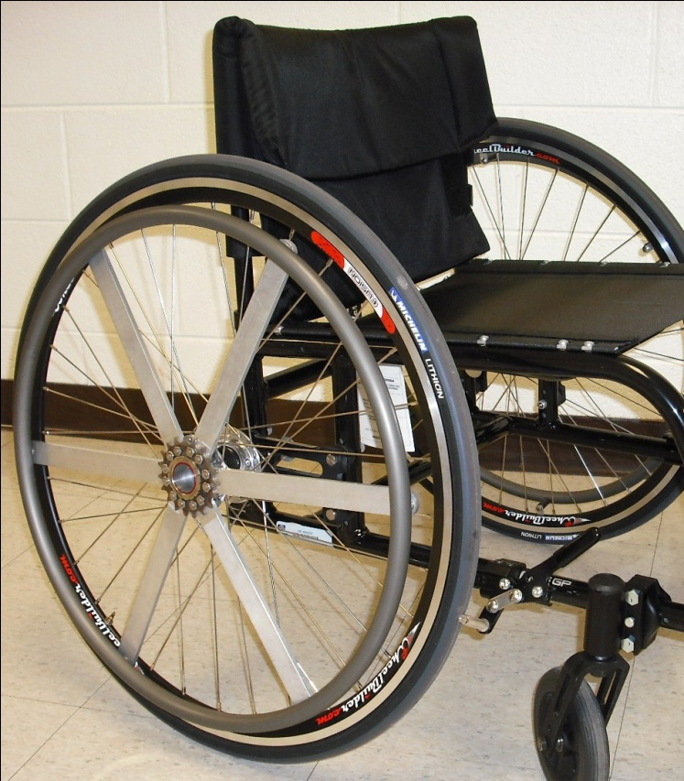
Figure 1- PowerTap hub adapted for use on a wheelchair
existing axle of a Quickie GP wheelchair (Quickie Wheelchairs, Phoenix, AZ). The PowerTap hub was laced to a 650C road cycling rim. To ensure that the power generated by the user during wheelchair activities was measured by the PowerTap hub, the push rim of an existing wheelchair wheel was attached to six aluminum spindles that radiated out from a splined cycling cog. The cog was locked into place on the PowerTap hub with a locking ring. The PowerTap wheel was attached to the right side of the wheelchair.
The PowerTap hub is capable of measuring a number of variables including torque (N-m), speed (km·hr⁻¹), power (Watts), distance (km), and heart rate (beats· min⁻¹) - sent via telemetry from a heart rate chest strap. The PowerTap hub samples at a rate of 60Hz, averages power data each second, then records data at intervals of 1.26 seconds [48]. After excluding the first 30 seconds of each bout to allow for the participant to reach the predetermined speed, the average values for each variable were calculated for the remainder of the bout.

Motion Sensors
Each participant also wore an Actical activity monitor (MiniMitter, Bend, OR) on the right wrist. Previously developed activity energy expenditure equations for the
Actical when worn on the wrist [212] were used for estimates of energy expenditure during the wheelchair activities. Participants wore a SenseWear Pro 3 Armband (Bodymedia, Pittsburgh, PA) on their right upper arm. The SenseWear has previously been validated in able-bodied populations [40-41] and populations who use wheelchairs [43-44]. Prior to beginning the wheelchair activities, the Actical and SenseWear were initialized for each participant in accordance with the manufacturer's instructions.
All devices were synchronized to an external clock to ensure that data from the Oxycon Mobile, the power meter, and the activity monitors were collected over simultaneous time periods. Data for each monitor were downloaded to a personal computer and imported into an Excel file so that mean values for each bout could be compared with oxygen consumption data from the Oxycon Mobile.

Data Analysis
Linear regression analysis was performed to predict energy expenditure (kcal·kg⁻¹·hr⁻¹) (where 1 kcal·kg⁻¹·hr⁻¹ ≈ 1 MET [46]) from power output for all activities using variables collected by the power meter and measured by the portable metabolic system. Stepwise, linear regression was performed for other variables (such as speed, distance, cadence, and heart rate) to improve on the prediction of energy expenditure from power output. Energy expenditure estimates were calculated using separate prediction models based on the PowerTap hub, Actical, and SenseWear Pro 3 Armband. The SenseWear data were analyzed using both the company's version 6.1 software and a previously established prediction equation for the SenseWear developed using wheelchair activities (SenseWear-Hiremath) [43]. A repeated-measured ANOVA was used to compare the measured energy expenditure (kcal·kg⁻¹·hr⁻¹) and to the estimates from the prediction methods. In the case of significant interactions, post-hoc pairwise comparisons with Bonferroni adjustments were performed to locate the differences between the criterion measurement and the estimates. The regression models were evaluated using a "leave-one-out" cross validation technique to determine the error and bias associated with each equation [213]. Bland-Altman plots were used to assess the agreement between the criterion values and the predicted values for each activity monitor [214]. The agreement between the criterion values and the estimates was determined by the mean values and bandwidth of the plots (mean ± 95% confidence interval). Prediction intervals that are tightly spaced around zero signify higher accuracy, values above zero are overestimates and values that are under zero are underestimates. All statistical analysis was performed using SPSS software (ver. 18, SPSS Inc, Chicago, IL), with statistical significance set at an alpha level of 0.05.

Results
Fourteen individuals who use wheelchairs (11 male, 3 female) volunteered for this study. Demographic information of the participants is presented in Table 1. Eight of the 14 subjects completed all five activities. For six subjects, the rubberized track surface was not available during the time of testing. Of the 62 activities that were completed, 60 were completed for the requested 8 minutes. The remaining two trials were between 5 and 6 minutes. One subject was unable to maintain the pre-determined speed during the 6.5 km·hr⁻¹activity or complete the sidewalk course for at

Table 1–Participant Characteristics
Participants | 14 (11M/3F)
Age | 38.9±13.1 y (range 20 to 64 y)
Body Mass | 76.6±15.4 kg (range 53.8 to 104.1 kg)
Reason for WC Use | SCI (T1-T12) (n=7)  Spina Bifida (n=4)  Amputation (n=2)  Charcot-Marie-Tooth (n=1)
Sports participation | Basketball (n=5)  Hand cycling (n=5)  Wheelchair racing (n=1)
Values are mean ± SD

least five consecutive minutes. These activities were excluded from the analysis. Measured metabolic cost and power information for each of the activities are shown in Table 2.

Estimations of Energy Expenditure
The relationship between energy expenditure (kcal·kg⁻¹·hr⁻¹) and power output (Watts·kg of body weight ⁻¹) yielded statistically significant correlations (r = 0.694, p < 0.001) (Figure 2). Other variables that yielded statistically significant correlations included speed (r = 0.829, p < 0.001), distance (r = 0.787, p < 0.001), cadence (r = 0.601, p < 0.001), and heart rate (r = 0.547, p < 0.001). Stepwise, linear regression analysis yielded three significant prediction models utilizing (1) measured power; (2) measured power and speed; and (3) measured power, speed, and heart rate. Using the "leave-one-out" cross validation technique, both the root mean squared error (rMSE) and the bias associated with each equation were low. The prediction model that

Table 2- Metabolic costs, power variables, and heart rate for each activity
Activity | Measured EE (kcal·  kg⁻¹·hr⁻¹) | Speed (km·hr⁻¹) | Power (W) | Est. Total Power (W) | Cadence (RPM) | Heart Rate (beats·  min⁻¹) | N
4.5 km·hr⁻¹ | 2.6  ± 0.5 | 4.6  ± 0.1 | 4.1  ± 2.3 | 8.3  ± 4.5 | 20.7  ± 15.7 | 101.0  ± 25.8 | 14
5.5 km·hr⁻¹ | 2.9  ± 0.5 | 5.4  ± 0.2 | 6.1  ± 3.2 | 12.2  ± 6.3 | 31.1  ± 18.3 | 104.0  ± 26.9 | 14
6.5 km·hr⁻¹ | 3.3  ± 0.5 | 6.4  ± 0.1 | 9.1  ± 4.3 | 18.3  ± 8.6 | 43.2  ± 19.7 | 102.4  ± 21.6 | 13
5.5 km·hr⁻¹ (rubberized track) | 4.3  ± 0.2 | 5.5  ± 0.3 | 7.4  ± 1.6 | 14.9  ± 3.2 | 45.7  ± 11.8 | 119.8  ± 24.8 | 8
Sidewalk (self-selected speed) | 4.6  ± 0.3 | 6.6  ± 1.5 | 13.8  ± 8.8 | 27.7  ± 17.6 | 41.6  ± 14.6 | 123.2  ± 22.3 | 13
Values are mean ± SD, Est. Total Power is calculated by multiplying the measured power from the right wheel by two.

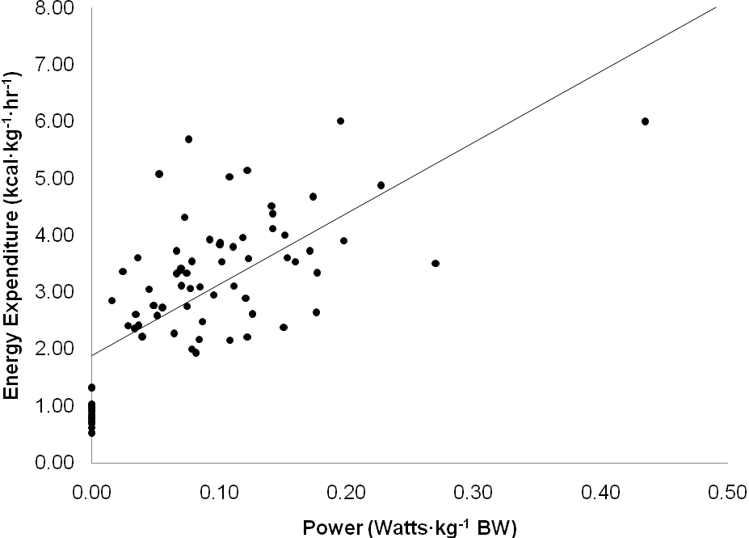
Figure 2- Regression line for mean measured energy expenditure (kcal·kg⁻¹·hr⁻¹) and power output (W) for rest and each activity (r = 0.694).

demonstrated the highest R² and the lowest rMSE was Model 3, which utilized measured power, speed, and heart rate. The prediction models are displayed in Table 3.
Measured energy expenditure values obtained from the criterion measurement of Oxycon Mobile were compared to the different prediction methods (Figure 3). A repeated measures ANOVA demonstrated a significant main effect between measured energy expenditure and estimated energy expenditure (p < 0.01). Overall, there were no significant differences between the criterion method and the power models, or

Table 3 - Regression equations to predict gross energy expenditure (kcal·kg⁻¹·hr⁻¹) for all activities
Prediction Model | Equation | R² | SEE | rMSE | Prediction bias
Power Model 1 - Power | EE = 1.884 + 12.484 * Watts·kg⁻¹ | 0.48 | 0.97 | 0.97 | -0.21
Power Model 2 - Power, speed | EE = 0.894 + 3.037 * Watts·kg⁻¹ + 0.387 * km·hr⁻¹ | 0.70 | 0.74 | 0.82 | 0.00
Power Model 3 - Power, speed, heart rate | EE = -1.454 + 1.320 * Watts·kg⁻¹ + 0.393 * km·hr⁻¹ + 0.023 * beats·min⁻¹ | 0.87 | 0.48 | 0.74 | -0.04
SEE = standard error of the estimate; rMSE = root mean squared error

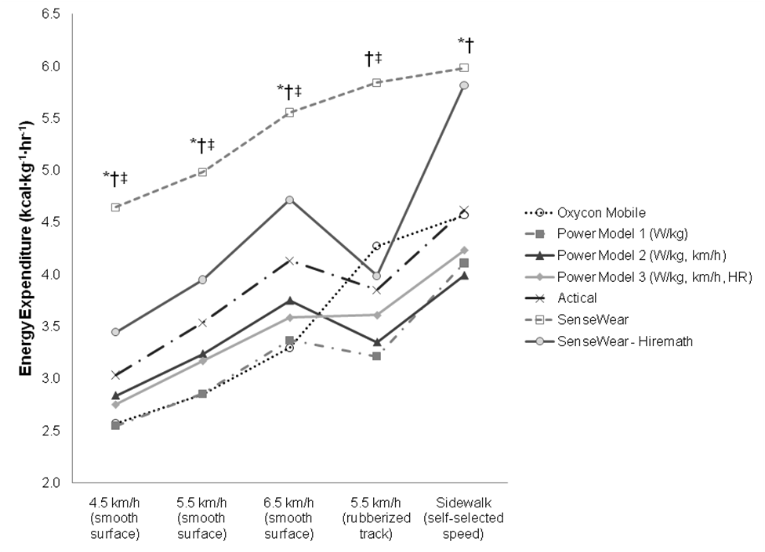
Figure 3 - Influence of different wheelchair activities on estimated energy expenditure by different prediction methods. * Significantly different than Oxycon mobile (p < 0.05), † Significantly different than Power Model 1, Power Model 2, Power Model 3 (p < 0.05), ‡ Significantly different than Actical (p < 0.05).
between the criterion method and the Actical (p > 0.05). However, the SenseWear significantly overestimated energy expenditure when wheeling at 4.5 km·hr⁻¹, 5.5 km·hr⁻¹, 6.5 km·hr⁻¹, and during self-paced sidewalk wheeling (p < 0.05).
The overall accuracy of each prediction method are represented in Figures 4, 5 and 6 using Bland-Altman plots to show the differences between measured energy expenditure and estimated energy expenditure for each method. Based on the Bland-Altman plots, the precision and accuracy of the three power models were higher than the other prediction methods. In addition, the SenseWear Hiremath prediction equation yielded less error at lower intensities and progressively more error at higher intensities.

Discussion
The results of this study suggest that wheelchair power output measurement is able to differentiate between changes that occur in energy expenditure during wheelchair locomotion. The magnitude of the correlation between the wheelchair power output and energy expenditure across a range of intensities (r = 0.69) in the present study was similar to those that have been reported previously. During an incremental
test on a wheelchair ergometer, Theisen et al. [215] reported correlations between power output and VO₂ of 0.72. Other studies that used motion sensors during wheelchair activities on a firm, level surface found similar relationships between activity counts and energy expenditure. Washburn and Copay [45] reported correlations between activity counts by ActiGraph monitors worn on the wrist and oxygen consumption measured using a portable metabolic system of 0.52 for the right wrist and
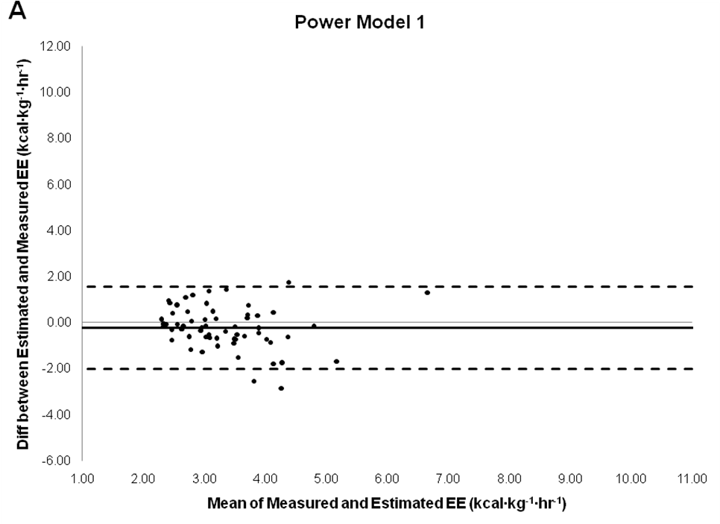

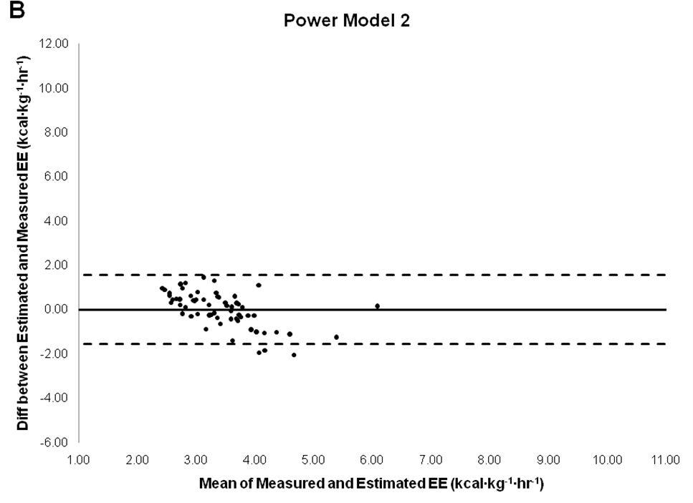
Figure 4 - Bland-Altman plots depicting error scores for (A) Power Model 1 (W·kg⁻¹) and (B) Power Model 2 (W·kg⁻¹, km·h⁻¹). Bold line represents the mean difference, dashed line represents the 95% confidence interval, solid line represents the line of perfect agreement.
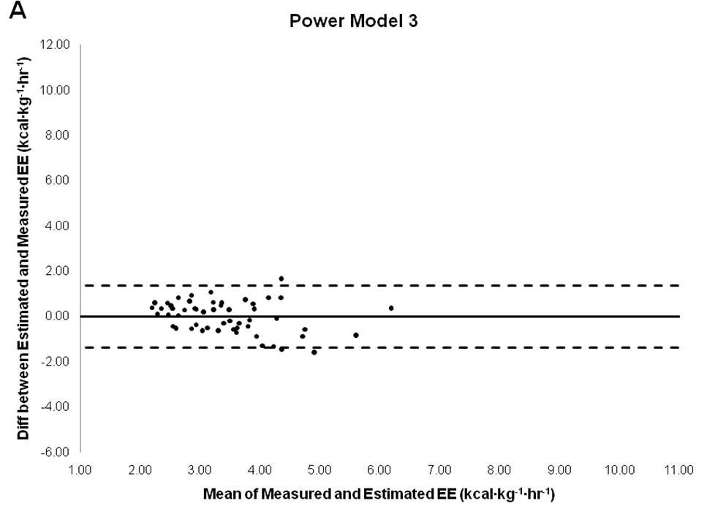

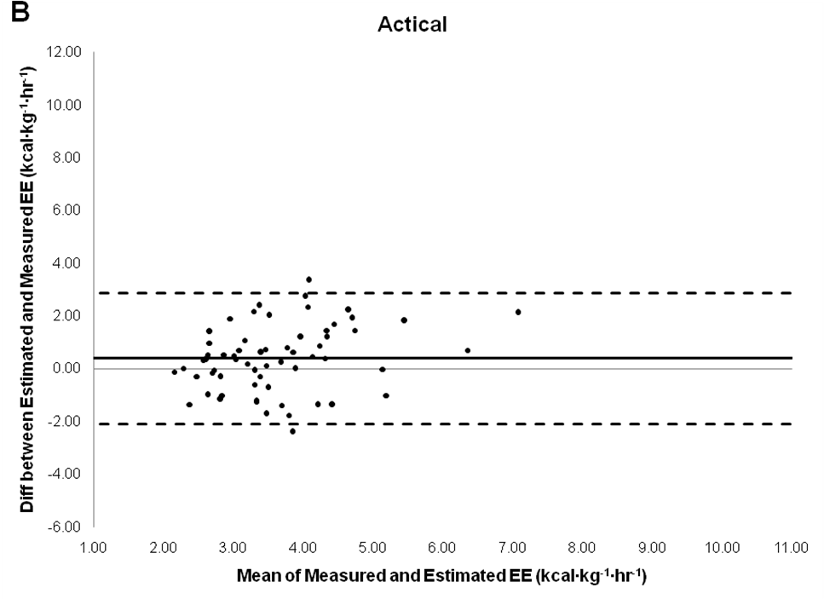
Figure 5 - Bland-Altman plots depicting error scores for (A) Power Model 3 (W·kg⁻¹, km·h⁻¹, beats·min⁻¹) and (B) Actical. Bold line represents the mean difference, dashed line represents the 95% confidence interval, solid line represents the line of perfect agreement.
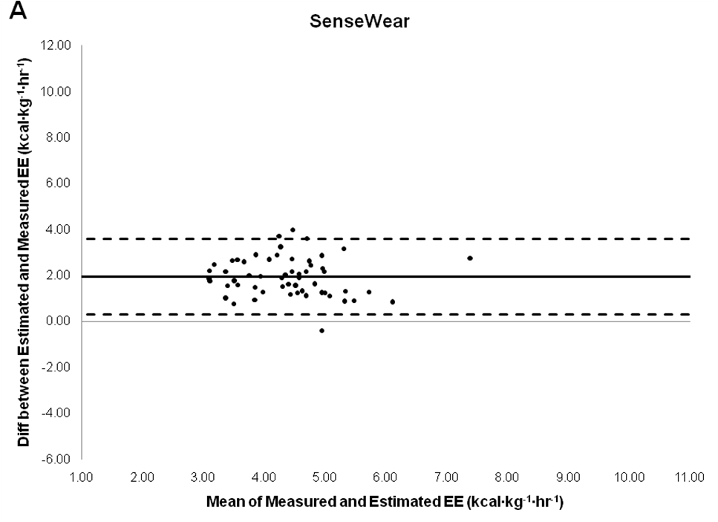

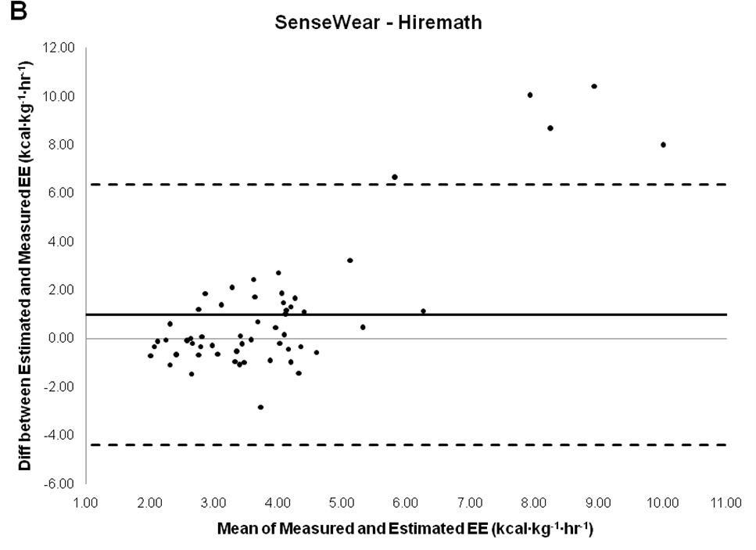
Figure 6 - Bland-Altman plots depicting error scores for (A) SenseWear and (B) SenseWear - Hiremath. Bold line represents the mean difference, dashed line represents the 95% confidence interval, solid line represents the line of perfect agreement.
0.67 for the left wrist (p<0.01) during wheelchair propulsion at three different speeds on a firm, level surface.
During activities ranging from resting and deskwork to wheelchair propulsion and arm crank ergometry, Hiremath and Ding [43] reported correlations between energy expenditure measured by a metabolic system and those estimated by the SenseWear armband and the RT3 tri-axial accelerometer of 0.79 and 0.71 (p<0.01), respectively. During wheelchair propulsion activities, Hiremath and Ding [44] also reported correlations of 0.47 by the SenseWear and 0.52 by the RT3 (p<0.05). The relationship between upper body movement and energy expenditure during wheelchair activities was correlated in these studies. However, this study did not include surfaces that elicited higher rolling resistances and different terrains. Thus, the present study demonstrated similar relationships between wheelchair propulsion power and energy expenditure with the inclusion of wheelchair activities on surfaces that elicited higher rolling resistances and different terrains as those that have been reported between wrist accelerometry and energy expenditure.
Using stepwise, linear regression, the results of this study were used to develop three models for predicting energy expenditure from power output. Each of these models used wheelchair power, and added other variables that can easily be obtained simultaneously via the PowerTap hub (i.e. speed and heart rate). A repeated measures ANOVA indicated that none of the mean values obtained from the power models were significantly different than the criterion measure for energy expenditure. On the surface that elicited a higher rolling resistance at 5.5 km·hr⁻¹, all three models underestimated the energy expenditure. However, due to logistical constraints the number of subjects who completed this activity (n = 8) was the fewest of any activities. Since this activity accounted for only 12% of the total trials, it had a relatively minor influence on the prediction equations. However, Model 3 (incorporating power, speed, and HR) did improve on the prediction. Nevertheless, none of the power prediction models over- or under-predicted energy expenditure when all trials were considered together.
The PowerTap hub was originally designed to provide an estimate of energy expenditure during bicycling. We chose not to use the estimates of energy expenditure by the PowerTap because the mechanical efficiency of bicycling and wheelchair locomotion differ. Mechanical efficiency has been defined as the ratio of work accomplished to energy expended in performing the work [216]. The mechanical efficiency of cycling is generally considered to be between 20 and 25% [216-218]. During manual wheelchair locomotion, the mechanical efficiency is considerably lower, ranging between 4 and 15% [215, 219-221]. Thus, using the energy expenditure estimates reported by the PowerTap in the analysis of this study would have considerably underestimated the actual energy expenditure of wheelchair locomotion.
In this study, we adapted a PowerTap hub to measure power output during wheelchair activities. This device yields similar power output values to a laboratory ergometer and another power meter, the Schoberer Rad Messtechnik (SRM) crankset [49-50]. Although the PowerTap and the SRM operate by measuring power output in different locations on a bicycle [48], adapting these devices (and others that utilize a similar design) to a wheelchair should produce similar power output values. Therefore, the results of this study can be applied to other methods that can be used for measuring hand rim propulsion power during manual wheelchair locomotion.
The present study found no statistical differences between the Actical energy expenditure estimates and the measured energy expenditure. Comparing the energy expenditure of wheeling at 5.5 km·hr⁻¹ on surfaces that elicited lower and higher rolling resistances, the Actical was able to detect the increased energy cost associated with wheelchair locomotion on a surface that elicited a higher metabolic cost due to increased rolling resistance. The Actical’s energy expenditure estimates are based on information about the acceleration and frequency of movement. The energy expenditure prediction equation used by the Actical was specific for the wrist location [212], but was not specifically developed using populations who use wheelchairs. The increased Actical energy expenditure seen on the rubberized track could be simply due to the increased frequency of movement that was associated with the activity. However, the Bland-Altman plots indicated substantial variation in Actical energy expenditure errors at any given energy expenditure. The Actical could be a viable option for physical activity assessment during wheelchair propulsion, but the Actical has higher individual errors than the power method.
The SenseWear armband significantly overestimated energy expenditure by an average of 31-81% during each of the five activities in this study. Others have also found that the SenseWear tends to overestimate energy expenditure during wheelchair activities by anywhere from 10 to 87% [43-44, 222]. This is likely due to the fact that the SenseWear equation did not include wheelchair activities during the development of its energy expenditure algorithm. Thus, Hiremath and Ding [43] proposed an alternative equation based on key attributes associated with measured energy expenditure including average transverse and longitudinal acceleration and galvanic skin response. The application of the Hiremath equation to the data collected in this study improved the overall mean estimation. However, the Bland-Altman plots reveal that the Hiremath and Ding equation had large variation in individual energy expenditure errors.
This study had several strengths and limitations. A strength was that energy expenditure was directly measured during wheelchair locomotion. We were able to directly compare several different energy expenditure methods that are commonly used in research. Wheelchair speed was closely monitored and surfaces that elicit different rolling resistances were examined. Additionally, this study was not limited to only one population of people who use wheelchairs. Many studies of energy expenditure during wheelchair activities have been limited to only individuals with SCI. While these studies have provided important insight into the different energy requirements that occur in populations with SCI, the results are limited in their generalizability to other individuals who use wheelchairs. In this study, 50% of the participants used a wheelchair due to a reason other than SCI. Limitations of the study include a relatively small sample size. Future studies using the power method for estimating energy expenditure in different study populations are needed to evaluate the equations developed in this study.
In conclusion, this study demonstrated that energy expenditure can be accurately and precisely estimated based on power output measurements during wheelchair propulsion. Energy expenditure estimates from the three prediction models based on wheelchair power output were not significantly different from the criterion measurement. The Actical activity monitor's estimations of energy expenditure also did not significantly differ from the criterion measurement. The two energy expenditure estimates based on the SenseWear armband both overestimated energy expenditure. Future studies using the wheelchair power method for estimating energy expenditure should examine higher intensity activities and free-living activities. In addition, a cross-validation of the equations developed in this study is needed.

REFERENCES
1. Blair, S.N., et al., Physical fitness and all-cause mortality: a prospective study of healthy men and women. JAMA, 1989. 262(17): p. 2395-2401.
2. Morris, J.N., Exercise in the prevention of coronary heart disease: today's best buy in public health. Med Sci Sports Exerc, 1994. 26(7): p. 807-14.
3. Haskell, W.L., J.B. Wolffe Memorial Lecture. Health consequences of physical activity: understanding and challenges regarding dose-response. Med Sci Sports Exerc, 1994. 26(6): p. 649-60.
4. Haskell, W.L., Physical activity, sport, and health: toward the next century. Res Q Exerc Sport, 1996. 67(3 Suppl): p. S37-47.
5. Heath, G.W. and P.H. Fentem, Physical activity among persons with disabilities - a public health perspective. Exerc Sport Sci Rev, 1997. 25: p. 195-234.
6. Dearwater, S.R., et al., Assessment of physical activity in inactive populations. Med Sci Sports Exerc, 1985. 17(6): p. 651-655.
7. Bauman, W.A. and A.M. Spungen, Coronary heart disease in individuals with spinal cord injury: assessment of risk factors. Spinal Cord, 2008. 46(7): p. 466-76.
8. DeVivo, M.J., K.J. Black, and S.L. Stover, Causes of death during the first 12 years after spinal cord injury. Arch Phys Med Rehabil, 1993. 74(3): p. 248-54.
9. Frankel, H.L., et al., Long-term survival in spinal cord injury: a fifty year investigation. Spinal Cord, 1998. 36(4): p. 266-74.
10. Myers, J., M. Lee, and J. Kiratli, Cardiovascular disease in spinal cord injury: an overview of prevalence, risk, evaluation, and management. Am J Phys Med Rehabil, 2007. 86(2): p. 142-52.
11. Duckworth, W.C., et al., Glucose intolerance due to insulin resistance in patients with spinal cord injuries. Diabetes, 1980. 29(11): p. 906-10.
12. Garshick, E., et al., A prospective assessment of mortality in chronic spinal cord injury. Spinal Cord, 2005. 43(7): p. 408-16.
13. Imai, K., T. Kadowaki, and Y. Aizawa, Standardized indices of mortality among persons with spinal cord injury: asselerated aging process. Industrial Health, 2004. 42: p. 213-218.
14. Brenes, G., et al., High density lipoprotein cholesterol concentrations in physically active and sedentary spinal cord injured patients. Arch Phys Med Rehabil, 1986. 67(7): p. 445-50.
15. Cowell, L.L., W.G. Squires, and P.B. Raven, Benefits of aerobic exercise for the paraplegic: a brief review. Med Sci Sports Exerc, 1986. 18(5): p. 501-8.
16. Dallmeijer, A.J., M.T.E. Hopman, and L.H.V. Van der Woude, Lipid, lipoprotein, and apolipoprotein profiles in active and sedentary men with tetraplegia. Arch Phys Med Rehabil, 1997. 78: p. 1173-1176.
17. Bauman, W.A., et al., The effect of residual neurological deficit on serum lipoproteins in individuals with chronic spinal cord injury. Spinal Cord, 1998. 36(1): p. 13-7.
18. Pate, R.R., et al., Physical activity and public health: a recommendation from the Centers for Disease Control and Prevention and the American College of Sports Medicine. JAMA, 1995. 273: p. 402-407.

19. U.S. Department of Health and Human Services, Physical Activity and Health: A Report of the Surgeon General. 1996, Atlanta, GA: U.S. Dept. of Health and Human Services, Centers for Disease Control and Prevention, National Center for Chronic Disease Prevention and Health Promotion.
20. U.S. Department of Health and Human Services (2008) 2008 Physical Activity Guidelines for Americans. 2011, 42-43.
21. Martin Ginis, K.A., et al., Development and evaluation of an activity measure for people with spinal cord injury. Med Sci Sports Exerc, 2005. 37(7): p. 1099-111.
22. Rimmer, J.H., B.B. Riley, and S.S. Rubin, A new measure for assessing the physical activity behaviors of persons with disabilities and chronic health conditions: the physical activity and disability survey. Am J Health Promot, 2001. 16(1): p. 34-45.
23. Rimmer, J.H., et al., Physical activity patterns of African-American women with physical disabilities. Med Sci Sports Exerc, 1999. 31(4): p. 613-618.
24. Washburn, R.A., et al., The physical activity scale for individuals with physical disabilities: development and evaluation. Arch Phys Med Rehabil, 2002. 83(2): p. 193-200.
25. Janssen, T.W., et al., Relationship between physical strain during standardised ADL tasks and physical capacity in men with spinal cord injuries. Paraplegia, 1994. 32(12): p. 844-59.
26. Ainsworth, B.E., H.J. Montoye, and A.S. Leon, Methods of Assessing Physical Activity during Leisure and Work, in Physical Activity Fitness and Health, C. Bonchard, R.J. Shepard, and T. Stephens, Editors. 1994, Human Kinetics. p. 146-159.
27. LaPorte, R.E., H.J. Montoye, and C.J. Caspersen, Assessment of physical activity in epidemiologic research: problems and prospects. Public Health Reports, 1985. 100(2): p. 131-146.
28. Wareham, N.J. and K.L. Rennie, The assessment of physical activity in individuals and populations: Why try to be more precise about how physical activity is assessed? Int J Obes, 1998. 22(Suppl 2): p. S30-S38.
29. Bassett, D.R., Jr., A.L. Cureton, and B.E. Ainsworth, Measurement of daily walking distance-questionnaire versus pedometer. Med Sci Sport Exerc, 2000. 32(5): p. 1018-1023.
30. Sallis, J.F. and B.E. Saelens, Assessment of physical activity by self-report: status, limitations, and future directions. Res Q Exerc Sport, 2000. 71: p. 1-14.
31. Warnecke, R.B., et al., Improving question wording in surveys of culturally diverse populations. Ann Epidemiol, 1997. 7(5): p. 334-42.
32. Cooper, R.A., et al., Driving characteristics of electric-powered wheelchair users: how far, fast, and often do people drive? Arch Phys Med Rehabil, 2002. 83(2): p. 250-5.
33. Karmarkar, A.M., et al., Manual wheelchair-related mobility characteristics of older adults in nursing homes. Disabil Rehabil Assist Technol, 2010. 5(6): p. 428-37.
34. Chen, K.Y. and D.R. Bassett, Jr., The technology of accelerometry-based activity monitors: current and future. Med Sci Sports Exerc, 2005. 37(11 Suppl): p. S490-500.
35. Jakicic, J.M., et al., The accuracy of the TriTrac-R3D accelerometer to estimate energy expenditure. Med Sci Sport Exerc, 1999. 31(5): p. 747-754.
36. Melanson, E.L., Jr. and P.S. Freedson, Validity of the Computer Science and Application, Inc. (CSA) activity monitor. Med Sci Sport Exerc, 1995. 27(6): p. 934-940.
37. Montoye, H.J., et al., Estimation of energy expenditure by a portable accelerometer. Med Sci Sport Exerc, 1983. 15(5): p. 403-407.
38. Servais, S.B., J.G. Webster, and H.J. Montoye, Estimating human energy expenditure using an accelerometer device. J Clin Eng, 1984. 9: p. 159-173.
39. Esliger, D.W., et al., Validation of the GENEA Accelerometer. Med Sci Sports Exerc, 2011. 43(6): p. 1085-93.
40. Jakicic, J.M., et al., Evaluation of the SenseWear Pro Armband to assess energy expenditure during exercise. Med Sci Sports Exerc, 2004. 36(5): p. 897-904.
41. King, G.A., et al., Comparison of activity monitors to estimate energy cost of treadmill exercise. Med Sci Sports Exerc, 2004. 36(7): p. 1244-51.
42. Swartz, A.M., et al., Estimation of energy expenditure using CSA accelerometers at hip and wrist sites. Med Sci Sport Exerc, 2000. 32(9 Suppl.): p. S450-S456.
43. Hiremath, S.V. and D. Ding, Evaluation of activity monitors to estimate energy expenditure in manual wheelchair users. Conf Proc IEEE Eng Med Biol Soc, 2009. 2009: p. 835-8.
44. Hiremath, S.V. and D. Ding, Evaluation of activity monitors in manual wheelchair users with paraplegia. J Spinal Cord Med, 2011. 34(1): p. 110-7.
45. Washburn, R.A. and A.G. Copay, Assessing physical activity during wheelchair pushing: Validity of a portable accelerometer. Adapt Phys Activ Q, 1999. 16: p. 290-299.
46. Conger, S.A. and D.R. Bassett, Jr., A compendium of the energy costs of physical activities for individuals who use a manual wheelchair. Adapt Phys Activ Q, 2011. In press.
47. Jones, S.M. and L. Passfield, Dynamic calibration of bicycle power measuring cranks, in The Engineering of Sport, S.J. Haake, Editor. 1998, Blackwell Science: Oxford. p. 265-274.
48. Allen, H. and A. Coggan, Training and Racing with a Power Meter. 2006, Boulder, CO: Velopress.
49. Gardner, A.S., et al., Maximal torque- and power-pedaling rate relationships for elite sprint cyclists in laboratory and field tests. Eur J Appl Physiol, 2007. 101(3): p. 287-92.
50. Bertucci, W., et al., Validity and reliability of the PowerTap mobile cycling powermeter when compared with the SRM Device. Int J Sports Med, 2005. 26(10): p. 868-73.
51. Gardner, A.S., et al., Accuracy of SRM and power tap power monitoring systems for bicycling. Med Sci Sports Exerc, 2004. 36(7): p. 1252-8.
52. Barbotte, E., F. Guillemin, and N. Chau, Prevalence of impairments, disabilities, handicaps and quality of life in the general population: a review of recent literature. Bull World Health Organ, 2001. 79(11): p. 1047-55.
53. Cook, J., et al., State-specific prevalence of disability among adults--11 states and the District of Columbia, 1998. MMWR Morb Mortal Wkly Rep, 2000. 49(31): p. 711-4.
54. McNeil, J.M. and J. Binette, Prevalence of disabilities and associated health conditions among adults--United States, 1999. MMWR Morb Mortal Wkly Rep, 2001. 50(7): p. 120-5.
55. Rimmer, J.H., D. Braddock, and K.H. Pitetti, Research on physical activity and disability: an emerging national priority. Med Sci Sport Exerc, 1996. 28(11): p. 1366-1372.
56. Albrecht, G.L., The disability business: Rehabilitation in America. 1992, Newbury Park, NY: Sage Publications.
57. Iezzoni, L.I., et al., Mobility impairmants and use of screening and preventive services. Am J Public Health, 2000. 90(6): p. 955-961.
58. Kaye, H.S., T. Kang, and M.P. LaPlante, Mobility device use in the United States. 2000, Washington, D.C.: U.S. Department of Education.
59. McNeil, J.M., Prevalance of disabilities and associated health conditions among adults - United States, 1999. MMWR. Morbidity and Mortality Weekly Report, 2001. 50(7): p. 120-125.
60. LaPlante, M.P. and H.S. Kaye, Demographics and trends in wheeled mobility equipment use and accessibility in the community. Assist Technol, 2010. 22(1): p. 3-17; quiz 19.
61. Brandt, Å., S. Iwarsson, and A. Ståhle, Older people's use of powered wheelchairs for activity and participation. J Rehabil Med, 2004. 36: p. 70-77.
62. Hoenig, H., et al., Activity restriction among wheelchair users. J Am Geriatr Soc, 2003. 51: p. 1244-1251.
63. Field, D., Powered mobility: A literature review illustrating the importance of a multifaceted approach. Assist Technol, 1999. 11: p. 20-33.
64. Best, K.L., et al., Comparison between performance with a pushrim-activated power-assisted wheelchair and a manual wheelchair on the Wheelchair Skills Test. Disabil Rehabil, 2006. 28(4): p. 213-20.
65. Wilson, A.B., Jr., Wheelchairs: A prescription guide. 1986, Charlottesville, VA: Rehalilitation Press.
66. Giacobbi, P.R., et al., Wheelchair users' perceptions of and experiences with power assist wheels. Am J Phys Med Rehabil, 2010. 89.
67. Sonenblum, S.E., et al., Characterization of power wheelchair use in the home and community. Arch Phys Med Rehabil, 2008. 89: p. 486-491.
68. Ivanoff, S.D. and U. Sonn, Changes in the use of assistive devices among 90-year-old persons. Aging Clin Exp Res, 2005. 17: p. 246-251.
69. Steinmetz, E., Americans with Disabilities, 2002. Current Population Reports. Special Censuses. Series P-28, 2006. P70(107): p. 1-32.
70. Wilder, C.S., Use of special aids. Vital Health Stat 10, 1972. 10(78): p. 1-23.
71. Russell, J.N., et al., Trends and differential use of assistive technology devices: United States, 1994. Adv Data, 1997(292): p. 1-9.
72. Fitzgerald, S.G., et al., The development of a nationwide registry of wheelchair users. Disabil Rehabil Assist Technol, 2007. 2(6): p. 358-365.
73. Shields, M., Use of wheelchairs and other mobility support devices. Health Rep, 2004. 15(3): p. 37-41.
74. Sedgwick, M., et al., Improving services for wheelchair users and carers, in Good practice guide: learning from the Wheelchair Services Collaborative. 2005, NHS, Department of Health: London.
75. Vignier, N., et al., Demographics of wheelchair users in France: results of national community-based handicaps-incapacités-dépendance surveys. J Rehabil Med, 2008. 40: p. 231-239.
76. Clarke, P. and A. Colantonio, Wheelchair use among community-dwelling older adults: prevalence and risk factors in a national sample. Can J Aging, 2005. 24(2): p. 191-198.
77. van der Woude, L.H.V., S. de Groot, and T.W.J. Janssen, Manual wheelchairs: Research and innovation in rehabilitation, sports, daily life and health. Med Eng Phys, 2006. 28(9): p. 905-915.
78. Cardinal, B.J., M. Kosma, and J.A. McCubbin, Factors influencing the exercise behavior of adults with physical disabilities. Med Sci Sports Exerc, 2004. 36(5): p. 868-75.
79. Coyle, C.P. and M.C. Santiago, Aerobic exercise training and depressive symptomatology in adults with physical disabilitie. Arch Phys Med Rehabil, 1995. 76(7): p. 647-52.
80. Washburn, R. and B.N. Hedrick, Descriptive epidemiology of physical activity in university graduates with locomotor disabilities. Int J Rehabil Res, 1997. 20(3): p. 275-87.
81. Brown, D.R., et al., Physical activity among adults >50 yr with and without disabilities, BRFSS 2001. Med Sci Sport Exerc, 2005. 37(4): p. 620-629.
82. U.S. Department of Health and Human Services, Healthy people 2010: Understanding and improving health. 2nd ed. 2000, Washington, D.C.: U.S. Department of Health and Human Services.
83. U.S. Department of Health and Human Services, The surgen general's call to action to improve the health and wellness of persons with disabilities. 2005, Rockville, MD: US Department of Health and Human Services, Office of the Surgeon General
84. Durstine, J.L., et al., Physical activity for the chronically ill and disabled. Sports Med, 2000. 30(3): p. 207-19.
85. Kinne, S., D.L. Patrick, and D. Lochner Doyle, Prevalence of secondary conditions among people with disabilities. Am J Public Health, 2004. 94(3): p. 443-445.
86. Liou, T.-H., F.X. Pi-Sunyer, and B. Laferrère, Physical disability and obesity. Nutr Rev, 2005. 63(10): p. 321-331.
87. Allen, S., L. Resnik, and J. Roy, Promoting independence for wheelchair users: the role of home accommodations. Gerontologist, 2006. 46(1): p. 115-123.
88. Rimmer, J.H., Health promotion for people with disabilities: the emerging paradigm shift from disability prevention to prevention of secondary conditions. Phys Ther, 1999. 79: p. 495-502.
89. Seaman, J.A., Physical activity and fitness for persons with disabilities. Pres Coun Phys Fit Sports Res Dig, 1999. 3(5): p. 1-6.
90. Devillard, X., et al., Effects of training programs for spinal cord injury. Ann Readapt Med Phys, 2007. 50: p. 490-498.
91. Kofsky, P.R., et al., Fitness classification tables for lower limb disabled individuals, in Sport and Disabled Athletes, C. Sherrill, Editor. 1986, Human Kinetics: Champaign, IL. p. 147-156.
92. Whiteneck, G.G., et al., Mortality, morbidity, and psychosocial outcomes of persons spinal cord injured more than 20 years ago. Paraplegia, 1992. 30(9): p. 617-30.
93. Bauman, W.A., et al., Risk factors for atherogenesis and cardiovascular autonomic function in persons with spinal cord injury. Spinal Cord, 1999. 37(9): p. 601-16.
94. Pentland, W., et al., The impact of spinal cord injury on men's time use. Spinal Cord, 1999. 37(11): p. 786-92.
95. Tremblay, M.S., et al., Incidental movement, lifestyle-embedded activity and sleep: new frontiers in physical activity assessment. Can J Public Health, 2007. 98 Suppl 2: p. S208-17.
96. Manns, P.J. and K.E. Chad, Determining the relation between quality of life, handicap, fitness, and physical activity for persons with spinal cord injury. Arch Phys Med Rehabil, 1999. 80(12): p. 1566-71.
97. Noreau, L., et al., Relationship of impairment and functional ability to habitual activity and fitness following spinal cord injury. Int J Rehabil Res, 1993. 16(4): p. 265-75.
98. Stewart, A.L., et al., Long-term functioning and well-being outcomes associated with physical activity and exercise in patients with chronic conditions in the Medical Outcomes Study. J Clin Epidemiol, 1994. 47(7): p. 719-30.
99. van den Berg-Emons, H.J., et al., Body fat, fitness and level of everyday physical activity in adolescents and young adults with meningomyelocele. J Rehabil Med, 2003. 35(6): p. 271-5.
100. Noreau, L. and R.J. Shephard, Spinal cord injury, exercise and quality of life. Sports Med, 1995. 20(4): p. 226-50.
101. Groah, S.L., et al., The relationship between neurological level of injury and symptomatic cardiovascular disease risk in the aging spinal injured. Spinal Cord, 2001. 39(6): p. 310-7.
102. Sawka, M.N., Physiology of upper body exercise. Exerc Sport Sci Rev, 1986. 14: p. 175-211.
103. DeVivo, M.J., et al., A cross-sectional study of the relationship between age and current health status for persons with spinal cord injuries. Paraplegia, 1992. 30(12): p. 820-7.
104. Bauman, W.A. and A.M. Spungen, Disorders of carbohydrate and lipid metabolism in veterans with paraplegia or quadriplegia: a model of premature aging. Metabolism, 1994. 43(6): p. 749-56.
105. Ohlson, L.O., et al., The influence of body fat distribution on the incidence of diabetes mellitus. 13.5 years of follow-up of the participants in the study of men born in 1913. Diabetes, 1985. 34(10): p. 1055-8.
106. Bauman, W.A., et al., The effect of residual neurological deficit on oral glucose tolerance in persons with chronic spinal cord injury. Spinal Cord, 1999. 37(11): p. 765-71.
107. Geisler, W.O., A.T. Jousse, and M. Wynne-Jones, Survival in traumatic transverse myelitis. Paraplegia, 1977. 14: p. 262-275.
108. Albert, M.A., R.J. Glynn, and P.M. Ridker, Effect of physical activity on serum C-reactive protein. Am J Cardiol, 2004. 93(2): p. 221-5.
109. Morse, L.R., et al., Association between mobility mode and C-reactive protein levels in men with chronic spinal cord injury. Arch Phys Med Rehabil, 2008. 89(4): p. 726-731.
110. Liang, H., et al., Different risk factor patterns for metabolic syndrome in men with spinal cord injury compared with able-bodied men despite similar prevalence rates. Arch Phys Med Rehabil, 2007. 88: p. 1198-1204.
111. Bauman, W.A., et al., Depressed serum high density lipoprotein cholesterol levels in veterans with spinal cord injury. Paraplegia, 1992. 30(10): p. 697-703.
112. Dearwater, S.R., et al., Activity in the spinal cord-injured patient: an epidemiologic analysis of metabolic parameters. Med Sci Sport Exerc, 1986. 18(5): p. 541-544.
113. Krum, H., et al., Risk factors for cardiovascular disease in chronic spinal cord injury patients. Paraplegia, 1992. 30: p. 381-388.
114. Nikkila, E.A., T. Kuusi, and P. Myllynen, High density lipoprotein and apolipoprotein A-i during physical inactivity. Demonstration at low levels in patients with spine fracture. Atherosclerosis, 1980. 37(3): p. 457-62.
115. Zlotolow, S.P., E. Levy, and W.A. Bauman, The serum lipoprotein profile in veterans with paraplegia: the relationship to nutritional factors and body mass index. J Am Paraplegia Soc, 1992. 15(3): p. 158-62.
116. Buffart, L.M., et al., Triad of physical activity, aerobic fitness and obesity in adolescents and young adults with myelomeningocele. J Rehabil Med, 2008. 40(1): p. 70-5.
117. Hoffman, M.D., Cardiorespiratory fitness and training in quadriplegics and paraplegics. Sports Med, 1986. 3(5): p. 312-30.
118. Rimaud, D., P. Calmels, and X. Devillard, Training programs in spinal cord injury. Ann Readapt Med Phys, 2005. 48(5): p. 259-69.
119. Davis, G.M., Exercise capacity of individuals with paraplegia. Med Sci Sports Exerc, 1993. 25(4): p. 423-32.
120. Huang, Y., et al., Physical fitness, physical activity, and functional limitation in adults aged 40 and older. Med Sci Sports Exerc, 1998. 30(9): p. 1430-5.
121. Bostom, A.G., et al., Lipid and lipoprotein profiles relate to peak aerobic power in spinal cord injured men. Med Sci Sport Exerc, 1991. 23(4): p. 409-414.
122. Lasko-McCarthey, P. and J.A. Davis, Protocol dependency of VO2max during arm cycle ergometry in males with quadriplegia. Med Sci Sport Exerc, 1991. 23(9): p. 1097-1101.
123. Nash, M.S., et al., Circuit resistance training improves the atherogenic lipid profiles of persons with chronic paraplegia. J Spinal Cord Med, 2001. 24(1): p. 2-9.
124. Dudley, G.A., et al., A simple means of increasing muscle size after spinal cord injury: a pilot study. Eur J Appl Physiol Occup Physiol, 1999. 80: p. 394-396.
125. Olle, M.M., et al., Body composition of sedentary and physically active spinal cord injured individuals estimated from total body electrical conductivity. Arch Phys Med Rehabil, 1993. 74(7): p. 706-10.
126. Mohr, T., et al., Insulin action and long-term electrically induced training in individuals with spinal cord injuries. Med Sci Sports Exerc, 2001. 33(8): p. 1247-52.
127. Le Foll-de Moro, D., et al., Ventilation efficiency and pulmonary function after a wheelchair interval-training program in subjects with recent spinal cord injury. Arch Phys Med Rehabil, 2005. 86(8): p. 1582-6.
128. Thijssen, D.H., et al., Local vascular adaptations after hybrid training in spinal cord-injured subjects. Med Sci Sports Exerc, 2005. 37(7): p. 1112-8.
129. Dallmeijer, A.J., et al., Physical performance during rehabilitation in persons with spinal cord injuries. Med Sci Sports Exerc, 1999. 31(9): p. 1330-5.
130. Stotts, K.M., Health maintenance: paraplegic athletes and nonathletes. Arch Phys Med Rehabil, 1986. 67(2): p. 109-14.
131. Marge, M.M., Health promotion for persons with disabilities: moving beyond rehabilitation. Am J Health Promo, 1988. 2: p. 29-35.
132. Martin Ginis, K.A., et al., Physical activity and subjective well-being among people with spinal cord injury: a meta-analysis. Spinal Cord, 2010. 48(1): p. 65-72.
133. Aronson, J., The encyclopedia of furniture. Third ed. 1965, New York: Clarkson Potter.
134. Tunis, E., Wheels: a pictorial history. 1955, Baltimore and London: The Johns Hopkins University Press.
135. Kamenetz, H., The wheelchair book: Mobility for the disabled. 1969, Springfield, IL: Charles C. Thomas.
136. Cooper, R.A., Wheelchair selection and configuration. 1998, New York: Demos Medical Publishing.
137. Lhermite, J., Le Passetemps. Vol. I. 1890, Antwerp. 257-258.
138. Doppelmayr, J.G., Historische nachricht von den nürnbergischen mathematicis und Künstlern. 1730, Nuremburg.
139. Feldhaus, F.M., Die technik der vorzeit, der geschichtlichen zeit und der naturvölker 1914, Leipzig and Berlin.
140. Black, C., Franklin Delano Roosevelt: champion of freedom. 2003, United States of America: PublicAffairs.
141. Profiles: Meet H.A. Everest, in Paraplegia News. 1955. p. 4.
142. Bather, R., The wheelchair, in Paraplegia News. 1955.
143. Ardigo, L.P., V.L. Goosey-Tolfrey, and A.E. Minetti, Biomechanics and energetics of basketball wheelchairs evolution. Int J Sports Med, 2005. 26: p. 388-396.
144. Karp, G., Choosing a wheelchair: a guide for optimal independence. 1998, Sebastopol, CA: O'Reilly and Associates.
145. Craven, P.L., The development of the self-propelled wheelchair since World War 2. 1992, Barcelona: Sport Science Congress Acts.
146. Algood, S.D., et al., Effect of a pushrim-activated power-assist wheelchair on the functional capabilities of persons with tetraplegia. Arch Phys Med Rehabil, 2005. 86(3): p. 380-6.
147. Fitzgerald, S.G., et al., A pilot study on community usage of a pushrim-activated, power-assisted wheelchair. Assist Technol, 2003. 15(2): p. 113-9.
148. Zukowski, L.A., et al., Metabolic cost of wheelchair propulsion using an ergonomic hand drive mechanism. Med Sci Sport Exerc, 2011. 43(5 Supplement): p. S600.
149. Rimmer, J.H., Exercise and physical activity in persons aging with a physical disability. Phys Med Rehab Clin N Am, 2005. 16: p. 41-56.
150. Gallagher-Lepak, S., Functional capacity and activity level before and after renal transplantation. ANNA J, 1991. 18(4): p. 378-82; discussion 382, 406.
151. Stuifbergen, A.K., Physical activity and perceived health status in persons with multiple sclerosis. J Neurosci Nurs, 1997. 29(4): p. 238-243.
152. Heller, T., et al., Determinants of exercise in adults with cerrebral palsy. Public Health Nurs, 2002. 19(3): p. 223-231.
153. Kayes, N.M., et al., The Physical Activity and Disability Survey (PADS): reliability, validity and acceptability in people with multiple sclerosis. Clin Rehabil, 2007. 21(7): p. 628-39.
154. Kayes, N.M., et al., The Physical Activity and Disability Survey -- Revised (PADS-R): an evaluation of a measure of physical activity in people with chronic neurological conditions. Clin Rehabil, 2009. 23(6): p. 534-43.
155. Liu-Ambrose, T.Y., M.C. Ashe, and C. Marra, Independent and inverse association of healthcare utilisation with physical activity in older adults with multiple chronic conditions. Br J Sports Med, 2010. 44(14): p. 1024-8.
156. Rand, D., et al., Daily physical activity and its contribution to the health-related quality of life of ambulatory individuals with chronic stroke. Health Qual Life Outcomes, 2010. 8: p. 80.
157. Caspersen, C.J., Physical activity epidemiology: concepts, methods, and applications to exercise science. Exerc Sport Sci Rev, 1989. 17: p. 423-73.
158. Kriska, A. and C.J. Caspersen, Introduction to a collection of physical activity questionnaires. Med Sci Sport Exerc, 1997. 29: p. s5-s9.
159. Warms, C.A., B.L. Belza, and J.D. Whitney, Correlates of physical activity in adults with mobility limitations. Fam Community Health, 2007. 30(2s): p. S5-S16.
160. Shephard, R.J., Limits to the measurement of habitual physical activity by questionnaires. Br J Sports Med, 2003. 37(3): p. 197-206; discussion 206.
161. Santiago, M.C. and C.P. Coyle, Leisure-time physical activity and secondary conditions in women with physical disabilities. Disabil Rehabil, 2004. 26(8): p. 485-494.
162. Slawta, J.N., et al., Health behaviors, body composition, and coronary heart disease risk in women with multiple sclerosis. Arch Phys Med Rehabil, 2003. 84: p. 1823-1830.
163. Godin, G. and R.J. Shephard, A simple method to assess exercise behavior in the community. Can J Appl Sport Sci, 1985. 10(3): p. 141-6.
164. Donkervoort, M., et al., Determinants of functioning of adolescents and young adults with cerebral palsy. Disabil Rehabil, 2007. 29(6): p. 453-63.
165. Grimby, G., et al., Structure of a combination of functional independence measure and instrumental activity measure items in community-living persons: a study of individuals with cerebral palsy and spina bifida. Arch Phys Med Rehabil, 1996. 77: p. 1109-1114.
166. Andrén, E. and G. Grimby, Dependence in daily activities and life satisfaction in adult subjects with cerebral palsy or spina bifida: a follow-up study. Disabil Rehabil 2004. 26(9): p. 528-536.
167. Macera, C.A., et al., Prevalence of physical activity in the United States: Behavioral Risk Factor Surveillance System, 2001. Prev Chronic Dis, 2005. 2(2): p. A17.
168. McGuire, L.C., et al., Healthy lifestyle behaviors among older U.S. adults with and without disabilities, Behavioral Risk Factor Surveillance System, 2003. Prev Chronic Dis, 2007. 4(1): p. A09.
169. Rimmer, J.H., et al., Physical Activity Among Adults With a Disability --- United States, 2005. MMWR Morb Mortal Wkly Rep, 2007. 56(39): p. 1021-1024.
170. Boslaugh, S.E. and E.M. Andresen, Correlates of physical activity for adults with disability. Prev Chronic Dis, 2006. 3(3): p. A78.
171. Rimmer, J.H., et al., A randomized controlled trial to increase physical activity and reduce obesity in a predominantly African American group of women with mobility disabilities and severe obesity. Prev Med, 2009. 48: p. 473-479.
172. Rockhill, B., et al., A prospective study of recreational physical activity and breast cancer risk. Arch Intern Med, 1999. 159(19): p. 2290-6.
173. Schuit, A.J., et al., Validity of the Physical Activity Scale for the Elderly (PASE): according to energy expenditure assessed by the doubly labeled water method. J Clin Epidemiol, 1997. 50(5): p. 541-6.
174. Liang, H., et al., Objective measures of neighborhood environment and self-reported physical activity in spinal cord injured men. Arch Phys Med Rehabil, 2008. 89: p. 1468-1473.
175. Warms, C.A., J.D. Whitney, and B. Belza, Measurement and description of physical activity in adult manual wheelchair users. Disabil Health J, 2008. 1: p. 236-244.
176. Giacobbi, P.R., et al., Physical activity and quality of life experienced by highly active individuals with physical disabilities. Adapt Phys Activ Q, 2008. 25: p. 189-207.
177. Van der Ploeg, H.P., et al., The physical activity scale for individuals with physical disabilities: test-retest reliability and comparison with an accelerometer. J Phys Act Health, 2007. 4: p. 96-100.
178. de Groot, S., et al., Evaluation of the physical activity scale for individuals with physical disabilities in people with spinal cord injury. Spinal Cord, 2010. 48(7): p. 542-7.
179. de Groot, S., et al., Is manual wheelchair satisfaction related to active lifestyle and participation in people with a spinal cord injury? Spinal Cord, 2011. 49(4): p. 560-5.
180. Latimer, A.E., et al., The physical activity recall assessment for people with spinal cord injury: validity. Med Sci Sports Exerc, 2006. 38(2): p. 208-16.
181. Tawashy, A.E., et al., Physical activity is related to lower levels of pain, fatigue and depression in individuals with spinal-cord injury: a correlational study. Spinal Cord, 2009. 47: p. 301-306.
182. Hetz, S.P., A.E. Latimer, and K.A. Ginis, Activities of daily living performed by individuals with SCI: relationships with physical fitness and leisure time physical activity. Spinal Cord, 2009. 47(7): p. 550-4.
183. Hetz, S.P., et al., Increased participation in activities of daily living is associated with lower cholesterol levels in people with spinal cord injury. Arch Phys Med Rehabil, 2009. 90(10): p. 1755-9.
184. Arbour, K.P. and K.A. Martin Ginis, The relationship between physical activity facility proximity and leisure-time physical activity in persons with spinal cord injury. Disabil Health J, 2009. 2(3): p. 128-35.
185. Monroe, M.B., et al., Lower daily energy expenditure as measured by a respiratory chamber in subjects with spinal cord injury compared with control subjects. Am J Clin Nutr, 1998. 68: p. 1223-1227.
186. Yamasaki, M., et al., Daily energy expenditure in active and inactive persons with spinal cord injury. J Hum Ergol (Tokyo), 1992. 21(2): p. 125-33.
187. Buchholz, A.C., C.F. McGillivray, and P.B. Pencharz, Physical activity levels are low in free-living adults with chronic paraplegia. Obes Res, 2003. 11(4): p. 563-70.
188. Janssen, T.W.J., et al., Physical strain in daily life of wheelchair users with spinal cord injuries. Med Sci Sport Exerc, 1994. 26(6): p. 661-670.
189. Westerterp, K.R., Physical activity assessment with accelerometers. Int J Obes Relat Metab Disoed, 1999. 23(Suppl 3): p. S45-S49.
190. Halstead, L.S., E.P. Willems, and C.S. Frey, Spinal cord injury: Time out of bed during rehabilitation. Arch Phys Med Rehabil, 1979. 60: p. 590-595.
191. Cooper, R.A., et al., Quantifying wheelchair activity of children: a pilot study. Am J Phys Med Rehabil, 2008. 87: p. 977-983.
192. Ferretti, E.C., Assessing the influence of wheelchair on individuals with spinal cord injury using a measure of participation, in Rehabilitation and Science Technology. 2007, University of Pittsburgh: Pittsburgh, PA. p. 174.
193. Tolerico, M.L., et al., Assessing mobility characteristics and activity levels of manual wheelchair users. J Rehabil Res Dev, 2007. 44(4): p. 561-572.
194. Sporner, M.L., et al., Quantification of activity during wheelchair basketball and rugby at the National Veterans Wheelchair Games: A pilot study. Prosthet Orthot Int, 2009. 33(3): p. 210-7.
195. Bussmann, J.B., et al., Measuring daily behavior using ambulatory accelerometry: the Activity Monitor. Behav Res Methods Instrum Comput, 2001. 33(3): p. 349-56.
196. van den Berg-Emons, H.J., et al., Everyday physical activity in adolescents and young adults with meningomyelocele as measured with a novel activity monitor. J Pediatr, 2001. 139: p. 880-886.
197. Buffart, L.M., et al., Lifestyle, participation, and health-related quality of life in adolescents and young adults with myelomeningocele. Dev Med Child Neurol, 2009. 51(11): p. 886-94.
198. Postma, K., et al., Validity of the detection of wheelchair propulsion as measured with an Activity Monitor in patients with spinal cord injury. Spinal Cord, 2005. 43: p. 550-557.
199. Van den Berg-Emons, R.J., et al., A prospective study on physical activity levels after spinal cord injury during inpatient rehabilitation and the year after discharge. Arch Phys Med Rehabil, 2008. 89: p. 2094-2101.
200. Wilson, S.K.M., et al., Objective assessment of mobility of the spinal cord injured in a free-living environment. Spinal Cord, 2008. 46: p. 352-357.
201. Coulter, E.H., et al., Development and validation of a physical activity monitor for use on a wheelchair. Spinal Cord, 2011. 49(3): p. 445-50.
202. Warms, C.A. and B.L. Belza, Actigraphy as a measure of physical activity for wheelchair users with spinal cord injury. Nurs Res, 2004. 53(2): p. 136-143.
203. Warms, C.A., et al., Lifestyle physical activity for individuals with spinal cord injury: a pilot study. Am J Health Promot, 2004. 18(4): p. 288-91.
204. Munakata, M., et al., Circadian blood pressure rhythm in patients with higher and lower spinal cord injury: simultaneous evaluation of autonomic nervous activity and physical activity. J Hypertens, 1997. 15(12 Pt 2): p. 1745-9.
205. Boninger, M.L., et al., Wheelchair pushrim kinetics: body weight and median nerve function. Arch Phys Med Rehabil, 1999. 80(8): p. 910-5.
206. Boninger, M.L., et al., Three-dimensional pushrim forces during two speeds of wheelchair propulsion. Am J Phys Med Rehabil, 1997. 76(5): p. 420-6.
207. Roeleveld, K., et al., Power output and technique of wheelchair athletes. Adapt Phys Activ Q, 1994. 11(1): p. 71-85.
208. Veeger, H.E., L.H. van der Woude, and R.H. Rozendal, Effect of handrim velocity on mechanical efficiency in wheelchair propulsion. Med Sci Sports Exerc, 1992. 24(1): p. 100-7.
209. Sawatzky, B.J., W.C. Willer, and I. Denison, Measuring energy expenditure using heart rate to assess the effects of wheelchair tyre pressure. Clin Rehab, 2005. 19: p. 182-187.
210. Sawatzky, B.J., W.O. Kim, and I. Denison, The ergonomics of different tyres and tyre pressure during wheelchair propulsion. Ergo, 2004. 47(14): p. 1475-1483.
211. Perret, C. and G. Mueller, Validation of a new portable ergospirometric device (Oxycon Mobile) during exercise. Int J Sports Med, 2006. 27(5): p. 363-7.
212. Heil, D.P., Predicting activity energy expenditure using the Actical activity monitor. Res Q Exerc Sport, 2006. 77(1): p. 64-80.
213. Hawkins, D.M., S.C. Basak, and D. Mills, Assessing model fit by cross-validation. J Chem Inf Comput Sci, 2003. 43(2): p. 579-86.
214. Bland, J.M. and D.G. Altman, Statistical methods for assessing agreement between two methods of clinical measurement. Lancet, 1986: p. 307-310.
215. Theisen, D., et al., A new procedure to determine external power output during handrim wheelchair propulsion on a roller ergometer: a reliability study. Int J Sports Med, 1996. 17(8): p. 564-71.
216. Gaesser, G.A. and G.A. Brooks, Muscular efficiency during steady-rate exercise: effects of speed and work rate. J Appl Physiol, 1975. 38(6): p. 1132-1139.
217. Capelli, C., et al., Energy cost and efficiency of riding aerodynamic bicycles. Eur J Appl Physiol Occup Physiol, 1993. 67: p. 144-149.
218. Millet, G.P., et al., Level ground and uphill cycling efficiency in seated and standing positions. Med Sci Sport Exerc, 2002. 34(10): p. 1645-1652.
219. Lenton, J.P., et al., Wheelchair propulsion: effects of experience and push strategy on efficiency and perceived exertion. Appl Physiol Nutr Metab, 2009. 33: p. 870-879.
220. Vanlandewijck, Y.C., A.J. Spaepen, and R.J. Lysens, Wheelchair propulsion efficiency: movement pattern adaptations to speed changes. Med Sci Sports Exerc, 1994. 26(11): p. 1373-81.
221. Veeger, H.E., L.H. van der Woude, and R.H. Rozendal, Wheelchair propulsion technique at different speeds. Scand J Rehabil Med, 1989. 21(4): p. 197-203.
222. Davis, G.M., et al., Energy expenditures during wheelchair propulsion derived from a body-worn sensor versus indirect calrimetry. Med Sci Sport Exerc, 2010. 42(5): p. S235.

APPENDICIES

APPENDIX A

Informed Consent - University of Tennessee

INFORMED CONSENT

Title: Physical Activity Assessment in Wheelchair Users

Investigator: Scott A. Conger, MS

Address: The University of Tennessee
Kinesiology, Recreation, and Sport Studies
1914 Andy Holt Ave.
322 HPER Bldg.
Knoxville, TN 37996

Telephone: (865) 974-5091

Purpose:
You are invited to participate in a research study. The purpose of this study is to test a new device that is built into a wheelchair wheel that can be used to measure physical activity during wheelchair movement.

Procedures:
You will be asked to come to the Applied Physiology Laboratory in the Health, Physical Education & Recreation (HPER) building on one occasion. During this visit, you will be asked to complete a health history questionnaire and your body weight will be measured. You will then be asked to complete five different wheelchair activities using the wheelchair that we will provide to you. You will be able to use your own seat cushion in this wheelchair. You will be given an opportunity to use this wheelchair for a short period before beginning the study. If you are uncomfortable while using the wheelchair at any time, you may discontinue your participation in the study.

Prior to beginning the activities, you will be fitted with a facemask and a small pack (about 2 pounds) attached to your back that will measure the air that you breathe out. Additionally, you will be fitted with a chest strap (to measure heart rate) and different activity monitors on your arms and wrists. After you are fitted with all of the monitors, you will be asked to rest quietly for 15 minutes.

Next, you will be asked to complete five different wheelchair activities. The first three activities will consist of wheeling at three different speeds (4.5, 5.5 and 6.5 km/h or approx. 3, 3.5, and 4 mph) on a tile surface for eight minutes each. You will also be asked to wheel at one speed (4.5 km/h) on a running track and on a sidewalk course at a self-selected speed for eight minutes each. You will be given a 3 to 5 minute rest period between each activity. Your total time commitment is about 2.5 hrs.

Risks of Participation:
The potential risks that may occur with participating in this study include those associated with exercise. These include muscle/joint soreness, lightheadedness, abnormal blood pressure response, nausea, and in rare instances, fainting, and heart attack. The Applied Physiology Laboratory has a planned response to any emergency procedure and all testing personnel are CPR certified.

Benefits of Participation:
Participation in this study will provide no long-term benefits to you. The information that is obtained may provide insights into improving methods for measuring physical activity in wheelchair users.

Confidentiality:
The information obtained from this study will be treated as confidential. Confidentiality will be maintained in the analysis and presentation of the data. You will be assigned an ID number, and this is the only way you will be identified in published reports. Your name and ID number will be recorded at the beginning of the study and this information will be placed in a file cabinet that will be locked and only accessible to study investigators.

Compensation:
Compensation for completing the study will be $75. Full payment will be received only if you complete the designated protocol. However, if you complete part of the study, you will receive partial payment that reflects the number of activities completed. Payment will be received by check within 6-8 weeks of completing the study.

Contact Information:
If you have questions or concerns at any time during the course of the testing procedures or after completion of the testing procedures, you may contact Scott Conger at (865) 974-5091. If you have questions concerning your rights as a participant, contact the Compliance Section of the Office of Research at (865) 974-3466.

Participation:
You are free to make a decision to participate in this study, and if you should choose to participate, you may withdraw from the study at any time without penalty. If you withdraw from the study, your data will be given to you or destroyed.

____________________________________
AUTHORIZATION
By signing this informed consent form, I am indicating that I have read and understood this document and have received a copy of it for my personal records. I have been given the opportunity to ask questions on any matters that I am not clear on. By signing this form I indicate that I agree to serve as a participant in this research study.

________________________________
Participant’s name

________________________________ ______________
Participant’s signature Date

________________________________ ______________
Investigator’s signature Date

APPENDIX B

Informed Consent - Columbus State University

INFORMED CONSENT

Title: Physical Activity Assessment in Wheelchair Users

Investigators: Scott A. Conger, MS; Brian Tyo, PhD; David Bassett Jr., PhD

Addresses: The University of Tennessee
Kinesiology, Recreation, and Sport Studies
1914 Andy Holt Ave.
322 HPER Bldg.
Knoxville, TN 37996

Columbus State University
Health, Physical Education, and Exercise Science
4225 University Avenue
250 Lumpkin Center
Columbus, GA 31907-5645

Telephone: (865) 974-5091

Purpose:
You are invited to participate in a research study. The purpose of this study is to test a new device that is built into a wheelchair wheel that can be used to measure physical activity during wheelchair movement.

Procedures:
You will be asked to come to the HPEX Department located in the Lumpkin Center on the campus of Columbus State University on one occasion. During this visit, you will be asked to complete a health history questionnaire and your body weight will be measured. You will then be asked to complete five different wheelchair activities using the wheelchair that we will provide to you. You will be able to use your own seat cushion in this wheelchair. You will be given an opportunity to use this wheelchair for a short period before beginning the study. If you are uncomfortable while using the wheelchair at any time, you may discontinue your participation in the study.

Prior to beginning the activities, you will be fitted with a facemask and a small pack (about 2 pounds) attached to your back that will measure the air that you breathe out. Additionally, you will be fitted with a chest strap (to measure heart rate) and different activity monitors on your arms and wrists. After you are fitted with all of the monitors, you will be asked to rest quietly for 15 minutes.

Next, you will be asked to complete five different wheelchair activities. The first three activities will consist of wheeling at three different speeds (4.5, 5.5 and 6.5 km/h or approx. 3, 3.5, and 4 mph) on a tile surface for eight minutes each. You will also be asked to wheel at one speed (4.5 km/h) on a running track and on a sidewalk course at a self-selected speed for eight minutes each. You will be given a 3 to 5 minute rest period between each activity. Your total time commitment is about 2.5 hrs.

Risks of Participation:
The potential risks that may occur with participating in this study include those associated with exercise. These include muscle/joint soreness, lightheadedness, abnormal blood pressure response, nausea, and in rare instances, fainting, and heart attack. The research team has a planned response to any emergency procedure and all testing personnel are CPR certified.

Benefits of Participation:
Participation in this study will provide no long-term benefits to you. The information that is obtained may provide insights into improving methods for measuring physical activity in wheelchair users.

Confidentiality:
The information obtained from this study will be treated as confidential. Confidentiality will be maintained in the analysis and presentation of the data. You will be assigned an ID number, and this is the only way you will be identified in published reports. Your name and ID number will be recorded at the beginning of the study and this information will be placed in a file cabinet that will be locked and only accessible to study investigators.

Compensation:
Compensation for completing the study will be $75. Full payment will be received only if you complete the designated protocol. However, if you complete part of the study, you will receive partial payment that reflects the number of activities completed. Payment will be received by check within 6-8 weeks of completing the study.

Contact Information:
If you have questions or concerns at any time during the course of the testing procedures or after completion of the testing procedures, you may contact Scott Conger at (865) 974-5091. If you have questions concerning your rights as a participant, contact the Compliance Section of the Office of Research at (865) 974-3466.

Participation:
You are free to make a decision to participate in this study, and if you should choose to participate, you may withdraw from the study at any time without penalty. If you withdraw from the study, your data will be given to you or destroyed.

____________________________________
AUTHORIZATION
By signing this informed consent form, I am indicating that I have read and understood this document and have received a copy of it for my personal records. I have been given the opportunity to ask questions on any matters that I am not clear on. By signing this form I indicate that I agree to serve as a participant in this research study.
________________________________
Participant’s name

________________________________ ______________
Participant’s signature Date

________________________________ ______________
Investigator’s signature Date

APPENDIX C

Informed Consent - Chattanooga Parks and Recreation
INFORMED CONSENT

Title: Physical Activity Assessment in Wheelchair Users

Investigators: Scott A. Conger, MS; David Bassett Jr., PhD

Addresses: The University of Tennessee
Kinesiology, Recreation, and Sport Studies
1914 Andy Holt Ave.
322 HPER Bldg.
Knoxville, TN 37996

Telephone: (865) 974-5091

Purpose:
You are invited to participate in a research study. The purpose of this study is to test a new device that is built into a wheelchair wheel that can be used to measure physical activity during wheelchair movement.

Procedures:
You will be asked to come to the Chattanooga Fitness Center on one occasion. During this visit, you will be asked to complete a health history questionnaire and your body weight will be measured. You will then be asked to complete five different wheelchair activities using the wheelchair that we will provide to you. You will be able to use your own seat cushion in this wheelchair. You will be given an opportunity to use this wheelchair for a short period before beginning the study. If you are uncomfortable while using the wheelchair at any time, you may discontinue your participation in the study.

Prior to beginning the activities, you will be fitted with a facemask and a small pack (about 2 pounds) attached to your back that will measure the air that you breathe out. Additionally, you will be fitted with a chest strap (to measure heart rate) and different activity monitors on your arms and wrists. After you are fitted with all of the monitors, you will be asked to rest quietly for 15 minutes.

Next, you will be asked to complete five different wheelchair activities. The first three activities will consist of wheeling at three different speeds (4.5, 5.5 and 6.5 km/h or approx. 3, 3.5, and 4 mph) on a tile surface for eight minutes each. You will also be asked to wheel at one speed (4.5 km/h) on a running track and on a sidewalk course at a self-selected speed for eight minutes each. You will be given a 3 to 5 minute rest period between each activity. Your total time commitment is about 2.5 hrs.

Risks of Participation:
The potential risks that may occur with participating in this study include those associated with exercise. These include muscle/joint soreness, lightheadedness, abnormal blood pressure response, nausea, and in rare instances, fainting, and heart attack. The research team has a planned response to any emergency procedure and all testing personnel are CPR certified.

Benefits of Participation:
Participation in this study will provide no long-term benefits to you. The information that is obtained may provide insights into improving methods for measuring physical activity in wheelchair users.

Confidentiality:
The information obtained from this study will be treated as confidential. Confidentiality will be maintained in the analysis and presentation of the data. You will be assigned an ID number, and this is the only way you will be identified in published reports. Your name and ID number will be recorded at the beginning of the study and this information will be placed in a file cabinet that will be locked and only accessible to study investigators.

Compensation:
Compensation for completing the study will be $75. Full payment will be received only if you complete the designated protocol. However, if you complete part of the study, you will receive partial payment that reflects the number of activities completed. Payment will be received by check within 6-8 weeks of completing the study.

Contact Information:
If you have questions or concerns at any time during the course of the testing procedures or after completion of the testing procedures, you may contact Scott Conger at (865) 974-5091. If you have questions concerning your rights as a participant, contact the Compliance Section of the Office of Research at (865) 974-3466.

Participation:
You are free to make a decision to participate in this study, and if you should choose to participate, you may withdraw from the study at any time without penalty. If you withdraw from the study, your data will be given to you or destroyed.

____________________________________
AUTHORIZATION

By signing this informed consent form, I am indicating that I have read and understood this document and have received a copy of it for my personal records. I have been given the opportunity to ask questions on any matters that I am not clear on. By signing this form I indicate that I agree to serve as a participant in this research study.

________________________________
Participant’s name

________________________________ ______________
Participant’s signature Date

________________________________ ______________
Investigator’s signature Date

APPENDIX D

Health History Questionnaire
Subject Number: _________ Test Date: _________

HEALTH HISTORY QUESTIONNAIRE

NAME: ______________________________ AGE: _______ DATE OF BIRTH:_________
First Last

ADDRESS: __________________________________________________________________
Street City State Zip

TELEPHONE (home): ________________________ (cell): ________________________

E-mail address: _______________________________

Person to contact in case of an emergency: __________________ Phone # _______________
(relationship) ______________________

Physician's name: ________________________ Phone number: ______________________

Reason for wheelchair use: _____________________________________________________________

Has your physician ever told you that you have any of the following? (Yes or No)
YES NO If yes, explain:

_____ _____ Heart Disease _______________________________________________

_____ _____ Diabetes _______________________________________________

_____ _____ Stroke _______________________________________________

_____ _____ Autonomic Dysreflexia ________________________________________

_____ _____ Deep vein thrombosis _________________________________________

_____ _____ Grade II or higher
Presssure sore ________________________________________

_____ _____ Epilepsy ________________________________________

In the past 30 days, have you had any of the following? (Yes or No)
YES NO If yes, explain:

_____ _____ Chest Pain _____________________________________________________

_____ _____ Shortness of breath _____________________________________________

_____ _____ Feeling faint/dizzy ____________________________________________

_____ _____ Heart palpitations ______________________________________________

_____ _____ Severe Headache _____________________________________________

_____ _____ Hospital admission _____________________________________________

Are you taking any prescription or over-the counter medications? Yes ___ No ___
Name of medication Reason for Taking For How Long?
_______________________________________________________________________________________________________________________________________________________________________________________________________________________________________________________________

Do you currently engage in vigorous physical activity on a regular basis? Yes __ No ___

If so, what type? _____________________________ How many days per week? ___________

How much time per day? (check one) < 15 min __ 15-30 min __ 30-45 min ___ > 60 min ___

How long have you been vigorously active? (check one) <1 mo _ 1-6 mo _ 6-12 mo _>12 mo _

Do you ever have an uncomfortable shortness of breath during exercise? Yes ____ No ____

Do you ever have chest discomfort during exercise? Yes ___ No ___

FOR STAFF USE:
____________________________________________________________________________________________________________________________________________________________________________________________________________________________________________________________________________________________________________________________________________________

APPENDIX E

Oxycon Mobile Data
Mean Oxycon Mobile Metabolic Data
 | 4.5 km∙hr⁻¹ (smooth surface) | 5.5 km∙hr⁻¹ (smooth surface) | 6.5 km∙hr⁻¹ (smooth surface) | 5.5 km∙hr⁻¹ (rough surface) | Sidewalk (self-paced)
VO₂ (ml/min) | 683.7±161.3 | 758.5±167.6 | 869.3±183.1 | 1084.3±256.5 | 1210.3±338.2
VO₂ (ml/kg/min) | 9.0±1.6 | 10.0±1.7 | 11.5±1.6 | 15.0±2.0 | 16.0±3.2
METs (1 MET = 3.5 ml/kg/min) | 2.6±0.5 | 2.9±0.5 | 3.3±0.5 | 4.3±0.6 | 4.6±0.9
VCO₂ (ml/min) | 547.2±155.1 | 604.0±145.9 | 703.8±170.0 | 880.3±187.2 | 1135.0±388.1
RER | 0.79±0.1 | 0.79±0.1 | 0.80±0.1 | 0.81±0.1 | 0.93±0.1
EE (kcal/day) | 4720.4±1150.3 | 5236.7±1173.4 | 6023.0±1297.6 | 7525.7±1703.7 | 8646.7±2470.3
EE (kcal/min) | 3.3±0.8 | 3.6±0.8 | 4.2±0.9 | 5.2±1.2 | 6.0±1.7
BF (br/min) | 25.6±5.1 | 27.7±6.6 | 28.9±6.5 | 29.5±4.1 | 35.8±7.4
VE (L/min) | 19.2±6.0 | 21.3±6.7 | 24.0±6.4 | 29.6±6.7 | 39.8±14.4
Mean±SD

APPENDIX F

PowerTap Hub Data
PowerTap Hub Mean Data
 | 4.5 km∙hr⁻¹ (smooth surface) | 5.5 km∙hr⁻¹ (smooth surface) | 6.5 km∙hr⁻¹ (smooth surface) | 5.5 km∙hr⁻¹ (rough surface) | Sidewalk (self-paced)
Torq (N-m) | 1.0±0.6 | 1.3±0.6 | 1.6±0.7 | 1.5±0.3 | 2.5±1.1
Speed (Km/h) | 4.6±0.1 | 5.4±0.2 | 6.4±0.1 | 5.5±0.3 | 6.6±1.5
Power (Watts) | 4.1±2.3 | 6.1±3.2 | 9.1±4.3 | 7.4±1.6 | 13.8±8.8
Power (Watts/kg) | 0.05±0.02 | 0.08±0.03 | 0.12±0.04 | 0.11±0.03 | 0.18±0.10
Power (Watts (x2)) | 8.3±4.5 | 12.2±6.3 | 18.3±8.6 | 14.9±3.2 | 27.7±17.6
Power (Watts(x2)/kg) | 0.11±0.05 | 0.16±0.07 | 0.24±0.09 | 0.21±0.06 | 0.36±0.19
Distance (Km) | 0.60±0.03 | 0.73±0.02 | 0.86±0.02 | 0.68±0.14 | 0.84±0.23
Cadence (RPM) | 20.7±15.7 | 31.1±18.3 | 43.2±19.7 | 45.7±11.8 | 41.6±14.6
Heart Rate (bpm) | 101.0±25.8 | 104.0±26.9 | 102.4±21.6 | 119.8±24.8 | 123.2±22.3
Mean±SD

APPENDIX G

Actical Data
Actical Mean Data
 | 4.5 km∙hr⁻¹ (smooth surface) | 5.5 km∙hr⁻¹ (smooth surface) | 6.5 km∙hr⁻¹ (smooth surface) | 5.5 km∙hr⁻¹ (rough surface) | Sidewalk (self-paced)
Activity Counts | 2392.1±1209.6 | 3030.5±1300.4 | 3803.0±1434.5 | 3440.7±1434.5 | 4432.2±2115.2
EE (kcals/min/kg) | 0.05±0.02 | 0.06±0.02 | 0.07±0.02 | 0.06±0.02 | 0.08±0.03
EE (kcals/min) | 4.0±1.7 | 4.6±1.9 | 5.3±2.1 | 4.6±1.6 | 6.0±2.8
Mean±SD

APPENDIX H

SenseWear Data

SenseWear Mean Data
 | 4.5 km∙hr⁻¹ (smooth surface) | 5.5 km∙hr⁻¹ (smooth surface) | 6.5 km∙hr⁻¹ (smooth surface) | 5.5 km∙hr⁻¹ (rough surface) | Sidewalk (self-paced)
Transverse accel - peaks | 341.8±33.9 | 348.1±32.5 | 369.4±32.2 | 376.5±28.8 | 384.1±28.8
Longitudinal accel - peaks | 331.6±33.9 | 344.2±34.7 | 354.6±41.7 | 367.3±44.7 | 407.1±46.6
Heat flux - average | 148.2±46.0 | 148.3±45.5 | 164.8±45.6 | 216.2±74.9 | 136.6±106.0
Skin temp - average | 29.6±1.8 | 30.4±1.6 | 30.7±1.7 | 30.9±2.2 | 31.6±1.8
Transverse accel - average | -0.57±0.11 | -0.56±0.10 | -0.57±0.08 | -0.58±0.12 | -0.57±0.09
Longitudinal accel - average | 0.75±0.07 | 0.78±0.07 | 0.81±0.07 | 0.80±0.09 | 0.81±0.08
Near-body temp - average | 29.6±1.7 | 30.3±1.6 | 30.5±1.7 | 30.6±2.2 | 31.6±2.0
Transverse accel - MAD | 3.8±0.9 | 4.8±0.8 | 6.6±1.5 | 6.6±1.2 | 8.2±4.0
Longitudinal accel - MAD | 3.6±1.3 | 4.5±1.2 | 6.1±1.5 | 7.0±1.1 | 7.8±3.1
Step Counter | 66.5±29.2 | 76.6±27.2 | 88.2±±21.5 | 87.1±13.1 | 79.1±29.3
GSR - average | 0.38±0.68 | 0.48±1.01 | 0.52±1.08 | 0.21±0.13 | 0.74±1.05
Lying down | 0±0 | 0±0 | 0±0 | 0±0 | 0±0
Sleep | 0±0 | 0±0 | 0±0 | 0±0 | 0±0
Physical Activity | 1±0 | 1±0 | 1±0 | 1±0 | 1±0
EE (kcals/min) | 6.0±2.0 | 6.3±1.8 | 7.0±2.1 | 6.9±1.8 | 7.6±2.4
Sedentary | 0±0 | 0±0 | 0±0 | 0±0 | 0±0
Moderate | 0.88±0.30 | 0.86±0.29 | 0.68±0.34 | 0.63±0.37 | 0.50±0.34
Vigorous | 0.11±0.30 | 0.14±0.29 | 0.32±0.34 | 0.37±0.37 | 0.44±0.32
Very Vigorous | 0.00±0.00 | 0.00±0.00 | 0.00±0.00 | 0.00±0.00 | 0.05±0.18
METs | 4.6±0.8 | 5.0±0.7 | 5.6±0.6 | 5.8±0.4 | 6.0±1.0

Mean±SD

VITA
Scott Alexander Conger was born in East Lansing, MI on August 1, 1975. He was raised in Little Rock, AR where he graduated from Joe T. Robinson High School. In 1998, he earned his Bachelor of Arts in Psychology from the University of Arkansas at Little Rock. In 2001, he completed his Masters of Science degree in Exercise Physiology from the University of Tennessee. Following the completion of his Masters degree, he worked for six years in clinical research at the University of Michigan in the Spinal Cord Injury Exercise Laboratory and at the University of Arkansas for Medical Sciences in the Nutrition, Metabolism, and Exercise Laboratory. In 2007, he began working on his doctoral degree at Georgia Institute of Technology in the School of Applied Physiology. In 2009, he moved to the University of Tennessee to finish his doctoral training in the Department of Kinesiology, Recreation, and Sports Studies. He completed his Doctor of Philosophy degree in Kinesiology and Sports Studies in August 2011. After completing his PhD, he assumed a faculty position in the Department of Sports Medicine and Nutrition at the University of Pittsburgh.

