Communication Breakdown: The Introduction of Several Communication Technology Innovations, the Societal Effects, and the Disconnect in the Way that We Connect.

Written by Chris Tramontana
Special Thanks to Suzanne Kurth, Ph.D.

December 2011

Table of Contents

Abstract 3

Introduction 3

Historical context of telecommunications 4

The Social Networking Revolution 7

i.) Facebook’s Outbreak 8

ii.) Social Circles 12

iii.) Birth of Twitte 21

Texting 23

Implications of Text-Based Communication 24

Anti-social? 27

Addiction 29

Wearout 32

Nonverbal Communication Taking on Different Shapes 35

Conclusion 37

Works Cited................................................................................................................................................38

Abstract:
The purpose of this paper is to examine the effects of the technological advances in communication over the past decade. I chose to focus on the introduction and adoption rates of such popular social mediums as Facebook and Twitter, and how our online social networks are attempting to mimic our offline ones. I also emphasized how although our communication capabilities have increased, our mental capabilities have remained the same. The increasing availability and access to the internet, including through smartphones, have turned us into a society of instant gratification. This has caused some issues, having major effects on attention spans as well as interfering with simpler forms of communication. I examined prevalence of text-based communication and how it has led to a degree of emotional detachment in our connections. I focused my research on overall usage rates as well as assessing the studies of many analysts in the industry.

Introduction:
The world as we know has experienced a significant revolution. This advancement has picked up so much steam in recent times and has experienced more growth in the past several years than most generations witness in several decades. This progression, of course, is referring to the entire landscape of society’s communication capabilities. This significant development has played out, almost silently, right under our noses, and no one is able to fully comprehend the implications. In fact, some of these implications may be more threatening than they first seem. The world is transforming more and more into a fully connected web. Each and every member plays a part and holds a certain degree of power right at his/her fingertips. However, when does the innovation overtake the human aspect of the connection? Where do we draw the line? The ease with which we can all connect with one another has become so streamlined that it has whittled down the very concept of a human connection, for both better and for worse.

Historical context of telecommunications:
First of all, let us examine some of the technological advances in communications over the past decade. In the early part of the 2000s, telecommunications was dominated by landline phones. Although mobile phones were in existence and many families owned at least one collectively, often times they were used very sparingly (strictly for business purposes, emergencies, etc.). Mobile phones have gradually and expectedly taken over as a more dominant presence than just outside the household. In the first half of 2010, about 1 out of every 4 had gotten rid of their landline phones, as 26.6% of American households went mobile only¹. This is compared to about 2.5% American households being “mobile only” in 2003. People are, in general, becoming more and more attached to their cell phones.
There is also a secondary shift taking place, as these mobile phone users are becoming owners of smartphones. A study by Pew Internet in 2011 concluded that 42% of American cell phone owners actually own a smartphone². This means that 42% of Americans have instant access to e-mail and internet capabilities at their fingertips. This is an astounding number to consider, and one must look at how internet access in general has grown over the past decade. As of May 2011, about 78% of Americans have direct internet access, compared to about 45% in the year 2000³. This refers to any person who uses a home, work, or school computer to occasionally access internet or send and receive e-mail. Every 6 out of 10 American adults have a high-speed broadband connection at home, compared to what was around 5% in 2000. Dial-up was very prevalent in the early part of the decade, making up the majority of internet access for Americans. Just under 40% of all Americans had dial-up in the year 2000. The following graph demonstrates the growing adoption rates of both the internet in general and the spread of high-speed internet access:
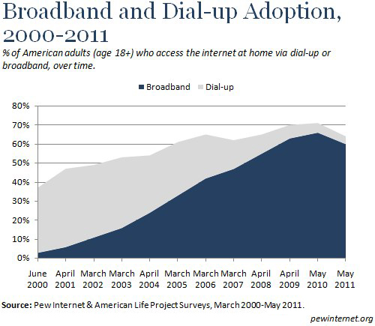³
As can be seen, the communication capabilities of Americans have exponentially increased over the past decade.
With internet access on mobile phones, these capabilities are growing to a phenomenal level. Mobile devices, which include both cell phones and tablets, make up 7% of all worldwide traffic on the Web as of August 2011⁴. This is trending upwards towards what many believe will be an overtaking of fixed internet usage by mobile devices. Internet analyst Mary Meeker of Morgan Stanley, dubbed the “Queen of the Net” by Barron’s magazine in 1998, is particularly keen on this prediction ⁵. She claims that we are currently in the fifth major technological cycle of the past half century. The other cycles include the mainframe era of the 1950s and 60s, the mini computer era of the 1970s, and the desktop Internet era of the 1980s. The current cycle is being dubbed by Meeker as the “era of the mobile Internet”. She goes as far as to say that over the next five years, “more users will connect to the internet over mobile devices than desktop PCs.” This is demonstrated by the following graph:
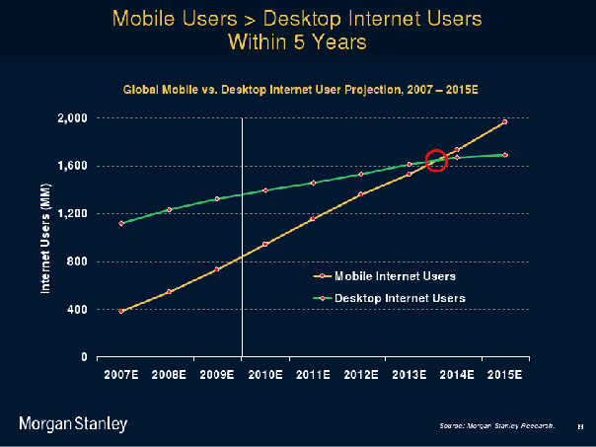⁵
As can be seen, the increase in mobile internet usage is occurring at an even faster rate than normal internet adoption rate ever was. The point of intersection, roughly occurring in year 2014 is when mobile internet usage will hypothetically surpass desktop internet. Meeker compares the usage of the Apple iPhone and iPod touch (those that have Wi-Fi capabilities) to the adoption rate of AOL and Netscape during the early 1990s. The adoption rate of the Apple devices is occurring 11 times faster than the adoption rate of AOL. These adoption rates are also helped with the emergence of 3G (and now 4G) networks. This graph helps to visualize how fast this rate really is:
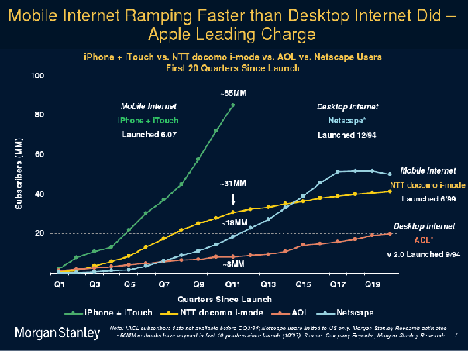⁵
While this study occurred in 2010, it exhibits how far mobile internet usage has come along and the heights that it has already reached.

The Social Networking Revolution:
One of the major reasons for this growth in mobile internet is the outbreak of another social revolution throughout the last decade: social networking. Around 72% of internet users between the ages of 18-29 use social networking websites as of February 2010 ⁶. Of these social networking websites, Facebook is by far the most popular. Of all adult users of social networking sites 18 years and older, 73% have a Facebook profile, 48% have a MySpace, 14% have the more professionally-oriented LinkedIn profile. Twitter is a separate social networking site that consists primarily of status updates and doesn’t rely too much on maintaining a profile page, per se. Of all adult internet users, 13% have a Twitter account as of May 2011. This number has actually grown from 8% as of November 2010 ⁷. While Twitter is on the incline, and Facebook is the current king, MySpace is well past its prime, being sold by News Corp. to Specific Media for $35 million on June 29, 2011, which was a significant loss ⁸. Let’s take a closer look at the big two in Facebook and Twitter and some of the implications of their popularity.

I.) Facebook’s Outbreak:
Facebook was founded by the then 19-year-old Harvard sophomore Mark Zuckerberg on February 4, 2004 ⁹. At that point in time, there were a number of other social networks in existence including MySpace, Xanga, and Friendster. So what was it exactly that catapulted Facebook into the cultural marvel that has, in many ways, shaped the way we connect with our peers? Well, it was for a number of reasons. In Malcolm Gladwell’s book The Tipping Point, he examines how small-scale occurrences get launched into full-on social epidemics ¹⁰. He defines the tipping point as "the moment of critical mass, the threshold, the boiling point." Gladwell then goes on to explain the three rules of epidemics that allow these trends to “tip”, or spread rapidly. Of these rules, the “Stickiness Factor”, and the “Power of Context” are very apparent in the spread of Facebook.
Facebook was initially an outgrowth of a separate idea entirely. Zuckerberg was initially approached by Cameron and Tyler Winklevoss to help them upstart a Harvard social networking dating site known as HarvardConnection.com. The website would require a Harvard e-mail account and would allow users to connect, chat and arrange dates with one another. Although initially agreeing in principle to helping the Winklevoss twins with their venture, Zuckerberg chose to focus on starting a social networking site of his own. Known at the time as “thefacebook.com”, the site was based on the idea of exclusivity, requiring the users to sign up with a Harvard school e-mail address. Within 24 hours of its launch in February of 2004, 1200 Harvard students had signed up ¹¹. This number grew to about half of the undergraduate population a month after its launch. The network was then extended to include other Boston area schools shortly after, then the rest of the Ivy League schools, until eventually it included all US universities. Leading the charge of this diffusion is what Gladwell refers to as the “Law of the Few”. This refers to the fact that many cultural developments and innovations are actually “tipped” into widespread acceptance by a small number of very influential individuals. These individuals are characterized as the “Mavens”, “Connectors”, and “Salesmen”. The Mavens are what are known as the “information specialists”. These are the people we rely on in life to connect us with new information. In the case of Facebook, there are two major Mavens of note. One is Zuckerberg himself, whose computer programming expertise allowed him to have a complete understanding of computer infrastructure and coding and to be able to utilize the tools necessary to get a successful website up and running. The other Maven is business partner and one-time Facebook president Sean Parker. Parker is an internet business guru, having been co-founder of the infamous music-sharing service Napster. Parker was actually friends with Jonathan Abrams, who was the programmer who launched the social-networking site Friendster in 2002 ¹². Parker had a strong interest in Abrams’ project, which at the time was the first online social network to grow its membership to the millions. The problems for Friendster arose when its servers could not handle the site traffic. Not too long after is when Parker spotted Thefacebook on his roommate’s girlfriend’s computer, who was a student at Stanford at the time. The concept got his juices flowing, as he had always felt that the best way for a social network to launch would be through a somewhat closed community, and college definitely fit the bill. Parker had all of the entrepreneurial expertise necessary to run a successful internet business as evidenced with his history. The combined expertise of Zuckerberg and Parker and their ability to play off one another played a strong part in the tipping point of Facebook.
The “connectors” that Gladwell refers to are those who have “a special gift for bringing the world together”. These are people who have a very strong knack for making friends and acquaintances, almost treating it as a hobby of collecting these connections. In the case of Facebook, it is difficult to pinpoint specific people that qualify for this term. However this applies to a number of the users of the service. Some of the individuals who were part of Facebook’s initial run at Harvard fall under the connector categorization. They spread the word about the service amongst their acquaintances and allowed it to capture half of the undergrad population in about a month. This is also true for the other locations. Zuckerberg strategically chose the locations, using Stanford as a vehicle of entrance into the west coast. Upon introduction, spreading the word basically took care of itself.
Finally the “salesmen” are just what they sound like, those charismatic individuals who have the power to negotiate and persuade. With his previous entrepreneurial success, it could be argued that Sean Parker also fit under this categorization. He was a key cog in persuading Peter Thiel, co-founder of PayPal and billionaire hedge-fund manager, to become the first outside investor for Thefacebook. All three of these factors of the “Law of the Few” came into play here.
The adoption rate of Facebook is very demonstrative of what Gladwell terms as the “Stickiness Factor”. This refers to the quality of certain cultural developments that causes them to “stick” in the minds and ultimately affect the behavior of the public. In the case of Facebook, it was definitely the exclusivity factor. People felt as if they were part of a club and had to be accepted to be able to use the services. What set Thefacebook apart from the proposed HarvardConnection website was that the latter was proposed as a dating site. The term “dating site” has some degree of negative connotations associated with it. People will not as readily and willingly sign up for what they perceive as a dating website. Even though many people join social networks and use the medium to try and attract members of the opposite sex, they do not want to be labeled as using a dating service. It has a lot to do with an individual’s pride and the refusal to admit the need for such a service, and the “dating site” classification has a definite “unsticky” quality to it. What ultimately set Thefacebook apart and allowed it to achieve “stickiness” was its exclusivity coupled with the idea of the digitization of the social life experience. The social life of a college student is a very important aspect to many young adults. The service that Facebook provided to its prospective users was basically a public log of the college experience that all members could share with one another. This is somewhat of a hidden desire for most college students. It is human nature to want to know what friends and acquaintances plans are for the night, and who is dating who, and what are the interests of your peers. It is also human nature to want to express yourself, as well. Given access to a personal profile, one could organize an entire page in order to construct a public image of themself. Facebook is just a way of explicitly putting that information out there for all to see. It allows one to share and connect with others that they may not otherwise remain in contact with. By starting in Harvard, the site built up a strong reputation and credibility, having only a select group of users and skimming out all of the “stalkers” and young people that plagued other social networks such as MySpace in the eyes of some users. Facebook was given time to flourish in these smaller environments, building up a strong basis in the Boston area before expanding to Stanford when Zuckerberg went to work full time on his endeavor in Palo Alto, California, and then eventually to all US colleges. This also falls under Gladwell’s description of the “Power of Context”. The process of introducing the website in a scaled-back and private manner amongst college communities proved crucial in harvesting the idea. It allowed it to grow and mature before diffusing across the nation and becoming a cultural mainstay. The adoption process of Facebook was representative of many of the conditions of social trends set forth by Malcolm Gladwell. Now, it is a global phenomenon:
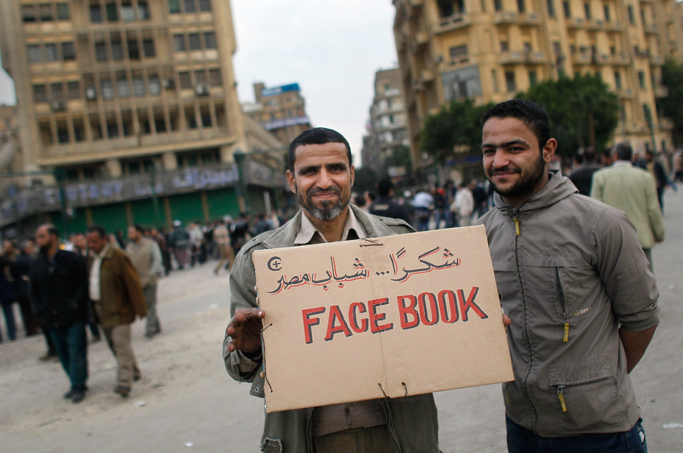
Facebook play a major role in the recent uprisings of the Middle East ¹³

ii.) Social Circles:
So Facebook has really caught on and stuck due to the delayed introduction and the element of “coolness” associated. However, the site may now be a victim of its own popularity. The site opened up for use by US high school students in September 2005, until finally anybody with a valid e-mail address could register in September 2006. Parents, teachers, and bosses now have profiles on the site. Social networking use among internet users 50 years and older has significantly grown, doubling from 22% to 44% between 2009 and 2010 ⁶. This changing of the guard is demonstrated here:
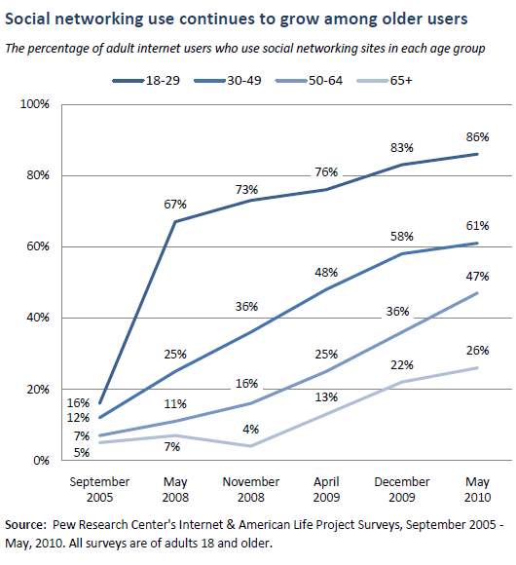⁶
Middle-Aged users ages 30-49 had grown to 61% by May 2010. In reference to Facebook, the once perceived exclusivity is gone. What used to be almost a hideout for the youth to vent about problems in school, at home, and in the workplace has been opened up to the older crowd, who are the ones that are often being talked about. Here is a whole segment of people who were at one time shut out from this form of communication. This growth was not exactly met with an easy-to-use privacy system that would allow users to account for this new audience. While it was entirely possible to adjust the privacy settings to deal with the expanding number of acquaintances, they were clumsy and difficult to use. This resulted in the unintentional revelation of a lot of information to all groups of people. This brings up an important issue about the way that we interact with all the people in our lives, and how we must explicitly deal with the situation nowadays.
Life itself is a social network. What we have experienced as a culture is the digitization of our network of friends, family, and acquaintances. What was not accounted for in this process is the fact that we interact with all the different groups in our lives in a different way. We choose to share and withhold certain information from certain groups of people in our lives, and this is not always possible in our online network. In real life, there are barriers present that separate our different social circles:
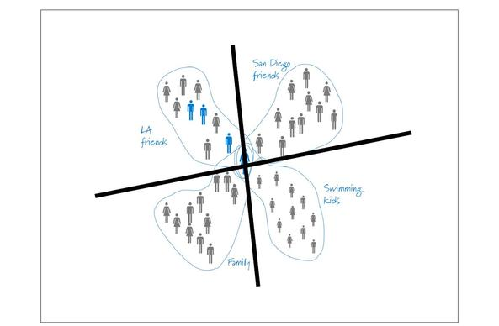¹⁴
We hold different circles of friends: those from high school, those from college, those from work, and so on. We also connect with family members in ways that are extremely different than the way we connect with our different groups of friends. There are aspects of our lives being exposed online to others that would never have been revealed offline.
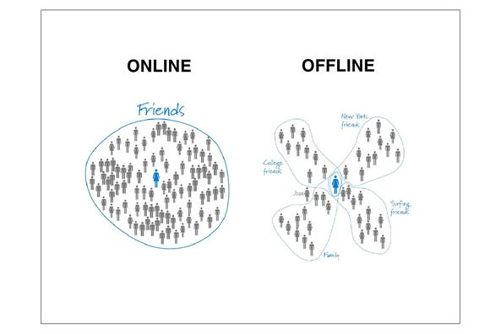¹⁴
What this shows is that our online social network does not match up with the one that we maintain offline. The barriers that are normally in place offline are not present. All of a person’s Facebook “friends” are lumped into one large category, without any distinguishing factors. Although steps have been taken and tweaks have been made to privacy settings in recent times, in many ways, the damage has already been done for a lot of individuals.
Paul Adams worked on the User Experience team at Google and was the lead for social research. He has done an in-depth exploration of this issue, and his research became a key cog in the development of the social network Google Plus. The idea of adding “Circles” as a feature of the website was introduced to help deal with some of the issues mentioned earlier. This allows users to group their friends and family into different groups and therefore interact in different ways with each, in a manner set to mimic our offline social network interactions. Adams’s slideshow “The Real Life Social Network” demonstrates his findings, which is basically an expert analysis of the evolution of the internet and the communication associated ¹⁴. He begins by describing the internet as being originally intended to link static documents together (pictured below, 1), but has eventually incorporated social media (below, 2), and is shifting towards a web that is built entirely around people, where their profiles and preferences are moving with them across different websites (below, 3):
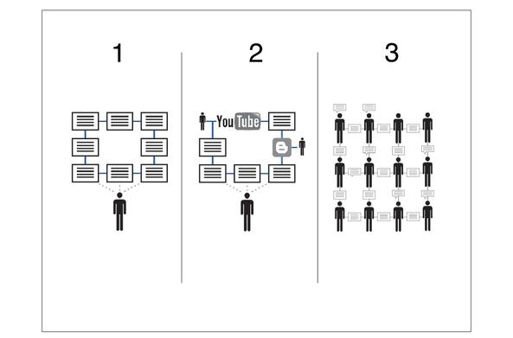¹⁴
This can be seen by the number of websites that offer to link up with Facebook, as well as the activity of other Facebook users on the same site. According to Adams, people are managing their internet usage in different ways now, spending more time interacting with other people and less time absorbing content from websites. This is apparent in websites such as Yelp, where people rely on word-of-mouth and the input of others when choosing a restaurant to dine at. As Adams states, “the web is increasing the volume of information available to us, but our capacity for memory isn’t changing.” Therefore, we are increasingly relying on others to help us make informed decisions. Adams goes as far as to say in the future, we will be able to go shopping for clothes online and see which friends bought a certain article of clothing, who is buying the same brand, who is buying a competitor’s brand and what each person’s feelings are on the matter. Almost all websites will eventually have some sort of social element implemented. This is not a trend or a fad, and eventually will lead to full integration.
Adams makes a very strong point about the evolution of communication. He states that the key is to understanding the behavior and not the technology. The new technology is not changing the way our minds work; it is merely enabling us to communicate in new ways. Social networks have been around for thousands of years. This refers to the fact that people have been forming different social groups with different types of people and sharing different types of information with each group. The behavior is the same in that regard. What we are seeing is just the online web catching up with our offline web. As Adams states, “Technologies will come and go, but the fundamental social behavior patterns of people will remain the same.”
Now, many are faced with the task of overtly categorizing their friends on their online social networks in order to avoid any unwanted overlap. Adams makes an analogy and likens it to wedding seating arrangements. This is a task where all of the acquaintances from all different facets of one’s life need to be grouped based on similarities. There is not one big overall group of “friends”. There are many subdivisions necessary. It is rare that our different “groups” will overlap in the offline world. However, we are given one profile on Facebook, so unwanted intersection is a fairly common occurrence. Adams makes the distinction between public content and publicized content. For example, people may be okay with disclosing information in one public setting, but not in another. This information is not “publicized”. However, in the realm of social networking, much information is unintentionally publicized. Privacy is a very important quality to social network users, and awareness of the need for proper controls is growing. Of the Facebook users ages 18-29 (young adults):
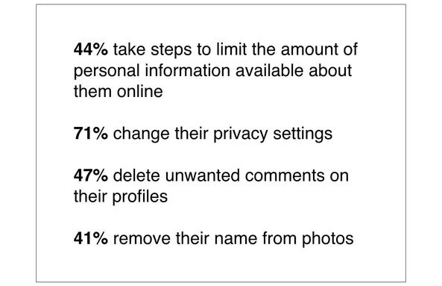¹⁴
The reason these numbers are not even higher is because of the lack of awareness. The need to control the visibility of certain aspects is not fully grasped by all users. It is an extra responsibility that has often been ignored because people are underestimating the size of their audience. People want certain groups of people to see certain bits of information. The use of Adams’s and Google Plus’s proposed “Circles” helps to mitigate this problem.
In Adams’s study, subjects were brought in and asked to explicitly diagram and split up their offline social network. The majority of the individuals that were brought in for research split their network up into 4-6 groups, with 2-10 people in each group. These groups were formed around different stages of one’s life. Each group was labeled by the study subjects. A total of 342 groups were formed, and 85% of those group labels did not contain the word “friends”. This is such a vague and all-encompassing term that is not very helpful in describing people’s actual connection with one another.
As humans, we maintain both strong and weak ties with the people in our lives, and this differs both between and within each of our defined groups. A study of 3000 randomly chosen Americans showed that the average American has just 4 strong ties, and most had between 2 and 6. Another study about Facebook usage produced similar results. The average number of Facebook friends is 130, and most people interact regularly on the site with only 4 to 6 of their friends. Similarly, 80% of phone calls are made to the same 4 people on average. The number of weak ties upheld is interesting because it is stable and has been fairly stable throughout history. The magic number is 150 for the number of weak ties that the brain is able to handle. Referred to as “Dunbar’s number” after Oxford University’s anthropologist Robin Dunbar, the number 150 has been discussed and debated by many social scientists over the years (it is even examined in the aforementioned Gladwell book The Tipping Point). What this means is that this study has determined that the brain is only able to handle roughly 150 connections. This number has been discovered after studying many social groupings over thousands of years. This was approximately the size of a Neolithic farming village thousands of years ago. Once a village grew above this number, it would often split into two. This was also the general size of a unit of the Roman army. If groups were to grow above this number, it was noted that the “social cohesion began to disintegrate” ¹⁵. While social networking sites like Facebook have allowed us to remain in contact with our weak ties, and in some ways strengthen them, it has not enabled us to make more of these connections. It has only aided in making our existing connections more observable. This demonstrates the fact that although we are experiencing what many label as “Web 2.0”, we are still operating on “Brain 1.0” ¹⁵. The technology has changed, but the human capabilities have not.
Google Plus was created on the basis of splitting up the different social circles of one’s life. In fact, every contact must be placed into a specific Circle. Although, as demonstrated, it is natural to have 4 to 6 different social groups on average, it is somewhat of a difficult process to have to “file away” all of one’s relationships. A relationship with another individual is a complex entity, and it cannot always be as cut-and-dry as it seems. Having to categorize certain relationships with others could end up discounting the relationships in general. As Kevin Cheng, a product manager Twitter, stated in response to the findings of Paul Adams’ research ¹⁶:
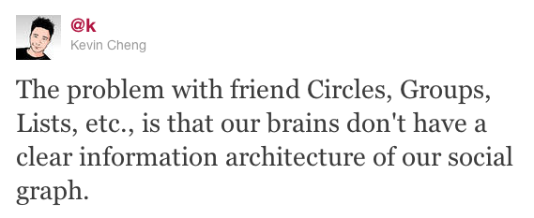

This is an interesting and important point to make. There are a lot of subtleties that are being discounted through the arbitrary classification of a relationship. We may not even be fully conscious of these subtleties. To treat them as easily-categorized is a superficial endeavor. Relationships are also fluid entities, constantly changing over time. The change is so gradual that it is difficult to firmly decide if a group change is in order. It is simple to be able to categorize connections based on the organization where these relationships developed such as school, work, sports, etc. However, past these distinctions, the boundaries become very blurred. There is a very thin line between what one might consider a friend and an acquaintance. There is no firm distinction. There is no black and white. One must make a judgment call when a connection is requested, and whatever the decision may be, the feelings change over time. Groupings require constant maintenance in order to update and reflect the current feelings of the owner. Therefore, although Paul Adams is entirely right in his findings, it may not ever be possible to effectively and accurately translate our entire offline social network into digitized form. Limiting audiences through the use of groups may be a very necessary change, but the process is too high-maintenance and the parameters too vague to be anything more than a superficial separation of audiences. It is also quite the chore. Fred Wilson, a VC and principal of Union Square Ventures, has suggested somewhat of an alternative in his blog ¹⁵. He claims that the recommendation system of Google Plus has worked fairly well. There are currently suggestions of which friends should be placed in certain circles. Once this algorithm becomes more advanced, it will reduce the task of categorization to a more subtle and efficient process. The users could accept the slight imperfections associated. As Wilson states, “If Google+ knows who my music friends are then just suggest ‘music friends’ when I hit the share button and send it on. Do I care if it goes to a few people who aren't actually my music friends? No I do not. Do I care if a few of my music friends don't get it? Yes, but then I can add them explicitly. I trust Google to do a fine job of this for me. They've proven themselves worthy of the job so many times in my relationship with them over the years”. There is even an iPhone app that serves the same purpose for people’s Facebook friends. Known as Katango, the application limits the audience of posts and allows for a more selective sharing approach. This issues that Paul Adams brings up are very real and must be addressed. While it may never be a perfect process, once these matters are dealt with and advancements are made, the situation can be adapted to. Adams has since left Google in December of 2010 and currently works for Facebook, where he has helped implement some similar ideas.

iii.) Birth of Twitter:
Twitter, the other major social network, is not necessarily met with these same issues. This service is based solely on the idea of status updates. It is a much more streamlined social network service where privacy is not as important. The concept of a status update can be perceived as somewhat of a narcissistic activity. Based on the research of Paul Adams, people have four primary reasons for updating their status:
  - To shape how other people perceive them
  - To maintain and grow relationships
  - To share content that others might find valuable
  - To source information
Twitter is built around the platform of sharing this information.
The founders Jack Dorsey, Evan Williams, and Biz Stone were former Google programmers who worked at the podcasting company Odeo Inc. in San Francisco ¹⁷. Entrepreneur Noah Glass had started the company Odeo in his apartment in July of 2005. The idea of this company was to be able to call a certain phone number and record a message that would be turned into an mp3 file that would be hosted on the Internet. However, in fall of 2005, Apple announced that iTunes would include a podcasting platform that would be built into the 200 million iPods they would sell. It was also discovered that podcasts were not as frequently used as initially expected. The prospects of Odeo were not looking too good. In February of 2006, the focus shifted. Dorsey presented the idea of a “status”. The way it would work is that a text would be sent to a central phone number where it would be broadcasted to all of your friends. Glass came up with the name for the service: “Twttr”. This idea was presented to the rest of the company. Williams was skeptical at first, but put Glass in charge of the project. Eventually becoming Twitter, the prototype was presented that summer. Williams wrote a letter to the investors in September of 2006 stating how the company was going nowhere, and then he offered to buy back their shares. The investors agreed to the buyback. However, there was evidence that the company was quietly building a following, and this was a very shrewd move by Williams. Glass was being told by some mobile carriers that they had never seen so much SMS activity. One of Odeo’s employees was noted as racking up a $400 SMS bill using the service early that summer. This speaks wonders about the addictive nature of the service.
After the buyout, Williams changed the company’s name to Obvious Corp. and surprisingly fired Noah Glass. It was not clear why this took place exactly other than reported clashing personalities. Despite evidence of its growth potential, the site only had around 5000 active users at the time. It was not obvious that it would be a hit until it premiered in spring of 2007 at the SXSW Interactive conference in Austin, Texas. The rest is history.
As of May 2011, 13% of online adults (18+) use Twitter, up from 8% in November 2011⁷. Twitter has not reached anywhere near the popularity and usage rates of Facebook, but this is to be expected, and is in many ways a plus for its users. It consists mainly of providing a status update, with the ability of mentioning other users, and delivering a message in 140 characters or less. The limit of 140 is derived from the common SMS carrier message limit of 160, leaving some room for the username to be included ¹⁸. Unlike Facebook, the users choose a nickname or username as their “Twitter handle”. There is not as much of a danger of teachers, parents, or bosses unintentionally being exposed to private information because they tend not to use the service. Twitter has a large degree of the “coolness” factor. The adoption of Twitter has been helped along by the endorsement of celebrities. Many famous people use the service and draw a crowd of interested followers. They were the “connectors” necessary to cause the service to “tip”. Users have the ability to “tweet” at celebrities with the outside chance of getting a response. “Retweeting” is when another user resends the original sender’s tweet, giving the original sender credit for their material. When a celebrity “retweets” a user, it is seen as a digital autograph of sorts. Twitter has also given birth to a slew of new internet lingo. Symbols such as “@” are used to mention other users and give “shoutouts”. Pound signs (#) are used and referred to as “hashtags”. Hashtags are basically putting these pound signs in front of words to create a trending topic. These hashtags can be clicked on to see all the people who are tweeting about the same topic and using the same hashtags. This is a social tool that allows for a more widespread and connected forum for strangers to comment and discuss similar current events and topics. It is also a user-created experience where Tweeters are able to almost invent language of their own. The whole experience leaves users feeling as if they are on the cutting edge, almost ahead of the times of all non-users. It is no wonder why people become easily addicted.

Texting:
Text messages sent through phone are increasing in usage. Three quarters of adult cell phone owners (73%) engage in sending and receiving text messages as of May 2011¹⁹. Of these texters, about one-third (31%) prefer texting over talking. Texting is a more popular activity for the younger crowd. Young adult cell phone owners between the ages of 18 to 24 exchange an average of 109.5 messages (!!!) on a normal day. Cell phone hardware itself has evolved in response to this trend, shifting from the standard flip phones to those with full keyboards, whether it be physical or touchscreen, which or more conducive for texting. Cell phone data plans are also accounting for the increase, as unlimited texting plans are made more widely available at more affordable prices.

Implications of Text-Based Communication:
There is no question about the pervasiveness of text-based communication in our lives. This includes the use of both cell phone text messaging and online social networking, among other methods. The question then becomes whether the prevalence of text-based communication becomes a replacement for human contact in general. There is, ironically, a disconnect in the way we connect. Literally what it boils down to is the disconnect between the connection and the message. When communicating through text, whether it be text messaging through phone or online messaging, a process is taking place. First, the sender thinks of the message. There is a gap between the thought and the actual message. Unlike normal face-to-face communication, the sender is given additional time to edit the message and frame it in an ideal fashion. Much like editing a paper, the sender is able to arrange the word placement and presentation as well as deciding what information to withhold. This process does also take place in normal conversation, but there is not nearly the delay available in order to make this as significant of a process as it is during text-based communication. There are also certain length constraints affecting the messages. Twitter notoriously holds a 140 character limit, and certain wireless phone providers such as Verizon Wireless put a cap on the length of text messages (160 characters for a single page of text). This almost requires that the messages be whittled down to nothing more than the main point, often times. This trims away all of the normal conversational excess of small talk and the like. There is often times not a normal greeting. Conversations can end when one of the parties stops responding. The formalities of common dialogue are all but eliminated. There is no interpretation of the different voice inflections or the emphasis on certain words that normally goes along with verbal communication. What this results in is a very dumbed-down message, in some regards. It is true that what needs to be said can be effectively stated under the character limit. However, it can also result in a different message than what was originally intended.
Once the message is framed to the liking of the sender, the message is sent. From there, the receiver initiates another process. Just like any other type of reading, the receiver must interpret the message. They must read and then process the message before acting upon or responding to it. There is also the danger of misinterpretation. Human communication is complex, filled with subtleties and nuances. Text-based communication removes some of these complexities as a result of the stripped-down messages. Sarcasm and intention of the message are not easily detected and often result in confusion and misunderstanding.
Also, it should be noted that this “response delay” is not always present. In fact, there are numerous instances of celebrities tweeting offensive thoughts or statements the minute they are conceived. They then have to play damage control and make the necessary PR moves to clean up their image and apologize for the situation. The immediate access to technology as a communication tool, such as the situation with many people who have Twitter applications on their phones, has led to the lack of a filter, so-to-speak. People end up publically broadcasting the thoughts that enter their heads rather than allowing second and third judgment calls to tell them otherwise. Plus, there is the lack of face-to-face contact. This gives the messengers more blind confidence, as they are not receive the immediate feedback from other individuals who the messages are intended for. There is no body language, and the messengers are not receiving different cues from facial expressions and mannerisms of the listeners. To make a real life analogy of what is actually taking place, try and envision a bulletin board. Let’s say that this bulletin board is posted in a common room in an office that all people have access to. People are free to post whatever they wish on the bulletin board, and others are free to come and take a look whenever they wish. A messenger has a thought and wants to tell everybody in the office. Rather than telling each person individually, they decide to post it on the bulletin board. This can happen a number of ways. The individual can impulsively post the thought as soon as it enters their brain for all to see, or they can wait and frame the thought in a more thoughtful and edited fashion. Either way, once they have their message to their liking, they post it on the bulletin board. Others walk freely into the room and read what the messenger has posted. Some are offended, others are touched, and yet others are unaffected either way. Regardless, the messenger does not immediately feel the effects or consequences of their post. They may eventually receive dirty looks from those who were offended at a later point in time, or others may choose to post a response on the bulletin board itself. Either way, the messenger did not have to stand up and stare the listeners in the face while delivering the message. This is commonly seen when a person publicly and (not so) indirectly announces their frustration towards their ex-lover. This provides some people a certain degree of courage and almost a feeling of anonymity that gives them free reign to state more details, or be more firm/blunt in their delivery.
On the flip side, such a concept of the impersonal nature of text-based communication could also potentially allow for shyer individuals to more easily connect with others. The detachment in this case can be seen in a positive light as a way of easing an introverted person into a communication exchange. This could then potentially lead to a more successful face-to-face interaction and provide that particular person with more confidence. However, this can be seen as a facilitator, not a replacement, for true human interaction.

Anti-social?:
The degree to which these text-based interactions are interfering with normal contact must be examined. In a 2009 study, it was discovered that teens (aged 12-17) contact their friends by text message (54%) on a daily basis more often than face-to-face contact (33%) outside of school ²⁰. The results are listed below:
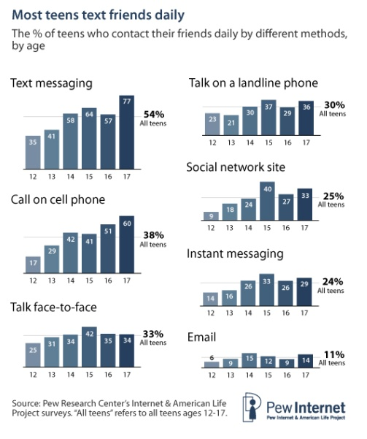²⁰
However, important factors must be deliberated in this study that cause the results to be somewhat deceiving. First of all, the survey was measuring contact “outside of school”. Therefore, face-to-face contact is not measured during school, when it would be much higher. Also, texting can be performed in addition to other forms of social interaction. Texting can become a side activity at any point in time, as it is worked into the flow of everyday life. Text messaging makes friends “available” at any point in time for communication. It may not be hampering interaction, but in fact increasing it, albeit of the more informal and casual type.
Nevertheless, what good is an increase in the number of interactions when they are all being diminished in quality? This text-based communication is lacking in the normal “intimacy and emotional give and take of regular, extended face-to-face time” ²¹. This is a very important issue being extensively studied, bringing about many more questions than answers. Lori Evans, a psychologist at the New York University Child Study Center, stated “We don’t yet have a huge body of research to confirm what we clinically think is going on.” What we are experiencing are communication exchanges that are more superficial and more public. This can potentially result in a lack of the experiences necessary to be able to “develop empathy, understand emotional nuances, and read social cues like facial expressions and body language” ²¹. With technology being introduced at a younger age, could this eventually result in a rewiring of the brain, and an overall diminished capacity for emotional attachment? This is a very strong statement, but the truth is that it is too early to know the true answer, but it is a shocking possibility. Gary Small, a neuroscientist and professor of psychiatry at U.C.L.A. and an author of "iBrain: Surviving the Technological Alteration of the Modern Mind," refers to these individuals as “digital natives.” This refers to the generation that has grown up using computers and other abundant technology. He claims that they are already having a harder time reading social cues. “Even though young digital natives are very good with the tech skills, they are weak with the face-to-face human contact skills,” he states.
So while the number of interactions has increased, the meaningfulness of each interaction has decreased. We do not and will not fully know the implications of this trend for quite some time. All we can do is recognize the changing of the guard and observe.

Addiction:
All the more apparent in these times is the growing addiction to technology. All the usage rates mentioned earlier have demonstrated a culture that is fully enveloped in technology and is still trending upwards. This is the portion where it begins to overlap and interfere with our everyday life, rather than act as a support system.
The biggest culprit of the problem has got to be the smartphone, simply due to its balance of availability and capabilities. As of 2008, 3 out of every 5 (60%) mobile phone owners claimed to have their cell phones with them “at all times”, including inside their house ²², a number that has surely grown over the past 3 years as much as the phones’ capabilities have. Allowing the users access to most functions that a computer has (e-mail, social networking, web surfing), these devices have been a heavily used diversion of its owners. The breakdown of common activities is listed below:
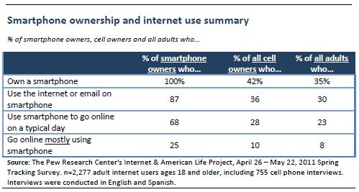²
The fact that a quarter of smartphone owners (25%) use their phones as their primary form of internet access (coupled with Mary Meeker’s findings mentioned earlier) speaks volumes about the effect that the convenience of smartphones has on its users. People truly have access to the world at their fingertips. This is a dangerously addictive notion.
There is actually a biological basis for the addiction that is developing. Scientists say that our ability to focus is being undermined by the desire for bursts of information ²³. There is actually a primitive impulse to respond to immediate opportunities and threats for information. This chemical dopamine, which is the body’s natural reward system, is released into the brain. This stimulation triggers excitement, and in its absence, a level of boredom sets in for the user. As of May 2011, 42% of cell owners admitted to using their phones to combat boredom, 51% of owners reported using their phones to get information they needed right away, and 27% of owners reported experiencing a problem doing something in the past month because they did not have their phone at hand ²⁴. Overall 49% of all adults have stated being a passenger in the car while the driver was sending or reading text messages as of May 2010 ²⁵. This is a death risk to the drivers, passengers, and other vehicles on the road. Texting may be one of the most addictive forms of communication due to its simplicity and non-committal nature. Participants can receive and respond at any pace that they please, and have access to their potential listeners at all points in time as long as they have their phone number. It becomes very apparent that this technology goes from simply being a support system, to being very deserving of its nickname “Crackberry” (a common nickname for the Blackberry smartphones that describes its addictive nature).
The immediate access to information has caused us to become a culture of multitaskers. Scientists are saying that these multitaskers are having “more trouble focusing and shutting out irrelevant information, and they experience more stress” ²³. It is also noted that after the act of multitasking is ceased, “fractured thinking” and “lack of focus” persists. Nora Volkow, one of the world’s leading brain scientists and director of the National Institute of Drug Abuse, has likened the digital stimulation to a food or sex addiction rather than a drug or alcohol addiction. This is because the former are essential to life but counterproductive in excess. It has become very difficult in our society to do away with the excessive use of technology, and our bodies are making it even more difficult. Our brains are being “rewired” in a number of ways. Eyal Ophir, a researcher at Stanford University, measured the effects of multitasking on the brain. Subjects were split up into two groups: one classified as heavy multitaskers based on their answers to survey questions, and one those who were not. The subjects were briefly shown a picture of red rectangles before being shown a similar image. They were asked to report if any of the rectangles changed positions between the pictures. As the test went on, blue rectangles were added to the pictures, which the subjects were told to ignore. It was discovered that the heavy multitaskers did a significantly worse job on the test due to their inability to filter out the irrelevant information (the blue rectangles in this case). It was also measured how quickly the two groups could differentiate vowels from consonants and odd from even numbers. Once again, the heavy multitaskers took significantly longer to make the distinction.
This points to a serious conflict in the brain. There is one portion that acts as the control tower of the brain, directing activities and setting priorities. There are other, more primitive portions that are in charge of sensory information ²³. With the wealth of information available, the primitive portion becomes constantly hungry, seeking new information at all times. This bombardment may be hindering our ability to carry out our priorities and ultimately make us more prone to distractions.
A study at UC Berkeley also attributes this change to our changing perception of time ²⁶. As technology has evolved, we find ourselves cramming more activities into a single day. Multitasking has become very common. The increase in technology has been met with an increased capacity for a quick response. The ability to produce an instantaneous response at all times has led to an altered perception of what exactly makes up a “late response”. James Gleick, an author who explores the cultural ramifications of science and technology, states the following:
"The changing pace of media from cinema to television commercials ... reflect[s] and condition[s] a changing pace in our psyches. Instantaneity rules in the network and in our emotional lives: instant coffee, instant intimacy, instant replay, and instant gratification." –Gleick ²⁷
This has led to an overall more impatient society. Time perception has altered because time is made up of two things: pace and duration. The pace with which we complete tasks has increased, while the duration that it takes to complete them has decreased ²⁶. This is being perceived as a feeling of being rushed, and then we are cramming more activities into shorter periods of time, leading to a certain degree of exhaustion.

Wearout:
With the abundance of information available, and their modes of travel becoming that much more widespread, there is prevalence of message wearout. Viral videos and internet sensations travel around the web at an increasing rate, and is leading to diminished lifespans for the material. Funny videos catch on like wildfire, and those that achieve “hit” status tend to fill up users’ Facebook feeds from multiple sources within a matter of hours. In fact, it often results in certain jokes and amazing feats seeming very old and uninteresting after a matter of weeks or even days due to overexposure.
This is a particular problem for marketers, as they must find a way to capture the interest of an audience with an ever-decreasing attention span. One of the methods is simply the sheer volume of the message. TV commercials are played and overplayed in order to try and find a place within the minds of a multitasking individual. For example, the humble writer of this analysis was watching football one Sunday afternoon and after a while noticed how often a certain Jennifer Lopez commercial was being played during breaks. Almost every break consisted of the same song clip being played and played again. By the end of the game, I did not even know what product was being advertised (by the way, it ended up being a Fiat car commercial; not to name any names). The following Sunday, I chose to do a little experiment and record the frequency of that particular commercial. Football games are prescribed 10 TV commercial breaks per half and 2 breaks during halftime ²⁸. This means that there are approximately 22 commercial breaks during the average football game. This particular Sunday, the J-Lo Fiat commercial ended up playing 21 times out of 23 total commercial breaks (at times twice during one break). The exposure to this commercial averaged out to about once every 8.57 minutes in a 3 hour period. The commercial was approximately 20 sec in length. Therefore 20 sec x 21 commercial plays = 420 total seconds of the commercial during a 3 hour period. This is equal to 7 whole minutes of one commercial. This may not seem like a lot at first, but let’s dig a little deeper. As a baseline, the average football game is around 3 hours. The actual time it takes to run each play is about 6 seconds. There are roughly 120 plays per game. This is equal to roughly 12 minutes of actual football action (that is: without pre-play, timeouts, and injuries). So comparatively, 7 minutes of ONE commercial for every 12 minutes of actual football being played. It should be noted that this message was not even doing its job properly, as this particular author did not even know what was being advertised until explicitly trying to measure it.
So what in the world is this phenomenon taking place? This is what is known as message “wearout”. There was a study conducted by George and Michael Belch of San Diego State University that elaborates on this issue a bit ²⁹. Their findings concluded that “wearout” occurs due to overexposure to a message, and individuals begin to tune out messages that are overly repeated. They had determined that there was a “significant decline in brand name recall when exposure levels exceeded the number needed to learn the brand names”. It was also noted that wearout was higher in high-exposure levels of humorous messages compared to serious messages. This is because repetition of humor leads to “satiation, fatigue, and irritation”. This concept can be applied to the lifespan of many popular internet videos. Overall, the use of many different messages and mediums can help delay the wearout to a significant degree.
Many companies are facing a double edged sword on this matter. They are attempting to reach an increasingly fleeting audience while trying to avoid message wearout. It is a difficult situation to juggle, and the use of social media and other methods has helped. The average “half-life” of a message on a social networking site is roughly 3 hours ³⁰. The graph below illustrates the half-lives across different services:
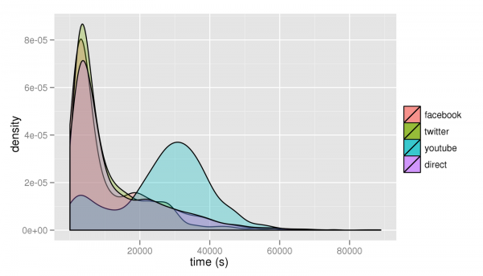³⁰
The term “half-life” refers to the time that it takes a shared link to receive half the number of clicks it will ever get. Various studies suggest the need for businesses to resend the message after this time limit, and it will result in roughly 50% more total traffic ³⁰. This must be done in moderation in order to avoid overexposure and potential wearout. This is an overall balancing act for those hoping to reach a wide audience. It is an interesting situation because the sheer volume of the message itself could have adverse effects, but it is often so difficult for the message to make its way to the intended members of this multi-tasking society in the first place.

Nonverbal Communication Taking on Different Shapes:
We are witnessing a new frontier of communication possibilities. This is not only referring to the new pathways of communications, but also to the new methods of nonverbal that have resulted. Facebook has some of these features built into its network, such as “poking” and “liking” someone’s pictures, status updates, shared links, etc. “Pokes” are a private manner in which you can let specific people know that you are thinking about them, and “likes” are a form of public endorsement. These are forms of communication that require no words, but send a message regardless. It provides yet another platform in which we interact with our peers without direct contact. These can be methods of supporting your friends. This is also what constitutes what could be referred to as digital flirting nowadays. These forms of contact can be made just as easily with close friends as they can with minor acquaintances. This allows an impersonal manner in which to strengthen weak ties. It can be seen as a low-effort, low-risk and overall effective and subtle way to enhance a connection.
The idea of “requesting friendship” is also a form of nonverbal communication. Once a connection is felt strong enough by one party, they offer a request for friendship to the other party. Now the other party may not feel as if the connection is worthy enough of accepting the request. The person may only maintain a close circle of friends on Facebook and would rather not remain in contact with a person they may consider a simple acquaintance. The act of declining this friendship is a form of nonverbal communication that definitely gets the message across (although the process has become more subtle over recent times with the increase in privacy settings and it is not as apparent that this rejection has taken place).
Then there is the act that many deem “Facebook stalking” (although this may occur anywhere on the Internet). This is where an individual heavily peruses the profile of another individual. The motivations may not always be clear, and this may just as easily occur between good friends as it can between complete strangers (depending on the privacy settings of their profile). This person’s behavior is not being publicly tracked, so they feel more at ease with snooping around. The amount of information made available is pretty astounding. One could potentially see another individual’s personal interests, the different activities he or she is involved in, and the other people that the individual knows well enough to call a Facebook friend, among other things. The information is made public, so it is not in violation of any ethics, right? Well, as was mentioned before, users are often ignorant to the degree with which they are exposing themselves to the public. Privacy settings are clumsy, and people don’t ever fully realize who their true audience is. So while the practice is not amoral, individuals should exercise a degree of personal restraint in terms of browsing the profile of a stranger.
It can result in a very weird situation in our society, where people could have secretly met the digital version of the person before every having contact in real life. People are often able to access the profiles of “friends of friends”. These are persons that they may not personally know, but choose to look at their information and examine a couple of photos. Next thing they know, they are placed in a real life social situation where they meet the actual owner of the profile. The owner has no idea that this particular person has accessed their profile and is under the assumption that they are truly meeting for the first time. However, the person holds the secret of having looked up this person prior. It is a very unsettling situation that is not often thought about, but many are sure to have experienced a gaze of familiarity coming from what was a presumed stranger.

Conclusion:
This past decade has seen a wave of technological innovations that has shaped the way we communicate with one another. We are overall a more connected bunch, but other areas may be suffering in the process. We will never fully comprehend the implications of our actions until several years down the road. It is certain that a social revolution is taking place. The extent with which it changes us, for better or for worse, is up in the air.

Works Cited

1.) Blumberg SJ, Luke JV. Wireless substitution: Early release of estimates from the National
Health Interview Survey, January–June 2010. National Center for Health Statistics. December 2010. Available from: http://www.cdc.gov/nchs/nhis.htm.

2.) Smith, Aaron. 35% of American adults own a smartphone. Pew Internet & American Life
Project, July 11, 2011. http://pewinternet.org/~/media/Files/Reports/2011/ PIP_Smartphones.pdf, Accessed November 2011

3.) "Home Broadband Adoption | Pew Research Center's Internet & American Life Project."
Pew Research Center's Internet & American Life Project. Pew Internet & American Life Project, May 2011. Web. Nov. 2011. <http://www.pewinternet.org/Static-Pages/Trend-Data/Home-Broadband-Adoption.aspx>.

4.) ComScore. Smartphones and Tablets Drive Nearly 7 Percent of Total U.S. Digital Traffic
ComScore, Inc. “Digital Omnivores: How Tablets, Smartphones and Connected Devices Are Changing U.S. Digital Media Consumption Habits”. 10 Oct. 2011. Web. Nov. 2011. <http://www.comscore.com/Press_Events/Press_Releases/2011/10/Smartphones_and_ Tablets_Drive_Nearly_7_Percent_of_Total_U.S._Digital_Traffic>.

5.) Ingram, Mathew. "Mary Meeker: Mobile Internet Will Soon Overtake Fixed Internet —
Tech News and Analysis." GigaOM. 12 Apr. 2010. Web. Nov. 2011. <http://gigaom.com/2010/04/12/mary-meeker-mobile-internet-will-soon-overtake-fixed-internet/>.

6.) Lenhart, Amanda, Kristen Purcell, Aaron Smith and Kathryn Zickuhr. Social Media &
Mobile Internet Use Among Teens and Young Adults. Pew Internet & American Life Project, February 3, 2010. http://www.pewinternet.org/~/media/Files/Reports/2010/PIP_Social_Media_and_Young_Adults_Report_Final_with_toplines.pdf,
Accessed November 2011.

7.) "Main Report | Pew Internet & American Life Project." Pew Research Center's Internet & American Life Project. 1 June 2011. Web. Nov. 2011. <http://www.pewinternet.org/Reports/2011/Twitter-Update-2011/Main-Report/ Main-Report.aspx>.

8.) Fixmer, Andy. "Myspace's $35 Million Sale Price a Hefty Loss - SFGate." The SFGate. 30 June 2011. Web. Nov. 2011. <http://articles.sfgate.com/2011-06-30/ business/29720214_1_news-corp-social-networking-advertising-network>.

9.) Carlson, Nicholas. "How Facebook Was Founded." Business Insider. 5 Mar. 2010. Web. Nov. 2011. <http://www.businessinsider.com/how-facebook-was-founded- 2010-3>.

10.) Gladwell, Malcolm. The Tipping Point: How Little Things Can Make a Big Difference. Boston: Back Bay, 2002. Print.

11.) Phillips, Sarah. "A Brief History of Facebook | Technology | The Guardian." Theguardian. 24 July 2007. Web. Nov. 2011. <http://www.guardian.co.uk/technology/2007/jul/25/media.newmedia>.

12.) Kirkpatrick, David. "With a Little Help From His Friends | Culture." Vanity Fair. Oct. 2010. Web. Nov. 2011. <http://www.vanityfair.com/culture/features/2010/10/sean-parker- 201010>.

13.) Thank You, Facebook: The Social Network as Mideast Hero - Global. Photograph. The Atlantic Wire. By John Hudson. 21 Feb. 2011. Web. Nov. 2011. <http://www.theatlanticwire.com/global/2011/02/thank-you-facebook-the-social- network-as-mideast-hero/21040/>.

14.) Adams, Paul. The Real Life Social Network. Slideshow Presentation. 2010. Web. Nov. 2011. <http://www.slideshare.net/padday/the-real-life-social-network-v2>.

15.) Wilson, Fred. "Explicit Groups vs Implicit Groups." A VC. 16 July 2011. Web. Nov. 2011. <http://www.avc.com/a_vc/2011/07/explicit-groups-vs-implicit-groups.html>.
16.) Cheng, Kevin. "Can We Ever Digitally Organize Our Friends? « Kev/null." Kev/null. 15 July 2011. Web. Nov. 2011. <http://kevnull.com/2011/07/can-we-ever-digitally- organize-our-friends.html>.

17.) Carlson, Nicholas. "The Real History Of Twitter - Business Insider." Featured Articles From The Business Insider. 13 Apr. 2011. Web. Nov. 2011. <http://articles.businessinsider.com/2011-04-13/tech/29957143_1_jack-dorsey-twitter- podcasting>.

18.) Picard, Andre. "The History of Twitter, 140 Characters at a Time - The Globe and Mail." Home - The Globe and Mail. 20 May 2011. Web. Nov. 2011. <http://www.theglobeandmail.com/news/technology/tech-news/the-history-of-twitter- 140-characters-at-a-time/article1949299/>.

19.) Smith, Aaron. Americans and Text Messaging. Pew Internet & American Life Project,
September 19, 2011. http://www.pewinternet.org/Reports/2011/Cell-Phone-Texting-2011.aspx, Accessed November 2011

20.) Ling, Rich. Teens, Texting, and Social Isolation. Pew Internet & American Life Project,
May 3, 2010. http://www.pewinternet.org/Commentary/2010/May/Teens-Texting-and-Social-Isolation.aspx

21.) Stout, Hilary. "Antisocial Networking?" The New York Times. 30 Apr. 2010. Web. Nov. 2011. <http://www.nytimes.com/2010/05/02/fashion/02BEST.html>.

22.) New Study Shows Mobile Phones Merging New, Established Roles: Communicator, Shopping Aide, Entertainment and Research Hub. Knowledge Networks. 18 Sept. 2008. Web. Nov. 2011. <http://www.knowledgenetworks.com/news/releases/2008/091808_mobilephones.html>.

23.) Richtel, Matt. "Attached to Technology and Paying a Price - NYTimes.com." The New York Times. 06 June 2010. Web. Nov. 2011. <http://www.nytimes.com/2010/06/07/technology/07brain.html?pagewanted=all>.

24.) Smith, Aaron. Americans and Their Cell Phones. Pew Internet & American Life Project,
August 15, 2011. http://www.pewinternet.org/Reports/2011/Cell-Phones.aspx

25.) Madden, Mary and Lee Rainie. Adults and Cell Phone Distractions. Pew Internet & American Life Project, June 18, 2011. http://www.pewinternet.org/Reports/2011/Cell- Phones.aspx

26.) "Effects of Technology on Our Sense of Time." Open Computing Facility at University of California, Berkeley. Web. Nov. 2011. <http://www.ocf.berkeley.edu/~jaimeng/techtime.html>.

27.) Gleick, James. Faster: The Acceleration of Everything. New York: Pantheon Books, 1999.

28.) Abt, Samuel. "ESPN Positions Itself to Take On Europe - NYTimes.com." The New York Times. 24 Jan. 2010. Web. Nov. 2011. <http://www.nytimes.com/2010/01/25/business/media/25iht-espn.html?ref=sports>.

29.) George E. Belch, Michael A. Belch (1984), "AN INVESTIGATION OF THE EFFECTS OF REPETITION ON COGNITIVE AND AFFECTIVE REACTIONS T0 HUMOROUS AND SERIOUS TELEVISION COMMERCIALS", in Advances in Consumer Research Volume 11, eds. Thomas C. Kinnear, Provo, UT : Association for Consumer Research, Pages: 4-10.

30.) Sullivan, Danny. "Why "Second Chance" Tweets Matter: After 3 Hours, Few Care About Socially Shared Links." Search Engine Land. 7 Sept. 2011. Web. Nov. 2011. <http://searchengineland.com/why-second-chance-tweets-matter-after-3-hours-few-care- about-socially-shared-links-92125?utm_source=twitterfeed>.

