A Geoarchaeological Analysis of Ground Stone Tools and
Architectural Materials from Mitrou, East Lokris, Greece

A Thesis Presented for the
Master of Arts
Degree
The University of Tennessee, Knoxville

Lee Anderson
May 2015

Acknowledgements

Thank you all for your help. However, this page is optional.
Abstract

This is a sample Word document that can be used as a template in formatting your thesis/dissertation. Your abstract must be 350 words or fewer. If you are using special characters, you’ll want to spell them out between square brackets after each time you use them (this is in the abstract only. It’s not necessary elsewhere in the document, although use of special characters in the title is prohibited.)
For our purposes a special character is any character which cannot be found on your typical English language keyboard. Because of how your abstract is used in the cataloging process, you will want to tell people how to interpret your special character in case the character itself gets garbled. So, if I wanted to use the µ [micro] character in my abstract, I would have to tell people how to interpret it. Since you’re the expert, you decide how to best interpret that character. It could be µ [micro] or µ [mu], whichever would make the most sense if the symbol itself cannot be replicated.
Table of Contents

Chapter 1 Introduction and General Information 1
Heading 2 1
Heading 2 1
Heading 3. 1
Heading 3. 1
Heading 2 1
Chapter 2 Literature Review 2
Heading 2 2
Heading 3. 2
Heading 3. 2
Chapter 3 Materials and Methods 5
Heading 2 5
Heading 3 5
Heading 3. 5
Heading 2 5
Heading 3. 5
Heading 3 5
Heading 2 5
Chapter 4 Results and Discussion 7
Heading 2 7
Chapter 5 Conclusions and Recommendations 8
List of References 9
Appendix 11
Vita 13

List of Tables

Table 1. Data 3

List of Figures

Figure 1. Shapes 6

Chapter 1
Introduction
Among the material culture of the Bronze Age and Early Iron Age Greece, ground stone tools and architectural materials have the potential to inform archaeologists on daily life and practices of prehistoric peoples, but they are generally under-studied compared to other items from the archaeological record. However, these materials are just as important because, with archaeologists asking the right questions, they reveal much about decision-making in the past, pertaining to their selection and manufacture. A basic tenet of anthropology, and more specifically, practice theory, is that humans are subject to societal norms, whether consciously or unconsciously. Therefore, marked changes in the selection and manufacturing process of ground stone tools and architectural materials could indicate changes in societal norms and hence in the structure of society. In this paper, I apply a geoarchaeological analysis to ground stone tools and architectural materials from the site of Mitrou (Figures 1 and 2) in East Lokris, Central Greece, for the broader purpose of understanding human behavior. If archaeologists can explain why people in the past behaved in certain ways and chose to or were forced to change those behaviors, then archaeologists can explain why people today adopt certain behaviors and what circumstances might necessitate a change in behavior.
The Mitrou Archaeological Project (2004-2008) is a cooperation of the Greek Archaeological Service and the University of Tennessee under the auspices of the American School of Classical Studies at Athens. I conducted field research at Mitrou during the 2013 and 2014 summer study seasons. Mine is the first geological analysis of these particular categories of finds at the site.
The tidal islet of Mitrou, a prosperous settlement during prehistory, is situated on the Northern Euboean Gulf, a major trade route, and located approximately 90 kilometers northwest of Athens. Compared to other prehistoric sites in the Aegean, Mitrou has the rare quality of being continuously occupied from Early Helladic (EH) IIB until the Late Protogeometric phase (LPG), ca. 2400 B.C. to 900 B.C., even during the Late Helladic (LH) IIIC, that is, the Post-palatial period, abandonments of other sites in southern Greece. Only approximately 2 percent of the islet has been excavated, and only approximately 25 percent of the islet has been intensively surveyed. Even though there remains much more to learn from the site, there is a basic understanding of the site’s history and of the nature of the settlement from what has already been uncovered. There is evidence for elite activity at the site during EH IIB and LH I-IIIA1, a.k.a. the Prepalatial period, a time of increasing social complexity and inequality which led to the creation of the Mycenaean palaces/state on the Greek mainland. This inequality is also seen at Mitrou, and due to Mitrou’s continuous occupation, it is an excellent milieu for studying the rise and decline of social complexity.
At several times during its history, the settlement of Mitrou experienced some rather significant changes in certain practices. For example, in EH III, the settlement saw drastic changes in the construction of mud bricks and walls which could be explained by the influx of a new population. I will examine how the construction of clayey architectural elements and the use of building materials and ground stone tools fit in with other practices. In short, simultaneous changes in architectural materials, ground stone tools, and other archaeological materials from the site may indicate interaction with a new group of people, through migration or trade, or a population which is highly innovative.
The general purpose of this study is to gain insight into the thought process of Mitrou’s inhabitants by studying the sources of stone they exploited and by demonstrating how stone resources were used in everyday life. The two primary materials to be addressed are the architectural materials and the ground stone tools recovered during the excavation at Mitrou between 2004 and 2008. The former category will be subdivided into clayey architectural elements, specifically the non-plastic inclusions, and building stones. My work relies on the typology of Mitrou’s clayey architectural materials developed by Kyle Jazwa and the typology of ground stone tools developed by Hannah Fuson.
The first category of finds to be discussed is clayey architectural fragments, e.g. pieces of mud bricks, wall plaster, clay ovens, hearths, and possibly ceiling fragments. In all, some 3000 architectural fragments were recovered from all habitation levels at Mitrou. Originally, Jazwa distinguished 14 groups of architectural fragments based on morphology, macroscopic fabric characteristics, and function. He later refined these and developed them into five architectural groups. My goals are 1) to provide geological identifications of the inclusions in Jazwa’s groups; 2) to try to determine whether Mitrou’s inhabitants had specific fabric “recipes” for specific functional groups, e.g., mud bricks, hearths, etc.; and 3) to understand the significance behind any variation within functional groups; for instance, Jazwa noted macroscopical shifts in mud brick composition at times of major societal changes at Mitrou: in EH III, LH I, and LH IIIC/PG. While Jazwa has seen variation in these categories, I focus on the non-plastic inclusions to determine whether variation in this aspect corresponds to Jazwa’s groups. Any differences in the amount, type, or size of non-plastic inclusions between fabric groups will be interpreted from the standpoint of function and practice. Even though one may expect the non-plastic inclusions in the architectural fragments to have come from the local area of Mitrou, I will investigate whether there are meaningful shifts in the exploitation of those local geological resources. I will also examine whether there are changes in the practice of making clayey architectural elements over time, and how these relate to major societal changes observed at the site. Finally, wherever it is feasible, I want to investigate whether there was much room for individual ingenuity and variation.
My second category of finds, building stones at Mitrou, has not been examined in detail because the site had been backfilled before I began my study. Excavation photos show that stone wall socles, support bases, lintels, and other building stones consisted almost exclusively of local limestone. The only exception is the carefully cut sandstone slabs that lined elite chamber tomb 73, which was used from the latter part of LH I through LH IIIA1. I investigated the possible provenance of this sandstone and its significance. In addition to having access to other exclusive objects that will be mentioned briefly in Chapter 2, the Pre-palatial elite at Mitrou distinguished itself by using this building material, which has hitherto not been found in any other context at the site.
My third category of finds are the ground stone tools from Mitrou. Unlike the non-plastic inclusions of architectural fragments, these can be expected to have been local as well as imported from elsewhere. Ground stone tools were examined with several goals in mind: 1) to identify their geological provenance and document changes in provenance over time; 2) to evaluate the suitability of the chosen stone types for each tool type and investigate how choices of stone types changed over time as Mitrou gained access to new sources; and 3) to highlight any differences between stone types used in elite versus non-elite contexts. In this way, I hope to learn if some households were using exotic stone tools in an attempt to distinguish themselves from the rest of the population. As with the architectural materials, I intend to examine, wherever the data allow it, the possibility of individual preferences for specific stone types.
In order to better grasp the thought processes of Mitrou’s inhabitants and how their practices changed over time, I intend to relate geology to practice theory, which is the theoretical perspective adopted for this paper. Ortner succinctly defines practice as “anything people do”. As I mentioned in the very beginning, any discernable changes in the selection and manufacturing process of ground stone tools and architectural elements could indicate major changes in the structure of society. An understanding of this interplay between the actions of individuals and the structure of society is the aim of practice theory, which essentially holds that humans maintain certain behaviors that become habit from generation to generation, but with individual or localized variation. These behaviors at their roots serve a practical purpose. Practice theory can explain behavioral patterns across long periods of time because of its focus on the most basic, material aspects of human societies, for example, the functions and associations of objects in the household, the spaces in which people spend their time, and the sources of utilized natural resources, their retrieval, and utilization. By investigating the habits of people and the differences in these habits within communities or changes in these habits over time, archaeologists are able to deduce the cultural mandates that may be at play and the level of autonomy of individuals/households or their dependence on societal leaders. Practice theory offers insight into the magnitude of the changes accompanying an increase or decrease in complexity and the sources of these changes, for example, the absorption of a new group into an existing group or increased trade.
The proxy for practice theory discussed in this paper is stone usage, specifically, establishing which types of rocks the ancient inhabitants of Mitrou used, where the sources of these rocks were, and whether or not these locales changed over time. The selection of geological materials to use for ground stone tools or in architectural elements is a choice by individuals but is be influenced by cultural notions of what works well or best and by what resources are available to the society. Ultimately, through this geoarchaeological study I hope to reveal more about the daily practices of Mitrou’s inhabitants and what they tell us about individual agency, social differences, and changes in society as well as external contacts. In this way I want to demonstrate how a geological analysis in combination with the application of practice theory can provide new insights into a prehistoric society. Before the analysis is presented, a brief introduction to Mitrou’s history and the general history of Bronze Age and Early Iron Age Greece is necessary to grasp the significance of this study.

Chapter 2
Historical Background
The Early Bronze Age in the Aegean (ca. 3100-2000 B.C.) was a time of social and technological change from the previous Late Neolithic and Final Neolithic periods. There is not much that distinguishes the Early Helladic I phase from the Final Neolithic period, and at Mitrou, there does not seem to be a distinct EH I phase. During the Early Helladic II phase (ca. 2650-2200/2150 B.C.), a higher level of social complexity, probably a ranked society, was attained on mainland Greece. This society was known as “Corridor House” society, named after the large, civic buildings with corridors found in south and central Greece, which probably served as redistribution centers, as archaeologists have deduced from the large number of stored goods, storage spaces, and seals associated with them. During the EH IIB phase at Mitrou, the existence of an elite is suggested by the relatively thick walls of Buildings M and N and the presence of roof tiles which represent sophisticated architecture similar to that of the Corridor Houses. The discovery of many fine clay drinking vessels and stone grinding tools in these two buildings further supports this interpretation.
At the end of the EH IIB phase, the Corridor House society collapses, and in the subsequent EH III phase there is a reversion to a simpler societal structure and a widespread adoption of pottery and architecture with Anatolian characteristics. This simple settlement organization continues into the Middle Helladic period (ca. 2000-1700 B.C.), the least-known period of the Bronze Age; it is not well-known because few Middle Helladic sites have been excavated thoroughly. The number of occupied settlements seems to have declined, as does the population. During the Middle Helladic period, the settlement of Mitrou reverts to a simpler organization. As with other Middle Helladic sites, not much is known about Mitrou at this time. In fact, only 80 square meters of the settlement have been excavated that date to the Early and Middle Helladic periods. The site, however, does have a firm pottery chronology and many occupation levels from the Middle Helladic. One fact about the settlement which will be of importance later in this paper is that during this time period, pottery from Aegina begins to be imported.
During the Middle Helladic III phase, and even as early as the Middle Helladic II phase, evidence for increasing social inequality appears in mainland Greece, primarily in the form of differential burials, both in the type of burial and in the quality of burial goods. At this time, the number of sites increases, as does the population. The number of exotica increases as well. The presence of weapons and boar’s tusks from boar’s-tusk helmets suggests that elite males wanted to be identified as warriors and that warfare was essential to the spread of this culture, which eventually evolves as the Mycenaean elite culture.
In this Pre-palatial period, beginning in the Late Helladic I phase or possibly late Middle Helladic, ca. 1700/1600 B.C., and continuing through the Late Helladic IIIA2 phase in the early 14th century B.C., an elite again becomes visible in the archaeological record at Mitrou. Much more evidence has been unearthed for this period than for the Early Helladic IIB phase. The emergence of this elite is marked by the construction of two large elite complexes (Buildings D and H), the development of an orthogonal network of carefully-made, long, wide roads in the settlement that may have been used only by the elite, the building of an unusually large cist grave as well as of an even larger, monumental built chamber tomb lined with sandstone slabs. The elite complexes contained the remnants of Murex-dye production as well as objects of gold, silver, amber, and faience, and a horse bridle piece with Carpatho-Danubian connections indicating the use of a war chariot, fragments of elite boar’s-tusk helmets, and much imported pottery. This elite increases in prominence over time and gradually adopts the elite culture of the Mycenaean heartland of southern Greece.
The Palatial period on mainland Greece (LH IIIA-B, ca. 1400-1200 B.C.) was characterized by large polities governed by palaces throughout Greece. These palaces (Mycenae, Pylos, etc.) were responsible for far-reaching trade, monumental architectural and infrastructural projects, and controlling regional economies to a certain extent by using Linear B. This was the first state-level society on mainland Europe, and it was a period of the greatest cultural homogeneity up to that point in prehistory.
In the LH IIIA2 Early phase (early 14th century B.C.), the process of Mycenaeanization ends in widespread destructions at the site, after which, little is seen in the way of architecture up through the end of the Palatial period (LH IIIB2 Late). However, an abundance of pottery (some of which is similar to that of other palatial sites) and other artifacts have been recovered that date to this period, as well as a few roof tiles, which are generally attributed to monumental architecture, so it can be reasonably assumed that Mitrou was part of a Mycenaean palatial society during the Palatial period.
Palatial society fell apart sometime around the end of the 13th century B.C. The palaces were destroyed, some after attempts to increase their fortifications. Other sites were destroyed or abandoned. The contacts with Egypt and the Near East from the Palatial period were lost. Scholars debate whether this breakdown was due to internal strife within the palatial system or because of an external threat, for instance, the Sea Peoples. However, after the collapse of the palatial society, Mitrou was rebuilt along the lines of its Prepalatial settlement pattern. In the Middle phase of LH IIIC, people were perhaps trying to restore a semblance of the Prepalatial leadership system, as Building B was constructed on top of Building D and had thicker walls than the contemporary houses which have been excavated thus far. However, in the last phase of LH IIIC, shortly before the end of the Bronze Age (ca. 1100 B.C.), the character of the site changed from an urban to a more rural settlement pattern, with isolated, irregularly-shaped, and more flimsy houses.
This rural character continued in the Early Iron Age, until the end of the Late Protogeometric phase (ca. 900 B.C.), when the settlement was abandoned. Studies of the surface survey finds and geophysical prospection done at Mitrou indicate that in the Early Iron Age, the site may have had five distinct households. It is possible that there was a leading household residing in Building A, which was larger-than-average in size and had numerous of drinking and pouring vessels, kraters, and a large bronze ring. During the Early and Middle Protogeometric phases, the burials are relatively poor, whereas by the Late Protogeometric phase, there is again evidence for purple-dye manufacture and burials are richer.
This period after the fall of the Mycenaean palatial society and before the rise of the Greek poleis and the use of a writing system again has traditionally been termed the “Dark Age” of Greece, because of the apparent lack of the social order of and the lack of information about the preceding and following periods. However, more data are coming to light concerning the Late Bronze Age and the Early Iron Age. At some sites, people were trying to restore the order of the palatial system, for example, at Tiryns, or of the pre-palatial system in the case of Mitrou. There was a memory of the attributes of the former elite society, on which the leaders of this time period were trying to capitalize, and some aspects of society, like religion, seem to have been maintained. In summary, the level of societal complexity at Mitrou follows the general trends of complexity in central Greece and the Peloponnese, but its occupational history also differs from the typical Bronze Age site in Greece, particularly during the post-Mycenaean period.

Chapter 3
Methodology
For my research, I seek to understand human behavior at Mitrou by investigating three different archaeological materials: clayey architectural materials, stone architectural materials, and ground stone tools. My specific questions vary with each material, but I focus primarily on the geological aspect of each material.
Clayey Architectural Materials
Previous Research
In his research of ca. 3000 samples of clayey architectural materials from Mitrou, Jazwa originally distinguished 16 categories of fragments, two of which he later discarded, and others of which can be grouped into more general categories. Starting with the notion that mud bricks and other architectural elements were created by prehistoric people based on mental templates that they had, Jazwa has found that changes took place over time at Mitrou in the manufacture of these architectural materials. For example, in contrast to the EH IIB mud bricks (Jazwa’s Groups 1-4), mud bricks beginning in EH III include a “substantial amount of very coarse straw temper” and a clay matrix that is “significantly darker red and coarser”. Then in LH I, mud bricks include an even and fine straw temper and well-sorted, medium-coarse grog and shell inclusions. Another change in mud bricks occurs in LH IIIC/PG, when the inclusions are of varying sizes. Similarly, the clay fragments with impressions of organic material (Group 8) indicate a change in architectural practices during LH I, namely, the introduction of either a second floor or flat roofs. These kinds of changes are not arbitrary decisions by Mitrou’s inhabitants but are symptomatic of a change in practice. Jazwa attributes these architectural changes to the influx of a new population at Mitrou during the EH II-EH III transition, “intense interaction with new groups and emulation of their practices” during the MH III-LH I transition, and the changing interactions with contacts or the changing practices of those contacts during LH IIIC/PG.
While Jazwa has studied the fabric and morphology of architectural elements, it is my aim to analyze the non-plastic inclusions of the two aforementioned architectural elements, as well as floor pieces (Group 12), oven pieces (Group 10), and “utilitarian trays” (Groups 6, 7, 14, and 15) in order to determine whether the inclusions change significantly over time, in accordance with the other changes in the materials, or whether there is even a difference in the inclusions between the categories. “Utilitarian trays” were originally assigned as architectural fragments but are probably permanent, low-fired ceramics of an unknown household function. Even though they are not architectural, their inclusions can also reveal any change in practice that might have occurred at the site.
Selection of Samples
Out of the circa 3000 architectural fragments recovered from Mitrou, 73 architectural fragments were selected by me firstly from those of significance from the 11 of the 14 fabric groups mentioned in Jazwa’s “‘Arch Frags’ (-004) 2013 Final Report” and secondly from the most substantial samples in each category. I exclude Group 5 (plaster), which I did not deem relevant to my study of non-plastic inclusions, as well as Group 11 (built hearths) due to the paucity of samples and Group 16, which was an “other” category.
Stone Architectural Materials
The stone architectural materials do not change diachronically, so examining them from the standpoint of practice theory would not be of much avail. Rather, examining the stone architectural materials from the perspective of common versus prestige use is more informative, with limestone being the common material and sandstone being a prestige material, as I argue.
Selection of Samples
The samples of the sandstone slabs from Tomb 73 were recommended to me for analysis by Aleydis Van de Moortel, due to their unique nature. The limestone used for rubble walls and tomb slabs were left in situ and covered over, thereby rendering them unavailable for direct study.
Ground Stone Tools
Previous Research
The total number of ground stone tools recovered from Mitrou is estimated to be roughly 500. Of these, 224 tools have been catalogued and studied by Fuson (2012). Nearly all of these came from A. Van de Moortel’s list of significant contexts at the site, and a few derived from miscellaneous contexts. Fuson studied the use-wear and morphology of these tools and grouped them into functional categories: “cutting tools (axes, adzes, and chisels), abrasive tools (rubbers, burnishing stones, grinding stones, pestles and scrapers), percussive tools (hammer stones), and surfaces tools (mortars, querns, whetstones, anvil stones)”.
My research adds the geological component of the ground stone tools to Fuson’s study of their function. The ground stone tools can be studied from several perspectives. First, from the perspective of practice theory, the selection of stone material for specific tools/tool functions can be determined to see if this changes over time, i.e. if Mitrou’s inhabitants ever changed how they chose materials. This would obviously be dependent upon the availability of stone materials, which is the second perspective. Over time, people chose to use different materials as they became available or unavailable, but even if a certain type of rock was available, occasionally they switched to a different rock type, changing their practice for reasons to be explored in this paper. The last perspective is that of considering whether certain exotic/“non-local” rocks were seen as prestige items, which will come from an analysis of the stone tools from elite settings versus those from non-elite settings.
Selection of Samples
I was able to locate and examine 141 of those ground stone tools. In addition, I decided to include twelve tools, for a total of 153 tools in my study, that were not in Fuson’s catalog so that I might learn more fully the extent of the variety in stone tool materials at Mitrou.
Study of the Local Geology
In order to determine which geological materials were local and which were imported, I spent a good portion of my time during the summers traveling in various parts of Greece that were in contact with Mitrou in order to get a sense of their geology and the accessibility of their rock types. Either by car or on foot, I intensively covered much of the local area of Mitrou within an approximately 4 km radius of the site, and I more extensively covered a surrounding area of ca. 130 sq. km in the triangle formed by the towns of Arkitsa, Kyrtone, and Malesina, lying along the Euboean Gulf. Having determined during the 2013 season that certain materials like basalt and schist were not local and were moreover relatively rare in Greece, during the summer of 2014, I traveled to several Greek islands and other locations in Greece (southern Euboea, Milos, Naxos, Paros, Antiparos, Santorini, Aegina, Methana, and Poros) to ascertain if they were sources of Mitrou’s stone tool materials. I consulted geologic maps of the local area and the areas farther away, but geologic maps were not always specific enough to inform me of the variety of rock represented in a particular formation. In my visit to the islands, I used geologic maps to see all of the types of stone that the island has to offer, even though I did not see the full variety of whichever geological formation I was surveying.

Tools Used for Study
During the 2013 and 2014 study seasons at Mitrou, I studied these three materials in hand specimen with the aid of a Dino-Lite Premier Digital Handheld Microscope AM413ZTAS that allowed up to approximately 220x magnification and a Dino-Lite AM4113MZTL that allowed up to approximately 90x magnification, for the purpose of basic geological identification of the rocks; both microscopes had a polarizing feature. I also frequently relied on a 10x magnification hand lens. In order to conclusively identify limestone and marble, I applied drops of 5-10 percent dilute hydrochloric acid. Using these tools, I was able to identify the specimens at a basic level, designating them as “basalt”, “limestone”, “marble”, “serpentinite,” etc. A more detailed identification was not necessary for the purposes of determining the variation within the stone tools and the general provenance of the stone tool materials. I also used these tools for the analysis of architectural materials. The data of my analysis are presented in Tables 1, 2, and 3. Table 1 presents samples of clayey architectural materials; Table 2 very generally presents the non-clayey building materials used at the site; and Table 3 presents ground stone tools. Table 1 is ordered by group and then by date. Table 3 is ordered chronologically, as best as the dates can allow.

Chapter 4
Analysis
This chapter deals with clayey architectural materials, stone architectural materials, and ground stone tools, in turn (Tables 1-3). I begin with my findings on the local geology. Then I discuss the clayey architectural materials, roofs and second floors, floors, mud bricks, ovens, and utilitarian trays. Shifting to the stone architectural materials, I address stone architectural materials, which offer a slightly different perspective than that of the clayey architectural materials. Lastly, I present the ground stone tools, discussing first the types of rock used, rock types as they relate to tool function, chronological changes in the use of stone materials, from which I derive chronological changes in trade patterns, and a comparison of rocks found in elite settings to those from non-elite settings.
Results of Geological Study
Before discussing my geological analysis of the artifacts from Mitrou, I want to first address my findings on the local geology as a framework for the discussion. Since I am interested in the availability of various rock sources to Mitrou’s inhabitants, I want to briefly state what I mean by the terms “local” and “non-local” stone materials. “Local” refers to rock sources that were close enough for individuals from the settlement to walk to and access on their own, areas that lay within the political boundary of the settlement. “Non-local” therefore refers to rock sources that were located further away and may have required trade or crossing into the territory of another settlement. Although the number and location of settlements within East Lokris is unknown, there are several known settlements near Mitrou, such as Kynos, known in antiquity as Pyrgos Livanaton, and Proskynas (see Figure X).
The local geology of Mitrou is comprised mostly of limestone and serpentinite. Since there has been a varying amount of metamorphism in the geologic past, this limestone in some places close to the site was metamorphosed into low-quality marble. Serpentinite and limestone outcrops are found in the hills approximately two and a half kilometers to the south of the site, limestone is found on Donkey Island one kilometer to the west, and limestone and the poor-quality marble are found across the bay to the east within two kilometers (Figure 3). Chert is also found several kilometers to the south of the site, only a couple-hours walk from the site. It does not appear to be the same variety as the stone tools in this study, but with chert being a fairly common rock, all of the chert used at the site was probably easily accessible. It is my argument, then, that these are the only “local” materials, due to their proximity, and were widely employed both as ground stone tools and as architectural materials.
Clayey Architectural Materials
Before discussing each category of architectural material, I will address a common feature of their manufacture. The most obvious trend noted in the clayey architectural materials is that they were made from completely local materials. Serpentinite dominates the inclusions used in every category. The rare inclusion of marble or chert can be explained as litter from human action that made its way into the serpentinite inclusions that were to be used. As I include in this study, the angularity of the inclusions says a little about the source of the inclusions. The closer a rock particle is to its source, the more angular it will be. In contrast, as a particle is carried farther away from its source by a river, it will become more rounded. The variation in the angularity of the inclusions indicates how widespread the source of the particles was. **COME BACK AND FINISH**
Clay Fragments with Impressions of Organic Material
The clay architectural fragments with impressions of organic material show a fair amount of variation with respect to the non-plastic inclusions. The amount of inclusions in the fragment varies from essentially none to about 10 percent. It is difficult to determine the angularity of the inclusions for all of the samples, but in one sample the angularity varies from subangular to subrounded. With such a small sample size for this type of architectural material, it is very difficult to notice any changes over time in their manufacture. In fact, the samples all fall within the Prepalatial period at the site (LH I, phase 1 to LH IIIA1). Though unrelated to the non-plastic inclusions, the straw impressions of these materials also varies from virtually none to comprising about 20 percent of the fragments. This apparent lack of standardization in the recipe of these architectural materials suggests that the recipe was not very important for the structural integrity of the roofs.
Floor Fragments
Similarly to the clay fragments with impressions of organic material, floor fragments show a fair amount of variation in their non-plastic inclusions. In spite of the small sample size, these samples are spread out more evenly throughout time. There are not many differences in the floors over time. During EH III/MH I, the amount of inclusions vary from about 5 to 20 percent. Later, during the Prepalatial period, the amount of inclusions range between 15 and 20 percent. Even though there are only three samples from the Prepalatial period, they seem to be too similar in composition to have been randomly manufactured. This possibly suggests that during the Prepalatial period, there was more of a common practice in making floors. However, since these three samples all came from possible elite contexts, the standardization of floors might have only been an elite feature.
Mud Bricks
Fragments of mud brick comprise the largest portion of architectural elements that I studied. The breakdown of mud bricks per time period is as follows:
EH IIB – 3
EH III-MH I – 3
MH II-MH III – 4
LH I-LH IIIA2 Early – 11
LH IIIA2 Middle-LH IIIB2 Late – 1?
LH IIIC-LPG – 10
During EH IIB, non-plastic inclusions seem to comprise less than 10 percent of the brick. The inclusions range in angularity, again suggesting particles that are not found immediately together. During EH III to MH I, the inclusions do not comprise more than 15 percent of the brick, and they also vary in angularity, which suggests a mud brick-making practice similar to that of the previous period. Mud bricks from the following period also follow the same recipe, as inclusions make up roughly between 15 and 25 percent of the brick and the angularity of the inclusions varies.
There appears to be a change during the Prepalatial period, LH I to LH IIIA2 Early. The inclusions in mud bricks vary from hardly any in the brick to as much as 33 percent of the brick. The variation in angularity is still constant, though. Although it is difficult to say for sure, it is interesting to note that the six mud brick samples from Building H, which is thought to be an elite complex, vary in composition, with inclusions making up 5 to 20 percent of the bricks. One might consider this to be due to a lack of adherence to a specific mud brick recipe, but the three mud brick samples from Building S, which is not known to be an elite residence, seem to have a more consistent amount of inclusions (roughly 5 percent). This is not conclusive enough to determine if there was a difference in the manufacturing practice of elite buildings versus non-elite buildings, but the possibility should be considered. At the very least, there appears to be more variety in the recipes of mud bricks across the site during the Prepalatial period than before. The one sample from a questionably Palatial-period context does not stand out from the pattern that was seen during the Prepalatial period. Finally, during the Postpalatial period, the mud bricks become more uniform. Non-plastic inclusions generally comprise less than 10 percent (maybe as much as 15 percent in one sample) of the mud bricks. The mud bricks from Building A, dating to the Middle Protogeometric phase, encompass this spectrum.
The non-plastic inclusions used in mud bricks at Mitrou fluctuate from 0 to 25 percent of the composition, averaging around 10 percent. The amount of variation in this increases during the Prepalatial period. Of course, this may simply be due to the fact that there are more samples dating to this period. On the other hand, during the Prepalatial period, there may have been less of a common practice in the manufacture of mud bricks. Some aspects of manufacture remain the same throughout the history of the site. Serpentinite is by far the most common type of inclusion used. The inclusions vary from being angular to being rounded but are generally consistent in their variation. In other words, there are no mud bricks which have only angular inclusions or only rounded inclusions. This suggests that there was equal access to the source from which these rocks were taken, but at the same time, I cannot explain how rounded and angular fragments would have been found in such a close proximity to one another.
Oven Fragments
Not as much can be said about ovens. Most of the oven samples come from the two ovens of Building G and can thus be expected to have similar fabric. However, the few other samples have a similar fabric as far as the non-plastic inclusions are concerned. In all of the oven samples, rocks comprise less than approximately 2 percent of the fragments. This is the same for oven fragments from MH I Early and LH IIIC Late, which could mean that the practice for making ovens did not change from during that time. Perhaps since pottery-making was such a refined skill during the Bronze Age, the manufacture of ovens and their fabric recipes were also refined. As expected, serpentinite is the most common material for inclusions. The angularity of the inclusions is also varied.
Utilitarian Trays
As previously stated, utilitarian trays are not architectural per se but provide the same information as architectural elements. Although Jazwa has found utilitarian trays dating as early as MH II, the earliest sample in my study dates to LH I, phase 1. During the Prepalatial period, there is a fair amount of variation in the fabric. Inclusions comprise between roughly 0 and 15 percent, and this variation applies to elite as well as non-elite contexts. There are no samples in my study dating to the Palatial period. In the Postpalatial period, the inclusions in all of the samples comprise around 5 percent or less of the fragment, except for one sample with a very questionable date, possibly not even dating to the Postpalatial period, which has 20 percent inclusions. Aside from this one sample, in contrast to the Prepalatial period, there now seems to be a common practice in the manufacture of utilitarian trays, using only the smallest amount of non-plastic inclusions in the fabric. Serpentinite again is by far the most common inclusion, and as with the categories of architectural elements, the inclusions vary from angular to rounded.
Stone Architectural Materials
Table 2 broadly presents the situation with non-clayey architectural materials. Local limestone was the predominant building material used at Mitrou. Across the bay to the northeast, slightly more than one kilometer from the site, is a limestone quarry of unknown age (Figure 5). While this does support the notion that local stone material is of architectural quality, the limestone used at the site, as best as I can determine from the excavation photographs, more closely resembles the limestone from either Donkey Island to the west or just across the bay to the east. The one anomaly in non-clayey architectural materials, which was brought to my attention by Aleydis Van de Moortel, is the sandstone orthostates used to line the chamber and dromos of Built Chamber Tomb 73 (Figure X), located within Building D, which has been interpreted as an elite complex during the Prepalatial period. This sandstone is a brittle, coarse-grained, yellowish sandstone (Figures X to X). There is no match to this sandstone in the outcrops near Mitrou. The closest match is found at Arkitsa, situated on the coast about 15 kilometers northwest of Mitrou (Figure X). There the sandstone is fine-grained and varies in lithification. Since sandstones can vary significantly even within a small region, there is little doubt that the sandstone used for Tomb 73 came from the Arkitsa area. Since this location is some distance from Mitrou, it is likely a material that had to be obtained through trade.
This is significant because the one usage of unique rock for architectural purposes occurs in an elite context. As described in the “Historical Background” chapter, the elite that arose at Mitrou during the Prepalatial period distinguished itself by instituting changes in the settlement layout and by possessing unique objects. The sandstone would have been noticed when the large chamber tomb was being constructed and would have possibly been seen by passers-by afterwards. This would have made the elite seem special in the eyes of the rest of the community.
Ground Stone Tools
Moving from building materials to ground stone tools, Table 3 lists all of the ground stone tools used in this study. I examined 153 ground stone tools total.
Rock Types Represented in the Stone Tools at Mitrou
Figure X shows the breakdown of the tools by rock type. Among the stone tools, sandstone was most common, followed closely by serpentinite, each comprising about one-fourth of the stone tool assemblage. The third largest category is marble, most of which appears to be the local variety, and the fourth is basalt. Less than 6 percent of the tools were made of limestone, and less than 5 percent were made of andesite.
The sources of these rocks vary. The provenience of all the sandstone has not been determined. Since I have explored much of Mitrou’s immediately surrounding area without encountering sandstone, it was probably a material that had to be acquired through trade. The source of the basalt tools is the island of Lichadonisia in the Northern Euboean Gulf, 33 kilometers as the crow flies from Mitrou (figure X). Even though this location would have been easily accessible by boat by Mitrou’s inhabitants, it is far enough away so that one can assume it was the territory of another settlement. A common source of ground stone tool material in prehistoric Greece was andesite from the island of Aegina in the Saronic Gulf (figure X), and this material was also used at Mitrou. There are also roughly twenty tools made of rocks whose source has been undetermined, rocks such as gabbro, granite, quartzite, schist, presumably non-Aeginetan andesite, non-local marble. In short, roughly 45 percent of the materials used at Mitrou for ground stone tools were local, while about 55 percent were non-local.
Tool Function
Figure X displays the stone tools grouped by function, i.e. tool type, although there are four tools that were not studied by Fuson but I included in my analysis. The original use of each tool is represented, since many tools were repurposed. Thirteen of the 39 tools listed as “other or unknown” were multipurpose tools, e.g., grinding stones and hammer stones or grinding stones and pestles.
The main trend one can see is that at Mitrou, people used a variety of rocks for a variety of tools, as is shown in Figure X. It is difficult to judge just by the numbers the popularity of a particular material without a real understanding of how prehistoric people would have perceived the usefulness of a certain rock type for a certain task. Nevertheless, some rock types clearly do not work well for certain kinds of tools.
Serpentinite was used in every tool category. Sandstone was similarly used in every tool category except for hammer stones, most likely due to the weakness of its cementation. Of all the tool categories, marble was used more for rubbing stones (five out of the 14 rubbing stones), but it was used in every category except for saddle querns and quern slabs, probably because of its smoothness. Marble was apparently not preferred for adzes, axes, and celts (one specimen). Limestone was most popularly used for saddle querns and quern slabs (five out of the 42 saddle querns/quern slabs), but there are four limestone tools with other functions. Andesite was also used most popularly for saddle querns and quern slabs (five) and less popularly for grinding stones (one) and for rubbing stones (one). Basalt was predominantly used for saddle querns and quern slabs (ten) and less popularly for grinding stones (one), hammer stones (one), and other functions (five). The preference for its use as saddle querns and quern slabs is probably due to basalt’s relative hardness and rough surface. Some of the other rock types also seem suited to particular tool types. For example, three of the four granite tools were used for saddle querns and quern slabs, and two of the three (presumably) gabbro tools were used for grinding stones, while the third gabbro tool was used as a grinding stone/pestle.
Changes over Time in the Use of Materials
Throughout Mitrou’s history, changes are seen in the use of certain materials over time. Certain rock types become available or become unavailable. Figures X through X show the changes in ground stone tools over time. Unfortunately, due to the few stratigraphic units that have been excavated dating to the Middle Helladic and Palatial (LH IIIA2 Middle to LH IIIB2 Late) periods, the number of ground stone tools from these periods is also low.
As may be expected, serpentinite, the primary local material, is used in every time period. The same thing could also probably be said for marble, another local material, although marble is not represented during EH III-MH I, probably due to the low number of tools dating to that time frame (six). The marble tool dating to the Palatial period (LH IIIA2 Middle-LH IIIB2 Late) does not resemble the local marble, but I am not certain. Definitely local marble may not be represented during this time period again due to the low number of tools from this period (seven).
As for sandstone and basalt, two non-local rocks with sources that are fairly close to the site, they are seen in every time period except the Palatial period. Unfortunately, there are only seven stone tools dating to the Palatial period, but sandstone and basalt tools are so prevalent in other time periods that their absence during this time period may reflect reality. The other exception to this trend is the only Middle Helladic basalt tool at Mitrou (Figure X), occurring during MH II Early, which does not resemble the basalt from Lichadonisia, as it seems to have a higher olivine content. Of course, the lack of basalt from Lichadonisia during this time period could be due to the low number of Middle Helladic stone tools recovered during excavation.
The earliest known use of andesite at the site occurs during MH II Early. However, this sample (Figure X) does not resemble Aeginetan andesite; it seems to have a higher olivine content. The similarity of this stone tool to the basalt stone tool with the higher olivine content mentioned in the previous paragraph and their very close dates suggest to me that they came from the same general area, although I do not know where that might be. The earliest definitive use of Aeginetan andesite occurs during LH IIIA2 Early, but a stone tool made of dacite (a volcanic rock also found on Aegina similar to andesite but containing more quartz) (Figure X) dates to LH IIA, which means that stone importation from Aegina occurred at least by this time period, even though the importation of pottery from Aegina had occurred at least by MH II Early. Aeginetan andesite is used again in the Palatial period but apparently is no longer used during the Postpalatial period. There is a non-Aeginetan andesite stone tool with an unknown date.
As I mentioned earlier, there are about 20 tools made of non-local materials from undetermined sources. It is not as easy to determine a pattern in them. The earliest occurrence of one of these exotic materials is a schist stone tool from EH IIB. The next occurrence of one of these materials does not occur until around LH IIB/LH IIIA1. Then they show up again during the Palatial period and the Postpalatial period.
Any major changes in practice as it is seen in ground stone tool use can best be studied in the categories of grinding stones and saddle querns and quern slabs, because these two categories have the largest number of samples. From EH IIB to MH I, sandstone seems to be the most common choice for grinding stones, and basalt seems to be the most common choice for saddle querns and quern slabs. Then the picture becomes less clear. Nothing can really be said about the MH II and MH III phases. During the Prepalatial period, the choice of rock becomes more varied, both in the grinding stones and in the saddle querns and quern slabs. Sandstone is still the most common choice for grinding stones, but basalt is no longer the most popular choice for saddle querns and quern slabs. The few samples from the Palatial period are not very telling. Neither sandstone nor basalt is used for grinding stones and saddle querns and quern slabs, respectively, but the types of rocks used for these categories had been used before, except for one new type of rock in each category. The biggest change in practice occurs in the Postpalatial period. Mitrou’s inhabitants experiment with more rock types for the grinding stones and saddle querns and quern slabs. For the grinding stones, marble and sandstone, traditional materials for grinding stones, were used, as well as basalt, which had never been used for grinding stones before, serpentinite, which had not been used for grinding stones since EH IIB, and gabbro and quartzite, exotic materials. For the saddle querns and quern slabs, many materials were experimented with, andesite being noticeably absent and schist being used in one case.
Having examined all of these pieces, it is now possible to reconstruct a tentative history of practice with respect to ground stone tool use and also the history of accessibility to the various materials. From its earliest establishment as a settlement, Mitrou had trade relations along the Northern Euboean Gulf, with Lichadonisia for basalt, Arkitsa possibly for sandstone, and still another source for schist. The importation of pottery from Aegina beginning in MH II Early also opened up the possibility for importation of andesite and dacite from Aegina, although there may have been a delay of several centuries for this to have occurred. During the Prepalatial period, several new rock types are employed as the formative Mycenaean elite spreads trade networks. Then during the Palatial period, when Mitrou is under the control of a palatial power and fully incorporated into the palatial network (look up source later), more rock types become available and there is less of a dependence on local materials. In fact, the former trade partners along the Northern Euboean Gulf are abandoned, as can be induced from the lack of basalt and sandstone during this time. After the demise of the Palatial society in LH IIIB, the inhabitants of Mitrou began to use many different types of rocks for different functions. Some of these rocks were obtained through existing trade partners established during the Prepalatial and Palatial periods, although the trade connection with Aegina was lost, but they also used local materials more and the materials from along the Euboean Gulf.
Rock Use among Elites and Non-Elites
One last aspect of the ground stone tools is whether elites had any access to any rock types to which non-elites did not have access, as I demonstrated with the sandstone used for Tomb 73. One might expect elites to use certain exotic rock types in their households. This is not the case, however. While exotic materials do appear in elite contexts, for example, dacite, gabbro, and diorite all appear in Building H during the Prepalatial period, as well as plenty of local materials, quartzite and andesite appear in Building F, presumably a non-elite residence, as well as plenty of local materials. It is doubtful that people in different households ever really saw the stone tools of another household, so elites probably did not consider them an important enough medium for displaying their wealth or distinguishing themselves. More simply, there is no evidence to say that rock choice varied between elites and non-elites.

Chapter 5
Conclusions and Recommendations
See, you could do it after all.

List of References
Eitam, D. 2007. “The Stone Tools from Khirbet ‘Aujah El-Foqa.” In “Up to the Gates of Ekron”: Essays on the Archaeology and History of the Eastern Mediterranean in Honor of Seymour Gitin, edited by S.W. Crawford, A. Ben-Tor, J.P. Dessel, W.G. Dever, A. Mazar, and J. Aviram, 93-106. Jerusalem: W.F. Albright Institute of Archaeological Research and Israel Exploration Society.

Fuson, H. 2012. “A Preliminary Analysis of the Ground Stone Tool Assemblage at the Prehistoric Site of Mitrou, Central Greece.” B.A. Honor’s thesis, University of Tennessee, Knoxville.

Hale, C. 2015. “Ceramic Evidence for Societal Changes at Mitrou in the Middle Helladic and Late Helladic I Phases, and the Impact of Inter-Regional Interactions.” Paper read at the 116th Annual Meeting of the Archaeological Institute of America, 8-11 January, New Orleans.

Jazwa, K. 2013. “‘Arch Frags’ (-004) 2013 Final Report.” Unpublished internal report, Mitrou Archaeological Project.

2015a. “A Diachronic Perspective of Architectural Fragments from Mitrou as
Evidence of Construction Traditions and Social Practice.” Paper read at the 116th Annual Meeting of the Archaeological Institute of America, 8-11 January, New Orleans.

2015b. “Utilitarian Trays from Mitrou: Introducing a New Artifact Class.” Paper read at the 5th Archaeological Meeting of Thessaly and Central Greece, 26 February-1 March, Volos, Greece.

Karimali, E. 2008. “Lithic Technologies and Use.” In The Archaeology of Mediterranean Prehistory, edited by E. Blake and A.B. Knapps, 181-214. Oxford: Blackwell Publishing Ltd.

Ortner, S. 1984. “Theory in Anthropology since the Sixties.” Comparative Studies in Society and History 26:126-166.

Pullen, D.J. 1986. “A ‘House of Tiles’ at Zygouries? The Function of Monumental Early Helladic Architecture.” In Early Helladic Architecture and Urbanization, edited by Robin Hägg and D. Konsola, 79–84. SIMA 76. Göteborg: Paul Åströms Förlag.

Van de Moortel, A. 2007. “The Site of Mitrou and East Lokris in ‘Homeric Times’.” In EPOS. Reconsidering Greek Epic and Aegean Bronze Age Archaeology, edited by S. Morris and R. Laffineur, 243-54. AEGAEUM 28. Liege: Université de Liège.

Van de Moortel, A., and E. Zahou. 2012. “Five Years of Archaeological Excavation at the Bronze Age and Early Iron Age Site of Mitrou, East Lokris (2004-2008). Preliminary Results.” In Αρχαιολογικό Έργο Θεσσαλίας και Στερεάς Ελλάδας 3. Πρακτικά Επιστημονικής Συνάντησης, Βόλος 12.3 – 15.3.2009. Τόμος ΙΙ: Στερεά Ελλαδά, edited by Α. Αινιάν, 1131-1146. Volos: Υπουργείο Πολιτισμού και Τουρισμού and Πανεπιστήμιο Θεσσαλίας.

Wiencke, M. 1989. “Changes in Early Helladic II.” American Journal of Archaeology 93:495-509.

Wright, J. 2008. “Early Mycenaean Greece.” In The Cambridge Companion to the Aegean Bronze Age, edited by C. Shelmerdine, 230-57. Cambridge: Cambridge University Press.

Appendix

Mitrou Find No. | Function | Date | Building Context | Elite Context? | Geological Identification
LX784-024-012 | Fragment of clay roof or second floor with straw or reed impressions | LH I phase 1 | Building S second phase with third floor | No | Circa 10% rock inclusions; angularity varies between subangular and subrounded; serpentinite
LX784-021-018 | Fragment of clay roof or second floor with straw or reed impressions | LH I phase 2 | Building S third phase with fourth floor | No | Ca 2% rocks; difficult to ascertain angularity; mostly serpentinite
LG790-026-012 | Fragment of clay roof or second floor with straw or reed impressions | LH IIA with later contamination up to LH IIIA2 | Building H | Yes | No rocks of notable size (largest inclusion under the microscope is about 0.1 mm in length, at 215X magnification)
LG789-008-015 | Fragment of clay roof or second floor with straw or reed impressions | LH IIA? With later material up to PG | Building H | Yes | Ca 3%; difficult to ascertain angularity; mostly serpentinite
LE795-036-038 | Fragment of clay roof or second floor with straw or reed impressions | LH IIIA1 | Building H | Yes | Negligible amount of rock
Table 1. Clayey architectural materials. For identifications of their function, see Jazwa 2013, 3-12. Each Mitrou find number consists of three parts: trench number (e.g., LX784), stratigraphic unit (e.g., 024), and object number (e.g., 012).
Mitrou Find No. | Function | Date | Building Context | Elite Context? | Geological Identification
LX784-090-017 | Floor fragment with straw impression | EH III/MH I | Building L | No | Ca 20% rocks (difficult to determine); difficult to ascertain angularity; mostly serpentinite
LX784-081-023 | Floor fragment with straw impression | MH I Early | Building K first phase | No | Ca 5% rocks; moderately sorted; angularity varies between angular and rounded; serpentinite
LP783-093-011 | Floor fragment with straw impression | LH I phase 3 or 4 | Building D | Yes | Ca 10-15% rocks; very poorly sorted, seem to be more exposed on the bottom of one fragment than on the other side; angularity varies between subangular and rounded; serpentinite
LP784-168-011 | Floor fragment with straw impression | LH I | Road 2 | Yes? | Ca 20% rocks; poorly sorted, seem to be more exposed on the top surface than on the bottom; angularity varies between angular and rounded; mostly serpentinite
LH792-023-012 | Floor fragment with straw impression | LH IIB? LH IIIA2 Early (floor deposit)? MH II Final/MH III (pottery date)? | Building H? | Yes | Ca 15-20% rocks; poorly sorted, evenly distributed; angularity varies between subangular and subrounded; mostly serpentinite
Table 1 (continued). Clayey architectural materials. For identifications of their function, see Jazwa 2013, 3-12. Each Mitrou find number consists of three parts: trench number (e.g., LX784), stratigraphic unit (e.g., 024), and object number (e.g., 012).
Mitrou Find No. | Function | Date | Building Context | Elite Context? | Geological Identification
LX784-107-037 | Mud brick | EH IIB with EH III contamination | Building M | No | Ca 5% rocks? (difficult to determine); difficult to ascertain angularity; mostly serpentinite?
LX784-125-004 | Mud brick | EH IIB with EH III contamination | Building M | No | Percentage of rocks undetermined; angularity varies between angular and rounded; mostly serpentinite but some marble
LX784-125-030 | Mud brick | EH IIB with EH III contamination | Building M | No | Ca 10% rocks; very poorly sorted, evenly distributed; angularity varies between angular and rounded; serpentinite
LX784-143-012 | Mud brick | EH III/MH I | EH III or EH III/MH I floor below Building L | No | Ca 15% rocks; somewhat poorly sorted, evenly distributed; angularity varies between angular and rounded; serpentinite and some marble?
LX784-129-011 | Mud brick | MH I Early (EH II Late-MH? pottery) | Building K first phase | No | Ca 10-15% rocks; moderately sorted, evenly distributed; angularity varies between sub-angular and sub-rounded; mostly serpentinite
LX784-072-020 | Mud brick | MH I Late | Building K second floor and debris of first phase below | No | Ca 5% rocks; moderately sorted, evenly distributed; difficult to ascertain angularity; mostly serpentinite
LX784-041-029 | Mud brick | MH II Late | Debris on top of Building R, second floor | No | Ca 15% rocks; poorly sorted, evenly distributed; angularity varies between angular and rounded; serpentinite
Table 1 (continued). Clayey architectural materials. For identifications of their function, see Jazwa 2013, 3-12. Each Mitrou find number consists of three parts: trench number (e.g., LX784), stratigraphic unit (e.g., 024), and object number (e.g., 012).
Mitrou Find No. | Function | Date | Building Context | Elite Context? | Geological Identification
LX784-057-022 | Mud brick | MH II Final/MH III | Kiln 034 | No | Ca 20-25% rocks; moderately sorted, evenly distributed; angularity varies between angular and rounded; mostly serpentinite but some possible chert and quartzite
LX784-057-023 | Mud brick | MH II Final/MH III | Kiln 034 | No | Ca 15-20% rocks; moderately sorted, evenly distributed; angularity varies between sub-angular and rounded; mostly serpentinite but some possible quartz
LX784-038-014 | Mud brick | MH II Final/MH III to LH I phases 1 or 2 | Kiln 034 debris cut into by LH I cist grave 56 | No | Ca 15% rocks; poorly sorted, evenly distributed; angularity varies between angular and sub-rounded; serpentinite
LG790-089-013 | Mud brick | LH I phase 1 | Building H | Yes | Ca 15-20% rocks; poorly sorted, evenly distributed; angularity varies between angular and rounded; mostly serpentinite, but also chert and some unidentified beach rock
LE792-025-013 | Mud brick | LH I phase 2 | Building H | Yes | Ca 15-20% rocks; moderately sorted, evenly distributed; angularity varies between sub-angular and rounded; mostly serpentinite but some possible chert
LF790-011-021 | Mud brick | LH I phase 3 | Building H | Yes | Ca 5% rocks; angularity varies between angular and rounded; serpentinite
LX784-015-048 | Mud brick | LH I phase 4 with LH IIIC/PG contamination | Building S fourth phase | No | Ca 5% rocks; poorly sorted, somewhat evenly distributed; difficult to ascertain angularity; serpentinite
Table 1 (continued). Clayey architectural materials. For identifications of their function, see Jazwa 2013, 3-12. Each Mitrou find number consists of three parts: trench number (e.g., LX784), stratigraphic unit (e.g., 024), and object number (e.g., 012).
Mitrou Find No. | Function | Date | Building Context | Elite Context? | Geological Identification
LX784-016-011 | Mud brick | LH I phase 4 with one LH IIIA2/B contamination | Building S fourth phase | No | Ca 5% rocks; moderately sorted, evenly distributed; angularity varies between angular and sub-rounded; serpentinite
LX784-017-012 | Mud brick | LH I phase 4 with LH II and LH IIIA2 contamination | Building S fourth phase | No | Ca 5% rocks; well sorted (very small inclusions); difficult to ascertain angularity; serpentinite
LP784-124-011 | Mud brick | LH I | Road 2 | Yes? | Ca 33% rocks; poorly sorted, evenly distributed; angularity varies between angular and rounded; serpentinite
LE795-048-012 | Mud brick | LH I-LH II floor | Building H Room 1 | Yes | Ca 15% rocks; moderately sorted, evenly distributed; angularity is between sub-angular and sub-rounded; serpentinite
LG790-025-058 | Mud brick | LH IIA with LH IIB and later material | Building H | Yes | Ca 10% rocks; moderately sorted, evenly distributed; angularity varies between angular and sub-angular; serpentinite
LP783-018-011 | Mud brick | LH IIB | Building D3 destruction, possibly contaminated by plow | Yes | Less than 5% rocks; poorly sorted, somewhat evenly distributed; angularity varies between angular and rounded; mostly serpentinite with some possible marble
LE793-011-011 | Mud brick | LH IIIA1 destruction with some PG contamination, lying over LH IIB or LH IIIA1 destruction level | Building H Room 2 | Yes | Ca 5% rocks; moderately sorted, evenly distributed; angularity varies from angular to sub-rounded; mostly serpentinite, but possibly some chert
Table 1 (continued). Clayey architectural materials. For identifications of their function, see Jazwa 2013, 3-12. Each Mitrou find number consists of three parts: trench number (e.g., LX784), stratigraphic unit (e.g., 024), and object number (e.g., 012).
Mitrou Find No. | Function | Date | Building Context | Elite Context? | Geological Identification
LO784-835-011 | Mud brick | LH IIIB2/LH IIIC | Under Building J? (contaminated) | No | Less than 5% rocks; moderately sorted (very small inclusions), evenly distributed; angularity varies between angular and sub-rounded; serpentinite
LM783-019-012 | Mud brick | LH IIIC Middle (pottery LH IIIA) | Road 1, adjacent to Building B | No | Ca 10% rocks (difficult to determine); moderately sorted, evenly distributed; difficult to ascertain angularity; mostly serpentinite
LN784-018-032 | Mud brick | LH IIIC Late | Building C destruction | No | Less than 5% rocks; well-sorted (very small inclusions), evenly distributed); angularity varies between angular and sub-rounded; serpentinite
LX784-018-012 | Mud brick | LH III | Cleaning of eastern sea scarp | No | Ca 5-10% rocks; moderately sorted, evenly distributed; angularity varies between angular and rounded; serpentinite
LO784-876-013 | Mud brick | EPG mixed | Disturbed NE area of grave enclosure Tomb 73, Building D | Yes? | Ca 10% rocks; poorly sorted, evenly distributed); angularity varies between angular and rounded; serpentinite
LN783-022-069 | Mud brick | MPG | Building A second phase | Yes | Less than 5% rocks; somewhat poorly sorted, evenly distributed; angularity varies between angular and rounded; mostly serpentinite
LN783-022-070 | Mud brick | MPG | Building A second phase | Yes | No substantial visible rock fragments
LN783-022-071 | Mud brick | MPG | Building A second phase | Yes | No substantial visible rock fragments
Table 1 (continued). Clayey architectural materials. For identifications of their function, see Jazwa 2013, 3-12. Each Mitrou find number consists of three parts: trench number (e.g., LX784), stratigraphic unit (e.g., 024), and object number (e.g., 012).
Mitrou Find No. | Function | Date | Building Context | Elite Context? | Geological Identification
LN783-442-011 | Mud brick | MPG context (LH IIB - LH IIIA pottery) | Building A second phase | Yes | Ca 10-15% rocks; poorly sorted, evenly distributed; angularity varies between angular and sub-rounded; mostly serpentinite but possible some marble
LN783-283-011 | Mud brick | LPG (early) | Building A second phase | Yes | Ca 5-10% rocks; moderately sorted, evenly distributed; angularity varies between angular and rounded; serpentinite
LN783-022-027 | Mud brick | MPG | Building A second phase | Yes | Less than 5% rocks; relatively well-sorted, evenly distributed; difficult to ascertain angularity; mostly serpentinite?
LX784-063-020 | Oven fragment (Oven 063) | MH I Early | Building K first phase | No | Ca 2% rocks; difficult to ascertain angularity; mostly serpentinite
LX784-084-011 | Oven fragment (Oven 063) | MH I Early | Building K first phase | No | Ca 2% rocks; difficult to ascertain angularity; serpentinite
LM782-021-022 | Oven fragment | LH IIIC Late | Upper layer of cobbles over Building G | No | Only one visible rock of notable size (about 11 mm in length, subrounded, marble?)
LM782-047-021 | Oven fragment | LH IIIC Late | Upper layer of cobbles over Building G | No | Ca 1-2% rocks; angularity varies between angular and rounded; mostly serpentinite, but also some possible mica
LM782-047-023 | Oven fragment | LH IIIC Late | Upper layer of cobbles over Building G | No | Ca 2% rocks; angularity varies between angular and rounded; serpentinite
LM782-047-029 | Oven fragment | LH IIIC Late | Upper layer of cobbles over Building G | No | Ca 1% rocks; poorly sorted (inclusions of different sizes; angularity varies between angular and subrounded; serpentinite
Table 1 (continued). Clayey architectural materials. For identifications of their function, see Jazwa 2013, 3-12. Each Mitrou find number consists of three parts: trench number (e.g., LX784), stratigraphic unit (e.g., 024), and object number (e.g., 012).
Mitrou Find No. | Function | Date | Building Context | Elite Context? | Geological Identification
LM782-047-035 | Oven fragment | LH IIIC Late | Upper layer of cobbles over Building G | No | Ca 1% rocks; very small fragments; difficult to ascertain angularity; serpentinite
LM782-047-036 | Oven fragment | LH IIIC Late | Upper layer of cobbles over Building G | No | No rocks of notable size
LM782-047-037 | Oven fragment | LH IIIC Late | Upper layer of cobbles over Building G | No | Less than 1% rocks; very small fragments; mostly subangular fragments, but difficult to determine; serpentinite
LM782-047-038 | Oven fragment | LH IIIC Late | Upper layer of cobbles over Building G | No | Less than 1% rocks; very small fragments; angularity varies between angular and rounded; serpentinite
LM782-060-011 | Oven fragment | LH IIIC Late | Building G | No | Ca 1% rocks; poorly sorted; angularity varies between angular and rounded; serpentinite
LX784-027-017 | Utilitarian tray | LH I phase 1 | Building S second phase with third floor | No | Ca 5-10% rocks; poorly sorted; angularity varies between angular and rounded?; serpentinite
LE795-070-018 | Utilitarian tray | LH I phase 1 | Building H | Yes | Ca 10% rocks; poorly sorted, evenly distributed; angularity varies between angular and rounded; serpentinite and some marble
LE792-017-037 | Utilitarian tray | LH I phase 3 | Building H | Yes | Ca 2% rocks; angularity varies between angular and subrounded; variegated serpentinite and possibly some marble
LE792-018-015 | Utilitarian tray | LH I phase 3 | Building H | Yes | Ca 15% rocks (difficult to determine); difficult to ascertain angularity; mostly serpentinite
Table 1 (continued). Clayey architectural materials. For identifications of their function, see Jazwa 2013, 3-12. Each Mitrou find number consists of three parts: trench number (e.g., LX784), stratigraphic unit (e.g., 024), and object number (e.g., 012).
Mitrou Find No. | Function | Date | Building Context | Elite Context? | Geological Identification
LX784-016-012 | Utilitarian tray | LH I phase 4 with one LH IIIA2/B contamination | Building S, fourth phase | No | Ca 15% rocks; moderately sorted; angularity varies between angular and subangular; mostly serpentinite
LP784-069-012 | Utilitarian tray | LH I | Road 2 | Yes? | No rocks of notable size
LG789-016-015 | Utilitarian tray | LH IIA | Building H | Yes | Ca 1% rocks; difficult to ascertain angularity; mostly serpentinite?
LG790-025-057 | Utilitarian tray | LH IIA with LH IIB and later material | Building H | Yes | Ca 2% rocks (difficult to determine); difficult to ascertain angularity; serpentinite
LG790-024-022 | Utilitarian tray | LH IIB with later contamination up to LH IIIC/PG | Building H | Yes | Ca 1-2% rocks; difficult to ascertain angularity; mostly serpentinite
LM782-021-024 | Utilitarian tray | LH IIIC Late | Upper layer of cobbles over Building G | No | Ca 3% rocks; difficult to ascertain angularity; mostly serpentinite
LO784-768-012 | Utilitarian tray | LH IIIC Late | Disturbed area over Building B including possible LH IIIC Late child's grave | No | No rocks of notable size
Table 1 (continued). Clayey architectural materials. For identifications of their function, see Jazwa 2013, 3-12. Each Mitrou find number consists of three parts: trench number (e.g., LX784), stratigraphic unit (e.g., 024), and object number (e.g., 012).
Mitrou Find No. | Function |  | Date | Building Context | Elite Context? | Geological Identification
LH792-008-020 |  | Utilitarian tray | Pottery very mixed with latest LH IIIC Middle/Late; possibly part of LH IIIA2 Early floor deposit, including cooking pot -011 | Building H? | Yes? | Ca 20% rocks; poorly sorted; angularity varies between angular and rounded; mostly serpentinite
LM782-027-015 | Utilitarian tray |  | LH IIIC Late (with PG contamination) | Building G | No | Ca 3% rocks; moderately sorted, seem to be concentrated more on the bottom side; angularity varies between angular and subrounded; mostly serpentinite
LM782-044-011 | Utilitarian tray |  | EPG-MPG mixed with earlier material | Plow zone over Building G | No | Ca 3% rocks; difficult to ascertain angularity; mostly serpentinite?
LN783-022-072 | Utilitarian tray |  | MPG | Building A second phase | Yes | No more than 5% rocks; well-sorted, evenly distributed; angularity varies between angular and subrounded; mostly serpentinite, but some possible marble
LN783-136-011 | Utilitarian tray |  | MPG (no pottery) | Building A second phase | Yes | Ca 5% rocks; poorly sorted, evenly distributed; angularity varies between angular and subrounded; mostly serpentinite
LO783-008-029 | Utilitarian tray |  | MPG | Building A second phase (possibly also Building E) | Yes | Negligible amount of rock
Table 1 (continued). Clayey architectural materials. For identifications of their function, see Jazwa 2013, 3-12. Each Mitrou find number consists of three parts: trench number (e.g., LX784), stratigraphic unit (e.g., 024), and object number (e.g., 012).
Mitrou Find No. |  | Function | Date | Building Context | Elite Context? | Geological Identification
LG789-006-020 | Utilitarian tray |  | LPG mixed | Plow zone over Building H | Yes? | No rocks of notable size
LN784-011-016 |  | Utilitarian tray | PG | Disturbed area N of Building A | No | Ca 2% rocks; difficult to ascertain angularity; mostly serpentinite
LN782-188-011 |  | Utilitarian tray | Mixed, up to PG | Plow zone, between (L)PG Building I and LH IIIC Late Building G | No | Less than 5% rocks; difficult to ascertain angularity; serpentinite
Table 1 (continued). Clayey architectural materials. For identifications of their function, see Jazwa 2013, 3-12. Each Mitrou find number consists of three parts: trench number (e.g., LX784), stratigraphic unit (e.g., 024), and object number (e.g., 012).

Date | Context | Elite Context? | Rock Type | Source
EH IIB - LPG | All contexts | Mixed | Limestone | Local
LH I late (construction) - LH IIIA1 (last interment) | Tomb 73 within Building D: | Yes | Sandstone | Arkitsa
Table 2. Stone building materials.

Mitrou Find No. | Function | Date | Context | Elite Context? | Rock Type | Source
KY799-515-012 | Grinding stone; repurposed as hammer stone | EH IIB | Material on surface | No | Sandstone | Arkitsa?
KY799-515-013 | Multipurpose tool: grinding stone and leather scraper | EH IIB | Material on surface | No | Sandstone | Arkitsa?
KY799-515-014 | Grinding stone; repurposed as hammer stone | EH IIB | Material on surface | No | Marble | local
LX784-121-013 | Rubbing stone; repurposed as hammer stone | EH IIB | Material on floor above Building M | No | Marble | local
LX784-121-037 | Burnishing stone | EH IIB | Material on floor above Building M | No | Basalt | Lichadonisia
LX784-125-012 | Grinding stone; repurposed as hammer stone | EH IIB | Building M | No | Sandstone | Arkitsa?
LX784-125-013 | Saddle quern | EH IIB | Building M | No | Basalt | Lichadonisia
LX784-125-016 | Hammer stone | EH IIB | Building M | No | Serpentinite | local
LX784-154-012 | Grinding/smoothing stone | EH IIB | Building M | No | Serpentinite | local
LX784-155-012 | Rubbing stone; repurposed as hammer stone | EH IIB | Building N | No | Marble | local
Table 3. Ground stone tools during EH IIB.
Mitrou Find No. | Function | Date | Context | Elite Context? | Rock Type | Source
LX784-155-014 | Unknown | EH IIB | Building N | No | Schist | ?
LX784-155-015 | Multipurpose tool: grinding stone and pestle | EH IIB | Building N | No | Sandstone | Arkitsa?
LX784-155-017 | Multipurpose tool: grinding stone and pestle | EH IIB | Building N | No | Marble | ?
LX784-155-019 | Rubbing stone | EH IIB | Building N | No | Marble | local
LX784-155-021 | Pestle | EH IIB | Building N | No | Sandstone | Arkitsa?
LX784-155-022 | Rubbing stone; repurposed as hammer stone | EH IIB | Building N | No | Chert | local?
LX784-155-023 | Saddle quern | EH IIB | Building N | No | Basalt | Lichadonisia
LX784-155-024 | Saddle quern | EH IIB | Building N | No | Basalt | Lichadonisia
LX784-157-012 | Mortar or handheld anvil | EH IIB | Building N | No | Sandstone | Arkitsa?
LX784-163-011 | Grinding stone; repurposed as hammer stone | EH IIB | Building N | No | Serpentinite | local
Table 3 (continued). Ground stone tools during EH IIB.
Mitrou Find No. | Function | Date | Context | Elite Context? | Rock Type | Source
LX784-158-011 | Smoothing stone | EH IIB | Building M, pit in surface at ca. +1.30/1.40 east of Wall 151 | No | Sandstone | Arkitsa?
LX784-158-012 | Whetstone | EH IIB | Building M, pit in surface at ca. +1.30/1.40 east of Wall 151 | No | Marble | local
LX784-158-017 | Quern slab | EH IIB | Building M, pit in surface at ca. +1.30/1.40 east of Wall 151 | No | Sandstone | Arkitsa?
LX784-158-018 | Saddle quern | EH IIB | Building M, pit in surface at ca. +1.30/1.40 east of Wall 151 | No | Serpentinite | local
LX784-107-012 | Grinding stone; repurposed as edge tool | EH IIB with EH III contamination | Building M | No | Sandstone | Arkitsa?
LX784-107-014 | Rubbing stone | EH IIB with EH III contamination | Building M | No | Marble | local
Table 3 (continued). Ground stone tools during EH IIB.
Mitrou Find No. | Function | Date | Context | Elite Context? | Rock Type | Source
LX784-097-011 | Saddle quern | EH III (pottery EH IIB-EH III with MH I contamination) | Material on floor above Building M | No | Basalt | Lichadonisia
LX784-097-012 | Saddle quern | EH III (pottery EH IIB-EH III with MH I contamination) | Material on floor above Building M | No | Basalt | Lichadonisia
KY798-513-022 | Grinding stone | EH III | Destruction debris | No | Sandstone | Arkitsa?
LX784-111-011 | Burnishing stone | EH III | Material on floor above Building M associated with Hearth 8 | No | Serpentinite | local
LX784-111-013 | Celt | EH III | Material on floor above Building M associated with Hearth 8 | No | Sandstone | Arkitsa?
LX784-081-011 | Grinding stone | MH I Early | Building L destruction | No | Sandstone | Arkitsa?
Table 3 (continued). Ground stone tools from EH III to MH I.
Mitrou Find No. | Function | Date | Context | Elite Context? | Rock Type | Source
LX784-062-011 | Rubbing stone | MH II Early | Building K, second phase (and construction of Building Q, first phase) | No | Serpentinite | local
LX784-062-015 | Saddle quern | MH II Early | Building K, second phase (and construction of Building Q, first phase) | No | Andesite | ?
LX784-065-011 | Grinding stone; repurposed as hammer stone | MH II Early | Building K, second phase (and construction of Building Q, first phase) | No | Marble | local
LE792-097-011 | Smoothing stone | MH II Early | Road 5 | No | Limestone | local
LX784-050-013 | Pestle | MH II Early | Destruction of Building Q, second phase | No | Sandstone | Arkitsa?
LX784-060-012 | Chisel | MH II Early | Destruction of Building Q, first phase, and fill of pit | No | Basalt | ?
LX784-041-012 | Hammer stone | MH II late | Debris on top of Building R, second floor | No | Chert | local?
Table 3 (continued). Ground stone tools from MH II to MH III.
Mitrou Find No. | Function | Date | Context | Elite Context? | Rock Type | Source
LX784-058-019 | Celt | MH II final/MH III | Kiln 034 | No | Sandstone | Arkitsa?
LN783-540-011 | Mortar | MH III (or LH I?) | MH III (or LH I?) context below Building D | No | Marble | local
Table 3 (continued). Ground stone tools from MH II to MH III.
Mitrou Find No. | Function | Date | Context | Elite Context? | Rock Type | Source
LF790-013-016 | Saddle quern | LH I phase 1 | Building H | Yes | Basalt | Lichadonisia
LG789-068-011 | Unknown | LH I phase 2 | Road 3, earth and pebble surface at ca. +4.20 | Yes? | Limestone | local
LE795-101-011 | Saddle quern | LH I phase 2 | Building H | Yes | Sandstone | Arkitsa?
LX784-021-012 | Hand axe/knife polisher? | LH I phase 2 | Building S, third phase, with fourth floor on top | No | Sandstone | Arkitsa?
LN783-486-012 | Chisel | LH I phase 3 | Building D, first floor and debris below | Yes | Sandstone | Arkitsa?
LP783-099-011 | Quern slab | LH I phases 3-4 | Building D, destruction of first phase and second floor on top, with later contamination | Yes | Limestone | local
LE792-027-011 | Bore-head axe | LH I phase 3 or 4 | Building H, small pit in surface at +4.39, north of Wall 101 | Yes | Serpentinite | local
LX784-015-045 | Possible anvil | LH I phase 4 with LH IIIC/PG contamination | Building S, fourth phase | No | Sandstone | Arkitsa?
LD791-075-011 | Multipurpose tool: grinding stone and hammer stone | LH I (possibly phase 3) | Building H | Yes | Sandstone | Arkitsa?
Table 3 (continued). Ground stone tools from LH I to LH IIIA2 Early.
Mitrou Find No. | Function | Date | Context | Elite Context? | Rock Type | Source
LP784-108-011 | Multipurpose tool: smoothing stone and edge tool | LH I | Road 2 | Yes? | Marble | local
LE793-035-011 | Saddle quern | LH IIA | Building H | Yes | Sandstone | Arkitsa?
LG789-025-020 | Grinding stone; repurposed as hammer stone | LH IIA | Building H | Yes | Sandstone | Arkitsa?
LG790-046-011 | Hammer stone | LH IIA | Building H | Yes | Serpentinite | local
LG790-046-026 | Grinding stone; repurposed as hammer stone | LH IIA | Building H | Yes | Marble | local
LL785-053-011 | Grinding stone; repurposed as hammer stone | LH IIA | Building below Building F | Yes? | Sandstone | Arkitsa?
LE793-087-011 | Saddle quern | LH IIA with LH IIIA/B and LH IIIC Late | Building H, LH IIA destruction with later material | Yes | Dacite | Aegina
LG790-024-014 | Celt | LH IIB with later contamination up to LH IIIC/PG | Building H | Yes | Serpentinite | local
LE793-025-011 | Rubbing stone | LH IIB with 1 PG | Building H, plow zone below and next to LH IIB/LH IIIA1 grave 31 | Yes | Marble | local
Table 3 (continued). Ground stone tools from LH I to LH IIIA2 Early.
Mitrou Find No. | Function | Date | Context | Elite Context? | Rock Type | Source
LR770-014-014 | Hand axe | LH I/LH II with later material up to PG | Mixed material on a surface north of Road 4 (LH IIA destruction with later material?) | No | Marble | local
LE795-036-039 | Grinding stone | LH IIIA1 | Building H | Yes | Sandstone | Arkitsa?
LE795-036-040 | Polisher | LH IIIA1 | Building H | Yes | Limestone | local
LP782-012-013 | Hammer stone | LH II-LH IIIA1 with later material up to EPG | Plow zone above Building D (elevation of Buildings D, B, A) | Yes? | Chert | local?
LE793-039-011 | Multipurpose tool: grinding stone and pestle | LH IIB/LH IIIA1 | Building H | Yes | Gabbro | ?
LE795-030-012 | Multipurpose tool: hammer stone and smoothing stone | LH IIIA1 | Building H Room 1, floor deposit on top of lower buckled surface at ca. +4..90/5.16 | Yes | Serpentinite | local
LE793-015-012 | Pestle | LH IIIA1 with some PG contamination | Building H | Yes | Diorite | ?
LE795-040-011 | Grinding stone | LH IIIA1 | Building H, LH IIIA1 surface at ca. +5.35 and material below | Yes | Sandstone | Arkitsa?
LE795-024-012 | "War club"; repurposed as hammer stone | LH IIIA1 | Building H Room 1, floor deposit on top of lower buckled surface at ca. +4..90/5.16 | Yes | Basalt | Lichadonisia
Table 3 (continued). Ground stone tools from LH I to LH IIIA2 Early.
Mitrou Find No. | Function | Date | Context | Elite Context? | Rock Type | Source
LE795-024-016 | Hammer stone | LH IIIA1 | Building H Room 1, floor deposit on top of lower buckled surface at ca. +4..90/5.16 | Yes | Basalt | Lichadonisia
LP782-021-011 | Grinding stone | LH IIIA1 | Building D LH IIIA1 floor with material below | Yes | Marble | local
LL785-016-011 | Hammer stone | LH IIIA2 Early | Building F destruction deposit | Yes | Quartzite | ?
LL785-016-030 | Multipurpose tool: grinding stone and hammer stone | LH IIIA2 Early | Building F destruction deposit | Yes | Serpentinite | local
LL785-021-011 | Pestle | LH IIIA2 Early | Building F destruction deposit | Yes | Sandstone | Arkitsa?
LL785-021-012 | Hammer stone | LH IIIA2 Early | Building F destruction deposit | Yes | Marble | local
LN784-066-024 | Grinding stone; repurposed as hammer stone | LH IIIA2 Early/Middle | Building F LH IIIA2 Early destruction deposit and overlying LH IIIA2 Middle floor | Yes | Quartzite | ?
LN784-066-025 | Saddle quern | LH IIIA2 Early/Middle | Building F LH IIIA2 Early destruction deposit and overlying LH IIIA2 Middle floor | Yes | Andesite | Aegina
Table 3 (continued). Ground stone tools from LH I to LH IIIA2 Early.
Mitrou Find No. | Function | Date | Context | Elite Context? | Rock Type | Source
LL785-051-013 | Grinding stone | LH IIIA2 Early destruction? With later material up to LH IIIC | Building F | Yes | Andesite | Aegina
LM786-018-015 | Rubbing stone | LH IIIA with later material up to LH IIIC/PG | Building F, LH IIIA2 Early destruction? With much later material; located above LH IIB walls | Yes | Serpentinite | local
LL786-019-012 | Saddle quern/quern slab | LH II/LH IIIA | Building F destruction | Yes | Limestone | local
Table 3 (continued). Ground stone tools from LH I to LH IIIA2 Early.
Mitrou Find No. | Function | Date | Context | Elite Context? | Rock Type | Source
LP783-017-016 | Saddle quern | LH IIIA2 Middle | Building D LH IIIA2 Middle surface and debris below | Yes | Limestone | local
LM784-068-011 | Grinding stone | LH IIIA2/B | Building F possibly LH IIIA2 Early destruction with later disturbance | No | Greenschist | ?
LP782-029-012 | Saddle quern | LH IIB or LH IIIB2 Late with later material up to LH IIIC | Building D3 abandonment with later contamination? Or part of LH IIIB2 Late primary dump? | Yes? | Serpentinite | local?
LP782-024-011 | Quern slab | LH IIIB2 Late with some later pieces | Possibly top of LH IIIB2 Late primary dump with palatial-style pottery | No | Granite | ?
LP782-028-011 | Saddle quern | LH IIIB2 Late | LH IIIB2 late primary dump with palatial-style pottery | No | Andesite | Aegina
LM783-083-012 | Grinding/smoothing stone | LH IIIB2 Late/LH IIIC Early | Road 1, debris below fallen stones lying on top of LH IIIC Early/Middle road surface | No | Marble | ?
LM785-014-011 | Quern slab | LH IIIB2 with LH IIIC/PG pottery | Building F, dismantling of LH IIIB2 rubble wall | No | Andesite | Aegina
Table 3 (continued). Ground stone tools from LH IIIA2 Middle to LH IIIB2 Late.
Mitrou Find No. | Function | Date | Context | Elite Context? | Rock Type | Source
LO784-820-011 | Rubbing stone; repurposed as hammer stone | LH IIIC Early/Middle (pottery LH IIIA2/B with one possible later) | Fill of Tomb 73 | No | Serpentinite | local
LN783-429-011 | Grinding stone | LH IIIC Early/Middle | Fill of Tomb 73 | No | Marble | ?
LM783-070-011 | Hammer stone | LH IIIC Early/Middle | Road 1, debris below fallen stones lying on top of LH IIIC Early/Middle road surface | No | Serpentinite | local
LN783-457-011 | Rubbing stone | LH IIIC Early/Middle with pottery up to LH IIIC Late | Lower layer of cobbles, bones, and pottery fragments on top of hard gray surface over Tomb 73, with joins in second level; predating Building B | No | Sandstone | Arkitsa?
LM783-019-017 | Unknown | LH IIIC Middle (pottery LH IIIA) | Road 1 adjacent to Building B | No | Serpentinite | local
LN786-050-012 | Saddle quern | LH IIIC Middle | Building F, sequence of floors | No | Basalt | Lichadonisia
LN783-516-011 | Saddle quern | LH IIIC Middle/Late | Building B? material below MPG support base 3 | No | Sandstone | Arkitsa?
Table 3 (continued). Ground stone tools from LH IIIC to LPG.
Mitrou Find No. | Function | Date | Context | Elite Context? | Rock Type | Source
LN787-012-013 | Grinding stone | LH IIIC Middle/Late (one possible PG sherd) | Building F material on possible occupation surface with Walls 56 and 57, with plow zone | No | Serpentinite | local
LN787-022-011 | Saddle quern | LH IIIC Middle/Late (one possible PG sherd) | Building F material on possible occupation surface with Walls 56 and 57, with possible plow zone | No | Serpentinite | local
LN787-022-023 | Multipurpose tool: grinding stone and hammer stone | LH IIIC Middle/Late (one possible PG sherd) | Building F material on possible occupation surface with Walls 56 and 57, with possible plow zone | No | Marble | local
LO784-023-011 | Multipurpose tool: whetstone and smoothing stone | LH IIIC Late (pottery LH IIIA2-IIIB1) | Building C destruction with other material | No | Basalt | Lichadonisia
LM782-021-027 | Grinding stone | LH IIIC Late | Building G, upper layer of cobbles | No | Sandstone | Arkitsa?
LM782-030-011 | Saddle quern | LH IIIC Late | Building G, upper floor and material below | No | Serpentinite | local
LN784-081-011 | Saddle quern | LH IIIC Late | Building B? burned destruction and earthen surface on top; below Building C | Yes? | Basalt | Lichadonisia
Table 3 (continued). Ground stone tools from LH IIIC to LPG.
Mitrou Find No. | Function | Date | Context | Elite Context? | Rock Type | Source
LO785-012-016 | Mortar/grinding slab fragment | LH IIIC/EPG | Road 2, disintegrated building material between plow marks | No | Basalt | Lichadonisia
LO786-018-013 | Grinding stone; repurposed as hammer stone | EPG with much earlier pottery as well | Mixed debris below and south of cist graves 7 and 8, and east of cist grave 16 | No | Serpentinite | local
LP785-014-011 | Celt | EPG with much earlier pottery as well | Plow zone | No | Serpentinite | local?
LM784-085-012 | Saddle quern | EPG (with lot of LH IIIA2/B and LH IIIC) | Building F mixed debris on top of Walls 31 and 32 | No | Serpentinite | local
LM782-039-012 | Saddle quern | EPG (pottery LH IIIC Late/EPG) | Cist grave 39: rocks and earth covering capstone | No | Limestone | local
LN783-243-011 | Saddle quern | EPG | Building A second phase with material below floor and later disturbance | Yes | Sandstone | Arkitsa?
LN783-345-011 | Grinding stone | MPG (pottery LH IIIC Late with possible later material) | Building A second phase with material below floor | Yes | Quartzite | ?
LN784-040-014 | Burnishing stone | MPG final | Building A second phase material on floor | Yes | Marble | local
Table 3 (continued). Ground stone tools from LH IIIC to LPG.
Mitrou Find No. | Function | Date | Context | Elite Context? | Rock Type | Source
LN783-342-011 | Grinding stone | MPG final/LPG Early (pottery EPG) | Building A: material on top of second floor | Yes | Gabbro | ?
LN783-022-033 | Multipurpose tool: grinding stone and hammer stone | MPG final/LPG Early (pottery MPG) | Building A material on second floor | Yes | Granite | ?
LN783-022-051 | Grinding stone | MPG final/LPG Early (pottery MPG) | Building A material on second floor | Yes | Serpentinite | local
LN783-022-063 | Saddle quern/quern slab | MPG final/LPG Early (pottery MPG) | Building A material on second floor | Yes | Basalt | Lichadonisia
LN783-132-011 | Grinding stone | MPG final/LPG Early | Building A material on second floor | Yes | Basalt | Lichadonisia
LO782-066-011 | Rubbing stone; repurposed as hammer stone | LPG (pottery LH I-LH II) | Building E | Yes | Serpentinite | local
LN783-217-011 | Rubbing stone | LPG (pottery LH IIIC Late) | Building E material on floor? | Yes | Serpentinite | local?
LN783-365-011 | Saddle quern/quern slab | LPG (pottery EPG) | Building E: dismantling of Hearth 3 | No | Basalt | Lichadonisia
LN783-235-012 | Hammer stone | LPG (pottery MPG) | Building E floor and Building A material on second floor | No | Marble | local
Table 3 (continued). Ground stone tools from LH IIIC to LPG.
Mitrou Find No. | Function | Date | Context | Elite Context? | Rock Type | Source
LN783-218-011 | Grinding stone; repurposed as edge tool | LPG (pottery MPG) | Building E: LPG pit in Building A | No | Sandstone | Arkitsa?
LN783-262-011 | Unknown | LPG (pottery MPG) | Building A: LPG pit into first floor | No | Sandstone | Arkitsa?
LN783-322-011 | Saddle quern | LPG (pottery MPG) | Building E courtyard | No | Serpentinite | local
LN783-322-012 | Quern slab | LPG (pottery MPG) | Building E courtyard | No | Sandstone | Arkitsa?
LN783-233-011 | Multipurpose tool: grinding stone and pestle | LPG (pottery MPG) | Building E: LPG pit in Building A | No | Sandstone | Arkitsa?
LN783-233-012 | Grinding stone; repurposed as hammer stone | LPG (pottery MPG) | Building E: LPG pit in Building A | No | Marble | local
LN783-233-013 | Grinding stone | LPG (pottery MPG) | Building E: LPG pit in Building A | No | Marble | local
LR797-050-013 | Whetstone | LPG with much earlier pottery as well | Plow zone above capstone of LH I phase 1/2 cist grave 66 | No | Sandstone | Arkitsa?
LO783-107-012 | Saddle quern | LPG (no pottery) | Building E courtyard | No | Schist | ?
LN783-016-015 | Quern slab | LPG | Building A disintegrated building material on second floor and material of Building E on top | No | Sandstone | Arkitsa?
Table 3 (continued). Ground stone tools from LH IIIC to LPG.
Mitrou Find No. | Function | Date | Context | Elite Context? | Rock Type | Source
LN783-220-012 | Grinding stone | LPG | Building A material on second floor or Building E: LPG pit disturbing this floor | No | Gabbro | ?
LN783-296-012 | Chisel | LPG | Building E courtyard surface and material below | No | Serpentinite | local
LN786-010-011 | Unknown | LH IIIC/PG | Mixed debris on top of LH IIIC Middle to Late Wall 14 | No | Limestone | local
LN786-026-011 | Multipurpose tool: rubbing stone and hammer stone | LH IIIC/PG | Building F disintegrated material on top of LH IIIC Early/Middle Wall 31 | No | Serpentinite | local
Table 3 (continued). Ground stone tools from LH IIIC to LPG.

Mitrou Find No. | Function | Date | Context | Elite Context? | Rock Type | Source
LE793-085-017 | Grinding stone | LH IIB with later material up to LH IIIC/PG | Building H destruction? With plow zone | Yes? | Sandstone | Arkitsa?
LE793-085-019 | Saddle quern/quern slab | LH IIB with later material up to LH IIIC/PG | Building H destruction? With plow zone | Yes? | Serpentinite | local
LE793-085-022 | Saddle quern/quern slab | LH IIB with later material up to LH IIIC/PG | Building H destruction? With plow zone | Yes? | Granite | ?
LL786-011-011 | Grinding stone | LH IIIA2 and PG | Building F: mixed material above LH IIB surface/floor and walls | No | Serpentinite | local
LL786-011-012 | Quern slab | LH IIIA2 and PG | Building F: mixed material above LH IIB surface/floor and walls | No | Andesite | Aegina
LL786-011-013 | Saddle quern | LH IIIA2 and PG | Building F: mixed material above LH IIB surface/floor and walls | No | Granite | ?
LL786-011-014 | Quern slab | LH IIIA2 and PG | Building F: mixed material above LH IIB surface/floor and walls | No | Limestone | local
LG790-005-024 | Saddle quern | LH IIIC/PG | Plow zone | No | Conglomerate | Arkitsa?
LL785-007-013 | Grinding stone | PG with much earlier material | Plow zone | No | Serpentinite | local
Table 3 (continued). Ground stone tools with uncertain dates.
Mitrou Find No. | Function | Date | Context | Elite Context? | Rock Type | Source
LL786-006-011 | Adze | PG with much earlier material | Plow zone | No | Serpentinite | local
LM785-005-012 | Celt | PG with much earlier material | Plow zone | No | Serpentinite | local
LM785-007-012 | Celt | PG mostly, with earlier material | Plow zone | No | Trachyte | ?
LP784-007-011 | Saddle quern | PG with much earlier material | Plow zone | No | Sandstone | Arkitsa?
LP784-113-017 | Grinding stone; repurposed as hammer stone | PG with much earlier material | Plow zone | No | Sandstone | Arkitsa?
LL786-012-013 | Grinding stone | Archaic with much earlier material | Plow zone | No | Serpentinite | local
LL786-012-016 | Saddle quern | Archaic with much earlier material | Plow zone | No | Serpentinite | local
LG789-005-011 | Hammer stone | Historic with much earlier material | Plow zone | No | Marble | ?
LR797-008-021 | Grinding stone | Historic with much earlier material | Plow zone | No | Marble | local
LR797-008-022 | Grinding stone | Historic with much earlier material | Plow zone | No | Sandstone | Arkitsa?
LN784-048-011 | Rubbing stone | Modern with much earlier material | Plow zone | No | Andesite | ?
LN784-048-013 | Rubbing stone | Modern with much earlier material | Plow zone | No | Serpentinite | local
LF795-005-012 | Hammer stone | Mixed: no potnote but inventoried pottery and figures | Plow zone | No | Serpentinite | local
Table 3 (continued). Ground stone tools with uncertain dates.

Figure 1. The site of Mitrou in Central Greece. Source: Van de Moortel and Zahou 2012.
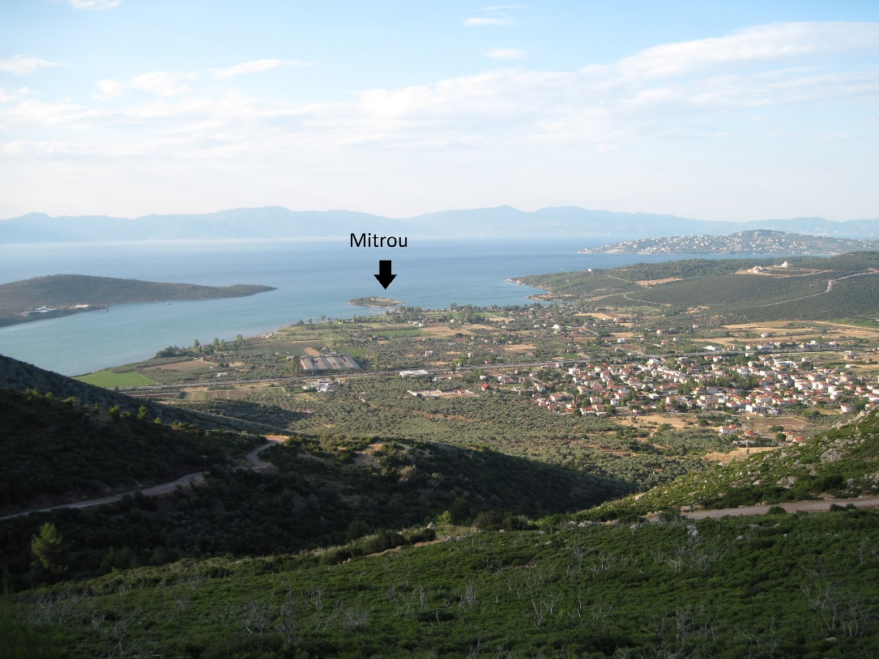
Figure 2. The tidal islet of Mitrou, as seen from the hills to the southwest. Photograph taken by author.

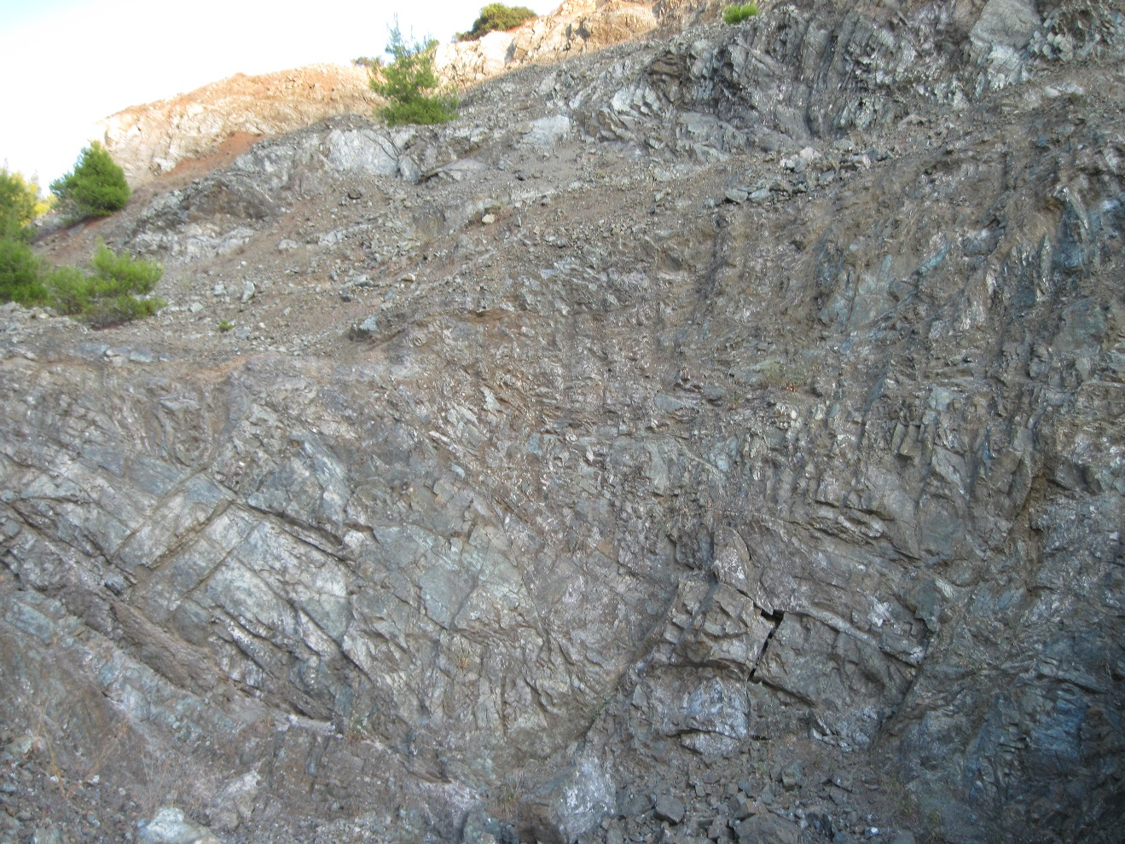
Figure 3. Serpentinite outcrop close to the site. Photograph taken by author.

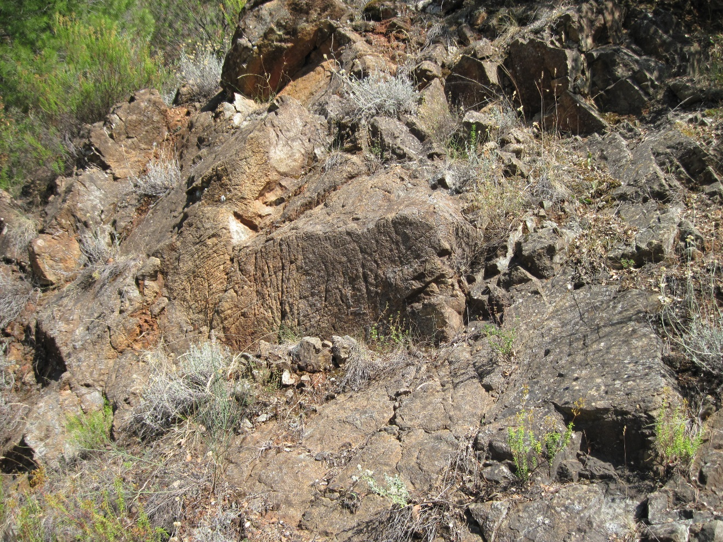
Figure 4. Serpentinite outcrop near the site. Photograph taken by author.
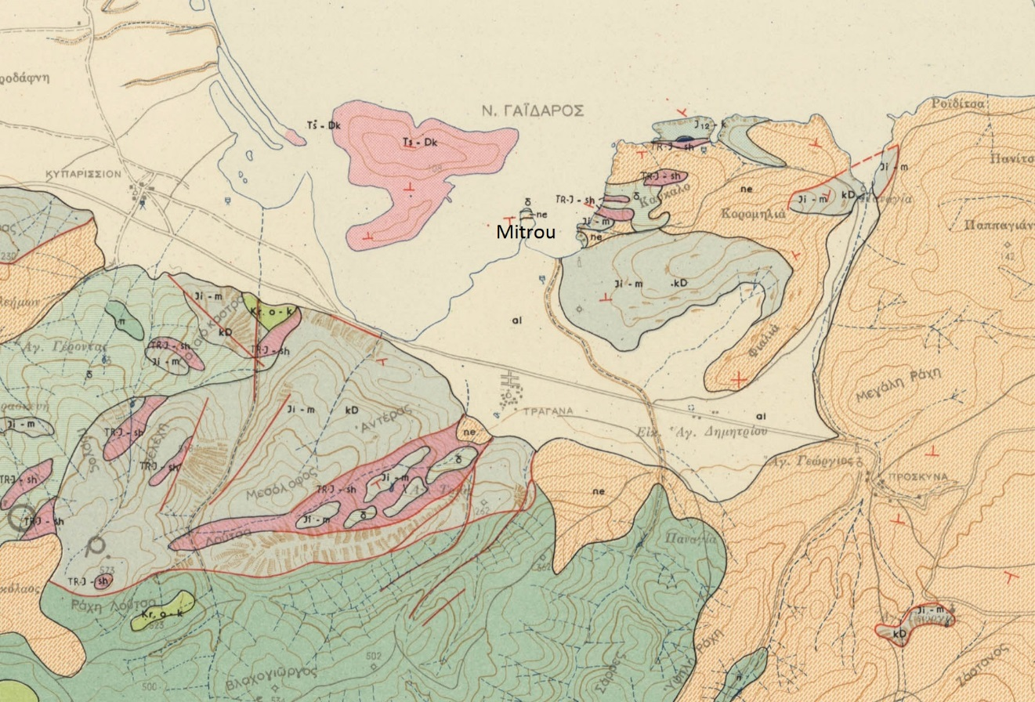
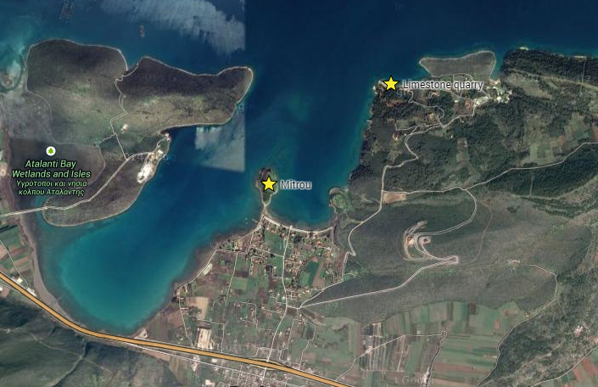
Figure 4. Mitrou in relation to limestone quarry.

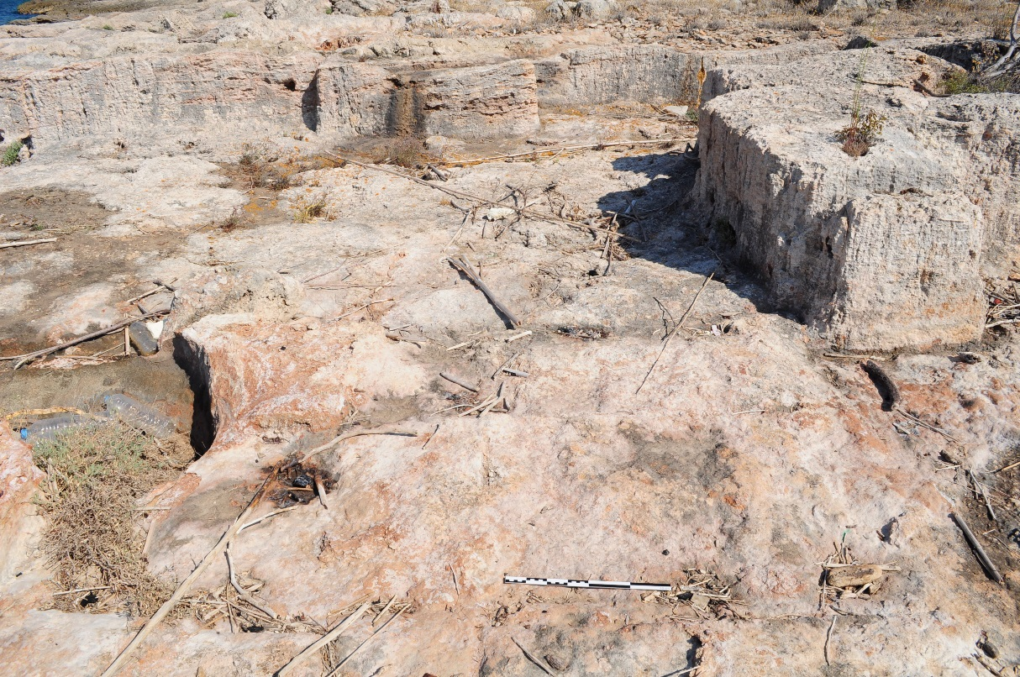
Figure 5. Limestone quarry near Mitrou. Note the 40-cm scale in foreground. Photograph taken by Jacquelyn Clements.

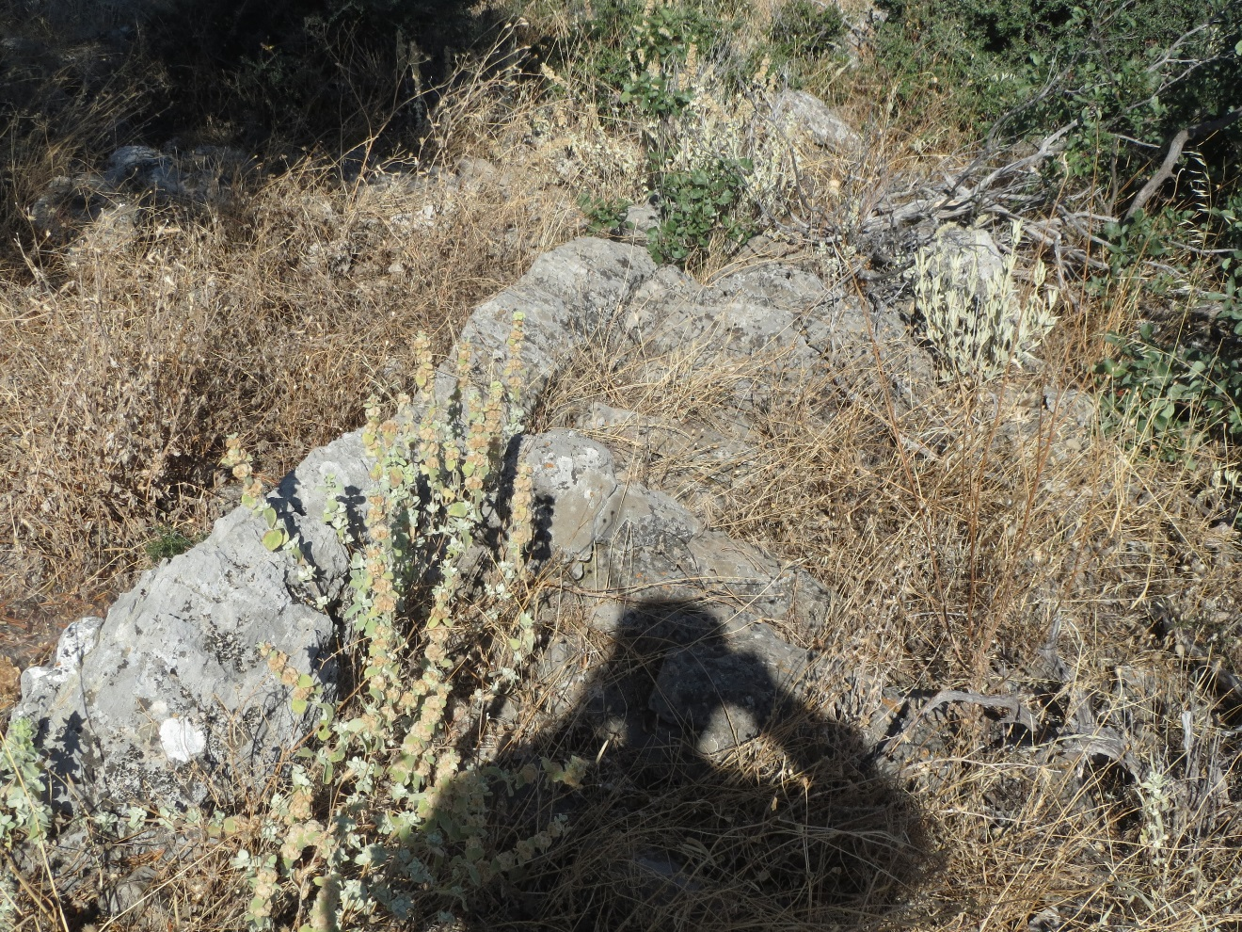
Figure 6. Limestone from Donkey Island, to the west of Mitrou. Photograph taken by Robert Jones.

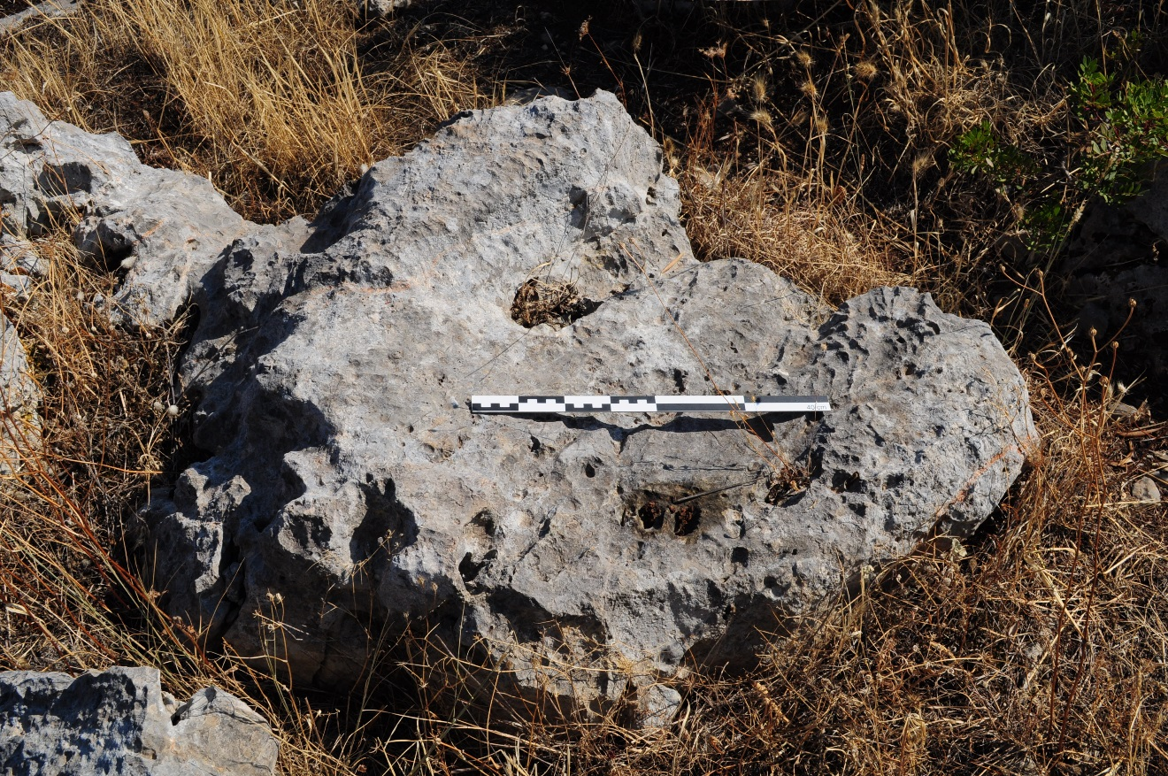
Figure 7. Limestone to the east of Mitrou. Photograph taken by Jacquelyn Clements.

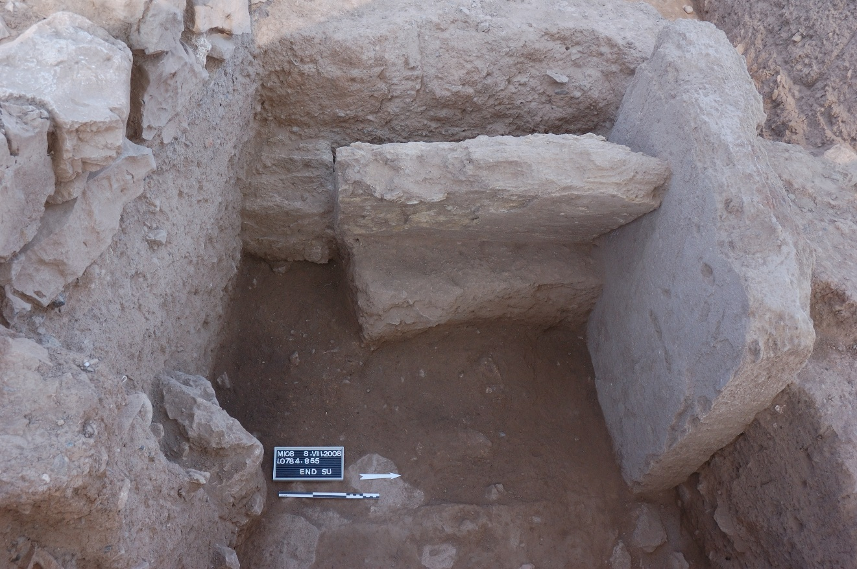
Figure 1. Two bisecting sandstone orthostates from Built Chamber Tomb 73 in situ. Photograph taken by Rachel Vykukal.

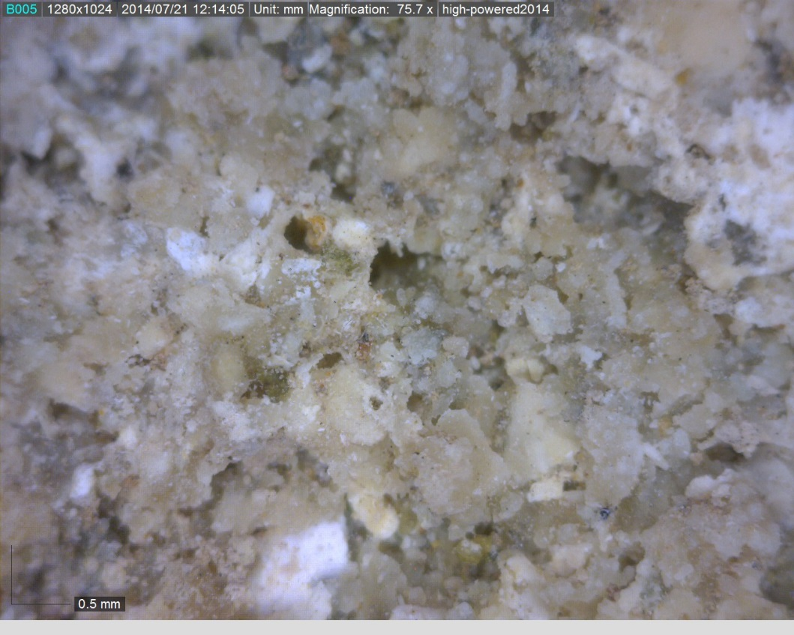
Figure 2. Sandstone sample at ~76X magnification. Photograph taken by author.

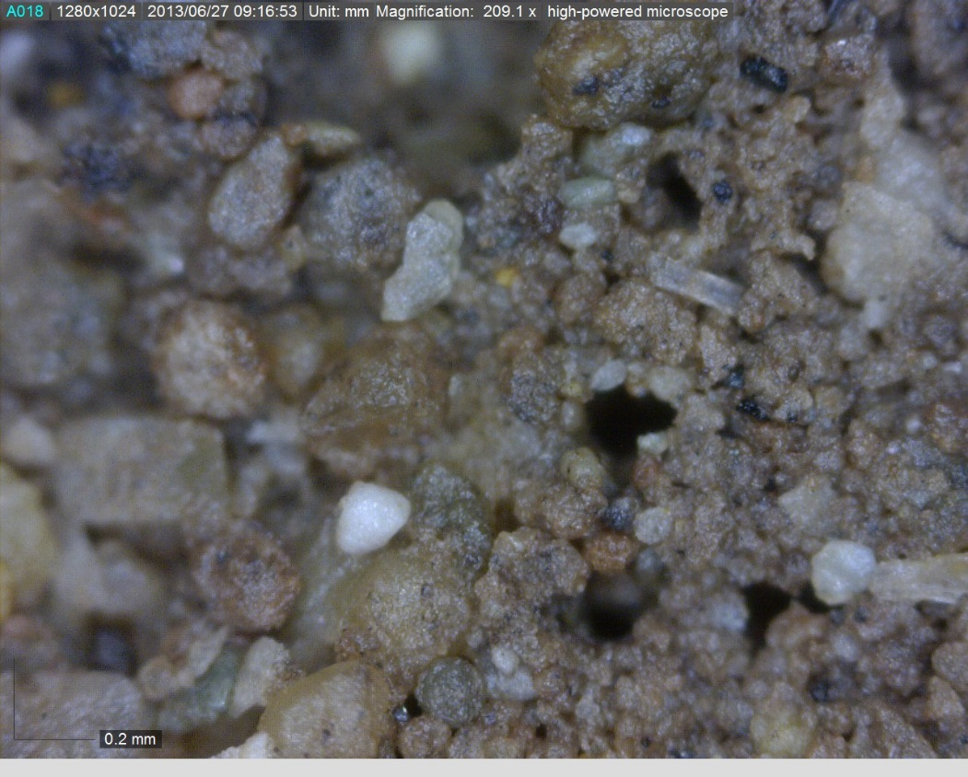
Figure 3. Sandstone sample at ~209X magnification. Photograph taken by author.

Figure 4. Rock types represented in the ground stone tools.

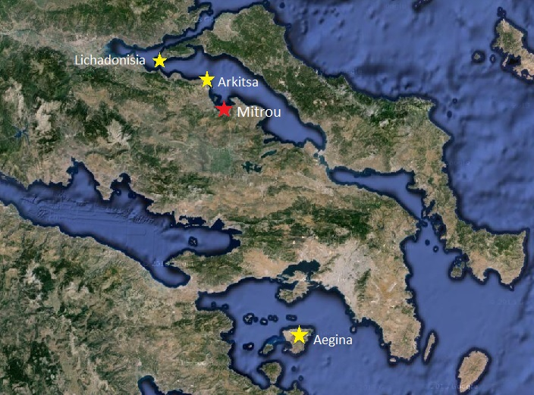
Figure 5. Rock sources to be discussed in the text.

Figure 6. Ground stone tools sorted by function.

Figure 7. Ground stone tools sorted by tool type and rock type.

Figure 8.

Figure 9.

Figure 10.

Figure 11.

Figure 12.

Figure 13.

Vita
Mary Smith was born. She went to school. She wrote a thesis. She graduated. This page really is required.

Van de Moortel and Zahou 2012.
Aleydis Van de Moortel, personal communication, February 20, 2015.
Jazwa 2013, 2015.
Fuson 2012.
Ortner 1984, 149. In her article, Ortner summarizes the various contemporary theories of practice and offers a more wide-ranging perspective for future anthropological research.
Ortner 1984.
Aleydis Van de Moortel, personal communication, February 20, 2015.
In his 1986 article, Daniel Pullen puts forth the idea that Corridor House society was comprised of chiefdoms, in which the heads of lineages controlled access to certain resources. Similarly, in her 1989 article, Martha Wiencke presents evidence that the latter part of the EH II phase saw the evolution of a simpler ranked society into “the more sophisticated, aggressive, and hierarchically defined system in which the expanded elite (‘chief’ and entourage) acquired more genuine power, more prestige, more control of actual wealth or of what was then perceived as actual wealth” (508).
Van de Moortel and Zahou 2012.
Ibid.
Wright 2008.
Van de Moortel and Zahou 2012.
Ibid.
Hale 2015.
Wright 2008.
Jazwa 2015a, 1.
Ibid, 2.
Ibid, 2.
Ibid, 2.
Ibid, 4-5.
Jazwa 2015b, 6.
Fuson 2012, 8. These typologies were adopted from Eitam (2007) and Karimali (2008).
Many thanks to Aleydis Van de Moortel for providing the dates and contexts for the samples.
Van de Moortel 2007, 244.
Jazwa 2015b, 3.
Van de Moortel and Zahou 2012.
Hale 2015, 2.

