ALTERNATIVE MODERATOR CONCEPTS FOR MODULAR/MICRO HIGH TEMPERATURE GAS-COOLED REACTORS

A Thesis Presented for the
Master of Science
Degree
The University of Tennessee, Knoxville

Edward Matthew Duchnowski
December 2020

Copyright © 2020 by Edward Matthew Duchnowski
All rights reserved.

ACKNOWLEDGEMENTS
The author would like to thank Prof. Nicholas R. Brown for his mentorship and guidance. The author would also like to extend his gratitude to Robert F. Kile and Jacob P. Gorton of University of Tennessee, Knoxville for assistance with thermohydraulic and neutronic calculations. The author thanks Dr. Seokbin Seo of University of Tennessee, Knoxville for assistance with thermal property data. The author would also like to thank Gerhard Strydom of Idaho National Laboratory for providing RELAP5-3D models of mHTGRs for use in this study. The author thanks his committee, Profs. Brian Wirth and Ivan Maldonado, for their feedback. Finally, the collaboration of Profs. Lance L. Snead and Jason R. Trelewicz from Stony Brook University is greatly appreciated.

This work was supported by the Advanced Research Projects Agency – Energy (ARPA-E) Modeling Enhanced Innovations Trailblazing Nuclear Energy Reinvigoration (MEITNER) program under contract DE-AR000087.

Portions of this thesis were published in the following peer-reviewed journal article:
Duchnowski, E.M., Kile, R.F., Snead, L.L., Trelewicz, J.R., and Brown, N.R., 2020. Reactor performance and safety characteristics of two-phase composite moderator concepts for modular high temperature gas-cooled reactors. Nuclear Engineering and Design, 368, p.110824.

ABSTRACT
Modular High Temperature Gas-Cooled Reactors (mHTGRs) have numerous applications other than electricity production and exhibit strong safety characteristics, but have challenges associated with the design. Graphite, primarily used as moderator material within an mHTGR, exhibits unfavorable material changes under irradiation and contributes to the low power density of an mHTGR. These issues have led to the investigation and development of alternative moderators to be utilized in mHTGRs, including beryllium- and hydride-based concepts with compositions selected for favorable moderating power and the potential for an improved in-service lifetime as compared to graphite.

The proposed moderators are fabricated as two-phase composites with magnesium oxide, MgO, as the radiation-stable host matrix and beryllium metal, Be, beryllium oxide, BeO, or zirconium hydride, ZrH_{x=1} as the entrained moderating phase. Here, the reactor performance and safety characteristics of these moderator concepts are evaluated relative to a graphite reference using a Ft. Saint Vrain-style fuel block. The cycle length, discharge burnup, natural resource utilization, neutron flux spectra, moderating power, moderating ratio, critical size, moderator and fuel temperature feedback, fuel cycle cost, spent nuclear fuel and high-level waste radioactivity per unit energy generated, and environmental impact per unit energy generated are assessed. These advanced moderators are also assessed from a reactor safety standpoint for Design Basis Accidents (DBAs) including Pressurized Loss of Forced Cooling and Depressurized Loss of Forced Cooling accidents for a 350-megawatt thermal prismatic-type mHTGR. Preliminary calculations of microcore neutronics and safety performance is demonstrated to illustrate a framework for designing a microcore.

The results demonstrate that the advanced moderators have the potential for comparable or enhanced cycle performance to that of the graphite reference case with significantly improved performance for an optimized moderator-to-fuel ratio design. The full core thermal-hydraulic analysis of DBAs shows that the high volumetric heat capacity of the beryllium-based moderator grants them a greater margin to fuel failure in these analyses than a conventional graphite-moderated system, but the lower thermal conductivity of the beryllium-based moderators leads to longer times at elevated temperatures. Microcore neutronics calculations show the effectiveness that the advanced moderators have on cycle length and safety evaluation of the design shows comparable performance to that of graphite.

Table of Contents
Chapter One Introduction 1
Chapter Two Literature Review 5
High Temperature Gas Cooled Reactors 5
Safety 5
Modular Applications 6
Challenges 7
Significant Historical Modular High Temperature Reactors 7
GA mHTGR 350 8
Nuclear Powered Flight 8
Proposed Moderators 9
Theory 10
Neutron Interactions 10
Thermophysical Properties 11
Chapter Three Neutronics performance 13
Discloser 13
Infinite Assembly Neutronics Evaluation 15
Neutronics and Fuel Cycle Performance 15
Reactivity Coefficients 27
Scoping Fuel cycle cost Analysis 30
Radioactivity Calculations 34
Environmental Impact 43
2D Core Neutronics Evaluation 45
GA mHTGR-350 Configuration 45
Micro Design 49
Chapter Four thermal-Hydraulics Model 54
Thermal-Hydraulics Performance and Accident Evaluation of GA mHTGR-350 57
Discloser 57
PLOFC 57
DLOFC 61
Thermal-Hydraulics Performance and Accident Evaluation of micro Reactor Design 61
Undercooling Accident 63
Overpower Accident 64
Chapter Five Conclusions 73
List of References 75
Vita 81

LIST OF TABLES
Table 1: Simulated cases and volume fractions of components 14
Table 2: Parameter of graphite optimized neutronics model [8] 17
Table 3: Three-batch burnup, natural resource utilization, and uranium savings of most promising optimized moderators and optimized moderators with vary enrichment *Optimized moderators with varied enrichment 26
Table 4: Fuel cycle costs for five mentioned categories 32
Table 5: Calculated costs for three batch fuel cycle 33
Table 6: Impact Factors used for calculating total environmental impact [44] 43
Table 7. Lattice pitch for reference and most promising moderators, both buckling and initial reactivity. *Optimal initial reactivity was not reached for graphite as the maximum pitch was set to 3 [cm] 53
Error! Hyperlink reference not valid.
Error! Hyperlink reference not valid.
Error! Hyperlink reference not valid.
Error! Hyperlink reference not valid.
Error! Hyperlink reference not valid.
Error! Hyperlink reference not valid.
Error! Hyperlink reference not valid.

LIST OF FIGURES
Figure 1: Diagram showing the approach taken for this study 4
Figure 2: (a) Ft. St. Vrain-style fuel blocked modeled for this study, with blue for helium, green for fuel channel, and gray for matrix. (b) Photograph of an actual moderator block of similar design. 16
Figure 3: Infinite multiplication factor as a function of cycle length for the advanced moderators and graphite reference case. 18
Figure 4: Flux per lethargy spectra for the advanced moderators and reference graphite case for BOC, and (b) for EOC. 20
Figure 5: Composite moderator systems compared with graphite. Inset: x-ray microtomographic image of a demonstration composite moderator with an MgO structural matrix (light blue) containing a complex Be/BeO entrained moderator phase (dark blue). 22
Figure 6: Critical buckling for the advanced moderators and reference graphite as a function of moderator-to-fuel volume ratios 23
Figure 7: Critical radii of a single region homogenized spherical reactor for optimal moderator-to-fuel volume ratio determined from the critical buckling calculations 24
Figure 8: (a) Moderator Temperature Coefficient and (b) Fuel Temperature Coefficient of the most promising moderators and graphite reference. 29
Figure 9: SNF + HLW at 100 years for graphite and most promising moderators 35
Figure 10: SNF + HLW at 10,000 years for graphite and most promising moderators 36
Figure 11: SNF + HLW at 100,000 years for graphite and most promising moderators 37
Figure 12: SNF + HLW for graphite and most promising moderators 38
Figure 13. Actinide, fission product, and total activity for alternative moderators and graphite reference case at 100 years after discharge 40
Figure 14. Actinide, fission product, and total activity for alternative moderators and graphite reference case at 100,000 years after discharge 41
Figure 15. Uranium-238 capture reaction rate for alternative moderators and graphite reference case during cycle length 42
Figure 16: Environmental impact of optimized advanced moderators’ values normalized to the graphite reference case 44
Figure 17. GA mHTGR-350 style core neutronics model 47
Figure 18. Cycle length for reference case and most promising moderators for the GA mHTGR-350 style core design 48
Figure 19. Preliminary micro HTGR core design 50
Figure 20. Cycle length for buckling optimized lattice pitch for reference and most promising moderators 51
Figure 21. Cycle length for initial reactivity optimized lattice pitch for reference and most promising moderators 52
Figure 22: Rule-of-mixtures thermal conductivity of the Be-based moderator materials from literature [48] [49] [53] relative to graphite. 55
Figure 23: Rule-of-Mixtures volumetric heat capacity of the Be-based moderator materials from literature [50] [51] [52] [53] relative to graphite. 56
Figure 24. Steady state temperature of fuel in concentric rings 4, 5, and 6 as an axial distribution. 59
Figure 25. Maximum fuel temperature and average moderator block temperature for the PLOFC accident. 60
Figure 26. Maximum fuel temperature and average moderator temperature for the DLOFC accident. 62
Figure 27. Steady state temperature of fuel in inner ring (IR) and outer ring (OR) as an axial distribution 65
Figure 28. Peak temperatures in fuel and moderator block for graphite and beryllium based moderators during PLOFC 66
Figure 29. Peak temperatures in fuel and moderator block for graphite and beryllium based moderators during DLOFC 67
Figure 30. Reactivity insertion for CRW transient 68
Figure 31. Core power for CRE and CRW transient 69
Figure 32. Peak temperatures in three-block high fuel column design for graphite and beryllium based moderator during CRW 70
Figure 33. Peak temperatures in three-block high fuel column design for graphite and beryllium based moderator during CRE 72
Error! Hyperlink reference not valid.
Error! Hyperlink reference not valid.
Error! Hyperlink reference not valid.
Error! Hyperlink reference not valid.
Error! Hyperlink reference not valid.
Error! Hyperlink reference not valid.
Error! Hyperlink reference not valid.
Error! Hyperlink reference not valid.
Error! Hyperlink reference not valid.
Error! Hyperlink reference not valid.
Error! Hyperlink reference not valid.
Error! Hyperlink reference not valid.
Error! Hyperlink reference not valid.
Error! Hyperlink reference not valid.
Error! Hyperlink reference not valid.
Error! Hyperlink reference not valid.
Error! Hyperlink reference not valid.
Error! Hyperlink reference not valid.
Error! Hyperlink reference not valid.
Error! Hyperlink reference not valid.
Error! Hyperlink reference not valid.
Error! Hyperlink reference not valid.
Error! Hyperlink reference not valid.
Error! Hyperlink reference not valid.
Error! Hyperlink reference not valid.
Error! Hyperlink reference not valid.
Error! Hyperlink reference not valid.
Error! Hyperlink reference not valid.
Error! Hyperlink reference not valid.

Introduction
Nuclear energy provides the largest source of low carbon energy in the United States and supplies the nation with approximately 20% of its total electrical output. The nuclear reactors that supply this demand are light water designs that are considered to be Generation II reactors. Although reliable and robust, the majority of these reactors are approaching retirement and will need to be substituted. Some of the main challenges associated with nuclear energy is the large capital cost, radioactive waste produced during operation, large dedication of natural resources, and large size.

A technology to address this issue would be of micro or modular nuclear reactors. These nuclear reactors would be factory built and then transported instead of constructed on-site, greatly reducing capital cost, construction time, and allowing the option of streamlining the reactor design. These reactors have the flexibility of application that large-scale power plants do not. The compact design has the option to be placed in remote locations or to be clustered together to produce a larger output of power [1]. Small Modular Reactor (SMR) technology can be applied to Light Water Reactors (LWRs), gas-cooled reactors, liquid metal cooled reactors, or molten salt reactors. LWRs are at the forefront of SMR designs as a deep understanding of physical phenomena and experience is available [2] but gas-cooled reactors, in particular High Temperature Gas-Cooled Reactors (HTGRs), have distinct advantages over LWRs.

HTGR operate at much higher temperatures than LWRs and subsequently have higher outlet temperatures (700 ºC compared to 300 ºC) leading to higher thermal to electric efficiencies. Moreover, the high outlet temperature can be used for non-electricity-generation applications such as hydrogen and synfuel production, desalination, or as process heat for metallurgy and petrochemistry related industrial processes [3] [4]. However, conventional HTGRs have problems concerning design and safety, these issues are nearly all related to the physical size of the core [5]. By modularizing the core, fuel damage can be prevented over a wide spectrum of accidents due to passive safety features [6], thus it is more advantageous to design an HTGR as an SMR than as a full-scale reactor.

The size limitation of an HTGR is based on graphite’s moderating capability and passive decay heat removal. Graphite requires neutrons to have more collisions in order to reduce the energy to thermal fission energies than for elements with a smaller atomic mass. The Advanced Research Projects Agency-Energy (ARPA-E) under the Modeling-Enhanced Innovations Trailblazing Nuclear Energy Reinvigoration (MEITNER) Program aims to identify alternatives to graphite moderators that will enable transformational design improvements for Modular High Temperature Gas-Cooled Reactors (mHTGRs). Concepts for the moderating phase include beryllium- and hydrogen-containing materials for their increased moderating power relative to graphite.

The advanced moderators are assessed from a reactor physics standpoint with the following parameters considered: reactor cycle length, discharge burnup, natural resource utilization, neutron flux spectra, moderating power, critical size, moderator and fuel temperature feedback, fuel cycle costs, waste radioactivity, and environmental impact. Additionally, a thermal-hydraulic analysis of magnesium oxide beryllium metal (MgO Be), magnesium oxide beryllium oxide (MgO BeO), and graphite reference cases was conducted to evaluate steady-state axial temperature profiles as well as Pressurized Loss Of Forced Cooling (PLOFC) and Depressurized Loss Of Forced Cooling (DLOFC) Design Basis Accidents (DBAs) peak and average moderator block temperatures. The scope of this thesis is to demonstrate an assessment of the composite moderators by leveraging graphite optimized prismatic fuel block design available in the open literature [7] and a moderator-to-fuel ratio optimized design to provide an initial comparison of reactor performance. The hypotheses examined within this thesis are:
- The lower atomic nuclei mass of these alternative moderators will outperform a graphite-moderated design for a micro-sized HTGR in terms of core size and/or fuel cycle length
- Relative to graphite, the higher heat capacity of the alternative moderators will offset the lower thermal conductivity and show similar or enhanced performance during transient analysis

The results demonstrate comparable neutronics performance for unoptimized cases and improved neutronics performance for optimized lattice pitch cases for an infinite assembly. A full 2D core that mimics the design of the General Atomics mHTGR-350 was also evaluated [8] along with a microreactor design [9]. The 2D core shows that for a full-scale design the alternative moderators’ capability is not harnessed in terms of reactor performance but when evaluating the design for a micro configuration, the beryllium-based moderators show enhanced performance. The model assessed other potential host matrixes, MgAl₂O₄ and SiC, and entrained moderator, Be₂C, but these options were not fully investigated because of decreased or marginal improvements to fuel cycle performance compared to the graphite reference case as well as their lower maturity in the manufacturing process. The approach to establishing and verifying the models is shown in Figure 1, which illustrates the different sources of the design information used in the study and relationships between these information sources and is adapted from the literature [10].

Figure 1: Diagram showing the approach taken for this study

chapter one
Literature Review

High Temperature Gas Cooled Reactors
To answer the question of what changes would be seen in performance and safety for mHTGRs utilizing alternative moderators relative to graphite, a literature review was conducted to provide oversite on HTGR safety, modular applications, and challenges.

Safety
The modular High Temperature Gas-Cooled Reactor (mHTGR) has attractive inherent safety features such as negative temperature feedback, high thermal inertia, and passive decay heat removal systems [11]. Conventional mHTGR designs utilize TRi-structural ISOtropic (TRISO) fuel particles. The particle consists of a nuclear fuel kernel with, a low-density carbon buffer, an Inner Pyrolytic Carbon (IPyC) layer, a protective Silicon Carbide (SiC) layer, and an Outer Pyrolytic Carbon (OPyC) layer. These particles are embedded into a graphitic compact which provides added measures of protection from fission product release during operation. An additional layer of safety can be added by implementing Full Ceramic Micro-encapsulated (FCM) fuel where the TRISO fuel particles are embedded into a silicon carbide compact, instead of graphite, which enhances safety [12] [13]. The TRISO particles are shown to be extremely reliable. The Advanced Gas Reactor Fuel Development and Qualification (AGR) program conducted an irradiation experiment with 300,000 TRISO particles to a peak burn of 19.6% (Fissions per Initial Metal Atom (FIMA)), a peak fast-neutron fluence of 4.3e25(n/m²), and a maximum time-averaged fuel temperature of about 1,200(ºC) without a single particle failure [14].

Experiments at the 10(MW) High Temperature gas-cooled Reactor test module (HTR-10) demonstrated the inherent safety features of mHTGRs during two simulated anticipated transients without SCRAM for both an overpower and undercooling event. The undercooling event was performed by tripping the helium coolant blower without moving any control rods. Initially, the power was set to 3(MW) then began to decrease do the negative temperature coeffect associated with the design but became critical again after 42 minutes before finally reaching a stable power level of 0.2(MW) at 120 minutes. For the overpower event, two cases of reactivity insertion by the removal of control rods were conducted. The initial power was set to 3(MW) and 0.138($) or 0.689($) of reactivity was inserted at a rate of 0.014($/second) and the helium blower was shut off at approximately 12 seconds. The 0.138($) and 0.689($) reactivity insertions resulted in power peaks of 150% and 216% respectively before the negative reactivity feedback was able to bring the power back down. Both of these transients maintained a fuel temperature below 1230(ºC). [15]. Similarly, experiments at the High Temperature engineering Test Reactor (HTTR) showed similar conclusions to that of the HTR undercooling transients [16]. Both of these reports attribute the passive shutdown of the core to the negative temperature feedback and maintaining fuel temperatures below safety limits to the large heat capacity of the moderator.

Modular Applications
mHTGRs have high helium coolant outlet temperatures, suggesting possible non-electricity-generating applications such as hydrogen and synfuel production, desalination, or as process heat for metallurgy and petrochemistry related industrial processes [3] [4]. Recently, interest in re-establishment of the Arctic Energy Office was shown in the 2020 Senate Energy & Water Development (SEWD) Appropriations Bill report, under Crosscutting Initiatives. The Arctic Energy Office mission highlights innovative activities including microgrids and integrated energy systems. mHTGRs are well suited for this task as most designs are constrained to have cycle lengths of a 3-year minimum. Interest in mobile microreactor has been expressed by the United States Department of Defense (US DOD) for electrical power necessary at forward and remote locations without the need for continuous fuel resupply [17]. Moreover, DOD has recently awarded three contracts to industry partners to begin design on a mobile nuclear reactor prototype under a Strategic Capabilities Office initiative called Project Pele.

Challenges
The conventional mHTGR has challenges associated with its current design. The low power density associated with an mHTGR equates to a costlier construction and operation. Additionally, the mHTGR has unique mechanical challenges associated with the graphite moderator. Graphite experiences a significant swing in volumetric change under a neutron fluence along with non-uniform expansion and contraction in the axial and transverse directions [18]. This anisotropic swelling ultimately leads to unsupportable internal stresses and microcracking, which defines the graphite lifetime and the corresponding need for costly replacement of core internals. Moreover, measurements on irradiated graphite reveal large strains and increases in stored energy within the lattice structure as well as changes in mechanical properties such as elastic constants, strength, and creep behavior [19]. The issue of stored energy is unique to the graphite system as compared with essentially all other ionically or covalently bonded ceramics [20]. HTGR operations have shown to have regions in the core that greatly exceed predicted temperatures. These problematic areas are compounded with the fact that the helium coolant increases in viscosity with an increase in temperature and that traditional HTGR having downward flowing coolant channels results in reduced flow to these hotter regions due to buoyancy effects [21].

Significant Historical Modular High Temperature Reactors
Significant mHTGR designs such as the General Atomics (GA) mHTGR-350 and reactors intended for aviation, the Heat Transfer Reactor Experiment No. 3 (HTRE3) and Aircraft Reactor Experiment (ARE), are reviewed for their relation to this study. The GA mHTGR-350 is reviewed as the overall study in this thesis is based on this style of design. Aviation intended aircraft are reviewed as these reactors were historical demonstrations that utilized alternative moderators in an HTGR design to demonstrate a compact reactor that would provide an aircraft with an essentially unlimited range

GA mHTGR 350
The GA mHTGR-350 is a Prismatic Modular Reactor (PMR) design subset of a High Temperature Reactor (HTR) that has a thermal power output of 350(MWth) and an electrical output of 165(MWe) [8]. This reactor has an annular core configuration where the central compacts are purely moderator with no fuel. This design is intended to accommodate passive decay heat removal which untimely improves the safety of the core under accident conditions at the cost of lowering overall core power density [22]. The active core consists of a ring of three rows of Fort Saint Vrain hexagonal style fuel block loaded with TRISO particles embedded in a graphite matrix along with helium coolant channels [23]. The fuel is then surrounded by reflector blocks and a permanent reflector. The overall size of this core has a radius of 340.8(cm) from center block to outer Reactor Pressure Vessel (RPV) and a height of 1,745.63(cm) from bottom to top RPV [8]. This design was able to show computationally that for a PLOFC or DLOFC the core can passively remove heat via the moderator blocks [13].

Nuclear Powered Flight
Hydrogen-based moderators were used within the Heat Transfer Reactor Experiment No. 3 (HTRE-3), a prototype aircraft power plant with zirconium hydride as its primary moderator, beryllium as its reflector, and air as coolant. The zirconium hydride moderator blocks were hexagonal with a cylindrical fuel cartridge located in the center and were able to operate at 977(K) for 100 hours without experiencing excessive oxidation or hydrogen loss. The hydrogen concentration in the moderators varied radially to provide a flatten power profile, outer moderator blocks contained more hydrogen than the inner. The beryllium reflector provided the primary purpose of shielding neutrons from leaking out of the core but was also shown to absorb thermal shock without cracking. HTRE No. 3 underwent numerous tests to evaluate endurance, power, and material integrity. The endurance testing concluded that variation from the peak temperature rise to the average was no greater than 8% and visual inspection of the fuel elements concluded no heat damage. More on the experiments and general design can be found in [24].

Beryllium-based moderators have historically been used in the Aircraft Reactor Experiment (ARE), which utilized hexagonal beryllium oxide blocks as both the moderator and reflector, liquid sodium fluoride fuel, and helium as a coolant. The ARE performed both low-power and high-power experiments for calibration as well as measurements of temperature coefficients. These experiments provided useful information on the technology of HTRs as well as operational methods. More on the history of the ARE can be found in [25].

Proposed Moderators
Ongoing efforts at Stony Brook University [26] and the University of Tennessee-Knoxville [27] are focused on the fabrication of two-phase moderators with the moderating phase entrained within a fully-dense MgO host matrix as it has been reported (albeit with only limited data) to be radiation tolerant and chemically stable [28]. The two-phase moderators aim to provide a potential lifetime reactor component that would greatly reduce the radioactive waste burden associated with graphite moderators. BeO has a long history of reactor performance/consideration. The high thermal heat capacity, good neutron moderation, and appreciable fast neutron multiplication factor due to (n,2n) reactors are just some of the many advantages [29]. However, beryllium is known to have many adverse health effects [30] that would require additional safety during large scale manufacturing. Hydride has also had consideration as both moderator and reflector material nuclear reactors [31]. However, zirconium dihydride (ZrH₂) begins to decompose at temperatures above 700(K) [32].

Theory
To understand why we chose specific alternative moderators for HTGRs we must first look at the physical phenomena associated with replacing the graphite moderator. An overview of neutron interactions with moderators is discussed as well as quantifiable performance parameters. Thermophysical properties are also outlined to highlight key parameters contributing to safety.

Neutron Interactions
A prismatic HTGR has fuel compacts stacked axially inside a graphite moderator block. The moderator block serves two main purposes, to provide a medium to thermalize neutrons to energies that greatly increase the chances of fission events and to provide heat removal via conduction from the fuel to the outer core, the former will be the discussion of this section. A moderator’s neutronic performance is related to the atomic mass ($A$), the scattering cross-section$(Σ_{s})$, and the absorption cross-section $(Σ_{a})$. Moderators should be able to thermalize high energy neutrons in as few collisions as possible with as little absorption as possible. The average number of collisions required to reduce a neutron’s energy is related to a variable known as the average change in lethargy $(ξ$) which describes the average loss of energy of a neutron during scattering. Equation 1 describes the average change in lethargy and Equation 2 is how this variable relates to the number of collisions required to reduce a neutron’s energy from $E_{0}$ to $E$.

$$ξ=1-\left(\frac{{\left(A-1\right)}^{2}}{2A}\right)\ln\left(\frac{A+1}{A-1}\right) Eq. 1$$
$$average number of collisions=\frac{1}{ξ}\ln\left(\frac{E_{0}}{E}\right) Eq. 2$$

It can be shown in Equation 1 and Equation 2 that the average number of collisions required to reduce a high energy neutron to thermal energies is dependent on the atomic mass of the moderator. The number of collisions does not consider neutron losses for either absorption or leakage. The metric for quantifying neutron losses is called buckling, which is separated into geometric buckling and material buckling to describe leakage and absorption, respectively. Material buckling is dependent on material properties within a reactor and is shown in Equation 3.

$$B_{mat}^{2}=\frac{νΣ_{f}-Σ_{a}}{D} Eq. 3$$

Where $ν$ is the average number of neutrons emitted after a fission event, $Σ_{f}$ is the fission cross-section, and $D$ is the diffusion coefficient of neutrons through a medium. When the material buckling is equal to the geometrical buckling the reactor has reached a critical size that could sustain fission events and both can be referred to as critical buckling. For a single region, homogenous, spherical reactor a radius can be determined from the geometrical buckling equation shown in Equation 4.

$$B_{geo}^{2}={\left(\frac{π}{r}\right)}^{2} Eq. 4$$

A higher geometric buckling result in smaller radii and smaller radii are associated with high fission probabilities and number of fission neutrons, small absorption probabilities, and small diffusion coefficients. More information on this topic and the source of these equations can be found in the literature [33].

Thermophysical Properties
As mentioned in the previous section, the graphite moderator block also serves as a means of heat removal that greatly enhances the safety characteristics of the HTGR design. To understand how substituting the moderator material will affect the heat being transferred from the fuel to the coolant we will first look at the method of conduction from the fuel compacts through the moderator block. The heat flux density equation is given by Fourier’s law of heat conduction and is shown in Equation 5, where $q''$ is the local heat flux density with units (W/m²), $k$ is the material’s thermal conductivity in units (W/m K), and $∇T$ is the temperature gradient in units (K/m).

$$q''=-k∇T Eq. 5$$

Another key parameter that is more applicable to non-steady-state conditions is the heat capacity. The heat capacity of a material is the required amount of energy to increase the temperature of the material by a degree centigrade. Shown in Equation 6 is the formula for calculating volumetric heat capacity $c$ in units (J/K m³), $Q$ is the energy deposited in the material in units (J), $ρ$ is the density of the material in units (g/m³), $m$ is the mass in units (g), and $ΔT$ is the temperature change.

$$c=\frac{Qρ}{mΔT} Eq. 6$$

Both thermal conductivity and heat capacity are dependent on material properties and temperature. Also, heat capacity is shown to increase with temperature as thermal conductivity tends to decrease for most materials.

chapter two
Neutronics performance

Discloser
The work presented in this chapter was previously published [34].

The continuous-energy Monte Carlo reactor physics burnup calculation code Serpent [35] was utilized to compare the neutronics performance of the proposed neutron moderators against the graphite-moderated reference case. These calculations utilized ENDF/B-VII.0 cross-section libraries and S($α,β$) libraries for thermal neutron scattering of ZrH and BeO. The neutronics model employs a Ft. Saint Vrain style fuel block based on the GA 350-mHTGR specification in the literature [8] [7]. The model was selected because it is a graphite-based design used extensively in the evaluation of Fully Ceramic Microencapsulated (FCM) fuel in prismatic mHTGRs [12]. We assumed Advanced Gas Reactor-type fuel compacts in the model [36] and H-451 graphite properties [37]. The moderator matrix composition is varied for several concepts according to volume fractions given in Table 1 including 1% for engineered porosity and assuming theoretical density for each constituent. The fabrication process of zirconium hydride initially starts with a ratio of hydrogen to zirconium of around 2, and after hydrogen losses during the fabrication process, the ratio is approximately 1.6. For the ZrH_{x=1} based moderator, the ratio of hydrogen to zirconium was set to one as this is expected to be the bounding value for hydrogen losses during fabrication and was maintained to provide a constant comparison between calculations. Additionally, the lower ratio would provide a conservative estimate of zirconium hydride required to provide sufficient moderation. The TRISO particle consists of a uranium oxycarbide (UCO) kernel with enriched uranium-235, a low-density carbon buffer, an Inner Pyrolytic Carbon (IPyC) layer, a protective Silicon Carbide (SiC) layer, and an Outer Pyrolytic Carbon (OPyC) layer. The model has a constant power and all material properties for the model are set to 900(K).

Table 1: Simulated cases and volume fractions of components
CASES | Carbon | MgO | BeO | Be | ZrH_{x=1} | MgAl₂O₄ | Be₂C | SiC
Nuclear Graphite | 100% | - | - | - | - | - | - | -
MgO BeO | - | 60% | 39% | - | - | - | - | -
MgO Be | - | 60% | - | 39% | - | - | - | -
MgO ZrH_{x=1} | - | 84% | - | - | 15% | - | - | -
MgAl₂O₄ BeO | - | - | 39% | - | - | 60% | - | -
MgO Be₂C | - | 60% | - | - | - | - | 39% | -
SiC BeO | - | - | 39% | - | - | - | - | 60%

Since the area of interest is the comparison of typical graphite-moderated mHTGR against that of the advanced moderators, the only variation between cases is the composition of the moderator block matrix while the fuel compact matrix remained graphite in all cases and the fuel loading remained the same as well. The optimal volume fractions of the moderators were selected for manufacturability (informed by the experimental tasks within this project) and cycle length. The reasoning behind this volume fraction is to maximize the moderating capability but not over moderate the system, which would ultimately hinder reactor performance.

Infinite Assembly Neutronics Evaluation
Figure 2 (a) shows a top-down view of the infinite assembly neutronics model that utilizes periodic boundary conditions and Figure 2 (b) is an actual moderator block of a similar design. Table 2 are the properties associated with the design. The model has both large and small helium coolant channels in light blue, graphite fuel channels with randomly distributed TRISO fuel particles in dark green, and moderator matrix, in gray. The infinite assembly model provides a preliminary comparison of the performance of the alternative moderators as well as a basis for the two-dimensional full core design.

Neutronics and Fuel Cycle Performance
The effectiveness of these advanced moderators is illustrated in Figure 3 where the infinite multiplication factor, K_{inf}, is plotted as a function of the cycle length in Effective Full Power Days (EFPD) where EFPD is the amount of days that the reactor can operate at 100% power. The model used does not incorporate control rods or burnable absorbers for any calculations. For the MgO Be and MgO ZrH_{x=1} cases, the cycle length is shown to have an increase of approximately 18% and 14%, respectively. The MgO BeO case exhibits a similar cycle length. For the less promising moderators considered (MgAl₂O₄ BeO, MgO Be₂C, and SiC BeO) it is shown that they have similar or decreased fuel cycle performance.

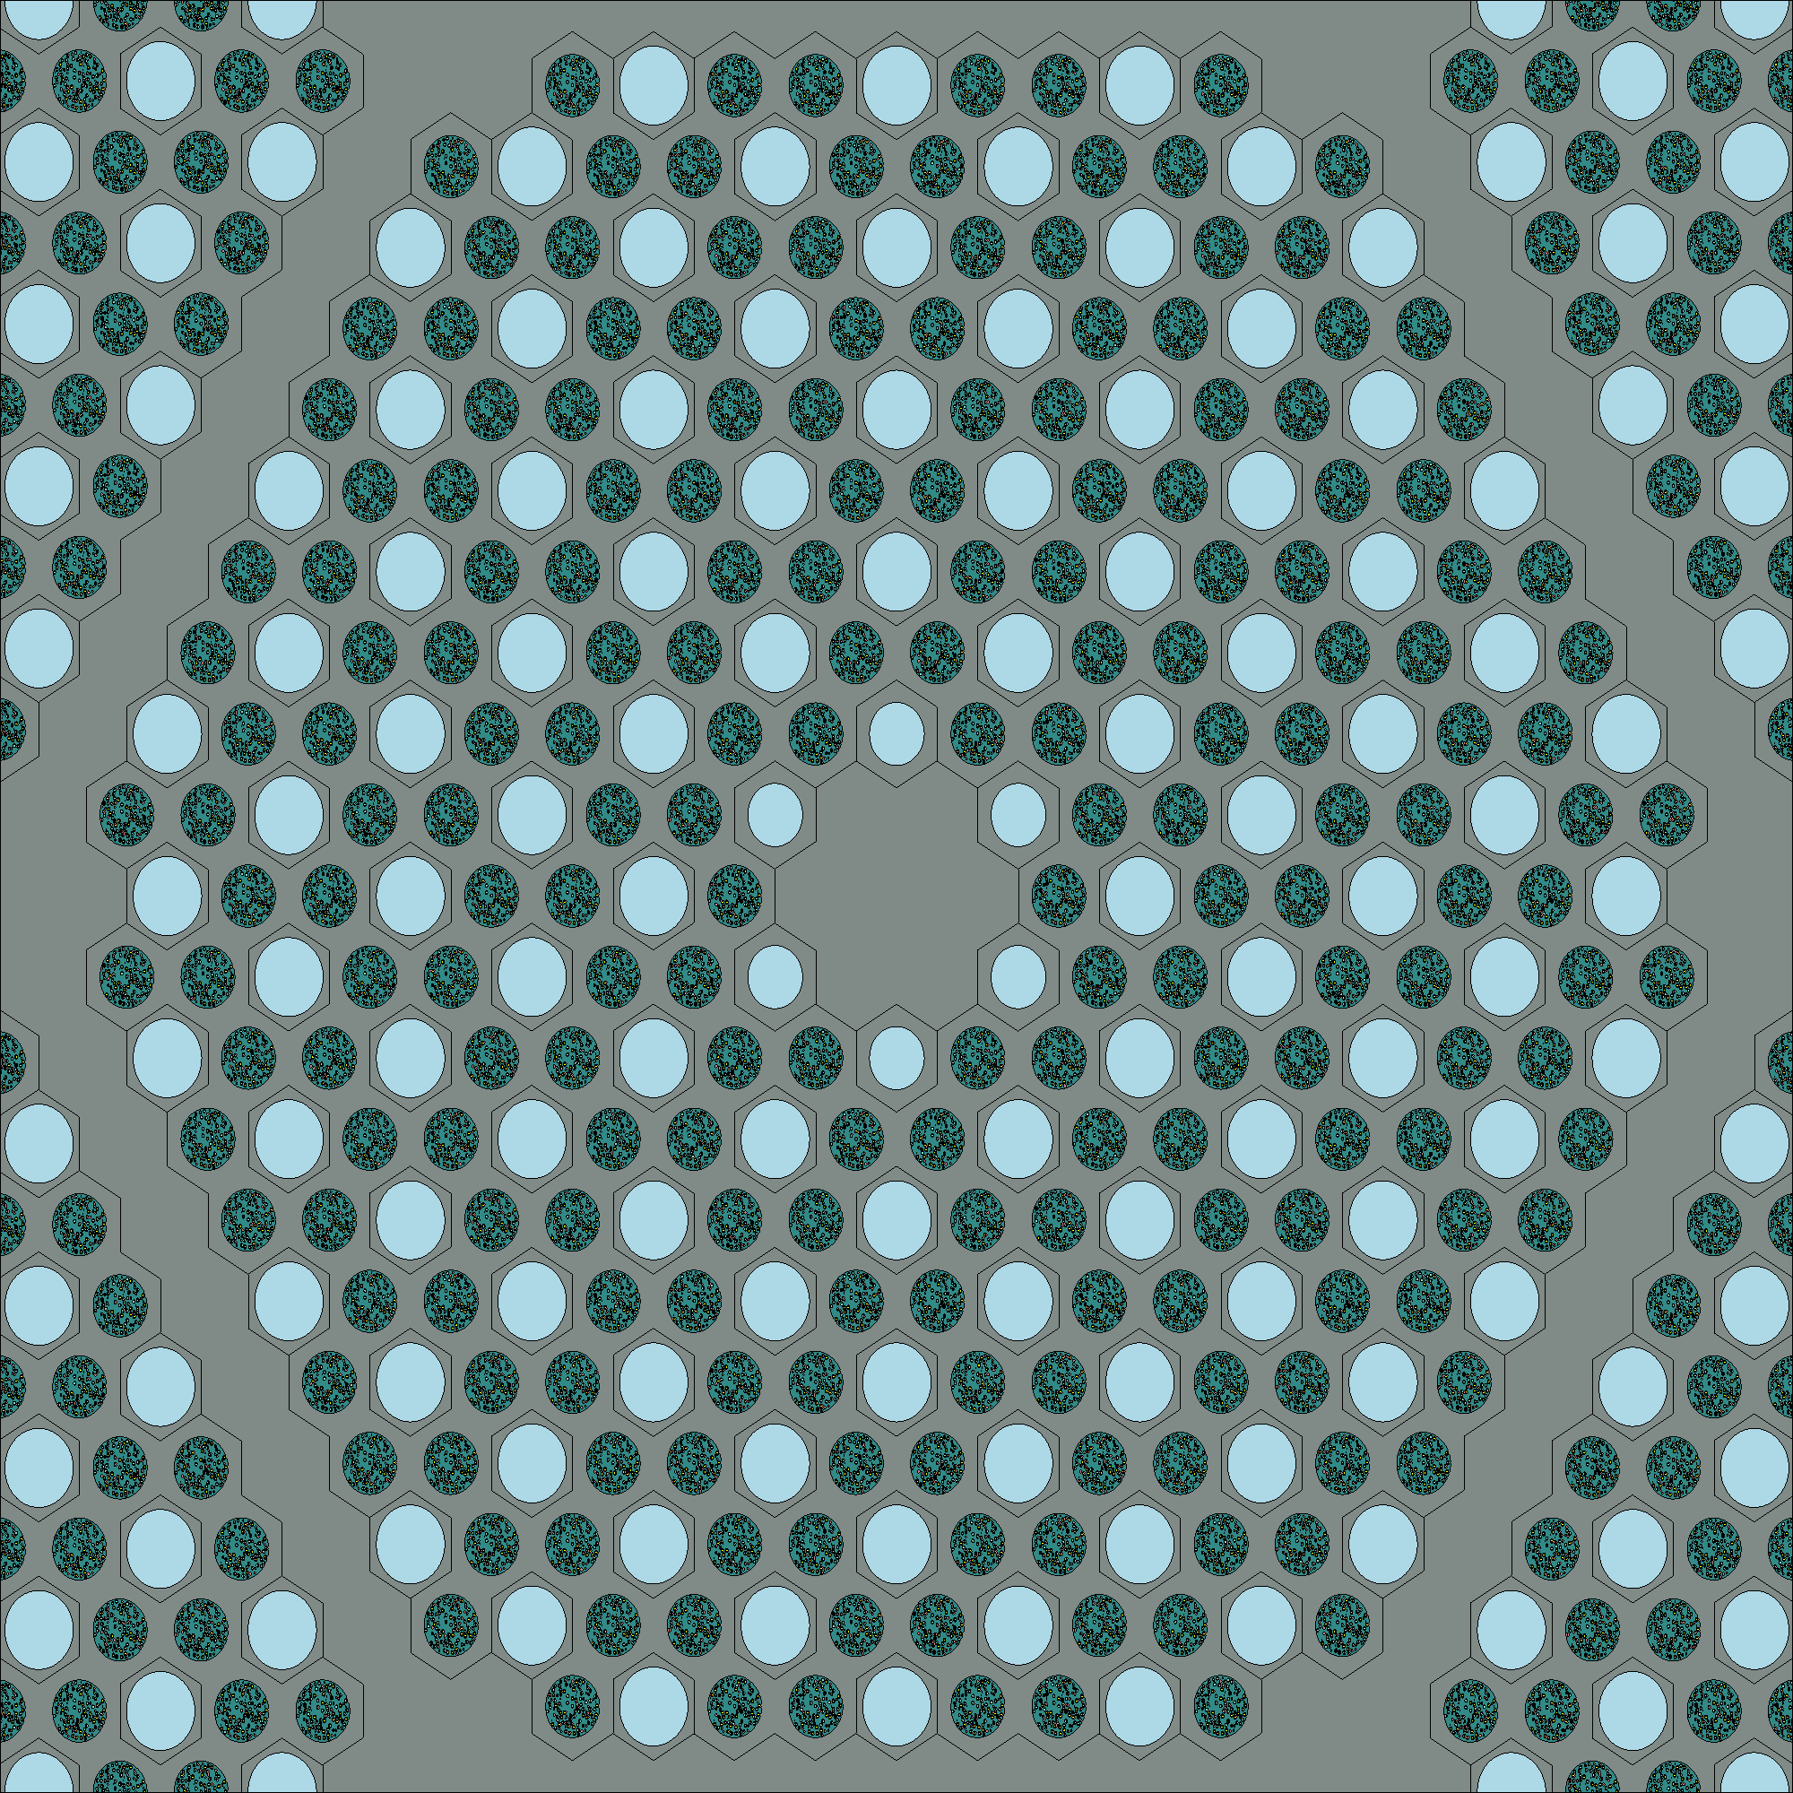
(a) (b)
Figure 2: (a) Ft. St. Vrain-style fuel blocked modeled for this study, with blue for helium, green for fuel channel, and gray for matrix. (b) Photograph of an actual moderator block of similar design.

Table 2: Parameter of graphite optimized neutronics model [8]
Parameter | Value | Unit
UCO fuel kernel radius | 0.02125 | cm
Low-density carbon buffer outer radius | 0.03125 | cm
Inner pyrolytic carbon outer radius | 0.03525 | cm
Silicon carbide outer radius | 0.03875 | cm
Outer pyrolytic carbon outer radius | 0.04275 | cm
Lattice pitch | 1.88 | cm
Fuel block (center to face) | 18 | cm
Fuel block height | 4.93 | cm
Packing fraction | 35 | %
U-235 Enrichment | 15.5 | %
Set thermal power | 35.66 | kW

Figure 3: Infinite multiplication factor as a function of cycle length for the advanced moderators and graphite reference case.

To understand why the proposed moderators have increased cycle length it is helpful to examine the neutron flux spectrum within the moderator region. The reason being that lower energy neutrons have higher chances to cause fission than neutrons of higher energies, thus it would be expected that increased cycle length is associated with more thermal neutrons. The normalized flux per unit lethargy spectra at the Beginning of Cycle (BOC) for the most promising advanced moderators and reference graphite case is shown in Figure 4 (a) and for End Of Cycle (EOC) in Figure 4 (b). The spectra are tallied in the moderator matrix and not the fuel matrix or coolant channels. As shown for moderators with smaller nuclear mass, the thermal peak is larger. For intermediate energies in the spectra, 1 - 10,000 eV, the comparison of neutron flux per lethargy is similar for most cases except for the MgO ZrH_{x=1} spectrum, which has a smaller value across the given energy range because of its larger moderating power relative to all other moderators. Additionally, the proposed moderators have valleys in the higher energy range, >10,000eV, as a result of high energy neutron interactions with the moderating isotopes [38]. The spectra harden from BOC to EOC for the beryllium-based moderators and graphite reference case. However, the MgO ZrH_{x=1} case has a larger thermal peak at EOC relative to BOC with an accompanying reduction in the flux per lethargy at both the intermediate and higher energy ranges.

The observation of longer cycle lengths corresponding to higher thermal neutron populations associated with smaller moderator nuclei can be explained in Equation 1. Higher values of the average change in lethargy correspond to fewer collisions required for thermalization and when this value is multiplied by macroscopic scattering cross-section a quantifiable value of moderating capabilities, also referred to as moderator power, can be determined. Shown in Figure 5 is the calculated moderating power for the most promising advanced moderators and graphite reference cases across all energies. Figure 5 shows that the advanced moderators have higher moderating powers than graphite with the MgO ZrH_{x=1} exhibiting a substantially larger value.

(a) (b)
Figure 4: Flux per lethargy spectra for the advanced moderators and reference graphite case for BOC, and (b) for EOC.

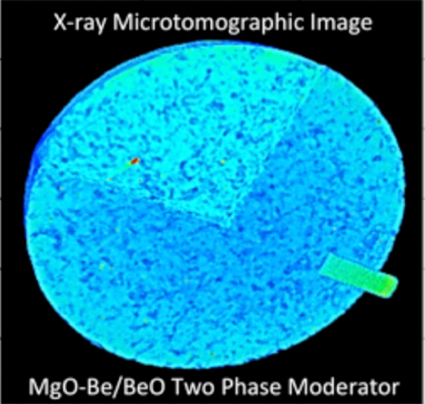
MgO ZrH_{x=1}
MgO Be
MgO BeO
Graphite
Figure 5: Composite moderator systems compared with graphite. Inset: x-ray microtomographic image of a demonstration composite moderator with an MgO structural matrix (light blue) containing a complex Be/BeO entrained moderator phase (dark blue).

This is attributed to a neutron having a higher probability to thermalize in relatively few collisions due to the low mass of the hydrogen and beryllium nuclei compared to the graphite nucleus. The insert in Figure 5 is an X-ray microtomographic image of the two-phase fabricated MgO structural matrix containing a complex Be/BeO entrained moderating phase.

The fuel block design used to evaluate the neutronic performance of the advanced moderators was optimized for graphite. Although exhibiting comparable or improved reactor cycle length depending on the moderating phase, the design of the lattice must be optimized to fully exploit the potential for enhanced moderating power. Recall that material buckling, Equation 3, is entirely material dependent and will change with composition. A sweep of moderator-to-fuel ratio was conducted by varying the spacing between fuel/coolant channels to investigate the impact on critical buckling and is shown in Figure 6 for all cases. From the infinite assembly buckling calculations, a critical radius that is only dependent on material properties is displayed in Figure 7 for all cases. This image is intended to provide a visual illustration on the potential for reduction of core size and does not intend to demonstrate the actual size of the reactor. Optimal moderator-to-fuel ratios of 6.3 and 3.9 were selected for the beryllium- and hydride-containing moderators, respectively, and correspond to the maximum critical buckling. The most promising moderators enable smaller radii over the majority of moderator-to-fuel ratios except for MgO ZrH_{x=1}, which surpasses the graphite reference case at higher ratios (at this selected composite loading of ZrH_{x=1}) due to over moderation. For the less promising moderator cases, only the MgO Be₂C case provides a similar comparison to the MgO BeO case in terms of cycle length and critical size; however, it was not fully investigated due to its marginal performance improvement and lower maturity in terms of fabrication relative to the MgO BeO.

Figure 6: Critical buckling for the advanced moderators and reference graphite as a function of moderator-to-fuel volume ratios

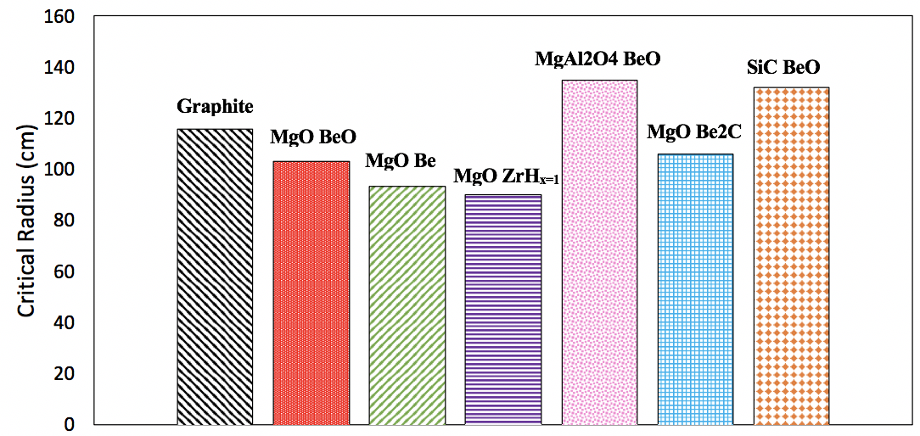
Figure 7: Critical radii of a single region homogenized spherical reactor for optimal moderator-to-fuel volume ratio determined from the critical buckling calculations

The impact of the enhanced moderating power is evaluated by considering the discharge burnup of the reactor, which provides a quantitative measure of the reactor fuel utilization, relatable to cycle length. The specific discharge burnup for graphite reference case, advanced moderators with the graphite optimized design, advanced moderators with their respective optimized lattice pitch, and advanced moderators with their respective optimized lattice pitch that have a reduced uranium-235 enrichment to match the discharge burnup to the reference graphite case are shown in Table 3. The 3-batch discharge burnup was calculated using the Linear Reactivity Model (LRM) and the burnup value at EOC for a single batch cycle. The charge mass flow of uranium $({\overline{M}}_{charge}^{Fuel})$ is the required amount of enriched uranium to achieve the desired burnup given a thermal-to-electric efficiency. The natural uranium resource utilization $({\overline{M}}_{Uranium}^{Natural})$ is the required amount of natural feed uranium to achieve the desired discharge burnup and represents a key parameter in assessing a reactor’s performance [33]. Natural uranium resource utilization was then determined using the charge mass flow via Equation 7 and multiplying that value by the enrichment requirement, shown in Equation 8. Equations 7 and 8 are derived from the U.S. Department of Energy Evaluation and Screening (E&S) of fuel cycle options [39]. The assumptions made for calculating the natural resource utilization in this study include a thermal-to-electric efficiency of 50% (P_{electric}/P_{thermal}), tails enrichment of 0.25 weight% uranium-235 (enrichment_{tails}), and a natural enrichment of uranium-235 of 0.711 weight% (enrichment_{natural}). The uranium savings is defined as the percentage difference between the natural resource utilization of the graphite reference case and each advanced moderator case, noting that the MgO Be optimized case of
15.5% uranium-235 enrichment has the highest natural uranium savings.

Table 3: Three-batch burnup, natural resource utilization, and uranium savings of most promising optimized moderators and optimized moderators with vary enrichment *Optimized moderators with varied enrichment
Cases | Graphite | MgO BeO | MgO Be | MgO ZrH_{x=1} | MgO BeO Optimized | MgO Be Optimized | MgO ZrH_{x=1}  Optimized | MgO BeO Optimized* | MgO Be Optimized* | MgO ZrH_{x=1} Optimized*
Enrichment weight% | 15.5 | 15.5 | 15.5 | 15.5 | 15.5 | 15.5 | 15.5 | 12.5 | 12 |  | 14
3-Batch Discharge Burnup (MW-d/kgU) | 131.6 | 131.2 | 156.3 | 149.7 | 162.0 | 170.7 | 149.3 | 127.6 | 128.3 | 130.7
3-Batch Natural Resource Utilization (t/GWe-y) | 183.5 | 184.0 | 154.5 | 161.2 | 149.1 | 141.5 | 162.8 | 152.0 | 145.1 | 166.6
Uranium Savings (%) | ----- | -0.2 | 15.8 | 12.1 | 18.7 | 22.8 | 11.2 | 17.1 | 20.9 | 9.2

$${\overline{M}}_{charge}^{Fuel}\left[\frac{t}{GWe-yr}\right]=\frac{P_{thermal}[GW]}{P_{electric}[GW]*BurnUp\left[\frac{GW*day}{t}\right]} (Eq. 7)$$

$${\overline{M}}_{Uranium}^{Natural}\left[\frac{t}{GWe-yr}\right]={\overline{M}}_{charge}^{Fuel}\left[\frac{t}{GWe-yr}\right]*\frac{{enrichment}_{fuel}\left[\frac{w}{o}\right]-{enrichment}_{tails}\left[\frac{w}{o}\right]}{{enrichment}_{natural}\left[\frac{w}{o}\right]-{enrichment}_{tails}\left[\frac{w}{o}\right]} (Eq. 8)$$

Reactivity Coefficients
Key safety parameters in neutronics performance are the MTC and FTC, which provide the intrinsic reactivity response of the moderator and fuel, respectively, as a function of temperature. We analyzed the most promising unoptimized moderator cases for these safety parameters. Both the moderator matrix and UCO fuel kernel were evaluated at a temperature of 900(K) and then individually perturbed to 600(K) to quantify the MTC and FTC. These values were chosen for their cross-section availability within Serpent. Cross-section data at 1200(K) is available within Serpent but was not utilized because of physical limitations of zirconium hydride due to hydrogen disassociation. The values for both MTC and FTC have a dependence on temperature [40], but were not investigated in this initial study because of the infinite assembly model. The purpose of these calculations was to provide a direct comparison of the reactivity response to temperature for the varying moderator material in the alternative moderators relative to the graphite reference case. Shown in Figure 8 (a) and (b) is the MTC and FTC, respectively, for the most promising moderator cases (unoptimized) and graphite reference. Calculation of the temperature coefficients, α_{T} and their uncertainties follow the infinite multiplication factor, k_{inf}, and associated statistical uncertainty from [33] given by the following equations:

αT=1kinfdkinfdT (Eq. 93)
δαT|αT|=δkinf,900K2+δkinf,600K2kinf,900K2-kinf,600K22+δkinf,600K2kinf,600K2 (Eq. 109)

(a) (b)
Figure 8: (a) Moderator Temperature Coefficient and (b) Fuel Temperature Coefficient of the most promising moderators and graphite reference.

The MTC for graphite is negative for the entire cycle length, and the beryllium-based moderators exhibit a similar behavior but diverge to positive values towards the EOC. This is consistent with experiments performed in the ARE, which demonstrated a negative MTC for a BeO moderator [25]. The MgO ZrH_{x=1} based moderator deviated considerably from the graphite reference near the BOC, immediately becoming positive and increasing monotonically throughout the entire cycle. This phenomenon was also observed in the HTRE No. 3 experiment, which reported a strongly positive MTC for a hydride-based moderator [24]. The positive MTC value for MgO ZrH_{x=1} is attributed to enhanced neutron absorption in hydrogen when the temperature is perturbed to a lesser value and subsequently decreased neutron absorption when the moderator is perturbed to a higher temperature. The FTC showed in Figure 8 (b) is negative throughout the entire cycle length for all most promising moderators with a subtle decrease from BOC to EOC. Because the leading mechanism for negative fuel reactivity feedback is attributed to the thermal resonance region of uranium-238, this decrease can be explained by the ratio of uranium-235 to uranium-238 being reduced through the fission process. Moreover, the FTC is less negative for moderators with higher moderating power, i.e., MgO ZrH_{x=1}, because of less uranium-238 capture which is further explained in the Radioactivity Calculations section of this chapter.

Scoping Fuel cycle cost Analysis
A fuel cycle cost comparison was performed to investigate the potential economic impact of the advanced moderators with optimized moderator-to-fuel volume ratios on fuel cost. The scope of this analysis is to provide a preliminary comparison of the fuel cost for each advanced moderator material with comparisons made to the graphite reference case for the neutronics model; cost comparisons do not include moderator fabrication or a detailed and in-depth study of the fuel cycle cost process. Costs associated with fuel forms are partitioned into five separate categories: (i) the cost of natural uranium mining/milling, (ii) conversion cost, (iii) enrichment, (iv) TRISO fuel fabrication, and (v) depleted uranium disposal. Fuel cycle costs are shown in Table 4 from evaluation and screening studies provided for low enriched uranium fuel for mHTGRs [41]. The calculated costs are obtained from Equation 7 and Equation 8 with the previously mentioned assumptions (50% thermal-to-electric efficiency, 0.25 weight% tails enrichment, and 0.711weight% natural enrichment). For enrichment costs, the Separative Work Unit (SWU) was needed and consisted of two more parameters, value function$(v)$ and tail mass flow (${\overline{M}}_{Charge}^{Tails})$, that were found in the open literature. Shown in Table 5 are the calculated values of the cost parameters, the costs per GWe-year of the five fuel cycle categories, and the total cost for a three-batch fuel cycle. The proposed optimized advanced moderators have fewer overall costs, which are correlated to the amount of natural uranium requirements. Although the beryllium moderators have the largest fuel cycle savings this may be offset because of the overall higher cost of beryllium material as compared to graphite.
venrichmentwo=1-2*enrichmentwo *ln1-enrichmentwoenrichmentwo (Eq. 110)

MChargeTailstGWe-yr= MUraniumNaturaltGWe-yr-MchargeFueltGWe-yr (Eq. 121)

SWUtGWe-yr=MChargeFueltGWe-yrvenrichmentfuelwo+MChargeTailstGWe-yrvenrichmenttailswo-MUraniumNaturaltGWe-yrvenrichmentnaturalwo (Eq. 132)

Table 4: Fuel cycle costs for five mentioned categories
Category | Cost
Mining/milling | 110 (Dollars/kgNatU)
Conversion | 12 (Dollars/kgNatU)
Enrichment | 100 (Dollars/kgNatU)
Depleted uranium disposal | 4 (Dollars/kgDU)
Fuel fabrication | 10000 (Dollars/kgLEU)

Matrix | Graphite | MgO BeO Optimized | MgO Be Optimized | MgO ZrH_{x=1}  Optimized
Burnup (GWd/t) | 131.6 | 162.0 | 170.7 | 149.3
Fuel residence time (days) | 1950 | 2400 | 2529 | 2213
Charge mass flow (t/GWe-yr) | 5.5 | 4.5 | 4.3 | 4.9
Natural resource required (t/GWe-yr) | 184 | 149 | 141 | 162
Tails mass flow (t/GWe-yr) | 178 | 145 | 137 | 157
SWU flow (kg/GWe-yr) | 173481 | 140928 | 133752 | 152914
Uranium mining/milling (MDollars/GWe-yr) | 20.2 | 16.4 | 15.6 | 17.8
Conversion (MDollars/GWe-yr) | 2.2 | 1.8 | 1.7 | 1.9
Enrichment (MDollars/GWe-yr) | 17.3 | 14.1 | 13.4 | 15.3
DU disposal (MDollars/GWe-yr) | 0.02 | 0.02 | 0.02 | 0.02
Fuel fabrication (MDollars/GWe-yr) | 55.5 | 45.1 | 42.8 | 48.9
Total (MDollars/GWe-yr) | 95 | 77 | 73 | 84
Savings | -- | 19% | 23% | 12%
Table 5: Calculated costs for three batch fuel cycle

Radioactivity Calculations
A preliminary analysis of the Spent Nuclear Fuel and High-Level Waste (SNF + HLW) for the neutronics model was conducted to provide a comparison of the total activity for one hundred, ten thousand, and one hundred thousand years after each case’s respective cycle length for a single batch loading scheme with 15.5% enrichment. The fissile mass and volume were equivalent in all cases. This analysis is critical for understanding the shielding and long-term storage requirements of the highly radioactive materials. Figure 9, Figure 10, and Figure 11 show the activity per GWe-year for the graphite reference case and optimized moderators for 100; 10,000; and 100,000 years after discharge, respectively. The activity per GWe-year was utilized for comparison to keep consistent with the E&S study [39]. Figure 12 is the plotted activity per GWe-year from EOC to 100,000 years for the mentioned cases. The method for calculating this metric is shown in Equation 13.

$$SNF+HLW Activity \left[\frac{Ci}{GWe-yr}\right]=\frac{Total Activity \left[\frac{Ci}{cm^{3}}\right]*{\overline{M}}_{charge}^{Fuel}\left[\frac{t}{GWe-yr}\right]}{Fissile Mass \left[\frac{t}{cm^{3}}\right]} (Eq. 13)$$

The SNF + HLW of the most promising advanced moderators are lower per unit energy generated than that of the graphite reference even though they have a longer cycle length because of the lower required charge mass. However, the alternative moderators have higher total activity 100 years after discharge because of the higher burnup and thus higher fission product activity. At 100,000 years after discharge, activity is dominated by actinides rather than fission products and because of the relatively higher thermal spectra of the alternative moderators less actinides are produced from the capture of neutrons in uranium-238.

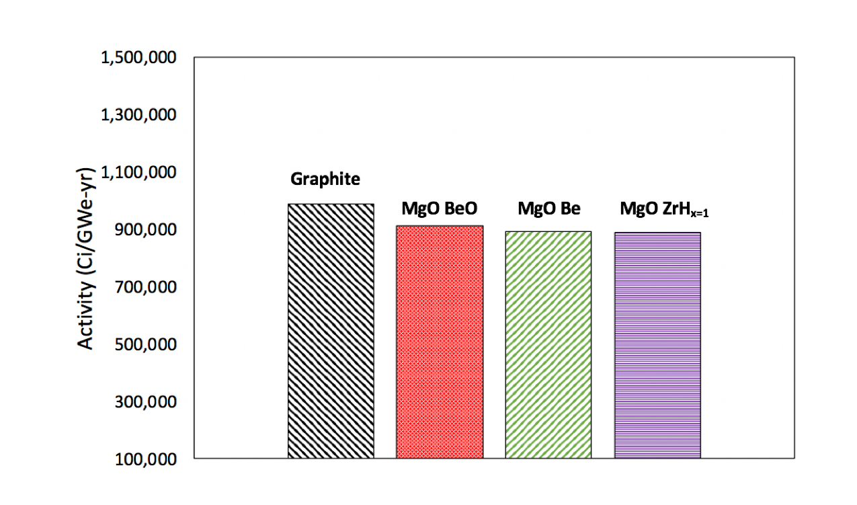
Figure 9: SNF + HLW at 100 years for graphite and most promising moderators

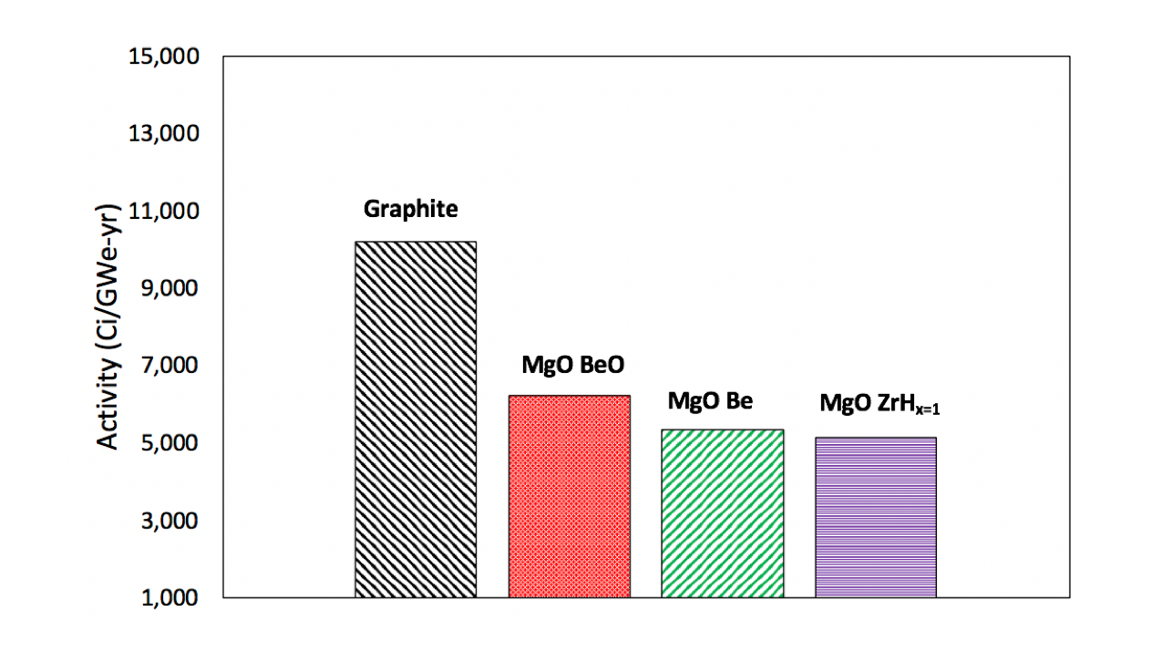
Figure 10: SNF + HLW at 10,000 years for graphite and most promising moderators

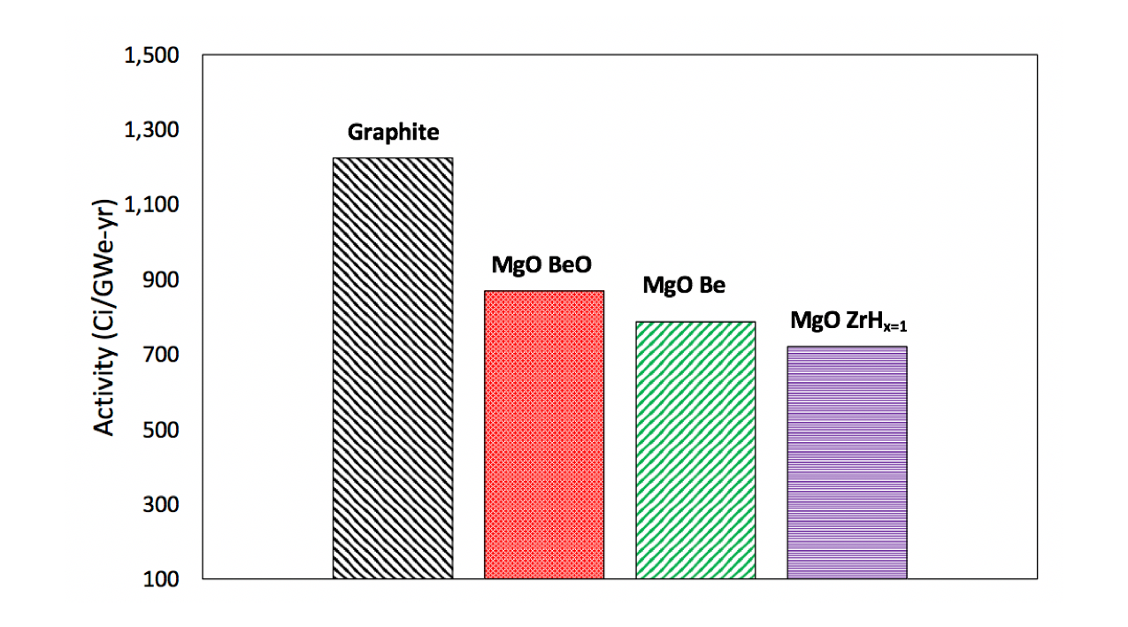
Figure 11: SNF + HLW at 100,000 years for graphite and most promising moderators

Figure 12: SNF + HLW for graphite and most promising moderators

Figure 13 and Figure 14 are the actinide, fission product, and total activity for the alternative and graphite reference moderators at 100 and 100,000 years after discharge, respectively. Figure 15 is the uranium-238 capture reaction rate (not including fission) for the graphite reference and alternative moderators over their respective cycle length.

Collectively, these results indicate that the advanced moderators will require less shielding and storage relative to graphite per unit energy, thus reducing the overall cost of the entire fuel cycle. This result is consistent with those in the literature for light water reactors with enrichments between 5 and 20% [39] [43].

Environmental Impact
An initial scoping study on the environmental impacts of the advanced moderators with optimized moderator-to-fuel volume ratios was performed and compared to the graphite reference case. The four quantifiable metrics that encompass environmental impact are (i) land use, (ii) water use, (iii) mass of carbon emission, and (iv) radiological exposure. The methodology for calculating these metrics is taken from Appendix C of the E&S study [39]. These metrics consist of nine parameters used for calculating the total impact for each metric, which are shown in Table 6 from Evaluation Group 2 (EG02), a 350 MWth mHTGR with TRISO fuel in a prismatic fuel block. Some values, such as worker radiological dose parameters, utilize Light Water Reactor (LWR) values instead as available data for these metrics are limited for HTGRs. This approach is consistent with that taken in the E&S study. Each of these parameters was multiplied by their respective values previously calculated in Table 5 for a three-batch fuel cycle. Summarized in Figure 16 are the calculated values of each metric as a function of moderating material normalized to the graphite reference values. Although this analysis is intended to provide an initial comparison between the advanced moderators and the graphite case, they are shown to generally have less impact on the environment per unit energy produced.

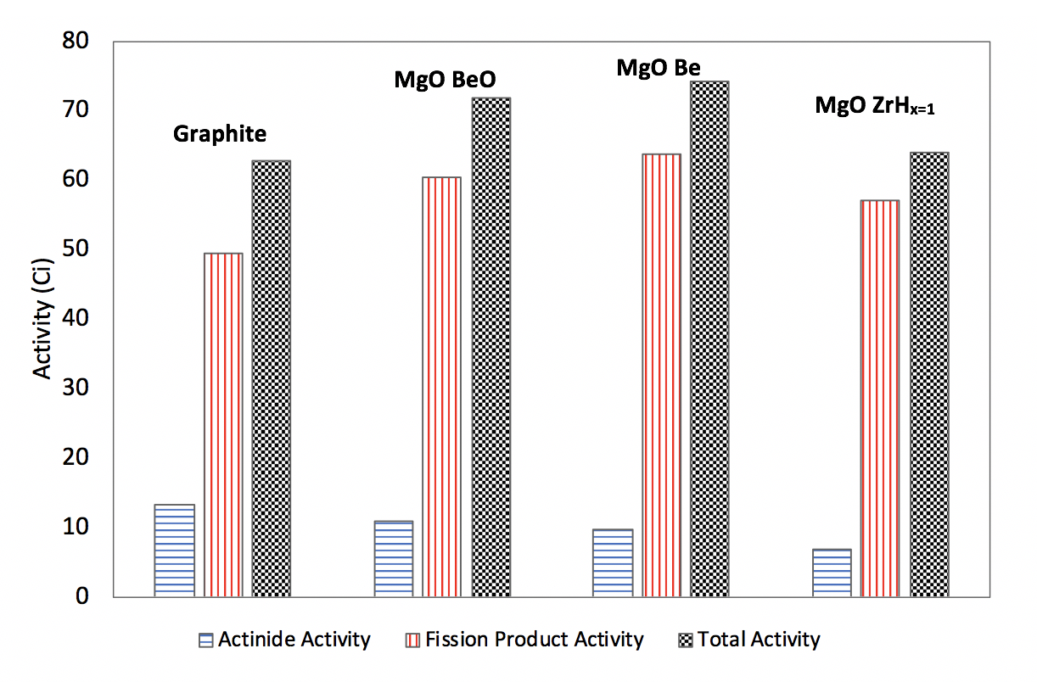
Figure 13. Actinide, fission product, and total activity for alternative moderators and graphite reference case at 100 years after discharge

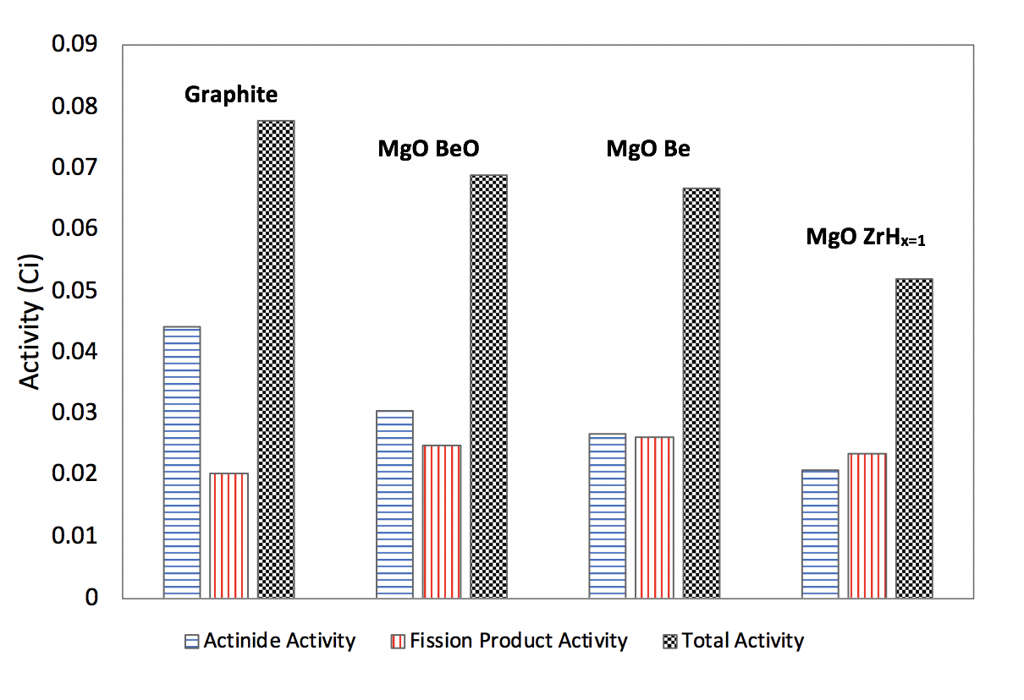
Figure 14. Actinide, fission product, and total activity for alternative moderators and graphite reference case at 100,000 years after discharge

Figure 15. Uranium-238 capture reaction rate for alternative moderators and graphite reference case during cycle length

Table 6: Impact Factors used for calculating total environmental impact [44]
Parameter | Land Use Impact Factor  (km²) | Water Use Impact Factor  (ML) | CO₂ Emissions Impact Factor  (kg CO₂) | Worker Radiological Dose Impact Factor  (Person-mSv)
Mining  (1/MTNU) | 2.8E-4 | 8.5E-1 | 8.3E4 | 5.2E-1
Milling  (1/MTNU) | 2.8E-4 | 8.5E-1 | 8.3E4 | 9.0E-1
Conversion  (1/MTNU) | 2.2E-6 | 6.5E-2 | 2.2E4 | 8.8E-2
Enrichment  (1/SWU) | 9.0E-9 | 2.9E-5 | 2.8E1 | 3.1E-5
Deconversion  (1/MTDU) | 9.3E-5 | 5.3E-4 | -3.2E3 | 2.9E-2
Fuel Fabrication  (1/MTiHM) | 1.0E-4 | 5.2E-1 | 2.9E5 | 1.4
Reactor Construction and Operation  (1/GWe-yr) | 7.3E-2 | 2.4E4 | 1.2E7 | 7.3E2
Low-Level Waste Disposal  (1/MTHM) | 9.7E-6 | 2.3E-4 | 1.8 | 1.6E-1
High-Level Waste Disposal  (1/MTHM) | 1.3E-3 | 1.4E-1 | 1.4E5 | 1.1

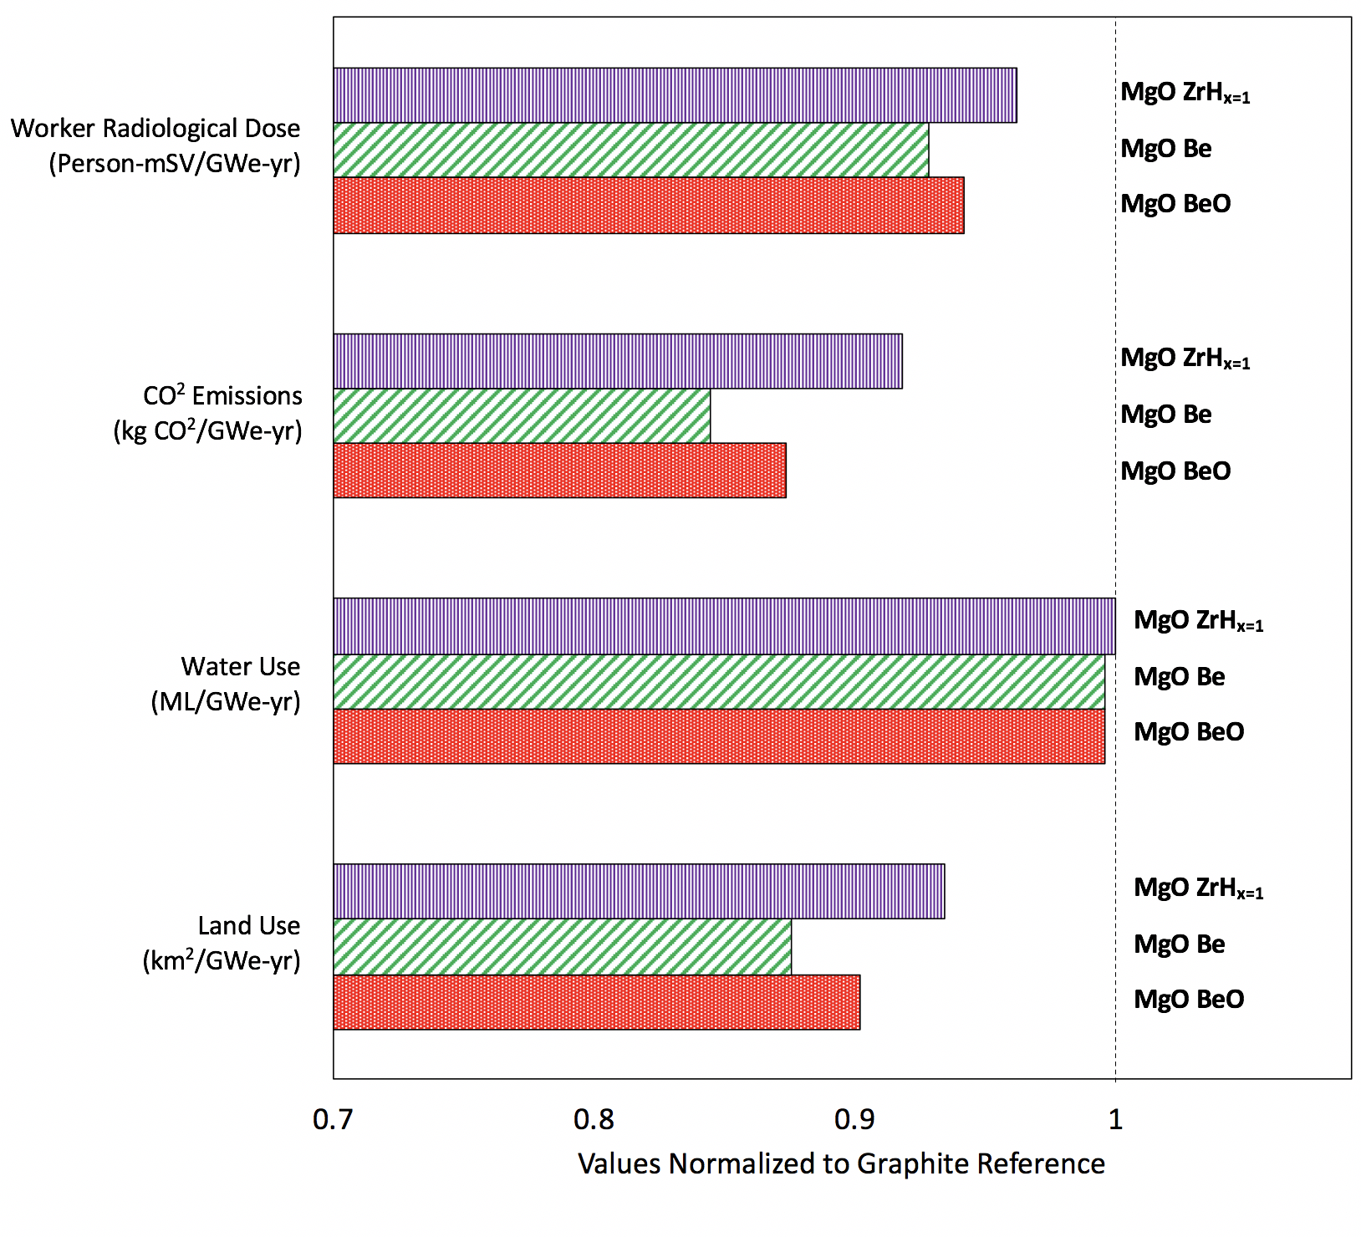
Figure 16: Environmental impact of optimized advanced moderators’ values normalized to the graphite reference case

2D Core Neutronics Evaluation
The infinite assembly scoping analysis provides confidence for the use of these alternative moderators in HTGRs. The next logical step would be to scale up from the assembly design to a simplified 2D GA mHTGR-350 design that included neutron leakage. The model allowed for neutron leakage in the radial direction but not in the axial direction. This boundary was implemented as leakage in much less in the axial direction than in the radial and by assuming this boundary the model could keep to a small height, greatly reducing the computational time needed to run a simulation. As before, the performance of the most promising moderators would be compared against graphite for an identical geometrical design. Performance is assed primarily based on cycle length. The alternative moderators show that they cannot achieve the cycle length of the graphite moderator for the GA mHTGR-350 configuration because the higher neutron absorption of the moderator allows for a significant amount of neutron loss within the inner reflector. Since the alternative moderators have a significantly shorter cycle length than that of graphite, optimizing moderator to fuel volume ratio of this type of design would at best get to a cycle length similar to graphite. The attractiveness of the alternative moderators is the ability for a higher performing, more compact design relative to a graphite moderated design. This section aims to help illustrate how the alternative moderators’ capability is leveraged by shifting to more compact designs and does not intend to provide a final optimal core design for the alternative moderators.

GA mHTGR-350 Configuration
A 2-dimensional core model of a GA mHTGR-350 model with axially reflective boundary conditions was used. Shown in Figure 17 is a top-down view of the core loaded with 66 fuel block columns. The model does not consider control rods or reflector coolant channels. Figure 18 is the cycle length for the graphite reference and alternative moderators.

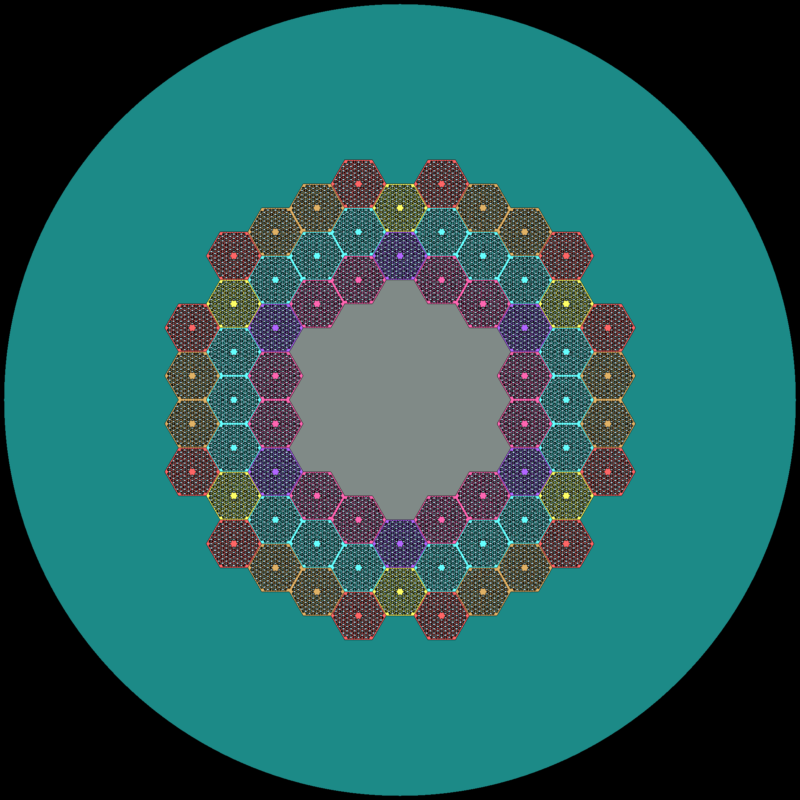
Figure 17. GA mHTGR-350 style core neutronics model

Figure 18. Cycle length for reference case and most promising moderators for the GA mHTGR-350 style core design

The moderator block, outer, and inner reflector are the same material as the moderator for a given calculation. The fuel blocks are similar in design to that of the infinite assembly model. It should be noted that the colors are purely for visual purposes. The alternative moderators are shown to greatly underperform for this core design. The cycle length for the highest performing alternative moderator, MgO Be, is only ~53% of the graphite cycle length. Thus, to leverage the capabilities of the alternative moderators a compact micro design is needed.

Micro Design
To take advantage of these alternative moderators a micro HTGR design was generated from models available in the literature [45]. The micro design operates with a lesser power due to having reduced the fuel columns from 66 to 7. Shown in Figure 16 is the micro HTGR design. Since the optimization of these reactor cores to their respective moderators requires iterations between neutronics performance and thermal-hydraulic safety evaluation, these results from this section should serve to show a framework of the reactor design process and preliminary performance comparison rather than place emphases on results. A similar approach for lattice pitch optimization for the infinite assembly model was performed for the micro design. However, a radial constraint of 90(cm) was implemented such that the entire reactor core, including the pressure vessel, would be able to be transported in an ISO 688 certified 20-foot box. Since the buckling term only accounts for material properties and not leakage, a buckling optimized lattice pitch will not provide an optimized cycle length. Initial reactivity was determined to be the figure of merit for lattice pitch optimization of this core design as starting with the highest initial reactivity would accommodate neutron loss and intern have longer cycle lengths. Figure 20 and Figure 21 are the buckling optimized lattice pitch and initial reactivity optimized lattice pitch, respectively and Table 7 are the associated lattice pitches for each respective moderator and figure of merit.

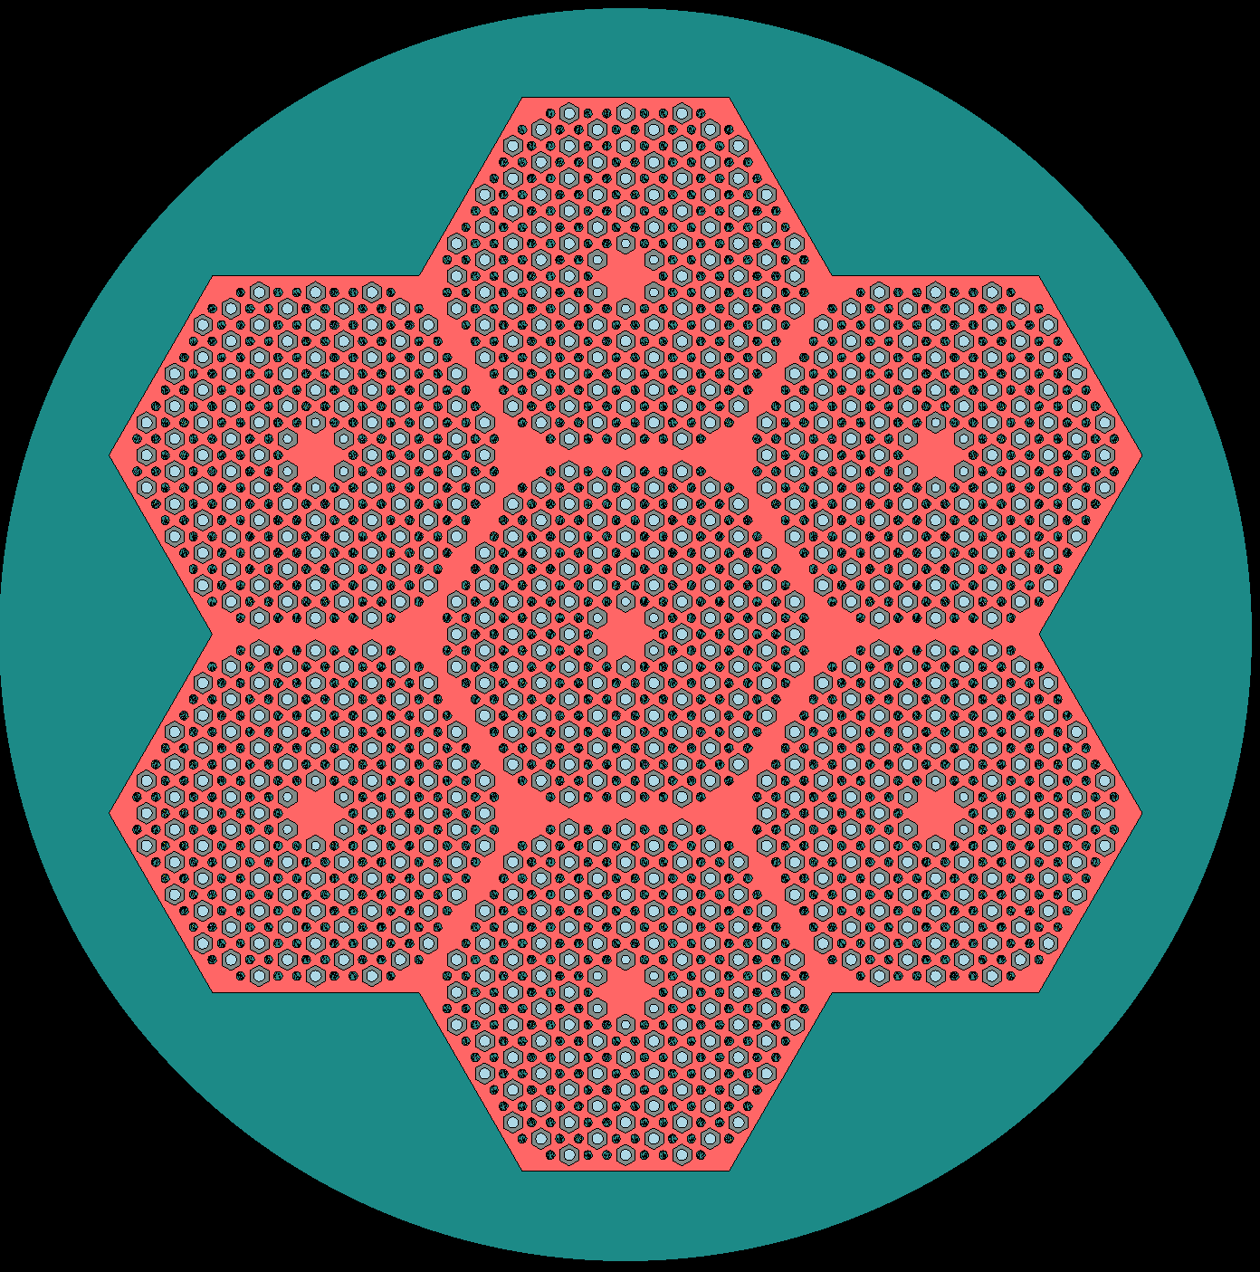
Figure 19. Preliminary micro HTGR core design

Figure 20. Cycle length for buckling optimized lattice pitch for reference and most promising moderators

Figure 21. Cycle length for initial reactivity optimized lattice pitch for reference and most promising moderators

Table 7. Lattice pitch for reference and most promising moderators, both buckling and initial reactivity. *Optimal initial reactivity was not reached for graphite as the maximum pitch was set to 3 [cm]
Moderator | Optimum B² pitch (cm) | Optimum k_{eff} pitch (cm)
Graphite | 2.8 | 3.0*
MgO-ZrH | 1.8 | 2.2
MgO-Be | 2.0 | 2.6
MgO-BeO | 2.3 | 2.6

For buckling optimized lattice pitch the beryllium-based moderators show similar performance to the graphite moderator and the MgO Be moderator shows to significantly enhanced performance when optimized to initial reactivity. For both optimizations, the MgO ZrH moderator has drastically reduced cycle length due to higher neutron absorption in the heterogenous design.

chapter three
thermal-Hydraulics Model
The thermal-hydraulic safety analysis for DBAs was performed by utilizing a RELAP5-3D ring model that was adapted from models available in the open literature [46] [45]. For this work, only the most promising beryllium composite moderators were utilized for comparison against the graphite reference moderator as thermophysical properties at the elevated temperature ranges of interest are not available for zirconium hydride [47]. The thermal conductivity and heat capacity of each moderator material in its unirradiated state is shown in Figure 19 and Figure 20, respectively, as determined using a volume fraction weighting rule-of-mixtures. The thermophysical properties of graphite were taken directly from [46] and all material properties are assumed to be unirradiated. The thermal conductivity of MgO and BeO came from [48] and [49] respectively. The specific heat of the oxide materials was taken from [50], and densities of MgO and BeO came from [51] and [52] respectively. Properties of Be metal came from [53]. This model uses power distributions from international benchmarks and related studies [13]. The GA mHTGR-350 RELAP model represents the hexagonal graphite blocks as a series of 10 concentric rings where rings 4, 5, and 6 represent 18. 24, and 24 hexagonal prismatic fuel columns. The axial mesh of the model was discretized into 14 elements, 2 in the upper reflector, 10 in the active core, and 2 in the lower reflector. The micro HTGR RELAP model utilizes a similar ring model with an inner and outer fuel ring of one and 6 fuel columns, respectively. The fuel compacts have been represented as a single material with volume-weighted thermal properties of each constituent. The thermal conductivity and volumetric heat capacity of the moderator blocks were calculated by volume-weighting the values of each material as reported in the open literature [48] [49] [50] [51] [52] based on the volume fractions in Table 1 and the thermal conductivity of the TRISO fuel particle was assumed to be 12.01(W/m-K), informed by experimental data and combined with the Maxwell-Eucken equations from [54].

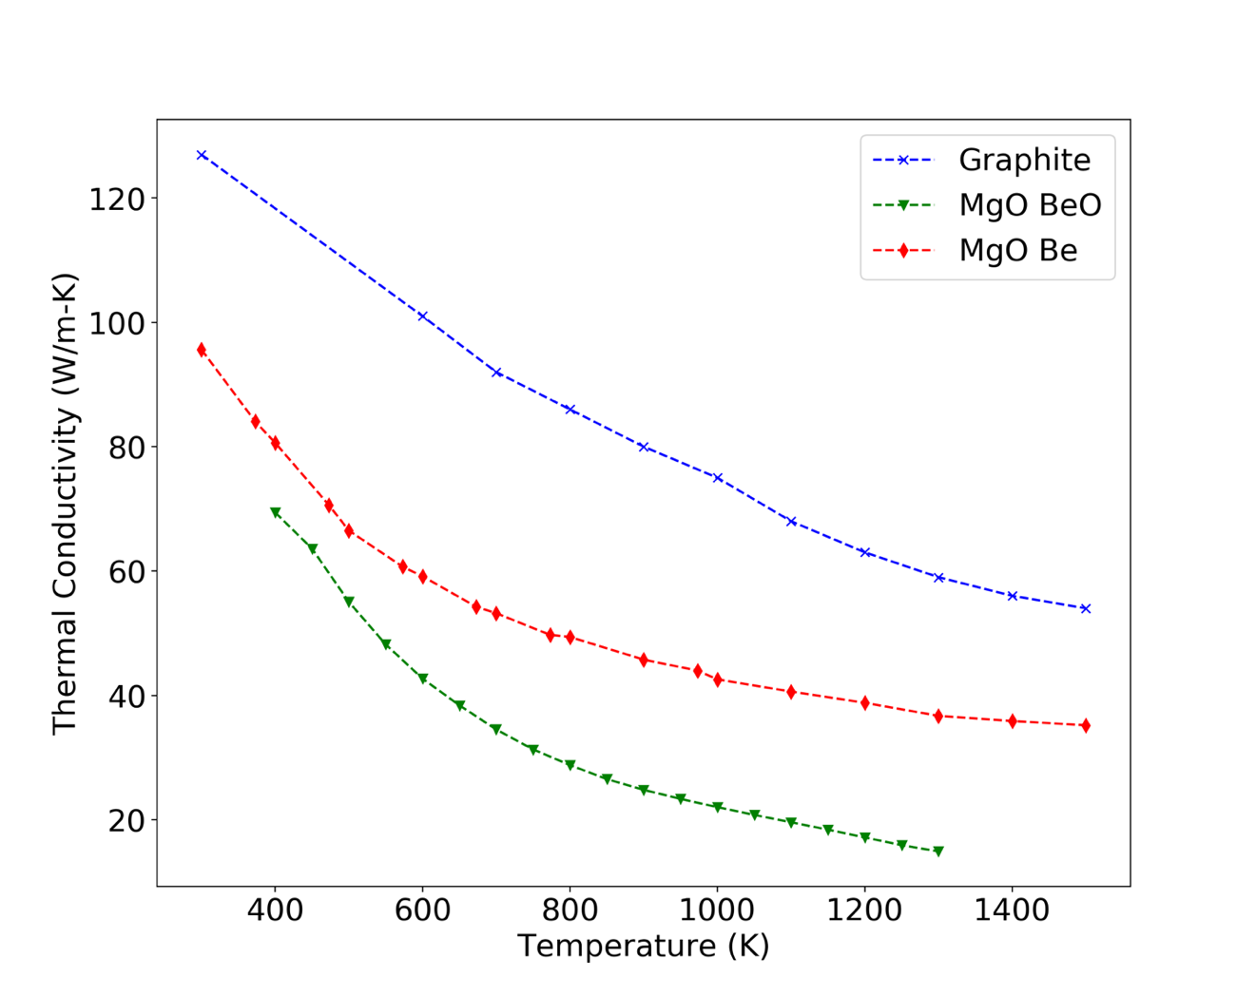
Figure 22: Rule-of-mixtures thermal conductivity of the Be-based moderator materials from literature [48] [49] [53] relative to graphite.

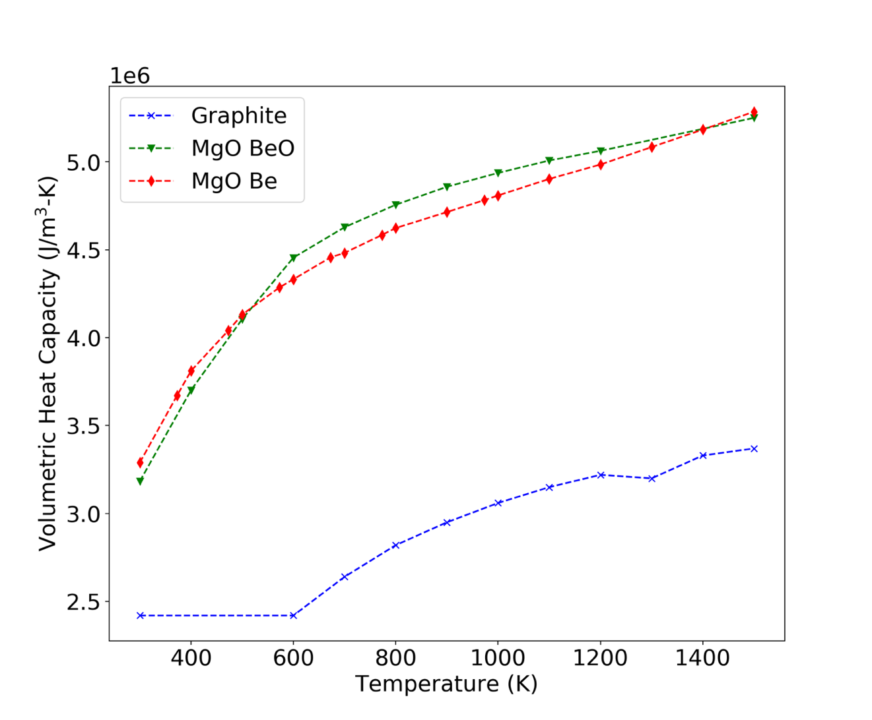
Figure 23: Rule-of-Mixtures volumetric heat capacity of the Be-based moderator materials from literature [50] [51] [52] [53] relative to graphite.

Thermal-Hydraulics Performance and Accident Evaluation of GA mHTGR-350

Disclosure
The work presented in this chapter was previously published [34].

The U.S. Department of Energy (DOE) and Idaho National Laboratory (INL) at one time were tasked by congress in the 2005 Energy Policy Act for the development, licensing, building, and operation of a prototype HTGR. Safety objectives were established for HTGR design that relate to inherent and passive safety features. A statement by the U.S. Nuclear Regulatory Commission regarding the safety of HTGRs determined that modular HTGRs designs assure sufficient core heat removal during Loss Of Forced Coolant (LOFC) accidents [55]. These observation on safety for LOFC accidents in mHTGR were focused graphite moderated designs. The graphite moderator provides the means for heat removal during these transient as the heat removal by the coolant becomes insufficient. It is important to investigate the performance of the alternative moderators for these types of accidents to ensure that safety would not be compromised for performance. The different thermal conductivities of the moderator materials will produce variations in steady-state fuel temperatures. In Figure 21, the graphite core exhibits the lowest fuel temperatures while the MgO BeO moderator the highest fuel temperatures. The fuel temperature distribution in the core is similar for all three cores and consistent with previous studies [12].

PLOFC
Some scoping accident analyses were performed for slow core conduction cooldown events that are not expected to challenge fuel performance [55] in the reference mHTGR design. PLOFC is an accident that occurs when forced circulation of the coolant decreases, thereby allowing the core to rapidly heat up. The accident is modeled as a linear decrease in coolant flow rate from 157(kg/s) to 0(kg/s) over 30 seconds with an accompanying pressure drop from 6.39 to 5.00 (MPa). Following the initial and rapid core temperature increase during the accident, SCRAM is activated at 57 seconds and heat begins to redistribute throughout the core, leading to a rapid decrease in peak fuel temperature. Average moderator block temperatures continue to increase until the core enters a long-term conduction cooldown, as evident from the trends in Figure 22. Graphite cools most rapidly, beginning only 12 hours after SCRAM, while cooling of the advanced moderators is delayed to after 30 hours. Early and more rapid cooling of the graphite block is due to its high thermal conductivity relative to the advanced moderators. However, because the change in fuel temperature is controlled by the volumetric heat capacity of the fuel and moderator blocks, the extremely low heat capacity of graphite (cf. Figure 20) causes the graphite core to reach the highest fuel temperature.
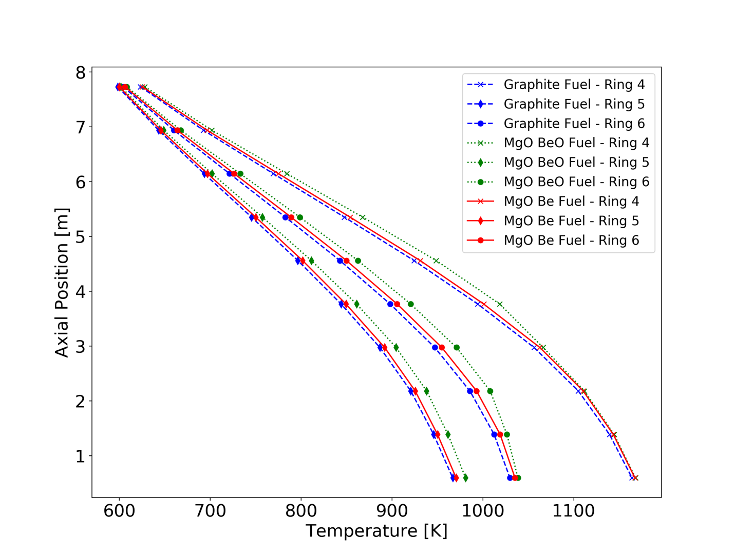
Figure 24. Steady state temperature of fuel in concentric rings 4, 5, and 6 as an axial distribution.

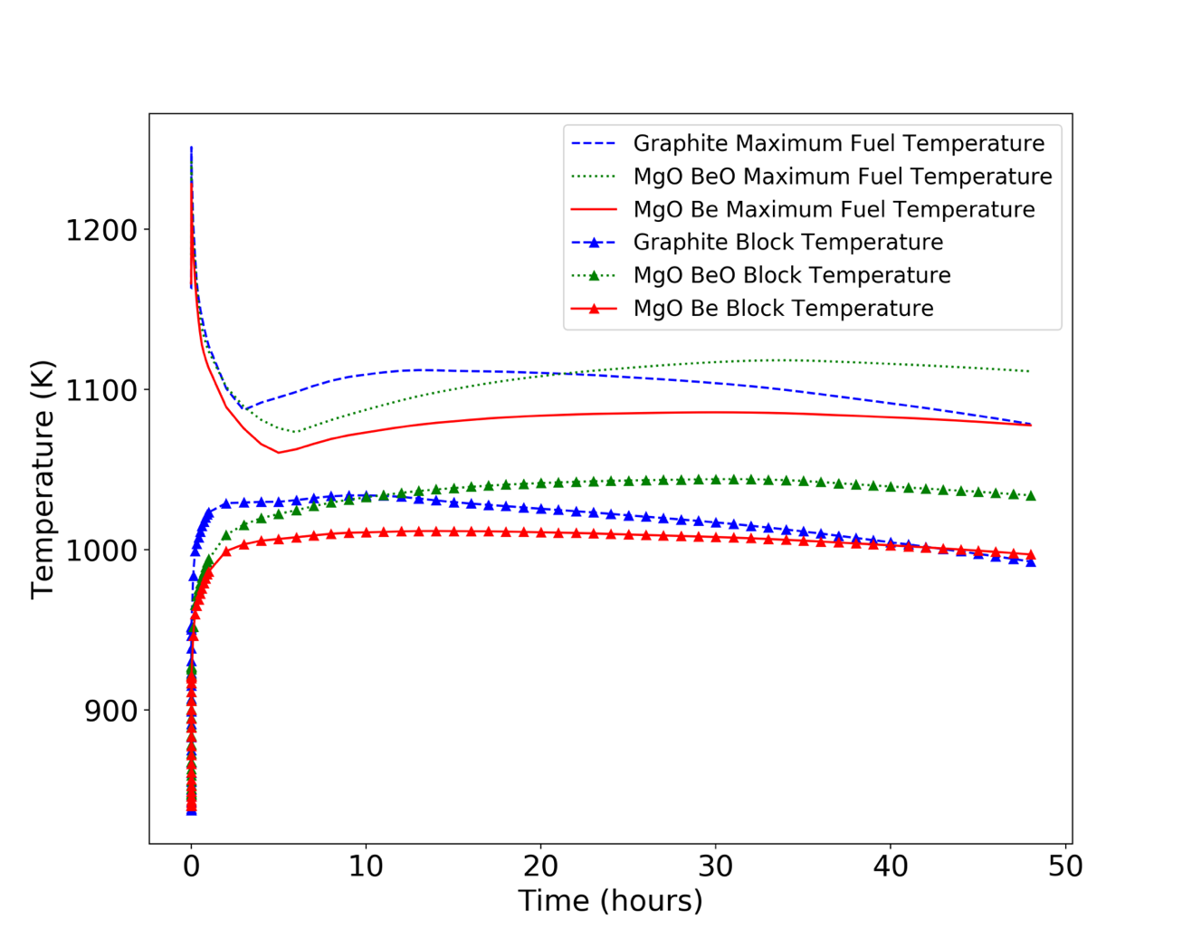
Figure 25. Maximum fuel temperature and average moderator block temperature for the PLOFC accident.

Both the MgO BeO and MgO Be moderators maintain a lower fuel temperature relative to graphite with the latter exhibiting the lowest peak fuel temperature due to its propensity to cool sooner after SCRAM based on its increased thermal conductivity relative to MgO BeO composite.

DLOFC
DLOFC occurs when the coolant pressure boundary is ruptured and helium escapes the system. The DLOFC model employs the same coolant flow rate drop as the PLOFC albeit with a larger pressure drop to 0.101(MPa) and SCRAM at 27 seconds. Due to the loss of primary coolant, the conduction cooldown is much slower due to the elimination of natural circulation, which helps cool the core in the PLOFC. Shown in Figure 23 is the maximum fuel temperature and average moderator block temperature for the DLOFC. Peak fuel temperatures are lower in the DLOFC due to SCRAM occurring 30 seconds earlier. The peak fuel temperature in the graphite core remained lower than that of the MgO BeO core because the steady-state temperature is sufficiently lower than the temperature rise before SCRAM is not adequate to surpass the MgO BeO temperature. However, the rise in peak fuel temperature is still higher in graphite than for either a beryllium-based moderator. For both the PLOFC and DLOFC cases a noticeable increase in fuel temperature after initial decrease is observed. This is attributed to the decay heat of the fuel rings which causes the inner reflector to increase in temperature and subsequently limit its availability for heat removal of the fuel. This was also observed in [13] but less pronounced because the model used in this study does not incorporate temperature feedback.

Thermal-Hydraulics Performance and Accident Evaluation of Micro Reactor Design
Preliminary safety analysis has been conducted for a modular reactor design that incorporates seven fuel columns ring model in RELAP5-3D.

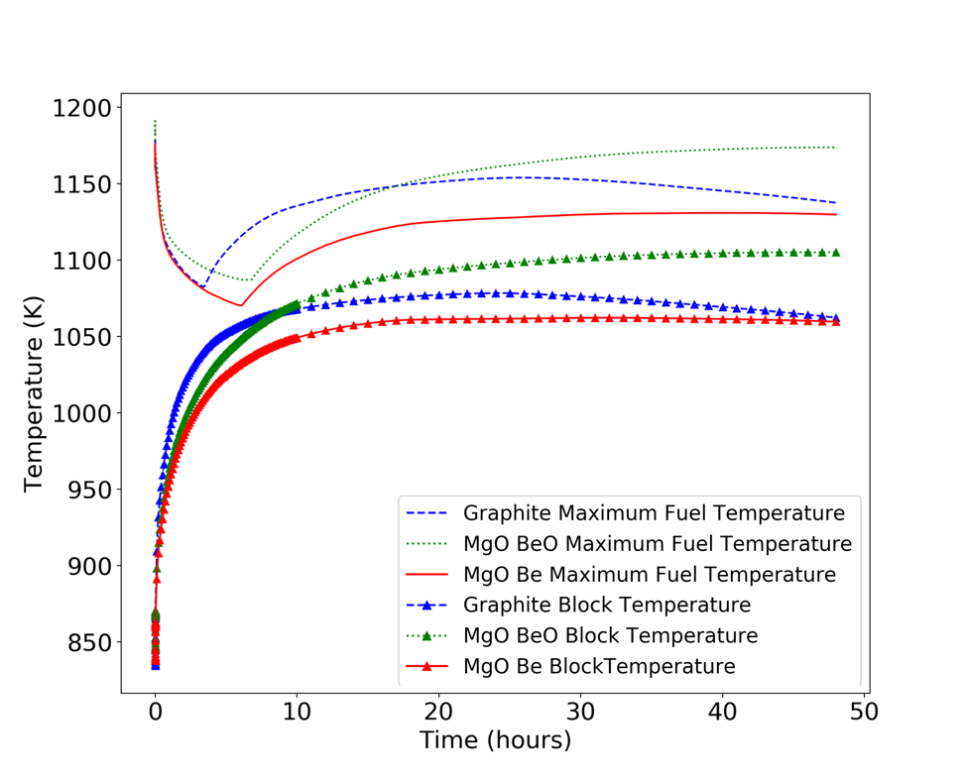
Figure 26. Maximum fuel temperature and average moderator temperature for the DLOFC accident.

This model has an inner ring of a single fuel block and an outer ring consisting of 6 fuel blocks. Moreover, the active core size was reduced from 10 axial fuel levels to just 3. Figure 27 is the steady state temperature for the alternative moderators and graphite case as an axial distribution. These models were modified from [45] to reduce the overall size and incorporate material properties for the proposed moderators. These dimensions are not finalized and a subject to change with core performance optimization studies. This section intends to provide a comparison of accident performance between in a micro design that will be relatively similar to the final design and to show the framework and iterative process of neutronics optimization and safety evaluation.

Undercooling Accident
Figure 24 shows the peak fuel and moderator temperature for the graphite moderator, MgO BeO, and MgO Be during a PLOFC accident. The PLOFC starts at a steady state with all cases having identical power of 11.5(MWt). SCRAM is initiated at 0 seconds and the mass flow rate linearly decreases to 0 over 5 seconds. The beryllium moderators have slightly higher temperatures at the end of the transient because of the lower thermal conductivity compared to graphite, as concluded in the GA mHTGR-350 thermal analysis. Figure 25 shows the peak fuel and moderator temperature for the graphite moderator and beryllium-based moderators during a DLOFC accident. PLOFC and DLOFC are similar but DLOFC has a mass flow rate decrease to 0 and pressure decrease to 0.1(MPa) in one second. The conclusion between moderators is the same for this transient but DLOFC has higher temperatures overall during the accident than for PLOFC as less coolant is available to remove heat.

Overpower Accident
Overpower accidnts are typically initiated by the unwanted withdraw or ejection of control rods during reactor operation. This insertion of reactivity leads to increasing power as well as increasing moderator and fuel temperatures. These types of accidents in HTGR were shown to not exceed fuel temperature limits and the core was able to safety shutdown without intervention because of its passive safety feature [16]. A statement by the US NRC explains why control ejection accidents are important to investigate,

"Analyses of rod ejection accidents are presently required for current light water reactor (LWR) designs. …. If modular HTGRs have certain advantages in this regard over LWRs because of design-specific characteristics such as rod-ejection engineered safety features, rod-ejection mechanics, fuel thermal time constants, or particular reactor kinetics parameters (e.g., longer neutron migration length, longer prompt neutron lifetime), then this will become clear in the course of the analysis. Understanding the resulting dynamic fuel service conditions and fuel behavior will be important in any case" [55]

The kinetic parameters for these alternative moderators are predicted to be quite different from the graphite referance case. Thus, assement of these overpower transients is need to ensure that safety is not compromised. A CRW is a subset of an RIA accident that has durations much smaller than of LOFC accidents and energy is rapidly deposited within the fuel kernel and may experience cracking or melting [56]. The total energy deposited for both CRW and CRE is equivalent but the rate of energy deposition is smaller for CRW because of the smaller rate of reactivity insertion. Faster energy depositions result in higher fuel temperatures because of the lack of significant heat removal. Figure 27 is the core power during both the CRE and CRW. The power profile can turnaround and reach a new equilibrium because of fuel temperature feedback which provides negative reactivity. It should be noted that moderator temperature feedback is not considered for these transients. The Shown in Figure 26 is the reactivity insertion overtime for the CRW. Figure 27 is the peak moderator and fuel temperatures during the transient for both the graphite and MgO BeO moderator. The transient begins at 150 seconds and a total of 1($) of reactivity is inserted over 270 seconds.

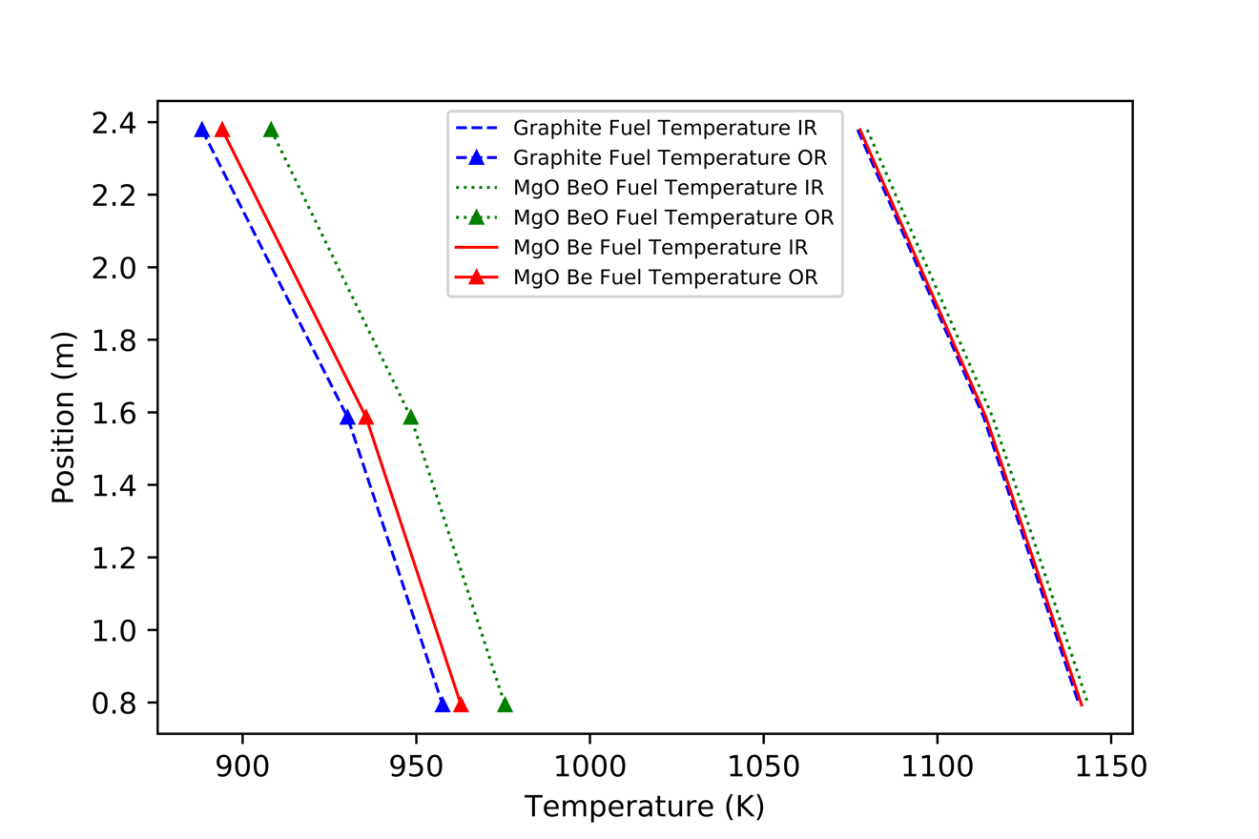
Figure 27. Steady state temperature of fuel in inner ring (IR) and outer ring (OR) as an axial distribution

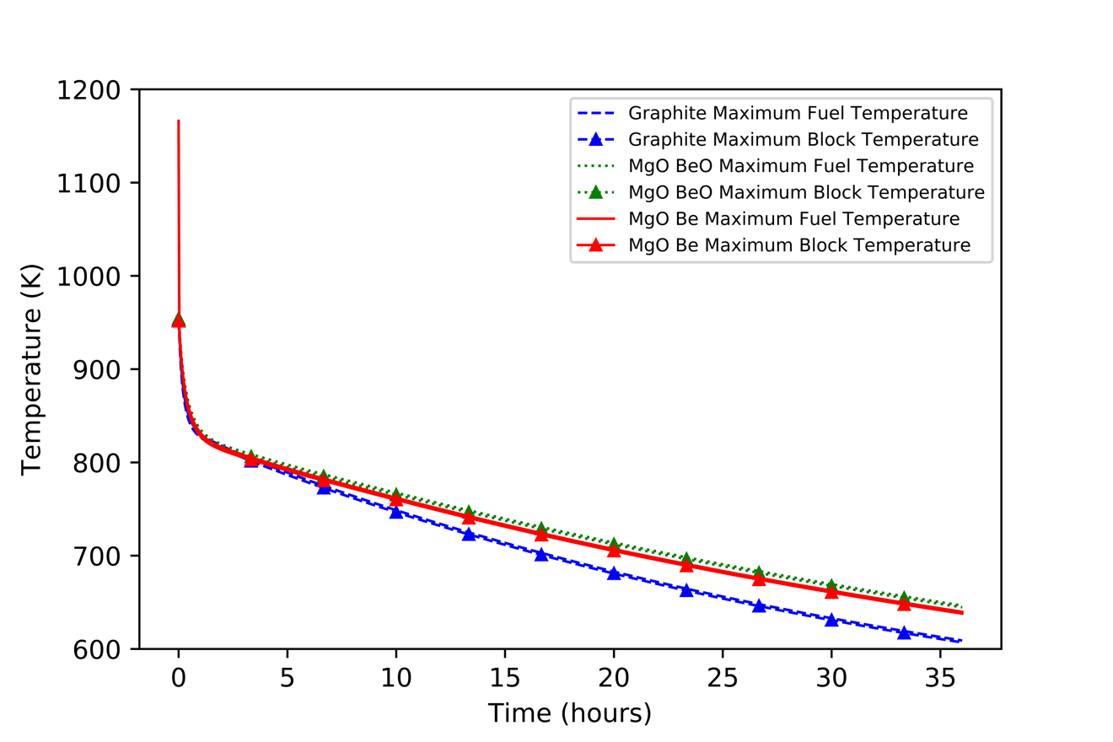
Figure 28. Peak temperatures in fuel and moderator block for graphite and beryllium based moderators during PLOFC

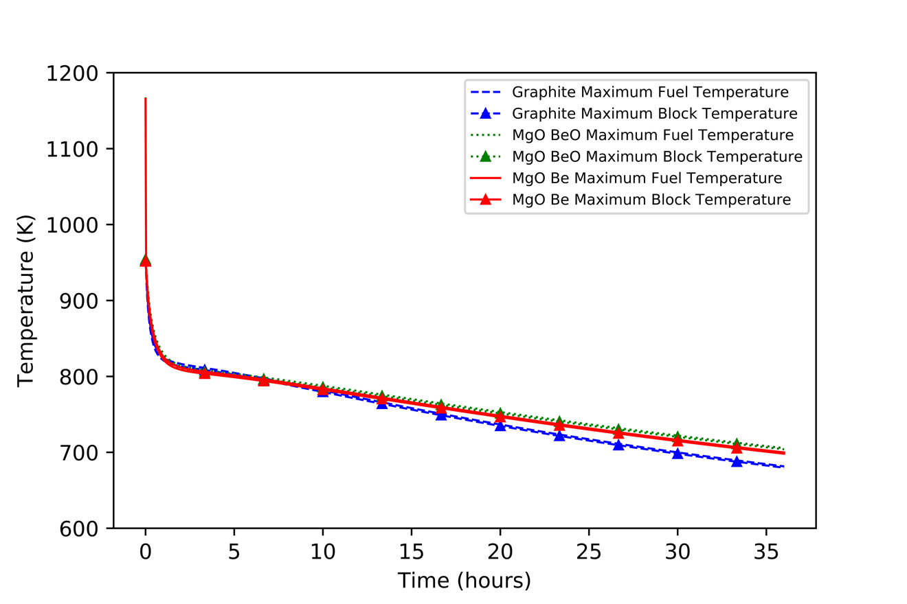
Figure 29. Peak temperatures in fuel and moderator block for graphite and beryllium based moderators during DLOFC

Figure 30. Reactivity insertion for CRW transient

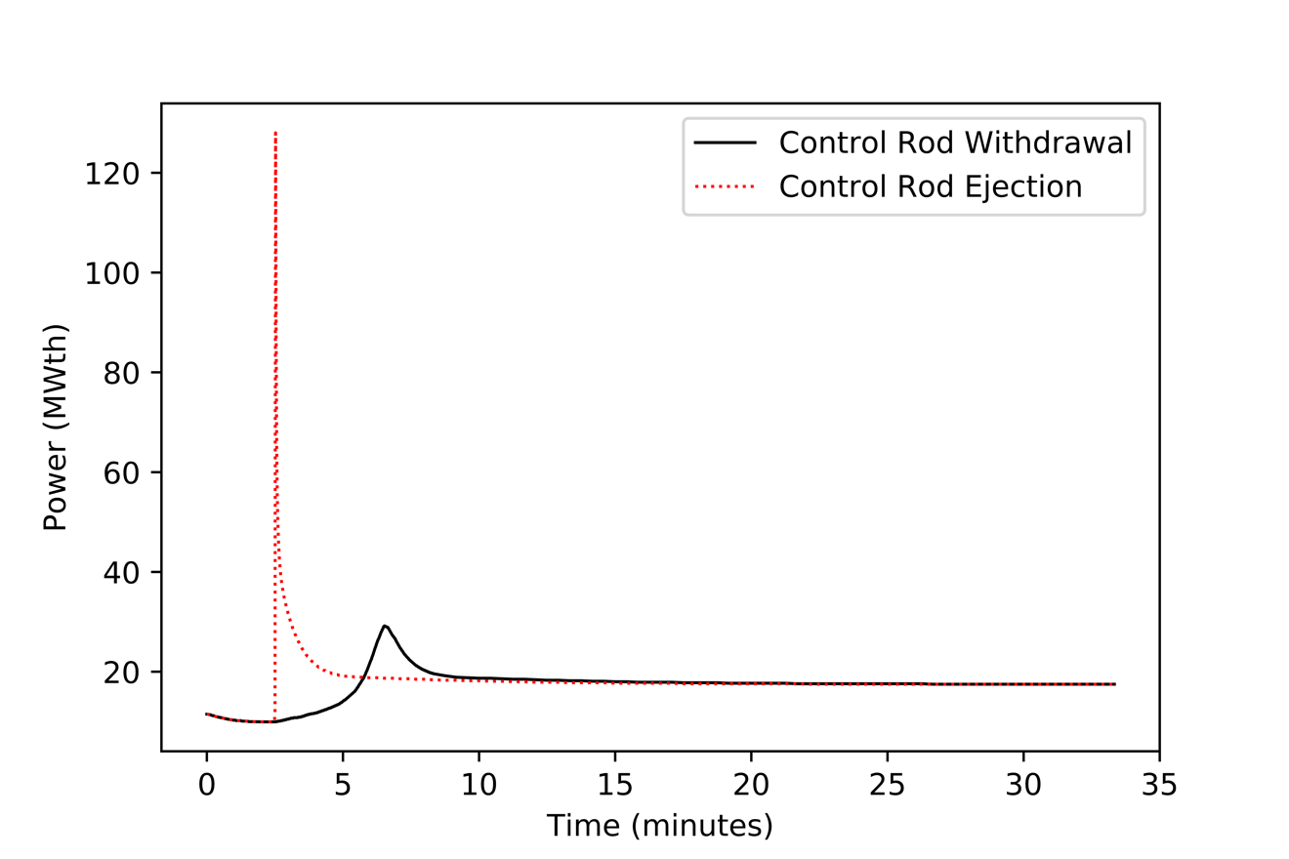
Figure 31. Core power for CRE and CRW transient

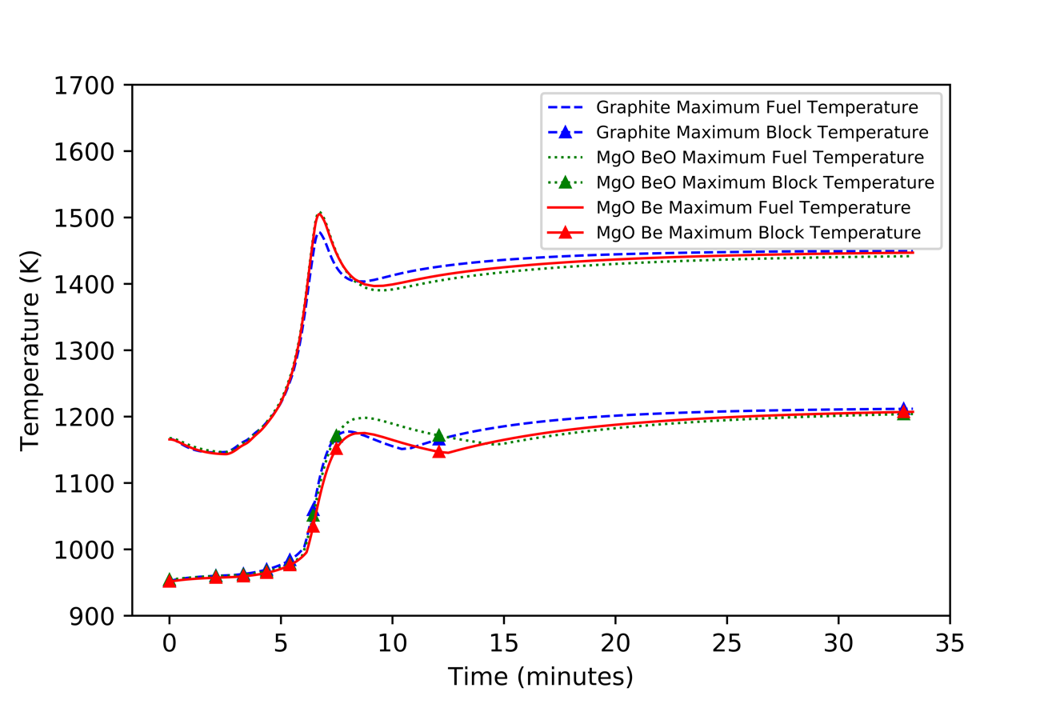
Figure 32. Peak temperatures in three-block high fuel column design for graphite and beryllium based moderator during CRW

A CRE is another subset of RIA in which the reactivity is inserted much more rapidly than for a CRW accident. A total of 1($) is promptly inserted at 150 seconds. Figure 28 is the peak moderator and fuel temperatures in all cases for an RIA. For both RIAs, it is shown that the fuel does not exceed the 1,873(K) temperature limit [57]. Moreover, the beryllium cases are shown to have similar performance to the graphite reference case for all considered accidents.

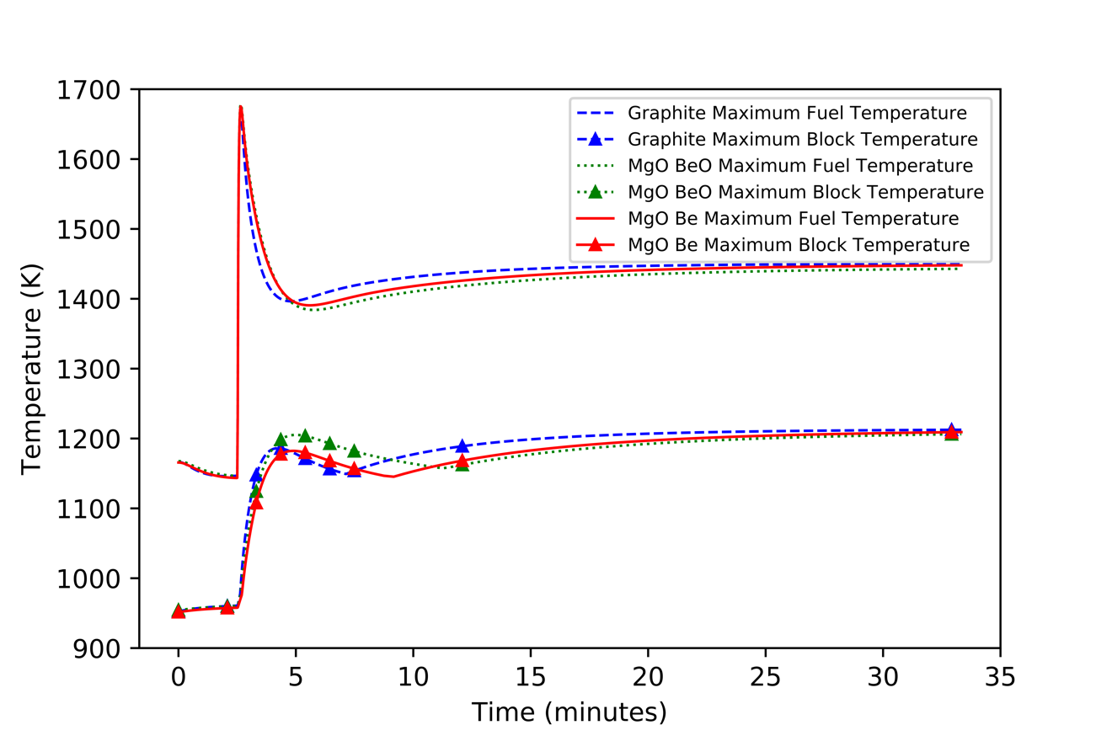
Figure 33. Peak temperatures in three-block high fuel column design for graphite and beryllium based moderator during CRE

Chapter four
Conclusions and Contributions
Using a simplified 350-MWth mHTGR fuel block Serpent neutronics model, we showed that advanced beryllium- and hydride-based moderators provide increases in cycle length and reduced overall fuel costs relative to a graphite-moderated reference mHTGR. The 60% MgO 39% BeO volume fraction moderator achieved similar fuel cycle performance to the graphite reference case for a graphite optimized design and a 60% MgO 39% Be or 84% MgO 15% ZrH_{x=1} volume fraction moderator exhibited improved fuel cycle performance. An optimization study of the lattice pitch of the fuel and coolant channels demonstrated increases in the cycle length for all these moderators. With the optimized design, the fuel cycle costs for each moderator significantly decreased, which provides economic incentives relative to graphite. Moreover, the calculated radioactivity showed that less shielding and storage requirements will be needed for the advanced moderators. Additional environmental benefits quantified included reduced CO₂, landmass occupancy, worker radiological exposure, and water consumed relative to the graphite reference case. Compared with the MgO BeO, MgO Be will have a lower upper-temperature limit due to the beryllium metal phase while the MgO ZrH_{x=1} has intrinsic neutronic challenges due to its MTC, which results in increasing reactivity for an increase in moderator temperature.

A RELAP5-3D thermal-hydraulic model was employed to study normal operation as well as some accident scenarios for the most promising beryllium-based moderators. Differences in moderator thermal properties drive minor differences in temperature response under steady-state and accident scenarios. Steady-state fuel temperature profiles are comparable for all moderator materials while under accident scenarios, fuel temperatures rise the most for the graphite moderator due to its lower heat capacity; however, it also cools down more rapidly than any other core.
To address the hypotheses formed from observation and theory, it can be concluded from this work that:
- By reducing the core size to a micro HTGR design the beryllium moderators show comparable or enhanced cycle performance. The hydride-based moderator shows significantly reduced cycle length compared to all other cases assessed despite displaying the most promising performance during initial scoping assessments due to neutron absorption.
- Preliminary thermal-hydraulic analysis shows that the beryllium-based moderators have comparable safety performance to the graphite reference case for full-scale core design as well as for microcore design.

The contributions of this thesis to the literature are:

- Assessment of fuel cycle performance and other neutronics characteristics for alternative moderators in a graphite optimized infinite assembly design.
- Lattice pitch optimization calculations for advanced moderators and evaluation of cycle performance and critical achievable theoretical size.
- Fuel cycle cost evaluation for reference and advanced moderators
- MTC and FTC neutronics safety calculations for reference and advanced moderators
- Radioactivity calculations for reference and advanced moderators.
- Environmental impact assessment for reference and advanced moderators
- LOFC accident analysis for beryllium and graphite moderator in a GA mHTGR-350 design
- Full-core neutronics calculations and assessment for reference and advanced moderators
- Preliminary assessment of microcore design performance and accident analysis for overpower and undercooling transients for reference and beryllium-based moderators

                - List of References

[1] | J. Vujić et al., "Small modular reactors: Simpler, safer, cheaper?," Energy, vol. 45, no. 1, pp. 288-295, 2012.
[2] | Z. Liu and J. Fang, "Technology readiness assessment of Small Modular Reactor (SMR) design," Progress in Nuclear Energy, vol. 70, pp. 20-28, 2014.
[3] | N. R. Brown, S. T. Revankar, "A review of catalytic sulfur (VI) oxide decomposition experiments," International Journal of Hydrogen Energy, no. 37, pp. 2685-2698, 2012a.
[4] | N. R. Brown, S. T. Revankar, "An endothermic chemical process facility coupled to a high temperature reactor. Part II: transient simulation of accident scenarios within the chemical plan.," Nuclear Engineering and Design, no. 246, pp. 266-276, 2012b.
[5] | H. Reutler and G. H. Lohnert, "The Modular High-Temperature Reactor," Nuclear Technology, vol. 62, no. 1, pp. 22-30, 1983.
[6] | D. D. Lanning, "Modularized high-temperature gas-cooled reactor systems.," Nuclear Technology, vol. 88.2, pp. 139-156, 1986.
[7] | M. A. Pope, "Transmutation Analysis of Enriched Uranium and Deep Burn High Temperature Reactors. No. INL/EXT-12-26423," Idaho National Laboratory, Idaho Falls, 2012.
[8] | H. Gougar, et al, "Prismatic Coupled Neutronics/Thermal Fluids Transient Benchmark of the MHTGR-350 MW Core Design: Benchmark Definition," Idaho National Laboratory, Idaho Falls, 2010.
[9] | J. W. Sterbentz et al, "High-Temperature gas-cooled test reactor point design: summary report," INL/EXT-16-37661, 2016.
[10] | C. Lu, "Fully Ceramic Microencapsulated Fuel in High-Temperature Gas-Cooled Reactors," [Published Dissertation] The Pennsylvania State University, January 2019.
[11] | D. E. Carlson, and S. J. Ball, "Perspectives on Understanding and Verifying the Safety Terrain of Modular High Temperature Gas-Cooled Reactors," Nucl. Eng. Des., no. 306, pp. 117-123, 2016.
[12] | C. Lu et at., "Fully ceramic microencapsulated fuel in prismatic high temperature gas-cooled reactors: analysis of reactor performance and safety characteristics," Annals of Nuclear Energy, no. 114, pp. 277-287, 2018.
[13] | C. Lu, et al., "Fully Ceramic Microencapsulated Fuel in Prismatic high-Temperature Gas-Cooled Reactors: Sensitivity of Reactor Behavior during Design Basis Accidents to Fuel Properties and the Potential Impact of the SiC Defect Annealing Process," Nuclear Engineering and Design, no. 345, pp. 125-147, 2019.
[14] | D. Petti, "Implications of results from the advanced gas reactor fuel development and qualification program on licensing of modular HTGRs.," No. INL/CON-14-32127, Idaho National Lab, Idaho Falls, 2001.
[15] | S. Hu, R. Wang, "Transient Tests on Blower Trip and Rod Removal at the HTR-10," Nuclear Engineering and Design, no. 236(5-6), pp. 677-680, 2006.
[16] | K. Takamatsu et al., "Spontaneous stabilization of HTGRs without reactor scram and core cooling—Safety demonstration tests using the HTTR: Loss of reactivity control and core cooling," Nuclear Engineering and Design, vol. 271, pp. 379-387, 2014.
[17] | J. A. Vitali, J. G. Lamothe, C. J. Toomey, V. O. Peoples, and K. A. Mccabe, "Study on the use of mobile nuclear power plants for ground operations," 2018.
[18] | A. A. Campbell, Y. Katoh, M. A. Snead, and K. Takizawa, "Property Changes of G347A Graphite Due to Neutron Irradiation," Carbon, no. 109, pp. 860-873, 2016.
[19] | R. H. Telling et al., "Wigner defects bridge the graphite gap.," Nature materials, no. 2.5, pp. 333-337, 2003.
[20] | L. L. Snead, et al., "Stored energy release in neutron irradiated silicon carbide," Journal of Nuclear Materials, vol. 514, pp. 181-188, 2019.
[21] | D. E. Carlson & S. J. Ball, "Perspectives on understanding and verifying the safety terrain of modular high temperature gas-cooled reactors," Nuclear engineering and Design, vol. 306, pp. 117-123, 2016.
[22] | O. Sambuu et al., "Design parameters in an annular, prismatic HTGR for passive decay heat removal," Annals of Nuclear Energy, vol. 111, pp. 441-448, 2018.
[23] | Matthieu Lemaire,Hyunsuk Lee,Nam-il Tak,Hyun Chul Lee & Deokjung Lee, "Multi-physics steady-state analysis of OECD/NEA modular high temperature gas-cooled reactor MHTGR-350," Nuclear Science and Technology, vol. 54, no. 6, 2017.
[24] | F. C. Linn, Heat Transfer Reactor Experiment Number 3: Comprehensive Technical Report, General Electric Direct-Air-Cycle Aircraft Nuclear Propulsion Program, US Atomic Energy Commission (AEC), 1962.
[25] | W. B. Cottrell, et al., "OPERATION OF THE AIRCRAFT REACTOR EXPERIMENT," Oak Ridge National Laboratory, Oak Ridge, Tennessee, 1955.
[26] | L. Snead, et al, "Fabrication of Two-Phase Composite Moderators as Potential Lifetime Reactor Components," Washington, D.C., 2019.
[27] | C. Ang, et al, "An Innovative Approach to Composite Moderators Containing Zirconium Hydrides," Washington, D.C., 2019.
[28] | F. W. Clinard Jr. et al, "Neutron irradiation damage in MgO, Al2O3 and MgAl2O4 ceramics," Journal of Nuclear Materials, no. 108&109, pp. 655-670, 1982.
[29] | W. D. Manly, "Utilization of BeO in reactors," Journal of Nuclear Materials, vol. 14, pp. 3-18, 1964.
[30] | A. L. Reeves, D. Deitch, and A. J. Vorwald, "Beryllium Carcinogenesis. I. Inhalation Exposure of Rats to Beryllium Sulfate Aerosol," Cancer Research, vol. 27.3, pp. 439-445, 1967.
[31] | J. B. Vetrano, "Hydrides as neutron moderator and reflector materials," Nuclear Engineering and Design, vol. 14, no. 3, pp. 390-412, 1971.
[32] | "Occupational Safety and Health Guidelines," United States Department of Labor, Occupational Safety & Health Administration, [Online]. Available: https://web.archive.org/web/20110727152402/http://www.osha.gov/SLTC/healthguidelines/index.html.
[33] | J. R. Lamarsh, A. J. Baratta, Introduction to Nuclear Engineering, 3rd Edition ed., Upper Saddle River, NJ: Prentic Hall, 2001.
[34] | E. M. Duchnowski, et al., "Reactor performance and safety characteristics of two-phase composite moderator concepts for modular high temperature gas cooled reactors.," Nuclear Engineering and Design, vol. 368, 2020.
[35] | J. Leppänen, M. Aufiero, E. Fridman, R. Rachamin, S. Marck, "Calculation of effective point kinetics parameters in the Serpent 2 Monte Carlo Code," Annals of Nuclear Energy, no. 65, pp. 272-279, 2014.
[36] | D. Petti, J. Maki, J. Hunn et al., "The DOE Advanced Gas Reactor Fuel Development and Qualification Program," Journal of The Minerals, Metals & Materials Society, no. 62, pp. 62-66, 2010.
[37] | L. L. Snead, T. D. Burchell, Y. Katoh, "Swelling of nuclear graphite and high quality carbon fiber composite under very high irradiation temperature," Journal of Nuclear Materials, vol. 381, no. 1-2, pp. 55-61, 2008.
[38] | M. T. Simnad, "Nuclear Reactors: Shielding Materials," Encyclopedia of Materials: Science and Technology (Second Edition), pp. 6377-6384, 2001.
[39] | R. Wigeland et al., "Nuclear Fuel Cycle Evaluation and Screening – Final Report," US Department of Energy, 2014.
[40] | V. Laboure, et al., "HTTR 3-D Cross-Section Generation with Serpent and MAMMOTH," (No. INL/EXT-18-51317-Rev000), Idaho National Lab(INL), Idaho Falls, ID (United States), 2018.
[41] | F. Ganda, E. A. Hoffman, K. Williams, "Nuclear energy system evaluation and screening – levelized cost of electricity at equilibrium," .S. Department of Energy Office of Nuclear Energy Fuel Cycle Research & Development. FCRD-FCO-2013-00196, 2013.
[42] | J. R. Burns et al., "Reactor and fuel cycle performance of light water reactor fuel with 235U enrichments above 5%.," Annals of Nuclear Energy, vol. 142, p. 107423, 2020.
[43] | R. Hernandez and N. R. Brown, "Potential fuel cycle performance of floating small modular light water reactors of Russian origin.," Annals of Nuclear Energy, vol. 144, p. 107555, 2020.
[44] | R. Wigeland, et al., "Nuclear fuel cycle evaluation and screening-final report," US Department of Energy, 2014.
[45] | J. W. Sterbentz et al., "High-Temperature gas-cooled test reactor point design: summary report," INL/EZXT-16-37661, 2016.
[46] | G. Strydom, A. S. Epiney, A. Alfonsi, C. Rabiti, "Comparison of the PHISICS/ RELAP5-3D ring and block model results for phase I of the OECD/NEA MHTGR-350 benchmark," Nuclear Technology, no. 193, pp. 15-35, 2016.
[47] | S. Yamanaka, et al., "Thermal properties of zirconium hydride," Journal of Nuclear Materials, vol. 294, no. 1-2, pp. 94-98, 2001.
[48] | A. J. Slifka, B. J. Filla, "Thermal Conductivity of Magnesium Oxide from Absolute, Steady-State Measurements," Journal of Research of the National Institute of Standards and Technology, vol. 4, no. 103, pp. 357-363, 1998.
[49] | D. A. Ditmars, D. C. Ginnings, "Thermal Conductivity of Beryllium Oxide from 40 to 750 C," Journal of Research of the National Institute of Standards and Technology, vol. 2, no. 59, pp. 93-99, 1957.
[50] | A. C. Victor, T. B. Douglas, "Thermodynamic Properties of Magnesium Oxide and Beryllium Oxide from 298 to 1,200 K,," Journal of Research of the National Bureau of Standards. Section A, Physics and Chemistry 67, no. 4, p. 325, 1963.
[51] | A. S. M. Rao, K. Narender, "Studies on Thermophysical Properties of CaO and MgO by γ -Ray Attenuation," Journal of Thermodynamics, vol. 2014, 2014.
[52] | J. Lillie, "Some properties of beryllium oxide," University of California, Lawrence Radiation Laboratory, Livermore, CA, 1961.
[53] | Y. Toloukian, Thermophysical Properties of High Temperature Solid Materials Volume 1: Elements, Lafayette, IN: Macmillan, 1967.
[54] | H. G. Lee et. al., "Thermal conductivity analysis of SiC ceramics and fully ceramic microencapsulated fuel composites," Nuclear Engineering and Design, vol. 311, pp. 9-15, 2017.
[55] | US Nuclear Regulatory Commission, "Assessment of White Paper Submittals of Fuel Qualification and Mechanistic Source Terms (Revision 1), Next Generation Nuclear Plant," ML14174A845 (2014)..
[56] | N. R. Brown, "A review of in-pile fuel safety tests of TRISO fuel forms and future testing opportunities in non-HTGR applications.," Journal of Nuclear Materials, vol. 534, p. 152139, 2020.
[57] | D. Schappel, N. R. Brown, and K. A. Terrani, "Modeling reactivity insertion experiments of TRISO particles in NSRR using BISON," Journal of Nuclear Materials, vol. 530, 2020.
[58] | Umeda, Miki, et al., "Behavior of coated fuel particle of high-temperature gas-cooled reactor under reactivity-initiated accident conditions," Journal of nuclear science and technology , vol. 47.11, pp. 991-997, 2010.
[59] | E. M. Duchnowski, et al., "Preliminary Reactor Physics Analysis of Alternative Moderators for Modular High Temperature Gas-Cooled Reactors," in American Nuclear Society, Washington D. C., 2019.

                - Vita
Edward Matthew Duchnowski graduated from Penn State with a Bachelor of Science in Nuclear Engineering in May of 2019. Edward started attending The University of Tennessee, Knoxville in June of 2019 to peruse a Master of Science and Doctorate of Philosophy in Nuclear Engineering. Edward has presented this work at American Nuclear Society Winter meeting in November of 2019 and has published a peer reviewed journal article in Nuclear Engineering and Design.

