Creating Competitive Advantage in the Premium Market Segment through a Sustainability Strategy

Faculty Advisor: Mike Burnette
Author: Andrew “Elliott” Iberg
Email: aiberg2@vols.utk.edu

Abstract
With increased pressure from external forces and consumers, companies have begun to incorporate sustainability into their business strategy and corporate objectives. This paper will outline successful tactics and examples of companies who have employed them.
Creating Competitive Advantage in the Premium Market Segment through a Sustainability Strategy
Introduction
Sustainability as a topic has been rapidly gaining prominence and focus in the business environment, appearing as a focal point in many industry reports, management journals, and shareholder distributions. The reasons for this increased focus is as wide and varied as the industries involved. For some companies facing environmental regulations or public scrutiny, sustainability is seen as a method of avoiding government fines and public backlash for damaging business practices. While others see it as strategy for driving demand and increasing sales or market share in a changing marketplace. Others view it as a source of innovation in reducing waste and thereby improving their long term viability and cost structure. While all of these companies have various and overlapping reasons for focusing on their sustainability strategy, it is safe to say sustainability has transformed from the realm of environmental activism to a source of strong competitive advantage.
In the United States, a major reason for the increased focus on resource conservation has been political pressure. Since 1969, when the National Environmental Policy Act was signed by Richard Nixon, it has been an official United States policy “to encourage productive and enjoyable harmony between man and his environment; to promote efforts which will prevent or eliminate damage to the environment and biosphere and stimulate the health and welfare of man” (“Environmental Protection Agency”)
More recently in the United States, this charge has been led by President Obama, the EPA, and other government agencies who have enacted various programs and initiatives to reduce our effect on the local environment and global climate. On October 19th 2015, over 81 multinational companies with a combined market cap of 5 trillion dollar, signed a pledge to reduce emissions by as much as 50% and ensure all new manufacturing plants in the US are zero waste-to-landfill, along with other ambitious resource conservation goals for power and water usage (“The White House”). Internationally, there has been a struggle to balance economic growth and development with resource conservation but over 37 industrialized countries and the European Community have agreed to follow the environmental accords set forth in the Kyoto Protocol. While this protocol excludes major contributors of greenhouse gas, such as India and China, many believe it is a step in the right direction (“Kyoto Protocol”). As countries attempt to meet their environmental commitments, there has significant pressure on businesses operating in those countries to improve their environmental performance in order to meet their regulatory requirements.
As part of their strategy to meet regulatory requirement, there has been a large increase in demand for “green” buildings, with many companies requiring new construction follow LEED (Leadership in Energy and Environmental Design) certifications (“Green Building Facts”). This certification is run by a third party that evaluates buildings based on construction materials used, the design of the building, and estimated energy efficiency. According the United States Green Building Council, 40-48% of new nonresidential construction will be LEED certified and by 2018 84% of all new single-family building will be also be LEED certified (“Green Building Facts”). Overall there has been a dramatic increase in consumer demand for sustainable products and companies are changing their brand strategies to meet these demands. Due to these new consumer demands, sustainability is not just for environmentalist but is a necessary part of competing in today’s business world.

Business Case for Going Green
As consumers become more ecologically focused, this demand has affected almost every industry from consumer packaged goods to clothing to energy. Many municipalities now include an option to purchase renewable energy credits and numerous federal and state grants subsidize installing renewable energy systems onto buildings (“Department of Energy”). Steve Estabrook, CEO of a natural cleaning company, declared “People shopping in stores like Whole Foods are not there just for apples […] They’re there to shop for everything, including cleaning supplies. They want to feel better about everything they’re buying” (“Green Cleaners”). As Steve noted, a highly visible area of increased demand for sustainable products is the organic food section of the local grocery store. As seen in Figure 1, organic food has seen massive increase in demand over the last 10 years, but it still accounts for less than half a percent of the United States Gross Domestic Product (“State of the Industry”; “US GDP”).
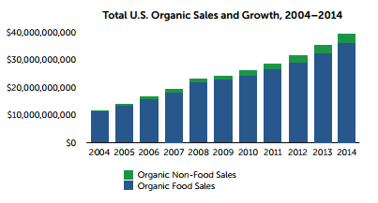
Figure 1 (Source: Organic Trade Association)
Naturally as this demand grows, companies will try to supply as much of the market as possible in order to grow their market share. In highly competitive or mature industries, green products and services can significantly grow the brand equity of a company. This is called “first mover advantage” and it can be a significant factor in public perception of a company and their portfolio of brands (Ruisinko 447). This reputational advantage is not only important to sales and marketing but also extends to attracting young talent as well. One study found that employees are “far more likely to identify with an employer whose principles and practices are in tune with current trends” (Davis-Peccoud). For companies seeking new and creative talent, this brand equity can be one of their greatest assets to drive innovation.
While growing brand equity can be advantageous, companies must be careful to avoid “green washing” or the disingenuous use of sustainability in order to deceive consumers into believing their products or practices are ethical or environmentally responsible (“About Greenwashing”). In the age of social media, public backlash against deceptive practices can be worse than the initial gain in reputation (Ionescu-Somers) While Nestlé was publicly touting their environmental practices it was discovered a major ingredient in many products, palm oil, was being harvested at the expense of Indonesia’s forest (“Super-Brands Commit”). This deforestation was ruining habitats for many animals while also increasing greenhouse gas emissions and the ability of the forest to absorb carbon dioxide (Ionescu-Somers). On a positive note, in light of this public relations issue, Nestle along with Walmart and Unilever created aggressive goals for their procurement departments to ensure 100% of their palm oil is derived from certified sustainable sources by 2020 (“Super-Brands Commit”).
More recently, Volkswagen AG was found to be using “cheat devices” on diesel vehicles, which were marketed as more fuel efficient and therefore more environmentally friendly. This green washing deception caused a huge public backlash while simultaneously earning unprecedented fines from various government agencies including the EPA (Hotten). At the time of this paper the outstanding fine liability has not been settled, but is estimated to be around $20 billion (Hotten). In the auto industry reputation is hugely important and the loss of brand equity along with forecasted fines has caused their stock price to be severely discounted by the financial markets (See Figure 2).
Volkswagen Auto Group 5 Year Historical Stock Price Chart
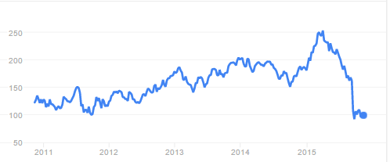
Emissions Scandal
Figure 2 (Source: Google Finance)
At its essence sustainability is a method of reducing waste in all of its forms. For many businesses, waste translates to an increase in operating costs and therefore decrease in profitability and revenue generation. Therefore it is natural that many companies have been engaging in sustainability before it was a buzzword. For many companies, logistics optimization initiatives have reduced fuel use, allowing them to transport good more efficiently while also reducing greenhouse gas emissions. In a similar fashion, recycling manufacturing waste has allowed companies to reduce their dependence on raw materials through re-use, while others have found willing buyers for their waste products (Muller). In 2011, 90%, or 2.5 million tons of General Motor’s waste products were reused or sold to recyclers, generating an additional $1 billion dollars in revenue (Muller). Through these cost reduction initiatives, companies can maintain their long term viability while simultaneously fulfilling their Corporate Social Responsibility initiatives.

Creating a Competitive Advantage
While some may see sustainability as the realm of “tree huggers”, there is a legitimate business need for a focus on sustainability as seen above. Regardless of the reason, the focus will lead to creating a competitive advantage for the firm versus their competitors. According to a study conducted by Nielson Research with 30,000 respondents across 60 countries worldwide, over 55% of consumers are willing to pay more for product made by companies that are devoted to positive environmental and social action ("Global Consumers”). The examples compiled below outline a set of proven practices that will lead to successful sustainability initiatives. These examples focus on the premium segment of their respective industry because due to the increased margins and consumer demographics, companies are able to devote more resources. In the premium market segment companies have used a sustainability strategy to create a competitive advantage for their firm by utilizing one or more of the following tactics:
1) Creating new market segments
2) Increasing Demand for products which have been improved to be more sustainable
3) Creating products that have proven consumer benefits which the consumer is willing to pay for, such as a lower Total Cost of Ownership (TCO)
4) Investing in a one-time capital expenditure that results in overall net benefit for the firm, such as brand equity

Cleaning Products
Tide Coldwater
New Market Segment, Increased Demand, Consumer Benefits (TCO), and Improved Brand Equity
The cleaning products industry in the United States is currently a $52 billion industry encompassing everything from surface cleaner to laundry detergent (“Revenue of The Soap”) .While there are many players in the market, Proctor and Gamble is the largest player with 19.6% market share in 2011(“Market Share”). With such wide-spread distribution and market share, changes in the sustainability of their products can have far –reaching and drastic impacts. As one the world wide leaders in market research, P&G saw a significant shift in public perception towards more environmentally responsible products. As the owner and developer of the most recognized cleaning brand, Tide, P&G leveraged this knowledge to launch a brand extension called Tide Coldwater (Shayon). This product was developed in combination with DuPont, who utilized agricultural waste to create cellulosic ethanol, a major component in the new formula. This partnership is one of the first uses of cellulosic ethanol at such a scale, diverting around 7,000 tons of agricultural waste annually. (Shayon)
While the use of cellulosic ethanol was innovative and improved the “greenness” of their product, it was the cost savings that really made the product a win/win for consumers. Due to its unique formulation, Tide Coldwater can be used on the cold water setting while washing clothes just as well as the conventional laundry detergent. While it is sold at a slight price premium depending on location, the cost savings allowed for a significant return on investment. According to a TCO analysis conducted by P&G, 80-85% of the energy used in washing clothes is derived from heating the water (Shayon). Therefore by eliminating the need to heat the water, if all consumers switched to cold water detergent, they could reduce CO² emission by 34 million tons while saving $63 per household per year; with professional laundry services the costs savings are even higher (Nidumolu; Shayon).
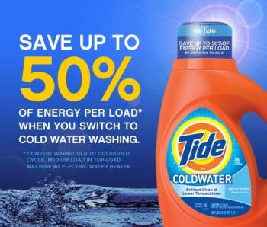
Figure 3 (Source: Greenbiz.com)
This product launch is an ideal case study for a sustainability related product as it fulfills all of the tactics mentioned earlier. This new formula created a one-time expenditure in marketing and product development that improved public perception of their brands. It also created a new market, growing the amount of households that used is from 5% to 51% in Holland within 3 years of product launch (Nidumolu). Furthermore, they can use this cellulosic ethanol partnership with DuPont to increase the environmental viability of their other brands that use similar formulations, thereby driving sales. Finally this launch was innovative in that P&G looked outside the company walls in their analysis to create TCO benefits directly for the consumer that saved them money in the long run.

Clorox Green Works
New Market Segment, Increased Demand, Consumer Benefits (Sustainable Ingredients), Improved Brand Equity
In 2008, Clorox became the first large consumer products good company to launch a brand of household cleaners that were ecologically friendly and made form nonsynthetic ingredients. According to their market research, 25% to 35% of consumers take environmental benefits into consideration when making a purchasing decision (Nidumolu). Following automobiles, cleaning products are the second largest environmental concern in the US, likely due to their connation with harsh chemicals, so it was a strong business decision to target this market. The Green Works line took over $20 million in investment and multiple delays to ensure these products performed as well as their conventional counterparts (Nidumolu). This investment was well worth the money though as the surface cleaners market is 23% of the $52 billion worldwide cleaning compound market or $11.96 billion (“Revenue of the Soap”; “Product and Services Segmentation).
Despite its association with harsh cleaning chemicals, Clorox’s marketing team decided that in order to assure customers their products were effective, they needed retained the Clorox brand on the bottle. Furthering their marketing strategy, they were able to secure an endorsement from the Sierra Club, a leading environmental organization, thereby lending legitimacy to their products (Nidumolu). As a consumer product, the packaging of the product is extremely important part of the marketing strategy and Nielsen research has shown an average 2% growth for companies with sustainability claims on packaging and it rises to 5% when companies make this part of wider product marketing (“Super-brands Commit”). As seen in Figures 4 and 5, this product packaging is very focused on informing consumers of its sustainable product design, even utilizing green in the liquid of the cleaner.
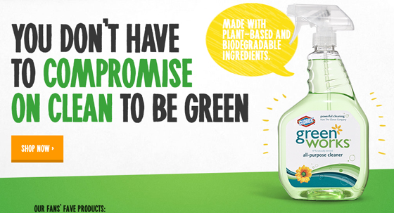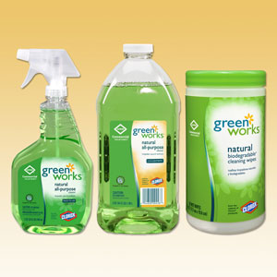
Figure 4 (Source: Brandchannel.com) Figure 5 (Source: Schoonursesupply.com)
The results of this product launch have been extremely promising for Clorox. Due to higher cost of materials, the product carries a 15% to 25% premium over conventional cleaners, but it seems consumers are willing to pay for the additional benefits (Nidumolu). After only one year, Green Works had grown the U.S. natural cleaners market by 100%, and Clorox enjoyed a 40% share of the $200 million natural cleaners market (Nidumolu). Similarly to Tide Coldwater, Clorox Green Works brand fulfills all of the four tactics needed to launch a successful “green” brand.
Method Brand Cleaners
New Market Segment, Consumer Benefits (Sustainable Ingredients)
Method brand was created from the start as an environmentally friendly company from the bottles to the cleaning liquid. Launched in 2001 and organized as a B Corporation, or Benefit Corporation, Method’s corporate goals are to have a positive impact on society and the environment in addition creating shareholder value (“B Corporation”). The company is extremely transparent in their efforts to create an environmentally sustainable product even acknowledging where they are failing and how they plan on overcoming those challenges. Their bottles are made from 100% recycled plastic, with the exception of their laundry bottle at 50%, and are designed with end recycling potential and raw material minimization in mind (“Packaging”). By using recycled materials, they use up to 70% less energy than using virgin materials, thereby reducing production costs (“Packaging”). They have even launched a product line derived from plastic recovered from the ocean, thereby turning a pollution into a useful raw material, allowing them to launch an innovative marketing strategy that resonates strongly with concerned consumers (“Ocean Plastic”).
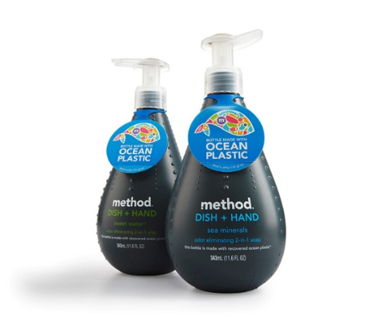

Figure 6 (Source: Method.com)
Furthering their brand positioning, Method has never engaged in animal testing allowing them to court another segment of environmentally concerned consumers (“Our Business”). For interested customers, Method has an entire list of all of their ingredients online along with their naturally derived sources, possible irritation issues, and their role in the product formulation (“Ingredients”). Their use of nontoxic and biodegradable ingredients is an benefit that consumers, such as those with children, are willing to pay a price premium for. Furthermore for those concerned with the environmental life cycle of the products, all of their materials are certified by a third party (MDBC) for environmental safety (“Ingredients”). In their supply chain, Method has taken an initiative to concentrate their products as much possible, thereby reducing transportation costs and packaging (“Packaging”). In the manufacturing and logistics side, Method is committed to using renewable energy in their manufacturing plants and uses biodiesel in 35% of their delivery trucks (“Our Business”). Overall this has created a brand that has an end to end sustainable and transparent supply chain
For Method their sustainability strategy has paid off by creating strong brand equity with positive social impacts while simultaneously allowing them to compete with market leader such as Clorox and P&G in the cleaning products market. When launched as a premium brand, Method was one of the only household cleaning companies solely focused on creating a nontoxic and biodegradable cleaning product. This strategy allowed take advantage of the four outlined tactics to become a successful green company with $100 million in revenues in 2012 (Kurtz).
Clothing
Cariloha
New Market Segment, Consumer Benefits (Sustainable Raw Materials and Product Quality
In the clothing industry the role of sustainability focuses not around the environmental end of life cycle effects, like household cleaners, but rather on the manufacturing and sourcing elements of the supply chain. One of the newest innovations in these elements has been the introduction of alternative fibers, such as bamboo. While bamboo would be conventionally unsuitable as a fiber due to its hard woody structure, due to modern technological advances manufacturers have been able to create an exceptionally soft and breathable raw material fabric (“Cariloha Bamboo”).
Compared to cotton and other wood based cellulose fabrics, bamboo has many advantages that consumers value and are willing to pay a price premium for. First it very quick growing and since it is a technically a grass, harvesting only requires trimming rather than the destruction of the plant which prevents soil erosion (Pellisier). On the resource usage side, it requires almost no water irrigation or pesticides/fertilizers thereby preserving the nearby land and waterways (Pellisier). Finally it can be grown on substandard soil in extremely dense configurations, minimizing land use, while also absorbing C02 and releasing 35% more oxygen of than the average plant (“Frequently Asked Questions”)
In 2007, Cariloha was founded and within a few short years has become one of the largest bamboo apparel retailers. Since 2008 they have seen their revenues grow from $1 million to $30 million with expected revenues of $40 million in 2015 (“Cariloha Bamboo”). As bamboo fabrics have risen in popularity their sales have grown 530% within the last three years with an average dollar per transaction of $120 (“Cariloha Bamboo”). These environmental benefits along with the exceptional quality of the end fabric has allowed them to distinguish themselves in highly competitive world of consumer fashion while also creating a new market segment with environmental and product benefits that consumers are willing to pay a premium for.
Patagonia
Increased Demand, Consumer Benefits (Sustainable and Product Quality), Improved Brand Equity
Since its inception, Patagonia has been a business that has sought to enact positive benefits for the environment and world, as evidenced by their mission statement (“Annual Report 2014”).
“Build the best product, cause no unnecessary harm, use business to inspire and implement solutions to the environmental crisis.”
For Patagonia sustainability is the core of their business, rather than a sales or marketing strategy. Like Method, Patagonia also is now a qualified and registered benefit corporation due to their exceptional supply chain certification programs and commitment to donate 1% of gross sales revenue to environmental restoration (“1% for the Planet”). Since 1985, they have donated $70 million to environmental programs (“1% for the Planet”). Despite their public pleas to their customers to reduce consumption and reuse clothing, their sales have continued to grow at an exceptional rate, with $575 million in sales in 2014 (Stock).
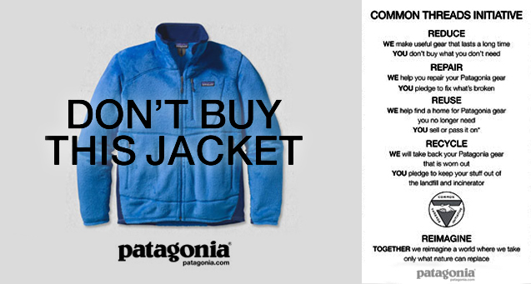
Figure 7 (Source: Patagonia.com)
As an outdoors company, their focus on reducing environmental effects resonates strongly with their customers who know that in buying their products they are causing minimal harm to their environment through supply chain operations. They have strict programs and certification in place to ensure their supply chain practices “cause no unnecessary harm” to the environment nor their fellow man. Patagonia has strict sourcing policies that requires all of their raw materials are third party-certified organic or come from verified recycled sources (“Annual Report 2014”). Additionally they conduct supplier and manufacturing audits to ensure that their supply chain partners are abiding by their code of conduct , which has strict labor, environmental, and fair wage guidelines (“Working with Factories”). Finally, one of the hallmarks of Patagonia brand is the exceptional quality standards, which attracts customers who aren’t even aware of their sustainability focus. In their view, the higher quality they make their products the longer it will last thereby resulting in lower resource usage levels. This is quality focus is also supplemented by their commitment to repair any Patagonia clothing, and if it is unrepairable, they will responsibly recycle the product into new Patagonia products (“Annual Report 2014”). All of this information is available on their website where they inform customers of their multitude of social programs and harm minimization policies. They invite consumers to research their business practices and supply chain initiatives to create an open dialogue on where they can improve.
According to the Outdoor Industry Association durability and high quality are the most important attributes consumers were willing to pay more for, with 46% and 42% respectively of consumer surveyed (“Outdoor Industry Association). Patagonia costumers are willing to pay more because they are buying high quality, durable, and repairable clothes that have been manufactured in a sustainable way, thereby creating a strong brand loyalty. Overall their sustainability strategy and business tactics has created a competitive advantage allowing them to command a price premium and become a leading retailer in the outdoor clothing segment.
Stella McCartney
New Market Segment, Consumer Benefits (Sustainable), Improved Brand Equity
While the previous examples were clothes that command a premium due to their ecologically friendliness, Stella McCartney is a luxury “high street” UK fashion house that has engaged in sustainability as a method of differentiation. In the luxury goods segment, many customers have philanthropic leanings and the clothes are already very fashionable and high quality. Therefore with all other factors equal a strong brand supported by sustainable initiatives can be a major competitive advantage. As noted by the founder, Stella McCartney, “it’s really the job of fashion designers now to turn things on their head in a different way, and not just try to turn a new dress on its head every season” (“Q&A with Stella”).
In the high street fashion world, Stella McCartney is certainly turning things on their head with many innovative projects that reduce their use of fossil fuels. To start with all of their offices and headquarters in the UK are powered by wind power, with significant initiatives to reduce water and waste materials in their textile production operations (Amed). Stella McCartney has also launched a brand of faux leather handbags which prevent the need for animal skins and harsh chemicals involved in the tanning process (See Figure 8). This leather is also created with a coating made with 50% vegetable oil rather than petroleum derivatives (Amed).

Figure 8 (Source: Untitled-Magazine.com)
Furthering reducing their use of petroleum, Stella has created a line of eyewear created from 50% natural and renewable sources such as castor oil and citric acid, currently retailing for $230-$350 (Amed). Continuing this focus, they have partnered API, a leading bioplastic firm that creates plastic from renewable sources, to supply them with biodegradable soles for their shoes (Lolli). Rounding out all these initiatives, Stella uses organic cotton and recycled materials in 50-75% of her collections, depending on the line (“Materials”). These initiatives along with her commitment to no animal testing, low impact dyes, and worker’s rights programs have allowed her to court a wide variety of clientele (“Q&A with Stella”).
All of the tactics have allowed her to become a beacon of sustainability in an industry that it frequently associated with luxurious wastefulness. As noted in the following quote she understand the qualities consumers value (Q&A with Stella).
“I don’t think that things have to look ugly because they’re organic; why can’t they be beautiful
as well? You can’t ask a consumer to compromise”

This vision of making sustainable and fashionable clothes has been successful for Stella McCartney as their sales from 2010 to 2013 grew by 60% for a total of £28.4 million (Lolli). As a newly launched company, their innovative tactics have built a strong presence of sustainability for the brand while increasing the appeal of their products to the ecologically focused luxury consumer.

Transportation
Tesla Motors
New Market Segment, Increased Demand, Consumer Benefits (Sustainable and Product Quality)
Another environmentally focused premium brand is the revolutionary Tesla Motors. Although still a small company relative to the massive players in the auto industry, with 2.5% market share, Tesla has been making huge gains in market share, revenue, and brand recognition with its line of all stylish electric vehicles (Ruiz).

Figure 9 (Source: IbisWorld)
Tesla originally positioned itself in the premium market versus Mercedes-Benz, Lexus, BMW and others by creating sophisticated and stylish electric cars that could compete with these traditional leaders in both performance and style. This allowed them to charge a premium versus other electric cars while creating an entirely new segment of premium electric sedans. In 2013, 3 years after going public, Tesla was actually the top selling car in the luxury sedan market with 17,650 units sold, beating Mercedes Benz S class with 13,303 units sold, and BMW’s 7 Series with 10,727 units sold (“Tesla Model S”). Over time they have created best practices and used these revenues to invest in battery technology and R&D. These advances have allowed them to release models with consistency lower price tags as they inch toward their goal of launching a mass market car that will retail for $30,000 to $40,000 (Richard). This mass market launch will lead well for Tesla as they lead the auto industry in consumer’s perception of technology and innovation in Figure 10 (Consumers Union).
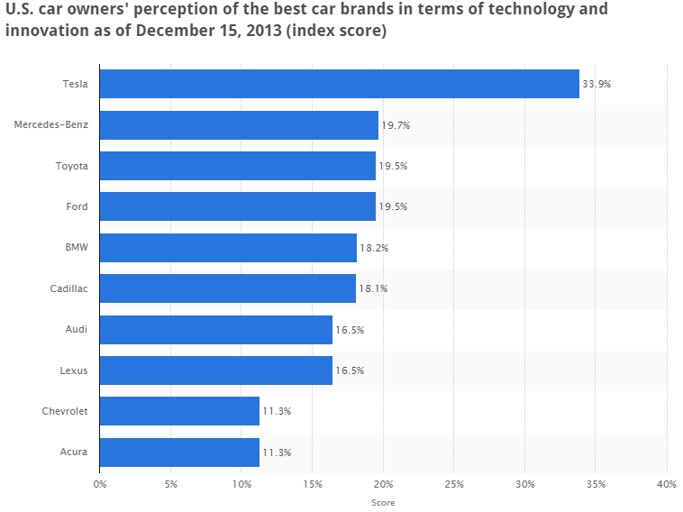
Figure 10 (Source: Statista)
To fuel this growth strategy Tesla has invested in creating a “Giga watt” factory in Nevada that will supply all of their battery at extremely low costs, while allowing them to have excess production capacity that they can sell to other car manufacturers or even consumers for their “Powerwall” initiative (“Powerwall”). This Powerwall is a home battery system that would capture energy from solar panels therefore eliminating the need for fossil fuels to produce power for the car’s battery charging station (“Powerwall”). This end to end integration increases consumer benefits by providing them with a convenient way to store energy produced from renewable sources for use in charging their car or providing the electricity needs of their home.
Finally as seen before, one quality that consumers value highly in the premium segment is durability and quality service. To provide this benefit, Tesla has created a convenient way to update the car via Wi-Fi in order to improve performance and introduce new features, such as automatic steering and parallel parking (“Software Updates”). Tesla also provides an 8 year unlimited mile warranty. For issues that cannot be fixed remotely, Tesla will send a technician to your house or office if you live more than 50 miles from service center (“Infinity Mile Warranty”). When questioned about this warranty Elon Musk, CEO, responded “If we truly believe that electric motors are fundamentally more reliable than gasoline engines, with far fewer moving parts and no oily residue or combustion byproducts to gum up the works, then our warranty policy should reflect that” (“Infinity Mile Warranty). Through this quote, Tesla builds brand loyalty and customer confidence while promoting both the quality of their vehicles along with their environmental benefits. Both of the benefits are strong values that Tesla consumers will pay for.
In line with their strategy of producing more eco-friendly forms of transportation and energy storage, Tesla ensures that their batteries with be responsibly dealt with at the end of their lifecycle with a closed loop battery recycling program. This program is led by partnerships with Umicore and Kinsbursky Brothers, innovators in the recycling industry (“Tesla’s Closed Loop”). By recycling these old batteries, Tesla is able to avoid up to 70% of CO2 emissions associated with creating new batteries, while also producing valuable raw materials that sell at a profit relative to the costs of recycling (“Tesla’s Closed Loop”). “Win/Win” examples like this are most effective drivers in implementing sustainability in business as they promote ecological responsibility while returning a profit to the business.
In the past electric cars design have typically been led by function rather than form, causing many consumer to consider them “dorky” or “ugly” (Rawsthorn). By making electric cars cool and stylish, Tesla has brought electric cars out of the fringes of the auto industry. By creating a new market segment of stylish electric cars Tesla has increased demand for their cars and electric vehicles in general. By promoting their environment and consumer benefits, such as eliminating the need for oil changes and lifetime warranty, Tesla has created a product that consumer want and are willing to pay a premium for. All of these strategies have lead Tesla to have a strong competitive advantage versus their competition, while also engaging in environmental responsibility.
Fedex
Consumer Benefits (Sustainable, Convenient, Increased Service, Improved Brand Equity
For FedEx, a leading logistics provider, greenhouse gases emissions are an unavoidable consequence of moving goods across the globe via their fleet of 700 aircraft and 44,000 motorized vehicle (Nidumolu). With an average daily consumption of 4 million gallons of fuel a day, FedEx has strong incentives to reduce their fuel consumption in the interest of cost savings and greenhouse gas reduction (Nidumolu). This mainly revolves around utilizing transportation optimization software and replacing planes and cars with more fuel efficient versions. Just by replacing their older Being 757’s with the larger Boeing 787 they will reduce their jet fuel consumption by 36% (Nidumolu). While these initiatives help, the best practice is to eliminate unneeded transportation while increasing customer service, a key benefit to customers. Many business and individuals use FedEx as a safe and reliable way to send physical documents rapidly around the world. With Fedex’s acquisition of Kinko’s, a printing service, they saw a synergy for their document delivery service. With this new program, FedEx customers can upload a copy of their document online and FedEx will professionally print the document at a Kinko’s location near the desired destination, using their network of delivery trucks to deliver the document the next day (Nidumolu). This gives customers extra time to finalize the document along with providing professional printing services, while minimizing their costs versus a traditional overnight delivery rate (Nidumolu). For FedEx, this method is not only greener but it minimizes their transportation costs to deliver the document. Using this system benefits both parties and the environment, a key factor in successful sustainability initiatives.

Restaurants
Chipotle
(Increased Demand, Consumer Benefits (Sustainable and High Quality), Improved Brand Equity)
Chipotle is currently one of the quickest growing fast casual chains in the United States, with a recent Nielson Scarborough study finding that in 2015, 20.09 million people had visited a Chipotle within the last 30 days (“Restaurant Visits”). This rapid growth and success is partly due to their commitment to create “Food with Integrity” by creating a sustainable and transparent sourcing supply chain. Chipotle currently sources 100% of their pork and 80-85% of their chicken and steak from “naturally raised” sources (Marrati). This means the animals are raised in deeply bedded barns or on a pasture under humane conditions with a zero tolerance policy for any form of animal cruelty, hormones, non-vegetarian diet, or nontherapeutic antibiotics (Baylis). In fact their commitment to this principle is so strong, when their main supplier of pork was found to be violating these practices during an audit, Chipotle stopped serving pork in all their restaurants for months until a new supplier could be found (“Carnitas”). As for their vegetables, Chipotle tries to minimize greenhouse gas emissions and guarantee freshness by sourcing over 35% of their vegetables, 10 million pounds, from small local farms within 350 miles of the restaurant (Baylis). All of their vegetables come from long term partnerships with farms that reduce their impact on the land by minimizing the use of pesticides and fertilizing while utilizing natural methods such as crop rotation (“Food with Integrity”). In addition to creating delicious fresh food, their sourcing strategy is a strong component of their marketing strategy. (See Figure 11 and 12)
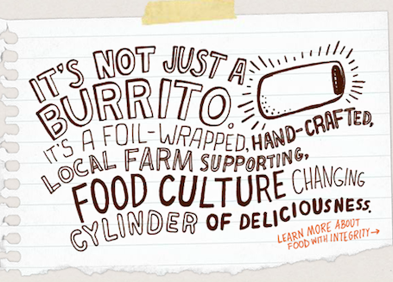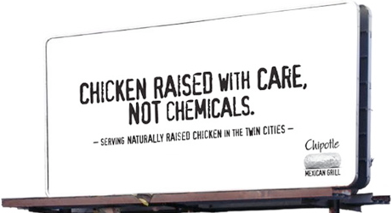
Figure 11 (Source: Ecosalon.com) Figure 12 (Source: Motherjones.com)
While this appeals to many demographics, it resonantly particularly well with millennials, who value their fresh, sustainable ingredients and in house food preparation. According to study conducted by YouGov, an international brand research firm, Chipotle is the most popular fast food chain with millennials in the US, garnering 18% of the total votes (YouGov). Furthering their appeal, they offer a tofu based “meat” option and their tortillas, vegetables, rice, beans, salsas, chips and guacamole are all vegan certified, making Chipotle a popular choice for Vegetarians (“Allergens”). While these sustainable, quality ingredients and focus on freshness are benefits customers’ value, they also cost Chipotle more. However, they are more than offset price premium they are able to charge versus other quick service restaurants. The average check price at Chipotle is around $10 while fast food restaurants average around $5 (Griswold). A senior restaurant financial analyst called Chipotle the “sweet spot of the restaurant industry” since they “use higher-quality ingredients than most fast-food chains do, they can draw in a more affluent clientele, even as their operating costs are still well below those of a traditional casual dining chain” (Griswold). As evidences by their revenue growth figures, customers are happy to pay for these benefits.
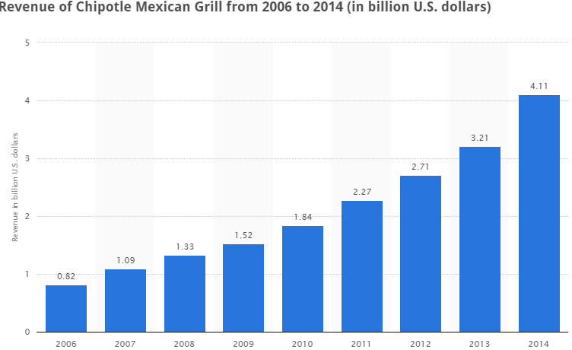
Figure 12 (Source: Statista)
With steady growth year after year Chipotle has gained a strong footing in the restaurant industry. For Chipotle their emphasis on fresh ingredients and responsible sourcing has certainly paid off. By increasing the demand for their sustainable products, leading the growing quick service market segment and creating benefits consumers are willing to pay a premium for, Chipotle is a prime model of how to create a strong competitive advantage through a sustainability strategy.

Conclusion
As seen in the examples above, investing in sustainability can create strong comparatives advantages for all businesses operating in the 21st century. By creating a strong value proposition for their customer and utilizing one or more of the following tactics the likelihood of success and sustained profit exponentially. By creating new market segments for sustainable products, companies offer their customers an alternative while allowing them to have a first mover advantage in a nascent market. By increasing demand for their innovative and improved sustainable products, businesses are able to capture market share from their competitors while decreasing the environmental impact of their product. By creating customer benefits that costumers are willing to pay a premium for, companies increase the profitability of their brands while simultaneously fulfilling the changing needs of their customers. Finally, by investing in a one-time capital expenditure that benefits the firm, such as improved brand equity, companies are able to leverage their customer perception in the future.
When businesses can create a win/win/win situation for themselves, the consumer, and the environment, success is almost guaranteed. These mutually beneficial situations are the key to driving the growth of a sustainability focused strategies in the business environment. As the consumer demand for sustainable products continues to rise and environment and resources become more strained in the future, sustainability will not just be an option it will be required for long term business success.

Works Cited
"1% for the Planet." Patagonia. N.p., n.d. Web. 3 Dec. 2015. <https://www.patagonia.com/us/patagonia.go?assetid=81218>.
"About Greenwashing." Greenwashing Index. N.p., n.d. Web. 03 Dec. 2015. <http://www.greenwashingindex.com/about-greenwashing/>.
“Allergens” Chipotle. N.p., n.d. Web. 3 Dec. 2015. <https://chipotle.com/allergens>
"Annual Report 2014." Patagonia Annual Benefit Corporation Report (2013): 1-42. Patagonia. Web. 3 Dec. 2015. <http://www.patagonia.com/pdf/en_US/bcorp_annual_report_2014.pdf>.
Amed, Imran. "Stella McCartney: Change Agent." BusinessofFashion.com. Business of Fasion, 29 Mar. 2015. Web. 3 Dec. 2015. <http://www.businessoffashion.com/articles/people/stella-mccartney-change-agent>.
Baylis, Bettina. "How Chipotle's 'Food with Integrity' Strategy Can Really Succeed." Triple Pundit People Planet Profit. N.p., 14 Oct. 2012. Web. 03 Dec. 2015. <http://www.triplepundit.com/2012/10/chipotle-food-with-integrity/>.
"B Corporation." Method Products, PBC. N.p., n.d. Web. 03 Dec. 2015. <https://www.bcorporation.net/community/method-products-pbc>.
Cariloha Bamboo. MEDIA KIT 2015. PW Companies. N.p., n.d. Web. 3 Dec. 2015. <http://www.pwcompanies.com/img/camediakit2015.pdf>.
“Carnitas” Chipotle. N.p., n.d. Web. 3 Dec. 2015. <http://chipotle.com/carnitas>
Consumers Union. "U.S. Car Owners' Perception of The Best Car Brands in Terms of Technology and Innovation as of December 15, 2013 (Index Score)."Statista - The Statistics Portal. Statista. 04 Dec 2015. <http://www.statista.com.proxy.lib.utk.edu:90/statistics/303737/us-car-owner-perception-of-best-car-brands-for-innovation/>
Davis-Peccoud, Jenny. "Sustainability Matters in the Battle for Talent." Harvard Business Review. N.p., 20 May 2013. Web. 03 Dec. 2015. <https://hbr.org/2013/05/sustainability-matters-in-the>.
The Department of Energy. Guide to Federal Financing for Energy Efficiency and Clean Energy Development. The United States Department of Energy, Sept. 2014. Web. 3 Dec. 2015. <http://www.energy.gov/public-services/funding-financing>
The Environmental Protection Agency. What Is the National Environmental Policy Act? N.p., n.d. Web. 3 Dec. 2015. <http://www2.epa.gov/nepa/what-national-environmental-policy-act>.
"Food with Integrity." Chipotle. N.p., n.d. Web. 3 Dec. 2015. <http://chipotle.com/food-with-integrity>.
"Frequently Asked Questions." Bamboo Central. Environmental Bamboo Foundation, n.d. Web. 3 Dec. 2015. <http://www.bamboocentral.org/shareinrepair/faq.htm>.
"Global Consumers Are Willing to Put Their Money Where Their Heart Is When It Comes to Goods and Services from Companies Committed to Social Responsibility." Nielsen Research. N.p., 17 June 2014. Web. 03 Dec. 2015. <http://www.nielsen.com/us/en/press-room/2014/global-consumers-are-willing-to-put-their-money-where-their-heart-is.html>.
"Green Building Facts." U.S. Green Building Council. N.p., 12 Feb. 2015. Web. 03 Dec. 2015. <http://www.usgbc.org/articles/green-building-facts>.
"Green Cleaners Take a Bite out of Grime." New Hope 360. Natural Foods Merchandiser, 24 Apr. 2008. Web. 3 Dec. 2015. <http://newhope360.com/news-amp-analysis/green-cleaners-take-bite-out-grime>.
Griswold, Alison. "Why Chipotle Customers Don’t Care About Rising Burrito Costs." Slate. N.p., n.d. Web. 03 Dec. 2015. <http://www.slate.com/blogs/moneybox/2014/05/19/chipotle_is_raising_prices_but_customers_don_t_care.html>.
Hill, Katie. "Super-brands Commit to Sustainability." The Consumer Goods Forum (n.d.): 1-40. Aug. 2014. Web. 3 Dec. 2015. <http://www.theconsumergoodsforum.com/files/Press_Clippings/The-Consumer-Goods-Forum-in_Nov-2014-Edition-of-PQ.pdf>.
Hotten, Russel. "Volkswagen: The Scandal Explained." BBC News. N.p., 4 Nov. 2015. Web. 03 Dec. 2015. <http://www.bbc.com/news/business-34324772>.
“Infinity Mile Warranty.” Tesla. N.p., n.d. Web. 03 Dec. 2015. <https://www.teslamotors.com/blog/infinite-mile-warranty>.
"Ingredients." Method. N.p., n.d. Web. 3 Dec. 2015. <http://methodhome.com/beyond-the-bottle/ingredients/>.
Ionescu-Somers, Aileen. "How Nestlé Dealt with a Social Media Campaign against It " Financial Times. N.p., 3 Dec. 2012. Web. 03 Dec. 2015. <http://www.ft.com/cms/s/0/90dbff8a-3aea-11e2-b3f0-00144feabdc0.html>.
Kim, Sun. "Federal LEED Certified Buildings Increase over 50 Percent." ZD Net. N.p., 12 Oct. 2012. Web. 3 Dec. 2015. <htttp://www.zdnet.com%2Farticle%2Ffederal-leed-certified-buildings-increase-over-50-percent%2F>.
Kurtz, Rod. "A Soap Maker Sought Compatibility in a Merger Partner." The New York Times. The New York Times, 16 Jan. 2013. Web. 03 Dec. 2015. <http://www.nytimes.com/2013/01/17/business/smallbusiness/a-founder-of-the-soap-maker-method-discusses-its-sale.html?_r=0>.
"Kyoto Protocol." Kyoto Protocol. The United Nations, n.d. Web. 03 Dec. 2015. <http://unfccc.int/kyoto_protocol/items/2830.php>.
Lolli, Alessandra. "Stella McCartney: Fashion And Sustainability." FG MAGAZINE. N.p., 13 May 2013. Web. 03 Dec. 2015. <http://www.thefashionglobe.com/stella-mccartney-sustainable>.
"Market Share of the Leading Soap and Cleaning Compound Manufacturing Companies in The U.S. in 2011." Statista - The Statistics Portal. Statista. 04 Dec 2015. <http://www.statista.com.proxy.lib.utk.edu:90/statistics/251341/market-share-of-the-leading-soap-and-cleaning-companies-in-the-us/ >
Marrati, Jessica. "Behind the Label: Chipotle, Food With Integrity." Ecosalon.com. N.p., 15 Feb. 2012. Web. 3 Dec. 2015. <http://ecosalon.com/behind-the-label-chipotle-food-with-integrity/>
"Materials." Stellamccartney. Stella McCartney, n.d. Web. 3 Dec. 2015. <http://www.stellamccartney.com/experience/us/material/>.
Muller, Joann. "How GM Makes $1 Billion A Year By Recycling Waste." Forbes. Forbes Magazine, 21 Feb. 2014. Web. 03 Dec. 2015. <http://www.forbes.com/sites/joannmuller/2013/02/21/how-gm-makes-1-billion-a-year-by-recycling-waste/>.
Nidumolu, Ram, C.K. Prahalad, and M.R. Rangaswami. "Why Sustainability Is Now the Key Driver of Innovation." Harvard Business Review. N.p., 01 Sept. 2009. Web. 03 Dec. 2015. <https://hbr.org/2009/09/why-sustainability-is-now-the-key-driver-of-innovation>.
"Ocean Plastic." Method. N.p., n.d. Web. 3 Dec. 2015. <http://methodhome.com/beyond-the-bottle/ocean-plastic/>.
"Our Business." Method. N.p., n.d. Web. 3 Dec. 2015. <http://methodhome.com/beyond-the-bottle/our-business/>.
Outdoor Industry Association. "Outdoor Product Attributes Consumers Are Willing to Pay More for in The United States in 2014." Statista - The Statistics Portal. Statista. 04 Dec 2015. <http://www.statista.com.proxy.lib.utk.edu:90/statistics/385795/outdoor-product-attributes-consumers-are-willing-to-pay-more-for-us/>
“Packaging”. N.p.: Packaging, n.d. Method. Web. 03 Dec. 2015. <http://methodhome.com/beyond-the-bottle/packaging/>.
Pellisier, Hank. "Bamboo: The Future's Favorite Plant." World Future Society. N.p., 26 May 2011. Web. 3 Dec. 2015. <http://www.wfs.org/content/bamboo-futures-favorite-plant>.
"Powerwall." Tesla. N.p., n.d. Web. 03 Dec. 2015. <https://www.teslamotors.com/POWERWALL>.
"Product and Services Segmentation of U.S. Soap and Cleaning Compound Manufacturing Industry in 2011." Statista - The Statistics Portal. Statista. 04 Dec 2015. <http://www.statista.com.proxy.lib.utk.edu:90/statistics/251311/products-segmentation-of-us-cleaning-compound-manufacturing-industry/>
"Q&A with Stella." Stellamccartney. Stella McCartney, n.d. Web. 3 Dec. 2015. <http://www.stellamccartney.com/experience/us/sustainability/our-commitment/qa-with-stella/>.
Rawsthorn, Alice. "The Electric Car and the Road Not Taken." The New York Times. The New York Times, 25 Oct. 2009. Web. 03 Dec. 2015. <http://www.nytimes.com/2009/10/26/arts/26iht-design26.html?_r=0>
"Restaurant Visit: Number of People Who Visited Chipotle for Dinner within The Last 30 Days in The United States (Usa) from Autumn 2009 to Spring 2015 (in Millions)." Statista - The Statistics Portal. Statista. 04 Dec 2015. <http://www.statista.com.proxy.lib.utk.edu:90/statistics/231016/people-who-visited-chipotle-for-dinner-usa/>
"Revenue of The Soap and Cleaning Compound Manufacturing Industry in The United States from 2007 to 2016 (in Million U.S. Dollars)."Statista - The Statistics Portal. Statista. 04 Dec 2015. <http://www.statista.com.proxy.lib.utk.edu:90/statistics/251356/revenue-of-the-cleaning-compound-manufacturing-industry-in-the-us/>
Richard, Michael. "Tesla's 2017 Mass-market EV to Be Called 'Model 3', Roadster to Be Upgraded to 400 Miles Range." Treehugger. N.p., 16 July 2014. Web. 3 Dec. 2015. <http://www.treehugger.com/cars/teslas-2017-mass-market-ev-be-called-model-3-roadster-be-upgraded-400-miles-range.html>.
Ruisinko, Cathy A. "Green Manufacturing: An Evaluation of Environmentally Sustainable Manufacturing Practices and Their Impact on Competitive Outcomes." IEEE TRANSACTIONS ON ENGINEERING MANAGEMENT 54.3 (2007): 445-53. Apr. 2007. Web. 3 Dec. 2015.
Ruiz, Brandon “Car and Automobile Manufacturing in the US.” IbisWorld. September 2015 Web. 3 Dec. 2015.
Shayon, Sheila. "P&G Boosts Tide Coldwater Eco-Benefits for Home and Professional Use." Brandchannel. N.p., 13 Oct. 2014. Web. 03 Dec. 2015. <http://brandchannel.com/2014/10/13/pg-boosts-tide-coldwater-eco-benefits-for-home-and-professional-use/>.
"State of the Industry." (n.d.): n. pag. OTA. Organic Trade Association. Web. 3 Dec. 2015. <http://ota.com/sites/default/files/indexed_files/StateOfOrganicIndustry_0.pdf>.
Stock, Kyle. "Patagonia's 'Buy Less' Plea Spurs More Buying." Bloomberg.com. Bloomberg, 28 Aug. 2013. Web. 03 Dec. 2015. <http://www.bloomberg.com/bw/articles/2013-08-28/patagonias-buy-less-plea-spurs-more-buying>.
“Software Updates.” Tesla. N.p., n.d. Web. 03 Dec. 2015. <https://www.teslamotors.com/support/software-updates>
“Tesla’s Closed Loop Battery Recycling Program.” Tesla. N.p., n.d. Web. 03 Dec. 2015. <https://www.teslamotors.com/blog/teslas-closed-loop-battery-recycling-program>
"Tesla Model S Outsold Mercedes-Benz S-Class, BMW 7 Series, Audi A8, Lexus Ls and Porsche Panamera." Tesla.com. N.p., 17 Jan. 2014. Web. 3 Dec. 2015.
<http://www.energy.gov/sites/prod/files/2014/10/f18/Federal%20Financing%20Guide%2009%2026%2014.pdf>.
"US GDP." World Bank. N.p., n.d. Web. 04 Dec. 2015. <http://data.worldbank.org/indicator/NY.GDP.MKTP.CD>.
The White House. Office of the Press Secretary. White House Announces Commitments to the American Business Act on Climate Pledge. The White House. The White House, 19 Oct. 2015. Web. 03 Dec. 2015. <https://www.whitehouse.gov/the-press-office/2015/10/19/fact-sheet-white-house-announces-commitments-american-business-act>.
"Working with Factories." Patagonia. Patagonia, n.d. Web. 3 Dec. 2015. <http://www.patagonia.com/us/patagonia.go?assetid=67583>.
YouGov. "Which Global Fast Food Chain Is Your Overall Favorite?." Statista - The Statistics Portal. Statista. 04 Dec 2015. <http://www.statista.com.proxy.lib.utk.edu:90/statistics/326730/most-popular-global-fast-food-chains-millennials-us/>

