Understanding the Applications of Tetflupyrolimet in Turfgrass Systems

A Dissertation Presented for the

Doctor of Philosophy

Degree

The University of Tennessee, Knoxville

Benjamin Donnelly Pritchard

May 2025

Copyright © 2025 by Benjamin D Pritchard
All rights reserved.

ACKNOWLEDGEMENTS
The journey of earning a graduate degree is filled with challenges, growth, and gratitude, and I am immensely thankful to those who have supported me throughout my time at the University of Tennessee. To my parents, Daryl & Beverly Pritchard, my sisters, Ellie & Jennie Pritchard, and my extended family, including Bill Hill and Becky Dearmond, your steadfast encouragement and belief in me throughout my life have been the foundation of my success, enabling me to pursue my dreams and achieve my goals. I am deeply grateful for your love and support. A special thanks to my advisor, Dr. Brosnan, who chose to mentor “Young Ben” during undergrad and whose faith in my abilities led me to grow in to the turfgrass weed scientist I am today. You continually provided me with opportunities to grow and excel in the field of turfgrass management while being a steadfast mentor through it all. Being part of your lab and cutting-edge research has been an honor and privilege. I look forward to building upon this foundation in my career. I also extend my gratitude to my committee members, Travis Gannon, David Butler, and Becky Bowling, for their invaluable guidance and support throughout this journey. To the UT Turfgrass Team, including Greg Breeden, Javier Vargas, Taylor Williams, Tyler Carr Ph.D., Kyley Dickson Ph.D., and Bill Czekai, thank you for your mentorship, assistance, and camaraderie, which have been essential to my academic and personal development. I am also thankful for the incredible friends and special people I have met along the way: Caitlin Dalton, Brooke Keadle, Robert Petursson, Dillon McCallum, Maureen Kahiu, Luke Edwards, Delaina McDonald, Alexis Walsh, Will Burgess, Eleanor Tant, Jack Oberman, and Hunter Hammock—your companionship and encouragement have enriched my life beyond measure. Lastly, a special mention to my loyal companion, Lyla Mae, whose presence has been a constant source of joy and comfort, reminding me to smile through challenges and cherish each moment. As Albert Einstein wisely stated, "If we knew what it was we were doing, it would not be called research, would it?"—a sentiment that I clung to throughout this challenging yet rewarding journey. Again, thank you all, and as always, onwards and upwards!

ABSTRACT
Tetflupyrolimet, a new herbicide developed by FMC Corporation, targets dihydroorotate dehydrogenase (DHODH), effectively inhibiting de novo pyrimidine biosynthesis in various grass species. This dissertation synthesizes findings from field, greenhouse, and laboratory trials conducted between 2021 and 2024, aimed at better understanding the applications of tetflupyrolimet in turfgrass systems. First, this included assessing turfgrass tolerance to tetflupyrolimet in controlling problematic species such as Poa annua and smooth crabgrass (Digitaria ischaemum). Five turfgrass species relevant to Tennessee were assessed at cutting heights ranging from 3.8 to 12.5 mm across different seasons, revealing that warm-season turfgrasses exhibited no adverse effects to as high as 3200 g ha⁻¹. Response of cool-season grasses varied with an overall trend for cool-season species to be more tolerant to applications made in spring than fall. Efficacy for preemergence (PRE) control of smooth crabgrass fluctuated yearly, but tetflupyrolimet (400 g ha⁻¹) in mixture with pyroxasulfone (128 g ha⁻¹) and rimsulfuron (35 g ha⁻¹) proved effective in controlling herbicide-resistant Poa annua. Additionally, research was conducted to understand the influence of soil texture on tetflupyrolimet activity, revealing significant variations in efficacy between sandy versus clay loam soils, with higher effectiveness with applications made to the coarser textured medium. Data collected suggest that matric potential differences amongst soil-types may explain this response with water being more accessible to seedling weeds in coarser textured mediums with overall moisture content is fixed across soil types. Offering tetflupyrolimet application rates based on soil texture may enhance herbicide performance under various soil-moisture conditions. Furthermore, the lateral movement of tetflupyrolimet was investigated under field capacity and saturated soil-conditions. Regardless of soil moisture content, tetflupyrolimet maximum lateral movement was limited to 1.1 meters, significantly less than pronamide exhibited greater mobility. This experiment indicated that maintaining a buffer of at least 1.1 meters from sensitive grass species could minimize the risk of non-target effects of tetflupyrolimet applications in turfgrass. Overall, the studies support tetflupyrolimet use in turfgrass management, giving managers a novel tool in mitigating herbicide resistance within the troublesome grassy weed, Poa annua.

TABLE OF CONTENTS
Introduction 1
Chapter I Turfgrass Tolerance to Tetflupyrolimet Applications for Preemergence Grassy Weed Control 2
Abstract 4
Introduction 4
Materials and Methods 6
Turfgrass Tolerance 6
Controlling Herbicide-Resistant Poa annua 8
Controlling Smooth Crabgrass 10
Results and Discussion 10
Turfgrass Tolerance 10
Controlling Herbicide-Resistant Poa annua 12
Controlling Smooth Crabgrass 13
Conclusions 14
References 15
Appendix 19
Chapter II Soil Texture Effects on Tetflupyrolimet Efficacy in Turfgrass 26
Abstract 28
Introduction 28
Materials and Methods 30
Soil Selection 30
Dose Reponse Studies 30
Soil Moisture Effects on Tetflupyrolimet 32
Results and Discussion 32
Soil-Type Dose Response 32
Soil-Moisture Impacting Tetflupyrolimet Efficacy 33
Conclusions 34
References 35
Appendix 39
Chapter III Downslope Lateral Movement of Tetflupyrolimet and Pronamide in Turfgrass 46
Abstract 48
Introduction 48
Materials and Methods 50
Site Preparation 50
Downslope Lateral Movement 50
Experimental Design 51
Data Analysis 51
Results and Discussion 52
Conclusions 54
References 55
Appendix 57
Vita 63

LIST OF TABLES
Table 1.1. Growing conditions during fall and spring experiments evaluating tolerance of five turfgrass species to tetflupyrolimet (Dodhylex™ Active. FMC Corporation. Philadelphia, PA) conducted in Knoxville, TN. Fall experiments were initiated on 28 September 2022 and 30 September 2023. Spring experiments were initiated on 28 February 2023 and 29 February 2024. In all studies, data were collected for 180 days. All weather data obtained from the mesur.io Earthstream® platform (mesur.io, Yanceyville, NC). 19
Table 1.2. Physical and chemical properties of the soils in place for all experimental trial work evaluating efficacy and tolerance of tetflupyrolimet (Dodhylex™ Active. FMC Corporation. Philadelphia, PA) at Montgomery Bell State Park Golf Course (Burns, TN) and the East Tennessee Research and Education Center (ETREC) – Plant Science Unit (Knoxville, TN). 20
Table 1.3. Rate of tetflupyrolimet (Dodhylex™ Active. FMC Corporation. Philadelphia, PA) to induce 25% injury (EC₂₅) at 95 days after treatment on Kentucky bluegrass (Poa pratensis L., cv., ‘HGT’), creeping bentgrass (Agrostis stolonifera L., cv. ‘L-93XD’), and tall fescue (Festuca arundinacea Schreb., cv. ‘Lebanon Winning Colors Plus’) during fall and spring. Fall tolerance experiments were initiated on 28 September 2022 and 30 September 2023, while spring experiments were initiated on 28 February 2023 and 29 February 2024. All studies were collected at the East Tennessee AgResearch and Education Center – Plant Sciences Unit (Knoxville, TN). 21
Table 1.4. Poa annua control with PRE and early postemergence (EPOST) applications of tetflupyrolimet (Dodhylex™ Active. FMC Corporation. Philadelphia, PA) alone and in mixtures. Applications made to a hybrid bermudagrass (C. dactylon x C. transvaalensis, cv. ’Tifway’) golf course fairway at Montgomery Bell State Park Golf Course (Burns, TN) infested with herbicide-resistant Poa annua. 24
Table 1.5. Smooth crabgrass (Digitaria ischaemum) control with PRE applications of tetflupyrolimet (Dodhylex™ Active. FMC Corporation. Philadelphia, PA) compared to industry standards. Applications made to a bermudagrass (Cynodon dactylon, cv. ’Yukon’) stand, maintained as a golf course fairway at East Tennessee Research and Education Center – Plant Science Unit (Knoxville, TN). 25
Table 2.1. Physical and chemical properties of soils used in glasshouse and laboratory experiments exploring effects of various edaphic factors on tetflupyrolimet (Dodhylex™ Active) efficacy for grassy weed control. Organic matter, total exchange capcity, and pH analyses conducted by Brookside Laboratories (New Bremen, OH). Soil texture, porosity, and saturated hydraulic conductivity analyses conducted by A. McNitt & SerenSoil (State College, PA). 39
Table 2.2. Nutrient analyses of soils used in glasshouse and laboratory experiments exploring effects of various edaphic factors on tetflupyrolimet (Dodhylex™ Active) efficacy for grassy weed control. Analysis was conducted by Brookside Laboratories (New Bremen, OH). 41
Table 2.3. Conditions inside glasshouses during dose response experiments evaluating efficacy of tetflupyrolimet (Dodhylex™ Active) for preemergence control of herbicide-susceptible Poa annua L. in two soil types. Experiments conducted in Knoxville, TN (35.94 N, -83.93 W) during spring 2023. 43
Table 2.4. Rate of tetflupyrolimet (Dodhylex™ Active. FMC Corporation. Philadelphia, PA) to achieve 90% Poa annua control or 90% reductions in Poa annua biomass (EC₉₀) in glasshouse experiments conducted in Knoxville, TN (35.94 N, -83.93 W) during spring 2023. 44
Table 3.1. Physical and chemical properties of the native soil on the sloped (9.5%) hybrid bermudagrass (C. dactylon L. Pers. x C. transvaalensis Burtt-Davy) plot where tetflupyrolimet (Dodhylex™ Active) was evaluated for downslope lateral movement compared to pronamide. Experiments were conducted at the North Carolina State University Lake Wheeler Turfgrass Field Lab (Raleigh, NC). Soil analyses were conducted by Brookside Laboratories (New Bremen, OH). 57
Table 3.2. Statistical parameters for predicting the lateral movement distance of herbicides in perennial ryegrass at 8 weeks after treatment under field capacity or saturated soil-moisture conditions at NC State University Lake Wheeler Turfgrass Center Raleigh, NC, following applications of tetflupyrolimet (400 g ha⁻¹) and pronamide (1160 g ha⁻¹). Injury₅₀ is thelateral movement distance corresponding to a 50% probability of perennial ryegrass injury. 58

LIST OF FIGURES
Figure 1.1. Dose response curves for Kentucky bluegrass (Poa pratensis L., cv., ‘HGT’), creeping bentgrass (Agrostis stolonifera L., cv. ‘L-93XD’), and tall fescue (Festuca arundinacea Schreb., cv. ‘Lebanon Winning Colors Plus’) treated with increasing rates of tetflupyrolimet (Dodhylex™ Active. FMC Corporation. Philadelphia, PA). Panels A and B present responses from applications made in fall of 2022 and 2023, respectively, in Knoxville, TN. Panels C and D present responses from applications made in spring of 2023 and 2024, respectively, in Knoxville, TN. 22
Figure 1.2. Temperature based growth potential (%) for cool-season turfgrasses during trials evaluating tolerance to increasing rates of tetflupyrolimet (Dodhylex™ Active. FMC Corporation. Philadelphia, PA) at East Tennessee Research and Education Center – Plant Science Unit (Knoxville, TN) in fall and spring. Fall tolerance trials on these cool-season grasses were initiated on 28 September 2022 and 30 September 2023; spring tolerance trials were initiated on 28 February 2023 and 29 February 2024. Panel A presents growth potential (%) three months prior to and after applications of tetflupyrolimet in fall 2022 and 2023; Panel B presents growth potential (%) three months prior to and after applications of tetflupyrolimet in spring 2023 and 2024. 23
Figure 2.1. Soil moisture retention curves for the two soils used in in glasshouse and laboratory experiments exploring effects of various edaphic factor on tetflupyrolimet (Dodhylex™ Active) efficacy for grassy weed control. Soil moisture retention curves generated by Turf & Soil Diagnostics (Trumansburg, NY) using ASTM D6836. Data were fit to a one-phase exponential decay model in GraphPad Prism (v.10.1.1. Graphpad Prism. LaJolla, CA) and compared using a global sums-of-squares F-test at α = 0.05. 40
Figure 2.2. Poa annua control (A) and aboveground biomass (B) response to increasing doses of tetflupyrolimet (Dodhylex™ Active, FMC Corporation, Philadelphia, PA) applied preemergence to herbicide susceptible Poa annua planted in a sand that conformed to United States Golf Association specifications, as well as a clay loam soil native to Knoxville, TN. Edaphic factors for each soil type are presented in Table 2.1. Bars represent standard error of each mean. 42
Figure 2.3. Effect of tetflupyrolimet (50 g ha⁻¹) on perennial ryegrass (Lolium perenne L.) germination in clay loam soil or sand varying in moisture content during repeated growth chamber experiments conducted in Knoxville, TN during 2024. Bars represent standard error of each mean. 45
Figure 3.1. Lateral movement assessment of perennial ryegrass (Lolium perenne L.) mortality (within 15 cm² grids) at 8 weeks after treatment (WAT) in 2023 under field capacity soil-moisture conditions at NC State University Lake Wheeler Turfgrass Center Raleigh, NC, following applications of tetflupyrolimet (400 g ha⁻¹) and pronamide (1160 g ha⁻¹). Data was analyzed and then presented using heat maps created in Prism (Version 10.2.3. GraphPad Prism. Boston, MA, USA). Solid lines represent the mean distances for 50% likelihood of perennial ryegrass mortality (Mortality₅₀) and dashed lines represent 95% confidence intervals. Treatments are not significantly different if Mortality₅₀ confidence intervals are overlapping. 59
Figure 3.2. Lateral movement assessment of perennial ryegrass (Lolium perenne L.) (within 15 cm² grids) mortality at 8 weeks after treatment (WAT) in 2024 under field capacity soil-moisture conditions at NC State University Lake Wheeler Turfgrass Center Raleigh, NC, following applications of tetflupyrolimet (400 g ha⁻¹) and pronamide (1160 g ha⁻¹). Data was analyzed and then presented using heat maps created in Prism (Version 10.2.3. GraphPad Prism. Boston, MA, USA). Solid lines represent the mean distances for 50% likelihood of perennial ryegrass mortality (Mortality₅₀) and dashed lines represent 95% confidence intervals. Treatments are not significantly different if Mortality₅₀ confidence intervals are overlapping. 60
Figure 3.3. Lateral movement assessment of perennial ryegrass mortality (within 15 cm² grids) at 8 weeks after treatment in 2023 under saturated soil-moisture conditions at NC State University Lake Wheeler Turfgrass Center Raleigh, NC, following applications of tetflupyrolimet (400 g ha⁻¹) and pronamide (1160 g ha⁻¹). Data was analyzed and then presented using heat maps created in Prism (Version 10.2.3. GraphPad Prism. Boston, MA, USA). Solid lines represent the mean distances for 50% likelihood of perennial ryegrass mortality (Mortality₅₀) and dashed lines represent 95% confidence intervals. Treatments are not significantly different if Mortality₅₀ confidence intervals are overlapping. 61
Figure 3.4. Lateral movement assessment of perennial ryegrass (Lolium perenne L.) mortality (within 15 cm² grids) at 8 weeks after treatment in 2024 under saturated soil-moisture conditions at NC State University Lake Wheeler Turfgrass Center Raleigh, NC, following applications of tetflupyrolimet (400 g ha⁻¹) and pronamide (1160 g ha⁻¹). Data was analyzed and then presented using heat maps created in Prism (Version 10.2.3. GraphPad Prism. Boston, MA, USA). Solid lines represent the mean distances for 50% likelihood of perennial ryegrass mortality (Mortality₅₀) and dashed lines represent 95% confidence intervals. Treatments are not significantly different if Mortality₅₀ confidence intervals are overlapping. 62

INTRODUCTION
This dissertation is structured into three peer-reviewed journal articles, each serving as a chapter within the document. As such, it does not include a stand-alone literature review. Instead, the relevant literature and foundational content have been integrated into the introduction sections of each respective chapter, providing the necessary context and background integral to understanding the research presented. This approach ensures that each chapter has the appropriate material relevant to the experiments contained within and allows it to be ready for submission to academic journals.

CHAPTER I
Turfgrass Tolerance to Tetflupyrolimet Applications for Preemergence Grassy Weed Control

A version of this chapter was originally published online 20 December 2024 and print in 2025 by Benjamin D. Pritchard, Greg K. Breeden, Rebecca G. Bowling, Travis W. Gannon, Kendall C. Hutto, and James T. Brosnan:
Pritchard BD, Breeden GK, Bowling RG, Gannon TW, Hutto KC, & Brosnan JT (2025). Turfgrass Tolerance to Tetflupyrolimet Applications for Preemergence Grassy Weed Control. Weed Science, 73, e17. doi:10.1017/wsc.2024.97
The publishing of this article involved an extensive peer-review process that improved the quality of the manuscript and allowed the authors to develop deeper hypotheses, arguments, and quality research methodology. The publishing of this article involved six authors from the University of Tennessee Department of Plant Sciences, North Carolina State University Department of Crop and Soil Science, and FMC Global Specialty Solutions. All authors made conceptual or technical contributions relative to their area of expertise. My primary contributions to this paper include (i) reading literature, (ii) writing the manuscript, (iii) conducting the research, (iv) analysing data, and (v) revising during the review process.

Abstract

Tetflupyrolimet (Dodhylex™ Active. FMC Corporation) is a novel herbicide inhibiting de novo pyrimidine biosynthesis that controls grassy weeds preemergence in rice (Oryza sativa L.) production. Field trials were conducted from 2021-2024 to evaluate turfgrass tolerance to tetflupyrolimet applications for annual bluegrass (Poa annua L.) and smooth crabgrass [Digitaria ischaemum (Schreb.) Schreb. ex Muhl.] control. Tolerance was evaluated on seven turfgrass species, including creeping bentgrass (Agrostis stolonifera L.), Kentucky bluegrass (Poa pratensis L.), tall fescue (Festuca arundinacea Schreb.), hybrid bermudagrass [C. dactylon (L.) Pers. x C. transvaalensis Burtt-Davy], and manilagrass (Zoysia matrella L. Merr.) at various mowing heights ranging from 3.8 to 12.5 mm. Separate experiments were conducted on each turfgrass species to evaluate tolerance in both fall and spring. Tetflupyrolimet was applied at rates of 0, 25, 50, 100, 200, 400, 800, 1600, 3200, or 6400 g ha⁻¹. No injury was observed on any warm-season turfgrass species in either season, whereas cool-season grass tolerance varied among species each season; however, cool-season turfgrass tolerance for all species was greater in spring than fall. While efficacy of tetflupyrolimet (400 g ha⁻¹) for PRE smooth crabgrass control varied among years, mixtures of tetflupyrolimet (400 g ha⁻¹), pyroxasulfone (128 g ha⁻¹), and rimsulfuron (35 g ha⁻¹) applied PRE or early POST effectively controlled multiple resistant Poa annua in both seasons. Overall, these findings highlight that warm-season turfgrasses are highly tolerant of tetflupyrolimet applications for Poa annua or smooth crabgrass control.

Introduction

Tetflupyrolimet is a novel mode-of-action herbicide inhibiting de novo pyrimidine biosynthesis, a process essential to the production of both DNA and RNA, as well as phospholipids and glycoproteins (Kang et al. 2023). Tetflupyrolimet binds to dihydroorotate dehydrogenase (DHODH), an enzyme located on the outer surface of the inner mitochondrial membrane (Reis et al. 2017), impeding ubiquinone-mediated oxidation of dihydroorate to orotate (Zrenner et al. 2006).
Pyrimidine biosynthesis via DHODH inhibition has been explored as a treatment for both cancers and viruses that are characterized by rapid cell proliferation (Zhou et al. 2021; Luban et al. 2021). Human inhibitors of DHODH are ineffective on plant-DHODH due to differences in amino acid sequence and structure that affect binding (Ullrich et al. 2002). For example, DHODH sequences from Homo sapiens and Arabidopsis thaliana were only 63.6% similar (Ullrich et al. 2002). In regards to tetflupyrolimet, Kang et al. (2023) reported in vitro I₅₀ values of 4.3 and 380 nM for Setaria italica and Homo sapiens, respectively. Similarly, fungicides targeting DHODH, particularly ipflufenoquin, have little effect on pyrimidine biosynthesis in plants given less than 40% sequence identity between orthologs from Setaria italica and fungal pathogens such as Aspergillus fumigatus or Cryptococcus spp. (Kang et al. 2023). In the field, ipflufenoquin exhibits no efficacy for weed control and tetflupyrolimet exhibits no efficacy against Aspergillus fumigatus (Kang et al. 2023; van Rhijn et al. 2024).
Tetflupyrolimet is an effective preemergence (PRE) herbicide to control troublesome grass weeds in rice (Oryza sativa L.), particularly barnyardgrass [Echinochloa crus-galli (L.) P. Beauv.] and junglerice [Echinochloa colona (L.) Link] (Castner et al. 2024a; Whitt et al. 2024). In rice, tetflupyrolimet has been mixed with other active ingredients (e.g., clomazone) to expand weed control spectrum, particularly versus dicot weeds (Acrement 2024a). However, a mixture of tetflupyrolimet and saflufenacil (70 g ha⁻¹) was antagonistic on spreading dayflower [Commelina diffusa Burm. f.]. When applied to silt loam, carryover potential with tetflupyrolimet is low (Castner et al. 2024b), in part due to its chemical properties [pKa = 12.8, K_{SP} = 4.7 mg L⁻¹, K_{OC} = 658 to 1131 mL g⁻¹ (A. Puri, personal communication)].
Similar to Echinochloa spp. in rice, herbicide resistance in Poa annua populations of turfgrass is widespread (Heap 2024; Brosnan et al. 2020a). A national survey of herbicide resistance within Poa annua populations of turfgrass reported that 42% of 1,349 populations collected exhibited putative resistance to at least one mode-of-action (McCurdy et al. 2023). At the state level, 25% of Poa annua collected from golf courses across Tennessee was resistant to at least two herbicides (Brosnan et al. 2020b), with certain populations resistant to multiple mode-of-action groups including HRAC Groups #2, #3, #5, #29 (Brosnan et al. 2020c). Similar to previous reports in commodity agriculture (Schroeder et al. 2018), there is a strong desire amongst turfgrass managers for new herbicides to control herbicide-resistant Poa annua (Allen et al. 2022), particularly in the southeastern United States where the issue is most prevalent (McCurdy et al. 2023; Rutland et al. 2023).
The first novel mode-of-action commercialized in decades, tetflupyrolimet could provide turfgrass managers a valuable tool for managing herbicide resistance in Poa annua. However, there is minimal information available regarding the tolerance of commonly used warm- and cool-season turfgrass to tetflupyrolimet applications for controlling Poa annua and Digitaria spp., which are both regarded as troublesome grassy weeds (Van Wychen 2020). This paper presents the results of several replicated trials conducted in Tennessee with a central objective of evaluating turfgrass tolerance and weed control efficacy following tetflupyrolimet applications for grassy weed control in fall and spring.
Materials and Methods

Turfgrass Tolerance
Field experiments to evaluate the tolerance of five turfgrass species to tetflupyrolimet (Dodhylex™ Active. FMC Corporation. Philadelphia, PA) were conducted at the East Tennessee AgResearch and Education Center – Plant Sciences Unit (Knoxville, TN) during both fall and spring. Experiments exploring turfgrass tolerance to tetflupyrolimet in fall were initiated on 28 September 2022 and 30 September 2023. Experiments exploring turfgrass tolerance to tetflupyrolimet in spring were initiated on 28 February 2023 and 29 February 2024. Plots (1.2 by 1.2 m) in all studies were arranged in a randomized complete block design with four replications. Growing conditions during these experiments are presented in Table 1.1 (All tables and figures can be found in the appendix at the end of the chapter).
Separate experiments were conducted on cool- and warm-season turfgrass species commonly used on golf courses throughout the United States (Shaddox et al. 2023). These species included Kentucky bluegrass (Poa pratensis L., cv., ‘HGT’), creeping bentgrass (Agrostis stolonifera L., cv. ‘L-93XD’), tall fescue (Festuca arundinacea Schreb., cv. ‘Lebanon Winning Colors Plus’), manilagrass (Zoysia matrella L. Merr., cv. ‘Trinity’) and hybrid bermudagrass [C. dactylon (L.) Pers. x C. transvaalensis Burtt-Davy, cv. ‘Latitude 36’]. These species were established atop a clay loam (fine-loamy, siliceous, semiactive, thermic humic Hapludult) that is characterized in detail in Table 1.2.
The Kentucky bluegrass and tall fescue sites were maintained with a rotary mower (ZTrak™ Z915E. John Deere. Moline, Il 1.5 cutting width) at 75 and 100 mm, respectively. Slow-release nitrogen (GAL-Xe^{ONE®} Polymer Coated Controlled Release Fertilizer. J.R. Simplot Company. Boise, ID) was applied to these sites at 73 kg N ha⁻¹ in spring and 49 kg N ha⁻¹ in fall. Cyazofamid (Segway® SC. PBI-Gordon Corporation. Shawnee, KS) was applied at 1150 g ha⁻¹ to the tall fescue site to manage Pythium aphanidermatum during summer both years. Once soil temperatures (5 cm depth) measured ≥ 18.3˚C, pyraclostrobin (Insignia® SC Intrinsic Brand Fungicide. BASF Corporation. Research Triangle Park, NC) was applied at 556 g ha⁻¹ every 28 d through August to manage Rhizoctonia solani. No other herbicides or plant growth regulators were applied to the tall fescue or Kentucky bluegrass sites throughout the experimental period.
The creeping bentgrass, manilagrass, and hybrid bermudagrass sites were maintained as golf course fairways using a reel mower (7700A PrecisionCut™. John Deere. Moline, Il 2.54 cutting width) at a 12.7 mm height of cut. All fairways received slow-release nitrogen (73 kg N ha⁻¹) in the spring. Additionally, creeping bentgrass received 12 kg N ha⁻¹ (Turf & Ornamentals™ 18 N – 3 P₂O_{5 –} 6 K₂O UMAXX®. J.R. Simplot Company. Boise, ID) from April through August, as well as 49 kg N ha⁻¹ (GAL-Xe^{ONE®} Polymer Coated Controlled Release Fertilizer. J.R. Simplot Company. Boise, ID) in the fall. Isofetamid (Kabuto® Fungicide SC. PBI-Gordon Corporation. Shawnee, KS) was applied at 4100 g ha⁻¹ on manilagrass and hybrid bermudagrass sites once soil temperatures (5 cm depth) were < 18.3˚C to prevent spring dead spot (Ophiosphaerella herpotricha). The creeping bentgrass site was treated with a preventative fungicide program that delivered two applications per month from April through August. Aluminum-tris (Signature™ XTRA Stressguard®. Envu Turf and Ornamentals. Cary, NC) and triadimefon1-(4-Chlorophenoxy)-3,3-dimethyl-1-(1H-1,2,4-triazol-1-yl)-2-butanone (Bayleton® Flo. Envu Turf and Ornamentals. Cary, NC) were applied in April and May at 1200 g ha⁻¹ and 1590 g ha⁻¹, respectively. Aluminum-tris (1200 g ha⁻¹) and cyazofamid (1150 g ha⁻¹) + a commercially formulated mixture of fluopyram + trifloxystrobin [Exteris® Stressguard®. Envu Turf and Ornamentals. Cary, NC (38.9 and 62.4 g ha⁻¹, respectively)] were applied in June, July, and August. No herbicides or plant growth regulators were applied to the creeping bentgrass, manilagrass, or hybrid bermudagrass sites throughout the experimental period.
Tolerance of manilagrass (cv. ‘Prizm’) and hybrid bermudagrass (cv. ‘Mach 1’) maintained as golf course putting greens was also evaluated in fall and spring each year. These species were maintained using a reel mower (Greensmaster® TriFlex™ 3300. The Toro Company. Bloomington, MN 1.5 m cutting width) at 3.8 mm on sand-based rootzones (Table 1.2). These sites received 12.2 kg N ha⁻¹ from a complete fertilizer (Turf & Ornamentals™ 18 N – 3 P₂O_{5 –} 6 K₂O UMAXX®. J.R. Simplot Company. Boise, ID) every 14 d from April through October each year. Both putting green sites were treated with a preventative fungicide program that delivered two applications per month. From April through August, commercially formulated mixtures of fluopyram (38.9 g ha⁻¹) + trifloxystrobin (62.4 g ha⁻¹) or pyraclostrobin (556 g ha⁻¹) + aluminum-tris (1200 g ha⁻¹) were applied, whereas cyazofamid (1150 g ha⁻¹) + aluminum-tris (1200 g ha⁻¹) or aluminum-tris (1200 g ha⁻¹) + commercially formulated mixture of benzovindiflupyr + difenoconazole [Ascernity®. Syngenta Crop Protection. Greensboro, NC (12.5 and 42.2 g ha⁻¹, respectively) was applied from September through November. No plant growth regulators were applied to the manilagrass or hybrid bermudagrass putting green sites.
In each experiment, turfgrass was subjected to increasing doses of tetflupyrolimet using a CO₂-pressurized sprayer at 374 L ha⁻¹ via flat-fan nozzle tips (XR8002. TeeJet Technologies. Wheaton, IL). Tetflupyrolimet (Dodhylex™ Active. FMC Corporation. Philadelphia, PA) application rates were 0, 25, 50, 100, 200, 400, 800, 1600, 3200, or 6400 g ha⁻¹. Overhead irrigation (5 mm) was applied within one hour of application in both fall and spring to ensure herbicide activation in the soil. Turfgrass injury was visually evaluated 14, 35, 95, and 180 days after treatment (DAT) relative to non-treated check plots (i.e., 0 g ha⁻¹ tetflupyrolimet) in each replication using a 0 (i.e., no phytotoxicity) to 100% (i.e., complete plant kill) scale.
Separate analyses were conducted to determine turfgrass tolerance to tetflupyrolimet in fall and spring on each species. Within a season (i.e., fall or spring trials), turfgrass injury data from a single species were subjected to combined analysis of variance (ANOVA) in R (v.4.2.2) using expected mean squares of McIntosh (1983) to determine if years could be combined. Non-linear regression analysis was conducted in GraphPad Prism (v.10.1.1. Graphpad Prism. LaJolla, CA) using injury data collected 95 DAT. An ‘EC anything’ model was used to calculate the dose of tetflupyrolimet required to generate 25% turfgrass injury (EC₂₅ values) on each turfgrass species in fall or spring. EC₂₅ values were compared using 95% confidence intervals.

Controlling Herbicide-Resistant Poa annua
Field experiments were conducted on a hybrid bermudagrass (cv. ’Tifway’) golf course fairway at Montgomery Bell State Park Golf Course (Burns, TN) during 2022 and 2023. Non-target site resistance is suspected in Poa annua from this location as resistance to multiple mode-of-action groups has been associated with elevated cytochrome P450 expression (E. Patterson and M. Mahey, personal communication). Hybrid bermudagrass at this location was maintained at 1.3 cm during periods of active growth each year. Plots (measuring 1.5 by 1.5 m) were arranged in a randomized complete block design with four replications. The soil series at this location was 9.6% Hawthorne (loamy-skeletal, siliceous, semiactive, thermic Typic Dystrudepts)–Sulphura (loamy-skeletal, siliceous, semiactive, thermic Typic Dystrudepts) association + 90.4% Sengtown gravelly silt loam (fine, mixed, semiactive, thermic Typic Paleudalfs) with a pH of 5.5 (Table 1.2). No supplemental nutrition was applied during the course of the study and the site was only irrigated via rainfall. This site received 70.4 cm of rainfall during the data collection period in 2022 compared to 63.7 cm in 2023.
A Poa annua emergence model developed by Taylor et al. (2021) was used to time PRE and early-postemergence (EPOST) herbicide applications each year. In 2022, treatments were applied PRE on 14 September and EPOST on 8 November. The 7-d average soil temperature (5 mm depth) on these dates was 23.6˚C and 17.1˚C, respectively. In 2023, treatments were applied PRE on 26 September and EPOST on 24 October. The 7-d average soil temperatures were 18.5˚C and 14.8˚C, respectively. No Poa annua plants were visible above the hybrid bermudagrass canopy when EPOST treatments were applied either year.
Herbicides were applied with a CO₂-pressurized sprayer at 374 L ha⁻¹ via flat-fan nozzle tips (XR8002. TeeJet Technologies, Wheaton, IL). Preemergence treatments included tetflupyrolimet at 400 g ha⁻¹, pyroxasulfone (Zidua SC. BASF Corporation. Research Triangle Park, NC) at 128 g ha⁻¹, tetflupyrolimet (400 g ha⁻¹) + pyroxasulfone (128 g ha⁻¹), and indaziflam (Specticle Flo. Envu Turf and Ornamentals. Cary, NC) at 45 g ha⁻¹. Early-postemergence treatments included tetflupyrolimet (400 g ha⁻¹), pyroxasulfone (128 g ha⁻¹), tetflupyrolimet + pyroxasulfone (400 g ha⁻¹ + 128 g ha⁻¹), and indaziflam + simazine (Princep 4FL. Syngenta Crop Protection. Greensboro, NC) + a commercially formulated mixture of thiencarbazone-methyl + foramsulfuron + halosulfuron (Tribute® Total. Envu Turf and Ornamentals. Cary, NC). Simazine and this commercially formulated mixture were combined with indaziflam (32.5 g ha⁻¹) at rates of 26.2 and 27.3 g ha⁻¹, respectively. All EPOST herbicide applications were mixed with a non-ionic surfactant (Induce. Helena Agri-Enterprises. Memphis, TN) at 0.25%.
Hybrid bermudagrass injury data were evaluated using a 0 (i.e., no control) to 100 (i.e., complete kill) percent scale relative to non-treated check plots in each replication. Poa annua control data were collected using a similar percentage-based scale at 11, 19, 23, and 27 weeks after initial treatment (WAIT) each year. Similar to turfgrass tolerance trials, a combined ANOVA using expected mean squares of McIntosh (1983) was conducted in R to determine if years could be combined. No significant year-by-treatment interactions were detected; therefore, the combined data set was subjected to ANOVA with means separated using the LSD.test function found within the ‘agricolae’ package (Mendiburu & Simon, 2015).

Controlling Smooth Crabgrass
Field experiments were conducted on a bermudagrass [Cynodon dactylon (L.) Pers., cv. ’Yukon’] stand, maintained as a golf course fairway at East Tennessee AgResearch and Education Center – Plant Sciences Unit (Knoxville, TN) during 2021 and 2022 that was naturally infested with smooth crabgrass [Digitaria ischaemum (Schreb.) Schreb. ex Muhl.]. Bermudagrass at this location was maintained at 1.3 cm throughout active growth periods. Soil at this location was a Sequatchie loam (fine-loamy, siliceous, semiactive, thermic Humic Hapludults) with a pH of 5.7 (Table 1.2). Plots (1.5 by 1.5 m) were arranged in a randomized complete block design with four replications. Slow-release nitrogen (GAL-Xe^{ONE®} Polymer Coated Controlled Release Fertilizer. J.R. Simplot Company. Boise, ID) was applied at 73 kg N ha⁻¹ in April 2021 and 2022.
Herbicides were applied PRE on 11 March 2021 and 11 March 2022 with a CO₂-pressurized sprayer at 374 L ha⁻¹ via flat-fan nozzle tips (XR8002. TeeJet Technologies, Wheaton, IL). Seven-day average soil temperatures (5 cm depth) on the date of study initiation each year, were 14˚C and 14.3˚C, respectively. Treatments included tetflupyrolimet at 250, 300, and 400 g ha⁻¹, prodiamine (Barricade® 4FL. Syngenta Crop Protection. Greensboro, NC) at 840 g ha⁻¹, and indaziflam (45 g ha⁻¹). Within 24 hours of application, ≥ 0.6 cm of precipitation fell each year and 0.5 cm of irrigation was also applied via an in-ground irrigation system at this location. In 2021 and 2022, total precipitation during the data collection period was 45.8 cm and 54.8 cm, respectively.
Smooth crabgrass control was evaluated using a 0 (i.e., no control) to 100% (i.e., complete plant death) scale with a non-treated check plot in each replication through 145 DAT. A combined ANOVA using expected mean squares of McIntosh (1983) was conducted in R to determine if years could be combined. A significant year-by-treatment interaction was detected; therefore, data from each year were subjected to ANOVA with means separated using the LSD.test function found within the ‘agricolae’ package (Mendiburu & Simon, 2015).
Results and Discussion
Turfgrass Tolerance
For several of the tested turfgrass species, significant year-by-treatment interactions were detected in both fall and spring datasets; therefore, years were analyzed separately. However, no injury was detected on hybrid bermudagrass or manilagrass (regardless of mowing height) with fall or spring applications of tetflupyrolimet applications up to 4800 g ha⁻¹ in either year (data not shown).
Differential responses to tetflupyrolimet applications in fall were detected among cool-season turfgrasses each year (Table 1.3, Figure 1.1). The dose of tetflupyrolimet to induce 25% injury to tall fescue (EC₂₅) in fall was 956 g ha⁻¹ in 2022 and 904 g ha⁻¹ in 2023 at 95 DAT (Table 1.3). EC₂₅ values following tetflupyrolimet applications to Kentucky bluegrass and creeping bentgrass in fall varied among years. For example, EC₂₅ values for Kentucky bluegrass were 704 g ha⁻¹ in 2022 and 1407 g ha⁻¹ in 2023. On creeping bentgrass, EC₂₅ values were 806 g ha⁻¹ in 2022 and 465 g ha⁻¹ in 2023. Differences were also detected among cool-season turfgrasses in response to tetflupyrolimet applications in spring each year (Table 1.3, Figure 1.1). Using EC₂₅ values, tolerance of cool-season turfgrass to tetflupyrolimet in spring 2023 was greatest for tall fescue, lowest for creeping bentgrass, with Kentucky bluegrass ranking intermediate. In 2024, Kentucky bluegrass exhibited the greatest tolerance to tetflupyrolimet of all cool-season turfgrass species treated in spring.
Differential tolerance among cool-season turfgrass species has been reported and attributed to biokinetics (Yu et al. 2013; McCullough et al. 2009). For example, amicarbazone absorption and translocation are greater in Poa annua than in creeping bentgrass or tall fescue; metabolism is also decreased in Poa annua compared to those species as well (Yu et al. 2013). Differential metabolism of bispyribac-sodium contributes to its selectivity for Poa annua control and tolerance among creeping bentgrass and perennial ryegrass (McCullough et al. 2009). In cereals, herbicide tolerance has also been associated with herbicide metabolism as well (Pester et al. 2000). It is possible that the biokinetics of tetflupyrolimet vary among tall fescue, Kentucky bluegrass, and creeping bentgrass. Further research with ¹⁴C-tetflupyrolimet to better understand these relationships is warranted.
Interestingly, cool-season turfgrass tolerance to tetflupyrolimet was greater in spring than fall. Across all cool-season species, EC₂₅ values following fall applications of tetflupyrolimet ranged from 465 to 1407 g ha⁻¹ compared to 1415 to 6655 g ha⁻¹ in spring (Table 1.3). Increased growth potential of cool-season turfgrasses in spring may explain the increased tolerance to tetflupyrolimet compared to applications made in fall. Growth potential is a metric used to quantify potential growing conditions for warm- and cool-season turfgrass based on air temperature (Gelernter and Stowell 2005). Units range from 0 to 100% with scores of 100% equating to optimal growing conditions, > 50% representing adequate growing conditions, and values ≤ 10% indicating that conditions would severely limit growth (Gelernter and Stowell 2005). Growth potential values during fall and spring tolerance trials are presented in Figure 1.2. Applications of tetflupyrolimet in fall were made following a summer stress period where growth potential was ≤ 71%, and aside from a one-month recovery period in September (when treatments were applied), declined thereafter. In spring, growing conditions linearly increased prior to applying treatments in March for several weeks thereafter (Figure 1.2). While not directly linked to growth potential, the varying efficacy of amicarbazone and bispyribac-sodium in fall and spring has been associated with changes in air temperature (Yu et al. 2015). Methiozolin dissipation following applications to actively growing cool-season turfgrass is also more rapid than bare soil further illustrating the effects of turfgrass growing conditions on herbicide activity (Peppers et al. 2024).
Controlling Herbicide-Resistant Poa annua
Significant differences in Poa annua control were detected among treatments from 11 to 27 WAIT (Table 1.4). When applied PRE, all herbicides provided effective (≥ 89%) control of this resistant population 11 WAIT with differences manifesting thereafter. This response aligns with those observed in rice where tetflupyrolimet applications at 100 g ha⁻¹ followed by carfentrazone (530 g ha⁻¹) controlled barnyardgrass (Echinochloa crus-galli) and bearded sprangletop (Diplachne fusca) to ≥ 99% for 4 weeks (Lombardi and Al-Khatib 2023). Given that Poa annua control was assessed in dormant hybrid bermudagrass that offered no plant competition, the efficacy of tetflupyrolimet applied alone at 400 g ha⁻¹ declined to 69% control by 19 WAIT. By 27 WAIT, indazflam only controlled this resistant Poa annua population 3% compared to 40% for tetflupyrolimet. It should be noted that differential expression of a cytochrome P450 ortholog similar to CYP81A10v7 found in non-target site resistant rigid ryegrass (Lolium rigidum L.) from Australia (Han et al. 2021) has been identified in Poa annua from this location (E. Patterson and M. Mahey, personal communication). PRE applications tetflupyrolimet + pyroxasulfone controlled this resistant population 89% by 23 WAIT. Effective PRE control of Poa annua for a 23-week period is similar to previous reports with industry standards applied to herbicide-susceptible populations (Brosnan et al. 2014). As an inhibitor of very-long chain fatty acid synthesis (HRAC Group #15), pyroxasulfone exhibits activity on grass and dicot weeds (Anonymous 2017). Including pyroxasulfone in mixture with tetflupyrolimet would expand the spectrum of weeds controlled via a single application and steward against the evolution of resistance to this novel Group #28 herbicide (Busi et al. 2020).
No significant differences were detected between EPOST treatments in this study (Table 1.4). Tetflupyrolimet + rimsulfuron and tetflupyrolimet + pyroxasulfone + rimsulfuron controlled resistant Poa annua at this location 89 to 95% by 23 WAIT, similar to indaziflam + simazine + a commercially formulated mixture of thiencarbazone-methyl + foramsulfuron + halosulfuron (88%). This level of Poa annua control is similar to previous reports with EPOST applications of pendimethalin + dimethenamid-P (Carroll et al. 2021), highlighting that tetflupyrolimet could be effectively incorporated into a resistance management program at either PRE or EPOST timings when combined with herbicides from other mode-of-action groups.
Controlling Smooth Crabgrass
Year-by-treatment interactions were detected in smooth crabgrass control data; therefore, data from each year were analyzed and are presented separately (Table 1.5). Smooth crabgrass control efficacy with tetflupyrolimet 8 WAIT in this study aligns with reports of bearded sprangletop control in rice 7 WAIT with tetflupyrolimet (100 g ha⁻¹) in mixture with carfentrazone (530 g ha⁻¹) (Lombardi and Al-Khatib 2023). Efficacy for smooth crabgrass control declined beyond the 8 WAIT assessment each year. When applied at 400 g ha⁻¹, tetflupyrolimet only controlled smooth crabgrass ≥ 81% for 13 weeks in 2021. However, in 2022, the same treatment controlled smooth crabgrass ≥ 88% for 21 weeks. A similar relationship was observed with tetflupyrolimet rates ≤ 300 g ha⁻¹ as well; however, overall efficacy with these applications tended to be lower than the 400 g ha⁻¹ rate in 2021. Prodiamine and indaziflam performed similarly each year with smooth crabgrass control ranging from 89 to 98%, similar to previous reports (Brosnan et al. 2011).
Differences in smooth crabgrass control between years could be attributed to differences in moisture availability. In 2021, this site received 11.3 cm of rainfall during the first 14 d of the trial compared to only 2.2 cm in 2022. Labeling for industry standard herbicides used for PRE smooth crabgrass control in turfgrass recommends ≤ 1.3 cm of irrigation or rainfall for activation (Anonymous 2021). It is possible that increased rainfall during the initial 14 d of this study in 2022 may have compromised tetflupyrolimet efficacy. In wheat (Triticum spp.), simulated rainfall as low as 0.5 mm 14 d after treatment resulted in leaching of prosulfocarb, pyroxasulfone, and trifluralin, with this response being affected by rainfall timing after application more than rainfall intensity (Khalil et al. 2019). Additional research to better understand effects of soil moisture on tetflupyrolimet efficacy is warranted.
Conclusions
Overall, our findings highlight that tetflupyrolimet has the utility of controlling problematic weeds of warm and cool-season turfgrass, particularly herbicide-resistant Poa annua. We observed no injury on hybrid bermudagrass or manilagrass cultivars with tetflupyrolimet applications up to 4800 g ha⁻¹ maintained at mowing heights ranging from 3.8 to 12.5 mm. This response suggests that the warm-season turfgrasses in this study are highly tolerant to tetflupyrolimet applications for controlling Poa annua or smooth crabgrass. On the cool-season turfgrasses in this study, tolerance to tetflupyroliment was greater in spring than fall and is likely affected by growth potential during the time period preceding and after treatment. Further research to better understand this phenomenon is warranted, along with efforts to understand effects of post-application moisture on tetflupyrolimet efficacy given year-by-treatment interactions observed herein. Efficacy for controlling herbicide-resistant Poa annua in this study suggests that evaluations on other resistant biotypes are warranted, as well as efforts to understand tolerance following applications to turfgrass species and cultivars not evaluated herein.

References
Allen JH, Ervin DE, Frisvold GB, Brosnan JT, McCurdy JD, Bowling RG, Patton AJ, Elmore MT, Gannon TW, McCarty LB, McCullough PE, Kaminski JE, Askew SD, Kowalewski AR, Unruh JB, McElroy JS, Bagavathiannan MV (2022). Herbicide-resistance in turf systems: insights and options for managing complexity. Sustainability, 14(20), 13399.
Anonymous (2021). Barricade® 4FL herbicide label. https://www.cdms.net/ldat/ld5JC006.pdf. [accessed 26 July 2024]
Anonymous (2017). Zidua® SC herbicide label. https://www.cdms.net/ldat/ldAMK018.pdf. [accessed 30 July 2024]
Arcement MP, Webster C, Williams JA, Carr WB, Stoker SB, Vallee LN (2024a, January 22-25). Evaluation of Tetflupyrolimet and Clomazone Mixtures on a Crowley Silt Loam Soil [Poster Abstract]. 2024 Weed Science Society of America Annual Meeting, San Antonio, TX, United States.
Arcement MP, Webster C, Williams JA, Carr WB, Stoker SB, Vallee LN (2024b, January 22-25). Evaluation of Tetflupyrolimet Mixtures with Various Preemergence Grass and Broadleaf Herbicides [Poster Abstract]. 2024 Weed Science Society of America Annual Meeting, San Antonio, TX, United States.
Brosnan JT, Elmore MT, Bagavathiannan MV (2020a). Herbicide-resistant weeds in turfgrass: current status and emerging threats. Weed Technology, 34(3), 424-430.
Brosnan JT, McCullough PE, Breeden GK (2011). Smooth crabgrass control with indaziflam at various spring timings. Weed Technology, 25(3), 363-366.
Brosnan JT, Reasor EH, Vargas JJ, Breeden GK, Kopsell DA, Cutulle MA, Mueller TC (2014). A putative prodiamine-resistant annual bluegrass (Poa annua) population is controlled by indaziflam. Weed Science, 62(1), 138-144.
Brosnan JT, Vargas JJ, Breeden GK, Zobel JM (2020b). Herbicide resistance in annual bluegrass on Tennessee golf courses. Crop, Forage & Turfgrass Management, 6(1), e20050.
Brosnan JT, Vargas JJ, Spesard B, Netzband D, Zobel JM, Chen J, Patterson EL (2020c). Annual bluegrass (Poa annua) resistance to indaziflam applied early‐postemergence. Pest Manag. Sci, 76: 2049-2057.
Busi R, Powles SB, Beckie HJ, Renton M (2020), Rotations and mixtures of soil-applied herbicides delay resistance. Pest. Manag. Sci., 76: 487-496. https://doi.org/10.1002/ps.5534
Carroll DE, Brosnan JT, Breeden GK (2021). Annual bluegrass control in bermudagrass using dimethenamid and pendimethalin. Crop, Forage & Turfgrass Management, 7(1), e20083.
Castner MC, Norsworthy JK, Edmund RM, Avent TH, Noe SC (2024a, January 22-25). Tetflupyrolimet Targets a Novel Site for Barnyardgrass Management in Rice [Poster Abstract]. 2024 Weed Science Society of America Annual Meeting, San Antonio, TX, United States.
Castner MC, Norsworthy JK, Hwang J, Stry J, Puri A, Edmund RM (2024b, January 22-25). Dissipation and Carryover Potential for Tetflupyrolimet on Two Silt Loam Soils in the Midsouth [Poster Abstract]. 2024 Weed Science Society of America Annual Meeting, San Antonio, TX, United States.
Dayan FE (2019). Current status and future prospects in herbicide discovery. Plants, 8(9), 341.
De Mendiburu F, Simon R (2015). Agricolae-Ten years of an open source statistical tool for experiments in breeding, agriculture, and biology (No. e1748). PeerJ PrePrints. https://doi.org/10.7287/peerj.preprints.1404v1
Gelernter W, Stowell L (2005) Improved overseeding programs: 1. The role of weather. Golf Course Management. 73(3), 108-113.
Han H, Yu Q, Beffa R, González S, Maiwald F, Wang J, Powles SB (2021), Cytochrome P450 CYP81A10v7 in Lolium rigidum confers metabolic resistance to herbicides across at least five modes of action. Plant J., 105: 79-92. https://doi.org/10.1111/tpj.15040
Heap I (2024) The International Herbicide-Resistant Weed Database. Online. www.weedscience.org. Accessed on June 11th, 2024.
Khalil Y, Flower K, Siddique KH, Ward P (2019). Rainfall affects leaching of pre-emergent herbicide from wheat residue into the soil. PloS one, 14(2), e0210219.
Kang IH, Emptage RP, Kim SI, Gutteridge S (2023). A novel mechanism of herbicide action through disruption of pyrimidine biosynthesis. Proceedings of the National Academy of Sciences, 120(48), e2313197120.
Lombardi MA, Al-Khatib K (2023). Control of Echinochloa spp. and Leptochloa fascicularis with the Novel Dihydroorotate Dehydrogenase Inhibitor Herbicide Tetflupyrolimet in California Water-seeded Rice. Weed Technology, 1-34.
Luban J, Sattler RA, Mühlberger E, Graci JD, Cao L, Weetall M, Trotta C, Colacino JM, Bavari S, Strambio-De-Castilla C, Suder EL, Wang Y, Soloveva V, Cintron-Lue K, Naryshkin NA, Pykett M, Welch EM, O’Keefe K, Kong R, Goodwin E, Jacobson A, Paessler S, Peltz SW (2021). The DHODH inhibitor PTC299 arrests SARS-CoV-2 replication and suppresses induction of inflammatory cytokines. Virus Research, 292, 198246.
McCullough PE, Hart SE, Gianfagna T, Chaves F (2011). Nitrogen influences bispyribac-sodium efficacy and metabolism in annual bluegrass (Poa annua) and creeping bentgrass (Agrostis stolonifera). Weed Technology, 25(3), 385-390.
McCurdy JD, Bowling RG, Patton AJ, de Castro EB, Kowalewski AR, Mattox CM, Brosnan JT, Ervin DE, Askew SD, Gonclaves CG, Elmore MT, McElroy JS, McNally BC, Pritchard BD, Kaminski JE, Bagavathiannan MV (2023). Developing and implementing a sustainable, integrated weed management program for herbicide‐resistant Poa annua in turfgrass. Crop, Forage & Turfgrass Management, 9(1), e20225.
McIntosh MS (1983). Analysis of combined experiments 1. Agronomy Journal, 75(1), 153-155.
Peppers JM, Hwang KH, Koo SJ, Askew SD (2024). Dissipation of spring-applied methiozolin in turfgrass systems. Weed Science, 72(3), 296-304.
Pester, TA, Westra P, Anderson RL, Lyon DJ, Miller SD, Stahlman PW, Northam FE, Wicks GA (2000). Secale cereale interference and economic thresholds in winter Triticum aestivum. Weed Science, 48(6), 720-727.
Reis RA, Calil FA, Feliciano PR, Pinheiro MP, Nonato MC (2017). The dihydroorotate dehydrogenases: past and present. Archives of biochemistry and biophysics, 632, 175-191.
Rutland CA, Bowling RG, Russell EC, Hall ND, Patel J, Askew SD, Bagavathiannan MV, Brosnan JT, Gannon TW, Gonclaves CG, Hathcoat D, McCarty LB, McCullough PE, McCurdy JD, Patton AJ, Unruh JB, McElroy JS (2023). Survey of target site resistance alleles conferring resistance in Poa annua. Crop Science, 63(5), 3110-3121.
Schroeder J, Barrett M, Shaw DR, Asmus AB, Coble H, Ervin D, Jussaume RA, Owen MDK, Burke I, Creech CF, Culpepper AS, Curran WS, Dodds DM, Gaines TA, Gunsolus JL, Hanson BD, Jha P, Klodd AE, Kniss AR, Leon RG, McDonald S, Morishita DW, Schutte BJ, Sprague CL, Stahlman PW, Steckel LE, VanGessel MJ(2018). Managing wicked herbicide-resistance: lessons from the field. Weed Technology, 32(4), 475-488.
Shaddox TW, Unruh JB, Johnson ME, Brown CD, Stacey G (2023). Turfgrass use on US golf courses. HortTechnology, 33(4), 367-376.
Taylor DR, Prorock M, Horvath BJ, Brosnan JT (2021). Modeling seasonal emergence of Poa annua in urban greenspace. Scientific Reports, 11(1), 18960.
Ullrich A, Knecht W, Piskur J, Löffler M (2002). Plant dihydroorotate dehydrogenase differs significantly in substrate specificity and inhibition from the animal enzymes. FEBS Letters, 529(2-3), 346-350.
van Rhijn N, Storer IS, Birch M, Oliver JD, Bottery MJ, Bromley MJ. (2024). Aspergillus fumigatus strains that evolve resistance to the agrochemical fungicide ipflufenoquin in vitro are also resistant to olorofim. Nature Microbiology, 9(1), 29-34.
Van Wychen L (2020). Survey of the most common and troublesome weeds in grass crops, pasture and turf in the United States and Canada. Weed Science Society of America national weed survey dataset. Available at: https://wssa.net/wp-content/uploads/2020-Weed-Survey_grass-crops.xlsx (Accessed June 11th, 2024)
Whitt DR, Bowman HD, Bond JA, Burrell II TD, Eubank TW, Mangialardi GA (2024, January 22-25). The Evaluation of Dodhylex in Mississippi Rice Production [Poster Abstract]. 2024 Weed Science Society of America Annual Meeting, San Antonio, TX, United States.
Yu J, McCullough PE, & Vencill WK (2013). Absorption, translocation, and metabolism of amicarbazone in annual bluegrass (Poa annua), creeping bentgrass (Agrostis stolonifera), and tall fescue (Festuca arundinacea). Weed science, 61(2), 217-221.
Zhou Y, Tao1 L, Zhou X, Zuo Z, Gong J, Liu1 X, Zhou Y, Liu C, Sang N, Liu H, Zou J, Gou K, Yang X, Zhao Y (2021). DHODH and cancer: promising prospects to be explored. Cancer & Metabolism, 9(1), 22.
Zrenner R, Stitt M, Sonnewald U, & Boldt R (2006). Pyrimidine and purine biosynthesis and degradation in plants. Annu. Rev. Plant Biol., 57, 805-836.

Appendix
Table 1.1. Growing conditions during fall and spring experiments evaluating tolerance of five turfgrass species to tetflupyrolimet (Dodhylex™ Active. FMC Corporation. Philadelphia, PA) conducted in Knoxville, TN. Fall experiments were initiated on 28 September 2022 and 30 September 2023. Spring experiments were initiated on 28 February 2023 and 29 February 2024. In all studies, data were collected for 180 days. All weather data obtained from the mesur.io Earthstream® platform (mesur.io, Yanceyville, NC).

 | Fall |  |  |  | Spring
 | 2022 |  | 2023 |  | 2023 |  | 2024
Air temperature (˚C) | 9.3 |  | 9.2 |  | 19.5 |  | 18.1
Soil temperature (˚C) | 10.7 |  | 10.7 |  | 19.6 |  | 17.8
Humidity (%) | 75 |  | 75 |  | 74 |  | 74
Precipitation (cm) | 73.7 |  | 63.1 |  | 81.3 |  | 85.6

Table 1.2. Physical and chemical properties of the soils in place for all experimental trial work evaluating efficacy and tolerance of tetflupyrolimet (Dodhylex™ Active. FMC Corporation. Philadelphia, PA) at Montgomery Bell State Park Golf Course (Burns, TN) and the East Tennessee Research and Education Center (ETREC) – Plant Science Unit (Knoxville, TN).

 |  |  | Soil analysis
Location |  |  | pH | TEC^{z} | OM %^{z} | % Sand | % Silt | % Clay
Montgomery Bell State Park Golf Course |  |  | 5.5 | 14.04 | 4.72 | 21.2 | 61.5 | 17.3
ETREC – Plant Science Unit^{x} |  |  | 5.7 | 6.71 | 2.20 | 38.6 | 35.5 | 25.9
Sand-based rootzone^{w} |  |  | 6.5 | 2.74 | 1.35 | 98.7 | 0.3 | 1.0
^{z} Abbreviation: TEC = total exchange capacity (ME / 100 g), OM % = organic matter % (360˚ LOI), BD = bulk density (g cm⁻³), TP = total porosity, CP = capillary porosity.
^{y} Bulk density (BD) calculated at 75% of the maximum density according to ASTM D698-12 2021. Standard test methods for laboratory compaction characteristics of soil using standard effort (12 400 ft-lbf/ft3 (600 kN-m/ m3)). West Conshohocken, PA: ASTM International.).
^{x} Soil type during all turfgrass tolerance and efficacy trials conducted at the East Tennessee AgResearch and Education Center-Plant Sciences Unit on plots maintained at heights of cut > 12.5 mm.
^{w} Soil type during all turfgrass tolerance trials at the East Tennessee AgResearch and Education Center-Plant Sciences Unit on plots maintained as golf course putting greens (3.8 mm height-of-cut).

Table 1.3. Rate of tetflupyrolimet (Dodhylex™ Active. FMC Corporation. Philadelphia, PA) to induce 25% injury (EC₂₅) at 95 days after treatment on Kentucky bluegrass (Poa pratensis L., cv., ‘HGT’), creeping bentgrass (Agrostis stolonifera L., cv. ‘L-93XD’), and tall fescue (Festuca arundinacea Schreb., cv. ‘Lebanon Winning Colors Plus’) during fall and spring. Fall tolerance experiments were initiated on 28 September 2022 and 30 September 2023, while spring experiments were initiated on 28 February 2023 and 29 February 2024. All studies were collected at the East Tennessee AgResearch and Education Center – Plant Sciences Unit (Knoxville, TN).

 |  |  | Tetflupyrolimet rate for 25% injury at 95 DAT (EC₂₅)
 |  |  | Fall 2022 |  |  | Fall 2023 |  |  | Spring 2023 |  |  | Spring 2024
 |  |  | -------------------------------------------------------------- g ha⁻¹ ------------------------------------------------------------
 |  |  | EC₂₅ | CI |  | EC₂₅ | CI |  | EC₂₅ | CI |  | EC₂₅ | CI
Creeping bentgrass |  |  | 806 | 662 to 963 |  | 465 | 433 to 497 |  | 1415 | 1112 to 1771 |  | 2200 | 1719 to 2751
Kentucky bluegrass |  |  | 702 | 578 to 842 |  | 1407 | 1306 to 1500 |  | 1724 | 1485 to 1990 |  | 6655 | 5987 to 8580
Tall fescue |  |  | 956 | 813 to 1114 |  | 904 | 849 to 963 |  | 2556 | undefined |  | 1581 | 1410 to 1764
^{z} Abbreviation: CI = 95% confidence interval.
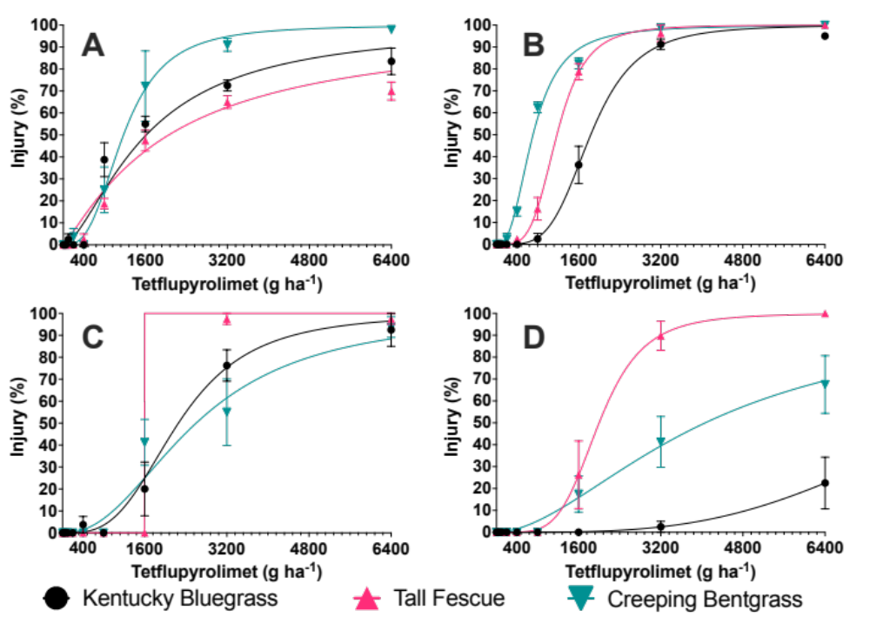

Figure 1.1. Dose response curves for Kentucky bluegrass (Poa pratensis L., cv., ‘HGT’), creeping bentgrass (Agrostis stolonifera L., cv. ‘L-93XD’), and tall fescue (Festuca arundinacea Schreb., cv. ‘Lebanon Winning Colors Plus’) treated with increasing rates of tetflupyrolimet (Dodhylex™ Active. FMC Corporation. Philadelphia, PA). Panels A and B present responses from applications made in fall of 2022 and 2023, respectively, in Knoxville, TN. Panels C and D present responses from applications made in spring of 2023 and 2024, respectively, in Knoxville, TN.

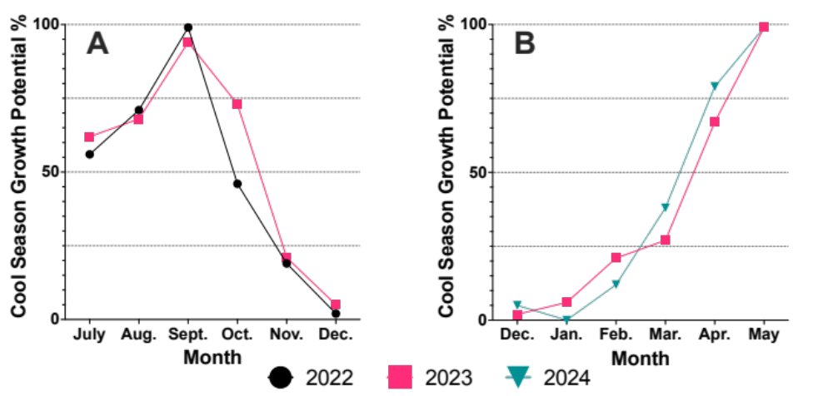
Figure 1.2. Temperature based growth potential (%) for cool-season turfgrasses during trials evaluating tolerance to increasing rates of tetflupyrolimet (Dodhylex™ Active. FMC Corporation. Philadelphia, PA) at East Tennessee Research and Education Center – Plant Science Unit (Knoxville, TN) in fall and spring. Fall tolerance trials on these cool-season grasses were initiated on 28 September 2022 and 30 September 2023; spring tolerance trials were initiated on 28 February 2023 and 29 February 2024. Panel A presents growth potential (%) three months prior to and after applications of tetflupyrolimet in fall 2022 and 2023; Panel B presents growth potential (%) three months prior to and after applications of tetflupyrolimet in spring 2023 and 2024.

Table 1.4. Poa annua control with PRE and early postemergence (EPOST) applications of tetflupyrolimet (Dodhylex™ Active. FMC Corporation. Philadelphia, PA) alone and in mixtures. Applications made to a hybrid bermudagrass (C. dactylon x C. transvaalensis, cv. ’Tifway’) golf course fairway at Montgomery Bell State Park Golf Course (Burns, TN) infested with herbicide-resistant Poa annua.
 |  |  | Poa annua control
Timing | Herbicide | Rate | 11 WAIT^{z} | 19 WAIT | 23 WAIT | 27 WAIT
 |  | g ha⁻¹ | ------------------------------%------------------------------
PRE | Tetflupyrolimet | 400 | 98 | 69 | 57 | 40
 | Pyroxasulfone | 128 | 100 | 86 | 68 | 57
 | Tetflupyrolimet + pyroxasulfone | 400 + 128 | 99 | 89 | 89 | 68
 | Indaziflam | 45 | 89 | 48 | 14 | 3
EPOST | Tetflupyrolimet + rimsulfuron | 400 + 35 | 100 | 87 | 89 | 71
 | Tetflupyrolimet + pyroxasulfone + rimsulfuron | 400 + 128 + 35 | 99 | 94 | 95 | 83
 | Tribute® Total + simazine + indazflam | 42 + 1120 + 26 | 100 | 88 | 88 | 66
 | P > F |  | ***^{x} | *** | *** | ***
 | LSD_{0.05} |  | 2 | 15 | 20 | 20
^{z} Abbreviations: WAIT = weeks after initial treatment.
^{y} Tribute® Total (Envu Turf and Ornamentals. Cary, NC) is a commercialized formulation of the following active ingredients: thiencarbazone-methyl + foramsulfuron + halosulfuron.
^{x} ***, **, * significant at p ≤ 0.001, 0.01, and 0.05, respectively.
Table 1.5. Smooth crabgrass (Digitaria ischaemum) control with PRE applications of tetflupyrolimet (Dodhylex™ Active. FMC Corporation. Philadelphia, PA) compared to industry standards. Applications made to a bermudagrass (Cynodon dactylon, cv. ’Yukon’) stand, maintained as a golf course fairway at East Tennessee Research and Education Center – Plant Science Unit (Knoxville, TN).
 |  | Smooth crabgrass control
 |  | 2021 |  |  |  |  | 2022
Herbicide | Rate | 8 WAIT^{z} | 13 WAIT | 17 WAIT | 21 WAIT |  | 8 WAIT | 13 WAIT | 17 WAIT | 21 WAIT
 | g ha⁻¹ | --------------------------------------------------------- |  |  |  | % | --------------------------------------------------------
Tetflupyrolimet | 250 | 96 | 56 | 28 | 8 |  | 100 | 89 | 79 | 75
Tetflupyrolimet | 300 | 98 | 66 | 23 | 8 |  | 100 | 95 | 90 | 89
Tetflupyrolimet | 400 | 100 | 81 | 44 | 40 |  | 100 | 96 | 95 | 88
Prodiamine | 840 | 100 | 99 | 96 | 96 |  | 100 | 96 | 99 | 98
Indaziflam | 45 | 100 | 98 | 92 | 89 |  | 100 | 96 | 90 | 90
P > F |  | ns | **^{y} | *** | *** |  | ns | ns | ns | *
LSD_{0.05} |  | ns | 25 | 35 | 26 |  | ns | ns | ns | 14
^{z} Abbreviations: WAIT = weeks after initial treatment; ns = non-significant.
^{y} ***, **, * significant at p ≤ 0.001, 0.01, and 0.05, respectively.

CHAPTER II

SOIL TEXTURE EFFECTS ON TETFLUPYROLIMET EFFICACY IN TURFGRASS

A version of this chapter was submitted for publication to Weed Science on 14 April 2025 by Benjamin D. Pritchard, Travis W. Gannon, David M. Butler, Rebecca G. Bowling, Atul Puri, and James T. Brosnan:
Pritchard BD, Gannon TW, Butler DM, Bowling RG, Puri A, and Brosnan JT. (2025). Soil Texture Effects on Tetflupyrolimet Efficacy in Turfgrass. Weed Science. In Review.
The publishing of this article involved an extensive peer-review process that improved the quality of the manuscript and allowed the authors to develop deeper hypotheses, arguments, and quality research methodology. The publishing of this article involved six authors from the University of Tennessee Department of Plant Sciences, North Carolina State University Department of Crop and Soil Science, and FMC Corporation. All authors made conceptual or technical contributions relative to their area of expertise. My primary contributions to this paper include (i) reading literature, (ii) writing the manuscript, (iii) conducting the research, (iv) analysing data, and (v) revising during the review process.
Abstract
Tetflupyrolimet is a novel herbicide that inhibits dihydroorotate dehydrogenase (DHODH), interfering with de novo pyrimidine biosynthesis in susceptible plants. While tetflupyrolimet efficacy for preemergence grassy weed control in rice (Oryza sativa L.) and managed turfgrass systems has been explored, there is minimal information regarding effects that edaphic factors may have on activity, particularly those pertaining to soil hydraulics. Dose-response experiments revealed 6- to 8-fold differences in tetflupyrolimet activity on Poa annua due to soil texture, with higher activity reported following applications to sand compared to clay loam. Higher tetflupyrolimet activity in sand could be related to matric potential as activity following applications to plants growing in sand exceeded that observed on clay loam across a wide range of volumetric moisture contents (15 to 80%). Once volumetric moisture content increased to > 80%, no differences in tetflupyrolimet activity were detected between soils, suggesting that post-application irrigation could mitigate potential reductions in efficacy on finer-textured soils when moisture is limited. These findings underscore that soil texture, and consequently moisture retention, affect tetflupyrolimet activity to the extent that application rates should vary based on soil texture in turfgrass systems. Further research exploring a broader range of soil types and field conditions is warranted to refine tetflupyrolimet rate recommendations based on soil type.
Introduction
Tetflupyrolimet is a new herbicide with a unique mode of action (HRAC Group #28) that inhibits de novo pyrimidine biosynthesis in susceptible plants (Kang et al. 2023). The herbicide binds to dihydroorotate dehydrogenase (DHODH), an enzyme on the outer surface of the inner mitochondrial membrane (Reis et al. 2017), thereby obstructing the ubiquinone-mediated oxidation of dihydroorate to orotate (Zrenner et al. 2006). This action renders tetflupyrolimet an effective option for preemergence (PRE) control of annual grassy weeds in rice (Oryza sativa L.), including barnyardgrass [Echinochloa crus-galli (L.) P. Beauv.] and junglerice [Echinochloa colona (L.) Link] (Castner et al. 2024a; Whitt et al. 2024).
In turfgrass systems, tetflupyrolimet offers a novel mode of action for effective PRE control of Poa annua and smooth crabgrass [Digitaria ischaemum (Schreb.) Schreb. ex Muhl.] for 11 to 13 weeks (Pritchard et al. 2025). Given that herbicide resistance is an emerging issue in managed turfgrass, particularly within Poa annua (Brosnan et al. 2020; McCurdy et al. 2023; Rutland et al. 2023), tetflupyrolimet offers a new herbicide for resistance management, particularly in warm-season turfgrasses. No injury was observed following tetflupyrolimet applications up to 4800 g ha⁻¹ on hybrid bermudagrass [C. dactylon (L.) Pers. x C. transvaalensis Burtt-Davy] or manilagrass (Zoysia matrella L. Merr.).⁶ Weed control and turfgrass tolerance with tetflupyrolimet could satisfy desires amongst turfgrass managers for new herbicides to quell resistance concerns (Allen et al. 2022).
Managed turfgrass systems such as golf courses are constructed on soils varying in texture. Golf course putting greens and teeing grounds are often constructed with engineered sand root zones containing ≤ 8% silt and clay by volume (Shaddox et al. 2023; United States Golf Association 2018). Golf course fairways and roughs are primarily established on native soils that can vary widely in both texture and other edaphic parameters (Soil Survey Staff). Given that sand root zones are designed to optimize internal drainage and aeration under concentrated traffic (Ok et al. 2004), sand is often introduced to native soil sites via applications of topdressing to improve turfgrass quality and playability (Beard 1973; Klingenberg 2009; Green et al. 2019). Differences in soil texture can impact efficacy of herbicides including atrazine (Blumhorst et al. 1990), pendimethalin (Blumhorst et al. 1990), metribuzin (Weber et al. 1987), and pronamide (Dutt & Harvey 1980). Commodity agriculture labels for these active ingredients often offer use directions based on soil texture (Anonymous 2008a, 2017, 2021a, 2022a). For example, label rates for atrazine (AAtrex®4L. Syngenta Crop Protection. Greensboro, NC) can vary as much 673 g ha⁻¹ due to soil texture (Anonymous 2022a). Rate specificity based on soil texture is not present within label directions for these same active ingredients in managed turfgrass (Anonymous 2019, 2021b, 2022b). While rate specificity for varied soil textures is not required by federal guidelines (Anonymous 2007, 2008b, 2024) and could be cost-prohibitive or logistically difficult, research aiming to improve sustainable use of new herbicides in turfgrass is warranted.
Textural differences can affect soil hydraulics, particularly soil moisture availability, that can influence herbicide performance. Pyroxasulfone efficacy for PRE weed control in corn (Zea maize L.) is affected by soil organic matter content and clod size, edaphic parameters that influence soil moisture retention following rainfall (Yamaji et al. 2016). Soil moisture deficits were attributed to reduced Digitaria spp. control with fenoxaprop applied at early- and mid- postemergence timings, whereas applications before a heavy rainfall increased efficacy at a late-postemergence timing (Neal et al. 1990). Foramsulfuron efficacy versus goosegrass (Eleusine indica L. Gaertn.) is maximized under conditions of elevated soil moisture (≥ 20%) and low evaporative demand (Shekoofa et al. 2020). Post-application irrigation increased efficacy of pendimethalin for PRE smooth crabgrass control, likely by moving foliar residues intercepted by the turfgrass canopy after treatment into the soil (Gasper et al. 1994). Indaziflam and flumioxazin efficacy for Kochia scoparia L. control decreased in drier soils (Sebastian et al. 2017). A drought tolerant species, Kochia scoparia L., was able to germinate in soils where soil water content limited water available for herbicide solubilization to soil solution (Everitt et al. 1983). Low soil moisture content can increase herbicide adsorption to soil, reducing ability for root uptake (Dao & Lavy 1978).
There is minimal information available regarding the effects of edaphic factors, such as soil texture and moisture retention, on tetflupyrolimet efficacy for weed control in turfgrass. Considering that tetflupyrolimet is a promising tool for turfgrass managers, particularly those challenged with herbicide-resistant weeds, understanding the effects of soil texture and moisture retention on performance is needed to optimize efficacy. We hypothesized that tetflupyrolimet efficacy would vary among soils of differing textures and hydraulic properties. This paper presents a series of experiments designed to explore that hypothesis in detail.
Materials and Methods
Soil Selection
All experiments were conducted using two distinctly different soils: a Sequatchie clay loam (fine-loamy, siliceous, semiactive, thermic humic Hapludult) with 26.1% sand, 41% silt, and 32.1% clay, and a United States Golf Association specified sand that contained 98.3% sand, 1.2% silt, and 0.5% clay (United States Golf Association 2018). Per specification, this sand medium was uniformly blended with reed-sedge peat moss in a 80:20 sand-to-peat ratio (by volume). A complete analysis of the physical and chemical properties of each soil is presented in Table 2.1 (All tables and figures can be found in the appendix at the end of the chapter). Additionally, soil moisture retention curves for each soil are presented in Figure 2.1. Nutrient analyses for both soils are presented in Table 2.2.
Dose Reponse Studies
Experiments were conducted in a controlled glasshouse environment in Knoxville, TN (35.94 N, -83.93 W) evaluating the response of herbicide-susceptible Poa annua to increasing doses of tetflupyrolimet in two different soils. Experiments were repeated in both time and space during spring 2023 under conditions of natural and supplemental light for a 16/8 h (day/night) photoperiod (PKB, Arize Element L1000 Next-Gen, Current Lighting Solutions, LLC, Cleveland, OH, USA).
Each experiment was arranged in a randomized complete block design with five replications repeated in time and space. Greenhouse pots (1,065 cm³) pots were filled with each soil and irrigated thereafter to ensure settling throughout the profile. After three days of irrigation cycling, pots were surface seeded with Poa annua (University Park, PA) prior to being treated with tetflupyrolimet (Dodhylex™ Active, FMC Corporation, Philadelphia, PA) at rates of 0, 25, 50, 100, 200, 400, 800, 1600, 3200, or 6400 g ai ha⁻¹ using an enclosed spray chamber (Generation III Research Sprayer, DeVries Manufacturing, Hollandale, MN), calibrated to deliver 215 L ha⁻¹ using a single flat-fan nozzle (8004EVS, TeeJet Spraying Systems, Wheaton, IL).
Temperature conditions in the glasshouse were monitored using greenhouse control sensors (PRIVA, Ontario, CA) whereas a quantam sensor (SQ-500 Full-Spectrum Quantum Sensor. Apogee Instruments, Logan, UT, USA) was used to record photosynthetically active radiation (Table 2.3). Irrigation was supplied via misting heads (Ein Dor Mini-Sprinklers, Tavlit Plastic Ltd., Yavne, Israel) connected to a timer (Galcon 8056AC-6S Timer. Galcon USA, LTD., San Rafael, CA, USA) that was configured to apply light (0.4 to 0.6 cm hr⁻¹) irrigation cycles throughout the day.
Poa annua control was evaluated using a 0 (i.e., no control) to 100% (i.e., complete plant death) scale relative to non-treated check pots (i.e., 0 g ha⁻¹ tetflupyrolimet) in each replication 42 days after treatment (DAT). After control assessments were made, aboveground biomass was harvested at the soil surface of each pot, bagged, dried in a forced-air oven (Laboratory Oven; The Grieve Corporation, Round Lake, IL) for 72 hours at 105°C, and weighed. Aboveground biomass data were expressed as a percentage of non-treated check pots in each replication.
Aboveground biomass and Poa annua control data were subjected to non-linear regression analysis using GraphPad Prism software (v.10.1.1. Graphpad Prism. LaJolla, CA). Data from each soil type were fit to an ‘EC anything’ model that was used to calculate doses of tetflupyrolimet required to achieve 90% Poa annua control and 90% reductions in aboveground biomass. Confidence intervals (95%) were used to compare values between soil types.
Soil Moisture Effects on Tetflupyrolimet
Laboratory research was conducted in 2024 to evaluate the effect of soil moisture on tetflupyrolimet activity in different soil types. Trials were arranged in a completely randomized design with four replications and repeated in time. Treatments included the factorial combination of two soil types (Table 2.1) and 10 soil moisture treatments.
Petri dishes (100 x 15 mm. Fisherbrand™ Petri Dishes with Clear Lid, Thermo-Fisher Scientific, St. Louis, MO, USA) were filled with 50 cm³ of each soil. Mean bulk density values within Petri dishes were 1.23 and 1.48 g cm⁻³ for the clay loam and sand, respectively. Distilled water was added to each plate using a syringe (10 mL Fisherbrand™ Sterile Syringes for Single Use, Thermo-Fisher Scientific, St. Louis, MO, USA) to create volumetric water content treatments: 0%, 5%, 10%, 15%, 20%, 30%, 40%, 60%, 80%, and 100%. Ten perennial ryegrass (Lolium perenne L.) seeds were added to each plate to serve as a bioindicator of tetflupyrolimet activity after treatment at 50 g ai ha⁻¹ using the previously described enclosed spray chamber. This rate was selected based on dose-response experiments discussed earlier (Figure 2.2, Table 2.4).
After herbicide application, Petri dishes were sealed with parafilm (2 IN All-Purpose Laboratory Film; Amcor, Menasha, WI) and placed inside a growth chamber (G1000-Germinator; Conviron, Winnipeg, Manitoba, Canada) that provided a constant 16˚C air temperature and 16 h photoperiod. The number of perennial ryegrass seeds germinating in each plate were counted 15 days after treatment. Data were subjected to ANOVA in R (v.6.2) to discern effects of soil type, volumetric water content, and their interaction on tetflupyrolimet activity. For each soil, perennial ryegrass germination means were plotted across volumetric water content in GraphPad Prism with means separated using standard error assessments.
Results and Discussion
Soil-Type Dose Response
Significant differences in Poa annua control were detected between soils treated with increasing doses of tetflupyrolimet from rates of 25 to 400 g ha⁻¹ in this study (Figure 2.2, Table 2.4). Tetflupyrolimet rates of 38 and 231 g ha⁻¹ were required to control Poa annua 90% in sand and clay loam, respectively. Similarly, rates of tetflupyrolimet required to reduce Poa annua biomass 90% also varied between soil types (Figure 2.2, Table 2.4). A rate of 30 g ha⁻¹ was required for a 90% biomass reduction in sand compared to 237 g ha⁻¹ in clay loam, representing a near 8-fold document difference in herbicide activity between soil textures.
Our experiments identified 6- to 8-fold differences in tetflupyrolimet activity on Poa annua due to soil texture. Soil texture effects on herbicide efficacy have been documented for other preemergence herbicides. For example, differences in efficacy have been documented with atrazine and pendimethalin in corn (Zea mays L.) production where humic matter, organic matter, and cation exchange capacity were significantly correlated with increasing herbicide rates required to reach 80% weed control (Blunhorst et al. 1990). In addition, higher rates of metribuzin were needed for effective weed control as humic and organic matter content increased across 201 soils evaluated representative of the corn, wheat (Triticum spp.), and cotton (Gossypium spp.) production belts of the United States Weber et al. 1987). To date, minimal information has been published regarding the effect of soil-type on tetflupyrolimet; efficacy in rice production has been reported on a single soil-type (clay) (Lombardi & Al-Khatib 2024). Similarly, tetflupyrolimet efficacy in turfgrass has only been evaluated on silt and clay loam soils (Pritchard et al. 2025).
Soil-Moisture Impacting Tetflupyrolimet Efficacy
A significant soil type-by-volumetric water content-by-herbicide treatment interaction was detected in perennial ryegrass germination data (Figure 2.3). When no herbicide was present, a minimum of 5% soil moisture (v/v) was required for perennial ryegrass germination in sand, whereas 15% soil moisture was required for similar germination in clay loam. While not measured directly, this difference could be a function water being held at greater matric potential in the clay loam compared to the sand rootzone. Although total porosity was similar among these two soils, the sand rootzone contained a greater quantity of macropores (27.6% compared to 18.5%) leading to significant increase in saturated hydraulic conductivity and reduced soil moisture rentention (Table 2.1, Figure 2.1). While herbicide sorption and bioavailability can differ amongst soil textures, these proxy measures suggest that less energy is required for perennial ryegrass to access moisture in this sand rootzone compared to clay loam. Similar to field reports on smooth crabgrass (Pritchard et al. 2025), overall activity of tetflupyrolimet (50 g ha⁻¹) in the current laboratory study increased in both soils as volumetric water content increased (Figure 2.3). However, tetflupyrolimet activity in sand was greater than clay loam at each soil moisture content from 15 to 80% (Figure 2.3).
Higher tetflupyrolimet activity in sand could be related to matric potential as activity on perennial ryegrass was higher in sand (compared to clay loam) across a wide range of volumetric water contents (15 to 80%). Once volumetric water content increased to > 80%, no differences in tetflupyrolimet activity were detected among soils with perennial ryegrass germination measuring 0% (Figure 2.3). Similar to what has been reported with other preemergence herbicides (Gasper et al. 1994; Sebastian et al. 2017; Olson et al. 2000), this response indicates that post-application irrigation could mitigate potential reductions in efficacy on heavier soils, particularly when soil moisture is limited.
While this study provides valuable information regarding the effects of soil type on tetflupyrolimet efficacy in turfgrass, this research has limitations. First, only two soil types were included in our experiments. Future research exploring tetflupyrolimet efficacy on different soils is warranted, particularly those with edaphic paramaters different from those presented in Table 2.1. It should be noted that pilot experiments found no significant differences in tetflupyrolimet efficacy due to soil pH, total exchange capacity, or calcium content (data not shown). Secondly, matric potential was not directly measured in our experiment. Similar to research with Kochia scoparia L. (Sebastian et al. 2017), direct assessments of matric potential on tetflupyrolimet efficacy are warranted. Lastly, we selected a laboratory assay with Petri plates that prevented internal drainage (through the soil profile) from confounding our results. Field research confirming enhanced efficacy of tetflupyrolimet in sandy soils is also warranted.
Conclusions
Overall, our experiments highlight a 6- to 8-fold difference in tetflupurolimet activity on Poa annua following treatments to plants growing in a sand rootzone compared to a clay loam. These data suggest that tetflupyrolimet application rates in sand should be different from those recommended for use in finer-textured soils, such as clay loam. Additionally, greater activity of tetflupyrolimet in sand offers several benefits for turfgrass managers, including its suitability for use on golf course putting greens which are predominantly constructed on sand profiles. Use of tetflupyrolimet on putting greens could address widespread infestations of ALS-resistant Poa annua on these surfaces (Singh et al. 2021). Secondly, new golf courses are often constructed on sandy sites given that they offer a growing medium that can withstand traffic and provide optimal ball-to-surface interactions. Greater tetflupyrolimet activity in these sandy mediums could allow for reduced application rates to be used for acceptable weed control.

References
Allen JH, Ervin DE, Frisvold GB, Brosnan JT, McCurdy JD, Bowling RG, Patton AJ, Elmore MT, Gannon TW, McCarty LB, McCullough PE, Kaminski JE, Askew SD, Kowalewski AR, Unruh JB, McElroy JS, & Bagavathiannan MV. (2022). Herbicide-resistance in turf systems: insights and options for managing complexity.
Sustainability, 14(20), 13399.
Anonymous. (2007). https://www.ecfr.gov/current/title-40/chapter-I/subchapter-E/part-158. [accessed 9 February 2025]Kang IH, Emptage RP, Kim SI, & Gutteridge S. (2023). A novel mechanism of herbicide action through disruption of pyrimidine biosynthesis. Proceedings of the National Academy of Sciences, 120(48), e2313197120.
Anonymous. (2008a). Prowl® 3.3 EC herbicide label. https://www.cdms.net/ldat/ld867008.pdf. [accessed 17 September 2024]
Anonymous. (2008b). https://www.ecfr.gov/current/title-40/chapter-I/subchapter-E/part-156. [accessed 9 February 2025]
Anonymous. (2017). Mauler™ herbicide label. https://www.cdms.net/ldat/ldEF9000.pdf. [accessed 17 September 2024]
Anonymous. (2019). Pendulum® AquaCap herbicide label. https://www.cdms.net/ldat/ld3BO000.pdf. [accessed 17 September 2024]
Anonymous. (2021a). Kerb® SC T&O herbicide label. https://www.cdms.net/ldat/ldAE3001.pdf. [accessed 17 September 2024]
Anonymous. (2021b). Kerb® SC herbicide label. https://www.cdms.net/ldat/ldEP2011.pdf. [accessed 17 September 2024]
Anonymous. (2022a). AAtrex® 4L herbicide label. https://www.cdms.net/ldat/ld280014.pdf. [accessed 3 September 2024]
Anonymous. (2022b). Sencor® 75% turf herbicide label. https://www.cdms.net/ldat/ldJEP000.pdf. [accessed 17 September 2024]
Anonymous. (2024). Series 835 – Fate, Transport, and Transformation Test Guidelines. https://www.epa.gov/test-guidelines-pesticides-and-toxic-substances/series-835-fate-transport-and-transformation-test. [accessed 9 February 2025]
Beard JB. 1973. Turfgrass science and culture. Prentice-Hall Inc., Englewood Cliffs, NJ.
Blumhorst MR, Weber JB, & Swain LR. (1990). Efficacy of selected herbicides as influenced by soil properties. Weed Technology, 4(2), 279-283.
Brosnan JT, Vargas JJ, Breeden GK, & Zobel JM. (2020). Herbicide resistance in annual bluegrass on Tennessee golf courses. Crop, Forage & Turfgrass Management, 6(1), e20050.
Castner MC, Norsworthy JK, Edmund RM, Avent TH, Noe SC (2024a, January 22-25). Tetflupyrolimet Targets a Novel Site for Barnyardgrass Management in Rice [Poster Abstract]. 2024 Weed Science Society of America Annual Meeting, San Antonio, TX, United States.
Dao TH & Lavy TL. (1978). Atrazine adsorption on soil as influenced by temperature, moisture content and electrolyte concentration. Weed Science, 26(3), 303-308.
Dutt TE & Harvey RG. (1980). Pronamide phytotoxicity in ten Wisconsin soils. Weed Science, 28(4), 429-432.
Everitt JH, Alaniz MA, & Lee JB. (1983). Seed germination characteristics of Kochia scoparia. Rangeland Ecology & Management/Journal of Range Management Archives, 36(5), 646-648.
Gasper JJ, Street JR, Harrison SK, & Pound WE. (1994). Pendimethalin efficacy and dissipation in turfgrass as influenced by rainfall incorporation. Weed Science, 42(4), 586-592.
Green TO, Rogers JN, Crum JR, Vargas JM, & Nikolai TA. (2019). Effects of rolling and sand topdressing on dollar spot severity in fairway turfgrass. HortTechnology, 29(4), 394-401.
Klingenberg MT. (2009). Topdressing and aerification programs on creeping bentgrass fairways. Iowa State University. (Master’s Thesis)
Lombardi MA & Al-Khatib K. (2024). Control of Echinochloa spp. and Leptochloa fascicularis with the Novel Dihydroorotate Dehydrogenase Inhibitor Herbicide Tetflupyrolimet in California Water-seeded Rice. Weed Technology, 1-34.
McCurdy JD, Bowling RG, Patton AJ, de Castro EB, Kowalewski AR, Mattox CM, Brosnan JT, Ervin DE, Askew SD, Gonclaves CG, Elmore MT, McElroy JS, McNally BC, Pritchard BD, Kaminski JE, Bagavathiannan MV (2023). Developing and implementing a sustainable, integrated weed management program for herbicide‐resistant Poa annua in turfgrass. Crop, Forage & Turfgrass Management, 9(1), e20225.
Neal JC, Bhowmik PC, & Senesac AF. (1990). Factors influencing fenoxaprop efficacy in cool-season turfgrass. Weed Technology, 4(2), 272-278.
Ok CH, Anderson SH, & Ervin EH. (2004). Amendments and construction systems for improving the performance of sand-based putting greens. Asian Journal of Turfgrass Science, 18(3), 149-163.
Olson BL, Al-Khatib K, Stahlman P, & Isakson PJ. (2000). Efficacy and metabolism of MON 37500 in Triticum aestivum and weedy grass species as affected by temperature and soil moisture. Weed Science, 48(5), 541-548.37
Pritchard BD, Breeden GK, Bowling RG, Gannon TW, Hutto KC, & Brosnan JT. (2024). Turfgrass Tolerance to Tetflupyrolimet Applications for Preemergence Grassy Weed Control. Weed Science, 73, e17. doi:10.1017/wsc.2024.97
Reis RA, Calil FA, Feliciano PR, Pinheiro MP, & Nonato MC. (2017). The dihydroorotate dehydrogenases: past and present. Archives of biochemistry and biophysics, 632, 175-191.
Rutland CA, Bowling RG, Russell EC, Hall ND, Patel J, Askew SD, Bagavathiannan MV, Brosnan JT, Gannon TW, Gonclaves CG, Hathcoat D, McCarty LB, McCullough PE, McCurdy JD, Patton AJ, Unruh JB, & McElroy JS. (2023). Survey of target site resistance alleles conferring resistance in Poa annua. Crop Science, 63(5), 3110-3121.
Sebastian DJ, Nissen SJ, Westra P, Shaner DL, & Butters G. (2017). Influence of soil properties and soil moisture on the efficacy of indaziflam and flumioxazin on Kochia scoparia L. Pest management science, 73(2), 444-451.
Shaddox TW, Unruh JB, Johnson ME, Brown CD, & Stacey G. (2023). Land-use and energy practices on US golf courses. HortTechnology, 33(3), 296-304.
Shekoofa A, Brosnan JT, Vargas JJ, Tuck DP, & Elmore MT. (2020). Environmental effects on efficacy of herbicides for postemergence goosegrass (Eleusine indica) control. Scientific reports, 10(1), 20579.
Singh V, Dos Reis FC, Reynolds C, Elmore M, & Bagavathiannan M. (2021). Cross and multiple herbicide resistance in annual bluegrass (Poa annua) populations from eastern Texas golf courses. Pest management science, 77(4), 1903-1914.
Soil Survey Staff, Natural Resources Conservation Service, United States Department of Agriculture. Web Soil Survey. Available online at the following link: http://websoilsurvey.sc.egov.usda.gov/. Accessed [10 September 2024].
United States Golf Association. (2018). USGA Recommendations For a Method of Putting Green Construction 2018 Revision. United States Golf Association. https://archive.lib.msu.edu/tic/usgamisc/monos/2018recommendationsmethodputtinggreen.pdf. Accessed [17 September 2024].
Weber JB, Tucker MR, & Isaac RA. (1987). Making herbicide rate recommendations based on soil tests. Weed Technology, 1(1), 41-45.
Whitt DR, Bowman HD, Bond JA, Burrell II TD, Eubank TW, Mangialardi GA. (2024, January 22-25). The Evaluation of Dodhylex in Mississippi Rice Production [Poster Abstract]. 2024 Weed Science Society of America Annual Meeting, San Antonio, TX, United States.
Yamaji Y, Honda H. Hanai R, & Inoue J. (2016). Soil and environmental factors affecting the efficacy of pyroxasulfone for weed control. Journal of pesticide science, 41(1), 1-5.
Zrenner R, Stitt M, Sonnewald U, & Boldt R. (2006). Pyrimidine and purine biosynthesis and degradation in plants. Annu. Rev. Plant Biol., 57, 805-836.

Appendix
Table 2.1. Physical and chemical properties of soils used in glasshouse and laboratory experiments exploring effects of various edaphic factors on tetflupyrolimet (Dodhylex™ Active) efficacy for grassy weed control. Organic matter, total exchange capcity, and pH analyses conducted by Brookside Laboratories (New Bremen, OH). Soil texture, porosity, and saturated hydraulic conductivity analyses conducted by A. McNitt & SerenSoil (State College, PA).

Soil Type | Sand | Silt | Clay | Organic Matter | Total Porosity | Air-Filled Porosity | Capillary Porosity | Total Exchange Capacity | Saturated Hydaulic Conductivity | pH
 | ______________________________%_________________________________________ |  |  |  |  |  |  | meq 100 g⁻¹ | cm hr⁻¹ | (H₂O 1:1)
Clay Loam | 26.1 | 41.0 | 32.1 | 2.2 | 54.5 | 18.5 | 36.0 | 6.7 | 25.1† | 5.7
Sand | 98.3 | 1.2 | 0.5 | 0.5 | 43.7 | 27.6 | 16.1 | 1.6 | 70.6 | 4.8
† Testing after compacting soil to 75% compaction using ASTM D698-12.

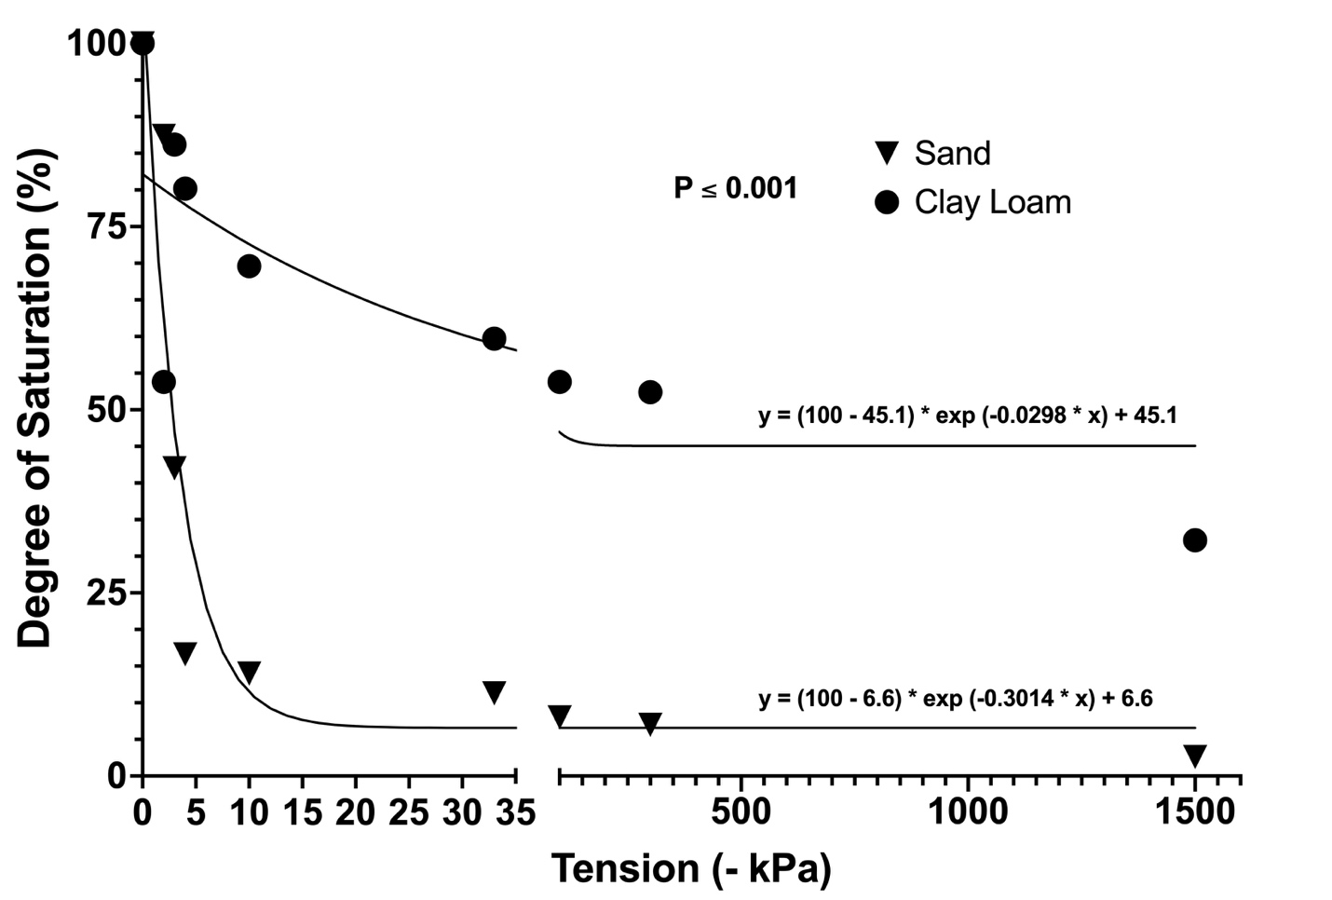
Figure 2.1. Soil moisture retention curves for the two soils used in glasshouse and laboratory experiments exploring effects of various edaphic factor on tetflupyrolimet (Dodhylex™ Active) efficacy for grassy weed control. Soil moisture retention curves generated by Turf & Soil Diagnostics (Trumansburg, NY) using ASTM D6836. Data were fit to a one-phase exponential decay model in GraphPad Prism (v.10.1.1. Graphpad Prism. LaJolla, CA) and compared using a global sums-of-squares F-test at α = 0.05.

Table 2.2. Nutrient analyses of soils used in glasshouse and laboratory experiments exploring effects of various edaphic factors on tetflupyrolimet (Dodhylex™ Active) efficacy for grassy weed control. Analysis was conducted by Brookside Laboratories (New Bremen, OH).

Soil Texture | Sulfur | Calcium | Magnesium | Potassium | Sodium | Boron | Iron | Manganese | Copper | Zinc | Aluminum
 | ______________________________________________________ ppm _________________________________________________________________
Clay Loam | 9 | 708 | 107 | 87 | 10 | 0.24 | 94 | 185 | 0.48 | 1.40 | 749
Sand | 6 | 104 | 16 | 6 | 9 | 0.43 | 82 | 3 | < 0.2 | < 0.4 | 37

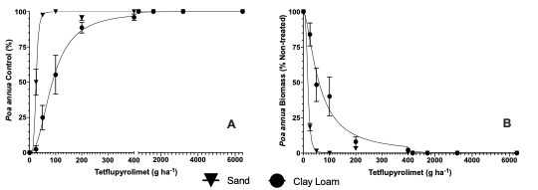
Figure 2.2. Poa annua control (A) and aboveground biomass (B) response to increasing doses of tetflupyrolimet (Dodhylex™ Active, FMC Corporation, Philadelphia, PA) applied preemergence to herbicide susceptible Poa annua planted in a sand that conformed to United States Golf Association specifications, as well as a clay loam soil native to Knoxville, TN. Edaphic factors for each soil type are presented in Table 2.1. Data pooled from two experimental runs conducted in a glasshouse in 2023. Bars represent standard error of each mean.

Table 2.3. Conditions inside glasshouses during dose response experiments evaluating efficacy of tetflupyrolimet (Dodhylex™ Active) for preemergence control of herbicide-susceptible Poa annua L. in two soil types. Experiments conducted in Knoxville, TN (35.94 N, -83.93 W) during spring 2023.

 | Experimental Run 1 | Experimental Run 2
Irrigation^{z} (cm day ⁻¹) | 0.43 | 0.58
Temperature^{y} (˚C) | 22.6 | 23.6
Photosynthetically active radiation^{x} (µmol m⁻² s⁻¹) | 495 | 716
^{z} Irrigation delivered via misting heads (Ein Dor Mini-Sprinklers, Tavlit Plastic Ltd., Yavne, Israel) connected to a timer (Galcon 8056AC-6S Timer. Galcon USA, LTD., San Rafael, CA, USA)
^{y} Measurements made using greenhouse control sensors (PRIVA, Ontario, CA)
^{x} Data is the daily average collected using a quantum sensor (SQ-500 Full-Spectrum Quantum Sensor. Apogee Instruments, Logan, UT, USA)

Table 2.4. Rate of tetflupyrolimet (Dodhylex™ Active. FMC Corporation. Philadelphia, PA) to achieve 90% Poa annua control or 90% reductions in Poa annua biomass (EC₉₀) in glasshouse experiments conducted in Knoxville, TN (35.94 N, -83.93 W) during spring 2023.

 | Sand |  | Clay loam
 | Control (%) | Biomass Reduction (%) | Control (%) | Biomass Reduction (%)
EC₉₀ (g ha⁻¹) | 38 | 30 | 231 | 237
Confidence Interval (95%) | ~ to 47 | ~ to 33 | 175 to 317 | 157 to 383
R² | 0.92 | 0.99 | 0.86 | 0.77

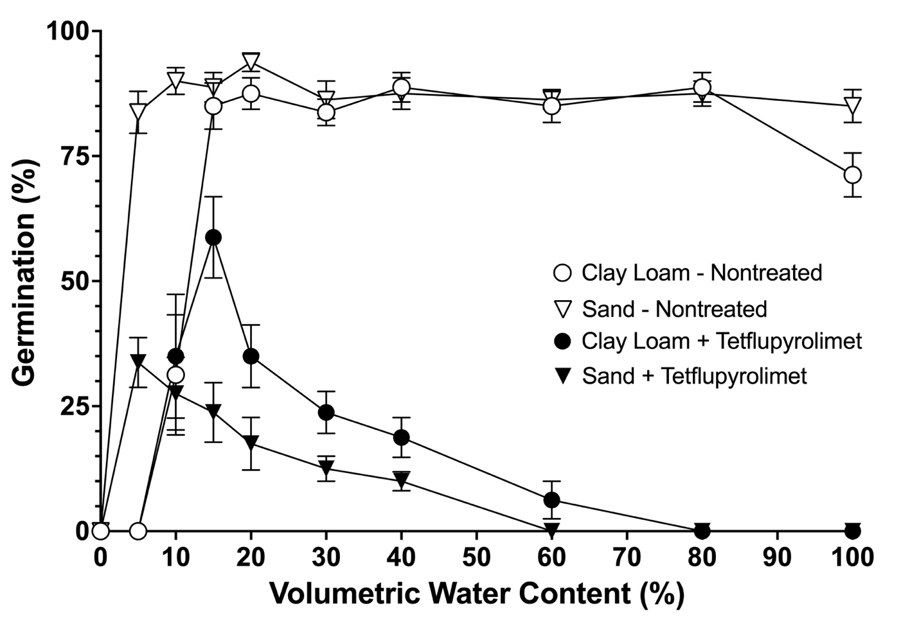
Figure 2.3. Effect of tetflupyrolimet (50 g ha⁻¹) on perennial ryegrass (Lolium perenne L.) germination in clay loam soil or sand varying in volumetric water content during repeated growth chamber experiments conducted in Knoxville, TN during 2024. Bars represent standard error of each mean.

CHAPTER III

DOWNSLOPE LATERAL MOVEMENT OF TETFLUPYROLIMET AND PRONAMIDE IN TURFGRASS

A version of this chapter will be submitted for publication to Weed Science on 2 May 2025 by Benjamin D. Pritchard, Travis W. Gannon, Richard R. Rogers, Tyler Q. Carr, Atul Puri, and James T. Brosnan:
Pritchard BD, Gannon TW, Rogers RR, Carr TQ, Puri A, and Brosnan JT. (2025). Downslope Lateral Movement of Tetflupyrolimet and Pronamide in Turfgrass. Weed Science. In Review.
The publishing of this article involved an extensive peer-review process that improved the quality of the manuscript and allowed the authors to develop deeper hypotheses, arguments, and quality research methodology. The publishing of this article involved six authors from the University of Tennessee Department of Plant Sciences, North Carolina State University Department of Crop and Soil Science, The Ohio State University, and FMC Corporation. All authors made conceptual or technical contributions relative to their area of expertise. My primary contributions to this paper include (i) reading literature, (ii) writing the manuscript, (iii) conducting the research, (iv) analysing data, and (v) revising during the review process.
Abstract
Tetflupyrolimet is a novel herbicide that inhibits dihydroorotate dehydrogenase (DHODH) in susceptible weeds, including those in warm-season turfgrass and rice (Oryza sativa L.). Given that in some regions, warm-season turfgrasses are managed adjacent to cool-season species sensitive to tetflupyrolimet, research on its lateral movement within turfgrass is warranted. Field experiments conducted in spring 2023 and 2024 at the North Carolina State University Lake Wheeler Turfgrass Field Lab evaluated downslope lateral movement of tetflupyrolimet (400 g ha⁻¹) and pronamide (1160 g ha⁻¹). Research was conducted on a 9.5% sloped plot of dormant hybrid bermudagrass [C. dactylon (L.) Pers. x C. transvaalensis Burtt-Davy], established on Cecil sandy loam soil, under two moisture regimes: field capacity (≈ 34% v/v) and saturation (≈ 46% v/v). Before experimentation, hybrid bermudagrass was scalped, and perennial ryegrass (Lolium perenne L.) was planted as an indicator species of herbicide movement. Tetflupyrolimet and pronamide were applied to plots (2.2 m²) upslope of lateral movement areas (8.6 m²) where perennial ryegrass mortality data were collected 2, 4, 6, and 8 weeks after treatment (WAT) via grid (15 cm²) count. Herbicides were irrigated into the soil after application and subjected to rainfall to ensure 2.5 cm of post-application precipitation during the 24 hours after treatment. Separate regression analyses were conducted to estimate the lateral movement distance corresponding to a 50% probability of perennial ryegrass mortality. With the exception of saturated conditions in 2023, movement distances associated with the probability of perennial ryegrass mortality were 1.2 to 3.5 times greater for pronamide than tetflupyrolimet. By 8 WAT, tetflupyrolimet moved ≤ 1.1 meters regardless of soil moisture, whereas pronamide maximally moved 1.7 to 1.8 m downslope. These findings suggest a 1.1-meter buffer from sensitive species is likely sufficient to prevent undesirable injury following tetflupyrolimet applications in warm-season turfgrass under conditions similar to this study.
Introduction
Tetflupyrolimet (Dodhylex™ Active, FMC Corporation, Philadelphia, PA) is a novel herbicide (HRAC Group #28) inhibiting de novo pyrimidine biosynthesis in vulnerable plants (Kang et al. 2023). Tetflupyrolimet was initially discovered through high-volume greenhouse screenings where it suppressed growth of several annual grassy weeds including giant foxtail (Setaria faberi R.A.W. Herrm.), barnyardgrass (Echinochloa crus-galli (L.) P.Beauv.), and crabgrass (Digitaria sanguinalis (L.) Scop.) (Selby et al. 2023). Compared to these weedy grasses, rice (Oryza sativa L.) is 10x more tolerant to tetflupyroliment (Dayan 2019; Selby et al. 2023). Consequently, tetflupyrolimet is an effective PRE herbicide for use in rice production at rates of 200 and 400 g ai ha⁻¹ (Castner et al. 2025). For example, when included in a herbicide program, tetflupyrolimet controlled non-herbicide resistant barnyardgrass infestations in rice ≥ 98% 56 days after final treatment (Castner et al. 2025). Similarly, tetflupyrolimet followed by carfentrazone controlled crabgrass & bearded sprangletop [Diplachne fusca (L.) P.Beauv. ex Roem. & Schult.] ≥ 99% (Lombardi & Al-Khatib 2024).
In addition to rice production, tetflupyrolimet offers efficacy for PRE control of Poa annua L. and smooth crabgrass [Digitaria ischaemum (Schreb.) Schreb. ex Muhl.] in turfgrass for 11 to 13 weeks when applied at 400 g ai ha⁻¹ (Pritchard et al. 2025). Warm-season turfgrass species including hybrid bermudagrass [C. dactylon (L.) Pers. x C. transvaalensis Burtt-Davy] and manilagrass (Zoysia matrella L. Merr.) were more tolerant to tetflupyrolimet than cool-season grasses including tall fescue (Festuca arundinacea Schreb.), creeping bentgrass (Agrostis stolonifera L.), and Kentucky bluegrass (Poa pratensis L.) (Pritchard et al. 2025). Hybrid bermudagrass and manilagrass were tolerant to tetflupyrolimet as high as 3200 g ai ha⁻¹ across several heights of cut (Pritchard et al. 2025). A unique mode-of-action herbicide, tetflupyrolimet offers a potential solution for managing herbicide-resistant Poa annua in warm-season turfgrass (Allen et al. 2022).
Tetflupyrolimet affinity for organic carbon in soil is lower (K_{OC} = 658 to 1131 mL g⁻¹) than other herbicides used for residual weed control in turfgrass such as pendimethalin (17200 mL g⁻¹) and prodiamine (13000 mL g⁻¹), suggesting that it could potentially move downslope when subjected to surface flow of water from rainfall or irrigation (Senseman 2007; A. Puri personal comm.). Additionally, tetflupyrolimet activity in sand is 6 to 8-fold greater than clay loam, likely due to water being more accessible in coarser textured mediums (Pritchard et al. 2025). K_{OC} values for tetflupyrolimet are similar to those reported for pronamide (540 to 1348 mL g⁻¹) and only slightly greater than trifloxysulfuron (29 to 574 mL g⁻¹), two herbicides that have been observed to move downslope following rainfall (Leon et al. 2016; LeCompte 2023; Senseman 2007).
Lateral movement of tetflupyrolimet could be a concern in the transition zone where warm-season and cool-season turfgrass species coexist in various environments, particularly golf courses (Shaddox et al. 2023). However, downslope movement potential of tetflupyrolimet has not yet been evaluated. Considering that minimizing pesticide loss is essential towards maximizing the ecosystem services offered from managed turfgrass stands (Braun et al. 2023), proactive stewardship of new herbicides such as tetflupyrolimet is warranted given the key role the active ingredient may play in addressing the growing challenge of resistance management. The objective of this research was to evaluate the downslope lateral movement potential with tetflupyrolimet compared to pronamide under two soil-moisture conditions. We hypothesized that tetflupyrolimet would move similarly to pronamide under both field capacity and saturated soil-moisture conditions.
Materials and Methods
Site Preparation
Field experiments were initiated in April 2023 and March 2024 at the North Carolina State University Lake Wheeler Turfgrass Field Lab (Raleigh, NC) characterizing downslope lateral movement of tetflupyrolimet (400 g ha⁻¹; Dodhylex™ Active, FMC Corporation, Philadelphia, PA) and pronamide (1160 g ha⁻¹; Kerb® SC T&O, Corteva Agriscience, Indianapolis, IN) compared to a non-treated control plot in each of four completely randomized replications. Each year, two separate experiments were conducted under different soil-moisture conditions. All experiments were conducted upon a sloped (9.5%) plot (30.5 by 15.2 m²) of dormant hybrid bermudagrass established on a Cecil sandy loam (Table 3.1; All tables and figures can be found in the appendix at the end of the chapter). Glufosinate (Finale® XL T&O, BASF Corporation, Research Park Triangle, NC) was applied to the trial site on 14 March and 3 April 2023 at 11300 g ha⁻¹ to remove perennial ryegrass (Lolium perenne) that had been established prior to initiating this research. In the second year of the study, these glufosinate applications were made on 14 and 28 February 2024.
The day prior to initiating each experiment, hybrid bermudagrass was scalped down to 2.5 cm with clippings removed via backpack blower (BR 800 X Magnum Commercial Backpack Blower. STIHL USA. Virginia Beach, VA). The two soil-moisture conditions targeted were field capacity [≈ 34% volumetric water content (VWC)] and saturation (≈ 46% VWC). The field capacity block (15.2 m²) was oriented upslope of the saturation block (15.2 m²). Both soil-moisture blocks were brought to saturation (≈ 46%) 24 hours before herbicide application via overhead irrigation. The field capacity block did not receive any additional irrigation whereas the saturation block was irrigated overnight every hour to maintain VWC at [≈ 46%]. Soil moisture in each block was determined via a thirty-sample average of VWC the morning of herbicide treatment using a soil moisture meter (Fieldscout™ TDR 300 Soil Moisture Meter, Spectrum Technologies, Inc., Bridgend, UK) fitted with 7.6 cm probes. Prior to herbicide treatment on the morning of 13 April 2023 and 13 March 2024, ‘Champion GQ’ perennial ryegrass was seeded at 732 kg ha⁻¹ across the entire experimental area as an indicator species of downslope lateral movement after herbicide application.
Downslope Lateral Movement
Herbicides were applied on 13 April 2023 and 13 March 2024 to treated plots (2.2 m²) upslope of lateral movement areas (8.6 m²) used for data collection. Tetflupyrolimet (400 g ha⁻¹) and pronamide (1160 g ha⁻¹) were applied with a CO₂ pressurized sprayer via 8002 VS nozzles (TeeJet, Wheaton, IL) at 374 L ha⁻¹. After application, herbicides were watered-in via irrigation and rainfall (2.5 cm of precipitation total) 24 hours after application. In 2023, a rainfall event delivered 1.75 cm of water during the first 24 hours after application, with an additional 0.75 cm applied through irrigation. In 2024, there was no rainfall event, with all 2.5 cm applied via irrigation. When overhead irrigation was used each year, 0.25 cm of water was applied every 30 minutes until target volumes of water were reached. After these initially prescribed precipitation events to active herbicides, no supplemental irrigation was applied for the duration of the trial; however, there was an accumulation of 11.3 cm and 11.9 cm of rainfall during the data collection period in 2023 and 2024, respectively. At 2 weeks after treatment (WAT) in both 2023 and 2024, a complete fertilizer (32N – 0 P₂O₅ – 4 K₂O. Gal-Xe One. Simplot. Boise, ID) was applied at 74 kg N ha⁻¹. Downslope lateral movement was assessed at 2, 4, 6, and 8 WAT via measurements of perennial ryegrass mortality downslope of treated plots. Perennial ryegrass mortality throughout each 8.6 m² data collection area was determined by assessing the presence or absence of perennial ryegrass via (15 cm²) grid count.
Experimental Design
Separate studies were conducted under field capacity and saturated soil-moisture conditions. Each study was designed as a two-factor split-plot design with a complete factorial
arrangement of herbicide treatment and lateral movement distance. The whole-plot factor
was herbicide treatment, and the split-plot factor was lateral movement distance. The study
included four replications per herbicide treatment with a non-treated comparison in each replication. Distance measurements were collected downslope of treated areas for each replication.
Data Analysis
For each experimental run at 8 WAT, separate regression analyses were conducted to estimate the lateral movement distance corresponding to a 50% probability of perennial ryegrass mortality (Version 10.4.1. GraphPad Prism. Boston, MA, USA). The following logistic regression model was used to predict the slope and midpoint of mortality probability:
$$Y= \frac{1}{1+\exp{[-B\left(X –X_{0}\right)]}}$$
Where Y represents the probability of the event occurring, B is the estimated slope parameter, X is the lateral movement distance predictor variable, and X₀ is the estimated midpoint of mortality probability, or the value of X at which Y = 0.5. The slope parameters defined how rapidly perennial ryegrass mortality dissipated with distance, decreasing slope values corresponding to steeper negative slopes on the curve. X₀ is a model parameter to generate the curves; however all discussion will be based on the value of X at which Y = 0.5 (50% probability of perennial ryegrass mortality; Mortality₅₀) since those values are most relevant to the study. Mortality₅₀ values for each treatment was separated using 95% confidence intervals.
In the 2024 experiment under saturated irrigation conditions, initial perennial ryegrass mortality at 15 cm was below 50%, preventing the application of logistic regression to model the data effectively. Therefore, a logit transformation were applied to perennial ryegrass mortality values and those data were fit to the following logit-linear model:
Y = B(X – X₀)
Heat maps of perennial ryegrass mortality data were created using Prism to visualize lateral movement distance for each treatment.
Results and Discussion
A similar relationship between tetflupyrolimet and pronamide was present at all rating dates; logistic regression models show this trend in Table 3.2. As this relationship was observed, onmly 8 WAT data are presented for brevity as well as agronomic relevance (Figures 3.1-3.4).
Both pronamide and tetflupyrolimet moved downslope less under saturated soil conditions than field capacity (Fig. 3.1-3.4). When comparing the furthest distance of movement at 8 WAT, pronamide moved 1.7 times farther downslope in field capacity plots than tetflupyrolimet; when soil was saturated, pronamide moved 2.6 times farther downslope than tetflupyrolimet. Over the two years of the experiment, tetflupyrolimet moved ≤ 1.1 meters downslope regardless of soil moisture condition whereas pronamide moved 1.5 to 1.65 meters downslope under saturated conditions and 1.5 to 1.8 meters downslope when soil was at field capacity. This response with pronamide is consistent with findings of Leon et al. (2016) in Florida on a similar sandy loam (71% sand, 14% silt, 15% clay, and 3.6% organic matter).
In addition, logistic regression modeled a similar relationship showing the 50% probability of turfgrass injury (Injury₅₀) with 95% confidence intervals (Table 3.2; Fig. 3.1-3.4). Tetflupyrolimet and pronamide were significantly different within logostic regression models for field capacity in 2023 & 2024 and in saturation 2024, however, they were not significantly different from each other in saturation 2023. For field capacity amongst 2023 & 2024, showed that tetflupyrolimet has a 50% probability to move < 39 cm downslope of the treated area with pronamide having a probability to move < 89 cm. Under saturation, like previously mentioned both herbicides moved less than under field capacity and in 2023 both showed a 50% probability to move < 23 cm downslope, while in 2024 tetflupyrolimet and probamide showed 50% probability to move < 17 and 47 cm, respectively.
Overall, maximum distance of downslope movement data indicate that a buffer of 1.1 meters from sensitive species may be adequate to prevent unintended injury following tetflupyrolimet applications to warm-season turfgrass under the conditions of this study. However, data also suggests a 95% confidence that a 50% probability of tetflupyrolimet injury would be detected no further than 0.5 meters downslope under either field capacity or saturated soil-moisture conditions.
Although a direct statistical comparison could not be made (due to our experimental design), both herbicides tended to move further downlope when applied to soil at field capacity compared to saturation. This response was unexpected. Leon et al. (2016) explains that many factors can affect lateral movement of PRE herbicides including herbicide sorption potential, herbicide solubility, soil pH, and surface uniformity such that differences K_{OC}, K_{D}, or K_{SP} values cannot explain differences in lateral movement alone. Given tha solubility of tetflupyrolimet (K_{SP} 4.7 mg L⁻¹) and pronamide (K_{SP} 15 mg L⁻¹) are somewhat similar (A. Puri personal communication 2024; Senseman 2007)., it is possible that these herbicides may have infiltrated deeper into the Cecil sandy loam profile at this trial site under saturared conditions compared to field capacity. Following a simulated storm event, Leon et al. (2016) reported reduced lateral movement distances with several PRE herbicides (including pronamide) on a soil with greater sand content and attributed the response to infiltration. Such an effect would reduce the concentration of herbicide within surface water moving downslope, leading to a reduced risk of perennial ryegrass mortality. Further research to better understand the movement of tetflupyrolimet and pronamide both laterally and vertically through the soil profile is warranted to refine best practices for using tetflupyrolimet in managed turfgrass systems.
Conclusions
Similar to Pritchard et al. (2025), this work is limited in that downslope movement potential was only investigated on a single soil type. Given that both soil texture and volumetric water content affect tetflupyrolimet activity, future research exploring downslope lateral movement potential on other soil textures is warranted to refine best practices for using tetflupyrolimet in managed turfgrass systems. By creating a baseline understanding of the potential downslope lateral movement of tetflupyrolimet, appropriate buffer zones can be implemented to protect sensitive species from herbicide exposure when this active ingredient becomes labeled for use in turfgrass. This insight is crucial in environments where warm-season and cool-season grasses coexist, such as the United States transition zone. Furthermore, the findings highlight the importance of proactive herbicide stewardship, encouraging more informed and strategic application practices.

References
Allen JH, Ervin DE, Frisvold GB, Brosnan JT, McCurdy JD, Bowling RG, Patton AJ, Elmore MT, Gannon TW, McCarty LB, McCullough PE, Kaminski JE, Askew SD, Kowalewski AR, Unruh JB, McElroy JS, Bagavathiannan MV (2022). Herbicide-resistance in turf systems: insights and options for managing complexity. Sustainability, 14(20), 13399.
Braun, R. C., Straw, C. M., Soldat, D. J., Bekken, M. A. H., Patton, A. J., Lonsdorf, E. V., & Horgan, B. P. (2023). Strategies for reducing inputs and emissions in turfgrass systems. Crop, Forage & Turfgrass Management, 9, e20218. https://doi.org/10.1002/cft2.20218
Castner MC, Norsworthy JK, Butts TR, Roberts TL, Bateman NR, & Faske TR (2025). Grass Weed Control and Rice Response with Tetflupyrolimet-containing Programs. Weed Technology, 1-32.
Dayan, F. E. (2019). Current status and future prospects in herbicide discovery. Plants, 8(9), 341.
Kang IH, Emptage RP, Kim SI, & Gutteridge S (2023). A novel mechanism of herbicide action through disruption of pyrimidine biosynthesis. Proceedings of the National Academy of Sciences, 120(48), e2313197120.
LeCompte MC (2023). Characterization of Herbicide Fate Through Dislodgeable Foliar Residue and Lateral Movement in Turfgrass Systems. North Carolina State University.
Leon RG, Unruh JB, & Brecke BJ (2016). Relative lateral movement in surface soil of amicarbazone and indaziflam compared with other preemergence herbicides for turfgrass. Weed Technology, 30(1), 229-237.
Lombardi MA & Al-Khatib K (2024). Control of Echinochloa spp. and Leptochloa fascicularis with the novel dihydroorotate dehydrogenase inhibitor herbicide tetflupyrolimet in California water-seeded rice. Weed Technology, 38, e42.
McCurdy JD, Bowling RG, Patton AJ, de Castro EB, Kowalewski AR, Mattox CM, Brosnan JT, Ervin DE, Askew SD, Gonclaves CG, Elmore MT, McElroy JS, McNally BC, Pritchard BD, Kaminski JE, Bagavathiannan MV (2023). Developing and implementing a sustainable, integrated weed management program for herbicide‐resistant Poa annua in turfgrass. Crop, Forage & Turfgrass Management, 9(1), e20225.
Pritchard BD, Breeden GK, Bowling RG, Gannon TW, Hutto KC, & Brosnan JT (2025). Turfgrass tolerance to tetflupyrolimet applications for preemergence grassy weed control. Weed Sci. (73) e17. doi:10.1017/wsc.2024.97
Pritchard BD, Gannon TW, Butler DM, Bowling RG, Puri A, & Brosnan JT (2025). Soil Texture Effects on Tetflupyrolimet Efficacy in Turfgrass. Weed Science, XX(X), XXXX-XXXX. (Under review; submitted 15 April 2025)
Selby TP, Satterfield AD, Puri A, Stevenson TM, Travis DA, Campbell MJ, Taggi AE, Hughes KA, & Bereznak J (2023). Bioisosteric tactics in the discovery of tetflupyrolimet: a new mode-of-action herbicide. Journal of Agricultural and Food Chemistry, 71(47), 18197-18204.
Senseman SA. Herbicide Handbook, 9th ed. Lawrence, KS: Weed Science Society of America. 2007.
Shaddox TW, Unruh JB, Johnson ME, Brown CD, & Stacey G (2023). Turfgrass use on US golf courses. HortTechnology, 33(4), 367-376.

Appendix
Table 3.1. Physical and chemical properties of the native soil on the sloped (9.5%) hybrid bermudagrass (C. dactylon L. Pers. x C. transvaalensis Burtt-Davy) plot where tetflupyrolimet (Dodhylex™ Active) was evaluated for downslope lateral movement compared to pronamide. Experiments were conducted at the North Carolina State University Lake Wheeler Turfgrass Field Lab (Raleigh, NC). Soil analyses were conducted by Brookside Laboratories (New Bremen, OH).

Soil Type | Sand | Silt | Clay | Organic Matter | Total Exchange Capacity | pH
 | __________________%____________________ |  |  |  | meq 100 g⁻¹ | (H₂O 1:1)
Cecil sandy loam | 77.4 | 15.0 | 7.6 | 2.19 | 7.51 | 5.2

Table 3.2. Statistical parameters for predicting the lateral movement distance of herbicides at 8 weeks after treatment under field capacity or saturated soil-moisture conditions at NC State University Lake Wheeler Turfgrass Center Raleigh, NC, following applications of tetflupyrolimet (400 g ha⁻¹) and pronamide (1160 g ha⁻¹). Mortality₅₀ is the lateral movement distance downslope where there was a 50% likelihood of perennial ryegrass (Lolium perenne L.) mortality.

 |  |  |  |  |  | 95% confidence interval |  |  | 95% confidence interval
Soil Moisture | Year | Treatment | Regression | R² | Mortality₅₀ª (cm) | Mortality₅₀ Lower (cm) | Mortality₅₀ Upper (cm) | Slope | Slope Lower | Slope Upper
Field Capacity | 2023 | Tetflupyrolimet | Logistic | 0.97 | 24.9 | 20.5 | 29.4 | -0.079 | -0.107 | -0.059
Field Capacity | 2023 | Pronamide | Logistic | 0.98 | 88.6 | 83.2 | 94.0 | -0.041 | -0.05 | -0.034
Field Capacity | 2024 | Tetflupyrolimet | Logistic | 0.96 | 38.8 | 32.4 | 45.2 | -0.043 | -0.055 | -0.034
Field Capacity | 2024 | Pronamide | Logistic | 0.96 | 48.2 | 40.3 | 55.8 | -0.033 | -0.043 | -0.026
Saturated | 2023 | Tetflupyrolimet | Logistic
Saturated | 2023 | Pronamide | Global model (no herbicide effect) | 0.94 | 22.4 | 18.8 | 26.2 | -0.077 | -0.103 | -0.059
Saturated | 2024 | Tetflupyrolimet | Logit-linear | 0.64 | 16.8 | -0.7 | 28.5 | -0.147 | -0.187 | -0.106
Saturated | 2024 | Pronamide | Logit-linear | 0.82 | 46.2 | 39.7 | 52.2 | -0.156 | -0.183 | -0.129
Note: ªMortality₅₀ and slope values determine the mortality threshold according to the formula: Y = 1/ {1+^{[-B(X – X0)]}} (logistic) or Y = B(X – X₀) (logit-linear). B = slope, X is the lateral movement distance predictor, and X₀ is the value of X at which Y = 0.5.
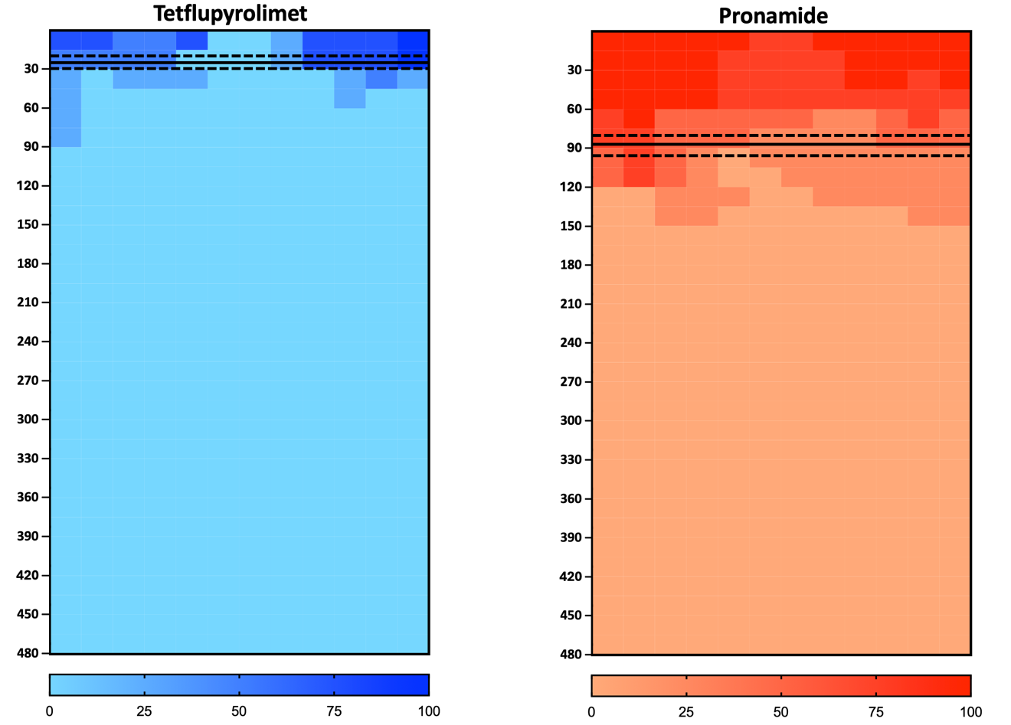
Figure 3.1. Lateral movement assessment of perennial ryegrass (Lolium perenne L.) mortality (within 15 cm² grids) at 8 weeks after treatment (WAT) in 2023 under field capacity soil-moisture conditions at NC State University Lake Wheeler Turfgrass Center Raleigh, NC, following applications of tetflupyrolimet (400 g ha⁻¹) and pronamide (1160 g ha⁻¹). Data was analyzed and then presented using heat maps created in Prism (Version 10.2.3. GraphPad Prism. Boston, MA, USA). Solid lines represent the mean distances for 50% likelihood of perennial ryegrass mortality (Mortality₅₀) and dashed lines represent 95% confidence intervals. Treatments are not significantly different if Mortality₅₀ confidence intervals are overlapping.

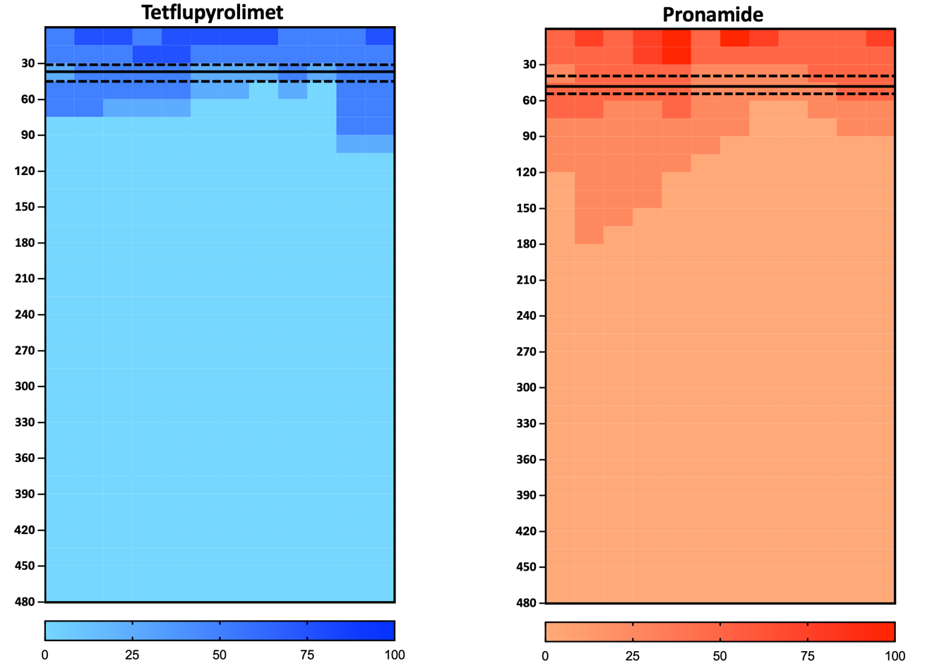

Figure 3.2. Lateral movement assessment of perennial ryegrass (Lolium perenne L.) (within 15 cm² grids) mortality at 8 weeks after treatment (WAT) in 2024 under field capacity soil-moisture conditions at NC State University Lake Wheeler Turfgrass Center Raleigh, NC, following applications of tetflupyrolimet (400 g ha⁻¹) and pronamide (1160 g ha⁻¹). Data was analyzed and then presented using heat maps created in Prism (Version 10.2.3. GraphPad Prism. Boston, MA, USA). Solid lines represent the mean distances for 50% likelihood of perennial ryegrass mortality (Mortality₅₀) and dashed lines represent 95% confidence intervals. Treatments are not significantly different if Mortality₅₀ confidence intervals are overlapping.

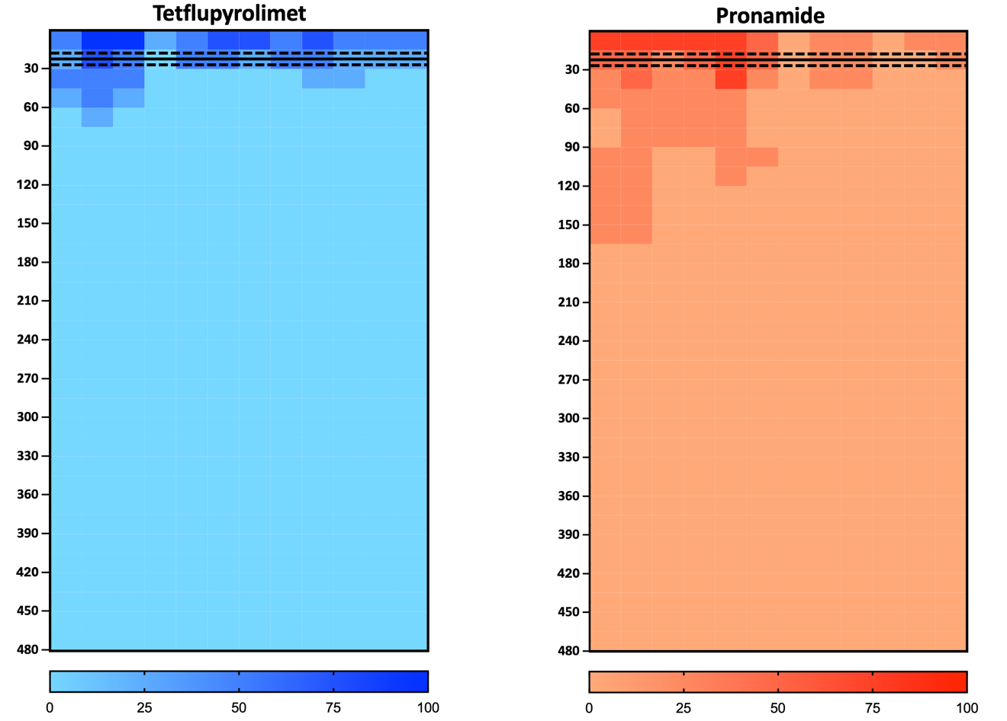

Figure 3.3. Lateral movement assessment of perennial ryegrass mortality (within 15 cm² grids) at 8 weeks after treatment in 2023 under saturated soil-moisture conditions at NC State University Lake Wheeler Turfgrass Center Raleigh, NC, following applications of tetflupyrolimet (400 g ha⁻¹) and pronamide (1160 g ha⁻¹). Data was analyzed and then presented using heat maps created in Prism (Version 10.2.3. GraphPad Prism. Boston, MA, USA). Solid lines represent the mean distances for 50% likelihood of perennial ryegrass mortality (Mortality₅₀) and dashed lines represent 95% confidence intervals. Treatments are not significantly different if Mortality₅₀ confidence intervals are overlapping.
.

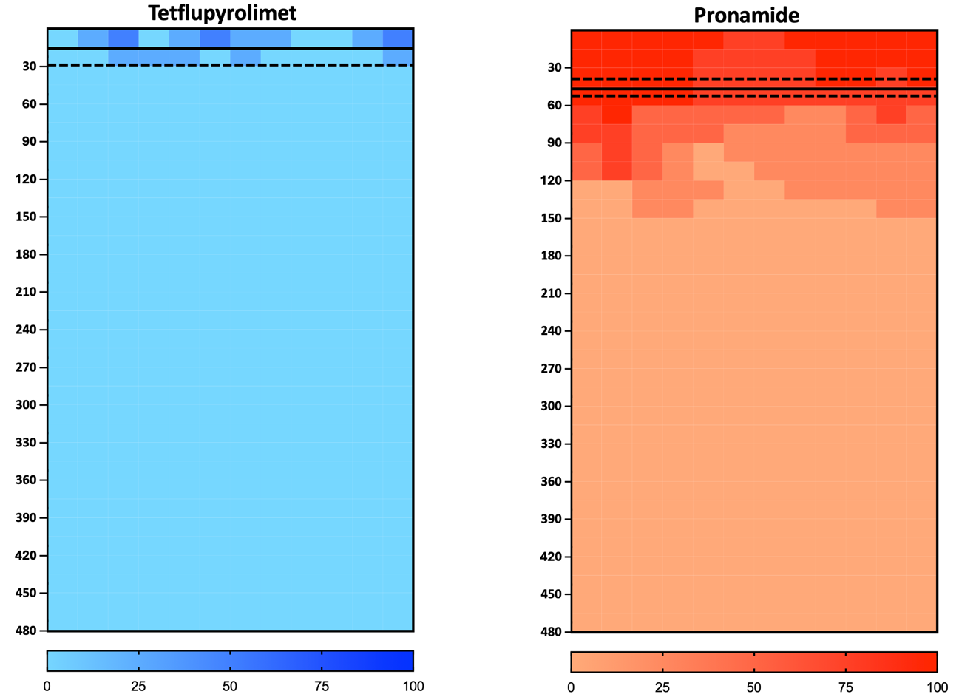

Figure 3.4. Lateral movement assessment of perennial ryegrass (Lolium perenne L.) mortality (within 15 cm² grids) at 8 weeks after treatment in 2024 under saturated soil-moisture conditions at NC State University Lake Wheeler Turfgrass Center Raleigh, NC, following applications of tetflupyrolimet (400 g ha⁻¹) and pronamide (1160 g ha⁻¹). Data was analyzed and then presented using heat maps created in Prism (Version 10.2.3. GraphPad Prism. Boston, MA, USA). Solid lines represent the mean distances for 50% likelihood of perennial ryegrass mortality (Mortality₅₀) and dashed lines represent 95% confidence intervals. Treatments are not significantly different if Mortality₅₀ confidence intervals are overlapping.

VITA
Benjamin D. Pritchard was born on December 25th, 1998, in Bluff City, TN. He lived there until he moved to Knoxville, TN, in Fall 2017 to attend the University of Tennessee. Ben graduated from the University of Tennessee in May 2020 with a Bachelor of Science in Plant Sciences. He also graduated with Chancellor’s honors and two Chancellor’s Citations for Extraordinary Academic Achievement and Extraordinary Professional Promise. Ben was also named the Plant Science Department Outstanding Senior of 2020. In Fall 2020, Ben began his Master’s in turfgrass weed science. His project was developing a bioassay to detect indaziflam-resistant collections of Poa annua to assist turfgrass managers in identifying this problem in a timelier manner. This will provide them with answers on what they should apply to control the troublesome weed of turfgrass Poa annua. Ben wrote his thesis and defended it on March 29th, 2022; then graduated on May 20th, 2022 with a Volunteer of Distinction Extraordinary Professional Promise Award. The following fall of 2022, he decided to return to the University of Tennessee, Knoxville, to acquire a Doctorate of Philosophy in turfgrass weed science under Dr. Jim Brosnan, working on understanding the applications in turfgrass for the first novel mode of action herbicide in over three decades, tetflupyrolimet. Upon graduation May 15th, 2025, Ben will be starting as the new Turfgrass Weed Scientist at the University of Georgia in July 2025. Ben is grateful for this time at the University of Tennessee and the mentorship and camaraderie he found there. He now looks forward to this next step and is excited to serve Georgia turfgrass stakeholders and the greater turfgrass industry through his research and extension appointment.

