Subcritical Facility Design
NE 471/472
Dr. Laurence Miller
Adam Beyer, Kacie Breeding, Jared Fuller,
Graham Jones, Kevin McDonald, Christopher Williams


OUTLINE:
OBJECTIVES ……………………………………………………………………….... 3
INTRODUCTION ……………………………………………………………………. 3
Background …………………………………………………………………... 3
Constraints ……………………………………………………………………. 4
Licensing & Regulation ………………………….………………………….... 5
Standards …………………………………………………………………...…. 6
Benefit of Courses ………………………………………………………….…. 7
METHODS ……………………………………………………………………………. 9
Neutronics ……………………………………………………………………... 9
Gridplate Design & Considerations ………………………………………...…. 11
Detectors & Instrumentation & Control …………………………………….… 13
Work Breakdown Structure …………………………………………………… 16
Gantt Chart & Team Responsibilities ………………………………………… 17
RESULTS …………………………………………………………………………….. 18
Tank Skirt (Both Designs) ………………………………………………...….. 18
Stacked Tank Design ……………………………………………………….… 19
Panel Tank Design…………………………………………………………….. 22
Cost Estimates ………………………………………………………………… 26
COMPARISONS & CONCLUSIONS …………………………………………….…. 29
FUTURE WORK & POSSIBLE IMPROVEMENTS ……………………………….. 30
APPENDIX A: Hand Calculations …………………………………………...………. 31
APPENDIX B: Codes Utilized ………………………………………………………. 34
APPENDIX C: Plate Tank Model & Other Concept Art …………………………….. 43
APPENDIX D: Hand Drawings ...…………………………………………………….. 44

Objectives

The objective of this project is to design a core and tank setup that can be run at a subcritical state, and that can be used for experimentation and demonstrations as needed by students and faculty for both educational laboratory and research purposes.
The objectives for the fall semester portion of the project were to complete the primary tasks of: reviewing the literature available from similar facilities, defining the functional requirements and specifications that fit both the physical constraints, as well as the needs of experiments that are to be conducted using the facility, identifying the licensing requirements, evaluating design options and narrowing down the design to one option, then purchasing the materials, instrumentation, and supplies needed to construct the facility.
The objectives for the Spring Semester portion of the project were to design and generate schematics for two different and independent, fully designed and fully functioning designs for the tank. Once the schematics and accompanying materials lists were completed, we sent the designs away to fabricators for cost estimates. We will then make our recommendation for the final decision of which tank should be built over the summer.

Introduction

Background Information

The University of Tennessee, Knoxville is the 3rd largest undergraduate nuclear engineering program in the country, and the largest PhD program. Once upon a time, we used to have a subcritical facility for educational purposes here at the university. However, that was discontinued in the 1970’s because of the proximity and availability of operating reactors at ORNL for educational and research purposes. But today, our students don’t have the access to these reactors at ORNL and thus don’t get to have any hands on reactor experiment experience. In recent years, the university has tried to fix this by offering a study abroad trip to the VR-1 Research Reactor in Prague, Czech Republic during the summer, however, this trip is rather expensive, and space is limited, only about twelve out of sixty undergraduates can go. Having a subcritical reactor on site, and available to students provides a safe and very useful opportunity to both enrich the learning of our students, by teaching them to have experience with an active reactor in a safe environment while they take experimental data hands-on. The data collected from a subcritical reactor is very useful to modelling data from a larger reactor, and this facility can also be used for countless research projects here at the university, such as detector and material testing. This facility would have some challenging design constraints, but its existence would greatly affect the education and research here at the University of Tennessee, Knoxville.

Constraints

The constraints of this project are reasonable but slightly tricky. Most subcritical facilities have very high ceilings, so that the fuel can simply be inserted from the top from a crane/ladder/etc. In our case however, we are limited to a room with nine foot ceilings with about eight feet of workable space because of low hanging lights in the room; so we must be able to load the fuel with that little of a height clearance. We can probably work around the lights to use the nine foot ceilings, but seeing as how this isn’t certain, we designed to the eight foot specs.
The tank pumping system must be able to raise or lower water level by one foot within ten minutes. Calculations were done with our design so that we could find a pump that would be able to meet this constraint.
We need to be able to manually adjust the pitch of the rods. We have a 17x17 gridplate array, but not nearly enough rods for there to be one in every hole (230 rods total), this makes it possible to do different core configuration and pitches.
We need to be able to measure radial and axial flux distributions. This is accomplished through several instrumentation slots radially through the core that have guide tubes, so that detectors can be moved up and down axially within the core as well.
We need to be able to easily relocate the neutron source and transfer it to a storage container. This tank must be designed so that a fast neutron source can be added to the tank to make a full fast neutron system, this implies the need of some sort of port for the fast neutron source. Additional constraints include that this needs to be able to fit through normal doors, and be able to be easily transported because it is going to have to change locations at least three times during department relocations. We are also cost constrained to $5000 for the tank itself and $30,000 for the instrumentation.

Licensing & Regulation

The primary issue here is getting the state of Tennessee to change our uranium storage license to a uranium usage license, however talking to the University’s Radiation officer as well as our mentor, this doesn’t seem to be a difficult obstacle, it will just be time consuming. There will be an application process that will include procedures for security (anti-theft, monitoring, personnel restrictions) as well as safety concerns (radiation levels, material effects, shielding other rooms, etc) .There will probably just need to be some physical modifications to the building/room to meet radiation exposure and security requirements, and procedures put in place to make sure that the people who work around and use the facility remain within the radiation limits set forth by radiation safety regulations. There will also need to be security measures put in place such as constantly monitored security feeds and very capable locking doors. The radiation safety requirements at the university require that the dose rates be no higher than 2mrem/hr and our MCNP models show that we are well below that threshold.
- Title 10, Part 20, of the Code of Federal Regulations (10 CFR Part 20), "Standards for Protection Against Radiation," establishes the dose limits for radiation workers. Although the limits vary, depending on the affected part of the body, the annual total effective dose equivalent (TEDE) for the whole body is 5,000 mrem (5 rem).
5000 mrem annually, assuming a 40 hour work week, sets the federal regulatory limit for radiation workers at 2.4 mrem/hr, so the 2mrem/hr required by the university is more conservative, and more closely related to the 2mrem/hr dose rates that is the limit for occupational exposure to the general public. Those limits can also be found in 10 CFR pt 20.
Also in 10 CFR part 20 is the control of access to high radiation areas. Although by the definitions set forth in the regulation, our facility would not constitute a high radiation environment, adhering to the security measures if at all possible would be advisable for safety concerns. The requirements of this regulation are generally what would be done anyway, such as having the door locked, and supervisors aware of anyone in the room, that there would be dosimeters to monitor personnel exposure, that the area be under constant direct or electronic surveillance. Since our facility wouldn’t technically be a high radiation environment, we wouldn’t be forced to adhere to all of these regulations, but treating them as standards to work by if at all possible makes the facility safer for everyone.

Standards

The standards relating to this project have not been purchased, but we have compiled a list of standards that might pertain to this project. We tried to find standards pertaining to industrial size, non-pressurized water tanks, however, the only standards we were able to find were those that pertained to tanks for fire safety, such as the water storage tanks for the sprinkler systems and such, so most of the requirements (heat resistance, flow speeds, corrosion & debris resistance) that were found have no relevance to our water tank.
I mentioned in the licensing and regulation section that there are a few regulations that don’t exactly pertain to our facility that should probably just be adhered to as standards, if at all possible. As stated earlier, the best we could do was compile a list of standards that might be applicable to our project. The standards aren’t available for viewing to us as individuals, or to the university in any simple way that we could find, and purchasing all of these standards just to see if they truly did apply would be a really inefficient use of our project resources. But based on the titles of the standards and whatever excerpts from them we could find on the internet, these are the ones that apply, and from what we can tell, most of them are simply adhering to the NRC regulations and proving that the facility would remain subcriticul under all circumstances, both normal and abnormal.
- ANSI/ANS-8.1-1998, Section 4.1.2 requires that “Before a new operation with fissionable material is begun, or before an existing operation is changed, it shall be determined that the entire process will be subcritical under both normal and credible abnormal conditions.”
- DOE-STD-3007-2007:Guidelines for Preparing Criticality Safety Evaluations at Department of Energy Non-Reactor Nuclear Facilities
- ANS-8.1-1983; R1988, “Nuclear Criticality Safety in Operations with Fissionable Material Outside Reactors” (PDF) $95
- ANS-8.6-1975 (N16.3), “Safety in Conducting Subcritical Neutron-Multiplication Measurements in Situ” $29
- ANS-8.7-1973 (N16.5), “Guide for Nuclear Criticality Safety in the Storage of Fissile Materials” $100
- ANS-8.10-1975, “Criteria for Nuclear Criticality Safety Controls in Operations Where Shielding Protects Personnel” $43
- ANS-15.11-1987, “Radiation Protection at Research Reactors” $58
- ANS-15.16-1982 (R2000), “Emergency Planning for Research Reactors” (PDF) $56

Benefit of Courses

There were several courses that were very helpful in this project. Most of the course work that we have in our major went into this project as more of an intrinsic knowledge than direct application. For example we didn’t directly apply aspects of NE 360: Reactor Systems and Safety, but we were able to use what we learned to know what systems would be needed in our subcritical reactor and how to find and apply regulations.
NE 470: Reactor Theory is an obvious course used in this project. It taught us how to configure a core, what the terms of the project really were (what is a pitch? What is a K-effective? What is meant by subcritical?) It also taught us what points of the reactor we needed to focus on, such as, when modelling the core in a monte-carlo code, where is the flux going to be the highest? Where is K-eff at its maximum? Etc.
NE 406 taught us how to model the core in MCNP. It is probably the course that most directly applied to this project. We were able to calculate the K-eff using Kcode and also to calculate the doses at the edges of the reactor using response functions for our neutron source. If shielding had been needed to lower that dose rate, we were prepared to use MCNP to calculate how much we needed and where. If this is needed or requested in the future it can still be done.
NE 402/467 is the course that taught us most about instrumentation and detectors through hands-on learning. It also taught us how to use MCNP and what type of detectors we would need for the reactor, since NE 402 is one of the courses that would most use the facility as an instructional tool. Kacie and Jared were in NE 467, and that experience allowed them to apply their firsthand knowledge and experience of a research reactor and the methods of operation and instrumentation that were used there.
ME 202/321 was the non-nuclear course that was an absolute necessity for this project. We used ME 202 as a basic design course, learning which materials are most effective at certain purposes, and how to make static objects stable and safe. ME 321 was used directly extensively for this project, in calculating the necessary thicknesses of the walls and baseplates to prevent bending and fracture of the tank.
Then of course NE 471 & 472 taught us the qualities of working as an effective team working on a project with constraints and a purpose. It taught us time management and planning techniques for accomplishing the goals of the project. The lectures and weekly reports as well as the planning techniques like the gantt chart and work breakdown structure, really did help set goals to a timeframe that made things seem easier to plan for and accommodate when things didn’t quite go as planned.
The primary course that would have been a great thing to have for this project would be a course using AutoCAD. We used it for one class period in EF 105, but that has been four years, and it wasn’t an in depth explanation. When trying to teach ourselves AutoCAD we looked at the course website for EF 105 for references, and saw that they don’t even have that one day of AutoCAD anymore. I don’t think this is really a necessary course for every nuclear engineering major, but it would be nice to have access to, maybe have informational seminars that we could be directed to or something of that nature.

Methods

Neutronics

Before can begin any building on the facility, we had to prove that the facility would be both subcritical and safe for any bystanders. To that end, we utilized an MCNP6 model to simulate the conditions of the facility and ensure that the constraints would be met. We created two files: one to calculate the dose rate one would receive at a point on the edge of the facility, and the other to calculate the criticality of the uranium rods. The two inputs have identical geometry and materials. They differ in that one runs a “KCODE” operation and the other has a specifically defined neutron source in the center.
The KCODE operation in MCNP6 simulates multiple “cycles” of neutrons, consisting of 25000 neutrons each. A cycle proceeds by simulating particles at random points within the source and tracking how many new neutrons are generated by the original. The ratio of newly generated neutrons to original neutrons is the k-eff value for that cycle. The source’s position is determined by running 40 inactive cycles. These cycles are not counted in the average of the k-eff values. The first active cycle only emits neutrons from a specified point. In this case, the point is the center of the middle rod, where the PuBe source will be located. During the first cycle, MCNP tracks where any new neutrons are generated. Then, the next cycle will start its original neutrons in the locations where the last cycle’s neutrons were generated. Over the course of the 40 inactive cycles, this process is repeated until the source position is found to be statistically stable. The result is that the neutrons in the active cycles will be created in all of the uranium slugs and the PuBe source. In our case, the final k-eff after 40 inactive cycles and 200 active cycles was .849, which is well within the reasonable range for a subcritical facility. In addition, we simulated the tank in multiple different geometric configurations to prove that it would never accidentally go critical.
To calculate the dose-rate a bystander would receive, our MCNP6 input simulates a point detector on the edge of the tank, halfway up its height. The point detect measures a neutron flux that’s converted by a response function into a dose per source particle. The particular response function that we used is found in Table D.3 of By Shultis and Faw. Their response function was given in Sv/sec. We used the following conversion factor to convert this value into a function that would output a dose in mrem/hr:
$$response (\frac{Sv}{sec})* \frac{100 rem}{Sv}*\frac{1000 mrem}{rem}*\frac{3600 sec}{hr}=Response (\frac{mrem}{hr})$$

The tally resulted in a value of: 1.89283E-10 ±4.47% mrem per neutron. To convert this value into a dose rate, the following equation was used:
$$MCNP f5 Tally (\frac{mrem}{neutron})*100000\frac{neutron}{sec}*3600\frac{sec}{hr}=Dose Rate (\frac{mrem}{hr})$$

The final calculate dose was 0.068 mrem/hr. The University’s safety limit for radiation exposure is set at 2 mrem/hr.

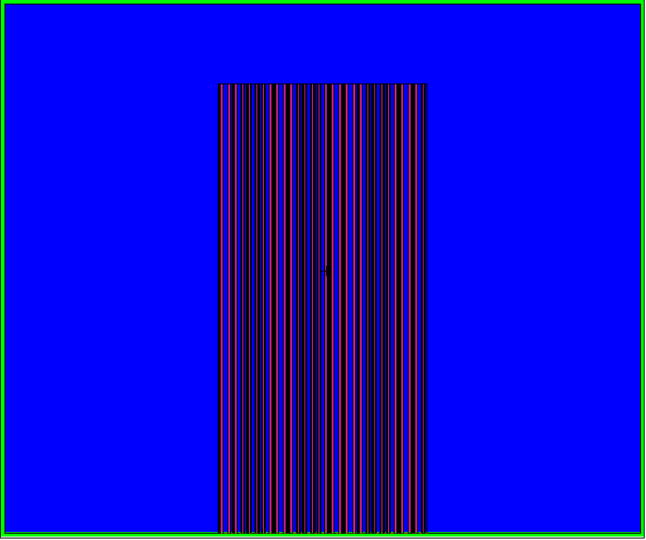  Figure 1: Side View | 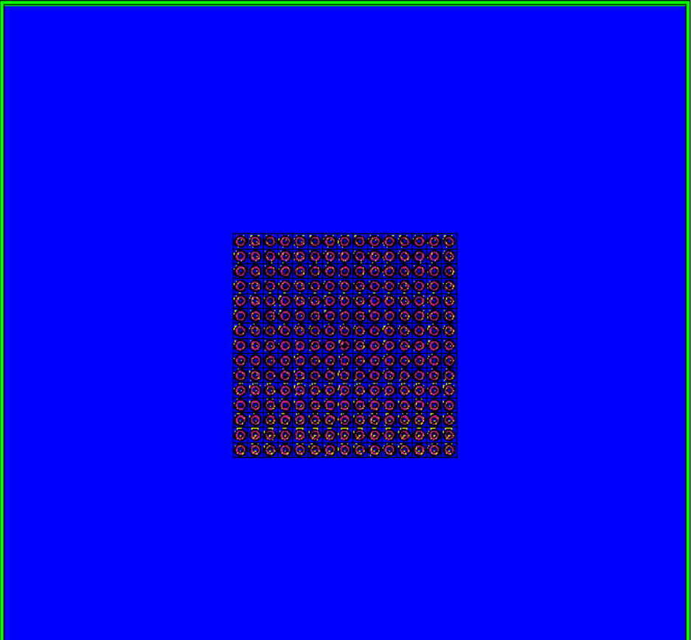  Figure 2: Top Down
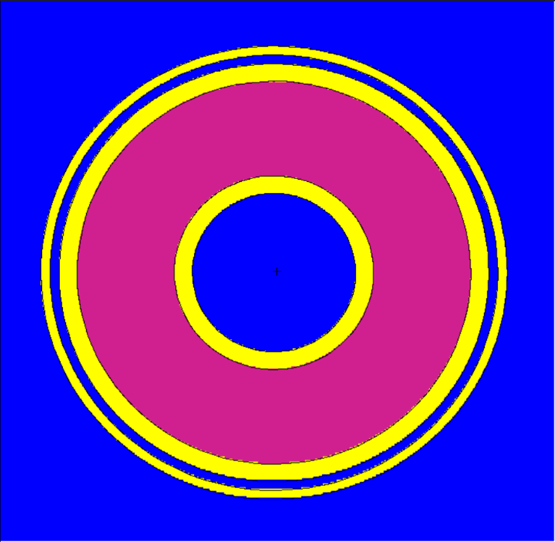  Figure 3: Close up of Pin | 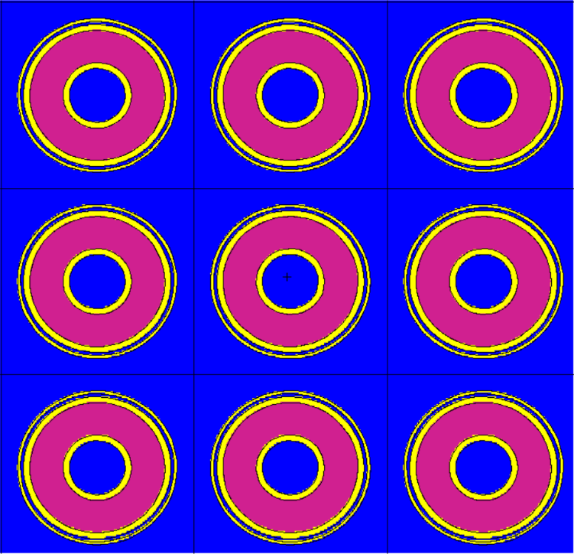  Figure 4: Section of Pins

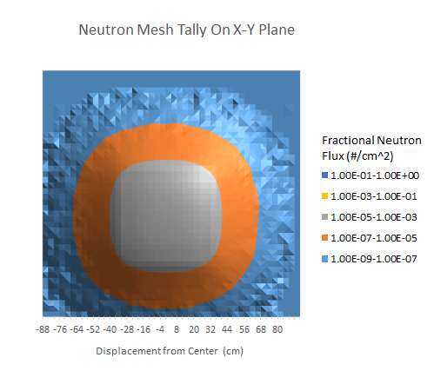 | 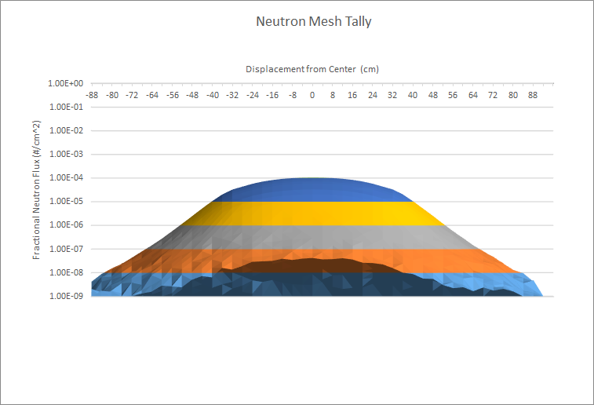  Figures 5&6: Neutron Mesh tally, top down & side view

Gridplate Design & Considerations

Since we have 230 uranium pins at our disposal, we decided to use a 17 by 17 array with a 2 Ci PuBe source in the middle. The PuBe source has a .98” (2.5 cm) diameter and is 2.24” (5.7 cm in length.) Each of the pins have a radius .652” and are positioned 1.57” center to center. The grid plate is to have the same thickness as the walls, which is ¼”. This is because after talking to axis fabrication, it is very hard to bend 3/16”, since welding would be very expensive. The detectors are placed on the right side of the grid plate, making it easier for instrumentation sake. We decided to have the rod in which the instrumentation is placed to be .1cm away from the control rods, and have a wall thickness of 1/8”. This gives us .596” diameter for the detectors, which is plenty of room for the .5” detectors that we have in mind. These rods will be closed on one side and filled with air. Since they will float, we plan on putting weights on each of the instrumentation tubes to weigh them down. The grid plate will rest on a 4” ledge on all sides, giving it ample stability. There are around 6” on each side of the gridplate from the furthest hole. One of the corners will be cut out as shown in Fig X, this hole will maintain stability but still allow us to use this hole for other instrumentation that may be needed, which includes draining, the possibilities of other instrumentation like bubblers and heaters, as well as any pressure or water level sensors that may be used. There will be two grid plates, each weighing around 32 pounds each.
We plan on having a hose or pipe system with a valves to allow for seamless transfer of water from the tank itself to doorway tanks, and vice versa. This valve system is shown in Fig X of the “Instrumentation & Control” section.

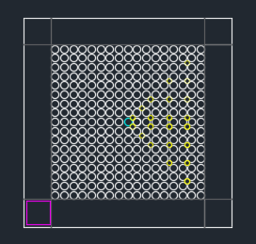 | 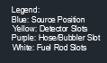  Figure 7 : Gridplate design. 3’x3’
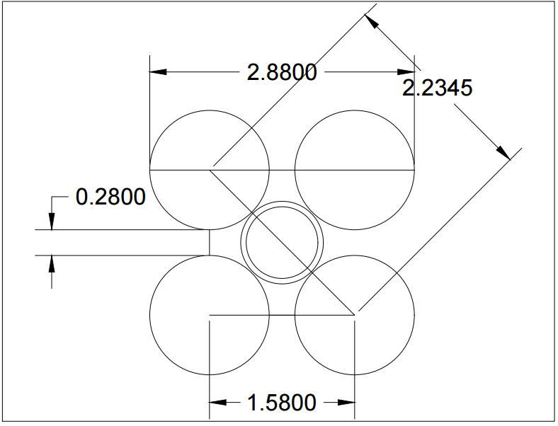
Figure 8: Zoomed in Diagram of the interstitial instrumentation holes.

Detectors & I&C

Detectors

The natural uranium fuel rods will be placed in the tank in a square grid with a 4 cm pitch (distance between rods), and the instrumentation tubes will be located multiple interstitial locations and will have an inside diameter one-half inch. If necessary we will replace several fuel rods with instrumentation tubes in order to use much larger detectors with higher sensitivity. In order to obtain useful measurements for these experiments neutron detectors that only measure count rate and that measure neutron energy spectra are needed. In addition the efficiency of at least one of the detectors should have a sufficiently high count rate (or efficiency) that a transient of a few seconds can be measured. It is also of interest to have detectors that employ different physical principals for educational purposes. Thus, we are expect to purchase several of the following types of detectors:
1) gas proportional,
2) He-3.
3) BF3,
4) Li-glass,
5) Fission,
6) Diamond,
and 7) One suitable for pulse shape discrimination.
The gas proportional and diamond detectors are useful for spectral measurements, He-3, BF3, Li-glass, and fission are useful for neutron count rate measurements, and a detector capable of pulse shape discrimination will be useful for verifying count rates are due to neutrons rather than gammas.
We have reached out to several vendors of detectors, and a few of them have given us quotes for several detectors. From LND, Inc. we have a BF3 detector, for $1050.00, a He3 Detector for $1400.00, a fission chamber for $9000.00, and a proportional counter for $1000.00. The specifics of these quotes can be found in the “Cost Estimates” section of the paper.

Instrumentation & Control

There aren’t too many things that we will need for non-detector instrumentation, but the things we will need for experimentation are listed below.
- Pressure gauges within the piping, in the primary tank and the secondary tank, with backups for redundancy.
- Water level indicators, which would be Arduino sensors that light up when water passes them, several of these could be placed in the tank and input into some software. (http://www.ebay.com/bhp/water-level-indicator), (https://diyhacking.com/ultrasonic-arduino-water-level-indicator/)
- Bubbler: fish tank bubblers are available, but it may be better to just construct our own using pressurized air and small holes. (http://www.drsfostersmith.com/product/prod_display.cfm?pcatid=19782&rel=1),( https://www.mcmaster.com/#air-pumps/=157n1hj)
- Void Fraction sensor: can be done using capacitance sensors. (http://www.ab.com/en/epub/catalogs/12772/6543185/12041221/12041231/print.html)
- Doorway water tanks:
http://www.plastic-mart.com/category/39/doorway-water-tanks
Price: $369.95 (may need multiple) - $1,559.95
- Air pump:
https://www.mcmaster.com/#air-pumps/=16hyi5x
Price: $483.17 – $2,559.65
- Water heater:
https://www.saltwateraquarium.com/true-temp-1000-watt-200-300-gallon-titanium-heater-element-only-jbj/?utm_medium=googleshopping&utm_source=bc&gclid=CMeLgKi2wtICFdYvgQodzX4BlQ
Price: $87.99 (need 2 for 400-600 gallons of water)
- Water pump (9.7 gpm, 1” hose inlet/outlet): https://www.northerntool.com/shop/tools/product_200672183_200672183?cm_mmc=Google-pla&utm_source=Google_PLA&utm_medium=Water%20Pumps%20%3E%20Utility%20Pumps&utm_campaign=Ironton&utm_content=50090&gclid=CNr05_q3wtICFZIvgQodQzMH6w
Price: $79.99
Note with the water pump: the 9.7gpm 1// hose inlet/outlet should be plenty of pull to cover the constraint of “lower the water level by a foot in 10 minutes” according to the calculation inculded in Appendix A, but if for some reason we want more there is a 1560 gph pump at (https://www.northerntool.com/shop/tools/product_200197324_200197324)
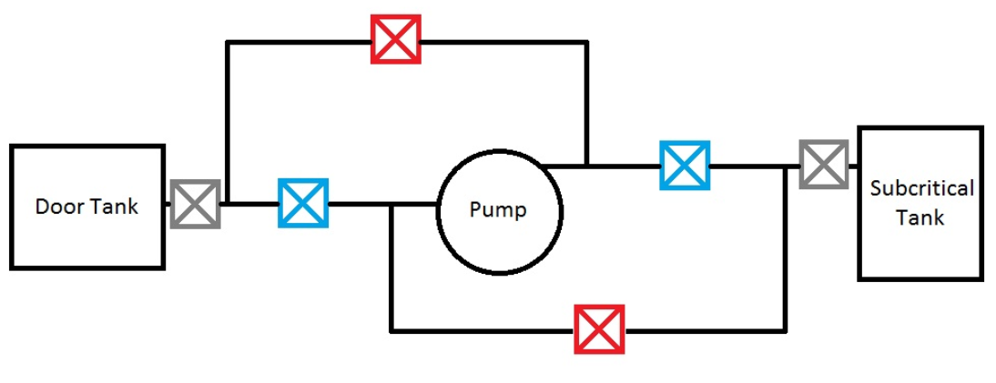
Figure 9: Schematic of the valve system that will allow seamless transfer of water from core to the doorway tanks. Gray is a metal valve. Blue is the “cold side” path, if both are open the water goes from storage to the core. Red is “hot side” path, if both are open water goes from the core to storage.

Work Breakdown Structure

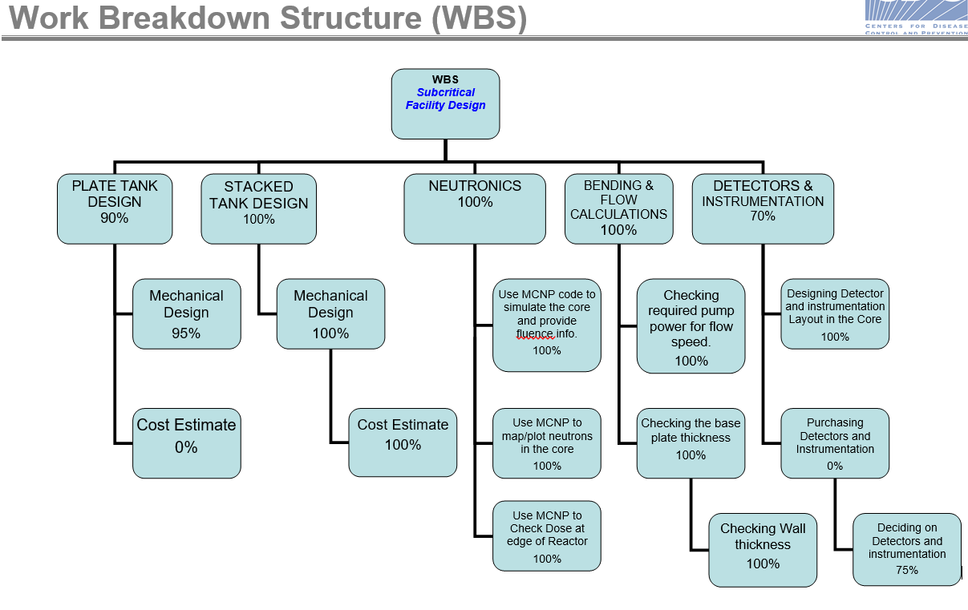

Gantt Chart & Team Responsibilities
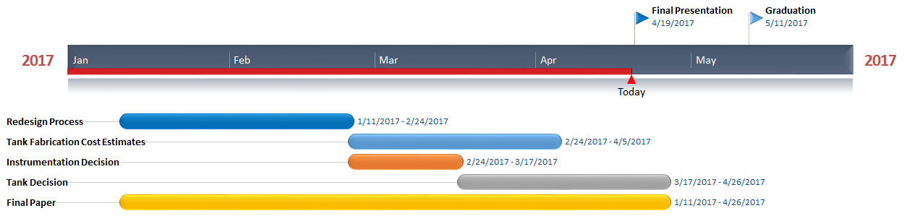
This project was a team effort, all of the work was at the very least, double checked by another team member, but in general each member of the group had their specializations within the project.
Kacie was the team leader. She arranged meetings, kept track of due dates and tasks that needed to be completed. She kept record of all the files and drawings for the project. She also wrote all of the weekly update progress reports, as well as the final report.
Jared was the primary operative working on the design and drawings of the tanks. He and Dr. Miller were the main two people throwing ideas back and forth to design both tank options. He drew almost all of the hand drawings, and he made over half of the AutoCAD drawings. He also reached out to other fabricators for cost estimates.
Adam was the main designer of the gridplate. He designed the array and calculated the optimal sizes and locations for instrumentation holes within the lattice, as well as the size of the primary instrumentation port on one side of the gridplate. He also looked into instrumentation tubes, how to keep them weighted down, and the maximum size of instrumentation that can actually be put into the interstitial holes, giving us our size constraints for our detectors.
Kevin worked on the neutronics aspects of the project. Including MCNP flux and dose calculations as well as ensuring that the facility will never go critical under any circumstances. He also made several of the AutoCAD drawings, particularly the ones in 3D.
Graham worked on instrumentation such as water level control and indicators, water removal pumps, research on the purchase of door tanks for the bringing in of the water. He also did several miscellaneous but crucial calculations, such as calculating the maximum deflection of the walls and baseplate using both a MATLAB code and several hand calculations, as well as codes calculating the weights of water and uranium in the system.
Christopher worked on the detector research and acquisition, he looked into the different aspects of detectors, and determined the types we would need to purchase for the experiments we intend to do. He used this information to reach out to detector suppliers with the size constraints we have to get possible quotes on prices of these detectors.

Results

Tank Skirt Design

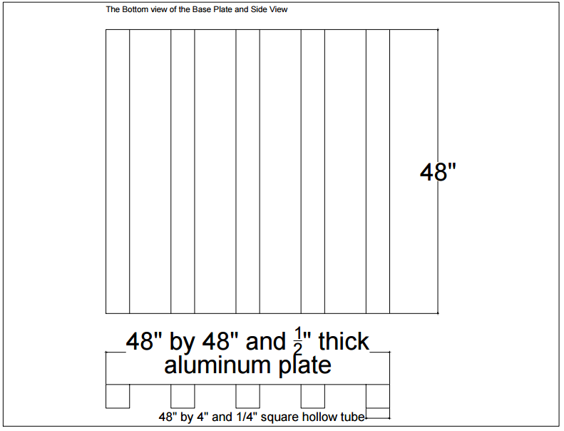
Figure 10: Tank Skirt Supports side view and bottom view.

The base tank, will be essentially the same for the stacked-tank and for the plate-tank designs. The difference is in the method finally chosen for forming water seals at the top of the tank. Ninety degree angle pieces are proposed for the stacked-tank design and tee bars are proposed for the panel-tank design. Each is to be welded on the inside to form a flange that faces out. The base plate of the bottom tank is 3’x 3’ for the stacked tank and 4’x4’ for the panel tank and one-half inch thick. Four side plates (3’x19”x1/4” for stacked tank, 4’x2’x1/4” for panel tank) are welded to the base plate to form the lower tank. The lower grid plate is placed one foot above the bottom tank and will be supported by welding a two foot 90 degree angle piece (2”x2”x1/4”, 2’ feet in length), or tee bars to each side of the tank. The bottom of the tank is shown to be supported by 5 square hollow tubes, this may not be necessary if the floor is level enough, but it has been drawn up and designed just in case.

Stacked Tank Design

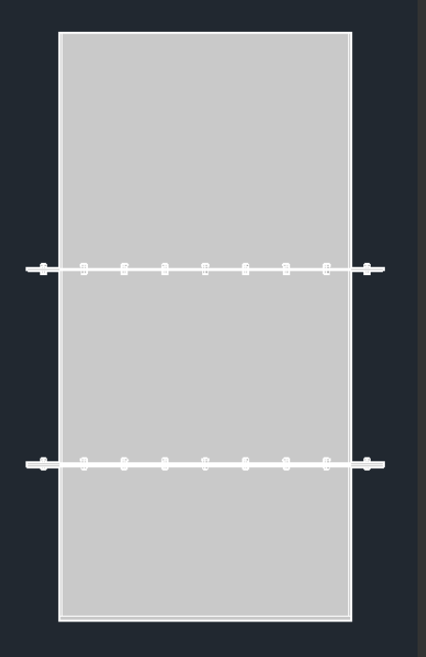 | 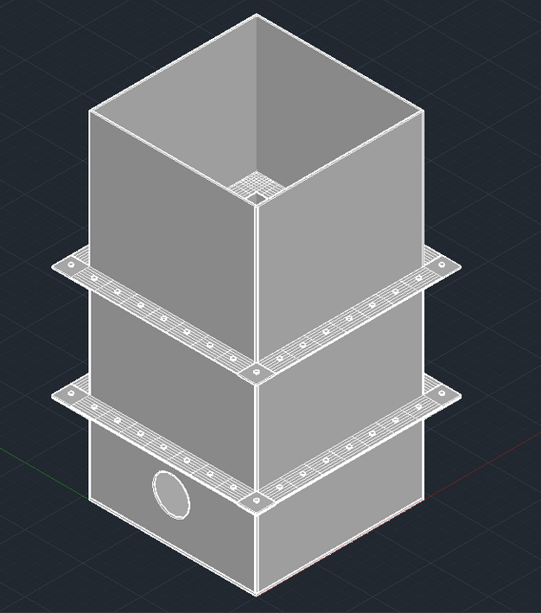
Figure 11: Side view of Stacked Tank | Figure 12: Isometric view of the stacked tank.

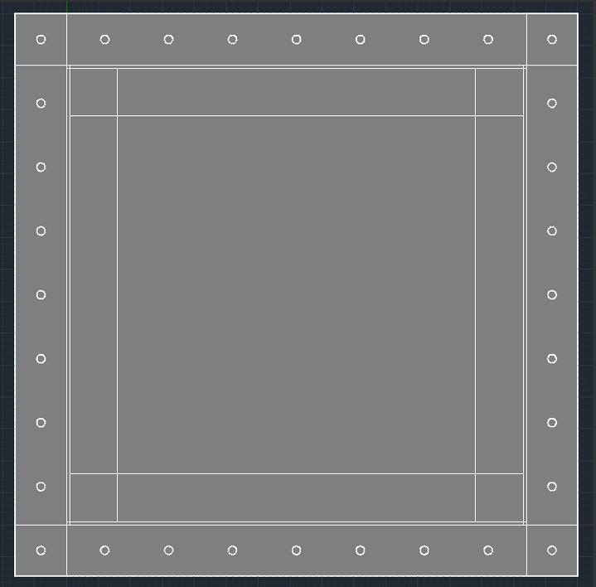
Figure 13: Top view of stacked tank
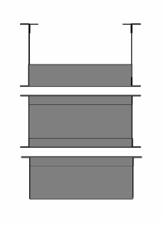
Figure 14: 3D Stacked Tank, 2D export

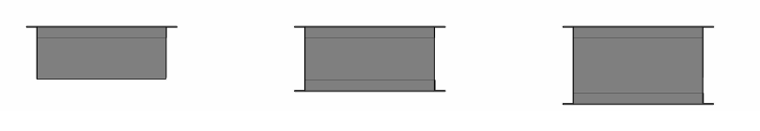
Figure 15: 3D Stacked Tank, 2D export

The stacked design consists of three separable tanks of varying heights (19’’ bottom, 24’’ middle, and 29’’ top). At the conjunctures of these tanks are welded angle irons creating flanges that will be used to both bolt the three tanks together (with a sealant to ensure water-tightness), as well as support the grid plates. The heights of the tanks were decided based on the constraints of the room dimensions and standard 32’’ doorways, as well as the complications of loading the fuel rods into the guiding grid plates with 8’ ceilings. The entire tank will be constructed of aluminum for durability as well as being low density, making it a much lighter design than steel.
The tank will be filled with either demineralized or deionized water. The water will be transferred in and out of the tank using a pump and valve system that can be seen below. The pipe for the tank will enter through the top and go to the bottom of the tank through the instrumentation hole in the grid plates. This is to avoid any additional holes in the tank that could lead to leakages. The water will be brought into, and removed from the room using simple door tanks that can be bought practically anywhere.

Table 1: Component list for Stacked Tank Design
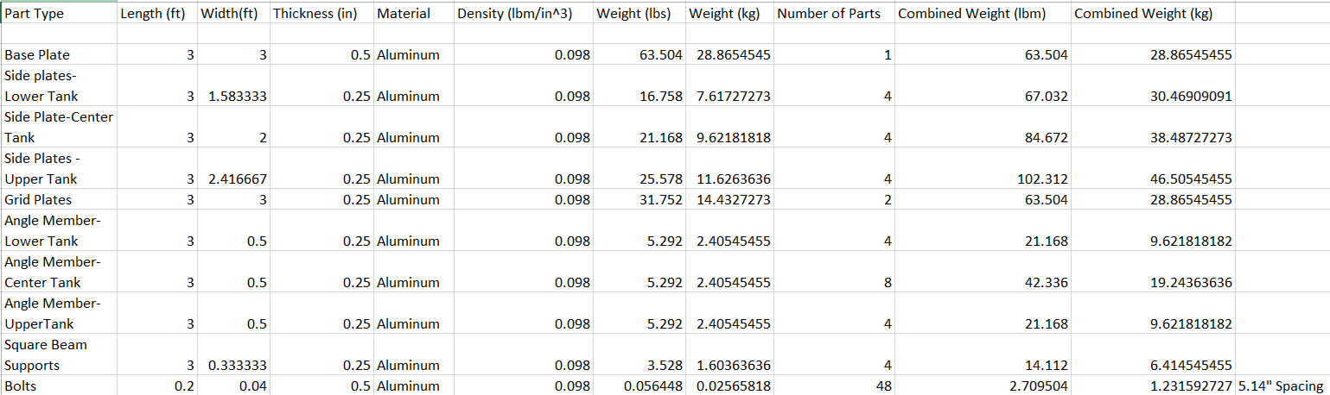

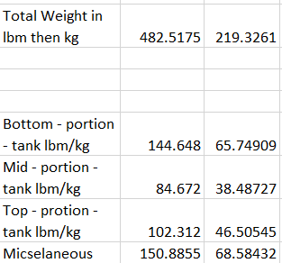

Panel Tank Design

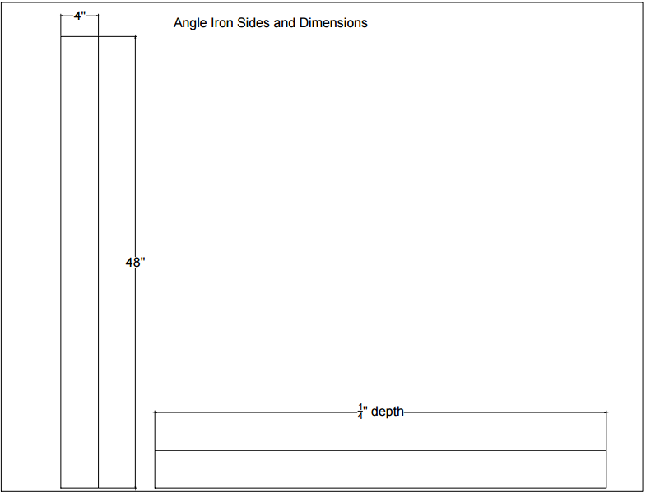
Figure 16: Panel Tank Design, 2D Drawings, Angle iron dimensions.

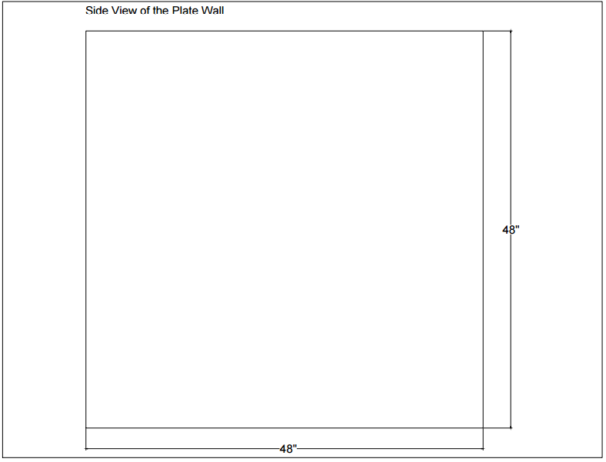
Figure 17: Panel Tank Design, 2D Drawings, Side Panel Dimensions.

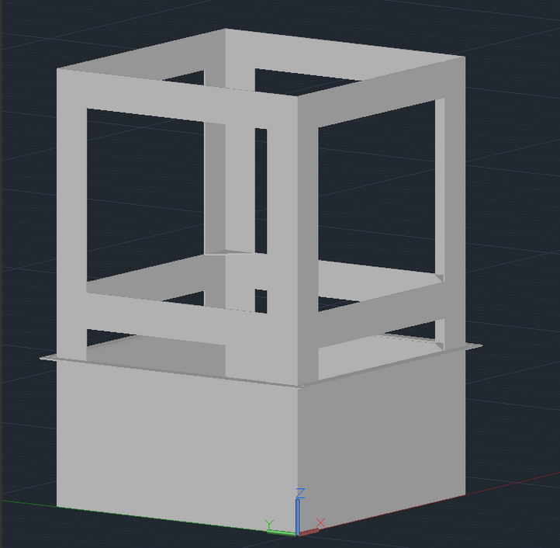 | 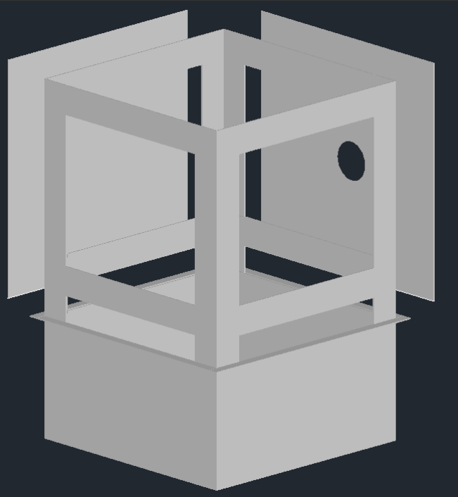
Figure 18: 3D Panel Tank Design, 3D image, no walls. | Figure 19: 3D Panel Tank Design, 3D image with walls.

The panel-tank will consist of base tank and four side panels (or plates), where the upper four feet of the tank is designed so that each of four side panels can be easily put in place and removed.
In order to provide structural support for these panels, four 90 degree angle pieces of aluminum that are six inches on each side, six feet high and one-fourth inch thick are to be used. The lower portion of these of these support structures are fastened to the lower tank by the diagonal corner braces (alternatively displaced panels to provide slots to secure these members). Tee bars, with the flange facing in, are proposed for use to connect the support posts on two levels; one on each side at the upper grid plate level and one on each side that the top of the support posts to support a cover or instrumentation. The tee bars will need to be notched so they can be bolted to a plate welded into the support posts. Alternatively, plates (6”x4’x1/4”) connect each of these support members could be used. In order to connect these to the vertical support posts, 90 degree angle pieces are welded to the connecting plates that extend to a triangle plate welded into the vertical post. Water seals will be needed where the horizontal side of the plates join the lower tank and where the vertical edges of the plates join. The following two options should be studied for the horizontal section of the side plates: 1) Weld ninety degree angled pieces to the bottom of the side panel to join with the flange on the lower tank. This would make the horizontal water seal method for the plate-tank design the same as for the stacked-tank design. 2) Weld a tee bar to the top of the base tank with the flange facing out.
The upper portion of the tee bar would be used to form the water seal. The portion of the tee bar that faces up is flush with the support post so the side plate covers both the support the upper portion of the tee bar and one side of the support post. The upper portion of the tee bar would have bolts welded in place, facing out. For this case the bottom of the 4’x4’x1/4” plate is notched so that the bolts pass through the plate. A 90 degree angle piece could then be bolted to the tee bar with the side plate and gasket sandwiched in between. For the four vertical sections where the side plates join, the following methods should be evaluated: 1) Weld a 45 degree angle piece (flange) to the vertical edges of each plate so that they can be bolted together with a gasket between each flange. 2) Weld bolts into the support posts facing out at a 45 degree angle and notch the side plates at the location of the bolts. Cover the line where the plates join with a gasket and then bolt a 90 degree angle piece to cover this joint. The corner where the horizontal and vertical seals meet could be a continuous surface. The side panels may have a latch that may be hooked over the cross ties so they will be stable when securing the gasket seal. These latches are included so that the panels will be securely held in place when installing the plates and mating the vertical seals. Handles can be added to make maneuvering the pieces easier.
Note that the panel tank was designed as 4’x4’x6’, however, it could just as easily be made to be 3’x3’x6’ like the stacked tank, however, since the stacked tank is favored because of its simplicity, it seemed frivolous to redraw the panel tank schematics just to change the 4’ sides to 3’ sides.
Table 2: Component List for Panel Tank Design
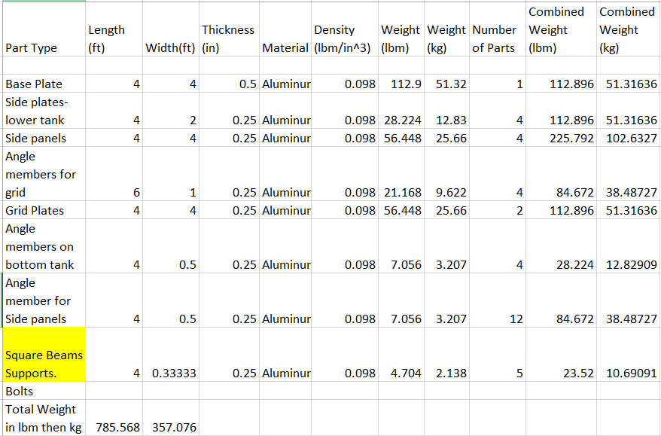

Cost Estimates


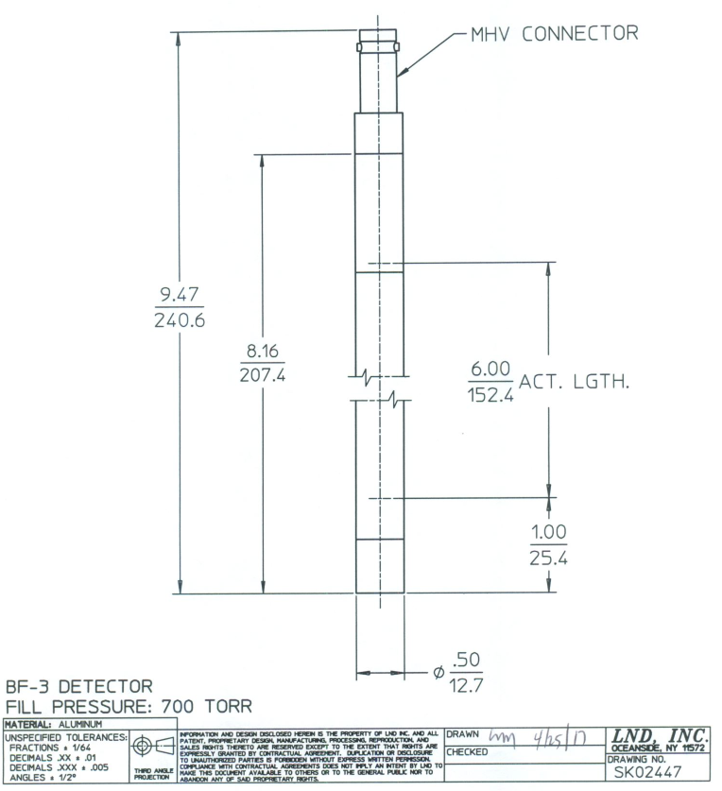 | 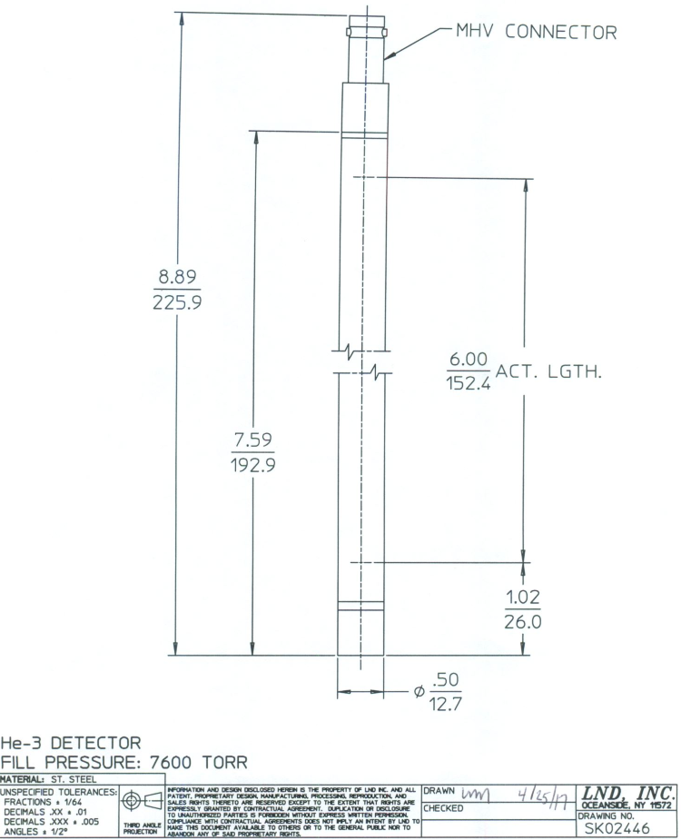
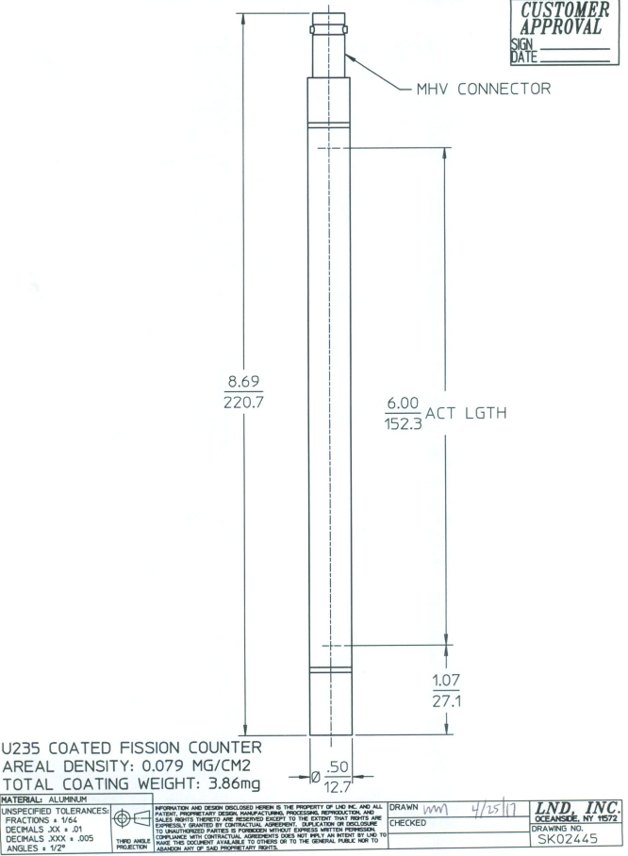 | 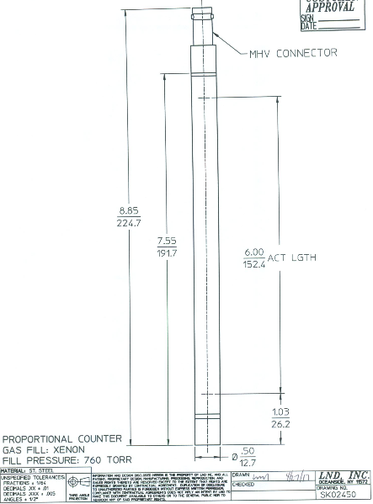


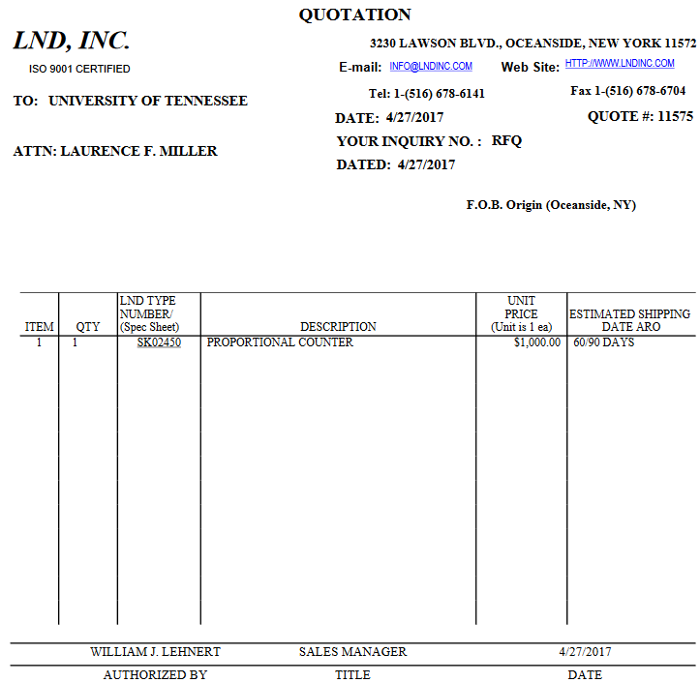

Comparisons & Conclusions

As of the end of the semester, we only have a cost estimate for the stacked design, but it is the simpler design and the one favored by the administration, so it will more than likely be the design that finally gets chosen to be built. And we only have one cost estimate in total, where we hoped to have several competing quotes from different vendors.
It seems like the stacked tank is going to be the winner, because it is more of a robust, simple design. Easy to maintain. Easy to put together. Hard to mess up. It doesn’t have quite the level of versatility that can be achieved with the panel design, but in the interests of longevity and the fact that we will not be the ones ultimately building and operating the tank, we have to look at this from the perspective of an outsider.
In conclusion, we have two well calculated, not over-designed tank designs. Both of the options have their pros and cons, and until we get cost estimates for both designs, we won’t be able to really make a suggestion on which one is ‘better’. Even then, it won’t be a question of which is ‘better’ just a weighted decision on what things matter the most to the people who will be using and maintaining the facility after we are graduated.

Future Work & Possible Improvements

Future work involves deciding on and acquiring auxiliary instrumentation (such as the pumps, heating elements, bubblers, etc.) We compiled a list of options, but nothing has been decided upon, and there are still a lot of other things to take into account.
The detectors to be used in the facility still need to be purchased, we have quotes from vendors, but no decisions have been made and probably won’t be until long after the tank is decided upon. In addition to the detectors themselves, there also needs to be a way to move the detectors through the system to gather measurements. There is the simple option of moving the detectors manually (sort of like a fishing rod) but automation would be preferred if possible.
The designs have in place a port hole for the addition of a fast neutron source. However, we were not able to find enough information on these sources to know exactly where the hole needs to be, or what other sorts of accommodations need to be made for it.
There is still much left to do in terms of instrumentation and control, as well as any sort of auxiliary equipment that may be needed to conduct experiments. But this is a good option for another senior design team, they may have better ideas about how to automate the detectors, and how to properly instrument the tank. Our goal was to design a tank, and get a framework for further work, and there is definitely room for improvement, as with any design.

Appendix A: Hand Calculations
Required:
Find a hose and pump that will lower the tank water by one foot in ten minutes

Given:
base (b) = 3 ft.
width (w) = 3 ft.
height (h) = 1 ft.
7.48052 gal = 1 ft³
time (t) = 10 min

Solution:
V_{H2O} = b*w*h = (3 ft.)*(3 ft.)*(1 ft.) = 9 ft³
V_{H2O} = (9 ft³) * (7.48052 $\frac{gal}{{ft}^{3}}$) = 67.32 gal
$\dot{m}$= $\frac{67.32 gal}{10 min}$ = 6.732 gpm
If FS = 2,
$\dot{m}$ = 13.47 gpm or 807.90 gph

Pumps are rated in gph or gpm, so this design need can be taken to most pumps to see if they match the criteria. For overestimation, the last foot of water in the tank was considered, as there would be no pressure forces acting on the water entering the hose from any water above it. This is also calculated for tank devoid of rods to overestimate the volume. A factor of safety of two is also included for any friction and pressure losses for the length of hose and six-foot vertical path of the hose over the tank.
The recommendation is a pump with a 1.5-in. diameter inlet and exit port, and a flow rated at 808 gph. The pump is connected with plastic piping to stand pipes in both the subcritical tank and door water tank, and there are four valves that let the same pump both drain and fill the tank without any disassembly. The pump needs to be self-priming as well.
Required:
Find the deflection of a fixed wall at half its yield stress.
Find the deflection of a fixed wall of thickness $\frac{1}{4}"$.

Given:
E = 10⁷ psi
ν = .35
$σ_{y}=$4*10^4 psi
b = 3 ft
w = 1.58 ft
FS = 2
Fixed on all edges

Solution:
α = $\frac{w}{b}$ = 0.528
P = (1.940 $\frac{slug}{{ft}^{3}}$) * (32.2 $\frac{ft}{s^{2}}$) * (5.21 ft) = 325.5 psf
σ = $\frac{σ_{y}}{FS}$ = 2*10⁴ psi = $\frac{6M}{h^{2}}$
M = $\frac{P b^{2}}{12(1+α^{4})}$ =226.52 lbf
h² = $\frac{6M}{σ}$; h = $\sqrt{\frac{6 \left( 226.52 lbf\right)}{2*{10}^{4} psi}}$ = 0.261”
w(h=0.261”) = $\frac{.0032(1-ν^{2})}{1+α^{4}}\frac{Pb^{4}}{Eh^{3}}$ = 0.000386”

w(h=0.25”) = 0.00044”

This problem was adapted from a very similar problem in an engineering class. It’s to determine the deformation of a wall fixed on all ends given the dimensions of the ends and the pressure being applied. The first calculation is the minimum thickness the wall can be and only place half of the yield stress of aluminum at the center of the wall, where stress and deformation are maximums. The pressure is taken at 5.21 feet of depth, because this is the center of the bottom wall, taken to be 3 feet wide and 1.58 feet tall.
The minimum thickness to keep a factor of safety of 2 is 0.261 inches, while the chosen thickness is 0.25 inches. This leaves a safety factor of 1.84 before the aluminum wall yields, and since aluminum walls cannot feasibly be made at the exact thickness of 0.261 inches, this is an acceptable amount of stress on the bottom when the tank is filled with water.
Required:
Determine the maximum deflection of the base plate with water and pins resting on it between spans of square beams

Given:
L = 6.66” span
t = 0.5” thick aluminum
E = 10⁷ psi
I = $\frac{Lt^{3}}{3}$ = 0.2775 ${in}^{4}$

For water:
h = 72”
d = 36”
ρ = 0.036127 $\frac{lb}{{in}^{3}}$

For rods:
4 rows
17 columns
34.4 $\frac{lbs}{rod}$

Solution:
w = (72”)(36”)( 0.036127 $\frac{lb}{{in}^{3}}$) = 93.64 $\frac{lb}{in}$
v_{max}(water) = $-\frac{5wL^{4}}{384EI}$ = -0.000864”

P = (4 rows)(17 $\frac{rods}{row}$)(34.4$\frac{lbs}{rod}$) = 2,339.2 lbs
v_{max}(rods) = $-\frac{PL^{3}}{48EI}=$-0.005188”

v_{max} = v_{max}(water) + v_{max}(rods) = -.00605”

This calculation for the deflection of a nearly half-foot span between square beams has a few overestimations. The volume of the water ignores the volume of rods, the rods are all placed at the center of the span, where deflection would be highest, and all spaces in the array are filled with rods. The superposition principle allows one to consider the deflection caused by a distributed load (water) and single-point loads (rods) separately, and then add the deflections for a total deflection.
If this overestimated deflection is too great, either the calculations can be done more realistically to lower the estimate, or either the base plate thickness can be increased (increasing the I value), or there can be more square beams added to the bottom (to lessen the span and subsequently the amount of water weight and number of rods on the span). If the base plate thickness were lessened to 0.25”, the deflection would then be slightly overestimated to be 0.0484”.

Required:
Determine the deflection of the neutron port, taken as a cantilever beam

Given:
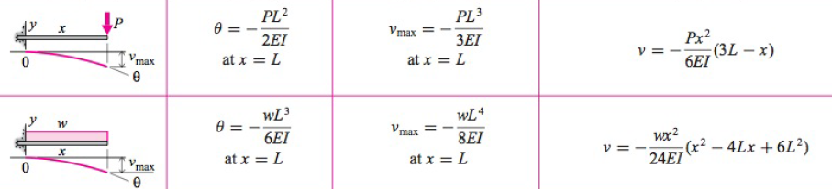

There will be an Excel file accompanying this paper, and this file was used to calculate this deflection with estimations of all of the variables is found to be -0.000326”. The cylinder and top support plate, when viewed from the side, are made out to be rectangles, and the second moment of area was calculated as such. The deflection of each column of rods is calculated separately, as it is currently unclear how far into the core the port will reach. The distributed water load is for the rectangular prism of water above the support.

Appendix B: Codes Utilized

Code 1: Bending Calculation Code
Code:
%Script to determine bending in senior design tank
%Version 1.02 written by Graham Jones 2-13-17

%Purpose: Find bending in the aluminum in the bottom of the tank
%Execution: Vary length between supports, thickness of aluminum
%Equations used:
%Distributed water: v = -wx/24EI (x^3 - 2Lx^2 + L^3)
%Max of water: v = -5wL^4/384EI (negative for downward bending)
%Each fuel pin row: v = -Pbx/6EIL (L^2 - b^2 - x^2)
% v = deflection distance from equilibrium
% w = force per unit length
% x = distance from left to point of interest (POI)
% E = Modulus of Elasticity
% I = Second moment of area; b*h^3/12 for a rectangle
% L = Length from one support beam to the next
% P = Force of all fuel pins in one row
% b = Distance from right to POI

clear all;
clc;
%Initial variables

%**********************************************************************
%Units should either be in English or SI. Please Indicate on next line.
%**********************************************************************
% English

%Overestimates weight of water; ignores volume pins take up.
H2Oh = 5; %ft%height of water in tank
H2Od = 4; %ft%depth of water in tank
rho = 1.938; %slugs/ft^3%density of water
g = 32.2; %ft/s^2%Acceleration of gravity
w = H2Oh.*H2Od.*rho.*g;%w, force per unit length of water

len = 48; %in%width of tank
%%%%%%%%%%%%%%%%%%%%%%%%%%%%%%%%%%%%%%%%%%%%%%%%%%%%%%%%%%%%%%%%%%%%%%%
LL = [len, len./2, len./4];
%%%%%%%%%%%%%%%%%%%%%%%%%%%%%%%%%%%%%%%%%%%%%%%%%%%%%%%%%%%%%%%%%%%%%%%
%LL now HAS to be 3 inputs
%%%%%%%%%%%%%%%%%%%%%%%%%%%%%%%%%%%%%%%%%%%%%%%%%%%%%%%%%%%%%%%%%%%%%%%

%Alternatively, manually indicate the lengths of interest between supports
%LL = [16 8 4];

for yyy = 1:17
x(yyy) = 10.5 + 1.575.*yyy;
end
%x = [1 2 3 4 5 6 7 8 9 10 11 12 13 14 15]; %Fifteen x-values for position of pin rows
%All values of x should be less than length of tank. There is no check for
%this for more general usage.

E = 10.2.*10.^6; %psi%Accepted value for modulus of elasticity in proper units

t = [0.125 0.25 0.5 1]; %Thicknesses of aluminum of interest
for ii = 1:length(LL)
I(ii,:) = LL(ii).*(t.^3)./12;
end %Makes a L x t matrix for values of I
%Example: I(2,3) is the I for the second L between supports, third t

npin = 17; %unitless%number of pins in one row of pins
Fpin = 34.4; %lbs%Force/weight of a single pin
P = npin.*Fpin; %lbs%Total force of pins at one x

%Setup for calculations

eL = LL.';
L = [ ];
for j = 1:length(t)
L = [L eL];
end %Gives L and I the same matrix dimensions

ex = [ ];
for qq = 1:length(LL)
ex =[ex ; x];
end

LLL = [ ];
for pp = 1:length(ex)
LLL = [LLL eL];
end
%b = LLL - ex; %Distance to POI from right of tank

b = zeros(3,length(x));
for uuu = 1:length(x)
b(1,uuu)=eL(1)-x(uuu);
b(2,uuu)=eL(2)-x(uuu);
b(3,uuu)=eL(2)-x(uuu); %This takes it from 24 to the left 12". It's complicated. Ask me.
for ttt = 1:3
if b(ttt,uuu)<0
b(ttt,uuu) = eL(ttt);
end
end

end
%for jjj = 1:length(b)
% if b(jjj) < 0
% b(jjj) = %%%L for that row%%%
%end
%end

%*********************************************************************
%IT MAY BE BEST TO HANDMAKE THE b MATRIX AS IT CAN BECOME NEGATIVE
%HAND-MAKE A MATRIX FOR ALL PIN ROWS LEFT OF L WHERE 0 IS ON THE RIGHT
%MAKE b==L FOR BLANK ROWS
%*********************************************************************

%Calculations
%By rule of superposition, sum the components of each row of pins and water

%Distributed water: v = -wx/24EI (x^3 - 2Lx^2 + L^3)
%Max of water: v = 5wL^4/384EI
%Each fuel pin row: v = -Pbx/6EIL (L^2 - b^2 - x^2)

H20MAX = -5.*w.*L.^4./(384.*E.*I);

[g h] = size(L);
g=1;
pinMAX01 = zeros(length(eL),length(t));

%vmax = -Pb (L^2-b^2)^(3/2) / 9sqrt(3)LEI
pinMAX1 = -P.*b(1).*(L(1,:).^2 - repmat(b(1),g,h).^2).^(1.5)./(9.*sqrt(3).*L(1,:).*E.*I(1,:));
pinMAX2 = -P.*b(4).*(L(1,:).^2 - repmat(b(4),g,h).^2).^(1.5)./(9.*sqrt(3).*L(1,:).*E.*I(1,:));
pinMAX3 = -P.*b(7).*(L(1,:).^2 - repmat(b(7),g,h).^2).^(1.5)./(9.*sqrt(3).*L(1,:).*E.*I(1,:));
pinMAX4 = -P.*b(10).*(L(1,:).^2 - repmat(b(10),g,h).^2).^(1.5)./(9.*sqrt(3).*L(1,:).*E.*I(1,:));
pinMAX5 = -P.*b(13).*(L(1,:).^2 - repmat(b(13),g,h).^2).^(1.5)./(9.*sqrt(3).*L(1,:).*E.*I(1,:));
pinMAX6 = -P.*b(16).*(L(1,:).^2 - repmat(b(16),g,h).^2).^(1.5)./(9.*sqrt(3).*L(1,:).*E.*I(1,:));
pinMAX7 = -P.*b(19).*(L(1,:).^2 - repmat(b(19),g,h).^2).^(1.5)./(9.*sqrt(3).*L(1,:).*E.*I(1,:));
pinMAX8 = -P.*b(22).*(L(1,:).^2 - repmat(b(22),g,h).^2).^(1.5)./(9.*sqrt(3).*L(1,:).*E.*I(1,:));
pinMAX9 = -P.*b(25).*(L(1,:).^2 - repmat(b(25),g,h).^2).^(1.5)./(9.*sqrt(3).*L(1,:).*E.*I(1,:));
pinMAX10 = -P.*b(28).*(L(1,:).^2 - repmat(b(28),g,h).^2).^(1.5)./(9.*sqrt(3).*L(1,:).*E.*I(1,:));
pinMAX11 = -P.*b(31).*(L(1,:).^2 - repmat(b(31),g,h).^2).^(1.5)./(9.*sqrt(3).*L(1,:).*E.*I(1,:));
pinMAX12 = -P.*b(34).*(L(1,:).^2 - repmat(b(34),g,h).^2).^(1.5)./(9.*sqrt(3).*L(1,:).*E.*I(1,:));
pinMAX13 = -P.*b(37).*(L(1,:).^2 - repmat(b(37),g,h).^2).^(1.5)./(9.*sqrt(3).*L(1,:).*E.*I(1,:));
pinMAX14 = -P.*b(40).*(L(1,:).^2 - repmat(b(40),g,h).^2).^(1.5)./(9.*sqrt(3).*L(1,:).*E.*I(1,:));
pinMAX15 = -P.*b(43).*(L(1,:).^2 - repmat(b(43),g,h).^2).^(1.5)./(9.*sqrt(3).*L(1,:).*E.*I(1,:));
pinMAX16 = -P.*b(46).*(L(1,:).^2 - repmat(b(46),g,h).^2).^(1.5)./(9.*sqrt(3).*L(1,:).*E.*I(1,:));
pinMAX17 = -P.*b(49).*(L(1,:).^2 - repmat(b(49),g,h).^2).^(1.5)./(9.*sqrt(3).*L(1,:).*E.*I(1,:));

%Add and subtract pins as needed
pinMAX01 =pinMAX1+pinMAX2+pinMAX3+pinMAX4+pinMAX5+pinMAX6+pinMAX7+pinMAX8+pinMAX9+pinMAX10+pinMAX11+pinMAX12+pinMAX13+pinMAX14+pinMAX15+pinMAX16+pinMAX17;

%Maximum bending for each span, thickness
MAXMAX1 = pinMAX01+H20MAX(1,:);

pinMAX1 = -P.*b(2).*(L(2,:).^2 - repmat(b(2),g,h).^2).^(1.5)./(9.*sqrt(3).*L(2,:).*E.*I(2,:));
pinMAX2 = -P.*b(5).*(L(2,:).^2 - repmat(b(5),g,h).^2).^(1.5)./(9.*sqrt(3).*L(2,:).*E.*I(2,:));
pinMAX3 = -P.*b(8).*(L(2,:).^2 - repmat(b(8),g,h).^2).^(1.5)./(9.*sqrt(3).*L(2,:).*E.*I(2,:));
pinMAX4 = -P.*b(11).*(L(2,:).^2 - repmat(b(11),g,h).^2).^(1.5)./(9.*sqrt(3).*L(2,:).*E.*I(2,:));
pinMAX5 = -P.*b(14).*(L(2,:).^2 - repmat(b(14),g,h).^2).^(1.5)./(9.*sqrt(3).*L(2,:).*E.*I(2,:));
pinMAX6 = -P.*b(17).*(L(2,:).^2 - repmat(b(17),g,h).^2).^(1.5)./(9.*sqrt(3).*L(2,:).*E.*I(2,:));
pinMAX7 = -P.*b(20).*(L(2,:).^2 - repmat(b(20),g,h).^2).^(1.5)./(9.*sqrt(3).*L(2,:).*E.*I(2,:));
pinMAX8 = -P.*b(23).*(L(2,:).^2 - repmat(b(23),g,h).^2).^(1.5)./(9.*sqrt(3).*L(2,:).*E.*I(2,:));
pinMAX9 = -P.*b(26).*(L(2,:).^2 - repmat(b(26),g,h).^2).^(1.5)./(9.*sqrt(3).*L(2,:).*E.*I(2,:));
pinMAX10 = -P.*b(29).*(L(2,:).^2 - repmat(b(29),g,h).^2).^(1.5)./(9.*sqrt(3).*L(2,:).*E.*I(2,:));
pinMAX11 = -P.*b(32).*(L(2,:).^2 - repmat(b(32),g,h).^2).^(1.5)./(9.*sqrt(3).*L(2,:).*E.*I(2,:));
pinMAX12 = -P.*b(35).*(L(2,:).^2 - repmat(b(35),g,h).^2).^(1.5)./(9.*sqrt(3).*L(2,:).*E.*I(2,:));
pinMAX13 = -P.*b(38).*(L(2,:).^2 - repmat(b(38),g,h).^2).^(1.5)./(9.*sqrt(3).*L(2,:).*E.*I(2,:));
pinMAX14 = -P.*b(41).*(L(2,:).^2 - repmat(b(41),g,h).^2).^(1.5)./(9.*sqrt(3).*L(2,:).*E.*I(2,:));
pinMAX15 = -P.*b(44).*(L(2,:).^2 - repmat(b(44),g,h).^2).^(1.5)./(9.*sqrt(3).*L(2,:).*E.*I(2,:));
pinMAX16 = -P.*b(47).*(L(2,:).^2 - repmat(b(47),g,h).^2).^(1.5)./(9.*sqrt(3).*L(2,:).*E.*I(2,:));
pinMAX17 = -P.*b(50).*(L(2,:).^2 - repmat(b(50),g,h).^2).^(1.5)./(9.*sqrt(3).*L(2,:).*E.*I(2,:));

%Add and subtract pins as needed
pinMAX02 =pinMAX1+pinMAX2+pinMAX3+pinMAX4+pinMAX5+pinMAX6+pinMAX7+pinMAX8+pinMAX9+pinMAX10+pinMAX11+pinMAX12+pinMAX13+pinMAX14+pinMAX15+pinMAX16+pinMAX17;

%Maximum bending for each span, thickness
MAXMAX2 = pinMAX02+H20MAX(2,:);

pinMAX1 = -P.*b(3).*(L(3,:).^2 - repmat(b(3),g,h).^2).^(1.5)./(9.*sqrt(3).*L(3,:).*E.*I(3,:));
pinMAX2 = -P.*b(6).*(L(3,:).^2 - repmat(b(6),g,h).^2).^(1.5)./(9.*sqrt(3).*L(3,:).*E.*I(3,:));
pinMAX3 = -P.*b(9).*(L(3,:).^2 - repmat(b(9),g,h).^2).^(1.5)./(9.*sqrt(3).*L(3,:).*E.*I(3,:));
pinMAX4 = -P.*b(12).*(L(3,:).^2 - repmat(b(12),g,h).^2).^(1.5)./(9.*sqrt(3).*L(3,:).*E.*I(3,:));
pinMAX5 = -P.*b(15).*(L(3,:).^2 - repmat(b(15),g,h).^2).^(1.5)./(9.*sqrt(3).*L(3,:).*E.*I(3,:));
pinMAX6 = -P.*b(28).*(L(3,:).^2 - repmat(b(18),g,h).^2).^(1.5)./(9.*sqrt(3).*L(3,:).*E.*I(3,:));
pinMAX7 = -P.*b(21).*(L(3,:).^2 - repmat(b(21),g,h).^2).^(1.5)./(9.*sqrt(3).*L(3,:).*E.*I(3,:));
pinMAX8 = -P.*b(24).*(L(3,:).^2 - repmat(b(24),g,h).^2).^(1.5)./(9.*sqrt(3).*L(3,:).*E.*I(3,:));
pinMAX9 = -P.*b(27).*(L(3,:).^2 - repmat(b(27),g,h).^2).^(1.5)./(9.*sqrt(3).*L(3,:).*E.*I(3,:));
pinMAX10 = -P.*b(30).*(L(3,:).^2 - repmat(b(30),g,h).^2).^(1.5)./(9.*sqrt(3).*L(3,:).*E.*I(3,:));
pinMAX11 = -P.*b(33).*(L(3,:).^2 - repmat(b(33),g,h).^2).^(1.5)./(9.*sqrt(3).*L(3,:).*E.*I(3,:));
pinMAX12 = -P.*b(36).*(L(3,:).^2 - repmat(b(36),g,h).^2).^(1.5)./(9.*sqrt(3).*L(3,:).*E.*I(3,:));
pinMAX13 = -P.*b(39).*(L(3,:).^2 - repmat(b(39),g,h).^2).^(1.5)./(9.*sqrt(3).*L(3,:).*E.*I(3,:));
pinMAX14 = -P.*b(42).*(L(3,:).^2 - repmat(b(42),g,h).^2).^(1.5)./(9.*sqrt(3).*L(3,:).*E.*I(3,:));
pinMAX15 = -P.*b(45).*(L(3,:).^2 - repmat(b(45),g,h).^2).^(1.5)./(9.*sqrt(3).*L(3,:).*E.*I(3,:));
pinMAX16 = -P.*b(48).*(L(3,:).^2 - repmat(b(48),g,h).^2).^(1.5)./(9.*sqrt(3).*L(3,:).*E.*I(3,:));
pinMAX17 = -P.*b(51).*(L(3,:).^2 - repmat(b(51),g,h).^2).^(1.5)./(9.*sqrt(3).*L(3,:).*E.*I(3,:));

%Add and subtract pins as needed
pinMAX03 =pinMAX1+pinMAX2+pinMAX3+pinMAX4+pinMAX5+pinMAX6+pinMAX7+pinMAX8+pinMAX9+pinMAX10+pinMAX11+pinMAX12+pinMAX13+pinMAX14+pinMAX15+pinMAX16+pinMAX17;

%Maximum bending for each span, thickness
MAXMAX3 = pinMAX03+H20MAX(3,:);

%[L1t1 L1t2 ... L1tn
% L2t1 L2t2 ... L2tn
% ... ... ... ...
% Lnt1 Lnt2 ... Lntn]

Code 2: KCODE Input deck
Kcode.txt
c Cells------------------------------------------------------------------------------------
1 4 -0.998207 -1 imp:n=1 u=1
2 6 -2.70 1 -2 imp:n=1 u=1
3 1 -18.90 2 -3 imp:n=1 u=1
4 6 -2.70 3 -4 imp:n=1 u=1
5 4 -0.998207 4 -5 imp:n=1 u=1
6 6 -2.70 5 -6 imp:n=1 u=1
7 4 -0.998207 6 -9 imp:n=1 u=1
8 0 -7 lat=1 fill=1 u=2 imp:n=1
9 0 -8 fill=2 imp:n=1
10 4 -.998207 8 -9 imp:n=1
11 7 -7.99949 9 -10 imp:n=1
12 0 10 imp:n=0

c Surfaces --------------------------------------------------------------------------------
1 RCC 0.0 0.0 0.0 0.0 0.0 129.54 0.58
2 RCC 0.0 0.0 0.0 0.0 0.0 129.54 0.707
3 RCC 0.0 0.0 0.0 0.0 0.0 129.54 1.398
4 RCC 0.0 0.0 0.0 0.0 0.0 129.54 1.525
5 RCC 0.0 0.0 0.0 0.0 0.0 129.54 1.59
6 RCC 0.0 0.0 0.0 0.0 0.0 129.54 1.655
7 RPP -2 2 -2 2 0.0 129.54
8 RPP -30 30 -30 30 0 129.54
9 RPP -44.45 44.45 -44.45 44.45 0.0 152.4
10 RPP -45.72 45.72 -45.72 45.72 -1.27 153.67

c Material Cards ----------------------------------------------------------------------------
m1 92234 -0.000057 92235 -0.007204
92238 -0.992739
m2 82204 -0.014 82206 -0.241
82207 -0.221 82208 -0.524
m3 6000 -0.000124 7014 -0.755268
8016 -0.231781 18040 -0.012827
m4 1001 -0.111894 8016 -0.888106
mt4 LWTR.10t
m5 13027 -1.000000
m6 12000 -0.010000 13027 -0.972000
14000 -0.006000 22000 -0.000880
24000 -0.001950 25055 -0.000880
26000 -0.004090 29000 -0.002750
30000 -0.001460
m7 6012 -3.95366E-04 14028 -4.59332E-03
14029 -2.41681E-04
14030 -1.64994E-04
15031 -2.30000E-04
16032 -1.42073E-04
16033 -1.15681E-06
16034 -6.75336E-06
16036 -1.68255E-08
24050 -7.93000E-03
24052 -1.59029E-01
24053 -1.83798E-02
24054 -4.66139E-03
25055 -1.00000E-02
26054 -3.96166E-02
26056 -6.44901E-01
26057 -1.51600E-02
26058 -2.05287E-03
28058 -6.21579E-02

Code 3: Dose Calculation input deck
3ftDoseNoDetectors.txt
c Cells----------------------------------------
1 4 -0.998207 -1 imp:n=1 u=1
2 6 -2.70 1 -2 imp:n=1 u=1
3 1 -18.90 2 -3 imp:n=1 u=1
4 6 -2.70 3 -4 imp:n=1 u=1
5 4 -0.998207 4 -5 imp:n=1 u=1
6 6 -2.70 5 -6 imp:n=1 u=1
7 4 -0.998207 6 -9 imp:n=1 u=1
8 0 -7 lat=1 fill=1 u=2 imp:n=1
9 0 -8 fill=2 imp:n=1
10 4 -.998207 8 -9 imp:n=1
11 7 -7.99949 9 -10 imp:n=1
12 0 11 imp:n=0
13 0 10 -11 imp:n=1

c Surfaces--------------------------------------
1 RCC 0.0 0.0 0.0 0.0 0.0 129.54 0.58
2 RCC 0.0 0.0 0.0 0.0 0.0 129.54 0.707
3 RCC 0.0 0.0 0.0 0.0 0.0 129.54 1.398
4 RCC 0.0 0.0 0.0 0.0 0.0 129.54 1.525
5 RCC 0.0 0.0 0.0 0.0 0.0 129.54 1.59
6 RCC 0.0 0.0 0.0 0.0 0.0 129.54 1.655
7 RPP -2 2 -2 2 0.0 129.54
8 RPP -30 30 -30 30 0 129.54
9 RPP -44.45 44.45 -44.45 44.45 0.0 152.4
10 RPP -45.72 45.72 -45.72 45.72 -1.27 153.67
11 RPP -50 50 -50 50 -5 160

c Material Cards----------------------------------
m1 92234 -0.000057 92235 -0.007204
92238 -0.992739
m4 1001 -0.111894 8016 -0.888106
mt4 LWTR.10t
m6 12000 -0.010000 13027 -0.972000
14000 -0.006000 22000 -0.000880
24000 -0.001950 25055 -0.000880
26000 -0.004090 29000 -0.002750
30000 -0.001460
m7 6012 -3.95366E-04 14028 -4.59332E-03
14029 -2.41681E-04
14030 -1.64994E-04
15031 -2.30000E-04
16032 -1.42073E-04
16033 -1.15681E-06
16034 -6.75336E-06
16036 -1.68255E-08
24050 -7.93000E-03
24052 -1.59029E-01
24053 -1.83798E-02
24054 -4.66139E-03
25055 -1.00000E-02
26054 -3.96166E-02
26056 -6.44901E-01
26057 -1.51600E-02
26058 -2.05287E-03
28058 -6.21579E-02
28060 -2.47678E-02
28061 -1.09461E-03
28062 -3.54721E-03
28064 -9.32539E-04
c Source Cards---------------------------------------------------
SDEF POS=0 0 45.72 RAD=D2 AXS=0 0 1 EXT=D3 ERG=D1 PAR=N
CTME=30
c Source Energies------------------------------------------------
SI1 0 0.25 0.5 0.75 1 1.25 1.5 1.75 2 2.25 2.5 2.75 3 3.25 3.5 3.75
4 4.25 4.5 4.75 5 5.25 5.5 5.75 6 6.25 6.5 6.75 7 7.25 7.5 7.75
8 8.25 8.5 8.75 9 9.25 9.5 9.75 10 10.25 10.5 10.75 11 11.25 11.5 11.75 12
SP1 D 0 2.39E-4 4.95E-3 1.29E-2 1.69E-2 1.73E-2 1.54E-2 1.17E-2
1.59E-2 1.93E-2 2.15E-2 2.62E-2 3.84E-2 4.96E-2 5.22E-2 5.01E-2
4.72E-2 4.49E-2 4.32E-2 4.13E-2 3.89E-2 3.35E-2 2.76E-2 2.49E-2
2.40E-2 2.09E-2 2.12E-2 2.39E-2 2.50E-2 2.50E-2 2.49E-2 2.43E-2
2.30E-2 2.11E-2 1.94E-2 1.82E-2 1.75E-2 1.67E-2 1.47E-2 1.13E-2
7.08E-3 3.98E-3 2.57E-3 1.34E-3 4.27E-4 5.93E-6 1.23E-8 9.78E-9 7.74E-9
c Radius Distribution---------------------------------------------
SI2 H 0 1.25
SP2 -21 1
c EXT Distribution------------------------------------------------
SI3 H 0 5.7
SP3 -21 1
c Point Flux Tally on Outer Wall----------------------------------
F15:n 48 0 75 .1
c Response Function-----------------------------------------------
DE0 0 2.5E-8 1.0E-7 1.0E-6 1.0E-5 1.0E-4 1.0E-3 1.0E-2 2.0E-2 5.0E-2
1.0E-1 1.5E-1 2.0E-1 5.0E-1 1.0 1.2 2.0 3.0 4.0 5.0 6.0 7.0
8.0 10.0 12.0 14.0
DF0 0 0.001188 0.0014868 0.0020268 0.0023184 0.002322
0.0021744 0.002772 0.003672 0.006228 0.007632 0.012672
0.015264 0.027 0.04176 0.0468 0.06408 0.0792 0.09 0.09792
0.10152 0.1044 0.10692 0.11124 0.11592 0.11988
nps 1000000

Appendix C: Plate Tank Model & Other Concept Art

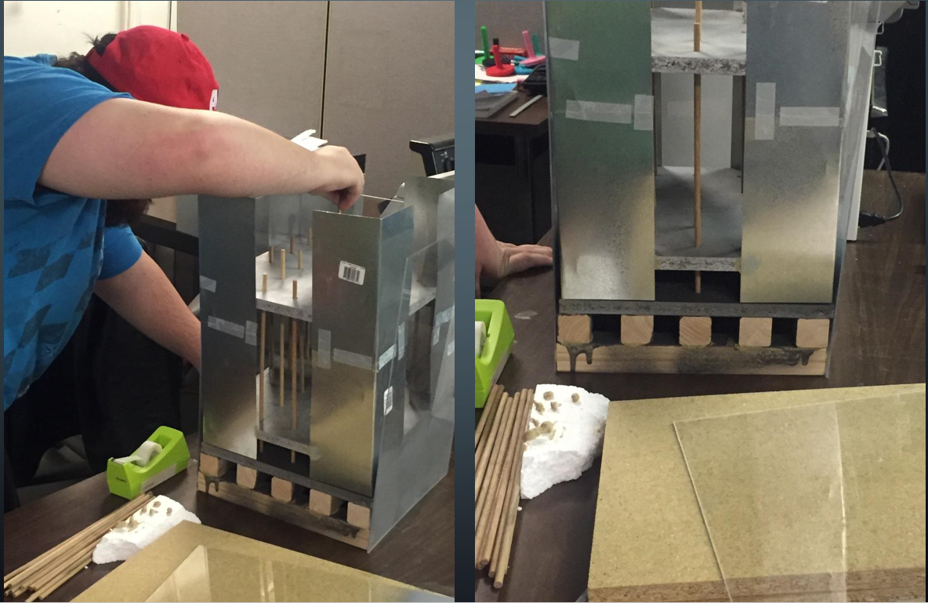
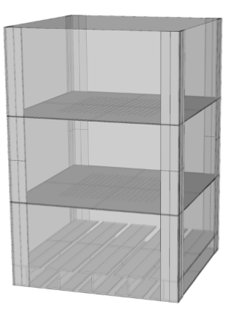
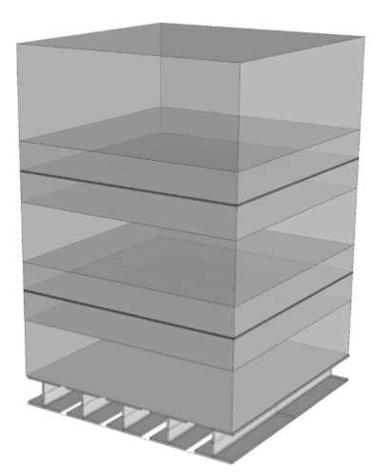

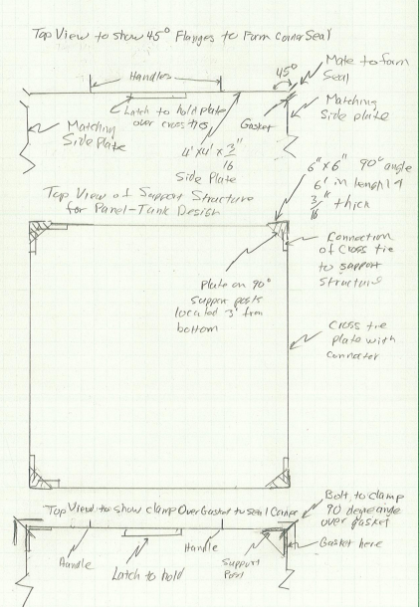
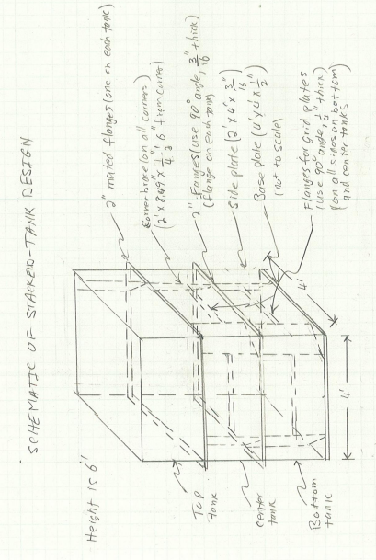
Appendix D: Hand Drawings
