Automated path planning for additive friction stir deposition

A Dissertation Presented for the
Doctorate of Philosophy
Mechanical Engineering
The University of Tennessee, Knoxville

Joshua Kincaid
May 2025
Copyright © 2025 by Joshua Kincaid
All rights reserved
ACKNOWLEDGEMENTS

Thank you, my beautiful and wonderful wife Anna, for supporting me always.
PREFACE

This page is optional.

ABSTRACT

The aim of this proposal is to provide automated path planning procedures for additive friction stir deposition (AFSD). This solid-state deformation-based metal additive manufacturing technology uses a non-consumable tool clamped in a rotating spindle. The tool has a center hole so wrought bar stock can be forced axially through the tool as it rotates with the spindle. The tool rotation generates frictional heating between the feed material and deposition surface that softens the material enabling plastic deformation. This plastic deformation also provides adiabatic heating. During this severe plastic deformation, there is mechanical intermixing between the deposit and substrate. As the tool follows the commanded path, a layer is produced. This layer-by-layer addition produces the desired preform geometry. Although path planning methods and software exist for other additive manufacturing (AM) processes, such as fused filament fabrication for polymers and powder bed fusion for metals, no solution exists for AFSD. Currently, path planning and the subsequent computer code generation to command the machine motions for AFSD are completed manually. This approach is both time consuming (often taking longer than the material deposition time) and prone to error. Additionally, the manual approach can limit geometric complexity, which sacrifices benefits often provided by AM.

Table of Contents
Chapter 1: Introduction and General Information 1
Dissertation summary 1
Intellectual merit 1
Broader impacts 2
Chapter 2: Literature Review 3
AFSD 3
Friction stir welding background 3
AFSD material studies 4
AFSD process studies 4
AFSD modeling studies 6
Path planning 6
Methods for approximating geometry 7
Path planning optimization 8
Originality 9
Chapter 3: Materials and Methods 14
Manuscript 1 14
Heading 3 14
Manuscript 2 14
Heading 3 14
Stuff not yet in a manuscript 14
Chapter 4: Results and Discussion 15
MATLAB based G-code writer 15
Data path 15
Example parts 18
The cone 18
Archimedes spiral 19
Linear overlap range 20
Ogive layup mold 22
LVDT initial spindle displacement tests 24
Summary 29
Chapter Five Conclusions and Recommendations 30
Appendix 32
Vita 33

LIST OF TABLES
Table 2.1. This is the first table on a text page. 3
Table 2.2. This is the second table on a separate page 4

LIST OF FIGURES

Figure 3.1. Shapes 6
Figure 3.2. This is a photo of campus 6

Chapter 1: Introduction and General Information

Dissertation summary
The aim of this proposal is to provide automated path planning procedures for additive friction stir deposition (AFSD). This solid-state deformation-based metal additive manufacturing technology uses a non-consumable tool clamped in a rotating spindle. The tool has a center hole so wrought bar stock can be forced axially through the tool as it rotates with the spindle. The tool rotation generates frictional heating between the feed material and deposition surface that softens the material enabling plastic deformation. This plastic deformation also provides adiabatic heating. During this severe plastic deformation, there is mechanical intermixing between the deposit and substrate. As the tool follows the commanded path, a layer is produced. This layer-by-layer addition produces the desired preform geometry. Although path planning methods and software exist for other additive manufacturing (AM) processes, such as fused filament fabrication for polymers and powder bed fusion for metals, no solution exists for AFSD. Currently, path planning and the subsequent computer code generation to command the machine motions for AFSD are completed manually. This approach is both time consuming (often taking longer than the material deposition time) and prone to error. Additionally, the manual approach can limit geometric complexity, which sacrifices benefits often provided by AM.

Intellectual merit
This project will advance the capabilities of AFSD by leveraging knowledge and techniques currently applied for path planning of other types of material extrusion AM. Further, it will develop new strategies specifically for AFSD. These advances are necessary for rapid production of complex geometries using AFSD. Also, there is little published work available on path planning in AM. This work will generate new knowledge in the AFSD discipline and will serve as an important resource for those who wish to implement AFSD AM.
Path planning methods and software already exist for many types of extrusion AM, but cannot be directly implemented for AFSD based on several factors unique to this process. First, due to the large track width and flash generation at the edges of the solid-state deposits, the effective deposition track width is nonconstant and adjacent tracks must have significant overlap. This overlap requires modified material deposition rate. Second, due to the combined rotation and translation of the tool, the material flow behavior is asymmetric in the tool travel direction. Therefore, the deposition direction must be considered in the path planning.

Broader impacts
The US is currently facing national and international supply chain challenges which can cause long lead times and/or unavailability of key components, especially for large castings and forgings. These obstacles are based, in large part, on the US dependence on foreign sources to provide manufacturing capabilities. This is an issue for US national defense, security, and economic health. AFSD could address current supply chain shortfalls by enabling parts to be produced through hybrid manufacturing (i.e., preform deposition using additive manufacturing, followed by measurement and machining to achieve the final geometry and surface finish). The primary advantage of AFSD is that the feed material is readily available (e.g., plate or bar stock) and convenient to store. For complex parts to be produced with a short lead time, automated path planning methods must be established. The reduced lead times would enable parts to reach the end user in a shorter time. Automated path planning protocols also allow AM parts to be produced with improved efficiency. This provides material, time, energy, and, therefore, cost savings. The combination of AFSD and automated path planning will address gaps in the US casting and forgings infrastructure by providing a viable alternative to traditional processes.

Chapter 2: Literature Review

This section includes previous work in AFSD and path planning. The AFSD section is divided into background in friction stir welding (FSW) from which AFSD is derived, an AFSD overview, AFSD materials studies, AFSD process studies, and AFSD modeling studies. The path planning section is divided into a path planning overview, methods for approximating geometry, and optimization.

AFSD
AFSD is a solid-state AM process which shows promise for its high deposition rates (9 kg/hr for Al, and 2.5 kg/hr for Ti) [2], energy efficiency, and ability to deposit materials such as ductile metals such as aluminum alloys Al 7075 and Al 7050, magnesium alloy WE43, and titanium alloy Ti-6Al-4V, which offers significant flexibility relative to conventional additive approaches [3], [4].

Friction stir welding background
AFSD is derived from friction stir welding (FSW) which is a solid-state welding technique that relies on bonding through severe plastic deformation [5]. Many elements of FSW, including force, torque, and tool temperature, have been modeled analytically [6], [7], [8], [9], [10] and numerically [10], [11], [12], [13]. Babu et al. investigated reproducing friction stir processed material using rapid hot torsion [14]. Arora et al. computed strains and strain rates along streamlines [15]. Other work included inclusion of ceramic powders into the weld to create metal matrix composites (MMCs) [16], [17]. Several authors have emphasized that knowledge from FSW can be applied to AFSD [1], [3], [4].

AFSD material studies
Initial AFSD studies have focused on process to material property relationships for aluminum alloys. Gang et al. found that the ultimate tensile strength (UTS) is positively correlated with spindle speed and traverse feed rate for Al 6061 [18]. Anderson-Wedge et al. analyzed fatigue behavior in deposited Al 2219. They found local optimal parameters which produced good fatigue life using microhardness and grain size measurements [19]. Avery et al. assessed the viability of using AFSD to repair Al 7075. The study found that, while the process shows promise, the samples had reduced fatigue life to failure [20]. Ghadimi et al. found that in Al 2050 the post process material has a much larger distribution of hardness [21]. Perry et al. investigated material flow and deposit morphology using x-ray computed tomography (XCT) of a mixed material interface (Al 2024 in Al 6061) [22]. Perry et al. continued this work by adding tracer particles to improve the resolution and draw conclusions on the fundamentals of material deformation [23]. Mason et al. investigated process to property relationships on deposited Al 7050, specifically the deposition was divided into three zones which received different amounts of heating. They found during tensile testing that the samples failed because the material was over aged [24]. Yoder et al. found that proper heat treatment of Al 7075 can return mechanical properties back to 95% of the yield strength (YS), 94% of the UTS, and 78% of the elongation for wrought material [25]. Agrawal et al. investigated the deposition of recycled Ti-6Al-4V chips using AFSD and found that the resulting tensile properties were greater than those of competing AM processes [26].

AFSD process studies
Authors have also investigated AFSD parameter selection and applications. An early study by Phillips et al. investigated the relationship between process parameters, microstructure, and mechanical properties of deposited Al 6061 and found that process parameters played little role in the microstructure and suggested that visual non-destructive inspection may be sufficient to evaluate build quality. The authors also suggested that further study be made into thermal gradients of the process and post process heat treatment [27]. Glenn et al. and Merritt et al. investigated the use of a tool with an embedded thermocouple and PID controller to control the process temperature by varying the spindle speed. These studies found that temperature control produces more consistent performance [28], [29].
Schmitz et al. embedded a QR code coupon into a pocket milled into deposited material which was subsequently sealed into using AFSD. The QR code was then imaged using XCT, which has applications for part qualification/authentication [30]. Kincaid et al. successfully completed a hybrid manufacturing process to produce a ribbed aerospace panel by depositing a preform which included overlapping paths making a grid. The preform was then 3D scanned to acquire accurate dimensional data, which was used as the stock model to generate tool paths for machining the final geometry [31].
Griffiths et al. investigated how changes in parameters affected resultant microstructure in AFSD Al 6061 and copper (Cu). They found that the aluminum strain depends on the ratio of rotation speed to traverse feed rate and the copper strain depends only on traverse feed rate [32]. Phillips et al. investigated the tensile properties of overlapped (by 6.35 mm) parallel deposition tracks on the tensile properties of deposited Al 6061 and compared them to tensile properties of wrought and single pass samples. They found that oxides were not well mixed in the overlapping region, but this had little impact on the tensile properties. It was observed that the single-track samples performed similarly to the overlapped tensile samples, though fractographic analysis found that oxides may have been a key element in sample failure [33]. Garcia et al. investigated heat generation mechanisms in Al 6061 and Cu with the goal of finding key relationships between processing conditions and heat generation. They found that heat generation systems are different and proposed temperature to process condition equations fit from the collected temperature data [34]. Phillips et al. evaluated the effects of lubricant on the microstructural and mechanical properties of deposited Al 5083. They observed delamination between deposited layers. This was explained as inefficient dispersion of the carbon graphite lubricant used to assist wrought material flow through the rotating spindle, which prevented bonding between layers [35]. Catalan et al. conducted a parametric study designed to analyze the impact of varying overlap on the microstructure, hardness, and tensile strength between overlapping tracks deposited with AFSD. The study found that minimum of 25% of the tool diameter must re-engage with the prior track for optimal strength [36].

AFSD modeling studies
Modeling efforts have also been completed. Stubblefield et al. modeled strain and temperature in AFSD using a mesh free smooth particle hydrodynamics model (SPH) model and compared results of the computation with physical experiments [37]. Stubblefield et al. continued their work by investigating several constitutive models including Johnson-Cook (JC), Fraser-Kiss-St-Georges (FKS), and Sellars-Tegart (ST) models which are used in FSW modeling [38]. Kincaid et al. modeled an Al 6061 deposit by creating a finite volume simulation in the open-source computational fluid dynamics (CFD) software OPENFOAM. The model was validated with experimental data [39] and for a multi-layer deposit [40].

Path planning
In general, AM toolpath generation begins with a fully defined 3D computer aided design (CAD) model of the desired geometry. This model is then simplified by tessellating the object into a watertight triangulated mesh and is typically stored as Standard Tessellation Language, or STL, filetype. Geometric details may be lost during this process, but this simplification is necessary to provide computationally inexpensive slicing which is the process of dividing the geometry into discrete layers of a specified height. For each layer, the geometry is identified, and the paths are chosen based on whether the path must be open-loop (path start and end point is different), closed-loop (path start and end point is the same), or space-filling (typically infill, or support structure pathing). See Figure 4.
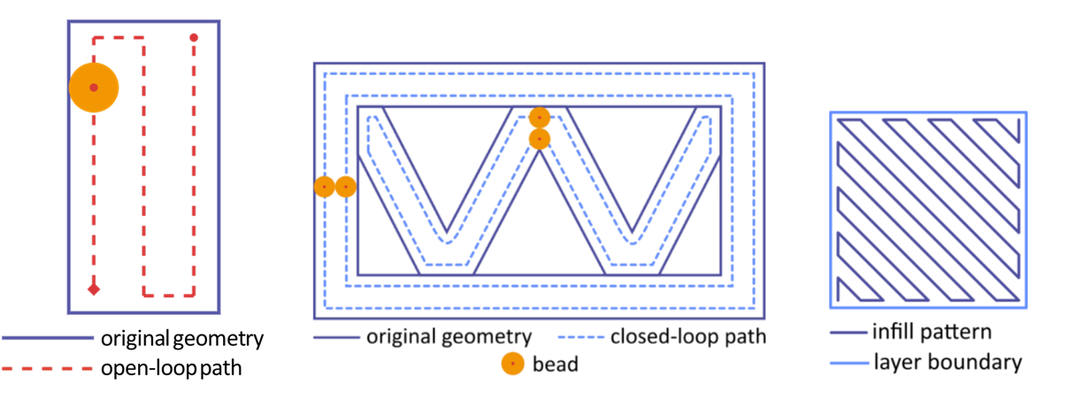
Figure 4: Depiction of open-loop path (left), closed-loop path (center), and a space-filling infill pattern (right). Adapted from [41].
The layers are then linked and a script is written that contains a list of machine coordinates for the AFSD tool to follow with appropriate feed rates for movement between the coordinates [41], [42]. A flowchart of this general process is shown in Figure 5.
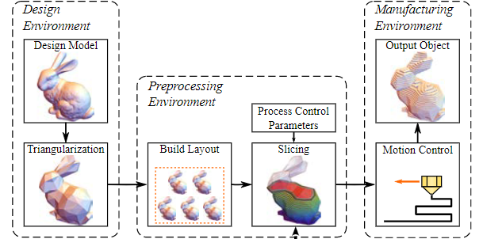
Figure 5: Flowchart of AM model to part [43].

Methods for approximating geometry
Because information about geometry is often lost in the tessellation process, authors have investigated methods to infer the original geometry from the created points for each layer. For instance, Wade and Borish proposed a hybrid method for reconstruction of arcs and splines to reduce the complexity of output machine code while improving the surface finish of the final geometry without substantially increasing total slicing workflow time [44]. Drysdale et al. developed an algorithm which best approximates an open polygon with arcs [45]. Huang et al. suggested eliminating the tessellation step entirely and instead using binary images of cross sections from the original CAD file to preserve the curvature [46]. Outside of the path planning literature there has also been work accomplished in fitting geometry to data point for use in metallurgy and for use with coordinate measurement machines. Forbes compiled a list of mathematical methods for fitting coordinate points to various geometries both 2D and 3D [47]. Umbach and Jones listed five methods for fitting circles to coordinate to 2D data points and compared their stability. Based on the findings of the study a method for fitting a circle in a 3D point set was also derived [48].

Path planning optimization
Many recent publications have focused on saving time and/or material through optimizing tool paths to reduce unnecessary support material or reduce time where material is not being deposited. Other research focuses are on improving infill quality, and geometric or surface accuracy [49]. Jin et al. proposed a method to improve build efficiency and build quality by reducing the number of sub paths required to infill a given geometry [50], including methods for increasing strength to weight ratio of a given thin-walled part using a sinusoidal wave infill pattern [51]. Jin et al. also proposed a combined method to improve infill density, prevent corner void defects, and improve surface quality of AM parts by removing sharp corners and forcing neighboring paths to be more parallel [52]. Ding et al. proposed a toolpath generation method for wire arc additive manufacturing (WAAM) which decomposes each geometric slice into polygons. This gives longer infill passes which provides increased cooling between neighboring beads and improved bead quality [53]. Ding et al. also proposed a corner path optimization algorithm which eliminates gaps in sharp corners [54]. Lastly, Steuben et al. proposed an implicit slicer which includes physics simulations in the slicing algorithm to produce infill that meets design requirements [43].

Originality
Many AFSD investigations focus on process to property relationships, modeling the process physics, or determining characteristics of deposited material. Because AFSD is a new process, there are many topics which have not been studied. Some knowledge gaps relevant to this proposal are:
- Research into part scale defects, such as squeeze flash, or bonding defects (must be prevented for successful prints).
- Interactions between overlapping or intersecting paths (essential for large scale parts).
- Best practices for selecting layer geometry, such as maximum overhang, and predicting deposition geometry.
- Path planning procedures specifically for AFSD.
For many of these topics, no prior work is available in the open literature. Two published studies include overlapping tracks [33] and [36]. Both studies focus on metallurgy and mechanical properties. In the study by Phillips et al. [33] that considers material properties between overlapping tracks, the $MFR$ on the return pass was decreased to reduce flash. The $MFR$ was calculated using an amount of “overbuild”, or material that escaped the width of the tool, and halving that amount of overbuild. It was found that the selected operating parameters produced 11% overbuild, so the parameters used on the return pass were reduced to create a 5.5% overbuild. Using this methodology, no squeeze flash was observed. See Figure 6.
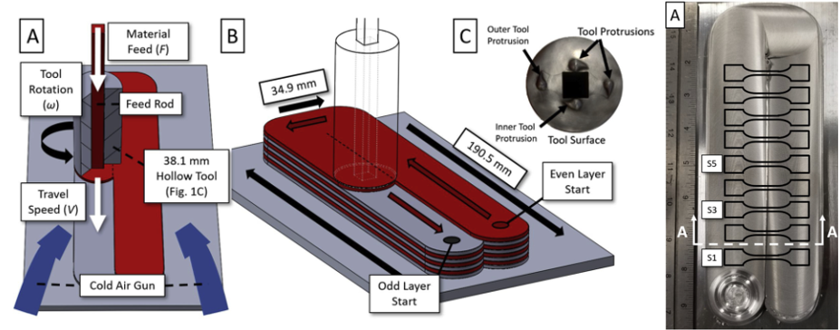
Figure 6: Depiction of sample used of overlapping deposit study if Al 6061 from Phillips et al. [33].
Cahalan et al. [36] conducted a parametric study to analyze the impact of overlap variation on the microstructure, hardness, and tensile strength between the deposited tracks. Nine samples were deposited varying in overlap from -6.4 mm (-0.25 in) to 19.1 mm (0.75 in) in increments of 3.2 mm (0.125 in) (see Figure 7, where the positive and negative overlaps are depicted). The $MFR$ and $TFR$ remained constant for each build and squeeze flash was generated.
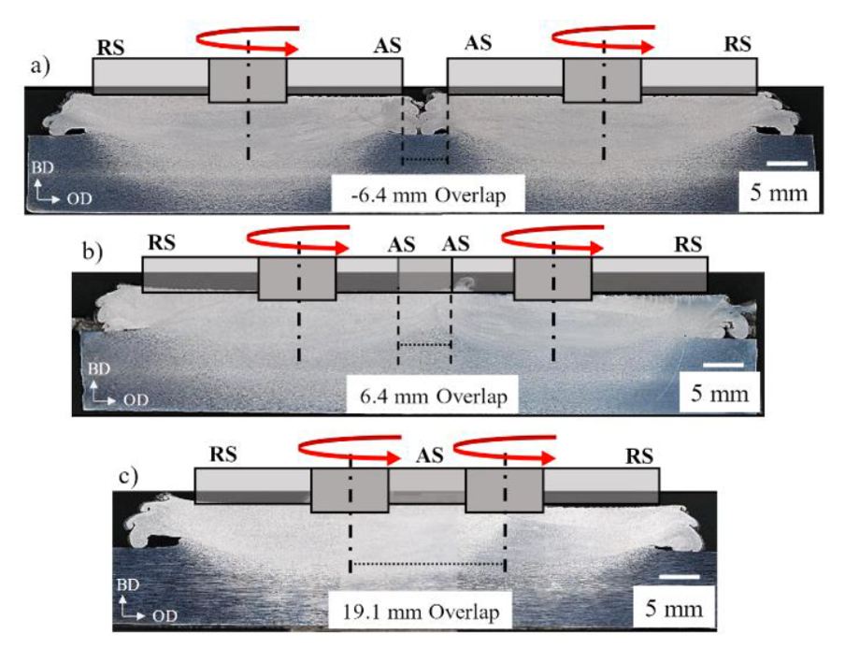
Figure 7: (a–c) Representative etched cross-sections with tool profile schematics of the AFSD overlap [36].
A study conducted by Kincaid et al. produced an aerospace panel by hybrid manufacturing, which included AFSD, structured light scanning, and computer numerical control (CNC) machining [31]. See Figure 8.
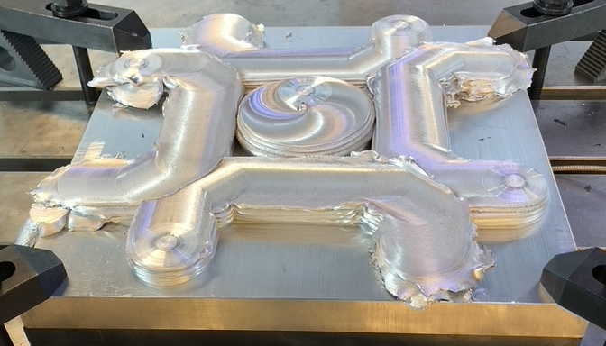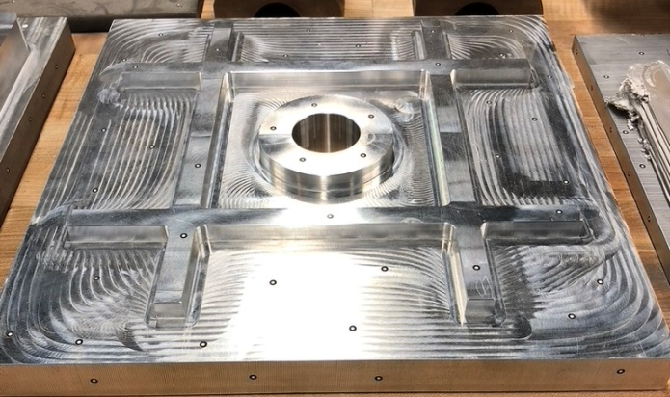
Figure 8: Image of ribbed aerospace panel preform (on left) before and (on right) final geometry after machining.
Prior research into AFSD path planning is not available. Many slicer/path planning approaches exist for extrusion AM, but cannot be directly used for AFSD. One of the major reasons is the constant bead width approximation [41] conventionally applied in AM, where a single bead width (typically is the size of the nozzle) is used for an entire print. If bead width is constant, then the ratio of travel speed to material feed is also constant throughout the entire print. Due to the necessary overlaps in AFSD, this ratio is not constant. This is both a constraint and a benefit as it allows for production of fully dense parts.
Another primary difference from AFSD is the inherent inhomogeneity of the process. Because the tool is rotating while traversing, the surface speed vector on one side of the tool matches the travel direction; this is referred to as the advancing side (AS). On the other side of the tool, the surface speed vector opposes the feed motion; this is referred to as the retreating side (RS). The material temperature is higher on the AS than the RS and, therefore, the material is softer which increases the flow. This effect can be observed in deposit microstructure [21], [22], [23]. Because of this, the order and direction of deposition tracks must be considered during path planning.
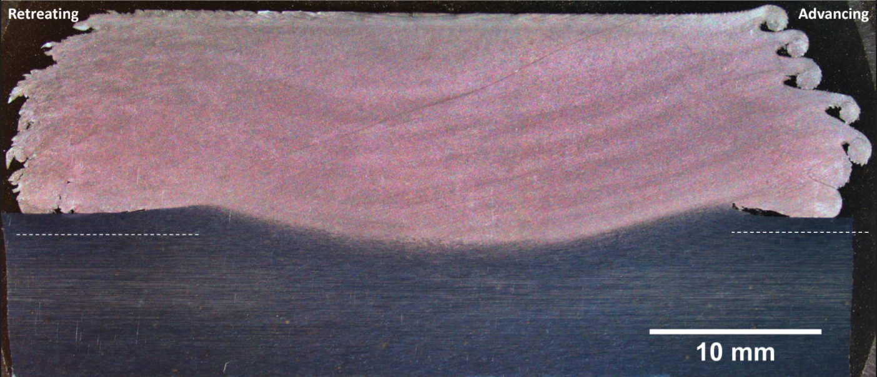
Figure 9: Polished and etched cross-section of an Al 7075 deposit which shows distinct differences between each side.
This research leverages pre-existing path planning methods and adapts them to address AFSD challenges. The goal is to create a working algorithm and develop machine code which will perform deposition to provide parts without defects. Existing methods which rebuild original geometry (such as arcs) from point data will be leveraged [42], [44], [45], [47], [48].

Chapter 3: Materials and Methods

Manuscript 1

Heading 3
Paste

Manuscript 2

Heading 3
Things and stuff, stuff and things.

Stuff not yet in a manuscript
Stuff not yet in a manuscript

Chapter 4: Results and Discussion
Some initial work and testing on the proposed method have been carried out including the development of a MATLAB based G-code writer which includes the path geometry fitting and the overlap process parameter adjustment. This testing has included some overlap process parameter adjustment tests, as well as some real-world parts which show algorithm success. This section discusses the MATLAB based code writer and the results of the initial tests.

MATLAB based G-code writer
This subsection discusses the operation of a script which takes an input of ordered (X, Y, Z) coordinates along with a nominal $MFR$ and $TFR$. This algorithm is a precursor to the proposed algorithm as it does not include compensation for predicted changes in layer for necessary changes in process parameters. A flowchart of the code operation is found in Figure 20.

Data path
The input to this script is a list of ordered points which are assumed to be of a density to fully define the desired geometry. Since all calculations are based on discrete point distances the resolution of the point (i.e., distance between provided points) is essential to accurate calculations. Following the methods described in the proposed method chapter, geometry is fit to the input point and prior to interpolating additional points to increase the point resolution. This is accomplished by determining the linear distance between the current point and the next point. If the distance is found to be greater than a defined minimum distance, then points are added equal to the rounded-up value of the linear distance divided by the minimum distance. Points are added along the unit vector if the point is linear and along the described arc if curvilinear. Next, for each point, linear distances are calculated for every point prior to the point being analyzed, and the closest point of each nearby geometric element is recorded. If there is an overlap, then the appropriate rule is applied according to the distance between points and the pair of elements as described in the proposed method chapter.
Next the start-up commands are written into the script. These include the units, coordinate system, whether movements should be made in absolute or relative coordinates, and settings such as force limits. Also included are subroutine calls for temperature control settings, the reload location and the initial to the autostart subroutine.
From here each point goes through the main script-writing decision tree. For each point it is determined whether feed will run out during movement to that point. This is done by calculating the travel time from the previous point to the current point (distance divided by TFR) and then multiplying that by the MFR. That quantity is added to a feed used value and if that value is greater than the available feed, then feed will run out. If feed will run out then the reload/recall process will be followed. If feed will not run out, then it must be determined if the point is redundant or not. This is done by comparing the unit vector of the last point to the current and the unit vector of the last point to the next point. If the vectors fall within a margin (typically ±5%) then the point is ignored and the next point enters the loop. If the point is deemed not redundant that it is written to the script and the next point enters the loop. Once all points have been evaluated the code end lines and subroutines are written.
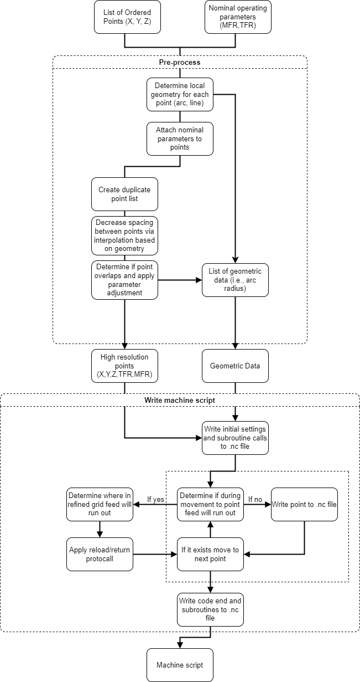
Figure 20: Flowchart showing process of precursor algorithm.

Example parts
In the following studies all AFSD was carried out using a MELD Manufacturing L3 with a discrete feed system, running on code generated through the described MATLAB script.

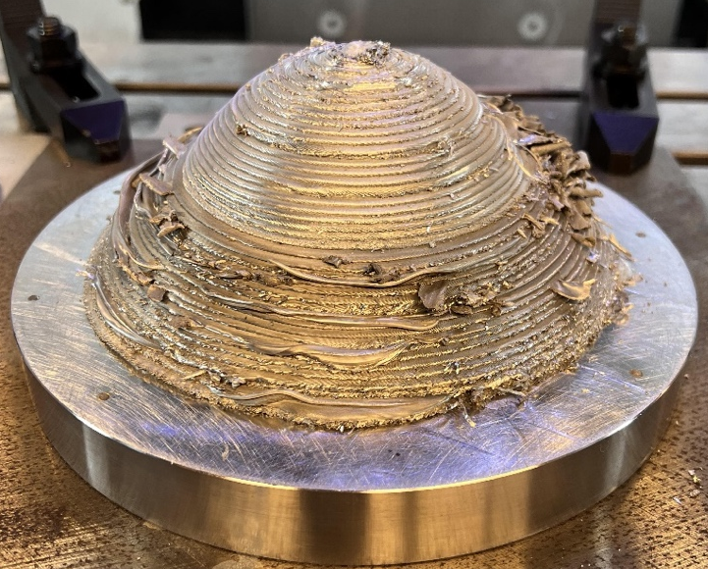
The cone
This study was carried out to demonstrate the ability for AFSD to deposit 3D hollow geometries. A cone shape was selected along with the material, Al 7075, due to their relevance to the aerospace community. This geometry also prompted the development of the MATLAB script, as developing flexible, bug free machine code was found to be nearly impossible; especially while planning for reloads as any change in operating parameters or the aspect ratio of the cone would require rewriting the whole script. The points were generated for this part through MATLAB as well, through an equation driven approach.
Figure 21: AFSD deposited cone.
On the final part shown in Figure 21 there can be seen a clear difference in print quality (i.e., lack of flash) between two of the layers. This change occurs due to a change in build strategy. On the lower half each layer was deposited and then a ramped layer change operation occurred. Each layer change was a discontinuity which generated some amount of flash. The deposition direction was clockwise causing the AS to be on the interior of the print, causing flash to initially be pushed towards the center. With each layer change the amount of flash grew. The changes which were instituted were to instead generate the paths helically (i.e., one continuous path which changed in the Z direction constantly) and to deposit the layer in the counterclockwise direction which forced material outside and out of reach of the next later and limiting discontinuities to reload sequences.

Archimedes spiral
This study was carried out to test and demonstrate the algorithms ability to fit circular arcs to a curvilinear geometry as an Archimedes spiral contains no perfect circular arc. It carries an inherent error which is definable. The input point matrix was generated in MATLAB where the radius of the spiral increases by 25.4 mm every full rotation; five layers were deposited in alternating directions using a MELD Manufacturing L3 equipped with a 12.7 mm (0.5 in) square rod discrete feed system. The Al 6061-T6 rods were coated in a carbon graphite lubricant. The nominal process parameters were $TFR=254 mm/min (10 ipm)$, $MFR=152.5 mm/min (6 ipm)$, and $h=2 mm (0.080 in)$. $MFR$ was the parameter was adjusted in the overlaps. PID control was used on the build to maintain tool face temperature at $T_{tool}=420 °C$. The tool face had four teardrop shaped nubs protruding from the surface to a depth of 2.3 mm (0.090 in). During the deposit there was no evidence of underfeeding or excess squeeze flash was only generated in the reload locations which occurred due to discrete feed system installed on the L3. The operator only engaged in the process during the reload process. An image of this is shown in Figure 22.
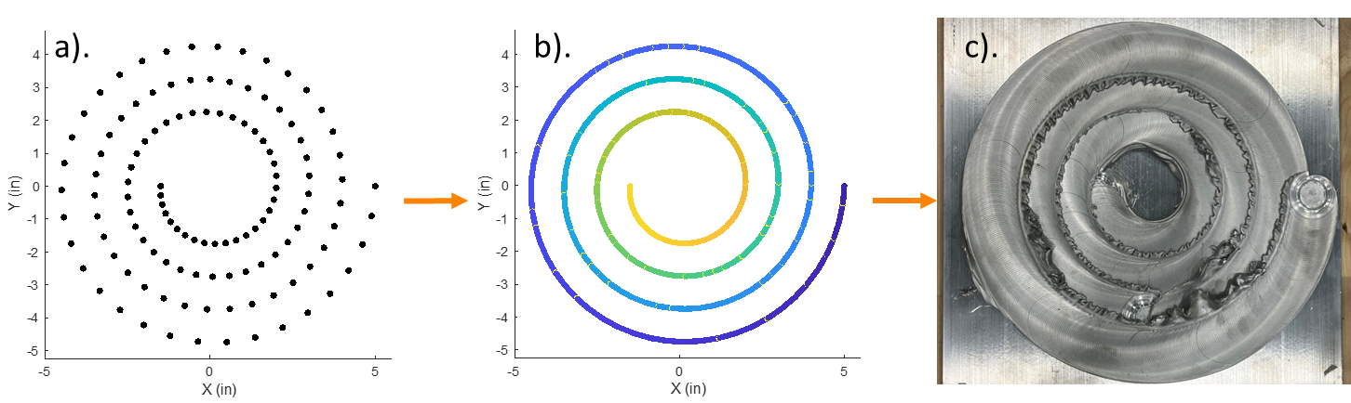
Figure 22: a). Point data describing Archimedes spiral. b). Arcs fit and oriented over toolpath point. c). Deposit from posted code.

Linear overlap range
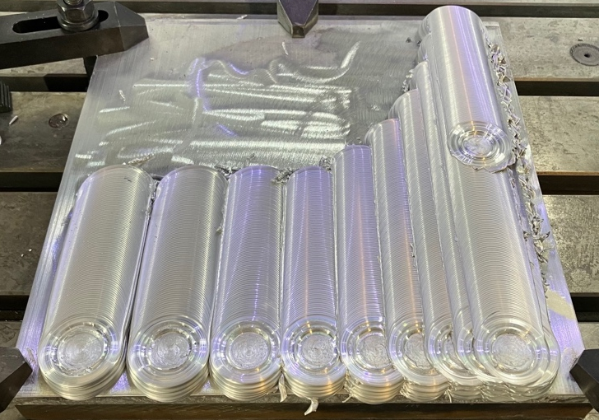
This study was carried out to test the robustness of the linear overlap method by simultaneously testing a range of overlap amounts while also testing over repeated overlaps. The deposit (shown in Figure 23) has ten parallel paths where the initial distance between tracks is 45 mm. Each subsequent path distance decreases by 5 mm per step with a final distance of 5 mm. The start positions of each parallel track are offset such that the tool does not contact the prior track during startup. Six layers were deposited using a MELD Manufacturing L3 using a 12.7 mm (0.5 in) square rod discrete feed system. The Al 6061-T6 rods were coated in a carbon graphite lubricant. The nominal process parameters were $TFR=254 mm/min (10 ipm)$, $MFR=152.5 mm/min (6 ipm)$, and $h=2 mm (0.080 in)$. $MFR$ was the parameter was adjusted in the overlaps. PID control was used on the build to maintain tool face temperature at $T_{tool}=420 °C$. The tool face had four teardrop shaped nubs protruding from the surface to a depth of 2.3 mm (0.090 in). During the deposit squeeze flash was generated on the final three tracks. This was discovered to be related to the decrease in force over each track (shown in Figure 25) which resulted in a reduction in layer height shown in Figure 24. This test displays the need to compensate layer height as increasing the number of layers could cause a build failure. It should be noted however that the flash generation only occurred on the finals three tracks once the overlap was much greater than half of the tool diameter. The spatial force plot (Figure 25) was generated from data generated on the AFSD machine. The print height plot (Figure 24) was generated using cross sections from a 3D structed light scan of the deposit using a GOM ATOS Q scanner. The Z-height comparison is created from a plane fit to the top surface of the build plate.
Figure 23: Image showing completed test of linear overlap compensation method.

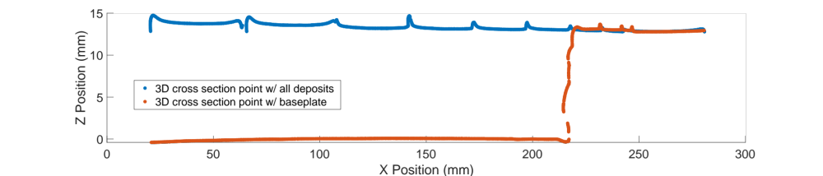
Figure 24: Plot showing a cross section of print height compared to the baseplate taken from a 3D structured light scan.
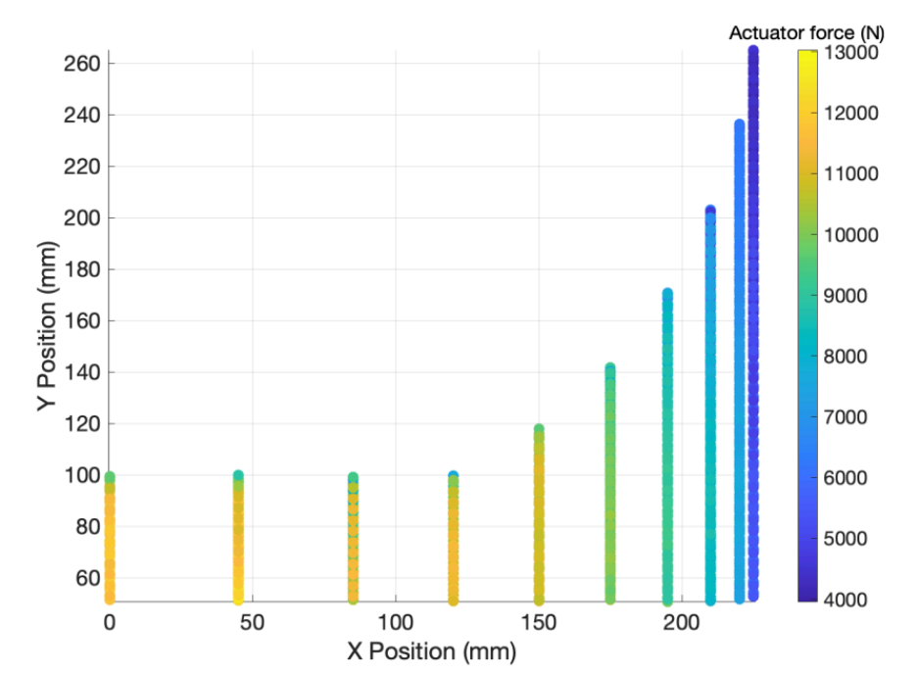
Figure 25: Spatial plot showing actuator force in different print locations.

Ogive layup mold
This test was carried out to demonstrate the utility of the proposed algorithm for production of a component using a hybrid manufacturing approach. First a part model was supplied. Then the model was input into Slicer 2 and a raster path was generated for the entire part. Next, the boundary points from the slicer were input into the algorithm, where process parameters were assigned, and a machine code was output. Note due to a machine stuttering issue where any change in $MFR$ causes the machine to momentarily pause the sloped parameter changes when moving perpendicular to a build path had to be smoothed as it would cause a severe drop in average $TFR$. This issue is also why a raster only build path was selected. The build file was then executed on a MELD Manufacturing L3 using a 0.5 in square rod discrete feed system. The Al 6061-T6 rods were coated in a carbon graphite lubricant. The nominal process parameters were $TFR=381 mm/min (15 ipm)$, $MFR=228.6 mm/min (9 ipm)$, and $h=2 mm (0.080 in)$ $MFR$ was the parameter that was adjusted in the overlaps. PID control was used on the build to maintain tool face temperature at $T_{tool}=420 °C$. The tool face had four teardrop shaped nubs protruding from the surface to a depth of 2.3 mm (0.090 in). Following the deposit, after cooling, a 3D structed light scan of the deposit was taken using a GOM ATOS Q scanner. Using the 3D scan a machining path was completed. The hybrid manufacturing process for this part is shown in Figure 26.
Three issues can be seen in this build, shown in Figure 27. The first is a large void found in the top right corner. This issue is related to a machine issue where the control stopped receiving commands causing the steel push rod to create a hole in the build which was unable to be filled during subsequent passes. The second is a small void near the center of the layup surface. This is due to an underestimation of the effect of the corners of the parallel raster paths. The final issue is found in two locations of the bottom left of the mating surface and are related to the algorithm used to smooth the rapid process parameter changes. An under approximation was used in order to prevent corner squeeze flash generation as this would fail the build. However, a slightly aggressive reduction was made such that some exterior regions of the build were underfed on the last three layers.
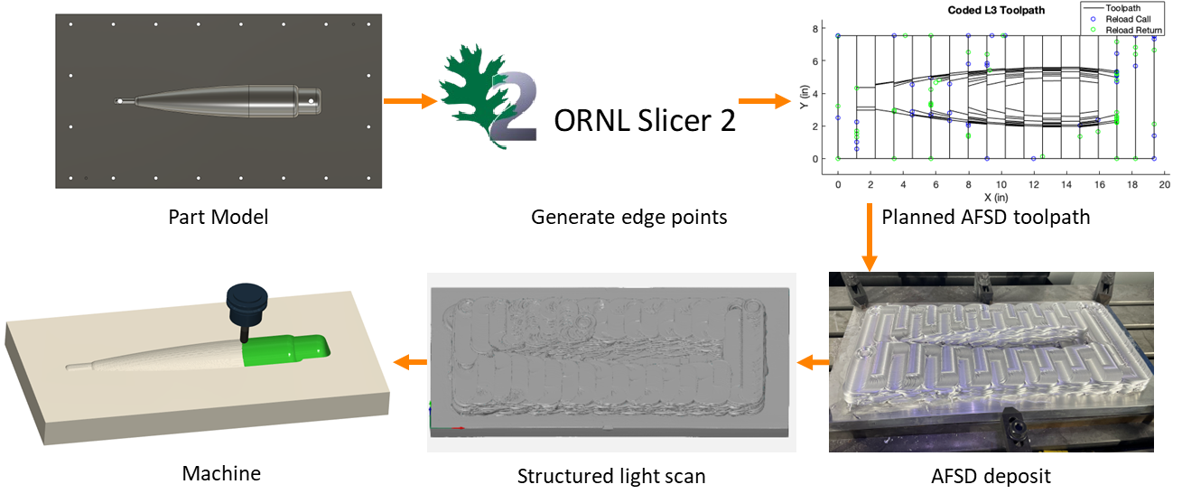
Figure 26: Hybrid manufacturing process flow for the ogive layup mold.

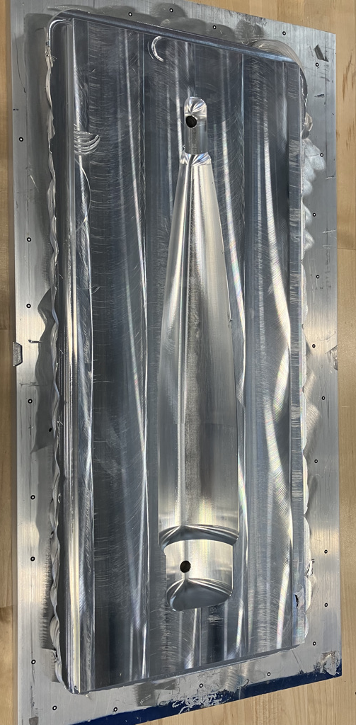
Figure 27: Final ogive mold part.

LVDT initial spindle displacement tests
The final case study discussed is an initial measurement of the tool displacement in-process with and without overlap. A HGSI ILPS-19S linear variable differential transformer (LVDT) sensor is mounted in the machine XZ plane in line with the center of the tool. The sensor contact tip is positioned such that it will drag along a ground parallel steel plate. This setup is shown in Figure 28. After setup, the baseplate was located into the coordinate system. Two data samples were then collected as follows:
- Sample 1 (Test) – Three-layer deposit was printed in a raster path to record in process displacement.
- Sample 2 (Trace) – The baseplate was removed, then the same path was repeated to record expected sensor displacement.
For each test, sensor displacement was recorded at 1000Hz for 240 seconds. All deposits in this section were executed on a MELD Manufacturing L3 using a 0.5 in square rod discrete feed system. The Al 6061-T6 rods were coated in a carbon graphite lubricant. The nominal process parameters were $TFR=254 mm/min (10 ipm)$, $MFR=152.5 mm/min (6 ipm)$, and $h=2 mm (0.080 in)$ was the parameter was adjusted in the overlaps. PID control was used on the build to maintain tool face temperature at $T_{tool}=400°C$. The tool face had four teardrop shaped nubs protruding from the surface to a depth of 2.3 mm (0.090 in). An image of the resulting deposit is shown in Figure 29.

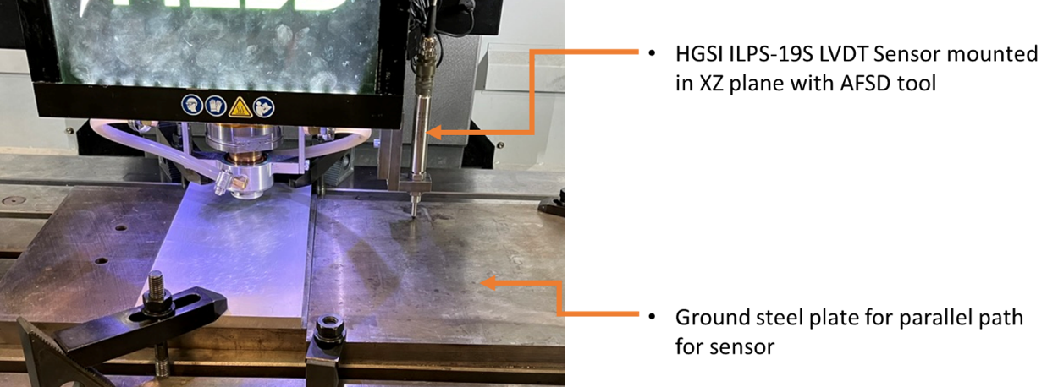
Figure 28: LVDT displacement test setup.

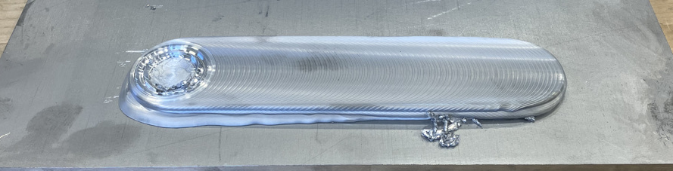
Figure 29: Resulting AFSD deposit from raster LVDT test.

The measured displacement is shown for each measurement in Figure 30. It is shown that there is a sizable difference in tool position during deposition. Net spindle displacement is calculated by subtracting the trace measurement from the test measurement ($measured-expected$).
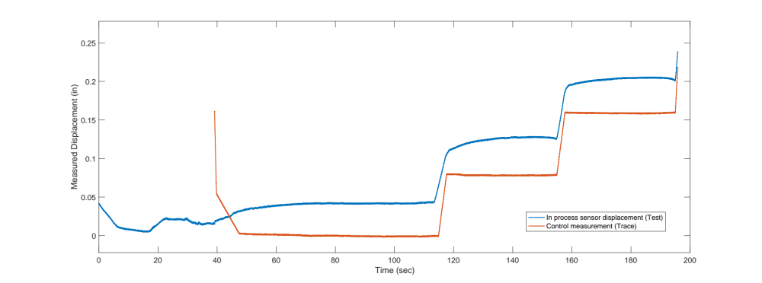
Figure 30: Measured displacement between test and trace measurements.
Max displacement was found to be 1.27 mm (0.050 in). Average displacement in steady state for each layer was found to be:
- Layer 1: 1.07 mm (0.042 in)
- Layer 2: 1.24 mm (0.049 in)
- Layer 3: 1.17 mm (0.046 in)
This test was repeated to include overlaps such that three pairs of data samples were collected such that distance between the overlapping tracks was 31.75 mm (1.25 in), 25.4 mm (1.00 in), and 19.05 mm (0.75 in). Once again, each test will include a test and a trace measurement:
- Sample 1 (Test) – Three-layer twin track deposit was printed to record in process displacement.
- Sample 2 (Trace) – The baseplate was removed, then the same path was repeated to record expected sensor displacement.
For each test sensor displacement was recorded at 500Hz. The start positions of each parallel track are offset such that the tool does not contact the prior track during startup. An image of the resulting deposits is shown in Figure 31. Differences between test and trace measurements were compared for each overlap amount.
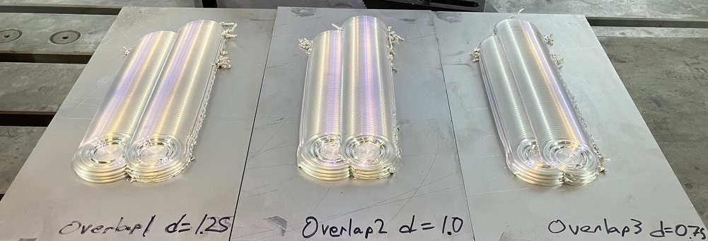
Figure 31: Resulting deposits from overlap LVDT test.
Net Z displacement is calculated between the test and trace measurement and the result for each overlap amount for every track and layer is shown in Figure 32.
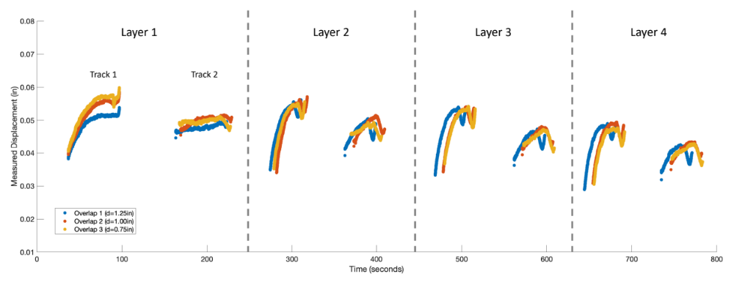
Figure 32: Resultant net displacement for each overlap amount.
A decreasing layer height trend can be observed which appears similar for each test. Due to the altered layer height on layer 1 the posterior layers show little to no steady state region. Therefore, the difference in spindle displacement for each overlap is calculated from the difference between track 1 and track 2 on layer 1:
- Overlap 1: 0.079 mm (0.0031 in)
- Overlap 2: 0.114 mm (0.0045 in)
- Overlap 3: 0.168 mm (0.0066 in)
This shows that as overlap increases the difference in layer height increases meaning track 2’s height is decreasing. Further testing is required and is planned. Further testing will include.
- Additional data points.
- Measurement of prior layer interface using the LVDT and 3D scanning so that data from layers 2-4 can be used.
- Tests to determine if displacement has a build direction dependance (i.e., A or R or R on A).
- Tests to determine impact of parameter compensation method (i.e., change in $MFR$ or $TFR$).
- Use of a force dynamometer so that total force can be calculated.

Summary
The previous examples demonstrate the need for path planning methodologies and the effectiveness of the proposed algorithmic process as well as the need for further research. Specific outcomes from above sections:
- The cone study shows how path planning decisions impact deposit quality.
- The Archimedes spiral study demonstrates the effectiveness of the arc fitting algorithm to fit circulars arcs to even noncircular geometry. And the circular feed compensation ability to prevent print failing defects.
- The linear overlap range test study shows the need for a model to predict and compensate for the change in layer height associated with the necessary change in parameters for overlaps.
- The ogive layup mold study shows that the proposed methodology can be implemented to produce real parts.
- The LVDT based spindle displacement measurement study verifies that the displacement is associated with the physical system and begins quantifying the displacement related to the varying overlap.

Conclusions and Recommendations
I’ll get to this soon

Blah blah blah blah blah blah blah blah blah blah blah blah blah blah blah blah blah. Blah blah blah blah blah blah blah blah blah blah blah blah blah blah blah blah blah. Blah blah blah blah blah blah blah blah blah blah blah blah blah blah blah blah blah. Blah blah blah blah blah blah blah blah blah blah blah blah blah blah blah blah blah. Blah blah blah blah

LIST OF REFERENCES
I have a reference manager for this

Appendix
[Remove this note, but DO NOT REMOVE THIS PAGE – you can change “Appendix” to “Appendices” if you would like. The appendix material should start at the top of THIS page unless you are using separator sheets for your chapter headings, in which case the appendix material should start at the top of the NEXT page. Please note that you should remove both this page and the next one if you are not including an appendix at all – “do not remove this page” refers only to students who ARE including an appendix]

Appendix material continued. This section is optional. You can place tables and figures in the appendix if you like. If you choose this option, you should indicate that tables and
figures are in the appendix after the first mention in the text. You can place some tables/figures in the text and others in the appendix, or all tables/figures in the appendix.

Vita
Jane X. Doe was born. She wrote a thesis. She graduated. She followed

instructions and wrote her vita in third person and paragraph form (as opposed to a

resume or CV), which made her thesis consultant very happy. This page is required.

