Thermodynamic Analysis of Nuclear Forensic-Relevant Lanthanides via Gas-Phase Separations

A Dissertation
Presented for the
Doctor of Philosophy
Degree
The University of Tennessee, Knoxville

Daniel Eric Hanson
December 2014

Copyright © 2014 by Daniel Eric Hanson
All rights reserved.

Dedication

Start here

Acknowledgements

Start here. John Auxier, Matthew Marsh, Howard Hall, Hall research group,

Financial support statement start

Abstract

Abstract Start

Table of Contents

Chapter 1: Background 1
1.1 Introduction 1
1.1.1 Radiochemistry 1
1.1.2 Nuclear Forensics 1
1.2 Current Methodology 1
1.3 Proposed Problem 1
Chapter 2: Literature Survey 2
2.1 Synthesis of Rare Earth-β-diketonate Complexes 2
2.2 Validation of Rare Earth β-diketonate Complexes 4
2.2.1 Melting Point Analysis 4
2.2.2 Infrared Spectroscopy Analysis 5
2.2.3 NMR Analysis 6
2.2.4 Volatilization and Purification 8
2.2.5 Coordination Number Analysis 8
2.2.6 Structural Analysis 9
2.3 Separation of Rare Earth β-diketonate Complexes 9
2.4 Separation of Inorganic Rare Earth Compounds via Thermochromatography 10
2.5 Mathematical Basis of Thermochromatographic Separations 13
2.5.1 Mathematical Representation of the Various Forms of Thermochromatography. 13
2.5.2 Derivation of Linearized Equations for Enthalpy and Entropy Values 15
Chapter 3: Experimental Methodology 17
3.1 Preparation of β-diketonate Rare Earth Complexes 17
3.1.1 Hfac complexes 17
3.1.2 Fod complexes 18
3.1.3 Dpm complexes 18
3.2 Characterization of Rare Earth Complexes 18
3.2.1 Elemental Analysis 18
3.2.2 Mass Spectrometry Analysis 18
3.2.3 IR Analysis 19
3.2.4 Nuclear Magnetic Resonance 19
3.2.5 Single Crystal X-Ray 19
3.2.6 Melting Point Analysis 19
3.2.7 Computational Structure 19
3.3 Gas-phase Analysis of Rare Earth Complexes 19
3.3.1 Equipment setup 19
3.3.2 Methodology 20
3.3.3 Calculation Methodology 20
Chapter 4: Experimental Results 22
4.1 Characterization of Rare Earth Complexes 22
4.1.1 Elemental Analysis 22
4.1.2 Mass Spectrometry 22
4.1.3 IR Analysis 32
4.1.4 Nuclear Magnetic Resonance 34
4.1.5 Single Crystal X-Ray 37
4.1.6 Melting Point 37
4.1.7 Computational Structure 39
4.2 Gas Phase Analysis of Rare Earth Complexes 40
4.2.1 Equipment setup 40
4.2.2 Methodology 40
4.2.3 Calculation Methodology 40
Chapter 5 Conclusions and Future Work 41
5.1 What Was Obtained 41
5.2 Conclusions 41
5.3 Future Work 42
List of References 43
Appendices 44
Appendix 1 ICP-TOF-MS Spectral Output for RE[hfac] complexes 45
Appendix 2 ICP-TOF-MS Spectral Output for RE[fod] complexes 53
Appendix 3 ICP-TOF-MS Spectral Output for RE[dpm] complexes 61
Appendix 4 Summary of Graduate School Honors, Publications, and Presentations 69
Vita 71
List of References 72

List of Figures
Figure 4.1-1: ICP-TOF-MS data for La, Eu, Ho, and Lu[hfac] complexes. 23
Figure 4.1-1: ICP-TOF-MS data for Pr, Gd, and Er[hfac] complexes. 24
Figure 4.1-1: ICP-TOF-MS data for Nd, Tb, and Tm[hfac] complexes. 25
Figure 4.1-1: ICP-TOF-MS data for Sm, Dy, and Yb[hfac] complexes. 26
Figure 4.1-2: ICP-TOF-MS data for La, Eu, Ho, and Lu [fod] complexes. 28
Figure 4.1-2: ICP-TOF-MS data for Pr, Gd, and Er[fod] complexes. 29
Figure 4.1-2: ICP-TOF-MS data for Nd, Tb, and Tm[fod] complexes. 30
Figure 4.1-2: ICP-TOF-MS data for Sm, Dy, Yb[fod] complexes. 31
Figure 5.2-1: 41
Figure A1-1: ICP-TOF-MS spectra of La[hfac] in mass range of lanthanides. 50
Figure A1-2: ICP-TOF-MS spectra of Pr[hfac] in mass range of lanthanides. 51
Figure A1-3: ICP-TOF-MS spectra of Nd[hfac] in mass range of lanthanides. 51
Figure A1-4: ICP-TOF-MS spectra of Sm[hfac] in mass range of lanthanides. 52
Figure A1-5: ICP-TOF-MS spectra of Eu[hfac] in mass range of lanthanides. 52
Figure A1-6: ICP-TOF-MS spectra of Gd[hfac] in mass range of lanthanides. 53
Figure A1-7: ICP-TOF-MS spectra of Tb[hfac] in mass range of lanthanides. 53
Figure A1-8: ICP-TOF-MS spectra of Dy[hfac] in mass range of lanthanides. 54
Figure A1-9: ICP-TOF-MS spectra of Ho[hfac] in mass range of lanthanides. 54
Figure A1-10: ICP-TOF-MS spectra of Er[hfac] in mass range of lanthanides. 55
Figure A1-11: ICP-TOF-MS spectra of Tm[hfac] in mass range of lanthanides. 55
Figure A1-12: ICP-TOF-MS spectra of Yb[hfac] in mass range of lanthanides. 56
Figure A1-13: ICP-TOF-MS spectra of Lu[hfac] in mass range of lanthanides. 56
Figure A2-1: ICP-TOF-MS spectra of La[fod] in mass range of lanthanides. 57
Figure A2-2: ICP-TOF-MS spectra of Pr[fod] in mass range of lanthanides. 58
Figure A2-3: ICP-TOF-MS spectra of Nd[fod] in mass range of lanthanides. 58
Figure A2-4: ICP-TOF-MS spectra of Sm[fod] in mass range of lanthanides. 59
Figure A2-5: ICP-TOF-MS spectra of Eu[fod] in mass range of lanthanides. 59
Figure A2-6: ICP-TOF-MS spectra of Gd[fod] in mass range of lanthanides. 60
Figure A2-7: ICP-TOF-MS spectra of Tb[fod] in mass range of lanthanides. 60
Figure A2-8: ICP-TOF-MS spectra of Dy[fod] in mass range of lanthanides. 61
Figure A2-9: ICP-TOF-MS spectra of Ho[fod] in mass range of lanthanides. 61
Figure A2-10: ICP-TOF-MS spectra of Er[fod] in mass range of lanthanides. 62
Figure A2-11: ICP-TOF-MS spectra of Tm[fod] in mass range of lanthanides. 62
Figure A2-12: ICP-TOF-MS spectra of Yb[fod] in mass range of lanthanides. 63
Figure A2-13: ICP-TOF-MS spectra of Lu[fod] in mass range of lanthanides. 63
Figure A3-1: ICP-TOF-MS spectra of La[dpm] in mass range of lanthanides. 64
Figure A3-2: ICP-TOF-MS spectra of Pr[dpm] in mass range of lanthanides. 65
Figure A3-3: ICP-TOF-MS spectra of Nd[dpm] in mass range of lanthanides. 65
Figure A3-4: ICP-TOF-MS spectra of Sm[dpm] in mass range of lanthanides. 66
Figure A3-5: ICP-TOF-MS spectra of Eu[dpm] in mass range of lanthanides. 66
Figure A3-6: ICP-TOF-MS spectra of Gd[dpm] in mass range of lanthanides. 67
Figure A3-7: ICP-TOF-MS spectra of Tb[dpm] in mass range of lanthanides. 67
Figure A3-8: ICP-TOF-MS spectra of Dy[dpm] in mass range of lanthanides. 68
Figure A3-9: ICP-TOF-MS spectra of Ho[dpm] in mass range of lanthanides. 68
Figure A3-10: ICP-TOF-MS spectra of Er[dpm] in mass range of lanthanides. 69
Figure A3-11: ICP-TOF-MS spectra of Tm[dpm] in mass range of lanthanides. 69
Figure A3-12: ICP-TOF-MS spectra of Yb[dpm] in mass range of lanthanides. 70
Figure A3-13: ICP-TOF-MS spectra of Lu[dpm] in mass range of lanthanides. 70

List of Tables
Table 2.2-1 IR absorbance peaks of various β-diketonates. 5
Table 2.2-2 NMR shift of various β-diketonates. 7
Table 2.4-1 Comparison of deposition temperatures of various metals 12
Table 4.1-5 EI-MS peaks of H[hfac] and their assignments 27
Table 4.1-3 IR absorbance peaks of synthesized RE[hfac] complexes. 32
Table 4.1-4 IR absorbance peaks of synthesized RE[fod] complexes. 33
Table 4.1-6 ¹H NMR shift for RE[hfac]. 35
Table 4.1-7 ¹³C NMR shift for RE[hfac]. 36
Table 4.1-8 ¹⁹F NMR shift for RE[hfac]. 36
Table 4.1-1 Melting points of the synthesized RE[hfac] and literature values. 38
Table 4.1-2 Melting points of the synthesized RE[fod] and literature values. 39
Table 5.2-1 41

List of Acronyms and Symbols
REE Rare Earth Elements
DPM Dipivaloylmethane (2,2,6,6-tetra-methyl-3,5-heptanedione)
HFAC
HFOD

Chapter 1: Background

Introduction

Radiochemistry

Nuclear Forensics

Current Methodology

Proposed Problem

Chapter 2: Literature Survey

Synthesis of Rare Earth-β-diketonate Complexes
The synthesis of rare earth (RE) complexes with β-diketonates has been widely studied,¹ and many similarities are found between the methods. A common methodology used by Eisentraut and Sievers² was the use of RE nitrates dissolved in a polar solvent (e.g. water, methanol, ethanol, ether, acetonitrile) and adding the deprotonated β-diketonate to the mixture.³⁻¹⁰ Additional methods used a rare earth halide, primarily chlorine, as the negative ion.¹⁰⁻¹⁷ The β-diketonate was deprotonated using a hydroxide, most commonly sodium hydroxide, but ammonia (as ammonium hydroxide) was used in a few instances.
A few unique synthesis methods were also developed, but not widely used due to their complexity. These methods typical were used to produce anhydrous complexes for the smaller β-diketonates. Belcher et al. used rare earth hydroxides in his methodology, using ammonia and protonated β-diketonates.¹⁸ Lim et al. used LaCl₃ in conjunction with methyllithium (MeLi) in tetrahydrofuran (THF) to synthesize anhydrous complexes.¹⁹ Koehler and Bos synthesized the complexes starting with the pure metal, converting it into a hydride, and directly reacting the hydride with acetylacetone.²⁰ Liss and Bos also used this method in the preparation of europium trisacetylactonates.²¹
A common feature of all of these methodologies was the use of vacuum desiccation to prevent the uptake of water, as hydration of the complexes reduced the thermal stability.⁷ However, many of the reactions were performed with the introduction of water as a solvent somewhere in the synthesis.^{2,3,8-15}
A study by Hammond was one of the first of many synthetic methods for β-diketonate complexes, but only two methods in his study were utilized for REs.¹⁰ In the first method, sodium dipivaloylmethane (dpm) in ethanol was added to the RE chloride. For the second method, RE oxide was dissolved with hydrochloric acid and its pH adjusted to just above the precipitation point of the Ln hydroxide. Ethanol and the β-diketonate were added and extracted with ether and recrystallized.¹⁰ This method was also utilized by Song.³
This methodology was adapted by Halverson and became a foundational methodology that many subsequent syntheses were based upon.^{2,4-9,11,12,17} Within this study, four different tris-β-diketonate complexes were formed, each with a unique synthesis based on a common theme. To synthesize these complexes, the β-diketonate salt (sodium or ammonium) was dissolved in a polar solvent (ethanol, acetone, water) and mixed with the REE salt (chloride or nitrate).¹⁵ Becht utilized this method using sodium, ethanol and cerium chloride.¹⁷ Utsunomiya and Shigematsu also used a rough version of Halverson’s methodology, using RE nitrates in hydrochloric acid mixed with ammonium salts of multiple β-diketonates in ethanol.⁸
Halverson’s method was followed much less modification by Richardson et al.^{11,12} In this method, the β-diketonate, hexafluoroacetylacetone (hfac), was intentionally hydrated and dissolved in ether. Chlorides of the RE were extracted and dried, evaporating the excess ether using dry air. The solid was then recrystallized using hexane. The resultant product was determined to be primarily Ln(hfac)₃∙nH₂O, but a significant fraction of Ln(hfac)₂CF₃CO₂∙2H₂O and trace NH₄Ln(hfac)₄.¹¹
This parent method further developed by Eisentraut and Seivers by performing the reactions in a vacuum to prevent oxidation of the complexes.² Again, the following the formula developed by Halverson, the synthesis was expanded to all REEs, but limited to only one β-diketonate, dpm. The solvent was 50% ethanol, sodium hydroxide was used for de-protonation, and nitrates were used as the source of the REEs. Heating the mixture under vacuum conditions distilled the solution, and more water was added, precipitating the RE(dpm)₃. Purification of the sample occurred by recrystallization in n-hexane. This methodology was followed exactly by Selbin, Sicre, and Berg and Acosta for their preparation of dpm complexes.^{4,6,9} Springer modified this method for the synthesis of 6,6,7,7,8,8,8-heptafluoro-2,2-dimethyl-3,5-octanedione (Hfod) complexes without the use of vacuum.⁷ Amano used a modified method, eliminating the vacuum conditions, substituting methanol for ethanol, and controlling the pH of the solution using ammonium hydroxide.⁵ Despite this modification the sublimation values found by Amano were in line with those established previously.^{5,6}
Separation of the products in these studies occurred by extraction or filtration. Complexes with hfac and 1,1,1,2,2,6,6,7,7,7-decafluoro-3,5-heptanedione (fhd) were always extracted into ether.^{6,11,12,15,16} Complexes isolating fod, Trifluoroacetylacetone (tfac), benzoylacetone (bzac), dibenzoylmethane (dbm), Benzoyltrifluoroacetone (btfac), pivaloyltrifluoroacetone (pta) and acetylacetone (acac) were isolated using a precipitation method through control of the pH.^{7,8,13,17,18} For dpm, the primary method of separation was precipitation; however the method used by Hammond isolated the β-diketonate complex via extraction.^{2-6,8-10,15,17,18}

Validation of Rare Earth β-diketonate Complexes
With the plethora of synthesis and possible combinations of RE and β-diketonates, validation of the synthesis played an important role in the synthesis process. Numerous physical methods were used to evaluate the compounds but infrared spectroscopy (IR), and melting point (MP) were the most common. Other methods included powder x-ray diffraction (PXRD), proton, carbon, and fluorine nuclear magnetic resonance (¹H, ¹³C, and ¹⁹F NMR, respectively), and volatilization temperature and recrystallization temperature were used occasionally as well.

Melting Point Analysis
The simplest of methods was the MP determination and used frequently in the first syntheses to establish a quick and easy method for sample identification. The first complexes developed were for dpm and there was relative agreement between the various authors.^{2,6,9} However, this was not without discrepancy. Hammond’s methodology (and correspondingly Song et al.) produced compounds with melting points far lower than would be found later.^{3,10} Further analysis would determine that the compounds contained dimethylformamide (dmf) and were not a pure complex of the and β-diketonates.²² The melting points of Utsunomiya and Shigematsu were also lower than expected.⁸ The unique non-aqueous process used by Lim for synthesis was able to create anhydrous complexes. When a sample was measured in a nitrogen atmosphere, the melting point for La(dpm)₃ was a few degrees lower than expected, but exposure to air raised the melting point to the expected range.¹⁹ Degrees of hydration were a complicating factor in melting point determination, complicated by assumptions made in the synthesis.⁶
While dpm was the most widely studied, MP determinations were made for acac,^{6,8,23} tfac,^{6,8,15} hfac,^{6,15} pta,^{8,24} and fod.⁷ With the exception of pta, there was little agreement between the various complexes, if multiple REs were studied.

Infrared Spectroscopy Analysis
Infrared spectroscopy (IR) was another commonly used method to evaluate at synthesized complex.^{3,5,7,8,11,12,14,17-19,21-27} Its ability to detect O-H stretching (broad peak: 3700-3200 cm⁻¹) acts as a simple identifier of hydration within a complex. However within the fingerprint range (1400-400 cm⁻¹), unique compound signatures are identified and correlated to un-complexed β-diketonates. Like the MP analysis, dpm has been analyzed most frequently. The data was all consistent within the fingerprint region.^{3,5,17,19,22,26} The key functional groups for hfac are the CF₃ and C-CF₃ group and this were assigned the wavenumbers 1260, 1212, and 1195 and 741 respectively.^{11,27} Additional IR investigations were performed without attribution of wavenumbers as well.^{12,14,18,19} For pta, no specific wavenumbers were assigned to the functional groups; however Shigematsu et al. published the full IR spectrum.^{8,18,24} Both Springer et al. and Richardson et al. published unique data for fod and fhd, respectively. No specific attribution was given for the fhd complexes, but a full peak list was given.¹² The same was true of fod.⁷ In both complex samples, water was present.^{7,12} Table XXXXXX below lists the functional groups of the RE complexes.

Table 2.2-1 IR absorbance peaks of various β-diketonates.
Wavenumber (cm⁻¹) | Ligand | Assignment | Author
3700-3150  3400, 3695, 3550, 3150 | fod, hfac | O-H | Springer⁷, Condorelli²⁷
2961 | dpm, acac, pta | CH₃ | Becht¹⁷, Song³, Przystal²³, Liss²¹
2950 | fod |  | Springer⁷
2867 | dpm, pta | CH₃ | Song³, Becht¹⁷
1655 | hfac | C-O | Condorelli²⁷, Lim¹⁹
1620 | hfac, fod | C=C | Condorelli²⁷, Springer⁷
1600 | fod |  | Springer⁷
1590 | dpm, acac, tfac | C-O | Song³, Lim¹⁹, Becht¹⁷
1570 | dpm, hfac | C=O, C=C | Becht¹⁷, Condorelli²⁷, Song³, Lim¹⁹, Przystal²³, Liss²¹
1546 | dpm | C-C | Becht¹⁷, Song³, Lim¹⁹
1534 | hfac, tfac, pta, fod | C-O, C-H | Condorelli²⁷, Lim¹⁹, Becht¹⁷, Springer⁷
1518 | acac |  | Przystal²³, Liss²¹
1502 | dpm | C-O,C-C, C-H | Song³, Becht¹⁷, Springer⁷, Lim¹⁹
1480 | fod, hfac |  | Springer⁷, Lim¹⁹, Condorelli²⁷
1460 | acac, tfac, hfac | C-O | Lim¹⁹, Condorelli²⁷
1453 | dpm, pta, hfac, acac | C-C, C-H | Song³, Becht¹⁷, Condorelli²⁷, Przystal²³, Lim¹⁹
1400 | dpm, acac | CH₃ | Lim¹⁹, Przystal²³, Liss²¹, Becht¹⁷, Song³
1390 | dpm, fod, acac | Ln-O, C-O | Song³, Lim¹⁹, Becht¹⁷, Springer⁷
1358 | dpm, pta, tfac, acac | CH₃ | Song³, Becht¹⁷, Lim¹⁹, Przystal²³
1350 | fod, hfac |  | Springer⁷, Condorelli²⁷
1290 | fod |  | Springer⁷
1286, 1245 | dpm | C-CH₃ | Song³, Lim¹⁹, Amano²⁶, Becht¹⁷
1266 | acac |  | Przystal²³, Liss²¹
1260 | hfac | C-F | Condorelli²⁷, Lim¹⁹
1225 | dpm, acac, tfac, pta | C-CH₃ | Song³, Przystal²³, Liss²¹, Lim¹⁹, Becht¹⁷
1212 | hfac | C-F | Condorelli²⁷, Lim¹⁹
1195 | hfac, tfac | C-F | Condorelli²⁷, Lim¹⁹, Springer⁷
1174 | dpm | C-CH₃ | Song³, Przystal²³, Liss 1977, Becht¹⁷, Lim¹⁹
1160 | fod |  | Springer⁷
1142 | dpm, hfac, pta | C-H | Song³, Condorelli²⁷, Becht¹⁷, Lim¹⁹, Amano²⁶
1120 | fod |  | Springer⁷
1110 | fod |  | Springer⁷
1070 | fod |  | Springer⁷
1023 | dpm, acac | CH₃ | Song³, Przystal²³, Amano²⁶, Lim¹⁹, Liss²¹
964 | dpm | CH₃ | Song³, Becht¹⁷, Lim¹⁹
932 | dpm, acac | CH₃ | Song³, Amano²⁶, Przystal²³
870 | dpm | C-CH₃, C-O | Song³, Lim¹⁹, Becht¹⁷, Amano²⁶
800 | hfac, acac, fod, dpm | CH | Lim¹⁹, Song³, Przystal²³, Condorelli²⁷, Springer⁷, Amano²⁶, Liss²¹
793 | dpm, pta | C-H | Song³, Lim¹⁹, Becht¹⁷, Amano²⁶
769 | hfac | C-CF₃ | Condorelli²⁷, Lim¹⁹
759, 735 | dpm, pta, acac | C-CH₃, C-C-O, Ln-O | Song³, Lim¹⁹, Becht¹⁷, Liss²¹
750 | fod |  | Springer⁷

The key feature within the IR spectra is the carbon-oxygen single bond, found at 1655, 1534, 1460, and 1390 cm⁻¹.²⁷ This shows the shift from the double-bonded ketone structure to a single bond that is coordinated with the central metal. For the individual complexes, the distinguishing terminal structures have been identified for many of the β-diketonates, which are unaffected by the central atom. An example of this is the peak at 1225 cm⁻¹, the carbon-methyl bond found in dpm, acac, tfac, and pta.^{3,17,19,21,23}Strucural peak assignments for fod remain unpublished, however overlap with assigned values do exist.

NMR Analysis
Unlike MP and IR, NMR was not used in the initial studies by Halverson or Hammond. However, later studies have used this methodology more frequently to more fully characterize the complexes and understand their structure.^{2,3,7,12,17,19,21,22,24,28} The most common work was with ¹H NMR.
Part of the initial work with these compounds was investigating their use as shift reagents for NMR.¹ Within the studies for dpm, a consistent shift of around 1.1 ppm was found.^{2,3,17,19,22} Studies of hfac were not as conclusive. Lim et al. found a shift of 5.73 ppm for their anhydrous La(hfac)₃ sample¹⁹, while Richardson and Sievers found a shift of 6.29 ppm for the dehydrate of Lu(hfac)₃¹². Studies with pta found shifts at 1.18 and 5.95 ppm for Ce(pta)₄ and 3.8 and 8.9 ppm for Sc(pta)_{3,} for which the discrepancy may be accounted for in the differences in the central atoms.^{17,24} ¹H NMR analysis of fhd and fod ligands was only carried out by Richardson and Sievers and Spring et al., respectively. These studies concluded the chemical shift of these two complexes was roughly that of dpm, approximately 1.1 ppm and 6.3.^{7,12}

Table 2.2-2 NMR shift of various β-diketonates.
Ligand | shift(ppm) | Assignment | NMR type | Author
acac | 1.75 | CH₃ | ¹H, DMS_{d-6}, 60 Hz | Liss²¹
acac | 5.1 | CH | ¹H, DMS_{d-6}, 60 Hz | Liss²¹
dpm | 1.11 | s, tBu | ¹H, CDCl₃ | Becht¹⁷
dpm | 5.33 | s, CH | ¹H, CDCl₃ | Becht¹⁷
dpm | 1.08 | CH₃ | ¹H, CDCl₃ | Eisentraut²
dpm | 5.68 | CH | ¹H, CDCl₃ | Eisentraut²
dpm | 1.16 | CH₃ | ¹H, CDCl₃ | Eisentraut²
dpm | 5.79 | CH | ¹H, CDCl₃ | Eisentraut²
dpm | 1.09 | s, CH₃ | ¹H, CDCl₃, 250 MHz | Lim¹⁹
dpm | 1.13 | s | ¹H, CDCl₃, 250 MHz | Lim¹⁹
dpm | 5.64 | s, CH | ¹H, CDCl₃, 250 MHz | Lim¹⁹
dpm | 1.08 | CH₃ | ¹H, CDCl₃, 60 Hz | Schwarberg²²
dpm | 5.68 | CH | ¹H, CDCl₃, 60 Hz | Schwarberg²²
dpm | 1.14 | s, tBu | ¹H, Acetone_{D-6} | Becht¹⁷
dpm | 5.62 | s, CH | ¹H, Acetone_{D-6} | Becht¹⁷
dpm | 1.12 | s, tBu | ¹H, CCl₄, 60 Hz | Song³
dpm | 5.49 | s, CH | ¹H, CCl₄, 60 Hz | Song³
dpm | 1.08 | s | ¹H, CD₃OD, 250 MHz | Lim¹⁹
tfac | 5.63 | CH₃ | ¹H, CDCl₃, 250 MHz | Lim¹⁹
tfac | 1.99 | s, 1 :2, total 9 H | ¹H, CDCl₃, 250 MHz | Lim¹⁹
tfac | 1.75 | s, 1 :2, total 9 H | ¹H, CDCl₃, 250 MHz | Lim¹⁹
tfac | 5.6 | s | ¹H, CD₃OD, 250 MHz | Lim¹⁹
tfac | 2.01 | s | ¹H, CD₃OD, 250 MHz | Lim¹⁹
hfac | 5.73 | s, CH | ¹H, CD₃OD, 250 MHz | Lim¹⁹
pta | 3.8 |  | ¹H, CDCl₃ | Shigematsu²⁴
pta | 8.9 |  | ¹H, CDCl₃ | Shigematsu²⁴
pta | 1.18 | s, tBu | ¹H, CDCl₃ | Becht¹⁷
pta | 5.95 | s, CH | ¹H, CDCl₃ | Becht¹⁷
fod | 1.11 | tBu | ¹H, CDCl₃, 60 Hz | Springer⁷
fod | 6.14 | CH | ¹H, CDCl₃, 60 Hz | Springer⁷
fod | 1.12 | tBu | ¹H, CDCl₃, 60 Hz | Springer⁷
fod | 6.02 | CH | ¹H, CDCl₃, 60 Hz | Springer⁷
fod | unreported |  | ¹⁹F, 40 MHz | Springer⁷
pta | -75.60 | CF₃ | ¹⁹F, CFCl₃ | Becht¹⁷

Volatilization and Purification
Volatilization and recrystallization analysis performed on β-diketonates complexes served multiple purposes. One, it acted as a method of purification for better compound analysis. More importantly, it served as a precursor to gas phase separations, or in some instances, a separation itself.⁶ The four complexes studied by Berg and Acosta showed a wide range of volatilities for each complex. Some, such as acac and for a few heavier tfac complexes, were completely non-volatile. The lighter tfac complexes showed a wide range of recrystallization temperatures, with overlap occurring between the various RE. Hexafluoroactylacetone and dpm however were much more volatile, and recrystallization temperature generally decreased for both as the atomic number increased.⁶ This trend was also identified by Amano.²⁶
Thermogravometric analyses (TGA) were performed to establish volatility and indirectly measure decomposition of the complexes under heating conditions. Studies with hfac demonstrated that while the complex was volatile, partial decomposition occurred.^{12,29} Investigations with dpm were similar, volatility with observed decomposition of the product.^{3,29} Aged samples were observed to have decreased volatility.³ Decomposition was not observed for fhd, which was attributed to the dehydrated state of the samples.¹²

Coordination Number Analysis
Much of the previous research in the areas of coordination number has shown that for RE, coordination numbers are higher than six, most commonly as an eight-coordinated metal.^{11,21,23,30} For the eight-coordinated species, the two additional bonds were attributed to hydration, confirmed in the IR analysis.¹¹ When in the gas phase, it has been shown that dpm exhibits a six-coordinated REE metal ion.³¹⁻³³ Since dpm exhibits low hydration (as determined through IR analysis)²², this matches the conclusions above. Overall, little work has been performed with a well-defined coordination and structure.

Structural Analysis
Structural analysis of β-diketonate complexes relevant to this work has been limited to the studies of dpm, primarily within the gas phase. One study of Pr(dpm)₃ found that the complex existed at a stable Pr₂(dpm)₆ dimer, having a bridging oxygen atom.³⁰ When analyzed in the gas phase, a monomeric molecule was found, in a trigonal prismatic structure, contrasted with the distorted octahedral share of the solid.³⁴ For heavier RE, the β-diketonates were monomeric with a trigonal prismatic structure,³⁵ like that of the gas phase.^{33,34}

Separation of Rare Earth β-diketonate Complexes
The separation of RE using the volatility discovered during the characterization of the complexes was a natural step forward. The simplest method given their inherent volatility was the use of gas chromatography (GC). One of the challenges of GC separations is given the large number of variables for the separation – column dimensions, column surface, temperature profiles, carrier gases, etc. Some success was had by the various authors studying potential gas-phase separations of these complexes.
The earliest work was performed by Seivers.³⁶ Using acac, tfac, and hfac a separation of various transition metals was attempted using four different chromatography columns. This work was able separate various tfac complexes, and observed the elution point could often be well below the melting point of the compound.³⁶ Polarity of the compound was also studied and the cis- and trans- isomers of Cr(tfac)₃ were found to elute at separated times.³⁶ One study focusing on multiple β-diketonates was unable to elute RE complexes of acac and tfac, but had success with dpm complexes of the same elements.⁸ Another study of tfac by Fujinaga et al. did not evaluate RE, but instead introduced tfac into the carrier gas to reduce tailing on the chromatographic peaks.³⁷
The volatility of dpm for RE was investigated by Eisentraut and Sievers.² No instances of decomposition were detected, and the retention time of the complexes was a function of the ionic radii.² A short (15 cm), packed column (10% Apiezon N on Gas-Pack F [60-80 mesh]) was used to facilitate the separation. This ionic radii trend was again found in a larger study with many ligands and few RE, and only for dpm.¹⁸ Another complex studied was fod and was successfully eluted without decomposition from a GC machine.⁷ The stability of this complex was attributed to its ability to dehydrate without decomposition, allowing for the volatilization of its anhydrous analogue.⁷ The same trend of retention time was found as well.⁷
A 75 cm column was used in a study of PTA, with a successful separation of REEs. This was again attributed to anhydrous complexes.²⁴ The successful separation of the REE complexes in this study is muddied by the unpublished results for PTA by Belcher et al. Regardless, the trend with the ionic radii was again observed.²⁴

Separation of Inorganic Rare Earth Compounds via Thermochromatography
Section 2.4 is a select portion of a paper submitted to Journal of Radioanalytical and Nuclear Chemistry and was co-authored by Jon Garrison and Dr. Howard Hall. It has been slightly modified to fit the standards of this work.
Chemical classification and elemental identification is an area of active study for new element research. The periodic table’s predictability of chemical properties within periodic groups is a useful gauge of the potential behavior of the desired element, and conversely, is a useful demonstration of chemical properties that can confirm elemental assignment. Thermochromatography studies have been used for the classification of elements since borhium (Bh, element 107) due to their short half-lives relative to time needed for traditional elemental separation.³⁸⁻⁴² Historically, the confirmation of the correct position within the periodic table has been with the use of the periodic group analogues.³⁸⁻⁴⁸ The periodic trending has been successful overall, however, a deviation from the trend was found with copernicium (Cn, element 112) with relativistic effects of the increasing number of electrons being the primary suspect.^{39,41} ^{40,42,49}
Volatile compound identification has been pursued as another method for studying period group trends as well as the creation of new or identification of existing compounds.^{42,45,46,50-63} Eichler used deposition temperatures in evaluation of various rhenium and iridium oxides and hydroxides.^{45,54,55} Eichler were also studied chlorides and oxychlorides to determine periodic trending and potential volatile compounds.^{42,46} Domanov isolated various oxides and hydroxides of Group 8, 9, 10 elements.^{51,53} Later, Domanov experimented with zirconium, hafnium and niobium chlorides and oxychlorides and isolated six different compounds.⁵⁷ Bayar^{56,61} and Helas⁵⁸ studied tungsten and molybdenum oxides and chlorides. This resulted in the identification of two different volatile tungsten oxides⁵⁶ and two molybdenum chlorides⁶¹ by Bayar and six compounds by Helas⁵⁸. Steffen identified various oxides of rhenium, technetium, ruthenium, and iridium.^{52,60} Fargeas used thermochromatography to identify the known fluorides and oxyfluorides of twelve different elements and discovered twenty new oxyfluorides.⁶³ In the studies evaluating deposition temperature, it was used to calculate the enthalpy (ΔH_{a}) and occasionally entropy (ΔS_{a}). The location of these various compounds was determined through several different experimental conditions. Differing enthalpy values lead to differing volatilities and distribution of compounds.
An offshoot of this type of separation is the purification of simple mixtures. Purification of bulk materials has been a topic of investigations, primarily – though not exclusively – for the generation of medical isotopes.^{50,64-72} Within this specific subset of thermochromatography separations the goal is high-purity eluates while maintaining a sufficient output. Rösch examined three different methods of ^{99m}Tc production focusing on speed, material purity, and reactant recovery.⁷¹ In a MoO₃-HTcO₄ system nearly 100% of the created technetium was recovered within six minutes, and after a subsequent purification molybdenum contamination was below detection level. A modified version of this setup was scaled up, and was able to produce 35 mCi of ^{99m}Tc in one hour. Denzler⁶⁶ used chlorides and oxychlorides to achieve similar separations as Rösch⁷¹ however with different purities and varying production levels. The differences in purity can be ascribed to the nuclear production rates of ^{99m}Tc.
Blessing examined the production of ⁷³Se and ⁷⁵Se through two different nuclear reactions starting with germanium and arsenic, respectively.^{64,65} Production of ⁷³Se yielded approximately 57 mCi of ⁷³Se at >95% purity⁶⁵. Using arsenic, two-step, batch production could yield 1 mCi of >99% pure ⁷⁵Se.⁶⁴
Separating different elements has been widely studied with a variety of compounds with varying degrees of separation.^{52,57,59,60,73-94} The variations between experimental conditions preclude drawing concrete generalizations, but some correlations may be found within similar studies.
In studies of chlorides, both Bachmann⁹¹ and Tsalas⁸³ found similar deposition temperatures for molybdenum, technetium, ruthenium, and osmium; but for rhenium, technetium, tellurium, cadmium, the deposition temperatures were discrepant sometimes greatly. Between the two studies, there were similar surface materials and temperature profiles, but different carrier and reactive gasses. Also, the experimental time may influence these numbers.
The data from Hickmann evaluates the same separations based on different reactive gasses.^{59,75} In the four experiments, all have unique compound distributions with only few similarities, the location of low volatility chlorides of strontium, barium, and the location of cesium.
Comparing the data from Hickmann^{59,75} to that of Bachmann⁹¹ and Tsalas⁸³ is difficult because the experimental conditions are incompatible. Different column materials, the inclusion of column packing, carrier and reactive gasses, make these three studies very different. It is not surprising that concrete agreement in the data is difficult to find.

Table 2.4-1 Comparison of deposition temperatures of various metals
Element | Hickman⁷⁵ | Hickman⁵⁹ | Tsalas⁸³ | Bachmann⁹¹
Tc | 100 | 320 | 408 | 440
Te | 300 | 450 | 448 | 220
Zr | 420 | 840 | 463 | -
Sb | 90 | 300 | 333 | -
Mo | 20 | 290 | 358 | -
Os | - | - | 393 | 600
In | - | - | 623 | 450
Re | - | - | 315 | 380
Rb | 950 | 920 | - | -
La | 950 | 1050 | - | -
Y | 800 | 1050 | - | -
Ce | 480 | 1050 | - | -
Cs | 420 | 900 | - | -

Deposition temperatures in the Fedoseev⁸⁵⁻⁸⁷, Travnikov^{82,95}, and Aizenberg⁸⁴ are all similar. However, unlike the studies mentioned previously, similar experimental setups were used in these experiments.

Mathematical Basis of Thermochromatographic Separations
Section 2.5.1 is a select portion of a paper submitted to Journal of Radioanalytical and Nuclear Chemistry and was co-authored by Jon Garrison and Dr. Howard Hall. It has been slightly modified to fit the standards of this work.

Mathematical Representation of the Various Forms of Thermochromatography.
There are three variations of thermochromatography, thermal gradient (TGTC), isothermal (ITC), and vacuum (VTC). While each has unique characteristics, each consist of two interconnected processes, adsorption to the column surface and transportation through the column. Surface adsorption is governed by the Frenkel equation:^{50,73}
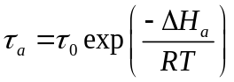 Eqn. 2.5-1
The Frenkel equation relates the oscillatory period of a specific atom or molecule (τ_{o}), ΔH_{a}, and temperature (T) to the length of time spent adsorbed to the surface (τ_{a}), where R is the gas constant. These values are dependent upon the adsorbate and the column material. Deposition in the column is defined as when the length of time in the adsorbed state exceeds that of the experiment. Because of its statistical nature, deposition does not occur in discrete functions for each atom or molecule, where the there is only one specific temperature of adsorption. Deposition appears as a continuous, Gaussian distribution with a distinct average temperature. The deposition temperature is not absolute; it is also function of time and transported species.^{51,52,74,75,96-98} However, in experiments lasting more than thirty minutes, the final deposition temperature varied less than ten percent.^{52,74,96-98} Primary assumptions also affecting the theoretical deposition of molecules are a homogeneous adsorbent, and a non-adsorbable carrier/reactive gases.⁵⁰ This supposes a clean surface for interactions with the desired chemical species only. Diffusion of the adsorbate into and along the adsorbent surface is disregarded and is assumed to be negligible.⁵⁰
The second process in thermochromatography is transportation through the column. This process measures where the atom or molecule is located after a specific period of time. In TGTC and VTC, this is often the location where the atom or molecule deposits within the column. For ITC, it is the length of time that is required for the species to elute through the column. For the TGTC the transport time is modeled as:^{53,99,100}
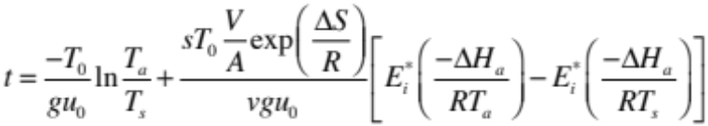 Eqn. 2.5-2
This equation describes the average time required for a specific molecule to adsorb at a specific temperature within the column as a function of standard, starting and adsorption temperatures (T₀, T_{s} and T_{a}, respectively), linear temperature gradient (g), gas velocity (u₀), entropy (ΔS), and enthalpy of adsorption, and column parameters of free surface area (s), free volume (ν), and the ratio of standard molar volume to standard molar surface (V/A). In most solutions to this equation, the standard molar volume is set to one. Here the E_{i}* is the exponential integral function.
In ITC the transport time is often called the retention time because the species are eluted from the column. The relationship between thermodynamic properties and experimental properties can be expressed as:¹⁰⁰
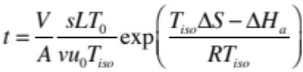 Eqn. 2.5-3
While using many parameters similar to that of Equation (2), the differences are the replacing of T_{a} with the temperature of the column (T_{iso}) and the inclusion of column length (L). This equation does not imply that the molecules do not adsorb to the column surface, this retention time is effectively how long the adsorbate spends in the adsorbed state within the column.
For the case of VTC, the reduced operating pressure restricts collisions to only those between the transported molecules and the column surface ¹⁰¹. Because of this the transportation time is modeled as:¹⁰¹
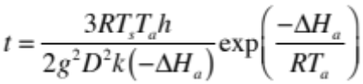 Eqn. 2.5-4
In this case, h is the Planck constant, k is the Boltzmann constant, and D is the diameter of the column. This equation is satisfactory for experimental times and half-lives of much greater than 1 second. If the half-lives are not greater than one second, equation 2.5-5 holds true.¹⁰¹
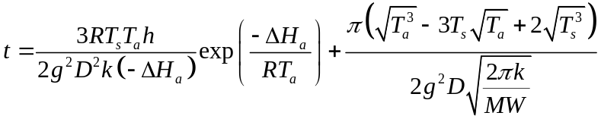 Eqn. 2.5-5
Here, MW is the molecular weight of the transported species.
Using the appropriate equation and the calculated and controlled values used in an experiment, ΔS_{a} and ΔH_{a} can be calculated. However, these calculations assume that ΔS_{a} and ΔH_{a} are independent of temperature.^{50,98,99} Overall, the ΔS_{a} function is limited by the approximation of surface area within the column, while the ΔH_{a} function is limited by the accuracy of the ΔS_{a} function.⁹⁹

Derivation of Linearized Equations for Enthalpy and Entropy Values
Churburkev et al. developed mathematically a linear relationship between ΔS_{a} and ΔH_{a}.⁷⁶ The equilibrium coefficient (k_{a}) is the relationship between the compound of interest adsorbed on the solid and in the gas phase, as shown in equation 2.5-6, below.
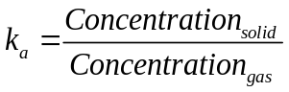 Eqn. 2.5-6
Since the compound will be separated in the gas phase through the use of a carrier gas, equation 2.5-7 applies.
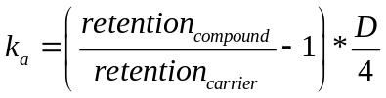 Eqn. 2.5-7
Conversion to equilibrium constant (K_{a}) is performed using the ratio between the molar volume and molar area.
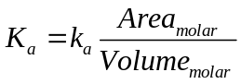 Eqn. 2.5-8
Manipulation of the Gibbs-Helmholtz equation with constant pressure, and substitution into the definition of Gibbs energy yields equation 2.5-9.
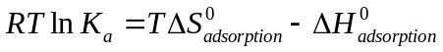 Eqn. 2.5-9
If the molar ratio (A_{m}/V_{m}) is assumed to be 1 cm⁻¹,⁹⁹ then combining equations 2.5-7, -8, and -9, equation 2.5-10 results.
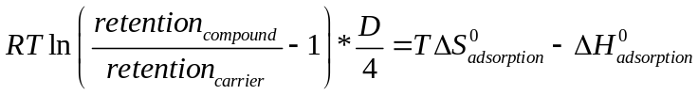 Eqn. 2.5-10
This derivation is founded upon the temperature independence of both ΔS_{a} and ΔH_{a}. Within a narrow temperature region, this is a reasonable assumption, since the material properties of compounds do not drastically vary within the same phase. From a practical standpoint, only two experiments are required to establish both the entropy and enthalpy of a specific compound. A similar methodology was also derived by Rudolph and Bächmann.¹⁰² This derivation however, utilized temperature programming, where the temperature of the column varied as a function of time. This is contrasted to the isothermal derivation delineated above.

Chapter 3: Experimental Methodology

Preparation of β-diketonate Rare Earth Complexes
The three β-diketonate complexes were all synthesized from the two base components, REs and the β-diketonate ligand. The REs were obtained as oxides (Sigma) and dissolved in hot, concentrated hydrochloric acid (HCl, Fisher) until fully dissolved. This aqueous solution was then dried until the subsequent chlorides remained. These synthesized chlorides would serve as the source of REs in the complex synthesis.
Likewise the β-diketonate ligands were all synthesized into a stock format for ease of use. The β-diketonates were prepared by mixing equimolar amounts of the ligand and concentrated ammonium hydroxide (NH₄OH, Fisher) at 0°C using an ice bath to chill both reagents. The reaction was performed in a fume hood to contain the vigorous reaction, which was stirred using a glass stir rod to ensure the complete reaction of the reagents. The resultant compound was placed in a vacuum desiccator (MgSO₄ desiccant) for at least 24 hours to dehydrate the sample to the greatest extent possible.
Sample purification was not performed on any of the final complexes. The synthesis method was designed to provide the desired complex in a high purity, with any byproducts being minor and easily identifiable in the compound analysis. The final application, thermochromatographic separation, would also isolate these byproducts, reducing the need for high purity.

Hfac complexes
Synthesis of the hfac complexes utilized a liquid-liquid extraction. Pre-made ammonium hfac (NH₄[hfac]) ligand was dissolved into 5 mL diethyl ether and aqueous RE chlorides was added in a molar ratio of 4:1. The mixture was then shaken for 30 seconds, and allowed to rest for 5 minutes, repeating a total of 3 times. The organic layer was extracted via transfer pipette to a weigh dish, and placed in a vacuum desiccator to drive off water and evaporate the ether from the sample. A solid residue remained after 24 hours of drying.

Fod complexes
Synthesis of the fod complexes utilized a precipitation reaction. Previously synthesized and dried ammonium fod (NH₄[fod]) was dissolved in 5 mL of diethyl ether. One millimole (mmol) of RE chloride was dissolved into 50 mL of water, and added to the 4 mmol of dissolved NH₄[fod]. The solution was allowed to rest for at least 3 minutes, and the solution was centrifuged and separated using a Büchner flask. The resultant material was dried under vacuum.

Dpm complexes

Characterization of Rare Earth Complexes
The compounds were characterized to have a basis of comparison to previous works involving gas-phase separations as well as have an understanding of the complexes being introduced into the thermochromatographic separations. Like other gas-phase separations, such as gas chromatography, different molecules will separate at different times.

Elemental Analysis
Elemental analysis provided a quantitative analysis for the elements within the β-diketonate complexes. Elemental analysis was performed by Atlantic Microlab in Norcross, GA and focused on the amounts of C, H, N and F. The data from this analysis was also compared with the data obtained from the mass spectrometry analysis for agreement.

Mass Spectrometry Analysis
Two different mass spectrometers were used to record two different mass spectra. A HP 5973 inert Mass Selective Detector (Electron Ionization Mass Spectrometer [EI-MS]) was used to study the composition of the complexes using fragmentation and for simple separations. Thermochromatographic separations and presence of REs in the complexes was determined using a GBC 9000 Optimass inductively coupled plasma time-of-flight mass spectrometer (ICP-TOF-MS). Detection on this instrument focused on the REs as detection and precise quantification of the lighter elements was difficult and unnecessary for this work.

IR Analysis
Infrared spectra were recorded using a Perkin Elmer FT-attenuated total reflectance – infrared spectrometer (FT-ATR-IR) spectrum 100 instrument in the range from 620-4000 cm⁻¹. IR analysis was performed to validate the functional groups on the ligands as well as detect the presence of water within the complex. Literature values were compared and used as reference points for functional groups.

Nuclear Magnetic Resonance
Three NMR analyses (¹H, ¹³C and ¹⁹F) were performed on a Varian NMR system at 500 MHz and were performed in 1,4-dioxane_{d-99%}. NMR analysis was used for confirmation of ligand structure as well as the presence of impurities (NH₄⁺, H₂O, unexpected ligands) due to the synthesis process. Literature data for the functional groups was used as a reference point for data obtained.

Single Crystal X-Ray

Melting Point Analysis
Melting point analysis was performed on a Mettler Toledo MP50 melting point system. Four samples of each compound were measured simultaneously. Melting point analysis served as a quick reference to compound purity and hydration for the various β-diketonate complexes.

Computational Structure

Gas-phase Analysis of Rare Earth Complexes
Gas-phase analysis and separations work was performed on a modified gas chromatography machine with a custom-built sample introduction port, carrier gas heating loop, reactive gas introduction port, and custom-built link to the ICP-TOF-MS discussed earlier.

Equipment setup
The equipment consisted of four primary components, a sample introduction system, an oven chamber, a transfer system, and an ICP-TOF-MS. The sample introduction system was a custom-built apparatus designed to provide a continuous flow of carrier gas (argon) and reactive gas (volatilized hfac, fod, or dpm) with controlled introduction of the RE complex (hfac, fod or dpm). Flow was controlled through the HP 5890 Gas Chromatograph flow control system. After receiving the carrier gas, the flow was throttled to one mL/minute, and run through a capillary column contained in the oven chamber to heat the argon to the oven temperature. Once at temperature the gas then enters the introduction system.
The introduction system was a combination of piping tees, valves and chambers used to control the flow of argon and introduce the reactive gases and samples. A diagram of the system can be seen in Figure XXXXXX. The flow was divided into two streams, one which would be saturated with β-diketonate vapors, and the other which would remain pure argon. The saturated stream would also flow through the sample chamber when

Methodology
The experiment was conducted in the following fashion. The GC oven was set to its designated temperature and its temperature allowed to stabilize while argon was passed through the empty column until the gas and oven temperature stabilized at the desired temperatures. The flow of the reactive gas was started and stabilized prior to the introduction of the sample. The sample was then eluted from the column and into the ICP-TOF-MS where it was recorded. At the conclusion of the test run, the column temperature was raised while reactive and carrier gases flowed through the device until it was clean. The reactive gas was then stopped and the carrier gas flushed out any remaining components while the temperature of the oven was reset. Multiple runs at a given temperature were performed. The data that was gathered was the elution time, measured from the sample introduction time, t₀, to the time it was detected by the MS, t_{e}, measured as a normal distribution.

Calculation Methodology
Calculation of the enthalpy and entropy (ΔH⁰ and ΔS⁰, respectively) of adsorption was laid out by Churburkev et al. as well as Rudolph and Bachmann based on the some of the work and assumptions made by Eichler and Zvara.^{76,99,102} In this work, the two can be linearized given certain known parameters giving equation 3.3-1, where R is the gas constant, and T is the temperature:
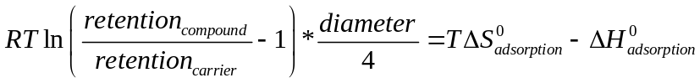 Eqn. 3.3-1
This is however, only appropriate for isothermal columns, like those used in this work. The retention time in the equation above is only for the time spent in the column. To determine this, the time spent in the ICP-TOF-MS must be determined and subtracted from t_{e}. The greatest difference between the carrier gas and the compound itself within the instrument is within the flight path of the atoms after ionization. This time can be calculated and compensated for.

Chapter 4: Experimental Results

Characterization of Rare Earth Complexes

Elemental Analysis

Hfac

Fod

Dpm

Mass Spectrometry
Two separate mass spectrometry analyses were performed. The first was to validate the inclusion of the desired central ion and exclude the presence of other REs. The second analysis served to validate the presence of the desired ligands and observe the way the ligand would fractionation.

Hfac
To verify the complexation of the ligands with the central lanthanide, the ICP-TOF-MS instrument was utilized to analyze the complexes for the presence of rare earth elements and any rare earth impurities. Figure XXXXXXX was the results of the analysis. In each of the samples, the targeted RE was isolated and distinct from the other REs. Peaks beyond isotopic range for each RE were attributed to RE oxides forming as a result of the analysis.

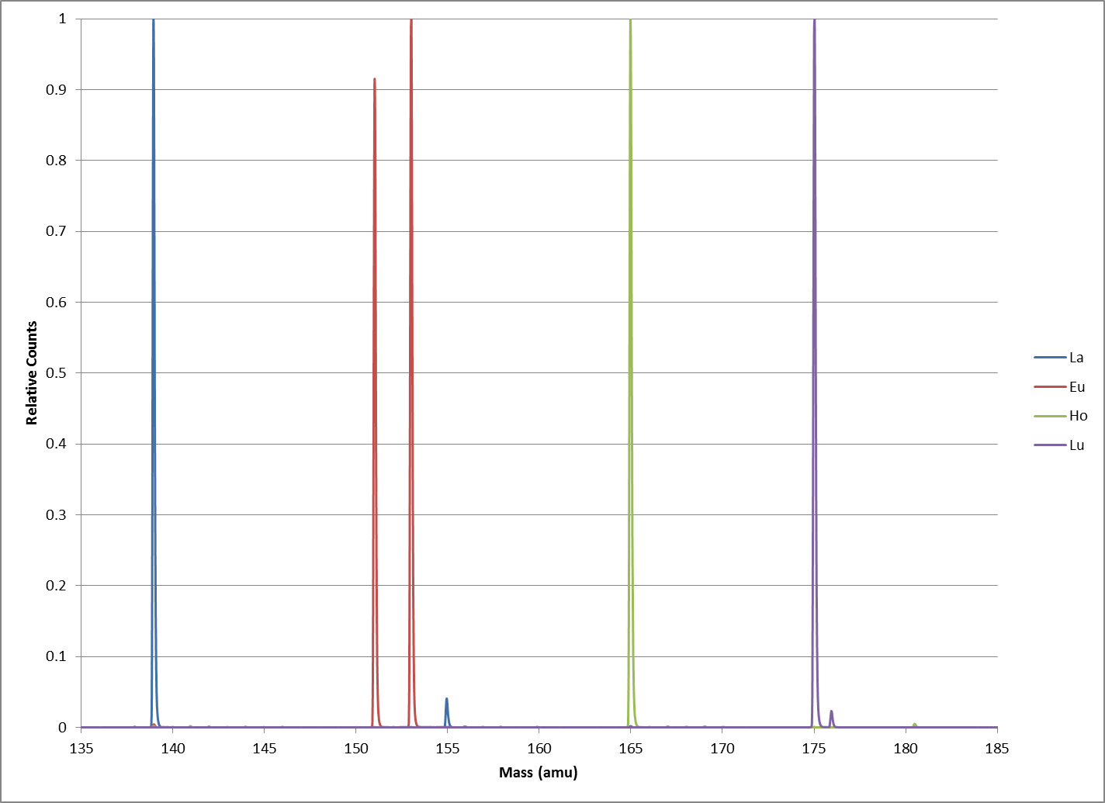
Figure 4.1-1: ICP-TOF-MS data for La, Eu, Ho, and Lu[hfac] complexes.
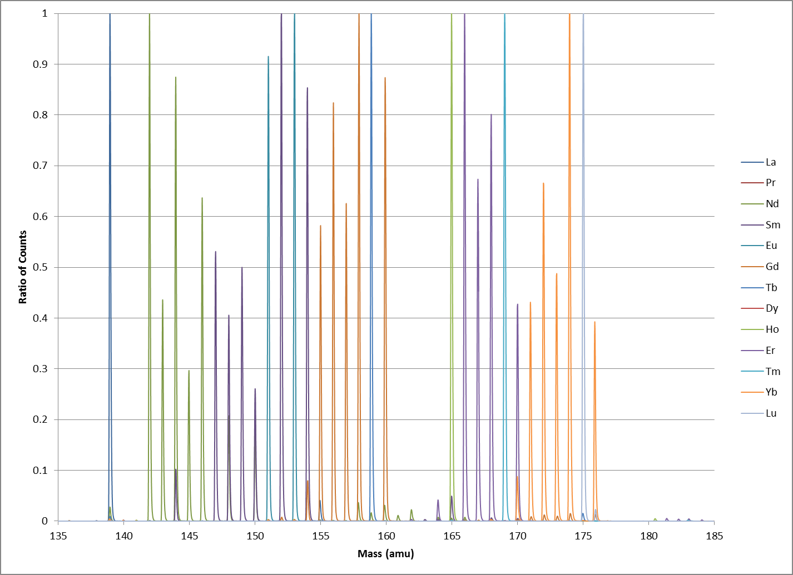
Figure 4.1-1: ICP-TOF-MS data for Pr, Gd, and Er[hfac] complexes.
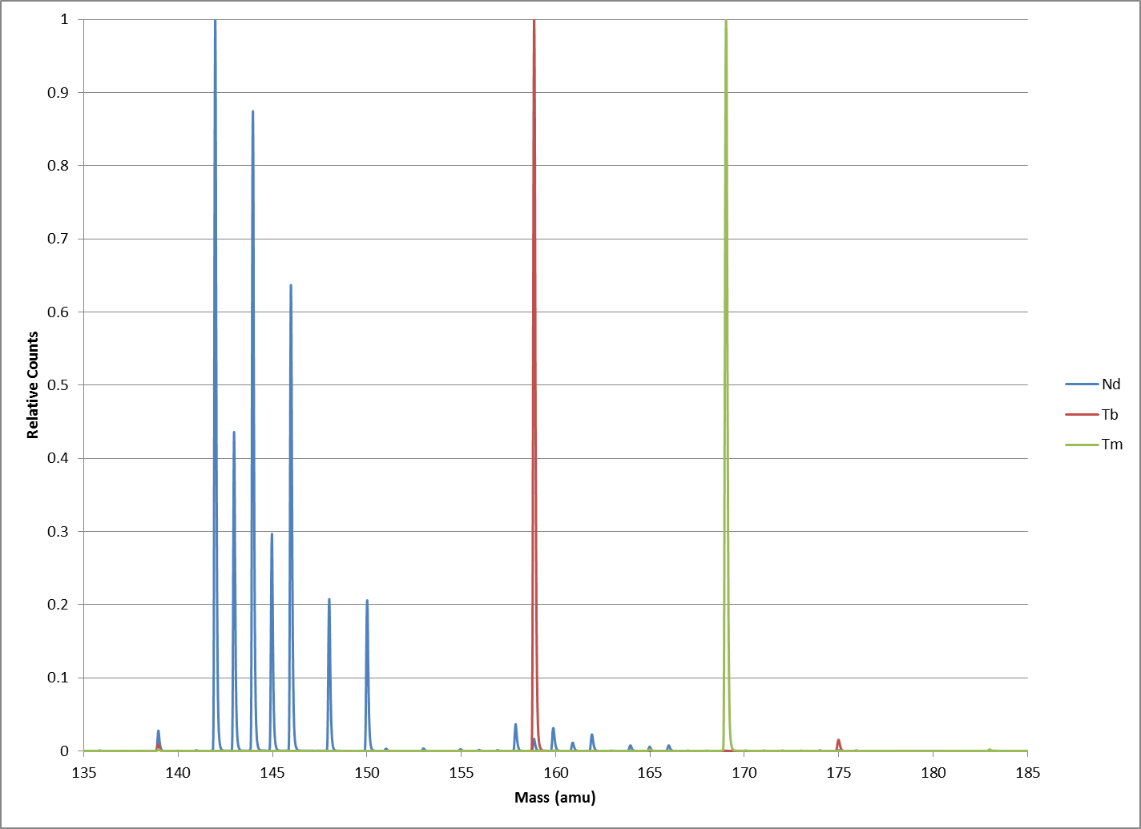
Figure 4.1-1: ICP-TOF-MS data for Nd, Tb, and Tm[hfac] complexes.
Figure 4.1-1: ICP-TOF-MS data for Sm, Dy, and Yb[hfac] complexes.

The EI-MS was employed to evaluate the complex as a whole as well as its fragmentation pattern. A blank H[hfac] sample was analyzed and the mass fragmentation peaks as listed in Table XXXXXXX.
Samples for Gd[hfac] and Lu[hfac] were run through the EI-MS to observe the fractionization of the complexes. Due to limitations of the MS, only masses of less than 800 amu were observable.
Table 4.1-5 EI-MS peaks of H[hfac] and their assignments
Peak mass (amu) | Ion Assignment
69.00 | trifluoromethane
69.03 | 1,3-propadione
78.01 | 2,2-difluoromethyl-acetone
119.05 | 4,4-difluoro-1,3-propanedione
139.05 | 4,4,4-trifluoro-1,3-propanedione
208.05 | H[hfac]

Fod
To verify the complexation of the ligands with the central lanthanide, the ICP-TOF-MS instrument was utilized to analyze the compounds for the presence of REs and any RE impurities. Figure XXXXXXX was the results of the analysis. In each of the samples, the targeted RE was isolated and distinct from the other REs. Peaks beyond isotopic range for each RE were assigned to RE oxides forming as a result of the analysis. Individual analysis of each complex can be found in Appendix XXXXXXX.

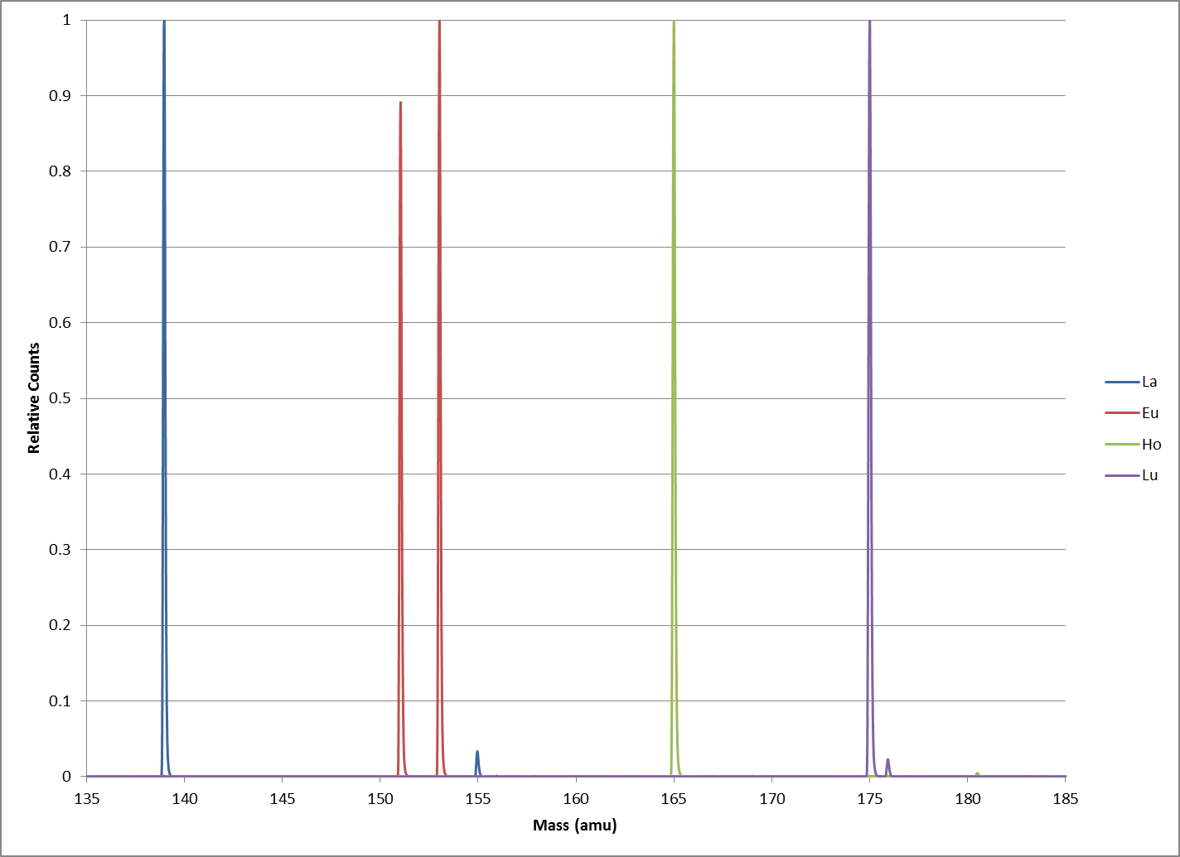
Figure 4.1-2: ICP-TOF-MS data for La, Eu, Ho, and Lu [fod] complexes.
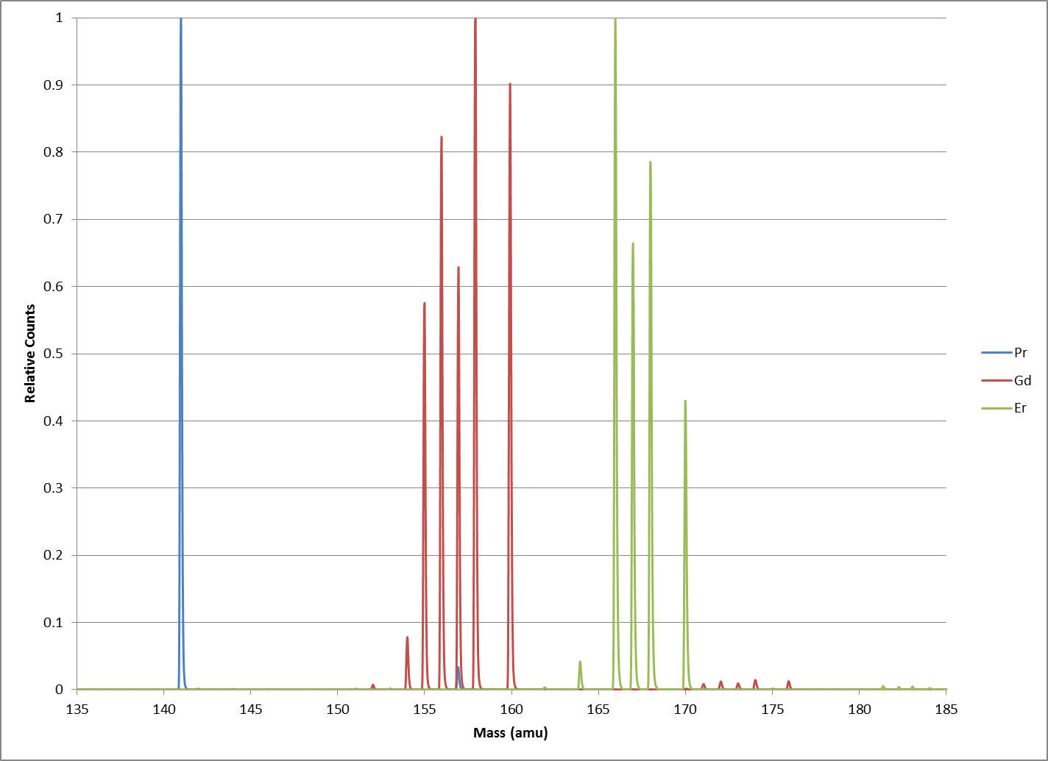
Figure 4.1-2: ICP-TOF-MS data for Pr, Gd, and Er[fod] complexes.
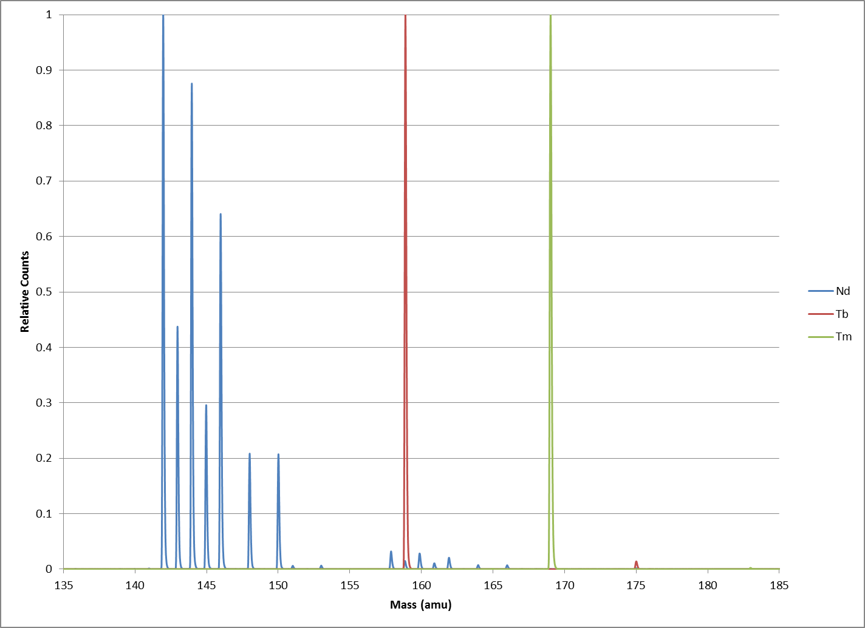
Figure 4.1-2: ICP-TOF-MS data for Nd, Tb, and Tm[fod] complexes.
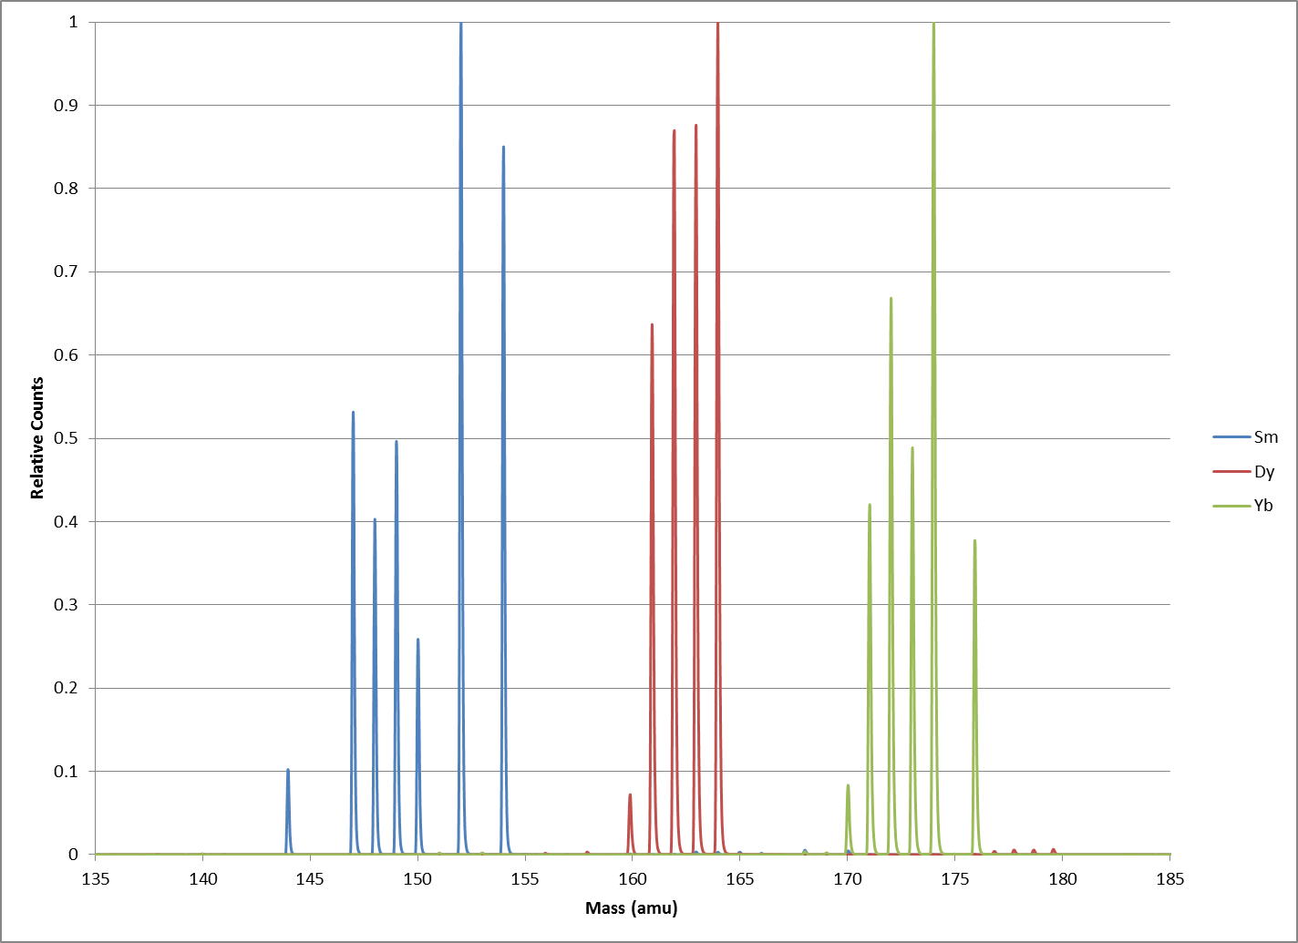
Figure 4.1-2: ICP-TOF-MS data for Sm, Dy, Yb[fod] complexes.

Dpm

IR Analysis

Hfac
The IR peaks for the complexes were in agreement with the data from Richards et al and Condorelli et al, and the functional groups were assigned based on those values. The work by Richards evaluated the trihydrate, while in Condorelli hydrate-free gas phase IR measurements were performed in addition to n-hydrated La[hfac].¹¹ The measurement data obtained contained four key data points signifying a metal coordinated ligand.²⁷
The major peaks from both of these papers were all identified in each of the RE complexes. Similar peaks were found for the NH₄[hfac] as well. Table XXXXXX presents the peak value and its associated functional group for each of the four compounds.
Excellent correlation was found between the wavenumbers of the compounds even from opposite ends of the lanthanide family, agreeing with previous literature.¹¹ The NH₄[hfac] compound was lacking two of the metal-ligand wavenumbers, clearly identified on the other three complexes. The Ga[hfac] was missing one of the three C-F₃ stretching peaks, which was unexpected and the cause remains undetermined, as does the occurrence of the 1656 cm⁻¹ peak for NH₄[hfac].

Table 4.1-3 IR absorbance peaks of synthesized RE[hfac] complexes.
NH₄ | La | Pr | Nd | Sm | Eu | Gd | Tb | Dy | Ho | Er | Tb | Yb | Lu
738 | 737 | 743 | 743 | 744 | 743 | 744 | 738 | 738 | 744 | 745 | 744 | 745 | 738
799 | 806 | 805 | 805 | 805 | 804 | 804 | 821 | 800 | 804 | 803 | 804 | 802 | 821
1113 | 1130 | 1135 | 1135 | 1130 | 1132 | 1136 | 1132 | 1123 | 1132 | 1134 | 1132 | 1120 | 1115
1176 | 1187 | 1179 | 1177 | 1179 | 1147 |  | 1147 | 1177 | 1175 | 1175 | 1177 | 1178 | 1177
1203 | 1203 | 1198 | 1198 | 1194 | 1203 | 1202 | 1202 | 1196 | 1203 | 1201 | 1203 | 1200 | 1204
1271 | 1270 | 1252 | 1253 | 1252 | 1250 | 1253 | 1251 | 1253 | 1251 | 1254 | 1251 | 1254 | 1271
1455 | 1458 | 1462 | 1462 | 1440 | 1501 | 1472 | 1403 | 1459 | 1477 | 1474 | 1473 | 1478 | 1456
 | 1537 | 1538 | 1537 | 1538 | 1536 | 1537 | 1537 | 1535 | 1537 | 1536 | 1537 | 1537 | 1536
 | 1563 | 1562 | 1563 | 1563 | 1564 | 1563 | 1564 | 1564 | 1565 | 1564 | 1564 | 1565 | 1562
1656 | 1645 | 1643 | 1643 | 1644 | 1644 | 1645 | 1645 | 1645 | 1647 | 1646 | 1649 | 1647 | 1652
3260 | 3332 | 3218 | 3215 | 3184 | 3148 | 3040 | 3148 | 3211 | 3238 | 3219 | 3149 | 3149 | 3253

Fod

Table 4.1-4 IR absorbance peaks of synthesized RE[fod] complexes.
NH₄ | La | Pr | Nd | Sm | Eu | Gd | Tb | Dy | Ho | Er | Tb | Yb |  | Lu
 | 687 | 695 | 695 | 695 | 696 | 696 | 696 | 696 | 688 | 689 | 689 | 689 |  | 689
 | 741 | 740 | 734 | 735 | 735 | 735 | 735 | 739 | 743 | 740 | 740 | 740 |  | 740
 | 754 | 755 | 756 | 756 | 756 | 756 | 756 | 755 | 755 | 755 | 755 | 755 |  | 755
 | 797 | 797 | 796 | 796 | 796 | 796 | 796 | 795 | 793 | 794 | 793 | 793 |  | 793
 | 833 | 833 | 833 | 833 | 833 | 833 | 833 | 833 | 833 | 833 | 833 | 833 |  | 833
 | 909 | 909 | 913 | 910 | 913 | 913 | 912 | 911 | 911 | 911 | 911 | 912 |  | 911
 | 938 | 939 | 938 | 936 | 939 | 938 | 939 | 939 | 938 | 939 | 939 | 939 |  | 939
 | 963 | 964 | 963 | 964 | 964 | 964 | 965 | 965 | 965 | 966 | 965 | 965 |  | 965
 | 1020 | 1018 | 1016 | 1017 | 1016 | 1015 | 1017 | 1018 | 1020 | 1021 | 1025 | 1025 |  | 1025
 | 1070 | 1069 | 1068 | 1069 | 1070 | 1070 | 1070 | 1071 | 1071 | 1072 | 1072 | 1072 |  | 1072
 |  |  |  |  |  |  |  |  |  | 1104 | 1103 | 1103 |  | 1103
 | 1117 | 1117 | 1115 | 1117 | 1116 | 1116 | 1116 | 1116 | 1115 | 1116 | 1115 | 1115 |  | 1115
 | 1150 | 1148 | 1144 | 1146 | 1145 | 1145 | 1146 | 1147 | 1151 | 1153 | 1152 | 1152 |  | 1152
 |  |  | 1159 | 1160 | 1160 | 1160
 | 1178 | 1179 | 1178 | 1179 | 1176 | 1178 | 1179 | 1180 | 1182 | 1183 | 1183 | 1183 | 1183
 |  |  | 1202 | 1203 | 1203 | 1203 | 1204 | 1206
 | 1220 | 1221 | 1222 | 1220 | 1223 | 1222 | 1222 | 1222 | 1222 | 1222 | 1222 | 1223 | 1223
 |  |  | 1261 |  | 1262 | 1263 | 1263
 | 1276 | 1280 | 1280 | 1281 | 1281 | 1281 | 1281 | 1281 | 1281 | 1281 | 1281 | 1281 | 1281
 | 1344 | 1345 | 1350 | 1347 | 1350 | 1350 | 1348 | 1346 | 1345 | 1345 | 1345 | 1345 | 1345
 | 1368 | 1367 | 1366 | 1367 | 1365 | 1366 | 1366 | 1366 | 1366 | 1367 | 1367 | 1367 | 1367
 | 1396 | 1395 | 1395 | 1395 | 1395 | 1395 | 1395 | 1395 | 1395 | 1395 | 1395 | 1395 | 1395
 |  |  |  |  |  |  |  |  | 1439 | 1438 | 1437 | 1437 | 1437
 | 1458 | 1459 | 1469 | 1470 | 1471 | 1471 | 1471 | 1471 | 1461 | 1461 | 1461 | 1465 | 1467
 | 1509 | 1509 | 1511 | 1511 | 1513 | 1515 | 1513 | 1511 | 1511 | 1511 | 1510 | 1511 | 1511
 |  |  |  |  |  |  |  |  |  | 1538 | 1538 | 1538 | 1538
 | 1594 | 1593 | 1593 | 1593 | 1593 | 1593 | 1592 | 1590 | 1588 | 1587 | 1585 | 1585 | 1585
 | 1624 | 1623 | 1624 | 1625 | 1626 | 1627 | 1625 | 1624 | 1621 | 1621 | 1620 | 1621 | 1622
 | 2974 | 2972 | 2971 | 2971 | 2971 | 2971 | 2971 | 2971 | 2972 | 2973 | 2973 | 2973 | 2973

Dpm

Nuclear Magnetic Resonance

Proton NMR
A sample of H[hfac] was first analyzed to obtain a baseline measurement of the ligand prior to any reactions with NH₄ or LnCl₃. Peaks for the proton were centered at 3.57 ppm (solvent) and 6.43 ppm which corresponds to the hydrogens on the β-carbon. A peak at -76.1 ppm for the fluorine spectrum was assigned to the trifluoromethyl groups. The proton peaks are given in Table 4, the ¹³C NMR results are given in Table XXXXXXX, and the ¹⁹F NMR results are given in Table XXXXXXX.
Proton peaks for NH₄[hfac] were found at 2.51 ppm (), 3.54 ppm (solvent), 5.7 ppm (β-carbon protons), and 7.31 ppm (residual ammonium). Fluorine peaks for NH₄[hfac] were -76.2 ppm (residual H[hfac]) and -77.4 ppm (de-shielded trifluoromethyl groups).
Following the reaction with LaCl₃, the proton peaks were at 2.24 ppm (water), 2.8 ppm (water), 3.54 ppm, (solvent) and 6.60 ppm (β-carbon protons). The β-carbon protons are similar to the peaks found by Richardson and Sievers.¹² The fluorine spectrum had peaks at -88.0 ppm (bound ligand), -77.3 ppm (unbound H[hfac]), and -87.2 ppm (unassigned).

Hfac
Proton NMR was performed on H[hfac] to obtain a baseline measurement of the ligand prior to any reactions with NH₄ or LnCl₃. The solvent used was 1,4-dioxane_{D-99%} and was assigned an integration value of one as a reference point. In addition to the RE[hfac] complexes, NH₄[hfac] was also analyzed to identify the ammonium peak.

Peaks for the complexes can be found in Table XXXXXXX.

Table 4.1-6 ¹H NMR shift for RE[hfac].
Compound | Solvent | δ | Integration | Assignment
1,4-dioxane | 1,4-dioxane_{D-99%} | 3.57 | 1* | - CH₂
H[hfac] | 1,4-dioxane_{D-99%} | 3.54 |  | Solvent
 |  | 6.43 | 2.18 | -CH₂
 |  | 12.28 | 1.98 | - impurity?
NH₄[hfac] | 1,4-dioxane_{D-99%} | 2.51 | N/A | H₂O impurity**
 |  | 5.70 | 1.00 | -CH
 |  | 7.31 | 2.77 | - NH₃ at β-carbon position
La | 1,4-dioxane_{D-99%} | 2.46 | 3.5 | - H₂O impurity
 |  | 6.60 | 1 | - CH
Gd | 1,4-dioxane_{D-99%} | None | 0
Lu | 1,4-dioxane_{D-99%} | None | 0
*The value has been assigned to the integer 1; all other integration assignments are relative to this.
** Impurity in the solution.

Fod

Dpm

Carbon NMR

Hfac

Table 4.1-7 ¹³C NMR shift for RE[hfac].
Compound | Solvent | δ | Assignment
Solvent | 1,4-dioxane_{D-99%} | 66.8 (p)* | -CH₂
H[hfac] | 1,4-dioxane_{D-99%} | 93.45 (t) | -CH₂
 |  | 116.45 (q) | -CF₃
 |  | 173.50 (q) | -C=O
NH₄[hfac] | 1,4-dioxane_{D-99%} | 93.48 (s) | -CH₂
 |  | 116.10 (q) | -CF₃
 |  | 173.50 (s) | -C=O
La | 1,4-dioxane_{D-99%} | None
Gd | 1,4-dioxane_{D-99%} | None
Lu | 1,4-dioxane_{D-99%} | None
*refers to the number of peaks. p = pentet, t = triplet, q = quartet, s = singlet.

Fod

Dpm

Fluorine NMR

Hfac

Table 4.1-8 ¹⁹F NMR shift for RE[hfac].
Compound | Solvent | δ | Assignment
H[hfac] | 1,4-dioxane_{D-99%} | -77.76 | -CF₃
NH₄ | 1,4-dioxane_{D-99%} | -77.40 | -CF₃
La | 1,4-dioxane_{D-99%} | -87.8 | -CF₃
 |  | -87.2 | ?
Gd | Solid State | -78.3
Lu | 1,4-dioxane_{D-99%} | -77.43

Fod

Single Crystal X-Ray

Hfac

Fod

Dpm

Melting Point
The melting point of the compounds provided a quick method of confirming compound synthesis. Four samples were measured per batch with the melting point being determined by percent light transmittance. The samples were first heated in a sample over prior to remove any trace contaminates (particularly trace NH₄[hfac], NH₄[fod], and NH₄[dpm]).

Hfac
The hfac complexes show variability between the measured and published values. This can be attributed to the lack of a purification step. The different synthesis method was discounted as the source of variability due to the reduction of water in the synthesis, as opposed to a purely anhydrous synthesis.

Table 4.1-1 Melting points of the synthesized RE[hfac] and literature values.
Lanthanide | Melting Point Range (°C) | Published Melting Point Range (°C)⁶
NH₄ | 80-89
La | 140-148 | 143-146
Pr | 179-184 | 148-151
Nd | 173-180 | 141-142
Sm | 188-196 | 144-145
Eu | 175-186 | 176-177
Gd | 173-184 | 170-173
Tb | 193-204 | 170-172
Dy | 203-212 | 185-188
Ho | 220-223 | 214-215
Er | 221-224 | 194-198
Tm | 202-213 | 194-196
Yb | 214-219 | 177-178
Lu | 217-221 | 222-223

Fod

Table 4.1-2 Melting points of the synthesized RE[fod] and literature values.
Lanthanide | Melting Point Range (°C) | Published Melting Point Range (°C)¹
NH₄
La | 101-109 | 215-230
Pr | 138.8-144.7 | 218-225
Nd |  | 210-215
Sm | 121-124 | 208-218
Eu | 131-141 | 205-212
Gd | 135-142 | 203-213
Tb | 143-148 | 190-196
Dy | 145-148 | 180-188
Ho | 139-143 | 172-178
Er | 126-138 | 158-164
Tm | 144-150 | 140-146
Yb | 139.8-143.7 | 125-132
Lu | 139.7-143.5 | 118-125

Dpm

Computational Structure

Hfac

Fod

Dpm

Gas Phase Analysis of Rare Earth Complexes

Equipment setup

Methodology

Calculation Methodology

Chapter 5: Conclusions and Future Work

What Was Obtained

Conclusions

Table 5.2-1

Figure 5.2-1:

Future Work

List of References
(1) Binnemans, K. In Handbook on the Physics and Chemistry of Rare Earths; K.A. Gschneidner, J. C. B., Pecharsky, V. K., Eds.; Elsevier: 2005; Vol. 35, p 107.
(2) Eisentraut, K. J.; Sievers, R. E. Journal of the American Chemical Society 1965, 87, 5254.
(3) Song, H.; Jiang, Y.; Xia, C.; Meng, G.; Peng, D. Journal of Crystal Growth 2003, 250, 423.
(4) Sicre, J. E.; Dubois, J. T.; Eisentraut, K. J.; Sievers, R. E. Journal of the American Chemical Society 1969, 91, 3476.
(5) Amano, R.; Sato, A.; Suzuki, S. Bulletin of the Chemical Society of Japan 1981, 54, 1368.
(6) Berg, E. W.; Acosta, J. J. C. Analytica Chimica Acta 1968, 40, 101.
(7) Springer, C. S.; Meek, D. W.; Sievers, R. E. Inorganic Chemistry 1967, 6, 1105.
(8) Utsunomiya, K.; Shigematsu, T. Analytica Chimica Acta 1972, 58, 8.
(9) Selbin, J.; Ahmad, N.; Bhacca, N. Inorganic Chemistry 1971, 10, 1383.
(10) Hammond, G. S.; Nonhebel, D. C.; Wu, C.-H. S. Inorganic Chemistry 1963, 2, 73.
(11) Richardson M.F.; Wagner, W. F.; Sands, D. E. Journal of Inorganic & Nuclear Chemistry 1968, 30, 1275.
(12) Richardson, M. F.; Sievers, R. E. Inorganic Chemistry 1971, 10, 498.
(13) Crosby, G. A.; Alire, R. M.; Whan, R. E. J. Chem. Phys. 1961, 34, 743.
(14) Butts, W. C.; Banks, C. V. Analytical Chemistry 1970, 42, 133.
(15) Halverson, F.; Brinen, J. S.; Leto, J. R. The Journal of Chemical Physics 1964, 41, 157.
(16) Halverson, F.; Brinen, J. S.; Leto, J. R. The Journal of Chemical Physics 1964, 40, 2790.
(17) Becht, M.; Gerfin, T.; Dahmen, K. H. Chemistry of Materials 1993, 5, 137.
(18) Belcher, R.; Majer, J.; Perry, R.; Stephen, W. I. Journal of Inorganic & Nuclear Chemistry 1969, 31, 471.
(19) Lim, J. T.; Hong, S. T.; Lee, J. C.; Lee, I. M. Bulletin of the Korean Chemical Society 1996, 17, 1023.
(20) Koehler, J. M.; Bos, W. G. Inorganic and Nuclear Chemistry Letters 1967, 3, 545.
(21) Liss, I. B.; Bos, W. G. Journal of Inorganic & Nuclear Chemistry 1977, 39, 443.
(22) Schwarberg, J. E.; Gere, D. R.; Sievers, R. E.; Eisentraut, K. J. Inorganic Chemistry 1967, 6, 1933.
(23) Przystal, J. K.; Bos, W. G.; Liss, I. B. Journal of Inorganic & Nuclear Chemistry 1971, 33, 679.
(24) Shigematsu, T.; Matsui, M.; Utsunomi.K Bulletin of the Chemical Society of Japan 1969, 42, 1278.
(25) Ahmed, Z.; Iftikhar, K. Inorganica Chimica Acta 2010, 363, 2606.
(26) Amano, R.; Sato, A.; Suzuki, S. Chemistry Letters 1980, 537.
(27) Condorelli, G. G.; Gennaro, S.; Fragalà, I. L. Chemical Vapor Deposition 2001, 7, 151.
(28) Burdett, J. L.; Rogers, M. T. Journal of the American Chemical Society 1964, 86, 2105.
(29) Leskelä, M.; Niinistö, L.; Nykänen, E.; Soininen, P.; Tiitta, M. Thermochimica Acta 1991, 175, 91.
(30) Erasmus, C. S.; Boeyens, J. C. A. Acta Crystallographica Section B 1970, 26, 1843.
(31) Shibata, S.; Iijima, K.; Inuzuka, T. Journal of Molecular Structure 1986, 144, 181.
(32) Shibata, S.; Iijima, K.; Inuzuka, T. Journal of Molecular Structure 1986, 140, 65.
(33) Shibata, S.; Iijima, K.; Inuzuka, T.; Kimura, S.; Sato, T. Journal of Molecular Structure 1986, 144, 351.
(34) Shibata, S.; Iijima, K.; Kimura, S. Journal of Molecular Structure 1985, 131, 113.
(35) De Villiers, J. P. R.; Boeyens, J. C. A. Acta Crystallographica Section B 1971, 27, 2335.
(36) Sievers, R. E.; Ponder, B. W.; Morris, M. L.; Moshier, R. W. Inorganic Chemistry 1963, 2, 693.
(37) Fujinaga, T.; Kuwamoto, T.; Murai, S. Talanta 1971, 18, 429.
(38) Dullmann, C. E.; Bruchle, W.; Dressler, R.; Eberhardt, K.; Eichler, B.; Eichler, R.; Gaggeler, H. W.; Ginter, T. N.; Glaus, F.; Gregorich, K. E.; Hoffman, D. C.; Jager, E.; Jost, D. T.; Kirbach, U. W.; Lee, D. M.; Nitsche, H.; Patin, J. B.; Pershina, V.; Piguet, D.; Qin, Z.; Schadel, M.; Schausten, B.; Schimpf, E.; Schott, H. J.; Soverna, S.; Sudowe, R.; Thorle, P.; Timokhin, S. N.; Trautmann, N.; Turler, A.; Vahle, A.; Wirth, G.; Yakushev, A. B.; Zielinski, P. M. Nature 2002, 418, 859.
(39) Eichler, R.; Bruchle, W.; Buda, R.; Burger, S.; Dressler, R.; Dullmann, C. E.; Dvorak, J.; Eberhardt, K.; Eichler, B.; Folden, C. M., III; Gaggeler, H. W.; Gregorich, K. E.; Haenssler, F.; Hoffman, D. C.; Hummrich, H.; Jager, E.; Kratz, J. V.; Kuczewski, B.; Liebe, D.; Nayak, D.; Nitsche, H.; Piguet, D.; Qin, Z.; Rieth, U.; Schadel, M.; Schausten, B.; Schimpf, E.; Semchenkov, A.; Soverna, S.; Sudowe, R.; Trautmann, N.; Thorle, P.; Turler, A.; Wierczinski, B.; Wiehl, N.; Wilk, P. A.; Wirth, G.; Yakushev, A. B.; von Zweidorf, A. Radiochimica Acta 2006, 94, 181.
(40) Eichler, R.; Soverna, S.; U, P. U. B. G. T. M. F. Physics of Atomic Nuclei 2003, 66, 1146.
(41) Yakushev, A. B.; Buklanov, G. V.; Chelnokov, M. L.; Chepigin, V. I.; Dmitriev, S. N.; Gorshkov, V. A.; Hubener, S.; Lebedev, V. Y.; Malyshev, O. N.; Oganessian, Y. T.; Popeko, A. G.; Sokol, E. A.; Timokhin, S. N.; Turler, A.; Vasko, V. M.; Yeremin, A. V.; Zvara, I. Radiochimica Acta 2001, 89, 743.
(42) Eichler, R.; Bruchle, W.; Dressler, R.; Dullmann, C. E.; Eichler, B.; Gaggeler, H. W.; Gregorich, K. E.; Hoffman, D. C.; Hubener, S.; Jost, D. T.; Kirbach, U. W.; Laue, C. A.; Lavanchy, V. M.; Nitsche, H.; Patin, J. B.; Piguet, D.; Schadel, M.; Shaughnessy, D. A.; Strellis, D. A.; Taut, S.; Tobler, L.; Tsyganov, Y. S.; Turler, A.; Vahle, A.; Wilk, P. A.; Yakushev, A. B. Nature 2000, 407, 63.
(43) Eichler, R.; Aksenov, N. V.; Belozerov, A. V.; Bozhikov, G. A.; Chepigin, V. I.; Dressler, R.; Dmitriev, S. N.; Gaggeler, H. W.; Gorshkov, V. A.; Haenssler, F.; Itkis, M. G.; Lebedev, V. Y.; Laube, A.; Malyshev, O. N.; Oganessian, Y. T.; Petruschkin, O. V.; Piguet, D.; Rasmussen, P.; Shishkin, S. V.; Shutov, A. V.; Svirikhin, A. I.; Tereshatov, E. E.; Vostokin, G. K.; Wegrzecki, M.; Yeremin, A. V. Nuclear Physics A 2007, 787, 373C.
(44) Soverna, S.; Dressler, R.; Duellmann, C. E.; Eichler, B.; Eichler, R.; Gaeggeler, H. W.; Haenssler, F.; Niklaus, J. P.; Piguet, D.; Qin, Z.; Tuerler, A.; Yakushev, A. B. Radiochim. Acta 2005, 93, 1.
(45) Eichler, R.; Eichler, B.; Gaggeler, H. W.; Jost, D. T.; Dressler, R.; Turler, A. Radiochimica Acta 1999, 87, 151.
(46) Eichler, R.; Eichler, B.; Gaggeler, H. W.; Jost, D. T.; Piguet, D.; Turler, A. Radiochimica Acta 2000, 88, 87.
(47) Chuburkov, Y. T.; Tsalertka, R.; Shalaevskii, M. R.; Zvara, I. Soviet Radiochemistry 1967, 9, 599.
(48) Türler, A.; Gäggeler, H.; Gregorich, K.; Barth, H.; Brüchle, W.; Czerwinski, K.; Gober, M.; Hannink, N.; Henderson, R.; Hoffman, D.; Jost, D.; Kacher, C.; Kadkhodayan, B.; Kovacs, J.; Kratz, J.; Kreek, S.; Lee, D.; Leyba, J.; Nurmia, M.; Schädel, M.; Scherer, U.; Schimpf; Vermeulen, D.; Weber, A.; Zimmermann, H.; Zvara, I. Journal of Radioanalytical and Nuclear Chemistry 1992, 160, 327.
(49) Eichler, R.; Schaedel, M. Journal of Physical Chemistry B 2002, 106, 5413.
(50) Novgorodov, A. F.; Rosch, F.; Korolev, N. A. In Instrumentation, Separation Techniques, Environmental Issues; Vertes, A., Nagy, S., Klencsar, Z., Eds.; Kluwer Academic Publishers: 2003; Vol. 5.
(51) Domanov, V. P.; Eichler, B.; Zvara, I. Soviet Radiochemistry 1984, 26, 63.
(52) Steffen, A.; Bachmann, K. Talanta 1978, 25, 677.
(53) Domanov, V. P.; Zvara, I. Soviet Radiochemistry 1984, 26, 731.
(54) Eichler, B.; Zude, F.; Fan, W.; Trautmann, N.; Herrmann, G. Radiochimica Acta 1992, 56, 133.
(55) Eichler, B.; Zude, F.; Fan, W.; Trautmann, N.; Herrmann, G. Radiochimica Acta 1993, 61, 81.
(56) Bayar, B.; Novgorodov, A. F.; Vocilka, I.; Zaitseva, N. G. Radiochemical and Radioanalytical Letters 1975, 22, 53.
(57) Domanov, V. P.; Zin, K. U. Soviet Radiochemistry 1989, 31, 160.
(58) Helas, G.; Hoffmann, P.; Bachmann, K. Radiochemical and Radioanalytical Letters 1977, 30, 371.
(59) Hickmann, U.; Greulich, N.; Trautmann, N.; Herrmann, G. Radiochimica Acta 1993, 60, 127.
(60) Steffen, A.; Bachmann, K. Talanta 1978, 25, 551.
(61) Bayar, B.; Novgorodov, A. F.; Vockilka, I.; Zaitseva, N. G.; Radiochemical and Radioanalytical Letters 1978, 35, 109.
(62) Hubener, S.; Taut, S.; Vahle, A.; Bernhard, G.; Fanghaenel, T. Radiochimica Acta 2008, 96, 781.
(63) Fargeas, M.; Legoux, Y.; Merini, J. Journal of Fluorine Chemistry 1987, 35, 127.
(64) Blessing, G.; Lavi, N.; Hashimoto, K.; Qaim, S. M. Radiochimica Acta 1994, 65, 93.
(65) Blessing, G.; Lavi, N.; Qaim, S. M. Applied Radiation and Isotopes 1992, 43, 455.
(66) Denzler, F. O.; Rosch, F.; Qaim, S. M. Radiochimica Acta 1995, 68, 13.
(67) Beyer, G.-J.; Pimentel-Gonzales, G. Radiochimica Acta 2000, 88, 175.
(68) Fassbender, M.; Novgorodov, A. F.; Rosch, F.; Qaim, S. M. Radiochimica Acta 1994, 65, 215.
(69) Novgorodov, A. F.; Beyer, G. J.; Selinzki, A.; Kolachkovski, A.; Rosch, F.; Schomacker, K. Applied Radiation and Isotopes 1986, 37, 445.
(70) Novgorodov, A. F.; Bruchertseifer, F.; Brockmann, J.; Lebedev, N. A.; Rosch, F. Radiochimica Acta 2000, 88.
(71) Rosch, F.; Novgorodov, A. F.; Qaim, S. M. Radiochimica Acta 1994, 64, 113.
(72) Rosch, F.; Qaim, S. M.; Novgorodov, A. F.; Tsai, Y. M. Applied Radiation and Isotopes 1997, 48, 19.
(73) Beyer, G. J.; Novgorodov, A. F.; Khalkin, V. A. Soviet Radiochemistry 1978, 20, 507.
(74) Dienstbach, F.; Bachmann, K. Radiochimica Acta 1983, 34, 215.
(75) Hickmann, U.; Greulich, N.; Trautmann, N.; Gäggeler, H.; Gäggeler-Koch, H.; Eichler, B.; Herrmann, G. Nuclear Instruments and Methods 1980, 174, 507.
(76) Chuburkov, Y. T.; Seb, N. H.; Alpert, L. K.; Zvara, I. Radiochemistry 1995, 37, 488.
(77) Davidov, A. V.; Travnikov, S. S.; Myasedov, B. F. Journal of Radioanalytical Chemistry 1973, 14, 285.
(78) Eichler, B.; J. Adams; R. Eichler; Gaggler, H. W.; Peterson, J. Radiochimica Acta 2002, 90, 895.
(79) Hubener, S. Radiochemical and Radioanalytical Letters 1980, 44, 79.
(80) Hubener, S.; Zvara, I. Radiochimica Acta 1982, 31, 89.
(81) Mozzhukhin, A. V. Soviet Radiochemistry 1981, 23, 630.
(82) Travnikov, S. S.; Fedoseev, E. V.; Davydov, A. V.; Myasoedov, B. F. Journal of Radioanalytical and Nuclear Chemistry 1985, 93, 227.
(83) Tsalas, S.; Bächmann, K. Analytica Chimica Acta 1978, 98, 17.
(84) Aizenberg, M. I.; Fedoseev, E. V.; Travnikov, S. S.; Davydov, A. V.; Myasoedov, B. F. Soviet Radiochemistry 1987, 29, 682.
(85) Fedoseev, E. V.; Aizenberg, M. I.; Davydov, A. V.; Myasoedov, B. F. Journal of Radioanalytical and Nuclear Chemistry-Letters 1989, 136, 395.
(86) Fedoseev, E. V.; Aizenberg, M. I.; Timokhin, S. N.; Travnikov, S. S.; Zvara, I.; Davydov, A. V.; Myasoedov, B. F. Journal of Radioanalytical and Nuclear Chemistry-Letters 1987, 119, 347.
(87) Fedoseev, E. V.; Travnikov, S. S.; Korovaikov, P. A.; Davydov, A. V.; Myasoedov, B. F. Radiochemistry 1993, 35, 540.
(88) Nguyen, C. K.; Novgorodov, A. V.; Kaskevich, M.; Kolachkovski, A.; Khalkin, V. A. Soviet Radiochemistry 1984, 26, 56.
(89) Grapengiesser, B.; Rudstam, G. Radiochimica Acta 1973, 20, 85.
(90) Abdulvakhobov, A.; Sattarov, G.; Kist, A. A. Soviet Radiochemistry 1986, 28, 192.
(91) Bachmann, K.; Matschoss, V.; Rudolph, J.; Steffen, A.; Tsalas, S. Nuclear Instruments & Methods 1976, 139, 343.
(92) Zvarova, T. S.; Zvara, I. Journal of Chromatography A 1970, 49, 290.
(93) Rudstam, G.; Grapengiesser, B. Radiochimica Acta 1973, 20, 97.
(94) Zvarova, T. S.; Zvara, I. Journal of Chromatography A 1969, 44, 604.
(95) Travnikov, S. S.; Fedoseev, E. V.; Davydov, A. V.; Myasoedov, B. F. Journal of Radioanalytical and Nuclear Chemistry 1985, 93, 217.
(96) Vahle, A.; Hubener, S.; Dressler, R.; Eichler, B.; Turler, A. Radiochimica Acta 1997, 78, 53.
(97) Vahle, A.; Hubener, S.; Eichler, B. Radiochimica Acta 1995, 69.
(98) Yakushev, A.; Eichler, B.; Turler, A.; Gaggeler, H. W.; Peterson, J. Radiochimica Acta 2003, 91, 123.
(99) Eichler, B.; Zvara, I. Radiochimica Acta 1982, 30, 233.
(100) Eichler, B.; Eichler, R. In The Chemistry of Superheavy Elements; Schadel, M., Ed.; Kluwer Academic Publishers: Darmsadt, Germany, 2003, p 205.
(101) Gaggeler, H.; Eichler, B.; Greulich, N.; Herrmann, G.; Trautmann, N. Radiochimica Acta 1986, 40, 137.
(102) Rudolph, J.; Bachmann, K. Journal of Chromatography A 1979, 178, 459.

Appendices

Appendix 1 ICP-TOF-MS Spectral Output for RE[hfac] complexes
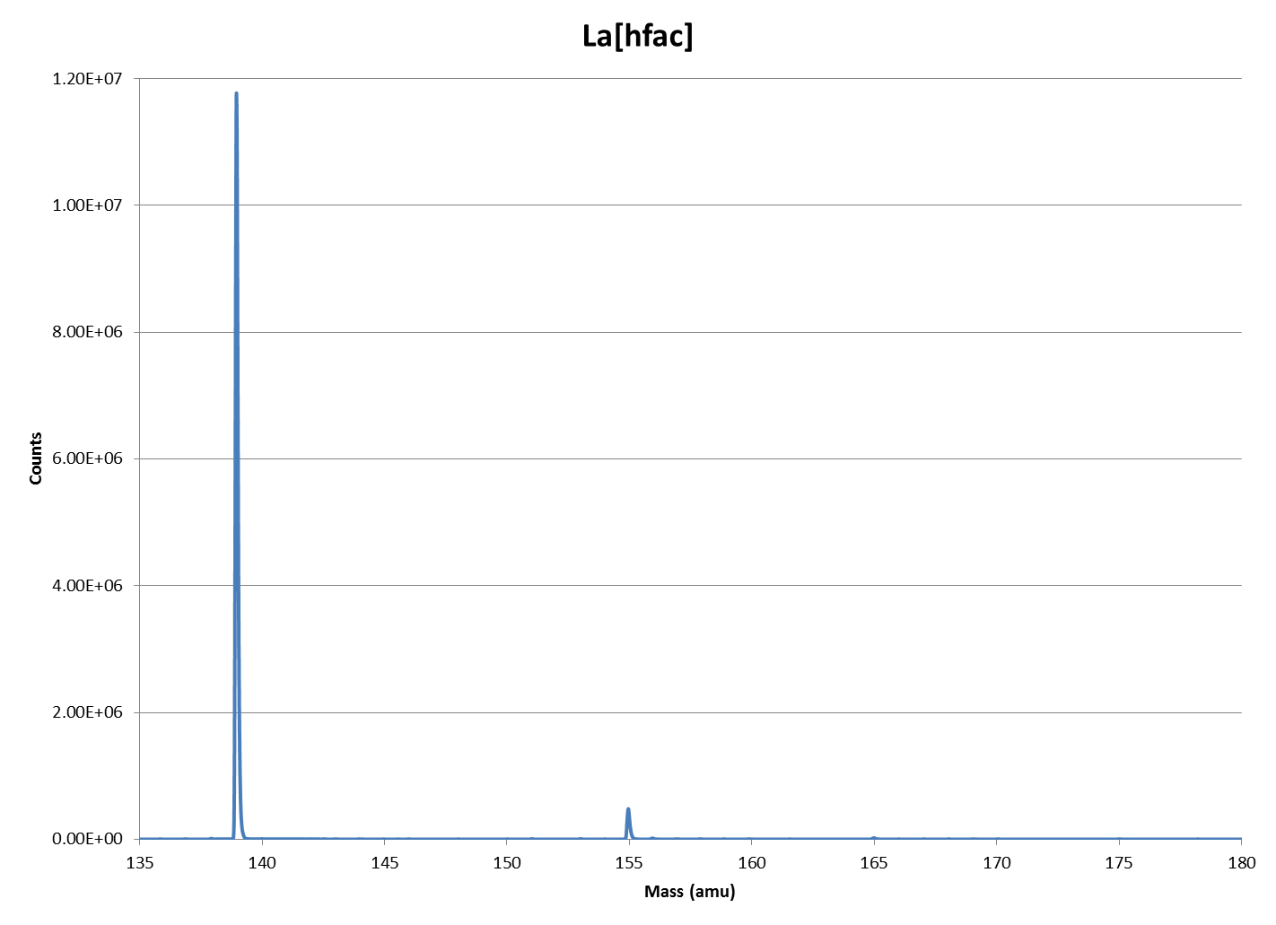
Figure A1-1: ICP-TOF-MS spectra of La[hfac] in mass range of lanthanides.
Figure A1-2: ICP-TOF-MS spectra of Pr[hfac] in mass range of lanthanides.
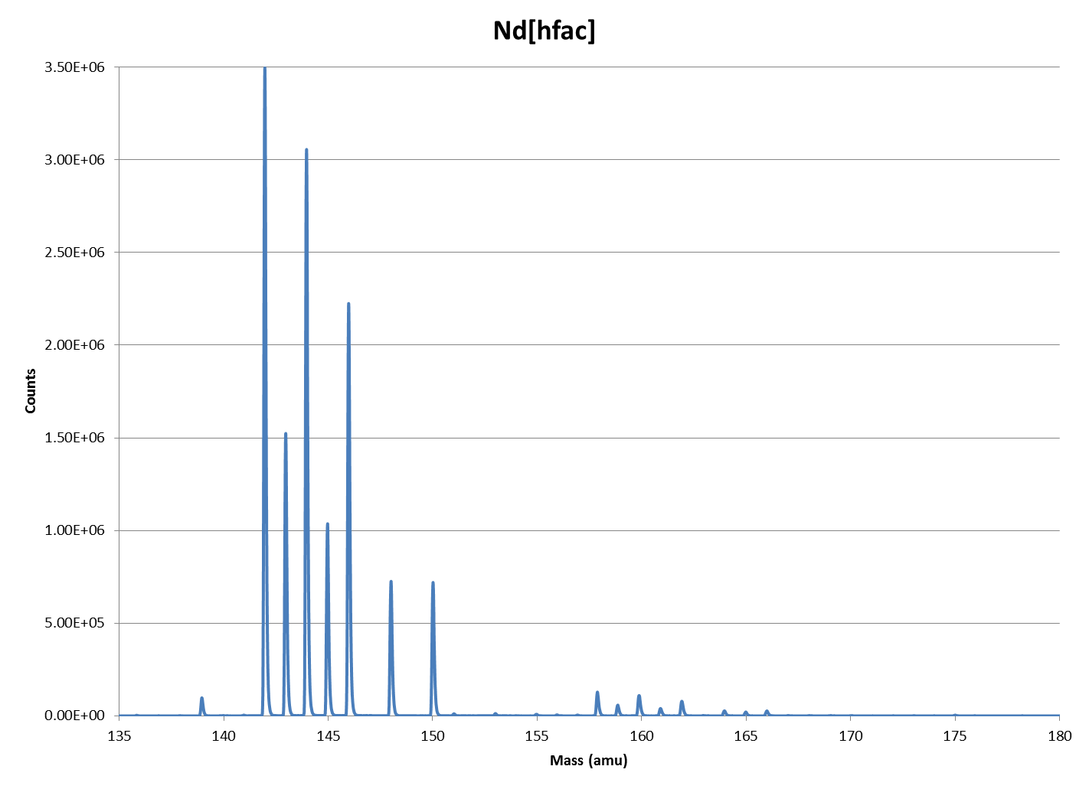
Figure A1-3: ICP-TOF-MS spectra of Nd[hfac] in mass range of lanthanides.
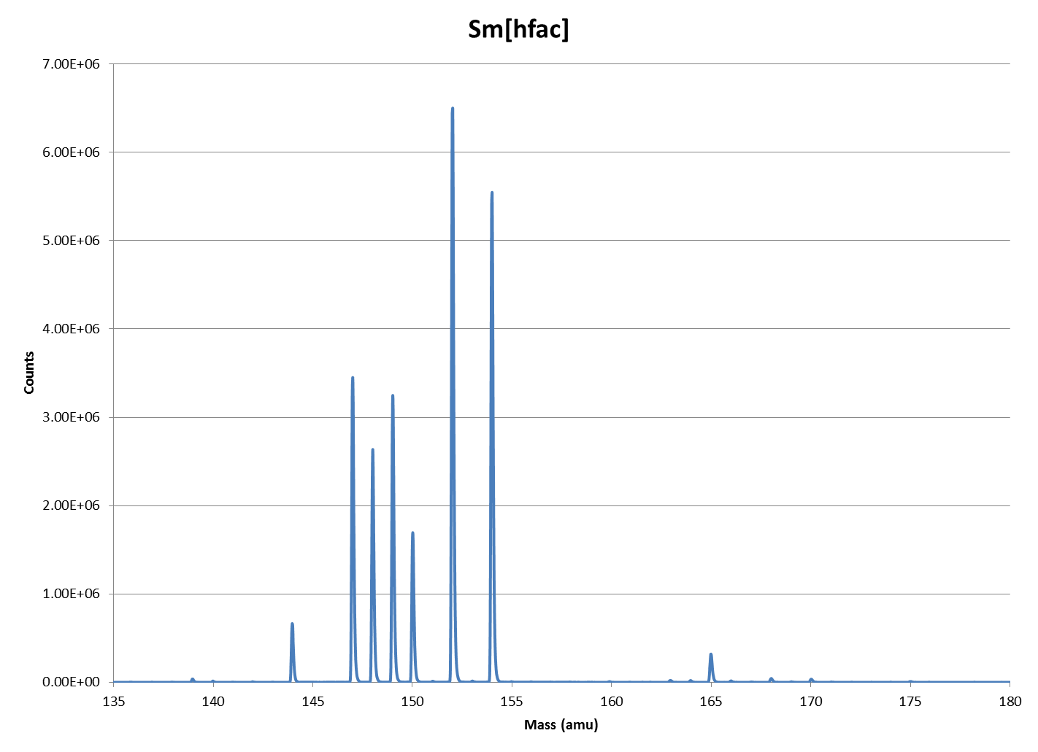
Figure A1-4: ICP-TOF-MS spectra of Sm[hfac] in mass range of lanthanides.
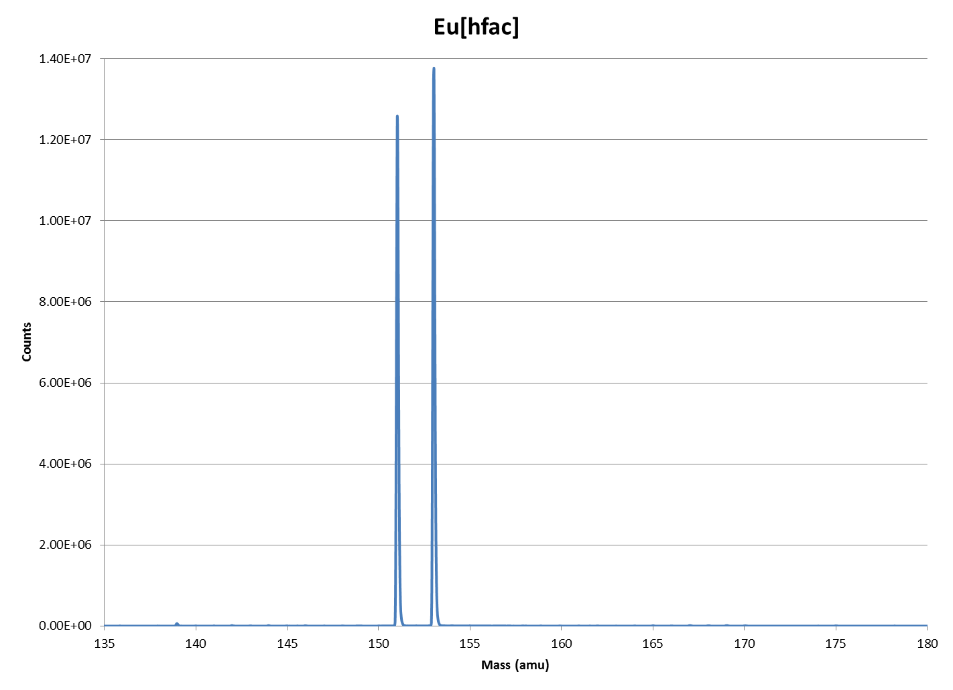
Figure A1-5: ICP-TOF-MS spectra of Eu[hfac] in mass range of lanthanides.
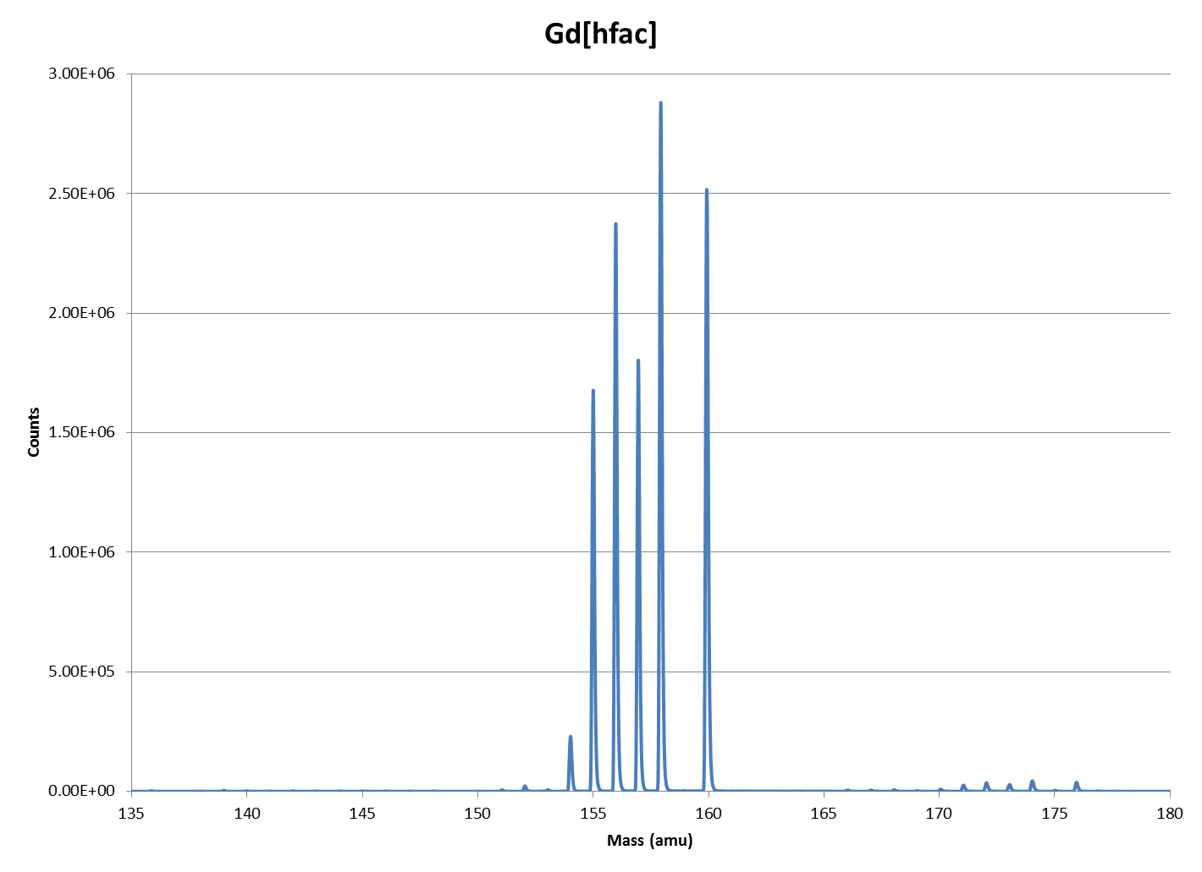
Figure A1-6: ICP-TOF-MS spectra of Gd[hfac] in mass range of lanthanides.
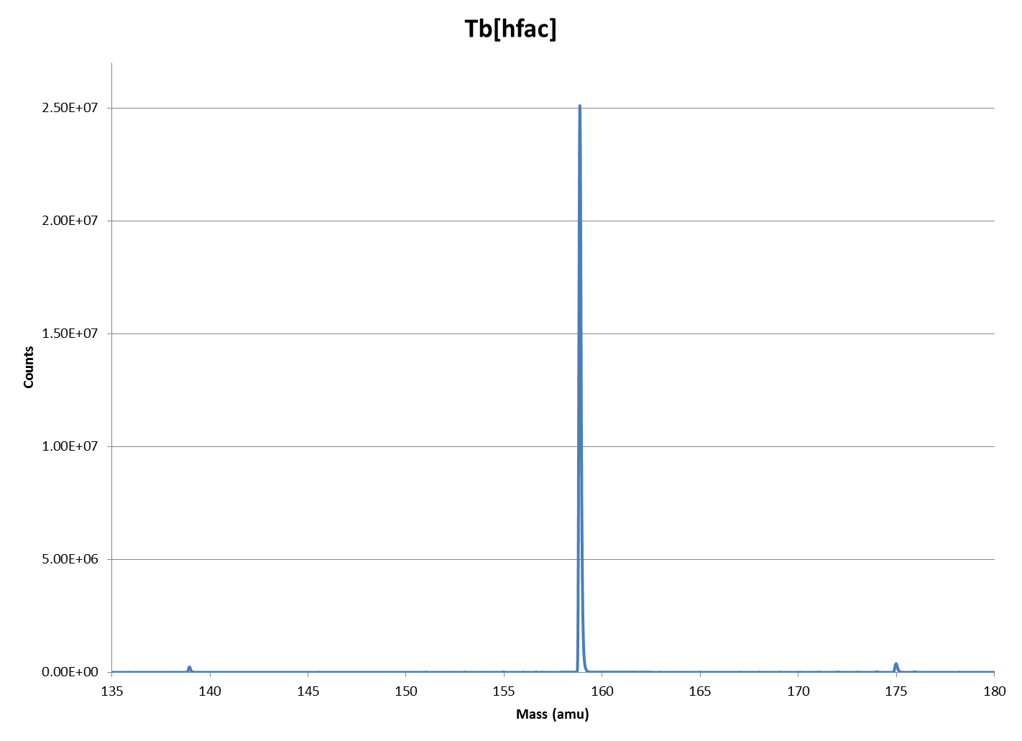
Figure A1-7: ICP-TOF-MS spectra of Tb[hfac] in mass range of lanthanides.
Figure A1-8: ICP-TOF-MS spectra of Dy[hfac] in mass range of lanthanides.
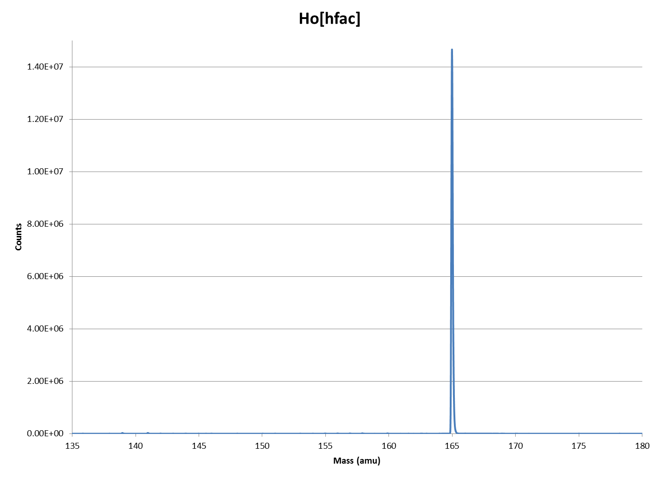
Figure A1-9: ICP-TOF-MS spectra of Ho[hfac] in mass range of lanthanides.
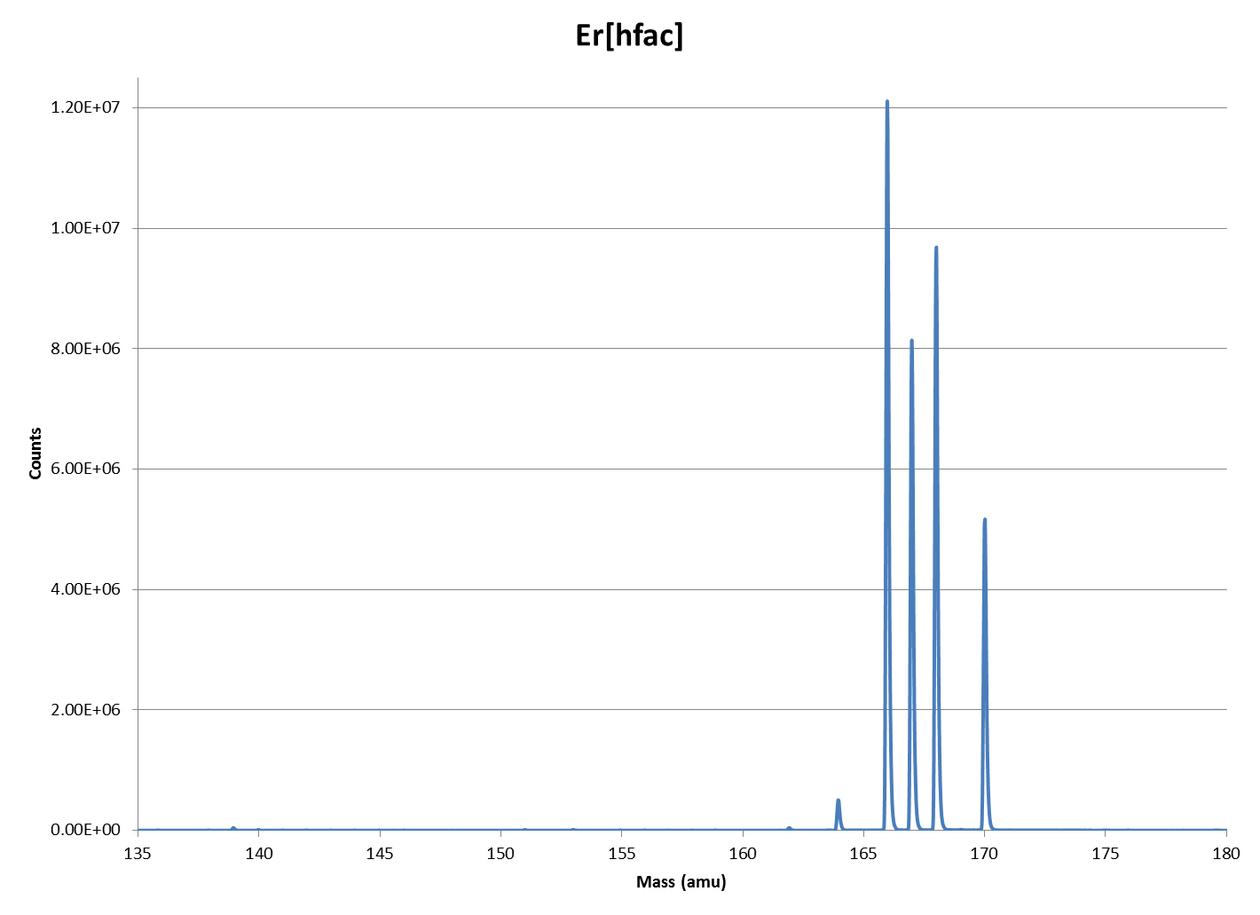
Figure A1-10: ICP-TOF-MS spectra of Er[hfac] in mass range of lanthanides.
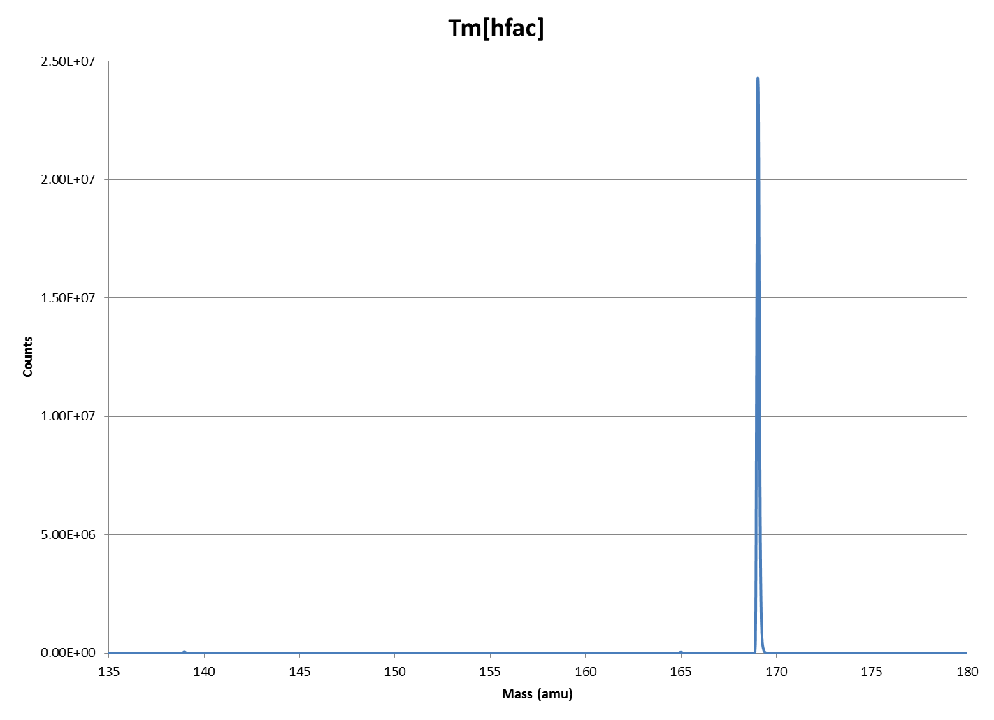
Figure A1-11: ICP-TOF-MS spectra of Tm[hfac] in mass range of lanthanides.
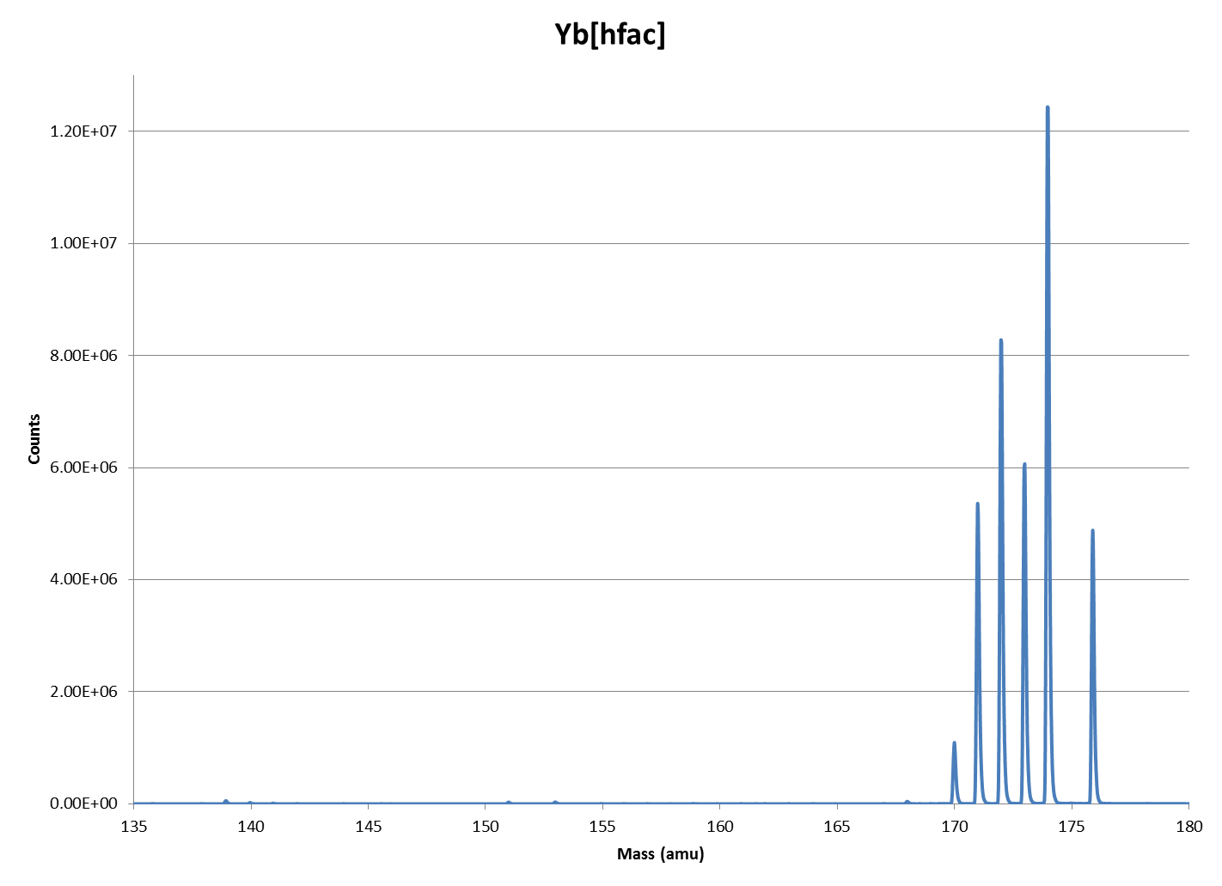
Figure A1-12: ICP-TOF-MS spectra of Yb[hfac] in mass range of lanthanides.
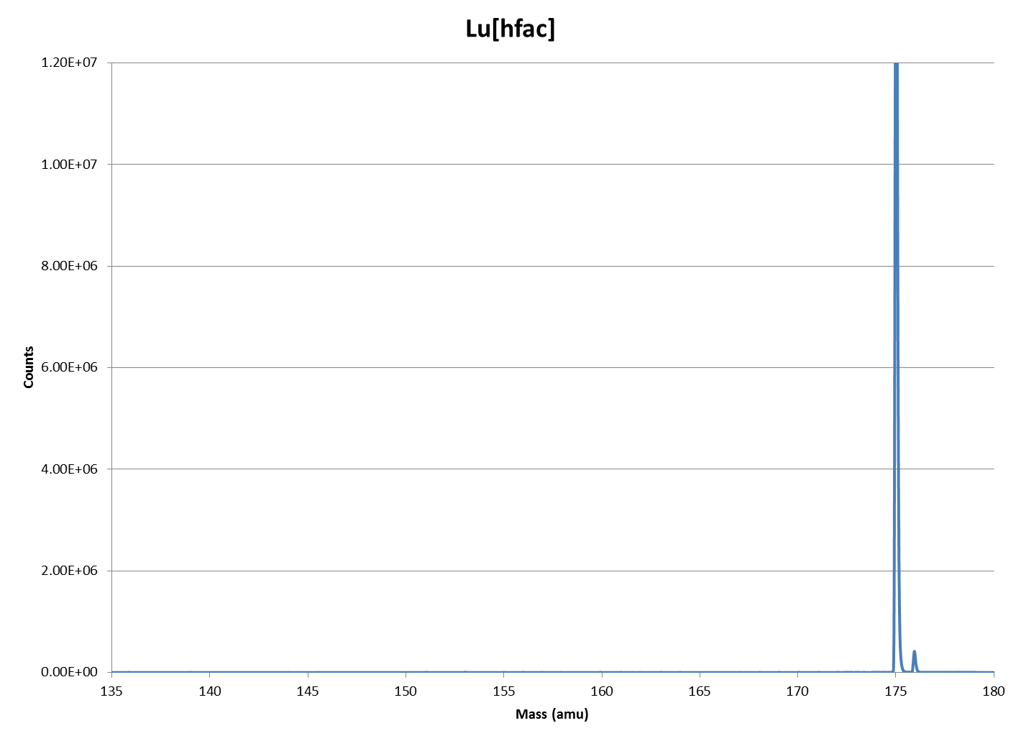
Figure A1-13: ICP-TOF-MS spectra of Lu[hfac] in mass range of lanthanides.

Appendix 2 ICP-TOF-MS Spectral Output for RE[fod] complexes
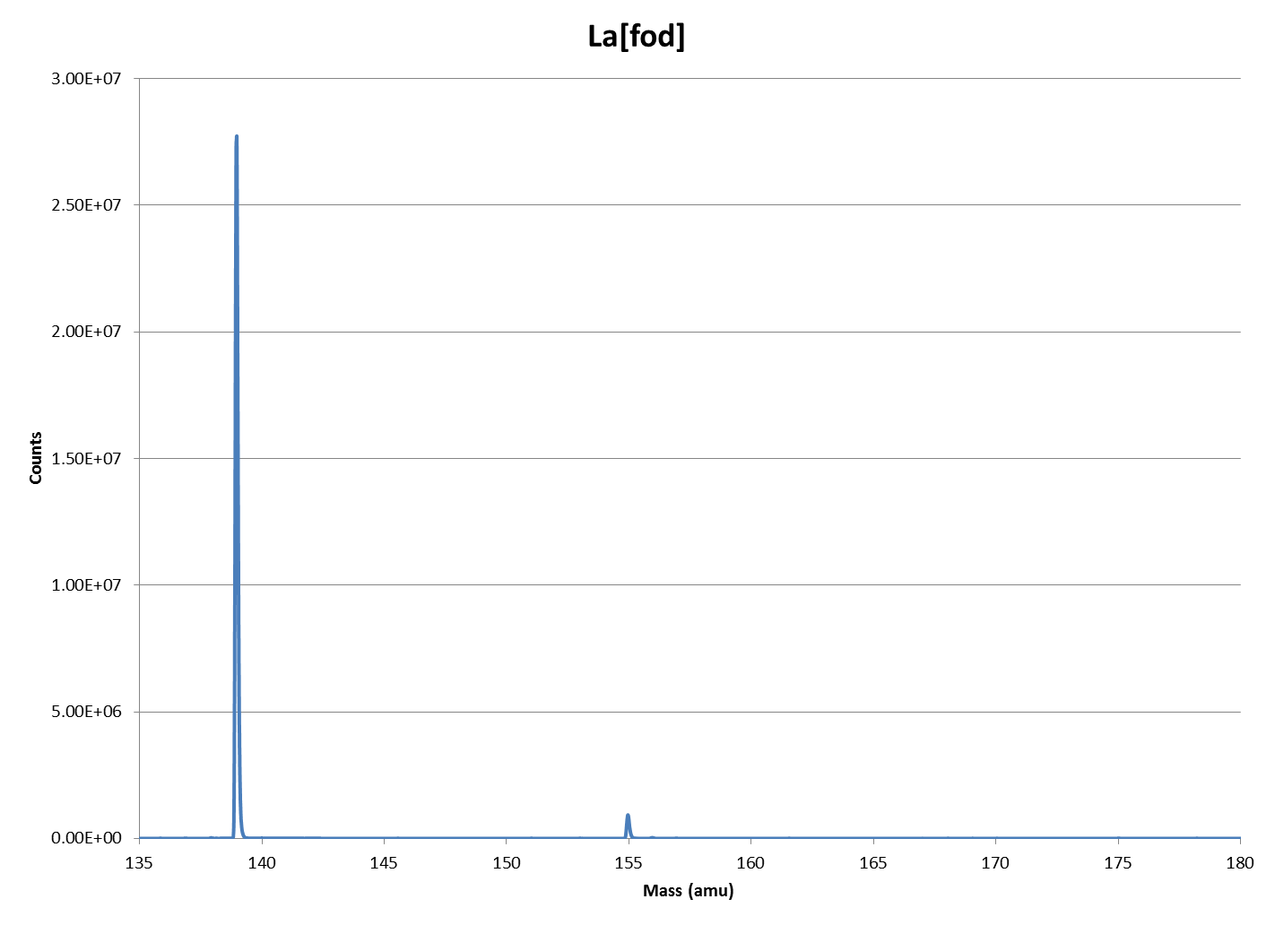
Figure A2-1: ICP-TOF-MS spectra of La[fod] in mass range of lanthanides.
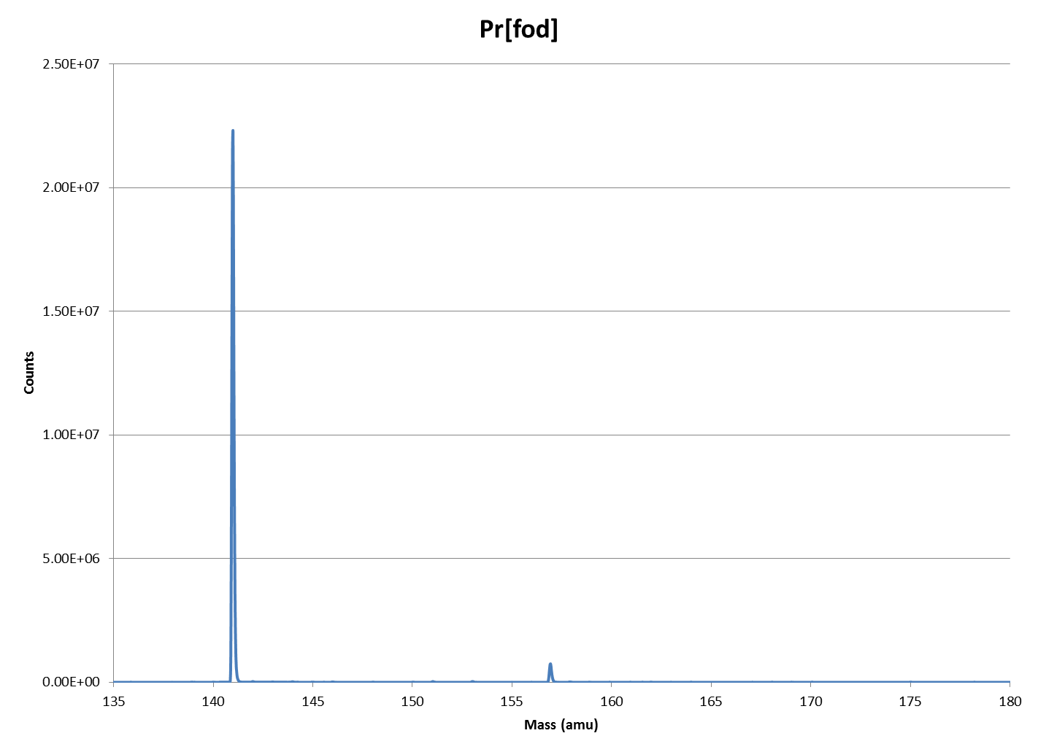
Figure A2-2: ICP-TOF-MS spectra of Pr[fod] in mass range of lanthanides.
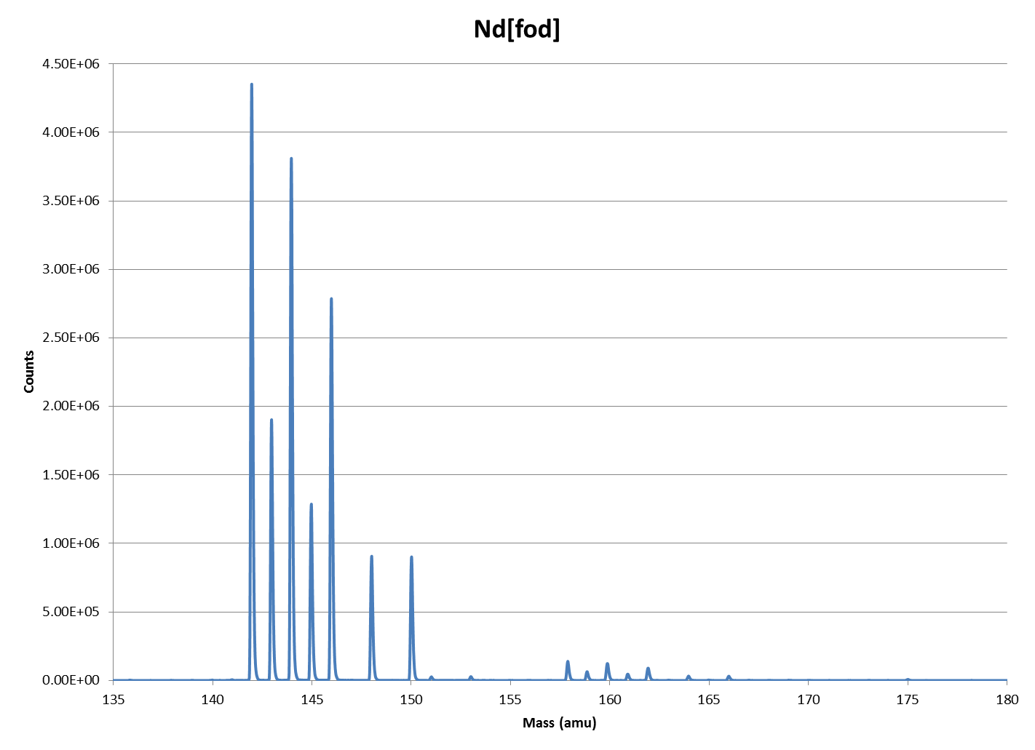
Figure A2-3: ICP-TOF-MS spectra of Nd[fod] in mass range of lanthanides.
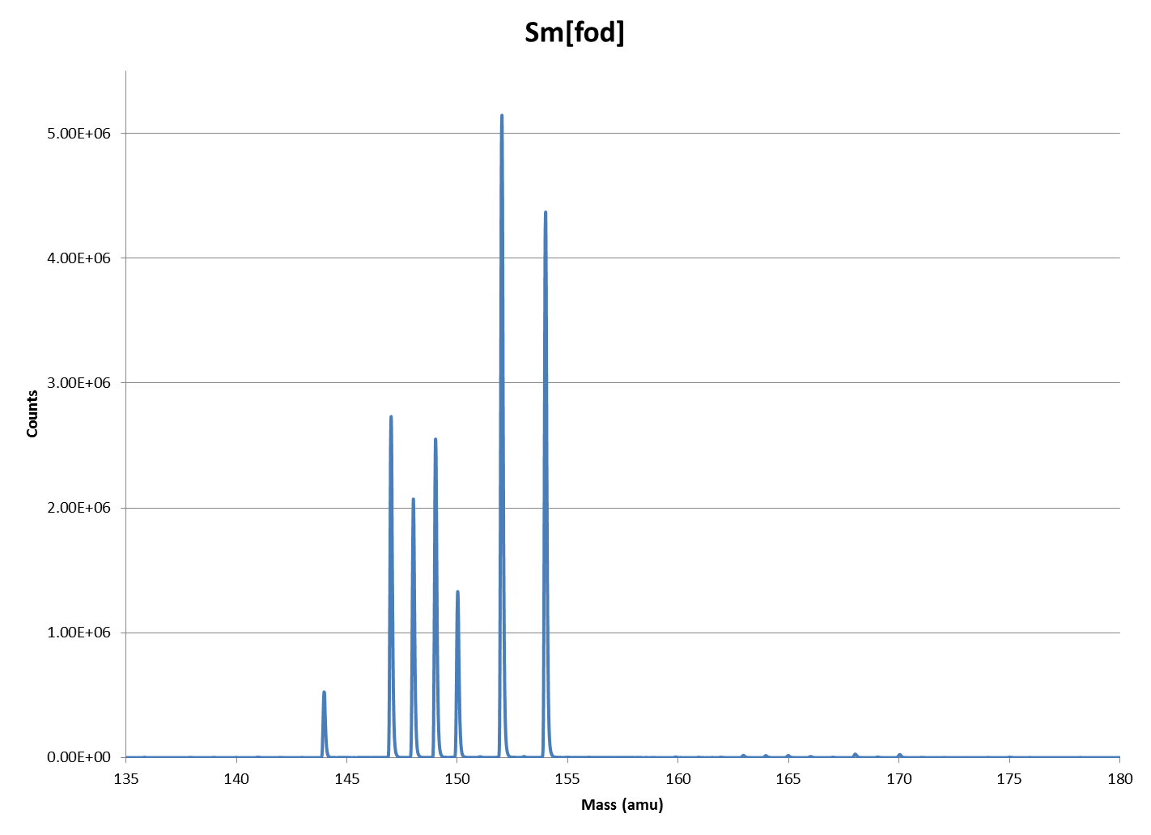
Figure A2-4: ICP-TOF-MS spectra of Sm[fod] in mass range of lanthanides.
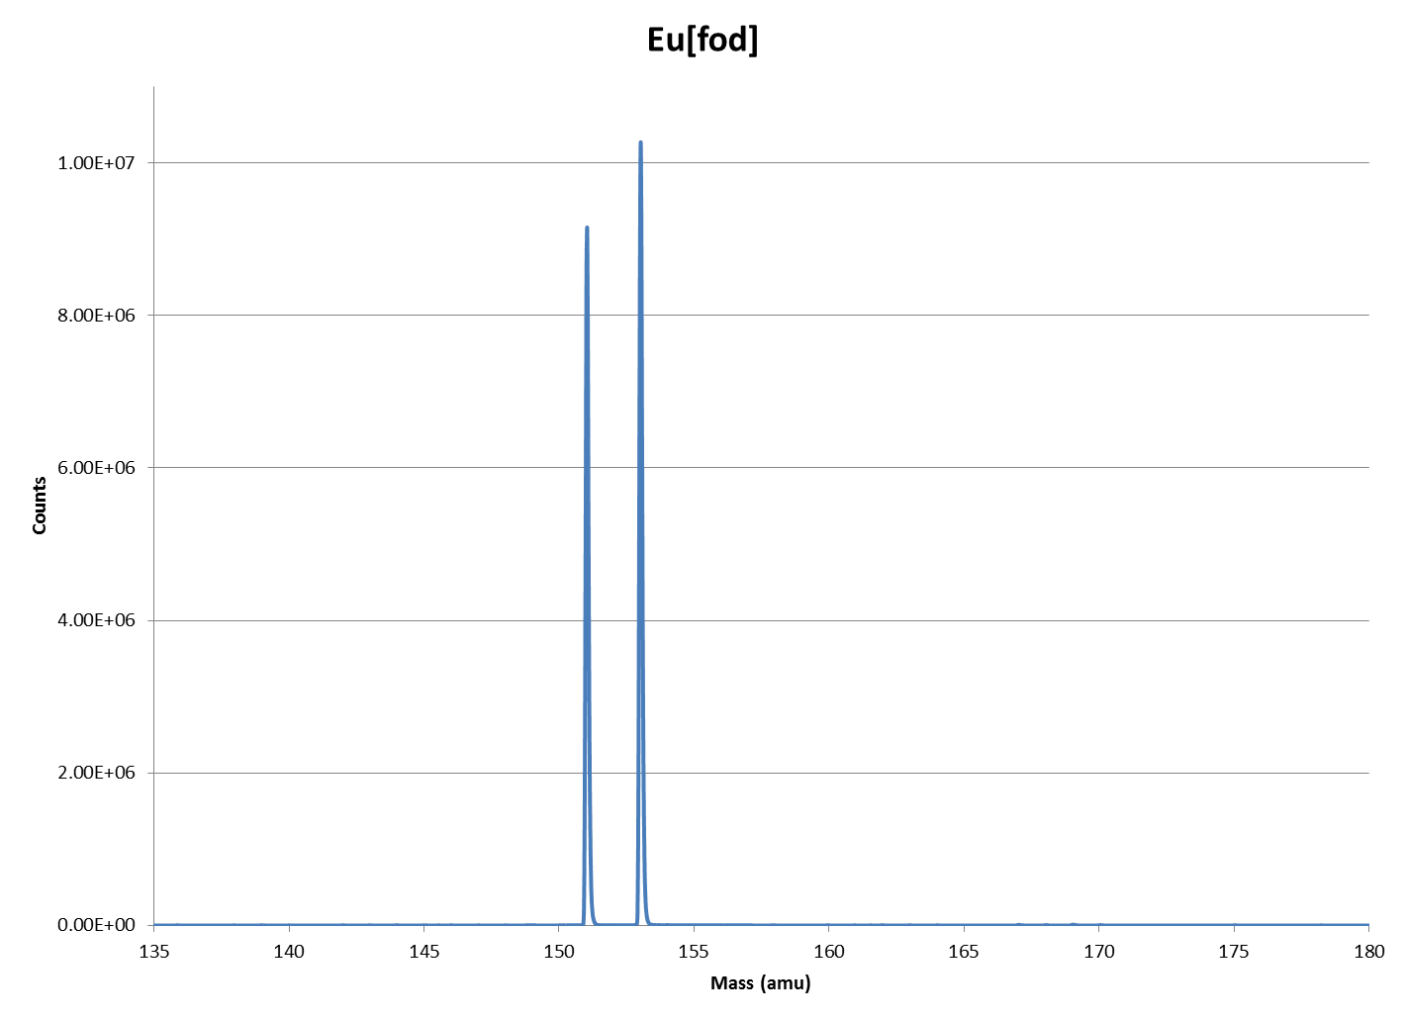
Figure A2-5: ICP-TOF-MS spectra of Eu[fod] in mass range of lanthanides.
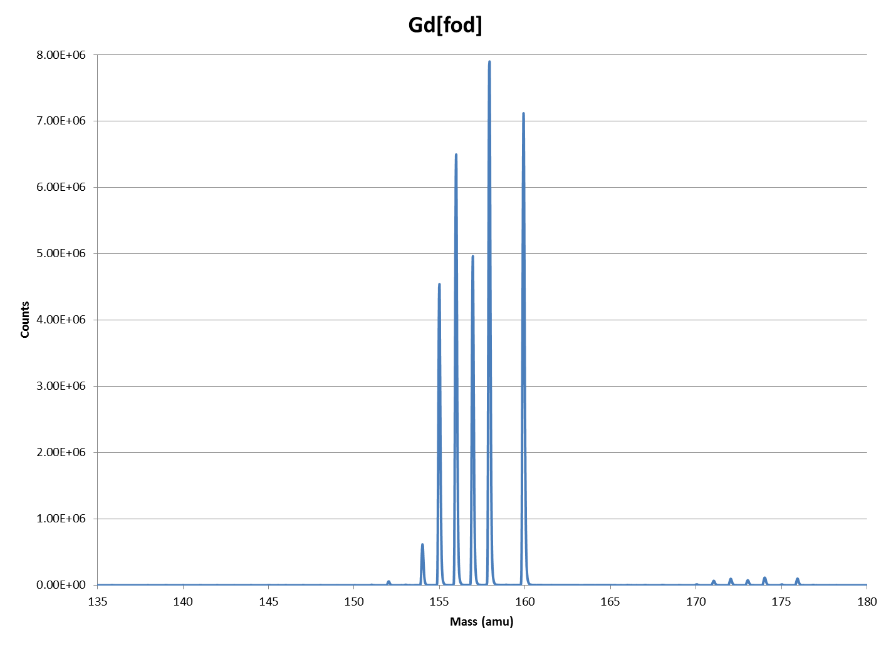
Figure A2-6: ICP-TOF-MS spectra of Gd[fod] in mass range of lanthanides.
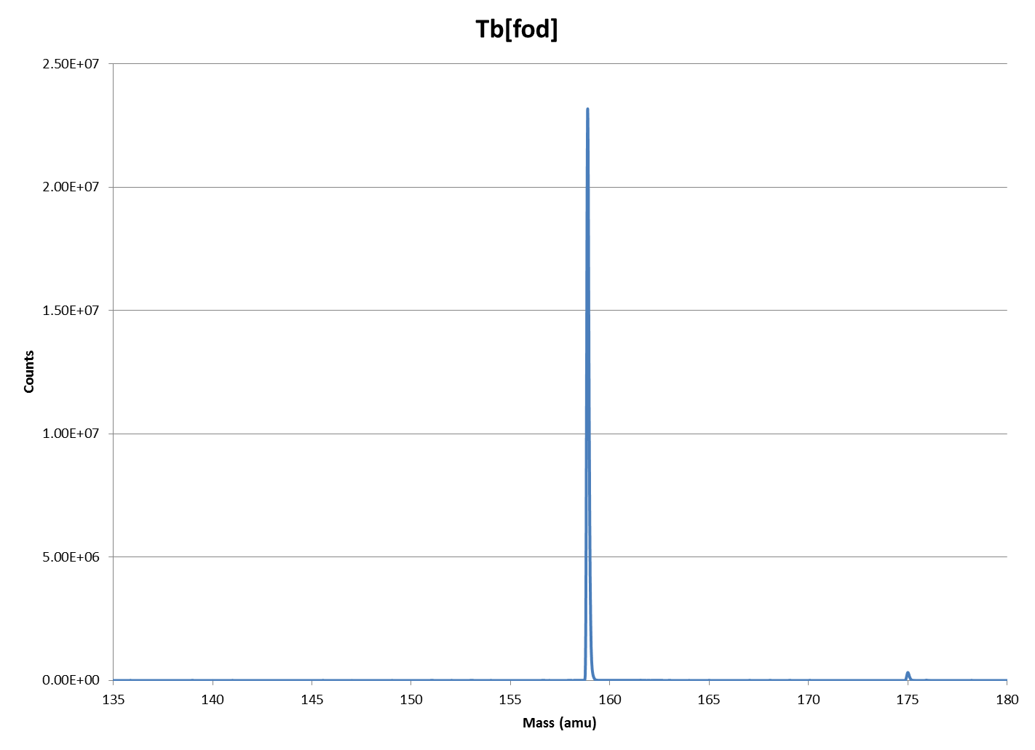
Figure A2-7: ICP-TOF-MS spectra of Tb[fod] in mass range of lanthanides.
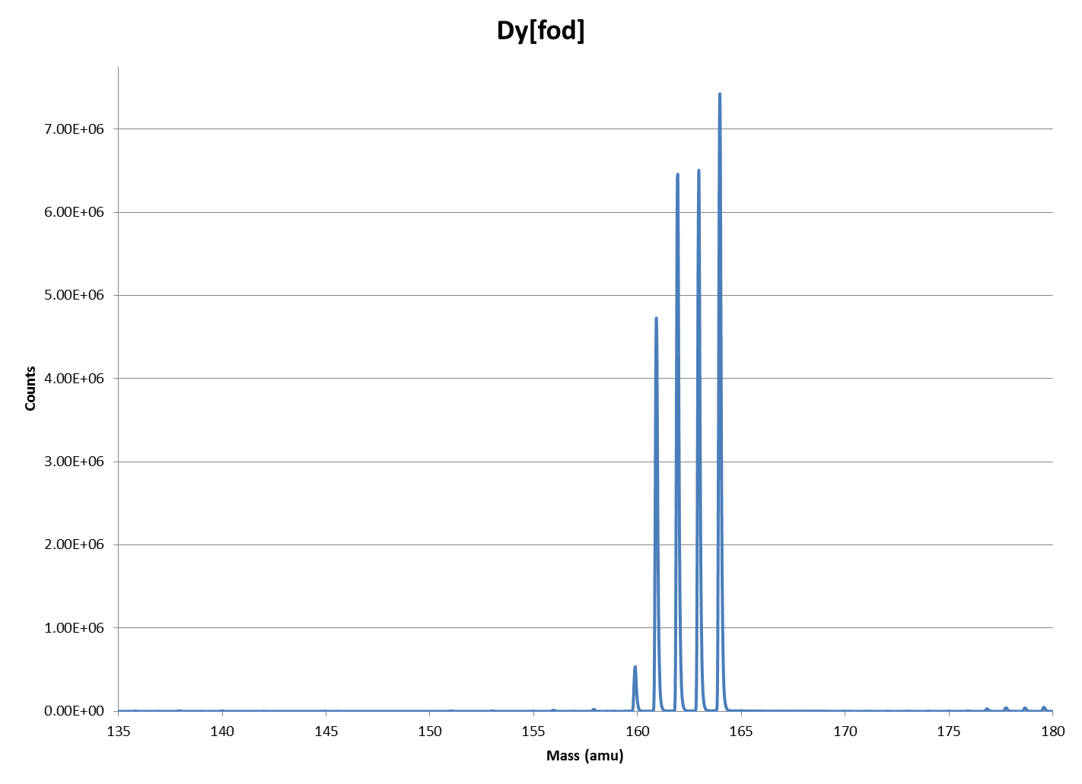
Figure A2-8: ICP-TOF-MS spectra of Dy[fod] in mass range of lanthanides.
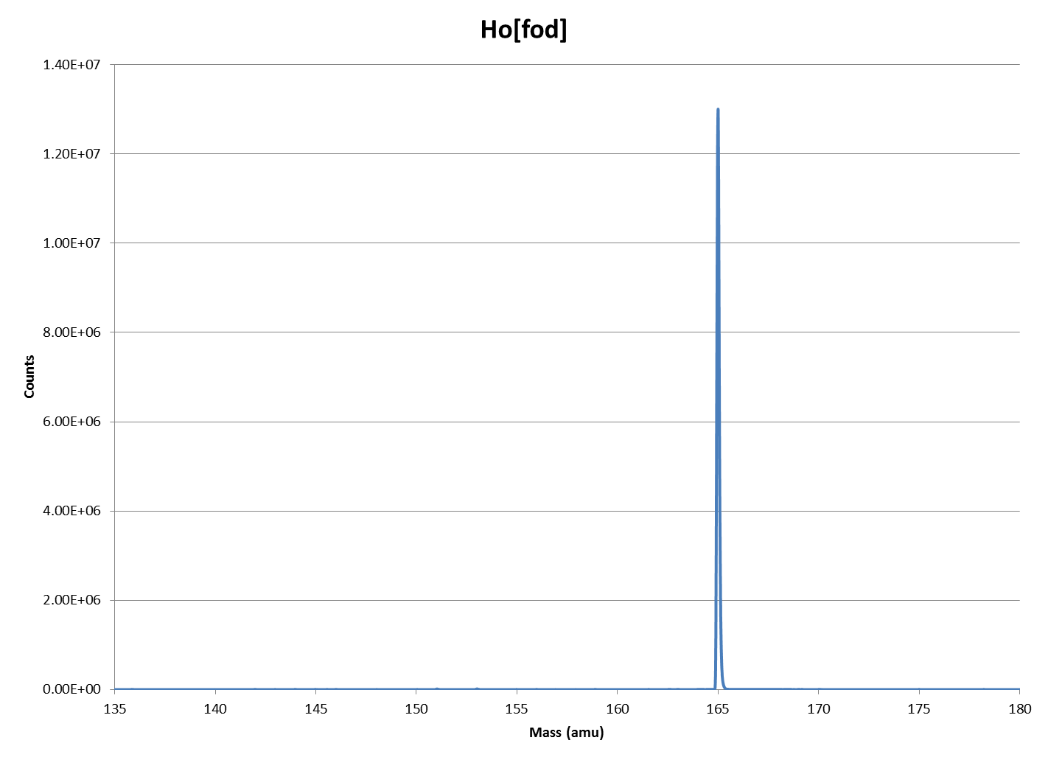
Figure A2-9: ICP-TOF-MS spectra of Ho[fod] in mass range of lanthanides.
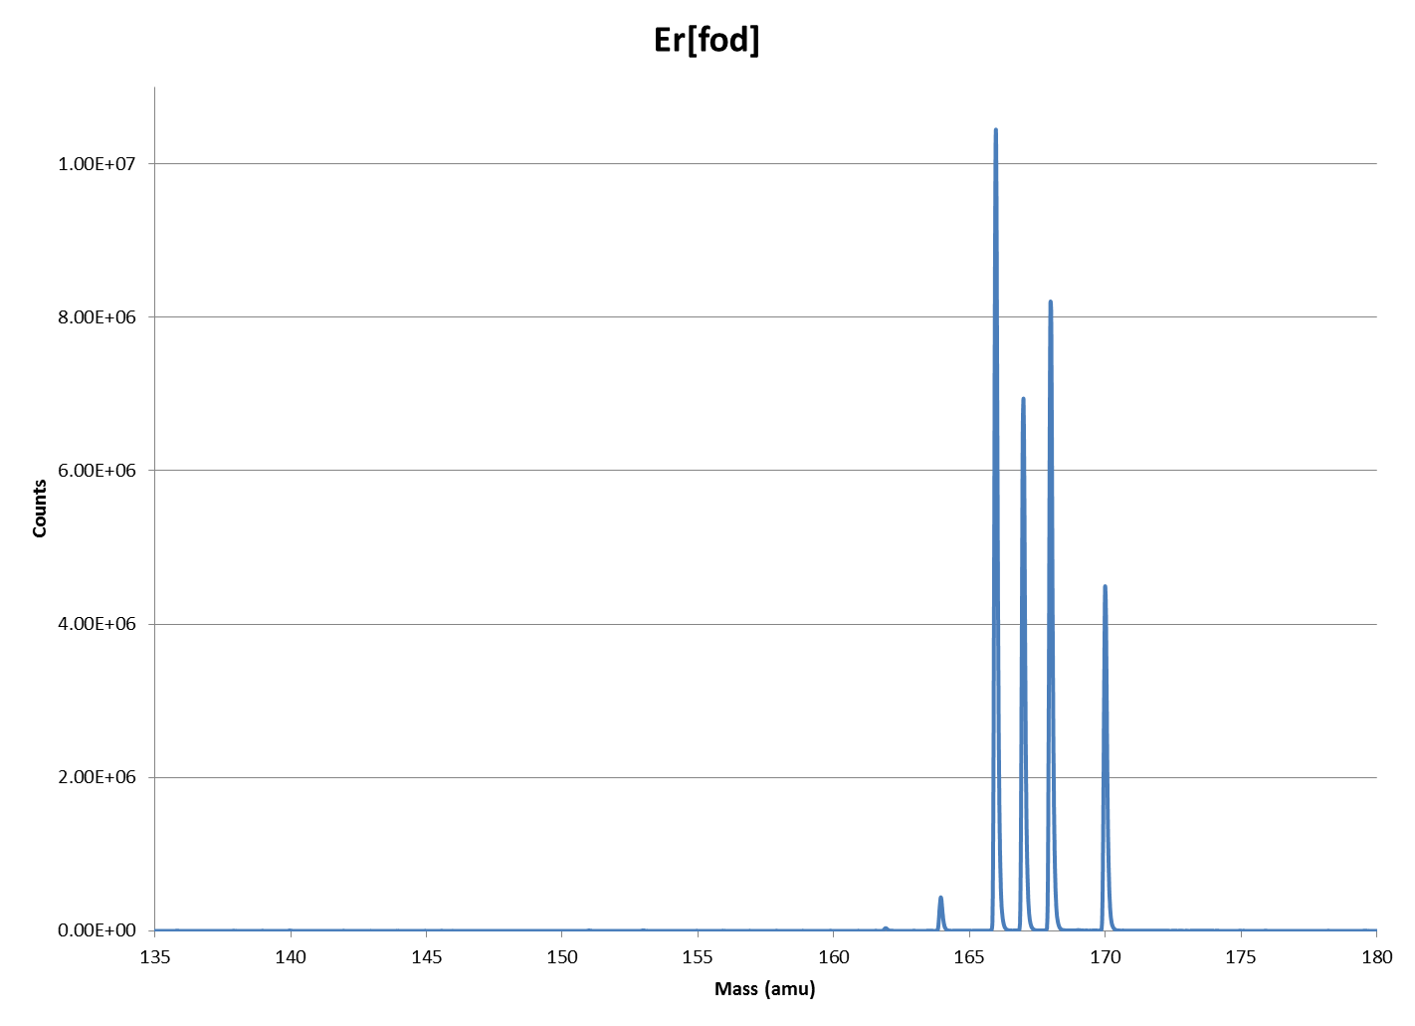
Figure A2-10: ICP-TOF-MS spectra of Er[fod] in mass range of lanthanides.
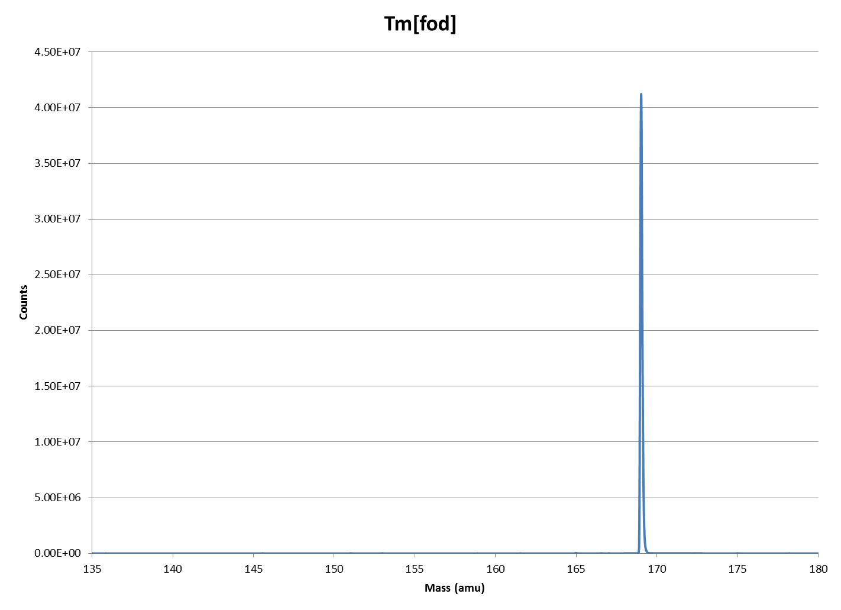
Figure A2-11: ICP-TOF-MS spectra of Tm[fod] in mass range of lanthanides.
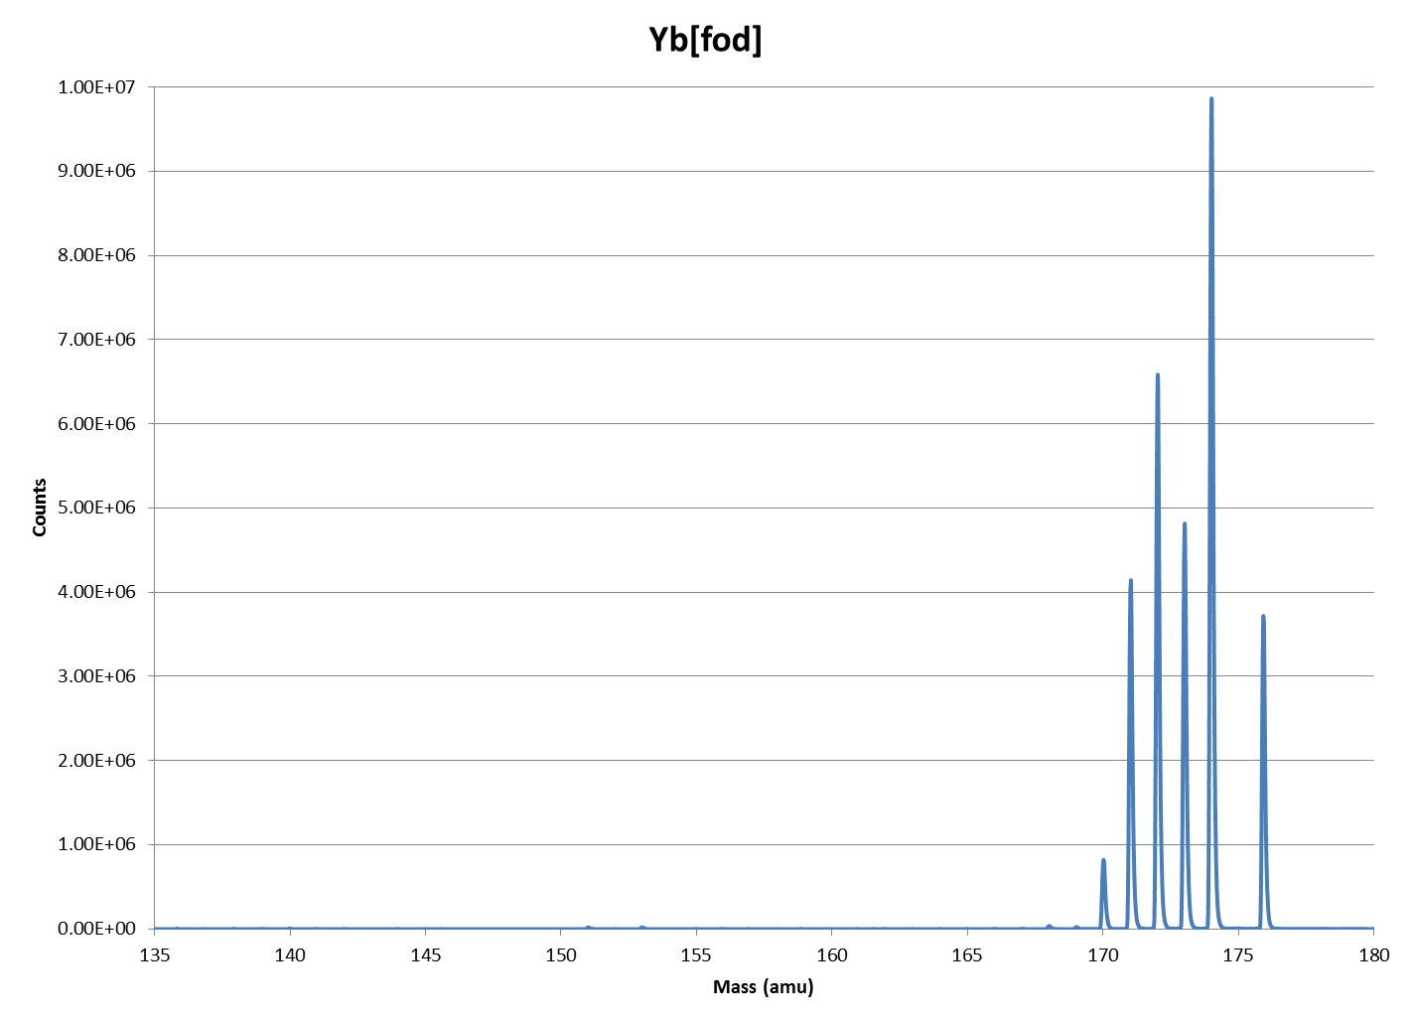
Figure A2-12: ICP-TOF-MS spectra of Yb[fod] in mass range of lanthanides.
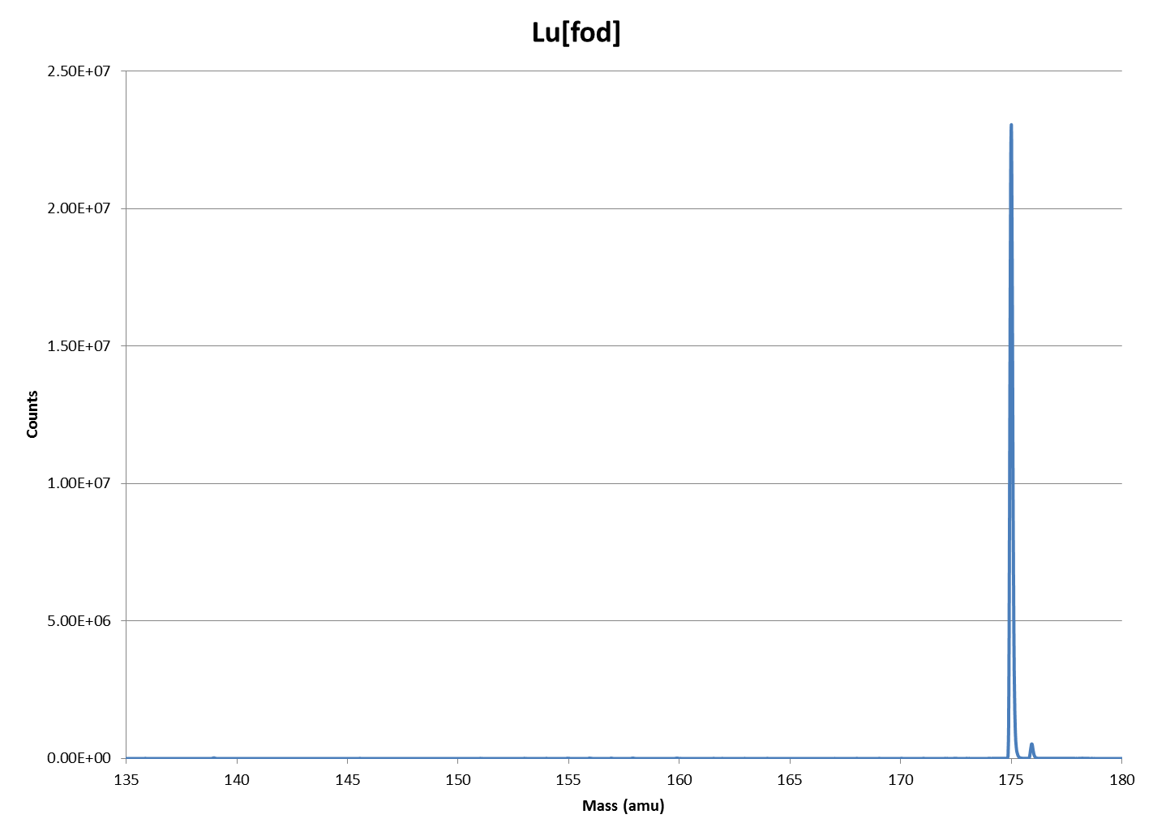
Figure A2-13: ICP-TOF-MS spectra of Lu[fod] in mass range of lanthanides.

Appendix 3 ICP-TOF-MS Spectral Output for RE[dpm] complexes
Figure A3-1: ICP-TOF-MS spectra of La[dpm] in mass range of lanthanides.
Figure A3-2: ICP-TOF-MS spectra of Pr[dpm] in mass range of lanthanides.
Figure A3-3: ICP-TOF-MS spectra of Nd[dpm] in mass range of lanthanides.
Figure A3-4: ICP-TOF-MS spectra of Sm[dpm] in mass range of lanthanides.
Figure A3-5: ICP-TOF-MS spectra of Eu[dpm] in mass range of lanthanides.
Figure A3-6: ICP-TOF-MS spectra of Gd[dpm] in mass range of lanthanides.
Figure A3-7: ICP-TOF-MS spectra of Tb[dpm] in mass range of lanthanides.
Figure A3-8: ICP-TOF-MS spectra of Dy[dpm] in mass range of lanthanides.
Figure A3-9: ICP-TOF-MS spectra of Ho[dpm] in mass range of lanthanides.
Figure A3-10: ICP-TOF-MS spectra of Er[dpm] in mass range of lanthanides.
Figure A3-11: ICP-TOF-MS spectra of Tm[dpm] in mass range of lanthanides.
Figure A3-12: ICP-TOF-MS spectra of Yb[dpm] in mass range of lanthanides.
Figure A3-13: ICP-TOF-MS spectra of Lu[dpm] in mass range of lanthanides.

Appendix 4 Summary of Graduate School Honors, Publications, and Presentations

Honors
- 2011 – Selected as a Nonproliferation Graduate Fellow
- 2011 – Won Best Poster Presentation at the 2011 American Nuclear Society (ANS)

Publications
    - 2012 – Garrison, J. R., D. E. Hanson, H. L. Hall. (2012) “Monte Carlo Analysis of Thermochromatography as a Fast Separation Method for Nuclear Forensics” J. Radioanal. Nucl. Chem.
    - 2011 – Hanson, D. E., J. R. Garrison, H. L. Hall. (2011) “Assessing Thermochromatography as a Separation Method for Nuclear Forensics: Current Capability vis-à-vis Forensic Requirements”. J. Radioanal. Nucl. Chem.
Patents
- Insert Patent Numbers

Presentations
Technical Talks
- 2014 – “Gas-phase Thermochromatographic Separations of Fission and Activation Products” – Meeting of the Institute for Nuclear Materials Management, Atlanta, GA
- 2010 – “Assessing Thermochromatography as a Separation Method for Nuclear Forensics: Current Capability vis-à-vis Forensic Requirements” – American Chemical Society Conference, Boston, MA.
Posters
- 2014 – “Synthesis of La[hfac]_{x} Compounds and Characterization of Subsequent Extractions into Ethyl Ether” - 18th Annual Exhibition of Undergraduate Research and Creative Achievement, in Knoxville, TN
- 2014 – “Synthesis and Characterization of Ln[hfac]_{x} for use in Rapid Thermochromatographic Separations” – Stewardship Science Academic Programs Symposium, in Bethesda, MD
- 2014 – “Optimizing a Method to Analyze Ln[hfac]_{x} Compounds with Inductively Couples Plasma-Time of Flight-Mass Spectrometry” – Stewardship Science Academic Programs Symposium, in Bethesda, MD
- 2014 – “Modeling gas phase of enthalpy and entropy of adsorption and de-sportion of Ln[hfac]_{x} compounds” - Stewardship Science Academic Programs Symposium, in Bethesda, MD
- 2014 – “Synthesis of La[hfac]_{x} Compounds and Characterization of Subsequent Extractions into Ethyl Ether” - 46th Southeast Undergraduate Research Conference, in Knoxville, TN
- 2011 – “Thermochromatography – A Rapid Separation Method for Nuclear Forensic Analysis” – American Nuclear Society Student Conference, in Atlanta, GA

Vita

Daniel Eric Hanson was born on September 23, 1985, firstborn of David and Jeanne Hanson. He spent his formative years in Grinnell, Iowa graduating from Grinnell Senior High School in 2004. Daniel first attended Faith Baptist Bible College for two semesters, eventually transferring to Iowa State University, where he would obtain his Bachelor of Science in Chemical Engineering in 2009. That fall, he would begin his studies at the University of Tennessee receiving his Master of Science in Nuclear Engineering in May 2011 under the direction of Dr. Howard L. Hall. In June of 2011, Daniel was selected as a Non-Proliferation Graduate Fellow with Pacific Northwest National Laboratory and spent one year working at the Savannah River Site on the MOX Fuel Fabrication Facility. At the conclusion of that year, Daniel obtained employment with the National Nuclear Security Administration on the MOX Fuel Fabrication Facility project while simultaneously continuing his work under Dr. Hall in pursuit of a Doctorate of Philosophy in Nuclear Engineering. He graduated in December 2014. Daniel continues his work at the MOX Fuel Fabrication Facility.

