Periodic Replenish and Recount Policy to Address Record Inaccuracy from Stock Loss

A Thesis Presented for the
Master of Science
Degree
The University of Tennessee, Knoxville

Colton K. Ku
April 2021

Copyright © 2021 by Colton K. Ku
All rights reserved.

ABSTRACT

Inventory record inaccuracy (IRI) often arises due to unaccounted stock loss. Theft, misplacement, spoilage, and transaction errors will reduce the true inventory values without changing the inventory record. As previous inventory replenishment policies assume perfect record accuracy, increasing IRI can cause unexpected stockout events, mistimed reorders, and replenishment freezes. Solutions to rectifying IRI vary from the use of improved tracking technologies to prevent it initially occurring at all to recounting programs which estimate true inventory value. However, in situations where high-tracking technology is unsuitable and continuous counting programs are too costly, practitioners will default to the dreaded inventory audit in which all stock is counted annually. To address these issues, we offer a periodic replenish and recount policy (PRRP) which accounts for stochastic stock loss and minimizes total costs including recounting. We find that in instances of stochastic stock loss, PRRP reduces total stockout events and prevents replenishment freezes when compared to a standard (r,Q) policy.

Table of Contents

Chapter One Introduction and General Information 1
Inventory Inaccuracy from Stock Loss 1
Chapter Two Literature Review 2
Previous Methods Addressing Inventory Inaccuracy 2
Chapter Three Materials and Methods 5
Business Assumptions and Sequential Events 5
PRRP Under Deterministic Stock Loss 5
PRRP Under Stochastic Stock Loss 6
Formulation of R_{n} 6
Formulation of S_{n} 7
Average Excess Inventory Assuming Surplus 7
Sample Spaces of Various PRRPs 8
Cost of Various PRRPs 9
Chapter Four Results and Discussion 11
Simulation of Periodic Replenishment Under Stochastic Stock Loss 11
Scenario Analysis 11
Chapter Five Conclusions and Recommendations 12
Effectiveness of PRRP 12
Important Limitations 12
Managerial Insights 12
Conclusions 12
List of References 13
Vita 16

LIST OF TABLES

Table 1. Comparison of simulated vs expected values 12
Table 2. Effect of Q on total cost. 13
Table 3. Effect of Q on total cost. 13

LIST OF FIGURES

Figure 3-1. Formulation of ghost inventory per reorder cycle 6
Figure 3-2. Formulation of difference between EOQ r and PRRP r 6
Figure 3-3. Definition of Rn and Sn 6
Figure 3-4. Formulation of R_{n} 7
Figure 3-5. Formulation of S_{n} 7
Figure 3-6. Average of excess ending inventory for R₁ 8
Figure 3-7. Average of excess ending inventory for higher cycles 8
Figure 3-8. Total average excess inventory for R_{n} 8
Figure 3-9. Graphical representation of a one-cycle PRRP sample space 8
Figure 3-10. Graphical representation of a two-cycle PRRP sample space 9
Figure 3-11. Graphical representation of a three-cycle PRRP sample space 9
Figure 3-12. Cost of excess average inventory 10
Figure 3-13. Expected cost per cycle of a one-cycle PRRP 10
Figure 3-14. Expected cost per cycle of a two-cycle PRRP 10
Figure 3-15. Expected cost per cycle of a three-cycle PRRP 10
Figure 3-16. Cost per cycle of a four-cycle PRRP 10
Figure 4-1. Inventory vs time for 10,000 simulated runs 11
Figure 4-2. Stockout events for 10,000 runs 11

Introduction and General Information

Inventory Inaccuracy from Stock Loss

The ability to accurately track inventory levels is critical for an organization to keep holding costs low and to avoid overstock and stockouts. Inventory managers rely upon accurate data to inform decisions on replenishment strategies, warehouse layouts, and even staffing requirements.[1] Yet, true inventory values often mismatch what they are purported to be within ERP systems. Item misplacement, incorrect counting, theft, and restocking errors are a few of the many ways in which an inventory record can deviate from its true value in real-case scenarios. Therefore, significant effort has been placed on understanding the nature of IRI (inventory record inaccuracy) as well as methods for its correction.[2, 3] We suggest a gap exists for simple inventories in which RFID is impractical and cycle counting ineffective. Our work bridges this gap through the development of a practical replenishment policy which does not rely upon accurate inventory record. The policy recommends periodic replenishment of inventory with subsequent recounting after a set number of reorder cycles.

Literature Review

Previous Methods Addressing Inventory Inaccuracy

This brief review documents notable achievements in the causes of IRI as well as the two majority prescribed solutions: RFID and inventory cycle-counting. In 2001, Raman et al. reported that over 65% of inventory records from the 370,000 SKUs (stock keeping units) stored at a major retailer were incorrect.[4] Broader studies by Kang et al. indicated that for a given company’s 500 stores, the highest performance was an accuracy of 75–‍80%. On average, the inventory accuracy of the company was a little over 50%.[5] Similar reports reflect the prominence of inventory inaccuracy among various industries.[6-8] Our research provides an additional tool for inventory managers that lack theoretical knowledge to practically rectify these inventory inaccuracies.
Inventory inaccuracy can theoretically occur in either the positive or negative direction, meaning inventory records may either exceed or be less than its true value. However, researchers have more often discovered inventory records to fall below its true value, rather than exceed it.[9] Most presume this fact is due to the more numerous ways an item may be lost or removed from a system when compared to the ways it may be added. Four scenarios in which inventory inaccuracy may arise are:
- the true value stays the same and the inventory record increases,
- the true value stays the same and the inventory record decreases,
- the true value increases and the inventory record stays the same, and
- the true value decreases and the inventory record stays the same.
Kang et al. rationalized that most causes of inventory inaccuracy may be attributed to stock loss, transaction error, inaccessible inventory, or incorrect product identification.[5] Stock loss occurs through internal theft, external theft, unauthorized consumption, product expiration, spoilage, or damage. Transaction errors may occur at either the inbound receipt or outbound checkout of a good. During the inbound phase, receiving clerks may incorrectly track the receipt amount of a shipment. On the other hand, checkout clerks may decide to scan a single item multiple times instead of each individual item when tasked to scan a batch of similar looking goods. While the same result occurs if the multiple items share the same SKU, similar looking goods may hold different SKUs, resulting in incorrect tracking of outbound inventory. Inaccessible inventory is that which is misplaced due to either a customer or employee moving it from its originally assigned location. Finally, incorrect product identification may occur when a wrong tag or label is placed on an item.
In simulating inventory record errors over time, typical models follow either a Poisson[5] or normal distribution.[10] Additionally, error sources have been found additive with little interaction effects.[11] Our assumptions agree with previous work that stock loss follows a Poisson distribution. We suggest that stock loss is memoryless and that both the loss in a single day and the loss in a full reorder cycle follow a Poisson distribution. This assumption encourages a certain frequency of inventory record rectification to prevent unaccounted stockouts or inventory buildup.
Effects of IRI have been studied in retail supply chains,[12] retail outlets,[10] and even three-echelon supply chains.[11] Stock loss was shown to predictably cause IRI and stockouts[5], while IRI was also shown to negatively impact service levels.[13] IRI has also been extensively studied to quantify its overall costs. Lee and Özer quantified the value of inventory accuracy through comparison of a perfect inventory record scenario with one of the downstream effects of IRI.[14] Our work is consistent with these findings that the major cost of IRI is attributed to stockouts of SKUs that are recorded as a greater inventory value than its true value.
RFID technology was first invented in 1946 and expanded to commercial use by the 1980s. In the 1990s, standards for its use were implemented across a wide variety of industries. More recently, the technology’s affordability has improved and many more companies have adopted its use.[15] Since 2005, emphasis on RFID’s impact on supply chain improvements have radiated throughout academia and industry. Specifically, RFID has been proposed to serve as solutions for inventory inaccuracy, bullwhip effects, and optimized replenishment policies.[16, 17] The promise of RFID as a silver-bullet hinges upon its successful implementation. That is, to reap the benefits of RFID, an inventory management system must first correctly add either passive[18] or active RFID tags to each item or pallet of inventory which needs to be tracked. We find the assumption that this task is viable, or even possible in many situations, unlikely. While collaborating with a typical small-sized organization with less than 10,000 SKUs, the capital costs of an RFID system were found inhibitory. Therefore, our work recognizes the benefits of RFID, but chooses to focus on a practical method of IRI correction which can be implemented with little to no cost to a firm.
Besides RFID technology which promises to automatically sync the inventory record with its true value, a second option inventory managers have available to correct IRI is a physical inspection. Physical inspections are costly in both time and capital and are typically used as sparingly as possible. For most small and mid-sized uninformed firms, this translates to an annual inspection for auditing and accounting purposes. On the other hand, well-informed and large-sized firms have recently implemented cycle-count programs which verify inventory accuracy through an on-going basis of counting only a portion of randomly selected items.[3] Through statistical methods, reasonable levels of inventory accuracy can be achieved with moderate confidence levels without the inhibitory costs associated with a full physical count. Kök and Shang further improved upon these methods through their development of an inspection adjusted base-stock (IABS) policy and cycle-count policy with state-dependent base-stock levels (CCABS).[19, 20] While both the IABS and CCABS solutions for IRI are massive improvements over non-inspection policies, their implementation is still predicated upon the use of ABC classification systems. These systems introduce bias within the policy, as ABC classification inherently requires subjective weights to be applied to each grouping.[21, 22] Thus, a gap is identified in which a non-biased inspection policy would bridge. Our inspection policy allows practitioners with little to no experience in statistical methods to ensure the highest inventory accuracy without the inhibitory costs of RFID or the complex set-up of cycle-count programs. Additionally, our non-biased approach uses easily accessible parameters to determine optimal count frequencies.

Materials and Methods

Business Assumptions and Sequential Events

Consider a single-item inventory model in which the following occurs sequentially:
- Inventory begins exactly at $Q$
- Each day, inventory decreases by the sum of a deterministic amount $D$ and a random amount $X$
  - $D$ represents demand which is accurately accounted for through traditional inventory tracking technologies
  - $X$ follows a Poisson distribution and represents stochastic stock loss which reduces inventory levels without updating the inventory record
- If the sum of $D$ and $X$ is greater than the current inventory level, a stockout event occurs and no backorder is created (lost sale)
  - In the case of a stockout, the inventory level will be reset to $Q$ upon the next reorder
- After a predetermined period of days $r$, $Q$ is added to the inventory level
- If no stockout occurs for a predetermined number of cycles $n$, the inventory is counted and reset to $Q$
The purpose of this study is to evaluate how changes to the reorder quantity, reorder period, and cycles until recount $n$ will affect total costs. It is found that slightly larger order quantities or alternatively, shorter reorder periods, reduce total costs when compared to a standard (r,Q) policy.

PRRP Under Deterministic Stock Loss

First, we can determine an optimal reorder period $r$ for a theoretical scenario in which both demand $D$ and stock loss $V$ are deterministic and known. In this case, the sum of $D$ and $V$ may be considered an aggregate demand. After the exact length of $\frac{Q}{D+V}$ days, inventory will reach 0 and should be reordered. Thus, setting $r$ to $\frac{Q}{D+V}$ results in an optimal balance of ordering and holding costs in the same manner as a deterministic EOQ model.
If we consider that stock loss $V$ is ‘known but invisible,’ i.e., our estimation of stock loss is perfect, yet the inventory record only takes account $D$, we can determine that every reorder cycle adds the unaccounted stock loss as ‘ghost inventory’ to the baseline (figure 3.1). We can also determine how much earlier $r$ should be in comparison to a standard EOQ model which does not consider stock loss by taking the difference between reorder periods (figure 3.2). Intuitively, the reorder period is much shorter since more inventory is removed from the system every day. Since in the deterministic case we can perfectly predict inventory level, there is no need to implement any recounting.
$$= Q-D*\frac{Q}{D+V}$$
$$=\frac{QV}{D+V}$$
Figure 3-1. Formulation of ghost inventory per reorder cycle
$$= \frac{Q}{D}-\frac{Q}{D+V}$$
$$= \frac{QV}{D(D+V)}$$
Figure 3-2. Formulation of difference between EOQ r and PRRP r

PRRP Under Stochastic Stock Loss

We can next extend our model to the case in which stock loss $X$ is random and follows a Poisson distribution with parameter $λ$. Upon stockout, inventory inaccuracy is rectified and the inventory level is reset to $Q$. We first define $R_{n}$ and $S_{n}$ as follows:

$$R_{n}: Probability of surplus through n reorder cycles$$
$$S_{n}: Probability of shortage during the n^{th} reorder cycle$$
Figure 3-3. Definition of Rn and Sn

Formulation of R_{n}

The probability of surplus within the first reorder cycle is equal to the probability that stock loss is less than $Q-Dr$. Since stock loss follows a Poisson distribution, this can simply be calculated using the probability mass function (figure 3-4). However, the probability of surplus of subsequent reorder cycles are dependent upon previous cycles. Simply stated, if a surplus occurs in the first cycle, there is a higher likelihood of another surplus occurring due to the extra inventory from the first. To calculate the exact probability of a surplus in any given reorder cycle, a recursive summation is used in which increasing bounds represent the increased chance of surplus given a previous surplus.

$$R_{1}= \sum_{W=0}^{Q-Dr}{\frac{{(λr)}^{W}e^{-λr}}{W!}}$$

$$R_{2}= \sum_{W=0}^{Q-Dr}{\sum_{μ=0}^{(2Q-2Dr-W)}{\frac{{(λr)}^{Wμ}e^{-2λr}}{W!μ!}}}$$

$$R_{3}= \sum_{W=0}^{Q-Dr}{\sum_{μ=0}^{(2(Q-Dr)-W)}{\sum_{ρ=0}^{(3\left(Q-Dr\right)-W-μ)}{\frac{{\left(λr\right)}^{Wμρ}e^{-3λr}}{W!μ!ρ!}}}}$$
…
Figure 3-4. Formulation of R_{n}

Formulation of S_{n}

Once the probability of surplus is known, the probability of a stockout event occurring can be easily calculated considering the overall sample space. In a single cycle, either a stockout event occurs or a surplus event occurs so the stockout probability is the difference between one and the probability of surplus. In greater order cycles, the sample space is composed of stockout events occurring at any one of the cycles or a surplus event occurring throughout. The probability of stockout can thus be calculated according to figure 3-5.

$$S_{1}+R_{1}=1$$
$$S_{1}+S_{2}+R_{2}=1$$
…

$$S_{n}=R_{n-1}- R_{n}$$
Figure 3-5. Formulation of S_{n}

Average Excess Inventory Assuming Surplus

If no stockout occurs within a single reorder cycle, then possible stock loss is bounded between zero and $Q-Dr$. The weighted average of the possible stock loss can then be calculated according to figure 3-6.

$$Ex\left(1\right)=\sum_{W=0}^{Q-Dr}{\frac{{(λr)}^{W}e^{-λr}}{W!}(Q-Dr-W)}$$

Figure 3-6. Average of excess ending inventory for R₁
In later order cycles, an adjusted formula may be used to calculate additional excess inventories by adding the previous excess inventory to the bounds (figure 3-7). Since a stockout will occur if a surplus does not, the strong assumption of stock loss following a Poisson distribution gives rise to an equivalent relationship between the average excess ending inventory in the case of surplus and the average stockout amount in the case of shortage. The relationship is illustrated in figure 3-8. Finally, with the formulation of excess ending inventory, the expected additional inventory per period may be calculated according to figure 3-9.

$$Ex\left(2\right)=\sum_{W=0}^{Q-Dr}{\sum_{μ=0}^{\left(2Q-2Dr-W\right)}{\frac{{\left(λr\right)}^{Wμ}e^{-2λr}}{W!μ!}}}(2\left(Q-Dr\right)-W-μ)$$

$$Ex\left(3\right)=\sum_{W=0}^{Q-Dr}{\sum_{μ=0}^{\left(2Q-2Dr-W\right)}{\sum_{ρ=0}^{\left(3Q-3Dr-W-μ\right)}{\frac{{\left(λr\right)}^{Wμρ}e^{-3λr}}{W!μ!ρ!}}}}(3\left(Q-Dr\right)-W-μ-ρ)$$

Figure 3-7. Average of excess ending inventory for higher cycles
$$Sh\left(n\right)+Sh\left(n-1\right)+Sh\left(n-2\right)+…+Sh(1)=Ex\left(n\right)$$
Figure 3-8. Relationship between average shortage amount and average excess
$$AvEx\left(n\right)=\frac{nQ+Ex\left(n\right)+Ex\left(n-1\right)+…+Ex(1)}{2n}-\frac{Q}{2}$$
Figure 3-9. Average excess inventory per period over n periods

Sample Spaces of Various PRRPs
To calculate the cost incurred for various PRRPs, the total sample space must first be considered and the appropriate cost functions applied. In a single-cycle PRRP, the sample space is: $R_{1}+S_{1}$, indicating two possible outcomes. In a two-cycle PRRP, the sample space is: $R_{2}+S_{1}R_{1}+S_{2}+S_{1}+S_{1}S_{1}$. A graphical representation of the possible outcomes is shown in figures 3-10, 3-11, and 3-12. Defining a PRRP with a constant renewal cycle allows for the accurate comparison of PRRP over a set period of time. Additionally, the PRRP does not assume inventory accuracy throughout the replenishment process.

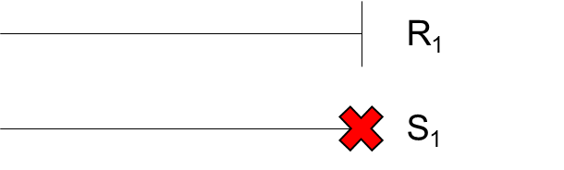
Figure 3-10. Graphical representation of a one-cycle PRRP sample space

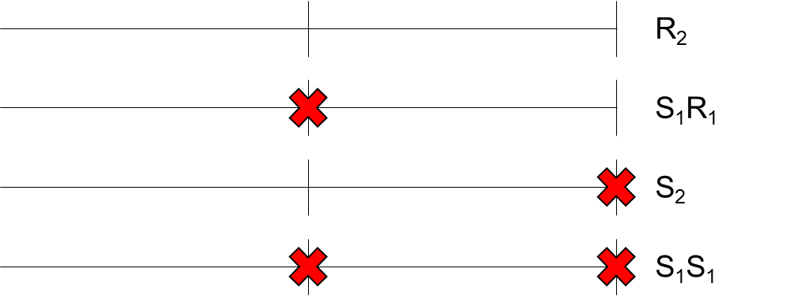
Figure 3-11. Graphical representation of a two-cycle PRRP sample space

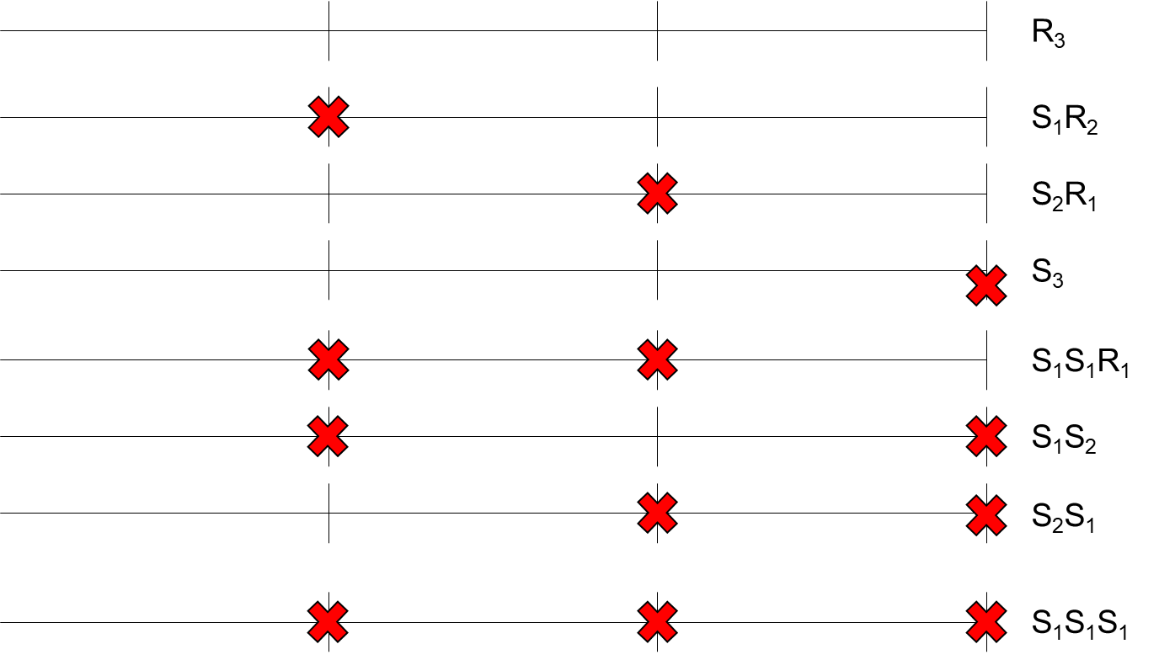
Figure 3-12. Graphical representation of a three-cycle PRRP sample space

Cost of Various PRRPs
Each unique outcome in a given sample space carries with it a cost. The inventory ordering and inventory holding cost for $\frac{Q}{2}$ are sunk costs and do not need to be considered when evaluating the cost of various PRRPs. Only the following three costs must be considered for each PRRP:
- $C^{S}(n)=$Cost of stockout
- $C^{I}(n)=$Cost of additional inventory holding
- $C^{C}=$Cost of recounting
The cost of stockout is given in figure 3-13 where $b$ is the cost per stockout unit. The cost of additional inventory is formulated in figure 3-13 where $h$ is the cost of excess inventory per unit per period. Finally, the recounting cost $C^{C}$ is incurred at the end of any PRRP. The average cost per cycle can be calculated for each PRRP through the weighted average using the product of each probability of sample space and its corresponding cost function (figures 3-14, 3-15, 3-16, 3-17).
$$C^{S}(n)=Sh\left(n\right)b$$
$$C^{I}(n)=AvEx\left(n\right)nh$$
Figure 3-13. Cost of excess average inventory and cost of stockouts

$$\frac{R_{1}C^{I}(1)+S_{1}C^{S}(1)+C_{c}}{1}$$
Figure 3-14. Expected cost per cycle of a one-cycle PRRP

$$\frac{R_{2}C^{I}(2)+S_{1}R_{1}\left(C^{S}\left(1\right)+C^{I}(1)\right)+S_{2}C^{S}\left(2\right)+{2S}_{1}S_{1}C^{S}\left(1\right)+C_{c}}{2}$$
Figure 3-15. Expected cost per cycle of a two-cycle PRRP

$$\frac{R_{3}C^{I}\left(3\right)+S_{1}R_{2}\left(C^{S}\left(1\right)+C^{I}\left(2\right)\right)+S_{2}R_{1}\left(C^{S}\left(2\right)+C^{I}\left(1\right)\right)+S_{3}\left(C^{S}\left(3\right)\right)+S_{1}S_{1}R_{1}\left(2C^{S}\left(1\right)+C^{I}\left(1\right)\right)}{3}+\frac{+S_{1}S_{2}\left(C^{S}\left(1\right)+C^{S}\left(2\right)\right)+S_{2}S_{1}\left(C^{S}\left(2\right)+C^{S}\left(1\right)\right)+S_{1}S_{1}S_{1}\left(3C^{S}\left(1\right)\right)+C_{c}}{3}$$
Figure 3-16. Expected cost per cycle of a three-cycle PRRP

$$\frac{R_{4}C^{I}\left(4\right)+S_{1}R_{3}\left(C^{S}\left(1\right)+C^{I}\left(3\right)\right)+S_{2}R_{2}\left(C^{S}\left(2\right)+C^{I}\left(2\right)\right)+S_{3}R_{1}\left(C^{S}\left(3\right)+C^{I}(1)\right)}{4}+\frac{+S_{4}C^{S}\left(4\right)+S_{1}S_{1}R_{2}\left(2C^{S}\left(1\right)+C^{I}(2)\right)+S_{1}S_{2}R_{1}\left(C^{S}\left(1\right)+C^{S}\left(2\right)+C^{I}(1)\right)}{4}+\frac{{S_{1}S_{3}\left(C^{S}\left(1\right)+C^{S}\left(3\right)\right)+S}_{2}S_{1}R_{1}\left(C^{S}\left(2\right)+C^{S}\left(1\right)+C^{I}(1)\right)+{2S}_{2}S_{2}C^{S}(2)+S_{3}S_{1}\left(C^{S}\left(3\right)+C^{S}\left(1\right)\right)}{4}+\frac{S_{1}S_{1}S_{1}R_{1}\left(3C^{S}\left(1\right)+C^{I}(1)\right)+{3S}_{1}S_{1}S_{2}\left(2C^{S}\left(1\right)+C^{S}\left(2\right)\right)+{4S}_{1}S_{1}S_{1}S_{1}C^{S}\left(1\right)+C_{c}}{4}$$
Figure 3-17. Expected cost per cycle of a four-cycle PRRP

Results and Discussion

Simulation of Periodic Replenishment Under Stochastic Stock Loss

To validate the probability, stockout, and excess inventory formulations, a simulation was created and run. The results of which can be seen in figures 4-1 and 4-2. For each run, once a stockout event occurred the simulation terminated.
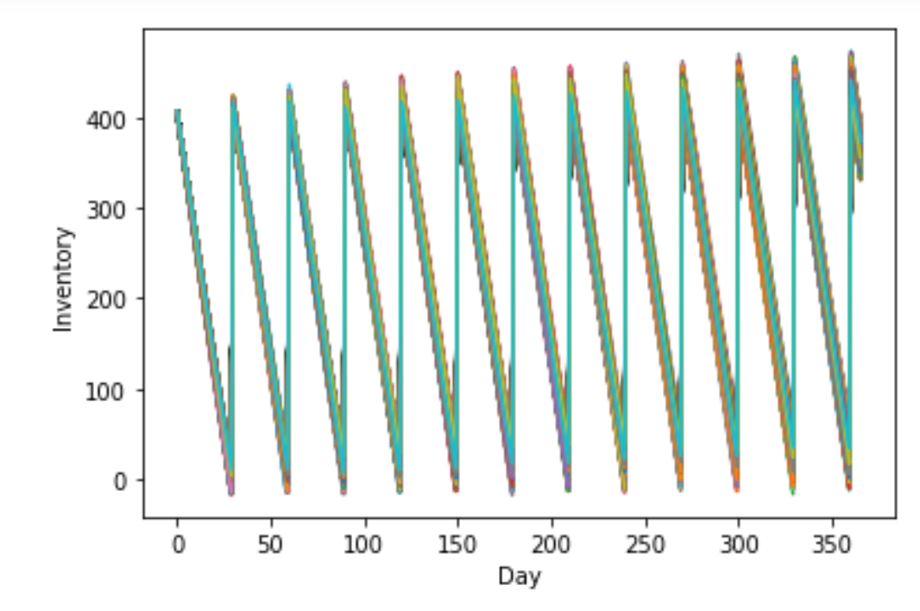
Figure 4-1. Inventory vs time for 10,000 simulated runs
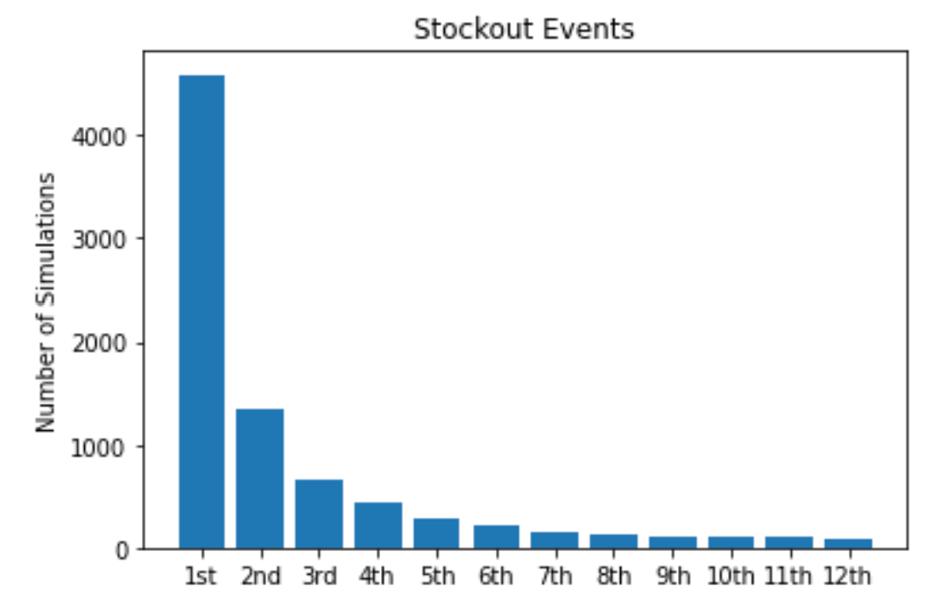
Figure 4-2. Stockout events for 10,000 simulated runs

By terminating the simulation at the first occurrence of a stockout, the ratio of stockouts in each cycle to total number of simulations represents $S_{n}$. In the example shown, parameters of $Q=420$, $D=13$, $λ=1$ were chosen with decision variable of $r=30$. According to the probability formulation, these parameters and variables correspond to $S_{1}=0.45$, $S_{2}=0.13$ and $S_{3}=0.07$. The simulation is thus validated as 4588 of the 10000 runs encountered a stockout within the first cycle, while 1346 of the 10000 experienced a surplus in the first cycle and stockout in the second, and 665 of the 10000 experienced a surplus in both the first and second cycles and stockout in the third.
Additionally, the excess inventory formulation may be validated through further analysis of the same 10000 simulated runs. The average inventory of the last day before a restock was captured and documented for every run that did not end in a stockout under the fourth column of table 1. This extra inventory is calculated as the expected excess inventory shown in column 5 of table 1. With these various formulations validated, the next step in the study is to conduct a scenario analysis in which the costs are analyzed of various PPRP to evaluate the benefits and detriments of varying reorder quantities, shortening and lengthening reorder periods as well as choosing to count more or less frequently.

Order cycle n | Sim R_{n} | Exp R_{n} | Sim Ex(n) | Exp Ex(n)
1 | 0.5412 | 0.54835 | 2.1237 | 2.1790
2 | 0.4066 | 0.41748 | 2.6478 | 2.7378
3 | 0.3401 | 0.34996 | 2.9345 | 3.0162
4 | 0.2968 | 0.30718 | 3.1171 | 3.1897
Table 1. Comparison of simulated vs expected values

Scenario Analysis

To determine the value of counting inventory early, a standard set of parameters were chosen and systematically altered. The effect on total cost per period was then documented and compared. First, the order quantity $Q$ was changed while keeping $D=13$, $λ=1$, and $r=30$ constant. Parameters $h$, $b$, and $C^{C}$ were arbitrarily set to 5, 100, and 100 respectively. The results can be seen in table 2. Not surprisingly, reducing the order quantity below the expected value of $\left(D+λ\right)r=420$ has a large detriment on the cost due to an increased number of stockouts. Both the expected stockout value and the probability of stockout increase with the reduced value of $Q$. Conversely by increasing $Q$, total costs are reduced for every PRRP due to the decreased expected stockout value as well as decreased probability of stockout. As the penalty for carrying extra inventory is comparatively low, the model rewards having extra inventory as a buffer to prevent more costly stockouts.

Q | PRRP_{1-cycle} | PRRP_{2-cycle} | PRRP_{3-cycle} | PRRP_{4-cycle} | PRRP_{5-cycle}
419 | 365.08 | 161.95 | 122.12 | 112.73 | 101.07
420 | 320.89 | 128.33 | 94.05 | 83.48 | 73.05
421 | 271.13 | 101.48 | 73.16 | 62.98 | 54.50
422 | 242.26 | 86.98 | 62.84 | 53.76 | 47.18
423 | 210.47 | 77.26 | 57.05 | 49.85 | 45.38
424 | 188.05 | 73.01 | 55.92 | 50.72 | 48.22
Table 2. Effect of Q on total cost. $D=13, λ=1, r=30, h=5, b=100, C^{C}=100$
A one-cycle PRRP means that the cost of recounting must be paid every cycle, so the total cost is comparatively much higher than longer recounting cycles. However, the trade-off for waiting too long to recount inventory is a natural increase in the excess inventory. For example, with a $Q$ of 421, expected average excess inventory after five cycles of surplus is 5.612. With the same $Q$ of 421, expected average excess inventory after two cycles of surplus is only 3.789. With a higher parameter of $h$, the policy has a larger penalty for failing to recount early. Even with the relatively low holding cost given in the above example, the value of not counting has diminishing returns.

Q | PRRP_{1-cycle} | PRRP_{2-cycle} | PRRP_{3-cycle} | PRRP_{4-cycle} | PRRP_{5-cycle}
419 | 556.23 | 239.94 | 190.35 | 186.21 | 171.71
420 | 470.74 | 176.38 | 138.12 | 132.63 | 121.10
421 | 374.91 | 127.80 | 102.16 | 99.34 | 92.95
422 | 321.69 | 105.44 | 89.61 | 91.85 | 91.41
423 | 263.45 | 94.18 | 88.51 | 98.16 | 105.01
424 | 224.65 | 95.18 | 98.89 | 116.71 | 131.29
Table 3. Effect of Q on total cost. $D=13, λ=1, r=30, h=25, b=200, C^{C}=20$
As illustrated in the above table 3, the optimal order quantity $Q$ and recounting frequency dramatically changes depending on the nature of the stockout, inventory holding, and recounting cost. For example, if the holding cost is high in relation to the stockout cost while the recounting cost is low, then the model rewards counting more frequently. Comparing table 3 to table 2 shows that the count frequency should be increased from every five cycles to every three cycles to obtain the lowest cost objective.

Chapter Five
Conclusions and Recommendations

Managerial Insights

In comparison to traditional (r,Q) or (s,S) policies, PRRP brings two distinct advantages. First, the true inventory value is never assumed accurate. This fundamental assumption of traditional policies is the main cause of unexpected stockouts and potential replenishment freezes. With PRRP, after an initial phase of gathering information to estimate average stockout and demand, an ideal frequency of recounting can be discovered. The true inventory value at any time between recounts is not assumed accurate to the inventory record. The second advantage PRRP holds over traditional replenishment policies is the consistent order quantity and period. An often-over-looked aspect of replenishment policies is the willingness of the supplier to maintain flexibility during times of distress. For example, in an (r,Q) policy, the order period fluctuates while the order quantity remains constant. If a period of unaccounted stock loss causes a rush-order from the supplier, the overall supply chain may become stressed. In many cases, the order may not be filled completely or on time. Similarly, an (s,S) policy often requires the supplier to dynamically change shipment quantities depending on how much is needed to order up to S. PRRP may allow for better planning throughout the entire supply chain, as the replenishment policy maintains consistent order quantity and order periods between recounting cycles.
Through analysis of the numerical experiments, insight can be gained on the nature of PRRP for inventory systems with stochastic stock loss. For any given PRRP, the first reorder cycle has the highest chance of stockout. Subsequent order cycles reduce stockout probability at the cost of holding extra inventory. This continues indefinitely with average extra inventory increasing every reorder cycle. Once a recount is issued, the inventory may be reset to its original level. Surprisingly, this means that initiating a recount will increase the chance of stockout due to depletion of the extra inventory. The optimal trade-off between cost of stockouts, cost of excess inventory and cost of recounting varies depending upon cost parameters but also the probabilities of surplus and stockout. Using recursive formulation can predict the expected total cost of any PRRP.

Conclusion

In this study, a new strategy for inventory replenishment was developed that does not assume perfect inventory record accuracy. The benefit of periodic replenish and recount policies was demonstrated under an inventory system of stochastic stock loss. The value of recounting was also shown through the decrease in total cost of PRRPs with higher count-frequencies. While other strategies to address IRI exist, RFID and cycle-count programs are not applicable to all systems. PRRP is particularly suitable for retail environments in which the chance of theft and misplacement is high. In such areas, it is also unlikely that traditional barcodes would be replaced with expensive tracking technologies, such as RFID. PRRP offers a simple method to address stock loss and inventory record inaccuracy with minimal up-front investment.

List of References

1. Wayman, W.A., Inventory accuracy through warehouse control. Production and inventory management journal, 1995. 36(2): p. 17.
2. Zhu, X., S.K. Mukhopadhyay, and H. Kurata, A review of RFID technology and its managerial applications in different industries. Journal of Engineering and Technology Management, 2012. 29(1): p. 152-167.
3. Rossetti, M.D., T. Collins, and R. Kurgund. Inventory cycle counting–A review. in The proceedings of the 2001 Industrial Engineering Research Conference. 2001.
4. Raman, A., N. DeHoratius, and Z. Ton, Execution: The missing link in retail operations. California Management Review, 2001. 43(3): p. 136-152.
5. Kang, Y. and S.B. Gershwin, Information inaccuracy in inventory systems: stock loss and stockout. IIE transactions, 2005. 37(9): p. 843-859.
6. Brown, K.L., R.A. Inman, and J.A. Calloway, Measuring the effects of inventory inaccuracy in MRP inventory and delivery performance. Production Planning & Control, 2001. 12(1): p. 46-57.
7. Sari, K., Inventory inaccuracy and performance of collaborative supply chain practices. Industrial Management & Data Systems, 2008.
8. Thiel, D., V. Hovelaque, and V.T. Le Hoa, Impact of inventory inaccuracy on service-level quality in (Q, R) continuous-review lost-sales inventory models. International Journal of Production Economics, 2010. 123(2): p. 301-311.
9. Sheldon, D.H., Achieving Inventory Accuracy: A Guide to Sustainable Class A Excellence in 120 Days. 2004: J. Ross Publishing.
10. Nachtmann, H., M.A. Waller, and D.W. Rieske, The impact of point‐of‐sale data inaccuracy and inventory record data errors. Journal of Business Logistics, 2010. 31(1): p. 149-158.
11. Chuang, H.H.-C. and R. Oliva, Inventory record inaccuracy: Causes and labor effects. Journal of Operations Management, 2015. 39: p. 63-78.
12. Fleisch, E. and C. Tellkamp, Inventory inaccuracy and supply chain performance: a simulation study of a retail supply chain. International journal of production economics, 2005. 95(3): p. 373-385.
13. Agrawal, P.M. and R. Sharda, Impact of frequency of alignment of physical and information system inventories on out of stocks: A simulation study. International Journal of Production Economics, 2012. 136(1): p. 45-55.
14. Atali, A., H.L. Lee, and Ö. Özer, If the inventory manager knew: Value of visibility and RFID under imperfect inventory information. Available at SSRN 1351606, 2009.
15. Landt, J., The history of RFID. IEEE potentials, 2005. 24(4): p. 8-11.
16. Sarac, A., N. Absi, and S. Dauzère-Pérès, A literature review on the impact of RFID technologies on supply chain management. International journal of production economics, 2010. 128(1): p. 77-95.

17. Thiesse, F. and T. Buckel, A comparison of RFID-based shelf replenishment policies in retail stores under suboptimal read rates. International Journal of Production Economics, 2015. 159: p. 126-136.
18. Chawla, V. and D.S. Ha, An overview of passive RFID. IEEE Communications Magazine, 2007. 45(9): p. 11-17.
19. Kök, A.G. and K.H. Shang, Inspection and replenishment policies for systems with inventory record inaccuracy. Manufacturing & service operations management, 2007. 9(2): p. 185-205.
20. Kök, A.G. and K.H. Shang, Evaluation of cycle-count policies for supply chains with inventory inaccuracy and implications on RFID investments. European Journal of Operational Research, 2014. 237(1): p. 91-105.
21. Ramanathan, R., ABC inventory classification with multiple-criteria using weighted linear optimization. Computers & Operations Research, 2006. 33(3): p. 695-700.
22. Hadi-Vencheh, A., An improvement to multiple criteria ABC inventory classification. European Journal of Operational Research, 2010. 201(3): p. 962-965.

Vita

Colton K. Ku was born on November 13, 1994 in Glendale, California. He earned a Bachelor’s degree in Pharmaceutical Chemistry from the University of California and a Master’s degree in Chemistry from Duke University. After exposure to the process of getting patented molecules to market, he became increasingly interested in business and engineering. Thus, in 2019 he entered the University of Tennessee to pursue two additional graduate degrees, an MBA with Supply Chain focus and an MS in Industrial Engineering. With a long history of formal education, he excitedly prepares to enter industry in the summer of 2021.

