The College Scorecard: A New Player in the Game

A Thesis Presented for the
Master of Science
Degree
The University of Tennessee, Knoxville

Cynthia J. Sweet
December 2016

Abstract
ii
Almost all products and services offered in the world today are evaluated on any number of criteria such as reputation, quality, popularity, or value, which results in a ranking or a rating of those products or services. In the world of higher education, colleges and universities are ranked and rated based on numerous factors such as academic quality, competitiveness in the admission process, academic programs, experiential programs, geographic location, size, and more by companies like US News and World Report and Kiplinger. In February 2013, President Obama and the US Department of Education launched the College Scorecard (https://collegescorecard.ed.gov), an online tool that “highlights key indicators about the cost and value of institutions across the country to help students choose a school that is well-suited to meet their needs, priced affordably, and is consistent with their educational and career goals” (Duncan, 2013). With the introduction of the College Scorecard, the purpose of this paper is to examine the communication feedback that has occurred since its launch and evaluate that feedback. The study also provides implications for the various stakeholders regarding the College Scorecard. The results included the evaluation of 375 comments which were grouped into four main constituencies; (1) High School teachers, (2) members of the public, (3) College and University faculty and staff, and (4) Special Interest Groups. Within these groups, the top 5 most frequently used words were students, institutions, ratings, systems, and data. The overall findings of the present study indicate the overall reception of the College Scorecard by constituencies with a vested interest in higher education to be the Scorecard is similar to rankings and ratings already executed each year by companies like USNWR and Kiplinger, meaning that while the ideology and intent may be good, the execution is lacking in its ability to achieve fair and equal unilateral comparisons between institutions.
Table of Contents
Chapter 1: Introduction 1
Chapter 2: Review of Literature 17
Rankings and Ratings 17
History of US News and World Report 18
History of Kiplinger 19
Development of the College Scorecard 21
Chapter 3: Methodology 24
Chapter 4: Findings 28
Online Feedback 46
Chapter 5: Conclusions and Recommendations 50
References 55
Appendices 59
A: USC Aiken Postcard 60
B: USNWR Annual Peer Assessment 61 C: A Look Inside the College Scorecard’s Data (Lawlor Review) 62
Vita 79
Chapter 1: Introduction
Almost all products and services offered in the world today are evaluated on any number of criteria such as reputation, quality, popularity, or value, which results in a ranking or a rating of those products or services. Social media feeds are full of “Top 10” lists of products, vacation spots, celebrities, websites; “Best of” lists; “Worst of” lists; or humorous videos showing people or companies who have “failed” to accomplish their intended task, activity, or message. In the world of smart phones and tablets, apps are rated by users. Users review products on company websites that result in ratings of the products sold over time. There is even a website simply named “thingsrated.com,” a conglomeration of these types of ratings, rankings, and lists.
In the world of higher education, colleges and universities are evaluated in numerous ways: academic quality, competitiveness in the admission process, academic programs, experiential programs, geographic location, size, and more. College rankings are not new, and there are a number of well-respected companies that produce yearly publications specifically focused on “Best of” college and university lists. In February 2013, President Obama and the US Department of Education launched the College Scorecard (https://collegescorecard.ed.gov), an online tool that “highlights key indicators about the cost and value of institutions across the country to help students choose a school that is well-suited to meet their needs, priced affordably, and is consistent with their educational and career goals” (Duncan, 2013).
With the release of the College Scorecard, the US Government and Department of Education entered the world of college performance evaluation alongside respected companies such as US News and World (USNWR), Kiplinger, Princeton Review, Niche Colleges, Forbes, and College Factual just to name a few. Since a number of well-established publications about college performance already exist, why did the President feel it was important to join the world of evaluation of college and university performance? The answer lies in the end product—the data and information made available to high school and college transfer students searching for a college, specifically regarding what information is most relevant and important to a college bound student’s ability to make an informed decision in today’s world—and President Obama’s belief that students are not getting the information they need from other sources.
The purpose of this paper is to examine the communication feedback that has occurred since the initial College Scorecard launch. Because social reality, how colleges and universities are perceived in this case, is constructed through interactions with others (Berger & Luckman, 1967; Mead, 1934), this exploratory study examines the ways in which various stakeholders have discussed the College Scorecard. Specifically, the study closely examines electronic feedback provided to the US Department of Education by college and university administrators, high school counselors, and the public. The study also provides implications for the various stakeholders regarding the College Scorecard.
Policy Evaluation
“There is a growing recognition that obtaining feedback from users is fundamental and integral part of measuring effectiveness and without such perspective, policy evaluation will have limited legitimacy” (Knox & McAlister, 1995, p. 413). Knox and McAlister discuss how policy evaluation, in our case the evaluation of the College Scorecard, is used to try to determine how well a policy or program has been constructed and how well it has been received by the intended audience. They state:
Policy evaluation is now an integral part of the public process in which programmes are reviewed to assess whether they have achieved their stated objectives and the intervention has had the requisite impact. Evaluation has been variously defined as ‘an assessment of the effects or outcomes of an activity compared with the goals which the activity was intended to achieve’ (Connor 1993, p. 8) and ‘a critical and detached look at a programme’s objectives and how they are being met’ (HM Treasury 1988, p. 1). Both definitions are deceptively simple especially when applied to the evaluation of public policies whose goals are broad-based, multifarious, and as a consequence, not easily amenable to quantitative measures of policy effectiveness (p. 413).
In the case of the College Scorecard, policy evaluation was sought by an open call for comments by the Department of Education. The Department of Education was wise to seek feedback because “In an abstract sense, every citizen, taxpayer, actual, potential or future user has an inherent interest in the outcome of the evaluation of public services” (Knox & McAlister, p. 414). By doing so, the Department of Education perhaps recognized the importance of feedback, as Knox and McAlister’s state “There is a political and professional commitment to redefine recipients of public services as customers or consumers” (p. 416).
They argue that ‘in the end it is only the public for whom the service is provided who can judge performance’ (Clarke and Stewart, 1987, p. 34). The key role played by service users in the recent drive to improve quality is yet another dimension of empowerment. Although quality is ‘inherently hard to define or measure’ (Audit Commission 1992, p. 7), there is a growing consensus that it must make some reverence to validation by the end user, since the only real measure of quality of service is whether it delivers customer satisfaction: ‘Quality is…a customer’s perceptions of certain features of the service and the values placed on these features. Quality is, therefore, in the eye of the beholder (Jackson & Palmer 1992, p. 50).
The importance of incorporating user’s views “leads not only to identifying and addressing the questions most salient to recipients, but increases ownership of suggestions made to review service provision/levels resulting from the evaluation (Mark & Shotland, 1985). Secondly, the decision making process is no longer the preserve of either politicians and/or public officials, and user inputs reflect this assertion” (Knox & McAlister, 1995, p. 417). With regards to ratings and ranking such as USNWR, Kiplinger, and the College Scorecard then, who are the “users” and how will their views be incorporated in the new player in the game, the College Scorecard? “The most obvious user is the direct recipient of the public service, but beyond this, there are both potential and future users with various degrees of interest in the service” (p. 418). Beyond defining who the “user is,” they go on to ask “What is the value of the input? (p. 419) and what is the “Stage, level, and cost implications of user involvement? (p. 420). Knox and McAlister developed the framework below as a guide (See Table 1).
Organizational Responses to the College Scorecard
Prior to the official release of the government College Scorecard, the Center for American Progress (CAP) agreed with the idea and overall concept of the Scorecard: “At a time when student loan debt has exceeded $1 trillion, fewer than 60 percent of college freshmen graduate within six years, and the wages of recent grads have declined by nearly 5 percent since 2007, it’s more important than ever that students make good decisions about where to go, what to study, and how to pay” (Morgan & Dechter, 2012, p. 1), but they had concerns about the overall design and effectiveness of the Scorecard. CAP conducted a thorough review of the Scorecard by “taking the college scorecard to college-bound high school students, asking them for feedback on design, content, and overall effectiveness” (p. 2) and conducting focus groups. CAP showed four different groups of college-bound high school juniors and seniors the government draft
Table 1 User input in policy evaluations (p. 421)
Evaluation Question | Most Appropriate Conditions
Who is the user? | Person actually using the service; user group(s) clearly identifiable; strong group cohesiveness from which a representative sample is drawn.
Value of user input? | Most valuable where:  Interests of professionals and users diverge;  Users can competently judge effectiveness—knowledge, information, choice;  Objective and subjective indicators used concurrently;  Role of users as evaluators is negotiated in advance with other stakeholders.
Stage of input? | When policy is first introduced or substantially revised;  Summative evaluations or impact measurement;  Degree of discretion and flexibility afforded to evaluator—evaluation timeframe may be driven by funding requirements.
Level of input? | Responding to service provision levels and quality; programme-specific;  Local service delivery.
Cost of input? | Resources (money, time, and methodological expertise) to elicit the views of the representative user sample.

version of the College Scorecard as well as an alternative version of the Scorecard designed by CAP so the students would have something against which to compare the government Scorecard.
After students had a chance to review both versions of the documents, they were asked questions such as “What’s the purpose of this document?” (p. 6). Students’ general reaction was confusion and lack of understanding about what type of information they were looking at and what it was supposed to be communicating. A common reaction from students was “What am I looking at?” (p. 6). Rather than reading the documents in linear fashion, students tended to scan for information with numbers such as tuitions and fees, graduation rates, and potential earnings. Because students could identify these pieces of information, they initially felt as if they had an understanding of the documents, but when asked to explain the overall purpose of the information they were unable to do so. The reason was due to missing contextual information on both Scorecard versions about the purpose of the informational disclosures or overall document. Additionally, students commented that both versions lacked enough information; a document that was more of a “one-stop shop” would be much more useful to them.
Another area that confused students was terminology used in both versions of the Scorecard. For example, when students were asked what the terms “net price” and “out-of-pocket” cost meant, “students most often responded with blank looks or general comments such as ‘It includes everything, altogether.’ And most students could not decide whether the net price or out-of-pocket figure would include the amount a student would take out in loans” (p. 8). It is not surprising that students were confused by terminology on the Scorecards as the college search process is full of language and abbreviations all its own, which are not common across all institutions. Student reaction to graduation rate information was that they found the information to be a relevant measure of the quality of a college, but there was a general lack of knowledge of the reality of four-year versus six-year graduation rates. “Students were generally more interested in a four-year graduation rate than a six year one. While students said they were aware that many college students take longer than four years to graduate, every student we spoke to expected to graduate in four years” (pp. 9-10).
Students had mixed reactions to student loan debt information and showed wide ranges of interpretation. The government Scorecard includes information about “student loan repayment” (p. 10) and employment. The student loan repayment refers to “the percentage of a student’s total outstanding student loan debt that is in repayment” (p. 10), which did not make much sense to the students and was, therefore, ruled out by them as useful information in the decision making process. The CAP version replaced student loan debt information with the student loan default rates, which was met with mixed reviews. Some students did not understand what it meant to be in default, some felt default rates were a reflection of the ability to get a good job, and some felt default data gave more information about an individual than an institution.
Limitations of the CAP focus groups were that the groups did not include parents, non-traditional students, or include one-on-one cognitive interviews. Based on the findings of their study, CAP made the following recommendations for a more effective College Scorecard: (p. 14)
- Introduce readers to the scorecard with a simple and descriptive name, logo, and introductory sentences.
- Consult with graphic designers to improve the scorecard’s layout.
- Test ways of better communicating the term “net price”.
- Highlight the likelihood of graduating in four years, not six.
- Develop alternative measures of student debt that matter to students.
- Use links to provide additional employment outcomes.
- Customize whenever possible.
The Penn Center for Minority Serving Institutions (MSIs) “serves as a repository for research, data, best practices, emerging innovations and ideas on and within MSIs.” There were specific concerns about the “one size fits all” approach of the government scorecard. True to their mission, the center narrowed their focus on the government scorecard specifically to how Historically Black College and Universities (HBCUs) fared on the scorecard, because “certain institutions, most notably those that serve underrepresented student groups, are presented less favorably than others” (p. 2). Like the Center for American Progress, The MSI also recommended an alternative scorecard in an effort to create a product that would truly educate and inform all college-seeking students with regard to relevant decision-making information.
The MSI makes an important point by noting the government Scorecard does not allow for extenuating circumstances that may have negatively affected institutions in past years. For example, Dillard University, a HBCU in New Orleans, Louisiana, has a Scorecard graduation rate of 24 percent. While this is an accurate rate, it is an incomplete representation of the institution. In late August of 2009, only a few weeks into the start of the fall semester, Hurricane Katrina devastated Dillard University, along with the rest of the Gulf Coast. Students from Dillard, and all other colleges and universities in the area, were forced to transfer to other institutions, thereby affecting retention and graduation rates of the schools they left. There is no way to account for instances such as this on the government scorecard.
Similar to the CAP findings, metrics related to costs and financial aid cause confusion. “Simplifying the cost to a single, averaged numerical value means that a low-income family who may qualify for a full or near-full financial aid package (either through institutional and state or federal support) could be led to believe that their cost would be higher than reality” (p. 5). Another similarity to the CAP findings was concern over the four- and six-year graduation rates. “The lack of 2-and 4-year graduation data may mislead students who do not read the methodology section, or it may make the metric irrelevant to students who understand the metric but intend to graduate before the 6-year timeframe (Decter & Morgan, 2012, p. 12)” (p. 5).
The MSI also felt the employment metric in the government scorecard showed bias against certain types of institutions including liberal arts schools, while technical and trade schools scored well. Technical and trade schools tend to lead to higher paying jobs immediately following graduation, while liberal arts degrees lead to higher-paying jobs over a longer timeframe. With regards to institutional performance, the MSI noted the government Scorecard as being shortsighted and unfair towards HBCUs. “The federal government’s interpretation of institutional performance is grounded in the idea that all institutions with higher graduation rates are doing something better to help their students graduate than schools with lower graduation rates. The College Scorecard, however, does not account for student preparation” (p. 6). Highly selective institutions have the ability, and luxury of being able to admit the most academically prepared low-income students and have the resources to graduate these students in less than six years. HBCUs do not have the same pool from which to draw students, the same resources, nor the same admission requirements and programs.
The MSI made three recommendations for an improved scorecard as follows:
- Align metrics with priorities of students—the authors noted that according to research conducted by the Cooperative Institutional Research Program of HBCU freshmen, the pieces of information that were most important to them when deciding on a college were total cost, financial aid, institutional reputation, and employment following graduation. “Rankings in national magazines was chosen by fewer than 18% of HBCU freshmen, suggesting that yet another rankings system, even one introduced by the White House, may have little impact on these students’ college decision-making processes (Eagan, Lozana, Hurtado, & Case, 2013, p. 38)” (p. 11-12).
- Create features that can be customized
- Develop a probability score to reflect varied and complex student needs and reward successful student outcomes—President Obama proposed “The College Opportunity and Graduation Bonus,” which would award $7 billion over 10 years to institutions “that graduate significant numbers of low and moderate income students. The amount of the bonus will be partially determined by the percentage of Pell grant recipients in each graduating class” (p. 14). “The overall graduation rate and loan default rate for outstanding federal loans of an institution will be considered when determining eligibility for the bonus. Many of these factors are also incorporated in the College Scorecard. This initiative could be amended to develop a more holistic system of evaluation for prospective students to determine the value of institutions, while rewarding those that enroll and graduate students from traditionally underserved populations” (p. 14).
Both the CAP and MSI believe in the value of a government Scorecard, if the information provided is user friendly, easy to understand, clearly communicated, and relevant to the college search process.
Rationale
At the start of each new recruiting season, colleges and universities eagerly await notification of how USNWR and others have ranked or rated them. With notifications in hand, they begin to promote their standings through press releases, badges on their websites, and inclusion in printed recruitment materials. How well a school is ranked or rated guides the institution’s narrative for the upcoming recruiting season. If a school is ranked or rated poorly, the administration may discuss the ways rankings and ratings are not a realistic or reliable evaluation of the school’s true worth. “College and university presidents repeatedly publicly pronounce that the USNWR rankings are not a measure of the quality of their institutions, that an institution’s quality cannot be measured by a single number, that changes in an institutions rank are often due to USNWR’s periodically changing the way the rankings are calculated, and that their university does not pay any attention to the rankings” (Ehrenberg, 2002, p. 147).
Alternatively, if a school is ranked or rated highly, administrators are quick to use the information as bragging rights and justification as to why their school should be chosen over others and how it will be the best college decision a prospective student can make. (See Appendix A for a postcard showing how USC Aiken promotes their USNWR results) In this case, there is good reason to brag. USNWR rankings impact an institution in a number of positive ways:
They found that changes in a school’s USNWR ranking had a significant impact on the admission rate, yield, and SAT scores of the next incoming class. According to Monks and Ehrenberg, moving up one rank in the USNWR corresponded to a 0.4% reduction in the acceptance rate, a 0.2% improvement in the yield, and a three-point gain in the average SAT score the following year. In addition, Monks and Ehrenberg found that a one-rank improvement in USNWR allowed schools to raise tuition by 0.3% the next year (Monks & Ehrenberg, 1999 quoted in Meredith, 2001, p. 446).
However, it is important to note that Monks and Ehrenberg’s results could be somewhat misleading if applied too broadly as their study was limited to private schools, most of whom were found in the top 25 USNWR rankings. At the surface, it is possible to mistakenly think that a ranking, rating, scorecard, or some other type of measurement of any particular product levels the playing field for anyone considering a purchase of the same type of product from different vendors, or, in this case, prospective students who are searching for a college or university.
Companies such as USNWR, Kiplinger, and now the College Scorecard, aim to create a system in which a fair decision about the education students and their parents are seeking to purchase by determining the worth of an education in terms of a ranking, rating or scorecard. However, as previously mentioned, college and university administrators will declare rankings and ratings to be unfair evaluations if their institution is either unranked or rated poorly. Additionally, research indicates there are cultural limitations to rankings, ratings, and rating cards (RCs), the system with which the College Scorecard most closely aligns. Culture, or “a system of shared beliefs, values, customs, behaviors, etc., which [sic] affect the behaviors of different groups in society, often identified with particular ethnic groups” (Cremonini, Westerheijden, & Enders, 2007, p. 380), is completely void in higher education rankings, ratings, and RCs. Incorporating culture into advertising is key to the success of the advertisement; tailoring advertisements to their cultural audience may mean using “individualism, competitiveness, and comparisons between brands” in western cultures or “status symbols and indirect expression” in East Asian cultures (p. 381).
The system of higher education in the United States is considered the best and the “envy of the rest of the world” (Ehrenberg, 2002, p. 145). Over 3,600 public and private colleges and universities across the US all compete for students and “an institution’s geographical location, selectivity, size, whether it is church related, the degrees that it offers, and the range of its curriculum, determine the specific institutions that are its competitors” (p. 145). The college choice process is one that can be quite daunting and overwhelming for families given the number of options available to them. How does a family even begin to make this important and possibly expensive decision?
Uncertainty Reduction Theory (URT) is a theory that was developed “to account for communication that occurs when strangers encounter each other” (Berger, 2011, p. 215). URT focuses on the initial interaction that occurs between strangers and how the parties address uncertainties they have about each other. In our case, the parties are prospective students and their families and the colleges and universities in which they are interested. “In the service of predicting, and in some cases explaining, each other’s beliefs and actions so that communicative choices can be made, individuals seek to reduce their uncertainties by acquiring information about each other. Initial interactions are highly saturated with questions during their initial few minutes (Berger & Kellerman, 1983) and individuals may employ a variety of strategies to acquire uncertainty-reducing information (Berger, 1979; Berger, Gardner, Parks, Schulman, & Miller, 1976; Berger & Kellerman, 1994; Kellermann & Berger, 1984)” (Berger, 2011, p. 215). In the case of the college search process, prospective students and colleges and universities seek to reduce uncertainty about each other through information seeking, a process that involves different layers of interaction. Students seek information about colleges and universities that offer academic programs, social opportunities, and career opportunities they seek; colleges and universities seek information about which prospective students to admit with the goal of those students becoming graduates and alumni of the institution.
Prospective students and their families move through different stages during the college search process in an attempt to reduce uncertainty about the institutions in which they are interested. A passive approach might include observing the college or university from a distance. The family may review the institution’s website or, if they live nearby, drive through the campus. If they like what they see, they may move into a more active approach by asking others about the institution or set up a campus visit. During the campus visit, they can observe the institution by walking around the campus, sitting in on a class, or eating in the dining hall. By moving through the passive and active information seeking phases, they may move into the interactive stage by setting up appointments to communicate directly with key players on the campus such as admissions personnel, faculty, and currently enrolled students.
“College choice is usually a three-stage process involving analytically successive decisions on collecting, evaluating, and acting on information about higher education institutions (‘colleges’), which finally lead students to enroll in a particular higher education program” (Cremonini, et al., 2007, p. 375).
At a very high level, the process begins when a student decides to attend college after high school. The student then begins to focus on learning about different colleges and universities in which he or she may be interested by contacting the school to request information and visiting the school’s website. Having identified a number of schools of interest, the student begins the application process. The next stages of selection involve many factors such as further exploring price, cost of attendance, financial aid, programs of study—all of which lead to further refinement of the list. Finally, the student selects an institution and enrolls. There are three types of college choice models (Hossler, Schmit, & Vesper, 1999; Jackson, 1982) that “specify factors leading to enrollment decisions; sociological, econometric, and combined” (Cremonini, et al., 2007, p. 375). The econometric model focuses on “the relationship between the attributes of goods (college and job characteristics) and individual choices, and these interests lead to models that emphasize the interaction between preferences, largely a function of aspiration, and constraints” (p. 375). Within one view of this model, students evaluate their options post high school such as attending college versus entering the military or workforce.
Another view of this model states college choice is more narrow and decided by enrolling in a particular program at a particular institution (Chapman, 1984; Kohn, et al., 1976). Under either view, total cost, expenses, and potential earnings post-graduation are factors in the final decision. Interestingly, there is a cultural component to this model in which “family background characteristics (income, education level, occupation), average ability, and sociological factors such as aspirations of neighborhood peers or parents’ educational background” (p. 376) play a role. Simply stated, does the culture from where the student comes see the value of education and support students who wish to pursue a degree?
The sociological model, also known as the “status-attainment” model, has a cultural connection as well in that “the socialization processes, family conditions, interactions with peers, school environments, etc. have a significant impact on students’ college choices” (p. 376). The combined models include many factors such as different stages of college search, and numerous different factors in the selection process such as family background, location, size, academic offerings, costs, finances, attainability, and input and judgements from people of influence in the student’s life.
In 2008, Morse indicated that rankings had “resulted in colleges reporting higher quality and more consistent data to the public” and that “colleges have made more serious efforts to ensure that the data they make public is accurate since they know it will be used in rankings” (p. 354). President Obama has indicated a desire to tie federal funding to College Scorecard data by 2018; colleges would not only receive incentives for providing accurate data, but also work hard to deliver a high quality education at a reasonable price. Given the high stakes for colleges and universities with respect to the College Scorecard, an examination of how it is being received and used is warranted.
Before arriving at the point of issuing federal funding, President Obama needed information about how well the College Scorecard would be received by a variety of people including those associated with the colleges and universities as well as those who were considering college/university attendance. As part of the uncertainty reduction process, the College Scorecard became available online to seek feedback from these various constituencies. The feedback provided is the data used to address the following research question: How has the College Scorecard been received by groups of people who have specific interest in the college and university selection process?

Chapter 2: Review of Literature
This chapter discusses the difference between rankings and ratings, makes a determination of ranking or rating with regards to US News and World Report, Kiplinger, and the College Scorecard, and highlights evaluation criteria utilized by all three. By doing so, areas of overlap and distinction are established among the group. Second, the chapter discusses how those in higher education perceive college rankings and how institutions try to leverage their rankings when competing for students. Next, it presents how prospective students use college rankings during the college search. What is most interesting to note is the absence of college rankings, ratings, or RCs in any of the college selection models, which brings us to our discussion of USNWR, Kiplinger, and the College Scorecard rankings and rating.
Ratings and Rankings
For the context of this paper, understanding the differences between a ranking and a rating is important. Merriam Webster defines “ranking” (singular) as “having a high position or the highest position in a group or organization” (Merriam-Webster’s Learner’s Dictionary, 2015). Merriam Webster further defines “rankings” (plural) as “a list of people or things that are ordered according to their quality, ability, size, etc.” Therefore, a “ranking is a relationship between a set of items such that, for any two items, the first is either 'ranked higher than,' 'ranked lower than' or 'ranked equal to' the second” (Ranking. 2015, https://www.wikipedia.org/).
Rate, as defined by Merriam Webster (2015), is “a measurement of how good, difficult, efficient, etc. something or someone is” and “to make a judgement about the quality, ability, or value of someone or something.” A rating is “the evaluation or assessment of something, in terms of quality (as with a critic rating a novel), quantity (as with an athlete being rated by his or her statistics), or some combination of both” (Ranking. 2015, October 15. Retrieved November 15, 2015, from https://www.wikipedia.org/).
To summarize, a ranking is a comparison of two or more items, goods, or services against each other resulting in one being ranked as being as better or worse than another. A rating is the evaluation of an individual item, good, or service resulting in a Likert-type scale of 1-10 where one may represent the item, good, or service as having little to no value and a 10 may represent high value (Gee, 2013).
USNWR, Kiplinger, and the College Scorecard
History of US News and World Report.
US News and World Report (magazine and website) annually publishes a ranking of colleges, which “began in 1983, strictly as a reputational survey of schools’ presidents. In 1987, USNWR switched to its current format of combining objective and reputational data” (Meredith, 2004, p. 444). The USNWR results are classified as rankings because they compare colleges and universities against each other, resulting in one being ranked higher or lower than the rest. Schools can also tie for a position on the list and the tie can be representative of two or more schools. USNWR groups colleges and universities into two categories: National Universities and Liberal Arts Colleges. These rankings are “based on up to 16 key measures of quality” that fall into “seven broad areas” (Morse and Brooks, 2015) as listed below. “The indicators include both input measures, which reflect the quality of students, faculty, and other resources used in education, and outcome measures, which capture the results of the education an individual receives” (Morse & Brooks, 2015).
- Undergraduate Academic Reputation--includes peer assessment (See Appendix B for copy of USNWR Peer Assessment tool) for National Universities and National Liberal Arts Colleges categories as well as high school counselors’ ratings
- Graduation and Retention Rates--average graduation rate and average first-year student retention rate
- Faculty Resources--salary, percent with terminal degree in their field, percent of full time faculty, student-faculty ratio, and class size
- Student Selectivity--acceptance rate, high school class standing in top 10%, high school class standing in top 25%, critical reading and math portions of the SAT and composite ACT scores
- Financial Resources--average spending per full-time equivalent student on instruction, research, public service, academic support, student services, and institutional support with heavier weight for higher average expenditures per student
- Alumni Giving--average alumni giving rate
- Graduation Rate Performance--the difference between the actual six-year graduation rate for students entering in fall 2008 and the predicted graduation rate. The predicted graduation rate is based upon characteristics of the entering class, as well as characteristics of the institution. A school with a higher ratio of its actual graduation rate compared with its U.S. News predicted graduation rate (actual graduation rage divided by predicted rate) scores better than a school with a lower ratio
History of Kiplinger
Kiplinger (magazine and website) also publishes an annual ranking of colleges. Kiplinger entered the world of college rankings in 1998 when it produced its first ranking of “Top Public Colleges.” It continued to publish ranked lists in 2000, 2002, 2003, 2006, 2007, 2008, and annual lists from 2010 to present. Additionally, Kiplinger began releasing an annual “Best Private College Values” list in 1999, named “Private Universities and Liberal Arts Colleges.” The second list in this category was not published until 2004. Beginning in 2007, two lists were published on an annual basis: “Liberal Arts Colleges” and “Private Universities.” (Wojino, Pitsker, Bansal, Zou, & Kuchler, 2016).
Kiplinger results are also classified as rankings because they compare colleges and universities against each other, resulting in one being ranked higher or lower than the rest. Kiplinger’s ranking model indicators are similar, yet different from USNWR. Kiplinger establishes a base line set of data by utilizing Peterson’s Data Collection (http://www.petersonsresearch.com/) on close to 1,200 public and private four-year schools and then adds its own reporting to the data. According to the Kiplinger website (2015),
We narrow the list based on measures of academic quality. We then rank each school using cost and financial aid measures. Quality criteria account for 55 percent of total points and cost criteria account for 45 percent. We include a combined list of the 50 best values in private liberal arts colleges, private universities and public colleges to show how the top schools in each of the three categories stack up against each other. We also include our rankings of the top 50 private universities, top 50 liberal arts colleges and top 100 public universities”
Kiplinger rankings fall into five broad areas:
- Competitiveness--percentage of applicants offered admission and percentage of those who enroll
- Graduation Rates--most weight given to the four-year graduation rate
- Academic Support--freshman retention rate and student-faculty ratio
- Cost and Financial Aid--most weight given to schools with the lowest tuition fees, room and board, and books with points added for schools that reduce price through need based and non-need based aid, highest points awarded to schools with highest percentage of need met
- Student Indebtedness--average debt at graduation with higher scores awarded to schools with a lower number of student borrowers.
Development of the College Scorecard
In 2013, President Obama publicly started talking about the value of higher education and called into question rankings produced by companies such as USNWR and Kiplinger. The President “argued that ratings actually incentivize colleges to ‘game the numbers and in some cases, [get rewarded] for raising costs” (Zhou, 2015, par. 1). The President also believes that colleges are motivated to work towards higher rankings, but by doing so, neglect a major indicator of a college’s success: student outcomes such as debt after graduation, employability, and salary earnings.
Officially released in September 2015, The College Scorecard incorporates nearly two years of federal data and delivers an online rating of colleges, which is different from the USNWR and Kiplinger rankings of colleges. The Scorecard “gives users extensive federal data on the student-debt and attendance-cost data for more than 7,000 U.S. higher-ed institutions allowing them to compare institutions; students can use the Scorecard to list and sort schools based on the institutions’ on-time graduation rates, school size, and salary after attending, among other factors” (Zhou, 2015, par. 2). The College Scorecard model indicators, as compared to USNWR and Kiplinger’s, are similar, yet different. Scorecard ratings fall into five broad areas (See appendix C “A Look Inside the College Scorecard’s Data”:
- Costs--average net price undergraduate students pay per year after grants and scholarships
- Graduation Rates--percentage of first-time undergraduate students enrolled full time who graduate in 6 years
- Loan Default Rates--percentage of students that defaulted on their student loans within 3 years of graduation
- Average Amount Borrowed--average amount of federal aid borrowed
- Employment Outcome--average earnings of students who attended then institution and borrowed federal student loans
Comparison of the USNWR, Kiplinger, and College Scorecard
While the purpose of this paper is not to focus in detail on each individual area of evaluation used by USNWR, Kiplinger, and the College Scorecard, it is necessary to demonstrate how the College Scorecard is truly different by establishing areas of overlap and distinction among the three.
- Graduation Rates/Retention—USNWR, Kiplinger, and The College Scorecard
- Faculty Resources/Academic Support—USNWR and Kiplinger
- Selectivity/Competitiveness—USNWR and Kiplinger
- Financial Resources/Cost and Financial Aid—USNWR, Kiplinger, and The College Scorecard
- Graduation Rates—USNRW, Kiplinger, and The College Scorecard
- Academic Reputation—specific to USNWR
- Alumni Giving—specific to USNWR
- Student Indebtedness—specific to The College Scorecard
- Loan Default Rates—specific to The College Scorecard
- Average Amount Borrowed—specific to The College Scorecard
- Employment Outcomes—specific to The College Scorecard
The differences in the criteria and data used by the three and the fact that USNWR and Kiplinger are rankings as opposed to the College Scorecard rating of colleges, indicates that college-bound students, their families, and high school counselors who assist students in the college selection process now have a different way of evaluating the value of a particular institution. This alternative places heavier emphasis on cost, debt, and outcomes.

Chapter 3: Methodology
This paper answers the question “How has the College Scorecard been received by groups of people who have specific interest in the college and university selection process?” It uses content analysis as the method for studying the meaning and context of feedback electronically submitted to the US Government about the College Scorecard by parties involved in the college search and selection process. (Retrieved June 13, 2016, from http://www.merriam-webster.com/dictionary/content analysis). The results of the analysis are evaluated by reviewing the top five most frequently used words and making a determination as to the positivity or negativity of the words in their context in the comments. This was done by not only looking at the word itself, but also the surrounding content of the word. Both manifest and latent coding were conducted (Krippendorf, 2013). “Manifest coding focuses on the content of the respondent’s answer to a question; latent coding focuses on the style of the person’s answers” (Wiseberg, H., Krosnick, J., & Bowen, B., 1996). Latent coding identifies the context in which the words are used to understand the intent behind them. For example, the word “positively” alone could be interpreted as a positive by itself, but when coded in context, could be negative. An example of the word in a positive context could be “The College Scorecard impacts students’ ability to research colleges positively due to the data available.” An example of the word in a negative context could be “I am positively sure there is no use for the College Scorecard in the college search process.”
Coders reviewed each word as well as surrounding content to make a determination of positive or negative. Comments that could have been considered as neutral were categorized as either positive or negative by separating them at the point of transition. For example, the comment “The idea of the College Scorecard is one in which we support due to its potential to better inform high school students searching for a college, but in its current form, lacks proper data points and key measures of success and cannot be supported at this time without changes” was split at the transition of “but in its current form.” The first half of the comment was coded as positive while the second half of the comment was coded as negative. Coders reached consensus through review of the context of the word and discussion of sentiment. Determinations of positive sentiment were comments that included words, synonyms or phrases such as “good,” “we support the development of such a tool,” or “The College Scorecard has the potential to provide useful information to students.” Negative sentiment were comments that included words, synonyms or phrases such as “lacks in use of correct data,” “misinformed,” “incomplete,” or “does not include proper measures.”
Feedback submitted to the US Department of Education about the College Scorecard was collected from the website (http://www.ed.gov/collegeratings). Thirteen PDF files with numerous comments from the public were downloaded. All of the PDF files were converted into Word documents. The comments were then copied and pasted from the Word documents into individual rows in an Excel file. The Excel columns were as follows: (a) an individual ID for each comment, (b) each comment was assigned a constituency group ID (high school students, teachers, members of the public, college and university faculty and staff, and special interest groups), (c) the date the comment was submitted, (d) the comment(s) themselves, (e) any signature included in the comment, and (f) any additional branding included in the comment(s). Branding is defined as “The process involved in creating a unique name and image for a product in the consumers’ mind, mainly through advertising campaigns with a consistent theme. Branding aims to establish a significant and differentiated presence in the market that attracts and retains loyal customers” (http://www.businessdictionary.com/definition/branding.html). The results included the evaluation of 375 comments grouped into four main constituencies; (1) High School teachers, (2) members of the public, (3) College and University faculty and staff, and (4) Special Interest Groups. The four constituency groups were established after each coder reviewed the comment and assigned it to a group. The initial review included 34 constituencies. Coders discussed each group and reassigned them to one of the four constituencies listed above. For example, private high school teacher and public high school teacher are both considered to be members of constituency one, high school teacher. Agreement between coders in grouping constituencies was easily achieved due to most comments being easily identified either in the context of the comment or by an email signature including name, title, and other identifying information. If there were no identifying information the comment was assigned to the member of the public group.
The data were uploaded to NVivo 11 Pro, software that “supports qualitative and mixed methods research. NVivo is designed to help organize, analyze and find insights in unstructured, or qualitative data like: interviews, open-ended survey responses, articles, social media and web content” (http://www.qsrinternational.com/what-is-nvivo).
Limitations
Limitations of this process included the ability to interpret each comment with 100% accuracy due to the fact that during the conversion from PDF to Word, some text quality was lost. The Excel was reviewed carefully to clean up text that was jumbled during the conversion by referring back to the original PDF document. Comments that were clearly duplicates were deleted. Coders also noted that some comments were submitted via email after attempts to use the online form failed. It is not possible to know how many commenters tried to submit the online form without success and did not try to find an alternative method to submit their comments. Evaluation of the feedback submitted is limited to the time at which it was submitted, which was immediately after the release of the College Scorecard. It does not allow for a “real time” evaluation after a year or two has passed since its release. Comments submitted measured immediate sentiment as opposed to sentiment after the Scorecard has been in use for some time, offering the opportunity for re-review and evaluation.

Chapter 4: Findings
To begin review of the data, a word frequency search was performed. Table 2 represents the top five most frequently occurring words across the four constituency groups excluding stop words. As opposed to a top 10, or more, list of words, by using a cut off of weighted percentage of use of a word at 1.0 percent, the top 5 words were chosen for evaluation because there was considerable drop-off in the number of meaningful word frequencies beyond the top five. Due to the large amount of text in comments submitted, words beyond the top five were unrelated to the overall sentiment of the comments. Stop words were words that were not relevant or descriptive and did not have an impact on the results. Stop words include words that mark nouns such as “the,” “a,” “an,” and “another”; coordinating conjunctions such as “for,” “an,” “nor,” “but,” “or,” and “so”; and prepositions. The columns from left to right are the most frequently occurring word, the count (number of times the word and similar words occurred), the weighted percentage which assigns a portion of the word’s frequency to each group (the frequency of the word relative to the total words and similar words counted), and the similar words, and the number of references coded as either positive or negative by the software (see Table 2).
Table 3 represents the order in which the top five most frequently occurring words across the four constituency groups. The columns from left to right are the top five most frequently occurring word, and the order in which the word appeared for each constituency. In this table, students was the top word across all four groups and ratings was the second most frequently used words across three of the four groups.

Table 2 Top five most frequently used words by all constituencies
Word | Count | Weighted % | Similar Words | Positive | Negative
Students | 3898 | 3.7 | student, students, students', students’ | 362 | 242
institutions | 2719 | 2.58 | institute, institutes, instituting, institution, institution', institutional, institutionally, institutions, institutions', institutions’ | 228 | 153
Ratings | 2516 | 2.39 | rate, 'rate', rated, rates, rating, ratings, ratings' | 394 | 359
Systems | 1789 | 1.7 | system, system', systemized, systems, systems' | 173 | 184
Data | 1309 | 1.24 | data | 121 | 124

Table 3 Order of how words appeared by constituency
 | Const. 1 (High School Teachers) | Const. 2 (Member of the Public) | Const. 3 (College & University Faculty & Staff | Const. 4 (Special Interest Groups)
Students | 1st | 1st | 1st | 1st
Institutions | 5th | 3rd | 5th | 4th
Ratings | 3rd | 2nd | 2nd | 2nd
Systems | 4th | 5th | 4th | 3rd
Data | 2nd | 4th | 3rd | 5th

Student(s)
In this paper, the most frequently used word, “student” is defined as someone who currently attends high school, someone who currently attends a college or university, or someone who has intentions of attending a college or university in the future. References to “student” by commenters were made both in first and third person form.
Positive references of “student”
- “Universities need to be transparent in their overall costs prior to student enrollment. A well-defined system of doing so will be of great help.”
- “The Student Achievement Measure provides an excellent model for reporting student outcomes, with student outcomes reported in five categories: 1) Graduated: Reporting institution; 2) Transferred & Graduated: Other institution; 3) Enrolled: Reporting institution; 4) Transferred & Enrolled: Other Institution; 5) Current Status Unknown.”
- “Let me say that, like all (or at least I hope all) university leaders, I support transparency and providing useful information to potential students and their families.”
Negative references to “student”
- “This measure would give institutions credit for enrolling students from lower family income backgrounds, but avoids creating sharply different incentives to enroll students from similar family circumstances.”
- “Using the projected family contribution data would look only at familiar wealth rather than individual ability to pay (i.e. even though a student has family with a high income, that family may refuse to help them pay for college), but that data would still be a more reliable indicator of low income students than Pell grant data.”
- “Although open enrollment may sound egalitarian; however, it is the road to academic perdition for many educationally unprepared students, particularly those from economically and demographically challenged areas in our nation.”
- “These issues are the real ‘elephant’ in the room that need to addressed if this ‘rating’ system is to have any efficacy in ensuring that low-income, first-generation, and otherwise demographically and educationally disadvantaged and challenged students will ever have a chance of securing a college education and meaningful employment.”
- “If the Ed Dept. really wants to expand the opportunity for more students to enroll and succeed in college, especially low-income and underrepresented students, it needs to require reports on measures of student learning sooner rather than later.”
- “If the primary purpose of this ratings plan is to measure the impact and reduce the cost of a college or university education on low-income and first-generation students, we would ask that the most important issues be the ones addressed first: retention and graduation rates for all students and diverse subpopulations.”
- “The fact that the idea of the university is increasingly becoming more and more of a costly investment into a business, it is important to protect the consumers (students) and give them the capability to rate their institutions, as well as an open forum for public opinion (that which is often kept hidden by the institutions that they attend). In simpler terms, the metrics already outlined (using Pell, EFC, etc.) are all useful and should be the primary tools used by legislators since these are all quantifiable values that can drive meaningful policy; however, in addition to the quantified metrics, a section for each institution’s ratings should also include the qualified metrics acquired from a student survey (overall student satisfaction, quality of specific campus services, satisfaction with administration, truth in advertising, etc.) and present these on a 1-5 scale or something identical to show how students perceive their institution after having already attended the institution for any period of time.”
- “While we find the Department’s desire to ‘provide information about earnings in a way that gives a useful level of information for comparative purposes’ laudable, we do not believe there is a way to incorporate is in ratings that would be of any use to prospective students or to institutions.”
- “We are concerned that this could lead to the opposite result from the one the Administration seeks: low-income students could end up with incomplete or faulty information that leads them to make sub-optimal choices about which schools to attend.”
- “Access and success will be harmed-not improved-by the creation of a system that places an overarching focus on metrics with little-to-no consideration of institutional mission…”
- “The “broad-brush” measures proposed to rate colleges will generate information that is generally useless to interested students and families.”
- “Rating the effectiveness of institutions, given the wide range of student diversity and mission complexity, is very misguided.”
When evaluating the College Scorecard with regard to students, commenters indicate potential value in the system, but also indicate there are weaknesses within the structure of the Scorecard. The criticism is similar to the structure of USNWR and Kiplinger in that the systems are not equal across the board in terms of measurement, data, and structure used to determine final rankings, ratings, or evaluations of colleges and universities.
Institution
In the comments submitted, the second most frequently used word, “institution”, refers to two-year colleges, four-year colleges and universities, public and private colleges and universities.
Positive references to “institution”
- “This is a good measure of institutional performance and would help, in particular, first-generation, low-income and non-traditional students who are known to under-perform at some institutions due not to academic preparation, aptitude or ability.”
- “Perhaps if the Department of Education creates some sort of metric to determine how well or how bad institutions are performing at this level, it will encourage those institutions that are not doing well in this category to allocate more resources towards low-income students.”
- “This measure would give institutions credit for enrolling students from lower family income backgrounds”
- “I appreciate the Department's suggestion to provide space for individual institutions to add additional information to their searchable page in the database that will be created in this process.”
- “I strongly support this effort to provide ratings of higher education institutions.”
- “Providing this information publicly supports institutional accountability, which is also assured through the accrediting associations.”
Negative references to “institution”
- “Perhaps if the Department of Education creates some sort of metric to determine how well or how bad institutions are performing at this level, it will encourage those institutions that are not doing well in this category to allocate more resources towards low-income students.”
- “It is likely not true that the data we have will nonetheless enable us to provide a fairer assessment of institutional performance.”
- “Such a system as proposed does not account for the diversity and complexity of the nation’s higher education entities and is a particular egregious for non-profit sector institutions.”
- “A one-size fits all ranking system devalues this diversity, potentially putting at risk the financial health of vibrant, important institutions.”
- “The component of the plan that would adjust outcomes for institutional-level characteristics, such as selectivity and endowment size, would have the effect of penalizing institutions that have been able to invest significant resources in the success of their students.”
- “But dividing institutions into too-granular groupings, while maintaining the current proposed categorization, risks classifying high-quality institutions as "poorly-performing" (we presume, based on the Framework, that institutions' ratings will vary depending upon the institutional grouping used).”
- “We want the department to focus on initiatives that will support, not punish, our nation's higher education institutions.”
- “The data driven testing, scoring, comparing, profit -minded number crunching that does not consider the divergent unique histories of our individual institutions undermines the value of our greatest human capital-bright American minds which are pawned at the expense of political and corporate special interests.”
- “We recommend separating four-year, for-profit institutions from four-year, non-profit institutions to provide students valuable information about these programs' differing outcomes when making a decision of which school to attend.”
- “We also urge the Administration keep in mind the unintended consequences of a universal rating system for assessment of institutional performance, such as colleges and universities manipulating outcomes in student success in order to receive federal student aid (e.g., lowering the requirements for graduation in order to improve the institution's rating), or in changing the admission criteria so that access is now limited to students who come from privileged backgrounds that predispose them for success in college.”
Commenters indicated that the system has potential to help keep institutions accountable and provides an avenue to greater transparency with regards to reporting key statistics and outcomes, but fear that yet another system of ranking, rating, and scoring does not take into account aspects that cannot be evaluated due to the unique nature of institutional mission. For example, an institution that produces technical degrees may lead to employment at a lower rate of pay over the course of a lifetime where institutions the produce bachelor’s degrees may lead to higher rates of pay over the course of a lifetime.

Ratings
In the comments submitted, the third most frequently used word, “ratings” refers to the process used by the College Scorecard in which an overall assessment of its value or worth as assessed by the commenters.
Positive references to “ratings”
- “In fact, the College Scorecard system already reports on the most critical aspects of the new rating system, in our opinion, retention and graduation.”
- “If the primary purpose of this ratings plan is to measure the impact and reduce the cost of a college or university education on low-income and first-generation students, we would ask that the most important issues be the ones addressed first: retention and graduation rates for all students and diverse subpopulations.”
- “I have strong interest in the positive outcomes that can be achieved by the proposed college rating system.”
- “After carefully examining the draft metrics proposed for potential inclusion in the Postsecondary Institution Ratings System (PIRS), I have the following comments and suggestions: First, I am encouraged by the decision to exclude non degree-granting colleges (mainly small for-profit colleges) from PIRS, as they are already subject to gainful employment.”
- “Further, we endorse the Department's proposal to avoid the "false precision" of fine-grained rankings in favor of a three category rating designed to highlight high- and low-performing institutions.”
- “The proposed rating system remains faithful to the President's original intent to measure institutional performance with respect to his three overarching priorities: access to higher education for low-income families, affordability and excellent outcomes.”
- “The draft framework fully describes the many challenges of constructing such a rating system and offers a nuanced assessment of the alternatives for measuring institutional performance.”
Negative references to “ratings”
- “The current plan to rate colleges and universities is yet another ill-informed decision by the Department of Education.”
- “A simplistic rating system will undermine our country's access and completion goals – goals…”
- “The proposed step of tying federal student aid to a subjective and likely arbitrary rating of "best value" is irresponsible.”
- “College ratings systems cannot be valid or reliable because they inevitably assign arbitrary weights to criteria that usually measure proxies for quality (not quality itself), and then aggregate those bogus measures into one ultimately meaningless numerical score.”
- “It is not possible, therefore, for any uniform rating system to actually be helpful in influencing college decision-making; in fact, a rating system could contribute to poor decision making based on the relative importance of any one student's situation.”
- “The Department of Education has proposed a plan to rate colleges and universities using the same type of accountability system that has failed the K-12 education system.”
- “By focusing on outcomes such as graduation rates, this plan doesn't adequately acknowledge the diversity of missions of institutions, particularly those of community colleges, which are designed for open access.”
- “As mentioned in the recommendations sent to Secretary Duncan on January 30, 2015, I am particularly concerned that access to and success in higher education will be harmed by the creation of a simplistic rating system that places an overarching focus on metrics with little to no consideration of institutional mission.”
Commenters expressed appreciation of the opportunity to give input, but the overarching sentiment indicated the College Scorecard, along with USNWR and Kiplinger do not provide fair and accurate measures due to the design being overly simplistic, not including the proper measures, or by not including relevant measures of institutional performance.
Systems
In the comments submitted, the fourth most frequently used word, “systems,” refers to the pieces of data and information used by the Department of Education in the creations of the College Scorecard and an overall assessment of said system as seen by the commenters.
Positive references to “system(s)”
- “It contains ideas that stand to strengthen the American system of higher education.”
- “A college ratings system will only help students if they are aware of such a tool and are able to use and understand it.”
- “We do find that the proposed federal ratings system does address some of the flaws inherent in ranking systems like the U.S. News & World Report ranking system in that it takes into consideration a number of metrics that focus on mission differentiation.”
- “The system is intended to inform institutional improvement, consumer choice, policymaking, and accountability.”
- “The draft framework fully describes the many challenges of constructing such a rating system and offers a nuanced assessment of the alternatives for measuring institutional performance.” By shedding light on key measures, the ratings system will support greater accountability and incentivize schools to make greater progress in these areas of shared priorities, especially at serving and graduating low income and first generation students and holding down the cost of college.”
Negative references to “system(s)”
- “Any rating/funding system that puts pressure on college teachers to pass students who have not fulfilled course requirements will similarly devalue the Bachelor's Degree and destroy the integrity of higher education.”
- “If the purpose of this exercise is to ensure funding for the institution, it is then flawed at its inception and serves only to support a decaying system of academia.”
- “It is inappropriate for the federal government to engage in a college rating system.”
- “A one-size fits all ranking system devalues this diversity, potentially putting at risk the financial health of vibrant, important institutions.”
- “Without clear guidance on how to calculate each data element of the rating system, schools may provide differing statistics, making any subsequent comparison of institutions inaccurate and confusing.”
- “Should the Department move forward with creating a 1.0 version that relies solely on federal sources, then the ratings system will be sharing information with prospective students and families that can mischaracterize institutions and even mislead prospective students and families about the value an institution can offer.”
Comments related to system indicated that a pre-determined system of evaluation is faulty because it does not allow for extenuating processes or situations that fall outside the norm. Systems include base structure, but do not allow for things that fall outside that structure such as overall institutional mission, which varies greatly across the colleges and universities in the US.
Data
In the comments submitted, the fifth most frequently used word, “data”, in the context of this paper, “data” refers to the pieces of information and its use as utilized and incorporated by the Department of Education in the creation of the College Scorecard and an overall assessment the data points as seen by the commenters.
Positive references to “data”
- “You have got to include the four-year graduation rate data and to count it as a huge positive in this endeavor.”
- "The Ed Dept. said that it planned to primarily rely on data sources to which it already had access.”
- “I am glad to see discussions of multiple data sources in the draft metrics, I think the focus in the short term has to be using IPEDS data and previously-collected NSLDS data for student loan repayment or default rates.”
- “We appreciate that the Department has acknowledged the limitations in the current IPEDS Graduation Rate surveys, and is considering using data from the Outcome Measures Component, which will capture data on part-time students; transfer-in students; and students who subsequently enroll at other institutions - data which is not currently captured by the IPEDS Graduation Rate surveys.”
- “Generating and making public data on individual college programs will often provide a more helpful unit of comparison/analysis than one based on entire institutions.”
Negative references to “data”
- “Using the projected family contribution data would look only at familiar wealth rather than individual ability to pay (i.e. even though a student has family with a high income, that family may refuse to help them pay for college), but that data would still be a more reliable indicator of low income students than Pell grant data.”
- “Overturning the ban on student unit record data would significantly improve the quality of the data, but this is a great time to have a conversation about what information should be collected and processed for both public-sector and private-sector accountability systems.”
- “Higher education is a complicated beast and what we can most effectively do is make available relevant data and let students interpret them to for their circumstances.”
- “Much of the available data is lagging substantially, makes it difficult for colleges to make changes and influence ratings in a timely manner in the event that problems arise.”
- “We echo the conclusions made by scores of others in this comment process that current federal data on student outcomes is flawed and widespread legitimate disagreement exists about appropriate metrics and, as such, the rating system as designed will do more harm than good.”
The use of data in the College Scorecard is seen as commenters as being overly limited, data that is dated at the time of report, and void of additional relative data in ways that are similar to the criticism of USNWR and Kiplinger.
Analysis
Utilizing Knox and McAlister’s table to evaluate user evaluation, I have expanded their table to include the conditions as used in the context of this paper and made a determination as to whether the condition was met, partially met, or not met to further examine the release and call for feedback regarding the College Scorecard.

Table 4 User feedback conditions
Evaluation Question | Most Appropriate Conditions | In the Context of this paper | Were the Conditions Met in the Open Call for Feedback about the College Scorecard
Who is the user? | Person actually using the service; user group(s) clearly identifiable; strong group cohesiveness from which a representative sample is drawn. | Someone who currently attends high school; someone who currently attends a college or university;  someone who has intentions of attending a college or university in the future;  some who has an interest in colleges or universities because they are assisting another with the college search process;  someone who works, or has worked at a college or university;  a company or program has a relationship with a college or university;  a company or organization that has influence with the college seeking or attending community | Conditions met:  Users who submitted feedback represented high school teachers, members of the public, college and university staff and faculty, and special interest groups, all of whom have influence on college seeking and/or college attending students and their families

Table 4 Continued
Evaluation Question | Most Appropriate Conditions | In the Context of this paper | Were the Conditions Met in the Open Call for Feedback about the College Scorecard
Value of user input? | Most valuable where:  interests of professionals and users diverge;  users can competently judge effectiveness—knowledge, information, choice;  objective and subjective indicators used concurrently;  role of users as evaluators is negotiated in advance with other stakeholders. | Commenters included constituencies of people who are educated with regards to rankings, ratings, and evaluations due to their position, roles, jobs, and backgrounds | Conditions partially met:  Commenters included constituencies of people who could competently judge the structure of the College Scorecard;  Commenters were able to use both objective and subjective measures concurrently;  No indication in documentation of the definition of “user” or the role of the user’s feedback by the Department of Education

Table 4 Continued
Evaluation Question | Most Appropriate Conditions | In the Context of this paper | Were the Conditions Met in the Open Call for Feedback about the College Scorecard
Stage of input? | When policy is first introduced or substantially revised;  Summative evaluations or impact measurement;  Degree of discretion and flexibility afforded to evaluator—evaluation timeframe may be driven by funding requirements. | Open call for feedback was made by the Department of Education prior to the official release of the already developed Scorecard | Condition partially met:  Open call for feedback was made after the structure of the Scorecard was established;  commenters had discretion and flexibility in the submission of their comments as comments were not limited to answering pre-determined questions or pre-determined amount of words or characters allowed
Level of input? | Responding to service provision levels and quality; programme-specific;  Local service delivery. | Level of input followed the establishment of the design, structure, and inputs of the Scorecard | Condition partially met:  input from stakeholders should have been allowed in the pre-development, development, and post-development stages prior to official release

Table 4 Continued
Evaluation Question | Most Appropriate Conditions | In the Context of this paper | Were the Conditions Met in the Open Call for Feedback about the College Scorecard
Cost of input? | Resources (money, time, and methodological expertise) to elicit the views of the representative user sample. | Unknown with regards to resources required to develop by the US Department of Education | Condition met:  Submission of comments was free and comments were submitted by a sufficient representative user sample with proper knowledge of colleges and universities

As shown above, the call for feedback regarding the College Scorecard met the criteria for user feedback in the areas of who the users are and the cost of input, partially met the criteria of the value, stage, and level of input, and did not have any areas that did not meet (in any way) the criteria. Thus, the Scorecard could be said to have some initial value, but leaves room for improvement by way of incorporating user feedback into further revisions of the overall structure, design, and outputs.
Online Feedback
When evaluating comments submitted in response to the open call for feedback by Department of Education about the College Scorecard, it is important to have some understanding of what motivates people to submit feedback. What is their motive for doing so? What do they hope to achieve by doing so?
“Online user reviews can influence product sales through either awareness effect or persuasive effects. Awareness effects indicate that reviews convey the existence of the product and thereby put it in the choice set of consumers. Persuasive effects, in contrast, are to shape consumers’ attitudes and evaluation towards the product and ultimately influence their purchase decision” (Duan, Gu, and Whinston, 2008, p. 1007).
In the case of feedback submitted about the College Scorecard, “commenters” included people who have a vested interest in higher education in the US, as determined by this study to include high school teachers, members of the public, college and university faculty and staff, and special interest groups. These groups are fully aware of the existence of rating and ranking systems such as USNWR, Kiplinger, and now the College Scorecard and are aware of the role these systems play in the minds of college consumers. When the Department of Education released the College Scorecard and asked for online feedback, groups with interest in higher education were possibly motivated to submit feedback because such systems have the ability to sway public opinion about colleges and universities regarding their value to students, communities, and future employers of their graduates. Therefore, the awareness of a new system of evaluation, which has the potential to positively or negatively affect enrollment, could be considered a factor for 335 commenters to provide feedback about the Scorecard’s design and usefulness.
Commenters potentially also saw the opportunity to provide feedback as a chance to be persuasive enough to influence the Department of Education to make changes to the College Scorecard. The Department of Education cannot directly influence a college or university to promote the use of the College Scorecard, but could possibly indirectly influence colleges and universities to promote its use by incorporating feedback submitted into design and functionality changes. For example, if the majority of commenters felt a key piece of uniform data was missing from the Scorecard, the Department of Education could incorporate the element and communicate to commenters that the change had been made in an effort to show that the feedback was heard and acted upon.
Providing feedback is more than simply typing words into a text box. It requires knowledge of the product, use of the product, and an investment of time to formulate and submit well thought out responses. Writing a review “requires a reviewer to write the experience into a coherent message and put it in the system” (Tong, Want, Tan, and Teo, 2013, p. 562). As noted by Tong, Want, Tan, and Teo, “Information contributed to an OFS (online feedback system) may be perceived as a free public good from which others could benefit” (2013, p. 562). Again, because of the vested interest commenters of the College Scorecard have in how evaluation systems influence college choice by consumers, they may have been more motivated to submit comprehensive and well-constructed comments to benefit not only themselves, but ultimately the end users of the system.
“Motivation can manifest itself in three ways resulting in different experiences and consequences: amotivation (when he/she shows a lack of purpose or inspiration with respect to the activity and hence is less likely to perform it.). Intrinsic motivation (when he/she derives satisfaction and psychological well-being from performing the activity), or extrinsic motivation (when an individual performs the activity with a view toward securing certain outcomes as a result of participation)” (Tong, et al., 2013, p. 563).
College Scorecard commenters most likely were motivated extrinsically with hopes of influencing the final College Scorecard product. When thinking in terms of the number of people who could have potentially submitted feedback, that number could have easily been in the thousands to hundreds of thousands when considering how many high school age students and parents are in the US, high school teachers and counselors, and college and university faculty, staff and administrators. When considering this pool of people in the US, 335 comments is very small, which would indicate that the majority of people were either unaware of the open call for feedback or unmotivated to provide feedback, possibly feeling as if their comments would not matter or make a difference.

Chapter 5: Conclusions and Recommendations
The world of higher education exists to serve students who have the desire to elevate their knowledge of the world around them, who want to specialize their academic interests and parlay abilities into a career, and who want to become well-rounded citizens of the world. The competition for students is fierce. Students have endless options when considering a place of higher education: size, location, program offerings, and price, just to name a few. Colleges and Universities constantly evaluate the ways in which they can promote their unique brand to prospective students. If a USNWR, Kiplinger, or College Scorecard rating or ranking will assist a college or university in selling their brand, they are bound to use that information in their marketing materials and messages. If their rating or ranking is not complimentary, they will simply ignore that information and direct the attention of students to other areas where they excel. As with already well established ranking and ratings such as USNWR and Kiplinger, the College Scorecard’s reception is largely the same among constituencies who have a role or interest in the college selection process: there is no way to truly compare one college or university to another in a manner that is fair across the board, due to the fact that the methodologies used by each ranking, rating, or scorecard are similar, yet different enough to produce results which cannot create a truly fair comparison.
“Criticism of college and university rankings now has its own Wikipedia page. And leaders at historically black colleges and universities, women’s institutions and schools that serve large numbers of low-income and first generation students express some of the deepest frustrations over national rankings. List focused tightly on endowment levels, selectivity and SAT scores ignore the work these institutions do to promote economic mobility in the United States, says Walter Kimbrough, president of Dillard University in New Orleans” (Zalaznick, June 2016).
However, if properly understood in their full context,
“rankings can provide students with valuable information about cost and outcomes. ‘They help people avoid making pretty large mistakes by letting them screen out colleges where students graduate with high debt and low earnings’, Matsudaira says. ‘It’s all about intelligent design so rankings incentivize things we actually want institutions to devote resources to’ (Zalaznick, June 2016).
The overall findings of the present study indicate the overall reception of the College Scorecard by constituencies with a vested interest in higher education to be the Scorecard is similar to rankings and ratings already executed each year by companies like USNWR and Kiplinger, meaning that while the ideology and intent may be good, the execution is lacking in its ability to achieve fair and equal unilateral comparisons between institutions. This finding was made by evaluating comments submitted to the US Department of Education via either an online form or by email. The comments were sorted into four constituencies of interested parties: high school teachers, members of the public, college and university faculty and staff, and special interest groups. Within the constituencies, comments were analyzed to determine the top 5 most frequently used words and if those words were used in context positively or negatively. The top 5 words were determined to be students, institutions, ratings, systems, and data. The effect and impact on students was clearly the top concern as they are the group most affected by any ranking, rating, or scorecard. Commenters stated students stand to benefit from a clearly defined system of evaluation which produces results that are easy to understand, clearly explained, well defined, and fair. However, commenters expressed concern that no existing system of evaluation accomplishes these goals due to differing methodology, the use of insider terminology, and lack of allowances made for institutions that serve minority or narrowly defined student groups. Building on this point, institutions was the second most frequently used word. Comments indicated that no two institutions are exactly the same. Every institution that exists operates by a unique mission statement which serves as the guiding principles for operation, student experience and outcomes at each school. While many schools are similar in nature, they are equally unique in their own ways, making truly fair comparisons difficult at best. The third most frequently used word, ratings, demonstrated the constituencies disposition that rating systems that use different methodologies produce different results making fair comparisons impossible. The fourth word, systems, was related to the data points and resources used in the creation of the Scorecard. me commenters believed the Scorecard system to be useful in inclusion of information not found in USNWR or Kiplinger, but lacking in other areas such as allowances for institution specific mission statements. Finally, data was the fifth most frequently used word and commenters enumerated ways that the Scorecard data sets readily available to the public and ways the Scorecard excluded other important data sets such as graduation rate surveys and Free Application for Federal Student Aid (FAFSA) data. When looking at the top five words in a cluster analysis, students was in first position across all four constituencies, ratings was in second position with three out of four constituencies, while placement of institutions, systems, and data varied across the groups.
Future Research
With regards to future study, the College Scorecard should be re-evaluated to determine what changes, if any, and what were made based on comments submitted to the Department of Education. Additionally, surveys of new first-year college students each year should be conducted to determine if they understood and considered information from USNWR, Kiplinger, and/or the College Scorecard in their decision making process and did that information help inform their choice is where to attend. Further study of the College Scorecard should include any changes made to the metrics used post-rollout or as a result of the comments submitted during the open call for comments.
While future research about the College Scorecard itself is important, additional research also needs to be done with respect to the online feedback process. Because online feedback has lacked a true loop where researchers are able to examine how the feedback is used by organizations, additional research needs to gain access to the organizations in which this feedback is solicited to determine the extent to which it is used. If people believe their feedback is going into a black hole suggestion box, they are less likely to provide feedback in the future. Similarly, researchers have an opportunity to help organizations determine exactly how to seek the most useful feedback for the goals they are trying to achieve. An open-ended question of “what do you think?” will elicit much feedback that is not meaningful to the organization and only serves to frustrate the organization and feedback providers. In this case, the sheer volume of feedback, both useful and tangential to the goals, demonstrates what happens when the feedback question is too open-ended.
Perhaps David Hawkins, executive director for educational content and policy at the National Association for College Admission Counseling summarized rankings, ratings, and scorecards best by saying “(campus leaders) love it when their institutions are treated favorably, but they hate the rankings and the pressure they create” (Zalaznick, June 2016). “NACAC members are engaged in a love-hate relationship with rankings” (Zalaznick, June 2016). It doesn’t seem the College Scorecard will have any impact in changing this love-hate relationship, and will only benefit students if they fully understand the information in which they seek.

References

Berger, C. R. (2011). In point of practice. From explanation to application. Journal of Applied Communication Research. 39, 214-222.
Berger, L. P., & Luckman, T. (1967). The social construction of reality. New York, NY: Anchor.
Chapman, R. (1984). Toward a theory of college choice: A model of college search and choice behavior. Alberta, Canada: University of Alberta Press.
Collins, H., Jenkins, S. M., & Strzelecka, N. (2014, September 12). Ranking and rewarding access: An alternative college scorecard. University of Pennsylvania Graduate School of Education Center for Minority Serving Institutions. Retrieved from http://www.gse.upenn.edu/pdf/cmsi/alternative_college_scorecard.pdf. Retrieved from http://www.gse.upenn.edu/pdf/cmsi/alternative_college_scorecard.pdf
Cremonini, L., Westerheijden, D., & Enders, J. (2007). Disseminating the right information to the right audience: Cultural determinants in the use (and misuse) of rankings. Journal of Higher Education, 55, 373-385.
Duan, W., Gu, B., & Whinston, A. (2008). Do online reviews matter? An empirical investigation of panel data. Elsevier. 1007-1016.
Duncan, A. (2013, February 13). Obama administration launches college scorecard. Retrieved December 2, 2015, from http://blog.ed.gov/2013/02/obama-administration-launches-college-scorecard/).
Ehrenberg, R. (2002). Reaching for the brass ring: The U.S. News & World Report rankings and competition. The Review of Higher Education, 26,145-162.
Gee. (2013, April 12). Recognising the difference between rating and ranking questions [Web log post]. Retrieved December 12, 2014, from https://www.smartsurvey.co.uk/blog/recognising-the-difference-between-rating-and-ranking-questions/
Hossler, D., Schmit., J., & Vesper, N. (1999). Going to college: How social, economic and educational factors influence the decisions students make. Baltimore, MD: The John Hopkins University Press
Jackson, G. (1982). Public efficiency and private choice in higher education. Educational Evaluation and Public Analysis, 4, 237-247.
Knox, C., & McAlister, D. (1995). Policy evaluation: Incorporating users’ views. Public Administration, 73, 413-436.
Kohn, M., Manski, C., & Mundel, D. (1976). An empirical investigation of factors which influence college-going behavior. Annuals of Economic and Social Measurement. 5, 391-419.
Krippendorf, K. (20113). Content analysis: An introduction to its methodology (3rd ed.). Los Angeles, CA: Sage.
Mead, G. H. (1934). Mind, self, and society from the perspective of a social behaviorist. Chicago, IL: University of Chicago.
Meredith, M. (2004). Why do universities compete in the ratings game? An empirical analysis of the effects of the U.S. News and World Report college rankings. Research in Higher Education,45, 443-461.
Morgan, J. M., & Gechter, G. (2012, December 2). Improving the college scorecard. Using student feedback to create an effective disclosure. Retrieved from https://www.americanprogress.org/issues/higher-education/report/2012/12/02/46306/improving-the-college-scorecard/. Retrieved from https://www.americanprogress.org/issues/higher-education/report/2012/12/02/46306/improving-the-college-scorecard/
Morse, R., & Brooks E. (2015, September 8). Best colleges ranking criteria and weights. US News. U.S. News & World Report. Web. 15 Nov. 2015. <http://www.usnews.com/education/best-colleges/articles/ranking-criteria-and-weights>.
Tong, Y., Want, X., Tan, CH., & Teo, HH. (2013) An empirical study of information contribution to online feedback systems: A motivation perspective. Elsevier. 562-570.
Wiseberg, H., Krosnick, J., & Bowen, B. (1996). An introduction to survey, research, polling, and data analysis (3rd ed.). Thousand Oaks, CA: Sage Publications.
Wojino, M. A., Pitsker, K., Bansal, V., Zou, D., & Kuchler, D. (2016, February). How we rank the best college values. Kiplinger’s. Retrieved from http://www.kiplinger.com/article/college/T014-C000-S002-how-we-rank-the-best-college-values.html
Zalaznick, M. (2016, June). Rankled by college rankings. Retrieved June 19, 2016, from http://www.universitybusiness.com/article/rankled-college-rankings
Zhou, L. (2015, September 15). Obama's new college scorecard flips the focus of rankings. Retrieved December 14, 2015, from http://www.theatlantic.com/education/archive/2015/09/obamas-new-college-scorecard-flips-the-focus-of-rankings/405379/

Appendices
APPENDIX A

APPENDIX B

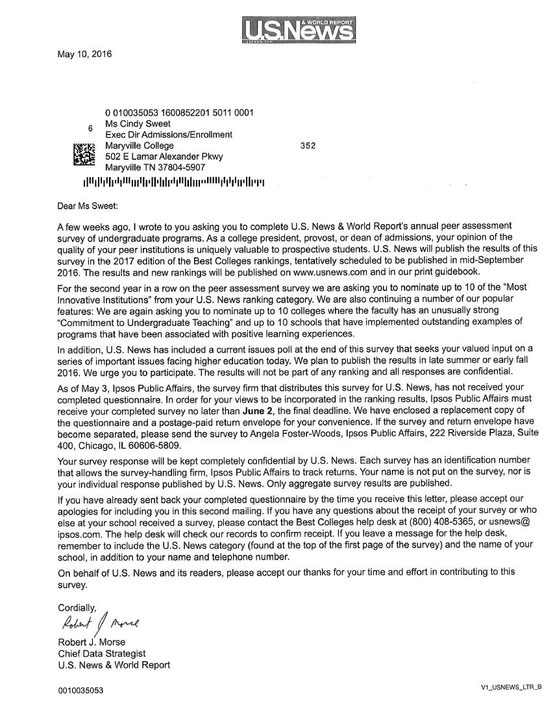

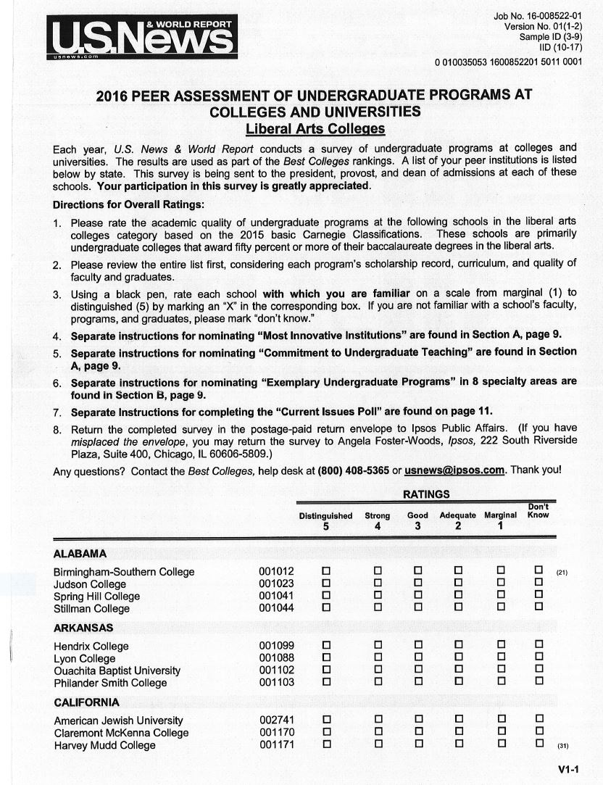

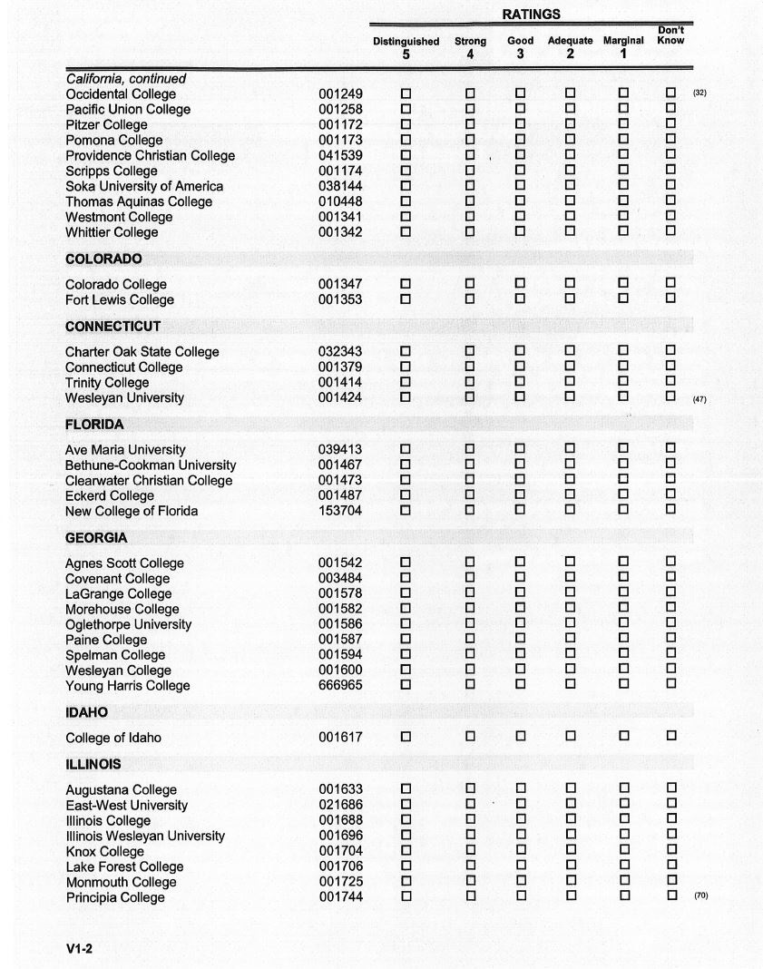

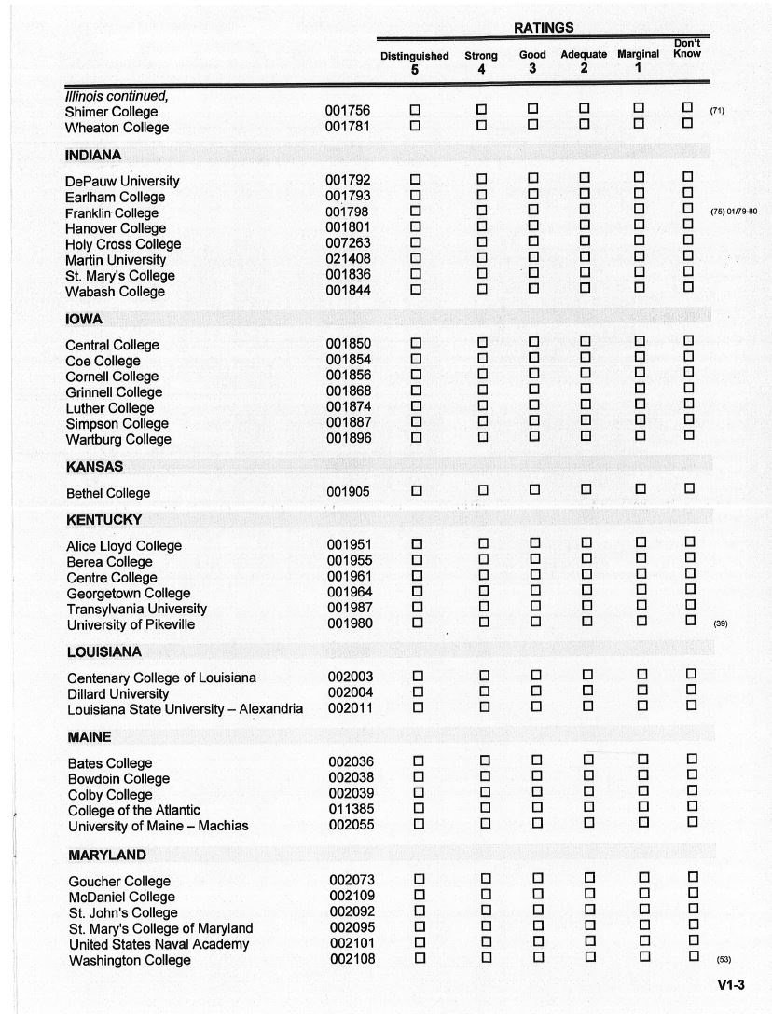

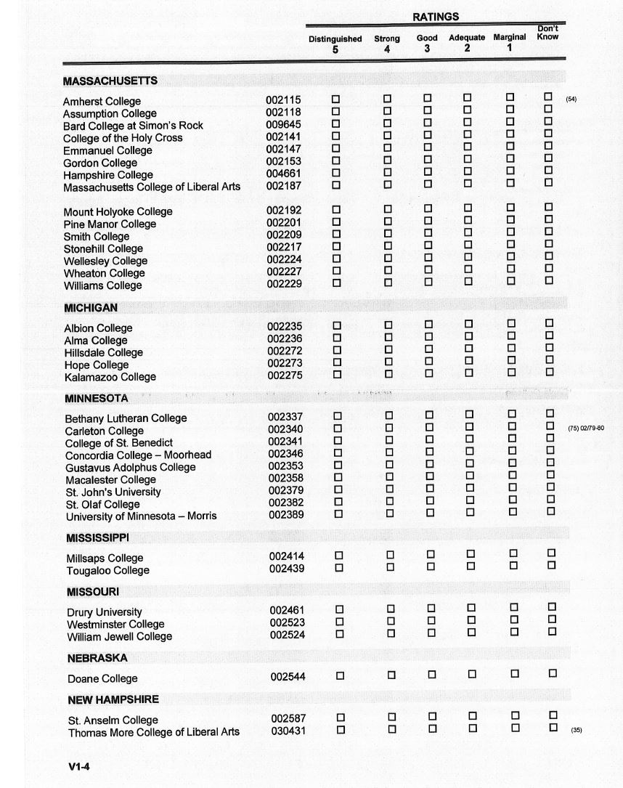
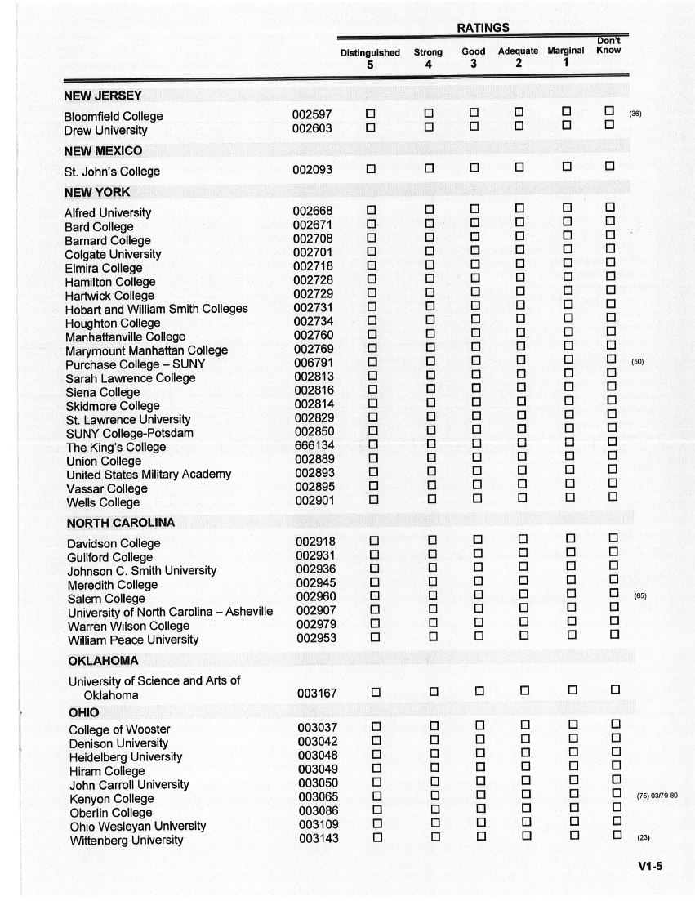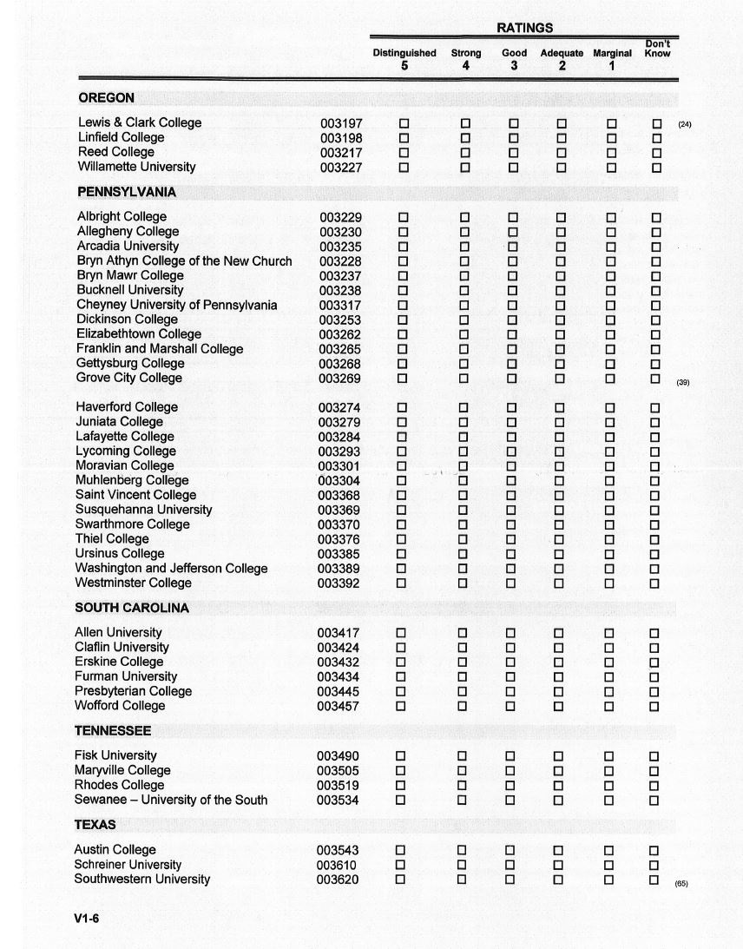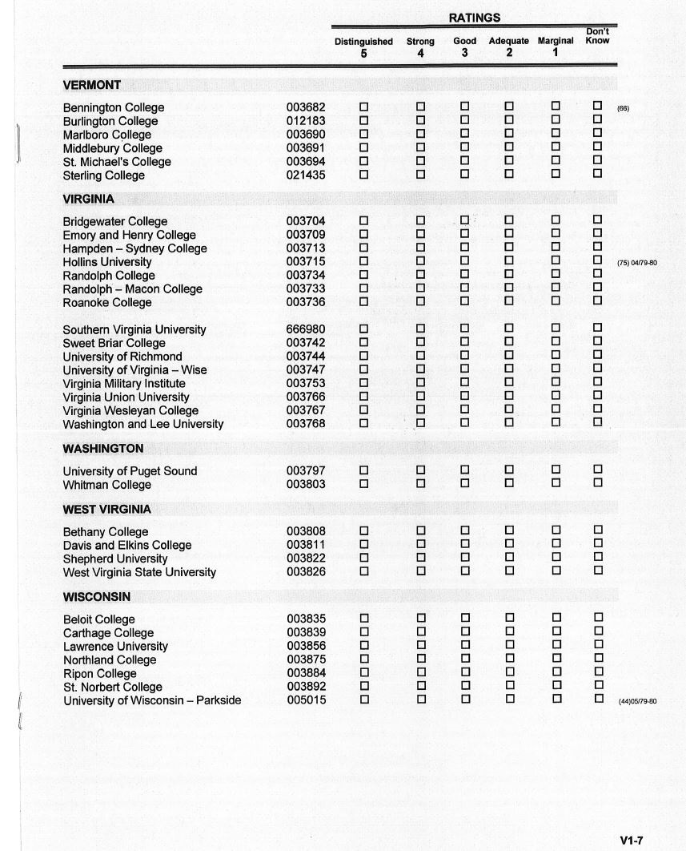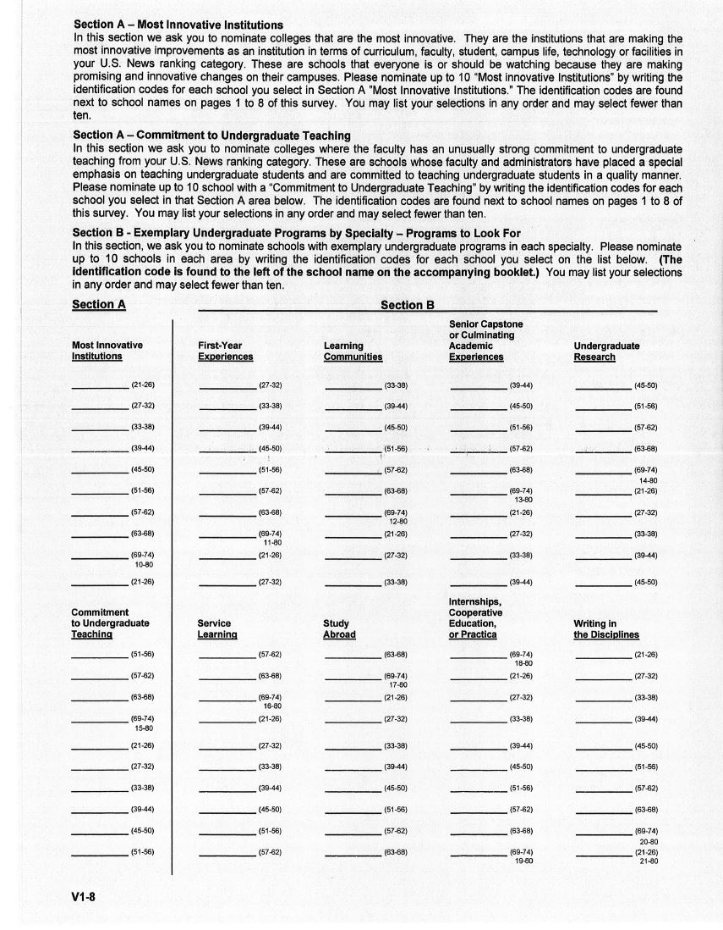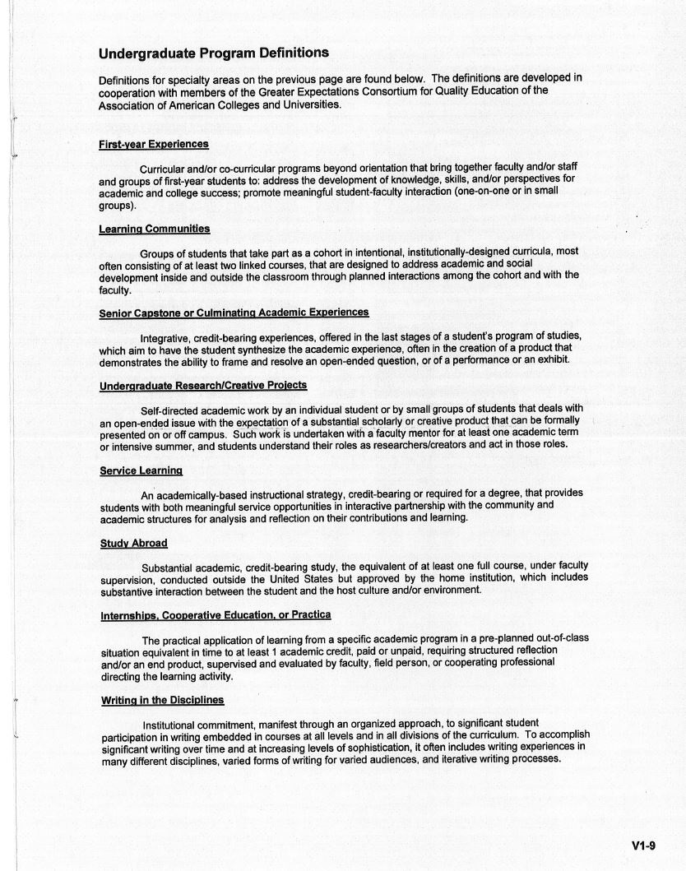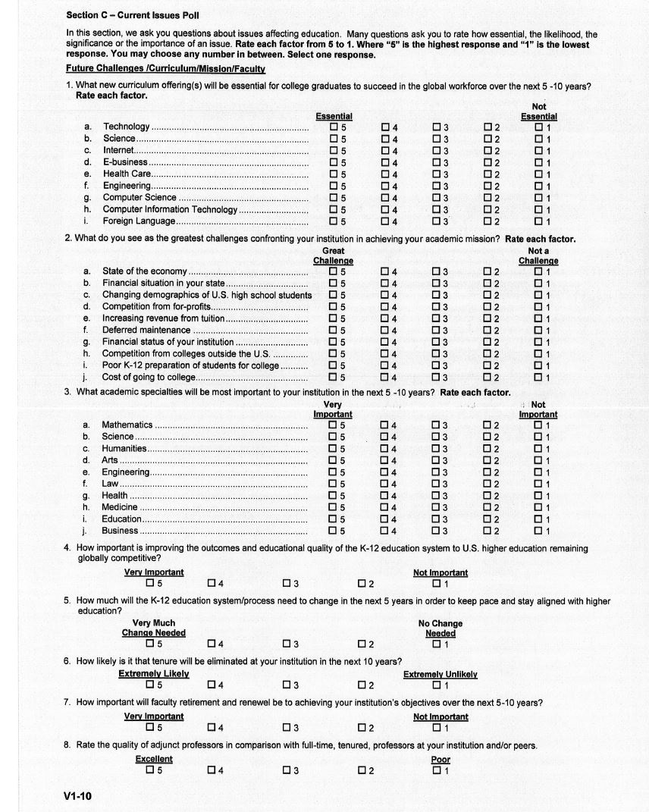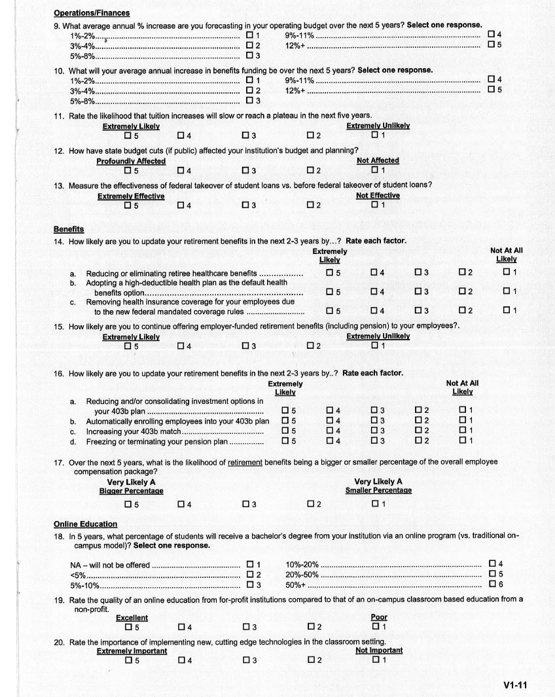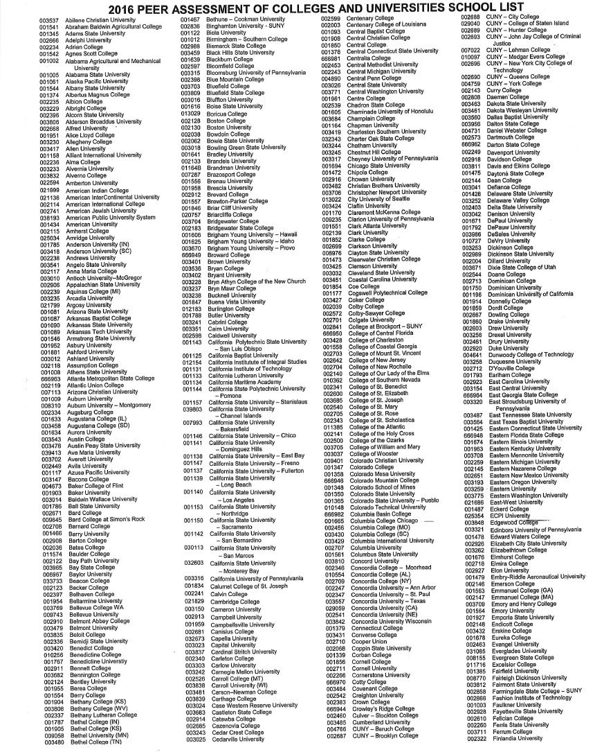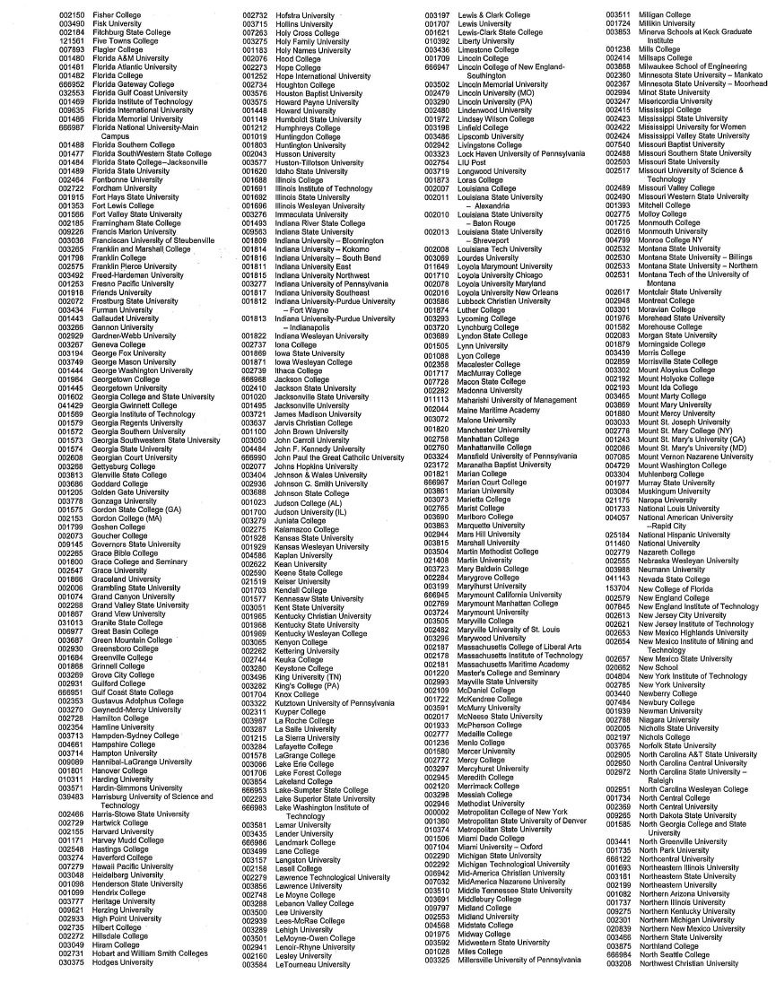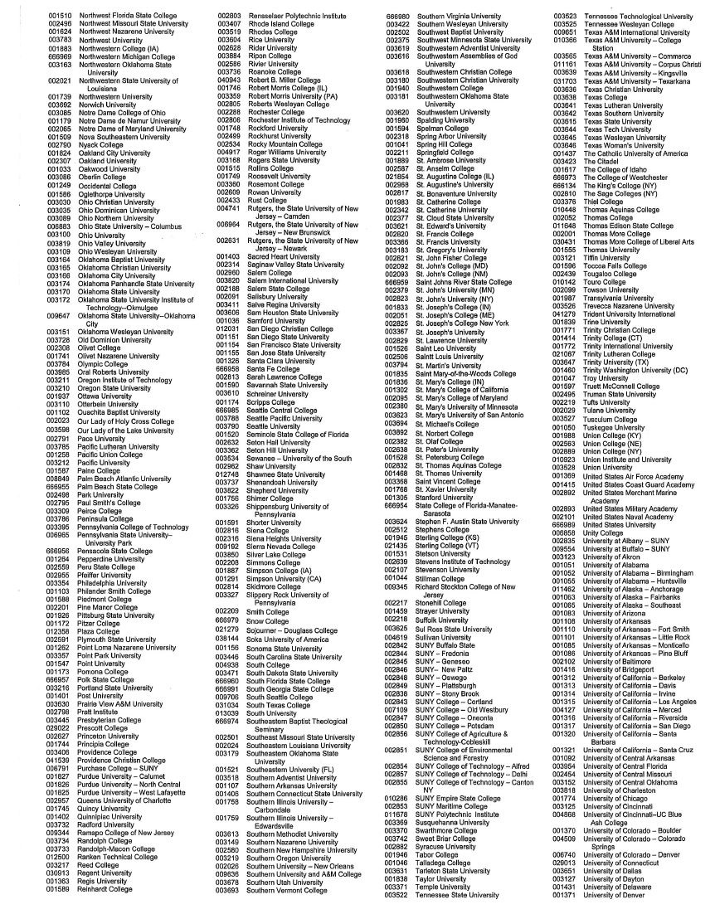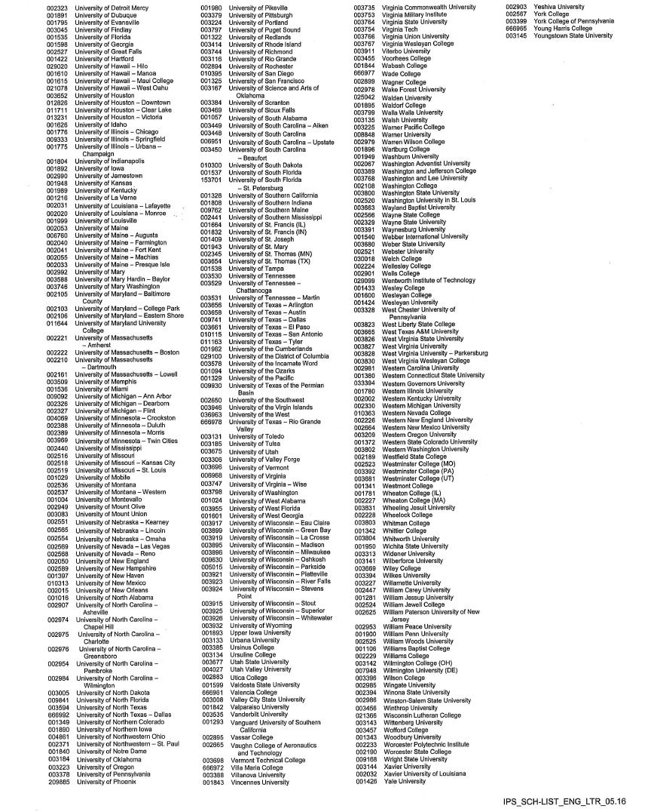

APPENDIX C
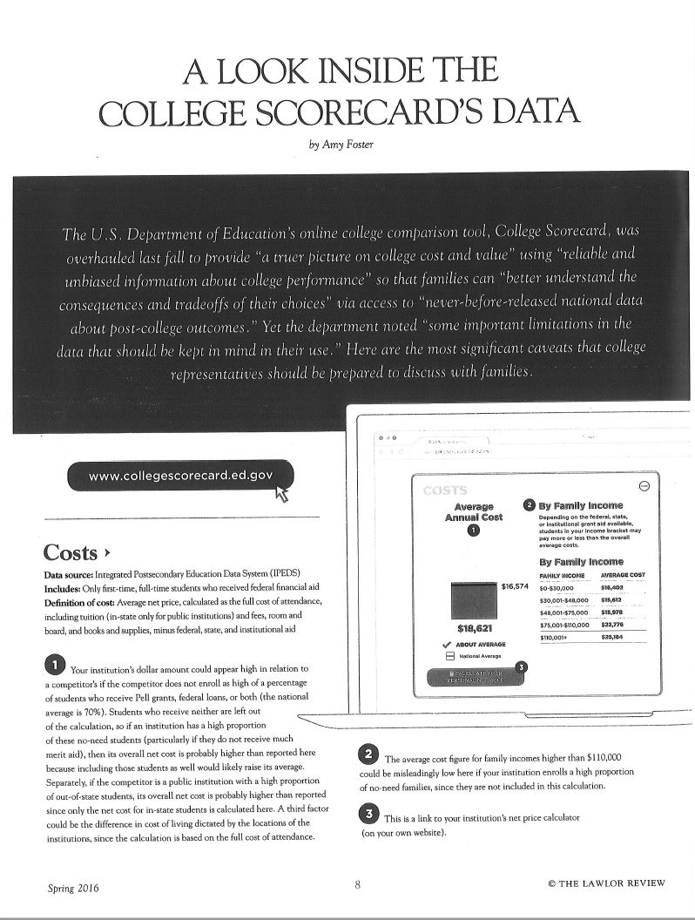

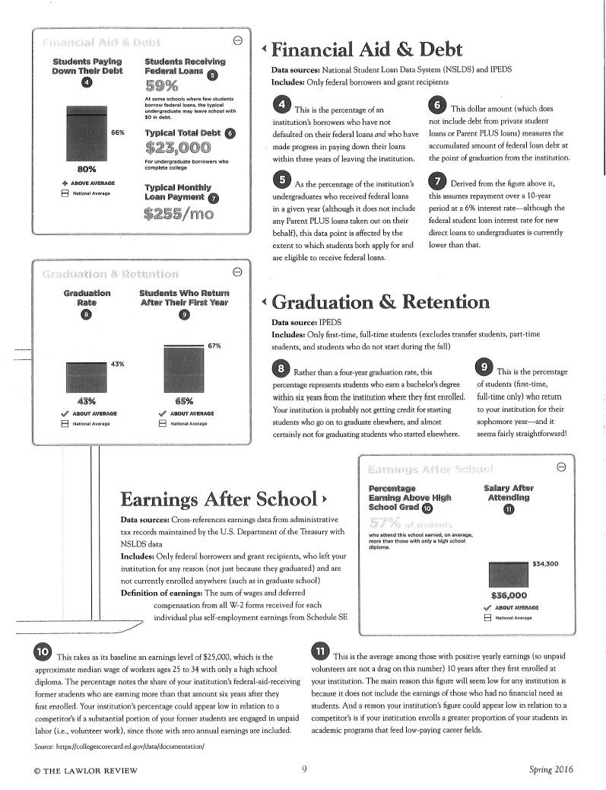

Vita
Cynthia Sweet currently serves as the Executive Director of Admissions and Financial Aid at Maryville College in Maryville, TN and has worked in college and university admissions for 20 years. Prior to her arrival at Maryville College, she served as Associate Director of Admissions at The University of Tennessee, Knoxville and as an Admissions Counselor at Carson-Newman University (formerly Carson-Newman College). She graduated from Carson-Newman College in 1993 with a Bachelor’s degree in Communication, with an emphasis in Broadcasting. She returned to the classroom in Spring 2012 to begin working on her Master’s degree in Communication where she completed the requirements for the degree while working full-time.

