Perceived Effects of Music on Mood and Focus for Underserved, School-Aged Children

Kayla Miller
Chancellor’s Honors Program
Faculty Advisor: Dr. Jason Kiernan

Contents
Abstract……………………………………………………………………………………………3
Introduction………………………………………………………………………………………..4
Review of Literature……………………………………………..………………………………..5
Purpose…………………………………………………………………………………………...15
Hypotheses……………………………………………………………………………………….15
Methods…………………………………………………………………………………………..15
Results…………………………………………………………………………………………....18
Limitations……………………………………………………………………………………….21
Conclusion…………………..…………………………………………………………………...22

Abstract
Children from low socioeconomic backgrounds fall progressively behind in academics compared to their higher-income peers. Music listening and music-making have been effective interventions to elicit happiness and relaxation, improved attention skills, and improved academic performance. Despite this evidence, further research is needed to examine how children perceive music to affect their mood and focus. A non-experimental cross-sectional descriptive study was conducted at the Wesley House Community Center, which serves children and families in the Mechanicsville, Lonsdale, and Beaumont communities in Knoxville, Tennessee. A convenience nonprobability sampling plan was used to select 17 eligible children. The baseline data for mood and focus were questions taken from the Health Measure’s PROMIS Pediatric Short Form v1.0 Positive Affect 4a and PROMIS Pediatric Short Form v1.0 Cognitive Function 7a, respectively. Children's perception of how 10 minutes of music listening might change their mood and focus were measured using modified versions of the same questions. Paired samples t-tests suggested no statistically significant changes between baseline mood and focus and perceived change to mood and focus after 10 minutes of music listening. However, scores for mood trended upward reflecting a positive change. Scores for focus trended downward, suggesting improved focus. Results suggested that school-aged children in an underserved population do not perceive that listening to “enjoyable” music would improve their mood and focus.

Perceived Effects of Music on Mood and Focus for Underserved, School-Aged Children
Children from low socioeconomic backgrounds have been shown to fall progressively behind in academics compared to their higher-income peers (Slater, et al., 2014). The academic achievement inequality between lower and higher-income students has been attributed to multiple factors including exposure to quality stimulation and preparation for school at home (Ferguson, Bovaird, & Mueller, 2007), outside-of-school reading and vocabulary exposure (Kim & Quinn, 2013) and involvement in extracurricular activities, especially with the introduction of “pay to play” programs (Snellman, Silva, Frederick, & Putnam, 2015). Collectively, these factors affect the socioemotional and academic well-being of early adolescents in measures of depression, academic engagement, and academic competence, as well as contribute to disparities in academic achievement (Godfrey, Burson, Yanisch, Hughes, & Way, 2019).
In Healthy People 2020, the Office of Disease Prevention and Health Promotion (2020) defines social determinants of health as “conditions in the environments in which people are born, live, learn, work, play, worship, and age that affect a wide range of health, functioning, and quality-of-life outcomes and risks” (para 6). One of the five key determinants of health is quality education, and within that determinant is early childhood education and development. Godfrey et al. (2019) found that addressing these social determinants of health can lead to more positive youth development for underserved communities.
Lower levels of education have been shown to put people at higher risk of experiencing multiple social and health problems such as obesity, substance abuse, and injury (Centers for Disease Control and Prevention, 2018). For children to succeed in school, they must be cognitively, emotionally, and physically prepared to learn (Annie E. Casey Foundation, 2010).
Research has suggested music affects neurobiological processes in the brain and that music may elicit different emotions depending on where it is processed (Lin, et al., 2011). Building upon and applying findings such as these, Cheung et al. (2019) reported that a musical training program was effective in promoting happiness and quality of life in an underserved preschool population. Huseynova, Egilmez, and Engur (2019) demonstrated the effectiveness of private piano education on attention skills and improved attention on multiple levels in children. The intent of this project is two-fold: to introduce and synthesize the present body of work that supports music interventional research with underserved, school-aged children, and to propose a study that builds upon this literature by addressing current gaps in knowledge.
Review of Literature
Studies suggest music listening and music-making have a positive relationship with mood/joy (Lynar, Cvejic, Schubert, & Vollmer-Conna, 2017; Cheung et al., 2019; Koelsch, Fritz, Cramon, Muller, & Friderici, 2005), stress and anxiety reduction (Fallon et al., 2019; De Witte, Spruit, Van Hooren, Moonen, & Stams, 2019), and psychological well-being (Koehler & Neubauer, 2019). Music education has also been found to improve attention skills and academic performance (Hallberg, Martin, & McClure, 2017; Huseynova, et al. 2019; Southgate & Roscigno, 2009; Kraus et al., 2014; Whitson, Robinson, Van Valkenburg, & Jackson, 2019).
Music's Effect on Mood
Lynar, et al. (2017) examined the effects of listening to classical music, jazz music, “uplifting” music of choice, and white noise in a randomized order on mood with 94 staff and students at the University of New South Wales, Sydney. Physiological responses were recorded throughout the music listening tests. After each piece, the participants rated their subjective responses on a series of Likert scales. They found that uplifting music of choice elicited the most joy and eustress response, while the classical pieces induced the most relaxing feeling. The findings suggest that the optimal music for therapy varies for each individual and that the most effective music for each particular listener should be identified and utilized.
Fallon et al. (2019) examined the effects of music-listening and music improvisation on a xylophone on stress reduction of 105 students from Salisbury University. Stress was measured using electrodermal activity (EDA) and self-report. The participants first filled out a baseline self-report on mood and a 3-minute baseline EDA recording. Next, the participants were exposed to a stressor, which was a modified version of the Trier Social Stress test with EDA measures recorded throughout the stressor session. After being exposed to the stressor for 5 minutes, they completed a self-report on their current mood and mental state. For the recovery session, they were randomly assigned to a control group, music listening, or music improvisation with the xylophone for five minutes. EDA was recorded during the recovery session, and participants in all the groups completed another self-report regarding their current mood after the session. The researchers reported that the EDA and self-report measurement indicated that the music-listening group significantly reduced their stress. Participants in the music improvisation group reported significantly higher satisfaction levels. Their study demonstrated the importance of understanding how music can be an effective stress reduction method and improve the quality of everyday life. The researchers recommended that further studies should control for past musical experience and explore the participants’ own choice of music to listen because those factors may have affected responses.
De Witte et al. (2019) conducted a meta-analysis of 104 randomized controlled trials to examine the effects of various music interventions (music listening and music therapy) on physiological and psychological effects of stress in adults. Physiological stress was measured by heart rate, blood pressure, and hormone levels; and psychological stress was measured with self-report instruments for state anxiety, nervousness, restlessness, and feelings of worry. The researchers reported a significant effect of music interventions on both physiological and psychological stress-related outcomes. The results indicate that music interventions can be effective in the reduction of psychological stress. For future research, the researchers suggest focusing on the specific characteristics of music interventions, including the music tempo, the style of the music, self-selected music, and frequency of the sessions because of the inconclusive results between those characteristics.
Cheung et al. (2019) examined the effectiveness of a musical training program in promoting happiness and quality of life of 100 Hong Kong Chinese underprivileged preschool children. The children ranged in ages from 3-6 years and were from low-income families in the Sham Shui Po community. The participants were split into a control group and an experimental group that attended a weekly one-hour musical training lesson for 12 weeks. Happiness and health-related quality of life were measured pre- and post-intervention. Happiness was measured with the Visual Analog Scale, and quality of life was measured with the Pediatric Quality of Life Inventory 4.0 Generic Core Scales. The overall results showed statistically significant differences between the groups and pre- and post-intervention. They indicated that the musical training program effectively promoted happiness and quality of life. Due to these beneficial effects of the community music training program, the researchers recommend that community nurses should promote these programs as a routine health promotion activity.
Lin, et al. (2011) conducted a systematic review to examine music’s effect as an alternative therapy and how it affects neurobiological processes in the brain. The literature they reviewed indicated how music can elicit different emotions depending on where it is processed in the brain. Lin et al. reported that music can minimize the impact of unpleasant procedures on patients by improving mood and reducing anxiety. They suggested research be conducted on how best to use different types of music interventions in clinical practice.
Porter et al. (2017) conducted a multi-center single-blind randomized control trial to determine the effects of music therapy as a clinical intervention for children and adolescents with behavioral and emotional problems on communication and interaction skills, self-esteem, and depression. The 251 children, ages 8-16 years old, were from six Child and Adolescent Mental Health Services within Belfast Health and Social Care Trust in Northern Ireland. Subjects were assigned to participate in either 12 weekly music therapy sessions plus usual care or usual care alone. The music therapy sessions used the Alvin model of ‘Free Improvisation,’ which encourages the individual to create music and sound freely through voice, instrument, or movement while receiving support and encouragement by the therapist. The primary outcome of communication and interactional skills was measured by parental and self-reporting of the Social Skills Improvement System Rating Scales. They found that communication skills, self-esteem, and depression significantly improved for participants aged 13 and over in the intervention group, as compared to the control group. No other significant differences were noted. The researchers suggest more studies be done relating to music therapy for these outcomes to ascertain what type and dosage of music therapy is most effective and for whom.
Koehler and Neubauer (2019) examined if music-making among people who play music as a hobby was associated with higher affective well-being. The 1,042 participants consisted of hobby musicians in Germany who report playing their instrument at least once a week. They recorded daily responses about their music-making, need fulfillment, and positive and negative affect for 10 consecutive days with a self-report questionnaire. Need fulfillment was assessed using the Balanced Measure of Psychological Needs Scale, and affect was assessed using the Short Form of the Positive and Negative Affect Schedule. Results showed that the satisfaction scales, positive affect, and music-making were positively correlated with each other. This leads to the possible conclusion that music-making in everyday life has a positive effect. Since the research was done on the population of hobby musicians, the same intervention should be assessed on non-musicians or people who engage in other hobbies.
Koelsch, et al. (2005) examined emotional processing using functional magnetic resonance imaging (fMRI) when subjects listened to either pleasant or unpleasant music. Pleasant stimuli were eight excerpts of joyful instrumental dance-tunes from the last four centuries, and unpleasant stimuli were electronically manipulated counterparts of the original tunes by shifting tones and pitches. The 11 non-musician participants, ages 20-29 years, listened to both pleasant and unpleasant music stimuli and rated how pleasant/unpleasant they felt as well as rate their emotional state with a 5-point scale. During the music, the participant’s brains were scanned with a 3 T Bruker Medspec 30/100 spectrometer. Subjects rated the original stimuli as pleasant and the manipulated stimuli as unpleasant. When unpleasant music was played, brain activity was noted in the limbic and paralimbic structures comprising the amygdala, hippocampus, parahippocampal gyrus, and temporal poles. This activity decreased during the pleasant stimuli. The unpleasant stimuli activated emotional responses and emotional processing within the brain. Comparative the ventral striatum, the anterior superior insula, and in the Rolandic operculum became active when pleasant music was played indicating that the subjects responded with emotional valence to the pleasant stimuli and coded vocal sound production. The researchers concluded that listening to music can regulate emotions with neuronal activity. They also suggest music listening as an intervention for future research on emotions with different subjects, such as children, patients, and subjects with different cultural backgrounds.
Music's Effect on Focus
Hallberg et al. (2017) examined the effects of instrumental music instruction on working memory efficiency and controlled attention on kindergarten children. The 52 kindergarteners were split into a treatment group who received Suzuki violin instruction for 3 hours a week for 5 weeks and the control group with no music instruction. Assessments of the working memory and controlled attention were based on the applications of the Stanford-Binet 5 and the Kiddie Connor’s Continuous Performance Test Version 5 respectively. The researchers reported that the violin training group scored significantly higher in attention and perseverance measures than the control group. These findings suggest that future studies investigate whether attentional control developed in music instruction, transfers generally to academic performance in school.
Huseynova et al. (2019) used a pretest/posttest quasi-experimental design to examine the effectiveness of private piano education on attention skills. Attention was measured with the Four Stage Stroop Color-Word Test which measures focused attention, selective attention, and data processing speed by naming colors which are printed in different colors than the words. The 99 children, ages 7-12, were assigned to two groups: those that received an hour piano lesson for 14 weeks or those that did not receive lessons. The participants receiving lessons were expected to practice for one hour per week. The participants in the experimental group scored significantly higher in two stages of the Stroop Color Test, suggesting improved attention skills. The researchers recommended more studies on the effect of music education on the attention skills of children.
Whitson et al. (2019) measured the musical skills, family bonding, responsibility/discipline, self-efficacy, social competence, and empowerment for low-income, urban youth participating in the Music Haven after-school music program. Seventy-one youth, ages 6-16, and their parents/caregivers participated in the mixed-method design and data was collected with focus groups and a questionnaire. The focus groups evaluated musical skills, responsibility, discipline, self-efficacy, empowerment, social competence, and family bonding time. The questionnaire was created based on the answers from the focus group. They found that the students who participated in the program showed statistically significant improvement in musical skills; academic performance; sense of responsibility and discipline; self-esteem and empowerment; and family bonding measured with the questionnaire and focus group answers. Implications of this study demonstrate the need for increased access to music programs for low-income youth.
Costa-Giomi (2014) reviewed the literature on the effects of music instruction on general cognitive abilities. The review of 75 studies suggested the short-term general cognitive benefits associated with music instruction and that sustained practice produces neurological changes associated with improvements in cognitive tasks which suggests an improvement in intelligence and general cognitive benefits. However, there was no definitive evidence that these improvements are long-lasting. The researcher suggests future studies to examine how the short-term cognitive benefits of music instruction can benefit academic endeavors and quality of life. Costa-Giomi also recommends further research investigates if the cognitive benefits with childhood music instruction contribute to their future lives as adults.
Kraus et al. (2014) examined the effects of active engagement with music and sound on cognition and brainstem responses. Subjects participated in the Harmony Project, which is a community foundation that provides free music instruction to over 1000 children from Los Angeles. The 19 at-risk children, ages 7-19, completed perceptual, cognitive, and neurophysiological tests before and after the intervention. The Test of Word Reading Efficiency measured reading fluency, the Wechsler Abbreviated Scale of Intelligence generated an estimate of intelligence quotient, and the Intelligent Hearing Systems SmartEP system recorded brainstem responses. The control group completed a music appreciation course and the experimental group engaged in an active music-making course with music instruction. Children who received the group instrumental lesson had stronger neural processing of speech than their peers who only participated in a music appreciation class. The researchers discuss how music engagement can help at-risk children deal with biopsychosocial challenges, including language learning and literacy. The researchers suggest that future research is needed with larger sample sizes, better gender distribution, and more detailed information as to what guided students’ progression through the Harmony Project’s curriculum. This results from this study highlights the efficacy of community programs to instill changes in neural processing and the potential of community-based interventions to support children growing up in at-risk conditions.
Southgate and Roscigno (2009) examined the association between music involvement and academic achievement in both childhood and adolescence. The data was drawn from two nationally representative sources. The National Educational Longitudinal Survey followed a group of students from eighth grade and beyond high school with follow-ups every two years from 1988 to 2000 with a sample of 7,781 subjects. The Early Childhood Longitudinal Survey was administered to approximately 20,000 U.S. kindergarten students in 1998-1999 with follow-up data in first grade with a sample of 4,376 subjects. They measured standardized achievement in reading and mathematics from the elementary and high school students in the data sets compared to their musical involvement in school, music outside of school, and parent’s attendance to the children’s music concerts. The results suggest that musical involvement is associated with reading and math achievement. A recommendation was that further research should consider the quality and duration of music involvement. Additionally, case-specific analyses of what music participation means for families and social groups of varying statuses could gauge the relevant processes involved in these variables.
Respress and Lutfi (2006) examined the involvement in the Health, Education, in the Arts, Refining Talented Students (HEARTS) project on self-esteem, school achievement, and violence. The HEARTS project is an afterschool fine arts program that develops the talents of African American middle schoolers at risk of school and social failure. The 66 middle school students were split into two groups that engaged in the HEARTS curriculum. The curriculum included instruction and activities with major emphasis placed on the facilitation of experiential learning in one of four fine arts areas: art, drama, music, and dance. Students were assigned to one of those fine arts areas based on their communicated interest. The outcomes of academic achievement, self-esteem, and commitment towards school were compared to participation in the fine arts. Measures included Grade Point Averages, the Wide Range Achievement Test, the Rosenberg Self Esteem Scale, the Violence Risk Assessment, and the Family Bonding Index. The findings suggested the program promoted increased school engagement, internal locus of control, academic achievement, and discouraged school disciplinary problems. These positive results suggest academic and social competence, reduced risky behavior, and increased self-esteem, which is an important aspect of healthy adolescent development. Because of the benefits from the fine arts program involvement, the researchers recommend that after-school programs should consider revising their curriculum to be inclusive of the fine arts. They also recommend that parents encourage their youth to participate in the fine arts.
Rickard et al. (2012) examined music training on global self-esteem, academic self-esteem, and social self-esteem. The 359 first and third-grade students were assigned to either a control or music training group. The music training occurred over two years and included three 30-minute Kodaly music classes per week for the first graders and weekly one-hour group string instrumental classes for the third graders. Self-esteem was assessed with the Culture-Free Self Esteem Inventory, and social skills were measured with the Social Skills Rating System. The results indicated that global self-esteem increased in both the younger and older cohort music groups and decreased in both the younger and older cohort control groups after the first year. The significant benefit appeared to reflect protection against a decline in self-esteem which occurred in the control group during the first year. Due to the self-esteem benefits, the researchers recommend that school curriculums increase arts-based activities.
Wang, Ossher, and Reuter-Lorenz (2015) examined the relationship between skilled music training and attention. The participants included musicians studying at the University of Michigan School of Music, Theater and Dance and non-musicians from the general University of Michigan student population. The Continuous Temporal Expectancy Task was used to measure sustained attention. After completing the tasks, participants completed a series of neuropsychological tests. The WAIS-III Digit Span Forward and Backward assessed working memory capacity. The Extended Range Vocabulary Test assessed crystallized intelligence. The Raven’s Advanced Progressive Matrices assessed fluid intelligence. The Need for Cognition Scale assessed self-reported tendency to engage in and enjoy thinking. Various portions of the Imaginal Processes Inventory assessed self-reported distractibility, mind-wandering, and boredom. The results show that the musicians outperformed non-musicians on the sustained attention task. They concluded that extensive, formal music training is associated with superior performance on timing-based sustained attention. They recommend future research be done about understanding the nature of this association and how it may relate to other cognitive abilities.
In conclusion, the studies presented provide evidence that music can impact mood and focus. Music listening and music-making are effective interventions to elicit happiness and relaxation. The results also suggest improved attention skills and academic performance. However, the perceived effects of music on mood and focus for school-aged children have not been evaluated.
Purpose and Hypotheses
The purpose of this study was to determine if school-aged children in an underserved population perceive that their mood and focus would improve after listening to music that they enjoy for 10 minutes. The hypotheses were:
- Underserved school-aged children perceive that their mood will significantly improve after 10 minutes of listening to self-defined “enjoyable” music.
- Underserved school-aged children perceive that their focus will significantly improve after 10 minutes of listening to self-defined “enjoyable” music.
Methods
Design
A non-experimental cross-sectional descriptive study was conducted to determine the perception of music listening on mood and focus. The target population was underserved children, ages 8-13. The study was conducted at the Wesley House Community Center. The Wesley House supports the academic and emotional growth of children within underserved communities in Knoxville with a structured after-school education program. Approval for the study was obtained from the University of Tennessee-Knoxville Institutional Review Board (Appendix E).
Sampling
A convenience nonprobability sampling plan was used to select up to 25 eligible children. Eligibility criteria included children between 8-13 years; residence in the Mechanicsville, Lonsdale, or Beaumont communities in Knoxville; and able to communicate in English. Children were excluded if they could not read the assent form on their own. Participant age range was chosen to improve the likelihood of adequate literacy level, and thus facilitate completion of both the assent form and survey.
Measures
A Likert scale questionnaire (Appendix D) was used to determine how Knoxville children from an underserved population perceived music listening would affect their mood and focus. Four questions asked about the child’s mood and seven questions inquired about the child’s focus. The baseline data for mood and focus were questions from the Health Measure’s PROMIS (Patient-Reported Outcomes Measurement Information System) Pediatric Short Form v1.0 Positive Affect 4a and PROMIS Pediatric Short Form v1.0 Cognitive Function 7a (Anastasi, 1988). The PROMIS Positive Affect instrument assesses feelings and moods associated with joy. The PROMIS Cognitive Function instrument assesses patient-perceived cognitive deficits. Facets include mental acuity, concentration, and perceived changes in these cognitive functions. These measures have been psychometrically tested. Content validity has been reported (Anastasi, 1988). For the modified, post-music questions developed by the PI and derived from the PROMIS tool, reliability and validity have not been established. Data was collected in a quiet, semi-private classroom in the Wesley House Community Center.
Procedure
The PI approached the parents of the Wesley House children as they were being picked up from the Wesley House Community Center and asked if they were willing to learn about a research study for their children between ages 8-13 to participate in (Appendix A). The PI asked for the age of the child when talking with the parents during the consent process. If the children were within the given age range and they agreed to learn about the study, the PI described the purpose of the study, how the study will be implemented, and the time commitment for the children. The parents were given written information and time to read through it on their own (Appendix B). Parents were informed of any potential benefits and risks for their children participating in the study. Parents were informed that study participation is voluntary. After the parents finished reading through the written information, they were given time to ask the PI questions about the study. If the parents decide to consent their child, they will be given 2 copies of the consent form (Appendix B), one to return to the PI and one to keep. The returned and signed copy is kept in a secure location at the UT Campus College of Nursing in a locked cabinet that is within a locked office.
After the parents consented, the children were asked if they would like to participate. Children were given information that the study was voluntary, had no impact on them as a recipient of Wesley House's services, and would take approximately 10-15 minutes. The children signed the assent form (Appendix C) if they agreed to participate.
On the day the survey was offered, the PI identified the consented and assented children with the assistance of the Wesley House classroom counselors. The children were identified in their classrooms and had the opportunity to take the survey in their respective classrooms on a Wesley House tablet during classroom time. The PI brought the child to a separate table in the classroom dedicated to taking the surveys to obtain a second verbal assent from the child and re-discuss the purpose of the study. The PI informed the child that they could skip any questions on the survey and raise their hand if they had any questions or discomfort while taking the survey. The PI directed the child to a Wesley House tablet with the survey available using QuestionPro Software (Appendix D).
Data Analysis
Descriptive statistics were used to describe the sample. Statistics included frequency, percentages, ranges, means, and standard deviations. A paired samples t-test was used to determine if a statistically significant difference existed between measures of mood and focus at baseline and after perceiving themselves engaging in 10 minutes of music listening.
Results
There were 17 responses to the survey. The age of respondents ranged from 8 to 12 (mean=9.6, s.d.=1.47) mean age of the respondents was 9.59 years. Grade level ranged from second grade to sixth grade. Eight participants were male and nine were female. All respondents reported that they had music experience. Three respondents reported experience playing music, five respondents reported experience singing, six respondents reported experience writing music, and all but one (n=16) respondents reported experience listening to music.
A summary of mean scores for each question at baseline and perceived change after music is given in Table 1.

Table 1

Summary of Means and Standard Deviations (s.d.)

Measure Mean Mean Mean
at baseline after music Difference
(s.d.) (s.d.)
Mood
Felt happy 3.80 (1.207) 4.13 (0.915) +.33
Felt great 3.94 (0.998) 4.19 (0.834) +.16
Felt cheerful 4.0 (1.000) 3.60 (1.404) -.4
Felt joyful 3.93 (1.003) 3.67 (1.291) -.26
Focus
Forget schoolwork 2.79 (1.626) 2.36 (0.387) -.43
Forget what I was 3.69 (1.397) 3.07 (1.100) -.62
going to say
Forget things easily 3.14 (1.292) 3.21 (1.251) +.07
Have trouble remembering 3.46 (1.506) 3.08 (1.498) -.38
to do things
Hard for me to concentrate 3.00 (1.468) 2.29 (1.383) -.71
Trouble paying attention 3.07 (1.328) 2.29 (1.383) -.78
Have to work really hard 2.92 (1.730) 2.17 (1.337) -.75
to pay attention or
I will make a mistake

Note: Mood and focus were measured using a 5-point Likert scale (1 = never; 5 = always).

Two mood questions trended in a positive direction reflecting an improved mood. Two of the mood questions trended in a negative direction reflecting a worsened mood. Overall, the baseline mood was positive with the scores of at least 3.8 out of 5. All except one of the focus questions trended in a negative direction reflecting an improved focus. The was no significant differences in mean scores between baseline and questions addressing after listening to music.
Table 2 summarizes the results of significance testing to compare baseline scores with perceived music listening scores.
Table 2

Paired T-test and Significance

Pairs T-test Sig. (2 Tailed)
Mood
“I felt happy” – “I would feel happy” -0.837 0.417
“I felt great” – “I would feel great” -0.719 0.483
“I felt cheerful” – “I would feel cheerful” 1.031 0.320
“I felt joyful” – “I would feel joyful” 1.000 0.334
Focus
“I forget schoolwork that I need to do” 0.791 0.443
– “I would forget schoolwork
that I need to do”
“I sometimes forget what I was going 1.655 0.120
to say” – “I would sometimes
forget what I was going to say”
“I forget things easily”- “I would -0.173 0.865
forget things easily”
“I have trouble remembering to do 1.328 0.209
things” – “I would have trouble
remembering to do things”
“It is hard for me to concentrate in 1.632 0.127
school” – “It would be hard for me
to concentrate in school”
“I have trouble paying attention to the 2.065 0.059
teacher” – “I would have trouble
paying attention to the teacher”
“I have to work really hard 1.915 0.082
to pay attention or I will make
a mistake” – “I would have to work
really hard to pay attention or
I would make a mistake”

Note: Mood measured on 5-point Likert scale (1 = never; 5 = always).

Only the focus question, “I have trouble paying attention to the teacher” showed a positive trend approaching statistical significance. In summary, research hypotheses for the study were not supported.
Limitations
There were several limitations to this study including sample size, lack of control of mood, instrument not at the appropriate reading level, missing data, and lack of quiet data collection site. The sample included only 17 participants. There was not sufficient power to find a difference if it existed.
This study also did not control for mood and concentration disorders such as depression and ADHD which could affect the results. Although the questionnaire was written for a school-age child to understand, participants reported having trouble reading or defining certain words used in the survey. Some questions were skipped or left blank which indicates that the child may have been confused with the question or was not engaged in the survey. Although the surveys were administered in semi-private classrooms at the Wesley House, there were still distractions to survey taking.
Future research should be conducted with a sample size based on power analysis. Children with mood or concentration disorders should be excluded or controlled statistically. Questions should be reworded to be at a lower reading level, or the sample could include only older children such as ages 10-15.
Conclusions
The purpose of this study was to examine how children perceived a music listening session might impact their mood and focus. Although the results suggested that school-aged children in an underserved population do not perceive that listening to “enjoyable” music would improve their mood and focus, it is not conclusive due to lack of power. Although no statistically significant differences were noted, the scores trended in a direction that shows an improved perceived mood and focus after listening to enjoyable music for 10 minutes. Future research addressing study limitations may improve upon the presented findings.

References
Anastasi, A. (1998). Psychological testing. 6th Edition, Macmillan Publishing Company, New York.
Annie E. Casey Foundation. (2010). Early warning! Why reading at by the end of third grade matters [PDF file]. Retrieved from https://www.ccf.ny.gov/files/9013/8262/2751/AECFReporReadingGrade3.pdf
Centers for Disease Control and Prevention. (2018). Health Disparities. Retrieved from https://www.cdc.gov/healthyyouth/disparities/index.htm
Cheung, A., Cheung, W., Ho, L., Ho, K., Lam, K., & Chung, O. (2019). Effectiveness of a musical training programme in promoting happiness and quality of life of underprivileged preschool children. Journal of Clinical Nursing, 28(23-24). doi:10.1111/jocn.15023
Costa-Giomi, E. (2014). The long-term effects of childhood music instruction on intelligence and general cognitive abilities. Applications of Research in Music Education, 33(2), 20-26. doi:10.1177/8755123314540661
De Witte, M., Spruit, A., Van Hooren, S., Moonen, X., & Stams, G. (2019). Effects of music interventions on stress-related outcomes: A systematic review and two meta-analyses. Health Psychology Review, 15, 1-15. doi:10.1080/17437199.2019.1627897
Fallon, V., Warfield, R., Hearn, B., Rubenstein, S., Ennerfelt, H., & Leaver, E. (2019). Stress reduction from a musical intervention. Psychomusicology: Music, Mind, and Brain. doi:10.1037/pmu0000246
Ferguson, H., Bovaird, S., & Mueller, M. (2007). The impact of poverty on educational outcomes for children. Paediatrics Child Health, 12(8), 701-706. doi:10.1093/pch/12.8.701
Godfrey, E., Burson, E., Yanisch, T., Hughes, D., & Way, N. (2019). A bitter pill to swallow? Patterns of critical consciousness and socioemotional and academic well-being in early adolescence. Developmental Psychology, 55(3), 525-537. doi:10.1037/dev0000558
Hallberg, K., Martin, W., & McClure, J. (2017). The impact of music instruction on attention in kindergarten children. Psychomusicology: Music, Mind, and Brain, 27(2), 113-121. doi:10.1037/pmu0000177
Huseynova, E., Egilmez, H., & Engur, D. (2019). Effect of piano education on the attention skills of 7-12 year old children. Educational Research and Reviews, 14(10), 327-339. doi:10.5897/ERR2019.3727
Kim, J. & Quinn, D. (2013). The effects of summer reading on low-income children’s literacy achievement from kindergarten to grade 8: A meta-analysis of classroom and home interventions. Review of Educational Research, 83(3), 386-431. doi:10.3102/0034654313483906
Koehler, F. & Neubauer, A. (2019). From music making to affective well-being in everyday life: The mediating role of need satisfaction. Psychology of Aesthetics, Creativity, and the Arts, doi:10.1037/aca0000261
Koelsch, S., Fritz, T., Cramon, D., Muller, K., & Friderici, A. (2005). Investigating emotion with music: An fMRI study. Human Brain Mapping, 27(3). doi:10.1002/hbm.20180
Kraus, N. Slater, J., Thompson, E., Hornickel, J., Strait, D., Nicol, T., & White-Schwoch, T. (2014). Auditory learning through active engagement with sound: biological impact of community music lessons in at-risk children. Frontiers in Neuroscience, 8, 351. doi:10.3389/fnins.2014.00351
Lara-Muñoz, C., Ponce De Leon, S., Feinstein, A. R., Puente, A., & Wells, C. K. (2004). Comparison of three rating scales for measuring subjective phenomena in clinical research. I. use of experimentally controlled auditory stimuli. Archives of Medical Research, 35(1), 43-48. doi:10.1016/j.arcmed.2003.07.007
Li, H. C. W., Mak, Y. W., Chan, S. C. S., Chu, A. K., Lee, E. Y., & Lam, T. H. (2013). Effectiveness of a play-integrated primary one preparatory programme to enhance a smooth transition for children. Journal of Health Psychology, 18(1), 10-25. doi:10.1177/1359105311434052
Lin, S., Yang, P., Lai, C., Yeh, Y., Huang, M., & Chen, C. (2011). Mental health implications of music: insight from neuroscientific and clinical studies. Harvard Review of Psychiatry, 19(1), 34-46. doi:10.3109/10673229.2011.549769
Lynar, E., Cvejic, E., Schubert, E., & Vollmer-Conna, U. (2017), The joy of heartfelt music: An examination of emotional and physiological responses. International Journal Psychophysiology, 120(118-125). doi:10.1016/j.ijpsycho.2017.07.012
Office of Disease Prevention and Health Promotion (2020, April 14) Social Determinants of Health. Healthy People 2020. https://www.healthypeople.gov/2020/topics-objectives/topic/social-determinants-of-health
Payne, A., Whitehurst, G., & Angell, A. (1994). The role of home literacy environment in the
the development of language ability in preschool children from low-income families. Early Childhood Research Quarterly, 9(3-4), 427–440. doi:10.1016/0885-2006(94)90018-3
Porter, S., McConnell, T., McLaughlin, K., Lynn, F., Cardwell, C., Braiden, H., Boylan, J., & Holmes, V. (2017). Music therapy for children and adolescents with behavioral and emotional problems: a randomized controlled trial. Journal of Child Psychology and Psychiatry, 58(5), 586-594. doi:10.1111/jcpp.12656
Respress, T. & Lutfi, G. (2006). Whole brain learning: The fine arts with students at risk. Reclaiming Children and Youth, 15(1), 24-31. ERIC Number: EJ747654
Rickard, N., Appleman, P., James, R., Murphy, F., Gill, A., & Bambrick, C. (2012). Orchestrating life skills: The effect of increased school-based music classes on children’s social competence and self-esteem. International Journal of Music Education, 31(3), 292-309. doi:10.1177/0255761411434824
Slater, J., Strait, D., Skoe, E., O’Connell, S., Thompson, E., & Kraus, N. (2014). Longitudinal effects of group music instruction on literacy skills in low-income children. PLOS One, 9(11). doi:10.1371/journal.pone.0113383
Snellman, K., Silva, J., Frederick, C., & Putnam, R. (2015). The engagement gap: social mobility and extracurricular participation among American youth. The ANNALS of the American Academy of Political and Social Science, 657(1), 194-207. doi:10.1177/0002716214548398
Southgate, D. & Roscigno, V. (2009). The impact of music on childhood and adolescent achievement. Social Science Quarterly, 90(1). doi:10.1111/j.1540-6237.2009.00598
Wang, X., Ossher, L., & Reuter-Lorenz, P. (2015). Examining the relationship between skilled music training and attention. Consciousness and Cognition, 36, 169-179. doi:10.1016/j.concog.2015.06.014
Whitson, M., Robinson, S., Van Valkenburg, K., & Jackson, M. (2019). The benefits of an afterschool music program for low-income, urban youth: The music haven evaluation project. Journal of Community Psychology, 1(11). doi:10.1002/jcop.22263

Appendix A
Recruitment Script
- Hi my name is Kayla Miller and I am a nursing honors student at the University of Tennessee. Is your child between ages 8-13?

- If at any point the parent wants to discontinue the conversation or the child does not qualify for the research, I would stop the conversation

- If yes: Are you willing to learn about a research study that your child could participate in?

- If yes: The purpose of the research study is to learn if school-age children think music listening will improve mood and focus. This study is being conducted by me with the help of my faculty advisor. The study consists of a survey for your child to take at the Wesley House and will take about 10-15 minutes. The survey questions will ask your child questions about themselves such as age, year in school, and then questions about how they think music affects their mood and focus. Your child's participation in this study is up to you. Either way, your decision won’t affect their relationship with the Wesley House or the services they receive. You can change your mind and stop at any time. Your child's participation may help us to learn more about how music can affect mood and focus. We hope the knowledge gained from this study will benefit others in the future. Here is some written information about the study, would you like me to explain it or give you time to read it over on your own?

- Do you have any questions?
  - If yes, answer their questions

- If you have any other questions or concerns you can contact me or my faculty advisor here (point to contact section on parent consent form).

- If you give your child permission, will you sign this consent form?

- I will provide a copy of this form for you as well.

- If the parent consents, now talk to the child

- Hi my name is Kayla Miller and I am asking you to help with this research study because I am trying to learn more about how school-aged children, like you, think music can help or hurt your mood and focus.

- If you want to help with this study I will ask you to answer questions on this tablet at the Wesley House. It will take 10-15 minutes.

- I have asked your parents they said it was okay for you to answer my questions. Even though your parents say “yes” you can still say no, that you don’t want to answer my questions. If you don’t want to talk to me and answer my questions on this tablet, you don’t have to. Remember, talking to me and answering my questions is up to you and no one will be upset if you don’t want to do it or if you change your mind later and want to stop.

- Do you have any questions about what I am asking you to help me with?

  - If yes, answer questions.

- If you have a question later that you didn’t think of now, you can email me (point to email on assent form) or ask me next time I see you.

- Here is some written information about the study, would you like me to explain it or give you time to read it over on your own?

- If you would like to help me, you can sign your name at the bottom. You and your parents will get a copy of this piece of paper after you sign it.

OBTAINING THE SECOND VERBAL ASSENT
- Hi again, my name is Kayla. Do you remember when I asked your help with my research study?
    - If yes, continue
    - If they do not want to take the survey, stop the conversation
- If you would still like to help me, you can take the survey today.

- To remind you about my study, I am trying to learn more about how school-aged children, like you, think music can help or hurt your mood and focus.

- If you want to help with this study you can answer questions on this tablet at the Wesley House. It will take 10-15 minutes.

- I have asked your parents they said it was okay for you to answer my questions. If you don’t want to talk to me and answer my questions on this tablet, you don’t have to. Remember, talking to me and answering my questions is up to you and no one will be upset if you don’t want to do it or if you change your mind later and want to stop.

- Do you have any questions about what I am asking you to help me with?

  - If yes, answer questions.

Appendix B
Informed Consent
Permission for Research Participation of a Minor
Research Study Title: Perceived Effects of Music on Mood and Focus
Researcher(s): Kayla Miller, University of Tennessee, Knoxville
Faculty advisor: Jason Kiernan, RN, MSN, ACNP, University of Tennessee, Knoxville

Why is my child being asked to be in this research study?
I am asking your child to be in this research study because they are school-aged.

What is this research study about?
The purpose of the research study is to learn if school-age children think music listening will improve mood and focus.

Who is conducting this research study?
This study is being conducted by researchers at the University of Tennessee, Knoxville.

How long will my child be in the research study?
If you give permission for your child to be in the study, and your child agrees, their participation will last for about 10-15 minutes and will involve 1 online survey accessible to them at the Wesley House.

What will happen if I say “Yes, I want my child to be in this research study”?
If you give permission for your child to be in this study, I will ask your child to take a survey on a tablet while they are at the Wesley House. The survey will ask questions about themselves such as age, year in school and then questions about how music affects their mood and focus.

What happens if I say “No, I do not want my child to be in this research study”?
Your child's participation in this study is up to you. You can say no now or leave the study later. Either way, your decision won’t affect their relationship with the Wesley House or the services they receive.

What happens if I say “Yes” but change my mind later?
Even if you decide to allow your child to be in the study now, you can change your mind and stop at any time.
If you decide to stop before the child completes the survey, contact Kayla Miller and your child will not be asked to participate. But, after the child completes the survey, the participant data cannot be withdrawn since we will not be able to know which answers were your child’s.

Are there any possible risks to my child?
A potential risk of your child participating is becoming upset with questions asking about how music may affect their mood and focus. It is unlikely that this will happen. I will inform your child that they can skip any questions or stop the survey at any point. If your child becomes upset, they will receive support from their Wesley House classroom counselor. You will be informed with a note from me if this happens and with my contact information if further questions arise.

Are there any benefits to being in this research study?
We do not expect your child to directly benefit from being in this study. Your child's participation may help us to learn more about how music can affect mood and focus. We hope the knowledge gained from this study will benefit others in the future.
We will protect the confidentiality of your child's information by making the surveys anonymous. Consent and assent documents will be kept confidential by the research team.
If information from this study is published or presented at scientific meetings, your child's name and other personal information will not be used.
We will make every effort to prevent anyone who is not on the research team from knowing that your child gave us information or what information came from your child. Although it is unlikely, there are times when others may need to see the information we collect about your child. These include:
- People at the University of Tennessee, Knoxville who oversee research to make sure it is conducted properly.
- Government agencies (such as the Office for Human Research Protections in the U.S. Department of Health and Human Services), and others responsible for watching over the safety, effectiveness, and conduct of the research.
- If a law or court requires us to share the information, we would have to follow that law or final court ruling.

What will happen to my child's information after this study is over?
We will not share your child's research data with other researchers. Your child’s data will be kept on a password protected computer with UT Google Drive. Paper documents will be stored for 3 years in a locked room and locked cabinet at the UT Campus College of Nursing. Electronic media will be securely erased 3 years after study completion.

What else do I need to know?
If we learn about any new information that may change your mind about your child's being in the study, we will tell you. If that happens, you may be asked to sign a new permission form.

Who can answer my questions about this research study?
If you have questions or concerns about this study, or have experienced a research related problem or injury, contact the researchers, Kayla Miller, kmill105@vols.utk.edu, or faculty advisor, Jason Kiernan, jkiernan@utk.edu, 865-974-9485
For questions or concerns about your rights or to speak with someone other than the research team about the study, please contact:
Institutional Review Board
The University of Tennessee, Knoxville
1534 White Avenue
Blount Hall, Room 408
Knoxville, TN 37996-1529
Phone: 865-974-7697
Email: utkirb@utk.edu

STATEMENT OF PERMISSION
I have read this form and the research study has been explained to me. I have been given the chance to ask questions and my questions have been answered. If I have more questions, I have been told who to contact. By signing this document, I am giving permission for my child to be in this study. I will receive a copy of this document after I sign it.
Child's Name (printed)

Parent's Name (printed)

Parent's Signature Date
Researcher Signature (to be completed at time of informed consent)
I have explained the study to the participant and answered all of his/her questions. I believe that he/she understands the information described in this consent form and freely consents to be in the study.

Name of Research Team Member Signature of Research Team Member Date
Appendix C
Assent
ASSENT TO PARTICIPATE IN RESEARCH

Perceived Effects of Music on Mood and Focus

1. My name is Kayla Miller.

2. I am asking you to help with this research study because I am trying to learn more about how school-aged children, like you, think music can help or hurt your mood and focus.

3. If you want to help with this study I will ask you to answer questions on this tablet at the Wesley House. It will take 10-15 minutes.

4. I don’t think it will hurt or upset you to answer my questions because they are easy and about music, mood, and focus. You can stop answering questions at any time and skip questions.

5. I don’t think answering my questions will help you but it could help me learn something that may help other children someday.

6. I have asked your parents they said it was okay for you to answer my questions. Even though your parents say “yes” you can still say no, that you don’t want to answer my questions.

7. If you don’t want to talk to me and answer my questions on this tablet, you don’t have to. Remember, talking to me and answering my questions is up to you and no one will be upset if you don’t want to do it or if you change your mind later and want to stop.

8. You can ask me questions about what I am asking you to help me with. If you have a question later that you didn’t think of now, you can email me at
kmill105@vols.utk.edu or ask me next time I see you.

9. Signing your name at the bottom means that you want to help me with my study. You and your parents will get a copy of this piece of paper after you sign it.

________________________________________ ____________________
Name of Subject Date
Appendix D
Questionnaire
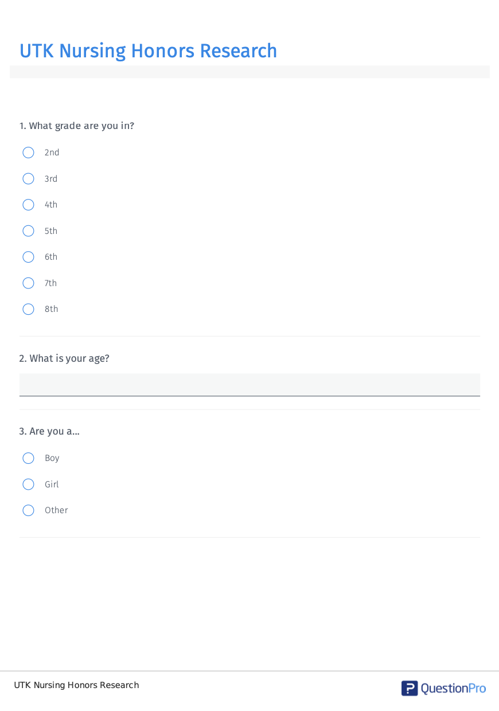
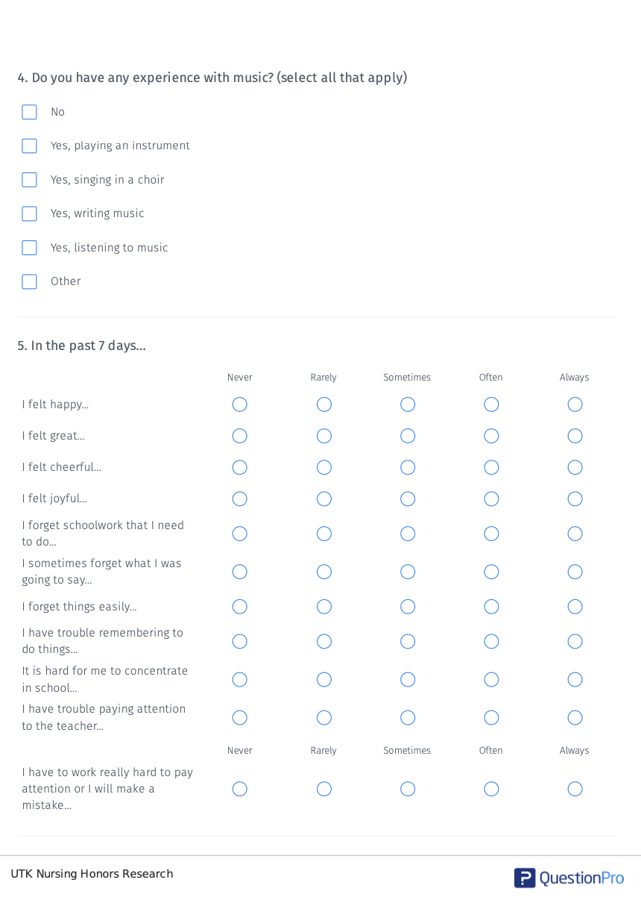
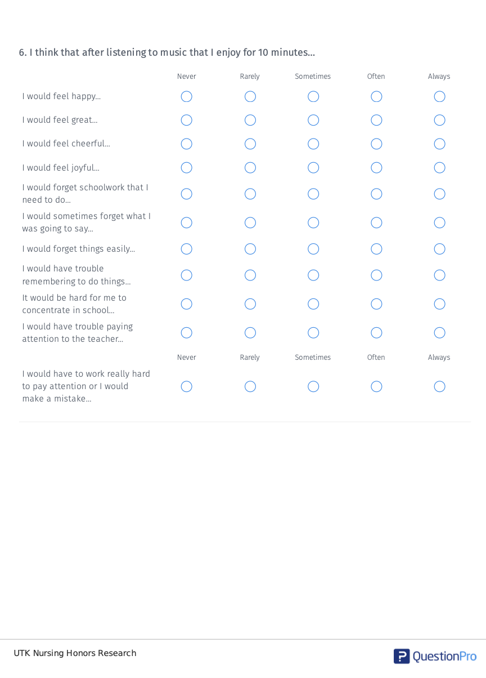

Appendix E
IRB Approval
