To the Graduate Council:

I am submitting herewith a thesis written by Angeles Ana Paula Raymundo entitled “Avian community structure and diversity in relation to coastal development in the Sian Ka’an Biosphere Reserve and Riviera Maya, Quintana Roo, Mexico.” I have examined the final electronic copy of this thesis for form and content and recommend that it be accepted in partial fulfillment of the requirements for the degree of Master in Science with a major in Wildlife and Fisheries Science.

_______________________________
David A. Buehler, Major Professor

We have read this thesis and
recommend its acceptance:

_____________________________
Nathan Sanders

_____________________________
Frank van Manen

_____________________________
Ben Fitzpatrick

Accepted for the Council:

________________________________
Carolyn R. Hodges
Vice Provost and Dean of the
Graduate School

(Original signatures are on file with official student records.)
Avian community structure and diversity in relation to coastal development in the Sian Ka’an Biosphere Reserve and Riviera Maya, Quintana Roo, Mexico.

A Thesis
Presented for the
Master of Science
Degree
The University of Tennessee, Knoxville

Angeles Ana Paula Raymundo
December 2009

DEDICATION

To my parents and sister for all their love and support.

Acknowledgments

I am really thankful to my committee for their support and patience. Specifically, I want to thank my major advisor, D. Buehler, for all his support, dedication and suggestions for this research, for having the interest in developing research in my lovely country, Mexico, and contributing to the knowledge of its biodiversity. I also thank D. Buehler for providing numerous opportunities for traveling to different states in the U.S and Mexico, and field experience outside this research that helped me to grow professionally and personally. I am really thankful to Nate Sanders for his patience while talking about community ecology analyses and his friendship. I thank Frank van Manen and Ben Fitzpatrick for their patience, support and suggestions.
Funding for this project was provided by the U.S. Fish and Wildlife Service, the Tennessee Wildlife Resources Agency, the American Bird Conservancy, and the Tennessee Ornithological Society. I want to thank CONANP Sian Ka’an and Amigos de Sian Ka’an A.C. for all the facilities provided in Mexico to work in the reserve. Without their support this work could not be finished. Centro Ecológico Akumal, A.C and Fundación Ecológica “Ecobahía” made the field work in the Riviera Maya very easy and their support and help for this project were invaluable. I also thank Barbara MacKinnon, who shared all her knowledge about birds in the region.
Additionally, I thank all the field technicians that made the field work possible from 2006-2008: Waldemar Santamaria, Diana Burgos, Jorge Aguilar, Luis Chulim, Veronica Mendiola, Christina Morales, Vianney Cupiche, Eileen Müller, Gabriel Briceño, Laila Yunez and Christian Montes for their long hours in the field and for their dedication and passion for birds and their conservation. I am especially thankful to Alexander Peña for all the hard and incredible work he did helping this project from beginning to end.
I thank the UT bird lab for all their support, friendship and wonderful times together and specially for sharing this passion for birds and their conservation: Than Boves, Emily Hockman, Katie Piercy, Kelly Caruso, Dan Hinnebusch, Tiffany Beachy and Lesley Bulluck.
I thank Marisol Benitez, Melissa Foster, Lesley Bulluck, Tiffany Beachy and all my TN friends for their friendship, support and encouragement in all aspects of my life. They made my time in TN very special and added some love and happiness to my life while I was here. I thank Ann Reed and Jorge Navarro for their invaluable help in statistics. I thank J. P. Lessard for his help in data analysis and ecological interpretation, and for his friendship.
Finally, I thank my family for their unending support and love. I thank my parents, Jorge Raymundo and Patricia Albarrán, for their encouragement in my academic career from a very early age that brought me to where I am today, and for all the support they provide during the field season. I also thank my sister, Yolotl Raymundo for her friendship, support and all the love that she gave when I needed it the most.

ABSTRACT
Habitat loss and fragmentation caused by tourist development along the eastern coast of the Yucatan Peninsula of Mexico represents a big threat to the survival of Nearctic-Neotropical migratory songbirds. This habitat plays a crucial role for successful migration for many migratory birds. However, the effects of habitat loss and fragmentation on these birds have not been well documented in the region. From September- December, 2006-2008, we mist-netted and conducted transect surveys to assess the variation in the avian community among three different levels of development (high, medium and low). The study area included two small reserves (10-20 ha) in the hotel zone associated with the Riviera Maya (high development), two sites with limited development within the Sian Ka’an Biosphere Reserve associated with small fishing camps (medium development), and two undeveloped sites located on a private ranch within Sian Ka’an (low development). I assessed species richness and abundance of four avian groups: the entire community, year-round residents, winter residents, and transients. Species richness and abundance decreased significantly with the greatest levels of disturbance. The high development level had the least species richness and abundance, whereas the medium development level had the greatest richness for all bird classes. However, my results suggest that small reserves in the hotel zone can be important compliments to the large, undisturbed reserves (Sian Ka’an) for both resident and migrant birds. Forty-six percent of all birds species captured in mist nets were Nearctic-Neotropical migrants; thus this group composed a significant component of the avian community. The dominance in the year-round resident community by the endemic Black Catbird (Dumetella glabrirostris) at medium and low development sites showed that coastal dune vegetation is also important in maintaining populations of endemic species, which are sensitive to levels of disturbance. The use of two different survey methods (mist-netting and transect surveys) produced complimentary descriptions of community composition. Because many year-round resident species and migrants depend on this scarce and discontinuous coastal habitat, and because of the intense development pressure on this coastal zone, better conservation strategies are needed to successfully sustain the avian community of this region.

RESUMEN
La fragmentación y pérdida del hábitat causada por el desarrollo turístico a lo largo de la costa este de la Península de Yucatán en México representan una gran amenaza para la sobrevivencia de miles de aves migratorias Neárticas-Neotropicales. Las dunas costeras representan un papel crucial en una migración exitosa para cientos de aves migratorias. Sin embargo, los efectos de la fragmentación y la pérdida de hábitat en éstos no han sido bien documentados en la región. Durante Septiembre - Diciembre, 2006-2008, se realizaron muestreos por medio de redes de niebla y transectos para evaluar la variación en la comunidad de aves en tres diferentes niveles de desarrollo turístico costero (alto, medio y bajo). El área de estudio incluyó dos reservas pequeñas (10-20 ha) en la zona hotelera asociada a la Riviera Maya (nivel alto), dos sitios con un desarrollo limitado en la Reserva de la Biósfera Sian Ka’an asociados con pequeños campamentos pesqueros (nivel medio) y dos sitios no desarrollados localizados en un rancho privado en la reserva (nivel bajo). Se evaluaron la riqueza de especies y abundancia de cuatro grupos de aves: la comunidad entera, los residentes anuales, los residentes de invierno y los transeúntes. La riqueza de especies y abundancia disminuyó significativamente con los niveles más altos de perturbación. El nivel alto de desarrollo presentó la menor riqueza de especies y abundancia, mientras que para el nivel medio se registró la mayor riqueza de especies para todos los grupos de aves. Sin embargo, los resultados del presente trabajo sugieren que las pequeñas reservas dentro de la zona hotelera pueden ser complementos importantes de áreas más grandes sin perturbación (e.j. Sian Ka’an) para las aves tanto residentes como migratorias. Cuarenta y seis por ciento de todas las especies de aves capturadas con redes de niebla representaron aves migratorias Neárticas-Neotropicales, siendo este grupo un componente significativo en la comunidad de aves. La dominancia en la comunidad de aves residentes anuales por parte de la especie endémica Black Catbird (Dumetella glabrirostris) en el nivel medio y bajo de desarrollo ilustró que la vegetación de dunas costeras es también importante en el mantenimiento de poblaciones de especies endémicas, las cuales resultaron sensibles a los niveles de perturbación. El uso de dos diferentes técnicas de monitoreo (redes de niebla y transectos) producen descripciones complementarias de la composición de la comunidad. Debido a que varias especies de aves tanto residentes como migratorias dependen de este esporádico y discontinuo hábitat costero y porque existe una presión intensa para el desarrollo en las zonas costeras se necesitan mejores estrategias de conservación que permitan el sustento de la comunidad de aves de esta región.

TABLE OF CONTENTS
INTRODUCTION 1
METHODS 4
Study Area 4
Study Site Selection 5
Avian Monitoring Techniques 6
Mist-netting Surveys 6
Transects Surveys 8
Data Analysis 8
Mist netting Data 8
Community structure: Species richness and abundance 8
Variation of species richness and abundance in relation with development level 11
Transect Data 11
RESULTS 12
Mist-netting Surveys 12
Variation of species richness and abundance in relation with development level 12
Migration phenology 15
Transects Surveys 15
DISCUSSION 16
Variation of species richness and abundance in relation with development level 16
Migration phenology 19
Mist nets and transect surveys 21
Conservation implications 23
LITERATURE CITED 26
Appendixes 32
VITA 86

List of Tables
Table 1. Description of the study sites used to evaluate the effects of coastal development on avian communities in the Sian Ka’an Biosphere Reserve and Riviera Maya, 2006–2008. 33

Table 2. Avian species richness, abundance, and Chao1 index for each bird class, year, and site in Sian Ka’an Biosphere Reserve and Riviera Maya, Quinta Roo, Mexico, 2006–2008. 35

Table 3. Unique species observed by development level, year, and site in Sian Ka’an Biosphere Reserve and Riviera Maya, Quintana Roo, Mexico, 2006–2008 37

Table 4. Comparison of avian species richness and abundance for each bird class in three different coastal development levels in the Sian Ka’an Biosphere Reserve and Riviera Maya,Quintana Roo, Mexico, 2006–2008. 40

Table 5. Similarity matrix for the entire avian community for three different development levels in the Sian Ka’an Biosphere Reserve and Riviera Maya, Quintana Roo, Mexico, 2006–2008... 44

Table 6. Pairwise comparisons of avian species composition among development levels in the Sian Ka’an Biosphere Reserve and Riviera Maya, 2006–2008 45

Table 7. Avian average abundance, average dissimilarity and individual species contribution to dissimilarity among three development levels in the Sian Ka’an Biosphere Reserve and Riviera Maya, 2006–2008. 46

Table 8. Nearctic-Neotropical species of conservation concern recorded for the Sian Ka’an Biosphere Reserve and Riviera Maya, Quinta Roo, Mexico, 2006–2008. 48

Table 9. Avian species richness and abundance comparison for transects surveys in three development levels in the Sian Ka’an Biosphere Reserve and Riviera Maya, 2006-2008.. 49

List of Figures
Figure 1. Location of sampling sites within three development levels in the Sian Ka'an Biosphere Reserve and Riviera Maya, Quintana Roo, Mexico, 2006–2008. (Source: Amigos de Sian Ka'an A. C. 2006) 52

Figure 2. Aerial view of Principe sampling site (high-development level) located in the Riviera Maya, Quintana Roo, Mexico, 2006–2008. 53

Figure 3. Aerial view of Akumal sampling site (high-development level) located in the Riviera Maya, Quintana Roo, Mexico, 2006–2008. 53

Figure 4. Aerial view of Chenchomac sampling site (medium-development level) located in the Sian Ka’an Biosphere Reserve, Quintana Roo, Mexico, 2006–2008. 54

Figure 5. Aerial view of Pez Maya sampling site (medium-development level) located in the Sian Ka’an Biosphere Reserve, Quintana Roo, Mexico, 2006–2008. 54

Figure 6. Aerial view of San Juan A sampling site (low-development level) located in the Sian Ka’an Biosphere Reserve, Quintana Roo, Mexico, 2006–2008. 55

Figure 7. Aerial view of San Juan B sampling site (low-development level) located in the Sian Ka’an Biosphere Reserve, Quintana Roo, Mexico, 2006–2008. 55

Figure 8. Example of net arrangement at Pez Maya study site, Sian Ka’an Biosphere Reserve, 2006–2008. Nets were located perpendicular to coastal dune. 56

Figure 9. Avian species richness for the entire community (all bird classes pooled) by year, across all years pooled, and by development level in the Sian Ka’an Biosphere Reserve and Riviera Maya, Quintana Roo, Mexico, 2006–2008. 57

Figure 10. Avian abundances for the entire community (all bird classes pooled) by year, across all years pooled, and by development level in the Sian Ka’an Biosphere Reserve and Riviera Maya, Quintana Roo, Mexico, 2006–2008. 57

Figure 11. Mean and total avian species richness for year-round resident species by year, across all years pooled, and by development level in the Sian Ka’an Biosphere Reserve and Riviera Maya, Quintana Roo, Mexico, 2006–2008 58

Figure 12. Mean and total avian species richness for winter residents by year, across all years pooled, and by development level in the Sian Ka’an Biosphere Reserve, Quintana Roo, Mexico, 2006–2008.. 58

Figure 13. Mean and total avian species richness for transients by year, across all years pooled, and development level in the Sian Ka’an Biosphere Reserve and Riviera Maya, Quintana Roo, Mexico, 2006–2008.. 59

Figure 14. Mean abundances for year-round resident species, by year, across all years pooled, and by development level in the Sian Ka’an Biosphere Reserve and Riviera Maya, Quintana Roo, Mexico, 2006–2008. 59

Figure 15. Mean abundances for winter resident species, by year, across all years pooled, and by development level in the Sian Ka’an Biosphere Reserve and Riviera Maya, Quintana Roo, Mexico, 2006–2008.. 60

Figure 16. Mean abundances for transient species, by year, across all years pooled and by development level in the Sian Ka’an Biosphere Reserve and Riviera Maya, Quintana Roo, Mexico, 2006–2008.. 60

Figure 17. Temporal variation by year and month in Nearctic-Neotropical migratory bird abundances for three development levels the Sian Ka’an Biosphere Reserve and Riviera Maya, Quintana Roo, Mexico, 2006–2008. Bars represent abundance of winter residents. 61

Figure 18. Rarefaction curves for all bird species in three different levels of coastal development in the Sian Ka’an Biosphere Reserve and Riviera Maya, Quintana Roo, Mexico, 2006–2008. The dotted lines represent the 95% confidence intervals. 62

Figure 19. Rarefaction curves for year-round resident bird species in three different levels of coastal development in the Sian Ka’an Biosphere Reserve and Riviera Maya, Quintana Roo, Mexico, 2006–2008 63

Figure 20. Rarefaction curves for winter resident bird species in three different levels of coastal development in the Sian Ka’an Biosphere Reserve and Riviera Maya, Quintana Roo, Mexico, 2006–2008. 64

Figure 21. Rarefaction curves for transient bird species in three different levels of coastal development in the Sian Ka’an Biosphere Reserve and Riviera Maya, Quintana Roo, Mexico, 2006–2008.. 65

Figure 22. Evenness and relative species richness for bird species in three different levels of coastal development in the Sian Ka’an Biosphere Reserve and Rivera Maya, Quintana Roo, Mexico, 2006–2008. a) entire community, b) year-round residents, c) winter residents and d) transients. 66

Figure 23. Non-metric multidimensional scaling based on avian species abundances of the entire community for each sampling period and development level in the Sian Ka’an Biosphere Reserve and Riviera Maya, Quintana Roo, Mexico, 2006–2008. 67

Figure 24. Migration phenology of five early migrants in the Sian Ka’an Biosphere Reserve and Riviera Maya, Quintana Roo, Mexico, 2006–2008.. 68

Figure 25. Migration phenology of two late migrants (Indigo Bunting and Palm Warbler) in the Sian Ka’an Biosphere Reserve and Riviera Maya, Quintana Roo, Mexico, 2006–2008. 69

Figure 26. Mean and total avian species richness from transect surveys for a) entire community, b) year-round resident, c) winter residents and d) transient bird assemblages in three different levels of coastal development, Sian Ka’an Biosphere Reserve and Riviera Maya, Quintana Roo, Mexico, 2006–2008. 70

Figure 27. Mean avian abundance from transect surveys for a) entire community, b) year-round resident, c) winter residents and d) transient bird assemblages in three different levels of coastal development, Sian Ka’an Biosphere Reserve and Riviera Maya, Quintana Roo, Mexico, 2006–2008. 71

Figure 28. Rarefaction curves for bird species assemblages in three different levels of coastal development in the Sian Ka’an Biosphere Reserve and Riviera Maya, Quintana Roo, Mexico, 2006–2008.. 72

Figure 29. Rarefaction curves for year-round residents species in three different levels of coastal development in the Sian Ka’an Biosphere Reserve and Riviera Maya, Quintana Roo, Mexico, 2006–2008 73

Figure 30. Rarefaction curves for winter residents species in three different levels of coastal development in the Sian Ka’an Biosphere Reserve and Riviera Maya, Quintana Roo, Mexico, 2006–2008. 74

Figure 31. Rarefaction curves for transients species in three different levels of coastal development in the Sian Ka’an Biosphere Reserve and Riviera Maya, Quintana Roo, Mexico, 2006–2008.. 74

Figure 32. Hurlbert’s PIE indexes for three different levels of coastal development in the Sian Ka’an Biosphere Reserve and Riviera Maya, Quintana Roo, 2006–2008. a) entire community, b) year-round residents, c) winter residents and d) transients.. 75

- INTRODUCTION
Nearctic-Neotropical migrants are bird species that breed in temperate North America during summer but spend the winter in tropical latitudes (Mexico, Central or South America, and Caribbean Islands). At least half of all bird species that breed in North America migrate to tropical wintering grounds (Rappole 1995). The main migration routes of North American land birds are oriented north-south, partly because wintering ranges of most species lie south of breeding ranges and partly because better habitat conditions trend north-south (Gill 1990). The annual cycle of most species entails spending 3-4 months at breeding sites, 5-6 months at overwintering areas and the remaining 2-4 months along migratory routes (Keast and Morton 1980). Thus, every year at least half of all species that breed in North America undertake long distance flights to their wintering grounds (Rappole 1995).
Long-distance migration has a high energetic cost for birds. Migrants are challenged to accumulate sufficient fat reserves to complete their entire flight to their final destination. Therefore, most migrants interrupt migration at stopover sites. These sites allow migrants to replenish fat stores, rebuild muscle, molt, rest between flights, and seek refuge from inclement weather (Winker et al. 1992, Leberg et al. 1996, Moore and Aborn 2000, Berthold 2001). Use of stopover sites, however, represents a challenge for migrants because they encounter competition with other migrants or resident species, predation risks, and new and unfamiliar areas and habitats, especially during the first migration. Recent studies have made important advances in most areas of migration (e.g., evolution, habitat selection, orientation). However, a better understanding of the importance of stopover sites is necessary to develop effective life cycle conservation strategies for migratory birds (Berthold and Terril 1991), particularly in tropical areas where habitat loss and fragmentation from conversion to agriculture and human development continue at an accelerated pace (Rappole 1995, Petit 2000, Tankersley 2002, 2004, Deppe 2005).
The decline of Nearctic-Neotropical migratory bird populations has been a conservation concern for decades (Robbins et al. 1989, Rappole and McDonald 1994, Peterjohn et al. 1995). Habitat loss and fragmentation on the breeding and wintering grounds are thought to be main causes of the declines (Kerlinger 1995, Sherry and Holmes 1995, Hutto and Young 1999, Petit 2000, Newton 2004). However, over the last few decades, there has been increasing evidence to suggest that the loss and fragmentation of suitable stopover habitat during migration may also play a critical role in the declines (Hutto 1998, Moore and Aborn 2000, Sillett and Holmes 2002). Because Nearctic-Neotropical migrants spend most of their annual cycle either in migration or on the wintering grounds, they need a variety of different ecosystems to satisfy their life cycle needs (Keast and Morton 1980). Thus, a detailed understanding of stopover ecology is crucial for conservation.
Several studies have demonstrated that availability of habitats that provide good quality stopover sites are important for a successful migration (Weber et al. 1999, Simons et al. 2000), especially for immature birds that are completing their first migratory flight (Hutto 1998, Woodrey 2000). If such areas are located near a geographic barrier, such as the Gulf of Mexico, the importance of stopover habitat becomes even more critical (Barrow et al. 2000, Barrow et al. 2005). The quality and quantity of stopover habitat play a very important role in migration phenology; a delayed migration might mean reduced survival or reproduction for several migratory species (Wiedenfeld and Wiedenfeld 1995, Sillett and Holmes 2002). Studies made in the Tropics have documented that habitat loss and fragmentation is reducing or changing the use of certain areas as stopover sites (Lopez-Ornat and Lynch 1990, Rappole 1995, Smith et al. 2001, Ruelas-Inzunza et al. 2004, MacKinnon 2008).
The coastal ecosystems of the Yucatan Peninsula in Mexico contain important stopover habitat. These areas have floristic affinities with the Antillean region which make them rich and diverse in resources (Lopez-Ornat and Lynch 1990). The Yucatan Peninsula could be considered a “full-service hotel”, a type of stopover site which is frequently used by migrants that provides enough resources to supply migrants’ needs without many predation risks (Deppe 2005, Mehlman et al. 2005). Although information is limited, these coastal areas are known to be crucial because they represent the first available stopover habitats for migrants from eastern North America after crossing the Gulf of Mexico (Deppe and Celis-Murillo 2005). Additionally, studies in forested habitats of the Yucatan Peninsula emphasize its importance for Nearctic-Neotropical migrants but many areas have been disturbed by agriculture and urbanization. This habitat loss and fragmentation are contributing to the decline of many Nearctic-Neotropical migratory songbird populations (Waide et al. 1980, Lynch 1989, Lynch 1991, Greenberg 1992, Deppe 2005).
The Sian Ka’an Biosphere Reserve is located on the eastern side of the Yucatan Peninsula. This reserve is approximately 528,000 ha (120,000 ha are marine). The reserve is located in a transition zone between the Yucatan Peninsula and Caribbean and therefore contains a high diversity of ecosystems (tropical forest, wetlands, coastal dunes, lagoons, bays and reefs). The coastal dunes in this area provide stopover sites and wintering habitat for some Nearctic-Neotropical migrants. This area also supports numerous endemic species (e.g., 35 plant species and 10 bird species; Lopez-Ornat and Lynch 1990, Espejel 2008, MacKinnon 2008). Over the past few decades, half of the original extent of this habitat has been destroyed or severely degraded by commercial cultivation of coconut palm or by coastal development for tourism or urbanization (SEMARNAP 1987, CONANP 2007). Coastal development represents the major threat for this habitat. Tourist development and urban populations have grown rapidly in the last 30 years. Since the 1970s, approximately 45,000 new hotel rooms have been built in the surrounding areas, and the human population has increased from 88,000 to 875,000, an annual growth rate of 20% (INEGI 2006, CONANP 2007). Forty-three kilometers of coastal dune vegetation were lost between 1976 and 2000 in northern part of Quintana Roo (Seingier et al. 2009). If this growth continues at the current rate, the future for this area as stopover habitat for migrants is in doubt. MacKinnon (2008) reported a decrease in the number of migratory species observed in surrounding areas of Cancun in comparison to those species numbers observed in 1980. In addition, Zimmerman (2004) reported that Swallow-tailed Kite (Elanoides forficatus) during stopover in the Yucatan Peninsula avoided highly disturbed areas, like Cancun, and moved south looking for better vegetated areas, like the evergreen broadleaf forests founded in the Sian Ka’an Biosphere Reserve. Thus, the Sian Ka’an Biosphere Reserve represents the only area where coastal vegetation and other habitats are being protected along the eastern coast of the Yucatan Peninsula (Mazzotti et al. 2005). However, private lands within and adjacent to the reserve are increasingly being considered for tourist development. Consequently, habitats may become more fragmented, potentially affecting habitat quality for migratory birds (Barrow et al. 2005, Moore and Aborn 2000, Simons et al. 2000).
Although the importance of Sian Ka’an Biosphere Reserve as stopover habitat for migratory birds is known, well documented information about the avian community structure in the coastal area of this region is scant, and knowledge about how birds use this habitat is even more limited. The overall goal of this research is to increase our understanding of the avian community in coastal habitats in the Sian Ka’an Biosphere Reserve (RBSK). The specific objectives of this study were: 1) to describe the avian community structure in the RBSK and Riviera Maya, 2) to assess the variation of species richness and abundance of avian communities temporally and within three different levels of coastal development along the northern coastal range in the Sian Ka’an Biosphere Reserve and Riviera Maya, 3) to determine the fall migration phenology in this area, and 4) to compare two different survey methods to obtain an inventory of species for the area.

- METHODS

Study Area
The Sian Ka’an Biosphere Reserve (RBSK) is located in the central coastal region of the Mexican state of Quintana Roo (Fig. 1). The climate is tropical with summer rains and occasional hurricanes. Mean monthly temperature was 22°C for January/February and 27.8°C for May. Mean annual rainfall was 112.8 cm with September being the wettest month (mean 20.8 cm) and March the driest (mean 2.94 cm). Mean relative humidity was around 80%. Hurricanes may occur between June and October, with peak occurrences in September (Garcia 1981). The most recent severe storm was hurricane Dean in August 2007, which caused severe damage to vegetation (McGinley 2008). The maximum elevation is 10 m above sea level. The main vegetation types of RBSK are evergreen and deciduous forest, wetlands, savannas, hammocks, and coastal dunes. Many areas of the reserve were disturbed by human activities during the 1950s, especially in the coastal ecosystems (SEMARNAP 1987). Sian Ka’an has approximately 100 km of coastal dune vegetation within a 100-200 m wide strip. Historically, 90% percent of these coastal dunes within the reserve were modified for coconut plantations (Cocos nucifera). As a result of this disturbance, the native vegetation occurs in different stages of succession. The remaining 10% represents typical Antillean elements such as ‘Chiit’ palm (Trinax radiata), skimay (Tournefortia naphaloides), Strumpfia marítima, Rihanona (Ipomoea pres-caprae), Cordia sebestena, lirium (Hymenocallis spp.), Sesuvium spp., seagrape (Coccoloba uvifera), and Ageratum littorale (Espejel 1983).

Study Site Selection
Study sites were selected according to the existing gradient of tourist development in the area. Tourist development has progressed southward from Cancun along coastal areas to Tulum, adjacent to the northern boundary of the reserve. Because the objective of this study was to assess the influence of tourist development on avian communities, the arrangement of the sampling sites followed the gradient of development from north to south. The high-developed sites were located in the Riviera Maya, a zone with high tourism potential but where limited coastal dune vegetation still remains (Villanueva and Cabrera 1988). The less-developed sites were located within the northern half of RBSK. Site selection within the high-development area was restricted to properties in which I could obtain landowner permission, and where coastal dune vegetation was still available in sufficiently large patches to support the mist-net sampling design. The latter factor was a big constraint, because few coastal dune vegetation patches in the Riviera Maya were large enough to set up the mist-net grids. Thus, two sites at each of three different levels of human development along coastal dune in the RBSK and Riviera Maya (6 sites total) were selected (Fig. 1). High-development sites (Principe and Akumal) were defined as those with the presence of large resort hotels located in a coastal setting. Land use cover within 1 km of Principe included 30.5% developed, 15.9% transportation, 8.3% water, and 45.3% native vegetation (Table 1, Fig. 2). Land use cover within 1 km of Akumal included 10.9% developed, 8.5% transportation, 41.5% water, and 39.1% native vegetation (Table 1, Fig. 3). The Principe site included two disjoint areas: small coastal dune vegetation patches located adjacent to the resort and a small (<10 ha) patch of coastal habitat that had been set aside as a reserve. The Akumal site also consisted of a small coastal reserve (~20 ha) adjacent to the developed area (Table 1).
Medium-development sites located within the RBSK included contiguous native vegetation adjacent to a former fishing lodge which now serves as a field station owned by Amigos de Sian Ka’an A. C. (Pez Maya) and contiguous native vegetation adjacent to an active private fishing lodge (Chenchomac). The medium-development sites contained a small main lodge building with several (<10) small cabanas located nearby along the coast. Land use cover within 1 km of Pez Maya included 1.2% developed, 6.3% transportation, 58% water, and 34.5% native vegetation (Table 1, Fig. 4). Land use cover within 1 km of Chenchomac included 1% developed, 5% transportation, 74% water, and 20% native vegetation (Table 1, Fig. 5). Mist-nets and other bird monitoring occurred in the largely undisturbed coastal dune habitat surrounding the developed area.
The two low-development sites were both located on Rancho San Juan. This ranch contained 7 km of undisturbed coastal vegetation bisected by an improved road that connects Tulum with Punta Allen. The two sites were located at opposite ends of the ranch and were approximately 5 km apart. Land use cover within 1 km of San Juan A included no development, 6.3% transportation, 74.7% water, and 19% native vegetation (Table 1, Fig. 6). Land use cover within 1 km of San Juan B included no development, 6.6% transportation, 65.3% water, and 28.1% native vegetation (Table 1, Fig. 7).

Avian Monitoring Techniques

Mist-netting Surveys
Passive mist-net sampling was conducted during fall 2006 (September 15th-December 15th), 2007 (September 1st – December 1st), and 2008 (September 1st – December 1st). An array of 10 nets (12 m x 2.7 m) was set up on each site. Nets were distributed in pairs, with approximately 30 m between adjacent pairs. Nets were located perpendicular to the coastal dunes, because I assumed migrants typically moved parallel to the coast and were more likely to encounter nets set in such a fashion (Fig. 8).
A given study site was monitored for 5 consecutive days, with one netting session (5 d) being conducted at each site every 3 weeks of the field season, resulting in 4 netting sessions (20 sample days total) per site per season. Nets were opened at sunrise and operated until weather conditions (high temperature) no longer permitted safe capture and handling of birds (3.5-4 h after sunrise). Weather condition (temperature, wind speed, and barometric pressure) was recorded hourly every day using a Kestrel 3500 weather instrument (Kestrel Meters, Sylvan Lake, MI). Nets were checked every 20 min or more frequently if the capture rate was high to ensure bird safety. Rarely, during times of peak capture rates, some nets were closed to ensure that captures did not exceed extractions.
For each bird captured, species, sex, and age were determined based on plumage and skull ossification according to Pyle (1997). Captured birds were banded with a United States Fish and Wildlife Service (USFWS) band for North American migrants (i.e., species covered in Pyle 1997) or with a uniquely numbered commercial band for resident species. Body mass for each bird captured was determined to 0.1 g by using a portable electronic balance (CS 200 OHaus Pine Brook, New Jersey). The unflattened wing chord, standard tail length, and tarsus length were measured to the nearest mm. Fat scores were assigned to each bird, based on a 1–7 scale, similar to MOSI protocols (DeSante and Sarraco 2004).
Bird species captured were classified as (1) resident if the species bred and remained in the area year-round; (2) transients if the species was a non-breeding visitor present only during autumn migration (August–October); or (3) as a winter resident if the species remained in the area through December. This classification was based on MacKinnon (2005) and Howell and Webb (1995). An additional group was comprised of (4) the entire community, which included year-round residents, winter residents, and transients.

Transects Surveys
To supplement mist-netting data, a daily 30-min strip transect 250 m long by 50 m wide was conducted for each netting session in all sites and years. The use of a complimentary observational method with mist-netting ensures a more representative inventory of bird communities and compensates for the potential biases associated with each individual method (Whitman et al. 1997).
Through the field seasons, a total of 55 transects were conducted. Five more transects were not conducted because adverse weather conditions did not allow to do that. Transects were walked at a similar pace for 30 minutes and were conducted in the first hour after dawn. Birds detected by sight and sound within 25 m on either side of the transect were recorded (Bibby et al. 2000, Gibbons and Gregory 2006). Species were classified as year-round residents, winter residents, and transients using the same criteria described previously. Birds flying over transects were recorded but not included in any of the analysis.

Data Analysis

Mist netting Data

Community structure: Species richness and abundance
For the entire bird community, year-round residents, winter residents, and transients, I calculated species richness for each development level as the average number of species encountered in each site, with all sampling periods being pooled. I also calculated an estimate of the number of species that were expected to be in the community on the basis of Chao 1 non-parametric estimator, using EstimateS 8.0 (Colwell 2006). The Chao 1 estimator calculates an estimate of the expected species richness in a site based on the number of rare species in a sample, represented only by one or two individuals (Chao 1984, Chao and Lee 1992, Moreno 2001).
Chao 1 = S + a²/2b

where S equals the total number of species in a sample,
a equals the number of species represented by one individual, and
b equals the number of species represented by two individuals.

I analyzed patterns of bird species accumulation against sampling effort for each of the four bird groups (entire community, year-round residents, winter residents, transients), sites, and years. I obtained species accumulation curves by using rarefaction (Sanders 1968, Simberloff 1972). This approach calculates the expected species richness based on random subsamples of individuals obtained based on the smallest sample. These subsamples can be compared amongst communities since they are calculated based on an identical number of individuals (Gotelli and Graves 1996). Rarefaction assumes sufficient sampling to guarantee an adequate characterization of the community, a random distribution of individuals, samples from similar taxa, and standardized sampling techniques. The rarefaction curves were created by using EcoSim 7 with 1000 randomizations (Gotelli and Entsminger 2009). The entire community analyses were based on a sample of 1185 individuals, the lowest number of birds recorded for any development level. For resident species, the analysis was based on 456 individuals, whereas for winter residents and transients the analysis was based on 640 and 89 individuals, respectively.
I computed Hurlbert’s Probability of Interspecific Encounter (PIE) index of diversity for each level of development. This index is a measure of equitability in the community. It calculates the probability that two individuals randomly selected from a sample represent two different species. It is based on the same principles of rarefaction, therefore is insensitive to sample size. Its values range from zero to one, with the maximum evenness equal to one. Comparisons of species richness and evenness were conducted based on examination of 95% confidence intervals. The 95% confidence limits of the mean were obtained after 1,000 iterations with rarefaction as the randomization algorithm (Gotelli and Entsminger 2009).
Multi-Dimensional Scaling ordination (MDS, Kruskal and Wish 1978) was used to ordinate sites based on their similarities, based on species composition. MDS is a nonparametric method which uses the rank order of similarities between samples rather than their absolute values. The ordination procedure results in a scatter plot in which each replicate sample is represented by a point, and the distances between points follow the same rank order as the pairwise dissimilarities in species composition between samples. Additionally, I calculated Bray-Curtis similarity coefficients among development levels by using species’ presence-absence within each site and year for each development level. Similarity matrices were used to test for differences in species composition among development levels using the ANOSIM procedure in PRIMER V6 (Clarke 1993, Clarke and Gorley 2006). ANOSIM compares the level of similarity of a given site with samples chosen randomly from the samples of all sites and determines if the former is greater than expected by chance. I also used ANOSIM with pairwise comparisons to determine species turnover between sites (spatial turnover) and between year and months (temporal turnover). ANOSIM ranks the elements of the Bray–Curtis dissimilarity matrix computed between all samples and calculates the statistic R.
R = (r_{B}-r_{W})/1/2 M

where M = n(n-1)/2 and n is the total number of samples under consideration,
r_{B} equals the average of rank similarities arising from all pairs of replicates between different sites, and
r_{W} equals the average of all rank similarities among replicates within sites.

R can only take values in the range -1 < R < 1, with R = 1 corresponding to the case where all replicates within sites are more similar to each other than any replicates from different sites. Values of approximately zero occur if similarities between and within sites are the same on average (Warwick et al. 1990).
Finally, I used mean Bray-Curtis dissimilarity indices computed by SIMPER in PRIMER V6 (Clarke and Gorley 2006) to explore the relative contribution of individual species to dissimilarities among development levels. SIMPER ranks species from most to least important in determining sites differences based on the averages of those ranks. Summed over all species, this gives the average dissimilarity (δ) between sites. The percentage contribution of each species to that overall dissimilarity can be determined and accumulated across species (Warwick et al. 1990).

Variation of species richness and abundance in relation to development level
To assess the richness and abundance variation along development levels (3 levels), months (September-December) and years (2006-2008), I conducted analysis of variance (ANOVA) and pairwise comparisons based on least significant differences (LSD) using PROC MIXED and PROC GLIMMIX procedures (SAS 2003). A randomized block design (RBD) with replication and repeated measures was used for the analysis. Site was considered a block effect, so every site containing a combination of development level, month, and year was considered an experimental unit for this analysis. Site was used as a block to control the variation of development level. Two replications of each treatment were used in the analysis, with a sample size of 72 samples. For year-round resident species, I used PROC MIXED because assumptions of normality and equal variances were met and I only assessed the variation of abundance and richness by development level and year. For winter residents and transient species, I was also interested in the effect of month on species richness and abundance because migration occurs in pulses. For winter residents analysis, I used PROC GLIMMIX because data were Poisson distributed and unequal variances were detected (SAS 2003). Because data for the transient group were sparse, I used a rank transformation and analyzed the data with PROC MIXED (SAS 2003).

Transect Data
I calculated species richness and abundance applying the same approaches used for the mist-netting data. Data for transients detected during transect surveys were summarized but not statistically analyzed because of limited sample sizes.

- RESULTS

Mist-netting Surveys

Variation of species richness and abundance in relation with development level
A total of 9,006 birds of 132 species were banded during 2006–08 (Appendix 2); 46% of the species (61 species, 3,171 individuals) were Nearctic-Neotropical migrants. The net sample at the two high-development sites (pooled) contained 83 species, the medium development sites contained 103 species, and the low development sites contained 85 species (Fig. 9). Total abundance ranged from 1,185 individuals for high-development sites (pooled), 3,982 individuals for medium-development sites, and 3,839 individuals for low-development sites (Fig. 10). For the Principe site, 77.5% of the abundance and species richness came from the coastal dune reserve. The small patches of coastal vegetation in front of the resort did not contribute much to species richness or abundance (22.5%) (Table 2). Chao1 species richness estimators for high-, medium-, and low-development levels were 84, 124.7 and 130.4, respectively. Based on this analysis, 79.6% of the species predicted considering the entire community were captured, 77.7% of resident species were captured, 76% of winter residents were captured, and 81% for transient species were captured.
A total of 44, 49, and 43 year-round resident species were captured for the high-, medium-, and low-development sites, respectively (Fig. 11). For winter residents, 29, 34, and 30 species were captured for high-, medium-, and
low-development sites, respectively (Fig. 12). For transients, high-development sites had 10 species, whereas medium- and low-development sites had 20 and 12 species, respectively (Fig. 13). Year-round residents were most abundant at the medium-development sites (P < 0.0001) (Fig. 14), whereas winter residents and transients were most abundant at the low-development sites (Figs. 15 and 16). Medium-development sites contained more unique species (18 species), several of which are considered of conservation concern either by the Mexican law NOM-059 or Partners In Flight designation (Table 3). Unique species are those species that were only recorded in a single site, and nowhere else. Capture rates averaged 3, 11 and 12 birds/10 net hours for the high-, medium- and low-development levels, respectively.
I detected differences among development levels for species richness and abundance of the entire community based on analysis of capture data without rarefaction. Medium-development sites had the greatest richness (P < 0.0001) and abundance (P = 0.0221). Abundance varied by year (P = 0.0451); 2006 had the greatest abundance (Table 4). The same pattern was evident for year-round residents; medium-development sites had the greatest richness (P < 0.0001) and abundance (P = 0.0341). For that group, abundance varied by month; September and October had the greatest abundance (P = 0.0049). For species richness of winter residents, I detected a month by year interaction (P = 0.0041). For all years, a pattern of greatest richness during late September and October, and least richness during December was observed (Table 4). For abundance of winter residents, there was a significant interaction of development level, year, and month (P = 0.0004). High-development sites had the least abundance for all years, whereas medium-development sites had the greatest abundance in 2006 and 2008. In late September, 2007, the
low-development sites had the greatest abundance. Year 2006 had the greatest abundance with September and October having the greatest monthly abundances (Table 4; Fig. 17). Species richness for transients differed by year (P = 0.0481) and month (P < 0.0001). Year 2007 and the months of September and October had the greatest richness. Transient abundance showed the same pattern with September and October having the greatest monthly abundances (P < 0.0001). There was a significant development level interaction with year; low- and medium-development sites differed in abundance in 2006 (P = 0.0129). Medium-development sites had lower abundances in 2006, whereas low-development sites had greater abundances in 2006 (Table 4; Fig. 17).
Species richness based on rarified samples differed among sites: the
high-development sites had the greatest rarified richness. Medium- and
low-development sites had lesser richness (high = 83, medium = 73, and low = 66 species) (Fig. 18). I observed the same pattern for resident species, with the
high-development sites having greater rarefied species richness and medium- and low-development sites having less rarefied species richness (high = 44, medium = 28, and low = 25 species; Fig. 19). For winter residents, medium-development sites had the greatest abundance (Fig. 20). For transients, medium-development sites had the greatest species richness and abundance (16 species; Fig. 21). Evenness differed among the development levels; high-development sites had the greatest evenness for the entire community and for year-round residents (Fig. 22 a and b). I observed no differences in evenness for winter residents (Fig. 22 c) but low-development sites had lesser evenness for transients (Fig.22 d).
The Bray-Curtis similarity indices differed among the development levels and species groups (global R = 0.619, P = 0.001) (Table 5). The high-development sites differed from medium- and low-development sites, and those differences were emphasized in the non-multidimensional scaling (Fig. 23) with the exception of the transient bird group (global R = 0.065, P = 0.019) (Table 7). In terms of spatial turnover, the medium- and low-development sites were the least different in species composition (P = 0.14), whereas the high- and low-development sites differed the most (P = 0.01). The temporal turnover did not show a clear pattern (Fig. 23).
Black Catbirds contributed 52% and 60% of the dissimilarity between the high- and medium-, and high- and low-development sites, respectively. Black Catbirds were much more abundant on the less-developed sites. For winter residents, Yellow Warblers and Gray Catbirds contributed 23% of the dissimilarities between high- and medium-, and high- and low-development sites. Finally, for transients, Red-eyed Vireo contributed 33% and 53% of the dissimilarity between high- and medium-, and
high- and low-development sites, respectively (Table 7).
Although abundances were not high, several priority species were captured, including Golden-winged Warbler (3 captures total, absent in 2007) and Painted Bunting (1 capture). We recorded a new record for Sian Ka’an for Eastern Phoebe in 2006. We also captured many other species of conservation concern (Audubon 2007 Watchlist; Table 8).

Migration phenology
A temporal pattern of migration characterized by periods of slow and rapid turnover was observed. In 2006, the period of slow turnover was missed by the start of the field season on September 15th, but 2007 and 2008 data showed that migration increased by mid- September and October and decreased by mid-November and early December. The beginning of all field seasons was characterized by early migrant species, including Red-eyed Vireos, Northern Waterthrushes, American Redstarts, and Magnolia Warblers (Fig.24). The slow turnover period at the end of the season was dominated by late arriving species, including Indigo Buntings and Palm Warblers (Fig.25).

Transects Surveys
A total of 9,550 individuals of 112 species were recorded during transect surveys (Appendix 2). Thirty-seven percent of these species were
Nearctic-Neotropical migrants. High-development sites had 79 species, medium-development sites had 85 species, and low-development sites had 84 species (Fig. 26 a). Abundance equaled 2,724 individuals for high-development sites, 3,691 individuals for medium-development sites, and 3,135 individuals for low-development sites (Fig. 27 a). Fifty-three, 55, and 53 year-round resident species were recorded for the
high-, medium- and low-development sites, respectively (Fig. 26 b). For winter residents, 20, 22, and 23 species were recorded for high-, medium-, and
low-development sites, respectively (Fig. 26 c). Finally, for transients, 6, 8, and 8 species were recorded for high-, medium-, and low-development sites, respectively (Fig. 26 d).
Based on non-rarified samples, species richness (P = 0.0145) and abundance (P = 0.0049) differed for the entire community. High-development sites had the least richness. Medium-development sites had the greatest abundance, particularly during the late September and October periods (Table 9). Year-round resident species richness differed by development level (P = 0.0205) and year (P = 0.0200).
High-development sites had the least year-round resident richness and 2007 had the greatest species richness. No differences were detected for abundance of year-round residents (Table 9). Abundance and richness of winter residents increased by month (P < 0. 01) with the first sampling period being different from the subsequent periods (Table 9). We recorded only a total of 285 transient individuals of 12 species;
high-development sites had the greatest abundance of transients (136 individuals). Medium- and low-development sites had 107 and 46 individuals, respectively, with 8 transient species observed for each development level.
Based on rarified samples, species richness did not differ (P > 0.0521) among development levels, for the entire community, year-round residents, or transients. However, species accumulation curves for low-development sites showed a greater total richness for the entire community (81 species; Fig. 28) and for transients (8 species; Fig. 31), whereas high-development sites had the greatest richness for the year-round residents (53 species; Fig. 29). In addition, for winter residents low-development sites had the greatest richness (23 species; Fig. 30).
Low-development sites had the least evenness (PIE = 0.8869 and 0.8587, respectively) for the entire community and for year-round residents. Evenness for high- and medium-development sites did not differ for the entire community and
year-round residents (Fig. 32 a, b). For winter residents, high-development sites had the greatest evenness (PIE = 0.8944) (Fig .32 c), whereas for transients,
high-development sites had the least evenness (Fig. 32 d). No differences in evenness were found for medium- and low-development sites for transients.
Overall, for species richness and abundance for the entire community, mist nets and transects had 49% similarity. For year-round residents, mist nets and transects had 49.9% similarity in species richness and abundance, whereas the two techniques had 51.8% and 19.1% similarity for winter residents and transients, respectively.

- DISCUSSION

Avian community structure and variation of species richness and abundance in relation to development level
The present study recorded 149 species for the northern portion of the Sian Ka’an Biosphere Reserve, including 132 species from mist-net sampling. This avifauna represents 26% of the all species reported for the Yucatan Peninsula, 37% of all species reported for Quintana Roo, and 40% of all species reported for the RBSK (MacKinnon 2005, 2008). Of the 132 species captured in mist nets, Parulide (n = 30 species), Tyrannidae (n = 18 species), Icteridae (n = 9 species), and Vireonidae (n = 9 specie) were the most represented families. This study recorded 83 year-round resident species, 38 winter resident species and 28 transient species. In terms of the residency status, the year-round residents accounted for 55% of the avifauna, whereas migratory species accounted for 45% of the avifauna. Lopez-Ornat and Lynch (1990) through a mist-net study reported a ratio of 68% residents to 32% migrants in coastal ecosystems of the Peninsula. However, Smith (2001), using mist nets and Gonzalez-Herrera (2009) using point counts, found a 70:30% ratio in different natural protected areas of the Yucatan state that included successional and mature forests. Similar to my study, Lopez-Ornat and Lynch (1990) reported Black Catbirds, Bananaquits, Tropical Mockingbirds, and Yucatan Vireos as the dominant species in the coastal scrub vegetation. The large numbers of migratory species we recorded confirms that the north coast of Quintana Roo provides stopover habitat and suitable wintering grounds for many migratory species from eastern North America.
Species richness and abundance of avian communities was negatively related to the development level. Richness and abundance were lower on the
high-development sites, whereas medium-development sites had the greatest total richness and abundance. Habitat patches associated with the Riviera Maya may not provide enough habitat complexity, large enough patch size, and connectivity to satisfy requirements for some avian species. Diversity of birds is highly correlated with the amount of structure provided by the habitat in the form of trees, shrubs and grasses, regardless of plant composition (Mills et al. 1989, Blair 1999, Blake and Loiselle 2001). However, Beissinger and Osborne (1982) found that in urban habitats, the type of vegetative cover influences avian communities because of food resources provided that variable plant species composition can provide. Additionally, patch size influenced bird species diversity in that study, because patches in urban areas tend to be smaller than the minimum size required by many birds. My results from the high-development sites confirmed this trend, because most of the data obtained for this development level came from 10-20 ha vegetation patches considered “reserves”. This shows that small “reserves” in a highly fragmented habitat are capable of supporting considerable richness and abundance of birds, and thus may play an important role in bird survival, particularly for Nearctic-Neotropical migratory birds. Migratory birds seem to assess alternative habitats during exploratory phases after arrival (Moore et al. 1995). Birds first arriving to the Yucatan Peninsula will stop in the first patch of suitable habitat they find. My data indicate that the small reserves in the high-development zone serve this purpose, which may be particularly important for young birds without migratory experience (Woodrey 2000). However, these small reserves may not actually provide high-quality resources, but may simply represent the best option compared to the extremely limited habitat patches that were present elsewhere on the hotel grounds. Barrow et al. (2000) found that migrants in poor body condition first arrived at disturbed sites but quickly moved to non-disturbed sites. Thus, these “reserves” may represent the only suitable stopover habitat for many migrants in the hotel zone. Conservation of these reserves throughout the high-development zone needs to be promoted. Fragmentation of habitat and loss of vegetation complexity in these coastal ecosystems are a consequence of the continuous degradation because of urbanization, agricultural cultivation, and tourist development since the 1970s (Lopez-Ornat and Lynch 1990, Villegas and Carrascal 2000, Mazzotti et al. 2005).
The endemic Black Catbird occurred in greater abundances in the
medium- and low-development sites than the high-development sites. The Black Catbird was the most abundant species, which demonstrates the importance of the coastal areas of the eastern portion of the Yucatan Peninsula for this species (Lopez-Ornat and Lynch 1990, Morgenthaler 2003). Documentation of very low densities in sites with high habitat disturbance suggests that this species is sensitive to changes in its environment and emphasizes the importance of the conservation of coastal ecosystems in the RBSK to conserve this species and other endemics. In addition, coastal dune vegetation provides shelter and food resources to species that show a very strong affinity with coastal ecosystems, such as Bananaquits. Thus, this narrow zone of vegetation plays a very important role for wildlife and its conservation is necessary.
Based on the rarefaction analysis, high-development sites had the greatest rarified species richness, which was contrary to the results based on analysis of the entire dataset. However, the rarefaction curve for the high-development sites was very steep, suggesting that caution should be used in interpretation for these results. Rarefaction standardizes data to equivalent sample size without taking in consideration differences in relative abundances and species numbers of individual samples (Simberloff 1972, Magurran 1988, Wiens 1992). By using this approach, a hypothetical sample of 100 birds from the high-development sites would contain more species than a similar-sized sample from the medium- and low-development sites. In our study, however, we used approximately equal sampling effort on all sites, regardless of development level. As a result, the low- and medium-development sites, based on equal sampling effort, did in fact contain more species and individuals than did the high-development sites. The richness detected for high-development sites was in part based on the presence of synantropic species that respond favorably to human-caused habitat disturbance, such as the Great-tailed Grackle, a species that is highly adaptable to disturbed habitats (Chablé-Santos et al. 2005).
The high-development sites also provided lesser conservation value because these sites were not used by many vulnerable species. In contrast,
medium-development sites were used by a number of species of conservation concern (e.g., Golden-winged Warbler, Canada Warbler, Bay-breasted Warbler, and others). For Nearctic-Neotropical migratory birds, the medium-development sites, even using a rarefaction approach, had the greatest richness. This confirms that even if migratory birds tolerate limited disturbance, not all disturbed habitats are suitable for migrants (Petit et al. 1995, Petit and Petit 2003).

Migration phenology
Differences in abundance and richness of Nearctic-Neotropical migrants by month illustrated the migration phenology. Numbers of migrants increased gradually during September and peaked during late September-early October. Migrants decreased during November and migration was essentially complete by early December, with only winter residents remaining. For 2006, the first netting session had greater abundance than other years because we did not start mist-netting until 15 September in 2006. In 2007-08, we started 1 September, which showed that this period preceded the peak of migration. In 2007, however, this pattern was not clear, because migrants seemed to stay longer in the area. This may be explained by the limited food resources available, likely because hurricane Dean impacted the area prior to the start of data collection.
Deppe (2005) and Bayly and Gómez (2008) found the same pulse turnover pattern; migrants increased in September and October, but decreased by November in the northern coast of the Yucatan, and northern Belize, respectively. However, species turnover varied in species composition in both studies. On the northern coast of the Yucatan, Barn Swallows and Northern Waterthrushes were considered early migrants, followed by Blue-winged Warblers and Yellow-billed Cuckoos. Black-throated Green Warblers and Indigo Buntings were considered late migrants (Deppe 2005). In Belize, Red-eye Vireos and Yellow Warblers were considered early migrants (Bayly and Gomez 2008). In my study, Red-eyed Vireos, American Redstarts, Magnolia Warblers and Northern Waterthrushes were considered early migrants, followed by Common Yellowthroat, and Yellow Warbler. Indigo Bunting and Palm Warblers were late migrants. The observed differences in species turnover between studies may be explained by study area location, temporal variations, and ethological characteristics. Migratory species move along habitats at different times and these movements are affected by environmental changes, such as weather. In addition, juvenile birds tend to migrate earlier than mature birds, as do birds that breed in more northern latitudes or that overwinter further south.
Hurricane Dean was a significant environmental factor that affected the avifaunal distribution and abundance in 2007 and also in 2008. This extreme storm happened two weeks before the start of the field season and greatly modified the vegetation of the area. Coastal habitat during fall 2007 was characterized by little foliage on trees and no fruit production on our field sites, accounting for lesser abundance in comparison with 2006. Additionally, several new species (i.e., not documented in 2006) were observed on the study sites in 2007, including Keel-billed Toucan, Collared Aracari, and Bright-rumped Attila. These frugivorous species were apparently dispersing from other hurricane-damaged areas in search of food. Lynch (1991) and Greenberg (1992) reported changes in species composition and abundances of both year-round residents and migrants after hurricane Gilbert modified forested areas of the Yucatan Peninsula in 1988. They found that some winter resident species (e.g., Blue Bunting, Magnolia Warbler, White-eyed Vireo, and Gray Catbird), were more resilient than year-round residents to the effects of habitat modifications because of the hurricane. Additionally, several researchers have documented that frugivorous and nectarivorous bird guilds are more severely affected because hurricanes substantially reduce fruit and nectar resources. Hurricane impacts may have significant consequences for migrant survival, especially if hurricanes impact stopover habitats. However, insectivorous species may actually benefit because of increasing insects populations following hurricanes (Wauer and Wunderle 1992, Dionne 2009, Dobbs 2009).
Few significant differences were found between 2007 and 2008 in avian distribution and abundances. This result suggests that the sites may not have completely recovered from the hurricane effects on vegetation. For areas at low altitudes lacking complex vegetation structure, recovery of the vegetation may take only two years, whereas for areas at higher altitudes, more time is required to recover structurally complex vegetation (Tanner et al. 1991, Dobbs et al.2009). Additionally, open habitats may recover more easily because they can be colonized with successional species (Tanner et al. 1991).

Mist nets and transect surveys
The use of two different survey methods can provide complimentary descriptions of community composition (Whitman et al. 1997). In my study, both methods showed a similar pattern of species richness for all sites, with greater species richness and abundance for medium-development sites for all bird assemblages. However, data from mist nets recorded greater species richness and abundance for migratory species. For example, 28 species were detected only with mist nets, including 3 species of Flycatchers, Golden-winged Warbler, Canada Warbler, Worm-eating Warbler, Yellow-bellied Sapsucker, and Yellow-throated Vireo. Nevertheless, eighteen species were recorded only with transects, although all had low densities (e.g., Vultures, Osprey, American Bittern, Great Blue Heron, Yellow-crowned Night-Heron, 2 species of swallows). Some species were detected more frequently by mist netting, included all 4 thrush species, Gray Catbird, Magnolia Warbler, Ovenbird, Northern Waterthrush, Prothonotary Warbler, and Red-eye Vireo. Conversely, a greater number of year-round resident species and individuals were recorded during transect surveys (14 more species and 2,364 individuals). For example, only 3 individuals of two species for the family Psittacidae, were captured with mist nets, whereas 119 individuals of 4 species were recorded with transects. Other examples of unique species for transects were 2 species of the family Cathartidae and 2 of the family Ardeidae. Although the Black Catbird was detected by both methods, mist netting had 3,212 individuals, whereas only 1,586 individuals were recorded with transects. Bray-Curtis similarity indices showed that the use of a single survey is inadequate to inventory avian communities. The use of two different survey methods that are complimentary to each other, allowed us to have a more complete inventory of bird communities’ composition, although relationships to development were similar.
Several studies on migrants reported that mist nets provide greater detection for this particular group, because migrants tend to be very quiet and secretive during the non-breeding season, whereas different guilds of resident species might be missed by mist netting because of limitations related to net height, net locations, and behavior of birds (singing, foraging, territoriality) (Rappole 1998, Blake and Loiselle 2001). Nets are typically located at ground level and can miss or under-represent species that forage above net height (e.g., Parrots, Parakeets, Flycatchers, Kingbirds) and, rarely descend to net level, or species with small home ranges (Long-billed Gnatwren). However, coastal dune habitat is generally not very tall, such that mist nets probably are effective at capturing the majority of species using coastal dune habitat. Additionally, mist nets often are operated during daytime hours and may miss species that are usually active at night (e.g., Yellow-crowned Night-Heron, owl species). Thus, to ensure a more complete inventory of bird communities, the use of complimentary sampling methods is always recommended, because different methods provide different perspectives on community composition (Rappole 1998, Blake and Loiselle 2001, Smith et al. 2001, Deppe 2005).

Conservation implications
My study documented significant differences in avian richness and abundance associated with different levels of development, with the most developed sites having the fewest species and individuals. The study was not designed, however, to experimentally demonstrate the entire impact of coastal development. For example, I did not survey areas that had been totally cleared of vegetation for hotel construction. Clearly these areas totally lack stopover habitat and have very little avian use of any conservation value. In addition, the small patches of coastal habitat that were intentionally left in front of the Principe Hotel had only about 1/3 of the avian use when compared to the small reserve on the same site. These small patches also appear to have little conservation value. Complex vegetation structure, sufficient patch size, and habitat connectivity are required to maintain high levels of bird diversity (Jarvis 1993, Whitacre et al. 1993, Smith et al. 2001). These factors were absent in the
high-development sites, likely accounting for the lower bird densities. However, I demonstrated that in highly-developed sites, the 10-20 ha vegetation patches considered “reserves” received considerable bird use, even if they don’t have enough comparable vegetation complexity or habitat connectivity as Sian Ka’an. These vegetation patches may provide the only suitable habitat for migratory birds arriving along this portion of highly-disturbed coastal habitat, and may be important as temporary stopover sites until higher-quality habitat patches can be located. For this reason, conservation of these reserves throughout the Riviera Maya needs to be promoted, and its establishment is critically needed before it is too late and all vegetation is gone. However, this strategy only makes sense if larger, high-quality habitats are also located somewhere within the region so that resident and migrant birds can ultimately find high quality habitat that will support migration and
over-wintering. Additionally, this strategy should be followed and planned more carefully for the new tourist development area south of the RBSK in Majahual. This is an excellent opportunity to ensure bird conservation for the future in coastal areas of the Yucatan.
Given the political and economic forces behind tourist development in coastal areas of the Yucatan, it is unlikely that development will be stopped for the sake of protecting habitats for bird conservation. However, a conservation strategy based on sustainable development compatible with bird conservation may be successful. This strategy may best be reflected by the medium-level of development, where disturbance was limited and large, well connected vegetation patches of intact coastal dune vegetation still remained. These sites supported substantial resident and migratory bird communities, with species richness and abundance similar to undeveloped sites. These areas have complex vegetation structure and composition, providing a broad variety of microhabitats that can attract and sustain many bird species and individuals. At these sites, disturbance was very limited and connectivity between coastal dune vegetation patches was maintained, demonstrating that bird conservation and development are not necessarily mutually exclusive. However, careful planning is essential to accomplish both goals.

LITERATURE CITED

- LITERATURE CITED
Alerstam, T., and A. Hedenstrôm. 1998. Optimal migration. Journal of Avian Biology 29:339–340.
American Ornithologists’ Union. 1998. Check-list of North American birds. 7th
edition.American Ornithologists’ Union. Washinton, DC.
Barrow, W. C., J. Chao-Chieh, R. B. Hamilton, K. Ouchley, and T. J. Spengler. 2000. Disruption and restoration of en route habitat, a case study: the Chenier Plain. Studies in Avian Biology 20:71–87.
Barrow, W., L. Johnson, M. Woodrey, R. Cox, I. Ruelas, C. Riley, R. Hamilton, and C. Eberly. 2005. Coastal forest of the Gulf of Mexico: a description and some thoughts on their conservation. USDA Forest Service General Technical Report. PSW-GTR-191. Albany, CA.
Bayly, N. J., and C., Gómez. 2008. Evaluating a stepping stone for Neotropical migratory birds – the Belizean north-east biological corridor. Final report to Belizean Forestry Department. Belmopan, Belize. 93 pp.
Beissinger, S. R., and D. Osborne. 1982. Effects of urbanization on avian community organization. Condor 84:75–83.
Bell, P. 2000. Process in the evolution of bird migration and pattern in avian ecogeography. Journal of Avian Biology 31:258–265.
Berthold, P. 2001. Bird migration. A general survey. 2nd edition. Oxford University Press, Oxford, England. 253 pp.
Berthold, P., and S. Terril. 1991. Recents advances in studies of bird migration. Annual Review of Ecology and Systematics 22:357–378.
Bibby, C., N. Burgess, and D. Hill. 2000. Bird census techniques. Academic Press, London, England. 302 pp.
Blair, R. B. 1999. Birds and butterflies along an urban gradient: Surrogate taxa for assessing biodiversity? Ecological Applications 9:164–170.
Blake, J. G., and B. A. Loiselle. 2001. Bird assemblages in second-growth and
old-growth forests, Costa Rica: perspectives from mist nets and point counts. Auk 118:304–326.
Clarke, K. R. 1993. Non-parametric multivariate analyses of changes in community structure. Australian Journal of Ecology 18:117–143.
Clarke, K. R., and R. N. Gorley. 2006. PRIMER v6:User Manual/Tutorial. Plymouth UK.
Colwell, R. K. 2006. EstimateS:statistical estimation of species richness and shared species from samples. Version 8.University of Connecticut, Storrs. purl.oclc.org/estimates.
CONANP. 2007. Programa de conservacion y manejo de la Reserva de la Biosfera Sian Ka'an, Reserva de la Biosfera Arrecifes de Sian Ka'an y Area de Proteccion de Flora y Fauna Uaymil. 113 pp.
Chablé-Santos, J. B., P. Escalante-Pliego and G. López-Santiago. 2005. Aves. Pp
261- 282. in J. Bueno, F. Álvarez and S. Santiago, editors. Biodiversidad del Estado de Tabasco. Instituto de Biología. UNAM-CONABIO. México.
Chao, A. 1984. Nonparametric estimation on the number of classes in a population. Scandinavian Journal of Statistics 11:265–270.
Chao, A., and S. M. Lee. 1992. Estimating the number of classes via sample coverage. Journal of American Statistical Association 87:210–217.
DeGraff, R., and J. Rappole. 1995. Neotropical migratory birds. Natural history, distribution and population changes. Cornell University Press, New York, USA. 676 pp.
Deppe, J. L. 2005. Stopover ecology of neotropical migrants in the Yucatan Peninsula. Dissertation, University of California, Riverside. 271 pp.
Deppe, J. L., and A. Celis Murillo. 2005. Habitat selection and migratory routes of fall Nearctic-Neotropical migrant land birds in southern Mexico. Part of Final Report to USFWS North American Wetlands Council (Project # 91100-3-G006) prepared by Amigos de Sian Ka'an (Conservación del Humedal de la Reserva de la Biósfera Banco Chinchorro, Quintana Roo – 2a Fase.
Deppe, J. L., and J. T. Rotenberry. 2005. Temporal patterns in fall migrant communities in Yucatan, Mexico. Condor 107:228-243.
DeSante, D. F., and J. F. Sarraco. 2004. Monitoreo de sobrevivencia invernal (MOSI) manual. Institute for Bird Populations., Point Reyes, CA. 44 pp.
Dionne, M., C. l. Maurice, J. Gauthier, and F. O. Shaffer. 2009. Impact of hurricane Wilma on migrating birds: the case of the Chimney Swift. Wilson Journal of Ornithology 120:784–792.
Dobbs, R. C., W. C., Barrow, Jr. C. W. Jeske, J. DiMiceli, T. C. Michot,and J. W. Beck.
2009. Short-term effects of hurricane disturbance on food availability for migrant
songbirds during autumn stopover. Wetlands 29:123-134.
Escalante, P., A. and J. Robles. 1996. Listado de nombres comunes de las aves de
México. CONABIO. Sierra Madre. México. 32p.
Espejel, I. 1983. Vegetacion de las dunas costeras de la Peninsula de Yucatan 1. Reserva de la biosfera de Sian Ka'an, Quintana Roo, Mexico. Biotica 9:183-210.
Espejel, I. 2008. Importancia de la vegetación costera para el desarrollo. Pp. 12-13 in M. A. Lazcano-Barrero, A. Hernández, and A. Gómez Pompa, editors. Seminario sobre la conservación de la zona norte de Quintana Roo. Publicación electrónica de la Reserva Ecológica El Edén A. C., Cancún Q.Roo.
Gibbons, D., and R. Gregory. 2006. Birds. Pp. 308–344 in W. Sutherland, editor. Ecological census techniques: a handbook. Cambridge University Press, New York.
Gill, F. 1990. Ornithology. 2nd edition. W. H. Freeman and Company, USA. 766 pp.
Gonzalez-Herrera, L. R. 2009. Diversidad de aves en seis areas naturales protegidas del estado de Yucatan. Thesis, Universidad Autónoma de Yucatán. 55 pp.
Gotelli, N., and Raves, G. 1996. Null models in ecology. Smithsonian Institution Press. Washington, D.C. 368 pp.
Gotelli, N., and G. Entsminger. 2009. EcoSim: null models software for ecology. Acquired Intelligence Inc. & Kesey-Bear, Jericho VT. http://garyentsminger.com/ecosim.htm.
Greenberg, R. 1992. Forest migrants in non-forest habitats on the Yucatan Peninsula. Pp. 273–286 in J. Hagan, and D. Johnston, editors. Ecology and conservation of Neotropical migrant landbirds. Smithsonian Institution Press, Washington, D. C.
Greenberg, R. and J. Reaser. 1995. Bring back the birds. What you can do to save threatened species. Stackpole Books, Mechanicsburg, PA. 296 pp.
Howell, S., and S. Webb. 1995. A guide to the birds of Mexico and northern Central America. Oxford University Press, Oxford. 851 pp.
Hutto, R. L. 1998. On the importance of stopover sites to migrating birds. Auk 115:823–825.
Hutto, R. L., and J. S. Young. 1999. Habitat relationships of landbirds in the northern region, USDA Forest Service. U.S. Dept. of Agriculture, Forest Service, Rocky Mountain Research Station. Report RMRS GTR-32. Ogden, UT.
INEGI. 2006. www.inegi.gob.mx.
Jarvis, P. J. 1993. Environmental changes. Pp. 42–85 in R. W. Furness, and J. J. D. Greenwood, editors. Birds as monitors of environmental changes. Chapman & Hall, publishers, London, England.
Keast, A., and E. S. Morton. 1980. Migrant birds in the Neotropics: ecology and conservation of neotropical migrants landbirds. Smithsonian Institution Press, Washington D.C. 576 pp.
Kerlinger, P. 1995. How birds migrate. Stackpole books, Mechanicsburg, PA. 228 pp.

Leberg, P., T. Spengler, and W. Barrow. 1996. Lipid and water depletion in migrating passerines following passage over the Gulf of Mexico. Oecologia 106:1–7.
Lopez-Ornat, and J. Lynch. 1990. Landbird communities of the coastal dune scrub in the Yucatan Peninsula: species composition, ecology and zoogeographic affinities. Vida Sivestre Neotropical 2:21–32.
Lynch, J. F. 1989. Distribution of overwintering Nearctic migrants in the Yucatan Peninsula I :general patterns of occurrence. Condor 91:515–544.
______.1991. Effects of hurricane Gilbert on birds in a dry tropical forest in the Yucatan Peninsula. Biotropica 23:488–496.
McGinley, M. 2008. Sian Ka’an Biosphere Reserve, Mexico. in C. J. Cleveland, editor.
Encyclopedia of Earth. United Nations Environment Programme-World
Conservation Monitoring Centre. Washington, DC. (http://www.eoearth.org/article/Sian_Ka%27an_Biosphere_Reserve,_Mexico).
MacKinnon, B. 2005. Birds and reserves of the Yucatan Peninsula. Amigos de Sian Ka'an, A.C. 76 pp.
______. 2008. Importancia del norte de Quintana Roo para la conservación de las aves residentes y migratorias. Pp. 14–29 in M. A. Lazcano-Barrero, A. Hernández, and A. Gómez Pompa, editors. Seminario sobre la conservación de la zona norte de Quintana Roo. Publicación electrónica de la Reserva Ecológica El Edén A. C., Cancún Q.Roo.
Magurran, A. 1988. Ecological diversity and its measurement. Princeton University Press, New Jersey. 179 pp.
Mazzotti, F. J., H. E. Fling, G. Merediz, M. Lazcano, C. Lasch, and T. Barnes. 2005. Conceptual ecological model of the Sian Ka'an Biosphere Reserve, Quintana Roo, Mexico. Wetlands 25:980–997.
Mehlman, D., S. Mabey, D. Ewert, C. Dundan, B. Abel, D. Cimprich, R. Sutter, and M. Woodrey. 2005. Conserving stopover sites for forest-dwelling migratory birds. Auk 122:1281–1290.
Mills, G. S., J. Dunning, and J. M. Bates. 1989. Effects of urbanization on breeding bird community structure in southwestern desert habitats. Condor 91:416-428.
Mills, E. D., and D. T. Rogers. 1990. Nearctic passerine fall migration in central Belize. Wilson Bulletin 102:146–150.
Moore, F. R., and D. A. Aborn. 2000. Mechanisms of en route habitat selection: how do migrants make habitat decisions during stopover? Studies in Avian Biology 20:34–42.
Moore, F. R., S. A. Gauthreaux, P. Kerlinger, and T. R. Simons. 1995. Habitat requirements during migration: important link in conservation. Pp. 121–144 in T. E. Martin, and D. M. Finch, editors. Ecology and management of Neotropical migratory birds: a syinthesis and review of critical issues. Oxford University Press, New York, NY.
Moreno, C. 2001. Métodos para medir la biodiversidad. Volume 1. Sociedad Entomologica Aragonesa, Zaragoza, España. 84 pp.
Morgenthaler, A. 2003. Ecology of the Black Catbird, Melanoptila glabrirostris, at Shipstern Nature Reserve (Belize), and distribution in Yucatan. Thesis, University of Neuchâtel, Switzerland. 77 pp.
Morse, D. H. 1989. American warblers. Harvard University Press, Cambridge, MA. 406 pp.
Newton, I. 2004. Population limitation in migrants. Ibis 146:197–226.
Peterjohn, B. G., J. R. Sauer, and C. S. Robbins. 1995. Population trends from the North American breeding bird survey.Pp. 3–39 in T. E. Martin, and D. M. Finch, editors. Ecology and management of neotropical migratory birds. A synthesis and review of critical issues. Oxford University Press, New York, NY.
Petit, D. 2000. Habitat use by landbrids along Nearctic-Neotropical migration routes: implications for conservation of stopover habitats. Studies of Avian Biology 20:15–33.
Petit, D. R., J. F. Lynch, R. L. Hutto, J. G. Blake, and R. B. Waide. 1995. Habitat use and conservation in the Neotropics. Pp. 145–197 in T. E. Martin and D. M. Finch, editors. Ecology and management of neotropical migratory birds: A synthesis and review of critical issues. Oxford University Press, New York, NY
Petit, L. J., and D. R. Petit. 2003. Evaluating the importance of human-modified lands for Neotropical bird conservation. Conservation Biology 17:687–694.
Pyle, P. 1997. Identification guide to North American birds. Volume l. Slate Creeek Press, Bolinas, CA. 732 pp.
Rappole, J. 1995. The ecology of migrants birds: a Neotropical perspective. Smithsonian Institution. 269 pp.
Rappole, J. H. 1998. Migratory bird habitat use in southern Mexico: mistnets versus point counts. Journal of Field Ornithology 69:635–643.
Rappole, J. H., and M. V. McDonald. 1994. Cause and effect in population declines of migratory birds. Auk 111:652–660.
Robbins, C. S., R. S. Sauer, R. Greenberg, and S. Droege. 1989. Population declines in North American birds that migrate to the Neotropics. Proceedings of the National Academy of Sciences 86:7658–7662.
Ruelas-Inzunza, E., S. W. Hoffman, and L. J. Goodrich. 2004. Stopover ecology of neotropical migrants in central Veracruz, Mexico. USDA Forest Service General Technical Report. Report PSW-GTR-191. Albany, CA.
Sanders, H. L. 1968. Marine benthic diversity: a comparative study. American Naturalist 102:243–282.
SAS. 2003. SAS 9.3.SAS Institute Inc., Cary, NC.
Seingier, G., I. Espejel, and J.L. Ferman Almada. 2009. Cobertura vegetal y marginacion en la costa mexicana. Investigacion ambiental 1:54–69
SEMARNAP. 1987. Programa de manejo de la Reserva de la Biosfera Sian Ka'an. 45 pp.
Sherry, T. W., and R. T. Holmes. 1995. Summer versus winter limitation of populations: what are the issues and what is the evidence?.Pp. 85–120 in T. E. Martin, and D. M. Finch, editors. Ecology and management of Neotropical migratory birds. A synthesis and review of critical issues Oxford University Press, New York, NY.
Sillett, T. S. and R. T. Holmes. 2002. Variation in survivorship of a migratory songbird throughout its annual cycle. Journal of Animal Ecology 71:296–308.
Simberloff, D. 1972. Properties of the rarefaction diversity measurement. American Naturalist 106:414–418.
Simons, T. R., S. M. Pearson, and F. R. Moore. 2000. Application of spatial models to the stopover ecology of trans-Gulf migrants. Studies in Avian Biology 20: 4-14.
Smith, A. L., J. Salgado Ortiz, and R. J. Robertson. 2001. Distribution patterns of migrant and resident birds in successional forests of the Yucatan Peninsula, Mexico. Biotropica 33:153–170.
Soberón, J., and J. Llorente. 1993. The use of species accumulation functions for the prediction of species richness. Conservation Biology 7:480–488.
Tankersley, R. 2002. Geography of stopover habitats and migratory pathways for neotropical migratory forest birds in the eastern United States. Dissertation, University of Tennessee, Knoxville. 159pp.
_____. 2004. Migration of birds as an indicator of broad-scale environmental condition. Environmental Monitoring and Assessment 94:55–74.
Tanner, E. V. J., V. Kapos, and J. R. Healey. 1991. Hurricane effects on forest ecosystems in the Caribbean. Biotropica 23:513–521.
Terborgh, J. 1989. Where have all the birds gone? Princeton University Press, New Jerseay. 207 pp.
Terry Chesser, R., R. C. Banks, F. Keith Barker, C. Cicero, J. L. Dunn, A. W. Kratter, I. J. Lovette, P. C. Rasmussen, J. V. Remsen, J. D. Rising, D. F. StFotz, and K. Winker. 2009. Fiftieth supplement to the American Ornithologists' Union check-list of North American birds. Auk 126:705–714.
Villanueva, R., and E. Cabrera. 1988. Adiciones a la lista floristica de la Reserva de la Biosfera de Sian Ka'an, Quintana Roo. Biotica 13:1–2.
Villegas, G. P., and E. Carrascal. 2000. El desarrollo turistico en Cancún, Quintana Roo y sus consecuencias sobre la cubierta vegetal. Investigaciones Geográficas. Boletín del Instituto de Geografía 43:144–166.
Waide, R. B., J. T. Emlen, and J. W. Tramer. 1980. Distribution of migrant birds in the Yucatan Peninsula: a survey. Pp. 172–185 in A. Keast, and E. S. Morton, editors. Migrant birds in the Neotropics: ecology, behavior, distribution, and conservation. Smithsonian Institution Press, Washington, D.C.
Warwick, R. M., K. R. Clarke, and Suharsono. 1990. A statistical analysis of coral community responses to the 1982–83 El Niño in the Thousand Islands, Indonesia. Coral Reefs 8:171–179.
Wauer, R. H. and J. M. Wunderle Jr. 1992. The effects of hurricane Hugo on bird populations on St. Croix U. S. Virgin Islands. Wilson Bulletin 104:656–673.
Weber, T. P., A. I. Houston, and B. J. Ens. 1999. Consequences of habitat loss at
migratory stopover sites: a theoretical investigation. Journal of Avian Biology
30:416.
Whitacre, D. F., J. Madrid, C. Marroquin, M. Schulze, L. Jones, J. Sutter, and A. J. Baker. 1993. Migrant songbirds, habitat change, and conservation prospects in northern Petén, Guatemala: some initial results. USDA. Forest Service. Rocky Mountain Research Station. Report RM-229. Estes Park, CO.
Whitman, A. A., J. M. Hagan, and N. V. L. Brokaw. 1997. A comparison of two bird survey techniques used in a sub-tropical forest. Condor 99:955–965.
Wiedenfeld, D. A., and M. G. Wiedenfeld. 1995. Large kill of Neotropical migrants by tornado and storm in Louisiana, April 1993. Journal of Field Ornithology 66:70–80.
Wiens, J. 1992. The ecology of bird communities. Volumen 1. Foundation and patterns. Cambridge University Press. 539 pp.
Winker, K., D. Warner, and A. Weisbrod. 1992. Migration of woodland birds at a fragmented inland stopover site. Wilson Bulletin 104:580–598
Woodrey, M. 2000. Age-dependent aspects of stopover biology of passerine migrants. Studies in Avian Biology 20:43–52
Zimmerman, G. M. 2004. Studies of the annual cycle of the Swallow-tailed Kite
(Elanoides forficatus): migration, habitat and parasites. Thesis, Georgia
Southern University. 131pp.

Appendixes

Appendix 1. Tables and Figures
Table 1. Description of the study sites used to evaluate the effects of coastal development on avian communities in the Sian Ka’an Biosphere Reserve and Riviera Maya, Quintana Roo, Mexico, 2006–2008.
 | HIGH DEVELOPMENT | MEDIUM DEVELOPMENT | LOW DEVELOPMENT
Sites | Akumal | Pez Maya | San Juan A
 | Principe | Chencomac | San Juan B
Tourist development | Presence of resort hotels. | Small ecotourism lodges and cabanas. | Absence of any development.
Vegetation | Small, isolated patches of coastal dune. | Well conserved patches of vegetation. | Large, continuous patches of coastal vegetation.
Patch Size | <20 ha | >100 ha | >500 ha
Landscape context | Native vegetation occurs in the reserve. The surrounding area is dominated by the resort hotels where most of the native vegetation has been removed. | Both sites have less than 10 cabanas that promote ecotourism. Native vegetation occurs in the surrounding areas. | Both sites are located in Rancho San Juan which has 7 km of undisturbed coastal vegetation.

Table 2. Avian species richness, abundance, and Chao1 index for each bird class, year, and site in the Sian Ka’an Biosphere Reserve and Riviera Maya, Quintana Roo, Mexico, 2006–2008.
 | Principe |  |  | Akumal | Chenchomac | Pez Maya | SJA | SJB
 | Total | Reserve | Beach
Total Richness | 70 | 58 | 33 | 63 | 76 | 83 | 76 | 71
Total Abundance | 653 | 506 | 147 | 540 | 2312 | 1670 | 1937 | 1902
Year-round residents
Total Richness | 37 | 48 | 17 | 33 | 31 | 45 | 39 | 32
2006 | 15 | 14 | 10 | 22 | 24 | 26 | 25 | 18
2007 | 19 | 16 | 8 | 23 | 23 | 33 | 28 | 26
2008 | 24 | 18 | 12 | 24 | 26 | 30 | 27 | 22
Total Abundance | 220 | 131 | 89 | 242 | 1684 | 1060 | 1337 | 1298
2006 | 80 | 51 | 29 | 84 | 704 | 276 | 643 | 670
2007 | 69 | 45 | 24 | 103 | 531 | 384 | 362 | 347
2008 | 71 | 35 | 36 | 55 | 449 | 400 | 332 | 281
Chao 1
2006 | 20 | 18 | 18 | 35.5 | 37 | 42 | 28.6 | 23
2007 | 60 | 32 | 10 | 29 | 23 | 50 | 38 | 76
2008 | 34 | 26 | 15.1 | 45 | 43 | 46.7 | 37 | 37
Winter Residents
Total Richness | 22 | 21 | 11 | 24 | 31 | 25 | 28 | 28
2006 | 16 | 16 | 6 | 18 | 25 | 17 | 25 | 21
2007 | 15 | 14 | 8 | 16 | 25 | 18 | 23 | 25
2008 | 17 | 15 | 9 | 16 | 22 | 22 | 21 | 22
Total Abundance | 396 | 348 | 48 | 244 | 553 | 1086 | 485 | 958
2006 | 178 | 167 | 11 | 87 | 148 | 153 | 267 | 131
2007 | 110 | 98 | 12 | 75 | 192 | 200 | 109 | 165
2008 | 108 | 83 | 25 | 82 | 213 | 180 | 97 | 189
Chao 1
2006 | 18.67 | 22 | 0 | 22 | 39 | 23 | 26.6 | 26
2007 | 0 | 0 | 26 | 19 | 35.7 | 27 | 26 | 28
2008 | 0 | 0 | 13.5 | 16 | 28 | 28 | 37 | 25

Table 2. Continued
 | Principe |  |  | Akumal | Chechomac | Pez Maya | SJA | SJB
 | Total | Reserve | Beach
Transients
Total Richness | 8 | 13 | 5 | 9 | 14 | 13 | 9 | 11
2006 | 4 | 4 | 1 | 4 | 3 | 5 | 7 | 6
2007 | 6 | 5 | 3 | 8 | 9 | 7 | 6 | 8
2008 | 4 | 4 | 2 | 3 | 10 | 7 | 6 | 8
Total Abundance | 37 | 27 | 10 | 54 | 75 | 77 | 127 | 119
2006 | 7 | 6 | 1 | 22 | 6 | 15 | 91 | 37
2007 | 10 | 7 | 3 | 25 | 26 | 34 | 9 | 21
2008 | 18 | 14 | 6 | 7 | 43 | 28 | 27 | 61
Chao 1
2006 | 6 | 0 | 0 | 0 | 0 | 0 | 8 | 11
2007 | 6.5 | 7.3 | 0 | 8.7 | 0 | 9 | 14 | 10
2008 | 4 | 4 | 2 | 35 | 18 | 15 | 16 | 8.1

Table 3. Unique species observed by development level, year, and site in Sian Ka’an Biosphere Reserve and Riviera Maya, Quintana Roo, Mexico, 2006–2008. Status and concern classification were taken from MacKinnon (2008). R = Year-round resident, W = Winter resident and T = Transient. AK = Akumal, PR = Principe, CH = Chenchomac, PM = Pez Maya, SJA = San Juan A and SJB = San Juan B. NOM = Norma Oficial Mexicana- 059-SEMARNAT-2001. A = Endangered, Pr = Protected. PIF = Partners in Flight species.
Family/Species | Common Name |  | Status |  |  | Level |  |  | Site |  |  | Year |  |  | Concern
ARDEIDAE
Tigrisoma mexicanum | Bare -throated Tiger-Heron |  | R |  |  | Medium |  |  | PM |  |  | '08
RALLIDAE
Aramides axillaris | Rufous-necked Wood-Rail |  | R |  |  | Medium |  |  | PM |  |  | '08 |  |  | NOM-A
ACCIPITRIDAE
Buteo magnirostris | Roadside Hawk |  | R |  |  | Medium |  |  | CH |  |  | '08
FALCONIDAE
Micrastur semitorquatus | Collared Forest-Falcon |  | R |  |  | High |  |  | PR |  |  | '08 |  |  | NOM-Pr
PSITTACIDAE
Amazona xantholora | Yellow-lored Parrot |  | R |  |  | Medium |  |  | PM |  |  | '07 |  |  | NOM-Pr (Endemic)
CUCULIDAE
Coccyzus americanus | Yellow-billed Cuckoo |  | T |  |  | Medium |  |  | CH |  |  | '07
Crotophaga sulcirostris | Groove-billed Ani |  | R |  |  | Medium |  |  | PM |  |  | ‘06
STRIGIDAE
Glaucidium brasilianum | Ferruginous Pygmy Owl |  | R |  |  | High |  |  | PR |  |  | '07
MOMOTIDAE
Momotus momota | Blue-crowned Motmot |  | R |  |  | High |  |  | AK |  |  | '08
Eumomota superciliosa | Turquoise-browed Motmot |  | R |  |  | High |  |  | AK |  |  | '08
ALCEDINIDAE
Ceryle alcyon | Belted Kingfisher |  | W |  |  | High |  |  | PR |  |  | '06
Chloroceryle americana | Green Kingfisher |  | R |  |  | Medium |  |  | PM |  |  | '06,'07
Table 3. Continued
Family/Species | Common Name |  | Status |  |  | Level |  |  | Site |  |  | Year |  |  | Concern
PICIDAE
Sphyrapicus varius | Yellow-bellied Sapsucker |  |  |  | W |  |  | Low |  | SJA |  |  | '07 |  |  | PIF
Picoides scalaris | Ladder-backed Woodpecker |  |  |  | R |  |  | Medium |  | PM |  |  | ‘06,'07
DENDROCOLAPTIDAE
Xyphorhynchus flavigaster | Ivory-billed Woodcreeper |  |  |  | R |  |  | High |  | AK |  |  | 08
TYRANNIDAE
Myiopagis viridicata | Greenish Elaenia |  |  |  | R |  |  | Low |  | SJA |  |  | '07
Empidonax trailli | Willow Flycatcher |  |  |  | T |  |  | Medium |  | PM |  |  | '06
Empidonax minimus | Least Flycatcher |  |  |  | W |  |  | High |  | PR |  |  | '08
Sayornis Phoebe | Eastern Phoebe |  |  |  | O |  |  | Medium |  | PM |  |  | '06
Tyrannus couchii | Couch's Kingbird |  |  |  | R |  |  | High |  | AK |  |  | ‘08
Pachyramphus aglaiae | Rose-throated Becard |  |  |  | R |  |  | Medium |  | PM |  |  | '08
Pachyramphus major | Grey-collared Becard |  |  |  | R |  |  | Low |  | SJA |  |  | '07
HIRUNDINIDAE
Hirundo rustica | Barn Swallow |  |  |  | T |  |  | Medium |  | PM |  |  | '07
Stelgidopteryx ridgwayi | Ridgway's Rough-winged Swallow |  |  |  | R |  |  | High |  | PR |  |  | '07
RHAMPASTIDAE
Pteroglossus torquatus | Collared Aracari |  |  |  | R |  |  | Low |  | SJB |  |  | '07 |  |  | NOM-Pr
SYLVIIDAE
Ramphocaenus melanurus | Long-billed Gnatwren |  |  |  | R |  |  | Low |  | SJA |  |  | ‘06,’07
VIREONIDAE
Vireo flavifrons | Yellow-throated Vireo |  |  |  | W |  |  | Medium |  | PM |  |  | '08 |  |  | PIF
Vireo flavoviridis | Yellow-green Vireo |  |  |  | R |  |  | High |  | AK |  |  | '06
Vireo altiloquus | Black-whiskered Vireo |  |  |  | T |  |  | Low |  | SJA |  |  | '06
PARULIDAE
Vermivora ruficapilla | Nashville Warbler |  |  |  | T |  |  | Medium |  | CH |  |  | '08
Dendroica castanea | Bay-breasted Warbler |  |  |  | T |  |  | Medium |  | PM |  |  | '07
Wilsonia canadensis | Canada Warbler |  |  |  | T |  |  | Medium |  | CH |  |  | ‘06,'07 |  |  | PIF
Wilsonia pusilla | Wilson's Warbler |  |  |  | W |  |  | Medium |  | CH |  |  | '08

Table 3. Continued
Family/Species | Common Name |  | Status |  |  | Level |  |  |  | Site |  |  |  |  | Year |  |  |  | Concern
THRAUPIDAE
Euphonia affinis | Scrub Euphonia |  |  |  | R |  |  |  | High |  |  | PR |  |  |  | '07, '08
Piranga roseogularis | Rose-throated Tanager |  |  |  | R |  |  |  | Medium |  |  | PM-CH |  |  |  | '07,’08
EMBERIZIDAE
Passerculus sandwichensis | Savannah Sparrow |  |  |  | W |  |  |  | Medium |  |  | CH |  |  |  | '06
Arremonops rufrivirgatus | Olive Sparrow |  |  |  | R |  |  |  | High |  |  | AK |  |  |  | '08
CARDINALIDAE
Cyanocompsa parellina | Blue Bunting |  |  |  | R |  |  |  | High |  |  | PR |  |  |  | '08
ICTERIDAE
Icterus auratus | Orange Oriole |  |  |  | R |  |  |  | High |  |  | AK |  |  |  | '06

Table 4. Avian species richness and abundance comparisons for each bird class in three different coastal development levels in the Sian Ka’an Biosphere Reserve and Riviera Maya, Quintana Roo, Mexico, 2006–2008. Left: Repeated Measures ANOVA results with alpha = 0.05. Significant main effects or interactions are indicated by an asterisk. Right: Least-square means and standard errors (SE) for significant main effects or interactions. Means followed by different letters indicate significant differences, with the exception of abundance for winter residents where no letters are shown. 1 = High, 2 = Medium, and 3 = Low development levels. Means were obtained for a 5-day sampling period.
Parameter | Analysis |  |  |  |  |  | Effect
 | Source | Df | F | P | Level | Year | Month | Mean | SE
Year-round residents
Richness
Level effect | Level | 2 | 27.48 | <0.0001* | 1 |  | - | 8.70^{b} | 0.68
 | Year | 2 | 2.13 | 0.1339 | 2 |  | - | 15.83ª | 0.68
 | Level*Year | 4 | 0.6 | 0.6657 | 3 |  | - | 12.75ª | 0.68
 | Month | 3 | 1.54 | 0.222
 | Level*Month | 6 | 0.4 | 0.8726
 | Year*Month | 6 | 1.12 | 0.3699
 | Level*Year*Month | 12 | 0.94 | 0.5197
Year-round residents
Abundance
a. Level effect | Level | 2 | 12.76 | 0.0341* | 1 |  | - | 19.00^{b} | 15.05
 | Year | 2 | 5.03 | 0.0522 | 2 |  | - | 114.3ª | 15.05
 | Level*Year | 4 | 2.94 | 0.1149 | 3 |  | - | 109.79ª | 15.05
b. Month effect | Month | 3 | 5.38 | 0.0049* | - |  | 1 | 103.89ª | 11.73
 | Level*Month | 6 | 2.21 | 0.0727 | - |  | 2 | 84.44ª | 11.73
 | Year*Month | 6 | 1.42 | 0.2427 | - |  | 3 | 83.05^{b} | 11.73
 | Level*Year*Month | 12 | 0.65 | 0.779 | - |  | 4 | 52.77^{b} | 11.73

Table 4. Continued
Parameter | Analysis |  |  |  |  |  | Effect
 | Source | Df | F | P | Level | Year | Month | Mean | SE
Winter residents
Richness
Year*Month effect | Level | 2 | 2.6 | 0.2211 | - | 6 | 1 | 2.42^{ab} | 18.42
 | Year | 2 | 0 | 0.9991 | - | 6 | 2 | 2.55ª | 20.73
 | Level*Year | 4 | 0.07 | 0.9879 | - | 6 | 3 | 2.12^{bc} | 14.17
 | Month | 3 | 6.89 | 0.0014 | - | 6 | 4 | 1.94^{c} | 12.04
 | Level*Month | 6 | 0.53 | 0.7836 | - | 7 | 1 | 1.81^{b} | 10.63
 | Year*Month | 6 | 4.2 | 0.0041* | - | 7 | 2 | 2.40ª | 18.02
 | Level*Year*Month | 12 | 0.51 | 0.8866 | - | 7 | 3 | 2.42ª | 18.68
 |  |  |  |  | - | 7 | 4 | 2.39ª | 18.06
 |  |  |  |  | - | 8 | 1 | 1.71^{b} | 9.28
 |  |  |  |  | - | 8 | 2 | 2.50ª | 19.83
 |  |  |  |  | - | 8 | 3 | 2.45ª | 19.01
 |  |  |  |  | - | 8 | 4 | 2.36ª | 17.66
Winter residents  Abundance  Level*Year*Month  effect | Level  Year  Level*Year | 2  2  4 | 3.67  0.17  0.49 | 0.1563  0.8473  0.7477 | 1  1  1 | 6  6  6 | 1  2  3 | 3.06  3.89  3.56 | 0.27  0.24  0.25
 | Month | 3 | 96.86 | <0.0001 | 1 | 6 | 4 | 3.01 | 0.27
 | Level*Month | 6 | 20.08 | <0.0001 | 1 | 7 | 1 | 2.66 | 0.29
 | Year*Month | 6 | 29.26 | <0.0001 | 1 | 7 | 2 | 3.05 | 0.27
 | Level*Year*Month | 12 | 4.77 | 0.0004* | 1 | 7 | 3 | 3.57 | 0.25
 |  |  |  |  | 1 | 7 | 4 | 3.01 | 0.27
 |  |  |  |  | 1 | 8 | 1 | 1.86 | 0.35
 |  |  |  |  | 1 | 8 | 2 | 3.29 | 0.26
 |  |  |  |  | 1 | 8 | 3 | 3.34 | 0.26
 |  |  |  |  | 1 | 8 | 4 | 3.49 | 0.25
 |  |  |  |  | 2 | 6 | 1 | 3.84 | 0.24
 |  |  |  |  | 2 | 6 | 2 | 3.96 | 0.24
 |  |  |  |  | 2 | 6 | 3 | 3.51 | 0.25
 |  |  |  |  | 2 | 6 | 4 | 2.89 | 0.28
 |  |  |  |  | 2 | 7 | 1 | 2.4 | 0.31
 |  |  |  |  | 2 | 7 | 2 | 3.89 | 0.24
 |  |  |  |  | 2 | 7 | 3 | 4.3 | 0.24
 |  |  |  |  | 2 | 7 | 4 | 4.14 | 0.24
 |  |  |  |  | 2 | 8 | 1 | 2.97 | 0.27
 |  |  |  |  | 2 | 8 | 2 | 4.07 | 0.24
 |  |  |  |  | 2 | 8 | 3 | 4.31 | 0.24
 |  |  |  |  | 2 | 8 | 4 | 3.76 | 0.25
 |  |  |  |  | 3 | 6 | 1 | 3.57 | 0.25
 |  |  |  |  | 3 | 6 | 2 | 4.77 | 0.23
 |  |  |  |  | 3 | 6 | 3 | 3.18 | 0.26
 |  |  |  |  | 3 | 6 | 4 | 2.34 | 0.31
 |  |  |  |  | 3 | 7 | 1 | 2.47 | 0.3
 |  |  |  |  | 3 | 7 | 2 | 4 | 0.24
 |  |  |  |  | 3 | 7 | 3 | 3.46 | 0.25
 |  |  |  |  | 3 | 7 | 4 | 3.59 | 0.25
 |  |  |  |  | 3 | 8 | 1 | 2.66 | 0.29
 |  |  |  |  | 3 | 8 | 2 | 4.23 | 0.24
 |  |  |  |  | 3 | 8 | 3 | 3.62 | 0.25
 |  |  |  |  | 3 | 8 | 4 | 2.79 | 0.28
Transients
Richness
a. Level *Year effect | Level | 2 | 1.41 | 0.2579 | 1 | 6 | - | 3.63^{b} | 2.99
 | Year | 2 | 1.32 | 0.2805 | 2 | 6 | - | 2.62^{b} | 2.99
 | Level*Year | 4 | 3.69 | 0.0129* | 3 | 6 | - | 16.00^{b} | 2.99
 | Month | 3 | 27.07 | <.0001* | 1 | 7 | - | 4.37^{ab} | 2.99
 | Level*Month | 6 | 1.28 | 0.2929 | 2 | 7 | - | 7.50ª | 2.99
 | Year*Month | 6 | 0.88 | 0.5196 | 3 | 7 | - | 3.75^{b} | 2.99
 | Level*Year*Month | 12 | 1.15 | 0.3505 | 1 | 8 | - | 3.12ª | 2.99
 |  |  |  |  | 2 | 8 | - | 8.87ª | 2.99
 |  |  |  |  | 3 | 8 | - | 11.00ª | 2.99
b. Month | Level | 2 | 1.41 | 0.2579 | - | - | -
 | Year | 2 | 1.32 | 0.2805 | - | - | -
 | Level*Year | 4 | 3.69 | 0.0129* | - | - | -
 | Month | 3 | 27.07 | <.0001* | - | - | 1 | 9.88ª | 1.85
 | Level*Month | 6 | 1.28 | 0.2929 | - | - | 2 | 13.22ª | 1.85
 | Year*Month | 6 | 0.88 | 0.5196 | - | - | 3 | 3.00^{b} | 1.85
 | Level*Year*Month | 12 | 1.15 | 0.3505 | - | - | 4 | 0.94^{c} | 1.85
Abundance
a. Year effect | Level | 2 | 0.59 | 0.56 | - | 6 | - | 1.62^{b} | 0.32
 | Year | 2 | 3.3 | 0.048* | - | 7 | - | 2.66ª | 0.32
 | Level*Year | 4 | 1.94 | 0.12 | - | 8 | - | 2.37^{ab} | 0.32
 | Month | 3 | 17.77 | <0.0001* | - | - | 1 | 3.00ª | 0.37
 | Level*Month | 6 | 1.3 | 0.28 | - | - | 2 | 3.50ª | 0.37
 | Year*Month | 6 | 1.19 | 0.33 | - | - | 3 | 1.67^{b} | 0.37
 | Level*Year*Month | 12 | 1.32 | 0.25 | - | - | 4 | 0.72^{b} | 0.37

Table 5. Similarity matrix for the entire avian community for three different development levels in the Sian Ka’an Biosphere Reserve and Riviera Maya, Quintana Roo, Mexico, 2006–2008. AK = Akumal, PR = Principe, CH = Chenchomac, PM = Pez Maya, SJA = San Juan A and SJB = San Juan B.
LEVEL | High | High | High | High | High | High | Med | Med | Med | Med | Med | Med | Low | Low | Low | Low | Low | Low
YEAR | ‘06 | ‘07 | ‘08 | ‘06 | ‘07 | ‘08 | ‘06 | ‘07 | ‘08 | ‘06 | ‘07 | ‘08 | ‘06 | ‘07 | ‘08 | ‘06 | ‘07 | ‘08
SITE | AK | AK | AK | PR | PR | PR | CH | CH | CH | PM | PM | PM | SJA | SJA | SJA | SJB | SJB | SJB
AK'06
AK'07 | 53.01
AK'08 | 50.98 | 68.59
PR'06 | 40.79 | 43.80 | 56.56
PR'07 | 47.21 | 56.56 | 61.15 | 55.05
PR'08 | 35.87 | 51.52 | 52.94 | 41.54 | 55.33
CH'06 | 19.98 | 17.05 | 19.17 | 18.46 | 24.51 | 15.97
CH'07 | 18.97 | 18.82 | 21.38 | 17.20 | 25.63 | 13.89 | 72.93
CH'08 | 28.93 | 24.69 | 25.08 | 26.06 | 32.16 | 22.14 | 70.12 | 71.80
PM'06 | 33.10 | 38.73 | 38.75 | 30.77 | 41.42 | 26.53 | 50.08 | 56.66 | 56.22
PM'07 | 29.06 | 32.84 | 33.66 | 23.67 | 35.08 | 22.83 | 57.99 | 70.08 | 62.28 | 69.30
PM'08 | 31.92 | 35.52 | 33.58 | 26.72 | 35.27 | 22.34 | 60.03 | 67.80 | 64.43 | 73.57 | 82.87
SJA'06 | 17.56 | 14.15 | 15.37 | 16.58 | 19.93 | 14.50 | 75.09 | 54.74 | 62.60 | 41.80 | 50.03 | 50.59
SJA'07 | 25.03 | 25.83 | 23.96 | 24.07 | 34.26 | 24.36 | 65.17 | 69.32 | 71.90 | 66.23 | 70.67 | 72.24 | 57.66
SJA'08 | 20.03 | 24.92 | 28.83 | 26.50 | 31.87 | 24.33 | 59.97 | 65.39 | 72.01 | 59.78 | 70.58 | 68.61 | 55.59 | 80.98
SJB'06 | 18.71 | 15.63 | 16.25 | 15.71 | 20.94 | 13.85 | 83.02 | 61.63 | 64.94 | 46.33 | 53.71 | 56.71 | 79.17 | 63.58 | 58.73
SJB'07 | 29.15 | 25.87 | 25.51 | 22.31 | 33.70 | 24.52 | 63.41 | 70.05 | 74.80 | 63.87 | 67.42 | 67.66 | 56.84 | 77.99 | 75.63 | 60.69
SJB'08 | 25.69 | 24.55 | 25.31 | 24.59 | 29.70 | 24.89 | 56.59 | 57.97 | 70.87 | 59.49 | 63.01 | 65.14 | 61.23 | 69.44 | 74.16 | 60.34 | 76.32

Table 6. Pairwise comparisons of avian species composition among development levels in the Sian Ka’an Biosphere Reserve and Riviera Maya, Quintana Roo, Mexico, 2006–2008. Values are pairwise R from ANOSIM based on Bray-Curtis similarity index. Significant comparisons (P < 0.05) are indicated by an asterisk.
 | HIGH | MEDIUM
Entire community and Year –round residents
MEDIUM | 0.99*
LOW | 1* | 0.14
Winter residents
MEDIUM | 0.69*
LOW | 0.78* | 0.37
Transients
MEDIUM | 0.065 | 0.092
LOW | 0.058

Table 7. Avian average abundance, average dissimilarity and individual species contribution to dissimilarity among three development levels in the Sian Ka’an Biosphere Reserve and Riviera Maya, Quintana Roo, Mexico, 2006–2008.
 | Development Level 1 | Development Level 2 | Av. Dissimilarity | % | % Cumulative
Species | Abundance | Abundance | Av. Dissimilarity | Contribution | % Cumulative
Average dissimilarity between HIGH and MEDIUM δ = 83.7
Year-round Residents
Black Catbird | 3.33 | 245 | 43.91 | 52.45 | 52.45
Bananquit | 0.33 | 44.5 | 8.34 | 9.97 | 62.42
Yucatan Vireo | 8.83 | 49.33 | 7.17 | 8.57 | 70.98
Average dissimilarity between HIGH and MEDIUM δ = 55.67
Winter residents
Yellow Warbler | 4.83 | 41.5 | 12.84 | 23.07 | 23.07
Northern Waterthrush | 24 | 21.67 | 6.63 | 11.9 | 34.97
American Redstart | 2.33 | 19 | 5.78 | 10.38 | 45.35
Average dissimilarity between HIGH and MEDIUM δ = 65.76
Transients
Red-eyed Vireo | 6 | 11.17 | 21.68 | 32.97 | 32.97
Prothonotary Warbler | 3 | 2.5 | 8.5 | 12.92 | 45.89
Tennessee Warbler | 0.67 | 2.17 | 4.59 | 6.97 | 52.86
Average dissimilarity between HIGH and LOW δ = 88.0
Year-round Residents
Black Catbird | 3.33 | 287 | 53.22 | 60.43 | 60.43
Bananaquit | 0.33 | 45.5 | 8.52 | 9.67 | 70.1
Yucatan Vireo | 8.83 | 42 | 6.56 | 77.45 | 77.54
Average dissimilarity between HIGH and LOW δ = 57.45
Winter residents
Gray Catbird | 13.17 | 48.33 | 13 | 22.63 | 22.63
Northern Waterthrush | 24 | 3.67 | 7.78 | 13.54 | 36.17
American Redstart | 2.33 | 18.83 | 6.3 | 10.97 | 47.15

Table 7. Continued
 | Level 1 | Level 2 | Av. Dissimilarity | % | % Cumulative
Species | Abundance | Abundance | Av. Dissimilarity | Contribution | % Cumulative
Average dissimilarity between HIGH and LOW δ = 65.62
Transients
Red-eyed Vireo | 6 | 27.17 | 34.97 | 53.3 | 53.3
Prothonotary Warbler | 3 | 1.67 | 5.05 | 7.69 | 60.99
Tennessee Warbler | 0.67 | 1.83 | 4.66 | 7.1 | 68.09
Average dissimilarity between MEDIUM and LOW δ = 29.58
Year-round Residents
Black Catbird | 245 | 287 | 12.73 | 43.03 | 43.03
Yucatan Vireo | 49.33 | 42 | 2.76 | 9.32 | 52.35
Bananquit | 44.50 | 45.50 | 2.29 | 7.75 | 60.11
Average dissimilarity between MEDIUM and LOW δ = 47.85
Winter residents
Gray Catbird | 15.50 | 48.33 | 9.72 | 20.31 | 20.31
Yellow Warbler | 41.50 | 10.5 | 9.22 | 19.25 | 39.57
Northern Waterthrush | 21.67 | 3.67 | 6.25 | 12.63 | 52.20
Average dissimilarity between MEDIUM and LOW δ = 64.02
Transients
Red-eyed Vireo | 11.17 | 27.17 | 29.96 | 46.8 | 46.80
Prothonotary Warbler | 2.5 | 1.67 | 4.95 | 7.74 | 54.54
Veery | 2.17 | 2.17 | 4.23 | 6.61 | 61.15

Table 8. Nearctic-Neotropical species of conservation concern considered near threatened (NT) or on the Red and Yellow categories of the Audubon 2007 Watchlist recorded for the Sian Ka’an Biosphere Reserve and Riviera Maya, Quintana Roo, Mexico, 2006–2008.
Common Name | Scientific Name | Global Status
Wood Thrush | Hylocichla mustelina | Yellow
Blue-winged warbler | Vermivora pinus | Yellow
Golden-winged Warbler | Vermivora chrysoptera | NT / Red
Bay-breasted Warbler | Dendroica castanea | Yellow
Prairie Warbler | Dendroica discolor | Yellow
Prothonotary Warbler | Protonotaria citrea | Yellow
Swainson’s Warbler | Limnothlypis swainsonii | Yellow
Kentucky Warbler | Oporornis formosus | Yellow
Canada Warbler | Wilsonia canadensis | Yellow
Painted Bunting | Passerina ciris | NT/Yellow

Table 9. Avian species richness and abundance comparisons for transects surveys in three development levels in the Sian Ka’an Biosphere Reserve and Riviera Maya, Quintana Roo, Mexico, 2006–2008. Left: Repeated Measures ANOVA results with alpha = 0.05. Significant main effects or interactions are indicated by an asterisk. Right: Least-square means and standard errors (SE) for significant main effects or interactions. Means followed by different letters indicated significantly differences, with the exception of abundance for winter residents where no letters are shown. 1 = High, 2 = Medium, and 3 = Low development levels. Means were obtained for a 5 day sampling period
Parameter | Analysis |  |  |  |  |  | Effect
 | Source | Df | F | P | Level | Year | Month | Mean | SE
Entire community
Richness
Level effect | Level | 2 | 6.29 | 0.0195* | 1 |  | - | 19.33^{b} | 1.18
 | Year | 2 | 1.52 | 0.2693 | 2 |  | - | 25.04ª | 1.18
 | Level*Year | 4 | 0.67 | 0.6304 | 3 |  | - | 23.54ª | 1.18
 | Month | 3 | 1.75 | 0.1800
 | Level*Month | 6 | 2.09 | 0.0876
 | Year*Month | 6 | 1.37 | 0.2613
 | Level*Year*Month | 12 | 1.63 | 0.1421
Entire community
Abundance
a. Level*month effect | Level | 2 | 2.14 | 0.2639 | 1 | - | 1 | 87.50e | 19.40
 | Year | 2 | 3.08 | 0.0594 | 1 | - | 2 | 123.0^{cde} | 19.40
 | Level*Year | 4 | 2.45 | 0.0657 | 1 | - | 3 | 112.83de | 19.40
 | Month | 3 | 0.81 | 0.4957 | 1 | - | 4 | 130.67^{abcde} | 19.40
 | Level*Month | 6 | 3.87 | 0.0049* | 2 | - | 1 | 132.17^{bde} | 19.40
 | Year*Month | 6 | 1.92 | 0.1062 | 2 | - | 2 | 179.17^{ac} | 19.40
 | Level*Year*Month | 12 | 2.23 | 0.0337 | 2 | - | 3 | 170.17^{abcd} | 19.40

Table 9. Continued
Parameter | Analysis |  |  |  |  |  | Effect
 | Source | Df | F | P | Level | Year | Month | Mean | SE
 |  |  |  |  | 2 | - | 4 | 133.67^{bde} | 19.40
 |  |  |  |  | 3 | - | 1 | 187.67^{ab} | 19.40
 |  |  |  |  | 3 | - | 2 | 139.00^{cde} | 19.40
 |  |  |  |  | 3 | - | 3 | 114.17de | 19.40
Year-round residents
Richness
a. Level effect | Level | 2 | 18.50 | 0.0205* | 1 | - | - | 2.63ª | 0.040
 | Year | 2 | 8.05 | 0.0200* | 2 | - | - | 2.94^{b} | 0.034
 | Level*Year | 4 | 3.55 | 0.0813 | 3 | - | - | 2.87^{b} | 0.035
b. Year effect | Month | 3 | 0.88 | 0.4890 | - | 6 | - | 2.74ª | 0.034
 | Level*Month | 6 | 1.36 | 0.3268 | - | 7 | - | 2.91^{b} | 0.031
 | Year*Month | 6 | 2.26 | 0.0846 | - | 8 | - | 2.80^{b} | 0.033
 | Level*Year*Month | 12 | 1.78 | 0.1304
Year-round residents
Abundance
 | Level | 2 | 2.51 | 0.2286
 | Year | 2 | 1.83 | 0.2400
 | Level*Year | 4 | 2.14 | 0.1933
 | Month | 3 | 0.76 | 0.5440
 | Level*Month | 6 | 2.61 | 0.0946
 | Year*Month | 6 | 1.13 | 0.3836
 | Level*Year*Month | 12 | 1.60 | 0.1769
Winter residents
Richness
 | Level | 2 | 0.59 | 0.6084
 | Year | 2 | 0.04 | 0.9651
 | Level*Year | 4 | 0.38 | 0.8165
Month effect | Month | 3 | 7.03 | 0.0098 | - | - | 1 | 0.97 | 0.15
 | Level*Month | 6 | 1.49 | 0.2823 | - | - | 2 | 1.73 | 0.10
 | Year*Month | 6 | 1.32 | 0.2984 | - | - | 3 | 1.72 | 0.10
 | Level*Year*Month | 12 | 0.97 | 0.5074 | - | - | 4 | 1.75 | 0.10
Winter residents
Abundance
 | Level | 2 | 0.29 | 0.7655
 | Year | 2 | 0.49 | 0.6359
 | Level*Year | 4 | 0.76 | 0.5863
 | Month | 3 | 6.60 | 0.0119* | - | - | 1 | 1.58 | 0.33
 | Level*Month | 6 | 1.95 | 0.1766 | - | - | 2 | 2.63 | 0.18
 | Year*Month | 6 | 2.36 | 0.0739 | - | - | 3 | 2.68 | 0.17
 | Level*Year*Month | 12 | 0.70 | 0.7286 | - | - | 4 | 3.03 | 0.14

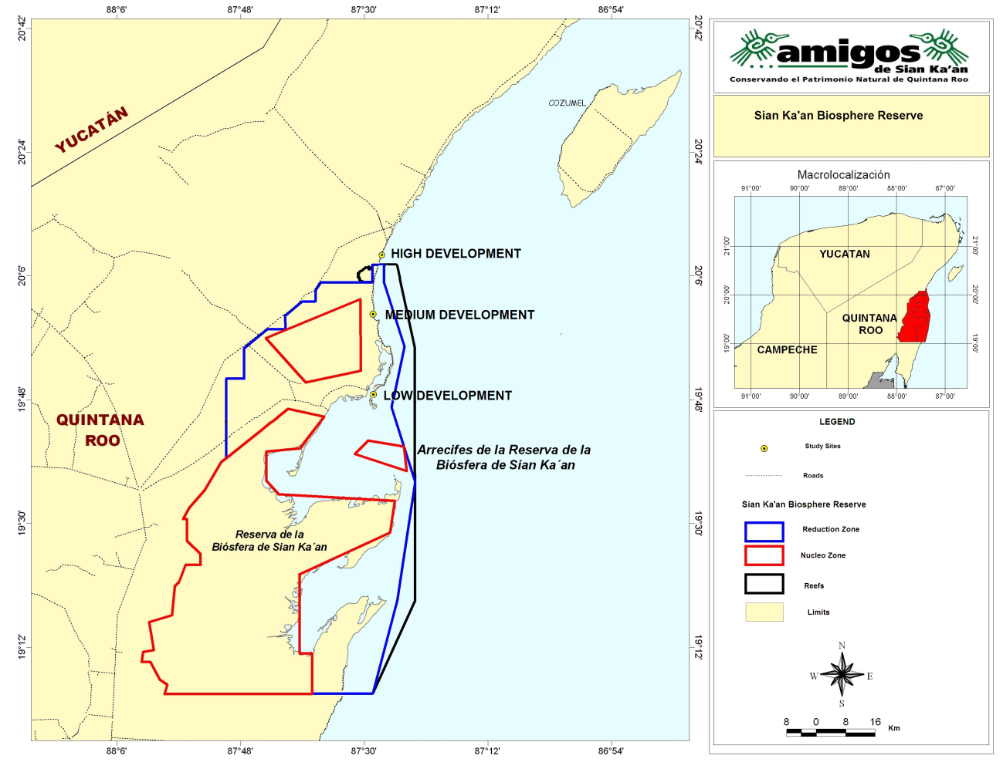
Figure 1. Location of sampling sites within three development levels in the Sian Ka'an Biosphere Reserve and Riviera Maya, Quintana Roo, Mexico, 2006–2008. (Source: Amigos de Sian Ka'an A. C. 2006)

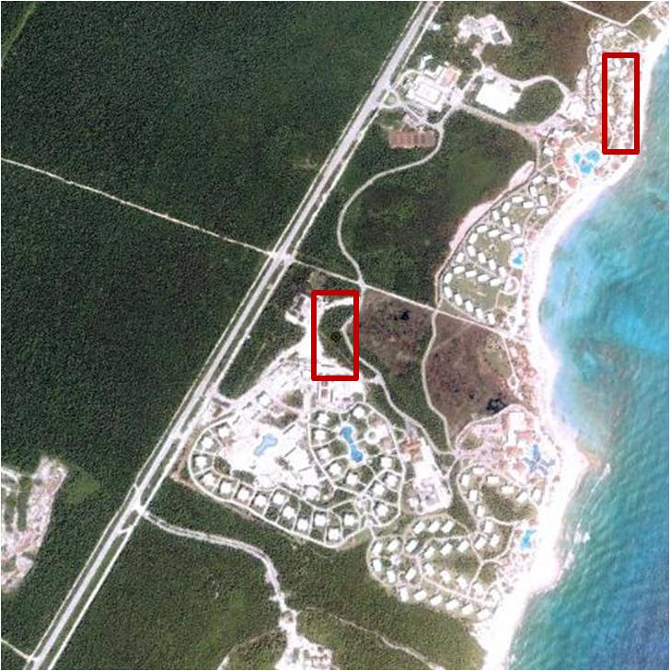
Figure 2. Aerial view of Principe sampling site (high-development level) located in the Riviera Maya, Quintana Roo, Mexico, 2006–2008.

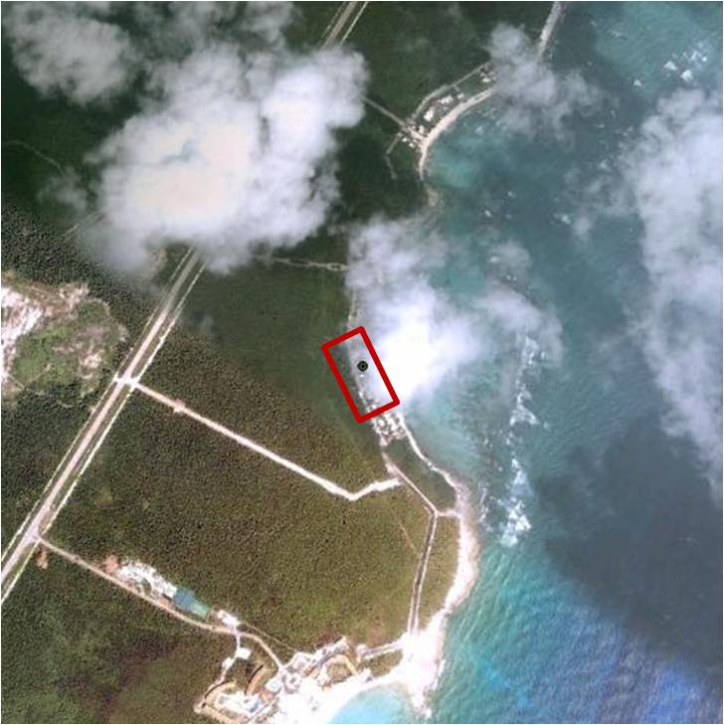
Figure 3. Aerial view of Akumal sampling site (high-development level) located in the Riviera Maya, Quintana Roo, Mexico, 2006–2008.

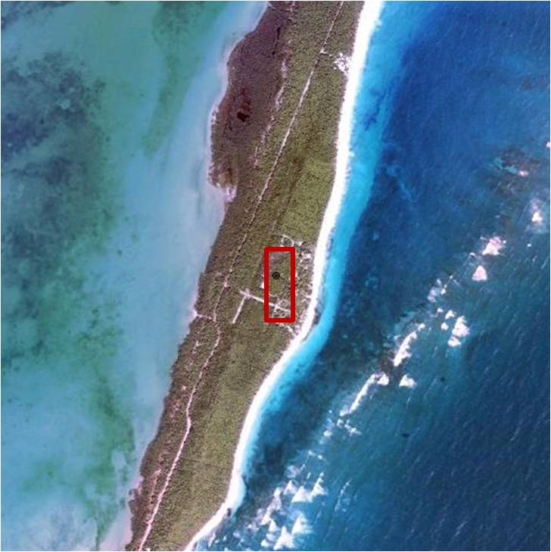
Figure 4. Aerial view of Chenchomac sampling site (medium-development level) located in the Sian Ka’an Biosphere Reserve, Quintana Roo, Mexico, 2006–2008.

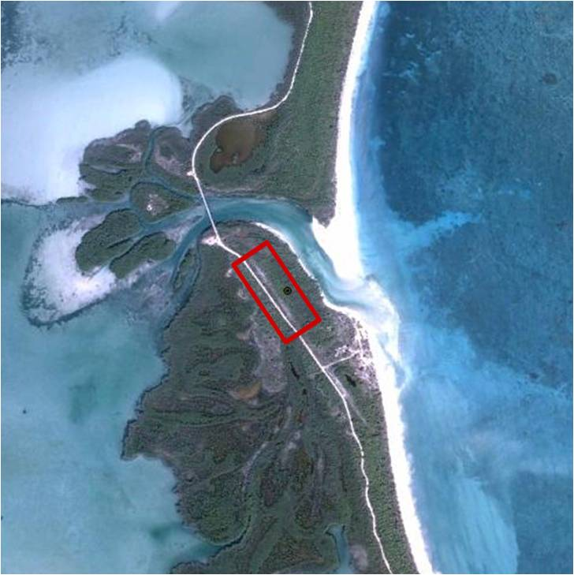
Figure 5. Aerial view of Pez Maya sampling site (medium-development level) located in the Sian Ka’an Biosphere Reserve, Quintana Roo, Mexico, 2006–2008.
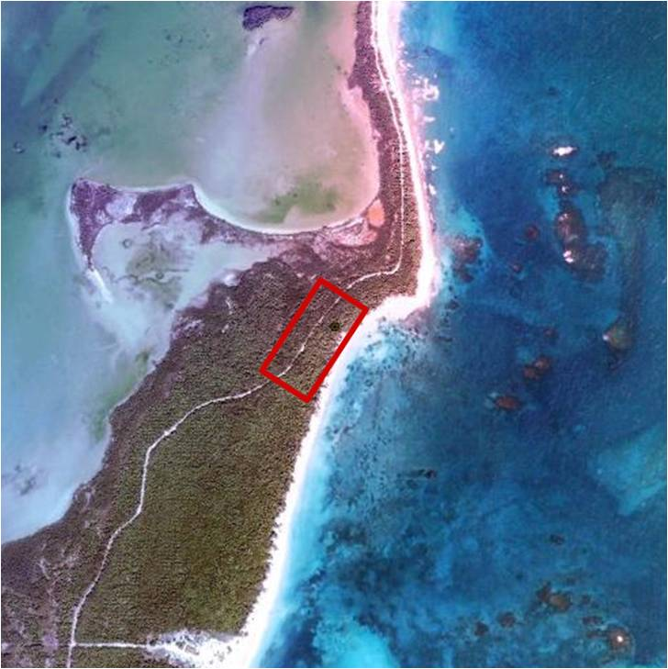
Figure 6. Aerial view of San Juan A sampling site (low-development level) located in the Sian Ka’an Biosphere Reserve, Quintana Roo, Mexico, 2006–2008.

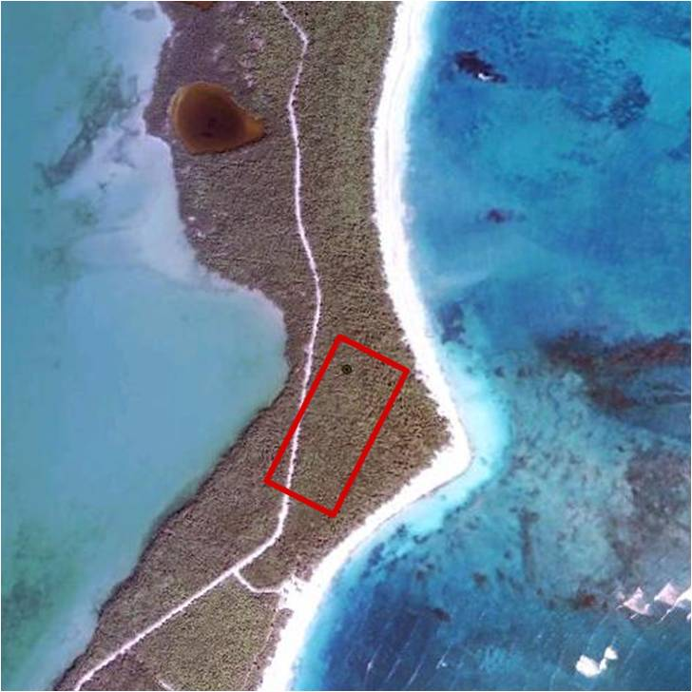
Figure 7. Aerial view of San Juan B sampling site (low-development level) located in the Sian Ka’an Biosphere Reserve, Quintana Roo, Mexico, 2006–2008.
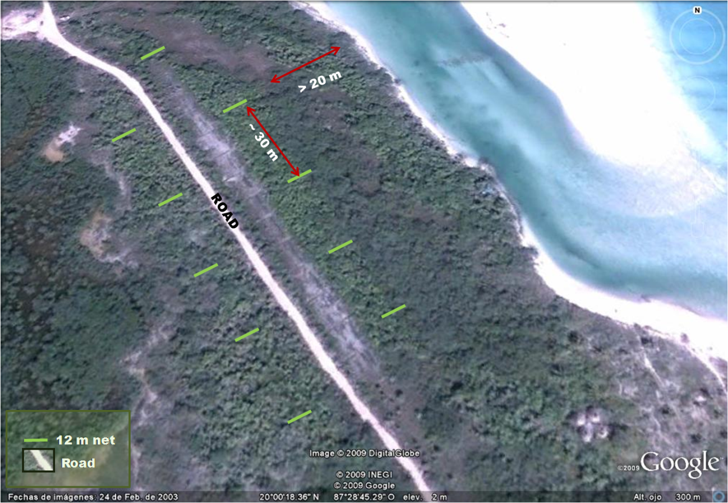
Figure 8. Example of net arrangement at Pez Maya study site, Sian Ka’an Biosphere Reserve, 2006–2008. Nets were located perpendicular to coastal dune.
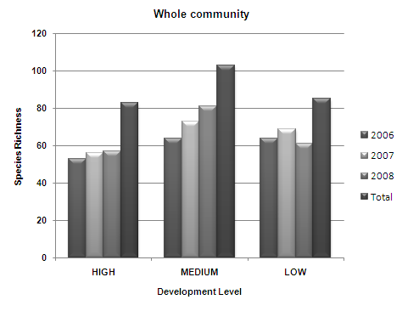
Figure 9. Avian species richness for the entire community (all bird classes pooled) by year, across all years pooled, and by development level in the Sian Ka’an Biosphere Reserve and Riviera Maya, Quintana Roo, Mexico, 2006–2008.
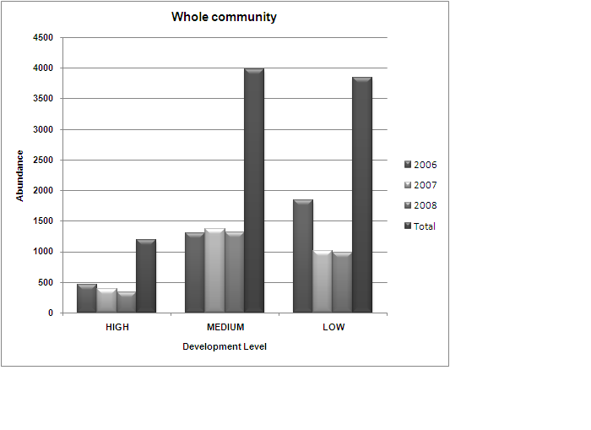
Figure 10. Avian abundances for the entire community (all bird classes pooled) by year, across all years pooled, and by development level in the Sian Ka’an Biosphere Reserve and Riviera Maya, Quintana Roo, Mexico, 2006–2008.
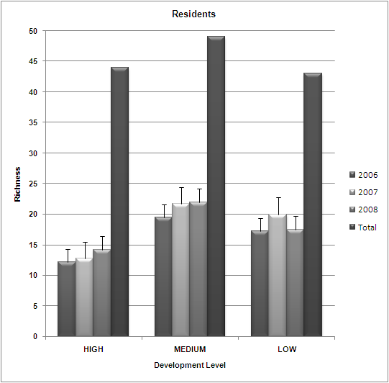
Figure 11. Mean and total avian species richness for year-round resident species by year, across all years pooled, and by development level in the Sian Ka’an Biosphere Reserve and Riviera Maya, Quintana Roo, Mexico, 2006–2008. Error bars represent 1 SE.
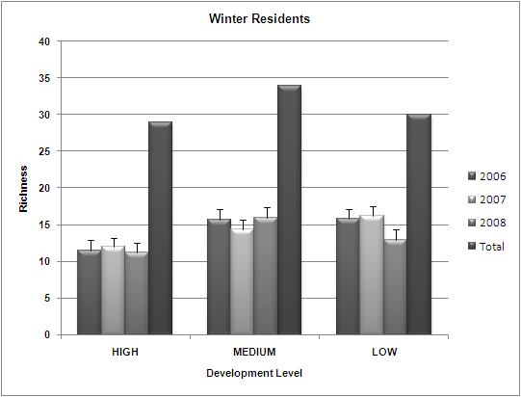
Figure 12. Mean and total avian species richness for winter residents by year, across all years pooled, and by development level in the Sian Ka’an Biosphere Reserve, Quintana Roo, Mexico, 2006–2008. Error bars represent 1 SE.
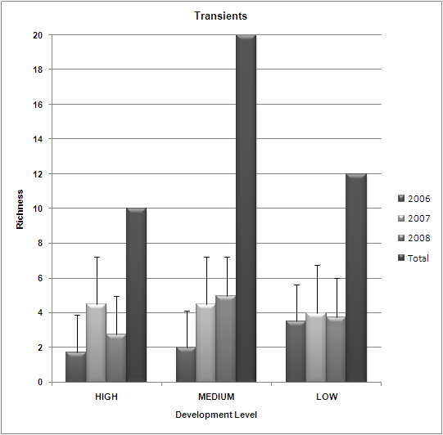
Figure 13. Mean and total avian species richness for transients by year, across all years pooled, and development level in the Sian Ka’an Biosphere Reserve and Riviera Maya, Quintana Roo, Mexico, 2006–2008. Error bars represent 1 SE.
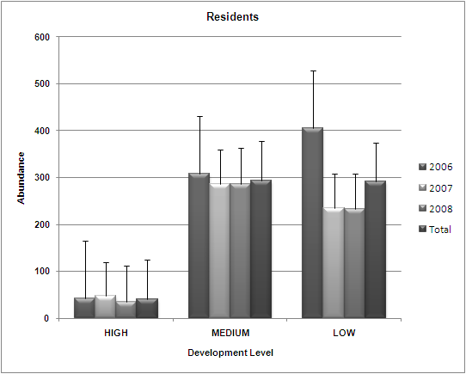
Figure 14. Mean abundances for year-round resident species, by year, across all years pooled, and by development level in the Sian Ka’an Biosphere Reserve and Riviera Maya, Quintana Roo, Mexico, 2006–2008. Error bars represent 1 SE.
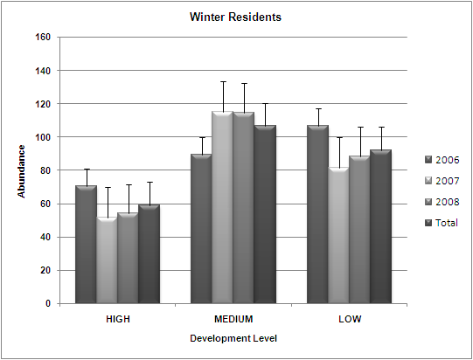
Figure 15. Mean abundances for winter resident species, by year, across all years pooled, and by development level in the Sian Ka’an Biosphere Reserve and Riviera Maya, Quintana Roo, Mexico, 2006–2008. Error bars represent 1 SE.
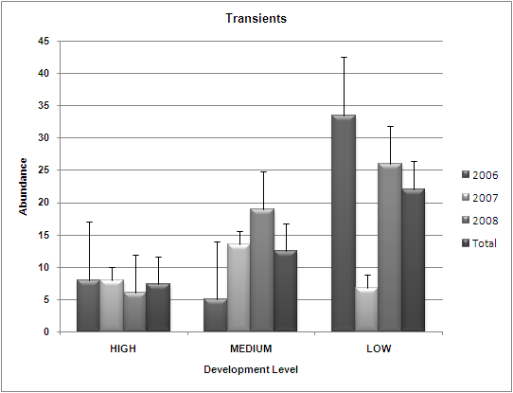
Figure 16. Mean abundances for transient species, by year, across all years pooled and by development level in the Sian Ka’an Biosphere Reserve and Riviera Maya, Quintana Roo, Mexico, 2006–2008. Error bars represent 1 SE.
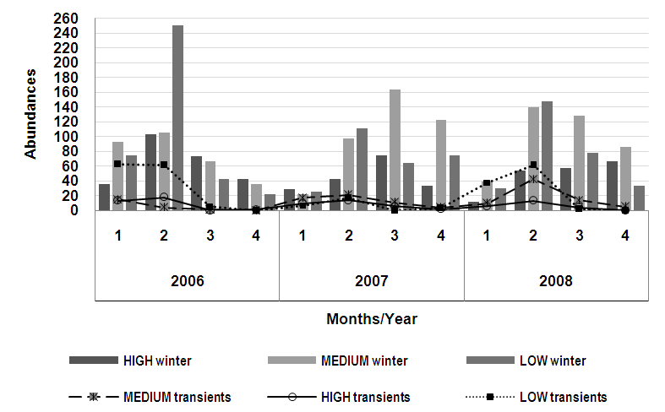
Figure 17. Temporal variation by year and month in Nearctic-Neotropical migratory bird abundances for three development levels the Sian Ka’an Biosphere Reserve and Riviera Maya, Quintana Roo, Mexico, 2006–2008. Bars represent abundance of winter residents. Lines represent abundance of transient species.

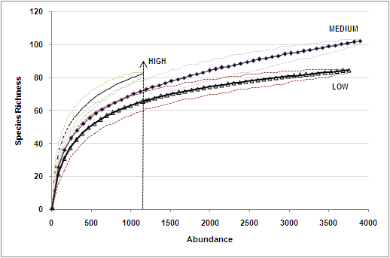
Figure 18. Rarefaction curves for all bird species in three different levels of coastal development in the Sian Ka’an Biosphere Reserve and Riviera Maya, Quintana Roo, Mexico, 2006–2008. The dotted lines represent the 95% confidence intervals. The vertical line represents the abundance cut off value to perform the analyses.
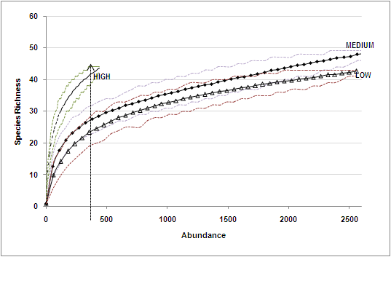
Figure 19. Rarefaction curves for year-round resident bird species in three different levels of coastal development in the Sian Ka’an Biosphere Reserve and Riviera Maya, Quintana Roo, Mexico, 2006–2008. The dotted lines represent the 95% confidence intervals. The vertical line represents the abundance cut off value to perform the analyses.

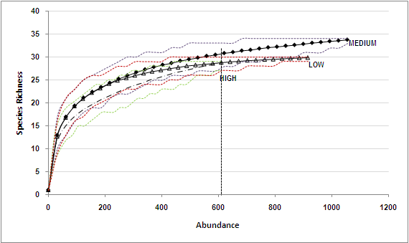
Figure 20. Rarefaction curves for winter resident bird species in three different levels of coastal development in the Sian Ka’an Biosphere Reserve and Riviera Maya, Quintana Roo, Mexico, 2006–2008. The dotted lines represent the 95% confidence intervals. The vertical line represents the abundance cut off value to perform the analyses.
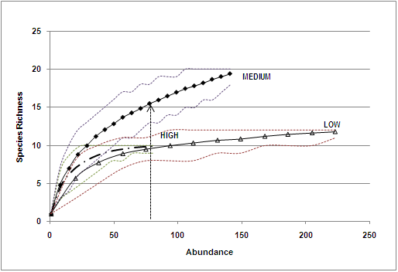
Figure 21. Rarefaction curves for transient bird species in three different levels of coastal development in the Sian Ka’an Biosphere Reserve and Riviera Maya, Quintana Roo, Mexico, 2006–2008. The dotted lines represent the 95% confidence intervals. The vertical line represents the abundance cut off value to perform the analyses.

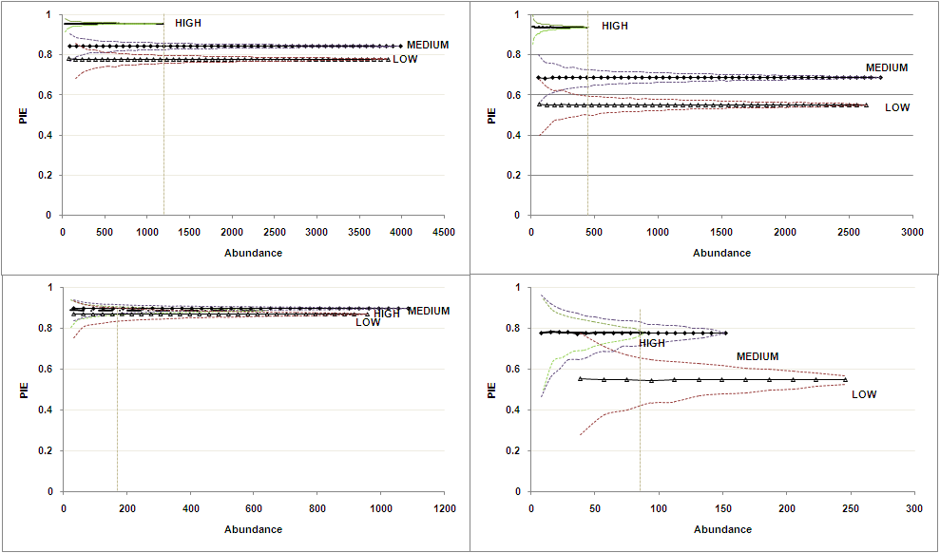
a) undances from transect surveys for a) entire community, b) year-round resident, c) winter residents and d) transient bird assemblages in three different coastal development levels
b)
c)
d)
Figure 22. Evenness for bird species in three different levels of coastal development in the Sian Ka’an Biosphere Reserve and Rivera Maya, Quintana Roo, Mexico, 2006–2008. a) entire community, b) year-round residents, c) winter residents and d) transients. Error lines represent the 95% confidence intervals for each curve.

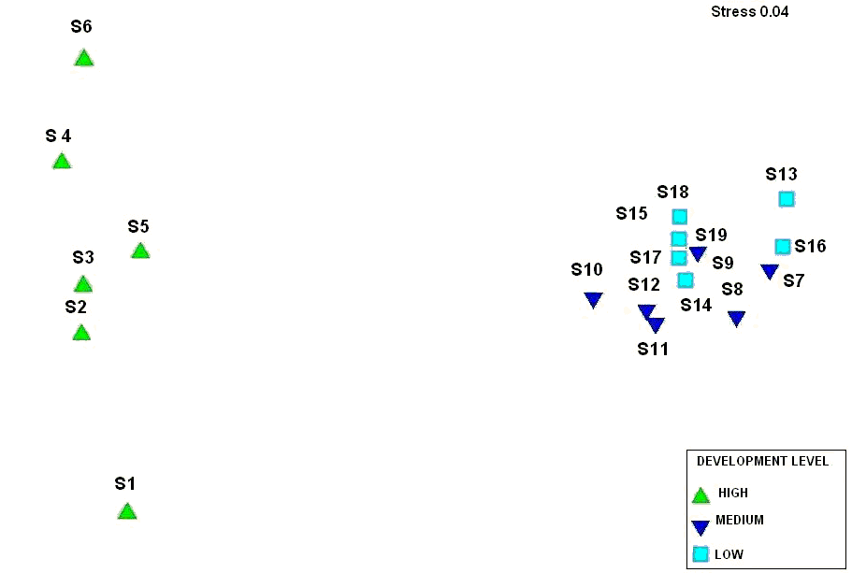
Figure 23. Non-metric multidimensional scaling based on avian species abundances of the entire community for each sampling period and development level in the Sian Ka’an Biosphere Reserve and Riviera Maya, Quintana Roo, Mexico, 2006–2008. Symbols represent each of the sites for development levels and year. The closer the symbols, the more similar they are in species composition. S1 = Akumal 2006, S2 = Akumal 2007, S3 = Akumal 2008, S4 = Principe 2006, S5 = Principe 2007, S6 = Principe 2008, S7 = Chenchomac 2006, S8 = Chenchomac 2007, S9 = Chenchomac 2008, S10 = Pez Maya 2006, S11 = Pez Maya 2007, S12 = Pez Maya 2008, S13 = San Juan A 2006, S14 = San Juan A 2007, S15 = San Juan A 2008, S16 = San Juan B 2006, S17 = San Juan B 2007, and S18 = San Juan B 2008.

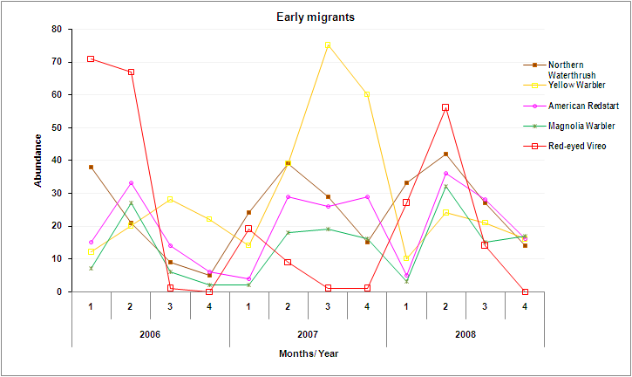
Figure 24. Migration phenology of five early migrants in the Sian Ka’an Biosphere Reserve and Riviera Maya, Quintana Roo, Mexico, 2006–2008. Early migrants reported for the area by Bayly and Gómez (2008), Deppe and Rotenberry (2005), and Mills and Rogers (1990).

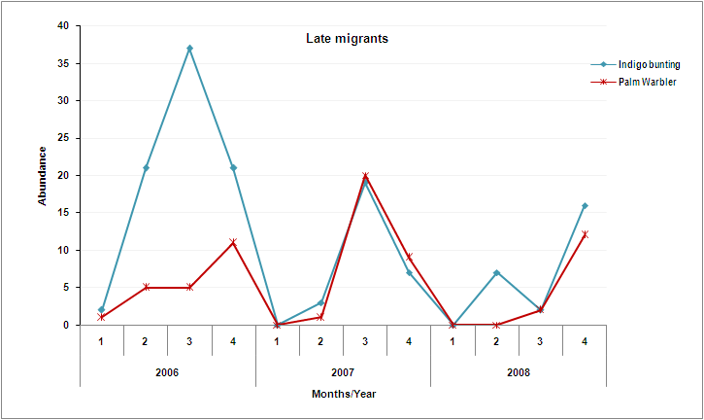
Figure 25. Migration phenology of two late migrants (Indigo Bunting and Palm Warbler) in the Sian Ka’an Biosphere Reserve and Riviera Maya, Quintana Roo, Mexico, 2006–2008.

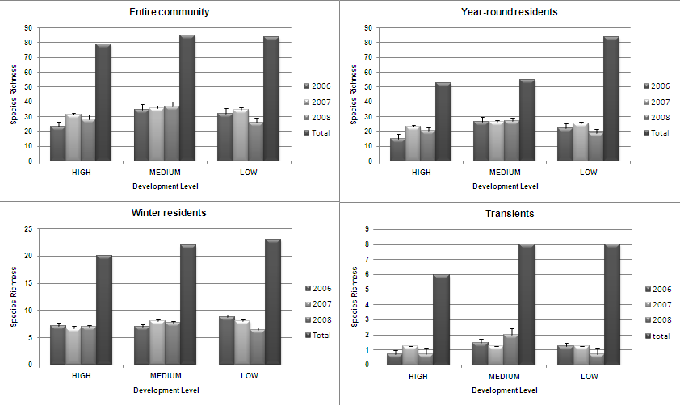
a)ndances from transect surveys for a) entire community, b) year-round resident, c) winter residents and d) transient bird assemblages in three different coastal development levels
b)
c)
d)
Figure 26. Mean and total avian species richness from transect surveys for a) entire community, b) year-round resident, c) winter residents and d) transient bird assemblages in three different levels of coastal development, Sian Ka’an Biosphere Reserve and Riviera Maya, Quintana Roo, Mexico, 2006–2008.
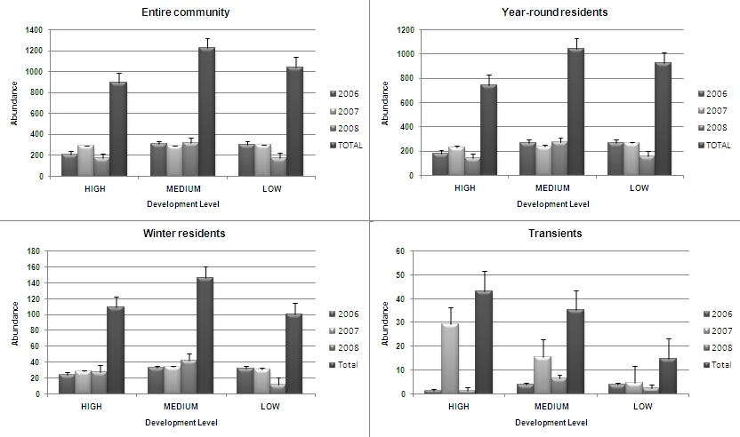
a) undances from transect surveys for a) entire community, b) year-round resident, c) winter residents and d) transient bird assemblages in three different coastal development levels
b)
c)
d)
Figure 27. Mean avian abundance from transect surveys for a) entire community, b) year-round resident, c) winter residents and d) transient bird assemblages in three different levels of coastal development, Sian Ka’an Biosphere Reserve and Riviera Maya, Quintana Roo, Mexico, 2006–2008.
a) Abundances from transect surveys for a) entire community, b) year-round resident, c) winter residents and d) transient bird assemblages in three different coastal development levels
b)
c)
d)

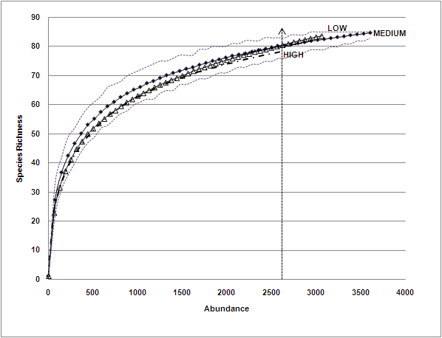
Figure 28. Rarefaction curves for bird species assemblages in three different levels of coastal development in the Sian Ka’an Biosphere Reserve and Riviera Maya, Quintana Roo, Mexico, 2006–2008. The dotted lines represent the 95% confidence intervals. The vertical line represents the abundance cut off value to perform the analyses.

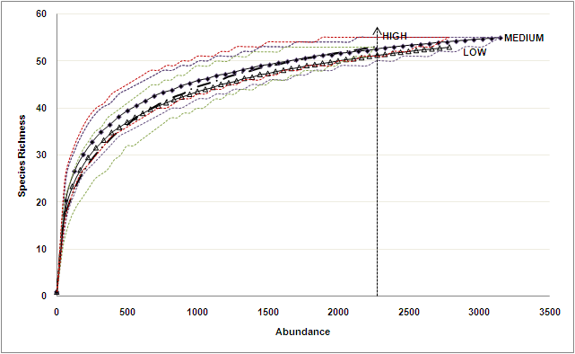
Figure 29. Rarefaction curves for year-round residents species in three different levels of coastal development in the Sian Ka’an Biosphere Reserve and Riviera Maya, Quintana Roo, Mexico, 2006–2008. The dotted lines represent the 95% confidence intervals. The vertical line represents the abundance cut off value to perform the analyses.

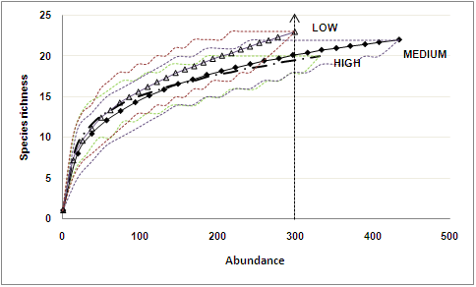
Figure 30. Rarefaction curves for winter residents species in three different levels of coastal development in the Sian Ka’an Biosphere Reserve and Riviera Maya, Quintana Roo, Mexico, 2006–2008. The dotted lines represent the 95% confidence intervals. The vertical line represents the abundance cut off value to perform the analyses.
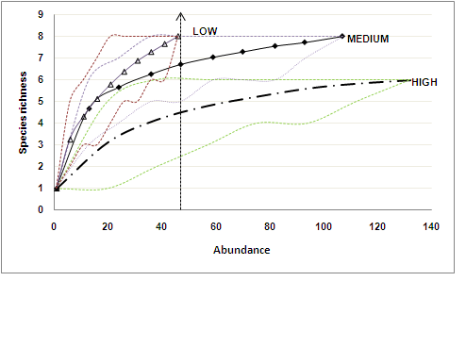
Figure 311. Rarefaction curves for transients species in three different levels of coastal development in the Sian Ka’an Biosphere Reserve and Riviera Maya, Quintana Roo, Mexico, 2006–2008. The dotted lines represent the 95% confidence intervals. The vertical line represents the abundance cut off value to perform the analyses.
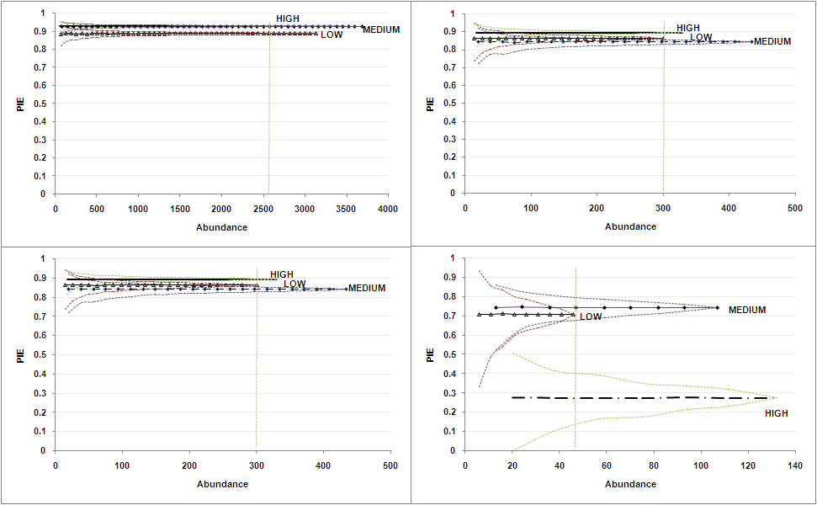
a)
b)
c)
d)
Figure 32. Hurlbert’s PIE indexes for three different levels of coastal development in the Sian Ka’an Biosphere Reserve and Riviera Maya, Quintana Roo, 2006–2008. a) entire community, b) year-round residents, c) winter residents and d) transients. The colored dotted lines represent 95% confidence intervals for each level.
- Appendix 2. Total avian species and abundances recorded in the Sian Ka’an Biosphere Reserve and Riviera Maya, Quintana Roo, Mexico, 2006–2008 . S= Residency status. R = year-round resident, W = Winter resident, and T = Transient. AK = Akumal, PR = Principe, CH = Chenchomac, PM = Pez Maya, SJA = San Juan A and SJB = San Juan B.
 |  |  |  | TOTAL ABUNDANCE |  |  | PR |  |  | AK |  |  | CH |  |  | PM |  |  | SJA |  |  | SJB
S | FAMILY  SCIENTIFIC NAME | COMMON NAME | NOMBRE COMÚN | Mist nets |  | Transects | 06 | 07 | 08 | 06 | 07 | 08 | 06 | 07 | 08 | 06 | 07 | 08 | 06 | 07 | 08 | 06 | 07 | 08
 | FREGATIDAE
R | Fregata magnificens† | Magnificent Frigatebird | Fregata magnifica | 0 |  | 6 |  |  |  |  |  |  | * |  |  |  |  |  | * |  |  | * |  | *
 | ARDEIDAE
W | Botaurus lentiginosus† | American Bittern | Avetoro norteño | 0 |  | 1
R | Tigrisoma mexicanum | Bare-throated Tiger-Heron | Garza-tigre mexicana | 1 |  | 4 | * |  |  |  |  | * |  |  |  |  |  | *
W | Ardea herodias † | Great Blue Heron | Garza morena | 0 |  | 12 | * |  |  |  |  |  |  |  |  |  |  |  |  | *
W | Nyctanassa violacea† | Yellow-crowned Night-Heron | Pedrete corona clara | 0 |  | 1 | * |  |  |  |  | *
 | CATHARTIDAE
R | Coragyps atratus† | Black Vulture | Zopilote común | 0 |  | 3 |  |  |  | * |  |  |  |  |  |  | * |  |  |  |  | *
W | Cathartes aura† | Turkey Vulture | Zopilote aura | 0 |  | 3 |  |  |  | * |  |  |  |  |  |  | * |  | *
Appendix 2. Continued

 |  |  |  | TOTAL ABUNDANCE |  |  | PR |  |  | AK |  |  | CH |  |  | PM |  |  | SJA |  |  | SJB
S | FAMILY  SCIENTIFIC NAME | COMMON NAME | NOMBRE COMÚN | Mist nets | Transects |  | 06 | 07 | 08 | 06 | 07 | 08 | 06 | 07 | 08 | 06 | 07 | 08 | 06 | 07 | 08 | 06 | 07 | 08
 | ACCIPITRIDAE
W | Pandion haliaetus † | Osprey | Gavilán pescador | 0 | 16 |  |  |  |  |  |  |  | * | * | * | * | * | * | * | * | * | * | * | *
R | Buteogallus anthracinus† | Common Black-Hawk | Aguililla-negra menor | 0 | 6 |  |  |  |  |  |  |  |  | * |  |  |  | * | *
R | Buteo magnirostris | Roadside Hawk | Aguililla caminera | 1 | 1 |  |  |  |  |  |  |  |  |  | *
 | FALCONIDAE
R | Micrastur semitorquatus | Collared Forest-Falcon | Halcón selvático de collar | 1 | 1 |  |  |  | *
 | RALLIDAE
R | Aramides axillaris | Rufous-necked Wood-Rail | Rasón cuello rufo | 1 | 2 |  |  |  |  |  |  |  |  |  |  |  |  | * |  |  | * |  | *
 | SCOLOPACIDAE
W | Actitis macularius† | Spotted Sandpiper | Playero alzacolita | 0 | 1 |  |  |  |  |  | *
 | LARIDAE
T | Sterna maxima † | Royal Tern | Charrán real | 0 | 9 |  | * |  |  |  | * |  |  |  |  | *
 | CRACIDAE
R | Ortalis vetula | Plain Chachalaca | Chachalaca vetula | 9 | 155 |  |  |  |  |  | * | * |  |  |  |  | * |  | * |  | * |  |  | *
 | COLUMBIDAE
R | Patagioneas leucocephala | White-crowned Pigeon | Paloma corona blanca | 5 | 30 |  |  |  | * | * |  |  |  |  |  |  |  |  |  |  | * | *
R | Zenaida asiatica | White-winged Dove | Paloma ala blanca | 1 | 56 |  |  |  |  |  |  |  |  |  | *
R | Columbina passerina | Common Ground-Dove | Tórtola coquita | 22 | 25 |  |  |  |  |  |  |  | * | * | * | * | * | * | * | * | * | *

Appendix 2. Continued

 |  |  |  | TOTAL ABUNDANCE |  |  |  | PR |  |  | AK |  |  | CH |  |  | PM |  |  | SJA |  |  | SJB
S | FAMILY  SCIENTIFIC NAME | COMMON NAME | NOMBRE COMÚN | Mist nets |  | Transects |  | 06 | 07 | 08 | 06 | 07 | 08 | 06 | 07 | 08 | 06 | 07 | 08 | 06 | 07 | 08 | 06 | 07 | 08
R | Leptotila verreauxi | White-tipped Dove | Paloma arroeyera | 7 |  | 6 |  |  | * |  | * |  | * |  |  |  |  |  |  |  |  | * |  | * | *
R | Leptotila jamaicensis | Caribbean Dove | Paloma caribeña | 24 |  | 21 |  |  | * |  |  | * |  | * | * | * |  | * |  | * |  | * |  | * | *
 | PSITTACIDAE
R | Aratinga nana | Olive-throated Parakeet | Perico pecho sucio | 2 |  | 77 |  |  |  |  |  |  |  |  |  |  |  | * |  |  | *
R | Amazona albifrons† | White-fronted Parrot | Loro frente blanca | 0 |  | 28 |  |  |  |  | * |  | * |  |  |  |  | * |  |  |  |  |  | *
R | Amazona xantholora | Yellow-lored Parrot | Loro yucateco | 1 |  | 24 |  |  |  |  |  |  |  |  |  |  |  | *
 | CUCULIDAE
T | Coccyzus americanus | Yellow-billed Cuckoo | Cuclillo pico amarillo | 1 |  | 0 |  |  |  |  |  |  |  |  | *
R | Piaya cayana* | Squirrel Cuckoo | Cuclillo canela | 1 |  | 0 |  |  |  |  |  |  |  |  | *
R | Crotophaga sulcirostris | Groove-billed Ani | Garrapatero pijuy | 1 |  | 3 |  |  |  |  |  |  |  |  |  |  | *
 | STRIGIDAE
R | Glaucidium brasilianum | Ferruginous Pygmy Owl | Tecolote bajeño | 1 |  | 1 |  |  | *
 | CAPRIMULGIDAE
R | Chordeiles acutippenis | Lesser Nigthhawk | Chotacabras menor | 2 |  | 8 |  |  |  |  |  |  |  |  |  |  |  | * |  | *
 | TROCHILIDAE
R | Chlorostilbon canivetii | Canivet's Emerald | Esmeralda tijereta | 8 |  | 26 |  |  |  |  |  |  |  | * |  |  |  |  | * |  |  | * | * |  | *
R | Amazilia yucatanensis | Buff-bellied Hummingbird | Colibrí yucateco | 10 |  | 8 |  | * | * | * | * |  | * |  |  |  |  | *
R | Amazilia rutila | Cinnamon Hummingbird | Colibrí canela | 105 |  | 84 |  | * |  | * | * | * | * | * | * | * | * | * | * | * | * | * | * | *
W | Archilochus colubris* | Ruby-throated Hummingbird | Colibrí garganta rubí | 1 |  | 0 |  |  |  |  | * |  |  |  | *
 | TROGONIDAE
R | Trogon melanocephalus | Black-headed Trogon | Trogón cabeza negra | 4 |  | 0 |  |  |  |  |  | * |  |  |  |  |  |  | * |  | * |  |  | *
 | MOMOTIDAE
R | Momotus momota | Blue-crowned Motmot | Momoto corona azul | 2 |  | 1 |  |  |  | * |  |  | *
R | Eumomota superciliosa | Turquoise-browed Motmot | Momoto ceja azul | 2 |  | 0 |  |  |  |  |  | *
 | ALCEDINIDAE
W | Megaceryle alcyon | Belted Kingfisher | Martín-pescador norteño | 2 |  | 6 |  | *
R | Chloroceryle americana | Green Kingfisher | Martín-pescador enano | 7 |  | 0 |  |  |  |  |  |  |  |  |  |  | * | * | *
 | RHAMPASTIDAE
R | Pteroglossus torquatus | Collared Aracari | Arasari de collar | 1 |  | 0 |  |  |  |  |  |  |  |  |  |  |  |  |  |  |  |  |  | *
R | Ramphastos sulfuratus | Keel- billed Toucan | Tucán pico canoa | 3 |  | 11 |  |  |  |  |  |  |  |  |  |  |  | * |  |  | *
 | PICIDAE
R | Melanerpes pygmaeus | Yucatan Woodpecker | Carpintero yucateco | 13 |  | 8 |  |  |  |  |  |  |  |  |  |  | * | * | * |  |  | * |  | * | *
R | Melanerpes aurifrons | Golden-fronted Woodpecker | Carpintero cheje | 119 |  | 251 |  | * | * | * | * | * | * | * | * | * | * | * | * | * | * | * | * | * | *
W | Sphyrapicus varius | Yellow-bellied Sapsucker | Chupasavia maculado | 1 |  | 0 |  |  |  |  |  |  |  |  |  |  |  |  |  |  | *
R | Picoides scalaris * | Ladder-backed Woodpecker | Carpintero mexicano | 3 |  | 7 |  |  |  |  |  |  |  |  | * |  |  |  | *
 | DENDROCOLAPTIDAE
R | Xiphorhynchus flavigaster | Ivory-billed Woodcreeper | Trepatroncos bigotudo | 1 |  | 2 |  |  |  |  |  |  | *
 | THAMNOPHILIDAE
R | Thamnophilus doliatus | Barred Antshrike | Batará barrado | 22 |  | 42 |  |  |  |  |  |  |  | * | * | * | * | * | * | * | * | * | * | * | *
 | TYRANNIDAE
R | Camptostoma imberbe | Northern Beardless-Tyrannulet | Mosquero lampiño | 12 |  | 15 |  |  |  |  |  |  | * | * | * |  | * | * |  |  | * |  | * |  | *
R | Myiopagis viridicata | Greenish Elaenia | Elenia verdosa | 2 |  | 0 |  |  |  |  |  |  |  |  |  |  |  |  |  |  | * |  |  | *
R | Elaenia flavogaster | Yellow-bellied Elaenia | Elenia vientre amarillo | 42 |  | 18 |  |  | * |  |  | * |  | * | * |  | * | * | * | * | * | * | * | *
R | Todirostrum cinereum | Common Tody-Flycatcher | Espatulilla amarillo | 61 |  | 455 |  |  |  |  |  |  |  | * | * | * | * | * | * | * | * | * | * | * | *
T | Contopus virens | Eastern Wood-Pewee | Pibi oriental | 26 |  | 14 |  |  | * | * | * | * | * | * |  | * |  | * |  |  | * | * | * | * | *
R | Contopus cinereus | Tropical Pewee | Pibi tropical | 37 |  | 20 |  | * |  | * | * | * |  | * |  | * |  | * | * | * | * |  |  | * | *
W | Empidonax flaviventris | Yellow bellied Flycatcher | Mosquero vientre amarillo | 11 |  | 1 |  |  |  |  |  |  | * | * |  |  |  | * | * | * |  | * | * |  | *
W | Empidonax virescens | Acadian Flycatcher | Mosquero verdoso | 8 |  | 0 |  |  |  |  |  |  | * |  |  | *
T | Empidonax trailli | Willow Flycatcher | Mosquero saucero | 1 |  | 0 |  |  |  |  |  |  |  |  |  |  | *
W | Empidonax minimus | Least Flycatcher | Mosquero mínimo | 1 |  | 0
O | Sayornis phoebe | Eastern Phoebe | Papamoscas fibi | 1 |  | 0 |  |  |  | *
R | Pyrocephalus rubinus† | Vermilion Flycatcher | Mosquero cardenal | 0 |  | 1 |  |  |  |  |  |  |  |  |  |  | *
R | Attila spadiceus | Bright -rumped Attila | Atila | 7 |  | 0 |  |  |  | * |  |  | * |  |  |  |  | *
R | Myiarchus tuberculifer | Dusky-capped Flycatcher | Papamoscas triste | 13 |  | 19 |  |  |  |  |  |  |  | * | * |  | * | * | * | * |  | *
R | Myiarchus tyrannulus | Brown-crested Flycatcher | Papamoscas tirano | 3 |  | 2 |  |  |  |  |  |  |  |  |  |  |  |  |  |  |  | * |  |  | *
R | Pitangus sulphuratus | Great Kiskadee | Luis bienteveo | 36 |  | 245 |  | * | * | * | * | * | * |  |  | * | * |  |  | *
R | Myiozetetes similis | Social Flycatcher | Luis gregario | 26 |  | 275 |  | * | * |  | * | * |  |  |  | * | * | * | * |  | *
R | Tyrannus melancholicus | Tropical Kingbird | Tirano tropicla | 35 |  | 396 |  | * |  | * |  | * |  | * | * | * | * | * | * | * | * | * |  | *
R | Tyrannus couchii | Couch's Kingbird | Tirano silbador | 1 |  | 4 |  |  |  | *
T | Tyrannus tyrannus | Eastern Kingbird | Tirano dorso negro | 4 |  | 174 |  |  |  |  |  | * |  |  |  |  |  |  | *
R | Pachyramphus major | Gray-collared Becard | Mosquero-cabezón mexicano | 1 |  | 0 |  |  |  |  |  |  |  |  |  |  |  |  |  |  | *
R | Pachyramphus aglaiae | Rose-throated Becard | Mosquero-cabezón degollado | 1 |  | 0 |  |  |  |  |  |  |  |  |  |  |  |  | *
R | Tityra semisfasciata | Masked Tityra | Titira enmascarada | 2 |  | 0 |  |  |  |  |  |  |  |  |  |  |  |  | * |  | *
 | VIREONIDAE
W | Vireo griseus | White-eyed Vireo | Vireo ojo blanco | 121 |  | 31 |  | * | * | * | * | * | * | * | * | * | * | * | * | * | * | * | * | * | *
R | Vireo pallens | Mangrove Vireo | Vireo manglero | 108 |  | 305 |  | * | * |  | * | * | * | * | * | * | * | * | * | * | * | * | * | * | *
W | Vireo flavifrons | Yellow-throated Vireo | Vireo garganta amarilla | 1 |  | 0 |  |  |  |  |  |  |  |  |  |  |  |  | *
W | Vireo philadelphicus | Philadelphia Vireo | Vireo de Filadelfia | 10 |  | 1 |  |  |  |  |  |  |  | * |  | * | * |  |  | * |  |  | * | * | *
T | Vireo olivaceus | Red-eye Vireo | Vireo ojo rojo | 266 |  | 29 |  | * | * | * | * | * |  | * | * | * | * | * | * | * | * | * | * | * | *
S | Vireo flavoviridis | Yellow-green Vireo | Vireo verdeamarillo | 1 |  | 0 |  |  |  |  | *
T | Vireo altiloquus | Black-whiskered Vireo | Vireo bigotudo | 1 |  | 0 |  |  |  |  |  |  |  |  |  |  |  |  |  | *
R | Vireo magister | Yucatan Vireo | Vireo yucateco | 601 |  | 137 |  | * | * | * | * | * | * | * | * | * | * | * | * | * | * | * | * | * | *
R | Cyclarhis gujanensis | Rufus -browed Peppershrike | Vireón ceja rufa | 17 |  | 17 |  | 0 | * | * | * | * | * |  |  |  |  |  | *
 | CORVIDAE
R | Cyanocorax yucatanicus | Yucatan Jay | Chara yucateca | 15 |  | 224 |  | * |  |  | * | * | * |  |  |  |  |  | * |  |  | *
 | HIRUNDINIDAE
T | Progne subis † | Purple Martin | Golondrina azulnegra | 0 |  | 34 |  |  |  | * |  |  |  | * | * |  | * |  | *
W | Stelgidopteryx serripennis† | Northern Rough-winged Swallow | Golondrina ala aserrada | 0 |  | 20 |  |  |  |  |  | * |  |  | * |  |  |  |  |  | *
R | Stelgidopteryx ridgwayi | Ridgway's Rough-winged Swallow | Golondrina yucateca | 3 |  | 0 |  |  | *
R | Petrochelidon fulva † | Cave Swallow | Golondrina pueblera | 0 |  | 1 |  |  |  |  |  |  |  |  | *
T | Hirundo rustica | Barn Swallow | Golondrina tijereta | 8 |  | 14 |  |  |  |  |  |  |  |  |  |  |  | *
 | TROGLODYTIDAE
R | Thryothorus maculipectus | Spot-breasted Wren | Chivirín moteado | 101 |  | 270 |  |  |  | * |  | * | * | * | * | * | * | * |  | * | * | * | * | * | *
R | Thryothorus ludovicianus† | Carolina Wren | Chivirín de Carolina | 0 |  | 3 |  |  |  |  |  |  |  |  |  |  | * |  |  |  |  |  | *
R | Uropsila leucogastra | White-bellied Wren | Chivirín vientre blanco | 10 |  | 28 |  |  | * | * | * | * | *
 | SYLVIIDAE
R | Ramphocaenus melanurus | Long-billed Gnatwren | Soterillo picudo | 1 |  | 0 |  |  |  |  |  |  |  |  |  |  |  |  |  | *
 | TURDIDAE
T | Catharus fuscescens | Veery | Zorzal rojizo | 26 |  | 0 |  |  |  |  |  |  |  |  |  | * |  | * | * | * |  | * | * |  | *
T | Catharus minimus | Gray-cheeked Thrush | Zorzal cara gris | 26 |  | 1 |  | * | * |  | * | * |  |  | * |  |  | * | * | * | * |  | * | * | *
W | Catharus ustulatus | Swainson's Thrush | Zorzal de Swainson | 124 |  | 9 |  |  | * | * | * | * | * | * | * | * | * | * | * | * | * | * | * | * | *
W | Hylocichla mustelina | Wood Thrush | Zorzal maculado | 17 |  | 1 |  |  |  |  |  |  | * | * | * | * | * | * |  | * |  |  |  | * | *
R | Turdus grayi | Clay-colored Thrush | Mirlo pardo | 5 |  | 2 |  |  |  |  | * | * | * |  |  |  | *
 | MIMIDAE
W | Dumetella carolinensis | Gray Catbird | Maullador gris | 462 |  | 77 |  | * | * | * | * | * | * | * | * | * | * | * | * | * | * | * | * | * | *
R | Melanoptila glabrirostris | Black Catbird | Maullador negro | 3212 |  | 1586 |  | * | * | * |  | * | * | * | * | * | * | * | * | * | * | * | * | * | *
R | Mimus gilvus | Tropical Mockingbird | Cenzontle tropical | 167 |  | 1018 |  | * | * | * | * | * | * | * | * | * | * | * | * | * | * | * |  | * | *
 | PARULIDAE
W | Vermivora pinus | Blue-winged Warbler | Chipe ala azul | 5 |  | 0 |  |  |  |  |  |  |  |  | * |  |  | * | * |  | * |  |  | *
T | Vermivora chrysoptera | Golden-winged Warbler | Chipe ala dorada | 3 |  | 0 |  |  |  |  |  |  |  |  | * |  |  |  |  |  |  |  |  |  | *
T | Vermivora peregrina | Tennessee Warbler | Chipe peregrino | 28 |  | 3 |  |  | * |  |  | * |  |  | * | * | * | * | * | * | * |  | * | *
W | Vermivora celata | Orange-crowned Warbler | Chipe corona naranja | 1 |  | 0
T | Vermivora ruficapilla | Nashville Warbler | Chipe de coronilla | 1 |  | 0 |  |  |  |  |  |  |  |  |  | *
W | Parula americana | Northern Parula | Parula norteña | 10 |  | 10 |  |  |  |  |  |  |  | * | * |  | * |  | * |  |  |  | * | * | *
W | Dendroica petechia | Yellow Warbler | Chipe amarillo | 341 |  | 245 |  | * | * | * | * | * | * | * | * | * | * | * | * | * | * | * | * | * | *
W | Dendroica eritachorides | Mangrove Warbler | Chipe manglero | 56 |  | 186 |  |  |  |  |  |  |  | * | * | * | * | * | * | * | * | * | * | * | *
T | Dendroica pensylvanica | Chesnut-sided Warbler | Chipe flanco castaño | 21 |  | 7 |  | * |  | * |  | * |  |  | * | * |  |  |  | * | * | * |  | * | *
W | Dendroica magnolia | Magnolia Warbler | Chipe de magnolia | 164 |  | 55 |  | * | * | * | * | * | * | * | * | * | * | * | * | * | * | * | * | * | *
T | Dendroica tigrina | Cape May Warbler | Chipe atigrado | 3 |  | 3 |  |  |  |  |  |  |  |  |  | * |  |  | * |  |  |  |  | *
W | Dendroica caerulescens | Black-throated Blue Warbler | Chipe azulnegro | 7 |  | 0 |  |  |  |  |  |  |  | * | * |  |  |  |  |  | * |  |  | *
W | Dendroica coronata | Yellow-rumped Warbler | Chipe coronado | 3 |  | 1 |  |  |  |  | * |  |  |  |  |  | *
W | Dendroica virens | Black-throated Green Warbler | Chipe dorso verde | 12 |  | 2 |  |  |  |  |  | * |  |  |  |  | * |  | * |  |  | * |  | * | *
W | Dendroica fusca | Blackburnian Warlber | Chipe garganta naraja | 3 |  | 1 |  |  |  |  |  |  |  |  | * |  |  |  |  |  |  |  |  |  | *
W | Dendroica dominica | Yellow-throated Warbler | Chipe garganta amarilla | 42 |  | 71 |  | * | * | * |  | * | * | * | * |  | * | * | * | * |  |  | * | *
W | Dendroica discolor | Prairie Warbler | Chipe de pradera | 11 |  | 1 |  |  |  |  |  |  |  | * |  | * |  |  |  |  |  |  | *
W | Dendroica palmarum | Palm Warbler | Chipe playero | 67 |  | 97 |  | * | * | * |  |  |  | * | * | * | * | * | * | * | * |  | * | *
T | Dendroica castanea | Bay-breasted Warbler | Chipe castaño | 3 |  | 0 |  |  |  |  |  |  |  |  | *
T | Dendroica striata | Blackpoll Warbler | Chipe gorra negra | 2 |  | 0 |  |  | * |  |  |  |  |  |  |  |  |  | *
W | Mniotilta varia | Black-and-white Warbler | Chipe trepador | 74 |  | 9 |  | * |  | * | * | * | * | * | * | * | * | * | * | * | * | * | * | * | *
W | Setophaga ruticilla | American Redstart | Chipe flameante | 240 |  | 125 |  |  | * | * |  | * | * | * | * | * | * | * | * | * | * | * | * | * | *
T | Protonotaria citrea | Prothonotary Warbler | Chipe dorado | 43 |  | 4 |  |  | * | * | * | * | * |  | * | * |  | * |  | * | * | * |  | *
W | Helmintheros vermivorum | Worm eating Warbler | Chipe gusanero | 47 |  | 0 |  |  |  | * | * |  |  | * | * | * |  | * | * | * | * | * | * | * | *
W | LImnothlypis swainsonii | Swainson's Warbler | Chipe corona café | 40 |  | 1 |  |  |  |  | * |  |  | * | * | * |  |  |  | * | * | * | * | * | *
W | Seiurus aurocapilla | Ovenbird | Chipe suelero | 98 |  | 12 |  | * | * | * | * | * | * | * | * | * |  | * | * | * | * | * | * | * | *
W | Seiurus noveboracensis | Northern Waterthrush | Chipe charquero | 295 |  | 57 |  | * | * | * | * | * | * | * | * | * | * | * | * | * | * | * |  | * | *
W | Oporornis formosus | Kentucky Warbler | Chipe patilludo | 6 |  | 0 |  |  | * |  |  |  |  |  |  | * |  |  |  | * | * |  |  | *
W | Geothlypis trichas | Common Yellowthroat | Mascarita común | 214 |  | 153 |  | * | * | * | * | * | * | * | * | * | * | * | * | * | * | * | * | * | *
W | Wilsonia citrina | Hooded Warbler | Chipe encapuchado | 58 |  | 15 |  | * | * | * | * | * | * | * | * | * |  | * | * | * | * | * | * | * | *
W | Wilsonia pusilla | Wilson's Warbler | Chipe corona negra | 1 |  | 0 |  |  |  |  |  |  |  |  |  | *
T | Wilsonia canadensis | Canada Warbler | Chipe de collar | 3 |  | 0 |  |  |  |  |  |  |  | * | * | *
W | Icteria virens | Yellow- breasted Chat | Buscabreña | 15 |  | 0 |  |  | * | * | * | * | * | * | * | * |  |  |  |  | * |  | *
 | COEREBIDAE
R | Coereba flaveola | Bananaquit | Reinita-mielera | 542 |  | 398 |  |  | * |  |  | * |  | * | * | * | * | * | * | * | * | * | * | * | *
 | EMBERIZIDAE
R | Sphorophila torqueola | White-collared Seedeater | Semillero de collar | 82 |  | 107 |  |  |  |  |  |  |  | * | * | * | * | * | * | * | * | * |  | * | *
R | Arremonops rufrivirgatus | Olive Sparrow | Rascador oliváceo | 1 |  | 0 |  |  |  |  |  | *
W | Passerculus sandwichensis | Savannah Sparrow | Gorrión savanero | 1 |  | 0 |  |  |  |  |  |  |  | *
 | CARDINALIDAE
W | Pheuticus ludovicianus | Rose-breasted Grosbeak | Picogordo pecho rosa | 18 |  | 0 |  |  |  |  |  | * |  |  | * |  |  |  | * | * | * |  | * | * | *
R | Cyanocompsa parellina | Blue Bunting | Picogordo negro | 1 |  | 0 |  |  |  | *
W | Passerina caerulea | Blue Grosbeak | Picogordo azul | 4 |  | 3 |  | * |  |  |  |  |  | * | * |  |  |  | *
W | Passerina cyanea | Indigo Bunting | Colorín azul | 135 |  | 67 |  | * | * | * | * | * | * | * | * | * | * | * | * | * | * |  | * | * | *
W | Passerina ciris | Painted Bunting | Colorín siete colores | 7 |  | 2 |  | * |  |  | * |  |  |  |  |  |  |  |  | *
R | Piranga roseogularis | Rose-throated Tanager | Tángara yucateca | 2 |  | 0 |  |  |  |  |  |  |  |  |  | * |  | *
W | Piranga rubra | Summer Tanager | Tángara roja | 13 |  | 2 |  | * |  |  | * |  |  |  | * | * |  |  |  | * |  |  |  | * | *
T | Piranga olivacea | Scarlet Tanager | Tángara escarlata | 10 |  | 1 |  | * |  |  |  | * |  |  |  |  |  |  |  |  |  | * | * | * | *
 | ICTERIDAE
R | Dives dives | Melodious Blackbird | Tordo cantador | 7 |  | 302 |  | * | * | * | * |  |  |  |  | *
R | Quiscalus mexicanus | Great-tailed Grackle | Zanate mexicano | 29 |  | 700 |  | * |  |  |  |  |  | * | * | * |  |  |  |  | * | * |  | * | *
T | Molothrus ater† | Brown-headed Cowbird | Tordo cabeza café | 0 |  | 1 |  |  |  |  |  |  |  |  | *
R | Icterus prosthemelas | Black cowled Oriole | Bolsero dominico | 2 |  | 4 |  |  |  |  |  |  | * |  |  |  |  |  |  |  |  |  | *
R | Icterus cucullatus | Hooded Oriole | Bolsero encapuchado | 81 |  | 156 |  | * | * | * | * | * | * | * | * | * | * | * | * | * | * | * | * | * | *
R | Icterus chrysater | Yellow-backed Oriole | Bolsero dorso dorado | 39 |  | 85 |  |  |  |  | * | * | * | * | * | * | * | * | * | * | * | * |  | *
R | Icterus auratus | Orange Oriole | Bolsero yucateco | 1 |  | 4 |  |  |  |  | *
R | Icterus gularis | Altamira Oriole | Bolsero de Altamira | 17 |  | 60 |  |  |  | * | * |  | * |  |  |  |  |  |  |  |  |  |  | *
R | Amblycercus holosericeus | Yellow-billed Cacique | Cacique pico claro | 73 |  | 170 |  |  |  |  | * | * |  | * | * | * | * | * | * | * | * | * | * | * | *
 | FRINGILLIDAE
R | Euphonia affinis | Scrub Euphonia | Eufonia garganta negra | 5 |  | 34 |  |  | * | *
R | Euphonia hirundinacea † | Yellow-throated Euphonia | Eufonia garganta amarilla | 0 |  | 3 |  |  |  | * |  |  |  |  |  |  |  | *
 | *Species captured in a fifth sampling period. Species and abundances captured in a fifth period were not included in any analyses to keep homogeneity for all sites and years.
 | † Species recorded only with transect surveys.

VITA
Angeles Ana Paula Raymundo Sanchez was born in Mexico City on August 2, 1983. In 1993, she and her family moved to Mérida, Yucatán, where she earned her B.S in Biology at the Universidad Autónoma de Yucatán in 2005. Ana worked as a volunteer and a field technician in projects assessing biodiversity in biosphere reserves in the Yucatan state. In Tennessee, she worked with Golden-winged and Cerulean Warblers in the Cumberland Mountains. Through this first bird job, she found her passion for migratory birds and their conservation, and the importance of creating connectivity between their habitats. This first experience working outside her country provided her with the opportunity to conduct research in the Sian Ka’an Biosphere Reserve, Mexico, and earn her Masters of Science Degree in Wildlife and Fisheries Sciences at the University of Tennessee in December 2009. Ana plans to continue with her education and her work with migratory birds and is looking for opportunities to get a Ph. D. degree Her major goal is to apply in Mexico what she has learned in her M. S. study through a position that allows her to help with the conservation of natural resources in such an incredible and mega-diverse country.

All tables and figures appear in Appendix 1
All scientific and Spanish names can be found in Appendix 2
Taxonomic sequence follows the American Ornithological Union Check List (1998) and Terry Chesser et al. (2009). Nombre Común obtained from Escalante et al. (1996). Residency status was taken from MacKinnon (2008)

