Evaluation of Eriophyid Mite Collection Methods and Environmental Parameters that Affect Populations of Phyllocoptes fructiphilus

A Thesis Presented for the
Master of Science
Degree
The University of Tennessee, Knoxville

Tara Michelle Barnette
December 2023

Abstract

Rose rosette disease is an infectious and lethal disease of roses, caused by Rose rosette virus (RRV). The eriophyid mite Phyllocoptes fructiphilus transmits the virus through feeding on healthy tissue after feeding on infected tissue. Infected plants must be destroyed, as there is currently no cure. An outbreak of RRV can cost a grower millions in lost product. Rose rosette disease has been reported in 39 states within the U.S., a looming threat to the country’s billion dollar rose industry. Within the last decade, public gardens have also had to destroy rose plantings due to RRV outbreaks. Prevention is key to an effective RRV management program. Tracking the emergence, rise, and decline of P. fructiphilus populations will give a more accurate timeframe for miticide applications to be most effective. Four counties within Tennessee were surveyed for populations of P. fructiphilus by collecting symptomatic rose tissue, which harbors the mite. P. fructiphilus travels from infected to healthy plants by “ballooning” on air currents. It is important to know when this movement takes place for outbreak prevention. However, due to their microscopic size, eriophyid mites are difficult to observe. Three eriophyid mite collection methods were evaluated to sample aerial dispersing mites. Environmental factors can influence eriophyid mite behaviors such as ballooning and can thus affect population densities. Mite populations were surveyed through tissue sampling roses growing in a rose garden near a weather station. Temperature, humidity, precipitation, wind speed, and solar radiation data from the weather station were tracked to observe how these environmental factors affect P. fructiphilus populations in Tennessee.
Table of Contents
Chapter 1 Literature Review 5
Introduction 5
The Host – Rosa spp. 7
The Disease – Rose Rosette Disease 10
The Pathogen - Rose Rosette Virus 11
The Vectors – Phyllocoptes fructiphilus & Phyllocoptes arcani 13
Management and Control 18
Chapter 2 Emergence & Seasonality of Phyllocoptes Fructiphilus in Knox, Campbell, Cumberland, & Davidson Counties, Tennessee 31
Introduction 31
Materials and Methods 32
Results 35
Multiflora Rose 35
Cumberland County 35
Discussion 38
Chapter 3 Evaluation Of Eriophyid Mite Collection Methods 44
Introduction 44
Materials and Methods 45
Results 48
Discussion 54
Chapter 3 Environmental Effects On Eriophyid Mites 58
Introduction 58
Materials and Methods 59
Results 61
Discussion 62
References 63
Vita 73

List of Figures

Figure 1. Hang tags publicizing RRV and its impact on roses were printed in English and Spanish and hung on residential doors in Allen, TX in 2015. 21
Figure 2. RRD distribution map as of December 19, 2023. (EDDMapS 2023). 21
Figure 3. Symptom of RRD classified as hyper thorniness. 22
Figure 4. Symptom of RRD classified as leaf mosaic/mottling. 22
Figure 5. Symptom of RRD classified as witches’ broom. 23
Figure 6. RRD symptoms on Rosa multiflora. 24
Figure 7. Phyllocoptes fructiphilus adults, eggs, spermatophores, and cast skins. 25
Figure 8. Ppopulation levels of Phyllocoptes fructiphilus on Knock Out roses 2020. 26
Figure 9. Comparison of Phyllocoptes fructiphilus, Callyntrotus schlechtendali, and Eriophyes eremus. 27
Figure 11. Spinning sticky trap placed in rose plantings, Crossville, TN. 28
Figure 12. Spinning bottle traps placed in rose plantings, Crossville, TN. 29
Figure 13. Water pan trap placed near roses, Crossville, TN. 30
Figure 10. Mite extraction using ethanol 40
Figure 11. Spinning sticky trap 56
Figure 12. Spinning bottle trap 56
Figure 13. Water pan trap 57

List of Tables

Table 1. Locations sampled and number of plants sampled 41
Table 2. Cumberland County multiflora rose P. fructiphilus population 41
Table 3. Campbell County multiflora rose P. fructiphilus population 42
Table 4. Cumberland County Knock out rose P. fructiphilus population 42
Table 5. Knox County Knock out rose P. fructiphilus population 43
Table 6. Davidson County Knock out rose P. fructiphilus population 43
Table 7. Collection Methods 2021 53
Table 8. Collection Methods 2022 54

Chapter 1 Literature Review

Introduction
Roses (Rosa spp.) are among the most popular flowers in the world and a perennial favorite among gardeners, landscapers, and florists. According to fossil records, roses have existed on earth for at least 40 million years (Gouliang 2003). Humans have cultivated roses for at least 5,000 years (Gudin 2003). Though valued for its timeless beauty and heavenly scent, humans have found a myriad of uses for the plant beyond its aesthetic value through medicinal applications, perfume, religious ceremonies, livestock hedges and culinary consumption. American’s infatuation with the rose led to the rose being proclaimed as the national flower in 1986 (National Archives and Records Administration 1986).
Not only are roses important symbolically to the U.S., but the rose industry also contributes to the country’s economy. The rose industry as a whole is estimated to contribute $1 billion to the country’s economy (Babu et al. 2018). Ornamental roses are grown in greenhouses, poly houses, container yards and in the field. Roses are harvested and sold as bareroot roses or container roses. End users for roses include homeowners, landscapers and public and private gardens. In a U.S. landscape, roses can number from one to thousands and be grown in landscape beds or large containers. According to the USDA’s 2019 Census of Horticulture Specialties, the wholesale and retail market values cut roses, shrub roses and potted roses at more than $200 million (USDA NASS 2020). Using the USDA’s estimated value of landscape roses per state, the leading rose-producing states are Florida at $33 million, California at $21 million, Arizona and Oregon $12 million, and Texas at $10 million (USDA NASS 2020).
The U.S. rose industry is threatened by rose rosette disease (RRD) which can be lethal in as little as 1-3 years (Amrine 2002, Epstein and Hill 1995). The disease is caused by Rose Rosette Virus (RRV) an emaravirus (Laney et al. 2011) which is primary vectored by the eriophyid mite Phyllocoptes fructiphilus Keifer (Allington et al. 1968). The disease was first reported in Manitoba Canada in 1940 and in Wyoming and California in 1941. Since the first reports, it has been found in more than 30 states (Conners 1941, Thomas and Scott 1953, Shires and Ong 2018). In 2017, Weeks Roses (a large commercial rose business) discovered an outbreak of RRD in their fields in Wasco, CA. The outbreak cost them millions of dollars in control costs, including destroying hundreds of thousands of roses, aerial applications of miticides, lost reputation and loss of sales (no roses were sold in the western half of the country in 2018 and sales were significantly reduced in the eastern U.S.).
Within the last decade, public parks and gardens have increasingly had to destroy rose plantings due to RRD outbreaks. In 2013, the Tulsa Municipal Rose Garden in Oklahoma destroyed and replaced 1,500 of their rose bushes after finding RRD (Stanley 2013). Texas has been struggling with outbreaks of the disease and many public gardens have abandoned the use of roses. In 2015, an outbreak at the Fort Worth Botanic Garden culminated in the removal of 2,000 rose bushes (Copeland 2018). Over 5,000 roses in medians and parks in Southlake, TX were removed and replaced due to RRD in 2015, costing the city an estimated $500,000 (Bahari 2015). In 2015, in Allen, TX, an alliance of rose growers, city officials and Texas A&M University personnel was formed to eradicate diseased roses from the city (Cook 2015). Hang tags, printed in English and Spanish (Figure 1), were hung on residence doors throughout the city to encourage residents to remove and bag diseased roses, and then to call a hotline telephone number to have a special garbage truck retrieve the bagged roses. The hang tags educated the public on RRD and what to do if they found diseased roses on residential property. The city passed an ordinance that required the public to remove their diseased roses. Symptomatic shrubs were found in 2018 at the Carleen Bright Arboretum in Tyler, TX, the city colloquially referred to as “the rose capital of America” (Copeland 2018). The Malcolm W. Gross Memorial Rose Garden in Allentown, PA lost 700 plants to an outbreak of RRD in 2019 (Merlin 2019).

The Host – Rosa spp.
The rose genus (Rosa) is in the Rosaceae family, which includes roses and many other economically and agriculturally important crops, such as apple, pear, cherry, peach, strawberry, and almond. The number of Rosa species is estimated to be between 140 and 360. The discrepancy in the numbers is due to some taxonomists clumping similar species into one species. Currently, more than 20,000 cultivars of Rosa species and interspecific crosses exist worldwide (Leus et al. 2018). Roses are divided into three types: old garden or antique roses, wild roses, modern garden roses. These classifications are subdivided into other groups based on horticultural characteristics and include climbing, hybrid tea, floribunda, grandiflora, floribunda miniature, musk and shrub roses (Dirr and Dirr 2009).
Mulitflora rose, Rosa multiflora Thunberg, is a wild type rose species, native to Japan, Korea and Eastern China (Amrine 2002). Initially, multiflora rose was imported from East Asia for use as rootstock in the 1860s (Dirr and Dirr 2009). In the 1930s, millions of R. multiflora were planted throughout the eastern U.S. for erosion control due to the plant’s robust root system (Amrine 2002). The plant’s ability to form a sprawling thicket made multiflora rose an ideal shelter for wildlife and it was recommended for use as a “living fence” for livestock (Hindal 1988). One multiflora rose plant can produce up to 500,000 seeds, making it an abundant source of food for wildlife (Amrine 2002). Multiflora rose was planted in highway medians to reduce headlight glare. A dark pink variant of multiflora rose, Seven Sisters, was introduced to the U.S. in 1817 (Warner 2017). The rose has also escaped cultivation and is often seen growing along roadsides, eroded banks and old homesites.
By the 1960s, the same characteristics that popularized multiflora rose also made it a nuisance. Its hardiness and prolific reproduction allowed multiflora rose to freely establish itself in areas where it was undesired. Since it escaped cultivation, the rose has reduced usable farm acreage, taken over abandoned, unmanaged land and crowded out native plants in natural areas. Since it has escaped cultivation and reproduces so prolifically, multiflora rose is now classified as an exotic, invasive species (Dirr and Dirr 2009, Kurtz and Hansen 2013). Once R. multiflora was declared as a noxious weed, RRD was studied as a possible biological control method due to its limited host range (only Rosa species) and lethal nature (Amrine and Hindal 1988, Epstein and Hill 1995, Hindal and Wong 1988). The use of RRD to control multiflora rose was never fully accepted because of the potential risk of the pathogen spreading to ornamental roses (Rohozinski et al. 2001) and its use as a biological control strategy was abandoned. Despite this precaution, RRD has become the preeminent menace to ornamental roses.
The modern rose cultivars of today are the descendants of 8 to 15 Rosa species with attributes humans found desirable that were selectively cultivated and crossbred for thousands of years (Leus et al. 2018). Today’s cultivated roses most likely originated from China, West Asia and North Africa; however, modern rose cultivars with genes of Rosa species native to the U.S. include R. acicularis Lindl, R. arkansana Porter, R. blanda Aiton, R. californica Chamisso & Schlechtendal, R. foliolosa Nuttall & Gray, R. gymnocarpa Nuttall, R. minutifolia Engelmann, R. palustris Marshall, R. setigera Michaux, R. stellata Wooton, R. virginiana Mill, and R. woodsia Lindl (Dirr and Dirr 2009). Modern rose breeding can be challenging due to the polyploidy of rose genetics and complications with pollination, seed production, and/or germination (Gudin 1999). Roses have chromosomes in sets of seven, modern cultivars of roses are diploid, triploid or tetraploid whereas wild rose species vary from diploid up to decaploid (Byrne et al. 2018).
No commercially available rose cultivars are resistant to RRD. A few wild type rose species, such as R. palustris and R. setigera, have shown promising levels of resistance (Martin 2014). However, the characteristics that native roses possess (such as single flowers with 1-3” diameters, consisting of 5 pink petals that bloom once per season), are not the qualities that are desirable in today’s rose market. Rose breeding programs have been developing resistant plants by crossbreeding popular commercial cultivars with disease resistant species. Researchers have looked for genes that contribute to RRD resistance, to modify the germplasm of R. species already possessing the desired characteristics (Bryne et al. 2018). After years of screening dozens of species and thousands of cultivars for RRD resistance the loci for resistance has been identified (Lau 2022). While this discovery is a major breakthrough, it could still take 11-20 years to get a RRD/RRV resistant rose in the commercial market.

The Disease – Rose Rosette Disease

Roses are susceptible to several plant diseases, including RRD. In the 1940s this disease was first recorded in Manitoba, Canada after being observed on a rose plant that displayed witches’ broom-like growth (Conners 1941). In the U.S. a disease was observed on roses in Wyoming and California with symptoms of witches’ broom (a prolific cluster of lateral shoots with stunted apical growth), distorted leaves, dwarfed stems and chlorotic leaves (Thomas and Scott 1953). An outbreak of a disease causing the same symptoms was reported in Nebraska with additional symptoms of thickened stems, short internode growth and persistent red coloration of leaves and the eventual death of the plant (Allington et al. 1968). Today, RRD is found in 39 states in the U.S. (Figure 2).
The symptoms of RRD can be categorized into three stages. The first stage describes early symptoms that include reddening veins on leaf underside, rapid shoot growth, succulent stems, excessive thorning (Figure 3), distorted, brittle leaves, and mottled leaf coloration (Figure 4) (Epstein and Hill 1995). The second stage symptoms involve intense reddening, reduced bud or flower production, stunted growth, shortened petioles, and rosette or witches’ broom formation (Figure 5) (Epstein and Hill 1995). The third stage symptoms include more witches’ brooming, reduced leaves, stunted vertical growth, proliferation of lateral shoots, and reddened tissue (Epstein and Hill 1995). However, symptoms of RRD can vary among ornamental rose cultivars, and symptoms produced on multiflora rose can vary from those produced on ornamental roses (Figure 6) (Epstein and Hill 1999). Symptoms on ornamental roses include hyper thorniness, distorted leaves, witches’ brooming, and hyper pigmentation (Amrine 1996). Multiflora rose symptoms include reddening of leaves and stems (Figure 5), mosaic patterns on leaves and witches’ brooms (Amrine and Hindal 1988). Some symptoms of RRD can be mistaken for those related to other issues, such as the red pigment seen in new growth which will change to green over time. Additionally, herbicide damage can induce stunted growth, distorted or thin leaves but not excessive thorn production. Symptoms of RRD usually occur within 30-146 days after infection takes place (Allington et al. 1968). While symptoms of this disease can vary based on the cultivar and age of the plant, the disease usually kills plants within 2-5 years, once symptoms start to show (Epstein and Hill 1995).

The Pathogen - Rose Rosette Virus

The causal agent of rose rosette disease (RRD) is Rose rosette virus (RRV), a seven segmented single stranded negative sense RNA virus, having a spherical shaped virion 120-150 nm in diameter, enclosed in a double membrane and a member of the genus Emaravirus (Gergerich and Kim 1983, Laney et al. 2011, Di Bello et al. 2015). RRV has low genetic variability between isolates which may be due to its limited host range. Low genetic variability and limited host range is not uncommon with Emaravirus species (Laney et al. 2011, Katsiani et al. 2020). Emaraviruses are members of the Fimoviridae virus family (Order Bunyavirales). Other members in the genus Emaravirus are European Mountain Ash Ringspot-associated Emaravirus, Fig Mosaic Emaravirus, Raspberry Leaf Blotch, Pigeon Pea Sterility Mosaic Emaravirus 1 & 2, Redbud Yellow Ringspot-associated Emaravirus, Actinidia Chlorotic Ringspot-associated Emaravirus and High Plains Wheat Mosaic Emaravirus. Emaraviruses are enveloped virion spheres, 80-100 nm in diameter, and have genomes consisting of four to eight negative-sense single strand RNAs (Elbeanio et al. 2018). Eriophyid mites vector many Emaraviruses (Mielke-Ehret and Muhlbach 2012).
Plant viruses often cause leaf yellowing, mosaics, crinkling and stunted growth, as these symptoms were seen in the first reports of the disease, it was theorized early that the causation of RRD was a viral pathogen (Thomas and Scott 1953). After a severe outbreak in Nebraska, a grafting study determined the cause to be associated with the mite P. fructiphilus, either as a viral vector or through feeding-induced damage (Allington et al. 1968). In 1980, the RRD was theorized to be caused by a phytoplasma, but this theory was discarded after antibiotic-treated plants symptomatic with RRD failed to recover (Slykhuis 1980, Epstein and Hill 1995). Researchers in 1983 observed symptomatic plant tissue to contain spherical “virus-like particles” which reinforced the theory that RRD was caused by a virus (Gergerich and Kim 1983). A transmission study in 1988 confirmed P. fructiphilus to be a vector of the disease and by 1990 researchers were able to isolate dsRNA from roses displaying RRD symptoms (Amrine et al. 1988, Di et al. 1990).
The virus genome was partially sequenced using dsRNA isolated from symptomatic R. multiflora, using genomes from other Emaraviruses as a guide, (EMARaV) European Mountain Ash Ringspot-Associated Emaravirus and (FMV) Fig Mosaic Emaravirus, four single strand negative sense segments of RNA were identified (Laney et al. 2011). Using the RNA segments found, a RT-PCR assay was created, this detection method found the virus to be present in 84 of 84 RRD symptomatic plants, confirming the pathogen that causes RRD is a viral pathogen called Rose Rosette Virus and classified it into the Emaravirus genus (Laney et al. 2011). Di Bello et al. (2015) isolated RNA segments 5-7 from an ornamental rose cultivar in 2015. A single primer for RRV detection (RRV2F/2R) was developed for use with TaqMan-quantitative RT- PCR (RT-qPCR), SYBR Green RT-qPCR, or Endpoint RT-PCR assays of RRV (Dobhal et al. 2016). In 2017, a highly specific RRV assay was created that used (RT-RPA) isothermal reverse transcription-recombinase polymerase amplification using primer sets RPA-267, RPA-131, and RPA-321 (Babu 2017b). Shires (2020) discovered that primers RRV2 and RRV (db/271) can be used to detect the presence of RRV in asymptomatic roses (Shires 2020).
The primary method of RRV transmission is by the eriophyid mite P. fructiphilus and only one infectious mite is needed to transmit the virus to a healthy plant (Epstein et al. 1997, Di Bello et al. 2015). The secondary method of RRV transmission is through grafting infected tissue on to healthy rose plants (Allington et al. 1968, Amrine 2002). RRV can also be transmitted through infected seeds (at very low rates) and may be transmitted through roots, but sap transmission is not likely (Shires 2020).

The Vectors – Phyllocoptes fructiphilus & Phyllocoptes arcani

In a 1968 study, rose plants were successfully infected with RRV by grafting but also by the eriophyid mite P. fructiphilus (Allington et al. 1968). P. fructiphilus was the only known vector of RRV until an August 2023 study which proved Phyllocoptes arcani Druciarek, first described in 2021, can successfully vector the virus as well (Druciarek et al. 2021, 2023). P. fructiphilus was first described by Keifer (1940) after it was found on a rose in California in the U.S. and is thought to be native to North America. P. fructiphilus has a two-segmented, cone-shaped body consisting of the gnathosoma (mouthparts) and a tapered abdomen (opisthosoma); an adult mite of this species is approximately 140-170 um long, 43 um wide (Keifer 1940). Like all eriophyid mites, P. fructiphilus has no eyes or wings; they do have two pairs of legs located anteriorly. Partially covering the gnathosoma, is the prodorsal shield which has a pattern of 10-12 irregular rectangular shaped raised cells (Keifer 1940). Adult females have a genital coverflap with 6 to 7 longitudinal ridges located ventrally (Keifer 1940). Juveniles do not have genital coverflaps (Otero-Colina et al. 2018).
The lifecycle of P. fructiphilus consists of four stages: egg, protonymph, deutonymph, adult (Kassar and Amrine 1990, Amrine 1996). Females lay eggs which are small, round, gelatinous, and translucent or white (Amrine 1996, Manson and Oldfield 1996) (Figure 7). An egg will hatch after approximately four days and a protonymph will emerge (Kassar and Amrine 1990). Protonymphs lack external genitalia, their bodies are transparent but shifts to a milky white over time; this stage lasts for 3 days until the juvenile mite enters a pharate resting state where the body will become swollen and shiny (Kassar and Amrine 1990). After two to three days a white deutonymph emerges, its size and shape are similar to that of an adult but this form still lacks external genitals (Kassar and Amrine 1990, Manson and Oldfield 1996). Over three days deutonymphs change from white to yellowish white until they enter their final pharate from which the adult will exit after 2-3 days (Kassar and Amrine 1990). The adult mite lifestage can last for 14 days and the overall average lifespan of P. fructiphilus is 30 days (Kassar and Amrine 1990, Amrine 1996). Adult mites can begin feeding soon after leaving their last pharate form (Kassar and Amrine 1990).
Once adult females exit their pharate form they can start laying eggs within 12-24 hours (Kassar and Amrine 1990). P. fructiphilus reproduces by indirect insemination in which an adult male will deposit a spermatophore (a sperm sac on a stalk) onto the substrate surface (Figure 7); if an adult female encounters a spermatophore, she will hover over it, taking the spermatophore into her sperm receptacle, the spermatheca where the female can fertilize the egg (Oldfield and Michalska 1996). Fertilized eggs will develop into females, whereas unfertilized eggs develop into males (Oldfield and Michalska 1996). Adult females can lay one egg a day (Amrine 1996). P. fructiphilus females have two forms, protogynes are the typical, primary form and deutogynes are the mated overwintering form (Manson and Oldfield 1996). After overwintering, deutogynes emerge and feed on tender new growth (Amrine 2002). As a refuge mite, P. fructiphilus lives within remote niches of a rose plant, often found in the hard to access regions of the plant such as sepals, petiole connections and bud scales (Otero-Colina et al. 2018).
Roses are the only known host of P. fructiphilus. This mite feeds on the rose plant sap; this species of eriophyid mite is found more frequently in the sepals and petioles of a symptomatic rose plant, which may be due to the plant tissue in these areas having more tender tissue while offering the mite protection from predators (Monterrosa et al. 2022). After P. fructiphilus feeds on the sap of a rose plant infected with RRV, it may take up to five days for the mite to become viruliferous; a viruliferous mite can then infect a healthy rose plant in less than 1 hour (Di Bello et al. 2018).
While few studies have been conducted on general populations of P. fructiphilus, populations are thought to be relatively low in early spring, with peak population density occurring in the summer until the population declines in late fall (Amrine et al. 1990). In Nebraska, populations of P. fructiphilus were low until mid-June to early July, hitting a peak in September, though large numbers of mites were still found on roses in December (Allington et al. 1968). In a field of multiflora roses in Iowa, populations of P. fructiphilus peaked in August or September (Epstein et al. 1997). Studies have also shown that P. fructiphilus populations are more abundantly found on the tissue of RRV-infected plants in quantities 14 to 40 times greater, than on noninfected plants (Amrine 1996, Epstein and Hill 1999, Solo et al. 2019). In a preliminary study conducted in 2020 in Knoxville, TN, populations of P. fructiphilus remained static till mid-June and then leveled off in August as previously reported in other publications (Barnette, unpubl. data) (Figure 8).
Eriophyid mites are slow, traveling short distances by crawling. To travel long distances eriophyid mites ride on air currents, called “ballooning,” which is their main mode of transport (Oldfield and Michalska 1996). To balloon the mite excretes a sticky substance from their posterior end on to the surface of a leaf, allowing the mite to raise up its anterior end and waive its legs to catch an air current (Michalska et al. 2010). Mites can travel 100 meters or more on air currents but have no way to control where they land (Epstein et al. 1997). Mites can also move from one plant to another by crawling, if the plants overlap or touch. Ballooning is performed almost entirely by adult eriophyid mites (Nault 1969).
Eriophyid mite species Phyllocoptes adalius Keifer, Phyllocoptes chorites Keifer, Phyllocoptes fructiphilus Keifer, Eriophyes eremus Druciarek & Lewandowski and Callyntrotus schlechtendali Nalepa have been found on rose plants with RRD symptoms, however, only P. fructiphilus and P. arcani are known to vector RRV (Otero-Colina et al. 2018, Druciarek 2023) (Figure 9). To identify these eriophyid mites, the mites’ prodorsal shield patterns and genital coverflaps are examined microscopically (Manson and Oldfield 1996). The prodorsal shield of E. eremus has no frontal lobe, the dashed median ridge is between two admedian unbroken lines extending the length of the shield and there are no cross dorsal ridges, only faint longitudinal ridges or dashes (Otero-Colina et al. 2018). Adult female E. eremus possess coverflaps bearing two parallel ridges on each side, the base of the coverflap is covered in protuberances (Otero-Colina et al. 2018). The prodorsal shield of C. schlechtendali has a protruding frontal lobe covering the gnathosoma; the shield does not have a median ridge, or any cross ridges (Otero-Colina et al. 2018). The dorsal side of C. schlechtendali has longitudinal wax-like ridges extending the length of the mite’s body (Otero-Colina et al. 2018). Adult C. schlechtendali females possess coverflaps bears 12-13 longitudinal ridges with 3 to 5 transverse ridges on the base of the coverflap (Otero-Colina et al. 2018). Mites of C. schlentendali can easily be identified from the other two using a stereoscope (70X) due to their waxy white color and broad bodies. Separation of E. eremus and P. fructiphilus may be more difficult at that magnification since body shapes and color are similar and distinctions of prodorsal shields and of coverflaps may be indistinctive at that magnification.
Eighteen Rosa species were evaluated for resistance to P. fructiphilus (increase in mite populations over time) in 2016-2017 (Solo et al. 2019). In the first year, R. carolina and R. hugonis harbored significantly lower populations than the susceptible control (R. multiflora). However, in 2017, mite populations were low on all Rosa species and differences in mite populations were indiscernible.

Management and Control

Hundreds of rose species and cultivars have been screened for natural resistance to RRV using PCR testing to detect the presence of the virus. Zary (1994) concluded that resistance would “turn the battle against RRD” but would take decades and be expensive due to the lengthy process of breeding a plant with polyploid genetics. Technological advances, such as digital genotyping, may speed the development of RRD-resistant roses (Byrne et al. 2015). A recent study found 14 rose species to be tolerant of RRV; these 14 species test positive for RRV but stay symptom-free for at least two years (Shires 2020). The Texas A&M Rose Breeding and Genetics program has assessed data collected from germplasm populations at the University of Tennessee AgResearch Plateau Research and Education Center. This genetic factor appears to inhibit the ability of the virus to replicate in the host. The preliminary analysis indicates that roses with this locus may be resistant the virus, in that they test negative for the virus and show no symptoms of the virus (Lau 2022). Quantitative trait loci for reduced susceptibility to RRD has been found within diploid rose groups in linkage groups 1, 3, 5, 6 and in 1, 5, 6, 7 in tetraploid groups; additionally genes on linkage group 5 may contain disease-resistanct genes (Hochhaus 2023).
Rose species with few or no symptoms of RRD have been identified by the University of Tennessee but infected with RRV and these roses have been designated as RRD-tolerant roses (Windham 2021). These roses are Rosa arkansana Porter, Rosa bracteate Wendl, Rosa carolina Linnaeus, Rosa folialosa Nuttall, Rosa rugosa Bailey Thunberg, Rosa virginiana Miller, Rosa wichurana Franchet & Rochebrune Rosa woodsii Lindl. However, these roses may cause serious problems by serving as an undetectable (or difficult to detect) source for virus inoculum for other roses in a rose garden. Other strategies aside from resistance need to be investigated and implemented to control RRD so both the rose industry and the rose loving public can survive until many RRV-resistant roses exist.
Best management practices relating to the control of RRD should encourage the immediate removal of the entire rose plant at detection of symptoms. Roses should be inspected often, every one to two weeks, for symptoms of RRD in order to prevent further spread of the disease. As eriophyid mites travel on air currents, leaf blowers should not be used in the garden. All multiflora rose within 100 meters of ornamental roses should be removed and destroyed to remove possible viral reservoirs.
Chemical control is effective in RRD prevention. Field studies found populations of P. fructiphilus on roses were significantly reduced with biweekly applications of a miticide containing the active ingredients bifenthrin, fenpyroximate, spiromesifen, or spirotetramat; however, bifenthrin is the only miticide of this group available for consumers without commercial applicator licenses (Windham 2021). As best management practices for pesticide usage involve using the correct pesticide for the target pest in the least amount needed while still effectively controlling the pest to prevent pesticide resistance, further research is needed to identify the maximum interval between miticide applications while still being effective. To be effective, miticides must be applied before populations of P. fructiphilus escalate, but more data are needed to determine when populations rise and decline, which may differ depending on the region, climate or cultivar the mite is inhabiting (Windham 2021).
Barriers of nonhost plants can be an effective means of reducing the spread of RRD in the garden. In a study that planted blocks of Miscanthus sinensis Andersson behind roses the incidence of RRD was reduced by 77% compared to rose plantings without the M. sinensis barrier (Windham 2021). Because establishing a 1.8 to 2.1 meter dense wall of M. sinensis may not be possible or desirable for many rosarians, other nonhost plants should be investigated for use as potential barriers to reduce the entry of eriophyid mite populations and to slow the spread of RRD if introduced.
In situations where the immediate removal of RRD-symptomatic roses is strongly advised, it may not always be possible. In these situations, the symptomatic tissue should be pruned and destroyed (Windham et al. 2016). Populations of eriophyid mites on symptomatic rose tissue were found to be 40 times greater than mite populations found on healthy tissue (Solo et al. 2019). Pruning cannot cure a plant once it is infected with RRV, however, it can reduce eriophyid mite populations which may reduce or slow the spread of RRD until a time when the total plant can be removed.

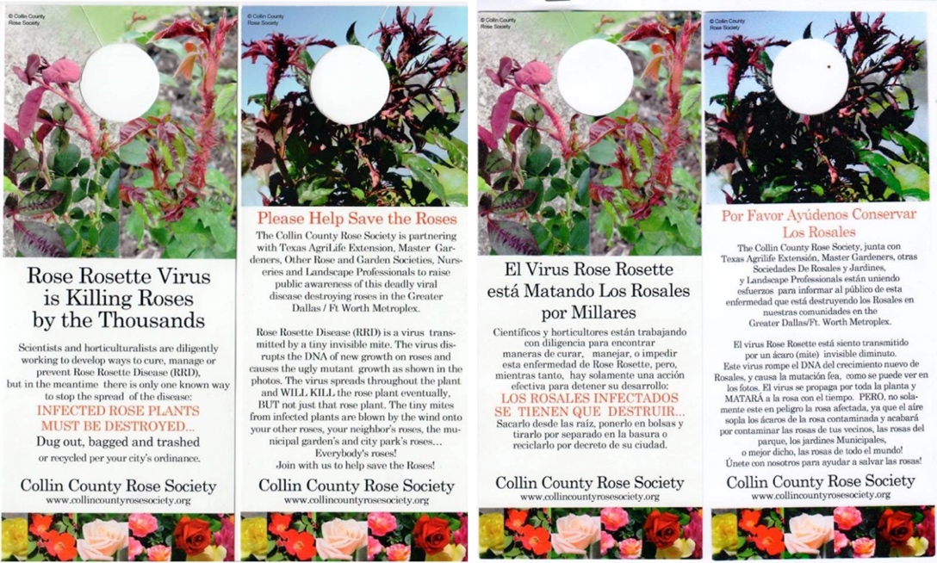
Figure 1. Hang tags publicizing RRV and its impact on roses were printed in English and Spanish and hung on residential doors in Allen, TX in 2015.

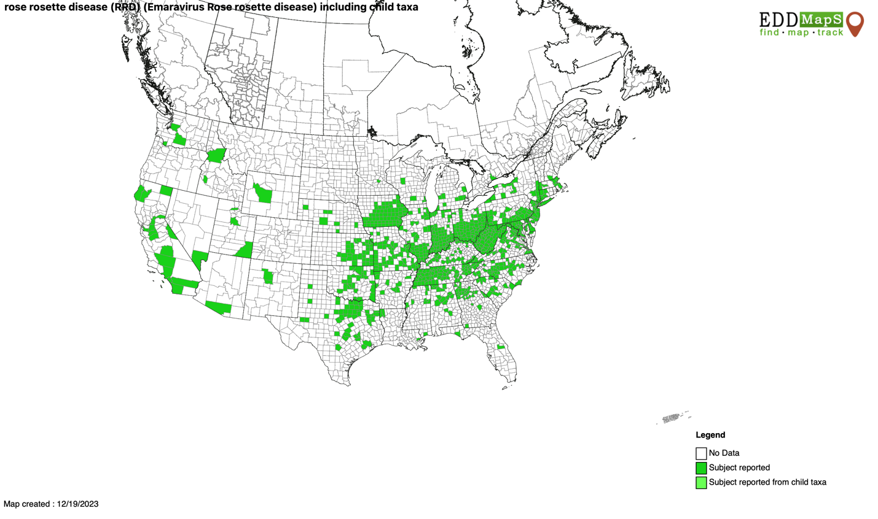
Figure 2. RRD distribution map as of December 19, 2023. (EDDMapS 2023).

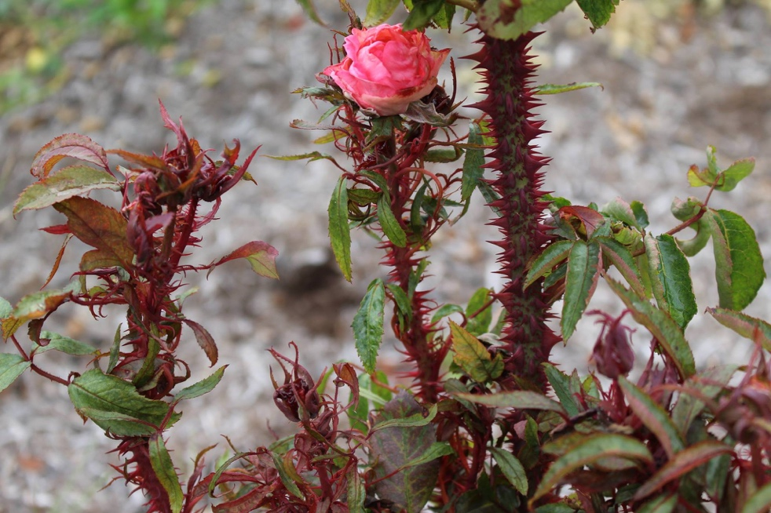
Figure 3. Symptom of RRD classified as hyper thorniness.
Note. RRD symptoms seen in photo: excessive thorn production, thickened stems, excessive red pigmentation, and strappy leaves. Photo credit: Alan Windham, 2017, UT Soil, Plant and Pest Center. https://www.facebook.com/SoilPlantPestCenter/photos/a.255177287859526/1556533437723898

.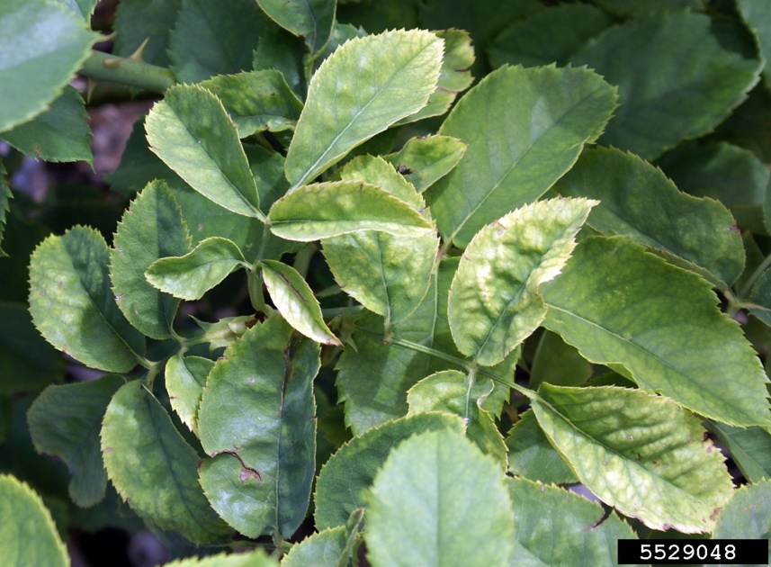
Figure 4. Symptom of RRD classified as leaf mosaic/mottling.
Note. Photo shows leaf distortion and mosaic/mottling pattern. Photo credit: Jennifer Olson, 2015, Oklahoma State University, Bugwood.org. https://www.ipmimages.org/browse/detail.cfm?imgnum=5529048
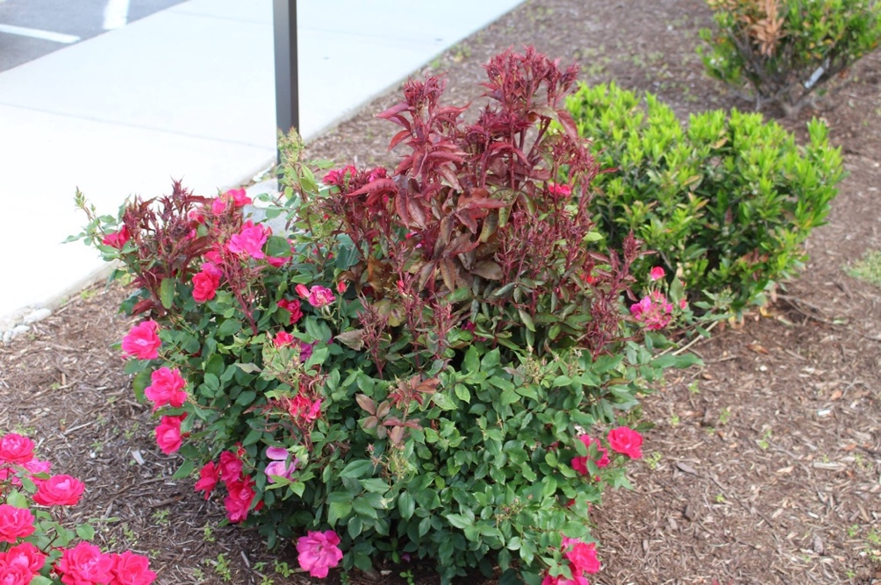
Figure 5. Symptom of RRD classified as witches’ broom.
Note. Ornamental rose displaying normal growth (bottom) and RRD symptoms (top): witches’ broom, hyper pigmentation, and leaf distortion. Photo credit: Alan Windham, 2014, UT Soil, Plant and Pest Center. https://www.facebook.com/SoilPlantPestCenter/photos/pcb.750662748310975/750660921644491/

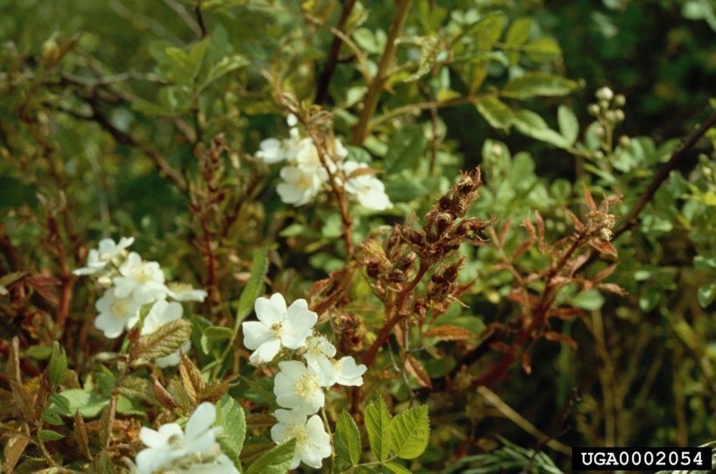
Figure 6. RRD symptoms on Rosa multiflora.
Note. Multiflora rose displaying RRD symptoms of distorted leaves and red pigmentation. Photo credit: James W. Amrine Jr., 2002, West Virginia University, Bugwood.org. https://www.ipmimages.org/browse/detail.cfm?imgnum=0002054
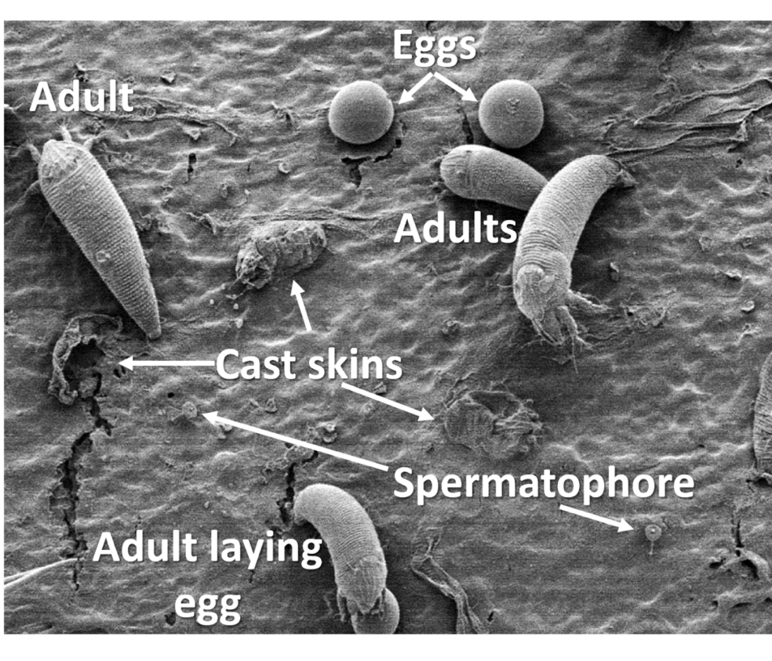
Figure 7. Phyllocoptes fructiphilus adults, eggs, spermatophores, and cast skins.
Note. Some of the pictured adults may be deutonymphs but this cannot be confirmed due to mite orientation. Photo credit: G. Bauchan and R. Ochoa, USDA ARS, Beltsville, MD.
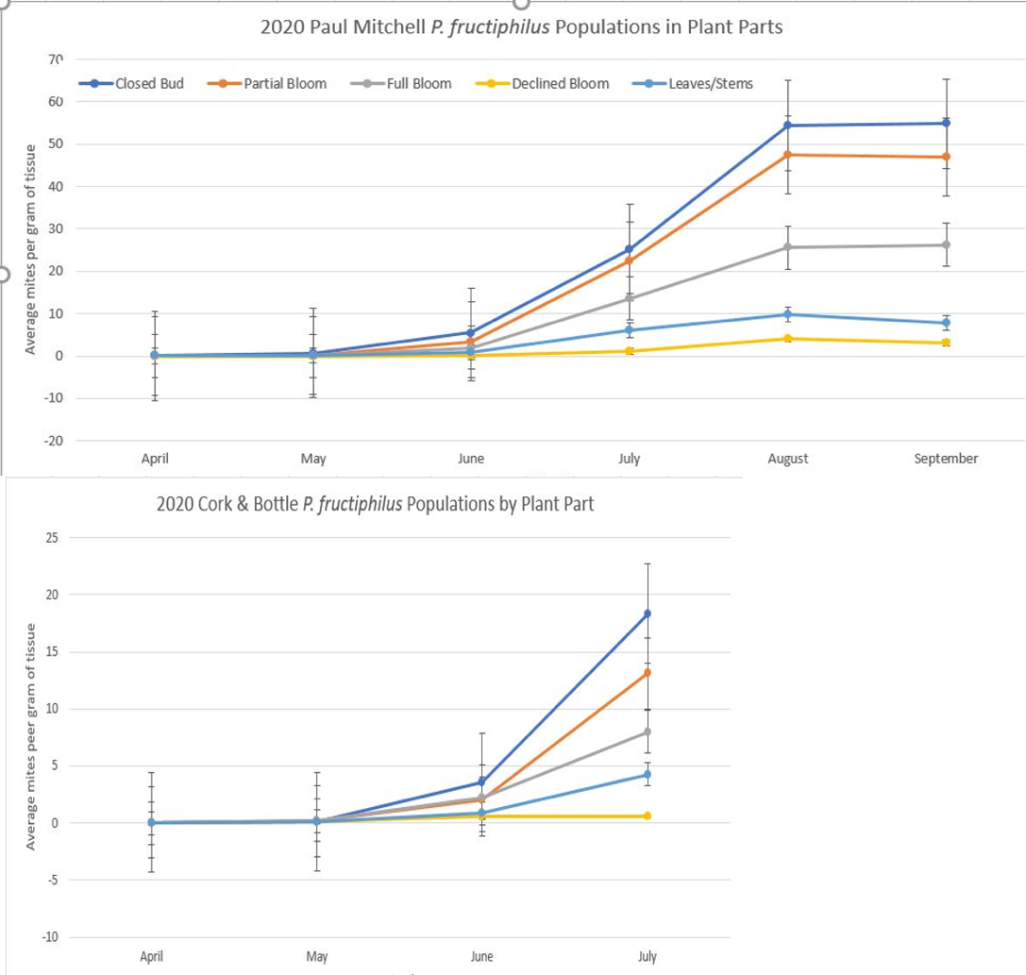

Figure 8. Ppopulation levels of Phyllocoptes fructiphilus on Knock Out roses 2020.
Note. Population levels of P. fructiphilus at two locations in Knoxville, TN for mites collected on different types (as well as ages) of plant parts.
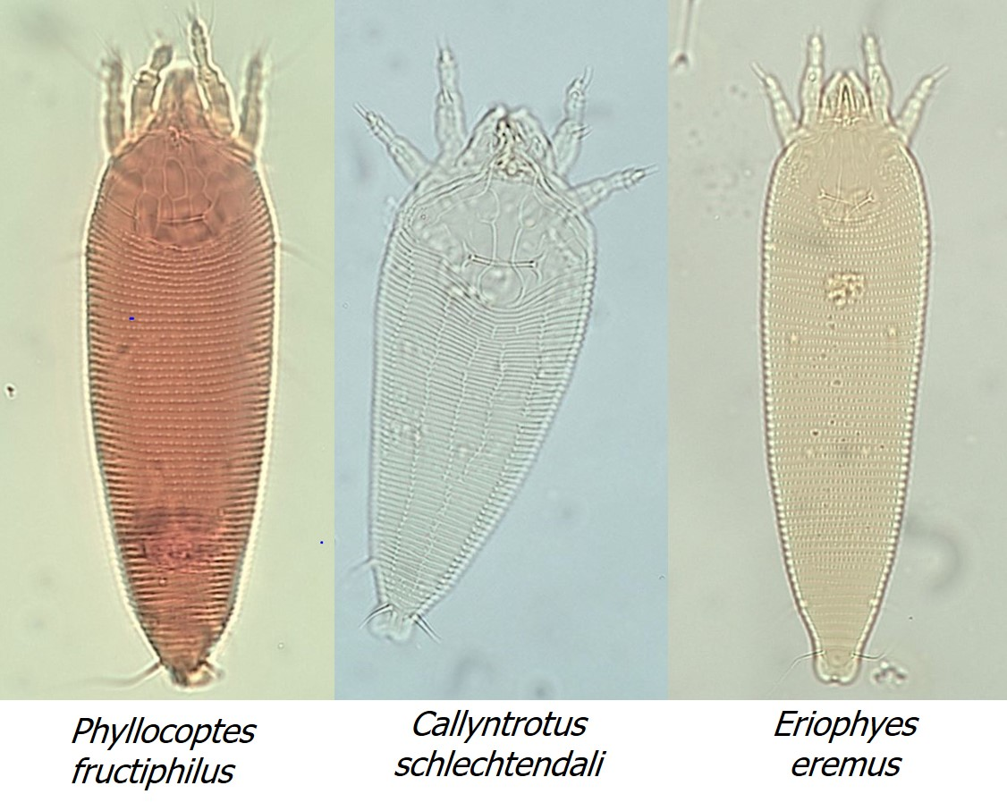
Figure 9. Comparison of Phyllocoptes fructiphilus, Callyntrotus schlechtendali, and Eriophyes eremus.
Note: Photo credit: Sara Collins and Katherine Solo, University of Tennessee.

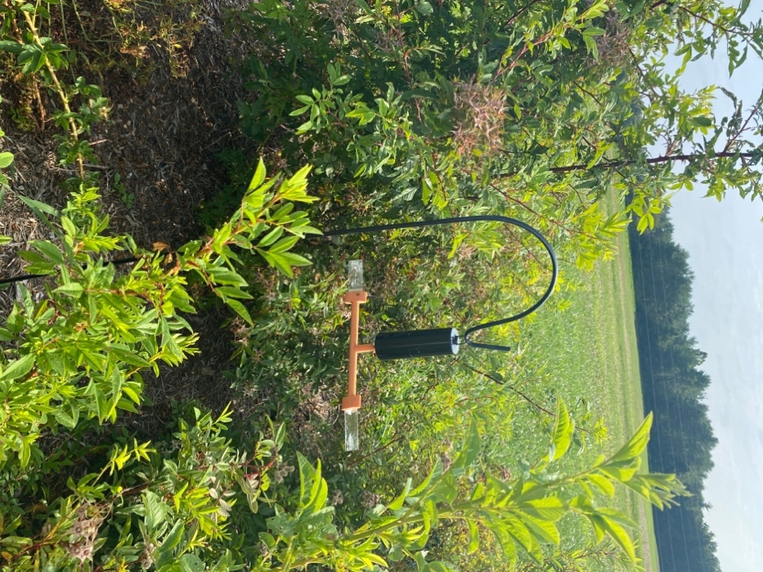
Figure 11. Spinning sticky trap placed in rose plantings, Crossville, TN.

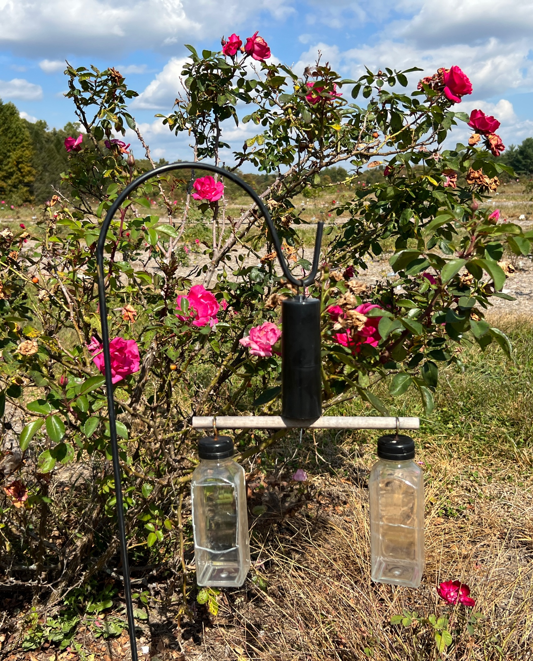
Figure 12. Spinning bottle traps placed in rose plantings, Crossville, TN.
Note. Designed by Sara Collins, University of Tennessee

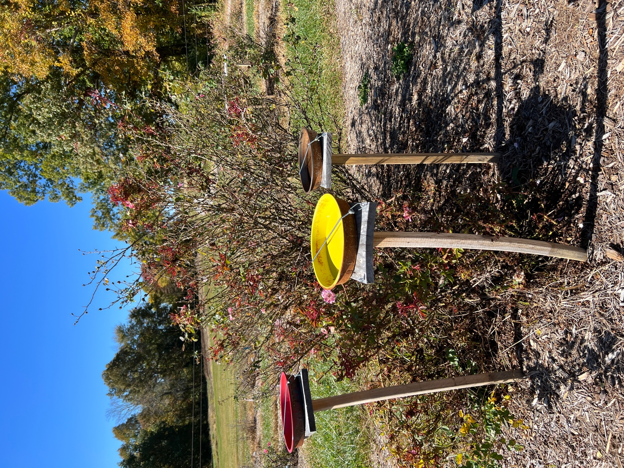
Figure 13. Water pan trap placed near roses, Crossville, TN.

Chapter 2 Emergence & Seasonality of Phyllocoptes Fructiphilus in Knox, Campbell, Cumberland, & Davidson Counties, Tennessee

Introduction

The health and survival of roses (Rosa spp.), as well as their continued use in landscapes and gardens, is threatened by rose rosette disease (RRD). The rose rosette virus that causes this disease, which can kill roses in as few as 2-3 years, is vectored by the eriophyid mite Phyllocoptes fructiphilus (Epstein 1995). Generally, P. fructiphilus populations overwinter as deutonymphs, the third instar stage of a mite, with adults emerging in the spring. Adult females will breed, laying one egg a day on average over their 30 day lifespan. During their lifecycle, some adult P. fructiphilus will travel to new host plants on air currents; this may be due to competition for resources. This reproduction and movement will continue until the population declines; usually as temperatures become colder.
Because P. fructiphilus is dependent on favorable environmental conditions for survival, detailed information of when populations start to increase, balloon, and when populations decrease is essential. Population levels generally increase as the weather becomes warmer. Emergence, seasonality and decline of populations of P. fructiphilus vary over the U.S. A better understanding of these population fluctuations would enhance control recommendations that are more location-specific. For example, Tennessee is a large state that encompasses four geological distinct regions (Division 1 - East Tennessee, Division 2 - Cumberland Plateau, Division 3 - Middle Tennessee, Division 4 – West Tennessee) (Grand Divisions and State Capital, 2021). These four climate divisions represent uniquely different topography, temperatures, and other environmental features. It is important to understand when emergence of P. fructiphilus occurs each year, and how populations fluctuate within the state.
The objective of this study was to determine, using generational population curves, when emergence of Phyllocoptes fructiphilus occurs and how populations fluctuate by monitoring populations of P. fructiphilus in three of the four climate divisions in Tennessee (Division 1 – East Tennessee, Division 2 – Cumberland Plateau, and Division 3 – Middle Tennessee). Suppression of early generations of P. fructiphilus before population densities reach damaging levels is crucial. The early suppression of populations may prevent the buildup of populations and the subsequent dispersal of adults to healthy plants. The information gained in this study will enable rose producers to better manage the mite that vectors RRV. It will also aid in more precise miticide application intervals, allowing for less usage of miticides, resulting in a reduction in the development of pesticide resistance by the mite.

Materials and Methods

In this study, wild roses and cultivated roses that were infected with RRV were monitored monthly from June to November at locations in Eastern and Middle Tennessee (Table 1). On each monthly sampling date, tissue samples were collected; mites were extracted from these samples and counted to obtain population data.
The wild and cultivated roses used for tissue collection in this study were Rosa multiflora (multiflora rose) and Rosa ‘Radrazz’ (Knock Out rose), respectively. Both of these rose types are Rosa species that are known hosts of P. fructiphilus. The tissue collected in this study consisted of the preferred tissue of P. fructiphilus mites: tender new growth, leaf petioles, sepals, bud scales, and flower buds. For the first two months of the study at the Knoxville Knock Out rose sites, 20g of tissue was obtained from each site in total, consisting of 10g of bud tissue (closed to partially open buds) and 10g of petiole tissue. The purpose of this is to confirm or rebuke 2020’s findings in Knoxville which showed a greater number of mites were found in closed and partially open buds than were found in petiole and leaf tissue. The tissue obtained from Knock Out roses was combined at each site to form a composite sample.
Tissue samples from Knock Out roses were collected from two locations in East (Knoxville) and three locations in Middle (Crossville and Nashville) Tennessee. Ten grams of tissue was collected from a composite of eight Knock Out roses located at Burke’s Outlet, 86 The Crossings, Crossville TN (35°58'50.4"N 85°02'17.1"W). Additionally, 10g of tissue was collected from a composite of 8 roses at Comfort Suites 258 E 1st St, Crossville, TN (35°57'42.2"N 84°59'01.2"W). The two sites used to obtain Knock Out rose tissue in Knox County were located at Dunkin Donuts, 720 Merchant Drive, Knoxville, TN (GPS 36°00'21.8"N 83°58'43.2"W), and Kroger Fuel Center, 4918 Kingston Pike, Knoxville, TN (35°56'22.5"N 83°59'08.2"W). Samples of tissue from Knock Out roses were collected by cooperators at one site in Nashville, TN (Davidson County) (36°7'2"N 86°46'26"W) and shipped via FedEx to Knoxville, TN, where they were processed.
Tissue samples from multiflora rose were collected from two locations in East (LaFollette) and two locations in Middle (Crossville) Tennessee. The multiflora rose tissue from Cumberland County was collected from R. multiflora growing wild at the UT AgResearch Plateau Research and Education Center, Crossville, TN; 10g of tissue was collected from one plant located at GPS coordinates 36°00'48.4"N 85°07'40.1"W and 10g of tissue from one plant located at GPS 36°00'46.2"N 85°07'57.9"W. Two multiflora rose plants were used for tissue collection in Campbell County in LaFollette, TN (36°20'07.2"N 84°04'01.9"W).
After collecting the samples, the mites were extracted from the rose tissue by placing 10g of tissue into a 400 ml beaker. The tissue was covered with 250 ml of 70% ethanol then stirred for 5 minutes to dislodge mites. A series of mesh sieves were placed on top of an empty beaker, arranged top to bottom from sieves no. 80 (180 mm), no. 270 (53 mm), no. 500 (25 mm). The stirred tissue and ethanol in the beaker was poured into the top sieve (no. 80) then this tissue was rinsed with 70% ethanol from a squeeze bottle (Figure 10). The top sieve (no.80) was removed, then the no. 270 sieve was rinsed with ethanol. The no. 500 sieve was removed and held over a counting dish, the sieve surface was rinsed into the counting dish. The counting dish was placed under a dissecting microscope and allowed to sit for 5 minutes to allow the contents to settle so the mites can be counted. The number of mites found per gram of tissue was recorded. Slides were made for mite identification. Using a glass pipette the mites were removed from the ethanol in the counting dish to a blank microscope slide to evaporate excess ethanol. Using a hair loop or minutemen pin tool, the mites were transferred onto a slide prepared with modified Berlese medium then covered with a coverslip. The slides were cured on a hot plate at 85º C for 1 hour. Slides were examined with a stereoscope at 40x magnification to identify the mite species using dorsal shield and coverflap markings.

Results

Multiflora Rose

Cumberland County

In 2021, within Cumberland County, P. fructiphilus was not recovered from Rosa multiflora samples taken in June but was present in samples collected in July, August, September, October (Table 2). In July, the density of P. fructiphilus 1.19 mites per gram of tissue. By August the density of P. fructiphilus peaked as it had increased to 7.39 mites per gram of tissue. Population densities of P. fructiphilus decreased slightly in September with 3.43 mites per gram of tissue and were even lower in October, when the mite population decreased to its lowest level at 0.81 mites per gram of tissue.
In 2022, P. fructiphilus populations were present in June (1.48 mites/gram), and increased monthly reaching 3.90 mites/g in July, 8.41 mites/gram in August and peaking in September (16.8 mites/g). Population densities slightly decreased in October (14.9 mites/g) from the September peak density.
Campbell County
In 2021 in Campbell County, mites were not recovered in June (Table 3). In July, density of P. fructiphilus was 1.61 mites/g of tissue from multiflora rose. The population increased in August to 0.93 mites/g, then peaked in September at 2.02 mites/g, before decreasing in October to 1.10 mites/g.
In 2022, P. fructiphilus was not collected from multiflora rose in June.
Mite densities were in 0 mites/g June, 0.60 mites/g in July, 5.79 mites/g in August, 4.57 mites/g in September, and 9.02 mites/gram in October.

Knock Out Roses
Cumberland County
Within Knock Out rose samples in Cumberland County in 2021, TN P. fructiphilus was present in June with 4.39 mites per gram of tissue recovered (Table 4). The P. fructiphilus population slightly increased monthly from June to September; in July 9.68 mites per gram of tissue, August 16.89 mites/gram of tissue, September 20.76 mites/gram of tissue. P. fructiphilus populations did not decrease until October in which 8.78 mites per gram of tissue recovered.
In 2022, populations of P. fructiphilus were 3-7X more abundant than they were in 2021 although they flowed the same pattern as the previous year. Mites were present in June (25.7 mites/g), July (40.8 mites/g), August (53.3 mites/g), September (91.1 mites/g), and October (56.8 mites/g). The population density increased each month until peaking in September.
Knox County
In 2021, Knox County populations of P. fructiphilus were present in June (5.35 mites/g of tissue) (Table 5). Populations of P.fructiphilus on Knock Out roses in Knox County peaked at 95.28 mites/g of rose tissue, and then slightly declined to 82.87 mites/g in August and 86.53 mites/g in September. By October and November, the population densities had decreased by more than 50% to 39.81 mites/g, respectively.
In 2022, P. fructiphilus was present in June (16.1 mites/g), and peacked in July (149.4 mites/g). This peak density was ca. 1.5X greater than the peak in 2021. Population densities then decreased each successive month (August - 86.6 mites/g, September - 70.4 mites/g, and October - 58.3 mites/g).
Davidson County
In Davidson County, samples were not obtained in June or July 2021. In August, density of P. fructiphilus was 10.4 mites/g on Knock Out roses; densities peaked in September at 53.9 mites/g and averaged 29.6 mites/g in early November 2021. No samples were collected in October (Table 6).
In 2022, P. fructiphilus was present on samples collected in July (27.5 mites/g), September (59.2 mites/g) and October (28.3 mites/g). No samples were processed in August.
Overall Comparisons
Across all samples collected each month for all locations on average in 2021, densities of P. fructiphilus peaked in September in Cumberland, and Davidson Counties. In Campbell County, populations of P. fructiphilus peaked in August, while P. fructiphilus were most abundant in July in Knox County.
Overall in 2021, within Knox, Davidson, Campbell, and Cumberland counties, eriophyid mites were present in June but the populations were relatively small. In July, the population increased to 42.1 mites/g. Then population of eriophyid mites decreased slightly in August to 47.2 mites/g of tissue. September was the peak population growth with 55.1 mites/g of tissue collected. October declined to 50.6 mites/gram before November’s decline to 41.4 mites/g of tissue.
In 2022, in Cumberland County on multiflora rose the mite population peaked on multiflora rose in September with an insignificant decrease in October (no data was available for November). In Campbell county, on multiflora rose, mites were present in July, the population peaked in October (no data available for November).
Knock Out rose in Cumberland County had mites presents in June, a population peak in September and a decline in October. In Knox County, mites were present in June, the population peaked in August and declined in October. Davidson County Knock Out rose had mites present in July, a population peak in September and a decline in October.

Discussion

This study monitored the eriophyid mite population in Knox, Campbell, Cumberland, and Davidson Counties in Tennessee. Results will influence current management practices relating to P. fructiphilus. As RRD has become more prevalent in the world, a better understanding of the annual cycle of P. fructiphilus, as well as its emergence and seasonality will help growers and producers strategize management tactics. This information can be utilized for miticide spray practices. In Knox County, start spraying in July when the mite is present but before its populations begin to increase and surge.

Summary

On Knock Out rose in Davidson P. fructiphilus was present in August 2021 and July 2022. The population was most abundant in September during both 2021 and 2022. In 2021 the population declined in November, in 2022 the population declined in October.

Cumberland Counties, on Knock Out rose, P. fructiphilus was present in June, the population was most abundant in September during both 2021 and 2022. The population declined in October in both 2021 and 2022.

In 2021 and 2022 in Knox County, P. fructiphilus populations were present in June. The population was most abundant in September of 2021 while in 2022 it was most abundant in August. The population declined in October of both 2021 and 2022.

On multiflora rose in Cumberland County, P. fructiphilus populations were present in July in 2021 and 2022. The population was most abundant in August in 2021, but 2022 was most abundant in September. The population declined in October of both years.
In Campbell County on multiflora rose, P. fructiphilus populations were present in July of 2021 and 2022. The population was most abundant in September of 2021 and October of 2022. The population declined in October of 2021. There was no data for November of 2022 to obtain when the population declined in 2022.

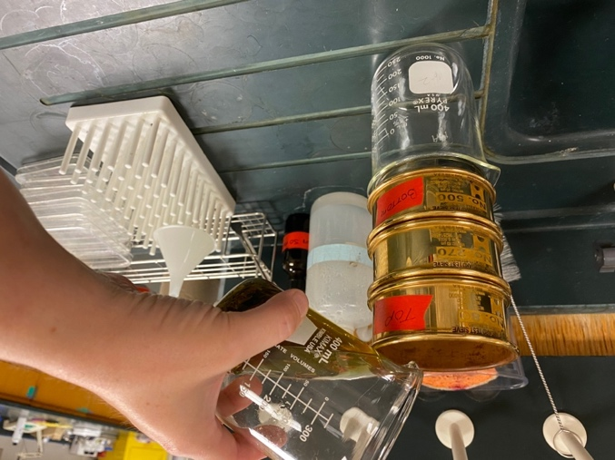
Figure 10. Mite extraction using ethanol

Rosa spp. Sampled | Year | County | No. of Locations | No. of Plants
Rosa multiflora  (multiflora rose) | 2021 | Campbell | 2 | 4
Rosa multiflora  (multiflora rose) | 2022 | Campbell | 2 | 4
Rosa multiflora  (multiflora rose) | 2021 | Cumberland | 2 | 4
Rosa multiflora  (multiflora rose) | 2022 | Cumberland | 2 | 4
Rosa sp.  (Knock Out rose) | 2021 | Cumberland | 2 | 8
Rosa sp.  (Knock Out rose) | 2022 | Cumberland | 2 | 8
Rosa sp.  (Knock Out rose) | 2021 | Davidson | 1 | 8
Rosa sp.  (Knock Out rose) | 2022 | Davidson | 1 | 8
Rosa sp.  (Knock Out rose) | 2021 | Knox | 2 | 8
Rosa sp.  (Knock Out rose) | 2022 | Knox | 2 | 8
Table 1. Locations sampled and number of plants sampled

 | Multiflora rose
Cumberland County |  | 2021 | 2022
Cumberland County | June | 0 mites/g | 1.48 mites/g
Cumberland County | July | 1.19 mites/g | 3.90 mites/g
Cumberland County | August | 7.39 mites/g | 8.41 mites/g
Cumberland County | September | 3.43 mites/g | 16.8 mites/g
Cumberland County | October | 0.81 mites/g | 14.9 mites/g
Cumberland County | November | No Data | No Data
Table 2. Cumberland County multiflora rose P. fructiphilus population

 | Multiflora rose
Campbell County |  | 2021 | 2022
Campbell County | June | 0 mites/g | 0 mites/g
Campbell County | July | 1.61 mites/g | 0.60 mites/g
Campbell County | August | 0.93 mites/g | 5.79 mites/g
Campbell County | September | 2.02 mites/g | 4.57 mites/g
Campbell County | October | 1.10 mites/g | 9.02 mites/g
Campbell County | November | No Data | No Data
Table 3. Campbell County multiflora rose P. fructiphilus population

 | Knock Out rose
Cumberland County |  | 2021 | 2022
Cumberland County | June | 4.39 mites/g | 25.7 mites/g
Cumberland County | July | 9.68 mites/g | 40.8 mites/g
Cumberland County | August | 16.89 mites/g | 53.3 mites/g
Cumberland County | September | 20.76 mites/g | 91.1 mites/g
Cumberland County | October | 8.78 mites/g | 56.8 mites/g
Cumberland County | November | No Data | No Data
Table 4. Cumberland County Knock out rose P. fructiphilus population

 | Knock Out rose
Knox County |  | 2021 | 2022
Knox County | June | 5.35 mites/g | 16.1 mites/g
Knox County | July | 95.28 mites/g | 149.4 mites/g
Knox County | August | 82.87 mites/g | 86.6 mites/g
Knox County | September | 86.53 mites/g | 70.4 mites/g
Knox County | October | 39.81 mites/g | 58.3 mites/g
Knox County | November | 38.84 mites/g | No Data
Table 5. Knox County Knock out rose P. fructiphilus population

 | Knock Out rose
Davidson County |  | 2021 | 2022
Davidson County | June | No Data | No Data
Davidson County | July | No Data | 27.5 mites/g
Davidson County | August | 10.4 mites/g | No Data
Davidson County | September | 53.9 mites/g | 59.2 mites/g
Davidson County | October | No Data | 28.3 mites/g
Davidson County | November | 29.6 mites/g | No Data

Table 6. Davidson County Knock out rose P. fructiphilus population

Chapter 3 Evaluation Of Eriophyid Mite Collection Methods

Introduction

The eriophyid mite, Phyllocoptes fructiphilus, vectors rose rosette virus (RRV) which causes rose rosette disease (RRD). This disease can kill roses, such as the popular Rosa spp. found in landscapes and gardens, in as few as 2-3 years. Eriophyid
mites are slow and can travel short distances on the plant by crawling. Mites can also transport themselves from one plant to another by crawling, if the plants overlap or touch. To travel longer distances, eriophyid mites ride on air currents, called "ballooning," which is their main mode of transport (Oldfield 1996). The ballooning process begins when mites excrete a sticky substance from their posterior end on to the surface of a leaf. This sticky substance enables the mite to raise up its anterior end and wave its legs to catch an air current (Michalska 2010). Mites can travel 100 m or more on air currents but have no way to control where they land (Epstein 1997). Ballooning is performed almost entirely by adult eriophyid mites (Nault 1969).
Knowing when Phyllocoptes fructiphilus populations balloon to a new host will improve understanding of the mite’s behavior and this knowledge will aid growers in devising better management strategies for RRD. Common methods used to study the aerial dispersal of eriophyid mites include sticky traps and water traps. The Woody Ornamental Laboratory at the University of Tennessee Knoxville currently uses a modified sticky trap to sample for ballooning mites. The drawback to using a sticky trap is that the adhesive substance can distort and modify the appearance of the mites, making species identification difficult. Attempting to remove the mites from the adhesive can destroy the mites making identification impossible (Monfreda 2009). It is important to have a simple, easy way to collect mites that leave them in a recognizable condition once they are collected. This study compared two nondestructive collection methods to a destructive sticky trap for sampling mites that disperse aerially.

Materials and Methods

This study was conducted for 18 weeks in 2021 at the University of Tennessee AgResearch Plateau Research and Education Center in Crossville, TN. Two types of nondestructive collecting methods (spinning bottle trap and water pan trap) and one type of destructive collecting method (spinning sticky trap) were evaluated. These collection methods were placed among roses that were known to be positive for RRV. Each collection method was replicated five times.
Collection Method 1. Spinning Sticky Traps
The first eriophyid mite collection method evaluated was a spinning sticky trap (Figure 11). This trap consisted of a 3D printed rod, 25 cm long, fashioned to hold a vertically aligned microscope slide on each end; this rod was attached to the base of a battery-operated rotating spinner. The spinning sticky trap was hung from a metal shepherd’s hook 60 cm above the ground. The spinning traps were placed close enough to the roses to intercede ballooning mites, but the traps did not touch any foliage to prevent mites from crawling on to the sticky traps. The spinning sticky slide traps were placed in the field for five days; they were then collected and transported to the laboratory, where the slides were viewed under a microscope and the mites were counted and the number of mites recorded. This process was repeated every week for 18 weeks.
Collection Method 2. Spinning Bottle Trap
The second sampling method evaluated was the battery-operated spinning bottle trap that was suspended from a shepherd’s hook (Figure 12). Each trap consisted of a wooden dowel, 15 cm long and 1.3 cm wide, a battery-operated rotating spinner, two clear plastic bottles with screw top caps, metal hooks, wire, and D-batteries. The plastic bottles used were 18 cm in length, 5 cm width, with a 7 cm x 5 cm “window” cut out of one side which would be the entrance to the collection chamber. A hole was drilled through the center each bottle cap where a cup hook with screw was attached and secured with glue. The wooden dowels had grooves cut into the upper surface, 2.5 cm from each end, where the hook that was attached to the bottle was placed to allow the bottle to be suspended. The dowels had a small hole drilled through the center and were placed on the attachment point at the base of the rotating spinner and secured with wire. The bottles were oriented vertically on the dowels with the “window” facing the windward direction (southwest) to catch ballooning mites. The spinning bottle trap was suspended from metal shepherds hooks 60 cm from the ground surface. Each bottle was filled with 50 mL of water with 1 drop of dish detergent to act as a surfactant.
Samples were collected once each week by pouring the solution from the bottle through stacked mesh sieves (180 mm, 53 mm, 25 mm). The 25 mm sieve was rinsed through a funnel into a 50 mL centrifuge tube. Samples in the centrifuge tube were taken to the laboratory where the contents were rinsed with an ethanol-filled bottle into a counting dish. The solution was observed under a stereoscope, and any mites present were counted. Mites were removed from the solution then placed on a microscope slide to be viewed under a compound microscope for species identification. This process was repeated for 18 weeks.
Collection Method 3. Water Pan Trap
Water pan traps were found to be more efficient than sticky pan traps for aerial dispersing mite studies (Zhao and Amrine 1997a). Therefore, the third mite collection method evaluated in this study was a modified water pan trap (Figure 13). The pan trap consisted of a gray, metal cake pan of 22.9 cm diameter and 3.8 cm height which was 3/4 filled with water and a drop of dish detergent. The pan filled with water was placed on top of a wooden support in the ground. The detergent was added to act as a surfactant to promote the mites breaking through the water surface. The base support for the pan trap was constructed out of an 18 cm x 30 x 2.54 x 1.27 cm square wood plank attached perpendicular to a 5 cm wooden stake, which was driven into the ground so that the pan rests 60 cm from the ground. To discourage wind or other weather events from dislodging the pan, wire brads were hammered into the wooden board around the perimeter of the pan. Eye hooks were screwed into the upper surface of the wood planks at each corner and a bungee cord was stretched over the top of the pan to strap the pan to the board, providing additional stability against blowing over.
After consulting with Dr. Ronald Ochoa regarding the collection methods in this study, an additional 10 water pan traps were added to the study September 2021; of these 5 were spray painted yellow, 5 were spray painted red. The yellow and red pan traps were implemented during week eleven between September 27 to October 1. The
additional water pans were added to observe the possibility of eriophyid mite’s light sensing capabilities. Since insects are most attracted to ultraviolet light, yellow was used for its ability to reflect UV light. Eriophyid mites are thought to have no eyes, though this topic has not been wildly studied. If the mite has any ocular light sensing capability, they may be able to orient themselves, using their appendages, while in the air to direct themselves toward a particular color.
Samples from the pans were collected once a week by pouring the soap and water solution through mesh sieves stacked top to bottom (180 mm, 53 mm, 25 mm). The sieves were rinsed with a water-filled spray bottle to separate the mites out from other insects and debris. The bottom sieve was rinsed through a funnel into a 50 mL centrifuge tube which was labeled with the date, trap type, and location of the trap. In the lab, the centrifuge tube will be rinsed into a counting dish using an ethanol-filled spray bottle. The mites were counted under a stereoscope, mounted onto slides using modified Berlese medium. The mite species were identified under a compound microscope. This process was repeated for 18 weeks.
As a control, to assess at what level eriophyid mites are present in the rose field, symptomatic tissue from nearby rose plants was gathered. The tissue was collected from plants that are located within the same row and block that each trap was located, instead of collecting tissue from the plant that was nearest each the trap; this selection was done to minimize interference with ballooning mites, which the trap would potentially collect. Sampling tissue from nearby plants, instead of the plants closest to the traps, will confirm mite presence in the field while minimizing interference of the mite populations closest to the traps.

Results

Due to inclement weather, traps were not set out for 11 of the 18 weeks of the study in 2021 resulting in no data during the following weeks: June 28-July 2, July 5-9, July 12-16, August 16-20, August 30-September 3, September 6-10, September 13-17, September 20-24, October 4-8, and October 25 to 29 (Table 7). The greatest number of mites collected from all pans, bottles, and slides combined were found during week 17 (October 18-22). In 2021, no mites were collected in any pan, bottle or slide trap during week 5 (July 26-July 30).
During 2021, 34 mites were collected using the bottle traps, 23 mites were collected using the spinning sticky slide traps, and 36 mites were collected using the grey pan traps over the course of the study. After comparing the number of mites collected in the bottle, pan and slide traps, respectively, it was found pan traps were the most effective method of eriophyid mite collection.
Over the four-week period the red and yellow pans were implemented along with the gray pans, the grey pans 21 mites were collected from the gray pans in 2021.The red pan traps collected a total of 20 mites during the 2021 sampling period. In 2021, the yellow pan traps collected a total of 11 mites over the course of the study.
In 2022, no data was collected during the weeks July 25-29, August 1-5, October 10-14, October 17-21, October 24-28 (Table 8). The spinning sticky traps collected a total of 125 eriophyid mites. The most mites were collected in the spinning sticky trap during the week of September 28-October 2 with 25 mites collected. The weeks with the least amount of mites collected using the spinning sticky trap were the weeks of August 8-12 and August 15-22 with zero mites collected, respectively.
The spinning bottle traps collected a total of 48 mites. The most mites were collected using this method during the week of September 28-October 2 with 11 mites collected. Zero mites were collected during the weeks of July 4-8, August 29-September 2, September 3-7.
The gray water pan traps collected a total of 112 mites during 2022, with the week of September 12-16 collecting the most (39), while the weeks of June 27-July 1 and August 8-12 had 2 mites collected each.
The red water pan traps collected a total of 100 mites, 18 mites were respectively collected during the weeks of September 12-16 and September 28-October 2. Only 2 mites were collected during August 8-12.
The yellow water pan traps collected a total of 142 mites with the largest amount (49) collected during September 12-16; zero mites were collected during the week of June 27-July 1.
In total, during the 2022 collection period a total of 354 mites were collected using the gray, red, and yellow water pan traps.
After comparing the number of mites collected in the bottle, pan, and slide traps, respectively, it was found pan traps were the most effective method of eriophyid mite collection. This study found that there was no significant difference between the color of the pan traps among the yellow, gray, and red pans.

Discussion

The vector of rose rosette disease is the size of a pin head, making monitoring extremely difficult. The purpose of this study was to evaluate two of the current eriophyid mite collection methods, the spinning sticky trap and pan trap. Additionally, this study evaluated a new trap type, the spinning bottle trap, for its potential in eriophyid mite collection. The pan trap and the spinning bottle trap was significantly more effective at eriophyid mite collection than the spinning sticky trap. The spinning bottle trap was not significantly more effective at collecting eriophyid mites than the water pan traps. However, the water pan traps have a few advantages over the spinning bottle trap, for example, the water pan traps do not rely on battery which was replaced frequently during the study (once per week). Additionally, the water pan trap was easier to set up than the bottle traps which required cutting into each plastic bottle and drilling into the plastic lids. The water pan trap required few parts which were easily found at a local big box store (wood plank, wood stake, metal pan, water, dish detergent, nails) versus the bottle trap which required a spinning motor, battery, wooden dowels, hooks, plastic bottles, water, dish detergent, shepherd’s hook, some of which had to be ordered online. There was no significant difference using the three different pan colors for the water pan traps which would suggest the mites do not have ocular capabilities or the ability to orient themselves toward a preferred color pan.

Summary
This study evaluated one destructive and two nondestructive eriophyid mite collection methods: a spinning sticky slide trap, a spinning bottle trap, and a water pan trap. Gray, red, and yellow metal pans were used in the water pan traps. The water pan traps and the spinning bottle traps outperformed the spinning sticky traps. The water pan traps and spinning bottle traps were significantly more effective at collecting eriophyid mites during the two year study, when compared to sticky traps. There was no significant difference between the amount of eriophyid mites collected using the water pan trap or the spinning bottle trap, however, for ease of use, the water pan trap was the more efficient trap of the two nondestructive eriophyid mite collection methods. There was no significant difference in the color of the metal pans used.

Week | Collection Period | Spinning Sticky Trap | Spinning Bottle Trap | Water Trap Gray | Water Trap Red | Water Trap Yellow
1 | 06/28/21-0702/21 | N/A | N/A | N/A | N/A | N/A
2 | 07/5/21-07/9/21 | N/A | N/A | N/A | N/A | N/A
3 | 07/12/21-07/16/21 | N/A | N/A | N/A | N/A | N/A
4 | 07/20/21-07/24/21 | 1 | 3 | 2 | N/A | N/A
5 | 07/26/21-07/30/21 | 0 | 0 | 0 | N/A | N/A
6 | 08/02/21-08/06/21 | 7 | 0 | 1 | N/A | N/A
7 | 08/09/21-08/13/21 | 9 | 1 | 0 | N/A | N/A
8 | 08/16/21-08/20/21 | N/A | N/A | N/A | N/A | N/A
9 | 08/23/21-08/26/21 | 3 | 4 | 2 | N/A | N/A
10 | 08/30/21-09/03/21 | N/A | N/A | N/A | N/A | N/A
11 | 09/06/21-09/10/21 | N/A | N/A | N/A | N/A | N/A
12 | 09/13/21-09/17/21 | N/A | N/A | N/A | N/A | N/A
13 | 09/20/21-09/24/21 | N/A | N/A | N/A | N/A | N/A
14 | 09/27/21-10/01/21 | 1 | 15 | 3 | 2 | 6
15 | 10/04/21-10/08/21 | N/A | N/A | N/A | N/A | N/A
16 | 10/11/21-10/15/21 | 1 | 1 | 2 | 3 | 0
17 | 10/18/21-10/11/21 | 1 | 4 | 9 | 0 | 8
18 | 10/25/21-10/29/21 | N/A | N/A | N/A | N/A | N/A
Table 7. Collection Methods 2021

Week | Collection Period | Spinning Sticky Trap | Spinning Bottle Trap | Water Trap Gray | Water Trap Red | Water Trap Yellow
1 | 06/27/22-07/01/22 | 13 | 9 | 2 | 3 | 0
2 | 07/04/22-07/08/22 | 11 | 0 | 4 | 4 | 5
3 | 07/11/22-07/15/22 | 3 | 4 | 5 | 14 | 3
4 | 07/18/22-07/22/22 | 7 | 3 | 4 | 4 | 3
5 | 07/25/22-07/29/22 | N/A | N/A | N/A | N/A | N/A
6 | 08/01/22-08/05/22 | N/A | N/A | N/A | N/A | N/A
7 | 08/08/22-08/12/22 | 0 | 1 | 2 | 2 | 2
8 | 08/15/22-08/19/22 | 0 | 1 | 5 | 4 | 2
9 | 08/22/22-08/26/22 | 4 | 3 | 4 | 8 | 8
10 | 08/29/22-09/02/22 | 12 | 0 | 15 | 11 | 9
11 | 09/03/22-09/07/22 | 11 | 0 | 5 | 5 | 7
12 | 09/12/22-09/16/22 | 8 | 6 | 39 | 18 | 49
13 | 09/19/22-09/23/22 | 10 | 4 | 14 | 4 | 15
14 | 09/28/22-10/02/22 | 25 | 11 | 4 | 18 | 25
15 | 10/03/22-10/07/22 | 21 | 6 | 9 | 5 | 14
16 | 10/10/22-10/14/22 | N/A | N/A | N/A | N/A | N/A
17 | 10/17/22-10/21/22 | N/A | N/A | N/A | N/A | N/A
18 | 10/24/22-10/28/22 | N/A | N/A | N/A | N/A | N/A
Table 8. Collection Methods 2022

Figure 11. Spinning sticky trap

Figure 12. Spinning bottle trap
Note. Designed by Sara Collins, University of Tennessee

Figure 13. Water pan trap

Chapter 3 Environmental Effects On Eriophyid Mites

Introduction

This study observed the effects precipitation, temperature, wind, humidity, and altitude have on Phyllocoptes fructiphilus, Eriophyes eremus and Callyntrotus schlechtendali populations in Tennessee.
P. fructiphilus emerges once the weather warms in the spring, after which females will feed on rose tissue and lay eggs. Under greenhouse conditions at 23° C on average a P. fructiphilus egg will hatch after 4 days and the lifespan of an adult mite is ~14 days; the average female can live up to 30 days (Kassar 1990). A study in Georgia that used temperature-controlled grow chambers observed P. fructiphilus population abundance was increased more so at 32° C than at temperatures of 15° C or 21° C (Joseph 2022). As temperatures in field conditions are less precise, this study will seek the range that coincides with P. fructiphilus decline, but more importantly the in which P. fructiphilus populations boom.
Aerial dispersal is the most frequently used method of transport by eriophyid mites. In West Virginia, more eriophyid mites were collected on windy days than on less windy days (Zhao 1997b). In a study of the eriophyid mite Floracarus pepprepae, a gall mite, population density was positively associated with wind speed (David 2019).
Eriophyid mites were more likely to balloon when wind speeds were between 11 to 19 kilometers per hour (Davis 1964). Ballooning is less likely to occurring in periods with low wind speeds, low temperatures, and during dark periods (Sabelis & Bruin 1996). In a study observing grass mites in Ohio, the greatest quantity of eriophyid mite aerial dispersal activity during periods when temperatures were greater than 18° C mites and wind speed was greater than 24 kilometers per hour (Nault 1969).
In addition to temperature, humidity factors into eriophyid mite behavior and survival. Generally, eriophyid mites disperse under conditions of high humidity and high temperatures (Michalska 2010). In the case of Aceria cajani, the eriophyid mite that vectors Pigeon pea sterility mosaic virus, mites were less abundant in periods with greater rainfall, however precipitation had less influence on population density than did temperature and humidity (2013 Dipshikha). In periods of relative humidity between 61% and 64%, mite populations were greatest, but in periods of higher humidity (68% and 79%) the mites did not thrive. In P. fructiphilus specifically, low humidity may inhibit growth, but this species may not need extreme levels of high humidity as refuge mite are less at risk for desiccation (Hoy 2013, Sabelis 1996). One study observed P. fructiphilus population density was greatest at relative humidity of 60% than at relative humidity of 20% or 95% within a controlled growth chamber (Monterrosa 2021). Within controlled grow chambers the eriophyid mite Aceria tulipae dispersed more frequently in periods of light than dark (Nault 1969). The pear rust mite Epitrimerus pyri population was more abundant in periods of light in both controlled and field conditions (Bergh 1992).

Materials and Methods

This study took place at the UT AgResearch Plateau Research and Experiment Station, Crossville, TN in the rose bed located at GPS 36°00'54.9"N 85°07'56.0"W. The elevation at this location is 551.7 m. The weather station is located 85 meters from the rose bed. These roses were visually assessed for RRD symptoms and tested for RRV using TaqMan RT-qPCR. Tissue samples were collected once a month to look for the presence of eriophyid mite species Phyllocoptes fructiphilus, Eriophyes eremus, and Callyntrotus schlechtendali. The type of rose tissue collected was that which displayed symptoms of rose rosette disease, primarily the sepals, buds, stipules, and petioles that P. fructiphilus most often inhabits (Otera-Colina 2018).
The samples were taken to the lab where the mites were extracted from the rose tissue by placing 10g of tissue into a 400 ml beaker then 250ml of 70% ethanol was added then stirred for 5 minutes. Mesh sieves were stacked in order as top no. 80 (180 mm), middle no. 270 (53 mm), bottom no. 500 (25 mm). The ethanol and tissue was
poured into the stacked sieves and rinsed with 70% ethanol. The top sieve was removed then the middle sieve was rinsed with 70% ethanol then removed. The contents of the bottom sieve was rinsed into a counting dish then placed under a dissecting microscope. After a period of 5 minutes had passed any mites present were counted. For identification, mites were siphoned from the ethanol onto a glass microscope slide using a glass pipette to allow the excess ethanol to evaporate; filter paper was also used to wick away excess ethanol from the slide as needed. A drop of modified Berlese medium was placed on a separate glass slide into which mites were positioned, either ventral or dorsally, using a pin tool. After a coverslip was applied, the slides were cured at 85° C for 1 hour on a hotplate. The slides were viewed under a stereoscope to identify the mite species using dorsal shield and coverflap markings.
Temperature, humidity, precipitation and wind speed data from the weather station were downloaded from the National Centers for Environmental Information and compared with the mite population data obtained from monthly rose tissue collection.
A spinning sticky slide trap mounted on a metal shepherd’s hook was placed in the same rose bed located 85 m from the weather station to collect ballooning eriophyid mites. The spinning sticky slide trap was loaded with 2 Tanglefoot coated glass slides, one on each end of the spinning rod. These glass slides were set out in the rose bed once a week for a duration of 5 days on average over the course of the experiment. After 5 days the glass slides were taken back to the lab and observed under a stereoscope. The number of eriophyid mites present on the slide were counted. The mites were not identified to species.

Results

This study set out to observe the effects precipitation, temperature, wind, solar radiation and relative humidity have on eriophyid populations in TN. This study took place from July 22 to October 29, 2021, over a 15-week period. The original site for sampling was found to have no mites but (at least 1 of 8 plants were verified RRV +). Instead of using the original site, the mite populations counts shown here are taken from the sampling I did 1x a month in Aug, Sept, Oct in the RRV trial field as a control for objective 2. August had the highest mite population and it decreased until I stopped sampling at the end of October. Note to self, I could use the number of eriophyid mites collected in the trap study as those were collected weekly.
The average temperature was the highest in July and decreased until the collected stopped in October. The mite populations were higher during periods of warmer weather, then decreased as the temperature decreased. This data seems to agree with previous findings in literature.
The solar radiation averages decreased steadily from July to October. Mite populations decreased steadily from August to October, as well. This data seems to agree with previous findings in literature.
Precipitation seems to have an inverse effect on mite populations. Mite populations were lower after rain events. This data seems to agree with previous findings in literature.
The wind speed averaged between 5-6 MPH. Wind did not seem to affect mite population.

Discussion

Eriophyid mite populations were active from July through October in Tennessee. The population spiked during August and September.

Summary

References

Allington, W. B., Staples, R., & Viehmeyer, G. (1968). Transmission of rose rosette virus by the eriophyid mite Phyllocoptes fructiphilus. Journal of Economic Entomology, 61(5), 1137–1140. https://doi.org/10.1093/jee/61.5.1137
Amrine, Jr, J. W. (1996). Phyllocoptes fructiphilus and biological control of multiflora rose. In E. Lindquist, M. Sabelis, & J. Bruin (Eds.), Eriophyoid mites: Their biology, natural enemies, and control. (pp. 741–749). Elsevier.
Amrine, Jr, J. W. (2002). Multiflora Rose. In Biological control of invasive plants in the Eastern United States. 265–292. USDA Forest Service.
Amrine Jr, J. W., & Hindal, D. (1988). Rose rosette: A fatal disease of multiflora rose. WVA University Ag Extension, Circular 147.
Amrine Jr, J. W., Hindal, D., Stasny, T., Williams, R., & Coffman, C. (1988). Transmission of the rose rosette disease agent to Rosa multiflora by Phyllocoptes fructiphilus (Acari: Eriophyidae). Entomological News, 99(5), 239–252.
Amrine, J. W, Jr., Hindal, D., Williams, R., Appel, J., Stasny, T., & Kassar. A. (1990). Rose rosette as a biocontrol of multiflora rose, 1987-1989. In Proceedings of the 43rd Annual Meeting of the Southern Weed Science Society. (pp. 316-320).
Babu, B., Paret, M. L., Schubert, T., Baker, C., Knox, G., Iriarte, F., Ritchie, L., Harmon, C. L., & Folimonova, S. Y. (2018). Rose rosette disease: A new disease of roses in Florida. Institute of Food and Agricultural Sciences Extension, University of Florida, Publication #PP317.
Babu, B., Washburn, B. K., Ertek, T. S., Miller, S. H., Riddle, C. B., Knox, G. W., Ochoa-Corona, F. M., Olson, J., Katırcıoğlu, Y. Z., & Paret, M. L. (2017). A field-based detection method for Rose rosette virus using isothermal probe-based reverse transcription-recombinase polymerase amplification assay. Journal of Virological Methods, 247, 81–90. https://doi.org/10.1016/j.jviromet.2017.05.019
Babu, B., Washburn, B. K., Miller, S. H., Poduch, K., Sarigul, T., Knox, G. W., Ochoa-Corona, F. M., & Paret, M. L. (2017). A rapid assay for detection of rose rosette virus using reverse transcription-recombinase polymerase amplification using multiple gene targets. Journal of Virological Methods, 240, 78–84. https://doi.org/10.1016/j.jviromet.2016.11.014
Bahari, S. (2015, July 20). Rose rosette is an epidemic and North Texas is the epicenter. Fort Worth Star-Telegram. https://www.star-telegram.com/news/local/fort-worth/article27534709.html
Byrne, D., Klein, P., Yan, M., Young, E., Lau, J., Ong, K., Shires, M., Olson, J., Windham, M., Evans, T., & Novick, D. (2018). Challenges of Breeding Rose Rosette–resistant Roses. HortScience, 53(5), 604–608. https://doi.org/10.21273/HORTSCI12553-17
Byrne, David H, Roundey, E., Klein, P., & Yan, M. (2015). Combating Rose Rosette Disease: Are there resistant roses? American Rose, 43(5), 78–83.
Claros, N. A., Shires, M., Mollov, D., Hammond, J., Jordan, R., Ochoa-Corona, F., Olson, J., Ong, K., & Salamanca, L. R. (2022). Rose rosette Disease: A Diagnostic Guide. Plant Health Progress, 23(4), 482-491. https://doi.org/10.1094/PHP-05-22-0047-DG
Conners, I. L. (1941). Twentieth Annual Report of the Canadian Plant Disease Survey, 1940. (pp. 97–98).
Cook, G., (2015, Feb 25). Alliance formed to prevent spread of plant virus. Star Local Media. https://starlocalmedia.com/allenamerican/news/alliance-formed-to-prevent-spread-of-plant-virus/article_1f98fdb6-bd3b-11e4-a2fb-8b40d5515191.html
Copeland, M. (2018, Aug 25). Thorny time for roses. Waco Tribune-Herald. https://wacotrib.com/news/local/rosette-disease-takes-out-roses-at-woodway-arboretum-a-growing-issue-locally/article_87e6a89c-9872-577d-bb62-d82072504875.html
Davis, R. (1964). Autecological studies of Rhynacus breitlowi Davis, (Acarina: Eriophyidae). The Florida Entomologist, 47(2), 113-121.
Di, R., Hill, J. H., & Epstein, A. H. (1990). Double-stranded RNA associated with the rose rosette disease of multiflora rose. Plant Disease, 74(1), 56–58. https://doi.org/10.1094/PD-74-0056
Di Bello, P. L., Ho, T., & Tzanetakis, I. E. (2015). The evolution of emaraviruses is becoming more complex: Seven segments identified in the causal agent of rose rosette disease. Virus Research, 210, 241–244. https://doi.org/10.1016/j.virusres.2015.08.009
Dirr, M., & Dirr, B. (2009). Manual of woody landscape plants: Their identification, ornamental characteristics, culture, propagation and uses (6th ed., pp. 1016-1031). Stipes Publishing.
Dobhal, S., Olson, J. D., Arif, M., Suarez, J. A. G., & Ochoa-Corona, F. M. (2016). A simplified strategy for sensitive detection of rose rosette virus compatible with three RT-PCR chemistries. Journal of Virological Methods, 232, 47–56. https://doi.org/10.1016/j.jviromet.2016.01.013
Druciarek, T., Lewandowski, M., & Tzanetakis, I. (2021). Molecular phylogeny of Phyllocoptes associated with roses discloses the presence of a new species. Infection, Genetics and Evolution, 95, 105051.
Druciarek, T., Lewandowski, M., & Tzanetakis, I. (2023). Identification of a second vector for rose rosette virus. Plant Disease, 107(8), 2313-2315.
EDDMapS. 2023. Early Detection & Distribution Mapping System. The University of Georgia – Center for Invasive Species and Ecosystem Health. http://www.eddmaps.org
Elbeaino, T., Digiaro, M., Mielke-Ehret, N., Muehlbach, H., & Martelli, G., & ICTV Report Consortium. (2018). ICTV Virus Taxonomy Profile: Fimoviridae. Journal of General Virology, 99(11), 1478–1479. https://doi.org/10.1099/jgv.0.001143
Epstein, A. H., & Hill, J. H. (1995). The biology of rose rosette disease: A mite-associated disease of uncertain aetiology. Journal of Phytopathology, 143(6), 353–360. https://doi.org/10.1111/j.1439-0434.1995.tb00275
Epstein, A. H., Hill, J. H., & F. W. Nutter, Jr. (1997). Augmentation of rose rosette disease for biocontrol of multiflora rose (Rosa multiflora). Weed Science, 45(1), 172–178.
Epstein, A. H., & Hill, J. H. (1999). Status of rose rosette disease as a biological control for multiflora rose. Plant Disease, 83(2), 92–101.
Gergerich, R. C., & Kim, K. S. (1983). A description of the causal agent of rose rosette disease. Arkansas Farm Research, 32(3).
Gudin, S. (1999) Improvement of rose varietal creation in the world. Acta Horticulturae 495,283–291. https://doi.org/10.17660/ActaHortic.2001.547.2
Gudin, S. (2003) Breeding. In: A.V. Roberts, T. Debener & S. Gudin, Encyclopedia of Rose Science (1st ed., Vol. 1, pp. 25-55) Elsevier.
Guoliang, W. (2003). History of roses in cultivation. In: A.V. Roberts, T. Debener & S. Gudin, Encyclopedia of Rose Science (1st ed., Vol. 1, pp. 387-395) Elsevier.
Hindal, D. F., & Wong, S. M. (1988). Potential biocontrol of multiflora rose, Rosa multiflora. Weed Technology, 2(2), 122–131.
Hochhaus, T., Lau, J., Taniguti, C. H., Young, E. L., Byrne, D. H., & Riera-Lizarazu, O. (2023). Meta-Analysis of Rose Rosette Disease-Resistant Quantitative Trait Loci and a Search for Candidate Genes. Pathogens, 12(4), 575. https://doi.org/10.3390/pathogens12040575
Joseph, S. V. (2022). Influence of Temperature on the Vector of Rose Rosette Disease, Phyllocoptes fructiphilus. The Southwestern Entomologist, 47(2), 393–398. https://doi.org/10.3958/059.047.0215
Kassar, A., & Amrine, J. (1990). Rearing and development of Phyllocoptes fructiphilus (Acari: Eriophyidae). Entomological News, 101(5), 276–282.
Katsiani, A., Stainton, D., Lamour, K., & Tzanetakis, I. (2020). The population structure of Rose rosette virus in the USA. Journal of General Virology, 101(6), 676–684. https://doi.org/10.1099/jgv.0.001418
Keifer, H. H. (1940). Eriophyid studies. Bureau of Entomology, California Department of Agriculture, Special Publication. Sacramento, California, USA.
Kurtz, C. M., & Hansen, M. H. (2013). An assessment of multiflora rose in northern U.S. forests. U.S. Department of Agriculture, Forest Service, Northern Research Station.
Laney, A. G., Keller, K. E., Martin, R. R., & Tzanetakis, I. E. (2011). A discovery 70 years in the making: Characterization of the Rose Rosette Virus. Journal of General Virology, 92(7), 1727–1732.
Lau, J., Young, E. L., Collins, S., Windham, M. T., Klein, P. E., Byrne, D. H., & Riera-Lizarazu, O. (2022). Rose rosette disease resistance loci detected in two interconnected tetraploid garden rose populations. Frontiers in Plant Science, 13, 2036.
Leus L., Van Laere K., De Riek J., Van Huylenbroeck J. (2018) Rose. In: J. Van Huylenbroeck (Eds.) Ornamental Crops. Handbook of Plant Breeding (Vol. 11 pp. 719-766) Springer, Cham. https://doi.org/10.1007/978-3-319-90698-0_27.
Manson, D. C. M., & Oldfield, G. N. (1996). Life forms, deuterogyny, diapause and seasonal development. Ppg.173-183. In E. Lindquist, M. Sabelis, & J. Bruin (Eds.), World Crop Pests Vol. 6 Eriophyoid mites: Their biology, natural enemies, and control. Elsevier. https://doi.org/10.1016/S1572-4379(96)80009-1
Martin, C. (2014). Rose rosette disease and the impacts on propagation. Acta Horticulturae, 1055, 319–321. https://doi.org/10.17660/ActaHortic.2014.1055.68
Merlin, M. (2019, March 24). How to tell if your roses are infected with fatal rose rosette disease. Mcall. https://www.mcall.com/news/breaking/mc-nws-allentown-rose-rosette-infobox-20190322-story.html.
Mielke-Ehret, N., & Mühlbach, H. P. 2012. Emaravirus: a novel genus of multipartite, negative strand RNA plant viruses. Viruses, 4(9), 1515-1536.
Michalska, K., Skoracka, A., Navia, D., & Amrine, J. W. jr. (2010). Behavioural studies on eriophyoid mites: An overview. Experimental and Applied Acarology, 51(1), 31–59.
Monfreda, R., Lekveishvili, M., Petanovic, R., & Amrine, J. W. (2009). Collection and detection of eriophyoid mites. Eriophyoid mites: progress and prognoses, 273-282.
Monterrosa, A., Iriarte, F. B., Paret, M. L., & Joseph, S. V. (2021). Effects of relative humidity on the vector of rose rosette disease, Phyllocoptes fructiphilus (Eriophyidae), and incidence of disease symptoms. Florida Entomologist, 104(3), 173-177.
Monterrosa, A., Paret, M. L., Ochoa, R., Ulsamer, A., & Joseph, S. V. (2022). Temporal Incidence of Eriophyid Mites on Rose Rosette Disease-Symptomatic and -Asymptomatic Roses in Central Georgia, USA. Pathogens, 11(2), 228. https://doi.org/10.3390/pathogens11020228
National Archives and Records Administration. (1986) Designation of the Rose as the National Floral Emblem of the United States of America. Federal Register Vol. 51 No. 226. Fed. Reg. 42197. Retrieved from the Library of Congress, https://www.loc.gov/item/fr051226/.
Nault, L. R., & Styer, W. E. (1969). The dispersal of Aceria tulipae and three other grass-infesting eriophyid mites in Ohio. Annals of the Entomological Society of America, 62(6), 1446-1455.
Oldfield, G. N., & Michalska, K. (1996). Spermatophore deposition, mating behavior and population mating structure. In E. Lindquist, M. Sabelis, & J. Bruin (Eds.), World Crop Pests Vol. 6 Eriophyoid mites: Their biology, natural enemies, and control. (pp. 185-198). Elsevier.
Otero-Colina, G., Ochoa, R., Amrine, J. W., Hammond, J., Jordan, R., & Bauchan, G. R. (2018). Eriophyoid Mites Found on Healthy and Rose Rosette Diseased Roses in the United States. Journal of Environmental Horticulture, 36(4), 146–153.
Rohozinski, J., Epstein, A. H., & Hill, J. H. (2001). Probable mechanical transmission of a virus-like agent from rose rosette disease-infected multiflora rose to Nicotiana species. Annals of Applied Biology, 138(2), 181–186.
Santos, Leite, T. R. M., Cunha, M. S. S., Gondim, M. G. C., Lofego, A. C., Ferla, N. J., Bizarro, G. L., & Oliveira, A. R. (2022). A rotatory funnel-shaped collector for trapping airborne mites in a glycerin-based adhesive surface. Experimental & Applied Acarology, 86(2), 189–200. https://doi.org/10.1007/s10493-022-00687-x
Shires, M.K. & Ong, K. (2018). Rose Rosette Distribution Map. J. Laforest, ed., https://roserosette.org/.
Shires, M.K. (2020). Study of resistance to rose rosette disease utilizing field research molecular tools and transmission methods Doctoral dissertation. Texas A&M University, College Station, TX.
Slykhuis, J.T. (1980). Mites pp. 325-356 in K.F. Harris and K. Maramorosch, eds. Vectors of Plant Pathogens. Academic Press N.Y.
Solo, K. M., Collins, S. B., Schneider, L. G., Hajimorad, M. R., Hale, F. A., Wilkerson, J. B., Windham, A. S., & Windham, M. T. (2019). Evaluation of floral cuts on eriophyid mite retention on Knock Out and multiflora rose cuttings. Plant Health Progress, 20(2), 83–87.
Solo, K. M., Collins, S. B., Schneider, L. G., Hajimorad, M. R., Hale, F. A., Wilkerson, J. B., Windham, A. S., Byrne, D. H., & Windham, M. T. (2019). Evaluation of Rosa species accessions for resistance to eriophyid mites. Journal of Environmental Horticulture, 37(4), 108–112.
Stanley, T. (2013). Rose disease killing hundreds of bushes at Tulsa Rose Garden. Tulsa World. https://tulsaworld.com/news/local/rose-disease-killing-hundreds-of-bushes-at-tulsa-rose-garden/article_ad10e378-31f7-11e3-9e39-001a4bcf6878.html
Tennessee Code Grand Divisions and State Capital (§) 4-1-201 (2021).
https://law.justia.com/codes/tennessee/2021/title-4/chapter-1/part-2/section-4-1-201/
Thomas, H. E., & Scott, C. E. (1953). Rosette of rose. Phytopathology, 43, 218–219.
USDA N.A.S.S. (2020). Census of Horticultural Specialties. 2019. USDA. Washington, D.C.
Verchot, J., Herath, V., Jordan, R., & Hammond, J. (2023). Genetic Diversity among Rose Rosette Virus Isolates: A Roadmap towards Studies of Gene Function and Pathogenicity. Pathogens, 12(5), 707. https://doi.org/10.3390/pathogens12050707
Warner, K., (2017, May 28). Fact sheet: Seven sisters rose. University of Florida, Institute of Food and Agricultural Sciences.
Windham, M., Evans, T., Collins, S., Lake, J., Lau, J., Riera-Lizarazu, O., Byrne, D. (2023). Field Resistance to Rose Rosette Disease as Determined by Multi-Year Evaluations in Tennessee and Delaware. Pathogens, 12, 439. https://doi.org/10.3390/pathogens12030439
Windham, M., Hale, F., & Windham, A. (2016). Managing rose rosette in the landscape - Ideas based on experimental data. American Rose, Nov/Dec, 36–38.
Windham, M. (2021). Rose rosette update: How close are we to finding something to combat rose rosette? American Rose, Jan/Feb, 75-78.
Young, E., Lau, J., Bentley, N., Rawandoozi, Z., Collins, S., Windham, M., Klein, P., Byrne, D., Riera-Lizarazu, O., (2022). Identification of QTLs for Reduced Susceptibility to Rose Rosette Disease in Diploid Roses. Pathogens, 11, 660. https://doi.org/10.3390/pathogens11060660
Zary, K. (1994). Breeding Resistance to Rose Rosette Disease. American Rose Annual, 21.
Zhao, S., & Amrine, J. W. (1997a). A new method for studying aerial dispersal behaviour of eriophyoid mites (Acari: Eriophyoidea). Systematic and Applied Acarology, 2(1), 107-110.
Zhao, S., & Amrine Jr, J. W. (1997b). Investigation of snowborne mites (Acari) and relevancy to dispersal. International Journal of Acarology, 23(3), 209-213.

Vita

Tara Barnette grew up in Wise, Virginia and spent her summers in Baltimore, Maryland. After high school, she worked in customer service. She relocated to Knoxville, Tennessee where she attended Pellissippi State Community College and received an Associate of Science degree. She transferred to the University of Tennessee, Knoxville where she earned a Bachelor of Science degree in Plant Science in 2020. She is currently pursuing a Master of Science degree in Entomology and Plant Pathology with a concentration on Plant Pathology.

