Influence of Substrate Orientation on

Feeding Kinematics of Algae Grazing

Lake Malawi Cichlid Fishes

A Thesis Presented for the
Master of Science
Degree
The University of Tennessee, Knoxville

Maxwell Friedrich Rupp
May 2014

DEDICATION

This work is dedicated to everyone who
pushed me to go further than I imagined I could.

ACKNOWLEDGEMENTS

Thank you to Darrin Hulsey, Brian O’Meara, and Ben Fitzpatrick
for guidance and helpful suggestions in conducting this study.
Also, to the Hulsey lab group and everyone who helped review
previous versions of this work, I appreciate your time and effort.

ABSTRACT

Lake Malawi cichlids have been studied extensively in an effort to elucidate the mechanisms underlying their adaptive radiation. This divergence is proposed to have happened via processes such as habitat partitioning, trophic specialization, and sexual selection. However, in the rock-dwelling mbuna of Lake Malawi this divergence likely involves how and where species feed on algae within the rocky reefs they exclusively inhabit. For three species of mbuna, we quantified feeding kinematics on substrates at different orientations that mimicked the top, sides, and bottoms of the algae covered boulders these species feed from in the wild. Significant differences in kinematics were found among the species, and several of the kinematic variables were found to differ within species when the same individuals grazed from different surface orientations. In general, it appears that microhabitat divergence linked to differences in feeding kinematics could have played a significant role in the origin and maintenance of the vast diversity of co-occurring Lake Malawi mbuna species.

TABLE OF CONTENTS

CHAPTER 1: INTRODUCTION 1
CHAPTER 2: MATERIALS AND METHODS 5
Fish Species 5
Experimental Setup 5
Kinematic Measurements 6
Statistical Analysis 7
CHAPTER 3: RESULTS 9
Intraspecific Variation 7
Intraspecific Correlations 7
Interspecific Variation 7
CHAPTER 4: DISCUSSION AND CONCLUSIONS 12
LIST OF REFERENCES 16
APPENDIX 22
Figures 23
Figure 1 23
Figure 2 24
Figure 3 25
Tables 26
Table 1 26
Table 2 27
Table 3 29
VITA 30

CHAPTER I
INTRODUCTION

Adaptive radiations provide unparalleled systems for understanding the functional basis of organismal diversification. However, these radiations often challenge our ability to elucidate the mechanisms facilitating coexistence and niche subdivision within communities composed of such remarkable numbers of closely related species. For instance, within Lake Malawi in Africa, up to 1000 species of cichlid fishes have diversified extensively over the past 2 million years to feed on virtually every available prey type in the lake (Fryer and Iles, 1972; Pauers, 2010). Yet, although habitat partitioning and trophic specialization have obviously played a role in this divergence (Danley and Kocher, 2001), it is not clear in many instances whether the huge number of co-occurring species are ecologically distinct. For instance, in the most species-rich Malawi cichlid group, the mbuna, several hundred species all obtain their nutrition primarily from the algal mats that cover the rocky shores they exclusively inhabit. This considerable overlap in trophic habits and feeding locations among the mbuna calls into question what factors are facilitating the persistence of so many unique species (Genner et al., 1999; Genner and Turner, 2005). However, microhabitat divergence, even within these algivorous mbuna species, does occur. For example, many species feed mainly from the tops of rocks while others preferentially obtain food from the sides and bottoms of boulders (Holzberg, 1978; Ribbink et al., 1983; Stauffer and Posner, 2006). This variation in the exploitation of substrate orientations could also interact with the extensive variation among mbuna trophic morphologies to facilitate previously underappreciated functional feeding specialization (Purcell and Bellwood, 1993; Collar et al., 2008; Wainwright et al., 2008; Afeworki et al., 2013). Although the mbuna might all be effectively utilizing a single ecological food type, the many ways that they have diverged within and among species to efficiently obtain this same resource could facilitate their coexistence.
The ability to exploit environments in multiple dimensions is likely a key component of animal diversification. For instance, divergence in locomotory and feeding performance often mediate the ability to exploit novel habitat dimensions and favor species-specific microhabitat usage (Higham, 2007). Likewise, many highly successful groups like birds and bats are able to exploit prey not only from the substrate but can also exploit the air, a third dimension inaccessible to many other groups (Dudley and Yanoviak, 2011). Similarly, the evolution of subdigital toe pads in geckos and other lizards facilitated the ability to feed from the tops as well as the sides of trees and rocky outcrops and the undersides of branches and boulders that characterize their complex habitats (Irschick et al., 1996; Higham and Jayne, 2004; Foster and Higham, 2012). In terrestrial environments, the overriding influence of gravity has clearly created strong functional gradients that require specialized abilities in order to efficiently utilize different micro-habitats (Duch and Pfluger, 1995; Astley and Jayne, 2009; Fujiwara et al., 2011; Schmidt and Fischer, 2011). However, because many aquatic organisms are neutrally buoyant, there might be few tradeoffs associated with utilizing all three dimensions of aquatic environments. Yet, there are a number of aquatic organisms including brine and fairy shrimps (Artemiidae), back swimmers (Corixidae), jellyfish (Cassiopeidae), the upside down catfish (Mochokidae) and even back-stroking humans that exhibit morphological and kinematic specializations associated with swimming in unusual orientations (Chapman et al., 1994; Blake and Chan, 2007; Hamlet et al., 2011). In Malawi cichlids, the ability, or inability, of mbuna species to efficiently feed from multiple surface orientations on rocky reefs could have a number of functional consequences.
Herbivorous cichlids have the potential to consistently alter, or modulate, their oral jaw kinematics in response to functional demands of obtaining food from different locations (Liem, 1979). This modularity could be a general mechanism promoting cichlid’s ability to efficiently exploit multiple types of trophic resources (Herrel et al., 1999; Stauffer and Posner, 2006; Iriarte-Diaz et al., 2011). This modification of kinematics might be especially advantageous if feeding abilities were generally uncorrelated because a single performance trait could readily be varied without substantially influencing other kinematic events (Hulsey et al., 2006; Hulsey et al., 2007). However, the need for individuals to modify their kinematics could also point to strong tradeoffs associated with certain challenges faced during routine feeding (e.g. grazing particular substrate orientations) (Matott et al., 2005). Furthermore, if individual fish change their bite rate or body orientation in response to environmental challenges such as the orientation of the substrate, those abilities might also be expected to be the traits that differentiate mbuna feeding kinematics. Identifying the kinematic traits that substrate orientation influences within and between mbuna species could therefore illuminate the mechanisms responsible for the microhabitat specialization likely found among many herbivorous Lake Malawi cichlids.
There are a number of kinematic variables that likely differentiate how mbuna species procure algae from various substrate orientations (Figure. 1, All tables in figures are located in the Appendix section). Gape width and jaw protrusion are common variables responsible for functional feeding disparity among fish species (Higham, 2007; Kane and Higham, 2011; Holzman et al., 2012), and could determine how much algae mbuna species are able to procure from the top or bottom of an algae covered rock. The existence of species with high bite frequencies and small gape size, as opposed to species with low bite rate and large gape size might suggest trade-offs for the rate at which different mbuna species can acquire algae (Kassam et al., 2003a; Kassam et al., 2003b). We might also expect fish to have a nearly one-to-one association between bites and fin beats. When individuals scrape algae from a surface the force generated during mouth closing tends to push the fish away from the substrate. Because grazing cichlids often use their pectoral fins to provide the necessary propulsion to bring their mouth back into contact with the feeding surface (Rupp per obs), cichlids that bite more frequently might be predicted to exhibit more rapid fin beats. The angle that mbuna protrude their jaw also clearly differs among species (Albertson et al., 2003; Stauffer and Posner, 2006) and might be related to the angle of the fish’s body to the feeding surface. Orientation of the mouth and body of fish species might also be critical to ecological differentiation. Smaller body angles relative to the feeding surface might allow fish to feed in the more spatially constrained areas such as on the sides and underneath algae covered rocks (Kassam et al., 2003a; Stauffer and Posner, 2006). Generally, the apparent narrow ecological divergence in the trophic resources mbuna utilize might be facilitated by the extensive divergence among mbuna species in feeding kinematics.
To better understand the mechanistic factors underlying mbuna micro-habitat partitioning and diversity in kinematics when obtaining algae, we examined the feeding kinematics of three phenotypically disparate mbuna species. By examining seven kinematic variables, we first determined if there were intraspecific differences associated with the orientation of the feeding substrate. To establish how modular these traits were intraspecifically, we also examined the intraspecific correlations among these variables. Finally, after controlling for the observed intraspecific differences due to substrate orientation, we determined whether the mbuna species commonly showed substantial interspecific differences in their feeding kinematics.
CHAPTER II
MATERIALS AND METHODS
Fish Species

We examined kinematics in three Malawi species: Petrotilapia chitimba, Metriaclima patricki and Labeotropheus trewavasae. These species were chosen because they likely represent some of the most morphologically disparate lineages of the algae-grazing mbuna clade in Lake Malawi. For instance, Petrotilapia chitimba has a terminal mouth, Metriaclima patricki has a slightly subterminal mouth, and the mouth of Labeotropheus trewavasae is very subterminal. If any kinematic differences in feeding and pectoral fin use exist among the many species of mbuna, we would expect them to be readily detectable among these three species. All fish were of adult size and obtained commercially with standard lengths (SL) ranging from 6.8 cm to 10.1 cm. The Petrotilapia chitimba had a mean SL of 7.8 cm, Metriaclima patricki had a mean SL of 7.8 cm, and Labeotropheus trewavassae had a mean SL of 8.8 cm. Six individuals of each cichlid species were filmed in aquaria maintained at a temperature of 28 ± 2ºC. Prior to filming, fish were fed tropical fish flake food ad libitum. All experimental procedures followed protocols approved through the University of Tennessee’s Institutional Animal Care and Use Committee (IACUC).

Experimental setup

To measure feeding kinematics, we obtained high-speed video (500 frames/sec) with a Phototron Fastcam 1024PCI video camera using Phototron Fastcam Viewer version 3171. For filming, each fish was isolated to the front 10 cm of a 20 gallon tank using an opaque plexiglass barrier marked with 1 cm grid lines. The barrier was inserted into the tank orthogonal to the camera and used to calibrate all kinematic measurements (Figure. 2). Individuals were filmed while feeding on algae-covered rectangular PVC blocks. The PVC blocks had a depth of 6.4 cm and were 10.3 cm on the top and bottom, and 6.6 cm on each side. To quantify kinematic variables, we filmed seven feeding events for each individual on each of the three surface orientations (top, side and bottom). For the purposes of our analyses, we only recorded feeding bouts that consisted of at least five uninterrupted bites from the substrate. To increase the accuracy of our kinematic measurements, we limited our analyses to videos in which the fish was lateral and the feeding bout was confined to a single side of the rectangular feeding block.

Kinematic Measurements

All videos were saved as a stack of TIFF images that were used to digitize kinematic landmarks using Image J (Schneider et al., 2012). Body angle (Figure. 1B) was quantified as the angle between the feeding surface and the line running through the horizontal axis of the fish’s body. This horizontal axis, was measured from the center of the caudal fin origin through the center of the eye and to the substrate (line 1-4-7-8). Maxillary protrusion angle (Figure. 1A) was measured from the center of the caudal fin origin to the top edge of the eye, then from the top of the eye to the tip of the fully protruded maxilla (line 1-3-5). Maxillary protrusion distance (Figure. 1C) was determined as the difference in distance from the back of the eye to the tip of the upper jaw when the jaw was fully protruded minus the distance from the back of the eye to the tip of the upper jaw when it was fully retracted (line 2-5). Gape size (Figure. 1D) was measured as the distance between the tip of the upper jaw and the tip of the lower jaw when the jaw was fully protruded (line 5-6). Standard length (Figure. 1D) was measured as the length (cm) of the body from the center of the caudal fin origin to the tip of the upper jaw while the jaw was fully closed (line 1-5). For analyses, protrusion distance and gape size were standardized as a proportion of SL to remove the effects of body size.
Three timing variables were also measured from each video. Fin beats per second were calculated as the number of fin beats during a feeding bout divided by the time between when the upper jaw first made contact with the feeding surface (time 0) until the jaw came into contact with the feeding surface for the last time. A fin beat was defined as a change from an abducting motion of the fin to an adducting motion. The fin beats per second were calculated using the total number of video frames from the jaw’s first contact to its last contact with the feeding surface. The number of bites per second was similarly calculated as beginning when the upper jaw of the fish first made contact with the feeding surface to the moment of the jaw’s final contact with the surface during the feeding bout.

Statistical Analyses

Statistical analyses were performed using R v2.14.2 (R Core Team, 2011). To test for associations in pectoral fin and jaw kinematics, the data were partitioned in three different ways: 1) Intraspecific by surface orientation, 2) species, and 3) orientation and species. First, we checked for within-species variation in feeding kinematic variables grouped by the different orientations of the feeding surface (top, side and bottom). To account for repeated measurements within individuals, we implemented a linear mixed-effects (LME) model, which considers the correlation between the non-independent measurements within and among individuals. Additionally, LME models describe the variation of individuals with respect to the population mean (Pinheiro and Bates, 2000). Maximum likelihood models were constructed using the lme function in the nlme library (Pinheiro et al., 2013), and for each model, the slope and intercept were allowed to vary for all individuals. To test for significant differences between the three pairwise comparisons of surface orientation, we used the glht function in the multcomp library (Hothorn et al., 2008), specifying “Tukey” as the method for linear post-hoc hypothesis testing.
Correlations among the seven kinematic variables were calculated using the cor function in R. P-values were obtained for their corresponding correlation coefficients using the cor.test function. Marginal means for each kinematic variable were found for each individual at the three different feeding surface orientations. The marginal means were then used to determine the correlations among the different variables. Means within each species were not partitioned by feeding surface when calculating correlation coefficients.
If there were no detectable intraspecific kinematic differences among the orientation treatments for the species, all feeding events within each individual were combined and statistically compared among the three species using an LME model that did not nest feeding surface within individual. If there were intraspecific kinematic differences among the orientation treatments for any of the species, only the feeding events for that kinematic variable at a particular orientation were statistically compared among the three species. All p-values were subsequently adjusted for multiple comparisons by applying a Holm’s correction to estimates of significance. This was performed in R using the function “p.adjust”.

CHAPTER III
RESULTS
Intraspecific Variation

The two displacement variables, protrusion distance and gape width, never exhibited intraspecific differences due to feeding surface orientation (Table 1). However, five of the variables showed intraspecific differences (significance threshold of p ≤ 0.05) with respect to surface orientation within at least one species (prior to adjustment for multiple comparisons; Table 2). All three species exhibited significant orientation-induced differences in body angle, and all showed an increase in body angle with respect to the substrate as they moved from top to side to bottom feeding surfaces. P. chitimba exhibited a mean body angle of 78.81° ± 2.42° on the top feeding surface and 85.85° ± 1.85° on the bottom surface for an average difference of 7.04°. However, the body angle on the side (81.72° ± 1.56°) was not significantly different from that of either the top or bottom surface. M. patricki displayed a mean body angle of 67.79° ± 4.71° on the top feeding surface, 75.23° ± 2.62° on the side surface, and 82.30° ± 2.38° on the bottom surface, and all pairwise comparisons of feeding surface orientation were significantly different. The third species, L. trewavasae, showed a mean body angle of 48.90° ± 3.44° on the top feeding surface, 57.60° ± 2.13° on the side surface, and 62.76° ± 2.46° on the bottom feeding surface, and all pairwise comparisons between orientation treatments were significant. Additionally, M. patricki differed in protrusion angle as a function of feeding surface orientation. On the top surface, M. patricki had a protrusion angle of 40.54° ± 3.38°, while on the side and bottom surfaces its protrusion angle was 36.16 ± 3.18° and 35.20 ± 2.10° respectively.
Effects of feeding surface orientation on fin beat rate were recovered for M. patricki and L. trewavasae. On the top feeding surface, M. patricki exhibited a fin beat rate (beats/sec) of 4.35 ± 0.46, which was significantly different from that of the side (4.04 ± 0.46) and the bottom (3.89 ± 0.49). Similarly, L. trewavasae’s fin beat rate on the top (5.86 ± 0.35) was found to be higher than that on both the side (5.30 ± 0.24) and the bottom (5.52 ± 0.34) surfaces. Differences in bite rate (bites/sec) due to surface orientation were found in both P. chitimba and L. trewavasae. In P. chitimba, the bite rate on the top (2.94 ± 0.18) and the side (2.92 ± 0.19) differed from the bite rate on the bottom (2.67 ± 0.17). Lastly, P. chitimba showed orientation-induced differences in the number of bites per fin beat. The bite per beat ratio on the top surface (0.76 ± 0.05) was not different from the ratio on the side (0.74 ± 0.07), but was different from the bite per beat ratio on the bottom surface (0.69 ± 0.05).

Intraspecific correlations

To test for correlations between kinematic variables within each species, we generated a correlation matrix (Table 3). This matrix shows the correlation coefficients (r) for all pairs of kinematic variables. Body angle and protrusion angle showed significant correlation for M. patricki and L. trewavasae (r = -0.82, p = < 0.0001 and r = -0.57, p = 0.0194 respectively). P. chitimba had a small correlation (r = -0.31) which was not found to be significant (p = 0.2176). In addition, the correlation between fin beat rate and bite rate for M. patricki and L. trewavasae (r = 0.96 and r = 0.79 respectively) was also significant (p = < 0.0001 for both species). However, P. chitimba again exhibited a relatively low correlation (r = -0.10, p = 07041). There are perceptible interactions between other kinematic variables as well such as protrusion distance and gape width, or bite rate and gape width. On the top feeding surface, P. chitimba has the largest gape width and the slowest bite rate (r = 0.0409, p = 0.8719), M. patricki has a 40% smaller gape width and a 33% faster bite rate (r = -0.5518, p = 0.0176), and L. trewavasae has a 73% smaller gape width with an 89% faster bite rate (r = -0.4256, p = 0.1137) than P. chitimba.

Interspecific Variation

Significant differences in all seven kinematic variables were found among the three species (Tables 1, 2). All means and standard errors (s.e.m) given in this section are from the top feeding surface, but the comparisons made for the other two surfaces showed very similar differences among the three species. P. chitimba consistently exhibited the largest body angle (78.81 ± 2.42°) of the three species, followed by M. patricki (67.79 ± 4.71) and then L. trewavasae (48.90 ± 3.44°). All changes in body angle were in the same direction for all three species as the orientation of the feeding surface changed. Protrusion angle differed among all three species for all feeding surface orientations in a similar manner to body angle. P. chitimba displayed the most terminal protrusion angle (26.83 ± 3.29°), M. patricki exhibited a slightly more subterminal protrusion angle (40.54 ± 3.38°), and L. trewavasae had the most subterminal protrusion angle (55.36 ± 2.57°) of the three species. L.trewavasae had the greatest size-standardized protrusion distance (0.017 ± 0.002). M. patricki showed slightly less protrusion (0.013 ± 0.003) and, interestingly, P. chitimba showed negative protrusion distance (-0.006 ± 0.004). This negative value of protrusion distance accurately reflects the fact that the tip of P. chitimba’s upper jaw actually moves slightly posteriorly at maximum gape width. Gape width differed significantly among the three species with P.chitimba having the largest SL standardized gape width (0.187 ± 0.005). M. patricki had the next largest gape (0.111 ± 0.007) and L. trewavasae had the smallest gape width (0.052 ± 0.003). Fin beat frequencies also differed significantly among the species with P. chitimba exhibiting the fewest fin beats per second (3.89 ± 0.21) and L. trewavasae beating its fins at the highest rate (5.86 ± 0.35). M. patricki fell in between with an average fin beat rate of 4.35 ± 0.46 beats per second. The mean bite rate of P.chitimba (2.94 ± 0.18) was the slowest of the three species. L. trewavasae had the highest bite rate (5.54 ± 0.25), and again M. patricki fell in between (3.91 ± 0.43). Finally, M. patricki and L. trewavasae both exhibited tightly coupled ratios of bites per fin beat (0.90 ± 0.04 and 0.95 ± 0.03 respectively), while P. chitimba exhibited a relatively uncoupled ratio of 0.76 ± 0.05 bites per fin beat.
CHAPTER IV
DISCUSSION AND CONCLUSIONS

The Lake Malawi mbuna radiation has likely diversified substantially along a prey acquisition axis (Fryer and Iles, 1972; Genner et al., 1999). The observed kinematic divergence related to surface orientation differences suggests there is performance variation associated with particular microhabitats found within the rocky substrates of Lake Malawi. Furthermore, all seven kinematic variables we examined differed significantly between at least two of the three cichlid species studied. Although most of the mbuna species exploit the same algal mats that coat the boulder fields they inhabit, they are clearly using highly divergent feeding kinematics to obtain this food resource. This type of performance mediated ecological many-to-one mapping, whereby multiple species exploit the same resource in functionally different ways, is likely characteristic of many adaptively radiating lineages (Wainwright et al., 2005; Parnell et al., 2008).
The ability of species to modulate their feeding kinematics is a potentially critical factor in maintaining efficiency during feeding. We found that several kinematic variables differed within the three species with respect to substrate orientation. Body angle changed significantly for each species among the three surface orientation treatments. In general, as each species moved from the top, to the side, and finally to the bottom of the algae covered surfaces, their body angle increased. In addition to changes in body angle, M. patricki and L. trewavasae also modulated protrusion angle in relation to the different substrate orientations. Interestingly, as body angle increased protrusion angle tended to decrease. These kinematic adjustments likely exist to maintain optimal contact between the trophic apparatus and feeding surface regardless of substrate orientation. L. trewavasae exhibited modulation of both its fin beat and bite frequencies with respect to feeding surface orientation, with both frequencies decreasing as the species moved from the top to the bottom feeding surface. Modularity in feeding kinematics could be a critical mechanism promoting cichlid’s ability to efficiently exploit multiple types of trophic resources (Liem 1979; Hulsey et al., 2006; Stauffer and Posner, 2006)
There are also clear interactions among the kinematic variables. A good example is the interplay between bites per beat and gape width (Table 3). The closing of the mouth pushes the fish away from the feeding surface, and therefore, some forward force must be applied to bring the trophic apparatus back to the surface for each subsequent bite. During feeding, the mbuna routinely exhibited extensive use of the pectoral fins in producing this forward propulsion. Our original prediction was that the ratio of bites to pectoral fin beats should be very close to one-to-one since each pectoral fin beat might be predicted to produce enough force to bring the fish back to the feeding surface. For M. patricki and L. trewavasae this does appear to be the case as both species displayed bite per beat ratios of roughly one-to-one, and the correlation between fin beat rate and bite rate was highly significant (Tables 2, 3). However, P. chitimba exhibited a relatively decoupled ratio of around three bites to every four fin beats. It would sometimes take an individual of P. chitimba more than one fin beat to get back to the feeding surface (Rupp per obs.). Individuals of M. patricki and L. trewavasae moved noticeably shorter distances from the feeding surface after each bite and this might be why they were able to maintain the one-to-one coupling of bites to fin beats. The three dimensional kinematics of fish fins and swimming are receiving increasing attention (Chapman et al., 1994; Blake and Chan, 2007) and our study indicates that understanding the dimensionality of the feeding habitat, and the links between locomotion and feeding might both be key to elucidating the mechanistic basis of how jaws and fins have diversified (Collar et al., 2008).
Our results also suggest that the variation in kinematics is likely a result of trade-offs associated with the different trophic morphologies of the three species. Gape width almost certainly plays a key role in determining bite and fin beat rates. Studies have shown gape width influences traits such as prey capture and jaw movement speeds (Wainwright and Richard, 1995; Venesky et al., 2013), and its link to feeding kinematics is likely ubiquitous. Among the three mbuna species we filmed, there is a clear trend between gape width and bite rate. It appears that as gape width increases so does the length of the gape cycle, and this trend holds for not only the top, but the side and bottom feeding surfaces as well. Previous studies have also shown correlations between gape width and other feeding kinematic variables during feeding (Wainwright et al., 2001; Higham et al., 2007). The large gape width of P. chitimba likely allows more algal biomass to be obtained with every bite than M. patricki or L. trewavasae. Similar functional trade-offs have been proposed in the kissing gourami Helostoma temminckii and armored suckermouth catfishes of the family Loricariidae (Adriaens et al., 2008; Ferry et al., 2012). However, further investigation into bite area and feeding efficiency would be necessary to test predictions about this putative correlation. Understanding the tradeoffs among kinematic variables associated with exploiting algae growing on different substrate orientations could be critical to understanding how so many species of mbuna seemingly coexist.
The ability to exploit multiple habitat dimensions has been shown to be vital to the success of many groups (Irschick and Losos, 1999; Higham et al., 2001). Innovations such as wings and the toe pads of geckos have likely allowed the groups possessing these functional abilities to diversify in three dimensions rather than the two dimensions previously available to their ancestors. Similarly, the ability of the mbuna to exploit algae growing on the tops, sides, and bottom of rocks has likely been one factor that has facilitated their exceptional diversification (Stauffer and Posner, 2006). For instance, variation in body angle and pectoral fin locomotion could be associated with L. trewavasae’s documented specialization of feeding on the sides and undersides of rocks (Ribbink et al., 1983). The substantial variation in how organisms utilize particular substrate orientations (Cartmill, 1985; Higham and Jayne, 2004; Foster and Higham, 2012) is clearly not constrained to terrestrial systems as the mbuna are influenced by substrate orientation during feeding. Nevertheless, since all three mbuna species could feed from all three orientations and not all of their kinematics appeared to be extensively modulated with respect to surface orientation, there are likely fewer tradeoffs associated with feeding from multiple substrate orientations in aquatic systems as compared to gravity-dominated terrestrial systems. Additional understanding of whether substrate orientation greatly influences resource acquisition in aquatic environments could provide substantial insight into a major difference and similarities in the factors structuring ecological divergence within aquatic and terrestrial systems. Further investigation is warranted to determine whether the varying functional demands of the different feeding surface orientations could be one of the driving forces behind the origin and persistence of the incredible diversity of algae grazing cichlids of Lake Malawi.

LIST OF REFERENCES

Adriaens, D., Geerinckx, T., Vlassenbroeck, J., Van Hoorebeke, L. and Herrel, A. (2008). Extensive jaw mobility in suckermouth armored catfishes (Loricariidae): a morphological and kinematic analysis of substrate scraping mode of feeding. Physiol. Biochem. Zool. 82, 51-62.
Afeworki, Y., Videler, J. J. and Bruggemann, J. H. (2013). Seasonally changing habitat use patterns among roving herbivorous fishes in the southern Red Sea: the role of temperature and algal community structure. Coral Reefs 32, 475-485.
Albertson, R. C., Streelman, J. T. and Kocher, T. D. (2003). Directional selection has shaped the oral jaws of Lake Malawi cichlid fishes. Proc. Natl. Acad. Sci. USA 100, 5252-5257.
Astley, H. C. and Jayne, B. C. (2009). Arboreal habitat structure affects the performance and modes of locomotion of corn snakes (Elaphe guttata). J. Exp. Zool. Part A. 311A, 207-216.
Blake, R. W. and Chan, K. H. S. (2007). Swimming in the upside down catfish Synodontis nigriventris: it matters which way is up. J. Exp. Biol. 210, 2979-2989.
Cartmill, M. (1985). Climbing. In Functional Vertebrate Morphology (ed. M. Hildebrand, D. M. Bramble, K. F. Liem and D. B. Wake), pp 73-78. Belknap Press, Cambridge, Mass. & London.
Chapman, L. J., Kaufman, L. and Chapman, C. A. (1994). Why swim upside down - a comparative study of 2 mochokid catfishes Copeia, 130-135.
Collar, D. C., Wainwright, P. C. and Alfaro, M. E. (2008). Integrated diversification of locomotion and feeding in labrid fishes. Biol. Lett. 4, 84-86.
Danley, P. D. and Kocher, T. D. (2001). Speciation in rapidly diverging systems: lessons from Lake Malawi. Mol. Ecol. 10, 1075-1086.
Duch, C. and Pfluger, H. J. (1995). Motor patterns for horizontal and upside-down walking and vertical climbing in the locust. J. Exp. Biol. 198, 1963-1976.
Dudley, R. and Yanoviak, S. P. (2011). Animal aloft: the origins of aerial behavior and flight. Integr. Comp. Biol. 51, 926-936.
Ferry, L. A., Konow, N. and Gibb, A. C. (2012). Are kissing gourami specialized for substrate-feeding? Prey capture kinematics of Helostoma temminckii and other anabantoid fishes. J. Exp. Zool. Part A. 317A, 571-579.
Foster, K. L. and Higham, T. E. (2012). How forelimb and hindlimb function changes with incline and perch diameter in the green anole, Anolis carolinensis. J. Exp. Biol. 215, 2288-2300.
Fryer, G. and Iles, T. D. (1972). The cichlid fishes of the great lakes of Africa. Their biology and evolution: Oliver & Boyd, Edinburgh.
Fujiwara, S., Endo, H. and Hutchinson, J. R. (2011). Topsy-turvy locomotion: biomechanical specializations of the elbow in suspended quadrupeds reflect inverted gravitational constraints. J. Anat. 219, 176-191.
Genner, M. J. and Turner, G. F. (2005). The mbuna cichlids of Lake Malawi: a model for rapid speciation and adaptive radiation. Fish. Fish. 6, 1-34.
Genner, M. J., Turner, G. F. and Hawkins, S. J. (1999). Foraging of rocky habitat cichlid fishes in Lake Malawi: coexistence through niche partitioning? Oecologia 121, 283-292.
Hamlet, C., Santhanakrishnan, A. and Miller, L. A. (2011). A numerical study of the effects of bell pulsation dynamics and oral arms on the exchange currents generated by the upside-down jellyfish Cassiopea xamachana. J. Exp. Biol. 214, 1911-1921.
Herrel, A., Verstappen, M. and De Vree, F. (1999). Modulatory complexity of the feeding repertoire in scincid lizards. J. Comp. Physiol. (A) 184, 501-518.
Higham, T. E. (2007). The integration of locomotion and prey capture in vertebrates: morphology, behavior, and performance. Integr. Comp. Biol. 47, 82-95.
Higham, T. E. and Jayne, B. C. (2004). In vivo muscle activity in the hindlimb of the arboreal lizard, Chamaeleo calyptratus: general patterns and the effects of incline. J. Exp. Biol. 207, 249-261.
Higham, T. E., Davenport, M. S. and Jayne, B. C. (2001). Maneuvering in an arboreal habitat: the effects of turning angle on the locomotion of three sympatric ecomorphs of Anolis lizards. J. Exp. Biol. 204, 4141-4155.
Higham, T. E., Hulsey, C. D., Rican, O. and Carroll, A. M. (2007). Feeding with speed: prey capture evolution in cichilds. J. Evol. Biol. 20, 70-78.
Holzberg, S. (1978). Field and laboratory study of behavior and ecology of Pseudotropheus zebra (Boulenger), an endemic cichlid of Lake Malawi (Pisces-Cichlidae). J. Zoolog. Syst. Evol. Res. 16, 171-187.
Holzman, R., Collar, D. C., Mehta, R. S. and Wainwright, P. C. (2012). An integrative modeling approach to elucidate suction-feeding performance. J. Exp. Biol. 215, 1-13.
Hothorn, T., Bretz, F. and Westfall, P. (2008). Simultaneous inference in general parametric models. Biom. J. 50, 346 - 363.
Hulsey, C. D., de Leon, F. J. G. and Rodiles-Hernandez, R. (2006). Micro- and macroevolutionary decoupling of cichlid jaws: a test of Liem's key innovation hypothesis. Evolution 60, 2096-2109.
Hulsey, C. D., Mims, M. C. and Streelman, J. T. (2007). Do constructional constraints influence cichlid craniofacial diversification? Proc. R. Soc. B 274, 1867-1875.
Iriarte-Diaz, J., Reed, D. A. and Ross, C. F. (2011). Sources of variance in temporal and spatial aspects of jaw dinematics in two species of primates feeding on foods of different properties. Integr. Comp. Biol. 51, 307-319.
Irschick, D. J. and Losos, J. B. (1999). Do lizards avoid habitats in which performance is submaximal? The relationship between sprinting capabilities and structural habitat use in Caribbean anoles. Am. Nat. 154, 293-305.
Irschick, D. J., Austin, C. C., Petren, K., Fisher, R. N., Losos, J. B. and Ellers, O. (1996). A comparative analysis of clinging ability among pad-bearing lizards. Biol. J. Linnean Soc. 59, 21-35.
Kane, E. A. and Higham, T. E. (2011). The integration of locomotion and prey capture in divergent cottid fishes: functional disparity despite morphological similarity. J. Exp. Biol. 214, 1092-1099.
Kassam, D. D., Adams, D. C., Ambali, A. J. D. and Yamaoka, K. (2003a). Body shape variation in relation to resource partitioning within cichlid trophic guilds coexisting along the rocky shore of Lake Malawi. Anim. Biol. 53, 59-70.
Kassam, D. D., Adams, D. C., Hori, M. and Yamaoka, K. (2003b). Morphometric analysis on ecomorphologically equivalent cichlid species from Lakes Malawi and Tanganyika. J. Zool. 260, 153-157.
Liem, K. F. (1979). Modulatory multiplicity in the feeding mechanism in cichlid fishes, as exemplified by the invertebrate pickers of Lake Tanganyika. J. Zool. 189, 93-125.
Matott, M. P., Motta, P. J. and Hueter, R. E. (2005). Modulation in feeding kinematics and motor pattern of the nurse shark Ginglymostoma cirratum. Environ. Biol. Fishes 74, 163-174.
Parnell, N. F., Hulsey, C. D. and Streelman, J. T. (2008). Hybridization produces novelty when the mapping of form to function is many to one. BMC Evol. Biol. 8.
Pauers, M. J. (2010). Species concepts, speciation, and taxonomic change in the Lake Malawi mbuna, with special reference to the genus Labeotropheus Ahl 1927 (Perciformes: Cichlidae). Rev. Fish. Biol. Fish. 20, 187-202.
Pinheiro, J., Bates, D., DebRoy, S., Sarkar, D. and Team, R. C. (2013). nlme: Linear and nonlinear mixed effects models.
Pinheiro, J. C. and Bates, D. M. (2000). Mixed effects models in S and S-PLUS. New York, NY: Springer-Verlag.
Purcell, S. W. and Bellwood, D. R. (1993). A functional analysis of food procurement in 2 surgeonfish species, Acanthurus nigrofuscus and Ctenochaetus striatus (Acanthuridae). Environ. Biol. Fishes 37, 139-159.
R Core Team (2011). A language and environment for statistical computing. Vienna, Austria: R Foundation for Statistical Computing.
Ribbink, A. J., Marsh, B. A., Marsh, A. C., Ribbink, A. C. and Sharp, B. J. (1983). A preliminary survey of the cichlid fishes of rocky habitats in Lake Malawi. S. Afr. J. Zool. 18, 149-310.
Schmidt, A. and Fischer, M. S. (2011). The kinematic consequences of locomotion on sloped arboreal substrates in a generalized (Rattus norvegicus) and a specialized (Sciurus vulgaris) rodent. J. Exp. Biol. 214, 2544-2559.
Schneider, C. A., Rasband, W. S. and Eliceiri, K. W. (2012). NIH Image to ImageJ: 25 years of image analysis. Nat. Methods 9, 671-675.
Stauffer, J. R. and Posner, I. (2006). An investigation of the utility of feeding angles among Lake Malawi rock-dwelling cichlids (Teleostei : Cichlidae). Copeia, 289-292.
Venesky, M. D., Rossa-Feres, D. C., Nomura, F., de Andrade, G. V., Pezzuti, T. L., de Sousa, V. T. T., Anderson, C. V. and Wassersug, R. J. (2013). Comparative feeding kinematics of tropical hylid tadpoles. J. Exp. Biol. 216, 1928-1937.
Wainwright, P. C. and Richard, B. A. (1995). Predicting patterns of prey use from morphology of fishes. Environ. Biol. Fishes 44, 97-113.
Wainwright, P. C., Mehta, R. S. and Higham, T. E. (2008). Stereotypy, flexibility and coordination: key concepts in behavioral functional morphology. J. Exp. Biol. 211, 3523-3528.
Wainwright, P. C., Alfaro, M. E., Bolnick, D. I. and Hulsey, C. D. (2005). Many-to-one mapping of form to function: a general principle in organismal design? Integr. Comp. Biol. 45, 256-262.
Wainwright, P. C., Ferry-Graham, L. A., Waltzek, T. B., Carroll, A. M., Hulsey, C. D. and Grubich, J. R. (2001). Evaluating the use of ram and suction during prey capture by cichlid fishes. J. Exp. Biol. 204, 3039-3051.

APPENDIX

Figures

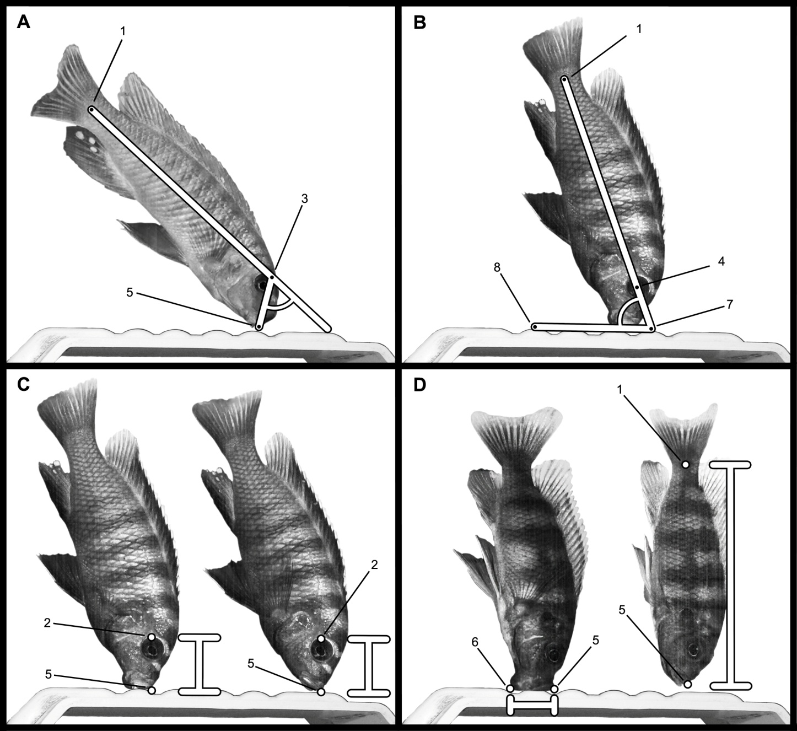
Figure 1. Illustrates the different kinematic variables. (A) Illustrates how protrusion angle was measured, (B) shows the measurement of body angle, (C) shows how protrusion distance was measured, and (D) demonstrates the measurement of gape width and standard length.

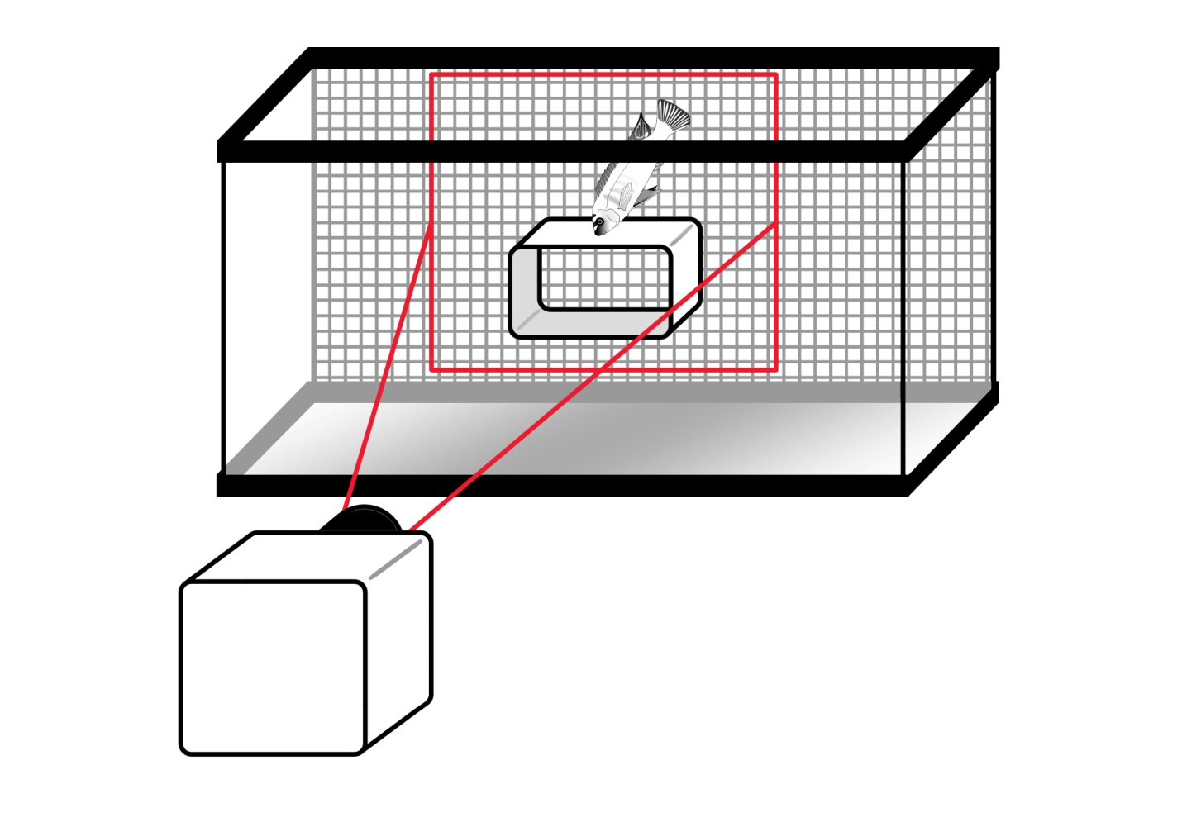
Figure 2. Shows the experimental filming setup. Fish were filmed scraping algae from the PVC rectangle until five feeding events were recorded for each of the three surface orientations.

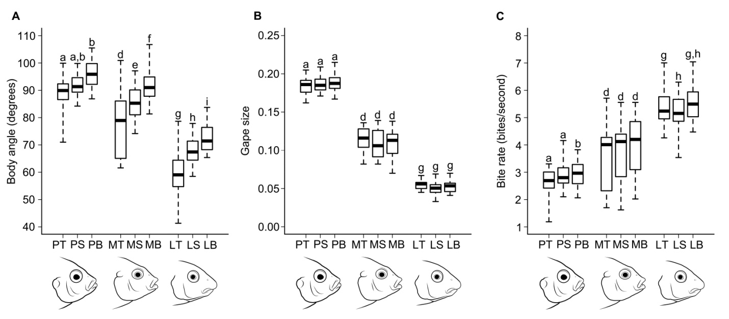
Figure 3. Shows the box plots for body angle (A), gape size (B) and bite rate (C). The labels on the x-axis designate the species (P, M or L) and the orientation of the feeding surface (T, S or B). The post hoc analyses supporting intraspecific differences are designated by the letters above the error bars.

Tables

Table 1. Kinematic variables that do not exhibit intraspecific differences.
Kinematic Variable | P. chitimba | M. patricki | L. trewavasae | P-value
Protrusion Distance (% SL) | -0.006 ± 0.004ª | 0.013 ± 0.003^{b} | 0.017 ± 0.002^{c} | < 0.001 (< 0.001)*
Gape Width (% SL) | 0.187 ± 0.005^{d} | 0.111 ± 0.007e | 0.052 ± 0.003^{f} | < 0.001 (< 0.001)*
Due to the number of comparisons being made, we have included the Holm's test corrected p-values in parentheses in addition to the raw p-values. Significant values are denoted with an asterisk, and superscripts denote the results of the post-hoc test.

Table 2. Kinematic variables that do exhibit intraspecific differences.
Body angle (degrees) | Top | Side | Bottom | P-value
P. chitimba | 78.81 ± 2.42 ^{a /x} | 81.72 ± 1.56 ^{a,b/x} | 85.85 ± 1.85 ^{b/x} | 0.009 (0.118)
M. patricki | 67.79 ± 4.71 ^{d,y} | 75.23 ± 2.62 ^{e/y} | 82.30 ± 2.38 ^{f/x} | 0.001 (0.013)*
L. trewavasae | 48.90 ± 3.44 ^{g/z} | 57.60 ± 2.13 ^{h/z} | 62.76 ± 2.46 ^{i/y} | 0.001 (0.012)*
P-value | < 0.001 | < 0.001 | < 0.001
Protrusion angle (degrees) | Top | Side | Bottom | P-value
P. chitimba | 26.83 ± 3.29 ^{a/x} | 22.30 ± 3.15 ^{a/x} | 22.38 ± 2.48 ^{a/x} | 0.093 (0.588)
M. patricki | 40.54 ± 3.38 ^{d/y} | 36.16 ± 3.18 ^{e/y} | 35.20 ± 2.10 ^{e/y} | 0.019 (0.202)
L. trewavasae | 55.36 ± 2.57 ^{g/z} | 51.56 ± 2.48 ^{g/z} | 51.43 ± 2.96 ^{g/z} | 0.286 (1.000)
P-value | < 0.001 | < 0.001 | < 0.001
Fin beat rate (beats/s) | Top | Side | Bottom | P-value
P. chitimba | 3.89 ± 0.21 ^{a/x} | 4.05 ± 0.32 ^{a/x} | 3.89 ± 0.25 ^{a/x} | 0.542 (1.000)
M. patricki | 4.35 ± 0.46 ^{d/x} | 4.04 ± 0.46 ^{d,e/x} | 3.89 ± 0.49 ^{e/x} | 0.055 (0.423)
L. trewavasae | 5.86 ± 0.35 ^{g/y} | 5.30 ± 0.24 ^{h/y} | 5.52 ± 0.34 ^{h/y} | 0.011 (0.133)
P-value | 0.001 | 0.005 | 0.003
Bite rate (bites/s) | Top | Side | Bottom | P-value
P. chitimba | 2.94 ± 0.18 ^{a/x} | 2.92 ± 0.19 ^{a/x} | 2.67 ± 0.17 ^{b/x} | 0.021 (0.202)
M. patricki | 3.91 ± 0.43 ^{d/y} | 3.72 ± 0.45 ^{d/y} | 3.63 ± 0.45 ^{d/y} | 0.161 (0.805)
L. trewavasae | 5.54 ± 0.25 ^{g/z} | 5.16 ± 0.24 ^{h/z} | 5.34 ± 0.24 ^{g,h/z} | 0.018 (0.202)
P-value | < 0.001 | < 0.001 | < 0.001
Bites Per Beat (bites/beat) | Top | Side | Bottom | P-value
P. chitimba | 0.76 ± 0.05 ^{a/x} | 0.74 ± 0.07 ^{a,b/x} | 0.69 ± 0.05 ^{b/x} | 0.053 (0.423)
M. patricki | 0.90 ± 0.04 ^{d/y} | 0.92 ± 0.04 ^{d/y} | 0.94 ± 0.04 ^{d/y} | 0.257 (1.000)
L. trewavasae | 0.95 ± 0.03 ^{g/y} | 0.97 ± 0.03 ^{g/y} | 0.98 ± 0.04 ^{g/y} | 0.463 (1.000)
P-value | 0.001 | < 0.001 | < 0.001
Due to the number of comparisons being made, we have included the Holm's test corrected p-values in parentheses in addition to the raw p-values for tests of intraspecific significance. Significant intraspecific p-values are marked with an asterisk. All interspecific p-values remained significant. Intraspecific comparisons are shown horizontally. Superscripts denote the results of the post-hoc test for kinematic differences on each of the different feeding surface orientations for each individual species: P. chitimba (a, b, c), M. patricki (d, e, f ), and L. trewavasae (g, h, i). Interspecific comparisons are shown vertically. Superscripts (x, y and z) denote the results of the post-hoc test for kinematic differences on each of the different feeding surface orientations.

Table 3. Matrix of pairwise correlations between the seven kinematic variables.
 | BA | PA | PD | GS | FBR | BR | BPB
BA | **** | -0.31 | -0.06 | -0.19 | -0.45 | -0.09 | 0.24
BA | **** | -0.82 | -0.02 | 0.68 | -0.24 | -0.29 | -0.21
BA | **** | -0.57 | 0.35 | -0.31 | 0.22 | 0.14 | -0.12
PA | 0.218 | **** | -0.11 | -0.23 | 0.26 | -0.16 | -0.27
PA | < 0.001 | **** | -0.03 | -0.65 | 0.30 | 0.37 | 0.33
PA | 0.019 | **** | -0.07 | -0.14 | 0.16 | 0.42 | 0.20
PD | 0.818 | 0.652 | **** | -0.36 | 0.26 | -0.17 | -0.32
PD | 0.935 | 0.914 | **** | 0.02 | 0.13 | 0.08 | -0.14
PD | 0.162 | 0.701 | **** | -0.67 | 0.37 | 0.45 | 0.00
GS | 0.459 | 0.368 | 0.140 | **** | 0.01 | 0.04 | 0.06
GS | 0.002 | 0.003 | 0.933 | **** | -0.46 | -0.55 | -0.51
GS | 0.261 | 0.630 | 0.007 | **** | -0.40 | -0.43 | 0.16
FBR | 0.061 | 0.302 | 0.297 | 0.975 | **** | -0.10 | -0.73
FBR | 0.336 | 0.222 | 0.602 | 0.058 | **** | 0.97 | 0.11
FBR | 0.694 | 0.316 | 0.408 | 0.139 | **** | 0.79 | -0.67
BR | 0.720 | 0.536 | 0.495 | 0.872 | 0.704 | **** | 0.74
BR | 0.236 | 0.133 | 0.742 | 0.018 | < 0.001 | **** | 0.34
BR | 0.902 | 0.064 | 0.302 | 0.114 | < 0.001 | **** | -0.09
BPB | 0.328 | 0.286 | 0.202 | 0.824 | 0.001 | < 0.001 | ****
BPB | 0.397 | 0.184 | 0.574 | 0.574 | 0.668 | 0.163 | ****
BPB | 0.733 | 0.602 | 0.926 | 0.569 | 0.004 | 0.406 | ****
The abbreviations in row and column headings are as follows: BA = body angle, PA = protrusion angle, PD = protrusion distance, GS = gape size, FBR = fin beat rate, BR = bite rate, BPB = bites per beat. All three species values are present in each cell with P. chitimba being the top value, M. patricki being the middle value, and L. trewavasae being the bottom value. Corresponding p-values can be found below the diagonal and are ordered in the same format as the correlation coefficients. Significant p-values are in bold.
VITA
Maxwell F. Rupp was born April 23rd, 1988. He attended Soddy Daisy high school from 2002 – 2006 and was accepted to the University of Tennessee in 2006. He graduated with his bachelor’s degree in December 2010, and obtained his master’s degree in Ecology and Evolutionary Biology in May 2014.

