Modeling and Experimental Investigation on the Influence of Radiation Defects on Helium Behavior in BCC Iron

A Thesis Presented for the
Master of Science
Degree
The University of Tennessee, Knoxville

Zuya Huang
May 2016
Acknowledgements

To my family
Abstract

Fe-based alloys are important structural materials for both fission and fusion energy. For fusion applications, the challenges of radiation-induced changes in microstructure, properties and performance is further challenged by the concomitant production of helium from (n, alpha) reactions with high-energy neutrons. While the challenging synergies of helium effects on radiation-induced microstructural changes have long been acknowledged and studied, research into this problem is very challenging due to a lack of volumetric, high flux 14-MeV neutron sources. Thus, studying these phenomena require the use of computational materials modeling and novel experimental methods. In this thesis, I report on the use of molecular dynamics (MD) simulations to investigate the synergistic interactions of helium with prismatic dislocation loops characteristic of those observed in neutron irradiated iron to determine how the presence of these loops modify the helium clustering and gas bubble nucleation process. In particular, we have investigated the role of a/2<111> or a<100> prismatic interstitial type dislocation loops on the helium clustering dynamics upon inserting interstitial helium into the body-centered cubic iron lattice at temperatures from 773 °K to 1173 °K. The simulations indicate a strong elastic interaction, which significantly influences the early stages of helium clustering that can aid bubble nucleation.
I also describe the use of experimental techniques to probe helium interactions with defect clusters, which has specifically focused on performing low energy helium ion implantation on neutron irradiated iron specimens followed by thermal desorption spectroscopy (TDS). The results of this experimental investigation show a limited number of dislocation lines and various-sized cavities are produced after neutron irradiation of both single crystal and poly-crystalline iron samples. The thermal helium desorption spectrometry (THDS) results indicated that the major helium desorption peaks shift to the higher temperature due to the existence of the radiation induced defects, working as strong trapping sites for helium.
Overall, the research performed in this thesis has confirmed that synergistic interactions occur between helium and point defect clusters, as well as the potential to combine computational modeling with experimental measurements using thermal desorption spectroscopy. Numerous possible future investigations are highlighted, including the possibility of investigating the helium desorption behavior from neutron irradiated iron samples at lower irradiation temperature with a higher density of prismatic dislocation loops.
Table of Contents

Chapter 1 Introduction and motivation 1
1.1 Materials challenges in nuclear environment 1
1.1.1 Background 1
1.2 Radiation damage processes 3
1.2.1 Radiation damage event 3
1.2.2 Irradiation effects on structure materials 4
1.3 Helium induced materials degradation 4
1.4 Motivation 7
Chapter 2 Research Approach 8
2.1 Molecular Dynamics (MD) Simulation 8
2.1.1 Introduction 8
2.1.2 MD simulation set-ups 10
2.2 Interatomic Potentials 11
2.2.1 Introduction 11
2.2.2 Potentials used in this work 12
2.3 Experimental Investigation on Helium behavior in Neutron-Irradiated Iron 13
2.3.1 Thermal Desorption Spectrometry (TDS) 14
2.3.2 Transmission Electron Microscopy (TEM) 16
Chapter 3 Simulation Results and Discussion 17
3.1 Helium clustering process at 500°C 17
3.2 Helium clustering process at 900$℃$ 21
3.3 He clusters distribution at a concentration of 2500 appm He 25
3.4 Temperature dependence of He clustering 26
3.5 Dislocation loop size comparison 27
Chapter 4 Experimental Results and Discussion 28
4.1 TEM results 28
4.1.1 Microstructures of neutron-irradited single crystalline $α$-Fe 28
4.1.2 Microstructures of neutron-irradiated polycrystalline $α$-Fe 30
4.2 Thermal Helium Desorption Spectrometry (THDS) 30
4.2.1 Thermal desorption spectrometry of as-received Fe samples 30
Chapter 5 Conclusion and Future Work 35
5.1 Conclusion 35
5.2 Future work 36
Appendix 40
Vita 45

List of Tables

Table 1 Irradiation Conditions and Measured Swelling for Type 316 Stainless Steel Irradiated in the HFIR ^{[14]} 6
Table 2 Overview of the neutron irradiation of iron samples 28
List of Figures

Figure 1.1 Schematic of the primary and secondary circuits of a pressurized water reactor and materials of construction ^{[8]} 2
Figure 1.2 The ARIES-AT fusion power core 3
Figure 1.3 Influence of the helium concentration (pre-implanted at 1023K) on the creep rupture properties of AISI 316 SS ^{[14]} 6
Figure 2.1 Flow chart describing the logic for a molecular dynamics simulation ^{[15]} 9
Figure 2.2 Initial condition of the simulation box 11
Figure 2.3 Schematic plot of interatomic potential as a function of the distance between atoms, r ^{[10]} 12
Figure 2.4 Schematic plot of interatomic potential as a function of the distance between atoms, distance between atoms, r ^{[10]} 12
Figure 2.5 TDS facility at ORNL 15
Figure 2.6 The principle of a TDS procedure when probing He-point defect interaction ^{[5]} 16
Figure 3.1 Helium clustering process at 500°C, loop<100> 18
Figure 3.2 Helium clustering process at 500°C, loop<111> 19
Figure 3.3 Helium clustering process at 500°C, without loop 20
Figure 3.4 Comparison of He cluster & monomer concentration at 500℃ 21
Figure 3.5 Helium clustering process at 900°C, loop<100> loop 22
Figure 3.6 Helium clustering process at 900°C, loop<111> loop 23
Figure 3.7 Helium clustering process at 900°C, without loop 24
Figure 3.8 Comparison of He cluster & monomer concentration at 900℃ 25
Figure 3.9 Helium clusters distribution at a concentration of 2500 appm He 25
Figure 3.10 Temperature dependence of helium clustering process 26
Figure 3.11 Dislocation loop size comparison 27
Figure 4.1 Cavity images in single crystal ⍺-Fe irradiated to 5 dpa, 300°C – HFIR 29
Figure 4.2 Cavity images in polycrystalline ⍺-Fe irradiated to 16.6 dpa, 386°C (0.2 appm He/dpa) – BOR60 30
Figure 4.3 Thermal desorption spectrometry of non-irradiated Fe sample 32
Figure 4.4 Thermal desorption spectrometry of neutron-irradiated Fe samples 33

Chapter 1
Introduction and motivation

Materials challenges in nuclear environment

1.1.1 Background
The environmental consequence of power generation is becoming more broadly recognized, which is increasing the emphasis on nuclear power as a promising clean and safe energy source. Global population growth in combination with industrial development will lead to a doubled electricity consumption by 2030. Climate change has also been raised as an urgent problem for the whole society. Fossil fuel will be replaced by low-emission source such as nuclear energy, which has demonstrated capability as the most cost-efficient of the available base-load technologies ^{[1-5]}.
Nuclear energy can be divided into two types. One is fission, which is considered as an increasingly reliable supplier of base-load electricity, as it is widely used throughout the world. While the other is fusion, which is a potentially attractive, but technologically challenging endeavor and has been ranked by the US National Academy of Engineering as one of the top engineering grand challenges of the 21st century^{[6]} [ref,]. The operating environment for materials in current and proposed future nuclear energy systems is extremely harsh. The challenging fusion reactor environment (radiation, heat flux, chemical compatibility, thermomechanical stresses) will require utilization of advanced structural materials in order to fulfill the promise of fusion energy to provide safe, economical, and environmentally acceptable energy ^{[7]}.
In the current and next generation of water-cooled fission reactors, corrosion and stress corrosion crack of structural materials and neutron-induced embrittlement of reactor pressure vessels are the three main degradation issues. Figure 1.1 shows a schematic of the major components in the primary and secondary circuits of a PWR ^{[8]}. The main types of light water reactors involve the boiling water reactor (BWR), and pressurized water reactor (PWR), along the heavy water reactor that was developed in Canada by CANDU (CANadian Deuterium Uranium); these types of water cooled reactors all operate at relatively high temperature (~300°C), with high stress (PWR: 15MPa, BWR: 7MPa), companied by chemically aggressive coolant (water containing boric acid and LiOH), and experience high neutron flux radiation (10¹³ n/cm²/s (> 0.1 MeV)).
For generation IV fission and fusion energy systems that have been proposed and are under various stages of research and development, there are five key radiation degradation effects, including low temperature radiation hardening and embrittlement, radiation-induced and -modified solute segregation and phase stability, irradiation creep, void swelling and high-temperature helium embrittlement. Figure 1.2 shows a schematic illustration of the advanced fusion reactor ARIES-AT under development. The coolant from blanket outlet temperature can be as high as 1000°C. Neutron flux even will reach 10¹⁴n/cm³/s, with an energy spectrum peaked at 14MeV.
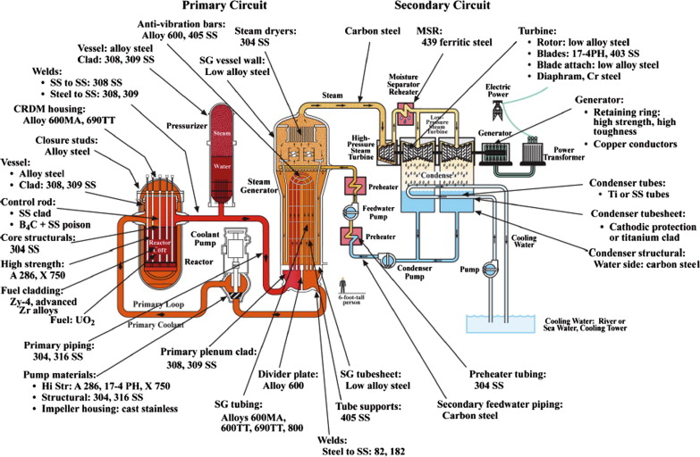
Figure 1.1 Schematic of the primary and secondary circuits of a pressurized water reactor and materials of construction ^{[8]}

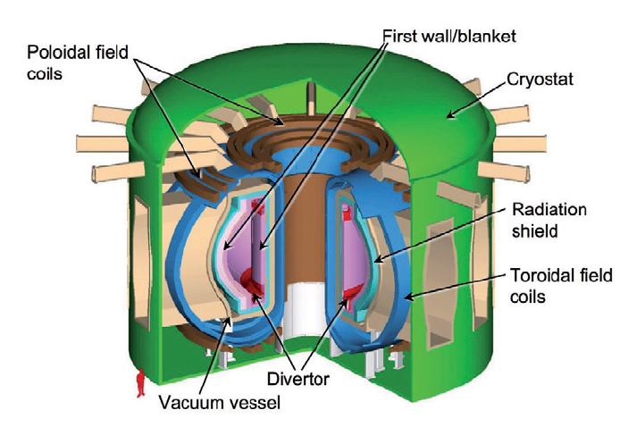
Figure 1.2 The ARIES-AT fusion power core

Radiation damage processes

1.2.1 Radiation damage event
Schematic of the primary and secondary circuits of a pressurized water reactor and materials of construction^{[8]} The radiation damage event is defined as the transfer of energy from an incident projectile to an atom within the solid, and the resulting collisional re-distribution of target atoms after completion of the event. This process contains several successive generations of atomic collisions during its evolution. After the interaction of an energetic incident particle with a lattice atom, energy is transferred to the lattice atom that is often significantly larger than the binding energy of the atom in the solid, which gives birth to a primary knock-on atom (PKA). The displaced PKA travels in its passage through the lattice, undergoing electronic and nuclear interactions and collisions, which is accompanied by additional knock-on atoms, which is typically referred to as a displacement cascade. The event concludes as the PKA comes to rest, along with the production of highly non-equilibrium concentrations of point defects (vacancies and interstitials) and clusters of these defects in the crystal lattice ^{[10]}.

1.2.2 Irradiation effects on structure materials
Exposure to neutrons degrades the mechanical performance of structural materials and impacts the economics and safety of current and future fission power plants as a result of the following phenomena, which are dependent on the irradiation temperature. Low temperature radiation hardening and embrittlement/decreased uniform elongation, are observed to occur in a temperature range up to ~ 0.4 T_{m}, where T_{m} is the melting temperature in Kelvin. Irradiation and thermal creep are usually observed for temperatures below and above 0.45 T_{m}, respectively. In the intermediate temperature range from 0.3 to 0.6 T_{m}, phase instabilities driven by radiation-induced segregation and radiation-enhanced diffusion and precipitation along with dimensional instabilities driven by volumetric swelling are the key concerns. As well, high temperature He embrittlement of grain boundaries can cause intergranular fracture at low stresses, particularly for doses > 10 dpa (He concentrations > 100 appm) and temperatures above 0.5 T_{m} ^{[5]}.

Helium induced materials degradation
Helium will be generated in the structural materials due to nuclear (n,α)-reactions during neutron irradiation or due to direct helium implantation, concurrently with high density of displacement defects.
As a noble gas atom, He has several unique characteristics, the most notable of which is an extremely low solubility in most metallic materials. It has a high potential to combine with defects such as interstitials, vacancies and their clusters, as well as extended defects such as dislocations, grain boundaries, and cavities or precipitate interfaces ^{[11]}. He bubbles formed in the grains or along the grain boundaries can result in swelling, significant radiation hardening or degradation in creep rupture behavior, and can further result in premature failure of the materials under relatively low stress ^{[12-13]}.
Figure 1.3 shows a representative example of helium impact on mechanical properties specifically focused on creep rupture, and shows that as the helium concentration increase in the material the creep rupture time decreases significantly ^{[14]}. Data on the impact of helium tend to indicate a threshold at a few hundred appm where the helium effects become very much pronounced. Nucleation of helium bubbles around microstructure defects can trigger dimensional swelling resulting in mechanical property degradation of stainless steel, as shown in Table 1.1^{[15]}. Not only how much helium is generated in the material is important, but also how the initial microstructure involving defect clusters, precipitates and extended defect evolution due to radiation damage influences how the helium behaves and its impact on swelling, remain unanswered questions. This is evident with the 20% cold worked sample, in which the increase in initial dislocation line density in the material resulted in much less swelling than the solution treated alloy. Again, this provides a hint that the interaction between defects microstructure including lines dislocation with helium can influence the helium bubble nucleation and impact the transition from helium bubble to voids that cause a void-swelling based dimensional change.

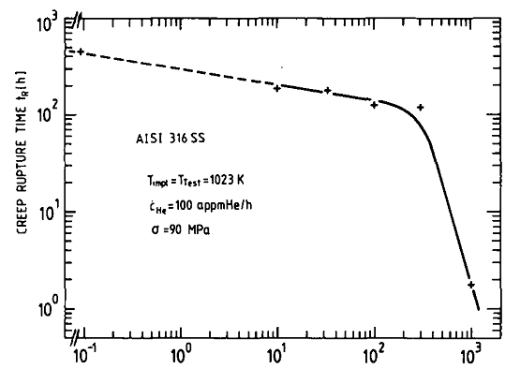
AISI 316 SS
T_{impl}=T_{test}=1023K
C_{He}=100appmHe/h
σ=90MPa
Creep Rupture Time t_{R} (h)
Helium Concentration C_{He} (appmHe)
Figure 1.3 Influence of the helium concentration (pre-implanted at 1023K) on the creep rupture properties of AISI 316 SS ^{[14]}

Table 1 Irradiation Conditions and Measured Swelling for Type 316 Stainless Steel Irradiated in the HFIR ^{[14]}
Specimen position | Irradiation Temperature ($℃$) | Displacement  (dpa) | Helium Content  (appm) | Measured Swelling, %
 |  |  |  | Solution Treated | 20% Cold worked
4 | 379 | 97 | 4020 | 6.7 | 1.6
5 | 456 | 107 | 4820 | 8.7 | 0.8
6 | 528 | 114 | 5450 | 8.3 | 2.6

Motivation
In order to eventually develop predictive capabilities of materials performance in the harsh nuclear fusion environment, it is extremely important to reveal the fundamental mechanisms of helium-defect interactions, which are needed to providing insight to the helium bubble nucleation and growth and the resulting materials degradation.
In this study, a coordinated experimental and modeling investigation on the influence of radiation damage on He behavior has been performed, focusing on the enhanced helium clustering in Fe and neutron irradiation impacts on the thermal helium desorption spectra.

Chapter 2
Research Approach

2.1 Molecular Dynamics (MD) Simulation

2.1.1 Introduction
Excellent instrumentation exists to observe defect clusters in materials using mature materials science characterization techniques such as transmission electron microscopy (TEM), X-ray scattering, small angle neutron scattering and positron annihilation spectroscopy. But these instruments are unable to either image many of the smallest, individual defects or capture the process of cascade. Correspondingly, computer simulations, such as MD simulation, is a good way to gain a better understanding of the spatial and temporal development of the cascade as well as to observe the defect evolution dynamics of atomic-level phenomena ^{[10]}. By using the analytical interatomic potentials, which describes the force between atoms depending on the distance, and appropriate initial and boundary conditions, the process of performing an atomistic MD simulation will be fully described.
The simplified schematic of the molecular dynamics (MD) algorithm is described in Figure 2.1 ^{[15]}. First, a suitable time step is chosen (usually very small $5-10×{10}^{-15}$s) and atoms are provided with an initial position $r_{0}$and velocity$v_{0}$. Based on the selection of an appropriate potential, the forces on all atoms can be obtained by by using $F=-∇ V(r_{0})$ or $F=F(ψ(r_{0}))$, and then Newton’s equations of motion can be integrated such that the acceleration, $a=F/m$. Applied boundary conditions such as temperature and pressure control as needed to calculate and output physical quantities of interest, as the equations of motion are integrated for each atom using a predictor-corrector. Following each integration step, the time step is moved forward $t=t+∆t$ and, all positions and velocities are updated for the next iteration. This procedure continues until a termination condition is reached.

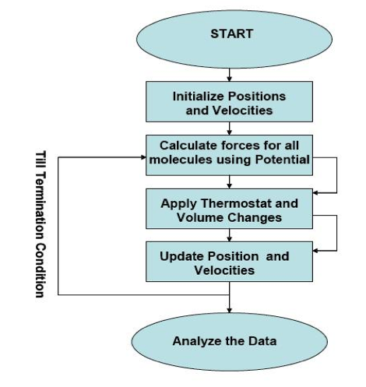
Figure 2.1 Flow chart describing the logic for a molecular dynamics simulation ^{[15]}

2.1.2 MD simulation set-ups
He-point defect interaction in Fe has been widely studied by using both MD simulation and ab initio modeling. In order to reveal the fundamental mechanisms of helium behavior in Fe-based alloys, MD simulations are used to investigate the synergistic interactions of helium and prismatic dislocation loops in modifying the helium clustering and gas bubble nucleation process in BCC iron.
The simulations that I have performed involves three conditions, two of which included prismatic dislocation loops with one additional simulation condition without a pre-existing defect to provide a control simulation for comparison. In particular, we have initially input a self-interstitial cluster of about 318 atoms with a prismatic dislocation loop morphology and a Burgers vector of either a<100> or a/2<111>. All of the MD simulations were performed at two different working temperatures of 500°C or 900°C. The simulation box, which is shown in Figure 2.2, has a size of $80a_{0}×80a_{0}×80a_{0}$, where $a_{0}$ refers to lattice parameter ($a_{0}=2.8654Å$). Periodic boundary conditions are applied in all three directions. In order to make it easier to create the dislocation loop in the <111> direction (along the x-axis), the crystal simulation cell was re-oriented. The LAMMPS code used to create the initial prismatic interstitial loop is presented in the Appendix.
One helium atom is randomly introduced into the modeling box every 5ps, equivalent to an insertion rate of 2×10¹¹ appm He/s, up to an ultimate concentration of 2500 appm He. It is important to point out that this insertion rate is many orders of magnitude larger than expected in a real fusion environment, in which the anticipated He production rate in iron is ~10⁻⁵ appm/s. However, this is to accelerate the helium clustering phenomena to a timescale amenable to observation during these MD simulations. We have also selected the higher temperature simulation to further accelerate the helium diffusion, and to influence the helium clustering kinetics as a first step towards compensation for the higher implantation rate.

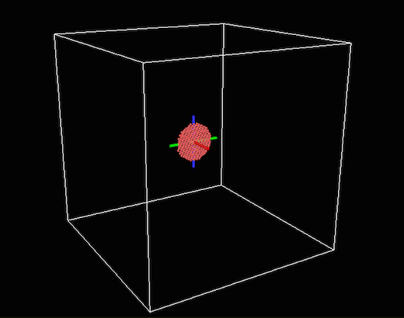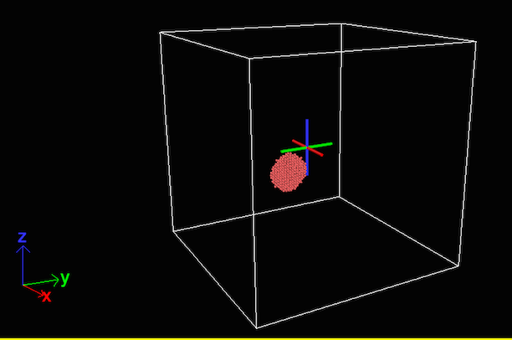
<100>
<111>
22.9 nm
Figure 2.2 Initial condition of the simulation box

2.2 Interatomic Potentials

2.2.1 Introduction
Interatomic potentials are used to describe the forces between two atoms, atom to ion or ion to ion, which is governed by interactions between electron clouds, the electron cloud and nucleus, and between nuclei. The function is complicated and strongly depends on the atom energies and the distance of closet approach of their nuclei. Figure 2.3 shows a general overview of the variation of interatomic potential with separation r ^{[10]}. At a long distance, two atoms are interacting with each other by the simply described by Coulomb forces and the central repulsion dominates at a small distance. At the distance $r_{e}$ where the two forces go to equilibrium reaching the lowest potential. To be specific, Figure 2.4 shows the behavior of various potential functions over a range of separation distances between copper atoms. When the distance between two atoms is $a_{0}<r<r_{e}$, the electronic interactions dominates and the most accurate potential to describe this is Born-Mayer potential. Here $a_{0}$ is the Bohr radius of the hydrogen ($a_{0}=0.053nm$), $r_{e}$ is the closest spacing in the crystal neighbors (~ 0.25nm). While the atoms are approaching, the electron cloud around the nuclei becomes overlap to the other, then the potential to describe this is known as screened Coulomb potential. While $r≪a_{0}$, Coulomb interactions dominate.
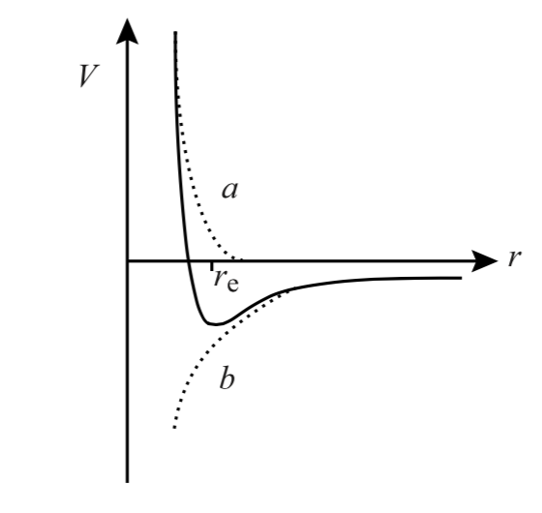
Figure 2.3 Schematic plot of interatomic potential as a function of the distance between atoms, r ^{[10]}
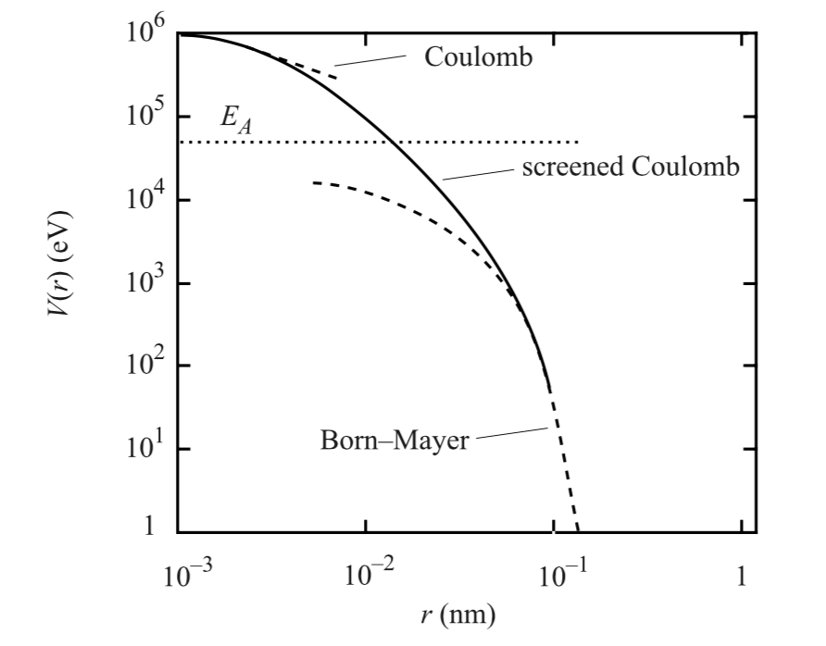
Figure 2.4 Schematic plot of interatomic potential as a function of the distance between atoms, distance between atoms, r ^{[10]}

2.2.2 Potentials used in this work
The He-He is the lightest van der Waals system and it is almost dominated by dispersion energy. Jazen’s potential, which is based on modified Tang-Toennies model, provides a more reliable standard for helium viscosity ^{[17]}. The mathematical representation of the potential is as follow:
$V\left(R\right)=A\exp\left(-αR+βR^{2}\right)-\frac{\left[1-\left(\sum_{k=0}^{6}{\frac{{\left(δR\right)}^{k}}{k!}}\right)×\exp\left(-δR\right)\right]C_{6}f\left(R\right)}{R^{6}}-\sum_{n=4}^{8}{\left[1-\left(\sum_{k=0}^{2n}{\frac{{\left(δR\right)}^{k}}{k!}}\right)\exp\left(-δR\right)\right]}C_{2n}/R^{2n}$
(1)
where R is the atomic separation in units of Bohr.
The Fe-Fe potential was developed by Ackland ^{[18]}, incorporating both ab inito and experimental data. The potential is written is the form of an embedded atom method formalism, such that:
(2)
$$U=\sum_{i}{F_{i}\left[\sum_{j}{ϕ(r_{ij})}\right]+\sum_{ij}{V(r_{ij})}}$$
The He-Fe potential was developed and modified by using the density-function theory (DFT) with the DMol97 program package ^{[19]}. It has been specifically fit to incorporate the range of interaction energies of relevance for high-energy displacement atomic collisions. The specific description of this potential is:
$f\left(r_{ij}\right)=\left\{\begin{matrix}DMOL-potential , r_{ij}≤r_{1} \\ p_{3}r_{ij}^{3}+p_{2}r_{ij}^{2}+p_{1}r_{ij}+p_{0}, r_{1}≤r_{ij}≤r_{2} \\ \left(a+\frac{b}{r_{ij}}\right)e^{cr_{ij}}f_{c}\left(r_{ij}\right), { r}_{ij}≥r_{2}\end{matrix}\right.$
(3)
where the cut of function $f_{c}$is included for computational efficiency. It is given by:
${f_{c}(r}_{ij})=\left\{\begin{aligned}1, r_{ij}≤r_{c}-r_{d} \\ \frac{1}{2}\left(1-sin\frac{π(r_{ij}-r_{c})}{2r_{d}}\right) \\ 0, r_{ij}≥r_{c}+r_{d}\end{aligned}\right., \left|r_{c}-r_{ij}\right|≤r_{d}$
(4)

2.3 Experimental Investigation on Helium behavior in Neutron-Irradiated Iron
High neutron flux is the main issue in the radiation damage of structural materials. During the fusion environment, ${}_{1}^{2}{H+{}_{1}^{3}{H={}_{2}^{4}{He}}}+n$ is the most basic reaction. High energy neutron (14MeV) is produced companied by helium, concurrently with high density of displacement defects. Helium has a high tendency to combine with those defects and form helium bubbles, which might induce dimensional swelling or high temperature grain boundary embrittlement. Given the fact that there is no fusion-relevant neutron source in the world, it is important to utilize the currently available fission reactors to investigate the influence of neutron-irradiation induced defects on the helium behavior in Fe.

2.3.1 Thermal Desorption Spectrometry (TDS)
Thermal Desorption Spectrometry is a method of observing desorbed gas atoms or molecules from a surface when the surface temperature is increased. In this study, TDS was used to capture the impact of neutron irradiated induced damage on the helium desorption behavior. The picture of TDS facility at ORNL is shown in Figure 2.5. The TDS has two working modes, either static or dynamic. If the pumping speed is negligible, the system operates in the static mode, and if the pumping speed is relatively high, it is called the dynamic mode of operation. In dynamic mode, the helium desorption rate is approximately proportional to the detected helium number in the system by the mass spectrometer ^{[5]}.
The working principle is pretty straightforward. After the sample is implanted by 10 keV helium to a fluence of $7×{10}^{14} He/{cm}^{2}$ at room temperature in the implantation chamber by using a 20 keV ion gun in the raster scanning mode with a raster area of 3.5 mm × 3.5 mm. Then the implanted sample placed in a tungsten crucible is transferred to the heating chamber by using a magnetically coupled transporter. After reaching a vacuum level of < 2×10⁻⁹ torr, the temperature of the sample is increased to 1150°C with a ramping rate of 0.5°C/s. In the temperature ramping process, helium will be thermally dissociated from the original He-defect complex and then desorbed out of the sample surface, depending on the binding energies. Then the released helium will be captured and measured by a quadrupol mass spectrometer in the measurement chamber. Figure 2.6 shows the principle of a TDS procedure when probing He-point defect interaction.
Figure 2.5 TDS facility at ORNL

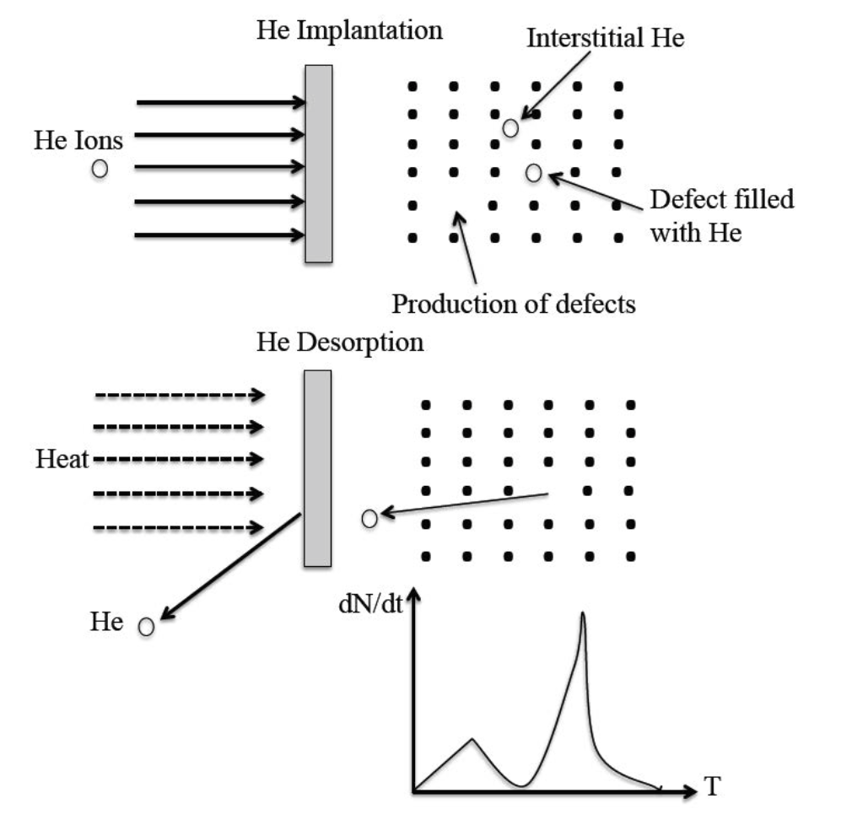
Figure 2.6 The principle of a TDS procedure when probing He-point defect interaction ^{[5]}

2.3.2 Transmission Electron Microscopy (TEM)
As the limitation of the resolution in light microscopy, which is imposed by the wavelength of visible light. Transmission Electron Microscopy (TEM) is a widely used potential resolution using electron beams accelerated at high voltage with effective wavelengths that are shorter by a factor of 10⁵ than visible light. It is a microscopy technique in which a beam of electrons is transmitted through an ultra-thin specimen, interacting with the specimen as it passes through it. TEM has many limitations in practical, such as samples must be thin, dry, and capable of scattering electrons in a vacuum ^{[20]}. TEM was used to characterize the microstructure of neutron-irradiated single crystalline and polycrystalline iron.
Microstructure characterization of the irradiated samples were conducted in low activation materials development and analysis lab (LAMDA) at ORNL by using transmission electron microscopy (TEM, JEOL JEM 2100F), of which the samples were prepared by using focus ion beam (FIB, FEI Quanta 3D DualBeam).

Chapter 3

Simulation Results and Discussion
In this Chapter, I describe the results from MD simulations of the three specific simulation conditions of helium implantation into the iron simulation cell that have been studied: these include an initial a<100> loop, or an a/2<111> loop or without a prismatic loop present, and all of the MD simulations were performed at either 500°C or 900°C. The first specific question we are investigating with these MD simulations is how the helium clustering or helium bubble nucleation processes are modified based on the presence of the prismatic dislocation loop, as well as the temperature dependence. Subsequently, I describe how the existence of helium will affect the behavior of defects is investigated.

3.1 Helium clustering process at 500°C
Figures 3.1, 3.2 and 3.3 show the helium clustering process observed during the MD simulations of the three different loop conditions, namely with <100>, with <111> and without a pre-existing loop, respectively. As the helium insertion continues, helium clusters begin to accumulate, and as these clusters grow in size, the interstitial helium clusters eventually build sufficient pressure to induce the formation of a Frenkel pair on the body centered cubic iron lattice in a process referred to as trap mutation. Once trap mutation occurs, the helium cluster moves onto the vacancy and the iron self-interstitial atoms stay in the vicinity of the helium clusters, until eventually diffusing to an extended defect cluster where they can be annihilated through absorption. In these Figures, the red ball represents iron atom and blue ball represent helium atom, respectively. A helium cluster is defined in this thesis as more than two atoms sticking together. From Figure 3.1 and Figure 3.2, when 500 appm He is inserted, it’s clear to see helium first start to accumulate around the periphery of the loop, and the loop also grows in size by absorbing the interstitials around it. Meanwhile, a large amount of helium and iron clusters can also observed in the area far away from the loop center.
Comparing between the simulations with and without the pre-existing loop, it is clear that for these simulation conditions the existence of the loop does not have a significant influence on the helium clustering process. Figure 3.4 shows a statistical analysis, which compares the concentration of cluster and monomer density, and which shows that the clustering process is slightly slower without the loop. But until the final stage of the simulation (2500 appm He), the presence of an a/2<111> loop in the box promotes the most helium cluster density.
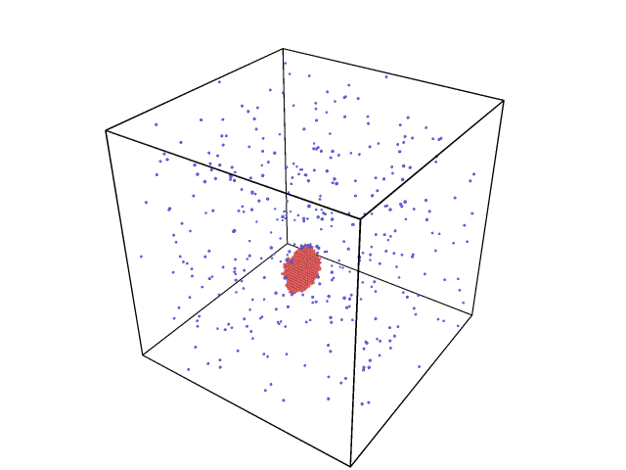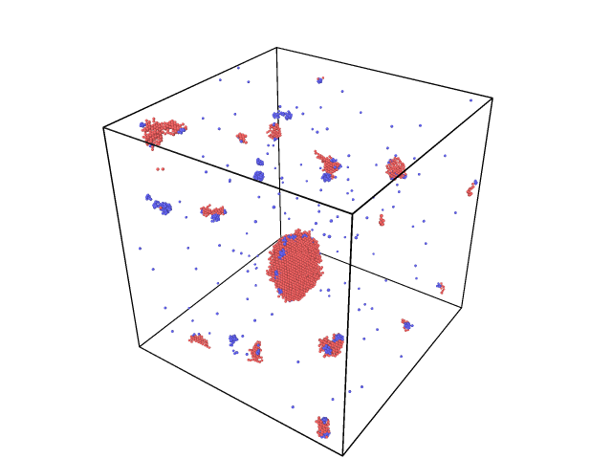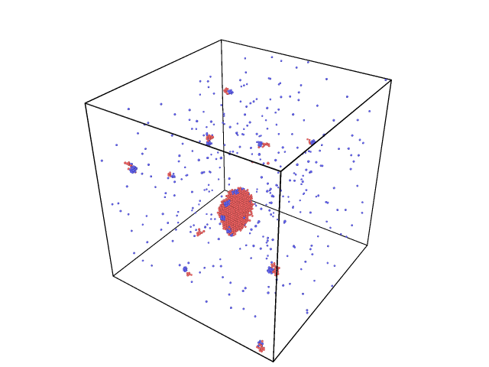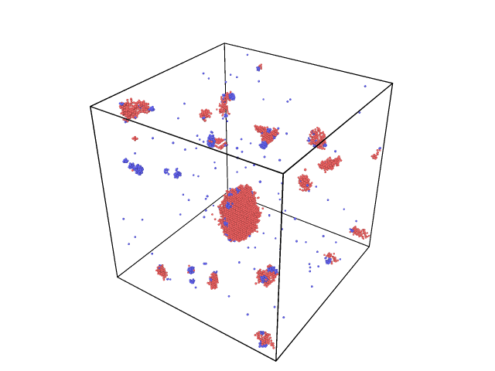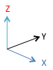
500 appm He
2000 appm He
1000 appm He
2500 appm He
Figure 3.1 Helium clustering process at 500°C, loop<100>

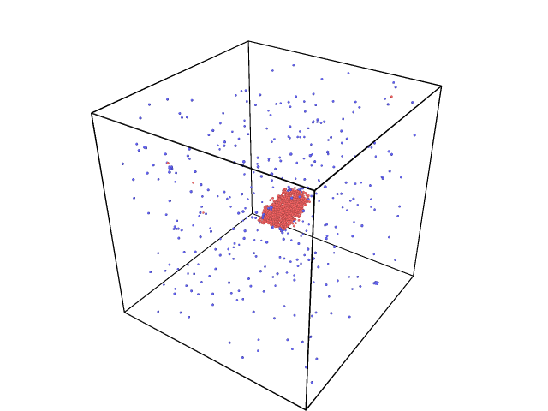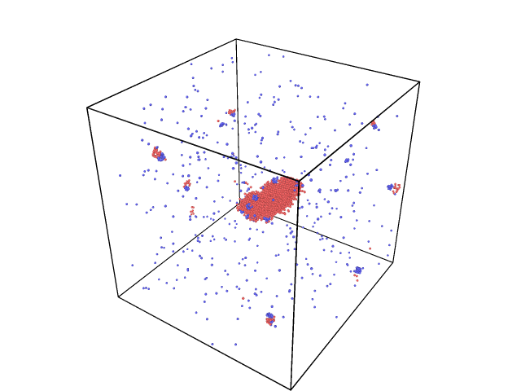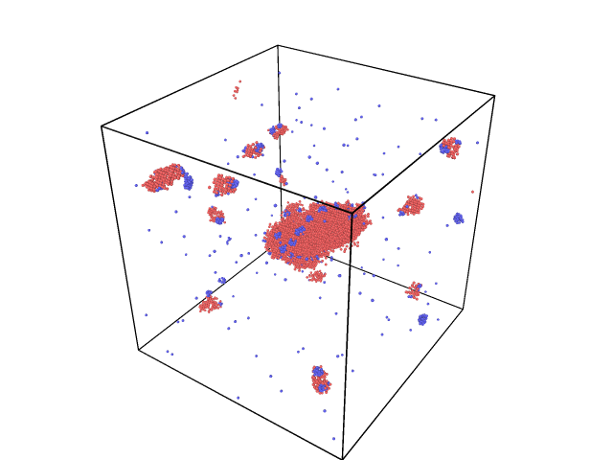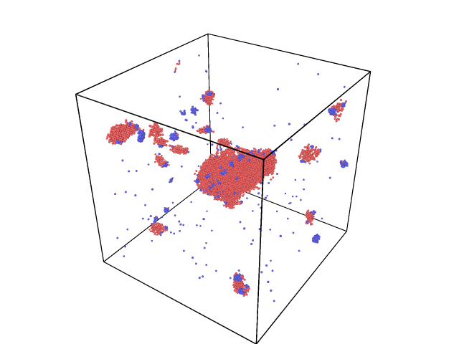
500 appm He
2000 appm He
1000 appm He
2500 appm He
Figure 3.2 Helium clustering process at 500°C, loop<111>

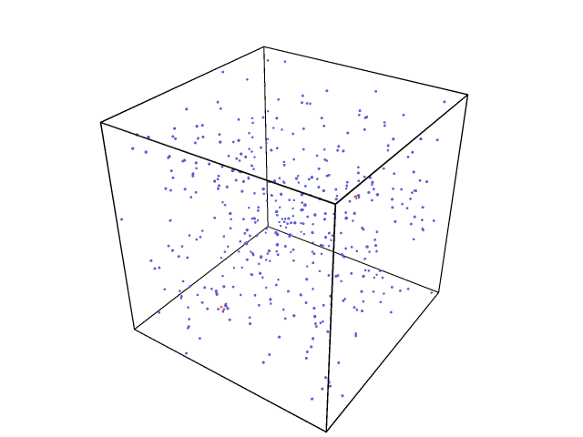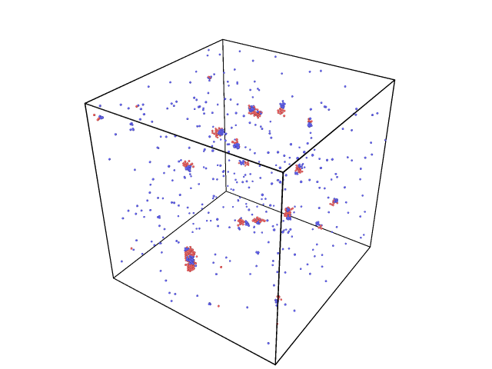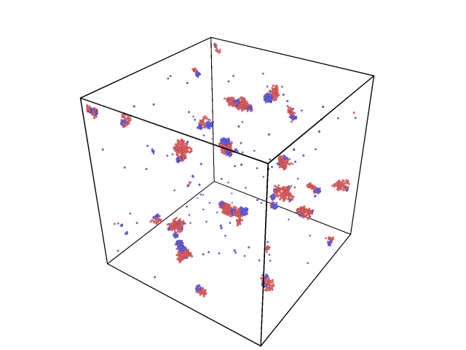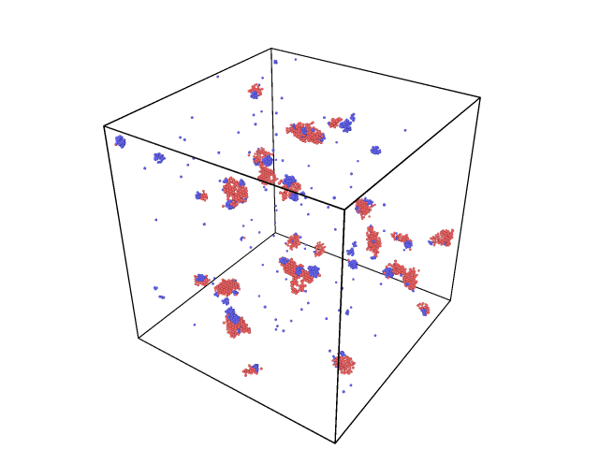
500 appm He
2000 appm He
2500 appm He
1000 appm He
Figure 3.3 Helium clustering process at 500°C, without loop

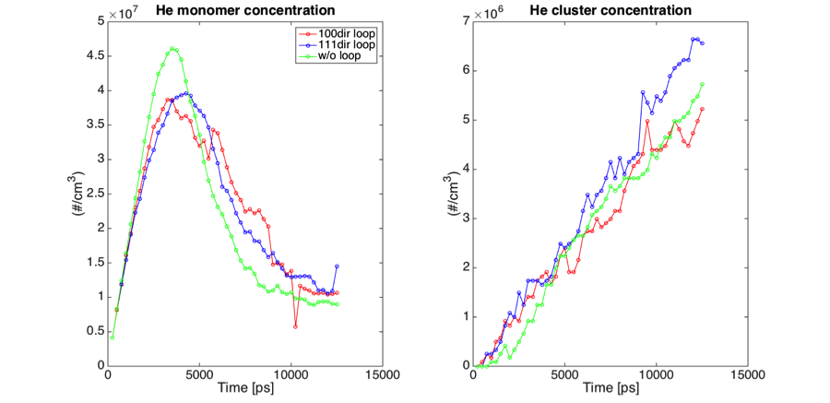
Figure 3.4 Comparison of He cluster & monomer concentration at 500℃

3.2 Helium clustering process at 900$℃$
The helium insertion process at 900$℃$ is shown in Figures 3.5 to 3.8. Helium and iron interstitial clusters have again been observed, and the dislocation loops also grow by absorbing the iron interstitials, all of which are generally similar to the observations from the MD simulations at 500$℃$. However, a lower number density and bigger size of helium cluster were observed at the higher temperature.
Figure 3.8 shows that at 900°C, the dislocation loop has a much more significant influence on the helium bubble nucleation compared to the lower temperature of 500°C. The monomer concentration is much higher for non-loop condition before decreasing as the helium clusters begin to form. Especially at the initial stage of the insertion procedure, the helium cluster concentration is much higher than the two with-loop cases. As the end of the simulation is approached with a helium concentration of 2500 appm, it is also evident that the presence of the a/2<111> loop promotes more helium clusters than the other two cases.
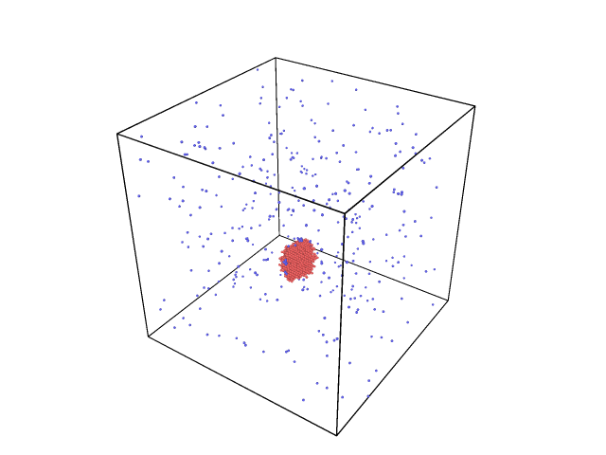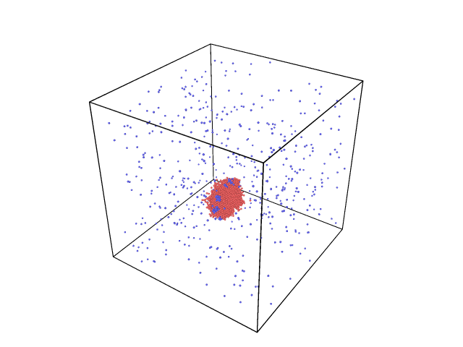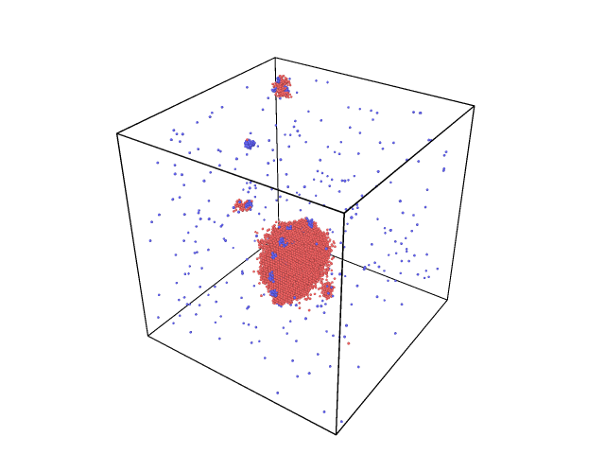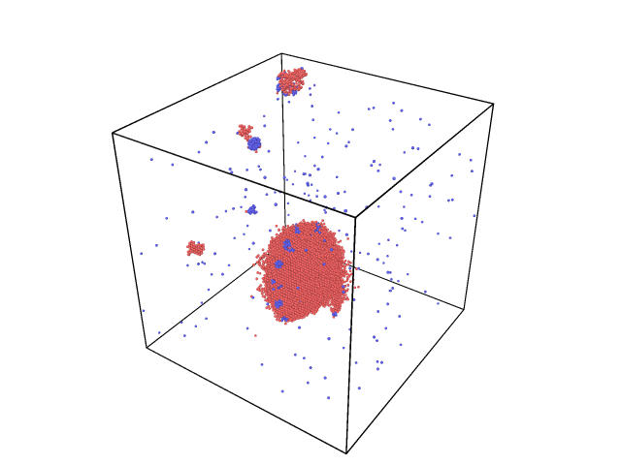
500 appm He
2000 appm He
1000 appm He
2500 appm He
Figure 3.5 Helium clustering process at 900°C, loop<100> loop

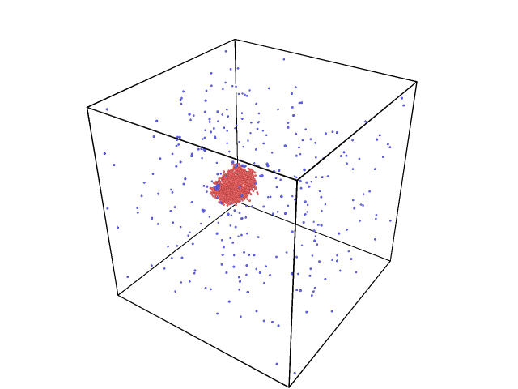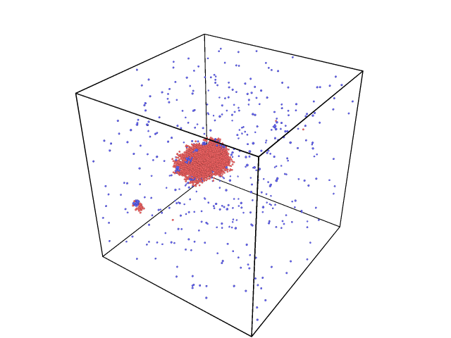
500 appm He
1000 appm He
Figure 3.6 Helium clustering process at 900°C, loop<111> loop

Plot is in process, the simulation is rerun to get the following image.

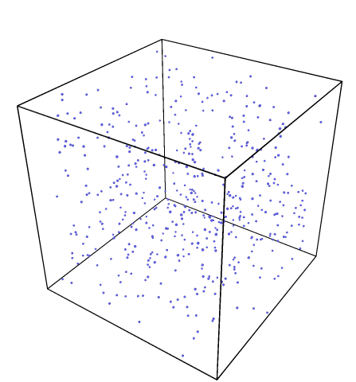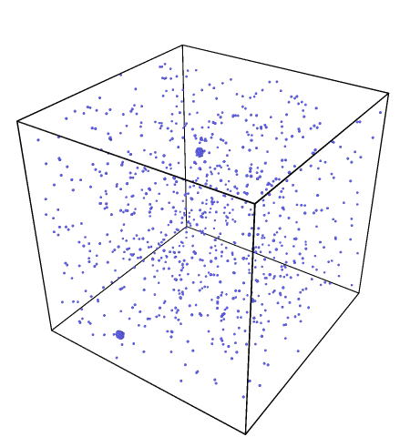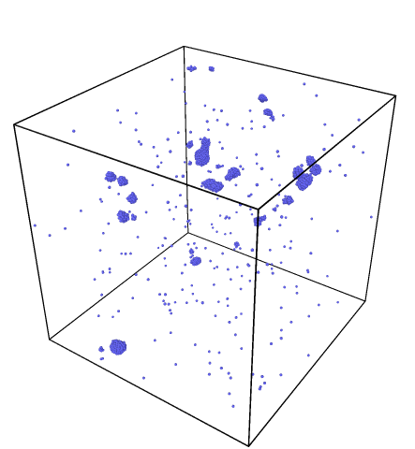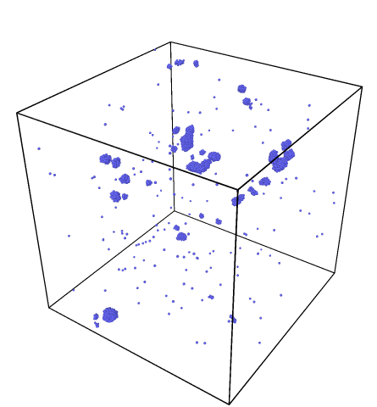
500 appm He
1000 appm He
2000 appm He
2500 appm He
Figure 3.7 Helium clustering process at 900°C, without loop

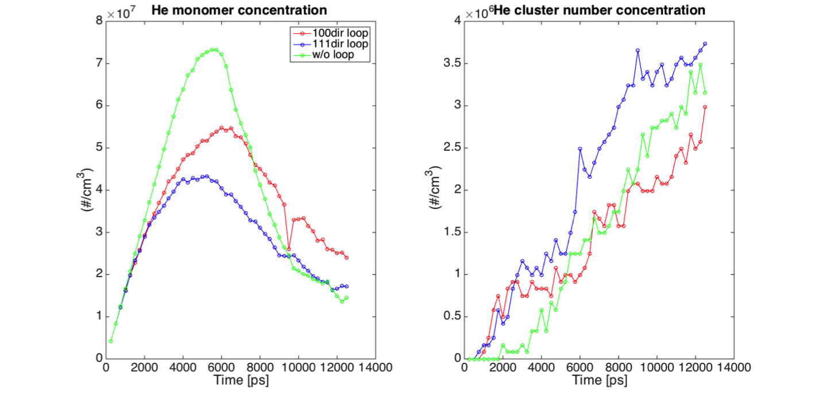
Figure 3.8 Comparison of He cluster & monomer concentration at 900℃

3.3 He clusters distribution at a concentration of 2500 appm He
The helium cluster size distribution is shown in Figure 3.9. As described previously, at higher temperature, the He cluster size distribution covers a much broader region while at lower temperature, the majority of He exists in small clusters. The presence of the a/2<111> dislocation loop promotes the clustering of He more significantly, compared to the other two cases.

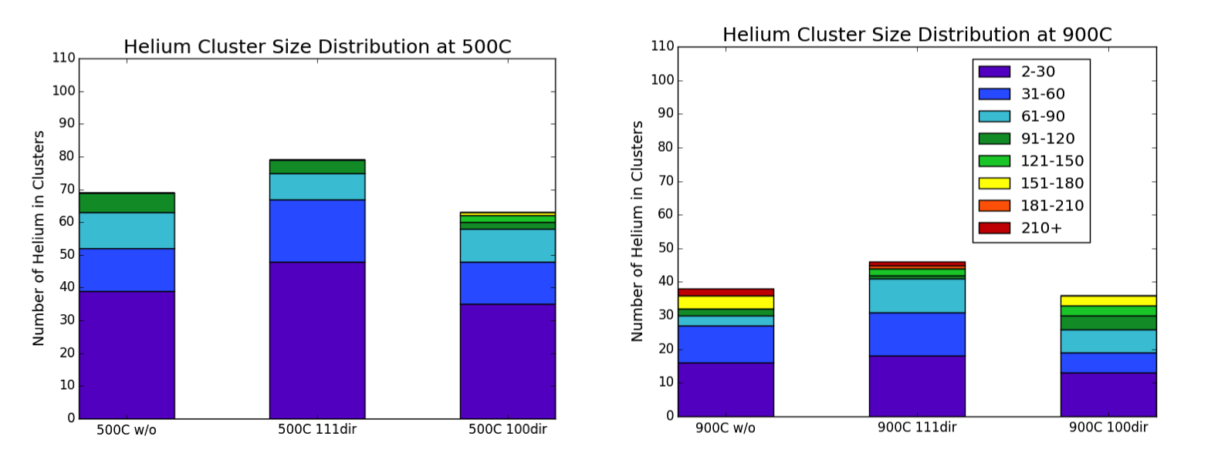
Figure 3.9 Helium clusters distribution at a concentration of 2500 appm He

3.4 Temperature dependence of He clustering
To investigate the temperature dependence of the helium clustering, Figure 3.10 shows the helium distribution from the MD simulation with or without a prismatic loop with Burgers vector of a<100> loop, where to aid the visualization, the loop is not explicitly imaged. However, it is clear in Figure 3.10, that a number of helium bubbles clearly form in the periphery of the loop location. At the higher temperature of 900°C, the helium cluster size is bigger and the number density is smaller. For these cases of the a<100> loop, it is again clear that the initial helium cluster nucleation occurs near the periphery of the dislocation loop.
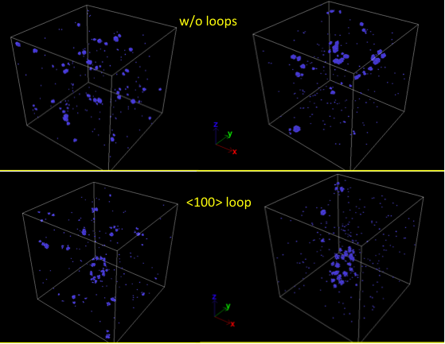
500$℃$
900$℃$
Figure 3.10 Temperature dependence of helium clustering process

3.5 Dislocation loop size comparison
As described in previous content, the pre-existing dislocation loop will grow by absorbing the iron interstitials produced by increasing pressure in the box. During the process of helium insertion, the size of the loop was measured by every 500 ps, equivalent to a rate at 10 appm He. The diameter of the loop was averaged by four directions’ measurement, horizontal, vertical and deviation form vertical by $±45°$. The loop size growing process is shown in Figure 3.11.
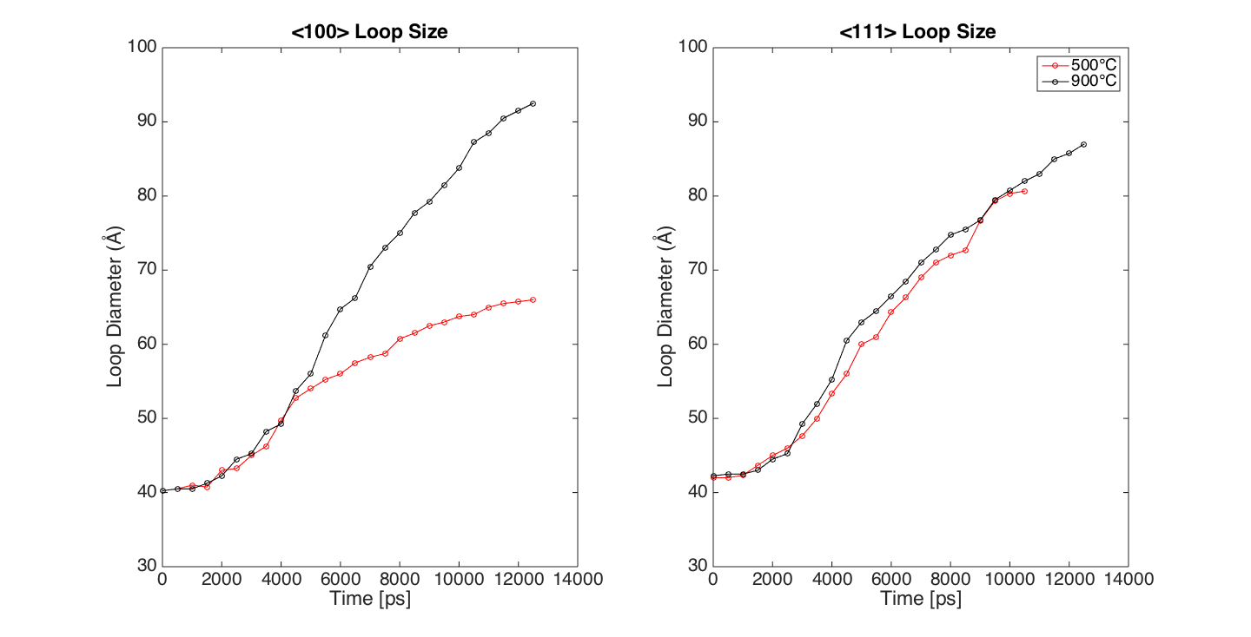
Figure 3.11 Dislocation loop size comparison

Two more simulations are in process for <100> loop at two temperatures to comfier the results.

Chapter 4

Experimental Results and Discussion
Both single crystal and polycrystalline iron samples were used to investigate the helium clustering and desorption behavior after neutron irradiation. Two types of specimens have been neutron irradiated in two different nuclear reactors. A single crystal iron sample was neutron-irradiated in the high flux isotope reactor (HFIR) at 300°C to reach a dose of about 5 dpa, and a poly-crystal iron sample was irradiated in the BOR-60 fast reactor at a higher temperature (371~395°C) to a dose of 16 dpa. Appropriate non-irradiated iron samples were used to provide a control to isolate the change in helium desorption resulting from the neutron irradiation.

Table 2 Overview of the neutron irradiation of iron samples
Sample ID | Materials type | Reactors | Reactor type | Irradiation Temperature (°C) | Radiation dose (dpa)
A4 | Single crystalline Fe | HFIR (Flux trap facility) | Mixed neutron spectrum | 300 | 5.0
F02 | Polycrystalline Fe | BOR-60 | Fast neutron spectrum | 386 | 16.6

4.1 TEM results

4.1.1 Microstructures of neutron-irradited single crystalline $α$-Fe
Figure 4.1 shows the results of transmission electron microscopy of the HFIR irradiated single crystal Fe specimen, in which a low number density of cavities is observed with a fairly narrow size distribution. No significant density of black dot type defect cluster, nor large dislocation loops were observed. Cavities are sparsely distributed within the grains, with a limited spatial correlation of the cavities to dislocation lines. From the TEM analysis performed using both over focus and under focus images, cavities appear as mostly as circles (green arrows), in which some of the cavities have some indication of truncated, or faceted, surface morphology.

BF-STEM
No cavities on line dislocations
TEM Over Focus: +3.5 µm
TEM Under Focus: -3.5 µm
Figure 4.1 Cavity images in single crystal ⍺-Fe irradiated to 5 dpa, 300°C – HFIR

4.1.2 Microstructures of neutron-irradiated polycrystalline $α$-Fe
Figure 4.2 shows the results of transmission electron microscopy of the Bor-60 neutron irradiated specimen, which reveals the formation of a high number density of cavities, which appear to have a, continuous (Gaussian) size distribution. Again, this neutron irradiated specimen does not exhibit any substantial black dot defect clusters nor large dislocation loops. We can see limited association of cavities with line dislocations (left image) and the appearance of a void denuded zone with a width of about 80-120 nm around grain boundaries (middle image). Cavities appear as squares (red arrow), truncated squares/rectangles (blue arrows), or circles (green arrows).

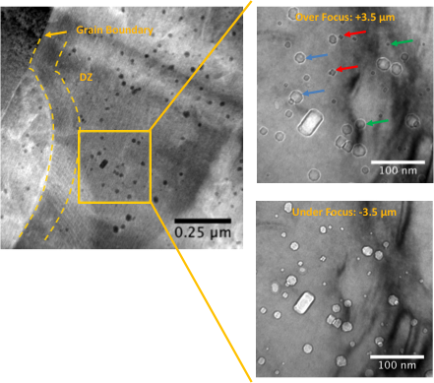
Line Dislocations
Figure 4.2 Cavity images in polycrystalline ⍺-Fe irradiated to 16.6 dpa, 386°C– BOR60

4.2 Thermal Helium Desorption Spectrometry (THDS)

4.2.1 Thermal desorption spectrometry of as-received Fe samples
Figure 4.3 shows the helium desorption spectra of the non-irradiated single crystalline and polycrystalline iron samples. The left figure shows two single crystal specimens implanted with 10keV helium to a fluence of $7×{10}^{14} He/{cm}^{2}$. The similar He desorption behaviors of these two tests imply the good repeatability of the system. The sharp He release peak at 912°C indicated the BCC-FCC transformation point, which can also be used to calibrate the measured sample temperatures. The major helium desorption in BCC phase region occurs in the temperature range from 600 to 900°C, with a peak of 750°Ç. An obvious helium desorption peak can also be expected in FCC phase region, which is not complete due to the limitation of the current maximum temperature the system can reach (1150°C). The integrated released helium amount during the TDS process is 80%, implying ~ 20% implanted He are still remained within the material following the TDS test. The right-hand side plot shows the helium desorption behavior of poly-crystal iron with the same implantation condition. Apart from the phase change peak, it is observed that the major helium release peak in BCC region shifts to a lower temperature region, from 500 to 620°C peaked at 580°C, which is also much sharper compared to that of single crystalline Fe. This release peak may result from several mechanisms, including sample impurity or low binding energy between the grain boundary and helium atoms. In FCC phase, above 912°C, another peak was observed. The total released He is 86% of the initially implanted He. For both cases, the implanted He was not completely released, indicating the existence of stable He bubbles formed during the implantation or the TDS process.

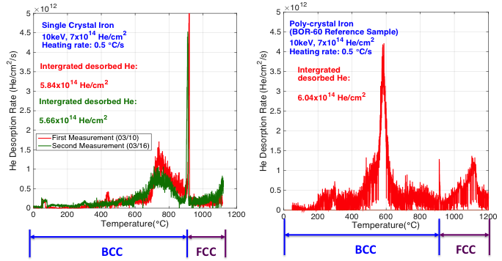
Figure 4.3 Thermal desorption spectrometry of non-irradiated Fe sample

Figure 4.4 shows the helium desorption spectra of neutron-irradiated iron samples. For the single crystalline iron, two obvious helium release peaks were observed at 650 and 850°C, respectively. Only one major helium desorption peak covering a broader temperature region (600-900°C) was observed. For both samples, the significant helium release starts at 600°C and the sharp He release peaks at 912°C are still observed. To notice, for the sample irradiated under high flux neutron, integrated desorbed He is one order (${10}^{15}$) higher than the total implantation He (${10}^{14}$). This suggests that apart from the implanted helium, transmutation helium were produced during the radiation process.

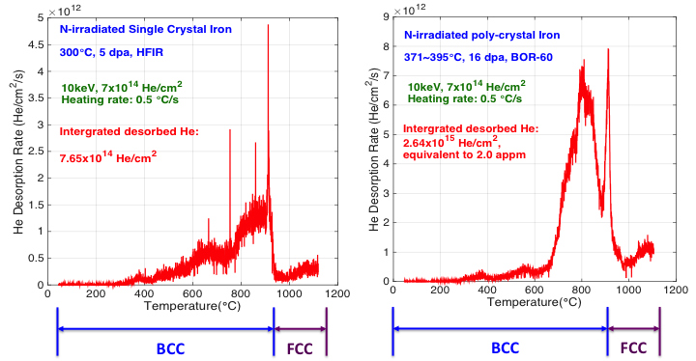
Figure 4.4 Thermal desorption spectrometry of neutron-irradiated Fe samples

Figure 4.5 presents a comparison of the desorbed helium spectra of non-irradiated and neutron irradiated samples. For the single crystal iron, after irradiation the desorption peak shifts to higher temperature. Refer to the TEM image, we see several types of cavities, to which helium might combine. The binding energy varies with the defects size or type, resulting in different desorbing stage. The neutron irradiation induced defects enhanced the combination of He to defect clusters. Similar behavior was also observed for the polycrystalline iron samples. Much higher number density of cavities is produced, which act as the trapping sites for helium atoms making it harder to be driven out through thermal desorption technology.

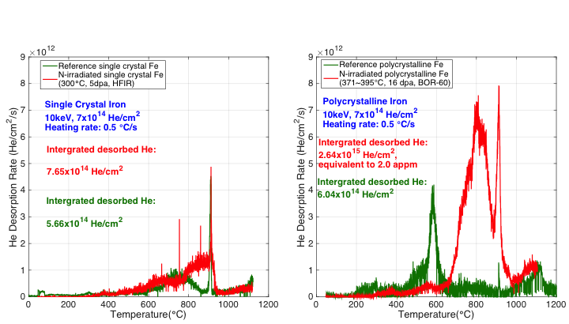
Figure 4.5 TDS comparison of non-irradiated and neutron irradiated samples

The TEM results after He implantation will be available probably next week.

Chapter 5 Conclusion and Future Work

5.1 Conclusion
MD simulation has been used to investigate the influence of pre-existing prismatic dislocation loops on the helium clustering process in BCC iron. Results show that the existence of dislocation loop at higher temperature (900℃) has more significant influence on the helium clustering behavior than the case at lower temperature (500℃). The <111> dislocation loop promotes the He clustering process more intensively than <100> loop. Both <111> and <100> dislocation loops grow in size by absorbing iron interstitials produced in the growing process of He clusters.
TEM was used to characterize the microstructure of neutron-irradiated single crystalline and polycrystalline iron. The results indicate the existence of big cavities and limited number of dislocation lines in both samples. We can see limited association of cavities with line dislocations or the appearance of a void denuded zone. Under high dose neutron irradiation condition, the huge number of cavities with a continuous size distribution was observed. While at lower dose sample, cavities are sparsely distributed within the grains.
TDS was used to capture the impact of neutron irradiated induced damage on the helium desorption behavior. The results show that the helium desorption spectrum shifts to higher temperature due to the strong binding of helium and the defects. Sharp helium releasing peak was observed in every sample at $912℃$, where the iron phase change from BCC to FCC. During the thermal desorption process, only part of the inserted helium was released, indicating the existence of stable He bubbles formed during the implantation or the TDS process. The sample irradiated under fast neutron energy spectrum, integrated desorbed He is higher than the total implanted He, due to the generation of transmutation He by (n, α) reactions.

5.2 Future work
If time permitted, a longer simulation time will be applied to the current simulation conditions. A smaller helium insertion rate might reduce the difference of helium clustering process within two different temperatures by most of the clusters will be accumulated around the periphery of the loop. At the same time, more experiment should be done to investigate the influence of dislocation loop defects on the helium clustering process to match our simulation work. For example using cold work to create more loops.
References
- Energy Information Administration, Washington, DC, Report DOE/EIA-0219, 2003.

- E.E. Bloom, S.J. Zinkle, F.W. Wiffen, Materials to deliver the promise of fusion power – progress and challenges, J. Nucl. Mater. 329-333 (2004) 12-19.
- IAEA, International Status and Prospects for Nuclear Power 2012, Board of Governors General Conference, GOV/INF/2012/12-GC (56) /INF/6.
- Committee on America’s Energy Future, America’s Energy Future: Technology and Transformation. National Academies Press, Washington (2009).
- D. Xunxiang Hu, Gas Diffusion in Metals: Fundamental Study of Helium-Point Defect Interactions in Iron and Kinetics of Hydrogen Desorption from Zirconium Hydride.

- Introduction to the Grand Challenges for Engineering, http://www.engineeringchallenges. org/cms/8996/9221. aspx, 2008.

- S.J. Zinkle, Fusion materials science: overview of challenges and recent progress. Phys. Plasmas 12 (2005) 058101.
- Staehle R. Personal communication.

- Farrokh Najmabadi, the ARIES Team, The ARIES-AT advanced tokamak, Advanced technology fusion power plant, Fusion Engineering and Design, Volume 80, Issues 1–4, January 2006, Pages 3–23

- Gary S. Was, Fundamentals of Radiation Materials Science

- E.V. Kornelsen, The interaction of injected helium with lattice defects in a tungsten crystal. Radiat. Eff. 13 (1972) 227–236.
- L.K. Mansur and W.A. Coghlan, Mechnisms of helium interaction with radiation effects in metals and alloys: A review. J. Nucl. Mater. 119 (1983) 1–25.
- H. Trinkaus, Energetics and formation kinetics of helium bubbles in metals, Radiat. Eff. 78 (1983) 189 – 211.
- Herbert Schoeder et al., Helium Effects on the Creep and Fatigue Resistance of Austenitic Stainless Steels at High Temperatures, Nuclear Engineering and Design/Fusion 2 (1985) 65-95

- F.W. Wiffen, E. E. Bloom, Effect of High helium Content on Stainless-Steel Swelling, Nuclear Technology 25 113 (1975)

- Nathan Allen Capps, Molecular Dynamics Simulation of Cascade Evolution near Pre-Existing Defects.
- A.R. Janzen and R.A. Aziz, J., An accurate potential energy curve for helium based on ab initio calculations,

- G. J. Ackland, M. I. Mendelev, D. J. Srolovitz, S. Han and A. V. Barashev,
Development of an interatomic potential for phosphorus impurities in α-iron, J. Phys.: Condens. Matter 16 (2004) S2629–S2642

- N. Juslin, K. Nordlund, Pair potential for Fe–He, J. of Nucl. Materials 382 (2008) 143–146

- Transmission Electron Microscopy

Appendix

<111> loop box code

units metal
dimension 3
boundary p p p

atom_modify map array
variable lattice equal 2.8654
variable WN equal 46
variable LN equal 57
variable HN equal 33

variable W equal sqrt(3)*${lattice}*${WN}
variable L equal sqrt(2)*${lattice}*${LN}
variable H equal sqrt(6)*${lattice}*${HN}

units metal
atom_style atomic
lattice bcc ${lattice} orient x 1 1 1 orient y 1 -1 0 orient z 1 1 -2 origin 0.001 0.001 0.001

region main block 0.0 $W 0.0 $L 0.0 $H units box

variable plane_1x equal 0.5*$W
variable plane_1y equal 0.5*$L
variable plane_1z equal 0.5*$H

variable plane_2x equal 0.5*$W+0.5*sqrt(3)*${lattice}
variable plane_2y equal 0.5*$L
variable plane_2z equal 0.5*$H

variable sphere_x equal 0.5*$W
variable sphere_y equal 0.5*$L
variable sphere_z equal 0.5*$H

variable radius equal 7.5*${lattice}

region habitplane1 plane ${plane_1x} ${plane_1y} ${plane_1z} 1 0 0 units box
region habitplane2 plane ${plane_2x} ${plane_2y} ${plane_2z} -1 0 0 units box
region spheredisloc sphere ${sphere_x} ${sphere_y} ${sphere_z} ${radius} units box
region extra intersect 4 main habitplane1 habitplane2 spheredisloc

create_box 2 main
create_atoms 1 region extra
group loop region extra
variable b_displ equal 0.25*${lattice}*sqrt(3)
displace_atoms loop move ${b_displ} 0 0 units box
create_atoms 1 region main

mass 1 55.847
mass 2 4.0026

# Force Fields
pair_style hybrid table linear 10000 eam/fs
pair_coeff * * eam/fs /lustre/home/zhuang18/newton/potential/Fe-Ackland2004.eam.fs Fe NULL
pair_coeff 1 2 table /lustre/home/zhuang18/newton/potential/FeHe-Juslin2008.table FeHe
pair_coeff 2 2 table /lustre/home/zhuang18/newton/potential/He-Janzen1997.table He

minimize 0 0 10000 10000

dump 1 all atom 1000 minimized.all
dump 2 loop atom 1000 minimized.loop

timestep 0.001

velocity all create 1543.0 25232351 dist gaussian
thermo_style custom step temp pe etotal press vol lx ly lz
thermo 1000
thermo_modify lost error
fix 1 all nvt temp 773.0 773.0 1
thermo 100

run 1000
unfix 1

<100> box loop code
units metal
dimension 3
boundary p p p
variable lattice equal 2.8654
atom_modify map array

variable l_x equal 80*${lattice}
variable l_y equal 80*${lattice}
variable l_z equal 80*${lattice}

variable z_thick equal 1.5*${lattice}
variable z_W_max equal ${l_z}+0.01*${lattice}
variable z_W_min equal -0.01*${lattice}

variable plane_1x equal 39.9*${lattice}
variable plane_1y equal 39.0*${lattice}
variable plane_1z equal 32.0*${lattice}

variable plane_2x equal 40.6*${lattice}
variable plane_2y equal 39.0*${lattice}
variable plane_2z equal 32.0*${lattice}

variable sphere_x equal 40.25*${lattice}
variable sphere_y equal 32.0*${lattice}
variable sphere_z equal 32.0*${lattice}
variable radius equal 7.1*${lattice}

region habitplane1 plane ${plane_1x} ${plane_1y} ${plane_1z} 1 0 0
region habitplane2 plane ${plane_2x} ${plane_2y} ${plane_2z} -1 0 0
region boundary sphere ${sphere_x} ${sphere_y} ${sphere_z} ${radius}

region simbox block 0 ${l_x} 0 ${l_y} 0 ${l_z}
create_box 2 simbox
region dislocate intersect 4 simbox habitplane1 habitplane2 boundary

lattice bcc ${lattice}
create_atoms 1 region dislocate
group loop region dislocate
displace_atoms loop move 0.5 0 0
create_atoms 1 region simbox
mass 1 55.847
mass 2 4.0026

# Force Fields

pair_style hybrid table linear 10000 eam/fs
pair_coeff * * eam/fs /lustre/home/zhuang18/newton/potential/Fe-Ackland2004.eam.fs Fe NULL
pair_coeff 1 2 table /lustre/home/zhuang18/newton/potential/FeHe-Juslin2008.table FeHe
pair_coeff 2 2 table /lustre/home/zhuang18/newton/potential/He-Janzen1997.table He

minimize 0 0 10000 10000

dump 1 all atom 1 dump.boxloop100_500C.all
dump 2 loop atom 1 dump.boxloop100_500C

timestep 0.001

velocity all create 1543.0 25232351 dist gaussian
thermo_style custom step temp pe etotal press vol lx ly lz
thermo 1000
thermo_modify lost error
fix 1 all nvt temp 773.0 773.0 0.1
thermo 100
run 1000

Vita
Zuya Huang was born in Chongqing, China to the parents of Yazhou Huang and Hong Cao. She went to Nankai middle school got her high school graduation certificate in 2010. Then she attended North China Electric Power University at Beijing where she earned the bachelor of Science degree in Nuclear Science and technology in June of 2014. She accepted a Graduate Research Assistant position within the Nuclear Engineering Department at the University of Tennessee upon graduation in 2014. Zuya will earn a Master of Science degree in Nuclear Engineering in May of 2016.

