Optimal Location of Cellulosic Ethanol Facilities and Their Impacts on Surface Water Quality in the Southeastern United States

A Thesis Presented for the
Master of Science
Degree
The University of Tennessee, Knoxville

Kevin Eric Cavasos
August 2014

ACKNOWLEDGEMENTS

This project is supported by the USDA National Institute of Food and Agriculture, Sustainable Bioenergy Challenge Area grant award #11025775, “Rural Economic Impacts of Green Energy Production from the Forest and Agricultural Sectors.” The views expressed here are those of the co-authors. The co-authors are grateful to Dr. Anne Hoos, Research Scientist with the United States Geological Survey, Nashville, TN for valuable assistance.

ABSTRACT

Research suggests that by 2022, 10.5 billion of the 21 billion gallon annual production target for advanced biofuels mandated by the expanded 2007 Renewable Fuel Standard (RFS2) could originate in the Southeastern United States (US) (USDA 2010). This study applied a biorefinery siting and feedstock optimization model and a water quality model to examine the ex-ante impact of biorefinery locations on agricultural input use and nitrogen (N) loading into the region’s hydrological system. The objective of this research is to understand the potential implications of this level of cellulosic ethanol production and concomitant changes in land use on surface water quality at local and regional scales.
Least-cost cellulosic biorefinery locations and associated conversion of agricultural land to switchgrass production were projected for the South Atlantic Coast, the Eastern Gulf Coast, and Tennessee river basins, collectively referred to as the SAGT River Basin. Two industry configurations and four levels of cellulosic ethanol production were considered, including 22%, 31%, 50%, and 100% of the 10.5 BGY target for the Southeastern US. Stream level N concentration and the percentage of N flux attributed to agricultural fertilizer applications were predicted under the two industry configurations at each production level using the US Geological Survey’s SPARROW hydrological model. Outcomes were compared to 2009 baseline stream system nutrient levels to determine agriculture’s contribution to total N loadings and the impact of land use change on the region’s surface water quality at each level of cellulosic ethanol production. The net effect across the region are increases in the mean stream level N concentration and agricultural N source share under both industry configurations (12.95% and 18.63%, respectively, at 100% of target under industry configuration A, and 10.16% and 29.85%, respectively, under industry configuration B), relative to the baseline. Changes were primarily driven by the conversion of hay/pastureland and soybeans into more fertilizer intensive industrial switchgrass production.

TABLE OF CONTENTS

Chapter I Introduction 1
Chapter II Literature Review 5
2.1 Firm Location Analysis 5
2.2 Modeling Water Quality Impacts of Agricultural Biomass Production 6
2.3 SPARROW Watershed Model 10
Chapter III Conceptual Model 12
3.1 Policy Influence 12
3.2 Optimal Ethanol Facility Location 13
3.3 Nutrient Loading and Water Quality 16
Chapter IV Methods 19
4.1 BioFLAME Facility Siting Model 19
4.2 SPARROW Water Quality Regression Model 22
4.3 Integrating Biorefinery Entry, Land Use and Water Quality Change 26
Chapter V Results and Discussion 34
5.1 Scenario A Results (no industry preference for localization economies) 34
5.2 Scenario B Results (firm preference for localization economies) 37
5.3 Spatial Association of SPARROW Results 40
Chapter VI Conclusion 42
List of References 45
Appendix 54
Vita 85

LIST OF TABLES

Table 1 Industrial sectors used to calculate location quotients 56
Table 2 Scenario A: Number of refineries, ethanol volume, and feedstock demand 57
Table 3 Scenario A: Change in SAGT River Basin crop acres relative to baseline 57
Table 4 Scenario B: Number of refineries, ethanol volume, and feedstock demand 58
Table 5 Scenario B: Change in SAGT River Basin crop acres relative to baseline 56
Table 6 N application rates used to calculate source variable for SPARROW predictions
for the baseline and 22%, 31%, 50%, and 100% of the 10.5 BGY cellulosic ethanol target 59
Table 7 Percent of cultivated acres receiving N treatment used to calculate source variable for SPARROW predictions for the baseline and 22%, 31%, 50%, and 100% of the 10.5 BGY cellulosic ethanol target 59
Table 8 Scenario A: Minimum, maximum, and mean HUC 12-Level quantity
of N applied 60
Table 9 Scenario B: Minimum, maximum, and mean HUC 12-Level quantity
of N applied 60
Table 10 SAGT SPARROW Nutrient Source Inputs 61
Table 11 Calibration Results for the SAGT SPARROW Model 62
Table 12 Scenario A: Mean N concentration and percentage of N flux attributed to N
source variables 63
Table 13 Scenario B: Mean N concentration and percentage of N flux attributed to N
source variables 63
Table 14 Scenario A: Minimum, maximum, and mean stream level mean
agricultural N source share and mean N concentration 64
Table 15 Scenario B: Minimum, maximum, and mean stream level mean
agricultural N source share and mean N concentration 64
Table 16 Scenario A: Global Moran’s Index of percentage change in N concentration and
agricultural N source share 65
Table 17 Scenario B: Global Moran’s Index of percentage change in N concentration and
agricultural N source share 66

LIST OF FIGURES

Figure 1 SAGT River Basin Study Area 67
Figure 2 County-level LQs for the cellulosic ethanol sector 68
Figure 3 SAGT River Basin superimposed onto BioFLAME model area 69
Figure 4 SPARROW model structure incorporating BioFLAME crops 70
Figure 5 Scenario A: Percentage change in total mass of N applied to barley, corn, cotton, hay/pastureland, oats, sorghum, soybeans, wheat, and switchgrass in the SAGT River Basin relative to the 2009 baseline at 22%, 31%, 50% and 100% of the 10.5 BGY cellulosic ethanol target 71
Figure 6 Scenario B: Percentage change in total mass of N applied to barley, corn, cotton, hay/pastureland, oats, sorghum, soybeans, wheat, and switchgrass in the SAGT River Basin relative to the 2009 baseline at 22%, 31%, 50% and 100% of the 10.5 BGY cellulosic ethanol target 71
Figure 7 Scenario A: Crop acres as a percent of total acres of the nine crops in the SAGT River Basin at 22%, 31%, 50% and 100% of the 10.5 BGY cellulosic ethanol target 72
Figure 8 Scenario B: Crop acres as a percent of total acres of the nine crops in the SAGT Basin at 22%, 31%, 50% and 100% of the 10.5 BGY cellulosic ethanol target 72
Figure 9 Scenario A: SAGT River Basin least-cost cellulosic biorefinery locations and agricultural feedstock distribution at 22%, 31%, 50%, and 100% of the 10.5 BGY cellulosic ethanol target 73
Figure 10 Scenario B: SAGT River Basin least-cost cellulosic biorefinery locations and agricultural feedstock distribution at 22%, 31%, 50%, and 100% of the 10.5 BGY cellulosic ethanol target 74
Figure 11 Scenario A: SAGT River Basin mean flow weighted N concentration (block) and 95% confidence interval (line) at the baseline, 22%, 31%, 50%, and 100% of the cellulosic ethanol target 75
Figure 12 Scenario A: SAGT River Basin mean agriculture N source share (block) and 95% confidence interval (line) at the baseline, 22%, 31%, 50%, and 100% of 10.5 BGY cellulosic ethanol target 75
Figure 13 Scenario B: SAGT River Basin mean flow weighted N concentration (block) and 95% confidence interval (line) at the baseline, 22%, 31%, 50%, and 100% of the 10.5 BGY cellulosic ethanol target 76
Figure 14 Scenario B: SAGT River Basin mean agriculture N source share (block) and
95% confidence interval (line) at the baseline, 22%, 31%, 50%, and 100% of the
10.5 BGY cellulosic ethanol target 76
Figure 15 Scenario A: Least-cost cellulosic biorefinery locations and the percentage
change in stream level N concentration 77
Figure 16 Scenario A: Least-cost cellulosic biorefinery locations and the percentage
change in mean agricultural N source share 78
Figure 17 Scenario B: Least-cost cellulosic biorefinery locations and the percentage
change in stream level N concentration 79
Figure 18 Scenario B: Least-cost cellulosic biorefinery locations and the percentage
change in mean agricultural N source share 80
Figure 19 Scenario A: Local Moran’s I of percentage change in mean stream level
N concentration 81
Figure 20 Scenario A: Local Moran’s I of percentage change in agricultural N
source share 82
Figure 21 Scenario B: Local Moran’s I of percentage change in mean stream level
N concentration 83
Figure 22 Scenario B: Local Moran’s I of percentage change in agricultural N
source share 84

CHAPTER I
INTRODUCTION

Advanced biofuels derived from renewable energy sources or biomass materials have the potential to be a major component of the nation’s long term sustainable energy strategy (US Congress 2007; Wu et al. 2012). The rapid growth of the biofuel industry in the mid-2000s was initiated through the Renewable Fuel Standard (RFS) established by the United States (US) Energy Policy Act of 2005, which mandated that domestic transportation fuel contain a specified volume of biofuels, with amounts increasing annually over a 15 year period (US Congress 2005). Production targets subsequently expanded under the US Energy Independence and Security Act of 2007 (EISA), increasing annual biofuel production targets to 36 billion gallons by 2022, including 21 billion gallons derived from cellulosic or other non-grain sources (US Congress 2007). The market for ethanol was given an additional boost with the 2006 national ban on methyl tertiary butyl ether (MTBE), an additive used to oxygenate transportation fuel. Following the ban of MTBE, ethanol became the primary gasoline additive used to meet oxygen content requirements mandated by the 1990 amendments to the Clean Air Act (US Congress 1990). Since its introduction in 2010, the expanded RFS (RFS2) mandate has been waived or reduced every year in response to projected production levels. For example, the US Environmental Protection Agency (EPA) proposed in late 2013 to lower the 2014 standard from 1.75 billion gallons to 17 million gallons (US EPA 2013).
Research suggests by 2022, 10.5 billion of the 21 billion gallon annual production target for advanced biofuels mandated by RFS2 could originate in the Southeastern US (USDA 2010). Although current production of grain-derived ethanol is already near the 2022 conventional biofuel target, meeting existing cellulosic ethanol production targets will require significant advances in industry production capacity, including construction of potentially hundreds of pre-processing and bio-refinery facilities as well as increased production and distribution of cellulosic biomass feedstock crops (National Research Council 2011). The increased market demand for energy crops is expected to result in extensive conversion of previously uncultivated land, fallow agricultural land, pastureland, or Conservation Reserve Program (CRP) land, potentially resulting in a substantial increase in the total agricultural land in production (Demissie, Yan, and Wu 2012; Perlack and Stokes 2011; Robertson et al. 2010). Changes in agricultural land use and, concomitantly, crop management practices associated with industrial ethanol production could adversely impact the quality of local and regional surface water systems in terms of nutrient loading, particularly nitrogen (N) and phosphorus (P). Excess N and P in water bodies may result in eutrophication leading to algae blooms, reduced species diversity, and diminished recreational access and appeal (Donner, Kucharik, and Foley 2004; Costello et al. 2009). Extreme situations can result in hypoxia, a condition in which dissolved oxygen levels are inadequate to support most animal life (Costello et al. 2009). Maintaining water quality is crucial to the preservation of the region’s drinking water and continued use for numerous recreational and economic activities.
Switchgrass, a native perennial grass considered favorable for cellulosic ethanol production in the Southeastern US, is the energy feedstock analyzed here. Industrial production of switchgrass requires fertilizer, with annual recommendations in the Southeast of 67.25 kg ha⁻¹ (McKinley and Gerloff 2010). Planting switchgrass on land where fertilizer was not previously used intensively could increase nutrient loading into streams and reservoirs. On the other hand, there is evidence that conversion of cropland used to produce crops with high fertilizer demand to switchgrass production may reduce nutrient loading into waterways (e.g. Robertson et al. 2010). Land use changes will be driven by feedstock availability and the concomitant location activity of ethanol production facilities choosing least-cost sites.
Beginning in the 1970s, national policies were implemented to promote the production of ethanol for fuel as world petroleum supplies and prices became increasingly volatile (Solomon, Barnes, and Halvorsen 2007). The relatively simple conversion process, existence of commercially viable operational technologies, favorable policies, and tremendous domestic capacity for the production of corn caused grain-based ethanol to be embraced prior to the more process intensive and logistically costly cellulosic ethanol (Solomon, Barnes, and Halvorsen 2007). The bulk of the nation’s corn is produced in the US Midwest. As a result, early investigations into the potential water quality implications of industrial ethanol feedstock production focused primarily on the nation’s “Corn Belt” (Pimentel 2001; Costello et al. 2009; Hill et al. 2006; Donner, Kucharik, and Foley 2004). Cellulosic ethanol is more commonly perceived as a sustainable alternative to grain-based ethanol once conversion technology efficiency improves (e.g., Robertson et al. 2008; National Resource Council 2011). Research on the potential water quality implications of industrial cellulosic feedstock production is emerging, focusing primarily on the nation’s Midwestern water systems (e.g., Ng et al. 2010; Costello et al. 2009). Potential land use changes and regional water quality implications associated with a mature cellulosic ethanol industry have been examined for the Southeastern US, but watershed-level hydrologic modeling incorporating the region’s major cash crops is rare (Costello, et al. 2009; English et al. 2008; De La Torre Ugarte et al. 2008). The extent and magnitude of land and agricultural chemical use changes associated with industrial cellulosic ethanol production may result in unintended environmental and economic consequences for communities in the Southeastern US. Quantifying the range of potential outcomes as they pertain to changes in land and fertilizer use and N loading into waterways provides a first step for understanding the local and regional impacts of biorefinery facilities and concomitant demand for energy crops on surface water quality. This information could be useful for guiding farmers, industry leaders, and policy makers in their decisions to ensure the adoption of sustainable land and water management practices and help conserve the health and quality of the region’s water supply. The objectives of this research are to (1) determine the impact of cellulosic ethanol biorefinery location activity on local and regional N loading into the Southeastern-Atlantic hydrologic region; and (2) determine if N contributions from agriculture and the associated impacts on water quality differ under different industry preferences for least-cost facility locations.

CHAPTER II
LITERATURE REVIEW

2.1 Firm Location Analysis
Industrial location analyses examining the motivations behind, and consequences of, industrial location behavior began in the nineteenth century with the work of Laundhart (1885) and Weber (1909), cited in McCann (2013). Assuming firms could locate anywhere, Weber (1909) theorized firms would choose locations that minimize the expected costs of transporting inputs from their origin to the firm and then products to markets. Optimal firm locations, therefore, reflect the tradeoff in locating near input and output markets in terms of relative transport costs. Optimal siting of ethanol facility locations has been examined for over 30 years using mathematical programming models incorporating feedstock production, transportation, and processing and handling costs (e.g. English et al. 1981). Transportation of feedstocks from producers to biorefineries is a major cost factor in cellulosic ethanol production making it essential to determine the optimal routing networks and, subsequently, biorefinery facility location. The evolution of geographic information systems (GIS) and advances in computational platforms has enabled the development of increasingly complex, spatially explicit models for optimizing biorefinery locations, given agricultural biomass supply and routing logistics (e.g. Tittman et al. 2010; Wilson 2009; Sokhansanj et al. 2006; Tatsiopoulos and Tolis 2003; Mantovani and Gibson 1992).
The BioFLAME platform (Biofuels Facility Location Analysis Modeling Endeavor) is an integrated software program that uses GIS layers to identify cost-minimizing cellulosic ethanol plant locations and project associated changes in agricultural land use in a 16 state area in the Southeastern US (Wilson 2009). BioFLAME incorporates parameters commonly used in similar biofuel supply chain and facility location models including proximity to infrastructure such as roads, railways, and navigable waterways, as well as feedstock availability, biorefinery capacity, crop prices, transport costs, and feedstock yield (i.e., Tittman et al. 2010; Tatsiopoulos and Tolis 2003). From among the commonly used biorefinery facility location models, BioFLAME’s modeling framework was determined to be the best suited for achieving the objectives of this research.

2.2 Modeling Water Quality Impacts of Agricultural Biomass Production
Meeting the ethanol production targets established by the RFS2 will require significant amounts of agricultural land to be converted to biomass feedstock production (De La Torre Ugarte et al. 2008; De La Torre Ugarte, English, and Jensen 2007). Various studies examine the potential extent of land conversion, changes in agricultural chemical use, and the potential impact on water quality in the nation’s river systems (e.g., Donner and Kucharik 2008; Demissie, Yan, and Wu 2012; Gramig et al. 2013; Robertson et al. 2010; Wu and Liu 2011). Given the complexities of ecological systems and underlying natural processes impacting water quality, the relationship between inputs and yields on water quality is non-linear. As a result, most current research into land use change and water quality uses some form of numerical computer modeling approaches to provide timely, specific answers to ex ante “what if” questions (Schwarz et al. 2006; Thomas, Engel, and Chaubey 2009). For example, if a policy encourages increased production of a particular type of crop, what impact will the associated changes in nutrient loading have on water quality?
Because of the Corn Belt’s comparative advantage in corn and soybean production, research investigating the potential watershed-level environmental impacts of expanded crop production in the Midwestern region is abundant (e.g., Thomas, Engel, and Chaubey 2009; Donner and Kucharik 2008; Secchi et al. 2011). In general, research has linked expanded feedstock production for grain-based ethanol with increased nutrient loading and adverse impacts to water quality. Alternatively, research suggests converting from conventional row crop production to perennial grass production may lead to decreased nutrient loadings and improvements to water quality. As the benefits of cellulosic-based ethanol relative to grain-based ethanol have become better understood and cellulosic conversion technologies advance, the potential water quality impacts of increased demand for cellulosic crops such as miscanthus and switchgrass in the Corn Belt region have received more attention (e.g. Gramig et al. 2013; Secchi et al. 2011; Ng et al. 2010). To date, however, comparable watershed-level research in the Southeastern US is sparse.
For example, Donner, Kucharik, and Foley (2004) used the Integrated Biosphere Simulator (IBIS) terrestrial ecosystem model (Kucharik et al. 2000; Foley et al. 1996) and the Hydrologic Routing Algorithm (HYDRA) aquatic transport model (Coe 2000) to examine how agricultural practices influenced N cycling across the Mississippi Basin and nitrate export into the Gulf of Mexico between 1960 and 1994. They concluded that nitrate export through the Mississippi doubled during that period as the result of increased fertilization use (particularly for corn); an increase in basin runoff; and the expansion of soybean production.
Using the Policy Analysis System (POLYSYS), a partial equilibrium model of the US agriculture sector, De La Torre Ugarte et al. (2008) projected national agricultural land use changes associated with a target of 60 billion gallons of ethanol production per year by 2030. Findings suggest, given appropriate policy support, the emergence of a dedicated energy crop such as switchgrass was likely to occur, potentially covering 14.6 million hectares of agricultural land nationwide. About 14.2 million hectares of agricultural pastureland was projected to be converted to hay production, dedicated energy crops, and other crops while the area planted in soybeans was projected to decline by 2.6 million hectares. Consistent with other research, De la Torre Ugarte, et al. (2008) also concluded that the emergence of cellulosic conversion technologies could improve water quality as land is removed from grain-based ethanol production (e.g., Love and Nejadhashemi 2011). Less chemical intensive crops such as native grasses and perennials or increased use of crop residues such as corn stover or wheat straw were determined to have a positive effect on water quality relative to traditional row crops as measured by changes in expenditures on chemical herbicides, N, potassium, and P.
Costello et al. (2009) examined different crop mix scenarios to meet the EISA target of 15 billion gallons per year (BGY) of corn based ethanol and 4.5 BGY of cellulosic ethanol in 2015, and 15 BGY of corn based ethanol and 20 BGY of cellulosic ethanol in 2022. Nitrate output was quantified for four crop mixes of corn/corn stover, corn/switchgrass, corn stover/switchgrass, and switchgrass in the Mississippi and Atchafalaya River Basins. Mean nitrate output values were determined lowest for a switchgrass-only scenario, followed by corn stover/switchgrass, corn/switchgrass, and corn/corn stover. Results suggested that moving from corn to cellulosic feedstocks may result in as much as a 20% decrease in nitrate output, consistent with comparable studies finding that nitrate output levels were lower with cellulosic-based ethanol than corn-derived ethanol (e.g. De La Torre Ugarte et al. 2008; Love and Nejadhashemi 2011).
Demissie, Yan, and Wu (2012) used the Soil and Water Assessment Tool (SWAT; Arnold et al. 1995) watershed model to simulate changes in water quality for N and P loading in streams in the upper Mississippi River Basin following biofuel production and land use projections contained in the US Department of Agriculture’s “Billion Ton Study” (Perlack and Stokes 2011). Water quality impacts associated with increased production of corn and switchgrass, and increased harvest of corn stover, were determined to be mixed; a 3% decrease in total N loading was projected along with a 45% increase in annual P loading. Love and Nejadhashemi (2011) also used the SWAT model to predict the impact on water quality after bioenergy feedstock expansion in Michigan. Four watersheds, four land uses, and 15 crop rotation scenarios were examined. Traditional crops such as corn, sorghum, and canola were correlated with increases in N loads and reduced P loadings. Perennial grass species were found to significantly mitigate P loading but increase N loading. Wu and Liu (2011) used the SWAT watershed system to evaluate the long term impacts of biofuel production alternatives on water quality in the Iowa River Basin. Land cover change from corn or native grass to bioenergy crops like switchgrass or miscanthus was considered. Native grass was found to be preferable to switchgrass or miscanthus considering N loads only. Miscanthus was found to be more productive than switchgrass in generating biomass, but its higher water and N requirements suggest that it may decrease water availability and quality compared to switchgrass.
The existing body of literature is useful for examining the ex ante impact of an emerging biofuel industry, but additional research specific to the Southeast region of the US is warranted to fully understand the range of potential outcomes associated with current industry development goals and policy objectives. This research expands the existing body of knowledge by evaluating the watershed-level water quality implications of industrial bioenergy crop expansion in the Southeastern US using a regionally calibrated Spatially Referenced Regressions on Watershed Attributes (SPARROW) hydrologic model (Schwarz et al. 2006).

2.3 SPARROW Watershed Model
SPARROW is a water quality model developed by the US Geological Survey that estimates the major sources and environmental factors affecting the long term supply, transport, and fate of surface water contaminants (Smith et al. 1997). SPARROW models have been developed and used over a wide range of spatial scales in the US (Alexander et al. 2000, 2008; Smith et al. 1997) from large regions such as the Chesapeake Bay watershed (Preston and Brakebill 1999) to smaller watersheds such as the North Carolina coast drainage basin (McMahon et al. 2003). SPARROW models have been applied to examine water quality and controlling factors including sources of nutrients in streams (Alexander et al. 2008; Smith et al. 1997) and individual watersheds (Moore et al. 2004; McMahon et al. 2003), the role of stream processes in the delivery of nutrients to coastal waters (Alexander et al. 2000, 2008), sources of salinity affecting water supply in the Southwest US (Anning et al. 2007), and environmental factors related to sediment loading to the Chesapeake Bay (Brakebill et al. 2010). SPARROW models have also been applied in New Zealand (Alexander et al. 2002) and are currently being developed to evaluate water quality conditions in other parts of the world (Preston et al. 2011). In this study, a regionally calibrated SPARROW model was applied to predict changes in surface water quality in the SAGT River Basin associated with meeting the RFS2 cellulosic ethanol production targets¹. Input datasets developed for application in the SAGT River Basin are documented by Hoos et al. (2008) (Figure 1).
CHAPTER III
CONCEPTUAL MODEL

3.1 Policy Influence
Uncertainties facing the cellulosic ethanol industry include the drivers of fuel production, feedstock acquisition, blending facilities, and the interactions between those drivers (National Research Council 2011). Key factors include future crude oil prices, feedstock costs and availability, advances in conversion technologies, land use change and government policy (National Research Council 2011). Tyner (2012) suggested that government policy is the most important driver of this industry in recent times.
Extensive biomass crop production is prerequisite for commercial scale cellulosic ethanol refineries to have sufficient feedstock (USDA 2011a). Conversely, cellulosic biomass crop production will not occur without ethanol facilities to purchase the biomass. The willingness of farmers to supply biomass energy crops is a function of the opportunity costs associated with conventional crop production (Larson et al. 2007). Due to the bulkiness and low energy density of cellulosic biomass, harvest, storage, and transportation costs from growers to processors will be high relative to other agricultural commodities, posing significant challenges to the economic feasibility of the cellulosic ethanol industry (Yu et al. 2011; Larson et al. 2007). To reduce the financial risk faced by potential feedstock producers, the Biomass Crop Assistance Program (BCAP) was introduced in the Food, Conservation, and Energy Act of 2008 (US Congress 2008). Under this program, crop producers are eligible for reimbursement of up to 75% of the cost of establishing a bioenergy perennial crop and may receive payments for up five years for herbaceous crops and 15 years for woody biomass crops (US Congress 2008). Matching funds of up to $45 per ton are also available for up to two years to assist with the cost of collection, harvesting, storage, and transportation of crops to ethanol facilities (US Congress 2008).
According to Tyner (2012), cellulosic biofuels would not be developed absent government mandates or subsidies. Under 2012 conditions, Tyner estimated the price of crude oil at which cellulosic ethanol is economical to be $120/barrel. The US Department of Energy (DOE) 2014 Annual Energy Outlook examined three future price scenarios for crude oil. The reference case price per barrel does not reach $120 until 2031. High and low prices for the same year are forecast at approximately $176 and $72, respectively, demonstrating oil future price volatility (US DOE 2013). Because the current market for cellulosic ethanol is entirely dependent on a government mandate that can be revised or eliminated, the substantial private investment needed for the industry to develop will not materialize without a reduction in uncertainty by way of a dramatic shift in market conditions, government policy, or radical technology breakthroughs (Tyner 2012).
Research suggests biorefineries will be located in close geographic proximity to feedstock producers due to the high storage and transportation costs associated with biomass feedstock (Larson et al. 2007). Therefore, accurately predicting the impacts of industrial cellulosic ethanol production on N loading in local and regional surface waters entails determining (1) cost-minimizing locations of biorefineries; (2) the nature and spatial distribution of associated changes in land use, crop mix, and fertilizer input use and; (3) the attendant changes in the spatial distribution and quantity of N applied.
3.2 Optimal Ethanol Facility Location
Choosing profit-maximizing industrial facility locations involves a tradeoff between transport costs of inputs and the costs of transporting finished goods to demand centers, holding all other variables constant (McCann 2013). Weber’s Least Cost Theory suggests firms choose locations that minimize costs and, therefore, maximize profits (Weber 1929). The cost condition that determines Weber’s least-cost firm location from an input acquisition perspective is:

(1) $TC=min\sum_{i=1}^{N}{m_{i}}t_{i}d_{i}$

where $m$ are input goods consumed by the firm; $t$ are the transport costs of inputs from their origin to the firm; $d$ is distance from an input location to the firm; and $i$ indexes input locations. Local factors such as skilled labor, land productivity, access to business centers, and local infrastructure may lower expected costs, thereby conferring competitive advantage to a particular location relative to others (Lambert and McNamara 2009). Research suggests once a geographic region has been selected based on broad company objectives or geographic requirements, cost-minimizing ethanol biorefinery locations are selected based on existing infrastructure, the distribution of product and input markets, state and local fiscal policy, and state and federal incentives (Lambert et al. 2008). Ethanol firms minimize expected costs subject to a production technology and vectors of location attributes influencing production costs. The second phase of the location decision is Z_{i} = h(M_{i}, P_{i}, I_{i} |q,t) where i indexes a candidate site, h(·) is the firm’s cost-minimizing site selection function, q is the firm’s pre-determined output of cellulosic ethanol, t are per unit transport costs, and M, P and I are vectors of community attributes representing input and product markets, proximity to metropolitan areas, and infrastructure, respectively. Ethanol facilities are characterized as supply oriented firms because total costs are dominated by expenditures on feedstock procurement (Shapouri and Gallagher 2005). Supply oriented firms tend to locate near inputs to minimize procurement costs (Lambert et al. 2006). Indeed, Lambert et al. (2008) concluded that feedstock availability was the strongest location determinant with respect to grain-based ethanol production and prospective refinery sites. Yet, pecuniary externalities are also important location determinants. For example, firms may choose to locate in a specific location because of agglomeration economies.
Agglomeration is the assemblage of business activity in and around a given geographic area. Agglomeration economies are the benefits that accrue to firms by locating near each other. Marshall (1920) identified three sources of these location specific economies of scale: information spillovers, non-traded local inputs, and a local skilled labor pool. Information spillovers are the information advantage firms within a spatial cluster share relative to other firms. Marshall’s non-traded local inputs concerns forward-backward linkages with respect to highly specialized or costly components, industrial equipment, or specialized local infrastructure. Access to skilled labor pools is associated with lower labor search, hiring and training costs. Firms have profit maximizing interests in selecting least-cost sites with respect to these linkages and information and employment advantages.
Location quotients are an index that measure agglomeration effects arising from localization economies. Florence (1939) introduced the first concept of the location quotient (LQ). Since its introduction, the LQ has been commonly used to assess the level of industrial concentration in a geographic region (Guimarães et al. 2008). A location with an LQ greater than one in a particular region implies the location is a net exporter of goods produced by a specific industry. Generally formulated using employment data, the LQ is the ratio of the employment share of a given industry in a location and the employment share of that industry in a broader area, such as a county or a state. Assuming the study area is a county$i$ of region $s$ and that employment $E$ is a measure of economic activity, then the location quotient for the ethanol industry is:

(2) ${LQ}_{i}=\left(E_{i}^{Ethanol}/E_{i}\right)/\left(E_{s}^{Ethanol}/E_{s}\right)$,

where $E_{i}^{Ethanol}$ is the number of jobs in county $i$ working in the ethanol industry, $E_{i}$ is the number of jobs in county $i$, $E_{s}^{Ethanol}$ is the number of jobs in region s working in the ethanol industry, and $E_{s}$ is the number of jobs in the region (Isserman 1977). In addition to being an indicator of industry clustering due to agglomeration, LQs exceeding 1 may indicate regional specialization in business activities based on natural resource endowments or other cost-minimizing comparative advantages (McCann 2013). Examining the food manufacturing industry, Lambert et al. (2006) found that agglomeration economies were significant attractors of supply oriented firms in particular and all food processors, in general. Bartik (1985) found that existing manufacturing activity had a strong impact on manufacturing plant location decisions, partly due to agglomeration economies. Assuming that firms always choose sites to minimize costs, there is a natural link between a location’s LQ for the cellulosic ethanol sector and optimal facility locations.

3.3 Nutrient Loading and Water Quality
The nutrient mass delivered from agricultural land to a stream is a function of the quantity of nutrients applied, the nutrient mass exported through crop harvesting and site specific environmental, landscape, and geologically related attenuation processes and features. Non-anthropogenic factors include surface slope, precipitation, air temperature, soil type, permeability, density, water holding capacity, and erodibility (Hoos and McMahon 2009). Once delivered to a receiving waterway, the transport of nutrients to downstream locations is determined by stream channel and aquatic features including reach type and length, stream velocity, mean annual stream flow, travel time, reservoir surface area and areal hydraulic loading (Schwarz et al. 2006). Stream level predictions for nutrient concentrations and source contributions can be made under various land management scenarios using a variety of empirical models.
Hydrologic and water quality models can be characterized by their process complexity and spatial and temporal scales. The level of model complexity typically depends on the extent to which “deterministic” (i.e., mechanistic) and “statistical/empirical” methods are used to describe and estimate the processes determining material transport and delivery (Schwarz et al. 2006). Purely statistical models typically reflect simpler constructs usually expressed as linear relationships between stream measurements, watershed attributes and landscape characteristics (e.g. Caraco et al. 2003; Howarth et al. 1996). The advantage of using basic correlative approaches is that they are useful for analyzing relatively large regions. However, linear interpretations of nutrient flow through a system lack mass-balance constraints on pollutant transport, details on sources and sinks within watersheds, and other non-linear relationships between water transport and attenuation processes (Schwarz et al. 2006). In contrast, mechanistic water quality models simulate hydrologic and material transport and loss processes at higher temporal resolutions (e.g., SWAT, Arnold et al. 1995; HSPF, Bicknell et al. 2001). Due to their substantial calibration and data requirements, however, mechanistic models are typically limited to applications examining relatively small watersheds or segments of larger regions (Schwarz et al. 2006).
By comparison, the US Geological Survey’s (USGS) SPARROW water quality model is a hybrid process-based and statistical mass balance model that estimates the major sources and environmental factors determining long term supply, transport, and contaminant fate in surface waters (Smith et al. 1997). Separate land and water process components generate estimates of pollution delivery rates from point and diffuse sources to stream reaches and downstream receiving bodies. Parameter estimation using stream water quality records, geographic data on contaminant sources, and climactic and geological features facilitates an objective statistical approach for assessing alternative hypotheses about different pollution sources and dominant transport processes at larger spatial scales (Schwarz et al. 2006).
CHAPTER IV
METHODS AND PROCEDURES

4.1 BioFLAME Facility Siting Model
BioFLAME is a biorefinery siting and feedstock assessment model developed by the Department of Agricultural and Resource Economics, The University of Tennessee and used to identify cellulosic ethanol biorefinery locations that minimize feedstock procurement and transportation costs and project associated changes in agricultural land use (Lambert et al. 2014; Wilson 2009). The central premise of the BioFLAME facility siting model is that by applying conceptual models of industrial location behavior to the cellulosic ethanol industry, optimal biorefinery locations can be identified using known location attributes, industry location preferences, and spatial variation in expected costs. Once optimal locations are identified, associated changes in the spatial distribution of traditional crops, land converted to biomass production, the attendant quantity of N applied to those crops at the sub-watershed level, and subsequent impacts to local and regional surface water quality can be estimated.
The BioFLAME siting model was used to identify cost-minimizing biorefinery locations and the associated conversion of traditional crops into switchgrass production under various cellulosic ethanol production targets in the first stage examining the impacts of meeting the RFS2 cellulosic ethanol production mandates on surface water quality. Two scenarios were considered. In scenario A, BioFLAME identified cost-minimizing sites in the absence of industry preferences for accessing agglomeration economies. In scenario B, county-level cellulosic ethanol industry LQs were incorporated into the biorefinery site suitability criteria; only those counties with a cellulosic ethanol industry LQ greater than 1 were included in BioFLAME’s site suitability criteria (Figure 2). County-level LQs were calculated using detailed information on business establishments and employment at the North American Industry Classification System (NAICS) 6-digit level (www.census.gov/eos/www/naics/), employment from IMPLAN 2010 national county-level datasets (MIG 2010), and the US Census Bureau’s County Business Patterns data (www.census.gov/epcd/cbp) for jobs making up the agricultural sector. The industries associated with the cellulosic ethanol sector used to calculate the LQs were selected following the report of Humbird et al. (2011) (Table 1).
BioFLAME was calibrated using 2009 crop and environmental data (USDA 2009; SSURGO 2009; USDA 2011c; ESRI 2005), prior to changes precipitated by the RFS2 mandate, to establish a baseline from which land use changes and changes in water quality associated with the RFS2 could be compared. For purposes of this study, baseline crop levels refer to the 2009 distribution of corn, soybeans, wheat, barley, oats, hay/pastureland, sorghum, cotton, and switchgrass production in the SAGT River Basin and the quantity of N applied to these crops. Incorporating parameters such as biorefinery operating capacity (Humbird et al. 2011), crop prices (USDA 2009), transport costs (McKinley and Gerloff 2010; Brechbill, Tyner, and Ileleji 2008; ASAE 2009), feedstock yield (NASS 2008; SSURGO 2009), hay/pastureland available (USDA 2011c), and driving distance (ESRI 2005), cost-minimizing sites across a 16 state region in the Southeastern US were identified to determine the optimal spatial distribution of cellulosic ethanol facilities. At the time the crop data was collected, the USDA Census of Agriculture did not distinguish between pastureland and land cultivated in hay. Although N application recommendations differ, on average, between hay and pastureland, this data limitation precluded the calculation of the quantity of N applied to each land use individually.
Optimal facility locations and land use change in the SAGT Basin were examined for the two sets of facility location assumptions (scenarios A and B) under four levels of cellulosic ethanol production: 22%, 31%, 50%, and 100% of the 10.5 BGY target for the Southeastern US. The 100% production levels correspond with full achievement of the RFS2 target in the Southeastern US. BioFLAME projected the acres of each traditional crop that would be converted to switchgrass production within 50 miles of each facility location. Using the 2009 market prices of the crops (USDA 2009), the model estimated at what price point a farmer would convert land allocated to traditional crop production to switchgrass production (Wilson 2009). The price point was estimated with a break-even formula to calculate a farm gate feedstock value. For example, assuming a producer must earn at least as much producing switchgrass (SG) as he would with a traditional crop (i.e., barley, corn, cotton, hay/pastureland, oats, sorghum, soybeans, and wheat), then:

(3) C$rop price*crop yield-crop cost=SG price*SG yield-SG cost-breakeven profit$,

where breakeven profit is the difference in net income to the producer between switchgrass production and traditional crop production (Wilson 2009). Rearranging terms and substituting the breakeven price for the switchgrass price, the switchgrass price at which a farmer would be indifferent between the production of switchgrass and producing a traditional crop is:

(4) $B.E. Price=$ $\frac{Crop Price*Crop Yield-Crop Cost+SG Cost+Breakeven Profit}{SG Yield}.$
Acreage in crops with market prices less than the breakeven price was projected by BioFLAME to simulate conversion to switchgrass production. Acreage not converted to switchgrass production remained cultivated in traditional crops.
For the purposes of this study, facility operating capacity was assumed to be 75 million gallons per year (MGY) (Humbird et al. 2011). In siting the multiple refineries required to achieve each production target, BioFLAME selected sites in rank order based on total annual costs, identifying the lowest cost site first, followed by the second lowest cost site, and so on, until the target production volume was met. Once a biorefinery was sited, the feedstock shed associated with that site was eliminated before the next iteration, effectively simulating a contract between the farmer and biorefinery for the switchgrass over a period of time and forcing the refineries that subsequently entered to look elsewhere for low cost feedstock sites (Wilson 2009).

4.2 SPARROW Water Quality Regression Model
Covariates included in the SAGT SPARROW water quality regression model include landscape, climactic, stream reach and reservoir characteristics; point and diffuse pollution sources; and factors affecting material transport through the sub-watersheds of the SAGT Basin (Hoos and McMahon 2009; Smith et al. 1997). Water quality prediction equations describe contaminant mass transport and loss from specific sources to the downstream end of receiving bodies. Landscape and climactic variables included in this application were soil permeability, depth to bedrock, mean annual precipitation, and the fraction of the catchment area in one of six hydrologic landscape regions (HLRs) having similar hydrological attributes. Coefficients for soil permeability and depth to bedrock are expected to be negative, reflecting higher N loadings in areas of lower soil permeability and depth to bedrock (Hoos and McMahon 2009). The coefficient for precipitation is expected to be positive, indicating higher N loadings in catchments with higher mean annual precipitation (Hoos and McMahon 2009). Because each HLR contains a matrix of regionally specific factors impacting nutrient transport and attenuation, there are no expectations regarding the directionality of these variables on nutrient flux. For this application, the SPARROW model estimated the instream removal of N as a function of reach segment mean water time of travel calculated from mean water velocity and flow-path length (Hoos and McMahon 2009). Loss rate coefficients were estimated for small (< 2.8 m³ s⁻¹) and intermediate (2.8-280 m³ s⁻¹) streams, and are expected to be positive but lower in magnitude as stream sizes increase (Alexander et al. 2000). The rate at which nutrients are removed from lakes and reservoirs was calculated by SPARROW as a function of an estimated settling velocity rate and the measured areal hydraulic load of the reservoir (Hoos and McMahon 2009). The estimated reservoir loss coefficient summarizing the mean water column length from which N is removed annually is expected to be positive (Schwarz et al. 2006).
Source variables included in the SAGT SPARROW model include the wet deposition of inorganic N, quantity of N in fertilizer applied to agricultural land, N mass in manure from livestock production, impervious surface area, and N mass permitted in wastewater discharge, all estimated for 2002 (Hoos and McMahon 2009). To calibrate the dependent variable (mean stream level concentrations of N), measured rates of contaminant transport were regressed on transport rates measured at stream monitoring locations (n = 321), generating a set of N loading estimates (Smith et al. 1997) (Figure 4). Using the calibrated N concentration data, stream level predictions of source contributions, nutrient concentration, and transport to downstream locations can be estimated under various land use scenarios for all reaches of the SAGT Basin.
The SPARROW model summarizes mean annual N loads at each monitoring station located downstream of stream reach i as a nonlinear function of point and diffuse N sources and the loss resulting from landscape and instream processes. Following Quian et al.’s (2005) notation:

(5) $\log\left({Load}_{i}\right)=log\left[\sum_{j∈J(i)}{\sum_{n=1}^{N}{β_{n}S_{n,j}}}e^{\left(-αZ_{j}\right)}H_{i,j}^{S}H_{i,j}^{R}\right]+ε_{i}$,

where ${Load}_{i}$ = the N loading (e.g., concentration) in reach $i$, measured in mg L⁻¹;
$n, N$ = source index, where $N$ is the total number of sources;
$J(i)$ = the set of all reaches upstream, including reach $i$, but excluding reaches at or above monitoring stations upstream in stream reach $i$;
$β_{n}$ = the source coefficient for source$n$;
$α$ = the vector of land to water delivery coefficients estimated by SPARROW;
$S_{n,j}$ = the contaminant mass from source $n$ in drainage to stream reach $j$;
$H_{i,j}^{S}$ = fraction of nutrient mass present in water body $j$ transported to water body $i$as a function
of first order loss processes associated with stream channels, such that
$H_{i,j}^{S}=\prod_{m}{exp\left({-k}_{s,m}L_{i,j,m}\right)}$;
$k_{s,m}$ is a first order loss coefficient estimated by the model;
$m$ is the number of discrete flow classes;
$L_{i,j,m}$ is the length of the stream channel between water bodies $j$ and $i$ in flow class $m$;
$H_{i,j}^{R}$ = the fraction of nutrient mass present in water body $j$ transported to water body $i$ as a
function of first order loss processes associated with lakes and reservoirs, such that
$H_{i,j}^{R}=\prod_{l}{exp\left(-k_{r}q_{l}^{-1}\right)}$;
$k_{r}$ is a first order loss rate of “settling velocity” estimated by the model;
$q_{l}^{-1}$ is the ratio of water surface area to outflow discharge;
$l$ indicates lakes or reservoirs located between water bodies $j$ and $i$; and
$ε_{i}$ is an independent error term with an expected value of zero and constant variance.
The statistical relationship between agricultural N fertilizer applications, N flux, concentration, and N yield in streams is forecast at the HUC 12-level (n = 8,321) using this model. Incorporating the N fertilizer management changes resulting from changes in crop mix associated with biorefinery locations into SPARROW, changes in N loadings and impacts to water quality under various levels of cellulosic ethanol production can be determined. The null hypotheses are H₀: (1) RFS2 cellulosic ethanol production mandates will have no impact on agricultural N source share and N concentration in the region’s river systems, and; (2) water quality impacts will not differ under alternative site suitability criteria, for example, location preferences for counties exhibiting localization economies biased towards cellulosic ethanol production (e.g., LQs greater than one).

4.3 Integrating Biorefinery Entry, Land Use and Water Quality Change
To simulate the range of incremental changes to water quality associated with an expanding cellulosic ethanol industry and concomitant changes in the agricultural landscape, we examined four target levels of cellulosic ethanol production: 22%, 31%, 50%, and 100% of the 10.5 BGY cellulosic ethanol target under alternative assumptions for cost-minimizing locations, hereafter referred to as scenarios A and B. Including the baseline, nine sets of water quality predictions were made. The geographic scope analyzed by BioFLAME exceeds the SAGT Basin (Figure 3). Only the subset of optimal facility locations identified by BioFLAME inside the SAGT hydrological network was retained for analysis. This resulted in the volume of cellulosic ethanol that could be produced in the SAGT Basin being less than the total volume capable of being produced in the Southeastern US at each target level (4.88 BGY vs. 10.5 BGY at 100% of target under scenario A and 4.35 BGY vs. 10.5 BGY at 100% of target under scenario B). In formulating the water quality and agricultural source share predictions under each production target, only the facilities and associated quantity of N applied inside the SAGT Basin were considered.
The method to examine the ex ante impact of biorefinery location on land use change, attendant changes in agricultural input use, and N loading into the SAGT hydrological system involved:
Step 1: disaggregating 2009 county-level acres of barley, corn, cotton, hay/pastureland, oats, sorghum, soybeans, and wheat obtained from the USDA Census of Agriculture (USDA 2011c) to the HUC 12-level;
Step 2: calculating the HUC 12-level 2009 baseline contribution of the nine crops to total N applied to commercial agriculture using the disaggregated crop acreage, published NASS fertilizer application rates (USDA 2011b), and regional POLYSYS crop budgets (De La Torre Ugarte et al. 2007). Due to a lack of published data on the percent of switchgrass and hay/pastureland acres receiving N treatment, these crops were assumed to receive N treatment on 100% of the cultivated acres.
Step 3: identifying cost-minimizing biorefinery sites in the SAGT Basin and projecting the associated conversion of agricultural land to switchgrass production at 22%, 31%, 50%, and 100% of the 10.5 BGY target for the Southeastern US using BioFLAME (Wilson 2009). For Scenario B, only candidate cost-minimizing sites in the SAGT Basin located in counties with cellulosic ethanol industry LQs greater than one were retained for further analysis;
Step 4: calculating the HUC 12-level quantity of N applied to the nine crops under the baseline and each production target using the spatial distribution of agricultural land converted into the production of switchgrass projected by BioFLAME (USDA 2011b; McKinley and Gerloff 2010; Wilson 2009);
Step 5: normalizing the HUC 12-level quantity of N applied to the nine crops with the aggregated 2002 SPARROW N fertilizer source variable (Hoos et al. 2008) used to calibrate the model under each production target relative to the baseline;
Step 6: incorporating the normalized quantity of N applied under each production target into SPARROW to generate predictions for stream level N concentration and agricultural N source share at the baseline, and at 22%, 31%, 50%, and 100% of the 10.5 BGY cellulosic ethanol target (Hoos and McMahon 2009);
Step 7: comparing the stream level N concentration and agricultural N source share predictions generated by SPARROW with the baseline year results to determine relative changes at each level of cellulosic ethanol production;
Step 8: calculating a Global Moran’s Index for the percentage changes in SAGT Basin wide agricultural N source share and stream level N concentration under each production level relative to baseline to determine whether the relative changes exhibited spatial structure; and
Step 9: using local spatial cluster analysis to identify watersheds likely to experience significant relative changes in mean stream level N concentration and agricultural N source share associated with agriculture based cellulosic ethanol production.
These steps were followed for scenarios A and B to determine the water quality impacts at each level of ethanol production under both industry configurations.
To calculate the contribution of the nine crops to total N applied in agriculture, county level crop production data (USDA 2011c) was first disaggregated to the HUC 12-level. The areal shares of HUC $i$ in county $n \left(V_{i∈n}\right)$ were calculated as:
(6) $V_{i∈n}=\frac{{Area}_{i∈n}}{\sum_{i∈n}{{Area}_{i}}}$,
where Area are acre units.
The share weighted acres of crop $k$ in HUC $i$, county $n$, were calculated as:
(7) ${Acres}_{i}^{k}=V_{i∈n}∙{Acres}_{n}^{k}.$
Finally, using an area weighted sum to account for HUCs that occupy multiple POLYSYS budget regions, the total quantity of N applied to each of the k crops associated with each production target,${ KGN}_{i}^{k}$, was calculated as:
(8) ${KGN}_{i}^{k}=\sum_{i^{'}∈j}{{Acres}_{i^{'}}^{k}}∙\left[\frac{ha}{acres}\right]∙{\left[\frac{kg}{ha}\right]}_{i^{'}∈j}^{k}∙\% {Acres Treated}^{k}$,
where $i^{'}$ represents the proportion of HUC $i$ in POLYSYS budget region $j,$and ${Acres Treated}^{k}$ is the percentage of acreage in the production of crop $k$receiving N fertilizer (USDA 2011c). The quantity of N applied to switchgrass was calculated in all watersheds using a flat application rate of 67.25 kg ha⁻¹ (McKinley and Gerloff 2010).
Accomplishing the objectives of this research entailed obtaining a measure of a relative, proportional change from a pre-policy condition to one in which policy mandates have altered land use and potentially water quality and availability, ceteris paribus. This involved combining models calibrated by different researchers/institutions using different datasets. The source variable for N applied to agricultural land used to calibrate the baseline SAGT SPARROW model was calculated for 2002 using county-level fertilizer sales data and 2001 USGS National Land Cover Database (NLCD) land cover classifications (Hoos et al. 2008; Ruddy et al. 2006; USGS 2001). The variable is an aggregate of N applied to all types of agricultural land, including orchards, vineyards, row crops, small grains, and fallow land. Land use change was projected using BioFLAME, which was calibrated using 2009 crop and environmental data, prior to land use changes precipitated by the RFS2 cellulosic ethanol production mandates. Isolating the relative, proportional changes in water quality associated with each ethanol production target required capturing the changes in the quantity of N applied to barley, corn, cotton, hay/pastureland, oats, sorghum, soybeans, wheat, and switchgrass at each ethanol production target level and incorporating these changes into the calibrated SPARROW model. This required normalizing the quantity of N applied to the nine crops at each target level with the 2002 SPARROW source variable for N applied to agriculture such that:
(9) $N_{i}^{T}=N_{i}^{2002}\left[\frac{N_{i}^{Target}}{N_{i}^{2009}}\right]$,
where $N_{i}^{T}$ is the normalized quantity of N applied in HUC $i$ under production target $T$ (where $T$ is 0%, 22%, 31%, 50%, and 100% of the 10.5 BGY target), $N_{i}^{2002}$ is the aggregated 2002 quantity of N applied to agriculture in HUC $i$ used to calibrate the baseline SPARROW model, $N_{i}^{Target}$ is the quantity of N applied to the nine crops in HUC i under target $T$, calculated as $\sum_{k=1}^{9}{{KGN}_{i}^{k, T}}$, and $N_{i}^{2009}$ is the baseline quantity of N applied in HUC i, calculated as $\sum_{k=1}^{9}{{KGN}_{i}^{k, 2009}}$. Normalizing the HUC 12-level quantity of N applied to the nine crops at each target level with the aggregated 2002 HUC 12-level mass of N applied used to calibrate SPARROW enabled the prediction of proportionate changes in water quality associated with each ethanol production target, relative to baseline levels.
Abstracting SPARROW to a generalized expression of a non-linear model, the baseline regression is:
(10) ${\hat{y}}_{i}^{0}=g\left(N_{i}^{2002}∙{\hat{β}}_{AG}^{SRC},S_{n-1, i }∙ {\hat{β}}_{n-1},Z_{i}∙\hat{θ}\right),$
where ${\hat{y}}_{i}^{0}$ is the predicted value for stream level N concentration in HUC $i$, $g\left(∙\right)$ is a non-linear function (equation 5), $N_{i}^{2002}$is the 2002 applied N from all agriculture in HUC $i$, ${\hat{β}}_{AG}^{SRC}$is the regression coefficient for N applied to agricultural land estimated by SPARROW, $Z_{i}$ represents all other variables (i.e., physical, hydrological, and climatic), excluding $N_{i}^{2002}$, and $\hat{θ}$ is the vector of regression coefficients for those variables ($α$, $k_{s}$, $k_{r}$, equation 5)
Incorporating the normalized quantity of N applied under each production target into the calibrated model, predicted values for stream level N concentration were generated in the SAGT Basin at each industry-wide production level:

(11) ${\hat{y}}_{i}^{T}=g\left(N_{i}^{T}∙{\hat{β}}_{AG}^{SRC},S_{n-1, i }∙ {\hat{β}}_{n-1},Z_{i}∙\hat{θ}\right)$,
where ${\hat{y}}_{i}^{T}$ is the predicted value for the stream level N concentration under target $T$ in HUC $i$, $N_{i}^{T}$ is the normalized quantity of N applied in HUC $i$ under target $T$, ${\hat{β}}_{AG}^{SRC}$is the regression coefficient for N applied to agricultural land estimated by the baseline SPARROW model, $Z_{i}$ represents all other variables (i.e., physical, hydrological, and climatic), excluding $N_{i}^{T}$, and $\hat{θ}$ is a vector of regression coefficients for those variables ($α$, $k_{s}$, $k_{r}$, equation 5).
Baseline agricultural N source share is the HUC 12-level percentage of stream level N concentration attributed to agricultural fertilizer applications and calculated as:

(12) $\%N_{i}^{0}$=${{(N}_{i}^{2002}∙{\hat{β}}_{AG}^{SRC})}/({\hat{y}}_{i}^{0})$,

where $\%N_{i}^{0}$ is the 2002 agricultural N source share in HUC $i$ and ${\hat{y}}_{i}^{0}$ is the 2002 stream level concentration.
Comparing the SPARROW model predictions of stream level N concentration generated under ethanol production target with the baseline predictions, relative changes in N concentration were calculated at 22%, 31%, 50%, and 100% of the 10.5 BGY targets as:

(13) $∆y=g\left(N_{i}^{T}∙{\hat{β}}_{AG}^{SRC},S_{n-1, i }∙ {\hat{β}}_{n-1},Z_{i}∙\hat{θ}\right)- g\left(N_{i}^{2002}∙{\hat{β}}_{AG}^{SRC},S_{n-1, i }∙ {\hat{β}}_{n-1},Z_{i}∙\hat{θ}\right)$

where $∆y$is the change in stream level N concentration in HUC $i$ under target $T$, relative to the baseline N concentration levels.
Changes in agricultural N source shares were calculated at 22%, 31%, 50%, and 100% of the 10.5 BGY target as:

(14) $∆\%N_{i}=(\%∆N_{i}^{T}-\%∆N_{i}^{0})$,

where $∆\%N_{i}$ is the change in the stream level agricultural N source share in HUC $i$ under target level $T,$ relative to the baseline result.

Global Moran’s I is a method that measures spatial dependence based on both feature locations and feature values (Moran 1950). For a given set of features (i.e., watersheds) with common attributes, the Global Moran’s I evaluates if the spatial pattern is clustered, dispersed, or random. A Global Moran’s I was first calculated for the SAGT Basin to examine whether the HUC-level changes in mean N concentrations and agricultural N source shares exhibited spatial dependence. If the Moran’s p-value indicates statistical significance, a positive Moran’s index value would indicate a tendency toward clustering of these changes in a specific geographic area. The null hypothesis is that changes mean stream level N concentrations or agricultural N source shares relative to baseline exhibit no spatial structure or pattern across the SAGT Basin under any of the four levels of cellulosic ethanol production of scenarios A or B.
In examining the local and regional water quality impacts of the RFS2 cellulosic ethanol production targets, Local Moran’s I was used to examine the spatial clustering of the changes in agricultural N source share and stream level N concentration predicted by SPARROW. The Local Moran’s I statistic is a local indicator of spatial association (LISA) that can be used to identify significant local spatial clustering of features (“hot spots”) with attribute values similar in magnitude as well as features which are spatial outliers (Anselin 1995). The null hypothesis is that the sub-watersheds of the SAGT Basin are not different from their neighbors in terms of relative changes in mean stream level N concentration or agricultural N source share relative to baseline under any the four levels of cellulosic ethanol production.

CHAPTER V
RESULTS AND DISCUSSION

To simulate the production of 10.5 BGY of cellulosic ethanol, 147 biorefineries with individual operating capacities of 75 MGY were sited across the Southeastern US under two sets of site suitability criteria. Concurrent with identifying the least-cost biorefinery locations under both scenarios at 22%, 31%, 50%, and 100% of the 10.5 BGY cellulosic ethanol production target for the Southeastern US, BioFLAME was used to project the associated spatial distribution of barley, corn, cotton, hay/pastureland, oats, sorghum, soybeans, and wheat converted to the production of switchgrass at each respective target.
Using the land use changes generated by BioFLAME, published N application rates and POLYSYS regional crop budgets, the HUC 12-level quantity of N applied under each production target was calculated in the SAGT Basin. Incorporating the normalized quantity of N applied under each production target into the SPARROW model, predictions for stream level N concentration and agricultural N source share were generated for each of the 8,321 sub- watersheds in the SAGT Basin.
5.1 Scenario A Results (no industry preference for localization economies)
When 22% of the cellulosic ethanol production target volume is achieved, 16 refineries produce 1.2 BGY in the SAGT Basin. Approximately 1.8 million acres of agricultural land are converted to switchgrass production (Table 3). The most intense facility location activity occurs in the Appalachian Plateau and Piedmont regions of Southern and Eastern Tennessee and the Western Carolinas as the least-cost biorefinery locations are occupied first. The surplus of hay/pastureland in the regions is the primary draw. Hay/pastureland and soybeans which, on average, typically receive less N applied than switchgrass, account for almost 95% of the converted acres, resulting in a net increase in N applied in the basin (Figure 5). Because soybeans typically receive little or no N fertilizer, when land allocated to soybeans was converted to switchgrass, these acres generated the greatest incremental increase in N loadings of the eight crops considered. Although soybean acres constitute only 20% of the total land converted when 22% of the 10.5 BGY target is met, they account for more than 80% of the net increase in total N applied in the basin. At this level of production, the SPARROW model predicts a 3.46% increase in the mean agricultural N source share (from 18.14% to 18.77%) and a 4.98% increase in mean stream level N concentration from 1.07 to 1.13 mg L⁻¹.
When 31% of the target volume is achieved, 2.1 BGY of cellulosic ethanol are produced in the SAGT Basin by 28 refineries with 3.3 million acres of agricultural land converted to switchgrass production. As with the 22% target, most of the converted acres (85%) is from hay/pastureland and soybeans, although soybeans represent a larger share of total converted acres (33%) than under the 22% target (20%) (Figure 7). As the least-cost sites are occupied the higher priced crops begin to convert at increasing rates, reflecting the increased opportunity cost of hay/pastureland and traditional crop production. Wheat, oats and cotton which, on average, receive more N than switchgrass, make up a larger share of total converted acres under the 31% target than under the 22% target, moderating the net increase in basin-wide N loading. However, total N loading increases relative to baseline levels. The SPARROW model predicts increases in the mean agriculture N source share and mean stream level N concentration of 11.33% and 7.58%, respectively, relative to the baseline.
Forty-six refineries produce 3.45 BGY at 37 locations in the SAGT Basin when 50% of the 10.5 BGY target volume is achieved. Facilities begin to overlap as competition for the least-cost sites increases. This results in the “stacking” of multiple facilities at one location, with location production capacities reaching 225 MGY. Soybeans and hay/pastureland make up 3.84 million (73%) of the 5.2 million acres converted, of which 2 million (38%) are soybeans. Hay and pastureland account for 1.83 million (35%) of total converted acres, down from 52% under the 31% target. Wheat and cotton account for 25% of the total acres converted, up from 14% under the 31% target. Again, due to the widespread conversion of soybeans and hay/pastureland, the net basin-wide effect is an increase in N loading and a reduction in water quality, with mean agricultural N source share and stream level N concentration predicted to increase 15.85% and 11.65%, respectively, relative to the baseline level.
When 100% of the target volume is achieved, 65 refineries produce 4.875 BGY at 42 locations in the SAGT Basin, with 7.5 million acres of agricultural land converted to the production of switchgrass (Figure 9). Soybeans and hay/pastureland comprise 4.5 million (60%) of the total land converted, down from 73% under the 50% target. This decrease, combined with an increase in the share of converted corn, cotton, and wheat acres results in only a slight increase in basin-wide N applied (5.17%), agricultural N source share (2.43%) and stream level N concentration (.008%) relative to the 50% target. The SPARROW model predicts an increase in mean N concentration and agricultural N source share of 12.95% and 18.61% respectively, relative to the baseline levels (Figure 11 and Figure 13).

5.2 Scenario B Results (firm preference for localization economies)
When 22% of the industry production target is achieved, 17 refineries produce 1.275 BGY in the SAGT Basin and 1.96 million acres of agricultural land are converted to switchgrass production (Table 5). As in Scenario A, initially, the most intense location activity is in the Appalachian Plateau and Piedmont Regions as the least-cost sites are occupied first. Hay/pastureland and soybeans account for almost 93% of the converted acreage resulting in a net increase in N applied in the basin (Figure 6). Under the 22% target, SPARROW predicts a 20.76% increase in SAGT Basin mean agriculture N source share (from 18.14% to 21.88%) and 6.86% increase in mean stream level N concentration from 1.07 to 1.15 mg L⁻¹.
When 31% of the production target is achieved, 2.1 BGY of cellulosic ethanol are produced in the SAGT basin by 28 refineries with 3.23 million acres of agricultural land converted to switchgrass production. As with the 22% target, most (83%) of the 3.23 million acres converted to switchgrass comes from hay/pastureland and soybeans, although soybeans represent a larger share of total converted acres (38%) than under the 22% target (24%) (Figure 8). Total N loadings increase relative to the baseline level. The SPARROW model predicts increases in the mean agricultural N source share and mean stream level N concentration of 25.93% and 8.78%, respectively, relative to the baseline level.
Thirty-nine refineries produce 2.93 BGY in the SAGT Basin when 50% of the 10.5 BGY production target is met. The number of facilities and volume of ethanol produced is less than at 50% of target under scenario A, suggesting backward cellulosic ethanol industry linkages may not be as prevalent in the SAGT Basin as outside of the Basin. The difference in the spatial distribution of refineries between Scenarios A and B is a reflection of the tradeoff firms face between maximizing economies of scale and minimizing feedstock acquisition costs. Incorporating LQs into the biorefinery site suitability criteria results in a higher concentration of larger facilities in close proximity to metropolitan areas, relative to Scenario A. At 50% of target, soybeans and hay/pastureland make up 3.46 million (71%) of the 4.86 million acres converted in the production of switchgrass, of which 1.86 million (38%) are soybeans. Hay and pastureland account for 1.60 million (33%) of total converted acres, down from 45% under the 31% target. Wheat and cotton account for 27% of the total acres converted, up from 16% under the 31% target. Again, due to the widespread conversion of soybeans and hay/pastureland, the net basin-wide effect is an increase in N loading and a reduction in water quality, with the mean agriculture N source share and stream level N concentration predicted to increase 29.63% and 10.16%, respectively, relative to baseline levels.
When 100% of the cellulosic ethanol production target is achieved, 58 refineries produce 4.35 BGY in the SAGT Basin, with 7.22 million acres of agricultural land are converted into the production of switchgrass (Figure 10). Soybeans, cotton, and hay/pastureland comprise 5.56 million (78%) of the total converted, down from 85% under the 50% target. This relative decrease, combined with an increase in the share of converted corn and sorghum, results in a slight decrease in basin wide N applied (-1.96%), and slight increase in agriculture N source share (0.17%) with no change in stream level N concentrations relative to the 50% target. The SPARROW model predicts an increase in the mean N concentration and agricultural N source share of 10.16% and 29.85% respectively, relative to the baseline levels (Figure 12 and Figure14).
The null hypothesis that the RFS2 cellulosic ethanol production mandates will have no impact on the SAGT Basin mean stream-level N concentration was not rejected under scenario A. The 95% confidence intervals (CI) of SAGT Basin mean stream-level N concentration do not differ from the baseline 95% CI of the mean at 22%, 31%, 50%, or 100% of the ethanol production target suggesting the RFS2 cellulosic ethanol production mandates will not significantly impact the mean SAGT Basin-wide stream level N concentration.
The null hypothesis that the RFS2 cellulosic ethanol production mandates will have no impact on the SAGT Basin mean agricultural N source share was not rejected under scenario A at 22% of the cellulosic ethanol production target. The 95% CI for the mean of mean agricultural N source share was not different from the 95% CI of the baseline mean at this level of production. The null hypothesis was rejected under scenario A at 31%, 50%, and 100% of the cellulosic ethanol production target. SAGT Basin level mean agricultural N source shares were statistically different from the baseline means at these levels of production suggesting the RFS2 production mandates will impact the share of stream level N flux attributed to agricultural fertilizer applications. The coefficient for quantity of N applied to agricultural land describing the relationship between quantity of N applied and stream level N loadings is positive (.1063) and highly significant (p < 0.001).
Factoring industry agglomeration into the site selection decision reduces the number of optimal sites in the SAGT Basin, resulting in fewer facilities with higher average operating production capacities relative to A. When 100% of the production target is achieved under A, 4.875 BGY of ethanol are produced at 50 locations across the SAGT Basin with an average annual production capacity of 97.5 MGY. Under B, 4.375 BGY are produced at 27 locations with an average annual production capacity of 162 MGY. The lower total volume of ethanol produced in the SAGT under B results in the total acres of agricultural land converted to switchgrass production and total quantity of N applied to the nine crops being less than under A. However, the higher average site production capacity under B results in more concentrated changes in land use, quantity of N applied, and impacts to water quality in some watersheds relative to A. Under A, SAGT Basin mean stream level N concentration is higher (1.21 mg L⁻¹ vs. 1.18 mg L⁻¹), relative to Scenario B. However, Scenario A agricultural N source share is lower than Scenario B (21.52% vs. 23.52%).
The null hypothesis that water quality impacts will not differ under different biorefinery site suitability criteria and industry configurations was not rejected under any of the four levels of cellulosic ethanol production under scenario B. Results indicate incorporating LQs into firms’ biorefinery site selection decisions will alter the spatial distribution of biorefineries and configuration of the cellulosic ethanol industry. However, SAGT Basin mean stream level N concentration does not differ between scenarios A and B.
The null hypothesis that mean agricultural N source share will not differ under different biorefinery site suitability criteria and industry configurations was rejected at 22%, 31%, 50%, and 100% of the cellulosic ethanol target. The 95% CI of the mean for SAGT Basin mean agricultural N source shares under scenario B is different than the baseline and different than scenario A under each level of production. This is an indication that agriculture’s contribution to SAGT Basin stream level N flux will differ under different cellulosic industry configurations.

5.3 Spatial Association of SPARROW Predictions
The null hypothesis that changes in the mean stream level N concentrations or agricultural N sources shares relative to baseline will exhibit no spatial structure or pattern across the SAGT Basin under any of the four levels of cellulosic ethanol production of scenarios A or B was rejected at the 5% level of confidence. SAGT Basin-wide Global Moran’s I values of the percentage change in stream level N concentration and agricultural N source share were significant at every level of production (p < 0.001) under scenario A and B and greater than 0.5, indicating a pattern of positive spatial dependence (Table 16 and Table 17). Changes in N concentration and agricultural N source share exhibit spatial structure, clustered around biorefinery locations, indicating RFS2 cellulosic ethanol production mandates will impact water quality in the SAGT Basin
Local indicators of spatial association were estimated to identify statistically significant clusters of watersheds predicted to experience large changes in water quality, small changes in water quality, outliers in which large changes are surrounded primarily by small changes, and outliers of small changes surrounded primarily by large changes. The null hypothesis that the sub-watersheds of the SAGT Basin are not different from their neighbors in terms of relative changes in mean stream level N concentration or agricultural N source share relative to baseline under any the four levels of cellulosic ethanol production was rejected at the 5% confidence level. Results indicate widespread spatial clustering of HUCs (hotspots) experiencing significant changes in water quality and agricultural N source share around biorefineries (Figures 19, 20, 21, and 22). Generally, as the distance from biorefineries increases, clustering of HUCs exhibiting large changes in water quality and agricultural N source share diminishes. The greatest concentrations of hotpots were located in the Coastal Plains (Northeast Mississippi, Eastern North and South Carolina), the Appalachian Plateau Region (South and East Tennessee), and the Piedmont Region of North and South Carolina. Soybeans are the primary crop converted into switchgrass production in the Eastern Coastal Plain region and hay/pastureland is the primary crop converted into switchgrass production in the Appalachian Plateau, Piedmont, and Western Coastal Plain.
CHAPTER VI
CONCLUSION
This study demonstrates that the expansion of cellulosic bioenergy feedstock production in the Southeastern US will not significantly impact water quality at the regional level. Under most of the production targets, the basin-wide changes in the mean levels are not statistically significant. However, SAGT Basin-wide changes in mean stream-level N concentration and agricultural N source share can be misleading as these measures are across all HUCs (n = 8321), obscuring water quality changes at the local level. Examination of the changes at finer spatial scales reveals watersheds that may experience significant changes in both stream-level N concentration and agricultural N source share. Local impacts will vary depending on baseline cropping patterns and the intensity of conversion of agricultural land into switchgrass production. Areas with high concentrations of soybean production and hay/pastureland will experience more significant negative impacts to water quality relative to areas where cultivation in the other traditional crops is more prevalent.
For example, BioFLAME projected the Tombigbee River Basin in Northeastern Mississippi will experience relatively intense conversion of soybeans and hay/pastureland to switchgrass production. Town Creek, located in the Tombigbee River Basin, was placed on the Mississippi 1996 List of Impaired Waterbodies due to organic enrichment and low dissolved oxygen resulting from pesticides, siltation, and nutrients. A target N concentration reduction of .11 mg L⁻¹ (from .81 mg L⁻¹ to .7 mg L⁻¹) was established in 2009 for Town Creek. It was determined at the time that achieving the reduction Town Creek target would require a 15% decrease in total daily nitrogen loads, from 2839 lbs. day⁻¹ to 2466 lbs. day⁻¹ (EPA 2009). At 100% of the cellulosic ethanol production target, SPARROW predicts Town Creek may experience nitrogen concentrations exceeding 2.76 mg L⁻¹, an increase of over 125% from the baseline levels estimated by SPARROW. SPARROW predictions indicate numerous watersheds may experience similar relative spikes in N concentration related to land use change precipitated by the RFS2 cellulosic ethanol production mandates. Although the accuracy of the this study’s stream level N concentration predictions may have been compromised by measurement error associated with the combination of multiple modeling platforms calibrated to different years, the predicted proportional changes in stream level N concentration associated with each cellulosic ethanol production target remain relevant, particularly with respect to water bodies at or near established TMDL thresholds. The results of this study may inform ongoing efforts to maintain and restore impaired water bodies, as well as preserve the status of historically healthy water bodies, through the use of targeted nutrient management efforts, including vegetative buffer strips, wetland construction, and precision fertilizer application.
Accomplishing the objectives of this research entailed obtaining a measure of a relative, proportional change from a pre-policy condition to one in which policy mandates have altered land use and potentially water quality and availability, ceteris paribus. Although this modeling endeavor offers valuable insight into the extent of potential impacts to water quality associated with the RFS2 cellulosic ethanol production mandates, it involved several limitations and potential sources of error that may have impacted the accuracy of the SPARROW model predictions. Intensification of traditional crop production was not factored into this analysis. For the purposes of this study, it was assumed that there would be no expansion of traditional crop production coincident to the conversion of agricultural land to switchgrass production. Indirect land use change or intensification of crop production from baseline levels would likely impact overall changes to water quality. Nitrogen fixation by soybeans was also not considered, potentially resulting in an under-estimation of the increase in N loading associated with conversion of soybean acres to switchgrass production. Any measurement error associated with the aggregated 2002 quantity of N applied to agriculture used to calibrate the SPARROW model will impact the SPARROW water quality predictions, as this would have been introduced through normalization of the source variable. Lastly, the assumptions that pastureland and land cultivated in hay receive the same quantity of N applied on 100% of their respective acres may be untenable. In the baseline year, 2009, the USDA Census of Agriculture did not distinguish between land cultivated in hay and pastureland. This precluded calculating the quantity of N applied to each land use separately. Additionally, published data on N application rates to pastureland in the Southeast US is lacking. Performing a sensitivity analysis under alternative assumptions may provide a more finely tuned assessment regarding the water quality impacts resulting from the conversion of pastureland and land cultivated in hay to switchgrass production and overall water quality impacts of the RFS2 cellulosic ethanol production mandates.

REFERENCES

Alexander, R.B., R.A. Smith, G.E. Schwarz, E.W. Boyer, J.V. Nolan, and J.W. Brakebill. 2008. Differences in Phosphorus and Nitrogen Delivery to the Gulf of Mexico from the Mississippi River Basin. Environmental Science and Technology 42(3):822-830. http://pubs.acs.org/doi/abs/10.1021/es0716103. Last accessed 28 April 2014.

Alexander, R.B., A.H. Elliott, U. Shankar, and G.B. McBride. 2002. Estimating the Sources and Transport of Nutrients in the Waikato River Basin, New Zealand. Water Resources Research
38(12):1268, doi: 10.1029/2001WR000878.

Alexander, R.B., R.A. Smith, and G.E. Schwarz. 2000. Effect of Stream Channel Size on the Delivery of Nitrogen to the Gulf of Mexico. Nature 403:758-761.

American Society of Agricultural Engineers (ASAE). 2009. Agricultural Machinery
Management, ASAE Standard EP496.3, ASAE, St Joseph, MI.

Anning, D.W., N.J. Bauch, S.J. Gerner, M.E. Flynn, S.N. Hamlin, S.J. Moore, D.H. Schaefer, S.K. Anderholm, and L.E. Spangler. 2007. Dissolved Solids in Basin-Fill Aquifers and Streams in the Southwestern United States: US Geological Survey Scientific Investigations Report 2006-5315, 187pp. http://pubs.er.usgs.gov/usgspubs/sir/sir20065315. Last accessed 30 March 2014.

Anselin, L. 1995. Local Indicators of Spatial Association. Geographical Analysis 27: 93-115.

Arnold, J., A. Williams, R. Srinivasan, B. King, and A. Griggs. 1994. SWAT, soil and water
assessment tool. Temple, TX 76502. ARS, USDA.

Bartik, T.J. 1985. Business Location Decisions in the United States: Estimates of the Effects of Unionization, Taxes, and Other Characteristics of States. Journal of Business & Economic Statistics 3 (1) 14-22.

Bicknell, B.R., Imhoff, J.C., Kittle Jr., J.L., Jobes, T.H., and Donigian, A.S., Jr. 2001. Hydrological Simulation Program - Fortran (HSPF). User’s Manual for Release 12. US EPA National Exposure Research Laboratory, Athens, GA, in cooperation with US Geological Survey, Water Resources Division, Reston, VA.

Brakebill, J.W., S.W. Ator, and G.E. Schwarz. 2010. Sources of Suspended-Sediment Flux in Streams of the Chesapeake Bay Watershed: A Regional Application of the SPARROW Model.
Journal of the American Water Resources Association 46:757-776, doi: 10.1111/j.1752-1688.2010.00450.x.

Brechbill, S.C., W.E. Tyner, and K.E. Ileleji. 2008. The Economics of Biomass Collection and
Transportation and its Supply to Indiana Cellulosic and Electric Utility Facilities,
Proceedings of the Risk, Infrastructure and Industry Evolution Conference, Berkeley,
CA, June 24-25, Farm Foundation, Oak Brook, IL, pp. 105-15, available at:
www.farmfoundation.org/news/articlefiles/365-Berkeley%20proceedings.pdf

Caraco N.F., J.J. Cole, G.E. Likens, G.M. Lovett, and K.C. Weathers. 2003. Variation in NO3 Export from Flowing Waters of Vastly Different Sizes: Does One Model Fit All? Ecosystems 6:344–52.

Coe, M.T. 2000. Modeling Terrestrial Hydrological Systems at the Continental Scale: Testing the Accuracy of an Atmospheric GCM. Journal of Climate (13) 686-704.

Costello, C., W.M. Griffin, A.E. Landis, and H.S. Matthews. 2009. Impact of Biofuel Crop
Production on the Formation of Hypoxia in the Gulf of Mexico. Environmental Science and
Technology 43:7985-7991.

De La Torre Ugarte, D.G., L. He, K. Jensen, B.C. English. 2008. Expanded Ethanol Production: Implications for Agriculture, Water Demand, and Water Quality. Biomass and Bioenergy 34:1586-1596.

De La Torre Ugarte, D.G., B.C. English, and K. Jensen. 2007. Sixty Billion Gallons by 2030:
Economic and Agricultural Impacts of Ethanol and Biodiesel Expansion. American Journal of
Agricultural Economics 89:1290-1295.

De La Torre Ugarte, D.G., D. E. Ray, M. R. Dicks, K. H. Tiller. 1997. The POLYSYS
Modeling Framework: A Documentation. Available at: http://www.agpolicy.org/tools/doccom.pdf.

Demissie, Y., E. Yan, and M. Wu. 2012. Assessing Regional Hydrology and Water Quality Implications of Large-Scale Biofuel Feedstock Production in the Upper Mississippi River Basin. Environmental Science and Technology 46:9174-9182.

Donner, S.D. and C.J. Kucharik. 2008. Corn-based Ethanol Production Compromises Goal of Reducing N Export by the Mississippi River. Proceedings of the National Academy of Sciences of the United States of America 105:4513-4518.

Donner, S.D., C.J. Kucharik, and J. Foley. 2004. Impact of Changing Land Use Practices on Nitrate Export by the Mississippi River. Global Biogeochemical Cycles 18:1-21.

English, B.C., R.J. Menard, and T.O. West. 2008. Economic and Environmental Impacts of Biofuels Expansion: The Role of Cellulosic Ethanol. Paper presented at conference, Atlanta GA, 12-13 February.

English, B.C., C. Short, and E.O. Heady. 1981. The Economic Feasibility of Crop Residues as an
Auxiliary Fuel in Coal-fired Power Plants. American Journal of Agricultural Economics 63(4): 136-44.

Environmental Protection Agency, 2009. Nutrient TMDL for Town Creek in the Tombigbee River Basin Mississippi. Available at:
http://iaspub.epa.gov/tmdl_waters10/attains_impaired_waters.tmdl_report?p_tmdl_id=38111&p_tribe=&p_report_type=

ESRI, 2013. Environmental Systems Research Institute. 2013. ESRI Data and Maps. Available at: http://www.arcgis.com/home/item.html?id=a06189262e694834b5d68e1a84030969.

ESRI, 2005. Environmental Systems Research Institute. 2005. ESRI Data and Maps (DVD). Available: Brock University Map Library Controlled Access G 3200 2005 E5.

Florence, P. 1939. Report of the Location of Industry Political and Economic Planning.
London, UK.

Foley, J.A., C.J. Kucharik, and D. Polzin. 2005. Integrated Biosphere Simulator Model (IBIS)
Version 2.5.Oak Ridge National Laboratory Distributed Active Archive Center, Oak Ridge,
Tennessee.

Foley, J.A., C.I. Prentice, N. Ramankutty, S. Levis, D. Pollard, S. Stitch, and A. Haxeltine. 1996. An Integrated Biosphere Model of Land Surface Processes, Terrestrial Carbon Balance, and Vegetation Dynamics. Global Biogeochemical Cycles 10(4): 603-628.

Gramig, B.M., C.J. Reeling, R. Cibin, and I. Chaubey. 2013. Environmental and Economic
Trade-offs in a Watershed When Using Corn Stover for Bioenergy. Environmental Science and
Technology 47:1784-1791.

Guimaraes, P., O. Figueiredo, and D. Woodward. 2009. Dartboard Tests for the Location
Quotient. Regional Science and Urban Economics 39:360-364.

Hill, J., E. Nelson, D. Tilman, S. Polasky, and D. Tiffany. 2006. Environmental, Economic, and
Energetic Costs and Benefits of Biodiesel and Ethanol Biofuels. Proceedings of the National
Academy of Sciences of the United States of America 103:11206-11210.

Hoos, A.B., G. McMahon. 2009. Spatial Analysis of Instream Nitrogen Loads and Factors Controlling Nitrogen Delivery to Streams in the Southeastern United States Using Spatially Referenced Regression on Watershed Attributes (SPARROW) and Regional Classification Frameworks. Hydrologic Processes 23 (16): 2275–2294.

Hoos A.B., S.E. Terziotti, G. McMahon, K. Savvas, K.C. Tighe, R. Alkons-Wolinsky. 2008. Data to Support Statistical Modeling of Instream Nutrient Load Based on Watershed Attributes, Southeastern United States, 2002. 2008 US Geological Survey Open-File Report 2008-1163, 50 pp.

Howarth, R.W., Billen, G., Swaney, D., Townsend, A., Jaworski, N., Lajtha, K., Downing, J.A., Elmgrem, R., Caraco, N., Jordan, T., Berendse, F., Freney, J., Kudeyarov, V., Murdoch, P., and Zhu, Zhao-liang. 1996. Regional Nitrogen Budgets and Riverine N&P Fluxes for the Drainages to the North Atlantic Ocean: Natural and Human Influences. Biogeochemistry 35: 75–139.

Humbird, D., R. Davis, L. Tao, C. Kinchin, D. Hsu, A. Aden, P. Schoen, J. Lukas, M. Olthof, M. Worley, D. Sexton, and D. Dudgeon. 2011. Process Design and Economics for Biochemical Conversion of Lignocellulosic Biomass to Ethanol. 2011. Technical Report NREL/TP-5100-47764, Contract No. DE-AC36-08GO28308.

Kucharik, C.J., J.A. Foley, C. Delire, V.A. Fisher, M.T. Coe, J. Lenters, C. Young-Molling, N. Ramankutty, J.M. Norman, and S.T. Gower. 2000. Testing the Performance of a Dynamic Global Ecosystem Model: Water Balance, Carbon Balance and Vegetation Structure. Global Biogeochemical Cycles 14(3), 795-825.

Lambert, D.M., M. Wilcox, A. English, L. Stewart. 2008. Ethanol Plant Location Determinants and County Comparative Advantage. Journal of Applied and Agricultural Economics. 40, 1:117-35.

Lambert, D.M., K. McNamara, M. Garrett. 2009. Food Industry Investment Flows: Implications for Rural Development. Review of Regional Studies. 36(2): 140-62.

Larson, J.A., B.C. English, C. Hellwinckel, D. De La Torre Ugarte, and M. Walsh. 2005. A Farm-Level Evaluation of Conditions under Which Farmers Will Supply Biomass Feedstocks for Energy Production. Selected Paper at the 2005 American Agricultural Economics Association Annual Meeting, 24-27 Jul. 2005, Providence, RI.

Launhardt, Wilhelm. 1885. Mathematisch Begrundung der Volkswirtschaftslehre. Leipzig: B. G. Teubner, translated by H. Schmidt and edited and introduction by J. Creedy as Mathematical Principles of Economics. Aldershot: Edward Elgar. 1993.

Love, B.J. and A. P. Nejadhashemi. 2011. Water Quality Impact Assessment of Large-scale
Biofuel Crops Expansion in Agricultural Regions of Michigan. Biomass and Bioenergy 35:2200-
216.

Mantovani, B. and H. Gibson. 1992. A Simulation Model for Analysis of Harvesting and Transport Costs for Biomass Based on Geography, Density, and Plant Location. In: R.M. Peart and R.C. Brook (Eds.), Analysis of Agricultural Energy Systems. Energy in World Agriculture, Vol. 5. Elsevier, Amsterdam, 253-280.

Marshall, Alfred. 1920. Principles of Economics; An Introductory Volume. Macmillan and Co.:
London, U.K. McCann, P. 2013. Modern Urban and Regional Economics. Oxford University Press.

McKinley, T.L. and D.C. Gerloff. 2010. Field Crops Budgets for 2010, Department of Agricultural and Resource Economics AE10-06, University of Tennessee, Knoxville, TN, available at: http://economics.ag.utk.edu/budgets.html.

McMahon, G., R.B. Alexander, S. Qian. 2003. Support of TMDL Programs Using Spatially Referenced Regression Models. Journal of Water Resources Planning and Management. 129:315-329.

MIG 2010. Minnesota IMPLAN Group, Inc. IMPLAN System (2010 data and software), 502 2nd Street, Suite 301, Hudson, WI 54016. Available at http://www.implan.com.

Moore, R.B., C.M. Johnston, K.W. Robinson, and J.R. Deacon. 2004. Estimation of Total Nitrogen and Phosphorus in New England Streams Using Spatially Referenced Regression Models: US Geological Survey Scientific Investigations Report 2004-5012, 50 pp. http://pubs.usgs.gov/sir/2004/5012/. Last accessed 2 April 2014.

NASS 2008. National Agricultural Statistics Service. Data and Statistics. Available online at: http://www.nass.usda.gov/Data_and_Statistics/index.asp.

National Research Council. 2011. Renewable Fuel Standard: Potential Economic and Environmental Effects of US Biofuel Policy. Washington, DC: The National Academies Press.

Ng, T.L., J.W. Eheart, X. Cai, and F. Miguez. 2010. Modeling Miscanthus in the Soil and Water
Assessment Tool (SWAT) to Simulate Its Water Quality Effects As a Bioenergy Crop.
Environmental Science and Technology 44:7138-7144.

Perlack, R. D. and B. J. Stokes. 2011. U.S. Billion-Ton update: Biomass Supply for a Bioenergy and Bioproducts Industry. Oak Ridge National Laboratory: Oak Ridge, TN: U.S. Department of Energy.

Pimentel, D. 2001. Ethanol fuels: Energy, Economics and Environmental Impact. International
Sugar Journal 103:491.

Preston, S.D., R.B. Alexander, and D.M. Wolock. 2011. SPARROW Modeling to Understand Water-Quality Conditions in Major Regions of the United States: A Featured Collection Introduction. Journal of the American Water Resources Association 47(5):887-890. DOI: 10.1111/j.1752-1688.2011.00585.x.

Preston, S.D. and J.W. Brakebill, 1999. Application of Spatially Referenced Regression Modeling for the Evaluation of Total Nitrogen Loading in the Chesapeake Bay Watershed. U.S. Geological Survey Water Resources Investigations Report 99-4054, 12pp., http://md.water.usgs.gov/publications/wrir-99-4054/.

Qian, S.S., K.H. Reckhow, J. Zhai, and G. McMahon. 2005. Nonlinear Regression Modeling of Nutrient Loads in Streams: a Bayesian Approach. Water Resources Research 41, W07012, doi:10.1029/2005WR003986.

Robertson, G.P., S.K. Hamilton, S.J. Del Grosso, and W.J. Parton. 2010. The Biogeochemistry
of Bioenergy Landscapes: Carbon, N, and Water Considerations. Ecological Applications
21:1055-1067.

Ruddy, B.C., D.L. Lorenz, and D.K. Mueller. 2006. County-Level Estimates of Nutrient Inputs to the Land Surface of the Conterminous United States, 1982–2001:
U.S. Geological Survey Scientific Investigations Report 2006-5012, 17 p.

Schwarz, G.E., A.B. Hoos, R.B. Alexander, and R.A Smith. 2006. The SPARROW Surface Water Quality Model—Theory, Applications and User Documentation: US Geological Survey, Techniques and Methods Book 6, Section B, Chapter 3, US Geologic Survey, Reston, Virginia. http://pubs.usgs.gov/tm/2006/tm6b3/PDF.htm. Last accessed 13 April 2014.

Secchi, S., L. Kurkalova, P.W. Gassman, and C. Hart. 2011. Land Use Change in a Biofuels
Hotspot: The Case of Iowa, USA. Biomass and Bioenergy 35:2391-2400.

Shapouri, H. and P. Gallagher. 2005. USDA’s 2002 Ethanol Cost-of-Production Survey. ESCS for. Agricultural Economics Report 841. Washington, D.C.: US Department of Agriculture.

Smith, R.A., G.E. Schwarz, and R.B. Alexander. 1997. Regional Interpretation of Water-Quality Monitoring Data. Water Resources Research 33(12):2781-2798.

Sokhansasnj, S., A. Kumar, and A. Turhollow. 2006. Development and Implementation of Integrated Biomass Supply Analysis & Logistics Model (IBSAL). Biomass and Bioenergy 30: 838-847.

Solomon, B.D., J.R. Barnes, and K.E. Halvorsen. 2007. Grain and Cellulosic Ethanol: History,
Economics, and Energy Policy. Biomass and Bioenergy 31:416-425.

Srinivasan, R., J. Arnold, W. Rosenthal, and R.S. Muttiah. 1993. Hydrologic Modeling of Texas Gulf Basin Using GIS. Proceedings, Second International Conference on Integrating GIS and Environmental Modeling, Breckenridge, Colorado; 213-217.

SSURGO, 2009. Soil Survey Staff, Natural Resource Conservation Service, USDA. Soil Survey Geographic (SSURGO) Database. Available online at: http://websoilsurvey.nrcs.usda.gov/.

Tatsiopoulos, I.P. and A.J. Tolis. 2003. Economic Aspects of the Cotton-Stalk Biomass Logistics and Comparison of Supply Chain Methods. Biomass and Bioenergy 24: 199-214.

Tembo, G., F.M. Epplin, and R.L. Huhnke. 2003. Integrative Investment Appraisal of a Lignocellulosic Biomass-to-Ethanol Industry. Journal of Agricultural and Resource Economics 28 (3) 611–633.

Thomas, M.A., B.A. Engel, and I. Chaubey. 2009. Water Quality Impacts of Corn Production to
Meet Biofuel Demands. Journal of Environmental Engineering-Asce 135:1123-1135.

Tittmann, P.W., N.C. Parker, Q.J. Hart, and B.M. Jenkins. 2010. A Spatially Explicit Techno-Economic Model of Bioenergy and Biofuels Production in California. Journal of Transport Geography 18 (6) 715-728.

Tyner, W.E. 2012. Biofuels and Agriculture: A Past Perspective and Uncertain Future.
International. Journal of Sustainable Development & World Ecology. 19:389-394.

United States Census Bureau, County Business Patterns. www.census.gov/epcd/cbp

U.S. Congress. 2008. H.R. 2419, the Food Conservation, and Energy Act of 2008. Washington, DC: 110th Congress. Available online at: http://www.gpo.gov/fdsys/pkg/PLAW-110publ246/pdf/PLAW-110publ246.pdf

U.S. Congress. 2007. Energy Independence and Security Act of 2007. Washington, DC: Public
Law 110-140, 110th Cong., 1st sess., December 19, Title II, Sec. 202. http://frwebgate.access
.gpo.gov/cgi-bin/getdoc.cgi?dbname=110_cong_public_laws&docid=f:publ140.110. Last
accessed 14 February 2014.

U.S. Congress. 2005. Energy Policy Act of 2005. Washington, DC: Public Law 109-58, 109th
Cong., 1st sess., August 8, Title XV, Sec. 1501. http://www.epa.gov/oust/fedlaws/publ_109-058.pdf.

U.S. Congress. 1990. Clean Air Act Amendments of 1990. (1989). Washington. DC: Public Law 101-549, 101st Congress. Retrieved July 2, 2014, from http://www.govtrack.us/congress/bills/101/s1630 S. 1630--:.

U.S. Department of Agriculture, 2011a. Farm Services Agency. Biomass Crop Assistance Program (BCAP). Fact Sheet Available at: https://www.fsa.usda.gov/Internet/FSA_File/bcap_update_may2011.pdf.

U.S. Department of Agriculture, 2011b. Ag Census. National Agricultural Statistics Service. Available at:
http://www.agcensus.usda.gov/index.php. Last accessed 5 Jan 2013.

U.S. Department of Agriculture, 2011c. Quick Stats. National Agricultural Statistics Service. Available at: http://quickstats.nass.usda.gov/. Last accessed 12 May 2013.

U.S. Department of Agriculture, 2010. A Regional Roadmap to Meeting the Biofuels Goals of the Renewable Fuel Standard by 2022, USDA Biofuels Strategic Production Report. http://www.usda.gov/ documents/USDA_ Biofuels_ Report _6232010.pdf.

U.S. Department of Agriculture, 2009. Economics, Statistics, and Market Information System.2009. Field and Miscellaneous Crop Price Per Unit. Available online at: http://usda.mannlib.cornell.edu/.

U.S. Department of Agriculture, 2004, 2002 Census of Agriculture—United States—Summary and state data, Volume 1: Geographic Area Series Part 51, National Agriculture Statistics Service, available online at http://www.nass.usda.gov/census/census02/volume1/us/index1.htm

U.S. Department of Energy, 2013. Annual Energy Outlook 2014 with Projections to 2040. http://www.eia.gov/forecasts/aeo/pdf/0383(2014).pdf.

U.S. Environmental Protection Agency, 2013. EPA Proposes 2014 Renewable Fuel Standards, 2015 Biomass-Based Diesel Volume. Available at: http://www.epa.gov/otaq/fuels/renewablefuels/documents/420f13048.pdf

U.S. Environmental Protection Agency, 2007. Renewable Fuel Standard Program (RFS) Regulatory Impact Analysis. Available at: http://www.epa.gov/otaq/renewablefuels/420r10006.pdf.

U.S. Geological Survey, 2001, National Land Cover Database 2001 (NLCD 2001): U.S. Geological Survey. Available online at http://www.mrlc.gov/mrlc2k_nlcd_map.asp/

Weber, A., C.J. Friedrich. 1909. Alfred Weber's Theory of the Location of Industries. The University of Chicago Press.

Wilson, B. 2009. Modelling Cellulosic Ethanol Plant Location Using GIS. MS Thesis,
University of Tennessee, Knoxville.

Wu, M., Y. Chiu, and Y. Demissie. 2012. Quantifying the Regional Water Footprint of Biofuel Production by Incorporating Hydrologic Modeling. Water Resources Research (48) 1-11.

Wu, Y. and S. Liu. 2011. Impacts of Biofuels Production Alternatives on Water Quantity and Quality in the Iowa River Basin. Biomass and Bioenergy 36:182-191.

Yu, Tun-Hsiang (Edward), J.A. Larson, Y. Gao, and B.C. English. 2011. Analyzing the Economics Values of an Alternative Preprocessing Facility in the Biomass Feedstocks - Biorefinery Supply Chain. 2011 Annual Meeting, July 24-26, 2011, Pittsburgh, Pennsylvania, Agricultural and Applied Economics Association.

APPENDIX

 | IMPLAN Sector Description
1 | Electric power generation, transmission, & distribution
2 | Employees
3 | Construction of other new nonresidential structures (dome reclaim system,  concrete feedstock storage dome, anaerobic basin, warehouse, site development, piping, field expenses.)
4 | All other basic inorganic chemical manufacturing (amine addition, ammonia addition, phosphate addition packages)
5 | Plate work & fabricated structural product manufacturing (Biogas emergency flare)
6 | Power boiler & heat exchange manufacturing (condensors, reactors, reboilers, boilers)
7 | Metal tank (heavy gauge) manufacturing
8 | Metal can, box, and other metal container (light gauge) manufacturing (Hoppers & bins)
9 | Other industrial machinery manufacturing
10 | Other commercial & service industry machinery manufacturing
11 | Air purification & ventilation equipment manufacturing
12 | Heating equipment (except warm air furnaces) manufacturing
13 | Air conditioning, refrigeration, & warm air heating equipment manufacturing
14 | Turbines & turbine generator set units manufacturing
15 | Pump & pumping equipment manufacturing
16 | Air & gas compressor manufacturing
17 | Material handling equipment manufacturing
18 | Other general purpose machinery manufacturing
19 | Non-depository credit intermediation & related activities
20 | Insurance carriers (prorateable expenses)
21 | Real estate establishments (Land)
22 | Architectural, engineering, & related services
23 | Water, sewage & other treatment & delivery systems
24 | Wet corn milling
25 | Alkalis & chlorine manufacturing
26 | All other basic inorganic chemical manufacturing
27 | Other basic organic chemical manufacturing
28 | Fertilizer manufacturing
29 | Lime & gypsum product manufacturing
30 | Insurance carriers
31 | Waste management & remediation services
32 | Commercial & industrial machinery & equipment repair & maintenance
33 | All Other Crop Farming (Feedstock Costs)
Table 1 Industrial sectors used to calculate location quotients

Source: MIG 2010

Table 2 Scenario A: Number of refineries, ethanol volume, and feedstock demand in the SAGT Region and Southeastern United States at 22%, 31%, 50%, and 100% of the 10.5 BGY cellulosic ethanol target

 | Pct. Of  Target | Number of  75 MGY  Refineries | Ethanol  Volume  (BGY) | Feedstock  Demand  (millions of acres)
SE Region | 22% | 32 | 2.40 | 3.76
 | 31% | 45 | 3.38 | 5.39
 | 50% | 74 | 5.55 | 8.92
 | 100% | 147 | 11.03 | 17.78
SAGT Region | 22% | 16 | 1.20 | 1.81
 | 31% | 28 | 2.10 | 3.26
 | 50% | 46 | 3.45 | 5.24
 | 100% | 65 | 4.88 | 7.49

Table 3 Scenario A: Change in SAGT River Basin crop acres relative to baseline at 22%, 31%, 50%, and 100% of the 10.5 BGY cellulosic ethanol target

Crop | 22% | 31% | 50% | 100%
Barley | (1,693) | (1,797) | (8,794) | (9,534)
Corn | (1,923) | (6,850) | (16,572) | (226,339)
Cotton | (15,788) | (190,850) | (640,180) | (1,859,771)
Hay/Pastureland | (1,340,242) | (1,695,076) | (1,825,251) | (1,883,028)
Oats | (11,366) | (26,157) | (35,759) | (36,929)
Sorghum | (1,146) | (1,826) | (4,825) | (9,797)
Soybeans | (371,189) | (1,066,685) | (2,011,641) | (2,624,874)
Wheat | (69,020) | (270,823) | (695,370) | (837,276)
Switchgrass | 1,812,368 | 3,260,063 | 5,238,391 | 7,487,549
Figures in parentheses are acres converted into switchgrass production

Table 4 Scenario B: Number of refineries, ethanol volume, and feedstock demand in the SAGT Region and Southeastern United States at 22%, 31%, 50%, and 100% of the 10.5 BGY cellulosic ethanol target

 | Pct. of  Target | Number of  75 MGY  Refineries | Ethanol  Volume  (BGY) | Feedstock  Demand  (millions of acres)
SE Region | 22% | 32 | 2.40 | 3.75
 | 31% | 45 | 3.38 | 5.35
 | 50% | 74 | 5.55 | 8.86
 | 100% | 147 | 11.03 | 16.44
SAGT Region | 22% | 17 | 1.28 | 1.96
 | 31% | 28 | 2.10 | 3.23
 | 50% | 39 | 2.93 | 4.86
 | 100% | 58 | 4.35 | 7.22

Table 5 Scenario B: Change in SAGT River Basin crop acres relative to the baseline at 22%, 31%, 50%, and 100% of the 10.5 BGY cellulosic ethanol target

Crop | 22% | 31% | 50% | 100%
Barley | (2,073) | (2,633) | (10,409) | (12,083)
Corn | (1,689) | (3,766) | (50,024) | (903,638)
Cotton | (21,716) | (122,872) | (688,606) | (1,712,544)
Hay/pastureland | (1,337,819) | (1,463,765) | (1,603,149) | (1,625,354)
Oats | (14,434) | (28,615) | (33,902) | (35,488)
Sorghum | (1,393) | (1,756) | (4,533) | (8,030)
Soybeans | (477,928) | (1,212,514) | (1,863,740) | (2,217,077)
Wheat | (102,381) | (394,486) | (608,852) | (707,135)
Switchgrass | 1,959,434 | 3,230,408 | 4,863,215 | 7,221,349
Figures in parentheses are acres converted into switchgrass production

Table 6 N application rates used to calculate source variable for SPARROW predictions
for the baseline and 22%, 31%, 50%, and 100% of the 10.5 BGY cellulosic ethanol target

Crop | Area Weighted Sum (kg/ha/yr) | Low  (kg/ha/yr) | High  (kg/ha/yr)
Barley | 112.13 | 90.08 | 133.48
Corn | 128.33 | 79.27 | 142.34
Cotton | 74.37 | 56.27 | 94.13
Hay/Pastureland | 19.08 | 8.63 | 49.25
Oats | 44.82 | 18.73 | 85.4
Sorghum | 55.44 | 10.27 | 98.03
Soybeans | 8.68 | 0.04 | 25.96
Wheat | 75.45 | 51.88 | 86.47
kg, kilogram; ha, hectare; yr, year

Table 7 Percent of cultivated acres receiving N treatment used to calculate source variable for SPARROW predictions for the baseline and 22%, 31%, 50%, and 100% of the 10.5 BGY cellulosic ethanol target

Crop | Percent of Acres  Receiving N Fertilizer
Barley | 78.91
Corn | 96.34
Cotton | 81.38
Hay/pastureland* | 100.00
Oats | 58.79
Sorghum | 82.18
Soybeans | 18.51
Switchgrass* | 100.00
Wheat | 93.89
Source: USDA NASS; * Due to a lack of published data on switchgrass and hay/pastureland N application rates, both were assumed to receive N treatment on 100% of acres cultivated.

Table 8 Scenario A: Minimum, maximum, and mean HUC 12-level quantity of N applied to all agriculture in the SAGT River Basin (kg yr⁻¹)
Percent of Target | Min. | Max | Mean
Baseline | 0 | 7,460,085 | 83,027
22% | 0 | 7,460,085 | 102,572
31% | 0 | 7,460,085 | 112,715
50% | 0 | 7,460,085 | 122,210
100% | 0 | 7,460,085 | 127,113

Table 9 Scenario B: Minimum, maximum, and mean HUC 12-level quantity of N applied to all agriculture in the SAGT River Basin (kg yr⁻¹)

Percent of Target | Min | Max | Mean
Baseline | 0 | 7,460,081 | 83,027
22% | 0 | 7,460,081 | 104,376
31% | 0 | 7,460,081 | 111,822
50% | 0 | 7,460,081 | 118,077
100% | 0 | 7,460,081 | 117,339

Table 10 SAGT SPARROW nutrient source inputs
Description | Units for attribute | Units used for summary statistic | Number of catchments with observations | Mean value for SAGT area | Std. deviation | Min. | Max.
Wet deposition of inorganic  nitrogen (ammonia and nitrate) | kg/yr | kg/ha/yr | 8311 | 4.20 | 0.65 | 2.80 | 7.30
Area in impervious surface | km² | % of CA | 8311 | 2.00 | 4.00 | 0.00 | 51.0
Nitrogen mass in fertilizer  applied to agricultural land | kg/yr | kg/ha/yr | 8309 | 7.80 | 9.00 | 0.00 | 109
Nitrogen mass in manure  from livestock production | kg/yr | kg/ha/yr | 8309 | 10.0 | 15.0 | 0.00 | 196
Nitrogen mass in permitted  wastewater discharge | kg/yr | kg/ha/yr | 8309 | 6,118 | 45,000 | 0.00 | 2,052,772
kg/yr, kilogram per year; kg/ha/yr, kilogram per hectare per year, km², square kilometer; %, percent; CA, catchment area. Modified from Hoos, et al. 2008.

Model Parameters | Coefficient Units | Parametric  Coefficient | Std. error | p-value
Source input variables:
Nitrogen mass in permitted wastewater discharge,  2002; kg/yr | kg/kg | 0.7903 | 0.1039 | 0.0000
Wet deposition of nitrogen (ammonia and  Nitrate), detrended to 2002; kg/yr | kg/kg | 0.4940 | 0.0423 | 0.0000
Area of impervious surfaces, 2001; kg/yr | kg/km² | 2477.62 | 430.56 | 0.0000
Nitrogen mass in commercial fertilizer applied to  agricultural land, 2002; kg/yr | kg/kg | 0.1063 | 0.0173 | 0.0000
Nitrogen mass in manure from livestock production,  2002; kg/yr | kg/kg | 0.0522 | 0.0112 | 0.0000
Physical landscape variables:
Ln of soil permeability, low value; ln of cm/day
Ln of depth to bedrock; ln of cm |  | -0.2829 | 0.1533 | 0.0660
Ln of mean annual precipitation; ln of mm |  | 1.1635 | 0.2593 | 0.0000
Fraction of catchment in HLR2; dimensionless |  | -0.2239 | 0.0953 | 0.0195
Fraction in HLR 4 |  | 0.2906 | 0.1035 | 0.0053
Fraction in HLRs 6, 9, or 11 |  | 0.2874 | 0.0948 | 0.0026
Fraction in HLR 7 |  | -0.2645 | 0.1056 | 0.0128
Fraction in HLR 16 |  | -0.1258 | 0.1108 | 0.2570
Stream variables:
Time of travel in reach segments where mean Q<2.8m³/s; day | per day | 0.1397 | 0.0420 | 0.0010
Time of travel in reach segments where mean Q>2.8 and<28 m³/s; day | per day | 0.1934 | 0.0308 | 0.5305
Reservoir variable:
Inverse of areal hydraulic loading; yr/m | m/yr | 10.5081 | 3.2576 | 0.0014
Standard Error of Estimate (SEE), computed as  root mean square error (RMSE) |  | 0.3137
Coefficient of determination (R²) of load estimate |  | 0.9657
Number of observations |  | 321
HLR, hydrologic landscape region, described in Wolock and others (2004); kg, kilogram; km², square kilometer, cm, centimeter; mm, millimeter; s, second; yr, year; Ln, natural logarithm transformation; all source variable VIFs <10; N=321. Table modified from Hoos and McMahon (2009)
Table 11 Calibration results for the SAGT SPARROW model

Table 12 Scenario A: HUC 12 level mean stream reach N concentration and percentage of N flux attributed to SAGT model N source variables at 22%, 31%, 50%, and 100% of the 10.5 BGY cellulosic ethanol target

 | N mass in permitted wastewater discharge (%) |  | Inorganic N deposition (%) |  | Area of impervious surfaces (%) |  | N mass applied to ag. land (%) |  | N mass in manure (%) |  | Flow-weighted N conc. (mg L⁻¹)
Pct. of Target | Mean | Std. Dev. | Mean | Std. Dev. | Mean | Std. Dev. | Mean | Std. Dev. | Mean | Std. Dev. | Mean | Std. Dev.
Baseline | 3.53 | 13.38 | 59.39 | 22.13 | 8.05 | 12.21 | 18.14 | 15.28 | 10.89 | 10.78 | 1.07 | 3.31
22% | 3.48 | 13.32 | 59.04 | 23.14 | 8.01 | 12.32 | 18.77 | 16.95 | 10.69 | 10.60 | 1.13 | 3.66
31% | 3.46 | 13.26 | 58.02 | 23.34 | 7.90 | 12.28 | 20.19 | 17.69 | 10.43 | 10.36 | 1.16 | 3.79
50% | 3.43 | 13.21 | 57.43 | 23.63 | 7.83 | 12.26 | 21.01 | 18.50 | 10.29 | 10.28 | 1.20 | 4.22
100% | 3.42 | 13.19 | 57.05 | 23.75 | 7.80 | 12.25 | 21.52 | 18.93 | 10.21 | 10.24 | 1.21 | 4.24

Table 13 Scenario B: HUC 12 level mean stream reach N concentration and percentage of N flux attributed to SAGT model
N source variables at 22%, 31%, 50%, and 100% of the 10.5 BGY cellulosic ethanol target
 | N mass in permitted wastewater discharge (%) |  | Inorganic N deposition (%) |  | Area of impervious surfaces (%) |  | N mass applied to ag. land (%) |  | N mass in  manure (%) |  | Flow-weighted N  conc. (mg L⁻¹)
Pct. of Target | Mean | Std. Dev. | Mean | Std. Dev. | Mean | Std. Dev. | Mean | Std. Dev. | Mean | Std. Dev. | Mean | Std. Dev.
Baseline | 3.53 | 13.38 | 59.39 | 22.13 | 8.05 | 12.21 | 18.14 | 15.28 | 10.89 | 10.78 | 1.07 | 3.31
22% | 3.44 | 13.21 | 56.76 | 22.65 | 7.73 | 12.00 | 21.88 | 16.98 | 10.19 | 10.15 | 1.15 | 3.54
31% | 3.42 | 13.16 | 56.06 | 22.78 | 7.65 | 11.97 | 22.81 | 17.58 | 10.06 | 10.06 | 1.17 | 3.69
50% | 3.40 | 13.12 | 55.57 | 22.89 | 7.61 | 11.96 | 23.48 | 18.03 | 9.95 | 10.00 | 1.18 | 3.77
100% | 3.40 | 13.13 | 55.52 | 22.91 | 7.61 | 11.97 | 23.52 | 18.13 | 9.95 | 10.05 | 1.18 | 3.74

Table 14 Scenario A: Minimum, maximum, and mean stream level mean agricultural N source share and mean N concentration
 | Agricultural N Source Share (%) |  |  | N Concentration (mg L⁻¹)
 | Min. | Max. | Mean | Min. | Max. | Mean
Baseline | 0 | 84.78 | 18.14 | .0239 | 261.11 | 1.07
22% | 0 | 84.88 | 18.77 | .0239 | 284.49 | 1.13
31% | 0 | 84.88 | 20.19 | .0239 | 296.77 | 1.16
50% | 0 | 93.70 | 21.01 | .0239 | 303.89 | 1.20
100% | 0 | 93.70 | 21.52 | .0239 | 306.46 | 1.21

Table 15 Scenario B: Minimum, maximum, and mean stream level mean agricultural N source share and mean N concentration

 | Agricultural N Source Share (%) |  |  | N Concentration (mg L⁻¹)
 | Min. | Max. | Mean | Min. | Max. | Mean
Baseline | 0 | 84.78 | 18.14 | .0239 | 261.11 | 1.07
22% | 0 | 84.88 | 21.88 | .0239 | 282.03 | 1.15
31% | 0 | 84.88 | 22.81 | .0239 | 297.24 | 1.17
50% | 0 | 84.58 | 23.48 | .0239 | 304.77 | 1.18
100% | 0 | 83.46 | 23.52 | .0239 | 301.83 | 1.18

Table 16 Scenario A: Global Moran’s Index of pct. change in SAGT Basin mean stream level N concentration and mean agricultural N source share relative to the 2009 baseline
Moran’s I of pct. change in SAGT Basin mean N concentration relative to baseline
Pct. of Target Achieved | Moran’s Index | z - score | P - value
22% | 0.7456 | 111.6814 | 0.0000
31% | 0.7360 | 110.4021 | 0.0000
50% | 0.7880 | 118.2014 | 0.0000
100% | 0.7825 | 117.3388 | 0.0000
Moran’s I of pct. change in SAGT Basin mean agriculture N source share relative to baseline
Pct. of Target Achieved | Moran’s Index | z - score | P - value
22% | 0.5679 | 85.0157 | 0.0000
31% | 0.5758 | 86.2035 | 0.0000
50% | 0.5878 | 87.9891 | 0.0000
100% | 0.5857 | 87.6811 | 0.0000

Table 17 Scenario B: Global Moran’s Index of pct. change in SAGT Basin mean stream level N concentration and mean agricultural N source share relative to the 2009 baseline
Moran’s I of pct. change in SAGT Basin mean N concentration relative to baseline using LQ
Pct. of Target Achieved | Moran’s Index | z-score | P-value
22% | .7767 | 116.48 | 0.0000
31% | .7524 | 112.73 | 0.0000
50% | .7571 | 113.39 | 0.0000
100% | .7532 | 112.79 | 0.0000
Moran’s I of pct. change in SAGT Basin mean agriculture N source share relative to baseline
Pct. of Target Achieved | Moran’s Index | z-score | P-value
22% | .8149 | 121.80 | 0.0000
31% | .7966 | 119.06 | 0.0000
50% | .6270 | 95.89 | 0.0000
100% | .5936 | 91.57 | 0.0000

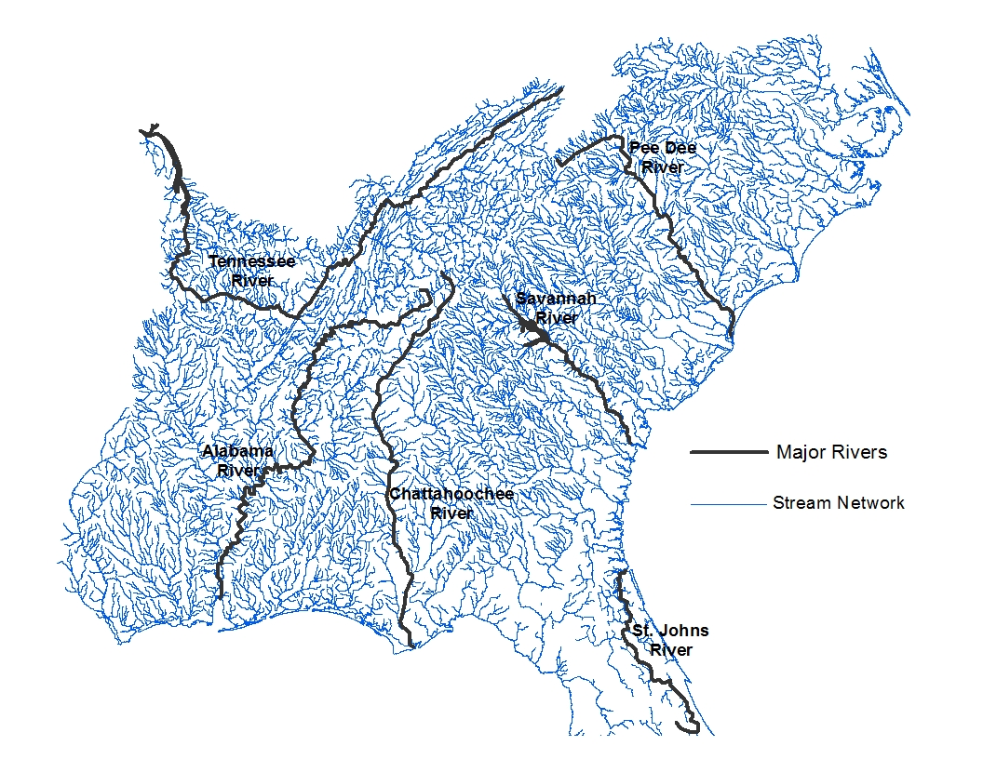
Figure 1 SAGT River Basin study Area
Source: Hoos et al. 2002; ESRI 2013

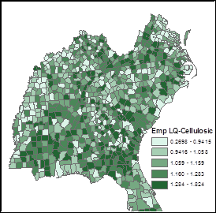
Figure 2 County-level LQs for the cellulosic ethanol sector

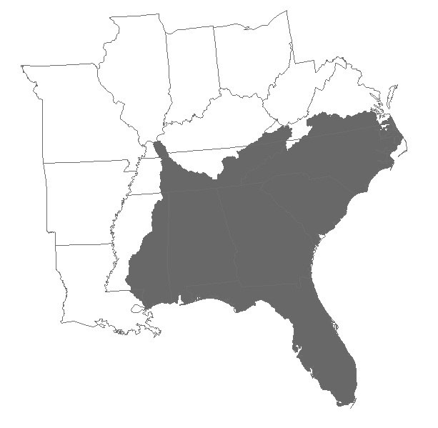
Figure 3 SAGT River Basin superimposed onto BioFLAME model area
Source: Hoos et al. 2002; ESRI 2013

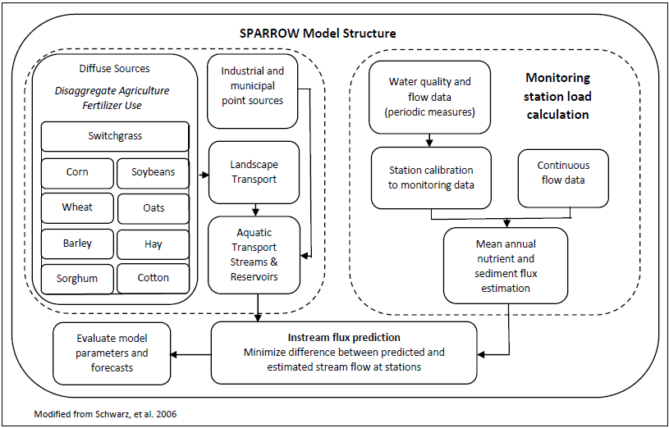
Figure 4 SPARROW model structure incorporating BioFLAME crops

Figure 5 Scenario A: Percentage change in total quantity of N applied to barley, corn, cotton, hay/pastureland, oats, sorghum, soybeans, wheat, and switchgrass in the SAGT River Basin relative to the 2009 baseline at 22%, 31%, 50% and 100% of the 10.5 BGY cellulosic ethanol target

Figure 6 Scenario B: Percentage change in total quantity of N applied to barley, corn, cotton, hay/pastureland, oats, sorghum, soybeans, wheat, and switchgrass in the SAGT River Basin relative to the 2009 baseline at 22%, 31%, 50% and 100% of the 10.5 BGY cellulosic ethanol target

Figure 7 Scenario A: Crop acres as a percent of total acres of the nine crops at 22%, 31%, 50% and 100% of the 10.5 BGY cellulosic ethanol target

Figure 8 Scenario B: Crop acres as a percent of total acres of the nine crops at 22%, 31%, 50% and 100% of the 10.5 BGY cellulosic ethanol target
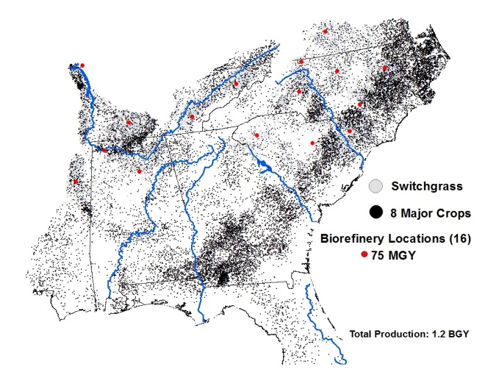 | 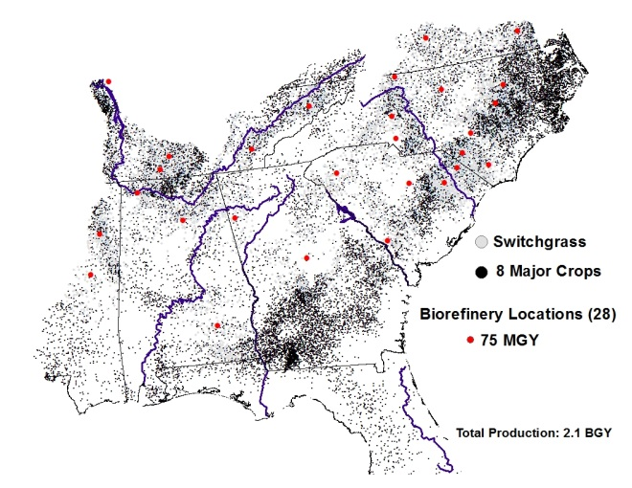
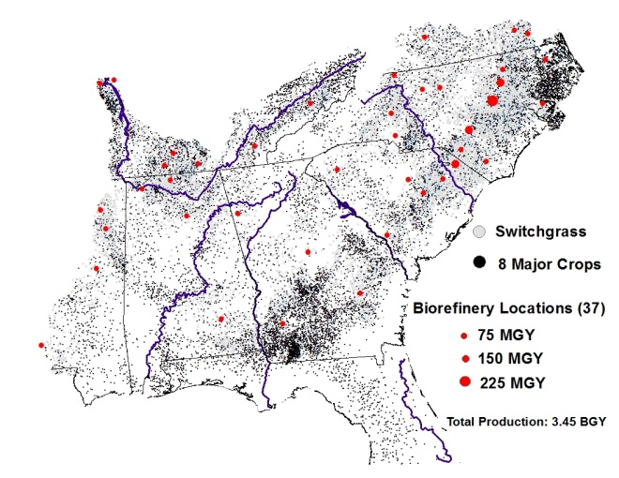 | 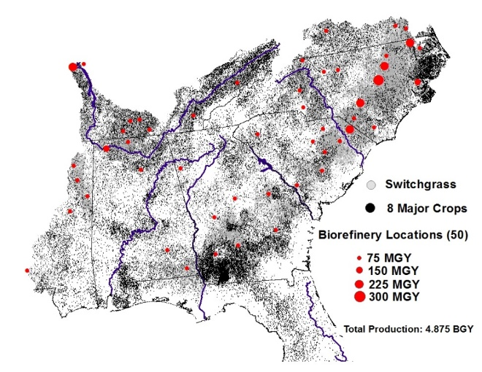

Figure 9 Scenario A: SAGT River Basin least-cost cellulosic biorefinery locations and agricultural feedstock distribution at 22%, 31%, 50%, and 100% of the 10.5 BGY cellulosic ethanol target

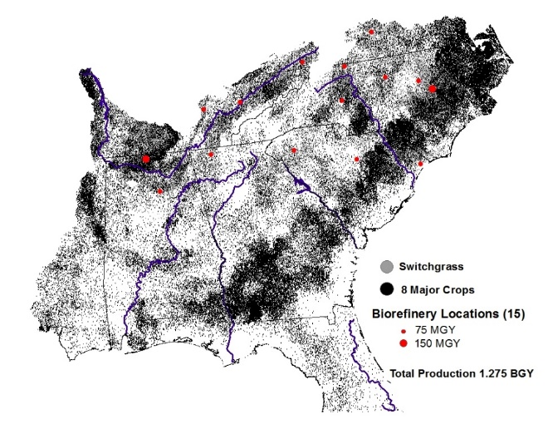 | 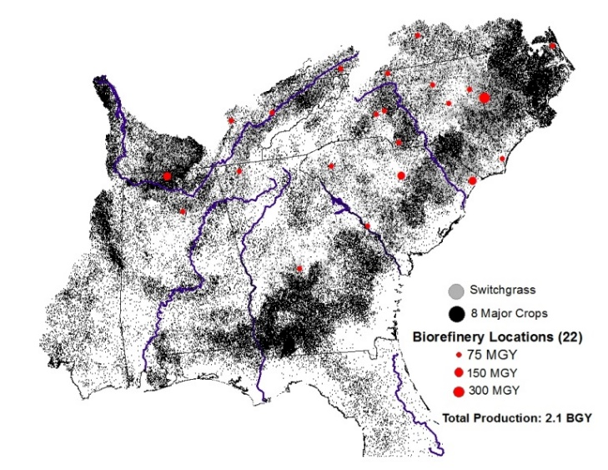
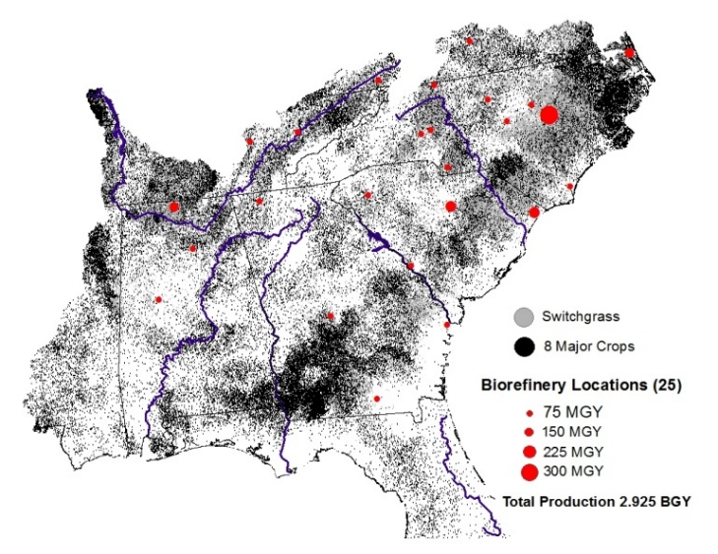 | 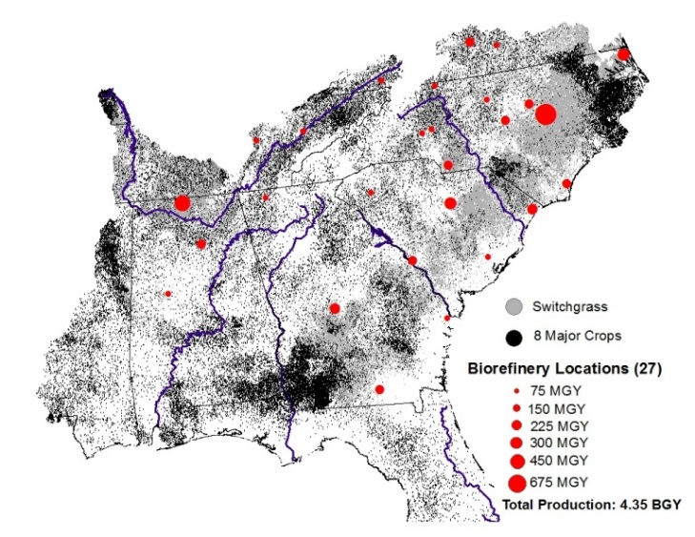

Figure 10 Scenario B: SAGT River Basin least-cost cellulosic biorefinery locations and agricultural feedstock distribution at 22% and 100% of the 10.5 BGY cellulosic ethanol target

Figure 11 Scenario A: SAGT River Basin mean flow weighted N concentration (block) and 95% confidence interval (line) at the baseline, 22%, 31%, 50%, and 100% of the cellulosic ethanol target. P-values for all production levels less than .001.

Figure 12 Scenario A: SAGT River Basin mean agriculture N source share (block) and 95% confidence interval (line) at the baseline, 22%, 31%, 50%, and 100% of 10.5 BGY cellulosic ethanol target. P-values for all production levels less than .001.

Figure 13 Scenario B: SAGT River Basin mean flow weighted N concentration (block) and 95% confidence interval (line) at the baseline, 22%, 31%, 50%, and 100% of the 10.5 BGY cellulosic ethanol target. P-values for all production levels less than .001.

Figure 14 Scenario B: SAGT River Basin mean agriculture N source share (block) and 95% confidence interval (line) at the baseline, 22%, 31%, 50%, and 100% of the 10.5 BGY cellulosic ethanol target. P-values for all productions levels less than .001.

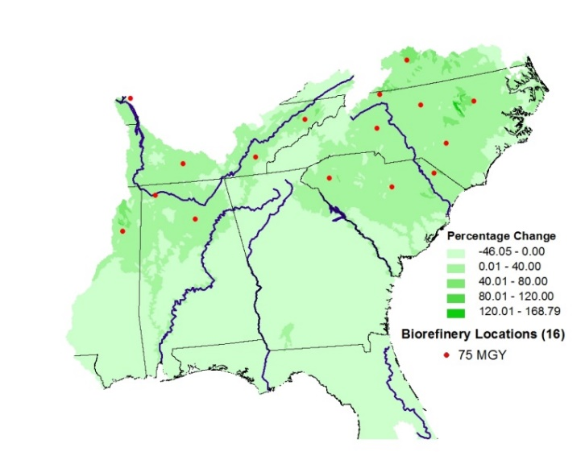 | 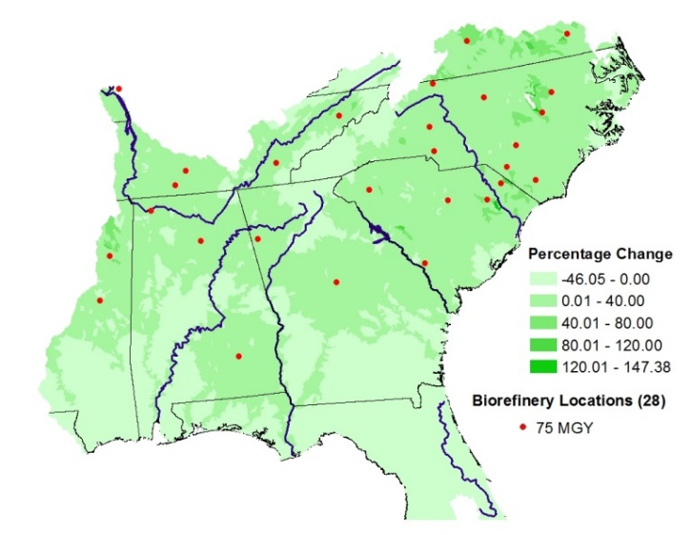
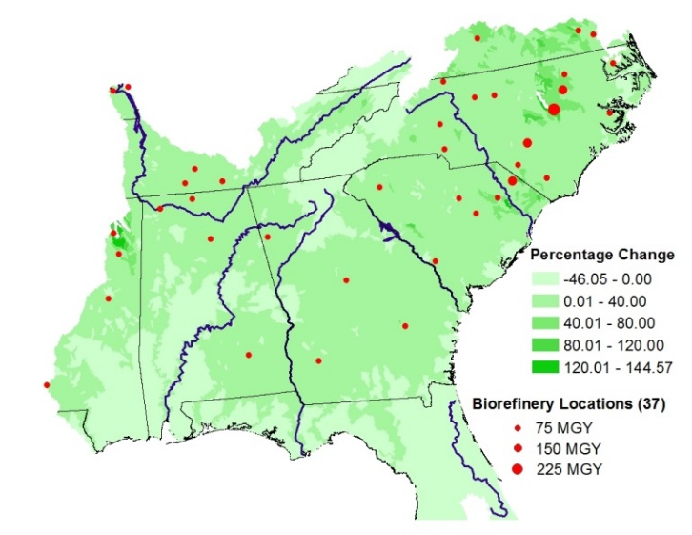 | 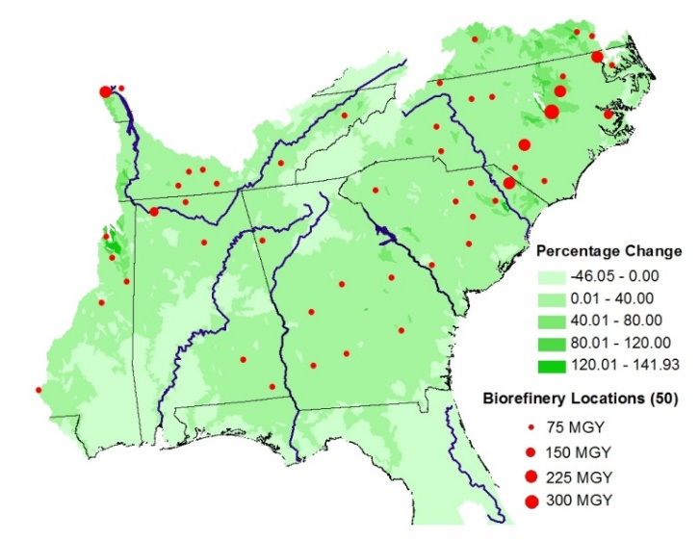

Figure 15 Scenario A: Least-cost cellulosic biorefinery locations and the percentage change in stream level N concentration relative to the 2009 baseline at 22%, 31%, 50%, and 100% of the 10.5 BGY cellulosic ethanol target

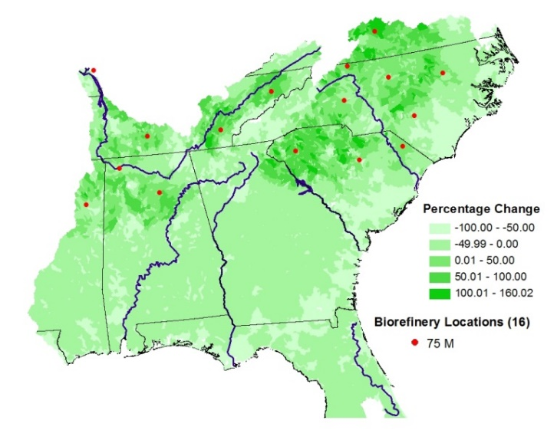 | 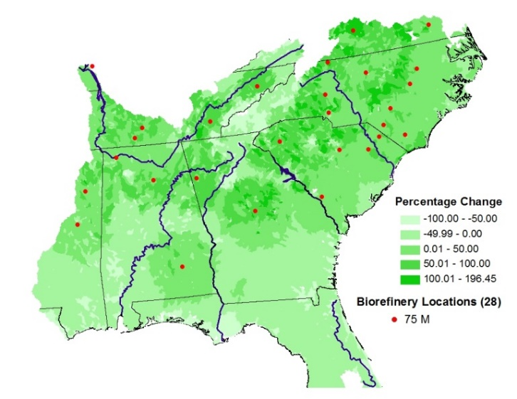
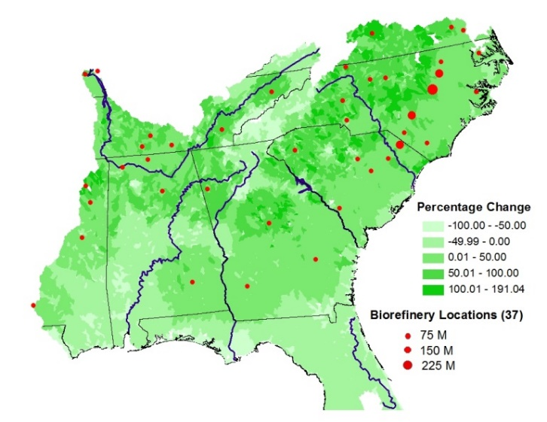 | 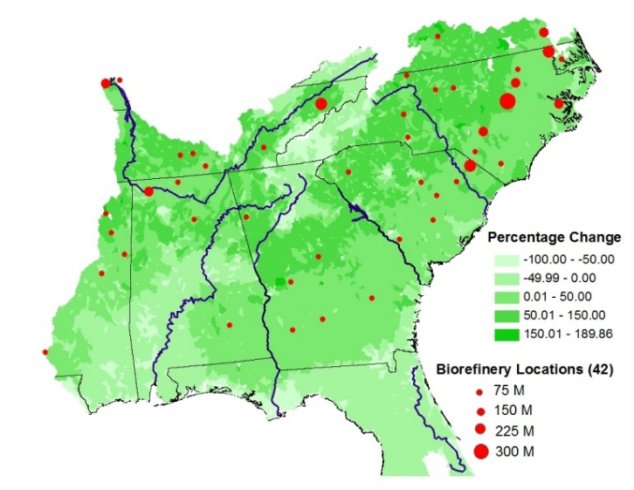

Figure 16 Scenario A: Least-cost cellulosic biorefinery locations and the percentage change in mean agricultural N source share relative to the 2009 baseline at 22%, 31%, 50%, and 100% of the 10.5 BGY cellulosic ethanol target
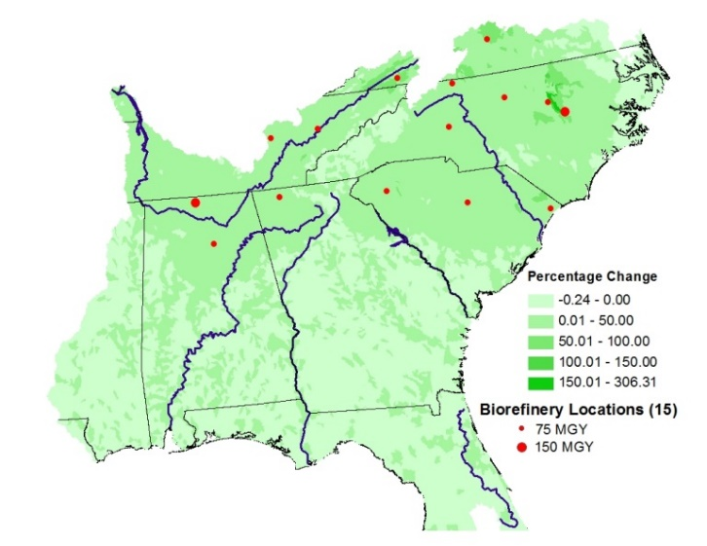 | 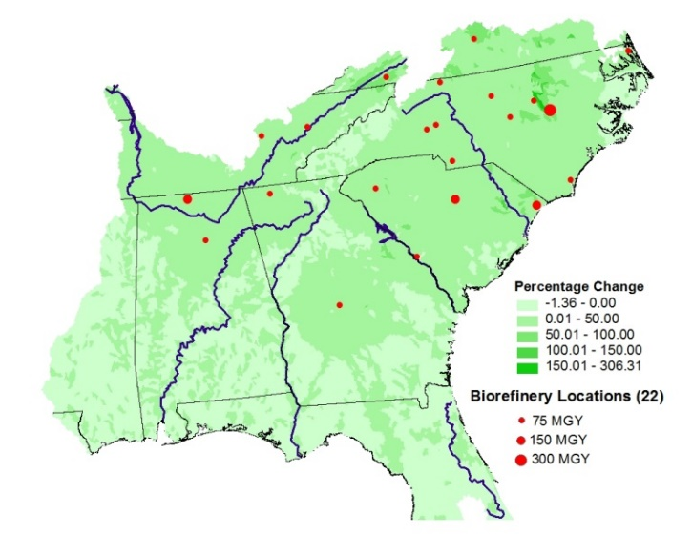
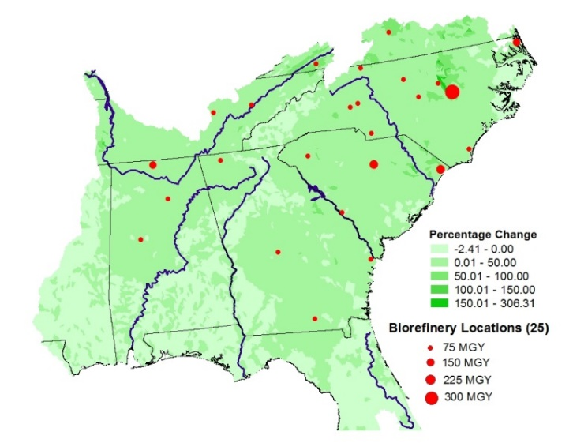 | 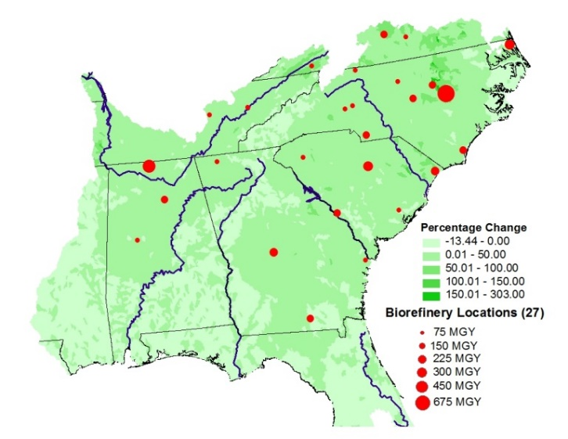

Figure 17 Scenario B: Least-cost cellulosic biorefinery locations and the percentage change in stream level N concentration relative to the 2009 baseline at 22%, 31%, 50%, and 100% of the 10.5 BGY cellulosic ethanol target

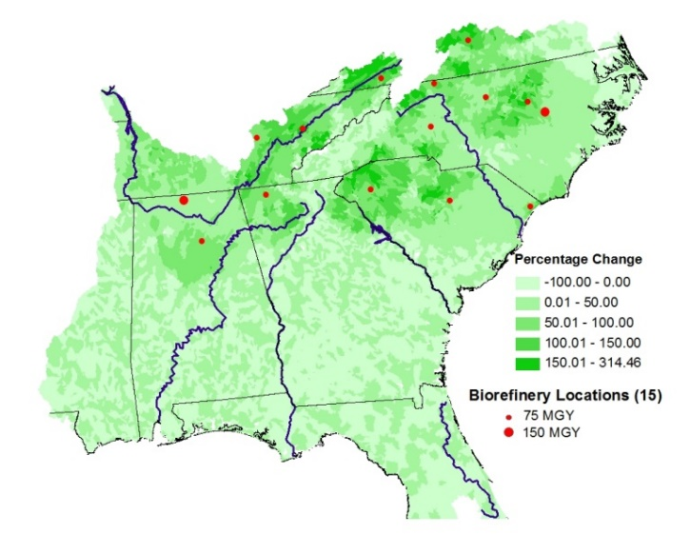 | 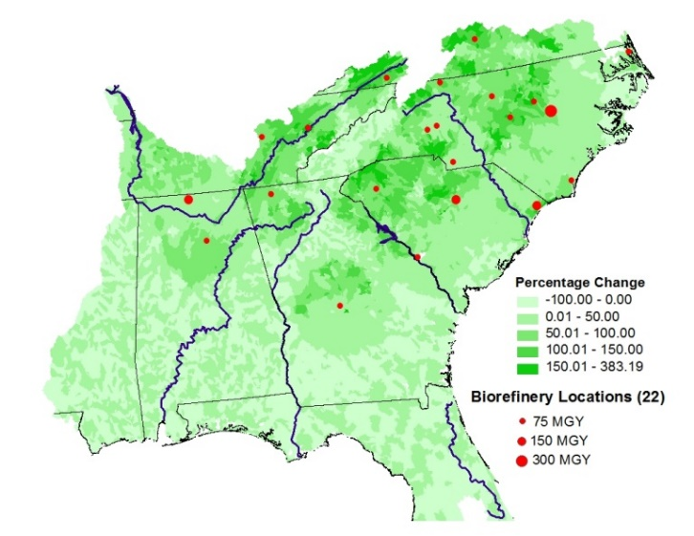
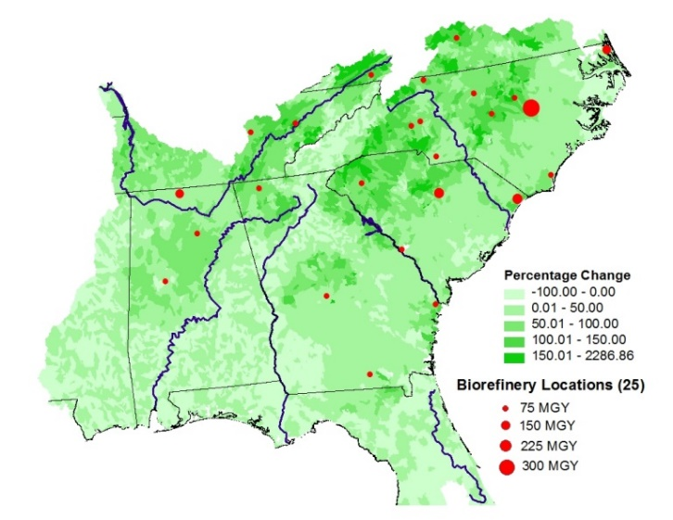 | 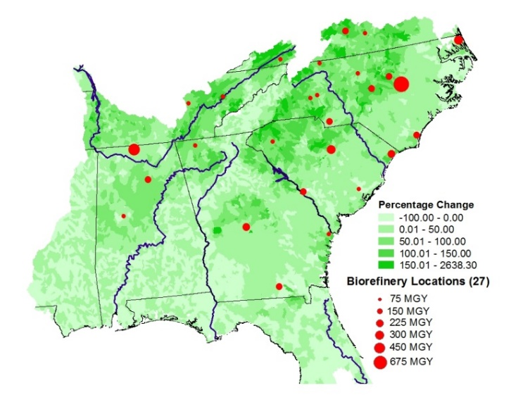

Figure 18 Scenario B: Least-cost cellulosic biorefinery locations and the percentage change in mean agricultural N source share relative to the 2009 baseline at 22%, 31%, 50%, and 100% of the 10.5 BGY cellulosic ethanol target
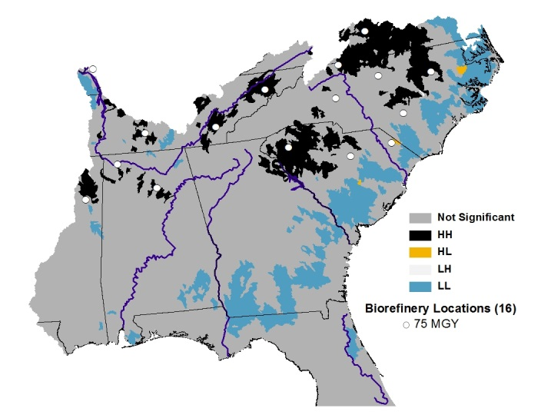 | 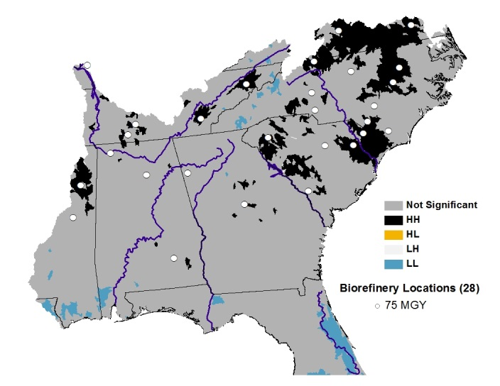
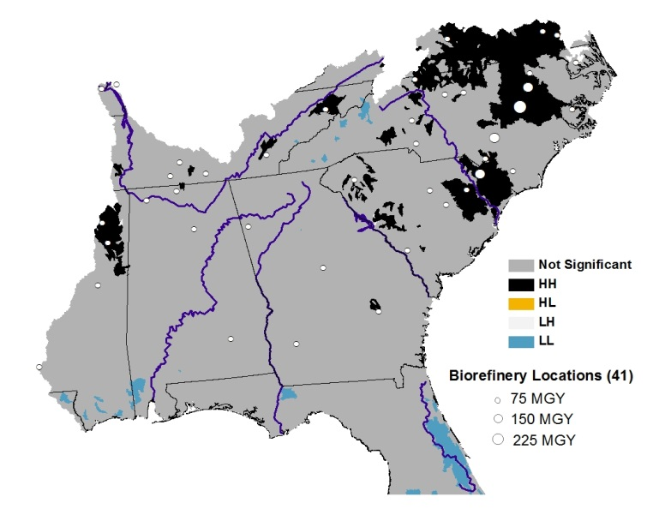 | 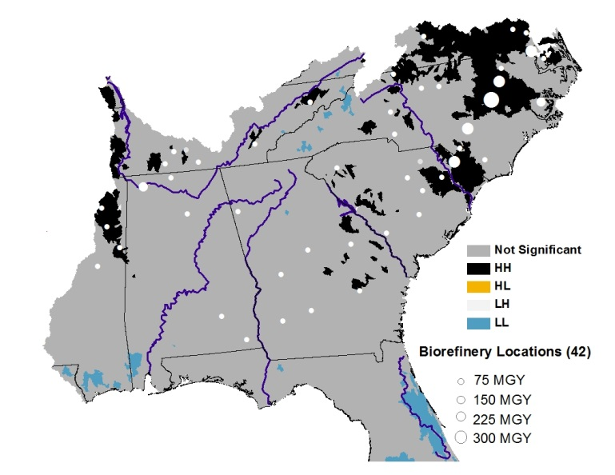

Figure 19 Scenario A: Local Moran’s I of percentage change in mean stream level N concentration relative to the 2009 baseline at 22%, 31%, 50%, and 100% of the 10.5 BGY cellulosic ethanol target
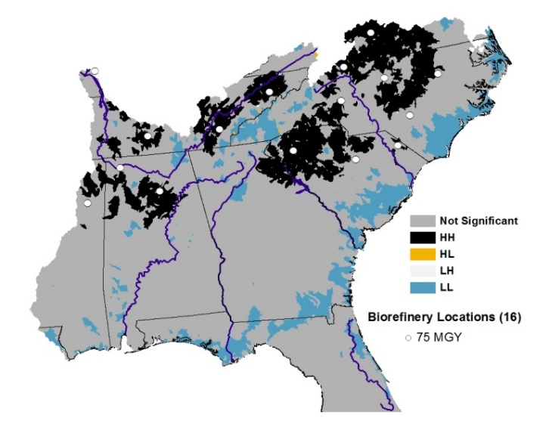 | 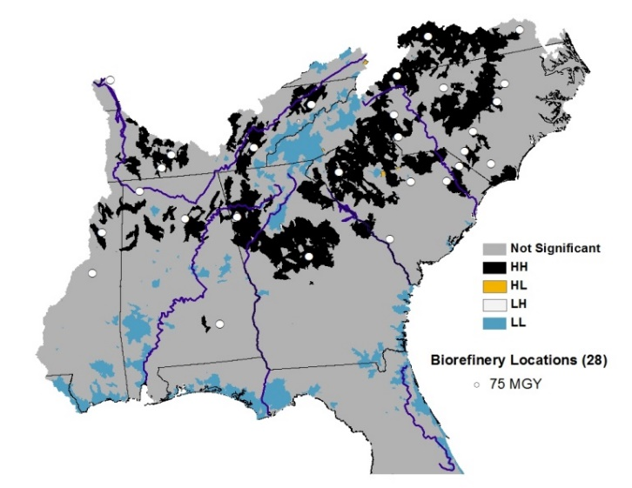
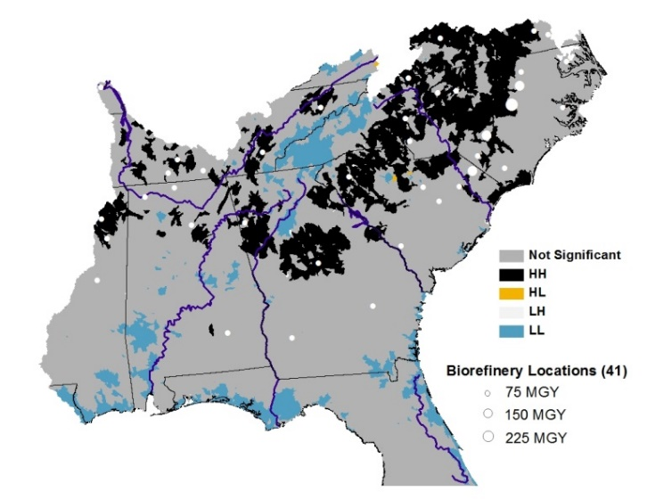 | 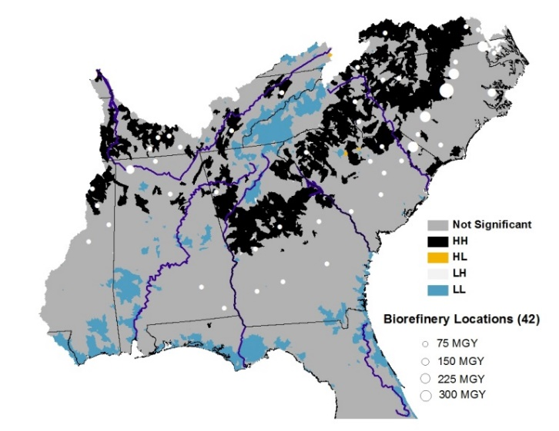

Figure 20 Scenario A: Local Moran’s I of percentage change in agricultural N source share relative to the 2009 baseline at 22%, 31%, 50%, and 100% of the 10.5 BGY cellulosic ethanol target
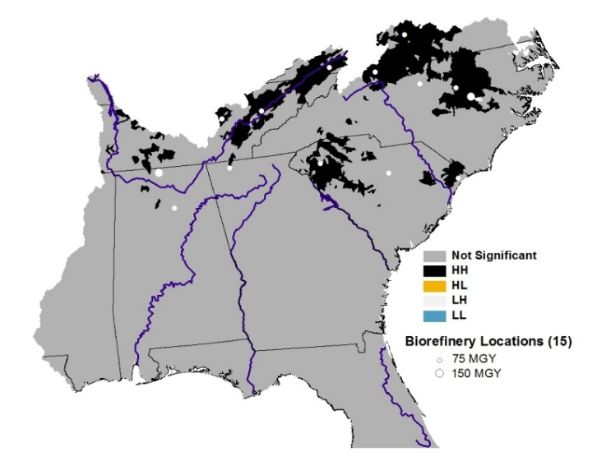 | 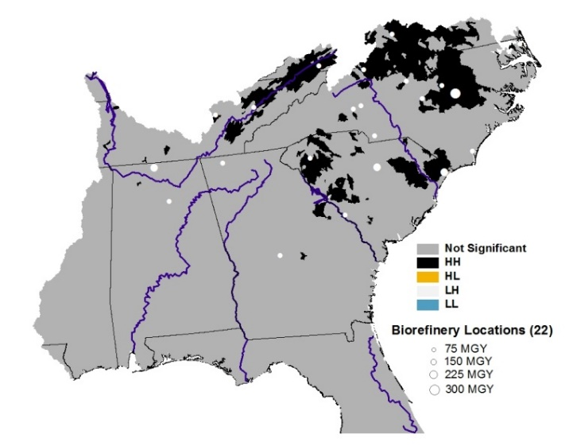
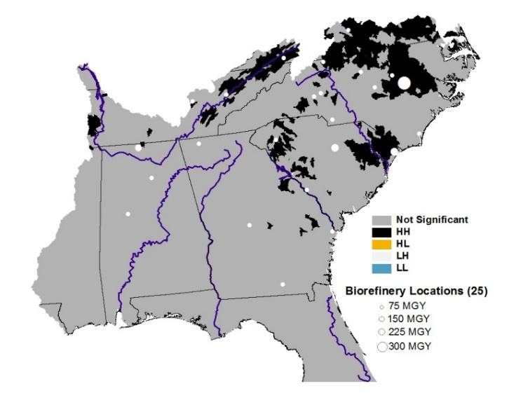 | 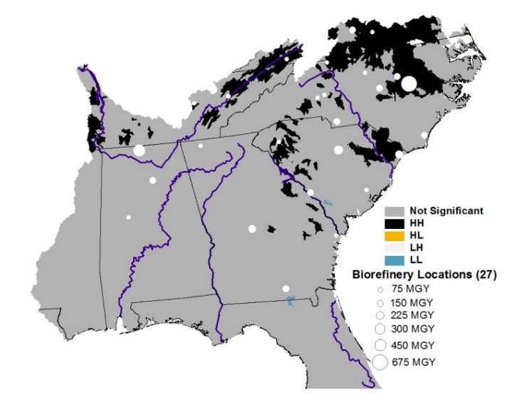

Figure 21 Scenario B: Local Moran’s I of percentage change in mean stream level N concentration relative to the 2009 baseline at 22%, 31%, 50%, and 100% of the 10.5 BGY cellulosic ethanol target
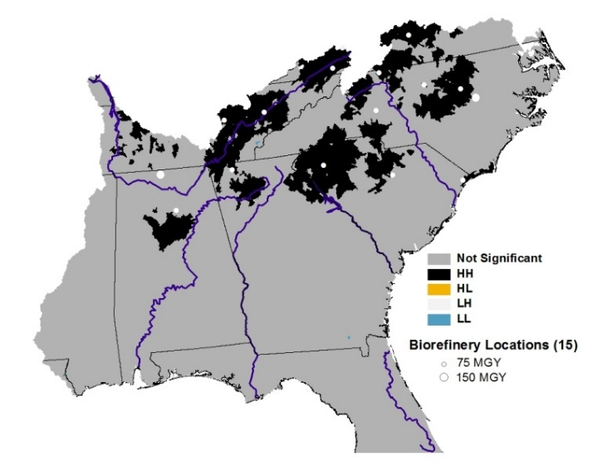 | 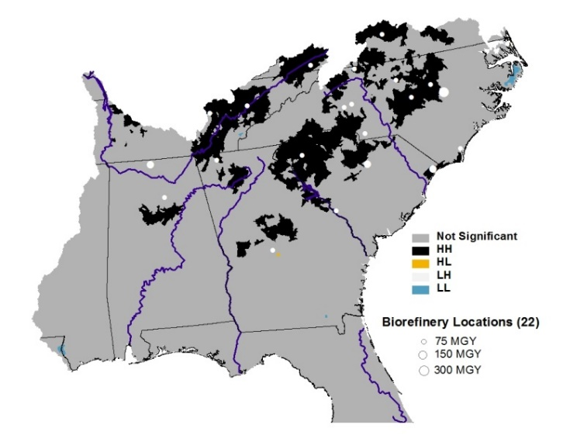
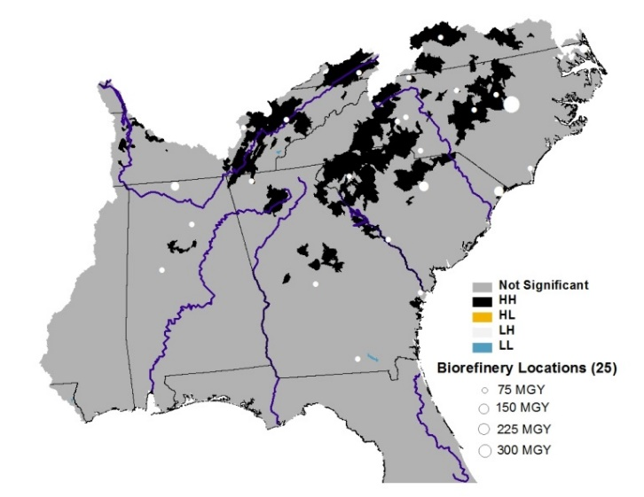 | 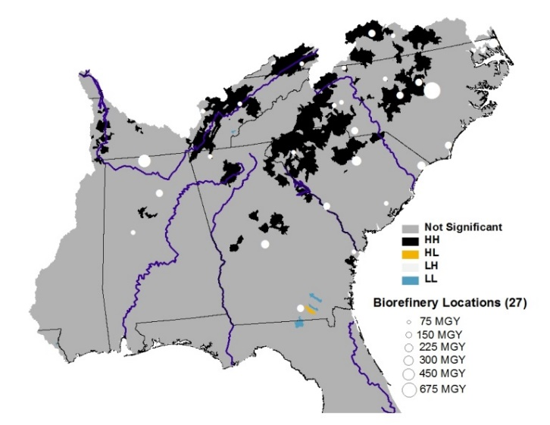

Figure 22 Scenario B: Local Moran’s I of percentage change in agricultural N source share relative to the 2009 baseline at 22%, 31%, 50%, and 100% of the 10.5 BGY cellulosic ethanol target

VITA

Kevin Cavasos is a master’s student at the University of Tennessee, Knoxville. He graduated from the University of Florida (High Honors) in 1995 with a bachelor’s degree in Finance. After working in real estate finance and development for 17 years, he enrolled at the University of Tennessee (UT) as a master’s student majoring in Agricultural and Resource Economics. He enjoys running, reading, and spending time with his wife and daughter.

All tables and figures located in the Appendix.

