Predators in the Petals: How crab spiders affect plants and their pollinators

A Dissertation Presented for the
Doctor of Philosophy
Degree
The University of Tennessee, Knoxville

Amanda Decker Benoit
August 2022

Copyright© 2022 by Amanda D. Benoit
All rights reserved

“You cannot get through a single day without having an impact on the world around you. What you do makes a difference, and you have to decide what kind of a difference you want to make”
Jane Goodall

I dedicate this dissertation to all those who have made a positive impact on my life, my spouse Danniel Siksay, my friend Elizabeth Stevens, my parents Bev and Ernie Benoit, Natalie Fraser, David Siksay, Olga Fraser, and all those who choose to promote kindness, curiosity, and growth.

ACKNOWLEDGEMENTS
Many thanks to my advisor Susan Kalisz for her mentorship, support, and guidance, and my committee members James Fordyce, Laura Russo, Charles Kwit, and Susan Riechert.
Sincere thanks to Danielle Coye and Dylan Patel for field assistance, directors and staff of the UC Davis McLaughlin Reserve for their support and assistance, and to Daniel Malagon, Katie Brown, Jennifer Hinds, Kristen Mecke, Harley DiMarco, Nick Koziol, Drew Freshour, and Alex Faidiga for assistance with greenhouse and lab work, and to Jeff Martin and Kaitlyn Palla for their work managing the greenhouse. Thank you to Jessie Mutz, Will Ryan, Morgan Roche, Alex Faidiga, Kristen Mecke, Robert McEldery, and Lalasia Bialic-Murphy and all other members of the Kalisz lab who provided feedback and advice throughout the development of this work. This work was funded by awards from the Society of Evolution, Rosemary Grant Research Award (2017); Botanical Society of America, Graduate Student Research Award (2017); the TENN Herbarium for the Breedlove, Dennis Fund Award (2018); and the Department of Ecology and Evolutionary Biology at the University of Tennessee, Knoxville for Graduate Research Awards (2016, 2017, 2018, 2019, and 2020).

ABSTRACT
Plants are literally rooted; they rely on biotic or abiotic vectors to carry their pollen and enable outcross mating. Most angiosperms partner with insect pollinators. These pollinators, by mediating sexual reproduction, directly impact plant reproduction and affect plant fitness, selection on plant traits, plant mating system, and population genetics. However, because flowers are reliable places to find high numbers of insect visitors, many predators exploit flowers as hunting sites. Predators that specialize on hunting floral visitors, i.e., pollinator predators, are an understudied group of predators and their direct effects on pollinators and indirect effects on flowering plants are poorly understood. I explore the history of research on pollinator predators and summarize what I know in chapter one, highlighting gaps in my understanding, and future research directions. I then present original research aimed at enhancing my understanding of the complex direct and indirect interactions among pollinator predators, floral visitors, and flowering plants. In chapter two, I investigate the impact of crab spiders, common pollinator predators that ambush floral visitors, on the strength and direction of phenotypic selection on floral traits of the yellow mariposa lily, Calochortus luteus (Liliaceae), and seed set as a component of plant female fitness. I find evidence that crab spiders are causal agents of selection on plant traits, and can affect seed set. In chapter three, I explore the effects of crab spider presence on the behavior of floral visitors, and the consequence for C. luteus pollination. I find that the presence of a crab spider significantly reduces pollinator visitation frequency and duration, and decreases stigma and anther contact, yet does not detectably affect pollen limitation or selfing rates. In chapter four, I present the results of a multi-year greenhouse and genetic study to investigate the impact of crab spiders on fitness, inbreeding depression, and population genetics of C. luteus. I find evidence of inbreeding depression within this population of C. luteus. Plants that are the product of outcross pollination have significantly higher fitness metrics than plants that are the product of self-pollination; however, when grown in low-stress greenhouse conditions fitness differences were not apparent until the plants reached adulthood (~3 years). I predicted that progeny from flowers that harbored crab spiders would be more likely to be self-pollinated and therefore would express higher levels of inbreeding depression than progeny from crab spider free plants. I found limited support for this prediction with non-significant trends in the predicted direction. Continued data collection may reveal additional cumulative negative effects of inbreeding depression on the fitness of plants produced via selfing. Together, this body of work suggests that predators in higher trophic levels can have meaningful indirect and direct effects on plants by altering selection on plant traits, pollination, and possibly even population genetics.

TABLE OF CONTENTS
INTRODUCTION…………………………………………………………………………………………………………………………1
CHAPTER I: PREDATOR EFFECTS ON PLANT-POLLINATOR INTERACTIONS, PLANT REPRODUCTION, MATING SYSTEMS, AND EVOLUTION…….………………………………………………..………3
Abstract………………………………………………………………………………………………………………………….4
Introduction……………………………………………………………………………………………………………………5
Historical context and current understanding of predation on pollinators……………………..6
Predator effects on pollinator abundance and behavior………………………………………………10
Effects of pollinator predators on plant-pollinator interactions……………………………………13
Pollinator predator effects on plant reproduction…………………………………………………….….15
The effect of predator hunting mode on plant-pollinator interactions and for selection on plant traits……………………………………….………………………………………………………………….….19
Conclusions………………………………………………………………………………………………………………….24
Future issues……………………………………………………………………………………………………….……….25
References…………………………………………………………………………………………………………………27
CHAPTER II: POLLINATOR PREDATOR INDIRECTLY AFFECTS THE STRENGTH OF PHENOTYPIC SELECTION ON FLORAL TRAITS…..……………………………………………………………………………………………37
Abstract…………………………………………………………………………………………………………………….…38
Introduction…………………………………………………………………………………………………………………39
Materials and Methods………………………………………………………………………………………………..44
Results …………………………………………………………………………………………………………………………50
Discussion …………………………………………………………………………………………………………………...59
References………………………………………………………………………………………………….……..………66
Appendix……………………………………………………………………………………………………..……..……...72
Chapter III: THE EFFECTS OF SIT-AND-WAIT PREDATORS ON POLLINATION: THE PRESENCE OF A CRAB SPIDER ON A MARIPOSA LILY REDUCES POLLINATOR VISITATION FREQUENCY, DURATION, AND STIGMA & ANTHER CONTACT……………………………………………………………………………………….....81
Abstract……………………………………………………………………………………………………………………….82
Introduction…………………………………………………………………………………………………………………83
Materials and Methods………………………………………………………………………………………………..86
Results ………….……………………………………………………………………………………………………..……..90 Discussion ………………………………………………………………………………………………………..………...96
References……….…………………………………………………………………………………………..…………106

Chapter IV: DIRECT AND INDIRECT EFFECTS OF SIT-AND-WAIT PREDATORS ON MATING SYSTEM, INBREEDING DEPRESSION, AND POPULATION GENETICS OF THE YELLOW MARIPOSA LILY…….110
Abstract……………………………………………………………………………………………………………….……111
Introduction…………………………………………………………………………………………………….………..112
Materials and Methods…………………………………………………………………………………………..…114
Results ………………………………………………………………………………………………………….…..………117
Discussion ………………………………………………………………………………………………………..……….122
References………………………………………………………………………………………………….……..……125
CONCLUSION…………………………………………………………………………………….………………………….……….128
References…………………………………….………………………………………………………………………..130
VITA…………………………………………………………………………………………………………………………….…………132

LIST OF TABLES
Table 2.1. Results of paired t-tests comparing traits of Calochortus luteus plants that were naturally colonized by crab spiders to the traits of spatially and temporally paired plants that were crab spider-free………………………………………………………………………………………………………………51
Table 2.2. Results of a general linear model estimating the effects of crab spiders, mammalian herbivores, pre-dispersal seed herbivores, and interactions among them, on the seed set of Calochortus luteus plants (n = 238) in 2017………………………………………………………………………………51
Table 2.3. Results of a general linear model estimating the effects of crab spiders, mammalian herbivores, pre-dispersal seed herbivores, and interactions among them, on the seed set of Calochortus luteus plants (n = 301) in 2018.…………………………………………………………………………….53
Table 2.4. Results of a general linear model estimating the effects of experimental crab spider addition vs. absent treatment as well as natural mammalian herbivore damage, pre-dispersal seed pre-dispersal seed herbivore damage, and interactions among them, on the seed set of Calochortus luteus plants (n = 288) along transects in 2018.……………………………………………………58
Table 3.1. Frequency of insect taxa visiting flowers of Calochortus luteus when crab spiders were absent and added.……………………………………………………………………………………………………….…91
Table 3.2. Frequency of insect inspection and reject, insect visitation, and plants with zero inspections/visits for 182 Calochortus luteus plants randomly assigned to crab spider absent or addition treatments and observed for 15 minutes.………………………………………………………………….91
Table 3.3. Frequency of floral visitors contacting reproductive structures of Calochortus luteus flowers when crab spiders are absent and added.………………………………………………………………….94
Table 3.4. ANOVA table for a generalized linear mixed model examining predictors of whether floral visitors contact the stigma of Calochortus luteus.………………………………………………………….95
Table 3.5. ANOVA table for a generalized linear mixed model examining predictors of whether floral visitors contact the anthers of Calochortus luteus.…………………………………………………………95
Table 3.6. Results of a linear mixed effects model with the seed set of Calochortus luteus as the dependent variable.………………………………………………………………………………………………………………..97
Table 3.7. Results of a linear mixed effects model examining seed set of Calochortus luteus plants that were emasculated vs. intact (emasculation treatment) and had crab spiders added vs. absent (crab spider treatment) and the interaction between the emasculation and crab spider treatments.……………………………………………………………………………………………………………………98
Table 3.8. Summary of a mixed effects model examining predictors of Calochortus luteus seed set along experimental transects where open pollinated plants were randomly assigned to a crab spider treatment (absent vs. added).…………………………………………………………………….………101

LIST OF FIGURES
Figure 1.1. (a) A tri-trophic food web among plants, primary consumers, and predators………7-8
Figure 1.2. Web of Science and Google Scholar searches yielded 62 relevant articles describing 114 predator-pollinator taxonomic pairings (e.g., Thomisidae consuming Bombus)…………….……9
Figure 1.3. Predictions regarding how predator hunting mode and location affect pollinator behavior and abundance and how these interaction modifications affect the strength and direction of phenotypic selection on plant traits…………………………………………………………………20-21
Figure 2.1. Conceptual figure illustrating simultaneous effects of pollinator preferences and sit-and-wait pollinator predator distribution across plant phenotypes on the strength and direction of selection on floral traits (here using flower size as an example trait)................................41-42
Figure 2.2. Behavior of a crab spider (Misumena vatia) and a sweat bee (Halictidae) in a Calochortus luteus flower..………………………………………………………………………………………………………46
Figure 2.3. Fitness (seed set per plant) of Calochortus luteus observed in 2017 and 2018, comparison of paired plants with crab spiders absent and present (top), plants with and without mammalian herbivore damage (middle), and with and without pre-dispersal seed herbivore damage (bottom)..…………………………………………………………………………….………………….…52
Figure 2.4. Linear selection gradients (ꞵ ± SE) estimated via multiple regression of standardized traits of Calochortus luteus plants using relativized seed set per plant as a fitness metric……….55
Figure 2.5. Linear selection gradients (ꞵ ± SE) estimated via multiple regression of standardized traits of Calochortus luteus plants using relativized seed set per plant as a fitness metric…….…56
Figure 2.6. Linear selection gradients (ꞵ ± SE) estimated via multiple regression of standardized traits of Calochortus luteus plants using relativized seed set per plant as a fitness metric……….60
Figure 3.1. Insect visitation during a 15-minute observation to pairs of Calochortus luteus flowers with one plant randomly assigned to a crab spider absent treatment and the other to a crab spider addition treatment..……………………………………………………………………………………………...92
Figure 3.2. Mean visit duration at paired Calochortus luteus plants with crab spiders absent and added. When a plant had more than one visitor the visit lengths were averaged……………………93
Figure 3.3. Total visit duration at paired Calochortus luteus plants with crab spiders absent and added...……………………………………………………………………………………………………………………………………94
Figure 3.4. Seed set of Calochortus luteus that were open pollinated or that received supplemental pollen via hand pollination and that had crab spiders absent or added……………..97
Figure 3.5. Seed set of Calochortus luteus plants that were emasculated (anthers removed to prevent self-pollination) vs. intact (anthers unmanipulated, outcross and self-pollination possible) with crab spiders absent and added.…………………………………………………………………………99
Figure 3.6. Seed set of Calochortus luteus plant randomly assigned to crab spider absent and added treatments and open pollinated along experimental transects at McLaughlin Reserve, Lake County, California.…………………………………………………………………………………………………………100
Figure 3.7. A female crab spider (Misumena vatia) hunting from a Calochortus luteus flower with a visiting bee (Lasioglossum sp.).……………………………………………………………………………………103
Figure 4.1. Seed set of greenhouse-raised and hand pollinated Calochortus
luteus plants that flowered in 2021..…………………………………………………………………………………..…119
Figure 4.2. Percentage of Calochortus luteus individuals planted as seed in 2018 that were alive as of January 2021 from the four maternal pollination treatment groups………………………………120
Figure 4.3. Estimated F_{IS} (inbreeding coefficient) with 95% confidence intervals for offspring of maternal plants with crab spiders absent vs. present.……………………………………………..…………….121

INTRODUCTION
Plants are the foundation of life. They convert sunlight and carbon dioxide into food that nourishes nearly all other lifeforms on Earth. As creators of food, with few exceptions, plants are connected to all other life. These connections can be direct, for example, when I eat my bagel with avocado, the wheat that grew the grain and the avocado tree that grew the fruit nourish me. These connections can also be indirect, for example outside my window a chickadee plucks a caterpillar from an oak and drops it into the gaping jaws of her eager chick; the oak nourishes the caterpillar, and the caterpillar nourishes the chick, therefore the oak indirectly feds the chick. These connections and interactions have consequences; through connections, lifeforms shape one another. These connections are an ontology: connections and interactions are the foundation of the world around us. There is no “self”, only inter-being. Every individual is a result of millennia of interactions.
Plants’ direct interactions with other species can be beneficial for the plant, such as those with pollinators and seed dispersers, or antagonistic, such as those with herbivores that consume leaves, flowers, and seeds. Species that provide benefits to plants in exchange for resources (or other benefits) like pollinator, are mutualists. Alternatively, antagonists, such as herbivores, consume plant tissues without providing any benefit in return. Both plant mutualists and antagonists are consumed by predatory organisms that are higher in the food web. Predators can exert strong top-down control on their prey, altering their abundance and behavior. By altering the abundance and behavior of plant mutualists and antagonists, predators indirectly affect plants.
In what follows, I explore how predators affect plants by altering their interactions with floral visitors. Plants are literally rooted; they rely on biotic or abiotic vectors to carry their gametes and enable outcross mating. Most angiosperms partner with insect pollinators to carry their pollen. By mediating mating opportunities, pollinators directly impact plant mating. Therefore, plant-pollinator interactions have important consequences for plant reproductive fitness, natural selection on plant traits, and population genetics.
Because flowers are reliable places to find high numbers of insect visitors, predators have evolved to exploit flowers as hunting sites. Some predators with sit-and-wait hunting modes hunt directly from flowers, ambushing visiting insects, while others with active hunting modes may hunt floral visitors within flowering patches. Predators that specialize on hunting floral visitors, i.e., pollinator predators, are an understudied group of predators and their direct effects on pollinators and indirect effects on flowering plants are only beginning to be examined.
In chapter one, I explore the history of research on pollinator predators and summarize what I know, gaps in my understanding, and future research directions. In chapters two through four I present original research aimed at enhancing my understanding of the complex direct and indirect interactions among pollinator predators, floral visitors, and flowering plants. In chapter two, I investigate the impact of crab spiders, common pollinator predators that ambush floral visitors, on the strength and direction of phenotypic selection on floral traits of the yellow mariposa lily, Calochortus luteus (Liliaceae), and seed set as a component of plant female fitness. In chapter three, I explore the effect of crab spider presence on the behavior of floral visitors, and the consequence for C. luteus pollination. In chapter four, I present the results of a multi-year greenhouse and genetic study to investigate the impact of crab spiders on fitness, inbreeding depression, and population genetics of C. luteus.

CHAPTER I: PREDATOR EFFECTS ON PLANT-POLLINATOR INTERACTIONS, PLANT REPRODUCTION, MATING SYSTEMS, AND EVOLUTION

This chapter was originally published by Amanda D. Benoit and Susan Kalisz:
Benoit, A. D., & Kalisz, S. (2020). Predator effects on plant-pollinator interactions, plant reproduction, mating systems, and evolution. Annual Review of Ecology, Evolution, and Systematics, 51, 319-340.
Abstract
Plants are the foundation of the food web and therefore interact directly and indirectly with myriad organisms at higher trophic levels. They directly provide nourishment to mutualistic and antagonistic primary consumers (e.g., pollinators and herbivores), which in turn are consumed by predators. These interactions produce cascading indirect effects on plants (either trait-mediated or density-mediated). I review how predators affect plant-pollinator interactions and thus how predators indirectly affect plant reproduction, fitness, mating systems, and trait evolution. Predators can influence pollinator abundance and foraging behavior. In many cases, predators cause pollinators to visit plants less frequently and for shorter durations. This decline in visitation can lead to pollen limitation and decreased seed set. However, alternative outcomes can result due to differences in predator, pollinator, and plant functional traits as well as due to altered interaction networks with plant enemies. Furthermore, predators may indirectly affect the evolution of plant traits and mating systems.

Full text available from publisher: https://doi.org/10.1146/annurev-ecolsys-012120-094926

Introduction
All organisms are embedded within food webs and interact directly and indirectly with other species. Plants convert sunlight and atmospheric CO2 into carbon compounds that nourish a diverse community of primary consumers ranging from plant enemies (e.g., herbivores or pathogens) to mutualists (e.g., pollinators, fungi, ants). When these primary consumers are preyed upon by secondary consumers (i.e., predators), trophic cascades can be generated with indirect positive, neutral, or negative effects on plant fitness (Ripple et al. 2016). Predation on plant enemies generates diverse indirect ecological effects that typically improve plant growth and reproduction (Hairston et al. 1960, Schmitz et al. 2000). The indirect effects generated by predation on mutualistic primary consumers are less well studied but are expected to negatively affect plant reproduction and population growth (Knight et al. 2006). Further, by altering plant fitness and plant-animal interactions, predators are expected to indirectly affect the evolution of plant traits, particularly floral traits and plant mating systems (Estes et al. 2013, Walsh 2013, McPeek 2017, terHorst et al. 2018).
In this review we focus on the keystone mutualism between plants and their pollinators, a reciprocal relationship vital for the integrity of natural ecosystems, agricultural systems, and human economies. Because plants are stationary, they have evolved elaborate strategies to achieve outcrossed sexual reproduction, often engaging animal pollinators to carry pollen between plants. In exchange, plants offer nectar, pollen, scent, or other valuable resources to reward their pollinators. Pollinators are thought to be the key drivers of the evolution of floral forms. Pollinators exert natural selection on their plant partners, and shifts in pollinators explain ∼25% of the shifts in floral diversity across angiosperms (van der Niet and Johnson 2012). Thus, information about additional unmeasured factors, or those not previously considered, is needed to understand the process of floral evolution.
While plant evolution and pollination mutualisms have long been a central focus of biology [Sprengel 1793, Darwin 2018 (1859)], they are typically studied as pairwise interactions without considering the indirect effects generated by multispecies interactions and higher trophic levels (Strauss and Irwin 2004, Strauss and Whittall 2006). To understand the forces that shape plant ecology and evolution, we need to integrate the study of plants and pollination with community ecology and consider the direct and indirect effects of predators (terHorst et al. 2018). In this review, we begin to fill this gap by providing evidence for the varied effects of predators on plants via pollinators. We highlight the evidence for indirect effects of predators on plant reproduction, mating systems, and the evolution of floral traits. We end with future avenues of research and approaches to test the role of pollinator predators in shaping the evolution of plant reproductive strategies.
Predators of pollinators exploit and disrupt plant-pollinator mutualisms by consuming pollinators and altering their behavior, with myriad potential consequences for plants. By decreasing pollinator abundance, predators create density-mediated indirect interactions (DMII; Abrams 1995; Fig. 1.1). Furthermore, the presence of predators can alter aspects of pollinator foraging behavior through risk effects (Preisser et al. 2005, Creel and Christianson 2008) and affect plants via trait-mediated indirect interactions (TMII; Werner and Peacor 2003; Fig. 1.1). Predation on pollinators is widespread and common both geographically and taxonomically.
We searched the literature on predators of pollinators for natural history sightings, scientific studies, and other reports of predators. We found examples of pollinator predators in diverse ecosystems around the globe. Predators of pollinators include insects such as wasps (Hymenoptera), dragonflies (Odonata), true bugs (Hemiptera), flies (Diptera), and mantids (Mantidae), as well as spiders (Araneae), various birds (Aves), lizards (Squamata), and frogs (Ranidae; Fig. 1.2). Pollinator predators are ubiquitous and diverse and have the potential to commonly affect plant pollinator interactions, plant fitness, and reproduction across ecosystems.
Historical context and current understanding of predation on pollinators
One of the earliest written descriptions of predation on pollinators affecting plant communities comes, unsurprisingly, from the keen observations of Darwin. In On the Origin of Species, Darwin [2018 (1859)] notes that domestic cats control populations of mice, thereby limiting the amount of honeycomb that mice eat, in turn affecting honey-bee populations and the abundance of red clover. Darwin [2018 (1859), p. 51] concludes, “Hence it is quite credible that the presence of a feline animal in large numbers in a district might determine, through the intervention first of mice and then of bees, the frequency of certain flowers in that district!” Despite Darwin’s description of pollinator predators causally shaping plant populations, the misconception that predation on pollinators was rare and insignificant took hold, and the effects of pollinator predators on plants were rarely considered until recently. Two main assumptions led to this misconception: Hymenoptera, the most common pollinators on Earth, were assumed to be protected from predation by their defensive sting, and pollinator predators were assumed to be too rare and have too low a prey-capture rate to impact pollinators (Morse 1986, Dukas 2001b, Schmalhofer 2001). Further, workers from pollinating social insect taxa were viewed as numerous and expendable. Therefore, it was assumed that selective pressure for predator-avoidance behaviors would be negligible, or negated by stronger selection to maximize resource acquisition (Morse 1986). Because few studies directly addressed these ideas, nearly two decades ago Dukas (2001b) called for studies to fill the knowledge gap. Since then, research focused on predator-pollinator interactions has demonstrated that predators can significantly affect pollinator abundance and behavior. We review evidence regarding the effects of predators on pollinator abundance and behavior published since the review by Dukas

Figure 1.1. (a) A tri-trophic food web among plants, primary consumers, and predators. The direct effects of each trophic level on the organisms it consumes are shown by solid arrows; the strength of these effects is shown by the arrow width. Positive effects are indicated by green arrows and a plus symbol, and negative effects are shown as purple arrows with a minus symbol. The predator community (represented by red) negatively affects the community of primary consumers (blue); however, it is important to note that not all primary consumers are equally affected. The effect strength is context and taxon dependent. Further, primary consumers compete with and affect one another. The primary consumers range from having positive (mutualistic, +), to neutral (0), to negative (antagonistic, −) effects on plants. Again, the strength of these effects depends on context and taxon. Panels b and c depict the mechanisms by which predators can indirectly affect plants via (b) mutualists and (c) antagonists. Indirect effects are represented by dashed arrows. Predators indirectly affect plants both by altering the density of primary consumers [density-mediated indirect interaction (DMII)] and/or by affecting the traits of primary consumers (represented by darker blue icons), especially foraging behavior [trait-mediated indirect interaction (TMII)]. The hunting mode of the predator (sit–and-wait versus active-pursuit) is expected to impact the relative strength of DMII and TMII. Many predators are generalists and will indirectly affect plants via both mutualists and antagonists.

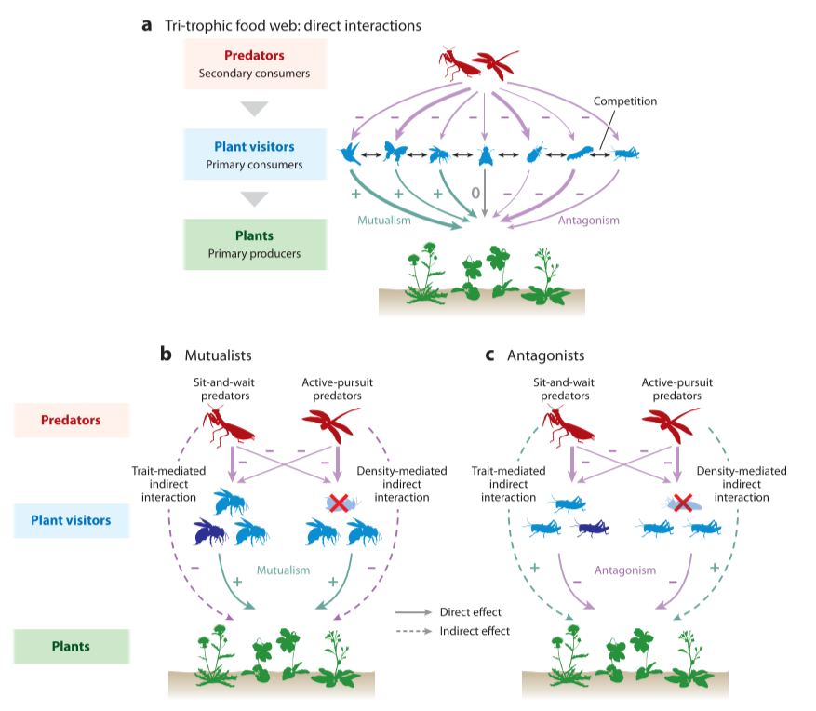

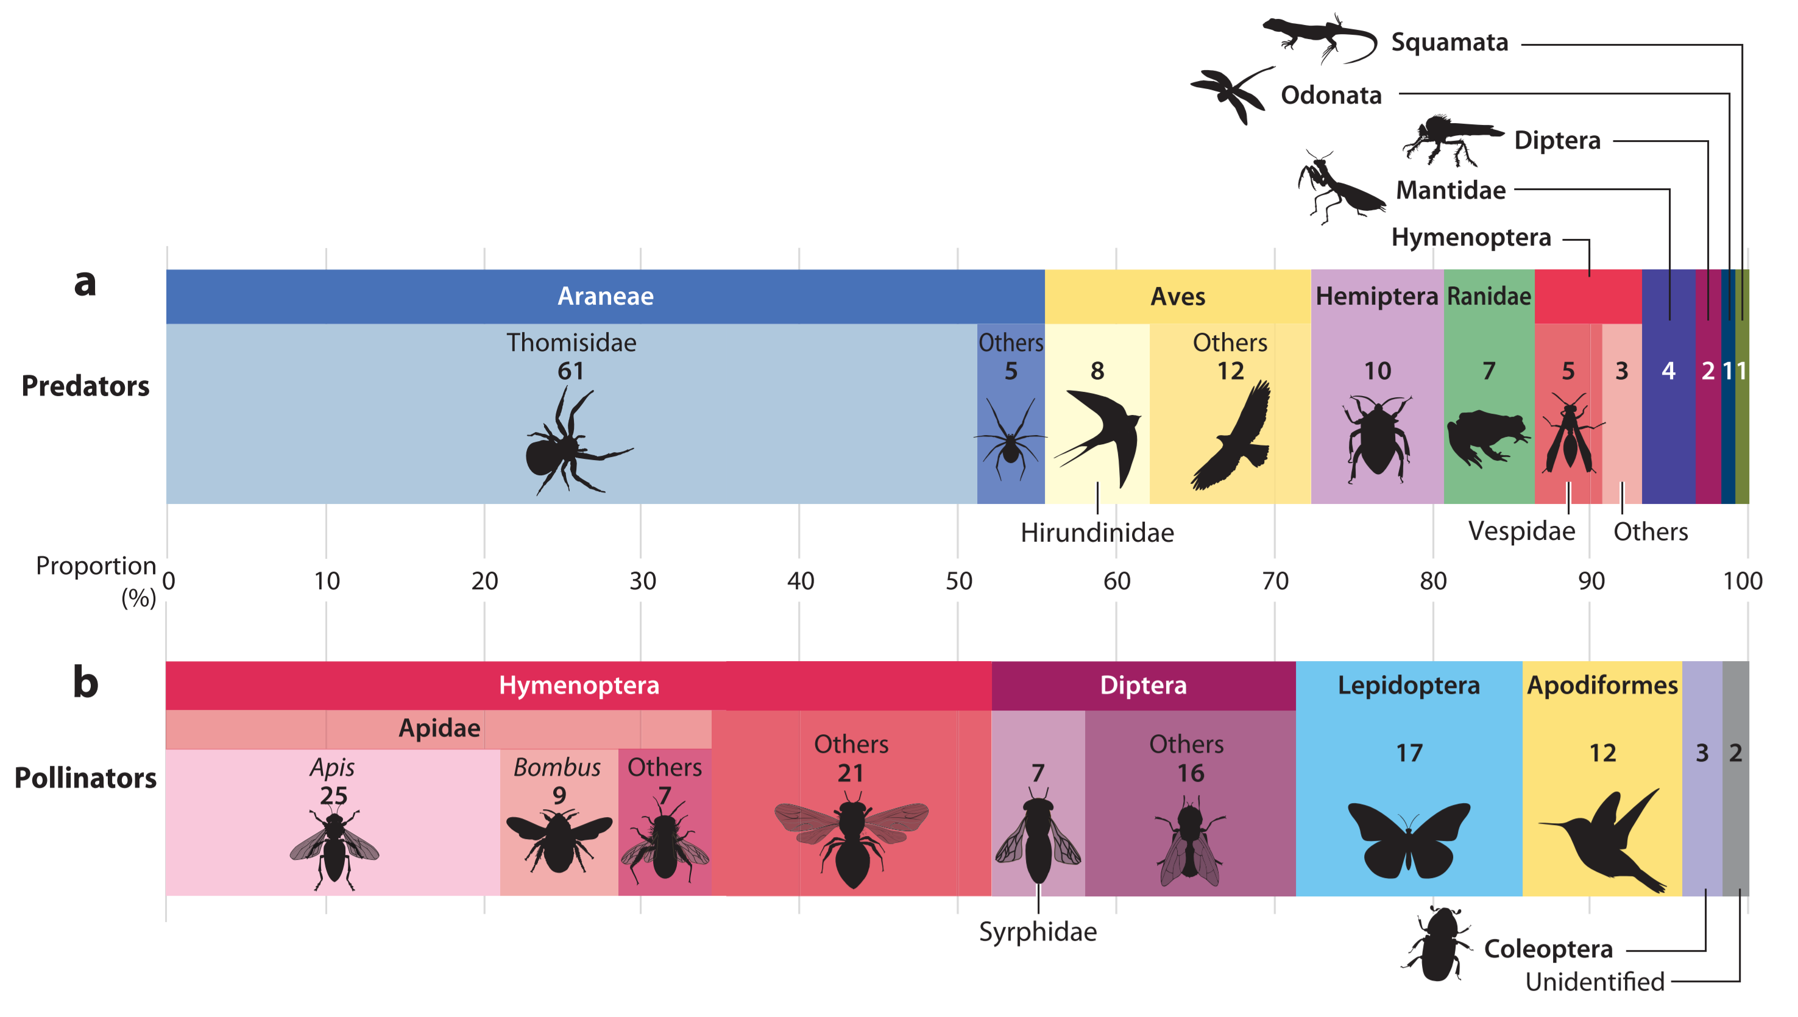

Figure 1.2. Web of Science and Google Scholar searches yielded 62 relevant articles describing 114 predator-pollinator taxonomic pairings (e.g., Thomisidae consuming Bombus). These articles are listed in the Supplemental Appendix. The taxa described as predators of pollinators are shown in panel a. The taxa of pollinators described as prey in these articles are shown in panel b. The size of each rectangle is proportional to the number of times each taxa was described in these predator-prey pairings; sample size is indicated within. This is a snapshot of currently available studies with biases regarding which taxonomic groups have more available data; popular study systems (e.g., Thomisidae and Apidae) may be overrepresented while other ecologically relevant predator-prey relationships may be underrepresented.

(2001b) and discuss the implications for plant reproduction, fitness, and the evolution of floral traits and plant mating systems.
Predator effects on pollinator abundance and behavior
Predators can be a major source of mortality for pollinators and can significantly decrease pollinator population size. Predators can reduce the abundance of pollinators through direct consumption and increased mortality via risk effects (Preisser et al. 2005, Creel and Christianson 2008). For example, wasps are aggressive bee predators. An aggregation of North American bumblebeewolves (Philanthus bicolor) was estimated to kill more than 850 bumblebees per hour within a 4-km radius (Dukas 2005). Likewise, novel predation by invasive wasps (Vespa spp.) can be a major source of mortality for native bees (e.g., genus Hylaeus in Hawaii) as well as domestic and naturalized honey bees (Apis mellifera) (Hanna and Eason 2013, Monceau et al. 2013). Numerous other predator taxa also affect pollinators. Dragonflies reduce the number of pollinating sweat bees (Halictidae) near ponds (Knight et al. 2005a). True bugs, such as ambush bugs (Phymata spp.) and assassin bugs (Reduviidae), and other insects such as robber flies (Asilidae) and mantids (Mantodea) prey upon pollinators at flowers or while in flight (e.g., Dukas 2001b, Shankar 2015). Birds, such as swallows (Hirundinidae; Meehan et al. 2005) and bee-eaters (Meropidae; Łangowska et al. 2018), are voracious predators of pollinators, especially bees. Spiders are also significant predators; crab spiders (Thomisidae), the best-studied pollinator predators, attack pollinators as they visit flowers (Morse 2007). Orb-weaving spiders exploit foraging pollinators by luring them to their webs with UV reflectance (Llandres et al. 2011). Many of the existing studies describe predation on pollinating insects, in particular economically important social bees (i.e., Apis and Bombus). Predators are likely to have similar effects on other pollinator taxa; there are simply fewer data currently available (Fig. 1.2).
Importantly, even relatively rare predators with low prey-capture rates can significantly affect pollinator populations. Morse (1986) found that only two of 531 bumblebees visiting inflorescences harboring crab spiders were captured and killed. This low prey-capture rate is often cited as evidence that spider predation is not an important source of bee mortality; however, Cresswell (2017) found that when this magnitude of spider-caused mortality is included in a demographic matrix projection model, it has a significant effect on colony growth and reproduction. Using Morse’s (1986) data, Cresswell estimated that bumblebees have a 3.4 × 10−3 chance of mortality when encountering a spider and that there are 4.7 × 10−3 spiders per inflorescence. Given that bumblebees visit an estimated 527 inflorescences per day, there is a 1% daily chance that a forager will be killed by a spider. Using this predation rate, over the course of a season, Cresswell’s (2017) matrix model projects that 47% of workers will be killed by spiders. Further, if spider abundance doubles, a density common in field observations, 60% of workers would be killed, new queen production would decrease by 11%, and male production would decline by 1%. Cresswell (2017) was able to model colony growth only within a season because data on queen hibernation survival are lacking. These results strongly suggest that even at low density and with low prey-capture rates, sit-and-wait predators can be a major source of bee forager mortality. Therefore, strong selection on foragers to avoid these predators is expected (Cresswell 2017).
Predators will not affect all pollinator taxa equally. Differences in pollinator taxa, body size, and sociality are expected to mediate the effects of predators on pollinator populations. To examine how ambush predators are expected to impact populations of solitary bee species that differ in body size and resource requirements, Rodríguez-Gironés (2012) developed a mathematical model. Similar to the findings of Cresswell (2017), this model suggests that low abundances of sit-and-wait predators (1–2% of flowers harboring predators) can exert strong top-down control on solitary bee populations. The model results demonstrate that key factors driving pollinator declines included bee resource requirements, predator encounter rates, and foraging and defensive behaviors. Specifically, these critical factors are the number of flowers bees must visit to provision their offspring (the more flowers that are visited, the more likely a bee is to encounter a predator), the bee’s ability to avoid landing on flowers that harbor predators (i.e., inspection and avoidance behavior), and the bee’s susceptibility to attack if it does land on a predator-harboring flower (i.e., chance of escape; Rodríguez-Gironés 2012). The model results suggest that medium-sized solitary bees are most vulnerable to population decline, even when ambush predators are relatively rare. Small-bodied bees are less vulnerable because they are able to provision their offspring with fewer flower visits, while large-bodied bees are less vulnerable because they are better able to survive attempted predator attacks (Rodríguez-Gironés 2012).
The work of Cresswell (2017) and Rodríguez-Gironés (2012) exemplifies how demographic and mathematical models can improve our understanding of how predators impact pollinator populations. Unfortunately, such studies are rare. While there are many examples of predation on pollinators (Figure 1.2), the impact of these predators on pollinator population dynamics is poorly understood. Many pollinators, and insects in general, are declining globally, largely due to anthropogenic factors (Potts et al. 2010, Regan et al. 2015, Hallmann et al. 2017). The role of native and introduced predators in these declines is unclear; further, it is unclear how anthropogenic activities affect the populations of these predators. We expect that the effects of predators on pollinator populations will depend on pollinator taxa, body size, sociality, and behavior, but more data are needed to fully appreciate the effects of predators on pollinator population dynamics.
Many pollinator taxa alter their behavior in response to predators. Pollinators can inspect flowers and detect cryptic ambush predators before landing (Chittka 2001, Théry and Casas 2002). While inspection behavior decreases foraging speed, the ability to evaluate risk at each flower is an important behavioral adaptation to mitigate predation (Chittka et al. 2003, Higginson and Houston 2015). Using predator models on flowers, Ings and Chittka (2008) found that naive bees landed on flowers with or without model predators as often as expected by chance. However, after experiencing simulated predator attacks while visiting flowers with predator models, bees increased inspection time and learned to avoid the predator models. In the same study, bees were equally good at detecting and avoiding cryptic and more conspicuous predator models. However, when the models were cryptic, bees slowed their foraging and inspected flowers 1.7 times longer, indicating a trade-off between foraging speed and accuracy of predator detection (Ings and Chittka 2008). Interestingly, the reward level of flowers may mediate the behavioral response of bees to predation. Bees that experienced a simulated predator attack at highly rewarding flowers responded by shifting to foraging on less rewarding flowers, while bees experiencing attacks at low-reward flowers reduced their overall foraging activity (Jones and Dornhaus 2011). Building on these results, Wang et al. (2013) investigated whether bees can make simultaneous foraging decisions based on predator presence and the level of floral reward. Bees exposed to conspicuous predator models learned to avoid them and were able to simultaneously choose higher-reward flowers. In contrast, bees exposed to cryptic predator models also successfully learned to avoid them, but did not discriminate among flower reward levels. Together, these studies, among others (Dukas 2001a, Chittka et al. 2003, Dukas and Morse 2003, Robertson and Maguire 2005, Jones 2010, Jones and Dornhaus 2011, Antiqueira and Romero 2016), demonstrate that predator avoidance can be learned and that bees prioritize predator avoidance over foraging speed and efficiency. However, it is important to note that learning seems to require multiple failed predator attacks (Ings and Chittka 2008); therefore, learning is likely more important to pollinators with low predator susceptibility (e.g., pollinators with large bodies), because pollinators that are more susceptible to predators may be killed before they are able to learn.
Pollinators can utilize indirect cues as indicators of risk when choosing flowers. The use of some indirect cues may be linked to pollinator sociality. For example, bumblebees avoid flowers with dead conspecifics or the scent of dead conspecifics; however, solitary bees do not (Abbott 2006, Llandres et al. 2013). Honey bees that encounter dead conspecifics perform fewer waggle runs, thereby recruiting fewer hive mates to potentially dangerous resource patches (Abbott and Dukas 2009). Scent may be an important factor in indirect cues. Bees avoid the scent of crab spiders and the silk they leave behind on flowers (Reader et al. 2006). Furthermore, social bees use alarm pheromones to warn conspecifics of danger; heterospecific social bees, but not solitary bees, can eavesdrop on these alarm pheromones to make more adaptive foraging decisions (Goodale and Nieh 2012; Wang et al. 2016a,b; Wen et al. 2017; McClenaghan et al. 2019; Romero-Gonzalez et al. 2019). Social bees may also use direct social information; for example, in environments known to be risky, social bees are more likely to land on a flower that is already occupied by a foraging conspecific (Dawson and Chittka 2014, Lihoreau et al. 2016). The use of indirect cues and social information sharing allows pollinators to assess and avoid risk while foraging. In this respect, social pollinators that can share information have an advantage over solitary pollinators.
Much of the work discussed so far pertains to how insect pollinators detect and avoid sit-and-wait ambush predators on flowers. Thus, there are two important gaps: Not all pollinators are insects, and not all predators are ambush hunters. Information on the behavioral responses of non-insect pollinators to predation is limited. There is some evidence that hummingbirds engage in risk-reducing behaviors such as avoiding flowers close to the ground and increasing vigilance at the expense of efficiency (Lima 1991). Hummingbirds may also engage in antipredator mobbing behavior (Zenzal et al. 2013, and references therein). While there are many examples of active pursuit predators preying upon pollinators, the effect of these predators on pollinator behavior is less clear. Studies of active-pursuit predators often measure pollinator floral visitation rates as a response variable; however, the mechanistic cause for reduced pollinator visitation is unclear. Active-pursuit predators may be causing reduced visitation by decreasing pollinator abundance and/or by altering pollinator foraging behavior.
Effects of pollinator predators on plant-pollinator interactions
As discussed in Section 3, predators cause pollinator abundance to decline via mortality, and predators alter the behavior of pollinators causing decreased foraging activity and speed. As a result, we expect predators to reduce interactions between plants and pollinators. Consequentially, both pollinators and plants will receive fewer benefits from this mutualism: Pollinators will collect fewer resources, and plants will export and receive less pollen. A meta-analysis (Romero et al. 2011) shows that, on average, predators decrease pollinator visits by 36% and visit duration by 51%. This response can result from two mechanisms: decreased pollinator abundance (i.e., a density-mediated effect of predators) or decreased pollinator foraging activity and/or speed (i.e., a trait-mediated effect of predators; Fig. 1.1). Both mechanisms lead to weakened plant-pollinator interactions. However, while the mean effect is that predators reduce both the frequency and the duration of pollinator visits to flowers, the outcome of each specific case is context dependent and variable. The effect of a predator on plant-pollinator interactions depends on predator traits, pollinator traits, and plant traits.
In some contexts, predators increase pollinator visitation to flowers. This is attributed to predator traits that serve as deceptions or lures. Orchid mantises exemplify deception. The bodies of these mantids mimic a flower’s physical and chemical structure, and when deceived pollinators attempt to visit the apparent flower, they are attacked by the mantid (Mizuno et al. 2014, O’Hanlon et al. 2014). A well-studied and complex example of lures is found in the Australian crab spider, Thomisus spectabilis. These spiders lure bees by reflecting UV light to create contrast between their bodies and flowers (Heiling et al. 2003, 2005a, b). Honey-bee visitation to Chrysanthemum frutescens increases twofold when an anesthetized, UV-reflecting crab spider is present (Heiling et al. 2003). However, anesthetization of spiders may falsely inflate the increase in visitation. Llandres and Rodríguez-Gironés (2011) found that large, non-anesthetized, UV-reflecting crab spiders increased honey-bee attraction but did not increase visitation compared to spider-free flowers. Honey bees were attracted only to large UV-reflecting spiders; when small spiders reflected UV, honey bees avoided them. Interestingly, Llandres and Rodríguez-Gironés (2011) found that color matching between crab spiders and flowers did not affect honey-bee visitation, but rather, the most important determinants were crab-spider size, movement, and UV reflectance. The evolution of UV reflectance in crab spiders occurred in Australia and has not been found in other regions (Herberstein et al. 2009, Gawryszewski et al. 2017). Interestingly, while both honey bees and native Australian bees were attracted to UV-reflecting spiders, only introduced European honey bees increased visitation (Heiling and Herberstein 2004, Llandres et al. 2011), suggesting that pollinator species have different responses to predator traits. It is unclear whether the difference in response is due to a longer coevolutionary history between native bees and Australian crab spiders or if novel selection for UV reflectance to exploit a sensory bias of honey bees occurred after European honey bees were introduced to Australia (Llandres and Rodríguez-Gironés 2011). While the strongest evidence that predators can increase pollinator attraction comes from Australian crab spiders, another intriguing case has been observed. Welti et al. (2016) found increased pollinator visitation to flowers harboring crab spiders in a North American prairie; however, they did not find support for crab spider use of UV reflectance as a lure. Their result suggests that crab spiders may use lures other than UV reflectance.
In some contexts, predators have little to no effect on pollinator visitation rates (Dukas et al. 2005, Schwantes et al. 2018, Rodríguez-Gironés and Jiménez 2019). A possible explanation is that effective predator crypsis may prevent some pollinators from perceiving and responding to danger (Chittka 2001, Cheng et al. 2006, Anderson and Dodson 2015, Rodríguez-Morales et al. 2018). This is especially likely if pollinators forage quickly and do not inspect flowers before landing or if foragers lack experience (Dukas et al. 2005). Furthermore, not all pollinators are equally susceptible to predation (Morse 2007, Rodríguez-Gironés 2012). Pollinator taxa with very low susceptibility to predator attack may be less likely to alter their foraging behavior in response to predators (Dukas and Morse 2005, Romero and Koricheva 2011, Gavini et al. 2020). Similarly, predators can have prey preferences that modify the level of threat they pose to different taxa (Morris and Reader 2016). As a result, some pollinator taxa may experience fewer failed attacks and therefore may not learn to avoid predators. Or, more generally, even if a pollinator taxon is both susceptible to attack and a preferred prey, if the majority of foragers in a population are naïve and have not learned to avoid predators, then avoidance behavior may not be observed. In addition, finding no change in plant-pollinator interactions in response to predators may result from the experimental methods. For example, pollinators may not respond to model predators or to dead predators in the same manner that they would respond to live ones (e.g., Brechbühl et al. 2010).
Most commonly, pollinators decrease the frequency and duration of floral visits in response to the presence of predators (reviewed in Romero et al. 2011). The above cases are intriguing exceptions to this pattern. Clearly, the effect of predators on plant-pollinator interactions depends on context. Ecological factors and experimental design may affect whether predators decrease, increase, or have no effect on plant-pollinator interactions. Because pollinators do not need to move far to be safe from sit-and-wait predators, the spatial scale of a study could influence the strength and detectability of the effect of predators on plant-pollinator interactions (Huey and Neih 2017). Visitation has been studied on a scale ranging from a single flower or inflorescence (e.g., Suttle 2003) up to an entire patch of flowering individuals (e.g., Dukas and Morse 2003, 2005). Too large a scale may lead to finding no effect of predators on visitation. Alternatively, a very small scale will increase the likelihood of finding an effect on visitation, but the results may not be ecologically relevant. For example, decreased visitation to a single flower may not have a significant impact on plants with many flowers but may be significant for plant species that produce few flowers. If predators affect plants through TMII, then a small scale (e.g., individual flowers or plants) may be appropriate because pollinators can detect and avoid predators at the flower/inflorescence level (e.g., Ings and Chittka 2008). Alternatively, if predators affect plant-pollinator interactions through DMII, then a larger spatial scale may be more appropriate. For example, one could compare visitation to plants near and far from an aggregation of beewolves (Dukas 2005). Similar to spatial scale, plant traits such as size, morphology, and inflorescence structure may mediate how predators affect visitation. The hunting success of predators varies across plant species with differing flower morphologies (e.g., Morse 2007). Plants with large inflorescences may not experience declines in visitations because visitors can land on a part of the inflorescence a safe distance from the predator and leave if the predator approaches (Morse 1986, Greco and Kevan 1994). A clearer understanding of how the environment and functional traits mediate the effect of predators on plant-pollinator interactions will aid in predicting the effects of predators on plant reproduction.
Pollinator predator effects on plant reproduction
Given that predators can affect pollinator abundance, behavior, and the frequency and duration of floral visitation, it follows that predators will affect plant reproduction. Predators can affect plant fitness along four major axes. First, if predators decrease pollinator visitation frequency and duration, and thus reduce the amount of pollen imported, then there may not be sufficient pollen to fertilize all ovules within flowers, and consequently, seed set will be reduced. Second, if predators decrease pollinator visitation frequency and duration, and thus reduce the amount of pollen exported, then the number of seeds that the plant can sire will be limited, and plant male fitness will decline. Third, in self-compatible plants, changes in pollinator visitation, and thus the amount of pollen imported and exported, may affect the proportion of ovules fertilized by self versus outcross pollen, which could then impact the expression of inbreeding depression (Jain 1976, Husband and Schemske 1996). Fourth, predators can alter interaction networks between plants and primary consumers. For example, generalist predators often suppress plant antagonists in addition to pollinators and can thereby reduce the number of seeds, flowers, and leaves damaged by plant enemies. Whether and how predators affect plant reproduction are expected to depend on predator traits, pollinator traits, and plant traits, as well as the presence and abundance of other community members such as herbivores, nectar/pollen thieves (Hargreaves et al. 2009), and other plant antagonists.
Pollen import and export
By reducing plant-pollinator interactions, predators reduce the amount of pollen imported to flowers. Consequently, predators can cause pollen limitation of plant reproduction (i.e., when individual plants do not receive sufficient pollen to fertilize all ovules; Knight et al. 2005b). For example, Knight et al. (2005a) found that Hypericum fasciculatum was significantly more pollen limited when it grew near ponds without fish than near ponds with fish. This is because immature dragonflies are more likely to survive to become adults in fishless ponds, and dragonfly adults are predators of the Halictidae bees that pollinate H. fasciculatum. The dragonflies reduce pollinator visitation, increase the magnitude of pollen limitation, and thereby decrease seed set (Knight et al. 2005a). Pollen limitation can be quantified by comparing the seed set of naturally pollinated plants to the seed set of plants in a pollen supplementation treatment (Knight et al. 2005b). While pollen limitation is easily quantified, few studies examining the impact of predators on seed set have done so. Despite the lack of direct measurement, pollen limitation can be inferred to be the mechanism behind decline in seed set caused by reduced pollinator visitation. For example, Suttle (2003) found that flowers of the invasive oxeye daisy Leucanthemum vulgare (Asteraceae), a self-incompatible, insect-pollinated, perennial herb, produced 17% fewer seeds when occupied by a crab spider. Crab spiders reduced both visitation frequency and duration, presumably leading to pollen limitation (Suttle 2003). Similarly, seed production of Chuquiraga oppositifolia (Asteraceae), a South American self-incompatible, insect-pollinated shrub, declined two-fold when lizards on rocks adjacent to shrubs reduced insect visitation frequency and duration (Muñoz and Arroyo 2004). Seed set of sweet clover, Melilotus officinalis, an introduced self-compatible herb, was significantly affected by proximity to nesting cliff swallows (Hirundo pyrrhonota; Meehan et al. 2005). The diet of cliff swallows overlapped with insect taxa that visited M. officinalis, leading to a 50% decline in fruit set of plants growing near nesting cliff swallows before fledging (Meehan et al. 2005). Western monkshood (Aconitum columbianum), a self-incompatible, bumblebee-pollinated wildflower, also showed decreased seed set as a function of proximity to an active bumblebeewolf (Philanthus bicinctus) aggregation—individuals near the aggregation produced half as many fruits as those far from the aggregation (Dukas 2005). The plants in these studies have several traits in common: They are all insect pollinated and either they are wholly dependent on pollinators (i.e., self-incompatible) or, if they are self-compatible, they have low reproductive success when pollinators are excluded (e.g., M. officinalis). Plants that are self-incompatible, prone to pollen limitation, or reliant on specialized pollinators are predicted to be more negatively affected by pollinator predators. Further, plants that depend on pollinators that are more susceptible to attack (i.e., smaller-bodied pollinators and/or taxa that are less able to detect and avoid predators) are also predicted to be more negatively affected by pollinator predators.
Pollen limitation is a measure of how pollen receipt impacts plant reproductive output. Similarly, declines in pollen export can also reduce plant fitness. Most plant species are hermaphroditic. Seed set represents only the female component of plant fitness. Plants also export pollen and thus sire seeds. This male component of plant fitness is much more difficult to quantify than the female fitness component; therefore, little is known about how pollinator predators affect plant male fitness. We expect that as pollinator visitation declines, pollen export, and therefore male fitness, will also decline.
Plant mating system and inbreeding depression
Declining pollinator visitation could change the relative amount of outcross pollen versus self-pollen that fertilizes ovules. This is rarely quantified in the context of pollinator predators. However, data regarding how other factors that disrupt plant-pollinator interactions, such as disturbance (Eckert et al. 2010) or habitat fragmentation (Aguilar et al. 2008), affect plant mating systems can be used to make predictions. We expect that decline in outcross pollen receipt in the presence of predators could affect mating systems by increasing the selfing rate of a population. Indeed, if a plant species is self-compatible and has no physical barriers to self-fertilization, ovules fertilized in the presence of predators could be primarily selfed. Chronic or unpredictable outcross pollen limitation can be a potent force in shaping reproductive traits of plants. Results may include the evolution of plant floral traits that are less attractive to pollinators (i.e., selfing-syndrome traits; reviewed in Sicard and Lenhard 2011), changes in the mating systems of local populations (shifts along the spectrum of outcrossing, mixed, and selfing mating systems; Stebbins 1974, Jain 1976, Wyatt 1983, Barrett et al. 1996, Fishman and Wyatt 1999), and ultimately declines in population level fitness via inbreeding depression.
Additionally, it is possible that sit-and-wait predators directly affect seed set of self-compatible plants by facilitating the transfer of self-pollen from anther to stigma while they hunt within a flower. If pollen adheres to the bodies of predators, it could be deposited onto a receptive stigma. Supporting this idea, we found that self-compatible Calochortus luteus flowers that harbored crab spiders produce more seeds than spider-free flowers, despite decreased pollinator visitation frequency and duration (Chapter II, III).
Altered visitor networks: Net effects of antagonists, commensalists, and mutualists
Many pollinator predators are generalist hunters who prey upon plant antagonists and commensalists in addition to pollinators and other mutualists. Therefore, the net effect of a predator’s impact on plant fitness will depend on the relative strength of the predator’s negative effect via suppression of plant mutualists and the predator’s positive effect on plant fitness via suppression of plant antagonists. Predators positively impact plant fitness when their effect via antagonists is stronger than their effect via mutualists (Romero and Vasconcellos-Neto 2004, Romero and Koricheva 2011). For example, green lynx spiders hunt from the inflorescences of Haplopappus venetus (Asteraceae) and reduce both visitation and seed set; however, the spiders also decrease seed damage by antagonistic insects. Thus, plants harboring spiders produced more viable seeds than plants without spiders, despite reduced fertilization (Louda 1982). Similarly, a net neutral effect on plant fitness results when a predator’s negative effect on plant fitness via suppression of pollinators is balanced by an equivalent positive effect via suppression of antagonists. For example, predatory frogs simultaneous suppressed herbivores and pollinators leading to a net neutral effect and therefore no change in seed set of the Tibetan lotus Nelumbo nucifera (Zhao et al. 2016).
Importantly, usually only a small proportion of taxa that visit flowers are effective pollinators; other visitors consist of commensalists or antagonists that take floral resources while providing little to no pollination service to the plant in return. Predators may reduce foraging by visitors that are ineffective pollinators more than that of effective pollinators, thereby decreasing total visitation with little to no change in effective pollination service or seed set (Quintero et al. 2015, Telles et al. 2018). How predators affect visitation of effective pollinators versus other floral visitors is predicted to depend on taxonomic differences, including behavior, susceptibility, and sociality, as well as body size (Romero et al. 2011, Rusch et al. 2015). Further, it is possible that predators increase plant seed set by increasing pollinator visitation of effective pollinators via lures and deception. This effect could potentially increase pollination and seed set; however, to our knowledge this has not been tested. This hypothesis would apply only to predators that hunt from flowers.
Conclusions
Pollinator predators exploit and disrupt plant-pollinator mutualisms. Predators can reduce the abundance of pollinators and alter their behavior, leading to fewer interactions between pollinators and plants. This affects plant reproduction in several ways. Plants export and receive less pollen, affecting female and male components of plant fitness. The proportion of plant ovules fertilized by self versus outcross pollen may be altered, which in turn could affect seed viability and offspring fitness through inbreeding depression as well as the amount of standing genetic variation within populations. Furthermore, predators may alter the network of interactions among plants and their mutualists, commensalists, and antagonists, thereby affecting both pollination services and plant and seed damage. Through these non-mutually exclusive mechanisms, pollinator predators can cause plant seed set to increase, decrease, or stay the same. However, an important caveat is that predator effects on seed set are not the complete story: We lack data on male fitness and on the proportion of seeds produced via self pollen versus outcross pollen and the consequent seed viability, offspring fitness, and genetic variation within populations. Much remains to be learned about the impact of predators on plant reproduction. For example, new insight into the evolution of selfing syndrome and outcross mating systems could be gained by incorporating pollinator predators into the theoretical framework of plant mating system evolution. Further, the study of plant demography and plant conservation could be advanced by incorporating predator effects, especially those of nonnative predators, on plant reproduction and population vital rates, such as seed production, recruitment, and survival.
The effect of predator hunting mode on plant-pollinator interactions and the consequences for selection on plant traits
Pollinator predators are a diverse group of animals. Differences among predators mediate their indirect effects on plants. We expect that predator hunting mode significantly affects the type of indirect interaction predators generate (Rinehart et al. 2017; Benoit and Caruso 2021). Predators vary in hunting mode along a continuum from sit-and-wait to active pursuit (Pianka 1966, Schoener 1971, Huey and Pianka 1981). Additionally, a predator’s hunting location is predicted to impact how predators indirectly affect plants. Predators can attack pollinators at flowers, while in flight, or at the pollinator’s nest or colony (Fig. 1.3).
Active-pursuit predators are generally more mobile, are more conspicuous, and have higher prey-capture rates than sit-and-wait predators (Pianka 196 6, Schoener 1971, Huey and Pianka 1981). Therefore, pursuit predators are expected to have larger effects on prey abundance and, consequently, to generate stronger DMII than sit-and-wait predators (Fig. 1.1). In contrast, sit-and-wait predators are more cryptic, are largely stationary, and have low prey-capture rates (Pianka 1966, Schoener 1971, Huey and Pianka 1981). They are therefore expected to have a smaller effect on prey abundance than active-pursuit predators. However, because pollinators can learn to detect and avoid sit-and-wait predators (e.g., Ings and Chittka 2008), they are expected to generate stronger TMII (Fig. 1.1). Similarly, predator hunting location is expected to affect the relative strengths of TMII and DMII. Predators that consume pollinators at their nests or colonies or consume queens are expected to have larger effects on pollinator abundance and generate DMII, while predators that prey upon pollinators while they visit plants are predicted to have a larger effect on pollinator foraging behavior and to generate TMII (Fig. 1.3).
Sit-and-wait predators choose hunting sites with reliable prey availability, such as flowers (Yong 2005, Morse 2007, O’Hanlon et al. 2014), whereas active-pursuit predators Figure 1.3. Predictions regarding how predator hunting mode and location affect pollinator behavior and abundance and how these interaction modifications affect the strength and direction of phenotypic selection on plant traits. Sit-and-wait predators are expected to hunt from plants with phenotypes that are highly attractive to pollinators, thereby making plants with highly attractive phenotypes risky for pollinators (risk indicated by yellow warning signs), while neighboring, less attractive plants will remain safe to visit. Sit-and-wait predators are expected to alter pollinator behavior more than pollinator abundance. Active-pursuit predators are highly mobile and hunt at the patch level; therefore, they are expected to make an entire patch of plants risky regardless of plant phenotype. Consequentially, patches with active-pursuit predators are expected to have lower densities of pollinators. Note, this decrease in density may be caused by mortality or by altered foraging behavior, such as pollinators decreasing the amount of time they forage or choosing to forage elsewhere; in either case, from the plant’s perspective, the abundance of pollinators in the patch will decline. Nest/hive predators do not make any plants risky to visit but will locally reduce pollinator abundance through mortality. In the absence of predators, pollinators generate selection for attractive and rewarding plant traits (βpoll; black line). If outcross pollination is unreliable or costly and plants are self-compatible, there can be selection for self-pollination, which will favor smaller, less costly flowers (βselfing; blue line). Predators are expected to alter pollinator-mediated selection (βpoll+predator; red line). Sit-and-wait predators are expected to weaken selection for traits that attract pollinators, because these predators hunt from plants with attractive phenotypes and decrease their relative fitness. Conversely, active-pursuit predators will create competition among plants to attract scarce pollinators, thereby increasing the strength of selection on attraction traits.

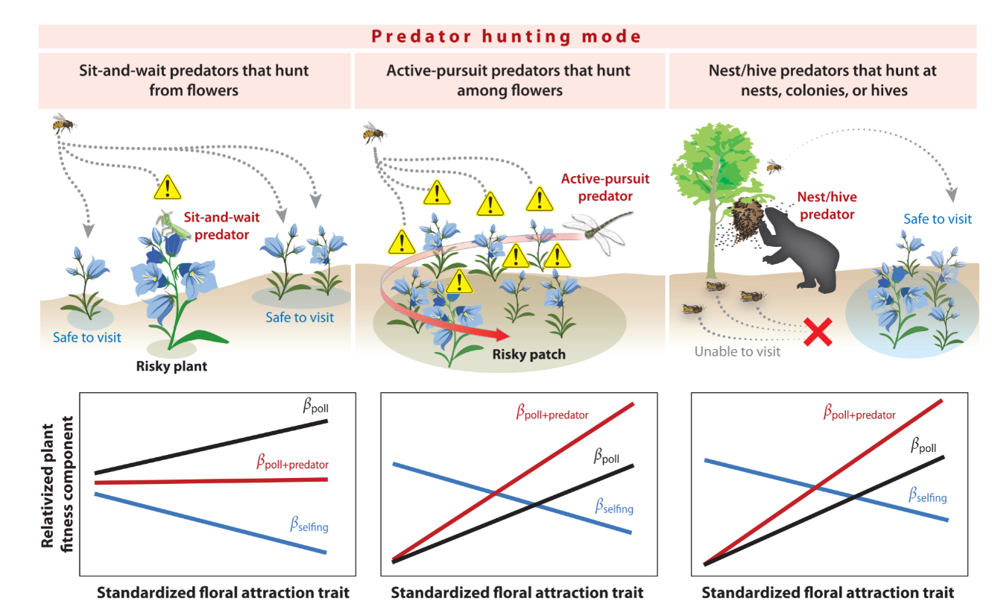

generally capture prey in flight or at nests or colonies (Calvert et al. 1979, Dukas 2005, Meehan et al. 2005). When sit-and-wait predators hunt from plants, pollinators can modify their behavior to avoid risky plants and visit safe plants instead (e.g., Jones and Dornhaus 2011). In contrast, active-pursuit predators patrol larger areas and are expected to decrease visitation both by consuming pollinators and by deterring pollinators from foraging in risky patches. Therefore, sit-and-wait predators are expected to decrease visitation to plants that harbor them and to increase visitation to neighboring safe plants, while active-pursuit predators are expected to decrease visitation more uniformly across plant patches (Fig. 1.3). Similarly, predators that hunt at nests or colonies are expected to have a larger impact on pollinator abundance and a much smaller effect on foraging behavior and, therefore, are expected to cause a more uniform decrease in visitation to all nearby plants via a density-mediated effect (Preisser et al. 2007; Fig. 1.3).
Because sit-and-wait predators do not pursue their prey, they experience strong selection to choose profitable hunting sites where prey will come to them (e.g., Olive 1982). Hence, many sit-and-wait predators hunt from flowers that pollinators and other insects reliably visit. Visitation rates can vary greatly among flowers based on species, phenotype, phenology, and surrounding community. The clearest cue a predator can use to find a profitable hunting site is direct observation of prey (Morse 1988, Greco and Kevan 1995). In the absence of an observable, highly visited site, it is possible predators use indirect cues such as flower shape, color, and scent (Greco and Kevan 1994, Heiling et al. 2004, 2005a, Wignall et al. 2006, Peixoto et al. 2012, Dodson et al. 2013). However, it is debatable whether pollinator predators use associative learning (e.g., Defrize et al. 2014). It is perhaps more likely that sit-and-wait predators choose hunting sites by direct observation of prey when possible and randomly when direct cues are unavailable (Morse 1988; Greco and Kevan 1994, 1995; Defrize et al. 2014). Once a hunting site is selected, predators remain if prey availability is high but leave after a giving-up time if prey availability is unreliable (Morse 2007). Via direct cues and trial and error, predators locate hunting sites with high prey availability. Therefore, sit-and-wait predators are not expected to be randomly distributed across plant phenotypes. Instead, sit-and-wait predators are expected to be more common on plants with phenotypes that attract many pollinators and other visitors (i.e., plants with attractive phenotypes; Jones 2010). For example, ambush bugs (Phymata spp.) hunt from Lobelia siphilitica plants with larger than average daily display sizes (Benoit and Caruso 2021), and crab spiders hunt from C. luteus with wider than average floral diameter (Chapter II). Since plants with more and/or larger flowers are well known to attract more visitors (Cohen and Shmida 1993), it is likely that pollinators and their predators use a common set of cues to choose flowers.
By hunting from plants with phenotypes that attract many visitors, sit-and-wait predators can affect the strength of pollinator-mediated selection on floral traits. Plants with traits that are attractive and/or rewarding to pollinators receive more visits, resulting in better pollination and higher fitness; thus, pollinators generate selection for increased attraction and reward. Sit-and-wait predators exploit the attractiveness of flowers to capture prey, and in the process, they decrease visitation to highly rewarding and/or attractive plants and increase visitation to safe, albeit less rewarding and/or attractive, neighboring plants (Jones 2010, Jones and Dornhaus 2011; Fig. 1.3). Therefore, we expect that sit-and-wait predators will weaken the strength of pollinator-mediated selection on plant traits that attract and/or reward pollinators. Supporting this hypothesis, Benoit and Caruso (2021) found that in the absence of predators, L. siphilitica experiences pollinator-mediated selection for larger daily floral displays; however, when ambush bugs are present the direction of pollinator-mediated selection reverses, and there is selection for smaller daily floral displays. Similarly, crab spiders were found to significantly alter the strength of selection on the size of C. luteus flowers (Chapter II).
Unlike sit-and-wait predators, active-pursuit predators are expected to decrease pollinator visitation more uniformly across their hunting range (Fig. 1.3). Thus, we predict that active-pursuit predators will alter pollinator-mediated selection via a different mechanism than sit-and-wait predators. Active-pursuit predators are expected to decrease plant-pollinator interactions, leading to pollen limitation and reduced seed production. By weakening the interaction strength between plants and their mutualists and by decreasing mean plant fitness, active-pursuit predators are expected to increase the opportunity for selection and the maximum strength of selection (Benkman 2013). Therefore, we predict that selection on plant traits that attract and/or reward pollinators will increase in strength when active-pursuit predators are present (Fig. 1.3).
Predators that consume pollinator’s nests, colonies, or queens are expected to have little to no effect on pollinator foraging behavior but a large effect on pollinator density. Therefore, these predators are expected to affect plants via DMII similarly to active-pursuit predators. Furthermore, these predators could alter pollinator community composition, decreasing social pollinators that aggregate or store resources such as honey—an attractive target for predators—while having a negligible effect on solitary pollinators (for a review of nest predators of Asian bees and bee responses to nest predation, see Fuchs and Tautz 2011). Shifts in the pollinator community could affect pollen limitation and pollinator-mediated selection on plant traits.
Predators may also cause selection on plant traits that have functions other than attraction or reward. For example, predators may affect selection on flowering phenology. Dukas (2005) found that before bumblebeewolves (P. bicinctus) became active, bumblebee densities were equal near and far from the beewolf aggregation. However, after beewolves became active in July, the density of bumblebees near the aggregation was halved, and consequently, the fruit set of monkshood near the beewolf aggregation was also halved. While Dukas (2005) did not measure phenotypic selection on the plants, we predict that bumblebeewolves generate selection for earlier flowering phenology in monkshood populations near beewolf aggregations. To our knowledge, no field data exist regarding how predator phenology indirectly affects selection of plant phenology. Kagawa and Takimoto (2013) explored coevolutionary diversification among predators, pollinators, and plants in a simulation and found that predators promote divergence of plant-pollinator mutualisms. Further, Abbott (2010) suggested that flower color may evolve to better match sit-and-wait predator color in order to reduce the ability of pollinators to detect predators and thereby prevent decreased pollinator visitation when predators are present. Whether floral traits like petal color reflect a coevolutionary arms race between plants and the pollinator predators that hide in them is unknown. Indirect interactions have the potential to significantly shape phenotypic selection, but data on their effect on selection are rarely collected (Estes et al. 2013, Walsh 2013).
A further possibility is that predators may indirectly affect selection on plant mating systems. Selfing-syndrome plant species have evolved repeatedly from outcrossing taxa (reviewed in Sicard and Lenhard 2011). One hypothesis is that scarce and/or unreliable pollinators cause selection for autonomous self-pollination as a reproductive assurance (Sicard and Lenhard 2011). Predators that reduce pollinator abundance and foraging activity could lead to the type of unreliable pollination environment that may favor the evolution of selfing-syndrome traits. If predators make pollinators scarce, plants that can self-pollinate, and are therefore less reliant on pollinators, may have higher relative fitness. Thus, the advantage of costly pollinator attraction traits would diminish, and smaller, less costly flowers adapted for self-pollination would be favored (i.e., selfing syndrome; Fig. 1.3). The inclusion of indirect effects of predators on phenotypic selection could help us to understand patterns of mating-system evolution.
Conclusions
Plants are the foundation of food webs and thus interact with myriad other organisms at higher trophic levels. Primary consumers range from plant mutualists, such as pollinators, to plant antagonists, such as florivores. Primary consumers are nourished by plants and in turn provide nourishment to secondary consumers (i.e., predators). Since the 1960s, ecologists have recognized that predators can have profound indirect effects on plant populations and communities via plant antagonists; yet, understanding of how predators affect plant populations and communities via plant mutualists has lagged. Our goal in this review is to synthesize current knowledge regarding the effects of predators on pollinators and plants to spur interest and further investigation. By better understanding the indirect effects generated by predation on pollinators, we will gain insight into the ecology and evolution of flowering plants. Plant-pollinator interactions form a vitally important keystone mutualism. These interactions drive diversification, provide much of the food humans rely on, and aid in maintaining genetic diversity within plant populations. We have learned much by studying pairwise interactions between plants and pollinators. Now, by understanding the role of predators in shaping these interactions, we can gain a more nuanced view.
We find ourselves at a critical juncture in history: We live in an unprecedented period of rapid extinction and global change caused by aggressive human exploitation of natural resources. Through the introduction of nonnative species, extinctions, and climate-driven range shifts, we have profoundly altered the composition of communities. Now as we scramble to conserve threatened native pollinators and plants, it is important to consider how higher trophic levels shape the behavior, abundance, reproduction, and demography of plants and their pollinators.
Future issues
1. We need a clearer understanding of how predator traits (e.g., hunting mode, hunting site, and prey preferences) and pollinator traits (e.g., sociality, cognitive ability, body size, and taxon) mediate the effects of predators on pollinator demography and, further, how pollinator demography impacts plant demography. The inclusion of pollinator and predator effect data as covariates in demographic models will provide insights into the magnitude of these effects.
2. Pollinator predators can significantly decrease pollinator visitation rates; however, the extent to which this indicates altered foraging behavior versus declining pollinator population size needs further investigation.
3. The presence of pollinator predators has been linked to decreased pollinator visitation and seed set, likely through pollen limitation, but the full impact of predators on plant reproduction needs further study to determine (a) if predators affect the male component of plant fitness, (b) if predators affect the proportion of self-pollinated versus out cross pollinated seeds in self-compatible plant species, and (c) if predators affect the expression of inbreeding depression in plant populations. Manipulative experimental studies controlling indirect and direct effects of predators on plants are needed to answer these questions.
4. By altering the reliability of pollinators and the availability of outcross pollen, predators may be affecting the evolution of plant mating systems, potentially contributing to the maintenance of mixed mating systems or the transition from outcross mating systems to selfing mating systems. Manipulative experiments and studies across gradients of predator pressure will provide new insights.
5. If predators increase rates of self-pollination, they could affect the expression of inbreeding depression and decrease the amount of genetic variation within populations. Currently, we have no data to address these hypotheses.
6. Observational studies and manipulative experiments that measure the strength and direction of pollinator-mediated selection on plant traits under different levels of predator pressure will provide insights into how predators indirectly shape selection on plant traits.

REFERENCES

Abbott KR. 2006. Bumblebees avoid flowers containing evidence of past predation events. Can. J. Zool. 84(9):1240–47
Abbott KR. 2010. Background evolution in camouflage systems: a predator–prey/pollinator–flower game. J. Theor. Biol. 262(4):662–78
Abbott KR, Dukas R. 2009. Honeybees consider flower danger in their waggle dance. Anim. Behav. 78(3):633– 35
Abrams PA. 1995. Implications of dynamically variable traits for identifying, classifying and measuring direct and indirect effects in ecological communities. Am. Nat. 146:112–34
Aguilar R, Quesada M, Ashworth L, Herrerias-Diego Y, Lobo J. 2008. Genetic consequences of habitat fragmentation in plant populations: susceptible signals in plant traits and methodological approaches. Mol. Ecol. 17(24):5177–88
Anderson AG, Dodson GN. 2015. Colour change ability and its effect on prey capture success in female Misumenoides formosipes crab spiders. Ecol. Entomol. 40(2):106–13
Antiqueira PAP, Romero GQ. 2016. Floral asymmetry and predation risk modify pollinator behavior, but only predation risk decreases plant fitness. Oecologia 181(2):475–85
Barrett SCH, Harder LD, Worley AC. 1996. The comparative biology of pollination and mating in flowering plants. Philos. Trans. R. Soc. B 351:1271–80
Benkman CW. 2013. Biotic interaction strength and the intensity of selection. Ecol. Lett. 16(8):1054–60
Benoit AD, Caruso CM. 2021. A sit‐and‐wait predator, but not an active‐pursuit predator, alters pollinator‐mediated selection on floral traits. Ecology. 102(12), p.e03506
Brechbühl R, Kropf C, Bacher S. 2010. Impact of flower-dwelling crab spiders on plant-pollinator mutualisms. Basic Appl. Ecol. 11(1):76–82
Calvert WH, Hedrick LE, Brower LP. 1979. Mortality of the monarch butterfly (Danaus plexippus L.): avian predation at five overwintering sites in Mexico. Science 204(4395):847–51
Cheng K, Heiling AM, Herberstein ME. 2006. Picking the right spot: Crab spiders position themselves on flowers to maximize prey attraction. Behaviour 143(8):957–68
Chittka L. 2001. Camouflage of predatory crab spiders on flowers and the colour perception of bees (Aranida: Thomisidae/Hymenoptera: Apidae). Entomol. Generalis 25(3):181–87
Chittka L, Dyer AG, Bock F, Dornhaus A. 2003. Psychophysics: Bees trade off foraging speed for accuracy. Nature 424(6947):388
Cohen D, Shmida A. 1993. The evolution of flower display and reward. Evolutionary Biology, Vol. 27, ed. MK Hecht, pp. 197–243. Boston: Springer
Creel S, Christianson D. 2008. Relationships between direct predation and risk effects. Trends Ecol. Evol. 23(4):194–201
Cresswell JE. 2017. A demographic approach to evaluating the impact of stressors on bumble bee colonies. Ecol. Entomol. 42(2):221–29
Darwin C. 2018 (1859). On the Origin of Species. Minneapolis, MN: Lerner Publ. Group
Dawson EH, Chittka L. 2014. Bumblebees (Bombus terrestris) use social information as an indicator of safety in dangerous environments. Proc. R. Soc. B. 281(1785):20133174
Defrize J, Llandres AL, Casas J. 2014. Indirect cues in selecting a hunting site in a sit-and-wait predator. Physiol. Entomol. 39(1):53–59
Dodson GN, Lang PL, Jones RN, Versprille AN. 2013. Specificity of attraction to floral chemistry in Misumenoides formosipes crab spiders. J. Arachnol. 41(1):36–43
Dukas R. 2001a. Effects of perceived danger on flower choice by bees. Ecol. Lett. 4(4):327–33
Dukas R. 2001b. Effects of predation risk on pollinators and plants. In Cognitive Ecology of Pollination, ed. L Chittka, JD Thomson, pp. 214–36. Cambridge, UK: Cambridge Univ. Press
Dukas R. 2005. Bumble bee predators reduce pollinator density and plant fitness. Ecology 86(6):1401–6
Dukas R, Morse DH. 2003. Crab spiders affect flower visitation by bees. Oikos 101(1):157–63
Dukas R, Morse DH. 2005. Crab spiders show mixed effects on flower-visiting bees and no effect on plant fitness components. Ecoscience 12(2):244–47
Dukas R, Morse DH, Myles S. 2005. Experience levels of individuals in natural bee populations and their ecological implications. Can. J. Zool. 83(3):492–97
Eckert CG, Kalisz S, Geber MA, Sargent R, Elle E, et al. 2010. Plant mating systems in a changing world. Trends Ecol. Evol. 25(1):35–43
Estes JA, Brashares JS, Power ME. 2013. Predicting and detecting reciprocity between indirect ecological interactions and evolution. Am. Nat. 181(Suppl. 1):S76–99
Fishman L, Wyatt R. 1999. Pollinator-mediated competition, reproductive character displacement, and the evolution of selfing in Arenaria uniflora (Caryophyllaceae). Evolution 53:1723–33
Fuchs S,Tautz J. 2011. Colony defense and natural enemies. In Honeybees of Asia, ed.HR Hepburn, SE Radloff, pp. 369–95. Heidelberg, Ger.: Springer
Gavini SS, Quintero C, Tadey M. 2020. Intraspecific variation in body size of bumblebee workers influences anti-predator behaviour. J. Anim. Ecol. 89(2):658–69
Gawryszewski FM, Calero-Torralbo MA, Gillespie RG, Rodríguez-Gironés MA, Herberstein ME. 2017. Correlated evolution between coloration and ambush site in predators with visual prey lures. Evolution 71(8):2010–21
Goodale E, Nieh JC. 2012. Public use of olfactory information associated with predation in two species of social bees. Anim. Behav. 84(4):919–24
Greco CF, Kevan PG. 1994. Contrasting patch choosing by anthophilous ambush predators: vegetation and floral cues for decisions by a crab spider (Misumena vatia) and males and females of an ambush bug (Phymata americana). Can. J. Zool. 72(9):1583–88
Greco CF, Kevan PG. 1995. Patch choice in the anthophilous ambush predator Phymata americana: improvement by switching hunting sites as part of the initial choice. Can. J. Zool. 73(10):1912–17
Hairston NG, Smith FE, Slobodkin LB. 1960. Community structure, population control, and competition. Am. Nat. 94(879):421–25
Hallmann CA, Sorg M, Jongejans E, Siepel H, Hofland N, et al. 2017. More than 75 percent decline over 27 years in total flying insect biomass in protected areas. PLOS ONE 12(10):e0185809
Hanna CJ, Eason PK. 2013. Juvenile crab spiders (Mecaphesa asperata) use indirect cues to choose foraging sites. Ethol. Ecol. Evol. 25(2):161–73
Hargreaves AL, Harder LD, Johnson SD. 2009. Consumptive emasculation: the ecological and evolutionary consequences of pollen theft. Biol. Rev. 84(2):259–76
Heiling AM, Cheng K, Chittka L, Goeth A, Herberstein ME. 2005a. The role of UV in crab spider signals: effects on perception by prey and predators. J. Exp. Biol. 208(20):3925–31
Heiling AM, Cheng K, Herberstein ME.2004. Exploitation of floral signals by crab spiders (Thomisus spectabilis, Thomisidae). Behav. Ecol. 15(2):321–26
Heiling AM, Chittka L, Cheng K, Herberstein ME. 2005b. Colouration in crab spiders: substrate choice and prey attraction. J. Exp. Biol. 208(10):1785–92
Heiling AM, Herberstein ME. 2004. Predator–prey coevolution: Australian native bees avoid their spider predators. Proc.R.Soc.B 271(Suppl. 4):S196–98
Heiling AM, Herberstein ME, Chittka L. 2003. Pollinator attraction: Crab-spiders manipulate flower signals. Nature 421(6921):334
Herberstein ME, Heiling AM, Cheng K. 2009. Evidence for UV-based sensory exploitation in Australian but not European crab spiders. Evol. Ecol. 23(4):621–34
Higginson AD, Houston AI. 2015. The influence of the food–predation trade-off on the foraging behaviour of central-place foragers. Behav. Ecol. Sociobiol. 69(4):551–61
Huey S, Nieh JC. 2017. Foraging at a safe distance: crab spider effects on pollinators. Ecol. Entomol. 42(4):469– 76
Huey RB, Pianka ER. 1981. Ecological consequences of foraging mode. Ecology 62:991–99
Husband BC, Schemske DW. 1996. Evolution of the magnitude and timing of inbreeding depression in plants. Evolution 50(1):54–70
Ings TC, Chittka L. 2008. Speed-accuracy tradeoffs and false alarms in bee responses to cryptic predators. Curr. Biol. 18(19):1520–24
Jain SK. 1976. The evolution of inbreeding in plants. Annu. Rev. Ecol. Syst. 7:469–95
Jones EI. 2010. Optimal foraging when predation risk increases with patch resources: an analysis of pollinators and ambush predators. Oikos 119(5):835–40
Jones EI, Dornhaus A. 2011. Predation risk makes bees reject rewarding flowers and reduce foraging activity. Behav. Ecol. Sociobiol. 65(8):1505–11
Kagawa K, Takimoto G. 2013. Predation on pollinators promotes coevolutionary divergence in plant pollinator mutualisms. Am. Nat. 183(2):229–42
Knight TM, Chase JM, Hillebrand H, Holt RD. 2006. Predation on mutualists can reduce the strength of trophic cascades. Ecol. Lett. 9(11):1173–78
Knight TM, McCoy MW, Chase JM, McCoy KA, Holt RD. 2005a. Trophic cascades across ecosystems. Nature 437(7060):880–83
Knight TM, Steets JA, Vamosi JC, Mazer SJ, Burd M, et al. 2005b. Pollen limitation of plant reproduction: pattern and process. Annu. Rev. Ecol. Evol. Syst. 36:467–97
Łangowska A, Yosef R, Skórka P, Tryjanowski P. 2018. Mist-netting of migrating bee-eaters positively influences honey bee colony performance. J. Apicult. Sci. 62(1):67–78
Lihoreau M, Chittka L, Raine NE. 2016. Monitoring flower visitation networks and interactions between pairs of bumble bees in a large outdoor flight cage. PLOS ONE 11(3):e0150844
Lima SL. 1991. Energy, predators and the behavior of feeding hummingbirds. Evol. Ecol. 5(3):220–30
Llandres AL, Gawryszewski FM, Heiling AM, Herberstein ME. 2011. The effect of colour variation in predators on the behaviour of pollinators: Australian crab spiders and native bees. Ecol. Entomol. 36(1):72–81
Llandres AL, Gonzálvez FG, Rodríguez-Gironés MA. 2013. Social but not solitary bees reject dangerous flowers where a conspecific has recently been attacked. Anim. Behav. 85(1):97–102
Llandres AL,Rodríguez-Gironés MA. 2011. Spider movement, UV reflectance and size, but not spider crypsis, affect the response of honeybees to Australian crab spiders. PLOS ONE 6(2):e17136
Louda SM. 1982. Inflorescence spiders: a cost/benefit analysis for the host plant, Haplopappus venetus Blake (Asteraceae). Oecologia 55(2):185–91
McClenaghan B, Schlaf M, Geddes M, Mazza J, Pitman G, et al. 2019. Behavioral responses of honey bees, Apis cerana and Apis mellifera, to Vespa mandarinia marking and alarm pheromones. J. Apicult. Res. 58(1):141–48
McPeek MA. 2017. The ecological dynamics of natural selection: traits and the coevolution of community structure. Am. Nat. 189(5):E91–117
Meehan TD, Lease HM, Wolf BO. 2005. Negative indirect effects of an avian insectivore on the fruit set of an insect-pollinated herb. Oikos 109(2):297–304
Mizuno T, Yamaguchi S, Yamamoto I, Yamaoka R, Akino T. 2014. “Double-trick” visual and chemical mimicry by the juvenile orchid mantis Hymenopus coronatus used in predation of the oriental honeybee Apis cerana. Zool. Sci. 31(12):795–802
Monceau K, Maher N, Bonnard O, Thiéry D. 2013. Predation pressure dynamics study of the recently introduced honeybee killer Vespa velutina: learning from the enemy. Apidologie 44(2):209–21
Morris RL, Reader T. 2016. Do crab spiders perceive Batesian mimicry in hoverflies? Behav. Ecol. 27(3):920–31
Morse DH. 1986. Predatory risk to insects foraging at flowers. Oikos 46:223–28
Morse DH. 1988. Cues associated with patch-choice decisions by foraging crab spiders Misumena vatia. Behaviour 107(3–4):297–313
Morse DH. 2007. Predator upon a Flower: Life History and Fitness in a Crab Spider. Cambridge, MA: Harvard Univ. Press
Muñoz AA, Arroyo MT. 2004. Negative impacts of a vertebrate predator on insect pollinator visitation and seed output in Chuquiraga oppositifolia, a high Andean shrub. Oecologia 138(1):66–73
O’Hanlon JC, Herberstein ME, Holwell GI. 2014. Habitat selection in a deceptive predator: maximizing resource availability and signal efficacy. Behav. Ecol. 26(1):194–99
Olive CW. 1982. Behavioral response of a sit-and-wait predator to spatial variation in foraging gain. Ecology 63(4):912–20
Peixoto PEC, Souza JC, Schramm JE Jr. 2012.To be or not to be... a flower? A test of possible cues influencing hunting site selection in subadult females of the crab spider Epicadus heterogaster (Guerin 1812) (Araneae: Thomisidae). Stud. Neotropical Fauna Environ. 47(1):73–79
Pianka ER. 1966. Convexity, desert lizards, and spatial heterogeneity. Ecology 47(6):1055–59
Potts SG, Biesmeijer JC, Kremen C,Neumann P, Schweiger O, Kunin WE. 2010. Global pollinator declines: trends, impacts and drivers. Trends Ecol. Evol. 25(6):345–53
Preisser EL, Bolnick DI, Benard MF. 2005. Scared to death? The effects of intimidation and consumption in predator–prey interactions. Ecology 86(2):501–9
Preisser EL, Orrock JL, Schmitz OJ. 2007. Predator hunting mode and habitat domain alter nonconsumptive effects in predator–prey interactions. Ecology 88(11):2744–51
Quintero C, Corley JC, Aizen MA. 2015. Weak trophic links between a crab-spider and the effective pollinators of a rewardless orchid. Acta Oecol. 62:32–39
Reader T, Higginson AD, Barnard CJ, Gilbert FS, Behavioural Ecology Field Course. 2006. The effects of predation risk from crab spiders on bee foraging behavior. Behav. Ecol. 17(6):933–39
Regan EC, Santini L, Ingwall-King L, Hoffmann M, Rondinini C, et al. 2015. Global trends in the status of bird and mammal pollinators. Conserv. Lett. 8(6):397–403
Rinehart SA, Schroeter SC, Long JD. 2017. Density-mediated indirect effects from active predators and narrow habitat domain prey. Ecology 98(10):2653–61
Ripple WJ, Estes JA, Schmitz OJ, Constant V, Kaylor MJ, et al. 2016. What is a trophic cascade? Trends Ecol. Evol. 31(11):842–49
Robertson IC, Maguire DK. 2005. Crab spiders deter insect visitations to slickspot peppergrass flowers. Oikos 109(3):577–82
Rodríguez-Gironés MA. 2012. Possible top-down control of solitary bee populations by ambush predators. Behav. Ecol. 23(3):559–65
Rodríguez-Morales D, Rico-Gray V, García-Franco JG, Ajuria-Ibarra H, Hernández-Salazar LT, et al. 2018. Context-dependent crypsis: a prey’s perspective of a color polymorphic predator. Sci. Nat. 105(5–6):36
Rodríguez-Gironés MA, Jiménez OM. 2019. Encounters with predators fail to trigger predator avoidance in bumblebees, Bombus terrestris (Hymenoptera: Apidae). Biol. J. Linn. Soc. 128(4):901–8
Romero GQ, Antiqueira PA, Koricheva J. 2011. A meta-analysis of predation risk effects on pollinator behaviour. PLOS ONE 6(6):e20689
Romero GQ, Koricheva J. 2011. Contrasting cascade effects of carnivores on plant fitness: a meta-analysis. J. Anim. Ecol. 80(3):696–704
Romero GQ, Vasconcellos-Neto J. 2004. Beneficial effects of flower-dwelling predators on their host plant. Ecology 85(2):446–57
Romero-Gonzalez JE, Perry CJ, Chittka L. 2019. Honeybees adjust colour preferences in response to concurrent social information from conspecifics and heterospecifics. bioRxiv 2019.12.12.874917. https://doi. org/10.1101/2019.12.12.874917
Rusch A, Birkhofer K, Bommarco R, Smith HG, Ekbom B. 2015. Predator body sizes and habitat preferences predict predation rates in an agroecosystem. Basic Appl. Ecol. 16(3):250–59
Schmalhofer VR. 2001. Tritrophic interactions in a pollination system: impacts of species composition and size of flower patches on the hunting success of a flower-dwelling spider. Oecologia 129(2):292–303
Schmitz OJ, Hambäck PA, Beckerman AP. 2000.Trophic cascades in terrestrial systems: a review of the effects of carnivore removals on plants. Am. Nat. 155(2):141–53
Schoener TW. 1971. Theory of feeding strategies. Annu. Rev. Ecol. Syst. 2:369–404
Schwantes CJ, Carper AL, Bowers MD. 2018. Solitary floral specialists do not respond to cryptic flower occupying predators. J. Insect Behav. 31(6):642–55
Shankar U. 2015. Predation risk of pollinators on flowers. Bee World 92(3):84–85
Sicard A, Lenhard M. 2011. The selfing syndrome: a model for studying the genetic and evolutionary basis of morphological adaptation in plants. Ann. Bot. 107(9):1433–43
Sprengel CK.1793. Das Entdeckte Geheimnis der Natur im Bau und in der Befruchtung der Blumen. Berlin: Vieweg
Stebbins GL. 1974. Flowering plants: Evolution above the species level. Boston: Belknap
Strauss SY, Irwin RE. 2004. Ecological and evolutionary consequences of multispecies plant-animal interactions. Annu. Rev. Ecol. Evol. Syst. 35:435–66
Strauss SY, Whittall JB. 2006. Non-pollinator agents of selection on floral traits. In Ecology and Evolution of Flowers, ed. LD Harder, SCH Barrett, pp. 120–38. Oxford, UK: Oxford Univ. Press
Suttle KB. 2003. Pollinators as mediators of top-down effects on plants. Ecol. Lett. 6(8):688–94
Telles FJ, Gonzálvez FG, Rodríguez-Gironés MA, Freitas L. 2018. The effect of a flower-dwelling predator on a specialized pollination system. Biol. J. Linn. Soc. 126(3):521–32
terHorst CP, Zee PC, Heath KD, Miller TE, Pastore AI, et al. 2018. Evolution in a community context: trait responses to multiple species interactions. Am. Nat. 191(3):368–80
Théry M, Casas J. 2002. Predator and prey views of spider camouflage. Nature 415(6868):133
van der Niet T, Johnson SD. 2012. Phylogenetic evidence for pollinator-driven diversification of angiosperms. Trends Ecol. Evol. 27(6):353–61
Walsh MR. 2013. The evolutionary consequences of indirect effects. Trends Ecol. Evol. 28(1):23–29
Wang MY, Ings TC, Proulx MJ, Chittka L. 2013. Can bees simultaneously engage in adaptive foraging behaviour and attend to cryptic predators? Anim. Behav. 86(4):859–66
Wang Z, Qu Y, Dong S, Wen P, Li J, et al. 2016a. Honey bees modulate their olfactory learning in the presence of hornet predators and alarm component. PLOS ONE 11(2):e0150399
Wang Z, Wen P, Qu Y, Dong S, Li J, et al. 2016b. Bees eavesdrop upon informative and persistent signal compounds in alarm pheromones. Sci. Rep. 6:25693
Welti EA, Putnam S, Joern A. 2016. Crab spiders (Thomisidae) attract insect flower-visitors without UV signalling. Ecol. Entomol. 41(5):611–17
Wen P, Cheng Y, Qu Y, Zhang H, Li J, et al. 2017. Foragers of sympatric Asian honey bee species intercept competitor signals by avoiding benzyl acetate from Apis cerana alarm pheromone. Sci. Rep. 7(1):6721
Werner EE, Peacor SD. 2003. A review of trait-mediated indirect interactions in ecological communities. Ecology 84(5):1083–100
Wignall AE, Heiling AM, Cheng K, Herberstein ME. 2006. Flower symmetry preferences in honeybees and their crab spider predators. Ethology 112(5):510–18
Wyatt R. 1983. Plant-pollinator interactions and the evolution of breeding systems. In Pollination Biology, ed. L Real, pp. 51–95. Orlando, FL: Academic
Yong TH. 2005. Prey capture by a generalist predator on flowering and nonflowering ambush sites: Are inflorescences higher quality hunting sites? Environ. Entomol. 34(4):969–76
Zenzal TJ Jr., Fish AC, Jones TM, Ospina EA, Moore FR. 2013. Observations of predation and anti-predator behavior of Ruby-throated hummingbirds during migratory stopover. Southeast. Nat. 12(4):N21–25
Zhao J, He K, Peng Y, Wu X, Sun S. 2016. Net neutral effects of a generalist vertebrate predator on seed production result from simultaneous suppression of plant antagonists and mutualists. Basic Appl. Ecol. 17(4):344–51

CHAPTER II: POLLINATOR PREDATOR INDIRECTLY AFFECTS THE STRENGTH OF PHENOTYPIC SELECTION ON FLORAL TRAITS

Abstract

Plants and pollinators are embedded in ecological communities where they interact with and are affected by each other and other community members. Pollinator predators, such as crab spiders, are common community members and can alter pollinator behavior and abundance, yet their effects on plants are rarely examined. I investigate how crab spiders, which occupy flowers and hunt pollinators, as well as mammalian and pre-dispersal seed herbivores, affect the strength and direction of phenotypic selection on floral traits and seed set of Calochortus luteus, a charismatic wildflower endemic to western North America.
To examine the natural distribution of crab spiders across plant phenotypes and to quantify their effect on phenotypic selection, I measured traits and fitness components of paired C. luteus plants that were either naturally crab spider free or colonized by crab spiders for two flowering seasons and estimated selection gradients. I also tracked damage by mammals and pre-dispersal seed herbivores. To test whether crab spiders are causal agents of selection on plant traits, and to determine if a non-random distribution of crab spiders across plant phenotypes is a cause of selection, I experimentally manipulated crab spider addition vs. absence on C. luteus and collected data on floral traits, seed set, and mammalian and pre-dispersal seed herbivory. I then estimated the extent to which the strength and direction of phenotypic selection gradients for C. luteus differs with crab spiders added or absent, and with mammalian and pre-dispersal seed herbivory.
Crab spiders hunted from plants with significantly larger flowers in 2017 and significantly weakened the strength of selection of flower size. In both 2017 and 2018 crab spiders did not choose plants based on flower number, yet selection on flower number was significantly stronger when crab spiders were present compared to absent. I found experimental evidence that crab spiders are agents of selection on plant traits. Plants with crab spiders experimentally added experienced significantly stronger selection on flowering stem height, and significantly weaker selection on flower size than plants without crab spiders. Surprisingly, I found that plants colonized by crab spiders had higher seed set in both 2017 and 2018 than crab spider free plants, and plants experimentally assigned to the crab spider addition treatment trended toward higher seed set. Interestingly, the increase in seed set was not caused via crab spider deterrence of herbivores - I found no evidence that crab spider presence mitigated the negative effects of pre-dispersal seed or mammalian herbivores on C. luteus seed set.
Our results indicate that crab spiders, a common pollinator predator, can alter the strength of selection on plant traits and plant fitness. These results suggest that pollinator predators may be significant yet underappreciated agents of selection on plant traits, and potential drivers of adaptive evolution.

Introduction
Pollinators are often thought of as the primary drivers of adaptive evolution of floral form. However, flowering plants and their pollinators are embedded within ecological communities where other species can directly and indirectly influence the strength and direction of natural selection on floral traits. To understand the selective forces that shape floral phenotypes it is essential to understand how plant-pollinator interactions and selection on plant traits are influenced within the context of species interactions (Caruso et al. 2019). Species in higher trophic levels, such as crab spiders and other sit-and-wait predators that hunt from flowers (hereafter ‘pollinator predators’), have notable potential to shape the adaptive evolution of flowering plants by altering the abundance and behavior of pollinators and herbivores, and thus altering relative fitness, the opportunity for selection, and the strength and direction of selection on plant traits (Romero et al. 2011, Benoit and Kalisz 2020; Benoit and Caruso 2021). Pollinator predators are globally abundant, taxonomically diverse, and have known effects on pollinator densities, behavior, and plant fitness (reviewed in Benoit and Kalisz 2020). Yet, my understanding of how pollinator predators affect the adaptive evolution of floral traits is limited.
Pollinator predators can indirectly affect plants by altering the density/abundance of pollinators or herbivores (density-mediated indirect effect) or by altering a trait such as the behavior of pollinators or herbivores (trait-mediated indirect effect; Wootton 1994, Abrams 1995, Preisser et al. 2005).Through both these mechanisms pollinator predators can generate cascading ecologically and evolutionarily effects on plants (Walsh 2013; terHorst et al. 2018, Benoit and Kalisz 2020; Benoit and Caruso 2021). Understanding of how predators indirectly affect plants is limited by several key gaps. While predators consume both plant mutualists, such as pollinators, and antagonists, such as herbivores/herbivores, most studies have focused on predation on herbivores, thus understanding of predator effects via mutualists are rudimentary (Ripple et al. 2016; Benoit and Kalisz 2020). Further, while many studies examine the indirect ecological effects of predators (e.g., effects of trophic cascades on community composition and productivity), the evolutionary consequences have garnered less attention (Walsh 2013; Benoit and Kalisz 2020). Lastly, while the visitation patterns and trait preferences of plant mutualists and antagonists are known to be important in shaping adaptive evolution of plant traits, the distribution of pollinator predators across plant phenotypes and how they affect patterns of visitation and selection on plant traits have not been fully considered (Benoit and Caruso 2021). To begin to fill these gaps and to deepen understanding of how complex species interactions can shape adaptive evolution, I examine the distribution of sit-and-wait pollinator predators across plant phenotypes and their indirect effects on plant fitness and selection on plant traits.
Floral visitors, including pollinators and herbivores are expected to prefer more rewarding or attractive plant phenotypes, such as larger flowers, larger floral displays, richer nectar, more pollen, etc. (Raguso 2004; Schiestl and Johnson 2013). Pollinator preferences can lead to selection on preferred traits because pollinator visits directly affect the number of (outcrossed) seeds a plant sires and produces. If an individual plant with more attractive traits receives more pollinator visits, its fitness relative to other plants in the population will increase. The correlation between phenotypic traits and relative fitness yields selection (Lande and Arnold 1983). By altering individual plants’ relative fitness in relation to attractive and rewarding traits, pollinators can be strong agents of selection on floral traits (e.g., Sletvold et al. 2015). However, herbivores, plant antagonists that feed on flowers, may likewise choose and consume plants with attractive and rewarding traits and reduce their relative fitness. Thus, herbivores can also affect selection on plant traits, and the selection they generate may counteract selection generated by pollinators (Gómez et al. 2009; Sletvold et al 2015). Selection, if stable across time and space, and if acting on heritable traits, leads to adaptive evolution (Sletvold 2019).
Predators, by altering plant-pollinator interactions, can affect the strength and direction of selection on plant traits (Benoit and Kalisz 2020; Benoit and Caruso 2021). Predators can weaken interactions between pollinators/herbivores and plants by decreasing pollinator/herbivore abundance (through consumption and risk effects) and by decreasing pollinator/herbivore foraging speed or time spent foraging (behavioral effects; Preisser 2005; Schmitz 2008; Benoit and Kalisz 2020). The strength of plant-pollinator and plant-herbivore interactions is an important determinant of the intensity of selection on plant traits (Benkman 2013). If plant-pollinator interactions weaken, then pollinator-mediated selection is predicted to intensify (Benkman 2013). As plant-pollinator interactions weaken, mean plant fitness decreases, thereby increasing the opportunity for selection, because the opportunity for selection is calculated as the variance in fitness divided by squared mean fitness of a population (Crow 1958). Therefore, if predators decrease pollinator abundance, foraging speed or foraging duration without changing pollinator trait preferences, then the strength of pollinator-mediated selection is predicted to increase. Importantly, this hypothesis assumes that predators reduce visitation evenly across all plant phenotypes without changing the trait preferences of pollinators. I do not expect this assumption to always be true, but this is predicted when predators are highly mobile or randomly distributed across plant phenotypes. Alternatively, as plant-herbivore interactions weaken, herbivore-mediated selection is expected to weaken, because mean plant fitness will increase (Benkman 2013; Crow 1958). Thus predators may simultaneously increase the strength of pollinator-mediated selection while decreasing the strength of herbivore mediated selection.
The distribution of less mobile sit-and-wait predators across plant phenotypes could mediate how predators affect selection on plant traits. Pollinators can learn through experience to detect and avoid sit-and-wait predators (Reader et al. 2006). As a result, plants harboring them often receive significantly fewer and shorter pollinator visits (Romero et al. 2011; Benoit and Kalisz 2020). Thus, if the distribution of sit-and-wait predators is non-random with respect to plant phenotype, then predator association with plant traits will be a key factor in determining how predators affect selection on plant traits (Fig. 2.1). Pollinators generate
Figure 2.1. Conceptual figure illustrating simultaneous effects of pollinator preferences and sit-and-wait pollinator predator distribution across plant phenotypes on the strength and direction of selection on floral traits (here using flower size as an example trait). Intensity of yellow shading indicates predator occurrence relative to a floral trait while intensity of blue shading indicates higher pollinator visitation. A) Expected pollinator-mediated selection in the absence of predators. Pollinators visit large-flowered plants more frequently than small-flowered plants. Thus, all else being equal, there will be positive linear selection on flower size. B) If pollinator predators hunt from plant phenotypes with the highest prey availability (i.e., matching the distribution of pollinator visit frequency from panel A), and if pollinators can learn to detect and avoid plants harboring predators, then pollinators are expected to avoid risky plants and thus visit plants with intermediate phenotypes most frequently. All else being equal, this shift in visitation patterns in response to increased predation risk associated with highly attractive plant phenotypes will weaken or reverse selection on the associated plant trait. C) If predators are randomly distributed across plants in relation to floral phenotype, then pollinator preference should mirror Panel A. However, if pollinators learn to inspect flowers for predators before landing, or predators lower pollinator abundance, then pollinator visits will decrease across all plant phenotypes. If the fitness of plants is limited by pollinator visits, then the opportunity for selection will increase, and thus the strength of selection will increase.

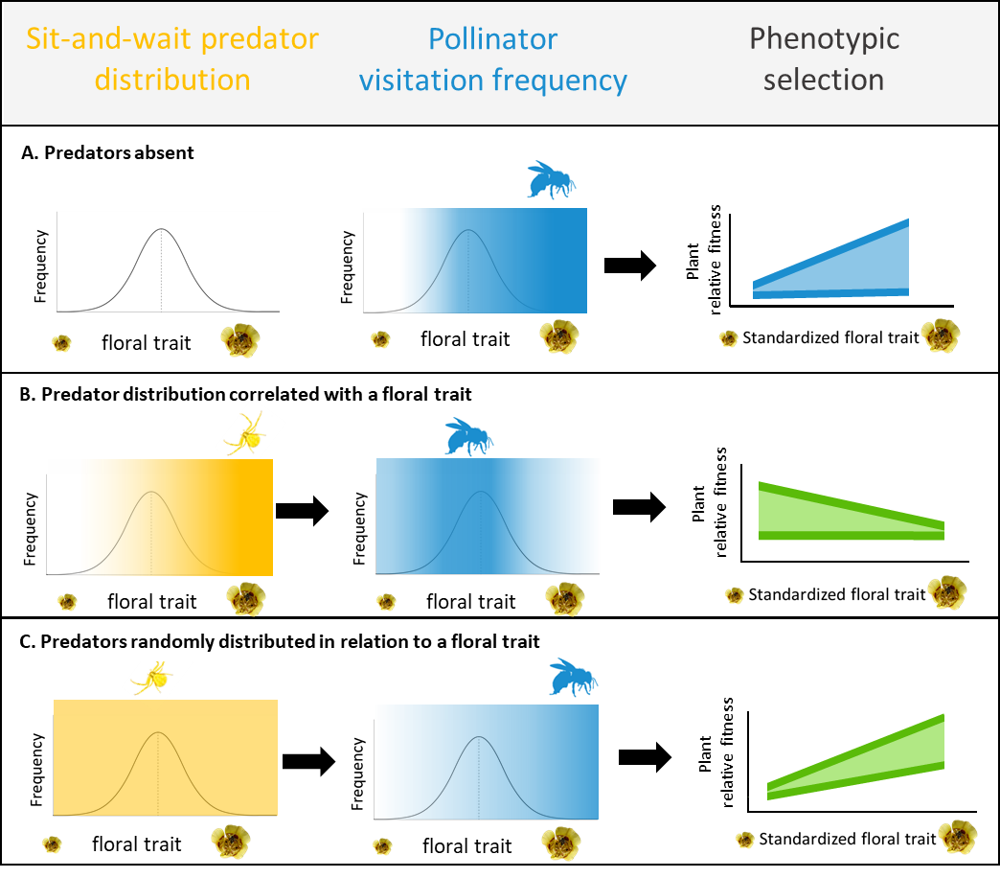
selection on floral traits by preferentially visiting plants with phenotypes that they find attractive/rewarding, which increases the relative fitness of those plants (Fig. 2.1, Panel A). Sit-and-wait predators that hunt directly from plants can weaken plant-pollinator interactions by decreasing visitation, and thereby have the potential to affect the intensity of selection on plant traits (Benoit and Caruso 2021). Evidence suggests that sit-and-wait predators hunt from plants with high prey availability; they arrive at hunting sites through a process of trial and error wherein they leave a site if too few potential prey arrive within a ‘giving up time” or “giving up density’ or stay at the site if prey arrival is sufficient (Morse 1993, 1999, 2007; Bedoya-Perez et al. 2013). Therefore, I predict that if pollinator visitation is correlated with a plant trait and predators hunt from flower phenotypes that are correlated with high pollinator visitation rates, then predator hunting sites will be associated with plant traits that attract pollinators. If predators are associated with plant traits, and they reduce visitation to the plants they occupy more than surrounding plants, then I expect that predators will affect selection by reducing the relative fitness of the plants they hunt from, thereby weakening overall selection on plant traits that they are associated with. For example, predatory ambush bugs hunt from great blue lobelia with larger than average floral displays, and significantly weaken the strength of selection on floral display size (Benoit and Caruso 2021). When ambush bugs are absent, there is strong pollinator-mediated selection for larger floral displays (Benoit and Caruso 2021).
Pollinator predators that hunt from flowers, such as crab spiders, opportunistically consume herbivores in addition to pollinators (Benoit and Kalisz 2020). In general, predators negatively affect plant fitness by disrupting mutualistic plant-pollinator interactions (Dukas 2005; Knight et al. 2005, 2006; Goncalves-Souza et al. 2008), but can positively affect plant fitness by consuming and deterring herbivores (Louda 1982; Whitney 2004; Romero et al. 2008). For example, Louda (1982) found that the presence of spiders on inflorescences reduced pollination and seed set, but ultimately increased the number of viable seeds by decreasing damage caused by pre-dispersal seed herbivores. The net effect of predators on plant fitness depends on factors including predator hunting mode, habitat domain, and the presence of plant rewards such as extrafloral nectaries (Romero and Koricheva 2011).
We conduct both an observational field study and a manipulative field experiment to quantify the effects of crab spiders (Thomisidae), a common sit-and-wait pollinator predator that hunts from flowers, on fitness and the strength and direction of phenotypic selection on traits of the wildflower Calochortus luteus [Liliaceae]. I address the effects of crab spiders within the context of C. luteus’ common herbivores including mammalian herbivory and pre-dispersal seed herbivory with the following research questions:
- How abundant are crab spiders on C. luteus and are crab spider hunting sites associated with plant traits?
- How do crab spiders, pre-dispersal seed herbivores, and mammalian herbivores affect the fitness of C. luteus and do their effects interact?
- To what extent do crab spiders affect the strength and direction of phenotypic selection on floral traits of C. luteus in nature?
- To what extent do crab spiders affect the strength and direction of phenotypic selection on traits of C. luteus when crab spider presence is experimentally randomized across C. luteus floral phenotypes?
- How does crab spider-mediated selection compare to selection by pre-dispersal seed herbivores and mammalian herbivores?
Crab spiders can decrease pollinator populations when they occupy as few as 1-2% of flowers (Cresswell 2017; Rodríguez-Gironés 2012). Therefore, I predict that if crab spiders are present on at least 1% of flowers they have the potential to impact plant-pollinator and plant-herbivore interactions leading to effects on fitness and selection. I predict that crab spider hunting sites will be associated with plant traits that increase prey visitation, such as flower size, flower number, flowering stem height, and flowering date. I predict that crab spiders will reduce plant-pollinator interaction through consumptive and non-consumptive effects leading to reduced pollen import and export resulting in lower seed set (Knight et al. 2006). However, I also predict that crab spiders will reduce damage to C. luteus seeds by pre-dispersal seed herbivores thereby increasing C. luteus seed set. I expect mammalian herbivores to decrease C. luteus seed set, and to be unaffected by crab spiders. If crab spider hunting sites are associated with plant traits, and crab spiders reduce the relative fitness of plants that they hunt from by decreasing pollination, then I expect crab spiders to weaken the strength of pollinator-mediated selection on those traits. However, if crab spiders increase plant relative fitness by decreasing damage by pre-dispersal seed herbivores, then I would expect crab spiders to increase the strength of selection on the plant trait that their hunting sites are associated with. I do not expect crab spiders to impact selection generated by mammalian herbivores on C. luteus traits. By experimentally manipulating crab spider presence and absence I test whether crab spiders are causal agents of selection (Wade and Kalisz 1990). Further, this experiment will allow us to determine whether crab spiders affect selection on plant traits via a mechanism other than hunting site association with plant traits, such as by altering the opportunity for selection. Predators, pollinators, and herbivores have the potential to generate conflicting or reinforcing selection on plant traits (Gomez et al. 2009; Caruso et al. 2010; Knauer et al. 2018). Examining how multiple community members affect plant fitness and selection, and how their effects can change across time, provides a more comprehensive understanding of the selective pressures that can shape adaptive evolution of plant traits.
Materials and Methods
Study system
Calochortus luteus, (Liliaceae), the yellow mariposa lily, is a perennial geophyte that grows in heavy and serpentine soils in grasslands and open woodlands at low elevations on the west coast of North America, primarily within California (Jepson 1993). Its narrow linear basal leaves emerge in the fall and wither before flowering stems emerge from April to June (Baldwin et al., 2012). Flowering plants produced between one and six sequential flowers, with more than 90% of flowering individuals producing a single flower in the study population (UC Davis McLaughlin Reserve in Lake County, California in Lake Co., California, USA (8°51’34.7”N 122°24’17.0”W; Appendix 1: Fig. S2.1). The flowers remained open for an average of three days. They are perfect, trimerous, and bowl-shaped, with a mean width of 36 mm, mean depth of 20 mm. The perianth is yellow with variable maroon pigmentation (Fig. 2.2). The ovary matures into a dry capsule with three locules containing up to ~200 seeds each. After the fruits mature in June, the plants go dormant for the duration of the hot dry summer. Growth resumes, and seeds germinate in October-November when temperatures cool and rain commences.
Calochortus luteus flowers are visited by a diverse group of insects, including bees, wasps, beetles, flies, and butterflies. The most frequent floral visitors observed in this population were Lasioglossum spp. (sweat bees; unpublished data). Calochortus luteus is self-compatible, but lacks a mechanism for autonomous selfing, thus relies on floral visitors for pollen transfer.
Calochortus flowers are used as hunting sites by crab spiders (Thomisidae). Crab spiders observed hunting from C. luteus included Misumena vatia and Mecaphesa spp. (personal observation). These spiders can reversibly change color from white to yellow/red over the course of several days. This color change matches the flowers they hunt from making them less conspicuous to their own predators and more cryptic to floral visitors (Théry and Casas 2002, Insausti and Casas 2008; Fig. 2.2). Crab spiders are sit-and-wait hunters and will opportunistically attack prey that come within reach including insect pollinators and herbivores as well as other spiders.
Observational study
We quantified the natural occurrence and distribution of crab spiders on C. luteus plants in relation to four phenotypic traits: flower size, flower number, flowering stem height, and flowering date. To determine the percentage of flowering C. luteus plants with crab spiders I examined plants for crab spider presence/absence and calculated the percent that harbor crab spiders: [(number of plants with crab spiders present)/ (total number of plants examined)] x 100. To determine if crab spiders were associated with plant traits, I compared trait means between spatially and temporally paired plants with crab spiders present and absent. Plants with crab spiders present were marked with flags and traits were measured, then a spider-free paired plant was selected by random compass direction, marked, and its traits were measured. All crab spider absent plants were within 0.5 to 10 m from their paired crab spider present plant and flowering concurrently. If the first compass direction did not yield a plant meeting those criteria another random compass direction was used. All marked plants were checked daily for crab spider presence or absence. If a crab spider-free plant was colonized by a crab spider, it was reassigned to the crab spider present category, and new spider absent plants were selected and marked for the original and new crab spider present plants.
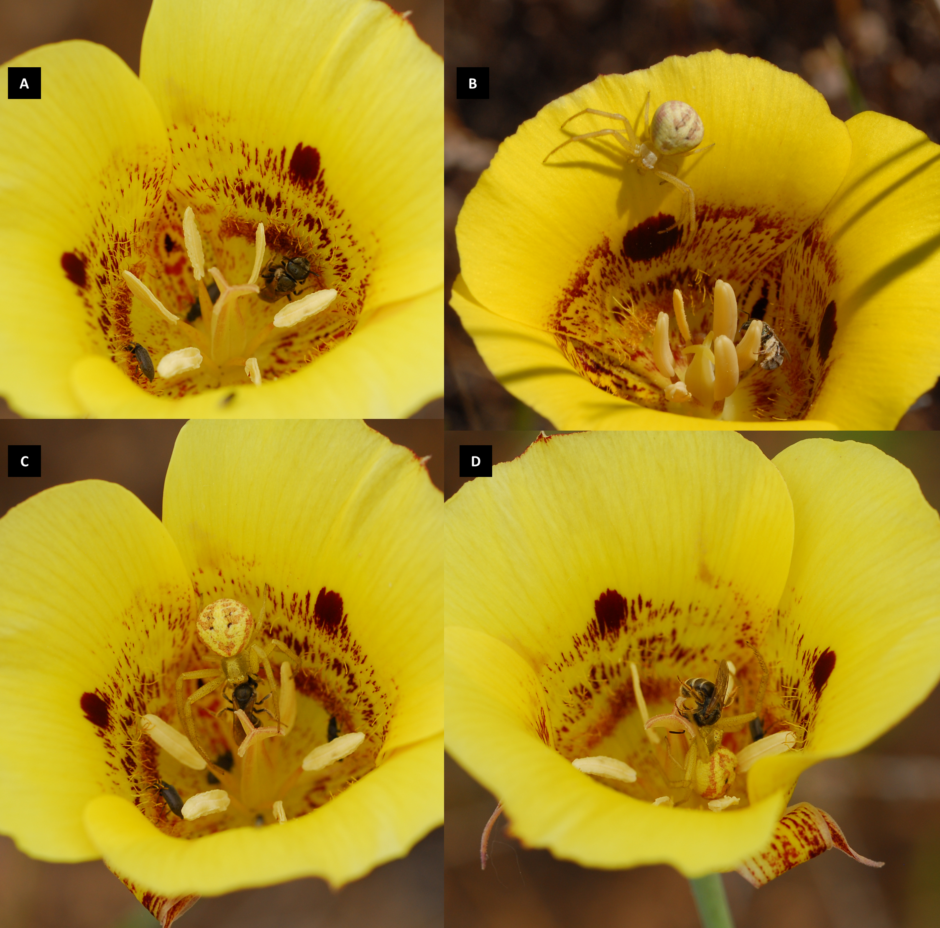
Figure 2.2. Behavior of a crab spider (Misumena vatia) and a sweat bee (Halictidae) in a Calochortus luteus flower. A) The bee collects nectar from hairs at the base of petals. B) The bee collects pollen from anther; crab spider moves into an attack position. C) Crab spider captures bee; note crab spider color matching with C. luteus petals. D) Crab spider moves to the base of the pistil with the bee. The bee attempts to escape, climbing to the stigma. Photo credit: A. Benoit at the UC Davis McLaughlin Reserve, Lake County, California.

To determine how crab spiders affect selection on floral traits of C. luteus, I compared the strength and direction of linear selection gradients between the plants with crab spiders present and crab spiders absent. In addition to collecting trait and fitness data (described in detail in a subsequent section) for each plant, I also collected data on herbivory damage, because herbivores can be strong agents of selection. Calochortus flowers are eaten by mammalian herbivores, including blacktail jackrabbits, Audubon cottontails, brush rabbits, mule deer and valley pocket gophers (Fiedler 1987). Mammalian herbivores clip stems a few inches from the ground, usually during flowering (personal observation). The developing fruit of C. luteus can be damaged by pre-dispersal seed herbivores, such as sawfly larvae (Tenthredinidae: Rhadinocereae) that feed on immature ovules and seeds within the developing fruit (Fiedler 1987). Each plant was scored for mammalian herbivore damage (0 = undamaged vs. 1 = damaged) and for pre-dispersal seed herbivore damage (0 = undamaged vs. 1 = damaged).
Transect experiment
To experimentally determine whether crab spiders are causal agents of selection on traits of C. luteus and to further elucidate the mechanism(s) by which crab spiders affect selection on floral traits I conducted a field experiment. In Spring 2018, I marked 288 C. luteus plants along 14 transects. Each transect was 60-meter long by a meter wide and marked plants were ≥0.5 meters apart. I tagged C. luteus plants with buds before flowering using metal ID tags and lawn staples. I randomly assigned each plant to a crab spider addition or crab spider absent treatment. I collected crab spiders via sweep netting in a section of the field that was separated by a road from the main population. I placed spiders individually in vials while collecting and transporting them to the experimental transects, and then placed them onto the open flowers of plants in the crab spider addition treatment. The plants were checked daily. If a spider left a plant, another spider was added. If I found a crab spider on a plant that was assigned to the crab spider absent treatment, I removed it and the plant was excluded from analysis because I cannot rule out the possibility that the spiders left scent or silk cues that could affect pollinator visitation and plant fitness.
Plant traits and fitness
For all plants in the observational study and transect experiment I measured four traits. Flower size was measured as the diameter of the bowl shaped perianth (i.e., petals and sepals; Fig 2) to the nearest millimeter using a ruler. Flowering stem height was measured as the distance from the soil to the tallest point of the corolla on the tallest flowering stem. Number of flowers was measured by counting the total number of flowers that bloomed on each individual. Flowering date is the Julian calendar day that the first flower of each plant senesced in the observational study (because flowers were already open when marked) and the Julian calendar day that the first flower opened in the transect experiment. Senescence was recorded when the petals wilted and drooped. I found little variation in flower longevity, with flowers reliably senescing after three days (unpublished data).
We tracked the fate of each flower and fruit to assess if it was aborted, eaten by a mammalian herbivore, or formed a fruit, and whether the fruit was intact or damaged by a pre-dispersal seed herbivore. I collected each fruit at maturity and counted the number of seeds. I summed the number of seeds across all fruits from the same plant (for individuals with more than one fruit) to calculate the total seed set per individual. Seed set was used as my fitness estimate and relativized (seed set of individual/ mean seed set of treatment group or category) in selection analyses.
Statistical analyses: observational study
We use paired t-tests to compare mean trait values between the paired observational plants with crab spiders present and absent. If trait means differ between plants used as hunting sites by crab spiders relative to randomly selected crab spider free plants, then I conclude that crab spiders are not randomly distributed in relation to plant phenotypes. To determine if crab spiders, mammalian herbivores, and pre-dispersal seed herbivores affected the seed set of C. luteus I used general linear models. I included seed set/plant as the dependent variable, and crab spider (present vs. absent), mammalian herbivore (damaged vs. undamaged), and pre-dispersal seed herbivore (damaged vs. undamaged) as fixed effects and interactions among these three factors. Separate models were run for 2017 and 2018. Additionally, to confirm the effect of crab spiders I used paired t-tests to compare the mean seed set of the paired observational plants with crab spiders present and absent in 2017 and 2018.
To determine how crab spiders affect selection on plant traits, I estimated linear selection gradients for the observational plants with crab spiders present and absent using multiple regression (Lande and Arnold 1983). I calculate selection gradients using general linear models with relative seed set as the response variable and standardized (mean of zero and standard deviation of one) flower size, height, flower number, and flowering date as independent variables, and mammalian herbivory (0 = no herbivory vs. 1 = herbivory) and pre-dispersal seed herbivory (0 = no herbivory vs. 1 = herbivory) as fixed effects. Separate models were run for plants with crab spider absent and present, and for 2017 and 2018 (four models). Data for 2017 and 2018 were analyzed separately because natural selection is notoriously variable year to year due to variation in the biotic and abiotic environment (Siepielski et al. 2009).
To determine whether selection on plant traits differed between plants with crab spiders present and absent, I used a general linear model including relative seeds per plant as the dependent variable, standardize traits (flower size, height, flower number, and flowering date) as independent variables, crab spider, mammalian herbivory and pre-dispersal seed herbivory as fixed effects, crab spider (present vs. absent) × trait interaction terms, mammalian herbivory × trait interaction terms, and pre-dispersal seed herbivory × trait interaction terms. A significant crab spider × trait interaction term indicates that selection on the trait differs when crab spiders are present compared to absent. A significant herbivory × trait interaction term indicates that selection differs between plants damaged and undamaged by herbivores. If a herbivory × trait interaction was significant, then I estimated selection gradients for plants with and without herbivore damage. I used a general linear model with relative seed set per plant as the dependent variable, standardized traits (flower size, flowering stem height, flower number, and flowering date) as independent variables, crab spider and the other herbivory type (i.e., mammalian or pre-dispersal seed herbivory) as fixed effects. I ran separate models for plants with and without herbivore damage to estimate and then compare the strength and direction of selection.
Statistical analysis: transect experiment
To determine how the randomized addition and absence of crab spiders on C. luteus, and natural occurrence of mammalian and pre-dispersal seed herbivory affected the seed set of C. luteus, I used a general linear model. I included seed set/plant as the dependent variable, crab spider treatment, mammalian herbivory, and pre-dispersal seed herbivory as fixed effects, and interactions among these three factors.
To determine how crab spiders affect selection on plant traits when they are randomly distributed across plants, I estimated selection gradients for transect plants that were randomly assigned to crab spider added and absent treatments. I calculated selection gradients using general linear models with relative seed per plant as the response variable and standardized traits (flower size, flowering stem height, flower number, and flowering date) as independent variables. Mammalian and pre-dispersal seed herbivory were included as fixed effects. Separate models were run for transect plants assigned to the crab spider added and absent treatments.
To determine whether selection on plant traits differs between plants that were randomly assigned to crab spider added and absent treatments, I used a general linear model including relative seed set per plant as the dependent variable, standardized traits (flower size, height, flower number, and flowering date) as independent variables, mammalian herbivory and pre-dispersal seed herbivory as fixed effects, and crab spider × trait (flower size, height, flower number, and flowering date), mammalian herbivore × trait, and pre-dispersal seed herbivory × trait interaction terms. A significant crab spider × trait interaction term indicates that selection on the trait is different when crab spiders were absent compared to added. A significant herbivory × trait interaction term indicates that selection differs between plants damaged and undamaged by herbivores. If a herbivory × trait interaction was significant, then I estimated selection gradients for plants with and without herbivory. I used a general linear models with relative seed set per plant as the dependent variable, standardized traits (flower size, height, flower number, and flowering date) as independent variables, crab spider and the other herbivory type (i.e., mammalian or pre-dispersal seed herbivory) as fixed effects. I ran separate models for plants with and without herbivory to estimate and then compare the strength and direction of selection.
All statistical analyses were completed in R version 4.1.2 (R Core Team 2021). The package ‘ggplot2’ was used to make figures (Wickham 2016). In the 2017 and 2018 observational data and the 2018 experimental transect data, the highest correlation between traits was between flowering stem height and flower size 0.37, 0.49, and 0.51 respectively (Appendix 1: Fig. S2.3, S2.4, S2.5).
Results
Observational study
We found that crab spiders occupied 7% of C. luteus plants in 2017 and 9% of C. luteus plants 2018. Plants colonized by crab spiders in 2017 had larger than average flowers: C. luteus without crab spiders had a mean flower size of 35.4 mm (median = 35 mm; range 18-53 mm) and C. luteus colonized by crab spiders were on average 11% larger, with a mean of 39.7 mm (median =40 mm; range = 20-57 mm; paired t-test: t = -4.3, df = 115, P < 0.001; Table 2.1). I did not detect a difference in plant height nor flower number between plants with and without crab spiders in 2017 (Table 2.1). In 2018 there was no detectable difference in flower size between plants with crab spiders present vs. absent (paired t-test: t = -1.0, df = 121, P = 0.3; Table 2.1). Crab spiders-free plants had a mean flower size of 36.4 mm (median = 36 mm, range of 20-53 mm) in 2018 and plants colonized by crab spiders had a mean flower size of 36.9 mm (median = 36.5 mm, range = 23-56 mm; Table 2.1). I did not detect a difference in plant height nor flower number between plants with crab spiders present vs. absent in 2018 (Table 2.1).
In 2017, crab spiders and mammalian herbivores, but not pre-dispersal seed herbivores, affected the seed set of C. luteus (Table 2.2). Interestingly, plants colonized by crab spiders produced more seeds than plants with crab spiders absent, but there was no detectable interaction between crab spiders and pre-dispersal seed herbivores (Table 2.2). Crab spider-free plants (n = 119) produced a mean of 23 seeds (median = 16 seeds; range of 0-140 seeds), while plants colonized by crab spiders (n = 119) produced 39% more seeds with a mean of 32 seeds (median = 23 seeds; range = 0-200 seeds; paired t-test: t = -2.3, df =118, P = 0.02). Of the 238 observational plants in 2017, 30% (n = 85) experienced mammalian herbivory. Plants with mammalian herbivore damage produced 64.6% fewer seeds with a mean of 13.1 seeds (median =0; range = 0-115 seeds); plants without mammalian herbivory produced a mean of 35.9 seeds (median = 26; range = 0-200 seeds; Fig. 2.3). Pre-dispersal seed herbivores damaged 21% of plants with no effect on mean fitness (Table 2.2, Fig. 2.3). No interactions among crab spiders, mammalian herbivores, or pre-dispersal seed herbivores were detected (Table 2.2).
In 2018 I again found that crab spiders and mammalian herbivores affected seed set. Additionally, I found that pre-dispersal seed herbivores decreased seed set (Table 2.3). Plants t = -2.64, df = 1.03, P = 0.01; Fig. 2.3). Crab spider-free plants (n = 150) produced a mean of 15.9 seeds (median = 11 seeds; range = 0-69 seeds). Plants colonized by crab spiders (n = 151) produced a mean of 23.9 seeds (median of 19 seeds; range = 0-203 seeds). Mammalian herbivores damaged 23% of marked C. luteus plants in 2018 and significantly reduced seed set
Table 2.1. Results of paired t-tests comparing traits of Calochortus luteus plants that were naturally colonized by crab spiders to the traits of spatially and temporally paired plants that were crab spider-free. Data are from the observational study completed at the UC Davis McLaughlin Reserve in Lake County, California.
Trait | t | df | P | Mean of the differences  (crab spider absent - present)
Flower number 2017 | -1.943 | 118 | 0.054 | -0.126 flowers
Flower number 2018 | 1.420 | 128 | 0.158 | 0.016 flowers
Flower size 2017 | -4.318 | 115 | <0.001*** | -4.07 mm
Flower size 2018 | -0.948 | 121 | 0.345 | -0.70 mm
Height 2017 | -1.092 | 118 | 0.277 | -8.36 mm
Height 2018 | -0.735 | 122 | 0.464 | -4.02 mm

Table 2.2. Results of a general linear model estimating the effects of crab spiders, mammalian herbivores, pre-dispersal seed herbivores, and interactions among them, on the seed set of Calochortus luteus plants (n = 238) in 2017.
 | Estimate | SE | t- value | P
Crab spiders | 13.0 | 4.1 | 2.2 | 0.03*
Mammalian herbivores | -20.0 | 6.8 | -3.0 | 0.003**
Pre-dispersal seed herbivores | 4.7 | 8.2 | 0.6 | 0.57
Crab spider X mammalian herbivores | - 7.6 | 9.6 | -0.8 | 0.43
Crab spiders X pre-dispersal seed herbivores | -3.6 | 12.2 | -0.3 | 0.77
mammalian herbivores X pre-dispersal seed herbivores | -10.4 | 20.9 | -0.5 | 0.62
Crab spider X mammalian herbivores X pre-dispersal seed herbivores | 19.9 | 25.5 | 0.8 | 0.44

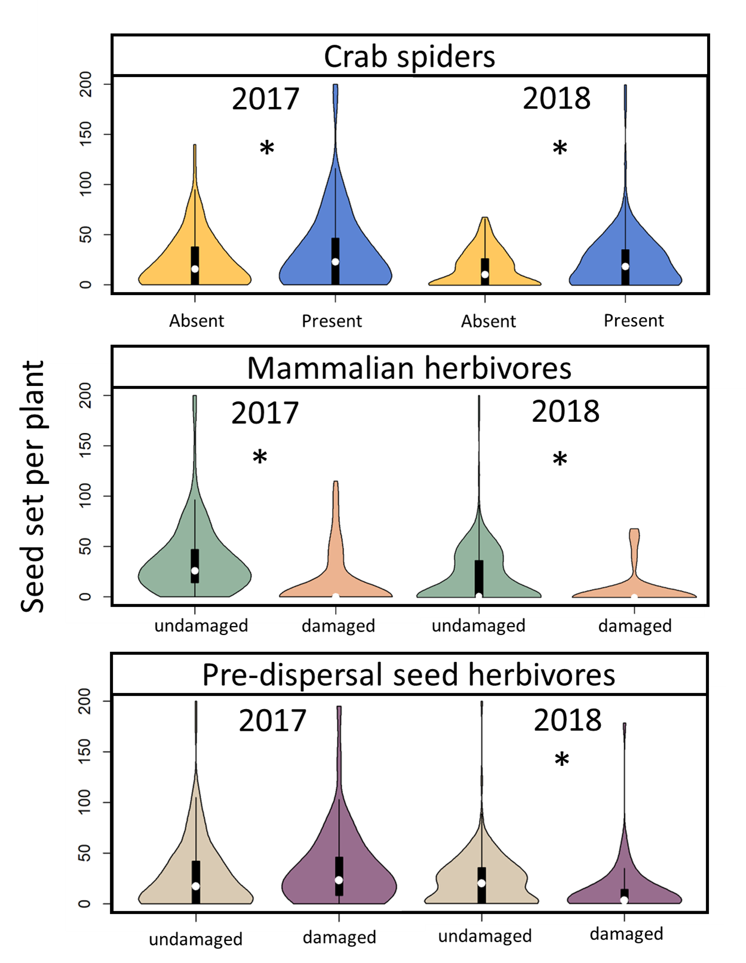
Figure 2.3. Fitness (seed set per plant) of Calochortus luteus observed in 2017 and 2018, comparison of paired plants with crab spiders absent and present (top), plants with and without mammalian herbivore damage (middle), and with and without pre-dispersal seed herbivore damage (bottom). Violin plots show distribution of the data, box plots show quantiles and white circles show the median.

Table 2.3. Results of a general linear model estimating the effects of crab spiders, mammalian herbivores, pre-dispersal seed herbivores, and interactions among them, on the seed set of Calochortus luteus plants (n = 301) in 2018.
 | Estimate | SE | t- value | P
Crab spiders | 7.2 | 3.5 | 2.1 | 0.04*
Mammalian herbivores | -21.1 | 4.7 | -4.5 | <0.001***
Pre-dispersal seed herbivores | -18.4 | 4.5 | -4.1 | <0.001***
Crab spider X Mammalian herbivores | -1.4 | 6.6 | -0.2 | 0.83
Crab spiders X Pre-dispersal seed herbivores | 5.5 | 6.6 | 0.8 | 0.1
Mammalian herbivores X Pre-dispersal seed herbivores | 3.4 | 17.2 | 0.2 | 0.84

(Table 2.3; Fig. 2.3). Plants without mammalian herbivore damage (n = 233) produced a mean of 23.8 seeds (median 20 seeds, range 0-203 seeds), and plants with mammalian herbivore damage (n = 68) produced 73% fewer seeds, with a mean of 6.4 seeds (median 0 seeds, range 0-69 seeds; Fig. 2.3). Pre-dispersal seed herbivores damaged 23% of C. luteus in 2018. Plants colonized by crab spiders produced 50% more seeds than crab spider free plants (paired t-test: without pre-dispersal seed herbivore damage (n = 232) produced a mean of 22.2 seeds (median = 20 seeds, range = 0-203 seeds), and plants with pre-dispersal seed herbivore damage (n = 69) produced 46% fewer seeds with a mean of 11.9 seed (median of 3 seeds; range of 0-181 seeds; Fig. 2.3). I found no evidence of interactions among crab spiders, mammalian herbivores, nor pre-dispersal seed predators (Table 2.3). In 2017 observational C. luteus plants without crab spiders experienced selection for more flowers (β ± SE = 0.61 ± 0.09; P < 0.001), and marginally significant selection for larger flowers (β ± SE = 0.17 ± 0.10; P = 0.08; Fig. 2.4). There was no detectable selection on either flowering stem height (β ± SE = 0.07 ± 0.10; P = 0.49) or flowering date (β ± SE = 0.04 ± 0.09; P = 0.64; Fig. 2.4). Plants colonized by crab spiders experienced selection for more flowers (β ± SE = 0.84 ± 0.10; P < 0.001), and selection was not detectable on flowering date (β ± SE = -0.15 ± 0.09; P = 0.12), flower size (β ± SE = -0.04 ± 0.10; P = 0.67), nor flowering stem height (β ± SE = 0.02 ± 0.10; P = 0.84; Fig. 2.4). I detected a crab spider × flower number interaction (P = 0.04), and a marginally significant crab spider × flower size interaction (P = 0.07; Appendix 2.1: Table S2.1). The crab spider × trait interactions suggest that plants colonized by crab spiders experience stronger selection on flower number and weaker selection on flower size than crab spider free plants (Fig. 2.4).
We found significant mammalian herbivore × flower size (P = 0.05), mammalian herbivore × flower number (P = 0.003) interactions in 2017 (Appendix 2.1: Table S2.1). Plants without mammalian herbivory experienced selection for more flowers per plant (β ± SE = 0.64 ± 0.06, P < 0.001) and marginally significant selection for larger flowers (β ± SE = 0.12 ± 0.07, P = 0.08). Plants damaged by mammalian herbivores experienced significantly stronger selection for more flowers (β ± SE = 1.19 ± 0.31; P < 0.001) and a reversal in the direction of selection on flower size (β ± SE = -0.29 ± 0.27; P = 0.28).
We also found a significant pre-dispersal seed herbivore × flowering date interaction in 2017 (P = 0.05; Appendix 2.1: Table S2.1). Plants without pre-dispersal seed herbivory experienced non-significant selection trending towards earlier flowering (β ± SE = -0.14 ± 0.10; P = 0.15) and plants with damage by pre-dispersal seed herbivores experienced non-significant selection trending for later flowering (β ± SE = 0.03 ± 0.13; P = 0.83; Appendix 2.1: Table S2.5).
In 2018, the observational C. luteus plants without crab spiders experienced selection for more flowers (β ± SE = 0.22 ± 0.08; P < 0.01), taller flowering stems (β ± SE = 0.36 ± 0.10; P < 0.001), and earlier flowering date (β ± SE = -0.41 ± 0.11; P < 0.001), but there was no detectable selection on flower size (β ± SE = 0.59 ± 0.09; P = 0.30; Fig. 2.5). Plants with crab spiders present in 2018 also experienced selection for more flowers (β ± SE = 0.22 ± 0.08; P < 0.001), taller flowering stems (β ± SE = 0.33 ± 0.11; P < 0.01), and earlier flowering (β ± SE = -0.25 ± 0.12; P =
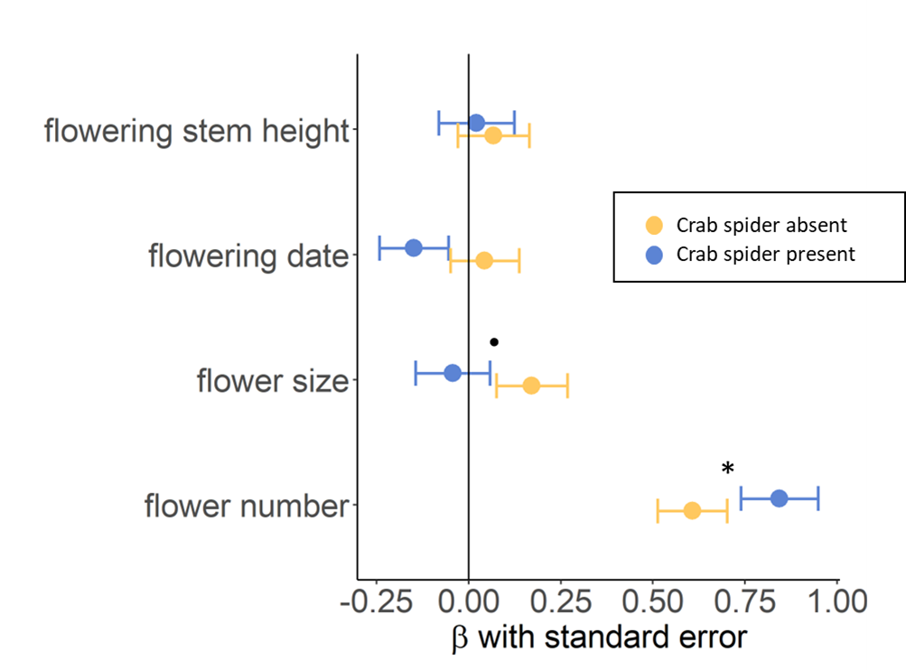
Figure 2.4. Linear selection gradients (ꞵ $±$SE) estimated via multiple regression of standardized traits of Calochortus luteus plants using relativized seed set per plant as a fitness metric. Selection gradients were calculated separately for observational plants with crab spiders absent and present in 2017. An asterisk indicates that the strength of selection differs between plants with crab spiders absent or present (i.e., interaction term P < 0.05 indicating differing slopes) and a dot indicates a marginally significant difference (P < 0.08).

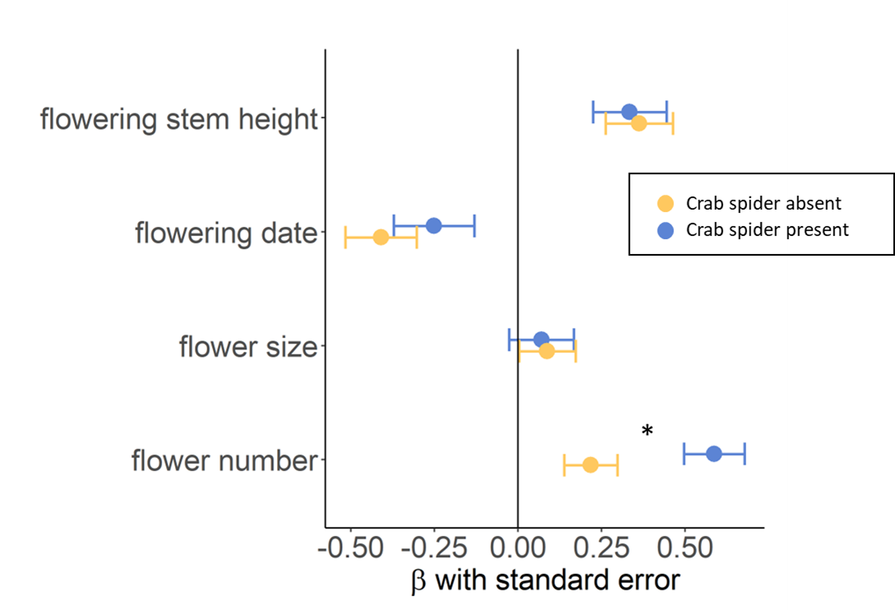
Figure 2.5. Linear selection gradients (ꞵ $±$SE) estimated via multiple regression of standardized traits of Calochortus luteus plants using relativized seed set per plant as a fitness metric. Selection gradients were calculated separately for observational plants with crab spiders absent and present in 2018. An asterisk indicates that the strength of selection differs between plants with crab spiders absent present (i.e., interaction term P < 0.05 indicating differing slopes).

0.04), and no detectable selection on flower size (β ± SE = 0.07 ± 0.11; P = 0.47; Fig. 2.5). I found a significant crab spider × flower number interaction term (P = 0.04; Appendix 2.1: Table S2.2) which indicates that the strength of selection on flower number is stronger when crab spiders are present compared to absent (Fig. 2.5). I found significant mammalian herbivore × flowering date and mammalian herbivore × flowering stem height interactions indicating that selection on these traits differ between plants that were damaged and undamaged by mammalian herbivores in 2018 (Appendix 2.1: Table S2.2). Plants without mammalian herbivore damage experienced selection for earlier flowering (β ± SE = -0.39 ± 0.08; P < 0.001), taller flowering stems (β ± SE = 0.37 ± 0.08; P < 0.001), and for more flowers (β ± SE = 0.46 ± 0.06; P < 0.001). Mammalian herbivory reversed the direction of selection on flowering date (β ± SE = 0.25 ± 0.38; P = 0.52) and flowering stem height (β ± SE = -0.11 ± 0.37; P = 0.76), and selection for more flowers did not significantly differ (β ± SE = 1.28 ± 0.34; P < 0.001).
We found a significant pre-dispersal seed herbivore × flower number interaction in 2018 (Appendix 2.1: Table S2.2). Plants without pre-dispersal seed herbivore damage experienced selection for more flowers (β ± SE = 0.34 ± 0.06; P < 0.001), earlier flowering (β ± SE = -0.34 ± 0.08; P < 0.001), and taller flowering stems (β ± SE = 0.08 ± 0.06; P < 0.001). Plants with pre-dispersal seed herbivore damage experienced significantly stronger selection on flower number (β ± SE = 1.62 ± 0.022; P < 0.001); selection on the other traits was non-significant.
Crab spider manipulation experiment
In the 2018 transect experiment, C. luteus plants were randomly assigned to crab spider addition and absent treatments. Crab spider treatment had a marginally significant effect on seed set, and both mammalian herbivores and pre-dispersal seed herbivores significantly reduced seed set (Table 2.4). I found a significant crab spider x pre-dispersal seed herbivore interaction, but not in the predicted direction. Contrary to my prediction that crab spiders would mitigate the negative effects of pre-dispersal seed herbivores, I found that plants with crab spiders added and pre-dispersal seed herbivores had the lowest seed set while plants with no pre-dispersal seed herbivores and added crab spiders had the highest seed set (Table 2.4; Appendix 2.1: Figure S2.2). However, only 10% of transect plants experienced pre-dispersal seed herbivory (n = 29; plants with pre-dispersal seed herbivory & crab spider addition: n = 14). Similarly, rates of mammalian herbivory were lower for transect plants than for observational plants; 35 of 288 transect plants experienced mammalian herbivory, or 12%. Plants without mammalian herbivory produced a mean of 25.1 seeds (median = 22 seeds; range = 0-118 seeds) while plants with mammalian herbivory produced 98% fewer seeds with a mean of only 0.6 seeds (median = 0 seeds; range = 0-21 seeds). Similar to the observational study results, I found that C. luteus with crab spiders added trended towards producing more seeds (P = 0.06; Table 2.4). Transect plants with crab spiders absent (n = 137) produced a mean of 21.7 seeds (median = 19 seeds; range = 0-118 seeds), and transect plants with crab spiders added (n = 151) produce a mean of 22.5 (median = 21 seeds; range = 0-85 seeds).

Table 2.4. Results of a general linear model estimating the effects of experimental crab spider addition vs. absent treatment as well as natural mammalian herbivore damage, pre-dispersal seed herbivore damage, and interactions among them, on the seed set of Calochortus luteus plants (n = 288) along transects in 2018.
 | Estimate | SE | t- value | P
Crab spiders | 4.4 | 1.7 | 1.9 | 0.06
Mammalian herbivores | -23.2 | 5.4 | -4.3 | <0.001***
Pre-dispersal seed herbivores | -10.9 | 4.9 | -2.2 | 0.03*
Crab spider X Mammalian herbivores | -6.1 | 6.7 | -0.9 | 0.36
Crab spiders X Pre-dispersal seed herbivores | -14.2 | 7.0 | -2.0 | 0.04*
Mammalian herbivores X Pre-dispersal seed herbivores | NA | NA | NA | NA

Transect plants with crab spiders absent experienced selection for earlier flower (β ± SE = 0.30 ± 0.07, P < 0.001), taller flowering stems (β ± SE = 0.31 ± 0.08, P < 0.001), larger flowers (β ± SE = 0.35 ± 0.07, P < 0.001), and more flowers (β ± SE = 0.17 ± 0.08, P = 0.04; Fig. 6). Plants with crab spiders added experienced selection for earlier flowering (β ± SE = -0.31 ± 0.06, P < 0.001) and taller flowering stems (β ± SE = 0.49 ± 0.06, P < 0.001), no significant selection was detected for flower size (β ± SE = 0.05 ± 0.05, P = 0.42) or flower number (β ± SE = 0.10 ± 0.08, P =0.23; Fig. 2.6). I found significant crab spider treatment x flower size and crab spider treatment x flowering stem height interactions, indicating that selection on these traits differs when crab spiders are absent vs. added (Fig. 2.6; Appendix 2.1: Table S2.3).
We found significant mammalian herbivore x flower size and mammalian herbivore x flowering date interactions, suggesting that mammalian herbivores affect selection on these traits. Transect plants without mammalian herbivory experienced selection for larger flowers (β ± SE = 0.18 ± 0.04, P < 0.001), taller flowering stems (β ± SE = 0.42 ± 0.05, P < 0.001), and earlier flowering (β ± SE = -0.30 ± 0.04, P < 0.001). However, I did not have sufficient power to estimate selection gradients for plants with mammalian herbivores (n = 35).
Discussion
Pairwise interactions between plants and pollinators, or plants and herbivores, are often predicted to drive adaptive evolution of floral form. However, flowering plants live within complex communities and interact directly and indirectly with many species simultaneously across trophic levels. These multi-species interactions can affect plant fitness and the strength and direction of natural selection on plant traits. Predators, by changing the abundance and behavior of pollinators and herbivores have the potential to shape selection and adaptive evolution of plant traits, yet the impact of sit-and-wait predators that hunt from plants on plant fitness and selection on plant traits has rarely been examined. Through a combination of observational study and field experiment I examined how crab spiders, a ubiquitous sit-and-wait predator, and two types of herbivores impact fitness and phenotypic selection on the charismatic yellow mariposa lily.
We found that crab spiders were present on 7% and 9% of C. luteus. Commonly reported crab spider abundance is 1-2% of flowers/inflorescences (Dukas and Morse 2005; Morse 2007; Rodriguez-Girones 2012; Cresswell 2017), with other reports as high as 26% of flowers/inflorescences (Knauer et al. 2018). Yet, the presence of crab spiders on just 1-2% of flowers or inflorescences has been shown to be sufficient to exert top-down control on bee populations (Rodriguez-Girones 2012; Cresswell 2017). By changing the abundance and behavior of pollinators, and/or herbivores, crab spiders, and other sit-and-wait floral predators, may affect selection on floral traits (Benoit and Kalisz 2020; Benoit and Caruso 2021).
We predicted that crab spiders hunting sites would be associated with floral traits, rather than randomly distributed across plant phenotypes. my 2017 observational results support this prediction, I found that crab spiders hunted from plants with larger flowers than spatially and temporally paired crab spider-free plants (Table 2.1). This finding is consistent with

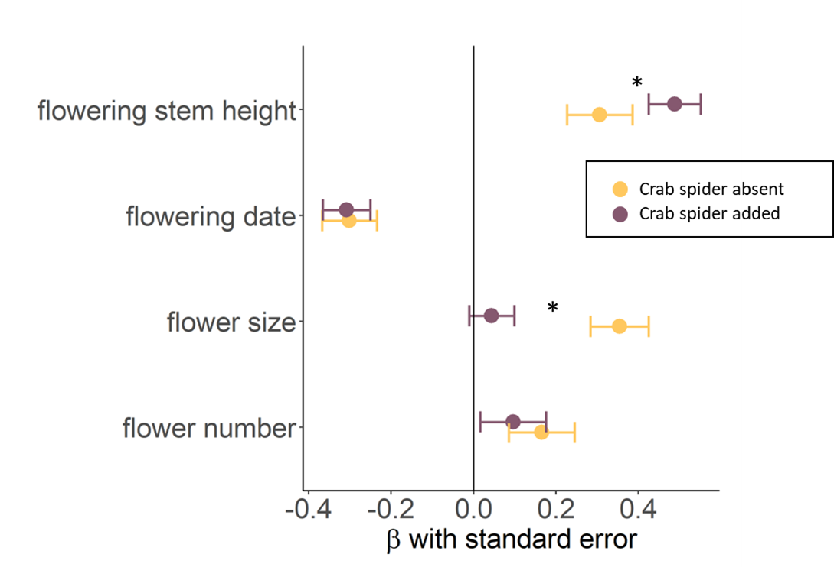
Figure 2.6. Linear selection gradients (ꞵ $±$SE) estimated via multiple regression of standardized traits of Calochortus luteus plants using relativized seed set per plant as a fitness metric. Selection gradients were calculated separately for plants with crab spiders experimentally added and absent along transects in 2018. An asterisk indicates that the strength of selection differs between plants with crab spiders present and added (i.e., interaction term P < 0.05 indicating differing slopes).

the hypothesis that crab spiders select hunting sites based on prey abundance. Pollinators are known to preferentially visit larger flowers or plants with bigger floral displays (Schemske and Agren 1995; Blarer et al. 2002). However, I cannot confirm that the plants with larger flowers received more visits since I did not measure pollinator visitation rates. my findings are similar to previous findings that sit-and-wait ambush bugs hunt from plants with larger than average floral displays (Benoit and Caruso 2021). I did not find any associations between crab spider hunting sites and the four measured plant traits in 2018. It is possible that in 2018 crab spider hunting sites were correlated with an unmeasured plant trait(s). For instance, floral visitors are known to be attracted by nectar quality and quantity, scent, and color, but these traits were not measured (Southwick et al. 1981; Raguso 2004). Alternatively, if floral visitation (i.e., prey availability) was higher in 2018 than 2017 across plant phenotypes, then all or most C. luteus flowers may have been sufficiently profitable hunting sites, leading to no association between crab spider hunting sites and floral traits. The growth and flowering season in 2018 was drier than in 2017, total rainfall from January - June in 2017 was 933.48 mm compared to only 341.87 mm during the same six month period in 2018 (Appendix 2.1: Table S2.4). This difference in water availability may have caused differences in plant height and flower size between years, which could in part explain the difference in crab spider association with traits seen between 2017 and 2018.
Since crab spiders hunted from larger than average flowers in 2017, I expected them to weaken selection on flower size and my findings match this prediction (Fig. 2.4). If the presence of crab spiders on larger flowers caused pollinators to slow their foraging, increase inspection time, and/or shift to visiting smaller safer flowers, then I would expect a trait mediated-indirect effect (i.e., the predator changes a trait of the pollinator, such as behavior, thereby altering plant-pollinator interactions and affecting the plant) yielding weakened or reversed selection on flower size because larger flowered plants that harbor crab spiders would receive fewer pollinator visits, thus reducing their relative fitness. Tradeoffs between foraging speed and accuracy of predator detection and shifts to less rewarding flowers have been documented in behavioral studies of bees (Ings and Chittka 2008; Jones and Dornhaus 2011; Benoit and Kalisz 2020). However, my seed set results are inconsistent with this hypothesis.
We predicted that plants with crab spiders would have reduced seed set compared to crab spider-free plants because crab spiders would reduce pollinator visits and cause pollen limitation (Knight et al. 2005; Benoit and Kalisz 2020). Alternatively, I predicted that if crab spider presence reduced damage by pre-dispersal seed herbivores, then crab spiders may have a net neutral or even a net positive effect on the seed set of C. luteus (Louda 1985; Romero and Koricheva 2011; Benoit and Kalisz 2020). Contrary to these predictions, I found that observational plants harboring crab spiders produced more seeds than crab spider free plants in both 2017 and 2018, but I found no evidence that crab spiders reduced damage by pre-dispersal seed herbivores. Some studies suggest that crab spiders can increase pollinator attraction to plants and thereby could increase seed set (Heiling et al. 2003; Llandres et al. 2011; Welti et al. 2016). However, I found that the presence of crab spiders decreased both visit frequency and visit duration (Chapter III). A possible explanation for this finding is that crab spiders are hunting from more fit plants. Crab spiders could be associated with an unmeasured trait (e.g. nectar quantity, scent, etc.), which could be correlated with the plant’s age or resource availability. This hypothesis would explain the increased seed set of plants with crab spiders despite lower pollination services, if pollen is not the limiting factor in seed production. Holtsford (1985) found that water availability, not pollen, limited the seed set of a related Calochortus species. However, I saw a non-significant trend toward higher seed set in the transect plants that were randomly assigned to the crab spider added treatment. This trend may simply be due to random chance, but more study is warranted to determine whether crab spiders are causal agents of higher seed set in C. luteus. If crab spiders are causal agents of higher seed set in C. luteus I hypothesize two potential mechanisms. First, since C. luteus is self-compatible but lacks a mechanism for autonomous pollen transfer, it is possible that crab spiders while hunting within a flower mediate transfer of self-pollen from anther to stigma r and thus increase seed set. If crab spiders mediate self-pollination, then plants with crab spiders would be pollinated (with self-pollen) regardless of pollinator visitation - which could explain why there was not a significant difference in relative fitness in relation to flower size (i.e. no selection on flower size) when crab spiders were present. Alternatively, I observed crab spiders attacking bees and attempting to subdue them while perched on the pistil of C. luteus flower, in the process holding the pollen-laden bee against the surface of the stigma. This hunting behavior could presumably facilitate outcross pollen deposition and may explain how crab spiders increase plant seed set and reduce the strength of selection on flower size. Further experiments are needed to test these two non-mutually exclusive hypotheses.
Unsurprisingly, I found that mammalian herbivores had a large negative effect on the seed set of C. luteus in both 2017 and 2018. Mammalian herbivores clipped flowering stems usually when the plant was flowering, but occasionally buds and developing fruits were also consumed. Since most plants (~90%) only produce a single flowering stem with one flower, if that flowering stem was consumed, plants were not able to produce any seeds. Plants that experienced mammalian herbivore damage and produced seed were plants that produced more than one flower, and were able to set seed in a subsequently produced flower/fruit. In the observational study I found that 30% and 23% of my marked plants experienced mammalian herbivory, while along my experimental transects only 12% of marked plants experienced herbivory. Since the second year of my observation study was the same year as my experimental study and conducted within the same population, temporal and spatial variation in herbivore abundance cannot explain this difference. I believe that this difference may be due to how the plants were marked. In the observational study survey flags were used while in the experimental study the transect ends were marked with poles and plants were marked with metal tags and ground staples. The orange color and/or movement of the survey flags may have attracted mammalian herbivores and cause higher rates of herbivory in the observational study.
We found that pre-dispersal seed herbivores did not have a detectable effect on seed set in 2017, but decreased seed set in 2018. Sawflies oviposit on developing fruit and their larva consume developing seeds (Fiedler 1987). In C. luteus, I found that seed consumption was generally restricted to one of the three locules. It is possible that in 2017, with higher rainfall, that C. luteus plants were able to compensate for the loss of developing seeds in one locule by maturing more seeds in the undamaged locules. Lower water availability in 2018 may have limited the plants’ ability to tolerate/compensate for pre-dispersal seed herbivory. As climate change causes hotter drier springs in California, plants such as C. luteus may become more susceptible to pre-dispersal seed herbivore damage. Further work exploring the effects of climate change on plants’ ability to tolerate herbivory are warranted (Hamann et al. 2021).
Predators that hunt from flowers often protect plants from insect herbivores (Romero and Koricheva 2011; Louda 1982), however I found no evidence that crab spiders decreased the amount of damage caused by pre-dispersal seed herbivores on C. luteus. In 2017 I found no interaction between crab spiders and pre-dispersal seed herbivores. In 2018, I did find evidence of an interaction, but not in the predicted direction. Rather than mitigating the negative effects of pre-dispersal seed herbivores, I found that crab spiders seemingly exacerbated the negative fitness effects (Appendix 2.1: Fig. S2.2).
We found that mammalian herbivores had a much larger negative effect on C. luteus fitness than pre-dispersal seed herbivores. This could be an important conservation consideration given that other members of the genus Calochortus are threatened or endangered. Trophic downgrading (sensu Estes et al. 2011) and the subsequent increase in populations of mammalian herbivores, such as deer and hares, may threaten Calochortus populations.
In 2017 I found that both mammalian and pre-dispersal seed herbivores affected selection on traits of C. luteus. I found that mammals increase the strength of selection for more flowers. This makes sense, only plants that produced multiple flowers were able to produce seeds if they experienced mammalian herbivory and plants with only one flower that was consumed produced zero seeds. I also found that mammalian herbivores selected for smaller flowers. Plants with larger flowers were more likely to be eaten by mammals, thus plants with smaller flowers had higher relative fitness. Pre-dispersal seed herbivores shifted selection from a trend toward earlier flowering to a trend towards later flowering. This is a common trend in the literature, pollinators tend to favor earlier or peak flowering while pre-dispersal seed herbivores tend to select for later flowering (reviewed in Elzinga et al. 2007). Similarly, in 2018 mammalian herbivores shifted selection towards later flowering, and towards shorter flowering stems. Pre-dispersal seed predators in 2018 shifted selection towards increased flower number.
Our findings suggest that sit-and-wait predators may alter selection on traits without their hunting sites being associated with the trait. I did not find a difference in flower number between plants with crab spiders present vs. absent in either 2017 or 2018, yet in both years selection for more flowers was significantly stronger when crab spiders were present compared to absent (Fig. 2.4, 2.5). Yet, because I did not find evidence that crab spiders increase the strength of selection on flower number when randomly assigned to plants in the transect experiment (Fig. 2.6), I cannot conclude that crab spiders are causal agents of selection on flower number.
Plants with more flowers have more ovules, thus it is not surprising that increased flower number is associated with higher seed set and higher relative fitness, i.e., selection for more flowers. However, in Calochortus ssp. seed production is often primarily restricted to one flower/fruit with additional flowers often aborting the fruit, or producing few seeds (Holtsford 1985 and personal observation). The production of more than one flower may serve to increase male fitness (not measured in this study), or may be a form of bet hedging. If the first flower is damaged then resource allocation to seed production can shift to a subsequent flower, or in years with high resource availability (e.g. high rainfall) plants with multiple flowers may be better able to capitalize on the resources and increase seed production (Holtsford 1985).
Traits like flower number are likely strongly influenced by plant age and resource availability. If a trait has low heritability due to environmental effects on trait expression, then little response to selection is possible. Therefore, my finding of selection favoring more flowers does not imply that the population will necessarily respond to selection and evolve to produce more flowers (Pujol et al. 2018). To predict how a population will respond to selection, data regarding the stability of pressure across time and the heritable of the trait, are required. In the current study, it is possible that crab spiders hunting sites are correlated with plant resource availability and thus that those plants were more able to benefit from the production of multiple flowers by producing more seeds. This would make sense if plants were more resource limited than pollen limited (as in Holtsford 1985), and this would explain my finding of stronger selection for increase flowering number when crab spiders were present in the observational study, but not when crab spiders were randomly assigned to plant in the transect experiment.
When crab spiders were randomly assigned to plants in the transect experiment, I found that they altered selection on flowering stem height and flower size. To my knowledge, this is the first experimental evidence that crab spiders are causal agents of selection on plant traits (sensu Kalisz and Wade 1990). Similar to my 2017 observational study results, I found that experimental plants experienced selection for larger flowers when crab spiders were absent, but that the addition of crab spiders negated selection on flower size (Fig. 6). As I hypothesized for the observational 2017 results, above, this negation of selection on flower size by crab spiders could be a result of crab spider-mediated self-pollination within C. luteus flowers as they hunt. Crab spider-mediated self-pollination could negate pollinator-mediated selection for larger flowers by allowing for deposition of pollen on flower sigmas (by spiders) regardless of flower size and pollinator visitation rates.
In both the observational plants and transect plants in 2018 I found selection for taller flowering stems. In the observation study the strength of selection on flowering stem height did not differ between plants with crab spiders presence vs. absence. In contrast, when crab spider presence was experimentally manipulated I found that plants with crab spider added experience stronger selection for taller flowering stems than plants with crab spiders absent (Fig. 2.6). In the 2017 observational study I did not find any selection on flowering stem height (Fig. 2.4). Flowering stem height can influence the visibility of flowers and thus their attractiveness to pollinators and herbivores. Further, flowering stem height may affect the amount of movement from wind that the flower experiences, which could impact crab spider, pollinator, and herbivore behavior.
Plants with crab spiders present, absent, or added in 2018 all experienced selection for earlier flowering. Selection for earlier flowering may be due to low rainfall in 2018 that would favor individuals with more rapid development (Appendix 2.1: table S2.4). In 2017, when rainfall was nearly triple that of the prior year (Appendix 2.1: table S2.4), I did not detect significant selection on flowering date. If climate change continues to cause hotter drier spring weather in this region and shorter growing seasons, then the flowering time of C. luteus may respond to selection and bloom earlier in the year. Changes in flowering date can lead to phenological mismatch between plants and pollinators and warrant further study (Gérard et al. 2020).
Temporal variation in phenotypic selection on plant traits is common (Siepielski et al. 2009). In 2017 there was no significant selection on either flowering stem height or the timing of flowering, however in 2018 there was significant selection on both these traits. In 2018 there was strong selection for earlier flowering and for taller flowering stems (Fig. 2.4, 2.5). Year to year variation in selection is likely attributable to differences in abiotic conditions between years (Caruso et al. 2019; Caruso et al. 2020). The only trait for which selection was consistent across years and crab spider presence in the observational study was selection for increased flower number: plants with more flowers consistently had higher relative fitness (Fig. 2.4 and 2.5). This is not surprising since flower number is generally correlated with plant size, age and resource availability. A study of a related Calochortus sp. found that water was the limiting factor for seed and fruit production (Holtsford 1985), thus plants able to produce more flowers and more seed may have been growing in soil with higher moisture content. It is important to note that flowers that produce few or no seeds may still play an important role in reproduction by contributing to a plant’s male fitness, which was not measured in this study
This study provides evidence that crab spiders, common and widespread pollinator predators, can affect the strength of phenotypic selection on plant traits. I found experimental evidence that crab spiders are causal agents of selection on flowering stem height and flower size of the wildflower Calochortus luteus. Further, through observational study I found that crab spiders hunting sites were associated with flower size in 2017, but not 2018, and that when hunting sites were associated with larger flower size, the presence of crab spiders negated selection for larger flowers. The study adds to a growing body of research suggesting that understanding indirect species interactions in complex communities are vital to understanding patterns and processes of adaptive evolution (Walsh 2013; Barbour et al. 2019; Benoit and Caruso 2021).

REFERENCES
Abbott, K.R. and Dukas, R., 2009. Honeybees consider flower danger in their waggle dance. Animal Behaviour, 78(3), pp.633-635.

Abrams, P.A., 1995. Implications of dynamically variable traits for identifying, classifying, and measuring direct and indirect effects in ecological communities. The American Naturalist, 146(1), pp.112-134.

Baldwin, B.G., Goldman, D.H., Keil, D.J., Patterson, R. and Rosatti, T.J., 2012. The Jepson manual: vascular plants of California. Univ of California Press.

Barbour, M.A., Greyson-Gaito, C.J., Sootodeh, A., Locke, B. and Bascompte, J., 2019. Phenotypic evolution is more constrained in simpler food webs. bioRxiv, p.527416.

Bedoya-Perez, M.A., Carthey, A.J., Mella, V.S., McArthur, C. and Banks, P.B., 2013. A practical guide to avoid giving up on giving-up densities. Behavioral Ecology and Sociobiology, 67(10), pp.1541-1553.

Benoit, A.D. and Caruso, C.M., 2021. A sit‐and‐wait predator, but not an active‐pursuit predator, alters pollinator‐mediated selection on floral traits. Ecology, 102(12), p.e03506.

Benoit, A.D. and Kalisz, S., 2020. Predator effects on plant-pollinator interactions, plant reproduction, mating systems, and evolution. Annual Review of Ecology, Evolution, and Systematics, 51, pp.319-340.

Benkman, C.W., 2013. Biotic interaction strength and the intensity of selection. Ecology Letters, 16(8), pp.1054-1060.

Blarer, A., Keasar, T. and Shmida, A., 2002. Possible mechanisms for the formation of flower size preferences by foraging bumblebees. Ethology, 108(4), pp.341-351.

Bullock, S.H., 1976. Comparison of the distribution of seed and parent-plant populations. The Southwestern Naturalist, pp.383-389.

Cresswell, J.E., 2017. A demographic approach to evaluating the impact of stressors on bumble bee colonies. Ecological Entomology, 42(2), pp.221-229.

Caruso, C.M., Eisen, K.E., Martin, R.A. and Sletvold, N., 2019. A meta‐analysis of the agents of selection on floral traits. Evolution, 73(1), pp.4-14.

Caruso, C.M., Maherali, H. and Martin, R.A., 2020. A meta-analysis of natural selection on plant functional traits. International Journal of Plant Sciences, 181(1), pp.44-55.
Crow, J.F. (1958). Some possibilities for measuring selection intensities in man. Human Biol., 30, 1– 13.

Dilley, J.D., Wilson, P. and Mesler, M.R., 2000. The radiation of Calochortus: generalist flowers moving through a mosaic of potential pollinators. Oikos, 89(2), pp.209-222.

D. Bates, M. Maechler, B. Bolker, and S. Walker (2015). Fitting Linear Mixed-Effects Models Using lme4. Journal of Statistical Software, 67(1), 1-48. doi:10.18637/jss.v067.i01.

Dukas, R. 2001a. Effects of predation risk on pollinators and plants. Cognitive ecology of pollination. Cambridge University Press, Cambridge, pp.214-236.

Dukas, R., 2001b. Effects of perceived danger on flower choice by bees. Ecology Letters, 4(4), pp.327-333.

Elzinga, J.A., Atlan, A., Biere, A., Gigord, L., Weis, A.E. and Bernasconi, G., 2007. Time after time: flowering phenology and biotic interactions. Trends in ecology & evolution, 22(8), pp.432-439.

Estes, J.A., Terborgh, J., Brashares, J.S., Power, M.E., Berger, J., Bond, W.J., Carpenter, S.R., Essington, T.E., Holt, R.D., Jackson, J.B. and Marquis, R.J., 2011. Trophic downgrading of planet Earth. science, 333(6040), pp.301-306.

Fiedler, P.L., 1987. Life history and population dynamics of rare and common mariposa lilies (Calochortus Pursh: Liliaceae). The Journal of Ecology, pp.977-995.

Fritz, R.S. and Morse, D.H., 1985. Reproductive success and foraging of the crab spider Misumena vatia. Oecologia, 65(2), pp.194-200.

Gérard, M., Vanderplanck, M., Wood, T. and Michez, D., 2020. Global warming and plant–pollinator mismatches. Emerging topics in life sciences, 4(1), pp.77-86.

Gómez, J.M., Perfectti, F., Bosch, J. and Camacho, J.P.M., 2009. A geographic selection mosaic in a generalized plant–pollinator–herbivore system. Ecological Monographs, 79(2), pp.245-263.

Greco, C.F. and Kevan, P.G., 1994. Contrasting patch choosing by anthophilous ambush predators: vegetation and floral cues for decisions by a crab spider (Misumena vatia) and males and females of an ambush bug (Phymata americana). Canadian Journal of Zoology, 72(9), pp.1583-1588.

Ings, T.C. and Chittka, L., 2008. Speed-accuracy tradeoffs and false alarms in bee responses to cryptic predators. Current Biology, 18(19), pp.1520-1524.

Insausti, T.C. and Casas, J., 2008. The functional morphology of color changing in a spider: development of ommochrome pigment granules. Journal of Experimental Biology, 211(5), pp.780-789.

Hairston, N.G., Smith, F.E. and Slobodkin, L.B., 1960. Community structure, population control, and competition. The american naturalist, 94(879), pp.421-425.

Hamann, E., Blevins, C., Franks, S.J., Jameel, M.I. and Anderson, J.T., 2021. Climate change alters plant–herbivore interactions. New Phytologist, 229(4), pp.1894-1910.

Holtsford, T.P., 1985. Nonfruiting hermaphroditic flowers of Calochortus leichtlinii (Liliaceae): potential reproductive functions. American Journal of Botany, 72(11), pp.1687-1694.

Jepson, W.L., 1993. The Jepson manual: higher plants of California. Univ of California Press.

Jones, E.I., 2010. Optimal foraging when predation risk increases with patch resources: an analysis of pollinators and ambush predators. Oikos, 119(5), pp.835-840.

Jones, E.I. and Dornhaus, A., 2011. Predation risk makes bees reject rewarding flowers and reduce foraging activity. Behavioral Ecology and Sociobiology, 65(8), pp.1505-1511.

Knight, T.M., McCoy, M.W., Chase, J.M., McCoy, K.A. and Holt, R.D., 2005. Trophic cascades across ecosystems. Nature, 437(7060), pp.880-883.

Knight, T.M., Chase, J.M., Hillebrand, H. and Holt, R.D., 2006. Predation on mutualists can reduce the strength of trophic cascades. Ecology Letters, 9(11), pp.1173-1178.

Lande, R. and Arnold, S.J., 1983. The measurement of selection on correlated characters. Evolution, pp.1210-1226.

Louda, S.M., 1982. Inflorescence spiders: a cost/benefit analysis for the host plant, Haplopappus venetus Blake (Asteraceae). Oecologia, 55(2), pp.185-191.

Knauer, A.C., Bakhtiari, M. and Schiestl, F.P., 2018. Crab spiders impact floral-signal evolution indirectly through removal of herbivores. Nature communications, 9(1), pp.1-10.

Miller, M.T., Antos, J.A. and Allen, G.A., 2012. Demography of a dormancy-prone geophyte: influence of spatial scale on interpretation of dynamics. Plant Ecology, 213(4), pp.569-579.
Morse, D.H., 1984. How crab spiders (Araneae, Thomisidae) hunt at flowers. Journal of Arachnology, pp.307-316.

Morse, D.H., 1993. Placement of Crab Spider (Misumena vitia) Nests in Relation to Their Spiderlings' Hunting Sites. American Midland Naturalist, pp.241-247.

Morse, D.H., 2007. Predator upon a flower: life history and fitness in a crab spider. Harvard University Press.

Pace, M.L., Cole, J.J., Carpenter, S.R. and Kitchell, J.F., 1999. Trophic cascades revealed in diverse ecosystems. Trends in ecology & evolution, 14(12), pp.483-488.

Paine, R.T., 1974. Intertidal community structure. Oecologia, 15(2), pp.93-120.

Preisser, E.L., Bolnick, D.I. and Benard, M.F., 2005. Scared to death? The effects of intimidation and consumption in predator–prey interactions. Ecology, 86(2), pp.501-509.

R Core Team (2021). R: A language and environment for statistical computing. R Foundation for Statistical Computing, Vienna, Austria. URL https://www.R-project.org/.

Raguso, R.A., 2004. Flowers as sensory billboards: progress towards an integrated understanding of floral advertisement. Current opinion in plant biology, 7(4), pp.434-440.

Reader, T., Higginson, A.D., Barnard, C.J., Gilbert, F.S. and Behavioral Ecology Field Course, 2006. The effects of predation risk from crab spiders on bee foraging behavior. Behavioral Ecology, 17(6), pp.933-939.

Ripple, W.J., Estes, J.A., Schmitz, O.J., Constant, V., Kaylor, M.J., Lenz, A., Motley, J.L., Self, K.E., Taylor, D.S. and Wolf, C., 2016. What is a trophic cascade?. Trends in ecology & evolution, 31(11), pp.842-849.

Rodríguez‐Gironés, M.A. and Bosch, J., 2012. Effects of body size and sociality on the anti‐predator behaviour of foraging bees. Oikos, 121(9), pp.1473-1482.

Romero, G.Q., Antiqueira, P.A. and Koricheva, J., 2011. A meta-analysis of predation risk effects on pollinator behaviour. PloS one, 6(6), p.e20689.

Romero, G.Q. and Koricheva, J., 2011. Contrasting cascade effects of carnivores on plant fitness: a meta‐analysis. Journal of Animal Ecology, 80(3), pp.696-704.
Southwick, E.E., Loper, G.M. and Sadwick, S.E., 1981. Nectar production, composition, energetics and pollinator attractiveness in spring flowers of western New York. American Journal of Botany, 68(7), pp.994-1002.

Suttle, K.B., 2003. Pollinators as mediators of top‐down effects on plants. Ecology Letters, 6(8), pp.688-694.

Schemske, D.W. and Agren, J., 1995. Deceit pollination and selection on female flower size in Begonia involucrata: an experimental approach. Evolution, pp.207-214.

Schiestl, F.P. and Johnson, S.D., 2013. Pollinator-mediated evolution of floral signals. Trends in ecology & evolution, 28(5), pp.307-315.

Siepielski, A.M., DiBattista, J.D. and Carlson, S.M., 2009. It’s about time: the temporal dynamics of phenotypic selection in the wild. Ecology letters, 12(11), pp.1261-1276.

Sletvold, N., Moritz, K.K. and Ågren, J., 2015. Additive effects of pollinators and herbivores result in both conflicting and reinforcing selection on floral traits. Ecology, 96(1), pp.214-221.

Théry, M. and Casas, J., 2002. Predator and prey views of spider camouflage. Nature, 415(6868), pp.133-133.

Walsh, M.R., 2013. The evolutionary consequences of indirect effects. Trends in Ecology & Evolution, 28(1), pp.23-29.

Werner, E.E. and Peacor, S.D., 2003. A review of trait‐mediated indirect interactions in ecological communities. Ecology, 84(5), pp.1083-1100.

Wickham, H. 2016. ggplot2: Elegant Graphics for Data Analysis. Springer-Verlag New York.

Wootton, J.T., 1994. The nature and consequences of indirect effects in ecological communities. Annual review of ecology and systematics, 25(1), pp.443-466.

APPENDIX

Table S2.1. Results of a general linear model with relativized seed set of observational Calochortus luteus plants in 2017 as the dependent variable. Independent factors include crab spiders (plants colonized by crab spider: n = 119 vs. crab spider free plants: n = 119), mammalian herbivores (damaged: n = 85 vs. undamaged: n = 153), and pre-dispersal seed herbivores (damaged: n = 49 vs. undamaged: n = 189). Four standardized plant traits, flowering date, flower number, flower size, and height were included as independent variables, and trait by crab spider, trait by mammalian herbivore, and trait by pre-dispersal seed herbivore interaction terms were included. A significant trait by factor interaction term indicates that the factor affects the strength/direction of selection on the trait (i.e. the estimated slopes are different).
 | Estimate | Standard Error | t value | P
Crab spiders | 0.21 | 0.16 | 1.32 | 0.19
Mammalian herbivores | -1.21 | 0.15 | -8.15 | <0.001***
Pre-dispersal seed herbivores | -0.08 | 0.17 | -0.50 | 0.62
Flowering date | 0.01 | 0.15 | 0.07 | 0.94
Flower number | 0.75 | 0.12 | 6.15 | <0.001***
Flower size | 0.25 | 0.12 | 2.09 | 0.04*
Height | -0.02 | 0.12 | -0.18 | 0.85
Crab spider × Flowering date | -0.27 | 0.17 | -1.54 | 0.12
Crab spider × Flower number | 0.28 | 0.14 | 2.06 | 0.04*
Crab spider × Flower size | -0.26 | 0.14 | -1.79 | 0.07 .
Crab spider × Height | -0.01 | 0.14 | -0.04 | 0.97
Mammalian herbivores × Flowering date | -0.01 | 0.15 | -0.06 | 0.95
Mammalian herbivores × Flower number | -0.47 | 0.15 | -3.04 | 0.003**
Mammalian herbivores × Flower size | -0.29 | 0.15 | -1.96 | 0.05*
Mammalian herbivores × Height | 0.22 | 0.15 | 1.42 | 0.16
Pre-dispersal seed herbivores × Flowering date | 0.34 | 0.17 | 1.99 | 0.05*
Pre-dispersal seed herbivores × Flower number | -0.12 | 0.15 | -0.78 | 0.44
Pre-dispersal seed herbivores × Flower size | 0.28 | 0.17 | 1.61 | 0.12
Pre-dispersal seed herbivores × Height | -0.13 | 0.17 | -0.77 | 0.44

Table S2.2: Results of a general linear model with relativized seed set of observational Calochortus luteus plants in 2018 as the dependent variable. Independent factors include crab spiders (present: n = 151 vs. absent: n = 150), mammalian herbivores (damaged: n = 68 vs. undamaged: n = 233), and pre-dispersal seed herbivores (damaged: n = 69 vs. undamaged: n = 232). Four standardized plant traits, flowering date, flower number, flower size, and flowering stem height were included as independent variables, and trait by crab spider, trait by mammalian herbivore, and trait by pre-dispersal seed herbivore interaction terms were included. A significant trait by factor interaction term indicates that the factor affects the strength/direction of selection on the trait (i.e. the estimated slopes are different).
 | Estimate | Standard Error | t value | P
Crab spiders | 0.18 | 0.15 | 1.20 | 0.23
Mammalian herbivores | -1.3 | 0.19 | -6.58 | <0.001***
Pre-dispersal seed herbivores | -0.71 | 0.22 | -3.16 | 0.002**
Flowering date | -0.47 | 0.12 | -3.83 | <0.001***
Flower number | 0.32 | 0.13 | 2.54 | 0.01*
Flower size | 0.11 | 0.11 | 1.01 | 0.31
Height | 0.32 | 0.13 | 2.54 | 0.01*
Crab spider × Flowering date | 0.02 | 0.16 | 0.12 | 0.90
Crab spider × Flower number | 0.28 | 0.13 | 2.11 | 0.04*
Crab spider × Flower size | 0.06 | 0.13 | 0.50 | 0.62
Crab spider × Height | 0.07 | 0.15 | 0.44 | 0.66
Mammalian herbivores × Flowering date | 0.56 | 0.22 | 2.58 | 0.01*
Mammalian herbivores × Flower number | -0.15 | 0.13 | -1.15 | 0.25
Mammalian herbivores × Flower size | -0.15 | 0.15 | -1.01 | 0.32
Mammalian herbivores × Height | -0.41 | 0.16 | -2.56 | 0.01*
Pre-dispersal seed herbivores × Flowering date | 0.23 | 0.21 | 1.11 | 0.27
Pre-dispersal seed herbivores × Flower number | 0.31 | 0.16 | 2.02 | 0.04*
Pre-dispersal seed herbivores × Flower size | -0.24 | 0.17 | -1.48 | 0.14
Pre-dispersal seed herbivores × Height | 0.05 | 0.20 | 0.27 | 0.79

Table S2.3: Results of a general linear model with relativized seed set of observational Calochortus luteus plants along experimental transects in 2018 as the dependent variable. Independent factors include crab spiders (added: n = 151 vs. absent: n = 137), mammalian herbivores (damaged: n = 35 vs. undamaged: n = 253), and pre-dispersal seed herbivores (damaged: n = 29 vs. undamaged: n = 259). Four standardized plant traits, flowering date, flower number, flower size, and flowering stem height were included as independent variables, and trait by crab spider, trait by mammalian herbivore, and trait by pre-dispersal seed herbivore interaction terms were included. A significant trait by factor interaction term indicates that the factor affects the strength/direction of selection on the trait (i.e. the estimated slopes are different).
 | Estimate | Standard Error | t value | P
Crab spiders | 0.03 | 0.08 | 0.38 | 0.72
Mammalian herbivores | -1.23 | 0.16 | -7.88 | <0.001***
Pre-dispersal seed herbivores | -0.67 | 0.13 | -5.10 | <0.001***
Flowering date | -0.32 | 0.06 | -5.26 | <0.001***
Flower number | 0.13 | 0.06 | 1.93 | 0.05*
Flower size | 0.35 | 0.06 | 5.66 | <0.001***
Height | 0.35 | 0.07 | 4.79 | <0.001***
Crab spider × Flowering date | -0.09 | 0.08 | -1.03 | 0.30
Crab spider × Flower number | -0.09 | 0.111 | -0.80 | 0.42
Crab spider × Flower size | -0.25 | 0.09 | -2.88 | 0.004**
Crab spider × Height | 0.28 | 010 | 2.91 | 0.004**
Mammalian herbivores × Flowering date | 0.41 | 0.15 | 2.75 | 0.006**
Mammalian herbivores × Flower number | NA | NA | NA | NA
Mammalian herbivores × Flower size | -0.15 | 0.15 | -0.94 | 0.35
Mammalian herbivores × Height | -0.57 | 0.16 | -3.7 | <0.001***
Pre-dispersal seed herbivores × Flowering date | 0.06 | 0.14 | 0.41 | 0.68
Pre-dispersal seed herbivores × Flower number | NA | NA | NA | NA
Pre-dispersal seed herbivores × Flower size | 0.13 | 0.14 | -0.97 | 0.33
Pre-dispersal seed herbivores × Height | -0.25 | 0.21 | -1.21 | 0.23

Table S2.4. Weather data from Knoxville Creek, California weather station (approximately 3 miles from study population) for January - June 2017 and 2018. Calochortus luteus blooms from late April - early June and fruits mature through June.
Year | Month | Average temperature (Celsius) | Average maximum temperature (Celsius) | Average minimum temperature  (Celsius) | Precipitation (mm)
2017 | January | 5.9 | 9.9 | 2.5 | 430.8
2017 | February | 7.9 | 11.4 | 4.6 | 351.8
2017 | March | 11.0 | 16.7 | 5.6 | 73.4
2017 | April | 11.6 | 16.8 | 6.4 | 76.2
2017 | May | 17.9 | 24.5 | 10.7 | 0
2017 | June | 23.1 | 29.9 | 14.6 | 1.27
2018 | January | 9.4 | 13.3 | 5.7 | 117.6
2018 | February | 10.2 | 15.4 | 5.4 | 14.0
2018 | March | 8.8 | 13.7 | 4.2 | 143.5
2018 | April | 12.6 | 18.5 | 6.4 | 63.8
2018 | May | 16.9 | 24.0 | 9.6 | 3.1
2018 | June | 22.7 | 30.2 | 13.9 | 0

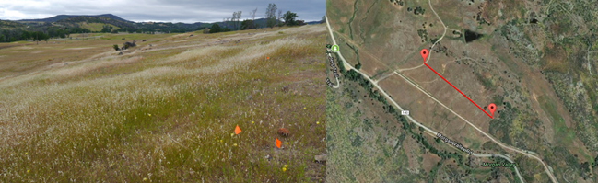
Figure S2.1. Field site at UC Davis McLaughlin Reserve (left). Satellite view of the field site (right). The length of the field is 435 meters (red line) and the width is ~200 meters.

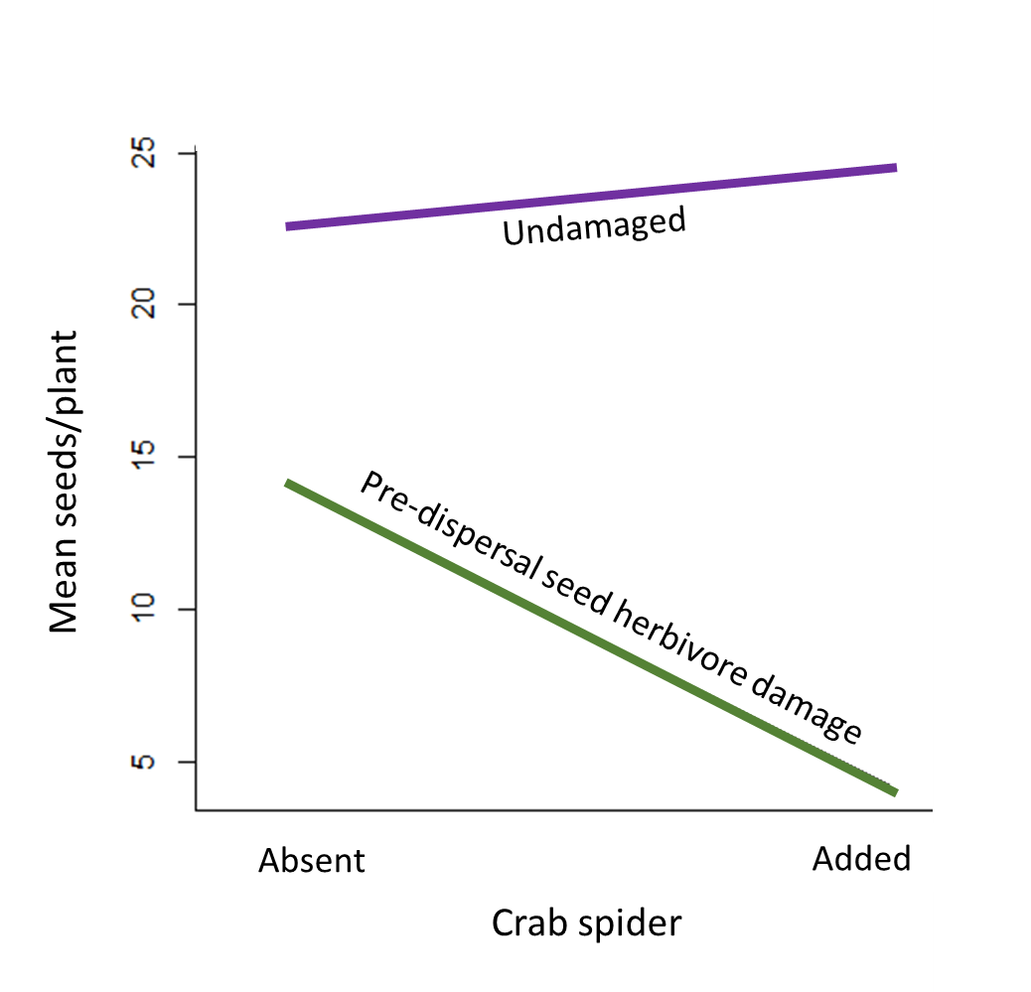
Figure S2.2. Crab spider treatment (absent vs. added) by pre-dispersal seed herbivory (undamaged vs. damaged) interaction plot with mean seed set of Calochortus luteus plants along experimental transects in 2018 as the response variable. Plants with crab spider absent and no pre-dispersal seed herbivory n = 122; plants with crab spiders absent and pre-dispersal seed herbivory n = 15; plants with crab spider added and no pre-dispersal seed herbivory n = 137; plants with crab spiders added and pre-dispersal seed herbivory n = 14.
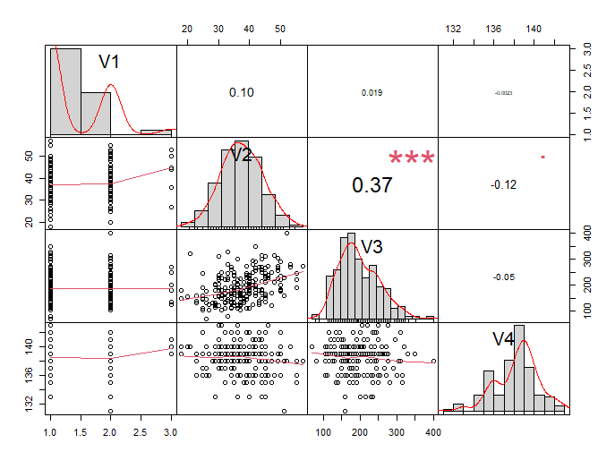
Figure. S2.3. Correlation matrix for the four measured traits of Calochortus luteus in the observation study in 2017. V1 is flower number, V2 is flower size, V3 is flowering stem height, and V4 is flowering date.
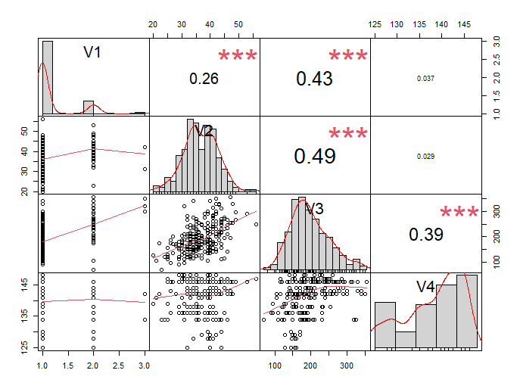
Figure. S2.4. Correlation matrix for the four measured traits of Calochortus luteus in the observation study in 2018. V1 is flower number, V2 is flower size, V3 is flowering stem height, and V4 is flowering date.
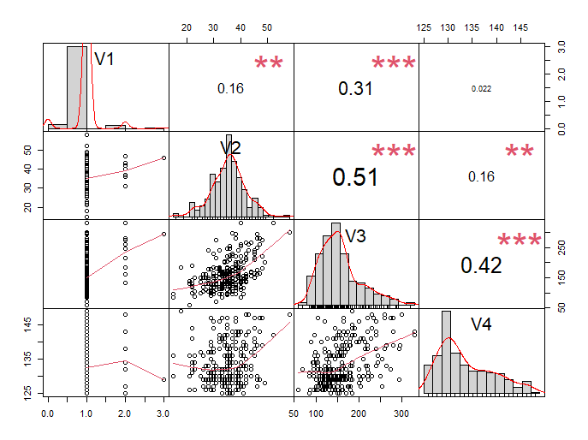
Figure. S2.4. Correlation matrix for the four measured traits of Calochortus luteus in the experimental transect study in 2018. V1 is flower number, V2 is flower size, V3 is flowering stem height, and V4 is flowering date.

CHAPTER III: THE EFFECTS OF SIT-AND-WAIT PREDATORS ON POLLINATION: THE PRESENCE OF A CRAB SPIDER ON A MARIPOSA LILY REDUCES POLLINATOR VISITATION FREQUENCY, DURATION, AND STIGMA & ANTHER CONTACT.

Abstract
Plant-pollinator interactions form a keystone mutualism, but predators can exploit the reliable arrival of visitors to flowers and disrupt this mutualism. The presence of sit-and-wait predators upon flowers is predicted to decrease the frequency and duration of flower visits, but it is not known how predators affect the behavior of effective pollinators vs. other floral visitors, and the pollination biology of plants with mixed mating systems. I found that Calochortus luteus, a charismatic endemic wildflower of the western United States, was visited and pollinated primarily by sweat bees in the genus Lassioglossum. Calochortus luteus flowers received significantly fewer and shorter visits in a paired randomized experiment when flowers were assigned a crab spider addition treatment compared to a crab spider absent treatment. When crab spiders were added, visit duration was significantly shorter and fewer visitors made stigma and anther contact. Interestingly, I found no decline in seed set nor evidence of pollen limitation despite these declines in the frequency and duration of visits, and reduction of stigma and anther contact. Further, I did not detect any change to self-pollination vs. outcross pollination rates in response to the addition to crab spiders. These results suggest that crab spiders significantly affect the behavior of floral visitors, but do not have a detectable effect on the outcrossing rate of Calochortus luteus when randomly assigned to and placed upon flowers.
Introduction
Mutualisms among plants and pollinators are one of the most ecologically important types of plant-animal interactions. Globally, 87.5% of angiosperms (~308,000 species) are pollinated by animals (Ollerton et al. 2011). Most angiosperm flowers are visited by a suite of generalist insects (Fenster et al. 2004). Importantly, these floral visitors do not all provide pollination services and are not all equal from the plant’s perspective. Floral visitors fall along a continuum from mutualists to antagonists depending upon whether they provide pollination services, how efficiently they pollinate, and how many resources they remove from the flower (e.g., pollen, nectar, etc.), and/or whether they damage flowers (Stebbins 1970, Thomson 2003, Hargreaves et al. 2009). To be an effective pollinator, a visitor must regularly contact anthers to collect pollen and stigmas to deposit pollen and move among flowers on conspecific plants to facilitate outcross pollination. Some visitors regularly remove resources without contacting the reproductive structures or doing so only rarely, and thus are pollen and nectar thieves (Inouye 1980, Hargreaves et al. 2009). Other insects such as flower robbers, damage flowers in the process of taking resources without pollinating (Inouye 1980, Hargreaves et al. 2009). Together, floral robbers and thieves are referred to as floral larcenists (Inouye 1980). Whether a floral visitor is a pollinator or larcenist can depend on context.
An important contextual detail that can influence the behavior of floral visitors, but is rarely considered in studies of pollination biology, is the presence of sit-and-wait predators that specialize on floral visitors. These predators, such as crab spiders, exploit the reliable arrival of insects to flowers as their food source. By hunting from flowers, predators can impact plant-visitor interactions by changing both the behavior and abundance of visitors (Romero et al. 2011). Thereby, these predators can indirectly affect plant reproduction and fitness (Romero and Koricheva 2011; Benoit and Kalisz 2020). The effects of predators on plants and floral visitors are expected to be context dependent and mediated by the traits of the predators, the visitors, and the plants. How predators affect pollination and plant reproduction will depend on how the predator affects plant interactions with each type of visitor and where along the mutualist to antagonist spectrum those floral visitors fall. Floral visitors often respond to predators by increasing the time they spend inspecting flowers and rejecting dangerous flowers, thereby decreasing foraging speed (Lima 1998, Ings and Chittka 2008, Wang et al. 2013), or decreasing foraging time in risky environments (Higginson and Houston 2015). Predator-induced behavioral changes can cause floral visitors to decrease visitation to flowers and shorten visit durations (Romero et al. 2011; Benoit and Kalisz 2020). Decreased frequency and duration of visitation can cause pollen limitation of plant reproduction and reduce seed set (Ashman et al. 2004; Knight et al. 2005; Romero et al. 2011). I expect that if a predator decreases the abundance or foraging-time of an effective pollinator, then pollination services will be reduced, negatively affecting plant reproduction. However, predators may simultaneously, or alternatively, decrease visitation of larcenists, or other plant antagonists such as herbivores, which may balance or counteract the negative effects of predators deterring effective pollinators (Romero and Koricheva 2011; Benoit and Kalisz 2020). Currently my understanding of how predators affect interactions among plants and floral visitors, and the consequences for plant reproduction, are limited in scope because of the small number of studies on this topic, a lack of data regarding behavioral responses of many common floral visiting taxa to sit-and-wait predators, and because existing studies rarely differentiate among effective pollinators and larcenists when examining the effects of predators on floral visitation. Further, much of the behavior work that has been done has used artificial flowers thus limiting my understanding of the indirect effects of predators on plants via floral visitors.
In nature, indirect effects, i.e., when one species affects another through an intermediary species, such as when a predator affects a plant’s fitness via floral visitator, are more common and can be stronger than direct effect (Wootton 1994; Abrams 1995). Yet because they are complex, indirect effects are often understudied, with a few notable exceptions. Over 2,000 published studies are devoted to the indirect effects of predators on plants via herbivores (i.e., trophic cascades; Paine 1969; Ripple et al. 2016). While trophic cascades have been a topic of enduring interest for the past five decades by comparison the study of indirect effects of predators on plants via plant mutualists has lagged, only beginning to gain traction in 2001 (Dukas 2001). This is surprising given the far-reaching effects of plant-pollinator interactions on plant fitness, population genetics, plant mating system evolution, speciation, as well as their as applied economic consequences (Kay and Sargent 2009; Devaux et al. 2014; Murphy et al. 2021).
Crab spiders (Thomisidae) are one of the most common and widespread taxa of sit-and-wait predators that hunt from flowers (Morse 2007). They have the capacity to change the behavior of floral visitors and disrupt pollination directly or indirectly (reviewed in Benoit and Kalisz 2020). Floral visitors may detect crab spider via visual or olfactory cues, or may detect indirect cues such as silk lines, dead conspecifics/heterospecifics, alarm pheromones, or other chemical cues (Benoit and Kalisz 2020; Rodríguez-Gironés and Maldonado 2020; Rodríguez-Morales et al. 2021). By leaving indirect cues, a spider may affect visitation even after departing the flower. Some insect taxa are more likely/able to avoid predators than others. For example, bees detect and avoid predators more often than flies (Romero et al. 2011). Experimental behavior studies demonstrate that honeybees and bumblebees respond to predators by learning and altering their behavior; however, data on the behavioral responses of other insect taxa are scant. These predictions are largely based on data from studies on large-bodied, highly social bees in the family Apidae and many of the detection and avoidance behaviors are only learned after a bee experiences a failed attack (Benoit and Kalisz 2020). It is possible that other taxa of visitors will have different behavioral responses or may not learn to detect and avoid crab spiders (Reader et al. 2006; Jones and Dornhaus 2011; Antiqueira et al. 2020). Some species of crab spiders can increase prey attraction by increasing UV contrast between their body and the flower they hunt from (Heiling et al. 2003). While this has not been reported in any North American species, one study did find increased visitation to plants harboring spiders without UV reflectance (Welti et al. 2016). While most studies examining North American species of crab spiders have found decreased insect visitation, frequency, and duration, I lack sufficient data to construct a comprehensive understanding of the predator, visitor, and plant traits or other contextual factors that cause other outcomes (Benoit and Kalisz 2020).
Notably, crab spiders have the potential to (directly or indirectly) alter the amount and type of pollen that is deposited on the stigmas of plants, and thereby may affect plant reproduction, mating system, or even population genetics. If crab spiders reduce the number of visits that a flower receives from effective pollinators, then they may cause or exacerbate pollen limitation of plant reproduction. Pollen limitation occurs when a plant does not receive enough conspecific pollen to fertilize its ovules, and thus pollen receipt is the limiting factor for seed production (Ashman et al. 2004; Knight et al. 2005). Pollen limitation is especially common in plants with primarily outcrossing mating systems in populations where pollinators are rare or unreliable (Goodwillie et al. 2005; Knight et al. 2005). Many flowering plants have mixed mating systems, where self-pollination can act as a reproductive assurance when pollination services are insufficient (Goodwillie et al. 2005). Predators, such as crab spiders, may influence plant mating systems by altering the reliability, abundance, and behavior of pollinators and larcenists through time and space. Further, predators may alter the abundance and/or ratio of effective pollinators to larcenists visiting flowers. By doing so, predators may affect pollen limitation and the cost to benefit ratio of flowering, even if they do not alter overall visitation rates. If the number of effective pollinator visits decreases relative to the number of larcenist visits, plants may experience more pollen limitation and a higher cost of flowering relative to the fitness benefit. Alternatively, if the number of larcenist visits declines and the number of effective pollinators increases, then plants will benefit; in this context, a predator could serve as a plant mutualist.
In addition to affecting the frequency of visits, predators can affect visit duration with numerous potential consequences. An important consideration is the relationship between visit duration and whether stigma and anther contact are made. If stigma and anther contact are made consistently and quickly, then shortened visit duration may benefit plants because visitors will have less time to collect resources which decreases the cost to the plant. Further, to collect enough resources visitors may visit a greater total number of conspecific plants, thus increasing the opportunity for outcross pollination. Alternatively, if a visitor stays for a long duration on a single flower or moves among flowers on a single plant, the likelihood of depositing self-pollen on the plant's stigmas increases (de Jong et al. 1993). However, if shorten visit duration reduces the likelihood of stigma or anther contact, then the plant may receive and export less pollen. Thus, depending upon how long visitors stay and how quickly they make stigma and anther contact in the absence of predators compared to in the presence of predators will determine whether shortened visit duration is neutral, beneficial or detrimental to plant fitness.
Here I explore the direct and indirect effects of a sit-and-wait predator on pollination and reproduction of a native wildflower via floral visits. I examine interactions among crab spiders (Thomisidae), the wildflower Calochortus luteus [Liliaceae] and floral visitors addressing three goals.
1. Determine which insects regularly visit C. luteus and which taxa are effective pollinators vs. larcenists. I observed and identified floral visitors and recorded their behavior (i.e., visitation frequency, duration, and whether they made stigma and/or anther contact).
2. Determine how crab spiders impact interactions between C. luteus flowers and its visitors. I compared the behavior of visitors on C. luteus randomly assigned to crab spiders added and absent treatments.
3. Assess the impact of crab spiders on pollination and reproduction of C. luteus. I compare the seed set of C. luteus assigned to pollination treatment and crab spider treatment combinations. Pollination treatments include hand pollinated vs. open pollinated, emasculated vs. intact, self-pollinated vs. outcross pollinated. Crab spider treatments were spider added vs. absent. These treatment combinations allow us to address questions of pollen limitation, self-compatibility and selfing/outcrossing and seed set in C. luteus.
This detailed study of how crab spiders alter interactions between a wildflower and a suite of generalist floral visitors, and the consequences for pollination and reproduction will lend a more nuanced understanding to this complex tri-trophic interaction.
Materials and Methods
Study system
Calochortus luteus (Liliaceae), the yellow mariposa lily, is a perennial geophyte endemic to California and Oregon. It grows in heavy soils, including serpentine soils, in grasslands, and open woodlands at low elevations, where it blooms from late April to early June. The trimerous flowers have six free stamens which surround a compound pistil with a three-lobed stigma. Hairs at the bases of the yellow and maroon petals secrete nectar. Each flower is open for ~3 days, and most plants (~90%) in the study population produce a single flower.
The flowers of C. luteus attract a diverse group of insects including bees, wasps, flies, beetles, and butterflies. The genus is Calochortus divided into four floral syndromes, C. luteus is in the mariposa group. Species in the mariposa group attract the highest diversity of flora visitors (Dilley et al. 2000). Mariposas attract many small bees and beetles as well as some large bees and beetles, such as Bombus, Xylocopa, and Tricodes (Jokerst 1981, Dilley et al. 2000). Dilley et al. (2000) found visitors to C. luteus included: five beetle species, three bee species (Halictus tripartus, Halictus farinosa, Ceratina acantha), one fly, and one wasp. However, this sample was spatially and temporally limited and should be considered a snapshot of visitors. Most visitors feed on nectar and/or pollen (Dilley et al. 2000). No studies have looked at how effective various C. luteus visitors are at pollinating. Many Calochortus species are self-compatible but most lack a mechanism of autonomous self-pollination and therefore rely on insect pollination (Jokerst 1981).
Crab spiders are ubiquitous sit-and-wait predators that can change color to match flowers and ambush floral visitors. Crab spiders occupy 7-9% of C. luteus flowers in the studied population at McLaughlin Reserve in Lake County, California (Benoit Chapter 2), this value is higher than many, but not all published reports from other systems (Morse 2007; Knauer et al. 2018). Crab spiders attempt to ambush prey that comes within reach, however successful prey capture can be relatively rare (Morse 2007). The body size of prey is an important factor in determining the success of an attack. Large-bodied prey are more likely to survive attacks while smaller-bodied prey are more vulnerable (Morse 2007).
Crab spider addition and floral visitation experimental set up and statistical analyses:
To investigate the effect of crab spiders on floral visitation, I observed visitation to 91 pairs of C. luteus plants assigned to either a crab spider addition or no crab spider addition (hereafter absent) treatment. Paired plants were 1-10 m from one another, similar in size, height, and flowering stage. I flipped a coin to assign one plant of the pair to the crab spider addition treatment. A crab spider was placed on the flower and given time to acclimate (approximately 1 minute, or until the spider assumed a resting or hunting posture). Once the spider acclimated, I began a 15-minute observation. One observer watched each plant and recorded the number of floral visitors’ inspections of the flower (i.e., when a potential visitor examined the flower without landing), the number of visits, the duration of each visit, whether each visitor made stigma and anther contact, and whether the visitor was attacked by the crab spider. If the crab spider left the flower during the observation period, the observation was paused until the spider was returned to the flower or I replaced it with a different spider. Floral visitors were identified, usually to taxonomic family. Visitors were photographed with a Nikon DSLR camera with a Tamron macro lens. Visitors were assigned to genera from photos when possible. The observers alternated which treatment they observed between each pair to mitigate the effects of observer bias. The observations were conducted May – June 2018 at the UC Davis McLaughlin Reserve in Lake County, California in a serpentine field bordering Morgan Valley Road (8°51'34.7"N 122°24'17.0"W).
To determine whether the presence of a crab spider on a C. luteus flower affects visitor inspection vs. visit behavior, I used a chi squared test with two categorical variables: flower visitation (no visits, inspection, or visit) and crab spider treatment (added or absent; Table 1). Further, to determine if crab spiders affect the frequency of floral inspections and visits, as well as the mean and total visit duration I used paired, one-tailed t-tests. When I observed a potential visitor hovering within several centimeters of a flower examining it without landing, I scored it as an inspection. Whenever an insect landed on a flower, I scored it as a visit. Visit frequency is the total number of insects that landed on the flower during the 15-minute observation period. Visit duration is the total number of seconds that each visitor spends on a flower during the 15-minute observation period. For flowers with more than one visit/observation period, visit duration was summarized in two ways. Mean visit duration is the average of all visit durations. Total visit duration is the sum of all visit durations. Because of my paired design, where one plant was randomly assigned crab spider addition, I used paired t-tests to compare response variables between crab spider treatments. Because I predict that crab spider addition will increase inspections, decrease visitation frequency, and shorten visit duration, I used one-tailed paired t-tests.
To be an effective pollinator, a visitor must contact reproductive structures, and they must also be common enough to facilitate pollination. To determine which visitors were effective pollinators, I considered how frequently each taxa visited C. luteus flowers, and how often they make stigma and anther contact.
To examine how the addition of a crab spider altered stigma contact by floral visitors, I used a generalized linear model with a binomial distribution. The dependent factor was stigma contact (yes vs. no) with visit duration as an independent variable, crab spider treatment as a fixed factor, and a crab spider × visit duration interaction term. To examine how the addition of a crab spider altered anther contact by floral visitors, I used a similar model except I included anther contact as the response factor.
Crab spiders and pollination biology transect experimental set up and statistical analyses:
To quantify the pollination biology of C. luteus and the impact of crab spiders on C. luteus reproduction I set up 12 60-m long transects within the population of C. luteus described above. Along each transect I marked C. luteus plants with unopened floral buds and randomly assigned them to a one of 12 treatment combinations. Each plant was assigned to a crab spider treatment (addition or absent), and a pollination treatment. Crab spiders were caught via sweep netting in an adjacent field separated from the transects by a road and placed on flowers in the crab spider addition treatment. The pollination treatments included hand pollination with supplemental outcross-pollen, hand pollination with self-pollen, open pollination, bagging to prevent any visitation, and emasculation. These transect plants were monitored daily for the duration of the flowering season (May- early June) and treatments were applied to flowers as they opened. For each plant I collected the following data: bud number, flower number, fruit number, seed number, flowering date, and herbivore damage. I also monitored these plants for crab spiders. If a crab spider was found on a plant assigned to the crab spider absent group, the plant was excluded from the study. If I found that a plant in the crab spider addition treatment was no longer occupied by a spider, a new spider was added to the plant.
To determine if C. luteus is self-compatible I compared the seed set of flowers that were bagged with lightweight white mesh which prevented insect visitation and hand-pollinated with self-pollen to the seed set of flowers that were bagged and hand pollinated with outcross pollen using a t-test. If C. luteus is fully self-compatible, then I expect no difference in seed set between these treatments.
To determine the extent to which seed set of C. luteus is reliant on insect pollinators, I compared the seed set of flowers that were bagged to exclude insect visitation to those that were not bagged and had unrestricted insect visitation with a t-test. Bagged flowers’ seed production would result from autonomous self-fertilization because biotic pollen vectors were excluded. No mechanism of autonomous self-fertilization has previously been described for C. luteus; therefore, I expect bagged flowers to produce few if any seeds. Further, to determine whether crab spiders facilitate self-pollination while hunting upon a flower, I compared the seed set of flowers that were bagged without a crab spider to flowers bagged with a crab spider with a t-test. If the bagged flowers with a crab spider produce more seeds than the bagged flowers without crab spiders, then I can infer that the difference is due to crab spider-mediated pollination.
To determine whether the seed production of C. luteus is pollen limited and the extent to which crab spiders affect the magnitude of pollen limitation, I used a linear mixed effects model. The model included seed set as the dependent variable, fixed effects included pollination treatment (open vs. supplemental hand pollination), crab spider treatment (absent vs. added), and a pollination treatment × crab spider treatment interaction term, and transect as a random effect. If pollen is a limiting factor of seed set, then plants receiving supplemental hand pollination will produce more seeds than open pollinated plants. If crab spiders affect the magnitude of pollen limitation, then the interaction term will be significant. If C. luteus reproduction is pollen limited and crab spiders reduce pollen receipt by decreasing the frequency and duration of visits, then the presence of a crab spider should increase pollen limitation and plants that are open pollinated with an added crab spider should have the lowest seed set.
To determine the extent to which C. luteus depends on self vs. outcross pollen for seed set and whether the presence of crab spiders affects the magnitude of dependence on self-pollen, I used a linear mixed effects model. Seed set was the dependent variable, fixed effects included emasculation treatment (emasculated vs. intact), crab spider treatment (absent vs. added), and a pollination treatment × crab spider treatment interaction term, and transect was included as a random effect. Since emasculated flower can only be pollinated by outcross pollen and intact flowers can be pollinated by both outcross and self-pollen, a difference in seed set between emasculated and intact plants can be inferred as the number of seeds fertilized by self-pollen. If crab spiders increase a plant’s dependence on self-pollen by decreasing receipt of outcross pollen and/or facilitating deposition of self-pollen on the stigma while hunting, then I expect that the difference in seed set between emasculated and intact flowers will be greater (i.e., intact flowers will produce more seeds than emasculated flowers) when crab spiders are added and the interaction term will be significant. To confirm that emasculation does not impact the flower’s ability to produce seeds, I compared the seed set of emasculated and hand pollinated flowers to intact and hand pollinated flowers with a t-test. A non-significant result indicates that the act of emasculation does not affect the flower’s seed set.
To determine the effect of crab spiders on seed set, I analyzed the seed set of C. luteus plants that were open pollinated and randomly assigned to crab spiders absent and addition treatments using a linear mixed effects model. The model included seed set as the dependent variable, crab spider treatment (absent vs. added), fruit number, flower size, and flowering date as fixed effects, and transect as a random effect. Fruit number, flower size and flower date were included in the model because these are traits predicted to impact seed set. If the crab spider treatment term is significant, then I can conclude that crab spiders can act as pollinators.
Results
Crab spider effects on floral visitation
In total I observed visitors for 45.5 hours (91 pairs of plants and 15 minutes per plant) and observed 152 floral visitors. Of those visitors, 97% (n =147) were bees of the family Halictidae. Five visitors were Diptera. Of the Halictidae that I was able to identify to genus, 120 were Lasioglossum and eight were Halictus. The taxa of visitors to plants with crab spiders absent and added are summarized in Table 3.1. I observed two crab spider attacks, both on Lasioglossum. In one attack the bee was killed and consumed, in the other the bee escaped.
The number of inspections and visits a flower received was strongly affected by the presence of a crab spider (ꭓ² = 1039.9, df = 6, P < 0.001; table 3.2). There was a trend towards more inspections and rejections of flowers with crab spiders added compared to absent, however the difference was not statistically significant (t = 1.290, df = 90, P = 0.100). Plants with crab spiders added received significantly fewer visits than plants with crab spiders absent (t = 2.253, df = 90, P = 0.013; Fig. 3.1). Plants with crab spiders absent received an average of 0.956 visits/15 minutes (n = 91) while plants with crab spiders added received 61% fewer visits with an average of 0.582 visits/15 minutes (n = 91). Both the mean visit duration and total visit duration were significantly shorter when crab spiders were added. Mean visit duration was 130 seconds when crab spiders were absent and 63 seconds when crab spiders were added (i.e., 48% shorter or 1.2 minutes less/15 minutes; t = 2.595, df = 89, P = 0.006; Fig. 3.2). Total visit duration was 253 seconds when crab spiders were absent and 105 seconds when crab spiders were added (i.e., 42% shorter, or 2.5 minutes less/15 minutes when crab spiders were added compared to absent; t = 3.052, df = 89, P = 0.001; Fig. 3.3).
Stigma contact declined by 77% and anther contact declined 80% when crab spiders were added. When crab spiders were absent, 23.7% of visitors contacted the stigma and 73.2% contacted the anthers (Table 3.3). However, when crab spiders were present only 18.2% of visitors contacted the stigma and 58.2% contacted the anthers (Table 3.3). Both stigma and anther contact are predicted by visit duration, with the likelihood of reproductive structure contact increasing with the length of the visit (Tables 3.4 and 3.5).
Crab spider effects on pollination biology:
Seed set of C. luteus did not differ between flowers that were bagged and self-pollinated or bagged and outcross-pollinated (t = 0.042, df = 77.333, P = 0.967). Plants whose flowers were pollinated with self-pollen (n = 37) produced a mean of 28.9 seeds and plants pollinated with outcross pollen (n = 43) produced a mean of 28.7 seeds, indicating that C. luteus is fully self-compatible.
Table 3.1. Frequency of insect taxa visiting flowers of Calochortus luteus when crab spiders were absent and added.
 | Flowers with crab spiders
 | absent | added
Halictidae (not identified to genus) | 13 | 6
Lasioglossum | 73 | 47
Halictus | 6 | 2
Diptera | 5 | 0
Total visitation | 97 | 55

Table 3.2. Frequency of insect inspection and reject, insect visitation, and plants with zero inspections/visits for 182 Calochortus luteus plants randomly assigned to crab spider absent or addition treatments and observed for 15 minutes.
 | Flower with crab spider
 | absent | added
Plants with no inspections or visits | 46 | 46
Insects who inspected and rejected | 15 | 27
Insects who visited | 97 | 55

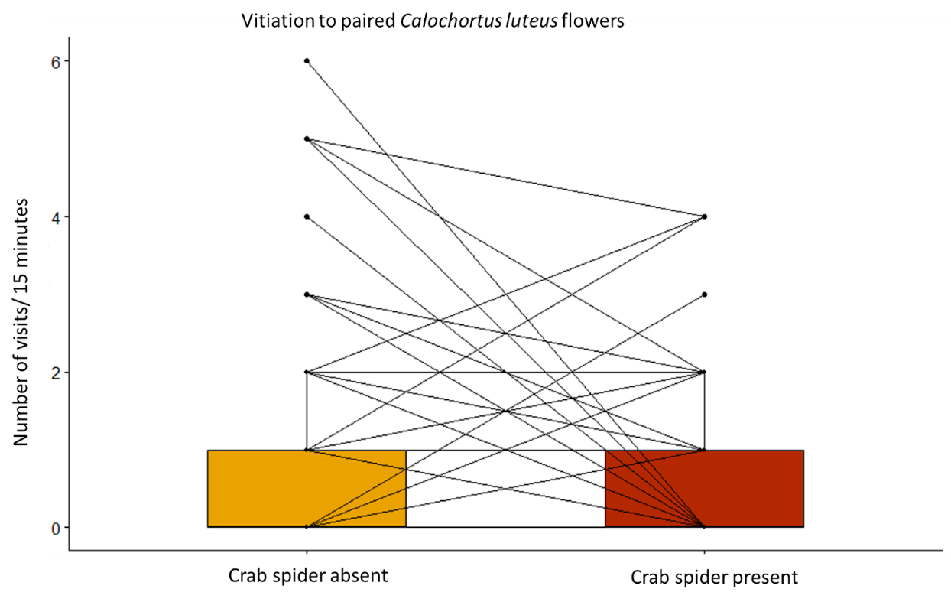
Figure 3.1. Insect visitation during a 15-minute observation to pairs of Calochortus luteus flowers with one plant randomly assigned to a crab spider absent treatment and the other to a crab spider addition treatment. Paired plants are connected by lines.

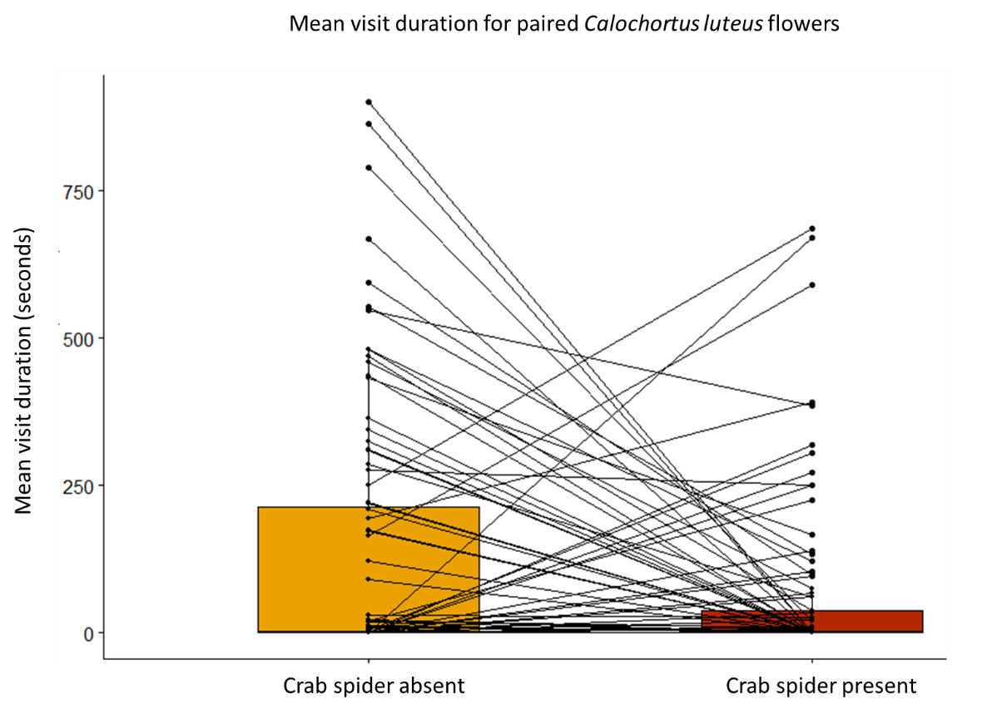
Figure 3.2. Mean visit duration at paired Calochortus luteus plants with crab spiders absent and added. When a plant had more than one visitor the visit lengths were averaged. Paired plants are connected by lines.

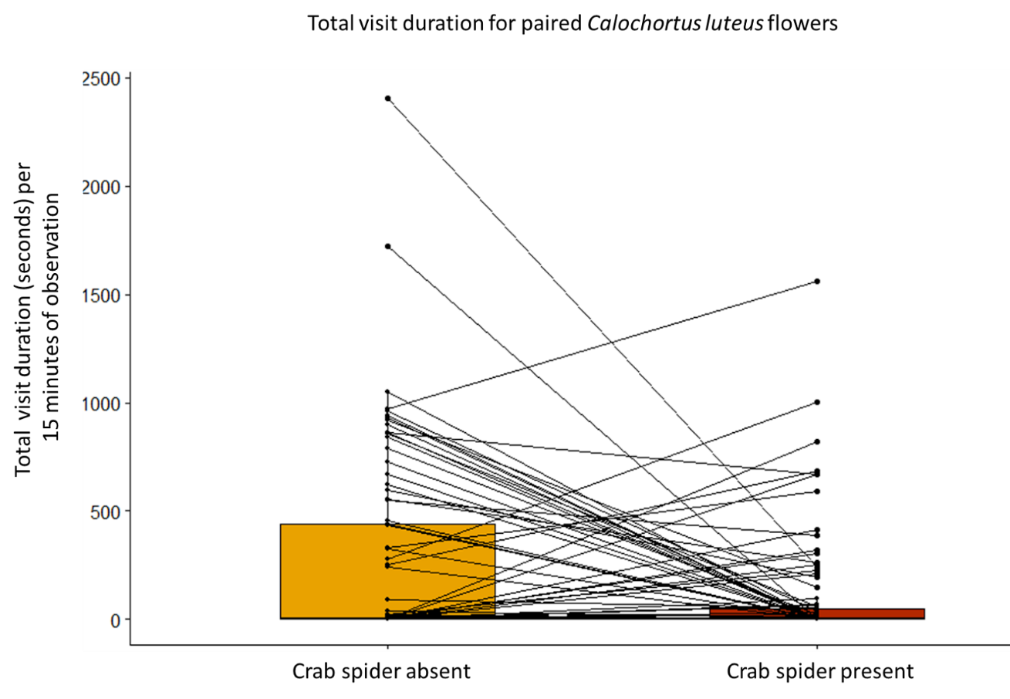
Figure 3.3. Total visit duration at paired Calochortus luteus plants with crab spiders absent and added. When a plant had more than one visitor the visit lengths were summed. Paired plants are connected by lines.

Table 3.3. Frequency of floral visitors contacting reproductive structures of Calochortus luteus flowers when crab spiders are absent and added.
 | No stigma contact | Stigma contacted | No anther contact | Anthers contacted
Flowers with crab spider absent | 74 | 23 | 26 | 71
Flowers with crab spider present | 45 | 10 | 23 | 32

Table 3.4. ANOVA table for a generalized linear mixed model examining predictors of whether floral visitors contact the stigma of Calochortus luteus.
 | ꭓ2 | df | P
Crab spider treatment (added vs. absent) | 0.266 | 1 | 0.606
Visit duration | 9.835 | 1 | 0.002**
Crab spider × duration | 2.756 | 1 | 0.097

Table 3.5. ANOVA table for a generalized linear mixed model examining predictors of whether floral visitors contact the anthers of Calochortus luteus.
 | ꭓ2 | df | P
Crab spider treatment (added vs. absent) | 2.875 | 1 | 0.090
Visit duration | 9214 | 1 | 0.002**
Crab spider × duration | 0.190 | 1 | 0.662

Flowers bagged to prevent insect visitation produced 52.8% fewer seeds than plants with open pollination (unrestricted insect access), on average 13.9 and 26.4 seeds respectively (t = -3.101, df = 19.076, P = 0.006). I found no difference in seed set between bagged flowers with crab spiders absent (mean seed set = 13.9, n = 12) and added (mean seed set = 13.8, n = 12; t = 0.017, df = 21.997, P = 0.987).
We found no evidence of pollen limitation of reproduction within this population of C. luteus. Neither pollination treatment, crab spider treatment, nor their interaction were significant predictors of seed set, indicating that C. luteus in this population were not pollen limited, and that crab spiders did not increase the magnitude of pollen limitation (Table 3.6, Fig. 3.4).
We found no evidence that emasculation treatment, crab spider treatment, nor their interaction, were significant predictors of seed set (Table 3.7; Fig. 3.5). When crab spiders were absent, intact plants produced a mean of 26.4 seeds and emasculated plants produced a mean of 24.1 seeds, a non-significant trend suggests that 2.3 seeds, or 8.7% of seeds, may be the result of self-pollen. When crab spiders were added, intact plants produced a mean of 29.7 seeds and emasculated plants produced a mean of 27.2 seeds. Again, a non-significant trend suggests that 2.5 seeds or ~8.4% of seed set may have been produced via self-pollen. There was no difference in seed set between hand pollinated intact and emasculated plants (t = 0.057, df = 46.678, P = 0.954, means = 29.06 and 28.84 respectively). I found no significant effect of crab spider addition on seed set (Table 3.6; Fig. 3.6). The other factors, fruit number, flower size, and flowering date all significantly predicted seed set (Table 3.8).

Discussion
Pollination takes place within a community context and thus, pollination services and plant reproductive fitness can be affected by direct and indirect interactions with other species. I examined the impact of crab spiders, a common sit-and-wait predator, on the behavior of floral visitors to the wildflower C. luteus and the resulting effects on pollination and plant fitness. Consistent with my predictions I found that the presence of a crab spider on a C. luteus flower decreased visits to the flower by 60% (Fig. 3.1). Further, the number of visitors who rejected flowers upon inspection was significantly higher when crab spiders were present compared to absent. These findings are consistent with behavioral studies that demonstrate that bees are able to recognize cryptic sit-and-wait predators when they inspect flowers, and that bees can learn to avoid predator-harboring flowers (reviewed in Benoit and Kalisz 2020). These results suggest that the crab spiders in this population do not utilize lures; the use of lures by crab spiders has been reported in other systems (Heiling et al. 2003; Welti et al. 2016).
When visitors landed on flowers with crab spiders, they spent less time on the flower compared to when visiting crab spider-free flowers. The crab spiders decreased mean visit
Table 3.6. Results of a linear mixed effects model with the seed set of Calochortus luteus as the dependent variable. Independent variables included pollination treatment (open vs. supplemental pollen), crab spider treatment (absent vs. present), and their interaction term. Transect was included as a random effect.
Term | df | F | P
Pollination treatment | 1, 325.37 | 0.617 | 0.433
Crab spider treatment | 1, 329.00 | 0.644 | 0.423
Pollination × crab spider | 1, 324.66 | 0.1764 | 0.675

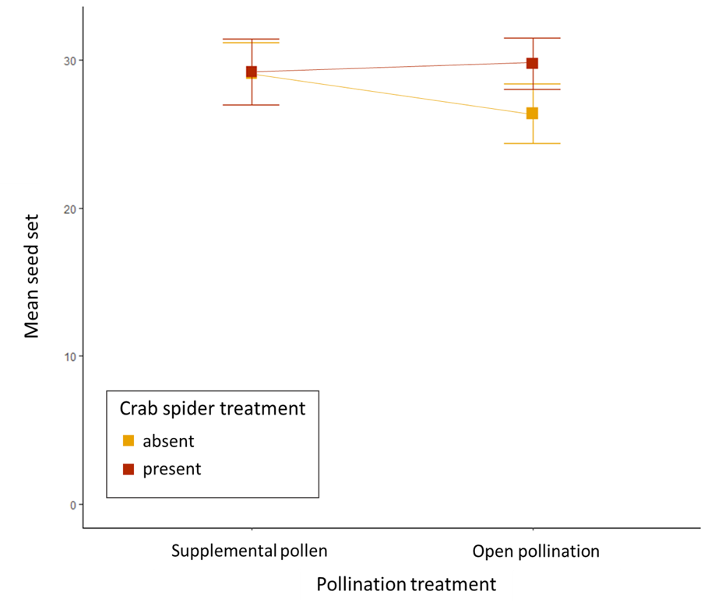
Figure 3.4. Seed set of Calochortus luteus that were open pollinated or that received supplemental pollen via hand pollination and that had crab spiders absent or added.

Table 3.7. Results of a linear mixed effects model quantifying seed set of Calochortus luteus plants that were emasculated vs. intact (emasculation treatment) and had crab spiders added vs. absent (crab spider treatment) and the interaction between the emasculation and crab spider treatments. Transect number was included as a random effect.
Term | df | F | P
Emasculation treatment | 1, 305 | 0.075 | 0.784
Crab spider treatment | 1, 294.44 | 1.978 | 0.161
Emasculation × crab spider | 1, 297.62 | 0.152 | 0.697

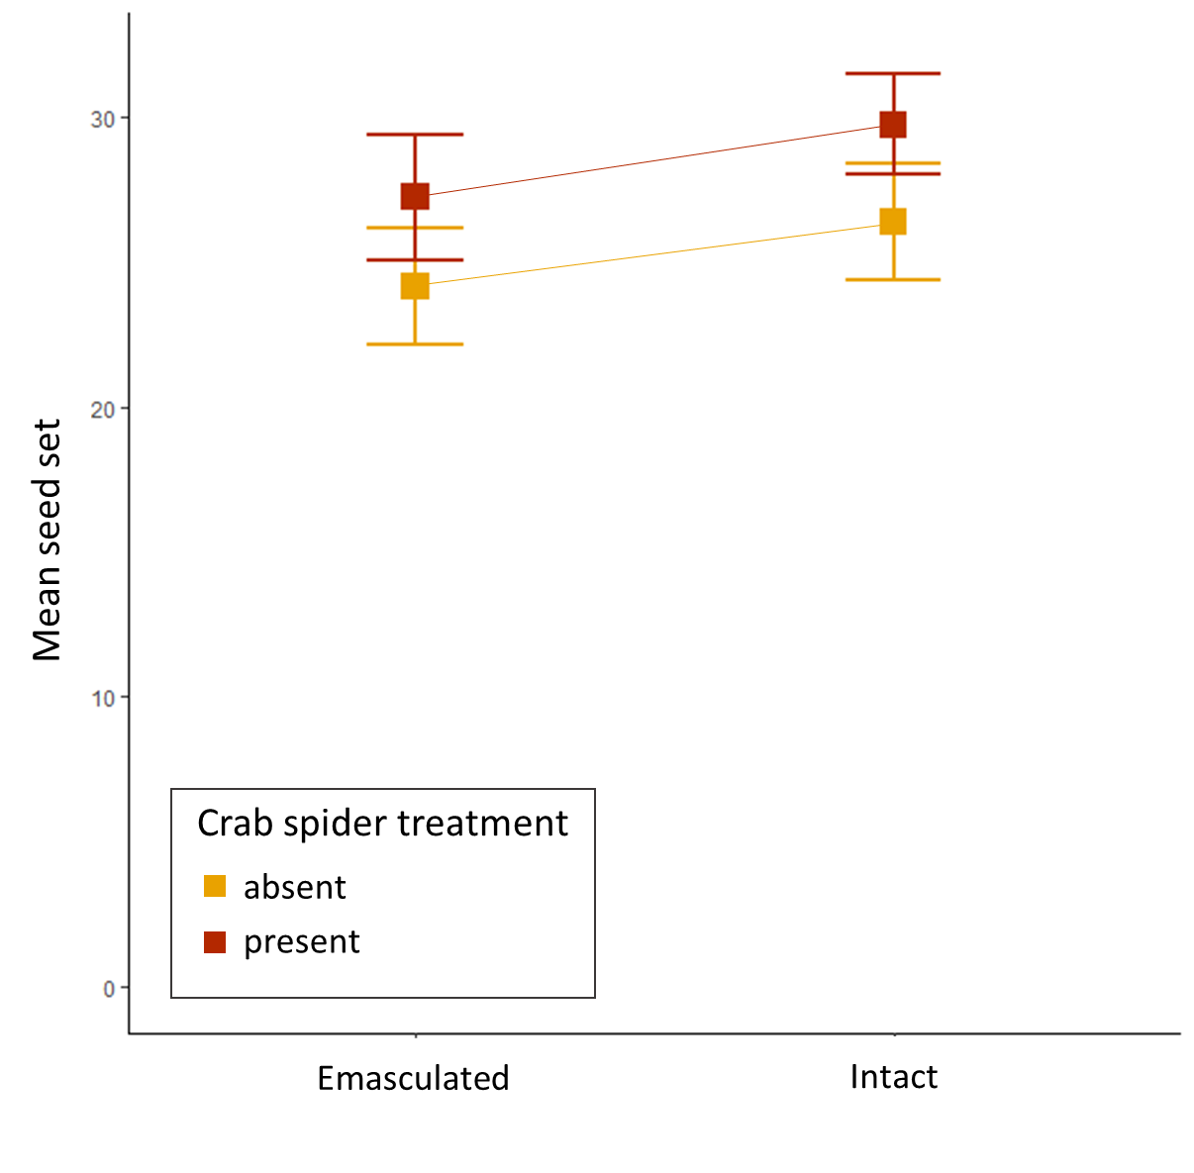
Figure 3.5. Seed set of Calochortus luteus plants that were emasculated (anthers removed to prevent self-pollination) vs. intact (anthers unmanipulated, outcross and self-pollination possible) with crab spiders absent and added.
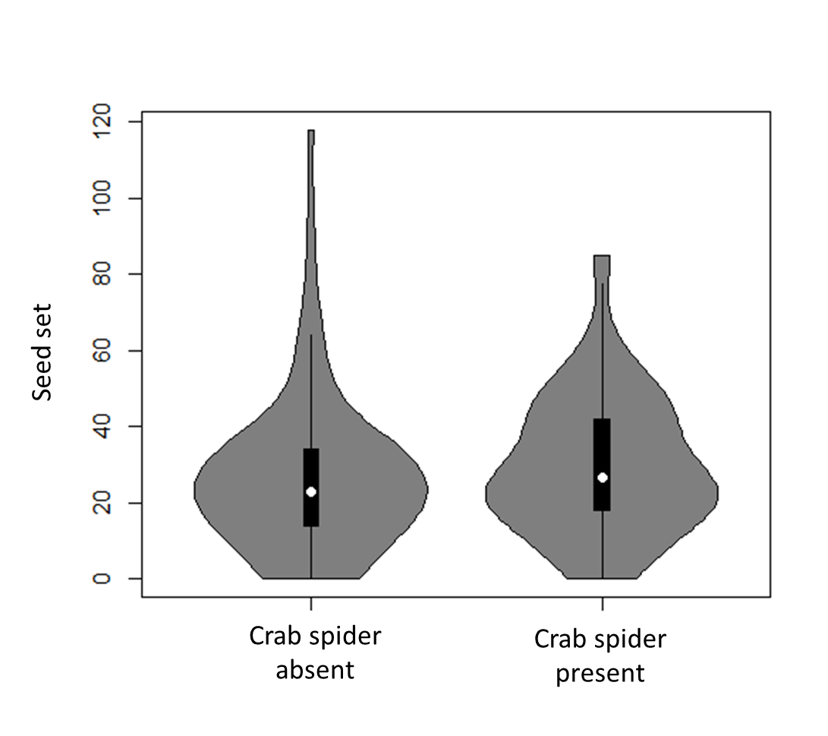
Figure 3.6. Seed set of Calochortus luteus plant randomly assigned to crab spider absent and added treatments and open pollinated along experimental transects at McLaughlin Reserve, Lake County, California.

Table 3.8. Summary of a mixed effects model examining predictors of Calochortus luteus seed set along experimental transects where open pollinated plants were randomly assigned to a crab spider treatment (absent vs. added).
 | Sum of Squares | Mean Square | df | F | P
Crab spider treatment | 190 | 190 | 1, 207.942 | 0.796 | 0.373
Fruit number (1-2) | 5028.6 | 5028.6 | 1, 207.826 | 21.059 | < 0.001***
Flower size (mm) | 14352.0 | 14352.0 | 1, 197.555 | 60.104 | < 0.001***
Flowering date (Julian) | 2149.0 | 2149.0 | 1, 42.565 | 9.0 | 0.004**

duration by 48%. This result is consistent with my prediction. A meta-analysis in 2011 found that floral predators reduced flower visit duration by 51% (Romero et al. 2011). If a visitor did not detect a crab spider before landing, they likely detected the predator soon after, and then left before being attacked. If they failed to detect or respond to the predator, and the predator attacked then there are two outcomes. Either the visitor escapes and potentially learns from the experience or they are consumed. Both eusocial and non-eusocial bees can learn from failed predator attacks (Chittka et al. 2003; Jones and Dornhaus 2011; Ings et al. 2012; Howard 2021). Visitors stayed two minutes longer (per 15 minutes) on flowers without crab spiders compared to flowers with added crab spiders. Visit duration alone is a poor proxy for pollination effectiveness because it is not a reliable indicator of how much conspecific pollen is deposited on the stigma (King et al. 2013). From the plant’s perspective, optimal visit duration must be long enough to contact the anther to collect pollen and to contact the stigma and deposit conspecific pollen, but not necessarily longer- since as visit length increases, visitors will remove more resources and potentially increase the likelihood of pollinator-mediated selfing. However, visiting insects have their own optimal visit duration which will depend upon available resources, optimal foraging, and risk avoidance. Thus, if crab spiders alter visit duration, then the impact on the plant’s fitness will depend on whether the visit duration when a spider is present is closer or further from the plant’s optimal visit time. Given that 80% fewer visitors made stigma contact when crab spiders were present, I infer that visit duration with crab spiders present is shorter than optimal for pollination.
We found that most insects (97%) observed visiting C. luteus flowers were bees from the family Halictidae in the genus Lasioglossum. This is surprising given other publications that suggest a greater diversity of taxa regularly visit flowers in this genus (Jokerst 1981, Dilley et al. 2000). However, it is possible that some taxa were more deterred by the presence of an observer than others. Given the low diversity of observed visitors, I am unable to address the question of how crab spiders affect visitation of different taxa and how they impact the relative visitation of pollinators vs. larcenists. This question warrants future study.
Halictidae bees, especially Lasioglossum, were the most common floral visitors, and despite low rates of visitation, the visitors that made regular stigma and anther contact. Thus, my data suggest they are the most likely pollinator of C. luteus, albeit contact rates were low. These bees are small relative to the flowers of C. luteus and spent much of their time within a flower collecting nectar from the base of the petals (Fig. 3.7). Therefore, it is not surprising that the rates of stigma and anther contact were relatively low. Stigma and anther contact were predicted by visit duration, thus when visits were shortened by the presence of a crab spider, the rates of stigma and anther contact declined. This suggests that the presence of a crab spider on a flower likely decreases pollen deposition and export. By reducing the likelihood that Lasioglossum make stigma and anther contact, crab spiders may shift the cost to benefit ratio of their visits towards larceny; from the plant’s perspective, resources are being used (cost) while the benefit (pollination) declines. However, since I primarily observed only one genus visiting C. luteus flowers in this study, I cannot generalize about how crab spider effect
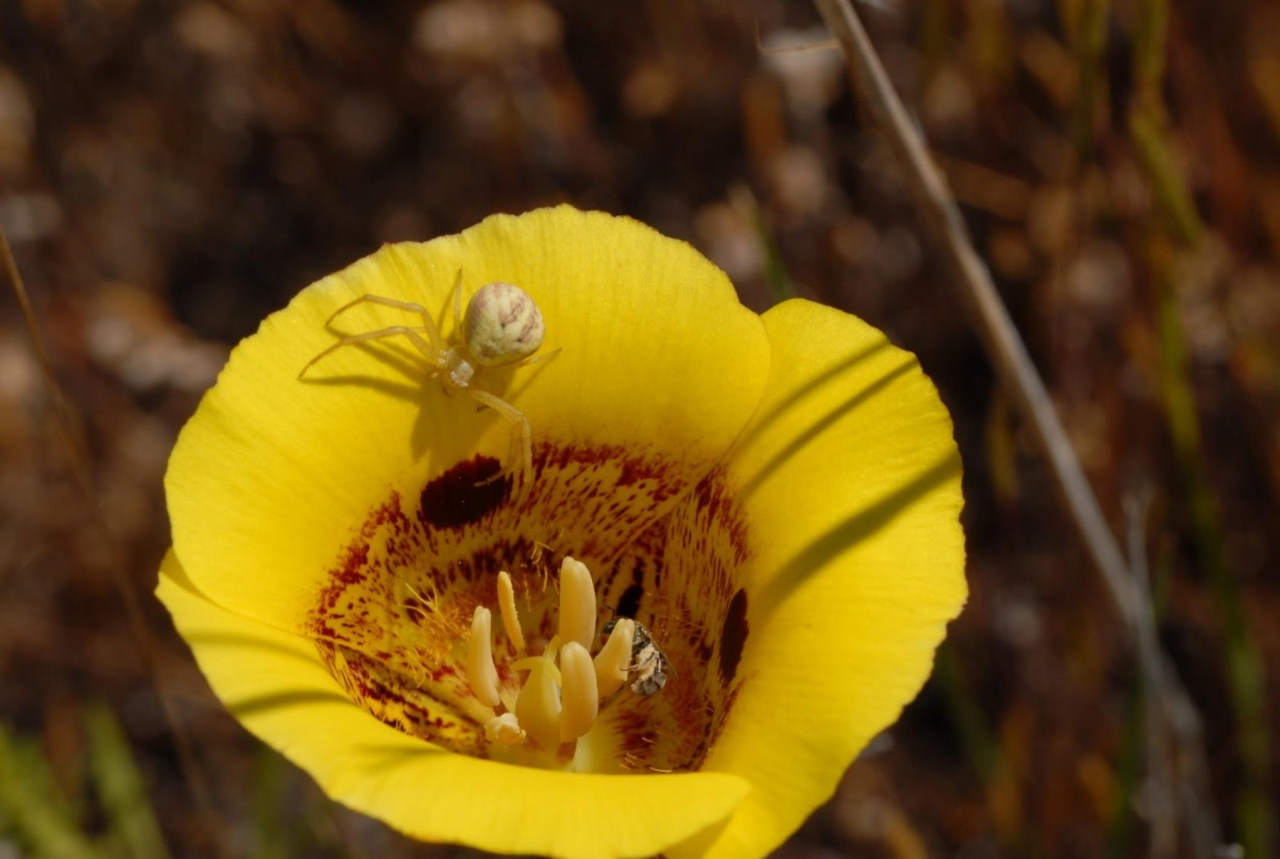
Figure 3.7. A female crab spider (Misumena vatia) hunting from a Calochortus luteus flower with a visiting bee (Lasioglossum sp.).

interacts with other visitor taxa to impact the behavior or abundance, or whether they alter the proportion of visitors that can be classified as pollinators vs. larcenists.
Given that flowers with added crab spiders received fewer visits, shorter visits, and were less likely to receive stigma and anther contact, I expected that crab spiders would cause pollen limitation of plant reproduction and reduce seed set (Romero and Koricheva 2011; Benoit and Kalisz 2020). However, I found no evidence of pollen limitation in this population, and no evidence that crab spiders reduced seed set (Fig. 3.4). While there was no significant difference between seed set of plants randomly assigned to crab spider addition and absent treatments, there was a trend toward higher seed set when crab spiders were added (Fig. 3.6). There are several potential explanations for why C. luteus plants were not pollen limited despite a decrease in pollination services when crab spiders were added. Flowers of C. luteus are open for an average of three days, during that time sufficient pollen may be deposited on the stigma to fertilize ovules even by a limited number of pollinators contacting the stigma. Alternatively, the crab spiders themselves may play a direct role in pollination, either moving self-pollen from anther to stigma while they hunt, or by capturing prey that are covered in pollen and dragging them across the stigma as they are captured or consumed (personal observation). Further, it is possible that other biotic or abiotic factors limit seed set more than pollen receipt. The fruit I collected commonly had undeveloped ovules, and of the plants that produced more than one flower and fruit, seed production was primarily restricted to the first fruit with subsequent fruits either being aborted or maturing a limited number of seeds. This pattern has been observed in other Calochortus species (Holtsford 1985). Production of flowers that do not develop into fruits may serve three purposes: These flowers may increase the male fitness of a plants by siring seeds, they may take over the role of seed production if the first flower/fruit is damaged, or they play a bet hedging role allowing the plant to develop multiple fruits when in years with high rainfall (Holtsford 1985). Rainfall may be a primary limiting factor for Calochortus seed set. In another study with a population of C. leichtlinii, that species was not pollen limited (hand pollinated plants produced as many seeds as open pollinated plants). However, a supplemental water treatment significantly increased seed set and fruit number of C. leichtlinii (Holtsford 1985). If water, or other abiotic factors are the primary limiting factors of plant reproduction, then supplemental pollen would not increase seed set, potentially masking a negative indirect effect of crab spiders on pollination. The year this study was conducted, 2018, was a particularly dry year, and thus water was likely the factor most limiting seed set. A future experiment that manipulates both water availability (ambient vs. supplemental) and crab spider (absent vs. added) and examines their effect on pollen limitation and seed set would be useful.
Our pollination experiments revealed new details about the pollination biology of C. luteus. I confirmed that C. luteus is self-compatible and that flowers fertilized with self-pollen produce the same number of seeds per plant as those pollinated with outcross pollen. I found that C. luteus may be capable of limited autonomous self-pollination. Flowers that were bagged to prevent insect visitation produced ~50% as many seeds as flowers with open visitation. However, the mesh bag used in the bagged treatment may have increased flower movement in the wind which may have facilitated self-pollination and artificially inflated self-pollination levels relative to unbagged flowers. The addition of a crab spider on the flowers within bags did not increase C. luteus seed set. However, I cannot rule out my hypothesis that crab spiders mediated self-pollination in the absence of a bag since the presence of the bag over the flower likely changed the interactions between the crab spider and the flower. The crab spiders were observed hunting from the bag more than the flower and therefore likely transfer less pollen within the flower because of the presence of the bag.
We found no significant effect of flower emasculation or crab spider addition, nor the interaction between emasculation and crab spider addition on seed set. A trend towards higher seed set in the intact vs. emasculated flowers may suggest that a small portion of seed production is due to selfing (~2%; Fig. 3.5). However, this slight difference in mean seed set is not significant and may be the result of chance. The act of emasculation did not affect seed set, emasculated and hand pollinated flowers given supplemental pollen produced a comparable number of seeds to flowers that were intact and hand pollinated. Thus, I have no evidence that the addition of crab spiders increases the rate of self-pollination. However, I also do not have sufficient evidence to dismiss the hypothesis. Crab spiders artificially added to plants may behave differently from crab spiders who freely choose their hunting sites. The crab spider addition treatment showed an unexpected, and non-significant trend. I predicted that if crab spiders have a direct effect on pollination (i.e., if they transfer self-pollen from anther to stigma while hunting) then I would expect to see higher seed set in intact plants with crab spiders present, but lower seed set in emasculated plants with crab spiders present since I know that crab spiders decrease the frequency of and duration of pollinator visits. Surprisingly, I see a trend towards higher seed set when crab spiders are added in both the emasculated and intact treatments. While this could be explained by chance, it may also suggest that crab spiders increase seed set in flowers despite decreasing pollination services. This could potentially be explained by pollen deposition occurring while crab spiders attack or consume prey. Further experiments, particularly those that manipulate potential abiotic factors that limit seed set such as water and resource availability would help determine if crab spiders affect seed set and pollination of C. luteus.
Understanding how the community of predators will impact the behavior and abundance of floral visitors, pollination, and plant reproduction is important for conservation and management, as well as more generally to allow for a clearer understanding of how ecological interactions shape the foundation of food webs. It is more vital than ever before to understand these complex species interactions. Communities and species interactions are changing rapidly due to anthropogenic effects including climate change and invasion. Plants are the base of the food web making their conservation and conservation of their species interactions essential for ecosystem function.

REFERENCES
Abrams, P. A. 1995. Implications of Dynamically Variable Traits for Identifying, Classifying, and Measuring Direct and Indirect Effects in Ecological Communities. The American Naturalist 146:112–134.
Antiqueira, P.A., de Omena, P.M., Goncalves-Souza, T., Vieira, C., Migliorini, G.H., Kersch-Becker, M.F., Bernabé, T.N., Recalde, F.C., Gordillo, S.B. and Romero, G.Q., 2020. Precipitation and predation risk alter the diversity and behavior of pollinators and reduce plant fitness. Oecologia, 192(3), pp.745-753.
Benoit, A.D. and Kalisz, S., 2020. Predator effects on plant-pollinator interactions, plant reproduction, mating systems, and evolution. Annual Review of Ecology, Evolution, and Systematics, 51, pp.319-340.
de Jong, T.J., Waser, N.M. and Klinkhamer, P.G., 1993. Geitonogamy: the neglected side of selfing. Trends in Ecology & Evolution, 8(9), pp.321-325.
Devaux, C., Lepers, C. and Porcher, E., 2014. Constraints imposed by pollinator behaviour on the ecology and evolution of plant mating systems. Journal of Evolutionary Biology, 27(7), pp.1413-1430.
Dilley, J. D., P. Wilson, M. R. Mesler, J. D. Dilley, P. Wilson, and M. R. Mesler. 2000. The Radiation of Calochortus : Generalist Flowers Moving through a Mosaic of Potential Pollinators. Nordic Society Oikos 89:209–222.
Fenster, C.B., Armbruster, W.S., Wilson, P., Dudash, M.R. and Thomson, J.D., 2004. Pollination syndromes and floral specialization. Annu. Rev. Ecol. Evol. Syst., 35, pp.375-403.
Goodwillie, C., Kalisz, S. and Eckert, C.G., 2005. The evolutionary enigma of mixed mating systems in plants: occurrence, theoretical explanations, and empirical evidence. Annu. Rev. Ecol. Evol. Syst., 36, pp.47-79.
Hargreaves, A.L., Harder, L.D. and Johnson, S.D., 2009. Consumptive emasculation: the ecological and evolutionary consequences of pollen theft. Biological Reviews, 84(2), pp.259-276.
Heiling, A.M., Herberstein, M.E. and Chittka, L., 2003. Crab-spiders manipulate flower signals. Nature, 421(6921), pp.334-334.
Higginson, A. D., and A. I. Houston. 2015. The influence of the food–predation trade-off on the foraging behaviour of central-place foragers. Behavioral Ecology and Sociobiology 69:551–561.
Holtsford, T.P., 1985. Nonfruiting hermaphroditic flowers of Calochortus leichtlinii (Liliaceae): potential reproductive functions. American Journal of Botany, 72(11), pp.1687-1694.
Ings, T. C., and L. Chittka. 2008. Speed-Accuracy Tradeoffs and False Alarms in Bee Responses to Cryptic Predators. Current Biology 18:1520–1524.
Inouye, D. 1980. The Terminology of Floral Larceny. Ecology 61:1251–1253.
Jones, E.I. and Dornhaus, A., 2011. Predation risk makes bees reject rewarding flowers and reduce foraging activity. Behavioral Ecology and Sociobiology, 65(8), pp.1505-1511.
Jokerst, J. D. 1981. The reproductive ecology of Calochortus (Liliaceae). California State University, Chico.
Kay, K.M. and Sargent, R.D., 2009. The role of animal pollination in plant speciation: integrating ecology, geography, and genetics. Annual Review of Ecology, Evolution, and Systematics, 40, pp.637-656.
Knauer, A. C., M. Bakhtiari, and F. P. Schiestl. 2018. Crab spiders impact floral-signal evolution indirectly through removal of herbivores. Nature Communications 9:1–10.
Knight, T.M., Steets, J.A., Vamosi, J.C., Mazer, S.J., Burd, M., Campbell, D.R., Dudash, M.R., Johnston, M.O., Mitchell, R.J. and Ashman, T.L., 2005. Pollen limitation of plant reproduction: pattern and process. Annu. Rev. Ecol. Evol. Syst., 36, pp.467-497.
Lima, S. L. 1998. Nonlethal Effects in the Ecology of Predator-Prey Interactions. BioScience 48:25–34.
Morse, D.H., 2007. Predator upon a flower: life history and fitness in a crab spider. Harvard University Press.
Murphy, J.T., Breeze, T.D., Willcox, B., Kavanagh, S. and Stout, J.C., 2022. Globalisation and pollinators: Pollinator declines are an economic threat to global food systems. People and Nature.
Ollerton, J., Winfree, R. and Tarrant, S., 2011. How many flowering plants are pollinated by animals?. Oikos, 120(3), pp.321-326.
Paine, R. T. 1974. Intertidal Community Structure. Experimental Studies on the Relationship between a Dominant Competitor and Its Principal Predator Published by : Springer in cooperation with International Association for Ecology. Oecologia.
Reader, T., Higginson, A.D., Barnard, C.J., Gilbert, F.S. and Behavioural Ecology Field Course, 2006. The effects of predation risk from crab spiders on bee foraging behavior. Behavioral Ecology, 17(6), pp.933-939.
Ripple, W.J., Estes, J.A., Schmitz, O.J., Constant, V., Kaylor, M.J., Lenz, A., Motley, J.L., Self, K.E., Taylor, D.S. and Wolf, C., 2016. What is a trophic cascade?. Trends in ecology & evolution, 31(11), pp.842-849.
Rodríguez-Gironés, M.A. and Maldonado, M., 2020. Detectable but unseen: imperfect crypsis protects crab spiders from predators. Animal Behaviour, 164, pp.83-90.
Rodríguez-Morales, D., Tapia-McClung, H., Robledo-Ospina, L.E. and Rao, D., 2021. Colour and motion affect a dune wasp’s ability to detect its cryptic spider predators. Scientific Reports, 11(1), pp.1-9.
Romero, G.Q., Antiqueira, P.A. and Koricheva, J., 2011. A meta-analysis of predation risk effects on pollinator behaviour. PloS one, 6(6), p.e20689.
Romero, G. Q., and J. Koricheva. 2011. Contrasting cascade effects of carnivores on plant fitness: A meta-analysis. Journal of Animal Ecology 80:696–704.
Stebbins, G.L., 1970. Adaptive radiation of reproductive characteristics in angiosperms, I: pollination mechanisms. Annual Review of Ecology and Systematics, 1(1), pp.307-326.
Thomson, J., 2003. When Is It Mutualism? (An American Society of Naturalists Presidential Address). The American Naturalist, 162(S4), pp.S1-S9.
Wang, M. Y., T. C. Ings, M. J. Proulx, and L. Chittka. 2013. Can bees simultaneously engage in adaptive foraging behaviour and attend to cryptic predators? Animal Behaviour 86:859–866.
Welti, E.A., Putnam, S. and Joern, A., 2016. Crab spiders (T homisidae) attract insect flower‐visitors without UV signaling . Ecological Entomology, 41(5), pp.611-617.
Wootton, J. T. 1994. The Nature and Consequences of Indirect Effects in Ecological Communities. Annual Review of Ecology and Systematics 25:443–466.

CHAPTER IV: DIRECT AND INDIRECT EFFECTS OF SIT-AND-WAIT PREDATORS ON MATING SYSTEM, INBREEDING DEPRESSION, AND POPULATION GENETICS OF THE YELLOW MARIPOSA LILY

Abstract
Pollinators have direct impacts on plant fitness, geneflow, and mating systems. However, despite strong evidence that pollinator predators significantly alter pollinator behavior and abundance, the impact of sit-and-wait predators that hunt from flowers on plant fitness, mating system and population genetics are scarcely considered. I grew field collected Calochortus luteus seeds in a multi-year greenhouse experiment to investigate the effects of pollination treatment and crab spider presence on maternal plants on progeny fitness, expression of inbreeding depression, and genetic homozygosity. Seeds were collected from plants in the field that were: 1. hand outcross-pollinated, 2. hand self-pollinated, 3. open pollinated with crab spiders absent, and 4. open pollinated with crab spiders present. If self-pollination causes the expression of inbreeding depression, then I expect the progeny of self-pollinated flowers to be less fit than the progeny of outcross flowers. If crab spiders increase selfing by decreasing pollinator visitation, and thereby the deposition of outcross pollen, and increase deposition of self-pollen mediated by self-pollen transfer within flowers, then I expect progeny of plants with crab spiders present to have fitness metrics similar to the progeny of selfed plants, and for the progeny to plants without crab spiders to be more similar to the progeny of outcrossed plants. I collect DNA from offspring of maternal plants with crab spiders absent and present treatments and used genotype-by-sequencing (GBS) to estimate inbreeding coefficients and homozygosity. If crab spiders increase rates of selfing, then I expect offspring of plants with crab spiders present to have higher inbreeding coefficients and to be more homozygous than the offspring of plants without crab spiders.
We found significant fitness differences between the progeny of self-pollinated and outcross-pollinated plants, suggesting that selfed plants have lower fitness due to inbreeding depression, the expression of deleterious recessive alleles. I found that fitness of offspring from plants with crab spiders trended lower than the fitness of plants with crab spiders absent, suggesting that the presence of crab spiders may negatively influence offspring fitness. Similarly, I found that the inbreeding coefficients for offspring of maternal plants with crab spiders present trended higher, suggesting increased inbreeding, compared to the inbreeding coefficients for the offspring of plants with crab spiders absent. Together these results suggest that selfing, and potentially crab spiders, can have small multiplicative effects on plant fitness that accumulate overtime to cause significant lifetime effects that cumulatively decrease the fitness for this long-lived perennial wildflower.

Introduction
Studies of pollination, evolution, and genetics generally examine pairwise interactions such as plants-pollinator interactions, and rarely consider the effects of predators in higher trophic levels. However, studies of predator-prey interactions and behavior suggest that predation on pollinators is common and can have significant effects on pollinator behavior and abundance (Benoit and Kalisz 2020). Predators of floral visitors can alter the abundance and behavior of pollinators (Romero et al. 2011). While pollinators clearly have significant direct impacts on plants and predators have significant direct impacts on pollinators, the indirect effects of predators on plants via pollinators, and the direct effects of flower dwelling predators on plants have only rarely been examined (Benoit and Caruso 2021).
By hunting upon flowers, sit-and-wait predators may have direct effects on pollination, especially on self-compatible plants. Sit-and-wait predators, such as crab spiders, may facilitate self-pollination by moving pollen from anther to stigma within a flower as they hunt and move within a flower. Crab spiders can collect pollen on their body and legs as they move within a flower (personal observation) and may deposit that pollen on the flower’s stigma. If the plant is self-compatible, then this pollen can germinate and fertilize ovules resulting in selfed seeds. Further, sit-and-wait predators can decrease pollinator visitation and thereby decrease the quantity of outcross pollen deposited on the stigma (Romero and Koricheva 2011). I hypothesize that, by increasing the amount of self-pollen deposited, and decreasing the amount of outcross pollen deposited on flower stigmas, sit-and-wait flower dwelling predators may shift mixed mating system plants towards more self-pollination (hereafter: selfing), decrease the genetic variability of the seeds produced by a plant (i.e., increase homozygosity), and increase the expression of inbreeding depression of progeny (Goodwillie et al. 2005; Whitehead et al. 2018).
Angiosperm mating systems range from fully selfing to obligate outcrossing or a mixture of selfing and outcrossing, (i.e., mixed mating system). While theory predicts fixation of selfing or outcrossing, mixed mating systems are common in nature (Goodwillie et al. 2005). The extent to which plants with mixed mating systems produce seeds via outcrossing versus selfing varies widely among species and even within species among populations (Whitehead et al. 2018). Whether seeds are outcrossed or selfed can have important consequences for effective population size, plant fitness through the expression of inbreeding depression, gene flow, and population genetic structure (Goodwillie et al. 2005; Barrett and Harder 2017; Whitehead et al. 2018). Selfing is hypothesized to be favored when pollinators are scarce, if visitation is stochastic, or when pollen transfer opportunities are otherwise limited (e.g., by low mate availability; Eckert et al. 2009; Busch and Delph 2011). However, if selfing causes inbreeding depression, a reduction of fitness due to expression of deleterious recessive alleles in homozygotes, and the fitness consequences of inbreeding depression are greater than the transmission advantage of selfing, then outcrossing will be favored (Lande and Schemske 1985; Barrett 2003).
We predict that pollinator predators can alter plant mating systems, causing higher rates of selfing. Pollinator predators are variable through space and time, and can significantly reduce the abundance and foraging speed of pollinators (Chapter 3), and thus cause pollen limitation of plant reproduction (reviewed in Benoit and Kalisz 2020). By reducing pollinator abundance and altering pollinator foraging behavior, predators can increase the stochasticity of pollination services, and decrease deposition of outcross pollen on stigmas. Pollinator predators may thereby generate selection for selfing as a reproductive assurance (Eckert et al. 2009; Benoit and Kalisz 2020). Further, sit-and-wait predators may directly influence selfing rates by mediating self-pollination by incidentally depositing self-pollen on the stigma as they hunt. If sit-and-wait predators directly and/or indirectly increase selfing rates, then they could affect plant population genetics by reducing gene flow, increasing homozygosity, and expression of inbreeding depression by increasing expression of deleterious recessive allele that lower fitness. Plant populations that are highly selfing can purge deleterious recessive alleles and express little to no inbreeding depression, while other populations, especially those with historically higher rates of outcrossing, may accumulate higher loads of deleterious recessive alleles that cause greater expression of inbreeding depression (Goodwillie et al. 2005).
We explore the effects of a ubiquitous sit-and-wait predator on the mating system and fitness of a charismatic wildflower of the western United States, Calochortus luteus (Liliaceae). my first objective is to determine whether C. luteus expresses inbreeding depression as a result of self-pollination. Calochortus luteus is self-compatible and flowers pollinated with self-pollen produce as many seeds as plants pollinated with outcross pollen (Benoit Chapter 3). I quantified fitness metrics of plants grown from seeds produced via self-pollination or outcross pollination in a multi-year greenhouse experiment to determine if selfed offspring have lower fitness due to inbreeding depression.
Our second objective is to determine whether the progeny of plants whose flowers had crab spiders present or absent differ in fitness due to direct or indirect effects of crab spiders on selfing rates and the expression of inbreeding depression. Previously I found that wild plants colonized by crab spiders have higher seed set than plants without crab spiders (Chapter 2). Further, when crab spider presence was experimentally manipulated there was a slight trend toward higher seed set for plants with crab spiders added compared to plants with crab spiders absent (Chapter 2). Higher seed set when crab spiders are present compared to absent has several potential explanations. my first hypothesis is that crab spiders choose higher than average quality plants as hunting sites, thus those plants have higher seed set. In this case, the trend towards higher seed set in the plants with crab spiders experimentally added is likely due to chance (Benoit Chapter 2). If plants used as hunting sites by crab spiders have higher seed set because they are higher quality plants, then I would expect them to produce offspring that are equal to or more fit than the offspring of crab spider free plants, and I would expect no difference in their inbreeding coefficients or homozygosity. Alternatively or additionally, the observed results could be explained if crab spiders facilitate self-pollination by transferring pollen from anther to stigma as they hunt thus increasing seeds set though deposition of self-pollen. The presence of crab spiders significantly reduced pollinator visitation, visit duration, and stigma contact, presumably reducing deposition of outcross pollen (Chapter 3). This decline in outcross pollen availability may have been offset by increased deposition of self-pollen. If crab spiders increase seed set by mediating self-pollination, then I predict that the offspring of plants with crab spiders present will have lower fitness, be more homozygous, and have higher inbreeding coefficients than the offspring of crab spider free plants. A third hypothesis is that crab spiders enhance deposition of outcross pollen by capturing pollen laden prey and holding them against the stigma as they subdue them (personal observation). If this is the case, I would expect no difference in fitness or inbreeding coefficients between offspring of maternal plants with crab spiders absent and present.
Our third objective is to characterize the mating system of C. luteus in the wild and determine whether the offspring of plants with crab spiders present are more inbred (i.e., have higher inbreeding coefficients, than the offspring of plants with crab spiders absent). I genotyped offspring of maternal plants with crab spiders absent and present using Genotype-by-Sequencing (GBS) technique, processed and cleaned the sequence data with the STACKS software, and then compared F_{IS} (inbreeding coefficient) between offspring of maternal plants with crab spiders present and absent.
In addressing these objectives, I will answer the following research questions: 1) What is the magnitude of inbreeding depression in this population of C. luteus and which fitness metrics are affected? 2) Does the presence of a crab spider on a flower affect the fitness of progeny produced by that flower? 3) Are the offspring produced by flowers with crab spiders present more inbred (i.e., do they have higher inbreeding coefficients) than the offspring produced by plants with crab spiders absent? I expect that offspring produced via selfing will have a higher homozygosity than offspring produced via outcross-pollination. Higher homozygosity rates are expected to increase expression of deleterious recessive alleles and therefore, I expect plants grown from self-pollinated seeds to have lower fitness metrics than plants grown from outcrossed seeds. Further, if the presence of crab spiders on a flowering increases selfing, then I expect the offspring of flowers with crab spiders present to have fitness metrics more similar to plants produced via selfing and for the offspring of plants with crab spiders absent to have fitness metrics more similar to plants produced via out-cross pollination. Lastly, if crab spiders do increase selfing rates, then I would expect to see higher homozygosity and thus higher inbreeding coefficients in the offspring of plants with crab spiders present than in offspring of plants with crab spiders absent. These data will enhance understanding of how sit-and-wait pollinator predators directly and indirectly affect plant fitness, mating systems, and population genetics.
Materials and Methods
We collected seeds from four maternal plant treatments in the field: plants that were emasculated to ensure that all seeds were outcross-pollinated (outcrossed; N =31), plants that were bagged to prevent receipt of outcross pollen and hand pollinated with self-pollen (selfed; N = 31), plants with crab spiders absent that were open pollinated (CS absent; N = 37), and plants with crab spiders present (naturally colonized) that were open pollinated (CS present; N = 37). All plants were from the same population of C. luteus at the UC Davis McLaughlin Reserve in Lake County, California. Mature fruit and seeds were collected in June 2018.
We planted 8-20 seeds from each maternal family (N _{total} = 2281 seeds) in a 1:1:1 mixture of germination mix soil: sand: Turface Athletics MVP™ capped with crushed granite. Seeds were planted in October 2018. Each seed was randomly assigned a cell in one of 24, 98-well trays. The trays were placed in Percival growth chambers with a daytime temperature of 16C and night temperature of 8C with 10 hours of light and watered as needed. Seeds were checked every other day for germination and leaf number. Leaf length was measured 14 days after sprouting. Starting December 18, 2018, trays were fertilized every other week with 20-20-20 fertilizer diluted to 50 ppm.
The trays were moved from the growth chambers to the Senter Hall Greenhouse on 19 January 2019. There, plants were given supplemental light from 8 am to 6 pm, watered as needed, and fertilized biweekly. A randomized subset of 1106 plants were transplanted into 3.8 cm X 21 cm rocket pots on 28 February – 1 March 2019. In May 2019 I ceased watering and fertilizing to simulate natural summer dormancy conditions for the plants. Watering resumed in October 2019 to simulate fall rain and stimulate plant emergence. In the 2019-2020 growing season I measured emergence date, leaf number, leaf length, survival, and flower number. I repeated this cycle, with plants dormant from May until October 2020, when I commenced watering for a third growth season. In the third growing season I recorded: survival, emergence date, leaf number, leaf height, number of stems, bud number, flower number, flower height, flower width, flower depth, fruit number, and seed set. Flowers were hand pollinated and randomly assigned to a self or outcross pollination treatment. All fruits were collected as they matured and the seeds from each fruit were counted.
In March 2020, tissue samples were collected from a randomized subset of plants grown from CS absent and CS present maternal plants. Leaf tissue stored at -80C. DNA was extracted from the leaf tissue using Qiagen DNeasy plant mini kits in summer 2020. DNA samples from five randomly selected individuals per maternal family (33 maternal families each from CS absent and CS present treatment) were sent to the University of Minnesota Genomics Center for Genotype by Sequencing.
After sequencing, I used the denovo_map.pl pipeline, which is part of the STACKS software (version 2.60), to identify the SNPs (Catchen et al. 2013). I used M = 4, N = 4, and r = 0.80, and the default values for the remaining parameters. I identified a total of 17,035 SNPs. Then I filtered the SNPs by applying sample-specific filters with genotypes at a nucleotide site (hereafter “site”) considered missing if the depth was lower than 10. I excluded sites with more than 50% samples missing. Then, I excluded samples that have more than 50% of sites missing. After filtering, there were 325 samples and 16,870 SNPs. I calculated the heterozygosity of each sample with the functions “--het” and “--missing-indv” in VCFtools (Danecek et al., 2011) and the F_{IS} (inbreeding coefficient) of each sample with the “--het” function.
Statistical analyses
To determine whether self-pollination reveals inbreeding depression in this population of C. luteus, I compare fitness metrics between plants grown from outcrossed seeds to plants growth from selfed seeds. For germination success, I used a generalized linear mixed model with a logit link function and a binomial distribution that included germination (0 = no, 1 = yes) as the dependent factor and maternal pollination treatment (selfed vs. outcrossed) as the independent factor and maternal family as a random effect. If the pollination term is significant, I will conclude that germination rates differ between seeds produced via selfing and outcrossing. I compared survival of the seeds that germinated using a generalized linear mixed model with a logit link function and a binomial distribution with survival (0 = died, 1 = survived) as the dependent factor and pollination treatment (selfed, outcrossed) as the independent factor and maternal family as a random effect. I also examined a general fitness metric; whether each seed planted in 2018 was alive in 2021. This metric pooled seeds that never germinated with those that germinated and died into a ‘not living’ category. To determine whether maternal pollination treatment affects whether plants lived to 2021, I used a generalized linear model with a logit link function and a binomial distribution including alive in 2021 (0 = not living, 1 = alive) as the dependent factor, pollination treatment (selfed vs. outcrossed) as the independent factor, and maternal plant family as a random effect.
We compared whether the selfed and outcrossed plants that were alive in 2021 flowered in the spring of 2021 using a generalized linear model with a binomial distribution. I included flowering (0 = no, 1 = yes) as the dependent factor and pollination treatment (selfed vs. outcrossed) as the independent factor and maternal family as a random effect. I also examined whether there was a difference in flower number and seed set of the plants that flowered in spring 2021. To compare flower number, I used a linear mixed model with flower number as the dependent variable, pollination treatment (selfed vs. outcrossed) as the independent factor, and maternal family as a random effect. To determine if outcrossed plants that flowered in 2021 produced more seeds than selfed plants that flowered in 2021, I used a generalized linear mixed effect model with a Poisson distribution and seed set as the dependent variable, maternal pollination treatment (outcrossed vs. selfed) as the independent factor, and maternal family as a random effect.
To determine whether the offspring of maternal plants with crab spiders differed in fitness from the offspring of maternal plants with crab spiders absent, I compare fitness metrics between these two groups. To compare germination, I used a generalized linear mixed model with a logit link function and a binomial distribution that included germination (0 = no, 1 = yes) as the dependent factor and maternal crab spider treatment (absent, present) as the independent factor and maternal family as a random effect. For the seeds that germinated, I examined survival over 3 years with a generalized linear mixed model with a logit link function and a binomial distribution and survival (0 = not living vs. 1 = alive) as the dependent factor, maternal plant crab spider treatment (absent vs. present) as the independent factor and maternal family as a random effect. To compare whether plants were living in 2021, I used a generalized linear model with a logit link function and a binomial distribution including living in 2021 (0 = dead, 1 = alive) as the dependent factor ,maternal plant crab spider treatment (absent vs. present) as the independent factor, and maternal plant family as a random effect.
For plants alive in 2021, I examined the likelihood of flowering using a generalized linear model with a logit link function and a binomial distribution with flowering in 2021 (0 = no,1 = yes) as the dependent factor and maternal plant crab spider treatment (absent vs. present) as the independent factor, and maternal family as a random effect. For plants that flowered in 2021, I compared flower number with a linear mixed effect model with flower number as the dependent variable and maternal plant crab spider treatment (absent vs. present) as the independent factor and maternal plant family as a random effect. I also compared the number of seeds produced by these plants with a generalized linear mixed effect model with a Poisson distribution and seed set as the dependent variable, maternal plant crab spider treatment (absent vs. present) as the independent factor, and maternal family as a random effect.
To determine whether offspring of plants with crab spiders present are more inbred than the offspring of plants with crab spiders absent, I used a general linear mixed effects model to compare the inbreeding coefficient of offspring from each treatment. The model included F_{is} as the dependent variable, maternal crab spider treatment as the independent factor (CS absent vs. CS present), and maternal family as a random effect.
Statistical analyses were done in R 4.1.2 (R Core Team 2021). General linear mixed effects models used the function ‘lmer’ and generalized linear mixed effects models used the function ‘glmer’ from the package lme4 (Bates et al. 2015). I used the function ‘anova’ from the package lmerTest (Kuznetsova et al. 2017). Figures were made using the package ggplot2 (Wickham 2016).
Results
We found no difference in germination success between seeds that were self-pollinated, and outcross pollinated. Of the 248 seeds of each type, 89.5% of the outcrossed seeds and 87.9% of the selfed seeds germinated. Pollination treatment (selfed vs. outcrossed) was not a significant predictor of germination (ꭓ² = 0.003, P = 0.96). However, survival differed significantly between selfed and outcrossed plants (ꭓ² = 10.558, P = 0.001). Of the seeds that germinated 82% of outcrossed plants survived while only 68% of selfed plants survived, as of January 2021. Pooling ungerminated seeds and plants that died, there was a significant difference in whether selfed and outcrossed seeds were alive vs. not living (ꭓ² = 6.26, P = 0.012), 73.4% of the outcrossed seeds and 59.7% of selfed seeds planted in 2018 were alive in 2021.
Of the plants that survived to 2021, maternal pollination treatment significantly affected their likelihood of flowering (ꭓ² = 17.292; P < 0.001). Of surviving outcrossed plants 71% flowered in spring 2021 compared to 44% of selfed plants. Of the plants that flowered, there was no difference in flower number: open pollinated plants mean ± SD = 2.4 ± 0.105 and self-pollinated plants mean ± SD = 2.5 ± 0.182 (t = 0.053, P = 0.6). However, there was a significant difference in seed set between plants that were outcrossed and selfed (F = 14.589; P < 0.001; Fig. 4.1). Outcrossed plants that flowered in 2021 produced a mean of 71 ± 61.25 (SD) seeds while selfed plants produced 62% fewer seeds with a mean of 44 ± 59.81 seeds per plant (Fig. 4.1).
Germination of seeds produced by maternal plants with crab spiders absent (n = 654) or present (n = 638) did not significantly differ (ꭓ² = 0.22, P = 0.636), with 87.3% of seeds from maternal plants with crab spiders absent germinating and 83.7 of seeds from maternal plants with crab spiders present germinating. Survival of the offspring from maternal plants with crab spider absent and present did not differ significantly (n = 1104 plants from 75 families, ꭓ² = 0.53, P = 0.467), 84.8% of offspring from maternal plants with crab spiders absent survived, and 83.0% of offspring from maternal plants with crab spiders present survived. There was not a significant difference in whether seeds of maternal plants with crab spiders absent and present planted in 2018 were alive in 2021 (ꭓ² = 0.80, P = 0.372). The percent of seeds planted in 2018 that were alive (vs. not living) in 2021 was 73.4% and 68.7% for offspring of maternal plants with crab spiders absent and present, respectively.
The likelihood of flowering did not differ between the offspring of maternal plants with crab spiders present and absent (ꭓ² = 1.05, P = 0.305), 63.9% of offspring from maternal plants with crab spiders absent flowered in 2021 and 68.0% of plants from maternal plants with crab spiders present flowered. There was no significant difference in flower number (F = 0.321, P = 0.573). Plants from maternal families with crab spiders absent produced 2.43 ± 0.94 (mean ± SD) flowers and plants from maternal families with crab spiders present produced 2.38 ± 0.99 flowers in 2021. Of the greenhouse plants that flowered in 2021 from maternal families with crab spiders absent or present, there was no detectable difference in seed set (F =- 0.004, P = 0.949). Greenhouse plants from maternal plants with crab spiders absent produced an average of 92.4 ± 74.96 (mean ± SD) seeds per plant, and greenhouse plants from maternal families with crab spiders present produced 92.0 ± 78.49 seeds per plant in 2021.
We compared whether seeds planted in 2018 were alive vs. not living in 2021 among all four seed origin treatments (Fig. 4.2). I used generalized linear mixed effect models with binomial distributions, with alive or not in 2021 as the dependent factor, different combinations of treatments as the independent factors (selfed vs. outcrossed; self vs. CS absent; self vs. CS present), and maternal family as a random effect. Estimated F_{IS} (inbreeding coefficient) for offspring from maternal plants with crab spiders absent or present were not significantly different (F_{1, 63.074} = 0.091, P = 0.091). Greenhouse plant from maternal plants with crab spiders absent had a F_{is} of -0.022 with SE = 0.006 that was significantly different from zero (df = 63.281, t = -3.627, P < 0.001), and offspring of maternal plants with crab spider present had a F_{is} of 0.015 with SE = 0.009 that was not significantly different from zero (df = 63.07, t = 1.714; Fig. 4.3).

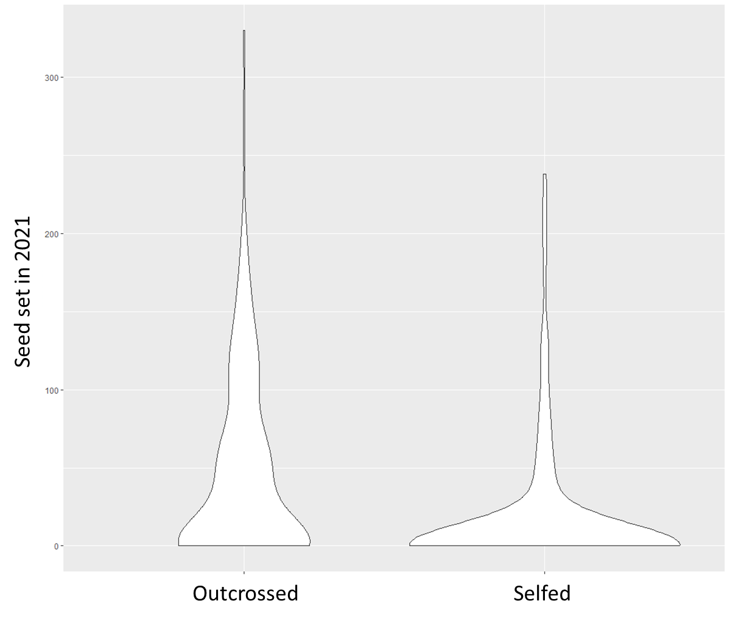
Figure 4.1. Seed set of greenhouse-raised and hand pollinated Calochortus luteus plants that flowered in 2021. Greenhouse plants grown from field collected outcrossed seeds produced significantly more seeds than greenhouse plants that were grown from field collected selfed seeds. All seeds were planted in 2018.

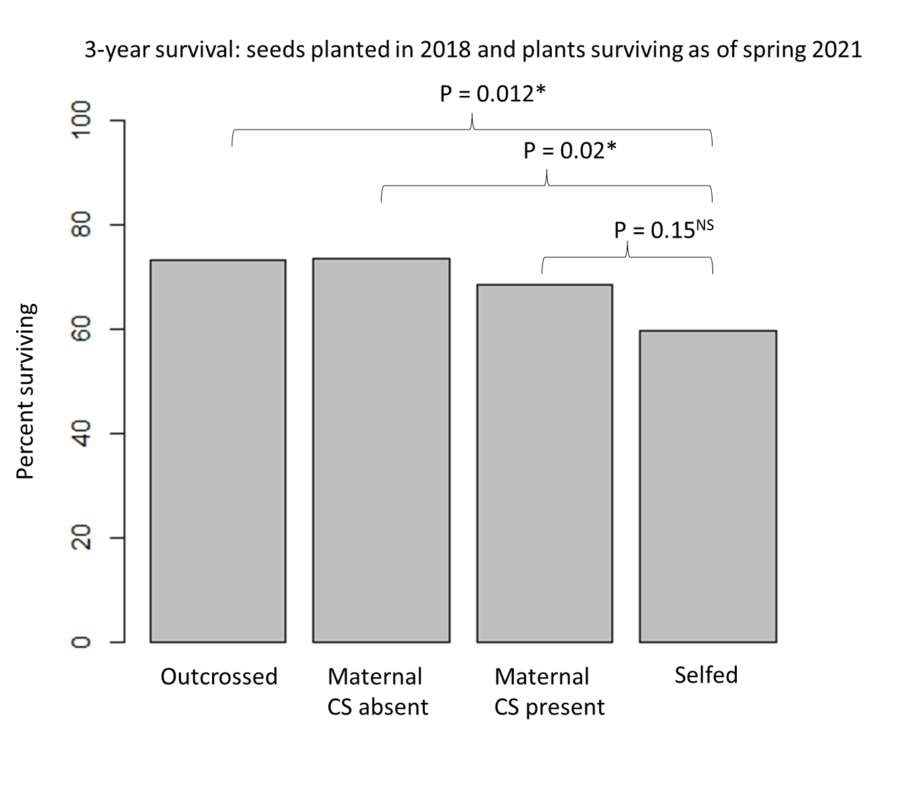
Figure 4.2. Percentage of greenhouse-grown Calochortus luteus individuals planted as seed in 2018 that were alive as of January 2021 from four maternal pollination treatment groups. Individuals derived from outcross-pollination (outcrossed) or from maternal plants with crab spiders absent (maternal CS absent) were significantly more likely to be alive in 2021 relative to individuals derived from self-pollination (selfed). Individuals derived from maternal plants with crab spiders present (maternal CS present) were not significantly different from individuals derived from self-pollination, however they also did not differ significantly from individuals derived from outcross-pollination nor maternal CS absent.

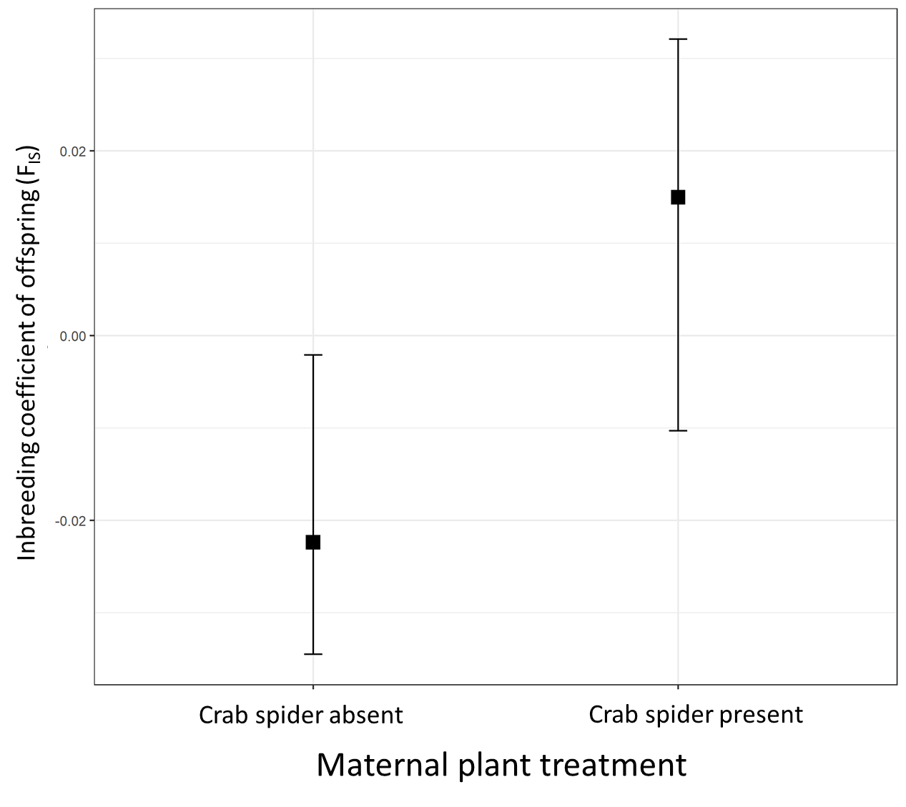
Figure 4.3. Estimated F_{IS} (inbreeding coefficient) with 95% confidence intervals for offspring of maternal plants with crab spiders absent vs. present. F_{IS} estimates are from a general linear mixed effects model with F_{IS} as the dependent variable, maternal plant crab spider treatment as the independent factor, and maternal plant family as a random effect.

Discussion
Differences in fitness due to inbreeding depression can affect adult life stages as well as early life stages, but are rarely measured throughout the life-time of long- lived species (Huisman et al. 2016). The cumulative lifetime effects of inbreeding depression are predicted to be ecologically and evolutionarily significant (Slate et al. 2000). I found that greenhouse-grown plants originating from self-pollinated seeds of C. luteus are significantly less fit than individuals grown from outcross-pollinated seeds. These results suggest that self-pollination causes expression of inbreeding depression: lower fitness due to increased expression of deleterious recessive alleles. The fitness difference is not apparent at early life stages, (e.g. seed set of maternal plants or seed germination), but becomes evident with time. Selfed progeny had significantly lower survival over three years, were less likely to flower, and when they did flower, they produced significantly fewer seeds than progeny grown from seeds that were outcross-pollinated. These cumulative fitness differences are expected to continue to accumulate over the lifetime of this long-lived perennial. These results highlight the importance of measuring fitness metrics at different life stages for long-lived species.
In this experiment plants were grown in a greenhouse in individual pots; they did not compete with other plants, they received ample water, light, nutrients, an ideal temperature range, and were free from herbivores. Under these favorable, low-stress conditions, most plants did not flower until their third growth season. These growing conditions undoubtedly minimized the fitness differences caused by inbreeding depression that would have been expressed under field conditions. Water and heat stress, especially in recent years as climate change intensifies, are factors that can limit fitness of wild C. luteus plants (Holtsford 1985). Calochortus luteus is a long-lived perennial estimated to live 10-40 years in the wild that flowers only after three or more years of growth (Leigh et al. 2006; Miller et al. 2012). Because fitness over time is multiplicative, even modest differences in survival, growth, and reproduction between selfed and outcrossed progeny are expected to result in large differences in lifetime fitness, especially in natural environments where species contend with drought, heat waves, and herbivores.
Germination, survival, flowering, and seed set did not differ significantly between plants grown from the seeds of maternal plants with crab spiders absent or present. However, all but one of these fitness metrics showed the predicted trend (i.e., offspring of maternal plants with crab spiders absent had higher mean fitness metrics than the offspring of maternal plants with crab spiders, but the differences between the means were not significant). This trend is expected if the maternal plants with crab spiders present had a higher selfing rate and thus their offspring express more inbreeding depression than offspring from plants with crab spiders absent. If this is the case, then significant fitness differences may emerge over time, and are predicted to be greater if the greenhouse grown plants are exposed to more stressful conditions. However, if the trend is due to chance, then I would expect the difference to remain non-significant as time elapses and in varying environmental conditions. Future data from this ongoing experiment will elucidate these alternative hypotheses.
Given that the fitness metrics of offspring from maternal plants with crab spiders absent, are similar to the fitness metrics of offspring from outcrossed maternal plants, it seems likely that these plants are primarily outcrossed (Fig. 4.2). This result is consistent with my previous finding that an emasculation treatment which made self-pollination impossible, did not significantly affect seed set indicating that wild plants received sufficient outcrossed pollen (Chapter III). However, the fitness metrics of offspring from maternal plants with crab spiders present were intermediate between the offspring of maternal plants that were outcrossed and selfed (Fig. 4.2). This may suggest that maternal plants with crab spiders present have increased rates of selfing compared to those without crab spiders. This result supports my hypothesis that crab spiders facilitate self-pollination within a flower and that increased self-pollination may compensate for decreased deposition of outcrossed pollen due to significant declines in pollinator visitation and stigma contact when crab spiders are present (Chapter III). Previously, I found no interaction between crab spider treatment (addition, absent) and emasculation treatment (intact, emasculated), which suggested that selfing rates were the same regardless of crab spider treatment (Chapter III). However, these results were based on the experimental addition of crab spiders to plants and the crab spiders more often left the plants when they were placed there relative to crab spiders who naturally colonized plants (Benoit, unpublished data).
Like the fitness metric data, the GBS data results trend in the predicted direction with offspring of maternal plants without crab spiders having a lower inbreeding coefficient and offspring of plants with crab spiders present having a higher inbreeding coefficient (Fig. 4.3). The inbreeding coefficient estimate for offspring of maternal plants without crab spiders is negative and significantly different from zero indicating low inbreeding. Alternatively, the inbreeding coefficient for offspring of plants with crab spiders present is positive, but not significantly different from zero, indicating a trend towards more homozygosity than expected thus indicating inbreeding as I predicted, but because the difference is not significant, I cannot definitively say that the presence of crab spiders on C. luteus plants increases selfing rates.
Given that the fitness data and the genetic data both suggest that the offspring of maternal plants with crab spiders present trends toward less fit and more inbred, I suggest that the most likely explanation is a combination of two of my hypotheses. Crab spiders likely generally lower deposition of outcross pollen by reducing pollinator visitation and stigma contact (Chapter III) and may increase selfing by depositing self-pollen while hunting. The effects of crab spiders are small because either C. luteus stigmas receive sufficient pollen from pollinator visits, and/or crab spiders may stochastically increase outcross pollen deposition when they manipulate prey within the flower.
Pollinators have direct impacts on gene flow and plant mating systems, and pollinator behavior and abundance can be significantly affected by predators (Benoit and Kalisz 2020). Therefore, predators may indirectly depress gene flow among individuals and drive plant mating systems toward higher rates of selfing. Further, sit-and-wait predators that hunt from flowers may also have direct effects on plant mating systems by transferring self-pollen from anthers to stigma within a flower, thereby directly affecting selfing rates. This is a new frontier at the intersection of pollination biology, species interactions, mating system evolution, and plant population genetics. my findings are among the first to provide support for the idea that pollinator predators influence plant mating systems, but much remains to be learned. Deeper understanding of the effects of predators on plant mating systems, population genetics, and pollinator communities will yield new insights in my understanding of the ecology and evolution of plant ecology, evolution, and community interactions.

REFERENCES
Barrett, S.C., 2003. Mating strategies in flowering plants: the outcrossing–selfing paradigm and beyond. Philosophical Transactions of the Royal Society of London. Series B: Biological Sciences, 358(1434), pp.991-1004.
Barrett, S.C. and Harder, L.D., 2017. The ecology of mating and its evolutionary consequences in seed plants. Annual Review of Ecology, Evolution, and Systematics, 48, pp.135-157.
Bates D, Mächler M, Bolker B, Walker S (2015). “Fitting Linear Mixed-Effects Models Using lme4.” Journal of Statistical Software, 67(1), 1–48. doi: 10.18637/jss
Benoit, A.D. and Caruso, C.M., 2021. A sit‐and‐wait predator, but not an active‐pursuit predator, alters pollinator‐mediated selection on floral traits. Ecology, 102(12), p.e03506.
Benoit, A.D. and Kalisz, S., 2020. Predator effects on plant-pollinator interactions, plant reproduction, mating systems, and evolution. Annual Review of Ecology, Evolution, and Systematics, 51, pp.319-340.
Busch, J.W. and Delph, L.F., 2012. The relative importance of reproductive assurance and automatic selection as hypotheses for the evolution of self-fertilization. Annals of botany, 109(3), pp.553-562.
Catchen, J., Hohenlohe, P.A., Bassham, S., Amores, A. and Cresko, W.A., 2013. Stacks: an analysis tool set for population genomics. Molecular ecology, 22(11), pp.3124-3140.
Danecek, P., Auton, A., Abecasis, G., Albers, C.A., Banks, E., DePristo, M.A., Handsaker, R.E., Lunter, G., Marth, G.T., Sherry, S.T. and McVean, G., 2011. The variant call format and VCFtools. Bioinformatics, 27(15), pp.2156-2158.
Eckert, C.G., Ozimec, B., Herlihy, C.R., Griffin, C.A. and Routley, M.B., 2009. Floral morphology mediates temporal variation in the mating system of a self‐compatible plant. Ecology, 90(6), pp.1540-1548.
Goodwillie, C., Kalisz, S. and Eckert, C.G., 2005. The evolutionary enigma of mixed mating systems in plants: occurrence, theoretical explanations, and empirical evidence. Annu. Rev. Ecol. Evol. Syst., 36, pp.47-79.
Huisman, J., Kruuk, L.E., Ellis, P.A., Clutton-Brock, T. and Pemberton, J.M., 2016. Inbreeding depression across the lifespan in a wild mammal population. Proceedings of the National Academy of Sciences, 113(13), pp.3585-3590.
Kuznetsova A., Brockhoff P.B. and Christensen R.H.B. (2017). "lmerTest Package: Tests in Linear Mixed Effects Models." Journal of Statistical Software, 82(13)
Lande, R. and Schemske, D.W., 1985. The evolution of self‐fertilization and inbreeding depression in plants. I. Genetic models. Evolution, 39(1), pp.24-40.
R Core Team (2021). R: A language and environment for statistical computing. R Foundation for Statistical Computing, Vienna, Austria. URL https://www.R-project.org/.
Slate, J., Kruuk, L.E.B., Marshall, T.C., Pemberton, J.M. and Clutton-Brock, T.H., 2000. Inbreeding depression influences lifetime breeding success in a wild population of red deer (Cervus elaphus). Proceedings of the Royal Society of London. Series B: Biological Sciences, 267(1453), pp.1657-1662.
Wickham H (2016). ggplot2: Elegant Graphics for Data Analysis. Springer-Verlag New York.
Whitehead, M.R., Lanfear, R., Mitchell, R.J. and Karron, J.D., 2018. Plant mating systems often vary widely among populations. Frontiers in Ecology and Evolution, 6, p.38.

CONCLUSION
Plants are the foundation of the food web and are members of complex communities. Within these communities, plants interact with numerous species and the outcomes of these interactions are highly context dependent. Understanding and being able to predict the outcomes of some of these interactions based on context, will enable us to better understand the interplay between ecology and evolution, and ultimately to better understand, appreciate, and protect natural communities. In this dissertation, I have compiled information, synthesized ideas, and added data to inform our understanding of interactions among predators, pollinators, and plants.
In my first chapter, I explore the history and available data regarding predator-pollinator-plant interactions. I found that Darwin wrote 1859 about the potential of cats to influence populations of mice, and thus indirectly impact populations of honeybees and clover (Darwin 2004). However, there was scant interest in the indirect effects of predators on plants via plant mutualists for over a century after Darwin’s mention of the subject. In the 1960’s excitement over trophic cascades and the indirect effects of predators on plants via herbivores began (Hairston et al. 1960), and thousands of studies have been published on the topic since. Yet, there was skepticism about the ability of plant mutualists to mediate similar indirect effects. The culture of the time often discounted mutualistic interactions or treated mutualism as a unilateral life history attribute rather than an ecologically and evolutionarily meaningful type of interaction (Bronstein 1994). In 2001 attention was brought to the potential of predators to impact plants through pollinators by Reuven Dukas (2001a, 2001b). In the subsequent two decades more and more data on predator-pollinator-plant interactions has been published, but several key gaps in our understanding remain. Chapter one of this dissertation summarizes available data and highlights areas where more data is needed. In chapters two through four I work to fill some of these gaps and deepen our understanding of the complex and context dependent interactions among plants, pollinators, and predators, and how these interactions influence plant evolutionary ecology.
In chapter two I present experimental evidence that the sit-and-wait predators that hunt from flowers are causal agents of selection on floral traits. To my knowledge this is the first research to experimentally demonstrate this. My findings are significant because plant trait evolution, especially floral trait evolution, is generally attributed to selection by pollinators, herbivores, and the abiotic environment. This new understanding that predators can also indirectly shape selection on plant traits can help elucidate enigmatic patterns in plant evolution, and can help predict and understand some of the ubiquitous temporal and spatial variation in selective pressure on plant traits.
In chapter three I present an in-depth study of how a sit-and-wait pollinator predator affects pollinator behavior and how that altered behavior affects the pollination biology of Calochortus luteus. Predators can have varied effects on pollinator behavior (Benoit and Kalisz 2020). In this system, I found that predators significantly reduced pollinator visitation frequency and duration, and decreased the number of times pollinators contacted the flowers' anthers and stigma. Surprisingly, despite reduced pollinator visitation we found that the presence of a sit-and-wait predator increased seed set, but not by reducing herbivore damage. I did not find evidence of pollen limitation, or changes in selfing rate in relation to the presence or absence of predators, but I present hypotheses and predictions that warrant further study in this system and in others. I predict that water limitation of C. luteus reproduction limited my ability to detect the effects of predators on pollination, and thus future experiments exploring the relationships among water/resource availability, predator presence, and pollination will be informative.
In my fourth chapter, I present data from an ongoing greenhouse study to examine whether the presence of predators on flowers increases homozygosity and the expression of inbreeding depression of offspring of those plants. This study uses modern genotype sequencing techniques to answer a novel question about the role of predators in shaping plant population genetics. Further, this study provides a unique examination of fitness metrics across different life stages of a long-lived perennial plant which provides the important data about how inbreeding influences performance at different life stages and the cumulative effects of inbreeding depression.
Together the body of work seeks to fill important gaps in our understanding of predator-pollinator plant interactions by integrating ecology, behavior, pollination, genetics, and evolution to form a more cohesive understanding of how complex species interactions shape the world.

REFERENCES

Benoit, A.D. and Kalisz, S., 2020. Predator effects on plant-pollinator interactions, plant reproduction, mating systems, and evolution. Annual Review of Ecology, Evolution, and Systematics, 51, pp.319-340.
Bronstein, J.L., 1994. Our current understanding of mutualism. The Quarterly Review of Biology, 69(1), pp.31-51.
Darwin, C., 2004. On the origin of species, 1859. Routledge.
Dukas, Reuven., 2001a. Effects of perceived danger on flower choice by bees. Ecology Letters, 4(4), pp.327-333.
Dukas, Reuven., 2001b. Effects of predation risk on pollinators and plants. Cognitive ecology of pollination. Cambridge University Press, Cambridge, pp.214-236.
Hairston, N.G., Smith, F.E. and Slobodkin, L.B., 1960. Community structure, population control, and competition. The American Naturalist, 94(879), pp.421-425.

VITA
Originally from upstate New York, Amanda Benoit graduated from Trent University in 2011 with a Bachelor of Art with Honors in Biology and Anthropology. Amanda studied abroad in Puebla, Mexico where she studied Spanish and anthropology and in Costa Rica with the Organization for Tropical Studies. Amanda worked as an Environmental Educator at Dyken Pond Environmental Education Center - a place which will always hold a special place in her heart for inspiring her love of the natural world when she was a child. After receiving her BA, Amanda moved to Jeongeup, South Korea where she lived for two years teaching English in elementary and middle schools. In 2016 Amanda received a Master of Science degree from the University of Guelph, where she was advised by Dr. Christina Caruso in the department of Integrative Biology.
In fall of 2016 Amanda joined the Kalisz Lab in the department of Ecology and Evolutionary Biology at the University of Tennessee, Knoxville. Amanda served on numerous committees including the Undergraduate Affairs Committee, the Executive Committee, and the Greenhouse Committee. Amanda was president of the graduate student group GREBE (Graduate Researchers in Ecology, Behavior, and Evolution). Amanda enthusiastically coordinated an Undergraduate Mentoring Program that connected undergraduate students with graduate student mentors, organized professional development opportunities, and organized an annual undergraduate researcher symposium. In addition to coordinating the program from 2018 - 2022, Amanda also mentored many undergraduate students.
Amanda received awards for teaching and publication, and over $50,000 in funding for her research. During her time at the University of Tennessee she taught Field Botany, Evolution, Economic Botany, Plant-Pollinator Interactions, and Intro Bio for non-science majors. Amanda is committed to evidence-based teaching practices and helping her students gain confidence and develop a lifelong love of learning.
Beyond her involvement with the University of Tennessee, Amanda is passionate about horses. She enjoys trail riding and fear-free relationship-focused horsemanship and training. She is also passionate about equine nutrition and hoof care to enhance equine well-being. In addition to her two horses, Amanda has two rescue dogs, two cats, chickens, and fosters kittens for the Humane Society. Amanda is a prolific gardener and has planted expansive native plant gardens in her yard to enhance biodiversity and provide food and habitat for wildlife. She enjoys photographing insects visiting flowers in her gardens. Amanda also enjoys spending time in nature hiking and backpacking, as well as learning about culture, history, ecology, and natural history by reading and traveling.

