IMPACTS OF THE RICHMONDIAN INVASION IN THE NASHVILLE DOME: ANALYSIS OF NICHE STABILITY USING ECOLOGICAL NICHE MODELING

A Thesis Presented for the
Master of Science
Degree
The University of Tennessee, Knoxville

Noel Jose Hernández Gómez
December 2024
ACKNOWLEGEMENTS
I acknowledge the support of the Department of Earth, Environmental, and Planetary Sciences and the Department of Ecology & Evolutionary Biology of the University of Tennessee, Knoxville faculty and staff, including my committee members Dr. Daniel I. Hembree and Dr. Monica Papeş, for their time and supporting me with this project. I acknowledge my advisor, Dr. Alycia L. Stigall, who made this project possible through invaluable mentorship, guidance, and emotional support. I acknowledge Dr. Carlton E. Brett and Ian J. Forsythe for their support and help with this projects and field work in the Nashville area. I want to thank Mariana Vilela De Andrade for assistance during field work. I thank my graduate student colleagues, Emily Etheridge, Hannah Maddox, and Drew White, for their support and friendship throughout this project. I would also like to acknowledge my family for supporting me through this process and for their hard work to allow me this opportunity to progress through my career path. Thanks to Steven M. Holland and Mark E. Patzkowsky for their foundational work that was essential for this project. This project was supported by funding from the Geological Society of America, the Dry Dredgers of Cincinnati, OH, the Paleontological Society, the Department of Earth, Environmental, and Planetary Sciences, and the Swingle Fellowship.

ABSTRACT
The Richmondian Invasion was the immigration of a diverse suite of marine taxa into southeastern Laurentia during the Late Ordovician (Katian), preserved in the strata of the Cincinnati Basin and Nashville Dome of North America. The evolutionary and ecological impacts of the invasion have been well studied in the Cincinnati region; however, faunal change in the Nashville Dome is poorly constrained. In this study, Paleo-Ecological Niche Modeling was applied to test the hypotheses that niche lability patterns in the Nashville Dome were similar to the Cincinnati region, specifically that niche stability was high among taxa before the invasion, but niche stability declined during and after the invasion. Late Ordovician strata of the Nashville Dome comprise highly fossiliferous limestone and shale units. In-situ species-level identifications for different fossil taxa and sedimentological data were collected to develop species occurrence and environmental proxy data for niche modeling. Niche models were developed using MAXENT, an R-based modeling package. Models were produced for taxa with at least seven geographic occurrence points among twenty locations spanning the western edge of the Nashville Dome. Articulated brachiopods, bryozoans, gastropods, and few other benthic clades were included in the modeled taxa. Sedimentary proxies, like carbonate bedding style and thickness, and limestone/shale percentage were used to construct environmental parameters. Niches were characterized across the invasion in the Nashville Dome by examining changes in environmental parameters coupled with taxa distribution data. Results demonstrate that taxa maintained a high level of niche stability throughout this interval but demonstrated elevated niche conservatism in times of biotic disturbance due to the introduction of invasive taxa. Results were compared with similar analyses previously conducted for taxa of Cincinnati region. Comparisons demonstrate that niche response differs between Nashville and Cincinnati taxa across the invasion. Nashville taxa exhibited overwhelming niche stability whereas Cincinnatian taxa underwent substantive niche contraction. This discrepancy invokes differences in tectonic position and sedimentary regimes of the two regions, differences in timing, differences in pre-invasion taxa and community structures, and differences in the identity of the invaders. This analysis improves the current understanding of how Biotic Immigration Events alter ecology in geologic time.
TABLE OF CONTENTS
Chapter 1. Introduction 1
Chapter 2. Background 4
Richmondian Invasion 4
Niche Dynamics 11
Paleoecological Niche Modeling 14
Geological Setting of the Nashville Dome 16
Chapter 3. Materials and Methods 18
Temporal Framework and Stratigraphic Descriptions 18
Data Collection and Field Methods 22
Modeling Paleogeographic Distribution 26
Statistical Evaluation 29
Chapter 4. Results 34
Model Evaluation 34
Niche Dynamics Analysis 36
Chapter 5. Discussion 42
Ecological Niche Model Evaluation 42
Niche Stability Across the Richmondian Invasion 43
Comparing the Nashville Dome and the Cincinnati Region 44
Biotic and Climatic Drivers 49
Implications for Modern Invasion Events 50
Chapter 6. Conclusion 51
References 53
Appendix 1. Stratigraphic columns 63
Appendix 2. Species occurrence data 84
Appendix 3. Coded environmental proxy data 85
Appendix 4. Species distribution models 88
Vita 91

LIST OF TABLES
Table 1. Characteristics of focal strata. 19
Table 2. List of sampled outcrops, geographic coordinates, and the sedimentary sequences exposed at each location. 24
Table 3. Sedimentary parameters used as environmental proxies for ENM development. 27
Table 4. MaxEnt model evaluation data. Green shading indicates values that fall within acceptable range for model usage. Models are grouped by whether they were tested via cross-validation or not. Orange shading shows taxa that were actually used for niche dynamic analysis, as well as similarity and equivalence analysis. * indicates model used when two models were acceptable. 30
Table 5. Niche dynamics analysis. Values range from 0 to 1.0, with 0 indicating no detection of expansion, stability or unfilling and 1.00 indicating very high level of expansion, stability or unfilling. 37
Table 6. Equivalency and Similarity analysis. Numbers indicate p-values (right-tailed alpha < 0.05), green shading indicates statistically significant values. Greater means niches are more similar or equivalent than expected from random processes indicating niche conservatism, whereas lower means niches are less similar or equivalent than expected from random processes indicating niche evolution. 40
Table 7. Environemntal proxy data for each locality sampled at meter scale. 85

LIST OF FIGURES
Figure 1. Paleogeographic reconstruction of Laurentia during the Late Ordovician. Both the Cincinnati and Nashville Basins (shaded red and orange, respectively) were located at approximately 25 degrees south latitude in the distal portion of the Appalachian foreland basin. Base map from Blakey (2012). 5
Figure 2. Stratigraphic framework for the Nashville and Cincinnati regions. Sequences C1, C2, C3, and C4 are similar between basins. Holland and Patzkowsky (1996) C5, and Brett et al. (2020) C5, and C6 are generally equivalent to Holland and Patzkowsky (1998)’s C5 sequence. Holland and Patzkowsky (1996) upper C5, and Brett et al. (2020) C7 sequence is generally equivalent to Holland and Patzkowsky (1998)’s C6 sequence. Blue shading indicated Richmondian Invasion pulses. Note: discrete pulses of invasion have not yet been identified in the Nashville area. 7
Figure 3. Examples of native and invasive taxa from the Nashville Dome. (A) Rafinesquina alternata, (B) Paupospira bowdeni, (C) Herbetella occidentalis, (D) Zygospira modesta, (E) Cyclonema bilix, (F) Ramose bryozoan?, (G) Constellaria florida, (H) Vinlandostrophia ponderosa, (I) Hiscobeccus capax, (J) Eochonetes clarksvillensis, (K) Grewingkia canadensis, (L) Leptaena richmondensis. 9
Figure 4. BAM diagram indicating how biotic, abiotic, and mobility constraints overlap to define the occupied niche. Modified from (Soberón and Peterson 2005). 12
Figure 5. Map of outcrop distribution across the western edge of the Nashville Dome. Localities where stratigraphic columns were constructed and faunal data were collected are indicated and correspond to Table 2. 20
Figure 6. Correlation of localities across the study area. Locality numbers found in Table 2. Stratigraphic columns are detailed in Appendix 1. 25
Figure 7. Example distribution models from four compared taxa across all time slices. 35
Figure 8. Principal component analysis results the eight taxa that were compared across time slices, Parvohallopora ramosa was only compared across the C3 vs. C4 time slices and Orthorhynchula linneyi was only compared across C4 vs. C5 time slices. 39
Figure 9. Cato Road Cut stratigraphic column 63
Figure 10. I-155 North Mile 23.0 stratigraphic column 64
Figure 11. I-155 East Mile 21.2 stratigraphic column 65
Figure 12. Vietnam Veterans Highway stratigraphic column 66
Figure 13. West 386 Mile 4.4 stratigraphic column. 67
Figure 14. I-386 East Mile 3.6 stratigraphic column. 68
Figure 15. Old Hickory Road Cut stratigraphic column. 69
Figure 16. I-840 West Mile 26.6 stratigraphic column. 70
Figure 17. I-840 West Mile 24.8 stratigraphic column. 71
Figure 18. I-840 East Mile 24.8 stratigraphic column. 72
Figure 19. Big East Form Stream Cut stratigraphic column. 73
Figure 20. Red Caboose Cut stratigraphic column. 74
Figure 21. I-40 East Exit 201B stratigraphic column. 75
Figure 22. I-40 South Substation Cut stratigraphic column. 76
Figure 23. I-65 South Mile 99.0 stratigraphic column. 77
Figure 24. Egypt Hollow Stream Cut stratigraphic column 78
Figure 25. Natchez Garrison Creek Wall stratigraphic column. 79
Figure 26. Carter’s Creek Mile 8 stratigraphic column. 80
Figure 27. Nine Mile Hill stratigraphic column. 81
Figure 28. I-24 East Mile 40.0 stratigraphic column. 82
Figure 29. I-24 West Mile 40.0 stratigraphic column. 83
Figure 30. MAXENT species distribution models for the C3 time slice 88
Figure 31. MAXENT species distribution models for the C4 time slice. 89
Figure 32. MAXENT species distribution models for the C5 time slice. 90

Chapter 1. Introduction
When a new species initially forms, its distribution is restricted to a single geographic region. However, some species expand their ranges to additional geographic areas through time. The arrival of invasive species into a new region can have an impact on both evolutionary and ecological dynamics (Stigall 2019). Consequently, understanding the long-term impacts of invasive species is important for modern conservational biology efforts (Guisan et al. 2014; Stigall 2019). However, the record of modern invasion events only spans decades in duration; therefore, the study of ancient invasions preserved in the fossil record can provide important insight into these long-term impacts of invasive species on ecological communities and the environment that they inhabit.
Being able to document and quantify change in niche dynamics across geologic time provides an analogue for modern ecological dynamics and can give insight into what consequences may be expected from modern environmental change (Dietl and Flessa 2011; Kiessling et al. 2023). Various ancient invasions have been investigated including the Great American Biotic Interchange (Stehli and Webb 1985), Late Devonian Biodiversity Crisis (Stigall Rode and Lieberman 2005a), and the Richmondian Invasion (Foerste 1905; Holland and Patzkowsky 1997, Stigall 2010a). Of the known invasion events in deep time, the Richmondian Invasion of the Late Ordovician has been the best characterized (Stigall 2023).
The Richmondian Invasion is well-documented within the Cincinnati Arch region around Cincinnati, Ohio, USA, and has also been identified in the Nashville Dome region central Tennessee, USA (Foerste 1905; Holland and Patzkowsky 1997; Dudei and Stigall 2010; Malizia and Stigall 2011; Kempf et al. 2020; Forsythe and Stigall 2023; Stigall 2023). This event includes the introduction of more than sixty invasive lineages, including members from all major clades of shallow marine taxa, into the southern Laurentian region near the base of the Richmondian Stage of North American stratigraphic terminology (Holland 1997; Patzkowsky and Holland 1996; Stigall 2023). The highly fossiliferous Upper Ordovician carbonate strata have facilitated numerous studies on this event in the Cincinnati Region, where the ecological and evolutionary impacts of the invasion have been analyzed and are well understood (Stigall 2023). In contrast, the ecological and evolutionary impacts of the Richmondian Invasion within the Nashville Dome have not been analyzed beyond a few initial analyses (i.e., Holland and Patzkowsky 1996, 1998, 1999).
This study focuses on quantifying niche dynamics of the taxa that inhabited the Nashville Dome before, during, and after the Richmondian Invasion. By doing so, it is possible to interpret the way in which taxa’s niches are changed as a result of ecosystem perturbation and assign factors that drive this process (Peterson 2003; Saupe et al. 2018). To do this, niche models were generated for shallow marine species inhabiting the Nashville Dome before, during, and after the Richmondian Invasion using paleontological ecological niche modeling (PaleoENM) to investigate how taxa responded to the biotic and abiotic changes during the invasion interval. Ecological Niche Modeling (ENM) utilizes environmental data to quantitatively assess the habitat/niche parameters that constrain the realized niche of taxa based on different traits of the taxa and their environments (Peterson 2001 2003; Peterson et al. 2011; Graham et al. 2010). This modeling method was originally developed by biologists to estimate the environmental requirements that modern organisms must have to inhabit an ecosystem, and what factors have a true impact on a community’s geographic range (Peterson 2001; Pohl et al. 2019; Edwards et al. 2023). However, the theoretical underpinning of ENM can be equally applied to fossil taxa, and a robust framework has been developed for PaleoENM (Stigall Rode and Lieberman 2005; Dudei and Stigall 2010; Saupe et al. 2014; Myers et al. 2015; Stigall 2019). This has facilitated a better understanding of how ancient taxa were distributed throughout deep time, how ecological niches change through time, as well as expanding the utility of niche modeling as a predictive tool for future ecological change (Malizia and Stigall 2011; Myers et al. 2015). Significantly, PaleoENM has been used to constrain the impact of the Richmondian Invasion within the Cincinnati Basin (Brame and Stigall 2014; Stigall 2014). This facilitates comparing the ecological response of species to the Richmondian Invasion in the Nashville region with that of species in the Cincinnati region.
Two main hypotheses were tested:
- Prior to the invasion, species are expected to exhibit high niche stability, and niche stability declined during the invasion interval.
- Taxa responded to the Richmondian Invasion through niche contraction, similar to patterns observed in the Cincinnati Region (Malizia and Stigall 2011; Brame and Stigall 2014).

Chapter 2. Background

Richmondian Invasion
The Richmondian Invasion is a major ancient Biotic Immigration Event (BIME) that took place in the Late Ordovician, Katian Age (Stigall 2023). It is recorded in the strata of Eastern North America, which at the time was a shallow, epicontinental, tropical carbonate-siliciclastic mixed shelf region (Fig. 1). Hence, the Richmondian Invasion is primarily recorded in limestones, which are consistently intermixed with mudstones and shales (Holland and Patzkowsky 2007; Pope et al. 2009; Brett et al. 2020). This influx of extrabasinal species was initially recognized across the Jessamine Dome, mainly around the Cincinnati, Ohio region (Foerste 1905; Holland et al. 1997; Stigall 2023), but was later recognized in the Nashville Dome as well (Foerste 1912; Holland and Patzkowsky 1998; Patzkowsky and Holland 1999). Studies of the Cincinnati region’s sedimentological record have noted that this invasion occurred as a response to a combination of shifting sea levels from climatic change and tectonic-driven uplift shifts in oceanic circulation, which connected previously separated ocean basins for long enough stretches of time to allow dispersal or species (Brame and Stigall 2014; Purcell and Stigall 2021; Stigall 2023). Some invaders utilized multiple pathways (Stigall et al. 2024). Some originated from tropical latitudes and infiltrated the lower regions of Laurentia while others immigrated from basins marginal to Laurentia from multiple pathways (Bauer and Stigall 2014; Stigall et al. 2017; Lam et al. 2018).
The highly fossiliferous Upper Ordovician carbonate strata in Cincinnati has facilitated numerous studies on this BIME, (Foerste 1905; Dudei and Stigall 2010; Malizia and Stigall

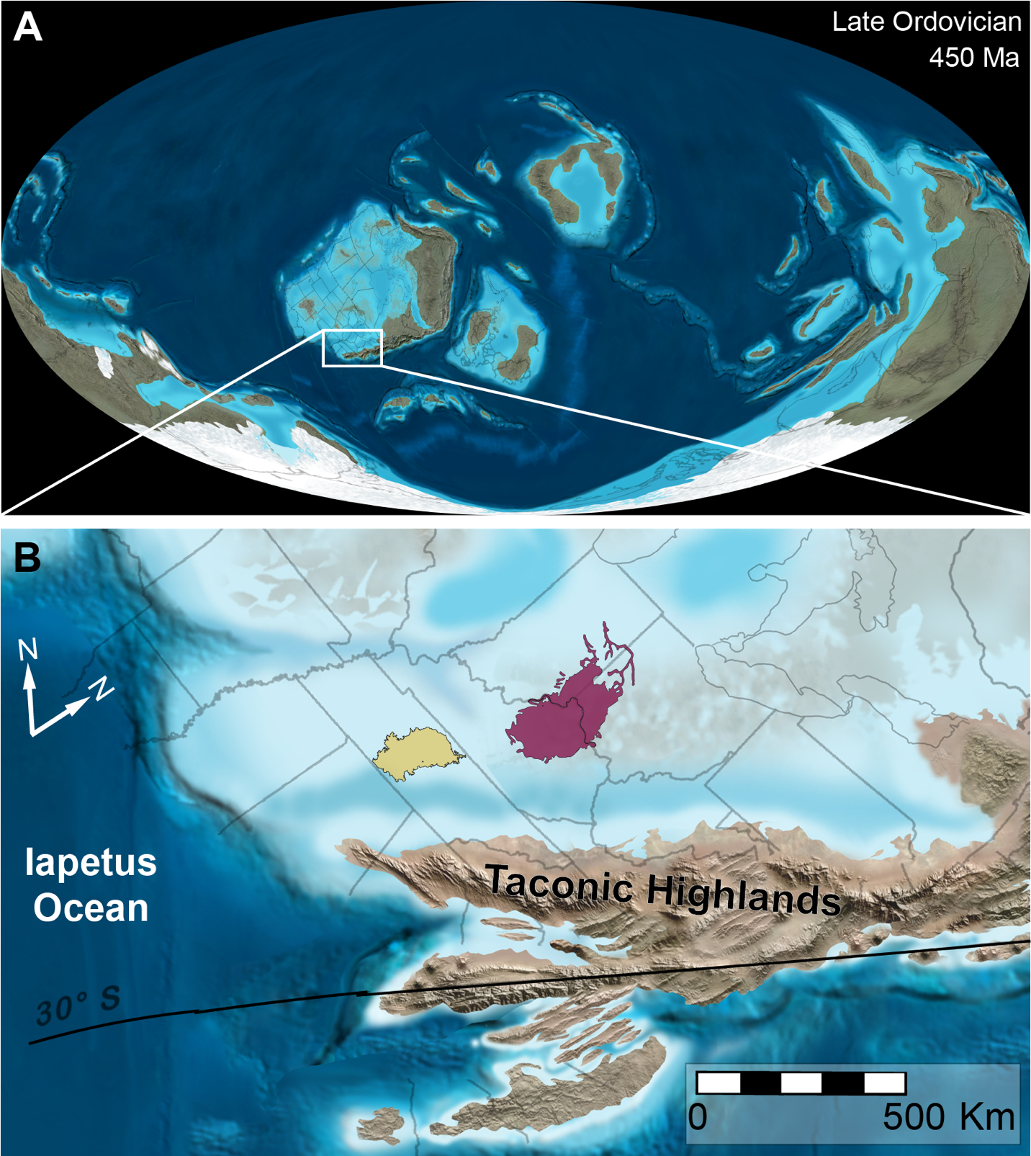
Figure 1. Paleogeographic reconstruction of Laurentia during the Late Ordovician. Both the Cincinnati and Nashville Basins (shaded red and orange, respectively) were located at approximately 25 degrees south latitude in the distal portion of the Appalachian foreland basin. Base map from Blakey (2012).

2011; Brame and Stigall 2014; Kempf et al. 2020; Forsythe and Stigall 2023; Stigall 2023) where the ecological and evolutionary impacts of the invasion have been analyzed and are well understood. In contrast, the ecological and evolutionary impact of the Richmondian Invasion within the Nashville Dome have yet to be analyzed beyond initial community structure, and facies preservation studies (i.e., Holland and Patzkowsky 1996, 1998, 1999). The Nashville Dome includes an extensive outcrop belt primarily comprised of Ordovician carbonate-siliciclastic rocks with similarly abundant fossils that correlate with Cincinnati strata and has been known to include taxa representative of the Richmondian Invasion for a long time (Foerste 1912; Holland and Patzkowsky 1996, 1998; Patzkowsky and Holland 1999).
More detailed analyses of the Richmondian Invasion documented the introduction of taxa across a series of three discrete pulses partitioned across three depositional sequences and varying lithologies, rather than a single event (Holland and Patzkowsky 1996; Brett et al. 2020; Stigall 2023) (Fig. 2). In the Cincinnati region, the initial pulse of the invasion took place in the lower part of the C4B sequence, and the subsequent fauna included only taxa with wide geographic ranges whether native or invasive (Stigall 2010a, 2023). The second and main pulse of the invasion is the Clarksville Phase, which occurred during the C5C and part of the C6A sequences, approximately one million years later, which introduces most of the invaders and corresponds with a major global positive δ¹³C excursion (Forsythe and Stigall 2023; Stigall 2023). The final invasion pulse is recorded in the C6B, and was heavily dominated by the introduction of mollusks, but was as impactful as the second pulse (Brett et al. 2020; Stigall 2023).
These pulses were driven by a set of environmental changes that facilitated the introduction of these new lineages into these basins. The tectonic setting of these basins at the time were
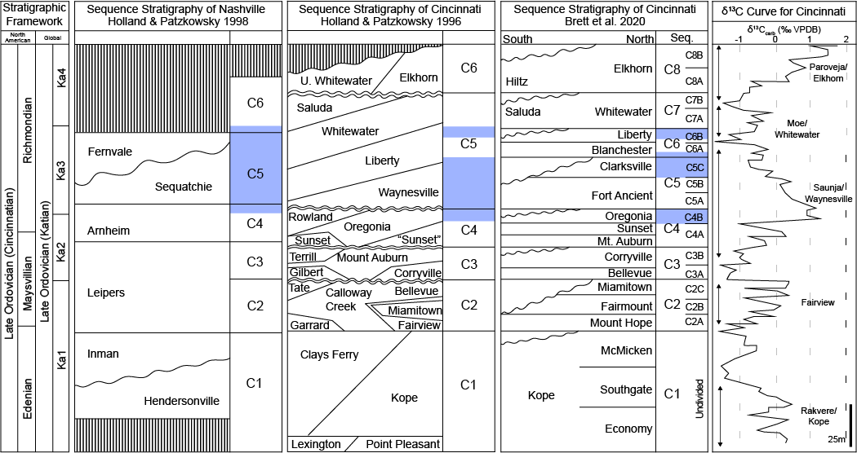
Figure 2. Stratigraphic framework for the Nashville and Cincinnati regions. Sequences C1, C2, C3, and C4 are similar between basins. Holland and Patzkowsky (1996) C5, and Brett et al. (2020) C5, and C6 are generally equivalent to Holland and Patzkowsky (1998)’s C5 sequence. Holland and Patzkowsky (1996) upper C5, and Brett et al. (2020) C7 sequence is generally equivalent to Holland and Patzkowsky (1998)’s C6 sequence. Blue shading indicated Richmondian Invasion pulses. Note: discrete pulses of invasion have not yet been identified in the Nashville area.

heavily controlled by the accretion of the Taconic highlands onto the Laurentian South (Cocks and Torsvik 2021; McLaughlin and Stigall 2023) (Fig. 1), which heavily altered the shape and dynamics of theforeland regions. Compounding onto topological shifts, climatic patterns were shifting during this time as well. The main pulse of invasion that has been described in the Cincinnati region is coeval with the short-lived Boda Warming Event (Fortey and Cocks 2005; Lu et al. 2021), a global positive C13 isotope excursion. A combination of tectonic shifts, along with global climatic trends, and oceanographic shifts is attributed with facilitating dispersal between the shallow basins of Laurentia and encouraged pole-ward migration of tropical taxa (Fig. 3).
A decline in speciation is observed during the invasion interval (Stigall 2010a, 2023; Forsythe and Stigall 2023). The introduction of invaders disturbed the ability for sustainable communities to develop long enough for either native or invading taxa to speciate at pre-invasion rates. This break in speciation has been noted in other BIMEs (Stigall et al. 2017) and is linked to the preferential conditions for generalist taxa over specialized ones in times of ecological and environmental disruption. The lack of specialized taxa during the Richmondian Invasion interval (Stigall 2010b) supports this concept and reflects the difficulties in sustaining the isolation required for successful speciation during intervals of range expansion. It was only after the invasion and the formation of a stable new community structure, that speciation recovered within the Cincinnatian fauna (Stigall 2010b; Purcell and Stigall 2021) once niche partitioning took place (Holland and Patzkowsky 2007). Genus-level analyses indicate that the introduction of invasive taxa not only resulted in a substantial change in the fauna and community structure within the inner Laurentian basin, but also increased the overall biodiversity that was present at
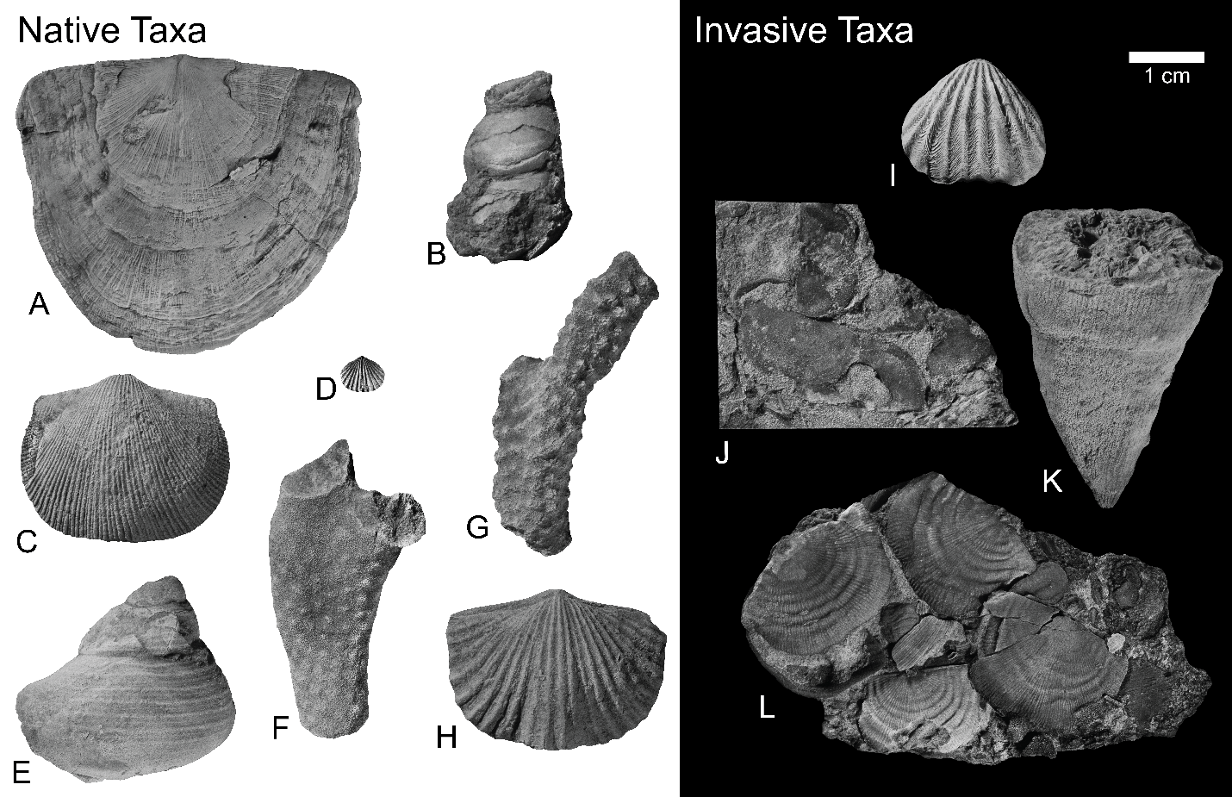
Figure 3. Examples of native and invasive taxa from the Nashville Dome. (A) Rafinesquina alternata, (B) Paupospira bowdeni, (C) Herbetella occidentalis, (D) Zygospira modesta, (E) Cyclonema bilix, (F) Ramose bryozoan?, (G) Constellaria florida, (H) Vinlandostrophia ponderosa, (I) Hiscobeccus capax, (J) Eochonetes clarksvillensis, (K) Grewingkia canadensis, (L) Leptaena richmondensis.

the genus level through a combination of invaders and native taxa (Holland and Patzkowsky 1996, 2007; Dudei and Stigall 2010, Stigall 2010b). Further analysis of food web interactions (Kempf et al. 2020) have shown that introduction of invaders into the basin did not disturb trophic interactions among guilds, but instead produced a decrease in richness and diversity at the species level within community structure after the invasion.
Studies that applied PaleoENM methods in the Cincinnati region (Malizia and Stigall 2011; Brame and Stigall 2014) found that niche stability and conservatism were high in the pre-invasion intervals, but niche stability declined, and niche contraction became prominent once the invasion began. These studies indicated that niches were not uniform but were indeed altered by the invasion. Notably, the degree of niche evolution was statistically similar among all clades and among both native vs. invasive (Brame and Stigall 2014). These patterns are congruent with analysis of community structure within Cincinnati (Holland and Patzkowsky 2007), biotic interactions became more homogenous as the invasion set in, there was more generalization of niches, and taxa which persisted became more conservative about their niches.
The current understanding of the correlative Cincinnatian strata of the Nashville Dome is mainly based on studies from Wilson (1949, 1962), Holland and Patzkowsky (1997, 1998) and Patzkowsky and Holland (1999). Wilson’s (1949, 1962) work provides the foundational sedimentological and formation-name related work. Holland and Patzkowsky (1997, 1998) applied sequence stratigraphic techniques to generate revised stratigraphic framework. Notably, these studies focused on identifying a sequence stratigraphic framework for the Nashville Dome that was compatible with those they had recently proposed for the Cincinnati region (Holland and Patzkowsky 1996). Following this fundamental understanding, Patzkowsky and Holland (1999) described the biofacies that were associated with their stratigraphic framework. They noted that invaders from the Richmondian Invasion also appeared at around the same time in Nashville as they had in the Cincinnati region, but the arrival of different invasive taxa was more staggered in timing from what is seen in Cincinnati, all invaders did not arrive as a cohesive group (Patzkowsky and Holland 1999).

Niche Dynamics
A niche can be defined based on the context in which it is used. This is due to the complex and multidimensional nature of representing the requirements to persist and distribution of organisms in a complex ecosystem (Peterson et al. 2011). For the purposes of this study, a niche is defined as the representation of fitness that an organism has over a geographic range or environmental space (Peterson et al. 2011; Purcell and Stigall 2021). Three primary parameters comprise the fitness that a species has for sustaining a niche and a viable population in environmental space: biotic interactions, abiotic factors, and movement limitations (Soberón and Peterson 2005; Purcell and Stigall 2021) (Fig. 4). Another interpretation of exclusively abiotic factors produces the fundamental niche of a species, which is the set of conditions that a species could potentially inhabit in an ideal scenario (Hutchinson 1957; Purcell and Stigall 2021). In practical terms, the intersection between all parameters is where species are truly geographically distributed, which is the realized niche, also known as an occupied niche (Hutchinson 1957; Soberón and Peterson 2005). This niche designation considers the abiotic requirements of a species as well as biotic exclusion combined with the ability of members of a species to move to potentially habitable regions.
Given these definitions, niche dynamics occur from changes in the abiotic and biotic environment in which the species exists. Niche stability is the preservation of a species’ niche parameters in response to environmental change, whereas niche lability is when a species
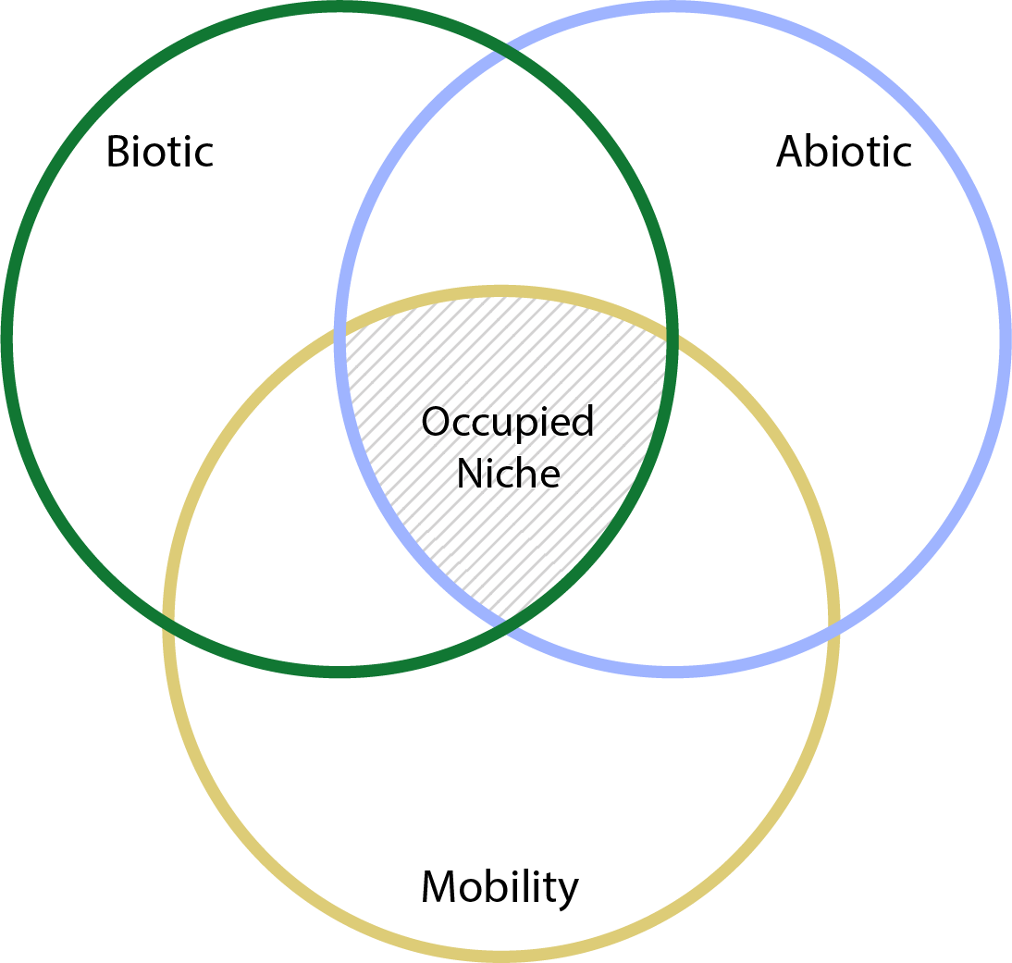
Figure 4. BAM diagram indicating how biotic, abiotic, and mobility constraints overlap to define the occupied niche. Modified from (Soberón and Peterson 2005).

changes its niche parameters as a response to environmental change (Saupe et al. 2014, 2019; Stigall 2014) (niche stability vs. niche evolution of Stigall (2014)). Niche lability can take many forms: a speciescan contract the range of ecological parameters utilized; it could expand its occupied niche to encompass additional ecological parameters, or it can shift its niche to utilize different environmental parameters. Each of these responses have been documented in modern or fossil species (Peterson et al. 2011; Stigall 2014). When environmental conditions change, a species can maintain niche stability and track its previously preferred habitat via geographic movement, modify its niche parameters through niche lability through adaptation to the new local environmental conditions, or become extinct (Peterson et al. 2011). The identification and interpretation of niche dynamics depends on the scope of the question that is being asked, as well as the resolution of the data availability.
Three metrics are most commonly used to quantify the way niche lability behaves between different environmental parameters: 1) niche stability, which measures the amount of overlapping environmental space shared between the two compared time slices (Strubbe et al. 2013; Purcell and Stigall 2021); 2) niche expansion, which is a measure of the opposing signal from niche stability, which weighs the amount of environmental space that is not shared from the first time slice and the second time slice (Strubbe et al. 2013); and 3) niche unfilling, which measures the amount of environmental space that was unoccupied from the initial time slice and left unoccupied during the final time slice (Strubbe et al. 2013). These metrics will be applied to the ENMs for compared taxa across the Nashville Dome. For this study, the nature of niche lability is measured across the three time slices of the same region

Paleoecological Niche Modeling
PaleoENM, which applies ecological niche modeling (ENM) to fossil data, can be used to examine how taxa of the Nashville Dome responded to the Richmondian Invasion. ENM proceeds by examining the environmental conditions associated with a set of discrete geographic occurrence points for a taxon. From these data, the set of preferred environmental parameters are identified that constrain the occupied niche of a taxon for a single temporal window. Because the fossil record is temporally extensive, it is possible to model the ecological niche of fossil taxa across multiple temporal windows. The ability to model taxa through time is a key advantage of PaleoENM as it provides a framework to directly test niche stability through time (Myers et al. 2015).
The application of ENM to fossil data has been relatively sparse in the Paleozoic (Stigall Rode and Lieberman 2005b; Dudei and Stigall 2010; Stigall 2012; Brame and Stigall 2014) and Mesozoic (Myers et al. 2015), but is more common in Cenozoic, especially in the recent past where environmental data can be obtained from climate models (Nogués-Bravo et al. 2008; Brame and Stigall 2014; Saupe et al. 2014; Edwards et al. 2023). Ground-truthing studies (ex., Walls and Stigall 2012) have substantiated that the fossil record provides sufficient data to produce accurate niche models. For modern taxon, high quality and high-resolution environmental data are available for generating ENM models from publicly accessible databases (Peterson et al. 2011). However, environmental data for fossil taxa need to be discerned from the sedimentological record, typically through new field work (Myers et al. 2015). Moreover, the structure of the fossil record must be considered (Schindel 1980; Patzkowsky and Holland 2012; Purcell and Stigall 2021). Understanding the sequence stratigraphic framework of the sampled units provides a temporal framework for both correlation and assessment of stratigraphic gaps and facies relationships, unconformities and gaps in time in the stratigraphic record of the region can limit fossil preservation (Patzkowsky and Holland 2012). However, the fossil record can also preserve ecological assemblages and geographic position of ancient organisms with very high fidelity (Kidwell and Flessa 1996), and the concentrated nature of individual beds provides a direct measure of absolute abundance, and a census of the species present (Finnegan and Droser 2005). Therefore, limitations do not hinder the ability for fossils to be useful for ENM if appropriate caveats are considered.
Well preserved body fossils are most often preserved within the sediment in which they lived in, unless there is clear evidence of sediment reworking (Kidwell and Flessa 1996), the host rock provides information about environmental preferences of taxa (Purcell and Stigall 2021). Sedimentary structures and features, some such as bedding thickness, percentage of siliciclastic input, and ichnofacies, serve as environmental proxies for conditions such as water depth, substate type, wave energy, etc., which allows for ecological niches to be quantified. Successions of strata record how environments change over time, and so it is possible to assess how fossil assemblages change in concert with environmental shifts (Myers et al. 2015). This temporal aspect to the fossil record is something that is not readily available with modern data, especially at the scale of time that is expressed in the geologic record. The combination of multiple available time slices and the direct association of organisms and environment is what makes fossils a viable, and unique, way to assess niche evolution and how it relates to biological evolution of species over long periods time (Peterson et al. 2003; Peterson et al. 2011). Field data collection was essential for performing PaleoENM, since geographic occurrences of taxa must be collected in tandem with environmental proxy information as well as stratigraphic temporal data.

Geological Setting of the Nashville Dome
Ordovician strata are well represented in the Eastern United States, a record of North America’s paleogeographic position. During the Ordovician Period, Laurentia was located in subtropical latitudes with the Nashville Dome located near 25 degrees south of the equator (Cocks and Torsvik 2021; McLaughlin and Stigall 2023) (Fig. 1). The high eustatic sea level of the Ordovician Period resulted in widespread epeiric seas (Munnecke et al. 2010; Rasmussen et al. 2019; McLaughlin and Stigall 2023). This set of conditions facilitated the presence of large carbonate platforms that covered much of the paleocontinent and hosted substantial marine biodiversity for most of the Ordovician (Holland and Patzkowsky 1998; Munnecke et al. 2010). Active tectonics, most notably the Taconic Orogeny, created immense amounts of accommodation for substantial sedimentation and fossil accumulation within these marine basins (Quinlan and Beaumont 1984; Holland and Patzkowsky 1996). The Taconic Orogeny resulted from convergence between Laurentia and the incoming Taconic Island Arc (Beaumont et al. 1988; Holland and Patzkowsky 1996). The resulting deformation from tectonic loading affected the eastern coast of Laurentia by causing subsidence in the foreland regions. This produced the deep Appalachian Basin, which included eastern Tennessee (Sevier Basin), and formed a foreland bulge from the flexure of the lithosphere and made space for shallow marine habitats in the region of modern middle Tennessee (Nashville Basin) (Quinlan and Beaumont 1984; Beaumont et al. 1988). Sediment input for the basin was generated from weathering of the Taconic Highlands and supplied the shallow marine shelves of inner Laurentia with siliciclastic sediments as well as nutrients in the form of phosphate from deltaic and fluvial systems, which propagated productivity in these environments (Holland and Patzkowsky 1996, 1997). The resulting Ordovician strata exposed today in the Nashville Dome are limestones beds (accumulated skeletal clasts) interbedded with mudstone-shale packets (siliciclastic dominated sediment shed from the weathering of the Taconic Highlands), divided into facies of shallow to deep intertidal environments.
Both the Nashville and Cincinnati basins shared very similar paleolatitudes during the Late Ordovician. They shared similar geologic settings, and shared influences from the orogenic belt to the south as well as climatic shifts at the time. However, to the degree as to how influential these commonalities were to the ecological setting at these basins differed, the extent of that difference has yet to be well understood. The Nashville basin also shared a closer proximity to the open Iapetus Ocean, whose influence with currents and sediment distribution would have been more notable than that of the Cincinnati basin.
The sequence stratigraphic framework for the Nashville Dome was developed by Holland and Patzkowsky (1998), which aligned the sequences of the Cincinnati Arch and Nashville Dome on a common framework, provides a direct mechanism to correlate between the Cincinnati and Nashville Basins to compare invasion response between the two regions (Fig. 2).

Chapter 3. Materials and Methods

Temporal Framework and Stratigraphic Descriptions
The focal interval for this study comprises the C3 (late Maysvillian), C4 (early Richmondian) and C5 (mid Richmondian) sequences of Holland and Patzkowsky (1998), which include the intervals before, during, and after the primary invasion interval within the strata of the Nashville Dome, in that order. These correspond to the Leipers (C3), Arnheim (C4), and Sequatchie and Fernvale (C5) formations. These sequences were interpreted by Holland and Patzkowsky (1998) to be coeval with their C3, C4, and C5 sequences in the Cincinnati region. Brett et al. (2020) revised the sequence stratigraphic framework of the Cincinnati region, and this group is actively working to improve Nashville stratigraphy (ex., Forsythe 2023). However, the current best correlative sequence stratigraphic framework is that of Holland and Patzkowsky (1996, 1998) (Fig. 2), therefore, this framework forms the basis for this study. Temporal resolution is developed at the level of third order stratigraphic sequences, which equates to ~250,000-500,000 years per time slice. These three depositional sequences are the basis for the three time slices that are used in the ecological niche models, as the pre-invasion, invasion, and post-invasion intervals.
The C3, C4, and C5 sequences are exposed primarily on the western rim of the Nashville Dome (Fig. 5). The strata of the western Highland Rim expose variable distributions of depositional environments, ranging from intermediate tidal zones, shallow subtidal, and deep subtidal. All three sequences include similarities in depositional environmental and facies architecture, with some differences (Table 1). The C3 sequence was notable for its abundance of terrigenous material in the form of shales interbedded with thin beds of skeletal grain-dominated limestone beds. At its thickest exposure the C3 sequence was about nine meters. C3 facies range
Table 1. Characteristics of focal strata.
Formation/  Sequence | Lithologic and Paleontological Description (Wilson 1948, 1949). Taxonomic names updated to current usage. | Paleoenvironmental interpretation (Patzkowsky & Holland 1999)
Fernvale  Upper C5 | Interbedded gray to tan limestones, coarsely crystalline with shales. Tainted with red to green layers. Massive, coarse to medium grained sandstones in some localities. Some sections in central Tennessee are bright red in color. Few fossils including Cincinnetina meeki, Lingulops cliftonensis, Rhynchotrema capax, Strophomena planodorsata, Cincinnetina jugosa, Rafinesquina alternata, Hebertella occidentalis, Plectambonites sericeus. | Deep subtidal marine.
Sequatchie  Lower C5 | This formation was not mentioned by name for many decades, as it was described as part of the Arnheim Fm. Primarily composed of massive limestone beds. The fauna that can be found in these strata is very similar to that of the Arnheim as well. | Ranges from a shallow subtidal marine assemblage to a deep subtidal.
Arnheim  C4 | Gray-blue, nodular limestones and shale interbedded. Some massive limestones resembling the Leipers lithology but with less phosphate. Argillaceous, massive, rubbly limestone subfacies can be found. Distinct fauna from the underlying Leipers. Fossils include Heterospongia subramosa, Streptelasma rusticum, Columnaria alveolate, Rhombotrypa quadrata, Vinlandostrophia ponderosa, V. cypha, Plectambonites clarksville, Strophomena concordensis, S. planumbona, S. subtenata, Hebertella sinuata, Rafinesquina alternata, Dalmanella jugosa, Plaesiomys subquadrata, Leptaena richmondensis, Rhynchotrema capax, Cyclonema fluctuatum. | Ranges from a shallow subtidal marine assemblage to a deep subtidal.
Leipers  C3 | Thin-bedded granular blue to grey limestones interbedded with prominent shales. Many massive beds of coarse-grained limestones. Uniform in lithology, thickness ranges from 0.5 to ~30 meters. Very fossiliferous including Hebertella occidentalis, Orthorhynchula linneyi, Vinlandostrophia ponderosa, V. laticosta. V. sublaticosta, P. nitida, Rafinesquina ponderosa, Constellaria florida. | Shallow subtidal to peritidal marine assemblage.

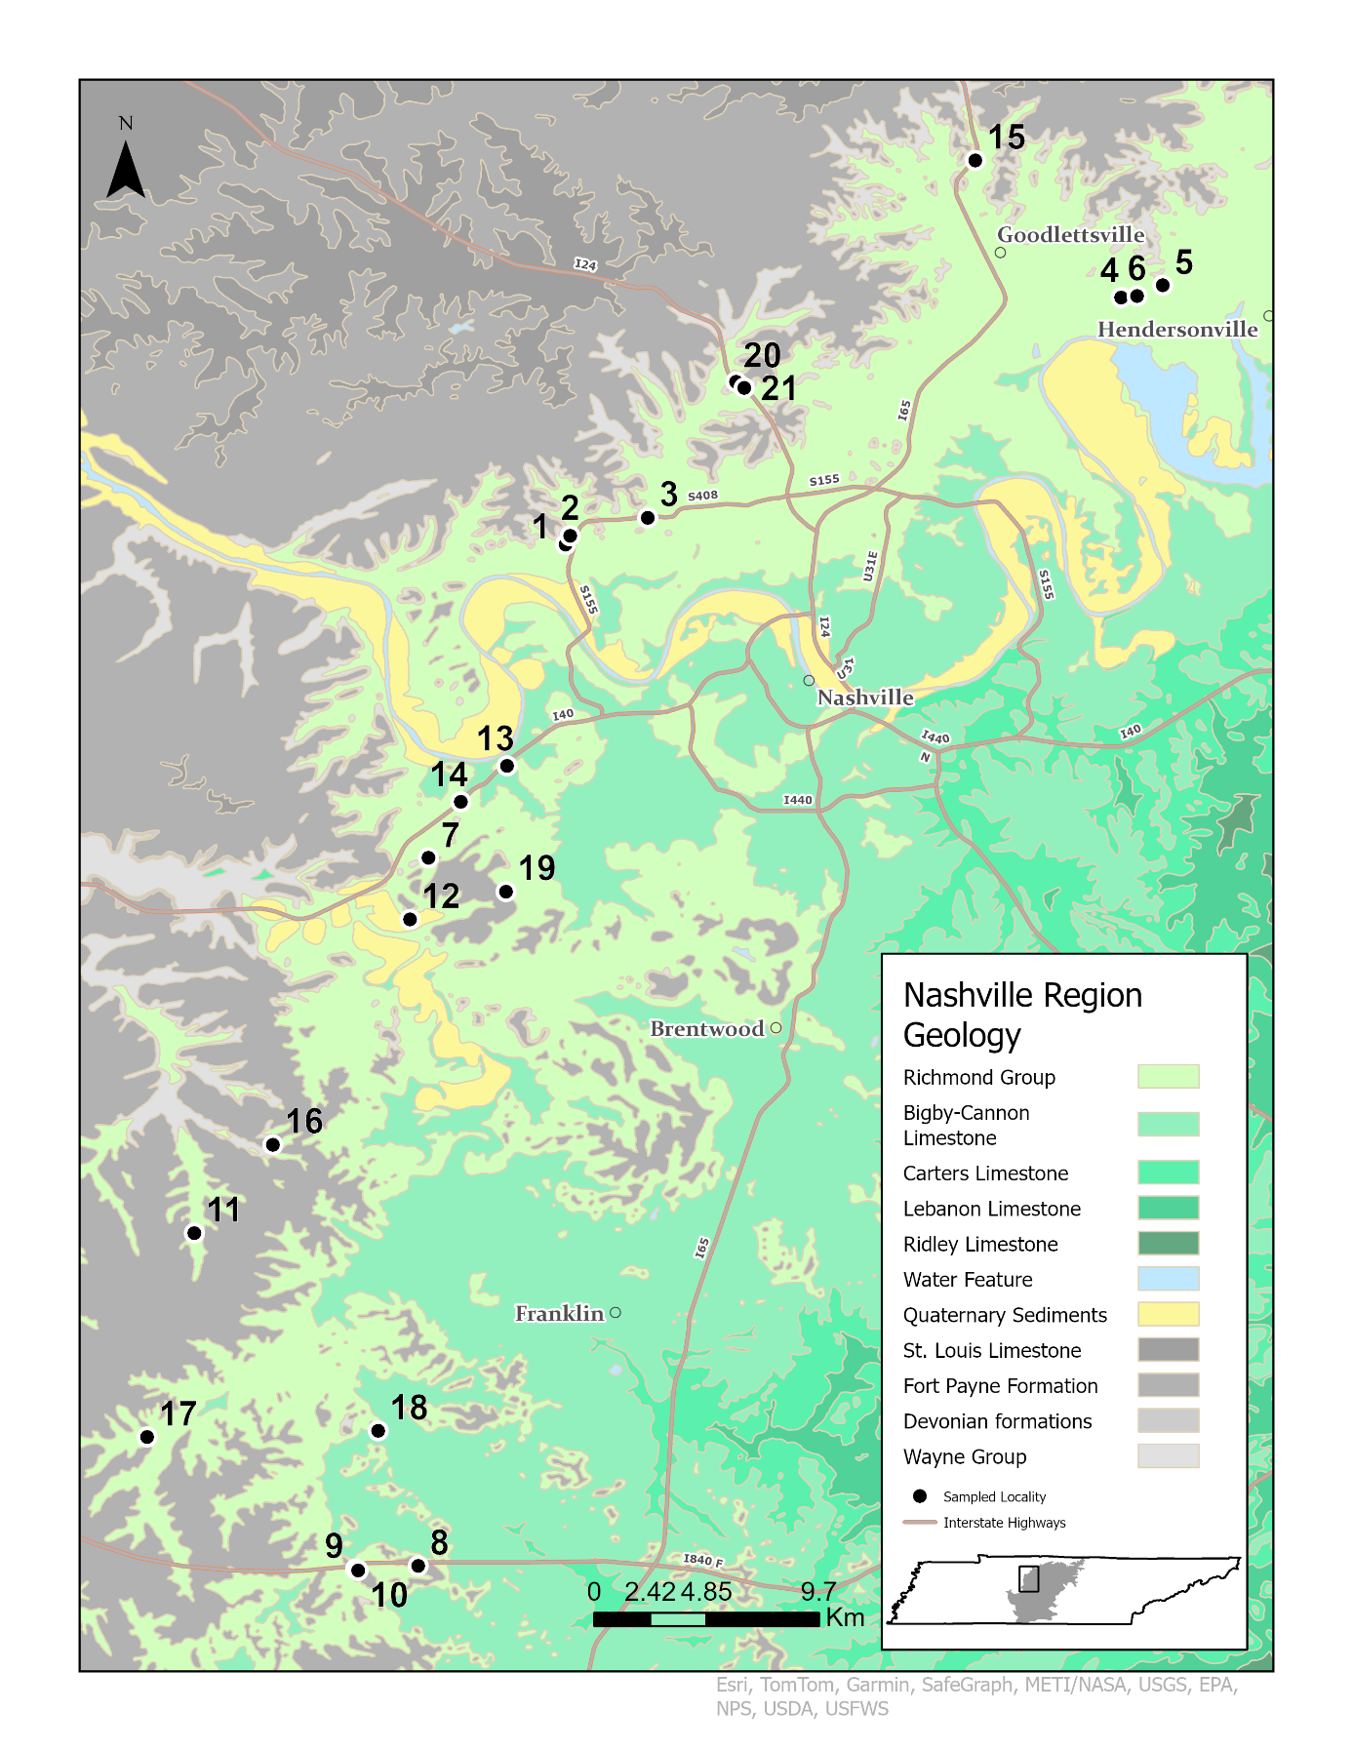
Figure 5. Map of outcrop distribution across the western edge of the Nashville Dome. Localities where stratigraphic columns were constructed and faunal data were collected are indicated and correspond to Table 2.
from subtidal facies in the northern part of the dome to intertidal/peritidal facies towards the south. C3 parasequences commonly include wavy contact between beds, shoal cross-stratification features, and stromatoporoid buildups in the shallow subtidal facies that do not occur in later sequences. The C4 sequence is seven meters thick at its largest exposure and primarily comprises shallow subtidal to deep subtidal carbonate facies (sits between slightly above fair-weather wave base and storm-weather wave base) with shales ranging from green to pale blue in color. The carbonate to shale ratio varies along the transect, with some sections in the south being dominated by large shale packages. A distinctive feature of the C4 sequence is the prevalence of thin (~5 – 10 cm) bryozoan packstones that are widespread across the outcrop belt in this sequence but less common in other sequences. The C5 sequence is the thickest (~15 m) of the focal sequences, and thus the best sampled. This sequence is easily recognized by the presence of invasive taxa. The lithology of the C5 is consistently similar, including shallow subtidal to peritidal facies, green shales interbedded with massive wackestones and packstones, surficial Cruziana ichnofacies occurring on bedding surfaces and Trypanites ichnofacies occurring on hard ground surfaces. Rugosa are common within the C5 sequence and onwards; Grewingkia canadensis and Streptelasma divcaricans comprise a substantial part of the invasive assemblage.
A prevalent feature that occurs across all sequences are rusted, phosphatic hard grounds that separate parasequences as maximum flooding surfaces and are persistent across major parts of the Nashville Dome north-south transect (Holland and Patzkowsky 1996). These surfaces were used as stratigraphic marker layers and facilitated correlations across the dome in all sequences, although they were at times missing or not well preserved. They are characteristically full of phosphatic nodules ranging from ~5 mm to ~2 cm in diameter and preserve a Trypanites ichnofacies.

Data Collection and Field Methods
PaleoENM analysis requires two primary data sets: (1) temporally constrained geographic occurrence data for the focal taxa and (2) temporally constrained environmental parameter data (Peterson 2001, 2003; Maguire and Stigall 2009; Dudei and Stigall 2010; Myers et al. 2015). For this, there needed to be a wide enough sampling representation of the Leipers, Arnheim, Sequatchie, and Fernvale formations (C3-C5 sequences) with equivalent geographic distribution of environmental and taxonomic occurrence data for adequate modeling.
The primary dataset for paleoecological niche modeling is the geographic occurrence data for focal taxa (Myers et al. 2015). Occurrence data for many Nashville species have been cataloged within prior studies of the Nashville region (Wilson 1949, 1962; Patzkowsky and Holland 1999) as well as by independent individuals. Modern databases, such as the Paleobiology Database (Peters and McClennen 2015; Ye and Peters 2023), were considered as potential data sources. However, the resolution of temporal and stratigraphic positioning for most data points was too inconsistent or inadequate for ENM analysis and modeling across such a constrained time, and thus they could not be utilized for this study. Digital data databases also include biases related to the nature of crowd sourced information, such as outdated or inaccurate taxonomic identifications (Ye and Peters 2023).
Consequently, all data were gathered from field surveys around the Nashville area. In-situ sampling is necessary for linking the occurrence of a fossil to the sedimentary proxies of environmental conditions preserved in the rock. Compilations of this data are paired with a well-constructed stratigraphic interpretation of each outcrop sampled so that correct stratigraphic correlations, and thus, correct sequence tracking can take place. The extent of the sampled region spans a N-S oriented arc approximately 60 km by 44 km, located on the western part of the Highland Rim that bounds the Nashville Dome. This was determined based on known fossil localities from Patzkowsky and Holland (1999), while extending the geographic reach far enough to optimize outcrop area for each sequence and minimize error from area interpolation methods (Brame and Stigall 2014).
Twenty-one discrete outcrops (Table 2) were examined for this study to ensure adequate geographic and stratigraphic coverage. At each outcrop, a detailed stratigraphic column was constructed. Each stratigraphic column was developed using bed-level measurements at a decimeter scale for each exposure (Appendix 1). Each bed was examined for both lithologic characteristics and identifiable fossils. Localities were correlated in the field, based primarily on fossil occurrences, and the use of previously mentioned rusty maximum flooding surfaces (Fig. 6). Special care was taken to locate and identify all taxa that could be identified in the field, primarily brachiopods, gastropods, bryozoans, and corals. A total of 302 individual occurrences from 35 identified taxa (Appendix 2) were collected across the 21 outcrops sampled. Similar sampling strategies have been employed on modern and fossil data sets (Nogués-Bravo et al. 2008; Dudei and Stigall 2010; Brame and Stigall 2014; Saupe et al. 2014; Myers et al. 2015; Edwards et al. 2023), and this is an effective method of capturing data for ENM. A minimum of 5-7 geographically discrete occurrences are required to produce ENM models in each time slice per taxon. This requirement limited the number of occurring taxa that could be accurately modeled using MAXENT from the 35 known taxa that were identified, down to 17 with enough presence data to be modeled. Prior studies within the Cincinnati region were able to model 10-12 species including brachiopods, bryozoans, gastropods, and corals (Malizia and Stigall 2011;
Table 2. List of sampled outcrops, geographic coordinates, and the sedimentary sequences exposed at each location.
Locality | Outcrop Name | Longitude | Latitude | Sequences
1 | Cato Road Cut | -86.8717 | 36.21909 | C3, C4
2 | I-155 North Mile 23.0 | -86.8699 | 36.22256 | C4
3 | I-155 East Mile 21.2 | -86.8398 | 36.2296 | C4, C5
4 | Vietnam Veterans Highway Cut | -86.6563 | 36.3149 | C3, C4, C5
5 | I-386 West Mile 4.4 | -86.6402 | 36.31961 | C5
6 | I-386 East Mile 3.6 | -86.6502 | 36.31547 | C4, C5
7 | Old Hickory Road Cut | -86.9247 | 36.09768 | C3, C4, C5
8 | I-840 West Mile 26.6 | -86.9287 | 35.82317 | C5
9 | I-840 West Mile 24.8 | -86.9532 | 35.82196 | C5
10 | I-840 East Mile 24.8 | -86.9521 | 35.82154 | C5
11 | Big East Fork Stream Cut | -87.0156 | 35.95217 | C3
12 | Red Caboose Cut | -86.9321 | 36.0738 | C3
13 | I-40 East Exit 201B | -86.8945 | 36.13328 | C3
14 | I-40 South Substation Cut | -86.9124 | 36.11942 | C3
15 | I-65 South Mile 99.0 | -86.7128 | 36.36815 | C4
16 | Egypt Hollow Stream Cut | -86.9851 | 35.98657 | C5
17 | Natchez Garrison Creek Wall | -87.0339 | 35.87316 | C3
18 | Carter's Creek Mile 8 | -86.9444 | 35.87555 | C3
19 | Nine Mile Hill Cut | -86.8948 | 36.08468 | C4, C5
20 | I-24 East Mile 40.0 | -86.8057 | 36.28226 | C3, C4
21 | I-24 West Mile 40.0 | -86.8024 | 36.27997 | C3, C4

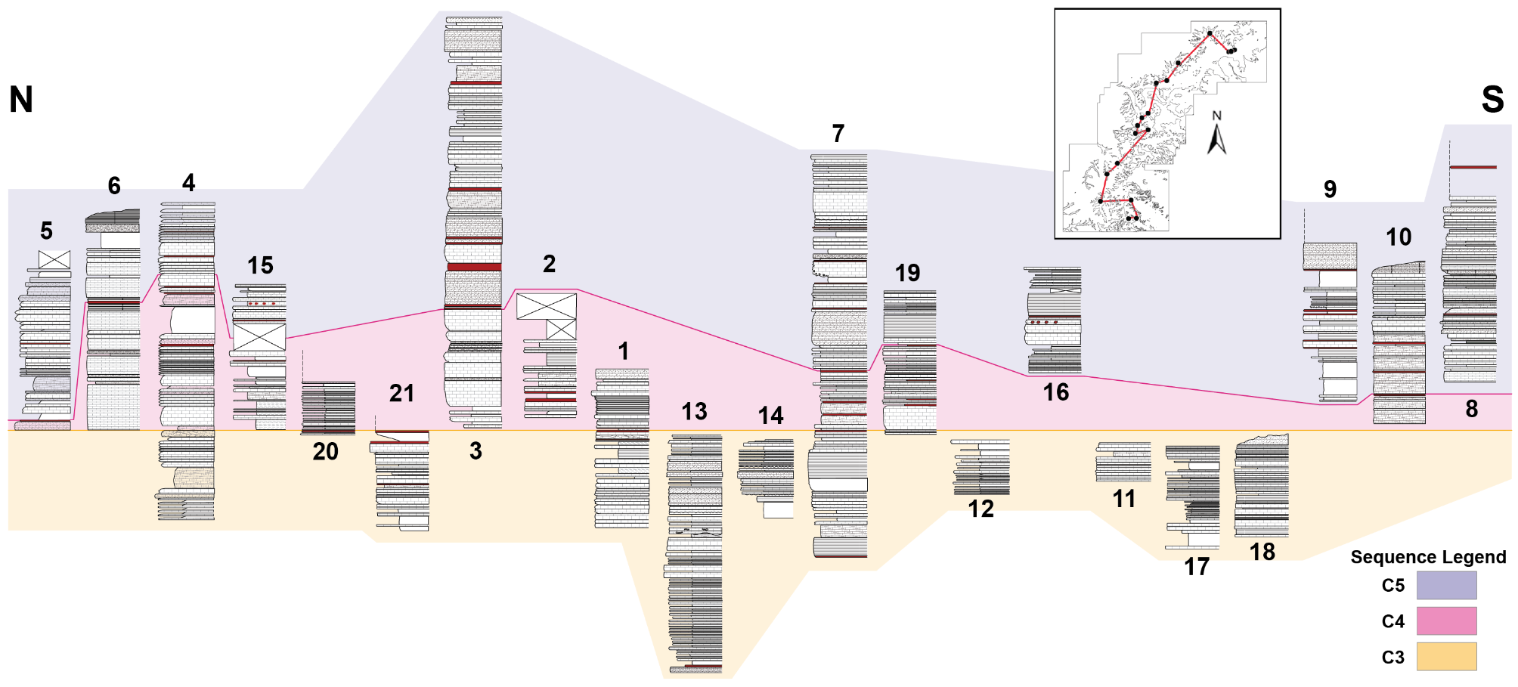
Figure 6. Correlation of localities across the study area. Locality numbers found in Table 2. Stratigraphic columns are detailed in Appendix 1.

Brame and Stigall 2014; Purcell and Stigall 2021). This study uses a similarly sized taxonomic data set.
Environmental proxy data are derived from sedimentary parameters that relate to conditions relevant to the ecological niche of the focal taxa. For this reason, sedimentary proxy data that reflects the conditions crucial to the habitability of these taxa this environment was collected. Given that taxa commonly found in the Nashville Dome consist of marine benthic and pelagic taxa that range from the shallow peritidal to deeper storm-dominated shelf facies, target parameters and proxies collected were: (1) bedding thickness, acquired by averaging the centimeter thickness of beds within a meter measurement of outcrop, (2) Shale-to-carbonate ratio, which was calculated based on the average percentage of shale that was measured from each meter measurement of outcrop, (3) bedding contact style was assigned based on the most prominent and consistent style of contact between subsequent beds within a meter measurement of outcrop, (4) ichnofabric analysis, which accounted the average amount of bioturbation visible within or on beds, and (5) bathymetry, which is a compilation proxy based on grain size, bedding thickness, and fossil abundance found at each meter measurement (Table 3, Appendix 3). Other potentially relevant parameters, such as food supply and oxygen content, can be derived through existing proxies such as ichnofabric index analysis, but these results cannot be directly linked to the organisms themselves, thus they cannot be used in the modeling data set.

Modeling Paleogeographic Distribution
MAXENT (Phillips et al. 2006; Saupe et al. 2012) was used as the modeling algorithm for this study. This is a maximum entropy-based modeling algorithm, deployed in R (Warren et al. 2008, 2021), known for its efficiency at generating models from small sets of occurrence-based data (Saupe et al. 2012; Myers et al. 2015). The combination of presence-only data and
Table 3. Sedimentary parameters used as environmental proxies for ENM development.
Parameters | Environmental Proxies
Bedding Thickness | * Average bedding thickness (cm) within one-meter measurements
Shale-to-Carbonate Ratio | *Average percentage of mudstone present within one-meter measurements
Bedding | (1) Planar bedding
Contact Style | (2) Wavy bedding
 | (3) Rubbly bedding
 | (4) Nodular bedding
Ichnofabric Analysis | *Scale of 1 - 6 based on degree of bioturbation
Bathymetric | (1) Shallow Subtidal: Above fair-weather wave base.
Inference | (2) Intermediate Subtidal: Between fair-weather and storm-weather wave base.
 | (3) Deep Subtidal: At storm weather wave base.

efficacy with small numbers of occurrence point features makes it possible to utilize fossil-based dataset with MAXENT to generate robust models (Hernandez et al. 2006; Purcell and Stigall 2021).MAXENT can generate suitability values per pixel generated on a modeled surface. This allows MAXENT to estimate the geographic distribution of each individual taxon within environmental suitability values (Elith et al. 2006; Myers et al. 2015). Another advantage to this method is that it standardizes different environmental data points throughout the model, which acts as a correction for collection bias in regions of lower sampling density (Guisan et al. 2014).
Prior to model development, environmental data were converted into integers. This step was taken to significantly lower the number of individual values and simplify the rasters into bins that would be much simpler to model. Then rasters were generated using ArcGIS Pro 3, utilizing the IDW interpolation method, set cell size at 0.0065889, with a total of 1,519 cells distributed across the entire modeled area. Rasters were masked with the shape of C3, C4 and C5 outcrop belts outlining the Highland Rim. Rasters were developed for each environmental parameter individually, per time slice.
Batches of taxa that corresponded to the same time slice were input into the standalone MAXENT software (Phillips et al. 2006; Phillips and Dudík 2008). Each time slice was run separately to minimize mixing of results. Models were computed using the jackknife cross-validation option and with Linear and Quadratic features. Initially all models were run with cross-validation replications for 5 runs, with a regularization multiplier of 0.1, and a maximum number of background points set to 200. These settings produced the most models with high AUC values. Models that had a very low-test AUC (<0.70) were not used for final analysis, but instead were re-run with different settings: no cross-validation repetitions, same regularization multiplier and number of background points, and a convergence threshold of 1.0e-6. These settings provided models with high AUC values that replaced previously unfit models. A total of 66 models across all three time slices from the 17 taxa that could be modeled were produced. Models with AUC values greater than 0.70 were interpreted as valid models with minimal error and retained for subsequent analyses (Table 4).

Statistical Evaluation
To test assess niche stability across the Richmondian Invasion, comparison analyses were conducted between the reconstructed ecological niches of taxa between two time slices over simplified environmental space (Broennimann et al. 2007). Comparing niches on the basis of geographic space can only provide a surface level understanding regarding the distribution of taxa over time (Broennimann et al. 2012; Brame and Stigall 2014; Purcell and Stigall 2021). For this reason, comparisons were performed using ordination methods that focus on environmental space, utilizing multidimensional description of parameters for niches reconstructed in MAXENT, as well as taking into account the change of environment over time (Purcell and Stigall 2021), which is important for this study.
Niche overlap was quantified utilizing two statistics developed by Warren et al. (2008), D and I, which quantify the similarities between niches in environmental space. D is a measure of how similar the compared niche is based on niche overlap. In general, this tests whether the niche in a second time slice is more similar to the initial niche than expected by chance, but it makes a biological assumption about taxon density (Warren et al. 2008). This is why a second statistic (I) should be used to reduce the amount of assumption and bias. The I statistic is a measure of whether the compared niches are statistically identical. (Warren et al. 2008; Broennimann et al. 2012; Purcell and Stigall 2021). Both statistics also take into account how environmental parameters change between the time slices being compared, which is important for making

Table 4. MAXENT model evaluation data. Green shading indicates values that fall within acceptable range for model usage. Models are grouped by whether they were tested via cross-validation or not. Orange shading shows taxa that were actually used for niche dynamic analysis, as well as similarity and equivalence analysis. * indicates model used when two models were acceptable.
Sequence | Taxa | AUC (Training Data) | Tested AUC (Training Data) | Regularized Training Gain | Unregularized Training Gain | Iterations
C3 | Cyclonema bilix | 0.724 | X | 0.644 | 0.991 | 120
 | Flexicalymene meeki | 0.767 | X | 0.611 | 0.916 | 140
 | Hebertella oxidentalis | 0.844 | 0.409 | 0.595 | 1.384 | 740
 | Isotelus maximus | 0.969 | 0.738 | 1.736 | 2.26 | 200
 | Paupospira bowdeni | 0.797 | 0.211 | 0.831 | 1.061 | 200
 | Parvohallopora ramose | 0.674 | 0.017 | 0.352 | 0.493 | 80
 | Ramose Bryozoan | 0.844 | 0.187 | 0.595 | 1.384 | 740
 | Stromataperoid | 0.75 | 0.418 | 0.953 | 1.279 | 120
 | Strophomena planoconvexa | 0.936 | 0.206 | 1.122 | 2.045 | 180
 | Vinlandostrophia pondarosa | 0.844 | 0.29 | 0.595 | 1.384 | 740
 | Zygospira modesta | 0.845 | 0.301 | 0.791 | 1.262 | 140
 | Zygospira resupinada | 0.785 | 0.247 | 0.791 | 1.015 | 140
C4 | Constellaria florida | 0.985 | 0.432 | 2.994 | 3.056 | 180
 | Cyclonema bilix | 0.976 | 0.538 | 1.345 | 2.028 | 160
 | Hebertella oxidentalis | 0.982 | 0.168 | 2.872 | 2.939 | 160
 | Paupospira bowdeni | 0.984 | 0.254 | 0.628 | 2.001 | 660
 | Orthorhynchula linneyi | 0.988 | 0.541 | 3.33 | 3.579 | 220
 | Parvohallopora ramose | 0.982 | 0.077 | 0.419 | 1.921 | 180
 | Ramose Bryozoan | 0.967 | 0.619 | 0.77 | 1.903 | 660
 | Strophomena planoconvexa | 0.845 | 0.626 | 0.762 | 1.473 | 240
 | Vinlandostrophia pondarosa | 0.967 | 0.712 | 0.77 | 1.903 | 660
C5 | Cyclonema bilix | 0.798 | 0.268 | 0.847 | 1.169 | 120
 | Eochonetes clarksvillensis | 0.804 | 0.203 | 0.594 | 1.334 | 320
 | Glyptorthis insculpta | 0.987 | 0.741 | 2.137 | 2.861 | 120
 | Grewingkia canadensis | 0.978 | 0.302 | 1.475 | 2.022 | 180
Table 4 Continued
 | Hebertella oxidentalis | 0.816 | 0.4 | 0.99 | 1.406 | 120
 | Paupospira bowdeni | 0.745 | 0.339 | 0.994 | 1.181 | 100
 | Orthorhynchula linneyi | 0.78 | 0.607 | 1.036 | 1.179 | 80
 | Parvohallopora ramose | 0.983 | 0.376 | 1.848 | 2.812 | 240
 | Ramose Bryozoan | 0.832 | 0.403 | 0.853 | 1.43 | 200
 | Strophomena planoconvexa | 0.925 | 0.4 | 0.972 | 1.934 | 260
 | Vinlandostrophia pondarosa | 0.858 | 0.43 | 0.729 | 1.487 | 740
 | Zygospira modesta | 0.988 | 0.891 | 2.933 | 3.483 | 120

comparisons in sedimentary systems. Both statistics were to measure the amount of niche change over time in taxa of the Nashville Dome using the ecospat package (Di Cola et al. 2017) in R, which is designed for niche comparison analysis.
Due to its multidimensional nature, environmental space cannot be graphically illustrated in two dimensions. Consequently, two-dimensional Principal Component Analysis (PCA)(Broennimann et al. 2007, 2012; Brame and Stigall 2014; Di Cola et al. 2017; Purcell and Stigall 2021) were used to graphically illustrate and compared reconstructed niches between time slices using the R package ecospat (Di Cola et al. 2017). By combining the occurrence data along with the environmental raster stacks the appropriate time slice of each occurrence, the ecospat.grid.clim.dyn function was used to generate spatial density distribution grids that could then be compared using the ecospat.niche.overlap function, which provides values for the D and I statistics of niche overlap. Ecospat allows for further analysis of changes in niche dynamics using the ecospat.niche.dyn.index function using the previously mentioned density grids. Niche dynamics values were used for a principal component analysis (PCA) that was made directly with the ecospat.plot.niche.dyn function in ecospat, and the ecospat.shift.centroids function allowed the display of how niche centroids shifted from the initial time slice to the next. Niche equivalency and similarity were calculated using the ecospat.niche.equivalency.test (500 repetitions) and ecospat.niche.similarity.test (1000 repetitions) functions respectively (Di Cola et al. 2017).
A final comparison was performed between the niche dynamics described in the Nashville Dome and the Cincinnati region from previous studies (i.e., Malizia and Stigall 2011, Brame and Stigall 2015). Given that the sequence stratigraphic framework of Nashville is not yet developed to as high of a resolution as the Cincinnati region, a deep level comparison that employs more complex methods is not yet possible and would be outside of the scope of this study. However, a simpler approach was implemented which still produced insightful results as to the effects of the Richmondian Invasion. A one-tailed, two-sample unequal variance t-test was performed to investigate similarity in D and I statistics patterns between prior Cincinnatian studies (Malizia and Stigall 2011) and the new Nashville data set. This demonstrated patterns related to the relationship between these two basins at the time of the invasion and expanded the scope of the current understanding of the invasion event as a whole.

Chapter 4. Results

Model Evaluation
Sixty-six niche models were produced from the seventeen taxa with sufficient geographic distribution and occurrences to be modeled (Appendix 4). Of these models, 36 had AUC values >0.70 and were considered to be acceptable for further use. Thirty models had AUC values lower than 0.7, which made them unsuitable for comparison or further analysis. However, 8 of these models did not include an acceptable model for the same taxon in the adjacent time slice, and therefore could not be used for comparisons between time slices.
Therefore, 24 models involving eight taxa were considered to be of high enough quality to be utilized for niche dynamic comparisons (Table 4). The average performance of these 24 models was 0.86 (range: 0.72 – 0.98). Out of the models used for comparison analysis, 22 were based on the original data set and had no cross-validation test used, AUC value of these averaged 0.87 (0.72 – 0.98). The four remaining models used were trained using cross-validation replication and exhibit an average AUC value of 0.77 (0.71 – 0.89). In general, model performance was high, models tested with cross-validation had overall lower AUC values than those that were not put through cross-validation procedure. Notably, models from the C4 sequence had a higher AUC average (0.96) than the C3 and C5 sequences (0.83 and 0.84 respectively).
Examination of species distribution models produced from the ENM analysis indicates that different species inhabited different regions of the outcrop belt and that estimated ranges of species changed through time (Fig. 7).
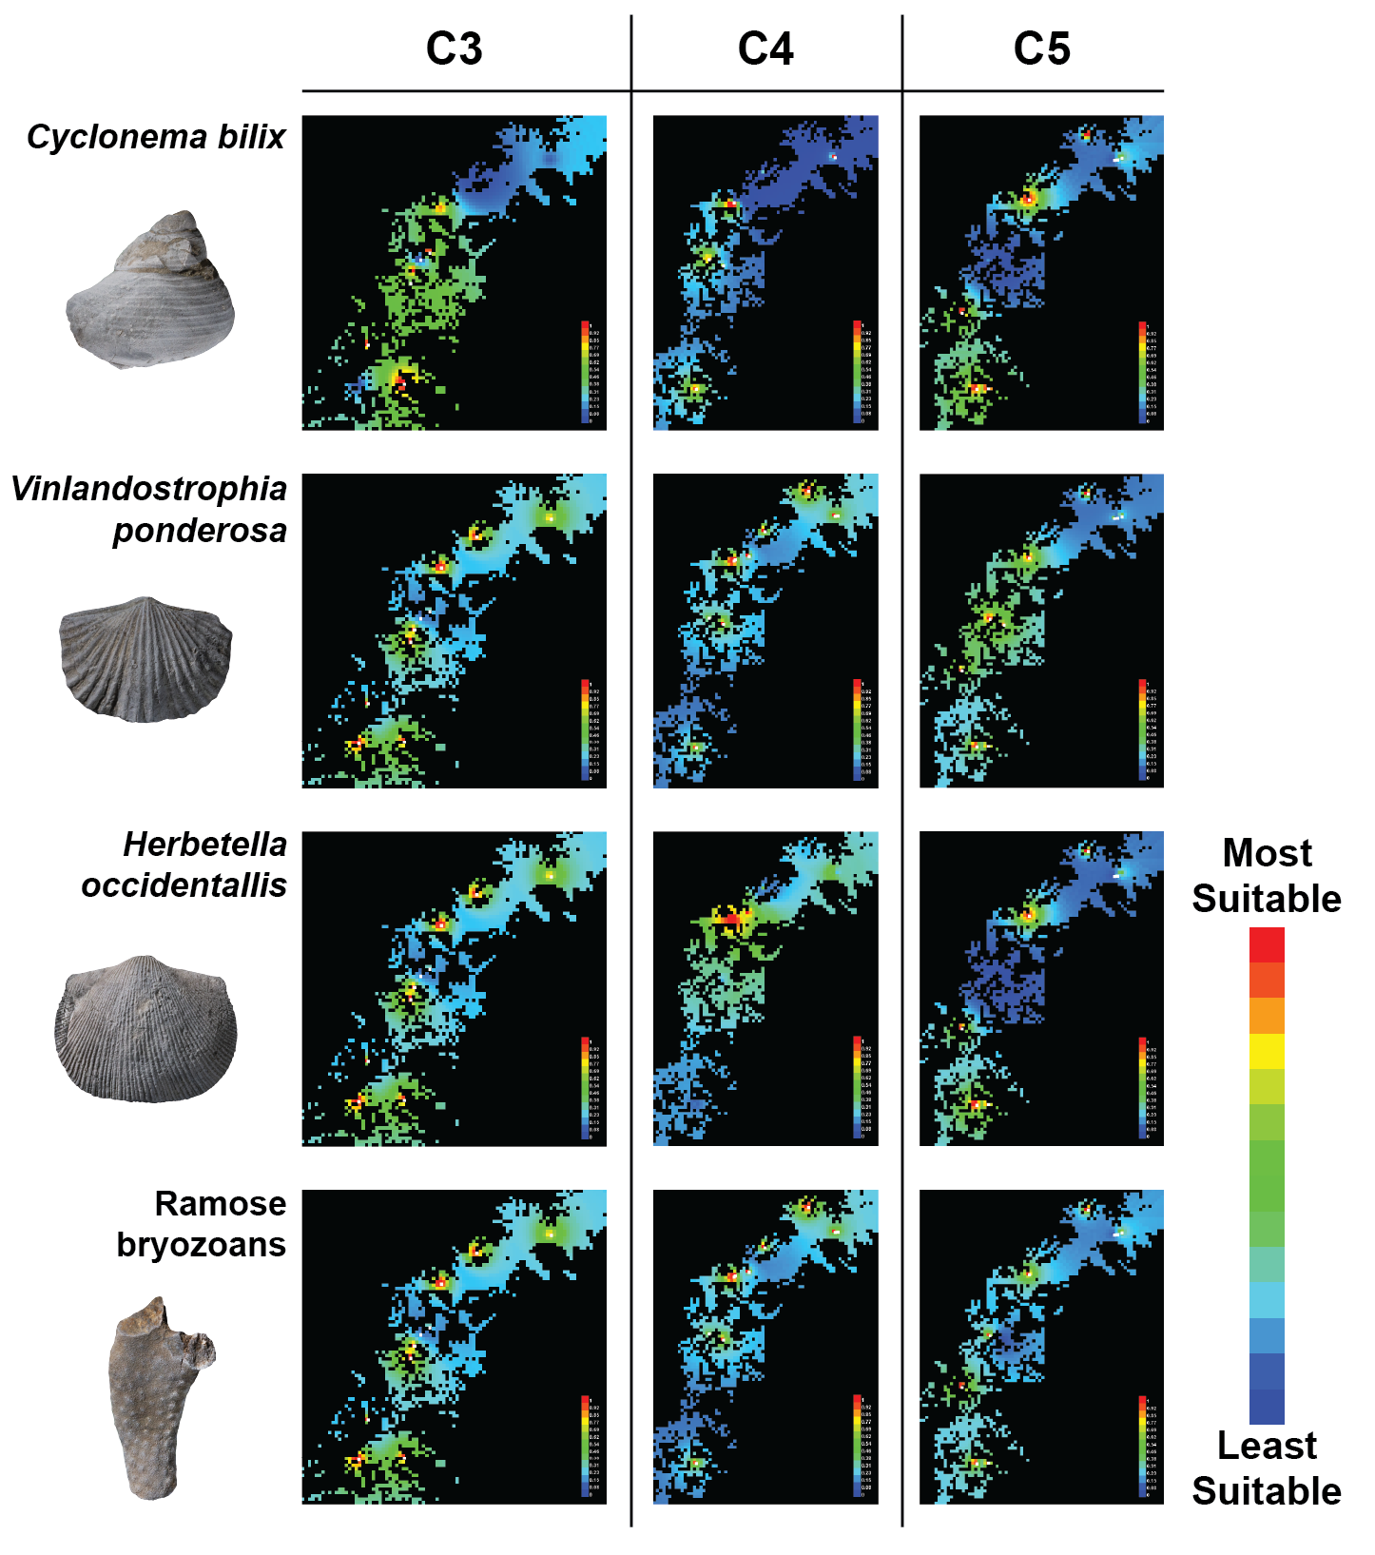
Figure 7. Example distribution models from four compared taxa across all time slices.

Niche Dynamics Analysis
Ecospat overlap analysis indicated that niche stability was more prevalent for taxa across time slices than niche expansion (Table 5). Niche stability averaged 77% between the C3 and C4 time slices and 74% between the C4 and C5; these values are not statistically different (t-test, p= 0.43). Average niche expansion was 23% in the C3 to C4 analysis to 26% in the C4 to C5, but these values are not statistically different (t-test, p=0.42). When analyzing the amount of niche expansion between the two comparisons, only three out of eight taxa (Parvohallopora, Cyclonema, and Paupospira) had expansions values greater than 0.1 between the C3 and the C4 sequences, which is less than 43% of the taxa measured. The number of taxa that have a niche expansion than 0.1 increases to four (~57% of taxa) during the C4 and C5 comparison. One taxon, Paupospira bowdeni, consistently has a high degree of expansion across both comparisons. Paupospira bowdeni also exhibits a trend of increasing levels of expansion from pre-invasion to post-invasion. Among the majority taxa, increasing expansion is the common trend, with the exceptions of Vinlandostrophia ponderosa, generalized ramose bryozoans, and Cyclonema bilix, which have decreasing expansion across the invasion.
The largest magnitude of change in niche dynamics was in degree of unfilling. Average unfilling among taxa is 35% in the C3 to C4 and increased to 47% in the C4 to C5 comparison (Table 5). However, this demonstrated no statistically significant shift of unfilling between comparisons (t-test, p=0.25). Most taxa had unfilling rates that were higher than 27% in both comparisons, with few exceptions in the C3 to C4 analysis (Paupospira bowdeni) and in the C4 to C5 (Vinlandostrophia ponderosa and Strophomena planumbona). The C3 and C4 comparison did not have any instances of unfilling exceeding 61%, unlike the C4 and C5 comparison, which
Table 5. Niche dynamics analysis. Values range from 0 to 1.0, with 0 indicating no detection of expansion, stability or unfilling and 1.00 indicating very high level of expansion, stability or unfilling.
Comparison | Taxon | Expansion | Stability | Unfilling
C3 vs. C4 | Vinlandostrophia ponderosa | 0.04 | 0.96 | 0.28
 | Hebertella occidentalis | 0.02 | 0.98 | 0.61
 | Strophomena planoconvexa | 0.00 | 1.00 | 0.49
 | Ramose bryozoan | 0.04 | 0.96 | 0.28
 | Parvohallopora ramosa | 0.97 | 0.03 | 0.54
 | Cyclonema bilix | 0.19 | 0.81 | 0.19
 | Paupospira bowdeni | 0.34 | 0.66 | 0.08
C4 vs. C5 | Vinlandostrophia ponderosa | 0.01 | 0.99 | 0.01
 | Hebertella occidentalis | 0.38 | 0.62 | 0.95
 | Strophomena planoconvexa | 0.28 | 0.72 | 0.01
 | Ramose bryozoan | 0.02 | 0.98 | 0.45
 | Cyclonema bilix | 0.00 | 1.00 | 0.38
 | Paupospira bowdeni | 1.00 | 0.00 | 1.00
 | Orthorhynchula linneyi | 0.15 | 0.85 | 0.49

has two taxa (Hebertella occidentalis and Paupospira bowdeni) which have unfilling values exceeding 95%, both of which have increased expansion rates, and lowered stability from the first comparison.
These results are also prevalent in visual analysis of the two-dimensional PCA overlap for these comparisons (Fig. 8). For the C3-C4 PCA grids, they all have very similar movement of the niche centroid to the bottom left, but a more pressing feature is that they all show a level of overlap. Even in the case of Paupospira bowdeni, which has a very small amount of visible overlap, it is still present. This is a contrast to the PCA’s for the C4-C5 comparison, in which not all grids demonstrate overlap, and those that do, have a smaller magnitude of overlap than the average PCA from the previous comparison. In the C4-C5, niche centroids all exhibit some kind of shift, but these shifts occur with variable magnitude and direction. Visual analysis of PCA grids also demonstrates trends regarding niche dynamics. Niche expansion is common in shared environmental space in both comparisons, but a definitive difference in expansion can barely be distinguished as it can be hard to distinguish in certain taxa (Strophomena planumbona, Orthorhynchula linneyi, Hebertella occidentalis, and Cyclonema bilix). Unfilling has a much more obvious increase from the C3-C4 to the C4-C5, especially for taxa in the C4-C5 comparison. The bottom line of these analysis is that all taxa demonstrate a dominant signal of stability and conservatism as the invasion sets in.
Similarity and equivalency analysis demonstrated that niche equivalency was more common than similarity in both comparisons (Table 6). D and I values indicated niche evolution in three and four (of 7) taxa between each of the C3 and C4 and between C4 and C5 comparisons respectively. D values are congruent with I results in all except for one taxon during each temporal comparison (Hebertella occidentalis during the C3-C5 and Strophomena planumbona
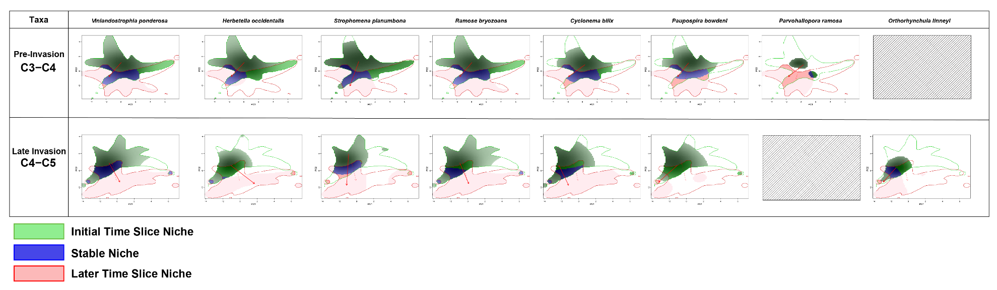
Figure 8. Principal component analysis results the eight taxa that were compared across time slices, Parvohallopora ramosa was only compared across the C3 vs. C4 time slices and Orthorhynchula linneyi was only compared across C4 vs. C5 time slices.

Table 6. Equivalency and Similarity analysis. Numbers indicate p-values (right-tailed alpha < 0.05), green shading indicates statistically significant values. Greater means niches are more similar or equivalent than expected from random processes indicating niche conservatism, whereas lower means niches are less similar or equivalent than expected from random processes indicating niche evolution.
 |  | Similarity |  |  |  | Equivalency
 |  | D |  | I |  | D |  | I
 | Taxa | Greater | Lower | Greater | Lower | Greater | Lower | Greater | Lower
C3 to C4 | Vinlandostrophia ponderosa | 0.163 | 0.840 | 0.223 | 0.788 | 0.994 | 0.010 | 1.000 | 0.002
 | Hebertella occidentalis | 0.258 | 0.757 | 0.283 | 0.727 | 0.910 | 0.100 | 0.974 | 0.026
 | Strophomena planoconvexa | 0.340 | 0.687 | 0.477 | 0.557 | 0.705 | 0.267 | 0.896 | 0.116
 | Ramose bryozoan | 0.156 | 0.840 | 0.217 | 0.784 | 0.996 | 0.008 | 0.998 | 0.006
 | Parvohallopora ramosa | 0.585 | 0.423 | 0.565 | 0.440 | 1.000 | 0.006 | 1.000 | 0.008
 | Cyclonema bilix | 0.330 | 0.658 | 0.365 | 0.615 | 0.894 | 0.092 | 0.882 | 0.112
 | Paupospira bowdeni | 0.373 | 0.644 | 0.452 | 0.568 | 0.896 | 0.118 | 0.922 | 0.110
C4 to C5 | Vinlandostrophia ponderosa | 0.008 | 0.993 | 0.022 | 0.975 | 0.766 | 0.220 | 0.910 | 0.100
 | Hebertella occidentalis | 0.355 | 0.671 | 0.501 | 0.521 | 0.996 | 0.008 | 1.000 | 0.002
 | Strophomena planoconvexa | 0.073 | 0.931 | 0.124 | 0.884 | 0.956 | 0.064 | 0.962 | 0.050
 | Ramose bryozoan | 0.021 | 0.974 | 0.046 | 0.940 | 0.980 | 0.014 | 0.994 | 0.006
 | Cyclonema bilix | 0.073 | 0.952 | 0.119 | 0.898 | 0.802 | 0.180 | 0.848 | 0.136
 | Paupospira bowdeni | 1.000 | 0.628 | 1.000 | 0.625 | 1.000 | 0.006 | 1.000 | 0.006
 | Orthorhynchula linneyi | 0.020 | 0.977 | 0.051 | 0.945 | 0.776 | 0.206 | 0.828 | 0.152

during the C4-C5). The magnitude of niche equivalency is constant across time, but the only three (Vinlandostrophia, ramose bryozoans, Orthorhynchula) instances of greater niche similarity (=niche conservatism) occurred in the C4-C5 analysis. A statistically significant pattern is observed: significant similarity signals only occurred with the I statistic, and significant signals for equivalence was only detected with the D statistic. There were no taxa that exhibited lower similarity than expected, and there were no taxa that showed greater equivalency than expected in either of the comparison across time.

Chapter 5. Discussion

Ecological Niche Model Evaluation
Geographic distribution analysis of ecological niche models produced in this study demonstrate that niche distribution for all analyzed taxa shifted temporally and spatially across the Late Ordovician. These models (Fig. 7) show the geographic distribution of habitat suitability of modeled taxa as a heat map with warmer colors indicating higher probability of occurrence and cooler colors indicating lower probability of occurrence. Different taxa are observed to occupy different geographic spaces during the same period. It is also observed that taxa change their habitat suitability as time passes into the invasion intervals, which is something that is expect, (Fig. 7). The accuracy and efficiency of the MAXENT algorithm have been tested many times (Broennimann et al. 2007; Malizia and Stigall 2011; Sillero et al. 2023), and shown to be the best resolved algorithm for ecological niche modeling, especially with paleontological data (Myers et al. 2015). Notably, the Nashville region outcrop belt is more geographically restricted than the Cincinnati region, which includes correlative strata that are more vertically extensive and with a broader geographic distribution. Model efficiency was hindered the most by sample size limitations of occurrence data, even with the proficiency of MAXENT at handling small data sets (Pearson et al. 2007). Some localities identified in previous studies (ex., Davis 2019; Patzkowsky and Holland 1999; Wilson 1949) within the Nashville area no longer exist, but many of the localities sampled for this project were not previously sampled and studied (such as I-40E Exit 201B, Natchez Garrison Creek Wall, and I-24 West Mile 40.2). Further surveying work done in the Nashville Dome is likely produce further sampling opportunities and an increased understanding of distribution of Late Ordovician taxa in this region.

Niche Stability Across the Richmondian Invasion
Analysis of niche dynamic patterns across both the C3 vs. C4 and C4 vs. C5 comparisons indicate that niche stability is the dominant pattern through time in all but two taxa, ramose bryozoans in the C3 - C4 comparison and Paupospira bowdeni in the C4 - C5 comparison (Table 4). Niche expansion and niche unfilling are substantially less common, and although both increase slightly from the pre-invasion to the post-invasion intervals, these increases are not statistically meaningful. These results indicate that niche stability remained consistently dominant throughout the intervals before, during, and after the Richmondian Invasion, with some exception of taxa that expanded their niche breadth into previously unused environmental space as the amount of niche expansion experienced by individual taxa does increase slightly in terms of magnitude. This pattern is further supported when areas of overlap are compared in the PCA analyses as the degree of overlap is consistent through time (Fig. 8).
Niche similarity and equivalency results further support the trend of continued niche conservatism. Niche similarity results indicate that niches in adjacent time slices are significantly more similar than expected from random processes across both the C3-C4 and C4-C5 comparison intervals (Warren et al. 2008; Purcell 2021). Niche equivalency analysis demonstrates a different behavior, it remains constant across both comparisons, indicating that niche equivalency is always present, but the level of equivalency is less than expected from random chance for about half of the taxa (Knouft et al. 2006; Warren et al. 2008). Equivalency is experienced by a variety of taxa, with two taxa that experience it in both comparisons (Vinlandostrophia ponderosa, and ramose bryozoans). Because niche equivalency tests whether niches in two time slices are indistinguishable (Warren et al 2008), these results indicate that there is change within the niche composition of these taxa. Niche similarity, however, is a less stringent test; it examines if niches are more similar than expected by chance. Niche similarity analysis has been documented to be a more accurate measure of niche shift significance than equivalency, as it takes advantage of available environmental parameter data of each time slice, to test the similarity between time slices (Warren et al. 2008, 2010; Strubbe et al. 2013). Overall, the combination of results indicates that Nashville taxa generally exhibited high niche conservatism where niches were stable, but not identical, between time slices.
This indicates that taxa in the Nashville Dome experienced a constant background level shifting in habitat suitability across all time slices. This background pattern was not substantially altered by the biotic introduction from the Richmondian Invasion. Instead, taxa responded to this event with the same degree of niche evolution and conservatism with which they responded to abiotic environmental changes that characterized the pre-invasion interval. This pattern shows resemblance to the niche dynamic analysis described above. Overall, the observed pattern is that niches are stable across the study interval, and that the Richmondian Invasion did not cause a change in niche stability among the studied taxa. However, failure to reject the null hypothesis for niche similarity tests does not inherently signify the lack of niche evolution (Warren et al. 2008, 2010).

Comparing the Nashville Dome and the Cincinnati Region
The pattern of widespread niche conservatism and stability in the Nashville Dome before, during, and after the Richmondian Invasion contrasts strongly with the pattern of niche lability observed in the Cincinnati region. Comparable studies by Malizia and Stigall (2011) and Brame and Stigall (2014) recovered high degrees of niche conservatism during the pre-invasion interval, indeed the percentage of niche stability recovered is similar to the amounts of pre-invasion niche stability recovered for the Nashville Dome. However, the invasion and post-invasion intervals are marked by a decline in niche stability in the Cincinnati region (Malizia and Stigall 2011; Brame and Stigall 2014). Specifically, niche stability declined through a process of niche contraction, in which species reduced the range of parameters utilized from one time slice to the next. Notably, niche contraction was present in all clades, trophic groups, and in both native and invasive lineages during the invasion and post-invasion interval in the Cincinnati region (Brame and Stigall 2014). The Nashville pattern of consistent niche stability regardless of position in time relative to the biotic invasion is particularly notable within this comparative framework.
Notably, the exposure and preservation of this event varies between the Nashville Dome and the Cincinnati region. For example, the amount of deposited sediments that are preserved as part of the stratigraphy within the two basins is drastically different. Exposures of the Maysville and Whitewater formations in the Cincinnati region can reach 29.5 m and 23.0 m in vertical thickness, respectively (Davis 1998). In contrast, correlative formations in the Nashville Dome do not extend past a dozen meters in the thickest sections found, most outcrops expose multiple formations, and no outcrop exceeded 20 meters in vertical thickness (see Appendix 1). The distribution of fossiliferous beds from the Richmondian Invasion plays a role in the availability of data from these regions. The Jessamine Dome in the Cincinnati region exposes fossiliferous strata around its entire circumference, which includes areas of Ohio, Kentucky and Indiana across a maximum linear distance of ~390 km (Foerste 1912; Pope et al. 2009; Brett et al. 2020). The Nashville Dome is primarily restricted to Tennessee, and it is much smaller than the Jessamine Dome with a maximum linear distance of only ~230 km. Exposure of fossiliferous Richmondian strata in the Nashville Dome is further diminished by the lack of preservation in the eastern portion of the dome, which was more susceptible to erosion through uplift of the basin floor countering later orogenic subsidence (Holland and Patzkowsky 1997).
The depositional regime that is preserved at each depositional sequence of the invasion is another point of disparity between the two basins that may have even more profound impact on the niche distribution as well as the assemblages of organisms found therein. The Cincinnatian series is highly variable in lithology and community assemblage (Holland and Patzkowsky 2007; Pope et al. 2009; Brett et al. 2020), ranging from intertidal shallow deposits such as those found in the Grant Lake Formation, to highly dolomitized limestone packages, to the low-diversity mudstone deep subtidal facies of the lower Waynesville Formation (Brett et al. 2020). Conversely, the depositional sequences in the Nashville Dome include a more limited set of depositional environments of carbonate-siliciclastic facies that formed mostly above storm weather wave base (Wilson 1962; Holland and Patzkowsky 1997; Patzkowsky and Holland 1999). This difference influences the fossils that are preserved in these two regions and could explain the major differences of key organisms that inhabited these basins. The limited range of facies in Nashville notably restricts the ability to model the potential constraint of habitable niches. However, there is the range of depositional environments preserved in Nashville is a subset of those in Cincinnati, not a group of different environments, thus the lack of niche evolution observed in the Nashville fauna cannot be fully attributable to sampling bias from reduced lithofacies preservation.
Patzkowsky and Holland (1999) quantitatively assessed fossil communities in the Nashville Dome and identified biofacies. Within their dataset, they recognized the relative absence of echinoderms within the region (Patzkowsky and Holland 1999), which is a pattern that is also apparent in the dataset for this study. Although echinoderms were not entirely absent, they were so uncommon that sufficient occurrence data were not available to produce ecological niche models. This is a substantial difference from the Late Ordovician assemblages that occur in the Cincinnati region, in which crinoids (such as Cincinnaticrinus and Ectenocrinus) commonly occur (Brett et al. 2020). Occurrence patterns of other taxonomic groups also differ between Nashville and Cincinnati, including trilobites, which are not widely distributed in Nashville, and bivalves, which appear to be more dominant than expected in Nashville. Such variations may be attributed to the differential facies preservation within the invasion in Nashville versus Cincinnati. The Nashville Dome lacks deep-subtidal facies which are as extensive and prevalent as those that are found in the Cincinnati arch (Holland and Patzkowsky 1996, 1998). Preservation of crinoids and trilobites in the Cincinnati Arch is tied to these deep-subtidal, low energy, muddy facies, where these benthic organisms thrived and had a higher probability of preserving. Given that these facies are not present in the Nashville Dome, the presence and importance of these groups to the ecological communities in this basin cannot be discarded. However, the depth and size of the Nashville basin, along with its constant input of siliciclastic material from the Taconic Highlands could put into question how pervasive deep-subtidal communities might have been, or if they were present at all in any continual manner.
The paleogeographic location of the Nashville Dome also differentiated this basin from the Cincinnati region (Fig. 1). During the Late Ordovician, both regions were situated in subtropical latitudes, ~27˚ South. However, Nashville was distinctly closer to the open ocean, while Cincinnati was located in a more interior position. This position could have increased the impact that storm systems and tidal forces had on this carbonate shelf, increasing turbidity of the water column on a more regular basis than that of the Cincinnati basin, and could have impacted oxygen and nutrient content derived from fair weather wave activity. To the direct south of the Nashville basin sat the Taconic Mountains, which provided siliciclastic input to both the Cincinnati and Nashville basins as well as nutrient supplies that maintained the biotic communities that inhabited these basins. Reconstructions of Laurentia (Cocks and Torsvik 2021) place Nashville closer to the highlands than the Cincinnati region. The strata that make up Nashville exhibit major input of terrigenous material, with large packages of mudstones that separate limestone beds, more so in the C3 and C5 sequences, as well as the high amount of phosphatic material (Holland and Patzkowsky 1996). The high amounts and distribution of phosphate throughout the Nashville Dome is not shared with the Cincinnati region, which hints to distinct input of terrigenous material, that could be attributed to the adjoining Taconic highlands. Inundation of siliciclastic sediments would have limited or masked the amount of carbonate production and productivity of the basin, but fossil abundance and distribution are comparable still to the Cincinnati region. Soft sediment deformation features, in the form of pillowing structures, can be found in the C5 sequences, further supporting the proximity to the Taconic tectophase (Wilson 1949; Holland and Patzkowsky 1997). The relationship that the Nashville Dome holds with the Taconic Orogeny and its subsequent sediment deposition cannot be overlooked to understand how it differs from the Cincinnati series.
These differences in depositional environment and the relative tectonic and oceanographic positions between Nashville and Cincinnati may explain the observed differences niche stability patterns. The more central position of Cincinnati may have had it more susceptible to colonization by invaders than Nashville. The impact of invaders within each ecosystem may also have been differential as there is more evidence for competitive interactions and niche partitioning in the Cincinnati region (ex. Holland and Patzkowsky 2004; Tyler and Leighton 2011). In previous ecological studies of the Richmondian Invasion in the Cincinnati region, niches were found to contract and stay conservative across periods of environmental change and evolve across periods of biotic upheaval (Dudei and Stigall 2010; Malizia and Stigall 2011; Forsythe and Stigall 2023). This is not the pattern that is observed in the Nashville Dome; instead, niches remained stable in the face of biotic change, and increased in conservatism as the invasion took place. The differential paleoenvironment and paleogeography are likely the key reason for these differences.

Biotic and Climatic Drivers
The Richmondian Invasion is a prime example for Late Ordovician ecological upheaval (Dudei and Stigall 2010; Malizia and Stigall 2011; Brame and Stigall 2014; Kempf et al. 2020; Forsythe and Stigall 2023; Stigall 2023). Multiple factors have been attributed to shifts in niches that occurred during the Richmondian Invasion, all prior interpretations were made within the context of the Cincinnati region. The main pulse of invasion has been linked to the Boda warming event (Fortey and Cocks 2005; Bauer and Stigall 2014), which propagated a period of glacial waning during the Late Ordovician, increasing sea levels globally, and connecting previously isolated basins. Bauer and Stigall (2014) used phylogenetic biogeographic analysis to reconstruct large scale trends in Laurentian dispersal patterns during the Late Ordovician. The Nashville Dome was part of the large Laurentian basin dataset used in this study. They observed that the Cincinnati region and the Nashville Dome shared pathway similarities in the most parsimonious models. The Nashville Dome received an influx of invaders through similar pathways to the Cincinnati region, yet the differences between these two basins show that this did not result in similar invasion impacts.
The high consistency of environmental parameters across the Nashville Dome limits the ability to compare how niches change across significantly different depositional environments along the shelf. This makes it more direct to compare time slices within the Nashville Dome but hinders the potential of direct comparisons with previous work in the Cincinnati region, which has a more varied set of depositional environments preserved. It is also understood that, in order for abiotic conditions to drive a shift in niche dynamics, it must be intrinsically linked to processes that propagate speciation in some way (Purcell and Stigall 2021). Even if environmental change was substantial in the Nashville Dome during or prior to the Richmondian Invasion, it was not significant enough to drive niche evolution.

Implications for Modern Invasion Events
To fully characterize how invasion events alter the ecological flux of a biotic community in modern ecosystems, it is essential to augment the short-term observation and experimental records with information about the long-term consequences of invasions. Paleoecology provides a framework to assess longer term patterns that are not available in modern datasets. Yet, it also operates through such large time scales, that the fine temporal resolution present within modern data is lost. The presence of the Richmondian Invasion in the Nashville Dome provides a unique opportunity to examine niche dynamics in deep time and apply a contrast against a separate occurrence of that same event in the Cincinnati region. All previous work on this invasion event focused on the Cincinnati region as the primary setting, which limited the scope to which results could be attributed. It is evident from the difference between these two regions that there are more factors to be considered when it comes to predicting niche response in the Nashville Dome than the ones listed in this study. This is pressingly significant when assessing modern environmental overturn, and the factors that are altering niches across modern ecosystems. Presently human interactions have facilitated countless biotic immigration events, some of them at the global levels of invasion (Stigall 2019). As these invasions progress through many different ecosystems, it is crucial to understand how these invasions will have long-term impacts on native niche dynamics in different ways.

Chapter 6. Conclusion
The mechanisms that drive niche change in ecosystems are intrinsically linked with climatic and biotic shifts. Understanding the long-term impacts that these drivers could pose on an ecological system requires data that span long temporal intervals as represented by the fossil record. A major impetus to niche dynamics has been biotic immigration events, which have shown to be incredibly impactful and widespread in the modern day, as well as the deep past. Analysis of ecological niche models of the Nashville Dome demonstrate high degrees of niche stability throughout the late Katian with an increase in niche conservatism during the period of interbasinal immigration events during the Richmondian Invasion. These results are consistent with stability analysis, which indicate a substantial amount of stability among niches throughout the entire study interval coupled with an increase in niche expansion and unfilling during the invasion interval, which is interpreted to mean slight instability in niche space during this time.
Previous studies that have examined niche dynamics during the Richmondian Invasion in the Cincinnati region recovered trends of increased niche evolution, specifically niche contraction, during times of biotic disturbance. The Nashville patterns reported here are substantively different from the documented niche dynamics of the Cincinnati region. These differences in niche evolution can be attributed to the variations in abiotic parameters as well as biotic system interactions in the Nashville Dome, from those in the previously studied area for the Richmondian Invasion, the Cincinnati region. Influence from ocean currents, lower rates of productivity, lesser accommodation space, and gradual abiotic environmental change all attribute to the different response of niches as the invasion occurred in the Nashville Dome.
This work is based on the largest yet compiled dataset for the Nashville Dome’s Cincinnatian strata fauna and is presently the most resolved analysis of these ecological patterns available. Expanding the scope of ecological work on the Richmondian Invasion to this new region has provided new insight into the responses that niches have to variable environmental stimuli. Through further comparative work, a deeper and mechanistic understanding of what drives these changes can be elaborated upon and used as an analogue for modern invasion events.

References
Bauer, J. E., and A. L. Stigall. 2014: Phylogenetic paleobiogeography of Late Ordovician Laurentian brachiopods. Estonian Journal of Earth Sciences 63:189.
Beaumont, C., G. Quinlan, and J. Hamilton. 1988: Orogeny and stratigraphy: Numerical models of the Paleozoic in the eastern interior of North America. Tectonics 7:389–416.
Brame, H.-M. R., and A. L. Stigall. 2014: Controls on niche stability in geologic time: congruent responses to biotic and abiotic environmental changes among Cincinnatian (Late Ordovician) marine invertebrates. Paleobiology 40:70–90.
Brett, C. E., C. D. Aucoin, B. F. Dattilo, R. L. Freeman, K. R. Hartshorn, P. I. McLaughlin, and C. E. Schwalbach. 2020: Revised sequence stratigraphy of the upper Katian Stage (Cincinnatian) strata in the Cincinnati Arch reference area: Geological and paleontological implications. Palaeogeography, Palaeoclimatology, Palaeoecology 540:109483.
Broennimann, O., U. A. Treier, H. Müller-Schärer, W. Thuiller, A. T. Peterson, and A. Guisan. 2007: Evidence of climatic niche shift during biological invasion. Ecology Letters 10:701–709.
Broennimann, O., M. C. Fitzpatrick, P. B. Pearman, B. Petitpierre, L. Pellissier, N. G. Yoccoz, W. Thuiller, M.-J. Fortin, C. Randin, N. E. Zimmermann, C. H. Graham, and A. Guisan. 2011: Measuring ecological niche overlap from occurrence and spatial environmental data. Global Ecology and Biogeography 21:481–497.
Cocks, L. R. M., and T. H. Torsvik. 2020: Ordovician palaeogeography and climate change. Gondwana Research 100.
Davis, M. B. 2019: Roadside Geology of Tennessee. Roadside Geology, p.
Davis, R. A. 1981: Cincinnati Fossils. Cincinnati Museum Center, Cincinnati, p.
Di Cola, V., O. Broennimann, B. Petitpierre, F. T. Breiner, M. D’Amen, C. Randin, R. Engler, J. Pottier, D. Pio, A. Dubuis, L. Pellissier, R. G. Mateo, W. Hordijk, N. Salamin, and A. Guisan. 2017: ecospat: an R package to support spatial analyses and modeling of species niches and distributions. Ecography 40:774–787.
Dietl, G. P., and K. W. Flessa. 2011: Conservation paleobiology: putting the dead to work. Trends in Ecology & Evolution 26:30–37.
Dudei, N. L., and A. L. Stigall. 2010: Using ecological niche modeling to assess biogeographic and niche response of brachiopod species to the Richmondian Invasion (Late Ordovician) in the Cincinnati Arch. Palaeogeography, Palaeoclimatology, Palaeoecology 296:28–43.
Edwards, S. V., R. Tonini, Nancy Rotzel McInerney, C. K. Welch, and P. Beerli. 2023: Multilocus phylogeography, population genetics and niche evolution of Australian brown and black-tailed treecreepers (Aves: Climacteris). Biological Journal of The Linnean Society 138:249–273.
Elith, J., C. H. Graham, R. P. Anderson, M. Dudík, S. Ferrier, A. Guisan, R. J. Hijmans, F. Huettmann, J. R. Leathwick, A. Lehmann, J. Li, L. G. Lohmann, B. A. Loiselle, G. Manion, C. Moritz, M. Nakamura, Y. Nakazawa, J. McC. M. Overton, A. Townsend Peterson, and S. J. Phillips. 2006: Novel methods improve prediction of species’ distributions from occurrence data. Ecography 29:129–151.
Finnegan, S., and M. L. Droser. 2005: Relative and absolute abundance of trilobites and rhynchonelliform brachiopods across the Lower/Middle Ordovician boundary, eastern Basin and Range. Paleobiology 31:480–502.
Foerste, A. F. 1905: Notes on the distribution of brachiopoda in the Arnheim and Waynesville beds. American Geologist 36:244–250.
———. 1912: The Arnheim Formation within the Areas Traversed by the Cincinnati Geanticline. The Ohio Naturalist 12.
Forsythe, I. J. 2023: Revied stratigraphy of the “Arnheim” Formation (Upper Ordovician, Upper Katian) of Tennessee and ecological impacts of the Richmondian Invasion in the Nashville Dome. Geological Society of America Abstracts with Programs.
Forsythe, I. J., and A. L. Stigall. 2023: Insights for modern invasion ecology from biotic changes of the Clarksville Phase of the Richmondian Invasion (Ordovician, Katian). Paleobiology 49:493–508.
Fortey, R. A., and L. R. M. Cocks. 2005: Late Ordovician global warming—The Boda event. Geology 33:405.
Graham, C. H., J. VanDerWal, S. J. Phillips, C. Moritz, and S. E. Williams. 2010: Dynamic refugia and species persistence: tracking spatial shifts in habitat through time. Ecography 33:1062–1069.
Guisan, A., B. Petitpierre, O. Broennimann, C. Daehler, and C. Kueffer. 2014: Unifying niche shift studies: insights from biological invasions. Trends in Ecology & Evolution 29:260–269.
Hernandez, P. A., C. H. Graham, L. L. Master, and D. L. Albert. 2006: The effect of sample size and species characteristics on performance of different species distribution modeling methods. Ecography 29:773–785.
Holland, S. M. 1997: Using time/environment analysis to recognize faunal events in the Upper Ordovician of the Cincinnati Arch. Pp.309–334 in Paleontological Events: Stratigraphic, Ecological, and Evolutionary Implications. Columbia University Press, New York.
Holland, S. M., and M. E. Patzkowsky. 1996: Sequence stratigraphy and long-term paleoceanographic change in the Middle and Upper Ordovician of the eastern United States. Geological Society of America eBooks 306:117–129.
———. 1997: Distal Orogenic Effects on Peripheral Bulge Sedimentation: Middle and Upper Ordovician of the Nashville Dome. Journal of Sedimentary Research Vol. 67.
———. 1998: Sequence stratigraphy and relative sea-level history of the Middle and Upper Ordovician of the Nashville Dome, Tennessee. Journal of Sedimentary Research 68:684–699.
———. 2004: Ecosystem Structure and Stability: Middle Upper Ordovician of Central Kentucky, USA. PALAIOS 19:316–331.
———. 2007: Gradient ecology of a biotic invasion: Biofacies of the type Cincinnatian series (Upper Ordovician), Cincinnati, Ohio Region, USA. PALAIOS 22:392–407.
Kempf, H. L., I. O. Castro, A. A. Dineen, C. L. Tyler, and P. D. Roopnarine. 2020: Comparisons of Late Ordovician ecosystem dynamics before and after the Richmondian invasion reveal consequences of invasive species in benthic marine paleocommunities. Paleobiology 46:320–336.
Kidwell, S. M., and K. W. Flessa. 1995: THE QUALITY OF THE FOSSIL RECORD: Populations, Species, and Communities. Annual Review of Ecology and Systematics 26:269–299.
Kiessling, W., J. A. Smith, and N. B. Raja. 2023: Improving the relevance of paleontology to climate change policy. Proceedings of the National Academy of Sciences 120.
Knouft, J. H., J. B. Losos, R. E. Glor, and J. J. Kolbe. 2006: PHYLOGENETIC ANALYSIS OF THE EVOLUTION OF THE NICHE IN LIZARDS OF THEANOLIS SAGREIGROUP. Ecology 87:S29–S38.
Lam, A. R., A. L. Stigall, and N. J. Matzke. 2018: Dispersal in the Ordovician: Speciation patterns and paleobiogeographic analyses of brachiopods and trilobites. Palaeogeography, Palaeoclimatology, Palaeoecology 489:147–165.
Lu, Y., F. Hao, D. Yan, and Y. Lu. 2021: Volcanism-induced late Boda warming in the Late Ordovician: Evidence from the Upper Yangtze Platform, South China. Palaeogeography, Palaeoclimatology, Palaeoecology 578:110579.
Maguire, K. C., and A. L. Stigall. 2009: Using ecological niche modeling for quantitative biogeographic analysis: a case study of Miocene and Pliocene Equinae in the Great Plains. Paleobiology 35:587–611.
Malizia, R. W., and A. L. Stigall. 2011: Niche stability in Late Ordovician articulated brachiopod species before, during, and after the Richmondian Invasion. Palaeogeography, Palaeoclimatology, Palaeoecology 311:154–170.
McLaughlin, P. I., and A. L. Stigall. 2022: Ordovician of the conterminous United States. Geological Society London Special Publications 533:93–113.
Munnecke, A., M. Calner, D. A. T. Harper, and T. Servais. 2010: Ordovician and Silurian sea–water chemistry, sea level, and climate: A synopsis. Palaeogeography, Palaeoclimatology, Palaeoecology 296:389–413.
Myers, C. E., A. L. Stigall, and B. S. Lieberman. 2015: PaleoENM: applying ecological niche modeling to the fossil record. Paleobiology 41:226–244.
Nogués-Bravo, D., J. Rodríguez, J. Hortal, P. Batra, and M. B. Araújo. 2008: Climate Change, Humans, and the Extinction of the Woolly Mammoth. PLoS Biology 6:e79.
Patzkowsky, M. E., and S. M. Holland. 1999: Biofacies Replacement in a Sequence Stratigraphic Framework: Middle and Upper Ordovician of the Nashville Dome, Tennessee, USA. PALAIOS 14:301–323.
Patzkowsky, M. E., and S. M. Holland. 2012: Stratigraphic Paleobiology. University of Chicago Press, p.
Pearson, R. G., C. J. Raxworthy, M. Nakamura, and A. Townsend Peterson. 2006: Predicting species distributions from small numbers of occurrence records: a test case using cryptic geckos in Madagascar. Journal of Biogeography 34:102–117.
Peters, S. E., and M. McClennen. 2015: The Paleobiology Database application programming interface. Paleobiology 42:1–7.
Peterson, A. T. 2001: Predicting Species’ Geographic Distributions Based on Ecological Niche Modeling. The Condor 103:599–605.
Phillips, S. B., V. P. Aneja, D. Kang, and S. P. Arya. 2006: Modelling and analysis of the atmospheric nitrogen deposition in North Carolina. International Journal of Global Environmental Issues 6:231.
Pohl, A., M. Laugié, J. Borgomano, J. Michel, C. Lanteaume, C. R. Scotese, C. Frau, E. Poli, and Yannick Donnadieu. 2019: Quantifying the paleogeographic driver of Cretaceous carbonate platform development using paleoecological niche modeling. Palaeogeography, Palaeoclimitology, Palaeoecology 514:222–232.
Pope, M. C., S. M. Holland, and M. E. Patzkowsky. 2009: The Cincinnati Arch: A Stationary Peripheral Bulge During the Late Ordovician. Pp.255–275 in Perspectives in Carbonate Geology: A Tribute to the Career of Robert Nathan Ginsburg. Wiley-Blackwell.
Purcell, C. K. Q. 2021: How do Ecological Niches Evolve during Late Ordovician Environmental Change? A Test using Laurentian Brachiopods.Master of Science Thesis, Ohio University, 176pp.
Purcell, C. K. Q., and A. L. Stigall. 2021: Ecological niche evolution, speciation, and feedback loops: Investigating factors promoting niche evolution in Ordovician brachiopods of eastern Laurentia. Palaeogeography, Palaeoclimatology, Palaeoecology 578:110555.
Quinlan, G., and C. Beaumont. 1984: Appalachian thrusting, lithospheric flexure, and the Paleozoic stratigraphy of the Eastern Interior of North America. Canadian Journal of Earth Sciences 21:973–996.
Saupe, E. E., N. Barve, H. L. Owens, J. C. Cooper, P. A. Hosner, and A. T. Peterson. 2017: Reconstructing Ecological Niche Evolution When Niches Are Incompletely Characterized. Systematic Biology 67:428–438.
Saupe, E. E., J. R. Hendricks, R. W. Portell, H. J. Dowsett, A. Haywood, S. J. Hunter, and B. S. Lieberman. 2014: Macroevolutionary consequences of profound climate change on niche evolution in marine molluscs over the past three million years. Proceedings of the Royal Society B: Biological Sciences 281:20141995.
Saupe, E. E., C. E. Myers, A. Townsend Peterson, J. Soberón, J. Singarayer, P. Valdes, and H. Qiao. 2019: Spatio-temporal climate change contributes to latitudinal diversity gradients. Nature Ecology & Evolution 3:1419–1429.
Saupe, E. E., V. Barve, C. E. Myers, J. Soberón, N. Barve, C. M. Hensz, A. T. Peterson, H. L. Owens, and A. Lira-Noriega. 2012: Variation in niche and distribution model performance: The need for a priori assessment of key causal factors. Ecological Modelling 237-238:11–22.
Schindel, D. E. 1980: Microstratigraphic sampling and the limits of paleontologic resolution. Paleobiology 6:408–426.
Sillero, N., J. C. Campos, S. Arenas-Castro, and A. Márcia. Barbosa. 2023: A curated list of R packages for ecological niche modelling. Ecological Modelling 476:110242.
Soberón, J., and A. T. Peterson. 2005: Interpretation of Models of Fundamental Ecological Niches and Species’ Distributional Areas. Biodiversity Informatics 2:1–10.
Stehli, F. G., and S. D. Webb. 1985: A Kaleidoscope of Plates, Faunal and Floral Dispersals, and Sea Level Changes. Pp.3–16 in The Great American Biotic Interchange. Springer Nature.
Stigall Rode, A. L., and B. S. Lieberman. 2005a: Paleobiogeographic patterns in the Middle and Late Devonian emphasizing Laurentia. Palaeogeography, Palaeoclimatology, Palaeoecology 222:272–284.
———. 2005b: Chapter 6using environmental niche modeling to study the late devonian biodiversity crisis. Developments in palaeontology and stratigraphy 20:93–179.
Stigall, A. L. 2010a: Invasive Species and Biodiversity Crises: Testing the Link in the Late Devonian. PLoS ONE 5:e15584.
———. 2010b: Using GIS to Assess the Biogeographic Impact of Species Invasions on Native Brachiopods During the Richmondian Invasion in the Type-Cincinnatian (Late Ordovician, Cincinnati Region). Palaeo-electronica.org 13:1–19.
———. 2012: Speciation collapse and invasive species dynamics during the Late Devonian “Mass Extinction.” GSA Today 22:4–9.
———. 2019: The Invasion Hierarchy: Ecological and Evolutionary Consequences of Invasions in the Fossil Record. Annual Review of Ecology, Evolution, and Systematics 50:355–380.
———. 2023: A review of the Late Ordovician (Katian) Richmondian Invasion of eastern Laurentia. Palaeogeography, Palaeoclimatology, Palaeoecology 618:111520.
Stigall, A. L., J. E. Bauer, A. R. Lam, and D. F. Wright. 2017: Biotic immigration events, speciation, and the accumulation of biodiversity in the fossil record. Global and Planetary Change 148:242–257.
Strubbe, D., O. Broennimann, F. Chiron, and E. Matthysen. 2013: Niche conservatism in non-native birds in Europe: niche unfilling rather than niche expansion. Global Ecology and Biogeography 22:962–970.
Tyler, C. L., and L. R. Leighton. 2011: Detecting competition in the fossil record: Support for character displacement among Ordovician brachiopods. Palaeogeography, Palaeoclimatology, Palaeoecology 307:205–217.
Warren, D. L., R. E. Glor, and M. Turelli. 2008: Environmental niche equivalency versus conservatism: Quantitative approaches to niche evolution. Evolution 62:2868–2883.
———. 2010: ENMTools: a toolbox for comparative studies of environmental niche models. Ecography 33:607–611.
Warren, D. L., N. J. Matzke, M. Cardillo, J. B. Baumgartner, L. J. Beaumont, M. Turelli, R. E. Glor, N. A. Huron, M. Simões, T. L. Iglesias, J. C. Piquet, and R. Dinnage. 2021: ENMTools 1.0: an R package for comparative ecological biogeography. Ecography 44:504–511.
Wilson, C. W. Jr. 1949: Pre-Chattanooga stratigraphy in central Tennessee. Tennessee Division of Geology, Bulletin 56:407.
Ye, S., and S. E. Peters. 2023: Bedrock geological map predictions for Phanerozoic fossil occurrences. Paleobiology 49:394–413.

Appendices

Appendix 1. Stratigraphic columns

Figure 9. Cato Road Cut stratigraphic column.
Figure 10. I-155 North Mile 23.0 stratigraphic column.
Figure 11. I-155 East Mile 21.2 stratigraphic column.
Figure 12. Vietnam Veterans Highway stratigraphic column.
Figure 13. West 386 Mile 4.4 stratigraphic column.
Figure 14. I-386 East Mile 3.6 stratigraphic column.
Figure 15. Old Hickory Road Cut stratigraphic column.
Figure 16. I-840 West Mile 26.6 stratigraphic column.
Figure 17. I-840 West Mile 24.8 stratigraphic column.
Figure 18. I-840 East Mile 24.8 stratigraphic column.
Figure 19. Big East Form Stream Cut stratigraphic column.
Figure 20. Red Caboose Cut stratigraphic column.
Figure 21. I-40 East Exit 201B stratigraphic column.
Figure 22. I-40 South Substation stratigraphic column.
Figure 23. I-65 South Mile 99.0 stratigraphic column.
Figure 24. Egypt Hollow Stream Cut stratigraphic column.
Figure 25. Natchez Garrison Creek Wall stratigraphic column.
Figure 26. Carter’s Creek Mile 8 stratigraphic column.
Figure 27. Nine Mile Hill stratigraphic column.
Figure 28. I-24 East Mile 40.0 stratigraphic column.
Figure 29. I-24 West Mile 40.0 stratigraphic column.

Appendix 2. Species occurrence data
Fossil occurrence data for this study can be accessed through Dryad: https://doi.org/10.5061/dryad.dz08kps70

Appendix 3. Coded environmental proxy data
Table 7. Environmental proxy data for each locality sampled at meter scale.
Locality | Meter Measurement | Sequence | Bedding Thickness | Shale Percentage | Ichnofabric Index | Bedding Style | Water Depth | LAT | LON
Cato Rd Cut | CR1 | C3 | 20 | 15 | 1 | 2 | 3 | 36.21909 | -86.8717
 | CR2 | C3 | 15 | 20 | 1 | 1 | 3 | 36.21909 | -86.8717
 | CR3 | C3 | 5.5 | 35 | 1 | 2 | 2 | 36.21909 | -86.8717
 | CR4 | C3 | 12.5 | 30 | 1 | 1 | 2 | 36.21909 | -86.8717
 | CR5 | C4 | 15 | 5 | 1 | 1 | 3 | 36.21909 | -86.8717
 | CR6 | C4 | 25 | 10 | 1 | 3 | 3 | 36.21909 | -86.8717
I-155N Mile 23.0 | N155M23.1 | C4 | 10 | 45 | 1 | 1 | 1 | 36.22256 | -86.8699
 | N155M23.2 | C4 | 8 | 40 | 1 | 2 | 1 | 36.22256 | -86.8699
 | N155M23.3 | C4 | 6 | 60 | 1 | 1 | 1 | 36.22256 | -86.8699
 | N155M23.4 | C4 | 10 | 45 | 1 | 1 | 1 | 36.22256 | -86.8699
I-155 Mile 21.2 | E155M21.1 | C4 | 6.6 | 10 | 1 | 3 | 2 | 36.2296 | -86.8398
 | E155M21.2 | C4 | 10 | 5 | 1 | 1 | 3 | 36.2296 | -86.8398
 | E155M21.3 | C4 | 3 | 5 | 1 | 3 | 3 | 36.2296 | -86.8398
 | E155M21.4 | C4 | 6 | 15 | 1 | 3 | 3 | 36.2296 | -86.8398
 | E155M21.5 | C4 | 10 | 20 | 1 | 2 | 2 | 36.2296 | -86.8398
 | E155M21.6 | C5 | 7.5 | 20 | 1 | 1 | 3 | 36.2296 | -86.8398
 | E155M21.7 | C5 | 15 | 10 | 1 | 1 | 3 | 36.2296 | -86.8398
 | E155M21.8 | C5 | 20 | 5 | 1 | 1 | 3 | 36.2296 | -86.8398
 | E155M21.9 | C5 | 5 | 10 | 1 | 1 | 3 | 36.2296 | -86.8398
 | E155M21.10 | C5 | 11.25 | 30 | 1 | 3 | 1 | 36.2296 | -86.8398
 | E155M21.11 | C5 | 8.33 | 10 | 1 | 2 | 2 | 36.2296 | -86.8398
 | E155M21.12 | C5 | 13 | 10 | 3 | 1 | 1 | 36.2296 | -86.8398
 | E155M21.13 | C5 | 28.33 | 7 | 3 | 3 | 1 | 36.2296 | -86.8398
 | E155M21.14 | C5 | 15 | 15 | 3 | 1 | 3 | 36.2296 | -86.8398
 | E155M21.15 | C5 | 40 | 25 | 1 | 1 | 3 | 36.2296 | -86.8398
Veteran's Highway Exit 3 | VET1 | C3 | 10 | 45 | 1 | 3 | 2 | 36.3149 | -86.6563
 | VET2 | C3 | 12.5 | 60 | 1 | 3 | 1 | 36.3149 | -86.6563
 | VET3 | C3 | 10 | 10 | 1 | 1 | 3 | 36.3149 | -86.6563
 | VET4 | C4 | 20 | 5 | 1 | 1 | 3 | 36.3149 | -86.6563
 | VET5 | C4 | 5 | 10 | 1 | 1 | 2 | 36.3149 | -86.6563
 | VET6 | C4 | 12 | 15 | 1 | 1 | 2 | 36.3149 | -86.6563
 | VET7 | C4 | 6 | 15 | 1 | 4 | 2 | 36.3149 | -86.6563
 | VET8 | C4 | 5 | 20 | 1 | 2 | 1 | 36.3149 | -86.6563
 | VET9 | C4 | 14 | 15 | 1 | 1 | 3 | 36.3149 | -86.6563
 | VET10 | C4 | 15 | 10 | 1 | 1 | 3 | 36.3149 | -86.6563
 | VET11 | C5 | 10 | 27 | 1 | 2 | 2 | 36.3149 | -86.6563
 | VET12 | C5 | 5 | 37 | 1 | 1 | 1 | 36.3149 | -86.6563
I-386W Mile 4.2 | W386M4.1 | C5 | 7 | 30 | 5 | 1 | 1 | 36.31961 | -86.6402
 | W386M4.2 | C5 | 4 | 10 | 1 | 1 | 2 | 36.31961 | -86.6402
 | W386M4.3 | C5 | 12 | 5 | 4 | 1 | 3 | 36.31961 | -86.6402
 | W386M4.4 | C5 | 11.66 | 5 | 5 | 3 | 2 | 36.31961 | -86.6402
 | W386M4.5 | C5 | 20 | 10 | 1 | 3 | 3 | 36.31961 | -86.6402
 | W386M4.6 | C5 | 20 | 10 | 1 | 1 | 3 | 36.31961 | -86.6402
I-386E Mile 3.6 | E386M3.1 | C4 | 3 | 30 | 1 | 1 | 1 | 36.31547 | -86.6502
 | E386M3.2 | C4 | 3 | 30 | 1 | 1 | 1 | 36.31547 | -86.6502
 | E386M3.3 | C4 | 8 | 30 | 1 | 4 | 2 | 36.31547 | -86.6502
 | E386M3.4 | C4 | 10 | 10 | 1 | 4 | 3 | 36.31547 | -86.6502
 | E386M3.5 | C4 | 7 | 10 | 1 | 1 | 2 | 36.31547 | -86.6502
 | E386M3.6 | C5 | 5 | 5 | 1 | 1 | 3 | 36.31547 | -86.6502
Table 7. Continued

 | E386M3.7 | C5 | 7 | 10 | 3 | 1 | 2 | 36.31547 | -86.6502
 | E386M3.8 | C5 | 11 | 75 | 1 | 3 | 1 | 36.31547 | -86.6502
Old Hickory Road Cut | OH1 | C3 | 5 | 32.5 | 1 | 1 | 1 | 36.09768 | -86.9247
 | OH2 | C3 | 5.25 | 20 | 1 | 1 | 1 | 36.09768 | -86.9247
 | OH3 | C3 | 5 | 25 | 1 | 2 | 1 | 36.09768 | -86.9247
 | OH4 | C3 | 5 | 15 | 1 | 1 | 2 | 36.09768 | -86.9247
 | OH5 | C4 | 5 | 15 | 1 | 1 | 2 | 36.09768 | -86.9247
 | OH6 | C4 | 21.75 | 25 | 1 | 4 | 2 | 36.09768 | -86.9247
 | OH7 | C4 | 5 | 20 | 1 | 1 | 1 | 36.09768 | -86.9247
 | OH8 | C5 | 4 | 15 | 1 | 1 | 1 | 36.09768 | -86.9247
 | OH9 | C5 | 5 | 10 | 1 | 1 | 2 | 36.09768 | -86.9247
 | OH10 | C5 | 6.5 | 10 | 4 | 2 | 2 | 36.09768 | -86.9247
 | OH11 | C5 | 15 | 5 | 1 | 1 | 3 | 36.09768 | -86.9247
 | OH12 | C5 | 15 | 20 | 2 | 1 | 2 | 36.09768 | -86.9247
 | OH13 | C5 | 8 | 15 | 4 | 2 | 2 | 36.09768 | -86.9247
 | OH14 | C5 | 10 | 5 | 1 | 1 | 3 | 36.09768 | -86.9247
 | OH15 | C5 | 10 | 5 | 1 | 1 | 3 | 36.09768 | -86.9247
I-840W Mile 26.6 | W840M26.1 | C5 | 20 | 5 | 1 | 1 | 3 | 35.82317 | -86.9287
 | W840M26.2 | C5 | 15 | 7 | 1 | 3 | 3 | 35.82317 | -86.9287
 | W840M26.3 | C5 | 10 | 5 | 1 | 1 | 3 | 35.82317 | -86.9287
 | W840M26.4 | C5 | 6 | 6 | 1 | 1 | 2 | 35.82317 | -86.9287
 | W840M26.5 | C5 | 10 | 5 | 1 | 1 | 3 | 35.82317 | -86.9287
 | W840M26.6 | C5 | 8 | 10 | 1 | 3 | 3 | 35.82317 | -86.9287
I-840W Mile 24.8 | W840M24.1 | C5 | 1 | 80 | 1 | 3 | 1 | 35.82196 | -86.9532
 | W840M24.2 | C5 | 3.5 | 75 | 1 | 3 | 1 | 35.82196 | -86.9532
 | W840M24.3 | C5 | 5 | 50 | 1 | 1 | 1 | 35.82196 | -86.9532
 | W840M24.4 | C5 | 3 | 70 | 1 | 3 | 1 | 35.82196 | -86.9532
 | W840M24.5 | C5 | 3 | 75 | 1 | 3 | 1 | 35.82196 | -86.9532
I-840E Mile 24.8 | E840M24.1 | C4 | 5 | 25 | 1 | 1 | 1 | 35.82154 | -86.9521
 | E840M24.2 | C4 | 5 | 30 | 3 | 4 | 1 | 35.82154 | -86.9521
 | E840M24.3 | C5 | 5 | 25 | 3 | 3 | 1 | 35.82154 | -86.9521
 | E840M24.4 | C5 | 15 | 5 | 1 | 1 | 3 | 35.82154 | -86.9521
 | E840M24.5 | C5 | 8.66 | 20 | 1 | 1 | 2 | 35.82154 | -86.9521
 | E840M24.6 | C5 | 10 | 25 | 1 | 1 | 3 | 35.82154 | -86.9521
Big East Fork Stream Cut | BF1 | C3 | 10 | 8 | 1 | 1 | 3 | 35.95217 | -87.0156
 | BF2 | C3 | 7 | 10 | 1 | 1 | 2 | 35.95217 | -87.0156
Red Caboose Road Cut | RED1 | C3 | 4 | 30 | 1 | 1 | 1 | 36.0738 | -86.9321
 | RED2 | C3 | 7 | 50 | 1 | 1 | 1 | 36.0738 | -86.9321
I-40E Mile 201 | E40M201.1 | C3 | 14 | 30 | 1 | 1 | 2 | 36.13328 | -86.8945
 | E40M201.2 | C3 | 3 | 30 | 1 | 1 | 1 | 36.13328 | -86.8945
 | E40M201.3 | C3 | 4 | 28 | 1 | 1 | 1 | 36.13328 | -86.8945
 | E40M201.4 | C3 | 12.66 | 20 | 1 | 1 | 3 | 36.13328 | -86.8945
 | E40M201.5 | C3 | 12 | 30 | 1 | 1 | 2 | 36.13328 | -86.8945
 | E40M201.6 | C3 | 10 | 15 | 1 | 2 | 3 | 36.13328 | -86.8945
 | E40M201.7 | C3 | 22.5 | 10 | 3 | 1 | 3 | 36.13328 | -86.8945
 | E40M201.8 | C3 | 15 | 45 | 3 | 1 | 2 | 36.13328 | -86.8945
 | E40M201.9 | C3 | 18.5 | 32 | 1 | 3 | 2 | 36.13328 | -86.8945
I-40 Electrical Substation | S40ES.1 | C3 | 0.5 | 95 | 1 | 2 | 1 | 36.11942 | -86.9124
 | S40ES.2 | C3 | 13.33 | 10 | 2 | 2 | 3 | 36.11942 | -86.9124
 | S40ES.3 | C3 | 8 | 7.5 | 1 | 2 | 2 | 36.11942 | -86.9124
Table 7. Continued

I-65S Mile 99 | S65M99.1 | C5 | 1.5 | 61 | 4 | 1 | 1 | 36.36815 | -86.7128
 | S65M99.2 | C5 | 2.5 | 60 | 3 | 1 | 1 | 36.36815 | -86.7128
 | S65M99.3 | C5 | 5 | 30 | 1 | 1 | 1 | 36.36815 | -86.7128
 | S65M99.5 | C4 | 5.25 | 15 | 1 | 1 | 2 | 36.36815 | -86.7128
 | S65M99.6 | C4 | 2.5 | 30 | 1 | 1 | 1 | 36.36815 | -86.7128
Egypt Hollow Stream Cut | EH1 | C5 | 5 | 12.5 | 1 | 2 | 2 | 35.98657 | -86.9851
 | EH2 | C5 | 30 | 5 | 2 | 1 | 3 | 35.98657 | -86.9851
 | EH3 | C5 | 4.5 | 7.5 | 3 | 1 | 3 | 35.98657 | -86.9851
 | EH4 | C5 | 10 | 30 | 1 | 2 | 2 | 35.98657 | -86.9851
Natchez Garrison Creek | NGCP.1 | C3 | 2.75 | 70 | 2 | 1 | 1 | 35.87316 | -87.0339
 | NGCP.2 | C3 | 3.5 | 35 | 2 | 1 | 1 | 35.87316 | -87.0339
 | NGCP.3 | C3 | 5.33 | 40 | 3 | 2 | 1 | 35.87316 | -87.0339
 | NGCP.4 | C3 | 2 | 50 | 1 | 1 | 1 | 35.87316 | -87.0339
Carters Creek Mile 8 | CCM8.1 | C3 | 8.75 | 20 | 1 | 3 | 2 | 35.87555 | -86.9444
 | CCM8.2 | C3 | 6 | 25 | 1 | 2 | 1 | 35.87555 | -86.9444
 | CCM8.3 | C3 | 5 | 15 | 1 | 1 | 2 | 35.87555 | -86.9444
 | CCM8.4 | C3 | 2.5 | 20 | 1 | 3 | 1 | 35.87555 | -86.9444
9 Mile Hill | 9MH.1 | C4 | 13 | 10 | 1 | 1 | 3 | 36.08468 | -86.8948
 | 9MH.2 | C4 | 6 | 10 | 1 | 1 | 2 | 36.08468 | -86.8948
 | 9MH.3 | C4 | 3 | 18 | 1 | 1 | 1 | 36.08468 | -86.8948
 | 9MH.4 | C5 | 13.25 | 20 | 1 | 1 | 2 | 36.08468 | -86.8948
 | 9MH.5 | C5 | 4.5 | 25 | 1 | 2 | 1 | 36.08468 | -86.8948
I-24E Mile 40 | E24M40.1 | C4 | 4 | 35 | 3 | 1 | 1 | 36.28226 | -86.8057
 | E24M40.2 | C4 | 3.5 | 30 | 1 | 1 | 1 | 36.28226 | -86.8057
I-24W Mile 40 | W24M40.1 | C3 | 0.5 | 60 | 1 | 1 | 1 | 36.27997 | -86.8024
 | W24M40.2 | C3 | 2.9 | 20 | 1 | 3 | 2 | 36.27997 | -86.8024
 | W24M40.3 | C3 | 11.45 | 25 | 1 | 2 | 3 | 36.27997 | -86.8024

Appendix 4. Species distribution models

Figure 30. MAXENT Species distribution models for the C3 Time Slice

Figure 31. MAXENT Species distribution models for the C4 Time Slice

Figure 32. MAXENT Species distribution models for the C5 Time Slice

Vita
Noel Jose Hernández Gómez was born in Caracas, Venezuela. Raised during a time of political and cultural turmoil, he moved with his family at the age of 10 to the United States of America in search of physical and financial security in order to pursue his career goals. He aspires to become a researcher that uses paleobiology to better understand the modern world. These goals are manifested as the result of great fascination and intrigue about the ancient world, and a desire to help the world from becoming unsustainable and chaotic. In 2018, he was accepted to the University of South Florida in Tampa, Florida to complete an undergraduate Bachelor of Science degree in geology. During his undergraduate studies, Noel developed the basic set of skills that are common among all geological professionals, and made connections with other professionals in his are of interest. Most influential of all was Dr. Sarah Sheffield, an assistant professor at the time, who allowed Noel to collaborate with her laboratory and research, strengthening his in paleobiology as well as biostratigraphy. In 2021 Noel graduated, and in 2023, Noel published his first peer-reviewed research paper based on the ontogeny of Erisocrinus typus, a Pennsylvanian crinoid, with the help of Dr. Sheffield as an advisor. This year also saw Noel was accepted to join the laboratory of Dr. Alycia L. Stigall at the University of Tennessee, Knoxville (UTK) for his Master of Science degree also in geology. Here he expanded his paleontological scope by integrating a more ecological focus to his methodology, exploring biological methods, and becoming familiar with the regional geologic history of Eastern North America. In the two years here, Noel presented his work at three different conferences, 1) GSA Connects 2023 in Pittsburg, Pennsylvania as a poster, 2) NAPC 2024 at Ann Arbor, Michigan as an oral talk, and 3) IGCP 735 4th annual meeting in Córdoba Capital, Córdoba, Argentina also as an oral presentation. Noel also gained teaching experience while being at UTK, by being a TA and a lab instructor for Introductory geological courses (GEOL 101, and EEPS 101), as well as introductory paleobiology courses (GEOL 102). After this, Noel will pursue a PhD program at a different institution, to further his career as a paleontologist.

