DAIRY REVENUE PROTECTION:
CHOICE DETERMINANTS AND
PERFORMANCE ASSESSMENT

A Thesis Presented for the
Master of Science
Degree
The University of Tennessee, Knoxville

Wyatt Allen Haley
May 2024

Abstract
Dairy Revenue Protection (Dairy-RP) is an insurance protection plan that started in 2018, and was developed to insure revenue for a producer-selected quarter. When purchasing Dairy-RP policies producers are faced with five decisions, where the most important is their pricing option as they can lock in future prices on either class option pricing or component option pricing. The other remaining producer-selected terms are; 1) the quarter of the year they wish to cover, 2) the amount of milk they would like to insure, 3) coverage level and 4) a protection factor. Within the first five years of this policy being active, there has been a large uptake in class pricing policies, whereas the number of component pricing policies has decreased during the same time frame. The first chapter of this study aims to determine the selective terms that lead to the choice of pricing option of class pricing or component pricing. Then in the second chapter, this study uses historical performance over the last five years and analyzes which of these significant producer-selected terms lead to a larger loss ratio, as the loss ratio is calculated as indemnity payments over total premiums.

Table of Contents
Chapter 1: Dairy Revenue Protection Choice Determinants 1
Introduction 1
Literature Review 2
Dairy RP Explained 5
Data 7
Estimation 7
Results 8
Discussion 10
Chapter 2: Dairy Revenue Protection Performance Assessment 12
Introduction 12
Literature Review 13
Data 14
Estimation 15
Results 17
Conclusion 19
References 22
Appendix 1 24
Appendix 2 28
Vita 31

List of Tables

Table 1: Producer Selective Traits Influence on Pricing Option Estimation Effects 24
Table 2: Dairy-RP Loss Ratio 5 Year Average 28
Table 3: Producer Selected Traits Influence Logit Estimation Results 28
Table 3 Continued: Producer Selected Traits Influence Logit Estimation Results 29
Table 4: Tobit Model Regression Parameter Estimation 30

List of Figures
Figure 1: Federal Milk Marketing Orders Areas (USDA AMS, 2024) 25
Figure 2: Dairy-RP usage on a county level for 2019 25
Figure 3: Dairy-RP usage on a county level for 2020 26
Figure 4: Dairy-RP usage on a county level for 2021 26
Figure 5: Dairy-RP usage on a county level for 2022 27
Figure 6: Dairy-RP usage on a county level for 2023 27

Chapter 1: Dairy Revenue Protection Choice Determinants

Introduction
Dairy producers face a multitude of challenges that affect the bottom line for their operations, consequently, these challenges have led to a decrease in the total number of dairy producers across the United States. In 2003, there were 70,375 licensed dairy herds (Nepveux, 2021), and that total has decreased to 27,932 licensed dairy herds in 2023 (U. S. Department of Agriculture, 2023). These challenges are due to various reasons such as economic recessions, increasing input cost, and most recently, the COVID-19 pandemic. One of the most notable challenges these producers face is the high volatility of prices in the fluid milk market. Several programs have been created to help producers face the ever-changing milk market. In 2008 Livestock Gross Margin – Dairy (LGM-Dairy) was introduced and allows producers to insure the margin between feed prices and milk price on a selected period and there is no limit to the amount of milk insured. Another program created to help producers is the Margin Protection Program for Dairy (MPP-Dairy), as authorized by the 2014 Farm Bill. The Dairy Margin Coverage program (DMC) replaced MPP-Dairy through the 2018 Farm Bill to help producers hedge the margin between all-milk price and the average feed price but limited to five million pounds for the first policy (USDA, 2019). Additionally in 2018, the American Farm Bureau Federation created the Dairy Revenue Protection (Dairy-RP) program (Kuykendall and Goeringer, 2018).
Dairy-RP is an insurance protection plan developed to act as a safeguard to help combat the high price volatility in the fluid milk market. These insurance policies allow producers to lock in future prices on both Class Option Pricing and Component Option Pricing, to guarantee revenue for a selected quarter. Class pricing uses dollar values for Class III and IV milk, where component pricing uses the dollar values for butterfat, protein, and other solids. Dairy-RP allows for the producer to pick coverage levels, protection factors, quarter options, and total amount of fluid milk insured. Within this program, there are instances when producers receive payments because of their policy details term whereas, other producers that insured the same quarter, do not receive payments.
Upon initial investigation into Dairy-RP it was found that since the start of the program there has been an increase in class pricing policies as there were 5,035 in 2019 and 11,308 by the end of 2023. While the number of component pricing policies have decreased from 2,802 in 2019 to 2,310 by the end of 2023. Thus, the objective of this research is to identify selected terms that lead to the producer choosing either class pricing or component pricing. By understanding how the producers selected terms influencing the producer’s purchasing decision, programs and policy design can become more efficient, as well as offering a more targeted outreach education for these producers.

Literature Review
One of the most complex attributes that is associated with the dairy industry is the final price that is seen at the farm level. Nepveux (2019) states there is an old saying that “only five people in the world know how milk is priced in the U.S. – and four of them are dead.” Milk price regulations and pricing structure stem from the Federal Milk Marketing Orders (FMMO). Figure 1.1 shows a map of the FMMO areas in the U.S. where there are now eleven total areas. This figure can be found in appendix one. These are the eleven areas where producers “pool” their market shares and a minimum milk price is declared. In 2000 there was a major reform to how the milk was priced in the FMMO. Thus, milk handlers were required to pay producers based off the utilization of the milk. When discussing FMMO, there are three C’s, commodity, component, and class. Where the different classes prices are derived from the components in the milk, and the prices for the components are derived from the end-product commodities. The end-product commodities are cheese, butter, whey, and nonfat dry milk. The component price for protein relates to the price of cheese, the price for butter fat relates to the price of butter, the price of other solids relates to the price of whey, and the price of nonfat solids relates to the nonfat dry milk price. The four classes of milk prices are then related to these component prices in that Class III accounts for the prices of protein, butterfat, and other solids. The Class IV price relates to the butter fat and non-solids price. The Class II price relates to the butterfat and nonfat solids prices. The Class I price is the only one that relates to the prices of Class III and Class IV prices. The distinctions between these classes are how the milk is used, in that Class I milk is for fluid drinking milk, Class II is for soft products like ice cream and yogurt, the Class III is used to make hard cheeses cream cheese and whey, and the Class IV milk is used for butter and dry powder milk products.
Dairy Margin Coverage Program (DMC) is one tool that producers can use to face the ever-changing fluid milk market. DMC is a voluntary risk management program that insures the margin between the national milk price and the average cost of feed. All dairy operations in the U.S. are eligible for the program. For producers to enroll in DMC, they must have an annual production history that is determined by the USDA Farm Service Agency (FSA), which normally is the highest production in either 2011, 2012, or 2013, and if the dairy does not have production history for those times, then the FSA will use one of the prior years the dairy has been in operation of 2021, 2022, and 2023. The DMC margin is computed monthly by a formula that subtracts the all milk price minus composite feed prices. Where the composite feed cost uses the price for corn, soybean meal, and alfalfa hay. Producers must pay a $100 administrative fee annually for each year of participation if they only want to enroll in catastrophic coverage. If the producer wants more coverage there are associated premiums with higher coverage level and coverage precents. Coverage levels range from $4.00 to $9.50 in $0.50 increments, and the coverage percentages range from 5% to 95% on 5% increments. There is a limitation to the amount of milk that can be covered by DMC as the first five million pounds of milk fall into the first tier. Whereas if there is more than five million pounds of milk will fall into the second tier which has a max margin of $8.00 (USDA FSA, 2024).
Since Dairy-RP is still a new program the literature for producer adoption is thin. Although there have been studies into the effective risk management of Dairy-RP. Chengchen (2022) compared the actual producers’ revenues that did not purchase Dairy-RP to the actual gain from when producers purchase Dairy-RP for the same quarter. This thesis focused on the class pricing option to find the best time to purchase a policy to maximize effective risk management. The study had a 180-day buy period they investigated and found when producers place the max weight on the Class III milk price then the best time to purchase was the day before the insured date. If a producer puts equal weight on the pricing class, then the best time was to purchase during the middle of the sales period. Finally, if the producer opted to place all the weight on the Class IV price, then the best time was the 40th day of the sales period.
Bozic (2020) describes a strategy to use Dairy-RP as to start watching futures milk prices regularly and if the prices look favorable hedge at least 5% of milk marketing if prices are not favorable hedge 2%. With this process the target is to have at least 65% of milk for the quarter declared three to four months before the quarter. The remaining 35% of milk marketings is viewed as opportunistic hedging for possibility of high future prices before the start of the insured period. The 65% of milk that is declared three to four months before the quarter should be insure with a protection factor of one and half, thus this policy or combination of policies have the potential to cover their entire milk marketing for the quarter.

Dairy RP Explained
Dairy-RP’s uniqueness sets it apart from other established dairy insurance programs, as it allows consumers to insure a guaranteed revenue for a quarter. A multitude of factors are used to determine the insured revenue final dollar amount, along with what the producer must pay for the premium. The producer first selects their pricing option, either class pricing option or component pricing option, their declared milk quantity, the level of coverage, protection factor, and which quarter they would like to insure. The coverage level ranges from 80% to 95% in five percent increments and with each coverage level there is a coinciding premium subsidy percentage (55% for 80% coverage, 49% for 85% coverage, 44% for both 90% and 95% coverage). The class pricing option that uses a combination of both Class III and Class IV expected milk prices to serve as a basis for the expected class price revenue, where the producer can place more emphasis on one class or the other by a weight option. This weight is between one and zero and is factored into the equation to solve for the producer’s expected revenue (ER_{CL}) by multiplying Class III milk price (EP^{III}) by the declared weight (W_{CL}) plus Class IV milk price (EP^{IV}) times one minus the weight factor, then multiplied by the declared quantity divided by 100. This is defined mathematically as
- ${ER}_{CL}=\frac{\left(\left({EP}^{III}*W_{CL}\right)+\left({EP}^{IV}*\left(1-W_{CL}\right)\right)\right)*Q}{100}$.
The expected revenue from the component pricing option (ER^{CM}) is equated by multiplying the expected price of butterfat (EP^{B}), protein (EP^{P}), and other solids (EP^{OS}) by the respective test of butterfat (Q^{B}), protein (Q^{P}), and other solids (Q^{OS}). The components are then multiplied by the component weight factor (W_{CM}). This added to the expected price for butterfat multiplied by the butterfat test, plus the expected nonfat solids price (E^{PN}) multiplied by the addition of 5.7 and protein test times one minus the component pricing weigh factor, divided by 100. This is defined mathematically as
- ${ER}_{CM}=\frac{(\left(\left({EP}^{B}*Q^{B}+{EP}^{P}*Q^{P}+{EP}^{OS}*Q^{OS}\right)*W_{CM}\right)+\left(\left({EP}^{B}*Q^{B}+{EP}^{N}*{(Q}^{P}+5.7\right)\right)*(1-W_{CM}))*Q}{100}$.
Both expected revenues ER_{i} (where i is ER_{CL} or ER_{CM}) are then used in a similar way to calculate the liability (L), which is the amount of milk that is covered by the policy. The liability is found by multiplying the expected revenue times coverage level (CL), times declared share (DS), times protection factor (PF).
- $L={ER}_{i}*CL*DS*PF$
Using liability, the gross premium, subsidy, and producer premiums can be calculated as well. The gross premium is the total price for the policy prior to applying any subsidy. The subsidy is based off the coverage level and pays the percentage of the total premium. The producer premium is the payable amount due to the producer after subtracting the subsidy.
After the insured quarter has ended, there are a few more calculations to determine whether there will be indemnity payments, and if so, how much the producer receives. The first is to determine if the total milk marketed for the quarter is greater than 85% of the milk declared, and for component pricing the actual butterfat and protein test are greater than 90% of what the producer declared. Then, the final class or component pricing revenue is found, which is the same as calculating expected revenue for both pricing options. The actual revenue is calculated the same as expected revenue for both pricing options, although, instead of expected prices it is the actual prices from that quarter. The indemnity payment will only trigger if the actual revenue falls below the final revenue and is the difference of final revenue and actual milk revenue times the share, times the protection factor.

Data
Empirical analysis in this study will use the statistical summary of business for the Dairy-RP program from the USDA Risk Management Agency (RMA). From this summary: county, state, pricing option, when the policy was purchased, what quarter the policy was purchased for, coverage level, protection factor, declared test, declared milk, subsidy, total premium, producer premium, liability, and indemnity are provided for every Dairy-RP policy since commodity year of 2019 to present. This summary was very extensive and was slightly modified for this study’s purpose. Removing the policies with unknown locations was the first task (n = 2732), as it was uncertain why the policies are listed. The declared milk for each policy was divided by 1,000,000 to limit the required computing power. Since Dairy-RP is a commodity year-based program, the data was on this commodity timeline, so calendar year variable was created to track timing from purchase date to insured period.

Estimation
A logit model was used to estimate the probability of a policy being under one or the other pricing option based off the producer selected terms. The choice of a logit model was used based on the binary nature of the decision to select one of the two pricing options, class pricing or component pricing. The estimations that come from a logit model are expressed in terms of odds ratios. Allowing for the quantification of the likely hood of choosing one or the other pricing option based on the producer selected terms. The equation is written below.
- $\operatorname{Pr}\left(ClassPrice=1\right)=(β_{0}+β_{1}weight+ β_{3}{CL}_{90\%}+ β_{4}{CL}_{80\%,85\%}+ β_{5}{PF}_{1.05,...,1.45}+ β_{6}{PF}_{1.5}+\sum_{y=1}^{5}{β_{i}{Pyear}_{y}}+\sum_{t=1}^{16}{β_{i}{length}_{t}}+\sum_{m=1}^{12}{β_{i}{sellmonth}_{m}}+\sum_{s=1}^{40}{β_{i}{state}_{s}})$
Where the dependent variable was a dummy variable for if the policy was purchased under the class pricing option equal to one $(ClassPrice=1)$, and if the policy was a component pricing, then a value of zero $(ClassPrice=0)$. The explanatory variables were weight declared $(weight)$, coverage level $(CL)$, protection factor $(PF)$, physical year $(Pyear)$, length between purchase date and insured period $(length)$, and has fixed effects for sell month and state. The year summation includes policies purchased for the 2019 to 2023 calendar year. The base coverage level was set at 95% as 96.3% of the policies selected this level, and coverage levels 80% and 85% were grouped together due to low selection. Similarly, the base for protection factor was 1.00 as 54.4% of the policies selected this option, and protection factors between 1.05 and 1.45 were also grouped together due to low selection. Policies can be purchased up to fifteen months prior, although the summation for the length variable includes a time of less than one month as the base, thus why the summation is form one to sixteen.

Results
Table 1.1 shows the marginal effects for each variable with the significance levels. The table for chapter one can be found in appendix 1. Three of the forty states were removed from the estimation as there have not been any component pricing policies purchased within, these states were Delaware (n=23), Massachusetts (n=13), and New Hampshire (n=147). While the logit regression results were useful in finding which variables would lead to a higher probability of a class pricing policy, the marginal effects were taken to quantify the magnitude of the variable directionality. The marginal effects show selecting the 90% coverage level the policy is 3.2% less likely to be purchased under class pricing policy, where the 80% to 85% range showed no significant difference from the 95% coverage level. Also, when a producer selects a protection factor in the range of 1.05 to 1.45, then the policy is 4.1% less likely to be purchased under the class pricing option, similarly if the policy had a protection factor of 1.5 then the policy was 5.4% less likely to be a class pricing option. The marginal effects from the length variable were interesting as the three-month period was 1.5% more likely to be a class pricing policy, additionally the four-month mark was 3.2% less likely to be a class pricing policy. As assumed, the marginal effects from year-to-year show that from 2019 policies were more likely to purchase under the class pricing option due to the rise in number of class pricing policies since the start of the program.
From the logit model marginal effects, the weight variable is an insignificant amount of probability, although when viewing the distribution of weight declared by producers the range is from the smallest policies being 1,000 pounds to one of the highest declared weights of 472,250,000 pounds in 2020. This range of had an average of 3,138,645.23 pounds of milk declared and a standard deviation of 8,499,826.44 pounds of milk declared. Therefore, the marginal effect of -0.0003 represents for each million-pound increase in declared milk, the policy will be 0.03% less likely to be a class pricing option. This metric represents that large scale dairies are more likely to use the component pricing option rather than smaller producers.

Discussion
A full comprehensive model to understand this large uptake in class pricing option over component pricing cannot be accomplished within a single equation as it would have to account for many parameters. One subjective answer to this increase is new producer usage being in a skim-fat market, thus causing the number of class pricing policies to grow along with the program. The FMMOs that use the skim-fat pricing are Appalachian, Arizona, Florida, and Southeast whereas the remaining areas use protein value in their pricing structure (Nepveux, 2019). Therefor it would be expected to see an increase in the number of class pricing policies in the southeastern areas as producers adopt this policy. However, Figure 1.2, Figure 1.3, Figure 1.4, Figure 1.5, and Figure 1.6 show the county level usage for Dairy-RP from 2019 to 2023, these figures can be found in appendix one. Where the red areas are counties using only class pricing and blue areas are counties only using component pricing, with the pink areas indicate counties that use both pricing options. While the participation of Dairy-RP is limited in the southeast, most of the uptake in class pricing policies have occurred in the northeastern states like New York, Vermont, and New Hampshire. In large enrollment states like Wisconsin and California there is a loss of counties enrolling in just component pricing.
For the dairy markets, producers can sell their milk in a revenue sharing pool and are either paid for the classification of milk or based off the components of the milk (Nepveux, 2019). It is understood that the pricing methods for fluid milk in the U.S. are complex approaches and a simplification of these methods are class structures to milk. Ultimately this creates another subjective response to this increase in class pricing policies numbers, as it could be assumed that more producers are opting for the simpler pricing option if they use Dairy-RP. There are no results available if the producer just selected the more simplistic pricing option. Instead, the regression from the logit model showed that larger policies are more likely to be a component pricing policy. This gives some insight into the fact that the increase in class pricing is due to smaller policies being purchased under that option. The increase in smaller policies being purchased could stem from producers following Bozic’s (2020) method to approach Diary-RP. In this method the goal was to purchase multiple policies for a given quarter to increase risk management through locking in alternative prices, and this resulted in an increase in the number of class pricing policies. Although, if this method was the result in the increase in class pricing there still was a decrease in the number of component pricing policies since the start of the program.
In conclusion, these findings do not entirely represent all the influential factors that lead producers to the selection of their pricing options. Instead, the estimation represents which of producer selective terms from the policy are significant impacts on the likelihood of a policy being under the component or class pricing option. These terms being the weight declared, coverage level, protection factor, and the length the policy was purchased before the insure period. These key producer selection terms can be beneficial when investigating performance on Dairy-RP by finding the producer selected traits that have led to a larger indemnity payment by the policy. Additional investigations need to be done into Dairy-RP such as a historical performance to understand if one pricing option is outperforming the alternative option and causing a large uptake in class pricing policies.

Chapter 2: Dairy Revenue Protection Performance Assessment

Introduction
There is no doubt that dairy producers face a multitude of financial challenges including price volatility in the fluid milk market, increasing input cost, and uncertainty in market demand. Thus, through products like Dairy Margin Coverage (DMC), Livestock Gross Margin-Dairy (LGM-Dairy), and Dairy-RP producers can combat these burdens. However, for these products there tend to be strategies for usage to ensure the producers are maximizing their risk reduction potential. For DMC most producer will only opt into the first five million pounds of milk covered and not opt into a second policy as the risk reduction is nearly nullified due to the products constraint on the amount of milk covered at the highest margin of $9.50 (Yu & Gabrielyan, 2023). Since Dairy-RP is a relatively new product only a few studies have investigated risk reduction like Chengchen (2022), where the study looked at the class pricing option and purchasing timing. There are recommendations for producers when purchasing Dairy-RP policies like Bozic (2020) to purchase a combination of policies that insure 65% of the milk to be marketed that quarter, when prices are more favorable. Thus, the second part of this study looks at how the producer selected terms influence the indemnity payments.
As mentioned before there are five selections that a producer faces when purchasing a Dairy-RP policy, the first being which quarter they would like to ensure. Then select the pricing option whether that is the Component pricing option or Class pricing option. Then the producer will declare the amount of milk that will be marketed during the quarter and select the coverage level and protection factor. The future prices are updated daily and come from the Chicago Board of Exchange Commission. After the insurance period the producers will receive the difference between insured revenue and actual revenue if the actual revenue is less than insured revenue. Also, the producer must market at least 85% of the milk declared, if using component pricing butter fat, protein, and other solids must test 90% of what was declared. There is no limit to the amount of milk that can be covered as well as producers can purchase multiple policies for the same quarter.
Over the past five years 252 billion pounds of milk have been declared by producers for Dairy-RP, insuring $51 billion in revenue. This has generated $1.7 billion in premiums and the policy has paid producers nearly $1.25 billion in indemnity. Of this $1.7 billion $671 million was from subsidy premiums and $853 million from producer premiums. Due to policy structure some producers may not receive indemnity payments while other producers are receiving indemnity during the same quarter. The purpose of this study is to find the producer selected terms that lead to a more favorable loss ratio.

Literature Review
The dairy market is becoming more concentrated as time progresses, as there is a shift towards larger production practices. This is because larger producers have a lower average production cost per hundred pounds of milk (MacDonald, 2020). These larger dairies are said to be making better decisions due to the size and scale of the operation. Yu and Gabrielyan (2022) test this theory with large dairy usage of DMC versus other dairies using the program. DMC covers the margin between all milk price minus composite feed cost, and has restrictions associated with the amount of milk that can be insured. The first tier allows for a producer to declare the first five million pounds at a max margin of $9.50, the second tier allows for the producer to cover more although the max margin is only $8.00. From the study Yu and Gabrielyan used data from producers who were and were not enrolled in DMC. The result from the study showed that lager operations are more likely to enroll in DMC and choice a margin that maximizes the net returns. Thus, larger operations are more likely to capture the benefits from a program.
A loss ratio is a performance metric on a government subsidized program is mostly done using loss ratio. As loss ratio for a policy is the indemnity divided by the total premiums. This ratio represents the money paid back to policy holders, and in an ideal situation a loss ratio of one is desired as all the money incoming to the program is paid back out to the policy holders. Zulauf and Schnitkey (2023) analyzed if loss ratio is still a sufficient measurement of crop insurance showed that this metric is useful at the state level. For Crop Insurance, a loss ratio of 0.88 is the goal for the program, as 88% of the premiums is paid back to producers while the remaining 12% is carried over for years with higher loss ratios. This investigation concluded that during the 20-year study period all the states fluctuated in their loss ratios and averaged close to the 0.88 goal. If the state’s loss ratio was high or low was a direct relationship to the state’s market share, as a higher market share resulted in a higher loss ratio.

Data
Understanding performance as well as terms that lead producers to indemnity payments is through an empirical analysis of the summary of business for Dairy-RP. This summary includes county, state, pricing option, when the policy was purchased, which quarter the policy was purchased for, coverage level, protection factor, declared test, declared milk, subsidy, total premium, producer premium, liability, and indemnity. This summary is very extensive, that includes 73,000 policies purchased between 2019 and 2023. Thus, the data has been modified by removing policies that are incorrectly coded for location (n = 2732). Also, creation of a calendar year variable was done to track time and prevent overlap as the data is in commodity year base. A loss ratio was also calculated for each policy by taking the indemnity divided by the total premiums.

Estimation
To understand how the producer selected terms impact the like hood of having a more favorable loss ratio this study used two models, one being a logit model, and the other being a Tobit model. The logit model estimates variable influence in odds ratio and allows for quantification of probability on a binary dependent variable. The response variable in the model is binary if the loss ratio for an individual policy, and equal to one if the loss ratio was greater than or equal to 0.88 $\left(\left(LR≥0.88\right)=1\right)$, equal to zero if the loss ratio was less than 0.88 $\left(\left(LR<0.88\right)=0\right)$. The equation is written below.
- $\operatorname{Pr}\left(\left(LR≥0.88\right)=1\right)=β_{0}+β_{1}ClassPrice+β_{2}Million+β_{3}{CL}_{90\%}+ β_{4}{CL}_{80,85\%}+ β_{5}{PF}_{1.05,…,1.45}+ β_{6}{PF}_{1.5}+\sum_{t=1}^{16}{β_{i}{length}_{t}}+\sum_{y=1}^{5}{β_{i}{Pyear}_{y}}+\sum_{m=1}^{12}{β_{i}{sellmonth}_{m}}+\sum_{s=1}^{40}{β_{i}{state}_{s}}$
The explanatory variables are dummy variables for if the producer selected that option. The first being equal to one if the producer chose the class pricing option $(ClassPrice=1)$, and a value of zero if the producer chose component pricing option $(ClassPrice=0)$. The million-pound variable was equal to one if the producer declared at least one million pounds $(Million=1)$, and a value of zero if the producer declared less than one million pounds $(Million=0)$. There are also variables for the selection of coverage level $(CL)$, protection factor $(PF)$, and the length between the sale date and first day of insured period $(length)$. The model included a year variable $(year)$, and fixed effects for sell month and state. The year summation included policies purchased for the 2019 to 2023 calendar year. due to low selection. Policies can be purchased up to fifteen months prior, although the summation for the length variable includes a time of less than one month as the base, thus why the summation is form one to sixteen.
The Tobit model is a type of linear censored regression that bounds the response variable to a limit. The variable estimation of a Tobit model is like that of a vanilla linear regression in the parameter estimates are scalable to the response variable (StataCorp., 2023). Therefor the utilization of the Tobit model was to find the effect the producer selected terms and purchasing time had on the loss ratio. The loss ratio was bound at zero since it represents the case of no indemnity payment for the policy. The equation is written below.
- $LR =α+β_{1}ClassPrice+β_{2}Million+β_{3}{CL}_{90\%}+ β_{4}{CL}_{80,85\%}+ β_{5}{PF}_{1.05,…,1.45}+ β_{6}{PF}_{1.5}+\sum_{t=1}^{16}{β_{i}{length}_{t}}+\sum_{y=1}^{5}{β_{i}{Pyear}_{y}}+\sum_{m=1}^{12}{β_{i}{sellmonth}_{m}}+\sum_{s=1}^{40}{β_{i}{state}_{s}}+ε$
The response variable for this model was the loss ratio for each individual policy $(LR)$. The explanatory variables are the same as the logit model in the class pricing variable was equal to one if the producer selected the class pricing option $(ClassPrice=1)$, and a value of zero for component pricing. The million-pound variable was equal to one if the producer declared at least one million pounds of milk $(Million=1),$ and equal to zero if less than a million pounds of milk declared. There were variables for the coverage level $(CL)$, protection factor $(PF)$, length between the purchase date and insured date $(length)$, and a year summation that included the policies purchased for the 2019 and 2023 calendar years $(year)$. There were also fixed effects for the sell month and state the policy was purchased in.
For the class pricing options there was 82.8% of the policies selected class pricing, and 59.2% of the policies declared one million pounds or more. The base coverage level was set at 95% as 96.3% of the policies selected this level, and coverage levels 80% and 85% were grouped together due to low selection. The base for protection factor was 1.00 as 54.4% of the policies selected this option, and protection factors between 1.05 and 1.45 were also grouped together due to the low selection of policies within this range of protection factors.

Results
Dairy-RP has a current average loss ratio for the last five years of 0.978, this average is close to the USDA RMA’s goal for crop insurance of one or slightly less (Sherrick, B. J., Schnitkey, 2014). All tables for chapter two can be found in appendix 2. Table 2.2 shows the average loss ratio for the program for the last five years, as well as an average loss ratio each year based on pricing option. Without 2020, when the milk market faced the COVID-19 pandemic, this policy has seen low loss ratio. The lowest year was 2019 with a average loss ratio of 0.079 when the policy was first introduced, and 2022 with an average loss ratio of 0.312. However, to our surprise Dairy-RP policies performed exceptionally well as a whole in 2023 and recorded some of the highest average loss ratios. As well as component pricing policies surpassed the performance for class pricing in 2022 and 2023 as the loss ratios were 0.484 and 1.475.
Table 2.3 shows the marginal effects and significance from the logit model estimation. If producers are to use class price over component pricing the policy holder is 4.4% more likely to have a loss ratio greater than the crop insurance goal of 0.88. As well as, if the producer is at or above the million pounds of milk declared then the policy is 1.6% more likely to have a loss ratio of .88 or greater. From the marginal effects for coverage level, if a producer was to select the lower options of 80% and 85% then the policy is 17.7% less likely to have the .088 or greater loss ratio and if a producer selected the 90% coverage level, then the policy was 3.4% less likely to have a loss ratio of 0.88 or greater. There is no significance between the varying options for protection factors. One of the most interesting findings and follows in what was expected that producers purchase policies closer to the insured quarter are more likely to have a loss ratio of .88 or greater. The lengths from one month to six months showed an increase in the probability of the policy being at 0.88 or greater. Where purchasing a policy three months before the start of the insured period had the highest probability of 11.7% more likely to be in the 0.88 or greater loss ratio range. The seventh-, eighth- and tenth-month variables did not show a significant difference from the less than a month base. After the tenth month the likely hood decreased of the policy having a loss ratio of 0.88 or higher. Purchasing the policy twelve months before the insured period had the lowest probability of the policy loss ratio being at 0.88 or greater, as this was -17.4%. More interesting the fifteen-month variable showed the policy to be 15% more likely to be in the loss ratio range of 0.88 or greater, this could be due to the lower number of policies selected this option as only 145 (0.1%) of the policies selected this option.
The estimated parameters and the significant levels for the Tobit regression are shown in Table 2.4. From this regression if the producer is to select the class pricing option the loss ratio would increase by 0.383 and declaring at least one million pounds could increase the loss ratio by 0.110. Interestingly if the producer selected a coverage level of 90% then the loss ratio could be 0.119 higher than those who chose 95%. Selecting alternative protection factors other than one shows no significance on an increase or decrease in the loss ratio. As expected, the loss ratio increases every year since 2019 and the results reflect so. Unlike the logit model the Tobit regression showed less significance for the length variables but showed purchasing the policy three months prior to the insurance period the loss ratios were 0.0289 higher, and six months before was 0.095 higher. While policies that were purchased farther from the insured date like nine months away would result in a 0.200 reduction in loss ratio, similarly twelve months before would lower the loss ratio by 0.388. At fifteen months before the insured date the loss ratio was 0.773 higher, although this is due to only 145 (0.1%) of these policies being purchased. These 145 policies alone had an average of 1.22 with one policy having loss ratios of 8.29 in 2021.

Conclusion
Dairy-RP is a quarterly based insurance program available to dairy producers across the U.S. to lock in future prices either on a class or component pricing option. There are numerous ways for producers to approach Dairy-RP, as mentioned before it is ideal for a producer to declare 65% of their milk three to four months before the insured quarter with a protection factor of 1.5. Additional recommendations can now be added as a producer that uses the class pricing method is more likely to have a higher loss ratio. As well as producers should select the highest coverage level of ninety-five percent to gain the most if there is a depression in revenue for the quarter as the expected revenue will be higher. While the recommendation is to have a protection factor of one and half there was no significant difference in the probability of a higher loss ratio if the policy had a protection factor of one or one and half.
The USDA RMA aims to reach a goal of having a loss ratio equal to one or slightly less than one for crop insurance (Sherrick, B. J., Schnitkey, 2014). Diary-RP has achieved this goal over the last five years as the average loss ratio was 0.978 as seen in Table 2.2. Thus, the recommendations to approach Dairy-RP stem from the two regressions, while it is understood that a loss ratio range of 0.88 or greater is relatively high on an individual policy base. The logit model helps discover the odds association with the producer selected terms and how they influence the likelihood of policy being in the favorable range of 0.88 or higher. Along with the Tobit helps support these claims, as the model showed an increase in loss ratio when selecting the class pricing option and declaring at least one million pounds. The loss in significance and signaling with the coverage level could be due to simply not enough data being present for the alternative coverage levels and protection factors, as 52.3% of all policies selected a coverage level of 95% and a protection factor of one. A loss of significance can also be seen in the length variable up until the eighth month mark when comparing the logit and Tobit regressions. Although this was expected because this supports Chengchen (2022) findings in the best time to purchase the policies were very close to the insured date. The results in the logit model suggest that there in an increase in a more favorable loss ratio the closer to the insured date the policy was purchased. Thus, the loss in significance in the Tobit model is due to the base being less than a month before the insured period.
Dairy-RP is a beneficial product for dairy producers across the United States and works as designed, although producers can benefit more when approaching this program with a strategy. There is no perfect solution for producers to guarantee their Dairy-RP policy will result in an indemnity payment. Although there are strong recommendations to lock in more desirable future prices, and if not desirable still hedging a percentage of the milk as prices can continue to fall. Selecting the highest coverage level and protection factor will not only give the producer the largest amount of insured revenue, but also the producer will face the highest total premium. In conclusion when producers are purchasing Dairy-RP they should fully comprehend the program design as this program can be beneficial to producers of all scales. Additional investigation should be done comparing if there is any type of relation to policy selection within the FMMO areas to compare usage and program performance on an aerial plane. Along with there should be an investigation into the premiums rates of the policies and how these have changed since the start of the program.

References
Bolotova, Y. (2021) Market Power in the Fluid Milk Industry in the Eastern United States (Case Study). Applied Economics Teaching Resources 3(2): 39-67.

Bozic, Marin (2020) Key Insights for Dairy Producers to Consider for 2021 Planning, December 8, Key Insights for Dairy Producers to Consider for 2021 Planning (farmcrediteast.com), (Accessed November 30, 2023)

Chengchen Ha. (2022) Dairy Revenue Protection Insurance: Effect on Risk Reduction and Return (Master Thesis). Cornell University, Ithaca, NY

Kuykendall, O and Goeringer, P. (2018) Dairy Revenue Protection Fact Sheet, RP-Dairy finalfact sheet.pdf (umd.edu) (Accessed January 22, 2023)

Nepveux, Michael and Farm Bureau. 2021 “USDA Report: U.S. Dairy Farm Numbers Continue to Decline” Available at: https://www.fb.org/market-intel/usda-report-u-s-dairy-farm-numberscontinue-to-decline (Accessed April 1, 2023)

Nepveux, Michael and Farm Bureau. 2019 “How Milk is Priced in Federal Milk Marketing Orders: A Primer” Available at: https://www.fb.org/market-intel/how-milk-is-priced-in-federal-milk-marketing-orders-a-primer (Accessed April 1, 2023)

Sherrick, B. J., Schnitkey, G. D., & Woodward, J. D. (2014). Crop insurance loss experience, ratings changes, and impacts on participants. Agricultural Finance Review, 74(4), 443-463. https://doi.org/10.1108/AFR-09-2014-0027 (Accessed April 1,2023)

StataCorp. (2020) Stata Tobit Reference Manual, Available online at: https://www.stata.com/manuals/rtobit.pdf (Accessed April 8, 2024)

United States Department of Agriculture Agricultural Marketing Service. (2023) Map of Federal Milk Marketing Order Areas pdf, Available at: https://www.ams.usda.gov/sites/default/files/media/Federal%20Milk%20Marketing%20Orders%20Map.pdf (Accessed April 1,2023)

United Stated Department of Agriculture Farm Service Agency. (2023) “Dairy Margin Coverage Fact Sheet” Available at: https://www.fsa.usda.gov/Assets/USDA-FSA-Public/usdafiles/FactSheets/2024/FSA_DMC_030524.pdf (Accessed April 1, 2023)

United States Department of Agriculture Risk Management Agency. (2019) Risk Management Agency Fact Sheet, Dairy Revenue Protection, https://www.rma.usda.gov/en/Fact-Sheets/National-Fact-Sheets/Dairy-RevenueProtection (Accessed January 22, 2023)

United States Department of Agriculture Risk Management Agency. (2023) Dairy Revenue Protection Summary of Business Data, https://www.rma.usda.gov/-/media/RMA/Dairy-Revenue-ProtectioParticipation/2019/DRP-Summary-of-Business-2019-forward-doc.ashx?la=en (Accessed August 19, 2023)

Yu, J., & Gabrielyan, G. T. (2023). Do large farms make better choices: Evidence from dairy margin coverage program participation patterns. Applied Economic Perspectives and Policy, 45(4), 2235–2254. https://doi.org/10.1002/aepp.13358

Zulauf, C. and G. Schnitkey. “Is Loss Ratio a Sufficient Measure of Crop Insurance Performance?” farmdoc daily (13): 55, Department of Agricultural and Consumer Economics, University of Illinois at Urbana-Champaign, March 27, 2023

Appendix 1

Table 1: Producer Selective Traits Influence on Pricing Option Estimation Effects
Variable | Marginal Effect
Weight | -0.0002**
Coverage Level 90% | -0.032***
Coverage Level 80%, 85% | -0.005
Protection Factor 1.05 – 1.45 | -0.041***
Protection Factor 1.5 | -0.054***
Calendar Year
2020 | 0.158***
2021 | 0.174***
2022 | 0.206***
2023 | 0.162***
Length
1 | -0.001
2 | 0.017
3 | 0.016**
4 | -0.032**
5 | -0.008
6 | 0.041***
7 | 0.004
8 | 0.015
9 | 0.035***
10 | 0.023*
11 | 0.039**
12 | 0.077***
13 | 0.041**
14 | 0.061***
15 | -0.323***
Number of observations | 73,456
(*, **,*** represent significance at 90%, 95%, and 99% respectively)

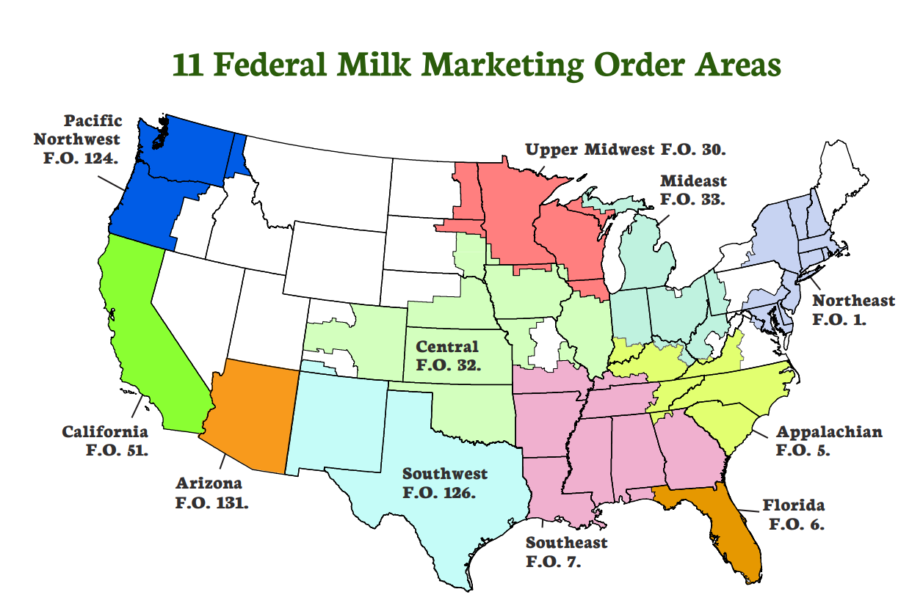

Figure 1: Federal Milk Marketing Orders Areas (USDA AMS, 2024)

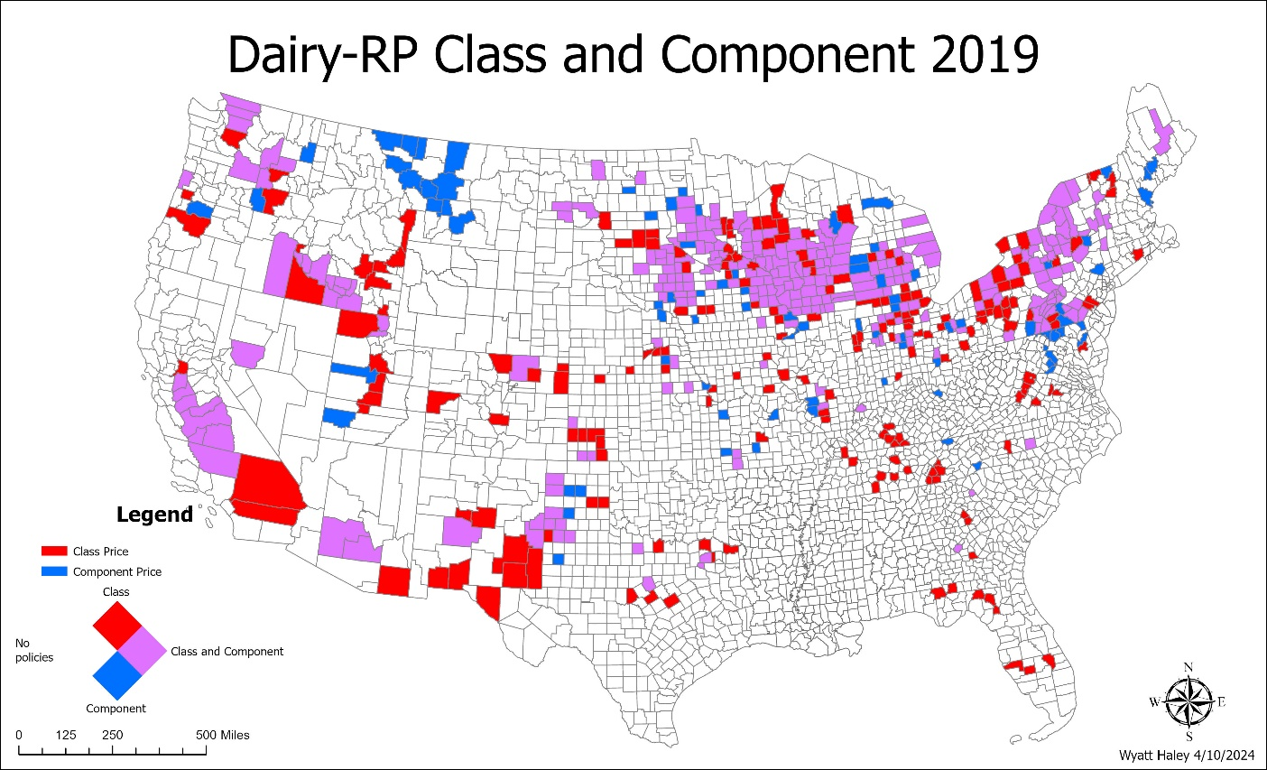

Figure 2: Dairy-RP usage on a county level for 2019

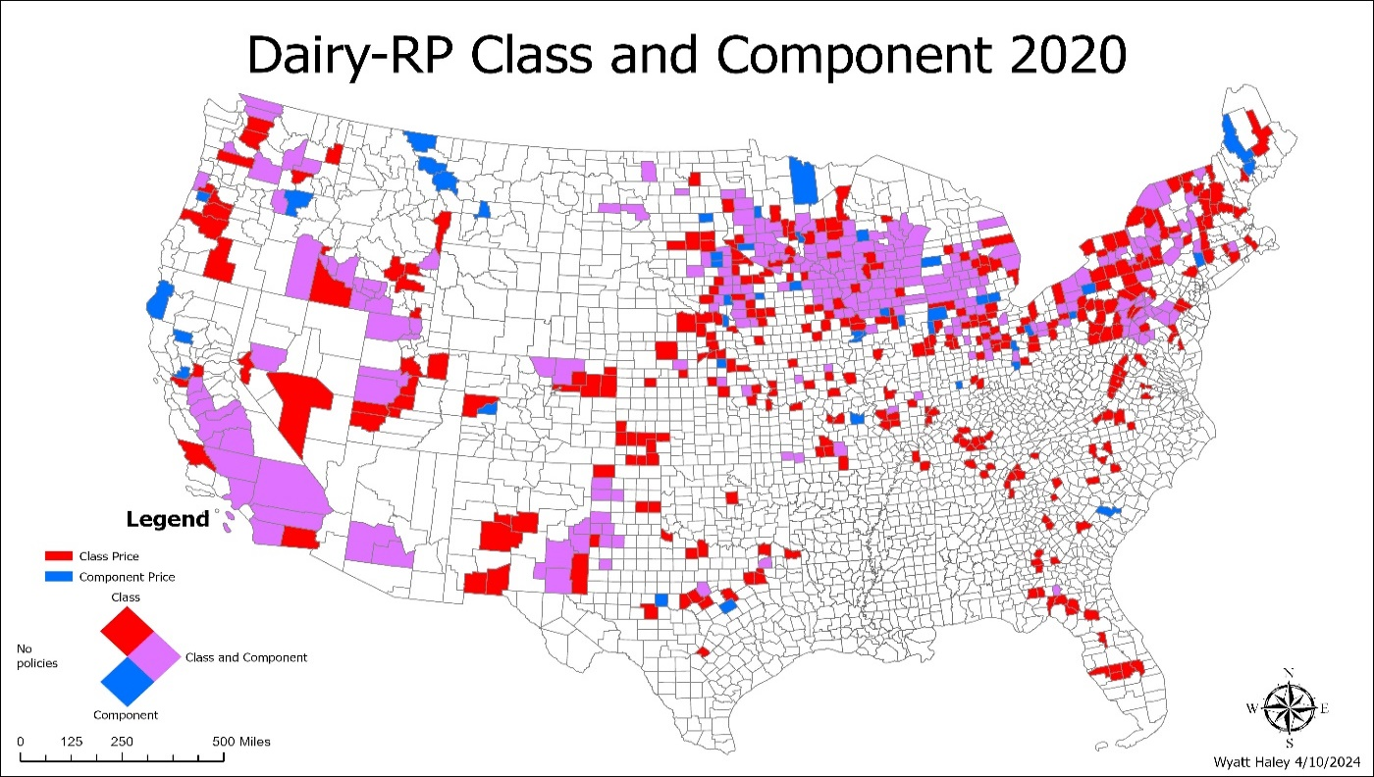

Figure 3: Dairy-RP usage on a county level for 2020

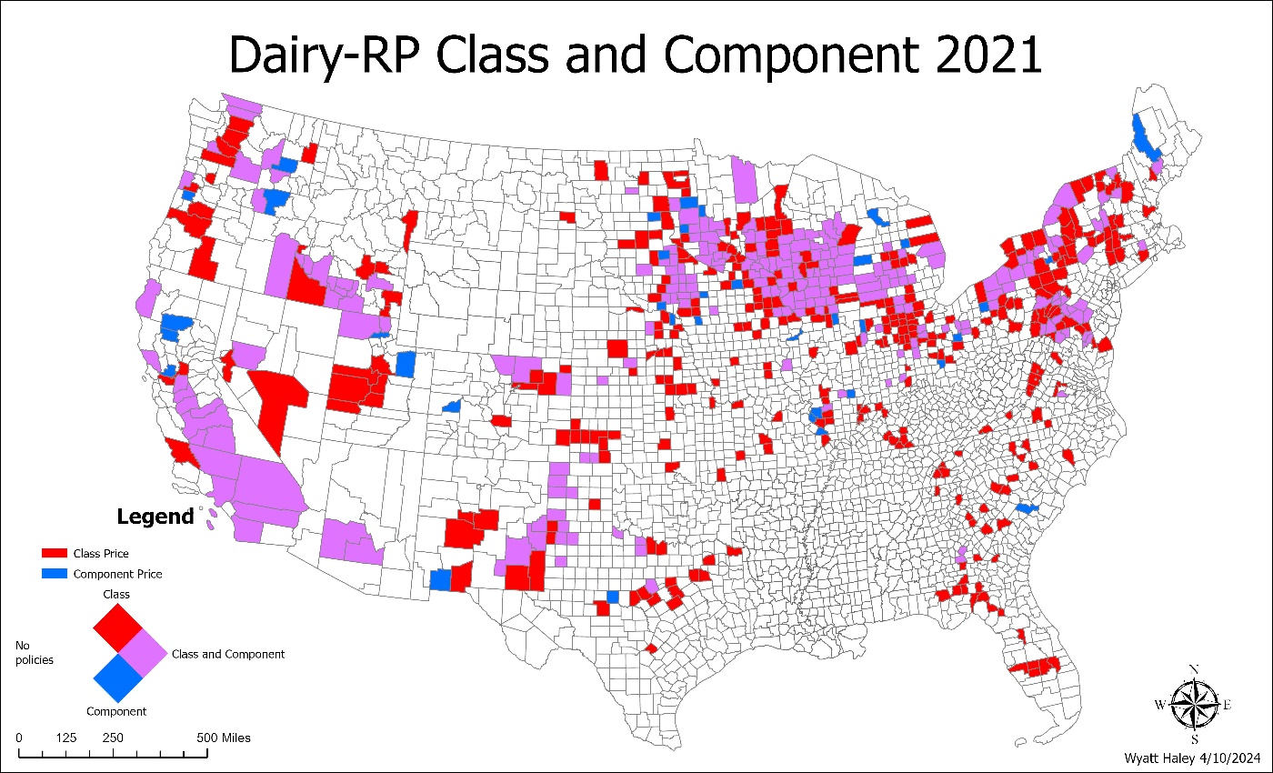

Figure 4: Dairy-RP usage on a county level for 2021

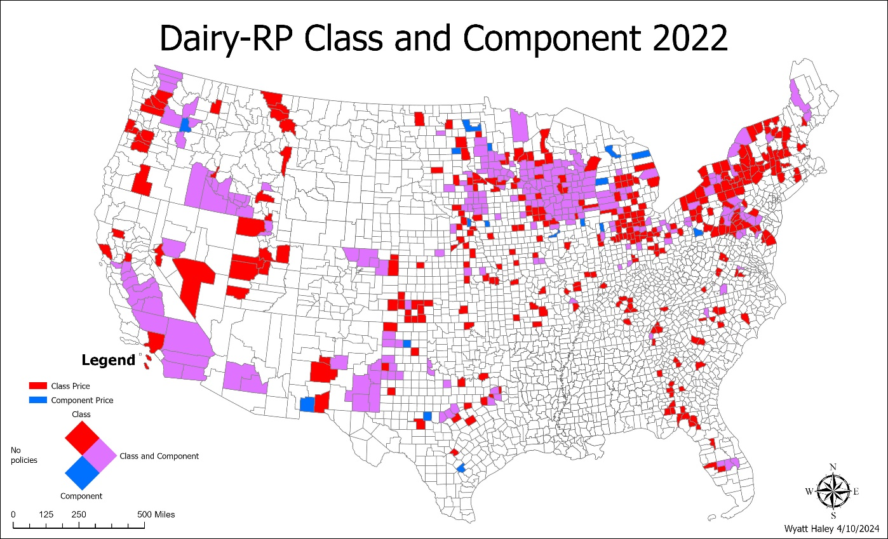

Figure 5: Dairy-RP usage on a county level for 2022

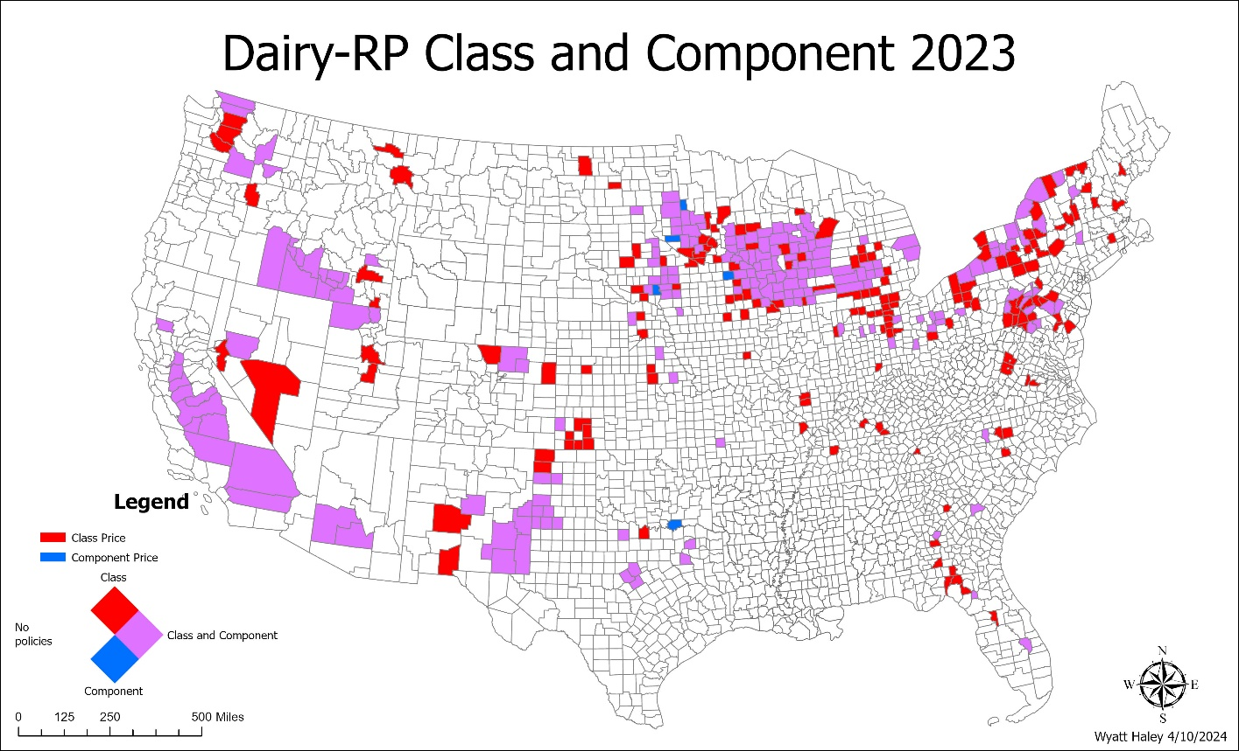

Figure 6: Dairy-RP usage on a county level for 2023

Appendix 2

Table 2: Dairy-RP Loss Ratio 5 Year Average
Year | Avg Loss Ratio | Avg Loss Ratio Class Price | Avg Loss Ratio Component Price
2019 | 0.079 | 0.080 | 0.078
2020 | 2.701 | 3.086 | 0.924
2021 | 0.507 | 0.530 | 0.375
2022 | 0.312 | 0.289 | 0.484
2023 | 1.286 | 1.248 | 1.475
Avg. | 0.978 | 1.047 | 0.668

Table 3: Producer Selected Traits Influence Logit Estimation Results
Variable | Marginal Effect
Class Price | 0.0444***
Million Milk | 0.0164***
Coverage Level
90% | -0.034***
80% - 85% | -0.177***
Protection Factor
1.05 – 1.45 | -0.003
1.5 | -0.001
Calander Year
2020 | 0.305***
2021 | 0.247***
2022 | 0.094***
2023 | 0.535***
Length Before Insure Date (months)
1 | 0.082***
2 | 0.076***
3 | 0.117***
4 | 0.093***
5 | 0.086***
6 | 0.084***
7 | 0.018
8 | 0.002
9 | -0.053***
10 | -0.018
11 | -0.066***

Table 3 Continued: Producer Selected Traits Influence Logit Estimation Results
Variable | Marginal Effect
Length Before Insure Date (months)
12 | -0.174***
13 | -0.112***
14 | -0.062***
15 | 0.15***
Number of observations | 73,639

Table 4: Tobit Model Regression Parameter Estimation
Variable | Parameter Estimation
Class Price | 0.383***
Million Milk | 0.110***
Coverage Level
90% | 0.119*
80% - 85% | -0.077
Protection Factor
1.05 – 1.45 | -0.009
1.5 | -0.028
Calander Year
2020 | 2.614***
2021 | 0.335***
2022 | 0.119***
2023 | 1.242***
Length Before Insure Date (months)
1 | -0.066
2 | 0.089
3 | 0.289***
4 | 0.077
5 | -0.057
6 | 0.095***
7 | -0.121*
8 | -0.136
9 | -0.200***
10 | -0.175**
11 | -0.191*
12 | -0.375***
13 | -0.388***
14 | -0.174
15 | 0.776***
Number of observations | 73,639
(*, **,*** represent significance at 90%, 95%, and 99% respectively)

Vita
Wyatt Haley is a second-year master’s student in the Agricultural and Resource Economics program at the University of Tennessee at Knoxville. Wyatt is from Nolensville, Tennessee and has a strong background in livestock management, specifically beef and dairy cattle. Wyatt completed his undergraduate degree at the University of Tennessee at Knoxville majoring in Animal Science with a minor in Food and Agriculture Business.

