Three-Dimensional Electrokinetic Trapping of a Single Fluorescent Nanoparticle in Solution

A Dissertation Presented for the
Doctor of Philosophy
Degree
The University of Tennessee, Knoxville

Jason Keith King
August 2013
Copyright © 2013 by Jason Keith King
All rights reserved.

ACKNOWLEDGEMENTS

I would like to start by thanking my advisor, Lloyd Davis, for recruiting me in my senior year at UT Knoxville. If not for him, I might have spent the last six years freezing to death in upstate New York. Lloyd has always pushed me to perform, and I know that I am a better scientist for it. I’d also like to thank my committee members, Christian Parigger, William Hofmeister, and Robert Compton, for advising me on my research. The three of you were always there to ask the hard questions, and I appreciate it.
I also want to thank my graduate student siblings, William Robinson and James Germann. The three of us went through enough homework, stress, and caffeine to choke a moose. I look forward to future gatherings, where we will no doubt meet to compare our Nobel prizes and discuss old war stories. Of course, I can’t forget my favorite Postdoc, Brian Canfield. Between advice on writing, help on optical design/alignment, and tutorials on milling/fabrication, I probably owe the better part of my knowledge in applied physics to him. Perhaps most importantly, he always brought refreshments to our weekly meetings.
Finally, I want to thank my family. My parents, Danny and Shu King, have been nothing but supportive throughout my academic career. Without their love and (more than) occasional financial support, I doubt I would have made it this far. I know I wouldn’t have made it this far without the love and support of my wife, Amanda. I am constantly amazed that I have managed to keep hold of her for this long, and I know that she would probably annul our marriage if I spent any more time in school.
ABSTRACT

This dissertation presents the development of an instrument for effectively trapping a single fluorescent nanoparticle that is freely diffusing in solution in all three dimensions. The instrument is expected to have applications for studies of single nanoparticles or molecules for which prolonged observations are required, but without immobilization or proximity to a surface, which may alter behavior. The trapping technique depends on rapid three-dimensional position measurements of the nanoparticle with sub-micron precision, which are used for real-time control of induced electrokinetic motion, so as to counteract Brownian motion. While anti-Brownian electrokinetic trapping experiments in one and two dimensions have previously been reported, this is the first account of three-dimensional electrokinetic trapping. A key innovation is the use of a custom microfluidic device with four electrodes in a tetrahedral arrangement spaced by about 100 microns. Adjustment of voltages between the four electrodes induces electrokinetic motion of the nanoparticle controllable in all three dimensions. To accomplish trapping, the device is mounted on a custom fluorescence microscope, in which the tube lens is tilted to deliberately introduce astigmatism. The tilt produces an elliptical point spread function when the nanoparticle is displaced from the focal plane. With use of calibration measurements, the position and shape of the point spread function from a camera image give the three-dimensional displacement of the nanoparticle. The electrode potentials to generate a proportional restoring motion are then applied. A 20-nanometer radius particle in aqueous solution can thus be held for a mean time of 7 seconds, which is much longer than the diffusional escape time without control. Statistical results over many such experiments show (x, y, z) fluctuations of (2.2, 1.8, 3.0) microns standard deviation from the target position, which corresponds to effective spring constants of (0.8, 1.2, 0.4) nanoNewtons per meter. In addition to trapping, arbitrary three-dimensional manipulation of the nanoparticle trajectory is demonstrated. Simulations show that time delay between measuring displacement and applying corrective motion requires reduced response to avoid instability and that use of the device with a faster camera or other position determination method should enable trapping of a 1.5 nanometer-sized objects in water.
TABLE OF CONTENTS

CHAPTER I Introduction 1
Nanoscale Manipulation and Trapping 3
CHAPTER II Theory and Experimental Setup 20
3D Trap Devices 20
Cross-channel Device 20
Tetrahedral Electrode Device 24
Experimental Setup 26
Electrode Pairs 27
Device Mount 31
Optical Setup 37
Sample Solution 39
CHAPTER III Methods and Results 43
Tracking Algorithm 43
Calibration 49
Trapping Algorithm 59
Simulations of Trapping and Free Diffusion 64
Trapping Capabilities 72
Experimental Results 77
Trapping in 25% Glycerol/Water 77
Trapping in Water 82
Trap and Diffuse 86
ROI Movement 88
CHAPTER IV Ongoing/Future Work 90
Improved Camera for Nanoparticle Imaging 90
Improved Understanding of Electrokinetic Response 93
Position Determination by Photon Counting 94
Cross-channel Microfluidic 96
CHAPTER V Summary 99
LIST OF REFERENCES 102
APPENDIX 110
1D Collision Simulation 111
3D Trap Simulation 113
3D Diffusion Simulation 116
VITA 118

LIST OF TABLES

Table 1: Measured and Extrapolated (Effective) Spring Constants 14
Table 2: Collision Rates 18

LIST OF FIGURES

Figure 1: Nanochannel and ABEL Traps 11
Figure 2: Collision Rate Simulation Flow Diagram 17
Figure 3: Cross-Channel Configuration 22
Figure 4: Tetrahedral Electrode Configuration 25
Figure 5: Electrode Pair Tip Detail 30
Figure 6: Lower Device Mount 32
Figure 7: Upper Device Mount 35
Figure 8: Assembled Device Mount 36
Figure 9: Optical Diagram 38
Figure 10: Excitation/Emission Dark Red FluoSpheres® 41
Figure 11: Calculated Diffusion Coefficient 42
Figure 12: Zemax modeling of the PSF 45
Figure 13: Collapsed ROI 46
Figure 14: Scale Measurement 48
Figure 15: Nanoparticle Calibration Run 51
Figure 16: Global Fit 53
Figure 17: Planar Position 55
Figure 18: Global Planar Position 56
Figure 19: Error Measurements 58
Figure 20: Trapping Latency 63
Figure 21: 3D Trapping Simulation Flow Diagram 65
Figure 22: Simulation Position Distributions 67
Figure 23: 3D Trapping Simulation Results 68
Figure 24: 3D Diffusion Simulation 71
Figure 25: Initial Position Width in Response to Diffusivity 75
Figure 26: Trapping Capabilities 76
Figure 27: Trapping in Glycerol/Water 79
Figure 28: Glycerol/Water Position Histogram 80
Figure 29: Glycerol/Water Time Histogram 81
Figure 30: Trapping in Water 83
Figure 31: Water Position Histogram 84
Figure 32: Water Time Histogram 85
Figure 33: Diffusion study 87
Figure 34: ROI Movement 89

CHAPTER I
Introduction

In recent times, there has been growing need for new methods and technologies to extend current capabilities for the study of single molecules and individual nanoparticles in solution. [1-8] Trapping of a single nanoparticle or fluorescent molecule is an example of a needed avenue for the improvement of single-particle studies as it enables prolonged observations, rather than just fleeting glimpses of each individual. [9] Many biological processes and mechanisms, such as molecular motors and protein folding, exhibit state heterogeneities because they are not synchronized from molecule to molecule, and thus they can only be observed in detail at the single-molecule level. An ensemble measurement of these processes may shed light on the mean state but entirely miss the important transitional states that define the essential behavior. Study of individual molecules and nanoparticles allows for the uncovering of these states and a better understanding of the processes they define.
An example is the study of the change of folding conformation of cold shock protein (Csp) in response to abrupt change in denaturant. [10, 11] Detection of fluorescence from a label on the protein following Förster Resonance Energy Transfer (FRET, in which the excitation energy is nonradiatively transferred from another nearby label with probability determined by its separation distance) is used to determine the state of folding of Csp molecules at various concentrations of denaturant. As the denaturant concentration is increased, the population of unfolded molecules decreases, with a corresponding increase in the population of folded proteins. While there is an initial shift in peak FRET efficiency (i.e., a decrease in the separation of the labels), no further peak shifts occur, indicating that end-to-end distances in the molecule do not change significantly during the reaction. This behavior agrees with a two-state model predicted by ensemble measurements. However, the unfolded state exhibits an increase in FRET efficiency when initially exposed to the denaturant, revealing a partial collapse in the unfolded molecule (reducing the volume by a factor of two) that is different from complete folding. These two subpopulations are indistinguishable in ensemble FRET measurements.
This work shows that single-molecule measurements provide an important tool for understanding biological mechanisms. In the Csp molecule study, a microfluidic mixing apparatus was developed to examine state configurations that exist well beyond equilibrium conditions. The subpopulation of completely folded proteins was too low to measure, as the average diffusion-limited dwell time for a single molecule in the focused laser beam is only ~0.5 s. In fact, in many single-molecule studies, the dwell times of typical molecules in a diffraction-limited confocal volume (used for many single-molecule experiments) are limited to fractions of a second. This severely restricts the ability to study long-lived processes or even rare events. As a result, trapping of single molecules and nanoparticles to improve observation times has become a vigorously pursued avenue of research. [9, 12-18]
The goal of this research is to develop a device for trapping a single fluorescent molecule in solution in an unconfined three-dimensional (3D) volume. The device developed in this research is, in principle, capable of doing just this, but it is a technically challenging problem to demonstrate its use with single molecules due to their high diffusivities and low fluorescence signals. Therefore, as an important step towards single-molecule trapping, trapping with the device is demonstrated using single fluorescent nanoparticles with diameters of 40 nm, about ten times larger than that of a single molecule and with about 300 times the fluorescence brightness. This in itself is technically challenging and is at the limits of capability of competing techniques for trapping microparticles and nanoparticles.

Nanoscale Manipulation and Trapping

There are a number of techniques used for manipulating and trapping single nanoparticles. The most straightforward method for prolonged studies of single nanoparticles in solution is to simply immobilize them by attaching them to a surface or embedding them in a solid matrix. Unfortunately, such attachment may perturb the local environment or may occupy binding sites or limit structural configurations, and the nanoparticle may react differently to environmental changes than it would while freely diffusing in solution. This consideration is particularly important for studies of protein folding, binding, and conformational changes of single molecules. [9] An example is the study of a fluorescent protein, allophycocyanin (APC) in solution. APC is a light-harvesting protein complex found in red algae and cyanobacteria; it is part of a protein superstructure exciton funnel that directs energy towards a photosynthetic reaction center. Two groups have previous studied this protein at the single-molecule level and found different photobleaching behaviors. [19, 20] One group studied the protein immobilized in polyvinyl alcohol (PVA), while the other group used agarose and glass surface adsorption. A follow-up study using the Anti-Brownian Electrokinetic (ABEL) single-molecule trap found photobleaching behavior similar to that reported by the first group, but also noted differences in measured fluorescence lifetimes. [21] Clearly, simply immobilizing the protein by adhering it to a surface can have significant effects on conformational and photophysical properties. Whereas this finding was supported by experiments in which a single APC molecule was held in a two-dimensional (2D) ABEL trap, the molecule still suffers frequent collisions and interactions with the walls of the 2D trap that could also alter its conformational and photophysical properties. For studies of truly unmodified single molecules in solution, a 3D trap is needed.
Optical tweezers are a versatile method for micro-manipulation and to some extent, nano-manipulation. [22-25] In all cases, the trapping forces arise from the momentum carried by light (radiation pressure) and the change in momentum when the light is refracted, scattered, absorbed, or reflected. For objects much larger than the wavelength of light, the effect of optical trapping is easily understood through ray optics and refraction and reflection of rays by the object. If the object is not at the center of the beam, it experiences a lateral force pushing it towards the center. At the focus, the forces due to light scattering and refraction are symmetric and hold it near the focus and balanced against the component of force along the beam path due to absorption and back-reflection of the light from the object. [26] For objects much smaller than the wavelength of light (such as sub-micron particles or single molecules), ray optics are no longer valid and a better explanation is made by treating the object as a dipole in an inhomogeneous optical field. The optical field scatters from the dipole, resulting in a force along the gradient of the optical field. When the force along the field gradient is balanced against the force due to back-scattered light (the force directed along the axis of the focused beam), a stable trapping configuration can be created. By adjusting the tightness of focus, power, and wavelength, one can trap targets ranging from several microns down to tens of nanometers. [24-27]
However, there are several limitations to the use of optical tweezers. Most importantly, the high intensities necessary to optically trap (several MW cm⁻²) can cause localized heating and photodamage to the target. [28, 29] Optical trapping has been shown to damage polystyrene and silica beads, Escherichia bacteria, Chinese hamster ovary cells, and many other biological specimens. [27, 30, 31] Recent work has demonstrated the enhancement of optical trapping forces through the use of nanoapertures [32-34] and nanostructures [35, 36] to reduce the necessary input power required to hold much smaller objects. These near-field techniques have been used to trap 10-15 nm quantum dots, 22 nm fluorescent beads, and even single bovine serum albumin (BSA) molecules (hydrodynamic radius 3.5 nm). However, these techniques require close proximity (<10 nm) of the nanoparticle to the field-enhancing nanostructure. Additionally, the effect of the enhanced field intensities on local temperature or molecular/nanoparticle behavior has not been well-quantified. [37] For example, BSA protein in a nanoaperture device exhibited a state change; most probably because the heating due to absorption of the strong trap intensity was enough to unfold the molecule. Although recent advances have allowed optical tweezers to trap single fluorescent molecules, there are still significant obstacles that limit their range of applications.
Magnetic tweezers are a straightforward configuration that allows for 3D manipulation and trapping of micron-sized (1−5 µm) magnetic particles. [25, 38-40] For example, by tethering a magnetic particle to a surface with a functionalized DNA strand, an electromagnet (or a permanent magnet) may be used to apply a constant force. [41] Use of multiple magnets can allow for rotational and torsional motion. While the range of motion is limited (10−100 µm) in comparison to optical tweezers, the main limitation is that the target must be either paramagnetic itself or bound to a magnetic bead. [25] This prevents the application of magnetic tweezers to studies of single biomolecules unless they are tethered to a magnetic bead, but as previously mentioned, binding a single molecule to a surface or other structure often perturbs its behavior.
Acoustic tweezers provide yet another option, in which wide-resonance bands produced by chirped interdigital transducers are used to generate standing acoustic wave fields. [40, 42, 43] The target particle is held in low-pressure nodes and may be moved by adjusting the frequency to change the location of these nodes. The required field intensity is ~5×10⁶ lower (0.2 W cm⁻²) than for optical tweezers, suggesting acoustical methods may be ideal for studies on biological specimens. [44] At the time of writing, however, 3D trapping has only been demonstrated for micron-sized particles. [43, 45] As such, acoustic trapping techniques are presently not a viable option for the study of single nanoparticles.
Hydrodynamic trapping uses secondary hydrodynamic forces generated by low-frequency oscillation (<1000 Hz) or pressure-driven flow. [46-49] In contact-based methods, objects are pressed against a solid object using drag forces created by fluid flow. This technique is not desirable, as physical contact can have adverse effects on the target. Noncontact methods currently rely on the creation of stagnation points or micro-eddies. Hydrodynamic trapping forces scale linearly with particle size, and trapping of submicron (~100 nm) spheres has been demonstrated. [47, 48] Nevertheless, practical use requires extensive flow modeling and specialized microfluidic geometries. [50] Furthermore, the capability to manipulate the object is considerably limited (one-dimensional (1D) control in a 2D device).
A dielectrophoretic trap uses a nonuniform DC field or high-frequency AC field to induce a dipole on a dielectric object and move it. [40, 51-53] For large objects (greater than the scale of field inhomogeneities) the charges constituting the induced dipole experience different field strengths, resulting in a net force along the field gradient. Smaller objects may be moved in a high-frequency AC field, where the dipole is induced with a phase lag, resulting in a time-averaged force. By adjusting the frequency of this field, the direction of motion may be changed. While dielectrophoresis is well-suited for rapid sorting of multi-species targets in solution [52, 53], control of sub-micron sized objects requires a combination of high field strengths and small device geometries. These conditions can result in joule heating and other undesirable effects.
Ultimately, magnetic, acoustic, dielectrophoretic, or conventional (far-field) optical tweezers either cannot exert enough force or cannot presently access the size scales necessary to trap objects smaller than ~100 nm in diameter. [35, 54-56] Smaller objects experience smaller applied forces for a fixed field intensity, because the force applied to an object scales with its volume ($F∝r^{3}$). Trapping of micron-sized objects has been achieved with each of the aforementioned techniques. However, to trap an object whose size is on the order of a single molecule (< 10 nm), the intensity must be increased by a factor of a million or more in order to produce a comparable trapping force. These high intensities can be difficult to produce, and may perturb or damage the sample.
A second concern is the lack of selectivity in trapping. In many of the above techniques, including hydrodynamic and optical trapping (both conventional and near-field enhanced), multiple objects can simultaneously inhabit the trapping volume (unless the objects to be trapped are bigger than the trapping volume). For many single-molecule or nanoparticle studies this is not a desirable situation, as multiple objects may interact and be difficult to discern from a single emitter. The microfluidic device described in this dissertation actively controls the position of only one nanoparticle and thus will trap only a single diffusing object at a time. If another nanoparticle diffuses into the region of interest, it may replace the originally trapped nanoparticle, or diffuse out again. Either way, because the diffusion of each nanoparticle is independent, at most only one of the two will be actively controlled. Motion control is accomplished through electrophoresis and/or electro-osmosis, which together are referred to as electrokinesis. As explained below, these processes scale much more favorably with small object size. [40, 54]
Electrophoresis is the movement of ions, or colloidal objects such as nanoparticles, in an externally applied DC electric field. [54, 57, 58] In the case of colloidal particles, surface charges and a surrounding electric double layer (EDL) develop in proportion to the surface area of the particle and the concentration of ions in the solution. The applied electric DC field acts upon these ions in the EDL and moves the particle through viscous stress. Very quickly, this force is balanced by viscous drag, resulting in a terminal velocity. Overall, the electrophoretic mobility, or the steady-state velocity for a given applied DC field, scales with the surface charges (q ∝ r²) and inversely with the viscous drag (F_{drag} ∝ r⁻¹). As a result, the electrophoretic mobility is expected to scale linearly with the size of the particle. In the case of ions, such as single cationic fluorophore molecules, the charge is fixed and independent of the size of the ion. The electrophoretic mobility is expected to increase as the hydrodynamic radius and viscous drag of the ion decrease. In either case, trapping by control of electrophoretic motion scales more favorably with the size of the object compared to trapping by optical, magnetic, acoustic, or dielectrophoretic forces.
Electro-osmosis is the motion of a fluid through a capillary, or through holes in a membrane, in response to an applied electric field. [54, 57-59] Similar to electrophoresis, an EDL arises from interactions between surface charges of the capillary and oppositely charged ions in the fluid. Coulomb forces in the diffuse portion of the EDL resulting from the externally applied DC electric field induce a uniform flow that is transferred to the bulk of the fluid through viscous stress. [60] Nanoparticles or molecules in solution are carried together with the bulk fluid flow, so their electro-osmotic motion is independent of their radius. Typical velocities for electro-osmotic flows in glass capillaries are 100 µm s⁻¹ for an applied field of 100 V cm⁻¹, [57, 59, 61] which is particularly useful for a large range of micro- and nano-fluidic devices.
Several devices utilizing electrophoresis and electro-osmosis have been demonstrated. [40, 54, 56, 62, 63] A ~100 nm cross-section nanochannel (effectively 1D) has been used with electro-osmotic flow and electrophoresis to trap single fluorescently labeled Streptavidin molecules. [63] The molecule’s position along the nanochannel was determined by use of pulse-interleaved excitation by two spatially offset laser-beam foci and time-resolved single-photon detection. A single cathode-anode pair was then used to induce motion in the appropriate direction to return the molecule to the midpoint of the laser foci (Figure 1, left).
As discussed earlier in this section, the ABEL trap has been developed for single-molecule trapping in 2D. It consists of a planar device with four electrodes separated by ~40 µm, sandwiched between two layers of fused silica (Figure 1, right). This arrangement allows free movement of the molecule in 2D, while the device extends only ~800 nm along the third dimension. [9, 62] Because this distance is less than the focal depth of an optical microscope, the molecule
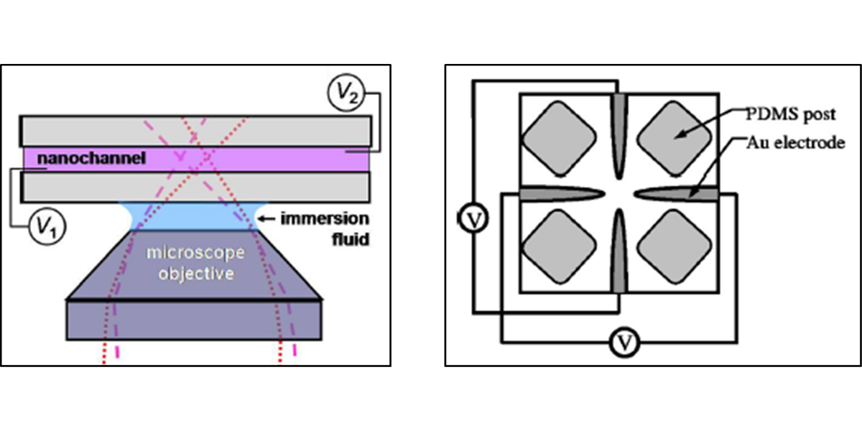
Figure 1: Nanochannel and ABEL Traps
Schematics of nanochannel (1D, left) trap [63] and ABEL (2D, right) trap. [69]

always remains in focus. Fluorescence response to a spatially and temporally modulated laser excitation pattern enables the 2D position of the molecule to be quickly determined so that adjustment of the electrode potentials can maintain the molecule near the center. The ABEL trap has been optimized to the point of trapping a single biomolecule within a 1 nm radius, or a small single chromophore with diffusivity as high as 330 µm² s⁻¹ and has been used in a number of biological studies involving fluorescently labeled DNA and proteins such as APC, for which immobilization may affect conformational dynamics. [21, 64, 65]
Analysis of thermal fluctuations is often used to estimate the spring constant k of optical traps. [29, 66, 67] The equipartition theorem states that each degree of freedom in a harmonic potential has $\frac{1}{2}k_{B}T$ of energy, where k_{B} is Boltzmann’s constant and T is the temperature. [68] The available thermal energy is related to the mean-square displacement of the trapped particle from the equilibrium position $\overline{x}$ by
 | $$\frac{1}{2}k_{B}T=\frac{1}{2}k〈{\left(x-\overline{x}\right)}^{2}〉.$$ | (1.1)
As the distribution of particle displacements is Gaussian with a variance $σ^{2}=〈{\left(x-\overline{x}\right)}^{2}〉$, the spring constant is given by
 | $$k=\frac{k_{B}T}{σ^{2}}.$$ | (1.2)
It is difficult to directly compare spring constants for nanometer-sized dielectric objects trapped optically (through conventional means) due to the unavailability of published values at similar sizes (<100 nm). Instead, consider the spring constant measured for a polystyrene bead of diameter 330 nm optically trapped in water with a NA 1.32 oil immersion microscope objective, 25 mW input power, λ = 1064 nm, at a depth of 5 μm. [67] The spring constant may be extrapolated downwards from,
 | $$k_{eff}=k_{r'}{\left(\frac{r}{r'}\right)}^{3},$$ | (1.3)
where r is the radius of the object to be compared and r’ is the radius of the object for which the spring constant is known (k_{r’}). For an optical trap, the spring constant provides an indication of the restoring force and trapping potential. However, for an electrokinetic trap, when voltages are applied, the target very quickly attains a terminal velocity — the measured position of the target is used to actively control the corrective motions to counteract Brownian diffusion. The displacements of the target from the equilibrium point do not give an indication of a force due to the applied voltages, but they are dependent on the quality of the control. Thus, for an ABEL trap, analysis of fluctuations using the equipartition theorem yields only an effective spring constant; there is not a trapping potential but only an effective trapping potential. Measured and extrapolated (effective) spring constants for the ABEL trap and optical trap are listed in Table 1. For objects 20-50 nm in diameter, the extrapolated spring constants in optical trapping are comparable to the effective spring constants in the ABEL trap. However, an optical trap requires a stiffer spring constant for successful trapping because the confinement radius is smaller, as determined by the beam waist.
Table 1: Measured and Extrapolated (Effective) Spring Constants
 | (Effective) Spring Constant, k_{eff} (nN m⁻¹)
Object Diameter (nm) | ABEL Trap | Optical Trap
330 | ­ | 16000 [67]
200 | 20.0 [69] | 3600
50 | 14.0 [70] | 56
20 | 1.7 [69] | 3.6

*Measured (effective) spring constants are highlighted in yellow, the remaining are extrapolated. Input power (25 mw at λ = 1064 nm) was assumed uniform over the range of optical trapping values and all objects are polystyrene beads.

From Equation 1.2, we may estimate the minimum spring constant required to successfully trap an object at room temperature:
 | $$k_{eff}≥\frac{k_{B}T}{σ^{2}},$$ | (1.4)
where σ is chosen to represent the beam waist of an optical trap. A conservative estimate of σ = 0.5 µm shows that the spring constant must exceed 16 nN m⁻¹ to reasonably confine an object within the beam waist at room temperature. Compare this to the ABEL trap, which has a wider field of view (minimum scan radius, σ = 2 µm) corresponding to effective k_{min} = 1 nN m⁻¹.
Of course, even this simple scaling argument does not provide a direct comparison between electrokinetic and optical trapping, as many factors (choice of buffer, sample composition, trapping depth, input power, etc.) will influence their capabilities. [29, 66, 67, 71] In the end, electrokinetic control should not be considered a technique to supersede traditional trapping methods, but as an alternative that operates favorably in the nanoscale regime.
Although both 1D and 2D devices have been used to successfully trap single molecules, confinement within a nanochannel or a planar geometry leads to frequent collisions with the walls. As noted earlier, these frequent interactions alter the molecule’s local environment and may also change its conformational dynamics. In addition, they may lead to adverse effects such as fluorescence quenching or sticking. Sticking eventually degrades the quality of the microfluidic device (by raising the background fluorescence level and depleting the already low concentration) and limits its usefulness in long-term (>30 min) studies.
In order to investigate the collision rates experienced in the nanochannel and ABEL traps, a series of simulations was performed (source code in Appendix). In the simulation (Figure 2), the particle begins at the center of the channel or gap and is allowed to diffuse in the dimension transverse to the channel or gap until it reflects from an interface. Note that for a rectangular cross-section channel, collisions may occur from either the horizontal or vertical walls and as a result, the actual collision rates would be higher than those determined from this 1D model.
The magnitude and direction of the diffusion steps are determined by sampling Gaussian random numbers (numpy.random.normal [72]) with standard deviation $σ=\sqrt{2Dt}$, where D is the diffusion coefficient and t is the time interval (10 ns). Should the particle encounter a wall, it is reflected in the opposite direction for the remainder of the step. Additionally, “bouncing” sets a flag used for collision determination. A particle is considered to collide once with a wall after it travels a fixed distance from the wall. This collision distance was set at 10 nm, which is a realistic upper-limit distance over which interactions occur between nanoparticles and an interface. (A smaller collision distance would give higher collision rates.) Simulations were performed for various diffusion coefficients representing a 40 nm diameter sphere, a 10 nm diameter sphere, and a Rhodamine B molecule (~0.54 nm hydrodynamic radius). [73] The collision rates obtained from these simulations are shown in Table 2. For both the 1D square channel (nanochannel trap) and 2D planar gap (ABEL trap), the rates far exceed 1 kHz even for something as large as a 40 nm sphere. For a single-molecule-sized target, such
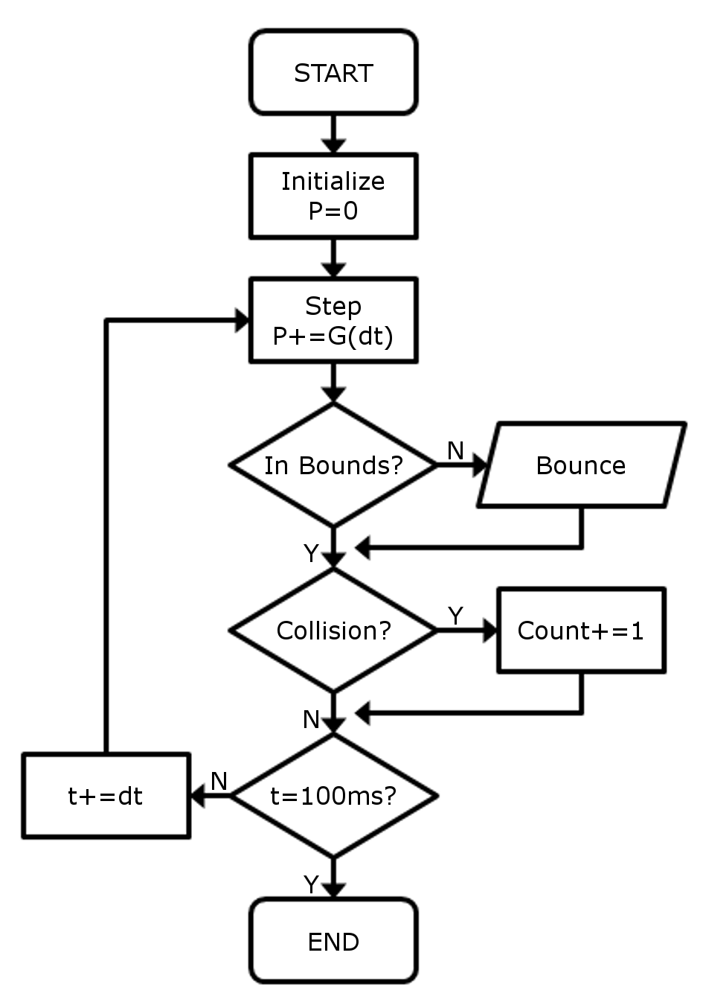
Figure 2: Collision Rate Simulation Flow Diagram
Detail of 1D diffusion simulation: diffusion is approximated by randomly sampling a Gaussian number with $σ=\sqrt{2Ddt}$. For every step, the simulation checks to see if the position exceeded the bounds of the device and reflects its motion accordingly. A collision is counted only after the particle travels at least 10 nm from the interface following a bounce.

Table 2: Collision Rates
 |  | Collision Rates (kHz)
Object | D (µm² s⁻¹) | Nanochannel | ABEL Trap
40 nm sphere | 12.2 | 23 | 3
10 nm sphere | 48.9 | 88 | 12
Rhodamine B | 452 | 671 | 87

Simulated collision rates for differently sized objects in 1D (nanochannel, 100 nm wide) and 2D (ABEL, 800 nm deep) traps with 10 nm collision distance.

as Rhodamine B, collision rates are substantially higher, a consequence of the approximately linear scaling of collision rate with diffusivity. The simulations highlight the relevance of 3D trapping for single-molecule studies, as a particle in a 3D trap will experience no collisions and is thus truly unperturbed by interactions with the walls of the device.
This work outlines the construction and use of a microfluidic device for 3D electrokinetic trapping of single fluorescent nanoparticles in solution. Chapter II presents the theory and configuration of the device, followed by the fabrication procedure and experimental apparatus. Extended trapping of single fluorescent 40 nm polystyrene beads in glycerol/water mixture and pure water is performed, and precise control in 3D is demonstrated in Chapter III. Subsequent improvement of these experiments and ongoing research is presented in Chapter IV, followed by a summary and some concluding remarks in Chapter V.

CHAPTER II
Theory and Experimental Setup

While there are many methods of manipulating and trapping single nanoparticles in solution, some with particular merits, electrokinetic manipulation is well-suited for such studies. However, current methods of electrokinetic trapping in 1D (nanochannel) and 2D (ABEL) physically constrain the target, resulting in high rates of collisions. These collisions are undesirable, so a method of electrokinetically trapping a single nanoparticle in 3D is required.
This chapter describes the theoretical basis and physical design of the 3D electrokinetic trap. Two different configurations have been studied as a means of active electrokinetic control in 3D — the first consists of two crossed channels, each of which are connected to a pair of electrodes, and the second consists of four electrodes in a tetrahedral arrangement. [74] Both configurations are outlined and a brief overview of the progress made in the cross-channel device is given. The theory, design, and construction of the tetrahedral-electrode device, which is the main focus of this dissertation, are then presented.

3D Trap Devices

Cross-channel Device
The idea behind the cross-channel device is to exploit the strong electro-osmotic effect that arises in a glass microfluidic channel and use it to manipulate nanoparticles suspended in the solution. The geometry of such a device consists of two microfluidic channels etched into separate substrates and bonded together in a crossed configuration, as shown in Figure 3. This results in a crossing region that is twice as deep as the individual microchannels. By adjusting the potentials between four electrodes located at the ends of microchannels, one can control the electro-osmotic flow along each microchannel and also the flow at the junction from one microchannel to the other. Hence, it should be possible to adjust the electro-osmotic driven flow at the center of the crossing region to be in any given orientation in 3D. [74, 75] As discussed in Chapter I, even electrically neutral nanoparticles will be carried with the electro-osmotically driven flow of the bulk solution in the microchannels. Also, their motion will be independent of their radius. If the nanoparticle is charged, it may also experience electrophoretic motion, but the electro-osmotically driven motion is expected to dominate for very small nanoparticles, as the electrophoretic motion generally decreases as the radius of the nanoparticle decreases.
Although conceptually simple, there are a number of technical challenges to overcome in order to produce a useful device. These include the fabrication of the channels, bonding of the substrates, and production and control of the voltages required for trapping.
Standard techniques for microchannel fabrication involve photolithography followed by wet etching [76, 77] or reactive ion etching [78]. As access to equipment for producing photolithography masks and etching with micron resolution was limited, microchannel fabrication was accomplished through femtosecond laser machining [79] using a facility being developed in our labs from a previous system. [80] While considerable time was devoted to this effort,
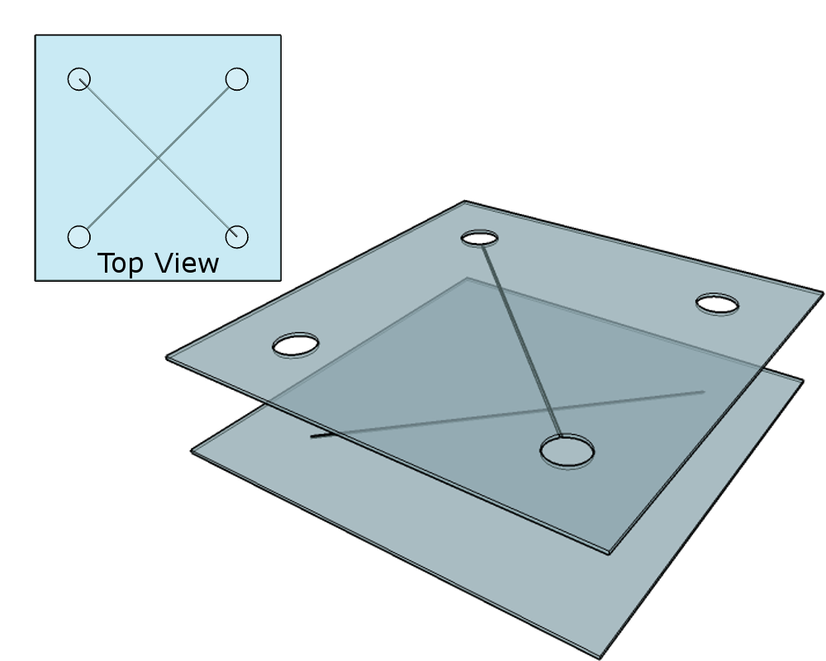
Figure 3: Cross-Channel Configuration
Microchannels on separate substrates arranged in a crossed configuration. The trapping region is at the intersection of the two channels. Note that the two surfaces are separated here for illustrative purposes but are bonded together in the final configuration.

and several prototype components were fabricated, the quality of channels produced in this manner exhibited severe optical scatter. Moreover, debris from the machining process consisting of molten glass that reformed on the surface near the machined area greatly affected surface quality, often preventing bonding of the two substrates. [81, 82] One robust and simple method for bonding of microfluidic devices is by use of an intermediate adhesive layer, such as epoxy [83] or polydimethylsiloxane (PDMS) [84, 85]. Unfortunately, for the crossed channels, both faces must have features on them, so application of a layer of adhesive would fill in the channel on that face. As a result, various forms of thermal bonding using high heat or low heat and high pressure were investigated. [76, 77, 86] These techniques gave a low rate of success (< 10%), perhaps due to the aforementioned debris from femtosecond laser machining.
Despite these difficulties, several devices were produced and mounted in the microscope for preliminary experiments. However, with the design of Figure 3, the electrodes were separated by 1 cm and it was found that high voltages (~100 V) were required to induce useful electro-osmotic flows. These high DC voltages were found to result in bubble formation, and distortion of the flow due to joule heating was also a concern. [87, 88] Also, the generation and millisecond switching times of these high voltages could not be achieved with the available data acquisition cards, but required additional circuitry. As a result of these difficulties, a decision was made to focus research efforts on the other electrokinetic trap configuration. Nevertheless, some methods for circumventing the above problems are presented in Chapter IV and further studies are warranted, as the cross-channel device holds great potential for trapping very small neutral nanoparticles or molecules.

Tetrahedral Electrode Device
In recognition of the need for 3D trapping, a modified ABEL trap arrangement of two stacked sets of four planar electrodes has been suggested as a means of providing 3D control without boundary walls. [54] However, finite-volume time-domain numerical modeling has demonstrated that a simpler configuration of just four electrodes in a tetrahedral arrangement, as shown in Figure 4, is sufficient to generate an electric field of controllable direction and magnitude in the center of the device, and that the field is approximately uniform over a volume of tens of microns in each dimension. [74, 89] The field generates electrophoretic and electro-osmotic motion of nanoparticles in the sample volume, where the specific mobility of the nanoparticles is dependent on their size and the ionic strength of the solution.
Although the device is conceptually simple, a number of technical challenges exist. These include a method of reliably creating a stable tetrahedral arrangement of electrodes, introducing sample solution, and controlling voltages. Finally, some method of real-time 3D position measurement was required to enable active control and trapping.
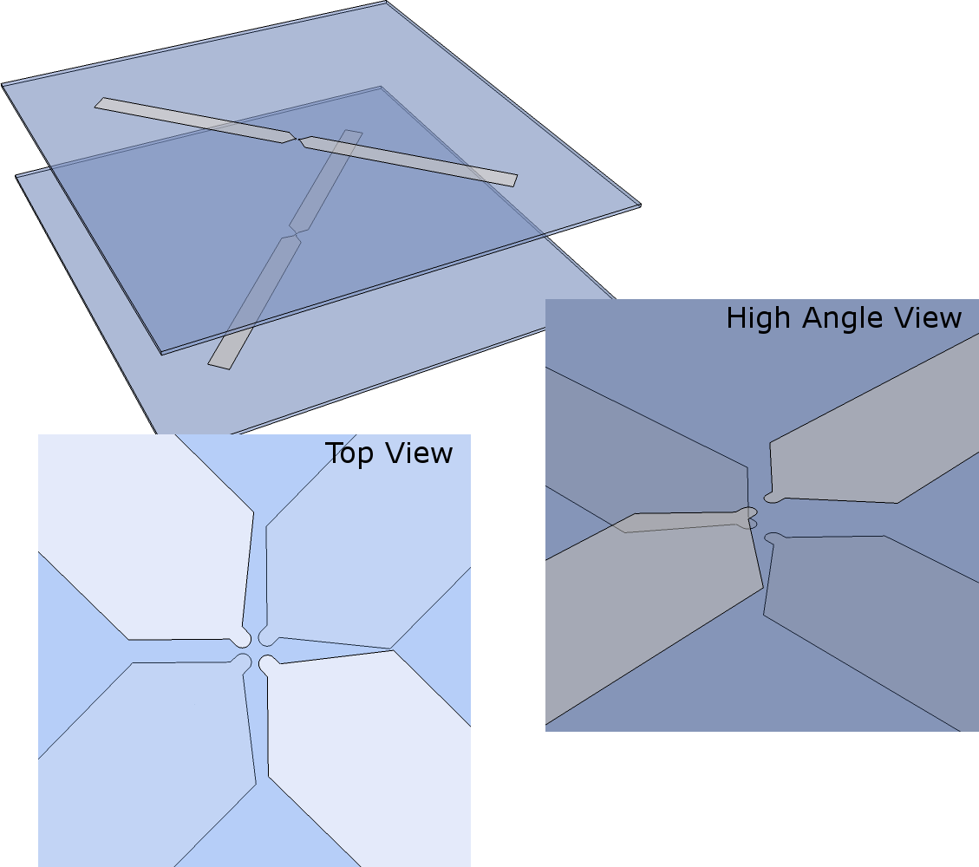
Figure 4: Tetrahedral Electrode Configuration
Crossed electrode pairs arranged in a tetrahedral geometry, with the lighter pair of electrodes representing the top coverslip. The electrodes are patterned on the interfacial surfaces of the coverslips. Note that the plane separation is greatly exaggerated for illustrative purposes.

Experimental Setup
The experimental setup incorporates microfabricated structures, but at the beginning of the project, the laboratory had no facilities available for microfabrication. The facilities used for production of the devices had to be developed during the course of the research. This included the procurement a calibrated UV source, appropriate photoresist, and developer. In addition, the clean room required UV masking of the windows and use of yellow lamps to prevent premature exposure. Although this required considerable time and trials of different procedures, only the final successful procedures are described in this chapter.
Some initial work was conducted at the Vanderbilt Institute for Integrative Biosystems Research and Education (VIIBRE) labs at Vanderbilt University. In particular, early photolithography tests were conducted prior to setting up facilities in our own laboratory, to determine necessary equipment and procedures. Further training was conducted at the Center for Nanophase Materials Sciences lab at Oak Ridge National Laboratory, where equipment was used to produce nanochannel devices and masks for ongoing experiments.
The following sections describe the design and production of the experimental apparatus, starting with the electrode pairs that define the core components of the trap. Fabrication procedures regarding cleaning, microlithography, and sputtering are detailed. Next, a frame used to align the two electrode pairs in a tetrahedral arrangement and provide electrical access is presented. The frame is mounted in a custom-built, forward-illuminated microscope with astigmatism introduced to the detection arm to enable the axial position of imaged nanoparticles to be determined from the point spread function (PSF). Finally, choice of sample solution and concentration is discussed.

Electrode Pairs
The electrode pairs are patterned onto standard glass coverslips (Cole Parmer #1.5 thickness) through positive photolithographic techniques. In preparation for spin coating of photoresist, the substrates are first cleaned. In initial studies, (before the purchase of the plasma etching/cleaning device described below) a very rigorous cleaning recipe involving a 15 min organic etch in 3:1 Piranha solution (90% concentration H₂S0₄, 35% concentration H₂0₂) was used. In addition, the glass substrate was lightly etched with hydrofluoric acid (2% concentration HF in aqueous solution) for 3 min to improve adhesion of the photoresist to the glass. These techniques were time-consuming, potentially dangerous, and generated hazardous waste. As a result, the decision was made to adopt an alternate cleaning recipe. This was used for all subsequent work and is as follows.
First, the glass coverslip is sonicated for 5 min in a 1” diameter shell vial filled with acetone. The 1” shell vial holds the coverslip in a vertical orientation during cleaning. The sample is then removed and rinsed with isopropyl alcohol (IPA) before another 5 min cycle of sonication in a shell vial filled with IPA. Next, the coverslip is removed and rinsed with ultrapure water before a final sonication in a shell vial filled with ultrapure water. The sample is then dried in a stream of nitrogen gas and subjected to 5 min of room-air plasma on medium (10.5 W) power (Harrick PDC-32G). This brief plasma treatment renders the surface hydrophilic. The surface will gradually revert to its original hydrophobicity over time, so immediate spin coating is used for best adhesion. [54]
The coverslip is then locked onto the spin coater with a vacuum chuck. Photoresist (Hoechst Celanese IR AZ-5214E) is pipetted into the corners and center and spun in a two part cycle; 300 RPM for 10 s followed by 4000 RPM for 30 s. This procedure results in a layer thickness of approximately 1.4 µm. Immediately following the coating procedure, the substrate is baked on a hot plate at 105°C for 1 min. This soft bake step activates the photosensitivity of the resist, and drastically affects the development stage, so care is taken to strictly adhere to the prescribed time. The coverslip is then mounted in a custom UV exposure setup to align a chrome mask. The chrome mask was produced at VIIBRE from a test pattern designed in AutoCAD. Unwanted features have been masked off with UV blocking film. With positive lithography, the region that is exposed to UV light will be removed. The maximum available intensity is used to reduce exposure time and prevent “light leaks”, which occur more often during prolonged exposure at low intensities and which result in poorly defined features. The UV source (Novacure N2001-A1) provides the recommended dosage (60 mJ cm⁻²) in an 8 s exposure. Following exposure, the coverslips are developed to a bath of 3:1 AZ400K developer (AZ Electronic Materials USA Corp.) and ultrapure water. Gentle agitation over a 15 s period is applied, followed by immediate rinsing in ultrapure water. The sample is then dried with a stream of nitrogen and baked at 150°C for a period of at least 5 min. This final hard bake removes the remaining solvent, eliminating the photosensitivity and hardening the resist. At this point, the surface of the glass coverslip is completely coated with hardened photoresist except in regions where the electrodes are to be formed.
The substrates are then coated with a thin (~20 nm) layer of chromium through thermal deposition in a vacuum chamber. This acts as a binding layer for the conductive layer (~20 nm) of platinum applied through ionic sputtering. Platinum was chosen as the conductive layer to match the platinum wire used (Chapter II) to provide electrical connection and plane separation. The coverslip is then cleaned (through the procedure described above) to lift off the unwanted photoresist and chrome/platinum. The final result is a patterned two-layer (platinum on chrome) electrode pair on a bare glass coverslip (Figure 5).
This process could be streamlined by use of full wafers, but the available UV exposure capabilities limit microlithography to 2” diameter substrates. However, even with the inefficiency of sequential processing, a batch of 10 devices can be produced in a single day with little or no attrition. In addition, the use of a binding layer of chromium greatly improves durability of the electrode, allowing for simple cleaning and reuse.

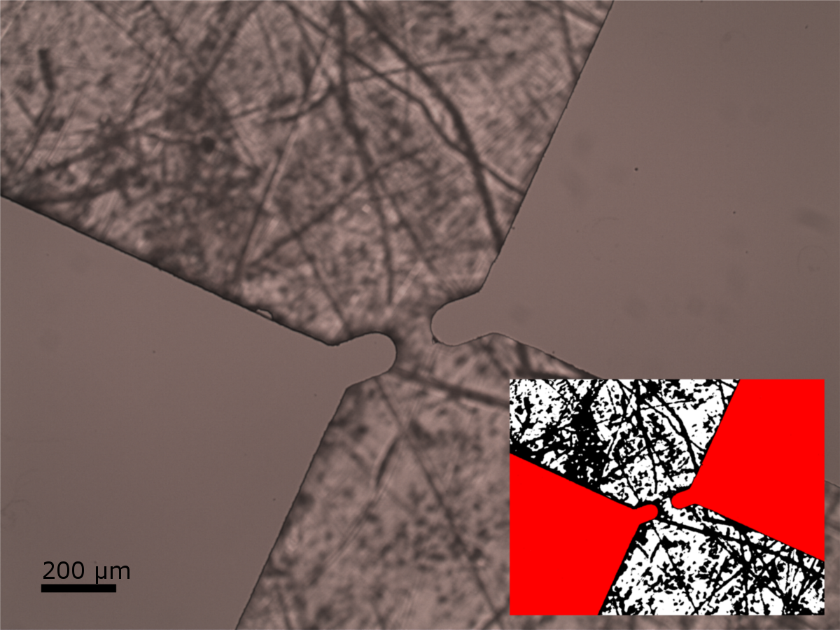
Figure 5: Electrode Pair Tip Detail
Detail of electrode pair tips, with gap separation of 100 µm. The electrodes (platinum/chrome bilayer) are highlighted in red (insert). The photograph is made by placing the coverslip on a fibrous background material to provide contrast.

Device Mount

Earlier work incorporated coverslip mounts that relied on hand manipulation for alignment. [89] Due to the lack of a precision mask aligner in our laboratories, the electrode pairs are not perfectly aligned with the diagonal of the coverslip, nor are they precisely centered. This deviation is typically less than 0.5 mm, but the tendency of two coverslips separated by fluid is to align along their borders. In addition to alignment of electrode pairs relative to each other, the two coverslips must be kept at a fixed distance apart and aligned to the optical setup.
To address these issues, a custom device mount was designed in SolidWorks and manufactured on a hobby computer numerical control (CNC) mill out of black acrylic. The mount consists of a lower segment (housing the bottom electrode pair and frame) and an upper segment (top electrode pair). The lower segment (Figure 6) is attached to a three-axis translation stage that allows the entire device mount to be shifted with respect to the microscope objective. An electrode pair coverslip is attached to the objective port with the use of repositionable glue at the edges. The frame is a sandwich of cardboard (to provide structural integrity for the terminal connections), platinum wire (A-M Systems, 0.003” diameter), and steel shim stock (Shop-Aid stainless, 0.008”). The platinum wire not only provides electrical conductivity to the four electrodes, but also sets a minimum separation between the two glass coverslips. Note that the platinum wire is looped to provide simpler alignment and to reduce stress on the coverslips. The steel shim is directly connected to the platinum wire and provides a sturdy terminal for an external connector. The upper segment of the device mount is
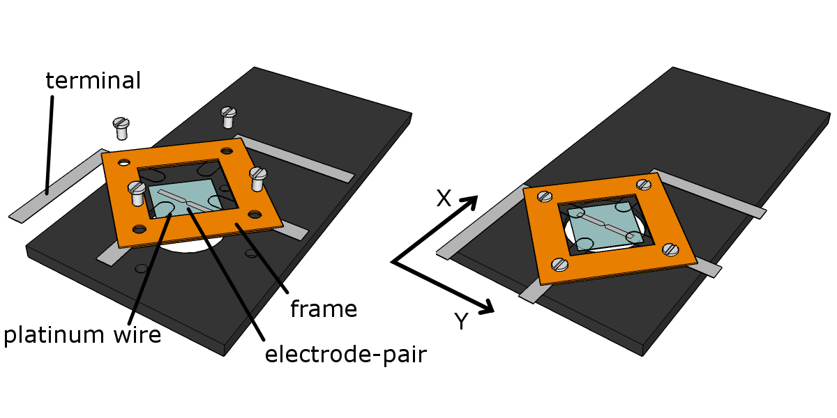
Figure 6: Lower Device Mount
Exploded (left) and assembled (right) view of lower device mount. This portion is mounted on a 3D translation stage that allows the lower electrode pair to be positioned with respect to the microscope objective below (not shown).

split into two parts — a smaller, three-axis translation stage, which moves with respect to the lower segment, and an insert (Figure 7), which allows inverted mounting of the top electrode pair coverslip. The top coverslip is attached with the same repositionable glue to a pedestal that hangs down from the upper mount.
The order of assembly for the device mount is as follows: First, mount the lower electrode pair coverslip onto the objective porthole of the lower segment. Next, mount the frame on the lower segment such that the platinum wire loops line up with the electrodes. Add water to the immersion objective; mount the lower segment on the three-axis translation stage. Then, attach the smaller translation stage to the lower segment, making sure that the pedestal insert is fully raised. Pipette a 40 µL drop of sample solution onto the electrode pair coverslip mounted on the lower segment (This covers an area of 18.4 mm diameter to 150 µm depth). Mount the second electrode pair coverslip on the pedestal and place it into the upper mount insert. Adjust the micrometers to bring the two layers together such that the solution contacts the surface of each coverslip. Align the bottom electrode pair with the objective, and then align the top pair with respect to the bottom. Finally, advance the two planes as close together as possible so that the electrodes contact the platinum wires, and use the micrometer to determine the center of the device.
Figure 8 shows the completed assembly. Complete assembly and disassembly takes only about 5–10 min. Note that there is limited exposure of the sample to outside air along the edges of the device (exposed area ~8.8 mm², which is only about 15% that of a spherical drop), which means that sample evaporation is slowed and is found to be insignificant over the duration of the experiments. Nevertheless, the sample is switched out at least every 30 minutes to reduce the possibility of changes in its composition.
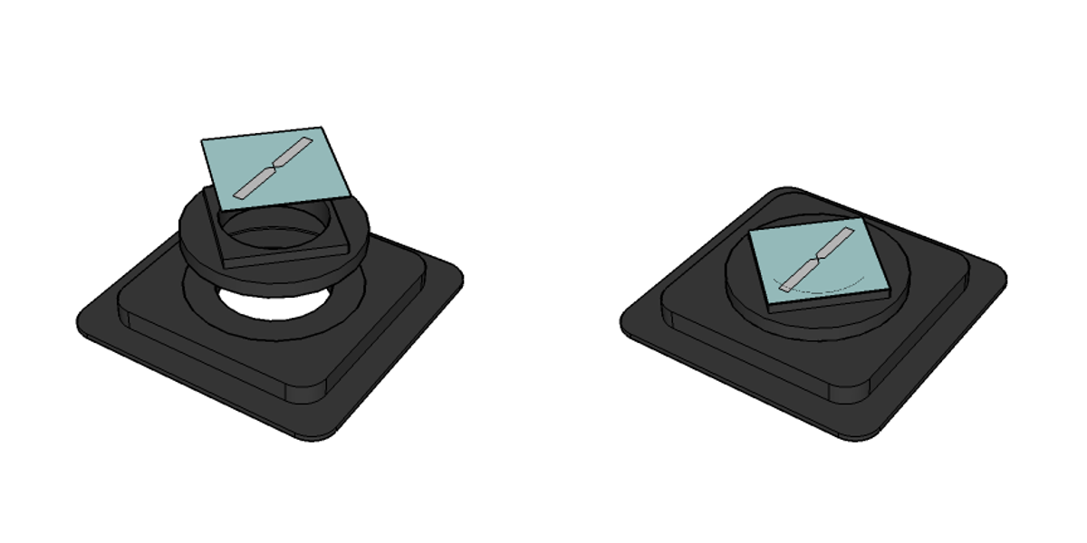
Figure 7: Upper Device Mount
Exploded (left) and assembled (right) view of upper electrode pair mounts. The assembled part will be oriented face-down in the device mount with the electrode pair perpendicular to the pair on the lower coverslip.

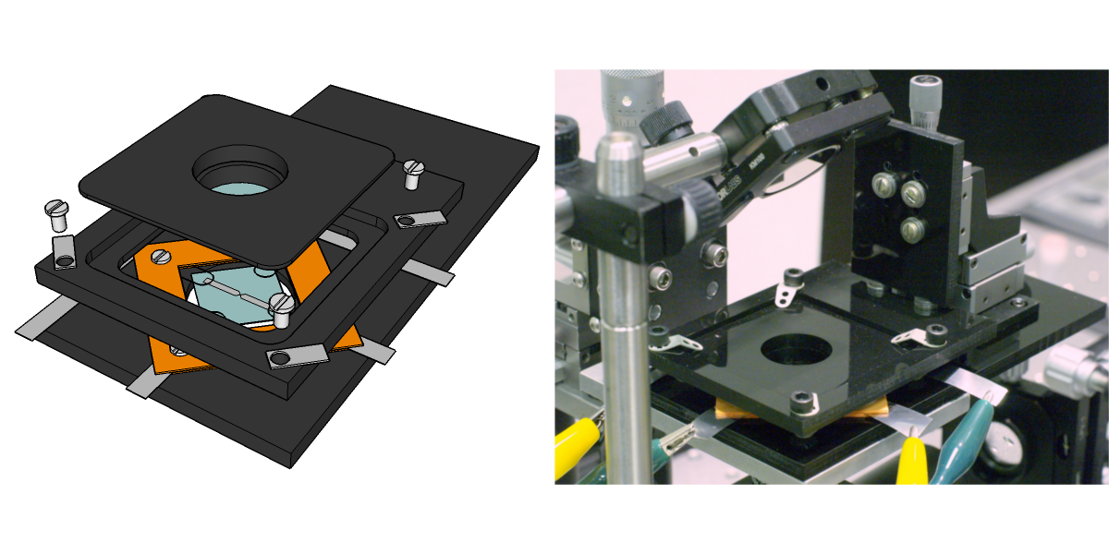
Figure 8: Assembled Device Mount
Schematic and photo of assembled device mount. Note that the photo shows electrical leads connected to the terminals on the frame. Additionally, the upper mount is attached to a 3D translation stage that allows for positioning of the upper electrode pair with respect to the bottom plane.

Optical Setup

3D trapping experiments are performed in a custom-built, forward-illuminated, inverted microscope (Figure 9) onto which the device mount detailed in the previous section is seated. The excitation source consists of a 660 nm diode laser module (Coherent, CUBE 660-60C, 55 mW) operated in continuous mode and spectrally filtered through an angle-tuned bandpass filter (Omega, 667BP5) and a short-pass filter (Omega, 3RD660SP). The 1.4 mm diameter laser beam is focused to a waist of 60 μm with a 200 mm effective focal length (EFL) lens to illuminate a wide field of the sample with an irradiance of ~730 W/cm², which is comparable to that used in typical single-molecule imaging experiments. Fluorescence is collected with a 1.2 NA (numerical aperture) water-immersion objective (Olympus, UPLSAPO 60XW) into a collimated beam, which is passed through two long-pass filters (Semrock, LP02-664RU-25 and Omega, 3RD670LP) to block the laser light. The fluorescence is then focused by a 100 mm EFL plano-convex lens (the microscope tube lens) so as to image an individual nanoparticle that is near the center of the four electrode tips. Note that the tube lens has been tilted 6° about the vertical axis to introduce a slight astigmatism to the PSF, which is imaged on a low-light CCD (Watec WAT-902H2 ULTIMATE EIA). The image is acquired with a National Instruments frame grabber (NI PCI-1407) under control of a LabVIEW virtual instrument (VI).

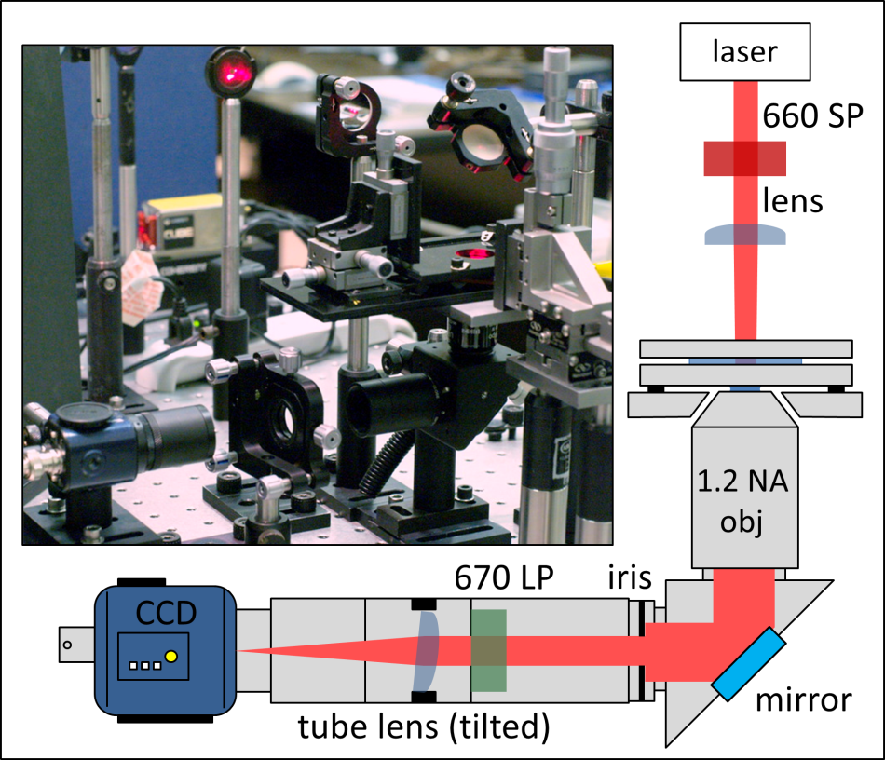
Figure 9: Optical Diagram
Photo and schematic diagram of the optical setup.

Sample Solution

All experiments were performed with a 20 fM solution of 40 nm diameter fluorescent polystyrene beads (Invitrogen, F8789, 660/680 FluoSpheres®) either in water or a 25% concentration glycerol/water mixture. The 20 fM concentration was chosen to limit the number of visible FluoSpheres® in the field of view. At this concentration, an average of ~1.2 beads will be visible in a sampling volume of 100×100×12 µm³, which roughly corresponds to the field of view bounded by the four electrode tips.
The polystyrene beads are carboxylate-modified, resulting in a highly charged, relatively hydrophobic, and somewhat porous surface layer. There are approximately 350 fluorescent dye molecules per bead, and the dye is completely encapsulated inside the bead. The excitation/emission curves are shown in Figure 10. [90, 91]
Temperature is a significant factor in determining diffusivity, mostly due to its effect on viscosity of the fluid. Unfortunately, temperature in the laboratory varies greatly from day to day, with a typical range of 23 ± 3°C. This this can have a significant effect on the viscosity (and therefore diffusivity). For example, at 21°C, the dynamic viscosities of water, glycerol, and 25% glycerol/water mixture are 0.98 Pa s, 1290 Pa s, and 2.00 Pa s, respectively. At 25°C the dynamic viscosities are µ_{w} = 0.89 Pa s, µ_{g} = 906 Pa s, and µ_{m} = 1.79 Pa s. [92] Care was taken to measure temperature during data collection. Calculations presented in this work are for standard ambient temperature and pressure values (SATP): P = 100 kPa and T = 25°C and may be adjusted for the measured temperature. For some experiments, glycerol was added to increase the viscosity of the solution and thereby decrease the diffusion coefficient of the FluoSpheres® by a factor of two (Figure 11). This was done to improve the initial trapping performance of the device, but single 40 nm FluoSpheres® in pure water were subsequently trapped with the current setup, as reported in the results section.

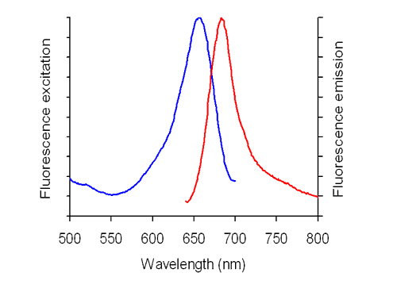
Figure 10: Excitation/Emission Dark Red FluoSpheres®
Excitation (blue) and Emission (red) spectra for 40 nm 660/680 FluoSpheres® Note that the diode laser detailed in Chapter II emits near the peak of the excitation curve (660 nm). Figure credit [91]

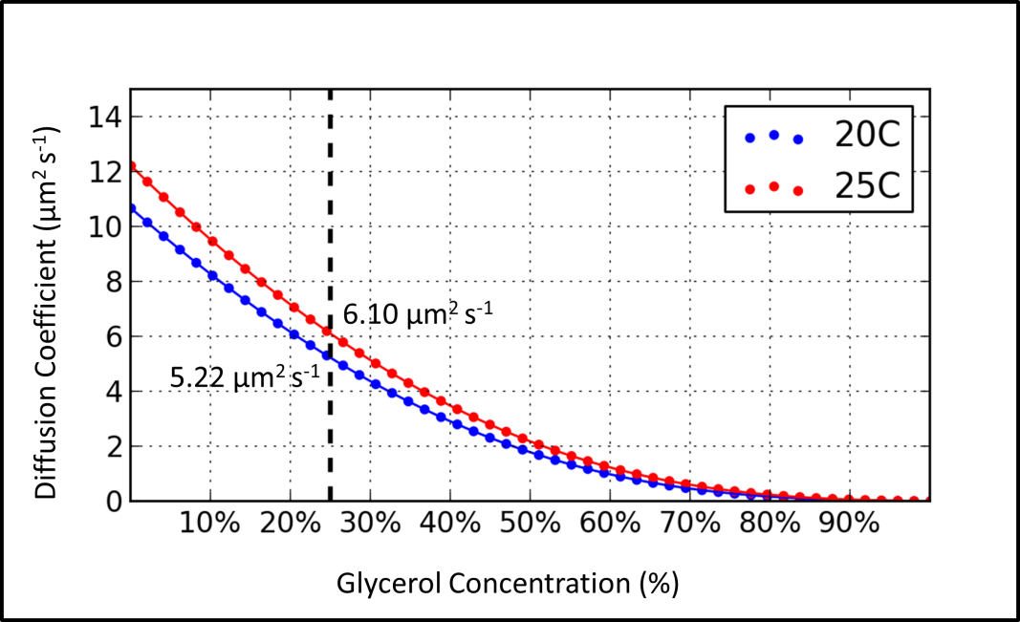
Figure 11: Calculated Diffusion Coefficient
Diffusion coefficient as a function of concentration (by mass) of glycerol for a 40 nm diameter sphere at 25°C. A 25% concentration corresponds to D = 6.10 µm² s⁻¹ (dashed line), or half the diffusion coefficient of a similar bead in pure water.

CHAPTER III
Methods and Results

In this chapter, the methods for tracking and trapping are detailed, followed by results from experimental runs. Through use of the introduced astigmatism, the axial position of the nanoparticle may be extracted from the eccentricity of the measured PSF. However, to provide useful real-time feedback for trapping, this process must be computationally fast and accurate. Therefore, a method of collapsing each image frame to quickly determine both the planar position and the shape of the PSF is presented, along with the necessary calibration to determine the axial position from the measured PSF shape. This calibration includes analysis of the planar (x,y) and axial (z) position measurement precisions, which are later used in simulations of the trapping experiments.
Trapping is accomplished by applying potential differences that vary linearly with the measured displacement of the nanoparticle from the center of the trap. A simulation is presented to investigate the role that latency between measurement and corrective motion plays in selecting optimum loop gain parameters. Another simulation defines a metric for trapping based on particle dwell time. These findings are applied to the physical experiment. Results for two trapping data sets, as well as diffusion and ROI movement, are presented and analyzed.

Tracking Algorithm
As mentioned above, to achieve trapping, the 3D location of the nanoparticle must be quickly determined from each acquired image frame. For this work, astigmatic imaging is used, but rather than taking the previously published approach of adding a very long focal length cylindrical lens to the detection path, [93-95] the 100 mm EFL microscope tube lens (Chapter II) is simply tilted by 6° about the vertical axis. With this tilt, the paraxial image plane is shifted 0.9 mm towards the lens and the overall magnification is slightly reduced from M = 33⅓ to M = 33. Modeling with optical design software (Zemax) [96] predicts that the tangential and sagittal image planes are displaced by ±0.5 µm from the paraxial image plane and that when the nanoparticle is axially displaced from the focal plane by z = +2 µm (or −2 µm), its image becomes defocused from a circular disk of radius 66 µm to form an elliptical image with semi-axes of 240 µm and 152 µm (or 152 µm and 240 µm) (Figure 12).
To achieve rapid analysis of each image, a smaller region of interest (ROI) is selected (typically 60×60 pixels) and all calculations are limited to the ROI to reduce computation time and possible confusion due to signals from any nearby particles. The ROI can be repositioned in software but is typically centered at the middle of the device where the electric field is most uniform. Following background subtraction, the rows and columns of the ROI are separately summed to form two 1D arrays representing pixel intensity along each individual axis, as shown in Figure 13.
These arrays are separately fit to Gaussians (LabVIEW Gaussian Peak Fit VI, nonlinear least-squares method) of the form
 | $$f\left(x\right)=A_{x}e^{-{{\left(x-x_{0}\right)}^{2}}/{2w_{x}^{2}}}+C_{x},$$ | (3.1)
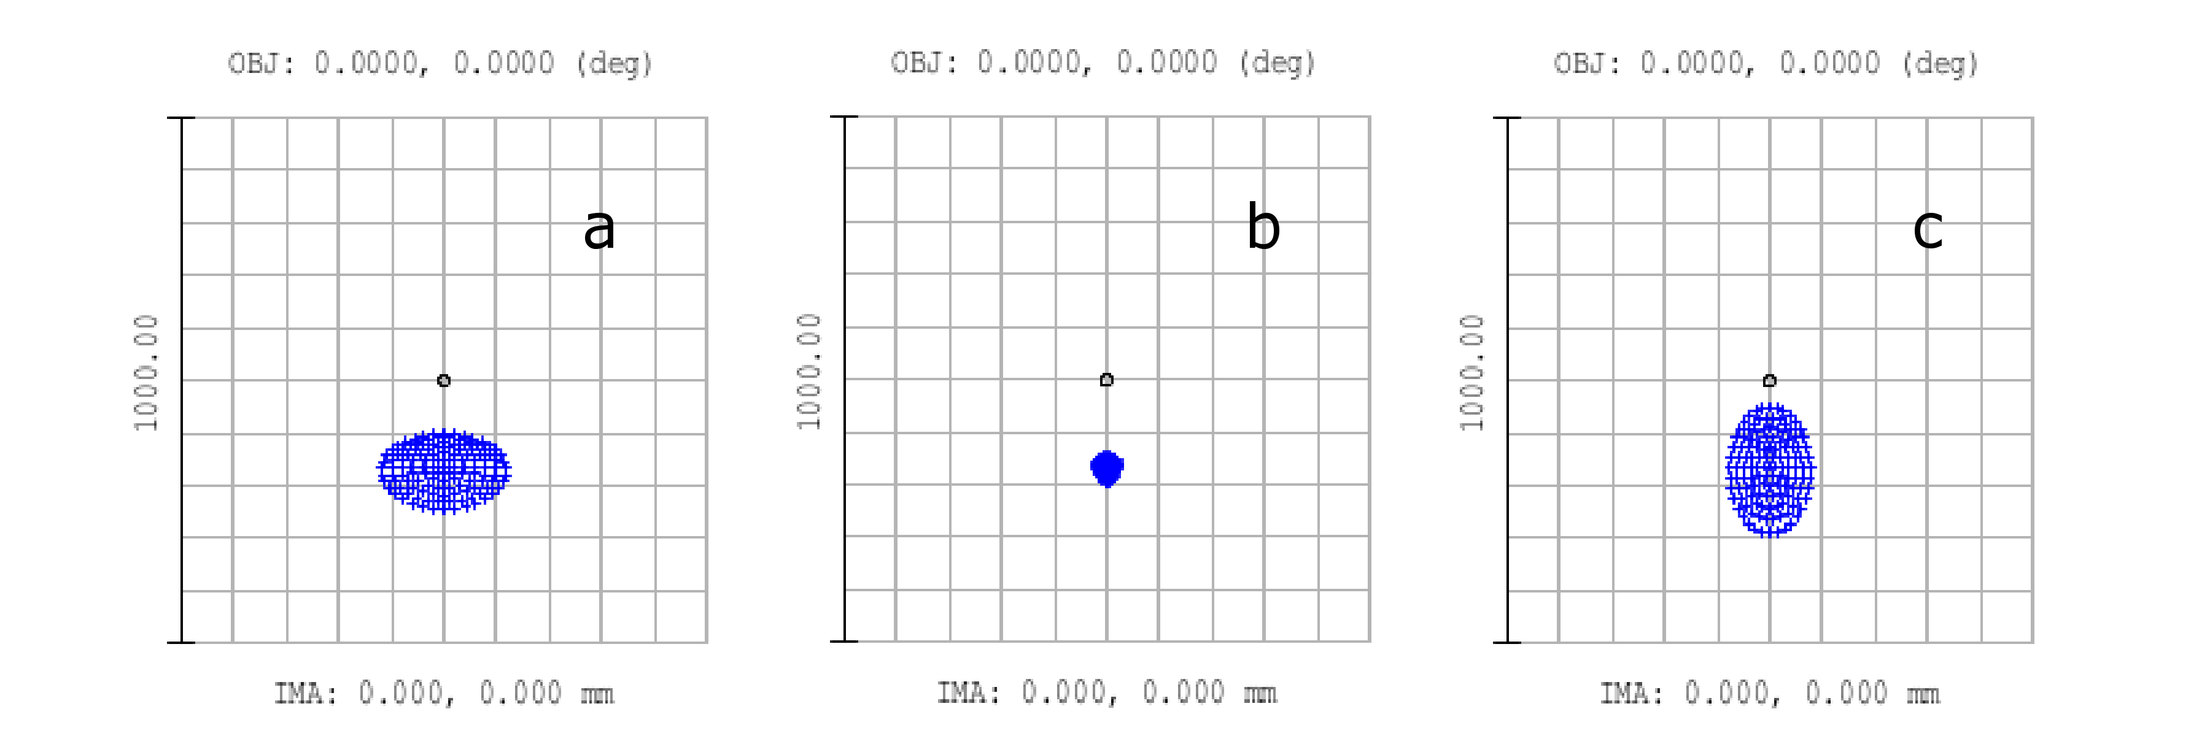
Figure 12: Zemax modeling of the PSF
PSF shape change in response to location of point source in the object plane: a) is at Z = −2 µm, b) Z = 0 µm, and c) Z = +2 µm where Z = 0 µm corresponds to the location of the circle of least confusion. The circle at the center represents the optical axis. The imaged spot is displaced from the optical axis because of the tilt of the tube lens.
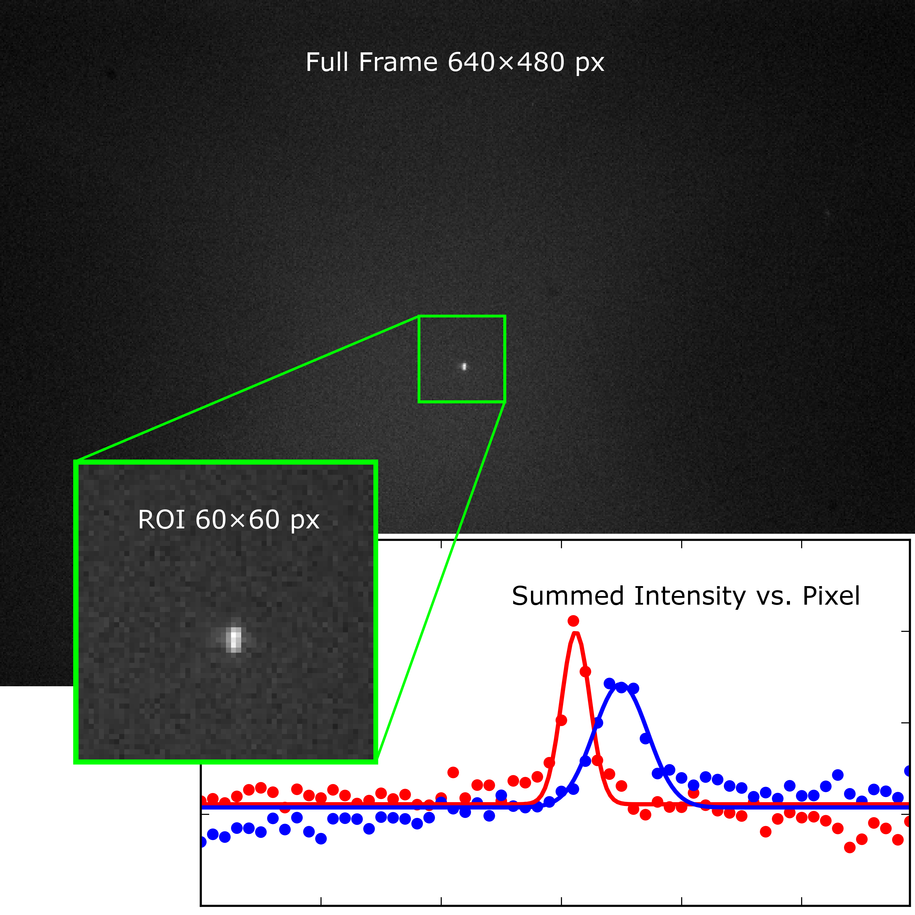
Figure 13: Collapsed ROI
A region of interest is extracted from the full frame and summed horizontally and vertically to form two 1D arrays, which are fit with Gaussians to extract the position and width of the PSF. Red represents the x-dimension, while blue represents the y-dimension.

 | $$f\left(y\right)=A_{y}e^{-{{\left(y-y_{0}\right)}^{2}}/{2w_{y}^{2}}}+C_{y},$$ | (3.2)
with adjustable amplitudes (A_{x},A_{y}), offsets (C_{x},C_{y}), centers (x₀,y₀) and widths (w_{x},w_{y}). In the event that the VI fails to fit the data (for example, due to an image with poor signal-to-background), all parameters are returned as zero. The x, y location of the nanoparticle is found from the centers $\left(x={\overline{S}}_{x}x_{0}, y={\overline{S}}_{y}y_{0}\right)$, where the scaling factors $\left({\overline{S}}_{x},{\overline{S}}_{y}\right)$are the average of the measured and calculated pixel-to-micron ratios:
 | $${\overline{S}}_{x}=\frac{1}{2}\left(\frac{l_{x}}{l_{y}}S_{y}+S_{x}\right), {\overline{S}}_{y}=\frac{1}{2}\left(\frac{l_{y}}{l_{x}}S_{x}+S_{y}\right).$$ | (3.3)
S_{x} and S_{y} depend on the optical magnification and are determined by measurement of the number of pixels spanning a fixed distance (the electrode pair gap, 100 µm) in the microscope (Figure 14). The camera has 480×640 rectangular pixels, each 9.8×8.4 µm², and the mounting orientation is such that the larger dimension is along the x-axis of the image, so $l_{x}=$ 9.8 µm and $l_{y}=$ 8.4 µm. This results in scaling factors of ${\overline{S}}_{x}=$0.335 µm px⁻¹ and ${\overline{S}}_{y}=$ 0.287 µm px⁻¹.
The axial location z is determined from the difference between the width in x and y. The difference is well-approximated as a quadratic function of the axial location:
 | $${Δw= w}_{x}-w_{y}=αz^{2}+βz+γ,$$ | (3.4)
which is inverted to find z. The parameters $\left(α,β,γ\right)$are determined through a calibration routine described in the following section.
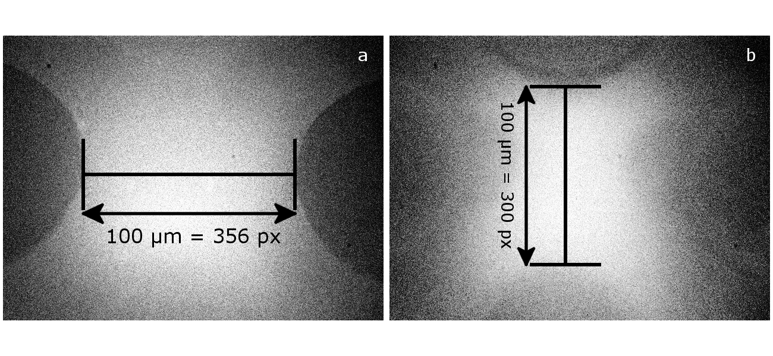
Figure 14: Scale Measurement
Images of electrode pair tips in the microscope setup: a) is the bottom pair used to determine S_{x}, and b) is the top pair used to determine S_{y}. The contrast has been modified to improve measurements. The focus has been adjusted between the two images.

Calibration

The calibration procedure consists of collecting and fitting a series of PSFs from a single immobilized fluorescent nanoparticle as it is translated by known distances in the object space of the microscope. This finds Δw for known values of z (Equation 3.4). Ideally, the nanoparticle should be immobilized in a medium with the same refractive index as the solution used in the trapping experiments, but as this is not possible, the calibration sample consists of fluorescent nanoparticles immobilized on the surface of a coverslip. Care is taken to reduce background from impurity species on the surface. All calibration sample preparation takes place in a Class 1000 cleanroom environment. Glass coverslips (Cole Parmer #1.5) are first cleaned using the technique detailed in Chapter II. Immediately after plasma cleaning, a 2 pM aqueous solution of 40 nm fluorescent latex beads (Invitrogen, F8789, 660/680 Fluospheres®) is pipetted onto the surface. The coverslip is then spun at 3000 RPM for 30 s to evenly coat the surface with solution and allowed to dry.
The calibration slide is placed on the inverted microscope with the nanoparticle surface face-up. The 3D translation stage is adjusted to position an isolated single nanoparticle in the ROI near the center of the image. Transverse (x, y) translation uses manual micrometers while axial (z) translation uses a motorized actuator (Newport, LTA-HS) with 0.1 µm minimum step size controlled by a custom LabVIEW VI. A preliminary scan is taken to approximately determine the axial position at which the image of the nanoparticle is focused best. At this point the PSF has minimum size and is circular. For an astigmatic imaging system, this round PSF is called the circle of least confusion (CLC). A 5-micron range scan in 300 nm steps centered about this axial position is then performed. At each step in this scan, 20 frames are captured. Following the procedure for extracting the position described in the previous section, the rows and columns of a 60×60 pixel ROI of each captured frame are summed into two arrays representing the integrated intensities along the x- and y-axes. The data sets in each pair of arrays are separately fit to 1D Gaussian functions plus an adjustable background offset to find the widths (w_{x}, w_{y}) and positions (x, y). This data is stored and the process is then repeated for multiple other single nanoparticles.
Visual inspection of the x- and y-widths of the PSF as a function of axial position near the focal plane (z ≤ 5 µm) suggests the use of a parabolic fitting function (Figure 15a). A Levenberg-Marquardt algorithm (scipy.optimize.curve_fit [72]) with a parabolic test function of the form w(z) = az² + bz + c is separately fit to the x- and y-widths. Note that should the fitting function fail, the data collection VI will return all zeros. These failure points are not considered in the fitting process, but the fraction of zeros to actual data points is noted to determine overall uncertainty. The difference between the x- and y-widths is taken:
 | $$w_{x}\left(z\right)=a_{x}z^{2}+b_{x}z+c_{x}{, w}_{y}\left(z\right)=a_{y}z^{2}+b_{y}z+c_{y},$$ | (3.5)
 | $$∆w=\left(a_{x}-a_{y}\right)z^{2}+\left(b_{x}-b_{y}\right)z+\left(c_{x}-c_{y}\right),$$ | (3.6)
 | $$∆w=αz^{2}+βz+γ,$$ | (3.7)
and the difference is inverted to derive z:
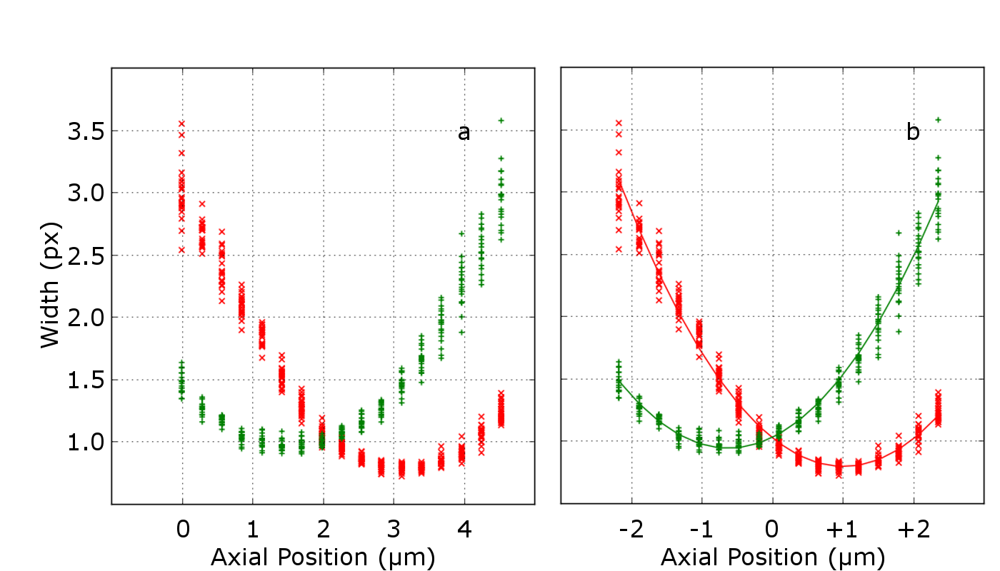
Figure 15: Nanoparticle Calibration Run
PSF widths (w_{x},w_{y}) as functions of axial position, z, for an individual nanoparticle calibration run: a) raw data with relative axial coordinates and b) parabolic fits for w_{x} and w_{y} used to center the axial position at the crossing point.

 | $$z\left(∆w\right)=\frac{-β-\sqrt{β^{2}-4αγ'}}{2α}, γ^{'}=γ-∆w.$$ | (3.8)
(Note that the solution for the positive root returns a non-physical result.)
Due to slight variations in the absolute axial positions of different fluorescent beads (possibly due to limited repeatability of the motorized actuator or the coverslip not being exactly flat), datasets from the different nanoparticles must be re-centered about an absolute zero before global fitting can take place. Setting $∆w$to zero allows for the axial position of the CLC to be calculated for an individual data set. This value of z is then subtracted from every axial position to re-center the dataset at z = 0 (Figure 15b). The process is repeated for each nanoparticle, and all the re-centered data points are grouped into a superset (~10,000 points). Starting with the same test functions described in Equation 3.5, the superset of data is fit, yielding α = 26 nm⁻¹, β = –750, and γ = 8 nm. Using the inverted function given in Equation 3.8, we now have a function for the axial position in terms of x- and y-widths.
As previously mentioned, it would be preferable to immobilize the FluoSpheres® in a medium with the same index of refraction as the experimental sample. As no suitable medium was found, dry coverslips with FluoSpheres® immobilized on the surface were used for the calibration measurements. The question arises, is a scaling factor necessary to compensate for the different refractive indices of air and solution when comparing calibration measurements from a dry sample with the trapping experiments in which the particle is
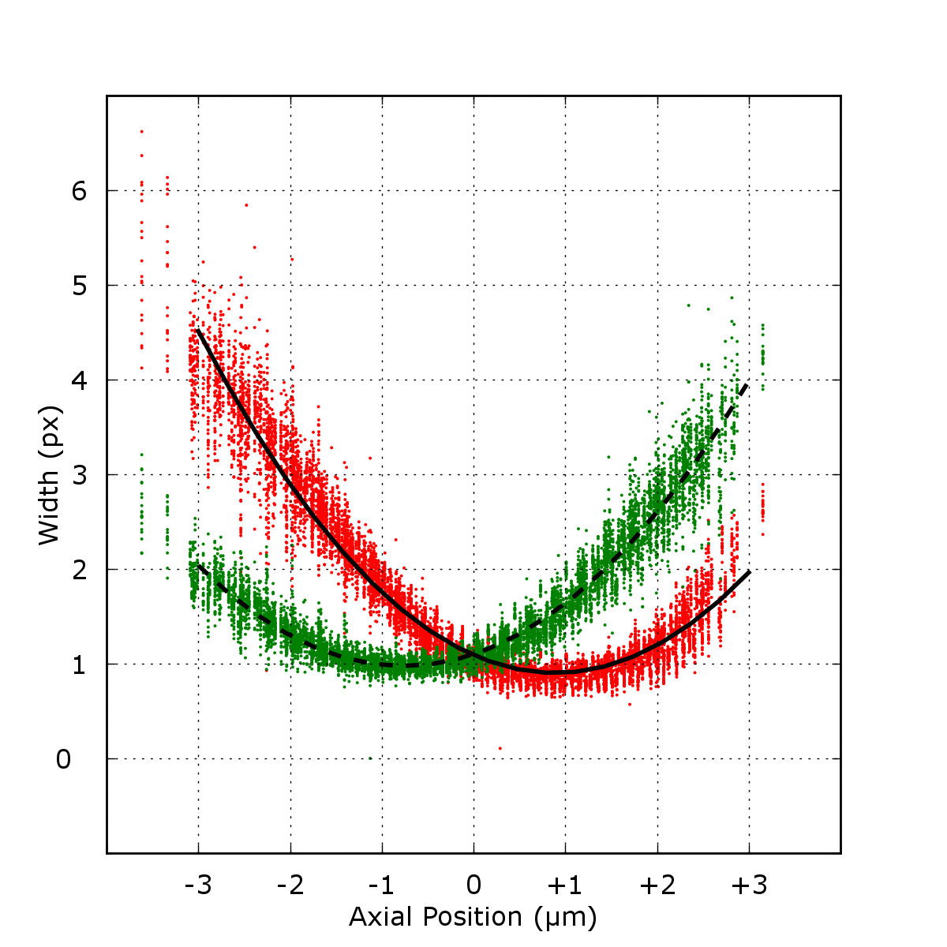
Figure 16: Global Fit
Global widths and fits in x and y as functions of axial position, z. w_{x} is represented in red/solid and w_{y} is in green/dashed.

immersed in solution? With a water immersion objective, when the height of the coverslip is adjusted, the thickness of the immersion fluid self-adjusts; hence the thickness of the immersion water on the microscope objective during the calibration measurement is equal to the thickness of the immersion water on the microscope objective added to the height of the nanoparticle from the glass surface during the trapping experiment. The index of refraction in the sample solution is slightly higher than the index of refraction of the immersion water, but at 25% glycerol concentration, the difference is only ~2%. [97] This is well within the limits of the axial position precision and as a result, may be ignored. Thus, a compensatory scaling factor is not necessary.
By determining the standard deviations in measured values for nanoparticles in a fixed position from image to image, we can quantify the precision of x-, y-, and derived z-position measurements. First, in examining planar measurements, we can see that the x- and y-positions are affected by the axial position (Figure 17a). In order to calculate the precision of measurements from the entire data set of all nanoparticles, the data for individual nanoparticles must first be converted to relative coordinates in axial and planar positions. Just as the axial position of the CLC varied between nanoparticles, the planar position was also not fixed in the precise center of the ROI. This can be seen by overlaying data from different nanoparticles that have been corrected for axial position only (Figure 17b). To convert the planar position to relative coordinates, the means of the x- and y-measurements in each nanoparticle dataset are subtracted from the respective positions. As a result, the global datasets of x- and y-positions are much more
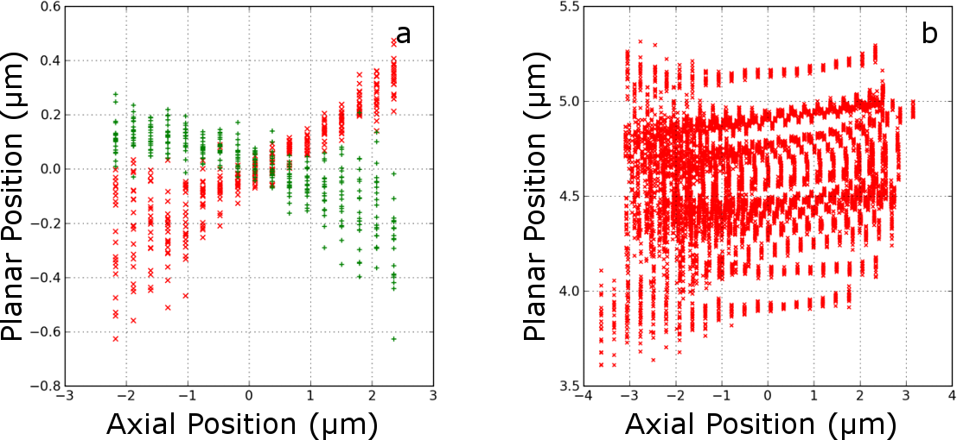
Figure 17: Planar Position
a) Planar (x,y) position measurements in response to axial (z) displacement. The red and green data points represent x- and y-position measurements, respectively. b) x-position measurements for various nanoparticles corrected for axial position only.

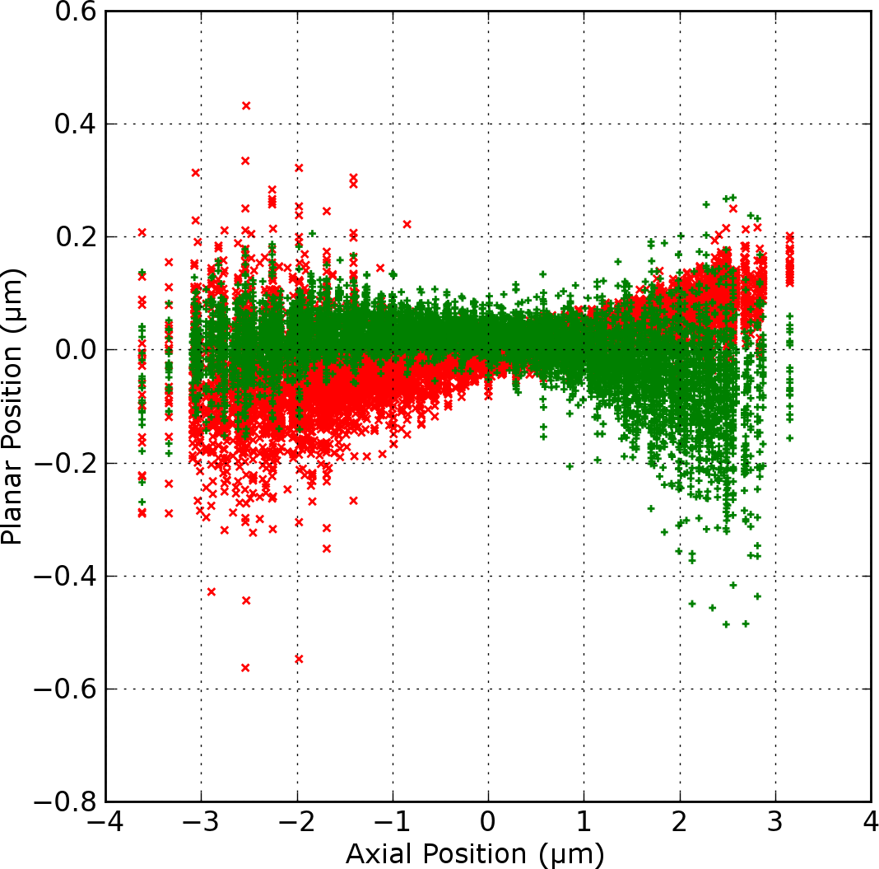
Figure 18: Global Planar Position
Superset representing all planar (x — red, y — green) measurements for different nanoparticles corrected for both axial and planar displacements.

uniform (Figure 18). The data is then split into 40 distinct bins and the standard deviation of position measurements in each bin is calculated.
The results of the preceding analysis indicate that the errors in planar measurements have a parabolic dependence on axial position (Figure 19a). Using fitting functions w_{i}(z) = a_{i}z² + b_{i}z + c_{i}, i = x, y, the fit parameters for the standard deviations in x are a_{x} = 7.0 nm⁻¹, b_{x} = –12, c_{x} = 29 nm, and for y, a_{y} = 7 nm⁻¹, b_{y} = 9, and c_{y} = 20 nm. The calculated minimum errors of σ_{x} and σ_{y} are 24 nm and 17 nm, respectively. The difference in precision between x and y measurements is mostly a result of the non-square pixel shape.
The axial precision was determined in a similar manner, with the transformation to relative coordinates in z. Instead of a directly measured coordinate, axial position is calculated from the parameters of the global fit discussed above. The calculated axial positions are then separated into 40 distinct bins and the standard deviation in each is calculated. These results also indicate that the error in axial determination has a parabolic dependence on the axial position (Figure 19b), albeit an order of magnitude larger than that for planar measurements. With the same parabolic fitting function we obtain a_{z} = 54 nm⁻¹, b_{z} = 15, and c_{z} = 173 nm, yielding a minimum error of 172 nm. This much larger value is to be expected, as the axial position is a calculated quantity derived from two indirect measurements (the x- and y-widths) and their associated uncertainties.
In summary, when a single image of the PSF from a fluorescent nanoparticle in solution is recorded during a trapping experiment, the 2D image in the ROI is
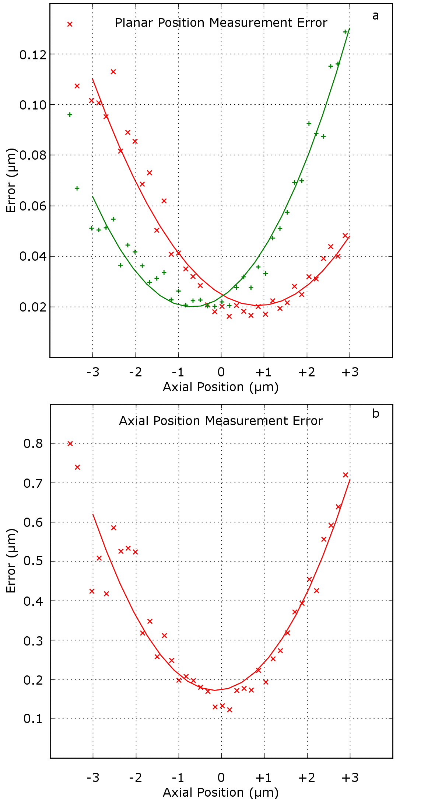
Figure 19: Error Measurements
Error analysis of a) planar (x — red, y — green) and b) axial (z) measurements as functions of z.

collapsed into two 1D arrays, which are separately fit to Gaussian functions. Taken together with the scaling factors ${\overline{S}}_{x}$ and ${\overline{S}}_{y}$, the centers of the fitted Gaussians give the x- and y-coordinates of the nanoparticle. The difference in the two fitted widths gives the z-coordinate by use of Equation 3.8, with the values of α = 26 nm⁻¹, β = –750, and γ = –8 nm determined from the calibration experiments described above. These x, y, z coordinates are determined to a statistical precision of σ_{x}, σ_{y}, σ_{z}, where
 | $$σ_{x}\left(z\right)=\left(7{ nm}^{-1}\right)z^{2}-12z+29 nm,$$ | (3.9)
 | $$σ_{y}\left(z\right)=\left(7{ nm}^{-1}\right)z^{2}+9z+20 nm,$$ | (3.10)
 | $$σ_{z}\left(z\right)=(54{{ nm}^{-1})z}^{2}+15z+173 nm.$$ | (3.11)
Although knowledge of the statistical precision is not needed for implementation of trapping, it is useful for simulations to accurately model the trapping experiments to determine the major limitations.

Trapping Algorithm

Once the 3D position has been determined, the appropriate potential differences can be generated to move the nanoparticle back towards the center of the ROI in x, y, and z. Image acquisition and analysis are performed on a single desktop computer running Windows XP using a program written in LabVIEW 2012. The computer contains a frame grabber (National Instruments PCI-1407) and a reconfigurable input/output card (National Instruments PCI-7833R). The 7833R has eight analog outputs with 16-bit resolution in the range ±10 V for a voltage resolution of ~0.3 mV. Four of these outputs are used to provide individual control of the voltage with respect to a common ground to each of the four electrodes in the microfluidic device (V₁, V₂, V₃, V₄). For ideal alignment of the device, the tips are located at P₁ = (–d, 0, –d/$\sqrt{2}$), P₂ = (+d, 0, –d/$\sqrt{2}$), P₃ = (0, –d, +d/$\sqrt{2}$), P₄ = (0, +d, +d/$\sqrt{2}$), where d = 50 µm. To produce a field at the origin along the +x (or +y) direction, a potential +V_{x} (+V_{y}) is applied to P₁ (P₃) and –V_{x} (–V_{y}) to P₂ (P₄) with respect to the common ground, whereas to generate a field along the +z direction, +V_{z} is applied to P₁ and P₂ and –V_{z} to P₃ and P₄ with respect to the common ground. For simplicity, the motion induced by these fields is assumed to be decoupled along each axis for positions close to the origin. Additionally, the electrokinetic speed of a nanoparticle near the center of the trap is assumed to be linear with the applied potential differences across the electrodes but possibly different along each axis. Hence, three user-specified response parameters R_{x}, R_{y}, R_{z} adjust the applied potentials with respect to the common ground for the measured location (x, y, z) of the nanoparticle, such that V_{x} = R_{x} x, V_{y} = R_{y} y, V_{z} = R_{z} z. The calculated potential differences from the common ground are linearly combined to produce a field of arbitrary direction and magnitude. For example, to produce a field at the origin given by (V_{x} /d, V_{y} /d, V_{z} /d), the potentials with respect to ground applied to the electodes are: V₁ = –V_{x} – V_{z}, V₂ = V_{x} – V_{z}, V₃ = –V_{y} + V_{z}, and V₄ = V_{y} + V_{z}. These voltages are applied for the duration of a frame (~33 ms) to move the nanoparticle towards the center of the ROI.
In addition to automated trapping, the LabVIEW VI allows the user to control the voltages directly through a USB joystick. V_{x} and V_{y} are mapped to vertical and horizontal motion of the joystick, while V_{z} is mapped to the rotational axis of the joystick. While the LabVIEW VI is running, the image from the CCD is displayed in real time, so direct joystick control allows the user to locate and steer single nanoparticles into the ROI. Once placed, trapping and data collection may be activated by the on-screen GUI or trigger button on the joystick.
In the ideal scenario, the measurement of nanoparticle position would be instantaneous and followed by immediate and full correction to return the nanoparticle to the origin. However, latencies (i.e., time delays) primarily due to CCD image acquisition and readout result in a delayed response. To complicate matters, the camera produces an alternating video signal composed of even and odd fields that are combined at the frame grabber into a single image. As a result, the measured position is effectively an average corresponding to the position at the midpoint between the two 10 ms exposures, as shown in Figure 20a-b. After readout of each field (16.7 ms/field) is complete (Figure 20c-d), the image becomes available in the system memory of the computer and may then be accessed by the LabVIEW VI. This VI runs a timed loop to acquire the most recent full image at 33 ms intervals. It then analyzes the ROI to determine the nanoparticle position, calculate appropriate voltages as described above, and apply them with respect to the common ground to their respective electrodes (a combined processing time of ~2 ms, Figure 20d). These voltage values are maintained until they are next updated, at the same 33 ms intervals.
To determine the effective latency, one may assume that the motion occurs at the midpoint of this interval (Figure 20f). The latency is the mean delay between the CCD exposure from which the position measurement is made (the midpoint between exposures) and the application of the voltage for electrokinetic correction (the midpoint of voltage application). The latency as illustrated in Figure 20 is at least 48.7 ms (13.3 + 16.7 + 2 + 16.7) but could be more due to random delays associated with the operating system that are not readily quantifiable. This overall delay between position measurement and motion correction is thus significant and remains the major obstacle to trapping of smaller nanoparticles with much higher diffusivities.

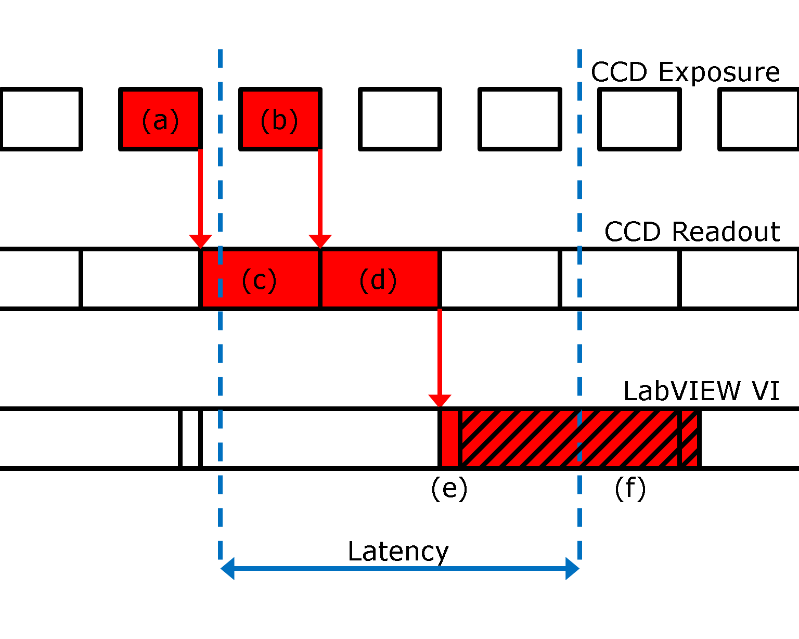
Figure 20: Trapping Latency
Detail of timing for a) exposure of odd lines (10 ms), b) exposure of even lines (10 ms), c) readout of odd lines (16.7 ms), d) readout of even lines (16.7 ms), e) analysis of the last full image frame (~2 ms), and f) application of voltage until the next analysis is completed (33 ms).

Simulations of Trapping and Free Diffusion

Control theory shows that lag will make proportional control unstable if the gain is too large, even in a first-order system. [98] In the case of the 3D electrokinetic trap, the bulk of the lag is due to the relatively slow frame rate of the Watec camera, so with the existing camera, the proportional control must be reduced below what would be considered “ideal”. To investigate the effects of this latency on selection of the response parameters (R_{x}, R_{y}, R_{z}), a simulation was developed in Python. [72]
Detailed in Figure 21, the main loop simulates the diffusion of a single nanoparticle in 3D, with 100 µs time resolution. For a 40 nm diameter FluoSphere®, this time corresponds to a root-mean-square step size of ~35 nm. The simulation begins with a particle at the origin. A second loop represents the CCD exposure step, updating the measured position every 33 ms. This measured position is the true position of the diffusing nanoparticle at that time plus Gaussian-distributed random numbers to account for the measurement error (modeling the measurement precision derived in the calibration section). A delay representing lag between position measurement (midpoint of exposures) and motion correction (midpoint of voltage application) is added to the current time and stored in a First In, First Out (FIFO) buffer. A conditional statement representing the motion correction step monitors the oldest timestamp in the FIFO buffer, and when the current time matches, the timestamp and corresponding position measurement are removed from the buffer and corrective
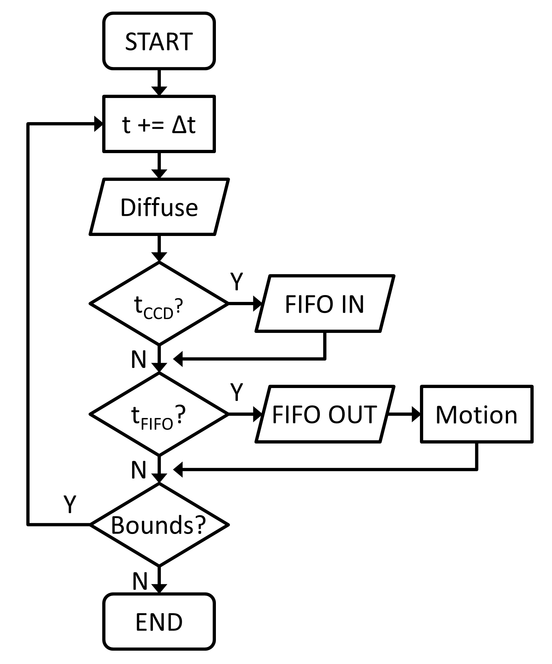
Figure 21: 3D Trapping Simulation Flow Diagram
Detail of 3D trapping simulation: For each iteration, the particle takes a diffusional step. After a number of iterations, when the time equals a multiple of t_{CCD} = 33 ms, the particle position is measured (overlaid with appropriate error) and added to the FIFO buffer. After an appropriate lag, the measured position is extracted from the FIFO buffer and used to calculate motion correction. The simulation will run until the particle exits the ROI or its dwell time exceeds 60 s.

motion takes place. The position measurement is scaled (loop gain factors κ_{x,} κ_{y,} κ_{z}) and applied to the true (current) position of the particle. The simulation will continue until the particle exits the ROI (20×17×12 µm³) or the simulation time exceeds 60 s.
For a parametric study of the experiment, this simulation is run for varying loop gain factors ranging from 0.05 to 1.00 in 0.05 steps. For simplicity, voltage response is assumed to be identical along each axis, such that κ_{x} = κ_{y} = κ_{z}. For each parameter set described above, 20 simulations are run (each with a different random number seed). To evaluate trapping performance, the average dwell time (time in the ROI) is measured and the position distribution in the ROI is calculated from the known true positions. These position distributions are well approximated by Gaussian functions, as shown in Figure 22. The widths of these Gaussians may be related to the effective spring constant of the trap by Equation 1.2. When the loop gain factors (κ_{x,} κ_{y,} κ_{z}) are set to unity, the particle is not trapped for long, because the latency of the response quickly results in instability. This is a result of the diffusion that occurs during the delay between position measurement and corrective motion. When the loop gain factors are set too low, the control is unable to compensate for diffusive motion, which eventually carries the particle out of the ROI. While an examination of the dwell times suggests successful trapping for a wide range of loop gain factors (0.2–0.7), as shown in Figure 23, a clear minimum position distribution width exists near κ_{x} = κ_{y} = κ_{z} = 0.5.
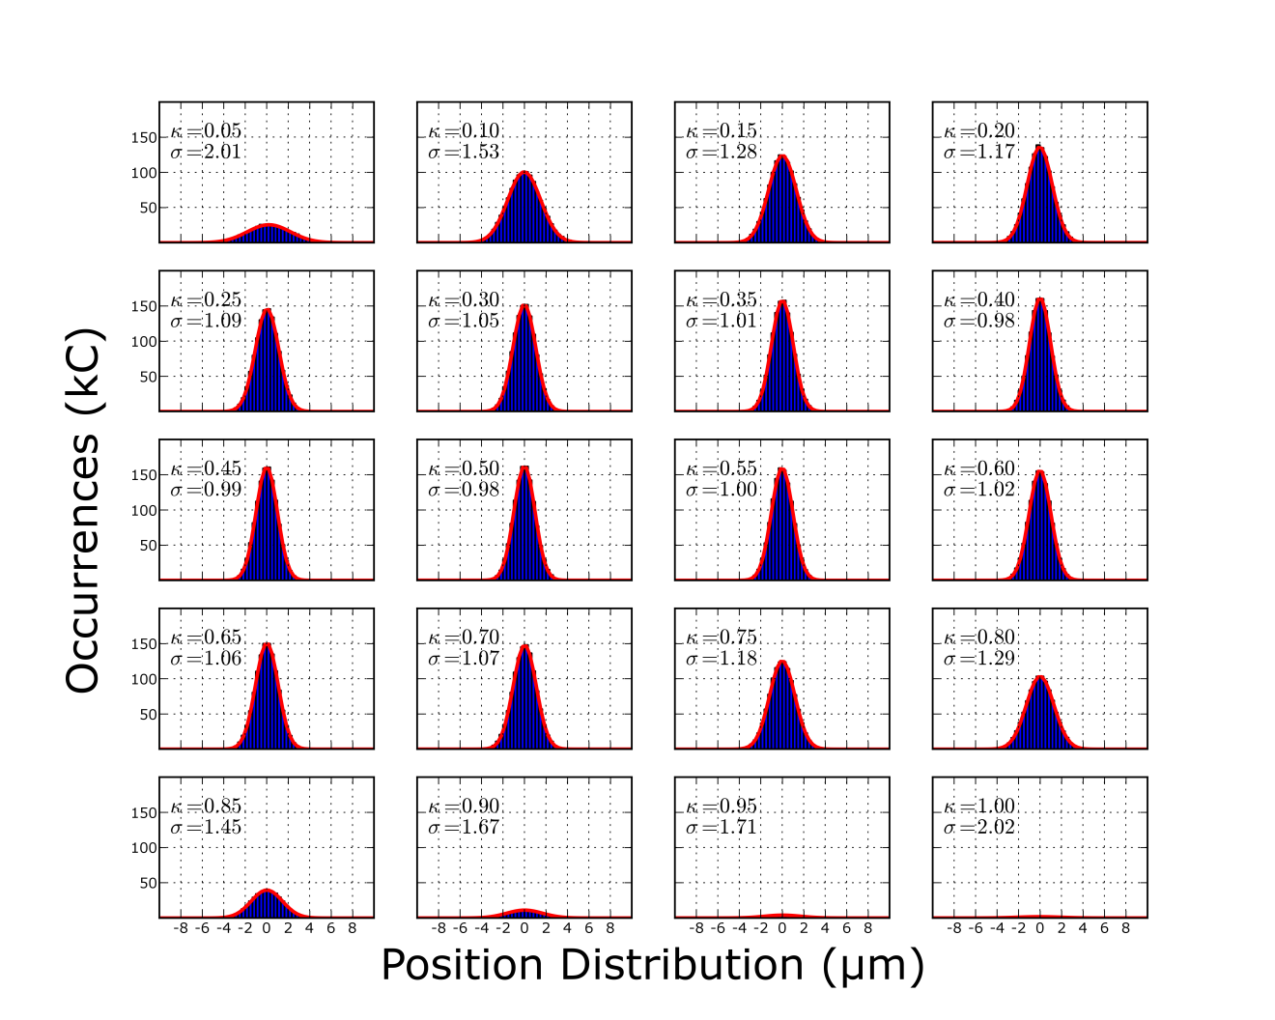
Figure 22: Simulation Position Distributions
Position distributions in x as a function of loop gain factor (κ). The width of each distribution (μm) is inversely proportional to the tightness of trapping and the amplitude reflects the average trapping time elapsed.

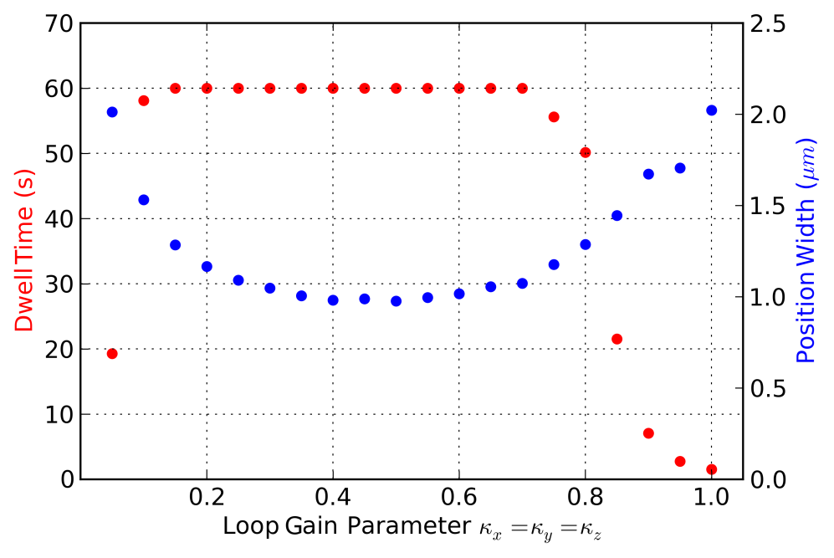
Figure 23: 3D Trapping Simulation Results
Dwell time (red) and position width (blue) simulation results for 3D trapping of a 40 nm FluoSphere® in 25% glycerol/water mixture for latency = 48.7 ms.

Although the simulated loop gain factors may not be translated into the physical response parameters discussed previously without a measurement of the electrokinetic mobility of the FluoSpheres®, this simulation shows that successful trapping should be attainable over a wide range of response parameters. Additionally, due to the latency from the Watec camera, these response parameters must be reduced from the values that would give full correction of the measured displacement.
Finally, in order to better understand trapping results, a simulation was developed in Python [72] to investigate the dwell times of a freely diffusing 40 nm sphere in pure water and in a 25% glycerol/water mixture, both at 25°C. The particle starts in the center of the ROI (20×17×12 µm³) and takes random steps in 3D with time resolution of 1 ms, corresponding to a root-mean-square step size of ~156 nm and ~110 nm for pure water and the glycerol/water mixture, respectively. Once the target has exited the ROI (or 60 s has passed), the time is recorded and a new particle is initialized at the origin. This process was repeated 10,000 times to build up histograms representing the frequency of various dwell times for a given diffusion coefficient. As shown in Figure 24, the mean dwell time of an object in water is 1.09 s with a standard deviation of 0.73 s. For the 25% glycerol/water mixture, the mean dwell time is 2.14 s with a standard deviation of 1.40 s. With these results, it is clear that a particle in water remaining in the ROI for longer than 3.62 s is very unlikely to be a result of random diffusion (< 1% probability). Similarly, a particle in a 25% glycerol/water mixture has a similarly low probability for staying in the ROI for longer than 7.06 s without being actively trapped.

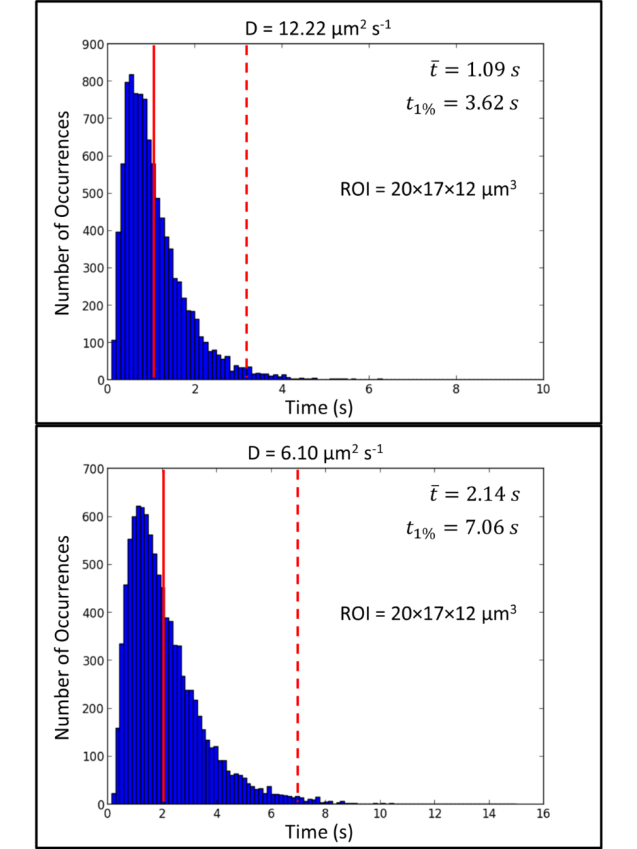
Figure 24: 3D Diffusion Simulation
Simulation results of the time required for a 40 nm FluoSphere® to diffuse out of a 20×17×12 µm³ ROI. Each histogram represents 10,000 runs, in pure water (top) and 25% glycerol/water mix (bottom). The solid red line represents the mean dwell time, while the dashed red line represents the time at which the probability of the target remaining in the ROI due to diffusion is less than 1%.

Trapping Capabilities
Consider now the trapping capabilities of the current setup. Given a fixed sampling rate ($f=30$ Hz) and ROI (20×17×12 µm³), we may estimate the smallest trappable object. The limiting dimension is clearly along the axial dimension, so let us examine the probability density function of a particle diffusing in 1D:
 | $$P\left(z\right)dz=\frac{1}{\sqrt{2π}σ}e^{{-z^{2}}/{2σ^{2}}},$$ | (3.13)
where $σ=\sqrt{2D∆t}$ and $∆t=\frac{1}{f}$. We can calculate the probability that the particle is in the ROI ($\left|z\right|<z_{max}$) after $∆t$, given that it starts at the origin,
 | $$P_{0}=\int_{-z_{max}}^{z_{max}}{P\left(z\right)dz}=\frac{1}{\sqrt{2π}σ}\int_{-z_{max}}^{z_{max}}{e^{{-z^{2}}/{2σ^{2}}}dz},$$ | (3.14)
 | $$P_{0}=erf\left(\frac{z_{max}}{2\sqrt{D∆t}}\right),$$ | (3.15)
where erf(z) is the Gaussian error function. Of course, we are really interested in trapping a nanoparticle for longer than a single frame. If the trapping control is perfect, so that the particle is returned to the origin following each position measurement, we may calculate the probability it remains trapped after n measurements in the following manner:
 | $$P_{trap}=P_{0}^{n}={\left[erf\left(\frac{z_{max}}{2\sqrt{D∆t}}\right)\right]}^{n},$$ | (3.16)
where $n=\frac{t_{trap}}{∆t}$. We define successful trapping to occur when the probability to hold a nanoparticle for an order of magnitude longer than the mean dwell time ($t_{trap}=10t_{diffuse}$, where $t_{diffuse}=\frac{z_{max}^{2}}{2D}$) exceeds 50%, or
 | $$0.5< {\left[erf\left(\frac{z_{max}}{2\sqrt{D∆t}}\right)\right]}^{{10z_{max}^{2}}/{2D∆t}}.$$ | (3.17)
Solving numerically for $z_{max}=$ 6 µm and $∆t=$ 1/30 s, we find that the maximum diffusivity to meet the criteria is $D=$ 82.6 µm² s⁻¹. From the Stokes-Einstein equation,
 | $$D=\frac{k_{B}T}{6πηr},$$ | (3.18)
where k_{B} is Boltzmann’s constant, T is the temperature, η is the viscosity of the solution, and r is the radius of particle, we find that this corresponds to a spherical object of radius 3.0 nm in water.
Rather than assuming perfect control, where the particle is returned to the origin after each measurement, it is more realistic to consider the scenario of imperfect control due to lag, where the initial position in each frame is described by a Gaussian-shaped position distribution, as in the 3D trap simulation. The probability density function would then be the convolution of this initial position distribution and the probability density function describing 1D diffusion in Equation 3.13:
 | $$P\left(z\right)dz=\frac{1}{\sqrt{2π}σ^{'}}e^{{-z^{2}}/{2σ^{'2}}},$$ | (3.19)
where $σ^{'}=\sqrt{σ_{0}^{2}+σ^{2}}$. In order to determine $σ_{0}$, a series of 3D trapping simulations were performed for increasing D values. Shown in Figure 25, there is a linear relationship between the square of the width of the position distribution and D. The probability of trapping after n measurements is then given by
 | $$P_{trap}=P_{0}^{n}={\left[erf\left(\frac{z_{max}}{\sqrt{2}σ^{'}}\right)\right]}^{n},$$ | (3.20)
 | $${P_{trap}=\left[erf\left(\frac{z_{max}}{\sqrt{2}\sqrt{(0.154 s)D+2D∆t}}\right)\right]}^{n}.$$ | (3.21)
Following the same conditions for successful trapping described above,
 | $${P_{trap}=\left[erf\left(\frac{z_{max}}{\sqrt{2}\sqrt{(0.154 s)D+2D∆t}}\right)\right]}^{{10z_{max}^{2}}/{2D∆t}}.$$ | (3.22)
As shown in Figure 26, the minimum object size trappable in water has a diffusivity of 17.5 µm² s⁻¹, corresponding to a sphere of radius 14.0 nm. This theoretical calculation of the minimum-sized particle that is trappable with the existing apparatus and latency of 48.7 ms is approximately consistent with experimental measurements presented in the following segment, where particles of radius 20 nm were trapped in water for an average time of 7.02 s, and up to 20.55 s. The theory presented above is also applied later in Chapter IV to provide an indication of the optimum performance that can be expected with improved position detection methods.

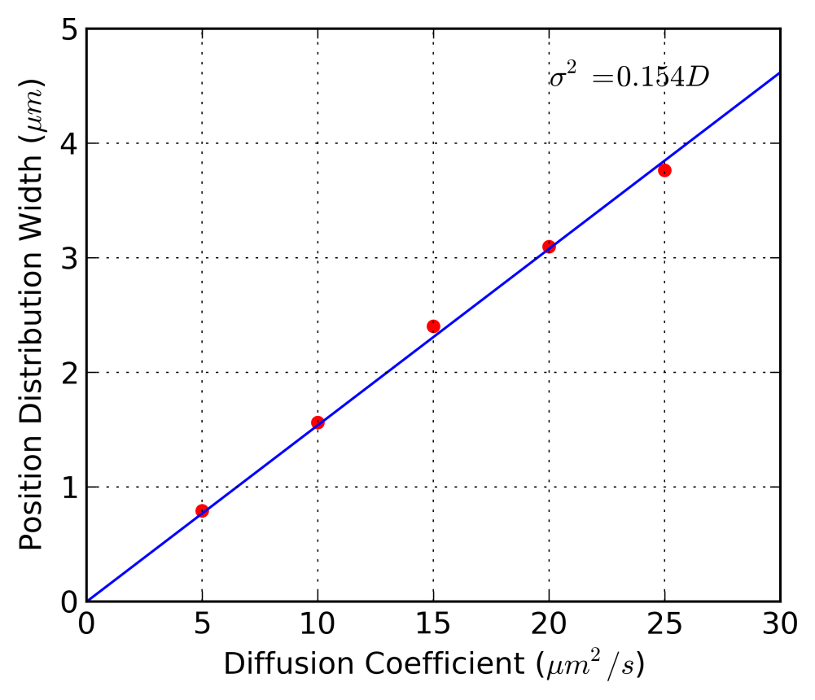
Figure 25: Initial Position Width in Response to Diffusivity
The relationship between the square of the width of the position distribution and the diffusivity of the trapped object, as calculated from a series of 3D trapping simulations (red points). There is a clear linear dependence (blue line) on D. These results are calculated for a latency of 48.7 ms.
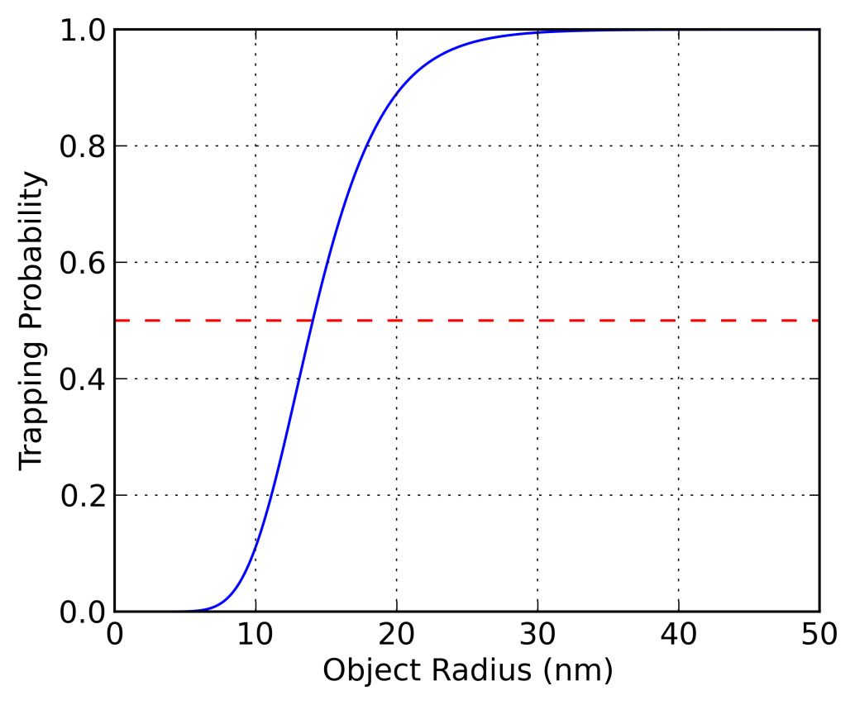
Figure 26: Trapping Capabilities
The probability of trapping a single nanoparticle in water for an order of magnitude longer than the mean diffusional dwell time as a function of object radius in the current setup. Successful trapping occurs when the probability exceeds 50% (dashed red line), which corresponds to an object radius of 14 nm.

Experimental Results

Trapping in 25% Glycerol/Water

This data set represents 52 instances of trapping of a single 40 nm fluorescent bead in 25% concentration glycerol/water mixture at 20°C. The response parameters used in this set of experiments were R_{x} = 200 mV µm⁻¹, R_{y} = 200 mV µm⁻¹, and R_{z} = 200 mV µm⁻¹. Note that these parameters were selected to give approximately the longest observed trapping times, but they are not fully optimized for the given latency. Optimization would require extensive measurements of the electrokinetic response along each axis, as explained in Chapter IV.
Figure 27 shows the measured nanoparticle position along each of the three axes as a function of time for a single run from the set. After 90 s, trapping is turned off and the nanoparticle diffuses out of the ROI. The position distribution over the 52 trapping instances is shown in Figure 28. From Equation 1.2, the effective spring constants are calculated as 2.4 and 2.8 nN/m in x and y, respectively. Although a double peak is evident in the z-position histogram, a Gaussian fit is used to estimate a lower bound of 0.6 nN/m for the effective spring constant in z. The double peak in z, which varies between device realignments, is most likely an effect of coupled motion exacerbated by non-ideal alignment and non-optimized response parameters, and will require further analysis of the electric field to address. [75]
Finally, the distribution of trapping times is shown in Figure 29. Without trapping, the 3D diffusion simulation predicts a mean diffusional dwell time of 2.53 s, with less than 1% probability of the bead remaining in the ROI after 8.40 s. All of the trapping instances in this experimental set exceeded the mean diffusional dwell time, and 87% exceeded the 1% probability line. 15 of 52 (29%) runs exceeded 25.3 s, which is an order of magnitude longer than the predicted diffusional mean dwell time.

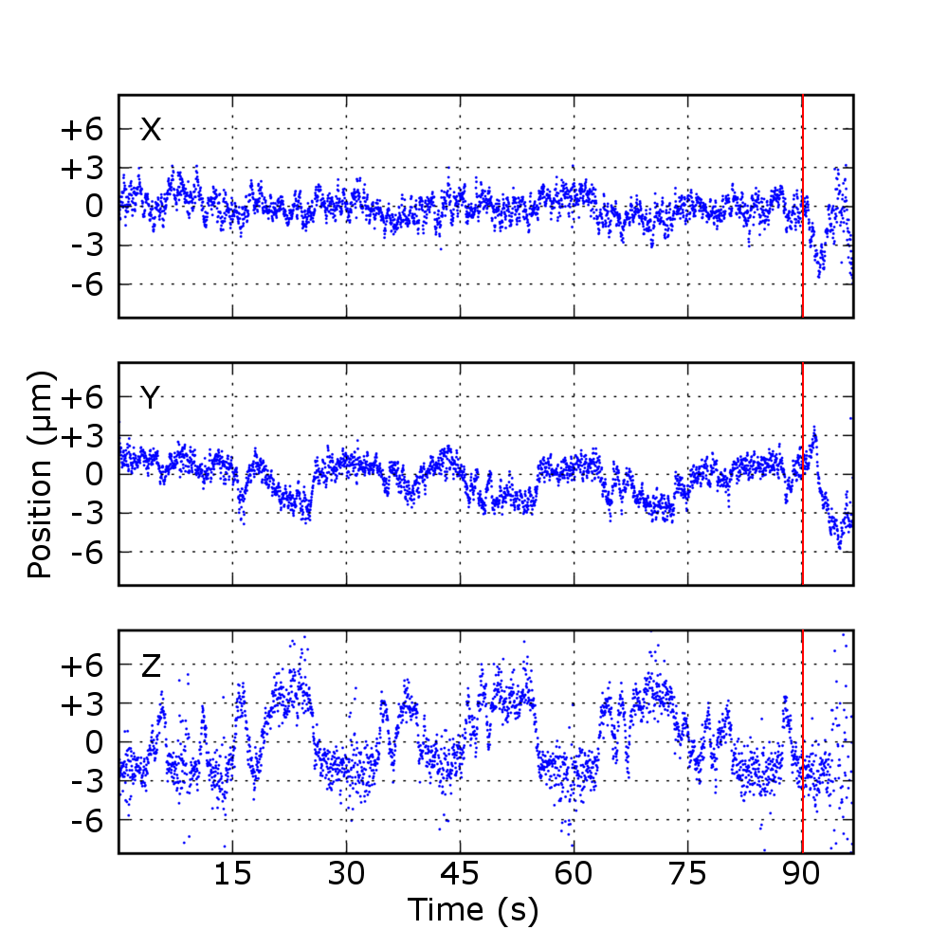
Figure 27: Trapping in Glycerol/Water
Trapped 40 nm fluorescent nanoparticle in 25% concentration glycerol/water solution. Background subtraction is used and the ROI is 20×17×12 µm³. The red line indicates when trapping is turned off and the particle is allowed to diffuse out of the ROI.

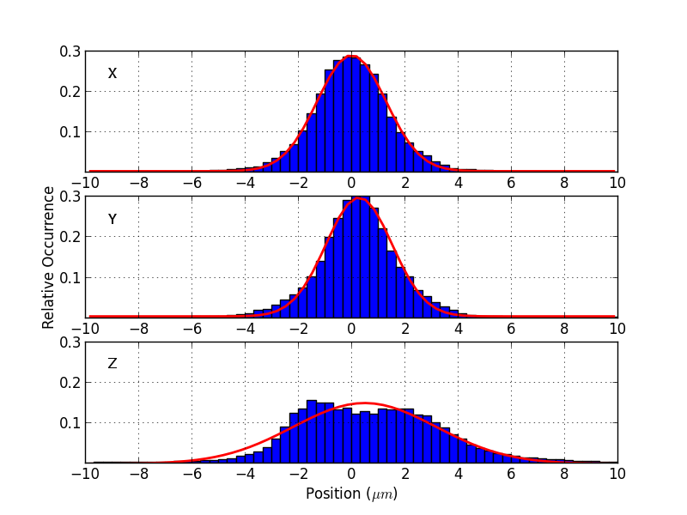
Figure 28: Glycerol/Water Position Histogram
Histograms representing position probabilities over 52 trapping instances. The red curves are Gaussian fits with σ_{x} = 1.3 µm, σ_{y} = 1.2 µm, σ_{z} = 2.7 µm, corresponding to effective trapping spring constants of 2.4, 2.8, and 0.6 nN m⁻¹.

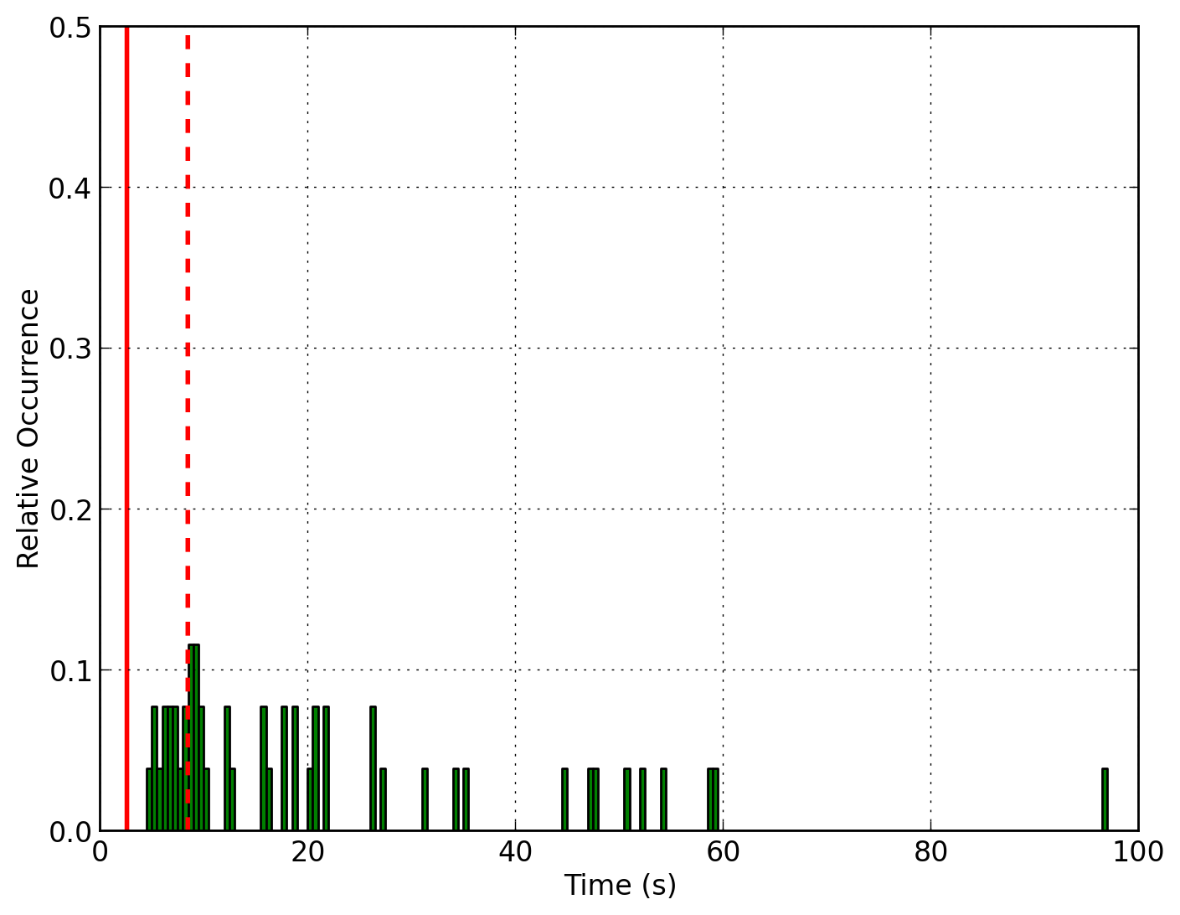
Figure 29: Glycerol/Water Time Histogram
Distribution of trapping times in glycerol/water solution. The solid red line represents the mean time for a particle of similar size to diffuse out of the ROI. The dashed red line represents the time at which there is less than a 1% probability of the target remaining in the ROI due to free diffusion. All trapping instances exceed the mean dwell time and 87% exceed the 1% line.

Trapping in Water

This data set represents 15 instances of trapping of a single 40 nm fluorescent bead in pure water at 19.5°C. The response parameters used in this set of experiments were R_{x} = 50 mV µm⁻¹, R_{y} = 50 mV µm⁻¹, and R_{z} = 50 mV µm⁻¹. Again, these parameters have not been fully optimized, but were chosen empirically to maximize observed trapping times. Figure 30 shows the measured nanoparticle position along each of the three axes as a function of time for a single run from the set. The nanoparticle escapes the ROI just after 20 s, likely a result of higher diffusivity (10.5 µm² s⁻¹) and choice of response parameter. The position distribution over the 15 trapping instances is shown in Figure 31. From Equation 1.2, the widths of the Gaussian fits (σ_{x} = 2.2 µm, σ_{y} = 1.8 µm, σ_{z} = 3.0 µm) may be used to calculate the effective spring constants along each axis (k_{x} = 0.8 nN m⁻¹, k_{y} = 1.2 nN m⁻¹, and k_{z} = 0.4 nN m⁻¹).
Finally, the distribution of trapping times is shown in Figure 32. Without trapping, the 3D diffusion simulation predicts a mean diffusional dwell time of 1.25 s, with less than 1% probability of the bead remaining in the ROI after 4.19 s. Again, all of the trapping instances in this experimental set exceeded the mean diffusional dwell time, and 75% exceeded the 1% probability line. 3 of 15 (20%) runs exceeded 12.5 s, which is an order of magnitude longer than the predicted diffusion mean dwell time.
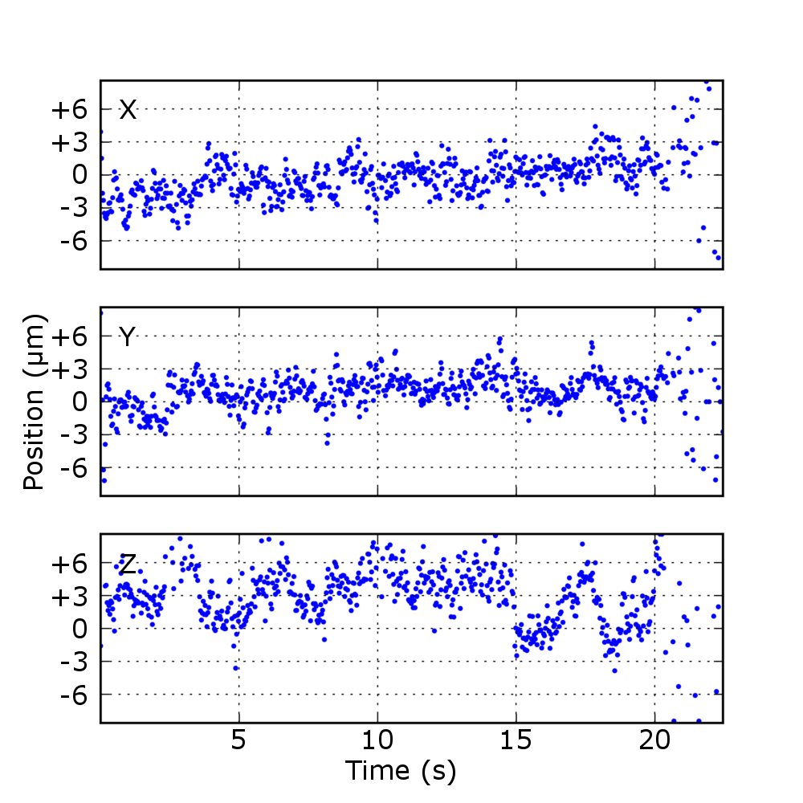
Figure 30: Trapping in Water
Trapped 40 nm fluorescent nanoparticle in water solution. Background subtraction is used and the region of interest is 20×17×12 µm³.

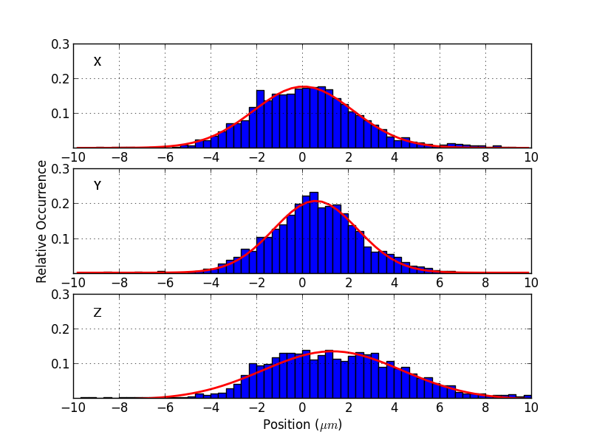
Figure 31: Water Position Histogram
Histograms representing position probabilities over 15 trapping instances. The red curves are Gaussian fits with σ_{x} = 2.2 µm, σ_{y} = 1.8 µm, σ_{z} = 3.0 µm, corresponding to effective trapping spring constants of 0.8, 1.2, and 0.4 nN m⁻¹.

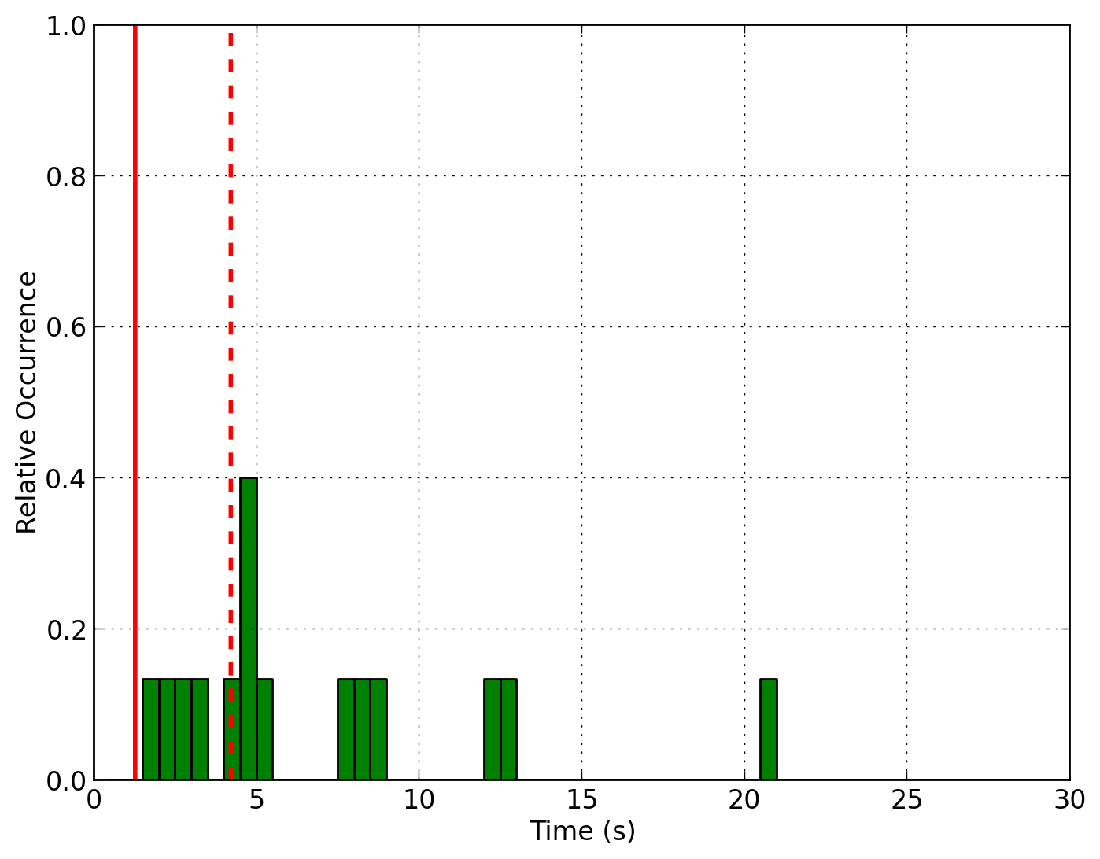
Figure 32: Water Time Histogram
Distribution of trapping times in water. The solid red line represents the mean time for a particle of similar size to diffuse out of the ROI. The dashed red line represents the time at which there is less than a 1% probability of the target remaining in the ROI due to free diffusion. All trapping instances exceed the mean dwell time and 75% exceed the 1% line.

Trap and Diffuse

The results from trapping in glycerol/water and water prompted a verification of the simulation model. A series of experiments was performed in which a nanoparticle was first trapped, and then allowed to freely diffuse out of the ROI. The response parameters used in these experiments were R_{x} = 200 mV µm⁻¹, R_{y} = 232 mV µm⁻¹, and R_{z} = 250 mV µm⁻¹.
As shown in Figure 33, the times measured were generally within the expected range derived from the simulation. These results suggest that a “catch and release” algorithm could be employed to measure the diffusion coefficient of a single nanoparticle. By repeatedly trapping and releasing a nanoparticle and measuring its trajectory or the length of time for it to diffuse a given distance, a statistically significant set of data could be used to determine the diffusivity. With appropriate experimental design, this would be particularly suited for solutions of low concentration or selective measurements of species in a mixture.

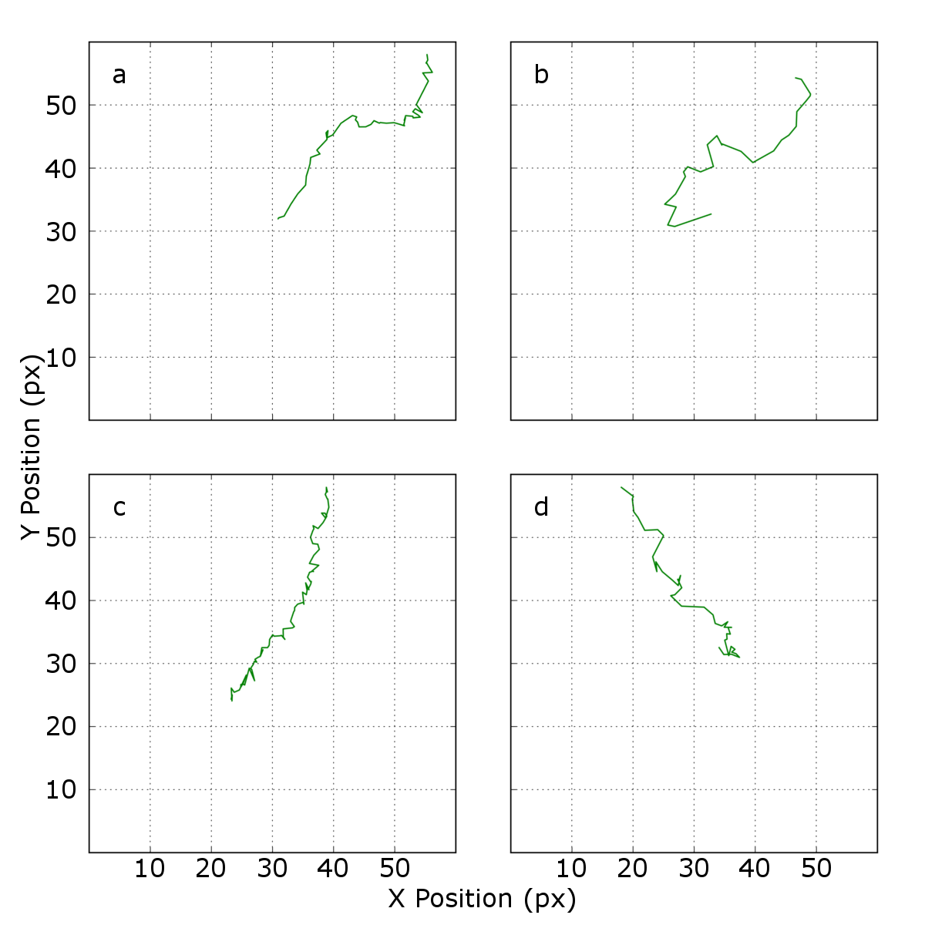
Figure 33: Diffusion study
Tracking of four different nanoparticles allowed to freely diffuse following trapping. Background subtraction is used and the ROI is 20×17×12 µm³. The times from end of trapping to exiting the ROI are a) 1.62 s, b), 0.96 s, c) 2.77 s, and d) 1.45 s.

ROI Movement

In addition to trapping, the LabVIEW VI may be used to manually move the ROI in the (x, y) plane while holding the nanoparticle near the center in (x, y, z). This demonstrates the capability of the device to control the movement along a predefined path. Macros can be easily assigned to demonstrate complex 3D control, such as orbiting about a fixed point or directing a nanoparticle to a specific location. Shown in Figure 34, a single 40 nm FluoSphere® follows the center of the ROI through an arbitrary 2D manipulation spanning ~70 µm and ~40 µm in the x- and y-dimensions, with a root-mean-square deviation of 3.1 µm. The response parameters used in this measurement were R_{x} = 200 mV µm⁻¹, R_{y} = 232 mV µm⁻¹, and R_{z} = 250 mV µm⁻¹.

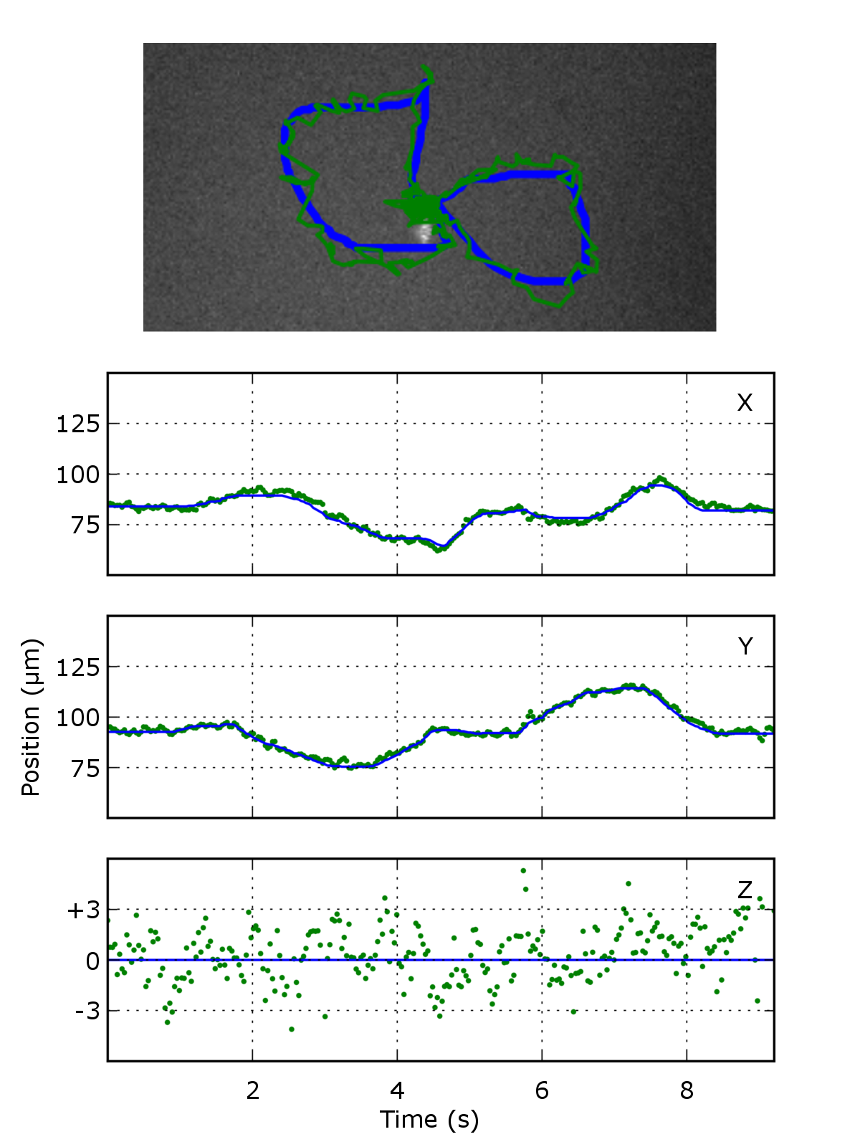
Figure 34: ROI Movement
Motion of a particle trapped in a moving region of interest (ROI). The top image traces the center of the ROI (target) in blue and the particle position in green. The bottom shows particle motion along each axis, with blue being the target and green the actual particle position.

CHAPTER IV
Ongoing/Future Work

Electrokinetic trapping in 3D provides a new method for prolonged studies of single nanoparticles. As presented in Chapter III, trapping of a 40 nm nanoparticle in a 25% glycerol/water solution or in pure water has been demonstrated, along with joystick control of the 3D trajectory of the nanoparticle. Simulations have shown that the latency in the current setup limits the size of trappable nanoparticles to greater than about 14 nm. To move to much smaller objects, such as single molecules, this latency must be reduced. The present chapter outlines possible methods to improve the capabilities of the trapping, either through imaging with a faster, more sensitive camera, improved calibration measurements of the electrokinetic motion in response to the applied voltages, or use of the electrokinetic device with an alternate method for very rapid position determination utilizing single-photon counting techniques. Also, the chapter ends with a discussion of possible solutions to problems encountered with the cross-channel microfluidic device for electro-osmotic 3D motion control, which was developed in the early stages of this dissertation research and presented early in Chapter II.

Improved Camera for Nanoparticle Imaging
As discussed in Chapter III, the lower limit on trappable object size in the 3D trap is primarily dependent on the latency or time delay between estimation of particle position and adjustment of the voltages used for corrective motion. Currently, the delay is dominated by the time taken to acquire each CCD frame. It should be possible to significantly reduce the latency by replacing the Watec CCD with a camera that has a faster frame rate. Also, a camera with significantly greater sensitivity, such as one with a back-illuminated, electron multiplying (EM) sensor, should enable trapping a much dimmer nanoparticle or even a molecule with a single chromophore tag. Therefore, the priority of ongoing research is to implement an EM-CCD camera currently available in our laboratory for more rapid nanoparticle position determination and 3D trapping.
The available EM-CCD camera is the Andor™ iXon 897, which has been used by many other researchers for single-molecule studies. [99-101] This camera has a frame-transfer sensor with 512×512 pixels that are exposed to light, each 16×16 µm², for a total imaging area of 8.2×8.2 mm². The sensor also has a second 512×512 pixel region that is masked from exposure and used for temporary storage of the image. When frame-transfer imaging is enabled, acquisition of a new image frame takes place simultaneously with the readout/digitization of the previous frame. This is accomplished by quickly shifting the charges from the exposed region of the sensor to the storage array immediately following exposure. In addition, even faster continual acquisition of frames can be achieved by digitizing frames with a smaller number of pixels. This can be accomplished by setting up the camera software to collect images from a smaller subregion of the sensor, or to add together (i.e., bin) the charges in adjacent pixels prior to digitizing.
For a 30×30 pixel sub-image, the period between frames can be reduced to a minimum of 3.2 ms, which corresponds to ~310 frames per second (fps). Under these conditions, the time taken for the frame transfer is about 0.9 ms and the maximum exposure time for each frame is 2.3 ms. This frame rate is almost ten times that of the Watec CCD. Referring back to Chapter III, we can estimate the trapping capability improvement. With increased sampling rate (f = 310 Hz) and reduced latency of 5.2 ms (assuming similar image analysis time of 2 ms), simulations suggest the minimum-sized object trappable in water has a diffusion coefficient of 170 µm² s⁻¹, corresponding to a hydrodynamic radius of 1.5 nm.
As the exposure time for each image with the faster frame rate is a factor of 2.3 ms/15 ms ≈ 0.15 times that for the Watec camera, greater light sensitivity will be required, even to view the same-sized nanoparticle under the same illumination conditions. The iXon CCD has a back-thinned sensor with a light detection quantum efficiency of ~95%. Moreover, the iXon CCD provides on-chip EM gain that leads to much-improved signal-to-noise. It is also thermoelectrically cooled to -70°C to reduce noise. [102] The EM gain is a signal amplification stage that occurs before the analog-to-digital converter (ADC). With EM-gain, the readout noise becomes insignificant. Finally, the ADC has 14-bit resolution, allowing a much broader dynamic range than that of the Watec CCD (8-bit).
The Andor™ EM-CCD is interfaced to the computer using a PCI card which places the image data directly into the random access memory (RAM). LabVIEW drivers are available for controlling the Andor™ EM-CCD and accessing the data as it is acquired. Implementation of the camera in the trapping experiment requires mounting the camera in the microscope and rewriting the LabVIEW VI for trapping to access the images. After the camera is interfaced with the experiment, a new set of calibration curves will need to be taken. However, the mechanism for extracting the results has already been developed, so this step should proceed quickly. Finally, it may be beneficial to change the optical magnification of the microscope to accommodate the larger pixel size. Increased magnification would improve planar localization, but reduce the field of view. [103] Additionally, the depth of focus would decrease, reducing the measurable axial range.
In summary, while the principle of the tetrahedral electrode microfluidic device for 3D trapping has been clearly demonstrated in the experiments with the Watec camera, implementation of the Andor™ EM-CCD camera for 3D particle position measurements is expected to significantly improve the trapping capabilities.

Improved Understanding of Electrokinetic Response
Recall from Chapter III (Trapping Algorithm) that the loop gain factors (κ_{x,} κ_{y,} κ_{z}) used in the simulation are dimensionless and represent proportions of the ideal response based on measured position. The conclusion from the simulation was that a reduced response should be applied, due to the latency between position measurement and motion correction. If the electrokinetic mobility (electrokinetic velocity as a function of field strength) were known, the results from the simulation could be reinterpreted in physical units to provide better guidance for setting the optimal trapping parameters. To perform these measurements, a sinusoidal voltage would be applied along a single axis while continuously recording full image frames. These frames would then be analyzed to extract the 3D position of nanoparticles traversing the field of view. Combined with known field strength and timestamp information, the electrokinetic velocity is then easily derived. In addition, this technique could be used to quantify the coupled motion mentioned in the experimental results of Chapter III. Once velocity is known, an “ideal” set of response parameters corresponding to κ_{x} = κ_{y} = κ_{z} = 1 is readily obtainable. These measurements are planned after the integration of the Andor™ EM-CCD camera into the optical setup, which will greatly improve spatial and temporal resolution.

Position Determination by Photon Counting
The technique of wide-field illumination and astigmatic imaging has been shown to provide 3D position measurements that are adequate for trapping single 40 nm FluoSpheres® in water. However, in many single-molecule applications, confocal microscopy is preferable to wide-field imaging. Confocal microscopy can be accomplished with one- or two-photon excitation and it exhibits increased signal-to-noise ratio due to the small excitation and detection volumes. Furthermore, collected fluorescence may be focused onto a detector with a small active area, in particular, a single-photon avalanche diode (SPAD). A SPAD has a much faster temporal response than any CCD, allowing for time-stamping of individual photon detection events. This information can be used to determine fluorescence lifetimes, thereby extending analysis of nanoparticle photophysics to the nanosecond regime.
While a single stationary excitation volume and SPAD detector cannot provide direct position readout, it is possible to determine the emitter position in 3D through the use of multiple SPAD detectors monitoring different spatial points [94, 104], through movement of the excitation volume in a 3D trajectory combined with time-resolved single-photon detection [12, 54, 62, 105-107], or by using multiple excitation volumes monitored by one or more SPAD detectors. [108]
The majority of these techniques use a single SPAD detector and move the excitation volume in a predefined 3D path through use of scanning mirrors or acousto-optical modulators, while actuating the objective position with a piezoelectric-nanopositioner. By correlating the arrival time of photons with the known excitation volume position, the emitter position can be estimated. Generally this can be done with fewer photons and faster computational analysis than is required for 3D position estimation by astigmatic imaging. In work currently underway in our laboratory, an alternate technique that uses a SPAD for counting fluorescence photons that originate from four tightly focused laser beams is being developed. The four foci are positioned in a closely spaced tetrahedral arrangement, which effectively makes a 3D quadrant detector. The four laser beams are alternately pulsed and the fraction of photon counts attributed to each of the four foci enables a quick estimation of the position of the fluorescent emitter. Simulations have shown that the 3D particle position can be determined to sub-micron precision with detection of tens of photons. [108]
In the current setup, the four lasers are modulated sequentially in a 2 ms cycle (each focus is on for 500 µs), resulting in an effective sampling rate of 500 Hz, but the modulation frequency could be increased to a practical limit of 5 kHz. Also, whereas the current setup uses closely spaced, tightly focused laser foci, the size and separation of the foci could be increased to allow a maximum excursion of about ±2 µm in xy and about ±4 µm in z. Assuming a latency of 0.2 ms between measurement and motion control, simulations suggest the minimum-sized object trappable in water has a diffusion coefficient of 302 µm² s⁻¹, corresponding to a sphere of radius 0.8 nm. The combination of the 3D electrokinetic trap developed in this dissertation together with the four foci method for fast single nanoparticle position determination holds great potential for future experiments in single-nanoparticle and single-molecule trapping. Further development to integrate the 3D electrokinetic trap with the four focus position determination is planned. In fact, the 3D electrokinetic trap presented in this dissertation is capable of being used with any of the above mentioned localization techniques, provided the position may be determined in real-time to provide feedback for active control.

Cross-channel Microfluidic
As discussed in Chapter II, a cross-channel glass microfluidic device was investigated as a means of introducing 3D electro-osmotic motion for trapping, but there were a number of technical challenges identified, which led to the decision to focus research on the tetrahedral electrode device. During this research, there were problems with channel fabrication, bonding of the substrates, and provision and rapid switching control of high voltages. Each of these problems has possible solutions. First, the capabilities for microfabrication at UTSI have substantially increased since this research was initiated. Photoresists suitable for use with hydrofluoric acid (HF) or buffered oxide etch (BOE) are now available. A wet etch technique for fabrication of the channels should improve bonding success rate, which was severely inhibited by surface irregularities caused by femtosecond laser machining. Nevertheless, bonding of glass substrates is still technically challenging. As an alternative, there are now commercial vendors from which custom glass microfluidic devices may be purchased. Finally, the provision and control of high voltages can be avoided by use of a more sophisticated design for the microfluidic device. This would require either production of a new mask using facilities outside of our institute, or purchase of a custom-made microfluidic device from an external vendor. To attain the required field strength (100 V cm⁻¹) to induce useful electro-osmotic flow velocities with low voltages, as may be produced by the National Instruments PCI-7833R card, the separation of the electrodes would need to be reduced to about 2 mm or less. This distance may be increased by use of wider channels that have a narrower width over a short length near the central crossing region. The resistance over this narrowed region is higher due to the reduced cross-sectional area, so by Ohm’s law the voltage drop is greater. For a total electrode separation of 1 cm and an applied voltage of 20 V, constriction of the width of the channel by a factor of 10 over a 1 mm segment would produce an electro-osmotic flow velocity of about 400 μm s⁻¹ for a buffer solution of 10 mM NaCl. [109] By comparison, for a feedback latency of 5.2 ms, an object with a hydrodynamic radius of 1.5 nm (D = 160 µm² s⁻¹) in water diffuses a root-mean-square distance of 1.3 µm, which corresponds to an effective speed of 250 μm s⁻¹.

CHAPTER V
Summary

In this work, the design, construction, and use of a microfluidic device for three-dimensional electrokinetic trapping of single fluorescent nanoparticles in solution was presented. Various methods of 3D manipulation and trapping were reviewed in Chapter I, but electrokinetic forces were shown to scale more favorably for nanoscale (<100 nm) objects. Electrokinetic trapping of single molecules has been previously demonstrated, but only in 1D or 2D, where the target is physically constrained by the trapping device in the other dimensions. This leads to a high rate of collisions with the walls of the device, which can adversely affect nanoparticle behavior.
In Chapter II, two configurations for 3D trapping were considered: the cross-channel and tetrahedral electrode devices. While some inroads were made towards the implementation of a cross-channel microfluidic device, difficulties in fabrication and voltage control resulted in a shift of focus to the structurally simpler tetrahedral electrode configuration. This device consists of a tetrahedral arrangement of four electrodes on two appropriately spaced standard glass coverslips. Individual control of the voltage with respect to a common ground to each of the four electrodes produces a field of arbitrary direction and magnitude. The design and fabrication of this device was detailed, along with the custom mount required for its alignment and use.
Experiments were performed in a custom-built, forward-illuminated microscope. A spectrally filtered 660 nm diode laser was focused with a 200 mm effective focal length lens into the sample volume. Fluorescence was collected with a high NA microscope objective and imaged onto a low-light CCD camera. Slight astigmatism was introduced by tilting the tube lens 6° about the vertical axis to encode axial position into the point spread function.
Chapter III described the tracking and trapping algorithms, as well as the calibration required for use of astigmatic imaging. Rapid analysis of the point spread function coupled with the calibration measurements allow for 3D position detection of a single nanoparticle in real time. Based on this position, appropriate voltages may be applied to induce motion to counteract the Brownian motion so that the nanoparticle is maintained within a defined ROI. Several simulations were performed to determine the range of response parameters that give optimal trapping and to better quantify trapping success. Additionally, an analysis of trapping capabilities in the current setup was discussed. With the current latency in the setup (at least 48.7 ms from position measurement to motion correction), the smallest object trappable in water is a sphere of radius 14 nm. This agrees with experimental results, which showed trapping of a 20 nm radius fluorescent latex bead in glycerol/water mixture and pure water for extended time periods. Additionally, the ability to trap and release nanoparticles, as well as precisely control 3D position in real time, was demonstrated.
Chapter IV presented ongoing and suggested future work to improve the 3D trap. In theory, careful control of the buffer solution should allow the current setup to trap macro-molecules, but single-biomolecule studies are better performed in conditions representative of the target’s natural environment, so adjustments to buffer components can be limited. To trap smaller objects, such as proteins or quantum dots, the sampling rate will need to be substantially increased. Simulations predict that use of an Andor™ EM-CCD camera (which has the capability of single-photon sensitivity and significantly higher frame rates) will greatly improve trapping capabilities, reducing the minimum object radius to 1.5 nm in water. Measurements of electrokinetic mobility are proposed, to allow for the reinterpretation of the simulated optimal trapping parameters into physical voltage values for use in experiments. Finally, some proposed methods of addressing the fabrication and voltage control issues associated with the cross-channel microfluidic are presented.
The device presented in this thesis enables prolonged observations of a single nanoparticle freely diffusing in aqueous solution. Although the implementation of this device has not yet been fully optimized, trapping and manipulation of single fluorescent latex beads smaller than 100 nm is clearly demonstrated. The trapping in bulk solution of a nanoscale dielectric object described here exceeds the capabilities of other competing techniques, such as direct optical trapping, and is the first reported demonstration of 3D electrokinetic trapping.

LIST OF REFERENCES

1. Leake, M.C., The physics of life: one molecule at a time. Phil. Trans. R. Soc. B, 2013. 368(1611): pp. 20120248-20120257.
2. Zijlstra, P., Paulo, P.M.R., and Orrit, M., Optical detection of single non-absorbing molecules using the surface plasmon resonance of a gold nanorod. Nat. Nanotechnol., 2012. 7(6): pp. 379-382.
3. Zenkevich, E.I., Stupak, A.P., Kowerko, D., and Borczyskowski, C., Influence of single dye molecules on temperature and time dependent optical properties of CdSe/ZnS quantum dots: Ensemble and single nanoassembly detection. Chem. Phys., 2012. 406: pp. 21-29.
4. Sorgenfrei, S., Chiu, C., Gonzalez, R.L., Yu, Y., Kim, P., Nuckolls, C., and Shepard, K.L., Label-free single-molecule detection of DNA-hybridization kinetics with a carbon nanotube field-effect transistor. Nat. Nanotechnol., 2011. 6(2): pp. 126-132.
5. Martin-Fernandez, M.L. and Clarke, D.T., Single Molecule Fluorescence Detection and Tracking in Mammalian Cells: The State-of-the-Art and Future Perspectives. Int. J. Mol. Sci., 2012. 13(11): pp. 14742-14765.
6. Song, W., Pang, P., He, J., and Lindsay, S., Optical and Electrical Detection of Single-Molecule Translocation through Carbon Nanotubes. ACS Nano, 2012. 7(1): pp. 689-694.
7. Meltzer, R.H., Krogmeier, J.R., Kwok, L.W., Allen, R., Crane, B., Griffis, J.W., Knaian, L., Kojanian, N., Malkin, G., Nahas, M.K., Papkov, V., Shaikh, S., Vyavahare, K., Zhong, Q., Zhou, Y., Larson, J.W., and Gilmanshin, R., A lab-on-chip for biothreat detection using single-molecule DNA mapping. Lab Chip, 2011. 11(5): pp. 863-873.
8. Rolfe, D.J., McLachlan, C.I., Hirsch, M., Needham, S.R., Tynan, C.J., Webb, S.E., Martin-Fernandez, M.L., and Hobson, M.P., Automated multidimensional single molecule fluorescence microscopy feature detection and tracking. Eur. Biophys. J., 2011. 40(10): pp. 1167-1186.
9. Cohen, A.E. and Fields, A.P., The Cat That Caught the Canary: What To Do with Single-Molecule Trapping. ACS Nano, 2011. 5(7): pp. 5296-5299.
10. Lipman, E.A., Schuler, B., Bakajin, O., and Eaton, W.A., Single-molecule measurement of protein folding kinetics. Science, 2003. 301(5637): pp. 1233-1235.
11. Schuler, B. and Eaton, W.A., Protein folding studied by single-molecule FRET. Curr. Opin. Struct. Biol., 2008. 18(1): pp. 16-26.
12. Wang, Q. and Moerner, W.E., An Adaptive Anti-Brownian Electrokinetic Trap with Real-Time Information on Single-Molecule Diffusivity and Mobility. ACS Nano, 2011. 5(7): pp. 5792-5799.
13. Pedone, D., Langecker, M., Abstreiter, G., and Rant, U., A Pore−Cavity−Pore Device to Trap and Investigate Single Nanoparticles and DNA Molecules in a Femtoliter Compartment: Confined Diffusion and Narrow Escape. Nano Letters, 2011. 11(4): pp. 1561-1567.
14. Xu, W. and Muller, S.J., Polymer-monovalent salt-induced DNA compaction studied via single-molecule microfluidic trapping. Lab Chip, 2012. 12(3): pp. 647-651.
15. Xu, W. and Muller, S.J., Exploring both sequence detection and restriction endonuclease cleavage kinetics by recognition site via single-molecule microfluidic trapping. Lab Chip, 2011. 11(3): pp. 435-442.
16. Kumemura, M., Collard, D., Sakaki, N., Yamahata, C., Hosogi, M., Hashiguchi, G., and Fujita, H., Single-DNA-molecule trapping with silicon nanotweezers using pulsed dielectrophoresis. J. Micromech. Microeng., 2011. 21(5): p. 054020.
17. Candelli, A., Wuite, G.J., and Peterman, E.J., Combining optical trapping, fluorescence microscopy and micro-fluidics for single molecule studies of DNA-protein interactions. Phys. Chem. Chem. Phys., 2011. 13(16): pp. 7263-7272.
18. Yang, L.L., Kao, M.W., Chen, H.L., Lim, T.S., Fann, W., and Chen, R.P., Observation of protein folding/unfolding dynamics of ubiquitin trapped in agarose gel by single-molecule FRET. Eur. Biophys. J., 2012. 41(2): pp. 189-198.
19. Loos, D., Cotlet, M., De Schryver, F., Habuchi, S., and Hofkens, J., Single-Molecule Spectroscopy Selectively Probes Donor and Acceptor Chromophores in the Phycobiliprotein Allophycocyanin. Biophys. J., 2004. 87(4): pp. 2598-2608.
20. Ying, L. and Xie, X.S., Fluorescence Spectroscopy, Exciton Dynamics, and Photochemistry of Single Allophycocyanin Trimers. J. Phys. Chem. B, 1998. 102(50): pp. 10399-10409.
21. Goldsmith, R.H. and Moerner, W.E., Watching conformational- and photodynamics of single fluorescent proteins in solution. Nat. Chem., 2010. 2(3): pp. 179-186.
22. Dienerowitz, M., Mazilu, M., and Dholakia, K., Optical manipulation of nanoparticles: a review. J. Nanophotonics, 2008. 2(1): pp. 021875-021875.
23. Ashkin, A., Optical trapping and manipulation of neutral particles using lasers. P. Natl. Acad. Sci. USA, 1997. 94(10): pp. 4853-4860.
24. Neuman, K.C., Lionnet, T., and Allemand, J.F., Single-Molecule Micromanipulation Techniques. Ann. Rev. Mat. Res., 2007. 37(1): pp. 33-67.
25. Neuman, K.C. and Nagy, A., Single-molecule force spectroscopy: optical tweezers, magnetic tweezers and atomic force microscopy. Nat. Methods, 2008. 5(6): pp. 491-505.
26. Ashkin, A., Acceleration and Trapping of Particles by Radiation Pressure. Phys. Rev. Lett., 1970. 24(4): pp. 156-159.
27. Ashkin, A., Dziedzic, J.M., Bjorkholm, J.E., and Chu, S., Observation of a single-beam gradient force optical trap for dielectric particles. Opt. Lett., 1986. 11(5): pp. 288-290.
28. Zhang, H. and Liu, K., Optical tweezers for single cells. J. R. Soc. Interface, 2008. 5(24): pp. 671-690.
29. Peterman, E.J.G., Gittes, F., and Schmidt, C.F., Laser-Induced Heating in Optical Traps. Biophys. J., 2003. 84(2): pp. 1308-1316.
30. Rasmussen, M.B., Oddershede, L.B., and Siegumfeldt, H., Optical tweezers cause physiological damage to Escherichia coli and Listeria bacteria. Appl. Environ. Microb., 2008. 74(8): pp. 2441-2446.
31. Liang, H., Vu, K.T., Krishnan, P., Trang, T.C., Shin, D., Kimel, S., and Berns, M.W., Wavelength dependence of cell cloning efficiency after optical trapping. Biophys. J., 1996. 70(3): pp. 1529-1533.
32. Zehtabi-Oskuie, A., Bergeron, J.G., and Gordon, R., Flow-dependent double-nanohole optical trapping of 20 nm polystyrene nanospheres. Sci. Rep., 2012. 2: pp. 966-969.
33. Juan, M.L., Gordon, R., Pang, Y., Eftekhari, F., and Quidant, R., Self-induced back-action optical trapping of dielectric nanoparticles. Nat. Phys., 2009. 5(12): pp. 915-919.
34. Pang, Y. and Gordon, R., Optical trapping of a single protein. Nano Lett., 2012. 12(1): pp. 402-406.
35. Chen, Y.F., Serey, X., Sarkar, R., Chen, P., and Erickson, D., Controlled Photonic Manipulation of Proteins and Other Nanomaterials. Nano Lett., 2012. 12(3): pp. 1633-1637.
36. Roxworthy, B.J. and Toussaint, K.C., Jr., Femtosecond-pulsed plasmonic nanotweezers. Sci. Rep., 2012. 2: p. 660.
37. Serey, X., Mandal, S., Chen, Y.F., and Erickson, D., DNA Transport and Delivery in Thermal Gradients near Optofluidic Resonators. Phys. Rev. Lett., 2012. 108(4): p. 048102.
38. Kim, K. and Saleh, O.A., A high-resolution magnetic tweezer for single-molecule measurements. Nucleic Acids Res., 2009. 37(20): pp. e136-e142.
39. Gosse, C. and Croquette, V., Magnetic Tweezers: Micromanipulation and Force Measurement at the Molecular Level. Biophys. J., 2002. 82(6): pp. 3314-3329.
40. Probst, R., Cummins, Z., Ropp, C., Waks, E., and Shapiro, B., Flow Control of Small Objects on Chip MANIPULATING LIVE CELLS, QUANTUM DOTS, AND NANOWIRES. IEEE Contr. Syst. Mag., 2012. 32(2): pp. 26-53.
41. Yan, J., Skoko, D., and Marko, J.F., Near-field-magnetic-tweezer manipulation of single DNA molecules. Phys. Rev. E, 2004. 70(1): p. 011905.
42. Ding, X., Lin, S.C.S., Kiraly, B., Yue, H., Li, S., Chiang, I.K., Shi, J., Benkovic, S.J., and Huang, T.J., On-chip manipulation of single microparticles, cells, and organisms using surface acoustic waves. P. Ntnl. Acad. Sci. USA, 2012. 109(28): pp. 11105-11109.
43. Hertz, H.M., Standing-wave acoustic trap for nonintrusive positioning of microparticles. J. Appl. Phys., 1995. 78(8): pp. 4845-4849.
44. Shi, J., Ahmed, D., Mao, X., Lin, S.S., Lawit, A., and Huang, T.J., Acoustic tweezers: patterning cells and microparticles using standing surface acoustic waves (SSAW). Lab Chip, 2009. 9(20): pp. 2890-2895.
45. Courtney, C.R.P., Drinkwater, B.W., Demore, C.E.M., Cochran, S., Grinenko, A., and Wilcox, P.D., Dexterous manipulation of microparticles using Bessel-function acoustic pressure fields. Appl. Phys. Lett., 2013. 102(12): p. 123508.
46. Lutz, B.R., Chen, J., and Schwartz, D.T., Hydrodynamic Tweezers: 1. Noncontact Trapping of Single Cells Using Steady Streaming Microeddies. Anal. Chem., 2006. 78(15): pp. 5429-5435.
47. Tanyeri, M., Johnson-Chavarria, E.M., and Schroeder, C.M., Hydrodynamic trap for single particles and cells. Appl. Phys. Lett., 2010. 96(22): p. 224101.
48. Tanyeri, M., Ranka, M., Sittipolkul, N., and Schroeder, C.M., A microfluidic-based hydrodynamic trap: design and implementation. Lab Chip, 2011. 11(10): pp. 1786-1794.
49. Lieu, V.H., House, T.A., and Schwartz, D.T., Hydrodynamic Tweezers: Impact of Design Geometry on Flow and Microparticle Trapping. Anal. Chem., 2012. 84(4): pp. 1963-1968.
50. Curtis, M.D., Sheard, G.J., and Fouras, A., Feedback control system simulator for the control of biological cells in microfluidic cross slots and integrated microfluidic systems. Lab Chip, 2011. 11(14): pp. 2343-2351.
51. Pethig, R. and Markx, G.H., Applications of dielectrophoresis in biotechnology. Trends Biotechnol., 1997. 15(10): pp. 426-432.
52. Cummings, E.B. and Singh, A.K., Dielectrophoresis in Microchips Containing Arrays of Insulating Posts: Theoretical and Experimental Results. Anal. Chem., 2003. 75(18): pp. 4724-4731.
53. Jen, C., Chang, H., Huang, C., and Chen, K., A microfabricated module for isolating cervical carcinoma cells from peripheral blood utilizing dielectrophoresis in stepping electric fields. Microsys. Technol., 2012. 18(11): pp. 1887-1896.
54. Cohen, A.E., Trapping and Manipulating Single Molecules in Solution, 2006, Stanford University: Stanford, CA.
55. Fields, A.P. and Cohen, A.E., Anti-Brownian traps for studies on single molecules. Method. Enzymol., 2010. 475: pp. 149-174.
56. Ropp, C., Cummins, Z., Probst, R., Qin, S., Fourkas, J.T., Shapiro, B., and Waks, E., Positioning and Immobilization of Individual Quantum Dots with Nanoscale Precision. Nano Lett., 2010. 10(11): pp. 4673-4679.
57. Bazant, M.Z. and Squires, T.M., Induced-charge electrokinetic phenomena. Curr. Opin. Colloid In., 2010. 15(3): pp. 203-213.
58. Barz, D.P.J. and Ehrhard, P., Model and verification of electrokinetic flow and transport in a micro-electrophoresis device. Lab Chip, 2005. 5(9): pp. 949-958.
59. Squires, T.M. and Bazant, M.Z., Induced-charge electro-osmosis. J. Fluid Mech., 2004. 509: pp. 217-252.
60. Glaser, R., Biophysics. 1 ed. 2010: Springer.
61. Sureda, M., Miller, A., and Diez, F.J., In situ particle zeta potential evaluation in electroosmotic flows from time-resolved microPIV measurements. Electrophoresis, 2012. 33(17): pp. 2759-2768.
62. Fields, A.P. and Cohen, A.E., Electrokinetic trapping at the one nanometer limit. P. Natl. Acad. Sci. USA, 2011. 108(22): pp. 8937-8942.
63. Davis, L.M., Canfield, B.K., Li, X., Hofmeister, W.H., Shen, G., Lescano-Mendoza, I.P., Bomar, B.W., Wikswo, J.P., Markov, D.A., Samson, P.C., Daniel, C., Sikorski, Z., and Robinson, W.N., Electrokinetic delivery of single fluorescent biomolecules in fluidic nanochannels. Proc. SPIE, 2008. 7035: p. 70350A.
64. Cohen, A.E. and Moerner, W.E., Suppressing Brownian motion of individual biomolecules in solution. P. Natl. Acad. Sci. USA, 2006. 103(12): pp. 4362-4365.
65. Cohen, A.E. and Moerner, W.E., Controlling Brownian motion of single protein molecules and single fluorophores in aqueous buffer. Opt. Express, 2008. 16(10): pp. 6941-6956.
66. Hansen, P.M., Bhatia, V.K., Harrit, N., and Oddershede, L., Expanding the Optical Trapping Range of Gold Nanoparticles. Nano Letters, 2005. 5(10): pp. 1937-1942.
67. Reihani, S.N.S. and Oddershede, L.B., Optimizing immersion media refractive index improves optical trapping by compensating spherical aberrations. Opt. Lett., 2007. 32(14): pp. 1998-2000.
68. Greiner, W., Neise, L., and Stöcker, H., Thermodynamics and Statistical Mechanics. 1995: Springer.
69. Cohen, A.E. and Moerner, W.E., Method for trapping and manipulating nanoscale objects in solution. App. Phys. Lett., 2005. 86(9): p. 093109.
70. Cohen, A.E., Control of Nanoparticles with Arbitrary Two-Dimensional Force Fields. Phys. Rev. Lett., 2005. 94(11): p. 118102.
71. Seol, Y., Carpenter, A.E., and Perkins, T.T., Gold nanoparticles: enhanced optical trapping and sensitivity coupled with significant heating. Opt. Lett., 2006. 31(16): pp. 2429-2431.
72. Davar, G. Python(x,y) 2.7.3.1 Full Edition. 12/19/2012 [cited 2013 4/9/2013]; Available from: https://code.google.com/p/pythonxy/wiki/Welcome.
73. Capusta, P. Absolute Diffusion Coefficients: Compilation of Reference Data for FCS Calibration. 7/1/2010 [cited 2013 4/11/2013]; Available from: http://www.picoquant.com/technotes/appnote_diffusion_coefficients.pdf.
74. Davis, L., Sikorski, Z., Robinson, W., Shen, G., Li, X., Canfield, B., Lescano, I., Bomar, B., Hofmeister, W., Germann, J., King, J., White, Y., and Terekhov, A., Maximum-likelihood position sensing and actively controlled electrokinetic transport for single-molecule trapping. Proc. SPIE, 2008. 6862: p. 68620P.
75. Probst, R. and Shapiro, B., Three-dimensional electrokinetic tweezing: device design, modeling, and control algorithms. J. Micromech. Microeng., 2011. 21(2): p. 027004.
76. Harrison, D.J., Manz, A., Fan, Z., Luedi, H., and Widmer, H.M., Capillary electrophoresis and sample injection systems integrated on a planar glass chip. Anal. Chem., 1992. 64(17): pp. 1926-1932.
77. Jacobson, S.C., Hergenroder, R., Koutny, L.B., Warmack, R.J., and Ramsey, J.M., Effects of Injection Schemes and Column Geometry on the Performance of Microchip Electrophoresis Devices. Anal. Chem., 1994. 66(7): pp. 1107-1113.
78. Ceriotti, L., Weible, K., de Rooij, N.F., and Verpoorte, E., Rectangular channels for lab-on-a-chip applications. Microelectron. Eng., 2003. 67–68(0): pp. 865-871.
79. Giridhar, M.S., Seong, K., Schülzgen, A., Khulbe, P., Peyghambarian, N., and Mansuripur, M., Femtosecond Pulsed Laser Micromachining of Glass Substrates with Application to Microfluidic Devices. Appl. Opt., 2004. 43(23): pp. 4584-4589.
80. Zalloum, O.H., Parrish, M., Terekhov, A., and Hofmeister, W., An amplified femtosecond laser system for material micro-/nanostructuring with an integrated Raman microscope. Rev. Sci. Instrum., 2010. 81(5): p. 053906.
81. Matsumura, T., Kazama, A., and Yagi, T., Generation of debris in the femtosecond laser machining of a silicon substrate. Appl. Phys. A-Mater., 2005. 81(7): pp. 1393-1398.
82. Li, Y., Itoh, K., Watanabe, W., Yamada, K., Kuroda, D., Nishii, J., and Jiang, Y., Three-dimensional hole drilling of silica glass from the rear surface with femtosecond laser pulses. Opt. Lett., 2001. 26(23): pp. 1912-1914.
83. Sayah, A., Solignac, D., Cueni, T., and Gijs, M.A.M., Development of novel low temperature bonding technologies for microchip chemical analysis applications. Sensor. and Actuat. A-Phys., 2000. 84(1–2): pp. 103-108.
84. Wu, H., Huang, B., and Zare, R.N., Construction of microfluidic chips using polydimethylsiloxane for adhesive bonding. Lab Chip, 2005. 5(12): pp. 1393-1398.
85. Rodriguez, I., Spicar-Mihalic, P., Kuyper, C.L., Fiorini, G.S., and Chiu, D.T., Rapid prototyping of glass microchannels. Anal. Chim. Acta, 2003. 496(1–2): pp. 205-215.
86. Castaño-Álvarez, M., Pozo Ayuso, D.F., García Granda, M., Fernández-Abedul, M.T., Rodríguez García, J., and Costa-García, A., Critical points in the fabrication of microfluidic devices on glass substrates. Sensor. Actuat. B-Chemical, 2008. 130(1): pp. 436-448.
87. Xuan, X., Xu, B., Sinton, D., and Li, D., Electroosmotic flow with Joule heating effects. Lab Chip, 2004. 4(3): pp. 230-236.
88. Wang, S.C., Chen, H.P., and Chang, H.C., ac electroosmotic pumping induced by noncontact external electrodes. Biomicrofluidics, 2007. 1(3): p. 034106.
89. King, J.K., Microfluidic Device for the Electrokinetic Manipulation of Single Molecules, 2009, University of Tennessee at Knoxville: Knoxville, TN.
90. Working With FluoSpheres® Fluorescent Microspheres. 6/2/2004 [cited 2013 2/22/2013]; Available from: http://probes.invitrogen.com/media/pis/mp05001.pdf.
91. FluoSpheres® Fluorescent Microspheres. 10/25/2005 [cited 2013 2/22/2013]; Available from: http://probes.invitrogen.com/media/pis/mp05000.pdf.
92. Cheng, N.S., Formula for the viscosity of a glycerol-water mixture. Ind. Eng. Chem. Res., 2008. 47(9): pp. 3285-3288.
93. Kao, H.P. and Verkman, A.S., Tracking of single fluorescent particles in 3 dimensions - use of cylindrical optics to encode particle position. Biophys. J., 1994. 67(3): pp. 1291-1300.
94. Holtzer, L., Meckel, T., and Schmidt, T., Nanometric three-dimensional tracking of individual quantum dots in cells. Appl. Phys. Lett., 2007. 90(5): p. 053902.
95. Cierpka, C., Rossi, M., Segura, R., and Kahler, C.J., On the calibration of astigmatism particle tracking velocimetry for microflows. Meas. Sci. Technol., 2011. 22(1): p. 015401.
96. Radiant Zemax. 2013 [cited 2013 2/22/2013]; Available from: http://www.radiantzemax.com/zemax/.
97. CRC Handbook of Chemistry and Physics, 86th Edition. 2005, CRC Press. pp. (8)59-60.
98. Bechhoefer, J., Feedback for physicists: A tutorial essay on control. Rev. Mod. Phys., 2005. 77(3): pp. 783-836.
99. Needleman, D.J., Groen, A., Ohi, R., Maresca, T., Mirny, L., and Mitchison, T., Fast microtubule dynamics in meiotic spindles measured by single molecule imaging: evidence that the spindle environment does not stabilize microtubules. Mol. Biol. Cell., 2010. 21(2): pp. 323-333.
100. Jonghyun, P., Yongmoon, J., Daekil, I., Fishel, R., Changill, B., and Jong-Bong, L., Single-Molecule Analysis Reveals the Kinetics and Physiological Relevance of MutL-ssDNA Binding. Plos One, 2010. 5(11): pp. 1-8.
101. Kowalczyk, S.W., Kapinos, L., Blosser, T.R., Magalhaes, T., van Nies, P., LimRoderick, Y.H., and Dekker, C., Single-molecule transport across an individual biomimetic nuclear pore complex. Nat. Nanotechnol., 2011. 6(7): pp. 433-438.
102. Andor iXon 897 Specifications. [cited 2013 2/27/2013]; Available from: http://www.andor.com/scientific-cameras/ixon-emccd-camera-series/ixon3-897.
103. Cheezum, M.K., Walker, W.F., and Guilford, W.H., Quantitative comparison of algorithms for tracking single fluorescent particles. Biophys. J., 2001. 81(4): pp. 2378-2388.
104. Han, J.J., Kiss, C., Bradbury, A.R.M., and Werner, J.H., Time-Resolved, Confocal Single-Molecule Tracking of Individual Organic Dyes and Fluorescent Proteins in Three Dimensions. ACS Nano, 2012. 6(10): pp. 8922-8932.
105. Enderlein, J., Tracking of fluorescent molecules diffusing within membranes. Appl. Phys. B-Lasers O., 2000. 71(5): pp. 773-777.
106. Dupont, A. and Lamb, D.C., Nanoscale three-dimensional single particle tracking. Nanoscale, 2011. 3(11): pp. 4532-4541.
107. Levi, V., Ruan, Q., and Gratton, E., 3-D Particle Tracking in a Two-Photon Microscope: Application to the Study of Molecular Dynamics in Cells. Biophys. J., 2005. 88(4): pp. 2919-2928.
108. Davis, L.M., Canfield, B.K., Germann, J.A., King, J.K., Robinson, W.N., Dukes III, A.D., Rosenthal, S.J., Samson, P.C., and Wikswo, J.P., Four-focus single-particle position determination in a confocal microscope. Proc. SPIE, 2010. 7571: p. 757112.
109. Hsieh, S.S., Lin, H.C., and Lin, C.Y., Electroosmotic flow velocity measurements in a square microchannel. Colloid Polym. Sci., 2006. 284(11): pp. 1275-1286.

APPENDIX

1D Collision Simulation
This python program simulates 1D diffusion and collisions of a physically constrained particle. Several trials are run to build a statistically significant set of data, and the extracted collision rates (in Hz) are written to a comma separated value (csv) file.
The number sign (#) is used to denote comments in Python. For clarity, the following Python code uses a single number sign (#) to explain the purpose and units of a variable. A double number sign (##) is used to explain logical steps.

# -*- coding: utf-8 -*-
"""
1D_Collision_Sim.py: Simulate 1D diffusion of a physically constrained particle to determine collision rate.
Jason K. King, April 6, 2013
"""

################################ INPUT ######################################
D = 12.2 # Diffusion coefficient (microns^2/s)
width = 0.4 # Total trap width (microns)
window = 0.01 # Collision window (microns)
t = 0.1 # Total simulation time (s)
dt = 1E-8 # Timestep (s)
trials = 10 # Number of simulations to perform
############################################################################

############################## INITIALIZE ####################################
import numpy as np
r = width/2.
## Calculate mean step size.
sigma = np.sqrt(2*D*dt)
## Calculate the number of points needed to get to 10s
## Use the number of points to preallocate pos and time arrays
pts = int(t/dt)
time = np.linspace(0,t,pts)
f = open('Report_%0.2f_%0.1f.csv' % (D, width),'w')
############################################################################

## Check to see if the particle is out of the trap boundary. If so, complete the remainder of the
## step in the opposite direction and set bounce flag.
def bounce(r, pos, b_flag):
if pos < 0:
if pos < -r:
b_flag = True
pos = -r + np.abs(r+pos)
if pos > 0:
if pos > r:
b_flag = True
pos = r - np.abs(r-pos)
return [pos, b_flag]

## Check to see if a bounce previously occurred, and if the distance from the boundary is greater ## than or equal to the collision window. If so, count as a collision and reset bounce flag.
def collide(r, window, pos):
check = r - window
if pos < 0:
if pos >= -check:
b_flag = False
result = True
else:
b_flag = True
result = False
if pos > 0:
if pos <= check:
b_flag = False
result = True
else:
b_flag = True
result = False
return [b_flag, result]

for k in range(trials):
b_flag = False
np.random.seed()
pos = np.zeros([pts])

count = 0
for i in range(pts-1):
## Take a gaussian step with mean step size, sigma
pos[i+1] = pos[i] + np.random.normal(scale=sigma)
## Check to see if it bounced.
pos[i+1], b_flag = bounce(r, pos[i+1], b_flag)
## If bounce flag is True, check for collision
if b_flag:
b_flag, n = collide(r, window, pos[i+1])
count += n

f.write("%d,%d,%0.1f,%0.1f\n" % (k, count, t, count/t))

f.close()
print 'Simulations complete.'

3D Trap Simulation
This python program simulates 3D trapping of a particle in solution. Several trials are run to build a statistically significant set of data, and the position and time information are written to numpy array files for post-processing analysis.
The number sign (#) is used to denote comments in Python. For clarity, the following Python code uses a single number sign (#) to explain the purpose and units of a variable. A double number sign (##) is used to explain logical steps.

# -*- coding: utf-8 -*-
"""
3D_Trap_Sim.py: Simulate 3D trapping of a particle in solution. Time resolution is 0.1 ms. Position and Time information are written to numpy array files and analyzed with 3D_Trap_Sim_PP.py
Jason K. King, April 7, 2013
"""

################################ INPUT ######################################
D = 6.10 # Diffusion coefficient (microns^2/s)
total_time = 60 # Maximum time length (s)
trials = 20 # Number of simulations to run per parameter set
lag = 48.7 # Delay between measurement and position correction (ms)
x_lim = 10.05 # Maximum excursion in x (microns)
y_lim = 8.61 # Maximum excursion in y (microns)
z_lim = 6.000 # Maximum excursion in z (microns)
############################################################################

############################## INITIALIZE ####################################
import numpy as np
lag = int(10*lag)
## Calculate mean step size.
sigma = np.sqrt(2*D*1E-4)
## Calculate the number of points needed to get to total_time
n = 10000*total_time
t = [ ]
rms = [ ]
var = [ ]
## Initialize parameters to use. For simplicity, let response be identical along each axis.
params = [ ]
for i in np.arange(0.05,1.05,0.05):
params.append([i,i,i])
############################################################################

for K in params:
print K
full_pos = np.array([[0.,0.,0.]])
T = [ ]
for m in range(trials):
## Reinitialize values at the beginning of each trial
true_pos = np.array([0.,0.,0.])
track_true = np.zeros([n,3])
timestamp = [ ]; pos = [ ]
i = 0; t_ccd = 0;

while True:
## Increment time
i += 1

## Take diffusion step
true_pos += np.random.normal(0.0, sigma, 3)
track_true[i] = true_pos

## Camera samples every 33 ms
if t_ccd == 330:
delay_1 = i + lag
timestamp.append(delay_1)
## Measurement error
sigma_x = 0.007*true_pos[2]*true_pos[2]-0.012*true_pos[2]+0.029
sigma_y = 0.007*true_pos[2]*true_pos[2]+0.009*true_pos[2]+0.020
sigma_z = 0.054*true_pos[2]*true_pos[2]-0.015*true_pos[2]+0.173
err = np.array([np.random.normal(scale=sigma_x),
np.random.normal(scale=sigma_y),
np.random.normal(scale=sigma_z)])
measurement = true_pos + err
pos.append(measurement)
t_ccd = 0
else:
t_ccd += 1

## If time for corrective motion to take place, apply step motion and remove from buffer.
if timestamp:
if timestamp[0] == i:
dummy = timestamp.pop(0)
measurement = pos.pop(0)
step = K*measurement
true_pos = true_pos - step

## Check to see if it exited volume or reached end time.
if true_pos[0] < -x_lim or true_pos[0] > x_lim:
break
if true_pos[1] < -y_lim or true_pos[1] > y_lim:
break
if true_pos[2] < -z_lim or true_pos[2] > z_lim:
break
if i == n-1:
break

## At the end of each trial, store ending time and true position over the whole run.
full_pos = np.append(full_pos, track_true[:i],axis = 0)
T.append(i)

## At the end of each parameter set, store the collected data for post-processing
np.save('K_%0.2f.npy' % K[0], full_pos)
np.save('T_%0.2f.npy' % K[0], np.array(T))

print 'Simulations complete.'

3D Diffusion Simulation
This python program simulates 3D diffusion of a particle in solution. Once the particle diffuses out of a defined region of interest, the exit time is recorded and the simulation is repeated. After 10,000 trials, a histogram and numpy array of recorded exit times are output for post-processing.
The number sign (#) is used to denote comments in Python. For clarity, the following Python code uses a single number sign (#) to explain the purpose and units of a variable. A double number sign (##) is used to explain logical steps.

# -*- coding: utf-8 -*-
"""
3D_Diffusion_Sim.py: Simulate 3D diffusion of a particle in solution to build up a dataset of times to exit ROI. Time resolution is 1 ms. Will output a histogram and numpy array of exit times.
Jason K. King, April 7, 2013
"""

################################ INPUT ######################################
D = 6.10 # Diffusion coefficient (microns^2/s)
trials = 10000 # Number of simulations to run
total_time = 60 # Maximum time length (s)
x_lim = 10.05 # Maximum excursion in x (microns)
y_lim = 8.61 # Maximum excursion in y (microns)
z_lim = 6.000 # Maximum excursion in z (microns)
data = [ ]
############################################################################

############################## INITIALIZE ####################################
import numpy as np
import pylab as plt

n = 1000*total_time
sigma = np.sqrt(2*D*1E-3)
############################################################################

## Search an array for the entry closest to the target value
def find_nearest(array,value):
idx = (np.abs(array-value)).argmin()
return idx

for k in range(trials):
np.random.seed()
i = 0
pos = [0, 0, 0]

while True:
## Increment time
i += 1

## Take diffusion step
pos += np.random.normal(0.0, sigma, 3)

## Check to see if it exited volume or reached end time.
if pos[0] < -x_lim or pos[0] > x_lim:
break
if pos[1] < -y_lim or pos[1] > y_lim:
break
if pos[2] < -z_lim or pos[2] > z_lim:
break
if i == n-1:
break

data.append(i*1E-3)

data = np.array(data)
mean = np.mean(data)
times = np.linspace(mean,60,1000)
count = [ ]
for t in times:
count.append((data > t).sum())
count = np.array(count)
t_1 = times[find_nearest(count,int(trials/100))]

fig = plt.figure('Time Histogram')
ax = fig.add_subplot(111)
n, bins, patches = ax.hist(data, 100, range = (0,10))
ax.axvline(x = mean, linestyle = 'solid', color = 'red')
ax.axvline(x = t_1, linestyle = 'dashed', color = 'red')
print 'Simulations complete.'
print 'Mean time = %0.2f' % mean
print '1%% time = %0.2f' % t_1
np.save('D%0.2f.npy' % D, times)
plt.show()

VITA
Jason King was born in Jacksonville, NC on August 14, 1985, the son of Danny and Shu King. He received his Bachelor of Science degree in May 2007 from the University of Tennessee at Knoxville, with a major in Physics and a minor in Mathematics. He moved to Murfreesboro, TN in the summer of 2007 and enrolled at the University of Tennessee Space Institute in Tullahoma, completing his Master of Science in Physics in August 2009.

