DRIVERS OF BRYOPHYTE COMMUNITY CHANGE ACROSS THE APPALACHIANS

A Dissertation Presented for the
Doctor of Philosophy
Degree
The University of Tennessee, Knoxville

Eric D. Shershen
August 2025
Copyright © 2025 by Eric D. Shershen
All rights reserved.

DEDICATION
This is dedicated to my little baby boy, Pierogi. Thank you for always getting me out of bed on days I didn’t want to, for giving me an excuse to leave social functions early, and for all the cuddles <3 I hope I can give you the best life filled with digging holes and romping around!



ACKNOWLEDGEMENTS
The tiny mosses I study grow and thrive in their high elevation ecosystem thanks to environmental factors and their community. I too, am just a little guy who was able to thrive thanks to the monetary support, and more importantly, the communities I am blessed to be a part of.
Monetary support: Thank you to the University of Tennessee Herbarium, Sharp Funds through the Department of Ecology and Environmental Biology, Graduate Student Senate, the Plant Research Colloquium, and the University of Tennessee Open Publishing Support Fund (OPSF) for funding my dissertation work and publications and investing in me as a scientist.
Non-academic support: The darkest days were made brighter by so many people supporting and encouraging me to not be a little krill, but a big strong whale. My family, my friends within the department, and my friends from the Knoxville Ultimate Community have all helped me make this journey.
Academic support: I cannot thank the department, the faculty and staff, and my fellow graduate students enough for their support and feedback on code, papers, and presentations.
I want to thank my committee members Drs Jim Fordyce, Mona Papeş, and Laura Thompson for their feedback, support, and mentoring. Each of you has sculpted a bit of who I am as a scientist and passed on invaluable skills. I hope I can use what you have taught me to make you all proud.
Finally, thank you to the best advisor I could have asked for, Dr. Jessica M. Budke. I’m sure after reading all of my writing (often ramblings) over the past few years, you know I’m not always great with my words and lose sight of where I’m going. So I’ll put it simply, you are the paragon of all that I could hope to be and achieve as a scientist and a mentor. I always left our meetings knowing I could conquer any task in front of me and I’ll always cherish our yap sessions, knowing that anything I said could be safely put in “the vault.” You were there to whack down rhododendron my first field season, celebrate my first talk in Alaska, console and support me when chapters and presentations didn’t go the way I had hoped, to gently push me out of my comfort zone to teach field botany, and so much more in between. You took a chance to take an ecologist under your wing, and I will forever be grateful that you did. Thank you for everything, one day I hope I can be as amazing as a scientist, and person, as you!

ABSTRACT
Work exploring the drivers of vascular plant community change through time are common throughout the literature. The literature pertaining to their non-vascular relatives, the bryophytes, however, dwarfs in comparison. Despite bryophytes providing key ecosystem functions like providing soil stability, sequestering carbon, and providing habitat for macro and microorganisms, the drivers behind bryophyte community change have been assumed to be akin to those of vascular plants despite literature which demonstrates key differences in how bryophytes respond across gradients of abiotic and biotic factors. As such, this dissertation explores these drivers to understand what drives bryophyte communities through time, using the bryophyte communities of the Appalachians as a case study.
I used a longitudinal study, herbarium records, and ecological niche modeling to examine 1) What environmental determinants drive bryophyte community change as well as to identify the current state of bryophyte communities 2) How differing management strategies for an invasive pest have impacted bryophyte communities in the past and 3) How macroclimatic variables may determine suitable habitat for species both now, and in the future. The results from these studies finds that elevation, aspect, slope, and gap fraction all play roles in determining bryophyte abundance and/or richness, that extreme management strategies may have negatively impacted bryophyte richness, that substrate generalists are more likely to persist through time following a disturbance, and that climate change will reduce suitable habitat across all bryophytes, with most species experiencing a range contraction at high elevations within national parks and forests.
Results from my dissertation are useful for ecologists, land managers, and policy makers when considering drivers of bryophyte community change and locations of where they will reside in the future. This will allow for the better preservation of bryophyte communities at both the community and species level, and consequently, better protect the ecosystem functions they provide.

Table of Contents
INTRODUCTION 1
CHAPTER 1: ENVIRONMENTAL DETERMINANTS OF BRYOPHYTE COMMUNITY CHANGE OVER TIME 4
ABSTRACT 5
INTRODUCTION 7
METHODS 9
Study site 9
Sampling 9
Data Analysis 11
RESULTS 13
Gap fraction and tree community 13
Abundance 13
Richness 14
General linear models 14
DISCUSSION 15
Elevation 15
Slope 16
Slope Aspect 17
Species significantly changing in abundance 17
Tree community and gap fraction 18
Conclusion 18
ACKNOWLEDGEMENTS 19
REFERENCES 20
APPENDIX 1 28
CHAPTER 2: DETECTING BRYOPHYTE COMMUNITY CHANGES UNDER DIFFERENT MANAGEMENT PRACTICES IN HIGH ELEVATION ECOSYSTEMS IN THE SOUTHERN APPALACHIANS USING HERBARIUM SPECIMENS 33
ABSTRACT 34
INTRODUCTION 35
METHODS 37
RESULTS: 40
Alpha diversity 40
Dissimilarity 40
Species change 41
DISCUSSION 42
Communities following disturbance 42
Management strategies and bryophyte communities 43
Trends in substrate specificity 44
Trends in taxonomic order 45
Conclusions 46
REFERENCES 47
APPENDIX 2 55
CHAPTER 3: HERBACEOUS LAYER SPECIES EXPERIENCE SUITABLE HABITAT LOSS AND RANGE CONTRACTIONS TO HIGHER ELEVATIONS UNDER CLIMATE CHANGE MODELS 65
ABSTRACT 66
INTRODUCTION 67
METHODS 70
Climatic variable selection 70
Species selection 71
Modeling 72
Statistical analyses: 73
RESULTS 74
Models and transferability 74
Suitable habitat 74
DISCUSSION 75
Light availability 77
Dispersal and connectivity limitations 77
Conservation 78
Conclusions 79
REFERENCES 81
APPENDIX 3 93
CONCLUSIONS AND RECOMMENDATIONS 126
VITA 129

LIST OF TABLES
Table 1.1 Mean gap fraction and change in gap fraction at each of the elevation zones. Note: A paired t-test was used to compare gap fraction between the two time points……………………………………………………………………………….. 28
Table 1.2 Significantly changing species between the two time points with their functional group (FG), percent of plots the species occupied, and the mean percent coverage in plots where the species was found for each time point listed. Note: Functional Groups are as follows: Pleurocarpous (P), Acrocarpous (A), and Liverwort (L). A paired t-test followed by a sequential Holm’s Bonferroni correction was performed to account for multiple comparisons………………………………. 30
Table 2.1 Percentage of 9,999 rarefaction iterations that had the same difference in direction for each timespan comparison [pre-BWA vs post-BWA, post-BWA vs ICR (Initial Canopy Recovery), and pre-BWA vs ICR]. If a timespan has a higher rarefied richness value for a majority of the iterations (close to 100%), we can confidently infer the rarefied richnesses are different from one another…………... 55
Table 2.2 Original substrate classes and their descriptions from Table 18 of Preston et al (2017). Substrate classes used in this study, which were condensed for the rock and soil classes to match the more general substrate descriptions used in the FNA (Flora of North America Editorial Committee, 1993)…………………………………….. 55
Table 2.3 High elevation spatial group differences between pre-BWA invasion (Balsam Wooly Adelgid) and ICR (Initial Canopy Recovery) for substrate specialist (one substrate type), flexible (two substrate types), and generalist (three or more substrate types) species focusing on the difference between the number of lost, new, and persisting species. Examining the entire table, Chi-squared = 13.07, df = 4, p-value = 0.011. The groups where the standardized residual was greater or less than the absolute critical value (-2.77) indicates that the observed number of species significantly differed from expected. These groups are denoted with an asterisk…. 60
Table 2.4 Observed change of specialist (one substrate type), flexible (two substrate types), and generalist (three or more substrate types) species from the high elevation spatial group compared between pre-BWA invasion and ICR (initial canopy recovery) timespans. Only two substrate groups were compared at a time using chi-square tests and the other not included in the test is marked with a dash. Comparisons are adjusted for multiple comparisons using a sequential Holms-Bonferroni correction. Significantly different groups are denoted with an asterisk……………………………………………………………………………... 61
Table 2.5 Species change compared between growth forms, including acrocarpous mosses, liverworts, and pleurocarpous mosses between pre-BWA (Balsam Wooly Adelgid) invasion and Initial Canopy Recovery at the high elevation spatial grouping. Significant comparisons are denoted with an asterisk…………………... 61
Table 2.6 Species change (new, lost, persisted) compared within taxonomic orders for liverworts, acrocarpous mosses, and pleurocarpous mosses. Comparisons are for changes between pre-BWA (Balsam Wooly Adelgid) invasion and Initial Canopy Recovery (ICR) for the high elevation spatial grouping using chi-square tests. P-values were corrected using a sequential Holms-Bonferroni correction with significant differences denoted with an asterisk…………………………………… 62
Table 3.1 Correlation results from PCA analysis of 20 selected climatic variables downloaded from Climate NA for the area of interest (Appalachian Mountains)………………………………………………………………………….93
Table 3.2 Environmental Protection Agency (EPA) ecoregions used to define the area of interest for this study, specifically those covering the Appalachian Mountains…… 97
Table 3.3 Species selected for study. Stable species are highlighted in gray, declining species are unshaded. Species change (declining vs stable) was determined by a previous study which found species either significantly declined (declining species) or significantly increased or did not change (together stable species) over 12 years (Shershen et al. 2024). Declining species were selected first by having a broad range throughout the Appalachians, then by having a minimum of 20 specimens with location information collected within the historical climate data timespan. In addition, five stable species that were either taxonomically closely related or have similar growth patterns to the declining species were selected for comparison while simultaneously meeting the aforementioned criteria………………………………. 98
Table 3.4 Top performing Maxent models for each species based on lowest omission error rate and highest AUC. All models can be viewed in supplementary Table 3. Stable species are highlighted in gray, declining species are unshaded…………… 99
Table 3.5 All Maxent models that were run sorted by species, regularization multiplier, and then cross-validation run. Top performing models used for final analysis and seen in Table 3.4 shaded in gray………………………………………………….. 100
Table 3.6 Percent of specimens correctly predicted after transferring the models from the historical to current timespan. Stable species are highlighted in gray, declining species are unshaded……………………………………………………………… 110

LIST OF FIGURES
Figure 1.1 (A) Location of the Great Smoky Mountains National Park highlighted in black. (B) Sampling design for community composition in each 20 x 20 meter plot. Each checkered line represents a 20 meter transect lines across the plot, spaced out six meters from each other and four meters from the edge of the plot. The white blocks represent the 10 meters where bryophytes were surveyed. The black blocks represent the alternating 10 meters where bryophytes were not surveyed. Thus, a total of 30 meters was sampled per plot. The black circle in the center represents the location where the fish-eye photo was taken in each plot as well as the central point for tree community composition data collection. (C) Map of the Great Smoky Mountains National Park with the Spruce, Spruce-Fir, and Fir zones in magenta and the 45 plots surveyed in 2020/21 in light green. (D) Example of a fish-eye photo taken at the center of each plot, photo taken by Eric Shershen. 28
Figure 1.2 Changes in bryophyte species richness and abundance over 12 years in the Great Smoky Mountains National Park. Individual points represent associated plot’s measurement for all figures. Whiskers represent variability outside first and third quartile, midline represents the median, and outliers are points plotted above or below the whiskers. (A) Species richness significantly declined over time across all plots. (B) Average bryophyte abundance in percent cover across the plots has not significantly declined over time when all plots are considered. (C) Species richness significantly declined across all elevation zones. (D) Average bryophyte abundance in percent cover has significantly decreased over time in the Fir zone, but not significantly changed over time in the Spruce or Spruce-Fir elevation zones. 29
Figure 1.3 Change in bryophyte alpha diversity across the distinct elevation zones. Whiskers represent variability outside first and third quartile, midline represents the median, and outliers are points plotted above or below the whiskers. Change in alpha diversity is evaluated over Hill numbers (q = 0, species richness; q = 1, Shannon’s diversity; q = 2, Simpson’s diversity). Letters denote significant differences for when p < 0.05 and were determined using a post-Hoc Tukey test. 31
Figure 1.4 Bryophyte turnover across time and elevation zones within the Great Smoky Mountains National Park. Whiskers represent variability outside first and third quartile, midline represents the median, and outliers are points plotted above or below the whiskers. Turnover is evaluated over Hill numbers (q = 0, species richness; q = 1, Shannon’s diversity; q = 2, Simpson’s diversity). Letters denote significant differences for when p < 0.05 and were determined using a post-Hoc Tukey test. 32
Figure 2.1 Number of specimens collected per year from 1913 to 2022. Red dashed lines represent the divisions between timespans with the total number of specimens collected during each timespan indicated below the name of each timespan. 57
Figure 2.2 Unrarefied richness (number of unique species) across each spatial grouping for each timespan, including pre-BWA (pre-Balsam Wooly Adelgid, 1934-1962), post-BWA (1963-1999), and ICR (Initial Canopy Recovery, 2000-2022). 58
Figure 2.3 Rarefied species richness curves for mountain peaks unmanaged for BWA A. Mt. Kephart, B. Mt. LeConte, as well as mountains managed for BWA C. Mt. Sterling, and D. Kuwohi. Median rarefied richness is represented by a solid line with the upper and lower quantiles as dashed lines on either side of the median. Each set of colored lines corresponds to a distinct timespan with pre-BWA (pre-Balsam Wooly Adelgid) in light blue, post-BWA in purple, and ICR (Initial Canopy Recovery) in green. 59
Figure 2.4 Dissimilarity of bryophyte communities between pre-BWA (pre-Balsam Wooly Adelgid) and post-BWA, post-BWA and ICR (Initial Canopy Recovery), and pre-BWA and ICR for each mountain peak at q = 0. 60
Figure 3.1 Change in the percent suitable habitat for five stable (left) and five declining (right) species for current (1991-2020) and future (2041-2070, 2071-2100) timespans under two different climate change scenarios [ssp245 (middle of the road) and ssp370 (regional rivalry, worse for the environment)] compared to historical levels. Each species is separated by a dashed line. 111
Figure 3.2 Predicted suitable habitat within the Appalachian Mountains for Atrichum crispum (stable species) with unsuitable habitat in gray and suitable habitat for A. historical in black, B. current in cream, C. ssp245 (2041-2070) in light blue, D. ssp370 (2041-2070) in orange, E. ssp245 (2071-2100) in dark blue, and F. ssp370 (2071-2100) in red-orange. 112
Figure 3.3 Predicted suitable habitat within the Appalachian Mountains for Dicranum scoparium (stable species) with unsuitable habitat in gray and suitable habitat for A. historical in black, B. current in cream, C. ssp245 (2041-2070) in light blue, D. ssp370 (2041-2070) in orange, E. ssp245 (2071-2100) in dark blue, and F. ssp370 (2071-2100) in red-orange. 113
Figure 3.4 Predicted suitable habitat within the Appalachian Mountains for Hypnum pallescens (stable species) with unsuitable habitat in gray and suitable habitat for A. historical in black, B. current in cream, C. ssp245 (2041-2070) in light blue, D. ssp370 (2041-2070) in orange, E. ssp245 (2071-2100) in dark blue, and F. ssp370 (2071-2100) in red-orange. 114
Figure 3.5 Predicted suitable habitat within the Appalachian Mountains for Rhytidiadelphus triquetrus (stable species) with unsuitable habitat in gray and suitable habitat for A. historical in black, B. current in cream, C. ssp245 (2041-2070) in light blue, D. ssp370 (2041-2070) in orange, E. ssp245 (2071-2100) in dark blue, and F. ssp370 (2071-2100) in red-orange. 115
Figure 3.6 Predicted suitable habitat within the Appalachian Mountains for Thuidium delicatulum (stable species) with unsuitable habitat in gray and suitable habitat for A. historical in black, B. current in cream, C. ssp245 (2041-2070) in light blue, D. ssp370 (2041-2070) in orange, E. ssp245 (2071-2100) in dark blue, and F. ssp370 (2071-2100) in red-orange. 116
Figure 3.7 Predicted suitable habitat within the Appalachian Mountains for Brotherella recurvans (declining species) with unsuitable habitat in gray and suitable habitat for A. historical in black, B. current in cream, C. ssp245 (2041-2070) in light blue, D. ssp370 (2041-2070) in orange, E. ssp245 (2071-2100) in dark blue, and F. ssp370 (2071-2100) in red-orange. 117
Figure 3.8 Predicted suitable habitat within the Appalachian Mountains for Bryhnia novae-angliae (declining species) with unsuitable habitat in gray and suitable habitat for A. historical in black, B. current in cream, C. ssp245 (2041-2070) in light blue, D. ssp370 (2041-2070) in orange, E. ssp245 (2071-2100) in dark blue, and F. ssp370 (2071-2100) in red-orange. 118
Figure 3.9 Predicted suitable habitat within the Appalachian Mountains for Dicranodontium denudatum (declining species) with unsuitable habitat in gray and suitable habitat for A. historical in black, B. current in cream, C. ssp245 (2041-2070) in light blue, D. ssp370 (2041-2070) in orange, E. ssp245 (2071-2100) in dark blue, and F. ssp370 (2071-2100) in red-orange. 119
Figure 3.10 Predicted suitable habitat within the Appalachian Mountains for Polytrichastrum pallidisetum (declining species) with unsuitable habitat in gray and suitable habitat for A. historical in black, B. current in cream, C. ssp245 (2041-2070) in light blue, D. ssp370 (2041-2070) in orange, E. ssp245 (2071-2100) in dark blue, and F. ssp370 (2071-2100) in red-orange. 120
Figure 3.11 Predicted suitable habitat within the Appalachian Mountains for Tetraphis pellucida (declining species) with unsuitable habitat in gray and suitable habitat for A. historical in black, B. current in cream, C. ssp245 (2041-2070) in light blue, D. ssp370 (2041-2070) in orange, E. ssp245 (2071-2100) in dark blue, and F. ssp370 (2071-2100) in red-orange. 121
Figure 3.12 Percent suitable habitat within a given timespan for all species. Lowercase letters above bars indicate significant differences with p < 0.05 based on Tukey HSD post-hoc tests following an ANOVA (F_{11, 48} = 5.62, p = 1.04e⁻⁵). 122
Figure 3.13 Percent suitable habitat change between historical and all other timespans for all species. Lowercase letters above bars indicate significant differences with p < 0.05 based on Tukey HSD post-hoc tests following an ANOVA (F_{9, 40} = 7.49, p = 2.54e⁻⁶). 123
Figure 3.14 Average percent average suitable habitat for selected species across an elevational gradient for A. Historical, B. Current day, C. ssp245 (2041-2070) D. ssp370 (2041-2070) E. ssp245 (2071-2100) and F. ssp370 (2071-2100). Each point represents the amount of suitable habitat for that species divided by the total habitat found within that elevation range. Lowercase letters above boxes indicate significant differences above 0.05 based on Tukey HSD post-hoc tests following an ANOVA (F_{23, 216} = 39.59, p = 2.2e⁻¹⁶). 124
Figure 3.15 Average percent suitable habitat for selected species across timespans and scenarios with panels corresponding to A. 0 - 400 m, B. 401 - 800 m, C. 801 – 1200 m, and D. greater than 1200 m. Each box represents the amount of suitable habitat divided by the total habitat found within that elevation range. Lowercase letters above boxes indicate significant differences above 0.05 based on Tukey HSD post-hoc tests following an ANOVA (F_{23, 216} = 39.59, p = 2.2e⁻¹⁶). 125

INTRODUCTION
Within the Appalachian Mountains the spruce-fir zone is a dynamic and sensitive ecosystem. This high elevation, montane region is dominated by spruce trees (Picea rubens) from 4,500 to 5,400 ft, spruce and fir trees (Abies fraseri) from 5,400 ft to 6,100 ft, and exclusively fir trees from 6,200 ft to the highest peaks at 6,400 ft. Past management actions within the Great Smoky Mountains National Park (GSMNP) sought to halt the spread of the invasive balsam woolly-adelgid (BWA) by clearcutting firs on Mt. Sterling, which was later deemed ineffective and the pest soon spread throughout the remainder of the GSMNP. This high-elevation habitat has begun to see canopy recovery where fir saplings have sprouted to fill in the gaps. Tree canopy recovery has been shown to decrease the amount of UV radiation and temperature, while increasing the humidity and soil moisture in the understory. Climate change acts in opposition, as it increases temperature and results in precipitation events that are more stochastic, with shorter, more intense bursts of rainfall followed by longer periods of drought. These forces may alter the understory within the spruce-fir zone, thus impacting the plants inhabiting the herbaceous layer.
Bryophytes, particularly mosses, contribute a majority of the biodiversity to the high elevation spruce-fir zone and dominate the herbaceous layer. Based on the inventories conducted by the National Park Service in the 1990s, it appears that bryophyte communities have changed in the spruce-fir zone since their first community classification in the 1960s. These changes, whether caused by natural succession or a result of the BWA infestation, could be further exacerbated by climate change. One such impact is that species at lower elevations often shift their distributions up in elevation in response to rising temperatures induced by climate change, leaving the species at the peaks without a higher elevation to shift to. However, many plants, especially bryophytes, have been shown to require a greater amount of time to fill these empty niches compared to vascular plants. This creates a timing lag between community shifts, thereby negatively impacting the ecosystem functions bryophytes provide. Such functions include stabilizing the soil matrix, regulating the amount of dissolved and soil organic carbon, reducing nutrient run-off, and providing habitat for a variety of organisms.
These impacts may be mitigated across the bryophyte community as there is variation from species to species in their ability to tolerate stress, including desiccation, UV damage, and competition. However, these stresses increase with elevation and thus it is unclear if mosses within the spruce-fir zone will be able to handle the enhanced stresses associated with climate change and whether there are other environmental determinants that may influence their communities. Within the GSMNP only a handful of studies have examined bryophytes of the spruce-fir zone, with the most recent having been carried out just over a decade ago. These provide a collection of data across the past half-century that creates a unique opportunity to understand changes in the moss community dynamics within the GSMNP over time. By integrating these species inventories with herbarium specimen data, this dissertation aims to assess the current state of bryophyte communities, how they have changed over time, and how they may change in the future.
Chapter 1: “Environmental determinants of bryophyte community change over time.” To understand the current state of bryophyte communities we must explore what drives them to change through time. I resurveyed plots established during a master’s thesis conducted in 2008 by researcher Sarah E. Stehn. They are located in the GSMNP and possess varying environmental determinants such as elevation, slope, aspect, and gap fraction. Other studies have indicated that changes to canopy cover over the course of 10 years can cause changes in the community composition of the understory. This further supports using Stehn’s study as a benchmark to explore bryophyte community change through time while simultaneously allowing us to identify the current state of the bryophyte community.
Chapter 2: “Bryophyte community changes detected at high elevations in the Great Smoky Mountains National Park using herbarium specimens.” Before we look to the future, we must look to the past to understand the history of the bryophyte communities and what brought them to their current structure. As previously noted, the GSMNP is recovering from the balsam wooly adelgid invasion event which began in the 1960’s and killed over ninety percent of the fir trees within the park boundaries and continues to influence the canopy cover, and the bryophyte communities of the herbaceous layer beneath. In an attempt to halt the spread of the BWA, various management actions were implemented that differed from peak to peak. Long-term changes observed through the use of herbarium records can be used to infer the effects of these management decisions, detect community change at the species level from pre- vs post-invasion, as well as identify any common features shared by species lost through time such as growth form, taxonomic family, and substrate specificity.
Chapter 3: “Bryophytes predicted to lose suitable habitat and experience range contractions under climate change.” Once we have understood the past, and know where we are currently, we can look to the future to predict where individual species may flourish. Climate change can have profound effects on ecosystems and identifying which species are most vulnerable is important for taking appropriate management actions to conserve biodiversity. Ecological niche modeling is often used to understand what species or ecosystems may be most susceptible to the effects of climate change. Once a model is generated using historical climate and specimens records, it can be projected into the future to predict where suitable conditions for species will be under different climate change scenarios. From these spatial results, suitable habitat can be estimated, allowing conservation resources to be efficiently distributed to maximize land critical for survival, thus ensuring the preservation of these species.

CHAPTER 1: ENVIRONMENTAL DETERMINANTS OF BRYOPHYTE COMMUNITY CHANGE OVER TIME

A version of this chapter was originally published by Eric Shershen, Sarah E. Stehn, and Jessica M. Budke. Vera:
Shershen, Eric, Sarah E. Stehn, and Jessica M. Budke. 2024. “Environmental Determinants of Bryophyte Community Change over Time.” Ecosphere 15(8): e4924. https://doi.org/10.1002/ecs2.4924
This article was revised to match the formatting requirements of the University of Tennessee-Knoxville. Eric Shershen was the main contributor for data collection in 2020/2021, data analysis, and manuscript preparation. Sarah E. Stehn was the spruce-fir zone bryophyte community study investigator and data collector in 2007/2008 and provided discussion and editing feedback. Jessica M. Budke was involved in project conception, execution, interpretation, and major editing feedback.

ABSTRACT
Environmental factors mediating community change over time have been well documented for vascular plants, but not for their non-vascular relatives, bryophytes. Elevation is one variable that has been explored regarding bryophyte community change wherein as elevation increases, bryophyte communities increase in diversity and abundance, whereas diversity and abundance decline for vascular plant communities. This begs the question, how might other environmental variables such as slope and aspect influence bryophyte communities, and how might these variables drive community changes over time? Our study focused on bryophyte communities in high elevation, spruce-fir zones in the Great Smoky Mountains National Park (GSMNP), located in the Southeastern United States to answer this question. Plots established in 2007 were revisited and reinventoried in 2020. Comparisons were drawn to determine whether changes in bryophyte coverage corresponded to canopy cover change and environmental factors including elevation, slope, and aspect. Diversity and abundance at the two timepoints were analyzed. Alpha diversity and turnover across orders of q were compared for different elevation zones. Bryophyte alpha diversity at q = 0 significantly declined over time in association with elevation, but at q = 2, changes in alpha diversity varied according to changes in gap fraction, a measure of canopy cover, and slope. Bryophyte coverage remained stable except in the highest elevation zone dominated by fir trees where there was a decline in coverage predicted by aspect. There were high rates of turnover across all elevation zones regardless of Hill number. In contrast with other studies which examine how environmental variables mediate community changes at q = 0, the species richness of a community, our study shows that the environmental drivers of bryophyte community change vary depending on how abundance is weighted.

INTRODUCTION
Vegetation communities can change as a consequence of various pressures and disturbances (Leßmeister et al. 2019; Meng et al. 2015; Wilson & Nilsson, 2009). Changes can be relatively brief wherein a community reverts to a previous stable state, such as communities recovering after a fire (Meng et al. 2015). Alternatively, changes may persist, thereby shifting the distributions of community members to track favorable conditions (Jacobson et al. 1987), or when species are lost because of community disassembly (Lindo et al. 2012; Zavaleta et al. 2009). Environmental variables, such as elevation, slope, and aspect, have been shown to mediate vascular plant community changes over time (Auld et al. 2022; Bale et al. 1998; Bennie et al. 2006). However, how environmental variables such as slope, aspect, elevation, and canopy cover interact to influence bryophytic communities over time has not been studied extensively.
Bryophytes, particularly mosses and liverworts, are major understory community members in temperate montane forests (Chen et al. 2017), like those in the southern Appalachians including in the Great Smoky Mountains National Park (GSMNP) (Davison et al. 1999; Smith et al. 1991; Stehn et al. 2010a, 2010b) (Figure 1.1A, all figures listed in the Appendix at the end of this chapter). Across ecosystems, bryophytes provide key ecosystem services such as enhancing soil stability (Gao et al. 2020) which reduces nutrient run-off (Silva et al. 2019; Van Miergot et al. 2007), and providing habitat for macroinvertebrates (Coyle, 2009; Ziesche & Roth, 2008) as well as microorganisms (Bartels & Nelson, 2007). Ecosystems may experience a loss of ecosystem functions due to insufficient knowledge regarding the drivers of bryophyte community change over time.
Environmental variables are known to impact bryophyte communities over spatial gradients at a single point in time. It has been shown that as elevation increases, bryophyte diversity increases (Dearborn & Danby, 2017), whereas slope has the opposite effect (Horvat et al. 2017). Aspect has also been shown to influence bryophyte community composition (Åström et al. 2007). Other determinants of bryophyte community composition that are more dynamic include canopy cover and temperature (Halpern et al. 2014; van Zuijlen et al. 2022; Walker et al. 2006). However, many of these static abiotic variables have been shown to interact and or correlate with these dynamic variables (Cacciatori et al. 2022; Gray et al. 2002; Griffiths et al. 2009; Phan et al. 2018; Ritter et al. 2005; Sospedra-alfonso et al. 2008), creating complex systems wherein all components warrant further examination to determine their effects on bryophyte communities over time.
Most prior work examining how environmental variables shape bryophyte communities over time has focused on experimentally altering conditions to simulate climate change (Alatalo et al. 2015; Scarpitta et al. 2017; van Zuijlen et al. 2022). There has been only one study to our knowledge that has examined how environmental variables mediate bryophyte community change over time focused on elevation and tree stand dynamics (Cacciatori et al. 2022). This study found contrasting results compared with vascular plant studies of elevation impacting communities over time (Auld et al. 2022). It follows that if bryophyte community responses differ in respect to one environmental variable, that responses to other variables might also differ. Our study addresses this knowledge gap by examining how environmental variables, including elevation, slope, aspect, and canopy cover, mediate observed changes in bryophyte community composition over time.
Here we address the following questions to advance understanding of bryophyte community compositional change: (1) How do bryophyte alpha and beta diversity change over time? (2) How does the abundance of bryophytes change over time? (3) Do environmental variables (e.g. canopy cover, elevation, slope, and aspect) elicit changes in bryophyte community composition? To achieve these objectives, we compared bryophyte community composition from the GSMNP over a 12-year period, which prior work suggests is sufficient to detect changes in bryophyte abundance and community composition (Fenton et al. 2003). We hypothesized that bryophyte species richness and abundance had declined over time in response to changes in canopy cover, which has been shown to influence bryophyte communities (Halpern et al. 2014). As it has been shown that bryophyte communities are distinct along elevational (Stehn et al. 2010a) and aspect gradients at one timepoint (Åström et al. 2007), we accordingly, hypothesized that elevation and aspect would be significant predictors of bryophyte community compositional change over time as well. To the best of our knowledge, no prior work has examined whether bryophyte community composition varies across slope gradients above 20%. The maximum slope gradients within our plots were ~75% and did not greatly vary. As such, we hypothesized that slope would not contribute to any changes to the bryophyte communities. To better predict how bryophyte communities will change in the future and thus preserve the ecosystem functions they provide, it is imperative to understand how environmental variables impact their communities.

METHODS

Study site
Across the southern Appalachian Mountains of the eastern United States, plant communities are influenced by an array of abiotic and biotic factors. Peaks of the southern Appalachians are dominated by red spruce trees (Picea rubens Sargent) from 1370 to 1646 m, red spruce and Fraser fir (Abies fraseri Poiret) trees from 1646 to 1860 m, and almost exclusively Fraser fir trees from 1890 m to the highest elevations at 2024 m (Whittaker, 1956). A major biotic disturbance for the high-elevation southern Appalachian ecosystems was the arrival of an invasive European insect, Adelges piceae Ratz. (balsam woolly adelgid [BWA]). First found in the southeastern United States in the 1950s (Speers, 1958), BWA has resulted in the death of >90% of Fraser fir trees across the southern Appalachians (Dull, 1988). In two recent studies, both Smith and Nicholas (2000) and Kaylor et al. (2016), showed that Fraser fir trees have recovered by increasing in abundance, specifically in the understory, but these gains have not reached preinvasion levels. Nonetheless, recent changes in Fraser fir canopy have most likely influenced the community composition of understory herbaceous plants, especially bryophytes.

Sampling
We conducted a comparative analysis of bryophyte community composition in GSMNP. One set of data was collected in 2007/2008 (Stehn et al. 2010a) and the other was collected in 2020/2021, representing a time span of 12–13 years. In 2007/2008, 60 plots were established ranging in elevation from 1262 to 1964 m. Plots were no more than 500 m off of roads or trails, and had an overstory dominated by either Red Spruce, Fraser Fir, or a combination of the two species. During the summers of 2020 and 2021, 45 of the 60 established plots (Stehn et al. 2010a, 2010b) were resurveyed. The other 15 plots studied in 2007/2008 were excluded from the 2020/2021 survey due to safety concerns with site accessibility and to reduce habitat disturbance to the endangered spruce-fir moss spider (Microhexura montivaga; Crosby and Bishop) (U.S. Fish and Wildlife Service, 2019). The 45 plots surveyed in 2020/2021 ranged in elevation from 1428 to 1963 m, which overlaps with a broad range of the elevations surveyed in 2007/2008.
Sampling methods in 2020/2021 plots replicated those of the 2007/2008 study, and were located using GPS coordinates (Stehn et al. 2010a). Within each 20 × 20-m plot, bryophyte abundance was measured via the line-intercept method along three 20-m transect lines spaced 6 m apart, perpendicular to the slope of the plot. Bryophytes were surveyed along every alternating meter on a transect line for a total of 30 m per plot (Figure 1.1B). Coverage was recorded to the nearest centimeter as the length of (1) bryophyte by species, (2) bare soil, (3) rock, (4) decaying wood, (5) live tree, (6) litter, or (7) lichen cover along the transect line. Additionally, substrate and habitat description (e.g. dry streambed) were recorded for each bryophyte sample that was collected to aid in identification. At every plot, 4 cm2 of each unique bryophyte species was collected for species identification to create a voucher specimen. The specimens were collected from the edge of the bryophyte mats to reduce disturbance to spruce-fir moss spider habitat. All specimens were identified to species using either The Flora of North America (Flora of North America Editorial Committee, 1993), The Mosses of Eastern North America (Crum & Anderson, 1981), or Guide to the Liverworts of North Carolina (Hicks, 1992). Certain specimens from 2007/2008 were referenced to ensure especially challenging species were paired correctly and to ensure nomenclature changes did not influence abundance comparisons. Specimens from 2020/2021 were deposited in the University of Tennessee Herbarium (TENN) (catalog TENN-B-0132932 – 0133272) in Knoxville, Tennessee.
Canopy cover and tree community composition were collected at both timepoints; however, the methodologies differed. In 2007/2008, a fish-eye photo was taken at the midpoint of each of the three 20-m transect lines per plot. Owing to a lack of field assistants resulting from COVID-19 restrictions in 2020/2021, we took a single fish-eye photo per plot at the midpoint of the middle transect line. The middle transect photos were used to assess changes in gap fraction, a way to examine canopy cover, over time. As such, when we examined tree community composition, we focused on the trees captured within our fish-eye photo utilizing the point-quarter method (Khan et al. 2016). The 2007/2008 study examined every tree within each 20 × 20-m plot with a dbh ≥ 10 cm, which for some plots was >85 trees. The point-quarter methodology used in 2020/2021 divided the plot into four quadrants centered on the midpoint of the middle transect line (Figure 1.1B). We measured the distance from the central point to the five closest trees per quadrant, while maintaining the 10-cm dbh cutoff, for a maximum of 20 trees per plot. If another tree had canopy branches within the fish-eye photo, the tree was recorded only if there were fewer than five trees already recorded for that quadrant.

Data Analysis
Bryophyte community change was assessed in several ways. Bryophyte abundance was calculated as the percentage of total bryophyte cover, across the total 30 m of transect length surveyed in each plot. To determine if abundance changed from 2007/2008 to 2020/2021, we used a paired t test to examine the difference in bryophyte abundance in each plot. Individual species abundances were also analyzed using a paired t test with a sequential Holms-Bonferroni correction. In order to determine whether alpha diversity changed over time, a paired t test was used wherein the alpha diversity value for each plot was considered as an independent sample. Alpha diversity is defined here as the total number of unique species in a given plot. Alpha diversity was calculated over multiple Hill numbers using the diversity function in the vegan package (Oksanen et al. 2016). Hill number diversities vary over orders of parameter q, which alters the sensitivity to the abundances of species present when calculating diversity metrics. At q = 0, diversity is only examined at the presence and absence levels, or simply species richness. At q = 1, diversity is dependent on relative abundance, and is based on the exponential of Shannon’s entropy. At q = 2, the diversity depends mainly on the common species and is equal to the inverse of Simpson’s concentration (Marion et al. 2017). This enables the importance of rarer species to be down-weighted as the order of q increases, as well as to compare how the main taxa of a community shift, which typically provide a majority of the ecosystem services in the community. The change in species richness and the change in percent cover were calculated by subtracting the difference in alpha diversity and the amount of bryophyte coverage within a plot between the two time points, respectively. All analyses were conducted in R version 4.1.2 (R Core Team, 2021).
Gap fraction was calculated by converting the raw fish-eye photos from both timepoints to binary pixel images in ImageJ (Schneider et al. 2012) using the add-on Hemispherical 2.0 (Beckschäfer, 2015). We then compared the number of gap pixels to the total number of pixels to measure gap fraction. The resulting values were normalized by log transformation and then analyzed using a paired t test with each plot considered as an independent sample.
General linear models were used to determine whether the response variables, change in abundance and change in alpha diversity (respectively, over various Hill numbers), were influenced by the following predictor variables; elevation, slope, aspect, and change gap fraction. All models were then selected using a backward stepwise Akaike information criterion (AIC) function to determine which predictors, if any, significantly influenced the response variables using an ANOVA.
Beta diversity, defined here as the turnover between the communities at the two timepoints, was analyzed using the R package hillR (Li, 2018) over multiple Hill numbers to determine whether species turnover occurred between the two sampling events. Turnover was calculated over various orders of q after dividing the plots into their elevation zones: spruce, spruce-fir, and fir. To determine whether beta diversity values were significantly different from one another, calculated pairwise turnover rates were compared across each Hill number between elevation zones. Data were log transformed at q = 0, and data were arcsine square root transformed at q = 1 and q = 2. The resulting datasets were then analyzed using an ANOVA followed by a post hoc Tukey test to determine whether there were different turnover rates at different elevations. Tree community turnover was calculated using the hill_taxa_parti_pairwise function in the hillR library in R, tested over various orders of q and across the three elevation zones to determine whether any species turnover had occurred over time. Turnover was then analyzed using an ANOVA followed by a post hoc Tukey test to determine whether there were different turnover rates at different elevations.

RESULTS
In 2020/2021, we detected 63 species of bryophytes in the spruce, spruce-fir, and fir zones across the GSMNP compared to 98 species in 2008. Comparisons revealed that the numbers of bryophyte species decreased across all functional groups: from 39 to 31 for pleurocarpous mosses, 26 to 25 for acrocarpous mosses, and from 33 to 7 species for liverworts.

Gap fraction and tree community
Gap fraction and tree species richness did not significantly change over the 12-year period across all plots regardless of elevation (Table 1.1, all tables listed in the Appendix at the end of this chapter). Tree community turnover rates were not significantly different across any of the various Hill numbers.

Abundance
Average bryophyte abundance did not significantly change across the plots over the 12-year period (Figure 1.2B). When bryophyte abundance was examined by Whittaker’s elevation zones, low and medium elevation abundances did not significantly change over time, but high elevation bryophyte abundance significantly decreased (Figure 1.2D). When individual species abundances are examined, only eight species of bryophytes have significantly decreased (declining species), while the remaining 55 species have not significantly changed (stable species) as shown in Table 1.2. Only one species significantly increased in abundance (Hypnum pallescens (Hedwig) P. Beauvois). The declining species were three pleurocarpous mosses (Brotherella recurvans (Michx.), Bryhnia novae-angliae (Sull. & Lesq.) Grout, and Isopterygium tenerum (Swartz) Mitten), three acrocarpous mosses (Dicranodontium denudatum (Brid.) Britt. Polytrichastrum pallidisetum (Funck) G.L. Sm. and Tetraphis pellucida Hedw.), and two liverworts (Lepidozia reptans (Linnaeus) Dum. and Nowellia curvifolia (Dicks.) Mitt.).

Richness
Species richness significantly declined over the 12-year period when considering all the plots (Figure 1.2A), and there were high rates of bryophyte turnover as well. When the plots were divided by their respective elevation zone, as defined by Whittaker (1956), richness significantly declined across all elevation zones with the greatest change occurring in the highest zone (Figure 1.2C), and this trend was also seen when examined across orders of q (Figure 1.3). Bryophyte beta diversity varied across time at various orders of q (Hill numbers) and between different elevation zones (Figure 1.4). As the order of q increased, low elevation turnover increased, but at medium and high elevations, turnover decreased. At q = 0, bryophyte communities in the high elevation zone had significantly more turnover (and thus species loss) between timepoints than communities in the medium elevation zone, while turnover between timepoints in bryophyte communities at low elevation was not significantly different than that at either medium or high elevation. At q = 1 and q = 2, low elevation communities had significantly more turnover than those at medium elevation, but those at high elevation were not significantly different than those at low or medium elevation communities (Figure 1.4).

General linear models
Change in overall bryophyte abundance was predicted by elevation (F_{1,42} = 4.25, p = 0.046) and aspect (F_{1,42} = 4.35, p = 0.043) and explained some of the variance (R-squared = 0.185). For change in species richness, the top AIC model predictors varied across the various orders of q. Change in species richness at q = 0 was predicted by elevation (F_{1,41} = 4.16, p = 0.048), change in gap fraction (F_{1,41} = 2.33, p = 0.13), and aspect (F_{1,41} = 3.06, p = 0.088), and this model explained a portion of the variance (R-squared = 0.205). At q = 1, only change in gap fraction (F_{1,40} = 5.42, p = 0.025) and slope (F_{1,40} = 2.83, p = 0.1) were predictors and explained less variance than the q = 0 model (R-squared = 0.143). At q = 2, change in gap fraction (F_{1,40} = 5.11, p = 0.029) and slope (F_{1,40} = 5.65, p = 0.022) were predictors of change in species richness and explained similar amounts of variance as the q = 0 model (R-squared = 0.176).

DISCUSSION
Bryophyte alpha diversity decreased over a 12-year period across the three highest elevation zones in the GSMNP, while bryophyte abundance declined only at the highest elevation zone. As hypothesized based on the literature, the observed changes were weakly influenced by elevation and slope aspect when only considering species richness at q = 0 (presence/absence). However, at q = 1 change in gap fraction was a significant predictor, and at q = 2 (where rare species were down-weighted), both change in gap fraction and slope were significant predictors, contrary to our predictions.

Elevation
In the spruce and the fir zone plots we observed high rates of turnover between time points at q = 2, where rare species were down-weighted in importance. This result indicates that common species, which often provide valued ecosystem services (Walker et al. 1999), are changing in abundance and thus increasing turnover rates, which is consistent with the significant loss of alpha diversity without a reduction in bryophyte abundance. It may be that some species that were already dominant in 2007/2008 further increased in abundance while other common species declined. Our models suggest that the observed changes reflect abiotic conditions that alter available niches, although the environmental factors included for consideration are not necessarily the major driving factors. It may be that other abiotic factors such as temperature and humidity are governing the observed shifts in community structure, which we will explore in future studies.
One reason we may have observed these changes in the fir zone is from a homogenization of the canopy and understory microclimate, caused by recovery from BWA. For example, a study in Poland found that bryophyte alpha diversity was strikingly elevated in high-elevation forests following mass stand mortality from an invasive pest like BWA (Fudali, 2008). The invasive BWA caused widespread fir mortality on the peaks within the GSMNP (Speers, 1958). Declining alpha diversity and abundance might thus be indicators of recovery from BWA. Notably, several of the species that were dominant in the high-elevation dead forests in Poland, like T. pellucida, are among those that were found to have declined in our study. T. pellucida is commonly found on dead wood (Stehn et al. 2010a), so it may be that as the forest recovers, the availability of downed wood has degraded. Other bryophytes found in healthy forest plots in Poland were also stable in our study plots, which is also consistent with the notion that bryophyte communities of the GSMNP fir zone are recovering from BWA impacts.
As we increased the weight of abundance, the more varied the turnover rates became across the plots in the spruce-fir zones. This may suggest that rare species are the main drivers of change over time in the spruce-fir zone, which is the middle elevation zone of our study. Rare species can often fill similar ecosystem functions as common species but exhibit differences in tolerance to disturbances (Walker et al. 1999). A broader distribution of tolerance can increase the resilience of an ecosystem in the event of disturbances that reduce the abundance of common species (Hernandez et al. 2022). Though the possible loss of valued services is of concern, it is important to note that the abundance of bryophytes has not significantly changed, suggesting that ecosystem services bryophytes provide in the spruce-fir zone are possibly being maintained by other species. Other studies have found that common species can often replace rare species, thereby reducing negative impacts an ecosystem would otherwise experience due to species loss (Smith & Knapp, 2003).

Slope
Slope was only a significant predictor of change in species richness when considering q = 2, where rare species were down-weighted. It may be that steepness of a slope does not necessarily influence the richness of a community, but that only certain species thrive or are able to colonize on certain slope percentages, thus increasing their abundance and explaining why slope was a significant predictor of our models at q = 2. It may also be that in our study area, rare species are found on certain slope percentages, which would explain our findings at q = 2. Other studies have found conflicting results regarding the effects of percent slope on bryophyte richness. For example, one study found that as percent slope increased, the richness of bryophytes decreased (Horvat et al. 2017). Other studies have found that slope is a significant predictor of the presence of certain species (Hespanhol et al. 2011) but not species richness (Hespanhol et al. 2011; Sun et al. 2013). However, these studies examined richness at q = 0 which does not preclude the possibility of broader effects of slope at higher orders of q. Other studies examining bryophyte diversity either focus on slope aspect or the slope percent is examined more qualitatively (e.g. bottom of slope, slope, top of slope; Tilk et al. 2018). As such, future studies should consider both quantifying slope and considering the abundance of species when examining how slope influences bryophyte communities.

Slope Aspect
Even though aspect was not a significant predictor, it was retained and increased the variance explained by our top models. Knowledge of how aspect influences plants in the southern Appalachians is limited to studies focusing on individual—and often dominant—tree species (e.g. Busing et al. 1993; Hart & Kupfer, 2011; Kincaid, 2007; Lafon et al. 2019) as opposed to the dozens of bryophytes species examined in our study. It is possible that refocusing on individual species might reveal trends similar to those found for dominant trees, but we do not have sufficient statistical power to assess individual-level generated models for each species.

Species significantly changing in abundance
Of the eight species with significant declines in abundance (Table 1.2), three were pleurocarpous mosses. Two of the eight significantly declining species were acrocarpous mosses. The final two significantly declining species were liverworts. T. pellucida (an acrocarpous moss), L. reptans, and N. curvifolia (liverworts) all significantly declined and are substrate specialists occupying downed or decaying wood; while N. curvifolia exclusively grows on decaying wood, T. pellucida can also grow on rock and at the base of trees (Flora of North America Editorial Committee, 1993). L. reptans is commonly found on decaying logs, but may also grow on shady, moist soils. The decline of these substrate specialists could indicate a decline or degradation of downed wood quality concomitant with decay since BWA infestation; however, we do not have the data to test this in our study. The declining pleurocarpous species are not substrate specialists, nor do they share any notable similarities other than their functional group. B. novae-angliae and I. tenerum prefer moist environments, whereas B. recurvans is a substrate generalist (Flora of North America Editorial Committee, 1993). More abiotic habitat data within the plots are required to better understand why these species are declining compared to their more stable community members. The only species which significantly increased in abundance was H. pallescens which is a pleurocarpous moss that grows on rocks, base of trees, decaying wood, and forested areas (Flora of North America Editorial Committee, 1993). It is possible that changes to downed wood quality (i.e. progressive decay) have allowed potential relay succession from liverwort species to H. pallescens to occur.

Tree community and gap fraction
We did not detect significant changes in canopy cover over time. As our sampling occurred across multiple mountain peaks, this lack of change could be due to the stochasticity of leaf density or stand density across the landscape (Pharo & Vitt, 2000). Tree community turnover was relatively low, suggesting that the tree community has not dramatically changed over time. However, a more intensive survey of the trees present within the plots could better depict any changes in tree structure over time. This is especially true of the age and size class of fir and spruce trees as their changes in canopy coverage may be the main drivers of the low turnover observed. It may be that the canopy conditions of individual trees or forest structure has changed and led to a cascading change in microclimatic moisture and temperature regimes that affect bryophyte habitat suitability. It has been shown that even sun specks can influence the understory community, and it may be that the understory vegetation is altering the microclimate that the mosses experience underneath them, which would not be captured with fish-eye photography (Pearcy & Way, 2012). The third most common species present across the plots and the most common deciduous tree species was yellow birch (Betula alleghaniensis Britt.). Future studies could determine whether yellow birch and other deciduous tree species increased significantly over time to determine whether their leaf litter could be a driving change in bryophyte community composition, which has been shown in other studies (Jean et al. 2017; Schmalholz & Granath, 2014).

Conclusion
Our study adds to the understanding of how key constituent communities of high elevation ecosystems change over time. However, there are other potential drivers that could influence the communities and explain why certain species are declining while others are not. Changes to temperature and humidity at the bryophyte habitat (e.g. microclimatic) scale could contribute to bryophyte decline and thus should be investigated further. Work continuing to monitor bryophyte communities in the future is also required to detect further shifts, especially for species of concern such as those which the spruce-fir moss spider inhabits. We should also utilize the rich history of specimens housed in herbaria to examine community changes through time, especially to compare pre versus post BWA community composition to determine how this invasive pest has impacted the bryophyte communities. Such temporal studies are crucial to understanding the drivers of community changes and allowing for the protection of critical species in an ecosystem.

ACKNOWLEDGEMENTS
We thank J. Fordyce, B. Holt, M. Papes, L. Thompson, M. Blum, and two anonymous reviewers for discussion and comments. We also thank S. Diamond for her assistance in the 2021 field season. This research was funded through the Breedlove, Dennis Fund through the University of Tennessee Knoxville Herbarium (TENN) and the Sharp Fund through the Ecology and Evolutionary Biology Department at the University of Tennessee Knoxville.

REFERENCES
Alatalo, J.M., A.K. Jӓgerbrand, and U. Molau. 2015. “Testing reliability of short-term responses to predict longer-term responses of bryophytes and lichens to environmental change.” Ecological Indicators 58: 77-85. https://doi.org/10.1016/j.ecolind.2015.05.050
Åström, M., M. Dynesius, K. Hylander, and C. Nilsson. 2007. “Slope Aspect Modifies Community Responses to Clear Cutting in Boreal Forests.” Ecology 88(3): 749–58. https://doi.org/10.1890/06-0613
Auld, J., S.E. Everingham, F.A. Hemmings, and A.T. Moles. 2022. “Alpine plants are on the move: Quantifying distribution shifts of Australian alpine plants through time.” Diversity and Distributions 28(5): 943-955. https://doi.org/10.1111/ddi.13494
Bale, C.L., J.B. Williams, and J.L. Charley. 1998. “The Impact of Aspect on Forest Structure and Floristics in some Eastern Australian Sites.” Forest Ecology and Management 110 (1-3): 363-377. https://doi.org/10.1016/S0378-1127(98)00300-4
Bartels, P.J. and D.R. Nelson. 2007. “An Evaluation of Species Richness Estimators for Tardigrades of the Great Smoky Mountains National Park, Tennessee and North Carolina, USA.” Journal of Limnology 66: 104-110. https://doi.org/10.4081/jlimnol.2007.s1.104
Beckschӓfer, P. 2015. “Hemispherical_2.0: Batch Processing Hemispherical and Canopy Photographs with ImageJ.” User Manual. Chair of Forest Inventory and Remote Sensing, GeorgAugust-Universität Göttingen, Germany. www.uni-goettingen.de/en/75936.html
Bennie, J., M.O. Hill, R. Baxter, and B. Huntley. 2006. Influence of slope and aspect on long-term vegetation change in British chalk grasslands. Journal of Ecology 94(2): 355-368. https://doi.org/10.1111/j.1365-2745.2006.01104.x
Busing, R.T., P.S. White, and M.D. Mackenzie. 1993. “Gradient Analysis of Old Spruce-Fir Forests of the Great Smoky Mountains circa 1935.” Canadian Journal of Botany 71(7): 951–58. https://doi.org/10.1139/b93-107.
Cacciatori, C., J. Czerepko,, and P. Lech. 2022. “Long-term changes in bryophytes diversity of central European managed forests depending on site environmental features.” Biodiversity and Conservation 31: 2657-2681. https://doi.org/10.1007/s10531-022-02449-y
Chen, Y., S. Niu, P. Li, H. Jia, H. Wang, Y. Ye, and Z. Yuan. 2017. “Stand Structures and Substrate Diversity as Two Major Drivers for Bryophyte Distribution in a Temperate Montane Ecosystem.” Frontiers in Plant Science 8: 874. https://doi.org/10.3389/fpls.2017.00874
Coyle, F.A. 2009. “Status Survey of the Spruce-Fir Moss Spider, Microhexura montivaga.” Report to the US Fish & Wildlife Service.
Crum, H.A. and L.E. Anderson. 1981. “Mosses of Eastern North America.” 1: 1–663; 2: 664–1328. Columbia University Press, New York.
Davison, P.G., K.D. McFarland, and D.K. Smith. 1999. “RTE bryophyte survey of southern Appalachian Fraser Fir forests, North Carolina, Tennessee, Virginia. Report to the Natural Heritage Programs, North Carolina and Tennessee, Raleigh NC, and Nashville, TN.” Grant ID-99-07377-00. Google Scholar
Dearborn, K.D. and R.K. Danby. 2017. “Aspect and Slope Influence Plant Community Composition More than Elevation across Forest – Tundra Ecotones in Subarctic Canada” Journal of Vegetation Science 28: 595–604. https://doi.org/10.1111/jvs.12521.
Dull, C.W. 1988. “Evaluation of Spruce and Fir Mortality in the Southern Appalachian Mountains.” Department of Agriculture, Forest Service, Southern Region. Google Scholar.
Flora of North America Editorial Committee, eds. 1993+. Flora of North America North of Mexico. 22+ vols. New York and Oxford. Vol. 1, 1993; vol. 2, 1993; vol. 3, 1997; vol. 4, 2003; vol. 5, 2005; vol. 7, 2010; vol. 8, 2009; vol. 19, 2006; vol. 20, 2006; vol. 21, 2006; vol. 22, 2000; vol. 23, 2002; vol. 24, 2007; vol. 25, 2003; vol. 26, 2002; vol. 27, 2007; vol 28, 2014; vol. 9, 2014; vol. 6, 2015; vol. 12, 2016; vol. 17, 2019; vol. 10, 2021.
Fudali, E. 2008. “Ecological Assessment of the Changes in Species Composition of Mountain Spruce Forests’ Bryophyte Layer in the Karkonosze Mts after Huge Dieback in 1970-1980.” Botanika - Steciana 12: 9–13.
Gao, L., M.A. Bowker, H. Sun, J. Zhao, and Y. Zhao. 2020. “Linkages between Biocrust Development and Water Erosion and Implications for Erosion Model Implementation.” Geoderma. 357: 113973. https://doi.org/10.1016/j.geoderma.2019.113973
Gray, A.N., T.A. Spies, and M.A. Easter. 2002. “Microclimatic and Soil Moisture Responses to Gap Formation in Coastal Douglas-Fir Forests” Canadian Journal of Forest Research 32(2): 332–343. https://doi.org/10.1139/X01-200.
Griffiths, R.P., M.D. Madritch, and A.K. Swanson. 2009. “The Effects of Topography on Forest Soil Characteristics in the Oregon Cascade Mountains (USA): Implications for the Effects of Climate Change on Soil Properties” Forest Ecology and Management 257: 1–7. https://doi.org/10.1016/j.foreco.2008.08.010.
Halpern, C.B., M. Dovčiak, L.S. Urgenson, and S.A. Evans. 2014. “Substrates Mediate Responses of Forest Bryophytes to a Gradient in Overstory Retention” Canadian Journal of Forest Research 866: 855–66. https://doi.org/10.1139/cjfr-2014-0059
Hart, J.L. and J.A. Kupfer. 2011. “Sapling Richness and Composition in Canopy Gaps of a Southern Appalachian Mixed Quercus forest.” The Journal of the Torrey Botanical Society 138(2): 207-219. https://doi.org/10.3159/TORREFY-D-11-00006.1
Hernández, D.L., A. Antia, and M.J. McKone. 2022. “The Ecosystem Impacts of Dominant Species Exclusion in a Prairie Restoration.” Ecological Applications 32(5): 1–11. https://doi.org/10.1002/eap.2592.
Hespanhol, H., A. Séneca, R. Figueira, and C. Sérgio. 2011. “Microhabitat effects on bryophyte species richness and community distribution on exposed rock outcrops in Portugal.” Plant Ecology and Diversity 4:(2-3), 251-264. https://doi.org/10.1080/17550874.2011.616546
Hicks, M. L. 1992. “Guide to the Liverworts of North Carolina.” Duke University Press. https://doi.org/10.2307/j.ctv11sn6m6
Horvat, V., P. Heras, I. García-Mijangos, and I. Biurrun. 2017. “Intensive forest management affects bryophyte diversity in the western Pyrenean silver fir-beech forests.” Biological Conservation. 215: 81-91. http://dx.doi.org/10.1016/j.biocon.2017.09.007
Jacobson, G.L., T. Webb, and E.C. Grimm. 1987. “Patterns and Rates of Vegetation Change during the Deglaciation of Eastern North America,” The Geology of North America 277-288 https://doi.org/10.1130/DNAG-GNA-K3.277
Jean, M., H.D. Alexander, M.C. Mack, and J.F. Johnstone. 2017. “Patterns of Bryophyte Succession in a 160-Year Chronosequence in Deciduous and Coniferous Forests of Boreal Alaska” Canadian Jounral of Forest Research 47:1021–32. https://doi.org/10.1139/cjfr-2017-0013
Kaylor, S. D., M.J. Hughes, and J.A. Franklin. 2016. “Recovery Trends and Predictons of Fraser Fir (Abies fraseri) Dynamics in the Southern Appalachian Mountains. Canadian Journal of Forest Research. 47 (1) 125-133. https://doi.org/10.1139/cjfr-2016-0067
Khan, M.N.I., R. Hijbeek, U. Berger, N. Koedam, U. Grueters, S.M.Z. Islam, M.A. Hasan, and F. Dahdouh-Guebas. 2016. “An Evaluation of the Plant Density Estimator the Point-Centered Quarter Method (PCQM) Using Monte Carlo Simulation.” PLoS ONE. 11(6): e0157985 https://doi.org/10.1371/journal.pone.0157985
Kincaid, J. A. 2007. “Compositional and Environmental Characteristics of Tsuga Canadensis ( L .) Carr. Forests in the Southern Appalachian Mountains, USA” The Journal of the Torrey Botanical Society 134(4): 479–88. https://doi.org/10.3159/07-RA-018.1
Lafon, C.W., A.A. Hanson, and R.A Dwight. 2019. “Geographic Variations in Fine-Scale Vegetation Patterns: Aspect Preferences of Montane Pine Stands over Southern Appalachian Landscapes Appalachian Landscapes.” Physical Geography 40(5): 433–60. https://doi.org/10.1080/02723646.2019.1576013.
Leßmeister, A., M. Bernhardt-Römermann, K. Schumann, A. Thiombiano, R. Wittig, and K. Hahn. 2019. “Vegetation Changes over the Past Two Decades in a West African Savanna Ecosystem.” Applied Vegetation Science 22(2): 230–42. https://doi.org/10.1111/avsc.12428.
Li, D. 2018. “hillR: taxonomic, functional, and phylogenetic diversity and similarity through Hill Numbers.” Journal of Open-Source Software. 3(31): 1041. https://doi.org/10.21105/joss.01041
Lindo, Z., J. Whiteley, and A. Gonzalez. 2012. “Traits Explain Community Disassembly and Trophic Contraction Following Experimental Environmental Change.” Global Change Biology 18: 2448–2457 https://doi.org/10.1111/j.1365-2486.2012.02725.x
Marion, Z.H., J.A. Fordyce, B.M. and Fitzpatrick. 2017. “Pairwise Beta Diversity Resolves an Underappreciated Source of Confusion in Calculating Species Turnover.” Ecology 98(4): 933–39. https://doi.org/10.1002/ecy.1753.
Meng, R., P.E. Dennison, C. Huang, M.A. Moritz, and C. D’Antonio. 2015. “Remote Sensing of Environment Effects of Fire Severity and Post- Fire Climate on Short-Term Vegetation Recovery of Mixed-Conifer and Red Fir Forests in the Sierra Nevada Mountains of California.” Remote Sensing of Environment 171: 311–25. https://doi.org/10.1016/j.rse.2015.10.024.
Oksanen, J., F.G. Blanchet, R. Kindt, P. Legendre, P.R. Minchin, R.B. O'Hara, G.L. Simpson, P. Solymos, M.H.H. Stevens, and H. Wagner. 2016. vegan: Community Ecology Package. R package version 2.3-4. https://CRAN.R-project.org/package=vegan
Pearcy, R. W. and Way, D. A. 2012. “Two decades of sunfleck research: looking back to move forward.” Tree Physiology. 32(9): 1059-61. https://doi.org/10.1093/treephys/tps084
Phan, T.N., M. Kappas, and T.P. Tran. 2018. “Land Surface Temperature Variation Due to Changes in Elevation in Northwest Vietnam,” Climate 6(28) 1–19. https://doi.org/10.3390/cli6020028.
Pharo, E.J. and D.H. Vitt. 2000. “Local Variation in Bryophyte and Macrolichen Cover and Diversity in Montane Forests of Western Canada.” The Bryologist. 103(3): 455-466. https://doi.org/10.1639/0007-2745(2000)103[0455:LVIBAM]2.0.CO;2
R Core Team (2021). R: A language and environment for statistical computing. R Foundation for Statistical Computing, Vienna, Austria. URL https://www.R-project.org/
Ritter, E., L. Dalsgaard, and K.S. Einhorn. 2005. “Light, Temperature and Soil Moisture Regimes Following Gap Formation in a Semi-Natural Beech-Dominated Forest in Denmark” Forest Ecology and Management 206(1-3): 15–33. https://doi.org/10.1016/j.foreco.2004.08.011.
Scarpitta, B., J. Bardat, A. Lalanne, and M. Vellend. 2017. “Long-term community change: bryophytes are more responsive than vascular plants to nitrogen deposition and warming.” Journal of Vegetation Science 28(6): 1220-1229. https://doi.org/10.1111/jvs.12579
Schmalholz, M. and G. Granath. 2014. “Effects of Microhabitat and Growth Form on Bryophyte Mortality Associated with Leaf Litter Burial in a Boreal Spruce Forest.” Journal of Vegetation Science 25(2): 439–46. https://doi.org/10.1111/jvs.12093.
Schneider, C.A., W.S. Raysband, and K.W. Eliceiri. 2012. “NIH Image to ImageJ: 25 Years of Image Analysis.” Nature Methods 9: 671-675. https://doi.org/10.1038/nmeth.2089
Silva, F.C., D.C.S. Viera, E. van der Spek, and J.J. Keizer. 2019. “Effect of Moss Crusts on Mitigation of Post-Fire Soil Erosion.” Ecological Engineering 128: 9-17 https://doi.org/10.1016/j.ecoleng.2018.12.024
Smith, M.D. and A.K. Knapp. 2003. “Dominant Species Maintain Ecosystem Function with Non-random Species Loss. Ecology Letters 6(6): 509-517. https://doi.org/10.1046/j.1461-0248.2003.00454.x
Smith, G.F. and N.S. Nicholas. 2000. “Size- and Age-Class Distributions of Fraser Fir Following Balsam Woolly Adelgid Infestation.” Canadian Journal of Forest Research 30(6): 948–57. https://doi.org/10.1139/cjfr-30-6-948.
Smith, D.K., K.D. McFarland, and P.G. Davison. 1991. “Development of a taxonomic/ecological database: report of the floristic richness of bryophytes, Great Smoky Mountains National Park. National Park Service, Gatlinburg, Tenn.” Google Scholar
Speers, C.F. 1958. “The balsam woolly aphid in the Southeast.” Journal of Forestry. 56: 515–516.Google Scholar
Sospedra-alfonso, R., J.R. Melton, and W.J. Merryfield. 2008. “Effects of Temperature and Precipitation on Snowpack Variability in the Central Rocky Mountains as a Function of Elevation,” Geophysical Research Letters 42(11): 4429–4438. https://doi.org/10.1002/2015GL063898.
Shershen, E. Stehn, S. E., and Budke, J. M. 2024. “Environmental determinants of bryophyte community change over time.” Data. OSF. DOI 10.17605/OSF.IO/KPM7X. https://osf.io/kpm7x/
Stehn a, S., C. Webster, J. Glime, and M. Jenkins. 2010. “Elevational Gradients of Bryophyte Diversity, Life Forms, and Community Assemblage in the Southern Appalachian Mountains.” Canadian Journal of Forest Research 40(11): 2164-2174. https://doi.org/10.1139/X10-156
Stehn b, S., C. Webster, J. Glime, and M. Jenkins. 2010. “Ground-layer Bryophyte Communities of Post-Adelgid Picea-Abies Forests.” Southeastern Naturalist 9(3): 435-452. http://doi.org/10.1656/058.009.0303
Sun, S.Q., Y.H. Wu, G.X. Wang, J. Zhou, D. Yu, H.J. Bing, and J. Luo. 2013. “Bryophyte species richness and composition along an altitudinal gradient in Gongga Mountain, China.” PLoS ONE 8(3): e58131. https://doi.org/10.1371/journal.pone.0058131
Tilk, N., K. Ots, and T. Tullus. 2018. “Effect of environmental factors on the composition of terrestrial bryophyte and lichen species in Scots pine forests on mixed sand dunes.” Forest Systems 27(3): e015. https://doi.org/10.5424/fs/2018273-13488
U.S. Fish and Wildlife Service. 2019. “Initiation of 5-Year Status Reviews for 53 Southeastern Species: Notice of Reviews; Request for Information.” Federal Register. 84(119): 28850-28851.
Van Miergot, H., P.T. Moore, C.E. Tewksbury, N.S. Nicholas. 2007. “Carbon Sources and Sinks in High-elevation Spruce-Fir Forests of the Southeastern US.” Forest Ecology and Management 238: 249-260. https://doi.org/10.1016/j.foreco.2006.10.020
van Zuijlen, K., J. Asplund, S. Sundsbø, O.S. Dahle, and K. Klanderud. 2022. “Ambient and experimental warming effects on alpine bryophyte community. Arctic Science 8(3): 831-842. https://doi.org/10.1139/as-2020-0047
Walker, B., A. Kinzig, and J. Langridge. 1999. “Plant Attribute Diversity, Resilience , and Ecosystem Function: The Nature and Significance of Dominant and Minor Species,” Ecosystems 2: 95–113.
Walker M.D., C.H. Wahren, R.D. Hollister, G.H.R. Henry, L.E. Ahlquist, J.M. Alatalo, et al. 2006. Plant community responses to experimental warming across the tundra biome. PNAS 103(5): 1342–1346. https://doi.org/10.1073/pnas.050319810
Whittaker, R. H. 1956. “Vegetation of the Great Smoky Mountains.” Ecological Monographs 26(1): 1-80. https://doi.org/10.2307/1943577
Wilson S. D. and C. Nilsson. 2009. “Arctic Alpine Vegetation Change over 20 Years,” Global Change Biology 15:1676–84. https://doi.org/10.1111/j.1365-2486.2009.01896.x.
Zavaleta, E., J. Pasari, J. Moore, D. Hernández, K.B. Suttle, and C.C. Wilmers. 2009. “Ecosystem Responses to Community Disassembly.” Annals of the New York Academy of Sciences 1162(1): 311–33. https://doi.org/10.1111/j.1749-6632.2009.04448.x.
Ziesche, T. M. and M. Roth. 2008. “Influence of Environmental Parameters on Small-Scale Distribution of Soil-Dwelling Spiders in Forests: What Makes the Difference, Tree Species or Microhabitat?” Forest Ecology and Management 255(3–4): 738–52. https://doi.org/10.1016/j.foreco.2007.09.060.

APPENDIX 1
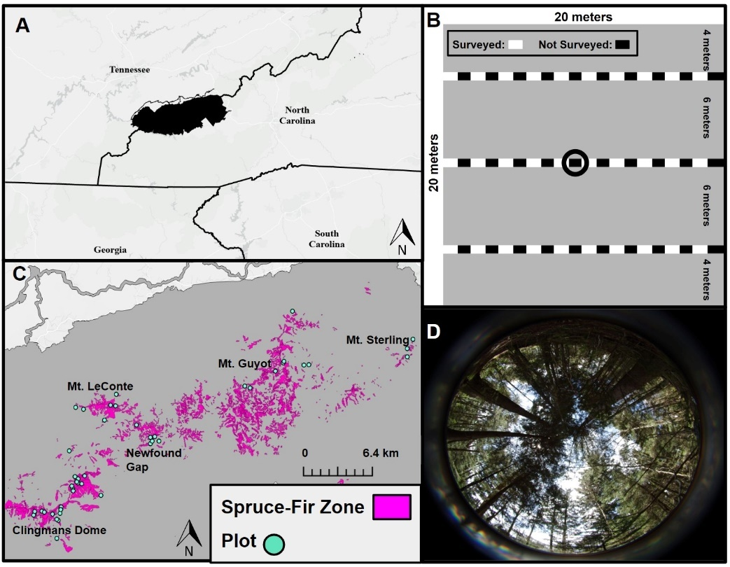
Figure 1.1 (A) Location of the Great Smoky Mountains National Park highlighted in black. (B) Sampling design for community composition in each 20 x 20 meter plot. Each checkered line represents a 20 meter transect lines across the plot, spaced out six meters from each other and four meters from the edge of the plot. The white blocks represent the 10 meters where bryophytes were surveyed. The black blocks represent the alternating 10 meters where bryophytes were not surveyed. Thus, a total of 30 meters was sampled per plot. The black circle in the center represents the location where the fish-eye photo was taken in each plot as well as the central point for tree community composition data collection. (C) Map of the Great Smoky Mountains National Park with the Spruce, Spruce-Fir, and Fir zones in magenta and the 45 plots surveyed in 2020/21 in light green. (D) Example of a fish-eye photo taken at the center of each plot, photo taken by Eric Shershen.

Table 1.1 Mean gap fraction and change in gap fraction at each of the elevation zones. Note: A paired t-test was used to compare gap fraction between the two time points
Elevation Zone | 2007/08 Gap Fraction | 2020/21 Gap Fraction | Change in Mean Gap Fraction | p-value | df | t-stat
Spruce | 9.74 | 13.51 | 3.77 | 0.44 | 7 | -0.83
Spruce-Fir | 10.88 | 11.00 | 0.12 | 0.97 | 27 | -0.038
Fir | 10.57 | 11.10 | 1.43 | 0.52 | 8 | -0.67
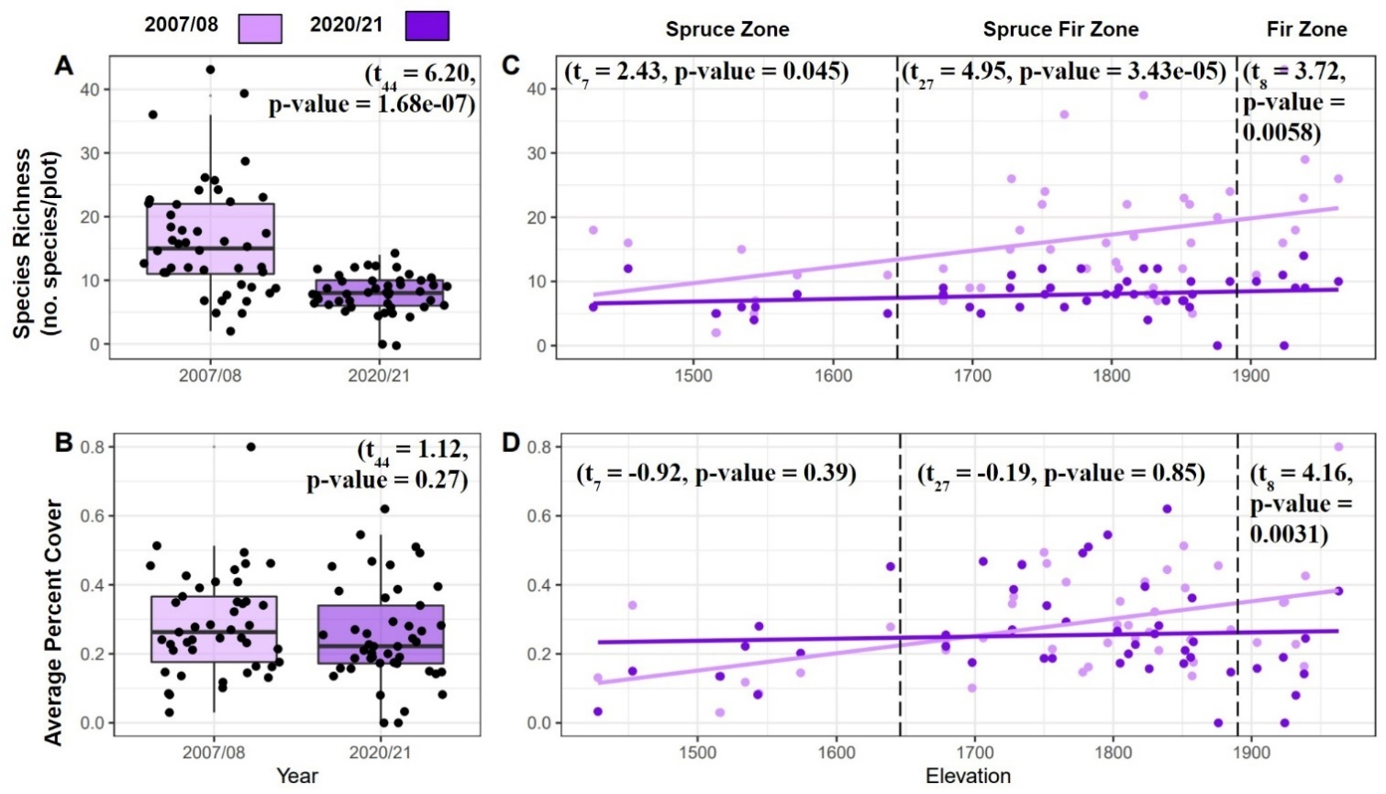
Figure 1.2 Changes in bryophyte species richness and abundance over 12 years in the Great Smoky Mountains National Park. Individual points represent associated plot’s measurement for all figures. Whiskers represent variability outside first and third quartile, midline represents the median, and outliers are points plotted above or below the whiskers. (A) Species richness significantly declined over time across all plots. (B) Average bryophyte abundance in percent cover across the plots has not significantly declined over time when all plots are considered. (C) Species richness significantly declined across all elevation zones. (D) Average bryophyte abundance in percent cover has significantly decreased over time in the Fir zone, but not significantly changed over time in the Spruce or Spruce-Fir elevation zones.

Table 1.2 Significantly changing species between the two time points with their functional group (FG), percent of plots the species occupied, and the mean percent coverage in plots where the species was found for each time point listed. Note: Functional Groups are as follows: Pleurocarpous (P), Acrocarpous (A), and Liverwort (L). A paired t-test followed by a sequential Holm’s Bonferroni correction was performed to account for multiple comparisons.
Species | FG | Percent of Plots Present 2007/08 | Mean Plot coverage 2007/08 | SD 2007/08 | Percent of Plots Present 2020/21 | Mean Plot coverage 2020/21 | SD 2020/21 | Raw  p-value | Holms-Bonferroni Corrected  p-value | df | t-stat
Brotherella recurvans | P | 87% | 6% | 3% | 22% | 1% | 3% | 3.68e-05 | 0.0018 | 38 | 4.67
Bryhnia novae-angliae | P | 18% | 1% | 0.6% | 2% | 0.08% | 0.2% | 6.9e-05 | 0.01 | 7 | 5.76
Dicranodontium denudatum | A | 62% | 0.9% | 0.8% | 11% | 0.2% | 0.5% | 0.0026 | 0.025 | 28 | 3.3
Hypnum pallescens | P | 17% | 0.07% | 0.1% | 38% | 3% | 3% | 8.09e-04 | 0.01 | 21 | -3.91
Isopterygium tenerum | P | 15% | 0.5% | 0.2% | 2% | 0.02% | 0.06% | 0.0032 | 0.025 | 6 | 4.72
Lepidozia reptans | L | 62% | 0.5% | 0.9% | 11% | 0.1% | 0.4% | 0.0029 | 0.025 | 30 | 3.24
Nowellia curvifolia | L | 76% | 1% | 0.9% | 22% | 0.3% | 0.5% | 5.79e-05 | 0.0018 | 33 | 4.61
Polytrichastrum pallidisetum | A | 75% | 2% | 4% | 16% | 0.2% | 0.6% | 0.0038 | 0.026 | 35 | 3.1
Tetraphis pellucida | A | 93% | 0.9% | 0.7% | 16% | 0.2% | 0.7% | 1.08e-04 | 0.0022 | 40 | 4.3

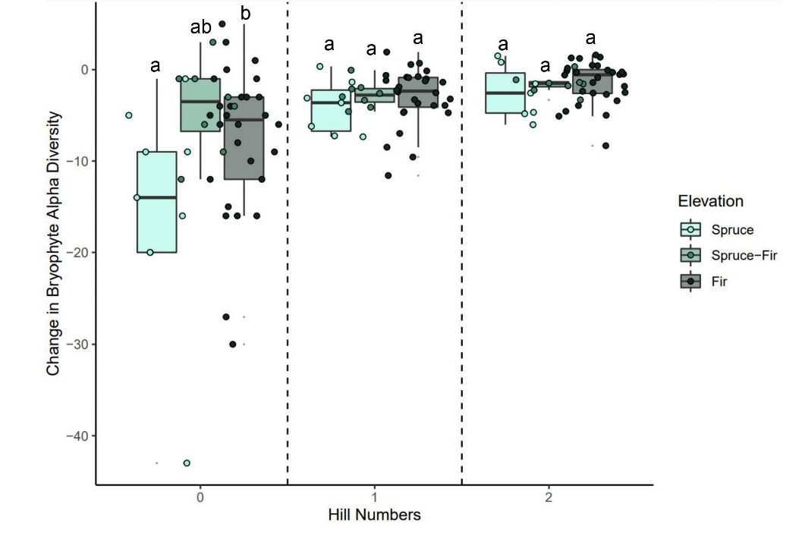
Figure 1.3 Change in bryophyte alpha diversity across the distinct elevation zones. Whiskers represent variability outside first and third quartile, midline represents the median, and outliers are points plotted above or below the whiskers. Change in alpha diversity is evaluated over Hill numbers (q = 0, species richness; q = 1, Shannon’s diversity; q = 2, Simpson’s diversity). Letters denote significant differences for when p < 0.05 and were determined using a post-Hoc Tukey test.

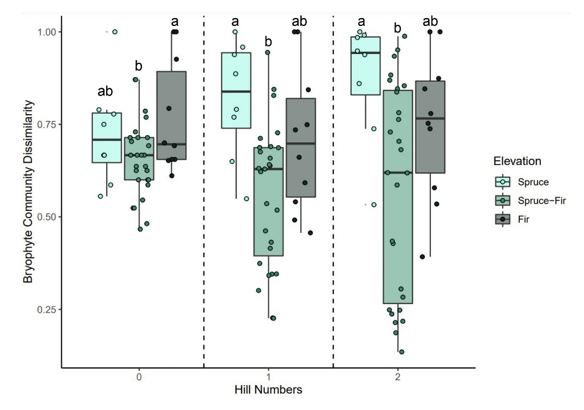
Figure 1.4 Bryophyte turnover across time and elevation zones within the Great Smoky Mountains National Park. Whiskers represent variability outside first and third quartile, midline represents the median, and outliers are points plotted above or below the whiskers. Turnover is evaluated over Hill numbers (q = 0, species richness; q = 1, Shannon’s diversity; q = 2, Simpson’s diversity). Letters denote significant differences for when p < 0.05 and were determined using a post-Hoc Tukey test.

CHAPTER 2: DETECTING BRYOPHYTE COMMUNITY CHANGES UNDER DIFFERENT MANAGEMENT PRACTICES IN HIGH ELEVATION ECOSYSTEMS IN THE SOUTHERN APPALACHIANS USING HERBARIUM SPECIMENS

ABSTRACT
Monitoring changes in plant communities over time is essential for understanding ecosystem health under multiple global change drivers. Permanent plots are an important tool for understanding how communities change through time, however, their establishment, maintenance, and regular surveying can be resource intensive. Natural history collections provide an open-source data alternative to study how communities change over time, especially for organisms not typically included in vegetation surveys, such as bryophytes. We used herbarium specimen data to examine bryophyte community change in the southern Appalachians before and after the arrival of the balsam wooly adelgid (BWA); an invasive pest which killed over 90% of the fir trees in the high elevations of the park, which altered microclimatic conditions for bryophytes. Mountain peaks were subjected to varying management strategies for this pest, and we examined how differences in strategies may have altered community composition through time. After downloading, trimming, and binning the specimen data, we examined both raw and rarefied alpha diversity, as well as dissimilarity, over time. Comparing two timespans related to pre-invasion and initial recovery from invasion, we determined if species were either lost, persisted, or new to the high elevations of the park following the BWA invasion and if these species had shared features. Observational studies have noted that habitat generalists have broader niches, allowing them to better handle disturbances and changes to their habitat, which we observed wherein generalists significantly persisted through time compared to expected. We also noted that differing management practices may have influenced bryophyte diversity when examining rarefied richness. Future studies could examine a broader area with larger sample sizes for each management strategy implemented, allowing for more powerful statistical analyses to detect community change trends under differing management strategies.

INTRODUCTION
Land managers are tasked with making informed decisions to preserve the ecosystems they monitor. Management decisions are often informed by research alongside stakeholder and societal interests, which empowers researchers and stakeholders to cooperate to effectively manage land (Enquist et al. 2017, Hallett et al. 2017). One common method to evaluate the effectiveness of these research-informed decisions is establishing and monitoring permanent plots to study community changes over time. Permanent plots have been shown to be powerful tools, especially when monitoring communities following disturbance events (Brice et al. 2019, Weber et al. 2006) or when management strategies are changed (Waring et al. 2016). While permanent plots are vital for a deeper understanding of community changes over time, they often may not be an option due to the prohibitive costs or person-power required to establish, maintain, and regularly survey them (de Ballo et al. 2020). This creates a barrier for managed lands that have limited and or inconsistent funding, leading to a vacuum of knowledge regarding the flora of those lands.
One alternative that avoids the high level of resources needed for permanent plots is to use the abundant specimen data housed in plant natural history collections (herbaria; Theirs 2023). These data include the location of species through time and much of these data are freely available through online portals, such as the Global Biodiversity Information Facility (www.gbif.org), Southeast Regional Network of Expertise and Collections (sernecportal.org), and The Consortium of Bryophyte Herbaria (bryophyteportal.org). Specimen data from herbaria have been used to identify changes in phenology (Faidiga et al. 2023, Park et al. 2021), range distribution shifts (Auld et al. 2022, Bergamini et al. 2009), changes in genetic diversity (Labouisse et al. 2020, Závada et al. 2022), and community change over time (Dodd et al. 2015, Dolan et al. 2011, Ewers-Saucedo et al. 2021). While it is important to note that specimens can only provide presence/absence data and are predisposed to collection biases (Daru et al. 2018), in areas where longitudinal studies with permanent plots have not been established or where certain organisms have not been included, herbarium data is an ideal alternative for understanding how communities have changed through time in response to disturbance events and management decisions.
Many community change studies focus on vascular plant communities at the species level and exclude bryophytes altogether (Franklin et al. 2004, Becker-Scarpitta et al. 2018). When bryophytes are included in long-term community change studies, they are often grouped together under “non-vascular plants” as opposed to documenting these organisms at the species level, which is standard for vascular plants (Kopecký and Szabó 2013, Collins et al. 2022). This is likely due to the difficulty identifying bryophytes to species in the field, as the vast majority require microscopic examination to confirm species level identifications. However, lumping all bryophytes into a single category hinders studies from understanding how their communities change at the species level in response to management decisions and disturbances. This could lead to species loss, and consequently the ecosystem functions they provide, which range from providing soil stability (Gao et al. 2020), habitat to a variety of taxa (Ziesche and Roth 2008, Coyle 2009, Bartels and Nelson 2007), and sequestering carbon (Yu et al. 2011, Kasimir et al. 2021). Bryophytes have been preserved in plant natural history collections with confident species level identifications along with geographic information. The Global Biodiversity Information Facility (GBIF) documents over 1.3 million preserved bryophyte specimens in the United States alone dating back as far as the 1800’s (GBIF 2023), making bryophytes a promising group to use herbarium specimen data to document species level community change through time, as is standard in vascular plant community change studies.
Here, we use the Great Smoky Mountains National Park (GSMNP) within the southern Appalachians as a case study to examine bryophyte community composition through time using herbarium specimens. The GSMNP has a rich history of bryophyte collection through time (Sharp 1939; Schofield 1960; Norris 1964; Studlar 1982; NPS 1991; NPS 1995; NPS 1999; Choerberka 1998; Stehn et al. 2010a; Stehn et al. 2010b; Shershen et al. 2024). The park has also experienced a major insect invasion event by the balsam wooly adelgid (BWA), first documented in 1962, which caused roughly 90% fir mortality which likely dramatically altered the microclimate of the understory (Speers 1958, Jenkins 2003). Across the GSMNP diverse BWA management strategies were applied to the high elevation sites with varying degrees of effectiveness (Johnson 1980; pers. comm. Paul Super, Research Coordinator at the National Park Service 2023). There have been no studies examining the impact of the BWA and its changes to the microclimate on bryophyte community composition from pre-BWA invasion to initial canopy recovery (ICR) or how the different management strategies may have impacted the bryophyte communities. This is especially important since bryophytes make up the bulk of the ground cover and species diversity within high elevation areas of the park (Stehn et al. 2010a).
We aim to address the following questions using herbarium specimens. 1) How has bryophyte community composition changed through time in the GSMNP? Specifically, how have the high elevation communities changed relative to the invasion of the BWA? 2) How have different management strategies for the BWA invasion impacted bryophyte community composition? For these two questions, we expect that the more impacted mountain peaks and those with more extreme management strategies that influenced the canopy cover will have greater effects on the community as bryophytes have been shown to be especially vulnerable to canopy changes (Halpern et al. 2014) 3) If changes in community composition are detected, are there shared features, such as substrate specificity, growth form, or taxonomic order, that define the species present prior to the BWA invasion compared to present day? Here we expect substrate generalists to be better able to handle such stresses as another study examining spruce decline in response to an invasive pest noted substrate generalists having a broader niche, including increased light tolerance (Fudali 2008).

METHODS
Extensive bryophyte collection events within the GSMNP boundary have been conducted between 1913 and 2022. Specimen data from this range was downloaded from the Consortium of Bryophyte Herbaria (CNBH) and Global Biodiversity Information Facility (GBIF) in August of 2023 (GBIF.org 2023, Consortium of Bryophyte Herbaria 2023). Specimens not yet available through these online portals were added to these data (Stehn et al. 2010a, Shershen et al. 2024). Species names were synonymized using Tropicos to account for taxonomic changes over time (Tropicos.org 2023). Duplicate records and specimens only possessing genus-level identifications were removed. Specimens were georeferenced as needed and their coordinates were uploaded to ArcGIS Pro version 3.3 (ESRI 2023) wherein elevation was extracted to each specimen. Specimens were then grouped spatially by mountain peak [Kuwohi (formerly Clingmans Dome), Mt. Kephart, Mt. LeConte, and Mt. Sterling]. These peaks were selected due to the different management strategies applied following the BWA invasion. Mt. LeConte and Mt. Kephart had little to no management for BWA due to limited access for implementing strategies (Johnson 1980; pers. comm. Paul Super, Research Coordinator at National Park Service 2023). Both chemical and biotic controls were used to manage for the BWA on Kuwohi. These had a positive impact on the fir community. Mt. Sterling had the highest levels of management, including clear-cutting strips of trees to create a buffer zone and biotic controls (Johnson 1980; pers. comm. Paul Super, Research Coordinator at National Park Service 2023). However, these management practices were found to have a minimal effect reducing the BWA invasion on Mt. Sterling (Johnson 1980; pers. comm. Paul Super, Research Coordinator at National Park Service 2023). To prevent overlap of specimen data, we applied a buffer area of 15 km² around the center of each peak, ensuring each specimen was only counted in a single group. Since the BWA impacts only high elevations above 1340 m (Whitaker 1956), an additional spatial group was created containing any specimen collected within the park above 1340 m, including those specimens collected on the aforementioned peaks. The four mountain peaks, along with the high elevation group will be called spatial groupings hereafter.
The specimen data from all spatial groupings were then divided into three timespans defined by ecologically relevant dates for the BWA invasion. The first timespan was 1934 through 1962. The park was established in 1934, which began a more intensive period of species documentation. In 1962 the first documentation of BWA severely impacting areas within the park boundary was recorded (Jenkins 2003, Johnson 1980). Specimens collected prior to 1934 were excluded since there were not enough specimens collected prior to 1934 to analyze as a standalone timespan. The second timespan was 1963 through 1999, the period when BWA was dramatically impacting high elevation areas until the first study documenting fir canopy recovery in the park in 1999 (Smith and Nicholas 2000). The final timespan was 2000 through 2022, which is from initial canopy recovery to the time this study was conducted. We will refer to these timespans as pre-BWA (1934-1962), post-BWA (1963-1999), and initial canopy recovery (ICR; 2000-2022), respectively. A species list was generated for each spatial grouping and timespan. Using these species lists, an abundance matrix was generated.
Richness (number of unique species) was calculated using this matrix for each spatial grouping and for each timespan. Richness was standardized by sampling effort via rarefaction using the vegan package in R (R Core Team 2023, Oksanen et al. 2015). Rarefaction randomly samples community data with the level of rarefaction set to the lowest level of sampling effort being compared (Sanders 1968, Simberloff 1972, Heck et al. 1975). In our case, this is set to the timespan with the lowest number of specimens collected for each mountain peak. We ran 9,999 rarefaction iterations for each timespan for each of spatial groupings except the high elevation grouping. For each iteration we determined the direction of differences between each timespan’s rarefied richness to each other. The percentage of times each timespan had a higher rarefied richness compared to another timespan is reported in Table 2.1 (all tables listed in the Appendix at the end of this chapter). In addition, dissimilarities were calculated to examine how different rarefied richness was between timespans using the vegan package in R (Oksanen et al. 2015).
We also examined changes in individual species between the pre-BWA (1934-1962) and ICR (2000-2022) timespans for the high elevation spatial group using our matrices. For only this group we determined which species were 1) present in the park before the arrival of the BWA (pre-BWA timespan) and then absent during initial canopy recovery (ICR timespan), 2) present during both the pre-BWA and ICR timespans, or 3) absent pre-BWA and then present during the ICR. Thus, we refer to these species as lost (present pre-BWA and absent during ICR), persisted (present pre-BWA and present during ICR), and new (absent pre-BWA and present during ICR).
Substrate specificity, growth form, and taxonomic order were determined for each bryophyte species in the dataset. Substrate specificity was scored by counting the number of substrates a species was known to inhabit as reported in the Flora of North America (FNA) (Flora of North America Editorial Committee 1993) using a modified version of a bryophyte substrate scoring system (Hill et al. 2017, Table 2.2). The number of substrate types a species can potentially occupy was summed and each species was categorized as having the ability to occupy either one substrate type (specialist), two substrate types (flexible), or three or more substrate types (generalist). For growth form, species were scored as either an acrocarpous moss, pleurocarpous moss, or liverwort. The taxonomic order for each species was determined using the moss classification of Goffinet & Buck (2020) or the liverwort classification of Söderström et al. (2016). These data were then analyzed with Chi square tests and corrected for multiple comparisons using a Sequential Holms-Bonferroni correction to determine if any of these features were different between the lost, persisted, and new species for the high elevation spatial group.

RESULTS:

Alpha diversity
Bryophyte sampling effort varies over time with higher numbers of specimens typically resulting from extensive surveys for either monitoring reports or individual research studies (Sharp 1939; Schofield 1960; Norris 1964; Studlar 1982; NPS 1991; NPS 1995; Choeberka et al. 1998; NPS 1999; Stehn et al. 2010a,b; Shershen et al. 2024; Figure 2.1 all figures listed in the Appendix at the end of this chapter). Examining uncorrected richness (total number of unique species) across all spatial groupings, we observed a decline from the pre-BWA to post-BWA timespan and an even more dramatic decrease in the ICR timespan (Figure 2.2). However, when we standardized by sampling effort using rarefaction, we observed two distinct patterns. On Mt. Sterling and Mt. Kephart rarefied alpha diversity increased from pre-BWA and peaked in the post-BWA timespan, followed by a decline in the ICR timespan whereas Kuwohi and Mt. LeConte had no difference between pre and post-BWA but had a stark decrease in rarefied alpha diversity during the ICR (Figure 2.3).

Dissimilarity
We examined dissimilarity to determine how different the communities were between pairs of timespans (pre-BWA and post-BWA, post-BWA and ICR, and pre-BWA and ICR). We observed dissimilarity levels above 0.5 for all comparisons across all four of the mountain peaks with the notable exception of Kuwohi and Mt. LeConte between pre and post-BWA (Figure 4). Mt. Sterling and Mt. Kephart consistently had higher dissimilarity levels compared to Mt. LeConte and Kuwohi for all of these comparisons (Figure 2.4).

Species change
We used Chi-square tests to examine how the high elevation spatial group differed between the pre-BWA and ICR timespans to determine if there were any shared characteristics between species that were lost, persisted, or new. We found that substrate specificity (whether a species is a specialist, flexible, or generalist) significantly differed between lost, persisted, and new species (χ² = 13.07, df = 4, p-value = 0.011). Following this test, we determined if the standardized residuals were either greater or less than the absolute critical value (-2.77) to determine which observations were significantly different than expected. We found that between these two timespans (pre-BWA and ICR) fewer generalists were lost and more generalists persist compared to the expected values (Table 2.3). All other observed values were not significantly different than the expected values (Table 2.3).
When we compared substrate specificity groups, there were significantly more generalist species that persisted compared to specialist species (χ²= 10.56, df = 1, corrected p-value = 0.009; Table 2.4). All other comparisons were not significantly different (Table 2.4). When grouping by growth form, there were no significant differences in any species change group between the different growth forms following a sequential Holm’s-Bonferroni correction (Table 2.5). When we examined taxonomic order in relation to species change, there were a few orders where there were significant differences between the lost, new, and persisting species (Table 2.6). These included significantly more species lost than new for Jungermanniales (χ² = 39.1, df = 1, corrected p-value = 2.7e-8), Porellales (χ² = 16,2m df = 1, corrected p-value = 5.7e⁻⁵), Hypnales (χ² = 26.1, df = 1, corrected p-value = 2.15e-5), Grimmiales (χ²= 13, df = 1, corrected p-value = 0.019), Bryales (χ² = 11.27, df = 1, corrected p-value = 0.046), Pottiales (χ² = 6, df = 1, correct p-value = 0.014), and Dicranales (χ² = 13, df = 1, corrected p-value = 0.019); significantly more species persisting than new for Jungermanniales (χ² = 20.17, df = 1, corrected p-value = 0.0044), Hypnales (χ² = 16, df = 1, corrected p-value = 0.004), Dicranales (χ² = 11, df = 1, corrected p-value = 0.0018), Sphagnales (χ² = 6, df = 1, corrected p-value = 0.014) and Porellales (χ² = 16.2, df = 1, corrected p-value = 0.00365); and significantly more species lost than persisted for Grimmiales (χ² = 13, df = 1, corrected p-value = 0.0189) and Bryales (χ² = 7.12, df = 1, corrected p-value = 0.015).

DISCUSSION

Communities following disturbance
Changes in canopy cover can influence microclimate and the available niches resulting in community compositional changes over time (Gray et al. 2002). In this study, the BWA killed over 90% of the fir trees in the GSMNP which opened the canopy and increased light levels in the understory (Jenkins 2003, Royo and Carson 2011). Bryophyte richness has been shown to initially increase following disturbances (Kimmerer et al. 1982, Jonsson and Esseen 1990), especially following canopy altering disturbances in studies leveraging permanent plots (Fudali 2008, Pedro et al. 2016). Our study corroborates these findings; rarefied richness increased during post-BWA timespan when the canopy would be expected to be most open followed by a decrease in richness during the initial canopy recovery period (ICR) when the canopy would be closing for two of the spatial groupings (Figure 2.3).
From a disturbed state like that of the post-BWA, communities can either recover to pre-disturbance state, remain in limbo between community succession states, or shift to a new community (Beisner et al. 2003, Aguadé- Gorgorió et al. 2024). Bryophytes communities have been shown to recover more slowly following disturbances (Dynesius 2015) and have been predicted to lag behind other species with respect to climate change-driven range shifts (Zanatta et al. 2020). In our case, if the canopy recovered and fully closed, we would expect to see a decrease in available niches and as such a decline in richness. Indeed, we observed a decline in bryophyte richness from post-BWA to ICR across all spatial groups, supporting this prediction (Figure 2.3). However, we observed greater dissimilarity between pre-BWA and ICR than we would expect if the pre-disturbance bryophyte community had fully recovered (Figure 2.4). This could be due to species turnover, a lag in recovery in the understory as species re-colonize, or a new bryophyte community is forming following canopy recovery. It may also be that the timespans required for canopy recovery from BWA are not long enough for complete bryophyte community recovery (Dynesius 2015).

Management strategies and bryophyte communities
Mountains with varying management strategies for BWA had dramatic differences in bryophyte community composition. We compared the pre-BWA to ICR timespans rarefied richness and dissimilarity metrics to test for community changes. If communities returned to their pre-BWA compositions, we expected the dissimilarity between pre-BWA and ICR to be low. Instead, we observed dissimilarity above 50% between these timespans for all mountain peaks, with Mt. Sterling having the highest levels of dissimilarity (Figure 2.4) indicating that these communities have different compositions. It is important to note that one of the mountains managed for BWA, Kuwohi, had dramatically lower dissimilarity (Figure 2.4) with nearly identical rarefied richness between the pre-BWA and post-BWA timespans across the iterations (Table 2.1, Figure 2.3). This could be due to Kuwohi having the most success managing for the BWA invasion (chemical and biotic controls) out of the mountains examined (Johnson 1980). While Mt. Sterling was managed for BWA with both clearcutting and biotic controls, reports state this combination of practices was not successful at reducing the BWA invasion (Johnson 1980). Dissimilarity was higher for Mt. Sterling compared to Kuwohi (Figure 2.4), and Mt. Sterling had a stark increase in rarefied diversity from pre-BWA to post-BWA (Table 2.1, Figure 2.3). In addition, dissimilarity for Mt. Sterling was higher than either of the unmanaged peaks (Figure 2.4). Consequently, it is possible that an aggressive management approach like clearcutting strips of canopy was more harmful to the bryophyte community than leaving the peak unmanaged or using pesticides like on Kuwohi.
However, it may be best to focus on the differences using rarefaction metrics to evaluate species change through time when using herbarium specimens. This is because dissimilarity relies on the presence and absence of species, and as such sampling bias can skew the calculated value. As we increase the number of specimens pooled in a spatial grouping, we would expect lower levels of dissimilarity as we detect shared species between time points more frequently. Whereas at low efforts of sampling, randomly collecting a less common species could greatly increase the dissimilarity between groups. We can use rarefaction to balance this limitation of dissimilarity and herbarium data to detect trends in bryophyte community change following disturbances. Careful consideration is needed when interpreting such results. To determine if this holds true on larger scales and for more prominent disturbances, more studies of similar management strategies could be examined to see if the same strategies yield similar trends in dissimilarity and rarefaction with herbarium data.

Trends in substrate specificity
If we can detect changes in substrate specificity using herbarium specimens could aid in determining the effects of management decisions in areas lacking permanent plots. When examining the relationship between substrate specificity and species change from pre-BWA to the ICR timespan, we observed that fewer generalists were lost and more persisted than expected (Table 2.3). There were also significantly more generalists than specialists that persisted from the pre-BWA to the ICR timespan (Table 2.4, Figure 2.5). This aligns with the prediction that species capable of living on multiple substrates have a higher probability of surviving disturbances since they have a larger variety of habitats where they can persist or colonize (Almoussawi et al. 2019, Noualhaguet et al. 2023). It has been shown for plants in the tropics that specialists require more time to re-establish following disturbance (Acebey et al. 2003). Thus, the generalists could have either persisted through the disturbance or recolonized more quickly than the specialists. Detecting these trends in substrate specificity with herbarium data is promising, as managed lands that lack permanent plots may be able to leverage natural history collections to assess how disturbances and management decisions alter the communities they aim to preserve, especially if such environmental changes are known to alter substrate availability.
The high fir tree mortality due to the BWA invasion as well as clearcutting as a management strategy resulted in an increase in logs on the forest floor (Johnson 1980). This increase in downed wood benefits species that require this substrate. However, they decay and inevitably disappear, thus reducing the substrate availability for species requiring downed logs (Söderström 1988). For specialists who only inhabit downed logs, this loss would be highly detrimental, whereas generalists who can survive on other substrates would be able to persist through time, even as substrate availability changes (Halpern 2014). Increased substrate availability has been shown to positively benefit rare bryophytes (Ódor and Standovár 2002), as such, land managers should consider rare species substrates when designing and implementing conservation efforts. This is especially critical for downed wood substrate specialist species that are declining in abundance within the Great Smoky Mountains National Park (Shershen et al. 2024).

Trends in taxonomic order
When grouping bryophytes by growth form and examining species change from the pre-BWA to the ICR timespan, we observed more liverwort species were lost compared to pleurocarpous and acrocarpous mosses (Table 2.5, Figure 2.5). While these were not statistically significant differences, this trend aligns with literature documenting liverworts being more sensitive to canopy opening compared to mosses (Halpern et al. 2014). Liverworts are also more likely exhibit substrate specificity than compared to pleurocarpous mosses, which are often generalists (Noualhaguet et al. 2023). This may be concerning as studies have shown liverworts are more likely to remain locally extirpated following canopy disturbances (Fenton et al. 2003).
Bryophytes in different taxonomic orders had different trends in species change from the pre-BWA to the ICR timespan. However, all but one of the significant comparisons between species change groups were between new species and the lost or persisted groups. The orders with significantly different levels of species change, were typically driven by small numbers of new species entering the community compared to the large number that were lost or persisted (Table 2.6). There is no other shared trend among growth forms or characteristics of these orders likely driving these differences. This information is still valuable in that it allows for targeted searches for “lost” species to determine if they are truly lost or if sampling efforts have not been sufficient to detect them. It also may be the case that these “new” species are from lower elevations, with climate change altering the available niches allowing them to invade the higher elevations.

Conclusions
Overall, we detected two patterns of changes in rarefied richness that could be dependent on management strategy implementation. In the case of less successful management of BWA, bryophyte rarefied richness increased post-disturbance, and decreased during recovery which aligns with other literature examining bryophyte community change following disturbance. We also found that substrate generalists were significantly more likely to persist through a disturbance than specialists. Finally, we observed how differing management strategies can influence bryophyte communities. All of these findings were based on specimen data thus demonstrating the importance of herbaria for studies of community change ecology, especially in areas that may not have permanent plots. Future research directions should investigate smaller managed lands with fewer collections to determine if trends observed in observational studies can be detected with fewer specimens. Another avenue would be to compare costly permanent plot collections with herbarium records from the same area and timespans to determine how similar the results are from these two types of data. Finally, examining a greater number of mountains or other ecosystems under the same management strategies would allow for more robust statistical analysis and help determine whether herbarium data can be more broadly utilized for evaluating community change following management.

REFERENCES
Acebey, A., Gradstein, R., and Krӧmer, T. 2003. “Species richness and habitat diversification of bryophytes in submontane rain forest and fallows of Bolivia.” Journal of Tropical Ecology 19:9–18. https://doi.org/10.1017/S026646740300302X
Aguadé-Gorgorió, G., Arnoldi, J., Barbier, M., and Kéfi, S. 2024. “A taxonomy of multipl sable states in complex ecological communities.” Ecology Letters 27(4) e14413. https://doi.org/10.1111/ele.14413
Almoussawi A., Lenoir, J., Jamoneau, A. Hattab, T., Wasof, S., Gallet-Moon, E., Garzon-Lopez, C. X., Spcher, F., Kobaissi, A., and Decocq, G. 2019. “Forest fragmentation shapes the alpha-gamma relationship in plant diversity.” Jounral of Vegetation Science 31: 63-74. https://doi.org/10.1111/jvs.12817
Auld, J., S.E. Everingham, F.A. Hemmings, and A.T. Moles. 2022. “Alpine plants are on the move: Quantifying distribution shifts of Australian alpine plants through time.” Diversity and Distributions 28(5): 943-955. https://doi.org/10.1111/ddi.13494
Bartels, P.J. and D.R. Nelson. 2007. “An Evaluation of Species Richness Estimators for Tardigrades of the Great Smoky Mountains National Park, Tennessee and North Carolina, USA.” Journal of Limnology 66: 104-110. https://doi.org/10.4081/jlimnol.2007.s1.104
Becker-Scarpitta, A., Vissault, S., and Vellend, M. 2018. “Four decades of plant community change along a continental gradient of warming.” Global Change Biology 25(5): 1629-1641. https://doi.org/10.1111/gcb.14568
Beisner B. E., Haydon, D. T., and Cuddington, K. 2003. “Alternative stable states in ecology.” Fronteris in Ecology and the Environment, 1(7) 376-382. https://doi.org/10.1890/1540-9295(2003)001[0376:ASSIE]2.0.CO;2
Bergamini, A., Ungricht, S., and Hofmann, H. 2009. “An elevational shift of cryophilous bryophytes in the last century – an effect of climate warming?” Diversity and Distributions 15: 871-879. https://doi.org/10.1111/j.1472-4642.2009.00595.x
Brice, M. H., Cazelles, K., Legendre, P., and Fortin, M. J., 2019. “Disturbances amplify tree community responses to climate change in the temperate-boreal ecotone.” Global Ecology and Biogeography 28(11): 1668-1681. https://doi.org/10.1111/geb.12971
Choberka, E.1998. “A study of epixylic bryophyte ecology on Fraser Fir logs in the Great Smoky Mountains National Park.” Master’s Thesis, University of Tennessee. https://trace.tennessee.edu/utk_gradthes/2383
Collins, G. C., Elmendorf, S. C., Smith, J. G., Shoemaker, L., Szojka, M., Swift, M., and Suind, K. N. 2022, “Global change re-structures alpine plant communities through interacting abiotic and biotic effects.” Ecology Letters 25(8): 1813-1826. https://doi.org/10.1111/ele.14060
Coyle, F.A. 2009. “Status Survey of the Spruce-Fir Moss Spider, Microhexura montivaga.” Report to the US Fish & Wildlife Service
Consortium of Bryophyte Herbaria (accessed through the Consortium of Bryophyte Herbaria Portal, https://bryophyteportal.org/portal, 2023.
Daru, B. H., Park, D. S., Primack, R. B., Willis, C. G., Barrington, D. S., Whitfeld, T. J. S., Seidler, T. G., Sweeney, P. W., Foster, D. R., Ellison, A. M., and Davis, C. C. 2018/ “Widespread sampling biases in herbaria revealed from large-scale digitization. New Phytologist 217(2): 939-955. https://doi.org/10.1111/nph.14855
de Ballo, F., Valencia, E., Ward, D., and Hallett, L. 2020. “Why we still need permanent plots for vegetation science.” Journal of Vegetation Science 31(5) 679-685. http://doi.org/10.1111/jvs.12928et al 2020
Dodd, A. J., Burgman, M. A., McCarthy, M. A., and Ainsworth, N. 2015. “The changing patterns of plant naturalization in Australia.” Diversity and Distributions 21: 1038-1050. https://doi.org/10.1111/ddi.12351
Dolan, R. W., Moore, M., E., and Stephans, J. D. 2011. “Documenting effects of urbanization on flora using herbarium records.” Journal of Ecology 99: 1055-1062. https://doi.org/10.1111/j.1365-2745.2011.01820.x
Dynesius, M. 2015. “Slow recovery of bryophyte assemblages in middle-aged boreal forests regrown after clear-cutting. Biological Conservation 191: 101-109. https://doi.org/10.1016/j.biocon.2015.06.024
Enquist, C. A. F., Jackson, S. T., Garfin, G. M., Davis, F. W., Gerber, L. R., Littell, J. A., Tank, J. L., Terando, A. J., Wall, T. U., Halpern, B, Hiers, J. K., Morelli, T. L., McNie, E., Stephenson, N. L., Williamson, M. A., Woodhouse, C. A., Yung, L., Brunson, M. W., Hall, K. R., Hallett, L. M., Lawson, D. M., Mositz, M. A., Nydick, K., Pairis,A., Ray, A. J., Regan, C., Safford, H. D., Schwartz, and M. W., Shaw, M. R. 2017, “Foundations of translational ecology.” Frontiers in Ecology and the Environment 15(10): 541-550. https://doi.org/10.1002/fee.1733
ESRI 2023. ArcGIS Pro version 3.3. Redlands, CA: Environmental Systems Research Institute.
Ewers-Saucedo, C., Allspach, A., Barilaro, C., Bick, A., Brandt, A., Fiege, D., Füting, S., Hausdorf, B., Hayer, S., Husemann, M., Joger, U., Kamcke, C., Küster, M., Lohrmann, V., Martin, I., Michalik, P., Reinicke, G., Schwentner, M., Stiller, M., and Brandis, D. 2021. “Natural history collections recapitulate 200 years of faunal change.” The Royal Society Publishing 8: 201983. https://doi.org/10.1098/rsos.201983
Faidiga, A. S., Oliver, M. G., Budke, J. M., and Kalisz, S. 2023. “Shifts in flowering phenology in response to spring temperatures in eastern Tennessee.” American Journal of Boany 110(8): e16203. https://doi.org/10.1002/ajb2.16203
Fenton, N. J., Frego, K. A., and Sims, M. R. 2003. “Changes in forest floor bryophyte (moss and liverwort) communities 4 years after forest harvest.” Canadian Journal of Botany 81(7): 714-731. https://doi.org/10.1139/b03-063
Flora of North America Editorial Committee, eds. 1993+. Flora of North America North of Mexico. 22+ vols. New York and Oxford. Vol. 1, 1993; vol. 2, 1993; vol. 3, 1997; vol. 4, 2003; vol. 5, 2005; vol. 7, 2010; vol. 8, 2009; vol. 19, 2006; vol. 20, 2006; vol. 21, 2006; vol. 22, 2000; vol. 23, 2002; vol. 24, 2007; vol. 25, 2003; vol. 26, 2002; vol. 27, 2007; vol 28, 2014; vol. 9, 2014; vol. 6, 2015; vol. 12, 2016; vol. 17, 2019; vol. 10, 2021.
Franklin, J. Charlotte, L. C., and Rey, S. J. 2004. “Change over 70 years in a southern California chaparral community related to fire history.” International Association of Vegetation Science 15(5): 701-710. https://doi.org/10.1111/j.1654-1103.2004.tb02312.x
Fudali, E. 2008. “Ecological Assessment of the Changes in Species Composition of Mountain Spruce Forests’ Bryophyte Layer in the Karkonosze Mts after Huge Dieback in 1970-1980.” Botanika - Steciana 12: 9–13.
Gao, L., M.A. Bowker, H. Sun, J. Zhao, and Y. Zhao. 2020. “Linkages between Biocrust Development and Water Erosion and Implications for Erosion Model Implementation.” Geoderma. 357: 113973. https://doi.org/10.1016/j.geoderma.2019.113973
GBIF.org (2023), GBIF Home Page. Available from: https://www.gbif.org
Goffinet, B. and Buck, W. R. Classification of the Bryophyta. On-line version available at http://bryology.eeb.uconn.edu/classification/. (2023)
Gray, A.N., T.A. Spies, and M.A. Easter. 2002. “Microclimatic and Soil Moisture Responses to Gap Formation in Coastal Douglas-Fir Forests” Canadian Journal of Forest Research 32(2): 332–343. https://doi.org/10.1139/X01-200.
Hallett, L. M., Morelli, T. L., Gerber, L. R., Moritz, M. A., Schwartz, M. W., Stephenson, N. L., Tank, J. L., Williamson, M. A., Woodhouse, C. A. 2017. “Navigating translational ecology: creating opportunities for scientist participation.” Fronteiers in Ecology and the Environment 15(10): 578-586. https://doi.org/10.1002/fee.1734
Halpern, C.B., M. Dovčiak, L.S. Urgenson, and S.A. Evans. 2014. “Substrates Mediate Responses of Forest Bryophytes to a Gradient in Overstory Retention” Canadian Journal of Forest Research 866: 855–66. https://doi.org/10.1139/cjfr-2014-0059
Heck, K. L., van Belle, G., Simberloff, D. 1975. “Explicit calculation of the rarefaction diversity measurement and the determination of sufficient sample size.” Ecology 56(6): 1459-1461. https://doi.org/10.2307/1934716
Hill, M.O., Preston, C.D., Bosanquet, S.D.S., Roy, D.B. 2007, updated 2017. BRYOATT – Attributes of British and Irish Mosses, Liverworts and Hornworts
Jenkins 2003. “Impact of the Balsam Woolly Adelgid (Adelges piceae Ratz.) on an Abies fraseri (Pursh) Poir. Dominated Stand near the Summit of Mount LeConte, Tennessee.” Castanea 68(2): 109-118. https://www.jstor.org/stable/4034301
Johnson K.1980. “Fraser Fir and Balsam Woolly Aphid.” The Southern Appalchain Research – Resource Management Cooperative.
Jonsson, B.G. and Esseen, P.A. 1990. “Treefall disturbance maintains high bryophyte diversity in a boreal spruce forest.” Journal of Ecology 78: 924–936
Kasimir, Å., He, H., Jansson, P. E., Lohila, A., and Minkkinen, K. 2021. “Mosses are important for soil carbon sequestration in forested peatlands.” Frontiers in Environmental Science 9: 680430. https://doi.org/10.3389/fenvs.2021.680430
Kimmerer, R.W. and Allen, T.F.H. 1982. “The role of disturbance in the pattern of a riparian bryophyte community.” American Midland Naturalist 107: 370–383. https://doi.org/10.2307/2425387
Kopecký, M. and Szabó, R. H. 2013. “Non-random extinctions dominate plant community changes in abandoned coppices.” Journal of Applied Ecology 50(1): 79-87. https://doi.org/10.1111/1365-2664.12010
Labouisse, J. P., Cubry, P, Austerlitz, F., Rivallan, R., and Nguyen, H. A., 2020. “New insights on spatial genetic structure and diversity of Coffea canephora (Rubiaceae) in Upper Guinea based on old herbaria.” Plant Ecology and Evolution 153(1): 82-100. https://www.jstor.org/stable/26906813
National Park Service 1995. “Bryophyte and lichen survey of foothills parkway segment 8B, Cosby-Pittman Center Great Smoky Mountains National Park”
National Park Service 1999. “RTE bryophyte survey of southern Appalachian Fraser fir forests, North Carolina, Tennessee, Virginia”
Norris, D. H. 1964. “Bryoecology of the Appalachian Spruce-Fir Zone.” PhD diss., University of Tennessee. https://trace.tennessee.edu/utk_graddiss/1608
Noualhaguet, M., Work, T. T., Soubeyrand, M, Fenton, N. J. 2023. “Bryophyte community responses 20 years after forest management in boreal mixedwood forest.” Forest Ecology and Management 531. https://doi.org/10.1016/j.foreco.2023.120804
Ódor, P. and Standovár, T. 2002. “Substrate specificity and community structure of bryophyte vegetation in a near monane beech forest. Community Ecology 3(1): 39-49. https://www.jstor.org/stable/10.2307/90002472
Oksanen, J., F.G. Blanchet, R. Kindt, P. Legendre, P.R. Minchin, R.B. O'Hara, G.L. Simpson, P. Solymos, M.H.H. Stevens, and H. Wagner. 2016. vegan: Community Ecology Package. R package version 2.3-4. https://CRAN.R-project.org/package=vegan
Park, D. S., Newman, E. A., Breckheimer, I. K. 2021. “Scale gaps in landscape phenology: challenges and opportunities.” Trends in Ecology and Evolution 36(8): 709-721. https://doi.org/10.1016/j.tree.2021.04.008
Pedro, M. S., Rammer, W., and Seidl, R. 2016. “A disturbance-induced increase in tree species diversity facilitates forest productivity.” Landscape Ecology 31: 989-1004. https://doi.org/10.1007/s10980-015-0317-y
R Core Team (2023). R: A language and environment for statistical computing. R Foundation for Statistical Computing, Vienna, Austria. URL https://www.R-project.org/
Royo, A. A. and Carson, W. P. 2011. “On the formation of dense understory layers in forests worldwide: consequences and implications for forest dynamics, biodiversity, and succession. Canadian Journal of Forest Research 36: 1345-1362. https://doi.org/10.1139/x06-025
Sanders, H. L. 1968. “Marine benthic diversity: A comparative study.” The American Naturalist 102(925): https://doi.org/10.1086/282541
Schofield WB (1960) The ecotone between spruce-fir and deciduous forest in the Great Smoky Mountains. Ph.D. Dissertation, Duke University, Durham, NC
Sharp, Aaron J. 1939. “Taxonomic and ecological studies of eastern Tennessee bryophytes.” American Midland Naturalist: 267-354.
Shershen, E., Stehn, S. E., and Budke, J. M. 2024. “Environmental determinants of bryophyte community change over time.” Ecosphere 15(8): e4924. https://doi.org/10.1002/ecs2.4924
Simberloff, D. 1972. “Properties of the rarefaction diversity measurement.” The American Naturalist 106(949) https://doi.org/10.1086/282781
Smith, D.K., K.D. McFarland, and P.G. Davison. 1991. “Development of a taxonomic/ecological database: report of the floristic richness of bryophytes, Great Smoky Mountains National Park. National Park Service, Gatlinburg, Tenn.” Google Scholar
Sӧderstrӧm, L. 1988. “Sequence of bryophytes and lichens in relation to substrate variables of decaying coniferous wood in Northern Sweden.” Nordic Journal of Boany 8: 89-97. https://doi.org/10.1111/j.1756-1051.1988.tb01709.x
Söderström L., Hagborg A., von Konrat M., Bartholomew‐Began S., Bell D., Briscoe L., Brown E., Cargill D. C., Costa D.P., Crandall‐Stotler B.J., Cooper E.D., Dauphin G., Engel J.J., Feldberg K., Glenny D., Gradstein S.R., He X., Heinrichs J., Hentschel J., Ilkiu‐Borges A.L., Katagiri T., Konstantinova N.A., Larraín J., Long D.G., Nebel M., Pócs T., Puche F., Reiner‐Drehwald E., Renner M. A. M., Sass‐Gyarmati A., Schäfer‐Verwimp A., Moragues J. G. S., Stotler R. E., Sukkharak P., Thiers B. M., Uribe J., Váňa J., Villarreal J. C., Wigginton M., Zhang L., Zhu R-L. 2016. World checklist of hornworts and liverworts. PhytoKeys 59: 1–828. https://doi.org/10.3897/phytokeys.59.6261
Speers, C.F. 1958. “The balsam woolly aphid in the Southeast.” Journal of Forestry. 56: 515–516.Google Scholar
Stehn a, S., C. Webster, J. Glime, and M. Jenkins. 2010. “Elevational Gradients of Bryophyte Diversity, Life Forms, and Community Assemblage in the Southern Appalachian Mountains.” Canadian Journal of Forest Research 40(11): 2164-2174. https://doi.org/10.1139/X10-156
Stehn b, S., C. Webster, J. Glime, and M. Jenkins. 2010. “Ground-layer Bryophyte Communities of Post-Adelgid Picea-Abies Forests.” Southeastern Naturalist 9(3): 435-452. http://doi.org/10.1656/058.009.0303
Studlar, S. M.1982. “Host specificity of epiphytic bryophytes near Mountain Lake, Virginia.” Bryologist 85(1):37-50. https://doi.org/10.2307/3243139
Thiers, B.M. 2023. The World's Herbaria 2023. New York Botanical Garden.Tropicos.org 2023
Tropicos.org. Missouri Botanical Garden. 2023 <http://tropicos.org>
Waring, K. M., Hansen, K. J., and Flatley, W. T. 2016. “Evaluating prescribed fire effectiveness using permanent plot data: A case study.” Fire Ecology 12(3):2-25. https://doi.org/10.4996/fireecology.1203002
Weber, B., Bowker, M., Zhange, Y., and Belnap, J. 2006. “Natural recovery of biological soil crusys after disturbance.” In: Weber, B., Büdel, B., Belnap, J. (eds) Biological Soil Crusts: An Organizing Principle in Drylands. Ecological Studies, vol 226. Springer, Cham. https://doi.org/10.1007/978-3-319-30214-0_23
Whittaker, R. H. 1956. “Vegetation of the Great Smoky Mountains.” Ecological Monographs 26(1): 1-80. https://doi.org/10.2307/1943577
Yu, Z., Beilman, D. W., Frolking, S., MacDonald, G. M., Roulet, N. T., Camill, P., and Charman, D. j. 2011. “Peatlands and their role in the global carbon cycle.” Eos 92(12): 97-98. https://doi.org/10.1029/2011EO120001
Závada, T., Malik, R. J., Mazumder, L., and Kesseli, R. V. 2022. “Radical shift in the genetic composition of New England chicory populations. Journal of Ecology 111(2): 391-399. https://doi.org/10.1111/1365-2745.13968
Ziesche, T. M. and M. Roth. 2008. “Influence of Environmental Parameters on Small-Scale Distribution of Soil-Dwelling Spiders in Forests: What Makes the Difference, Tree Species or Microhabitat?” Forest Ecology and Management 255(3–4): 738–52. https://doi.org/10.1016/j.foreco.2007.09.060.

APPENDIX 2
Table 2.1 Percentage of 9,999 rarefaction iterations that had the same difference in direction for each timespan comparison [pre-BWA vs post-BWA, post-BWA vs ICR (Initial Canopy Recovery), and pre-BWA vs ICR]. If a timespan has a higher rarefied richness value for a majority of the iterations (close to 100%), we can confidently infer the rarefied richnesses are different from one another.
Spatial Group | pre-BWA vs post-BWA |  | post-BWA vs ICR |  | pre-BWA vs ICR
Spatial Group | pre-BWA higher | Post-BWA higher | Post-BWA higher | ICR higher | Pre-BWA higher | ICR higher
Kephart | 0% | 100% | 100% | 0% | 100% | 0%
Kuwohi | 47.4% | 52.6% | 100% | 0% | 100% | 0%
LeConte | 46.8% | 53.2% | 100% | 0% | 100% | 0%
Sterling | 0.35% | 99.7% | 100% | 0% | 100% | 0%

Table 2.2 Original substrate classes and their descriptions from Table 18 of Preston et al (2017). Substrate classes used in this study, which were condensed for the rock and soil classes to match the more general substrate descriptions used in the FNA (Flora of North America Editorial Committee, 1993).
Substrate classes from Preston et al (2017) | Substrate class description from Preston et al (2017) | Substrate classes used in this study
Rock, hard (RH) | Includes drystone walls when made of hard rock | Rock
Rock, soft (RS) | Includes chalk, soft sandstones and schists, tufa etc. | Rock
Rock, worked | Includes building stone, roofing slates, brick, mortar,  concrete, asphalt etc., but drystone walls built of unworked  rocks and stones count as RH or RS | Rock
Soil on rock | Thin layer of soil over rock; includes soil over natural, worked or artificial rock | Soil
Soil | Includes mineral, sandy, gravelly, humus-rich and peaty soils; pure peats, sands and gravels are treated separately | Soil

Table 2.2 continued
Substrate classes from Preston et al (2017) | Substrate class description from Preston et al (2017) | Substrate classes used in this study
Peat | Includes relatively shallow peat over mineral soil | Peat
Gravel or sand | Gravel or sand | Gravel or sand
Decorticated wood | Includes decorticated logs, rotting wood and worked wood (fence posts etc.) | Decorticated wood
Decaying vegetation | Includes leaf litter, thatch, decaying vascular plant tussocks (e.g. Carex paniculata, Molinia caerulea) etc. | Decaying vegetation
Decaying animal | Decaying animal matter, including bones, dung etc. | Decaying animal
Bryophyte | Growing amongst or through other bryophytes (including Sphagnum) | Bryophyte
Epiphytic on non-woody substrate | Includes epiphytic occurrences on lichens, other bryophytes and fern fronds, and on the leaves of flowering plants | Epiphytic on non-woody substrate
Epiphytic on living wood | On bark on the trunks, branches, stems and exposed roots of vascular plants (including the trunks of tree ferns) | Epiphytic on living wood
Floating on water | Floating on water | Floating on water

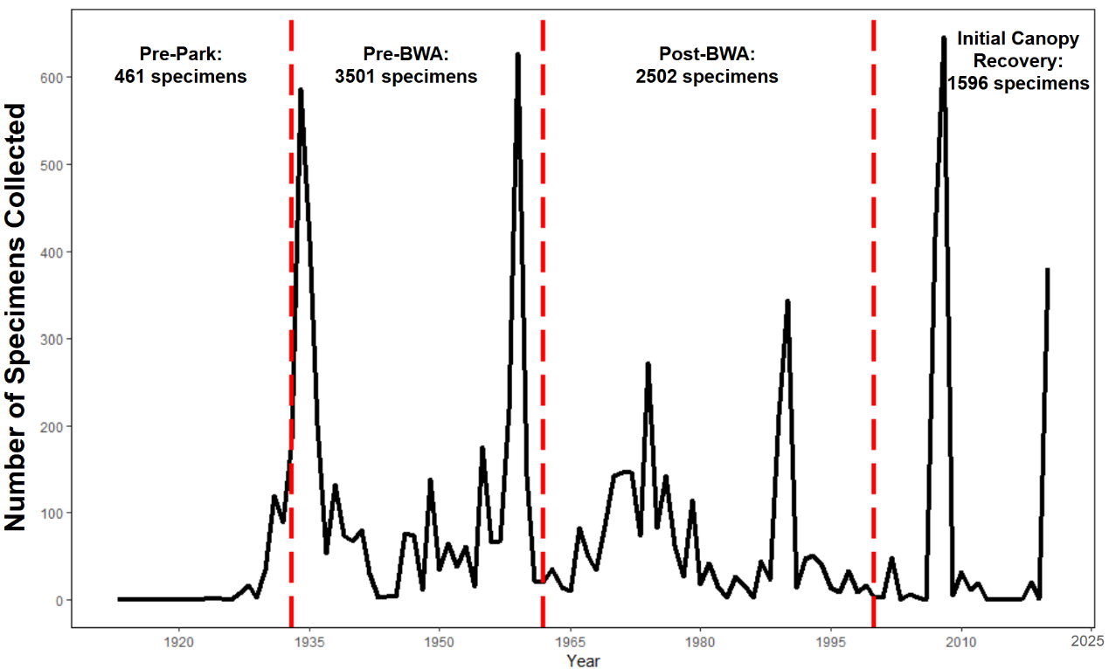
Figure 2.1 Number of specimens collected per year from 1913 to 2022. Red dashed lines represent the divisions between timespans with the total number of specimens collected during each timespan indicated below the name of each timespan.

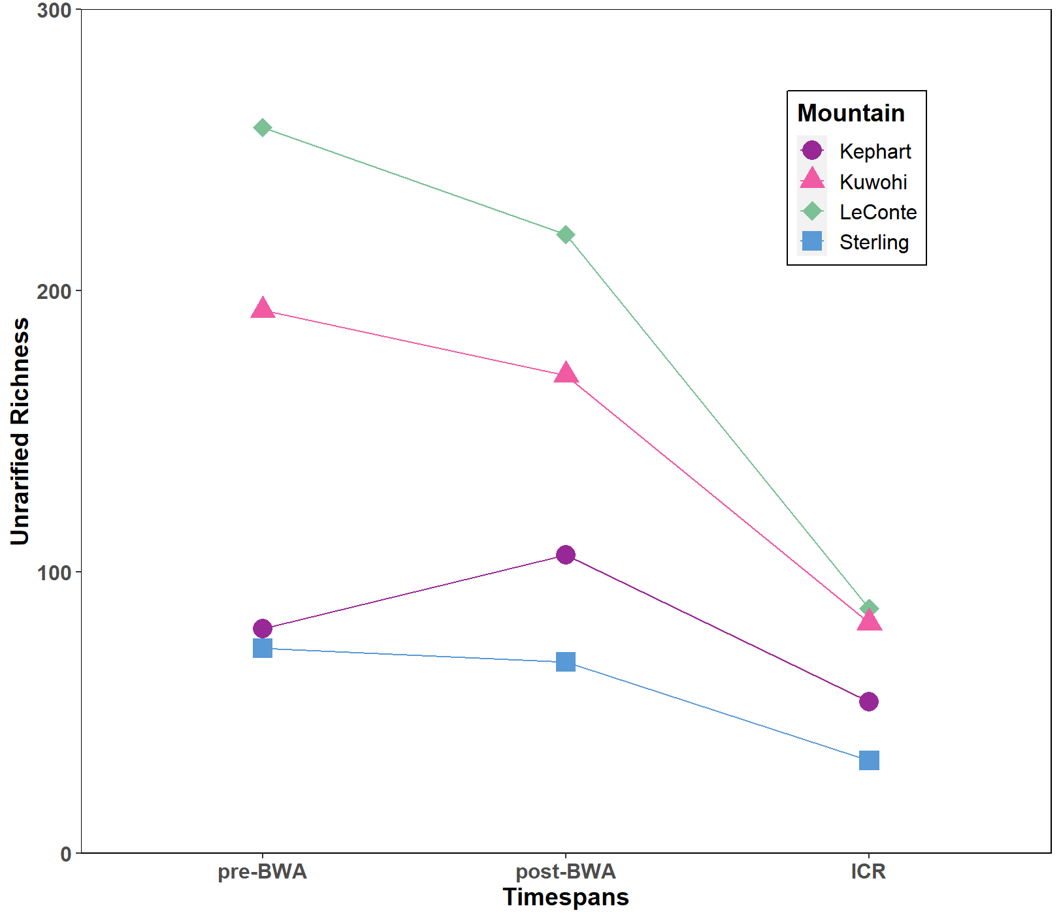
Figure 2.2 Unrarefied richness (number of unique species) across each spatial grouping for each timespan, including pre-BWA (pre-Balsam Wooly Adelgid, 1934-1962), post-BWA (1963-1999), and ICR (Initial Canopy Recovery, 2000-2022).

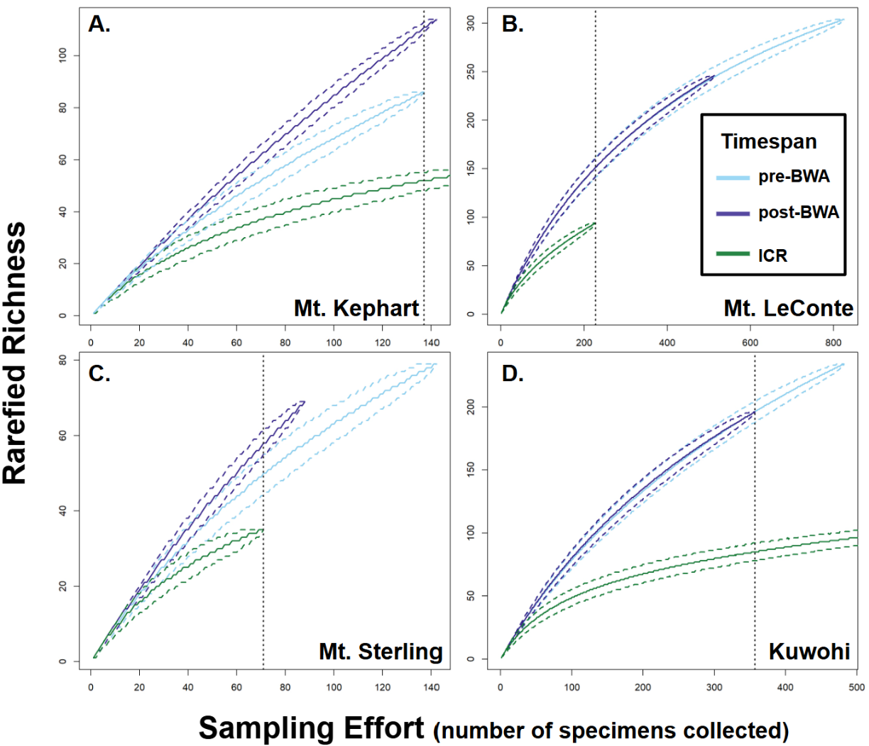
Figure 2.3 Rarefied species richness curves for mountain peaks unmanaged for BWA A. Mt. Kephart, B. Mt. LeConte, as well as mountains managed for BWA C. Mt. Sterling, and D. Kuwohi. Median rarefied richness is represented by a solid line with the upper and lower quantiles as dashed lines on either side of the median. Each set of colored lines corresponds to a distinct timespan with pre-BWA (pre-Balsam Wooly Adelgid) in light blue, post-BWA in purple, and ICR (Initial Canopy Recovery) in green. Dashed black lines indicate the lowest level of sampling effort (number of specimens collected) across the three timespans.

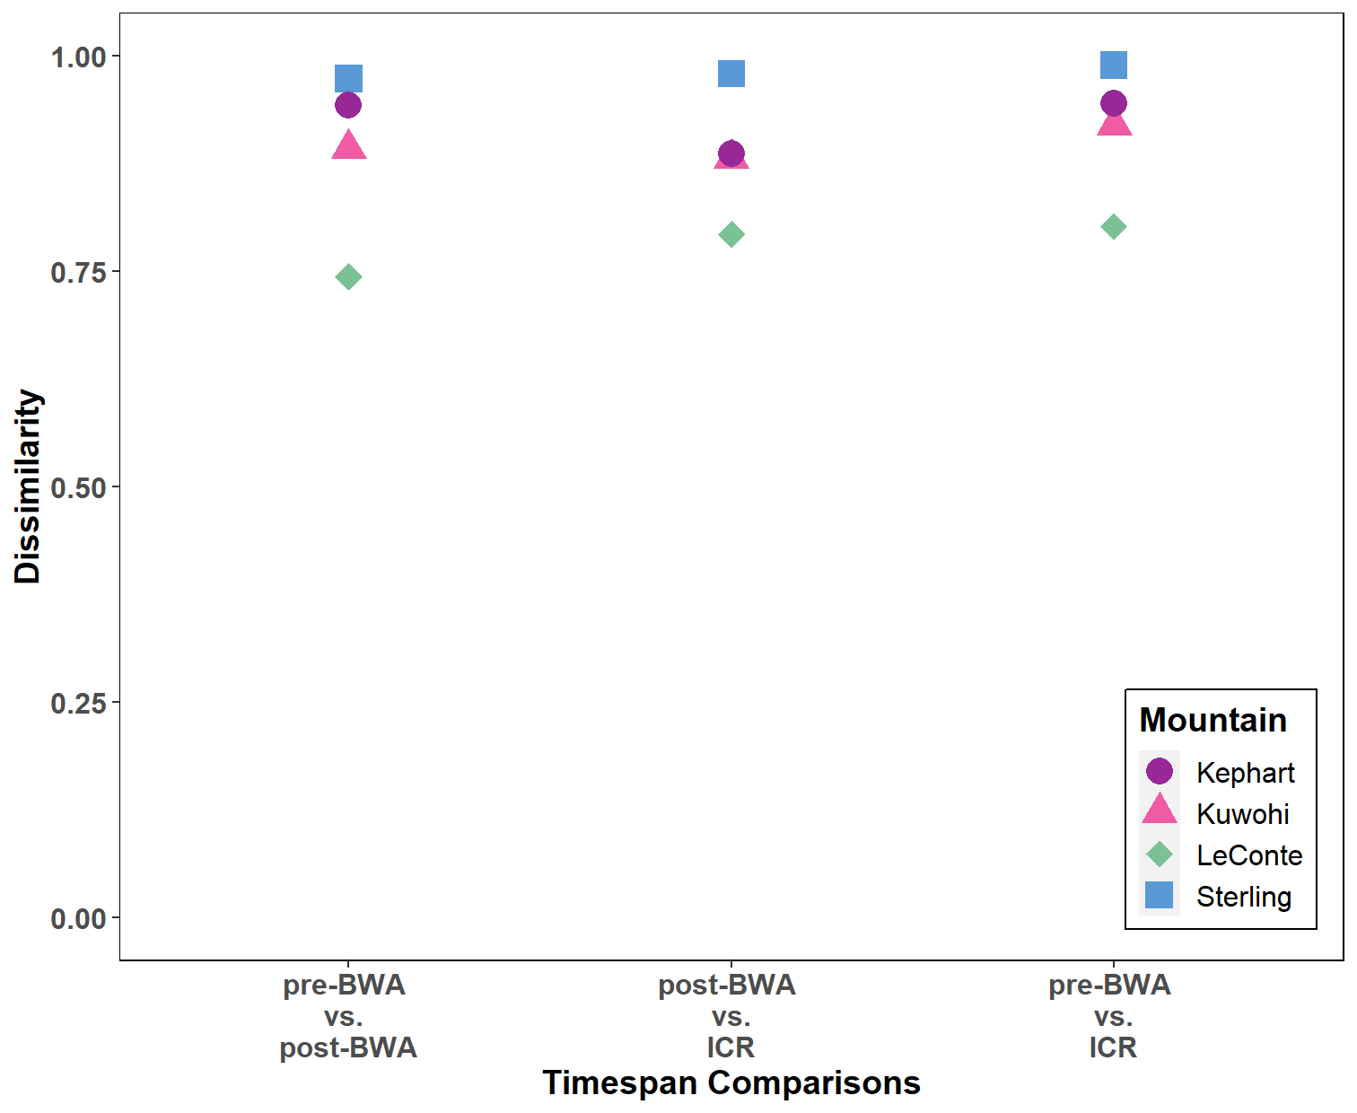
Figure 2.4 Dissimilarity of bryophyte communities between pre-BWA (pre-Balsam Wooly Adelgid) and post-BWA, post-BWA and ICR (Initial Canopy Recovery), and pre-BWA and ICR for each mountain peak at q = 0.

Table 2.3 High elevation spatial group differences between pre-BWA invasion (Balsam Wooly Adelgid) and ICR (Initial Canopy Recovery) for substrate specialist (one substrate type), flexible (two substrate types), and generalist (three or more substrate types) species focusing on the difference between the number of lost, new, and persisting species. Examining the entire table, Chi-squared = 13.07, df = 4, p-value = 0.011. The groups where the standardized residual was greater or less than the absolute critical value (-2.77) indicates that the observed number of species significantly differed from expected. These groups are denoted with an asterisk.
Substrate Group | Species Change | Observed | Expected | Standardized Residuals
Specialist | Lost | 58 | 51.6 | 1.7
Specialist | Persist | 19 | 27.5 | -2.3
Specialist | New | 6 | 3.8 | 1.3
Flexible | Lost | 66 | 62.9 | 1.4
Flexible | Persist | 29 | 33.4 | -0.82
Flexible | New | 2 | 4.7 | -1.48
Generalist | Lost | 51 | 60.4 | -3.0*
Generalist | Persist | 45 | 32.1 | 3.0*
Generalist | New | 5 | 4.5 | 0.1

Table 2.4 Observed change of specialist (one substrate type), flexible (two substrate types), and generalist (three or more substrate types) species from the high elevation spatial group compared between pre-BWA invasion and ICR (initial canopy recovery) timespans. Only two substrate groups were compared at a time using chi-square tests and the other not included in the test is marked with a dash. Comparisons are adjusted for multiple comparisons using a sequential Holms-Bonferroni correction. Significantly different groups are denoted with an asterisk.
Species Change | Specialist | Flexible | Generalist | Chi-squared | df | Corrected p-value
Lost | 58 | - | 51 | 0.45 | 1 | 1
Lost | 58 | 66 | - | 0.52 | 1 | 1
Lost | - | 66 | 51 | 1.92 | 1 | 1
Persisted | 19 | - | 45 | 10.56 | 1 | 0.009*
Persisted | 19 | 29 | - | 2.08 | 1 | 1
Persisted | - | 29 | 45 | 3.46 | 1 | 0.48
New | 6 | - | 5 | 0.09 | 1 | 1
New | 6 | 2 | - | 2 | 1 | 1
New | - | 2 | 5 | 1.29 | 1 | 1

Table 2.5 Species change compared between growth forms, including acrocarpous mosses, liverworts, and pleurocarpous mosses between pre-BWA (Balsam Wooly Adelgid) invasion and Initial Canopy Recovery at the high elevation spatial grouping. Significant comparisons are denoted with an asterisk.
Species Change | Acrocarp | Liverwort | Pleurocarp | Chi-squared | df | Corrected p-value
Lost | 62 | - | 46 | 2.74 | 1 | 0.84
Lost | 62 | 67 | - | 0.19 | 1 | 1
Lost | - | 67 | 46 | 3.9 | 1 | 0.43
Persisted | 29 | - | 32 | 0.15 | 1 | 1
Persisted | 29 | 32 | - | 0.15 | 1 | 1
Persisted | - | 32 | 32 | 0 | 1 | 1
New | 2 | - | 7 | 2.78 | 1 | 0.77
New | 2 | 4 | - | 0.67 | 1 | 1
New | - | 4 | 7 | 0.82 | 1 | 1

Table 2.6 Species change (new, lost, persisted) compared within taxonomic orders for liverworts, acrocarpous mosses, and pleurocarpous mosses. Comparisons are for changes between pre-BWA (Balsam Wooly Adelgid) invasion and Initial Canopy Recovery (ICR) for the high elevation spatial grouping using chi-square tests. P-values were corrected using a sequential Holms-Bonferroni correction with significant differences denoted with an asterisk.
Growth Form | Order | Number of Species Lost | Number of Species Persisted | Number of Species New | Chi square | df | Corrected p-value
Liverworts | Jungermanniales | 42 | 23 | - | 5.55 | 1 | 0.06
Liverworts | Jungermanniales | 42 | - | 1 | 39.1 | 1 | <0.001*
Liverworts | Jungermanniales | - | 23 | 1 | 20.17 | 1 | <0.001*
Liverworts | Porellales | 19 | - | 1 | 16.2 | 1 | <0.001*
Liverworts | Porellales | 19 | 5 | - | 8.17 | 1 | 0.008*
Liverworts | Porellales | - | 5 | 1 | 2.67 | 1 | 0.3
Liverworts | Marchantiales | 1 | - | 0 | 1 | 1 | 0.64
Liverworts | Marchantiales | 1 | 0 | - | 1 | 1 | 0.32
Liverworts | Marchantiales | - | 0 | 0 | - | 0 | -
Liverworts | Metzgeriales | 5 | - | 1 | 2.67 | 1 | 0.1
Liverworts | Metzgeriales | - | 4 | 1 | 1.8 | 1 | 0.36
Liverworts | Metzgeriales | 5 | 4 | - | 0.11 | 1 | 1
Liverworts | Pallaviciniales | - | 0 | 1 | 1 | 1 | 0.32
Liverworts | Pallaviciniales | 0 | - | 1 | 1 | 1 | 0.64
Liverworts | Pallaviciniales | 0 | 0 | - | - | 1 | -
Acrocarpous  Mosses | Andreaeales | - | 2 | 0 | 2 | 1 | 0.16
Acrocarpous  Mosses | Andreaeales | 0 | 2 | - | 2 | 1 | 0.32
Acrocarpous  Mosses | Andreaeales | 0 | - | 0 | - | 1 | -
Acrocarpous  Mosses | Bartramiales | - | 1 | 0 | 0 | 1 | 1
Acrocarpous  Mosses | Bartramiales | 1 | - | 0 | 0 | 1 | 1
Acrocarpous  Mosses | Bartramiales | 1 | 1 | - | 0 | 1 | 1
Acrocarpous  Mosses | Bryales | 14 | - | 1 | 11.27 | 1 | <0.001*
Acrocarpous  Mosses | Bryales | 14 | 3 | - | 7.12 | 1 | 0.015*
Acrocarpous  Mosses | Bryales | - | 3 | 1 | 1 | 1 | 0.96
Acrocarpous  Mosses | Dicranales | 13 | - | 0 | 13 | 1 | <0.001*
Acrocarpous  Mosses | Dicranales | - | 11 | 0 | 11 | 1 | 0.002*
Acrocarpous  Mosses | Dicranales | 13 | 11 | - | 0.17 | 1 | 1

Table 2.6 continued
Growth Form | Order | Number of Species Lost | Number of Species Persisted | Number of Species New | Chi square | df | Corrected p-value
Acrocarpous  Mosses | Diphysciales | 1 | - | 0 | 1 | 1 | 0.32
Acrocarpous  Mosses | Diphysciales | 1 | 0 | - | 1 | 1 | 0.64
Acrocarpous  Mosses | Diphysciales | - | 0 | 0 | - | 1 | -
Acrocarpous  Mosses | Encalyptales | 1 | - | 0 | 1 | 1 | 0.32
Acrocarpous  Mosses | Encalyptales | 1 | 0 | - | 1 | 1 | 0.64
Acrocarpous  Mosses | Encalyptales | - | 0 | 0 | - | 1 | -
Acrocarpous  Mosses | Funariales | 1 | - | 0 | 1 | 1 | 0.32
Acrocarpous  Mosses | Funariales | 1 | 0 | - | 1 | 1 | 0.64
Acrocarpous  Mosses | Funariales | - | 0 | 0 | - | 1 | -
Acrocarpous  Mosses | Grimmiales | 13 | - | 0 | 13 | 1 | <0.001*
Acrocarpous  Mosses | Grimmiales | 13 | 0 | - | 13 | 1 | <0.001*
Acrocarpous  Mosses | Grimmiales | - | 0 | 0 | - | 1 | -
Acrocarpous  Mosses | Hedwigiales | 1 | - | 0 | 1 | 1 | 0.32
Acrocarpous  Mosses | Hedwigiales | 1 | 0 | - | 1 | 1 | 0.64
Acrocarpous  Mosses | Hedwigiales | - | 0 | 0 | - | 1 | -
Acrocarpous  Mosses | Polytrichales | 4 | - | 1 | 1.8 | 1 | 0.18
Acrocarpous  Mosses | Polytrichales | - | 3 | 1 | 1 | 1 | 0.64
Acrocarpous  Mosses | Polytrichales | 4 | 3 | - | 0.14 | 1 | 1
Acrocarpous  Mosses | Pottiales | 6 | - | 0 | 6 | 1 | 0.014*
Acrocarpous  Mosses | Pottiales | - | 2 | 0 | 2 | 1 | 0.48
Acrocarpous  Mosses | Pottiales | 6 | 2 | - | 2 | 1 | 0.32
Acrocarpous  Mosses | Rhizogoniales | 2 | - | 0 | 2 | 1 | 0.16
Acrocarpous  Mosses | Rhizogoniales | 2 | 0 | - | 2 | 1 | 0.32
Acrocarpous  Mosses | Rhizogoniales | - | 0 | 0 | - | 1 | -
Acrocarpous  Mosses | Sphagnales | - | 6 | 0 | 6 | 1 | 0.014*
Acrocarpous  Mosses | Sphagnales | 5 | - | 0 | 5 | 1 | 0.05
Acrocarpous  Mosses | Sphagnales | 5 | 6 | - | 0.091 | 1 | 1
Acrocarpous  Mosses | Tetraphidales | - | 1 | 0 | 1 | 1 | 0.32
Acrocarpous  Mosses | Tetraphidales | 0 | 1 | - | 1 | 1 | 0.64
Acrocarpous  Mosses | Tetraphidales | 0 | - | 0 | - | 1 | -

Table 2.6 continued
Growth Form | Order | Number of Species Lost | Number of Species Persisted | Number of Species New | Chi square | df | Corrected p-value
Pleurocarpous Mosses | Hookeriales | 1 | - | 0 | 1 | 1 | 0.32
Pleurocarpous Mosses | Hookeriales | 1 | 0 | - | 1 | 1 | 0.64
Pleurocarpous Mosses | Hookeriales | - | 0 | 0 | - | 1 | -
Pleurocarpous Mosses | Hypnales | 41 | - | 6 | 26.1 | 1 | <0.001*
Pleurocarpous Mosses | Hypnales | - | 30 | 6 | 16 | 1 | <0.001*
Pleurocarpous Mosses | Hypnales | 41 | 30 | - | 1.7 | 1 | 0.57
Pleurocarpous Mosses | Orthotrichales | 4 | - | 1 | 1.8 | 1 | 0.18
Pleurocarpous Mosses | Orthotrichales | 4 | 2 | - | 0.67 | 1 | 0.82
Pleurocarpous Mosses | Orthotrichales | - | 2 | 1 | 0.33 | 1 | 1

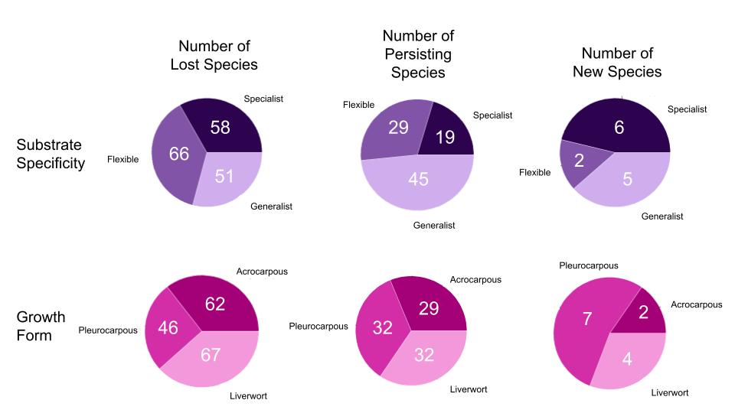
Figure 2.5 Proportion of species lost, persisting, and new to the high elevation spatial grouping between pre-BWA invasion (Balsam Wooly Adelgid) and ICR (Initial Canopy Recovery) for specialist (one substrate type), flexible (two substrate types), and generalist (three or more substrate types) species as well as between the different growth forms (acrocarps, pleurocarps, and liverwort). Numbers within the pie chart represent the number of species. See Tables 3 and 5 for results testing for significant differences between groups.

CHAPTER 3: HERBACEOUS LAYER SPECIES EXPERIENCE SUITABLE HABITAT LOSS AND RANGE CONTRACTIONS TO HIGHER ELEVATIONS UNDER CLIMATE CHANGE MODELS

ABSTRACT
Climate change is predicted to alter abiotic and disturbance regimes across the globe thereby reshaping ecological communities. Studies predict that species will have to shift their distributions to track their niches or face range contractions due to suitable habitat loss. Across studies, there are profound taxonomic, geographic, and stratification levels, with the herbaceous layer poorly understood regarding range shifts and contractions. Bryophytes are major components of the herbaceous layer and provide key ecosystem services, especially in montane ecosystems where they often cover a large portion of the understory. Past studies found that in the eastern Appalachians, certain species declined while others remained stable over a 12-year period. As climate change persists and alters abiotic conditions, it is unclear whether these bryophyte species will respond and whether they will face range contractions. We used ecological niche models (ENMs) for two climate change scenarios (ssp245 and ssp370) to examine how suitable habitat will change through time for both declining and stable species, if there will be an elevational range contraction across species, and where suitable habitat will be located in the future to guide management decisions and aid conservation efforts. Overall, we found that regardless of whether a species was declining or stable, they all lost suitable habitat. All species are predicted to experience range contractions wherein suitable habitat will be predominately at the highest elevations within many national parks and forests. This study increases our understanding of range shifts within the herbaceous layer, specifically bryophytes. Here we note the importance of habitat refuges within national parks and high elevation forests for the bryophytes explored in this study. As these high-elevation ecosystems are vulnerable to other disturbances, the need to ensure their conservation under the threats of climate change are more important than ever, not only for bryophytes but for other species that rely on this important habitat.

INTRODUCTION
Climate change is predicted to alter the abiotic and disturbance regimes across the globe, thereby reshaping ecological communities (IPCC 2023). On average, temperatures are predicted to increase, rainfall to become more sporadic, and extreme disturbances like wildfires and hurricanes will increase in frequency. Such changes can impact the phenology of plants (Callinger et al. 2013, Miller-Rushing and Inouye 2009, and Rawal et al. 2015), leading to mismatches between native plant-pollinator relationships (Hindle et al. 2015, Pyke et al. 2016, Gallinat et al. 2021) as well as birds and the fruits they feed on and disperse (Gallinat et al. 2021). Climate change increases CO2 concentrations which could provide invasives a competitive edge compared to natives and further damage ecosystems (Davidson et al 2011, Mainka and Howard 2010). To combat these regime changes and increased competition, natives may be able to shift their distributions to more optimal conditions. However, there are concerns that natives may not shift fast enough in response to climate change (Bellemare et al 2017, Alexander et al. 2018, Zanatta et al. 2020). Lags in range shifts in response to niche shifts are predicted across lineages using environmental niche modeling (ENM), but reviews have not found a consistent trend across taxa (Duchenne et al. 2021, Lenoir et al. 2008, Lenoir et al. 2020).
Studies examining range shifts are biased taxonomically with the vast majority focusing on arthropods, birds, and vascular plants (Feeley et al. 2017, Lawlor et al. 2024). This taxonomic bias creates difficulties predicting where suitable habitat will be in the future for less-studied-organisms that deviate from general range shift trends. Across studied taxa, 35% of observed range shifts were opposite their isotherm shifts, suggesting a generalizable pattern cannot be applied across taxa (Lawlor et al. 2024). Studies are heavily biased geographically, with many vascular plant studies concentrated in Europe and North America (Lawlor et al. 2024). Even within an ecosystem, climate change induced changes are better studied in overstory plants compared to their herbaceous understory relatives (Cleland et al. 2006, Augspurger and Zaya 2020). One major component of the herbaceous layer whose range shifts are especially underexplored, are the bryophytes (mosses, hornworts, and liverworts) (Mallen-Cooper et al. 2023, Lawlor et al. 2024). Thus, applying weakly supported vascular plant based range shift trends to bryophytes could result in inaccurate predictions and potentially damaging management decisions.
Bryophytes respond to abiotic and topographic variables differently than their vascular plant relatives (Sérgio et al. 2000, Pharo et al. 2005). Bryophytes increase in diversity as elevation increases (Shershen et al. 2024, Stehn et al. 2010), which is opposite to the patterns observed for vascular plants (Asplund et al. 2021, Chen et al. 2017). They are able to inhabit stressful environments, such as bare rock and tree bark, due to their desiccation tolerance and water uptake directly from rain. Whereas the vast majority of vascular plants cannot reside (Proctor 2011) as they are typically desiccation intolerant and rely on the soil matrix for water (Zoltan et al. 2011). It has also been shown that experimental warming and drying often increase the net primary production and biomass of vascular plants whereas under similar conditions bryophytes decline (He et al. 2016). Such disparate responses to environmental conditions only affirm the idea that trends from vascular plants cannot be applied to bryophytes. Thus, bryophyte range shifts and suitable habitat changes need to be further explored so we better understand how climate change may impact them and can apply that knowledge to inform management practices that are appropriate for these organisms.
Bryophytes provide vital functions across many ecosystems, and if we fail to manage land with their communities in mind, we may lose these functions. Together bryophytes and lichens store 3.9 Pg of carbon globally each year, contribute 80% of the biological nitrogen fixation in Asia and North America, and are responsible for 10% of the net primary production in North America alone (Elbert et al. 2012). Bryophytes also enhance soil stability (Gao et al. 2020), which reduces nutrient run-off, especially following disturbance (Silva et al. 2019, Van Miergot et al. 2007). Many organisms rely on bryophytes for habitat, including birds (Wesolowski and Wierzcholska 2018), small mammals (Couch 1926, Harestad 1990), salamanders (Chalmers and Loftin 2006, Glime and Boelema 2017), macroinvertebrates (Coyle, 2009; Ziesche & Roth, 2008), and microorganisms (Bartels & Nelson, 2007). Montane regions rely heavily on bryophyte ecosystem functions as they are the dominant ground cover and make up the bulk of the richness as elevation increases (Asplund et al. 2021, Chen et al. 2017). This is especially true of the eastern United States, specifically the Appalachian Mountains (Smith et al. 1991, Stehn et al. 2008, Carter 2021).
The Great Smoky Mountains National Park (GSMNP) is a protected area in the southeastern Appalachians that has a rich history of studies and collections documenting bryophyte community changes over time (Norris 1964, Smith et al. 1991, Choberka 1998, Stehn et al. 2010, Shershen et al. 2024). While some of these community changes were attributed to an invasive pest altering the canopy cover at the highest elevations (Speers 1958, Choberka 1998), the canopy has recently shown recovery (Jenkins 2003). The most recent of these studies compared the communities between a 12-year period and found that across all elevations, species richness declined while bryophyte abundance only declined at the highest elevations (Shershen et al. 2024). Individual species abundances changed across all elevations, with some significantly declining in abundance while others did not change (Shershen et al. 2024). Some of these more recent changes may be due to canopy homogenization following recovery, but this does not explain the community changes observed at elevations historically not impacted by the pest. One explanation may be that climate change is altering the available suitable habitat, thus driving these species level changes. Less is known about bryophyte range shift responses to climate change, especially in this region, making it unclear how declining species may be impacted and whether they will match their isotherms or face range contractions.
Climate change may exacerbate not only these declining species, but also those which appear to be stable. While many bryophytes are highly mobile and known to disperse their spores across continents (Lewis et al. 2014, Vanderpoorten et al. 2019), if suitable habitat is not available for their spores to grow and develop, they may face local extirpation. To predict where suitable habitat will be under climate change scenarios, researchers often use Ecological Niche Models (ENMs) (Sérgio et al. 2007, Allen and Lendemer 2016, Phillips et al. 2024). ENMs leverage herbarium specimens and historical climate data to determine the climatic niche for the modeled species. Researchers then project the models into the future under various climate change scenarios to determine suitable habitat availability and location. Due to the uncertainty as to how severe climate change may be, common practice examines suitable habitat availability under multiple climate scenarios with varying severity. To our knowledge, no studies have examined bryophyte suitable habitat availability under even the least severe climate change scenarios in this region, making it unclear as to how climate change will impact habitat availability across the Appalachians.
As such, we set out to test four hypotheses: 1) Suitable habitat loss will be lower under conservative climate change models compared to more extreme models. This is because as scenario worsens, climatic conditions become hotter and drier, which are detrimental to bryophyte health (He et al. 2016). 2) Species documented to be declining will have less suitable habitat compared to stable species regardless of which climate change model is examined. 3) Declining species will have a greater decrease in suitable habitat through time than stable species, regardless of climate change model. These hypotheses are because we expect that as declining species have already exhibited decreased abundance, that they may inhabit a narrower niche than stable species, making them more vulnerable to the impacts of climate change. 4) At lower elevations the percentage of suitable habitat will decrease under the future climate change models, while higher elevations will remain the same. While the species modeled here are found across a broad range of elevations, high elevation ecosystems are typically viewed as refugia under climate change (Michalak et al. 2018) as they are often cooler and wetter which may help buffer the hotter and drier conditions created by climate change (Morelli et al. 2016). As these cooler and wetter conditions are more optimal for bryophytes, the high elevations may be the last refugia for these bryophytes. Exploring these questions will provide a springboard to explore bryophyte range shifts in North America, specifically the Appalachians.

METHODS

Climatic variable selection
Annual macroclimate data was downloaded from ClimateNA version 7.50, which downscales climatic data to North America at a 1 km² resolution (Wang et al. 2016, Mahony et al. 2022). These variables cover historical (1961-1990), current day (1991-2020), and future timespans (2041-2070; 2071-2100), with future climate inferred from an eight model mean ensemble. For the future timespans, two Shared Socioeconomic Pathways (SSPs) were selected, ssp245 and ssp370. ssp245 follows historical environmental protection levels representing the “middle of the road” in terms of environmental degradation entails cooperation between countries to achieve sustainable development goals, despite this, environmental degradation (Riahi et al. 2017). Whereas ssp370 represents a “regional rivalry” scenario, which expects countries to prioritize their own resource security over the environment and global efforts resulting in strong environmental degradation (Riahi et al. 2017). Thus, selected SSPs follow historical environmental protection levels (ssp245) and the next worst-case scenario in terms of environmental degradation (ssp370).
Of the 89 annual and seasonal variables from ClimateNA, 20 that have been found to be important for bryophytes (Lappalainen et al. 2008a, Lappalainen et al. 2008b, Proctor 2011, Carter 2021, Collart et al. 2023, Mallen-Cooper et al. 2023, Ryan 2023, van Zuijlen et al. 2024) were downloaded (Table 3.1, all tables listed in the Appendix at the end of this chapter), with others being left out since they have been found to be highly correlated with the selected variables in other studies (Collart et al. 2023, Mallen-Cooper et al. 2023, Ryan 2023). The 20 variables were then trimmed in ArcGISPro version 3.30 (ESRI 2023) using the Environmental Protection Agency (EPA) ecoregions pertinent to the Appalachian Mountain range as a mask (Table 3.2; United States Environmental Protection Agency 2025). A correlation analysis was performed on the historical timespan data and highly correlated variables, above 0.8 or below -0.8, were removed leaving six climatic variables as inputs for our models (Table 3.1). Despite being highly correlated, variables like Mean Annual Temperature, Chilling Days, and Growing Degree Days were retained as they were known to be important to bryophytes (Proctor 2011, Zoltan et al 2011). It has been shown that including some correlated variables may not hinder model performance (Hanberry 2024).

Species selection
The moss species analyzed were selected based on the following criteria. The selected species had a broad distribution throughout the Appalachian Mountains and at least 20 specimens collected during the historical timespan. Maxent (Phillips et al. 2024) has been used to successfully model species with as few as five specimens for a similar sized region (Pearson et al. 2007), thus 20 was selected as a conservative minimum. Five species observed to decrease in abundance from a previous study were selected to serve as declining species (Shershen et al. 2024). In addition, five stable species that were either taxonomically closely related or have similar growth patterns to the declining species were selected for comparison. Spatial data for these ten species (Table 3.3) was downloaded from the Consortium of Bryophyte Herbaria (CBH) (Consortium of Bryophyte Herbaria 2025) for both historical and current day timespans. These data were trimmed to the area of interest and then duplicate and spatially similar specimens were removed.

Modeling
Multiple ecological niche models (ENM) were built and evaluated using historical specimens (1961-1990) in Maxent for each species (Phillips et al. 2024). This tool has been shown to be effective for modeling bryophytes and other small organisms (Sérgio et al. 2007, Allen and Lendemer 2016). Maxent uses regularization parameters to alter model complexity, which when multiplied by a regularization multiplier, can adjust how closely fit to the training data the model should adhere (Phillips and Dudik 2008). The regularization parameter default is 1, with values lower than this more tightly fitting the training data, thus increasing model complexity. Too tightly fitted models can lead to overfitting, which can lead to inaccurate predictions of species distributions (Merow et al. 2013). Regularization values higher than 1 are less tightly fit to training data, allowing for the model to be less complex. Thus, multiple regularization multipliers (0.1, 0.5, 1, 2, 5) were used to determine the level of complexity required to accurately predict presences for each species (Morales et al. 2017). For each regularization multiplier run, models were cross validated for five replicates, each subject to a maximum amount of 1000 training iterations per replicate. In addition, a ten-percent threshold rule was applied to determine suitable habitat. This is a more conservative approach; however, this threshold has been shown to reduce overfitting and is especially useful for addressing uncertainty of presence data used (Radosavljevic and Anderson 2014). This cautionary safeguard allows us to proceed with higher confidence in our results. Models were not extrapolated nor clamped outside the training area, as this can generate misleading, or sometimes incorrect predictions based on areas where the model lacks information to test (Anderson and Raza 2010, Elith et al. 2010). Additionally, as the focus of this study are the Appalachians across the eastern United States, there was no need to extrapolate our models outside of the training area.
All models were then evaluated using the lowest omission error rate (OR) and then the highest area under the curve (AUC) (Table 3.4, Table 3.5). Omission error is the proportion of known occurrences that are inaccurately predicted as absent while AUC examines the ability of the model to discriminate between presences and absences; both are standard metrics for evaluating models (Peterson 2007, Radosavljevic and Anderson 2014, Bohl et al. 2019, Konowalik and Nosol 2021). Based on the lowest omission error and highest AUC, the top performing model was selected and reproduced so that it could be transferred to both current and future timespan climates. Model outputs for all timespans were converted to binary in ArcGISPro using the logistic threshold of the 10-percentile training presence (Table 3.4, Table 3.5). Percent suitable habitat was then calculated based on the number pixels above this threshold out of the total pixels within the area of interest. We then extracted all presence/absence predictions along with elevational data to determine the percent of suitable habitat available under the various scenarios along an elevational gradient. To achieve this gradient, habitat was divided into 400 m elevation bins to understand how suitable habitat changes through time and if any range contractions occur.
By training our model using historical specimens and climate data, we were able to evaluate the transferability of our models using current herbarium records with the current day climate. After transferring the model to current day climate, calculating and converting suitable habitat for each species to binary in ArcGISPro, we then uploaded specimens collected within the area of interest during current day timespan to observe the percent of specimens accurately predicted as present by the transferred model (Table 3.6).

Statistical analyses:
To test our hypotheses, ANOVAs were performed wherein either average suitable habitat or average percent change in suitable habitat were used as response variables. Timespan (timespan and scenario used), species change (stable vs declining), and the interaction between the two were used as predictors in both models. In a third model examining average percent suitable habitat across elevation, an elevation predictor using the 400 m elevation bands was included in addition to those used in the previous models. A post-hoc Tukey test was performed on any significant models to determine differences between groups. All statistical analyses were conducted in R version 4.3.2 (R Core Team 2023).

RESULTS

Models and transferability
Climatic variables were reduced from twenty to six, eliminating those that were highly correlated (Table 3.1) except for ones that have been shown to be particularly important for bryophytes (Proctor 2011, van Zuijlen et al. 2024). When examining the transferability of the models to current day, all models accurately predicted over 80% of the presences, with some achieving 100% accuracy of presences (Table 3.6), suggesting the models transfer well over time for the selected species.

Suitable habitat
All species were predicted to lose habitat in the future timespans compared to the historical timespan regardless of SSP or whether they were stable or declining from 2008 to 2022 (Figure 3.1, all figures listed in the Appendix at the end of this chapter). The suitable habitat declines can be observed across the maps in Figures 3.2 – 3.11.
Our model examining average percent suitable habitat was significant (F_{11, 48} = 5.62, p = 1.04e⁻⁵) and was significantly predicted by the timespan (F_{1,5} = 11.59, p = 2.27e⁻⁷), but not species change (F_{1,1} = 0.84, p = 0.36) or the interaction between these two predictors (F_{1,5} = 0.61, p = 0.7). A post-hoc Tukey test detected significant differences between all scenarios and both current and historical timespans (Figure 3.12). The next model examining predictors of percent suitable habitat change between a given timespan and the historical timespan was significant (F_{1,9}, 40 = 7.49, p = 2.54e⁻⁶) and significantly predicted by timespan (F_{1,4} = 14.83, p = 1.64e⁻⁷) and species change (F_{1,1} = 7.77, p = 0.008), but not the interaction between them (F_{1,4} = 0.082, p = 0.1). A post-hoc Tukey test detected significant differences between all climate change projections and the current day timespan (Figure 3.13).
The suitable habitat across elevation model (F_{23,216} = 39.59, p = 2.2e⁻¹⁶) was predicted significantly by timespan (F_{1,5} = 26.12, p = 2.2e⁻¹⁶), elevation range (F_{1,3} = 245.73, p = 2.2e⁻¹⁶), and the interaction between the two (F_{1,15} = 2.85, p = 0.0004). Species change was dropped from this model following a stepwise AIC function and thus was not included in the final model. A post-hoc Tukey test detected significant differences between the lowest elevation group (0-400 m) and the highest elevation group (>1200 m) for each of the timespans (Figure 3.14). While the ANOVA and post-hoc Tukey test were across all scenarios, timespans and elevations, differing letters only indicate differences within a panel (Figure 3.14-3.15). The later the timespan and more severe the climate change scenario, the greater the difference in percent suitable habitat across elevation (Figure 3.14C-F). Under ssp370 from 2071-2100, the 801-1200 m elevation range has a significantly lower percent suitable habitat compared to the >1200 m elevations (Figure 3.14F). Within an elevation range, there was no significant difference in suitable habitat across timespans and scenarios at low elevations, except current day and ssp370 2071-2100 were significantly different in amount of suitable habitat available (Figure 3.15A). The 401-800 m group had significantly less suitable habitat between historical and current day compared to all other groups (Figure 3.15B). The 801-1200 m group had significantly less suitable habitat in the ssp370 2071-2100 timespan scenario compared to all other timespans and scenarios (Figure 3.15C). There was no significant difference at the highest elevation (>1200 m) regardless of timespan or scenario (Figure 3.15D).

DISCUSSION
The goal of this research was to improve our understanding of habitat suitability changes and identify potential range shifts of herbaceous layer plants, specifically bryophytes. We hypothesized that 1) suitable habitat would be lower under ssp245 compared to ssp370, 2) overall suitable habitat would be higher for declining species compared to stable species, 3) there would be a greater change In suitable habitat availability compared to the historical amounts for declining species, and 4) that all species would experience a range contraction wherein the greatest proportion of suitable habitat would be present at the highest elevations.
To address our first hypothesis, we examined the “middle of the road” (ssp245) and the “regional rivalry” (ssp370) climate change scenarios. Both predicted lower levels of habitat suitability compared to historical and current day (Figure 3.12) with more habitat loss from historical levels compared to current day (Figure 3.13). Suitable habitat availability was not different between scenarios, and thus we reject our first hypothesis. However, there was a trend of less suitable habitat for the ssp370 scenarios within a timespan (Figure 3.1). This suggests that the more extreme scenario, ssp585, may yield even further loss in suitable habitat as this scenario expects increases in fossil fuel reliance and higher energy consumption worldwide (Riahi et al. 2017). As such, efforts to at least maintain, if not diverge policy trajectories to more environmentally friendly scenarios should be at the forefront of conservation goals.
We observed that species change (stable vs declining based on Shershen et al. 2024) was not a significant predictor in any of our models and as such we reject our second and third hypotheses. This suggests population changes within a 12-year time span may not inform long-term changes for suitable habitat loss. As our models transferred well between historical and current day presences (Table 3.6), the decline in suitable habitat does not bode well for eastern Appalachian bryophytes (Figure 3.1, 3.12, & 3.13).
Finally, for our fourth hypothesis, all species included in this study are predicted to experience range contraction (Figures 3.2 – 3.11), with much of the habitat being constrained to high elevation ecosystems (Figure 3.14 & 3.15). This supports our last hypothesis and suggests that a range contraction may be occurring for bryophytes of the Appalachians. Vascular plant species from lower elevations are predicted to shift their distribution to higher elevations to track their optimal niches (Lenoir et al. 2008, Telwala et al. 2013), which may alter the bryophyte communities at higher elevations. Bryophytes in a dryland ecosystem did not match the rate at which their niches shifted (Mallen-Cooper et al 2023) and even if these montane bryophytes were able to shift, there is not a higher elevation in the Appalachians to shift up to. This raises concerns as to how these major herbaceous layer components may persist through time.

Light availability
Overstory plants shifting to higher elevations will decrease light availability for the herbaceous layer, especially bryophytes. Shading can alter bryophyte community composition and cover (Tinya et al 2008, Halpern et al. 2014) and potentially halt spore germination (Maciel da Silva et al. 2010), which could reduce the ability of bryophytes to establish new populations. Bryophyte responses to shading may also be dependent on habitat, substrate, and forest type, which may enhance or reduce the effects of shading (Halpern et al. 2014, Barbe et al 2020). However, as other abiotic stresses increase with climate change and interact with light availability, overall bryophyte health may decline (Seel et al. 1992, Hao and Chu 2021). As the high elevation range retains the highest proportion of suitable habitat across scenario and timespan (Figure 3.14 & 3.15), overshading by vascular plants could further reduce future suitable habitat.

Dispersal and connectivity limitations
While bryophytes are known to disperse across intercontinental distances (Lewis et al. 2014, Vanderpoorten et al. 2019), their communities benefit from high habitat connectivity, especially species with poor dispersal capabilities (Zartman & Shaw 2006, Pharo & Zartman 2007, Virtanen & Oksanen 2007). Populations of these poor dispersers are more genetically similar to each other, suggesting they may not disperse much beyond their parent plant (Snӓll et al. 2004, Hylander 2009). Rare bryophytes may be especially poor dispersers (Cleavitt 2005) and thus the idea that bryophytes are capable of sustained long-distance dispersal to maintain genetic diversity is debated (Vanderpoorten and Hallingbӓck 2009). When examining suitable habitat for our species much of it is discontinuous, especially at the northern edge of the Appalachian Mountains (Figures 3.2-3.11). While some species may be able to reach disjunct habitat on their own accord, others may be poor dispersers. Dispersal ability varies based on a suite of morphological features. Species reproducing sexually may rely on tall sporophytes to break the boundary layer and disperse their spores, like P. pallidisetum in our study (Johansson et al. 2014, Flora of North America Editorial Committee 1993). Other species like D. scoparium have small spores that aid in long distance dispersal (Zanatta et al. 2016). These may help species maintain genetic diversity across large ranges (Lewis et al. 2014), but for species with large spores, short sporophytes, or those that reproduce asexually, habitat fragmentation may limit their ability to persist under climate change even if suitable habitat is available.

Conservation
In this study, much of the future suitable habitat for the selected species is predicted to be within protected areas, such as the Great Smoky Mountain National Park (GSMNP), Shenandoah National Park, Nantahala National Forest, and Monongahela National Forest (Figures 3.2-3.11). These lands are currently managed, hopefully ensuring the protection of this habitat. If this land was to be shifted to commercial use, it would likely result in the destruction of the final refuge for not only the species examined within this study, but also other species exclusively found at high elevations. This study adds further evidence that federally protected lands can buffer species from extirpation by safeguarding suitable habitat. The high elevation ecosystems within these lands are especially critical for bryophytes as they possess the highest proportion of suitable habitat for the species analyzed in this study (Figure 3.14).
In the cases of species unable to reach suitable habitat due to habitat fragmentation, transplantation may be used to assist relocation. Entire habitat transplantations wherein all plants of an area are moved in an attempt to save them from disturbance have achieved success, and these transplants only observed declines in richness when left unmanaged for an extended period (Box et al. 2011), suggesting whole communities could be transplanted if needed. Mosses rarely experience transplant shock (Mallen-Cooper and Cornwell 2020). As such, if a population of concern is at risk of disturbance or is at the edge of its suitable habitat, managers could transplant the population to areas with suitable habitat to rescue them. This may be habitat with optimal conditions for that species, more connected habitat, or habitat that is more buffered from the effects of climate change. However, foresight to transplant vulnerable populations may be challenging as disturbances are becoming more unpredictable (IPCC 2023). It may be more efficient to collect current day specimens to cryopreserve them and or curate a living collection as has been successful for multiple species in Europe (Rowntree and Ramsey 2009, Rowntree et al. 2010). If living tissue is not available from current day populations, herbarium specimens as old as 20 years have been shown to grow and photosynthesize following rehydration (Stark et al. 2017), and gametophytic tissue harvested from under a glacier recovered after 400 years (La Farge et al. 2013). By using preservation methods or historical populations along with transplant experiments, we may be able to assist relocation to suitable habitat to ensure the persistence of vulnerable bryophytes and reduce the effects of habitat fragmentation.
While this study raises many concerns for bryophytes, it also invokes promise as to modeling their suitable habitat both currently, and into the future. As our models were able to transfer well from historical to current day (Table 3.6), we can also be confident in our predictions of future suitable habitat. These projections may appear bleak, but it enables us to make evidence-based conservation decisions and improve targeted habitat preservation. To our knowledge, very few studies have examined bryophyte suitable habitat within the contiguous United States, let alone in the east (Mallen-Cooper et al.2023, Ryan 2023). Considering this region houses many endemics or disjunct populations (Carter 2021), further work exploring bryophyte distributions could improve our ability to protect land crucial for bryophyte conservation. A newly founded group has recently emerged in the United States, the Bryophyte Conservation Alliance (BCA), whose mission is to “foster bryophyte conservation and support…efforts with sound scientific data” (Bryophyte Conservation Alliance 2025). Such groups will be vital for improving understanding of bryophyte distributions, understanding and preserving rare species populations, and making informed conservation decisions to protect bryophytes and the many organisms that rely on them.

Conclusions
Herbaceous layer species, especially bryophytes, provide key ecosystem functions within the understory, yet less attention has been spent on understanding their future distributions under climate change (Mallen-Cooper et al. 2023). This study expands the knowledge of bryophyte range shifts and habitat suitability, thus reducing biases seen in the literature that focus on overstory vascular plants (Augspurger and Zaya 2020, Lawlor et al. 2024). This study also adds to the growing body of literature demonstrating not only declines in suitable habitat but also range contractions from climate change induced stress (Zhu et al. 2012, Feeley et al. 2016, Lawlor et al. 2024). Here we note the importance of habitat refuges within national parks and high elevation forests for the bryophytes examined in this study. As these high-elevation ecosystems are vulnerable to other disturbances (Rollins et al 2010, White et al. 2012), the need to ensure their conservation under the threats of climate change are more important than ever, not only for bryophytes but for other species that rely on this important habitat (Estill and Cruzan 2001, Colye 2009, Allen and Lendemer 2016)

REFERENCES
Alexander, J. M., Chalmandrier, L., Lenoir, J., Burgess, T. I., Essl, F., Haider, S., Kueffer, C., McDougall, K., Milbau, A., Nuñex, M. A., Pauchard, A., Rabitsch, W., Rew, L. J., Sanders, N. J., and Pellissier, L. 2018. Lags in the response of mountain plant communities to climate change. Global Change Biology, 24(2): 563–579. https://doi.org/10.1111/gcb.13976
Allen, J. L., & Lendemer, J. C. 2016. Climate change impacts on endemic, high-elevation lichens in a biodiversity hotspot. Biodiversity and Conservation, 25(3): 555–568. https://doi.org/10.1007/s10531-016-1071-4
Anderson, R. P., & Raza, A. 2010. The effect of the extent of the study region on GIS models of species geographic distributions and estimates of niche evolution: Preliminary tests with montane rodents (genus Nephelomys) in Venezuela. Journal of Biogeography, 37(7): 1378–1393. https://doi.org/10.1111/j.1365-2699.2010.02290.x
Asplund, J., van Zuijlen, K., Roos, R. E., Birkemoe, T., Klanderud, K., Land, S. I., and Wardle, D. A. 2021. “Divergent response of functional diversity to an elevational gradient for vascular plants, bryophytes and lichens.” Journal of Vegetation Science 33(1): e13105. https://doi.org/10.1111/jvs.13105
Augspurger, C. K., & Zaya, D. N. 2020. Concordance of long-term shifts with climate warming varies among phenological events and herbaceous species. Ecological Monographs, 90(4): 1–20. https://doi.org/10.1002/ecm.1421
Barbé, M., Bouchard, M., & Fenton, N. J. 2020. Examining boreal forest resilience to temperature variability using bryophytes: forest type matters. Ecosphere, 11(8): https://doi.org/10.1002/ecs2.3232
Bartels, P.J. and D.R. Nelson. 2007. “An Evaluation of Species Richness Estimators for Tardigrades of the Great Smoky Mountains National Park, Tennessee and North Carolina, USA.” Journal of Limnology 66: 104-110. https://doi.org/10.4081/jlimnol.2007.s1.104
Bellemare, J., Connolly, B., & Sax, D. F. 2017. Climate change, managed relocation, and the risk of intra-continental plant invasions: A theoretical and empirical exploration relative to the flora of New England. Rhodora, 119(978): 73–109. https://doi.org/10.3119/16-10
Bohl, C. L., Kass, J. M., & Anderson, R. P. 2019. A new null model approach to quantify performance and significance for ecological niche models of species distributions. Journal of Biogeography, 46(6): 1101–1111. https://doi.org/10.1111/jbi.13573
Box, J., Brown, M., Coppin, N., Hawkeswood, N., Webb, M., Hill, A., Palmer, Q., Le Duc, M., and Putwain, P. 2011. Experimental wet heath translocation in Dorset, England. Ecological Engineering, 37(2):158–171. https://doi.org/10.1016/j.ecoleng.2010.08.006
Bryophyte Conservation Alliance. 2025. https://www.bryoconservation.com/
Calinger, K. M., Queenborough, S., & Curtis, P. S. 2013. Herbarium specimens reveal the footprint of climate change on flowering trends across north-central North America. Ecology Letters, 16(8): 1037–1044. https://doi.org/10.1111/ele.12135
Carter, B. E. 2021. The roles of dispersal limitation, climatic niches and glacial history in endemism of the North American bryophyte flora. American Journal of Botany, 108(8): 1555–1567. https://doi.org/10.1002/ajb2.1721
Chalmers, R. J. and Loftin S. L. 2006. “Wetland and microhabitat use by nesting Four-Toed Salamanders in Maine.” Journal of Herpetology 40(4): 478-485. https://doi.org/10.1670/0022-1511(2006)40[478:WAMUBN]2.0.CO;2
Chen, Y., S. Niu, P. Li, H. Jia, H. Wang, Y. Ye, and Z. Yuan. 2017. “Stand Structures and Substrate Diversity as Two Major Drivers for Bryophyte Distribution in a Temperate Montane Ecosystem.” Frontiers in Plant Science 8: 874. https://doi.org/10.3389/fpls.2017.00874
Choberka, E.1998. “A study of epixylic bryophyte ecology on Fraser Fir logs in the Great Smoky Mountains National Park.” Master’s Thesis, University of Tennessee. https://trace.tennessee.edu/utk_gradthes/2383
Cleavitt, N. L. 2005. “Patterns, hypotheses and processes in the biology of rare bryophytes.” The Bryologist 108(4): 554-566. https://doi.org/10.1639/0007-2745(2005)108[0554:PHAPIT]2.0.CO;2
Cleland, E. E., Chiariello, N. R., Loarie, S. R., Mooney, H. A., & Field, C. B. 2006. Diverse responses of phenology to global changes in a grassland ecosystem. Proceedings of the National Academy of Sciences of the United States of America, 103(37), 13740–13744. https://doi.org/10.1073/pnas.0600815103
Collart, F., Broennimann, O., Guisan, A., & Vanderpoorten, A. 2023. Ecological and biological indicators of the accuracy of species distribution models: lessons from European bryophytes. Ecography, (8):1–13. https://doi.org/10.1111/ecog.06721
Consortium of Bryophyte Herbaria (accessed through the Consortium of Bryophyte Herbaria Portal, https://bryophyteportal.org/portal, 2025.
Couch, L. K. 1926. “Nesting habits of Richardson Pine Squirrel.” The Murrelet 7(1): 12. https://www.jstor.org/stable/3534925
Coyle, F.A. 2009. “Status Survey of the Spruce-Fir Moss Spider, Microhexura montivaga.” Report to the US Fish & Wildlife Service
Davidson, A. M., Jennions, M., & Nicotra, A. B. 2011. Do invasive species show higher phenotypic plasticity than native species and, if so, is it adaptive? A meta-analysis. Ecology Letters, 14(4), 419–431. https://doi.org/10.1111/j.1461-0248.2011.01596.x
Duchenne, F., Martin, G., & Porcher, E. 2021. European plants lagging behind climate change pay a climatic debt in the North, but are favoured in the South. Ecology Letters, 24(6), 1178–1186. https://doi.org/10.1111/ele.13730
Elbert, W., Weber, B., Burrows, S., Steinkamp, J., Büdel, B., Andreae, M. O., & Pöschl, U. 2012. Contribution of cryptogamic covers to the global cycles of carbon and nitrogen. Nature Geoscience, 5(7), 459–462. https://doi.org/10.1038/ngeo1486
Elith, J., Phillips, S. J., Hastie, T., Dudík, M., Chee, Y. E., & Yates, C. J. 2010. A statistical explanation of MaxEnt for ecologists. Diversity and Distributions, 17(1), 43–57. https://doi.org/10.1111/j.1472-4642.2010.00725.x
ESRI 2023. ArcGIS Pro version 3.3. Redlands, CA: Environmental Systems Research Institute.
Estill, J. C. and Cruzan, M. B. 2001. “Phytogeography of rare plant species endemic to the southeastern United States.” Castanea 66(1-2): 3-23. https://www.jstor.org/stable/4033879
Feeley, K. J., Stroud, J. T., & Perez, T. M. 2017. Most ‘global’ reviews of species’ responses to climate change are not truly global. Diversity and Distributions, 23(3), 231–234. https://doi.org/10.1111/ddi.12517
Flora of North America Editorial Committee, eds. 1993+. Flora of North America North of Mexico. 22+ vols. New York and Oxford. Vol. 1, 1993; vol. 2, 1993; vol. 3, 1997; vol. 4, 2003; vol. 5, 2005; vol. 7, 2010; vol. 8, 2009; vol. 19, 2006; vol. 20, 2006; vol. 21, 2006; vol. 22, 2000; vol. 23, 2002; vol. 24, 2007; vol. 25, 2003; vol. 26, 2002; vol. 27, 2007; vol 28, 2014; vol. 9, 2014; vol. 6, 2015; vol. 12, 2016; vol. 17, 2019; vol. 10, 2021.
Gallinat, A. S., Ellwood, E. R., Heberling, J. M., Miller-Rushing, A. J., Pearse, W. D., & Primack, R. B. 2021. Macrophenology: insights into the broad-scale patterns, drivers, and consequences of phenology. American Journal of Botany, 108(11), 2112–2126. https://doi.org/10.1002/ajb2.1793
Gao, L., M.A. Bowker, H. Sun, J. Zhao, and Y. Zhao. 2020. “Linkages between Biocrust Development and Water Erosion and Implications for Erosion Model Implementation.” Geoderma. 357: 113973. https://doi.org/10.1016/j.geoderma.2019.113973
Glime, J. M. and Boelema, W. J. 2017. “Amphibians: anuran adaptations.” Chapt. 14-1. In: Glime, J. M. Bryophyte Ecology. Volume 14-1-1 2. Bryological Interaction. <http://digitalcommons.mtu.edu/bryophyte-ecology2/>.
Halpern, C.B., M. Dovčiak, L.S. Urgenson, and S.A. Evans. 2014. “Substrates Mediate Responses of Forest Bryophytes to a Gradient in Overstory Retention” Canadian Journal of Forest Research 866: 855–66. https://doi.org/10.1139/cjfr-2014-0059
Hanberry, B. B. 2024. “Practical guide for retaining correlated climate variables and unthinned samples in species distribution modeling, using random forests.” Ecological Informatics 79: 102406. https://doi.org/10.1016/j.ecoinf.2023.102406
Hao, J., & Chu, L. M. 2021. Short-term detrimental impacts of increasing temperature and photosynthetically active radiation on the ecophysiology of selected bryophytes in Hong Kong, southern China. Global Ecology and Conservation, 31: e01868. https://doi.org/10.1016/j.gecco.2021.e01868
Harestad, A. S. 1990. “Nest site selection by Northern Flying Squirrels and Douglas Squirrels.” Northwestern Naturalist 71(2): 43-45. https://doi.org/10.2307/3536588
He, X., He, K. S., & Hyvönen, J. 2016. Will bryophytes survive in a warming world? Perspectives in Plant Ecology, Evolution and Systematics, 19, 49–60. https://doi.org/10.1016/j.ppees.2016.02.005
Hindle, B. J., Kerr, C. L., Richards, S. A., & Willis, S. G. 2015. Topographical variation reduces phenological mismatch between a butterfly and its nectar source. Journal of Insect Conservation, 19(2), 227–236. https://doi.org/10.1007/s10841-014-9713-x
Hylander, K. 2009. “No increase in colonization rate of boreal bryophytes close to propagule sources.” Ecology 90(1): 160-169. https://doi.org/10.1890/08-0042.1
IPCC. 2023. Climate Change 2023: Synthesis Report. Contribution of Working Groups I, II and III to the Sixth Assessment Report of the Intergovernmental Panel on Climate Change [Core Writing Team, H. Lee and J. Romero (eds.)]. IPCC, Geneva, Switzerland, pp. 35-115, doi: 10.59327/IPCC/AR6-9789291691647.
Jenkins, D. H., Sullivan, J., Amacher, G. S., Nicholas, N. S., & Reaves, D. W. 2003. Valuing high altitude spruce-fir forest improvements: Importance of forest condition and recreation activity. Journal of Forest Economics, 8(1), 77–99. https://doi.org/10.1078/1104-6899-00005
Johansson, V., Lönnell, N., Sundberg, S., & Hylander, K. 2014. Release thresholds for moss spores: The importance of turbulence and sporophyte length. Journal of Ecology, 102(3), 721–729. https://doi.org/10.1111/1365-2745.12245
Konowalik, K., & Nosol, A. 2021. Evaluation metrics and validation of presence-only species distribution models based on distributional maps with varying coverage. Scientific Reports, 11(1), 1–15. https://doi.org/10.1038/s41598-020-80062-1
La Farge, C., Williams, K. H., and England, J. H. 2013. “Regeneration of Little Ice Age bryophytes emerging from a polar glacier with implications of totipotency in extreme environments.” PNAS 110(24): 9839-9844. https://doi.org/10.1073/pnas.1304199110
Lappalainen, N. M., Huttunen, S., and Suokanerva, H. 2008a. Acclimation of a pleurocarpous moss Pluerozium schreberi (Britt.) Mitt. To enhanced ultraviolet radiation in situ.” Global Change Biology 14:321-333. https://doi.org/10.1111/j.1365-2486.2007.01489.x
Lappalainen, N. M., Huttunen, S., and Suokanerva, H.2008b. “The ectohydric moss PLeurozium schreberi (Britt.) Mitt. After 5 years of enhanced UV-B radiation in situ. Proceedings of the Moss Meeting August 15-18, 2008, Tampere, Finland. Physiologia Plantarium 133 P04-024.
Lawlor, J. A., Comte, L., Grenouillet, G., Lenoir, J., Baecher, J. A., Bandara, R. M. W. J., … Sunday, J. 2024. Mechanisms, detection and impacts of species redistributions under climate change. Nature Reviews Earth and Environment, 5(5), 351–368. https://doi.org/10.1038/s43017-024-00527-z
Lenoir, J., Gégout, J. C., Marquet, P. A., De Ruffray, P., & Brisse, H. 2008. A significant upward shift in plant species optimum elevation during the 20th century. Science, 320(5884), 1768–1771. https://doi.org/10.1126/science.1156831
Lenoir, J., Bertrand, R., Comte, L., Bourgeaud, L., Hattab, T., Murienne, J., & Grenouillet, G. 2020. Species better track climate warming in the oceans than on land. Nature Ecology and Evolution, 4(8), 1044–1059. https://doi.org/10.1038/s41559-020-1198-2
Lewis, L. R., Behling, E., Gousee, H., Qian, E., Elphick, C. S., Lamarre, J-F, Bêty, J., Liebezelt, J., Rozzi, R., and Goffinet, B. 2014. “First evidence of bryophyte diaspores in the plumage of transequatorial migrant birds.” PeerJ 2:e424 https://doi.org/10.7717/peerj.424
Mahony, C. R., Wang, T.; Hamann, A., and Cannon, A. J. 2022. A CMIP6 ensemble for downscaled monthly climate normals over North America. International Journal of Climatology 42(11): 5871-5891 DOI: https://doi.org/10.1002/joc.7566
Mainka, S. A., & Howard, G. W. 2010. Climate change and invasive species: Double jeopardy. Integrative Zoology, 5(2), 102–111. https://doi.org/10.1111/j.1749-4877.2010.00193.x
Mallen-Cooper, M., & Cornwell, W. K. 2020. A systematic review of transplant experiments in lichens and bryophytes. Bryologist, 123(3), 444–454. https://doi.org/10.1639/0007-2745-123.3.443
Mallen-Cooper, M., Cornwell, W. K., Slavich, E., Sabot, M. E. B., Xirocostas, Z. A., & Eldridge, D. J. 2023. Limited range shifting in biocrusts despite climate warming: A 25-year resurvey. Journal of Ecology, 111(10), 2194–2207. https://doi.org/10.1111/1365-2745.14169
Maciel da Silva, A. S., Pôrto, K. C., and Simabukuro, E. A. 2010. “Effects of light and nutrients on differenct germination phases of the cosmopolitan moss Bryum argenteum Hedw. (Bryaceae).” Brazilian Archives of Biology and Technology 53(4). https://doi.org/10.1590/S1516-89132010000400003
Merow, C., Smith, M. J., & Silander, J. A. 2013. A practical guide to MaxEnt for modeling species’ distributions: What it does, and why inputs and settings matter. Ecography, 36(10), 1058–1069. https://doi.org/10.1111/j.1600-0587.2013.07872.x
Michalak, J. L., Lawler, J. J., Roberts, D. R., & Carroll, C. 2018. Distribution and protection of climatic refugia in North America. Conservation Biology, 32(6), 1414–1425. https://doi.org/10.1111/cobi.13130
Miller-Rushing, A. J., & Inouye, D. W. 2009. Variation in the impact of climate change on flowering phenology and abundance: An examination of two pairs of closely related wildflower species. American Journal of Botany, 96(10), 1821–1829. https://doi.org/10.3732/ajb.0800411
Morales, N. S., Fernández, I., and Baca-González, V. 2017. “MaxEnt’s parameter configuration and small samples: are we paying attention to recommendations? A systematic review.” PeerJ 5:e3093 https://doi.org/10.7717/peerj.3093
Morelli, T. L., Daly, C., Dobrowski, S. Z., Dulen, D. M., Ebersole, J. L., Jackson, S. T., … Beissinger, S. R. 2016. Managing climate change refugia for climate adaptation. PLoS ONE, 11(8), 1–17. https://doi.org/10.1371/journal.pone.0159909
Pearson, R. G., Raxworthy, C. J., Nakamura, M., & Townsend Peterson, A. 2007. Predicting species distributions from small numbers of occurrence records: A test case using cryptic geckos in Madagascar. Journal of Biogeography, 34(1), 102–117. https://doi.org/10.1111/j.1365-2699.2006.01594.x
Peterson, A. T., Papeş, M., & Eaton, M. (2007). Transferability and model evaluation in ecological niche modeling: A comparison of GARP and Maxent. Ecography, 30(4), 550–560. https://doi.org/10.1111/j.0906-7590.2007.05102.x
Pharo, E. J., Kirkpatrick, J. B., Gilfedder, L., Mendel, L., and Turner, P. A. M. 2005. “Predicting bryophyte diversity in grassland and eucalypt-dominated remnants in subhumid Tasmania.” Journal of Biogeography 32: 2015-2024. https://doi.org/10.1111/j.1365-2699.2005.01366.x
Pharo, E. J. and Zartman, C. E. 2007. “Bryophytes in a changing landscape: the hierarchical effect of habitat fragmentation on ecological and evolutionary processes.” Biological Conservation 135: 315- 325. https://doi.org/10.1016/j.biocon.2006.10.016
Phillips, S. J. and Dudik, M. 2008. “Modeling of species distributions with Maxent: new extensions and a comprehensive evaluation.” Ecography 31(2): 161-175. https://doi.org/10.1111/j.0906-7590.2008.5203.x
Phillips, S. J., Dudki, M., and Schapire, R. E. 2024. [Internet] Maxent software for modeling species niches and distributions (Version 3.4.1). Available from url: http://biodiversityinformatics.amnh.org/open_source/maxent/.
Proctor, M. C. F. 2011. “Climatic responses and limits of bryophytes: comparisons and contrasts with vascular plants.” In Z. Tuba, N.L. Slack, & L.R. Stark (Eds.), Bryophyte Ecology and Climate Change (pp. 35-54). Cambridge University Press.
Pyke, G. H., Thomson, J. D., Inouye, D. W., & Miller, T. J. 2016. Effects of climate change on phenologies and distributions of bumble bees and the plants they visit. Ecosphere, 7(3), 1–19. https://doi.org/10.1002/ecs2.1267
R Core Team (2023). R: A language and environment for statistical computing. R Foundation for Statistical Computing, Vienna, Austria. URL https://www.R-project.org/
Radosavljevic, A., & Anderson, R. P. 2014. Making better Maxent models of species distributions: Complexity, overfitting and evaluation. Journal of Biogeography, 41(4), 629–643. https://doi.org/10.1111/jbi.12227
Rawal, D. S., Kasel, S., Keatley, M. R., & Nitschke, C. R. 2015. Herbarium records identify sensitivity of flowering phenology of eucalypts to climate: Implications for species response to climate change. Austral Ecology, 40(2), 117–125. https://doi.org/10.1111/aec.12183
Rollins, A. W., Adams, H. S., and Stephenson, S. L. 2010. “Changes in forest composition and structure across the Red Spruce-hardwood ecotone in the central Appalachians.” Castanea 75(3): 303-314. https://doi.org/10.2179/09-052.1
Rowntree, J.K. and Ramsay, M.M. 2009. “How bryophytes came out of the cold: successful cryopreservation of threatened species.” Biodiversity and Conservation 18, 1413–1420. https://doi.org/10.1007/s10531-008-9453-x
Rowntree, J.K., Pressel, S., Ramsay, M.M., Sabovljevic, A., and Sabovljevic, M. 2010. “In vitro conservation of European bryophytes.” In Vitro Cellular Development Biology-Plant 47, 55–64. https://doi.org/10.1007/s11627-010-9326-3
Riahi, K., van Vuuren, D. P., Kriegler, E., Edmonds, J., O'Neill, B. C., Fujimori, S., Bauer, N., Calvin, K., Dellink, R., Fricko, O., Lutz, W., Popp, A., Cuaresma, J. C., Kc, S., Leimbach, M., Jiang, L., Kram, T., Rao, S., Emmerling, J., Ebi, K., Hasegawa, T., Havlik, P., Humpenöder, F., Da Silva, L. A., Smith, S., Stehfest, E., Bosetti, V., Eom, J., Gernaat, D., Masui, T., Rogelj, J., Strefler, J., Drouet, L., Krey, V., Luderer, G., Harmsen, M., Takahashi, K., Baumstark, L., Doelman, J. C., Kainuma, M., Klimont, Z., Marangoni, G., Lotze-Campen, H., Obersteiner, M., Tabeau, A., and Tavoni, M. 2017. “The Shared Socioeconomic Pathways and their energy, land use, and greenhouse gas emissions implications: An overview” Global Environmental Change, 42: 153–168, https://doi.org/10.1016/j.gloenvcha.2016.05.009
Ryan, Z. 2023. “The Prairie State: Using Ecological Niche Modeling to Predict Distributions of Early Land Plants.” College of Science and Health Theses and Dissertations. 468. https://via.library.depaul.edu/csh_etd/468
Seel, W. E,. Hendry, G. A. F., and Lee, J. A. 1992. “The combined effects of desiccation and irradiance on mosses from xeric and hydric habitats.” Journal of Experimental Botany 43: 1023–1030. https://doi.org/10.1093/jxb/43.8.1023
Sérgio, C., Araujo, M., and Draper, D. 2000. “Portuguese bryophyte diversity and priority areas for conservation.” Lindbergia 25: 116-123.
Sérgio, C., Figeuira, R., and Draper, D. 2007. “Modeling bryophyte distribution based on ecological information for extent of occurrence assessment.” Biological Conservation 135: 341-351. https://doi.org/10.1016/j.biocon.2006.10.018
Shershen, E., Stehn, S. E., and Budke, J. M. 2024. “Environmental determinants of bryophyte community change over time.” Ecosphere 15(8): e4924. https://doi.org/10.1002/ecs2.4924
Silva, F.C., D.C.S. Viera, E. van der Spek, and J.J. Keizer. 2019. “Effect of Moss Crusts on Mitigation of Post-Fire Soil Erosion.” Ecological Engineering 128: 9-17 https://doi.org/10.1016/j.ecoleng.2018.12.024
Smith, D.K., K.D. McFarland, and P.G. Davison. 1991. “Development of a taxonomic/ecological database: report of the floristic richness of bryophytes, Great Smoky Mountains National Park. National Park Service, Gatlinburg, Tenn.” Google Scholar
Snӓll T., Fogelqvist, J., Bibeiro, P. J., and Lascoux, L. 2004. “Spatial genetic structure in two congeneric epiphytes with different dispersal strategies analyzed by three different methods.” Molecular Ecology 13: 2109-2119. https://doi.org/10.1111/j.1365-294X.2004.02217.x
Speers, C.F. 1958. “The balsam woolly aphid in the Southeast.” Journal of Forestry. 56: 515–516.Google Scholar
Stark, L. R. 2017. “Ecology of desiccation tolerance in bryophytes: A conceptual framework and methodology.” The Bryologist, 120(2), 130–165. https://doi.org/10.1639/0007-2745-120.2.130
Stehn S. E., C. Webster, J. Glime, and M. Jenkins. 2010. “Elevational Gradients of Bryophyte Diversity, Life Forms, and Community Assemblage in the Southern Appalachian Mountains.” Canadian Journal of Forest Research 40(11): 2164-2174. https://doi.org/10.1139/X10-156
Telwala, Y., Brook, B. W., Manish, K., & Pandit, M. K. 2013. Climate-Induced Elevational Range Shifts and Increase in Plant Species Richness in a Himalayan Biodiversity Epicentre. PLoS ONE, 8(2). https://doi.org/10.1371/journal.pone.0057103
Tinya, F., Márialigeti, S., Király, I., Németh, B., & Ódor, P. 2009. The effect of light conditions on herbs, bryophytes and seedlings of temperate mixed forests in O{double acute}rség, Western Hungary. Plant Ecology, 204(1), 69–81. https://doi.org/10.1007/s11258-008-9566-z
United States Environmental Protection Agency 2025. “Ecoregions of North America.” https://www.epa.gov/eco-research/ecoregions-north-america
van Miergot, H., P.T. Moore, C.E. Tewksbury, N.S. Nicholas. 2007. “Carbon Sources and Sinks in High-elevation Spruce-Fir Forests of the Southeastern US.” Forest Ecology and Management 238: 249-260. https://doi.org/10.1016/j.foreco.2006.10.020
van Zuijlen, K., Kassel, M., Dorrepaal, E., & Lett, S. 2024. Frost damage measured by electrolyte leakage in subarctic bryophytes increases with climate warming. Journal of Ecology, 112(2), 220–232. https://doi.org/10.1111/1365-2745.14236
Vanderpoorten A, Hallingbäck T. 2009. Conservation biology. In: Goffinet B, Shaw AJ, editors. Bryophyte biology. 2nd ed. Cambridge, UK: Cambridge University Press; p. 487–533.
Vanderpoorten A., Patinño, J., Désamoré, A., Laenen, B., Górski, P., Papp, B., Holá, E., Korpelainen, H., and Hardy, O. 2019. “To what extent are bryophytes efficient dispersers?” Journal of Ecology 107(5): 2149-2154. https://doi.org/10.1111/1365-2745.13161
Virtanen, R. and Oksanen, J. 2007. “The effects of habitat connectivity on cryptogram richness in boulder metacommunity.” Biological Conservation 135(3): 415-422. https://doi.org/10.1016/j.biocon.2006.10.013
Wang T., Hamann A., Spittlehouse D., Carroll C. 2016. Locally Downscaled and Spatially Customizable Climate Data for Historical and Future Periods for North America. PLoS ONE 11(6): e0156720. doi:10.1371/journal.pone.0156720
Wesołowski, T. and Wierzcholska, S. 2018. Tits as bryologists: patterns of bryophyte use in nests of three species cohabiting a primeval forest. Journal of Ornithology 159, 733–745. https://doi.org/10.1007/s10336-018-1535-2
White, P. B., van de Gevel, S. L., and Soulé, P. T. 2012. “Succession and disturbance in an endangered red rpuce-Fraser fir forest in the southern Appalcahian Mountains, North Carolina, USA.” Endangered Species Research 18:17-25. https://doi.org/10.3354/esr00431
Zanatta, F., Engler, R., Collart, F., Broennimann, O., Mateo, R. G., Papp, B., Muñoz, J., Guisan, A., and Vanderpoorten, A. 2016. “Bryophytes are predicted to lag behind future climate change despite their high dispersal capacities” Natural Communications 11, 5601 (2020). https://doi-org.utk.idm.oclc.org/10.1038/s41467-020-19410-8
Zanatta, F., Engler, R., Collart, F., Broennimann, O., Mateo, R. G., Papp, B., Vanderpoorten, A. 2020. Bryophytes are predicted to lag behind future climate change despite their high dispersal capacities. Nature Communications, 11(1). https://doi.org/10.1038/s41467-020-19410-8
Zartman, C. E. and Shaw, A. J. 2006. “Metapopulation extinction thresholds in rain forest remnats.” The American Naturalist 167(2) https://doi.org/10.1086/499376
Zhu, K., Woodall, C. W., & Clark, J. S. 2012. Failure to migrate: Lack of tree range expansion in response to climate change. Global Change Biology, 18(3), 1042–1052. https://doi.org/10.1111/j.1365-2486.2011.02571.x
Ziesche, T. M. and M. Roth. 2008. “Influence of Environmental Parameters on Small-Scale Distribution of Soil-Dwelling Spiders in Forests: What Makes the Difference, Tree Species or Microhabitat?” Forest Ecology and Management 255(3–4): 738–52. https://doi.org/10.1016/j.foreco.2007.09.060.
Tuba, Z., Slack, N. G., and Stark, L. R. 2011. Bryophyte ecology and climate change. Cambridge University Press.

APPENDIX 3
Table 3.1 Correlation results between the 20 selected climatic variables downloaded from Climate NA for the area of interest (Appalachian Mountains).
 | Average Temperature Autumn
Average Temperature Spring | 0.98639 | Average Temperature Spring
Average Temperature Summer | 0.97368 | 0.93799 | Average Temperature Summer
Average Temperature Winter | 0.96011 | 0.98574 | 0.87995 | Average Temperature Winter
Chilling Degree Days (Below 0˚) | -0.9198 | -0.95932 | -0.84987 | -0.96355 | Chilling Degree Days (Below 0˚)
Coldest Month Temperature | 0.95343 | 0.98084 | 0.86955 | 0.99903 | -0.96325 | Coldest Month Temperature
Continentality | -0.66415 | -0.7512 | -0.48807 | -0.84283 | 0.81233 | -0.85493
Extreme Minimum Temperature | 0.97845 | 0.98272 | 0.91981 | 0.98149 | -0.93645 | 0.97802
Extreme Maximum Temperature | 0.80382 | 0.73406 | 0.90992 | 0.62961 | -0.62223 | 0.61408
Growing Degree Days | 0.99674 | 0.98182 | 0.97611 | 0.95287 | -0.89759 | 0.94536
Mean Annual Precipitation (MAP) | 0.52093 | 0.56469 | 0.37629 | 0.63249 | -0.53972 | 0.63357
Mean Annual Temperature (MAT) | 0.99486 | 0.99718 | 0.95467 | 0.9808 | -0.94705 | 0.97566
Precipitation Autumn | 0.15291 | 0.18276 | 0.01739 | 0.27171 | -0.17978 | 0.27836

Table 3.1 continued
 | Average Temperature Autumn | Average Temperature Spring | Average Temperature Summer | Average Temperature Winter | Chilling Degree Days (Below 0˚) | Coldest Month Temperature
Precipitation Spring | 0.65611 | 0.69995 | 0.52492 | 0.75106 | -0.66763 | 0.7498
Precipitation Summer (June-August) | 0.12302 | 0.19099 | -0.0115 | 0.25603 | -0.23998 | 0.26071
Precipitation Winter | 0.65704 | 0.68637 | 0.52575 | 0.74283 | -0.62821 | 0.74115
Precipitation as Snow | -0.87977 | -0.90873 | -0.83522 | -0.89968 | 0.96652 | -0.89985
Relative Humidity | -0.22753 | -0.28393 | -0.19274 | -0.29887 | 0.33267 | -0.30533
May -September Precipitation | 0.23491 | 0.29687 | 0.09225 | 0.36801 | -0.3276 | 0.37237
Warmest Month Temperature | 0.95505 | 0.9099 | 0.99671 | 0.84378 | -0.81391 | 0.8324

Table 3.1 continued
 | Continentality
Extreme Minimum Temperature | -0.76423 | Extreme Minimum Temperature
Extreme Maximum Temperature | -0.13069 | 0.68495 | Extreme Maximum Temperature
Growing Degree Days | -0.64734 | 0.9733 | 0.81256 | Growing Degree Days
Mean Annual Precipitation (MAP) | -0.72703 | 0.59866 | 0.06345 | 0.51901 | Mean Annual Precipitation (MAP)
Mean Annual Temperature (MAT) | -0.72356 | 0.98566 | 0.76183 | 0.99104 | 0.55 | Mean Annual Temperature (MAT)
Precipitation Autumn | -0.46959 | 0.24548 | -0.2477 | 0.14824 | 0.85302 | 0.17592
Precipitation Spring | -0.77828 | 0.72187 | 0.21311 | 0.65588 | 0.96824 | 0.68474

Table 3.1 continued
 | Continentality | Extreme Minimum Temperature | Extreme Maximum Temperature | Growing Degree Days | Mean Annual Precipitation (MAP) | Mean Annual Temperature (MAT)
Precipitation Summer (June-August) | -0.47793 | 0.19611 | -0.23802 | 0.10927 | 0.7931 | 0.16124
Precipitation Winter | -0.76009 | 0.72137 | 0.2207 | 0.66101 | 0.96309 | 0.67856
Precipitation as Snow | 0.71514 | -0.88209 | -0.65932 | -0.85161 | -0.36011 | -0.90059
Relative Humidity | 0.33623 | -0.15298 | -0.25165 | -0.22422 | -0.05408 | -0.26374
May -September Precipitation | -0.56469 | 0.3173 | -0.1765 | 0.22379 | 0.89958 | 0.27173
Warmest Month Temperature | -0.42451 | 0.89107 | 0.93248 | 0.95892 | 0.3294 | 0.9304

Table 3.1 continued
 | Precipitation Autumn
Precipitation Spring | 0.72206 | Precipitation Spring
Precipitation Summer (June-August) | 0.74567 | 0.6846 | Precipitation Summer
Precipitation Winter | 0.73936 | 0.97199 | 0.62541 | Precipitation Winter
Precipitation as Snow | -0.01126 | -0.50232 | -0.09193 | -0.45845 | Precipitation Snow
Relative Humidity | 0.12474 | -0.09099 | -0.10693 | -0.0752 | 0.33415 | Relative Humidity
May -September Precipitation | 0.85598 | 0.8074 | 0.96661 | 0.7571 | -0.16135 | -0.04984 | May -September Precipitation
Warmest Month Temperature | -0.01573 | 0.47757 | -0.05543 | 0.4819 | -0.80708 | -0.17375 | 0.04681

Table 3.2 Environmental Protection Agency (EPA) ecoregions used to define the area of interest for this study, specifically those covering the Appalachian Mountains.
EPA Ecoregion Number | Ecoregion Description
8.4.1 | Ridge and Valley
8.4.2 | Central Appalachians
8.4.3 | West Alleghany Plateau
8.4.4 | Blue Ridge
8.4.9 | Southwest Appalachians
8.1.3 | North Central Appalachians and Uplands
8.1.10 | Erie Drift Plain
5.3.3 | North Central Appalachians

Table 3.3 Species selected for study. Stable species are highlighted in gray, declining species are unshaded. Species change (declining vs stable) was determined by a previous study which found species either significantly declined (declining species) or significantly increased or did not change (together stable species) over 12 years (Shershen et al. 2024). Declining species were selected first by having a broad range throughout the Appalachians, then by having a minimum of 20 specimens with location information collected within the historical climate data timespan. In addition, five stable species that were either taxonomically closely related or have similar growth patterns to the declining species were selected for comparison while simultaneously meeting the aforementioned criteria.
Species & Authority | Species change | Number of specimens used for training models | Number of specimens used for testing models | Total number of historical specimens used in models
Brotherella recurvans  Michx. M. Fleisch | Declining | 97 | 24 | 121
Bryhnia novae-angliae  (Sull. & Lesq.) Grout | Declining | 56 | 14 | 70
Dicranodontium denudatum  (Brid.) E. Britton | Declining | 31 | 7 | 38
Polytrichastrum pallidisetum  (Funck) G.L. Sm. | Declining | 17 | 4 | 21
Tetraphis pellucida  Hedw. | Declining | 64 | 16 | 80
Atrichum crispum  Schimp. Ex. Besch | Stable | 25 | 7 | 32
Dicranum scoparium  Hedw. | Stable | 91 | 23 | 114
Hypnum pallescens  (Hedw.) P. Beauv. | Stable | 49 | 12 | 61
Rhytidiadelphus triquetrus  (Hedw.) Warnst. | Stable | 22 | 6 | 28
Thuidium delicatulum  (Hedw.) Schimp | Stable | 92 | 23 | 115

Table 3.4 Top performing Maxent models for each species based on lowest omission error rate and highest AUC. All models can be viewed in supplementary Table 3. Stable species are highlighted in gray, declining species are unshaded.
Species | Regularization multiplier | Omission error training | Omission error test | Training AUC | Test AUC | Logistic threshold | Fractional predicted area
B. recurvans | 5 | 0.0928 | 0.0417 | 0.8414 | 0.8644 | 0.108 | 0.507
B. novae-angliae | 2 | 0.0893 | 0 | 0.8692 | 0.9164 | 0.061 | 0.507
D. denudatum | 5 | 0.0968 | 0 | 0.9444 | 0.9838 | 0.201 | 0.121
P. pallidisetum | 0.5 | 0.0588 | 0 | 0.9407 | 0.9982 | 0.034 | 0.204
T. pellucida | 5 | 0.0938 | 0 | 0.704 | 0.7683 | 0.242 | 0.772
A. crispum | 1 | 0.08 | 0 | 0.8575 | 0.9633 | 0.251 | 0.798
D. scoparium | 1 | 0.0989 | 0.0435 | 0.828 | 0.8316 | 0.172 | 0.54
H. pallescens | 5 | 0.0816 | 0 | 0.8724 | 0.9249 | 0.077 | 0.513
R. triquetrus | 5 | 0.0909 | 0 | 0.877 | 0.9309 | 0.11 | 0.578
T. delicatulum | 0.5 | 0.0978 | 0.0435 | 0.8072 | 0.8387 | 0.169 | 0.582

Table 3.5 All Maxent models that were run sorted by species, regularization multiplier, and then cross-validation run. Top performing models used for final analysis and seen in Table 3.4 shaded in gray.
Species | Regularization multiplier | Cross-validation Run | Omission Error Training | Omission Error Test | Training AUC | Test AUC
A. crispum | 0.1 | 1 | 0.08 | 0.1429 | 0.9448 | 0.8706
A. crispum | 0.1 | 2 | 0.08 | 0.1429 | 0.9518 | 0.8628
A. crispum | 0.1 | 3 | 0.0769 | 0.3333 | 0.954 | 0.7753
A. crispum | 0.1 | 4 | 0.0769 | 0.5 | 0.9612 | 0.7521
A. crispum | 0.1 | 5 | 0.0769 | 0.1667 | 0.9491 | 0.817
A. crispum | 0.1 | Average | 0.0781 | 0.2572 | 0.9522 | 0.8156
A. crispum | 0.5 | 1 | 0.08 | 0.1429 | 0.8986 | 0.856
A. crispum | 0.5 | 2 | 0.08 | 0 | 0.8946 | 0.9581
A. crispum | 0.5 | 3 | 0.0769 | 0.3333 | 0.9129 | 0.7159
A. crispum | 0.5 | 4 | 0.0769 | 0.3333 | 0.9215 | 0.7478
A. crispum | 0.5 | 5 | 0.0769 | 0 | 0.8896 | 0.7584
A. crispum | 0.5 | Average | 0.0781 | 0.1619 | 0.9034 | 0.8072
A. crispum | 1 | 1 | 0.08 | 0.1429 | 0.8755 | 0.8467
A. crispum | 1 | 2 | 0.08 | 0 | 0.8575 | 0.9633
A. crispum | 1 | 3 | 0.0769 | 0.3333 | 0.8915 | 0.6822
A. crispum | 1 | 4 | 0.0769 | 0.3333 | 0.8903 | 0.7598
A. crispum | 1 | 5 | 0.0769 | 0 | 0.8709 | 0.764
A. crispum | 1 | Average | 0.0781 | 0.1619 | 0.8771 | 0.8032
A. crispum | 2 | 1 | 0.08 | 0.1429 | 0.8298 | 0.8255
A. crispum | 2 | 2 | 0.08 | 0 | 0.8039 | 0.9587
A. crispum | 2 | 3 | 0.0769 | 0.3333 | 0.8604 | 0.6858
A. crispum | 2 | 4 | 0.0769 | 0 | 0.8426 | 0.7575
A. crispum | 2 | 5 | 0.0769 | 0 | 0.8396 | 0.7583
A. crispum | 2 | Average | 0.0781 | 0.0952 | 0.8353 | 0.7972
A. crispum | 5 | 1 | 0.08 | 0.1429 | 0.8307 | 0.8297
A. crispum | 5 | 2 | 0.08 | 0 | 0.7833 | 0.9494
A. crispum | 5 | 3 | 0.0769 | 0.3333 | 0.843 | 0.6772
A. crispum | 5 | 4 | 0.0769 | 0 | 0.8274 | 0.7555
A. crispum | 5 | 5 | 0.0769 | 0 | 0.8358 | 0.7883
A. crispum | 5 | Average | 0.0781 | 0.0952 | 0.824 | 0.8

Table 3.5 continued
Species | Regularization multiplier | Cross-validation Run | Omission Error Training | Omission Error Test | Training AUC | Test AUC
D. scoparium | 0.1 | 1 | 0.0989 | 0.3478 | 0.8843 | 0.7799
D. scoparium | 0.1 | 2 | 0.0989 | 0.3478 | 0.8935 | 0.7605
D. scoparium | 0.1 | 3 | 0.0989 | 0.3043 | 0.8884 | 0.78
D. scoparium | 0.1 | 4 | 0.0989 | 0.3478 | 0.8931 | 0.7244
D. scoparium | 0.1 | 5 | 0.0978 | 0.1364 | 0.8862 | 0.8232
D. scoparium | 0.1 | Average | 0.0987 | 0.2968 | 0.8891 | 0.7736
D. scoparium | 0.5 | 1 | 0.0989 | 0.1739 | 0.851 | 0.8029
D. scoparium | 0.5 | 2 | 0.0989 | 0.1739 | 0.8586 | 0.7911
D. scoparium | 0.5 | 3 | 0.0989 | 0.087 | 0.8451 | 0.831
D. scoparium | 0.5 | 4 | 0.0989 | 0.1739 | 0.8572 | 0.8099
D. scoparium | 0.5 | 5 | 0.0978 | 0.0909 | 0.8565 | 0.822
D. scoparium | 0.5 | Average | 0.0987 | 0.1399 | 0.8537 | 0.8114
D. scoparium | 1 | 1 | 0.0989 | 0.2174 | 0.832 | 0.7816
D. scoparium | 1 | 2 | 0.0989 | 0.1739 | 0.8402 | 0.7937
D. scoparium | 1 | 3 | 0.0989 | 0.0435 | 0.828 | 0.8316
D. scoparium | 1 | 4 | 0.0989 | 0.2609 | 0.8405 | 0.7954
D. scoparium | 1 | 5 | 0.0978 | 0.1364 | 0.8408 | 0.8242
D. scoparium | 1 | Average | 0.0987 | 0.1664 | 0.8363 | 0.8053
D. scoparium | 2 | 1 | 0.0989 | 0.1304 | 0.8091 | 0.7543
D. scoparium | 2 | 2 | 0.0989 | 0.2174 | 0.8168 | 0.7904
D. scoparium | 2 | 3 | 0.0989 | 0.087 | 0.8049 | 0.8094
D. scoparium | 2 | 4 | 0.0989 | 0.2609 | 0.8156 | 0.7734
D. scoparium | 2 | 5 | 0.0978 | 0.1364 | 0.8129 | 0.8198
D. scoparium | 2 | Average | 0.0987 | 0.1664 | 0.8119 | 0.7895
D. scoparium | 5 | 1 | 0.0989 | 0.0435 | 0.7252 | 0.7171
D. scoparium | 5 | 2 | 0.0989 | 0.087 | 0.7188 | 0.7636
D. scoparium | 5 | 3 | 0.0989 | 0.087 | 0.7302 | 0.7177
D. scoparium | 5 | 4 | 0.0989 | 0.2174 | 0.738 | 0.6527
D. scoparium | 5 | 5 | 0.0978 | 0.0909 | 0.7237 | 0.7502
D. scoparium | 5 | Average | 0.0987 | 0.1052 | 0.7272 | 0.7203
H. pallescens | 0.1 | 1 | 0.0833 | 0.2308 | 0.9564 | 0.8898
H. pallescens | 0.1 | 2 | 0.0816 | 0.25 | 0.9459 | 0.8618

Table 3.5 continued
Species | Regularization multiplier | Cross-validation Run | Omission Error Training | Omission Error Test | Training AUC | Test AUC
H. pallescens | 0.1 | 3 | 0.0816 | 0.1667 | 0.9577 | 0.8961
H. pallescens | 0.1 | 4 | 0.0816 | 0.4167 | 0.9607 | 0.8211
H. pallescens | 0.1 | 5 | 0.0816 | 0.3333 | 0.9586 | 0.8646
H. pallescens | 0.1 | Average | 0.0819 | 0.2795 | 0.9559 | 0.8667
H. pallescens | 0.5 | 1 | 0.0833 | 0.0769 | 0.9288 | 0.9164
H. pallescens | 0.5 | 2 | 0.0816 | 0.0833 | 0.9172 | 0.8868
H. pallescens | 0.5 | 3 | 0.0816 | 0.0833 | 0.9223 | 0.9347
H. pallescens | 0.5 | 4 | 0.0816 | 0.4167 | 0.9414 | 0.7816
H. pallescens | 0.5 | 5 | 0.0816 | 0.1667 | 0.93 | 0.8849
H. pallescens | 0.5 | Average | 0.0819 | 0.1654 | 0.9279 | 0.8809
H. pallescens | 1 | 1 | 0.0833 | 0.0769 | 0.9115 | 0.9188
H. pallescens | 1 | 2 | 0.0816 | 0.0833 | 0.9135 | 0.8935
H. pallescens | 1 | 3 | 0.0816 | 0.0833 | 0.9035 | 0.9223
H. pallescens | 1 | 4 | 0.0816 | 0.4167 | 0.9343 | 0.7868
H. pallescens | 1 | 5 | 0.0816 | 0.0833 | 0.914 | 0.9067
H. pallescens | 1 | Average | 0.0819 | 0.1487 | 0.9154 | 0.8856
H. pallescens | 2 | 1 | 0.0833 | 0.1538 | 0.8904 | 0.8698
H. pallescens | 2 | 2 | 0.0816 | 0.0833 | 0.9064 | 0.9079
H. pallescens | 2 | 3 | 0.0816 | 0.1667 | 0.8887 | 0.858
H. pallescens | 2 | 4 | 0.0816 | 0.4167 | 0.928 | 0.7823
H. pallescens | 2 | 5 | 0.0816 | 0 | 0.9016 | 0.9173
H. pallescens | 2 | Average | 0.0819 | 0.1641 | 0.903 | 0.8671
H. pallescens | 5 | 1 | 0.0833 | 0.0769 | 0.8831 | 0.8771
H. pallescens | 5 | 2 | 0.0816 | 0 | 0.8724 | 0.9249
H. pallescens | 5 | 3 | 0.0816 | 0.1667 | 0.8886 | 0.8533
H. pallescens | 5 | 4 | 0.0816 | 0.25 | 0.9043 | 0.7832
H. pallescens | 5 | 5 | 0.0816 | 0 | 0.8728 | 0.9221
H. pallescens | 5 | Average | 0.0819 | 0.0987 | 0.8842 | 0.8721
R. triquetrus | 0.1 | 1 | 0.0909 | 0.3333 | 0.9819 | 0.7595
R. triquetrus | 0.1 | 2 | 0.0909 | 0.5 | 0.9862 | 0.803
R. triquetrus | 0.1 | 3 | 0.0909 | 0.6667 | 0.9871 | 0.8243
R. triquetrus | 0.1 | 4 | 0.087 | 0.6 | 0.9862 | 0.9177
R. triquetrus | 0.1 | 5 | 0.087 | 0.4 | 0.9782 | 0.9333

Table 3.5 continued
Species | Regularization multiplier | Cross-validation Run | Omission Error Training | Omission Error Test | Training AUC | Test AUC
R. triquetrus | 0.1 | Average | 0.0893 | 0.5 | 0.9839 | 0.8476
R. triquetrus | 0.5 | 1 | 0.0909 | 0.1667 | 0.9406 | 0.9006
R. triquetrus | 0.5 | 2 | 0.0909 | 0.3333 | 0.9543 | 0.8808
R. triquetrus | 0.5 | 3 | 0.0909 | 0.3333 | 0.961 | 0.7927
R. triquetrus | 0.5 | 4 | 0.087 | 0.2 | 0.9451 | 0.9275
R. triquetrus | 0.5 | 5 | 0.087 | 0.4 | 0.9452 | 0.8676
R. triquetrus | 0.5 | Average | 0.0893 | 0.2867 | 0.9492 | 0.8738
R. triquetrus | 1 | 1 | 0.0909 | 0.1667 | 0.9183 | 0.8974
R. triquetrus | 1 | 2 | 0.0909 | 0.1667 | 0.9425 | 0.9023
R. triquetrus | 1 | 3 | 0.0909 | 0.3333 | 0.9499 | 0.7755
R. triquetrus | 1 | 4 | 0.087 | 0.2 | 0.9338 | 0.9194
R. triquetrus | 1 | 5 | 0.087 | 0.4 | 0.9311 | 0.7884
R. triquetrus | 1 | Average | 0.0893 | 0.2533 | 0.9351 | 0.8566
R. triquetrus | 2 | 1 | 0.0909 | 0.1667 | 0.8985 | 0.9227
R. triquetrus | 2 | 2 | 0.0909 | 0.1667 | 0.9331 | 0.9286
R. triquetrus | 2 | 3 | 0.0909 | 0.3333 | 0.9301 | 0.7899
R. triquetrus | 2 | 4 | 0.087 | 0.2 | 0.9058 | 0.872
R. triquetrus | 2 | 5 | 0.087 | 0.4 | 0.9202 | 0.752
R. triquetrus | 2 | Average | 0.0893 | 0.2533 | 0.9175 | 0.853
R. triquetrus | 5 | 1 | 0.0909 | 0 | 0.877 | 0.9309
R. triquetrus | 5 | 2 | 0.0909 | 0.1667 | 0.9065 | 0.9127
R. triquetrus | 5 | 3 | 0.0909 | 0.1667 | 0.8975 | 0.8714
R. triquetrus | 5 | 4 | 0.087 | 0.2 | 0.8986 | 0.8554
R. triquetrus | 5 | 5 | 0.087 | 0.4 | 0.9215 | 0.7405
R. triquetrus | 5 | Average | 0.0893 | 0.1867 | 0.9002 | 0.8622
T. delicatulum | 0.1 | 1 | 0.0978 | 0.3478 | 0.8891 | 0.7229
T. delicatulum | 0.1 | 2 | 0.0978 | 0.1304 | 0.8596 | 0.835
T. delicatulum | 0.1 | 3 | 0.0978 | 0.2174 | 0.8626 | 0.8039
T. delicatulum | 0.1 | 4 | 0.0978 | 0.3478 | 0.8784 | 0.6855
T. delicatulum | 0.1 | 5 | 0.0978 | 0.2609 | 0.875 | 0.7861
T. delicatulum | 0.1 | Average | 0.0978 | 0.2609 | 0.8729 | 0.7667
T. delicatulum | 0.5 | 1 | 0.0978 | 0.1304 | 0.8287 | 0.756

Table 3.5 continued
Species | Regularization multiplier | Cross-validation Run | Omission Error Training | Omission Error Test | Training AUC | Test AUC
T. delicatulum | 0.5 | 2 | 0.0978 | 0.1739 | 0.8115 | 0.8115
T. delicatulum | 0.5 | 3 | 0.0978 | 0.0435 | 0.8072 | 0.8387
T. delicatulum | 0.5 | 4 | 0.0978 | 0.2609 | 0.8284 | 0.7077
T. delicatulum | 0.5 | 5 | 0.0978 | 0.2174 | 0.8242 | 0.7638
T. delicatulum | 0.5 | Average | 0.0978 | 0.1652 | 0.82 | 0.7755
T. delicatulum | 1 | 1 | 0.0978 | 0.087 | 0.8094 | 0.7377
T. delicatulum | 1 | 2 | 0.0978 | 0.1304 | 0.7916 | 0.7998
T. delicatulum | 1 | 3 | 0.0978 | 0.0435 | 0.7853 | 0.8385
T. delicatulum | 1 | 4 | 0.0978 | 0.1304 | 0.8075 | 0.723
T. delicatulum | 1 | 5 | 0.0978 | 0.2174 | 0.8069 | 0.7575
T. delicatulum | 1 | Average | 0.0978 | 0.1217 | 0.8001 | 0.7713
T. delicatulum | 2 | 1 | 0.0978 | 0.2174 | 0.7918 | 0.7236
T. delicatulum | 2 | 2 | 0.0978 | 0.1739 | 0.7701 | 0.7831
T. delicatulum | 2 | 3 | 0.0978 | 0.0435 | 0.7623 | 0.8275
T. delicatulum | 2 | 4 | 0.0978 | 0.1739 | 0.7804 | 0.7025
T. delicatulum | 2 | 5 | 0.0978 | 0.1739 | 0.7857 | 0.7454
T. delicatulum | 2 | Average | 0.0978 | 0.1565 | 0.7781 | 0.7564
T. delicatulum | 5 | 1 | 0.0978 | 0.0435 | 0.7486 | 0.721
T. delicatulum | 5 | 2 | 0.0978 | 0.1304 | 0.7404 | 0.7753
T. delicatulum | 5 | 3 | 0.0978 | 0.087 | 0.7356 | 0.7926
T. delicatulum | 5 | 4 | 0.0978 | 0.1304 | 0.7604 | 0.6893
T. delicatulum | 5 | 5 | 0.0978 | 0.2174 | 0.7543 | 0.706
T. delicatulum | 5 | Average | 0.0978 | 0.1217 | 0.7479 | 0.7368
B. novae-angliae | 0.1 | 1 | 0.0893 | 0.2143 | 0.9404 | 0.8788
B. novae-angliae | 0.1 | 2 | 0.0893 | 0.2143 | 0.9457 | 0.8861
B. novae-angliae | 0.1 | 3 | 0.0893 | 0.4286 | 0.9428 | 0.7748
B. novae-angliae | 0.1 | 4 | 0.0893 | 0.2143 | 0.9444 | 0.8718
B. novae-angliae | 0.1 | 5 | 0.0893 | 0.4286 | 0.9626 | 0.7757
B. novae-angliae | 0.1 | Average | 0.0893 | 0.3 | 0.9472 | 0.8374

Table 3.5 continued
Species | Regularization multiplier | Cross-validation Run | Omission Error Training | Omission Error Test | Training AUC | Test AUC
B. novae-angliae | 0.5 | 1 | 0.0893 | 0.1429 | 0.9055 | 0.8754
B. novae-angliae | 0.5 | 2 | 0.0893 | 0.0714 | 0.9063 | 0.9114
B. novae-angliae | 0.5 | 3 | 0.0893 | 0.1429 | 0.9131 | 0.8376
B. novae-angliae | 0.5 | 4 | 0.0893 | 0.2143 | 0.9158 | 0.8702
B. novae-angliae | 0.5 | 5 | 0.0893 | 0.2143 | 0.9289 | 0.8464
B. novae-angliae | 0.5 | Average | 0.0893 | 0.1572 | 0.9139 | 0.8682
B. novae-angliae | 1 | 1 | 0.0893 | 0.1429 | 0.8942 | 0.875
B. novae-angliae | 1 | 2 | 0.0893 | 0 | 0.8866 | 0.9144
B. novae-angliae | 1 | 3 | 0.0893 | 0.1429 | 0.8958 | 0.8344
B. novae-angliae | 1 | 4 | 0.0893 | 0.2143 | 0.8983 | 0.8774
B. novae-angliae | 1 | 5 | 0.0893 | 0.1429 | 0.8982 | 0.855
B. novae-angliae | 1 | Average | 0.0893 | 0.1286 | 0.8946 | 0.8712
B. novae-angliae | 2 | 1 | 0.0893 | 0.0714 | 0.8749 | 0.8729
B. novae-angliae | 2 | 2 | 0.0893 | 0 | 0.8692 | 0.9164
B. novae-angliae | 2 | 3 | 0.0893 | 0.1429 | 0.8911 | 0.8347
B. novae-angliae | 2 | 4 | 0.0893 | 0.2143 | 0.8804 | 0.8744
B. novae-angliae | 2 | 5 | 0.0893 | 0.1429 | 0.8775 | 0.8553
B. novae-angliae | 2 | Average | 0.0893 | 0.1143 | 0.8786 | 0.8707

Table 3.5 continued
Species | Regularization multiplier | Cross-validation Run | Omission Error Training | Omission Error Test | Training AUC | Test AUC
B. novae-angliae | 5 | 1 | 0.0893 | 0.0714 | 0.8703 | 0.8617
B. novae-angliae | 5 | 2 | 0.0893 | 0 | 0.8663 | 0.9152
B. novae-angliae | 5 | 3 | 0.0893 | 0.1429 | 0.8869 | 0.8394
B. novae-angliae | 5 | 4 | 0.0893 | 0.2143 | 0.8789 | 0.8592
B. novae-angliae | 5 | 5 | 0.0893 | 0.1429 | 0.8721 | 0.8533
B. novae-angliae | 5 | Average | 0.0893 | 0.1143 | 0.8749 | 0.8658
B. recurvans | 0.1 | 1 | 0.0938 | 0.16 | 0.9102 | 0.8612
B. recurvans | 0.1 | 2 | 0.0928 | 0.2083 | 0.9134 | 0.8387
B. recurvans | 0.1 | 3 | 0.0928 | 0.25 | 0.9184 | 0.8225
B. recurvans | 0.1 | 4 | 0.0928 | 0.2083 | 0.909 | 0.8631
B. recurvans | 0.1 | 5 | 0.0928 | 0.1667 | 0.9064 | 0.8544
B. recurvans | 0.1 | Average | 0.093 | 0.1987 | 0.9115 | 0.848
B. recurvans | 0.5 | 1 | 0.0938 | 0.12 | 0.8719 | 0.8676
B. recurvans | 0.5 | 2 | 0.0928 | 0.1667 | 0.8761 | 0.8538
B. recurvans | 0.5 | 3 | 0.0928 | 0.2083 | 0.8818 | 0.827
B. recurvans | 0.5 | 4 | 0.0928 | 0.1667 | 0.8753 | 0.8567
B. recurvans | 0.5 | 5 | 0.0928 | 0.125 | 0.8803 | 0.8517
B. recurvans | 0.5 | Average | 0.093 | 0.1573 | 0.8771 | 0.8514
B. recurvans | 1 | 1 | 0.0938 | 0.12 | 0.8584 | 0.8621
B. recurvans | 1 | 2 | 0.0928 | 0.125 | 0.8613 | 0.8608
B. recurvans | 1 | 3 | 0.0928 | 0.125 | 0.8679 | 0.8329
B. recurvans | 1 | 4 | 0.0928 | 0.1667 | 0.8631 | 0.8489
B. recurvans | 1 | 5 | 0.0928 | 0.0833 | 0.8641 | 0.8383
B. recurvans | 1 | Average | 0.093 | 0.124 | 0.863 | 0.8486
B. recurvans | 2 | 1 | 0.0938 | 0.12 | 0.8521 | 0.8646
B. recurvans | 2 | 2 | 0.0928 | 0.0833 | 0.8543 | 0.8638
B. recurvans | 2 | 3 | 0.0928 | 0.125 | 0.8598 | 0.8342
B. recurvans | 2 | 4 | 0.0928 | 0.1667 | 0.856 | 0.8473

Table 3.5 continued
Species | Regularization multiplier | Cross-validation Run | Omission Error Training | Omission Error Test | Training AUC | Test AUC
B. recurvans | 2 | 5 | 0.0928 | 0.1667 | 0.8589 | 0.8304
B. recurvans | 2 | Average | 0.093 | 0.1323 | 0.8562 | 0.8481
B. recurvans | 5 | 1 | 0.0938 | 0.08 | 0.8392 | 0.8583
B. recurvans | 5 | 2 | 0.0928 | 0.0417 | 0.8414 | 0.8644
B. recurvans | 5 | 3 | 0.0928 | 0.0833 | 0.8482 | 0.8273
B. recurvans | 5 | 4 | 0.0928 | 0.2083 | 0.8444 | 0.8291
B. recurvans | 5 | 5 | 0.0928 | 0.1667 | 0.8435 | 0.8128
B. recurvans | 5 | Average | 0.093 | 0.116 | 0.8433 | 0.8384
D. denudatum | 0.1 | 1 | 0.1 | 0.375 | 0.9866 | 0.9285
D. denudatum | 0.1 | 2 | 0.1 | 0.125 | 0.9771 | 0.9731
D. denudatum | 0.1 | 3 | 0.1 | 0.25 | 0.9782 | 0.9743
D. denudatum | 0.1 | 4 | 0.0968 | 0.1429 | 0.975 | 0.9833
D. denudatum | 0.1 | 5 | 0.0968 | 0.5714 | 0.9824 | 0.9049
D. denudatum | 0.1 | Average | 0.0987 | 0.2929 | 0.9799 | 0.9528
D. denudatum | 0.5 | 1 | 0.1 | 0.25 | 0.9731 | 0.9187
D. denudatum | 0.5 | 2 | 0.1 | 0.125 | 0.9631 | 0.9581
D. denudatum | 0.5 | 3 | 0.1 | 0.125 | 0.9607 | 0.9719
D. denudatum | 0.5 | 4 | 0.0968 | 0 | 0.9598 | 0.9821
D. denudatum | 0.5 | 5 | 0.0968 | 0.4286 | 0.9643 | 0.953
D. denudatum | 0.5 | Average | 0.0987 | 0.1857 | 0.9642 | 0.9568
D. denudatum | 1 | 1 | 0.1 | 0.25 | 0.9689 | 0.9087
D. denudatum | 1 | 2 | 0.1 | 0.125 | 0.958 | 0.9527
D. denudatum | 1 | 3 | 0.1 | 0 | 0.9547 | 0.9707
D. denudatum | 1 | 4 | 0.0968 | 0 | 0.9544 | 0.9833
D. denudatum | 1 | 5 | 0.0968 | 0.1429 | 0.9591 | 0.9577
D. denudatum | 1 | Average | 0.0987 | 0.1036 | 0.959 | 0.9546
D. denudatum | 2 | 1 | 0.1 | 0.25 | 0.9652 | 0.9039
D. denudatum | 2 | 2 | 0.1 | 0.125 | 0.9516 | 0.9476
D. denudatum | 2 | 3 | 0.1 | 0 | 0.9482 | 0.9681
D. denudatum | 2 | 4 | 0.0968 | 0 | 0.9465 | 0.9829
D. denudatum | 2 | 5 | 0.0968 | 0.1429 | 0.95 | 0.9553
D. denudatum | 2 | Average | 0.0987 | 0.1036 | 0.9523 | 0.9516
D. denudatum | 5 | 1 | 0.1 | 0.25 | 0.9636 | 0.906

Table 3.5 continued
Species | Regularization multiplier | Cross-validation Run | Omission Error Training | Omission Error Test | Training AUC | Test AUC
D. denudatum | 5 | 2 | 0.1 | 0.125 | 0.9519 | 0.9467
D. denudatum | 5 | 3 | 0.1 | 0 | 0.9472 | 0.9681
D. denudatum | 5 | 4 | 0.0968 | 0 | 0.9444 | 0.9838
D. denudatum | 5 | 5 | 0.0968 | 0.1429 | 0.9499 | 0.9558
D. denudatum | 5 | Average | 0.0987 | 0.1036 | 0.9514 | 0.9521
P. pallidisetum | 0.1 | 1 | 0.0625 | 0.4 | 0.9925 | 0.8308
P. pallidisetum | 0.1 | 2 | 0.0588 | 0.25 | 0.9917 | 0.9199
P. pallidisetum | 0.1 | 3 | 0.0588 | 0 | 0.9841 | 0.9981
P. pallidisetum | 0.1 | 4 | 0.0588 | 0.25 | 0.9898 | 0.7963
P. pallidisetum | 0.1 | 5 | 0.0588 | 0.25 | 0.991 | 0.7929
P. pallidisetum | 0.1 | Average | 0.0595 | 0.23 | 0.9898 | 0.8676
P. pallidisetum | 0.5 | 1 | 0.0625 | 0.2 | 0.9512 | 0.9079
P. pallidisetum | 0.5 | 2 | 0.0588 | 0.25 | 0.9608 | 0.8948
P. pallidisetum | 0.5 | 3 | 0.0588 | 0 | 0.9407 | 0.9982
P. pallidisetum | 0.5 | 4 | 0.0588 | 0.25 | 0.9433 | 0.9297
P. pallidisetum | 0.5 | 5 | 0.0588 | 0.25 | 0.9705 | 0.8148
P. pallidisetum | 0.5 | Average | 0.0595 | 0.19 | 0.9533 | 0.9091
P. pallidisetum | 1 | 1 | 0.0625 | 0.2 | 0.9426 | 0.917
P. pallidisetum | 1 | 2 | 0.0588 | 0.25 | 0.9453 | 0.9477
P. pallidisetum | 1 | 3 | 0.0588 | 0 | 0.9313 | 0.9979
P. pallidisetum | 1 | 4 | 0.0588 | 0.25 | 0.9341 | 0.9001
P. pallidisetum | 1 | 5 | 0.0588 | 0.25 | 0.965 | 0.8193
P. pallidisetum | 1 | Average | 0.0595 | 0.19 | 0.9437 | 0.9164
P. pallidisetum | 2 | 1 | 0.0625 | 0.2 | 0.943 | 0.928
P. pallidisetum | 2 | 2 | 0.0588 | 0.25 | 0.9465 | 0.9462
P. pallidisetum | 2 | 3 | 0.0588 | 0 | 0.9307 | 0.9973
P. pallidisetum | 2 | 4 | 0.0588 | 0.25 | 0.9392 | 0.9258
P. pallidisetum | 2 | 5 | 0.0588 | 0.25 | 0.9667 | 0.8249
P. pallidisetum | 2 | Average | 0.0595 | 0.19 | 0.9452 | 0.9244
P. pallidisetum | 5 | 1 | 0.0625 | 0 | 0.944 | 0.9579
P. pallidisetum | 5 | 2 | 0.0588 | 0.25 | 0.9519 | 0.9294
P. pallidisetum | 5 | 3 | 0.0588 | 0 | 0.9351 | 0.9965
P. pallidisetum | 5 | 4 | 0.0588 | 0.25 | 0.942 | 0.9257
P. pallidisetum | 5 | 5 | 0.0588 | 0.25 | 0.9699 | 0.8313
P. pallidisetum | 5 | Average | 0.0595 | 0.15 | 0.9486 | 0.9282
Table 3.5 continued
Species | Regularization multiplier | Cross-validation Run | Omission Error Training | Omission Error Test | Training AUC | Test AUC
T. pellucida | 0.1 | 1 | 0.0938 | 0.3125 | 0.8928 | 0.8035
T. pellucida | 0.1 | 2 | 0.0938 | 0.3125 | 0.8807 | 0.732
T. pellucida | 0.1 | 3 | 0.0938 | 0.5 | 0.8994 | 0.6561
T. pellucida | 0.1 | 4 | 0.0938 | 0.125 | 0.883 | 0.8501
T. pellucida | 0.1 | 5 | 0.0938 | 0.375 | 0.8997 | 0.7418
T. pellucida | 0.1 | Average | 0.0938 | 0.325 | 0.8911 | 0.7567
T. pellucida | 0.5 | 1 | 0.0938 | 0.0625 | 0.8028 | 0.8314
T. pellucida | 0.5 | 2 | 0.0938 | 0.0625 | 0.802 | 0.8026
T. pellucida | 0.5 | 3 | 0.0938 | 0.4375 | 0.8489 | 0.6376
T. pellucida | 0.5 | 4 | 0.0938 | 0.0625 | 0.8122 | 0.8392
T. pellucida | 0.5 | 5 | 0.0938 | 0.0625 | 0.8251 | 0.7191
T. pellucida | 0.5 | Average | 0.0938 | 0.1375 | 0.8182 | 0.766
T. pellucida | 1 | 1 | 0.0938 | 0.0625 | 0.7684 | 0.817
T. pellucida | 1 | 2 | 0.0938 | 0.0625 | 0.7666 | 0.8022
T. pellucida | 1 | 3 | 0.0938 | 0.4375 | 0.8208 | 0.6178
T. pellucida | 1 | 4 | 0.0938 | 0.0625 | 0.7716 | 0.8238
T. pellucida | 1 | 5 | 0.0938 | 0.125 | 0.7963 | 0.6745
T. pellucida | 1 | Average | 0.0938 | 0.15 | 0.7847 | 0.7471
T. pellucida | 2 | 1 | 0.0938 | 0.0625 | 0.7286 | 0.805
T. pellucida | 2 | 2 | 0.0938 | 0.0625 | 0.7298 | 0.7903
T. pellucida | 2 | 3 | 0.0938 | 0.375 | 0.7877 | 0.6208
T. pellucida | 2 | 4 | 0.0938 | 0.0625 | 0.7217 | 0.7882
T. pellucida | 2 | 5 | 0.0938 | 0.1875 | 0.7534 | 0.6094
T. pellucida | 2 | Average | 0.0938 | 0.15 | 0.7442 | 0.7227
T. pellucida | 5 | 1 | 0.0938 | 0.0625 | 0.6995 | 0.7827
T. pellucida | 5 | 2 | 0.0938 | 0.125 | 0.699 | 0.7789
T. pellucida | 5 | 3 | 0.0938 | 0.125 | 0.7368 | 0.6233
T. pellucida | 5 | 4 | 0.0938 | 0 | 0.704 | 0.7683
T. pellucida | 5 | 5 | 0.0938 | 0.25 | 0.7435 | 0.6039
T. pellucida | 5 | Average | 0.0938 | 0.1125 | 0.7166 | 0.7114
Table 3.6 Percent of specimens correctly predicted after transferring the models from the historical to current timespan. Stable species are highlighted in gray, declining species are unshaded.
Species | Number correctly predicted | Number incorrectly predicted | Total number of specimens | Percent of specimens correctly predicted | Percent of specimens incorrectly predicted
B. recurvans | 190 | 35 | 225 | 84 | 16
B. novae-angliae | 86 | 4 | 90 | 96 | 4
D. denudatum | 56 | 9 | 65 | 86 | 14
P. pallidisetum | 43 | 2 | 45 | 96 | 4
T. pellucida | 112 | 5 | 117 | 96 | 4
A. crispum | 44 | 9 | 53 | 83 | 17
D. scoparium | 150 | 10 | 160 | 94 | 6
H. pallescens | 97 | 3 | 100 | 97 | 3
R. triquetrus | 42 | 0 | 42 | 100 | 0
T. delicatulum | 135 | 6 | 141 | 96 | 4

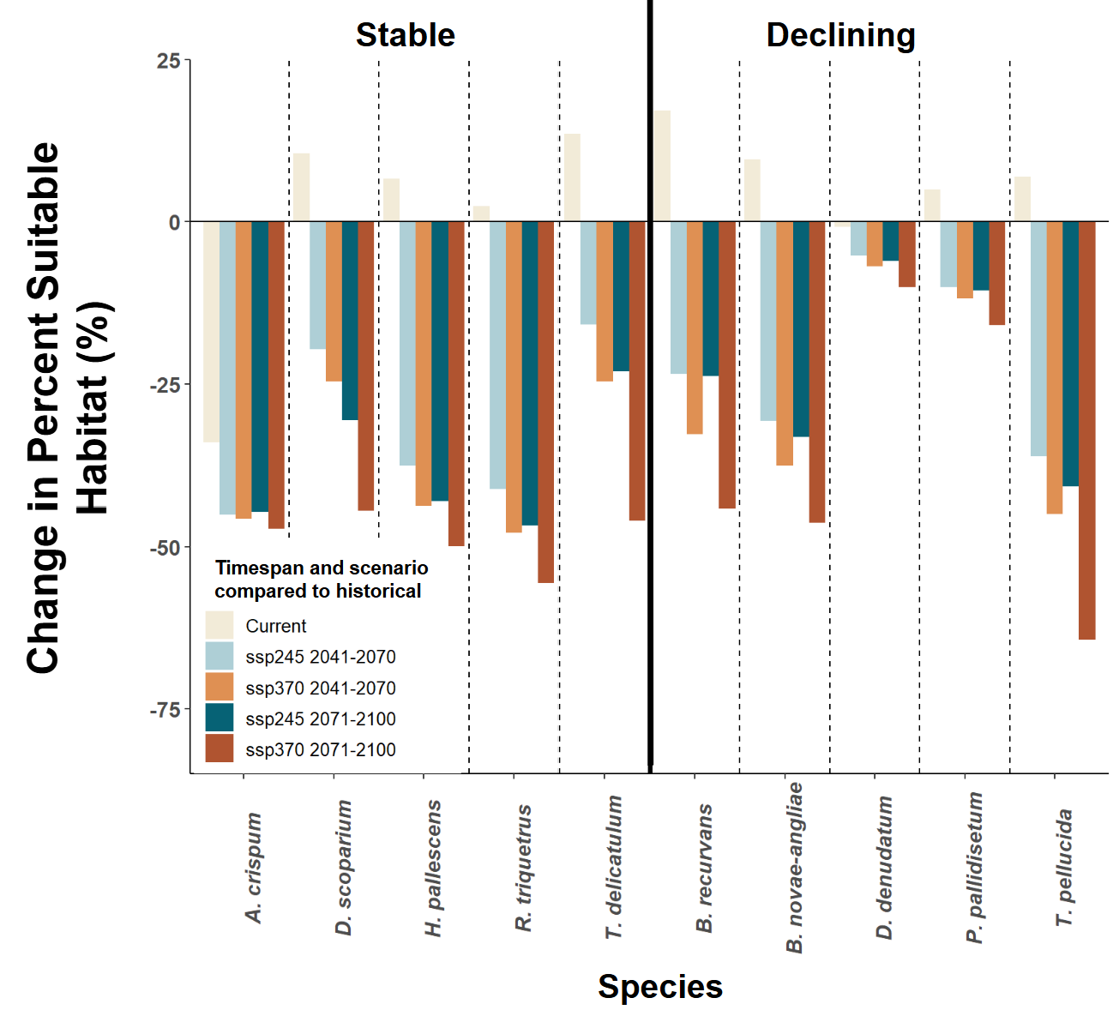
Figure 3.1 Change in the percent suitable habitat for five stable (left) and five declining (right) species for current (1991-2020) and future (2041-2070, 2071-2100) timespans under two different climate change scenarios [ssp245 (middle of the road) and ssp370 (regional rivalry, worse for the environment)] compared to historical levels. Each species is separated by a dashed line.

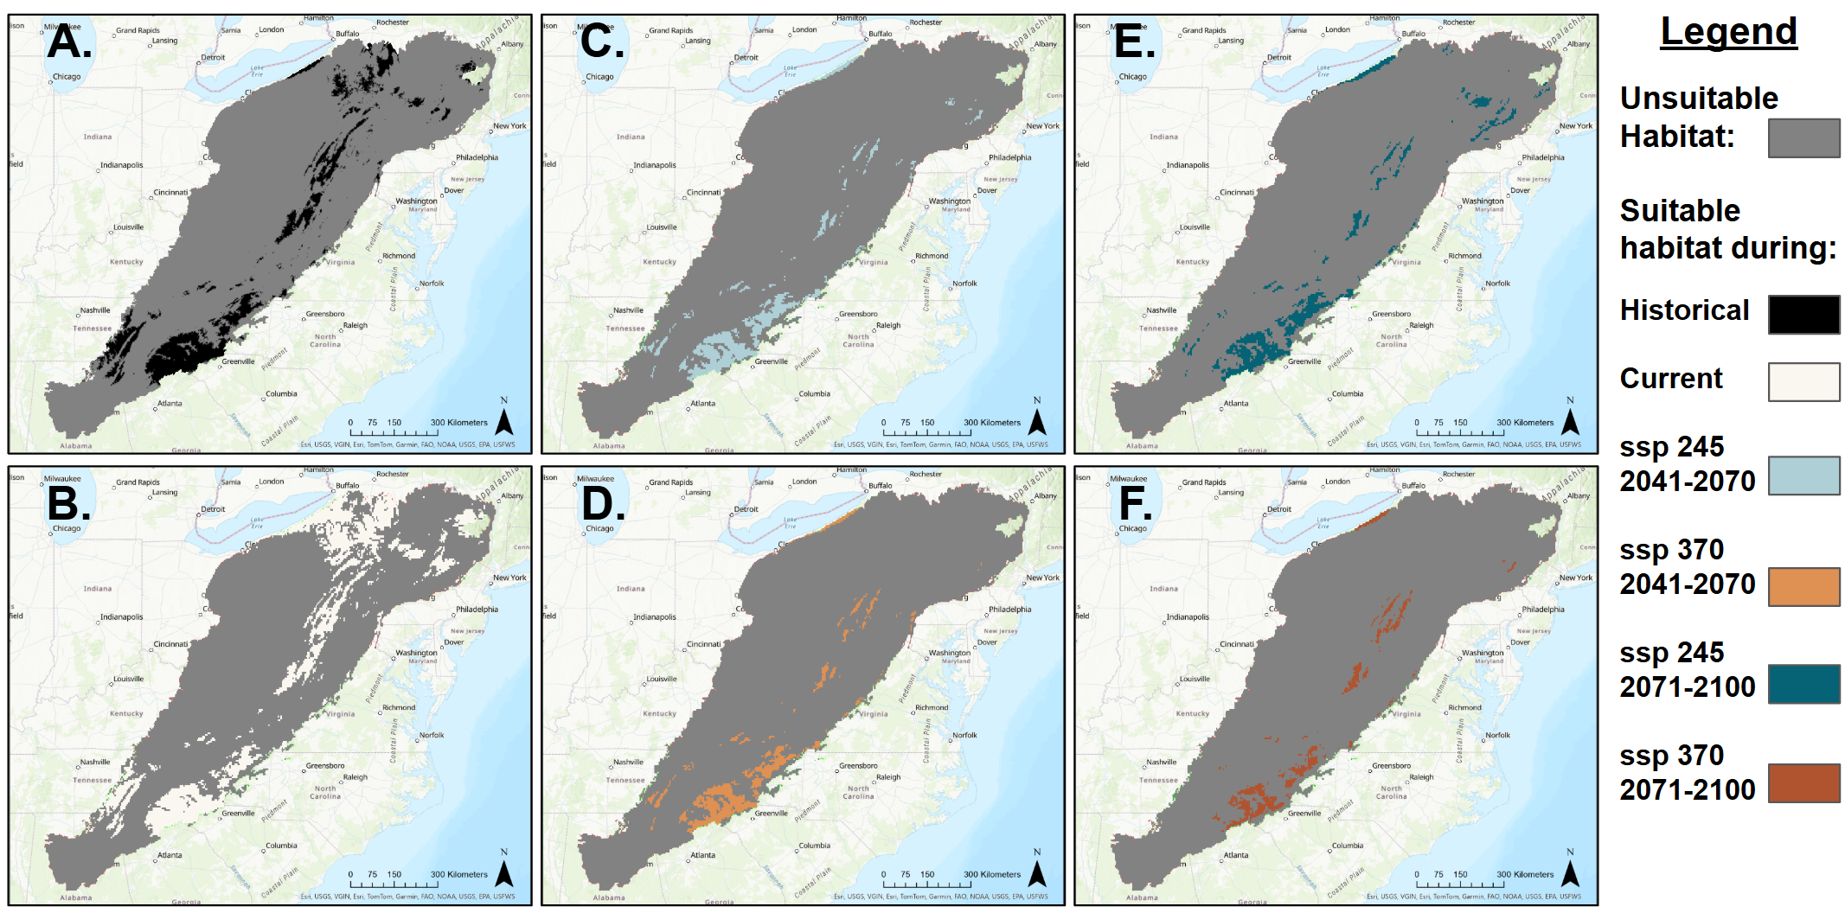
Figure 3.2 Predicted suitable habitat within the Appalachian Mountains for Atrichum crispum (stable species) with unsuitable habitat in gray and suitable habitat for A. historical in black, B. current in cream, C. ssp245 (2041-2070) in light blue, D. ssp370 (2041-2070) in orange, E. ssp245 (2071-2100) in dark blue, and F. ssp370 (2071-2100) in red-orange.

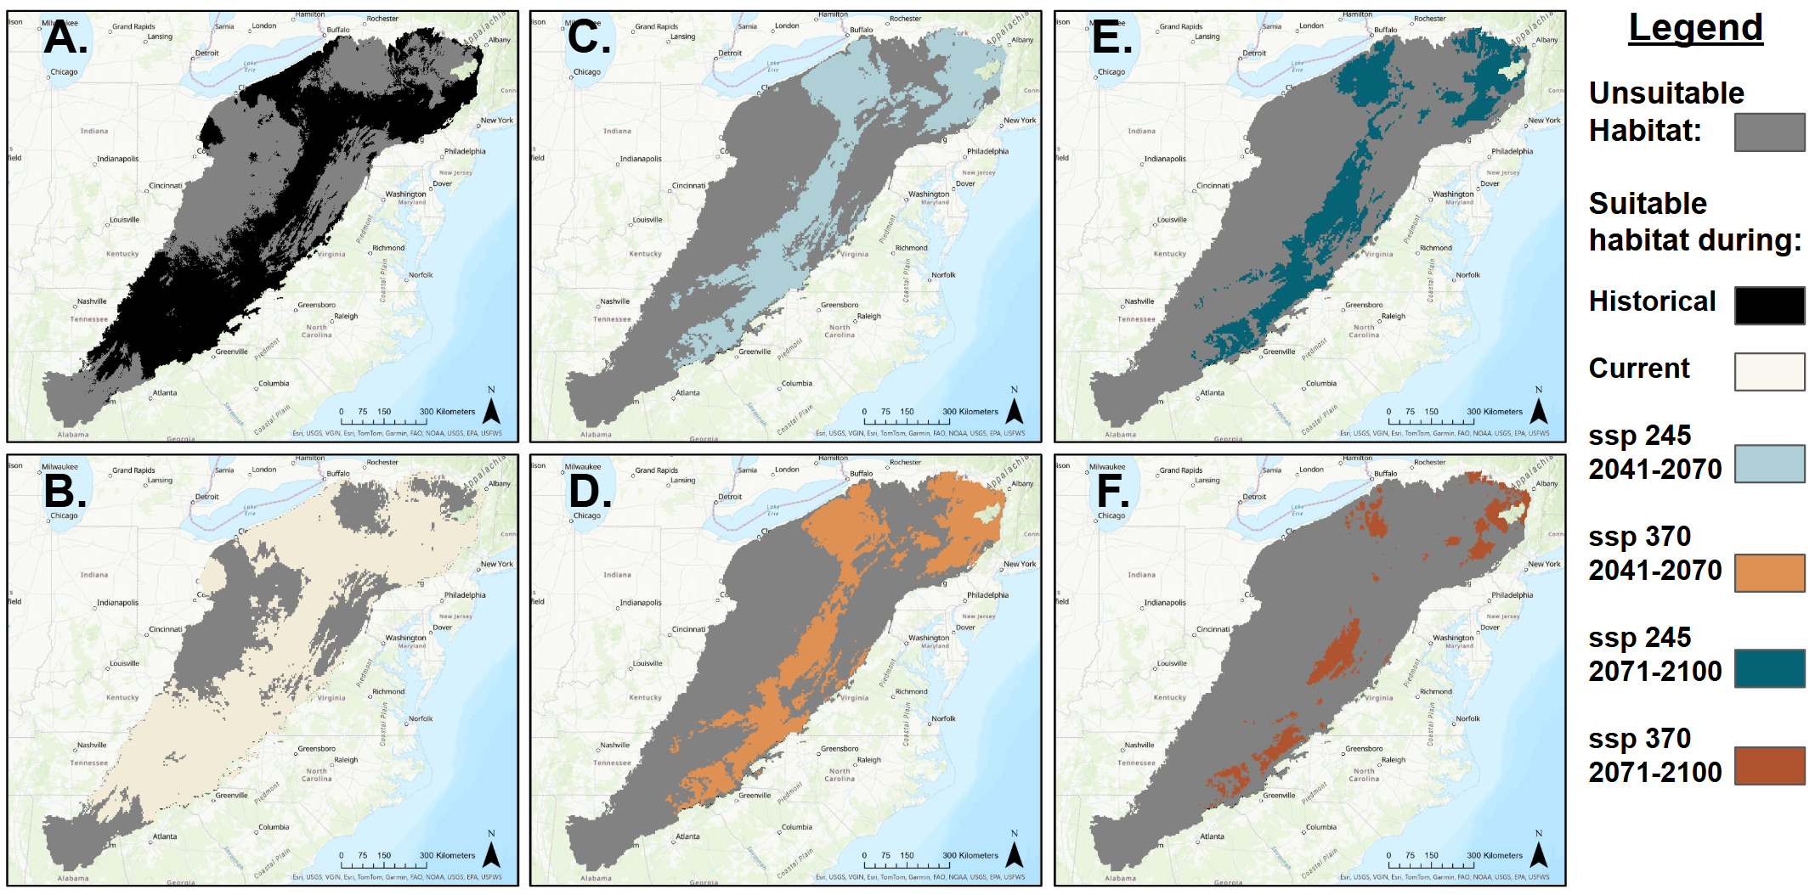
Figure 3.3 Predicted suitable habitat within the Appalachian Mountains for Dicranum scoparium (stable species) with unsuitable habitat in gray and suitable habitat for A. historical in black, B. current in cream, C. ssp245 (2041-2070) in light blue, D. ssp370 (2041-2070) in orange, E. ssp245 (2071-2100) in dark blue, and F. ssp370 (2071-2100) in red-orange.

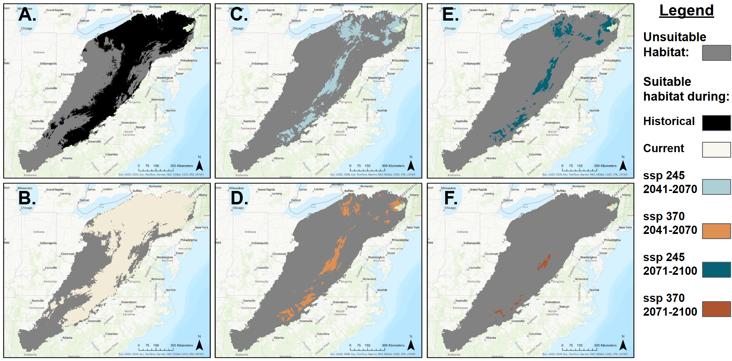
Figure 3.4 Predicted suitable habitat within the Appalachian Mountains for Hypnum pallescens (stable species) with unsuitable habitat in gray and suitable habitat for A. historical in black, B. current in cream, C. ssp245 (2041-2070) in light blue, D. ssp370 (2041-2070) in orange, E. ssp245 (2071-2100) in dark blue, and F. ssp370 (2071-2100) in red-orange.

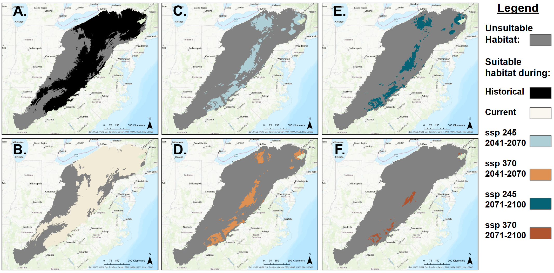
Figure 3.5 Predicted suitable habitat within the Appalachian Mountains for Rhytidiadelphus triquetrus (stable species) with unsuitable habitat in gray and suitable habitat for A. historical in black, B. current in cream, C. ssp245 (2041-2070) in light blue, D. ssp370 (2041-2070) in orange, E. ssp245 (2071-2100) in dark blue, and F. ssp370 (2071-2100) in red-orange.

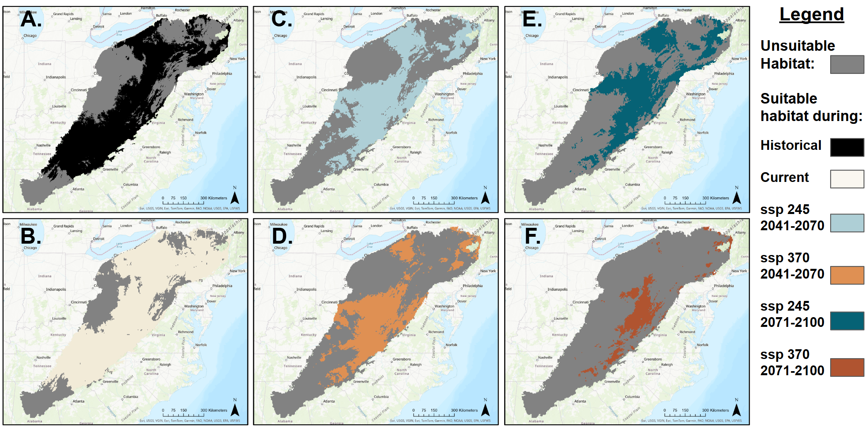
Figure 3.6 Predicted suitable habitat within the Appalachian Mountains for Thuidium delicatulum (stable species) with unsuitable habitat in gray and suitable habitat for A. historical in black, B. current in cream, C. ssp245 (2041-2070) in light blue, D. ssp370 (2041-2070) in orange, E. ssp245 (2071-2100) in dark blue, and F. ssp370 (2071-2100) in red-orange.

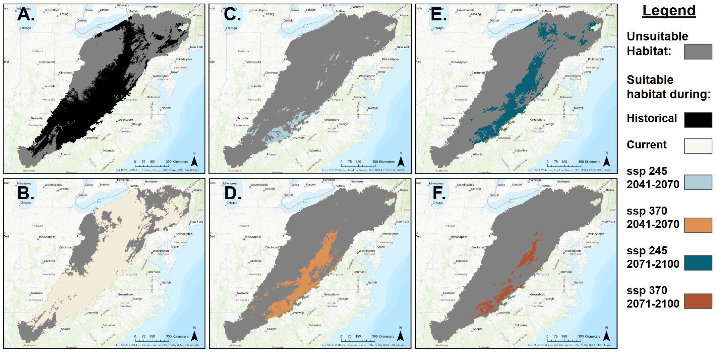
Figure 3.7 Predicted suitable habitat within the Appalachian Mountains for Brotherella recurvans (declining species) with unsuitable habitat in gray and suitable habitat for A. historical in black, B. current in cream, C. ssp245 (2041-2070) in light blue, D. ssp370 (2041-2070) in orange, E. ssp245 (2071-2100) in dark blue, and F. ssp370 (2071-2100) in red-orange.

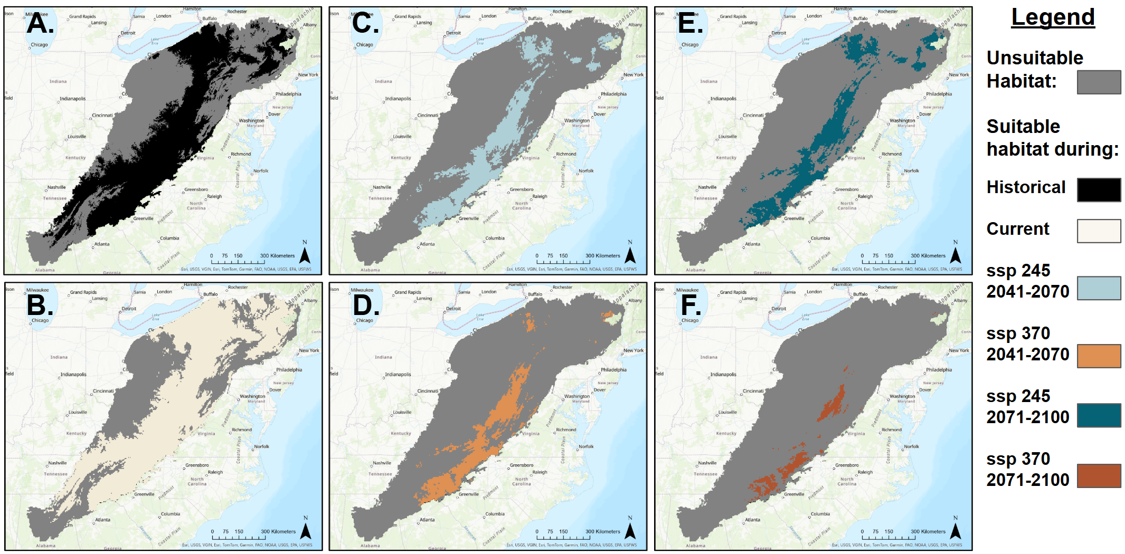
Figure 3.8 Predicted suitable habitat within the Appalachian Mountains for Bryhnia novae-angliae (declining species) with unsuitable habitat in gray and suitable habitat for A. historical in black, B. current in cream, C. ssp245 (2041-2070) in light blue, D. ssp370 (2041-2070) in orange, E. ssp245 (2071-2100) in dark blue, and F. ssp370 (2071-2100) in red-orange.

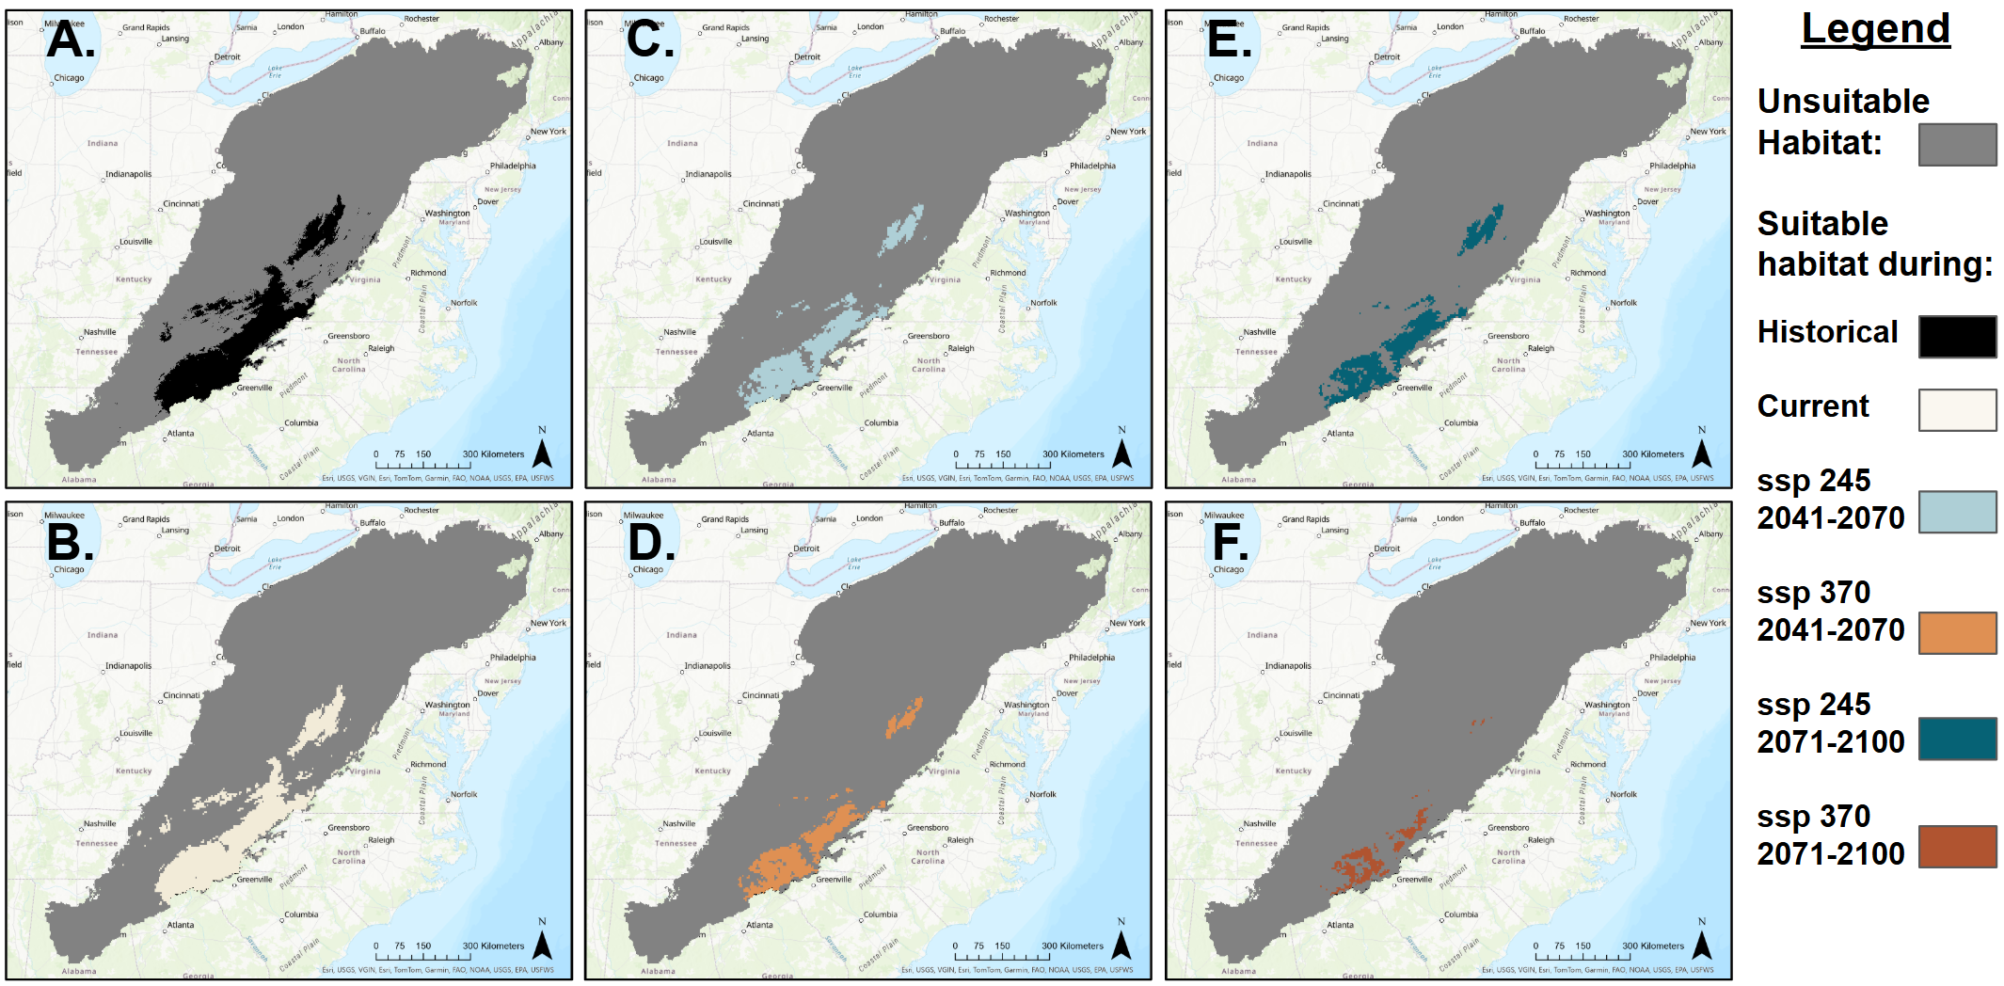
Figure 3.9 Predicted suitable habitat within the Appalachian Mountains for Dicranodontium denudatum (declining species) with unsuitable habitat in gray and suitable habitat for A. historical in black, B. current in cream, C. ssp245 (2041-2070) in light blue, D. ssp370 (2041-2070) in orange, E. ssp245 (2071-2100) in dark blue, and F. ssp370 (2071-2100) in red-orange.

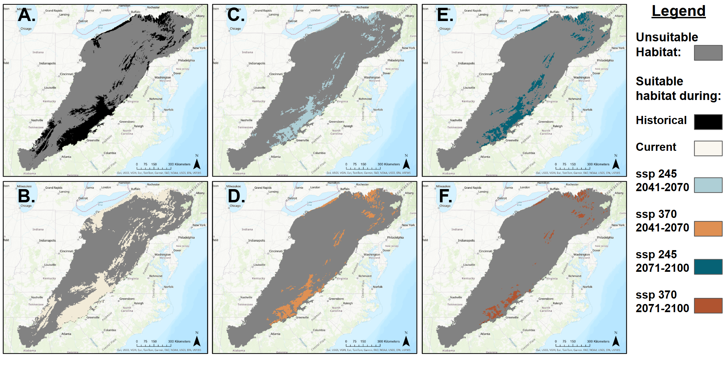
Figure 3.10 Predicted suitable habitat within the Appalachian Mountains for Polytrichastrum pallidisetum (declining species) with unsuitable habitat in gray and suitable habitat for A. historical in black, B. current in cream, C. ssp245 (2041-2070) in light blue, D. ssp370 (2041-2070) in orange, E. ssp245 (2071-2100) in dark blue, and F. ssp370 (2071-2100) in red-orange.

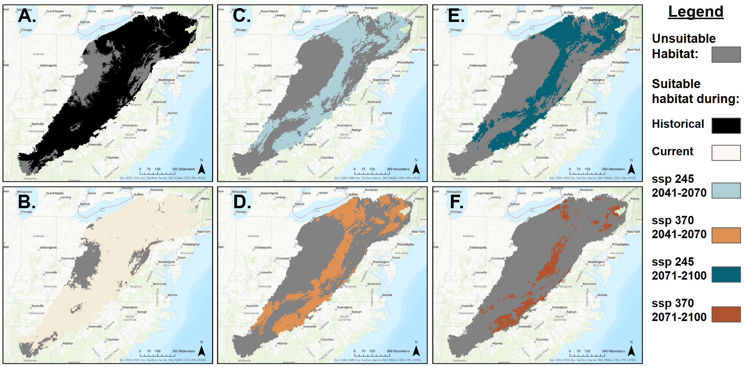
Figure 3.11 Predicted suitable habitat within the Appalachian Mountains for Tetraphis pellucida (declining species) with unsuitable habitat in gray and suitable habitat for A. historical in black, B. current in cream, C. ssp245 (2041-2070) in light blue, D. ssp370 (2041-2070) in orange, E. ssp245 (2071-2100) in dark blue, and F. ssp370 (2071-2100) in red-orange.

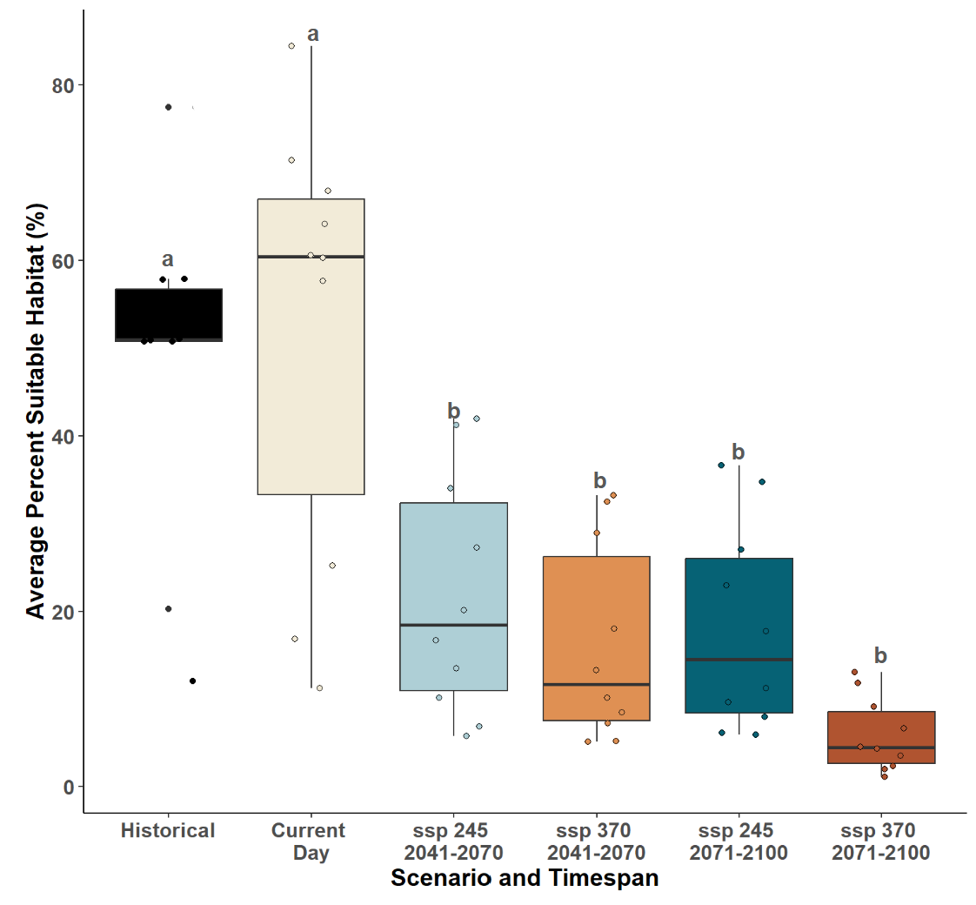
Figure 3.12 Percent suitable habitat within a given timespan for all species. Lowercase letters above bars indicate significant differences with p < 0.05 based on Tukey HSD post-hoc tests following an ANOVA (F_{11, 48} = 5.62, p = 1.04e⁻⁵).

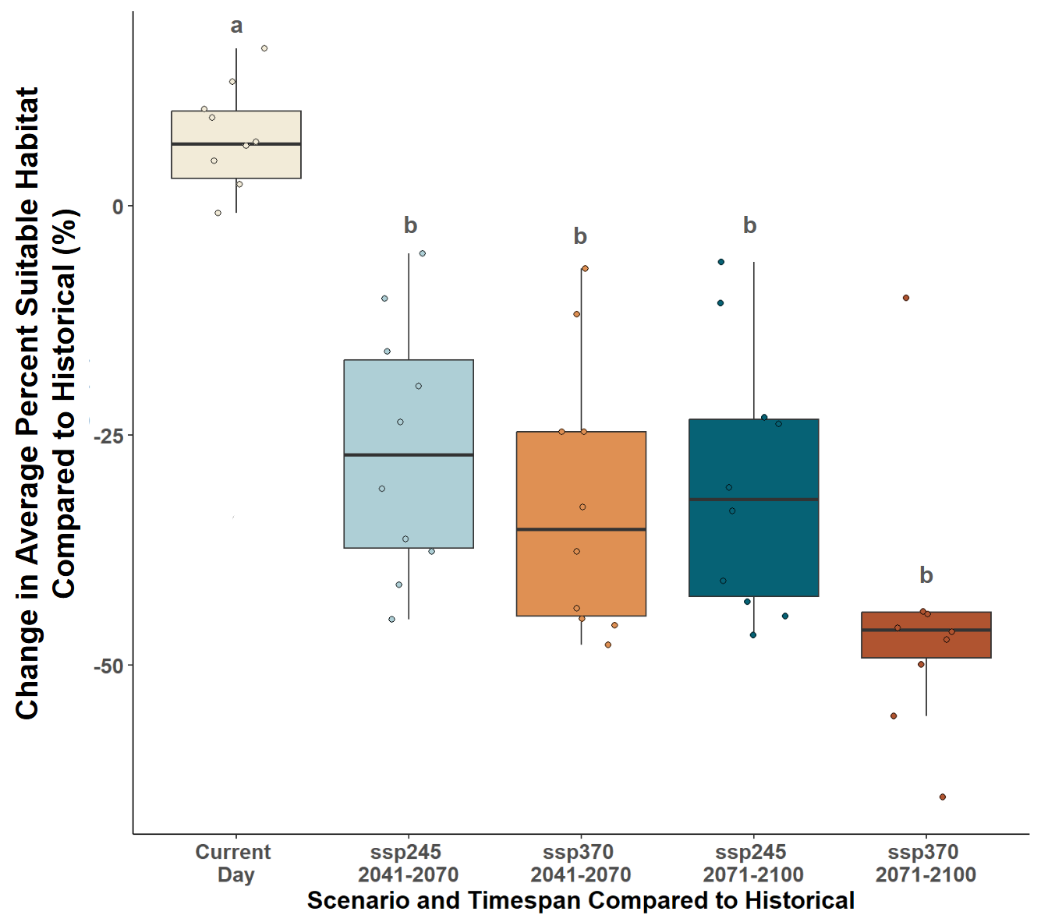
Figure 3.13 Percent suitable habitat change between historical and all other timespans for all species. Lowercase letters above bars indicate significant differences with p < 0.05 based on Tukey HSD post-hoc tests following an ANOVA (F_{9, 40} = 7.49, p = 2.54e⁻⁶).

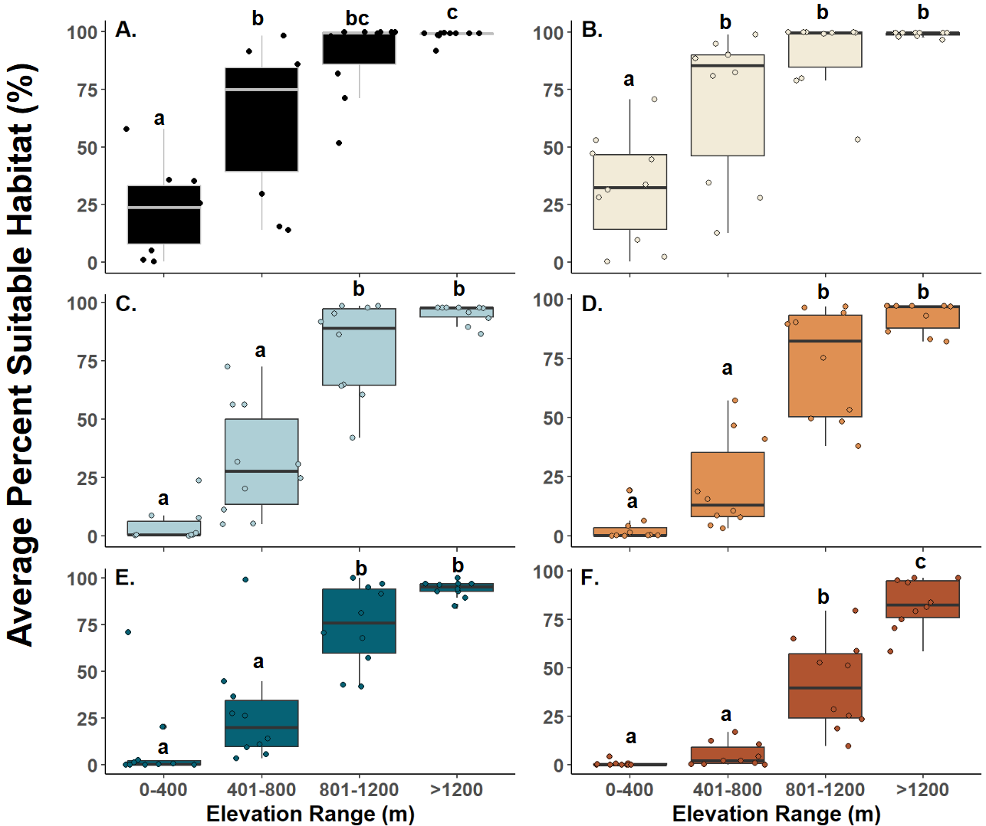
Figure 3.14 Average percent average suitable habitat for selected species across an elevational gradient for A. Historical, B. Current day, C. ssp245 (2041-2070) D. ssp370 (2041-2070) E. ssp245 (2071-2100) and F. ssp370 (2071-2100). Each point represents the amount of suitable habitat for that species divided by the total habitat found within that elevation range. Lowercase letters above boxes indicate significant differences above 0.05 based on Tukey HSD post-hoc tests following an ANOVA (F_{23, 216} = 39.59, p = 2.2e⁻¹⁶).

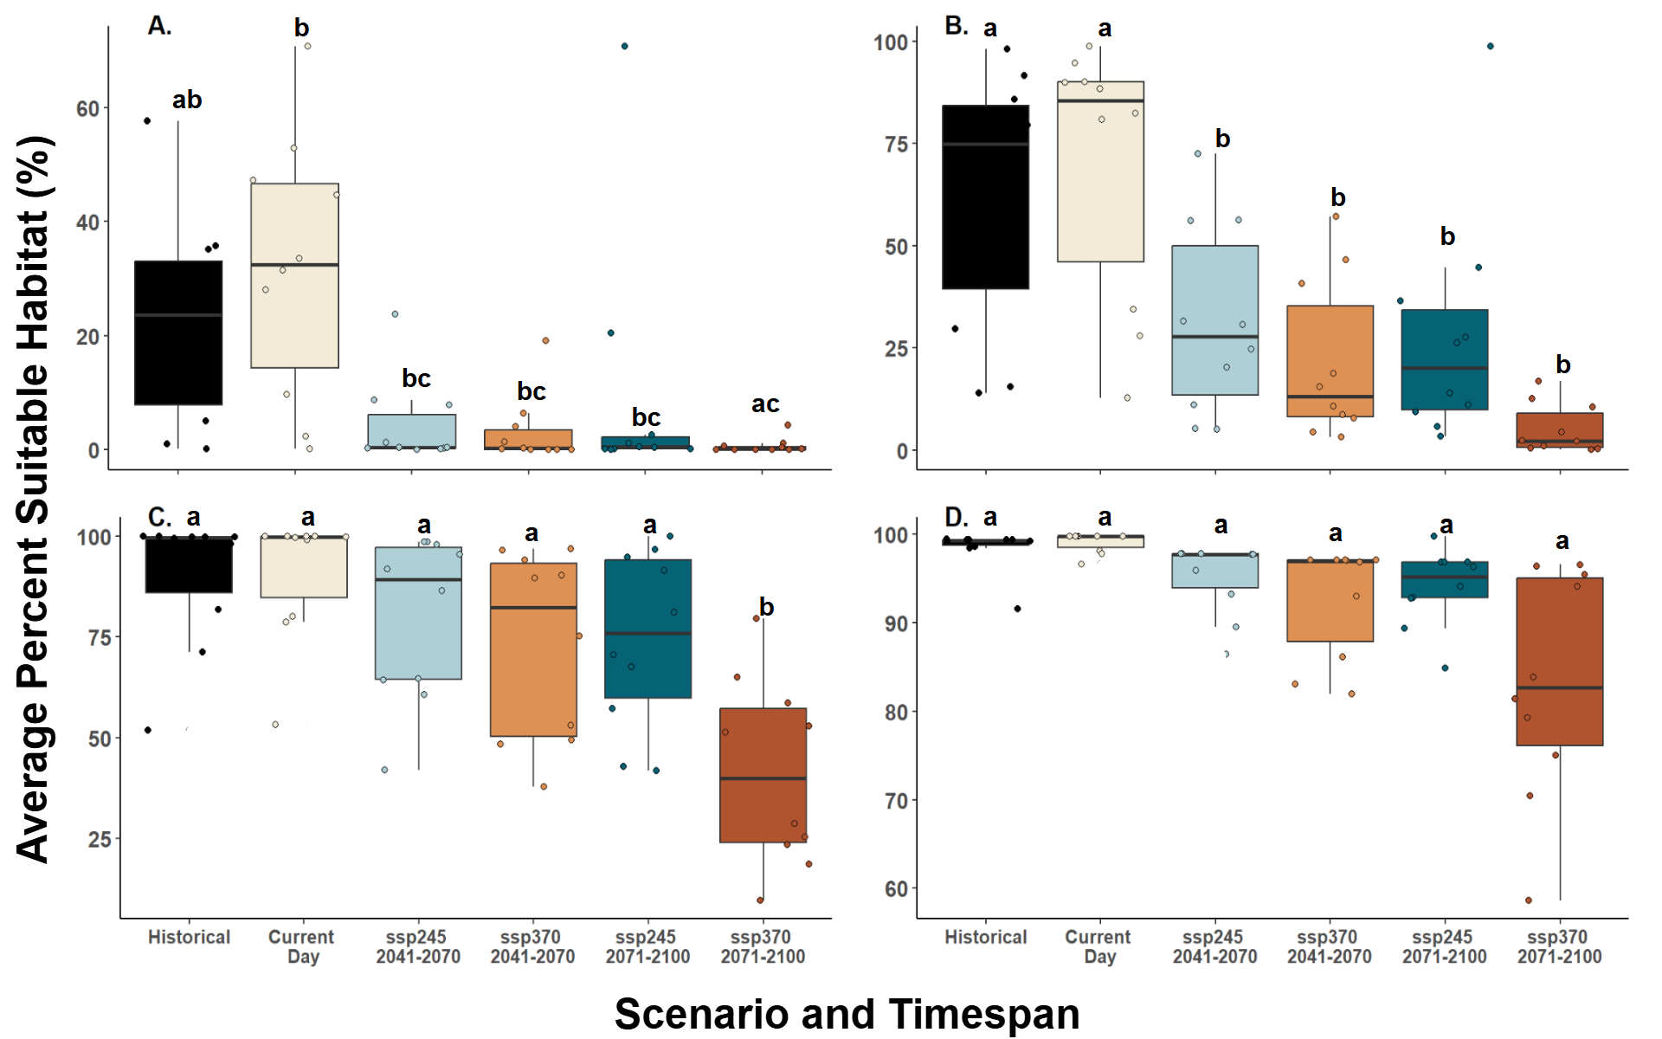
Figure 3.15 Average percent suitable habitat for selected species across timespans and scenarios with panels corresponding to A. 0 - 400 m, B. 401 - 800 m, C. 801 – 1200 m, and D. greater than 1200 m. Each box represents the amount of suitable habitat divided by the total habitat found within that elevation range. Lowercase letters above boxes indicate significant differences above 0.05 based on Tukey HSD post-hoc tests following an ANOVA (F_{23, 216} = 39.59, p = 2.2e⁻¹⁶).

CONCLUSIONS AND RECOMMENDATIONS
This dissertation set out to evaluate bryophyte community changes through time and determine the drivers of these observed changes within the Great Smoky Mountains National Park (GSMNP). Historically, the high elevation ecosystem has endured the invasion of the Balsam Woolly Adelgid (BWA). This perseverance is likely due to the various management policies implemented to halt the spread of this pest. These differed from peak to peak with two distinct bryophyte community change patterns emerging. 1. post-BWA had higher rarefied richness than pre-BWA, or 2. There was no difference in rarefied richness between pre- and post-BWA. It is likely that the more extreme management decisions which were deemed ineffective at halting the BWA (clearcutting) resulted in the first pattern while more conservative approaches that were viewed as a success (pesticides and biotic controls) drove the second. However, across all mountains and management practice, the ICR had the lowest rarefied richness out of all timespans, which may suggest that some other driver is acting on the bryophyte communities during this timespan.
When focusing on the ICR and comparing community composition between two time points, both richness and abundance significantly declined in the fir zone. Change in gap fraction significantly predicted the declines observed in evenness and richness (q = 1) and when rare species importance was down weighted (q = 2). This suggests that as the canopy closes, either fewer species are present overall, or the abundances of species has changed to become more uneven. While this appears to be positive news for the tree community and their recovery, that may not be the same for the bryophytes. The ICR period diversity did not match that of pre-BWA community, suggesting that many species may have been lost altogether and still have not returned a half-century later. These may be the specialists species that were unable to persist through time. Studies predict that rare species and species exhibiting substrate specificity are typically poorer dispersers and have more narrow niches, meaning that once lost, even if suitable habitat is present, they may be unable to disperse to such locations. A more targeted search could be performed, using past herbarium specimen GPS coordinates to try and find these “lost” species within the park. If they are unable to be located, researchers and park staff could perform assisted transplantation to restore the diversity to pre-BWA levels.
While the fir-zone community was impacted by the BWA, the spruce and spruce-fir zones were too low in elevation to be affected. Yet, in these zones we observed declines in overall richness but no change in bryophyte abundance between 2008 and 2020. Other disturbances, such as climate change, may have altered the abiotic conditions at these lower elevation sites thereby changing suitable habitat into unsuitable for these species. There were several species significantly declining or that were never observed in 2020 but present in 2008. Many of these were substrate specialists, which again are less likely to persist through a disturbance like climate change induced stress.
That said, this dissertation modeled suitable habitat for significantly declining species that were either substrate generalists or flexible and compared to that of stable species. There was no difference in amount of suitable habitat between declining and stable species, suggesting all bryophytes may suffer habitat loss under climate change. It may be that the stable species are physiologically adapted or more plastic to environmental changes than declining species, but that as the effects of climate change worsen, even the stable species will lose habitat. Another hypothesis is that the macroclimatic variables may not reflect that of the microhabitat where these tiny organisms are residing. Microclimatic data could be used to determine if there are differences between declining and stable species.
Regardless of stable or declining, all modeled species had the highest proportion of suitable habitat at higher elevations, especially those within national parks and forests, like the GSMNP. This dissertation highlights the importance of our protected public lands as climate change refugia for a plethora of bryophyte species of varying growth forms. While connectivity of suitable habitat between parks and forests is low, species with morphological features suited for long-distance dispersal may be able to maintain disjunct populations. Substrate specialists or rare species may be susceptible to genetic isolation if suitable habitat continues to contract. As such assisted transplantation may be required as they become stranded at the peaks of these mountains with nowhere else to shift up to.
It is also apparent that management strategies implemented for other taxa may greatly influence the bryophyte communities. Thus, as climate change worsens and land managers continue to make informed, yet difficult decisions regarding that park, the herbaceous layer and especially the bryophytes within should be considered as they provide vital ecosystem functions. As these plants are sensitive to changes in canopy as well as the macroclimate changes induced by climate change, it is imperative to not further exacerbate their communities with harsh management practices, like clearcutting, that could extirpate specialist and rare species and the ecosystem functions they provide.
Future work should continue to monitor these high elevation champions of diversity to ensure that further declines in richness and abundance do not continue. Researchers could submit species of various substrate preferences to physiological stress, and model that along with morphological characteristics to determine if there are shared features between vulnerable taxa. More work will be needed to understand the dispersal capabilities of these species to determine whether assisted transplantation will be necessary as suitable habitat is constrained to the highest peaks. Finally, the continued preservation of their suitable habitat will be crucial to maintaining the diversity and abundance of bryophytes within the GSMNP.

VITA
Eric D. Shershen grew up in the suburbs of Chicago and attended Augustana College in Rock Island, Illinois. Here he discovered his love for mosses conducting field work and writing a manuscript on the bryophyte community of Rock Island County. He went on to graduate with his bachelor’s degree in Biology and Environmental Studies with a minor in Geography in May of 2018. He returned to academia in the fall of 2019 at the University of Tennessee Knoxville to determine what drives bryophyte community change through time, where he graduated with his doctorate in ecology and evolutionary biology in August 2025.

