DYAD AND GROUP COORDINATION IN PURE COORDINATION GAMES

A Thesis Presented for the
Master of Arts
Degree
The University of Tennessee, Knoxville

Kennedy D. Evins
August 2024

Copyright © 2024 by Kennedy D. Evins
All rights reserved.

ACKNOWLEDGEMENTS

Thank you to my advisor, Dr. Garriy Shteynberg, for supporting my journey towards completing this thesis. I also want to thank the other members of my committee, Dr. Sarah Lamer and Dr. Lowell Gaertner, for their input, expertise, and encouragement. Second, I would like to thank the undergraduate students who worked in the GAB Lab for helping run this study. Without their help, there would be no data to analyze. Lastly, I would like to thank the faculty and administrators in Psychology Department at the University of Tennessee, Knoxville for providing me with the resources and training necessary for earning a Master of Arts in Psychology.
ABSTRACT

Game theory research has utilized pure coordination games to examine response matching as the most basic form of coordination between participants, even when the participants are not able to communicate with one another. Studies with pure coordination games have found that people are able to coordinate above-chance, and findings suggest that there are interesting coordination differences between groups that may be influenced by the social cognition of participants. The present study explored how strangers respond in pure coordination games at dyad and group-levels and how social cognition may be impacted by synchronous and asynchronous conditions. Data from 392 students at the University of Tennessee, Knoxville was used for analysis, and participants were randomly assigned to the synchronous dyad, asynchronous dyad, or the solo condition. Three research questions were addressed. The first research question sought to examine if strangers achieve above-chance coordination at the dyad and group levels, and hypotheses predicted above-chance coordination in all conditions at the dyad and group levels. The second research question sought to examine quantitative differences in coordination by condition, and it was hypothesized that participants in the synchronous condition would have the highest coordination success followed by the asynchronous condition and then the solo condition. Lastly, the third research question sought to examine qualitative differences in coordination by condition, and it was hypothesized that coordination responses would differ between participants in the dyad conditions and the solo condition. ANOVAs and paired-sample and one-sample t-tests were used for multiple analyses. All conditions achieved above-chance coordination, supporting the first hypothesis. The hypothesis for the second research question was partially supported by the data. The third hypothesis was also supported as results showed that synchronous participants and asynchronous participants had significantly different response patterns when comparing within-coding scores with scores re-coded based on the solo participants’ responses. Exploratory analyses found nonsignificant correlations between experimental items and control items for most tasks across the three conditions. Recommendations for further research include instruction modifications and investigation with diverse samples.
Table of Contents

CHAPTER ONE INTRODUCTION AND GENERAL INFORMATION 1
CHAPTER TWO LITERATURE REVIEW 4
Pure Coordination Games 4
Social Cognitive Foundations 6
Dyads 8
Hypotheses 9
CHAPTER THREE MATERIALS AND METHODS 12
Method 12
Participants 12
Measures 12
Procedure 15
Conditions 16
CHAPTER FOUR RESULTS AND DISCUSSION 19
Data Analysis 20
Research Question 1 21
Research Question 2 22
Research Question 3 27
Exploratory Analyses 30
Discussion 33
Limitations 35
CHAPTER FIVE CONCLUSIONS AND RECOMMENDATIONS 37
Future Directions 37
Conclusions 37
REFERENCES 39
APPENDIX 45
VITA 55

LIST OF TABLES

Table 4.1. Descriptives of Experimental Items 43

LIST OF FIGURES

Figure 3.1. Example Items for Each Task 14
Figure 3.2. Study Set-Up 17
Figure 4.1. Dyad-Level Coordination Results 24
Figure 4.2. Group-Level Coordination Results 26
Figure 4.3. Between-Coding Example 28
Figure 4.4. Within-Coding versus Between-Coding Results 31

Introduction and General Information

For humans, the sociocognitive ability to coordinate and align with others evolved as survival mechanisms that promote successful social interactions in our institutions, communities, organizations, and cultural groups (Jackson & Xing, 2014; Nyborg, 2020; Portes, 1998). Individuals continuously rely on shared knowledge, interests, goals, and understanding to guide their choices and to anticipate the thoughts and behaviors of others, which facilitates social interactions by promoting conflict resolution and coordination (Jackson & Xing, 2014; McGrath et al., 1999). Social interactions and coordinated behavior are more likely to happen between individuals of the same group because geographical proximity and community-level beliefs and interests produce familiarity, rapport, and ingroup favoritism (Mateo, 2004; Sariñana-González et al., 2017). Yet, coordination with others is not limited to ingroup members. In the United States, modernization has led to less interdependence and social connectedness as evidenced by increased individualism, fewer interactions with friends, and less community participation (Putnam, 2000, 2020; Yuan et al., 2022). Although it may be easy to quickly label these effects as negative, this sociocultural change is not completely antisocial. A recent meta-analysis showed that increased individualism is a probable cause of increased coordination between strangers because people interact and form relationships with strangers more often (Yuan et al., 2022). Therefore, social norms that promote in-group coordination can also promote coordination between strangers, and research has shown that, because we are in contact with strangers more often, establishing social cooperation as a universal strategy for both in-group members and strangers can facilitate coordination and lead to more social and economic capital (Macy & Skvoretz, 1998; Molina et al., 2023).
Coordination ability between two or more people has been evaluated by using social dilemma games like the Prisoner’s Dilemma (PD) to simulate when cooperation is difficult to achieve during a social interaction (Macy & Skvoretz, 1998; Pletzer et al., 2018; Sariñana-González et al., 2017; Van Lange et al., 2013). Communication between participants of these social dilemma games is usually prohibited, and these games contain a payoff incentive that may conflict personal gain with the motivation to coordinate with others (Mizrahi et al., 2023; Pletzer et al., 2018). In classic PD games, two individuals are paired together as a single dyadic social unit, and both familiar and randomly assigned dyads (i.e., strangers) have been able to coordinate with one another (Duffy & Xie, 2016; Macy & Skvoretz, 1998). However, standard game theory analyses have focused on individual cognition and interdependent outcomes, which limits knowledge about how the outcomes of plural individuals in social interactions can be jointly influenced by one another (Marsh et al., 2006). Therefore, it is important to conduct research that highlights how dyads may represent a unique social unit that embodies its own choices and social strategies. In lieu of social dilemma games, pure coordination games can be used to examine response matching as the most basic form of coordination within a dyad or group by prompting individuals to make the same choice without having a payoff incentive (Mizrahi et al., 2023; Schelling, 1960). The current study investigated how dyads respond in pure coordination games and how the social cognition of coordination impacts individual and dyad-level choices.

Literature Review

Pure Coordination Games
In his book The Strategy of Conflict (1960), Thomas C. Schelling criticized traditional game theory’s focus on cooperative games, noting how these games have a mixture of partnership and competition, thereby creating conflicts of interests between players. Schelling believed that, although these games provide insight on strategic behavioral decisions, they also limit the field’s knowledge of how coordination between individuals encourages and is influenced by certain behavior. He recommended using noncooperative, pure coordination games to investigate situations in which individuals win together by converging their behavior on a common interest. Participants in pure coordination games are not personally rewarded for picking a certain answer, and this lack of payoff eliminates conflict between individual interests and collective coordination (Mizrahi et al., 2023). Because “winning” is determined only by partners selecting the same answer, pure coordination games can have multiple equilibria (i.e., potential choices) that partners can match on (Schelling, 1960). The existence of multiple equilibria reflects the complexity of predicting successful solutions in real world coordination problems, which is important for game theory research (Cooper & Weber, 2020; Schelling, 1960). Pure coordination research has shown that two players can successfully coordinate answers to open-ended verbal items (e.g., “Write down any year” or “Name a shape”) and visual items as well as multiple-choice items without communication (Schelling, 1960; Mehta et al., 1994; Perez-Zapata & Apperly, 2021). Success in these games has been attributed to the sociocognitive ability to recognize a stand-out option (i.e., focal point) that a player can infer is also noticed by the other player (Schelling, 1960; De Freitas et al., 2019). A focal point becomes relevant through the cognitive process of labeling information, and individuals depend on common knowledge, experience, and culture to identify what information is relevant for coordination (De Freitas et al., 2019; Halpern & Moses, 1990; Mehta et al., 1994; Schelling, 1960). Additionally, social norms can also guide expected behaviors and improve coordination performance in pure coordination games (Jackson & Xing, 2014). Altogether, Schelling’s criticism of traditional game theory helped introduce pure coordination games as important components for evaluating economic and social theories and for examining behaviors and social strategies among individuals (Myerson, 2009). Researchers continue to expand on Schelling’s The Strategy of Conflict by implementing pure coordination games in experimental settings.
Cooper and Weber (2020) reviewed recent pure coordination experiments and found evidence that supported using coordination for studying social issues and phenomena. Results from one study show that individuals can guess and reason to achieve above-chance coordination with others (Bardsley et al., 2010), which suggests that participants are doing more than just randomly guessing in the game. Another study found that individuals as young as 4-years-old can coordinate with one another above-chance (Perez-Zapata & Apperly, 2021). Pure coordination games have also been used to compare coordination ability between socially close players and strangers (Gatcher et al., 2022) and to show associations between coordination ability and cognitive load (Mizrahi et al., 2022). Despite these advances, many pure coordination studies focus on individual coordination ability and maintain anonymity between partners. The current study will expand upon prior research by using pure coordination games to examine dyadic coordination ability amongst strangers in face-to-face dyads. Because pure coordination game tasks do not have objectively correct answers, I will describe three social cognitive foundations that can be used to explain how people infer focal points to coordinate with one another.

Social Cognitive Foundations
As previously stated, coordination success in games is supported by shared knowledge among participants. The sociocognitive ability to coordinate with others is necessary for novel and repeated social interactions (Jackson & Xing, 2018), so understanding the social cognitive foundation of coordination is vital. Currently, there are three main foundations that are discussed in the field. The descriptive norms foundation suggests that coordination is achieved by reflecting on social norms, which are typical ways of perceiving and behaving in one’s group (Rivis & Sheeran, 2003). Research has found that descriptive norms can be used to explain differences in thinking, conformity, negotiation, and other social cognitive phenomena (Gelfand & Harrington, 2015; Yamagishi, Hashimoto, & Schug, 2008; Gelfand et al., 2013). These norms function as behavior predictors that aid in social coordination (Gelfand & Harrington, 2015). The theory of minds foundation (ToM) suggests that people can interpret and infer the thoughts of others through their behavior, appearance, and other social cues, and this ability is developed through social experience and interactions (De Freitas et al., 2019; Garfield et al., 2002). Although humans have the capacity to interpret actions in terms of intention and knowledge at an early age, it is an effortful social cognitive process to utilize (Lin et al., 2009). ToM aids in various social interactions (e.g., teaching, navigation, and empathy) because it is the ability to recognize that someone can have a separate set of knowledge and beliefs than oneself (Frith & Frith, 2005). The collective attention foundation suggests that alignment is achieved by activating a we-mindset among individuals (Shteynberg et al., 2020), even when one’s partner cannot be seen but is thought to be receiving information at the same time (i.e., co-attending). The synchronous arrival of information via co-attention allows for mind representations, and research suggests that collective representations of reality impact cognition (Shteynberg et al., 2023). Comparisons between contexts that allow co-attention (i.e., synchronous conditions) and conditions that do not (i.e., asynchronous conditions) have suggested that synchronous conditions are best for social cognition because of the passing and sharing of information (Marsh et al., 2006; Shteynberg et al., 2023).
Each of these sociocognitive foundations have components that may impact how individuals are able to coordinate with one another. For example, research suggests social cues facilitate coordination success (Sauppe & Mutlu, 2014), thereby supporting ToM as a relevant foundation for coordination tasks. Prior research has also found that collective attention establishes common knowledge, which can enhance cooperation, facilitate coordination, and reduce conflict among individuals and groups (Mehta et al., 2014; Schelling, 1960; Shteynberg et al., 2020). However, further investigation is needed to better understand which sociocognitive strategies are most apparent in pure coordination tasks. There is limited research that evaluates how the social cognition within a dyadic social unit may differ from coordination amongst individuals. By having participants in solo, synchronous, and asynchronous conditions, the current study will examine if creating face-to-face dyads helps explain how social norms, social cues, and co-attending can impact coordination.

Dyads
Because humans are motivated to maintain social connections in their environments (Nyborg, 2020), social interaction research has naturally centered on individuals who share social norms with other familiar group members (i.e., families, neighborhoods, business organizations, etc.). More specifically, this field of research commonly addresses social learning, behavior predictions, and interdependent outcomes within social networks by using naturally occurring dyads (i.e., couples, friends, parent and child, coworkers, therapist and client, etc.). A recent study found that non-verbal synchrony has been possible in a therapeutic setting through therapist-client relationships (Atzil-Slonim et al., 2023), but coordination within therapist-client relationships happens on a continuum and can change over time, which differentiates familiar dyads from unfamiliar dyads (i.e., strangers). As we increasingly interact with strangers (Yuan et al., 2022), research about dyadic coordination between strangers can potentially indicate the quality of these interactions. Game theory research has consistently used 2-person games to evaluate coordination behaviors, and results show that strangers and familiar individuals are able to coordinate with each other (Cooper & Weber, 2020; Mehta et al., 1994; Melis & Semmann, 2010). However, the data analyses for these studies often focus on individual differences and interdependent outcomes. This standard approach negates evaluating the “emergent collective” that can arise when individuals mutually and jointly influence social interaction (Marsh et al., 2006). Ignoring the dyadic nature of data from paired individuals is discouraged conceptually and statistically because the individual outcomes are no longer independent (Kenny et al., 2006; Marsh et al., 2006). In the context of pure coordination games, the outcomes are inherently non-independent because partners either win together or lose together. By further examining the pure coordination abilities of strangers in face-to-face dyads, researchers can better understand how social information from the environment can impact social interactions between strangers. The current study maintained the integrity of dyadic data by evaluating coordination as a within dyad and a between dyad variable to compare and contrast experimental effects.

Hypotheses
Coordination between individuals is necessary for a functional modern society. However, minimal research has investigated how sociocognitive abilities prompt coordination within unfamiliar dyads and how different contexts influence coordination at the dyad and group levels. The purpose of this study is to examine how social norms, social cues, and co-attending can impact pure coordination ability amongst strangers in face-to-face dyads and unfamiliar groups. Participants were randomly assigned to a solo, synchronous dyad, or asynchronous dyad condition, and they completed a pure coordination game that was made up of five different tasks. The focus on interdependent outcomes in game theory research have been criticized for ignoring an emergent collective that forms when individuals are partnered together (Marsh et al., 2006); therefore, it is likely that analyzing dyad outcomes may highlight results that differ from standard game theory analyses. Descriptive norms research suggests that reflecting on social norms to predict behavior aids in social coordination (Gelfand & Harrington, 2015; Rivis & Sheeran, 2003), and pure coordination game research has shown that strangers are able to coordinate with each other without communicating (Perez-Zapata et al., 2021; Cooper & Weber, 2022). Therefore, it was anticipated that coordination would happen above-chance for all conditions at both the dyad level and the group level. Theory of minds research suggests that access to visible social cues promotes people’s ability to infer the mind of others (De Freitas et al., 2019), and findings on collective attention indicate that synchronous conditions benefit social cognition (Shteynberg et al., 2023). With these two sociocognitive foundations in mind, it was anticipated that visible social cues available in both the synchronous dyad and asynchronous dyad conditions and co-attention in only the synchronous condition would be important for facilitating coordination success. Previous research on collective minds supports that the synchronous arrival of information and co-attention promote complementary actions (Shteynberg et al., 2023); therefore, it is likely that participants in the synchronous dyad condition would have particularly high levels of coordination within dyads and across the group. It is also anticipated that the coordination success in the synchronous dyad condition would coincide with condition-specific answer choices amongst participants. These expectations are reflected in the study hypotheses:
Q1: Can strangers coordinate with each other above chance?
H1a: Strangers will successfully coordinate above chance in each task at the dyad-level as sync and async face-to face partners and as randomized dyads from the solo condition.
H1b: Strangers will successfully coordinate above chance in each task at group-level across all conditions.
Q2: Does coordination differ quantitatively by condition?
H2: Coordination will be highest in the synchronous condition, and the solo condition will have weakest coordination when compared to the asynchronous and synchronous conditions at the dyad- and group-level.
Q3: Does coordination differ qualitatively by condition?
H3: Participants in the synchronous and asynchronous conditions will coordinate on different responses than solo participants.

Materials and Methods

Method

Participants
For this study, 408 college students at the University of Tennessee, Knoxville (UTK) were recruited through the online research system used by the Psychology department (i.e., Sona; https://utk.sona-systems.com). Participants came into the lab to complete the study. Of these participants, 142 were randomly assigned into dyads to form partnerships in the synchronous and asynchronous conditions, leaving 124 participants in the control condition (i.e. solo participants). Within this majority white sample (84.7%), 52.9% of participants were female and 45.8% were male. The average age was 18-years-old, and most participants were college first-year students (68.8%).

Measures
Demographic Questionnaire. Immediately after consenting to the study, participants responded to a brief demographic questionnaire that was used to assess participants’ gender, age, race, sexual orientation, ethnicity, hometown and state, and college status.
Pure Coordination Game Tasks (Perez-Zapata, et al., 2021). To replicate a previous experiment, four tasks created by Perez-Zapata and Apperly (2021) were used. The tasks vary in modality (2 visual, 2 verbal) and response options (3 forced choice, one open choice): Coarse-Visual (CV); Fine-Visual (FV); Forced-choice Verbal (FCV); and Open-Verbal (OV). In the creators’ study, the CV, FV and FCV tasks have five experimental items, and each question has four answer choices. The visual tasks prompt participants to pick a particular square. Two items from the OV task were removed from this study’s measure (“Name a boy’s name and “Name a vehicle”), and “Name a color” was added from Mehta, Starmer, and Stugen’s article (1994). This OV task was further modified by the addition of two statements that may have more salient answers with college aged participants (“Name a social media app” and “Name a brand”). Participants will have to pick the salient option in an initial trial for each task to check comprehension. The tasks were presented in a fixed order (see Figure 3.1 shows example items from each task).
12-trial Imaginiff Game (Pinel & Long, 2012). A fifth coordination task was added to the pure coordination game for this study. The Imaginiff game involved twelve ambiguous imagination scenarios that prompted participants to associate a celebrity with an object. This game was modified to include a control item (i.e. If Michael Jackson were a college major, he would be: a) accounting b) education c) music d) business.) to include all of Pinel and Long’s items in analysis and to have a control in each task. Other modifications included 1) updating the celebrities mentioned to more current ones (i.e., Russel Crowe switched to Elon Musk) and 2) one image of each celebrity was added, so that each participant read the name of the celebrity and saw a representative image of that celebrity when responding to the items.
Confidence item. A single item was used to assess the participants’ confidence in alignment. Partners responded to the statement, “I believe that I will be successful in matching answers with my partner” on a 5-point scale: 1 = Definitely No, 2 = Slightly
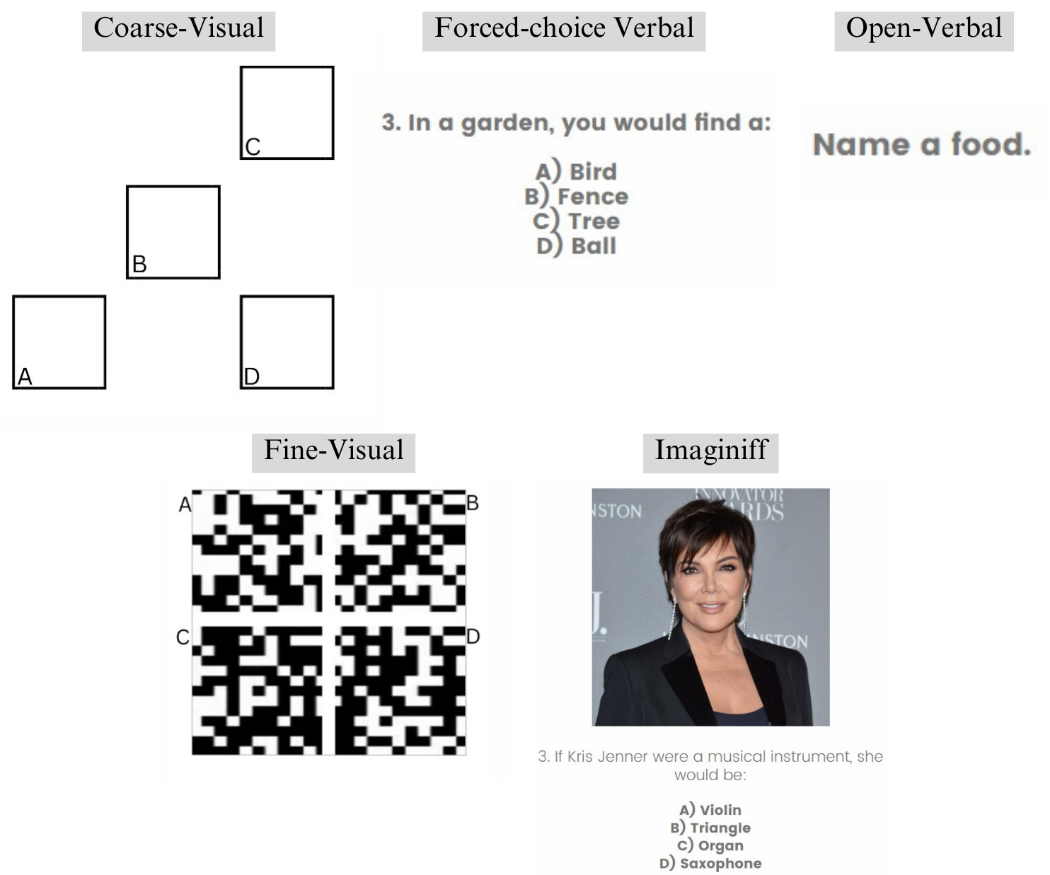

Figure 3.1. One example item of each task is shown. For the Imaginiff example, the photo of the celebrity was added for this study, and Kris Jenner was used as a replacement for Martha Stewart.
No, 3 = Undecided, 4 = Slightly Yes, 5 = Definitely Yes. For solo players, the statement will say, “I believe that I will be successful in matching answers with most other participants in this study.” Confidence was measured before and after (i.e., “I believe that I was successful…”) the pure coordination game.

Procedure
The participants came into the lab to complete the study on Qualtrics, which had an online consent form that included more information about the study and any risks and benefits of the study. The online consent form explained that receiving 1.0 credits was contingent upon reaching the end of the survey. Participants were able to withdraw participation without penalty. After providing online consent, students were directed to the Qualtrics survey with the pure coordination game tasks and the other aforementioned measures. Participant identification numbers were collected to award Sona credit, and that data will be maintained on a secure cloud server for up to seven years before being destroyed to ensure confidentiality.
This study was run with players in mostly mixed-gender dyads participating in a coordination game sampled from Mehta (1994) and Perez-Zapata and Apperly (2021) and an Imaginiff game sampled from Pinel and Long (2012). A coin flip method was used to randomly assign participants to the partnered conditions (synchronous and asynchronous). Partner visibility was allowed to examine how dyadic alignment is impacted when theory of minds is allowed (i.e., due to visible social cues). Partners saw each other before and during the completion of the coordination game. To prevent verbal communication between them, partners were instructed not to communicate with one another. The research assistant briefly explained the study and stayed in the room to guide participants through the task. The experimental stimuli for the pure coordination tasks were presented on a big screen for all participants, and they were directed to respond on their individual laptops before indicating to the research assistant that they were ready to move on to the next item (see Figure 3.2).

Conditions
Solo Condition. Solo players participated as the control group. Replicating Perez-Zapata and Apperly (2021), solo players were instructed to pick answers based on what they think “most other participants in this study will select.” Solo players completed the experimental tasks without a partner and with only the solo player and the research assistant in the room.
Synchronous Dyad. In this condition, partners went through each experimental task together with the research assistant. Both individuals in the dyad had to indicate that they entered their response and were ready to move on before the research assistant proceeded to the next item. Partners were instructed to pick answers that they think their partner would also pick.
Asynchronous Dyad. In this condition, the partners did not respond to the experimental tasks at the same time. After the partners completed the demographics section, the research assistant stated, “From this point forward, you [the participants] will be completing the same tasks, but at different times. It is very important that you follow the instructions on your screen. There are several big screen tasks that you will go through with me and some tasks that you will complete on your own. I will let you know

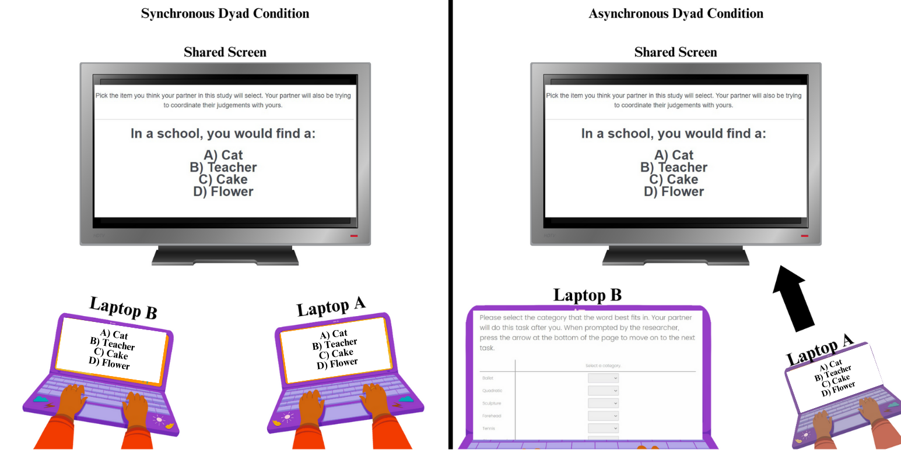Figure 3.2. Experimental design for the current study. Dyads in the synchronous condition complete each item of each task at the same time by viewing the stimuli on a shared big screen and then responding on their individual laptops. For dyads in the asynchronous condition, the partner at laptop A completed the experimental items of each experimental task while the partner at laptop B completed a word sorting task. The partners switched tasks when partner A completed each item in an experimental task.

when you will switch tasks with your partner. Remember to try to match answers with your partner throughout these tasks.” The participant seated at Laptop A (i.e., Partner A) went through the experimental task on the big screen first while their partner (i.e., Partner B) completed a word sorting task on their laptop. When Partner A answered all the items for the corresponding task, the research assistant instructed the partners to switch so that Partner B could then complete that same task. This fixed order of Partner A then Partner B was repeated until both had responded to all five experimental tasks. This current study was approved by the Institutional Review Board (IRB) at the University of Tennessee, Knoxville.

Results and Discussion
Because pure coordination games do not have correct answers, success in the experimental tasks was determined based on 1) whether or not participants matched with their partner (dyad-level) by calculating matching scores and 2) whether or not participants matched with other participants in their condition (group-level) by calculating alignment scores (Perez-Zapata & Apperly, 2021). For each dyad, matching scores were calculated by adding up the number of items that the partners matched answers on in each experimental task. For example, dyad number 36 in the synchronous condition matched on 3/5 of the items in the Fine-Visual task, so both participants in the dyad got a match score of .60 for that particular task. Each dyad had 5 matching scores (one for each experimental task). Replicating the approach used by Perez-Zapata and Apperly (2021), an alignment score was calculated for each individual to represent the average “proportion of other participants in their group [i.e. their assigned condition] who gave the same answer as the participant” in each task. The proportional coordination was calculated for each item in the task. For example, 124 of the 146 participants in the asynchronous condition picked A for item 4 in the Coarse-Visual task, so each got a score of .849 for that item. The scores for the items within each task were then averaged to produce an alignment score for the task. Each individual participant had five alignment scores (one for each experimental task).
Responses for the Open-Verbal task were re-coded as the same if they are a variation of another (i.e., “ball” and “basketball” or “storm” and “stormy”). The responses that did not have variations were not re-coded. After accounting for variations, the open-ended responses were coded as unique responses spontaneously produced by at least one participant. The chance baseline at the dyad-level took into account the number of participants in the analysis and only the responses that were produced by at least two participants. The chance baseline at the group-level took into account the number of participants in the analysis and the frequency of each response. For example, participants in the synchronous condition produced 14 unique responses for item 4 which yielded a chance baseline of .167 at the dyad-level and .164 at the group-level. After item analyses of each task, Item 8 (“Name a girl’s name”) in this Open-Verbal task was removed from all analyses because participants performed below chance in the synchronous (t(129)=-28.49, p<.001), asynchronous (t(145)=-13.59, p<.001), and solo conditions (t(115)=-28.38, p<.001). For this item, over 90% of the responses in each condition were stated by only one participant and, therefore, unable to be matched on at the dyad and group level.

Data Analysis
This study focused on dyad and group level coordination between college students at UTK. The electronic data was collected between the months of October and December of 2023. As a control group for the dyad-level analyses, solo players were randomly partnered into dyads to be compared with the face-to-face dyads in the synchronous and asynchronous conditions. Because alignment scores cannot be calculated with missing values, twenty-two participants who did not respond to every item were removed from analysis. The remaining 392 cases were used for analysis: 128 (64 dyads) in the synchronous condition, 144 (72 dyads) in the asynchronous condition, and 114 (57 randomized dyads) in the solo condition. All participants and dyads included in analysis answered 100% of the items in each experimental task. One sample t-tests, paired sample t-tests, and ANOVAs were used to examine the research questions and hypotheses.

Research Question 1
In order to determine above-chance performance in each condition, dyadic matching and group alignment was evaluated against chance for each task. The chance rate for the Coarse Visual, Forced-choice Verbal, Fine-Visual, and Imaginiff tasks was .25 since each item was presented with 4 multiple choice options for participants to select from. The mean chance rates for the Open-Verbal tasks for the solo, synchronous, and asynchronous conditions were 0.174, 0.160, and 0.147 at the dyad level and 0.172, 0.161, and 0.148 at the group-level respectively. Table 4.1 shows the descriptives of each item by task (see Appendix). To assess potential order effects in the asynchronous condition, a one-way ANOVA revealed no significant difference in each task between the partner who completed the experimental tasks first (Partner A) when compared to the other partner (Partner B) who completed them second (all F(1,144) >.270 all p > .134). Therefore, the following analyses do not distinguish between Partner A and Partner B. The hypotheses predicted above-chance performance in each condition at the dyad-level and the group-level on all pure coordination game tasks.
Dyad-level. For the multiple-choice tasks, one-sample t-tests revealed above-chance performance in the Coarse-Visual, Forced-choice Verbal, and Imaginiff tasks for randomized solo dyads (all t(57)>2.00 all p< .001), but not for the Fine-Visual task in this condition (t(57)=.92, p=.181). For synchronous dyads, one-sample t-tests revealed above-chance performance in the Coarse-Visual, Forced-choice Verbal, Fine-Visual, and Imaginiff tasks (all t(64)> 2.00 all p<.05). Above-chance performance was also revealed for asynchronous dyads (all t(72)>1.99 all p< .001). For the Open-Verbal task, one-sample t-tests revealed above-chance performance in all three conditions (all t>19.20 all p<.001).The findings support this study’s hypotheses that expected above-chance performance at the dyad-level as results indicated that partners were able to match with each other in each task, excluding the Fine-Visual task for the randomized solo dyads.
Group-level. For the multiple-choice tasks, one sample t-tests revealed above-chance performance in the Coarse-Visual, Forced-choice Verbal, Fine-Visual, and Imaginiff tasks for participants in the solo, synchronous, and asynchronous conditions (all t > 1.98 all p<.001). For the Open-Verbal task, one sample t-tests revealed above-chance performance in all conditions (all t > 19.40 all p<.001). The findings support this study’s hypotheses that expected above-chance performance at the group-level as results indicated that individual participants were able to match with other participants in their condition for each task.

Research Question 2
To determine if coordination differed quantitatively by condition, a 5 (task: coarse-visual, forced-choice verbal, fine visual, Imaginiff, and open-verbal) x 3 (condition: synchronous, asynchronous, or solo) mixed ANOVA was conducted with the first factor varying within subjects and the second varying between participants. The hypothesis predicted coordination in the synchronous, asynchronous, and solo conditions to be ranked from highest to lowest, respectively.
Dyad-level. With the matching scores, there was no significant main effect of Condition (F(2,193) = .182, p = .834). Additionally, there was no significant interaction between Task and Condition (F(8,772) = 1.25, p = .269). There was no hypothesis about task differences; however, analysis revealed a significant main effect of Task (F(4,772) = 34.30, p < .001). This main effect showed that dyads had high coordination in the Coarse-Visual (M = 0.49) and Forced-closed Verbal (M = 0.49) tasks with no significant difference between these two tasks. Coordination was significantly lower in the remaining tasks, with dyads having decreasing coordination in the Imaginiff (M = 0.38), Open-Verbal (M = 0.35), and Fine-Visual (M = 0.31) tasks, respectively. The findings do not support this study’s hypotheses that expected the synchronous condition to have a significantly higher level of coordination as results indicated that dyadic matching did not differ significantly by condition (see Figure 4.1 for dyad-level results).
Group-level. With the alignment scores, a 5 x 3 mixed ANOVA revealed that there was a significant main effect of Task (F(4,1556) = 319.79, p < .001), Condition (F(2,389) = 20.84, p < .001), and a significant interaction between Task and Condition (F(8,1556) = 7.70, p < .001). Again, there were no anticipated task differences before data collection, so separate one-way ANOVAs accompanied by Tukey HSD tests were used to examine the interaction between the Task and Condition. For the Coarse-Visual task, there was a significant effect of Condition, F(2,389) = 13.43, p < .001, η² = .065. Tukey HSD showed that participants in the synchronous condition scored significantly lower than those in the asynchronous (p = .004) and solo (p < .001) conditions. For the Forced-choice Verbal task, a significant effect of Condition was revealed,

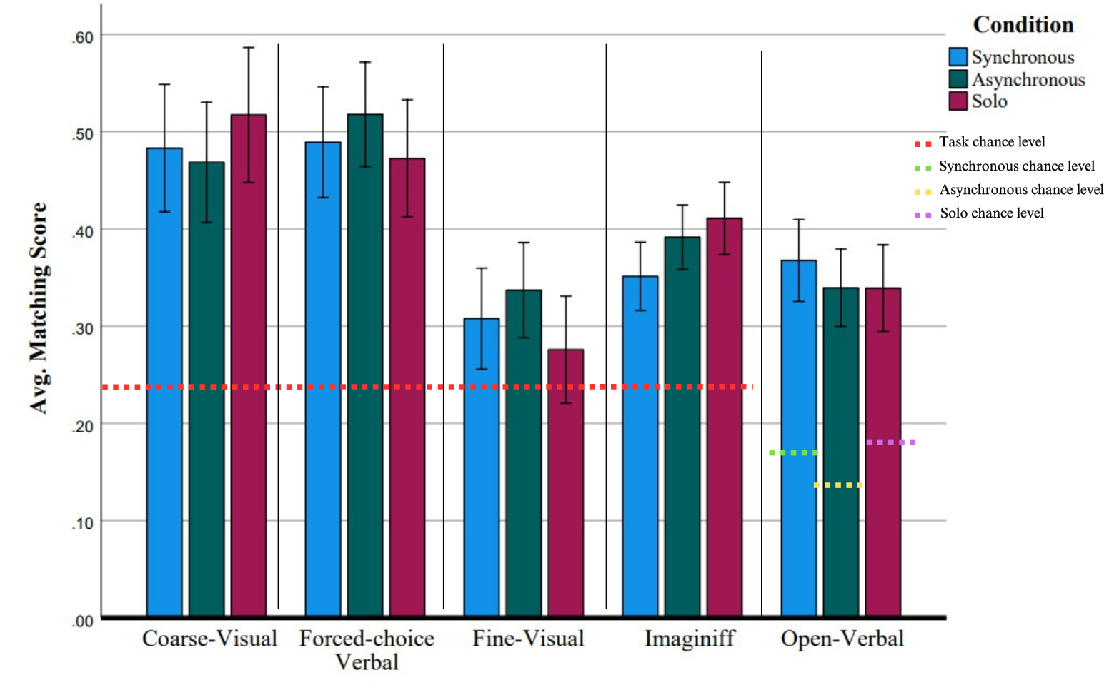Figure 4.1. Bar graphs show the dyad-level matching of each condition by task. Item 8 in the Open-Verbal task was excluded from all analyses. Error bars display 95% confidence intervals.

F(2,389) = 16.78, p < .001, η²= .079. Tukey HSD showed that participants in the asynchronous condition scored significantly higher than those in the synchronous (p < .001) and solo (p = .001) conditions. For the Fine-Visual task, there was a significant effect of Condition, (F(2,289) = 6.93, p = .001, η²= .034. Tukey HSD showed that participants in the synchronous condition scored significantly lower than those in the asynchronous (p = .001) and solo (p = .025) conditions. For the Imaginiff task, there was a significant effect of Condition, F(2,389)= 7.32, p < .001, η²=.036. Tukey HSD showed that participants in the asynchronous condition scored significantly higher than those in the synchronous condition (p < .001). There was no significant effect of Condition for the Open-Verbal task, F(2,389)= 1.92, p =.149.
Results of these analyses demonstrate that the synchronous condition scored the lowest in the Coarse-Visual and Fine-Visual tasks. The asynchronous condition scored the highest in the Forced-choice Verbal task and higher than the synchronous condition in the Imaginiff task. A Condition effect was not revealed in the Open-Verbal task. These findings partially support this study’s hypotheses that expected a condition effect at the group-level. Instead of the synchronous condition producing the highest scores, results indicated that individual participants in asynchronous condition coordinated with each other better than those in the synchronous condition. The solo condition did not differ significantly from the asynchronous in the Coarse-Visual and Fine-Visual tasks nor the synchronous in the Forced-choice Verbal and Imaginiff tasks. Therefore, the hypothesized ranked coordination performance was not supported (see Figure 4.2 for group-level results).
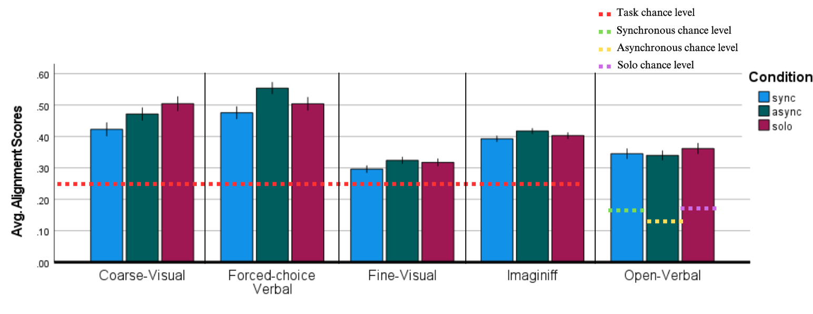Figure 4.2. Bar graphs show the group-level alignment of each condition by task. Item 8 in the Open-Verbal task was excluded from all analyses. Error bars display 95% confidence intervals.

Research Question 3
In order to determine if coordination differed qualitatively by condition, the participant’s original alignment scores were compared against alignment scores that have been re-coded to reflect the distribution of responses in the solo condition (see Figure 4.3 for re-coding example). Because solo participants were instructed to select answers that most other participants would select, the hypothesis predicted an effect of condition that shows that different answers were selected by participants who were instructed to match specifically with their partner. If this prediction is not supported by the data, the original alignment scores and the re-coded between alignment scores should not differ significantly. As previously stated, the original (i.e., within) alignment scores for each task reflected the average proportion of participants in the assigned condition that coordinated on the same answer as the participant. The between-coding scores took into account the average proportion of solo participants (instead of those in their assigned condition) who coordinated on the same answer as the participant.
A three-way mixed ANOVA was conducted with Task (coarse-visual, forced-choice verbal, fine visual, Imaginiff, and open-verbal) varying within subjects and Condition (synchronous and asynchronous) and Reference Group (within-coding and between-coding) varying between participants. The three-way mixed ANOVA revealed a significant main effect of Task (F(1, 548) = 416.74, p < .001), a significant main effect of Condition (F(3, 548) = 38.18, p < .001), and no significant main effect of Reference Group (F(3,548) = .101, p = .751). One significant interaction between Task and Condition was revealed (F(4,2192) = 8.08, p < .001), but not between Task and

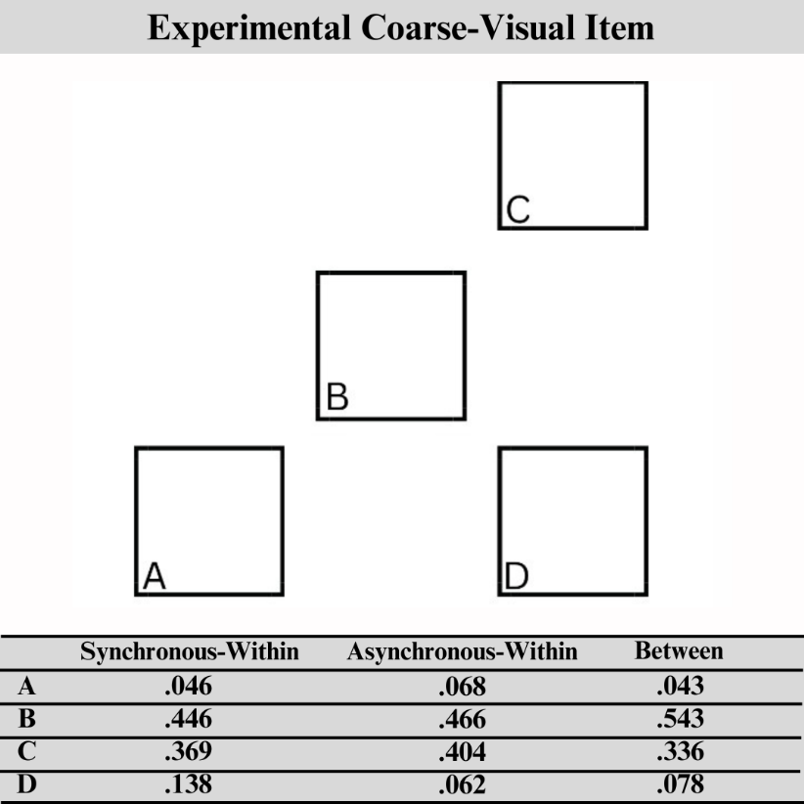

Figure 4.3. Bar graphs show the group-level alignment of each condition by task. The Synchronous and Asynchronous alignment scores are coded based on each condition’s unique responses. The Synchronous-Between and Asynchronous-Between scores were re-coded based on the distribution of solo participants’ responses.

Reference Group (F(4,2192) = 2.09, p = .080). Lastly, there was a significant three-way interaction of Task x Condition x Reference Group (F(4,2192) = .31, p = .002).
Separate 2 x 2 ANOVAs accompanied by paired-sample t-tests were used to examine the interactions for each task. For the Coarse-Visual, significant main effects of Reference Group (F(1,129) = 4.55, p = .004, η² = .440) and Condition (F(1,129) = 4.55, p = .004, η² = .035) were revealed along with a significant Reference x Condition interaction (F(1,129) = 4.55, p = .004, η² = .199). Paired-sample t-tests showed lower scores for within-coding than between-coding in both the synchronous (t(129)= -10.16 p < .001) and asynchronous (t(145)= -3.57 p < .001) conditions. For the Forced-choice Verbal, significant main effects of Reference Group (F(1,129) = 41.94, p < .001, η² = .245) and Condition (F(1,129) = 16.67, p < .001, η² = .114) were revealed along with a significant Reference x Condition interaction (F(1,129) = 178.59, p < .001, η² = .581). Paired-sample t-tests showed lower scores for within-coding than between-coding in the synchronous condition (t(129)= -6.04, p < .001) and higher scores for within-coding than between coding in the asynchronous condition (t(145) = 13.88, p < .001). For the Fine-Visual, a significant main effect of Condition (F(1,129) = 9.00, p = .003, η² = .065) and a significant Reference x Condition interaction (F(1,129) = 27.94, p = .001, η² = .178), but no significant Reference Group main effect was found (F(1,129) = .001, p = .981). Again, paired-sample t-tests showed lower scores for within-coding than between-coding in the synchronous condition (t(129)= -2.90, p = .004) and higher scores for within-coding than between-coding in asynchronous conditions (t(145) = 5.06, p < .001). For the Imaginiff, significant main effects of Reference Group (F(1,129) = 50.37, p < .001, η² = .281) and Condition (F(1,129) = 4.79, p = .030, η² = .036) were revealed along with a significant Reference x Condition interaction (F(1,129) = 88.85, p < .001, η² = .408). Lower scores for within-coding than between-coding in the synchronous condition (t(129)= -1.51, p = .135) and higher scores for within-coding than between-coding in the asynchronous condition (t(145) = 11.11, p < .001) were again revealed with paired-sample t-tests. Finally, for the Open-Verbal, a significant main effect of Reference Group (F(1,129) = 10.42, p = .002, η² = .075) and a significant Reference x Condition interaction (F(1,129) = 4.75, p = .031, η² = .036), but no significant Condition main effect was found (F(1,129) = .072, p = .789). Paired-sample t-tests showed lower scores for within-coding than between-coding in both the asynchronous (t(145)= -3.40, p < .001) conditions, but no significant difference between the coding methods in the synchronous condition (t(129)= -.832 p =.407).
These findings support this study’s hypothesis that predicted participants in the synchronous dyad and asynchronous dyad conditions exhibiting different coordination patterns than those in the solo condition. Participants in the dyad conditions responded differently from the solo participants in all tasks except for synchronous participants in the Open-Verbal task (see Figure 4.4 for the results).

Exploratory Analyses
Each experimental task began with one item that had a more obvious “correct” answer than the remaining items. These items were excluded from the previous analyses because of their less ambiguous nature; however, they will be analyzed here to explore any potential implications on performance. One-sample t-tests revealed above-chance
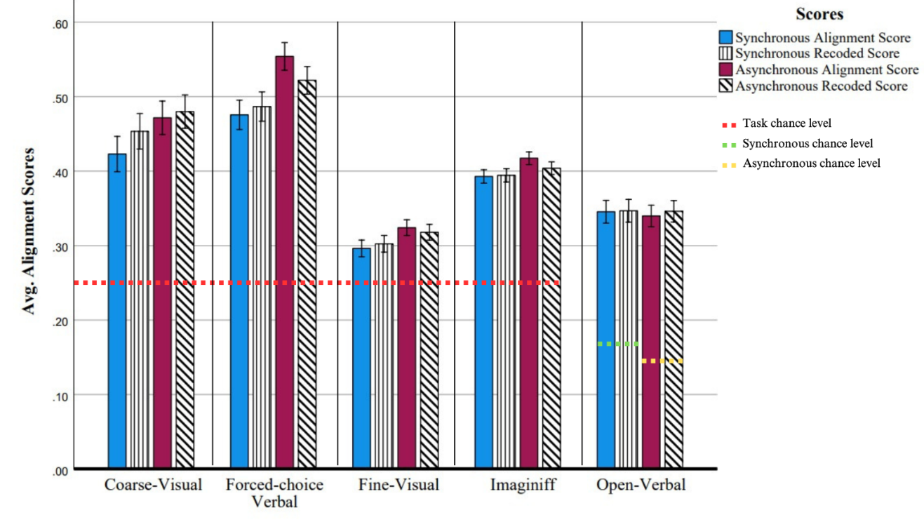
Figure 4.4. Bar graphs show the group-level alignment of each condition by task. Item 8 in the Open-Verbal task was excluded from all analyses. Error bars display 95% confidence intervals.

coordination for multiple-choice control items in the synchronous (all t(129) > 11.50 all p < .001), asynchronous (all t(145) > 14.93 all p < .001), and solo conditions (all t(115) >13.77 all p < .001). For the Open-Verbal control item, one sample t-tests revealed above-chance coordination in each condition (all t > 10.17 all p < .001). Additional correlational analyses revealed significant correlations between the control item and the
overall alignment score for the Coarse-Visual task in each condition (all r > .474 all p < .001). Significant correlations were also found between the control item and the overall alignment scores for the Forced-choice Verbal task in each condition (all r > .363 all p < .001). However, several nonsignificant correlations between the control item and overall task alignment score were revealed. The control item for the Open-Verbal task was not significantly correlated with the task’s alignment score for synchronous (r(129) = -.040, p = .654 ), asynchronous (r(145) = .081, p = .331), and solo conditions (r(115) = .134, p = .151). Additionally, no significant correlation was found between the control item and overall task alignment score in the Fine-Visual task for the synchronous (r(129) = .146, p = .098 ), asynchronous (r(145) = .133, p = .109 ), and solo conditions in the Fine-Visual task (r(115) = .137, p = .142 ). Lastly, the correlation between the control item and task alignment score for the Imaginiff task was nonsignificant for synchronous (r(129) = .080, p = .368) and asynchronous (r(145) = .103, p = .215). Although a previous study discarded the responses of adult participants who failed the control items (Perez-Zapata & Apperly, 2021), these nonsignificant correlations suggest that using these items as a disqualifier would not be appropriate because performance on the control item does not seem to be a strong predictor of task performance.

Discussion
The purpose of this study was to investigate how synchronous and asynchronous conditions impact dyad-level and group-level coordination success in pure coordination games. The first research question sought to examine if strangers achieve above-chance coordination at the dyad and group levels. The results confirmed that participants were able to match with each other at the dyad group levels in each task, excluding the Fine-Visual task for the randomized solo dyads. These results align with previous studies that support above-chance alignment amongst strangers in pure coordination games (Mehta et al., 1994; Perez-Zapata & Apperly, 2021; Schelling, 1960), suggesting that strangers are doing more than just randomly guessing when completing these tasks. This coordination between strangers is supported by the human sociocognitive ability to recognize a stand-out option that can be coordinated on (De Freitas et al., 2019; Schelling, 1960). It is unclear as to why randomized solo dyads were unable to, especially when they succeeded in the other tasks. Prior research has shown that adults were able to match with one another above chance when completing these same tasks (minus the Imaginiff task) on their own (Perez-Zapata & Apperly, 2021), so the replication of their findings at the group-level are likely to be the more significant finding. A recent meta-analysis by Yuan and colleagues (2022) posits that societal trends in the United States have created a society in which people are more likely to interact and have relationships with strangers. Therefore, these findings are in accordance with previous pure coordination research and the current state of American society.
The second research question sought to examine if experimental conditions produce a quantitative difference in coordination. Contrary to predictions, the results showed that dyad-level matching did not differ significantly by condition and higher coordination at the group-level was not reliant on being in the synchronous condition. The synchronous condition did not have higher levels of coordination at the dyad-level. These findings partially support this study’s hypotheses that expected a condition effect at the group-level, but the synchronous condition having the highest coordination at the dyad and group levels was not supported. Instead of the synchronous condition producing the highest scores at the group-level, results indicated that individual participants in asynchronous condition coordinated as a group better than those in the synchronous condition in all tasks except for the Open-Verbal task. Previous research found that asynchronous conditions promote an individual mindset (Shteynberg et al., 2023), which suggests that asynchronous participation could potentially result in more individualized answers. However, this study’s findings suggest that the mindset taken on by the asynchronous participants may have facilitated their ability to coordinate. It is possible that, because they did not complete the experimental tasks at the same time, the asynchronous participants were selecting answers based on what most other participants would pick by relying on social norms as supported by the descriptive norms foundation (Rivis & Sheeran, 2003). Therefore, if both partners were selecting what most other people would select, then that pattern would be reflected in the group-level analyses, which may help explain why they had increased group-level alignment but not a significant difference in matching scores. Another explanation could be that those in the synchronous condition experienced more social stress when being asked to match with a stranger while completing the tasks at the same time (Sariñana-González, et al., 2017), which could explain why the synchronous condition did not have higher coordination scores as expected.
The third research question sought to examine if experimental conditions produce a qualitative difference in coordination. The results showed that synchronous participants and asynchronous participants had significantly different response patterns when comparing within-coding scores with scores re-coded based on the solo participants’ responses. Analyses revealed that participants in the dyad conditions frequently selected different responses to this study’s ambiguous tasks, excluding synchronous participants in the Open-Verbal task. Unequal scores show that, on average, dyad conditions matched on the same answer with a higher proportion (Within-coding > Between-coding) or lower proportion (Within-coding < Between-coding) of solo participants. As previously stated, pure coordination game research is premised on people’s ability to identify focal points that allow for answer matching when there is no clear “correct” answer, and the rules and strategies that participants can use to coordinate can lead to them coordinating on different responses more frequently (Mehta et al., 1994). Therefore, the current findings further support qualitative coordination differences between participants by condition.

Limitations
There are a few limitations to discuss. First, the lack of diversity in this sample limits the generalizability of the findings. College students are a homogeneous and overused sample in psychological research (Hanel & Vione, 2016), and most participants in this study were white and in mixed gender dyads. There could be quantitative and qualitative coordination differences between male and female participants even if both groups coordinate above-chance that would be best addressed by comparing same gender and mixed gender coordination results. Additionally, previous research indicates that shared experiences and knowledge is important for coordination ability, and that there are cultural differences in coordination (Wong & Hong, 2005). With diverse populations in mind, the findings of this study should not be generalized to other cultural groups and same-gender dyads without considering potential differences. Second, the wording in the instructions differed between the dyad and solo conditions. Partners in both dyad conditions (Synchronous and asynchronous) were told to pick what they think their partner will pick while their partner does the same. The solo participants were instructed to pick what they think most other participants would pick while others were instructed to do the same. The impact of the wording on social cognition cannot be directly examined in this current study; therefore, the potential impact of the wording cannot be ruled out.

Conclusions and Recommendations

Future Directions
The present findings show that dyad and group level coordination between strangers is possible in different experimental conditions and suggest that variation in coordination is influenced by condition and task. Future research should focus on coordination ability amongst diverse cultural groups and groups of different sizes. Diverse types of tasks or stimuli could also be important for evaluating quantitative and qualitative aspects of coordination. Additionally, the current study was unable to directly examine if the different wording in the instructions impacted the participants’ coordination, so data for a second study was collected from February to May of 2024 to address this limitation. Synchronous, asynchronous, and solo participants in this second study were asked to select the response that most other participants would select. By having the same instructions for all participants, this change aims to build upon the present findings to allow for a more robust comparison between synchronous dyads, asynchronous dyads, and solo participants. This data will be analyzed and discussed in a future paper.

Conclusions
In modern U.S. society, human consistently interact with and build networks and teams with strangers (i.e., people that they are not socially close to). Therefore, research about successful social interactions between strangers provides insight on how we are connected through shared knowledge and experiences. In summary, the current study utilized pure coordination games to examine the coordination abilities of strangers in face-to-face dyads in synchronous and asynchronous conditions and solo participants. By having different experimental social environments, the findings of this study show that dyads are able to achieve above-chance coordination with each other across different tasks (Research Question 1). Quantitative (Research Question 2) and qualitative differences (Research Question 3) in coordination were also revealed in this study’s analyses. Above-chance coordination suggests that participants are organizing information in functional ways, which facilitates their ability to match with others. The inclusion of the Imaginiff game in the current study presented a novel use of this task that differs from its use in shared subjective experience work (see Pinel & Long, 2012), and this study’s results suggest that this game was an appropriate addition to the overall pure coordination game presented to participants. These findings add to the literature on coordination by suggesting that coordination ability can be assessed in a variety of tasks and is not limited to group-level analysis. The ability to coordinate with strangers is especially useful in modern societies like the United States, so it is hoped that this study will lead to more research into the sociocognitive foundations and conditions that drive coordination and more inquiry into the variation of coordination abilities in different populations.

References
Bardsley, N., J. Mehta, J., Starmer, C., & Sugden, R. (2010). Explaining focal points: Cognitive hierarchy theory versus team reasoning, Economic Journal, 120 (543), 40–79. https://doi.org/10.1111/j.1468-0297.2009.02304.x
Carvalho, JP. (2017). Coordination and culture. Econ Theory, 64, 449–475. https://doi.org/10.1007/s00199-016-0990-3
De Freitas, J., Thomas, K., DeScioli, P., & Pinker, S. (2019). Common Knowledge, coordination, and strategic mentalizing in human social life. Proceedings of the National Academy of Sciences, 116(28). https://doi.org/10.1073/pnas.1905518116
Duffy, J., & Xie, H. (2016). Group size and cooperation among strangers. Journal of Economic Behavior & Organization, 126, 55-74.Frith, C., & Frith, U. (2005). Theory of mind. Current biology, 15(17), R644-R645.
Frith, U., & Blakemore, S. J. (2006). Social Cognition. In R. Morris, L. Tarassenko, & M. Kenward (Eds.), Cognitive Systems - Information Processing Meets Brain Science (pp. 138-162). Academic Press. https://doi.org/10.1016/B978-012088566-4/50012-X
Frith, C. D. (2008). Social cognition. Phil. Trans. R. Soc. B, 363(1499), 2033–2039. https://doi.org/10.1098/rstb.2008.0005
Garfield, J. L., Peterson, C. C., & Perry, T. (2002). Social cognition, language acquisition and the development of the Theory of Mind. Mind and Language, 16(5), 494-541, https://doi.org/10.1111/1468-0017.00180.
Gelfand, M. J., Brett, J., Gunia, B. C., Imai, L., Huang, T.-J., & Hsu, B.-F. (2013). Toward a culture-by context perspective on negotiation: Negotiating teams in the United States and Taiwan. Journal of Applied Psychology, 98, 504-513.
Gelfand, M. J., & Harrington, J. R. (2015). The motivational force of descriptive norms: For whom and when are descriptive norms most predictive of behavior?. Journal of Cross-Cultural Psychology, 46(10), 1273-1278.
Gelfand, M.J., Harrington J.R., & Jackson J.C. (2017). The strength of social norms across human groups. Perspectives on Psychological Science, 12(5), 800–809.
Guthrie, R. V. (1991). The psychology of African Americans: An historical perspective. In R. L. Jones (Ed.), Black psychology (pp. 33–45). Cobb & Henry Publishers.
Halpern, J. Y. & Moses, Y. (1990). Knowledge and common knowledge in a distributed environment. Journal of the Association for Computing Machinery, 37(3), 549-587.
Handwerker, W. P. (2002). The construct validity of cultures: Cultural diversity, culture theory, and a method for ethnography. American Anthropologist, 104(1), 106-122.
Hunt, C., Borgide, E., & Lavine, H. (2012). Social Cognition. In V.S. Ramachandran (Ed.), Encyclopedia of Human Behavior (2nd ed.) (pp. 456-462). Academic Press. https://doi.org/10.1016/B978-0-12-375000-6.00331-1
Jackson, M. O. & Xing, Y. (2014). Culture-dependent strategies in coordination games. Proceedings of the National Academy of Sciences, 111(supplement_3), https://doi.org/10.1073/pnas.1400826111
Komarraju, M. & Cokley, K. O. (2008). Horizontal and vertical dimensions of individualism-collectivism: A comparison of African Americans and European Americans. Cultural Diversity and Ethnic Minority Psychology, 14(4), 336-343. DOI: 10.1037/1099-9809.14.4.336.
Lin, S., Keysar, B., & Epley, N. (2010). Reflexively mindblind: Using theory of mind to interpret behavior requires effortful attention. Journal of Experimental Social Psychology, 46(3), 551-556, https://doi.org/10.1016/j.jesp.2009.12.019
Macy, M. W., & Skvoretz, J. (1998). The Evolution of Trust and Cooperation between Strangers: A Computational Model. American Sociological Review, 63(5), 638–660. https://doi.org/10.2307/2657332
Marsh, K. L., Richardson, M. J., Baron, R. M., & Schmidt, R. C. (2006). Contrasting Approaches to Perceiving and Acting With Others, Ecological Psychology, 18(1), 1-38, DOI: 10.1207/s15326969eco1801_1
Mateo J. M. (2004). Recognition systems and biological organization: The perception component of social recognition. Annales Zoologici Fennici, 41, 729–745.
McGrath, J. E., Arrow, H., & Berdahl, J. L. (1999). Cooperation and conflict as manifestations of coordination in small groups. Polish Psychological Bulletin, 30(1), 1–14.
Mehta, J., Starmer, C., & Sugden, R. (1994). The nature of salience: An experimental investigation of pure coordination games. The American Economic Review, 84(3), 658–673. https://www.jstor.org/stable/2118074.
Melis, A. P., & Semmann, D. (2010). How is human cooperation different? Philosophical Transactions of the Royal Society B: Biological Sciences, 365(1553), 2663-2674.
Mizrahi, D., Laufer, I. & Zuckerman, I. (2022). Modeling and predicting individual tacit coordination ability. Brain Inf., 9(4). https://doi.org/10.1186/s40708-022-00152-w
Mizrahi, D., Laufer, I., & Zuckerman, I. (2023). Predicting focal point solution in divergent interest tacit coordination games. Journal of Experimental & Theoretical Artificial Intelligence, 35(6), 933-953.
Molina, M., Nee, V., & Holm, H. (2023). Cooperation with strangers: Spillover of community norms. Organization Science, 34(6), 2315-2331.
Myerson, R. B. (2009). Learning from Schelling's strategy of conflict. Journal of Economic Literature, 47(4), 1109-1125.
Nyborg, K. (2020). No man is an island: social coordination and the environment. Environmental and resource economics, 76, 177-193.
Osborne, M. J. (2004). An introduction to game theory (Vol. 3, No. 3). New York: Oxford university press.
Oliviola, C. Y., Kim, Y., Merzel, A., Karee, Y., Avrahami, J., & Ritov, I. (2019). Cooperation and coordination across cultures and contexts: Individual, sociocultural, and contextual factors jointly influence decision making in the volunteer's dilemma game. J Behav Dec Making, 33, 93–118. https://doi.org/10.1002/bdm.2135.
Perez-Zapata, D., McKenzie-Smart, X., Charest, I., & Apperly, I. (2021). Meeting and missing minds: Children and adults use alignment of intuitions to solve pure coordination games. PsyArXiv. https://doi.org/10.31234/osf.io/96hbp
Pinel, E. C., & Long, A. E. (2012). When I’s Meet: Sharing subjective experience with someone from the outgroup. Personality and Social Psychology Bulletin, 38(3), 296–307. https://doi.org/10.1177/0146167211433878
Pletzer, J. L., Balliet, D., Joireman, J., Kuhlman, D. M., Voelpel, S. C., & Van Lange, P. (2018). Social Value Orientation, Expectations, and Cooperation in Social Dilemmas: A Meta-analysis European Journal of Personality, 32, 62–83, DOI: 10.1002/per.2139.
Portes, A. (1998). Social capital: Its origins and applications in modern sociology. Annual Review of Sociology, 24(1), 1–24. https://doi.org/10 .1146/annurev.soc.24.1.1
Putnam, R. D. (2000). Bowling alone: The collapse and revival of American community. Simon & Schuster.
Putnam, R. D. (2020). Bowling alone: The collapse and revival of American community (Revised and updated edition). Simon & Schuster.
Cooper, D. J., & Weber, R. A. (2020). Recent advances in experimental coordination games. Handbook of experimental game theory, 149-183.
Rivis, A. & Sheeran, P. (2003). Descriptive norms as an additional predictor in the theory of planned behavior: A meta-analysis. Current Psychology: Developmental, Learning, Personality, Social, 22(3), 218-233.
Roberts, S. O., Bareket-Shavit, C., Dollins, F. A., Goldie, P. D., & Mortenson, E. (2020). Racial inequality in psychological research: Trends of the past and recommendations for the future. Perspectives on psychological science : a journal of the Association for Psychological Science, 15(6), 1295–1309. https://doi.org/10.1177/1745691620927709
Sariñana-González, P., Romero-Martínez, Á., & Moya-Albiol, L. (2017). Does being a Stranger make it Difficult to Cooperate?. The Spanish Journal of Psychology, 20, E35.
Schelling, Thomas C. (1960). The Strategy of Conflict. Cambridge and London: Harvard University.
Shteynberg, G., Hirsh, J. B., Bentley, R. A., & Garthoff, J. (2020). Shared worlds and shared minds: A theory of collective learning and a psychology of common knowledge. Psychological Review, 127(5), 918–931. https://doi.org/10.1037/rev0000200
Shteynberg, G., Hirsh, J. B., Wolf, W., Bargh, J. A., Boothby, E. B., Colman, A. M., ... & Rossignac-Milon, M. (2023). Theory of collective mind. Trends in Cognitive Sciences. https://doi.org/10.1016/j.tics.2023.06.009.

Appendix
Table 4.1. This is the table that shows the descriptives of the experimental items.

Coarse-Visual Task
Groups |  | 1 | 2 | 3 | 4 | 5 | Average | Between
Sync dyad | Mean | .48 | .37 | .55 | .41 | .32 | .42 | .45
Sync dyad | SD | .261 | .122 | .271 | .160 | .157 | .126 | .151
Sync dyad | Chance | .25 | .25 | .25 | .25 | .25 | .25 | .25
Sync dyad | t | 36.01*** | 34.20*** | 15.85*** | 17.98*** | 27.31*** | 15.70*** | 15.39***
Sync dyad | df | 129 | 129 | 129 | 129 | 129 | 129 | 129
Sync dyad | 95% CI lower | [2.39 | [2.21 | [1.07 | [1.49 | [2.19 | [0.151 | [0.177
Sync dyad | CI upper | 2.67] | 2.49] | 1.38] | 1.86] | 2.53] | 0.195] | 0.230]
Async dyad | Mean | .49 | .39 | .73 | .43 | .32 | .47 | .48
Async dyad | SD | .263 | .129 | .286 | .177 | .137 | .132 | .143
Async dyad | Chance | .25 | .25 | .25 | .25 | .25 | .25 | .25
Async dyad | t | 46.50*** | 40.62*** | 37.30*** | 17.20*** | 18.71*** | 20.34*** | 19.48***
Async dyad | df | 145 | 145 | 145 | 145 | 145 | 145 | 145
Async dyad | 95% CI lower | [3.18 | [2.47 | [2.09 | [0.91 | [2.47 | [0.200 | [0.207
Async dyad | CI upper | 3.46] | 2.73] | 2.33] | 1.14] | 2.79] | 0.243] | 0.253]

Table 4.1 Continued

Solo | Mean | .71 | .42 | .58 | .51 | .31 | .50
Solo | SD | .290 | .161 | .282 | .151 | .116 | .114
Solo | Chance | .25 | .25 | .25 | .25 | .25 | .25
Solo | t | 49.10*** | 33.72*** | 14.47*** | 16.54*** | 30.16*** | 24.01***
Solo | df | 115 | 115 | 115 | 115 | 115 | 115
Solo | 95% CI lower | [2.54 | [2.07 | [1.04 | [1.32 | [2.50 | [0.234
Solo | CI upper | 2.75] | 2.33] | 1.37] | 1.68] | 2.86] | 0.275]

Table 4.1 Continued

Forced-choice Task
Groups |  | 1 | 2 | 3 | 4 | 5 | Average | Between
Sync dyad | Mean | .48 | .37 | .55 | .41 | .32 | .42 | .45
Sync dyad | SD | .261 | .122 | .271 | .160 | .157 | .126 | .151
Sync dyad | Chance | .25 | .25 | .25 | .25 | .25 | .25 | .25
Sync dyad | t | 36.01*** | 34.20*** | 15.85*** | 17.98*** | 27.31*** | 15.70*** | 15.39***
Sync dyad | df | 129 | 129 | 129 | 129 | 129 | 129 | 129
Sync dyad | 95% CI lower | [2.39 | [2.21 | [1.07 | [1.49 | [2.19 | [0.151 | [0.177
Sync dyad | CI upper | 2.67] | 2.49] | 1.38] | 1.86] | 2.53] | 0.195] | 0.230]
Async dyad | Mean | .49 | .39 | .73 | .43 | .32 | .47 | .48
Async dyad | SD | .263 | .129 | .286 | .177 | .137 | .132 | .143
Async dyad | Chance | .25 | .25 | .25 | .25 | .25 | .25 | .25
Async dyad | t | 46.50*** | 40.62*** | 37.30*** | 17.20*** | 18.71*** | 20.34*** | 19.48***
Async dyad | df | 145 | 145 | 145 | 145 | 145 | 145 | 145
Async dyad | 95% CI lower | [3.18 | [2.47 | [2.09 | [0.91 | [2.47 | [0.200 | [0.207
Async dyad | CI upper | 3.46] | 2.73] | 2.33] | 1.14] | 2.79] | 0.243] | 0.253]

Table 4.1 Continued

Solo | Mean | .71 | .42 | .58 | .51 | .31 | .50
Solo | SD | .290 | .161 | .282 | .151 | .116 | .114
Solo | Chance | .25 | .25 | .25 | .25 | .25 | .25
Solo | t | 49.10*** | 33.72*** | 14.47*** | 16.54*** | 30.16*** | 24.01***
Solo | df | 115 | 115 | 115 | 115 | 115 | 115
Solo | 95% CI lower | [2.54 | [2.07 | [1.04 | [1.32 | [2.50 | [0.234
Solo | CI upper | 2.75] | 2.33] | 1.37] | 1.68] | 2.86] | 0.275]

Table 4.1 Continued

Fine-Visual Task
Groups |  | 1 | 2 | 3 | 4 | 5 | Average | Between
Sync dyad | Mean | .33 | .26 | .27 | .35 | .27 | .30 | .30
Sync dyad | SD | .160 | .055 | .065 | .176 | .082 | .056 | .069
Sync dyad | Chance | .25 | .25 | .25 | .25 | .25 | .25 | .25
Sync dyad | t | 26.13*** | 23.28*** | 21.46*** | 29.01*** | 23.84*** | 9.38*** | 8.61***
Sync dyad | df | 129 | 129 | 129 | 129 | 129 | 129 | 129
Sync dyad | 95% CI lower | [2.12 | [2.04 | [2.11 | [2.63 | [1.98 | [0.036 | [0.040
Sync dyad | CI upper | 2.46] | 2.42] | 2.53] | 3.01] | 2.34] | 0.056] | .064]
Async dyad | Mean | .44 | .27 | .29 | .36 | .26 | .32 | .32
Async dyad | SD | .243 | .055 | .088 | .188 | .051 | .068 | .066
Async dyad | Chance | .25 | .25 | .25 | .25 | .25 | .25 | .25
Async dyad | t | 35.55*** | 22.93*** | 20.82*** | 32.38*** | 22.69*** | 13.12*** | 12.46***
Async dyad | df | 145 | 145 | 145 | 145 | 145 | 145 | 145
Async dyad | 95% CI lower | [2.29 | [1.83 | [2.00 | [2.71 | [1.92 | [0.063 | [0.057
Async dyad | CI upper | 2.56] | 2.18] | 2.42] | 3.06] | 2.28] | 0.085] | 0.079]

Table 4.1 Continued

Solo | Mean | .40 | .27 | .30 | .37 | .25 | .32
Solo | SD | .203 | .058 | .102 | .201 | .025 | .068
Solo | Chance | .25 | .25 | .25 | .25 | .25 | .25
Solo | t | 26.32*** | 20.38*** | 18.81*** | 28.00*** | 21.12*** | 10.77***
Solo | df | 115 | 115 | 115 | 115 | 115 | 115
Solo | 95% CI lower | [2.20 | [1.82 | [2.04 | [2.68 | [1.95 | [0.055
Solo | CI upper | 2.56] | 2.21] | 2.53] | 3.08] | 2.35] | .0.080]

Table 4.1 Continued

Imaginiff Task
Groups |  | 1 | 2 | 3 | 4 | 5 | 6 | 7 | 8 | 9 | 10 | 11 | Average | Between
Sync dyad | Mean | .38 | .26 | .37 | .59 | .45 | .29 | .62 | .27 | .52 | .32 | .38 | .30 | .30
Sync dyad | SD | .128 | .049 | .170 | .265 | .203 | .086 | .275 | .067 | .262 | .097 | .125 | .056 | .069
Sync dyad | Chance | .25 | .25 | .25 | .25 | .25 | .25 | .25 | .25 | .25 | .25 | .25 | .25 | .25
Sync dyad | t | 20.71*** | 30.79*** | 33.12*** | 28.01*** | 22.93*** | 13.74*** | 27.01*** | 16.99*** | 21.27*** | 34.86*** | 23.57*** | 9.38*** | 8.61***
Sync dyad | df | 129 | 129 | 129 | 129 | 129 | 129 | 129 | 129 | 129 | 129 | 129 | 129 | 129
Sync dyad | 95% CI lower | [1.97 | [2.66 | [2.22 | [2.16 | [2.10 | [1.08 | [2.32 | [1.09 | [2.20 | [2.10 | [1.98 | [0.036 | 0.040]
Sync dyad | CI upper | 2.39] | 3.02] | 2.50] | 2.49] | 2.49] | 1.44] | 2.69] | 1.38] | 2.65] | 2.35] | 2.35] | 0.056] | 0.064]
Async dyad | Mean | .37 | .28 | .43 | .70 | .47 | .34 | .55 | .32 | .58 | .29 | .37 | .42 | .40
Async dyad | SD | .126 | .074 | .208 | .282 | .179 | .156 | .261 | .125 | 277 | .070 | .125 | .055 | .052
Async dyad | Chance | .25 | .25 | .25 | .25 | .25 | .25 | .25 | .25 | .25 | .25 | .25 | .25 | .25
Async dyad | t | 21.46*** | 35.67*** | 45.26*** | 29.38*** | 30.23*** | 14.81*** | 33.85*** | 18.20*** | 23.36*** | 32.25*** | 28.83*** | 36.83*** | 35.87***
Async dyad | df | 145 | 145 | 145 | 145 | 145 | 145 | 145 | 145 | 145 | 145 | 145 | 145 | 145

Table 4.1 Continued

 | 95% CI lower | [2.02 | [2.82 | [2.45 | [2.23 | [2.36 | [1.21 | [2.52 | [1.03 | [2.20 | [1.87 | [2.04 | [0.158 | [0.145
 | CI upper | 2.43] | 3.15] | 2.68] | 2.55] | 2.69] | 1.58] | 2.83] | 1.28] | 2.61] | 2.11] | 2.34] | 1.76] | 0.162]
Solo | Mean | .36 | .27 | .35 | .64 | .54 | .33 | .52 | .28 | .55 | .36 | .37 | .40
Solo | SD | .110 | .058 | .137 | .283 | .229 | .123 | .244 | .072 | .278 | .137 | .123 | .056
Solo | Chance | .25 | .25 | .25 | .25 | .25 | .25 | .25 | .25 | .25 | .25 | .25 | .25
Solo | t | 20.03*** | 31.60*** | 36.42*** | 27.57*** | 22.51*** | 13.82*** | 28.24*** | 15.27*** | 21.23*** | 32.08*** | 24.94*** | 29.27***
Solo | df | 115 | 115 | 115 | 115 | 115 | 115 | 115 | 115 | 115 | 115 | 115 | 115
Solo | 95% CI lower | [1.93 | [2.02 | [2.67 | [2.40 | [2.11 | [2.11 | [1.17 | [2.40 | [1.07 | [2.34 | [2.16 | [2.11
Solo | CI upper | 2.44] | 2.46] | 3.03] | 2.68] | 2.44] | 2.51] | 1.56] | 2.77] | 1.39] | 2.83] | 2.44] | 2.48]

Table 4.1 Continued

Open-Verbal Task
Groups |  | 1 | 2 | 3 | 4 | 5 | 6 | 7 | 8 | 9 | 10 | Average | Between
Sync dyad | Mean | .33 | .21 | .60 | .42 | .51 | .12 | .05 | .23 | .33 | .31 | .35 | .35
Sync dyad | SD | .184 | .177 | .307 | .131 | .306 | .088 | .042 | .141 | .171 | .245 | .092 | .095
Sync dyad | Chance | .25 | .25 | .25 | .25 | .25 | .25 | .25 | .25 | .25 | .25 | .25 | .25
Sync dyad | t | 11.45*** | 8.071*** | 16.29*** | 7.30*** | 14.79*** | 6.46*** | -28.50*** | 12.77*** | 11.08*** | 10.31*** | 22.99 | 20.89
Sync dyad | df | 129 | 129 | 129 | 129 | 129 | 129 | 129 | 129 | 129 | 129 | 129 | 129
Sync dyad | 95% CI lower | [0.153 | [0.094 | [0.385 | [0.061 | [0.344 | [0.034 | [-0.114 | [0.133 | [0.136 | [0.179 | [0.170 | [0.158
Sync dyad | CI upper | 0.217] | 0.156] | 0.491] | 0.107] | 0.450] | 0.065] | -0.100] | 0.182] | 0.196] | 0.0264] | 0.201] | 0.191]
Async dyad | Mean | .31 | .18 | .59 | .39 | .46 | .09 | .05 | .31 | .36 | .38 | .34 | .35
Async dyad | SD | .158 | .158 | .315 | .124 | .297 | .085 | .050 | .167 | .140 | .267 | .081 | .087
Async dyad | Chance | .25 | .25 | .25 | .25 | .25 | .25 | .25 | .25 | .25 | .25 | .25 | .25
Async dyad | t | 12.35*** | 7.36*** | 18.84*** | 12.67*** | 14.64*** | .805 | -13.59*** | 11.56*** | 19.54*** | 12.37*** | 29.28*** | 24.17***
Async dyad | df | 145 | 145 | 145 | 145 | 145 | 145 | 145 | 145 | 145 | 145 | 145 | 145
Async dyad | 95% CI lower | [0.135 | [0.070 | [0.440 | [0.110 | [0.311 | [-.008 | [-0.065 | [0.133 | [0.204 | [0.229 | [0.183 | [0.160

Table 4.1 Continued

 | CI upper | 0.187] | 0.122] | 0.543] | 0.151] | 0.408] | 0.020] | -0.049] | 0.188] | 0.249] | 0.317] | 0.209] | 0.188]
Solo | Mean | .32 | .25 | .62 | .41 | .58 | .16 | .05 | .34 | .28 | .29 | .36
Solo | SD | .144 | .213 | .306 | .178 | .307 | .119 | .041 | .155 | .124 | .240 | .105
Solo | Chance | .25 | .25 | .25 | .25 | .25 | .25 | .25 | .25 | .25 | .25 | .25
Solo | t | 13.46*** | 8.12*** | 16.34*** | 4.95*** | 14.47*** | 7.33*** | -28.38*** | 9.53*** | 7.42*** | 8.29*** | 19.40***
Solo | df | 115 | 115 | 115 | 115 | 115 | 115 | 115 | 115 | 115 | 115 | 115
Solo | 95% CI lower | [0.154 | [0.121 | [0.402 | [0.049 | [0.356 | [0.059 | [-0.115 | [0.109 | [0.063 | [0.140 | [0.170
Solo | CI upper | 0.207] | 0.199] | 0.514] | 0.114] | 0.468] | 0.103] | -0.100] | 0.166] | 0.109] | 0.229] | 0.209]

Vita
Kennedy Denise Evins was born in Starkville, Mississippi to Angela Sanford and Rayfield Evins, Jr. She graduated from Starkville High School in 2019 and went on to graduate with a Bachelor of Arts degree in Psychology, summa cum laude, at the University of Southern Mississippi in 2022. She was accepted into the Experimental Psychology program at the University of Tennessee, Knoxville in 2022 and began working under her advisor, Dr. Garriy Shteynberg. Kennedy is currently a rising third-year graduate student, and she plans on continuing her education as a doctoral candidate.

Dyad-level analysis refers to comparing participants to their partners while group-level refers to comparing participants to other participants in the same condition.

