INCREASING EFFICIENCY OF THERMAL DESALINATION

[ME 460 Senior Design - Spring 2015]

By:

Jarrod Edwards
Ben Garrison
Chan Jung
MacKinzie Washington

Department of Mechanical, Aerospace and Biomedical Engineering
University of Tennessee, Knoxville, TN 37996
U. S. A.

Submitted to:

Dr. J. Mark Barker
Department of Mechanical, Aerospace and Biomedical Engineering
University of Tennessee, Knoxville, TN 37996
U. S. A.

May 5, 2015

Ben Garrison, Chan Jung, Jarrod Edwards, MacKinzie Washington
University of Tennessee
Knoxville, TN, 37920

May 5, 2015

Dr. J. Mark Barker
312 Dougherty Engineering Building
University of Tennessee
Knoxville, TN 37996-2210

Dear Dr. Barker:

Enclosed in the following pages is the final submittal of the Thermal Desalination Project Report.

The given report consists of a thorough analysis of the test procedure and results and collected data that followed. In the test, a designed desalination machine was designed, fabricated, and run, and temperature and fresh water data was collected for heat transfer evaluation purposes. Using this data, it was possible to calculate the heat transfer and the efficiencies of the device and compare to the theoretical calculations made in the first semester of the project (Fall 2014).

Using the data collected and calculated, numerous tables and figures were generated to compare how the calculated data matched up to the experimental data.

Sincerely,

Ben Garrison, Chan Jung, Jarrod Edwards, MacKinzie Washington
Mechanical Engineering Students
University of Tennessee

Enclosed: Desalination Project Report.

Executive Summary

The Mechanical, Aerospace, and Biomedical Engineering (MABE) Department has received a desalination project to test the effectiveness of a new graphite foam material developed by Oak Ridge National Laboratory. The task involves analyzing and developing a technical solution that can be utilized to create pure water through condensation that is optimized with the foam. This project involves a mechanical approach and involves a variety of pumps for fluid flow, boilers used to created steam from the salt water, condensation via heat transfer conduction and convection properties, and valves and piping used to direct fluid flow.
The purpose of the desalination project is to create pure water, and there are a variety of methods that can be used to complete this process referred to as desalination. The most popular methods are: thermal desalination, reverse osmosis, electro-dialysis, and vacuum freezing. Since thermal desalination has ability to remove salt from large amounts of water in a relatively cheap and accessible manner, it was determined to be the best method for this task. After making this selection, the ultimate project goal is established to test the thermal efficiency of the condenser with the addition of the graphite foam in a small-scale controlled environment before applying it to large-scale system.
The goal of this project is develop a more efficient thermal process, and developing a better condensation rate will help to support this theory. Based on results obtained through research at ORNL, graphite foam has much higher thermal conductivity than stainless steel (150 W/m-K as compared to 17 W/m-K), and the extensive network of pores yields a much larger surface area in the foam. These two characteristics will result in a higher transfer rate and ideally a higher condensation rate of steam over a given period of time. Six thermocouples and a water bucket located strategically throughout the test apparatus were used to complete the evaluation, and as salt water was gone in through the pipe, the thermocouples collected temperature data and the bucket collected the fresh water from the system.
In regards to the operation procedure, power is supplied to the pumps to contribute flow of saltwater in and out of the boiling chamber as well as cold-water flow through the condenser. Then, opening and closing a particular arrangement of valves set flow channels; after these are in order, the boiling chamber can be filled with saltwater. Once the water is added, valves flowing cold water for the condenser can be opened and the PID controller can be set to 105°C to allow for adequate boiling of the water. Finally, power can be added to the heating elements, and fresh water will soon begin to develop inside the condensing chamber.
In conclusion, the overall data was reasonable, given the materials and equipment used, and it gave results that were generally expected. The graphite foam condenser was found to have a UA value that was 19% higher, as expected from initial evaluations. In looking for ways to improve the task, if flow rates could be monitored with flow-meters, our calculated results could be higher; additionally, we experienced some error in the temperature data points, so if better equipment had been used, results could be more optimistic in the efficiency of the device.

Table of Contents

- Cover Elements
  - Cover Page………………………………………………………………………………………i
  - Letter of Transmittal……………………………………………………………………….2
  - Executive Summary………………………………………………………………………...3
  - Table of Contents…………………………………………………………………………....4

- Introduction
  - Objectives……………………………………………………………………………………....5
  - Background…………………………………………………………………………………....5

- Test Apparatus
  - Apparatus…………………………………………………………………………………........7
  - Test Procedure……………………………………………………………………………….7
  - Data Reduction Procedure………………………………………………………………8

- Results/Discussion
  - Technical Analysis………………………………………………………………………...10
  - Data Results………………………………………………………………………………….12
  - Discussion of Results…………………………………………………………………… 14

- Conclusions/Recommendations
  - What We Learned…………………………………………………………………………14
  - Acknowledgements……………………………………………………………………....15

- Bibliography…………………………………………………………………………………..............17

- Appendices
  - Appendix A: Sample Calculations with Nomenclature and Units…….18
  - Appendix B: Equipment List and Calibration Details……………………...19
  - Appendix C: Matlab Program Used………………………………………………..20
  - Appendix D: Bill of Materials………………………………………………………...23

Objectives

Upon the start of this project, students were tasked with analyzing and developing a solution to the given thermal desalination senior design project involving a desalination system that can be utilized to create pure water with a graphite foam material used to enhance this process. This project did not appear to involve a very extensive mechanical approach at first glance, but after further investigation, the process itself is largely a mechanical problem, involving a variety of pumps for fluid flow, boilers used to created steam, condensers to cool the steam into pure water, a graphite foam material used to optimize condensation via heat transfer, and valves and piping used to direct flow.

The main objectives considered throughout the duration of the project were to maximize the freshwater output from the upper chamber of the desalination system and to compare the performances of the two different heat exchanger configurations. Ideally, the condenser with the addition of the graphite foam blocks, with the help of the higher thermal conductivity and surface area, will pull heat from the superheated steam rising from the boiling chamber, thus yielding a more effective heat exchanger system. Additionally, because measurements of water collection are made in given time intervals, and because the foam will remove higher at a faster rate, more fresh water can be expected in the discharge bucket.

Background

Desalination is a common practice that has become a rising focus for many areas of the world in an effort to find sources of fresh water, whether it might be used for human consumption, irrigation, or another area of need. Essentially, this involves the process of removing salt and minerals that can be harmful to the above listed applications, and the resulting product is more “purified” water that can be readily available if needed. As the populations of countries rise and economies grow, the idea of desalination is more than ever being actively pursued, and the ultimate goal is to find the most efficient method possible, in regards to both technical and cost efficiency, and to generate the largest amount of water possible. This is one of only a few methods of collecting fresh water, outside of collecting rainwater in a large-scale application.

In regards to desalination, there are a variety of methods that can be used to develop pure water through this process, and these include the following: thermal distillation, reverse osmosis, electro-dialysis, and vacuum freezing. Thermal distillation uses a heat source to bring the saltwater to a boiling point, and the generated steam, which is then free of impurities, can be pulled into a condensing portion of the system, and the condensed water accumulates into a sizeable amount of fresh water. Reverse osmosis occurs by pressing saltwater against a semi-permeable membrane, and the applied pressure, which must be larger than the osmotic pressure of seawater, allows the pure water, which is the permeate, to pass through, accumulating on the other side. Electro-dialysis involves the process of pulling salt ions out of the water with an electric potential, creating a fresh water stream through the output – this is only effective for water with low salt concentrations. [2] Lastly, vacuum freezing can be used to freeze the saltwater, and upon freezing, the salt crystals should group together, and they can be extracted and rinsed off to create pure water.

Of these listed options, electro-dialysis and vacuum freezing are not very good options because neither have produced substantial results of success on a commercial scale and the goal of this project is to test efficiency before applying it to a large-scale system. Additionally, these methods are cumbersome and can quickly become taxing on a tight budget, and, as stated before, a major focus of desalination is to keep costs at a minimum. Thermal distillation and reverse osmosis are the most popular methods of desalinating water because of the ability to desalinate large amounts of water if necessary in a relatively short period of time; the downside to reverse osmosis is the need for a large pressure differential between boundaries in order to create the osmosis effect and the pretreatment chemicals needed to eliminate constituents that could damage the permeable membrane [1]. The last option, which was initially recommended and finally chosen by the group, is thermal desalination, which uses an enclosed container to boil the saltwater solution with a given heat source, which, in this case, is a 5000-W heating element. The boiled and purified steam then rises to the top section of the system, in which a condenser is present, constantly flowing cold tap water inside the piping; the steam will condensate around the machined network of stainless steel piping, and the fresh water will fall to the base of the upper section, eventually feeding out to a water-collecting bucket outside of the system.

After gaining a better understanding of the functionality of the system, it is very important to see the application of the graphite foam developed by Oak Ridge National Laboratory to the thermal desalination process that is being used. The steam itself will condense at a given rate over the stainless steel piping configuration developed in the condenser, simply due to a given temperature difference and thermal conductivity of the steel. However, with the newly developed graphite foam, the goal of this project is to develop a better condensation rate, and this should be theoretically achievable since the thermal conductivity of the foam is much higher than that of the stainless steel (approximately 170 W/m-K as compared to 17 W/m-K for steel). [2] Additionally, as seen in Figure 1, the surface area of the foam is much, much larger than just the piping because of the porous design of the foam itself. So, when looking at a standard convection coefficient for the tap water and steam surrounding each side of the condenser, the larger surface area in the foam will exchange heat between the steam and cooling water at a much faster rate, ideally condensing more steam and producing more fresh water over a given time period.
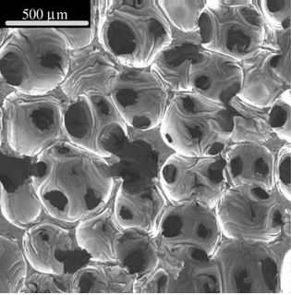
Figure 1. ORNL Graphite Foam (zoomed porous view). [1]

Apparatus

Data collection will come from two separate processes throughout the system, and they are as follows: six thermocouples that are strategically located at water inlets and outlets to keep track on the heat exchange occurring through the process, and a water collection bucket, which will measure the generated pure water from the condenser. Thermocouples T₀ and T₁ will measure the temperature of the cooling water flowing to the inlet and from the outlet of the heat exchanger tube bundle; there is expected to be a gap here, as the water is absorbing the energy that the steam releases when it condenses in the upper chamber. These values are in turn used to calculate the expected ΔT, which then can yield the result in terms of heat per unit time. Thermocouple T₂ will read the temperature coming from where fresh water is being collected, so that the energy still held within the condensed water can be taken into account. Thermocouple T₃ reads from the concentrated salt water out after boiling off the fresh water, which, similarly to T₃, gives an idea of the heat that is not being used to boil the steam. Finally, Thermocouple T₄ will measure from the salt water entering the system, which is more or less used as a preliminary value to give an idea of the initial state of the water, which is basically expected to be held somewhere around room temperature. These temperature differences can yield the expected q value from the system, which in turn is compared to q_{max}, giving an overall effectiveness of the two different heat exchangers and justifying whether the addition of the graphite foam is potentially worth an investment on a large scale.

Test Procedure

When operating the thermal desalination unit, one must follow a strict procedure in order to optimize results and prevent any possible damage to the equipment. First, plug in the 120V system power source into a standard wall outlet, which is used to provide power Pumps 1,2, and 3, which pump saltwater into the system, as well as the PID controller, which controls the heating element in the boiling chamber. Then, one must use the toggle switches on the control panel to ensure that pumps 1 and 2 operate correctly on command. Simply flip the switch on and off quickly to test for sure that the pumps work – do not run them for a long period of time. Next, adjust Valves 1 and 3 to the “open” position and Valve 2 to the “closed” position; this sets the flow channels, only allowing saltwater into the boiling chamber and tap water into and out of the heat exchanger. Turn on pump 2 in order to fill the boiler chamber to the top marking on the sight glass tube, located on the left hand side of the chamber. Next, turn off Pump 2 and close Valve 1, which in turn will ensure a sealed system for boiling of the saltwater. Then, ensure Valves 3 and 4 are in the “open” position, and turn on the outside cooling water source for it to flow into and out of the heat exchanger tube bundle. Allow a few minutes to pass for the entire bundle to fill before continuing to the next step. Next, plug in the 240V 3-Phase power source to power the 5000-W heating element and set the PID control at or above 105 °C; this will ensure that the saltwater in the boiling chamber will begin to boil and produce the desired steam. To be safe, one may set the PID control to 115 °C to heat the water more rapidly. From this point forward, the unit is now an operational, steady state condition. Fresh water accumulation will begin to come from a hose connected to Valve 4 – ensure that this hose is properly placed in a collection bucket so that the production level may be recorded. (Note: if the boiler water level drops below the lowest mark on the sight tube, immediately unplug the 240V source and use Pump 1 to add more saltwater to the chamber).

If one wants to repeat the process and collect more fresh water, unplug the 240V power source, open Valve 1, and turn on Pump 2 to refill the boiler chamber to the top hash mark. After this step is completed, desalination may resume by plugging the 240V source back in to the wall outlet.

Data Reduction Procedure

The condenser of the apparatus can be analyzed as a control volume, so, by the first law of thermodynamics, one can do an energy balance, which is shown in Equation 1

$\frac{dE_{ST}}{dt}= \dot{Q}-\dot{W}+\sum_{in}{\dot{m}(h+KE+PE)}-\sum_{out}{\dot{m}(h+KE+PE)}$ (1)

where $\frac{dE_{ST}}{dt}$is the change in energy storage, $\dot{Q}$ is heat added to or taken from the system, $\dot{W}$ is work done by or on the system, $\dot{m}$ is the mass flow rate of a fluid across a boundary, $h$ is the enthalpy of the fluid, $KE$ is the kinetic energy, and $PE$ is the potential energy. Calculations are done assuming steady state conditions so there is no energy storage. Furthermore, the system is assumed to be adiabatic although it was not insulated (surface temperatures of the apparatus were not recorded), and no work is being done by or on the system. The changes in kinetic and potential energy of the fluids are assumed to be negligible relative to the changes in enthalpy. After these assumptions, continuity (mass balance) and algebraic manipulation, the energy balance can be reduced to
${\dot{m}}_{coolant}c_{p,water}\left(T_{coolant,in}-T_{coolant,out }\right)={\dot{m}}_{steam} \left[h_{fg@0psig}+c_{p,water}\left(T_{sat. water}-T_{fresh,out}\right)\right]$ (2)

where ${\dot{m}}_{coolant}$ is the mass flow rate of building water run through the HX, $c_{p,water}$ is the specific heat capacity of water, T is the measured temperature of the subscripted flow, and $h_{fg@0psig}$is the enthalpy of vaporization at atmospheric pressure—5psi relief valves were used to ensure that the system stayed under 5psi. The expressions on each side of equation 2 represent the heat flow to or from that fluid. Specifically, the expression on the left represents the heat gained by the coolant, and the expression on the right represents the heat lost by the steam, which can be written

${\dot{q}}_{coolant}= {\dot{m}}_{coolant}c_{p,water}\left(T_{coolant,in}-T_{coolant,out }\right)$ (3)

${\dot{q}}_{steam}={\dot{m}}_{steam} \left[h_{fg@0psig}+c_{p,water}\left(T_{steam,in}-T_{fresh,out}\right)\right]$ (4)

It is important to note that the mass flow rate and specific heat of the fluid can be lumped together into the capacitance of the fluid

$C= \dot{m}c_{p}$ (5)

where C is the capacitance of the fluid. This capacitance is used to determine the maximum amount of heat exchange that can be achieved by a given system with known inlet temperatures for a counterflow or crossflow heat exchanger. Moreover, if one of the fluids included in a heat exchanger is changing state, the capacitance is infinity, so the capacitance of the steam in the condenser is infinity. Therefore, for this system it is known that the minimum capacitance is the capacitance of the
coolant.
$C_{min}={\dot{m}}_{coolant}c_{p,water}$ (6)

With the minimum capacitance known, the maximum heat flow possible for the given inlet temperatures can be calculated. Specifically, if all the possible heat is transferred, in a counterflow or crossflow heat exchanger the fluid with the lesser capacitance will exit the exchanger at the inlet temperature of the other fluid, which can be represented as

${\dot{q}}_{max}=C_{min}\left(T_{hot,in}-T_{cold,in}\right)$ (7)

The ratio of actual heat transferred to the maximum amount possible is termed the effectiveness, and can be represented as follows

$ε=\frac{\dot{q}}{{\dot{q}}_{max}}$ (8)

where ε is the effectiveness of the heat exchanger.

With the effectiveness, the number of transfer units, NTU, can be calculated using a relation that is valid when one of the fluids is changing state

$NTU= -ln⁡(1-ε)$ (9)

Finally, the performance of the heat exchanger can be calculated using the equation

$UA=NTU∙C_{min}$ (10)

where U is the thermal conductivity of the material, and A is the surface area that experiences heat transfer. Note that in common practice it is difficult to separate the two terms, but the lumped term, UA, is a valid representation of the performance because the two separate parameters are always used together in HX equations.
In order to calculate the uncertainty in the UA term, uncertainty analysis process was followed

$R=f(x_{1},x_{2},…x_{n})$ (11)

$ω_{R}= \sqrt{{\left(\frac{δf}{δx_{1}}ω_{x_{1}}\right)}^{2}+{\left(\frac{δf}{δx_{2}}ω_{x_{2}}\right)}^{2}+…{\left(\frac{δf}{δx_{n}}ω_{x_{n}}\right)}^{2}}$ (12)

where R is a calculated value that is a function of various inputs, x, and $ω$ is the uncertainty in the subscripted input. These two equations were done to find the uncertainty for each calculated value in order to eventually calculate the uncertainty in the UA lumped term.

Technical Analysis

In a thermal desalination application, there are a few points of interest that are very important to note when looking for the performance of the system as a whole. It is known that the heat input through the heater element in the bottom of the tank, seen in Figure 2, is approximately 5 kW, and the maximum flows for both the inlet of saltwater is known to be 340 gal/hr, or about 5.7 gal/min. In regards to the condenser, the thermal conductivity values for both the stainless steel piping configuration as well as the graphite foam that is added to the piping are known to be approximately 17 W/m-K and 150 W/m-K, respectively [1].

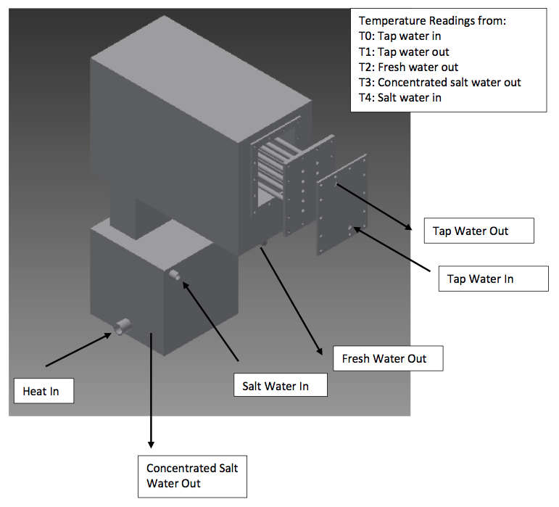
Figure 2. Designed Desalination System.

Additionally, some assumptions must be made in order to develop equations that can be easily manipulated for expected results of the desalination tank. Heat loss and pressure change within the tank are neglected as calculations are made for expected output of fresh water. The specific heat for the water is being used at the average of the room and boiling temperatures of water, and the boiling temperature of the solution is assumed to be approximately 102°C, rather than a salt solution. The system is assumed to be running at a steady state rate, ignoring the start-up or shutdown steps of the procedure along the way.

The heat input from the boiler element is held at a constant rate of 5 kW, which actually restricts the amount of saltwater that can be boiled in the entrance of the tank; the initial plan was to have two 5 kW elements, but because of the high current requirement that was needed, a decision was made to just stick with one. The enthalpy of saturated steam (31240 Btu/slug), the heat capacity of the freshwater, which is what the steam is, is (32.2 Btu/slug-°R), and the change from room temperature to boiling temperature (~146°F) are known, which are applied in Equation 4. The amount of steam boiled can be directly proportional to the amount of water added to the boiling chamber, and this amount can be controlled by throttling Pump 1, which pulls the saltwater from a given reservoir.

Upon determining a reasonable flow of steam out of the reservoir, this steam flows up through the stainless steel mesh and into the upper section of the desalinator, per Figure 2, where the condenser sits. Equations 3 and 4 represent the heat exchange occurring between the condensing steam and the cool tap water flowing through the steel piping; as the hot steam surrounds the cool pipe, the saturated steam condenses on the pipes and drips down into the fresh water collection area. The steam must condense from a vapor to a liquid, per the enthalpy term, and then the liquid will begin to drop in temperature until dripping off into the collection bucket. The cooler tap water will absorb the energy from the steam, generating a higher outlet temperature from the condenser. That being said, the outlet temperature read by Thermocouple T₂ can be controlled by also throttling the mass flow rate of the cooling water – as the flow rate is slowed, the water has more time to absorb the heat, therefore yielding a higher temperature out of the exit.

As stated before, per the initial problem statement, the goal is to compare the effectiveness of a standard thermal desalination system to that with the addition of the graphite foam insulation surrounding the condenser configuration. The foam adds a new dimension in that it has a much higher thermal conductivity value than just the stainless steel piping, providing a better medium of heat transfer than just the pipe; additionally, the extensive network of pores in the foam provide a vastly larger surface area, creating a larger “UA” term in the heat transfer equation. This basically means that the graphite foam has a higher thermal potential, and more heat will be transferred from the steam to the tap water in the condenser over a given period of time, essentially yielding a higher thermal efficiency than that of just basic steel.

Data Results

After fabrication of the thermal desalination system was completed, the operational procedure was followed in order to gain valuable data that reflects the effectiveness of the ORNL graphite foam in the condenser of the device. The two most important data sections collected were the thermocouple readings from the inlet and outlet of the cooling water fluid flows in the condenser tube bundle and the volumetric measurements of the fresh water generated by the system in the collection bucket.

The temperature values are used to calculate an energy transfer from the steam to the cooling water, which in turn can be used to calculate the effectiveness for the heat exchanger. After comparisons are made between the two tube bundles, it can be used to justify the use of the foam composite material in the future. Figure 3 shows the UA term of the energy absorption properties of the foam – this essentially shows a potential for how much energy the foam can pull from the steam surrounding it in the condensation chamber. These values generated with the help of Equations 7-10 for each of the condensers help to show the performance of each one, and they are actually a better representation of the efficiency of the heat exchanger because ε can be manually modified by adjusting flow rates, whereas the UA term is a more broad value for the true properties of any system with this material. As seen below, the average values for the standard and graphite bundles are 0.47 Btu/°R and 0.56 Btu/°R respectively, which reflects that the graphite foam does have an effect on the system, adding a 19% increase to the performance of the system.

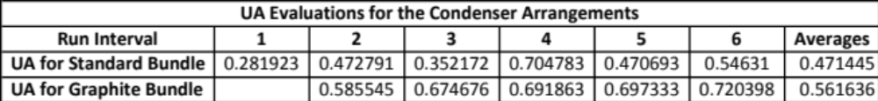
Figure 3. Condenser Tube Bundle UA Values and Total Averages.

The volumetric values for fresh water produced give a much better visual depiction of the difference in condensers, with the graphite foam tube bundle taking the slight edge over the standard bundle. Figure 4 shows the differences in the volume of water collection the tube bundles per 30-minute time interval; the graphite bundle has a much faster initial condensation rate than the standard bundle, as seen by the differences between the 385 mL and 2190 mL initial values of water produced. Basically, this states that as a set amount of steam is produced in the boiling chamber, the graphite foam’s large surface area and thermal conductivity can remove the heat in the surrounding steam at a faster rate, thus condensing more water in the given 30-minute time interval. Based on the average value of fresh water produced in the given time period, with the exception of the initial standard tube bundle outlier of 385 mL, the graphite condenser averaged approximately 90 mL more of fresh water in the collection period, showing its increased effectiveness.

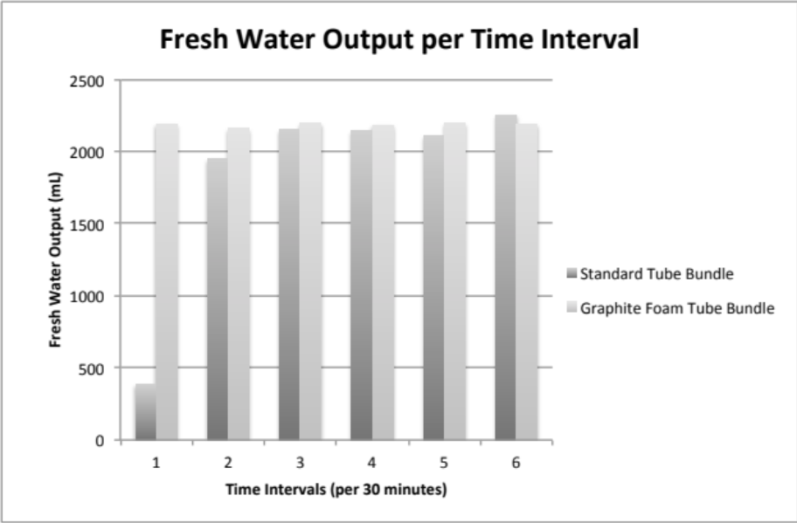
Figure 4. Fresh Water Output per Run.

Discussion of Results

When analyzing the calculated UA terms of each of the condensers, these give a solid representation of the thermal potential for removing energy from the steam, and the difference in the values reflects positively on the question of whether the graphite foam is a good edition to the desalination system or not. One downside to the UA term that is used to evaluate performance is that the temperature readings gathered by thermocouples were oftentimes inconsistent and varied drastically at points, so the average temperature after each run was calculated and inserted into calculations for the heat transfer and ultimately the UA terms. This can present error in the final results, but, after completing uncertainty calculations for the performance of both the standard and graphite tube bundles, the total uncertainties were found from Equations 11 and 12 to be 7.1% and 4.9%, which is actually quite reasonable based on this small-scale application. If temperatures could be more accurately read through the system, the calculated thermal potentials (UA) could have a much more precise output, but the given results from testing are acceptable for this system.

The results of the fresh water output are much more interesting to the operator of the system, because, as stated before, this gives a definite visual representation of the efficiency of the thermal exchange in the condenser. Upon initial inspection of the graphite properties, the expectations were very high that the foam would produce a significantly higher amount of water in a given time interval when compared to the steel, but after performing the operational steps to produce water, the output was not quite as impressive as originally thought. The graphite foam produced approximately 90 mL more of fresh water per 30 minutes of heating; this is approximately 4.3% more water, which really is not an overly significant increase.
To put the overall efficiency of this thermal desalinator in a financial perspective, the EPA states that the cost of 400 gallons of water is approximately $1.43. [4] The graphite foam developed by Oak Ridge National Laboratory that was donated to this project was estimated to hold a value of $15,000. If approximately one gallon of fresh water is produced in an hour, based on above gathered results, the desalination system would have to run continuously for approximately 428.6 years to completely offset the cost of the foam. This number is outrageously large, and this goes to show that the foam is not a great investment, at least not on a small scale, to produce fresh water at a reasonable rate. However, if this project was scaled up to a larger scale, the results could perhaps be more realistic.

What We Learned

Throughout the duration of this project, many difficulties and problems were encountered that have forced the project team to react and adapt to the changes at hand. One serious issue that arose was an extensive budget delay that severely slowed the progression of the fabrication, which was largely due to poor scheduling and unexpected delays. This could easily be resolved with full budget account information and a guarantee that the given budget is in fact available and that the use of that entire budget is open to the team’s discretion. Also, in regards to scheduling, the best way to improve this would have been to create a Gantt chart at the beginning of the semester in order to keep track with an ordered system of tasks to keep the project on schedule; this would have aided in making up for lost time when dealing with unexpected delays such as weather or monetary issues.

Additionally, it became apparent that there was a considerable need for individuals with expertise outside of our own. Upon initial thoughts, this appeared to be a mechanical engineering proposal, but it soon became apparent that there would be a sizeable amount of electrical engineering and circuitry to have control of the system. That being said, a suggested improvement would be to have a contact outside of the group that had a solid knowledge of other subject areas. For the purpose of our project, desired support would include subject areas such as electrical engineering, trade skills (welding and machining), and instrumentation or controls.

Lastly, in relation to the budget, we found that there was a need for more precise instrumentation and access to equipment that can aid in accurate data collection. This developed into a fiscal problem because with more precise the instrumentation comes more expense. Also, by not having access to the original budget total, we were limited in what instrumentation we could purchase. If more precise thermocouples and better software to read the temperatures were available, the collected data could more directly reflect the thermal desalination process. Along with this, the addition of flow meters in order to control the flow rate of water into and out of the system would have been a huge benefit in calculations of heat transfer, but again, this would exceed the available funding. In regards to future adjustments, the main improvement that should be made is to invest in more effective equipment for data collection, because the majority of data collected experienced great variation and inaccuracy for the most part.

Acknowledgements

Throughout the entire process of evaluation and design for the thermal desalination system, students worked diligently to analyze the project in detail and propose a theoretical solution for optimization of fresh water output with the addition of the new graphite foam developed by Oak Ridge National Laboratory. This group would like to extend a warm recognition to James Klett of ORNL for his donation of the blocks of graphite foam that were used in the condenser tube bundle so that this project could be completed and full analysis could be done on the overall effectiveness of the addition of the foam in this application. The results gathered help to support the claims that this material is in fact beneficial in maximizing heat transfer and the rate of water output in a thermal system, potentially opening the door to a large-scale system in the future.

Additionally, much credit is given to ITW Welding for the very generous donation of the welder that was used extensively in the fabrication of the entire thermal desalination system. The vast majority of the system was stainless steel, and because of this, much welding had to be done to create acceptable seals of the metal so that the tank itself could hold a large supply of saltwater and steam with no leaks. In addition to the extensive use that the machine received throughout the duration of the building process, members of the team received invaluable experience with the opportunity to practice with the welder and gain a deeper knowledge of the art of welding. This project was completed largely with the help of ITW Welding, and, again because of this much appreciation is warranted.

Again, throughout the fabrication phase, an extensive amount of manual fabrication and assembly had to be done to build the thermal system, including control of fluid flow in and out of the system, heating of the saltwater in the boiling chamber, and temperature measurement at fluid inlets and outlets to determine heat exchanger effectiveness. Because of this, an extensive list of parts had to be ordered to fulfill these requirements, as seen in Appendix D, and this was only possible with the generous financial support provided to us by Dr. Claudia Rawn of the UT Material Science and Engineering Department through the use of the CMP Fund. Much thanks is in order for full cooperation throughout the process, and even though there were a few mishaps with the budget along the way, Dr. Rawn worked diligently to pull together funds for us to complete the system on time.

Lastly, on behalf of the thermal desalination senior design team, sincere appreciation is extended to Jonaaron Jones and Dr. J. Mark Barker for their help throughout the year in both the theoretical design phase as well as the physical fabrication phase of the project. Dr. Barker provided quality insight during weekly meetings and gave guidance in many different areas of mechanical design, and his cooperation and help has helped this team to meet time requirements and finish the project, even with the adversities that arose throughout the year. Jonaaron Jones was instrumental in the development of the thermal desalination system, and his extensive hands-on knowledge of welding and electrical controls were invaluable in completion of this project; additionally, the time and effort he gave throughout a full graduate school and work schedule is greatly appreciated, and this team is very grateful for this investments in our success.
Bibliography

- Klett, J.W. McMillan, A.D. Gallego, N.C. Walls, C.A. The Role of Structure on the Thermal Properties of Graphitic Foams. Oak Ridge: Journal of Materials Science, 2004. 3 February 2004. 3659-3676. Print.

- Bruggen, Bart Van der, Vandecasteele, Carlo. “Distillation vs. Membrane Filtration: Overview of Process Evolutions of Seawater Desalination”. Elsevier. 15 January 2002. 207-218. Print.

- Çengel, Yunus A. Boles, Michael A. Thermodynamics: An Engineering Approach. 7th Edition. New York: McGraw-Hill, 2011. Print.

- U.S. Environmental Protection Agency. Water and Wastewater Pricing. N.p.: U.S. Environmental Protection Agency, n.d. U.S. EPA, 1995. Web. 4 May 2015. <http://water.epa.gov/infrastructure/sustain/Water-and-Wastewater-PricingIntroduction.cfm >.

Appendix A

Sample Calculations with Nomenclature and Units

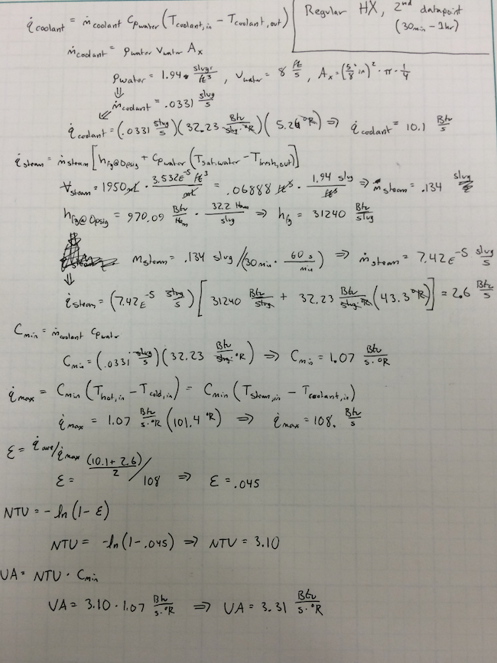
Appendix B

Equipment List and Calibration Details

Instructions for calibration, operation, and data collection are located on desalination device, and this list gives a full breakdown of the equipment operation steps. Calibration steps have already been executed and no additional manual input must be performed.
Appendix C

Matlab Program Used

% clear all
close all
clc
filenamexl = 'Data Collection - Regular';
filenamex2 = 'Data Collection - Graphite Foam';
raw_data1 = cell(6,2);
raw_data2 = cell(6,2);
raw_data1{1,1} = xlsread(filenamexl,'1st Half Hour','C8:G487');
raw_data1{2,1} = xlsread(filenamexl,'2nd Half Hour','C8:G1726');
raw_data1{3,1} = xlsread(filenamexl,'3rd Half Hour','C8:G3607');
raw_data1{4,1} = xlsread(filenamexl,'4th Half Hour','C8:G3607');
raw_data1{5,1} = xlsread(filenamexl,'5th Half Hour','C8:G2219');
raw_data1{6,1} = xlsread(filenamexl,'6th Half Hour','C8:G3007');
raw_data1{1,2} = 385;
raw_data1{2,2} = 1950;
raw_data1{3,2} = 2150;
raw_data1{4,2} = 2140;
raw_data1{5,2} = 2110;
raw_data1{6,2} = 2250;
raw_data2{2,1} = xlsread(filenamex2,'2nd Half Hour','C8:G2809');
raw_data2{3,1} = xlsread(filenamex2,'3rd Half Hour','C8:G2490');
raw_data2{4,1} = xlsread(filenamex2,'4th Half Hour','C8:G2636');
raw_data2{5,1} = xlsread(filenamex2,'5th Half Hour','C8:G3306');
raw_data2{6,1} = xlsread(filenamex2,'6th Half Hour','C8:G3186');
raw_data2{1,2} = 2190;
raw_data2{2,2} = 2160;
raw_data2{3,2} = 2200;
raw_data2{4,2} = 2180;
raw_data2{5,2} = 2200;
raw_data2{6,2} = 2190;
Tcon_in = cell(2,6);
Tcon_out = cell(2,6);
Tfresh_out = cell(2,6);
Tsalt_out = cell(2,6);
Tsalt_in = cell(2,6);
qdot_cond = cell(2,6);
qdot_steam = cell(2,6);
eff = cell(2,6);
UA = cell(2,6);
delh = 974.1*32.2; %change in enthalpy of fresh superheated steam to saturated water (Btu/slug)
cp_water = 32.232; % (Btu/slug/R)
v_cond = 8; %velocity of water in condenser
mdot_cond = 1.94*v_cond*pi*((5/8)^2)*1/4*(1/144);
Cmin = mdot_cond * cp_water;
Wqdot_cond = Cmin*4*(2^.5);
Wqdot_steam = Cmin*4;
WUA = cell(2,6);
for n =1:6
Tcon_in{1,n} = mean(raw_data1{n,1}(:,1)); %Celcius
Tcon_out{1,n}= mean(raw_data1{n,1}(:,2)); %Celcius
Tfresh_out{1,n} = mean(raw_data1{n,1}(:,3)); %Celcius
Tsalt_out{1,n} = mean(raw_data1{n,1}(:,4));
Tsalt_in{1,n} = mean(raw_data1{n,1}(:,5));
DelTcon = Tcon_out{1,n} - Tcon_in{1,n};
qdot_cond{1,n} = Cmin*(DelTcon*1.8); %Btu/s
mL = raw_data1{n,2}; %mL of water out
mdot_steam = mL*3.5315*1.94*(10^(-5))/30/60; %mass flow rate of created fresh water (slug/s)
Tfresh_out{1,n} = ((Tfresh_out{1,n}*1.8)+32); %converts temps from Celcius to Farenheit
qdot_steam{1,n} = mdot_steam*(delh + cp_water*(212-Tfresh_out{1,n}));
qmax = Cmin*(220-(1.8*Tcon_in{1,n})); %Cmin * delT max
qdot = (qdot_cond{1,n}+qdot_steam{1,n})/2;
eff{1,n} = qdot/qmax;
NTU = -1*log(1-eff{1,n});
UA{1,n} = NTU*10.3;
Wqmax = 4*Cmin;
WE = sqrt((((qmax^(-1))*Wqdot_steam)^2)+(((-qdot_steam{1,n}/(qmax^2))*Wqmax)^2));
WNTU = ((1-eff{1,n})^(-1))*WE;
WUA{1,n} = WE*Cmin;
end
for n = 2:6
Tcon_in{2,n} = mean(raw_data2{n,1}(:,1)); %Celcius
Tcon_out{2,n}= mean(raw_data2{n,1}(:,2)); %Celcius
Tfresh_out{2,n} = mean(raw_data2{n,1}(:,3)); %Celcius
Tsalt_out{2,n} = mean(raw_data2{n,1}(:,4));
Tsalt_in{2,n} = mean(raw_data2{n,1}(:,5));
DelTcon = Tcon_out{2,n} - Tcon_in{2,n};
qdot_cond{2,n} = Cmin*(DelTcon*1.8); %Btu/s
mL = raw_data2{n,2}; %mL of water out
mdot_steam = mL*3.5315*1.94*(10^(-5))/30/60; %mass flow rate of created fresh water (slug/s)
Tfresh_out{2,n} = ((Tfresh_out{2,n}*1.8)+32); %converts temps from Celcius to Farenheit
qdot_steam{2,n} = mdot_steam*(delh + cp_water*(212-Tfresh_out{2,n}));
qmax = Cmin*(220-(1.8*Tcon_in{2,n})); %Cmin * delT max
qdot = (qdot_cond{2,n}+qdot_steam{2,n})/2;
eff{2,n} = qdot/qmax;
NTU = -1*log(1-eff{2,n});
UA{2,n} = NTU*10.3;
Wqmax = 4*Cmin;
WE = sqrt((((qmax^(-1))*Wqdot_steam)^2)+(((-qdot_steam{2,n}/(qmax^2))*Wqmax)^2));
WNTU = ((1-eff{2,n})^(-1))*WE;
WUA{2,n} = WE*Cmin;
end
xlswrite('Report_data',UA);
UA1 = zeros(1,6);
UA2 = zeros(1,6);
for n= 1:6
UA1(n) = UA{1,n};
UA2(n) = UA{2,n};
end
UA_ave1 = mean(UA1);
UA_ave2 = mean(UA2);
UA_ave = [UA_ave1, UA_ave2];
xlswrite('Report_data', UA_ave, 'A4:B4');

Uncertainty
WUA1 = zeros(1,6);
WUA2 = zeros(1,6);
for n = 1:6
WUA1(n) = WUA{1,n};
WUA2(n) = WUA{2,n};
end
WUA_ave1 = mean(WUA1);
WUA_ave2 = mean(WUA2);
WUA_ave = [WUA_ave1,WUA_ave2];
Wpercent_UA = WUA_ave./UA_ave;
Published with MATLAB® R2013a

Appendix D

Bill of Materials

