Effects of rodents on ecosystem structure and function

A Dissertation Presented for the

Doctor of Philosophy

Degree

The University of Tennessee, Knoxville

Leigh Courtney Moorhead

May 2017
Copyright © 2017 by Leigh C. Moorhead
Chapter 1 copyright © John Wiley and Sons, Inc.
All rights reserved.

ACKNOWLEDGEMENTS

Thank you to my advisor Aimée Classen and committee members Nate Sanders, Charlie Kwit, and Dan Simberloff for your guidance and feedback over the last six years.

Thank you to the Classen and Sanders labs and the EEB department.

Thank you to the Tennessee Wildlife Resources Agency for help in maintaining my experimental field site.

Special thanks to Michael Becker, Jeremy Beaulieu, Lauren Breza, Jaime Call, Lacy Chick, Chelsea Chisholm, Melissa Cregger, Raina Fitzpatrick, Jim Fordyce, Rachel Fovargue, Jeremiah Henning, Sara Kuebbing, Zach Marion, Liam Mueller, Courtney Patterson, Alix Pfennigwerth, Quentin Read, Relena Ribbons, Max Rupp, Lara Souza, and Maja Sundqvist.

Thank you to Richard D. Bardgett and David A. Wardle for their Aboveground- Belowground Linkages: Biotic Interactions, Ecosystem Processes, and Global Change book—particularly chapter 4.

And of course, many thanks to my parental units for their love and support.

ABSTRACT

What structures systems across the landscape and over time has long been a focus of ecosystem ecology. Together, abiotic and biotic components interact to shape the flow of nutrients and energy through a system. My Ph.D. explores how small mammals directly and indirectly affect ecosystem structure and function using a manipulation experiment in an old-field system in East Tennessee. Despite previous research showing herbivores have large and sustained impacts on ecosystems, small mammals, specifically, are oft overlooked despite their ubiquitous presence. Specifically, I will examine how small mammals contribute to above and belowground community structure, nutrient cycling and decomposition, and how they influence an ecosystem’s stability in response to fire disturbance. By manipulating their presence, I can explore how a biotic ecosystem component directly structures an ecosystem and indirectly by examining an interaction with an abiotic disturbance.

TABLE OF CONTENTS

INTRODUCTION 1
Key questions 2
Study System 4
References 7
CHAPTER I Small mammal activity alters plant community composition and microbial activity in an old-field 10
Abstract 11
Introduction 12
Materials and Methods 13
Experimental Design 13
Above-ground Structure and Composition 15
Plant and Litter Chemistry 15
Below-ground Structure and Composition 16
Statistical Analyses 18
Results 19
Discussion 20
Acknowledgements 27
References 29
CHAPTER II The presence of rodents decreases the extent of burning 35
Abstract 36
Introduction 37
Methods and Materials 38
Site description 38
Experimental design 38
Statistical Analysis 41
Results 41
Discussion 43
Acknowledgements 50
References 52
CHAPTER III Rodents do not create a home-field advantage for litter decomposition they just speed up the process 56
Introduction 59
Materials and Methods 61
Experimental Design 61
Bag Construction 62
Bag Deployment and Pickup 63
Data Collection and Analysis 63
Results 64
Discussion 64
Acknowledgements 72
References 73
CONCLUSION 80
References Included in Map 84
References 86
VITA 87

LIST OF TABLES

Table 1. Means, standard errors, F, and P-values for all above- and belowground responses in small mammal access and exclosure plots 22
Table 2. ANOVA table output for mass loss 67
Table 3. Litter x plot treatment decay rates. 68
Table 4. Post-hoc test for overall treatment differences. 69

LIST OF FIGURES

Figure 1. Aerial and ground views of field site 6
Figure 2. Effects of rodent absence/presence on (A) 2009 and 2010 aboveground community structure; (B) plant leaf chemistry and belowground structure; and (C) ecosystem process and function 24
Figure 3. Principal coordinate (PCO) axes illustrating 2009 plant functional group (A), 2010 plant functional group (B), and extracellular enzyme composition (C) 25
Figure 4. Difference in percent ground cover burned between access and exclosure plots. 42
Figure 5. Plant community structure and composition between access and exclosure plots in 2011 (pre-burn) 44
Figure 6. Percent area burned in response to 2010 C₃ graminoid biomass 45
Figure 7. Plant community structure and composition between access and exclosure plots in 2012 (post-burn) 46
Figure 8. Four panel graph showing functional group cover between 2011 and 2012 for both access and exclosure treatments for graminoids (A), forbs (B), woody (C), and n-fixers (D) 47
Figure 9. Decomposition curves for our four litter x plot treatments. 65
Figure 10. Nitrogen (A) and phosphorous (B) content of initial (control) litter bags for access and exclosure litter treatments. 66
Figure 11. Preliminary map showing response of plant communities to vole (Microtus) exclusion 83

INTRODUCTION
Ecosystem structure is driven by abiotic factors including climate and soil type, as well as biotic components and their interactions. These drivers of ecosystem structure vary both spatially and temporally. For example, abiotic disturbances such as hurricanes and wildfires influence ecosystem structure and function by massive, immediate removal or addition of biotic material (Lodge and McDowell 1991; Gardner et al. 1992) and are most common during the autumn (hurricanes) or summer (fires) season in the northern hemisphere (Michener et al. 1997; McKenzie et al. 2011). Similarly, herbivores substantially acquire and redistribute nutrients in ecosystems through their continuous consumption of net primary productivity (Frank and McNaughton 1992; Augustine et al. 2003; Martin and Wilsey 2006) and addition of nutrients through waste deposition (Clark et al. 2005; Habeck and Meehan 2008), throughout the year and across continuous spatial scales. Therefore, understanding how the abiotic and biotic components of ecosystems act individually and together to regulate immediate and long-term structure and function is increasingly important as human activity across the landscape increases.
Herbivory can be viewed as a chronic biotic ecosystem disturbance with variable effects on plant communities. Although herbivores harvest large amounts of aboveground biomass in forests—even more in grasslands (Frank and McNaughton 1992, Augustine et al. 2003)—and can alter plant community composition (e.g. Howe et al. 2002, 2006), the direction of the plant community response to herbivory is not always consistent. While herbivores tend to selectively graze on more palatable, and therefore higher quality (lower carbon:nitrogen and lignin:nitrogen) plant material, herbivory does not always select for a recalcitrant landscape. For instance, early successional plants can positively respond to foliar herbivory through compensatory growth and outcompeting establishment of later successional species with poorer quality litter (McNaughton et al. 1997; Augustine and McNaughton 1998). Conversely, herbivores can drive succession when high quality plants are selectively grazed and more recalcitrant, herbivory-resistant species colonize (Ritchie et al. 1998; Bardgett and Wardle 2003). However, the responses to herbivores are not limited to plant community composition. Through these changes aboveground, herbivory can lead to changes in belowground community structure (e.g., Wardle et al. 2001; Veen et al. 2010; Niwa et al. 2011; Lessard et al. 2012; Gergocs and Hufnagel 2016) and function (e.g., Bagchi and Ritchie 2010; Chomel et al. 2016). Therefore, herbivores are one example of the biological community that can alter ecosystem structure through changes in above and belowground structure and processes.
While long-term abiotic and biotic conditions including soil type, precipitation patterns, growing season, and herbivory all influence ecosystem structure directly through controls on primary production (e.g., Grimes 1979; McIntyre et al. 1995; Bardgett and Wardle 2010), short-duration abiotic events also influence the movement of energy and nutrients through an ecosystem (Gardner 1992; Michener et al. 1997; McKenzie et al. 2011). In particular, discrete, high-intensity events such as windstorms or wildfires can cause massive mortality while simultaneously adding a large influx of nutrients. For fires, the degree of mass loss and nutrient volatilization depends on fire regime (i.e., intensity, frequency, and season), which in turn, depends on ecosystem properties such as regional climate but also fuel quantity and quality. Since herbivores alter plant communities, it follows they also alter fuel loads and should indirectly alter fire patterns. Across grassland systems, for instance, ungulate and other large herbivores often alter woody-grass dynamics by reducing the fine fuel quantity provided by grasses which feeds back to alter fire frequency and severity (e.g., van Auken 2000; Gordijn et al. 2012). With anthropogenic caused changes to global climate patterns, including changes in precipitation regimes, increases in severity and intensity of storms and lightning occurrences, combined with decades-long fire suppression, it is important to understanding the effects of both biotic and abiotic controls and their interactions on short and long-term ecosystem structure and function.

Key questions
My dissertation will address the overarching question: how do rodents directly influence ecosystem structure and how do aboveground changes influence a fire disturbance? The chapters of my dissertation will address three specific research questions. Chapter 1 explores the influence of rodents on above- and belowground communities and ecosystem functioning through manipulation of rodent presence and assessing the (1) plant community standing biomass, composition, and structure, (2) the soil community bacterial and fungal abundance, (3) soil microbial extracellular enzyme activity, and (4) potential net nitrogen mineralization. Chapter 2 further analyzes the effects of rodents on ecosystem structure by examining whether rodent-driven changes in the aboveground community can alter a fire disturbance pattern. Chapter 3 will expand the scope of how rodents influence ecosystem structure by exploring whether rodent exclusion alters decomposition processes at a small spatial scale through the creation of a home-field advantage for litter decomposition.
In chapter 1, I explored how rodents influence above- and belowground community structure and function by using an exclosure experiment and measured the response of the plant community, soil fungal and bacterial abundance, microbial activity, and potential net nitrogen (N) mineralization. I found functional group composition differed between small mammal treatments whereby C₃ graminoids dominated exclosure plots more than access plots in both foliar cover and biomass. I found rodent exclosure had no effect on bacteria and fungi abundance nor did exclusion affect potential nitrogen mineralization. However, I did find that extracellular enzyme activity was higher when rodents were excluded. My findings indicate that rodents alter the aboveground plant community and appear to slow ecosystem processes.
In chapter 2, I explored whether rodent-driven changes in the plant community alter the way a fire disturbance moved through my system. I found exclosure plots had 3.6 times more ground area burned than access plots. While there was no difference in the composition or structure of our plant community of the previous season (measured mid-summer), biomass measurements taken in the fall two years ago did differ and helped to explain the difference in burning observed. In particular, increased C₃ graminoid biomass explained about sixty percent of the burn pattern. Furthermore, while I found no difference in the plant community during the previous growing season, I did find the access and exclosure communities did differ during the growing season following the burn. Richness was nineteen percent higher in exclosures and species and functional group composition differed with graminoid cover, in particular, increasing in exclosure plots from pre- to post-burn seasons. These results highlight the important role rodent consumers play and highlight that their impacts on community phenology and productivity should be considered when using fire as a management tool.
In chapter 3, I explored whether rodents can create a home-field advantage for litter decomposition. Understanding the feedbacks between plants and soil communities is an exciting new (relatively) area of ecosystem research. Previous research indicates that plant litter often decomposes faster in the habitat where it was produced than in ‘other habitats’ because the decomposition communities in the home habitat have developed while decomposing the litter from that habitat; this phenomenon is known as ‘home field advantage’ (HFA). HFA has been shown in disparate ecosystems where, for example, leaf litter from a forest decomposes faster in a forest than in a grassland (Veen et al. 2014). However, fewer studies have focused on whether HFA can work within an ecosystem. Since previous work in my system found that rodents altered plant community structure and soil function, decomposition may also vary when rodents were present or absent. Further, rodent presence may select for a soil community that is most efficient at decomposing litter produced when rodents are present—an HFA of rodent presence. To determine if rodents can create an HFA for litter decomposition I tested whether litter from access treatments decomposes faster in access plots (‘home’) or in exclosure plots (‘away’) and vice versa. I found no litter by site interaction indicating rodents do not create an HFA. However, I did find access plots had higher decomposition rates compared to exclosure plots and access litter decomposed faster than exclosure litter—with initial access litter bags having a higher nitrogen content than initial exclosure bags. These results indicate that while rodents do not appear to create a home-field advantage, they do increase decomposition rates overall through differences in litter quality and through some change at the plot level.

Study System
All chapters of my dissertation take advantage of a long-term manipulation experiment. This study site is located on Freels Bend part of the Oak Ridge National National Environmental Research Park near Oak Ridge, Tennessee (35º58’ N, 84º17’W). The site was abandoned from agricultural use in 1943 and has maintained as wildlife habitat since 2000. This site was burned with a low intensity fire on 22 March 2008 prior to establishing the experiment. The soil is classified as a Typic Hapludult. Precipitation is evenly distributed throughout the year with an annual mean of 1360 mm. January minimum temperatures average 3°C and July maximum temperatures average 31°C. Common herbaceous plant species include tall goldenrod (Solidago altissima), blackberry (Rubus sp.), white cornbeard (Verbesina virginica), trumpet creeper (Campsis radicans), sericea (Lespedeza cuneata), brome grass (Bromus sp.), yellow crownbeard (Verbesina occidentalis), clover (Trifolium sp.), broomsedge (Andropogon virginicus), and orchard grass (Dactylis glomerata). The most common small mammals at our site are the hispid cotton rat (Sigmodon hispidus), Microtus species, and Peromyscus species.
In March of 2008, twenty 4 m × 8 m rectangular plots were constructed in an old-field and randomly assigned ten plots to small mammal exclosure and ten plots to no-exclosure (i.e., access plots) treatments (Figure 1). Plot perimeters consisted of a galvanized hardware cloth fence (122 cm width, 0.64 cm mesh) sunk 40 cm below ground and extending 82 cm above ground. Fencing depth is sufficient to exclude burrowing rodents. We installed aluminum flashing (36 cm width) on the upper portion of the fence to exclude climbing small mammals. Holes (15 cm × 30 cm) were cut at ground level around the perimeter of the access plots to allow passive entry of rodent-sized animals while the exclusion plots remained unmanipulated. For the duration of the study there was no evidence of rodent activity in the exclusion plots. For multiple years, we assed the plant community in our treatments by measuring plant foliar cover in 2008, 2009, 2011, and 2012. We measured species-specific foliar cover with a modified Braun-Blanquet cover class scale (Braun-Blanquet 1932) with six categories: 1 = <1%, 2 = 1-5%, 3 = 5-25%, 4 = 25-50%, 5 = 50-75%, 6 = 75-100%. The foliar cover of forbs, C₃ graminoids, C₄ graminoids, nitrogen fixers, and woody species were summed for individuals in the different functional groups (Moorhead et al. in press).

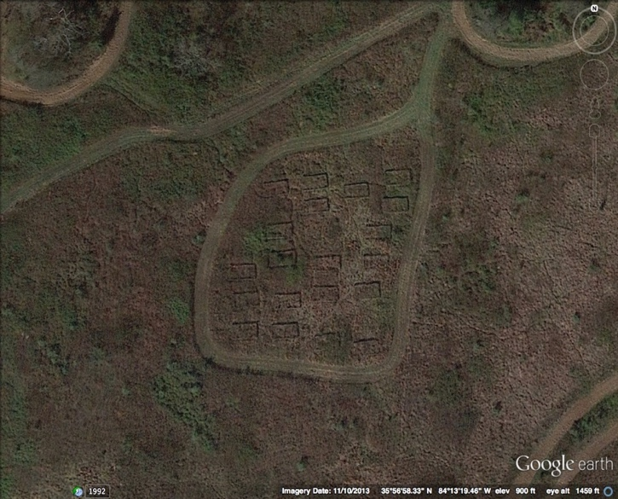
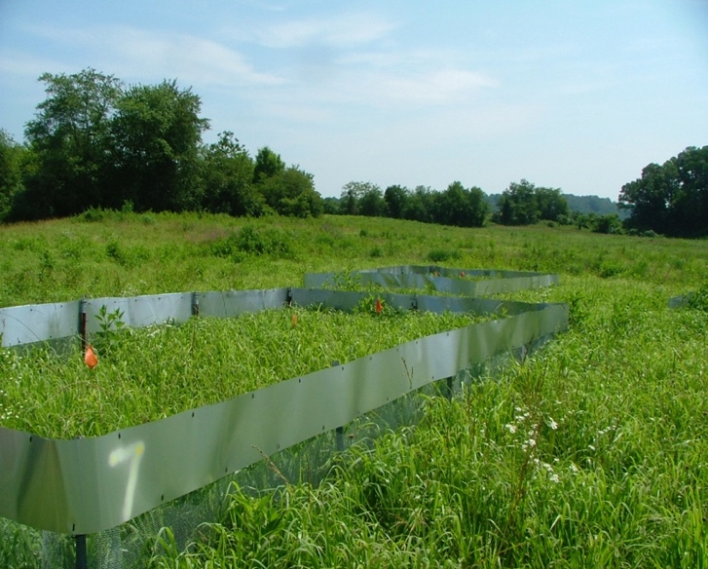
A
A
A
A
A
A
A
A
A
A
X
X
X
X
X
X
X
X
X
X
A
B

Figure 1. Aerial and ground views of field site (A) Google Earth image of Freel’s Bend study site showing aerial image of access (“A”) and exclosure (“X”) plots. Area containing plots within mowed perimeter is roughly 60 m × 60 m. (B) Photograph of two of the twenty 4 m × 8 m rectangular rodent manipulation plots established in an old-field community. Plot perimeters consisted of a galvanized hardware cloth fence sunk 40 cm into the soil profile and extending 82 cm above the soil surface. We installed aluminum flashing on the upper portion of the fence to exclude climbing rodents. Holes were cut in half of the plots at ground level for rodent-sized animal access.

References
Augustine, D.J. and S.J. McNaughton. 1998. Ungulate effects on the functional species composition of plant communities: Herbivore selectivity and plant tolerance. The Journal of Wildlife Management 62:1165–1183.
Augustine, D.J., S.J. McNaughton, and D.A. Frank. 2003. Feedbacks between soil nutrients and large herbivores in a managed savanna ecosystem. Ecological Applications 13:1325–1337.
Bagchi, S., and M.E. Ritchie. 2010. Introduced grazers can restrict potential soil carbon sequestration through impacts on plant community composition. Ecology Letters 13:959–968.
Bardgett, R.D., and D.A. Wardle. 2003. Herbivore-mediated linkages between aboveground and belowground communities. Ecology 84:2258–2268.
Bardgett, R. D. and D. A. Wardle. 2010. Aboveground-Belowground Linkages: Biotic Interactions, Ecosystem Processes, and Global Change. New York: Oxford University Press.
Chomel, M., M. Guittonny-Larcheveque, C. Fernandez, C. Gallet, A. DesRochers, D. Pare, B.G. Jackson, and V. Baldy. 2016. Plant secondary metabolites: a key driver of litter decomposition and soil nutrient cycling. Journal of Ecology 104:1527–1541.
Clark, J.E., E.C. Hellgren, J.L. Parsons, E.E. Jorgensen, D.M Engle, and D.M. Leslie Jr. 2005. Nitrogen outputs from fecal and urine deoposition of small mammals: implications for nitrogen cycling. Oecologia 144:447–455.
Frank, D.A. and S.J. McNaughton. 1992. The ecology of plants, large mammalian herbivores, and drought in Yellowstone National Park. Ecology 73:2043–2058.
Gardner, L.R., W.K. Michener, T.M. Williams, E.R. Blood, B. Kjerve, L.A. Smock, D.J. Lipscomb, and C. Gresham. 1992. Disturbance effects of hurricane Hugo on a pristine coastal landscape-north inlet, South-Carolina, USA. Netherlands Journal of Sea Research 30:249–263.
Gergócs, V., and L. Hugnagel. 2016. The effect of microarthropods on litter decomposition depends on litter quality. European Journal of Soil Biology 75:24–30.
Gordijn, P.J., W. Rice, and D. Ward. 2012. The effects of fire on woody plant encroachment are exacerbated by succession of trees of decreased palatability. Perspectives in Plant Evolution and Systematics 14:411–422.
Grimes, J.P. 1979. Plant Strategies, Vegetation Processes, and Ecosystem Properties (2nd ed.). New York: John Wiley & Sons, LTD.
Habeck, C.W., and T.D. Meehan. 2008. Mass invariance of population nitrogen flux by terrestrial mammalian herbivores: an extension of the energetic equivalence rule. Ecology Letters 11:898–903.
Howe, H.F., J.S. Brown, B. and Zorn-Arnold. 2002. A rodent plague on prairie diversity. Ecology Letters 5:30–36.
Howe, H. F., Zorn-Arnold, B., Sullivan, A., and Brown, J. S. 2006. Massive and distinctive effects of meadow voles on grassland vegetation. Ecology 87:3007–3013.
Lessard, J., W. N. Reynolds, W.A. Bunn, M.A. Genung, M.A. Cregger, E. Felker-Quinn, M.N. Barrios-Garcia, M.L. Stevenson, R.M. Lawton, C.B. Brown, M. Patrick, J. H. Rock, M.A. Jenkins, J.K. Bailey and J.A. Schweitzer. 2012. Equivalence in the strength of deer herbivory on above and belowground communities. Basic and Applied Ecology 13:59–66.
Lodge, D.J., and W.H. McDowell. 1991. Summary of ecosystem-level effects of Caribbean hurricanes. Biotropica 23:373–378.
Martin, L.M., and B.J. Wilsey. 2006. Assessing grassland restoration success: Relative roles of seed additions and native ungulate activities. Journal of Applied Ecology 43:1098–1109.
McIntyre, S., S. Lavorel and R.M. Tremont. 1995. Plant life-history attributes: Their relationship to disturbance response in herbaceous vegetation. Journal of Ecology 83:31–44.
McKenzie, D., C. Miller, and D.A. Falk (Eds.). 2011. The Landscape Ecology of Fire (pp. 3- 27). New York: Springer.
McNaughton, S.J., F.F. Banyikwa, and M.M. McNaughton. 1997. Promotion of the cycling of diet-enhancing nutrients by African grazers. Science 278:1798–1800.
Michener, W.K., E.R. Blood, K.L. Bildstein, M.M. Brinson, and L.R. Gardner. 1997. Climate change, hurricanes and tropical storms, and rising sea level in coastal wetlands. Ecological Applications 7:770–801.
Niwa, S., L. Mariani, N. Kaneko, H. Okada, and K. Sakamoto. 2011. Early-stage impacts of sika deer on structure and function of the soil microbial food webs in a temperate forest: A large-scale experiment. Forest Ecology and Management 261:391–399.
Ritchie, M.E., D. Tilman, and J.M.H. Knops. 1998. Herbivore effects on plant and nitrogen dynamics in oak savanna. Ecology 79:165–177.
van Auken, O.W. 2000. Shrub invasions of North American semiarid grasslands. Annual Review of Ecology and Systematics 31:197–215.
Veen, G.F., H. Olff, H. Duyts, and W.H. van der Putten. 2010. Vertebrate herbivores influence soil nematodes by modifying plant communities. Ecology 91:828–835.
Veen, G.F., G.T. Freschet, A. Ordonez, and D.A. Wardle. 2014. Litter quality and environmental controls of home-field advantage effects on litter decomposition. Oikos 123:800-806.
Wardle, D.A., Barker, G.M., Yeates, G.W., Bonner, K.I., and Ghani, A. 2001. Introduced browsing mammals in New Zealand natural forests: Aboveground and belowground consequences. Ecological Monographs 4:587–614.

CHAPTER I
Small mammal activity alters plant community composition and microbial activity in an old-field

A version of this chapter is currently accepted for publication.
Moorhead, L.C., L. Souza, C. Habeck, R.L. Lindroth, and A.T. Classen. In press. Small mammal activity alters plant community composition and microbial activity in an old-field. Ecosphere.
This copyrighted material is owned by or exclusively licensed to John Wiley & Sons, Inc., and is reproduced with their permission.
The experimental design was done by Aimée T Classen, Richard Lindroth, Christopher Habeck and Lara Souza. Data collection was done by Christopher Habeck and Lara Souza. Leigh Moorhead completed all analyses and wrote and revised the manuscript. Lara Souza assisted with statistical analysis and all coauthors assisted with the writing and revision process.

Abstract
Herbivores modify their environment by consuming plant biomass and redistributing materials across the landscape. While small mammalian herbivores, such as rodents, are typically inconspicuous, their impacts on plant community structure and chemistry can be large. We used a small mammal exclosure experiment to explore if rodents in a southeastern old field directly altered the aboveground plant species composition and chemistry, and indirectly altered the belowground soil community composition and activity. In general, when rodents were excluded, C₃ graminoids increased in abundance, contributing towards a shift in plant species composition relative to plots where rodents were present. The plant community chemistry also shifted; litter fiber concentration and carbon:nitrogen were higher, whereas litter nitrogen concentration was lower in exclosure plots relative to access plots. While microbial community enzyme activity increased when rodents were excluded, no significant changes in the fungal:bacterial or potential nitrogen mineralization occurred between treatments. Our results show that rodents can rapidly influence aboveground plant community composition and chemistry, but their influence on belowground processes may require plant inputs to the soil to accumulate over longer periods of time.

Introduction
Understanding how abiotic factors such as temperature and precipitation shape large-scale plant distributions, diversity patterns, and ecosystem function remain a focal interest of ecology (Whittaker 1960; Meentemeyer 1978). However, biotic factors, including plant-herbivore interactions (Bardgett and Wardle 2003), often shape local-scale diversity patterns and associated functions. Globally, herbivores consume 10 to 20% of net primary productivity (NPP) in forests and over twice as much in grasslands (Frank and McNaughton 1992; Augustine et al. 2003; Howe et al. 2006; Martin and Wilsey 2006; Borer et al. 2014). Thus, via their consumption of plants, herbivores influence the amount and quality of materials that enter the soil system, having large impacts on the functioning of ecosystems.
In addition to the removal of plant biomass, herbivores can selectively consume high-quality plants leading to temporal shifts in the nutrient content of plants in the community (Ritchie et al. 1998; van Wijnen et al. 1999). Further, herbivory can induce plant defenses that can bind nutrients into complexes that are difficult both for herbivores to digest and decomposers to degrade (e.g. Schultz and Baldwin 1982; Agrawal et al. 1999). Lower quality litter slows microbial decomposition and thus can slow ecosystem function (Pastor et al. 1993; Sirotnak and Huntly 2000). However, at larger scales, herbivores can also stimulate nutrient cycling and plant productivity (e.g., Bardgett and Wardle 2003; Clark et al. 2005) by redistributing nutrients on the landscape (Day and Detling 1990; Afzal and Adams 1992; Willot et al. 2000). In particular, small mammals can stimulate soil nutrient cycling through fecal deposition (Bakker et al. 2004) and by mixing soil and litter with their rooting and burrowing behaviors (e.g., Hole 1981; Brown and Heske 1990; Huntly and Reichman 1994).
Some of the characteristics that make plants generally more palatable to herbivores, such as a high nitrogen concentration, are also characteristics that make leaf material more labile to decomposers. Thus, herbivore-mediated changes in plant community composition should impact the decomposer community and its function in soils (Wardle et al. 2001; Sariyildiz et al. 2005; Cornwell et al. 2008; Bagchi and Ritchie 2010; Lessard et al. 2012). As the inputs to the soil system change to an altered chemical quality, the soil community may shift its function to produce enzymes that can degrade this new complex of molecules (Sinsabaugh et al. 2002) or change from being dominated by fast decomposing bacterial dominated to slower decomposing fungal dominated assemblages (e.g. Ritchie et al. 1998, Bardgett and Wardle 2003). Thus, via direct changes in plant composition (quality) and plant material inputs (quantity), herbivores can indirectly alter belowground communities, processes, and ecosystem functioning (Wardle et al. 2001; Bagchi and Ritchie 2010; Veen et al. 2010; Niwa et al. 2011; Lessard et al. 2012).
Clearly, the influence of herbivores on ecosystems can be complex and variable (e.g., Huntly 1991). To explore how rodents alter the above- and belowground composition and function of an old-field ecosystem, we used a rodent exclusion experiment and measured the response of above-ground (plant community structure and composition, standing green plant biomass and litter mass chemistry) and below-ground (soil fungal and bacterial gene copy numbers, extracellular enzyme activity (microbial activity), and potential N-mineralization (nutrient cycling and an index of soil nitrogen available for plant uptake)) variables. We predicted that excluding rodents from an ecosystem would stimulate ecosystem function. Specifically, we predicted that rodent exclusion would: (1) directly increase aboveground plant biomass as well as cause a shift in plant community composition towards more palatable nitrogen fixers and C3 grasses and thereby increasing plant community chemical quality, (2) indirectly lead to an increase in soil bacteria relative to fungi, extracellular enzymatic activity, and nutrient cycling.

Materials and Methods

Experimental Design
In March 2008, we constructed twenty 4 × 8 m rectangular plots in an old-field community and randomly assigned ten plots as rodent exclosure treatment plots and ten plots as access plots (the control plots for the experiment). Plot perimeters consisted of a galvanized hardware cloth (122 cm width, 0.64 cm mesh) fence sunk 40 cm into the soil profile and extended 82 cm above the soil surface. Fencing depth was sufficient to exclude burrowing rodents. We installed aluminum flashing (36 cm width) on the upper portion of the fence to exclude climbing rodents. Ten holes (15 cm × 30 cm) were cut at ground level around the perimeter of the access plots to allow for passive entry of rodent-sized animals while the exclusion plots remained unaltered (Fig. 1).
To monitor the effectiveness of the exclusion and access plots, we surveyed the rodent community across the entire field site twice annually (March and July) inside and outside plots from 2008 to 2010, using Sherman live traps in a 10 × 10 square grid with traps spaced 10 meters apart. Low recapture rates precluded estimation of densities for the species captured, so we report minimum number known alive, averaged between trapping periods within years. Microtus pinetorum was absent in 2008 but trapped in 2009 and 2010 (7 and 17 individuals, respectively). Reithrodontomys humulis and Sigmodon hispidus showed similar patterns (0, 10, 3; 0, 3, 40; respectively). Peromyscus species were found in 2008 (7) as well as 2009 (3) and 2010 (7). In addition, we set two traps inside each of the access and exclusion plots during each trapping period to monitor the effectiveness of the rodent barriers. Although captures of rodents were low in the access plots, rodent signs in the form of runways, burrows, feces and herbivory were obvious. We never caught rodents or observed signs of rodent activity in any of the exclusion plots, suggesting that the barriers were effective. To check continued exclosure efficacy, we used track plates to measure rodent activity in 2012. We created track plates using acetate paper painted with a graphite solution and stapled to sheets of aluminum flashing (see Connors et al. 2005). Two plates were placed within each mammal access and exclosure plot and collected after 48 hours. At collection, we took pictures of each plate. In the lab we used WinFolia 2009a to scan each photo. This program differentiates contrast differences between leaves and background color and is often used to measure percentage of leaf herbivory. We set the parameters of the program to distinguish black and white contrast and recorded the number of black and white pixels using white pixels as a proxy of disturbance. Disturbance included smudges from incidental vegetation movement (e.g., wind) and mammal activity. We found disturbance events on the plates were significantly higher under mammal access (64.61 (8.72); 34.38 (6.24) Mean (SE); F = 9.85, p < 0.05). Further, we saw numerous rodent prints on plates in the access plots, but never saw indication of rodent activity on plates from exclusion plots.

Above-ground Structure and Composition
We assessed plant community structure in our treatments by measuring plant foliar cover and harvesting plant aboveground biomass in two randomly selected 0.25 m² subplots at peak growing season in September 2009. We measured species-specific foliar cover with a modified Braun-Blanquet cover class scale (Braun-Blanquet 1932) with six categories: 1 = <1%, 2 = 1-5%, 3 = 5-25%, 4 = 25-50%, 5 = 50-75%, 6 = 75-100%. We used the median of each foliar cover category value as an estimate of species-specific abundance per plot, averaged across the two 0.25 m² subplots. We calculated the Shannon diversity index (H´) from foliar cover data using the median of each cover class category as our values of abundance. We then calculated the proportional cover of each species and then summed across proportions. We calculated evenness (J´) as H´/ln (species richness). Functional group (e.g., forbs, C₃ graminoids, C₄ graminoids, nitrogen fixers, and woody) foliar cover was calculated as summed species-specific foliar cover within each functional group. Finally, to determine aboveground biomass we clipped all individuals within each 0.5 m² subplot, sorted them into forbs, C₃ graminoids, C₄ graminoids, nitrogen fixers, and woody, and then oven-dried them at 60ºC for at least 48 hours to calculate oven-dry mass.

Plant and Litter Chemistry
During September 2010, we harvested samples of aboveground plants and plant litter from each plot to understand how rodent exclusion influenced the relative abundance and chemical composition of plant functional groups and litter inputs. We harvested all aboveground standing green plant biomass within two randomly located 0.5 m² subplots per plot by clipping at ground level. Standing green biomass was sorted into functional groups (woody, C₄ graminoids, C₃ graminoids, nitrogen fixers, and forbs) for further analysis. Litter mass (i.e., senesced plant material) was harvested from standing biomass (suspended litter) and from the soil surface (surface litter). Suspended litter mass was collected by gently lifting it out from standing green biomass by moving two open hands slowly up from the base to the top of the plant canopy. Surface litter mass was collected from the soil surface after standing litter mass and aboveground biomass was removed. Prior to further analysis, suspended and surface litter samples were combined into a single litter sample for each subplot. Directly after harvest, we dried aboveground green biomass and litter mass samples at 60°C for 48 hours. We quantified functional group and litter abundance as oven-dried mass (g), after which a portion of each sample was ground in a Wiley mill in preparation for foliar chemical analysis.
In an attempt to understand how rodent-mediated changes in the plant community might influence ecosystem processes, we assayed each plant functional group and litter sample separately for foliar chemical properties related to resistance to herbivory and decomposition. These properties were carbon (C), nitrogen (N), fiber, and lignin. C and N were quantified via combustion analysis using a Thermo Finnigan Flash 1112 elemental analyzer (Thermo Finnigan, San Jose, CA, USA). Fiber (cellulose and lignin) and lignin were quantified as acid detergent fiber (ADF) and acid detergent lignin (ADL), respectively, via sequential extraction in hot acid-detergent using an Ankom 200 Digestor (ANKOM Technology Corporation, Fairport, NY).
For each replicate plot, we linked functional group biomass with foliar chemical properties by calculating an index we call community chemistry. The community chemistry (CC) of foliar chemical property j for each plot was calculated as
$${CC}_{j}=\sum_{i=1}^{n}{B_{i}P_{i}}$$
where B_{i} is the proportional biomass relative to total biomass of functional group i, and P_{i} is the assayed value of the foliar chemical property (e.g., % ADF) of functional group i.

Below-ground Structure and Composition
Given the strong plant responses to herbivore exclusion reported in the literature, we predicted that litter inputs to the soil system would also have changed. Thus, we followed up the plant community work with soil measurements in July of 2010. Plots were visually divided into three equal sections and soil cores (0-15 cm, 5 cm diameter) were taken from the middle of each section, to minimize edge effects. We combined and homogenized all three cores taken per plot. A subsample was frozen for molecular analysis and the rest of the samples were kept cool (4ºC) until analysis within 24 hours. Soils not used in molecular analyses were sieved to 2 mm and gravimetric water content was determined by drying a subsample (105ºC for 48 hours). Relevant data are shown on a dry mass basis.
We assessed the composition and activity of the soil community in three ways. First, we estimated the relative abundances of fungi and bacteria using quantitative polymerase chain reactions (qPCR). To amplify 16s and 18s rRNA genes from bacteria and fungi, respectively, we performed PCR analyses using primers 63f and 1087r8 for 16s rRNA genes and ITS1f and ITS4r for 18s rRNA genes on a 96-well T-gradient thermocycler (Biometra, Goettingen, Germany; see Cregger et al. 2012). Next we assessed microbial potential extracellular-enzyme activity by assaying phenoloxidase, peroxidase, β-glucosidase, cellobiohydrolase, β-xylosidase, α-glucosidase, N acetylglucosaminidase (NAGase), phosphatase, and sulfatase. We measured activity using substrates: L-3,4- dihydroxphenylalanine (L-DOPA), 4-MUB-β-D-glucoside, 4-MUB-β-D- cellobioside, 4-MUB-β-D-xyloside, 4-MUB-α-D-glucoside, 4 MUB- N-acetyl-β-D-glucosaminide, 4-MUB-phosphate, and 4-MUB-sulfate respectively. Phenoloxidase and peroxidase are involved in lignin degradation. β-Glucosidase, cellobiohydrolase, β-xylosidase, and α-glucosidase break down carbohydrates and polysaccharides. NAGase mineralizes nitrogen from chitin, phosphatase releases inorganic phosphorus, and sulfatase is involved in inorganic sulfur release. We suspended one gram of soil from each sample in 125 ml of sodium acetate buffer (pH 5) by mixing the slurry on a stir plate for 2 minutes. We used eight replicate 96-well plates (clear for phenoloxidase and peroxidase, black for other enzymes) in the following ways: clear plates had negative substrate controls and negative sample controls; black plates used a similar well set up but also used 8 replicate wells for reference standards and quench controls. We incubated plates in a dark environment at room temperature and read them using BioTek Gen 5 software on a BioTek Synergy HT multi-mode microplate reader according to activity. We stopped reactions in black plates using 25 μl of NaOH prior to reading (see Saiya-Cork et al. 2002). Finally, we measured the ability of the microbial community to mineralize nitrogen (NO₃⁻ and NH₄⁺) with a potential net nitrogen mineralization incubation (see Robertson et al. 1999). We removed a subsample (~ 20 g) of soil from each plot and brought it up to field water holding capacity. We incubated all samples in a mason jar (25°C in the dark) for 28 days. We extracted samples, 0 day and 28 days, with 2M KCl and determined soil nitrate (NO₃⁻) and ammonium (NH₄⁺) concentrations on an autoanalyzer (SmartChem 200, Unity Scientific, Brookfield, CT).

Statistical Analyses
We used a series of one-way analyses of variance (ANOVA) to examine the impact of rodents on plant community structure (biomass, richness, evenness, diversity, and plant functional groups), plant and litter chemistry (fiber, lignin and nitrogen concentrations, C:N and fiber:N), soil community structure (fungal:bacterial), and soil community potential function (extracellular enzyme activity, nitrogen mineralization). Response variables that did not meet normality assumptions were log transformed. P-values <0.05 were considered statistically significant and values between 0.05 and 0.10 were considered marginally significant.
To determine the effects of rodents on plant functional group composition and to explore whether the composition of belowground enzymes contributed to overall differences in activity between treatments, we conducted a permutational multivariate analysis of variance (PERMANOVA) (Anderson 2006). The PERMANOVA tested whether the observed variability in plant functional group and extracellular enzyme composition between treatments differed from expected variability generated from permutational shuffling (10,000 iterations). Functional group foliar cover and microbial extracellular enzyme activity were used in the permutational shuffling that generated pseudo F-ratios. PERMANOVA tests were conducted on Bray-Curtis similarity triangular matrices (Bray and Curtis 1957) generated from transformed (log x + 1) functional group-specific relative foliar cover and on extracellular enzyme-specific relative activity. A significant pseudo F-ratio from a PERMANOVA indicates between-treatment differences in location of functional group or extracellular enzyme composition. Likewise, within-treatment differences in dispersion of functional group or extracellular enzyme composition in multivariate space could also contribute to a significant pseudo F-ratio. As a result, we followed PERMANOVA analyses with a permutational analysis of multivariate dispersions (BETADISPER) to test whether, in addition to differences in compositional location, there were any differences in community dispersion (i.e., variability) within treatments. Finally, we used a principal coordinate (PCO) approach to explore how plant functional groups (2009 and 2010) and specific enzymes described access and exclosure communities. PCO was performed on the Bray-Curtis similarity matrix, which was based on log-transformed (log x +1) functional group-specific relative foliar cover, biomass, and extracellular enzyme-specific relative potential activity. Plant functional group and extracellular enzyme vectors were overlaid to represent their association to the PCO axes and associated rodent treatments. We used R version 3.2.2 (R Core Team 2013) and JMP versions 9 and 11.1 for statistical analyses.

Results
When rodents were excluded, total aboveground plant biomass in 2009 was slightly (19%) higher than in plots where rodents were present, a marginally significant effect. Rodent exclusion resulted in 2.6 × greater foliar cover of C₃ graminoids while woody foliar cover was 4.4 × greater in access plots—although differences in these groups were marginally significant—and there were no changes in foliar cover of nitrogen fixers, forbs, or C₄ graminoid plant species (Table 1, Fig. 2a). We found no difference between rodent treatments in plant richness, evenness, and diversity (Table 1). However, the effect of rodents on the plant community was significant in 2010; C₃ biomass was 672% greater in exclosure plots compared to access plots while forb cover was 140% greater in access plots but C₄, woody, and nitrogen fixer biomass did not differ between treatments. We find similar patterns between years in composition as well. We found rodent exclusion only marginally influenced the compositional similarity of the plant functional group community in 2009 (Fig. 3a, Pseudo F = 2.86, P (perm) = 0.07). However, in 2010 we found a stronger pattern of rodent exclusion on compositional dissimilarity (Fig 3b, Pseudo F = 0.259, P (perm) < 0.05). Plant community chemistry also changed when rodents were removed. Litter fiber concentration and C:N were 4.6% and 24.7% higher, respectively, in exclosure plots relative to access plots, while litter nitrogen concentration was 23.6% higher in access plots compared to exclosure plots (Table 1).
While we found no change in the soil fungal to bacterial ratio between our treatments (Table 1), when rodents were excluded enzyme activity tended to increase. Specifically, in exclusion plots, phosphatase activity was 97% higher, phenoloxidase was 35% higher, cellobiohydrolase was 118% higher, and α-glucosidase was 80% higher relative to access plots (Table 1, Fig. 2b). Sulfatase activity was marginally significantly higher in exclusion relative to access plots, whereas xylosidase, β-glucosidase, and peroxidase activities were not significantly different between exclusion and access plots. Compositional similarity of the belowground community function (microbial extracellular enzyme activities) differed between treatments (Fig. 3, Pseudo F = 4.06, P (perm) = 0.02). Potential net nitrogen mineralization and nitrification rates were not significantly different between the treatments, however, ammonium immobilization was marginally higher in exclusion plots (Table 1).
Finally, we found no effects of rodent treatments on over-dispersion (2009 plant functional group BETADISPER: F = 0.04, P (perm) = 0.85; 2010 plant functional group BETADISPER: F = 0.36, P (perm) = 0. 98; extracellular enzyme BETADISPER: F = 0.57, P (perm) = 0.46). This result indicates that the compositional dissimilarity between rodent treatments was a function of rodent treatment effects on compositional location (e.g., lack of overlap between plant or enzyme composition in rodent present vs. rodent removal plots) rather than on compositional variability (e.g., the amount of over-dispersion of composition in rodent present vs. rodent removal plots).

Discussion
After three years of rodent experimental manipulation, plant community structure and composition shifted as we predicted—toward higher biomass (in 2009) and a community with more C₃ graminoids in our small-mammal exclusion treatments. In 2009 and 2010, the cover and biomass of C₃ grasses was higher in the exclosure plots than in the access plots, a pattern that became stronger in the second year. In 2009, C₃ cover was 155% higher in exclosure plots and in 2010 C₃ biomass was 672% higher in exclosure plots than in access plots. This large increase in C3 grasses suggests the plant community is shifting toward a newly C₃ dominated community composition (Fig. 3). In addition, the standing stock of aboveground plant biomass was 19% higher when rodents were excluded in the short term (2009). Our findings support previous work showing rodents can significantly alter plant communities. For example, when meadow voles (Microtus pennsylvanicus) were given access to previously enclosed prairie grassland communities, both a legume and C₃ grass species were eliminated within 48 months (Howe and Lane 2004). Similarly, exclusion of small mammals in an annual grassland system in northern California led to a 47% increase in aboveground plant biomass and a 90% increase in primarily C₃ grasses (Peters 2007).
Given the plant functional group composition shifted toward higher C₃ graminoid cover and biomass in the exclosure plots, it is not unexpected we would find both fiber and C:N ratios to be higher in the exclosure plots relative to access plots. Furthermore, the higher plant leaf nitrogen in the access plots may be a consequence of rodents preferentially avoiding plants that are higher in nitrogen concentration because they may also be higher in unpalatable secondary compounds—such as alkaloids—which we did not measure. Alternatively, changes in the plant community composition may alter carbon allocation to the soil community via root exudation, a process that can increase microbial activity, nitrogen mineralization, and plant available nitrogen, but we did not observe this increase in our study (Wardle et al. 2003, Wardle et al. 2004, Ladygina and Hedlund 2010).
We predicted that declines in the quality of plant inputs to the soil would lead to an increase in the fungal relative to bacterial gene copy numbers; however, we did not see differences in fungal and bacterial gene copy numbers. While gene copy numbers give insights to what organisms are present in the soil community, they also capture the
inactive microbial pool (Strickland & Rousk 2010). Thus, these measurements are a rather coarse scale measure of microbial community composition and may not have
Table 1. Means, standard errors, F, and P-values for all above- and belowground responses in small mammal access and exclosure plots. Significant P-values (< 0.05) are bolded. Marginal P-values (0.05 – 0.10) are shown in italics.

 | Access | Exclosure | F | P
Plant community 2009
Woody cover (%) | 9.30 ± 3.23 | 2.10 ± 1.47 | 3.63 | 0.07
C₄ graminoid cover (%) | 37.55 ± 1.50 | 42.58 ± 5.97 | 0.48 | 0.50
C₃ graminoid cover (%) | 1.55 ± 1.50 | 3.95 ± 1.87 | 3.23 | 0.09
Nitrogen fixer cover (%) | 12.83 ± 3.92 | 21.88 ± 6.60 | 1.39 | 0.25
Forb cover (%) | 37.75 ± 4.06 | 41.13 ± 5.94 | 0.22 | 0.65
Total cover (%)  Standing biomass | 98.98 ± 7.52  354.71 ± 22.29 | 111.63 ± 8.45  420.50 ± 25.59 | 1.25  3.76 | 0.28  0.07
Species diversity | 1.79 ± 0.05 | 1.72 ± 0.06 | 0.65 | 0.43
Species evenness | 0.75 ± 0.02 | 0.74 ± 0.02 | 0.30 | 0.59
Species richness | 11.00 ± 0.45 | 10.60 ± 0.60 | 0.29 | 0.60
Plant Community 2010
Woody biomass (g) | 17.07 ± 5.49 | 12.31 ± 3.19 | 0.53 | 0.48
C₄ biomass (g) | 104.09 ± 39.39 | 56.83 ± 19.64 | 0.07 | 0.79
C₃ biomass (g) | 38.97 ± 14.35 | 301.0 ± 39.90 | 24.11 | <0.05
N-fixer biomass (g) | 180.40 ± 66.50 | 64.31 ± 25.66 | 1.68 | 0.21
Forb biomass (g) | 102.17 ± 37.19 | 42.68 ± 17.82 | 5.41 | <0.05
Total biomass (g) | 442.70 ± 44.57 | 477.27 ± 41.86 | 0.32 | 0.58
Litter biomass (g) | 197.69 ± 29.77 | 186.31 ± 20.27 | 0.10 | 0.76
Green Leaf Chemistry 2010
ADF (cellulose+lignin, %) | 43.10 ± 0.73 | 45.09 ± 0.59 | 4.35 | 0.05
ADL (lignin, %) | 13.05 ± 0.99 | 11.47 ± 0.59 | 1.77 | 0.20
N (nitrogen, %) | 1.57 ± 0.10 | 1.27 ± 0.11 | 4.31 | 0.05
C (carbon, %) | 46.85 ± 0.84 | 45.51 ± 1.32 | 0.96 | 0.34
C:N | 30.64 ± 1.59 | 38.21 ± 3.37 | 4.42 | 0.05
ADL:N | 8.42 ± 0.66 | 9.43 ± 0.64 | 1.21 | 0.29
Table 1. Continued
 | Access | Exclosure | F | P
Microbial community
(gene copy number/g soil)
Fungal:bacterial | 0.81 ± 0.13 | 0.83 ± 0.15 | 0.53 | 0.48
Fungal abundance | 1.89 (10⁵) ± 2.77 (10⁴) | 2.50 (10⁵) ± 3.54 (10⁴) | 2.10 | 0.16
Bacterial abundance | 2.54 (10⁵) ± 3.69 (10⁴) | 3.12 (10⁵) ± 2.25 (10⁴) | 2.91 | 0.11
Enzyme activity
(nmol/hour/g soil)
Phenoloxidase | 465.86 ± 44.94 | 626.88 ± 51.33 | 5.57 | 0.03
Peroxidase | 1058.21 ± 156.89 | 1011.80 ± 146.42 | 0.05 | 0.83
Beta Glucosidase | 23.50 ± 8.41 | 35.92 ± 6.03 | 2.53 | 0.14
Cellobiohydrolase | 1.81 ± 1.27 | 3.95 ± 2.48 | 5.27 | 0.04
Xilosidase | 6.59 ± 3.49 | 8.34 ± 1.50 | 1.5 | 0.24
Alpha Glucosidase | 0.88 ± 0.23 | 1.58 ± 0.33 | 4.85 | 0.04
Nagase | 30.21 ± 5.78 | 43.28 ± 5.53 | 2.69 | 0.12
Phosphatase | 55.70 ± 11.67 | 109.77 ± 17.00 | 6.88 | 0.02
Sulfatase | 3.94 ± 0.67 | 5.58 ± 0.63 | 3.18 | 0.09
Total enzyme activity | 1502.92 ± 206.93 | 1829.03 ± 281.92 | 0.12 | 0.74
Potential nitrogen availability
(mg/kg/day)
Total (NH₄+NO₃) | 0.41 ± 0.11 | 0.37 ± 0.15 | 0.03 | 0.86
Nitrate (NO₃) | 14.92 ± 2.96 | 18.57 ± 6.11 | 0.05 | 0.83
Ammonium (NH₄) | -2.66 ± 1.09 | -7.35 ± 2.22 | 3.52 | 0.08
Soil moisture (GWC)
 | 0.20 ± 0.01 | 0.23 ± 0.01 | 6.52 | <0.05

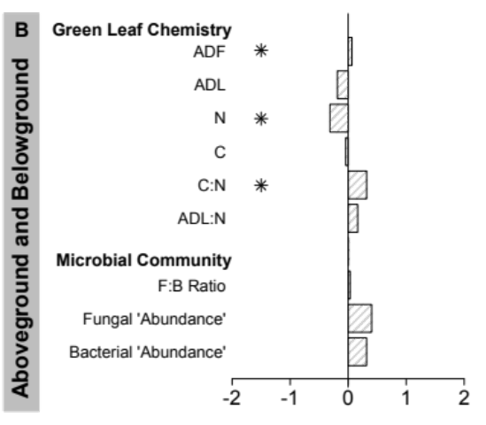
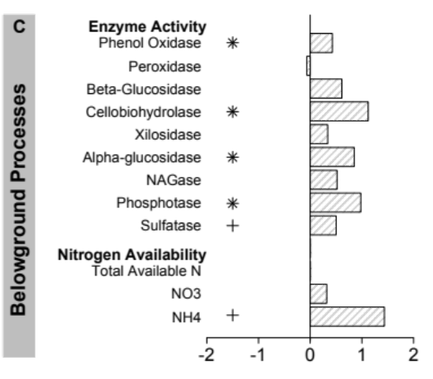
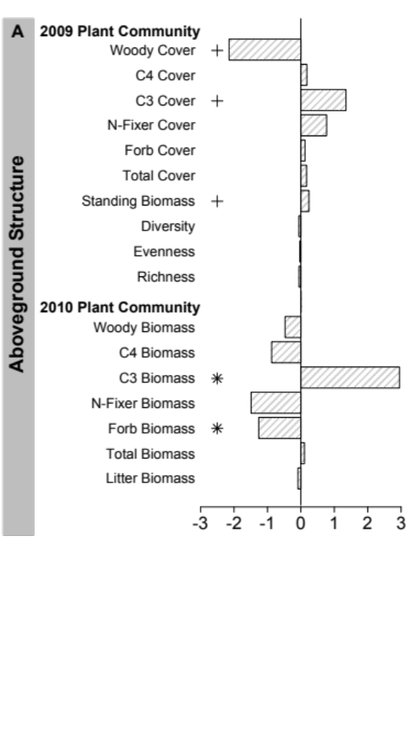
Figure 2. Effects of rodent absence/presence on (A) 2009 and 2010 aboveground community structure; (B) plant leaf chemistry and belowground structure; and (C) ecosystem process and function expressed as log (2) of the ratios of means from rodent exclusion to access plots. Values below 0 indicate stimulation under rodent acess; values above 0 indicate stimulation under rodent exclusion. * P < 0.05, + indicates 0.05 < P < 0.10. Values for actual means +/- SE and ANOVA results are given in Table 1.

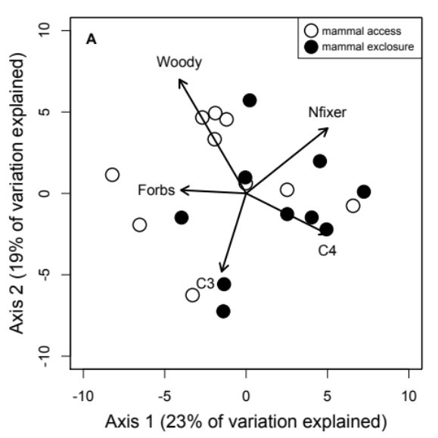
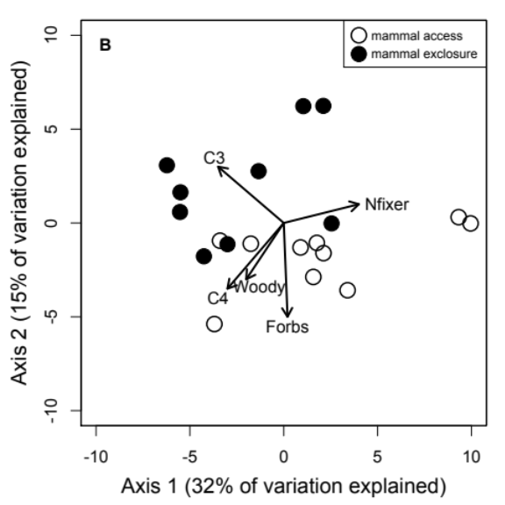
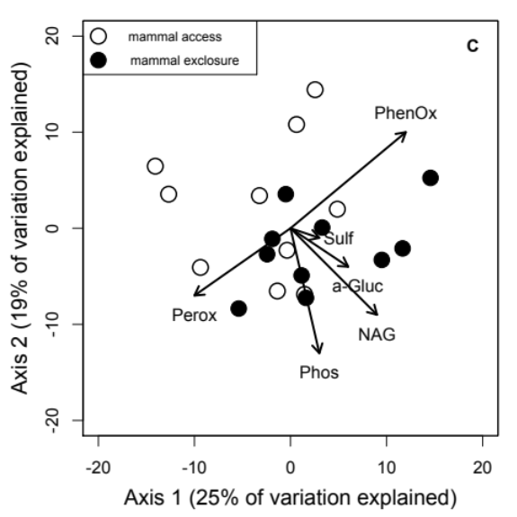
Figure 3. Principal coordinate (PCO) axes illustrating 2009 plant functional group (A), 2010 plant functional group (B), and extracellular enzyme composition (C) with small mammal access (clear circles) and rodent exclusion (filled circles) plots. PCO was performed on Bray-Curtis similarity matrix, which was based on log-transformed (log x +1) functional group-specific relative foliar cover and extracellular enzyme-specific relative potential activity. Plant functional group and extracellular enzyme vectors were overlaid to represent their association to the PCO axes and associated rodent treatments.
captured changes in the active community. At the same time, the community may have stayed constant, but shifted its activity with the changing plant inputs. Finally, old-field ecosystems can be relatively nutrient rich (Blue et al. 2011); thus bacteria may still dominate the decomposition pathway even if litter entering the system is of lower quality.
While the coarse-scale composition of the microbial community remained unchanged, the enzyme activity of the soil community was higher in exclosure relative to access plots. Rodent exclosures had higher cellulose (cellobiohydrolase), starch (alpha-glucosidase) organic phosphorus (phosphatase), and lignin (phenoloxidase) degrading enzyme activity. Whether enzyme activity reflects what nutrients are available (substrate supply) versus what microbes are seeking (microbial demand) remains unknown. However, nutrient additions via herbivores or changes in plant communities can increase enzyme activities (Riggs & Hobbie 2016). The addition of labile carbon substrates to nutrient rich ecosystems can stimulate enzyme activity by alleviating microbial carbon limitation (Asmar et al. 1994). When herbivores were removed from the plots, the plant community shifted and the carbon inputs to the soil also likely shifted (e.g. Ritchie et al. 1998; Sirotnak & Huntly 2000). It may be that the aboveground chemical quality declined in the exclosure plots which led to an increase in enzyme activity to break down the more recalcitrant litter inputs—with the higher phenoloxidase activity in exclosure plots possibly providing further support for this hypothesis.
Rodents in our system had little impact on potential soil nitrogen mineralization and nitrification rates; however, this lack of directional response has been observed in other studies (Sirotnak & Huntly 2000; Bakker et al. 2004). Potential nitrogen mineralization could be high in the access and the exclosure plots for different reasons: bioturbation of the soil or deposition of fecal material by rodents may increase mineralization in the access plots to the same extent that changes in the plant composition may increase mineralization in the exclosure plots. Bioturbation by pocket gophers increased nitrification rates by 186% in an alpine system (Litaor et al. 1996). Herbivores in the access plots could have mixed the soil, leading to a release of plant available nutrients that we were unable to measure with our potential mineralization assays. An increase in mineralization due to soil mixing could lead to an increase in plant chemical quality when rodents were present. Alternatively, total soil carbon and nutrient pools are large and thus can be slow to respond to short-term (4-10 years of experimental manipulation) changes in plant inputs (e.g., Hungate et al. 1996; Smith 2004). For example, deer exclosures in a boreal ecosystem impacted soil nitrogen mineralization, but only after 10 years of manipulation (Harrison and Bardgett 2004). Thus, changes in the nitrogen mineralization may increase between our treatments over time as the influence of changes in biomass inputs and chemistry compounds.
Overall, our study shows that rodents can directly and indirectly impact above- and below-ground ecosystem properties, even over short 2–3 year time scales. These data contribute to a growing body of work demonstrating that vertebrate consumers, both large and small, are important components of ecosystems and that their impacts on ecosystem function can extend beyond the consumption of plant biomass (Bardgett et al. 1998, Bardget and Wardle 2003, Wardle et al. 2004, Habeck and Meehan 2008). However, consumers and their effects are often excluded or ignored in large-scale ecosystem manipulations that aim to understand how ecosystems will function under a variety of global changes (but see Borer et al. 2014). If ecologists are to better describe and predict what factors will structure ecosystems and their functions across landscapes and over time, rodent consumers should be included in both manipulations and models.

Acknowledgements
We thank EA Austin, L Breza, MA Cregger, J Childs, P Kardol, RJ Norby, L Marsh, A Oaks, H Smith, JAM Moore, G Robinson, and H Tran for help in the field and the lab. K Rewcastle, J Henning, CM Patterson, Q Read, L Chick, and J Jiang gave valuable feedback on earlier versions of the manuscript. Pat Parr and Harry Quarrels from Oak Ridge National Laboratory facilitated research logistics and safety training respectively. The Tennessee Wildlife Resources Agency, particularly Jim Evans, assisted with plot maintenance and logistics. This material is based upon work supported by the National Science Foundation Graduate Research Fellowship to LM under Grant No. DGE-0929298, the Department of Ecology and Evolutionary Biology at the University of Tennessee, and a U.S. DOE Global Change Education Program – Graduate Research Environmental Fellowship to CH.

References
Afzal, M., and W. A. Adams. 1992. Heterogeneity of soil mineral nitrogen in pasture grazed by cattle. Soil Science Society of America Journal 56:1160–1166.
Agrawal, A. A., S. Y. Strauss, and M. J. Stout. 1999. Costs of induced responses and tolerance to herbivory in male and female fitness components of wild radish. Evolution 53:1093–1104.
Anderson, M. J., K. E. Ellingsen, and B. H. McArdle. 2006. Multivariate dispersion as a measure of beta diversity. Ecology Letters 9:683–693.
Asmar, F., F. Eiland, and N. E. Nielsen. 1994. Effect of extracellular-enzyme activities on solubilization rate of soil organic nitrogen. Biology and Fertility of Soils 17:32–38.
Augustine, D. J., S. J. McNaughton, and D. A. Frank. 2003. Feedbacks between soil nutrients and large herbivores in a managed savanna ecosystem. Ecological Applications 13:1325–1337.
Bagchi, S., and M. E. Ritchie. 2010. Introduced grazers can restrict potential soil carbon sequestration through impacts on plant community composition. Ecology Letters 13:959–968.
Bakker, E. S., H. Olff, M. Boekhoff, J. M Gleichman, and F. Berendse. 2004. Impact of herbivores on nitrogen cycling: contrasting effects of small and large species. Oecologia 138:91–101.
Bardgett, R. D., D. A. Wardle, and G. W. Yeates. 1998. Linking above-ground and below-ground interactions: How plant responses to foliar herbivory influence soil organisms. Soil Biology & Biochemistry 30:1867–1878.
Bardgett, R. D., and D. A. Wardle. 2003. Herbivore-mediated linkages between aboveground and belowground communities. Ecology 84:2258–2268.
Blue, J. D., L. Souza, A. T. Classen, J. A. Schweitzer, and N. J. Sanders. 2011. Soil nitrogen amendments and insect herbivory alter above- and belowground plant biomass in an old-field ecosystem. Oecologia 167:771–780.
Borer, E. T., E. W. Seabloom, D. S. Gruner, W. S. Harpole, H. Hillebrand, E. M. Lind, P. B. Adler, J. Alberti, T. M. Anderson, J. D. Bakker, et al. 2014. Herbivores and nutrients control grassland plant diversity via light limitation. Nature 508:517–520.
Braun-Blanquet, J. 1932. The study of plant communities. Plant sociology. First ed. Fuller, G.D. and Conrad, H.S. (trans). New York: McGraw-Hill.
Bray, J. R., and J. T. Curtis. 1957 An ordination of the upland forest communities of southern Wisconsin. Ecological Monographs 27:325–349.
Brown, J. H., and E. J. Heske. 1990. Control of a desert-grassland transition by a keystone rodent guild. Science 250:1705–1707.
Clark, J. E., E. C. Hellgren, J. L. Parsons, E. E. Jorgensen, D. M Engle, and D. M. Leslie Jr. 2005. Nitrogen outputs from fecal and urine deposition of small mammals: Implications for nitrogen cycling. Oecologia 144:447–455.
Cornwell, W. K., J. H. C. Cornelissen, K. Amatangelo, E. Dorrepaal, V. T. Eviner, O. Godoy, S. E. Hobbie, B. Hoorens, H. Kurokawa, N. Pérez-Harguindeguy, et al. 2008. Plant species traits are the predominant control on litter decomposition rates within biomes worldwide. Ecology Letters 11:1065–1071.
Cregger, M. A., C. Schadt, N. G. McDowell, W. T. Pockman, and A. T. Classen. 2012. Microbial community response to precipitation change in a semi-arid ecosystem. Applied and Environmental Microbiology 78:8587–8594.
Day, T. A., and J. K. Detling. 1990. Grassland patch dynamics and herbivore grazing preference following urine deposition. Ecology 71:180–188.
Frank, D. A., and S. J. McNaughton. 1992. The ecology of plants, large mammalian herbivores, and drought in Yellowstone National Park. Ecology 73:2043–2058.
Habeck, C.W., and T.D. Meehan. 2008. Mass invariance of population nitrogen flux by terrestrial mammalian herbivores: an extension of the elemental equivalence rule. Ecology Letters 11:898–903.
Harrison, K. A., and Bardgett, R. D. 2004. Browsing by red deer negatively impacts on soil nitrogen availability in regenerating native forest. Soil Biology and Biogeochemistry 36:115–126.
Hole, F.D. 1981. Effects of animals on soil. Geoderma 25:75–112.
Howe, H. F., J. S. Brown, and B. Zorn-Arnold. 2002. A rodent plague on prairie diversity. Ecology Letters 5:30–36.
Howe, H. F., and D. Lane 2004. Vole-driven succession in experimental wet-prairie restorations. Ecological Applications 14:1295–1305.
Howe, H. F., B. Zorn-Arnold, A. Sullivan, and J. S. Brown. 2006. Massive and distinctive effects of meadow voles on grassland vegetation. Ecology 87:3007–3013.
Hungate, B. A., R. B. Jackson, C. B. Field, and F. S. Chapin III. 1996. Detecting changes in soil carbon in CO₂ enrichment experiments. Plant and Soil 187:135–145.
Huntly, N., and O. J. Reichman. 1994. Effects of subterranean mammalian herbivores on vegetation. Journal of Mammalogy 75:852–859.
Ladygina, N. and K. Hedlund. 2010. Plant species influence microbial diversity and carbon allocation in the rhizosphere. Soil Biology & Biochemistry 42:162–168.
Lessard, J., W. N. Reynolds, W. A. Bunn, M. A. Genung, M. A. Cregger, E. Felker-Quinn, M. N. Barrios-Garcia, M. L. Stevenson, R. M. Lawton, C. B. Brown, M. Patrick, J. H. Rock, M.A. Jenkins, J. K. Bailey, and J. A. Schweitzer. 2012. Equivalence in the strength of deer herbivory on above and belowground communities. Basic and Applied Ecology 13:59–66.
Litaor, M. I., R. Mancinelli, and J. C. Halfpenny. 1996. The influence of pocket gophers on the status of nutrients in Alpine soils. Geoderma 70:37–48.
Martin, L. M., and B. J. Wilsey. 2006. Assessing grassland restoration success: Relative roles of seed additions and native ungulate activities. Journal of Applied Ecology 43:1098–1109.
Meentemeyer, V. 1978. Macroclimate and lignin control of litter decomposition rates. Ecology 59:465–472.
Niwa, S., L. Mariani, N. Kaneko, H. Okada, and K. Sakamoto. 2011. Early-stage impacts of sika deer on structure and function of the soil microbial food webs in a temperate forest: A large-scale experiment. Forest Ecology and Management 261:391–399.
Pastor, J., B. Dewey, R. J. Naiman, P. F. McInnes, and Y. Cohen. 1993. Moose browsing and soil fertility in the boreal forests of Isle Royale National Park. Ecology 74:467–480.
Peters, H. A. 2007. The significance of small herbivores in structuring annual grassland. Journal of Vegetation Science 18:175–182.
Phillips, D. H., J. E. Foss, C. A. Stiles, C. C. Trettin, and R. J. Luxmoore. 2001. Soil-landscape relationships at the lower reaches of a watershed at Bear Creek near Oak Ridge, Tennessee. Catena 44:205–222.
R Core Team. 2013. R: A language and environment for statistical computing. R Foundation for Statistical Computing, Vienna, Austria.
Reichman, O. J. 1979. Desert granivore foraging and its impact on seed densities and distributions. Ecology 60:1085–1092.
Reichman, O. J., and E. W. Seabloom. 2002. The role of pocket gophers as subterranean ecosystem engineers. TRENDS in Ecology & Evolution 17:44–49.
Riggs, C. E., and S. E. Hobbie. 2016. Mechanisms driving the soil organic matter decomposition response to nitrogen enrichment in grassland soils. Soil Biology and Biochemistry 99:54–65.
Ritchie, M. E., D. Tilman, and J. M. H. Knops. 1998. Herbivore effects on plant and nitrogen dynamics in oak savanna. Ecology 79:165–177.
Robertson, G. P., D. Wedin, P. M. Groffman, J. M. Blair, E. A. Holland, K. J. Nadelhoffer, and D. Harris. 1999. Soil carbon and nitrogen availability. Nitrogen mineralization, nitrification, and soil respiration potentials. Pages 258-271 in G. P. Robertson, D. C. Coleman, C. S. Bledsoe, and P. Sollins, editors. Standard soil methods for long-term ecological research. Oxford University Press, New York.
Saiya-Cork, K. R., R. L. Sinsabaugh, and D. R. Zak. 2002. The effects of long term nitrogen deposition on extracellular enzyme activity in an Acer saccharum forest soil. Soil Biology & Biochemistry 34:1309–1315.
Sariyildiz, T., J. M Anderson, and M. Kucuk. 2005. Effects of tree species and topography on soil chemistry, litter quality, and decomposition in Northeast Turkey. Soil Biology and Biochemistry 37:1695–1706.
Schultz, J. C., and I. T. Baldwin. 1982. Oak leaf quality declines in response to defoliation by gypsy-moth larvae. Science 217:149–150.
Sinsabaugh, R. L., M. M. Carreiro, and D. A. Repert. 2002. Allocation of extracellular enzymatic activity in relation to litter composition, N deposition, and mass loss. Biogeochemistry 60:1–24.
Sirotnak, J. M., and N. J. Huntly. 2000. Direct and indirect effects of herbivores on nitrogen dynamics: Voles in riparian areas. Ecology 81:78–87.
Smith, P. 2004. How long before a change in soil organic carbon can be detected? Global Change Biology 10:1878–1883.
Strickland, M. S., and J. Rousk. 2010. Considering fungal:bacterial dominance in soils – Methods, controls, and ecosystem implications. Soil Biology & Biochemistry 42:1385–1395.
van Wijnen, H. J., R. van der Wal, and J. P. Bakker. 1999. The impact of herbivores on nitrogen mineralization rate: consequences for salt-marsh succession. Oecologia 118:225–231.
Veen, G. F., H. Olff, H. Duyts, and W. H. van der Putten. 2010. Vertebrate herbivores influence soil nematodes by modifying plant communities. Ecology 91:828–835.
Wardle, D. A., G. M. Barker, G. W. Yeates, K. I. Bonner, and A. Ghani. 2001. Introduced browsing mammals in New Zealand natural forests: Aboveground and belowground consequences. Ecological Monographs 4:587–614.
Wardle, D. A., G. W. Yeates, W. Williamson, and K. I. Bonner. 2003. The response of a three trophic level soil food web to the identity and diversity of plant species and functional groups. Oikos 102:45–56.
Wardle, D. A., R. D. Bardgett, J. N. Klironomos, H. Setälä, W. H. Van Der Putten, and D. H. Wall. 2004. Ecological linkages between aboveground and belowground biota. Science 304:1629–1633.
Whittaker, R. H. 1960. Vegetation of the Siskiyou Mountains, Oregon and California. Ecological Monographs 30:279–338.
Willot, S. J., A. J. Miller, L. D. Incoll, and S. G. Compton. 2000. The contribution of rabbits (Oryctolagus cuniculus L.) to soil fertility in semi-arid Spain. Biology and Fertility of Soils 31:379–384.

CHAPTER II
The presence of rodents decreases the extent of burning

Abstract
While herbivores and fire individually shape plant communities, each can alter the patterns of the other through direct changes to and feedbacks from the plant community. It is assumed primary consumers alter fire dynamics through the reduction or alteration of plant-derived fuel loads, but this interaction is seldom directly tested. Here, we examined whether i) rodent exclusion altered a fire disturbance in an old-field ecosystem, ii) rodent-driven changes in plant community composition or structure influenced the fire disturbance, and iii) changes in the plant community resulted from fire disturbance. We found burn extent was 260% greater in plots where rodents were experimentally excluded than where they were present. However, we found no indication rodents altered the plant community prior to burning in a way that explains this burn response. We also found cover of graminoids and species richness increased under rodent exclusion post-fire and plant community composition differed between rodent treatments. These results support previous work demonstrating fire and consumers alter plant communities and highlights that consumers can reduce the extent of the effects of fire. Furthermore, our results indicate that rodents, like larger primary consumers, influence fire dynamics and should be included when considering fire management of ecosystems.

Introduction
There is little doubt that herbivores influence the structure and dynamics of plant communities (e.g., Frank and McNaughton 1992, Augustine et al. 2003), either through selective browsing or biomass removal. Disturbance by fire is, in many ways, similar to herbivory—some may even call it pyric herbivory—inasmuch as it removes aboveground biomass, sometimes selectively (Bond & Keeley 2005; Michener et al. 1997; McKenzie et al. 2011). As a consequence, fire can alter plant populations and communities over the short- and long-term (Boerner 1982), and the cascading effects of fire can modify successional patterns, re-shape plant community structure, and influence animal populations (Ahlgren & Ahlgren 1960; Fox & Fox 1987).
In many ecosystems, fire and herbivory rarely act independently but rather interact to shape plant communities. Indeed, a growing number of studies examine how the response of plants depends on whether fire and herbivory interact or operate independently (e.g., Collins & Calabrese 2012; Sankaran et al. 2008; Belsky 1992). The response of a plant community to fire and herbivory may depend on the order in which fire and herbivory occur. For example, some studies highlight how fires can affect plant community composition and in turn the behavior of herbivores (e.g., Allred et al. 2011; Pfeiffer & Hartnett 1995; Vermeire et al. 2004). Herbivores can also influence the dynamics of fires by altering the composition and standing biomass of the resident plant community, presumably changing fuel load and quality. However, the bulk of these studies examine the effects of high-density ungulate or elephant herbivores and overlook the role of rodents on plant community structure and fires.
Here, we examine whether the presence of rodents influences the impact of fire in an old-field ecosystem and in turn alters plant community structure. The majority of studies to date that ask whether herbivores mediate the effects of fire on plant communities have focused on the impacts of mega-herbivores and ungulate grazers in grassland ecosystems (e.g., Sankaran et al. 2008; Archibald et al. 2005; Collins & Calabrese 2012). Despite their ubiquity and abundance, few studies, to our knowledge, have examined how rodents might mediate the effects of fire on the plant community. Specifically, we ask a series of inter-related questions:(1) Does the presence of rodents mediate a fire disturbance? (2) Is the effect of rodents on fire disturbance due to alterations of the plant community? (3) Do fire and rodents interact to shape plant community structure?

Methods and Materials

Site description
We conducted this work in an old-field ecosystem at Freels Bend at the Oak Ridge National Environmental Research Park (NERP) near Oak Ridge, Tennessee (35º58’ N, 84º17’W). The soil is classified as a Typic Hapludult (Phillips et al. 2001). Precipitation is evenly distributed throughout the year with an annual mean of 1360 mm, while mean daily temperatures range from 3°C in January to 31°C in July. Common rodents at this site include the hispid cotton rat (Sigmodon hispidus), woodland vole (Microtus pinetorum), eastern harvest mouse (Reithrodontomys humulis) and deer mice (Peromyscus spp.). Old-field ecosystems are a common ecosystem type, occupying upwards of 2.02 × 10⁷ ha in the eastern US alone (Cramer et al. 2008). Common plant species at our site include tall goldenrod (Solidago altissima), sawtooth blackberry (Rubus argustus), white cornbeard (Verbesina virginica), trumpet creeper (Campsis radicans), sericea (Lespedeza cuneata), brome grass (Bromus sp.), yellow crownbeard (Verbesina occidentalis), clovers (Trifolium spp.), broomsedge (Andropogon virginicus), and orchard grass (Dactylis glomerata).

Experimental design
In March 2008 twenty (4 × 8 m) experimental plots were established following a moderate prescribed burn that removed the majority of the aboveground biomass. Each plot was separated from its neighbor by 4 to 8 meters over an area of roughly 40 × 60 meters (Figure 1). Each plot was trenched around its perimeter with a backhoe and galvanized hardware cloth fencing (122 cm width, 0.64 cm mesh) was installed 40 cm into the soil profile. The installed fencing extended 82 cm above the soil surface and aluminum flashing (36 cm width) was installed on the upper portion of the fence to exclude climbing rodents. Ten plots were randomly assigned as access treatment plots and ten as exclosure plots. Ten holes (15 cm × 30 cm) were cut at ground level around the perimeter of access plots to allow for passive entry of rodent-sized animals.
We used live trapping in March and July in 2008, 2009, and 2010 to determine the effectiveness of the exclusion treatment. Sherman live traps were placed in a 10 × 10 grid with traps 10 meters apart. Recapture rates were low so densities were not calculated but instead we report just minimum number known alive, averaged between trapping periods within each year. Microtus pinetorum was only found in 2009 and 2010 (7 and 17 individuals, respectively). Similarly, Sigmodon hispidus and Reithrodontomys humulis were also captured in only 2009 and 2010 (3, 40; 10, 3; repectively). Peromyscus, however, was found in all three years (7, 3, 7). During each trapping period we also placed two traps inside each access and exclusion plot. While rodent numbers in the access plots were low, we did observe signs of activity in the access plots in the form of runways, feces, burrows, and herbivory. No rodents were ever trapped within exclusion plots nor did we notice signs of activity. Furthermore, in June 2012 we checked for rodent activity, or lack thereof, by using track pads to estimate rodent activity. Track pads were created using acetate paper painted with a graphite solution (see Connors et al. 2005). Two plates were placed within each plot and plates were placed outside between plots and around the perimeter of the site. Plates were left for 48 hours after which were collected and photos taken of each plate. In the lab we used WinFolia 2009a to scan each photo to determine “activity” levels. Traditionally, this program differentiates contrast between leaves and background color and is most often used to measure leaf herbivory. We used the program to distinguish between black (undisturbed, painted) and white contrast. We recorded the number of black and white pixels and used these pixels as a proxy for disturbance. Disturbance did include smudges from vegetation movement (e.g. wind) but also mammal activity (foot prints were at times clear and readily distinguished but never on exclosure plates). Disturbance events on plates were significantly higher in access plots (64.61 (8.72); 34.38 (6.24) Mean (SE); F = 9.85, p < 0.05).
On 15 March 2012, a controlled burn was implemented as part of a conservation approach to maintain a grassland-forest mosaic. The burn was performed on only March 15th. Each plot—and the areas between and surrounding the plots—were individually lit on fire with drip torches. The metal fencing did not impede nor hinder the fire and the fire was prescribed by a team who was unfamiliar with the study and its design. To examine whether rodent exclusion mediated the burn, we measured percent ground cover burned in each plot immediately following the controlled burn (March 20). Within each of the experimental plots, we randomly placed two 1-m² quadrats and recorded percent cover of green vegetation, burned vegetation, and bare ground. The random location of these quadrats were determined by subdividing the 4 x 8 m plots into smaller 1 m² (or 0.25 m² for plant community detailed below) using the southwestern corner of each plot as point 0,0 and the southern edge as our X-axis and the western edge as our Y axis. We then used a random number generator from Excel to determine our X and Y coordinates for two different subplots within each larger treatment plot. This was done for each of the twenty plots. To test whether there was a difference in fire disturbance between the treatment plots, we used a Wilcoxon signed-rank test because the residual variance was not normally distributed between the treatments.
To address whether the effect of rodents on the fire disturbance was explained by alterations in the plant community and whether fire and rodents interacted to influence the plant community post burn, we assessed plant community composition in each plot by measuring plant foliar cover in two randomly selected 0.25 m² subplots at the peak of the growing season in June 2011 and 2012—three and four years after exclosures were installed. Plant species-specific foliar cover was measured using a modified Braun-Blanquet cover class scale (Braun-Blanquet 1932) with six categories: 1 = <1%, 2 = 1-5%, 3 = 5-25%, 4 = 25-50%, 5 = 50-75%, 6 = 75-100%. We recorded the median foliar cover category value for each species in each subplot, then we took the average of these values between the two 0.25 m² subplots within each plot. We converted absolute cover to relative cover as a way to standardize among our plant communities. This approach allows us to compare shifts in composition even if total cover is altered. Foliar cover for each functional group (e.g., forbs, graminoids, nitrogen fixers, and woody) was calculated by summing the species-specific foliar cover within each functional group. Species evenness was calculated as the probability of interspecific encounter, PIE, where P(i) was the proportion of foliar cover for species i.
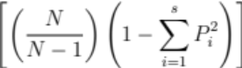

Statistical Analysis
We used a one-way analysis of variance (ANOVA) to examine the impact of rodent exclosure on plant community structure (richness and evenness) in 2011, prior to the burn. To examine the relationship between the rodent treatment and 2011 plant community composition, we used a distance-based redundancy analysis (dbRDA) for both species and functional group levels. We followed this analysis with a permutation significance test generating a pseudo F-ratio (PERMANOVA) (Anderson 2006). Permutation tests were conducted on Jaccard abundance-based similarity matrices.
We used ANOVA to examine the impact of rodent presence and absence on plant species richness and evenness in July 2012 (post burn). To examine the effects of the prescribed burn on community composition, we used exactly the same approach described above (as in 2011) and again conducted a PERMANOVA test on plant functional groups and species cover. To further explore whether fire altered plant community composition, we used an analysis of multivariate homogeneity of variance (betadisper) to determine whether there were any differences in community dispersion (i.e., variability) among treatments (Anderson 2006b). Finally, we used a repeated measures ANOVA to examine the change in relative functional group cover between years and treatments. All of the data were square root transformed to meet assumptions of normality for ANOVA. All of the statistical analyses were completed using the vegan package in R version 3.2.2 (R Core Team 2013).

Results
When rodents were excluded, burn extent, defined as the percent area ground cover burned, was 3.6× greater than when rodents were present (F = 209.38, p < 0.01, Figure 4). This suggests that rodents most likely altered the plant community the previous year

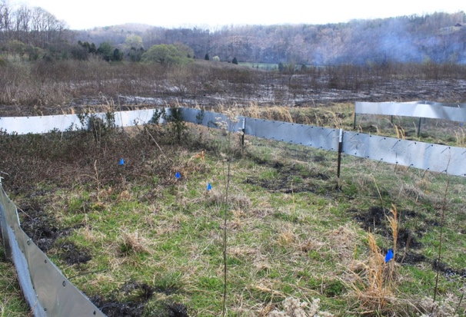
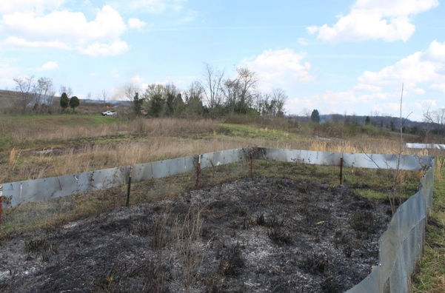
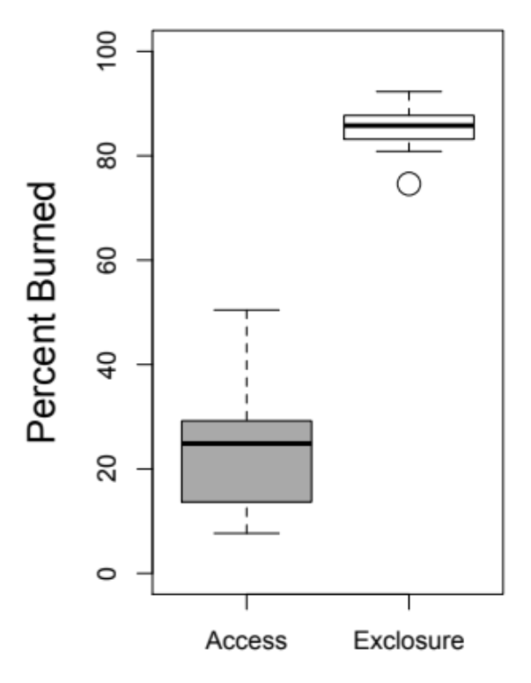
Figure 4. Difference in percent ground cover burned between access and exclosure plots. Typical access and exclosure plots post burn pictured.
Access
Exclosure

so as to drastically cause the observed burn patterns. However, prior to burning this old-field ecosystem, rodents had no significant effect on plant species richness (F = 2.32, p = 0.15; Figure 5a), evenness (F = 1.47, p = 0.24; Figure 5b), community dispersion (Pseudo F = 1.70, p (PERM) = 0.21; Figure 5c), species community composition (Pseudo F = 0.67, p (PERM) = 0.81), or functional group composition (Pseudo F = 1.26, p (PERM) = 0.26; Figure 5d) during mid-summer of 2011. However, when the plant community was surveyed in previous years, measurements were taken later in the growing season (September). When measured in September, we did find differences in the plant community—in particular between C₃ graminoid cover and biomass (Moorhead et al. in press). When rodents are excluded, C₃ cover was 2.6 × higher (September 2009) and C₃ biomass was 7.7 × higher (September 2010). When we use C₃ graminoid biomass from September 2010 to predict our observed burn patterns, we find C₃ graminoid biomass explains ~65% of the variation in burning (Figure 6).
While plant communities were similar between treatments prior to the burn, their composition diverged significantly after the burn, suggesting fire and rodents interact to
shape the trajectory of the plant community. After the prescribed burn, plant species richness was 19% greater in rodent exclosure plots than in access plots (F = 4.05, p = 0.06; Figure 7a), but evenness did not differ between exclosure and access plots (F = 2.17, p = 0.16; Figure 7b). While there was no effect of rodents on community dispersion (Pseudo F = 0.03, p (PERM) = 0.85; Figure 7c), both species composition (Pseudo F = 1.79, p (PERM) = 0.03; Figure 7d) and functional group composition (Pseudo F = 2.25, p (PERM) = 0.06) differed between exclosure plots and access plots. Post burn, rodent treatment accounted for 9% of the variation in species composition and 11% of the variation in functional-group composition. In particular, cover of graminoids did not differ between rodent treatments in 2011 (pre-burn) but graminoid cover was 89% greater in exclosure treatments post burn (F = 6.73, p = 0.01; Figure 8a).

Discussion
The effects of herbivores on plant community structure are often idiosyncratic;

Figure 5. Plant community structure and composition between access and exclosure plots in 2011 (pre-burn). There was no difference among treatments in richness (a), evenness (b), dispersion (c) or functional group composition (d) (axis 1 explains 7%, axis 2 explains 42%).
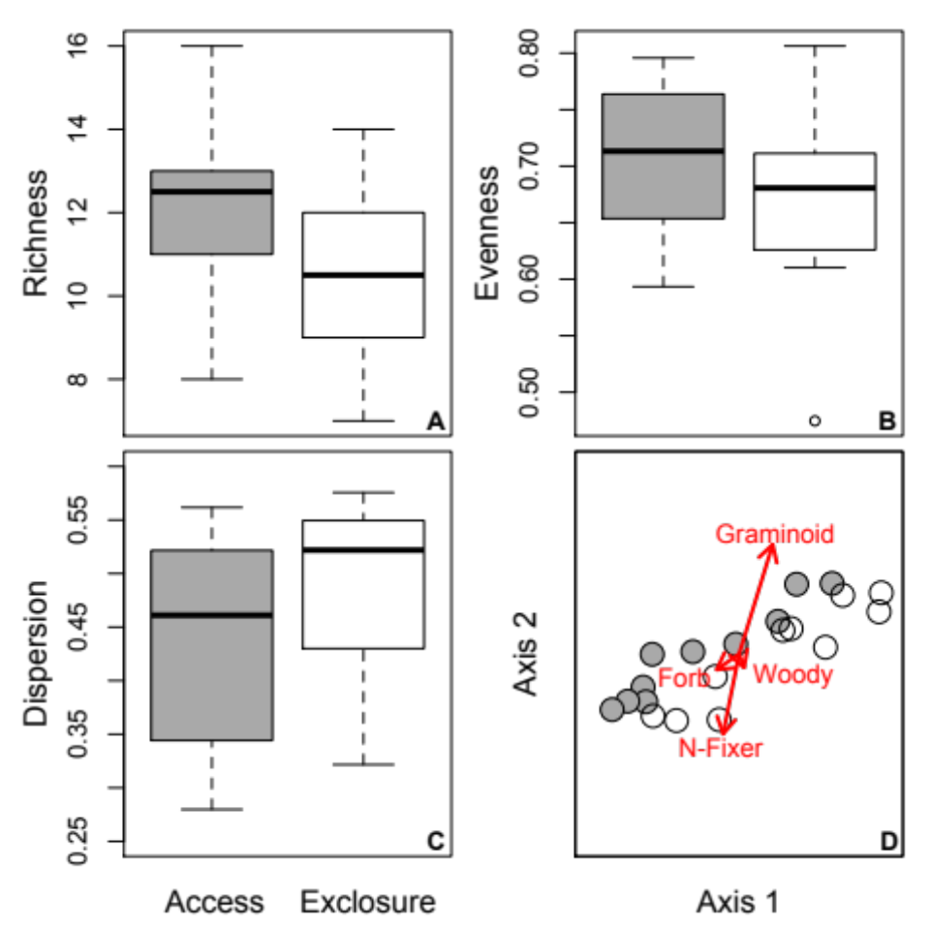
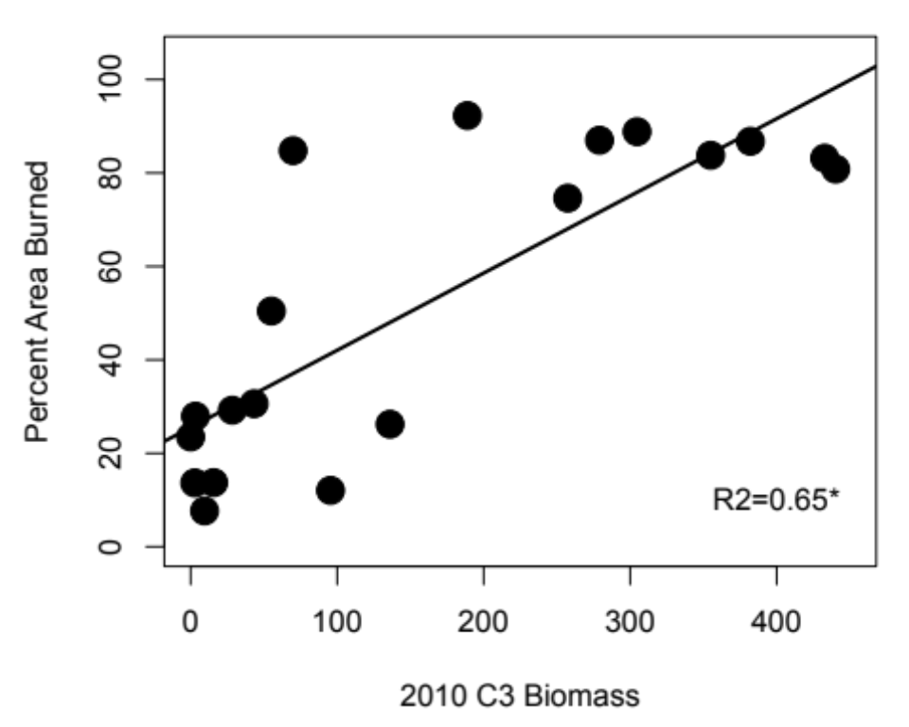
Figure 6. Percent area burned in response to 2010 C₃ graminoid biomass (F = 31.23, p < 0.001).
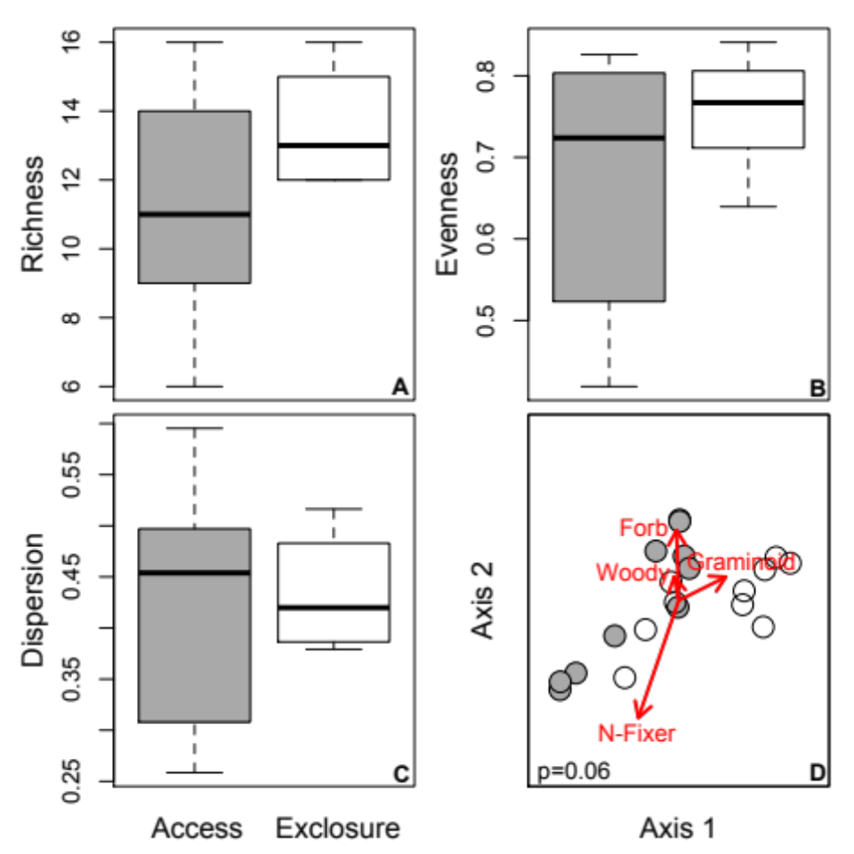

Figure 7. Plant community structure and composition between access and exclosure plots in 2012 (post-burn). There was no difference in evenness (b) or dispersion (c); marginal difference in richness (a) with functional group composition (d) differing between access and exclosure plots (axis 1 explains 11%, axis 2 explains 37%).
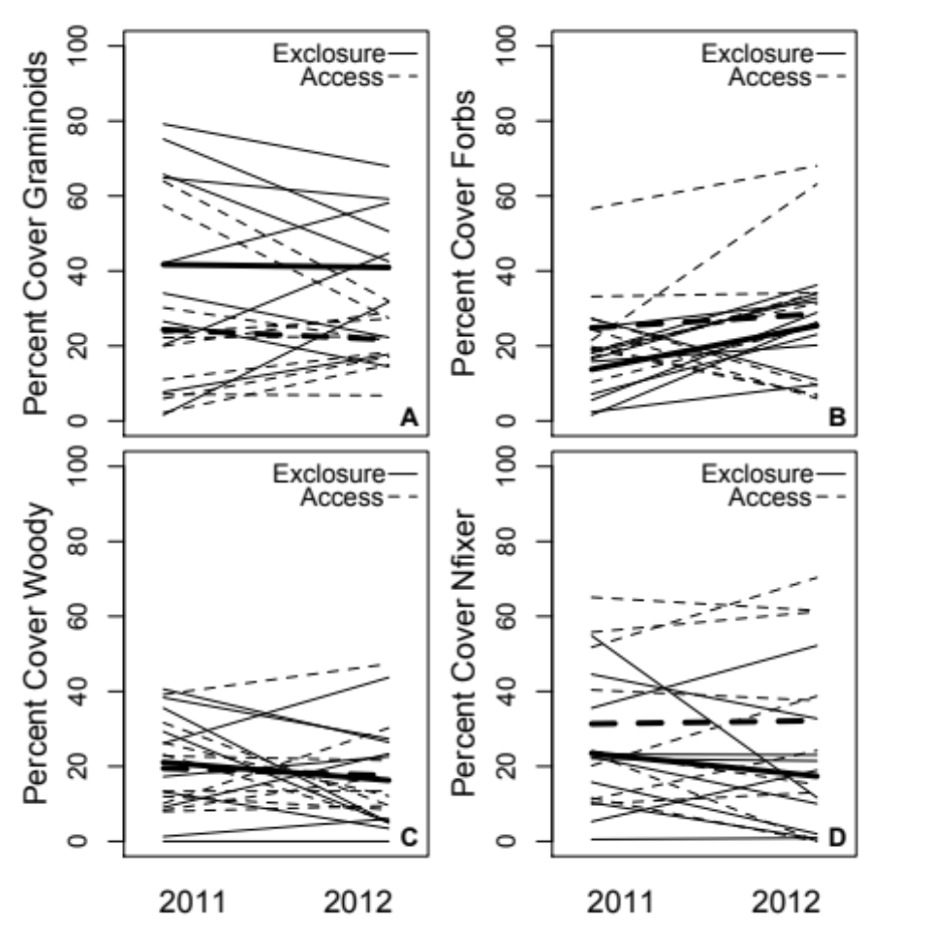
Figure 8. Each line represents one plot’s functional group cover change between 2011 and 2012. Bold lines represent treatment averages (solid line for exclosure plots, dashed line for access plots). Treatment only had an effect on graminoid cover in 2012 (note the narrowing of both dashed and solid lines from 2011 to 2012); sample years had no effect (meaning each functional group’s cover did not differ between years for either access or exclosure treatments) and there was no treatment × year effect.
sometimes herbivory increases diversity and richness or alters community composition, and sometimes it does not (e.g., Hobbs 1996; Milchunas & Lauenroth 1993; Diaz et al. 2006; Augustine & McNaughton 1998). While initially surprising (at least to us), the lack of an effect of herbivory is not altogether uncommon. In another 6-year experiment conducted within the same research area as our study, there was no direct effect of reduced insect abundance on aboveground structure (Wright et al. 2014). Similarly, there was no effect on total aboveground biomass, richness or composition of the subdominant plant community when two dominant species were removed (Souza et al. 2011). Together, these results indicate an overall lack of change in response to a variety of different manipulations and suggests that the plant communities in these old fields may be resistant to vegetation removal, however it occurs. Or, it could be that rodents simply have no impact on plant communities in this ecosystem.
Despite the lack of an effect of rodents on plant community structure in 2011, burn extent was nearly 4× greater when rodents were absent than when they were present. One likely mechanism is that fuel load is affected by the presence of rodents. It is possible that rodent activity, and their impacts on the plant community and fuel load, happened later in the growing season when we did not take measurements. Rodent populations, such as voles, can peak at the end of a growing season (Norrdahl et al. 2002) when plant communities are beginning to senesce. Thus, their impacts on plant community composition and fuel load may be delayed. In support, in 2010 aboveground biomass was measured in September and similar to other ecosystems (e.g., Leonard et al. 2010), access plots had ~ 8× less C₃ graminoid biomass later in the season compared to exclosure plots (standing green biomass harvested to ground level and sorted into functional groups, unpublished data). However, we did not have biomass data from September 2011 to test this idea. Rodents can also remove fuel load during the winter months (Norrdahl et al. 2002), a response we would not have captured in this study. In sum, rodents at our site either do not have a measurable effect on plant community structure and fuel load, or their effects are stronger during times of the year that we did not capture.
Our results do suggest rodents and fire interact and the change in the 2012 plant community composition between treatments is a response to this interaction. Furthermore, previous research conducted nearby found insect herbivores interact with nitrogen availability and the propagule pressure of an invasive plant species to alter aboveground biomass, suggesting herbivore interactions with other biotic and abiotic components of the system are required to set the trajectory of the ecosystem in a new direction (Sanders et al. 2007; Wright et al. 2014).
Herbivores have large and sustained impacts on ecosystem structure and function; impacts that do not necessarily scale to herbivore size. For example, large-herbivores,
such as moose, can slow the function of forests by selectively consuming higher quality forage while leaving behind lower quality plants leading to dominance of slower processed plant litter (e.g. Pastor et al. 1993). Small mammals can similarly shape ecosystems via their consumption of plant material (Zorn-Arnold et al. 2006) and their engineering of plant communities (Howe et al. 2002). However, a large comparative study by Bakker et al. (2006) finds the effects of small mammals on plant community structure to be variable across a productivity gradient whereas the effects of larger herbivores were consistent. Since small mammals have been shown to alter the structure of the aboveground plant community, just as larger herbivores can and do, it should be expected that rodents would indirectly influence fire patterns, yet that area of research is dominated by large herbivores.
Herbivores and fire both independently and collectively shape plant communities. For example, woody-grass dynamics are highly responsive to fire-grazer interactions (e.g Archibald et al. 2005; Gordijn et al. 2012; Guldemond & van Aarde 2008). While natural fire regimes can suppress woody growth (Bond et al. 2005; Higgins et al. 2000), herbivores can indirectly increase woody encroachment due to consumption of grasses and other herbaceous forage (e.g., Van Auken 2000; Grellier et al. 2012). In both American and South African grasslands, large grazers decreased graminoid and increased forb cover, but the effects of fire on plant community structure depended on whether grazers were present or not and in what abundance (Koerner and Collins 2013). Similarly, fire and grazing interacted to alter plant community structure in Konza Prairie (Kansas, USA). Grass cover varied in response to burning frequency—cover was highest on infrequently burned, ungrazed grasslands and lowest in areas that experienced frequent burning and grazing (Collings & Calabrese 2012). In the other direction, fire can structure plant communities by influencing herbivore grazing patterns. Large grazers preferentially feed in areas that are more frequently burned or more recently burned (e.g., Allred et al. 2011; Pfeiffer & Hartnett 1995; Vermeire et al. 2004). While large herbivores such as American bison or African elephants can change plant communities and in turn alter the behavior and impact of fires, or fire can alter plant communities and in turn change grazing patterns of large herbivores, our work uniquely demonstrates that small consumers such as rodents can also interact with fire to structure plant communities. However, it is important to note that the results we report here include only one growing season post fire and any interactive effects of rodents and fire on plant communities may be short term. Regardless, our work uniquely demonstrates that small consumers such as rodents can strongly alter burning patterns and interact with fire to structure plant communities post burn. Furthermore, since smaller herbivores may have less predictable effects on plant communities than larger herbivores (Bakker et al. 2006), they may also have less predictable effects on fire dynamics—an area of research that begs for more attention.
Overall, we demonstrated that rodents can modify a landscape and through their modification they can alter how a fire disturbance moves through a grassy ecosystem. These data add to the large body of work that explores how vertebrate consumers, plant communities, and fire interact and change the trajectory of the subsequent plant community, but our work is novel because it demonstrates that even small consumers can influence an ecosystem’s resistance to a fire disturbance. We suggest that rodents and their roles in structuring herbaceous plant communities over time and space should be considered when determining best management practices—such as when and under what conditions to use a controlled burn.

Acknowledgements
We thank J.H. Call, R.M. Fitzpatrick, and A.A. Pfennigwerth for help in the field and the lab. M.S. Becker, L.D. Chick, C. Chisholm, R.E. Fovargue, J.A. Henning, G. Newman, C.M. Patterson, Q.D. Read, M.A. Rúa, M.K. Sundqvist, and I. del Toro gave valuable feedback on earlier versions of the manuscript. C. Habeck, L.A. Souza, R.L. Lindroth, E.A. Austin, L.C. Breza, M.A. Cregger, J. Childs, P. Kardol, R.J. Norby, H. Smith, G. Robinson, and H. Tran for help with establishing the plots. The Tennessee Wildlife Resources Agency, particularly Jim Evans, assisted with plot maintenance and logistics. This material is based upon work supported by the National Science Foundation Graduate Research Fellowship to L.C.M. under Grant No. DGE-0929298, and the Department of Ecology and Evolutionary Biology at the University of Tennessee. A.T.C. was supported by the U.S. Department of Energy, Office of Science, Office of Biological and Environmental Research, Terrestrial Ecosystem Sciences Program under Award Number DE-SC0010562. N.J.S. was supported by a National Science Foundation Dimensions of Biodiversity grant (NSF-1136703). A.T.C, N.J.S, and L.C.M acknowledge the support of the Danish National Research Foundation for its support for Macroecology, Evolution and Climate.

References
Ahlgren, I. F. and C. E. Ahlgren. 1960. Ecological effects of forest fires. Botanical Review 26:483–533.
Allred, B. W., S. D. Fuhlendorf, D. M Engle, and R. D. Elmore. 2011. Ungulate preference for burned patches reveals strength of fire-grazing interaction. Ecology and Evolution 2:132–144.
Anderson, M. J. 2006. Distance-based tests for homogeneity of multivariate dispersions. Biometrics 62:245–253.
Anderson, M. J., K. E. Ellingsen, and B. H. McArdle. 2006b. Multivariate dispersion as a measure of beta diversity. Ecology Letters 9:683–693.
Archibald, S., W. J. Bond, W. D. Stock, and D. H. K. Fairbanks. 2005. Shaping the landscape: Fire-grazer interactions in an African savanna. Ecological Applications 15:96–109.
Augustine, D. J., S. J. McNaughton, and D. A. Frank. 2003. Feedbacks between soil nutrients and large herbivores in a managed savanna ecosystem. Ecological Applications 13:1325–1337.
Augustine, D. J. and S. J. McNaughton. 1998. Ungulate effects on the functional species composition of plant communities: Herbivore selectivity and plant tolerance. The Journal of Wildlife Management 62:1165–1183
Belsky, A. J. 1992. Effects of grazing, competition, disturbance and fire on species composition and diversity in grassland communities. Journal of Vegetation Science 3:187–200.
Boerner, R. E. J. 1982. Fire and nutrient cycling in temperate ecosystems. Bioscience 32:187–192.
Bond, W. J. and J. E. Keeley. 2005. Fire as a global ‘herbivore’: the ecology and evolution of flammable ecosystems. Trends in Ecology and Evolution 20:387–394.
Bond, W. J., F. I. Woodward, and G. F. Midgley. 2005. The global distribution of ecosystems in a world without fire. New Phytologist 165:525–538.
Braun-Blanquet, J. 1932. Plant Sociology. Fuller, G.D. & H.S. Conrad (trans). New York: McGraw–Hill.
Collins, S. L. and L. B. Calabrese. 2012. Effects of fire, grazing and topographic variation on vegetation structure in tallgrass prairie. Journal of Vegetation Science 23:563–575.
Cramer, V. A., R. J. Hobbs, and R. J. Standish. 2008. What’s new about old fields? Land abandonment and ecosystem assembly. Trends in Ecology and Evolution 23:104–112.
Diaz, S., S. Lavorel, S. McIntyre, V. Falczuk, F. Casanoves, D. G. Milchunas, C. Skarpe, G. Rusch, M. Sternberg, I. Noy-Meir, et al. 2007. Plant trait responses to grazing – a global synthesis. Global Change Biology 13:313–341.
Fox, M. D. and B. J. Fox. The role of fire in the scleromorphic forests and shrublands of eastern Australia. Trabaud, L. (Ed.). 1987. The Role of Fire in Ecological Systems (pp. 23–48). The Netherlands: SPB Academic Publishing.
Frank, D. A. and S. J. McNaughton. 1992. The ecology of plants, large mammalian herbivores, and drought in Yellowstone National Park. Ecology 73:2043–2058.
Gordijn, P. J., W. Rice, and D. Ward. 2012. The effects of fire on woody plant encroachment are exacerbated by succession of trees of decreased palatability. Perspectives in Plant Evolution and Systematics 14:411–422.
Grellier, S., S. Barot, J. Janeau, and D. Ward. 2012. Grass competition is more important than seed ingestion by livestock for Acacia recruitment in South Africa. Plant Ecology 213:899–908.
Guldemond, R. and R. van Aarde. 2008. A meta-analysis of the impact of African elephants on savanna vegetation. The Journal of Wildlife Management 72:892–899.
Higgins, S. T., W. J. Bond, and W. S. W. Trollope. 2000. Fire, resprouting and variability: a recipe for grass-tree coexistence in savanna. Journal of Ecology 88:213–229.
Hobbs, N. T. 1996. Modification of ecosystems by ungulates. The Journal of Wildlife Management 60:695–713.
Koerner, S.E., and S.L. Collins. 2013. Small-scale patch structure in North American and South African grasslands responds differently to fire and grazing. Landscape Ecology 28:1293–1306.
Leonard, S., J. Kirkpatrick, and J. Marsden-Smedley. 2010. Variation in the effects of vertebrate grazing on fire potential between grassland structural types. Journal of Applied Ecology 47:876–883.
McKenzie, D., C. Miller, and D. A. Falk. (Eds.). 2011. The Landscape Ecology of Fire (pp. 3–27). New York: Springer.
Michener, W. K., E. R. Blood, K. L. Bildstein, M. M. Brinson, and L. R. Gardner. 1997. Climate change, hurricanes and tropical storms, and rising sea level in coastal wetlands. Ecological Applications 7:770–801.
Milchunas, D. G., and W. K. Lauenroth. 1993. Quantitative effects of grazing on vegetation and soils over a global range of environments. Ecological Monographs 63:327–366.
Norrdahl, K., T. Klemola, E. Korpimäki, and M. Koivula. 2002. Strong seasonality may attenuate trophic cascades: Vertebrate predator exclusion in boreal grassland. Oikos 99:419–430.
Pfeiffer, K. E., and D. C. Hartnett. 1995. Bison selectivity and grazing of little bluestem in tallgrass prairie. Journal of Range Management 48:26–31.
Phillips, D. H., J. E. Foss, C. A. Stiles, C. C. Trettin and R. J. Luxmoore. 2001. Soil-landscape relationships at the lower reaches of a watershed at Bear Creek near Oak Ridge, Tennessee. Catena 44:205–222.
Sankaran, M., J. Ratnam, and N. Hanan. 2008. Woody cover in African savannas: the role of resources, fire and herbivory. Global Ecology and Biogeography 17:236–245.
Sanders, N. J., J. F. Weltzin, G. M. Crutsinger, M. C. Fitzpatrick, M. A. Nuñez, C. M. Oswalt, and K. E. Lane. 2007. Insects mediate the effects of propagule supply and resource availability on a plant invasion. Ecology 88:2893–2391.
Souza, L., J. F. Weltzin, and N. J. Sanders. 2011. Differential effects of two dominant plant species on community structure and invisibility in an old-field ecosystem. Journal of Plant Ecology 4:123–131.
Van Auken, O. W. 2000. Shrub invasions of North American semiarid grasslands. Annual Review of Ecololgy, Evolution and Systematics 31:197–215.
Vermeire, L. T., R. B. Mitchell, S. D. Fuhlendorf, and R. L. Gillen. 2004. Patch burning effects on grazing distribution. Journal of Range Management 57:248–252.
Williams, R. J., C. Wahren, R. A. Bradstock, and W. J. Müller. 2006. Does alpine grazing reduce blazing? A landscape test of a widely-held hypothesis. Austral Ecology 31:925–936.
Wright, P., M. A. Cregger, L. Souza, N. J. Sanders, and A. T. Classen. 2014. The effects of insects, nutrients, and plant invasion on community structure and function above- and belowground. Ecology and Evolution 4:732–742.

CHAPTER III
Rodents do not create a home-field advantage for litter decomposition they just speed up the process

Abstract
Studies show plant litter often decomposes faster in the habitat it derives than in a different habitat—an idea known as home-field advantage (HFA). Within this literature, HFA is often found when litter between different functional groups of plants is tested as well as between disparate ecosystems, but we have less understanding of how or even if HFA works within an ecosystem. Furthermore, herbivores can alter plant community composition and redistribute nutrients via waste input, processes that can alter decomposition and nutrient cycling processes. However, it is unknown whether herbivore activities might mediate litter decomposition HFAs. We explored this question using decomposition bags in a reciprocal design. We find no litter by site interaction suggesting rodents do not create a home-field advantage for litter decomposition. However, litter bags from rodent access plots decomposed faster than bags containing exclosure litter—possibly due to access litter bags having a higher initial nitrogen content. Furthermore, access plots had higher decomposition rates than exclosure plots indicating rodents influence decomposition at the microsite level. These results support previous work showing large herbivores can alter ecosystem processes but highlights the importance small inconspicuous consumers can play in these processes as well.

Introduction
From the Serengeti to the high arctic, herbivores have large and sustained impacts on ecosystem structure and function. Driven primarily through responses from the plant community, herbivores influence processes such as nutrient turnover. In particular, decomposition is a vital ecosystem process that is governed by climate and the quality of material (Melillo et al. 1982; Parton et al. 2007), the soil community (Gessner et al. 2010), litter diversity (Wardle et al. 1997, 2003; Ball et al. 2009; Crutsinger et al. 2009) and the interactions and feedbacks between these drivers (e.g., Wall et al. 2008; Upadhyay et al. 1989; Berg 1993; Shaw and Harte 2001; Ayres et al. 2006, 2009a, 2009b; Vivanco and Austin 2008).
Litter quality has long been recognized as one of the most important drivers of decomposition (Melillo et al. 1982; Parton et al. 2007). Specifically, decomposition often responds positively to increases in the “quality” of litter—i.e. lower carbon to nitrogen and lignin to nitrogen ratios. However, while litter quality as a whole is an important driver of decomposition at large spatial scales, at smaller scales, the species composition of the leaf litter has been shown to influence decomposition rates (Wardle et al. 1997, 2003; Ball et al. 2009). The same chemical characteristics that drive litter quality are tied to those that describe palatability. Unsurprisingly, through foraging behavior, mammalian herbivores can alter plant community composition, and therefore the leaf litter composition entering the decomposer pathway (Bardgett and Wardle 2003; Howe et al. 2002, 2006; McInnes et al. 1992; Pastor et al. 1993; Wang et al. 2010). However, the patterns of herbivores on plant composition, and therefor ecosystem processes, are not consistent across habitats. Herbivores can select for a plant community that responds with compensatory growth and therefore a more palatable (and labile) landscape which can lead to an increase in soil microbial activity and, subsequently, potentially increase nitrogen mineralization rates, leading to positive feedback to the plant community (Bardgett et al. 1998; Hamilton et al. 2008) and increased decomposition rates. However, if foraging selects for more palatable plants to be overgrazed, a shift to higher dominance of less palatable plants can follow, leading to more recalcitrant litter inputs. This litter is slower to decompose and leads to lower nitrogen mineralization, leading to a reduction in plant productivity within the system (e.g. Pastor et al. 1993). In addition to altering the chemical quality of the overall community, herbivores can also directly alter the litter quality at the species level by inducing chemical defenses and increasing the concentration of secondary metabolites in foliar material, which can also retard microbial activity and decomposition rates (e.g. Findlay et al. 1996). It is not just through changes in the plant community whereby herbivores can alter the process of decomposition.
Along with litter quality, climate is considered a primary driver of decomposition. Studies have found that initial decomposition responds positively to increases in temperatures and rainfall (Vitousek 1994; Murphy et al. 1998), but that these patterns are constrained to temperate regions (Berg 1993; Couteaux et al. 1995). Warmer and wetter conditions help fracture and degrade leaf litter, as well as create suitable conditions to stimulate the decomposer microbial community. More recently—similar to litter quality and composition—focus has shifted to examine the smaller spatial scale to explore how microclimate variation influences decomposition. Changes in the litter quality herbivores can bring about via alteration of the plant community composition may mean changes in the litter layer structure and microclimate, which can alter the structure and function of the detritivore community (Kochy and Wilson 1997; Kaneko and Salamanca 1999; Shaw and Harte 2001). Herbivores can also speed nutrient turnover through fecal and urine deposition since breakdown of this material is faster than the breakdown of plant litter (Inouye et al. 1987; Frank et al. 1994; Hobbs 1996). Furthermore, herbivores, and in particular small mammal herbivores may further alter microsite conditions through behaviors such as rooting and burrowing which can mix the litter and soil profile as well (Hole 1981; Brown and Heske 1990; Huntly and Reichman 1994; Gervais et al. 2010; Reichman and Seabloom 2002)—changes that would influence decomposition and nutrient turnover.
Research on the drivers of decomposition has increasingly focused on interactions and feedbacks between multiple drivers. Specifically, researchers have examined the effects of abiotic drivers on soil food-web community structure and function (e.g., Seastedt 1984; Moore 2004; Wall et al. 2008), interactions between abiotic conditions and litter quality (Upadhyay et al. 1989; Berg 1990, 1993; Shaw and Harte 2001; Herman 2003), and how interactions between local environment, substrate quality and the decomposer community influence decomposition rates (Ayres et al. 2006, 2009a, 2009b; Norris 2001; Vivanco and Austin 2008). Studies have shown plant litter often decomposes faster in the habitat it derives from than in a different habitat. The general consensus is soil communities have locally adapted to decompose the most abundant litter they encounter. Most often, this is litter from the plants directly above them. This idea is known as home-field advantage (HFA). Studies examining decomposition in a HFA context have measured decomposition rates of litter between different functional groups of plants (e.g. spruce v. aspen forests) as well as between disparate ecosystems (e.g. fields v. forests) (Ayres et al. 2009; St. John et al. 2011). Most studies have consistently found higher rates of decomposition of leaf litter in their home habitats when litter is more recalcitrant (Ayres et al. 2009b; Milcu & Manning 2011). Current evidence suggests that a HFA can occur between very disparate ecosystems or litter types, but we have less of an understanding of how or even if it may work within an ecosystem. Herbivores shape ecosystems in a myriad of ways—they alter plant composition, induce plant defenses, and redistribute nutrients via waste input—all of which can alter decomposition and nutrient cycling processes. However, an unaddressed question is whether herbivores can transform ecosystems in ways to create an HFA for litter decomposition. Therefore, we ask if small mammal—specifically rodent—herbivores create a HFA in decomposition within such a small spatial scale.

Materials and Methods

Experimental Design
Briefly, in March 2008 twenty (4 × 8 m) experimental plots were established following a moderate prescribed burn that removed the majority of the aboveground biomass. Each plot was trenched around its perimeter with a backhoe and galvanized hardware cloth fencing (122 cm width, 0.64 cm mesh) was installed 40 cm into the soil profile. The installed fencing extended 82 cm above the soil surface and aluminum flashing (36 cm width) was installed on the upper portion of the fence to exclude climbing rodents. Ten of the plots had openings cut at ground level to allow mammal access and ten remained uncut to exclude mammal access. For each rodent access plot, ten access holes (15 cm × 30 cm) were cut at ground level around the perimeter to allow for passive entry of rodent-sized animals. We used live trapping in March and July 2008 to determine the effectiveness of the exclusion treatment; no rodents were trapped within exclusion plots. Furthermore, in June 2012 we checked for rodent activity, or lack thereof, by using track pads to estimate rodent activity and found no evidence of rodents in the exclusion plots (see Moorhead et al. 2017 in press for more detail).

Bag Construction
Litter was collected in autumn of 2011 from within treatment plots. We collected litter from the five most abundance plant species common to both treatments. These species were Lonicera japonica, Rubus argutus, Plantago lanceolata, a Poa sp., and Andropogon virginicus. Leaf litter decomposition bags (15-cm²) were made using a double layer of 5-mm nylon mesh and a single layer of 1.2-mm charcoal fiberglass window screening on the downward facing side. Three edges were sewn together with the remaining side stapled shut using stainless steel staples. A total of 210 bags were constructed for 200 deployment bags (20 plots x 2 treatments x 5 removal dates) and 10 control bags (five access and five exclosure controls). Control bags were used to calculate mass loss in transit and to determine differences in decomposition bag chemical quality. Each bag contained 2.0 g of leaf litter—the amount representative of the leaf litter layer for a 15 cm2 area within our site. The amount of litter from each species in the decomposition bag reflected the abundance of that species found within the treatments, relative to the other four species. Within the access community, L. japonica comprised 6% abundance, R. argustus 35%, P. lanceolata 20%, P. sp. 19%, and A. virginicus 20%. Therefore, within each 2g bag, the respective weights were 0.12g, 0.7g, 0.4g, 0.38g, and 0.4g. Likewise, for exclosure litter bags (13%, 25%, 10%, 27%, and 25%) the respective weights were 0.26g, 0.5g, 0.2g, 0.54g, and 0.5g.

Bag Deployment and Pickup
Litter decomposition bags were deployed on May 15, 2013. Bags were placed window screening side down to reduce root penetration during deployment while allowing invertebrate access through nylon mesh. Within each access (n=10) and exclosure (n=10) plot, five bags of each litter type (access or exclosure) were placed. Five bags of each litter type (access or exclosure) were placed in each plot for a total of ten bags per plot. The decomposition bags were picked up from the field in 5 collections: June 12 (4 weeks), July 24 (10 weeks), September 18 (18 weeks), November 27 of 2013 (28 weeks), and February 19 of 2014 (40 weeks). One access and one exclosure bag were removed per plot per removal date (n=40). Decomposition bags were initially air-dried, sorted to remove foreign debris, weighed for air dried mass, then subsequently oven dried at 60º C for 48 hours and immediately weighed for oven dried mass. Control bags were taken to field site, laid on ground, and placed back in individual paper bags and taken back to the lab to calculate mass loss in transit. Control bags were also air and oven dried. All samples were ground to a fine powder using a SPEX 8000D ball mill grinder (SPEX sample prep, Metuchen, NJ). We took 50 mg of ground sample, folded within adhesive-free cigarette paper, and digested the sample at 350º C in 5 mL H₂SO₄ in a Kjeldatherm digestion block (Gerhardt, Königswinter, Germany) for 5 h. After cooling, we added 45 mL deionized water to each digest. We then measured total Kjeldahl nitrogen (N) and phosphorous (P) expressed as a proportion of total tissue mass using a Westco Smartchem 200 discrete analyzer (Unity Scientific, Brookfield, CT, USA). Another set of subsamples were ashed at 550º C for 6 h. All data are shown on an ash-free oven-dry basis.

Data Collection and Analysis
We calculated the mass lost in transit for each litter bag type by measuring the mass loss in the control bags prior to drying. To correct mass loss values for litter bag treatments, we subtracted the proportion of mass lost in transit from the proportion of mass lost overall. Proportional data were square-root transformed to meet assumptions of normality and homogeneity of variance. All preliminary figures show untransformed data. For preliminary decomposition data, we used a full factorial, fixed effects, analysis of variance (ANOVA) to test for the effects of removal date, location placed, and litter origin on percent mass loss.
We followed up our ANOVAs with Tukey HSD to determine differences within removal dates. All statistical analysis was completed using R software program (R Core Team 2013).

Results
Plot treatment, litter type, and removal date all explained mass loss, but there were no significant interactions (Figure 9, Table 2). In particular, there was no interaction between litter type and plot location indicating no home-field advantage. However, patterns show mass loss and decay rates to be faster in access plots, and with access litter (Tables 3, 4).
Initial nitrogen content differed between access and exclosure bags with access bags having 26% greater nitrogen content than exclosure bags (14.19 (2.33), 11.23 (2.32); access and exclosure respectively; t = 2.20, p = 0.06; Figure 10a). However, phosphorous content did not differ between litter treatments (1.23 (0.32), 1.25 (0.31); access and exclosure respectively; t = -0.09, p = 0.93; Figure 10b). There was also no difference in the N:P ratio between litter types of the control bags (12.00 (2.79), 9.16 (1.83); t = 1.90, p = 0.10).

Discussion
Recently, a slew of studies has explored whether plants create a home-field advantage for litter decomposition, with results supporting a wide variation in response (e.g., Jacob et al. 2010; Wang et al 2013; Gao et al. 2015; Sun & Zhao 2016). For example, Ayres and others (2009) found a positive HFA for several high-elevation tree species, while a study
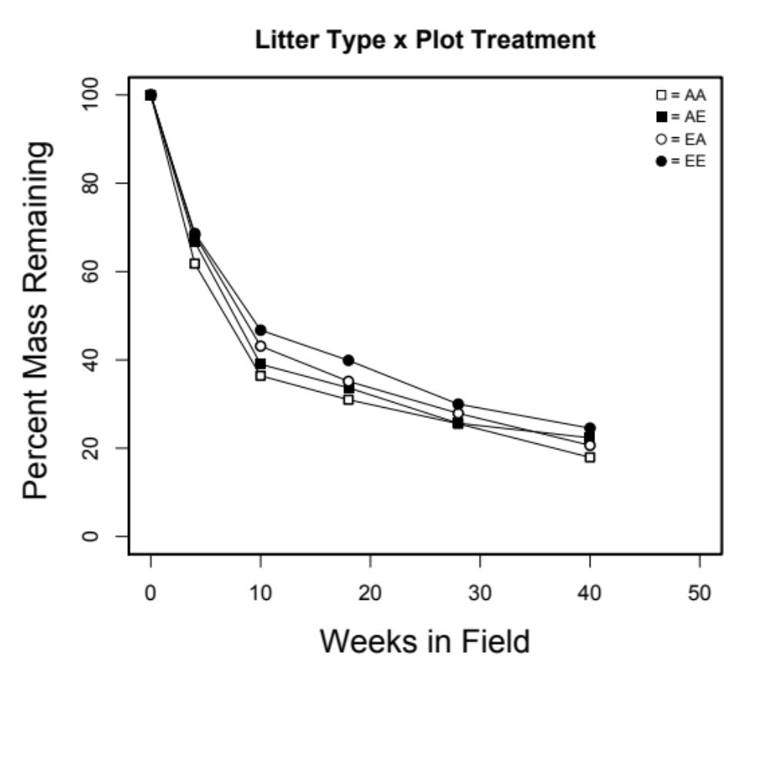
Figure 9. Decomposition curves for our four litter x plot treatments.

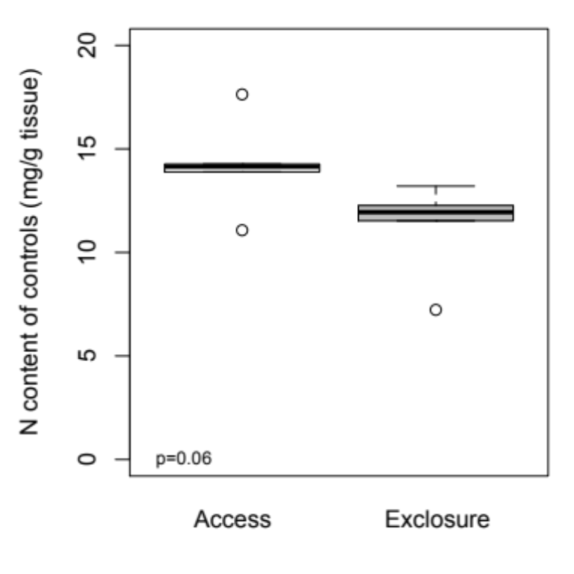
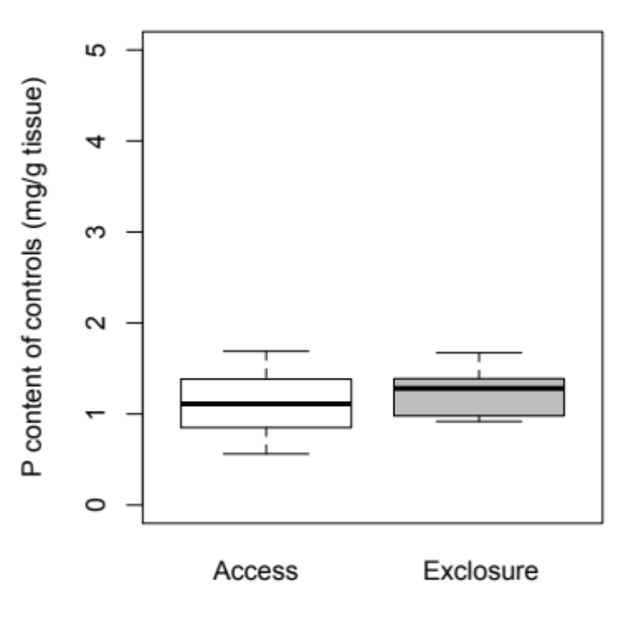
A
B

Figure 10. Nitrogen (A) and phosphorous (B) content of initial (control) litter bags for access and exclosure litter treatments.

Factor | df | Sum Sq | F | p
Litter Type | 1 | 0.34 | 20.63 | <0.001
Plot Treatment | 1 | 0.13 | 7.75 | <0.001
Removal Date | 4 | 16.53 | 247.88 | <0.001
Litter Type x Plot | 1 | <0.001 | 0.04 | 0.83
Litter x Removal | 4 | 0.05 | 0.67 | 0.62
Plot x Removal | 4 | 0.02 | 0.27 | 0.90
Litter x Plot x Removal | 4 | 0.03 | 0.38 | 0.82
Residuals | 179 | 2.98
Table 2. ANOVA table output for mass loss.
Treatment (Litter type x plot treatment) | Decay rate constant (k/week)
Access x Access | 0.043
Access x Exclosure | 0.037
Exclosure x Access | 0.039
Exclosure x Exclosure | 0.035
Table 3. Litter x plot treatment decay rates.
Table 4. Post-hoc test for overall treatment differences.
Treatment (Litter type x plot treatment) | Means | Tukey Group
Access x Access | 0.64 | A
Access x Exclosure | 0.69 | AB
Exclosure x Access | 0.72 | BC
Exclosure x Exclosure | 0.77 | C

by Gao et al. (2016) found both positive and negative HFAs for tree litter decomposition, while others found no indication of an HFA for forest litters (e.g. Gießelmann et al. 2011). Our results add to this growing body of literature by showing while rodents in this system do alter plant community composition (Moorhead et al. in press), this plant community response does not translate to the creation of a home-field advantage for litter decomposition. In support, a recent meta-analysis exploring global patterns of HFAs found grassland-grassland transplants often do not show an HFA effect (Veen et al. 2014). It appears our site—which has high cover and biomass of graminoids—aligns with these previous studies. The reason for this lack of an effect may be tied to the magnitude of dissimilarity, or lack thereof, of the plant community represented in our decomposition bags. Strong HFA effects appear to be explained, in part, by dissimilarity between the litter quality (C:N and N:P) of material used in the transplant studies (Freschet et al. 2012; Veen et al. 2014; Jewell et al. 2015).
While we do not find any indication of an HFA within our system, we do find that rodents accelerate decomposition. One possible mechanism through which they are doing this is by changing the litter quality entering the system. While the N:P does not differ between our litter treatment bags, the nitrogen content is higher in the access bags. This is a possible explanation for why we see access litter bags decomposing faster than exclosure litter bags. A change in litter quality is one way herbivores can influence decomposition and nutrient cycling. Mammalian herbivory has been reported to slow or speed decomposition and nutrient cycling depending on ecosystem type, for instance. Faster decomposition and nutrient cycling occurs when grazed plants respond to herbivory through compensatory growth (McNaughton 1985; McNaughton et al. 1997; Bardgett et al 1998; De Manzancourt et al. 1999; Hamilton and Frank 2001; Frank et al. 2002; Bardgett and Wardle 2003) keeping the community dominated by palatable and therefore more labile plants. The opposite pattern has also been found when preferred plants are lost from a system and replaced by a less palatable and lower quality plant community as seen in the classic case on Isle Royale, Michigan (Pastor 1993; see also Ritchie et al. 1998; Howe et al. 2006; Kasahara et al. 2016). However, changes in litter quality is not the only pathway through which herbivores can alter decomposition and nutrient cycling.
In addition to litter quality differences, we also found rodent presence increased decomposition rates indicating some plot level difference is partly responsible. Previous research in this site has found plant community composition at both the species and functional group level differed starting just one year after plots were in place (Moorhead et al. in press; Table 1). Besides changes in litter quality, specific plant species and functional group id have been found to influence decomposition. Removal of shrubs, for instance, have been found to slow decomposition (Jonsson and Wardle 2008). Others have found removal of graminoids and forbs to slow decomposition (McLaren and Turkington 2011). These responses in decomposition rates to changes in plant community may be due to differences in soil temperature and moisture found under these different plant species and groups or differences in rhizosphere communities supported by different plant species (Dormaar 1990; Bardgett et al 1999). Herbivores can also influence root exudation by plants which can alter microbial activity and composition (e.g., Hamilton and Frank 2001; Hamilton et al. 2008). Lastly, rodents in our system may be further altering decomposition rates through pathways other than the plant community, such as through burrowing behavior or waste deposition.
One important consideration for how rodents might be increasing decomposition rates through plot level differences is through burrowing behaviors or waste deposition. Burrowing and formation of runs by rodent and other mammals can alter nutrient cycling through mixing of the soil profile and alteration of soil moisture and temperature (Hole 1981; Huntly and Reichman 1994; Ross et at. 2007; Gervais et al. 2010). For example, burrowing by gophers led to larger ammonium and nitrate pools in mounded soil compared to undisturbed soil nearby and soil temperature was higher (Canals et al. 2003). Similarly, vizcacha burrows in Argentina have higher total nitrogen, carbon, and phosphorous than in undisturbed soils as similar depths (Villarreal et al. 2008; Clark et al. 2016). In addition to disturbance of the soil and litter profile, mammalian herbivores can influence nutrient cycling through fecal and urine deposition (e.g., Afzal and Adams 1992; McNaughton 1997, Bardgett et al. 1998, Willot et al. 2000; Wardle et al. 2002; Bardgett and Wardle 2003; Bakker et al. 2004; van der Wal et al. 2004; Clark et al. 2005; Mikola et al 2009). Since nitrogen from waste deposits are more readily available for plant and microbial use it is likely waste deposition and subsequent stimulation of the microbial community is one possible mechanism contributing to the faster decomposition of plant litter in access plots compared to exclosures.
Overall we demonstrate that while rodents do not create a home-field advantage for litter decomposition, they do appear to speed decomposition rates within a small spatial scale. These data contribute to both the HFA literature as another study that shows grassland-grassland HFA experiments do not find HFAs, as well as to the growing body of literature examining aboveground consumer effects on belowground processes. While previous literature has shown primary consumers such as ungulates can alter belowground communities and processes through changes in the quality of the plant community (McInnes et al. 1992; Pastor et al. 1993; Bardgett & Wardle 2003; Howe et al. 2002, 2006; Wang et al. 2010), our study provides new evidence on how smaller consumers may also alter plant community quality but also highlights the importance of examining changes at the microsite level to explain changes in decomposition.

Acknowledgements
We thank C.M. Patterson, R.M. Fitzpatrick, B. Pieper, and N. Dunkirk for help in the field and the lab. C.M. Patterson gave valuable feedback on earlier versions of the manuscript. C. Habeck, L.A. Souza, R.L. Lindroth, E.A. Austin, L.C. Breza, M.A. Cregger, J. Childs, P. Kardol, R.J. Norby, H. Smith, G. Robinson, and H. Tran for help with establishing the plots. The Tennessee Wildlife Resources Agency, particularly Jim Evans, assisted with plot maintenance and logistics. This material is based upon work supported by the National Science Foundation Graduate Research Fellowship to L.C.M. under Grant No. DGE-0929298, and the Department of Ecology and Evolutionary Biology at the University of Tennessee. A.T.C. was supported by the U.S. Department of Energy, Office of Science, Office of Biological and Environmental Research, Terrestrial Ecosystem Sciences Program under Award Number DE-SC0010562. A.T.C, and L.C.M acknowledge the support of the Danish National Research Foundation for its support for Macroecology, Evolution and Climate.

References
Afzal, M., W. A. Adams. 1992. Heterogeneity of soil mineral nitrogen in pasture grazed by cattle. Soil Science Society of America Journal 56:1160–1166.
Ayres, E., K.M. Dromph, and R.D. Bardgett. 2006. Do plant species encourage soil biota that specialise in the rapid decomposition of their litter? Soil Biology & Biochemistry 38:183–186.
Ayres, E., H. Steltzer, S. Berg, and D.H. Wall. 2009. Soil biota accelerate decomposition in high-elevation forests by specializing in the breakdown of litter produced by the plant species above them. Journal of Ecology 97:901–912.
Ayres, E., Steltzer, H., Simmons, B. L., Simpson, R. T., Steinweg, J. M., Wallenstein, M. D., Mellor, N., W. J. Parton, J. C. Moore and D.H. Wall. 2009b. Home-field advantage accelerates leaf litter decomposition in forests. Soil Biology & Biochemistry 41:606–610.
Bakker, E. S., H. Olff, M. Boekhoff, J. M Gleichman, and F. Berendse. 2004. Impact of herbivores on nitrogen cycling: contrasting effects of small and large species. Oecologia 138:91–101.
Ball, B.A., M.A. Bradford, D.C. Coleman, and M.D. Hunter 2009. Linkages between below and above-ground communities: decomposer responses to simulated tree species loss are largely additive. Soil Biology and Biochemistry 41:1155–1163.
Bardgett, R.D., D.A. Wardle and G. W. Yeates. 1998. Linking above-ground and below-ground interactions: How plant responses to foliar herbivory influence soil organisms. Soil Biology & Biochemistry 30:1867–1878.
Bardgett, R.D., J.L. Mawdsley, S. Edwards, P.J. Hobbs, J.S. Rodwell, and W.J. Davies. 1999. Plant species and nitrogen effects on soil biological properties of temperate upland grasslands. Functional Ecology 13:650–660.
Bardgett, R.D., and D.A. Wardle. 2003. Herbivore-mediated linkages between aboveground and belowground communities. Ecology 84:2258–2268.
Berg, B., M.P. Berg, P. Bottner, E. Box, A. Breymeyer, R.C. Deanta, M. Couteaux, A. Escudero, A. Gallardo, W. Kratz, M. Madeira, et al. 1993. Litter mass loss rates in pine forests of Europe and eastern United States – some relationships with climate and litter quality. Biogeochemistry 20:127–159.
Brown, J.H., and E.J. Heske. 1990. Control of a desert-grassland transition by a keystone rodent guild. Science 250:1705–1707.
Canals, R.M., D.J. Herman, and M.K. Firestone. 2003. How disturbance by fossorial mammals alters N cycling in a California annual grassland. 84:875–881.
Clark, J.E., E.C. Hellgren, J.L. Parsons, E.E. Jorgensen, D.M. Engle, and D.M. Leslie Jr. 2005. Nitrogen outputs from fecal and urine deposition of small mammals: Implications for nitrogen cycling. Oecologia 144:447–455.
Clark, K.K., L.C. Branch, J.L. Hierro, and D. Villarreal. 2016. Burrowing herbivores alter soil carbon and nitrogen dynamics in a semi-arid ecosystem, Argentina. Soil Biology and Biochemistry 103:253–261.
Couteaux, M.M., P. Bottner, and B. Berg. 1995. Litter decomposition, climate and litter quality. TRENDS in Ecology and Evolution 10:63–66.
Crutsinger, G.M., N.J. Sanders, and A.T. Classen. 2009. Comparing intra- and inter-specific effects on litter decomposition in an old-field ecosystem. Basic and Applied Ecology 10:535–543.
Day, T.A. and J.K Detling. 2009. Grassland patch dynamics and herbivore grazing preference following urine deposition. Ecology 71:180–188.
De Mazancourt, C., M. Loreau, and L. Abbadie. 1999. Grazing optimization and nutrient cycling: potential impact of large herbivores in a savannah system, Ecological Applications 9:784–797.
Dormaar, J.F. 1990. Effect of active roots on the decomposition of soil organic materials. Biology and Fertility of Soils 10:121–126.
Findlay, S., M. Carreiro, V. Krischik, and C.G. Jones. 1996. Effects of damage to living plants on leaf litter quality. Ecological Applications 6:269–275.
Frank, D.A., M.M. Kuns, and D.R. Guido. 2002. Consumer control of grassland plant production. Ecology 83:602–606.
Frank, A.B. 2002. Carbon dioxide fluxes over a grazed prairie and seeded pasture in the Northern Great Plains. Environmental Pollution 116:397–403.
Freschet, G.T., R. Aerts, and J.H.C. Cornelissen. 2012. Mulitple mechanisms for trait effects on litter decomposition: moving beyond home-field advantage with a new hypothesis. Journal of Ecology 100:619–630.
Gao, J., F. Kang, and H. Han. 2016. Effect of litter quality on leaf-litter decomposition in the context of home-field advantage and non-additive effects in temperate forests in China. Polish Journal of Environmental Studies 25:1911–1920.
Gervais, J.A., S.M. Griffith, J.H. Davis, J.R. Cassidy, and M.I. Dragila. 2010. Effects of gray-tailed vole activity on soil properties. Northwest Science 84:159–169.
Gessner, M.O., C.M. Swan, C.K. Dang, B.G. McKie, R.D. Bardgett, D.H. Wall, and S. Hattenschwiler. 2010. Diversity meets decomposition. TRENDS in Ecology and Evolution 35:372–380.
Gießelmann, U.C., K.G. Martins, M. Brandle, M. Schadler, R. Marques, and R. Brandl. 2011. Lack of home-field advantage in the decomposition of leaf litter in the Atlantic Rainforest of Brazil. Applied Soil Ecology 49:5–10.
Hamilton, E.W., D.A. Frank, P.M. Hinchey, and T.R. Murray. 2008. Defoliation induces root exudation and triggers positive rhizospheric feedbacks in a temperate grassland. Soil Biology and Biochemistry 40:2865–2873.
Hamilton, E.W. III, and D.A. Frank. 2001. Can plants stimulate soil microbes and their own nutrient supply? Evidence from a grazing tolerant grass. Ecology 82:2397–2402.
Hobbs, N.T. 1996. Modification of ecosystems by ungulates. The Journal of Wildlife Management 60:695–713.
Hole, F.D. 1981. Effects of animals on soil. Geoderma 25:75–112.
Howe, H.F., J.S. Brown, and Zorn-Arnold, B. 2002. A rodent plague on prairie diversity. Ecology Letters 5:30–36.
Howe, H.F., B. Zorn-Arnold, A. Sullivan, and J.S. Brown. 2006. Massive and distinctive effects of meadow voles on grassland vegetation. Ecology 87:3007–3013.
Huntly, N., and O.J. Reichman. 1994. Effects of subterranean mammalian herbivores on vegetation. Journal of Mammalogy 75:852–859.
Inouye, R.S., N.J. Huntly, D. Tilman, J.R. Tester, M. Stillwell, and K.C. Zinnel. 1987. Old-field succession on a Minnesota sand plain. Ecology 68:12–26.
Jacob, M., K. Viedenz, A. Polle, and F.M. Thomas. 2010. Leaf litter decomposition in temperate deciduous forest stands with a decreasing fraction of beech (Fagus sylvatica). Oecologia 164:1083–1094.
Jewell, M.D., B. Shipley, A. Paquette, C. Messier, and P.B. Reich. 2015. A traits-based test of the home-field advantage in mixed-species tree litter decomposition. Annals of Botany 116:781–788.
Jonsson, M., and D.A. Wardle. 2008. Context dependency of litter-mixing effects on decomposition and nutrient release across a long-term chronosequence. Oikos 117:1674–1682.
Kaneko, N., and E.R. Salamanca. 1999. Mixed leaf litter effects on decomposition rates and soil microarthropod communities in an oak-pine stand in Japan. Ecological Research 14:131–138.
Kasahara, M., S. Fujii, T. Tanikawa, and A.S. Mori. 2016. Ungulates decelerate litter decomposition by altering litter quality above and below ground. European Journal of Forest Research 135:849–856.
Kochy, M., and S.D. Wilson. 1997. Litter decomposition and nitrogen dynamics in aspen forest and mixed-grass prairie. Ecology 78:732–739.
McInnes, P.F., R.J. Naiman, J. Pastor, and Y. Cohen. 1992. Effects of moose browsing on vegetation and litter of the boreal forest, Isle Royale, Michigan, USA. Ecology 73: 2059–2075.
McLaren, J.R., and R. Turkington. 2011. Plant identity influences decomposition through more than one mechanism. Plos One 6:e23702
McNaughton, S.J., F.F. Banyikwa, and M.M. McNaughton. 1997. Promotion of the cycling of diet-enhancing nutrients by African grazers. Science 278:1798–1800.
McNaughton, S.J. 1985. Ecology of a grazing ecosystem: The Serengeti. Ecological Monographs 55:259–294.
Melillo, J.M., J.D. Aber, and J.F. Muratore. 1982. Nitrogen and lignin control of hardwood leaf litter decomposition dynamics. Ecology 63:621–626.
Mikola, J., H. Setala, P. Virkajarvi, K. Saarijarvi, K. Ilmarinen, W. Voigt, and M. Vestberg. 2009. Defoliation and patchy nutrient return drive grazing effects on plant and soil properties in a dairy cow pasture. Ecological Monographs 79:221–244.
Milcu, A., and P. Manning. 2011. All size classes of soil fauna and litter quality control the acceleration of litter decay in its home environment. Oikos 120:1366–1370.
Murphey, K.L., J.M. Klopatek, and C.C. Klopatek. 1998. The effects of litter quality and climate on decomposition along an elevational gradient. Ecological Applications 1998:1061–1071.
Parton, W., W.L. Silver, I.C. Burke, L. Grassens, M.E. Harmon, W.S. Currie, J.Y. King, E.C. Adair, L.A. Brandt, S.C. Hart, and B. Fasth. 2007. Global-scale similarities in nnitrogen release patterns during long-term decomposition. Science 315:361–364.
Pastor, J., B. Dewey, R.J. Naiman, P.F. McInnes, and Y. Cohen. 1993. Moose browsing and soil fertility in the boreal forests of Isle Royale National Park. Ecology 74:467–480.
Reichman, O.J., and E.W. Seabloom. 2002. The role of pocket gophers as subterranean ecosystem engineers. TRENDS in Ecology and Evolution 17:44–49.
Ritchie, M.E., D. Tilman, and J.M.H. Knops. 1998. Herbivore effects on plant and nitrogen dynamics in oak savanna. Ecology 79:165–177.
Ross, B.E., A.W. Reed, R.L. Rehmeier, G.A. Kaufman, and D.W. Kaufman. 2007. Effects of prairie vole runways on tallgrass prairie. Transactions of the Kansas Academy of Science. 110:100–106.
Shaw, M.R., and J. Harte. 2001. Control of litter decomposition in a subalpine meadow-sagebrush steppe ecotone under climate change. Ecological Applications 11:1206–1223.
St. John, M.G., K.H. Orwin, and I.A. Dickie. 2011. No ‘home’ versus ‘away’ effects of decomposition found in a grassland-forest reciprocal litter transplant study. Soil Biology and Biochemistry 43:1482–1489.
Sun, Y., and S. Zhao. 2016. Leaf litter decomposition in urban forests: test of the home-field advantage hypothesis. Annals of Forest Science 73:1063–1072.
Upadhyay, V.P., J.S. Singh, and V. Meetemeyer. 1989. Dynamics and weight loss of leaf litter in central Himalayan forests: Abiotic versus litter quality influences. Journal of Ecology 77:147–161.
van der Wal, R., R.D. Bardgett, K.A. Harrison, and A. Stien. 2004. Vertebrate herbivores and ecosystem control: cascading effects of faeces on tundra ecosystems. Ecography 27:242–252.
Veen, G.F., G.T. Freschet, A. Ordonez, and D.A. Wardle. 2014. Litter quality and environmental controls of home-field advantage effects on litter decomposition. Oikos 123:800–806.
Villarreal, D., K.L. Clark, L.C. Branch, J.L. Hierro, and M. Machicote. 2008. Alteration of ecosystem structure by a burrowing herbivore, the plains vizcacha (Lagostomus maximus). Journal of Mammalogy 89:700–711.
Vitousek, P.M., D.R. Turner, W.J. Parton, and R.L. Sanford. 1994. Litter decomposition on the Mauna-Loa environmental matrix, Hawaii – patterns, mechanisms, and models. Ecology 75:418–429.
Vivanco, L. and A.T. Austin. 2008. Tree species identity alters forest litter decomposition through long-term plant and soil interactions in Patagonia, Argentina. Journal of Ecology 96:727–736.
Wall, D.H., M.A. Bradford, M.G. St. John, J.A. Trofymow, V. Behan-Pelletier, D.E. Bignell, J.M. Dangerfield, W.J. Parton, J. Rusek, W. Voigt, C. Wolters, et al. 2008. Global decomposition experiment shows soil animal impacts on decomposition are climate-dependent. Global Change Biology 14:2661–2677.
Wang, S., H. Ruan, and Y. Han. 2010. Effects of microclimate, litter type, and mesh size on leaf litter decomposition along an elevation gradient in the Wuyi Mountains, China. Ecological Research 25:1113–1120.
Wang, Q., M. Zhong, and T. He. 2013. Home-field advantage of litter decomposition and nitrogen release in forest ecosystems. Biology and Fertility of Soils. 49:427–434.
Wardle, D.A., G.W. Yeates, W. Williamson, and K.I. Bonner. 2003. The response of a three trophic level soil food web to the identity and diversity of plant species and functional groups. Oikos 102:45–56.
Wardle, D.A., K.I. Bonner, and K.S. Nicholson. 1997. Biodiversity and plant litter: Experimental evidence which does not support the view that enhanced species richness improves ecosystem function. Oikos 79:247–258.
Wardle, D.A., K.I. Bonner, and G.M. Barker. 2002. Linkages between plant litter decomposition, litter quality, and vegetation responses to herbivores. Functional Ecology 16:585–595.
Willot, S.J., A.J. Miller, L.D. Incoll, and S.G. Compton. 2000. The contribution of rabbits (Oryctolagus cuniculus L.) to soil fertility in semi-arid Spain. Biology and Fertility of Soils 31:379–384.

CONCLUSION
My dissertation examines how rodents can interact with other biotic and abiotic components to influence ecosystem structure. My work finds rodents quickly alter plant community composition and structure in an old-field ecosystem, that changes in the aboveground community can alter how fire moves through the ecosystem and how the ecosystem recovers from fire disturbance, and that rodents speed litter decomposition due, in part, to their influence on the plant community. However, future research to further elucidate the direct and indirect effects of rodents begs the following:
- While Chapter 1 showed clear effects of rodents on aboveground communities, I found few effects on the belowground community. A worthwhile next step would be to determine whether rodents in this system are altering the plant community through herbaceous consumption, or if changes in the plant community is the result of other non consumptive behaviors such as granivory or removal of material for nesting. Further, while I found few impacts of herbviores on the belowground ecosystem, a more detailed exploration of the belowground community composition would likely provide new insight into how primary consumers can impact the belowground system.
- In Chapter 2 I showed that rodents altered the plant community and this community change altered the way a prescribe burn moved through the ecosystem. Interestingly, my plant community measurements from the mid growing season prior to burning did not explain this burn pattern. It was not until I used plant community results from the end of the growing season a year and a half prior to burning was I able to explain the control of plant community on burning. Future work exploring the effects of rodents on plant community structure and composition should take multiple measurements from the very start of the growing season to the very end as it seems we are likely to miss strong seasonal effects. This additional information would benefit agencies and land managers by helping to inform the decision of when to use a controlled burn as well as expand on understanding of consumer-driven plant phenological shifts.
- In Chapter 3 I found litter treatment and plot treatment influenced decomposition rates with rodent presence resulting in faster mass loss. While litter treatment can be explained by a difference in the litter quality of the bag, plot level differences responsible for the faster mass loss in access plots could be a result of differences in the detritivore community composition in response to indirect rodent-mediated changes in plant community or to direct rodent-mediate changes through fecal and urine deposition. Further research would help elucidate the pathways through which primary consumers alter decomposition and nutrient cycling and when.
Although my work highlights both community and ecosystem level responses to rodents, it begs the question if patterns found in my site are unique to my site or if they fit a larger pattern of rodent effects on ecosystems. As previously discussed, herbivores can shape ecosystems through their interactions with the plant community. However, although herbivores can alter plant communities, the direction of the plant community response is not always consistent. In fact, plant-herbivore interactions can vary along latitudinal gradients (Schemske et al. 2009). Specifically, increasing rates of leaf herbivory and investment in plant defenses are correlated with decreasing latitudes. However, the influence of herbivores on plant communities can also vary with precipitation. Grazing promotes a positive growth response of palatable species in humid environments, while unpalatable species increase with herbivory in drier environments (Grime 1977; Coley et al. 1985; Milchunas and Lauenroth 1993). Furthermore, studies examining the response of plant communities to ungulate grazing found that factors such as topography and precipitation help explain plant responses to herbivory (Harrison and Bardgett 2004; Diaz et al. 2007). Together, these results suggest plant response to herbivores depends on multiple factors including herbivore identity and abiotic conditions.
A quick literature search using “rodent*” and “plant+community” limited to studies within the USA returned over 400 results. However, these studies included everything from the effects of mice to tunneling rodents, such as pocket gophers, on plant communities as well as the effects of plant community structure, foliar cover, and edge effects on rodent communities. Therefore, since several species of the vole genera Microtus are found throughout fields, forest edges, and grasslands of the US including my field site, I used a second literature search of “microtus” and “plant+community” to find studies explicitly measuring plant community responses to the presence of Microtus voles. Web of Science returned 52 studies, of which I was able to qualitatively summarize the main plant community response to voles from 14 studies and points were overlaid onto a map of the US (Figure 11). The majority of studies found results similar to mine—Microtus presence notably reduced cover of grasses as a whole, or of dominant grass species. Furthermore, this response was almost always met with an increase in forb cover. Additionally, in several studies from New York, Microtus species were found to limit seedling recruitment into old fields through preferential consumption.

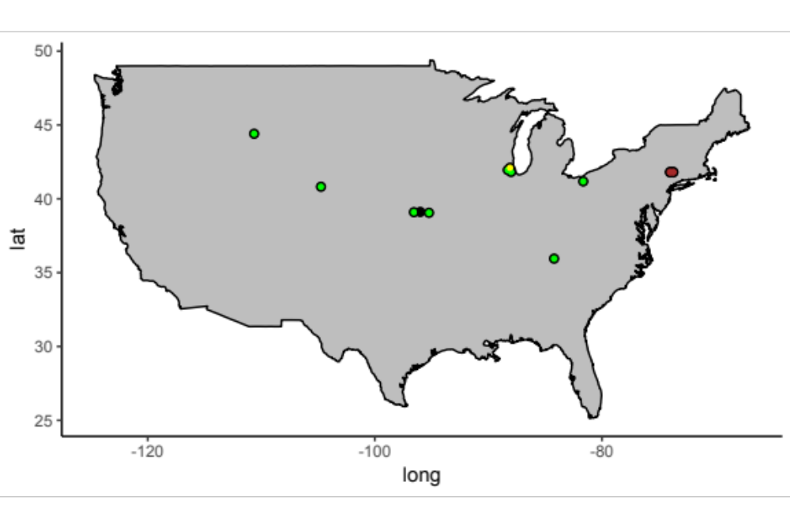
Figure 11. Preliminary map showing response of plant communities to vole (Microtus) exclusion. Green points indicate a general plant community response of loss of graminoid functional groups or dominant grass species in favor of increasing forb cover or biomass. Yellow points indicate loss of forb cover in favor of graminoid cover. Black points indicate no plant community composition response was found. Studies represented by brown points (clustered in SE New York), are a series of studies that find meadow voles’ consumption of tree seedlings prevent or slow woody encroachment and succession in old-fields.

References Included in Map
Fraser, L.H., and E.B. Madson. 2008. The interacting effects of herbivore exclosures and seed addition in a wet meadow. Oikos 117:1057–1063.
Gibson, D.J., C.C. Freeman, and L.C. Hulbert. 1990. Effects of small mammal and invertebrate herbivory on plant species richness and abundance in tallgrass prairie. Oecologia 84:169–175.
Howe, H.F., and J.S. Brown. 1999. Effects of birds and rodents on synthetic tallgrass communities. Ecology 80:1776–1781.
Howe, H.F., J.S. Brown, B. and Zorn-Arnold. 2002. A rodent plague on prairie diversity. Ecology Letters 5:30–36.
Howe, H. F., Zorn-Arnold, B., Sullivan, A., and Brown, J. S. 2006. Massive and distinctive effects of meadow voles on grassland vegetation. Ecology 87:3007–3013.
La Pierre, K.J., A. Joern, and M.D. Smith. 2015. Invertebrate, not small vertebrate, herbivory interacts with nutrient availability to impact tallgrass prairie community composition and forb biomass. Oikos 124:842–850.
Quested, E.J., and B.L. Foster. 2007. Vole disturbances and plant diversity in a grassland metacommunity. Oecologia 153:341–351.
Manson, R.H., R.S. Ostfeld, and C.D. Canham. 2001. Long-term effects of rodent herbivores on tree invasion dynamics along forest-field edges. Ecology 82:3320–3329.
Ostfeld, R.S., and C.D. Canham. 1993. Effects of meadow vole population density on tree seedling survival in old fields. Ecology 74:1792–1801.
Ostfeld, R.S., R.H. Manson, and C.D. Canham. 1997. Effects of rodents on survival of tree seeds and seedlings invading old fields. Ecology 78:1531–1542.
Pusenius, J., R.S. Ostfeld, and F. Keesing. 2000. Patch selection and tree-seedling predation by president vs. immigrant meadow voles. Ecology 81:2951–2956.
Rebollo, S., D.G. Milchunas, P. Stapp, D.J. Augustine, and J.D. Derner. 2013. Disproportionate effects of non-colonial small herbivores on structure and diversity of grassland dominated by large herbivores. Oikos 122:1757-1767.
Sirotnak, J. M., and N. J. Huntly. 2000. Direct and indirect effects of herbivores on nitrogen dynamics: Voles in riparian areas. Ecology 81:78–87.

References
Coley, P.D., J.P. Bryant JP, and F.S. Chapin. 1985. Resource availability and plant antiherbivore defense. Science 230:895–899.
Diaz, S., S. Lavorel, S. McIntyre, V. Falczuk, F. Casanoves, D.G. Milchunas, C. Skarpe, G. Rusch, M. Sternberg, I. Noy-Meir, J. Landsberg, et al. 2007. Plant trait responses to grazing – a global synthesis. Global Change Biology 13:313–341.
Grime, JP. 1977. Evidence for the existence of three primary strategies of plants and its relevance to ecological and evolutionary theory. American Naturalist 111:1169–1194.
Harrison, K.A., and R.D. Bardgett. 2004. Browsing by red deer negatively impacts on soil nitrogen availability in regenerating native forest. Soil Biology and Biogeochemistry 36:115–126.
Milchunas, D.G., and W.K. Lauenroth. 1993. Quantitative effects of grazing on vegetation and soil over a global range of environments. Ecological Monographs 63:327–366.
Schemske, D.W., G.G. Mittelbach, H.V. Cornell, J.M. Sobel, and K. Roy. 2009. Is there a latitudinal gradient in the importance of biotic interactions? Annual Review of Ecolog Evolution and Systematics 40:245–269.

VITA

Leigh C. Moorhead was born in 1987 in San Diego to Carol and Daryl Moorhead. At the age of two her family moved her from the beautiful oasis of coastal southern California to spend ten long years in the culturally and environmentally dry, wind-battered plains of the Llano Estacado. In 1999, Leigh’s parents finally came to their senses and moved the family to the comparative Eden of Toledo, Ohio. It was here where Leigh realized the natural world could be pleasant as well as beautiful. Halfway through college, she decided the living plants and animals around her were more interesting than digging up relics of long-gone human lives and so graduated from the University of Toledo with a bachelor’s degree in environmental sciences in 2010 and soon after enrolled in the graduate program in ecology and evolutionary biology at the University of Tennessee. Over the last ten years, Leigh has had the joy of working and living in many different ecosystem types from the subtropics to the arctic circle and looks forward to wherever the future drags her.

