Investigating the Blending Mechanism and Strength Development of 100% Hot In-place Recycled Asphalt Mixtures

A Dissertation Presented for the
Doctor of Philosophy
Degree
The University of Tennessee, Knoxville

Yuetan Ma
August 2022

DEDICATION
This dissertation is dedicated to my parents, Jiankun Ma, Liping Wang, and my girlfriend Jing Guo, for all their endless love and support.
ACKNOWLEDGEMENTS
I would like to express my gratitude to my advisor, Dr. Baoshan Huang, for his support, patience, generosity, and encouragement during my graduate studies at the University of Tennessee and his continuous interest and guidance throughout this doctoral research. I have learned a lot from him, not only how to do the research, but also the attitude to overcome the difficulties in life.
I would like to extend my sincere thanks to Dr. Qiang He, Dr. Hongyu Zhou, and Dr. Hong Park for serving as committee members and for their help and instruction in my Ph.D. research.
I would like to acknowledge the staff and engineers’ assistance at the Tennessee Department of Transportation (TDOT). They have provided valuable support for this research.
I would like to acknowledge the help of my research colleagues at the University of Tennessee. We collaborated, discussed problems, and shared our happiness in our daily life.
I would like to acknowledge the love and support of my cute girlfriend, Jing Guo. Many thanks and pleasure for meeting her, loving her, and accompanying her over the last two years.
I would like to finally acknowledge the support and encouragement of my father, Jiankun Ma, and my mother, Liping Wang. They are always understandable and supportive of my decisions. Most importantly, they always show their endless love and encouragement all the time.

ABSTRACT
The current tendency in the asphalt paving industry is to increase the utilization of recycled asphalt pavement (RAP). Hot in-place recycling (HIR) is a promising approach to consume 100% RAP from the existing pavement for pavement surface rehabilitation in the field. However, some concerns remained regarding the utilization of HIR techniques in pavement rehabilitation: 1. Whether it is cost-effective to apply the in-place recycling techniques to pavement rehabilitation compared to the conventional HMA surface milling & filling? 2. How to improve the performance of the asphalt mixtures with HIR techniques? 3. How much RAP binder can be available for coating the aggregates during HIR? 4. What are the bonding mechanisms, the influence of effective asphalt content, and properties on the performances of the HIR mix? 5. What are the contributions of the immobilized RAP binder?
To better understand the pavement performance and recycling efficiency during HIR procedures, the overall objective of the proposed doctoral study is to investigate the blending mechanism and strength development of asphalt mixtures during HIR technique. The research scopes are to (1) investigate the blending mechanism of HIR mixes relating to binder mobilization and mixture mechanical properties; (2) develop an approach to quantify the recycling efficiency of HIR mixes; (3) explore the mechanism of bonding, effects of the degree of blending, and properties of effective binder in HIR mixes; (4) investigate the effects of immobilized RAP binder on asphalt-aggregate interactions and the performance of 100% recycled asphalt mixtures. The results of this study provide a better understanding of the significance of mobilized and immobilized RAP binder on the recycling efficiency of 100% recycled asphalt mixtures.
Key Words: Hot in-place recycling (HIR), reclaimed asphalt pavement (RAP), recycling efficiency, effective binder, immobilized RAP binder, asphalt-aggregate interaction

Table of Contents
Chapter One General Introduction 1
Problem Statement 2
Objectives and scope 4
Research questions 4
Organization 5
Chapter Two Literature Review 6
Hot in-place recycling technique 7
Reclaimed asphalt (RA) binder availability and blending efficiency 8
RA binder components 8
RA binder availability 9
Blending efficiency 10
Blending scenarios of hot mix asphalt (HMA) and HIR mixes 11
Approaches to quantify blending efficiency of asphalt mixtures 12
APPENDIX 14
APPENDIX 2A: Figures 15
Chapter Three A comparative study between HIR and HMA mixes performance evaluation, pavement service life prediction, and life cycle cost analysis (LCCA). 21
Introduction 24
Objective and scope 26
Materials preparation 26
Experimental methodology 27
Mixture performance tests 27
Pavement life prediction 29
Life cycle cost analysis 31
Results and analysis 31
Performance tests 31
Field cores evaluations 33
Pavement life prediction 34
Life Cycle Cost Analysis 35
Conclusions 37
APPENDIX 39
APPENDIX 3A: Abbreviations 40
APPENDIX 3B: Figures 41
APPENDIX 3C: Tables 49
Chapter Four Investigate the blending mechanism of HIR mixes relating to binder mobilization and mixture mechanical properties. 58
Introduction 60
Objective and scope 63
Laboratory experiments 64
Materials and sample preparation 64
AMPT test 65
Superpave IDT tests 67
Moisture susceptibility test 68
Staged extraction test 69
Results and analysis 70
AMPT test 70
APA rutting test 71
Superpave IDT tests 72
Moisture susceptibility tests 73
Staged extraction test 74
Discussion of the results. 75
Conclusions 76
Acknowledgments 78
APPENDIX 79
APPENDIX 4A: Figures 80
APPENDIX 4B: Tables 95
Chapter Five Quantify and maximize the recycling efficiency of HIR mixes 98
Introduction 100
Materials and methodology 104
Raw materials 104
Heating methodology 104
Effective mobilized RAP content quantification. 105
FTIR characterization 106
Evaluation of FTIR spectrum. 107
Results and analysis 108
Infrared camera results 108
Ignition oven test results. 109
FTIR test results 112
Discussion of the results 113
Conclusions 116
APPENDIX 118
APPENDIX 5A: Figures 119
APPENDIX 5B: Tables 138
Chapter Six Explore the effects of degree of blending, and properties of effective binder in HIR mix 140
Introduction 142
Materials and methodology 144
Raw material collection 145
Effective mobilized RAP binder quantification procedures 145
Effective binder blends preparation 146
Quality of effective binder blends 147
HIR mixture performance tests 149
Results and analysis 151
Mobilized RAP content 151
Temperature sweep test results. 152
Surface free energy of the effective binder blends 152
Mixture performance test results 153
Discussion of the results 156
Conclusions 158
APPENDIX 160
APPENDIX 6A: Figures 161
APPENDIX 6B: Tables 172
Chapter Seven Explore the effects of Immobilized RAP on asphalt-aggregate interaction and performance of 100% Recycled asphalt mixtures 176
Introduction 179
Materials and experimental design 182
Raw material collection 182
Immobilized RAP binder content quantification 182
Preparation of immobilized RAP aggregates 183
Preparation of asphalt mortar and mixtures 184
Methodology 184
Surface free energy and work of adhesion 184
Asphalt mortar tests 185
Asphalt mixtures performance tests 188
Results and analysis 189
Surface free energy and work of adhesion 189
Master curve results 190
Asphalt and aggregates interaction analysis 190
Mixture performance tests 192
Conclusions 195
APPENDIX 197
APPENDIX 7A: Figures 198
APPENDIX 7B: Tables 211
Chapter Eight Conclusions and recommendations 215
Recommendations for Future Work 218
REFERENCE 219
VITA 227

LIST OF TABLES
Table 3-1. Asphalt content of HIR and HMA mixes. 49
Table 3-2. Binder properties design input at 10 rad/s. 50
Table 3-3. Dynamic modulus of asphalt mixtures in different pavement layers. 51
Table 3-4. Design parameters thresholds in ME design. 53
Table 3-5. Tennessee pavement design criteria. 54
Table 3-6. Pavement performance after 20 years. 55
Table 3-7. Life cycles of the pavement after different rehabilitation approaches. 56
Table 3-8. A summary of asphalt mixtures and pavement performance with two rehabilitation techniques. 57
Table 4-1. Compositions and properties of ARA-3P. 95
Table 4-2. Parameters for the performance tests. 96
Table 4-3. Stage extraction test results. 97
Table 5-1. Physical and chemical properties of ARA_3P. 138
Table 5-2. Physical properties of the rejuvenator. 139
Table 6-1. Experimental design of effective mobilized RAP quantification under different mixing conditions. 172
Table 6-2. Surface free energy components of different probe liquids. 173
Table 6-3. Effective mobilized RAP content for HIR mixes. 174
Table 6-4. Surface energy results of the effective binder blends in different HIR mixes. 175
Table 7-1. RAP binder contents of different aggregate types. 211
Table 7-2. The compositions of various asphalt mortars. 212
Table 7-3. Different binder content in asphalt mixtures with different aggregate types. 213
Table 7-4. Binder content 100% recycled asphalt mixtures mixed at different temperatures. 214
LIST OF FIGURES
Figure 2-1. Hot in-place recycling procedures. 15
Figure 2-2. Reclaimed asphalt binder components (Lo Presti et al., 2019). 16
Figure 2-3. Ideal blending between virgin and aged binder in HMA. 17
Figure 2-4. Different RAP binders in RAP aggregates. 18
Figure 2-5. Real blending between virgin and aged binder in HMA. 19
Figure 2-6. The situation of RAP binder during HIR procedures. 20
Figure 3-1. The grain size distributions of raw materials. 41
Figure 3-2. Pavement structure models of two pavements; (a) New HMA surface layer; (b) after HIR surface treatment. 42
Figure 3-3. DSR master curves of different binder blends. (a) Complex modulus master curves; (b) phase angle master curves. 43
Figure 3-4. AMPT test results of HIR and HMA mixes, (a) dynamic modulus at 4 °C, (b) dynamic modulus at 20°C, (c) dynamic modulus at 40 °C, (d) flow number. 44
Figure 3-5. Superpave IDT test results of HIR and HMA mixes, (a) Resilient modulus; (b) Indirect tensile strength; (c) DCSEf. 45
Figure 3-6. Moisture susceptibility tests of HIR and HMA mixes, (a) TSR (IM); (b) TSR (F-T). 46
Figure 3-7. Performance comparison between field cores and lab specimens, (a) IDT strength, (b) DCSEf. 47
Figure 3-8. The LCCA of 48 years between pavement surface rehabilitation with HIR and HMA. (a) HIR surface treatment without overly (b) HIR surface treatment with a thin overlay. 48
Figure 4-1. (a) HIR trains; (b) surface layers before and after HIR procedures; (c) temperature distribution during mixing; (d) temperature distribution during paving. 80
Figure 4-2. The gradations of the materials: RAP stands for asphalt mixtures before adding the additives, Mix refers to the mixtures after adding the additives. 81
Figure 4-3. Superpave IDT test setup. 82
Figure 4-4. Determination of creep strain energy. 83
Figure 4-5. Dynamic modulus of the HIR mixtures results: (a)Tested at 4 °C, (b) tested at 20 °C, and (c) tested at 40 °C. 84
Figure 4-6. Dynamic modulus master curve of the HIR mixtures at the reference temperature of 20 °C. 86
Figure 4-7. Flow number results of the HIR mix. 87
Figure 4-8. APA rutting test results: (a) Rut depth vs. loading cycles (b) Rut depth. 88
Figure 4-9. Results of IDT tests, (a) Indirect tensile strength and (b) failure strain. 89
Figure 4-10. Resilient modulus test results. 90
Figure 4-11. Dissipated creep strain energy threshold results. 91
Figure 4-12. Resilient modulus ratio results. 92
Figure 4-13. Tensile strength ratio (TSR) results. 93
Figure 4-14. Dissipated creep strain energy ratio (DCSE_{f}) results. 94
Figure 5-1. Hot in-place recycling procedures. 119
Figure 5-2. Ideal blending between virgin and aged binder in HMA. 120
Figure 5-3. Different RAP binders in RAP aggregates. 121
Figure 5-4. Real blending between virgin and aged binder in HMA. 122
Figure 5-5. The situation of RAP binder during HIR procedures. 123
Figure 5-6. The grain size distribution of RAP. 124
Figure 5-7. The fire heating simulation using torch blow test. 125
Figure 5-8. Two scenarios of quantifying the effective mobilized RAP content. (a) “Dry” mixing; (b) “Wet” mixing; (c) Asphalt emulsion film calculation. 126
Figure 5-9. FTIR spectrums of virgin binder and RAP binder with the peak area selections. 127
Figure 5-10. The experimental design flow chart. 128
Figure 5-11. Thermo images of the HIR mix under various conditions, (a) Blending in the field; (b) Blending through torch blow test; (c) The final blending stage through torch blow test. 129
Figure 5-12. The effective mobilized RAP content for “dry” blending at different temperatures. 130
Figure 5-13. Effective mobilized RAP content with different additives. 131
Figure 5-14. Effective mobilized RAP content with various dosages of asphalt emulsion under different oven heating temperatures. 132
Figure 5-15. The effective mobilized content of the HIR mix with 2.6% asphalt emulsion through both oven and fire heating at different temperatures. 133
Figure 5-16. The effective mobilized RAP content with asphalt emulsion and HMA at 160°C. 134
Figure 5-17. The contour of the CI and effective mobilized RAP content under different conditions using the FTIR method, (a) CI, (b) Effective mobilized RAP content (%). 135
Figure 5-18. Comparison of effective mobilized RAP content between FTIR and ignition oven method, (a) 110 °C with asphalt emulsion; (b) 130°C with asphalt emulsion; (c) 160°C with asphalt emulsion; (d) 160°C with virgin asphalt. 136
Figure 5-19. Relationship between the FTIR method results and ignition oven method results. 137
Figure 6-1. Experimental design and procedures of the study. 161
Figure 6-2. Gradation for loose mixes collected after heat scarification with the HIR train. 162
Figure 6-3. Determination of mobilized RAP content through the ignition oven method. 163
Figure 6-4. Mobilized RAP content quantification procedures. 164
Figure 6-5. Temperature sweep test results of the effective binder blends. 165
Figure 6-6. Dynamic modulus test results of HIR mixes at different temperatures; (a) 4 °C; (b) 20°C; (c) 40 °C. 166
Figure 6-7. Flow number test results of HIR mix at 54.4 °C. 168
Figure 6-8. Ideal CT test results of different HIR mixes. 169
Figure 6-9. Correlation analysis for rutting resistance of HIR mixes, (a) flow number and effective RAP binder ratio, (b) flow number and effective asphalt content. 170
Figure 6-10. Correlation analysis for cracking resistance of HIR mixes, (a) CT_{index} and effective RAP binder ratio, (b) CT_{index} and effective asphalt content. 171
Figure 7-1. Gradation of RAP aggregates. 198
Figure 7-2. Mobilization rate of RAP binder quantified by using the ignition oven method. 199
Figure 7-3. Preparation of immobilized RAP aggregates. 200
Figure 7-4. Preparation of asphalt mortar and mixtures. 201
Figure 7-5. Determination of creep strain energy. 202
Figure 7-6. Surface free energy of RAP aggregates after different wash levels. 203
Figure 7-7. Work of adhesion between asphalt and aggregates after different wash levels. 204
Figure 7-8. Master curves of asphalt mortar with different fine aggregate sizes. 205
Figure 7-9. Master curves of asphalt mortar with fine aggregate after different wash levels. 206
Figure 7-10. B-value of asphalt mortars under different conditions, (a) fine aggregate sizes, (b) fine aggregate with different washing levels, and (c) different volume fractions. 207
Figure 7-11. B-value of asphalt mortar containing immobilized RAP aggregates mixed at different temperatures. 208
Figure 7-12. Mr and DCSEf of 100% recycled asphalt mixtures with different aggregates. 209
Figure 7-13. Mr and DCSEf of asphalt mixtures with 100% RAP aggregates mixed at different temperatures. 210

General Introduction

Problem Statement
The increasing costs of asphalt binder and aggregates have put much pressure on the highway maintenance budgets. Recycling has played a significant role in the pavement rehabilitation of state highway agencies. According to the asphalt pavement survey on recycled materials conducted by National Asphalt Pavement Association (NAPA), the total estimated tons of recycled asphalt pavement (RAP) used in the asphalt mixtures was 76.2 million in 2017, and the total estimated amount of stockpiled RAP at the end of the 2017 construction season was about 102.1 million tons. The survey also reported that about 0.89 million tons of the RAP were created in Tennessee in 2017 (Williams et al., 2018). Pavement managers are seeking alternative cost-effective approaches to rehabilitate the roads. Currently, there exist several asphalt recycling techniques consisting of two basic approaches: (a) inclusion of the milled reclaimed asphalt pavement (RAP) to replace a proportion of aggregates in hot mix asphalt (HMA) in asphalt plant, and (b) hot in-place recycling (HIR), encouraging to consume 100% RAP from the existing pavement, which was allowed by utilizing suitable recycling agents to rejuvenate the aged asphalt.
However, a major concern of using 100% RAP materials in the asphalt mixtures is how much RAP binder can be activated and mobilized to coat the aggregates since RAP binder has become stiff and brittle, which is difficult to be activated. In terms of the production of traditional HMA, a certain percentage of RAP (up to 30%) is usually incorporated into the asphalt mixtures (Huang et al., 2005a). Compared to the blending scenario of HMA, HIR technique severely restricts mobilization of the RAP binder, since 100% RAP is promoted to be utilized in the field, which might lead to different mixture performances and pavement service life. Hence, in order to improve the efficiency of asphalt mixtures during HIR construction, approaches need to be developed to characterize and quantify the mobilized RAP content.
As for 100% recycled asphalt mixtures, a large content of RAP binder could be mobilized, which might significantly alter the influence of RAP binder availability on the effective binder quality and content. Hence, it is necessary to quantify the RAP mobilizations and explore their significance on the performance of the HIR mixes.
There are two types of RAP binder in RAP aggregates, the mobilized RAP binder, and the immobilized RAP binder. The mobilized RAP binder can be blended into the virgin binder to coat aggregates during asphalt blending, while immobilized RAP binders are treated as “black rocks” since they have already become an outer crust of RAP aggregates.
Previous studies demonstrated that the mobilized RAP binder could blend into virgin asphalt and form a relative homogenous binder blend during mixing, while the immobilized RAP binder was simply assumed no contributions to aggregates coating. However, even though the segment of RAP binders cannot be mobilized, it might act as an undercoat before painting, which could improve the interaction between asphalt and aggregates during mixing. Hence, the significance of immobilized RAP binder on asphalt-aggregate interaction and mixture performance is also worth investigating.

Objectives and scope
To better understand the pavement performance and recycling efficiency during HIR procedures, the overall objective of the proposed doctoral study is to investigate the blending mechanism and strength development of asphalt mixtures during HIR technique. The research scopes are:
- Investigate the blending mechanism of HIR mixes relating to binder mobilization and mixture mechanical properties;
- Develop an approach to quantify the recycling efficiency of HIR mixes;
- Explore the mechanism of bonding, effects of the degree of blending, and properties of effective binder in HIR mixes;
- Investigate the effects of immobilized RAP binder on asphalt-aggregate interactions and the performance of 100% recycled asphalt mixtures.

Research questions
This study addresses the blending mechanisms and strength development of 100% hot in-place recycled asphalt mixtures. For the research contained in this dissertation, the following research questions were asked:

- Whether it is cost-effective to apply the in-place recycling techniques to pavement rehabilitation compared to the conventional HMA surface milling & filling?
- How to improve the performance of the asphalt mixtures with HIR technique?
- How much RAP binder can be available for coating the aggregates during HIR?
- What are the bonding mechanisms, the influence of effective asphalt content, and properties on the performances of the HIR mix?
- What are the contributions of the immobilized RAP binder?

Organization
This work is divided into eight chapters, as follows:
- Chapter One defines the problem, research questions, objectives, and outline of this study.
- Chapter Two includes a literature review on the hot in-place recycling and blending efficiency of asphalt mixtures.
- Chapter Three describes a comparative study between HIR and HMA mixtures including performance, pavement life prediction, and life cycle cost analysis
- Chapter Four describes the blending mechanism of HIR mixes relating to binder mobilization and mixture mechanical properties
- Chapter Five describes the approaches to quantify and maximize the recycling efficiency of HIR mixes
- Chapter Six describes the effects of the degree of blending, and properties of effective binder in HIR mixes
- Chapter Seven describes the effects of immobilized RAP binder on asphalt-aggregate interactions and the performance of 100% recycled asphalt mixtures
- Chapter Eight concludes the findings of this work and provides recommendations for future research.

Literature Review

Disclaimer: Portions of this chapter will be repeated in subsequent chapters.

Hot in-place recycling technique
With the increasing cost of petroleum products and construction and the limitation of the federal budgets for pavement preservation, recycling techniques have played significant roles in pavement rehabilitation for state highway agencies (SHAs) (O’Sullivan, 2009). According to the National Asphalt Pavement Association (NAPA) asphalt pavement survey on recycled materials, the total estimated tons of recycled asphalt pavement (RAP) used in the asphalt mixtures was 76.2 million, whereas the total estimated amount of stockpiled RAP was about 102.1 million tons during the 2017 construction season. Therefore, there is an urgent need to investigate some cost-effective methods and alternative techniques to rehabilitate distressed pavements. Among the existing rehabilitation methods, the in-place recycling techniques are proving to be economical and sustainable in utilizing more recycled materials, which have developed rapidly in countries including the United States, Canada, France, Germany, and Spain because of their potential to reduce the pollution issues, to extend the life cycle of the pavements, and to save the construction costs (Martínez-Echevarría et al., 2008).
Among different in-place recycling techniques, the hot in-place recycling (HIR) technique aims at restoring the damaged surface to its original condition with the application of in situ heat during the construction process. Based on the severity of distress, different types of HIR processes can be applied for pavement maintenance. In general, surface recycling (heater scarification), mixing, and paving are the basic HIR process organized by the Asphalt Recycling and Reclaiming Association (ARRA) (Recycling, 1992). The overall procedures are presented in Figure 2-1. Surface recycling is the process of heating and scarifying the existing road surface, followed by mixing with the rejuvenating agents and compaction technique, which is suitable for pavements subjected to minor cracks within 25-50 mm in depth. Additional repaving is often used when surface recycling fails to restore the pavement condition, which requires a new asphalt concrete overlay of 25-50 mm thickness. Remixing is usually applied when significant modifications of the existing mix are required due to the change in aggregate gradation, binder content, binder rheology, and mixture volumetric properties (Stroup-Gardiner, 2012).
A number of studies summarized that the addition of recycling agents lowers the viscosity and stiffness of the RAP binder; therefore, the mixtures from HIR procedures exhibit improved cracking and moisture resistance but may compromise the rutting resistance and indirect tensile strength (Bouraima et al., 2019; Hafeez et al., 2014). Florida Department of Transportation (FDOT) evaluated the cost and performance data of HIR mix and traditional hot mix asphalt (HMA) sections for eight years and confirmed that the life-cycle cost of HIR sections was more cost-effective, resulting in 40% cost saving as opposed to the traditional HMA sections (Ali and Grzybowski, 2012a)

Reclaimed asphalt (RA) binder availability and blending efficiency

RA binder components
Lo Presti et al. and Hettiarachchi et al. classified the RA binder into two different phases, the available RA binder, and the unavailable RA binder (Hettiarachchi et al., 2020; Lo Presti et al., 2019). As shown in Figure 2-2, the liquid RA binder is the component of binder that can be mobilized and blended with virgin binder. The softer RA binder represents the binder is softened under mixing temperature instead of transferred from RA aggregates surface. Black rock RA binder is stiff and brittle which has been considered part of RA aggregates. The absorbed RA binder is the amount of binder that is absorbed by RA aggregates without coating ability. Hence, the available RA binder represents the liquid RA binder and the softer RA binder, while the unavailable RA binder represents the absorbed RA binder and the black rock RA binder.

RA binder availability
RA binder availability can be defined as the amount of RAP/RAS binder that can be considered as available in the recycled asphalt mixtures (Lo Presti et al., 2019). The use of recycling agents could increase the available RA binders in asphalt mixtures (Orešković et al., 2020). Researchers outlined three possible blending scenarios of RA in asphalt mixtures: a.) “total blending” or “100% RA binder availability” – all RA binder can be mobilized and blended with virgin binder to coat aggregates, b.) “black rock” or “zero RA binder availability” – none of the RA binders can be mobilized and RA acts like “black rocks”, and c.) “actual practice” or “partial RA binder availability” – partial RA binder is mobilized and blended with virgin asphalt binder for aggregate coating (Huang et al., 2005b; Kaseer et al., 2019; McDaniel and Anderson, 2001). If the mixture proportion is assumed 100% binder availability, the actual working binder coating aggregates will be insufficient. Lack of binder leads to weakened properties such as inadequate mixture durability and cracking performance (Cooper Jr, 2015; Cooper et al., 2014). According to a survey by NCHRP Synthesis 495, 77% of the state highway agencies consider 100% RAP binder availability. About 6% of the respondents consider 0% RAP binder availability, and approximately 17% considered partial RAP binder availability, assuming around 75% of the RAP binder is available (Stroup-Gardiner, 2016). Current AASHTO standards assume 100% binder availability (Aashto, 2017). The neglect of actual binder availability in these AASHTO standards will result in compromised quality of mixtures with the inclusion of reclaimed asphalt materials.

Blending efficiency
Blending efficiency (or the degree of blending) is defined as the percentage of RA binder that contributes to the final properties of the new binder blend, consisting of virgin binder, RA binder, and the recycling agent (Lo Presti et al., 2019). Unlike the RA binder availability, blending efficiency can be characterized at the binder level by measuring the rheological, mechanical, and chemical properties (Ding et al., 2018; Shirodkar et al., 2013b; Zhao et al., 2016). As for the current mix design, it is critical to consider the properties of the final blend. AASHTO standard specifies that the PG grade of virgin binder should be no change if the RA content is less than 15%. If the RA content is between 15% and 25%, the virgin binder should be selected one grade softer. If the RA content is larger than 25%, blending charts should be applied in the mix design (Soleymani et al., 1999). The blending efficiency of the RA binders highly affects the properties of binder blends and the mixture performance. Xu et al. summarized that the increase in blending efficiency decreases the dynamic stability of asphalt mixtures (Xu et al., 2019). Over-estimating the blending efficiency will produce the asphalt mixtures with less effective asphalt content, which lowers the fatigue resistance and causes stripping problems (Colbert and You, 2012). The under estimate of blending efficiency will lead to an excess of asphalt binder as well as rutting potential (Yu et al., 2017).

Blending scenarios of hot mix asphalt (HMA) and HIR mixes
A major concern of using 100% RAP materials in the asphalt mixtures is how much RAP binder can be activated and mobilized to coat the aggregates since RAP binder has become stiff and brittle, which is difficult to be activated. In terms of the production of traditional HMA, a certain percentage of RAP (up to 30%) is usually incorporated into the asphalt mixtures (Huang et al., 2005a). As shown in Figure 2-3, theoretically, it is expected that the virgin binder can diffuse into the RAP binder to achieve a homogenous binder blend, which wraps over both virgin and RAP aggregates (Zhao et al., 2015). However, as shown in Figure 2-4, there exist three statuses (layers) of RAP binders on RAP aggregates in reality: 1. The immobilized RAP binder, or “black rock”, refers to the RAP binder that cannot be activated during blending; 2. The viscous RAP, meaning the RAP that attaches to the “black rock” is activated, but cannot be mobilized at high temperatures without the addition of virgin binder or rejuvenator; 3. The effective mobilized RAP binder, which is able to be activated and mobilized under high temperatures, serving as “glue” to coat aggregates (Ding et al., 2016a; Zhao et al., 2019).
In the real blending scenarios of HMA, as shown in Figure 2-5, the “black rock” lies in the innermost layer, while part of the viscous RAP is mobilized with the virgin binder, which is used to coat both virgin and RAP aggregates (Zhao et al., 2016). Therefore, the effective mobilized RAP consists of the RAP binder activated by high temperatures and part of the viscous RAP that is mobilized by the virgin asphalt or additives.
In terms of the RAP binder during HIR procedures, some of the RAP binders are scraped off by the auger system during heat scarification. With the addition of the recycling agents such as asphalt emulsion and rejuvenator, part of the viscous RAP is rejuvenated and mobilized to glue the aggregates. The aforementioned situation is presented in Figure 2-6. In this scenario, the effective RAP binder includes a proportion of the scraped RAP binder, the mobilized RAP binder through heating, and part of the viscous RAP mobilized by additives. Compared to the blending scenario of HMA, HIR techniques severely restrict mobilization of the RAP binder, since 100% RAP is promoted to be utilized in the field. Hence, in order to improve the efficiency of asphalt mixtures during HIR construction, approaches need to be developed to characterize and quantify the mobilized RAP content.

Approaches to quantify blending efficiency of asphalt mixtures
Professionals have spent many efforts to characterize and quantify the blending efficiency of the reclaimed asphalt binders. For example, Cooper et al. quantified the binder availability of RAP and RAS based on the volumetric properties of asphalt mixtures (Cooper et al., 2014). Kaseer et al. quantified RAP binder availability via asphalt content changes obtained from the ignition oven (Kaseer et al., 2019). Blending chart method was developed to correlate the mobilization rate with the properties of binder blends such as PG, complex modulus (G*), large molecular size fractions, and mean grey value (Ding et al., 2018; Shirodkar et al., 2013a; Zhao et al., 2016). Chemical properties including large molecular size (LMS) fraction and carbonyl area were usually determined using gel permeation chromatography (GPC) and Fourier transform infrared spectroscopy (FTIR) since LMS fraction and carbonyl areas tend to undergo a clear change with the presence of RAP binder (Bowers et al., 2014; Hou et al., 2018). A tracker material (TiO2) was employed to trace the virgin binder for blending efficiency evaluation using optical methods such as scanning electron microscope (SEM), X-ray scanning (Castorena et al., 2016), and fluorescence microscopy (FM) (Ding et al., 2018). Navaro et al. investigated the blending efficiency using automated image analysis of ultraviolet light photomicrographs and found that the degree of blending was influenced by mixing temperature and mixing time (Navaro et al., 2012). Furthermore, the mobilization rate was developed to quantify the degree of blending between virgin and aged binders in HMA. Special virgin aggregates were incorporated and mixed with different proportions of RAP. The binders from the selected special aggregates were extracted and recovered to conduct GPC and FM tests, aiming at correlating the RAP binder content with large molecule size (LMS) and mean grey value (MGV), respectively. The mobilization rate was finally determined based on the fitted blending chart (Ding et al., 2016a; Zhao et al., 2016). In terms of the blending scenario in 100% RAP during HIR techniques, the influence of the effective RAP binder including the temperature-activated RAP and part of the viscous RAP on the performance of HIR mix will be enlarged. Hence, it is necessary to find a parameter similar to mobilization rate to quantify the recycling efficiency of 100% RAP during HIR procedures.

APPENDIX

APPENDIX 2A: Figures
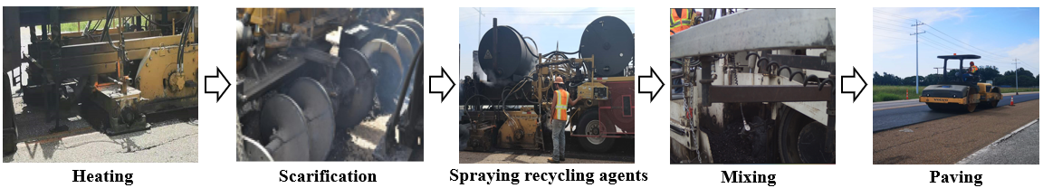

Figure 2-1. Hot in-place recycling procedures.

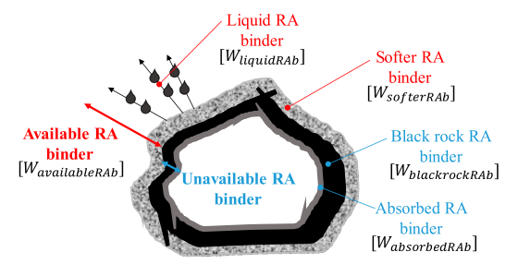
Figure 2-2. Reclaimed asphalt binder components (Lo Presti et al., 2019).

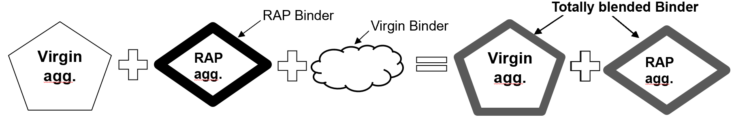

Figure 2-3. Ideal blending between virgin and aged binder in HMA.

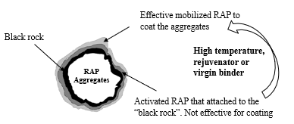
Figure 2-4. Different RAP binders in RAP aggregates.

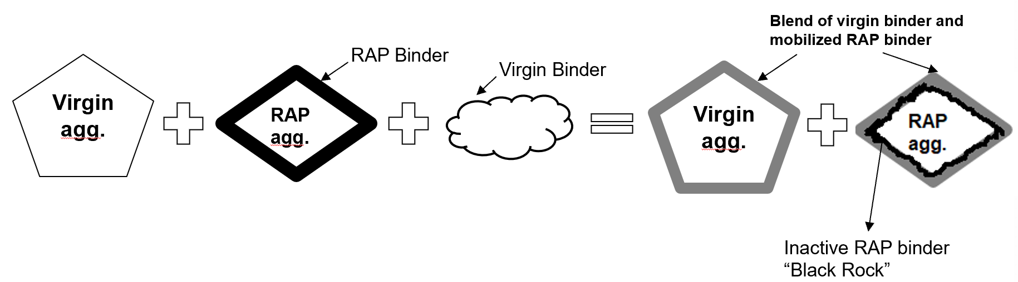
Figure 2-5. Real blending between virgin and aged binder in HMA.

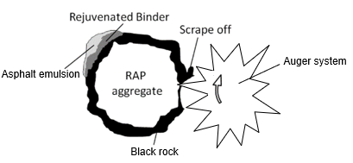
Figure 2-6. The situation of RAP binder during HIR procedures.

A comparative study between HIR and HMA mixes performance evaluation, pavement service life prediction, and life cycle cost analysis (LCCA).

A version of this chapter was published as Ma, Y., Polaczyk, P., Zhang M., Xiao R., Jiang X., & Huang B. “A Comparative Study on Pavement Rehabilitation using HIR and HMA: Performance Evaluation, Pavement Life Prediction, and Life Cycle Cost Analysis”, Transporation Research Record,

Abstract: The utilization of hot in-place recycling (HIR) for pavement surface rehabilitation has gained increasing attention to achieve sustainable pavement in recent years. For the purpose of cost-saving and the consumption of 100% reclaimed asphalt pavement (RAP), an in-place HIR train has been developed to combine various units including preheating, milling, rejuvenating, and compacting. Compared with the conventional hot mix asphalt (HMA) surface treatment, the HIR technique might result in different pavement performances due to the low mixing temperature and insufficient quality control. This study aimed to conduct a comparative study on pavement surface rehabilitation using HIR and HMA, including the performance evaluation, pavement life prediction, and the life cycle cost analysis (LCCA). HIR and HMA mixes were collected from the construction sections and the nearby asphalt plant, respectively. The loose mixes were reheated and compacted for performance testing, including dynamic modulus tests, Superpave IDT tests, and moisture susceptibility tests. The AASHTOWare Pavement ME Design software was adopted to predict the pavement life with two rehabilitation techniques, followed by the LCCA regarding the prediction results. Test results showed that pavement surface rehabilitation with HIR has acceptable performance and economic benefits. However, the HIR mixes are brittle and more susceptible to cracking issues, hence the shorter pavement service lives compared to HMA.

Introduction
The increasing costs of asphalt binder and aggregates have put much pressure on the highway maintenance budgets. Pavement managers are seeking alternative cost-effective approaches to rehabilitate the roads (Ma et al., 2020d; Ma et al., 2021d; Ma et al., 2021e; Song et al., 2018). Currently, there exist several asphalt recycling techniques consisting of two basic approaches: (a) inclusion of the milled reclaimed asphalt pavement (RAP) to replace a proportion of aggregates in hot mix asphalt (HMA) in asphalt plant, and (b) the in-place recycling, including cold in-place recycling (CIR) and hot in-place recycling (HIR) (Huang et al., 2005b; Ma et al., 2020f). In-place recycling technique encouraged consuming 100% RAP from the existing pavement, which allowed the utilization of suitable recycling agents to rejuvenate the aged asphalt. HIR is one of the pavement rehabilitation techniques primarily for the surface distresses, limited up to 25-50 mm (Manual, 2001). The pavement temperature before paving is usually around 110 °C (Ma et al., 2020f). The existing pavement is softened via flame heating, followed by scarification, rejuvenation, and compaction by an HIR train equipped with all the construction units. The cost-effectiveness of in-place recycling might be attributed to the saving of asphalt binder and virgin aggregates, the lower traffic disruption, and the less transportation cost (Finlayson et al., 2011). Repaving with HMA overlay is applied when HIR is not sufficient to restore the required pavement properties (Singhvi et al., 2016a).
A series of studies have explored the concept of incorporating RAP (up to 30%) during HMA production in asphalt plants. Results showed that the incorporation of RAP would increase the stiffness but also reduce the dissipated creep strain energy of the asphalt mixtures (Huang et al., 2005b; Huang et al., 2011; Huang et al., 2004). The brittleness of the RAP binder is considered a significant factor that would attenuate the cracking resistance of asphalt mixtures, hence the pavement's durability (Zhao et al., 2012). The aforementioned cracking problems might exaggerate during HIR procedures since 100% RAP is commonly used for rehabilitation. Zhong et al. investigated the binder aging level during HIR of asphalt pavement. They concluded that extra aging caused by HIR was not significant and the aging level of the bottom part is smaller than the surface part (Zhong et al., 2021). To improve the properties of the HIR mix, recycling agents were adopted to recover the chemical and mechanical properties of the RAP binder in HIR (Hafeez et al., 2014; Li et al., 2014). Ali and Bonaquist suggested that the addition of recycling agents could restore the recycled binder PG grade close to the original condition (Hesham and Bonaquist, 2012). A new additive, named Styrene-butadiene rubber (SBR) latex, was also introduced to enhance the moisture susceptibility and low-temperature cracking resistance of the HIR mix (Li et al., 2016; Ma et al., 2021b). Preheating conditions including temperatures and heating times were critical to the performance of HIR mixes (Liu et al., 2019). Ma et al. proposed that proper increase of temperature and adequate use of rejuvenator help improve the mobilization rate of the RAP binder, hence the performance of HIR mix (Ma et al., 2021a; Ma et al., 2020f). Ali and Grzybowski conducted a case study of life cycle cost analysis (LCCA) between HIR and conventional pavement rehabilitation. Projections reflected that HIR could result in an over 40% reduction of the initial cost (Ali and Grzybowski, 2012b). Cao et al. assessed the cost and environmental concerns between HIR and the conventional milling & filling techniques with assumed service life, indicating that HIR could save 5% cost and reduce 16% of the overall environmental impacts (Cao et al., 2019). In contrast to HMA mixtures in asphalt plants, HIR mix is produced in-place with 100% RAP, asphalt emulsion, with fire heating method, but lower mixing and compaction temperature, which might lead to different mixture performances and pavement service life. Furthermore, the quality control and LCCA of the pavements between HIR and HMA are also worth investigating.

Objective and scope
This study aims to conduct comprehensive comparisons between HIR and HMA mixes and pavement, including performance evaluation, pavement life prediction, and LCCA. To achieve this, HIR mixes from three different projects were collected and recompacted in the lab. One common HMA surface mix was also obtained from the asphalt plant for comparison. Asphalt Mixture Performance Tester (AMPT), Superpave indirect tensile strength (IDT) tests, and tensile strength ratio (TSR) tests were adopted for performance evaluation. Field cores were collected to assess the in-place construction qualities. ME software was utilized for modeling and pavement life prediction.

Materials preparation
HIR and HMA surface mixes were collected from three different construction sections and asphalt plants in Tennessee, respectively. All the materials came from a certain region, indicating similar aggregate types. The grain size distributions of the raw materials are shown in Figure 3-1. Both HIR and HMA mixes follow a similar gradation, which generally matches the typical surface mix in Tennessee. One cationic asphalt emulsion was used as a recycling agent to restore the binder properties of RAP. The asphalt contents of HIR and HMA mixes were determined through the centrifuge extraction test. As shown in Table 3-1, the asphalt contents of HIR mixes are generally higher than HMA since HIR mix contains the asphalt binder in RAP and asphalt emulsion. The incorporation of recycling agents would soften and activate more RAP binders and increase the effective binder contents of HIR mixes (Ma et al., 2021a). The asphalt contents in three HIR mixes represent the different dosages of asphalt emulsion incorporated during construction. The loose HIR mixes were reheated and recompacted for performance testing. Two replicates of AMPT tests and three replicates of IDT tests were conducted. 12 Field cores with a diameter of 150 mm were also extracted from the pavements before and after HIR procedures in each section, followed by cutting the top 50 mm for further performance testing.

Experimental methodology

Mixture performance tests

AMPT tests

Dynamic modulus tests and flow number tests were included in this study. In the dynamic modulus test, the trimmed specimens with a diameter of 100mm and a height of 150mm were placed in an environmental chamber and conditioned at 4 °C, 20°C, and 40 °C. The vertical deformations were captured via three linear variable differential transformers (LVDT) at 120° angles on the side. Tests were performed under an axial haversine load with various frequency sweeps at different temperatures. The dynamic modulus was calculated based on the collected stress and strain.
Flow number test is an efficient approach to characterize the creep properties of asphalt mixtures. The specimens are subjected to a continuous repeated load until the deformation reaches 3000 cycles or 50000 microstrains. The flow number is denoted as the cycles in which the rate of the permanent strain rate is achieved, reflecting the rutting potential of the mixtures (Witczak, 2002). In general, a higher flow number indicates less rutting potential of the asphalt pavement.

Superpave IDT tests

Superpave IDT tests consist of the resilient modulus test and the IDT strength test. As for the resilient modulus test, a specimen with 150 mm in diameter and 50 mm in thickness is subjected to a repeated load with a 0.1s loading and a 0.9s unloading rest period. Four strain gauges are placed in the middle to record the horizontal and vertical deformations. The resilient modulus (Mr) is calculated by the ratio of the applied stress and recoverable strain.
In terms of the IDT strength test, the load was applied to the same specimen at a constant rate of 50 mm/min until the failure occurs. The stress and strain curves are constructed according to the collected force and deformation. The dissipated creep strain energy threshold (DCSEf) can be determined by the difference between fracture energy (FE) and elastic energy (EE) in the stress-strain curves (Roque et al., 2004b).

Moisture susceptibility tests

Two types of moisture susceptibility tests were conducted to evaluate the moisture resistance of HIR and HMA mixes, the immersion-conditioned (IM) test, and the freeze-thaw-conditioned (F-T) test. The asphalt mixtures were compacted into a cylinder with a diameter of 150 mm and a height of 50 mm at 7% ± 0.5% air voids. One group of specimens was immersed in a water bath at 60 °C for 24 hours, followed by conditioning at 25 °C for 2 hours, whereas the other group of specimens was conditioned in the freeze-thaw machine for one cycle before further IDT strength testing. The tensile strength ratio (TSR) between the conditioned and unconditioned specimens was calculated to evaluate the moisture resistance of the HIR and HMA mixes.

Pavement life prediction

ME pavement design

The ME software was utilized to predict the performance and life cycle between the pavement after HIR surface treatment and the construction of a new HMA surface layer. The pavement performance models were locally calibrated to ensure the reliability of the prediction (Gong et al., 2017; Zhou et al., 2013). The traffic, climate, and pavement structures were determined according to the field project condition. The pavement layer and thickness were adopted following the TDOT pavement design guide. The average two-way annual daily truck traffic (AADTT) was calculated as 2000. The design life was set as 20 years. The pavement structure models are presented in Figure 3-2. D-mix, a dense mix of HMA, is applied as the surface layer, while BM2-mix is used as the binder layer in Tennessee. Afterward, the pavement design life was reduced until all the pavement performance satisfy the pavement design criteria, which determined the life cycle of the pavement.

Binder level-1 data inputs

As for binder properties, the binders of HIR mixes before and after rejuvenation were extracted and recovered for DSR frequency sweep tests at different temperatures. Asphalt is assumed to be fully blended with the RAP binder, which is the ideal blending scenario for HIR. One unmodified asphalt PG 64-22 and one SBS modified asphalt PG 76-22 were used for pavement prediction and comparison with the HIR surface mixes. DSR master curves were constructed based on superposition principles (Ma et al., 2020b; Ma et al., 2021c). Figure 3-3 and Table 3-2 present the DSR master curves and input parameters, respectively. It can be seen that the stiffness of the RAP binder is much higher than the base asphalt, especially in low frequency (high temperature). The addition of additives could soften the RAP binder and improve the rheological properties of the binder blends.

Mixture level-1 data inputs

The asphalt mixtures from different pavement layers were adopted to manufacture the cylinders for dynamic modulus tests at different temperatures. The dynamic modulus inputs for different asphalt mixtures are shown in Table 3-3.

Design criteria and thresholds

A series of pavement performances were analyzed at a design life of 20 years, including international roughness index (IRI), top-down fatigue cracking, bottom-up fatigue cracking, thermal cracking, and pavement deformations. The performance criteria were summarized in Table 3-4 to achieve a fair pavement condition with Tennessee pavement design criteria (Table 3-5).

Life cycle cost analysis
The Estimated Uniform Annual Cost (EUAC) method expresses life cycle costs as an annualized estimation of cash flow instead of a lump-sum estimation of the present value. The EUAC values of HIR and conventional HMA were calculated using the following equation:
$$EUAC=Cost \frac{i{(1+i)}^{n}}{{(1+i)}^{n}-1}$$
where i = discount rate, and n = number of years
Meanwhile, the LCCA of the pavement after 48 years was also plotted to evaluate the cost-effectiveness of using HIR surface treatment compared to the HMA surface layer.

Results and analysis

Performance tests

AMPT test results

Figure 3-4 (a), (b), and (c) plots the dynamic modulus test results of HIR, and HMA mixes at different temperatures. The former study reflects that the dynamic modulus of asphalt mixtures is sensitive to the change of asphalt binders (Huang et al., 2008). The mixtures with higher asphalt content present a lower dynamic modulus at all temperatures and frequency sweeps in HIR mixes. A larger proportion of HIR binder generates a softer asphalt mixture, indicating more rutting potential for the pavements. Compared to HIR mixes, HMA mixes present a larger dynamic modulus value at low temperatures (4 °C) and intermediate temperatures (20 °C) but a lower value at high temperatures (40 °C). It can also be noticed that HMA mix has less asphalt content than HIR mixes but provides stiffer performances of the asphalt mixtures, especially at low temperatures. Such differences might attribute to the better adhesion and coating capability between the virgin asphalt and the aggregates. As the temperature increases, the virgin binder tends to be softened more severely than the RAP binder, indicating more rutting issues in the asphalt mixtures. A lower flow number value of HMA, obtained at 54.4 °C in Figure 3-4 (d), also validates more rutting potential of HMA pavements at high service temperatures.

Superpave IDT results

Figure 3-5 (a), (b), and (c) illustrate the resilient modulus, IDT strength, and DCSE_{f} test results of HIR and HMA mixes at room temperatures. The resilient modulus test is applied to characterize the elastic behavior of asphalt mixtures. As for HIR mixes, it is shown that HIR mix with higher asphalt content has a lower resilient modulus, indicating the increasing ductility of the asphalt mixtures. HMA mixes exhibit the lowest resilient modulus compared to HIR mixes due to the better ductility of virgin binder than the aged binder.
DCSE_{f} reflects a threshold for cracking initiation and propagation of the asphalt mixtures. In general, asphalt mixtures with a higher DCSE_{f} value have improved cracking resistance (Zhang et al., 2001b). As shown in Figures 3-5 (b) and (c), the IDT strength and DCSE_{f} of the HMA mix are much higher than the HIR mixes, even though it contains the lowest asphalt content. Therefore, the HMA mix tends to have better cracking resistance than the HIR mix. The high production temperature of HMA with virgin asphalt would contribute to an improved coating and adhesion between the binder and aggregates. However, in terms of HIR mix, the incomplete activation of RAP binder through fire heating, the low mixing, compaction temperature, and the large proportion of RAP binder would result in a weaker coating with aggregates, and hence the compromised cracking resistance of asphalt mixtures. In addition, the major concern of the HIR mix is the cracking issue, which can be potentially improved by using more additives and increasing the mixing temperatures.

Moisture susceptibility test results

The immersion conditioned test and freeze-thaw conditioned test were adopted to evaluate the moisture resistance of the asphalt mixtures, denoted as TSR (IM) and TSR (F-T) in Figure 3-6, respectively. Freeze-thaw conditioning has more severe moisture damage than the immersion conditioning method. It can be seen that the HMA mix has better moisture resistance than the HIR mix in both moisture damage conditions. The TSR values for HIR mix with different asphalt content did not vary a lot. The TSR values for HIR mix underwater immersion conditions could satisfy the minimum criteria for Superpave asphalt mixture design (TSR ≥ 0.80). Further strategies should be considered to improve the moisture resistance of HIR mixes, especially for areas with large temperature differences.

Field cores evaluations
Field cores from one HIR section were collected from the pavement before and after HIR surface treatment. The air voids of old and new cores are around 4% and 7%, respectively. The cores were trimmed from the top 50 mm for further Superpave IDT tests. As a comparison, the collected HIR loose mixes were also compacted at 7% and 4% air voids in the lab to simulate the pavement condition after construction and long service life. Figure 3-7 (a) and (b) illustrate the indirect tensile strength and DCSE_{f} test results of the cores and the lab compacted specimens. It can be noticed that the IDT strength and dissipated creep strain energy of the old pavement decreased around 40%, corresponding to their initial conditions. This means that the quality of the pavement surface was mitigated due to the cracking issues during service lives, which required surface rehabilitation. The new cores and lab compacted HIR mix present similar values of the IDT strength and DCSE_{f}, indicating a good quality control of the pavement surface treatment through HIR procedures.

Pavement life prediction
The ME software was adopted to predict the pavement's service life through HIR and HMA surface rehabilitation considering different pavement performance criteria. The pavement performances after 20 years are predicted in Table 3-6. Compared to the pavements constructed by the new HMA surface layer, the pavements after HIR procedures present similar permanent deformations but higher fatigue cracking area and thermal cracking length. Both the bottom-up fatigue cracking area and the thermal cracking length will not satisfy the criteria. Therefore, the pavement after HIR procedures is not susceptible to rutting issues, whereas it tends to encounter bottom-up fatigue cracking problems, especially thermal cracking. The pavement prediction results agree with the laboratory performance test results.
Table 3-7 presents the life cycle of pavements using different rehabilitation approaches. Based on the combination of fatigue cracking and thermal cracking prediction, the pavement's life cycle after the HIR technique is around eight years, four years shorter than the pavement with the new HMA surface layer.

Life Cycle Cost Analysis
The EUAC method was applied to evaluate the economic value of different alternatives, reflecting the life cycle cost of the pavement. As for the 2-inch surface layer, the average cost of the HIR section is 4.02 $/yard² (19778.1$/lane mile), while that of the convention section via HMA milling and & filling is $12.8/yard² ($62975.05/lane mile) in Tennessee. Correspondingly, assuming a discount rate of 4%, the EUAC of HIR over 8 years and the conventional pavement over 12 years are $0.60/yard² ($2937.60/lane mile), and $1.36/yard² ($6710.13 /lane mile), respectively. Therefore, pavement rehabilitated through HIR could offer up to 56% of the initial cost-saving. The LCCA of 48 years between pavement after HIR construction and HMA built surface layer construction is plotted in Figure 3-8 (a). Assuming two new pavements after rehabilitation with HIR and HMA at the beginning, the pavements would last 8 years and 12 years for using HIR and HMA surface rehabilitation, respectively. The construction periods for the two techniques were assumed as 1 year. Hence, the pavements were rehabilitated at the end of the 7th year and 11th year, while the construction cost started to increase afterward. It can be shown that at the end of 47 years, the HIR techniques could save around $ 90000 compared to the new HMA surface layer.
As mentioned in the input parameters, not all of the RAP binder in the HIR mix can be activated to coat the aggregates. Hence, the inputs of the binder properties in the HIR mix tend to be the ideal condition. In the real scenario, a thin overlay sometimes was repaved to achieve a better performance of the pavement, which might alter the cost-effectiveness of the pavement. Assuming the pavement life is also 8 years with thin overlay and additional surface treatment, the LCCA of 48 years of the pavement is also presented in Figure 3-8 (b). It can be noticed that HIR and HMA treatment display similar in the first two life cycles (20 years), while the HIR technique could save around 20% of the cost in 48 years life cycle. Hence, HIR surface treatment proved to be more cost-effective than the new HMA surface layer regarding the long service life of the pavements.
It is necessary to remind that the cost data were mainly considered the direct construction cost. However, the total cost includes some indirect costs such as user costs and environmental costs that were not involved in this study. It also needs to point out that the AADTT was adopted based on the traffic conditions of the low-volume road. The increase in traffic volume or load capacity would damage the HIR pavement surface more severely, which might lead to a shorter pavement life compared with HMA surface treatment. In addition, the extended service life of the HIR surface layer would further reduce the quality of existing RAP aggregates and cause more aging of the RAP binder, which might affect the reliability of LCCA. Lacking adequate pavement performance data in the field, future test sections and pavement monitoring should be conducted to validate the pavement life and performance between the HIR and HMA pavement surface rehabilitation techniques.

Conclusions
In this study, a comprehensive comparison of pavement surface rehabilitation using HIR and HMA was conducted, including the performance evaluation, pavement service life prediction, and life cycle cost analysis. HIR mix from three different sections and the plant mix in the same region were collected, while field cores were also obtained to assess the pavement condition after HIR surface treatment. Table 3-8 summarized the major comparison results of the asphalt mixtures and pavement performances with HIR and HMA surface rehabilitation techniques. The main conclusions can be summarized as follows:
- HIR mixes showed acceptable rutting and moisture resistance. Cracking resistance is the main issue that HIR mixes would encounter. HMA has a stronger coating between asphalt and aggregates than the HIR mix even with the lower asphalt binder content, indicated by higher IDT strength and DCSEf.
- The incorporation of recycling agents in the HIR mix would soften the RAP binder and increase the effective binder content of HIR mixes, which improve the ductility and cracking resistance of the asphalt mixtures.
- The DCSEf of field cores reflected that the cracking resistance of the existing pavement surface before HIR rehabilitation decreased by more than 40%. HIR technique showed consistent construction qualities as lab mixes, which could restore the cracking resistance of existing pavement.
- ME prediction results indicated that pavement after HIR surface treatment would yield a larger value of roughness index and encounter severe fatigue cracking as well as low-temperature cracking issues.
- LCCA results reflect that HIR surface rehabilitation would cause over 50% of the initial cost-saving than conventional HMA milling and filling technique. Along with the overlay, HIR surface rehabilitation is expected to save the construction cost for the whole life cycle. Various traffic volume or load conditions and further pavement monitoring should be considered for LCCA validation.
For future studies, pavement monitoring is promoted to investigate the detailed differences between the HIR and HMA pavement conditions. Innovative approaches, including rejuvenators or heating techniques, should be developed to improve the cracking resistance of the HIR mix. In addition, detailed energy consumption, emissions, and toxicity potential data are required to be collected to evaluate the environmental effect of using HIR for pavement rehabilitation.

APPENDIX

APPENDIX 3A: Abbreviations
HIR --- hot in-place recycling
HMA --- hot mix asphalt
RAP --- reclaimed asphalt pavement
LCCA --- life cycle cost analysis
CIR --- cold in-place recycling
AMPT --- Asphalt Mixture Performance Tester
IDT --- Indirect tensile strength
TSR --- tensile strength ratio
LVDT --- linear variable differential transformers
DCSEf --- dissipated creep strain energy threshold
EE --- elastic energy
FE --- fracture energy
IM --- immersion conditioned
F-T --- freeze-thaw conditioned
AADTT --- average two-way annual daily truck traffic
EUAC --- estimated uniform annual cost

APPENDIX 3B: Figures
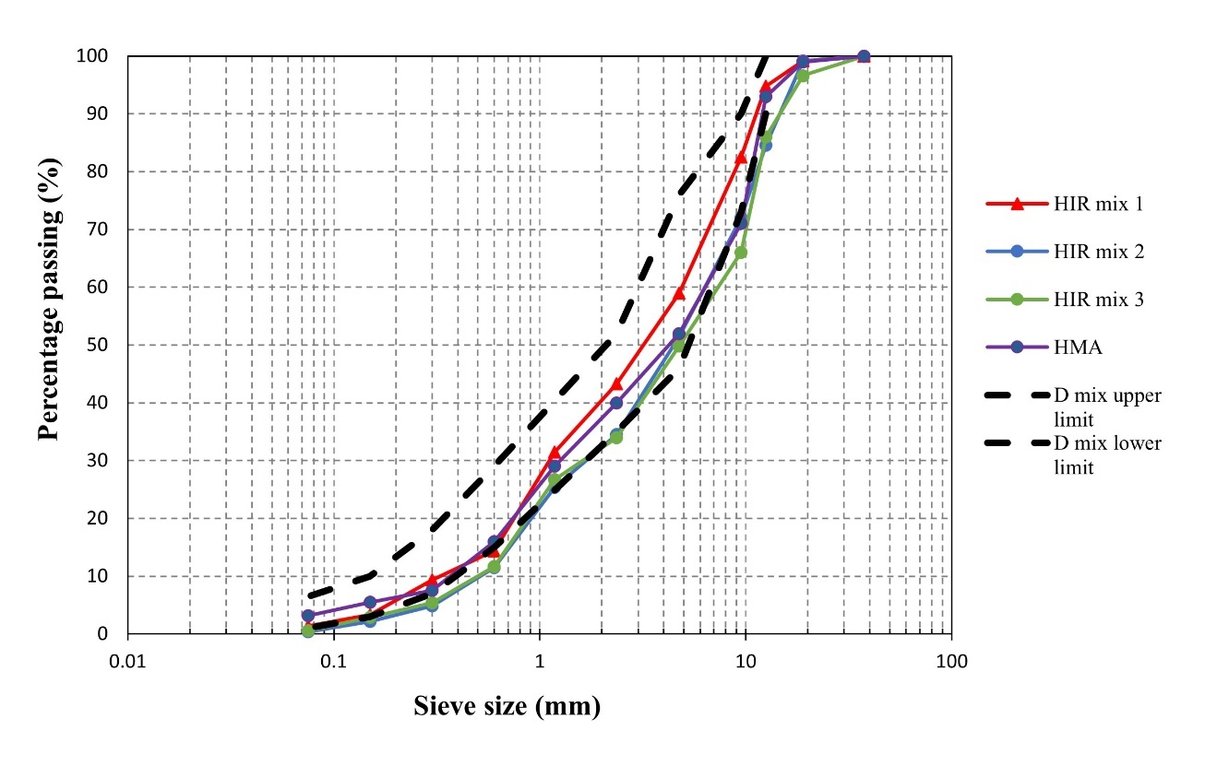

Figure 3-1. The grain size distributions of raw materials.

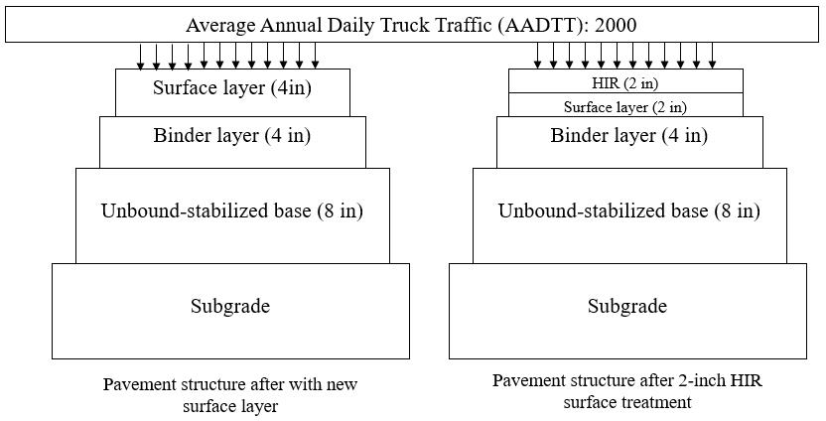
Figure 3-2. Pavement structure models of two pavements; (a) New HMA surface layer; (b) after HIR surface treatment.

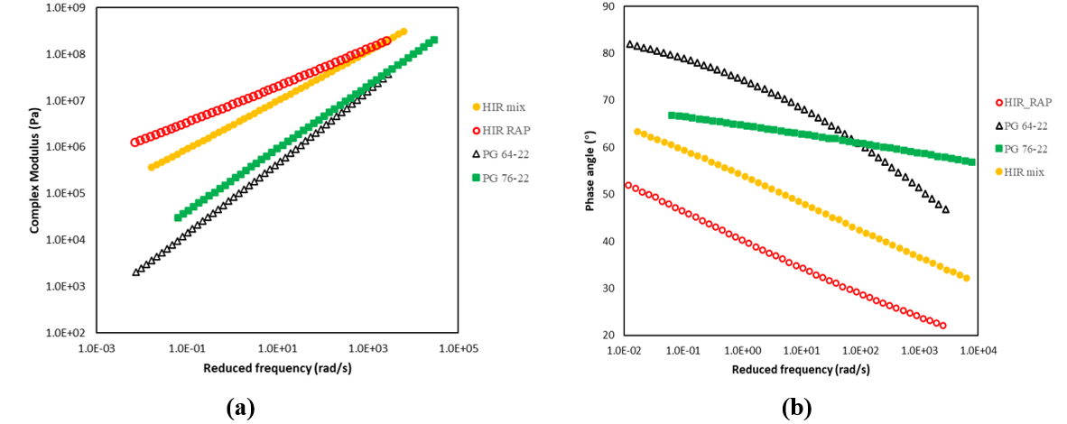
Figure 3-3. DSR master curves of different binder blends. (a) Complex modulus master curves; (b) phase angle master curves.

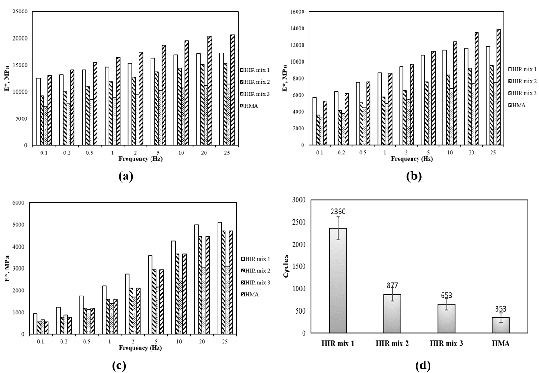
Figure 3-4. AMPT test results of HIR and HMA mixes, (a) dynamic modulus at 4 °C, (b) dynamic modulus at 20°C, (c) dynamic modulus at 40 °C, (d) flow number.

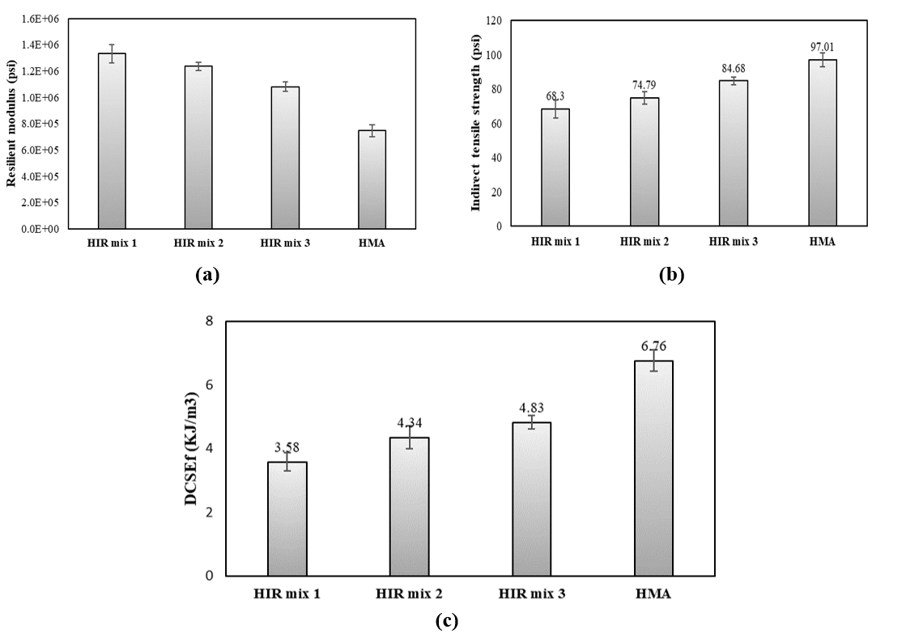
Figure 3-5. Superpave IDT test results of HIR and HMA mixes, (a) Resilient modulus; (b) Indirect tensile strength; (c) DCSEf.

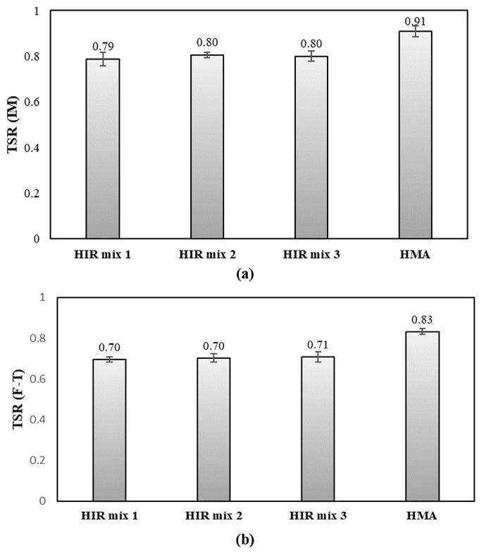
Figure 3-6. Moisture susceptibility tests of HIR and HMA mixes, (a) TSR (IM); (b) TSR (F-T).

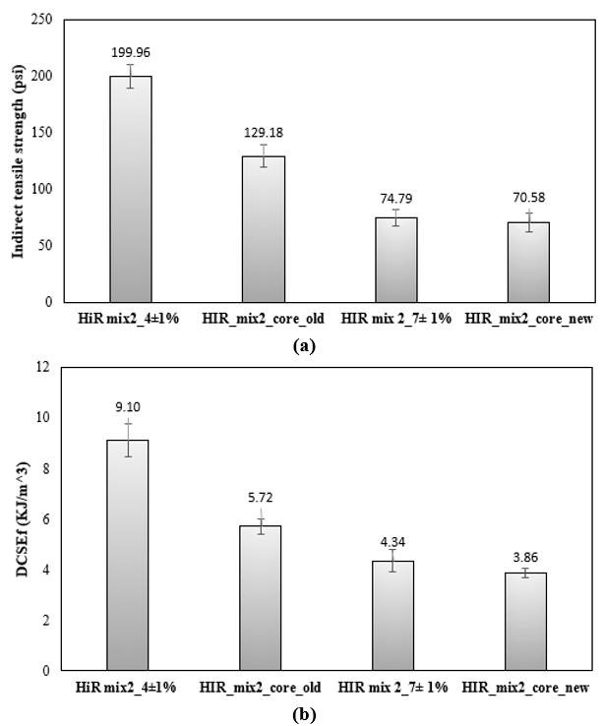
Figure 3-7. Performance comparison between field cores and lab specimens, (a) IDT strength, (b) DCSEf.

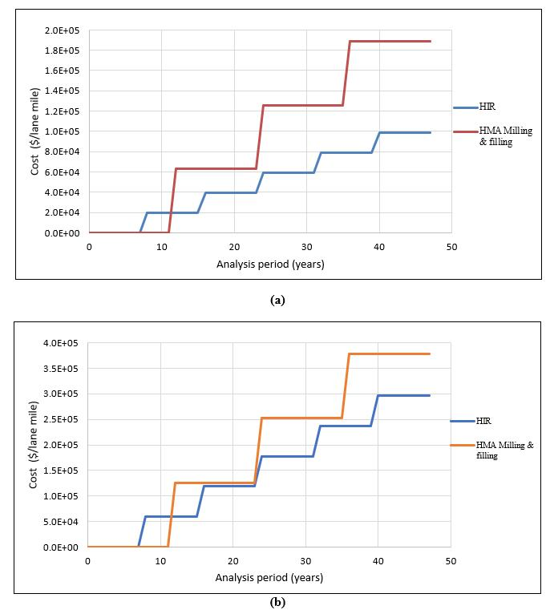

Figure 3-8. The LCCA of 48 years between pavement surface rehabilitation with HIR and HMA. (a) HIR surface treatment without overly (b) HIR surface treatment with a thin overlay.

APPENDIX 3C: Tables
Table 3-1. Asphalt content of HIR and HMA mixes.
Type of Mixes | HIR mix 1 | HIR mix 2 | HIR mix 3 | HMA
Asphalt content (%) | 6.93 | 7.32 | 7.68 | 6.0

Table 3-2. Binder properties design input at 10 rad/s.
PG 64-22 |  |  |  | PG 76-22
Temp (F) | Temp (°C) | G* (Pa) | Phase angle (°) | Temp (F) | Temp (°C) | G* (Pa) | Phase angle (°)
59 | 15 | 676435.5 | 65.3 | 59 | 15 | 1146239 | 61.8
77 | 25 | 116630.4 | 72.1 | 77 | 25 | 245153 | 64.9
95 | 35 | 15805 | 78.7 | 95 | 35 | 45049 | 64.9
HIR mix |  |  |  | HIR RAP
Temp (F) | Temp (°C) | G* (Pa) | Phase angle (°) | Temp (F) | Temp (°C) | G* (Pa) | Phase angle (°)
59 | 15 | 14782760 | 43.63 | 59 | 15 | 29618406 | 31.32
77 | 25 | 6162031 | 51.34 | 77 | 25 | 11253999 | 38.39
95 | 35 | 862668 | 58.55 | 95 | 35 | 3055880 | 46.59

Table 3-3. Dynamic modulus of asphalt mixtures in different pavement layers.
Dynamic modulus of HIR mix (psi)
Temperature (°F) Frequency (Hz)
 | 0.1 | 0.5 | 1 | 5 | 10 | 25
14 | 2132499 | 2365736 | 2455186 | 2637494 | 2705520 | 2786409
40 | 1274491 | 1577604 | 1705456 | 1987229 | 2099961 | 2239597
70 | 465389 | 697235 | 797339 | 1078398 | 1206781 | 1379401
100 | 118114 | 202981 | 252804 | 404709 | 486601 | 609898
130 | 28435 | 50623 | 65020 | 115253 | 146316 | 198403
Dynamic modulus of D-mix with PG 64-22 (psi)
Temperature (°F) Frequency (Hz)
 | 0.1 | 0.5 | 1 | 5 | 10 | 25
14 | 1751298 | 2076674 | 2203310 | 2461892 | 2557819 | 2670907
40 | 7922916 | 1135249 | 1290768 | 1650911 | 1799975 | 1987100
70 | 169227.5 | 323025.6 | 412935.4 | 676585.7 | 810901.1 | 1002730
100 | 23123.3 | 53610.5 | 75852.6 | 160645.3 | 215656.8 | 309022.5
130 | 3542.3 | 7965.7 | 11464.9 | 26980.4 | 38839.2 | 62101.8
Dynamic modulus of D-mix with PG 76-22 (psi)
Temperature (°F) Frequency (Hz)
 | 0.1 | 0.5 | 1 | 5 | 10 | 25
14 | 2520385 | 2722695 | 2795313 | 2934413 | 2983130 | 3038682
40 | 1348727 | 1709169 | 1858036 | 2175995 | 2298423 | 2445601
70 | 256367 | 452466 | 556287 | 847530 | 990656 | 1190588
100 | 31996 | 58908 | 77229 | 144498 | 187781 | 261992
130 | 7208 | 10729 | 13062 | 21818 | 27808 | 38943

Table 3-3 continued.

Dynamic modulus of BM-2 mix (psi)
Temperature (°F) Frequency (Hz)
 | 0.1 | 0.5 | 1 | 5 | 10 | 25
14 | 2504737 | 2705062 | 2777478 | 2917199 | 2966520 | 3023069
40 | 1347969 | 1699086 | 1844327 | 2155694 | 2276201 | 2421692
70 | 271373 | 457767 | 560217 | 845515 | 985071 | 1179726
100 | 31920 | 59384 | 77993 | 145757 | 188989 | 262624
130 | 6571 | 10052 | 12371 | 21116 | 27111 | 38251

Table 3-4. Design parameters thresholds in ME design.
Design input | Limit | Reliability
IRI (in/mile) | 170 | 90
AC top-down fatigue cracking (% lane area) | 20 | 90
AC bottom-up fatigue cracking (% lane area) | 20 | 90
AC thermal cracking (ft/mile) | 1000 | 90
Permanent deformation – total pavement | 0.4 | 90
Permanent deformation AC only (in) | 0.25 | 90

Table 3-5. Tennessee pavement design criteria.
Performance criteria | Good | Fair | Poor
IRI (in/mile) | < 95 | 95-170 | >170
Cracking (%), Asphalt Pavements | < 5 | 5-20 | >90
Cracking (%) Jointed Concrete Pavements | < 5 | 5-15 | >90
Rutting, (in.) | < 0.20 | 0.20-0.40 | >0.40
Faulting (in.) | < 0.10 | 0.10-0.15 | >0.15

Table 3-6. Pavement performance after 20 years.
Performance criteria | PG 64-22 | PG 76-22 | HIR | Limit | Reliability
IRI (in/mile) | 158.24 | 158.46 | 172.87 | 170 | 90
AC top-down fatigue cracking (% lane area) | 4.69 | 12.91 | 14.13 | 20 | 90
AC bottom-up fatigue cracking (% lane area) | 58.44 | 58.44 | 64.47 | 20 | 90
AC thermal cracking (ft/mile) | 934.59 | 485.08 | 1727.52 | 1000 | 90
Permanent deformation - AC only (in) | 0.22 | 0.12 | 0.20 | 0.25 | 90

Table 3-7. Life cycles of the pavement after different rehabilitation approaches.
Types  Reference | PG 64-22 | PG 76-22 | HIR
Based on fatigue cracking | 12 years | 12 years | 10 years
Based on thermal cracking | 20 years | Over 20 years | 8 years

Table 3-8. A summary of asphalt mixtures and pavement performance with two rehabilitation techniques.
Mixture performances and pavement response | HIR | HMA milling & filling
Mixtures
Flow number (cycles) | High | --
Resilient modulus at 25°C (psi) | High | --
IDT strength at 25°C (psi) | -- | High
DCSE_{f} at 25°C (KJ/m³) | -- | High
TSR(I-M) & (F-T) | -- | High
Pavement
IRI (in/mile) | High | --
Fatigue cracking (% lane area) | High | --
Thermal cracking (ft/mile) | High | --
Permanent deformation (in) | -- | Little high
Predicted life (years) | 8 | 12
Initial cost saving | Up to 50% | --
Cost-saving of 48 years | Up to 20% | --

Investigate the blending mechanism of HIR mixes relating to binder mobilization and mixture mechanical properties.

A version of this chapter was published as Ma, Y., Polaczyk, P., Park, H., Jiang, X., Hu, W., & Huang, B. (2020). “Performance evaluation of temperature effect on hot in-place recycling asphalt mixtures.” Journal of Cleaner Production, 277, 124093. DOI: https://doi.org/10.1016/j.jclepro.2020.124093
Abstract: Hot in-place recycling (HIR) is a novel technique to rehabilitate the surface layer of the pavements, in which recycling agents are commonly utilized to restore the binder rheological properties of reclaimed asphalt pavements (RAP). Considering the energy consumption and smoke issue, the heating temperatures for HIR containing 100% RAP mix are usually controlled at around 110°C, which is significantly lower than that for the traditional hot mix asphalt (HMA). To evaluate the effect of temperature on the performance of 100% recycled asphalt mixtures after the HIR process, the materials obtained from an HIR project were remixed and compacted at different temperatures (110°C, 120°C, and 130°C). The asphalt mixture performance tester, asphalt pavement analyzer test, Superpave indirect tension tests, and moisture susceptibility tests were conducted to evaluate the performances of the HIR mix. The staged extraction tests were used to identify the mobilized RAP binders under different temperatures. It was revealed that mixtures heated with a higher temperature exhibit better cracking and moisture resistance performances. It was also found that a larger proportion of the RAP binders can be activated to coat the aggregates at a higher mixing temperature, which may increase the rutting potential.

Introduction
With the increasing cost of petroleum products and construction and the limitation of the federal budgets for pavement preservation, recycling techniques have played significant roles in pavement rehabilitation for state highway agencies (SHAs) (O’Sullivan, 2009). According to the National Asphalt Pavement Association (NAPA) asphalt pavement survey on recycled materials, the total estimated tons of recycled asphalt pavement (RAP) used in the asphalt mixtures was 76.2 million, whereas the total estimated amount of stockpiled RAP was about 102.1 million tons during the 2017 construction season. Therefore, some cost-effective methods and alternative techniques are expected to rehabilitate distressed pavements (Ma et al., 2020e). Among the existing rehabilitation methods, the in-place recycling techniques are proving to be economical and sustainable in utilizing more recycled materials, which have been developed rapidly in countries including the United States, Canada, France, Germany, and Spain because of their potential to reduce the pollution issues, to extend the life cycle of the pavements, and to save the construction costs (Martínez-Echevarría et al., 2008).
Among different in-place recycling techniques, the hot in-place recycling (HIR) technique aims at restoring the damaged surface to its original condition with the application of in situ heat during the construction process. Based on the severity of distress, different types of HIR processes can be applied for pavement rehabilitation. In general, surface recycling (heater scarification), mixing, and paving are the basic HIR process organized by the Asphalt Recycling and Reclaiming Association (ARRA) (Recycling, 1992). Surface recycling is the process of heating and scarifying the existing road surface, followed by mixing with the rejuvenating agents and compaction technique, which is suitable for pavements subjected to minor cracks within 25-50 mm in depth. Additional repaving is often used when surface recycling fails to restore the pavement condition, which requires a new asphalt concrete overlay of 25-50 mm thickness. Remixing is usually applied when significant modifications of the existing mix are required due to the change in aggregate gradation, binder content, binder rheology, and mixture volumetric properties (Stroup-Gardiner, 2012).
With the ever-increasing awareness of achieving sustainable pavements, a higher percentage of RAP is encouraged to be used in asphalt mixtures. The properties of asphalt mixtures with high RAP contents have been investigated in previous studies (Zhao et al., 2012; Zhao et al., 2013). Shu et al. evaluated the moisture susceptibility of foamed warm mix asphalt (WMA) and hot mix asphalt (HMA) with the addition of RAP (Shu et al., 2012). Results showed that mixtures with high RAP content are conducive to moisture resistance. Song et al. explored the moisture resistance of the rejuvenated asphalt mixtures and summarized that the addition of rejuvenator could improve the moisture damage resistance of asphalt mixtures (Song et al., 2018). However, the HIR section was expected to contain 100% of the aged mix, which may result in different pavement performance from the traditional HMA. Several studies have explored the performance of the HIR mix. Ali et al. explored the performance of mixtures after the HIR process compared to the original Superpave mixtures in Florida. The results demonstrated that the HIR mix could meet the Superpave requirements with an acceptable rutting and cracking resistance (Ali et al., 2013). They also recommended improving the performance of mixtures by optimizing air voids and binder grades. Hafeez et al. explored the influence of HIR techniques on the performance of asphalt mixtures and binder rheological properties. Results indicated that alternative additives could improve the blending and compatibility of the new and old materials. (Hafeez et al., 2014; Yu et al., 2016).
Since HIR contains 100% percent of RAP materials during the HIR procedure, rejuvenator was commonly used to restore the binder properties of aged asphalt (Zaumanis et al., 2013). Ma et al. investigated two different rejuvenator incorporation methods and reported that the binder blends will perform better rheological properties by adding the rejuvenator into the aged binder first (Ma et al., 2020a). Polymer-modified asphalt was also applied to improve the performance of asphalt mixtures without increasing the rutting risk. Styrene-butadiene rubber (SBR), a new polymer emulsion additive, was utilized in an HIR project in China. Both binder and mixture properties were evaluated and it was proved that SBR latex could enhance the rutting and fatigue cracking resistance of the asphalt mixtures (Li et al., 2014; Li et al., 2016).
Temperature is another important parameter that can affect the rutting and cracking resistance of the asphalt mixtures. Xiao et al. explored the effect of compaction temperature on the performance of foamed warm mix asphalt. Results revealed that when the mixtures were compacted at a certain air void, the rising compaction temperature generally increased the rutting potential but improved the cracking resistance of the mixtures (Xiao et al., 2013). In the HIR process, old pavement mixtures must be heated to the desired temperature before mixing. Achieving high temperatures with the flame heating technique will generate more smoke and emissions, which are hazardous to both human health and the environment (Terrel and Hicks, 2008). To balance the workability and safety, temperatures were usually controlled at around 110°C in the existing HIR projects, which may arise two concerns. First, the mixing and compacting temperatures for HMA were usually determined by characterizing the viscosity properties of the binder through a rotational viscometer which will be significantly higher than this value. Second, for the 100% RAP mixtures with the addition of rejuvenator, the aged binder may not reach the desired viscosity at this relatively low heating temperature. Based on previous studies, the high temperature is helpful to accelerate the diffusion and blending efficiency between the virgin and aged binders (Ding et al., 2016a). Zhao et al. used the stage extraction test to characterize the blending efficiency between the virgin and aged binders (Zhao et al., 2015). As for the 100% RAP after HIR procedures, more RAP binders are expected to be activated and mobilized to coat the aggregates under a high mixing temperature, which might be evaluated by using stage extraction tests. Therefore, it is necessary to investigate the mixing and compaction temperature effect on the performance of the 100% hot in-place recycling processed mixtures.

Objective and scope
The objective of this study is to investigate the influence of mixing and compaction temperature on the performance of the HIR mix. To achieve this, the loose mixes after being incorporated with additives at 110 °C were collected in the field project. The mixtures were remixed and compacted to a target air void using Superpave Gyratory Compactor (SGC) at 110°C, 120°C, and 130°C in the lab. The Asphalt Pavement Analyzer (APA) tests, the Superpave indirect tension (IDT) tests, the asphalt mixture performance tester (AMPT), and moisture susceptibility evaluation were used to characterize the performances of the asphalt mixtures compacted at different temperatures. Also, a staged extraction test was used to identify the mobilization of RAP binders, and the blending mechanism of the binder blends under different mixing temperatures.

Laboratory experiments

Materials and sample preparation
A pavement section in Madison county, Tennessee, was selected to monitor the HIR construction process and to collect the recycled materials for laboratory testing. In this project, a four-stage HIR train, shown in Figure 4-1 (a), repeated the heating and milling process to achieve a total depth of up to 2 inches. The surface layers before and after HIR are presented in Figure 4-1 (b). Figures 4-1 (c) and (d) presented the images of analyzed temperature distributions that were captured infrared camera. Both mixing and compaction temperatures were around 110 °C. A type of polymer-modified asphalt emulsion additive named ARA-3P with 0.9 % wt of the asphalt mixtures was applied to rejuvenate the asphalt binder in the existing pavement during the HIR mixing process. The composition and properties of ARA-3P are listed in Table 4-1. The grain size distribution of the mixtures before and after milling is shown in Figure 4-2, in which “RAP” stands for the recycled materials, while the materials after hot scarification and additive incorporation are named “Mix”. The Tennessee Dense-graded mix (D-mix) specification is also plotted in Figure 4-2. The gradations of the two mixtures lie in the range of D mix specification and overlap each other, indicating that there exists limited variation in gradations before and after HIR processing.
The collected loose materials after rejuvenation were remixed and compacted into required air voids using SGC in the lab at three temperatures (110°C, 120°C, and 130°C) for further performance testing. Since the aforementioned emulsified asphalt instead of the HMA was used during mixing and compaction, the workability of HIR mixes was improved at relatively low temperatures. For the APA rutting test, cylindrical samples were compacted to a height of 75 ± 2 mm and a diameter of 150 mm at 7 ± 0.5 % air voids. For the Superpave IDT tests, the mixtures were first compacted to a cylinder with a diameter of 150 mm and a height of 150 mm at 4 ± 0.5 % air voids, and the compacted specimens were cut and trimmed to a height of 50 mm afterward. The AMPT samples were compacted to a diameter of 150 mm and a height of 170 mm at 7 ± 0.5 % air voids and then cored and cut on both ends to obtain the samples with a diameter of 100 mm and a height of 150 mm for further testing.

AMPT test

Dynamic modulus test

In the dynamic modulus test, the trimmed specimens were conditioned in an environmental chamber. The test was performed over a range of temperatures (4 °C, 20 °C, and 40 °C) under a frequency sweep mode of 0.1, 0.5, 1, 2, 5, 10, 20, 25 Hz following AASHTO TP62-03. Three linear variable differential transformers (LVDT) were placed at 120° angles on the side, which were used to capture the vertical deformation of the specimens. The dynamic modulus, defined as the absolute value of complex modulus $\left|E^{*}\right|$, was obtained from the axial stress and strain. The calculation is shown as follows:
$\left|E^{*}\right|=\frac{σ_{0}}{ε_{0}}$ (1)
where: $σ_{0}$= the stress amplitude; $ε_{0}$ = the recoverable strain amplitude.

Flow number test

Flow number test is a useful tool to characterize the creep properties of asphalt mixtures subjected to a repeated-load. A haversine load is applied to compress the specimen with a 0.1 second loading time and 0.9 second recovery time until the deformation of 50000 microstrains or 10000 cycles was reached. The test was conducted at 54 °C, which matched the average maximum effective pavement temperature in Tennessee. The flow number, denoted as the point where the permanent strain rate is at the minimum value, has been correlated with the rutting potential of the mixtures (Witczak, 2002). Mixtures with a higher flow number will exhibit less permanent deformation in the field.

APA rutting test

The Asphalt Pavement Analyzer (APA) is widely used to evaluate the rutting resistance of the asphalt mixtures. Based on AASHTO TP 63-09 procedures, the wheel is tracked across the sample for 8000 cycles using a 100-lb load and a 100-psi hose pressure. In this study, the specimens were conditioned in the molds at 64 °C for 6 h and the rut depths at 8000 cycles were recorded.

Superpave IDT tests
The Superpave IDT tests consist of resilient modulus (M_{R}), creep compliance, and indirect tensile (IDT) strength tests (Buttlar, W.G. and Roque, R., 1994). Four strain gauges are fixed on a sample to obtain the horizontal and vertical deformation during testing. In this study, resilient modulus and IDT strength tests were conducted at 25 °C for all the specimens. Figure 4-3 shows the setup of the Superpave IDT tests.

Resilient modulus test

The resilient modulus test is performed on a sample with 150 mm in diameter and 50 mm in thickness by applying a repeated peak load, which contains a 0.1-second loading followed by 0.9 second unloading rest period. The resilient modulus can be calculated from the recorded load and deformation, which is shown as follows:
$M_{R}=\frac{P×GL}{∆H×t×D{×C}_{cmpl}}$ (2)
where $M_{R}$= resilience modulus; $P$ = maximum load; $GL$ = gage length; $∆H$ = horizontal deformation; $t$ = thickness of specimen; $D$ = diameter of specimen; $C_{cmpl}$ = 0.6354${\text{(X/Y)}}^{-1}-0.332$; nondimensional creep compliance factor and $\text{X/Y}$ = the ratio of horizontal to vertical deformation.

IDT strength test

In the IDT strength test, the load was applied to the specimen at a constant rate of 50 mm/min. The load and deformation till failure were recorded during the test. The indirect tensile strength was calculated using the following equation:
$S_{t}=\frac{2×P×C_{sx}}{π×t×D}$ (3) where $S_{t}$ = indirect tensile strength; $P=$ peak load; $C_{sx}=0.948-0.01114×\left(\frac{t}{D}\right)-0.2693×υ+1.436×(t/D)×υ$ Where $υ=-0.1+1.48×{\left(\frac{X}{Y}\right)}^{2}-0.778×{(t/D)}^{2}×{(X/Y)}^{2}$; D, t, and (X/Y) are the same as described above.
An example of stress-strain response curve from the IDT strength test is shown in Figure 4-4 and the dissipated creep strain energy threshold ($\text{DCS}{\text{E}}_{\text{f}}$) can be determined using the following approaches (Roque et al., 2004a):
$\text{DCS}{\text{E}}_{\text{f}}=FE-EE$ (4)
where FE = fracture energy, which represents the area under the stress-strain curve to the failure strain ${\text{ε}}_{\text{f}}$, and EE = elastic energy.
$FE=\int_{0}^{{\text{ε}}_{\text{f}}}{S(ε)}$ (5)
$EE=\frac{1}{2}S_{t}({\text{ε}}_{\text{f}}-{\text{ε}}_{\text{0}})$ (6)

Moisture susceptibility test

The Tensile Strength Ratio test was utilized to measure the effect of water on the tensile strength of asphalt mixtures following the AASHTO T283 standard test. The standard specimens, 150 mm in diameter and 50 mm in height with 7 ± 0.5 % air voids were divided into two groups: One was left in dry condition, while the other was placed in the water bath and partially saturated. For each test at least six samples should be compacted, three for the unconditioned test, and three for the conditioned test. The vacuum should be applied to saturate the second group of specimens from 55 to 80%. The partially saturated samples should be conditioned in distilled water at 60°C for 24 hours. The unconditioned and conditioned samples were used to determine the tensile strength ratio (TSR), which was calculated as follows:
$TSR=\left(\frac{S_{tm}}{S_{td}}\right)100$ (7)
where TSR is the tensile strength ratio, S_{tm} is the average tensile strength of moisture conditioned specimens, S_{td} is the average tensile strength of dry set.
The M_{R} and $\text{DCS}{\text{E}}_{\text{f}}$ ratios of conditioned and unconditioned specimens were also selected to evaluate the moisture susceptibility of the mixtures.
All the parameters for performance tests were summarized in Table 4-2.

Staged extraction test
To identify the blending mechanism of binder blends, two beakers were filled with 50 ml of trichloroethylene (TCE) to dissolve the asphalt binder first. 25 g of the mixtures blended at three different temperatures were washed in the first beaker for 30 seconds by using a small aluminum mesh basket and immediately washed in the second beaker for 3 mins afterward. The two washes were aimed to obtain the outer and inner layer of the asphalt mixtures. The extracted solutions were firstly dried in the fume hood. After most of the solvent was evaporated, the binder was then placed in the vacuum-oven at 80°C overnight to remove the residual solvents. After obtaining the asphalt binder specimens, Gel permeation chromatography (GPC) was operated to detect the molecular size distributions of the asphalt. The concentration of 3mg asphalt per 3ml of the tetrahydrofuran (THF) was prepared and injected into a 2 ml vial for further testing. The relationship between the molecular weight and refractive index was obtained from the GPC chromatogram. The large molecular size (LMS) fraction, with the molecular weight greater than 3000 Dalton, is determined by calculating the ratio between the fraction area and the total area in the chromatogram. Due to the high proportion of asphaltenes, which occupies more molecular weight, the aged asphalt binder usually has a larger LMS fraction value than the virgin binder (Daly et al., 2013). At the beginning of blending, the additives and RAP binders lie in the outer and inner layer of the asphalt mixtures, respectively. As the blending process goes, additives will gradually diffuse into and activate the RAP binder. The mobilized RAP binders will result in the LMS fraction decrease of the inner layer and the LMS fraction increase of the outer layer, which may due to different temperatures. Therefore, the difference of the LMS fractions between the two asphalt layers was able to identify the effect of temperatures on the mobilization of the RAP binders and the blending mechanism of the binder blends.

Results and analysis

AMPT test
The dynamic modulus of each specimen obtained from frequency sweep tests under different testing temperatures was presented in Figure 4-5 (a), (b), (c). Results showed that the higher the testing temperature would lower the dynamic modulus of the mixtures. The master curves for the asphalt mixtures were developed at the reference temperature of 20 °C by the time-temperature superposition principle. Figure 4-6 plots the dynamic modulus master curves of the HIR mixtures heated at three temperatures in a log scale. It can be observed that mixtures compacted at 130 °C show the lowest dynamic modulus at all frequency stages, followed by the mixtures conditioned at 120 °C and 110 °C. Previous research revealed that the dynamic modulus test is sensitive to the small change of the asphalt binder content (Huang et al., 2008). Therefore, for the 100% HIR mix, the high heating temperature may activate more aged asphalt and accelerate the diffusion of the additives into the RAP binder. More effective asphalt binder would be activated to soften the mixtures, which makes the specimens easier to deform during the dynamic modulus test.
Flow number test was also conducted to explore the high-temperature performances of the HIR mixtures compacted at three temperatures. The test was performed at 54.4 °C, which was the average highest temperature in Tennessee. As shown in Figure 4-7, the flow numbers of mixes conditioned at 110 °C, 120 °C, and 130 °C are 2360, 2049, and 1504, respectively. Mixtures compacted at a higher temperature will compromise the rutting resistance, indicated by a lower flow number. Higher compaction temperature may also facilitate curing and breaking of emulsified asphalt. More additives were possible to diffuse into the aged binder at high temperatures. Therefore, the activated RAP asphalt was able to weaken the rutting performances of the mixtures. The rutting resistance of the mixtures will be evaluated further by the APA rutting test.

APA rutting test
Figure 4-8 presents the APA rutting test results. Figure 4-8 (a) shows the rut depth development at different loading cycles. Figure 4-8 (b) gives the average rut depth at 8000 cycles. As expected, the HIR mixtures heated at high temperature are more susceptible to rutting, indicated by a larger value of rut depth. The rut depths of the mixtures are in accordance with the dynamic modulus and flow number results.

Superpave IDT tests
Figure 4-9 illustrates the IDT strength and failure strain results. Mixtures compacted at a higher temperature tend to have a lower the indirect tensile strength, and the failure strains seem to increase as expected. The additives used during HIR procedures were aimed to restore the binder rheological properties of the aged RAP. Meanwhile, increasing the temperature might facilitate the softening process of the RAP binder, which would compromise the stiffness of the asphalt mixtures. Therefore, the strength of the mixtures could reduce due to the loss of the stiffness, while the ductility of the mixtures could be improved.
Figure 4-10 presents the resilient modulus results of the HIR mixtures. Resilient modulus test is used to evaluate the elastic behavior of the asphalt mixtures under different compaction temperatures. From the results, it is shown that the resilient modulus of the HIR mixtures was reduced with increasing temperature. The additives used in this study consist of up to 40% of the virgin asphalt as well as the petroleum-based extracts. Previous studies reported that the increasing temperature could improve the blending efficiency between the virgin binder and RAP binder (Ding et al., 2018; Zhao et al., 2016). Therefore, with the incorporation of the additives at a higher temperature, the additives were possible to soften the RAP binder and facilitate the blending efficiency of the additives and RAP binders, which made it easier for the binder blends to coat the aggregates. A staged extraction test will be used to validate the blending mechanism of the two binders in the following section.
The dissipated creep strain energy (DCSE_{f}) exhibits a threshold for crack initiation and propagation. The increase of DCSE_{f} results in the improvement of cracking resistance of the asphalt mixtures (Zhang et al., 2001a). Figure 4-11 presents the DCSE_{f} results of the HIR mix at different heating temperatures. The DCSE_{f} is required to be greater than 0.75kJ/m³ for HIR regarding the Florida experience (Roque et al., 2004a). All the mixtures satisfied the minimum requirements for the DCSE_{f}, however, the higher temperature resulted in a larger DCSE_{f} value of the HIR mix, indicating that the cracking resistance of the mixtures was improved. The DCSE_{f} results also validated the IDT strength results, since increasing the heating temperature of the HIR mix could result in a higher failure strain, reflecting that the ductility and cracking resistance of the mixtures was further improved.

Moisture susceptibility tests
The moisture susceptibility of the mixtures was characterized using the resilient modulus ratio, tensile strength ratio (TSR), and dissipated creep strain energy ratio (DCSE_{f}) between the moisture conditioned and unconditioned specimens. Figure 4-12, Figure 4-13, and Figure 4-14 present the resilient modulus ratio, TSR, and DCSE_{f} ratio respectively. In general, the moisture conditioning procedure may cause more moisture damage to tensile strength than the resilient modulus and DCSE_{f}. However, the increase of temperature tended to enhance the moisture resistance of the HIR mixtures, reflected by larger values of the three ratios.

Staged extraction test
Based on the performance test results, high mixing temperatures are likely to accelerate the diffusion of the additives into the RAP binders. The mobilized RAP binders increase the amount of effective asphalt content to achieve better-coated asphalt mixtures. In this section, the staged extraction test was conducted to validate the mobilization of RAP binders and the blending mechanism of the binder blends. The outer and inner layers of the HIR mix blended at three temperatures were separated by being submerged into TCE for 30 s and then 3 mins, respectively. The differences of the LMS fractions between the inner and outer layers were obtained by the GPC test.
Table 4-3 shows the results of staged extraction tests. The LMS fractions of the emulsified asphalt and RAP binder were 20.6% and 33.8%, respectively. Regardless of the temperature, all the outer and inner layers had a value of LMS fractions between them with a lower value for the outer layer, indicating that the outer layer contained more additives, whereas the inner layer had more RAP binders. The differences of LMS fractions of inner and outer layers reflected the capability of the emulsified asphalt diffusing into the RAP binder. The smaller value indicated that the blending is more efficient and a larger proportion of RAP binder was mobilized. It can be observed that the increase of mixing temperature will decrease the difference of LMS fractions, which means that high temperatures could facilitate the diffusion of additives into the aged binder and improve the blending efficiency of the binders. As a result, more RAP binders would be activated to coat the aggregates at the higher temperature. Therefore, the cracking and moisture resistance performances of the asphalt mixture could be improved, but the higher content of activated asphalt would cause some rutting issues.

Discussion of the results.
In this study, the 100% HIR processed RAP was remixed and compacted at three different temperatures, then the performances of the HIR mix were investigated. Test results suggested that the high temperature could improve the cracking and moisture resistance of the mixtures but might decrease rutting resistance. Additives were proved to play a significant role in restoring the aged RAP and improving the ductility of the HIR mix. The staged extraction test validated that high temperatures could improve the blending efficiency between the emulsified asphalt and RAP binder. More mobilized RAP binder would be incorporated to coat the aggregates. Several studies about the asphalt binders also revealed that the higher temperature was able to facilitate the rejuvenation effect and the blending efficiency between the virgin and aged binders, which was consistent with the stage extraction results in this study (Ding et al., 2016b; Kriz et al., 2014). During the HIR process, an appropriate heating temperature could activate more aged materials and accelerate the diffusion between the virgin and aged binders, which led to better cracking resistance. However, the overheated temperatures could activate excessively aged asphalt and increase the content of the mobilized binders, therefore, mixtures would be more susceptible to rutting and also compromise the IDT strength. Therefore, a reasonable range of temperatures should be considered in the mix design to ensure better performances of the asphalt mixtures.
Currently, the HIR technique is mostly applied in the low volume road and there still exist some problems during the HIR procedures such as the inadequate mixing and smoke issues. High mixing and compaction temperatures could improve the performances of the pavement; however, because of the limitations of the heating equipment and the loss of temperature in the field, it is hard to achieve the expected temperature, which could influence the coating of aggregates. Advanced heating techniques should be developed to retain the heat and balance the smoke issue. The inadequate coating of aggregates may also due to the HIR train speed and the consumption of additives, which should be carefully considered in the mix design. Another potential approach is to explore the new types of additives such as optimizing the content of polymer and solvent to facilitate the workability during mixing. In addition, the homogeneity of air voids as related to the compactability of the mixtures. Polaczyk et al. developed the impact compaction method to evaluate the compactability of the HMA (Polaczyk et al., 2018; Polaczyk et al., 2019). A better compaction effect would be expected by adjusting the asphalt content and the angularity of the aggregates. The digital image processing technique was also utilized to evaluate the compaction homogeneity of the HIR mix (Li et al., 2020). Further studies are supposed to solve these existing problems to improve the quality of the HIR pavements.

Conclusions
The study aimed to investigate the temperature effect on the performance of the 100% reclaimed asphalt mixtures after HIR procedures. Samples were prepared at 110°C, 120°C, and 130°C, respectively. APA rutting test, Superpave IDT tests, as well as moisture susceptibility tests, were conducted to compare the performance of the three types of mixtures, including the rutting, cracking, and moisture susceptibility of the mixtures. A staged extraction test was used to validate the mobilization of the RAP binder and the blending mechanism of the binder blends. Based on the test results, the conclusions can be summarized as follows:
- A higher temperature was able to improve the cracking resistance of the mixtures, indicated by a larger DCSEf value.
- Increasing the temperature could result in a higher ratio of resilient modulus, tensile strength, and DCSEf,, revealing that the moisture resistance of the HIR could be improved.
- The HIR mixes compacted at higher temperatures were more susceptible to rutting, indicated by a larger rut depth and a lower flow number value.
- Based on the staged extraction test, a higher temperature could facilitate the diffusion of the additives into aged asphalt. More aged asphalt binder could be activated to coat the aggregates, which improved the cracking and moisture resistance of the asphalt mixtures. However, the high content of mobilized asphalt would also cause some rutting potentials of the asphalt mixtures.
- Temperatures should be considered based on different pavement conditions. For example, higher temperatures are recommended for the pavements that are more susceptible to the cracking and moisture damage, while lower temperatures are preffered for the pavements subjected to hot weather, which may cause the rutting issues.

Acknowledgments
The author would like to thank the Tennessee Department of Transportation (TDOT) for offering financial support and conducting the field project. The views reflect within this manuscript are those of the authors and do not necessarily represent the views of TDOT.

APPENDIX

APPENDIX 4A: Figures
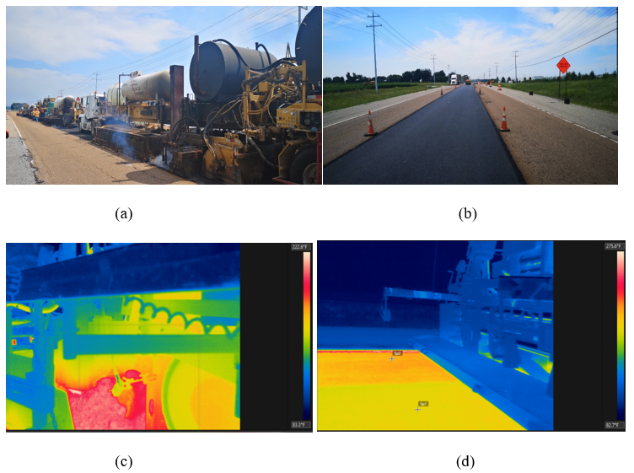
Figure 4-1. (a) HIR trains; (b) surface layers before and after HIR procedures; (c) temperature distribution during mixing; (d) temperature distribution during paving.

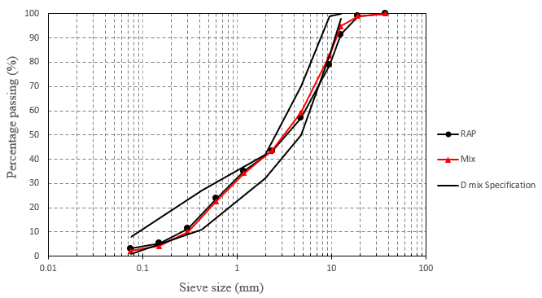
Figure 4-2. The gradations of the materials: RAP stands for asphalt mixtures before adding the additives, Mix refers to the mixtures after adding the additives.

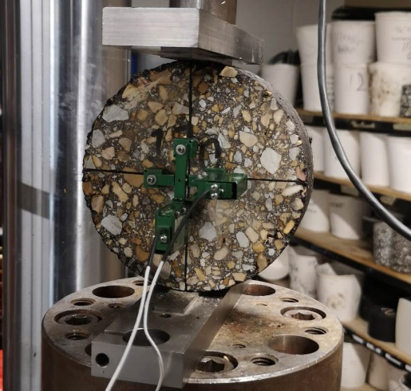
Figure 4-3. Superpave IDT test setup.

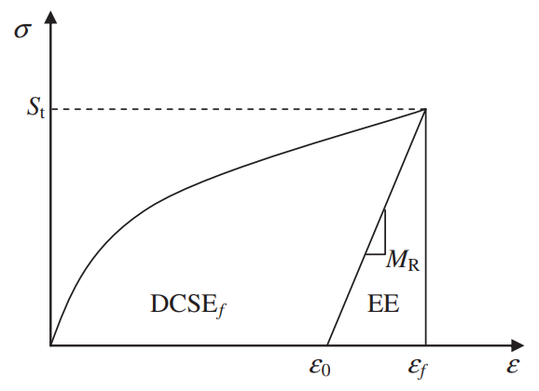
Figure 4-4. Determination of creep strain energy.

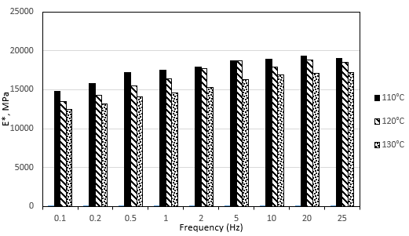

(a)

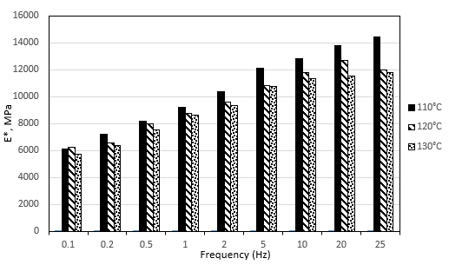
(b)

Figure 4-5. Dynamic modulus of the HIR mixtures results: (a)Tested at 4 °C, (b) tested at 20 °C, and (c) tested at 40 °C.

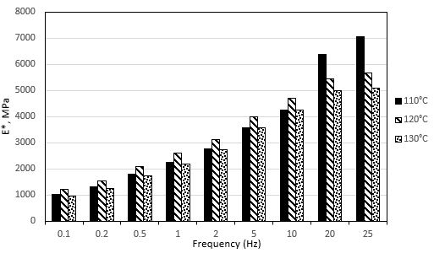
(c)

Figure 4-5 continued.

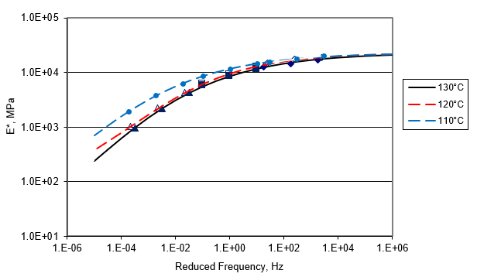
Figure 4-6. Dynamic modulus master curve of the HIR mixtures at the reference temperature of 20 °C.

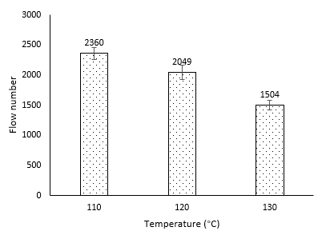
Figure 4-7. Flow number results of the HIR mix.

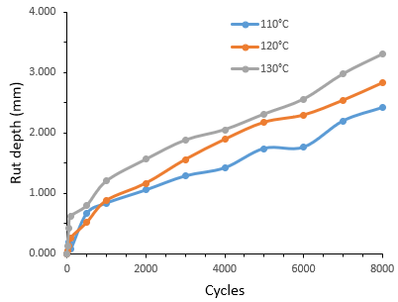
(a)

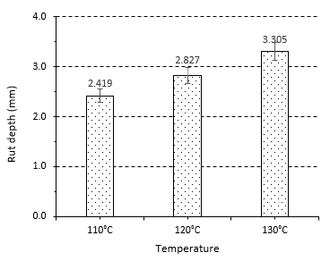
(b)

Figure 4-8. APA rutting test results: (a) Rut depth vs. loading cycles (b) Rut depth.

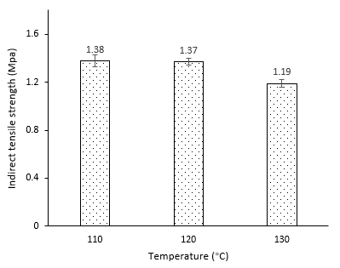
(a)

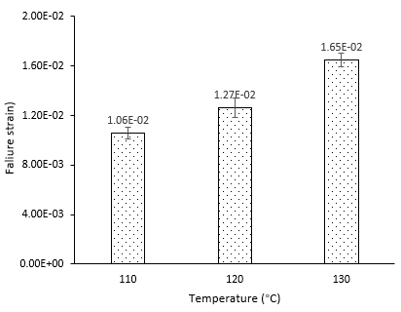
(b)

Figure 4-9. Results of IDT tests, (a) Indirect tensile strength and (b) failure strain.

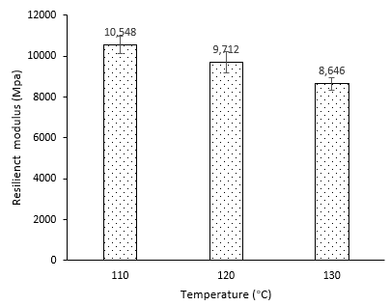

Figure 4-10. Resilient modulus test results.

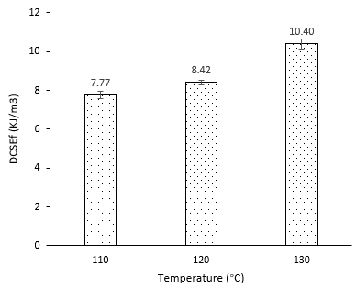

Figure 4-11. Dissipated creep strain energy threshold results.

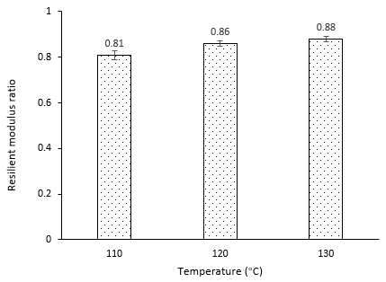

Figure 4-12. Resilient modulus ratio results.

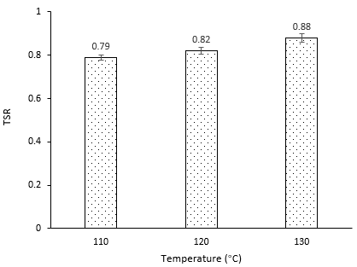

Figure 4-13. Tensile strength ratio (TSR) results.

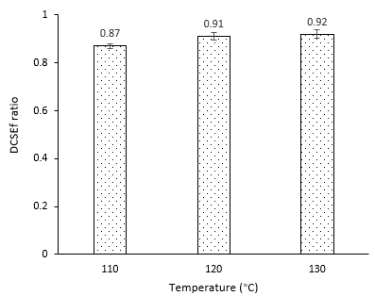

Figure 4-14. Dissipated creep strain energy ratio (DCSE_{f}) results.

APPENDIX 4B: Tables
Table 4-1. Compositions and properties of ARA-3P.
Compositions
Chemical name | Content (%)
Water | 50-70
Asphalt | 20-40
Extracts (petroleum), heavy naphthenic distillate solvent | 1-20
Physical and chemical properties
Physical state | Liquid
Odor | Tar-like
pH | 2.1-4
Boiling point | 100 °C
Density | 1.0 g/cm³

Table 4-2. Parameters for the performance tests.
Performance test | Dimensions | Target air void (%)
APA rutting test | 150 mm in diameter, 75mm in thickness | 7±0.5
AMPT tests | 150 mm in diameter, 150mm in thickness | 7±0.5
Superpave IDT tests | 150 mm in diameter, 50mm in thickness | 4±0.5
TSR tests | 150 mm in diameter, 50mm in thickness | 7±0.5

Table 4-3. Stage extraction test results.
Material types | Mixing temperature (°C) | Large molecular size fraction (%)
Material types | Mixing temperature (°C) | Outer | Inner | Difference
HIR mix | 110 | 25.8 | 31.7 | 5.9
HIR mix | 120 | 26.3 | 29.3 | 3.0
HIR mix | 130 | 27.1 | 28.4 | 1.4
Emulsified asphalt | -- | 20.6 |  | --
RAP | -- | 33.8 |  | --

Quantify and maximize the recycling efficiency of HIR mixes

A version of this chapter was published as Ma, Y., Polaczyk, P., Hu, W., Zhang, M., & Huang, B. (2021).. “Quantifying the effective mobilized RAP content during hot in-place recycling techniques.” Journal of Cleaner Production, 314, 127953. DOI: https://doi.org/10.1016/j.jclepro.2021.127953

Abstract: The utilization of in-place recycling techniques is capable of consuming 100% reclaimed asphalt pavement (RAP). Hot in-place recycling (HIR) is one of the promising techniques to rehabilitate the pavements suffering from minor cracking issues through heat scarification, additive injecting, mechanical mixing, and compacting. However, the main concern of using 100% RAP in HIR remains as how much RAP can be activated and mobilized to coat the aggregates under different circumstances. In this study, an approach was developed to quantify the effective mobilized RAP content during HIR procedures by targeting directly into the ignition loss of the RAP binder. Various factors were considered including temperatures, heating methods, as well as the types and dosage of the additives. The commonly used Fourier transform infrared spectroscopy (FTIR) method was also adopted to validate the effective mobilized RAP content quantified by the ignition oven method. The results demonstrated that the ignition oven method is an effective tool for quantifying the effective mobilized RAP content, which is comparable to the FTIR methods. The temperatures and dosage of additives are critical in improving the mobilization of RAP and should be optimized to achieve a sustainable pavement.

Introduction
It was estimated that over 100 million tons of the reclaimed asphalt pavement (RAP) were stockpiled at the end of 2018 in the United States (Williams et al., 2019). Researchers and professionals are looking for alternative approaches to accommodate the increasing amount of recycled pavement supply. To this end, the utilization of in-place recycling techniques demonstrates the economic and environmental benefits to consume 100% RAP materials without significant compromise in mixture performance (Singhvi et al., 2016b). Among these in-place recycling techniques, hot in-place recycling (HIR) is one of the available technologies to rehabilitate the pavement when the majority of crack lengths were limited to 50 mm with minor structural problems (Manual, 2001). The HIR technique consists of softening and scarifying the surface layer, spraying the recycling agents such as asphalt emulsion and rejuvenators, mixing and paving the rejuvenated RAP materials. The overall procedures are presented in Figure 5-1. A number of studies summarized that the addition of recycling agents lowers the viscosity and stiffness of the RAP binder; therefore, the mixtures from HIR procedures exhibit improved cracking and moisture resistance but may compromise the rutting resistance and indirect tensile strength (Bouraima et al., 2019; Hafeez et al., 2014). Florida Department of Transportation (FDOT) evaluated the cost and performance data of HIR mix and traditional hot mix asphalt (HMA) sections for eight years and confirmed that the life-cycle cost of HIR sections was more cost-effective, resulting in 40% cost saving as opposed to the traditional HMA sections (Ali and Grzybowski, 2012a).

However, a major concern of using 100% RAP materials in the asphalt mixtures is how much RAP binder can be activated and mobilized to coat the aggregates since RAP binder has become stiff and brittle, which is difficult to be activated. In terms of the production of traditional HMA, a certain percentage of RAP (up to 30%) is usually incorporated into the asphalt mixtures (Huang et al., 2005a). As shown in Figure 5-2, theoretically, it is expected that the virgin binder can diffuse into the RAP binder to achieve a homogenous binder blend, which wraps over both virgin and RAP aggregates (Zhao et al., 2015). However, as shown in Figure 5-3, ` (Ding et al., 2016a; Zhao et al., 2019). In the real blending scenarios of HMA, as shown in Figure 5-4, the “black rock” lies in the innermost layer, while part of the viscous RAP is mobilized with the virgin binder, which is used to coat both virgin and RAP aggregates (Zhao et al., 2016). Therefore, the effective mobilized RAP consists of the RAP binder activated by high temperatures and part of the viscous RAP that is mobilized by the virgin asphalt or additives.
In terms of the RAP binder during HIR procedures, some of the RAP binders are scraped off by the auger system during heat scarification. With the addition of the recycling agents such as asphalt emulsion and rejuvenator, part of the viscous RAP is rejuvenated and mobilized to glue the aggregates. The aforementioned situation is presented in Figure 5-5. In this scenario, the effective RAP binder includes a proportion of the scraped RAP binder, the mobilized RAP binder through heating, and part of the viscous RAP mobilized by additives. Compared to the blending scenario of HMA, HIR techniques severely restricts mobilization of the RAP binder, since 100% RAP is promoted to be utilized in the field. Hence, in order to improve the efficiency of asphalt mixtures during HIR construction, approaches need to be developed to characterize and quantify the mobilized RAP content.
Previous studies have been conducted to evaluate the blending efficiency of the aged binder by employing different methods based on chemical properties, mechanical properties, and visual assessment of the asphalt. Mechanical properties involve measuring the rheological properties of binders using dynamic shear rheometer (DSR) or bending rheometer (BBR) tests (Shirodkar et al., 2011; Zhao et al., 2014). Chemical properties including large molecular size (LMS) fraction and carbonyl area were usually determined using gel permeation chromatography (GPC) and Fourier transform infrared spectroscopy (FTIR), since LMS fraction and carbonyl areas tend to undergo a clear change with the presence of RAP binder (Bowers et al., 2014; Hou et al., 2018). A tracker material (TiO₂) was employed to trace the virgin binder for blending efficiency evaluation using optical methods such as scanning electron microscope (SEM), X-ray scanning (Castorena et al., 2016), and fluorescence microscopy (FM) (Ding et al., 2018). Navaro et al. investigated the blending efficiency using automated image analysis of ultraviolet light photomicrographs and found that the degree of blending was influenced by mixing temperature and mixing time (Navaro et al., 2012). Furthermore, the mobilization rate was developed to quantify the degree of blending between virgin and aged binders in HMA. Special virgin aggregates were incorporated and mixed with different proportions of RAP. The binders from the selected special aggregates were extracted and recovered to conduct GPC and FM tests, aiming at correlating the RAP binder content with large molecule size (LMS) and mean grey value (MGV), respectively. The mobilization rate was finally determined based on the fitted blending chart (Ding et al., 2016a; Zhao et al., 2016). In terms of the blending scenario in 100% RAP during HIR techniques, the influence of the effective RAP binder including the temperature-activated RAP and part of the viscous RAP on the performance of HIR mix will be enlarged. However, most of the approaches to quantifying the degree of blending focused on the extracted binder properties, and the extraction process might dissolve the immobilized RAP binder such as “black rock”, which would affect the characterization of blending efficiency. Furthermore, fire heating was applied in the HIR train, which was different from the oven heating in the lab. No available studies have been conducted to simulate the entire HIR procedures in the lab. The conventional used extraction method to quantify the blending efficiency of asphalt mixtures may not be suitable for HIR mix. Therefore, the objective of this study was to simulate the HIR procedures and introduce a straightforward approach to quantifying the effective mobilized RAP content of HIR mix based on the ignition loss of the RAP binder. The HIR process was simulated with the application of the torch and mixer in which the temperature distribution was also captured through the infrared camera. The ignition oven method was used to directly obtain the ignition loss of the RAP binder. The influence of various factors on the effective mobilized RAP content were considered including the temperatures, the types of additives, the additives content, and the heating method. The FTIR method was also adopted to compare the effective mobilized RAP content with the ignition oven method.

Materials and methodology

Raw materials
The RAP materials after heat scarification of HIR procedures were collected in Henderson County, Tennessee. The RAP binder was washed with Trichloroethylene (TCE) using a centrifuge extractor and dried for sieve analysis afterward. Figure 5-6 shows the grain size distribution of the RAP. One cationic asphalt emulsion, ARA_3P, was used during the HIR technique. The physical and chemical properties of ARA_3P were listed in Table 5-1. As shown in Table 5-2, one type of tall oil, serving as a rejuvenator, was also obtained for blending evaluation. Furthermore, the commercial virgin asphalt for HMA was received from Marathon Petroleum Corporation in Tennessee.

Heating methodology
Oven heating methodology is used to simulate the asphalt mixing procedures in the asphalt plant; however, as for the HIR train in the field, the heating units apply fire to directly heat the pavement in a short period. The use of fire will activate more but may burn a little RAP binder, which may influence the mobilization rate of RAP. Therefore, torch heating procedure is designed to simulate the fire heating in the lab. As shown in Figure 5-7, a torch is controlled to directly blow the asphalt mixtures in the asphalt mixing machine, while a digital infrared thermometer is used to detect the temperature. The infrared camera is also applied to capture the temperature distribution of the asphalt mixtures until reaching the target temperature.

Effective mobilized RAP content quantification.
The aforementioned effective mobilized RAP content refers to the activated RAP binder that is used to coat aggregates. The asphalt ignition furnace was applied to determine the asphalt content of asphalt mixtures using the loss on ignition following ASTM D6307. In order to directly simulate the blending process and quantify the proportion of effective RAP content, virgin aggregates that retained ½ and 3/8 inches were selected to replace part of coarse RAP in mix while keeping the fine RAP that passed No. 4 Sieve, since it is convenient to differentiate and separate the coarse virgin aggregates and fine RAP for further tests.
There exist two scenarios in quantifying the effective mobilized RAP content: 1. “Dry” mixing, the blend including coarse virgin aggregates and fine RAP only, which is to simulate the heat scarification and scrape off RAP during HIR procedures. 2. “Wet” mixing, the mixtures with the incorporation of additives or asphalt (rejuvenator, asphalt emulsion, and commercial asphalt PG 64-22 used in this study), aiming at simulating the injection of additives in the HIR technique. Figure 5-8 (a) presents the blending condition of “dry” mixing. The fine RAP before and after “dry” mixing was picked out and fully burnt in the ignition furnace. The effective mobilized RAP content could be obtained by the difference of ignition loss of RAP materials before and after ignition. Further, the calculation of effective mobilized RAP content would be more complicated under the scenarios with the incorporation of rejuvenator, asphalt emulsion, and commercial virgin asphalt (PG 64-22), since additives or asphalt binder are capable of diffusing into the RAP binder, which can help with the activation and mobilization. As shown in Figure 5-8 (b), the asphalt emulsion tends to adhere to the surface of both virgin and RAP aggregates as well. Therefore, after the “wet” mixing, the ignition loss of the collected fine RAP consists of the mobilized RAP content and the attached additives or virgin binder. Approaches are needed to get rid of this proportion of asphalt emulsion films. Previous studies usually applied the surface area of different sizes of aggregates to roughly estimate the mass of asphalt film around the aggregate particles (Craus and Ishai, 1977; Ding et al., 2016a). In this study, as shown in Figure 5-8 (c), a relatively direct method was developed for the asphalt emulsion film calculation, which is to substitute all the fine RAP with a similar gradation of virgin aggregates for mixing and burn the collected fine virgin aggregates afterward. The mass of the asphalt emulsion film could be determined through the ignition loss of the collected virgin aggregates. Based on this approach, various conditions including temperatures, the dosage of additives, and the heating methods, were considered to quantify the effective mobilized RAP content of 100% RAP after HIR procedures.

FTIR characterization
The coarse aggregates were picked out and washed through TCE, followed by FTIR analysis. FTIR provides a convenient approach to characterize the blending efficiency of the asphalt binders at molecular levels (Zhao et al., 2015). The absorbed radiation will be converted into vibration and rotational energy by the molecules in asphalt samples. A receiver can detect the signals and form a spectrum afterward, revealing a certain molecular fingerprint of each functional group in asphalt. In asphalt binder chemistry, the carbonyl bond (C=O) exhibits at a wavelength around 1700 cm⁻¹ while the sulfoxide bond (S=O) exhibits a wavelength around 1000 cm⁻¹ in the asphalt spectrum. Both chemical bonds could gauge the level of asphalt oxidation. Studies showed that the aged asphalt is prone to have higher C=O and S=O compared with the virgin binder (Hou et al., 2018). The blended binder virgin and aged binder would fall in the middle of the two regions. The degree of blending can be calculated with the reference of the peak areas (Sreeram et al., 2018a).

Evaluation of FTIR spectrum.
Figure 5-9 illustrates the FTIR spectrum of the virgin emulsion and RAP binder that used in this study. Studies concluded that the carbonyl band has been known to be better correlated with the level of long-term aging. The virgin and aged binder are more explicit to evaluate the aging level (Bowers et al., 2014; Sreeram et al., 2018a). The two-point method is used to calculate the degree of blending using the peak areas. As shown in Figure 5-8, the carbonyl area is firstly selected in the spectrum curves. The baseline is constructed by connecting the lower limit (1672.567 cm⁻¹) and the upper limit (1729,537 cm⁻¹) of the area. It can be seen that the virgin binder presents little C=O bonds whereas the RAP binder undergoes a significant change of C=O due to the long service period on the pavement (Dony et al., 2016). However, the reference area with a lower limit of 2760.417 cm⁻¹ and a higher limit of 3007.286 cm⁻¹ remain stable in both virgin and RAP binder. Therefore, the degree of blending can be calculated based on the ratio of the carbonyl area to the reference area, which is measured using the OMNIC software.
The degree of blending of HMA refers to the ratio of the mobilized RAP binder in the mixtures (α) to the total RAP binder in the mixtures (β) (Coffey et al., 2013). In this study, the degree of blending is noted as the effective mobilized RAP content, which can be calculated according to equation (1)
$Effective mobilized RAP content=\frac{α}{β}×100\%$ (1)
where β is relatively easy to determine as the mass of total RAP binder in the mixtures. By giving the carbonyl index determined by carbonyl area and reference area, α can be calculated as the following equations:
$α=\frac{{CI}_{Mix}-{CI}_{Virgin}}{{CI}_{RAP}-{CI}_{Virgin}}$ (2)
where,
α = the proportion of mobilized RAP binder in the mixtures
$CI=\frac{Carbonyl Area}{Reference Area}$ (3)
${CI}_{Mix}$= Carbonyl index of the binder extracted from virgin coarse aggregates
${CI}_{Virgin}$= Carbonyl index of the asphalt emulsion
${CI}_{RAP}$ = Carbonyl index of the RAP binder
Considering the above test apparatus and calculation methodologies, the flow chart of the overall experimental design is listed in Figure 5-10.

Results and analysis

Infrared camera results
Figure 5-11 compares the thermal images of the HIR mix during blending in the field and in the lab using torch blow tests. Images were captured by the infrared camera and analyzed in the FLIR tool. In the field, the temperature distribution of the HIR mix was relatively homogenous with an average temperature of 106.4°C and a standard deviation of 1.07°C, indicating a homogenous temperature distribution. When the torch blow test was applied in the lab, mixtures had higher temperatures near the flame than the edge with an average temperature of 114.5 °C and a standard deviation of 9.22 °C. However, after a short period of blending, as shown in Figure 5-11 (c), the final mixtures could reach a homogenous temperature distribution with an average temperature of 108.2°C, and a standard deviation of 1.53°C. Therefore, the torch flow test was comparable to the fire heating in the field.

Ignition oven test results.
Figure 5-12 shows the effective mobilized RAP content for “dry” blending at different temperatures. In this case, the RAP binder was activated and mobilized mainly with the assist of temperatures. Three mass proportions of virgin aggregates and RAP aggregates were considered to determine the amount of raw material in further tests. It is evident that temperature performs a significant role in mobilizing the RAP binder to coat aggregates. At lower temperatures (110°C), it is difficult to diffuse the RAP binder, while at higher temperatures up to 190°C, over 25% of the RAP binder can be mobilized under the condition of the mass ratio of virgin: RAP =1:1, since the higher temperature is able to reduce the viscosity of the stiff RAP binder. Furthermore, a larger proportion of RAP in the mixtures presents less effective mobilized RAP content, because the mobilized RAP binder has limited virgin aggregates surface to coat and adhere to the surface of RAP materials instead. Such phenomena are becoming more explicit at higher temperatures. Hence, more virgin aggregates should be incorporated to apply adequate area for the mobilized RAP binder. There exist few differences in the effective mobilized RAP content between the mass ratio of virgin aggregates and RAP aggregates =1:1 and 2:1. Finally, 1000g virgin aggregates and 1000g RAP aggregates were adopted for further tests in this study considering the similar gradation of the HIR mix in the field.
Different additives including rejuvenator and asphalt emulsion were also used to evaluate the changes of mobilized RAP content at different temperatures. Virgin and RAP aggregates were heated in the oven first, followed by spraying the additives. The dosage of rejuvenator and asphalt emulsion was determined based on the field application, which was 1.0% and 2.6% mass of the RAP materials, respectively. As shown in Figure 5-13, compared to the “dry” blending, both rejuvenator and asphalt emulsion could significantly improve the mobilization of RAP binder. At lower temperatures, asphalt emulsion performed slightly higher mobilization of RAP binder than rejuvenator; however, rejuvenator tended to work more efficiently at higher temperatures, since asphalt emulsion will experience more rapid breakage and evaporation at high temperatures, which compromises the blending efficiency.
More RAP binder is expected to be mobilized to coat aggregates with the incorporation of a larger proportion of asphalt emulsion in HIR. Different contents of asphalt emulsion were also considered to explore whether the amount of asphalt emulsion can affect the mobilized RAP content and whether the ignition oven method is suitable for recognizing these differences. Figure 5-14 compares the effective mobilized RAP content with various content of asphalt emulsion under three oven heating temperatures. It is clearly shown that higher dosages of asphalt emulsion will activate more RAP binder. Three dosages exhibit similar trends at three temperatures, indicating that an optimum temperature for RAP mobilization with asphalt emulsion during HIR procedures lies around 130°C since excessive heating tends to evaporate the water and break the asphalt emulsion. Furthermore, it can be noticed that the effective mobilized RAP content for 1.3% asphalt emulsion at 130°C is close to the 2.6% asphalt emulsion at 110°C. Therefore, there exists a balance blending efficiency regarding the temperature and the amount of asphalt emulsion in 100% RAP during HIR mix design. To improve the mobilization efficiency of RAP, energy-saving pavement rehabilitation can be achieved by adding more content asphalt emulsion without increasing temperatures.
In field HIR projects, the heating units provide fire heating to soften and activate RAP, which is different from the oven heating in the lab. To better understand the blending efficiency scenario of 100% RAP with the HIR technique, torch blow tests were developed to simulate the fire heating in the field. Figure 5-15 presents the effective mobilized content of the HIR mix with 2.6% asphalt emulsion through both oven and fire heating at different temperatures. As shown in Figure 5-15, HIR mix with fire heating has higher effective mobilized RAP content, compared with the ones heated with the oven. Similar to the oven heating, fire heating gives a larger increase of mobilized RAP content from 110°C to 130°C, but a smooth increase (or little decrease) from 130°C to 160°C due to the breakage of asphalt emulsion. Therefore, on the one hand, the fire heating method is able to increase the temperature rapidly and activate more RAP binder within a short period; while on the other hand, it would break the asphalt emulsion quicker.
The above results confirm that the ignition oven method is an acceptable approach to quantifying the effective mobilized RAP content of the HIR mix, which directly focused on the mass loss variations of the RAP binder. It is expected that such a method can be applied in HMA (PG 64-22 as a virgin binder). Figure 5-16 compares the effective mobilized RAP content with asphalt emulsion and HMA at 160°C. Mixtures with 3.9% virgin asphalt present the highest effective mobilized RAP content over 50%, which is over two times than the mixtures with asphalt emulsion. The virgin asphalt will not break or evaporate at high temperatures, resulting in a continuous capability of diffusing into the RAP binder and assisting the mobilization afterward. The amount of asphalt used in HMA should be adjusted carefully since it can significantly influence the blending efficiency and the effective mobilized RAP content.

FTIR test results
The ignition oven method offers an effective approach to quantify the effective mobilized RAP content, which aims at measuring the ignition loss differences of RAP materials. Besides, FTIR is a commonly used method of quantifying the degree of blending based on the extracted binder blends of the virgin aggregates. As shown in Figure 5-17, the 3D contour of CI and effective mobilized RAP content was constructed considering temperature and asphalt emulsion content. It can be seen that the effective mobilized RAP content is positively correlated with both asphalt emulsion content and temperatures, which matches the pattern obtained by the ignition oven method. Mixtures with the addition of 3.9% asphalt emulsion at 160°C exhibits the highest effective mobilized RAP content close to 50%.

Discussion of the results
It can be observed that the effective mobilized RAP content of the HIR mix with 100% RAP could be quantified using the ignition oven method. Variables including temperatures, additive dosages, and additive types could be investigated during the mobilized RAP content characterization. In terms of HIR techniques, the torch blow test was capable of simulating the fire heating mode in which a larger proportion of RAP could be activated and mobilized to coat aggregates. Increasing the mixing temperature could significantly improve the mobilization of RAP binder; however, excessive temperatures would cause the breakage of asphalt emulsion, which compromises the efficiency of the additive utilization. Furthermore, the incorporation of more asphalt emulsion could also increase the effective mobilized RAP content. Hence, HIR mix with lower asphalt emulsion content at higher temperatures was expected to perform similar blending efficiency to the one with more addition of asphalt emulsion at lower temperatures. Ma et al. investigated the temperature effect on the performance of the HIR mix and concluded that a higher mixing and compaction temperature could improve the cracking and moisture resistance of the pavement (Ma et al., 2020f). It is necessary to explore potential correlations between the effective mobilized RAP content and the performance of asphalt mixtures, which is beneficial to balance the blending efficiency, performance, additive cost, and energy consumption in the HIR mix design for more sustainable rehabilitated pavements.
FTIR test, an approach focused on the extracted binder properties in the coated virgin aggregates, was also applied to quantify the effective mobilized RAP content. Detailed comparisons between the two quantifying methods are plotted in Figure 5-18. Basically, in terms of the addition of asphalt emulsion, the value of the effective mobilized RAP content quantified by FTIR is larger than that quantified by the ignition oven method. The differences exaggerate at higher asphalt emulsion contents. Literature has shown that the RAP binder through stage extraction has different values of carbonyl area and the LMS, indicating the different aging levels of the RAP binder (Bowers et al., 2014; Zhao et al., 2015). The aging degree of the effective RAP binder is uncertain, which may result in a larger carbonyl area of CI_{mix} and effective mobilized RAP content during FTIR quantification. The larger value of effective mobilized RAP content may attribute to the ununiform distribution of the aging level in RAP and the sensitive variation of the carbonyl area of the binder. To be specific, when the increased asphalt emulsion is involved in the mixtures, more RAP binder inside the layer can be activated and mobilized to coat the aggregates; therefore, a slight increasing percentage of the extracted RAP binder and asphalt emulsion around the virgin aggregates may cause a remarkable change of the carbonyl area, which represents a larger value of effective mobilized RAP content. Such conclusions agree with the mobilized RAP with additives in a previous study on warm mix asphalt (Sreeram et al., 2018a). Furthermore, at high temperatures of 160 °C, the breakage of asphalt emulsion can hinder the diffusion into the inner RAP binder, while the higher temperature facilitates the mobilization of the RAP binder. In this case, there still exists more inner RAP binder around the virgin aggregates with a larger carbonyl area, which also leads to a higher value of effective mobilized RAP content. On the contrary, the ignition oven method could avoid the aforementioned limitations by targeting straightforward to the mass loss of RAP mix instead of analyzing the extracted binder from virgin aggregates, which is more suitable for the blending scenarios of HIR mix considering the breakage of asphalt emulsion.
Figure 5-19 summarized the linear correlation between the mobilized RAP content results obtained by FTIR method and ignition oven method at different testing conditions. A linear relationship was discovered between the two testing methods and the trendline was constructed with a R² = 0.8161, indicating a relatively strong fitness of the data. Therefore, an accurate mobilized RAP content can be estimated through ignition oven method under the circumstance where FTIR method is hard to be applied.
This study remained some limitations of quantifying the 100% RAP since a percentage of coarse virgin aggregates was applied to provide adequate space for the mobilized RAP binder. According to Figure 5-12, a larger proportion of RAP results in a smaller value of effective mobilized RAP binder because more RAP binder will adhere to the surface of RAP aggregates. Therefore, the effective mobilized RAP content is expected to present a lower value. Furthermore, in the 100% RAP scenario, even though the effective mobilized RAP content might decrease with the increasing proportion of RAP aggregates, the viscous RAP binder also serves an important role in enhancing the adhesion between the RAP binder and RAP aggregates, which is expected to improve the performance of HIR mix. Based on the ignition oven method, further studies should be focused on the mobilization RAP content prediction and the performance evaluation of the 100% RAP aggregates.

Conclusions
In this study, the ignition oven method was tried to quantify the effective mobilized RAP content of the HIR mix with 100% RAP. The concept of effective mobilized RAP content was clarified with different blending scenarios. Aimed at improving the blending efficiency, different test conditions were considered including the temperatures, the additive types, the additive dosages, and HMA. The Torch blow test was developed to simulate the fire heating method in the HIR heating system. FTIR test was also used to validate the effective mobilized RAP content quantified by the ignition oven method. Based on the test results, the main conclusions can be summarized as follows:
- The ignition oven method was a valid approach to quantifying the effective mobilized asphalt content in the HIR mix. The proportion of coarse virgin aggregates and fine RAP should be adjusted to make sure there exists enough area for the mobilized RAP binder to coat the virgin aggregates.
- Based on the ignition oven method, an increasing use of additives would assist the RAP mobilization of the HIR mix.
- Excessively high temperatures would affect the mobilization rate due to the breakage of asphalt emulsion. Therefore, temperatures and additive contents selection should be optimizec to balance the mobilization of RAP, the cost of materials, and the energy consumption.
- Torch blow test was effective to simulate the fire heating and mixing procedures with a similar temperature distribution in the field. Compared with the oven heating in the lab, fire heating could activate more RAP content and result in a larger value of effective mobilized RAP content.
- Ignition oven method can be also applied to evaluate the blending efficiency of HMA, which present a remarkable improvement of effective mobilized RAP content than asphalt emulsion.
- Compared with the FTIR quantification, the ignition oven method exhibited comparable results but a smaller value of the effective mobilized RAP content. Focused directly on the mass loss of the RAP binder, the ignition method is more suitable to evaluate the blending scenarios in HIR mix with 100% RAP materials in future studies.

APPENDIX

APPENDIX 5A: Figures
Figure 5-1. Hot in-place recycling procedures.

Figure 5-2. Ideal blending between virgin and aged binder in HMA.

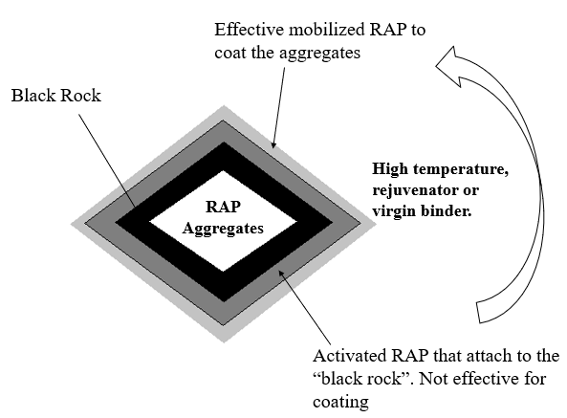

Figure 5-3. Different RAP binders in RAP aggregates.

Figure 5-4. Real blending between virgin and aged binder in HMA.

Figure 5-5. The situation of RAP binder during HIR procedures.

Figure 5-6. The grain size distribution of RAP.

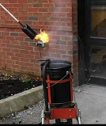
Figure 5-7. The fire heating simulation using torch blow test.

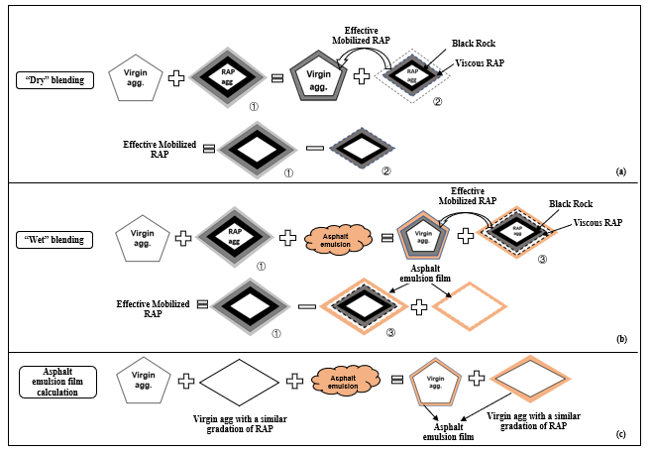
Figure 5-8. Two scenarios of quantifying the effective mobilized RAP content. (a) “Dry” mixing; (b) “Wet” mixing; (c) Asphalt emulsion film calculation.

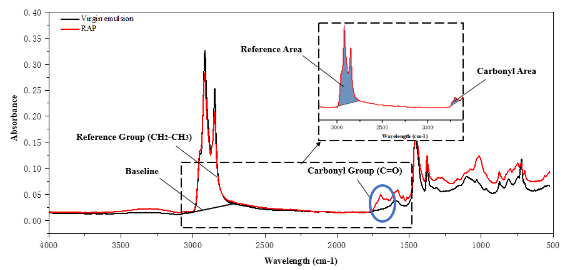
Figure 5-9. FTIR spectrums of virgin binder and RAP binder with the peak area selections.

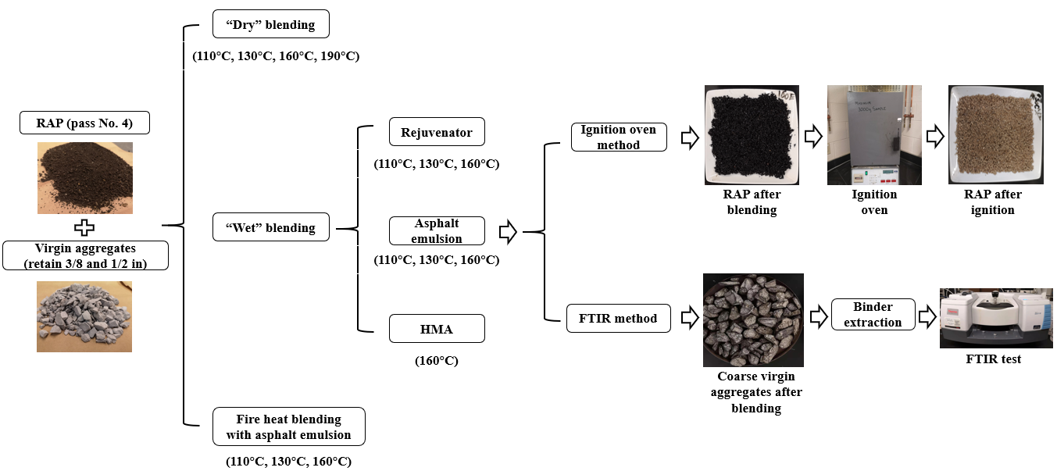
Figure 5-10. The experimental design flow chart.

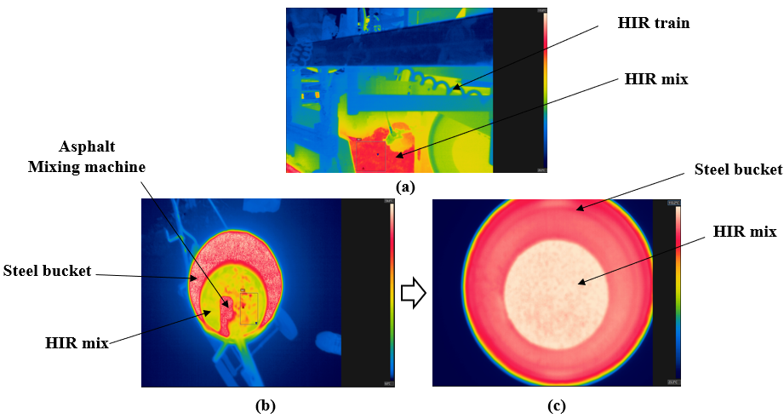
Figure 5-11. Thermo images of the HIR mix under various conditions, (a) Blending in the field; (b) Blending through torch blow test; (c) The final blending stage through torch blow test.

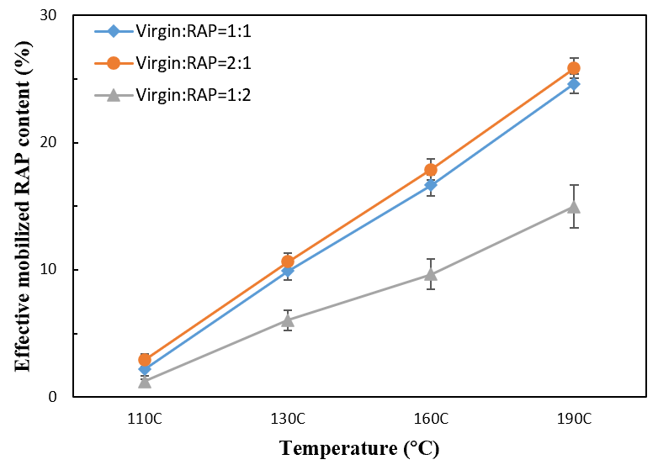

Figure 5-12. The effective mobilized RAP content for “dry” blending at different temperatures.

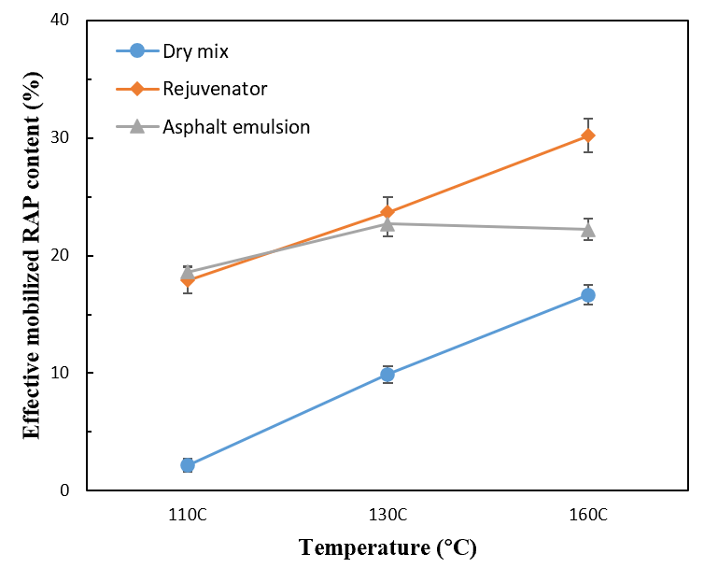
Figure 5-13. Effective mobilized RAP content with different additives.

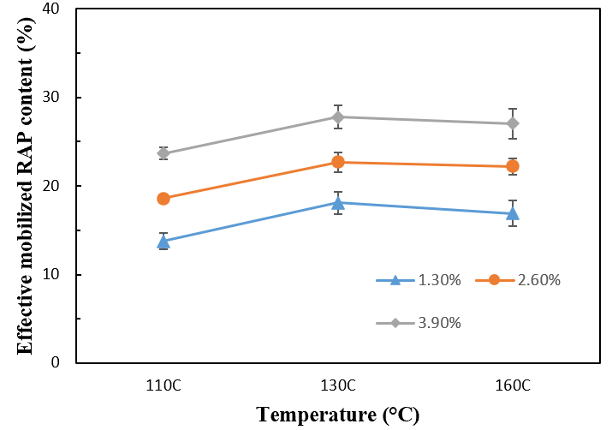
Figure 5-14. Effective mobilized RAP content with various dosages of asphalt emulsion under different oven heating temperatures.

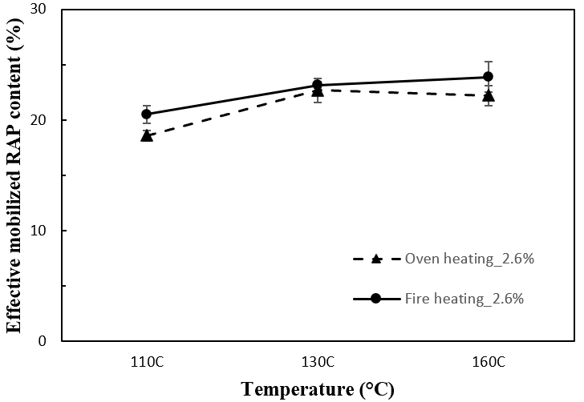

Figure 5-15. The effective mobilized content of the HIR mix with 2.6% asphalt emulsion through both oven and fire heating at different temperatures.

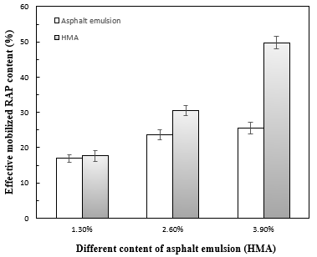
Figure 5-16. The effective mobilized RAP content with asphalt emulsion and HMA at 160°C.

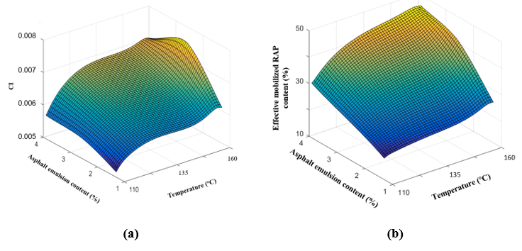
Figure 5-17. The contour of the CI and effective mobilized RAP content under different conditions using the FTIR method, (a) CI, (b) Effective mobilized RAP content (%).

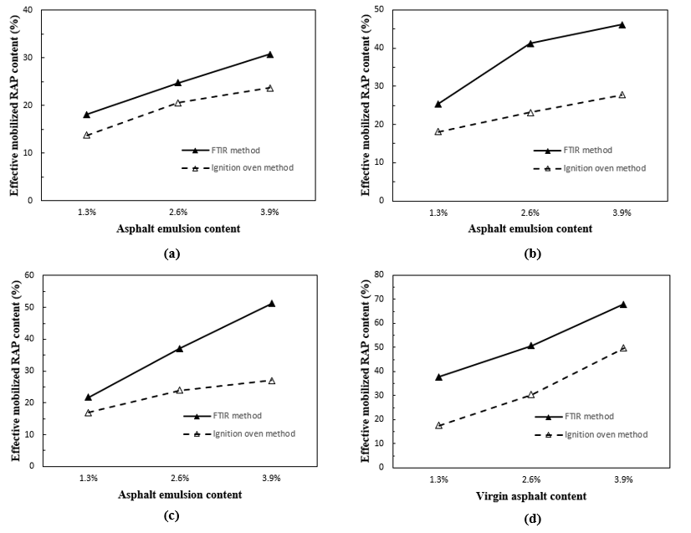
Figure 5-18. Comparison of effective mobilized RAP content between FTIR and ignition oven method, (a) 110 °C with asphalt emulsion; (b) 130°C with asphalt emulsion; (c) 160°C with asphalt emulsion; (d) 160°C with virgin asphalt.

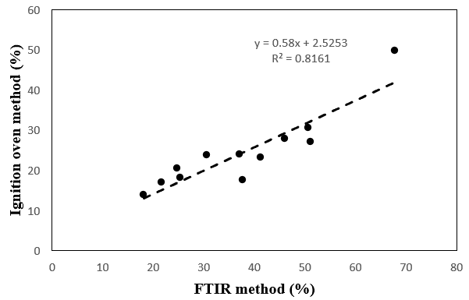

Figure 5-19. Relationship between the FTIR method results and ignition oven method results.

APPENDIX 5B: Tables
Table 5-1. Physical and chemical properties of ARA_3P.
Typical properties | Value
Physical state | Liquid
pH | 2.1-4
Initial boiling point and boiling range, °C | 100
Flash point, °C | 100
Density, g/ml | 1.0

Table 5-2. Physical properties of the rejuvenator.
Typical properties | Value
Appearance | Brown liquid
Density @ 20 °C, g/ml | 0.92 – 0.95
Viscosity @ 40°C, cSt | 45 – 60
Flash point, °C | >290

Explore the effects of degree of blending, and properties of effective binder in HIR mix

A version of this chapter was accepted as Ma, Y., Xiao, R., Jiang, X., Polaczyk, P., Zhang, M., Liu Y., & Huang, B. “Influence of Mobilized RAP Content on Effective Binder Quality and Performance of 100% Hot In-Place Recycled Asphalt Mixtures.” Construction of Building Materials. DOI: https://doi.org/10.1016/j.conbuildmat.2022.127941

Abstract: Hot in-place recycling (HIR) is a promising technique to consume 100% recycled asphalt pavement (RAP) for pavement surface rehabilitation. When RAP aggregates are incorporated in asphalt mixtures, a proportion of the RAP binder can be mobilized by the virgin binder or additive and achieve a homogenous binder blend, named “the effective binder blend.” There exist two major concerns about using 100% RAP in HIR mixes: 1. How much of the RAP binder can be mobilized to coat aggregates? 2. What are the contributions of the mobilized RAP binder to the performance of HIR mixes? This study firstly developed an approach to quantify the mobilized RAP content in HIR mixes. Afterward, the effective binder blends were prepared in the laboratory, based on the mobilized RAP and virgin asphalt percentage. Finally, the dynamic shear rheometer test and sessile drop method were adopted to characterize the effective binder qualities, while AMPT and Ideal-CT tests were utilized for mixture performance evaluation. Results showed that the mobilized RAP binder altered the binder qualities of the effective binder blends and also the effective asphalt content in HIR mixes. The binder qualities, including rheological properties and surface free energy, contributed to the different stiffness and cohesion of the effective binder blends in HIR mixes. However, the effective asphalt content proved to dominate the cracking resistance of HIR mixes.

Introduction
Currently, the United States produces over 100 million tons of reclaimed asphalt pavement (RAP) every year (Nam et al., 2014). The utilization of RAP in asphalt pavement has gained increasing attention from both environmental and economic points of view. The inclusion of RAP into hot mix asphalt (HMA) and warm mix asphalt (WMA) has been increasingly implemented during plant production over the last two decades (Huang et al., 2005b; Ma et al., 2021e; Zhao et al., 2012). Hot in-place recycling (HIR) is another promising strategy to consume 100% RAP for pavement surface rehabilitation directly in the field (Recycling, 1992). Several units are equipped in the whole HIR train, including preheating, scarification, recycle agents incorporation, mixing, and compaction (Hafeez et al., 2014). The incorporation of recycling agents could lower the viscosity and stiffness of the RAP binder to improve the cracking resistance of the HIR mixes (Ali et al., 2013; Bouraima et al., 2019; Ma et al., 2021b). Researchers also proved that HIR surface rehabilitation exhibits cost and environmental benefits compared to the HMA surface milling and filling techniques (Cao et al., 2019).
However, the successful utilization of RAP in asphalt paving materials relies on the engineering properties of the asphalt mixtures. One important factor that should be considered during mixing is the availability of recycled asphalt binder, which is the amount of RAP binder that can be mobilized to blend with the newly added virgin binder (Kaseer et al., 2019; Zhao et al., 2016, 2019). The mobilized RAP binder can be considered as an effective binder to form new asphalt mastic to glue the aggregates together in a new mixture (Ma et al., 2021a). Researchers outlined three possible scenarios of RAP blending into the asphalt mixtures: a.) “total blending” – all RAP asphalt is mobilized and blended with virgin asphalt binder, b.) “black rock” – none of RAP asphalt binder is mobilized, and RAP acts like aggregates and c.) “actual practice” partial RAP binder is mobilized and blended with virgin asphalt binder (Ding et al., 2016a; Huang et al., 2005b; Zhao et al., 2016). If the mixture proportion is calculated assuming 100% binder availability, the actual effective binder coating aggregates will be insufficient. Lack of binder leads to weakened properties such as inadequate mixture durability and cracking performance. As for 100% recycled asphalt mixtures, a large proportion of RAP binders could be mobilized, which might significantly alter the influence of RAP binder availability on the effective binder quality and content. Hence, it is necessary to quantify the RAP mobilizations and explore their significance on the performance of the HIR mixes.
Many researchers have investigated the blending efficiency of recycled asphalt binders in asphalt mixtures. Copper et al. proposed a volumetric-based procedure by comparing the reference Voids Filled with Asphalt (VFA_{r}) from mixtures with all virgin materials and mixtures with similar gradation and containing recycled materials. Binder mobilization rate is determined from the shortage in the percentage of asphalt binder (Cooper Jr, 2015). Kasser et al. quantified the RAP binder availability by interpolating the binder content obtained from the ignition oven method under two extreme conditions (total blending and zero blending) (Kaseer et al., 2019). Ding et al. built a blending chart regarding the mean grey value and large molecular size from fluorescence microscopy (FM) and gel permeation chromatography (GPC) tests (Ding et al., 2016a, 2018). Sreeram et al. identified the mobilization rate of the RAP binder by using the carbonyl area variations in the FTIR spectrum (Sreeram et al., 2018b). Limited studies have applied the existing quantification methods to investigate the blending efficiency of HIR mixes. Ma et al. investigated the mobilized RAP content in HIR mixes and developed methods to quantify the mobilized RAP content through ignition oven and FTIR spectrum (Ma et al., 2021a). They also found that the increase in temperatures and adequate use of recycling agents would facilitate the mobilization rate of the RAP binder (Ma et al., 2020f).
However, there exist concerns about whether the mobilized RAP binder is beneficial to the mixture performance since the mobilized RAP binder might increase the brittleness of the effective binder blends. The objective of this study is to explore the influence of the mobilized RAP content on the effective binder quality and the performance of HIR mixes. The loose RAP materials were collected in an HIR project after heat scarification. The ignition oven method was adopted to quantify the mobilization rate of the RAP binder and obtain the effective binder content. The effective binder blends were prepared based on the proportion of the mobilized RAP binder and the dosages of recycling agent. Binder qualities including rheological properties and surface free energy were characterized through dynamic shear rheometer (DSR) and sessile drop method. The performances of HIR mixes at different mobilization conditions were tested using Asphalt Mixture Performance Tester (AMPT) and Ideal-CT cracking tests.

Materials and methodology
Figure 6-1 illustrates the experimental design and procedures of this study, including the effective asphalt content quantification, the characterization of the effective binder qualities, and the performance of the asphalt mixtures.

Raw material collection
The loose mixes were collected after heat scarification with the HIR train in Henderson County, Tennessee. Figure 6-2 shows the gradation of the RAP mixtures. The RAP gradation curve is located between the upper and lower limit of the typical surface mix in Tennessee. One chemical additive, named ARA-3P, consists of 50% of water and 50% of asphalt with heavy naphthenic distillate solvent, serving as a recycling agent to restore the properties of the RAP binder. The base asphalt binder, PG 64-22, was also utilized for asphalt mixing at high temperatures.

Effective mobilized RAP binder quantification procedures
Figure 6-3 presents the quantification procedures for the mobilized RAP binder content using the ignition oven method. The RAP aggregate passing No. 4 sieve was denoted as the “fine RAP”, while coarse virgin aggregates retaining on ½ inch and 3/8-inch sieve were collected for blending. The asphalt content of fine RAP aggregates was firstly obtained, the fine RAP aggregates after blending were picked out to test the asphalt content again. The purposes of using coarse virgin aggregates are to provide space to absorb the mobilized RAP binder and to differentiate from the fine RAP for the ignition oven test. In order to quantify the mobilized RAP content precisely, coarse virgin aggregates are supposed to ensure sufficient area for the mobilized RAP binders. After several trial mixes, the mass ratio of coarse virgin aggregates and fine RAP were selected as 2:1.
Figure 6-4 illustrates the detailed blending and the mobilized RAP quantification procedures. As for fine RAP aggregates, the blue color represents the RAP binder that can be only mobilized by a certain temperature. The black color stands for the immobilized RAP binder or “black rock”. The grey color represents the “viscous RAP” that attaches to the “black rock”, reflecting that the RAP binder can be activated by temperature but cannot be mobilized to coat the aggregates. A proportion of “viscous RAP” can be mobilized with the recycling agents or virgin asphalt. The binder blends with viscous RAP can be assumed homogenous to coat aggregates. Hence, the total mobilized RAP consists of the RAP binder mobilized by temperature and the viscous RAP binder that is mobilized due to the addition of recycling agents or virgin asphalt. The mobilized RAP content was quantified by calculating the mass change of the RAP aggregates (Ma et al., 2021a). The recycling agent films were quantified by replacing the fine RAP with similar virgin aggregates. As shown in Figure 6-4, the mobilized RAP content equals the asphalt content changes of the fine RAP aggregates before and after blending. The proportions of mobilized RAP and virgin asphalt or recycling agent can be determined to evaluate the effective binder qualities further. Table 6-1 shows the experimental design of mobilized RAP quantification for 100% RAP with different mixing conditions, including temperature, asphalt types, and dosages. As for the HIR project in Tennessee, mixing temperature and the recycling agent dosage were selected as 110 °C and 2.6 %, respectively. Hence, various mixing temperature and recycling agent dosages were considered to investigate the influence of different mixing conditions on the mobilized RAP content and the performance of HIR mixes.

Effective binder blends preparation
The RAP binder was extracted through the centrifuge extractor following ASTM-D2172, recovered using the rotational evaporator following ASTM-D5404, and then mixed with the heated virgin binder at 160 °C for 15 mins. As for the blending scenario of 100% RAP with a recycling agent, water would evaporate during blending. Under this scenario, the effective binder blends include the mobilized RAP binder and the asphalt in the recycling agent. Hence, to prepare the effective binder blends, the recycling agent was firstly heated in the oven at 100°C to remove the extra water. Then, the heated RAP binder was added and stirred on the heater. The binder blends were finally heated in the oven for 20 mins to ensure a complete diffusion. Binder testings, including the dynamic shear rheometer test and surface energy tests, were conducted to investigate the quality of the effective binder blends.

Quality of effective binder blends

Rheological characterizations

DSR temperature sweep tests were conducted to evaluate the rheological properties of the effective binder blends. The binder blends were sandwiched between the two plates in the dynamic shear rheometer machine. Shear stress was applied by the upper plate at different temperatures at a certain frequency of 10 rad/s. The complex shear modulus and phase angle were automatically collected by the software. The parameter G*/sinδ was calculated to characterize the rheological properties and stiffness of the effective binder blends (Ma et al., 2020c). Two replicates for each binder blend were conducted for DSR temperature sweep tests.

Surface free energy
Surface-free energy is the magnitude of work required to create a unit area of a material in a vacuum. In the asphalt-aggregate system, the cohesion and adhesion strengths are determined by the surface energy at the asphalt-aggregate interface. Based on the Good-van Oss-Chaudhury theory proposed by Van Oss et al., the total surface energy can be expressed in the form of a Lewis acidic component ($Γ^{+}$), a Lewis basic component ($Γ^{-}$), and Lifshitz-van der Walls components ($Γ^{LW}$) (Van Oss et al., 1988). The total surface free energy ($Γ^{Total}$) can be expressed in terms of a Lifshitz-van der Walls and an acid-base ($Γ^{AB}$) component using the following equations:
$Γ^{Total}=Γ^{LW}+ Γ^{AB}$ (1)
where, $Γ^{AB}=2\sqrt{Γ^{+}Γ^{-}}$ (2)
The wetting and spreading of a liquid over a surface, determined by the contact angle ($θ$), proved to be directly related to the surface free energy. The sessile drop method was adopted to measure the contact angle of the effective binder blends (Howson et al., 2009; Little and Bhasin, 2006). The prepared binder blends were firstly reheated and poured over the glass slides. Then the samples were dried until a homogenous thin asphalt layer was achieved. At room temperature, a drop of approximately 5 μL probe liquid was dispensed over the asphalt sample. Finally, a digital image was captured, and the contact angle was measured using the image processing software. The average value of the three replicates was used for surface energy calculation. The suitable probe liquids should have high surface free energy values, be immiscible with asphalt binder and have a wider range of surface energy components. Distilled water, ethylene glycol, and formamide were selected for contact angle measurement. The surface energy components of the three probe liquids are given in Table 6-2 (Cheng et al., 2002).
Cohesive energy ($W_{c}$) interprets the intermolecular attraction between similar molecules. The cohesive nature of a liquid or solid involves the separation of the liquid or solid from itself, which can be described as:
$W_{c}=2 Γ^{Total}$ (3)
The work of adhesion ($W_{a}$) reflects the intermolecular interaction between the two materials. The relationship between contact angle, surface free energy, and work of adhesion can be expressed as Young-Dupré equation:
${W_{a}=Γ}_{L}\left(1+cosθ\right)=2(\sqrt{Γ_{S}^{LW}Γ_{L}^{LW}}+\sqrt{Γ_{S}^{+}Γ_{L}^{-}}+\sqrt{Γ_{S}^{-}Γ_{L}^{+}})$ (4)
where L and S represent the probe liquids and the solid asphalt, respectively.

HIR mixture performance tests
According to Table 7-1, the collected RAP aggregates were mixed with different dosages of recycling agents or virgin binder at different temperatures. To simulate the HIR procedures and match the mixing time, all the mixtures were mixed for 90s and immediately compacted into 7 ± 0.5% air voids through Superpave gyratory compactor. The compacted specimens were further trimmed into specific dimensions for AMPT and Ideal-CT tests. Three replicates were conducted for each mixing condition.

2.5.1 AMPT tests
Dynamic modulus test was adopted to characterize the viscoelastic behaviors of the different HIR mixes. Tests were performed at three temperatures (4°C, 20°C, 40 °C) under a frequency range of 0.1, 0.5, 1, 2, 5, 10, 20, 25 Hz. Three linear variable differential transformers (LVDTs) were located at 120° angles on the side of the cylinders, which were used to collect the vertical deformation of the specimens. The dynamic modulus of the asphalt mixtures was obtained from the axial stress and strain.
Flow number test is a useful tool to evaluate the permanent deformation of the asphalt mixtures in the field. The specimens were subjected to a repeated haversine load with a 0.1s loading time and a 0.9s recovery time until 3000 cycles or 50000 microstrains were achieved. The specimens were conditioned in the chamber at 54 °C for 2 hours. The flow number is denoted as the point where the permanent strain rate is at the minimum value, reflecting the rutting potential of the asphalt mixtures (Witczak, 2002). In general, a larger flow number represents a higher rutting resistance of the asphalt mixtures.

2.5.2 Ideal-CT test
Ideal-CT test was adopted to evaluate the cracking resistance of the HIR mixes following ASTM D8225 standard (Zhou et al., 2017). The specimens were compacted at a diameter of 150 mm and a height of 75 mm and were centered in the Material Test System (MTS). The load was applied at a 50 mm/min rate during the test. The load and load-line displacement (LLD) were collected and plotted for CT_{index} calculations. The work of failure (W_{f}) is firstly calculated by integrating the area under the load and LLD curves. Then, the failure energy (G_{f}) is obtained by dividing the work of failure by the cross-sectional area. Finally, the CT_{index} is derived from the parameters in the load-displacement curves using equation (1):
${CT}_{index}=\frac{t}{62}×\frac{l_{75}}{D}×\frac{G_{f}}{\left|m_{75}\right|}×{10}^{6}$ (5)
where CT_{index} is the cracking tolerance index; $l_{75}$ is the displacement at 75% of the peak load after failure; $\left|m_{75}\right|$ is the slope of the tangential zone around the 75% peak load point after the peak; t is the specimen thickness (mm); D is the specimen diameter (mm).

Results and analysis

Mobilized RAP content
The mobilized RAP content of HIR mixes was determined at three mixing temperatures and different dosages of recycling agents using the ignition oven method. Table 6-3 shows the results of mobilized RAP content and the RAP binder ratio for HIR mixes with different dosages of recycling agents at three mixing temperatures. The effective asphalt content consists of the effective mobilized RAP content and the asphalt content in the recycling agent or virgin binder. The proportion of the virgin and RAP binder in the effective binder blends might affect the quality of the effective binder blends and hence the HIR mixes’ performance. As shown in Table 6-3, the increase in temperature and recycling agent mobilized more RAP binder, contributing to a larger value of effective asphalt content. Regarding the HIR mixes with the same dosages of recycling agents, a higher temperature increased the effective RAP binder ratio in the effective binder blends. However, considering the HIR mixes blended at the same temperature, a higher dosage of recycling agent decreased the RAP binder ratio in the effective binder blends. Furthermore, compared with the HIR mixes with the recycling agents, the addition of virgin binder improved the mobilization of the RAP binder but decreased the RAP binder ratio in the effective binder blends since no water or additives appear in the virgin binder.

Temperature sweep test results.
The effective binder blends were manually prepared for binder quality characterization at different temperatures. Figure 6-5 shows the effective binder blends’ DSR temperature sweep test results. The rutting parameter G*/sinδ was used to characterize the rheological properties of the effective binder blends. As shown in Figure 6-5, the effective binder blends with virgin asphalt and mobilized RAP binder present a higher rutting parameter than those with recycling agent, indicating the stiffer binder blends. Higher content of virgin binder increased the RAP binder mobilization, but the rheological properties of the effective binder blends did not vary too much. Regarding the incorporation of recycling agents, a higher content decreased the rutting parameters of the binder blends. At the same time, the increase in temperature could facilitate the mobilization of the RAP binders, which increased the rutting parameter of the effective binder blends. The DSR temperature sweep test results agree with the effective RAP binder ratio in Table 7-2, reflecting that the preparation procedures are representative of the quality of the effective binder blends.

Surface free energy of the effective binder blends
Table 6-4 displays the surface energy of the effective binder blends in different HIR mixes. For the HIR mixes with virgin asphalt, the effective RAP binder ratios in the effective binder blends are similar among V16013, V16026, and V16039. Hence, one type of binder blend with a RAP binder ratio of 0.5 was prepared for contact angle and surface energy testing. From Table 6-4, higher RAP binder ratios in the effective binder blends decreased surface free energy. It can also be found that the total surface free energy of the effective binder blends increases with higher additive dosages, reflecting higher cohesive energy of the binder blends. Increasing the mixing temperature decreased the surface energy of effective binder blends at the same additive dosages, indicated by a larger RAP binder ratio. However, the high RAP mobilization also increased the effective asphalt content, which might cause the different performances of the HIR mixes.

Mixture performance test results
To further investigate which factor dominated the mixture performances, performance tests including AMPT tests and Ideal CT tests were adopted to evaluate the viscoelastic behaviors and cracking performances of the HIR mixes.

3.4.1 AMPT test results

Figure 6-6 (a), (b), and (c) present the dynamic modulus results of the HIR mixes conditioned at 4°C, 20°C, and 40°C, respectively. As for the use of recycling agents, it can be found that higher proportions increased the dynamic modulus of the HIR mixes at low temperatures (4°C). According to DSR results, high dosages of recycling agents would lower the effective binder ratio and hence the modulus of the effective binder blends, which might result in a lower dynamic modulus of the asphalt mixtures. However, the mobilized RAP content also significantly increased the effective asphalt content in the HIR mixes. The surface-free energy of effective binder blends also increased with a higher dosage of recycling agents. At low testing temperatures, the higher asphalt content and surface-free energy of the effective binder blends would increase the interaction area and the coating between asphalt and aggregates, which could strengthen the asphalt-aggregates system. Furthermore, increasing the mixing temperature could facilitate the RAP binder mobilization, leading to a higher effective RAP binder ratio and effective asphalt content. The higher effective asphalt content and the stiffness of effective binder blends could contribute to an increased dynamic modulus of HIR mixes. Similarly, HIR mixes with virgin binder showed the highest dynamic modulus. As shown in Figures 6-6 (b) and (c), when the testing temperature increases, the dynamic modulus of the HIR mixes was reduced with the higher dosages of additives, which was different from the trend at low temperatures (4 °C). The elevated temperatures could soften the effective binder blends and weaken the rutting resistance of the asphalt mixtures. The high asphalt content would cause more asphalt migration and also a lower dynamic modulus of asphalt mixtures (Daniel and Lachance, 2005). Hence, both effective binder quality and effective asphalt content could affect the dynamic modulus of HIR mixes. More effective asphalt content could improve the asphalt-aggregates coating system at low temperatures but mitigate the rutting resistance of HIR mixes at high temperatures.
Figure 6-7 shows the flow number test results of the HIR mixes. Tests were conducted at 54.4 °C to simulate the high pavement service temperature based on AASHTO-T378. Flow number exhibited a similar pattern compared to the dynamic modulus test results at high temperatures, which further demonstrated the function of effective binder quality and asphalt content in HIR mixes. It is necessary to point out that the HIR mixes present relatively high flow numbers than the traditional HMA mixes based on literature (Huang et al., 2008; Polaczyk et al., 2021). As mentioned previously, HIR mixes contained 100% RAP, which increased the stiffness of the asphalt mixtures. Hence, HIR mixes would not encounter rutting issues for the current effective asphalt content. However, if the cracking resistance of HIR mixes was expected to be improved by increasing more mobilized RAP or effective asphalt content, rutting issues may exist and should be considered in future studies.

3.4.2 Ideal CT test results

Cracking is considered the main concern for asphalt mixtures containing a high percentage of RAP (Huang et al., 2004). The 100% use of RAP in HIR mixes tends to exaggerate the cracking issue. Figure 6-8 shows the Ideal-CT test results of different HIR mixes. CT_{index} was obtained from the average of three replicates. At a certain mixing temperature, the use of more additives or virgin asphalt facilitated the mobilization of the RAP binder and improved the cracking resistance of the HIR mixes, indicated by a larger value of CT_{index.} Similarly, the increase in temperature also resulted in a higher CT_{index} of the HIR mixes with a certain additive dosage. Regarding the mobilized RAP content in Table 6-3 and the binder quality characterization, more RAP binder mobilization would increase the modulus and decrease the surface energy of the effective binder blends, which might lower the cracking resistance of the HIR mixes. To be specific, the effective RAP binder ratio for RA13026 is higher than RA11026, reflecting that the effective binder blend of RA13026 is stiffer than RA11026. Theoretically, the stiffer binder blends would cause more cracking issue of the asphalt mixtures. However, the CT_{index} of RA13026 is higher than RA11026, indicating a higher cracking resistance. The aforementioned results could be attributed to the effective asphalt content in HIR mixes. Specifically, the mobilized RAP binder would also contribute to an increase in the effective asphalt content. As shown in Table 7-3, the effective asphalt content for RA13026 is higher than RA13013. More effective asphalt content could improve the asphalt-aggregates coating system, the ductility of the asphalt mixture, and also the cracking resistance of HIR mixes. Hence, under such circumstances, the effective asphalt content played a more important role in the cracking behavior of the HIR mixes than the effective RAP binder ratio. The use of virgin binder would significantly improve the binder quality, and the cracking resistance of HIR mixes was notably improved when the virgin binder was adequate during mixing.

Discussion of the results
In terms of the rutting resistance of HIR mixes, reflected by flow number, both binder qualities and effective asphalt content affected the flow number. The flow numbers of HIR mix with virgin asphalt were higher than any HIR mixes with the recycling agents, since the effective binder V160 presented the largest rutting parameter in DSR temperature sweep test. For HIR mixes at different temperatures, a higher effective asphalt content decreased the flow number of HIR mixes. Figure 6-9 (a) and (b) present the relationship between the effective RAP binder ratio, the effective asphalt content and flow number of HIR mix with asphalt emulsion, respectively. It can be shown that the effective RAP binder ratio has a strong correlation with the flow number and hence the rutting resistance.
Cracking is the main issue of using 100% RAP in HIR mixes since the RAP binder is stiff and brittle. The quantification of mobilized RAP binder in HIR mixes could clarify the proportion of RAP binder in the effective binder blends, which was called the “effective RAP binder ratio” in this study. The mobilized RAP binder altered the binder qualities and the effective binder content, which might be related to the cracking resistance of the HIR mixes. Based on the prepared effective binder blends of different mixing conditions in HIR mixes, the higher RAP binder ratio in the effective binder blends would increase the stiffness, and lower the surface energy of the effective binder blends, which might encounter more severe cracking issues in HIR mixes. However, on the other hand, the increase of mobilized RAP binder in the effective binder blends would also contribute to an increase in effective asphalt content, improving the cracking resistance of the HIR mixes.
Figure 6-10 presents the correlations among the CT_{index}, effective RAP binder ratio, and effective asphalt content. As shown in Figure 9 (a), CT_{index} presents a negative relationship with the effective RAP binder ratio; however, the correlation is not strong since the R² is only 0.48. The weak correlation indicates that higher mobilized RAP content might result in a higher CT_{index.} The mobilized RAP content also increases the effective asphalt content, contributing to higher cracking resistance. It might not be appropriate to evaluate the performance of HIR mixes only by the mobilized RAP content. Then, Figure 9 (b) shows the correlations between the CT_{index} and effective asphalt content, reflecting that the effective asphalt content played a more important role in the cracking resistance of the HIR mixes. Hence, even though the mobilized RAP binder lowers the effective binder qualities, the mobilized RAP binder content might significantly increase the effective asphalt content, which dominated the cracking performance in HIR mixes with 100% RAP. Furthermore, compared to the additives, the adequate of using virgin binder results in better effective binder qualities and more effective asphalt content, which significantly improved the cracking resistance of the HIR mixes. It is necessary to point out that this study is mainly targeted at the effect of RAP binder mobilization on the asphalt mixtures with 100% RAP. The effective binder blends containing virgin binder and mobilized RAP binder were assumed to be homogenous during blending, which may not represent the real case in the field. Furthermore, when RAP aggregates were partially incorporated in HMA during plant mixing, it is also worth investigating whether the effective binder qualities or the effective asphalt content dominates the performance of the asphalt mixtures. The aforementioned concerns are supposed to be considered in future studies.

Conclusions
The influence of RAP binder mobilization on the effective binder quality and mixture performance of HIR mixes with 100% RAP were investigated in this study. Different mixing temperatures, binder types, additive dosages were considered to represent different RAP mobilization scenarios. The mobilized RAP binder content was firstly quantified through the ignition oven methods. Then the effective binder blends were manually prepared for the rheological and surface energy testing. Finally, AMPT tests and Ideal CT tests were adopted to evaluate the performance of HIR mixes with different RAP binder mobilization. The main conclusions are listed as follows:
- The mobilized RAP binder content could alter the qualities of the effective binder blends and the effective asphalt content, which was highly related to the performance of the HIR mixes.
- The higher proportion of RAP binder in the effective binder blends would increase the stiffness and lower the surface free energy of the binder blends. The binder qualities, including the rheological properties and surface free energy, were highly related to the dynamic modulus of the HIR mixes.
- Based on the dynamic modulus results at low testing temperature, the higher effective asphalt content caused by increasing the recycling agent dosages would improve the interaction and coating between asphalt and aggregates. However, as for high testing temperature, the high asphalt content would cause more asphalt migration and hence a lower dynamic modulus of asphalt mixtures.
- The effective asphalt content is considered a more important factor that dominated the cracking behavior of the 100% HIR mixes. A higher temperature increased the RAP binder mobilization and the effective binder blends would become more brittle, which might cause more cracking potential of asphalt mixtures. However, the mobilized RAP content would also contribute to an increase in the effective asphalt content. Ideal-CT test showed that HIR mixes with higher effective asphalt content had better cracking resistance.

APPENDIX

APPENDIX 6A: Figures
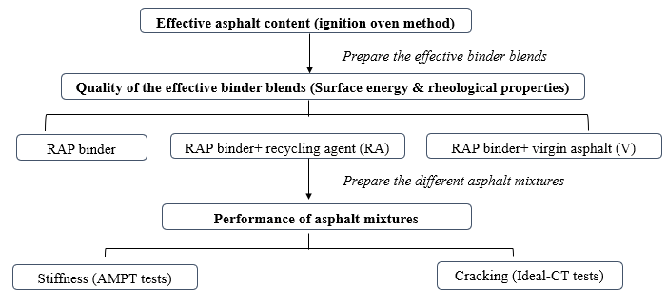
Figure 6-1. Experimental design and procedures of the study.

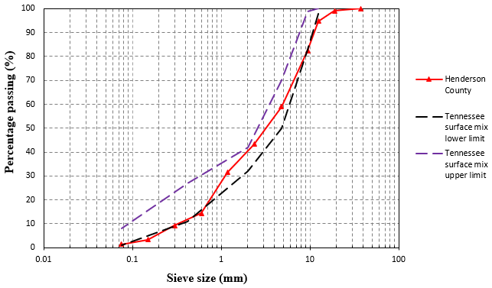
Figure 6-2. Gradation for loose mixes collected after heat scarification with the HIR train.

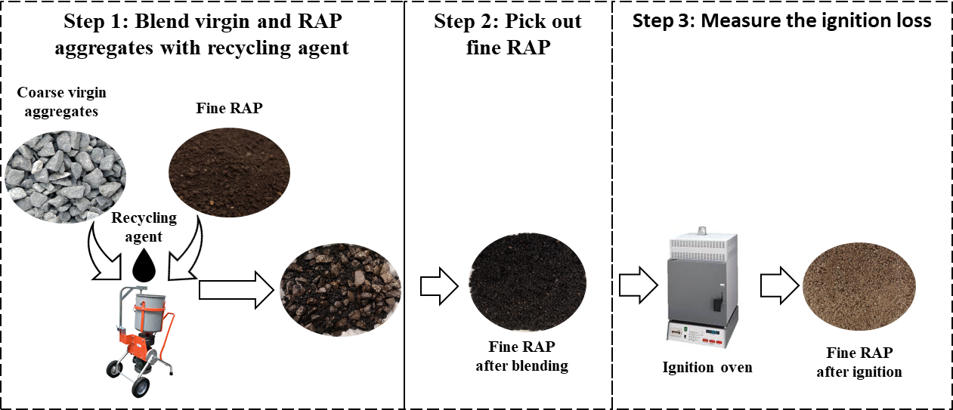
Figure 6-3. Determination of mobilized RAP content through the ignition oven method.

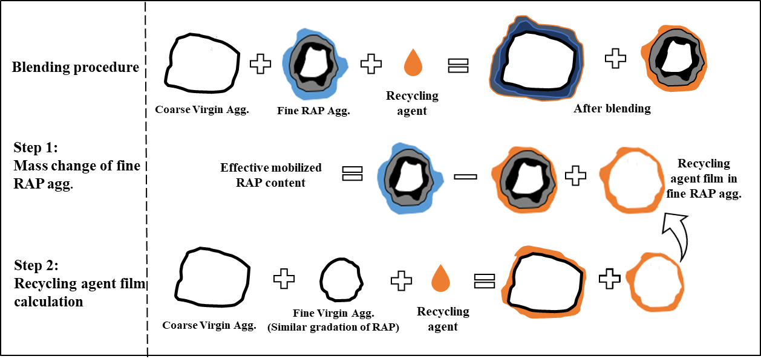

Figure 6-4. Mobilized RAP content quantification procedures.

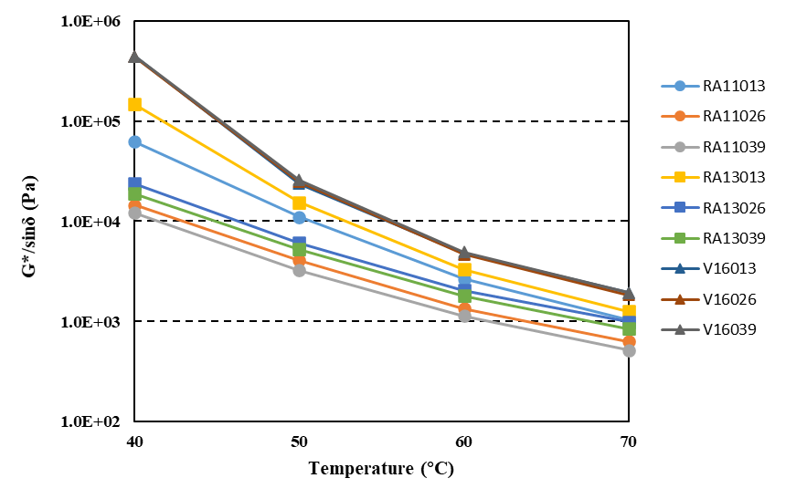
Figure 6-5. Temperature sweep test results of the effective binder blends.

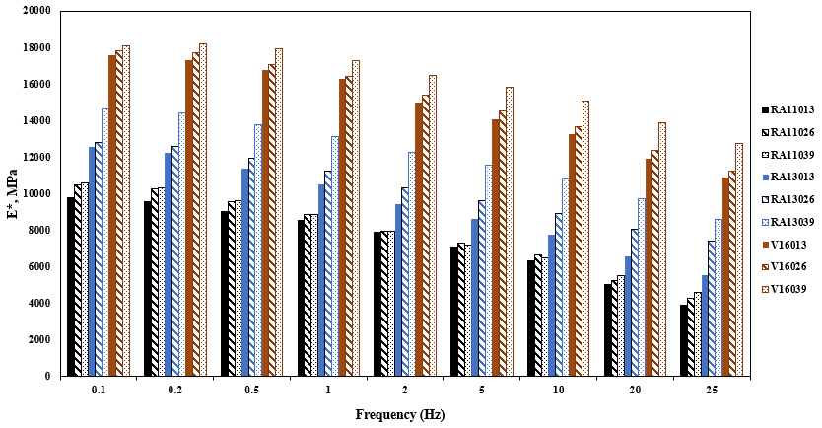
(a)

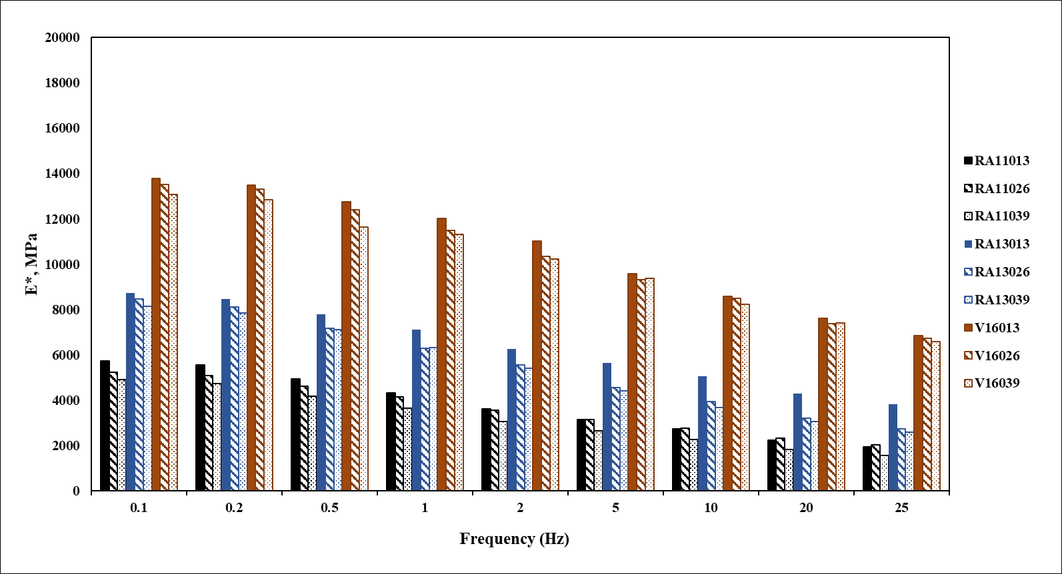

(b)

Figure 6-6. Dynamic modulus test results of HIR mixes at different temperatures; (a) 4 °C; (b) 20°C; (c) 40 °C.

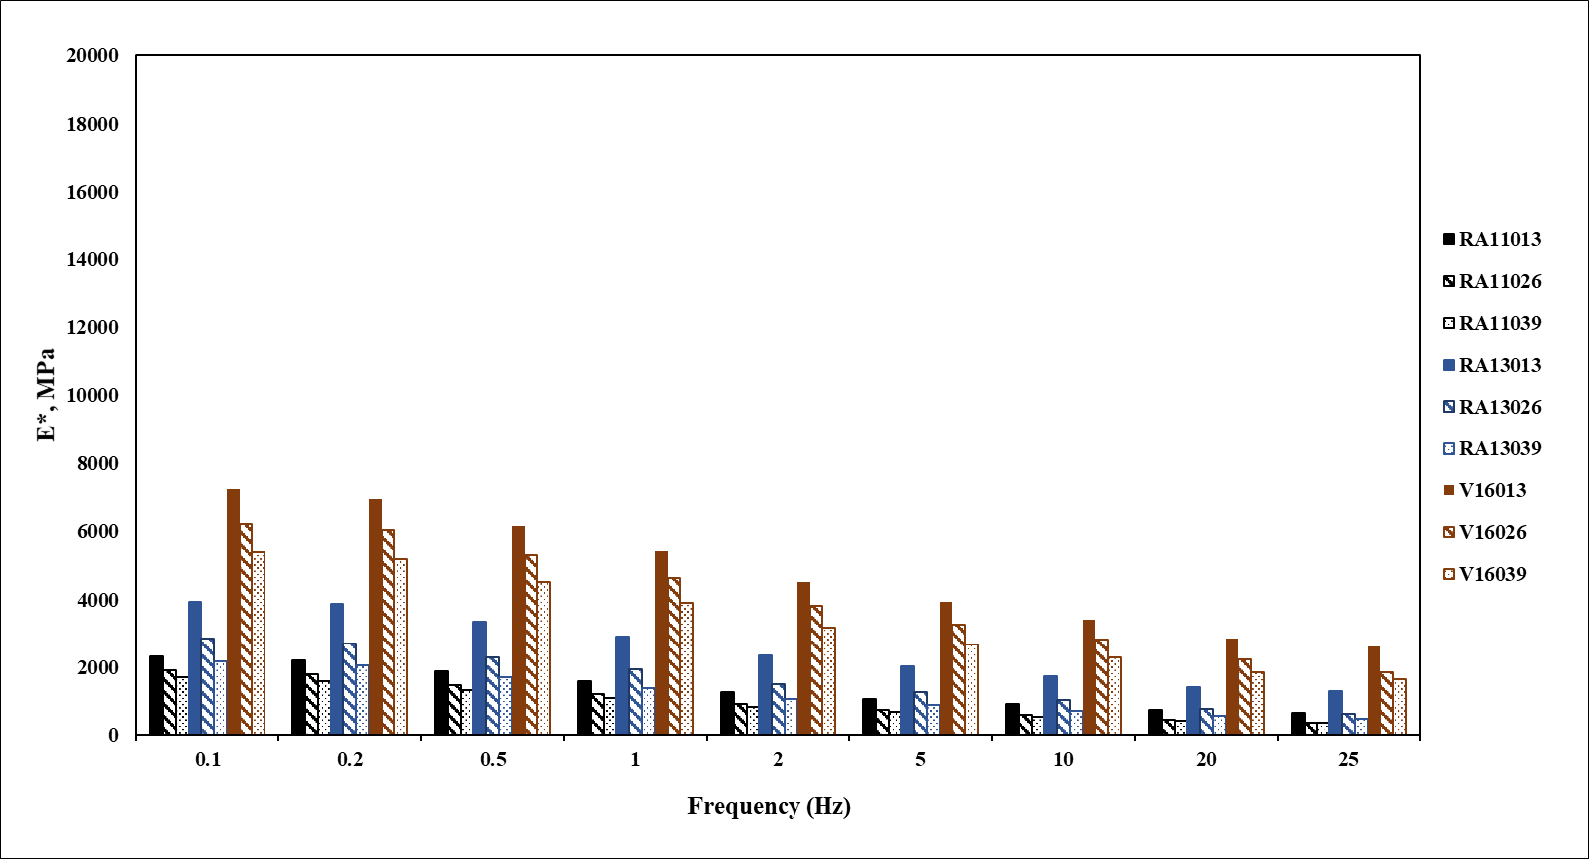
(c)

Figure 6-6 continued.

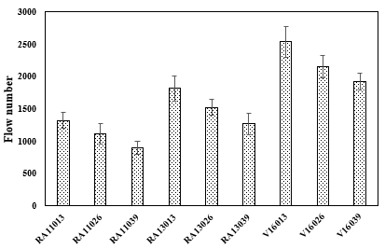
Figure 6-7. Flow number test results of HIR mix at 54.4 °C.

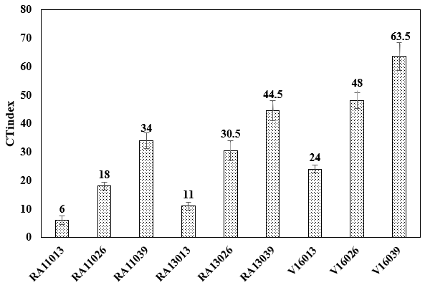
Figure 6-8. Ideal CT test results of different HIR mixes.

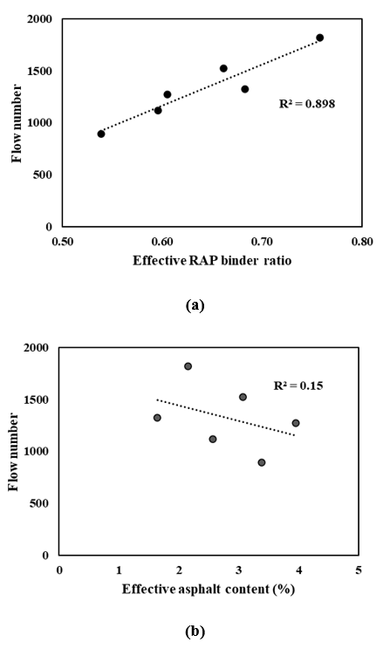
Figure 6-9. Correlation analysis for rutting resistance of HIR mixes, (a) flow number and effective RAP binder ratio, (b) flow number and effective asphalt content.
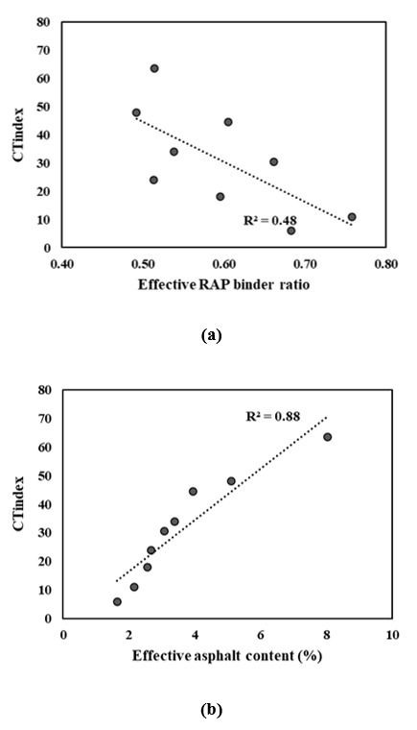
Figure 6-10. Correlation analysis for cracking resistance of HIR mixes, (a) CT_{index} and effective RAP binder ratio, (b) CT_{index} and effective asphalt content.

APPENDIX 6B: Tables
Table 6-1. Experimental design of effective mobilized RAP quantification under different mixing conditions.
Mixture label | Temperatures (°C) | Asphalt types | Dosages (%)
RA11013 | 110 | ARA-3P | 1.3
RA11026 | 110 | ARA-3P | 2.6
RA11039 | 110 | ARA-3P | 3.9
RA13013 | 130 | ARA-3P | 1.3
RA13026 | 130 | ARA-3P | 2.6
RA13039 | 130 | ARA-3P | 3.9
V16013 | 160 | PG-6422 | 1.3
V16026 | 160 | PG-6422 | 2.6
V16039 | 160 | PG-6422 | 3.9

Table 6-2. Surface free energy components of different probe liquids.
Probe liquids | $$Γ_{Total} \text{(mJ/}{\text{m}}^{\text{2}}\text{)}$$ | $$Γ_{L}^{LW}\text{(mJ/}{\text{m}}^{\text{2}}\text{)}$$ | $$Γ_{L}^{+}\text{(mJ/}{\text{m}}^{\text{2}}\text{)}$$ | $$Γ_{L}^{-}\text{(mJ/}{\text{m}}^{\text{2}}\text{)}$$
water | 72.8 | 21.8 | 25.5 | 25.5
Glycerol | 64 | 34 | 3.92 | 57.4
Formamide | 58 | 39 | 2.28 | 39.6
Ethylene glycol | 48.3 | 29.3 | 1.92 | 47

Table 6-3. Effective mobilized RAP content for HIR mixes.
Mixture label | Temperature  (°C) | Dosages  (%) | Mobilized RAP content (%) | Effective asphalt content (%) | Effective RAP binder ratio
RA11013 | 110 | 1.3 | 1.14 | 1.79 | 0.64
RA11026 | 110 | 2.6 | 1.54 | 2.84 | 0.54
RA11039 | 110 | 3.9 | 1.96 | 3.91 | 0.50
RA13013 | 130 | 1.3 | 1.50 | 2.15 | 0.70
RA13026 | 130 | 2.6 | 1.88 | 3.18 | 0.59
RA13039 | 130 | 3.9 | 2.42 | 4.37 | 0.55
V16013 | 160 | 1.3 | 1.40 | 2.76 | 0.52
V16026 | 160 | 2.6 | 2.52 | 5.12 | 0.49
V16039 | 160 | 3.9 | 4.12 | 8.02 | 0.51

Table 6-4. Surface energy results of the effective binder blends in different HIR mixes.
Effective binder blends |  | $$Γ_{L}^{LW}$$  $$\text{(}\text{mJ}\text{/}{\text{m}}^{\text{2}}\text{)}$$ | $$Γ_{L}^{+}$$  $$\text{(}\text{mJ}\text{/}{\text{m}}^{\text{2}}\text{)}$$ | $$Γ_{L}^{-}$$  $$\text{(}\text{mJ}\text{/}{\text{m}}^{\text{2}}\text{)}$$ | $$Γ^{AB}$$  $\text{(}\text{mJ}\text{/}{\text{m}}^{\text{2}}\text{)}$ | $$Γ_{Total}$$  $$\text{(}\text{mJ}\text{/}{\text{m}}^{\text{2}}\text{)}$$ | $$W_{c}$$  $$\text{(}\text{mJ}\text{/}{\text{m}}^{\text{2}}\text{)}$$
RA11013 |  | 16.91 | 0.53 | 3.82 | 2.84 | 19.74 | 33.82
RA11026 |  | 18.01 | 0.43 | 4.33 | 2.72 | 20.73 | 36.02
RA11039 |  | 19.56 | 0.21 | 4.71 | 1.99 | 21.55 | 39.12
RA13013 |  | 15.92 | 0.5 | 3.92 | 2.80 | 18.70 | 31.84
RA13026 |  | 17.23 | 0.45 | 4.12 | 2.72 | 19.95 | 34.46
RA13039 |  | 18.30 | 0.32 | 4.65 | 2.44 | 20.74 | 36.60
V160 |  | 20.12 | 0.26 | 4.95 | 2.27 | 22.39 | 40.24

Explore the effects of Immobilized RAP on asphalt-aggregate interaction and performance of 100% Recycled asphalt mixtures

A version of this chapter was submitted as Ma, Y., Ding, Y., Zheng, K., Polaczyk, P., Zhang, M., Huang, B., “Effects of Immobilized RAP binder on Asphalt-aggregate Interaction and Performance of 100% Recycled Asphalt Mixtures.” ASCE, Journal of Materials in Civil Engineering.
Abstract: The current tendency in the asphalt paving industry is to increase the utilization of recycled asphalt pavement (RAP). In general, there are two types of RAP binder in RAP aggregates, the mobilized RAP binder and the immobilized RAP binder. The mobilized RAP binder can be blended into the virgin binder to coat aggregates during asphalt blending, while immobilized RAP binders are treated as “black rocks” since they have already become an outer crust of RAP aggregates. Studies have focused on the mobilized RAP binder quantification and the significance of mobilized RAP binder to mixture performances. However, it remains unknown whether the immobilized RAP binder affects mixture performances. This study developed a laboratory procedure for immobilized RAP aggregates preparation and investigated the contribution of immobilized RAP binder to asphalt-aggregate interaction as well as the performance of 100% recycled asphalt mixtures. The work of adhesive energy and the K-B-G* model were adopted to characterize the asphalt-aggregate interaction for asphalt mortar. Resilient modulus and dissipated creep strain energy were used to evaluate the stiffness and cracking resistance of 100% recycled asphalt mixtures. Results showed that the contributions of immobilized RAP binder are to strengthen the asphalt-aggregate interaction and improve the cracking resistance of 100% recycled asphalt mixtures by increasing total asphalt content. However, if the total asphalt content remains the same, the immobilized RAP binder would increase the stiffness and decrease the cracking resistance of 100% recycled asphalt mixtures.

Introduction
The utilization of recycled asphalt pavement (RAP) in the pavement industry has gained widespread and considerable attention from economic and environmental perspectives (Huang et al., 2005b; Ma et al., 2020b). Currently, the use of RAP in asphalt pavement can be divided into two categories: (1) to incorporate RAP during hot mix asphalt (HMA) or warm mix asphalt (WMA) plant production (Huang et al., 2011; Zhao et al., 2012). (2) to directly consume RAP in the field during in-place recycling, such as hot in-place recycling (HIR) (Ma et al., 2020f).
There are two types of binders on a RAP particle, the mobilized RAP binder and the immobilized RAP binder (Ding et al., 2016b). The mobilized RAP binder is the component of binder that can be mobilized to coat aggregates, while the immobilized RAP binder is the stiff component that has become the outer crust of the RAP aggregates (Hettiarachchi et al., 2020). Former researchers have proposed a possible asphalt blending scenario in which a blend of virgin binder and mobilized RAP binder re-coats both virgin and RAP aggregates with the immobilized RAP binder on the surface (Zhao et al., 2019). The binder attached to the virgin aggregates represents the binder blend of mobilized RAP binder and virgin binder called the effective binder blend (Ma et al., 2021a). Hence, the contribution of the mobilized RAP binder can be evaluated by the separation of virgin aggregates, and the mobilized RAP content can be quantitatively determined (Zhao et al., 2016). Studies also showed that the increase in mixing temperature, mixing time, and the use of recycling agents could increase the mobilized RAP content of asphalt mixtures (Ding et al., 2018). The mobilized RAP binder could alter the percentage of the RAP binder in the effective binder blends, resulting in different binder properties and mixture performances (Shu et al., 2008). However, another category of RAP binder, named immobilized RAP binder, represents the RAP binder that can not be mobilized during mixing. The immobilized RAP binder and aggregates can be treated as a new combined soild that was coated by the effective binder blends during mixing. Previous studies simply assumed that the immobilized RAP binder has no contribution for aggregates coating. However, even though the segment of RAP binder cannot be mobilized, it might act as an undercoat before painting, which could improve the interaction between asphalt and aggregates during mixing.
An asphalt mixture can be treated as a dispersion system with multi-level spatial network structures, including coarse dispersion and fine dispersion systems. The asphalt-aggregate system can be divided into two categories based on the aggregate size: asphalt mastic (a combination of asphalt and mineral filler smaller than 0.075 mm) and asphalt mortar (a blend of asphalt, fine aggregate smaller than 2.36 mm, and mineral filler). In general, coarse aggregates form the stone skeleton, while fine aggregate, mineral filler, and asphalt binder are used to fill in the voids and glue everything together (Chen et al., 2019). Researchers found that filler properties, including acidity, content, and size, could affect the asphalt-filler interaction (Moraes and Bahia, 2015; Xu et al., 2020). The interaction between asphalt binder, fine aggregates, and filler reflected a physical process and could be evaluated by the particle reinforcement mechanisms (Zhang et al., 2016). Various parameters were proposed to evaluate the asphalt-filler (or fine aggregate) interaction ability based on the complex modulus, phase angle, creep recovery, and stiffness (Tan et al., 2014). For example, two rheological parameters were used to characterize the asphalt-filler interactions, including complex ΔG* and complex viscosity coefficient Δη* (Huang et al., 2006). The phase angle-based models K-B-$δ$ model and L-A-$δ$ model were proposed by Ziegel et al. to estimate the asphalt-filler interaction (Ziegel and Romanov, 1973). However, the phase angle-based models have high sensitivity and cannot consider the filler volume fraction to differentiate the filler-filler interaction and asphalt-filler interaction (Pei et al., 2015). Hence, K-B-G* model was introduced, and the derivation procedures were shown in the following section.
Surface free energy theory has also been commonly used to evaluate the interaction of the asphalt-aggregate system (Little and Bhasin, 2006). This theory reflects that the energy exchange will occur when asphalt binders wet the aggregate surface. In the asphalt-aggregate system, the common method to obtain the surface free energy is to determine the contact angle of the asphalt binder and aggregates using the sessile drop method and column wicking method, respectively (Guo et al., 2020). The work of adhesion between asphalt binder and aggregates could be further obtained to characterize the asphalt-aggregates interaction properties.
The objective of this study is to investigate the effects of immobilized RAP binder on asphalt-aggregate interaction and the contribution of immobilized RAP aggregates to the performance of 100% recycled asphalt mixtures. To achieve this objective, the immobilized RAP binder content was quantified using the ignition oven method. The immobilized RAP aggregates were obtained by washing the RAP aggregates with trichloroethylene (TCE). Surface-free energy methods were used to calculate the adhesive energy of asphalt and immobilized RAP aggregates at room temperature. The immobilized RAP aggregates were further sieved to fine sizes for asphalt mortar preparation at high temperatures. Dynamic shear rheometer test and K-B-G* model were applied to characterize the rheological and asphalt-aggregate interaction properties in asphalt mortar. The immobilized RAP aggregates were also mixed with virgin asphalt to investigate the influence of immobilized RAP binder on mixture performances.

Materials and experimental design

Raw material collection
The RAP mixtures were collected from the asphalt pavement section under rehabilitation after heat scarification in Tennessee, USA. The gradation of RAP aggregates is presented in Figure 7-1. One type of PG 64-22 asphalt was obtained from the local asphalt binder provider.

Immobilized RAP binder content quantification
Basically, the immobilized RAP binder content can be obtained by using the total RAP binder content minors the mobilized RAP binder content. Ma et al. proposed an approach to quantify the mobilized RAP binder content for 100% recycled asphalt mixtures through the ignition oven method. Figure 7-2 presents the procedure for the ignition oven method. The mobilized RAP content could be obtained based on the mass change of the RAP binders in fine RAP aggregates. The detailed quantification procedures can be found in the previous study (Ma et al., 2021a).

Preparation of immobilized RAP aggregates
Figure 7-3 shows the procedures to prepare the immobilized RAP aggregates. As shown in Figure 7-3 (a), the mobilized RAP binder locates at the outermost layer of the aggregates in which the binder can be mobilized to coat aggregates during mixing. The immobilized RAP binder consists of the binder absorbed in the aggregates in which such binder can not be activated for coating. The mobilized RAP content for 100% RAP aggregates with the base binder at 160 °C was firstly determined as 48.3% of the total RAP binder content following the ignition oven method. To obtain aggregates with different content of immobilized RAP binders, RAP aggregates were washed through trichloroethylene (TCE) to remove the mobilized RAP binder and different proportions of immobilized RAP binders. Figure 7-3 (b) and (c) illustrate the aggregates with different immobilized RAP content after two repetitions of TCE washing. Wash A represents the RAP aggregates that were washed with TCE for one time. Wash B represents the RAP aggregates that were washed with TCE two times. The asphalt content of RAP aggregates was measured to ensure that the remaining RAP binders were entirely the immobilized RAP binder. The RAP binder contents of the initial RAP aggregates and RAP aggregates after different washes are presented in Table 1. Regarding the mobilization rate, the maximum immobilized RAP content is 6.2%×(1-48.3%)=3.2%. Hence, the wash levels successfully represent different immobilized RAP contents of the RAP aggregates. Meanwhile, clean aggregates were obtained by completely washing the RAP binders in RAP aggregates.

Preparation of asphalt mortar and mixtures
Figure 7-4 shows the procedures for asphalt mortar and mixtures preparation. The washed aggregates were recovered to remove the TCE residues. As for asphalt mortar, the recovered aggregates were sieved to different aggregate sizes and heated in the oven for one hour at 160 °C. The heated aggregates were added to the base asphalt and sheared with a mixer for 15 mins at 160 °C to form the asphalt mortar for asphalt binder testing. Fine aggregates with different sizes and volume fractions were also considered during the tests. Table 2 shows the compositions of various asphalt mortars. It needs to be pointed out that the minimum size of aggregates containing RAP binders after sieving is passing sieve No. 30, while that of clean aggregates is passing No. 50. As for asphalt mixtures, the recovered aggregates without sieving were directly blended with asphalt and compacted through the Superpave gyratory compactor (SGC) for further performance testing.

Methodology

Surface free energy and work of adhesion
Surface free energy is defined as the work required to increase the surface by a unit area under a vacuum (Van Oss et al., 1988). Based on the Good-van Oss-Chaudhury theory, the total surface energy consists of a Lewis acidic component ($Γ^{+}$), a Lewis basic component ($Γ^{-}$), and Lifshitz-van der Walls components ($Γ^{LW}$) (Van Oss et al., 1988). As shown in equations (1) and (2), the total surface free energy ($Γ^{Total}$) can be expressed as the summation of a Lifshitz-van der Walls and an acid-base ($Γ^{AB}$) component:
$Γ^{Total}=Γ^{LW}+ Γ^{AB}$ (1)
where, $Γ^{AB}=2\sqrt{Γ^{+}Γ^{-}}$ (2)
The work of adhesion between an asphalt binder and aggregate filler represents the bonding strength between the asphalt and filler, which can be determined from equation (3):
$W_{AF}=2(\sqrt{Γ_{A}^{LW}Γ_{F}^{LW}}+\sqrt{Γ_{A}^{+}Γ_{F}^{-}}+\sqrt{Γ_{A}^{-}Γ_{F}^{+}})$ (3)
where $W_{AF}$ = the work of adhesion between asphalt (subscript A) and fillers (subscript F)
This study measured the surface free energy of one specific asphalt (PG 64-22) and aggregates with different RAP binders to evaluate the adhesion cases between asphalt and aggregates. The contact angle ($θ$), measured by the sessile drop method for asphalt and column wicking method for aggregates (Tan and Guo, 2013; Wei and Zhang, 2012), proved to be directly related to the surface free energy of the system. Four representative probe liquids, including distilled water, glycerol, ethylene glycol, and formamide, were used for contact angle measurements. The surface energy components can be obtained by solving the equation (4).
$Γ_{L}\left(1+cosθ\right)=2(\sqrt{Γ_{S}^{LW}Γ_{L}^{LW}}+\sqrt{Γ_{S}^{+}Γ_{L}^{-}}+\sqrt{Γ_{S}^{-}Γ_{L}^{+}})$ (3)
where L and S represent the probe liquids and substrates, respectively.

Asphalt mortar tests

Dynamic shear rheometer (DSR) test

DSR frequency sweep tests were conducted to evaluate the rheological properties of different asphalt mortars. The binder blends were sandwiched between two plates at the height of 2 mm during testing. Shear stress was applied by the upper plate at three temperatures (30, 45, and 60 °C) with different frequencies. The master curves were constructed at a reference temperature of 45 °C based on superposition principles (Ma et al., 2020b). The rheology parameters were applied to the interaction analysis between asphalt and fine aggregate.

K-B-G* model

To overcome the deficiency of the K-B-δ model, K-B-G* was introduced to evaluate the interaction between asphalt and fine aggregate. To derive the K-B-G* model, the Palierne emulsion model was first used to evaluate the viscoelasticity of multiphase blends based on the rheological properties. The Palierne emulsion model is a continuous equation with two basic assumptions: (1) the dispersed phase is spherically distributed in the substrate (base asphalt) when the two-phase components are mixed homogenously. (2) the interfacial tension between the dispersed and matrix phases has no relationship with the change of partial areas. Hence, the complex shear modulus of the blend phases can be seen as a function of each phase of the complex modulus, the particle size distribution of the dispersed phase, and the interfacial tension between the two phases. The Palierne emulsion model at the fixed frequency can be expressed as follows:
$G^{*}(ω)=G_{m}^{*}\left(ω\right)\frac{1+3\sum_{i}{φ_{i}H_{i}(ω)}}{1-2\sum_{i}{φ_{i}H_{i}(ω)}}$ (6)
$H_{i}\left(ω\right)=\frac{4(α/{R_{i})[2G_{m}^{*}\left(ω\right)+5G_{i}^{*}\left(ω\right)]}+[G_{i}^{*}\left(ω\right)+G_{m}^{*}\left(ω\right)][{16G}_{m}^{*}\left(ω\right)+{19G}_{i}^{*}\left(ω\right)]}{40(α/{R_{i})[G_{m}^{*}\left(ω\right)+G_{i}^{*}\left(ω\right)]}+[{2G}_{i}^{*}\left(ω\right)+{3G}_{m}^{*}\left(ω\right)][{16G}_{m}^{*}\left(ω\right)+{19G}_{i}^{*}\left(ω\right)]}$ (7)
where $G_{i}^{*}\left(ω\right)$ = the complex shear modulus of the dispersed phase,
$G_{m}^{*}\left(ω\right)$ = the complex shear modulus of the substrate (base asphalt),
$G^{*}(ω)$ = the complex shear modulus of the blends
$α$ = the interface tension,
$φ_{i}$ = the volume fraction of dispersed phase with radius R.
Graebling and Muller demonstrated that the particle size distributions of the dispersed phase can be converted to the mean volume diameter (Graebling et al., 1991). The Palierne model can be simplified as follows:
$G^{*}(ω)=G_{m}^{*}\left(ω\right)\frac{1+3φH(ω)}{1-2φH(ω)}$ (8)
$H\left(ω\right)= \frac{4(α/{R_{i})[2G_{m}^{*}\left(ω\right)+5G_{i}^{*}\left(ω\right)]}+[G_{i}^{*}\left(ω\right)+G_{m}^{*}\left(ω\right)][{16G}_{m}^{*}\left(ω\right)+{19G}_{i}^{*}\left(ω\right)]}{40(α/{R_{i})[G_{m}^{*}\left(ω\right)+G_{i}^{*}\left(ω\right)]}+[{2G}_{i}^{*}\left(ω\right)+{3G}_{m}^{*}\left(ω\right)][{16G}_{m}^{*}\left(ω\right)+{19G}_{i}^{*}\left(ω\right)]}$ (9)
For the hard particles system dispersing in the viscoelastic substrate, $G_{i}^{*}\left(ω\right)$ can be assumed to reach infinity. In this case, $H\left(ω\right)$ = 0.5. The Palierne model can be further simplified as follows:
$G^{*}(ω)=G_{m}^{*}\left(ω\right)\frac{1+1.5φ}{1-φ}$ (10)
Ziegek and Romanov proposed that the volume fraction $φ$ can be replaced by $φB$ when the dissipated energy is considered (Ziegel and Romanov, 1973). In this study, B represents the interaction between the asphalt and filler. Then the equation can be modified as follows:
$G^{*}(ω)=G_{m}^{*}\left(ω\right)\frac{1+1.5φB}{1-φB}$ (11)
where B = asphalt and filler interaction parameter
$G^{*}(ω)$ = the complex modulus of asphalt mastics
$G_{m}^{*}\left(ω\right)$ = the complex modulus of base asphalt
$φ$ = the filler volume fraction
B can be solved from equation (11). A larger B-value represents a stronger interaction between the asphalt and fillers.
$B=\frac{Y-1}{(1.5+Y)φ}$ (12)
where Y = ${G^{*}(ω)}/{G_{m}^{*}\left(ω\right)}$.

Asphalt mixtures performance tests
Cracking behavior is the main issue for asphalt mixtures with 100% RAP. Superpave indirect tensile strength (IDT) tests were used to evaluate the cracking resistance of asphalt mixtures and the contribution of immobilized RAP binders to the mixture performances. RAP aggregates after different washing levels were mixed with 4.0% asphalt content. The compacted sample was further trimmed to a diameter of 150 mm and a height of 50 mm for performance tests.

Resilient modulus test

The resilient modulus test was performed on the cylindrical samples by applying a repeated load. Each load cycle consists of a 0.1s-load and a 0.9s-rest period afterward. The horizontal and vertical deformations were obtained by two linear variable differential transformers and recorded by a computer. The resilient modulus (Mr) can be calculated based on the collected load and displacements (Buttlar, W.G. and Roque, R.J.T.R.R., 1994).

Dissipated creep strain energy

The IDT strength tests were adopted to determine the strength and strain at the peak load for the specimens after resilient modulus tests. The samples were monotonically loaded to failure at a 50 mm/min constant loading rate. Based on the stress-strain response from IDT strength tests, the dissipated creep strain energy threshold ($\text{DCS}{\text{E}}_{\text{f}}$) can be determined using the following approaches (Roque et al., 2004a):
$\text{DCS}{\text{E}}_{\text{f}}=FE-EE$ (13)
where FE = fracture energy, which is defined as the area under the stress-strain curve to the failure strain ${\text{ε}}_{\text{f}}$, (Figure 7-5) and EE = elastic energy.
$FE=\int_{0}^{{\text{ε}}_{\text{f}}}{S(ε)}$ (14)
$EE=\frac{1}{2}S_{t}({\text{ε}}_{\text{f}}-{\text{ε}}_{\text{0}})$ (15)

Results and analysis

Surface free energy and work of adhesion
Figure 7-6 shows the surface free energy of RAP aggregates after different wash levels. Different wash levels represent different immobilized RAP content in RAP aggregates. The clean aggregates present the highest surface free energy. The higher immobilized RAP content in aggregates decreased the surface free energy of the clean aggregates, reflected by the lower surface energy of RAP (Wash A) than RAP (Wash B). RAP aggregates without TCE washes show the lowest surface free energy, meaning that more RAP binders could lower the surface free energy of the aggregates. Figure 7-7 shows the work of adhesion between asphalt and different aggregates. Asphalt and clean aggregates present the highest adhesive energy. The higher RAP binder content in aggregates decreased the adhesive energy between asphalt and aggregates.

Master curve results
The complex modulus and phase angle master curves were constructed to evaluate the viscoelastic properties of the different asphalt mortars. Figure 7-8 shows the master curves of asphalt mortar with different aggregate sizes. Clean aggregates were used to obtain finer particles (pass No.50). In terms of asphalt mortars with the same mass fraction of asphalt and fine aggregate, asphalt mortars with smaller aggregate sizes present higher complex modulus and lower phase angle, which indicates that the finer materials further increase the stiffness of the asphalt mortar. Figure 7-9 presents master curves of asphalt mortar with fine aggregate after different wash levels. All the washed aggregates were sieved to the same size for asphalt mortar preparation. It can be shown that asphalt mortar with immobilized RAP aggregates had a higher complex modulus and a lower phase angle than clean aggregates. A higher immobilized RAP content increased the complex modulus and decreased the phase angle of the asphalt mortar. Asphalt mortar with the RAP aggregates showed the highest complex modulus.

Asphalt and aggregates interaction analysis
To further analyze the interaction between asphalt and aggregates, K-B-G* model was applied to different asphalt mortars. B-value was calculated based on the Palierne emulsion model. Figure 7-10 (a) summarizes the B-values of asphalt mortar with different fine aggregate sizes. Similar to DSR master curves, clean aggregates were first selected to investigate the influence of aggregate sizes on the interaction between asphalt and aggregates. It is clearly shown that asphalt mortar with finer aggregates had a higher B-value, indicating that the interaction between asphalt and aggregates was improved along with the smaller aggregate sizes. The stronger interaction may be due to the increased surface area of finer aggregate sizes (Chen et al., 2019). Figure 7-10 (b) presents the B-value of asphalt mortar with fine aggregate after different wash levels. A specific size of aggregates was used to avoid the size effect of asphalt mortars. Compared to the clean aggregates, aggregates with the immobilized RAP binder improved the asphalt and aggregate interaction. Fine aggregate with higher immobilized RAP content contributed to a stronger asphalt-aggregate system. Asphalt mortar with RAP aggregates showed the highest B-value, indicating the strongest interaction between asphalt and aggregates. Figure 7-10 (c) shows the B-value of asphalt mortars with different volume fractions of immobilized RAP aggregates. A larger volume fraction of fine aggregate improved the asphalt-aggregate interaction in asphalt mortar.
The interaction analysis results reflect that aggregates with immobilized RAP binder contribute to an improved interaction of the asphalt-aggregate system, while the surface free energy results show a different trend that aggregates with immobilized RAP binder decrease the adhesive energy of asphalt-aggregate systems. One possible reason is that aggregate surface free energy tests are conducted at room temperature, aiming to evaluate the influence of aggregate properties such as mineral composition and textures (Huang et al., 2022; Tan et al., 2013). However, asphalt mortars are fabricated at high temperatures (160 °C), and the immobilized RAP binder in aggregates may be activated slightly and improve the adhesion with asphalt at high temperatures. To investigate the temperature effect on the adhesion of asphalt and immobilized RAP aggregates, asphalt mortar containing immobilized RAP aggregates was mixed at three different temperatures for interaction analysis. As shown in Figure 7-11, asphalt mortar with a higher mixing temperature had a larger B-value, indicating that the interaction between asphalt and immobilized RAP aggregates was improved.
The immobilized RAP binder was more adhesive and improved asphalt-aggregate interaction at higher temperatures based on rheological and interaction analysis of asphalt mortars. Smaller aggregate sizes and more immobilized RAP content could further improve the interaction. Mixture performance tests were conducted to investigate the influence of immobilized RAP on the performance of 100% recycled asphalt mixtures.

Mixture performance tests
Figure 7-12 shows the Mr and DCSEf results of 100% recycled asphalt mixtures with different types of aggregates. Compared to asphalt mixtures with clean aggregates, asphalt mixtures with immobilized RAP aggregates had higher DCSEf, reflecting an improved cracking resistance. However, the resilient modulus of asphalt mixtures with immobilized RAP aggregates decreased, indicating a lower stiffness of the asphalt mixtures. An increase of immobilized RAP binder content in aggregates improved the cracking resistance but decreased the stiffness of asphalt mixtures, as indicated by RAP (Wash A). Asphalt mixtures with 100% RAP aggregates performed the best cracking resistance and the highest stiffness.
To further investigate the reasons, Table 3 summarizes the change in binder content in asphalt mixtures, including the immobilized RAP binder content, virgin asphalt content, effective asphalt content, and total asphalt content. The immobilized RAP binder content was determined previously based on the mobilization rate of the RAP binder. Virgin asphalt content represents the fresh asphalt content for mixing. Effective asphalt content represents the asphalt content for aggregate coating, including the virgin asphalt content and the mobilized RAP content. Total asphalt content includes virgin asphalt content, mobilized RAP content, and immobilized RAP content. As for clean aggregates and aggregates with different immobilized RAP contents, the effective asphalt content remained the same since the immobilized RAP binder can be treated like the “black rock,” which was not flowable to coat aggregates. However, the total asphalt content of asphalt mixtures with immobilized RAP aggregates became higher compared to the clean aggregates. The higher asphalt content resulted in a lower resilient modulus of asphalt mixtures, indicated by the performances of RAP (Wash A) and RAP (Wash B). Furthermore, the aforementioned results showed that the interaction between asphalt and immobilized RAP aggregates was improved at high temperatures, which increased the cracking resistance of asphalt mixtures. Hence, besides the improved interaction in asphalt-aggregate systems, the immobilized RAP binder could contribute to part of asphalt content. Even though the immobilized RAP is stiff, it can fill the voids in aggregates and maximize the effective asphalt content. In other words, 4% virgin asphalt in clean aggregates may not be enough for coating, since part of the virgin asphalt was absorbed in the aggregates.
Asphalt mixtures with RAP aggregates have the highest resilient modulus and the DCSEf. The higher resilient modulus may be attributed to the increased stiffness in the effective binder blends since a proportion of RAP binder was mobilized with the virgin binder to form effective binder blends. The increase of effective asphalt content and total asphalt content results in an improved cracking resistance of asphalt mixtures.
In Table 3, the immobilized RAP binder contributed to different total asphalt content, which led to different performances of 100% recycled asphalt mixtures. There still remained concerns about whether the immobilized RAP affected the performance of asphalt mixtures when the total asphalt content was the same. To ensure the same total asphalt content, an equal virgin asphalt content was added into 100% RAP during mixing. Different temperatures were used to vary the immobilized RAP content by changing the mobilization rate of RAP binders. Figure 7-13 presents the Mr and DCSEf test results for 100% recycled asphalt mixtures mixed at different temperatures. As temperatures increased, asphalt mixtures performed lower resilient modulus but higher DCSEf, indicating improved ductility and cracking resistance, respectively. Table 7-4 presents the binder content with RAP aggregates mixed at different temperatures. The mobilization rate of RAP binders was firstly quantified using the ignition oven method. With the same amount of virgin asphalt, the mobilization rate of the RAP binder increased at a higher temperature. The higher RAP binder mobilization caused an increase in effective asphalt content but a decrease in the immobilized RAP content. In this scenario, more immobilized RAP content could mitigate the cracking resistance of asphalt mixtures. In other words, the effective asphalt content played a significant role in improving the cracking resistance of 100% recycled asphalt mixtures.

Conclusions
This study investigated the influence of immobilized RAP binder on asphalt-aggregate interaction and performance of 100% recycled asphalt mixtures. RAP aggregates were partly washed to obtain the aggregates with immobilized RAP binders. The surface free energy test was used to evaluate the surface adhesion behaviors of raw materials. Asphalt mortars were fabricated with different sieved RAP aggregates for rheological and interaction characterization. Resilient modulus and dissipated creep strain energy tests were used to evaluate the influence of immobilized RAP binder on the performance of asphalt mixtures. The main conclusions can be summarized as follows:
- Compared to the clean aggregates, the immobilized RAP binder decreased the surface energy of aggregates at room temperature. However, the high temperature could activate the immobilized RAP binder around the aggregates and improve the interaction between asphalt and aggregates.
- In terms of asphalt mortar characterization, smaller aggregate sizes, larger volume fractions, and more immobilized RAP content in aggregates improved the asphalt-aggregates interaction system.
- Compared to the asphalt mixtures with clean aggregates, asphalt mixtures with the immobilized RAP aggregates obtained lower resilient modulus, and higher dissipated creep strain energy, indicating lower stiffness and improved cracking resistance, respectively. The major contributions of the immobilized RAP binder are to improve the asphalt-aggregates interaction and increase the total asphalt content.
- As for 100% recycled asphalt mixtures with the same total asphalt content, the immobilized RAP binder content could be affected by temperatures. Asphalt mixtures with more immobilized RAP binder content presented higher stiffness and lowered cracking resistance. In this scenario, the higher immobilized RAP binder content was caused by, the lower mobilization rate of RAP binders and hence the effective asphalt content.

APPENDIX

APPENDIX 7A: Figures
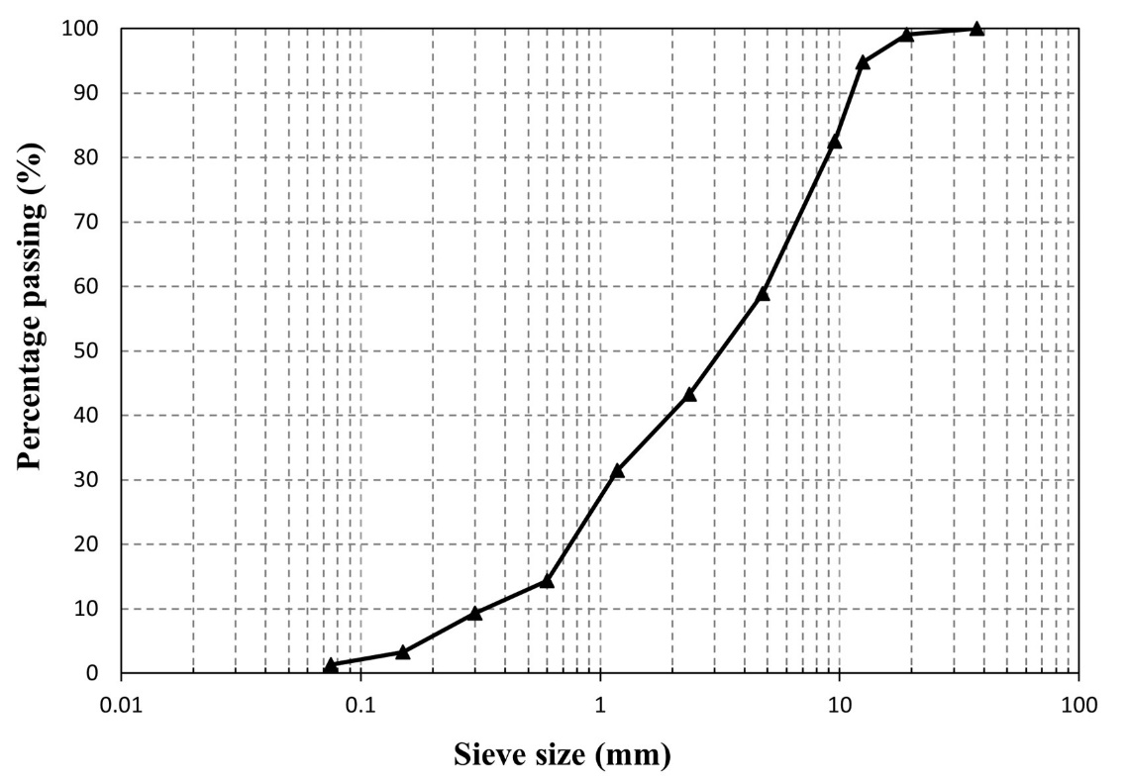

Figure 7-1. Gradation of RAP aggregates.

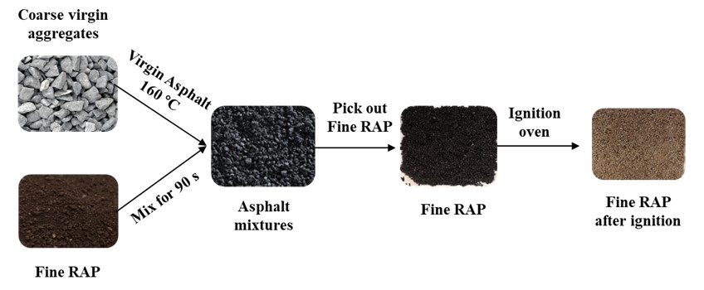
Figure 7-2. Mobilization rate of RAP binder quantified by using the ignition oven method.

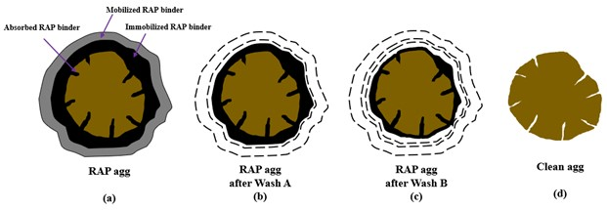
Figure 7-3. Preparation of immobilized RAP aggregates.

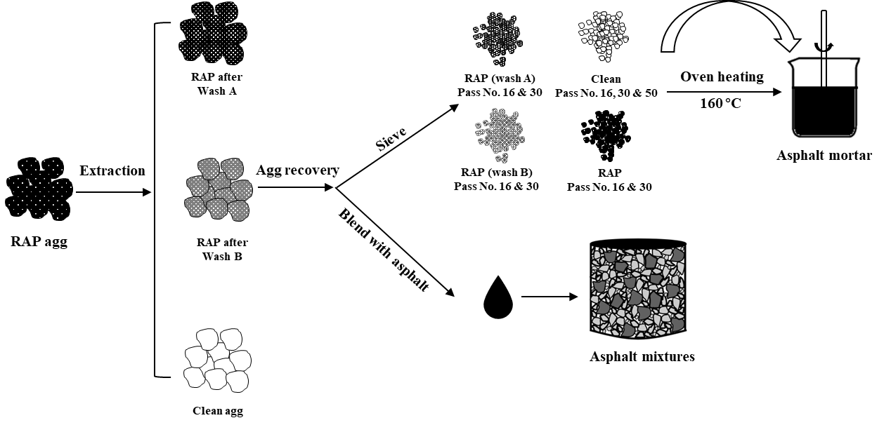
Figure 7-4. Preparation of asphalt mortar and mixtures.

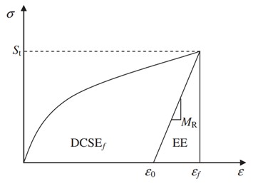
Figure 7-5. Determination of creep strain energy.

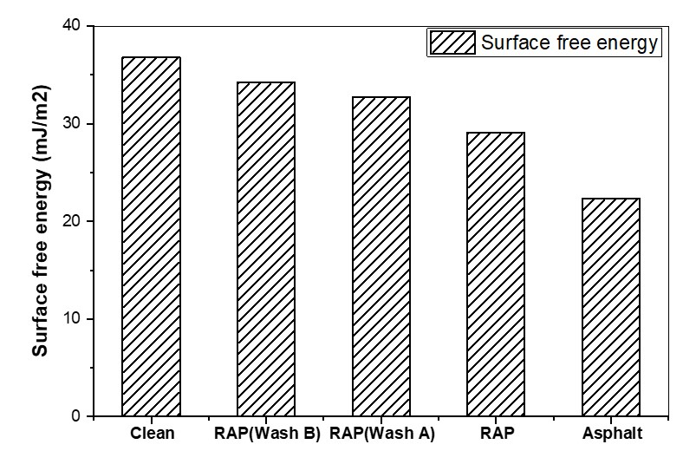
Figure 7-6. Surface free energy of RAP aggregates after different wash levels.

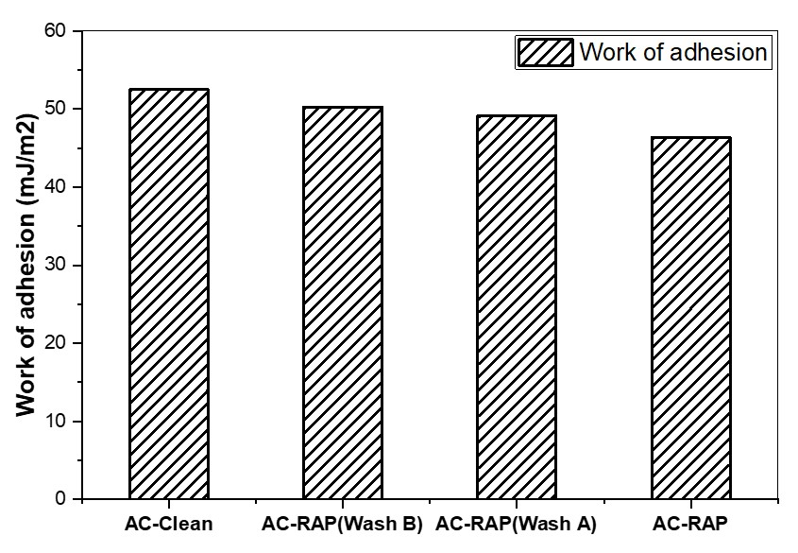
Figure 7-7. Work of adhesion between asphalt and aggregates after different wash levels.

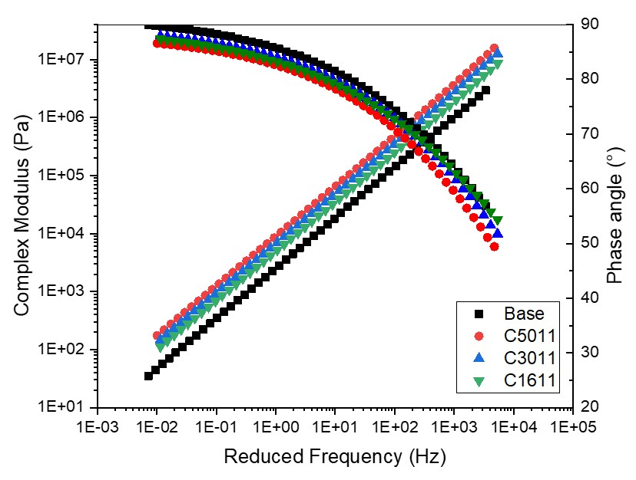
Figure 7-8. Master curves of asphalt mortar with different fine aggregate sizes.

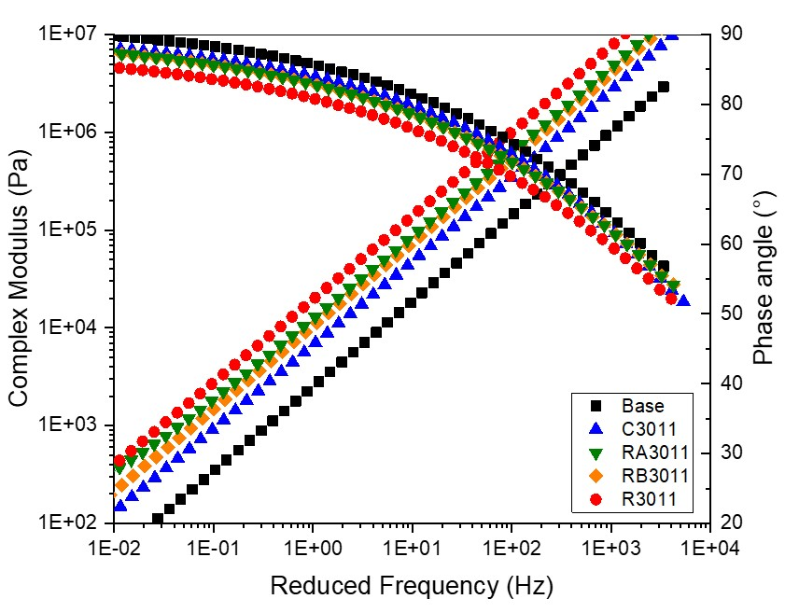
Figure 7-9. Master curves of asphalt mortar with fine aggregate after different wash levels.

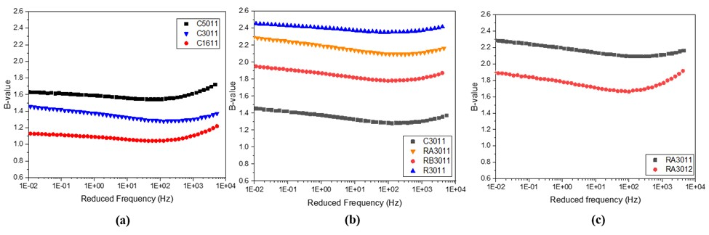
Figure 7-10. B-value of asphalt mortars under different conditions, (a) fine aggregate sizes, (b) fine aggregate with different washing levels, and (c) different volume fractions.

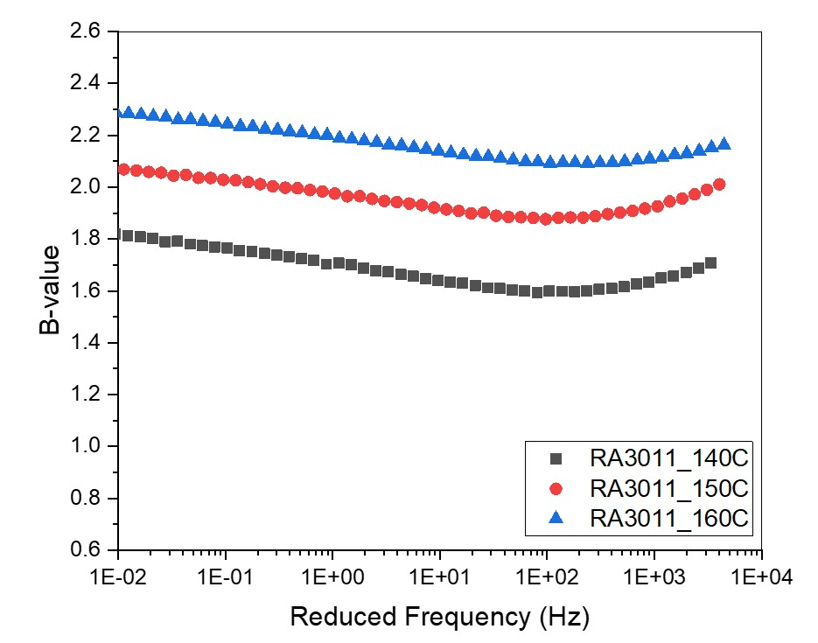
Figure 7-11. B-value of asphalt mortar containing immobilized RAP aggregates mixed at different temperatures.

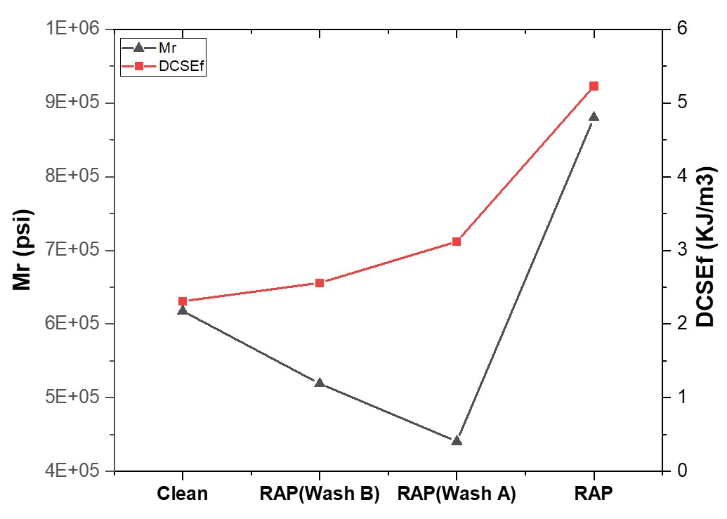
Figure 7-12. Mr and DCSEf of 100% recycled asphalt mixtures with different aggregates.

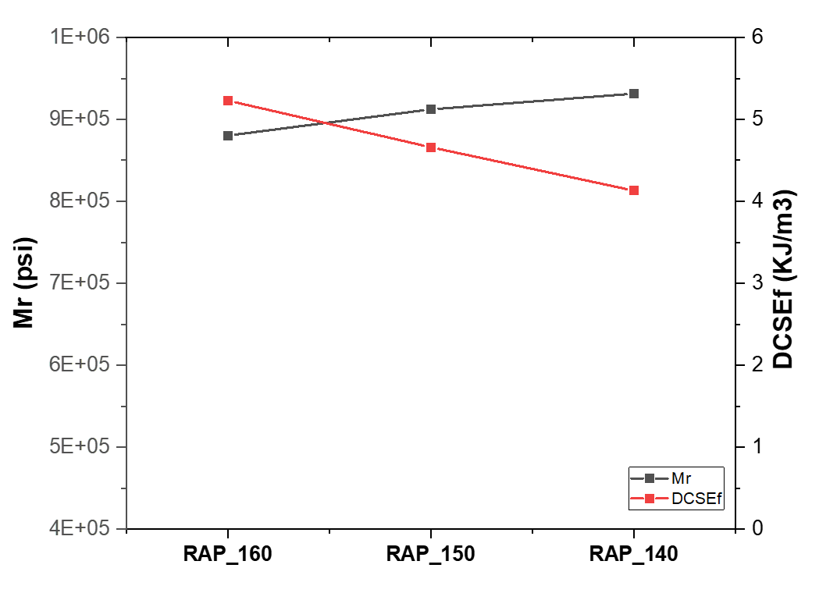
Figure 7-13. Mr and DCSEf of asphalt mixtures with 100% RAP aggregates mixed at different temperatures.

APPENDIX 7B: Tables
Table 7-1. RAP binder contents of different aggregate types.
Aggregate types | RAP aggregate | RAP aggregate  after wash A | RAP aggregate  after wash B | Clean aggregate
Asphalt content (%) | 6.2 | 3.0 | 1.8 | 0

Table 7-2. The compositions of various asphalt mortars.
Type of  asphalt mortar | Size (mm) | F/A  (mass ratio) | Mixing temperature (°C) | Clean | RAP  (Wash A) | RAP  (Wash B) | RAP
C5011 | 0.3 | 1:1 | 160 | √
C3011 | 0.6 | 1:1 | 160 | √
C1611 | 1.18 | 1:1 | 160 | √
RA3011 | 0.6 | 1:1 | 160 |  | √
RA3011_150 | 0.6 | 1:1 | 150 |  | √
RA3011_140 | 0.6 | 1:1 | 140 |  | √
RA3012 | 0.6 | 1:2 | 160 |  | √
RA1611 | 1.18 | 1:1 | 160 |  | √
RB3011 | 0.6 | 1:1 | 160 |  |  | √
RB3012 | 0.6 | 1:2 | 160 |  |  | √
RB1611 | 1.18 | 1:1 | 160 |  |  | √
R3011 | 0.6 | 1:1 | 160 |  |  |  | √
R1611 | 1.18 | 1:1 | 160 |  |  |  | √

Table 7-3. Different binder content in asphalt mixtures with different aggregate types.
Agg types  Binder types | Clean agg | RAP agg after Wash B | RAP agg after Wash A | RAP agg
Virgin asphalt content (%) | 4.0 | 4.0 | 4.0 | 4.0
Immobilized RAP binder content (%) | 0.0 | 1.8 | 3.0 | 3.3
Effective asphalt content (%) | 4.0 | 4.0 | 4.0 | 7.0
Total asphalt content (%) | 4.0 | 5.8 | 7.0 | 10.2

Table 7-4. Binder content 100% recycled asphalt mixtures mixed at different temperatures.
Mixture types  Binder types | RAP agg_160C | RAP agg_150C | RAP agg_140C
Virgin asphalt content (%) | 4.0 | 4.0 | 4.0
Mobilization rate (%) | 48.3 | 41.5 | 31.6
Immobilized RAP binder content (%) | 3.3 | 3.7 | 4.3
Effective asphalt content (%) | 7.0 | 6.6 | 6.0
Total asphalt content (%) | 10.3 | 10.3 | 10.3

Conclusions and recommendations
- HIR mixes showed acceptable rutting and moisture resistance. Cracking resistance is the main issue that HIR mixes would encounter. HMA has a stronger coating between asphalt and aggregates than the HIR mix even with the lower asphalt binder content, indicated by higher IDT strength and DCSEf.
- The DCSEf of field cores reflected that the cracking resistance of the existing pavement surface before HIR rehabilitation decreased more than 40%. HIR technique showed consistent construction qualities as lab mixes, which could restore the cracking resistance of existing pavement.
- ME prediction results indicated that pavement after HIR surface treatment would yield a larger value of roughness index and encounter severe fatigue cracking as well as low-temperature cracking issues.
- LCCA results reflect that HIR surface rehabilitation would cause over 50% of the initial cost-saving than conventional HMA milling and filling technique. Along with the overlay, HIR surface rehabilitation is expected to save the construction cost for the whole life cycle. Various traffic volume or load conditions and further pavement monitoring should be considered for LCCA validation.
- A higher temperature could facilitate the diffusion of the additives into aged asphalt. More aged asphalt binder could be activated to coat the aggregates, which improved the cracking and moisture resistance of the asphalt mixtures. However, the high content of mobilized asphalt would also cause some rutting potentials of the asphalt mixtures.
- The ignition oven method was a valid approach to quantifying the effective mobilized asphalt content in the HIR mix. The proportion of coarse virgin aggregates and fine RAP should be adjusted to make sure there exists enough area for the mobilized RAP binder to coat the virgin aggregates.
- Excessively high temperatures would affect the mobilization rate due to the breakage of asphalt emulsion. Therefore, temperatures and additive contents selection should be optimizec to balance the mobilization of RAP, the cost of materials, and the energy consumption.
- The mobilized RAP binder content could alter the qualities of the effective binder blends and the effective asphalt content, which was highly related to the performance of the HIR mixes.
- The higher proportion of RAP binder in the effective binder blends would increase the stiffness and lower the surface free energy of the binder blends. The binder qualities, including the rheological properties and surface free energy, were highly related to the dynamic modulus of the HIR mixes.
- Based on the dynamic modulus results at low testing temperature, the higher effective asphalt content caused by increasing the recycling agent dosages would improve the interaction and coating between asphalt and aggregates. However, as for high testing temperature, the high asphalt content would cause more asphalt migration and hence a lower dynamic modulus of asphalt mixtures.
- The effective asphalt content is considered a more important factor that dominated the cracking behavior of the 100% HIR mixes. A higher temperature increased the RAP binder mobilization and the effective binder blends would become more brittle, which might cause more cracking potential of asphalt mixtures. However, the mobilized RAP content would also contribute to an increase in the effective asphalt content. Ideal-CT test showed that HIR mixes with higher effective asphalt content had better cracking resistance.
- Compared to the clean aggregates, the immobilized RAP binder decreased the surface energy of aggregates at room temperature. However, the high temperature could activate the immobilized RAP binder around the aggregates and improve the interaction between asphalt and aggregates.
- In terms of asphalt mortar characterization, smaller aggregate sizes, larger volume fractions, and more immobilized RAP content in aggregates improved the asphalt-aggregates interaction system.
- Compared to the asphalt mixtures with clean aggregates, asphalt mixtures with the immobilized RAP aggregates obtained lower resilient modulus, and higher dissipated creep strain energy, indicating lower stiffness and improved cracking resistance, respectively. The major contributions of the immobilized RAP binder are to improve the asphalt-aggregates interaction and increase the total asphalt content.
- As for 100% recycled asphalt mixtures with the same total asphalt content, the immobilized RAP binder content could be affected by temperatures. Asphalt mixtures with more immobilized RAP binder content presented higher stiffness and lowered cracking resistance. In this scenario, the higher immobilized RAP binder content was caused by, the lower mobilization rate of RAP binders and hence the effective asphalt content.

Recommendations for Future Work
- HIR mixes are mainly susceptible to cracking issues. The performance-based mix design such as the “balance mix design” is necessary to be investigated for HIR mix design, which will be mainly focused on the cracking resistance of asphalt mixtures.
- The effective asphalt content dominates the cracking resistance of 100% recycled asphalt mixes. How the mobilized RAP binder content contributes to the performance of HMA is still worth investigating.
- Pavement life prediction and LCCA analysis indicate that HIR is cost-effective for pavement rehabilitation during the whole life cycle. Field monitoring should be conducted to validate the results.

REFERENCE
Aashto, M., 2017. Standard specification for Superpave volumetric mix design. American Association of State Highway and Transportation Officials ….
Ali, H., Grzybowski, K., 2012a. Hot In-Place Pavement Recycling Life Cycle? A Case Study, 91st Annual Meeting of the Transportation Research Board, Washington DC.
Ali, H., Grzybowski, K., 2012b. Life Cycle of Hot In-Place Pavement Recycling. Transportation Research Record: Journal of the Transportation Research Board 2292(1), 29-35.
Ali, H., McCarthy, L.M., Welker, A., 2013. Performance of hot in-place recycled Superpave mixtures in Florida. Construction and Building Materials 49, 618-626.
Bouraima, M.B., Zhang, X.H., Rahman, A., Qiu, Y., 2019. A comparative study on asphalt binder and mixture performance of two traffic lanes during hot in-place recycling (HIR) procedure. Construction and Building Materials 223, 33-43.
Bowers, B.F., Huang, B., Shu, X., Miller, B.C., 2014. Investigation of Reclaimed Asphalt Pavement blending efficiency through GPC and FTIR. Construction and Building Materials 50, 517-523.
Buttlar, W.G., Roque, R., 1994. Development and evaluation of the strategic highway research program measurement and analysis system for indirect tensile testing at low temperatures. Transportation Research Record(1454).
Buttlar, W.G., Roque, R.J.T.R.R., 1994. Development and evaluation of the strategic highway research program measurement and analysis system for indirect tensile testing at low temperatures. (1454).
Cao, R., Leng, Z., Hsu, S.-C., 2019. Comparative eco-efficiency analysis on asphalt pavement rehabilitation alternatives: Hot in-place recycling and milling-and-filling. Journal of Cleaner Production 210, 1385-1395.
Castorena, C., Pape, S., Mooney, C., 2016. Blending Measurements in Mixtures with Reclaimed Asphalt: Use of Scanning Electron Microscopy with X-Ray Analysis. Transportation Research Record: Journal of the Transportation Research Board 2574(1), 57-63.
Chen, M., Javilla, B., Hong, W., Pan, C., Riara, M., Mo, L., Guo, M., 2019. Rheological and Interaction Analysis of Asphalt Binder, Mastic and Mortar. Materials (Basel) 12(1).
Cheng, D., Little, D.N., Lytton, R.L., Holste, J.C.J.T.R.R., 2002. Surface energy measurement of asphalt and its application to predicting fatigue and healing in asphalt mixtures. 1810(1), 44-53.
Coffey, S., DuBois, E., Mehta, Y., Nolan, A., Purdy, C., 2013. Determining the impact of degree of blending and quality of reclaimed asphalt pavement on predicted pavement performance using pavement ME design. Construction and Building Materials 48, 473-478.
Colbert, B., You, Z., 2012. The properties of asphalt binder blended with variable quantities of recycled asphalt using short term and long term aging simulations. Construction and Building Materials 26(1), 552-557.
Cooper Jr, S.B., 2015. Sustainable Materials for Pavement Infrastructure: Design and Performance of Asphalt Mixtures Containing Recycled Asphalt Shingles.
Cooper, S.B., Mohammad, L.N., Elseifi, M.A., 2014. Laboratory Performance of Asphalt Mixtures Containing Recycled Asphalt Shingles. Transportation Research Record: Journal of the Transportation Research Board 2445(1), 94-102.
Craus, J., Ishai, I., 1977. A method for the determination of the surface area of fine aggregate in bituminous mixtures. Journal of testing and evaluation 5(4), 284-291.
Daly, W.H., Negulescu, I., Balamurugan, S.S., 2013. Implementation of GPC characterization of asphalt binders at Louisiana materials laboratory. Louisiana. Dept. of Transportation and Development.
Daniel, J.S., Lachance, A.J.T.r.r., 2005. Mechanistic and volumetric properties of asphalt mixtures with recycled asphalt pavement. 1929(1), 28-36.
Ding, Y., Huang, B., Shu, X., 2016a. Characterizing blending efficiency of plant produced asphalt paving mixtures containing high RAP. Construction and Building Materials 126, 172-178.
Ding, Y., Huang, B., Shu, X., 2018. Blending efficiency evaluation of plant asphalt mixtures using fluorescence microscopy. Construction and Building Materials 161, 461-467.
Ding, Y., Huang, B., Shu, X., Zhang, Y., Woods, M.E., 2016b. Use of molecular dynamics to investigate diffusion between virgin and aged asphalt binders. Fuel 174, 267-273.
Dony, A., Ziyani, L., Drouadaine, I., Pouget, S., Faucon-Dumont, S., Simard, D., Mouillet, V., Poirier, J.E., Gabet, T., Boulange, L., 2016. MURE National Project: FTIR spectroscopy study to assess ageing of asphalt mixtures, Proceedings of the E&E congress.
Finlayson, D., Nicoletti, C., Pilkington, I., Sharma, V., Teufele, B., 2011. British Columbia's Success with Hot-In-Place Recycling—A 25 year History, CTAA Annual Conference Proceedings-Canadian Technical Asphalt Association. p. 185.
Gong, H., Huang, B., Shu, X., Udeh, S.J.R.M., Design, P., 2017. Local calibration of the fatigue cracking models in the Mechanistic-Empirical Pavement Design Guide for Tennessee. 18(sup3), 130-138.
Graebling, D., Muller, R.J.C., surfaces, 1991. Determination of interfacial tension of polymer melts by dynamic shear measurements. 55, 89-103.
Guo, F., Pei, J., Zhang, J., Xue, B., Sun, G., Li, R., 2020. Study on the adhesion property between asphalt binder and aggregate: A state-of-the-art review. Construction and Building Materials 256.
Hafeez, I., Ozer, H., Al-Qadi, I.L., 2014. Performance Characterization of Hot In-Place Recycled Asphalt Mixtures. Journal of Transportation Engineering 140(8).
Hesham, A., Bonaquist, R., 2012. Evaluation of Binder Grade and Recycling Agent Blending for Hot In-Place Recycled Pavement.
Hettiarachchi, C., Hou, X., Xiang, Q., Yong, D., Xiao, F., 2020. A blending efficiency model for virgin and aged binders in recycled asphalt mixtures based on blending temperature and duration. Resources, Conservation and Recycling 161.
Hou, X., Lv, S., Chen, Z., Xiao, F., 2018. Applications of Fourier transform infrared spectroscopy technologies on asphalt materials. Measurement 121, 304-316.
Howson, J., Bhasin, A., Masad, E., Lytton, R., Little, D., 2009. Development of a database for surface energy of aggregates and asphalt binders. Texas Transportation Institute.
Huang, B., Li, G., Vukosavljevic, D., Shu, X., Egan, B.K., 2005a. Laboratory investigation of mixing hot-mix asphalt with reclaimed asphalt pavement. Transportation Research Record 1929(1), 37-45.
Huang, B., Li, G., Vukosavljevic, D., Shu, X., Egan, B.K.J.T.R.R., 2005b. Laboratory investigation of mixing hot-mix asphalt with reclaimed asphalt pavement. 1929(1), 37-45.
Huang, B., Shu, X., Bass, J., 2008. Investigation of Simple Performance Characteristics of Plant-Produced Asphalt Mixtures in Tennessee. Transportation Research Record: Journal of the Transportation Research Board 2057(1), 140-148.
Huang, B., Shu, X., Vukosavljevic, D., 2011. Laboratory Investigation of Cracking Resistance of Hot-Mix Asphalt Field Mixtures Containing Screened Reclaimed Asphalt Pavement. Journal of Materials in Civil Engineering 23(11), 1535-1543.
Huang, B., Zhang, Z., Kingery, W., Zuo, G., 2004. Fatigue crack characteristics of HMA mixtures containing RAP, Fifth Int RILEM Conf Reflective Crack Pavements. pp. 631-638.
Huang, S.-C., Robertson, R.E.J.R.m., design, p., 2006. Rheology of thin asphalt films in contact with aggregate. 7(2), 179-199.
Huang, T., Luo, J., Luo, R., Tu, C.J.C., Materials, B., 2022. Investigation on the relationship between the surface texture index and the surface free energy of aggregate. 325, 126759.
Kaseer, F., Arámbula-Mercado, E., Martin, A.E., 2019. A Method to Quantify Reclaimed Asphalt Pavement Binder Availability (Effective RAP Binder) in Recycled Asphalt Mixes. Transportation Research Record: Journal of the Transportation Research Board 2673(1), 205-216.
Kriz, P., Grant, D.L., Veloza, B.A., Gale, M.J., Blahey, A.G., Brownie, J.H., Shirts, R.D., Maccarrone, S., 2014. Blending and diffusion of reclaimed asphalt pavement and virgin asphalt binders. Road Materials and Pavement Design 15(sup1), 78-112.
Li, J., Ni, F., Huang, Y., Gao, L., 2014. New Additive for Use in Hot In-Place Recycling to Improve Performance of Reclaimed Asphalt Pavement Mix. Transportation Research Record: Journal of the Transportation Research Board 2445(1), 39-46.
Li, J., Ni, F., Jin, J., Zhou, Z., 2016. A comparison of rejuvenator and sryrene–butadiene rubber latex used in hot in-place recycling. Road Materials and Pavement Design 18(1), 101-115.
Li, X., Lv, X., Zhou, Y., You, Z., Chen, Y., Cui, Z., Diab, A., 2020. Homogeneity evaluation of hot in-place recycling asphalt mixture using digital image processing technique. Journal of Cleaner Production 258, 120524.
Little, D.N., Bhasin, A., 2006. Using surface energy measurements to select materials for asphalt pavement.
Liu, Y., Wang, H., Tighe, S.L., Zhao, G., You, Z.J.C., Materials, B., 2019. Effects of preheating conditions on performance and workability of hot in-place recycled asphalt mixtures. 226, 288-298.
Lo Presti, D., Vasconcelos, K., Orešković, M., Pires, G.M., Bressi, S., 2019. On the degree of binder activity of reclaimed asphalt and degree of blending with recycling agents. Road Materials and Pavement Design 21(8), 2071-2090.
Ma, Y., Hu, W., Polaczyk, P.A., Han, B., Xiao, R., Zhang, M., Huang, B., 2020a. Rheological and aging characteristics of the recycled asphalt binders with different rejuvenator incorporation methods. Journal of Cleaner Production.
Ma, Y., Hu, W., Polaczyk, P.A., Han, B., Xiao, R., Zhang, M., Huang, B., 2020b. Rheological and aging characteristics of the recycled asphalt binders with different rejuvenator incorporation methods. Journal of Cleaner Production 262.
Ma, Y., Hu, W., Polaczyk, P.A., Han, B., Xiao, R., Zhang, M., Huang, B.J.J.o.C.P., 2020c. Rheological and aging characteristics of the recycled asphalt binders with different rejuvenator incorporation methods. 262, 121249.
Ma, Y., Nie, Q., Xiao, R., Hu, W., Han, B., Polaczyk, P.A., Huang, B., 2020d. Experimental investigation of utilizing waste flue gas desulfurized gypsum as backfill materials. Construction and Building Materials 245.
Ma, Y., Nie, Q., Xiao, R., Hu, W., Han, B., Polaczyk, P.A., Huang, B., 2020e. Experimental investigation of utilizing waste flue gas desulfurized gypsum as backfill materials. Construction and Building Materials 245, 118393.
Ma, Y., Polaczyk, P., Hu, W., Zhang, M., Huang, B., 2021a. Quantifying the effective mobilized RAP content during hot in-place recycling techniques. Journal of Cleaner Production 314.
Ma, Y., Polaczyk, P., Park, H., Jiang, X., Hu, W., Huang, B., 2020f. Performance evaluation of temperature effect on hot in-place recycling asphalt mixtures. Journal of Cleaner Production 277.
Ma, Y., Wang, S., Zhou, H., Hu, W., Polaczyk, P., Huang, B., 2021b. Potential Alternative to Styrene–Butadiene–Styrene for Asphalt Modification Using Recycled Rubber–Plastic Blends. Journal of Materials in Civil Engineering 33(12).
Ma, Y., Wang, S., Zhou, H., Hu, W., Polaczyk, P., Huang, B.J.J.o.C.P., 2021c. Recycled polyethylene and crumb rubber composites modified asphalt with improved aging resistance and thermal stability. 130102.
Ma, Y., Wang, S., Zhou, H., Hu, W., Polaczyk, P., Zhang, M., Huang, B., 2021d. Compatibility and rheological characterization of asphalt modified with recycled rubber-plastic blends. Construction and Building Materials 270.
Ma, Y., Zhou, H., Jiang, X., Polaczyk, P., Xiao, R., Zhang, M., Huang, B., 2021e. The utilization of waste plastics in asphalt pavements: A review. Cleaner Materials 2.
Manual, B.A.R.J.A., Maryland, 2001. Asphalt recycling and reclaiming Association.
Martínez-Echevarría, M., Rubio, M., Menendez, A., 2008. The reuse of waste from road resurfacing: cold in-place recycling of bituminous pavement, an environmentally friendly alternative to conventional pavement rehabilitation methods. WIT Transactions on ecology and the environment 109, 459-469.
McDaniel, R.S., Anderson, R.M., 2001. Recommended use of reclaimed asphalt pavement in the Superpave mix design method: technician's manual. National Research Council (US). Transportation Research Board.
Moraes, R., Bahia, H.U., 2015. Effect of mineral filler on changes in molecular size distribution of asphalts during oxidative ageing. Road Materials and Pavement Design 16(sup2), 55-72.
Nam, B., Maherinia, H., Behzadan, A.H.J.C., Materials, B., 2014. Mechanical characterization of asphalt tear-off roofing shingles in Hot Mix Asphalt. 50, 308-316.
Navaro, J., Drouadaine, I., Proteau, M., Mendez, S., Pouteau, B., 2012. New Methodology for Verifying the Homogeneity of the Bitumen in the Production of Warm Mix with High Recycle Rate, CTAA Annual Conference Proceedings-Canadian Technical Asphalt Association. p. 75.
O’Sullivan, K., 2009. 100 percent recycling—sustainability in pavement construction. IRF News 2009, 1-16.
Orešković, M., Menegusso Pires, G., Bressi, S., Vasconcelos, K., Lo Presti, D., 2020. Quantitative assessment of the parameters linked to the blending between reclaimed asphalt binder and recycling agent: A literature review. Construction and Building Materials 234.
Pei, J., Fan, Z., Wang, P., Zhang, J., Xue, B., Li, R., 2015. Micromechanics prediction of effective modulus for asphalt mastic considering inter-particle interaction. Construction and Building Materials 101, 209-216.
Polaczyk, P., Han, B., Huang, B., Jia, X., Shu, X., 2018. Evaluation of the hot mix asphalt compactability utilizing the impact compaction method. Construction and Building Materials 187, 131-137.
Polaczyk, P., Huang, B., Shu, X., Gong, H., 2019. Investigation into Locking Point of Asphalt Mixtures Utilizing Superpave and Marshall Compactors. Journal of Materials in Civil Engineering 31(9), 04019188.
Polaczyk, P., Ma, Y., Xiao, R., Hu, W., Jiang, X., Huang, B.J.R.M., Design, P., 2021. Characterization of aggregate interlocking in hot mix asphalt by mechanistic performance tests. 22(sup1), S498-S513.
Recycling, A., 1992. Reclaiming Association (ARRA)–Hot In-Place Recycling--First in the Line of Pavement Maintenance. HIR Technical Committee, Annapolis, Maryland.
Roque, R., Birgisson, B., Drakos, C., Dietrich, B., 2004a. Development and field evaluation of energy-based criteria for top-down cracking performance of hot mix asphalt (with discussion). Journal of the Association of Asphalt Paving Technologists 73.
Roque, R., Birgisson, B., Drakos, C., Dietrich, B.J.J.o.t.A.o.A.P.T., 2004b. Development and field evaluation of energy-based criteria for top-down cracking performance of hot mix asphalt (with discussion). 73.
Shirodkar, P., Mehta, Y., Nolan, A., Dubois, E., Reger, D., McCarthy, L., 2013a. Development of blending chart for different degrees of blending of RAP binder and virgin binder. Resources, Conservation and Recycling 73, 156-161.
Shirodkar, P., Mehta, Y., Nolan, A., Dubois, E., Reger, D., McCarthy, L.J.R., conservation, recycling, 2013b. Development of blending chart for different degrees of blending of RAP binder and virgin binder. 73, 156-161.
Shirodkar, P., Mehta, Y., Nolan, A., Sonpal, K., Norton, A., Tomlinson, C., Dubois, E., Sullivan, P., Sauber, R., 2011. A study to determine the degree of partial blending of reclaimed asphalt pavement (RAP) binder for high RAP hot mix asphalt. Construction and Building Materials 25(1), 150-155.
Shu, X., Huang, B., Shrum, E.D., Jia, X., 2012. Laboratory evaluation of moisture susceptibility of foamed warm mix asphalt containing high percentages of RAP. Construction and Building Materials 35, 125-130.
Shu, X., Huang, B., Vukosavljevic, D., 2008. Laboratory evaluation of fatigue characteristics of recycled asphalt mixture. Construction and Building Materials 22(7), 1323-1330.
Singhvi, P., Ozer, H., Al-Qadi, I.L., 2016a. Environmental and Functional Benefits and Trade-Offs of Hot In-Place Recycling Treatment Techniques.
Singhvi, P., Ozer, H., Al-Qadi, I.L.J.C.f.H.P.P., Report No. ICT-17-001, Okemos, MI, 2016b. Environmental and Functional Benefits and Trade-Offs of Hot In-Place Recycling Treatment Techniques.
Soleymani, H.R., Bahia, H.U., Bergan, A.T.J.T.r.r., 1999. Blending charts based on performance-graded asphalt binder specification. 1661(1), 7-14.
Song, W., Huang, B., Shu, X., 2018. Influence of warm-mix asphalt technology and rejuvenator on performance of asphalt mixtures containing 50% reclaimed asphalt pavement. Journal of Cleaner Production 192, 191-198.
Sreeram, A., Leng, Z., Zhang, Y., Padhan, R.K., 2018a. Evaluation of RAP binder mobilisation and blending efficiency in bituminous mixtures: An approach using ATR-FTIR and artificial aggregate. Construction and Building Materials 179, 245-253.
Sreeram, A., Leng, Z., Zhang, Y., Padhan, R.K.J.C., Materials, B., 2018b. Evaluation of RAP binder mobilisation and blending efficiency in bituminous mixtures: An approach using ATR-FTIR and artificial aggregate. 179, 245-253.
Stroup-Gardiner, M., 2012. Selection guidelines for in-place recycling projects. Transportation Research Record 2306(1), 3-10.
Stroup-Gardiner, M., 2016. Use of Reclaimed Asphalt Pavement and Recycled Asphalt Shingles in Asphalt Mixtures.
Tan, Y., Guo, M., 2013. Using surface free energy method to study the cohesion and adhesion of asphalt mastic. Construction and Building Materials 47, 254-260.
Tan, Y., Guo, M.J.C., Materials, B., 2013. Using surface free energy method to study the cohesion and adhesion of asphalt mastic. 47, 254-260.
Tan, Y., Guo, M.J.M., Structures, 2014. Interfacial thickness and interaction between asphalt and mineral fillers. 47(4), 605-614.
Terrel, R.L., Hicks, R.G., 2008. Viability of hot in-place recycling as a pavement preservation strategy. Final report for Caltrans. California Pavement Preservation Center Report CP2 106.
Van Oss, C.J., Chaudhury, M.K., Good, R.J.J.C.r., 1988. Interfacial Lifshitz-van der Waals and polar interactions in macroscopic systems. 88(6), 927-941.
Wei, J., Zhang, Y., 2012. Application of sessile drop method to determine surface free energy of asphalt and aggregate. ASTM International.
Williams, B.A., Copeland, A., Ross, T.C., 2018. Asphalt Pavement Industry Survey on Recycled Materials and Warm-Mix Asphalt Usage: 2017.
Williams, B.A., Willis, J.R., Ross, T.C., 2019. Asphalt Pavement Industry Survey on Recycled Materials and Warm-Mix Asphalt Usage: 2018.
Witczak, M.W., 2002. Simple performance test for superpave mix design. Transportation Research Board.
Xiao, F., Punith, V.S., Putman, B.J., 2013. Effect of Compaction Temperature on Rutting and Moisture Resistance of Foamed Warm-Mix-Asphalt Mixtures. Journal of Materials in Civil Engineering 25(9), 1344-1352.
Xu, W., Qiu, X., Xiao, S., Hong, H., Wang, F., Yuan, J., 2020. Characteristics and Mechanisms of Asphalt-Filler Interactions from a Multi-Scale Perspective. Materials (Basel) 13(12).
Xu, Y., Chou, Z., Li, Y., Ji, J., Xu, S.-f., 2019. Effect of Blending Degree between Virgin and Aged Binder on Pavement Performance of Recycled Asphalt Mixture with High RAP Content. Advances in Materials Science and Engineering 2019, 1-15.
Yu, B., Gu, X., Zhang, L., Ni, F., 2016. Performance Evaluation of Aged Asphalt Mix for Hot In-Place Recycling. Journal of Testing and Evaluation 44(2).
Yu, S., Shen, S., Zhang, C., Zhang, W., Jia, X.J.J.o.M.i.C.E., 2017. Evaluation of the blending effectiveness of reclaimed asphalt pavement binder. 29(12), 04017230.
Zaumanis, M., Mallick, R.B., Frank, R., 2013. Evaluation of Rejuvenator's Effectiveness with Conventional Mix Testing for 100% Reclaimed Asphalt Pavement Mixtures. Transportation Research Record: Journal of the Transportation Research Board 2370(1), 17-25.
Zhang, J., Liu, G., Hu, Z., Zhu, C., Pei, J., Jin, L., 2016. Effects of temperature and loading frequency on asphalt and filler interaction ability. Construction and Building Materials 124, 1028-1037.
Zhang, Z., Roque, R., Birgisson, B., Sangpetngam, B., 2001a. Identification and verification of a suitable crack growth law (with discussion). Journal of the Association of Asphalt Paving Technologists 70.
Zhang, Z., Roque, R., Birgisson, B., Sangpetngam, B.J.J.o.t.A.o.A.P.T., 2001b. Identification and verification of a suitable crack growth law (with discussion). 70.
Zhao, S., Bowers, B., Huang, B., Shu, X., 2014. Characterizing rheological properties of binder and blending efficiency of asphalt paving mixtures containing RAS through GPC. Journal of Materials in Civil Engineering 26(5), 941-946.
Zhao, S., Huang, B., Shu, X., 2015. Investigation on binder homogeneity of RAP/RAS mixtures through staged extraction. Construction and Building Materials 82, 184-191.
Zhao, S., Huang, B., Shu, X., Jia, X., Woods, M., 2012. Laboratory Performance Evaluation of Warm-Mix Asphalt Containing High Percentages of Reclaimed Asphalt Pavement. Transportation Research Record: Journal of the Transportation Research Board 2294(1), 98-105.
Zhao, S., Huang, B., Shu, X., Woods, M., 2013. Comparative evaluation of warm mix asphalt containing high percentages of reclaimed asphalt pavement. Construction and Building Materials 44, 92-100.
Zhao, S., Huang, B., Shu, X., Woods, M.E., 2016. Quantitative evaluation of blending and diffusion in high RAP and RAS mixtures. Materials & Design 89, 1161-1170.
Zhao, S., Huang, B., Shu, X., Woods, M.E., 2019. Quantitative Characterization of Binder Blending. Transportation Research Record: Journal of the Transportation Research Board 2506(1), 72-80.
Zhong, H., Huang, W., Yan, C., Zhang, Y., Lv, Q., Sun, L., Liu, L., 2021. Investigating binder aging during hot in-place recycling (HIR) of asphalt pavement. Construction and Building Materials 276.
Zhou, C., Huang, B., Shu, X., Dong, Q.J.J.o.T.E., 2013. Validating MEPDG with Tennessee pavement performance data. 139(3), 306-312.
Zhou, F., Im, S., Sun, L., Scullion, T.J.R.M., Design, P., 2017. Development of an IDEAL cracking test for asphalt mix design and QC/QA. 18(sup4), 405-427.
Ziegel, K., Romanov, A.J.J.o.A.P.S., 1973. Modulus reinforcement in elastomer composites. I. Inorganic fillers. 17(4), 1119-1131.

VITA
Yuetan Ma was born in Shijizhuang, Hebei, China, to the pareants of Jiankun Ma and Liping Wang. He received his bachelor’s degree in Shijiazhuang Tiedao University (College of Civil Engineering) in 2016. Afterward, he attended Penn State University and received a Master’s degree in Civil and Environmental Engineering with a concentration in Geotechnical and Materials Engineering in 2018. Currently, he attends Civil Engineering Doctorate Program with a concentration in Geotechincal and Materials Engineering at The University of Tennessee, Knoxcille. He works as Graduate Research and Teaching Assistant under the supervision of Dr. Baoshan Huang.

