Unearthing Tree Symbolism in Song: A Sentiment Analysis

A Thesis Presented for the
Master of Science
Degree
The University of Tennessee, Knoxville

Shannon Lee Jo-Ann Bayliss
August 2021

Copyright © 2021 by Shannon Lee Jo-Ann Bayliss
All rights reserved.

ACKNOWLEDGEMENTS
I am grateful for the many people who have helped with this project. To my mentors: you have all been invaluable. Thank you to Dr. Mark Littmann –your enthusiasm for science communication is infectious. Thank you to Dr. Julie Andsager and Professor Robert Heller for your insights and guidance. Thank you to Dr. Joe Bailey and Dr. Jen Schweitzer for encouraging me to pursue this degree. To my friends everywhere: you inspire me. To Elizabeth, for everything. To Leila, for coding tips and tricks. To Kendall, for dog dates and tennis dates. To Liam, for proofreading my novel. To Sophia, for helping me annunciate my t’s. To Andy, for never needing an explanation. And finally, to my family: you are wonderful. Thank you.

ABSTRACT
How societies communicate about nature can shape the way that they interact with it. Messages contained in music are especially interesting to study because of the unique ability of sound and language to alter moods and/or induce physiological reactions. Research on cultural values in music is growing but studies on environmental themes are scarce despite pervasive natural symbolism in songs. Historically, most species of tree have gained a symbolic meaning in part based on their physical characteristics and the various ways they are used by humans (e.g., for construction or for medicine). The overall goal of this thesis was to understand the emotional sentiment associated with tree symbolism in English-language songs. To quantitatively investigate these associations, I assembled a corpus of 1335 songs that use common North American tree names in lyrics. Songs were categorized into two groups based on the evolutionary history of the tree used in lyrics. Trees are either angiosperms (typically flowering, fruiting, and deciduous) or gymnosperms (typically cone-producing and evergreen). I extracted lyrical sentiment (e.g., positive words) and musical qualities (e.g., tempo) of each song for analyses. Lyrically, I found that angiosperm songs were more likely to contain positive words and less likely to contain negative words than gymnosperm songs. Additionally, angiosperm songs were more likely to contain words of anticipation, joy, and trust, while gymnosperm songs were more likely to contain words of anger, fear, and sadness. Musically, gymnosperm songs had higher energy and tempo than angiosperm songs. Exploring these data further at other levels of taxonomy would likely provide higher resolution of thematic content. These results provide support for the idea that the sentiments we associate with trees are related to the tree’s evolutionary history which is important because our sentiments have the potential to affect how we connect to and interact with environments.
PREFACE
The big oak tree on Big Oak Road seems smaller now. Not because it hasn’t grown, but because I have. The house that used to be numbered 606 at the end of the cul-de-sac also seems smaller. The steep gravel driveway leading down to it is now a gently paved incline truncated by a cornflower blue shed - an eyesore if you ask my mother. The numbers “652” glisten on the cowering home’s front door.
The widest part of the big oak’s crown is about 80 feet – a rough measurement I made using Google Maps’ aerial view. In an open area like this, a white oak can grow as tall as it is wide. I verified that the pi-r-squared equation still applies to circles (it does) and calculated that, with the sun directly overhead, the tree could cast 5000 square feet of shade. But the shadow of this big oak must always be larger than that because the sun is never directly overhead here in the mid-latitudes.
This oak had been the meeting spot for me and my best friend Alexandra on weekends and after school. It felt like it was ours, even though our brothers met there too, and the rest of the neighborhood kids, for that matter. Alexandra and I would sometimes sell bouquets to neighbors around the cul-de-sac fashioned from other neighbors’ gardens. I said it was stealing, but she said it was okay because we were giving them back. I guess selling is sort of like giving with a caveat. I did the knocking so I didn’t have to do the talking and would keep my eyes on my shoelaces as she graciously accepted quarters in exchange for the flowers. I recognize now that she was just a budding capitalist facilitating an exchange of goods. We counted our money under that big oak.
During my research, I came across a BuzzFeed quiz titled “Everyone Has A Tree That Matches Their Personality.” I selected some preferences, including a cocktail and a dog breed, and found that my personality matched a maple tree: sweet, comforting, making friends everywhere and making others feel accepted. More than anything else, this seemed attributable to choosing the golden retriever over the French bulldog.
So, I took the quiz again, trying to select opposite responses. This time I got a pine tree: warm, kind, sentimental, cherishing memories from the past. Like other evergreen species, a pine’s ever-greenness connects them to the passing of time.
Choosing randomly this time, I took it again. Maple. I took it again. This time choosing preferences trying to get an oak tree, but I got a palm: positive attitude, great sense of humor, calm, cool, collected, someone who goes with the flow and doesn’t worry about things they can’t change. Palm leaves have fronds that resemble fingers on a hand, or so the person who named them thought. A symbol of victory in athletic contests.
I took it again, maple. Again, pine. Again, palm. I was starting to feel like Harry Potter trying to convince The Sorting Hat to place him in Gryffindor instead of Slytherin his first year at Hogwarts.
Finally, an oak tree: strong, powerful, dependable, caring, brave.
BuzzFeed knew that the oak tree is a symbol of strength and stability across many cultures. The scientific name for the English Oak is Quercus robur: robur means “strength.” Oaks were said to be most often struck by lightning which associated them with the Ancient Greek and Roman gods Zeus and Jupiter, whose signature weapons were the lightning bolt. Giving trees personalities pre-dates BuzzFeed by a few millennia. They often hold great historical, cultural, and mythological significance, connecting identity and belonging to a place as well as connecting the earth to the divine.
In front of the house that I live in now is a beautiful young red maple tree. If I’d grown up in this house, I might have stopped with BuzzFeed’s first decision on my tree personality. I would never compare a maple tree to a Slytherin, after all. Voldemort’s wand was made from the wood of a yew tree: a sturdy, dismal, unsocial tree with poisonous berries and leaves. Paths to many underworlds are said to be lined with them.
My mom watches the real estate market online, so she knows that our home has since belonged to two other families. Sometimes I wonder who else thinks about that big oak on Big Oak Road in the foothills of the Appalachian Mountains.

Table of Contents
Chapter One Introduction 1
Music & Nature 1
Chapter Two Background & Literature Review 4
Nature Communication 5
Music as Communication 10
Chapter Three Materials & Methods 13
Hypotheses 13
Data Collection 13
Sentiment Analysis 18
Statistical Analyses 20
Chapter Four Results 22
Lyrical Sentiment 24
Audio Sentiment 28
Chapter Five Discussion & Conclusion 30
Discussion 30
Conclusion 33
List of References 34
Appendix 45
Vita 53

LIST OF TABLES

Table 3.1. Song title, original artist(s), approximate number of covers or reproductions, songwriter(s), original release date, and lyric samples from seven popular songs that were excluded from analysis because they were written prior to 1959, but that have been extensively covered by other artists after 1959. 17

Table A.1. Song country of origin and count. Origin is determined based on songwriter and performer origins. If multiple or unclear origins, additional countries are included in column 3 (for example, one song is attributable to Canada and Australia). 46

Table A.2. Model and summary statistics for lyrical sentiment across tree type. Summary statistics include mean word counts in songs for each sentiment and percentages of songs with zero words that match a sentiment category. Model statistics include odds ratios, residual deviances on 1330 degrees of freedom (df), and p-values from models with tree type as the sole predictor for word count response variables, with binomial distributed error structure. 47

Table A.3. Model and summary statistics for polarity lyric metrics and audio variables across tree type. Summary statistics include mean values +/- standard errors. Model statistics include F-ratios and p-values. 48

LIST OF FIGURES

Figure 4.1. The number of songs for each tree name used in lyrics across three hierarchical levels of evolutionary relatedness. Each horizontal bar represents a tree genus (y-axis tree names), the color of bars represents the higher classification of tree order, and the vertical bar color splits orders into two higher groups of vascular seed plants: gymnosperms and angiosperms. 23

Figure 4.2. Lyrical positivity, negativity, and polarity across tree type. Panels (A-B) represent odds ratios which indicate the probability that lyrics contain words of (A) positive or (B) negative sentiment. Panel (C) shows mean values of polarity +/- standard errors. Polarity metrics are from two lexicons (nrc lexicon: square symbols on grey background; LIWC lexicon: circular symbols). Asterisks indicate statistically significant differences. 25

Figure 4.3. Lyrical emotional sentiment across tree type. Values are odds ratios which indicate the probability that lyrics contain words of (A) anger, (B) anticipation, (C) disgust, (D) fear, (E) joy, (F) sadness, (G) surprise, and (H) trust. Asterisks indicate statistically significant differences. 27

Figure 4.4. Mean values +/- standard errors of audio qualities across tree type. Valence (A), danceability (B), and energy (C) are on a scale of 0-1. Loudness (D) is measured in decibels. Tempo (E) is measured in beats per minute (BPM). Asterisks indicate statistically significant differences. 29

Figure A.1. Number (A) and proportion (B) of songs across genre and tree type. 49

Figure A.2. Total number of words in dataset categorized into each sentiment by tree type. Recall that the number of songs per tree type differ (N_{angio}= 853; N_{gymno} = 482). 50

Figure A.3. Word clouds representing the most frequent words used in lyrics for each sentiment category. The relative size of words represents its relative frequency in lyrics. Text color represents the tree group that was significantly more likely to have words in that category (magenta = angiosperm; blue green = gymnosperm; black = no significant difference). 51

Figure A.4. Mean lyrical polarity +/- standard errors across tree genera. Polarity is from the LIWC lexicon (left, circular symbols) and the nrc lexicon (right, square symbols). Key follows figure 4.1. 52

Introduction

Music & Nature
Human senses (e.g., auditory, tactile, or visual) have evolved in response to cues in the natural environment – cues that often initiate physical and emotional responses. The pervasiveness of environmental sounds – a buzzing bee, a running stream, whistling winds – varies widely across human populations living in different ecosystems. Repeatedly hearing these environmental sounds musicalizes them (a phenomenon that also applies to the repetition of words) such that differences in environmental sounds across ecosystems has likely influenced the creation of music across cultures (Simchy-Gross & Margulis, 2018). In fact, regional patterns of musical structures have been shown to correlate with population genetic structure – in other words, the more genetically similar the populations, the more similar their music (Brown et al., 2014; Pamjay et al., 2012). For instance, musical valence decreases with latitude, meaning that more positive sounds are produced near the equator (Dodds & Danforth, 2010), and Scandinavia – over 4,200 miles from the equator – makes the most negative sounding music (Kolchinsky et al., 2017).
With or without lyrical language, music is ubiquitous across human societies. This is likely due to the high number evolutionarily adaptive behaviors that are associated with it, such as infant care, religiosity, storytelling, entertainment, and play (Mehr et al., 2019). Storytelling through song is a flexible and reliable way that learned information can be passed across generations.
As a method of communication, music is unique. Like non-verbal cues in discourse, it is considered an “aesthetic symbol system” that can express forms that language alone cannot. Though artists often use traditional language (lyrics) in songs, musical qualities like beat, rhythm, tone, pitch, and choice of instrument can alter moods and stimulate physical reactions like tear production or dancing, even without the inclusion of lyrics (Chesebro et al., 1985; Lull, 1985). Like other types of creative language use, song lyrics are poetic in their use of metaphor, symbolism, rhyme, repetition, and double entendre. Lyrics also take liberties with language conventions like grammar, punctuation, and spelling. This allows the underlying structure of the lyrics (not the words themselves) to also relay or reinforce ideas, emotions, and/or physical sensations (Booth, 1976; Chesebro et al., 1985). Lyrical sentiment can complement or contrast the musical sentiment within a song, creating complicated interactions that can shift the meaning of ideas and challenge listeners to experience a variety of emotional states (Vickers, 1984; Sellnow & Sellnow, 2001). Silence and sound, rhythm, melody, harmony, phrasing, and words all contribute to the meaning of songs.
Research into environmental messages, sentiments, and themes within popular music is scarce, despite pervasive natural symbolism in music. Most research about nature in song focuses on traditional music of specific cultures, and these songs often emphasize cultivated plants or game animals that have been important for agriculture, hunting, or medicine (e.g., Herrero & Cardaño, 2015; Jackson & Levine, 2002; Pečnikar, 2018; Sakakibara, 2009). Themes of love, beauty, sadness, and death also regularly occur with mentions of plants in traditional songs (Ahmed & Singh, 2008; Herrero & Cardaño, 2015; Pečnikar, 2018). Contemporary music research related to the environment commonly focuses on “protest” songs in response to environmental problems (e.g., Dust Bowl Blues by Woodie Guthrie or Big Yellow Taxi by Joni Mitchell) or on the prospect of using music in environmental education to foster empathetic connections to, and interest in, the natural world (Capra et al., 2017; Carnivale, 2021; Publicover et al., 2018; Turner & Freedman, 2004). For instance, music and art can translate factual messaging into expressive forms that are easier to interpret. “Data sonification” exemplifies this idea by creating music from layers of data (Verhoeven et al., 2014). For instance, Daniel Crawford, with a string quartet, musically and factually described 130 years of global temperature change across different geographic regions (Hansman, 2015).
In general, most research on environmental messages, sentiments, and themes in music is focused on the past (e.g., traditional music) or on the future (e.g., how to use music in education). Many environmental “protest” songs and those used for environmental education hold more blatant messages about nature than contemporary songs that simply reference nature symbolically. These types of songs deliver less deliberate, but still potentially influential, messages about nature. Research on these themes is rare (but see Capra et al., 2017). Dissecting messages in contemporary songs can reveal modern cultural values and attitudes, and importantly, these messages have the potential to reach large audiences.
The overall goal of this thesis is to understand how trees are connected to sentiment in English language song lyrics. Using a corpus of song lyrics from 1959-2021, I conducted a sentiment analysis to quantitatively investigate associations between emotional sentiment and trees. I compared sentiment within songs that included tree names in lyrics that can be grouped by the broadest evolutionary division of vascular plants: (1) angiosperms (typically flowering, fruiting, and deciduous), or (2) gymnosperms (typically cone-producing and evergreen). Studying contemporary songs can uncover current attitudes towards nature and potentially influence behavior related to environmental stewardship.

Background & Literature Review
Providence Canyon State Park is a geological formation in Western Georgia that is considered one of the state’s seven natural wonders – a tourist attraction. Despite the categorization of “natural,” the canyon formed in less than one hundred years as a direct result of southern plantation owners forcing enslaved humans to overharvest the land. The canyon is known as Georgia’s “Little Grand Canyon,” exhibiting beautifully colored soil geological formations as well as rare plant taxa.
In the 1930s, farmers were encouraged to plant kudzu. The same over-harvesting of the land that created Providence Canyon became so extreme that something was needed to help control and prevent soil erosion. Kudzu is an ornamental plant that was brought to the United States for the 1876 Philadelphia Centennial Exposition, eleven years after the 13th amendment abolished slavery. By the 1950s, the farmers were encouraged not to plant kudzu. Kudzu had rapidly climbed and clambered and crawled and consumed the southern landscape. Each plant grows up to one foot each day, rooting in any soil it touches, smothering most life it encounters. Kudzu simultaneously conceals and reveals a troubled southern landscape: one that witnessed its own abuse, and the abuse of the people forced to work it.
Some use distancing language when referring to the canyon’s formation: It was “poor agricultural practices” that caused red clay to erode into rivers. This conveys a false sense of objectivity. Others use anthropomorphizing language to speak of it, creating a sense of proximity to the canyon: The rivers in the South were “bleeding.”
Used as something pretty to look at. Used to feed domesticated animals. Used to prevent soil loss. Human “use” of kudzu has resulted in one of the most devastatingly invasive plants in the United States. The idea that humans are separate from and can control nature is an irresponsible but prevailing idea in Western societies. Though widely recognized as false, the idea persists in environmental discourse. Providence Canyon State Park exemplifies the dichotomy: the park is a product of natural processes set into motion by human action. Referring to the park as strictly natural muddles a grotesque human history in the southern United States and works to further distance humans from nature.

Nature Communication
Climate change and biodiversity loss are two of the biggest crises facing humanity, and human activities have caused both (Bellard et al., 2012; Cardinale et al., 2012). Both crises are tightly linked, as shifts to climatic conditions like temperature and precipitation force populations of species to move, acclimate, evolve, or die (Bellard et al., 2012). Though media coverage of climate change has been steadily increasing over the past three decades, coverage of biodiversity loss has remained stagnant despite widespread species extinctions and scientific attention to the subject (Legagneux et al., 2018). Moreover, the amount of biological knowledge contained within written communication has decreased during the 20th century, possibly due to reduced exposure to nature (Wolff et al., 1999).
Diversity within, and among, species helps structure complex networks of interacting organisms and their environments – ecosystems. Trees, for example, are foundational to ecosystems, stabilizing local conditions and creating habitat and food for other species. An ecosystem that has more diverse foundational tree population(s) generally hosts a higher diversity of other organisms (“biodiversity”) and performs more functions overall (Tilman, 1991; Whitham et al., 2006). The term “ecosystem function” refers to processes that determine the flow of energy and nutrients through organisms and environments, for example, the process of decomposition (Loreau et al., 2001).
Scientists use the related term, “ecosystem services,” to conceptualize the many ways that humans benefit from ecosystem functions. These “services” can be directly consumable goods, such as foods, medicines, and materials, or they can be indirect services like flood protection or soil stabilization (Boyd & Banzhaf, 2007; TEEB, 2010; Vallecillo et al., 2019). The concept of “services” has been useful for encouraging the consideration of biodiversity in fields outside of ecology, such as economics, policy, and development (Kusmanoff, 2017). All ecosystem functions and services are dependent upon the maintenance of biodiversity and the key roles of species in their ecosystems.
How these crises are “framed” within various modes of communication can reveal cultural attitudes toward the natural world, biodiversity loss, and climate change. Strategically framing these issues can influence how people judge and respond to them – and changes to human behavior are the only way to mitigate the consequences of climate change and biodiversity loss (Kusmanoff, 2017). It is important to study how humans communicate about nature because our language choices can either reinforce a human-nature divide or encourage an inter-connectedness (Carbaugh, 2007; Oravec, 1984).

Separation
Language can shape our perceptions, experiences, and definitions of nature. In this section, I provide three examples of how language can distance us from the natural world: first, in the definition of “wilderness”; second, in the use of the term “ecosystem services”; and third, in the use of scientific jargon and “objective” language.
First, the idea that one should not meet other humans while experiencing nature is widespread and worsens the human-nature divide. This idea has been referred to as the wilderness fallacy. The National Park Service was created in 1916 in part to “conserve” nature within new national parks (National Park Service Organic Act, 1916). Later, the Wilderness Act of 1964 defined the term “wilderness” as “an area where the earth and its community of life are untrammeled by man, where man himself is a visitor who does not remain” (Wilderness Act, 1964). Once this definition was written into law, it was used extensively to persecute and separate remaining Native American peoples from their lands. These atrocities were justified because of laws based on Western ideas of “conserving wilderness” (Kantor, 2007; Oravec, 1984). Likening national parks to museum exhibits that are meant to be observed and enjoyed from the outside, Kantor (2007) writes, “immediately after these removals, the parks were advertised as a showcase of uninhabited America, nature’s handiwork unspoiled.”
The second example considers potential consequences of using the concept of “ecosystem services” to communicate about nature. Though the concept of services does highlight the role nature plays in sustaining human life (and thus our connection to, and dependence upon it), it has been criticized for being used to promote biodiversity conservation. This criticism is primarily because the concept adheres to a market-driven perspective that nature is only valuable when it provides economic benefits (Coffey, 2016; Kusmanoff, 2017; McCauley, 2006). This means that adding a dollar value to some parts of nature devalues other parts of it, which also devalues the intrinsic curiosity and awe that humans have for the entirety of nature (Kellert, 2005; Schröter et al., 2014). Using language that ignores emotional relationships to nature and focuses on nature as a commodity may be counterproductive for fostering a caring and engaged public (Schultz, 2001).
A third way that language use can separate humans from nature is exemplified by scientists, though not exclusively. Scientific jargon is specialized terminology – “ecosystem services,” for example – that functions to condense years of accumulated knowledge into a single term. Though useful for that reason, jargon such as “biodiversity” is actually less relatable to the general public than “nature” – a simpler, less-technical term that could be used synonymously (Díaz et al., 2015). A poll conducted in 2010 revealed that the term “biodiversity” was either unknown or not understood by a majority of E.U. citizens (Manchin, 2010). Additionally, the “readability” of scientific articles has been decreasing (Plavén-Sigray et al., 2017) and those with more jargon are less likely to be cited by other scientists (Martínez & Mammola, 2021), which limits the spread of new knowledge about nature. In addition to jargon, scientists use distancing language to convey a sense of objectivity by careful observation and detailed description (Rautio, 2011). Though objectivity is one goal of the scientific method, using this type of language to communicate outside of science inherently separates and emotionally detaches the observer (human) from the observed (nature).

Connection
Proximity to nature is important for human “well-being” – a broad term in psychology that includes positive emotion like joy, gratefulness, awe, hope, and love (Frederickson, 2009; Seligman & Csikszentmihalyi, 2000) – and humans naturally gravitate towards it (Kellert, 2005). Children who feel more pleasure at the sight of flowers and animals rank higher on happiness scales than their peers and are more likely to engage in altruistic activities related to the environment like recycling or reusing objects and saving water. These same children are also more likely to believe in equality (Barrera-Hernández et al., 2020). Moreover, children who gain experience with nature at summer camps (vs. children who attend camp but do not experience nature) possess an increased emotional affinity towards nature as well as a willingness to perform daily conservation-related behaviors (Collado et al., 2013). Unfortunately, however, socio-economic inequities severely limit which children gain access to the benefits of nature (Schell et al., 2020). Nature-based health interventions such as animal-assisted therapy, horticultural therapy, or natural environment therapy are being employed more frequently with positive effects on many aspects of health (reviewed in Corazon et al., 2019). Simply being surrounded by more dense green vegetation had positive effects on psychological and physiological stress recovery (James et al., 2015), and exposure to live cats (compared to fake or no cats) was shown to significantly improve communication behavior in Alzheimer’s patients (Greer et al., 2001). Alas, the loss of biodiversity threatens human well-being (Cardinale et al., 2012; Díaz et al., 2006).
Aesthetic, entertainment, recreational, symbolic, and sacred needs of culture are often filled by nature and considered one part of ecosystem services (TEEB, 2010). Culture has evolved inseparably from our interactions with nature, and thus nature symbolism has been embedded within it. Consider trees: Trees are used for building, creating, eating, healing, and much more (Harrison & Kirkham, 2019). They have long been objects of reverence because of their size, longevity, and relative permanence: They represent the mystery of life. Most notably, the “Cosmic Tree” is a widely used archetype that connects the earthly to the divine (Miller & Hartzog, 2020). Examples include the Norse Ash tree Yggdrasil, the Tree of Knowledge from the Garden of Eden, and the Tree of Immortality in the Quran (Baracchi, 2013). Mythologies have been a driving determinant of tree symbology. For example, mythology has attached the theme of temptation and the undoing of characters to apple trees: some examples include Eve and the Garden of Eden (Old Testament Book of Genesis) and Atalanta and the irresistible golden apples (Greek mythology; George, 2018).
Literature, film, and most art forms are replete with nature symbolism derived in part by anthropomorphizing – imposing human characteristics or thought patterns upon non-human entities. Physical analogs are used to liken trees to humans: the trunk as the body, the bark as the skin, the limbs as the arms, the leaves as the hair, and the sap as the blood. In fantasy literature, Tolkien famously created quasi-human beings named “Ents” that resemble trees. The cedar tree is a symbol of pride and arrogance in the Bible due to its tall, lofty, and majestic appearance. Shakespeare prominently features the willow tree with its drooping, frowning branches in at least two of his dramas when Ophelia falls to her death from a willow tree and Desdemona sings of willows the night she is murdered.
The image of the tree also holds symbolic meaning in secular contexts. Trees symbolize wisdom. Trees can depict familial relationships (“trees of consanguinity”) that can legitimize succession or inheritance (Miller & Hartzog, 2020). They can create spatial jurisdictions, denote land ownership or social class, and act as landmarks or monuments (Acquaviva, 2019; Whyte, 2013). They function as meeting places for celebration, dance, worship, or administering justice: “Justice Trees” are actual trees where gatherings to uphold the law occurred in many cultures (Davies, 2015). In general, trees are dominant symbols across landscapes and most species hold rich cultural symbolism that is attributable in part to their physical characteristics and uses (Tatay-Nieto & Munoz-Igualada, 2019). Many books are dedicated to the subject (Brosse, 1989; Ferber, 2007; Harrison & Kirkham, 2019).
How we communicate about nature in various contexts can reveal cultural attitudes towards the natural world, biodiversity, and climate change. Positive and emotional connotations held in nature symbolism can work to accentuate our connectivity to the natural world and possibly to promote environmental stewardship.

Music as Communication
Music consumption changed after the invention of the internet – during the second media age, a period defined by a shift from a centralized and unidirectional production of messages to a decentralized and democratized production of messages (Littlejohn et al., 2017). MP3 players and portable electronic devices replaced radio for obtaining music exposure because of their portability and accessibility (Dominick, 1974; Ferguson et al., 2007; Lull, 1985). This change allowed music consumers to easily choose the time and place to listen, thereby exerting more control over the physical, emotional, and social effects of music consumption (Lull, 1985).

Uses of Music
Various motivations drive consumers to use media to achieve goals – the key principle of Uses and Gratifications Theory (Littlejohn et al., 2017). Gratifications are generally categorized as information-seeking, identity-creating, social interaction-seeking, or entertainment-seeking (Miller, 2005). People “use” music for all four of these reasons.
Young people use music to learn about “taboo” subjects like sex or drugs that are deemed inappropriate and left out of other forms of media that are under institutional or social control (Lull, 1985). Young people also use music to forge unique identities that differentiate them from previous generations.
Music can be consumed with others (e.g., at a concert or a party) or alone (e.g., listening in a bedroom; Sellnow & Sellnow, 2001). One study showed that people with fewer friends listened more often and felt deeper personal connections to singers and radio personalities than people with more friends. Additionally, those with fewer friends emphasized the information-seeking utility of music whereas people with more friends emphasized the entertainment value of music (Dominick, 1974). Other social implications arise from musical genre preferences, which can convey meaning to others. For instance, listeners to the genre of contemporary Christian music feel closer to those who share and appreciate the values reflected in the lyrics, easing the formation of relationships (Bentley, 2012). Choice of genre can also change expectations held of an individual. For instance, expectations rise for a person who enjoys jazz music but fall for a person who enjoys heavy metal (Hall, 2007). While these signals could be given intentionally, they could also be given unintentionally and have incidental social costs.
The “uses” and effects of music make it a prominent feature of social and cultural movements. Lyrical themes often reflect societal and cultural values of the time and can empower communities to resist and change burdensome authoritative or oppressive structures (Weissman, 2010). An analysis of popular singles revealed that the ‘50s was associated with innocence, the ‘60s with exploration, the ‘70s with frustrated idealism, and the ‘80s with pragmatism (Chesebro et al., 1985). Attitudes reflected in country music lyrics over time have reflected a societal evolution towards a greater acceptance of divorce (Lewis, 1991). Similarly, the way themes of “lust” are treated within popular music lyrics suggests a culture more accepting of sex outside of love (Madanikia & Bartholomew, 2014). Other themes considered in lyrical research include misogyny, heteronormativity, profanity, and violence (Monk-Turner & Sylvertooth, 2008; Smalls, 2011; Strong & Rush, 2018).
Generally, uses and gratifications of music include sharing knowledge or experience, social utility or companionship, entertainment, evoking emotion or altering moods, increasing concentration, lifestyle verification, or as an escape (Belcher, 2013, Chaffee, 1985; Chesebro et al., 1985; Dominick, 1974; Ferguson et al., 2007; Hall, 2007; Lull, 1985; Miller, 2005; Wells, 1990; Zeng, 2011). Quelling boredom was a main predictor of MP3 use among college students (Ferguson et al., 2007; Zeng, 2011).

Trends in Music
Similar to how cultural themes can be reflected in lyrics, sentiment can also be reflected in lyrical and musical content and can change with fluctuations in social, cultural, and economic situations (e.g., war). For instance, in general, rational language use (i.e., causal language) rose alongside the spread of science and technology (Iliev & Axelrod, 2016; Iliev et al., 2017). Over time, popular music lyrics have reflected more negative, less happy, and/or more sad sentiment (Brand et al., 2019; Dodds & Danforth, 2010; Interiano et al., 2018). The proportion of “love” and “hate” being used in song lyrics decreased and increased, respectively, in about 5,000 top 100 songs since 1965 (Brand et al., 2019). These declining trends of lyrical positivity mimic those found in English fiction over the past two centuries (Morin & Acerbi, 2017).
Musical sentiment has changed with lyrical sentiment. Though genre explains most variation in musical sentiment (Dodds & Danforth, 2010; Kolchinsky et al., 2017), overall, musical valence has decreased over the past seven decades (Kolchinsky et al., 2017). Other studies show that pitch and timbre have become less variable and that the average loudness and “danceability” of songs have increased over time (Interiano et al., 2018; Serrà et al., 2012). Music of different genres and sentiments appeal to people with different personality traits: openness to experience and empathy were two traits associated with liking sad music and having intense emotional responses to music (Vuoskoski et al., 2012).

Materials & Methods
Increasing our understanding of how human history is intertwined with the evolutionary history of other species is one way to enhance our awareness of the role that nature plays in our being and the role that we play in nature. In this chapter, I examine the cognitive associations that exist between sentiments and tree type within English-language songs.

Hypotheses
I hypothesized that songs using the names of flowering trees (angiosperms) in lyrics would have more positive lyrical and musical sentiment than songs that use the names of non-flowering trees (gymnosperms) in lyrics. These hypotheses are based on two premises. First, that trees with similar evolutionary histories will share characteristics; and second, that angiosperm trees, because of their bright, colorful flowers, appear happier to humans.

Data Collection
First, I generated a list of tree names to use as search terms for data collection. I collected lyric and music data for songs that used tree names in lyrics and labelled them as either angiosperm or gymnosperm songs. I then analyzed lyrical and musical sentiment using general linear statistical models with tree-type as the main explanatory variable.

Search Terms
A list of trees to use in song lyric searches was generated from the United States Department of Agriculture (USDA; https://plants.sc.egov.usda.gov). I found 408 unique scientific names of trees geographically distributed within English-speaking North America. Scientific names consist of a generic (Genus) identifier and a specific (species) identifier. For example, Acer nigrum refers to the black maple, a species within the genus Acer. The genus Acer contains multiple other species of maple trees, including (non-exhaustively) the red maple, Acer rubrum; the mountain maple, Acer spicatum; and the bigtooth maple, Acer grandidentatum. Because it is unlikely that scientific names are used in song lyrics, I generated a list of common names for each scientific name to use in the lyrics search. This resulted in 1055 unique common names for the 408 scientific names. Acer negundo, for example, is known fondly as the Manitoba maple, elf maple, box elder, boxelder maple, ash-leaved maple, and the maple ash. Though the exhaustive lyric search included search terms of unique tree genera only (e.g., “Maple”), species identifiers from common names were noted when they appeared.

Evolutionary Grouping of Trees
All songs were sorted as belonging to two evolutionarily distinct categories of trees. Trees are either gymnosperms – an ancient lineage of nonflowering plants comprising about 1,000 extant species – or angiosperms – a diverse lineage of flowering plants comprising over 230,000 extant species.
Gymnosperms were found in the fossil record as early as 363 million years ago, thought to have originated in the Devonian period and becoming prevalent during the Carboniferous period. About two-thirds of all gymnosperms are conifers – a subgroup that makes up about forty percent of the world’s forests including common names like pines, cedars, and hemlocks (Armenise et al., 2012) – while the rest are cycads, ginkgos, and gnetophytes. Gymnosperms are adapted to cold climates like taiga and alpine forests (Wang & Ran, 2014).
Angiosperms are primarily differentiated from gymnosperms by their reproductive structures of flowers and fruit. The fleshy fruit is an ovary produced to contain and protect fertilized seeds, an adaptation that also brought about diverse pollination strategies and deciduousness. Both developments have been diversifying forces within the angiosperm lineage, which includes common trees from oaks and maples, to magnolias and palms. The ability of plants to shed leaves to slow metabolism in response to stressful environmental conditions has allowed them to evolve in diverse environments. Angiosperms appeared during the Jurassic-Cretaceous periods over 130 million years ago (Axelrod, 1952; Friis et al., 2011; Soltis & Soltis, 2004).

Lyric Data
Lyrics were mined from two websites: lyrics.com and azlyrics.com. Though many lyrics websites exist, both websites allowed for keyword searches within song lyrics while others only allowed searches for artists or song titles. I began with lyrics.com because they provide easily accessible song metadata with the lyrics. Lyrics.com is part of a larger collaboratively assembled and edited network that began as a free online digital resource in 2001 (STANDS4 LLC, 2021). I collected metadata including song title, artist (band), country of origin, date of song release, and song genre. Any missing or uncertain metadata was filled manually through additional web searches. The initial lyrics.com search was followed by a search on azlyrics.com. Additional songs from this source made up about 11% of the final dataset.
Songs recorded prior to 1959 were removed from the dataset. This was the year that Mo’Town Records was founded in Detroit (a.k.a. “Motor City” [Town]”) and has since played a fundamental role in racially integrating popular music genres in the United States. Additionally, until 1955 the music industry had been dominated by four firms, and thus the supply of music and the messages carried therein were controlled and disseminated by few (Chaffee, 1985; Peterson & Berger, 1975). Around this same time (1954), the transistor radio was introduced commercially in the United States, revolutionizing the way music could be accessed in time and space (Stromberg, 2011). Songs from after this date should thus be more representative of subcultures and genres within the United States.
Seven songs were excluded for having been recorded prior to the year 1959 that have since been covered extensively by other artists (Table 3.1). Though these songs were not included in the sentiment analysis it is important to note them as their widespread popularity might have influenced the way other artists used these trees as symbols in songs as well as the cognitive associations music consumers have made about these trees. It is important to note that different covers have added, subtracted, or changed lyrics slightly. For example, the original version of “Lawdy Miss Clawdy” (Table 3.1) did not include the line with the willow tree.

Table 3.1. Song title, original artist(s), approximate number of covers or reproductions, songwriter(s), original release date, and lyric samples from seven popular songs that were excluded from analysis because they were written prior to 1959, but that have been extensively covered by other artists after 1959.

“Song Title”  Original Artist (# of covers)  [Songwriter] | Date | Lyric Sample [tree]
“April in Paris”  Freddy Martin (>50)  [Yip Harburg] | 1932 | I never missed a warm embrace  Till April in Paris, [chestnuts] in blossom  Holiday tables under the trees
“I’ll Be Seeing You”  Dick Todd (>80)  [Irving Kahal, Sammy Fain] | 1938 | The children's carousel  The [chestnut tree]  The wishing well
“This Land is Your Land”  Woody Guthrie (~60)  [Woody Guthrie] | 1940 | From California to the New York island  From the [redwood] forest to the Gulf Stream waters  This land was made for you and me
“Dream a Little Dream of Me”  Ozzie Nelson (>70)  [Gus Kahn, Fabian Andre, Wilbur Schwandt] | 1931 | Night breezes seem to whisper "I love you"  Birds singing in the [sycamore tree]  Dream a little dream of me
“Moonlight in Vermont”  Margaret Whiting (~70)  [John Blackburn, Karl Suessdorf] | 1944 | Pennies in a stream  Falling leaves a [sycamore]  Moonlight in Vermont
“Willow Weep for Me”  Irene Taylor (>100)  [Ann Ronell] | 1932 | [Willow] weep for me, [willow] weep for me  Bend your branches green along the stream that runs to sea  Listen to my plea, listen [willow] weep for me
“Lawdy Miss Clawdy”  Lloyd Price, Fats Domino, Dave Bartholomew (>50)  [Lloyd Price] | 1952 | You got me reelin' and a-rockin'  Just like a [willow] tree  When I lawdy lawdy lawdy Miss Clawdy

Only original versions of songs (i.e., excluded covers reproduced by an artist other than the original) were collected as to not pseudo-replicate data with the most popular songs. Likewise, remixes of original songs were also excluded.
Song lyrics that used tree names in indirect ways were not always included in the final dataset. If the tree name was used as a modifier in a compound noun, it was included if the compound noun directly related to or was derived from trees (e.g., “maple syrup” or “pine forest”); but was excluded if it held another meaning not directly related to trees (e.g., “hazel eyes”). Tree names could also hold different meanings (e.g., “palm” referring to hands, or “ash” referring to fire) and/or be used as other parts of speech (e.g., “spruced up” or “pining away”) – these were excluded. Songs were also excluded if the tree name was used as a proper name of a person (e.g., “Peter Rowan” or “Huckleberry Finn”) or of a band (e.g., “Cypress Hill”). If the tree name was the proper name of a place, it was included if it occurred in a single song of that tree’s search results (e.g., “Acacia Avenue”) but was excluded if it occurred in many songs from the tree’s search results (e.g., “Aspen, CO,” “Hawthorne, CA,” “Elm Street,” or “Cedar Block”).

Audio data
Song titles were used to find song identification numbers from Spotify’s Web API (https://api.spotify.com), from musical features for each song can be accessed. Founded in Sweden in 2006, Spotify is one of the world’s largest music streaming services. It was the most downloaded music app on the iOS platform in the United States in 2020 (Clement, 2020) and is expected to operate in 178 countries by the end of 2021 (Spangler, 2021). I used the package ‘spotifyr’ (Thompson et al., 2021) in R Studio (R Core Team, 2021) to extract track audio features for each song. The quantitative musical qualities considered in this study include: danceability, energy, loudness, valence, and tempo (beats per minute).

Sentiment Analysis
Sentiment Analysis is a widely applied tool across disciplines including psychology, political science, and marketing. Conducting sentiment analysis on a text corpus can provide insight into their emotional content and can more broadly reveal cultural attitudes. There are many approaches to sentiment analysis, but here I use a lexical-based method with a pre-defined list of associated words and sentiments that can be applied to a corpus of song lyrics (Ribeiro et al., 2016).

Lyric Tidying
Lyrical data were formatted in RStudio (Version 4.0.3, 2020, RStudio, Inc.) before proceeding with sentiment analysis. I used several R packages developed for text analysis that are included within the package ‘tidyverse’ (Wickham et al., 2019). First, contractions were expanded into the original words from which they were derived (e.g., “won’t” is expanded to “will not”) and all special characters were removed from the text, including punctuation. Next, lyrics were tokenized, or broken down into individual “tokens” (words) that can be considered separately, in sequences, or together in text analysis. Then, common or neutral words that do not add thematic value to the song, known as “stop words,” were removed from the lyrics using a lexicon in the R package ‘tidytext’ (Silge & Robinson, 2016). A random sample of five stop words include: into, far, put, if, and or. Finally, a list of lyric-specific words and phrases such as “verse” and “repeat chorus” were removed prior to analysis.

Sentiment Data
I used two sources to derive sentiment information from our tidied lyric corpus: the NRC Word-Emotion Association Lexicon (Mohammad & Turney, 2013) and the Linguistic Inquiry and Word Count (LIWC, liwc.net) application (Pennebaker et al., 2007, 2015).
The NRC lexicon includes 14,182 words that can be categorized into ten sentiment or emotion categories: anger, anticipation, disgust, fear, joy, sadness, surprise, trust, negative, and positive. Categories are not exclusive – for example, a word like “abandon” is categorized as negative in sentiment and as both fear and sadness in emotion and a word like “abrupt” is categorized only as surprise. Some words do not fit any categories. The full lyric dataset had a 0.174 match ratio with the NRC lexicon, a ratio describing the number of unique words matched to a category divided by the number of unique words in the entire corpus. I accessed the NRC lexicon through the R package ‘tidytext’ (Silge & Robinson, 2016). Applying this lexicon to the lyric data results in word count data for each category.
The LIWC is a tool used broadly for text mining and sentiment analysis and has been demonstrated to capture about 86% of words used in blogs, in novels, on Twitter, in the New York Times, and in natural speech (Pennebaker et al., 2007, 2015). The output of this software is extensive, and includes summary language variables, linguistic dimensions (e.g., pronouns), word categories based on psychological constructs (e.g., cognition), personal concern categories (e.g., work), informal language categories, punctuation categories, and much more (Pennebaker et al., 2015). Many categories were not relevant to the study, or applicable to the study of lyrics and I focused on the categories of positive and negative emotion. The LIWC lexicon includes 620 positive emotion words and 744 negative emotion words. Applying this tool to the lyric data resulted in percentages of the total words in each song that could be categorized as positive or negative.
From each data source I derived a metric of lyrical polarity. With the NRC data, polarity was calculated as the difference between positive and negative words divided by the total number of positive and negative words. This polarity metric does not consider neutral words, or any word not assigned to one of the two categories. With the LIWC data, polarity was calculated from differences in the percentages of total words in a song classified as positive and negative (as opposed to word counts), and thereby inherently includes neutral and unclassified words. A polarity score of zero would indicate that a song uses equal numbers (or percentages) of positive and negative words, whereas a positive (negative) polarity would indicate that more positive (negative) words are used.

Statistical Analyses
To test my hypotheses, I used binomial distributions to model the probability that songs with angiosperm or gymnosperm lyrics contain words that could be categorized into the ten NRC categories (positive, negative, anger, anticipation, disgust, fear, joy, sad, surprise, and trust). This approach allowed me to account for the fact that songs with more words are more likely to include words that could be categorized. For all analyses, the total sample size was 1335 song lyrics: 853 songs that use the name of an angiosperm tree and 482 songs that use the name of a gymnosperm tree. Tree type was specified as the sole predictor variable with a binomial distributed error structure and logit link for the count sentiment response variables. Non-count response variables were analyzed with general linear models and ANOVA. These included NRC polarity, LIWC polarity, musical valence, danceability, energy, loudness, and tempo. All analyses were performed using the R statistical programming language in RStudio (R Core Team, 2021) and the resulting statistics were visualized using the ‘ggplot2’ package (Wickham, 2016).

Results
The final lyrical corpus included 1335 English-language songs by 829 unique artists (or bands) from 27 countries. Most songs (992) were from the United States of America – 74% of the dataset (Table A.1). Songs spanned 62 years (1959-2021) and were sorted into 14 genre categories (Figure A.1). Genre song counts ranged from 6 (reggae) to 340 (country). Rap songs had the highest word-to-song ratio of all genres.
I found song lyrics that used 28 unique names of tree genera from the list of search terms (Figure 4.1). These 28 tree genera can be hierarchically categorized into 11 taxonomic orders, and two major groups. Differences between the two groups are based largely on reproductive differences. Angiosperms are plants that produce flowers and fruits that protect their seeds, while gymnosperms do not (Armenise et al., 2012; Soltis & Soltis, 2004). More detail about these groups can be found in previous chapters. This level of taxonomic categorization resulted in 17 angiosperm and 9 gymnosperm trees with 853 and 482 songs, respectively. This difference is unsurprising given the differences in diversity between the two groups (Soltis & Soltis, 2004). Final song counts varied widely by tree genera ranging from 7 songs (alder) to 174 songs (cedar; Figure 4.1). The average number of songs per tree was 51 and the median was 39.5. Only 22 songs (< 2% of total) included a common species identifier with the name of the tree genus in lyrics: For example, of the 115 maple songs, six included a species identifier: silver maple (n=1), sugar maple (n=3), Tennessee maple (n=1), and white maple (n=1).
Words within lyrics were categorized into the following ten NRC categories, listed in order of frequency across the dataset: positive, negative, trust, joy, anticipation, sadness, fear, anger, surprise, and disgust (Figure A.2). With more positive words (9219) than negative ones (8576), these data conform to the Pollyanna Effect, or Linguistic Positivity Bias, which describes the general tendency in language to use positive words more frequently than negative ones (Iliev et al., 2017). Except the positive-negative sentiment categories, trust had the highest word count at 5,387 and disgust had the lowest word count
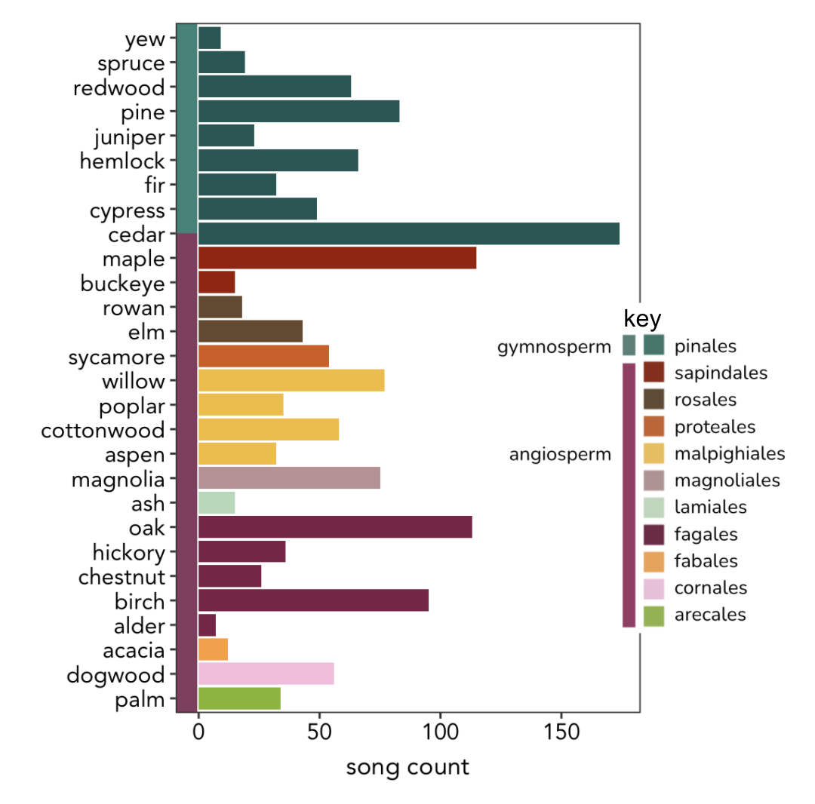
Figure 4.1. The number of songs for each tree name used in lyrics across three hierarchical levels of evolutionary relatedness. Each horizontal bar represents a tree genus (y-axis tree names), the color of bars represents the higher classification of tree order, and the vertical bar color splits orders into two higher groups of vascular seed plants: gymnosperms and angiosperms.

of 2,556 words (Figure A.2). The most frequent words categorized into each sentiment were “sweet” (trust), “love” (joy), “time” (anticipation), “black” (sad), “fire” (fear), “money” (anger), “sweet” (surprise), and “lord” (disgust; Figure A.3).
A few audio variables were significantly correlated across the dataset: Loudness (decibels) was positively correlated with energy, a perceptual measure of the intensity and activity in a song (R² = 0.8; p < 0.05). Loudness is used to calculate energy – a composite variable calculated with loudness, timbre, entropy, onset rate, and dynamic range. Second, song valence was positively correlated with danceability, a metric calculated from tempo, rhythm stability, strength of beat, and regularity (R² = 0.47; p < 0.05). This correlation suggests that happy, cheerful, or euphoric songs are more danceable than sad or angry sounding songs. Third, song valence was negatively correlated with song duration, suggesting that longer songs tend to sound less happy (R² = -0.33; p < 0.05).

Lyrical Sentiment
I tested the overall hypothesis that more positive songs are more likely to include the names of flowering trees (angiosperms) than non-flowering trees (gymnosperms) in their lyrics.
Specifically, I hypothesized song lyrics that use angiosperm tree names contain (1) more positive, anticipation, joy, surprise, and trust words, and (2) fewer negative, anger, disgust, fear, and sad words than song lyrics that use gymnosperms tree names.

Lyrical Positivity
I found support for the hypothesis that angiosperms were used in lyrics with more positive, and less negative, sentiment compared gymnosperms (Figure 4.2a, 4.2b). Note that words not classified as positive are not necessarily negative. Specifically, the probability of a song containing positive sentiment words was about 2% higher for angiosperms than gymnosperms (p < 0.05; Figure 4.2a; Table A.2). For both tree types, only around 1.5% of song lyrics had no words that could be classified as positive (Table A.2). The probability of song lyrics containing negative sentiment words was significantly lower for angiosperms than gymnosperms (p < 0.05; Figure 4.2b; Table A.2). Further, angiosperm lyrics were

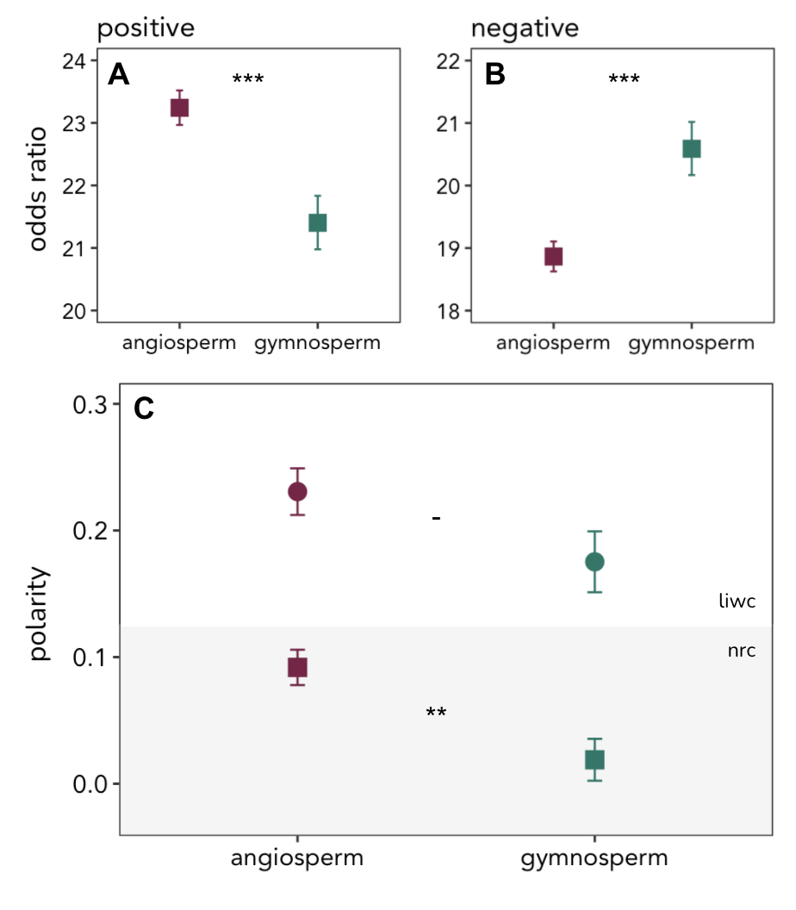
Figure 4.2. Lyrical positivity, negativity, and polarity across tree type. Panels (A-B) represent odds ratios which indicate the probability that lyrics contain words of (A) positive or (B) negative sentiment. Panel (C) shows mean values of polarity +/- standard errors. Polarity metrics are from two lexicons (nrc lexicon: square symbols on grey background; LIWC lexicon: circular symbols). Asterisks indicate statistically significant differences.

twice as likely as gymnosperm lyrics to not contain any words that could be classified as negative (Table A.2).
Polarity metrics also support the hypothesis that angiosperm song lyrics are more positive than gymnosperm song lyrics. Unlike the positive and negative word counts analyzed above, polarity considers the relative number of positive words to negative words used together within a song. A polarity of zero indicates that a song uses equal numbers of positive and negative words, whereas a positive or negative polarity indicates that more positive or negative words are used, respectively. Lyrics with angiosperms had significantly higher polarity than song lyrics with gymnosperms (F (1,1330) = 10.7; p = 0.001; Figure 4.2c, square points). Similar trends were found using the polarity metric calculated from the LIWC analysis, though the difference between angiosperms and gymnosperms was not significant at a threshold of p < 0.05 (p = 0.069; Figure 4.2c, circular points). I expect this difference was because LIWC-polarity is calculated from differences in the percentage of total words in a song that were classified as either positive or negative as opposed to differences in total word counts – thereby including neutral words in the calculation of the metric.

Lyrical Emotion
Angiosperm lyrics were significantly more likely to contain anticipation (p = 0.015), joy (p < 0.001), and trust (p < 0.001) words than gymnosperm lyrics (Figure 4.3b, 4.3e, 4.3h; Table A.2). Notably, about 9% of gymnosperm songs contained no joy words at all compared to just 6% of angiosperm songs (Table A.2). In support of the hypothesis, gymnosperm lyrics were significantly more likely to contain anger (p < 0.001), fear (p < 0.001), and sad (p < 0.001) words than angiosperm lyrics (Figure 4.3a, 4.3d, 4.3f; Table A.2). About 23% of angiosperm song lyrics contained no anger words at all compared to approximately 16% of gymnosperm song lyrics (Table A.2).
No differences were found in the probability of finding disgust or surprise words in songs between the two tree types (Figure 4.3c, 4.3g). Additionally, these two sentiment categories were the least likely to be found in songs overall: Almost 30% of songs from both tree groups contained no disgust words at all (Table A.2).
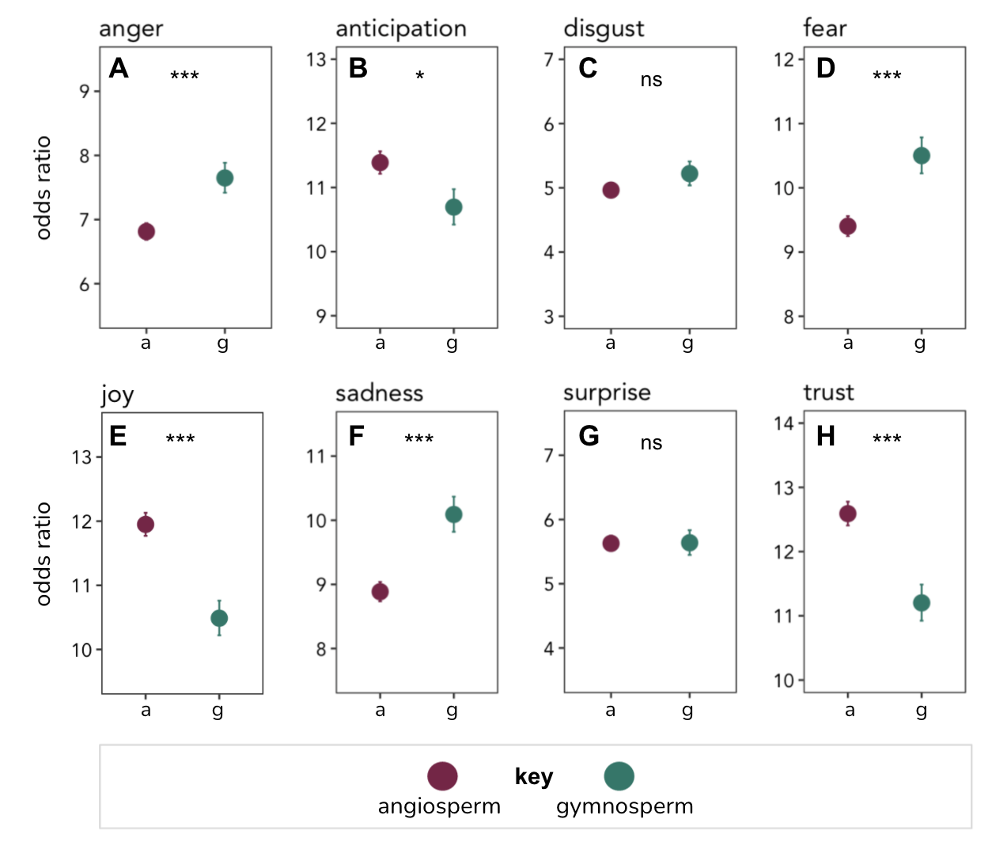
Figure 4.3. Lyrical emotional sentiment across tree type. Values are odds ratios which indicate the probability that lyrics contain words of (A) anger, (B) anticipation, (C) disgust, (D) fear, (E) joy, (F) sadness, (G) surprise, and (H) trust. Asterisks indicate statistically significant differences.

The overall pattern that angiosperm songs contain more anticipation, joy, and trust words than gymnosperm lyrics further supports that the overall lyrical sentiment of these songs is more positive. Likewise, the pattern that gymnosperm lyrics contain more anger, fear, and sad words than angiosperm lyrics supports the idea that gymnosperm lyrics have a more negative lyrical sentiment overall.

Audio Sentiment
I also tested the hypothesis that musical valence would be higher in songs that use flowering trees (angiosperms) in lyrics compared to non-flowering trees (gymnosperms). Additionally, I tested if songs of each group differed in other audio metrics, including danceability, energy, loudness, and tempo.
I did not find support that song valence was be higher for angiosperms than for gymnosperms (Figure 4.4a): both groups had a mean valence of 0.47 on a scale of 0-1 (Table A.3). No differences were found in danceability between the two tree groups, which is unsurprising given the significant positive correlation between valence and danceability (Figure 4.4b; Table A.3). There also was no significant difference between groups in loudness (Figure 4.4d), though energy and tempo did differ between groups (Figure 4.4c, 4.4e): gymnosperm songs had significantly higher energy and tempo than angiosperm songs (Figure 4.4c, 4.4e; Table A.3).

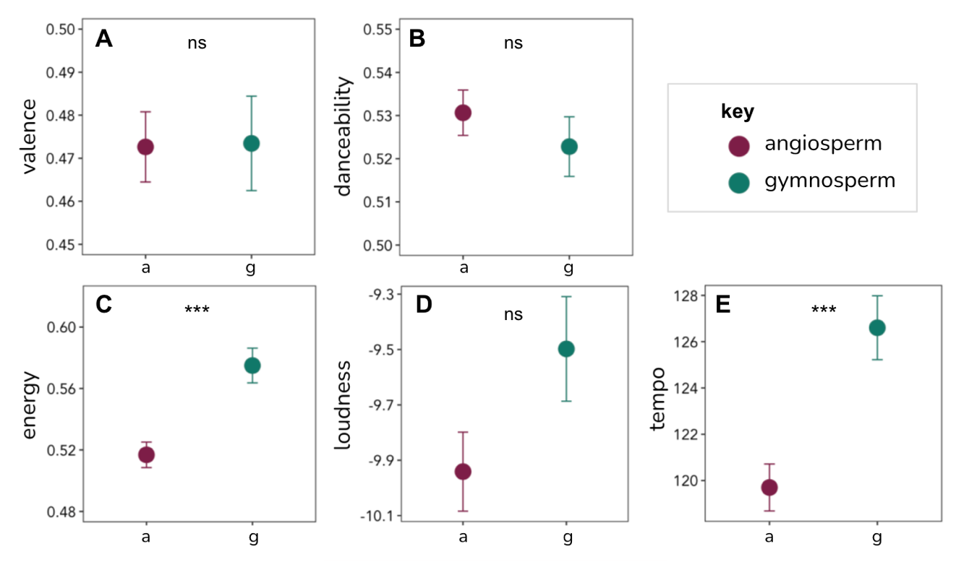
Figure 4.4. Mean values +/- standard errors of audio qualities across tree type. Valence (A), danceability (B), and energy (C) are on a scale of 0-1. Loudness (D) is measured in decibels. Tempo (E) is measured in beats per minute (BPM). Asterisks indicate statistically significant differences.

Discussion & Conclusion
Overall, I found mixed support for the hypothesis that songs that include the names of angiosperm trees in lyrics are more positive than songs that include the names of gymnosperm trees in lyrics. There was stronger support for this hypothesis with lyrical sentiment data than with musical sentiment data.

Discussion
Music research is complicated by the interacting systems of linguistic (i.e., lyrical) and non-linguistic (i.e., musical) structures (Chesebro et al., 1985) such that studies examining both lyrics and music usually attempt to disentangle which element has the larger impact on audiences (Ransom, 2015). Could the lower energy (Figure 4.4c) and tempo (Figure 4.4e) of angiosperm songs counteract their more positive lyrical sentiment (Figure 4.2a)? Or, as a corollary, could the higher energy (Figure 4.4c) and tempo (Figure 4.4e) of gymnosperm songs counteract their negative lyrical sentiment (Figure 4.2b)? One way that researchers test these ideas is by presenting listeners with happy melodies and sad lyrics of a foreign language that have or have not been translated and measuring how listeners determine the songs’ positivity (Sousou, 1997). The effects of lyric-music sentiment interactions would require deeper consideration of the motivations of music consumers and the way they consume it (e.g., alone, with friends, in a crowd). For example, sad lyrics may bring about negative emotions if used to ruminate, but they can actually bring on positive emotions when a listener feels understood by the artist (Saarikallio & Erkkilä, 2007) – and most musical audiences do experience musical lyrics as if they were direct communication from the singer (Booth, 1976).
Understanding how lyrical sentiment affects people would also require further analysis of lyrical structures. Lyrics can have strong effects that are not due to their content (i.e., word choices) but to their underlying structure. Ambiguity and dislocation of punctuation in songs, such as a disorganized and/or choppy structure, could convey panic or confusion, for example. Songs with higher repetition of lyrics hold a lower density of information in each line or stanza of a song. This type of redundancy could relay and reinforce simplified ideas, emotional ideas, or physical sensations. Repeating the same idea or thought many times can also amplifies the persuasiveness of the idea (Booth, 1976; Chesebro et al., 1985).

Genre Considerations
It is important to consider whether the lyrical positivity differences between tree-types hold within genres, though it should be noted that categorizing genre is not easy or agreed upon (Interiano et al., 2018). Individual consumers and entire cultures or sub-cultures have genre preferences each of which possess an average underlying positivity based on frequently used musical structures of that genre: One study showed that genre, compared to eras, regions, and chords explains the most variance in musical valence: 60s rock, religious, and classic R&B/soul music had the highest valence while emo, punk, and metal music had the lowest (Kolchinsky et al., 2017). Another study showed that physical responses to music can depend on genre, as well as the frequency of listening, and the listener’s gender identification (Wells, 1990). Cultural comparisons have demonstrated that cultures with very little exposure to one another recognized the same three emotions in musical samples (happy, sad, scared/fearful; Fritz et al., 2009), and generated similar melodies when given an emotional prompt (i.e., told to create music that sounded angry, happy, etc.; Sievers et al., 2013).
Another consideration with genre is that some tend to be more successful than others in reaching more people. Jazz and classical music are least likely to appear on top 100 charts, for instance, while dance and pop music are most likely to appear on the charts (Interiano et al., 2018). This type of success correlates with more radio play, media coverage, and listeners. The messages in these more successful songs tend to be happier, have a brighter timbre, and be more danceable than less successful songs (Interiano et al., 2018). Individual consumers and sub-cultures have genre preferences, so sentimental associations with tree symbols in music will reach different types and sizes of audiences.
Because culture, genre, lyrical, and musical features are not independent (Interiano et al., 2018) and genres may (Figure A.1; not tested statistically) use certain trees more often than others, it would be informative to examine lyrical positivity and musical valence within genre and at multiple levels of tree taxonomy (e.g., Figure A.4).

Nature Considerations
The results of this study support the idea that the evolutionary history of trees has influenced how they are symbolized in art – specifically in popular music. The five most frequently used words across all songs were “love,” “time,” “night,” “home,” and “life.” While the top two words overall were “love” and “time” the top position was switched between the two tree types. Angiosperm songs used “love” the most and gymnosperm songs used “time” the most. This is interesting because tree genera within the gymnosperm group tend to have associations with memory and the passing of time due to their relative permanence and constant greenness. Deemed the “archetype of existence” (Chatrudi & Jalali, 2012), all trees carry some association with time and life, in part due to their long lives. However, it has been suggested that gymnosperms and angiosperm trees reveal different aspects of these themes: gymnosperms endure life while angiosperms submit to cycles of life and death (Barrachi, 2013). Because these themes are shared across all trees (Chatrudi & Jalali, 2012) further study could reveal more detailed sub-themes held at lower levels of tree taxonomy (e.g., at the order or genus level) allowing for comparison to already-known tree symbology, especially as I found significant variation in polarity within each of the two groups (Figure A.4). These investigations should be supplemented with additional analyses of natural language processing that allow for extraction and identification of themes and ideas.
Other interesting questions regarding nature and tree symbolism in songs: Do the geographic range size or the climatic conditions of a tree’s habitat affect sentiment? For example, different species of fir trees live in the north-eastern (e.g., balsam fir) and north-western (pacific silver fir) climatic regions of the United States. The answer is ostensibly yes given that we already know regions differ in musical sentiment and that distance from the equator, a proxy for climate, affects sentiment (Dodds & Danforth, 2010; Kolchinsky et al., 2017). However, testing this by deriving geographic (and thus climatic) origins for songs is difficult without species identifiers (< 2% of song lyrics in this corpus included a species identifier with the tree name) and without clear origins of songwriters and/or artists – they often move to city centers such as Los Angeles or Nashville to produce music.

Conclusion
This thesis shows that recent English-language songs hold varying sentimental associations with tree-type. Whether these sentiments translate to societal or cultural attitudes and actions regarding nature is unclear, but possible.
Are sentimental messages about nature more likely to stick with people in songs that use more natural symbolism in general? Do sentiments associated with natural symbols fluctuate over time in response to important environmental events such as the publication of Silent Spring by Rachel Carson in 1962, the disaster at Chernobyl in 1986, or the adoption of the Kyoto Climate Change Protocol in 2005? Answers to these questions would provide insight into whether environmental values of cultures emerge in songs as other changes in cultural attitudes or values have (e.g., Madanikia & Bartholomew, 2014).
There are approximately 60,000 living species of tree today (Harrison & Kirkham, 2019). Due to human activities, many of those species are threatened or endangered including some birch, cypress, fir, juniper, oak, pine, redwood, and yew species (Harrison & Kirkham, 2019). Language use can shape the meaning, interpretation, and connections we form with nature, which in turn can influence our behavior (Littlejohn et al., 2017). Might our innate feelings towards different types of trees correspond to the level of protection we provide to them on the landscape? Regardless, changing human behavior is the only way to mitigate the negative consequences of climate change and biodiversity loss.

List of References

Acquaviva, G. (2019). Cultural Values of Trees in the East African Context. International Journal of Afro-Asiatic Studies, 23(1), 29-47.
Ahmed, M.M., & Singh, P.K. (2008). Plant-Lore with Reference to Muslim folksong in Association with Human Perception of Plants in Agricultural and Horticultural Practices. Notulae Botanicae Horti Agrobotanici Cluj-Napoca, 36(1), 42-47.
Armenise, L., Simeone, M., Piredda, R., & Schirone, B. (2012). Validation of DNA barcoding as an efficient tool for taxon identification and detection of species diversity in Italian conifers. European Journal of Forest Research, 131, 1337-1353.
Axelrod, D.I., (1952). A theory of angiosperm evolution. Evolution, 6(1), 29-60.
Baracchi, C. (2013). Paul Klee: Trees and the Art of Life. Research in Phenomenology, 43, 340-365.
Barrera-Hernández, L.F., Sotelo-Castillo, M.A., Echeverría-Castro, S.B., & Tapia-Fonllem, C.O. (2020). Connectedness to Nature: Its Impact on Sustainable Behaviors and Happiness in Children. Frontiers in Psychology, 11, 276.
Belcher, J.D., & Haridakis, P. (2013). The Role of Background Characteristics, Music-Listening Motives, and Music Selection on Music Discussion. Communication Quarterly, 61(4), 375-396.
Bellard, C., Bertelsmeier, C., Leadley, P., Thuiller, W., & Courchamp, F. (2012). Impacts of climate change on the future of biodiversity. Ecology Letters, 15, 365-377.
Bentley, J.M. (2012). A Uses and Gratifications Study of Contemporary Christian Radio Web Sites. Journal of Radio and Audio Media, 19(1), 2-16.
Booth, M.W. (1976). The Art of Words in Songs. Quarterly Journal of Speech, 62, 242-249.
Boyd, J., & Banzhaf, S. (2007). What are ecosystem services? The need for standardized environmental accounting units. Ecological Economics, 63, 616–626.
Brand, C.O., Acerbi, A., & Mesoudi, A. (2019). Cultural evolution of emotional expression in 50 years of song lyrics. Evolutionary Human Sciences 1, e11, 1-14.
Brosse, J. (1989). Mythologie des Arbres. Paris: Librairie Plon.
Brown S., Savage, P.E., Ko, A.M-S., Stoneking, M., Ko, Y-C., Loo, J-H., & Trejaut, J.A. (2014). Correlations in the population structure of music, genes and language. Proceedings of the Royal Society B., 281, 20132072.
Capra, G.F., Ganga, A., & Moore, A.F. (2017). Songs for our soils. How soil themes have been represented in popular song. Soil Science and Plant Nutrition, 63(5), 517-525.
Carbaugh, D. (2007). Quoting “the Environment”: Touchstones on Earth. Environmental Communication, 1(1), 64-73.
Cardinale, B.J., Duffy, E., Gonzalez, A., Hooper, D.U., Perrings, C., Venail, P., Narwani, A., Mace, G.M., Tilman, D., Wardle, D.A., Kinzig, A.P., Dailey, G.C., Loreau, M., Grace, J.B., Larigauderie, A., Srivastava, D., & Naeem, S. (2012). Biodiversity loss and its impact on humanity. Nature, 486, 59-67.
Carnivale, A. (2021). The palm tree and the fist. The use of popular imagery in the Tunisian protest songs of the 1970s-1980s. British Journal of Middle Eastern Studies, 48(1), 130-152.
Chaffee, S.H. (1985). Popular Music and Communication Research: An Editorial Epilogue. Communication Research, 12(3), 413-424.
Chatrudi, M.P., & Jalali, M. (2012). Trees: Symbols of Unification, Love, and Peace among Civilizations. Theology Today, 69(1), 73-84.
Chesebro, J.W., Foulger, D.A., Nachman, J.E., & Yannelli, A. (1985). Popular Music as a Mode of Communication, 1955-1982. Critical Studies in Mass Communication, 2, 115-135.
Clement J. (2020, April 8). Leading iPhone music apps worldwide 2020. Statista. https://www.statista.com/statistics/696146/top-iphone-music-apps-worldwide-by-number-of-downloads/
Coffey, B. (2016). Unpacking the politics of natural capital and economic metaphors in environmental policy discourse. Environmental Politics, 25(2), 203-222.
Collado, S., Staats, H., & Corraliza, J.A. (2013). Experiencing nature in children’s summer camps: Affective, cognitive, and behavioural consequences. Journal of Environmental Psychology, 33, 37-44.
Corazon, S.S., Sidenius, U., Poulsen, D.V., Gramkow, M.C., & Stigsdotter, U.K. (2019). Review: Psycho-Physiological Stress Recovery in Outdoor Nature-Based Interventions: A Systematic Review of the Past Eight Years of Research. International Journal of Environmental Research and Public Health, 16(10), 1711.
Davies, M. (2015). The Consciousness of Trees. Law & Literature, 27(2), 217-235.
Díaz, S., Demissew, S., Carabias, J., Joly, C., Lonsdale, M., Ash, N., Larigauderie A., Adhikari, J.R., Arico, S., Báldi, A., Bartuska, A., Baste, I.A., Bilgin, A., Brondizio, E., Chan, K.M.A., Figueroa, V.E., Duraiappah, A., Fischer, M., Hill, R., ... & Zlatanova, D. (2015). The IPBES Conceptual Framework – connecting nature and people. Current Opinion in Environmental Sustainability, 14, 1-16.
Díaz, S., Fargione, J., Chapin, F.S. III., Tilman, D. (2006). Biodiversity Loss Threatens Human Well-Being. PLoS Biology, 4(8), e277.
Dodds, P.S., & Danforth, C.M. (2010). Measuring the Happiness of Large-Scale Written Expression: Songs, Blogs, and Presidents. Journal of Happiness Studies, 11, 441-456.
Dominick J.R. (1974). The Portable Friend: Peer Group Membership and Radio Usage. Journal of Broadcasting, 18(2), 161-172.
Ferber, M. (2007). A dictionary of literary symbols. Cambridge: Cambridge University Press.
Ferguson, D.A., Greer, C.F., & Reardon, M.E. (2007). Uses and Gratifications of MP3 Players by College Students: Are iPods More Popular than Radio? Journal of Radio Studies, 14(2), 102-121.
Frederickson, B. (2009). Positivity: Groundbreaking research reveals how to embrace the hidden strength of positive emotions, overcome negativity, and thrive. New York: Random House.
Friis, E.M., Crane, P.R., Pederson, K.R. (2011). Early Flowers and Angiosperm Evolution. New York: Cambridge University Press.
Fritz, T., Jentschke, S., Gosselin, N., Sammler, D., Peretz, I., Turner, R., Friederici, A.D., & Koelsch, S. (2009). Universal Recognition of Three Basic Emotions in Music. Current Biology, 19, 573-576.
George, M. (2018). The Symbolism of Trees in TESS OF THE D’URBERVILLES. The Explicator, 76(2), 57-59.
Greer, K.L., Pustay, K.A., Zaun, T.C., & Coppens, P. (2001). A comparison of the effects of toys versus live animals on the communication of patients with dementia of the Alzheimer’s type. Clinical Gerontology, 24, 157-182.
Hall, A. (2007). The Social Implications of Enjoyment of Different Types of Music, Movies, and Television Programming. Western Journal of Communication, 71(4), 259-271.
Hansman, H. (2015, September 21). This Song is Composed From 133 Years of Climate Change Data. Smithsonian Magazine. https://www.smithsonianmag.com/science-nature/this-song-composed-from-133-years-climate-change-data-180956225/
Harrison, C., & Kirkham, T. (2019). Remarkable Trees. London: Thames & Hudson Ltd.
Herrero, B., & Cardaño, M. (2015). Ethnobotany in the Folksongs of Castilla y León. Botanical Sciences, 93(2), 1-12.
Iliev, R., & Axelrod R. (2016). Does Causality matter more now? Increase in the proportion of causal language in English texts. Psychological Science, 27(5), 635-643.
Iliev, R., Hoover, J. Dehghani, M., & Axelrod, R. (2017). Linguistic positivity in historical texts reflects dynamic environmental and psychological factors. PNAS, E7871-E7879.
Interiano, M., Kazemi, K., Wang, L., Yang, J., Yu, Z., & Komarova N.L. (2018) Musical trends and predictability of success in contemporary songs in and out of the top charts. Royal Society Open Science, 5, 171274.
Jackson, J.B., & Levine, V.L. (2002). Singing for Garfish: Music and Woodland Communities in Eastern Oklahoma. Ethnomusicology, 46(2), 284-306.
James, P., Banay, R.F., Hart, J.E. & Laden, F. (2015). A Review of the Health Benefits of Greenness. Current Epidemiology Reports, 2, 131-142.
Kantor, I. (2007). Ethnic Cleansing and America’s Creation of National Parks. Public Land & Resources Law Review, 41(28), 42-64.
Kellert, S.R. (2005). Building for life: Designing and understanding the human-nature connection. Washington, DC: Island Press.
Kolchinsky, A., Dhande, N., Park, K., & Ahn, Y-Y. (2017). The Minor fall, the Major lift: inferring emotional valence of musical chords through lyrics. Royal Society Open Science, 4, 170952.
Kusmanoff, A.M. (2017). Framing the Conservation Conversation: An investigation into framing techniques for communicating biodiversity conservation. Doctoral Dissertation, RMIT University. rmit.edu.au.
Legagneux, P., Casajus, N., Cazelles, K., Chevallier, C., Chevrinais, M., Guéry, L., Jacquet, C., Jaffré, M., Naud, M-J., Noisette, F., Ropars, P., Vissault, S., Archambault, P., Bêty, J., Berteaux, D., & Gravel, D. (2018). Our House is Burning: Discrepancy in Climate Change vs. Biodiversity Coverage in the Media as Compared to Scientific Literature. Frontiers in Ecology and Evolution, 5, 175.
Lewis, G.H. (1991). Duellin’ Values: Tension, Conflict, and Contradiction in Country Music. Journal of Popular Culture, 103-117.
Littlejohn, S.W., Foss, K.A., & Oetzel, J.G. (2017). Theories of Human Communication (11th ed.). Long Grove, IL: Waveland Press Inc.
Loreau, M., Naeem, S., Inchausti, P., Bengtsson, J., Grime, J.P., Hector, A., Hooper, D.U., Huston, M.A., Raffaelli, D., Schmid, B., Tilman, D., & Wardle, D.A. (2001). Biodiversity and ecosystem functioning: current knowledge and future challenges. Science, 294, 804-808.
Lull, J. (1985). On the Communicative Properties of Music. Communication Research, 12(3), 363-372.
Madanikia Y, & Bartholomew K. (2014). Themes of Lust and Love in Popular Music Lyrics From 1971 to 2011. SAGE Open, 4.
Manchin, A., (2010, June 2). Most Europeans See Biodiversity Loss as Serious Problem: Majority make some effort to preserve biodiversity. Gallup News. https://news.gallup.com/poll/139319/europeans-biodiversity-loss-serious-problem.aspx
Martínez, A., & Mammola, S. (2021). Specialized terminology reduces the number of citations of scientific papers. Proceedings of the Royal Society B., 228, 20202581.
McCauley, D. (2006). Selling out on nature. Nature, 443, 27-28.
Mehr, S.A., Singh, M., Knox, D., Ketter, D.K., Pickens-Jones, D., Atwood, S., Lucas, C., Jacoby, N., Egner, A.A., Hopkins, E.J., Howard, R.M., Hartshorne, J.K., Jennings, M.V., Simson, J., Bainbridge, C.M., Pinker, S., O’Donnell, T.J., Krasnow, M.M., & Glowacki, L. (2019). Universality and diversity in human song. Science, 366(6468), 970.
Miller, C.R., & Hartzog, M. (2020). “Tree Thinking”: The Rhetoric of Tree Diagrams in Biological Thought. Poroi, 15(2).
Miller, K. (2005). Communication Theories: Perspectives, Processes, and Contexts (second edition). Boston McGraw Hill.
Mohammad, S.M., & Turney, P. (2013). Crowdsourcing a Word-Emotion Association Lexicon. Computational Intelligence, 29(3), 436-465.
Monk-Turner, E., & Sylvertooth, D. (2008). Rap Music: Gender Difference in Derogatory Word Use. American Communication Journal, 10(4), 1-12.
Morin, O., & Acerbi, A. (2017). Birth of the cool: a two-centuries decline in emotional expression in Anglophone fiction. Cognition and Emotion, 31(8), 1663-1675.
National Park Service Organic Act of 1916, 16 U.S.C §§ 1-18.
Oravec, C. (1984). Conservationism vs. Preservationism: The “Public Interest” in the Hetch Hetchy Controversy. Quarterly Journal of Speech, 70, 444-458.
Pamjay, H., Juhász, Z., Zalán, A., Németh, E., & Damdin, B. (2012). A comparative phylogenetic study of genetics and folk music. Molecular Genetics and Genomics, 287(4), 337–349.
Pečnikar, Z.F. (2018). Ethnobotanical Tradition in Slovenian Folk Love Songs. Annales Series Historia et Sociologia, 28, 267-280.
Pennebaker, J.W., Boyd, R.L., Jordan, K., & Blackburn, K. (2015). The development and psychometric properties of LIWC2015. Austin, TX: University of Texas at Austin.
Pennebaker, J.W., Chung, C.K., Ireland, M., Gonzales, A., & Booth, R.J. (2007). The development and psychometric properties of LIWC2007, 22. https://repositories.lib.utexas.edu/handle/2152/31333
Peterson, R.A., & Berger, D.G. (1975). Cycles in Symbol Production: The Case of Popular Music. American Sociological Review, 40(2), 158-173.
Plavén-Sigray, P., Matheson, G.J., Schiffler, B.C., & Thompson, W.H. (2017). The readability of scientific texts is decreasing over time. eLife, 6:e27725.
Publicover, J.L., Wright, T.S., Baur, S., & Duinker, P.N. (2018). Music as a tool for environmental education and advocacy: artistic perspectives from musicians of Playlist for the Planet, Environmental Education Research, 24(7), 925-936.
R Core Team (2021). R: A language and environment for statistical computing. R Foundation for Statistical Computing, Vienna, Austria. URL https://www.R-project.org/.
Ransom, P.F. (2015). Message in the Music: Do Lyrics Influence Well-Being? Master of Applied Positive Psychology Capstone Projects, 94. http://repository.upenn.edu/mapp_capstone/94
Rautio, P. (2011). Writing about everyday beauty: anthropomorphizing and distancing as literary practices. Environmental Communication, 5(1), 104-123.
Ribeiro, F.N., Araujo M., Goncalves P., Goncalves M.A., & Benevenuto, F. (2016). SentiBench - a benchmark comparison of state-of-the-practice sentiment analysis methods. EPJ Data Science, 5(23).
Saarikallio, S., & Erkkilä, J. (2007). The role of music in adolescents’ mood regulation. Psychology of Music, 35, 88-109.
Sakakibara, C. (2009). ‘No whale, no music’: Iñupiaq drumming and global warming. Polar Record, 45(235), 289-303.
Schell, C.J., Dyson, K., Fuentes, T.L., Des Roches, S., Harris, N.C., Miller, D.S., Woelfle-Erskine, C.A., & Lambert, M.R. (2020). The ecological and evolutionary consequences of systemic racism in urban environments. Science, 10.1126/science.aay4497.
Schröter, M., van der Zanden, E.H., van Oudenhoven, A.P.E., Remme, R.P., Serna-Chavez, H.M., de Groot, R.S., & Opdam, P. (2014). Ecosystem Services as a Contested Concept: A Synthesis of Critique and Counter-Arguments. Conservation Letters, 7(6), 514-523.
Schultz, P.W. (2001). The structure of environmental concern: Concern for self, other people, and the biosphere. Journal of Environmental Psychology, 21(4), 327-339.
Seligman, M.E.P., & Csikszentmihalyi, M. (2000). Positive Psychology: An introduction. American Psychologist, 55, 5-14.
Sellnow, D., & Sellnow, T. (2001). The “Illusion of Life” Rhetorical Perspective: An Integrated Approach to the Study of Music as Communication. Critical Studies in Media Communication, 18(4), 295-415.
Serrà J., Corral Á., Boguñá M., Haro M., & Arcos J.L. (2012). Measuring the evolution of contemporary western popular music. Scientific Reports, 2(521), 1–6.
Sievers, B., Polansky, L., Casey, M., & Wheatley, T. (2013). Music and movement share a dynamic structure that supports universal expressions of emotion. Proceedings of the National Academy of Sciences, 110(1), 70-75.
Silge, J., & Robinson, D. (2016). tidytext: Text Mining and Analysis: Using Tidy Data Principles in R. The Journal of Open Source Software, 1(3), 37.
Simchy-Gross, R., & Margulis, E.H. (2018). The sound-to-music illusion: Repetition can musicalize nonspeech sounds. Music & Science, 1, 1-6.
Smalls, S.P. (2011), “The Rain Comes Down”: Jean Grae and Hip-Hop Heteronormativity. American Behavioral Scientist, 55(1), 86-95.
Soltis, P.S., & Soltis, D.E. (2004). The origin and diversification of angiosperms. American Journal of Botany, 91(10), 1614-1626.
Sousou, S.D. (1997) ‘Effects of Melody and Lyrics on Mood and Memory’, Perceptual and Motor Skills, 85, 31-40.
Spangler, T. (2021, February 22). Spotify to Launch in 85 New Markets. Variety. https://variety.com/2021/digital/news/spotify-to-launch-in-85-new-countries-1234912270/
Stromberg, J. (2011, October 18). The Transistor Radio Launches the Portable Electronic Age. Smithsonian Magazine. https://www.smithsonianmag.com/smithsonian-institution/the-transistor-radio-launches-the-portable-electronic-age-110761753/
Strong C., & Rush E. (2018). Musical genius and/or a nasty piece of work? Dealing with violence and sexual assault in accounts of popular music’s past. Continuum: Journal of Media and Cultural Studies, 32(5), 569-580.
Tatay-Nieto, J. & Munoz-Igualada, K. (2019). Popular Religion, Sacred Natural Sites, and “Marian Verdant Advocations” in Spain. Religions, 10(1), 46.
TEEB, Ecological and Economic Foundations; Routledge Abingdon, UK: 2010. The Economics of Ecosystems and Biodiversity.
Thompson, C., Parry, J., Phipps, D., & Wolff, T. (2021). spotifyr: R Wrapper for the ‘Spotify’ Web API. R package version 2.1.1. http://github.com/charlie86/spotifyr.
Tilman, D. (1991). The ecological consequences of changes in biodiversity: a search for general principles. Ecology, 80, 1455-1474.
Turner, K., & Freedman, B. (2004). Music and Environmental Studies. The Journal of Environmental Education, 36(1), 45-52.
Vallecillo, S., La Notte, A., Zulian, G., Ferrini, S., & Maes, J. (2019). Ecosystem services accounts: Valuing the actual flow of nature-based recreation from ecosystems to people. Ecological Modelling, 392, 196-211.
Verhoeven, D., Davidson, A., Gionfriddo, A., Verhoeven, J., & Gravestock, P. (2014). Turning Gigabytes into Gigs. “Sonification” and Live Music Data. Academic Quarter, 9, 151-163.
Vickers, B. (1984). Figures of rhetoric/ Figures of music? Rhetorica: A Journal of the History of Rhetoric, 2(1), 1-44.
Vuoskoski, J., Thompson, W. F., McIlwain, D., & Eerola, T. (2012). Who enjoys listening to sad music and why? Music Perception, 29(3), 311-317.
Wang, X.Q., & Ran, J.H. (2014). Evolution and biogeography of gymnosperms. Molecular Phylogenetics and Evolution, 75, 24–40.
Weissman, D. (2010). Talkin’ ‘Bout a Revolution: Music and Social Change in America. Milwaukee: Backbeat Books.
Wells, A. (1990). Popular Music: Emotional Use and Management. Journal of Popular Culture, 105-117.
Whitham, T., Bailey, J., Schweitzer, J., Shuster, S.M., Bangert, R.K., LeRoy, C.J., Lonsdorf, E.V., Allan, G.J., DiFazio, S.P., Potts, B.M., Fischer, D.G., Gehring, C.A., Lindroth, R.L., Marks, J.C., Hart, S.C., Wimp, G.M., & Wooley, S.C. (2006). A framework for community and ecosystem genetics: from genes to ecosystems. Nature Reviews: Genetics, 7, 510-52.
Whyte, N. (2013). An Archaeology of Natural Places: Trees in the Early Modern Landscape. Huntington Library Quarterly, 76(4), 499-517.
Wickham, H., Averick, M., Bryan, J., Chang, W., D’Agnostino McGowan, L., François, R., Grolemund, G., Hayes, A., Henry, L., Hester, J., Kuhn, M., Pederson, T.L., Miller, E., Bache, S.M., Müller, K., Ooms, J., Robinson, D., Seiden, D.P., Spinu, V., ... & Yutani, H. (2019). Welcome to the tidyverse. Journal of Open Source Software, 4(43), 1686.
Wilderness Act of 1964, 16 U.S.C. §§ 1131-1136.
Wolff, P., Medin, D.L., & Pankratz, C. (1991). Evolution and devolution of folkbiological knowledge. Cognition, 73, 177-204.
Zeng, L. (2011). More than Audio on the Go: Uses and Gratifications of MP3 Players. Communication Research Reports, 28(1), 97-108.

Appendix

Table A.1. Song country of origin and count. Origin is determined based on songwriter and performer origins. If multiple or unclear origins, additional countries are included in column 3 (for example, one song is attributable to Canada and Australia).
Country of Origin | Song Count | + Countries
United States of America | 992 | +Canada (7)  +England (5)  +England & Finland (1)  + Ireland (1)
Canada | 97 | +Australia (1)  +Sweden & France (1)
Iroquois Oneida Nation | 4
England | 150 | +France (1)
Finland | 26
Ireland | 25
Australia | 20
Sweden | 18
Scotland | 15
Northern Ireland | 6
Russia | 5
Italy, Netherlands, Wales | 4 | Italy + France (1)  Italy + Germany (1)
France, Germany, Jamaica, South Africa | 3 | Germany + Ireland (1)
Belgium, Bermuda, Norway, Switzerland | 2
Austria, Bulgaria, Denmark, Israel, Japan | 1

Table A.2. Model and summary statistics for lyrical sentiment across tree type. Summary statistics include mean word counts in songs for each sentiment and percentages of songs with zero words that match a sentiment category. Model statistics include odds ratios, residual deviances on 1330 degrees of freedom (df), and p-values from models with tree type as the sole predictor for word count response variables, with binomial distributed error structure.
Sentiment  Response | Mean |  | Percent Zero |  | Odds Ratio |  | Residual  Deviance  (1330 df) | p-value
Sentiment  Response | angio- | gymno- | angio- | gymno- | angio- | gymno- | Residual  Deviance  (1330 df) | p-value
anger | 3.48 | 3.92 | 22.5 | 16.2 | 6.81 | 7.65 | 1955.8 | 0.000148
anticipation | 5.58 | 5.34 | 5.29 | 6.84 | 11.4 | 10.7 | 1540.8 | 0.0148
disgust | 2.58 | 2.74 | 28.6 | 29.5 | 4.96 | 5.22 | 2084.7 | 0.158
fear | 4.69 | 5.25 | 13.4 | 9.34 | 9.40 | 10.5 | 1813.4 | 3.38e-05
joy | 5.82 | 5.25 | 6.24 | 9.34 | 11.9 | 10.5 | 1986.3 | 3.99e-07
sadness | 4.45 | 5.07 | 10.2 | 7.88 | 8.89 | 10.1 | 1949.4 | 2.91e-06
surprise | 2.91 | 2.95 | 24.0 | 19.7 | 5.63 | 5.64 | 1739.7 | 0.96
trust | 6.10 | 5.57 | 5.41 | 6.85 | 12.6 | 11.2 | 1644.6 | 3.3e-06
positive | 10.3 | 9.74 | 1.53 | 1.45 | 23.2 | 21.4 | 1945.0 | 3.67e-05
negative | 8.66 | 9.44 | 4.11 | 2.07 | 18.9 | 20.6 | 2132.5 | 2.31e-05

Table A.3. Model and summary statistics for polarity lyric metrics and audio variables across tree type. Summary statistics include mean values +/- standard errors. Model statistics include F-ratios and p-values.
Lyrical / Musical  Response | Mean +/- se |  | F-Ratio | p-value
Lyrical / Musical  Response | angio- | gymno- | F-Ratio | p-value
polarity (nrc) | 0.092 +/- 0.014 | 0.019 +/- 0.017 | 10.7 | 0.0011**
polarity (LIWC) | 0.23 +/- 0.018 | 0.17 +/- 0.024 | 3.31 | 0.069 `
valence | 0.47 +/- 0.0082 | 0.47 +/- 0.011 | 0.004 | 0.95
danceability | 0.53 +/- 0.0053 | 0.52 +/- 0.007 | 0.81 | 0.37
energy | 0.52 +/- 0.0083 | 0.58 +/- 0.011 | 17.4 | 3.3e-0.5***
loudness | 9.9 +/- 0.143 | 9.5 +/- 0.188 | 3.49 | 0.062 `
tempo | 119.7 +/- 1.01 | 126.6 +/- 1.38 | 16.5 | 5.3e-05***

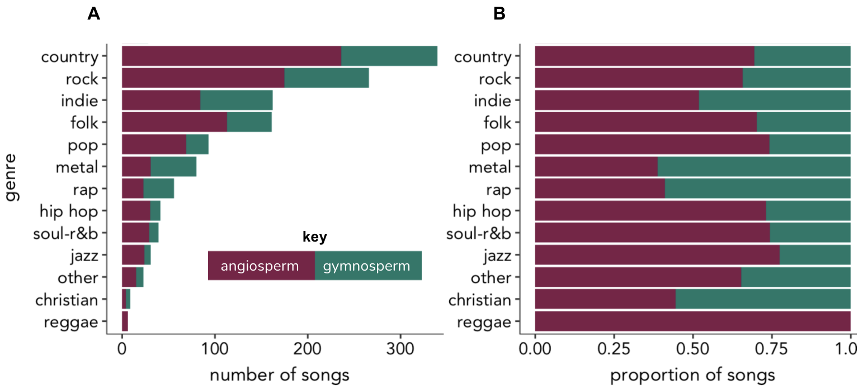

Figure A.1. Number (A) and proportion (B) of songs across genre and tree type.

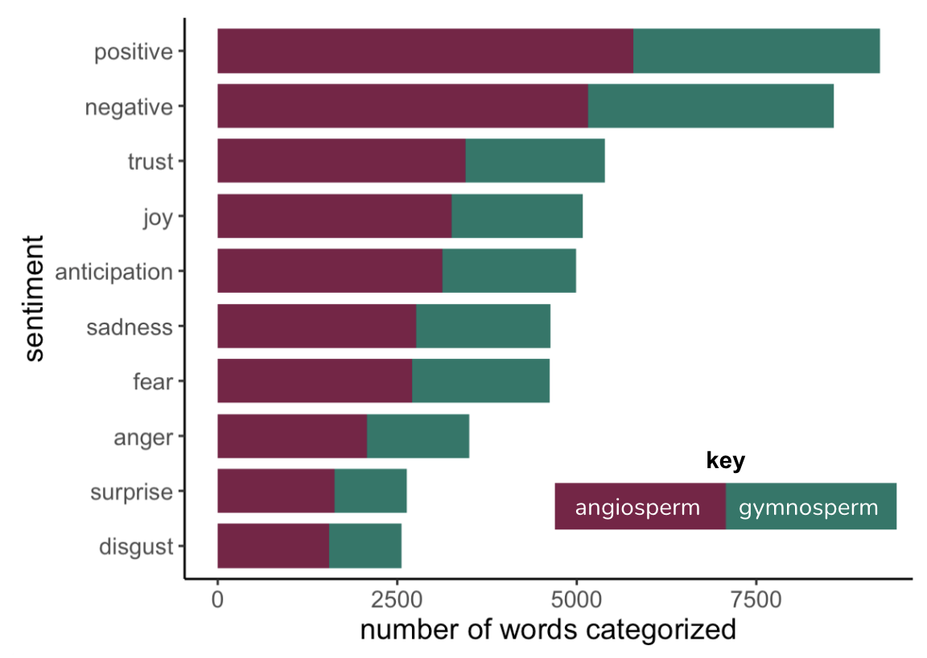

Figure A.2. Total number of words in dataset categorized into each sentiment by tree type. Recall that the number of songs per tree type differ (N_{angio}= 853; N_{gymno} = 482).

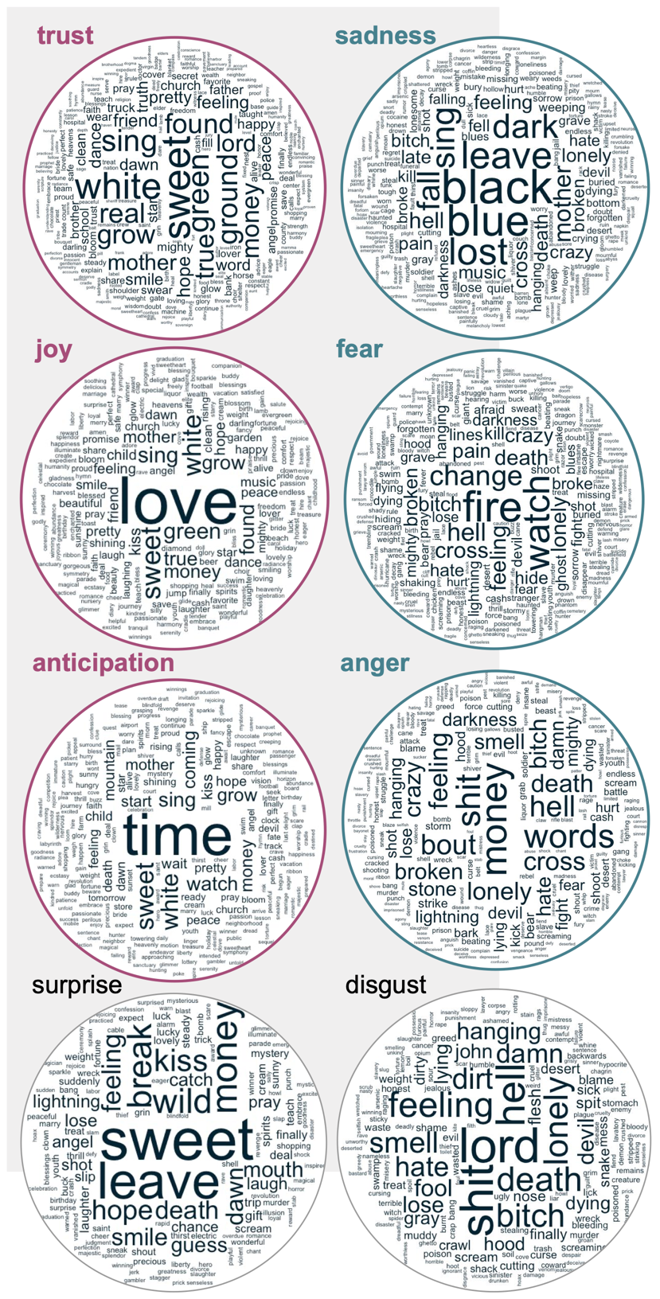

Figure A.3. Word clouds representing the most frequent words used in lyrics for each sentiment category. The relative size of words represents its relative frequency in lyrics. Text color represents the tree group that was significantly more likely to have words in that category (magenta = angiosperm; blue green = gymnosperm; black = no significant difference).

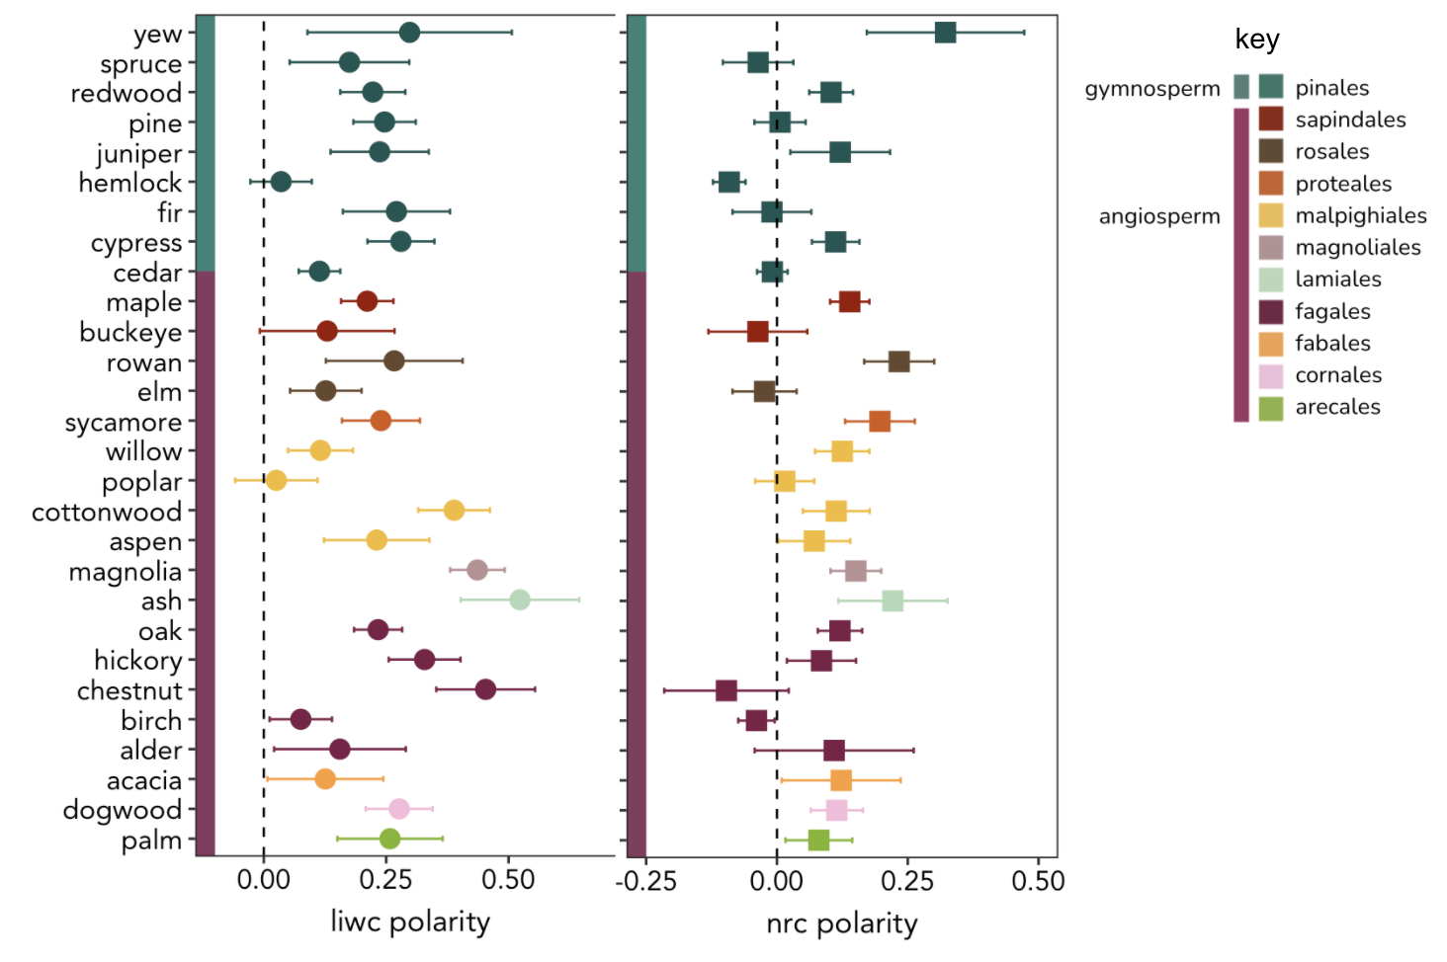
Figure A.4. Mean lyrical polarity +/- standard errors across tree genera. Polarity is from the LIWC lexicon (left, circular symbols) and the nrc lexicon (right, square symbols). Key follows figure 4.1.

Vita
Shannon Lee Jo-Ann Bayliss was born in September 1990. She graduated from the University of Virginia in 2012 with a Bachelor of Science degree in Environmental Sciences and a minor in Art History. She earned her Master of Science in Biology from California State University, Northridge in 2016. She is a doctoral candidate in Ecology and Evolutionary biology at the University of Tennessee, Knoxville. Her interest in science writing led her to pursue a degree in Communication and Information with a concentration in Journalism and Electronic Media. She will graduate from the University of Tennessee, Knoxville in 2021.

This anecdote is inspired by the research and artwork of a friend, Elizabeth M. Webb, titled For the Mud Holds What History Refuses (Providence in Four Parts). I interviewed Webb about her work in 2020. Details of the project can be found on her webpage (www.elizabethmwebb.com/portfolio/providence-in-four-parts/).
This description is from the Georgia Department of Natural Resources Webpage for Providence Canyon State Park, accessed on June 29, 2021 (https://gastateparks.org/ProvidenceCanyon). The full quotation is: “Uncover the layers of 'Georgia’s Little Grand Canyon' as you navigate the unusual geological formations created by erosion of the Coastal Plain after years of poor agricultural practices, hike miles of sandy nature trails, and gaze at dark skies while camping at Providence Canyon State Park.”

