CHAPTER-7
Application of Random Array on Black Point Lava Flow (BPLF) - A Lunar Analog Site

  - INTRODUCTION
Multichannel Analysis of Surface Wave (MASW) data from terrestrial analog environments can help constrain models for evolution of the lunar subsurface and help predict the nature of subsurface properties encountered during future landed scientific or engineering operations on the Moon. MASW method can yield insight into mapping subsurface variations in physical properties, and other important engineering properties of the subsurface—like shear modulus, shear wave velocity and Poisson’s ratio, that are the key parameters for any type of civil engineering works, as they characterize the mechanical behavior of geotechnical materials under various types of loading. The purpose of this work is to demonstrate the usefulness and capabilities of MASW technique at terrestrial analog sites where the geologic settings, processes and/or materials are somewhat similar to those encountered on the Moon. This study mainly focuses on near surface seismic studies and interpretation of the subsurface geology using random geophone array.
Multi-channel surface wave data was collected at Black Point Lava Flow (BPLF) site which is 40 km north of Flagstaff, Arizona in March 2012. This field test was primarily intended to determine the engineering parameters, like shear wave velocities, at a high-fidelity lunar mission simulant using MASW method with randomly distributed geophone arrangement. Such type of array will be necessary for future lunar exploration keeping in mind the logistical constraints involved in deploying a linear or circular array robotically or by astronaut. This information obtained on the Moon using this technique should prove to be a critical based on the anticipated engineering needs of lunar exploration and on the extreme logistics imposed by lunar exploration. Here, I present a description of the experiment conducted and the results thus obtained.

  - LUNAR ANALOG SITES FOR SEISMIC STUDIES
Analog sites are places or spaces on earth that approximate, in some respect, the geological, environmental and putative biological conditions or settings on a particular planetary body, either at the present day or sometime in the past. Therefore, an analogue may be broadly defined based on the conditions the site is meant to represent and the specific parameters meant to be examined/tested. For example, a meteoritic impact crater site is an obvious analog for the moon where surface geometry, etc. are of interest, whereas a basalt lava plateau that has undergone severe physical weathering is an equally legitimate analog site if the physical properties of the subsurface are of interest. The use of a lunar analog site is an essential component in the development of systems that are planned for lunar and planetary exploration. Also analog experiments help aid astronauts, engineers and scientists to enhance scientific exploration by combining human and robotic efforts. Analogs can be used to test robotics, vehicles, habitats and in-situ resource utilization in realistic environments that will help us better prepare and understand the complex challenges that will be encountered on the moon.

Selecting an analog site that would best suit my proposed research is an integral element, capable of influencing data and impacting test results. Examples of relevant characteristics of a lunar analog site for my work include terrains, soil properties, meteorology, geologic features, biological changes and remoteness. Investigation of surface processes and comparative studies with other planetary bodies can be carried out using several techniques and methods including, but not limited to, (1) fieldwork and remote-sensing campaigns at terrestrial analog sites; (2) comparisons between terrestrial and planetary datasets; and (3) numerical and computer modeling of geological processes (Tornabene et al.,2005). Few of the many terrestrial analog sites, within United States which are suitable for lunar analogs were studied in detail and the Black Point Lava Flow (BPLF) site was selected. Various locations that can serve as a lunar analog site are explained below.

Antarctic
These kinds of places are mainly used to test the inflatable habitat concept. When astronauts return to the moon for extended stays, they will require shelter to live and work under for protection from the harsh lunar environment. The site selected was the cold, isolated landscape of Antarctica.
Oceans
Ocean conditions such as the Florida Keys National Marine Sanctuary, serves as a test site for NASA’s Extreme Environment Mission Operations. NASA uses the laboratory’s lunar-like environment as a semi-permanent site for testing lunar exploration concepts such as advanced navigation and communication equipment. Astronauts also execute a variety of undersea “moonwalks” at this site. The tests cultivate an astronauts understanding of his or her ability to carry out daily operations in a simulated planetary environment.
Deserts
These sites are used to measure the benefits of using pressurized vehicles as opposed to unpressurized vehicles, and incorporate the findings into upcoming lunar missions. These sites area also needed to conduct short-distance mobility exploration and also engineering evaluation tests to investigate the utility of its robotic vehicle concepts in an earthly moonscape. For this purpose NASA found the sand dunes of Moses lake, Washington. And the desert-like landscape in Black Point Lava flow, Arizona is well suited for testing technologies and procedures for future human-robotic exploration in extreme environments.
Volcanic Terrains
The terrain, rock distribution and soil materials at such sites as in Hawaii and Idaho provide an ideal simulated environment for testing hardware and other equipment to harness local resources for use in human and robotic exploration.

  - GEOLOGIC SETTING-BLACK POINT LAVA FLOW
The San Francisco volcanic field is an area of volcanoes in northern Arizona, north of Flagstaff, USA. This field contains approximately 600 volcanoes in age from less than 6 million years old to less than 1,000 years (Miocene to Holocene). The Black Point Lava Flow (BPLF) is a part of the San Fransisco volcanic field which is approximately 2 million years old. Stretched across much of the northern Arizona, the Black Point Lava Flow resembles an alien landscape on Earth, the perfect place for NASA to test rovers, habitats, space suits and the other equipment that future astronauts will need when they explore the moon, the asteroids as well as Mars and the Moons of the Red Planet. It is considered one of the best and excellent sites for surface system analog sites, because it shares so many terrain and environmental similarities with the Moon, Mars, and near Earth asteroids (NEAs). Like so many other planetary bodies, Black Point Lava Flow is a desolate environment with rugged terrain, dust storms, varying soil composition, temperature extremes, deep craters, steep slopes, rolling plains, and volcanic ash fields. The BPLF was first considered as a candidate for field testing during the Apollo program. Along with the great combination of Moon- and mars-like features, Black Point Lava Flow is a good analog site for any kind of field experiments because of its large size. It is large enough to accommodate multiple extended missions, including day-long scenarios and long-duration traverse operations. It has enough space to fit a large science and engineering teams. Considering all the advantages at this site, it is chosen to be an excellent setting for training and systems testing for future exploration missions to the moon.
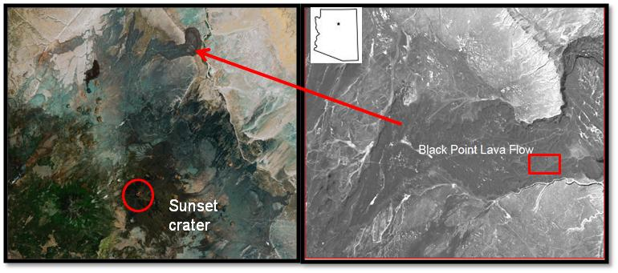 Figure 1: (a) Sunset crater and the Black Point Lava Flow (BPLF), north of Flagstaff, AZ.
(a)
(b)
(b) Box marks the far-east side of the BPLF where seismic data was collected. (Google Earth)

  - FIELD TEST PROCEDURE
The three day field test consisted of collecting MASW data for three different receiver array types: Linear (east-west and north-south traverse), Cross and Random arrays.
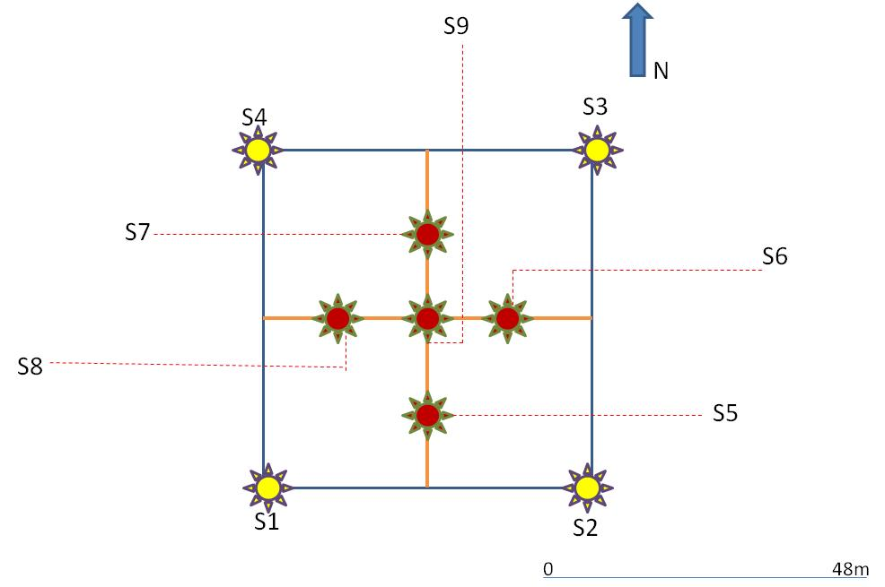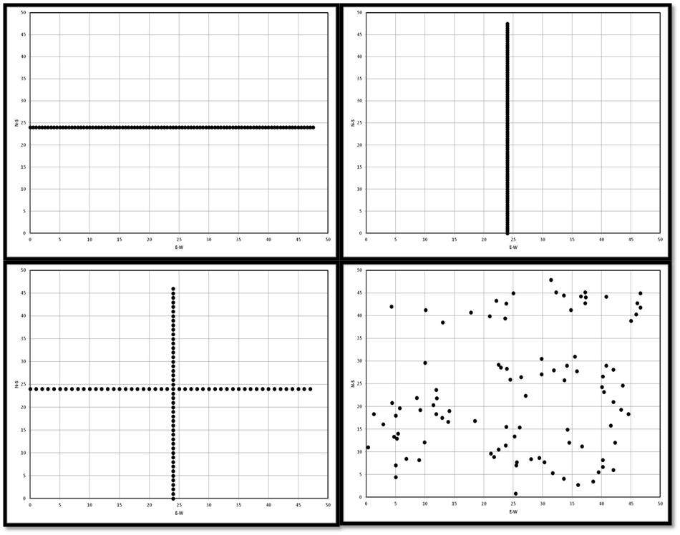
(iii)
(i)
(iv)
(ii)
Figure 2: (a) The figure represents the shot point locations as deployed on the ground. There are a total of nine shot points for the 2-D arrays. The yellow markers represent the extra-shot points and the red markers represent the intra-shot points. (b) Schematic representation of various receiver arrays as deployed in the field. X-axis represents E-W traverse and Y-axis represents N-S traverse (i) Linear EW (ii) Linear NS (iii) Cross (iv) Random.

Data acquisition
Multi channel data were collected on the BPLF site in Flagstaff, Arizona, using a 96-channel Geometrics startview seismograph with 14 Hz geophones. A 10-lb sledge hammer was used as a seismic source to generate source energy and data was collected on a 48m×48m grid (Figure 2a). Fifteen shot records were shot for the linear arrays (EW and NS traverses) and nine records were shot for cross and random arrays. Graphical representations of various arrays are shown in Figure (2b) and a summary of data acquisition parameters are tabulated in Table 1. A time sampling interval of 0.5 ms and a total recording time of 1000 ms were used during data acquisition. No acquisition filter was applied during the recording. Three sets of data were collected for each array. A typical shot gather for each type of array are represented in Figure 3.
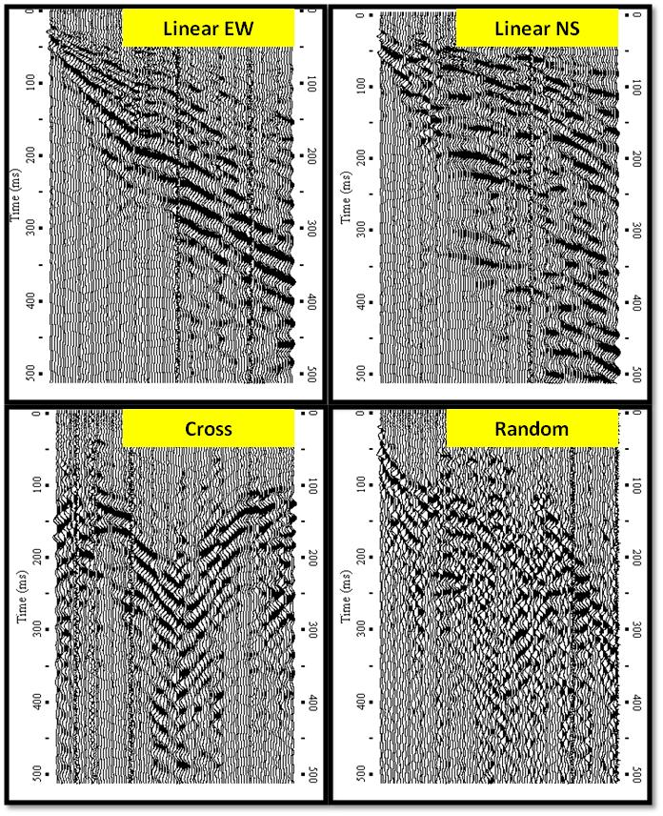
Figure 3: Typical shot gathers for various array types as acquired from the BPLF field site. Data was collected for 1000 ms but only the first 500 ms data is shown here as surface waves are more prominent here.
Table 1: Summary of data acquisition parameters

Data analysis-Dispersion
The acquired data is then processed using SURFSEIS software (developed by Kansas Geologic Survey), which is done mainly in three steps: The first step involves converting the acquired SEG-2 standard data into KGS format. This process is also known as pre-processing in which the raw data in SEG-2 format is converted to the KGS format. After that the data was sorted by applying field geometry to data based on source and geophone locations. The second step involves converting the data from time-domain (Time-Distance) to frequency-domain (Frequency-Phase velocity) using Fourier transforms in which process dispersion curves are generated. The third and final step involves the inversion of surface wave data in order to obtain a 1-D shear wave velocity profile. Figure 4 represents typical dispersion curves obtained during data processing and the fundamental modes (represented in white dots) that were picked manually as accurately as possible during the process. Dispersion analysis shows that the data posses dominant frequencies at approximately 15-90 Hz with 0.5 Hz increment and dominant phase velocities at approximately 100-3000 m/s with 10 m/s increment. Figure 6 represents a graph comparing dispersion curves for different array types. It is observed from the graph how well the dispersion curves correlate with one another, especially at higher frequencies (25-90 Hz).
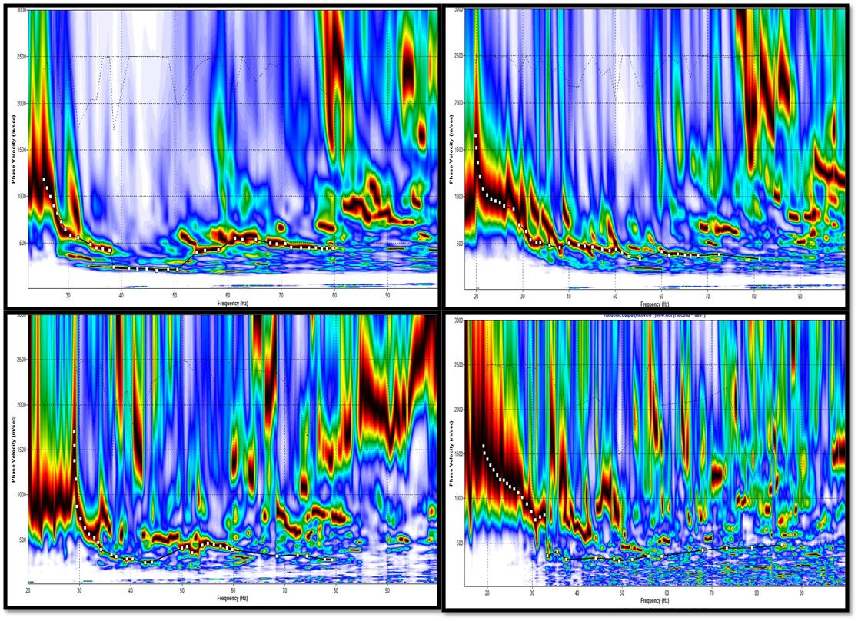
Figure 4: Dispersion images obtained from shot gathers for various receiver arrays in Figure 3. The x-axis represents the frequency (Hz) and y-axis represents the phase velocity (m/s). The white dots on the dispersion image represent the fundamental mode picks for various receiver arrays.

Data Analysis-Inversion
In the final step of data processing, the dispersion curves are inverted to obtain 1-D shear wave velocity profiles (Figure 5). The profiles are calculated using an iterative inversion process requiring the dispersion data as input. The process is automated by using least-squares approach (Xia et al., 1999). In this iteration process, parameters such as Poisson’s ratio, density, and thickness of the model are kept constant but only Vs is updated after each iteration. These velocities versus depth profiles generally produce a profile column consisting of ten distinct velocity layers for the site. Figure 7 is a graph representing shear wave velocities versus depth comparisons for each array type. It is observed that there is a good correlation between Vs values for the array types. The velocities thus obtained are further used to interpret the subsurface geology structure. The National Earthquake Hazards Reduction Program (NEHRP) guidelines are used here to classify different soil profile types. The NEHRP building code assigns one of six soil-profile types to a site, from hard rock (type A) to soft soils (types E or F), based on the average Vs30 value calculated from the velocity-depth profiles (Table 2). These profile categories determined for the BPLF site in this study, are a part of the International Building Code adopted in 2001 (IBC, 2002).
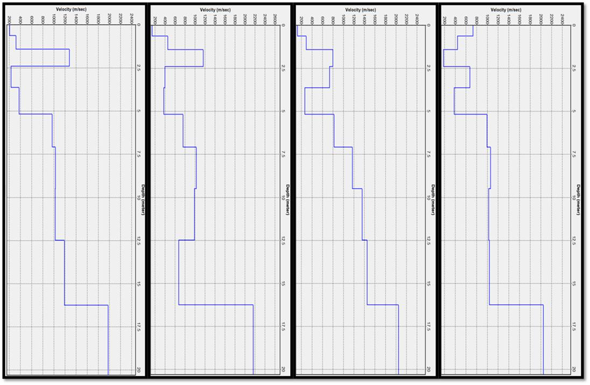
Figure 5: The 1-D shear wave velocity profiles obtained from the dispersion curves extracted from the dispersion images in Figure 4. The x-axis represents the shear wave velocity (m/s) and the y-axis represents the depth (m).
Table2: Site categories in NEHRP provisions (BSSC, 1997). (Modified from www.usgs.gov)

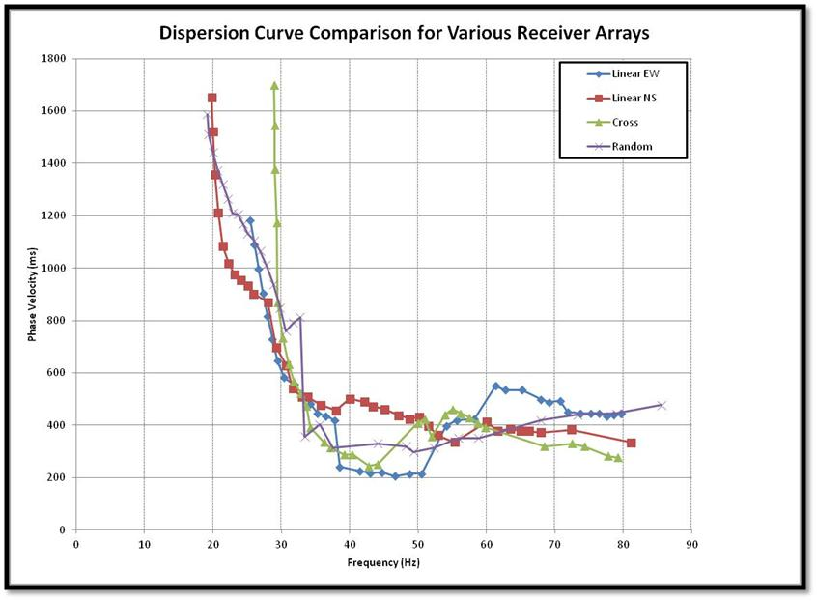
Figure 6: A graph comparing dispersion curves for various receiver arrays. The X-axis represents frequency (Hz) and Y-axis represents phase velocity (m/s).
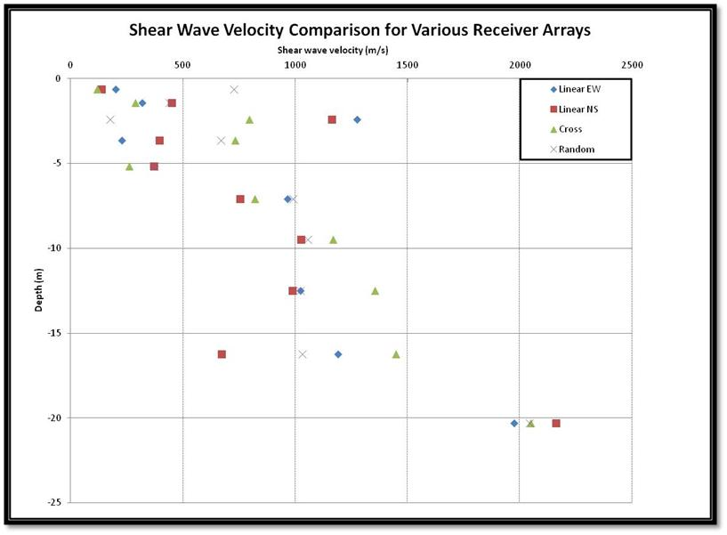
Figure 7: Velocity (m/s) versus depth (m) comparison for various receiver arrays. The X-axis represents shear wave velocity (m/s) and Y-axis represents depth (m).
Data Interpretation
The shear wave velocities along each survey line for each type of array are evaluated based on dispersion picks shown in Figure 5. A soil profile is created describing each layer (for upper 20m) based on shear wave velocity for each layers as per NEHRP classification of site categories (Martin, 1994) and IBC code site classification (IBC-2000). Figure 9 shows that on an average the shear wave velocities varies from 200 m/s to 2000 m/s for a linear array, 150 m/s to 2000 m/s for cross array, and 400 m/s to 2000 m/s for random array for up to a depth of 20m from ground level. It is observed from the obtained Vs values that there is a significant variation in soil types from ground level to 20m deep. And it is also apparent from the dispersion images that soil thickness changes significantly even within a relatively narrow area. Since the dispersion image of the fundamental mode looks different in all kinds of arrays it may be inferred that the soil thickness below each array type may be different.
The top layer consists of very dense soil/soft rock having a velocity range of 450 m/s from 0 to 2 m deep. The geologic map of Arizona identifies this material to be Holocene to middle Pliocene basaltic rocks. Primary rock type found here is alkaline basalt that is mostly dark-colored basaltic lava and cinders young enough that some original volcanic landforms are still apparent. It includes basalt as the secondary rock type along with small amounts of andesite, dacite, and rhyolite. The second layer is interpreted as soft soil having a velocity ranging around 170 m/s found at a depth ranging from 2 to 4 m. A layer of very dense soil with a velocity of 500m/s is found to be the third layer which extends up to a depth of 6m. It is also observed that in this particular location, the hard rock (Vs > 750 m/s) is found starting at a depth of 8 m and extending all the way up to 25 m. I interpreted this range to be the approximate depth to bedrock in that area.
Although more information from geotechnical borings are needed to better constrain the geologic units at various depths and also depth to bedrock, the estimated depth to bedrock map (Figure 9) published by Arizona Geological Survey suggests that the approximate depth to bedrock at this site ranges anywhere between 5-15 m. This is in turn estimated from the data acquired from wells penetrating bedrock near the surrounding area. The geologic unit associated with the bedrock at this site is the tertiary volcanic and sedimentary rocks.
The dynamic properties like the shear modulus and Poisson’s ratio for each receiver array type is calculated based on the shear wave velocity profiles and are tabulated in Table 3. From Table 3, it is observed that the shear modulus varies from 58 MN/ m² to 2260 MN/m² in linear array, 58 MN/ m² to 2273 MN/ m² for cross and from 58 MN/ m² to 2184 MN/ m² for random. It is once again observed here of how well these values correlate with each other for various types of arrays.

  - Conclusions
This paper presents the MASW method, surveying and its application to a lunar analogue field site. It can be concluded from this study that random MASW method can be used effectively to measure the shear wave velocities and calculations of dynamic properties of materials. It is also concluded that random geophone arrangement yields results that are comparable with conventional arrays. This method can further be used in places that are inaccessible, in slopes, embankments etc. The dynamic properties thus measured using random array MASW can be used for structural design in earthquake loading condition.

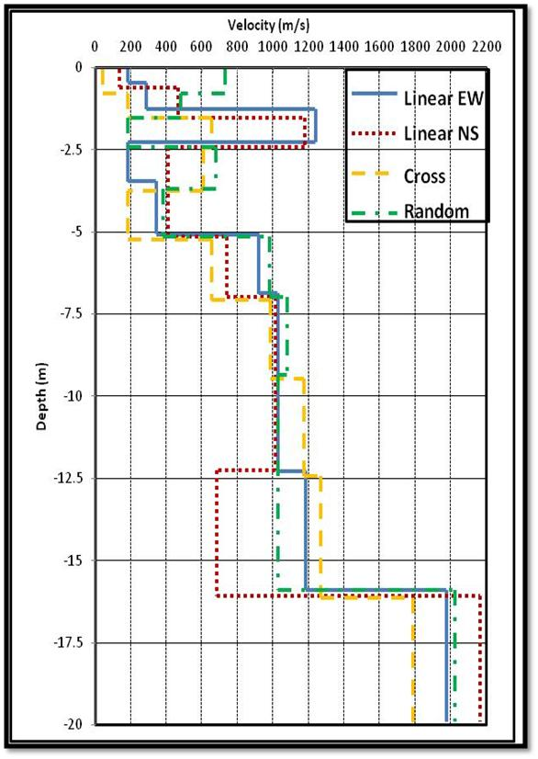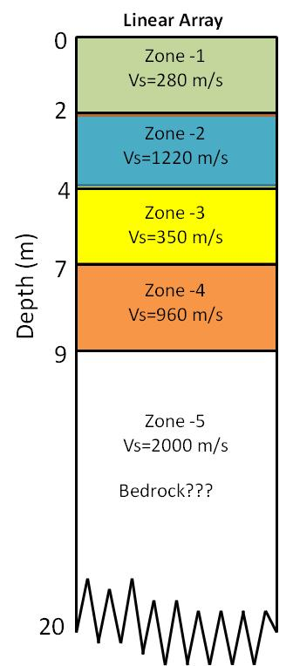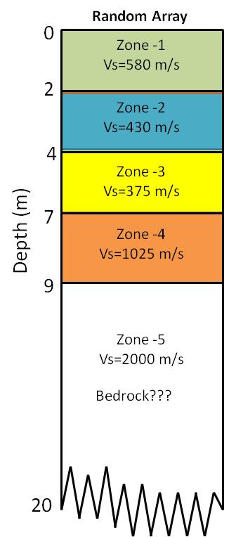

Figure 9: Graphical representation of Vs profiles for all receiver array types shown together in a single graph.
Vs30 = 265 m/s
NEHRP class “D”
(Stiff Soil)

Location-BPLF
N 35⁰ 40’ 20”
W 111⁰ 22’ 03”

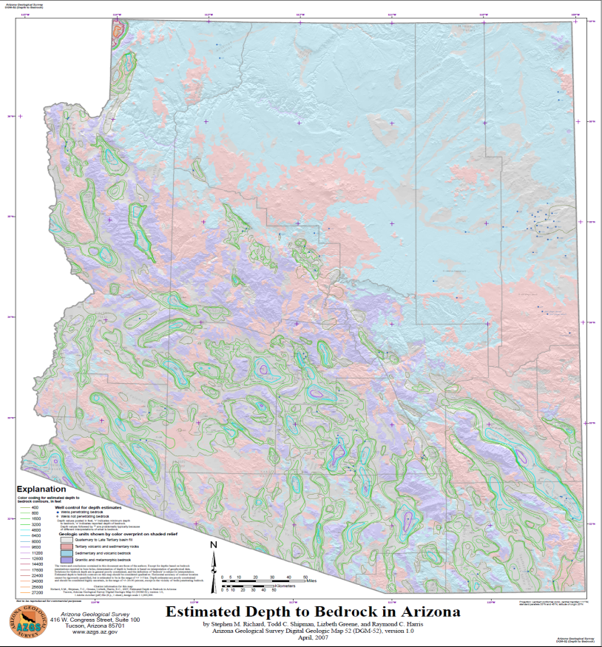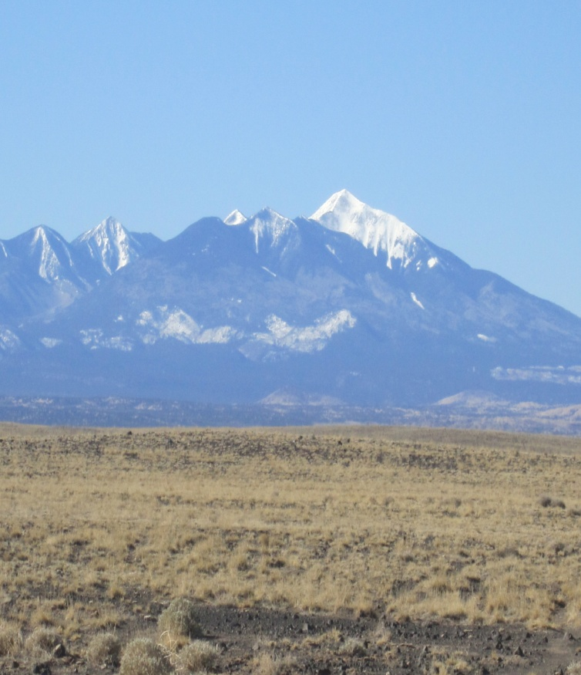
Figure 10: Figure (on left) Geologic map for the state of Arizona showing the estimated depth to bedrock (modified from www.usgs.gov). Star represents the approximate location of the Black Point Lava Flow (BPLF) site. Figure (on right) represents a snapshot of the field site.

Table3. Dynamic properties of soil layers with depth measured using MASW method
