Economic Analysis of Rare Earth Element Recovery from Clay

Group 4:
Josiah Brandt
Jordan Christopher
Garrett Smith
Joel Weber

Instructor: Robert M. Counce
Chemical Engineering (CBE 488)
University of Tennessee Knoxville
1 May 2017

Table of Contents
1.0 Introduction…………………………………………………………….……………4-5
2.0 Synthesis Information for Processes…………………………………….…………..5-9
2.1 Overall Process Schematic…………………………………….…………….5-6
2.2 Chemical Equations……………………………………………….………....6-7
2.3 Literature Summary…………………………………………….…………....7-9
2.4 Costs and Specifications……………………………………………………..9
2.5 Thermodynamic Properties………………………………………………….9-10
2.6 Input Information for Base Cases……………………………………………11
2.7 Design Variables…………………………………………………………….12
2.8 Cost Information…………………………………………………………….12-14
3.0 Method of Approach………………………………………………………………...14-25
3.1 How Project Objectives are Obtained………………………………………..14-23
3.2 Topics to be Assessed………………………………………………………...23
3.3 Sustainability…………………………………………………………………23-24
3.5 Financial……………………………………………………………………...24
3.6 Environment………………………………………………………………….24
3.7 Worker Health and Safety……………………………………………………24-25
4.0 Results………………………………………………………………………....…….25-29
4.1 Capital Cost Estimates………………………………………………………26-28
4.2 Manufacturing Cost Estimates………………………………………...…….28-29
5.0 Discussion of Results………………………………………………………..….……29-31
6.0 Conclusions…………………………………………………………………………..31
7.0 Recommendations…………………………………………………………….……..32-33
8.0 Acknowledgements………………………………………………………………..…...33
9.0 References……………………………………………………………………...……….34
Appendices………………………………………………………………….……….35-42
Appendix A: Clay Waste Feed Concentrations of REEs…………………...…..........35-36
Appendix B: Uranium and Thorium Limits in Product……………………...……….36-37
Appendix C: Capital Cost Calculations………………………………………...…….37-42

Summary:
Rare earth elements (REE’s) are being incorporated into today’s products at an increasing rate. Their value is due to an increased demand and limited supply, both of which are because of their rarity in the earth’s crust and high cost of extraction. Due to the increasing demands of REE’s, it is corporately and nationally advantageous to identify strategies to edge into the market if it is found to be economically viable. By looking into the clay byproduct stream of the “wet” production of phosphoric acid from fluorapatite, this report will attempt to outline a process in which the extraction of REE’s from clay contains enough material to be beneficial for the producer. The following paper covers a process design and analysis concerning the recovery of REE’s and its economic feasibility.

1.0 Introduction:
In the following report, results on the economic feasibility of extracting rare earth elements (REE’s) from a byproduct stream in the wet production of phosphoric acid are assessed. REE’s are increasingly being integrated into technologies involved with green energy, military research, and consumer electronics and have become valuable in today’s global market. The demand for these technologies in the Unites States is growing due to technological advances, but domestic profits are limited because of our current reliance on foreign REE suppliers. By analyzing and optimizing economically viable process designs, REE recovery can decrease the United States’ dependence on foreign competitors, such as China, while providing beneficial value to industries.
Rare earth elements can be found in ores that are mined for phosphoric acid (H₃PO₄) and in the associated byproduct streams of those production sites. Every year roughly 220 million tonnes of phosphate rock is processed with 32 million of that being in the United States. The phosphoric acid industry is stable in many markets and products, so the REE supply is steady and readily available for REE recovery is pursued. The State of Florida has already initiated an effort to try and recover them from the several H₃PO₄ production sites where the waste streams are unused. The production of phosphoric acid can be categorized into either “wet” or “dry” processes. Our focus will revolve around the “wet” phosphoric acid production, which generates four byproducts: phosphogypsum rock, sand, clay and sludge. These four waste streams have differing economic potential with respect to REE recovery, but the byproduct stream of focus for this paper is the clay. The primary design objective of this report is to develop and analyze a flow sheet, capital cost, and operating cost for an REE extraction process from the clay byproduct stream of a “wet” phosphoric acid production site; the report will then be compared with others in an attempt to procure the most beneficial design with modifications, if necessary. The scale of the facility will be based upon a feed stream of four million metric tonnes of clay per year. The chosen process design, with its economic and chemical considerations, is presented in the following report. The only requirement of design was that the REE product be at least 50% REE by mass and non-radioactive. This paper uses a CEPCI of 558.6 as estimated from Chemical Engineering Online projection estimates for February, 2017. Energy demands of the process was estimated using the modern day cost of Natural Gas per gigajoule of energy. Many of the figures, tables, experimental values and recommendations came from data derived from the work and personal assistance of David Depaoli of Oak Ridge National Lab (ORNL), Patrick Zhang of the Florida Phosphate Research Institute (FIPR) and Thomas Gaetjens and Robert Counce from the University of Tennessee.

2.0 Synthesis Information for Processes

2.1 Overall Process Design
The “wet” production of phosphoric acid involves many steps that are not introduced here. The focus of this manuscript revolves around the clay waste stream produced from phosphate rock processing. The process described below is a beneficiation and refinement technique used to isolate phosphate rock from a slurry that is composed of sand, clay, and other relatively large impurities. The process is generalized to avoid unnecessary detail and allow for an effective focus on the overall design. For questions concerning regulations, the Environmental Protection Agency (EPA) uses a Standard Industrial Classification (SIC) code for phosphate rock processing (1475) and a 6-digit Source Classification Code (SCC) for phosphate rock processing (3-05-019). The method of purification relies on many factors that include phosphate ore content and size, phosphoric acid production plant specifications, state codes, etc. Some will be highlighted here.
Phosphate ore from the mine will be analyzed to assess its overall quality. Most size separation techniques require the use of hydrocyclones and flotation tanks; floatation methods may use hydrophilic or hydrophobic chemical reagents with aeration to separate suspended particles. Furthermore, because of the use of water (to limit dust and ease transportation) and dependent on the organic content of the slurry, the ore may be dried and/or calcined. The state of Florida has low organic content and uses rotary and fluidized driers with direct fire from natural gas and/or fuel oil. Other phosphate ore reserves contain organics and must be heated to 760 to 870°C (1400 to 1600°F) to remove them; fluidized and rotary calciners are used, here. Overall particle size will determine the need for the dried/calcined slurry to be crushed and grinded. Crushing techniques tend to involve “impact” crushing, while grinding techniques typically utilize rod or ball mills. Circulating air streams remove particulates from the air to reduce toxic or radioactive emissions. Overall, these processes are transformative of the physical properties of the source slurry and not chemically altering.
Overall supply refinement is dependent, heavily, on phosphoric acid plant design and requirements. Some, or even none, of the process illustrated above may be performed prior to arrival of a phosphoric acid production site; production sites may house their own methods and techniques depending on the quality of the supply. The highlighted points above are discussed to depict the processes that clay streams may undergo before REE extraction.

2.2 Chemical Equations
Leaching/Extraction Equation
The REE’s (represented by “Ln”) that reside in the waste streams, particularly clay, are phosphates (LnPO₄). To be leached from the waste stream, they are reacted with sulfuric acid (H₂SO₄) to become soluble sulfates, as is seen in the following equation:
2LnPO₄ + 3 H₂SO₄ => Ln₂(SO₄)₃ + 2H₃PO₄ eq. 1
Secondary Equations
Consequently, other metals in the waste stream react with sulfuric acid. They, however, become insoluble species, and it is this molecular characteristic that will be capitalized on. The metal oxides of the clay feed undergo the following reactions:
Fe₂O₃ + 3H₂SO₄ => Fe₂(SO₄)₃ + 6H₂O eq.2
Al₂O₃ + 3H₂SO₄ => Al₂(SO₄)₃ + 6H₂O eq.3
MgO + H₂SO₄ => MgSO₄ + H₂O eq.4
CaO + H₂SO₄ => CaSO₄ + H₂O eq.5

Reformation Equation
Unfortunately, REE sulfates are not marketable. Once isolated, they must be transformed into oxides, which solidify as a precipitate and can, from there, be dried, stored, and shipped. The reactions that rare earth sulfates, and then rare earth oxalates, must undergo are as follows:
Ln₂(SO₄)₃ + H₂C₂O₄ => 10H₂O + Ln₂(C₂O₄)₃ + 3H₂SO₄ eq.6
Ln₂(C₂O₄)₃ + 1.5O₂ => Ln₂O₃ + 6CO₂ eq.7

2.3 Literature Summary
The rare earth elements are a categorization of elements that include the lanthanides, yttrium, and scandium. Although similar in atomic structure, each have unique properties that offer various benefits. Neodymium is known to be a main component of magnets, while erbium is used for optical fiber data transmission.¹ Figure 1 illustrates the various industries that capitalize on REE traits.
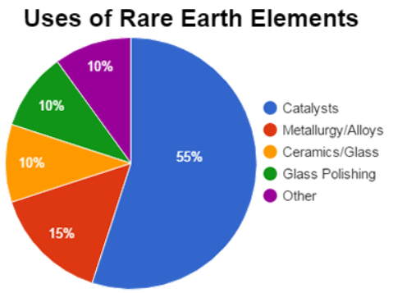
Figure 2.1: Uses of REE’s in the United States as reported by the United States Geological Survey Mineral Commodity Summary, 2017

Although REE’s are, in many ways, beneficial, they are also known to be harmful and detrimental to one’s health and the environment. Many industrial processes disregard the adverse effects and dispose, improperly, of waste that is partially composed of REE’s. Referring back to the production of phosphoric acid, phosphogypsum (gypsum), a byproduct whose composition is high in REE’s, has been shown to decrease biodiversity when leached into water sources. Currently, the most environmentally friendly way of disposing of gypsum is dump it into piles called “gyp” stacks and limit their access to water.²
In an attempt to both increase the supply of and decrease environmental harm from REE’s, studies on recoverability and recyclability are being performed, as much as the research on their usefulness is. One study proved the viability of biosorption with the use of brown algae on industrial waste in nature. Its results are leading to further research in REE recovery of similar techniques.³ Other studies are being conducted on economically sound methods of REE recovery. One such study showed how salmon milt, a low-cost waste product of fisheries, worked well via ion-exchange on the extraction of REE’s.⁴
Extraction of REE’s is becoming a well-studied practice with time. Leaching experiments are comparing the most suitable chemicals to reduce the cost and increase efficiency when isolating these elements. A study by N.B. Egorov et al. showed how the decomposition of rare earth phosphates (REP’s), via sulfuric acid or sodium hydroxide, can have an improved degree of leaching with the addition of NH₄NF₂ or NH₄F, while another study, by J. Amaral et al., indicates how various REE’s, with different chemical properties, could be isolated simultaneously.^{5,6} One of the leading methods of REE leaching is liquid-liquid separation (LLE); this is a method that incorporates the transfer of one or more solute(s) to a solvent based on relative solubilities. A study using betaine-betainium bis(trifluoromethylsulfonyl)imide ionic liquid system placed emphasis on this solvent’s ability to extract neodymium with relatively small vapor pressure, low flammability, and high thermal stability. More common techniques used in industry include the use of Di-(2-ethylhexyl)phosphoric acid (D2EHPA), 2-ethylhexylphosphonic acid mono-2-ethylhexyl ester (HEHEHP), and Aliquat 336.^{7,8} Less common techniques include cation and anion exchangers.⁹

2.4 Costs and Specifications
A table consisting of raw materials, energy, products, and byproducts are listed below with their respective prices.

Table 2.1: Product, Byproduct, Raw Material, and Energy Costs
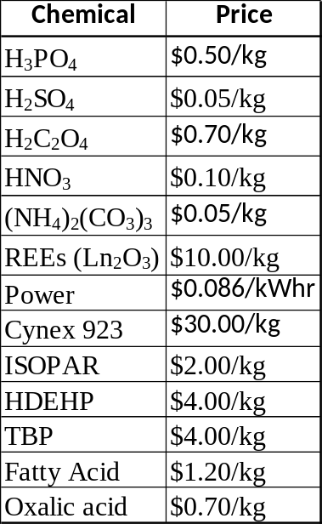

2.5 Thermodynamic Properties
The thermodynamic properties of the chemicals used and reactions that occur are as follows:

Table 2.2: Heats of Formation @ 298.15 K.
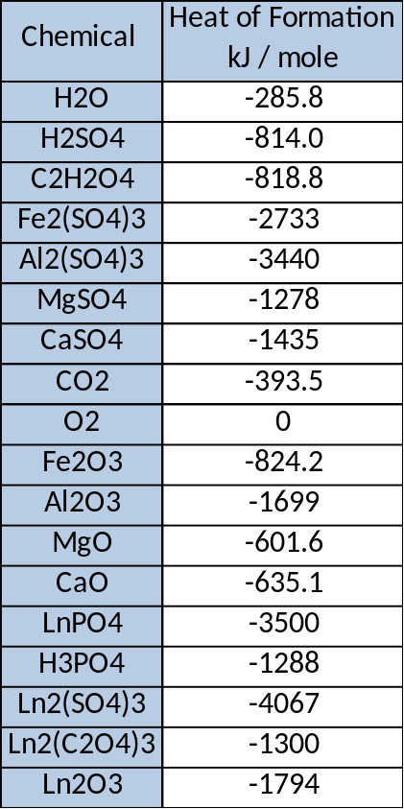
Note: Lanthanum Oxalate and Lanthanum Phosphate were estimated.

Table 2.3: Heats of Reaction for Plant Processes
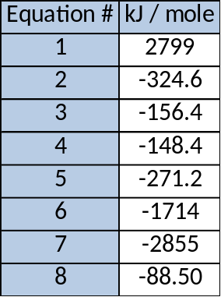

Table 2.4: Cost of Natural Gas from Henry Hub Spot Price for March 2017.
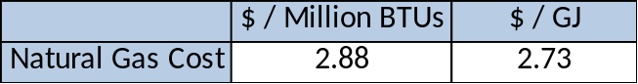
2.6 Base-Case Input Information
The input values for our specific project (base-case) are as follows:

Table 2.5: Clay Waste Stream Composition and Flow Rate.
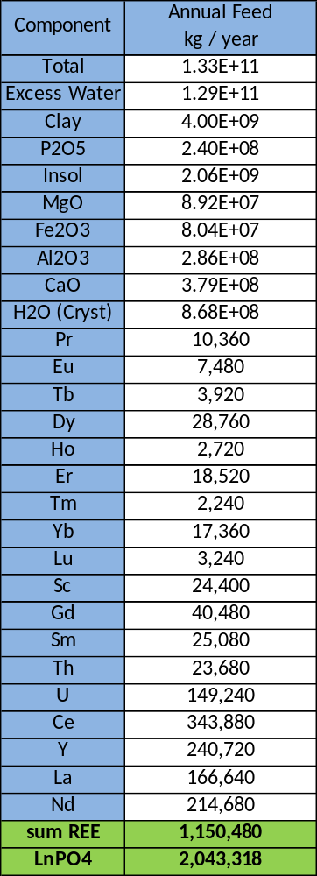
Note: Uranium and Thorium is not considered in the design of the process; their flows are not considered as part of the REE whole.
2.7 Design Variables
The design variables associated with the development and capital assessment of this plant process are based on various assumptions, the main assumption being that the base-case values remain constant. (This report is specified on a waste stream flow rate and composition described by the analytical results of Dr. Patrick Zhang of the Florida Industrial and Phosphate Research (FIPR) Institute.) Further mentioned is that the product is to be solid at >50% elemental REE concentration and must contain and acceptable product level of radioactivity. Another assumption is that the waste stream is considered dilute solids because of the solid content of the streams; they are not pure and must first be subjected to particle separation methods using a carrier fluid to separate out the desirable solids or beneficiation.
Also, per Dr. Haing Liang, the performance of the hydrocyclone, floatation, and leaching vessels are analytically assumed to be:
Hydrocyclone performance:
12 to 15 wt% solids in underflow (course clay stream)
Up to 35 to 40 wt% of solids recovered in underflow
Flotation performance:
> 30 % recovery of solids in concentrate
> 70 % REE recovery in concentrate
> 80 % P₂O₅ recovery in concentrate
Leaching performance: (H₂SO₄:CaO = 4, 230 °C)
90 % REE recovery
95 % P₂O₅ recovery
Leaching of Al, Mg, and Fe: 35%, 20% and 10%, respectively

2.8 Cost Information
Raw Material cost, by-product credits, and product values are outlined in section 2.4 and the cost of energy is taken to be the market cost of Natural Gas as given by the EIA. The design costs are estimated by costing tables in Chemical Engineering: Process Design and Economics, a Practical Guide by Gael D. Ulrich with a CEPCI of 558.6 as given by a projection for February, 2017 from Chemical Engineering Online, or information given by consulting groups (classmates or Dr. Counce). The initial dilution cost (around $8 Million annually) was ignored; the assumption was that the clay was already diluted upon receiving it to the front end of our process.
The expense data assumptions are summarized in the following tables:

Table 2.6: Expense Assumptions
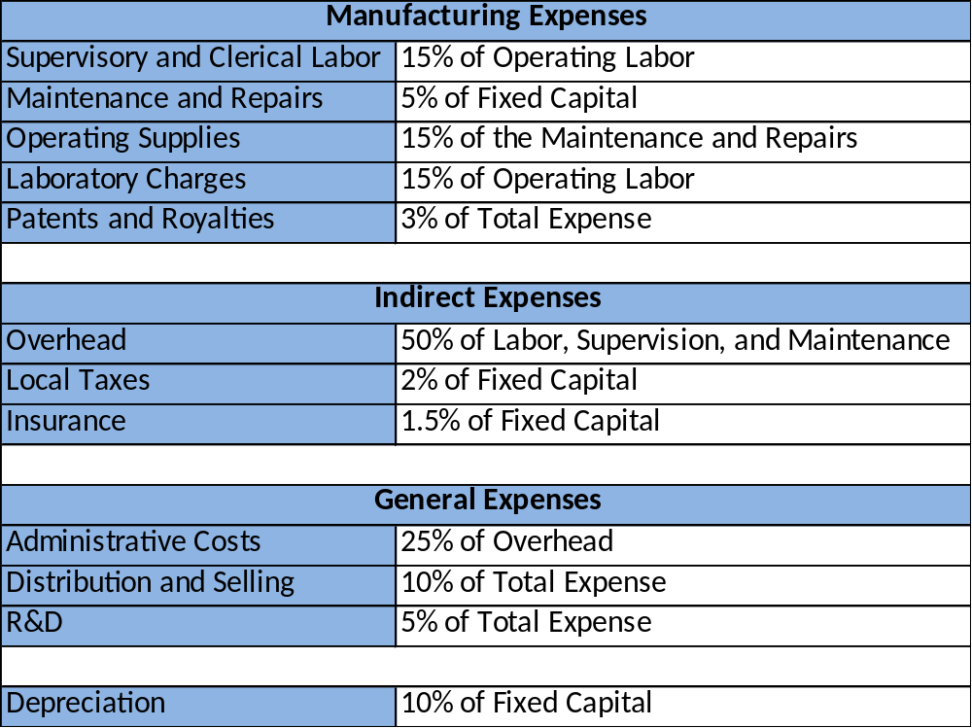

Table 2.7: Utility Assumptions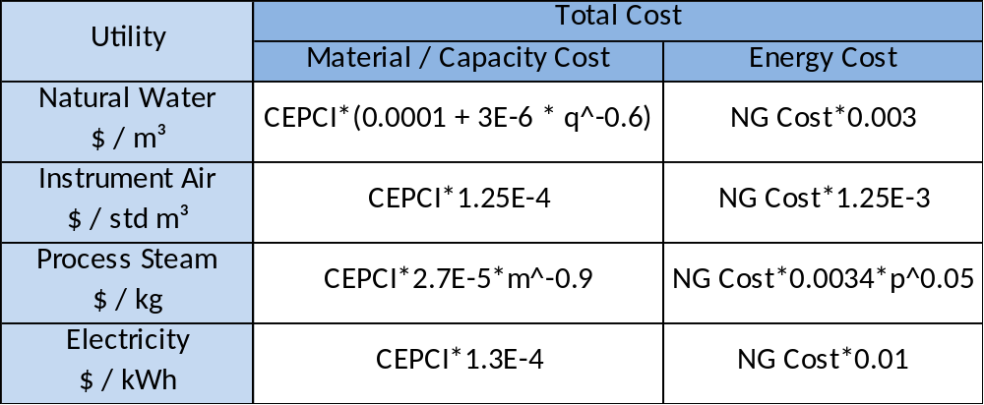

Other assumptions include the full recovery of Sulfuric Acid leaving through the dryer and extractor, as well as some auxiliary cost. However, we did not assign any by-product credits to the Phosphorous pentoxide (P₂O₅ is the empirical formula) by which the majority of the sales would be derived.

3.0 Method of Approach

3.1 How Project Objectives are Obtained
The main objective of this project is “to estimate the capital and manufacturing costs in 2017 U.S. dollars to produce a rare earth element (REE) product” from the clay waste stream of a “wet” phosphoric acid production plant. To achieve this, engineers must obtain background information (including but not limited to: current review articles (rational), design variables (constraints), and ChE indexes), develop plant processes, estimate start-up and annual costs, and assess feasibility (implementation of the plant in today’s regulations and standards).
The basis of this project is a feed rate of 4 billion kg of clay waste per year. The composition of this feed stream is illustrated in Appendix A. The process of extracting REE’s from this clay feed stream occur in steps illustrated by the detailed schematic shown below in Figure 3.1.
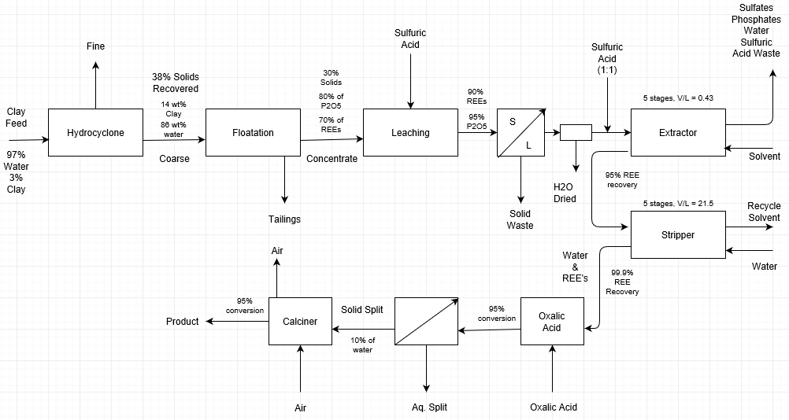
Figure 3.1: Flow diagram of the REE recovery process from a clay waste stream.
3.1.1 Hydrocyclone
Initial processing of the clay waste is achieved via hydrocyclone. The clay waste is diluted with water until a stream composition of 97% water, 3% clay is satisfied. Hydrocyclone performance is based off data from Liang’s lab and is assumed to be the following: 14 wt% solids, 86 wt% water underflow composition, with 38 wt% of solids recovered. The rest is recovered in the top fine stream, which was not considered in this design. Table 3.1.1 shows the input and output information for the hydrocyclone.

Table 3.1.1: Data for clay waste stream processing via hydrocyclone showing input stream and two output streams. Flow basis is kg/s.
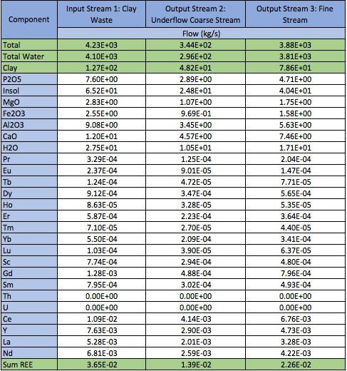

3.1.2 Flotation Vessel
Further processing of the clay waste is done via the use of a flotation vessel, which generates a stream higher in purity of REEs and P₂O_{5.} 30% solids are recovered in the flotation concentrate, with the rest recovered as tailings, which can be processed in a separate design not discussed here. In the concentrate, 70% of REEs and 80% of P₂O₅ are recovered. Table 3.1.2a shows the mass balance for the flotation vessel.

Table 3.1.2a: Data for clay waste stream processing via flotation vessel showing input stream and two output streams. Flow basis is kg/s.
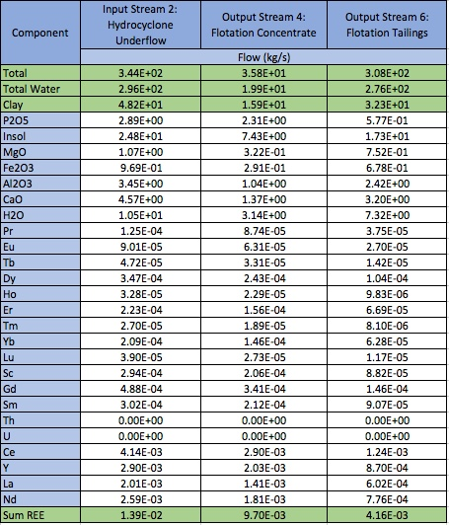

Chemicals are used in the vessel to separate hydrophobic and hydrophilic components. These are presented in Table 3.1.2b in terms of total mass present in the vessel.

Table 3.1.2b: Flotation chemicals.
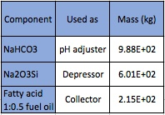

3.1.3 Leaching Vessel
After initial processing of the clay, it is sent into the leaching vessel for reaction with sulfuric acid. Rare earth phosphates are subsequently converted to sulfates, and phosphoric acid is generated from P₂O₅. A REE conversion of 90% was assumed based on a H₂SO₄:CaO ratio of 4:1 (from Liang). Conversion performance for magnesium, iron, and aluminum oxides were also specified by Dr. Counce and are included in Table 3.1.3, which breakdowns the balance around the leaching vessel.

Table 3.1.3 Data for the leaching vessel. Concentrated clay stream from the flotation vessel is sent to vessel and reacted with sulfuric acid. Extent of reaction based on conversion.
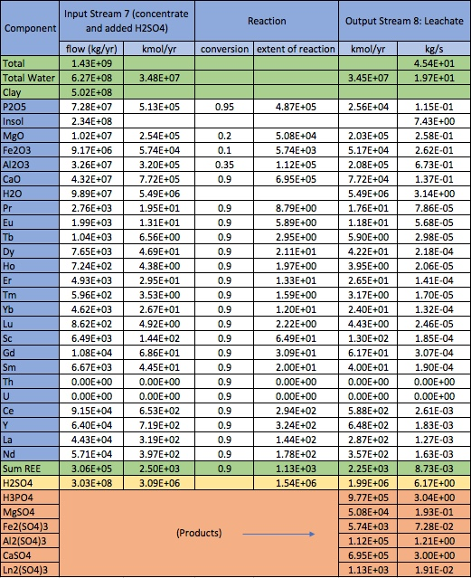
Notes: Products (very bottom) emerge with unreacted inputs in stream 8, the leachate.
3.1.4 Solvent Extraction System
After separation of solid and acid products from the leaching vessel via filtration, drying, and cooling, during which most water is removed, the iron, aluminum, and magnesium sulfates, and the REEs are mixed with sulfuric acid in a 1:1 mol ratio to create the aqueous stream input to the solvent extraction system. The REEs are first absorbed into an organic solvent to separate them from the metal sulfates, then stripped back into the aqueous phase. Distribution coefficients of REEs for absorption and stripping were provided by Dr. Counce. The schematic below shows the solvent extraction system.

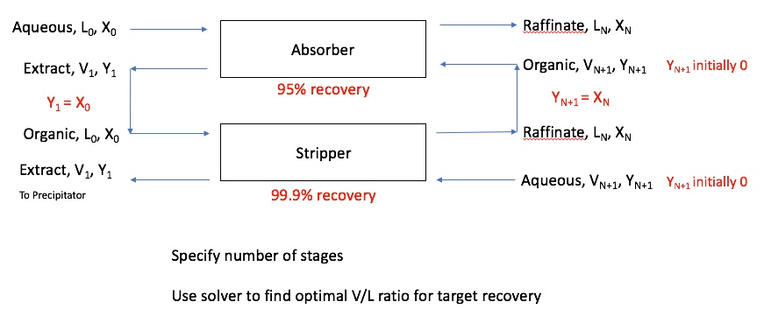

Figure 3.1.4: A summary of the Solvent Extraction process. The stages in the absorber and stripper are modeled as separate mixer-settler units for sizing and costing purposes.

Table 3.1.4 shows the input streams, distribution coefficients and absorption and extraction factors for each REE, and recovery streams.
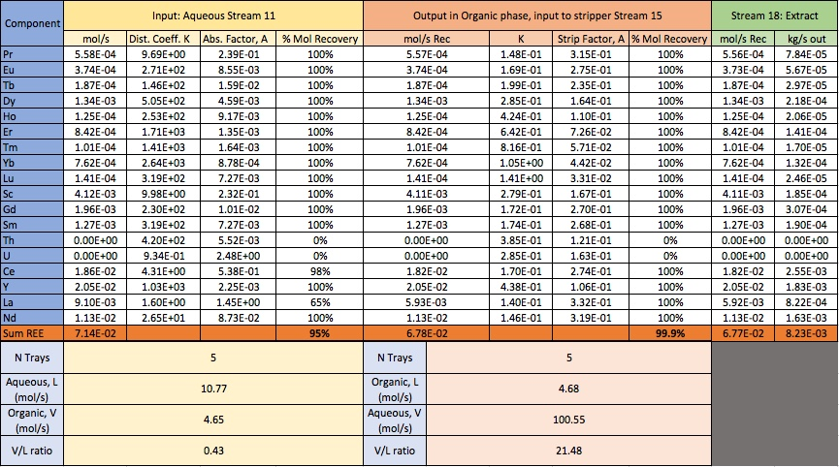
3.1.5 Precipitation Reactor
The extraction REEs from the Solvent Extraction System are then sent to a precipitation reactor. Here, REE sulfates react with oxalic acid to form REE oxalates, a form that can be oxidized via calcination, the final unit operation.

Table 3.1.5: Data for the precipitator vessel.
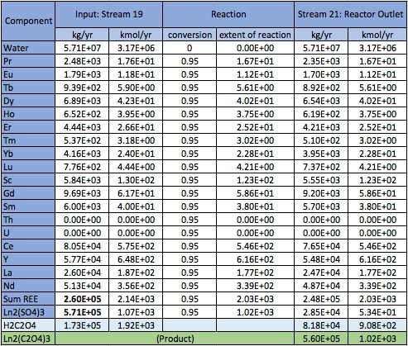

3.1.6 Calcination Reactor
A sedimentation tank following the precipitation reactor helps to remove excess liquid from the effluent, and then the mixture is sent to the final unit, the calcination reactor.

Table 3.1.6: Data for Calciner
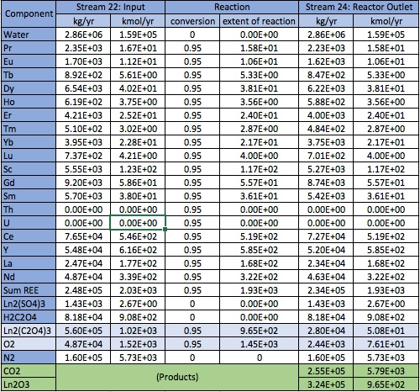

3.2 Topics to be Assessed
To assess feasibility, the plant process will be broken down into various areas of thought ranging from capital sustainability to regulatory compliance. Section 3.3 through 3.6 are more in-depth analysis of these topics.

3.3 Sustainability
When assessing sustainability, engineers must consider a financial analysis that includes annual costs and net annual profit. Through the use of market projections and inflation, the sustainability of the plant can then be projected. Sustainability must take into account the lifespan of the plant, itself, and the scrap value of the plant for when costs begin to outweigh profit. Another important goal is providing for the needs of present generations without neglecting the ability to meet future needs.

3.4 Financial
In order to perform a financial analysis, engineers need to take into account the grass roots startup costs of the plant, which can be estimated from the mass and energy balances, the estimated raw material costs, and the product values. Future estimations need to be done based on discount factors, inflations, and the longevity of the plant (which may also affect the scrap value).

3.5 Environment
Since the first environmental movement in the mid-1900’s, industry has had to abide by more and more protective regulations. These pieces of legislature are set by federal and state departments, such as the Environmental Protection Agency (EPA) and respective state environmental agencies. They implement regulatory practices that include, but are not limited to, emissions, site impact, waste disposal, and energy consumption/output. In a social context, progressive movements have limited, if not completely inhibited, plant processes. To avoid confrontation, many companies express a desire to assist environmentalist and be “morally proactive” on this front. Depending on the economic feasibility and environmental impact of our plant process, we may look towards expressing a cooperative mindset directed toward environmental protection.

3.6 Worker Safety and Health
Within the development of industry, work conditions grew to be more dangerous and unhealthy. This, linked to more frequent accidents, pushed government to intervene with the first factory regulatory bill, the Massachusetts Factory Act of 1877. Since then, numerous others regulatory laws have been passed on behalf of worker safety and health concerns. To pass inspections, a plant would have to abide by both federal and state regulations, which are imposed by the United States Department of Labor (DOL) and the associated state labor bureau(s), respectively. Also, factories must pass inspections associated with site and process specific laws. This may include but is not limited to machinery, such as the operating and maintaining of pumps, and chemicals, such as the handling, storing, and use of Sulfuric Acid. It should be mentioned that this plant will be handling radioactive material and proper use and disposal of such items must be in accordance with federal and state laws, as well. Lastly, industrial plants, such as this one, may have to abide by regulations sets by unions; those regulatory items will be established by contract and specific to the union and plant at the time of negotiation.

4.0 Results
The main idea of this process is to harvest REE’s from the waste stream “wet” production of phosphoric acid. REE’s are supposed to be the primary source of product; however, as one can see in Table 4.2.1 the annual sales from the REE oxides are nearly 15 times less than the sales from the byproduct value of Phosphoric Acid. (Note: In the annual expense estimation, though phosphoric acid is a byproduct credit of this process, the massive worth of this sale offsets the expenses and produce a large error in the financial calculations of the expenses. Therefore, the phosphoric acid was considered a sale as opposed to a byproduct in the cost analysis.) If the phosphoric acid is removed is the project still viable? A Cost Profile Comparison was created for the purpose of answering this question. Table 4.0.1 Contains information on the cash flow analysis as is with and without the phosphoric acid sales. Similarly Figure 4.0.1 is a visual representation of the data.
Project construction was assumed to take around two full years with investments of equal increments each year; the working capital was assumed to be invested during the startup year. Discount rates were assumed at 0%, 10% and 15% to show potential flow profiles over the next ten years. A ten year life was assumed for the process.
Table 4.0.1. Profitability Analysis of an REE plant with and without Consideration of the Phosphoric Acid Sales
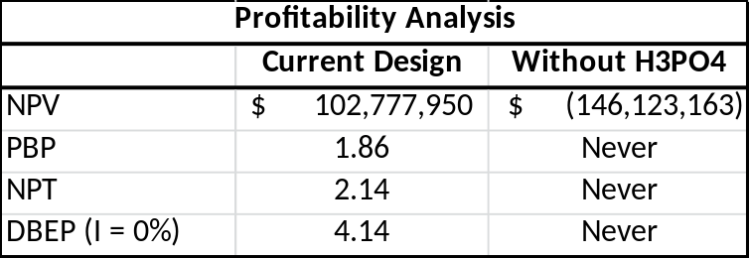
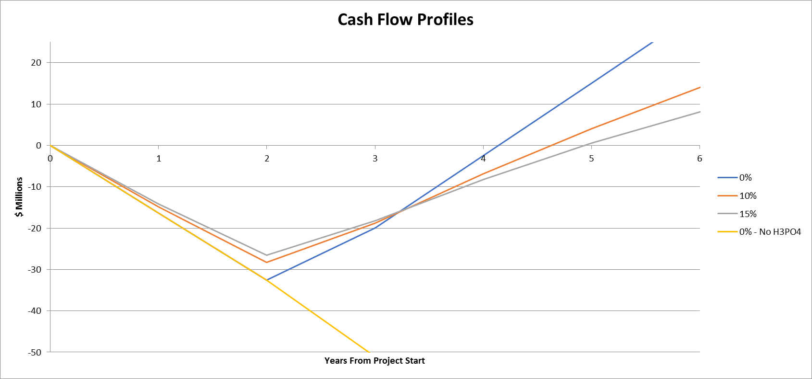
Figure 4.0.1 Cash Flow Profiles for the Next Ten Years across multiple Pathways

As one can see, the REE process is supported almost entirely by the sales of the phosphoric acid, without it their simply would be no profit. Note, however, that the process does have a reasonable PBP.

4.1 Capital Costs Estimates
The equipment of necessity, previously explained, and their respective costs were estimated with Gael Ulrich’s Chemical Engineering Process Design and Economics: A Practical Guide¹¹, as well as from quotes derived from correspondence with our professor and other references he provided. Table 4.1.1 is the Capital Cost Summary. It displays a summary of the cost data for each piece of equipment and estimates the Grass Roots Capital needed to build the plant. The grass roots capital cost is estimated to be $32.6 million. (A note of caution, this is an estimate; many items including all auxiliary equipment, with the exception of a few intermediary tanks and sedimentation units, are left out. Pumps and unique piping elements are not considered, and the estimates for the existing equipment are rough.) To help illustrate the process of calculating these costs, example calculations for the leaching vessel are shown below; complete calculations are listed in Appendix C.

Table 4.1.1 Capital Cost Summary of REE Recovery from Clay Byproduct
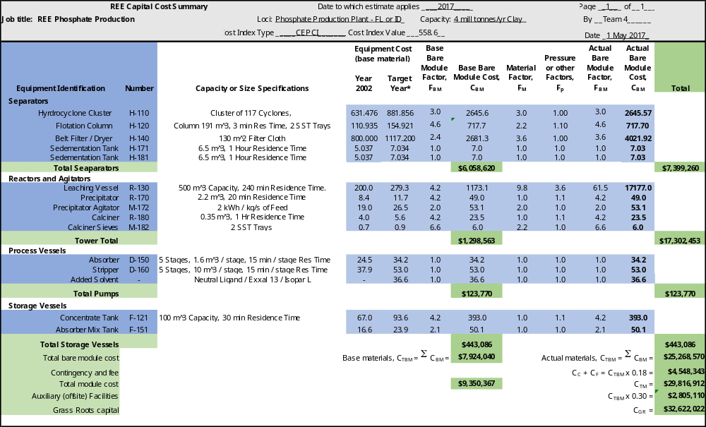

Costing for Floatation Tank
See Appendix C, Table C1 for given constants.

Superficial Air Flow is calculated as follows:
$$J_{G }=\frac{P_{c}*J_{G}^{*}*\ln\left[\frac{P_{t}}{P_{c}}\right]}{P_{t}-P_{c}}=\left[\frac{101325*2.2*\ln\left[\frac{199425}{101325}\right]}{199425-101325}\right]=3.15\frac{cm}{s}$$
$$Air Flow= \frac{J_{G}*\frac{A}{100}*P}{R*T*(Mol per Vol. of Air)}=\frac{3.15*\left(\frac{15.9}{100}\right)*150375}{8.314*300*40.46}= 0.17 std\frac{m^{3}}{s}$$
Wash Water Flow Rate is calculated as follows:
$$E_{C}=\frac{J_{c}}{J_{c}+J_{G}^{*}}=\frac{2}{2+2.2}=0.476$$
$$J_{w}=\frac{E_{c}*J_{G}^{*}}{1-E_{c}}+J_{B}= \frac{0.476+2.2}{1-0.476}+0=2\frac{cm}{s}$$
$Water Rate=\frac{J_{W}}{100}*A=\frac{2}{100}*15.9=0.318\frac{m^{3}}{s}$
Total manufacturing costs are calculated as follows:
$$C_{BM}=C_{p}F_{BM}=\left[\$90,936*\left(\frac{558.6}{400}\right)\right]*4.2=\$533,366.92$$
$$C_{BM}\left(Seives\right)=C_{p}F_{BM}N=\left[\$10,000*\left(\frac{558.6}{400}\right)\right]*6.6*2=\$184,338.00$$
$${Total C}_{BM}= C_{BM}+C_{BM} \left(Sieves\right)=\$533,366.92+\$184,338.00=\$717,704.92$$

4.2 Manufacturing Cost Estimate
The manufacturing expenses are all those direct, indirect or otherwise that are associated with the production of the REE’s in the process. These include, but are not limited to, utility costs, maintenance costs, and labor costs. Raw material costs are also calculated based on the amount needed per unit flow of feed (specific to the unit operation). The total annual expenses is estimated at $29.1 million; the data used to estimate this total value is shown in Table 4.2.1. Again, Ulrich’s book was used for calculation purposes.

Table 4.2.1: A detailed manufacturing costs summary sheet.
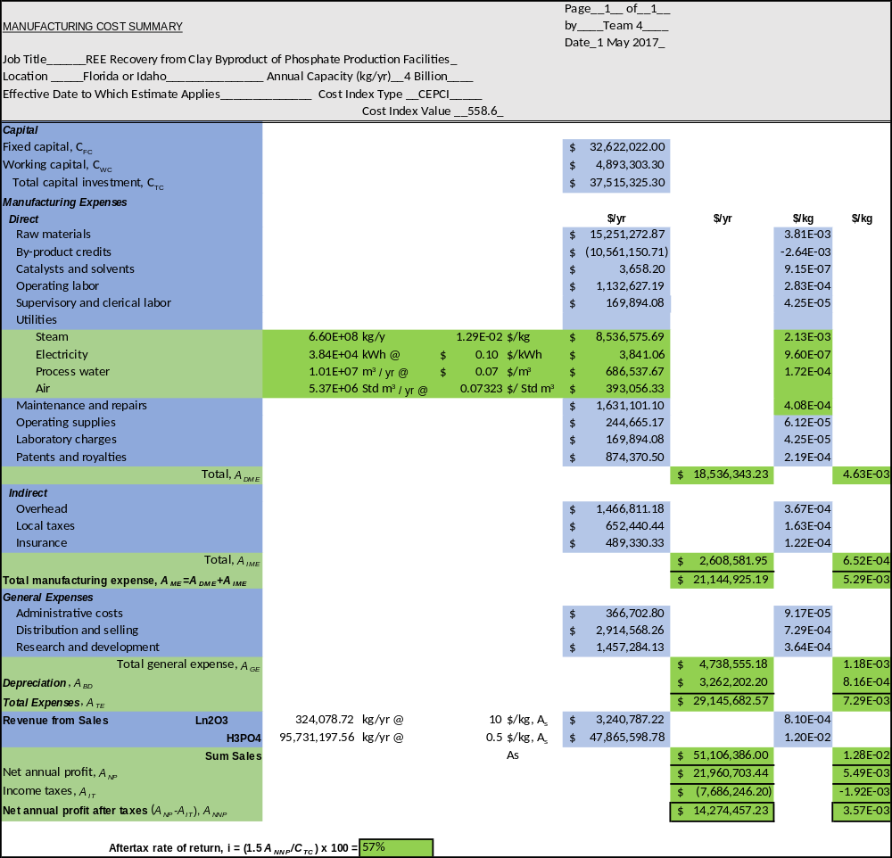

5.0 Discussion of Results
The design process shown above provides an economically viable system to recover and sell REE’s from the clay waste stream of a “wet” phosphoric acid production plant. The annual revenue from REE’s is relatively small compared to the profit yielded from the sale and resale of phosphoric and sulfuric acid. Actually, without the later, the given process would not yield a profit. Whereas the sales from REE’s is ~$3.2 million, the sales from phosphoric acid is ~$47.9 million, and with a manufacturing cost way above the former, the only viable option would be to reap a benefit from the byproducts of the system. One of the reasons for the small return based on the REE’s is because of our percent yield, which is 20% (see “Sum REE” in stream 1 and stream 24). Another reason could be due to the large manufacturing cost because of the raw materials (organic solvent, steam, etc.); this cost, alone, is more than two-thirds the annual fee, and a reduction here would allow for a larger annual return. Chart 5.1 illustrates these effects.

Chart 5.1: Major manufacturing costs visualized as percentages.

As is seen in section 4.1 and 4.2, the fixed and working capital costs equate to ~$32.6 million and ~$5 million, respectively. This sums up to a total capital investment of ~$37.6. Chart 5.2 is a visual of the bare module cost breakdown for the major unit operations of the process. It is worth noting the large cost of the leaching vessel, which makes up nearly 68% of the total cost. The vessel was designed to withstand pressures of up to 50 barg (reasonable safety estimate due to the steam being the largest energy influx to the system; i.e. the vessel could not reasonably increase beyond 45 barg) in addition to having to handle caustic chemicals. The material factor was 9.8 as seen above due to the Nickel based alloy chosen for the design material. If the cost of the vessel can be reduced by some means, the feasibility of this process’s economic worth would increase greatly. Among other groups, the cost of the solvent ligand was typically outrageously high. We believe in order to mitigate this issue, a vacuum should pull the water out of the filtrate in order to reduce total volume capacity of the moving fluid. Once the water is removed from the filtrate and the volume is greatly reduced, the amount of solvent needed for extraction is greatly reduced as is the size of the downstream unit operations. Doing this allowed us to have a solvent cost of around $36.6 thousand initially.

Chart 5.2: Major Bare Module Cost visualized as percentages.

Referring to section 4.0, the payback period (PBP) would not be overcome until a duration of roughly 1.86 years has been achieved. However, the net payout time (NPT) is 2.14, and the discount break even period (DBEP) is 4.14. With this being said, after a period of 10 years the plant is expected to yield a net present value (NPV) of $102,777,950.00.

6.0 Conclusions
The current design process that is implemented for the sole recovery and sale of REE’s from the clay waste stream of a wet production plant of phosphoric acid is not economically viable. However, with the respective sale and resale of phosphoric and sulfuric acid, the plant deems a substantial profit. Further studies and future work on the design processes could increase efficiency and minimize costs, plus careful studies and development of the REE market could lead to more dependency on that specific product.
7.0 Recommendations
Post conclusion, we have put together recommendations that could further increase the accuracy of our report and efficiency of the overall plant process. To start, we address final plant designs and calculated costs. Items that we have intentionally neglected include, but are not limited to, the pipes, pumps, and storage tanks that would rely on information needed from specific site dimensions and local regulations. We recommend, with the comprehensive objectives of the plant or company in mind, that unit operations either remain close together to decrease costs associated with the aforementioned items or spaced apart for the flexibility to install and adjust plant processes over time.
The second item we address would be the need to optimize various, specific unit operations. For example, our design of the solvent extractor was based on the volume of fluid flowing through the system, however, we believe, that this item can become more efficient by analyzing the extract and raffinate streams to select a more ideal number of stages. Other components that can be assessed include the life span of the plant and what duration would allow for maximum profit between fixing/replacing part and scrap value. Lastly, one may want to design a recycling process for sulfuric acid; this could save time and money in replace of extracting and reselling the chemical.
Lastly, we would recommend that specialist consider the isolation and removal of radioactive material. We know from the mass balance and federal regulations that too much is being extruded with the product to be sold without proper preparation. Also, due to the annual amount of material handled, costs will accumulate in association with the safety equipment and plant protocols established in regards to worker safety. Detailed commentary on this subject can be found in Appendix B.
Other recommendations include changing the design material of the leaching vessel. Doing this may bring down the material factor reducing the cost greatly. This could be done by potentially lining the vessel with rubber or glass, though these options may prove unfeasible. Another recommendation that we would make is to reduce the volumetric flow by every possible means to the solvent extraction system. This would reduce the cost of the neutral ligand because of the smaller capacity. Given the ligand’s expense we cannot recommend this any greater. Thirdly, find ways to reduce utility cost. A great deal of the cost came from steam and water. In fact, the steam cost was found to be nearlyt equivalent to the sale value of the recovered REE’s.
Finally, after examining the process, we have determined that the process for REE recovery seems unfeasible economically even if the best cost cutting measures are taken. We suggest shifting focus to more lucrative routes such as the recovery of the P2O5 from the clay which would be hyrdrated fto form Phosphoric Acid and sold at a huge profit that would dwarf any sale the REE’s would hope to achieve.

8.0 Acknowledgments
In summary of our report, we would like to thank several people for their undivided attention, knowledgeable recommendations, and unfathomable amounts of provided information. Without the help from FPIR, Mosaic, ORNL, and UTK Chemical and Biomolecular Engineering department, this project would not have been successful. Our gratitude is offered with the highest extent to following people:

From FPIR
- Dr. Medley
- Dr. Liang
- Dr. Zhang
From ORNL
- Dr. Depaoli

From Mosaic
- Dr. Bidinger
- Dr. Kucera
- Dr. Whitt
From UTK
- Dr. Counce
- Dr. Desimone
- Mr. Gaetjens

9.0 References
- "Rare Earth Elements Supply and Demand." Future of Strategic Natural Resources. Massachusetts Institute of Technology, 2016. Web. 01 May 2017.
- Ober, Joyce A. "Mineral Commodity Summaries 2017." Mineral Commodity Summaries (2017). U.S. Geological Survey, 19 Jan. 2017. Web.
- Nessim, Ramzy B. "Biosorption of Lead and Cadmium Using Marine Algae." Chemistry and Ecology 27.6 (2011): 579-94. Web.
- Takahashi, Yoshio. "Recovery and Separation of Rare Earth Elements Using Salmon Milt." Analytical Sciences 28.10 (n.d.): 985-92. Oct. 2012. Web.
- Egorov, N.B. et al. “Extraction of REE by Using Solutions of H2SO4 and NH4F.” Procedia Chemistry. 11 (2014): 15–19. Web. 1 May 2017.
- Amaral, Janúbia C.B.S., and Carlos A. Morais. “Thorium and Uranium Extraction from Rare Earth Elements in Monazite Sulfuric Acid Liquor through Solvent Extraction.” Minerals Engineering 23.6 (2010): 498–503. Web. 1 May 2017.
- Mori, Takahiro et al. “Homogeneous Liquid–liquid Extraction of U(VI) from HNO3 Aqueous Solution to Betainium Bis(trifluoromethylsulfonyl)imide Ionic Liquid and Recovery of Extracted U(VI).” Separation and Purification Technology 155 (2015): 133–138. Web. 1 May 2017.
- Chi, R., and Z. Xu. "A Solution Chemistry Approach to the Study of Rare Earth Element Precipitation by Oxalic Acid." Metallurgical and Materials Transactions B 30B (1999): 189-95. Web.
- Douglas, J. M. "A Hierarchical Decision Procedure for Process Synthesis." AIChE Journal 31.3 (1985): 353-62. Web.
- Geankoplis, Christie J. Transport processes and separation process principles. Fourth Edition, Prentice Hall Professional Technical Reference, 2003, Upper Saddle River, NJ.
- Ulrich, Gael D. Chemical Engineering Process Design and Economics: A Practical Guide. Second Edition, Process Publishing, 2004, Durham, NH.

Appendix A: Component Distribution in Clay Feed

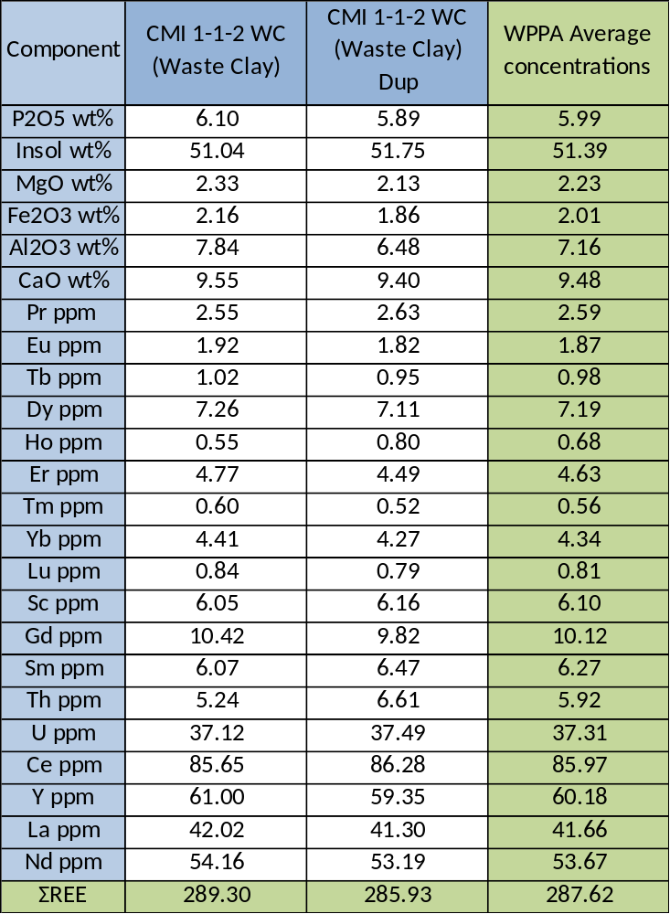
Table A1. Component Distribution in Clay Feed. (Remainder is Crystallized Water)
Note: The Clay is further diluted to a 97:3 water-clay ratio.

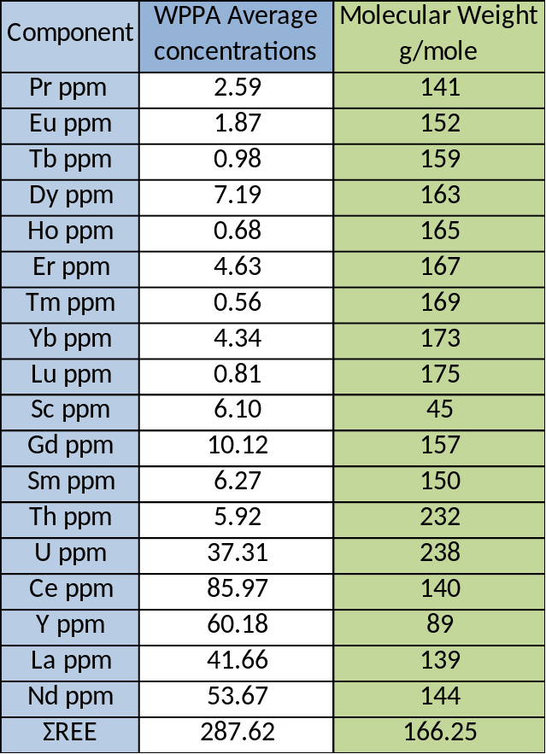
Table A2. Molecular Weight Table of Individual Species in Clay. Including Overall REE Molecular Weight Average.

Appendix B: Uranium and Thorium Guidelines
Design Steps
Uranium and Thorium was primarily ignored throughout most of the process design steps due to the complications and indecisiveness of how to approach government limits. It was suggested by reviewers (made up of FIPR, Idaho and ORNL representatives) that the Uranium and Thorium would be removed through a TDP solvent extraction system. It remains to be seen whether it would be possible for simultaneous removal of Uranium and Thorium from the process stream and the rest of the REEs in our already existing Mixer Settler System. It may be feasible to have a three-stage solvent extraction system beginning with our Neutral Ligand which would remove our REEs from the process stream along with our Uranium and Thorium, then followed up by and intermediary mixer-settler system that would remove the Uranium and Thorium from the stream via another solvent (organic or aqueous phases yet to determine, in our estimation a more selective organic phase might be needed). Finally, this system would be followed up with the stripping section that would strip our REEs from the organic phase via most likely water. We believe this design, if possible, would add the fewest unit op steps between the removal of Uranium and Thorium and simply ignoring its existence.
Further analysis of Uranium and Thorium was performed on the request of Professor Counce. It was found that in the solvent extraction system Thorium is completely extracted and recovered, while Uranium is thankfully only recovered on a level of around 40%. This sadly does not meet regulations for Uranium and Thorium content as given by the government. The amount of recovered radioactive elements reaches nearly 20,000 kilograms per year.

Appendix C: Total Capital Cost of Unit Operations

Table C1: Data table for unit operation design
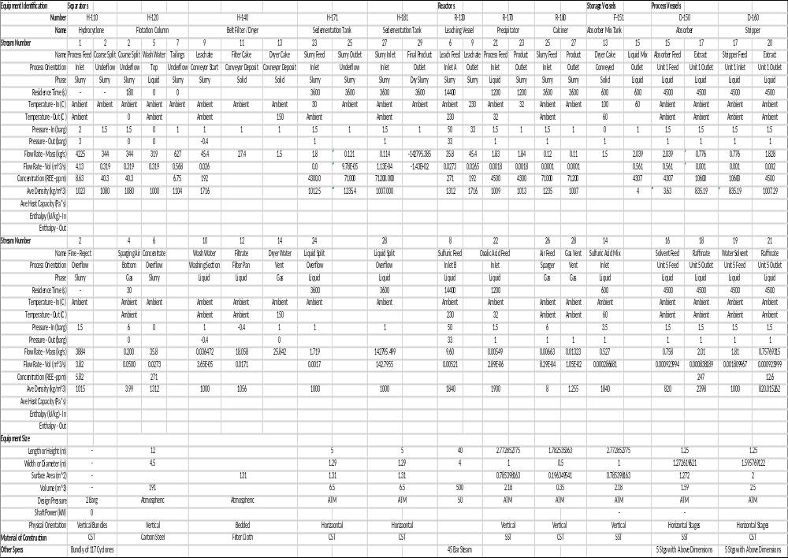
Hydrocyclone
$$C_{p}=\$185,000*{\left(\frac{Feed Slurry Rate}{546\frac{L}{S}}\right)}^{0.6}=\$631,469.20$$
Floatation Vessel Calculations
Superficial Air Flow is calculated as follows:
$$J_{G }=\frac{P_{c}*J_{G}^{*}*\ln\left[\frac{P_{t}}{P_{c}}\right]}{P_{t}-P_{c}}=\left[\frac{101325*2.2*\ln\left[\frac{199425}{101325}\right]}{199425-101325}\right]=3.15\frac{cm}{s}$$
$$Air Flow= \frac{J_{G}*\frac{A}{100}*P}{R*T*(Mol per Vol. of Air)}=\frac{3.15*\left(\frac{15.9}{100}\right)*150375}{8.314*300*40.46}= 0.17 std\frac{m^{3}}{s}$$
Wash Water Flow Rate is calculated as follows:
$$E_{C}=\frac{J_{c}}{J_{c}+J_{G}^{*}}=\frac{2}{2+2.2}=0.476$$
$$J_{w}=\frac{E_{c}*J_{G}^{*}}{1-E_{c}}+J_{B}= \frac{0.476+2.2}{1-0.476}+0=2\frac{cm}{s}$$
$Water Rate=\frac{J_{W}}{100}*A=\frac{2}{100}*15.9=0.318\frac{m^{3}}{s}$
Total manufacturing costs are calculated as follows:
$$C_{BM}=C_{p}F_{BM}=\left[\$90,936*\left(\frac{558.6}{400}\right)\right]*4.2=\$533,366.92$$
$$C_{BM}\left(Seives\right)=C_{p}F_{BM}N=\left[\$10,000*\left(\frac{558.6}{400}\right)\right]*6.6*2=\$184,338.00$$
$${Total C}_{BM}= C_{BM}+C_{BM} \left(Sieves\right)=\$533,366.92+\$184,338.00=\$717,704.92$$

Leaching Vessel Calculations
Volume of the vessel required by fluid:
$$Total Volume= \sum{\frac{m_{i}}{ρ_{i}}=500 m^{3}}$$
Steam Cost
$$m_{steam}=\frac{mc_p ∆T of leachate}{∆H of steam}$$

Refer to Table 2.7
Total manufacturing costs are calculated as follows:
$$C_{BM}=C_{p}F_{BM}=\left[\$200,000.00*\left(\frac{558.6}{400}\right)\right]*61.5=\$17,176,950.00$$

Filtration System (Sedimentation Tank)
Total manufacturing costs are calculated as follows:
$$C_{BM}=C_{p}F_{BM}=\left[\$400,000.00*\left(\frac{558.6}{400}\right)\right]*3.6=\$2,010,960.00$$
2 filters, therefore
$$2* C_{BM}=2* \$2,010,960.00=\$4,021,920.00$$
Absorber
Kremser Equation
$$\frac{y_{n+1}-y_{1}}{y_{n+1}-{Kx}_{0}}=\frac{A^{n+1}-A}{A^{n+1}-1}$$
Note: n and V are iterated to get 95% Recovery
$$Absorbtion Factor \left(A\right)=\frac{L}{KV}$$
$$Distribution coefficient (K)$$
Calculating Recovery
$$Recovery= \frac{y_{1}V}{x_{0}L}$$
$$Total Recovery= \frac{\sum{{Recovery}_{i}*n_{i}}}{n}$$
Constrained
$$0,1<\frac{L}{V}\left(Volume\right)<1$$

Total manufacturing costs are calculated as follows:
$$C_{BM}=C_{p}F_{BM}=\left[\$24,500.00*\left(\frac{558.6}{400}\right)\right]*1.0=\$34,214.25$$

Stripper
Kremser Equation
$$\frac{y_{n+1}-y_{1}}{y_{n+1}-{Kx}_{0}}=\frac{A^{n+1}-A}{A^{n+1}-1}$$
Note: n and V are iterated to get 99% Recovery
$$Absorbtion Factor \left(A\right)=\frac{L}{KV}$$
$$Distribution coefficient (K)$$
Calculating Recovery
$$Recovery= \frac{y_{1}V}{x_{0}L}$$
$$Total Recovery= \frac{\sum{{Recovery}_{i}*n_{i}}}{n}$$
Constrained
$$0,1<\frac{L}{V}\left(Volume\right)<1$$

Total manufacturing costs are calculated as follows:
$$C_{BM}=C_{p}F_{BM}=\left[\$37,900.00*\left(\frac{558.6}{400}\right)\right]*1.0=\$52,927.35$$

Precipitator
Total manufacturing costs are calculated as follows:
$$C_{BM}=C_{p}F_{BM}=\left[\$8,400*\left(\frac{558.6}{400}\right)\right]*4.2=\$49,268.52$$
$$C_{BM}\left(Agitator\right)=C_{p}F_{BM}=\left[\$19,000*\left(\frac{558.6}{400}\right)\right]*2=\$53,067.00$$
$${Total C}_{BM}= C_{BM}+C_{BM} \left(Agitator\right)=\$49,268.52+\$53,067.00=\$102,335.52$$

Calciner
Total manufacturing costs are calculated as follows:
$$C_{BM}=C_{p}F_{BM}=\left[\$4,000*\left(\frac{558.6}{400}\right)\right]*4.2=\$5,586.00$$
$$C_{BM}\left(Seives\right)=C_{p}F_{BM}N=\left[\$700*\left(\frac{558.6}{400}\right)\right]*6.6*2=\$6,451.00$$
$${Total C}_{BM}= C_{BM}+C_{BM} \left(Sieves\right)=\$5,586.00+\$6,451.00=\$12,037.00$$

