Cherokee Architectural Traditions:
A Southeastern Environmental Design Precedent

Josie Tunnell
UNHO 498: Honors Capstone Project
Gregor Kalas
May 13, 2022

INTRODUCTION
With rolling smoky, blue mountains and waterways teeming with life, the Southeastern United States is a place of great natural beauty. Great Smoky Mountains National Park holds the title of most visited National Park through its captivating wonder of the vegetation, animals, geography, and atmosphere that draws people to these mountains in the states of Tennessee and North Carolina. This park is just a portion of the original territory of the Cherokee Nation that stretched along the Southeastern Appalachian Mountains and Great Appalachian Valley. Today with communities located across the continent, particularly in Oklahoma and North Carolina, the cultural traditions of the Cherokee Nation can be traced to this region of the Southeast.
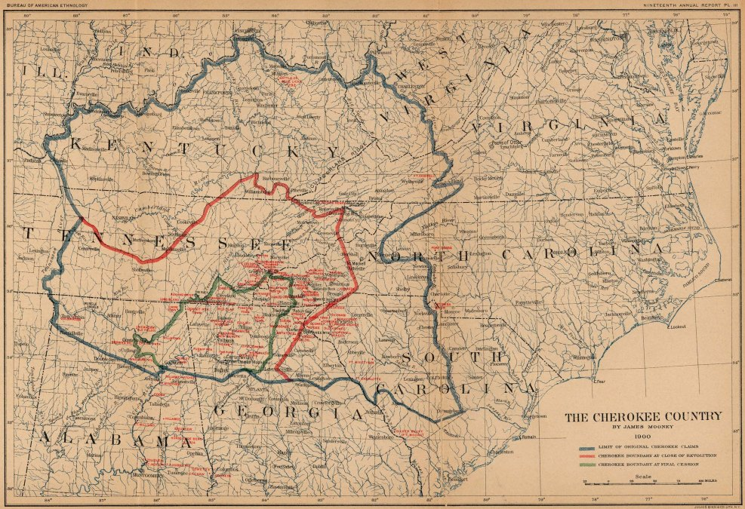Fig. 1 The Cherokee Country showing the original Cherokee claims when the British arrived, at the end of the Revolutionary war, and the boundary at final cession (Map by James Mooney, 1900, Jacobs)
The mountains they cultivated, the waterways they nurtured, and the forests they hunted are full of biodiversity due to the sustainable and nature-centric practices that they practice. This culture interwoven with the landscape flourishes with the flora and fauna found in the Southeastern United States. “[The Cherokee] are connected to all living things in their world, from the four-legged beasts to the plants” (Museum of the Cherokee Indian). The Smoky Mountains would simply not be the natural attraction they are today without the Cherokee touch. The historic architecture of the Cherokee Nation also shares many of these environmental qualities. Traditional Cherokee architecture, specifically before forced removal to western territory, traces all the way back to the moundbuilders, responding to the Southeastern regional climate with unique programs, site sensitive construction techniques, passive design strategies and local materials. Through the understanding of Cherokee structures and techniques, contemporary designers can begin to imagine low-impact, environmentally responsive designs that utilize the traditional Cherokee architectural knowledge inherently tied to the landscape.
MOUND BUILDERS
Before traditional Cherokee architecture emerged, in this region there was the dominant culture of the Mississippians. While there were many unidentified individual groups within this larger group, the Mississippians is the overarching terminology for this ancient civilization. Many aspects of Indigenous cultures succeeding the Mississippians in the Southeast draw from these people. In this era, the three sisters' agricultural companion planting regime of corn, beans, and squash grown in a mound configuration developed and is still used today by the Cherokee (Museum of the Cherokee Indian). Architectural traditions advanced as well alongside these agricultural ones. Monumental earthen mounds excavated from the rich soils of the region were established along major waterways and used for a variety of programs, such as burial sites and important elevated buildings. Rich in rainfall and river systems, the main mode of transportation in this region for the Indigenous people was the canoe, making earthen mounds situated along riverbanks a monument jutting out of the landscape as one paddles along the currents. Drawn in 1923, the map below documents these historic mounds through the clear relationship between the mound site and the transportation waterway.
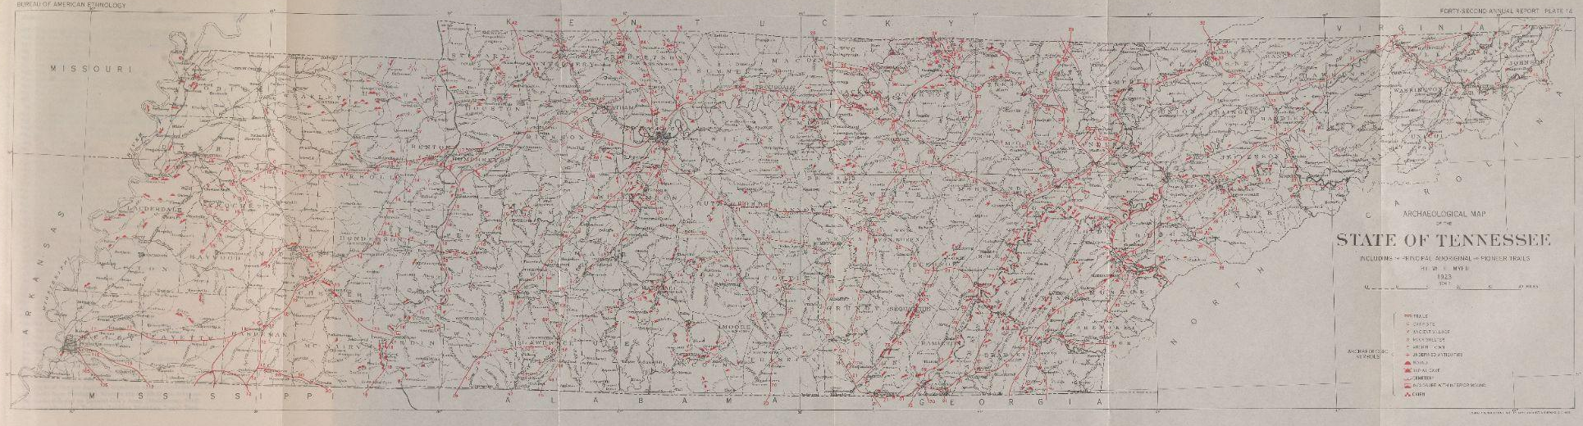
Figure 2 Indigenous Trails of the Southeast including mound sites (Map by William E. Myer, 1923)
An example of one of these mounds can be found on the University of Tennessee’s agricultural campus, located adjacent to the Tennessee River. Dating back to over a thousand years, this burial mound is an ovular form built intergenerationally by the Hamilton culture of eastern Tennessee, who lived in the Tennessee River watershed from 600 to 1000 AD (Creekmore). While time and natural elements have taken over the site today, the overall form is still intact and recognizable.
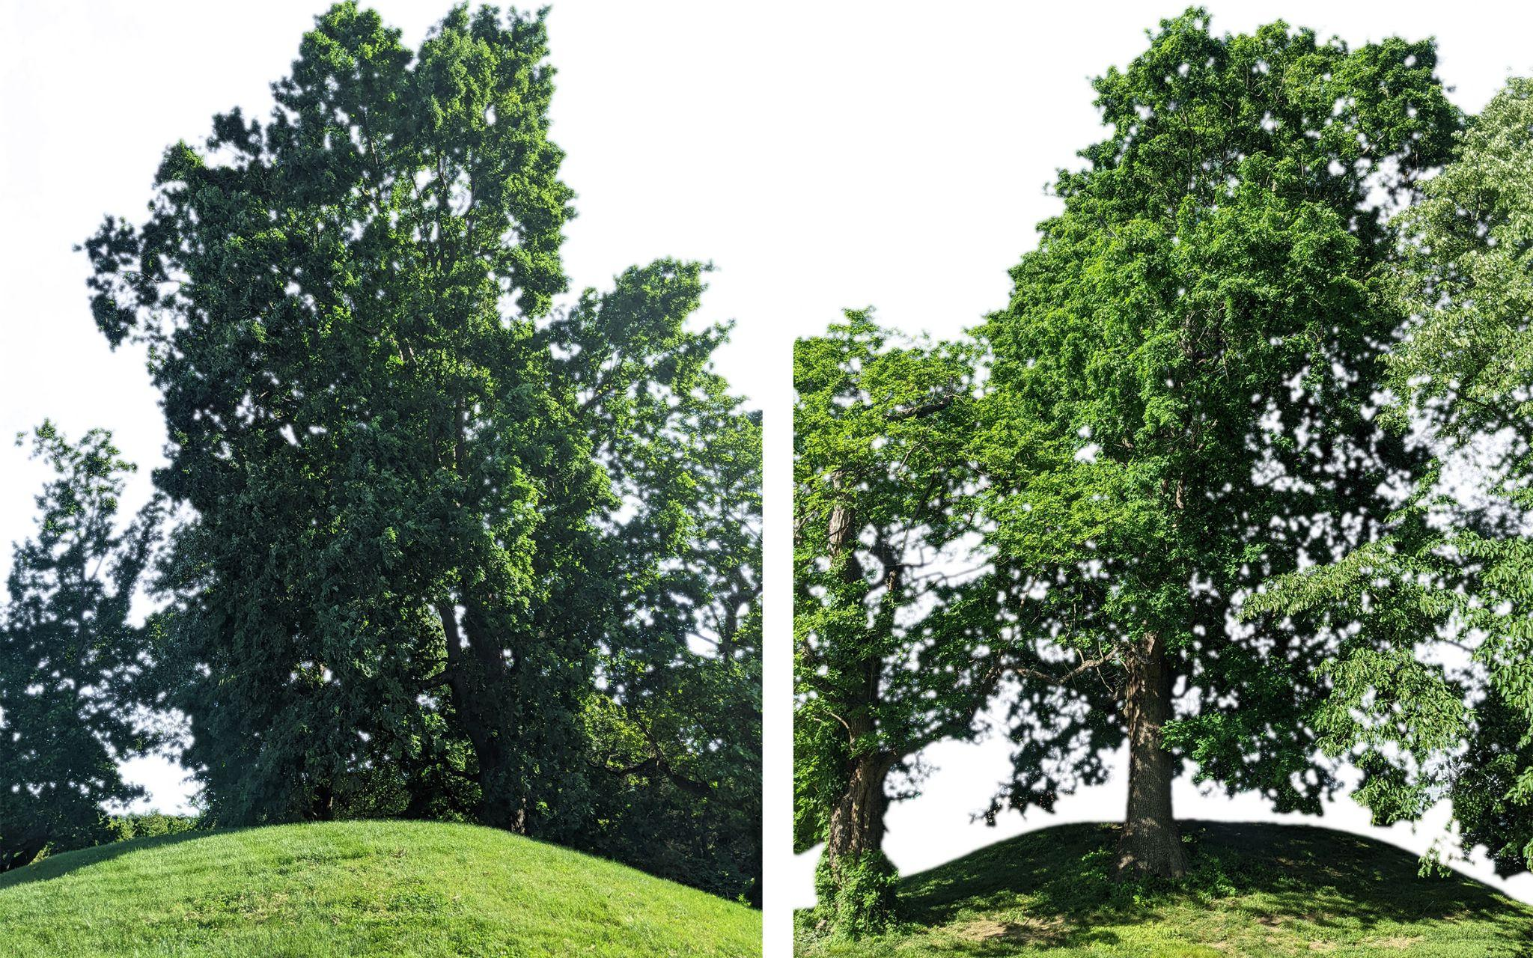
Fig. 3 “Indian Mound” found on the University of Tennessee’s agriculture campus (Photograph by Josie Tunnell, 2022).
From burial traditions to platform mounds, these structures were dug out of the earth, moved basket by basket, and shaped by the community in order to elevate the earth up towards the sky. Utilizing earth found on or near a mound site was economically feasible while being a malleable material. Structures placed on top of platform mounds utilized the local woodlands and canebrakes, weaving sapling and rivercane to create wall systems that were then covered with a mixture of mud and grass (Nabokov, 96). This technique is called wattle and daub and was also used later on by the Cherokee. The ancient predecessors of the Cherokee left distinct markers along the landscape that were later adopted and adapted for the Cherokee council lodges. Many of the techniques used on these sites evolved and shifted with the Cherokee as well, including earthwork and wood weaving techniques. From one Indigenous culture to another, the techniques of using the localized landscape of the Southeast and its many resources created a monumental architecture that is still visible today.
COUNCIL LODGES
The center of the riverside Cherokee communities was the council lodge. A place to pray, dance, sing, eat, talk, govern, celebrate, and deliberate, council lodges defined Cherokee culture. The council house was often in conjunction with a large, open-air plaza where these flexible spaces, both inside the lodge and outside in the plaza, allowed for a variety of programs and events. Visitors to the Cherokee, pre-removal, described these structures as “raised with wood, and covered with earth, and has all the appearance of a small mountain in the distance” (Cherokee Voices, 36).
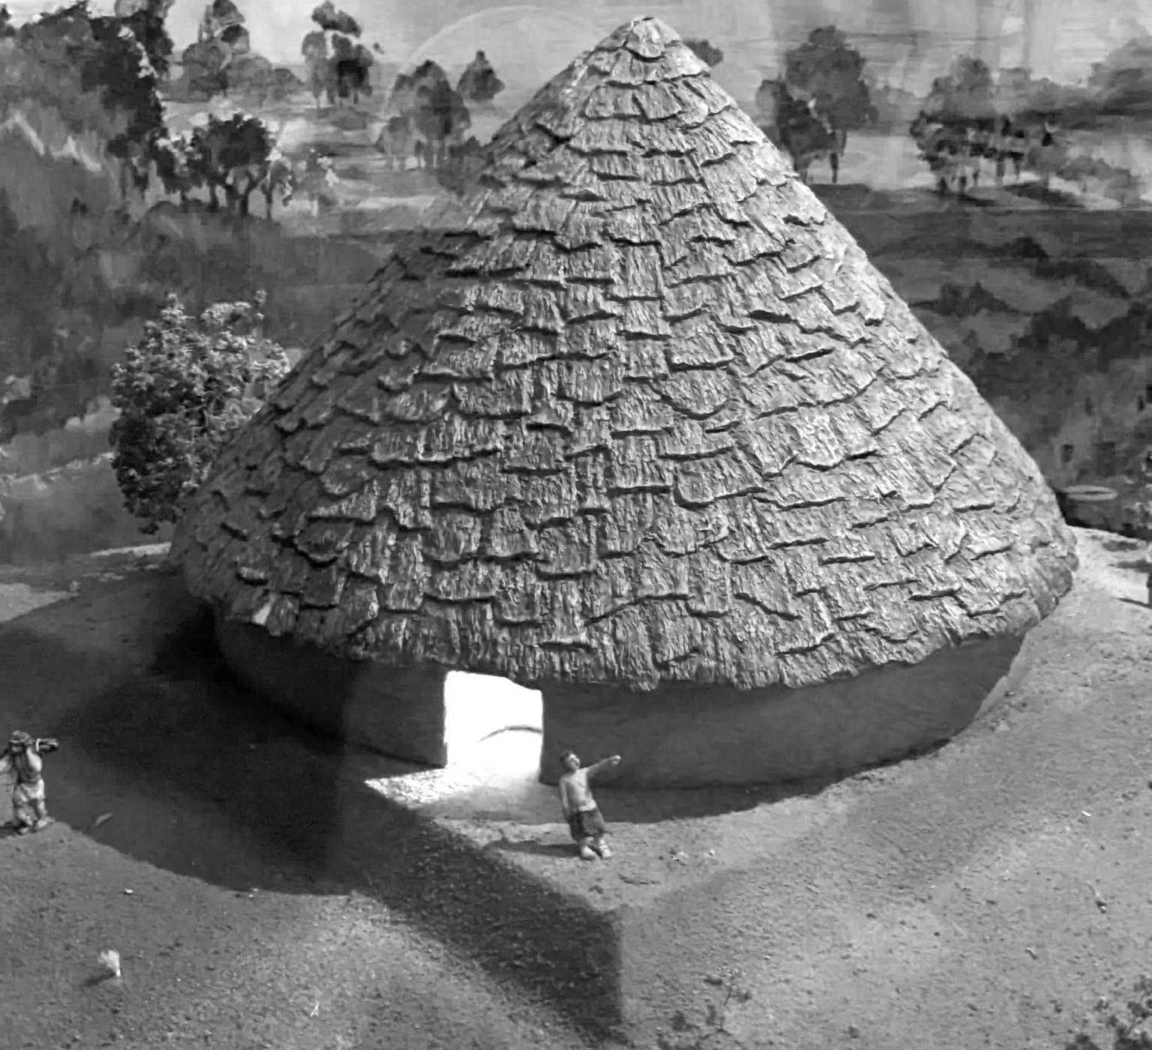
Fig. 4 council lodge mini model at the Museum of the Cherokee Indian (photograph by Josie Tunnell, 2022).
Here lies a parallel with the structures of the Mississippians, who also utilized wood and earth to elevate their architecture. The lifeblood of these communal homes lies in the embers of the central fire, providing warmth and light into the dark space. “From ancient times, fire was maintained in the center of their temples. In later times, the Sacred Fire burned in the center of the town house and in a circle drawn on the ground by dancers. So, to the Cherokees, the Sacred Fire is the living manifestation of the Great Spirit” (Museum of the Cherokee Indian). To contain and maintain this fire, there was only one circulation entry point and one ventilation exit point at the top of the conical roof assembly. With the capability to hold five hundred people inside, these timber framed structures had seven sides to indicate the seven Cherokee clans.
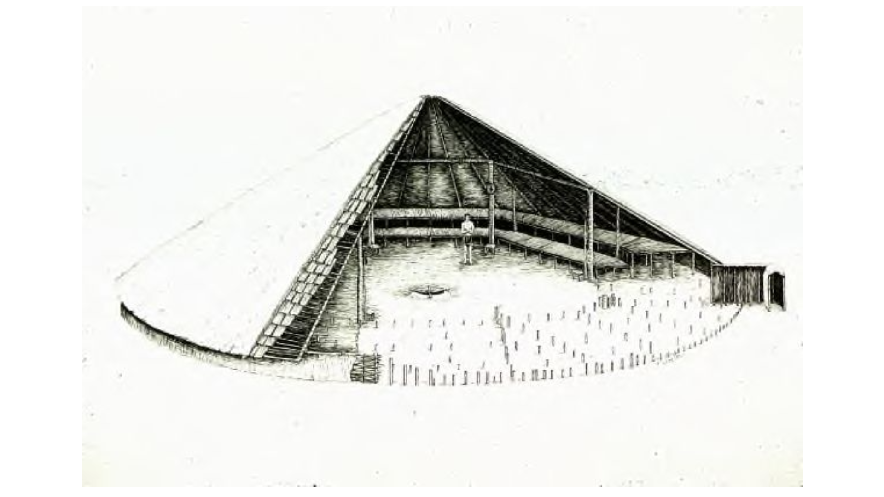
Fig. 5 Structural diagram of the Cherokee council lodge at Chota (drawing by Thomas Whyte).
The resulting circular form of these buildings reflects the democratic society of the Cherokee, creating equal ground for everyone who sat on the benches that lined the walls. As Cherokee leaders and members met to deliberate, the circular orientation did not have a hierarchy of one person over another, but rather a balanced, equal manner of providing everyone a chance to be heard and seen inside the space. This circular structure was achieved through large timber elements, notched into the seven posts, and interlocked until they reached a point at the pinnacle. All structural elements were constructed to fit perfectly together, interwoven without the use of nails or fasteners. Covered tightly with bark and packed with earth, the structures were rain tight and insulated to maintain an agreeable interior condition (Rozema, 54). The use of these wooden elements speaks to the forests that the Cherokee were surrounded by while architecturally allowing for the heat of the fire to be trapped within the space. Every element of the tree was utilized, the stripped trunk set the structure while the bark created the facade and shelter. Younger saplings and branches were woven together to create the walls that the earth excavated near the site then covered and solidified. Through expanding upon ancient architectural traditions and utilizing the surrounding ecosystems, the Cherokee composed the heart of their community through culturally reflective elements.
SEASONAL HOUSING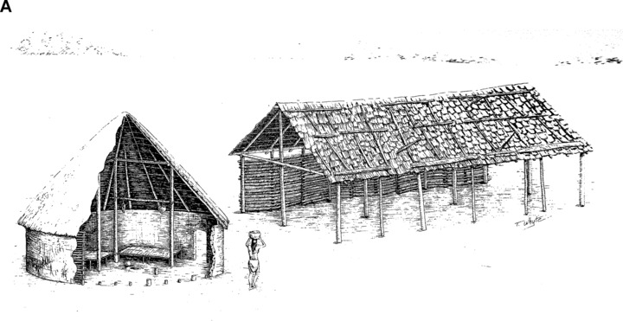
Fig. 6 Structural diagram of the winter hot home (left) and the summer home (right) (drawing by Thomas Whyte, 18th- Century Cherokee Homes at Chota-Tanase).
Just as the council house was rooted in the climate and conditions of the Appalachian Valley and Mountains region, so too are the traditional Cherokee residential buildings. The original Cherokee territory resides in the Eastern Temperate Forest ecological region of North America. This climate is characterized by hot, humid summers and cool, mild winters. To adapt to these temporal shifts in the environment, living conditions shifted from one season to another. The town of Cowe was visited in the 1770’s by William Bartram who described the residential structure occupied in the summers with “the materials consisting of logs or trunks of trees, stripped of their bark, notched at their ends, fixed one upon another, afterwards plastered well, both inside and out, with clay well-tempered with dry grass, and the whole covered or roofed with the bark of the chestnut tree or long broad shingles” (Rozema, 53). The wattle and daub plastering technique, visible in both summer and winter structures, allows for a flexible form making material that insulates well and utilizes the local soils such as clay as an easily applicable facade finish. The summer structures were often open-air, with mats hung on certain sides to block prevailing winds and the intense summer sun. This exposure allows for cross ventilation to move through the space as a natural cooling system, while the structure still blocked out unwanted sunlight and precipitation that are intense in the summer months.

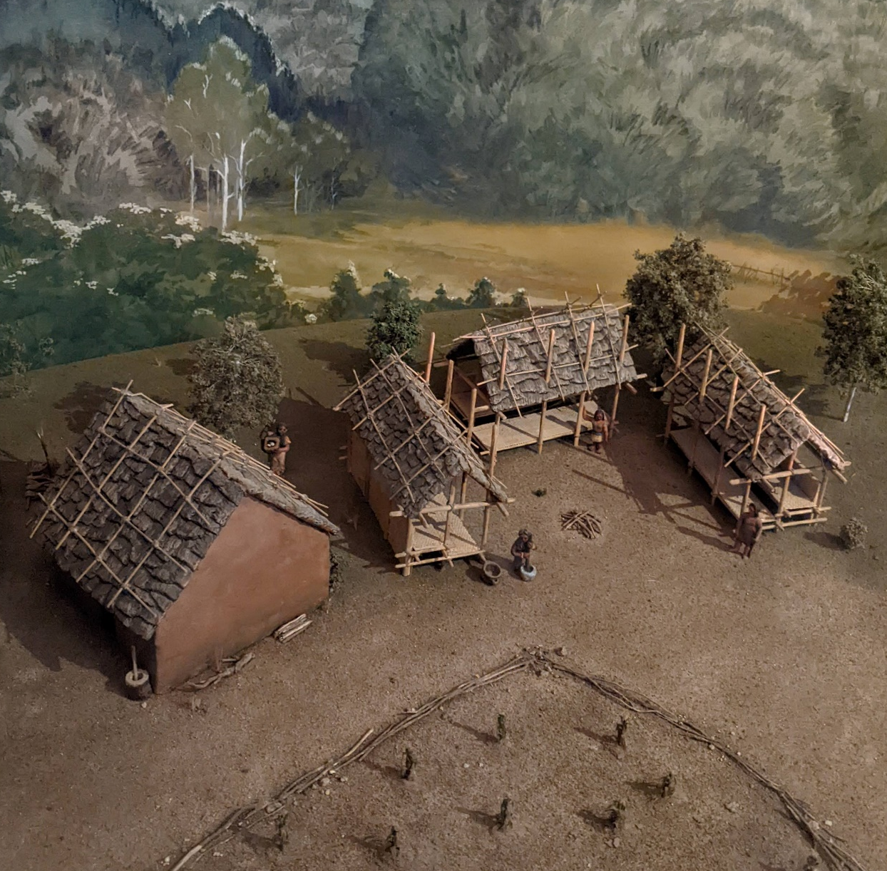
Fig. 7 Cherokee homestead mini model at the Museum of the Cherokee Indian showing the summer structures (Photograph by Josie Tunnell, 2022).
The winter homes, known as asi, took the opposite approach to passive heating and cooling design. Rather than being open and airy like the summer pavilion, the hot house was dug into the ground, focusing on insulation and containing the heat inside the home (Perdue, 15). The stable temperatures of the ground provide warmth from below while the circular structure, quite similar to the council lodge, traps the heat of the central hearth. The homes were so efficient in maintaining a warm interior temperature that the family did not even need to wear winter clothes. These structures built for all seasons formed the Cherokee homesteads that were occupied by large families, with many generations sharing these spaces. The Cherokee residences have evolved with the changing social and economic conditions of the world around them. As the settlers witnessed the timber techniques of the Cherokee and other Indigenous groups, the log cabin became a common building type which the Cherokee also adopted, even bringing these architectural techniques for wooden homes to Oklahoma where part of the Cherokee Nation relocated. Shifting seasons brought about shifting living conditions, one being open while the other closed, as the Cherokee adapted and responded to the many changing conditions around them.
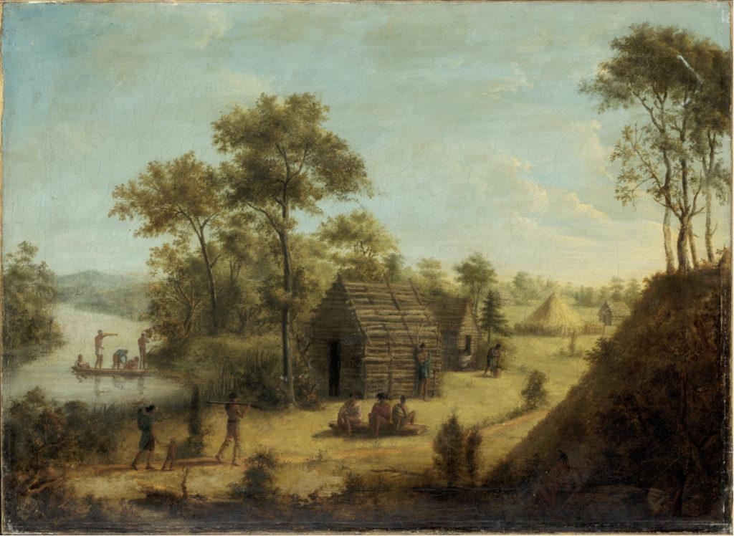
Fig. 8 Depiction of a traditional Cherokee village showing the log cabin residential structures and the council lodge in the distance, Antoine-Philippe d’Orléans, duc de Montpensier, oil on canvas, 1804 (Oil “View of Tokouo, Tennessee,” Rex Nan Kivell Collection, NK115; courtesy, National Library of Australia, Canberra).

MATERIALITY & STRUCTURE
The materiality of traditional Cherokee structures lies in the resources of the region. The wattle and daub techniques along with the heavy timber framing and wood finishes bring the landscape of the Cherokee straight into the house. Another interior material condition lies in an ancient weaving technique now visible in contemporary Cherokee basket weaving. Cherokee weaving techniques with the native bamboo grass, rivercane, can be traced back to 7500 BC (Museum of the Cherokee Indian). Double weaving baskets is a unique technique that makes the material waterproof. “One of the most difficult techniques of plaited basketry, the double weave requires the skillful weaving of one basket inside another, in one continuous weave of material” (Qualla Arts and Crafts). Eva Wolfe is one artist that aided in reviving this technique in the Qualla Boundary in the 1940’s. “Rivercane, one of the three materials used by Cherokees in their basket weaving, has always been the material that challenged me in making the many difficult designs that lend themselves to this material” (Qualla Arts and Crafts).
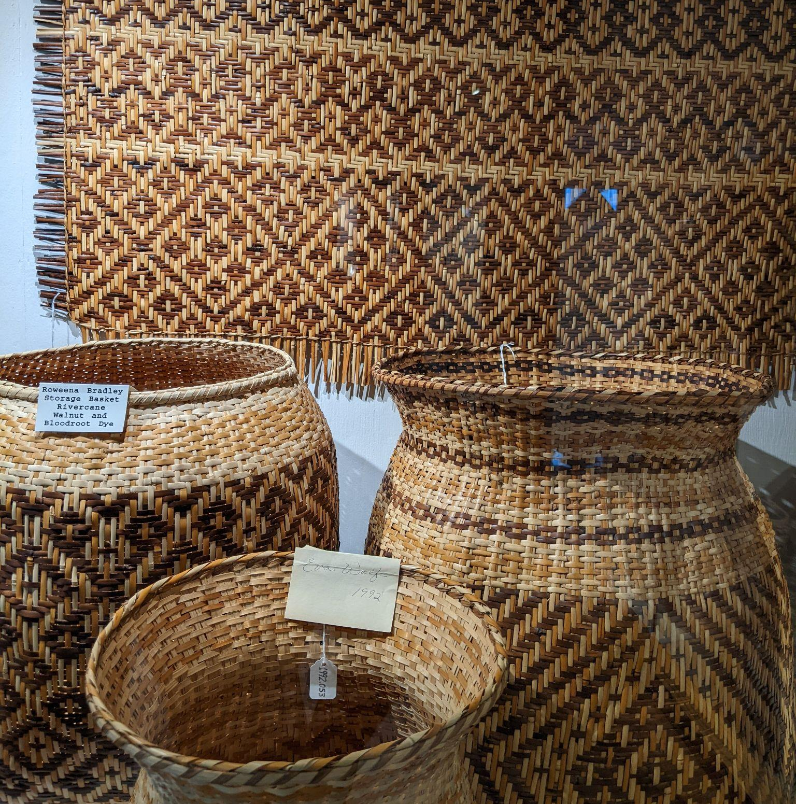
Figure 9 Qualla Arts and Crafts rivercane weaving exhibition showing woven mats and baskets (photograph by Josie Tunnell, 2022).
Rivercane is harvested, stripped, boiled, and dyed to produce cane strips which are woven together to form geometric patterns and a variety of shapes. While cane weaving is practiced today mostly for decorative baskets, weaving was applied all throughout the communities in traditional Cherokee structures. Not only was weaving baskets an integral part of Cherokee living, from serving dinner to storing goods, but these weaving techniques also contributed to the architecture. In visitor’s travel logs of the Cherokee, they “described a seven-sided council house and woven mats that were attached to the building’s framework. Mats made of split cane were placed on benches for seating” (Fariello, 14). Woven cane created an aesthetic, patterned wall and seating finish that was easy to clean, durable, comfortable and beautiful as patterns are easily incorporated into the material thanks to rivercane’s malleability. These interior finishes were due to an abundance of canebrakes that dominated Southeastern waterways, in which
Cherokee communities often established near. Canebrakes today only occupy 2% of the cover they used to before European colonization due to agricultural clearing, overgrazing, and the loss of the Indigenous cultures that respected and maintained these ecosystems. (Qualla Arts and Crafts). Without these ecosystems and Cherokee access to them, the river cane weaving techniques are endangered and the mats once covering entire walls are not achievable as they were previously. With a rich history steeped in generational knowledge passed down, rivercane weaving along with other natural textures defined the interior materiality of Cherokee structures.
CONCLUSION
Today, the United States is defined by a collection of state boundaries and often predominantly white populations that trace their lineage to the European settlers. The history taught in schools and generally accepted by the public often skews itself to towards white people and completely misses the rich traditions of the Indigenous people who were here first. In the Southeast, between the jurisdictions of Tennessee, North Carolina, Georgia, and Alabama, lies the original territory of the Cherokee Nation with a history that traces back to 11,000 BC. The architectural history of this region therefore does not begin with the barns and log cabins of the settlers but, rather the Indigenous architecture that utilized local materials with evolved techniques that responded directly to the climate here. The moundbuilders utilized movement of the earth to form monuments along the rivers and begin the traditions passed down to the Cherokee today. With an emphasis on communal gathering, the Cherokee council lodge frames itself with heavy timber and a central hearth to create an atmosphere of warmth. The residential structures display the attention to temporal shifts in the environment, as the open summer structures passively cool while the closed winter homes passively heat the family. The material choices of the Cherokee are paralleled with the ecosystems of the region, as woodlands and canebrakes are harvested and woven together to create wall systems and interior finishes. As the future of architectural design is one defined by the climate crisis, designers within the field must create structures that respond to the climate while utilizing local materials with a lower carbon footprint. Understanding the history of Indigenous design through the traditional structures of the Cherokee will allow designers to look to the past to solve issues of the future while giving credit to the original architects of this region.

Bibliography
“18th-Century Cherokee Townhouse at Chota-Tanasee.” Research Gate. Frank H. McClung Museum. Accessed May 13, 2022. https://www.researchgate.net/figure/5-The-18th-century-Cherokee-townhouse-at-Chota-Tanasee-site-a-Artists-reconstruction_fig7_264611947.
Creekmore, Betsey B. “Indian Mound.” Volopedia. University of Tennessee Libraries, October 8, 2018. https://volopedia.lib.utk.edu/entries/indian-mound/.
“Drawing Depicting a Cherokee Townhouse at Chota.” Digital Collections. University of Tennessee Libraries. Accessed April 17, 2022. https://digital.lib.utk.edu/collections/islandora/object/volvoices%3A4067.
Fariello, M. Anna. “The Cherokee.” Essay. In Cherokee Basketry: From the Hands of Our Elders, 14. Charleston, SC: History Press, 2009.
“Indian Trails of the Southeast, by William E. Myer.” Yale University Library. Accessed March 20, 2022. https://collections.library.yale.edu/catalog/12363218.
Jacobs, Frank. “Watch the Old Cherokee Country Vanish off the Map.” Big Think, July 23, 2010. https://bigthink.com/strange-maps/206-going-going-gone-the-old-cherokee-country/.
Lane, Rose Jenkins. “Restoring Rivercane for Cherokee Baskets.” Conserving Carolina, June 23, 2021. https://conservingcarolina.org/rivercane-restoration/.
“Museum of the Cherokee Indian.” Cherokee, NC: Museum of the Cherokee Indian, April 15, 2022.
Nabokov, Peter, and Robert Olney Easton. “Mound, Town, & Chickee: Southeast.” Essay. In Native American Architecture, 93–121. London, EN: Oxford University Press, 1990.
Perdue, Theda, and Frank Porter III. “The Principle People.” Essay. In The Cherokee, 13–25. New York & Philadelphia, NY & PA: Chelsea House Publishers, 1989.
“Qualla Arts and Crafts.” Cherokee, NC: Qualla Arts and Crafts, April 15, 2022.
Rozema, Vicki. Cherokee Voices: Early Accounts of Cherokee Life in the East. Winston-Salem, NC: John Blair, 2002.
Toplovich, Ann. “View of Toqua on the Little Tennessee River.” Tennessee Historical Society, September 25, 2017. https://tennesseehistory.org/view-toqua-little-tennessee-river/.

