University of Tennessee
Chancellors Honors Program
Undergraduate Thesis

Valuation and Value Drivers for US Based Airlines, an Analysis of an Industry

Ryan Caveney
Advisor: Dr. Phillip Daves
May 8, 2017

Introduction
The purpose of this paper is to analyze the US airline industry and provide an understanding of the industry itself, how companies in the industry are valued, and what the market assumes for their future potential.
Background
In a 1996 article titled “A Review of History, Structure, and Competition in the U.S. Airline Industry”, Gerald Cook describes the evolution of the airline industry from its origin after World War II through its maturity in the 1970s and through a fierce, competitive renascence after the Civil Aeronautics Board stopped regulating the industry and handed it over to the forces of the free market. Before 1978, US airlines were regulated by the CAB against “unfair or destructive competitive practices” who controlled everything from prices, routes, and entrants and exits to the industry. Ultimately, in attempts to grab market share, airlines began competing where they could by “increasing flight frequency, lowering seating density, and adding ever more extravagant in-flight service” which lead to poor performance, low load factors, and a push to deregulate the industry. With this move, airlines were finally able to compete on prices and operational efficiencies leading to many innovations including the hub and spoke route systems. The deregulation also led to many new entrants into the market, hoping to compete against established carriers. Economic difficulties in the 1980s resulted in consolidations and bankruptcies, placing nearly 80% of air passengers in the 8 largest airlines. Since then, industry knowledge and technological advances have led to more efficient pricing and ticketing policies, among other things. The paper concludes with a new market trend of the time, low cost carriers, about to shape the future of the industry.
Literature Review
“The Effect of Operation Performance and Focus on Profitability: A Longitudinal Study of the U.S. Airline Industry” is a study published in 2007 by Nikos Tsikriktsis that examines the effects of operational performance as well as the effects of quality of service on profitability for US airlines. Tsikriktsis used two operational indicators, the load factor to measure flight utilization and a fleet factor to measure the utilization of aircraft, as well as two quality indicators, late arrivals and lost baggage, to find effects on relative profitability as defined by operational profit/ operational revenue. To isolate the effects of operational performance and quality performance across the industry, he controlled for the 10 airlines in the study as well as the changes in airlines over time. He concluded that across the industry as a whole, improvements in both operational performance indicators were statistically significant and positive in predicting profitability, meaning increases in load factor and fleet factor are associated with increased profitability. In addition, late arrivals was also statistically significant and negative, meaning increases in late arrivals decreased profitability, but only at a 10% level. There were also differences between full service airlines and focused (low cost) airlines. For full service airlines, only the operational performance indicators, load factor and fleet factor, were significant and positive, and late arrivals was statistically significant and negative for focused airlines.
A 2010 paper by E. Suryani et al. published in Expert Systems with Applications 37 predicted air passenger demand for the purpose of developing policy related to runway and passenger terminal expansion. In forecasting air passenger demand, they concluded GDP growth and population to have positive impacts on demand and airfare impact and level of service have negative impacts on demand. They defined level of service in this study as the change of demand that results from a change in travel time times the time elasticity of demand. Due to the negative time elasticity of demand, an increase in this metric results in lower demand, and thus has a negative value in the analysis. This conclusion show airline demand is cyclical in nature, following typical economic cycles.
Despite demand being cyclical, Liehr et al. published a paper called Cycles in the sky: understanding and managing business cycles in the airline market in 2001 that shows the profitability cycles of airlines are impacted by endogenous factors. They show that several operational factors within the industry are main causes of the cyclicality of the industry and the exogenous factors such as GDP and population growth are only responsible for the amplitude of the cycles, not the cycles themselves. The first factor is aircraft ordering. In attempts to grow market share, airlines need to grow capacity; however with fluctuating market conditions, growing capacity can lead to capacity surpluses and thus lower margins. To manage this cycle, the authors suggest that “counter-cycle ordering yields several advantages for a single carrier…” and that “the objective is to ensure a quasi-continuous inflow and outflow of aircrafts, regardless of fluctuations in the market. This includes leasing over-capacities to other airlines”. In addition to aircraft ordering to manage the business cycle, the authors show that shifting capacities from areas of low demand to areas of high demand help to manage over-capacity. In conclusion, this paper shows that the business cycles observed in the airlines industry are caused by improper managing of demand and successful airlines can manage operational activities to smooth out cyclicality in profits.
S.Y. Abed et al. published a study in 2001 that was conducted to forecast air traffic demand in Saudi Arabia to advise regulatory agencies and airlines predict demand. Over the period of 1971 to 1994, they considered 16 independent variables as determinates of demand. They concluded that the best model to predict demand included population size and total expenditures, a figure very highly correlated with GDP that represents total expenditures, government and private, including investment expenditures.

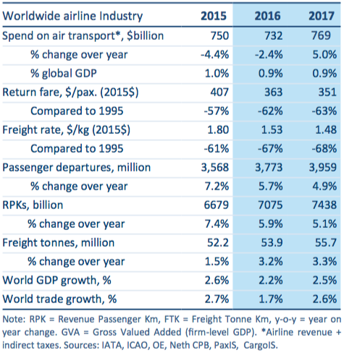
Industry Overview
© International Air Transport Association, 2015 . Economic Performance of the Airline industry. All Rights Reserved. Available on IATA Economics page.

The airline industry is a very large part of the global economy and helps facilitate economic growth and trade in its areas of operation. In 2015 and 2016, around 1% of global GDP was spent on air transportation, however the profitability and maturity of the industry depends greatly on the region, with North American operations accounting for about 60% of worldwide profits in 2016 as reported by the IATA (International Air Transportation Association). Additionally, airlines have been able to provide higher levels connectivity by nearly doubling the number of unique routes since 1995 while over the same period reducing the real transportation costs by over 50%. One of the airline industry’s largest expenditure, labor costs, saw an increase of 6.5% in 2016 to keep pace with growing capacities, however this is expected to slow in the next few years as indicated by a survey of CFO sentiment conducted by the IATA. This sentiment can also be observed in the ordering of new aircraft as they outpaced demand growth with fleet capacity growth in 2016, but this trend is expected to reverse in 2017.
The airline industry faces several large risks, including terrorism, effects of potential crashes, employee relations, heavy regulation by the FAA and DOT, foreign exchange fluctuations, weather, and overall economic risk. While these types are risks are found in many other industries, the airlines are especially susceptible to these. For example, after the terrorist attacks of 9/11, the industry saw an initial shock decline of 37.8% in demand and a lasting effect of 7.4% according to a 2005 paper by Harumi Itoa and Darin Lee.
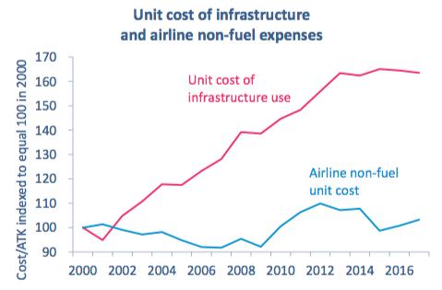
An additional risk for the airline industry is the cost of using infrastructure. This cost includes fees to airports to build and expand runways as well as to the FAA to support their operations regulating US airspace. However, because there is a lack of competition in this space, these costs have been rising steadily and are being passed onto consumers.
© International Air Transport Association, 2015 . Economic Performance of the Airline industry. All Rights Reserved. Available on IATA Economics page.

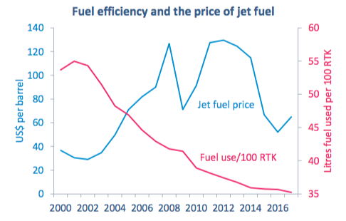
Another large risk in the airline industry is exposure to fuel prices. Depending on market conditions, fuel spend can account for 18%-30% of operating costs and presents a huge risk to airlines, especially when the markets are volatile. To address this risk, airlines often use futures contracts one, two, even three years into the future to hedge against rising fuel costs and can account for upward of 40% of fuel spend. Historically, the airlines have benefitted doing this, as the savings as a result of lower than market fuel prices more than compensated for the cost of the hedges themselves. From mid-2014 to mid-2016, however, the price of oil declined around 60%, causing many airlines to exit hedged positions at losses in the hundreds of millions of dollars. Seeing signs of stability in 2015 around $60 a barrel, some airlines entered into new hedges, only to see prices decline further.
© International Air Transport Association, 2015 . Economic Performance of the Airline industry. All Rights Reserved. Available on IATA Economics page.

The industry has been reducing their use of fuel, mostly through more fuel efficient aircraft replacing old airplanes. Newer aircraft are significantly more fuel efficient than older ones, and the industry has been improving fuel efficiencies 2.4% per year over the last 5 years. The rationale behind ordering new aircraft is also twofold. As Liehr suggested in 2001, increasing fleet capacity despite fluctuations in the underlying demand is crucial to staying ahead of competitors and increasing market share.
As previously mentioned, the strongest regional performance is in North America. Overall the revenue per passenger is falling, however margins are still strong thanks in part to lower regulatory costs than in other markets.
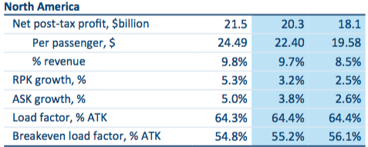
Aswath Damodaran, a professor of corporate finance at NYU Stern School of Business, identified 18 companies In the United States with operations in passenger air travel. Of these, seven are not traded on any major exchanges, one mainly contracts as a regional carrier for Delta, Alaska, and American, and one does not have operations that actually focus on air transportation. For the analysis in this paper, the industry will be defined by the remaining 9 airlines. The largest 4 of these companies, Delta, Southwest, American, and United control 85% of passenger market share and 88% of total revenues, so the analysis will focus on these 4 companies.
© International Air Transport Association, 2015 . Economic Performance of the Airline industry. All Rights Reserved. Available on IATA Economics page.

After deregulation of the airline industry at the end of the 1970s, the industry saw explosive growth in the number of carriers in the market; however since the economic hardships in the 1980s, airlines started to consolidate. This consolidation has served as a major source of growth for airlines. With the concentration of passengers and revenues skewed toward a small number of firms in the domestic market, it is uncertain if future consolidations will be a reliable source of domestic growth for the large airlines.
To understand how these companies are valued in light of the effectiveness of their operational and financial performance, I will compare valuation methods within each company and across the industry. I will use valuation multiples in addition to a discounted cash flow model, taking into account operational metrics and company initiatives, to arrive at these values. The two multiples I will use are Enterprise Value/EBITDA and Enterprise Value/EBIT. These two metrics value companies based on their operating profitability before taking into account the capital structures and differ with the effects of depreciation and amortization.
Assumptions common for all DCF models:
- Given the studies by S.Y. Abed et al. and E. Suryani et al., the long term growth rates for determining the terminal values are based on estimated long term GDP growth rates. The expected domestic growth rate as reported by tradingeconomics.com in 2020 is 2.6% and international GDP growth estimates are higher, at 3.6% in 2018 as reported by the International Monetary Fund’s World Economic Outlook report in January 2017. A combination of the domestic and international estimates are used for each company in proportion to their domestic/foreign exposure.
- The EIA projects Brent Crude oil prices to rise into the upper $50s by 2018 whereas tradingeconomics.com projects in the lower $50s in 2018 with a decline into the low $40s using only ARIMA models. Given ARIMA models weaknesses for projecting more than a few periods into the future and level of economic input used by the EIA, I anticipate rising jet fuel prices closer in line with EIA projections meaning jet fuel spot prices 10%-15% higher than current levels.
- Without additional knowledge, I will project other levels at their 3 year average or 2106 levels, whichever is appropriate.
For the analysis, I created a discounted cash flow model to value the companies. A discounted cash flow model derives the value by projecting revenues, expenses, capital expenditures, net working capital and other items into the future in order to calculate free cash flows and discount them at the company’s weighted average cost of capital. I will walk through the assumptions I made for Delta, and the same process extends to all 4 airlines.
The items that are needed to project free cash flows are the operating revenues and expenses, current assets, current liabilities, capital expenditures, and debt. Revenue accounts are projected using growth rates, depreciation and amortization is projected as a percent of capital expenditures, taxes are calculated as a percent of EBIT, accounts receivable are projected as days sales outstanding, and other accounts are projected as a percent of sales.
- Given Delta’s new antitrust immunized joint ventures in Europe, their existing antitrust immunized agreements in Asia, new joint ventures with Aeromexico and Korean Air, I expect Delta to grow passenger revenues at 2.5% in 2017, 3.5% in 2018-2019, and slow to 3% in 2020 and 2021. Given the assumptions above and the fact they receive about 30% of their revenues internationally, a long term growth rate of 2.9% is assumed for the constant growth beyond 2021.
- Salaries are Delta’s single largest expense, representing 25% of sales in 2016. Delta re-negotiated contracts with labor unions who represent around 80% of their employees and resulted in large raises for their employees. Because of this, I project salaries to remain at 25% of sales, over the 22% average for the past 3 years.
- Fuel expenditures are at a low as a percent of sales, declining from 29% in 2014 to 13% in 2016. With the sentiment that fuel prices will begin to rise in the future, I expect their fuel costs to rise 15% in 2019 and remain at those levels.
- I project net working capital levels as well as capital expenditure levels to remain at current levels, as the company did not highlight any specific initiatives that would change them. Currently, they are not accelerating the retirement of old aircraft and will continue to replace them at similar rates.
After projecting the relevant accounts, operating income is calculated. Taxes are then subtracted to arrive at net operating profit after taxes or NOPAT. Depreciation and amortization are then added back, as they are non-cash expenses that lower taxable income but do not represent a cash outflow. Finally, capital expenditures and change in net working capital are added back to calculate unlevered free cash flows. These cash flows represent the cash generated by the company after accounting for the operations of the business, capital expenditures and working capital required to maintain the business, and before any interest payments on debt. This means it is a representation of the cash generated for distribution to debt and equity investors and is important for investors to determine possible return on their investment.
In order to find the value of the enterprise, I discount the free cash flows at the company’s weighted average cost of capital. I assume that Delta is going to continue operating forever, but need to calculate a terminal value to their FCFs in order to actually discount these future cash flows. For this, I use a constant growth rate that projects the value of all future cash flows based on the last year of projections in my model, 2021. By adding the NPV of the FCFs to the NPV of the terminal value, I arrive at the enterprise value, or the total value of the firm. To find the equity value, I subtract total debt and add cash, then divide by the number of shares outstanding to arrive at the price per share. Because of the sensitivity of the DCF model to assumptions made in projecting free cash flow, a sensitivity analysis is created to test the effects of different long term growth rates and WACCs. This provides a range of values one could reasonably expect given the assumptions made.
I then compare this value to the value found using a multiples approach. EV/EBIT and EV/EDITDA provide a market based approach to value companies and are useful for comparing the value of companies over a range of multiples rather than just the industry average. EV/EBITDA serves as a standard valuation free of the effects of capital structure, taxes, and depreciation whereas EV/EBIT takes into account depreciation. Airlines have large capital expenditures, so accounting for the effects of that by using EV/EBIT together with EV/EBITDA should provide a better valuation. For the airlines, I calculated the average EV/EBITDA ratio to be 5.40 with a standard deviation of 0.74 and the average EV/EBIT ratio to be 7.28 with a standard deviation of 0.99, creating the ranges I will use to value them. The results of these valuations can be seen in the football field charts in the analysis section.

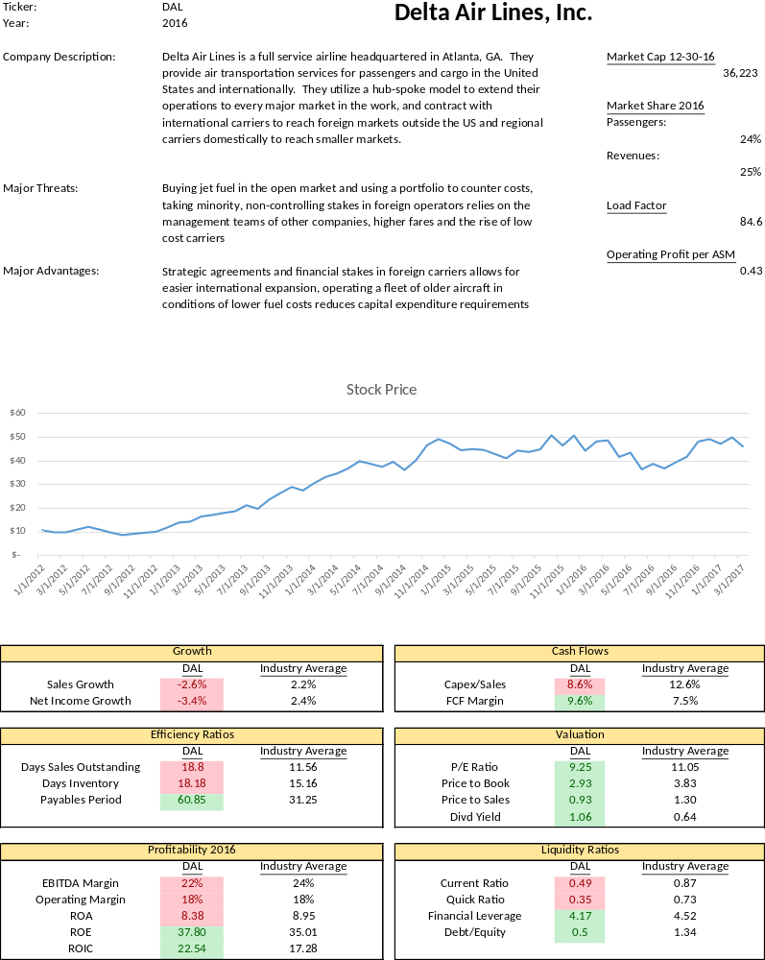
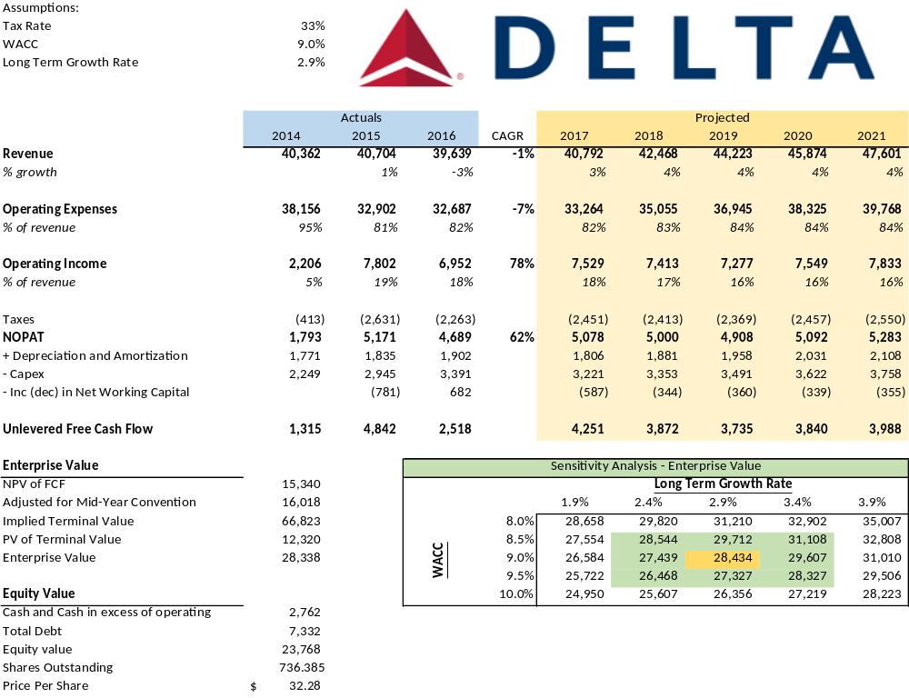
Assumptions for Delta DCF:
- With lower growth potential in the United States, Delta is focusing on foreign markets to provide growth. They have plans in 2017 to expand hubs in London, Paris, and Amsterdam, helped by the approval of an antitrust immunized joint venture with Virgin Atlantic in addition to expanding existing joint ventures with Air France-KLM and Alitalia. With antitrust immunity approval with Aeromexico, they plan to own 49% of Aeromexico’s stock and implement this plan in the second half of 2017. Asian growth is helped by partnerships with multiple Asian airlines and expanding stakes in China Eastern. Delta derives about 70% of revenues from domestic flight.
- Given Delta’s older fleet they continue to have non-fuel unit cost growth less than 2% however with less fuel efficient planes in a rising fuel price environment, I expect fuel costs to begin to rise again.
- Salaries will continue to rise, as Delta approved an 18% pay raise for pilots in 2016 in addition to a 14.5% increase in base pay to ground and flight crews as a part of their profit sharing plan.
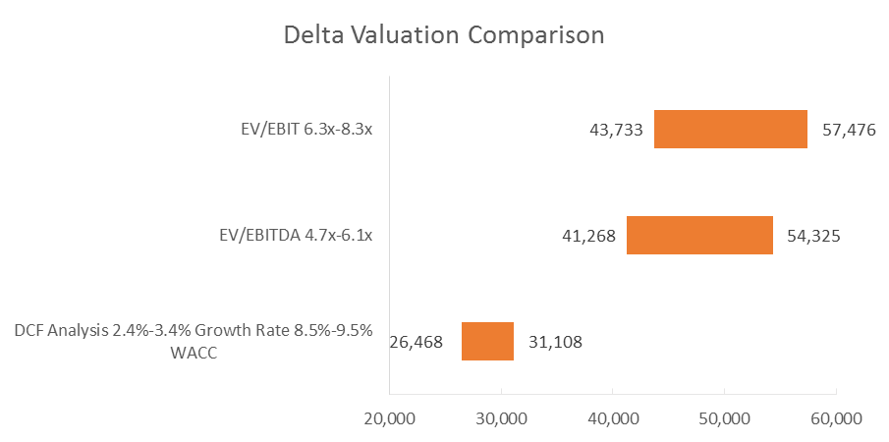
- I expect the tax rate to remain in line with 2016 levels, a decline from previous years as a result of global tax changes. They also have $5.9 billion in loss carryforwards which do not expire until 2027.

Current EV $40,306
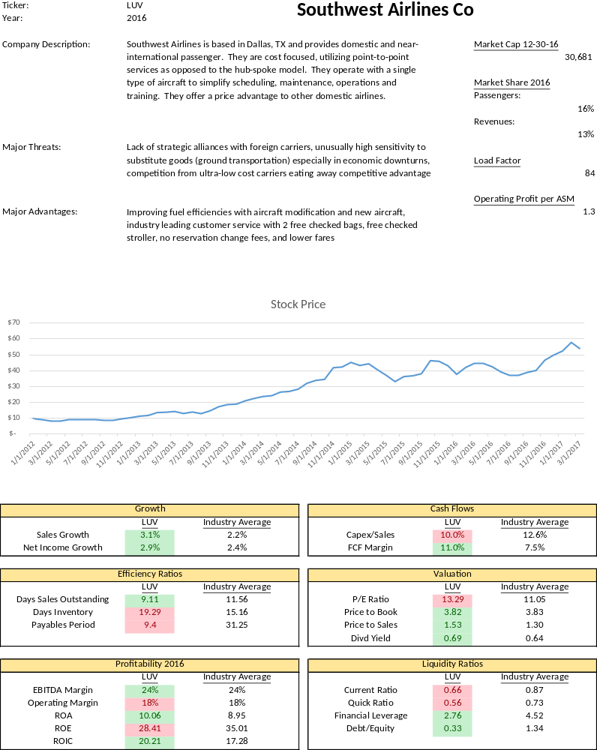
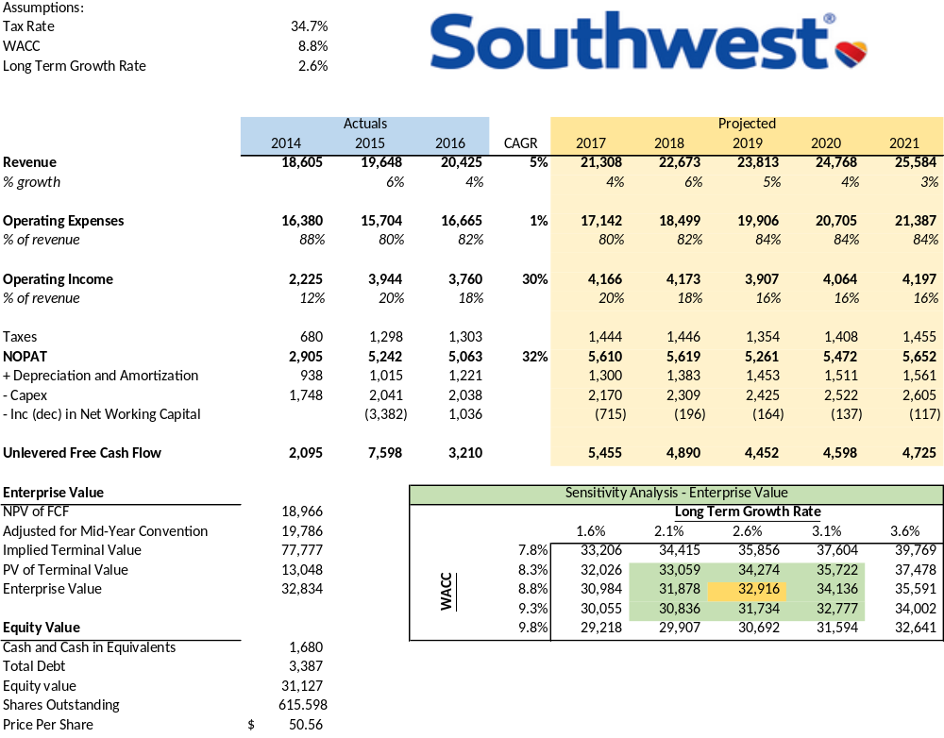
Assumptions for Southwest DCF:
- Implementation of new, fuel efficient aircraft will start in Q4 of 2017 reducing fuel costs by 20% over the existing airplanes. Even with expected rising fuel costs, this efficiency will help decrease fuel costs over time. They are reducing their use of fuel hedges as a result of huge losses, so with new fuel efficiencies and rising prices, I anticipate gradually increasing fuel costs
- Extended contracts with employee groups at higher levels, keeping salary level consistent with 2016 as these contracts extend until 2019-2022
- Freight demand is lagging, expect similar levels as 2016
- Other revenues grew as a result of agreements with Chase and early check in policies. Expected to continue to grow
- Maintenance costs are expect to remain flat in due to a combination of retiring old aircraft and increased fleet capacity
- Retiring aircraft leases will help keep rentals flat over the next 2 years
- Depreciation is expected as moderately higher levels due to accelerated depreciation of older aircraft and the receiving of new aircraft
- Nearly 100% of revenues from domestic flights
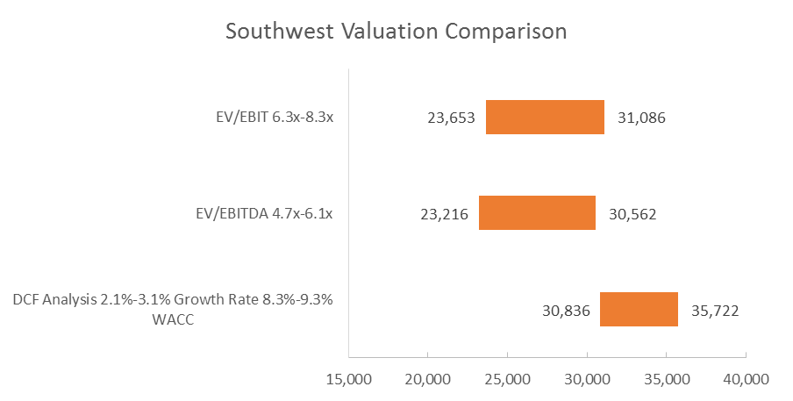
Current EV $31,378
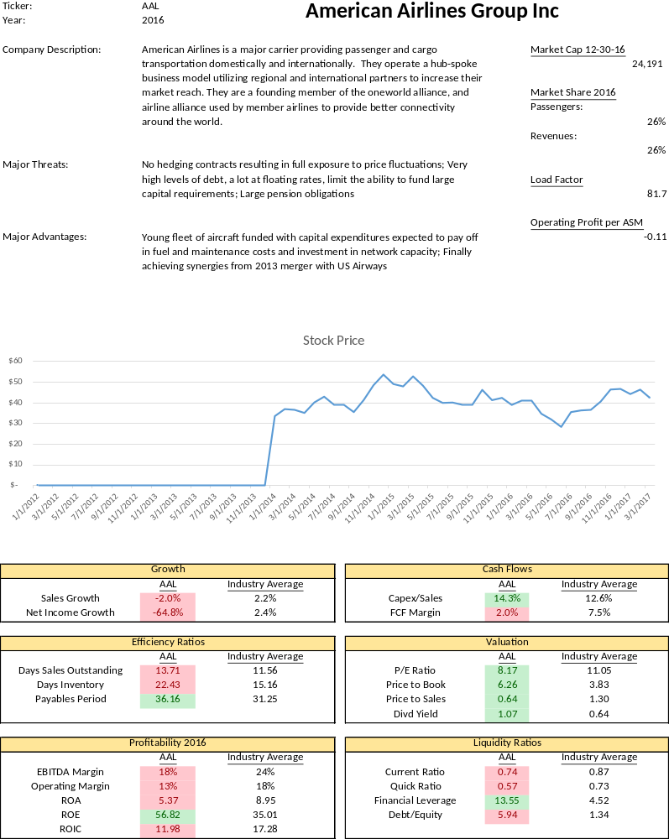
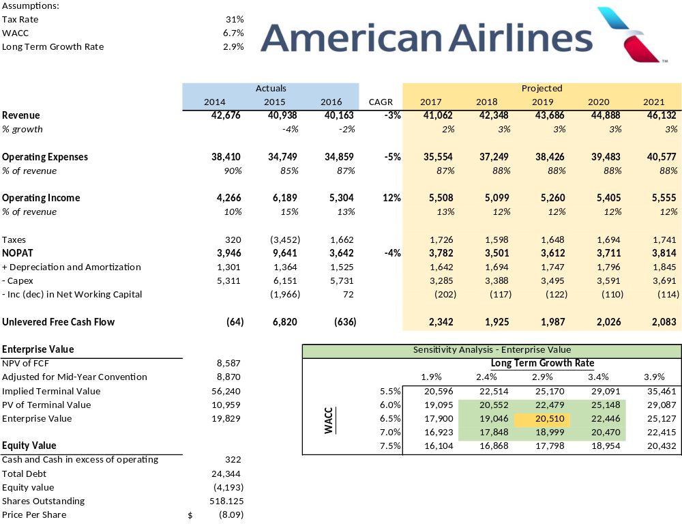
Assumptions for American Airlines DCF:
- Do not have outstanding fuel hedges, so I expect fuel costs to gradually increase
- Renegotiated contracts with employee groups in 2016, resulting in a 13.2% increase in salary and wages expenses, expected to remain high into the future
- Capital expenditures cannot continue to be supported at current levels. Financing with debt in 2016 alone raised $7.7 billion, bringing their total debt to around $24 billion. They also have contractual obligations hovering around $11 billion per year for the next 5 years. This puts significant limits on their ability to finance capital expenditures and requires very high levels of liquidity.
- Depreciation will remain at high levels as they implement their new aircraft in their fleet
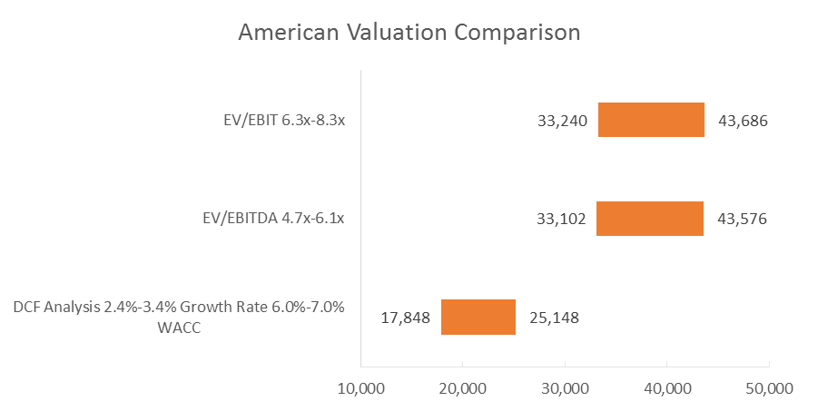
- 70% of revenues from domestic flights

Current EV $42,176

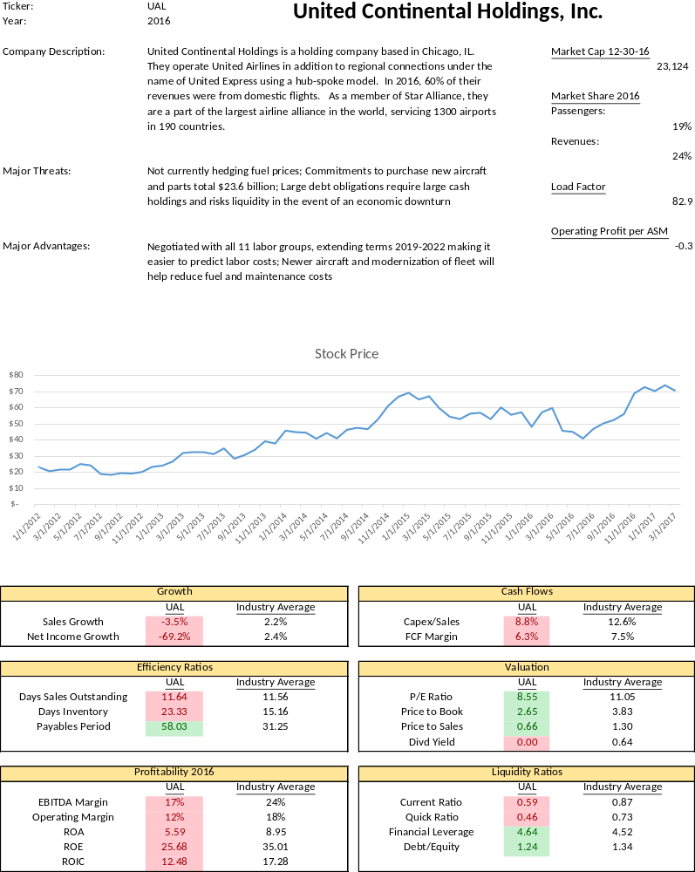
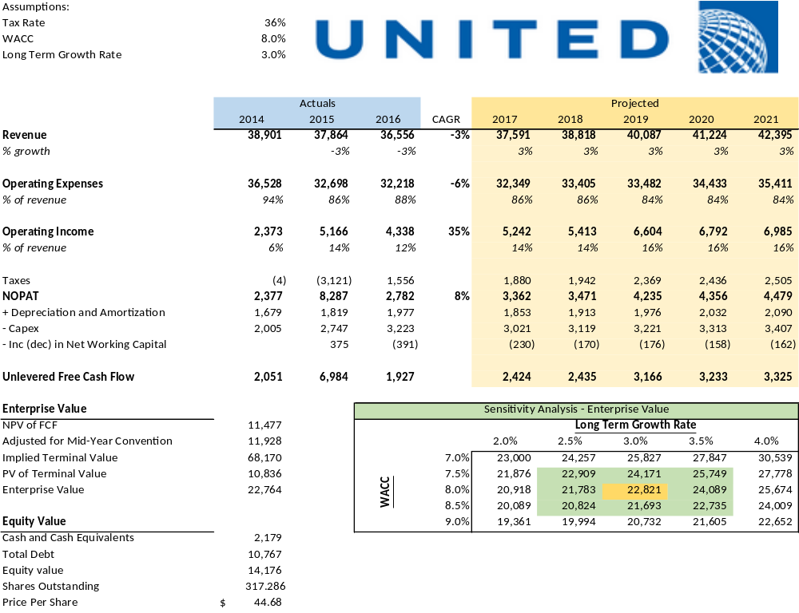
Assumptions for United DCF:
- United is increasing their fleet capacity faster than demand, so their load factor will decrease and their related expenses will rise similarly to 2016
- Given their sensitivity to fuel prices, a $1 change in the price of crude oil would have a $95 million impact on their fuel spend or 0.3% of 2016 fuel expenditures. This with the expectation of higher fuel prices, I will project fuel to grow moderately faster
- Renegotiated contracts with their employees will incur approximately $900 million of additional salary expenses in 2017
- A labor dispute at a port in 2015 increased demand for air cargo, so the trend downward in 2016 was affected by this
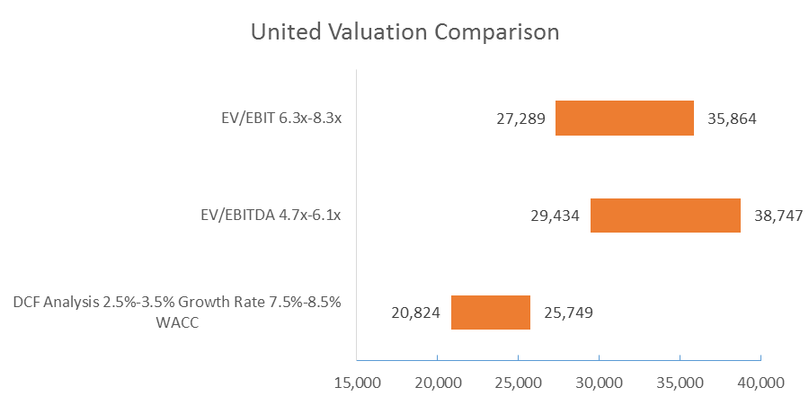

Current EV $30,329

Analysis of Results
As clearly seen in the football field charts comparing the different valuation methods, there is a lot of variability in the valuations provided by the different methods. Part of this variability stems from the nature of the airline industry itself, and the rest can be attributable to the operations of the individual companies.
Capital Structure - The airline industry requires constant, large capital expenditures to stay ahead of competition in areas of fuel efficiency, seats per plane, fleet capacity etc. and as a result, leaves less free cash flows for distribution to shareholders or to invest in the business. This means a lot of these costs are funded through the issuance of debt which can severely limit an airline’s ability to continue to borrow while also needing to maintain large levels of liquidity, reducing potential return for investors. This is seen in American Airlines, as they currently have almost 50% of their capital structure financed with debt and about $8.8 billion in availability liquidity. In addition, just to service this debt fully, they have about $28 billion of outstanding contractual obligations. All of this puts enormous pressure on airlines to properly balance increasing capacity, maximizing load factors, and improving margins to attract investors.
Major Risks - One factor that is hurting airlines’ financial performance is the labor unions. Across all of the major airlines, about 80% of the employees are represented by unions, and in 2016, most unions renegotiated contracts that provided double digit percent increases in salaries, and in the case of Delta, an 18% increase for their pilots. The Railway Labor Act gives airline employees the right to collectively bargain, so it is not legal for airlines to forcibly break up unions that exist, but these increases in salaries are unsustainable and cause almost a billion dollar increase in expenses per year in the case of United. Because of this, I have projected salaries as a percent of sales to increase, causing margins to get tighter.
Another cost driver for airlines is fuel. Airlines are inherently dependent on buying fuel but recently have been exposed to fluctuations in fuel prices. With oil prices stabilizing and expecting to rise moderately in the future, airlines need to reevaluate their policies around fuel hedging and adopt policies to help smooth out the effects. In recent years, fuel hedging has cost hundreds of millions of dollars in losses due to falling fuel prices, but stopping fuel hedging programs is shortsighted. As a result, I have also projected fuel expenditures to increase as a percent of sales, further reducing margins of these airlines.
Value Driver - The main driver of value in a DCF model is sales growth. These airlines operate in a very competitive and mature environment, meaning domestic growth beyond overall economic growth occurs by capturing market share from competitors. This is the primary strategy for Southwest, as they have very limited international exposure and have to distinguish themselves to do this. The other airlines are looking to international markets and joint ventures to drive top line revenue growth. Given the risks the airlines laid out for these ventures and the declining revenues of the past few years, I did not anticipate this foreign growth to drive growth at rates that support their current market values.
Market Comparison - It is apparent the market is more optimistic about the outlook for airlines then I have been. Except for Southwest, the value I found for the other three airlines using a DCF model undershot the value found in the market substantially. In order for the value of the DCF to increase, either revenue growth needs to increase, margins need to increase, or capital expenditures need to decrease. In the case of Delta, the market valuation can be achieved using a long term growth rate of 6%, an increase in operating margin by reducing fuel and salary spend to 3 year lows, or by decreasing capital expenditures by 50%. I cannot support any of these assumptions as the market conditions simply do not exist to support that level of growth, the cost reductions, or the decreased investment in new equipment.
Two things the market is pricing into Delta’s and other’s stock is increased ROIC provided by increasing dividends and share repurchase programs. Because of these programs, ROIC was higher than WACC in 2014 for the first time since the 1980s. ROIC is expected to slowly decline over the next few years as share repurchase programs are scaled back, however this return of capital to investors may explain the higher prices seen in the market.
Additional Valuation Methods – In order to get a more complete sense of the markets’ expectations of airlines, Enterprise Value/EBITDA and EV/EBIT are used as valuation multiples. The major difference here is that EV/EBIT takes into account the depreciation whereas EV/EBITDA does not. This is more important when comparing companies across industries where the capital expenditures and in turn depreciation are very different. In comparing companies within an industry, one should expect these metrics to provide similar estimates. Overall, these metrics serve as proxies for operating cash flows which is good for airlines, as their main source of liquidity is operating cash flows. A major concern using these metrics is the effect that items after EBIT play, mainly taxes. This is less of a concern here, as these airlines operate in similar tax environments, however foreign exposure should be taken into consideration.
In my analysis, the valuation of these airlines needs to incorporate aspects from all the DCF model, the EV/EBIT, and EV/EBITDA ratios. The enterprise value ratios here serve as a good long term indicator of where an airline should be valued based on current and historical industry norms. The DCF model adds in the complexities of the operations and initiatives of the individual companies to better value the capabilities of the firms. Due to slow overall growth and a shift in corporate policy toward increasing dividends, I see the value of airlines in the future is their ability to maintain and grow dividends while capturing international growth. This cannot occur without a constant focus on controlling costs, especially related to fuel and salary expenses.
Conclusion
The United States airline industry serves as a great example of the forces of the free market, the effects of government intervention, and the operation of a capital intensive industry. The deregulation of the industry, which according to supporters of government control would ruin the industry and drive prices so high the industry would no longer serve in the best public interest, provides a great before and after effect that makes a strong case for the free market. The number of locations serviced by airlines is at an all-time high, the price of an average trip is at an all-time low, and service standards continue to improve as customers come to expect more for what they pay.
Despite all this, investors have been wary of investing in airlines as the risks associated with the operations of an airline have not historically been matched with appropriate levels of return. In 2014 airlines finally broke through and provided an ROIC above their WACC thus attracting investors and driving value. As seen in the analysis, the industry is burdened with heavy capital expenditures which reduce the valuation provided by a discounted cash flow model. To match the value provided by these models to the valuation seen in the markets, revenue growth would reach levels that are not possible (around 6%), margins would need to increase beyond what is possible (by decreasing fuel and salary expenses), or capital expenditures would need to be severally reduced (a 50% reduction) which would be detrimental in the long run operations of the business.
EV/EBITDA and EV/EBIT are additional tools used to value airlines based on historic industry averages. These ratios provided estimates that more closely matched current market values, however they do not take into account the additional information provided by projecting individual line items like in a DCF. For these reasons, Delta, American, and United are overvalued as they do not have strong growth outlooks to support their current valuations. The operating model of Southwest should allow for additional market share in the US, supporting a higher valuation in the face of slower growth.
Other further research that would help develop a better understanding of the valuation of airlines would include non-standard metrics. One such metric would be cash from operations – capex – borrowing. This metric should show the generation of cash from the core operations of the business including effects of financing and reinvestment in assets. Finally, another distinction that could be made is separating the industry by classification of full-service airline or low cost airline. With the differing operational strategies employed by these differing airlines, their valuations should have factors unique to the class that could make for more accurate valuations.

Works Cited
Cook, G. N. (1996). A Review of History, Structure, and Competition in the U.S. Airline Industry. Journal of Aviation/Aerospace Education & Research, 7(1). Retrieved from http://commons.erau.edu/jaaer/vol7/iss1/1
Tsikriktsis, N. (2007). The Effect of Operation Performance and Focus on Profitability: A Longitudinal Study of the U.S. Airline Industry. Manufacturing & Service Operations Management. Retrieved from https://www.researchgate.net/publication/220391436_The_Effect_of_Operation_Performance_and_Focus_on_Profitability_A_Longitudinal_Study_of_the_US_Airline_Industry
Erma Suryania, Shuo-Yan Choua, Chih-Hsien Chenb (2010) Air passenger demand forecasting and passenger terminal capacity expansion: A system dynamics framework. Expert Systems with Applications, Volume 37, Issue 3, 15 March 2010, Pages 2324–2339, Retrieved from http://www.sciencedirect.com/science/article/pii/S0957417409007076?np=y&npKey=d3eb95be668018ee8dd682406de5d6ddb43c5c4a4b5c20ea130498d0ad2ca5da
Liehr, M. et al. (2001). Cycles in the sky: understanding and managing business cycles in the airline market. System Dynamics Review, Volume 17, Number 4, Retrieved from http://onlinelibrary.wiley.com/doi/10.1002/sdr.226/epdf
Seraj, Y. A., Abdullah, O. B., & Sajjad, M. J. (2001). An econometric analysis of international air travel demand in Saudi Arabia. Journal of Air Transport Management, 7, 143–148. https://www.researchgate.net/publication/222830860_An_econometric_analysis_of_international_air_travel_demand_in_Saudi_Arabia
Harumi Itoa, Darin Lee (2005). Assessing the impact of the September 11 terrorist attacks on US airline demand. Journal of Economics and Business, Volume 57, Issue 1 January-February 2005, Pages 75-95, http://www.sciencedirect.com/science/article/pii/S0148619504000700?np=y&npKey=3de26ec54a411d625ebf28daa2f387de6b5396ac14dffa9b6c7d158e4ce5367a
Air Travel Demand. IATA Economics Briefing No 9 (2008) www.iata.org/publications/economic-briefings/air_travel_demand.pdf
“Airline hedges fuel rally in later dated oil prices” http://www.cnbc.com/2016/04/06/airline-hedges-fuel-rally-in-later-dated-oil-prices.html
Damodaran Online: http://pages.stern.nyu.edu/~adamodar/
http://ir.delta.com/stock-and-financial/sec-filings/
http://investors.southwest.com/financials/sec-filings
http://phx.corporate-ir.net/phoenix.zhtml?c=117098&p=irol-sec&secCat01.2_rs=1&secCat01.2_rc=10&seccat01.1_rs=21&seccat01.1_rc=10&control_selectgroup=Annual%20Filings
http://ir.united.com/financial-performance/sec-filings
http://www.tradingeconomics.com/forecast/gdp-annual-growth-rate
https://www.eia.gov/outlooks/steo/report/prices.cfm
http://www.tradingeconomics.com/commodity/brent-crude-oil/forecast
World Economic Outlook (WEO) Update, A Shifting Global Economic Landscape January 2017 https://www.imf.org/external/pubs/ft/weo/2017/update/01/

