HYPORHEIC ZONE HYDRODYNAMICS, BIOGEOCHEMISTRY, AND MICROBIAL COMMUNITY DISTRIBUTIONS FOR THE SAN SABA RIVER, TEXAS

A Thesis Presented for the
Master of Science
Degree
The University of Tennessee, Knoxville

Ethan G. Sweet
December 2023

ACKNOWLEDGEMENTS
I owe tremendous gratitude to many people for the achievement of my research and time spent here at UT. This project was funded by the U.S. Army Corps of Engineers’ Aquatic Nuisance Species Research Program’s focus on Next Generation Ecological Modeling. I thank my major advisor, Dr. Annette Engel, for providing me with this tremendous opportunity and serving as my guide throughout the process. Her supervision offered a wealth of knowledge, and exceptional academic resources that would not have been available in many other environments. Second, I extend my utmost appreciation to our laboratory manager, Audrey Paterson, for her time, patience, and assistance with nearly every aspect of this research project, and in particular, her expertise in instrument preparation and procedures. To the other members of my committee, Dr. Andrew Steen, and Dr. John Schwartz, I would like to thank them for their time, patience, advice, and, of course, capability in their respective fields. Furthermore, I must express my sincere appreciation to Hannah Rigoni who generously volunteered her own time in the field for this project, as well as the other members of my lab group, Allison Rogers, and John Fulginiti, who supported me by helping prepare field materials and various other aspects of this research. To my fellow EPS graduate students who supported me during my time here at UT, I cannot thank you enough. Also, I must credit my undergraduate advisor and friend, Dr. Jonathan Malzone, for preparing me for future research and continuous sound advice. Finally, I could not have completed this research without the constant support from my caring wife, Brittany Sweet, as well as my parents who have encouraged me to continue learning throughout my life.

ABSTRACT
The hyporheic zone (HZ) plays a crucial role in riparian ecosystems by providing essential habitat and contributing to biogeochemical cycling. Although microorganisms are known to control most of the biogeochemical processes occurring in the HZ, past investigations of microbial communities within the HZ have been limited in scope. This study examines changes in geochemical processes, associated microbial communities, and other environmental factors at large and small scales within the HZ of the San Saba River in Central Texas. Pool-riffle sequences spanned approximately 228.6 to 22.4 kilometers upstream from the confluence of the San Saba and Colorado Rivers. Up to five different Bou Rouch (BR) samplers were installed at each pool-riffle sequence to access the HZ. Aqueous physiochemistry and microbial community compositions were determined from river water and water extracted from the HZ. Discharge was determined at each location and hydraulic gradients and bedload permeability were measured. Six pool-and-riffle locations had gaining hydrological conditions, such that groundwater was discharging into the HZ, and five locations had losing conditions, meaning that river water was recharging the HZ. Geochemical indicators of microbial activity generally reflected gaining/losing conditions, and dissolved sulfide and methane concentrations were greater in gaining reaches. The HZ had higher microbial diversity compared to the river, but also more unclassified taxonomic groups, which suggested that the HZ may be a reservoir for novel taxa. Microbial diversity was also higher from gaining sites. Gammaproteobacteria, Actinobacteria, Bacteroidia, and Cyanobacteria were more prevalent under losing conditions, and Planctomycetes, Dehalococcoidia, Bdellovibrionia, Anaerolineae, and Omnitrophia were more prevalent from gaining conditions. Furthermore, post-hoc multivariate testing confirmed the effects of lithology, hydrologic conditions, and the location within the pool-riffle sequence and distance along the San Saba River on various geochemical parameters and microbial communities. This study enhances our understanding of the spatial and environmental drivers shaping microbial communities and geochemical processes in the HZ of the San Saba River. The findings emphasize the significance of both large and small-scale factors in shaping microbial diversity and community structure within this ecologically important aquatic zone.

TABLE OF CONTENTS

SECTION 1. INTRODUCTION 1
1.1 Background 1
1.2 Thesis Goals 2
1.3 Thesis Questions 4
SECTION 2. MATERIALS AND METHODS 5
2.1 Field Area 5
2.2 Field Sampling 10
2.2 Hydrogeology 13
2.3 Geochemical Analyses 13
2.4 DNA Extraction, 16S rRNA Gene Sequencing, and Analyses 15
2.5 Sequence Data Submission 16
2.6 Statistical Data Treatment and Analysis 16
SECTION 3. RESULTS 19
3.1 Hydrogeology 19
3.2 Geochemistry of the San Saba River and the Hyporheic Zone 27
3.3 Microbial Diversity 42
SECTION 4. DISCUSSION 72
4.1 Hydrologic Controls on Biogeochemical Processes and Microbial Diversity 72
4.2 Lithologic Controls on Biogeochemical Processes and Microbial Diversity 74
4.3 Distinct Hyporheic Zone Microbial Communities 75
SECTION 5. CONCLUSIONS & FUTURE HYPORHEIC ZONE RESEARCH 78
REFERENCES 81
APPENDICES 100
APPENDIX A 101
APPENDIX B 118
VITA 146

LIST OF TABLES
Table 2.1. Geologic descriptions of each pool-riffle sequence sampled. Adapted from Stoeser et al. (2005). 9
Table 2.2. Summary of expected relationships among microbial communities and geochemical variables under differing hydrologic conditions (modified from Newcomer et al., 2018). 18
Table 3.1. Measured discharge for selected pool-and-riffle sites for the San Saba River, central Texas, from June 2021. Site ID includes the distance (m) from confluence with the Colorado River. USGS = United States Geological Survey; LCRA = Lower Colorado River Authority. 24
Table 3.2. Distance between pool-riffle sites with hydrologic condition (gaining/losing) and change in discharge over the distance between sites. An asterisk (*) indicates that flow was obtained from a gauging station. 25
Table 3.3. Calculated hydraulic conductivity values (cm/sec) determined from the slug tests for each Bou Rouch (BR) sampler (Figure 3.3). Samplers that were missing slug test measurements could not be used for calculations and are left blank on the table. 26
Table 3.4. Horizontal hydraulic gradients calculated for selected pool-and-riffle locations from the San Saba River in June 2021. Values for each of the Bou Rouch (BR) sampler comparisons are the differences in water level between BR sites divided by the horizontal distance in meters between the samplers. Upwelling sites are indicated in light blue. Sites missing a BR sampler could not be used for calculations, which are left blank in the table. 28
Table 3.5. Measured vertical gradients calculated for selected pool-and-riffle locations from the San Saba River in June 2021. A higher water level inside a Bou Rouch (BR) sampler calculates to a negative gradient and water would be upwelling from the HZ. These upwelling sites are designated in light blue on the table. Samplers that were missing could not be used for calculations and are left blank on the table. 29
Table 3.6. Field-collected physiochemistry (pH, temperature, and conductivity) from Bou Rouch (BR) samplers and surface water (SW) samples collected from the San Saba River, Texas, in June 2021. Site names denote the distance (m) from the Colorado River confluence, listed from downstream to upstream. Not all locations had five BR samples. Rock types were interpreted from geological maps (Figure 2.3). Units for dissolved oxygen (DO), sulfide, and NH₃-N are in mmol/L. Units for dissolved CH₄ are in nmol/L. NM = not measured. BDL = below detection limit. 30
Table 3.7. Field-collected alkalinity, as bicarbonate (HCO₃⁻) concentration, and other major anion and cation concentrations from Bou Rouch (BR) samplers and surface water (SW) samples collected from the San Saba River, Texas, in June 2021. Not all locations had five BR samplers. Site names include distance (m) from the Colorado River, listed from downstream to upstream. See Section 2.3 for method details. Units are in mmol/L. C.B. = charge balance. NM = not measured. 35
Table 3.8. Non-purgeable organic carbon (NPOC), total nitrogen (TN), calculated C:N ratios, and CDOM fluorescence indices, including the fluorescence index (FI), humification index (HIX), and biological index (BIX) for surface water (SW) and Bou Rouch (BR) samplers in the San Saba River, Texas, from June 2021. Only BR1, BR3, and BR4 samples were analyzed to link with microbial data. NPOC and TN are reported in mg/L. 40
Table 3.9. Relative abundances for all samples with classified archaeal sequence reads. Rows shaded in gray represent taxa with ≥1% relative abundances. Uncl. = unclassified 51
Table 3.10. Relative abundances for all samples with classified archaeal sequence reads. Rows shaded in gray represent taxa with ≥1% relative abundances. Uncl. = unclassified 52
Table 3.11. Comparison of average relative abundances of dominant bacterial classes at >1% of all sequence reads in surface water or hyporheic zone (HZ) samples. Uncl. = Unclassified. 54
Table 3.12. Relative abundances of bacterial classes (representing >1% of all sequence reads) in HZ samples according to their hydrologic condition (i.e., losing or gaining). 56
Table 3.13. Enumeration and taxonomic profiling of co-occurring OTUs (Relative Abundance ≥1%) using get.coremicrobiome in MOTHUR. Note: Some OTUs lack confident genus-level classification; the closest available taxonomic designation was assigned. In cases of multiple unclassified OTUs sharing the same name, their OTU numbers are provided in parentheses. 63
Table A.1. One-way PERMANOVA p-values based on Euclidian similarity for discharge according to lithology with 9999 permutations (global F-value = 2.58, p-value 0.06). 113
Table A.2. Spearman’s rho correlations (lower-half) for hydrological parameters with supporting the p-values (upper-half). Shaded values are significantly significant. 113
Table A.3. One-way PERMANOVA p-values based on Euclidian similarity for discharge according to vertical hydraulic gradient with 9999 permutations Shaded values are significantly significant. (global F-value = 5.36, p-value 0.04). 113
Table A.4. One-way PERMANOVA p-values based on Euclidian similarity for hammered depth according to lithology with 9999 permutations (global F-value = 3.34, p-value 0.03). 113
Table A.5. One-way PERMANOVA p-values based on Euclidian similarity for pH and Bou Rouch (BR) sampler and surface water (SW) with 9999 permutations (global F-value = 3.33, p-value 0.03). 114
Table A.6. One-way PERMANOVA p-values based on Euclidian similarity for all pH values at each river location (listed in km) with 9999 permutations (global F-value = 4.86, p-value 0.001). 114
Table A.7. One-way PERMANOVA p-values based on Euclidian similarity for dissolved oxygen (DO) and Bou Rouch (BR) sampler and surface water (SW) with 9999 permutations (global F-value = 29.44, p-value 0.0001). 114
Table A.8. One-way PERMANOVA p-values based on Euclidian similarity for ammonia-nitrogen (NH₃-N) and Bou Rouch (BR) sampler and surface water (SW) with 9999 permutations (global F-value = 3.35, p-value 0.03). 115
Table A.9. One-way PERMANOVA p-values based on Euclidian similarity for sulfide and Bou Rouch (BR) sampler and surface water (SW) with 9999 permutations (global F-value = 2.42, p-value 0.07). 115
Table A.10. One-way PERMANOVA p-values based on Euclidian similarity for sulfide according to lithology with 9999 permutations (global F-value = 2.38, p-value 0.08). 115
Table A.11. One-way PERMANOVA p-values based on Euclidian similarity for sulfate at each river location (listed in km) with 9999 permutations (global F-value = 1.21, p-value 0.97). 116
Table A.12. One-way PERMANOVA p-value results based on Euclidian similarity for methane at each river location (listed in km) with 9999 permutations (global F-value = 2.51, p-value 0.03). 116
Table A.13. One-way PERMANOVA p-values based on Euclidian similarity for methane according to lithology with 9999 permutations (global F-value = 1.94, p-value 0.13). 116
Table A.14. Spearman’s rho correlations (lower-half) for nutrient geochemistry and calculated fluorescence indices, with supporting the p-values (upper-half). Shaded values are significantly significant. 117
Table A.15. One-way PERMANOVA p-values based on Euclidian similarity for bicarbonate values in the hyporheic zone (HZ) according to lithology with 9999 permutations (global F-value = 3.157, p-value 0.04). 117
Table A.16. One-way PERMANOVA p-values based on Euclidian similarity for bicarbonate values in surface water (SW) according to lithology with 9999 permutations (global F-value =0.54, p-value 0.63). 117
Table B.1. An example of the taxonomic identification of operational taxonomic units (OTUs) identified for all the samples, showing on four sample locations and only 20 OTUs. For each OTU, the number of sequence reads in the whole data set are counted (listed on the “Number of Reads” column), and the number of sequences per sample are noted separately. Taxonomic identification done using SILVA reference database. 121
Table B.2. One-way ANOSIM p-value results based on Bray-Curtis similarity for OTU-level diversity at each river location (listed in km) comparing all Bou Rouch samplers at a location and the surface water (SW) with 9999 permutations (R value = 0.51, p-value 0.0001). 122
Table B.3. Results of combined alpha-diversity indices for different hydrological conditions. 122
Table B.4. Uncorrected p-values obtained from a one-way ANOSIM analysis for alpha-diversity metrics. The analysis was conducted using Bray-Curtis similarity across hydrologic group (gaining or losing), specifically comparing all Bou Rouch sampler locations within the hyporheic zone. The statistical significance is determined using 9999 permutations. 123
Table B.5. Results of a three-way MANOVA test examining diversity indices concerning geology, hydrology (gaining or losing), and sample locations within the hydrologic zone (HZ). 123
Table B.6. One-way ANOSIM p-values for the “core” OTUs for Bou Rouch (BR) and surface water (SW) samples based on Bray-Curtis similarity with 9999 permutations (R value = 3.53, p-value = 0.004). 124
Table B.7. Statistical results of CCA plot scores for “core” OTUs and major geochemical and environmental parameters by sample locations in the hyporheic zone (HZ). Only axes that accounted for more than 1% of variation are shown. 125
Table B.8. Results of Indicator Species Analysis and sample location type (hyporheic zone or surface water). Unclassified OTUs are denoted by an asterisk (*), while uncultured OTUs are indicated by a double asterisk (**) 128
Table B.9. Results of Indicator Species Analysis and hydrologic condition (gaining or losing). Unclassified OTUs are denoted by an asterisk (*), while uncultured OTUs are indicated by a double asterisk (**). 131
Table B.10. Results of Indicator Species Analysis and hydrologic condition (upwelling or downwelling). Unclassified OTUs are denoted by an asterisk (*), while uncultured OTUs are indicated by a double asterisk (**). 136
Table B.11. Results of Indicator Species Analysis and sample location in pool-riffle sequences. “IndVal” is Indicator Value. Unclassified OTUs are denoted by an asterisk (*), while uncultured OTUs are indicated by a double asterisk (**) 141

LIST OF FIGURES
Figure 2.1. Location map of sample sites on the San Saba River, noting counties in Central Texas. Map from Esri, USGS. 6
Figure 2.2. Overlain digital elevation map of San Saba River, Texas, HUC-8 watershed area (black outline). Sample locations are noted with a red triangle and labelled “SS.” The number corresponds to the distance from the confluence of the San Saba with the Colorado River in kilometers (km), the last digit specifying a decimal point (e.g., SS02286 = 228.6 km). 7
Figure 2.3. Map showing major lithologic units outcropping at the surface and that underlie the San Saba River, Texas, HUC-8 watershed area (black outline). Colors correspond to standard stratigraphic convention (Stoeser et al., 2005). Sample locations are noted with a red triangle and labelled “SS.” The number corresponds to the distance from the confluence of the San Saba with the Colorado River in kilometers (km), the last digit specifying a decimal point (e.g., SS02286 = 228.6 km). 8
Figure 2.4. (A) An example of a pool-and-riffle sequence, with pool highlighted in yellow upstream, riffle highlighted in light blue, and downstream direction denoted by the red arrow. The Bou Rouch sampler “spike” is indicated by the dashed orange oval. (B) A schematic of the five intended Bou Rouch sampler (“spike”) sites within a pool-and-riffle location. (C) A cross-section of three Bou Rouch sampler arrangement used for this study, specifically BR1 (upstream), BR4 (in channel), and BR3 (downstream), at each HZ location. Black arrows indicate HZ water being drawn into a BR sampler, and the blue arrow indicates flow direction of river. 12
Figure 3.1. (A) A hydrograph from a USGS gauging station that measures San Saba River discharge at the town of Menard, Texas. Red boxes highlight the section of the hydrograph that corresponds to the days in June 2021, that specific locations were sampled, beginning with upstream locations. Note that discharge is reported in cubic feet per second. (B) A hydrograph from a USGS gauging station that measures San Saba River discharge at the town of San Saba, Texas. Red boxes highlight the section of the hydrograph that corresponds to the days that specific midstream and downstream locations were sampled. Note that discharge is reported in cubic feet per second. 20
Figure 3.2. San Saba River, Texas, discharge (m³/sec) measured at each site plotted as distance from the confluence with the Colorado River. Bars represent 5% error. 21
Figure 3.3. Recovery times from aquifer testing (slug tests) at each HZ location. Individual Bou Rouch (BR) sampler sites are indicated by blue-green lines, and water level recovery times (as determined from t₃₇) are indicated by a dashed red line. 22
Figure 3.4. Box plots of hydraulic conductivity for those sites where measurements could be made along the San Saba River. The average for all BR sampler locations is indicated by the blue horizontal line at 0.189 cm/s. See Table 3.3 for all values. 23
Figure 3.5. Dissolved sulfide and soluble-ammonia nitrogen concentrations by hydrologic condition. All values in mmol/L. Red indicates losing conditions, and blue indicates gaining conditions. 38
Figure 3.6. (A) XY plot of log-transformed values for non-purgeable organic carbon (NPOC) and total nitrogen (TN) from HZ samples. Bound regions in red indicate convex hulls for hydrologically losing sites, and blue-bound regions indicate convex hulls for hydrologically gaining sites. (B) General linear model (GLM) of NPOC and TN. 39
Figure 3.7. Piper diagram illustrating the hydrogeochemical composition of all sample locations in the San Saba River, Texas, during June 2021. The samples are categorized based on their respective hyporheic zone (HZ) sampler locations (BR) or surface water (SW) designation. 43
Figure 3.8. (A) Evaluation of potential sources for calcium and magnesium by plotting their sum against bicarbonate concentrations and after subtracting sulfate concentrations to account for potential contributions from gypsum dissolution. Data plot on or slightly below a 2:1 line (black line) representing two moles of bicarbonate for every one mole of cation attributed to carbonate dissolution. Excess bicarbonate could originate from microbial processes. (B) Carbonate, silicate, and evaporite rock dissolution account for increases in cation concentrations, but the waters plot consistent with carbonate dissolution. 44
Figure 3.9. Gibb’s Diagram for Bou Rouch (BR) samples and surface water (SW) from the San Saba River indicating only a few samples, those farthest downstream, had ion concentrations and total dissolved solids (TDS) values suggestive of evaporation. 45
Figure 3.10. (A) Bicarbonate and dissolved oxygen (DO) concentrations in Bou Rouch (BR) samples and surface water (SW) from the San Saba River, Texas. The data reveals an association between higher bicarbonate concentrations and low DO conditions. (B) Additionally, methane concentrations increase in the BR samples under low DO conditions, suggesting a potential link between bicarbonate and methane dynamics in these samples. 46
Figure 3.11. Relative abundances of dominant archaeal classes (>1% of the total archaeal sequence reads) in (A) surface water and (B) Bou Rouch (BR) samples, listed from left to right in the direction of upstream flow, respectively, for each pool-riffle location. 48
Figure 3.12. Stacked bar graph of relative sequence percentages of dominant bacterial classes (>1% of the total bacterial sequence reads) in surface water and HZ Bou Rouch (BR) samples, listed from left to right in the direction of upstream (BR1) to downstream (BR3) flow, respectively, and for each pool-riffle location. 49
Figure 3.13. Summary of relative abundances of bacterial classes that accounted for >1% of the bacterial sequence reads and combined remaining taxa for each Bou Rouch (BR) and surface water (SW) sampling locations for the San Saba River. 50
Figure 3.14. Dendrogram of Bray-Curtis similarity index values of dominant operational taxonomic units (OTUs) (>1% of the total sequence reads) for surface water (SW), modeled with unweighted pair group method with arithmetic mean (UPGMA) hierarchical clustering algorithm (cophenetic correlation = 0.92). The number at each node represents the bootstrap value for 999 estimations. Blue represents gaining conditions and red color represents losing conditions. Lithology is noted for each sample. 58
Figure 3.15. Dendrogram of Bray-Curtis similarity index values of dominant operational taxonomic units (OTUs) (>1% of the total sequence reads) for the hyporheic zone (HZ), modeled with unweighted pair group method with arithmetic mean (UPGMA) hierarchical clustering algorithm (cophenetic correlation = 0.97). The number at each node represents the bootstrap value for 999 estimations. Blue represents gaining conditions and red color represents losing conditions. Lithology is noted for each sample. 59
Figure 3.16. Stacked bar graph of relative sequence percentages of dominant (i.e., “core”) OTUs (>1% of the total sequence reads) in surface water (SW) and HZ Bou Rouch (BR) samples, listed from left to right in the direction of upstream (BR1) to downstream (BR3) flow, respectively, and for each pool-riffle location. 61
Figure 3.17. Changes in the relative abundances along the river of core operational taxonomic units (OTUs) comprising ≥1% of the total relative abundances of all samples for the hyporheic zone (HZ) and surface water (SW), as well as other OTUs (labelled “other”) constituting ≤1% of the total relative abundances from the HZ and SW. The blue shaded regions represent segments of the river characterized by net gaining conditions, and the red section denotes net losing segments. 62
Figure 3.18. (A) Canonical correspondence analysis (CCA) of the normalized relative abundances and major geochemical/environmental parameters along the San Saba River of “core” operational taxonomic units (OTUs) comprising ≥1% of the total relative abundances for only hyporheic zone (HZ) samples. (B) The same CCA showing OTU clustering. The triplot amplitude for both CCAs was set to 5 for better visualization. Axes 1 and 2 are shown; axes 3 to 11 accounted for increasingly smaller percentages of variation. Permutation tests did yield p-values below alpha. 67
Figure 3.19. Indicator Species Analysis (ISA) results for operational taxonomic units (OTUs) with relative abundance > 0.1% in surface water (SW) and hyporheic zone (HZ) samples collected from the San Saba River, Texas. Colored ellipses indicate significant indicator values (p-values < 0.05), with the scale representing the indicator value as a percentage. Lists of the ISA values for the OTUs are provided in Table B.8. 68
Figure 3.20. Indicator Species Analysis (ISA) results for hyporheic zone (HZ) operational taxonomic units (OTUs) with relative abundance > 0.1% across all samples, distinguished by hydrologic conditions in the San Saba River, Texas. Colored ellipses depict significant indicator values (p-values < 0.05), with the scale representing the indicator value as a percentage. Lists of the ISA values for the OTUs are provided in Table B.9. 69
Figure 3.21. Indicator Species Analysis (ISA) results for hyporheic zone (HZ) operational taxonomic units (OTUs) with relative abundance > 0.1%, grouped by hydrologic conditions in the San Saba River, Texas. Colored ellipses indicate statistically significant indicator values (p-values < 0.05), with the scale representing the indicator value as a percentage. Lists of the ISA values for the OTUs are provided in Table B.10. 70
Figure 3.22. Indicator Species Analysis (ISA) results for hyporheic zone (HZ) operational taxonomic units (OTUs) with relative abundance > 0.1%, grouped by Bou Rouch (BR) location or surface water (SW) in the San Saba River, Texas. Colored ellipses indicate statistically significant indicator values (p-values < 0.05), with the scale representing the indicator value as a percentage. Lists of the ISA values for the OTUs are provided in Table B.11. 71
Figure A.1. Changes in pH values for each Bou Rouch (BR) sampler and surface water (SW) samples along the river flow path and corresponding to major changes in lithology. Lithology symbols are noted for carbonate, shale, sandstone, and conglomerate rock types. (B) pH values for all spike samples by hydrological condition (gaining conditions in blue or losing conditions in red). 102
Figure A.2. (A) Changes in temperature values, in degrees Celsius, for each Bou Rouch (BR) sampler and surface water (SW) samples along the river flow path. (B) pH values for all spike samples by hydrological condition (gaining conditions in blue or losing conditions in red). 103
Figure A.3. Changes in specific conductance values for each Bou Rouch (BR) sampler and surface water (SW) samples along the river flow path. (B) Specific conductance values for all spike samples by hydrological condition (gaining conditions in blue or losing conditions in red). 104
Figure A.4. Changes for each Bou Rouch (BR) sampler and surface water (SW) samples along the flow path for (A) dissolved oxygen and (B) soluble ammonia-nitrogen concentrations. Values listed at zero on the graphs represent values below each of the respective detection limits. 105
Figure A.5. Split bar graphs arranged by hydrologic condition (i.e., losing versus gaining) and Bou Rouch (BR) samplers and surface water (SW) samples for (A) dissolved oxygen concentrations, (B) soluble ammonia-nitrogen concentrations, and (C) nitrate concentrations. Red indicates losing conditions, and blue indicates gaining conditions. Solid lines in the bards indicate 25% and 75% interquartile range and dashed lines indicate the median, and small black squares represent mean concentrations. 106
Figure A.6. Changes for each Bou Rouch (BR) sampler and surface water (SW) samples along the flow path for (A) sulfide and (B) sulfate concentrations. 107
Figure A.7. Split bar graphs arranged by hydrologic condition (i.e., losing versus gaining) and Bou Rouch (BR) samplers and surface water (SW) samples for (A) dissolved sulfide and (B) sulfate concentrations. Red indicates losing conditions, and blue indicates gaining conditions. Solid lines indicate 25% and 75% interquartile range and dashed lines indicate the median, and small black square represents mean concentrations. 108
Figure A.8. (A) Changes in methane concentrations for each Bou Rouch (BR) sampler and surface water (SW) samples along the flow path. The red dashed line indicates a projected equilibrium concentration of 2.8 nmol/L. (B) Split bar graphs of methane concentrations arranged by hydrologic condition (i.e., losing versus gaining) and BR spike. Blue indicates gaining conditions and red indicates losing conditions. Solid lines indicate 25% and 75% interquartile range and dashed line indicates median. Red dashed line indicates equilibrium concentration of 2.8 nmol/L. No methane measurements were taken from BR2 or BR5. 109
Figure A.9. Changes in non-purgeable organic carbon (NPOC) concentrations for each Bou Rouch (BR) sampler and surface water (SW) sample along the flow path. (B) Split bar graphs of NPOC concentrations arranged by hydrologic condition (i.e., losing versus gaining) and BR sampler and SW. Blue indicates gaining conditions and red indicates losing conditions. Solid lines indicate 25% and 75% interquartile range and dashed line indicates median. No NPOC measurements were taken from BR2 or BR5. 110
Figure A.10. (A) Changes in total nitrogen (TN) concentrations for each Bou Rouch (BR) sampler and surface water (SW) sample along the flow path. (B) Split bar graphs of TN concentrations arranged by hydrologic condition (i.e., losing versus gaining) and BR sampler and SW. Blue indicates gaining conditions and red indicates losing conditions. Solid lines indicate 25% and 75% interquartile range and dashed line indicates median. No TN measurements were taken from BR2 or BR5. 111
Figure A.11. (A) Scatter plot of Humification Index (HIX) and total nitrogen (TN) by hydrologic condition for all Bou Rouch (BR) samplers. (B) Scatter plot of Biological Index (BIX) values and TN. Red indicates losing conditions and blue indicates gaining conditions on both graphs. 112
Figure B.1. (A) Box chart of Non-parametric Shannon Index values split by hydrologic condition. (B) Box chart of Chao-1 index values split by hydrologic condition. (C) Box chart of Simpson's index values split by hydrologic condition. (D) Box chart of Berger-Parker index values split by hydrologic condition. Whiskers designate 25% and 75% interquartile ranges and solid line indicates the median, and the small black square represents the mean. 119
Figure B.2. (A) Box chart of Non-parametric Shannon Index values split by hydrologic condition. (B) Box chart of Chao-1 index values split by hydrologic condition. (C) Box chart of Simpson's index values split by hydrologic condition. (D) Box chart of Berger-Parker index values split by hydrologic condition. Whiskers designate 25% and 75% interquartile ranges and solid line indicates the median, and the small black square represents the mean. 120

SECTION 1. INTRODUCTION

1.1 Background
The hyporheic zone (HZ) of a river ecosystem is an ecotone within the Earth’s Critical Zone, which spans from the top of the vegetation canopy through the soil to the groundwater (Woodward et al., 2010; Chorover et al., 2017; Häder et al., 2020). The HZ connects surface and subsurface, aquatic, and terrestrial riparian systems, and is an important habitat for microbes, lotic and groundwater invertebrates, as well as higher trophic levels, like fish and mussels (Holmes, 2000). Advances in understanding the importance of the HZ to river hydrology and riparian ecological processes over the past few decades began by defining HZ processes in hydrological models (Bencala & Walters, 1983; Thibodeaux & Boyle, 1987), differentiating between groundwater and hyporheic flow (Castro & Hornberger, 1991) and exchange (Elliot & Brooks, 1997; Wörman, 1998), addressing the importance of solute, and especially nutrient, transport in rivers (Fernald et al., 2001), and identifying the transient storage zone (TSZ), which is a term sometimes used interchangeably with the HZ (but is fundamentally distinctive, see Cardenas, 2015). Incorporating different model types (i.e., non-Fickian transport) into existing hyporheic flow models, as well as coupling hydrological and geographic variables into models, continued to improve our understanding of streambed exchange and hydraulic conductivity, riffle hydraulic head gradient, and regional groundwater flow conditions (Storey et al., 2003. Binley et al., 2013; Briggs & Lautz, 2014; Zimmer & Lautz, 2014). Including concepts like nutrient spiraling (Elwood et al., 1982; Mulholland et al., 1985; Harvey & Wagner, 2000; Peterson et al., 2001), considering how the HZ contributes to in-stream uptake processes like denitrification and organic matter (OM) mineralization (Doyle, 2005; Ensign & Doyle, 2006), and determining how specific microbial groups in the HZ regulate changes in OM cycling and gas exchange that affect bedload hydraulic conductivity and cause fluctuating HZ flow (Cuthbert et al., 2010; Harjung et al., 2019), all helped us to understand HZ exchange of OM, nutrients, and other biogeochemical components along the river continuum. We now appreciate that substantial mixing of surface water and groundwater occurs in saturated sediments and across fluctuating (hydro)geological, biological, and atmospheric boundaries in the HZ (Bencala, 2000; Boulton et al., 2010; Ye et al., 2012) and that as much as 90–98% of biogeochemical processing of a river system is performed by diverse microbial communities within the HZ (Dwivedi et al., 2021).
The current climate crisis is affecting and threatening nearly all freshwater river, lake, and groundwater ecosystems. Coupled HZ hydrodynamics and biogeochemistry have the potential to buffer river ecosystems against the effects of climate change, like temperature fluctuations, changes in contaminant transport and dissolved oxygen and nutrient concentrations, as well as altered flow conditions caused by drought. However, despite the decades of advances, there are still significant gaps in our knowledge about how most rivers and their HZs will respond to climate change that could inform ecological futures models (Ward, 2016; Buser-Young et al., 2021). Consequently, objectives for current and future HZ research aim at determining upstream-to-downstream changes in hydrologic variability, expanding the scale of study from short reaches (i.e., 10 m to 100 m) to the catchment scale, resolving how HZ processes affect animal and plant species, and uncovering microbial contributions to biogeochemical processes from characterizing microbial community abundances, distributions, and diversity within the HZ (Feris et al., 2003; Mendoza & Datry, 2016; Ward, 2016; Zhang et al., 2020; Buser-Young et al., 2021). Many microbial HZ studies focus on one major nutrient cycle or geochemical process (e.g., heavy metal contamination and cycling, nitrogen cycling) (Merill & Tonjes, 2014; Ward, 2016; Hou et al., 2017), which has limited the potential to extrapolate their findings to other river systems. Lastly, because rivers are impacted by many anthropogenic disturbances, in addition to climate change, including groundwater withdrawal, point and non-point source contamination, and infrastructure, like dams and impoundments, the effects that these disturbances have on spatial and temporal biogeochemical and microbial interactions between the surface river and HZ are unclear (Bernhard et al., 2012; Merill & Tonjes, 2014; Ward, 2016; Peter et al., 2019; Yang et al., 2020; Buser-Young et al., 2021; Wang et al., 2021).

1.2 Thesis Goals
The overarching objective of the current study was to evaluate the geology, hydrological properties, geochemistry, and microbial diversity from the HZ in the San Saba River in Central Texas, from its headwaters to the Colorado River confluence. River and HZ dynamics were evaluated among, between, and within single pool and riffle zones where the river is both “gaining,” due to groundwater discharging into the river, and “losing,” due to the river recharging groundwater (Fox et al., 2016). Microbial communities were characterized from molecular genetics and the results were evaluated based on hydrological and geochemical conditions.
The San Saba River was selected for this study for two reasons: (i) less than 2% of the subbasin is considered developed (Dewitz & USGS, 2021), which meant there would be less potential for HZ processes being overprinted by the effects of development, like from impervious runoff, urban development, etc., and (ii) the impacts of climate change on rivers in arid regions, like those of central and western Texas, will include higher temperatures, more frequent spring flooding events, and more extreme summer droughts (Trenberth, 2011). Extended periods of drought force permitted and unpermitted groundwater extraction for domestic, agricultural, and industrial uses, which potentially alters HZ biogeochemical dynamics, impacts the health and well-being of native riverine animals (e.g., fish, mussels) and plants, as well as spreads invasive species. Moreover, with no surface water, and over-extraction of groundwater, land subsidence also significantly affects hydrological and geochemical inputs into the HZ, as well as the extent of the HZ, within the river corridor. Although Texas law stipulates that natural river surface waters are property of the State and are to be used as a state resource by the citizens (Texas Water Code Section 11.021, 11.0235), this has resulted in impoundment construction to help with reduced or low river flow. There are also restrictions placed on how much groundwater can be pumped. Historic excesses may have caused an 80-km section of the San Saba River to dry-up for approximately five months from 2011 to 2012 (American Rivers Organization, 2016), after the watershed experienced the worst drought in a 60-year timeframe (Hamilton, 2013). Moreover, to date, there have been no HZ studies within the San Saba River watershed, but understanding HZ processes will be imperative for understanding how the HZ and river ecosystems are, and will be, impacted ecologically in response to climate change.
This thesis research was part of a larger analysis of the distribution and abundance of native and invasive riverine species in surface and HZ environments in Central Texas. The present study is motivated by the continued mission of the United States Army Corps of Engineers (USACE) that is responsible for planning, designing, building, and operating locks and dams, as well as managing civil engineering projects that includes flood control, beach nourishment, and dredging for waterway navigation, environmental regulation, and ecosystem restoration. These tasks generate over $73 billion in cargo for the U.S. economy and highlight the significance of understanding the complexities of river networks in achieving the goals of the USACE (USACE, 2021). The current understanding of species abundance and distribution in river networks is mainly based on past patterns and reference conditions, which may change due to uncertain future hydrologic conditions, climate change, and disturbance. Given the different needs (i.e., economic, societal, and environmental) to consider for river management, it is essential to develop next-generation ecological models that can predict the abundance and distribution of species in river networks under different ecological conditions and quantify future ecological responses due to changes in hydrodynamics, climate, and species disturbance.
Central Texas is an ideal location to investigate the abundance and distribution of species in river networks due to its large economy and growing population, both of which are heavily dependent on riverine and maritime transport. Current estimates place around 595.5 million tons of cargo being moved on Texas rivers and over 1.8 million transportation industry jobs, which generates $102 billion in personal income and local consumption and $7.8 billion in State and local tax dollars from river-associated economies (Waterborne Commerce Statistics Center, 2020; USA Trade Online, 2020). Most river basins in Texas also have similar flow directions (from west to east and northwest to southeast), but cover a range of climatic, geologic, land use, and biogeographic gradients. Moreover, flow regime variability across these large drainage basins makes them susceptible to extreme flow conditions, from flood to drought. Notably, the San Saba River is recently experiencing increasingly more frequent hydrological drought conditions, which means it is important to establish its baseline conditions for ecological futures modeling. As such, this study is an essential step towards developing a comprehensive understanding of riverine ecosystems in Texas and their response to future climatic changes. It is anticipated that, by identifying and describing the microbial communities within the HZ, as well as their related hydrological and geochemical factors, the distribution and abundance of other species, like fish and mussels, could be better predicted.

1.3 Thesis Questions
To meet the main objectives, this thesis aims to answer the following main questions:
- What are the spatial variations in hydrology and geochemistry within the HZ of pool-riffle sequences along the San Sab River?
- Are there discernible patterns in hydrological and/or geochemical parameters within both surface water and the HZ, either along the San Sab River or within individual pool-riffle sequences, with respect to changing environmental conditions (i.e., underlying lithology, discharge, etc.)?
- What is the composition of microbial communities within the river and within the HZ of pool-riffle sites in the San Saba River?
- How do environmental factors, such as hydrologic conditions, geochemistry, and underlying lithologies, influence microbial diversity along the San Saba River, from headwaters to its confluence with the Colorado River, in both the surface water and the HZ?

SECTION 2. MATERIALS AND METHODS

2.1 Field Area
The San Saba River is over 280 km long and has a watershed, at the HUC-8 (subbasin) scale, of approximately 6,000 km² (Dewitz & USGS, 2021). It has roughly 7,500 km of 1st and 2nd order streams (57% and 21%, respectively) (Buto & Anderson, 2020). The San Saba River has two main branches. The first, the North Valley branch, flows from Eldorado County to Schleicher County and then flows east where it joins the Middle Valley branch that begins northeast of the town of Sonora in northern Sutton County and then flows northeast. The San Saba River “proper” begins in Schleicher County at the confluence of the North and Middle branches, a few kilometers west of the town of Fort McKavett. Overall, the San Saba River flows through Menard, Mason, McCulloch, and San Saba counties, before reaching the confluence with the Colorado River in eastern San Saba County (Figure. 2.1). Major tributaries to the San Saba River are Terrett Draw and Brady Creek.
A digital elevation model (DEM) was created by combining individual parcels of 10-m seamless raster elevation data in the Esri computer program ArcGIS Pro (ESRI, V2.9.1) from the publicly available National Elevation Dataset on the Texas Natural Resource Information System (TNRIS) Data Hub (Texas Water Development Board, 2020) (Figure 2.2). The maximum watershed elevation is approximately 752 m and maximum slope is 65%, associated with river valley walls. In contrast, for the overall watershed, the average slope is 2.7%.
Geological units were downloaded from the United States Geological Survey (USGS) geologic map database of Texas, available from TNRIS and the USGS (Stoeser et al., 2005) and integrated into ArcGIS Pro (ESRI, V2.9.1) (Figure 2.3, Table 2.1). The San Saba River crosses the Edwards Plateau and High Plains and Rolling Plains ecoregions. The river flows, from west to east, across Cretaceous carbonates of the Edwards Limestone Group and sandstone of the Hensell Sand, then crosses unconformities as it flows over the Pennsylvanian Canyon Group and Mississippian Barnett Formation, and then Ordovician carbonates of the Ellenburger Group and Cambrian carbonates of the Moore Hollow Group, including the San Saba Member and Hickory Sandstone Member. Near the town of San Saba, before the Colorado River confluence, the river flows over Pennsylvanian carbonates of the Bend Group, including the Marble Falls Formation and Smithwick Shale, and then the Strawn Group sandstones and mudstones (Barnes et al., 1992). The geological complexity, particularly in McCulloch and San Saba counties, is due to the Llano Uplift that brought approximately 1.3 to
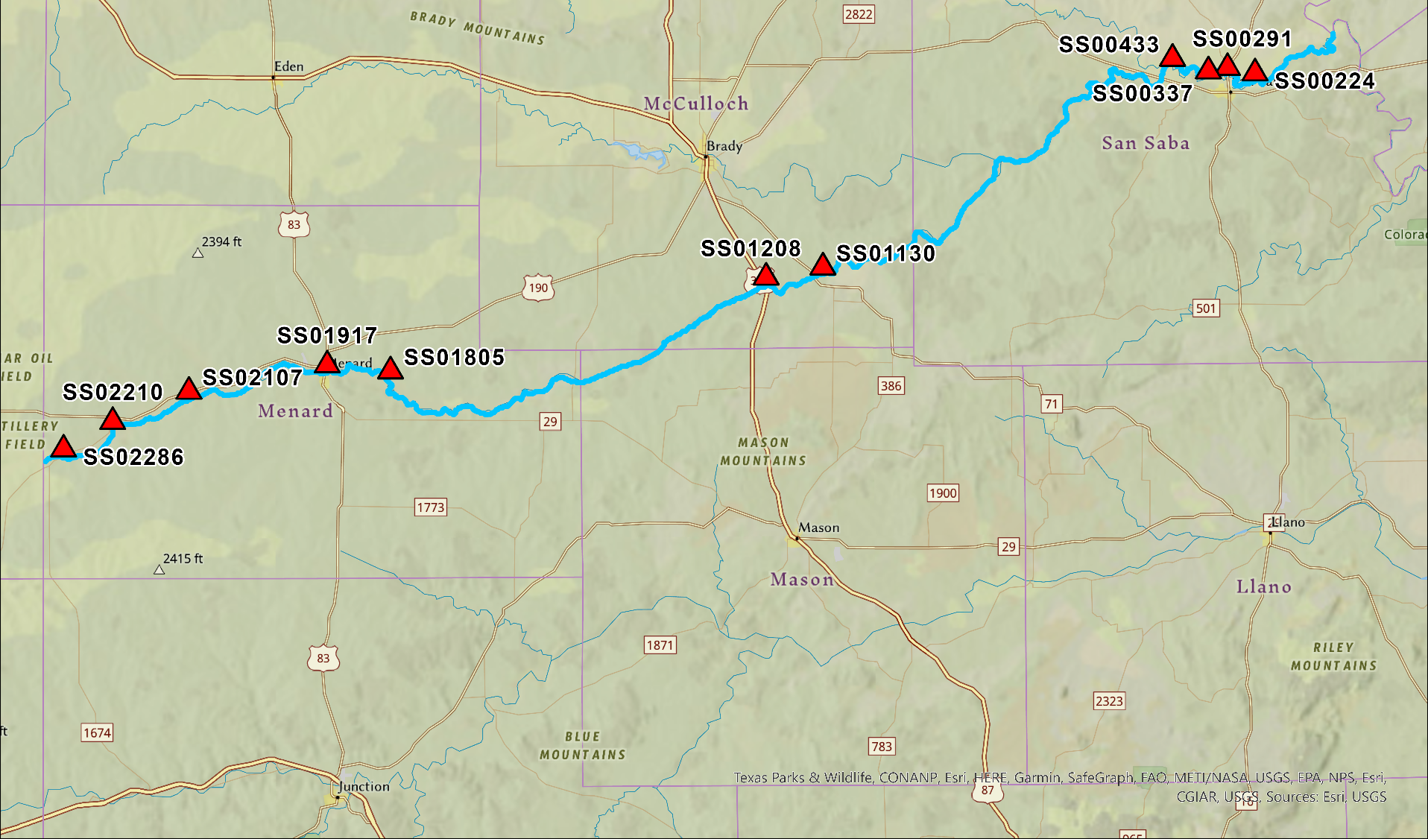
Figure 2.1. Location map of sample sites on the San Saba River, noting counties in Central Texas. Map from Esri, USGS.
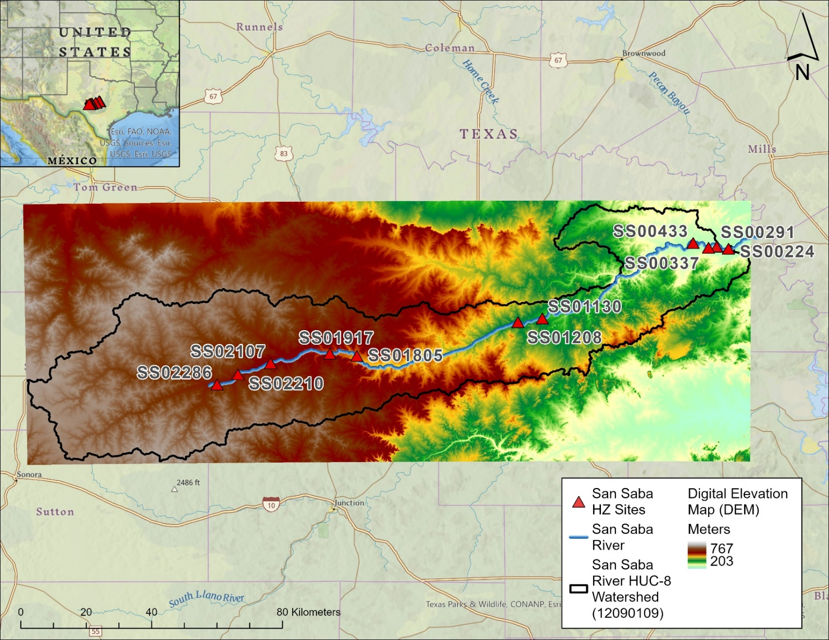

Figure 2.2. Overlain digital elevation map of San Saba River, Texas, HUC-8 watershed area (black outline). Sample locations are noted with a red triangle and labelled “SS.” The number corresponds to the distance from the confluence of the San Saba with the Colorado River in kilometers (km), the last digit specifying a decimal point (e.g., SS02286 = 228.6 km).
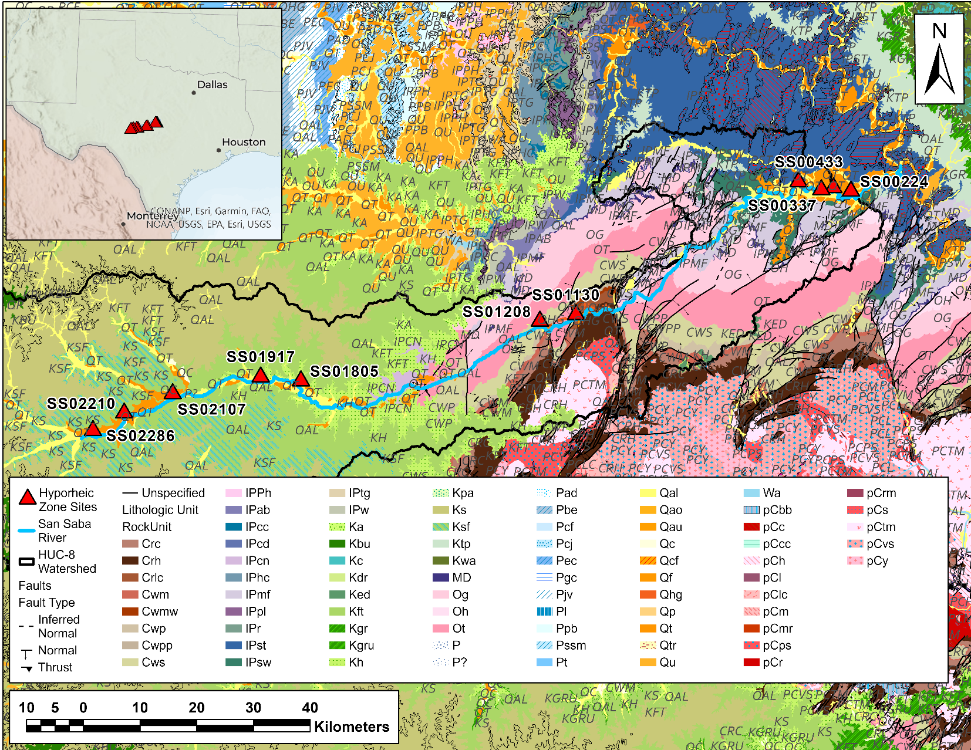
Figure 2.3. Map showing major lithologic units outcropping at the surface and that underlie the San Saba River, Texas, HUC-8 watershed area (black outline). Colors correspond to standard stratigraphic convention (Stoeser et al., 2005). Sample locations are noted with a red triangle and labelled “SS.” The number corresponds to the distance from the confluence of the San Saba with the Colorado River in kilometers (km), the last digit specifying a decimal point (e.g., SS02286 = 228.6 km).
Table 2.1. Geologic descriptions of each pool-riffle sequence sampled. Adapted from Stoeser et al. (2005).
Site Name | Rock Unit Name | Major Rock Type | Rock Unit Code | Group | Lithologic Description
SS00224 | Marble Falls Formation | Carbonate | IPmf | Bend Group | Limestone and shale. Mostly limestone. Very fine to coarse-grained. Oolites and pellets common, locally cherty and siliceous. Thin bedded to massive bedded.
SS00291
SS00337
SS00433 | Strawn Group (Undivided) & Pre-Brazos River Formation | Mixed Clastic | IPst / IPpbr | Strawn Group | Strawn Group (IPst) - Undivided sandstone, shale, mudstone, conglomerate, siltstone, and limestone.  Pre-Brazos River (IPpbr) - Mostly shale & mudstone, silty, poorly exposed. Limestone beds impure, and discontinuous. Sandstone forms thin discontinuous sheets, and small channel fills, fewer beds near top.
SS01130 | Lion Mountain Sandstone & Cap Mountain Limestone Members | Sandstone | Crlc | Moore Hollow Group | Lion Mountain Member - quartzose greensand, glauconitic quartz sandstone, impure limestone with phosphatic brachiopods. Minor shale and siltstone.  Cap Mountain Limestone - Thick bedded, granular, grades to calcareous sandstone at base. Sparsely glauconitic. Oolitic in upper part.
SS01208 | San Saba Member | Carbonate | Cws | Moore Hollow Group | Dolomite and Limestone. Thick to thinly bedded. Sparsely cherty. Limestone is moderately glauconitic.
SS01805  SS01917 | Hensell Sand | Conglomerate / Mixed Clastic | Kh | Trinity Group | Sand, silt, clay, and conglomerate. Conglomerate chiefly composed of pebbles and cobbles of Paleozoic and Precambrian rocks. Sand, silt and clay; friable except where calcareous.
SS02107  SS02210 | Fort Terrett Member | Carbonate | Kft | Fredericksburg Group | Limestone & Dolomite. Porcelaneous aphanitic limestone, collapse breccia, chert, recrystallized limestone
SS02286 | Segovia & Fort Terrett Members | Carbonate | Ksf | Fredericksburg Group | Contains Kirschberg evaporite. Chiefly marly limestone, dolomite, biosparite limestone. Overlies Fort Terrett Formation of Edwards Group; underlies Del Rio Clay.

1.2-billion-year-old crystalline rock to the surface as part of the Llano (Grenville) Orogeny. The San Saba River does not flow over Precambrian rock, although its tributaries do, including Katemcy Creek, Lost Creek, Waterhole Creek, and Sandy Creek. Within the river valley, the channel banks and bottom are underlain by Pleistocene and Holocene alluvium and terrace deposits, primarily composed of sand, silt, clay, and gravel of varying thicknesses (Stoeser et al., 2005). The HZ is associated with these deposits (Figure 2.3).
According to the Köppen climate classification system, the climate in this region is humid subtropical, with an average of 61.9 cm rainfall annually (PRISM Climate Group, 2020). In a given year, the highest rainfall amounts occur during May and September, but over the past decade, this region has received about 70-90% of their average precipitation, which suggests drought conditions (PRISM Climate Group, 2020). The average annual temperature is 18.3 ºC, peaking from May to September to at or above 38 ºC (PRISM Climate Group, 2020).
Land-use / land-cover (LULC) orthoimagery were downloaded from the U.S. National Land Cover Database (Dewitz, 2021). Most of the land within the HUC-8 watershed is classified as shrub/scrub (88%), with the remainder being a mix of grassland, mixed forest, and cultivated cropland. Vegetation near the river valley includes water-tolerant hardwoods, conifers, and grasses (San Saba River, THSA, 2019). Soils within the watershed are mostly comprised of expanding clays and other fine-grained sediment. Areas adjacent to the San Saba River are generally classified as class C (slow infiltration) and class B (moderate infiltration); however, near the Llano Uplift, soils are heterogeneously mixed and higher infiltration soils (Soil Survey Staff, 2016).

2.2 Field Sampling
As part of a three-week sampling campaign in June 2021 to five different rivers within the Colorado River basin, field samples from the San Saba River were collected by two teams of four to six people. Eleven pool-and-riffle locations were selected for river based on differences in geology, geomorphology, and/or potential groundwater input and groundwater-surface water exchange, as well as according to historical records for endemic mussels. Along the roughly 280-km length of the San Saba River (Figure 2.1), the sample locations were also spaced at approximately order-of-magnitude increasing distances from each another, such that adjacent sampling locations were separated by approximately 0.1 km, 1.0 km, and 10 km distances. Sample location identification designations (IDs) start with a two-letter code for the river (San Saba = SS) followed by a five-digit number noting the meters upstream from the confluence with the Colorado River. The last digit is separated with a decimal point from the other numbers if using kilometers for the distance (e.g., SS02286 = 228.6 km).
At each location, up to five HZ samples were taken from Bou Rouch (BR) samplers (Figure 2.4A), also referred to as “spikes,” arranged in a plus (+) pattern from upstream to downstream across a riffle and from mid-channel to stream bank to the floodplain (Figure 2.4B). For this study, only upstream (BR1), within channel (BR4), and downstream of the pool-and-riffle locations (BR3) were used for microbial samples (Figure 2.4C), sometimes mid-channel (BR2) and off-channel (BR5) used for hydrological measurements were not sampled because of difficulties driving the spike into the substrate or lack of an off-channel bank. From all samplers, the depth into the sediment, referred to “hammered depth,” was recorded. HZ water samples and invertebrates (not part of this thesis work) were collected from all BR samplers, if possible. River water and water pumped from the HZ were used to measure pH, temperature, dissolved oxygen, and conductivity using a Eureka Manta 30+ water quality multiprobe sonde (Tillman, 2017).
After pumping a BR sampler, the pump head was removed and a low-flow, gas-tight syringe pump was used (constructed with peristaltic pump tubing and a 60-ml gas-tight syringe) to slowly purge the water from the open sampler without exposure to air and until the water was free of sediment but without drawing down the water in the spike completely. A grab sample of surface river water (SW) was also collected in a 250 ml bottle. The surface river and purged HZ water were immediately used in the field to measure soluble ammonia-nitrogen (NH₃-N), dissolved oxygen, and dissolved sulfide (including H₂S, HS-, and acid-soluble metallic sulfides) concentrations using a V-2000 multi-analyte spectrophotometer and after applying specific colorimetric methods for each analyte (CHEMetrics Inc., Midland, VA). Highly-colored or turbid water could have caused interference with some of these analyses. A vacuum was created in sterile glass serum bottles (Wheaton) with butyl rubber plugs and Al-crimp seals, and HZ water directly from the spike or from the surface river water was drawn into the bottles until a headspace formed at atmospheric pressure. Each gas sample was preserved using 8 M potassium hydroxide (KOH) (Magen et al., 2014). Water samples were kept on ice in the field during transport until storage at 4 ºC. In the field, purged HZ water from BR samplers and SW were separately filtered through 0.2-micron Sterivex™ (Millipore Sigma, Burlington, MA) filters into HDPE bottles for anions and acid-washed HDPE bottles for cations and trace metals (following preservation to at least pH2.0 with trace metal grade nitric acid), and into baked (to 550 ºC) glass vials for non-purgeable organic carbon (NPOC), total organic carbon (TOC), and total nitrogen (TN). Sterivex filters were placed in sterile Whirl-Pak® bags (Nasco, Fort Atkinson,

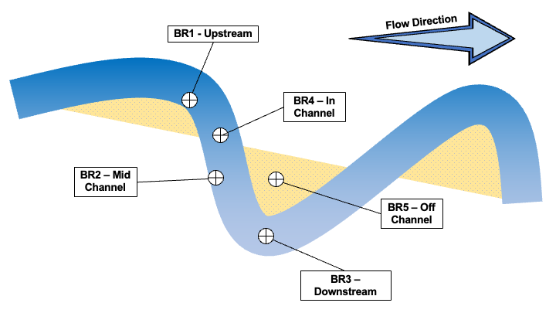
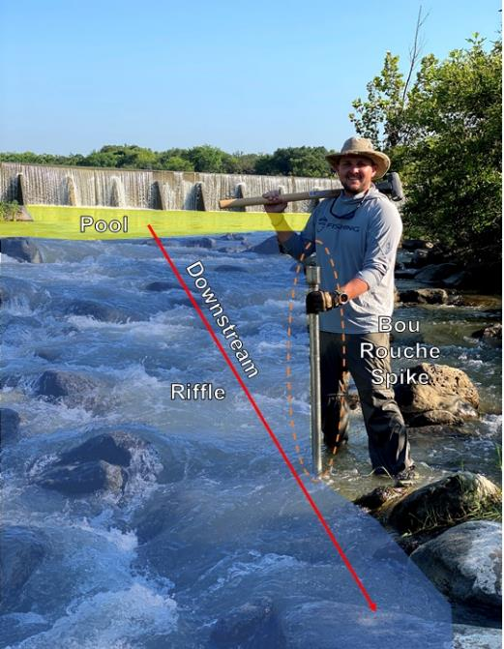
B

B
A

A

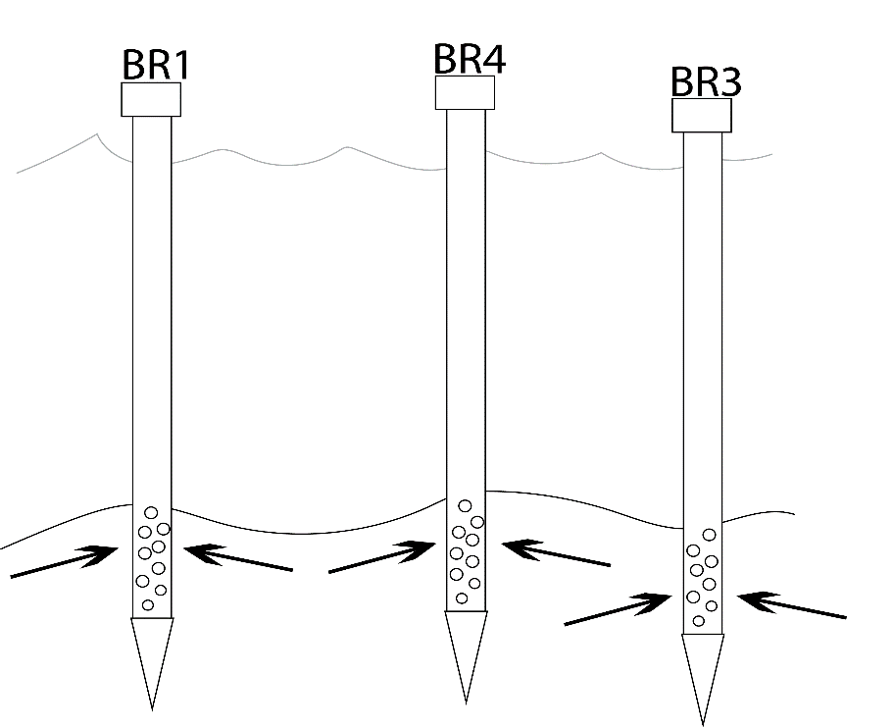
Flow Direction

Flow Direction
Flow Direction

Flow Direction
C

C

Figure 2.4. (A) An example of a pool-and-riffle sequence, with pool highlighted in yellow upstream, riffle highlighted in light blue, and downstream direction denoted by the red arrow. The Bou Rouch sampler “spike” is indicated by the dashed orange oval. (B) A schematic of the five intended Bou Rouch sampler (“spike”) sites within a pool-and-riffle location. (C) A cross-section of three Bou Rouch sampler arrangement used for this study, specifically BR1 (upstream), BR4 (in channel), and BR3 (downstream), at each HZ location. Black arrows indicate HZ water being drawn into a BR sampler, and the blue arrow indicates flow direction of river.

WI, USA) in the field and immediately put on dry ice during transport to the University of Tennessee, Knoxville (UTK), where at least two filters were stored at -20°C until DNA extractions could be completed.

2.2 Hydrogeology
Discharge was measured using a SonTek (Xylem Inc., San Diego, CA) RiverSurveyor S5 & M9 or a FlowTracker2. Best practice technical memoranda from the USGS and the SonTek were implemented for all measurements (Sauer & Turnipseed, 2010). If these methods were insufficient, then a discharge reading was taken from the nearest USGS or Lower Colorado River Authority (LCRA) gauging station(s) on the sampling day. Generalized gaining or losing conditions between reaches were determined by taking the difference in river discharge between locations and dividing the difference by the distance between locations.
Attempts were made to measure vertical hydraulic gradients and bedload permeability from each BR sampler by using slug tests. These measurements were done and calculated by collaborators at Texas State University. Where possible, hydraulic gradient was calculated by measuring the vertical elevation of the river at each sampler, as well as distance to water inside each BR sampler prior to slug testing. Hydraulic gradient was used to determine if individual sampling locations were upwelling or downwelling. Slug tests were completed at each BR sampler by first recording initial water level inside the sampler, placing a pressure transducer inside the sampler, and drawing a vacuum using a hand-held vacuum pump. Once under vacuum, the transducer was released, and water level recovery was measured. Up to three slug tests were completed at each sampler depending on recovery time and the final hydraulic conductivity values were calculated from the average.
Hydraulic conductivity (K) in cm/sec was calculated via Hvorslev method for unconfined aquifers, according to Equation 2.1,
Equation 2.1 $K=\frac{\left[r^{2}\ln\left(\frac{L_{e}}{R}\right)\right]}{[2L_{e}t_{37}]}$
where r is radius of the BR sampler (3 cm), R is the radius of well screen in BR sampler (3 cm), L_{e} is the length of BR screen (25 cm), t₃₇ is equivalent to the water level recovery time (relative to initial water level) rises or fall to 37% of the initial hydraulic head and calculated through linear interpolation of raw 0.5 sec interval measurement.

2.3 Geochemical Analyses
Alkalinity was manually titrated in the field from a filtered, unpreserved water sample (at room temperature) for BR1, BR3, BR4, and SW (i.e., corresponding to sites where microbial samples were taken) within 24 hours of collection to an end-point pH of 4.3 with 0.1N sulfuric acid (H₂SO₄). All geochemical analyses were done in accordance with recommended analyte hold times (EPA, 2016) and completed either at the University of Tennessee–Knoxville (UTK) or at Texas State University (TSU), San Marcos, Texas.
Major anion and cation concentrations for BR1, BR3, BR4, and SW were determined at UTK, and BR2 and BR5 samples were analyzed by TSU. At UTK, ions were measured using ICS-2000 ion chromatographs (ICs) (ThermoFisher Scientific). At TSU, ions were measured using ICS-1600 ICs (Dionex, Bannockburn, IL). Standard curves for ions of known concentrations were used, with method detection limits based on the lower limit of each standard curve. Charge balance was calculated using the major ion data, with alkalinity being speciated as bicarbonate at the measured pH for each sample. Values less than or equal to +/-10% were considered complete.
Dissolved methane (CH₄) was determined by headspace-equilibration of KOH-preserved water collected in serum bottles using an SRI 8610C gas chromatograph (GC) (SRI Instruments, Torrance, CA) with a flame ionization detector with methanizer at UTK. Calibration curves were made using mixed gas standards. Dissolved gas concentrations were calculated based on the volume of water collected and Henry’s Law constant for each gas.
Non-purgeable organic carbon (NPOC) was measured at UTK from filtered water samples using a Shimadzu TOC-L series analyzer with a sparging kit to remove inorganic carbon. A chemiluminescent TML-L detector was used to measure TN, according to manufacturer instructions.
Fluorescence data for chromophoric dissolved organic matter (CDOM) were measured from filtered unpreserved water at UTK using quartz cuvettes. Fluorescence was measured by using a Horiba Scientific FluoroMax-4 spectrofluorometer and UV-Vis absorbance from 200-nm to 750-nm in 1-nm increments was measured using a Thermo Scientific UV-Visible Spectrophotometer. Ultrapure Millipore DI water (MilliQ) was used to blank the instruments. Using the approach from Birdwell and Engel (2009, 2010) to generate excitation–emission matrix (EEM) spectra, spectrophotometer settings included slits set to 5-nm with an integration time of 0.1 sec. Excitation wavelengths ranged from 240 to 450 nm in 5-nm increments and emission wavelengths ranged from 250 to 550 in increments of 2.5-nm. Several corrections were applied, including inner-filter effect correction that utilizes absorbance spectra, and Raman and Rayleigh scattering corrections done by subtracting the blank from the corrected EEMs. Fluorescence indices were calculated from ratios of fluorescence intensities at specific wavelengths to determine the potential sources of CDOM (e.g., microbially-produced proteins versus terrestrially-derived humic acids), including the fluorescence index (FI), biological index (BIX), and humification index (HIX) (Birdwell and Engel, 2010), and the StaRdom package (v 1.1.21) (Pucher et al., 2019) in RStudio (V1.4) (R Core Team 2021) was used to determine components from EEMs using parallel factor analysis (PARAFAC) (Luciani et al., 2008).

2.4 DNA Extraction, 16S rRNA Gene Sequencing, and Analyses
Total environmental DNA (eDNA) (Dejean et al., 2011; Pilliod et al., 2013) was extracted from the Sterivex™ filters collected from SW, BR1, BR3, and BR4. DNeasy Blood and Tissue Kits (Qiagen, Hilden, Germany) were used, following manufacturer instructions with modifications from Spens et al. (2016). Briefly, the filters were incubated with Buffer ATL and Proteinase K, were capped, and sealed with sterile rubber caps, then agitated for 24 hours at 56˚C. Recoverable liquid was transferred to molecular grade ethanol prior to centrifugation, washing, and suspension with kit-supplied buffers. Extractions were stored at -20ºC until sequencing. Duplicate DNA extractions were homogenized prior to sending to the Molecular Research LP (Shallowater, Texas) where the V4 region of the 16S rRNA gene was sequenced, after amplification with the 515F– 806R primers, on a Ilumina MiSeq sequencing platform (Caporaso et al., 2012; Parada et al., 2016).
Gene sequences were analyzed using the open-source computer program MOTHUR (V1.48.0) (Schloss et al., 2009). Following a standardized pipeline for raw sequence processing, including demultiplexing and removing barcodes and primers, screened sequences were aligned to the SILVA (V138.1) reference database (Quast et al., 2013; Yilmaz et al., 2014), and potential chimeric sequences and sequences that did not align were removed prior to classifying sequences taxonomically. Sequences identified as chloroplasts, mitochondria, unknown, or to Eukaryota were also removed.
Operational taxonomic units (OTUs) were calculated from pairwise distances calculated from among the aligned sequences using a 0.03 cutoff (97% sequence identity) based on the SILVA reference file. This cutoff loosely corresponds to genus-level classifications. Evaluation of sequence data using OTUs allowed for alpha diversity (intra-sample) index calculations using MOTHUR, including the non-parametric Shannon-Diversity Index, Simpson’s Index, and the Berger-Parker Index. Shannon and Simpson’s indies reflect richness and evenness, respectively, whereas Berger-Parker measures the dominance of the most common taxa within a community. To quantify microbial community richness, the Chao1 estimator was used. To make these diversity measurements, classified OTUs were rarified to the sample with the lowest number of OTU reads (i.e., 22,719) in MOTHUR. Although OTUs do not necessarily reflect the true biological diversity of a microbial community (Hughes et al., 2001; Bohannon & Hughes, 2003; Blaxter, 2005), beta diversity (inter-sample) comparisons were made based on the presence or absence of OTUs across all samples. The get.coremicrobiome function in MOTHUR, was used to determine the fraction of OTUs that were found in varying numbers of samples for a relative abundance of 1% or greater. Although OTU-level comparisons provide insight into a microbial community, interpreting OTU-based results was done with caution because different clustering methods, and applying different cut-off levels, could lead to different results. Moreover, taxonomic assignments of poorly known taxa based on OTU outcomes can provide misleading information.

2.5 Sequence Data Submission
Raw sequence files for each sample were submitted to the National Center for Biotechnology Information (NCBI) Sequence Read Archive under the BioProject PRJNA1006045 (http://www.ncbi.nlm.gov/bioproject/ PRJNA1006045).

2.6 Statistical Data Treatment and Analysis
All variables, including microbial relative abundances and presence/absence data, were subjected to data preprocessing procedures. First, a constant value of 1 was added to each data point and then a logarithmic transformation using the log10 function in R (R Core Team, 2021) was applied to address issues related to data distribution. Following the transformation, values were scaled between 0 and 1 by dividing each value by the maximum value observed within the dataset (Chinn, 1996; Feng et al., 2014). This normalization process compressed the value ranges but preserved the relative numerical order of the original data. To investigate the strength and direction of relationships among geochemical and hydrological factors and microbial abundance data, Spearman's correlation coefficients (ρ) were calculated for pairs of values using the 'cor()' function in R. Multivariate analyses, such as one and two-way permutational multivariate ANOVA (PERMANOVA), General Linear Models (GLMs), analysis of similarity (ANOSIM), Canonical Correspondence Analysis (CCA), Unweighted Pair Group Method with Arithmetic Mean (UPGMA), and Indicator Species Analysis (ISA), were performed using PAST V4.13 (Hammer et al., 2001) to explore data structure and correlations among variables. ANOSIM were done using the Bray-Curtis dissimilarity matrix and 9999 permutations were performed. Furthermore, a three-way factorial multivariate analysis of variance (MANOVA) was conducted using the 'manova()' function from the 'stats' package in R (R Core Team, 2021). This analysis assessed the effects of lithology, hydrological conditions, and spatial position in a pool-riffle sequence on the variation in the microbial abundance data and geochemical parameters. The statistical significance level (alpha) was set at 0.05, and p-values used for hypothesis rejection or support were interpreted alongside effect size considerations. The resulting MANOVA output provided statistical measures that included Pillai's trace statistic, approximate F-values, degrees of freedom, and p-values. The major hypotheses tested were:
- Changing hydrological conditions, either from upwelling/downwelling or gaining/losing, and lithology (e.g., carbonate vs. siliciclastic) will correspond to major changes in water chemistry and microbial community compositions (expanded in Table 2.2).
- The microbial diversity of HZ samples will be distinct from river water communities.
- Greater microbial diversity will be associated with upwelling and being connected hydrologically to local/regional groundwater systems (i.e., gaining conditions). Conversely, locations where water is downwelling and/or experiencing losing hydrologic conditions will be dominated by river microbial communities.
- Microbial community compositions in the HZ will be more similar to each other within the same pool-riffle sequence. In contrast, microbial communities in the river water will not differ regardless of spatial distance along the upstream to downstream gradient.

Table 2.2. Summary of expected relationships among microbial communities and geochemical variables under differing hydrologic conditions (modified from Newcomer et al., 2018).
Hydrologic Condition | Microbial Diversity | Nutrients | Surface & Groundwater Conditions
Gaining (i.e., groundwater input to river) | Increase | Increased exchange of C, N, and dissolved oxygen (DO) between surface water and HZ.  Surface water will contain higher amounts of nutrients in gaining reaches. | Variable water table, discharge of groundwater into surface water (exfiltration), increase in measured river discharge.
Losing (i.e., surface water lost into groundwater) | Decrease | Storage of C, and N in biomass and increased exchange of DOC, NH₄, NO₃, and DO below water table. | Lower water table, increased infiltration from surface water and riverbed into groundwater, decrease in measured river discharge.

SECTION 3. RESULTS

3.1 Hydrogeology
There were no significant precipitation events that affected river discharge during sampling. Flow conditions in June 2021, as recorded at river gauging stations, indicated baseflow conditions at upstream locations (i.e., SS02107, SS02210, SS02286) (Figure 3.1A), with uniform discharge that averaged about 0.55 m³/sec. But the midstream and downstream locations (Figure 3.1B) were sampled on the falling limb of the hydrograph, which resulted from peak flow after rainfall the previous week. As expected, discharge increased downstream due to tributary contributions (Figure 3.2, Table 3.1), with discharge at midstream locations (i.e., SS01130, SS01208, SS01805, SS01917) varying slightly around 1.0 m³/sec. Discharge at the four downstream locations was more than three times higher, at about 3.0 m³/sec.
Overall differences in discharge at each location divided by the distance between locations indicated gaining and losing reaches (Table 3.2). Six pool-and-riffle locations were gaining and five were losing. In total, 117 km of the San Saba River could be considered to experience gaining conditions, but 85.3 km may have losing conditions. Notably, three of the four downstream locations were gaining, which could also explain why discharge was higher downstream. These sites were also underlain by carbonate bedrock. One-way PERMANOVA results for all sample locations in the HZ also indicated that there were significant differences in discharge between sites underlain by different lithologies (Table A.1 in Appendix A). Statistically significant differences in discharge were observed between carbonates and mixed-clastics without conglomerates (p = 0.04), as well as between mixed-clastics with conglomerates and sandstone (p = 0.003), and mixed-clastics without conglomerates (p = 0.002).
Aquifer testing using slug tests could be completed at eight of the eleven locations. Water level recovery times (as determined from t₃₇) at each BR spike varied significantly, ranging from < 5 seconds to nearly 30 seconds (Figure 3.3). From these data, hydraulic conductivity was calculated (Figure 3.4, Table 3.3). Collectively, most of the calculated values indicated pervious, well-sorted sand and gravel, although values were lower downstream than upstream. The highest average hydraulic conductivity was from SS02210 (upstream), at 0.36 cm/sec, and the lowest average value was at site at SS00224, near the confluence with the Colorado River, at 0.04 cm/sec (Figure 3.4, Table 3.3). Among the spikes, BR5 (off-channel) and BR1 (upstream) had the highest average hydraulic conductivity values, and close to the full river’s average value, around 0.2 cm/sec. In contrast, BR3 and BR4 spikes had, on average, the lowest average hydraulic conductivity values, at around 0.1 cm/sec (Table 3.3).

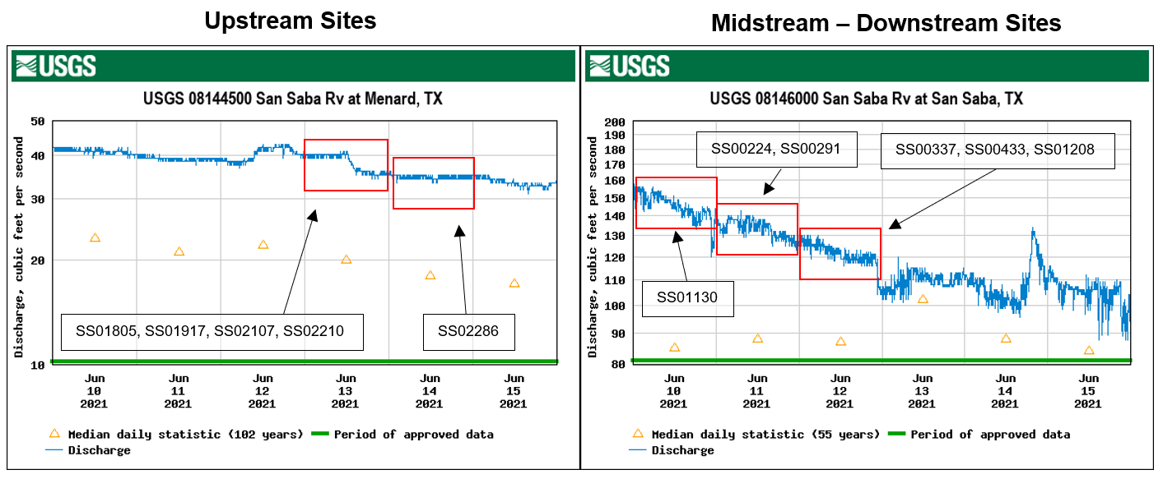
Figure 3.1. (A) A hydrograph from a USGS gauging station that measures San Saba River discharge at the town of Menard, Texas. Red boxes highlight the section of the hydrograph that corresponds to the days in June 2021, that specific locations were sampled, beginning with upstream locations. Note that discharge is reported in cubic feet per second. (B) A hydrograph from a USGS gauging station that measures San Saba River discharge at the town of San Saba, Texas. Red boxes highlight the section of the hydrograph that corresponds to the days that specific midstream and downstream locations were sampled. Note that discharge is reported in cubic feet per second.
A
B
Figure 3.2. San Saba River, Texas, discharge (m³/sec) measured at each site plotted as distance from the confluence with the Colorado River. Bars represent 5% error.
Figure 3.3. Recovery times from aquifer testing (slug tests) at each HZ location. Individual Bou Rouch (BR) sampler sites are indicated by blue-green lines, and water level recovery times (as determined from t₃₇) are indicated by a dashed red line.
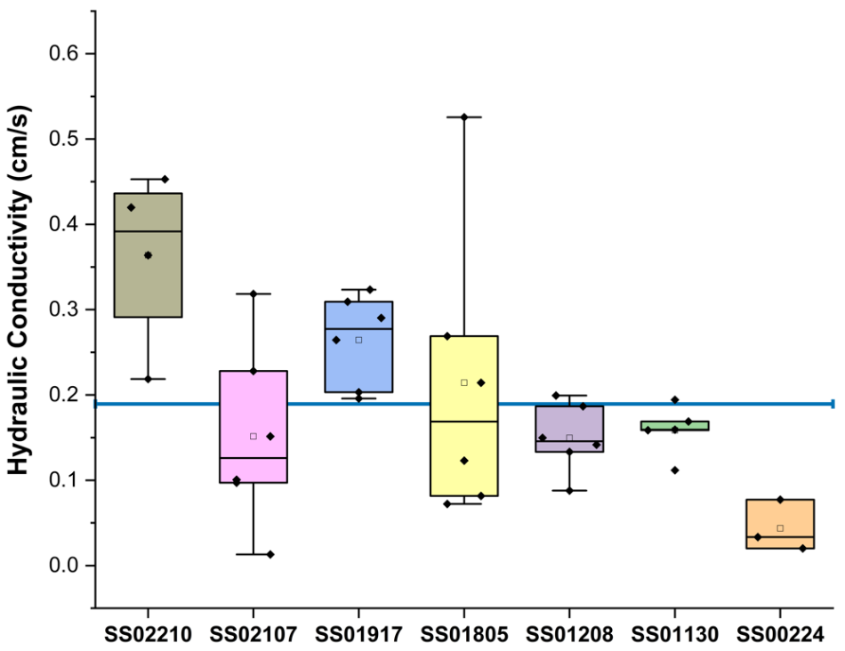
Figure 3.4. Box plots of hydraulic conductivity for those sites where measurements could be made along the San Saba River. The average for all BR sampler locations is indicated by the blue horizontal line at 0.189 cm/s. See Table 3.3 for all values.
Table 3.1. Measured discharge for selected pool-and-riffle sites for the San Saba River, central Texas, from June 2021. Site ID includes the distance (m) from confluence with the Colorado River. USGS = United States Geological Survey; LCRA = Lower Colorado River Authority.

Site ID | Date | Time | Discharge (m³/sec) | Method
SS02286 | 06/14/2021 | 11:14 AM – 11:34 AM | 0.57 | RiverSurveyor
SS02210 | 06/13/2021 | 12:49 PM – 1:26 PM | 0.51 | FlowTracker2
SS02107 | 06/13/2021 | 8:45 AM – 9:14 AM | 0.57 | FlowTracker2
SS01917 | 06/13/2021 | 3:50 PM – 4:43 PM | 1.18 | FlowTracker2
SS01805 | 06/13/2021 | 10:01 AM – 10:14 AM | 1.02 | RiverSurveyor
SS01208 | 06/12/2021 | 12:25 PM | 0.99 | LCRA gauge
SS01130 | 06/10/2021 | 1:17 PM – 2:10 PM | 1.24 | FlowTracker2
SS00433 | 06/12/2021 | 3:17 PM – 3:26 PM | 2.54 | RiverSurveyor
SS00337 | 06/12/2021 | 10:23 AM – 10:35 AM | 2.59 | RiverSurveyor
SS00291 | 06/11/2021 | 2:00 PM | 3.71 | USGS gauge
SS00224 | 06/11/2021 | 11:44 AM – 11:55 AM | 3.03 | RiverSurveyor

Upstream Site | Downstream Site | Reach Designation | Net ∆ Discharge / Distance  (m³/ s / m) | Distance Between Sample Locations (km) | Hydrologic Condition Between Sites | ∆ Discharge / Distance  (m³/ s / m)
2286 | 2210 | Upstream | 0.0016 | 7.6 | Losing | -0.0008
2210 | 2107 | Upstream | 0.0016 | 10.3 | Gaining | 0.0006
2107 | 1917 | Upstream | 0.0016 | 19.0 | Gaining | 0.0032
1917 | 1805 | Upstream | 0.0016 | 11.2 | Losing | -0.0014
1805 | 1208* | Midstream | 0.0031 | 59.7 | Losing | -0.0001
1208* | 1130 | Midstream | 0.0031 | 7.8 | Gaining | 0.0032
1130 | 433 | Downstream | 0.017 | 69.7 | Gaining | 0.0019
433 | 337 | Downstream | 0.017 | 5.6 | Gaining | 0.0010
337 | 291* | Downstream | 0.017 | 4.6 | Gaining | 0.0243
291* | 224 | Downstream | 0.017 | 6.7 | Losing | -0.0102
Table 3.2. Distance between pool-riffle sites with hydrologic condition (gaining/losing) and change in discharge over the distance between sites. An asterisk (*) indicates that flow was obtained from a gauging station.

 | Bou Rouch Sampler Locations
Site | BR1 | BR2 | BR3 | BR4 | Average
SS00224 | 0.0773 | 0.0201 | 0.0334 |  | 0.0436
SS00291
SS00337
SS00433 |  |  |  | 0.1161 | 0.1161
SS01130 | 0.1593 | 0.1689 | 0.1117 | 0.1944 | 0.1586
SS01208 | 0.1333 | 0.1867 | 0.1994 | 0.1417 | 0.1498
SS01805 | 0.2689 | 0.1231 | 0.0722 | 0.0817 | 0.2143
SS01917 | 0.2032 | 0.1958 | 0.3094 | 0.2903 | 0.2644
SS02107 | 0.3184 | 0.2282 | 0.1006 | 0.0972 | 0.1515
SS02210 | 0.4198 | 0.4529 | 0.2187 |  | 0.3638
SS02286
Table 3.3. Calculated hydraulic conductivity values (cm/sec) determined from the slug tests for each Bou Rouch (BR) sampler (Figure 3.3). Samplers that were missing slug test measurements could not be used for calculations and are left blank on the table.

Changes in discharge due to gaining or losing, as well as hydraulic conductivity values, were compared to calculated horizontal (Table 3.4) and vertical (Table 3.5) hydraulic gradients, which were determined by measuring the depth of water outside the BR sampler and subtracting that depth from the depth of water inside the sampler. Essentially, hydraulic gradients can be affected by hydraulic conductivity, slope, and local to regional groundwater connectivity. But, if the water level inside the sampler was higher than the SW level, then there was a negative gradient and the HZ was upwelling at that location, likely due to groundwater discharge. Conversely, if there was a positive vertical gradient, then this indicated river downwelling into the HZ at a particular location. Of the 31 sites where a vertical gradient was calculated, 24 also had microbial samples, and only eight had downwelling conditions. Consequently, most of the sites sampled had groundwater upwelling into the HZ.
Spearman's rank correlation coefficient (ρ) was used to examine associations between distance along the river from the confluence with the Colorado River, hydraulic conductivity, hammered depth, and discharge (Table A.2). Discharge and vertical hydraulic gradient significantly correlated (p-value = 0.04) (Table A.3), and there were significant correlations between river distance and hydraulic conductivity (ρ = 0.49, p-value = 0.004), and distance and discharge (ρ = -0.92, p-value < 0.001), but distance and hammered depth were not significantly correlated. However, according to one-way PERMANOVA results for all sample locations in the HZ, lithology and hammered depth significantly correlated (global F-value = 3.34, p-value = 0.03) (Table A.4). Specifically, there were statistically significant differences in hammered depth and the lithology pairs of carbonate-sandstone (p-value = 0.02) and sandstone-mixed clastics with conglomerate (p-value = 0.02).

3.2 Geochemistry of the San Saba River and the Hyporheic Zone

3.2.1 Physiochemistry, dissolved gases, and redox geochemistry
All pH values ranged from 7.18 to 8.96 (Table 3.6). Surface water (SW) had the highest values (Table 3.6). In general, changes in BR pH values mirrored surface water pH changes. The midstream reaches (SS01805 – SS01130) had the highest pH values. pH between BR locations had comparable averages and medians, but the median and average BR pH values in losing reaches were higher than in gaining samples (Figure A.1, in Appendix A). Based on PERMANOVA, in general, all SW pH values were significantly different from the pH values of all BR1 and BR3 (p-value = 0.02) (Table A.5). Along the river, the pH values of SS01208 were significantly different than nearly all the other sites (Table A.6).

Table 3.4. Horizontal hydraulic gradients calculated for selected pool-and-riffle locations from the San Saba River in June 2021. Values for each of the Bou Rouch (BR) sampler comparisons are the differences in water level between BR sites divided by the horizontal distance in meters between the samplers. Upwelling sites are indicated in light blue. Sites missing a BR sampler could not be used for calculations, which are left blank in the table.

 | Bou Rouch Sampler Pairs
Site | BR1 &  BR2 | BR1 &  BR3 | BR1 &  BR4 | BR1 &  BR5 | BR2 &  BR3 | BR4 &  BR3 | BR5 &  BR3 | BR2 &  BR4 | BR5 &  BR2 | BR5 &  BR4 | Upstream to  Downstream
2286 | -0.011 | -0.004 | -0.005 |  | 0.003 | -0.003 |  | 0.022 |  |  | -0.00002
2210 | -0.002 | -0.022 |  |  | -0.041 |  |  |  |  |  | -0.00001
2107 | -0.007 | -0.006 | -0.008 | -0.266 | -0.005 | -0.004 | 0.306 | -0.006 | 0.831 | 0.529 | -0.00004
1917 | -0.007 | -0.006 | -0.003 | -0.008 | -0.005 | -0.009 | -0.002 | 0.020 | 0.007 | 0.010 | -0.00006
1805 | 0.009 | 0.005 | 0.024 | -0.001 | 0.003 | -0.013 | 0.013 | 0.049 | 0.020 | 0.035 | -0.00010
1208 | -0.025 | -0.019 | -0.023 | -0.027 | -0.007 | -0.008 | 0.013 | 0.006 | 0.023 | 0.018 | -0.00011
1130 | -0.017 | -0.014 | -0.013 | -0.017 | -0.009 | -0.008 | -0.012 | 0.003 | -0.002 | -0.001 | -0.00013
433 |  |  |  |  |  |  |  |  |  |  | 0.00005
337 |  | -0.004 | -0.001 |  |  | -0.005 |  |  |  |  | -0.00003
291 |  |  |  |  |  |  |  |  |  |  | -0.00001
224 | -0.019 | -0.010 | -0.003 | 0.032 | 0.000 | -0.013 | -0.052 | 0.044 | -0.303 | -0.068 | -0.00003

Table 3.5. Measured vertical gradients calculated for selected pool-and-riffle locations from the San Saba River in June 2021. A higher water level inside a Bou Rouch (BR) sampler calculates to a negative gradient and water would be upwelling from the HZ. These upwelling sites are designated in light blue on the table. Samplers that were missing could not be used for calculations and are left blank on the table.
 | Bou Rouch Sampler Locations
Site | BR1 | BR2 | BR3 | BR4
SS00224 | 0.549 | 0.094 | 0.351 | 0.528
SS00291
SS00337 |  |  | 0.034 | -0.068
SS00433 | 0.005
SS01130 | -0.154 | 0.015 | 0.057 | -0.041
SS01208 | -0.009 | -0.061 | -0.115 | 0.003
SS01805 | -1.544 | -0.918 | 0.004 | -0.160
SS01917 | -0.132 | -0.198 | -0.063 | 0.214
SS02107 | -0.009 | -0.015 | -0.010 | -0.056
SS02210
SS02286 | -0.005 | -0.163 | -0.005 | -0.055

Table 3.6. Field-collected physiochemistry (pH, temperature, and conductivity) from Bou Rouch (BR) samplers and surface water (SW) samples collected from the San Saba River, Texas, in June 2021. Site names denote the distance (m) from the Colorado River confluence, listed from downstream to upstream. Not all locations had five BR samples. Rock types were interpreted from geological maps (Figure 2.3). Units for dissolved oxygen (DO), sulfide, and NH₃-N are in mmol/L. Units for dissolved CH₄ are in nmol/L. NM = not measured. BDL = below detection limit.

 |  | Geochemical Parameters
Site | Rock Type | pH |  | Temp (℃) |  | Cond (uS/cm) |  | DO |  | CH₄ |  | Sulfide |  | NH₃-N
SS00224.BR1 | Marble Falls Formation: carbonates | 7.7 | 24.6 |  | 1323 |  | 0.098 |  | 1.35 |  | 0.025 |  | 0.09
SS00224.BR2 | Marble Falls Formation: carbonates | 7.93 | 24.8 |  | 1373 |  | 0.045 |  | NM |  | 0.046 |  | 0.16
SS00224.BR3 | Marble Falls Formation: carbonates | 7.89 | 24.7 |  | 1244 |  | BDL |  | 11.45 |  | 0.022 |  | 0.05
SS00224.BR4 | Marble Falls Formation: carbonates | 8.25 | 26.6 |  | 957.9 |  | 0.003 |  | 109.18 |  | 0.08 |  | 0.38
SS00224.BR5 | Marble Falls Formation: carbonates | 8.13 | 24.3 |  | 1286 |  | 0.003 |  | NM |  | 0.032 |  | 0.15
SS00224.SW | Marble Falls Formation: carbonates | 8.33 | 27.2 |  | 868.1 |  | 0.168 |  | 10.61 |  | BDL |  | 0.01
SS00291.BR4 | Marble Falls Formation: carbonates | 8.29 | 28.8 |  | 886.6 |  | 0.023 |  | 8.53 |  | 0.053 |  | 0.23
SS00291.SW | Marble Falls Formation: carbonates | 8.57 | 29.1 |  | 734.4 |  | 0.192 |  | 17.37 |  | BDL |  | 0.02
SS00337.BR1 | Marble Falls Formation: carbonates | 7.34 | 27 |  | 470.2 |  | 0.018 |  | 42.17 |  | 0.017 |  | 0.1
SS00337.BR2 | Marble Falls Formation: carbonates | 7.54 | 27.4 |  | 449.5 |  | 0.004 |  | NM |  | 0.058 |  | 0.21
SS00337.BR3 | Marble Falls Formation: carbonates | 7.36 | 24.7 |  | 505.5 |  | 0.022 |  | 9.89 |  | 0.031 |  | 0.14
SS00337.BR4 | Marble Falls Formation: carbonates | 7.9 | 27.2 |  | 477.6 |  | BDL |  | 11.71 |  | 0.028 |  | 0.18
SS00337.SW | Marble Falls Formation: carbonates | 7.95 | 28.3 |  | 508 |  | 0.185 |  | 5.6 |  | BDL |  | 0.01
SS00433.BR1 | Strawn Group & Pre-Brazos River Formation: mixed clastics | 7.84 | 28.4 |  | 571.2 |  | BDL |  | 495.56 |  | 0.054 |  | 0.19
SS00433.BR2 | Strawn Group & Pre-Brazos River Formation: mixed clastics | 7.5 | 25.9 |  | 658.1 |  | BDL |  | NM |  | 0.037 |  | 0.11
SS00433.BR3 | Strawn Group & Pre-Brazos River Formation: mixed clastics | 7.97 | 28.5 |  | 518.8 |  | 0.025 |  | 89.27 |  | 0.079 |  | 0.23
SS00433.BR4 | Strawn Group & Pre-Brazos River Formation: mixed clastics | 7.86 | 29.2 |  | 527.4 |  | 0.067 |  | 60.49 |  | 0.027 |  | 0.17
SS00433.SW | Strawn Group & Pre-Brazos River Formation: mixed clastics | 8 | 29.4 |  | 505.5 |  | 0.168 |  | 41.56 |  | BDL |  | 0.01
SS01130.BR1 | Lion Mountain & Cap Mountain Limestone Members: sandstone | 8.06 | 27.8 |  | 548.7 |  | 0.084 |  | 4.34 |  | 0.014 |  | 0.06
SS01130.BR2 | Lion Mountain & Cap Mountain Limestone Members: sandstone | 8.14 | 28.1 |  | 539.5 |  | 0.068 |  | NM |  | 0.013 |  | 0.09

Table 3.6 Continued
 |  | Geochemical Parameters
Site | Rock Type | pH | Temp (℃) | Cond (uS/cm) | DO | CH₄ | Sulfide | NH₃-N
SS01130.BR3 | Lion Mountain & Cap Mountain Limestone Members: sandstone | 7.92 | 26.4 | 563.6 | 0.092 | 29.31 | 0.012 | 0.04
SS01130.BR4 | Lion Mountain & Cap Mountain Limestone Members: sandstone | 8.05 | 27.4 | 591.1 | 0.048 | 9.98 | 0.024 | 0.1
SS01130.BR5 | Lion Mountain & Cap Mountain Limestone Members: sandstone | 8.13 | 28.4 | 562.4 | 0.036 | NM | 0.044 | 0.22
SS01130.SW | Lion Mountain & Cap Mountain Limestone Members: sandstone | 8.66 | 27.7 | 541.7 | 0.231 | 27.73 | BDL | 0.005
SS01208.BR1 | San Saba Member: carbonate | 8.74 | 28.7 | 439.2 | 0.006 | 15.65 | BDL | 0.02
SS01208.BR2 | San Saba Member: carbonate | 8.4 | 28.2 | 467.6 | BDL | NM | BDL | 0.05
SS01208.BR3 | San Saba Member: carbonate | 8.49 | 28.2 | 459.7 | 0.012 | 8.95 | BDL | 0.005
SS01208.BR4 | San Saba Member: carbonate | 8.5 | 27.7 | 457.6 | BDL | 9.4 | 0.009 | 0.03
SS01208.BR5 | San Saba Member: carbonate | 8.48 | 27.7 | 482.3 | 0.032 | NM | 0.02 | 0.08
SS01208.SW | San Saba Member: carbonate | 8.96 | 29.6 | 424.1 | 0.239 | 34.99 | BDL | 0.005
SS01805.BR1 | Hensell Sand: mixed clastics, conglomerate | 7.91 | 28.4 | 467.1 | 0.145 | 3.09 | 0.012 | 0.003
SS01805.BR2 | Hensell Sand: mixed clastics, conglomerate | 7.98 | 28.6 | 475.3 | 0.004 | NM | BDL | 0.02
SS01805.BR3 | Hensell Sand: mixed clastics, conglomerate | 7.82 | 27.6 | 498.6 | 0.024 | 613.82 | 0.053 | 0.27
SS01805.BR4 | Hensell Sand: mixed clastics, conglomerate | 7.98 | 27.2 | 514.1 | BDL | 94.92 | 0.009 | 0.01
SS01805.BR5 | Hensell Sand: mixed clastics, conglomerate | 7.49 | 25.3 | 649.9 | 0.148 | NM | 0.016 | 0.06
SS01805.SW | Hensell Sand: mixed clastics, conglomerate | 8.3 | 29.4 | 470.8 | 0.243 | 10.55 | BDL | 0.001
SS01917.BR1 | Hensell Sand: mixed clastics, conglomerate | 7.86 | 30.2 | 509.1 | 0.112 | 9.35 | BDL | 0.02
SS01917.BR2 | Hensell Sand: mixed clastics, conglomerate | 7.72 | 30.4 | 506.9 | 0.051 | NM | BDL | 0.002
SS01917.BR3 | Hensell Sand: mixed clastics, conglomerate | 7.69 | 26.2 | 505.6 | 0.06 | 18.55 | 0.009 | 0.02
SS01917.BR4 | Hensell Sand: mixed clastics, conglomerate | 7.84 | 30.6 | 489 | 0.14 | 4.1 | BDL | 0.02
SS01917.BR5 | Hensell Sand: mixed clastics, conglomerate | 7.8 | 25.9 | 509.8 | 0.076 | NM | 0.027 | 0.11
SS01917.SW | Hensell Sand: mixed clastics, conglomerate | 8.22 | 30.8 | 494.9 | 0.222 | 12.73 | BDL | 0
SS02107.BR1 | Fort Terrett Member: carbonate | 7.63 | 25.7 | 608.4 | BDL | 308.34 | 0.016 | 0.05
SS02107.BR2 | Fort Terrett Member: carbonate | 8.11 | 26.9 | 521.5 | BDL | NM | 0.02 | 0.15
SS02107.BR3 | Fort Terrett Member: carbonate | 7.72 | 25.2 | 641.6 | 0.022 | 249.79 | 0.027 | 0.19
SS02107.BR4 | Fort Terrett Member: carbonate | 8.3 | 27.5 | 492.2 | BDL | 79.19 | BDL | 0.04

Table 3.6 continued.
 |  | Geochemical Parameters
Site | Rock Type | pH | Temp (℃) | Cond (uS/cm) | DO | CH₄ | Sulfide | NH₃-N
SS02107.BR5 | Fort Terrett Member: carbonate | 8.13 | 23.3 | 656 | 0.117 | NM | 0.019 | 0.06
SS02107.SW | Fort Terrett Member: carbonate | 8.49 | 29.5 | 459.5 | 0.177 | 61.64 | BDL | 0
SS02210.BR1 | Fort Terrett Member: carbonate | 7.88 | 24.7 | 552.8 | 0.117 | 33.14 | BDL | 0.005
SS02210.BR2 | Fort Terrett Member: carbonate | 7.65 | 23.7 | 670.3 | 0.084 | NM | BDL | 0.008
SS02210.BR3 | Fort Terrett Member: carbonate | 7.85 | 23.9 | 673.7 | 0.057 | 13.96 | BDL | 0.01
SS02210.SW | Fort Terrett Member: carbonate | 8.44 | 30.8 | 503.6 | 0.235 | 25.6 | BDL | 0
SS02286.BR1 | Segovia & Fort Terrett Members: carbonate | 7.18 | 24.8 | 598.7 | BDL | 176.51 | 0.03 | 0.12
SS02286.BR2 | Segovia & Fort Terrett Members: carbonate | 7.59 | 25.8 | 658.3 | 0.02 | NM | 0.061 | 0.33
SS02286.BR3 | Segovia & Fort Terrett Members: carbonate | 7.82 | 25.4 | 560.9 | 0.081 | 46.92 | 0.012 | 0.04
SS02286.BR4 | Segovia & Fort Terrett Members: carbonate | 7.56 | 25.5 | 576.3 | 0.083 | 61.89 | 0.013 | 0.04
SS02286.SW | Segovia & Fort Terrett Members: carbonate | 7.41 | 25.5 | 608.4 | 0.163 | 11.02 | BDL | 0

Temperature plays a crucial role in regulating biogeochemical processes in surface water. Overall, surface water temperatures decreased downstream, but HZ temperatures fluctuated, increasing in midstream locations and decreasing furthest downstream (Table 3.6, Figure A.2A). The highest temperatures were recorded in surface water at sites SS01917 and SS02210. Average and median temperatures were generally higher across all sample locations in hydrologically gaining pool-riffle sequences (Figure A.2B). Collectively, however, temperatures from BR samplers and locations were not statistically different from each other.
Specific conductance values ranged from 424.1 to 1,373 µS/cm (Table 3.6, Figure A.3). The USGS defines slightly saline waters as those with specific conductance > 1,000 µS/cm (National Field Manual for the Collection of Water-Quality Data, USGS, 2015). Four samples met or exceeded this threshold and were all located within one pool-riffle sequence at SS00224, the furthest downstream location before the confluence with the Colorado River and downstream of the confluence with Brady Creek. Losing reaches had more variable specific conductance than gaining reaches (Figure A.3B), but were not statistically different.
Dissolved oxygen (DO), sulfide, and methane concentrations (Table 3.6) were used as indicators for major oxidation-reduction (redox) geochemistry of the HZ and overlying river, which should also correlate to major microbial metabolic guilds (Barcelona and Holm, 1991). The USGS defines anoxia in groundwater as water having <0.5 mg/L or 0.01 mmol/L DO (USGS, 2015), which means that it was critical to maintain gas-tight sampling conditions to minimize introducing oxygen into HZ samples. If the river water was in equilibrium with atmospheric oxygen, at 210,000 ppmv, then expected DO concentrations (depending on the temperature) could be around 0.25 mmol/L. However, with water temperatures generally above 25ºC, DO concentrations would be less. The detection limit for DO using Chemetrics was 0.003 mmol/L and error using the Manta DO sensor was +/-0.009 mmol/L (Tillman, 2017). In general, SW samples had DO concentrations indicative of open exchange with the atmosphere, but HZ samples had more variable DO levels and DO levels that suggested suboxic to anoxic conditions (Table 3.6, Figure A.4A). The DO of all SW samples was statistically different than all BR samplers (p-value = 0.001) (Table A.7). Across pool-and-riffle reaches, from BR1 to BR3, HZ DO concentrations generally decreased, as would be expected from river water entering the riffle and then DO being consumed by heterotrophic processes in the HZ. Moreover, DO concentrations at BR1 and BR2 were higher in losing reaches of the river, whereas BR3, BR4, and BR5 had higher DO concentrations in gaining sections (Figure A.5A). However, from location to location along the river, DO values were not statistically different.
Microbial degradation of OM with DO within the river water and HZ should result in a series of redox reactions that release nutrients, including nitrogen compounds, and can fuel various microorganisms. Microbial fixation of atmospheric nitrogen (N₂), which does not necessarily result from microbial OM degradation via DO, and ammonia production (Howard & Rees, 1996) were measured as soluble-ammonia-nitrogen (NH₃-N) (Table 3.6, Figures A.4B and A.5B). NH₃-N concentrations generally varied, with the lowest concentrations being from SW and BR1 and the highest concentrations being at BR3, BR5 (off-channel), and BR2 (mid-channel), as well from losing conditions (Figure A.5B). The NH₃-N values from all SW samples were significantly different than all BR1 (p-value = 0.008), BR3 (p-value = 0.0001), and BR4 (p-value = 0.0002) samples (Table A.8), but values from location to location did not differ significantly. The DO and NH₃-N values strongly and inversely correlated to each other (ρ = -0.64, p-value = 0.0001). Microbes convert ammonia to nitrite (NO₂⁻) and nitrate (NO₃⁻), a process that relies on DO (Howard & Rees, 1996). Therefore, higher nitrite and nitrate concentrations should correspond to a decrease in ammonia and DO levels. Nitrite was typically below detection limit or not present in most samples (Table 3.7), but when nitrite was measured above detection limits, it was generally associated with losing conditions. Location SS00337.SW was the only SW sample with nitrite (Table 3.7). Conversely, nitrate concentrations, if above detection limits, were highest in the SW and lower in the HZ (Table 3.7, Figure A.5C). Elevated nitrate concentrations may also be attributed to the application and runoff of fertilizers into specific locations along the river (Caraco & Cole, 1999).
When DO and nitrate are depleted, sulfate (SO₄²⁻) is metabolized as a terminal electron acceptor, which results in the production of hydrogen sulfide (H₂S). Sulfide concentrations (Figure A.6A) and sulfate (Figure A.6B) increased from upstream to downstream at every pool-riffle sequence (Tables 3.6 and 3.7). The highest sulfide concentrations tended to be from BR3 and BR5, and concentrations were generally higher in gaining reaches at every sample location (Figure A.7A), which corresponded to sulfate concentrations also being slightly higher at gaining reaches (Figure A.7B). BR samplers had sulfide concentrations that were significantly different than SW samples (Table A.9). When sample locations were grouped by major lithology, sulfide concentrations at sites underlain by mixed clastic rocks (i.e., sandstones and shales) were significantly different than carbonates (p-value = 0.02) (Table A.10). In general, sulfide concentrations were lower from sandstone and conglomerate locations. Although sulfate concentrations among SW and BR samplers did not significantly differ, sulfate concentrations from the most downstream location were significantly different than other sections of the river
Table 3.7. Field-collected alkalinity, as bicarbonate (HCO₃⁻) concentration, and other major anion and cation concentrations from Bou Rouch (BR) samplers and surface water (SW) samples collected from the San Saba River, Texas, in June 2021. Not all locations had five BR samplers. Site names include distance (m) from the Colorado River, listed from downstream to upstream. See Section 2.3 for method details. Units are in mmol/L. C.B. = charge balance. NM = not measured.
 | Geochemical Parameters
Site | HCO₃⁻ | Cl⁻ | F⁻ | Br⁻ | NO₂⁻ | NO₃⁻ | SO₄²⁻ | NH₄⁺ | Na⁺ | K⁺ | Ca²⁺ | Mg²⁺ | C.B.
SS00224.BR1 | 7.46 | 3.39 | 0.13 | 0 | 0.09 | 0 | 0.37 | 0 | 2.9 | 0.04 | 2.49 | 1.8 | -1.24
SS00224.BR2 | NM | 4.05 | 0.12 | 0 | 0 | 0 | 0.44 | NM | 3.1 | 0.09 | 1.18 | 1.97 | NM
SS00224.BR3 | 7.25 | 2.73 | 0.13 | 0 | 0 | 0 | 0.46 | 0.01 | 2.63 | 0.05 | 2.71 | 1.49 | 0.27
SS00224.BR4 | 6.21 | 2.05 | 0.13 | 0 | 0 | 0 | 0.22 | 0.02 | 1.97 | 0.06 | 2.13 | 1.35 | 1.01
SS00224.BR5 | NM | 3.52 | 0.13 | 0 | 0.03 | 0 | 0.34 | NM | 2.89 | 0.11 | 1.00 | 1.82 | NM
SS00224.SW | 5.21 | 1.10 | 0.10 | 0.01 | 0 | 0 | 0.18 | 0 | 1.02 | 0.06 | 1.69 | 1.05 | -1.65
SS00291.BR4 | 5.82 | 1.55 | 0.07 | 0.02 | 0.02 | 0 | 0.54 | 0.05 | 1.21 | 0.12 | 1.73 | 1.21 | 8.56
SS00291.SW | 5.56 | 0.71 | 0.07 | 0.01 | 0 | 0 | 0.24 | 0.07 | 0.73 | 0.05 | 1.57 | 1.01 | -6.39
SS00337.BR1 | 5.15 | 0.46 | 0.11 | 0 | 0 | 0.02 | 0.09 | 0.03 | 0.78 | 0.05 | 1.64 | 0.63 | -4.59
SS00337.BR2 | NM | 0.37 | 0.07 | 0 | 0 | 0.01 | 0.06 | NM | 0.60 | 0.08 | 1.25 | 0.78 | NM
SS00337.BR3 | 5.35 | 0.53 | 0.08 | 0 | 0 | 0 | 0.14 | 0.01 | 0.74 | 0.05 | 1.92 | 0.56 | -4.00
SS00337.BR4 | 4.93 | 0.43 | 0.07 | 0 | 0 | 0.02 | 0.08 | 0.04 | 0.69 | 0.07 | 1.34 | 1.08 | 0.27
SS00337.SW | 5.05 | 0.42 | 0.07 | 0 | 0.02 | 0.03 | 0.15 | 0 | 0.66 | 0.06 | 1.58 | 1.01 | 0.08
SS00433.BR1 | 5.61 | 0.53 | 0.08 | 0 | 0 | 0.03 | 0.13 | 0.05 | 0.78 | 0.07 | 1.53 | 1.26 | -0.23
SS00433.BR2 | NM | 0.87 | 0.08 | 0.01 | 0 | 0.03 | 0.11 | NM | 0.74 | 0.10 | 1.71 | 1.31 | NM
SS00433.BR3 | 5.29 | 0.47 | 0.08 | 0 | 0 | 0.02 | 0.16 | 0.04 | 0.75 | 0.08 | 1.41 | 1.12 | -2.06
SS00433.BR4 | 5.34 | 0.45 | 0.08 | 0 | 0 | 0.03 | 0.17 | 0.01 | 0.68 | 0.10 | 1.45 | 1.06 | -3.57
SS00433.SW | 5.17 | 0.41 | 0.06 | 0 | 0 | 0.04 | 0.14 | 0 | 0.64 | 0.06 | 1.56 | 1.01 | -1.02
SS01130.BR1 | 3.99 | 0.59 | 0.11 | 0 | 0 | 0 | 0.11 | 0 | 0.84 | 0.05 | 1.11 | 0.93 | 0.61
SS01130.BR2 | NM | 0.64 | 0.11 | 0 | 0 | 0 | 0.12 | NM | 0.78 | 0.06 | 1.05 | 0.91 | NM
SS01130.BR3 | 4.24 | 0.18 | 0.07 | 0 | 0 | 0 | 0.03 | 0 | 0.76 | 0.03 | 1.25 | 0.88 | 5.21
SS01130.BR4 | 4.22 | 0.61 | 0.11 | 0.01 | 0 | 0 | 0.09 | 0 | 0.84 | 0.05 | 1.16 | 0.95 | -0.20
SS01130.BR5 | NM | 0.59 | 0.12 | 0.01 | 0 | 0 | 0.09 | NM | 0.69 | 0.04 | 1.19 | 0.89 | NM
SS01130.SW | 4.13 | 0.12 | 0.06 | 0 | 0 | 0 | 0.03 | 0 | 0.77 | 0.04 | 1.14 | 0.92 | 6.02
SS01208.BR1 | 3.93 | 0.55 | 0.08 | 0 | 0 | 0 | 0.09 | 0.02 | 0.75 | 0.05 | 1.04 | 0.87 | -1.07
SS01208.BR2 | NM | 0.54 | 0.10 | 0 | 0 | 0 | 0.10 | NM | 0.74 | 0.07 | 1.13 | 0.93 | NM
SS01208.BR3 | 3.82 | 0.55 | 0.11 | 0 | 0 | 0 | 0.10 | 0 | 0.77 | 0.05 | 1.04 | 0.89 | 0.00
SS01208.BR4 | 3.79 | 0.57 | 0.11 | 0 | 0 | 0 | 0.09 | 0.09 | 0.79 | 0.05 | 1.04 | 0.88 | 1.27
SS01208.BR5 | NM | 0.60 | 0.09 | 0 | 0 | 0 | 0.10 | NM | 0.74 | 0.07 | 1.23 | 0.92 | NM

Table 3.7. Continued.
 | Geochemical Parameters
Site | HCO₃⁻ | Cl⁻ | F⁻ | Br⁻ | NO₂⁻ | NO₃⁻ | SO₄²⁻ | NH₄⁺ | Na⁺ | K⁺ | Ca²⁺ | Mg²⁺ | C.B.
SS01208.SW | 3.99 | 0.52 | 0.09 | 0 | 0 | 0 | 0.11 | 0 | 0.79 | 0.04 | 1.05 | 0.89 | -1.15
SS01805.BR1 | 4.73 | 0.54 | 0.10 | 0 | 0 | 0 | 0.11 | 0 | 0.73 | 0.05 | 1.35 | 0.83 | -4.19
SS01805.BR2 | NM | 0.54 | 0.10 | 0 | 0 | 0.02 | 0.10 | NM | 0.73 | 0.10 | 1.28 | 0.79 | NM
SS01805.BR3 | 4.61 | 0.54 | 0.11 | 0 | 0 | 0 | 0.05 | 0.06 | 0.77 | 0.06 | 1.46 | 0.80 | 0.46
SS01805.BR4 | 4.31 | 0.56 | 0.10 | 0 | 0 | 0 | 0.08 | 0.01 | 0.76 | 0.05 | 1.33 | 0.81 | -0.29
SS01805.BR5 | NM | 0.80 | 0.11 | 0.01 | 0 | 0 | 0.23 | NM | 1.11 | 0.04 | 1.73 | 1.12 | NM
SS01805.SW | 4.88 | 0.54 | 0.09 | 0 | 0 | 0.02 | 0.10 | 0 | 0.75 | 0.05 | 1.35 | 0.84 | -5.04
SS01917.BR1 | 4.60 | 0.55 | 0.09 | 0 | 0 | 0.03 | 0.12 | 0.06 | 0.72 | 0.04 | 1.45 | 0.86 | -0.64
SS01917.BR2 | NM | 0.57 | 0.12 | 0 | 0 | 0.02 | 0.18 | NM | 1.65 | 0.04 | 0.95 | 0.81 | NM
SS01917.BR3 | 4.89 | 0.52 | 0.11 | 0.01 | 0 | 0 | 0.11 | 0 | 0.69 | 0.04 | 1.52 | 0.87 | -2.13
SS01917.BR4 | NM | 0.55 | 0.09 | 0 | 0 | 0.02 | 0.11 | 0.04 | 0.72 | 0.04 | 1.44 | 0.86 | -3.05
SS01917.BR5 | NM | 0.52 | 0.09 | 0 | 0 | 0 | 0.10 | NM | 0.67 | 0.05 | 1.45 | 0.87 | NM
SS01917.SW | 4.56 | 0.55 | 0.09 | 0 | 0 | 0.03 | 0.10 | 0 | 0.72 | 0.04 | 1.43 | 0.86 | -0.84
SS02107.BR1 | 6.10 | 0.60 | 0.10 | 0.01 | 0 | 0 | 0.06 | 0.02 | 0.83 | 0.04 | 2.00 | 1.00 | -0.29
SS02107.BR2 | NM | 0.52 | 0.11 | 0.01 | 0 | 0 | 0.04 | NM | 0.67 | 0.05 | 1.57 | 0.80 | NM
SS02107.BR3 | 6.68 | 0.63 | 0.11 | 0.01 | 0 | 0 | 0.03 | 0.03 | 0.84 | 0.04 | 2.23 | 1.05 | -0.13
SS02107.BR4 | 4.85 | 0.47 | 0.09 | 0 | 0 | 0.01 | 0.03 | 0.02 | 0.70 | 0.04 | 1.37 | 0.82 | -3.20
SS02107.BR5 | NM | 0.81 | 0.08 | 0.01 | 0 | 0 | 0.11 | NM | 0.79 | 0.05 | 2.02 | 1.07 | NM
SS02107.SW | 4.34 | 0.51 | 0.08 | 0 | 0 | 0.02 | 0.10 | 0 | 0.67 | 0.04 | 1.35 | 0.83 | -0.78
SS02210.BR1 | 6.89 | 0.62 | 0.09 | 0 | 0 | 0 | 0.11 | 0 | 0.81 | 0.03 | 2.46 | 0.98 | -0.64
SS02210.BR2 | NM | 0.64 | 0.09 | 0.01 | 0 | 0.01 | 0.11 | NM | 0.85 | 0.11 | 2.15 | 0.97 | NM
SS02210.BR3 | 7.28 | 0.63 | 0.10 | 0.01 | 0 | 0 | 0.12 | 0 | 0.85 | 0.03 | 2.47 | 0.99 | -2.86
SS02210.SW | 5.09 | 0.46 | 0.07 | 0 | 0 | 0.02 | 0.09 | 0 | 0.68 | 0.03 | 1.67 | 0.83 | -0.95
SS02286.BR1 | 6.42 | 0.45 | 0.11 | 0 | 0 | 0 | 0.04 | 0.04 | 0.64 | 0.05 | 2.23 | 0.81 | -1.80
SS02286.BR2 | NM | 0.59 | 0.10 | 001 | 0.01 | 0.02 | 0.05 | NM | 0.76 | 0.07 | 1.94 | 0.96 | NM
SS02286.BR3 | 6.01 | 0.45 | 0.08 | 0 | 0 | 0.04 | 0.09 | 0.03 | 0.64 | 0.04 | 2.16 | 0.81 | -0.82
SS02286.BR4 | 6.27 | 0.46 | 0.08 | 0 | 0 | 0.03 | 0.08 | 0.01 | 0.64 | 0.04 | 2.20 | 0.82 | -1.97
SS02286.SW | 6.21 | 0.45 | 0.08 | 0 | 0 | 0 | 0.10 | 0 | 0.63 | 0.03 | 2.21 | 0.83 | -1.46

(p-values ~0.03) (Table A.11). Sulfide and NH₃-N strongly and positively correlated (ρ = 0.9, p-value <0.00001), regardless of hydrology (Figure 3.5). Sulfide and methane concentrations also positively correlated, albeit weakly (ρ = 0.36, p-value 0.03), and sulfide negatively correlated to DO (ρ = -0.59, p-value = 0.0008).
Methane (CH₄) is indicative of microbial methanogenesis, which results from the metabolic use of CO₂ with molecular hydrogen (H₂) or degradation of small organic acids, such as acetate or lactate, among other compounds like methanol (Zeikus, 1977). If water reaches equilibrium with atmospheric CH₄ at 1.8 ppmv at 20°C, then the expected dissolved CH₄. concentration should be around 2.8 nmol/L (less at elevated temperatures). Therefore, CH₄ concentrations above 2.8 nmol/L could indicate CH₄ production exceeds oxidation by microbial and/or abiotic processes (Oze et al., 2012; Ho et al., 2016). Except for one location (SS00224.BR1), all other locations along the San Saba River, including SW, had dissolved CH₄ concentrations higher than 2.8 nmol/L (Table 3.6, Figure A.8A). In general, the highest concentrations were from BR1 and BR3 sites, and CH₄ concentrations were higher in gaining reaches for all sample locations except for BR4 (Figure A.8B), but these differences were not significant statistically according to PERMANOVA. Among all SW and BR samplers at each location along the river, there were significant differences in CH₄ concentrations (p-values ~0.03) between some locations, but not all (Table A.12). When sample locations were grouped by major lithology, CH₄ concentrations from locations underlain by mixed clastics, sandstone, and conglomerates differed (p-value = 0.03) (Table A.13). There were no apparent correlations between CH₄ concentrations and upwelling/downwelling conditions or hydraulic conductivities, although the sites with the two highest concentrations (SS01805.BR3 and SS00433.BR1) were from downwelling samplers. Methane concentrations also weakly but positively correlated to NH₃-N concentrations (R² = 0.36, p-value = 0.02) and negatively to DO (R² = -0.38, p-value 0.02) and sulfate (R² = -0.36, p-value = 0.02) concentrations.

3.2.2 Nutrient geochemistry and indicators of carbon cycling
Carbon and nitrogen are essential nutrients for microbial metabolism that cycle through the coupled river and HZ system. NPOC concentrations ranged from 1.93 to 55.46 mg/L and TN concentrations varied from 0.06 to 1.04 mg/L (Table 3.8). NPOC concentrations in SW were also higher where the river flowed across shale or carbonates. Elsewhere, in general, higher NPOC (Figure A.9) and TN (Figure A.10) concentrations in SW and BR1 samples were from gaining conditions. In the HZ, NPOC was higher in gaining sites when compared to losing sites (Figure 3.6A). When sample locations were grouped by major lithology, locations underlain by
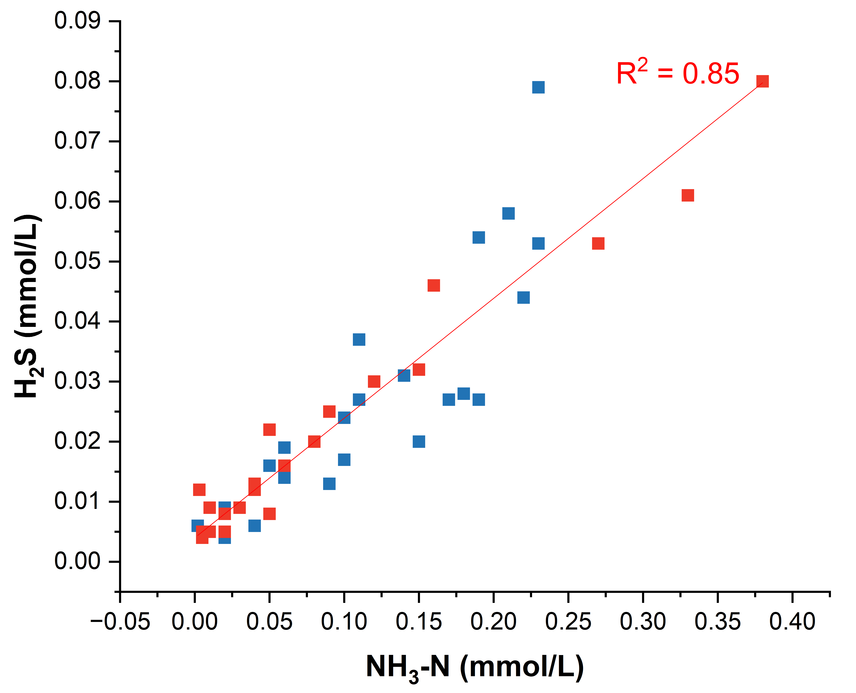
Figure 3.5. Dissolved sulfide and soluble-ammonia nitrogen concentrations by hydrologic condition. All values in mmol/L. Red indicates losing conditions, and blue indicates gaining conditions.
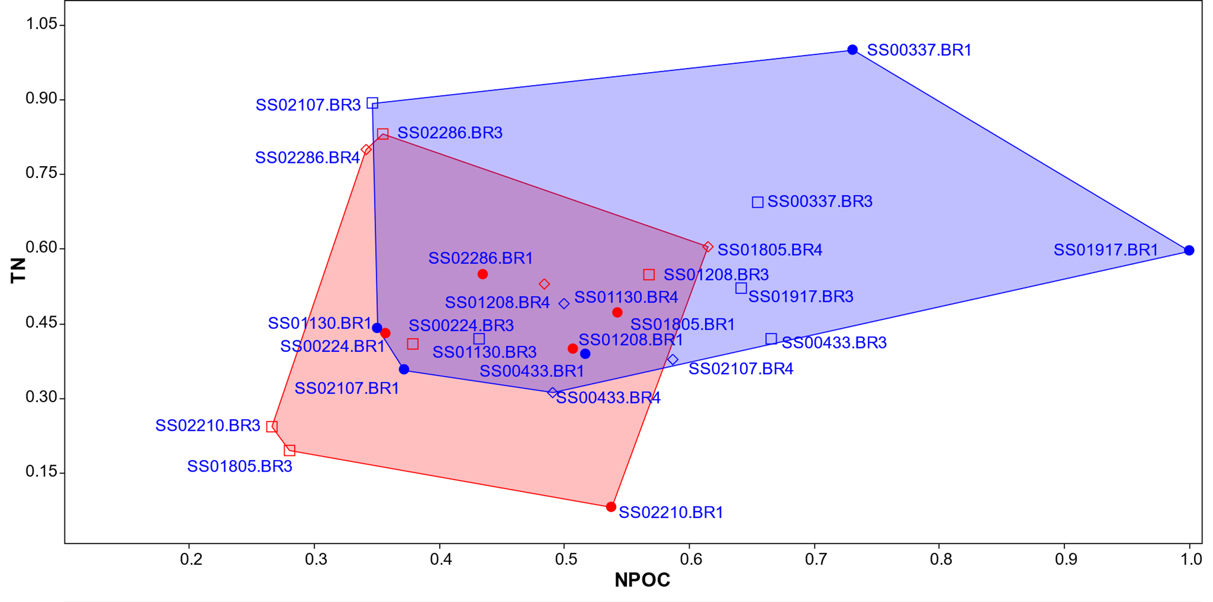
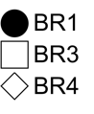
A

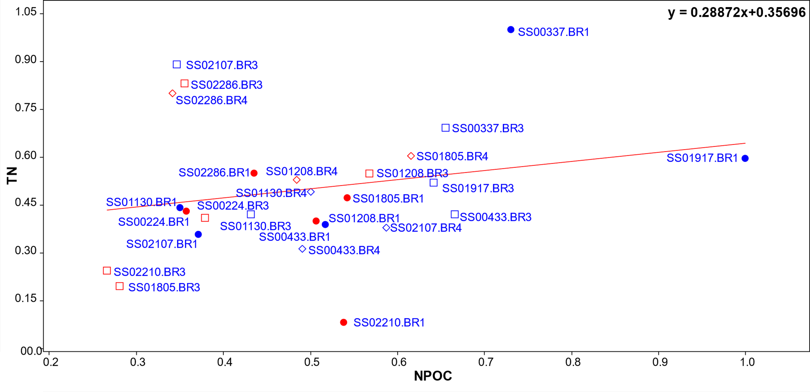
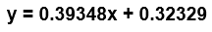
Figure 3.6. (A) XY plot of log-transformed values for non-purgeable organic carbon (NPOC) and total nitrogen (TN) from HZ samples. Bound regions in red indicate convex hulls for hydrologically losing sites, and blue-bound regions indicate convex hulls for hydrologically gaining sites. (B) General linear model (GLM) of NPOC and TN.
B
Table 3.8. Non-purgeable organic carbon (NPOC), total nitrogen (TN), calculated C:N ratios, and CDOM fluorescence indices, including the fluorescence index (FI), humification index (HIX), and biological index (BIX) for surface water (SW) and Bou Rouch (BR) samplers in the San Saba River, Texas, from June 2021. Only BR1, BR3, and BR4 samples were analyzed to link with microbial data. NPOC and TN are reported in mg/L.

Site | NPOC | TN | C: N | FI | HIX | BIX
SS00224.BR1 | 7.93 | 0.4 | 20.02 | 1.61 | 11.38 | 0.67
SS00224.BR3 | 2.10 | 0.1 | 14.44 | 1.61 | 12.16 | 0.66
SS00224.BR4 | 10.96 | 0.5 | 20.21 | 1.63 | 8.67 | 0.67
SS00224.SW | 4.28 | 0.7 | 6.28 | 1.50 | 14.75 | 0.63
SS00291.BR4 | 16.69 | 0.8 | 19.59 | 1.59 | 7.54 | 0.71
SS00291.SW | 14.48 | 0.6 | 23.24 | 1.51 | 9.95 | 0.63
SS00337.BR1 | 3.23 | 0.4 | 9.06 | 1.56 | 15.50 | 0.62
SS00337.BR3 | 3.61 | 0.3 | 10.76 | 1.58 | 10.60 | 0.62
SS00337.BR4 | 12.78 | 0.8 | 15.67 | 1.55 | 10.58 | 0.66
SS00337.SW | 4.09 | 0.6 | 6.72 | 1.51 | 7.29 | 0.69
SS00433.BR1 | 18.07 | 1.0 | 17.42 | 1.55 | 11.19 | 0.65
SS00433.BR3 | 13.04 | 0.6 | 20.53 | 1.55 | 7.36 | 0.68
SS00433.BR4 | 10.54 | 0.9 | 11.70 | 1.53 | 11.40 | 0.64
SS00433.SW | 15.68 | 0.6 | 24.26 | 1.50 | 12.77 | 0.64
SS01130.BR1 | 7.06 | 0.3 | 21.76 | 1.53 | 5.49 | 0.65
SS01130.BR3 | 13.64 | 0.3 | 39.44 | 1.49 | 12.30 | 0.59
SS01130.BR4 | 6.24 | 0.2 | 24.51 | 1.54 | 8.68 | 0.64
SS01130.SW | 5.07 | 0.4 | 12.52 | 1.53 | 10.68 | 0.68
SS01208.BR1 | 55.46 | 0.5 | 104.64 | 1.53 | 5.56 | 0.68
SS01208.BR3 | 12.30 | 0.4 | 27.33 | 1.51 | 7.25 | 0.67
SS01208.BR4 | 15.62 | 0.4 | 38.10 | 1.53 | 8.78 | 0.67
SS01208.SW | 9.48 | 0.3 | 32.69 | 1.50 | 7.03 | 0.68
SS01805.BR1 | 3.48 | 0.3 | 12.00 | 1.51 | 7.37 | 0.77
SS01805.BR3 | 3.04 | 0.9 | 3.42 | 1.55 | 8.11 | 0.67
SS01805.BR4 | 9.68 | 0.3 | 31.23 | 1.51 | 7.82 | 0.67
SS01805.SW | 4.14 | 0.4 | 11.19 | 1.53 | 8.80 | 0.68
SS01917.BR1 | 3.11 | 0.4 | 8.41 | 1.55 | 4.80 | 0.80
SS01917.BR3 | 4.70 | 0.3 | 13.43 | 1.52 | 11.77 | 0.62
SS01917.BR4 | 6.52 | 0.4 | 15.52 | 1.55 | 7.86 | 0.67
SS01917.SW | 3.10 | 0.5 | 6.20 | 1.56 | 9.66 | 0.68
SS02107.BR1 | 6.73 | 0.3 | 20.39 | 1.55 | 8.93 | 0.62
SS02107.BR3 | 8.88 | 0.5 | 18.50 | 1.55 | 11.70 | 0.62
SS02107.BR4 | 6.05 | 0.5 | 13.15 | 1.54 | 9.06 | 0.65
SS02107.SW | 3.45 | NM | NM | 1.55 | 6.33 | 0.68
SS02210.BR1 | 7.77 | 0.1 | 131.72 | 1.58 | 7.06 | 0.61
SS02210.BR3 | 1.93 | 0.2 | 9.97 | 1.54 | 5.28 | 0.63
SS02210.SW | 5.86 | 0.4 | 14.71 | 1.56 | 3.42 | 0.81
SS02286.BR1 | 4.79 | 0.5 | 10.03 | 1.54 | 8.06 | 0.61
SS02286.BR3 | 3.19 | 0.8 | 3.96 | 1.61 | 5.74 | 0.71
SS02286.BR4 | 2.97 | 0.8 | 3.86 | 1.61 | 5.34 | 0.71
SS02286.SW | 5.27 | 0.6 | 9.47 | 1.57 | 2.55 | 0.87
conglomerate/mixed clastics significantly differed from carbonate (p-value 0.006) (Table A.14).
One-way PERMANOVA tests were used to examine the relationships among NPOC, TN, C:N ratio, and hydrologic condition (gaining or losing). Of these, only NPOC relative to hydrologic conditions was close to being statistically significant (p-value = 0.05), with a high calculated F-statistic of 4.117 (Table A.14). The total sum of squares (SS) was calculated to be 0.75, with within-group SS being 0.65, which also indicated considerable variation in NPOC across the different hydrologic conditions.
To accommodate for the non-normal distribution of the response variable and appropriately model associations, a GLM with a normal distribution assumption and an identity link function were used, indicating a direct and additive relationship between the predictor (NPOC) and the response (TN) for HZ samples (Figure 3.6B). The intercept, which represented the expected value of TN when NPOC was zero, was estimated to be 0.323, with a standard error of 0.136. The slope coefficient indicated that, on average, TN increased by 0.393 units for every one-unit increase in NPOC, with a standard error of 0.252. The dispersion parameter (phi) estimate was 0.047, which suggested constant variance for the response variable (TN) across the range of NPOC. The log likelihood was found to be -13.5, which was a reasonable fit to the observed data. Additionally, the G statistic yielded a value of 2.437, with an associated p-value of 0.118 for the slope coefficient that reflected the significance of the relationship between NPOC and TN. However, the slope coefficient was not statistically significant.
The calculated fluorescence indices also provided a way to compare NPOC, TN, and CDOM nature and type (Figure A.11). Although there were observable differences among BR sampler locations for the different calculated fluorescence indices, none were statistically significant. In general, FI values generally did not vary (Table 3.8) and indicated a mixture of mostly terrestrial OM sources (e.g., Birdwell and Engel, 2010). One-way PERMANOVA suggested a statistically significant difference in FI values according to hydrologic condition (F-statistic = 25.47, p-value = 0.0001). HIX and BIX values negatively correlated with each other (p-value = 0.0004). HIX values generally decreased downstream with higher TN concentrations (Table 3.8, Figure A.11A). Values below 5 would indicate fresh organic material with limited humification (Birdwell and Engel, 2010). BIX values were also consistent with biological or microbial sources and higher BIX values were calculated or downstream reaches (Table 3.8). Losing reaches had fewer samples with moderate to high HIX values and lower BIX values, indicating that the river in hydrologically losing reaches may be supplying fresh organic material into the HZ. However, there were no statistically significant differences between BIX and HIX values with gaining or losing conditions.

3.2.3 Geochemistry controlled by lithology
Changes in the major dissolved ion concentrations were evaluated in the context of underlying bedrock lithology (Figure 2.3) by accounting for carbonate and gypsum dissolution, silicate weathering, and halite dissolution, in addition to processes like evaporation. Bicarbonate was the dominant anion, but the dominant cation varied along the river (Figure 3.7). Carbonate dissolution would be responsible for two moles of bicarbonate to every mole of calcium and magnesium, but gypsum dissolution would also add calcium. By subtracting sulfate concentrations from calcium and magnesium concentrations, any calcium contributed by
gypsum dissolution would be removed. All SW and BR data plotted on or slightly below a 2 to 1 bicarbonate-cation line, providing evidence for minimal gypsum dissolution (Figure 3.8A).
To evaluate whether cations could be supplied from weathering silicate minerals (e.g., feldspars), ratios of the cations were plotted against each other (Figure 3.8B). There was limited evidence for cations being supplied by silicate or evaporite weathering. To evaluate the contribution of evaporation, a Gibb’s plot was constructed (Figure 3.9), and only the farthest downstream samples showed the potential effect of evaporation. Excess bicarbonate could be contributed from redox processes associated with respiration, as higher bicarbonate concentrations correlated to lower DO concentrations and higher CH₄ concentrations (Figure 3.10). The pairwise distance matrix, generated as part of the one-way PERMANOVA test for bicarbonate values from BR spikes in the HZ (Table A.15), revealed p-values to suggest varying levels of significance. Notably, bicarbonate values from the carbonate-sandstone pairing had the lowest p-value (0.04). The calculated F-value of 3.16 indicated that the variation in bicarbonate values between the lithologic groups was greater than the variation within each individual group. Importantly, the one-way PERMANOVA test yielded no significant results for the surface water samples (Table A.16).

3.3 Microbial Diversity

3.3.1 Taxonomic overview of the surface water and hyporheic zone
The microbial diversity of the San Saba River water and HZ was evaluated from 16S rRNA gene sequence surveys. A total of 8,221,976 curated sequences were retrieved from 39 different samples See Table B.1, in Appendix B, for an example of these data.
There were 69,391 sequences affiliated with the Archaea, which represented 0.84% of all the sequences. Eleven archaeal phyla were identified. The proportion of total sequences that were classified as Archaea was higher in the HZ (1.24%) compared to SW (0.03%). The most prevalent archaeal phyla among the classified OTUs from all samples were Crenarchaeota,

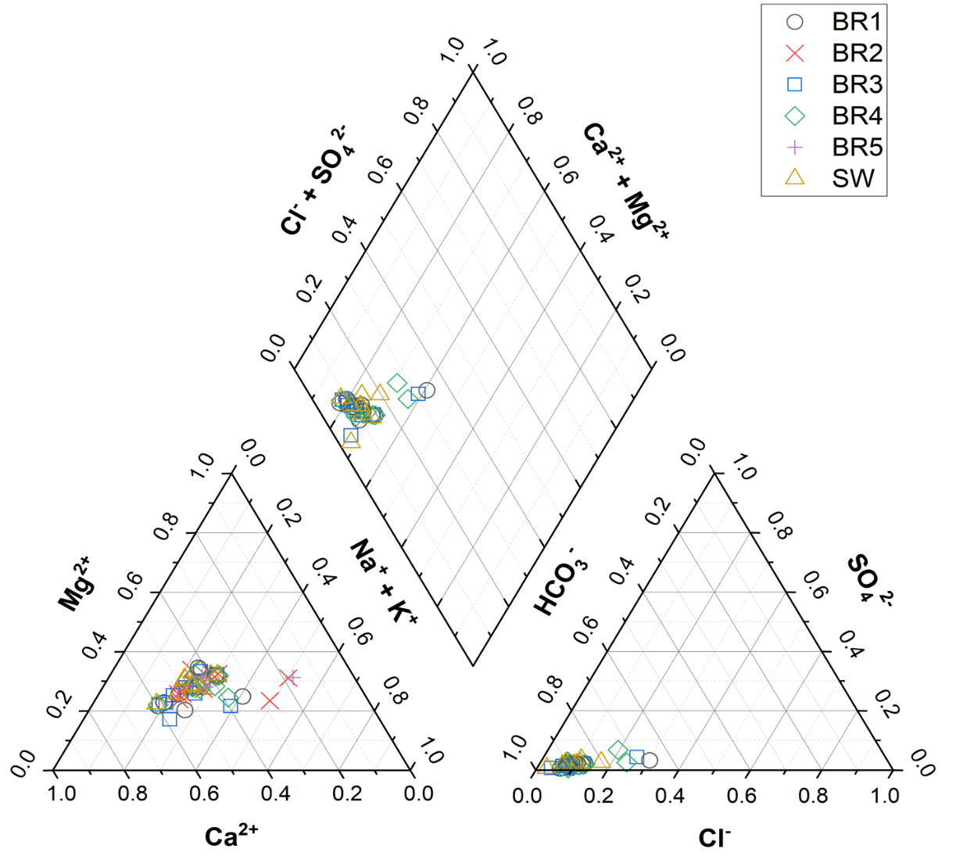

Figure 3.7. Piper diagram illustrating the hydrogeochemical composition of all sample locations in the San Saba River, Texas, during June 2021. The samples are categorized based on their respective hyporheic zone (HZ) sampler locations (BR) or surface water (SW) designation.

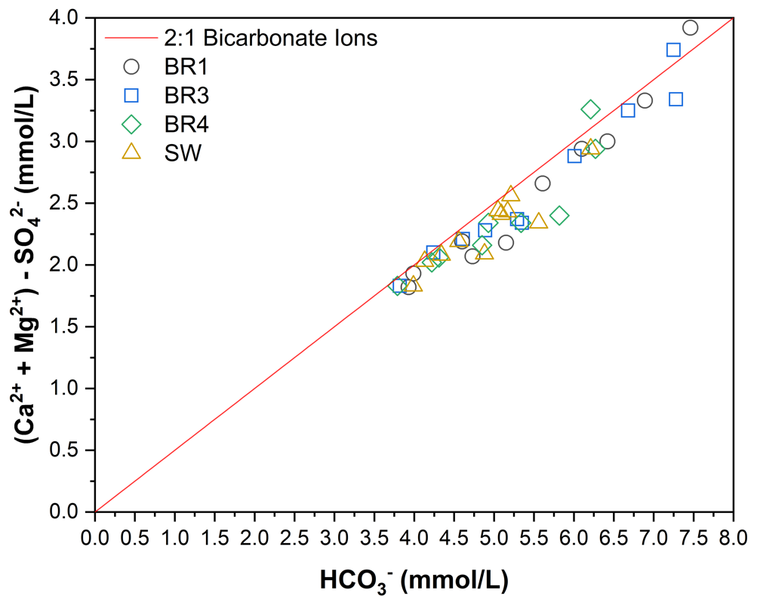
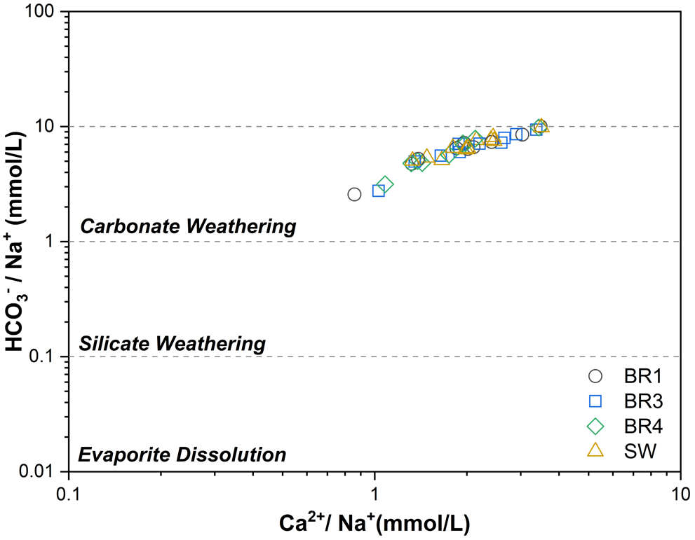
Excess HCO₃⁻
A
B
Figure 3.8. (A) Evaluation of potential sources for calcium and magnesium by plotting their sum against bicarbonate concentrations and after subtracting sulfate concentrations to account for potential contributions from gypsum dissolution. Data plot on or slightly below a 2:1 line (black line) representing two moles of bicarbonate for every one mole of cation attributed to carbonate dissolution. Excess bicarbonate could originate from microbial processes. (B) Carbonate, silicate, and evaporite rock dissolution account for increases in cation concentrations, but the waters plot consistent with carbonate dissolution.
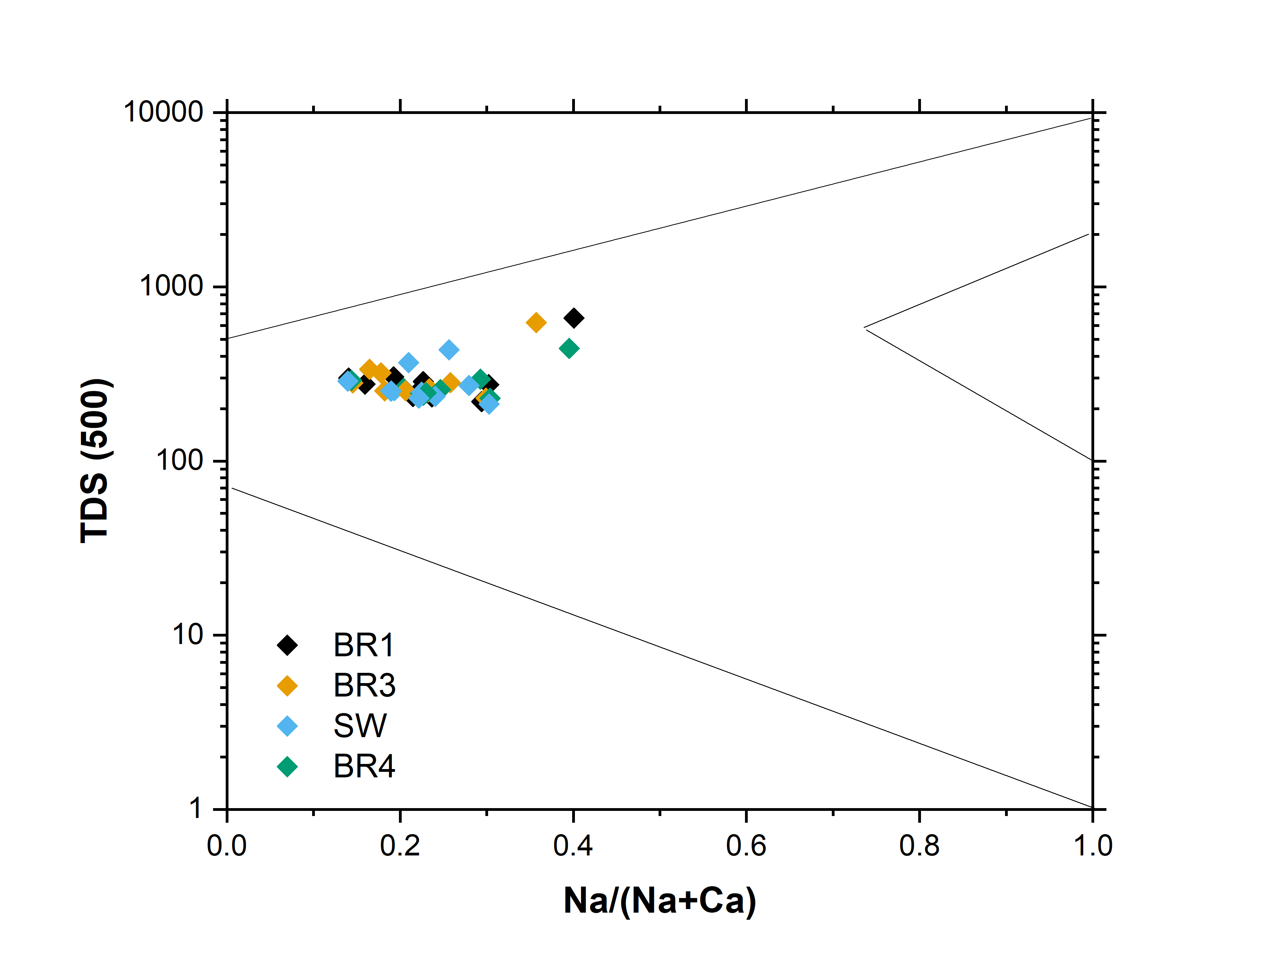
Figure 3.9. Gibb’s Diagram for Bou Rouch (BR) samples and surface water (SW) from the San Saba River indicating only a few samples, those farthest downstream, had ion concentrations and total dissolved solids (TDS) values suggestive of evaporation.
Farthest Downstream Samples
Rock Weathering Dominance
Evaporation Dominance
Precipitation Dominance
Total Dissolved Solids (ppm)
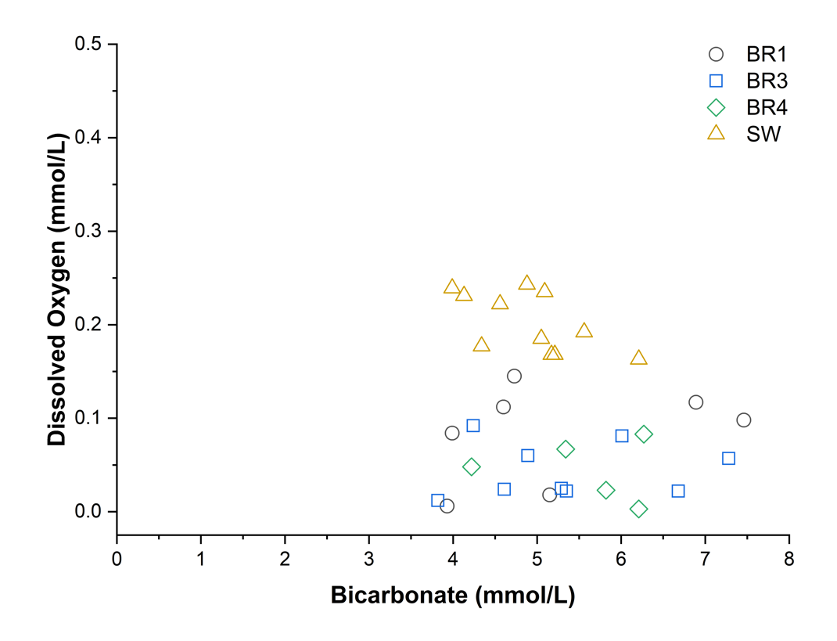
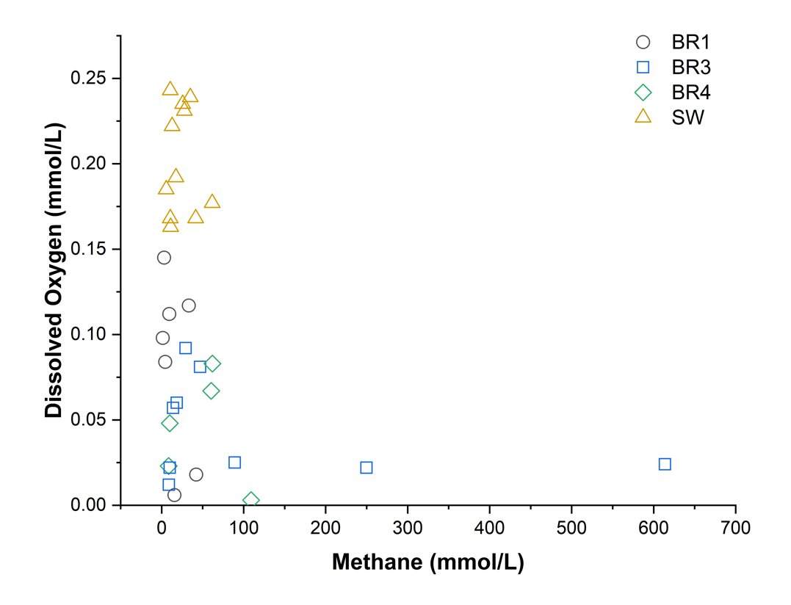
A
B
Figure 3.10. (A) Bicarbonate and dissolved oxygen (DO) concentrations in Bou Rouch (BR) samples and surface water (SW) from the San Saba River, Texas. The data reveals an association between higher bicarbonate concentrations and low DO conditions. (B) Additionally, methane concentrations increase in the BR samples under low DO conditions, suggesting a potential link between bicarbonate and methane dynamics in these samples.

Thermoplasmatoa, Nanoarchaeota, and Aenigmarchaeota (Table 3.9, Figure 3.11), although 38% of the archaeal reads were also unclassified, which suggested potentially novel diversity.
Among the Bacteria, 76 phyla were identified, in addition to unclassified bacteria. Almost every sequence retrieved from the SW (99.96%) was classified as Bacteria, compared to 98.8%
of sequences from the HZ samples. Among the classified OTUs, Proteobacteria was the most prevalent phylum (27.2% relative abundance of all bacterial OTUs), followed by unclassified Bacteria (24.1%), Verrucomicrobiota (7.7%), and Chloroflexi (6.17%) (Figure 3.12). Eleven other phyla had ≥1% relative abundances (Table 3.10).
Briefly, the microbial communities from all BR1 samplers were dominated by Gammaproteobacteria, although the relative abundances fluctuated (from 12.4% to 53.35%) (Figure 3.13). Actinobacteria had lower average relative abundances from BR1 samplers but an average relative abundance of around 15% from all SW and most HZ samples; three locations had ≤1% relative abundance of Actinobacteria (SS02286, SS02210, and SS00337). None of the BR1 samplers had more than 5% relative abundances of Alphaproteobacteria, except for one sample location SS02210, which had the highest relative abundance of Alphaproteobacteria for any sample location (20.21%). Dehalococcoidia had an average relative abundance of 2.81% for all BR1 sample locations, but abundances differed. Specifically, Dehalococcoidia had higher than average relative abundances in five BR1 sample locations, two of which were upstream locations, SS02286 (7.68%) and SS02107 (4.45%), and again in the three downstream locations, SS00337, which had the highest relative abundance in all BR1 samples (8.47%), SS00433 (6.75%) and SS00224 (3.21%). Other notable distinctions for BR1 locations included that the Sva0485 clade (proposed as Candidatus Acidulodesulfobacter; Tan et al. 2019) had an average relative abundance of 2.26%, which was more comparable to BR3 as this group was not recovered in high relative abundances from the SW and was noticeably lower in BR4 sample locations as well (Table 3.11). In BR1 samplers, Cyanobacteria had an average relative abundance of 3.68%, which was less than SW (at 11%) and BR4 (at 3.87%), but higher than BR3 (2.28%). The average relative abundance of Omnitrophia in BR1 sample locations was 1.33% and was retrieved at ≤2% across all sites, except for two upstream locations, SS02286 (6.46%) and SS02107 (6.91%). Unclassified bacteria had an average relative abundance of 6.57% in all BR1 sites, which was only slightly greater than the average for all samples (5.75%).
Like BR1, Gammaproteobacteria was the dominant class retrieved from BR4 samples (32.97% relative abundance), and with Actinobacteria (21.1%) and Bacteroidia (14.5%), they made up nearly 70% of the relative abundances of all BR4 sites (Figure 3.13). The average relative abundances of BR4 Actinobacteria were higher than from the SW at 16.12%, but the

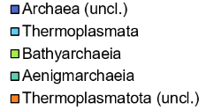
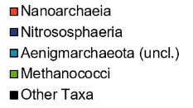
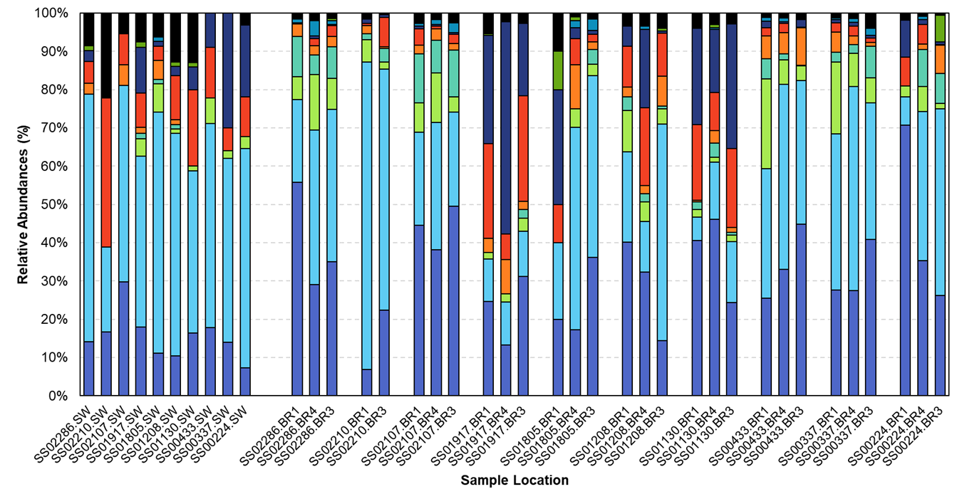
Figure 3.11. Relative abundances of dominant archaeal classes (>1% of the total archaeal sequence reads) in (A) surface water and (B) Bou Rouch (BR) samples, listed from left to right in the direction of upstream flow, respectively, for each pool-riffle location.
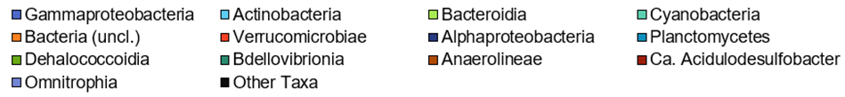
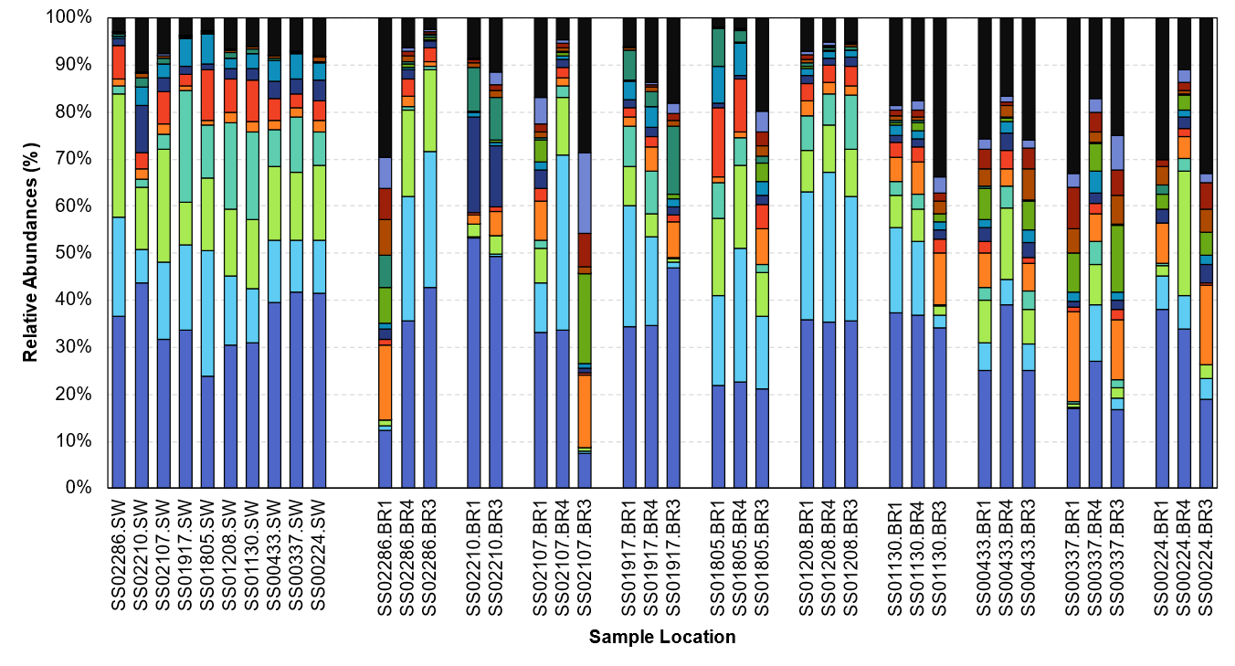
Figure 3.12. Stacked bar graph of relative sequence percentages of dominant bacterial classes (>1% of the total bacterial sequence reads) in surface water and HZ Bou Rouch (BR) samples, listed from left to right in the direction of upstream (BR1) to downstream (BR3) flow, respectively, and for each pool-riffle location.
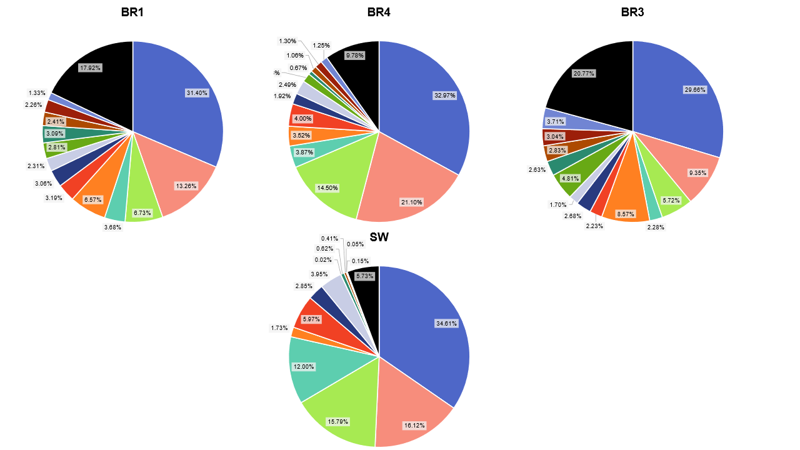
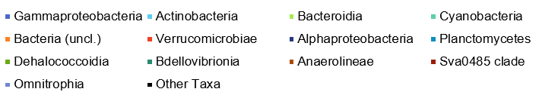
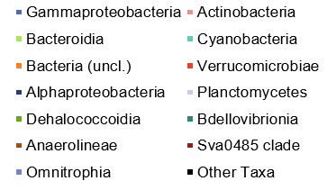
Figure 3.13. Summary of relative abundances of bacterial classes that accounted for >1% of the bacterial sequence reads and combined remaining taxa for each Bou Rouch (BR) and surface water (SW) sampling locations for the San Saba River.
Phylum | Class | Total Number of Sequence Reads | Relative Abundance Archaeal Sequence Reads [%]
Unclassified | Archaea (uncl.) | 26205 | 37.76%
Thermoplasmatota | Thermoplasmata | 23564 | 33.96%
Crenarchaeota | Bathyarchaeia | 4895 | 7.05%
Aenigmarchaeota | Aenigmarchaeia | 4783 | 6.89%
Thermoplasmatota | Thermoplasmatota (uncl.) | 2564 | 3.70%
Nanoarchaeota | Nanoarchaeia | 2440 | 3.52%
Crenarchaeota | Nitrososphaeria | 2144 | 3.09%
Aenigmarchaeota | Aenigmarchaeota (uncl.) | 803 | 1.16%
Euryarchaeota | Methanococci | 688 | 0.99%
Crenarchaeota | Crenarchaeota (uncl.) | 375 | 0.54%
Euryarchaeota | Thermococci | 187 | 0.27%
Hydrothermarchaeota | Hydrothermarchaeia | 164 | 0.24%
Aenigmarchaeota | DSEG | 140 | 0.20%
Hadarchaeota | Hadarchaeia | 132 | 0.19%
Thermoplasmatota | Thermoplasmatota | 125 | 0.18%
Halobacterota | Halobacterota (uncl.) | 59 | 0.09%
Asgardarchaeota | Odinarchaeia | 40 | 0.06%
Euryarchaeota | Methanobacteria | 28 | 0.04%
Halobacterota | Methanomicrobia | 23 | 0.03%
Asgardarchaeota | Lokiarchaeia | 11 | 0.02%
Crenarchaeota | Methanomethylicia | 11 | 0.02%
Halobacterota | Methanosarcinia | 5 | 0.01%
Halobacterota | Methanocellia | 4 | 0.01%
Table 3.9. Relative abundances for all samples with classified archaeal sequence reads. Rows shaded in gray represent taxa with ≥1% relative abundances. Uncl. = unclassified

Table 3.10. Relative abundances for all samples with classified archaeal sequence reads. Rows shaded in gray represent taxa with ≥1% relative abundances. Uncl. = unclassified
Phylum | Class | Total Sequence Reads | Proportion of Bacterial Sequence Reads [%]
Proteobacteria | Gammaproteobacteria | 2621046 | 32.15%
Actinobacteriota | Actinobacteria | 1206469 | 14.80%
Bacteroidota | Bacteroidia | 873018 | 10.71%
Cyanobacteria | Cyanobacteria | 453818 | 5.57%
Unclassified | Bacteria (uncl.) | 416313 | 5.11%
Verrucomicrobiota | Verrucomicrobiae | 314839 | 3.86%
Proteobacteria | Alphaproteobacteria | 214457 | 2.63%
Planctomycetota | Planctomycetes | 214050 | 2.63%
Chloroflexi | Dehalococcoidia | 189207 | 2.32%
Bdellovibrionota | Bdellovibrionia | 141179 | 1.73%
Chloroflexi | Anaerolineae | 136255 | 1.67%
Sva0485 | Sva0485_cl | 135111 | 1.66%
Verrucomicrobiota | Omnitrophia | 134309 | 1.65%
Nitrospirota | Thermodesulfovibrionia | 68536 | 0.84%
Methylomirabilota | Methylomirabilia | 68082 | 0.84%
Acidobacteriota | Vicinamibacteria | 50447 | 0.62%
Planctomycetota | Phycisphaerae | 49282 | 0.60%
Acidobacteriota | Acidobacteriae | 45174 | 0.55%
Dependentiae | Babeliae | 42665 | 0.52%
Gemmatimonadota | Gemmatimonadetes | 40555 | 0.50%
Desulfobacterota | Desulfobacteria | 37948 | 0.47%
Myxococcota | Polyangia | 35220 | 0.43%
Firmicutes | Bacilli | 34218 | 0.42%
Acidobacteriota | Aminicenantia | 33115 | 0.41%
Desulfobacterota | Desulfobaccia | 24194 | 0.30%
Bdellovibrionota | Oligoflexia | 22543 | 0.28%
Firmicutes | Clostridia | 22321 | 0.27%
Chloroflexi | Chloroflexi (uncl.) | 21968 | 0.27%
Chloroflexi | Chloroflexia | 21375 | 0.26%
Desulfobacterota | Desulfobacterota (uncl.) | 18524 | 0.23%
Patescibacteria | Parcubacteria | 16361 | 0.20%
Latescibacterota | Latescibacterota_cl | 16190 | 0.20%
Halanaerobiaeota | Halanaerobiia | 16144 | 0.20%
Bacteroidota | Kryptonia | 16131 | 0.20%
Spirochaetota | Spirochaetia | 14135 | 0.17%
Desulfobacterota | Syntrophobacteria | 13476 | 0.17%
Desulfobacterota | Desulfuromonadia | 12902 | 0.16%
Desulfobacterota | Syntrophia | 12525 | 0.15%
Verrucomicrobiota | Chlamydiae | 12249 | 0.15%
Table 3.10, continued.
Phylum | Class | Total Sequence Reads | Proportion of Bacterial Sequence Reads [%]
Nitrospirota | Nitrospiria | 12086 | 0.15%
Planctomycetota | Planctomycetota (uncl.) | 12010 | 0.15%
Latescibacterota | Latescibacteria | 11833 | 0.15%
Myxococcota | Myxococcia | 11263 | 0.14%
Planctomycetota | OM190 | 11021 | 0.14%
Planctomycetota | Brocadiae | 9611 | 0.12%
Actinobacteriota | Thermoleophilia | 9449 | 0.12%
Nitrospinota | P9X2b3D02 | 9057 | 0.11%
Verrucomicrobiota | Kiritimatiellae | 8583 | 0.11%
Acidobacteriota | Blastocatellia | 8124 | 0.10%

Table 3.11. Comparison of average relative abundances of dominant bacterial classes at >1% of all sequence reads in surface water or hyporheic zone (HZ) samples. Uncl. = Unclassified.

 |  | Sample Location
Taxon (Phylum) | Taxon (Class) | Surface Water | Hyporheic Zone
Proteobacteria | Gammaproteobacteria | 36.7% | 37.4%
Actinobacteriota | Actinobacteria | 17.1% | 17.1%
Bacteroidota | Bacteroidia | 16.7% | 10.6%
Cyanobacteria | Cyanobacteria | 12.7% | 3.8%
Unclassified | Bacteria (uncl.) | 1.8% | 7.6%
Verrucomicrobiota | Verrucomicrobiae | 6.3% | 3.7%
Proteobacteria | Alphaproteobacteria | 3.0% | 3.0%
Planctomycetota | Planctomycetes | 4.2% | 2.6%
Chloroflexi | Dehalococcoidia | 0.0% | 3.8%
Bdellovibrionota | Bdellovibrionia | 0.7% | 2.6%
Chloroflexi | Anaerolineae | 0.4% | 2.5%
Sva0485 | Sva0485 clade | 0.1% | 2.7%
Verrucomicrobiota | Omnitrophia | 0.2% | 2.6%

average Bacteroidia was lower than SW at 14.5%. Compared to other HZ samples, BR4 had the highest average relative abundance of Cyanobacteria, at 3.87%. The average relative abundance of Dehalococcoidia was 1.58%, although the farthest upstream sites had lower relative abundances compared to the other BR locations (BR1 and BR3).
From BR3 locations, Gammaproteobacteria had the highest relative abundances, which ranged from 49.9% to 7.43% (average = 29.66%). Unclassified bacteria had an average relative abundance of 8.57%, which was more than all other HZ and SW samples (Figure 3.13). Actinobacteria had an average relative abundance of 13.26% in BR3 samples, which was slightly lower than the average of 14.8% across all HZ samples. Dehalococcoidia had an average relative abundance of 4.81%, which was the highest for this class at all HZ locations. Bacteroidia had an average relative abundance of 5.72% across all BR3 samples, which was lower than all other HZ samples (10.71%). The average relative abundance of Omnitrophia was 3.71%, which was higher than BR1, although abundances ranged from 17.13% to 0.18% from BR3 locations. Cyanobacteria had an average relative abundance of 2.28%, which was the lowest of all the BR sample locations.

3.3.2 Hydrologic conditions and lithologic controls on microbial diversity
Considering the overall taxonomic representation in all the samples and locations, the SW samples, regardless of location along the river, had distinct community representation compared to all the BR samplers (all p-values <0.04) (Table 3.11, Table B.2), which directly supported one of the hypotheses tested, and there were more unclassified bacteria from HZ sites than the SW, which might suggest more novel diversity in the HZ. The microbial diversity from locations with gaining hydrological conditions were distinct from diversity in losing locations (p-value = 0.02) (Table 3.12), which also supported a hypothesis. Despite being present in both sample types (i.e., SW vs HZ, gaining vs losing), Gammaproteobacteria, Actinobacteria, Bacteroidia, and Cyanobacteria were more prevalent under losing conditions, and Planctomycetes, Dehalococcoidia, Bdellovibrionia, Anaerolineae, class Sva0485, and Omnitrophia were more prevalent from gaining conditions.
Calculated alpha diversity based on the non-parametric Shannon’s diversity index (H’), Chao1 values, Simpson’s dominance index (D), and Berger-Parker Dominance (d) from OTUs for all samples revealed community compositional differences among locations, from upstream to downstream, and based on hydrology for gaining and losing conditions (Figure B.1, see Appendix B) and upwelling/downwelling conditions (Figure B.2). One-way ANOSIM tests for only HZ samples for all diversity metrics indicated that diversity indices were weakly significantly different between gaining and losing conditions (p-value = 0.05) and upwelling or downwelling
Table 3.12. Relative abundances of bacterial classes (representing >1% of all sequence reads) in HZ samples according to their hydrologic condition (i.e., losing or gaining).
 |  | Hydrologic Condition
Taxon (Phylum) | Taxon (Class) | Losing | Gaining
Proteobacteria | Gammaproteobacteria | 19.05% | 18.32%
Actinobacteriota | Actinobacteria | 10.56% | 6.56%
Bacteroidota | Bacteroidia | 6.72% | 3.86%
Cyanobacteria | Cyanobacteria | 2.11% | 1.73%
Unclassified | Bacteria (uncl.) | 3.18% | 4.40%
Verrucomicrobiota | Verrucomicrobiae | 2.34% | 1.36%
Proteobacteria | Alphaproteobacteria | 1.80% | 1.25%
Planctomycetota | Planctomycetes | 1.24% | 1.32%
Chloroflexi | Dehalococcoidia | 1.06% | 2.72%
Bdellovibrionota | Bdellovibrionia | 1.28% | 1.28%
Chloroflexi | Anaerolineae | 1.02% | 1.52%
Sva0485 | Sva0485 cl | 0.96% | 1.73%
Verrucomicrobiota | Omnitrophia | 0.75% | 1.87%

conditions (p-value = 0.04) (Tables B.3 and B.4). However, one-way ANOSIM tests for SW samples indicated the effect of gaining or losing conditions on diversity was not significant (p-value = 0.38). The H’ values for SW samples ranged from 4.65 to 6.12 and were lower than the HZ samples. The higher the H’ value, the more species are represented; if H’ is 0, then only one species is present. Median H’ values were higher for all HZ and SW sample locations under gaining hydrological conditions, and median Chao1 values were higher under gaining conditions for BR1 and BR3 only. Chao1 is an estimate of the number of taxa in a community, and there was a statistically significant difference in Chao1 values between upwelling and downwelling conditions (p-value = 0.03). For D, which ranges from 0 to 1, communities with less diversity tend to have more dominant taxa. With d, the value is based on the most abundant species within a community. The D values were similar for all BR locations and SW samples but d values for BR1 sites were slightly lower (0.08 ±0.03) than the other HZ and SW locations (0.09 ±0.03). According to one-way ANOSIM, D values were weakly different between upwelling and downwelling conditions (p-value = 0.05).
When comparing lithology to the relative abundances of major taxonomic groups, communities from locations underlain by mixed clastics and conglomerates were significantly different (p-value = 0.02) from the other communities. The relative abundances of different groups from BR1 and BR3 samples were more like each other (i.e., not statistically different) compared to BR4 samples, and BR4 and SW samples were more compositionally like each other (Figure 3.13). The H’ diversity at locations underlain by mixed clastics was significantly different than H’ values from sandstone (p-value = 0.03), which emphasized the role that the underlying geology may play in influencing the microbial community compositions within the HZ and supported one of the proposed hypotheses. However, one-way ANOSIM results for OTU-level Simpson and Chao1 diversity indices by lithology revealed no significant differences.
Relationships among hydrologic condition, sample location, and lithology were also modeled using UPGMA hierarchical clustering with Bray-Curtis dissimilarity values of the “core” OTUs for both SW and HZ (Figures 3.14 and 3.15, respectively). Although the clustering did not reveal strong associations with lithology, a three-way factorial multivariate analysis of variance (MANOVA) (Table B.5) suggested that the factor "geology" significantly affected diversity metrics (Pillai's trace = 2.164, F (4, 32) = 2.358, p-value = 0.02). Additionally, the factor "hydrology" also may have had a significant impact on diversity (Pillai's trace = 0.933, F(1, 5) = 17.58, p-value = 0.004), and the "geology:hydrology" interaction had marginal significance (Pillai's trace = 0.767, F(1, 5) = 4.105, p-value = 0.08). The factor "spike," representing the

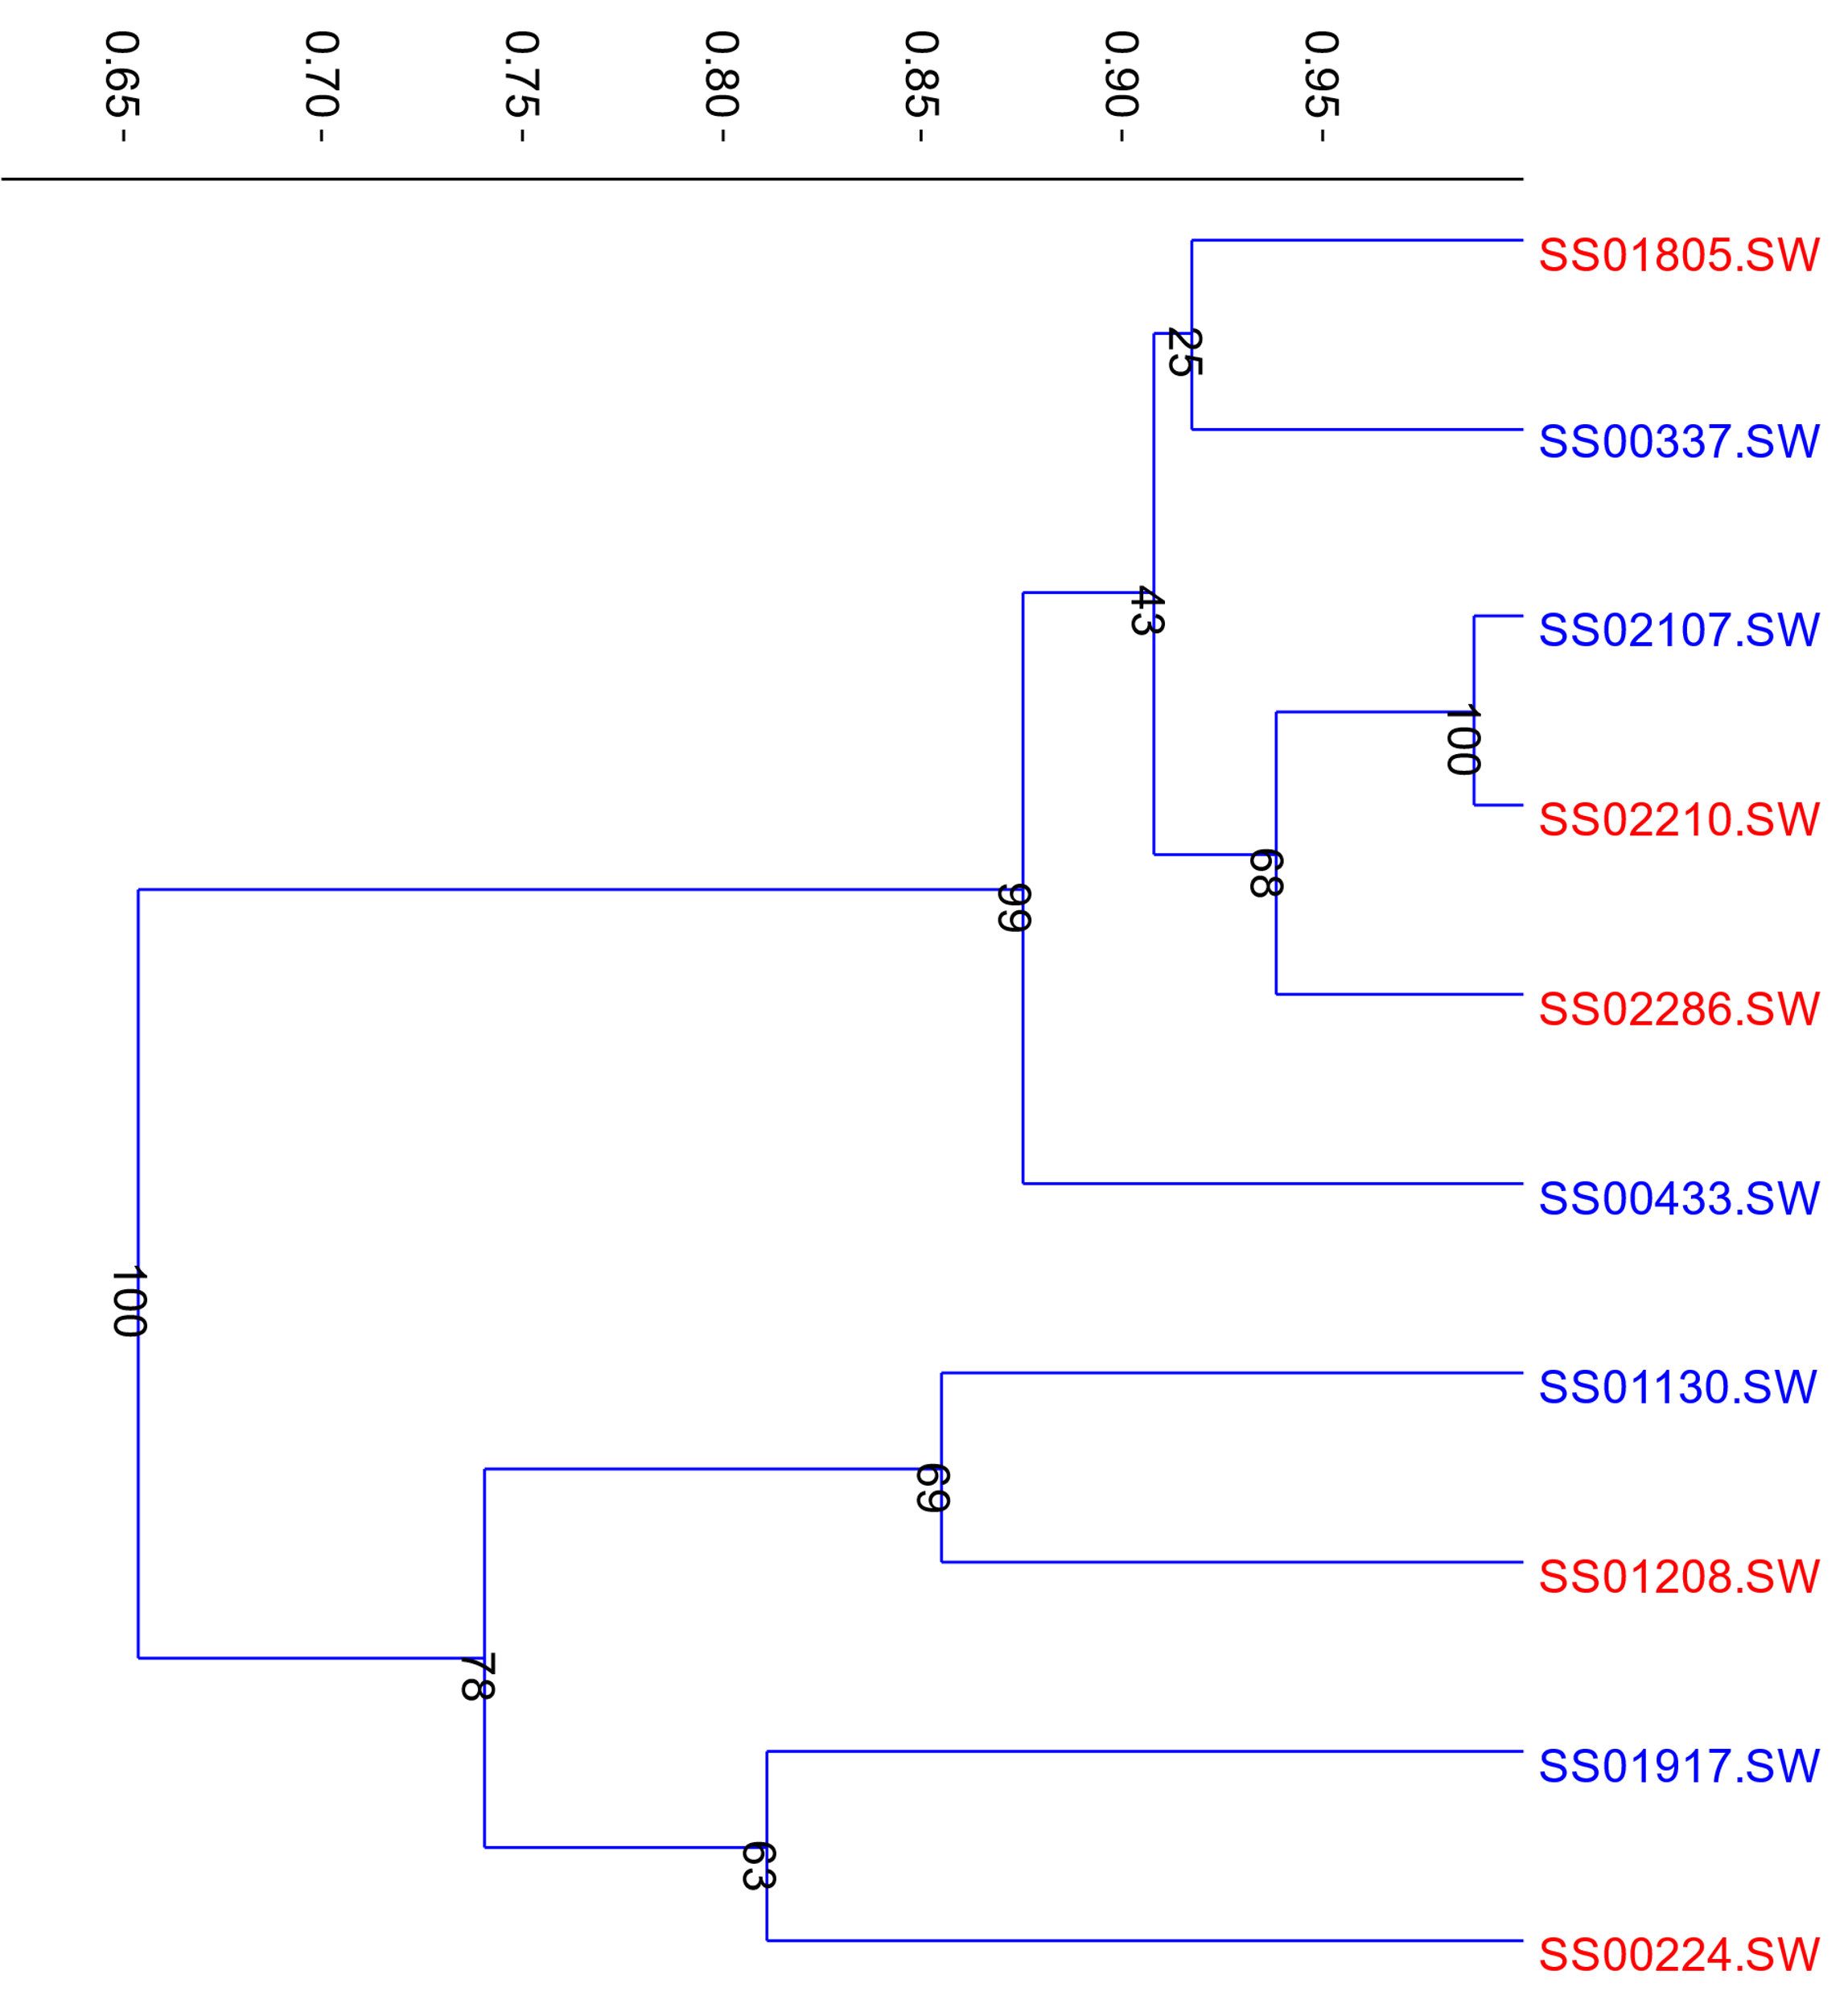
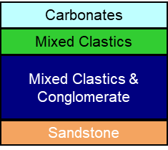
Figure 3.14. Dendrogram of Bray-Curtis similarity index values of dominant operational taxonomic units (OTUs) (>1% of the total sequence reads) for surface water (SW), modeled with unweighted pair group method with arithmetic mean (UPGMA) hierarchical clustering algorithm (cophenetic correlation = 0.92). The number at each node represents the bootstrap value for 999 estimations. Blue represents gaining conditions and red color represents losing conditions. Lithology is noted for each sample.
Bray-Curtis Similarity Index Value
Lithology
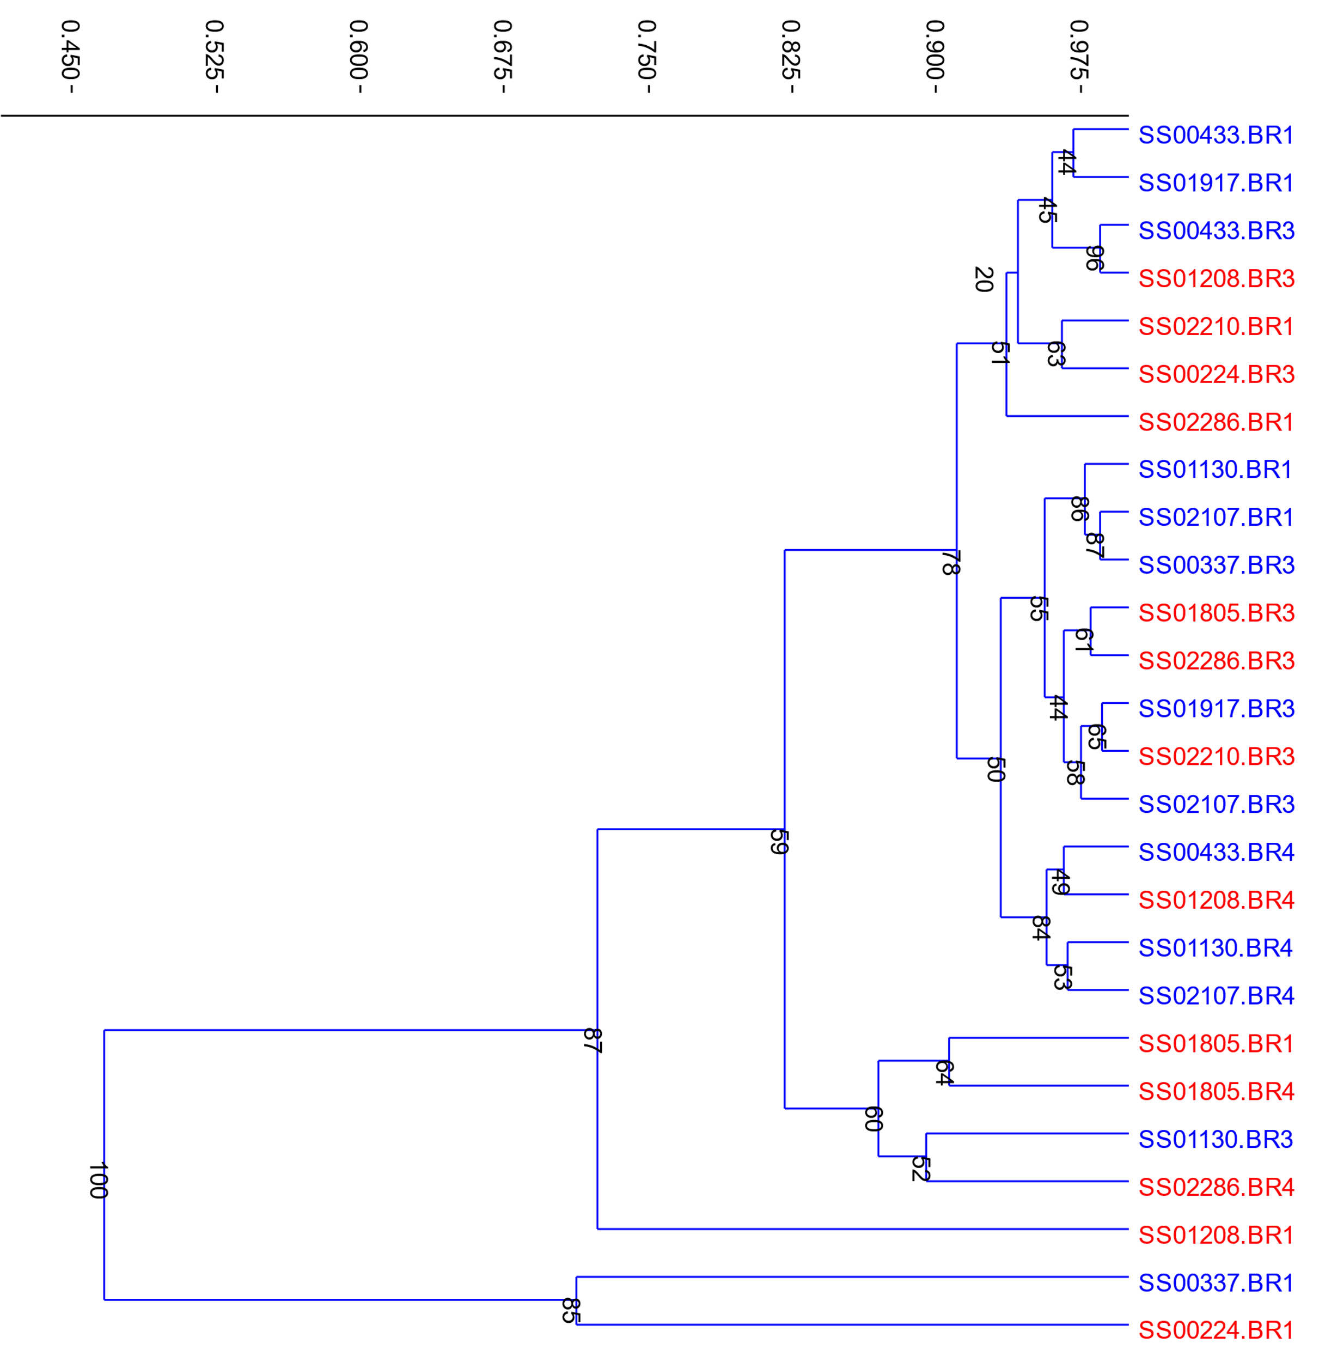
Bray-Curtis Similarity Index Value
Lithology

Figure 3.15. Dendrogram of Bray-Curtis similarity index values of dominant operational taxonomic units (OTUs) (>1% of the total sequence reads) for the hyporheic zone (HZ), modeled with unweighted pair group method with arithmetic mean (UPGMA) hierarchical clustering algorithm (cophenetic correlation = 0.97). The number at each node represents the bootstrap value for 999 estimations. Blue represents gaining conditions and red color represents losing conditions. Lithology is noted for each sample.

spatial position in a pool-riffle sequence, did not have a significant effect on diversity metrics (Pillai's trace = 1.117, F(2, 12) = 1.90, p-value = 0.15). , and the "geology:spike," "hydrology:spike," and "geology:hydrology:spike" interactions also were not significant (p-values > 0.05). These analyses should be examined further because we noted the phenomenon "Hotelling’s effect,” which led to Pillai's trace values, employed as test statistics to evaluate the significance of multivariate effects, surpassing the theoretical upper limit of 1. This was likely due to small sample sizes.

3.3.3 Overview of shared operational taxonomic units
The full dataset yielded 140,518 OTUs at the 97% taxonomic similarity level; 66,587 of the OTUs were singletons and 2309 OTUs were assigned Archaea. After rarifying the data to 22,719 sequences per sample (i.e., the lowest number of reads per sample in the dataset), 106 OTUs represented 60.0% of all the reads having at least ≥0.1% relative abundances. Considering only those OTUs having 20 or more sequences each (i.e., 15,936 OTUs, which was 11% of all OTUs that were classified), this dataset represented 95.5% of all sequence data (Table B.1). The top 16 OTUs with relative abundances ≥1% from all the data represented about 38% of all the reads (Figure 3.16). To focus on the most prevalent groups in the SW and HZ, only those OTUs amounting to ≥1% relative abundance in all samples is described, noting that some of these groups may have also had ≥1% in at least one sample and that some OTUs may not be in every sample (Figure 3.16).
There were significant differences regarding which OTUs (≥ 1% total relative abundances) were present at sampling locations (p-value = 0.005) (Figure 3.16, Tables B.2 and B.3) and between the SW and HZ (Table B.6). There were very few OTUs shared across all locations, considered to represent the “core” microbiome. Of any shared OTUs, none had a relative abundance greater than 1%. The “core” HZ OTUs also had higher relative abundances in the mid-section of the river compared to upstream or downstream sections (Figure 3.17). The mid-section had mostly losing hydrological conditions non-carbonate bedrock.
Of the shared “core” OTUs, nine were classified as Gammaproteobacteria, three to Actinobacteria, and Bacteroidia, Cyanobacteria, Bdellovibrionia, and Planctomycetes were also represented (Table 3.13). The largest OTU (by relative abundance) contained 421,548 sequences and accounted for 5.13% of all the sample sequence reads, but it was not retrieved from every sample (Figure 3.16). This OTU was classified as Actinobacteria and was most closely related to an unclassified genus within the family Sporichthyaceae. Currently, there are three recognized genera in this family, Epidermidibacterium (Lee et al., 2018), Longivirga (Qu et al., 2018), and Sporichthya (Lechevalier et al., 1968), and they are aerobic or facultatively

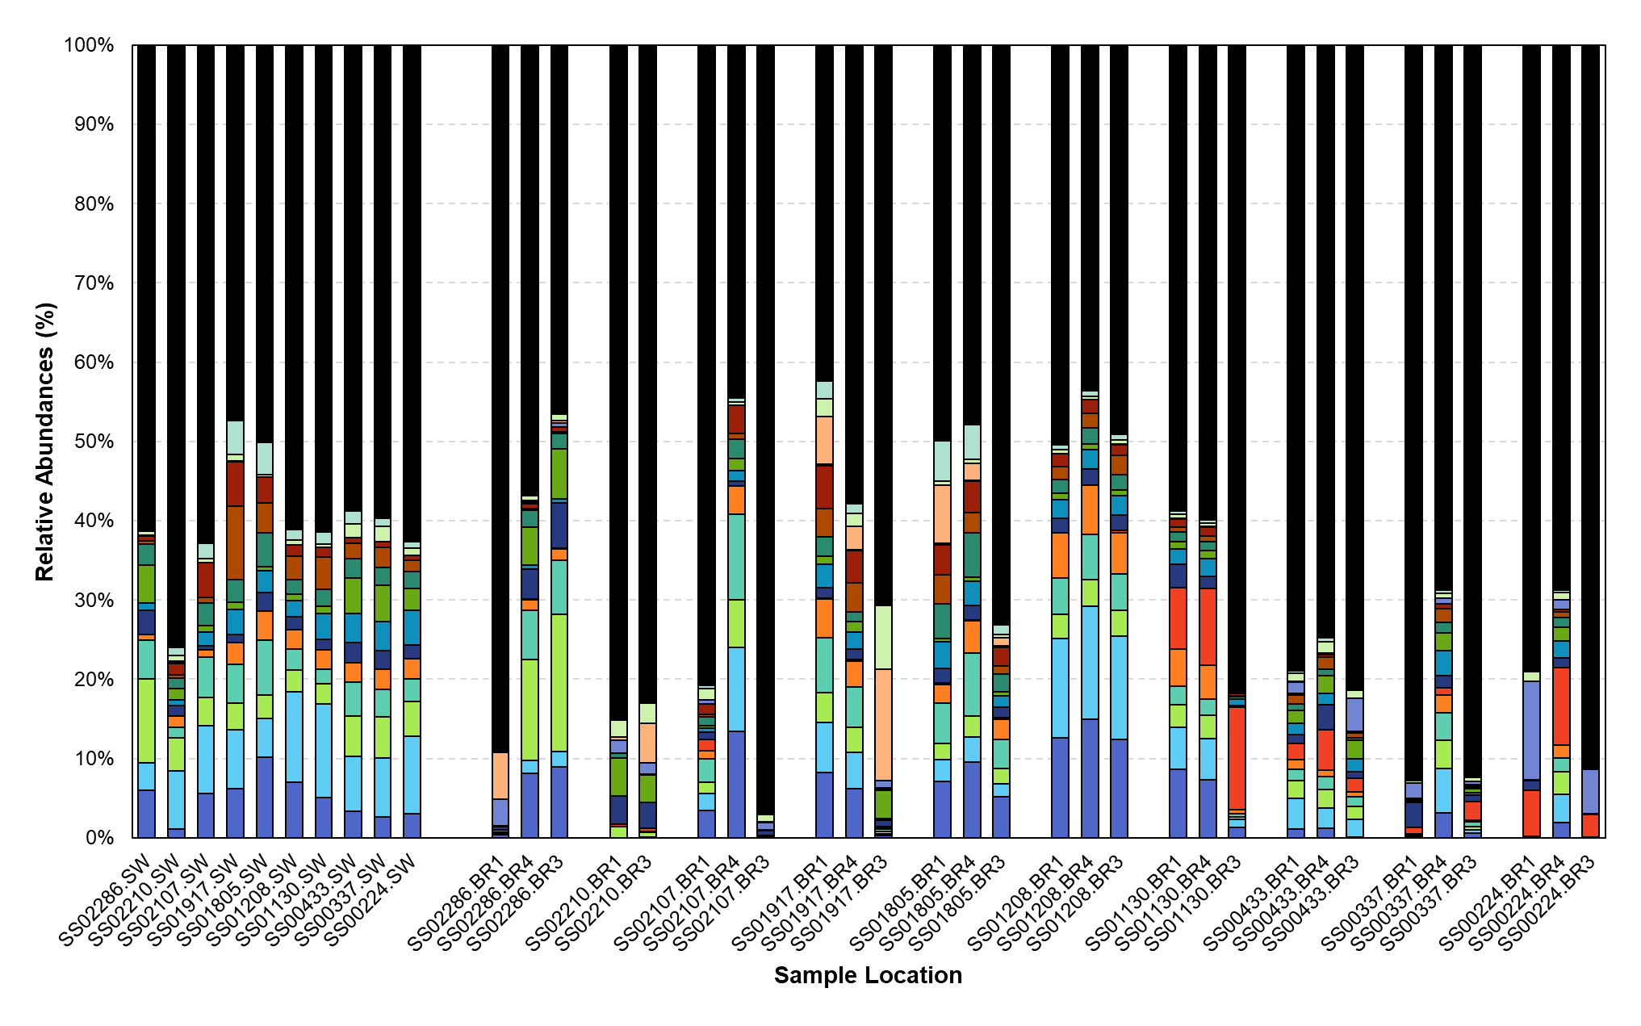

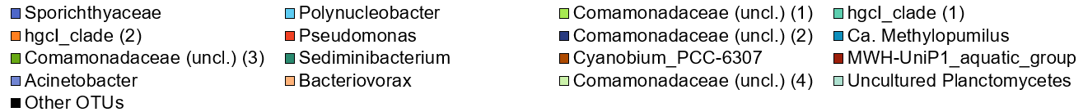
Figure 3.16. Stacked bar graph of relative sequence percentages of dominant (i.e., “core”) OTUs (>1% of the total sequence reads) in surface water (SW) and HZ Bou Rouch (BR) samples, listed from left to right in the direction of upstream (BR1) to downstream (BR3) flow, respectively, and for each pool-riffle location.

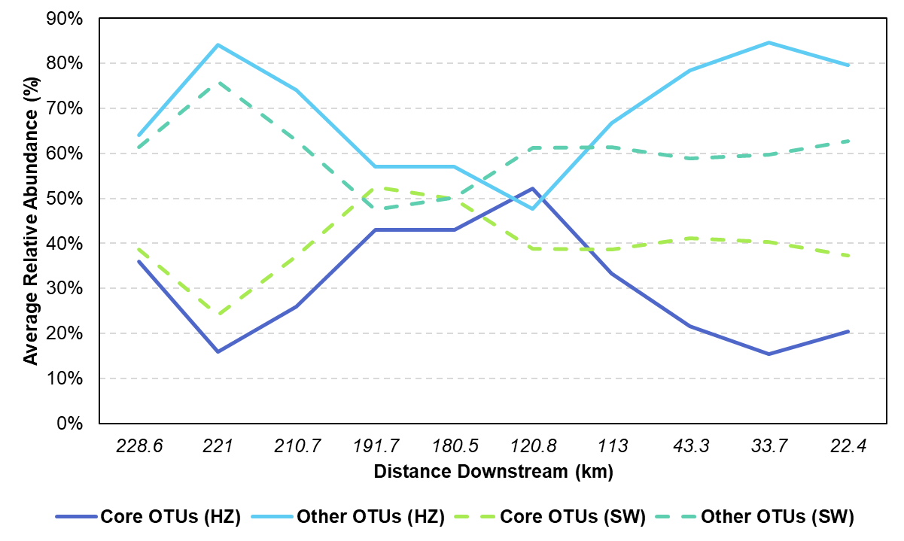
Figure 3.17. Changes in the relative abundances along the river of core operational taxonomic units (OTUs) comprising ≥1% of the total relative abundances of all samples for the hyporheic zone (HZ) and surface water (SW), as well as other OTUs (labelled “other”) constituting ≤1% of the total relative abundances from the HZ and SW. The blue shaded regions represent segments of the river characterized by net gaining conditions, and the red section denotes net losing segments.

Table 3.13. Enumeration and taxonomic profiling of co-occurring OTUs (Relative Abundance ≥1%) using get.coremicrobiome in MOTHUR. Note: Some OTUs lack confident genus-level classification; the closest available taxonomic designation was assigned. In cases of multiple unclassified OTUs sharing the same name, their OTU numbers are provided in parentheses.

Number of  Shared Samples | OTU Classification
30 | Polynucleobacter  Comamonadaceae (OTU000003)
27 - 29 | Sporichthyaceae,  Polynucleobacter  Comamonadaceae (OTU000003), (OTU000007)  HgcI Clade (OTU000004)
25 & 26 | Sporichthyaceae  Polynucleobacter  Comamonadaceae (OTU000003), (OTU000007)  HgcI Clade (OTU000004)  Sediminibacterium
19 - 24 | Sporichthyaceae  Polynucleobacter  Comamonadaceae (OTU000003), (OTU000007)  HgcI Clade (OTU000004), (OTU000005)  Candidatus Methylopumilus  Sediminibacterium
14 - 18 | Sporichthyaceae  Polynucleobacter  Comamonadaceae (OTU000003), (OTU000007), (OTU000009)  HgcI Clade OTU000004), (OTU000005) | Ca. Methylopumilus  Sediminibacterium  Cyanobium PCC-6307  MWH-UniP1 Aquatic Group
12 - 13 | Sporichthyaceae,  Polynucleobacter,  Comamonadaceae (OTU000003), (OTU000007), (OTU000009)  HgcI Clade (OTU000004), (OTU000005) | Cyanobium PCC-6307  MWH-UniP1 Aquatic Group  Uncultured Planctomycetes  Oxalobacteraceae  Ca. Methylopumilus,  Sediminibacterium
11 | Sporichthyaceae  Polynucleobacter  Comamonadaceae (OTU000003), (OTU000007), (OTU000009)  HgcI Clade (OTU000004), (OTU000005)  Pseudomonas | Ca. Methylopumilus  Sediminibacterium  Cyanobium PCC-6307  MWH-UniP1 Aquatic Group  Uncultured Planctomycetes  Oxalobacteraceae  Dinghuibacter
10 | Sporichthyaceae  Polynucleobacter  Comamonadaceae (OTU000003), (OTU000007), (OTU000009), (OTU000015)  HgcI Clade (OTU000004), (OTU000005)  Pseudomonas | Ca. Methylopumilus  Sediminibacterium  Cyanobium PCC-6307  MWH-UniP1 Aquatic Group  Uncultured Planctomycetes  Algoriphagus  Oxalobacteraceae  Dinghuibacter

anaerobic, Gram stain variable, and create aerial hyphae that have a unique upright posture maintained by holdfasts that helps them to form multicellular aggregates or biofilms (Trujillo & Normand, 2019). Sporichthyaceae were first isolated from organic rich soil (Rainey et al., 1993) but are also common in aquatic environments, including freshwater and marine habitats. They are heterotrophs capable of degrading complex organic compounds, such as lignin, and some form symbiotic associations with marine invertebrates (Trujillo & Normand, 2019).
The second largest OTU had 406,141 and accounted for 4.94% of the total sequence reads for all samples. This OTU was classified as the genus Polynucleobacter, which is in the Pseudomonadota. This OTU was found if relatively high abundances in the river water samples but was not shared across all locations (Figure 3.16). Polynucleobacter are small, aerobic, freshwater bacteria that are widely distributed in aquatic ecosystems (Hahn, 2009), and some species are notable for their carbon metabolism (Newton et al., 2011) and ability to form symbiotic relationships with a variety of aquatic organisms, including protists, invertebrates, and algae (Newton et al., 2011). Polynucleobacter have streamlined genomes with high degrees of plasticity, meaning that their genomes can rapidly evolve and adapt to changing environmental conditions. They also possess many genes that are not well-characterized, suggesting novel metabolic capabilities (Hoetzinger et al., 2017).
The third largest OTU had 284,639 sequences and accounted for 3.46% of the total sequence reads for all samples. This OTU was classified as Pseudomonadota and belonged to an unclassified genus within the Comamonadaceae family, but MOTHUR only classified this OTU at the genus level with 58% certainty. There are currently 23 genera in the family Comamonadaceae. and they have diverse metabolic functions. There is no single defining metabolic trait that unites all members of this family. However, they are generally considered versatile degraders of organic compounds with the ability to use various sources of carbon and energy sources, while also performing nitrogen cycling through nitrification, and denitrification, as well as sulfur and iron cycling (Kahn et al., 2002; He et al., 2016; Bao & Li, 2017; Deja-Sikora et al., 2019).
The fourth and fifth largest OTUs were classified as Actinobacteria, and specifically the hgcI clade. MOTHUR classified both OTUs to <70% certainty. These OTUs had 274,587 and 178,969 reads, respectively, representing 3.34% and 2.18%, respectively, of all sequence reads. The hgcl clade is a monophyletic group designated by the initials of the type strains of the first four genera described, Humicola, Geosiphon, Conexibacter, and Longispora. These genera are prevalent across a variety of freshwater habitats (Warnecke et al., 2004). They can metabolize carbohydrates and nitrogen-rich organic compounds as heterotrophs (Ghylin et al., 2014), but also use sunlight as autotrophs via actinorhodopsin, which is a microbial pigment that captures light energy and generates a proton gradient that can be used for metabolic energy (Ghylin et al., 2014). Having this metabolic flexibility may help this group acquire nutrients and energy within a changing HZ environment.

3.3.4 Controls on shared OTU distribution and indicator taxa
Using Canonical Correspondence Analysis (CCA) of the “core” OTUs for the HZ (Figure 3.18), and despite limited statistical significance for sample clustering, some community composition and environmental control patterns were evident (Figure 3.18B, Table B.7). For instance, Pseudomonas, Acinetobacter, and unclassified Comamonadaceae exhibited higher scores on both Axis 1 and Axis 2, and were associated with higher conductivity and discharge values, as well as bicarbonate concentrations, whereas Sporichthyaceae, Polynucleobacter, the hgcI_clade, and other “core” OTUs had lower scores but corresponded to higher pH, sulfide, and methane values. Among the geochemical and environmental parameters, conductivity, discharge, and bicarbonate had higher Axis 1 scores but NPOC, TN, and discharge had higher Axis 2 scores. Outliers on Figure 3.18A include the furthest downstream sites, which were the only samples to contain OTUs classified as Halanaerobiia, which are halophilic, obligate anaerobes, and on Figure 3.18B Bacteriovorax is an outlier. Bacteriovorax has predatory behavior against other bacteria (Chen et al., 2011).
Indicator Species Analysis (ISA) was conducted for SW and HZ to identify potential OTUs (> 0.1% relative abundance) with robust indicator values (≥ 50) and statistically significant associations (p-values < 0.05) concerning hydrological or geochemical conditions. Several OTUs were distinct to the HZ (Figure 3.19, Table B.8), including Pseudomonas and Acinetobacter with indicator values of 99.56 and 97.94, respectively (p < 0.0001). Desulfatiglans also significantly associated with HZ, with an indicator value of 80.98 (p < 0.01). Conversely, Gemmatimonas showed a significant association with the SW, with a value of 82.34 (p < 0.01). Although Polynucleobacter had an indicator value of 67.2 in the SW compared to 31.67 in the HZ, the difference was not significant. For losing/gaining hydrological conditions (Figure 3.20, Table B.9), indicator taxa in losing reaches included unclassified Comamonadaceae, Cyanobium PCC-6307 (OTU00003), and uncultured Verrucomicrobiae. In gaining sections, Cyanobium PCC-6307 (OTU000034), MWH-UniP1 aquatic group, and Sva0485 were indicator taxa. For downwelling/upwelling (Figure 3.21, Table B.10), indicator taxa under downwelling conditions included Pseudomonas, Acinetobacter, and Halanaerobium. In upwelling reaches, Sporichthyaceae, Comamonadaceae (OTU000003), and hgcI clade (OTU000004) were significant taxa. Considering BR locations (Figure 3.22, Table B11), Sh765B-TzT-35 and Acinetobacter were indicator taxa at BR1, and Aquabacterium and Sva0485 at BR3.

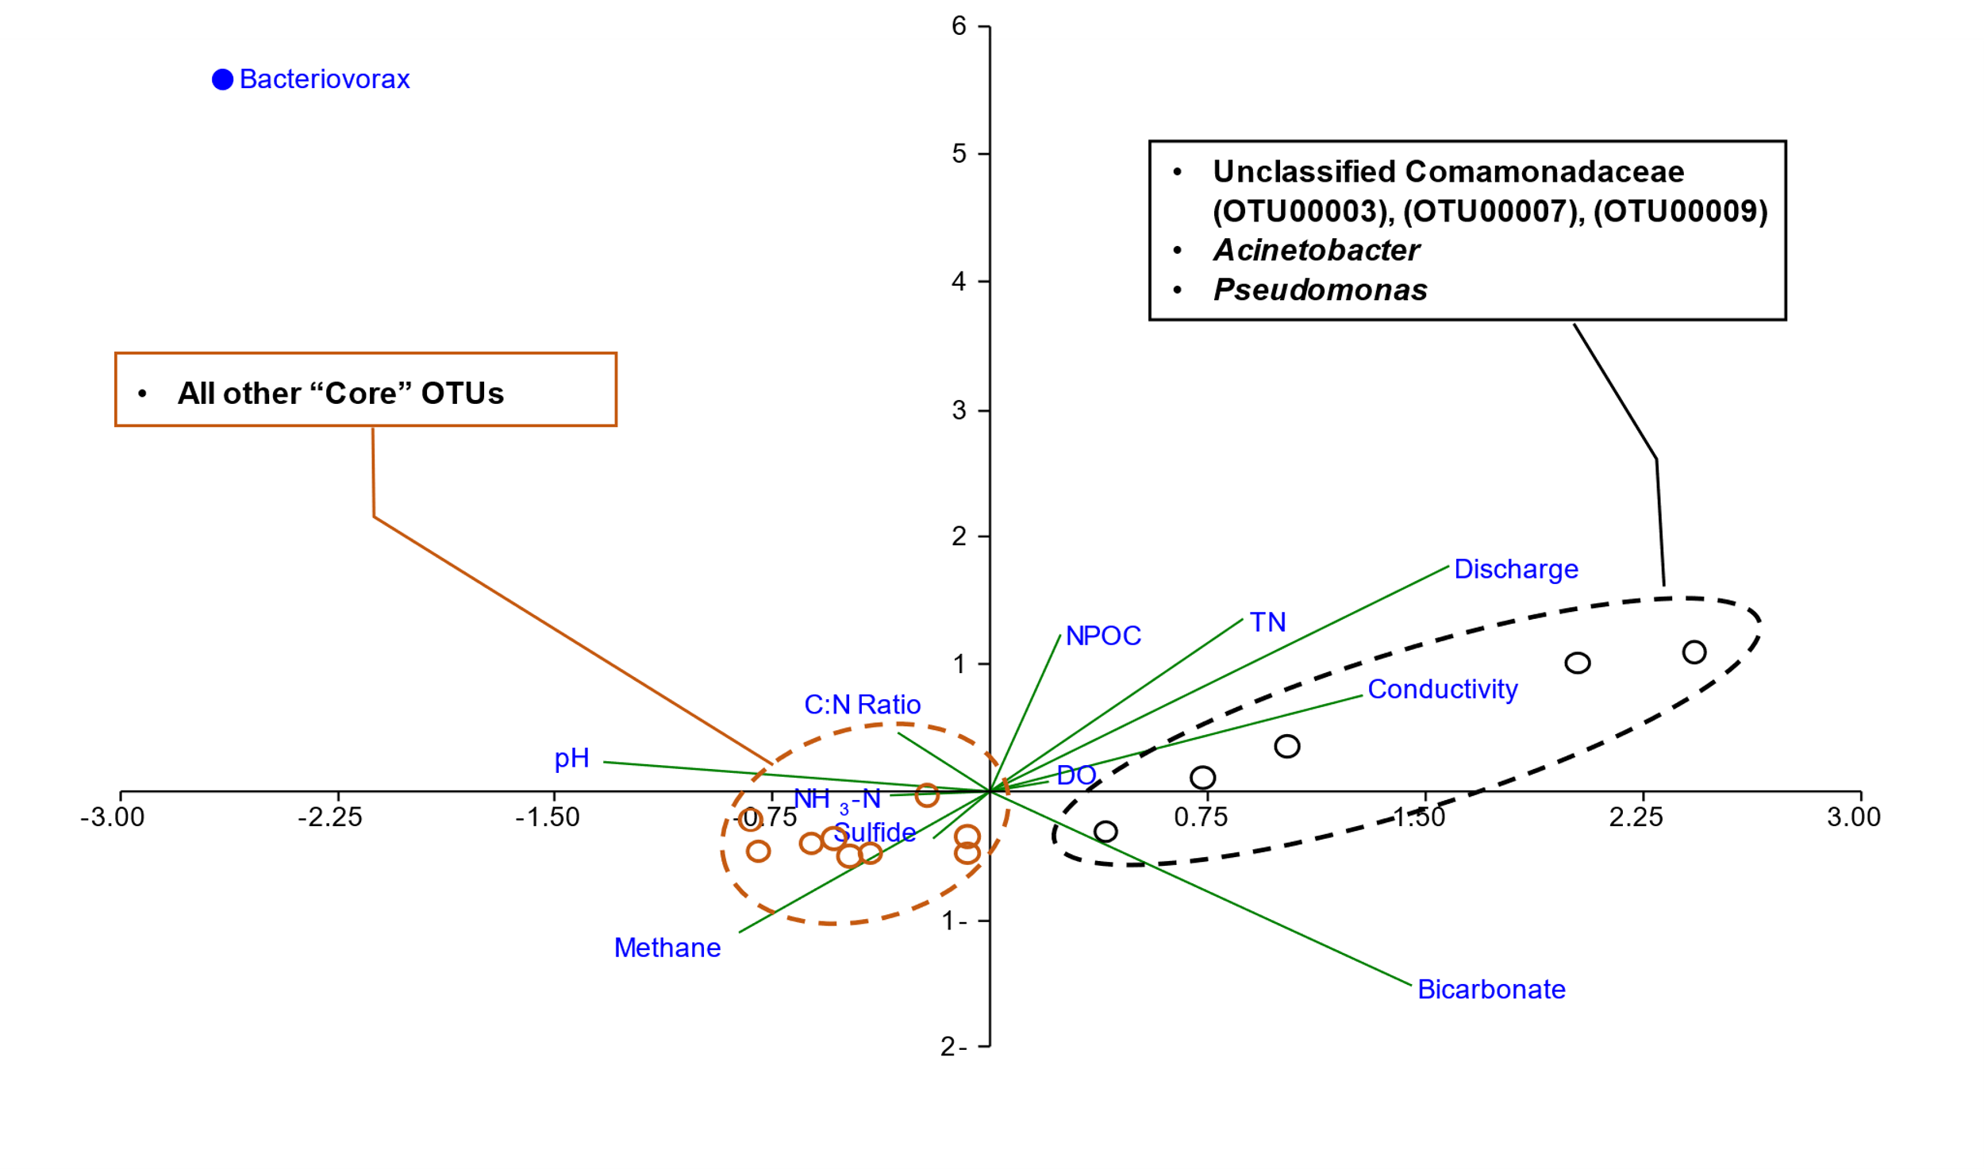
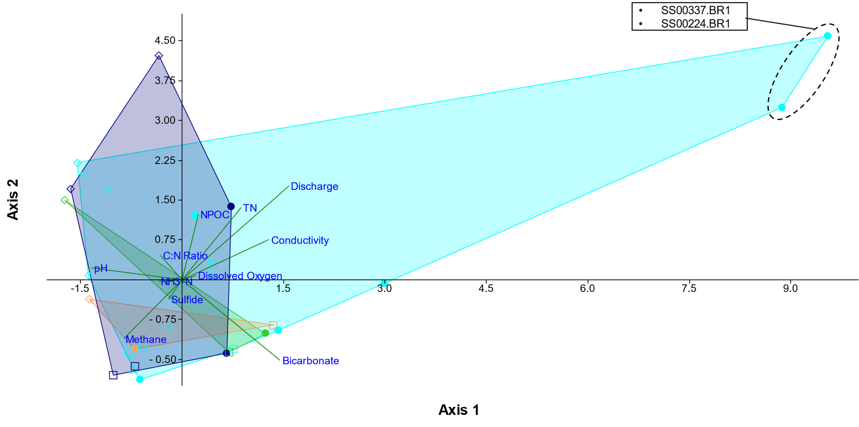
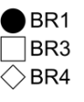
A
B
(55.89%)
(33.54%)
Figure 3.18. (A) Canonical correspondence analysis (CCA) of the normalized relative abundances and major geochemical/environmental parameters along the San Saba River of “core” operational taxonomic units (OTUs) comprising ≥1% of the total relative abundances for only hyporheic zone (HZ) samples. (B) The same CCA showing OTU clustering. The triplot amplitude for both CCAs was set to 5 for better visualization. Axes 1 and 2 are shown; axes 3 to 11 accounted for increasingly smaller percentages of variation. Permutation tests did yield p-values below alpha.
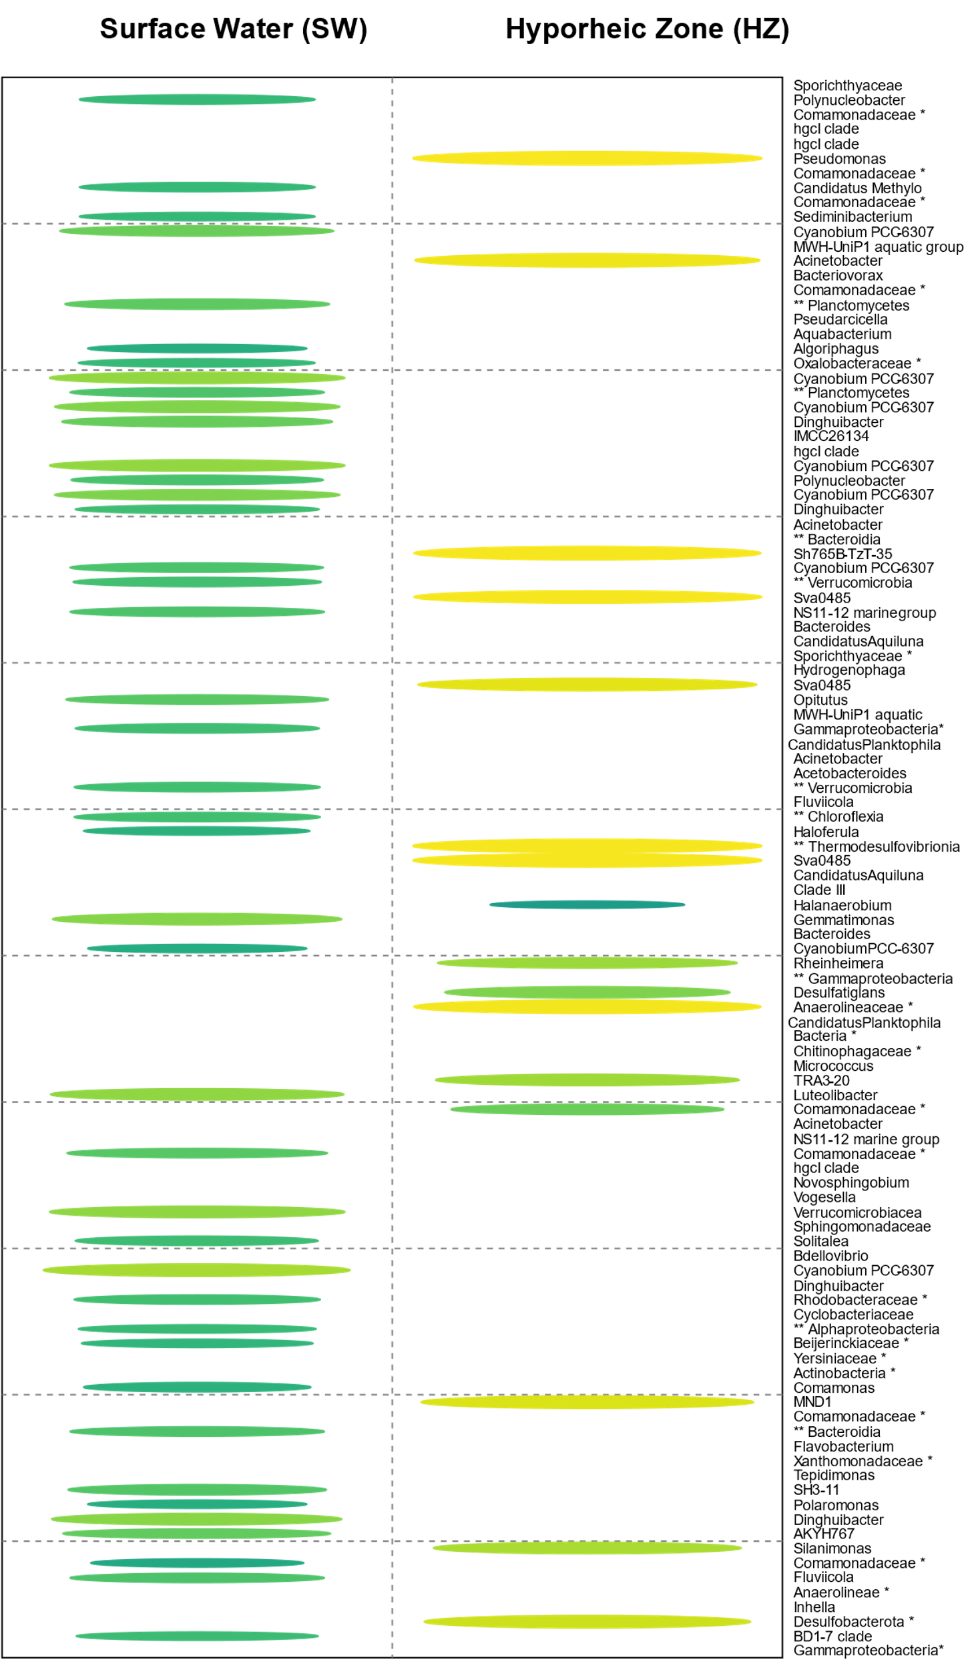
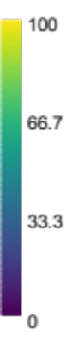
Figure 3.19. Indicator Species Analysis (ISA) results for operational taxonomic units (OTUs) with relative abundance > 0.1% in surface water (SW) and hyporheic zone (HZ) samples collected from the San Saba River, Texas. Colored ellipses indicate significant indicator values (p-values < 0.05), with the scale representing the indicator value as a percentage. Lists of the ISA values for the OTUs are provided in Table B.8.
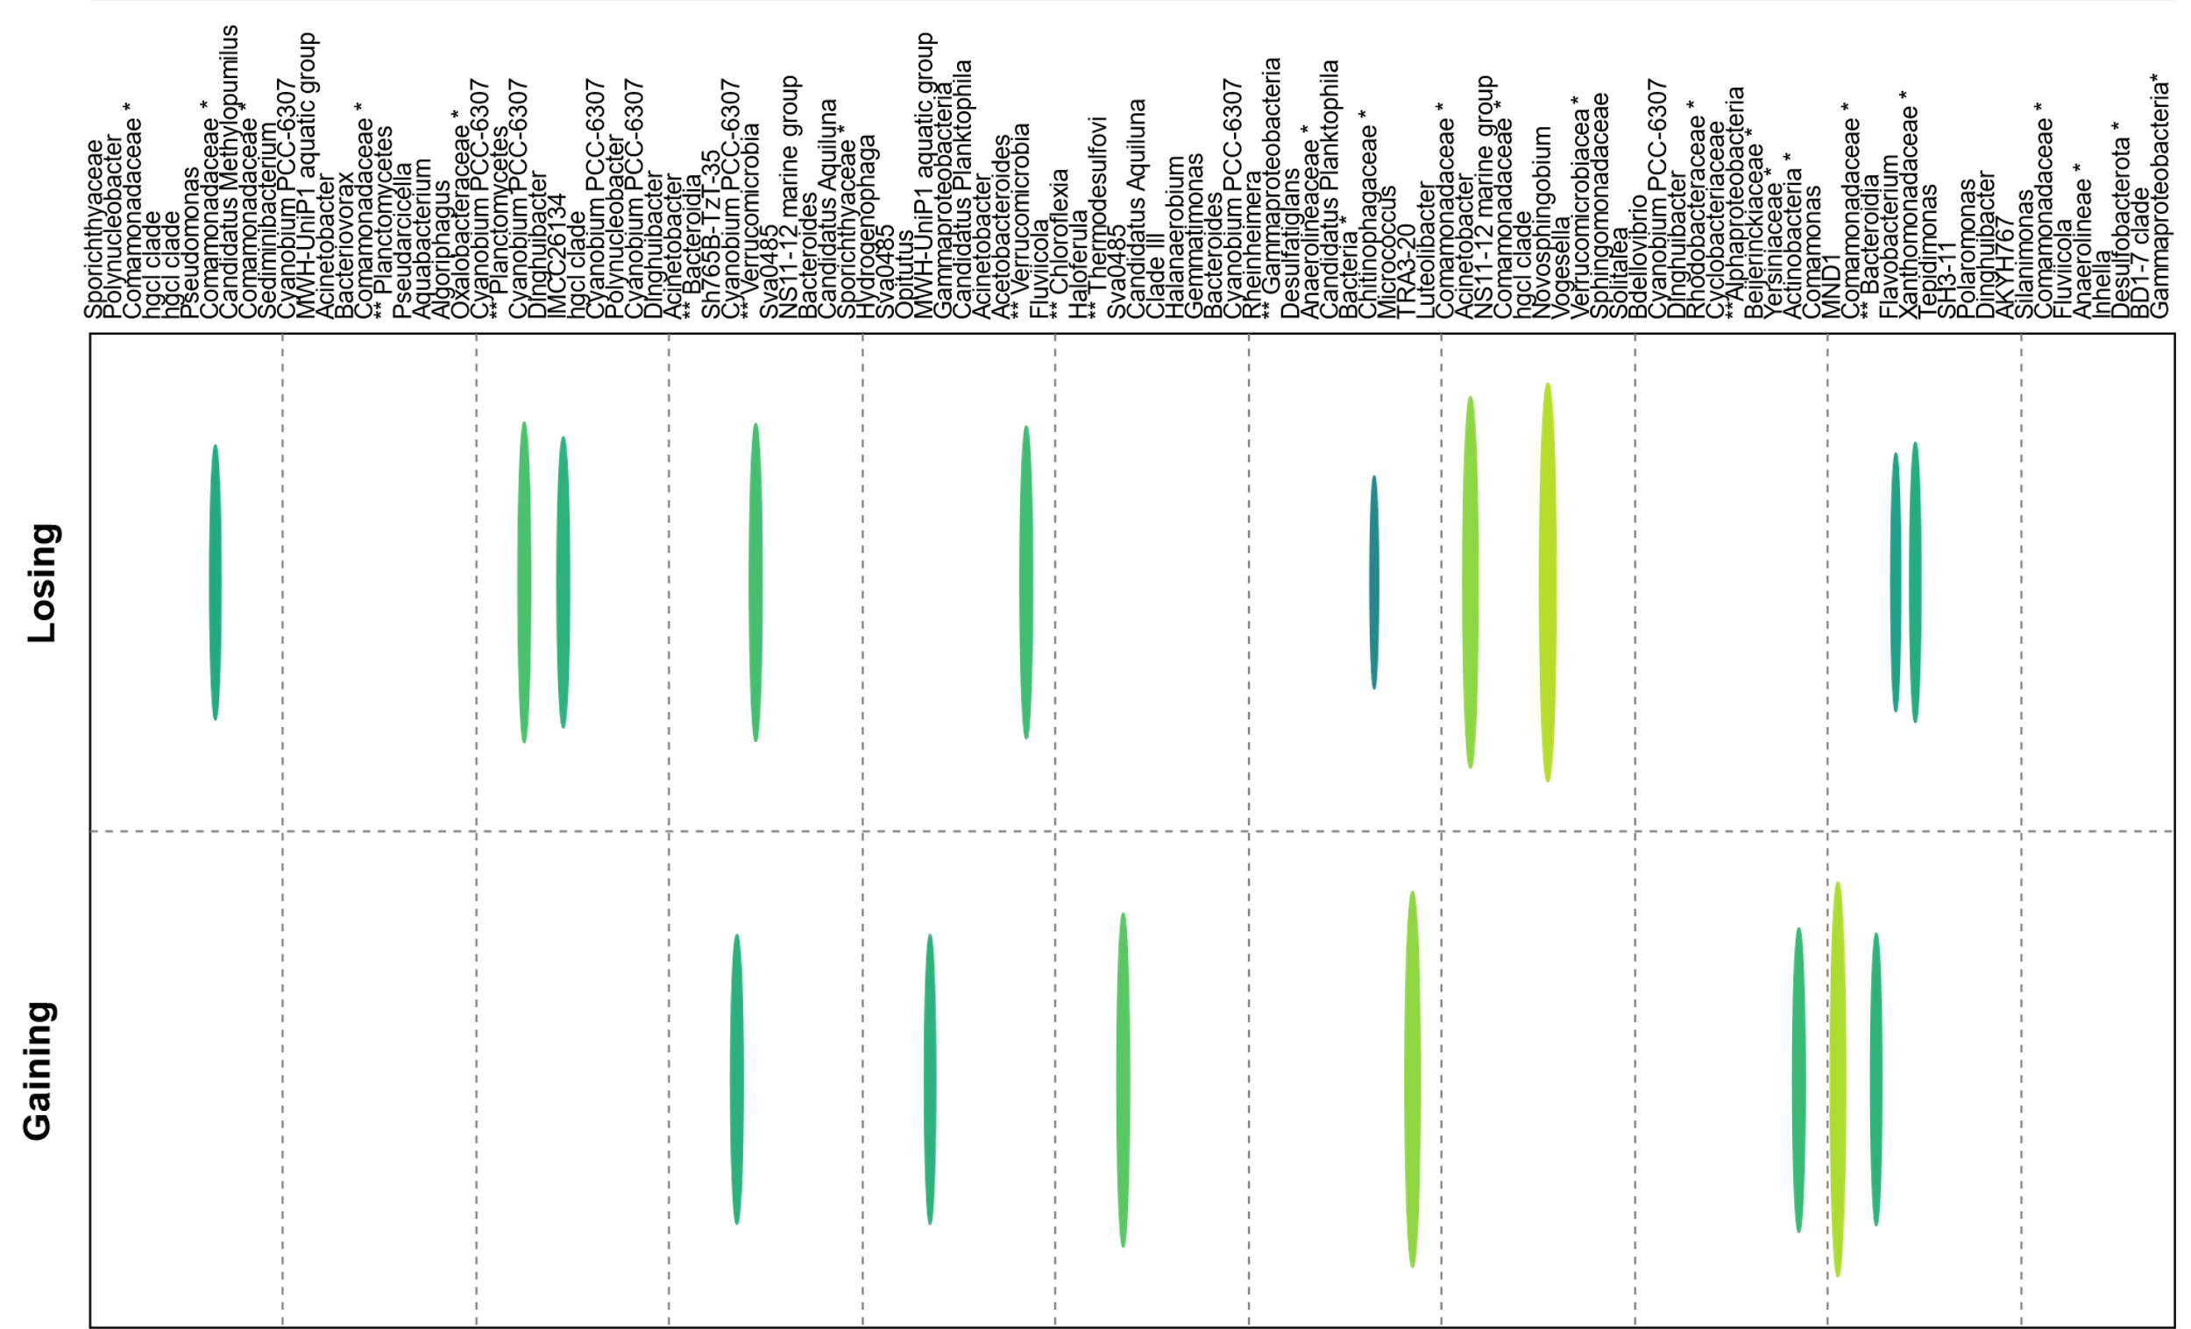

Figure 3.20. Indicator Species Analysis (ISA) results for hyporheic zone (HZ) operational taxonomic units (OTUs) with relative abundance > 0.1% across all samples, distinguished by hydrologic conditions in the San Saba River, Texas. Colored ellipses depict significant indicator values (p-values < 0.05), with the scale representing the indicator value as a percentage. Lists of the ISA values for the OTUs are provided in Table B.9.
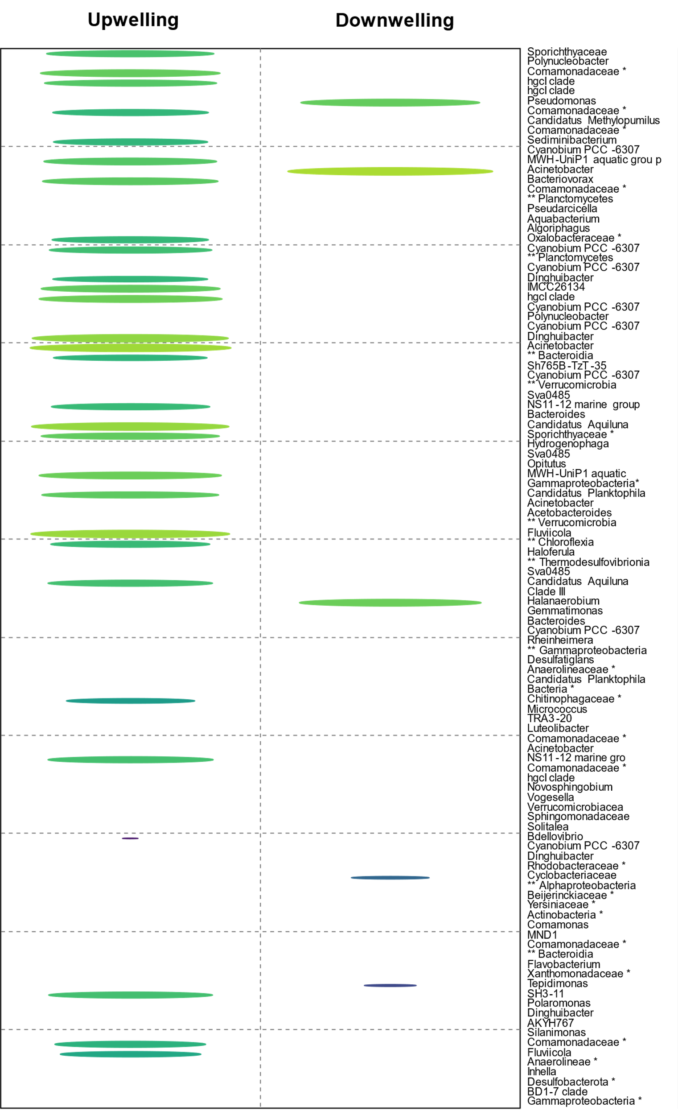
Figure 3.21. Indicator Species Analysis (ISA) results for hyporheic zone (HZ) operational taxonomic units (OTUs) with relative abundance > 0.1%, grouped by hydrologic conditions in the San Saba River, Texas. Colored ellipses indicate statistically significant indicator values (p-values < 0.05), with the scale representing the indicator value as a percentage. Lists of the ISA values for the OTUs are provided in Table B.10.
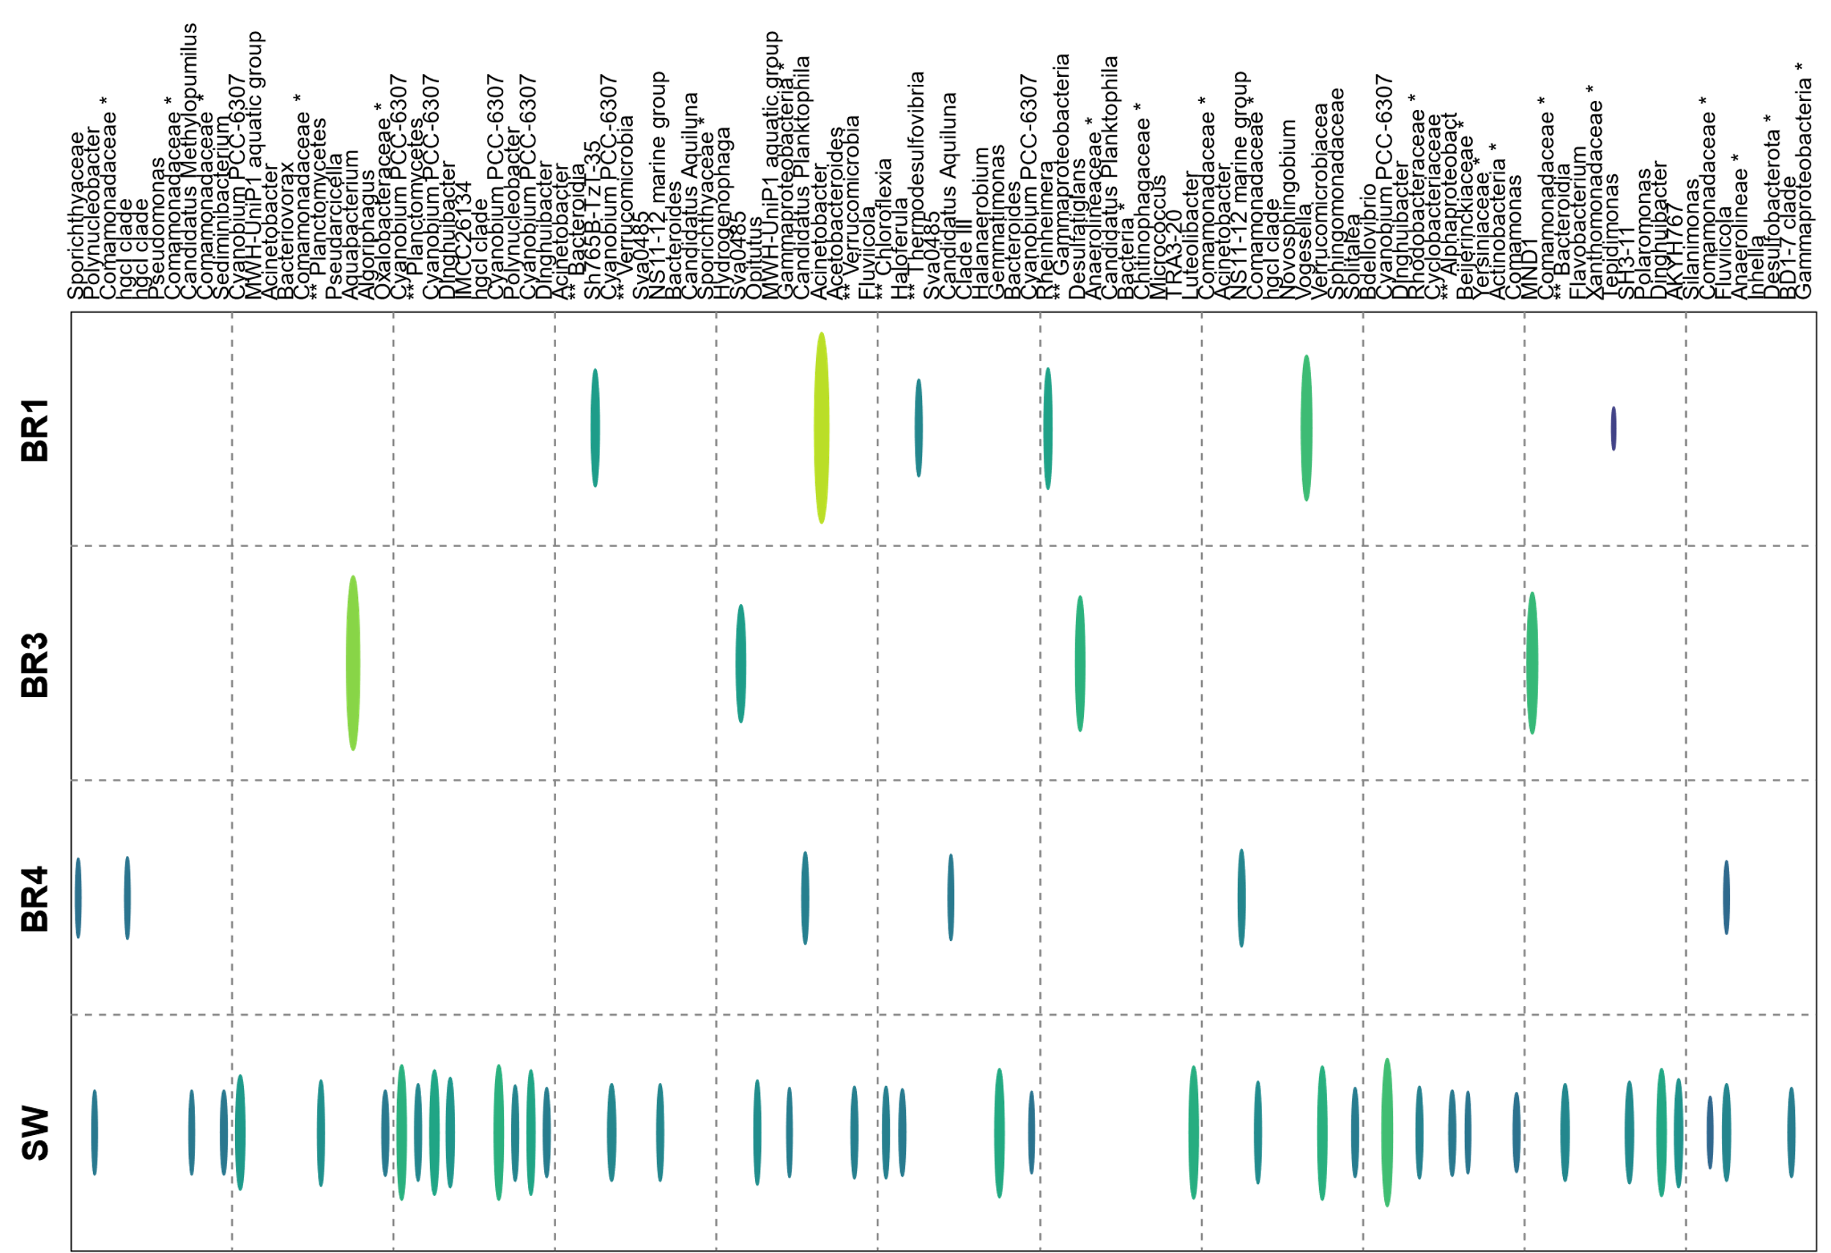
Figure 3.22. Indicator Species Analysis (ISA) results for hyporheic zone (HZ) operational taxonomic units (OTUs) with relative abundance > 0.1%, grouped by Bou Rouch (BR) location or surface water (SW) in the San Saba River, Texas. Colored ellipses indicate statistically significant indicator values (p-values < 0.05), with the scale representing the indicator value as a percentage. Lists of the ISA values for the OTUs are provided in Table B.11.

SECTION 4. DISCUSSION
Previous HZ research has uncovered how specific microbial groups regulate changes in OM cycling and gas exchange, such that as much as 90-98% of biogeochemical processing in a river are completed by microbes within the HZ (e.g., Doyle, 2005; Ye et al., 2012; Dwivedi et al., 2021). Although these microbially controlled processes are broadly critical for riparian and groundwater ecosystems connected with the HZ, knowledge about members of microbial communities and their specific functional roles, as well as their potential response rates to changing environmental conditions, has been limited for most river systems. In Central Texas, the impacts of climate change are increasingly affecting river health by causing higher temperatures, more frequent spring floods, and more extreme summer droughts (e.g., Trenberth, 2011). The HZ exhibits the capacity to mitigate the effects of climate change (Ward, 2016; Buser-Young et al., 2021), but without more investigations into the abundances and distributions of species, it is unclear how to best manage the ecological future of rivers in Texas, which is one of the goals of government agencies like the U.S. Army Corps of Engineers (USACE, 2021). As a result, the primary objective of this study was to rectify the existing knowledge gaps surrounding HZ biogeochemistry and related microbial communities intrinsic to the San Saba River, a tributary of the Colorado River in Central Texas. The hope would be that the findings could be eventually incorporated into future modeling efforts by the U.S. Army Corps of Engineers. This river was chosen because there have not been previous HZ studies within the watershed, and this river is a critical resource, not only to maintain populations of endemic fauna, such as fish and mussels, but also to provide domestic, agricultural, and industrial water through groundwater extraction. Following predicted hydrologic, nutrient cycling, and microbial relationships presented by Newcomer et al. (2018), additional overarching questions that guided the research included what the compositions of microbial communities within the river and HZ were, and how environmental factors, such as hydrologic condition, geochemistry, and lithology, influence microbial diversity.

4.1 Hydrologic Controls on Biogeochemical Processes and Microbial Diversity
This study focused on a roughly 200-km segment of the San Saba River from eleven pool-riffle sequences. One of the main questions that this research addressed was how hydrology and geochemistry varied spatially along the river, and if there were discernable patterns that corresponded to specific environmental conditions, such as discharge or lithology. The findings suggested that major trends in river physiochemistry were tied to the changes in river discharge and hydrologically gaining and losing conditions. Discharge affects nutrient transport and the overall river flow dynamics, which also impacts microbial colonization patterns and community structure (Luo et al., 2020). Measurements of horizontal and vertical hydraulic gradients, specifically to determine gaining and losing conditions, as well as upwelling or downwelling conditions, indicated that many of the HZ locations were experiencing upwelling conditions, and that a net gain was measured at the farthest upstream and downstream locations.
Overall, the San Saba River discharge increased downstream and was likely due to tributary input and groundwater recharge into the river (Morrice et al., 1997; Storey et al., 2003; Boano et al., 2009; Zhou et al., 2014). Given the geographic position, these upstream and downstream locations may be connected to the larger Edwards Aquifer system of the Edwards Plateau. Moreover, higher hydraulic conductivity values in headwater pool-riffle sequences (Figure 3.4) suggested more efficient water flow through the subsurface and between or through the HZ and into the river compared to the lower hydraulic conductivity values downstream (Figure 3.4) (Franken et al, 2001; Mojarrad et al., 2019). In each pool-riffle sequence, the proximity of the water table to the pool would facilitate upwelling, whereas the riffles would enable the flow of water from the riverbed into the subsurface (Mojarrad et al., 2019). This could potentially create complex and dynamic flow patterns that foster water mixing and exchange between surface and subsurface flow paths (Boulton et al., 1998; Franken et al, 2001; Storey et al., 2003; Trauth et al., 2013), which affects upwelling and downwelling conditions.
One of the presented hypotheses tested in this study was that microbial diversity (as measured by diversity indices, Figures B.1 and B.2) would be higher in hydrologically gaining sites, and this hypothesis was supported, as was the hypothesis that upwelling sites would have higher microbial diversity. Hydrologically gaining sites may provide more favorable conditions for a diverse array of microbial taxa, whereas hydrologically losing sites may be overwhelming by recharging river water, which is less diverse than the HZ.
As demonstrated from past research, hyporheic exchange influences the groundwater table under gaining or losing conditions, and the timing of groundwater drawdown into the HZ has the potential to buffer the HZ against thermal disturbances (Zheng & Cardenas, 2018; Wu et al., 2021). But, in this study, HZ microbial responses to temperature changes, as well as diel river temperatures, spatiotemporal variability of HZ exchange rates, and mean residence times were not assessed and should be investigated in the future to better understand microbial community dynamics during HZ exchange. Additionally, seasonality of surface and groundwater flow, recognized as a significant factor in subsurface flow paths and regional groundwater recharge (Zimmer & McGlynn, 2017), represents another aspect of HZ hydrodynamics that was not investigated in this study. Other factors to consider include local and regional groundwater pumping/drawdown, LULC changes, and time between flooding and/or drought events.

4.2 Lithologic Controls on Biogeochemical Processes and Microbial Diversity
Despite increases in discharge, which should have the effect of diluting solutes and lowering the specific conductance of river water, specific conductance values increased downstream. The HZ also had generally higher specific conductance than the river at each pool-riffle sequence location, but especially in losing reaches. The composition and abundance of microbial communities can be shaped by specific conductance and nutrient availability, carbon and OM sources, dissolved oxygen concentrations, and other conditions (Hendricks, 1993; Stevenson et al., 2004; Febria et al., 2012; Broman et al., 2017; Newcomer et al., 2018; Hong et al., 2019; Dai et al., 2023). Some HZ OTUs strongly correlated with higher specific conductance, including Pseudomonas, Acinetobacter, and Comamonadaceae (unclassified), as well as Halanaerobiia for downstream locations (Figure 3.18). Higher specific conductance in the HZ could also indicate the HZ was experiencing enhanced biogeochemical processes but may also reflect limited exchange with the river that would flush solutes from the HZ, particularly as hydraulic conductivities decrease.
Limited exchange between the river and HZ likely also impacts DO and other solute and gas concentrations. Surface water samples had higher DO concentrations compared to the HZ samples and the HZ DO concentrations differed depending on gaining and losing hydrological conditions. The expectation was that gaining locations would have lower DO concentrations because recharging groundwater would most likely be depleted in DO, and that losing sites would have higher DO concentrations because the river water had elevated DO levels due to active photosynthesis (Newcomer et al., 2018). However, BR3, BR4, and BR5 locations in hydrologically gaining sections of the river had slightly higher DO concentrations than the same BR samplers from losing sections of the river. Lower DO concentrations in losing reaches may be related to the river water also providing nutrients, and specifically OM, that would create hotspots of microbial activity in the HZ when DO would be used as the most energetic terminal electron acceptor to degrade the OM.
Enhanced OM degradation in the HZ would lead to a buildup of bicarbonate and other byproducts of redox reactions tied to microbial metabolism as DO becomes depleted, such as ammonium, sulfide, and methane (Hendricks, 1993; Zaikova et al., 2012; Broman et al., 2017). Although bicarbonate concentrations are most often attributed to water-rock interactions, particularly in carbonate terrain, bicarbonate concentrations can have profound influence on microbial community compositions by serving as an inorganic carbon source and pH buffer (Gray & Engel, 2013) that would favor specific microbial groups (Yuan et al., 2023). Higher bicarbonate concentrations were measured from the HZ where DO concentrations were lower but also where dissolved sulfide and CH₄ concentrations were higher (Figure 3.10). Overall, nitrate concentrations were very low among both gaining and losing sites (Figure A.5C), but overall, TN, NH₃-N, and ammonium and other nitrogen species concentrations are generally difficult to understand the causes for high or low concentrations. Low nitrate concentrations could be due to microbial denitrification, and high NH₃-N could be due to microbial fixation of atmospheric N₂ (Howard & Rees, 1996). A strongly positive correlation between NH₃-N and dissolved sulfide concentrations in HZ samples, which also inversely correlated with DO, suggested a link between microbial nitrogen and sulfur cycling (Figure 3.5).
The coexistence of dissolved sulfide and CH₄ within the HZ highlights the importance of microbial processes to overall river dynamics. The distribution of CH₄ production and cycling in the HZ of most rivers is largely unknown, as is the extent to which the HZ can serve as a source of greenhouse gases (e.g., Michaelis et al. 2022). In the San Saba River, although CH₄ concentrations in the HZ and SW were variable, higher concentrations above atmospheric levels were generally measured under gaining conditions (Figure A.8). However, the highest measured CH₄ concentrations occurred at BR sample locations that were downwelling and losing hydrologically, and these sites also had elevated NPOC values and were from mixed clastic rock units, which may indicate a correlation of CH₄ production with coexisting OM. Overall, CH₄ is likely sourced from methanogenesis within the HZ or from methanogenesis occurring in contributing groundwater, as the San Saba River water was near equilibrium with atmospheric CH₄ levels. Depletion of CH₄ that would outgas into the river could be due to active microbial methanotrophy or abiotic oxidation. There was low relative abundance of methanogenic archaeal groups from the 16S rRNA gene sequence data obtained from HZ water, which could be due to issues with primer amplification; overall, retrieval of archaeal sequences was very low and future research should focus on using different primers or another approach to attempt to recover archaeal sequence reads from HZ samples. It may also be possible that the methanogenic zone is below the sediment depth penetrated by the BR samplers.

4.3 Distinct Hyporheic Zone Microbial Communities
This study provided an opportunity to investigate the diversity of microbial communities distinct to the HZ in the San Saba River. The microbial communities comprising the HZ of most rivers has been largely unexplored, despite a long history of biogeochemical studies demonstrating the importance of microbes to HZ and river processes (e.g., Doyle, 2005; Ye et al., 2012; Buser-Young et al., 2021; Dwivedi et al., 2021). The findings from the Indicator Species Analysis (ISA) for each set of parameters, specifically HZ versus SW (Figure 3.19), gaining versus losing (Figure 3.20), upwelling versus downwelling (Figure 3.21), and by BR location (Figure 3.22) reveal the potential environmental and habitat-type preferences of different communities that may shed light on managing river system in the future. In general, San Saba River water communities had higher proportions of Cyanobacteria and bacterioplankton taxa characteristic of eutrophic environments and high primary productivity. In contrast, HZ samples had higher proportions of Bacteroidia, and many bacterial classes that were not abundant in the surface water samples, such as Dehalococcoidia, Bdellovibrionia, Anaerolineae, Sva0485 clade, and Omnitrophia, which are commonly found in subsurface environments, including soil and groundwater. These HZ microbial communities are dependent on the availability and concentration of electron acceptors. Prior research has shown that electron acceptor concentrations, as well as sufficient electron donors, including organic carbon compounds, strongly determine the composition of subsurface microbial communities (Espenberg et al., 2018; Hong et al., 2019). Future studies should measure additional environmental parameters that could impact microbial community structure and function, including substrate availability and concentration, such as acetate and molecular hydrogen.
Within the broad context of river water versus HZ settings, there were additional taxonomic groups that were indicator taxa for specific hydrological conditions. In the losing sections of the river, taxa like unclassified Comamonadaceae, Cyanobium PCC-6307, and uncultured Verrucomicrobiae had significant associations. Comamonadaceae have diverse metabolic capabilities, as well as Verrucomicrobiae, which have potential for diverse ecological functions including carbon cycling, nitrogen fixation, and degradation of complex organic compounds. Cyanobium PCC-6307 is a photosynthetic cyanobacterium that was also found to be associated with surface water, reinforcing the hypothesis that surface water microbial communities will be more abundant in losing sections of the San Saba River. In the gaining sections, taxa such as Sva0485 (Ca. Acidulodesulfobacterales), TRA3-20, Actinobacteria, MND1, and Bacteroidia, which degrade organic substances (Yang et al., 2020), were significant indicators, but also were two photosynthetic cyanobacterial OTUs, Cyanobium PCC-6307 (OTU000034) and MWH-UniP1 aquatic group. These OTUs could provide evidence of mixing conditions between surface water, the HZ, and groundwater. Actinobacteria produce bioactive compounds with antimicrobial properties (Selim et al., 2021) and may have affinity for nitrogen-rich environments, but have complex role in carbon, nitrogen, and other nutrient cycling, as it has been demonstrated that they have genetic potential for photoheterotrophic metabolism (Allgaier & Grossart, 2006). Similarly, the analysis of upwelling and downwelling sections revealed distinct indicator taxa, such as Pseudomonas and Sporichthyaceae. Pseudomonas are versatile bacteria with various metabolic capabilities, including biodegradation of hydrocarbons, nitrogen fixation, and plant growth promotion. Sporichthyaceae can be involved in sulfur cycling, which may be relevant to the environmental conditions of the downwelling sections. Sampler locations BR1 and BR3 showed varying indicator taxa, such as Acinetobacter, Aquabacterium, Sva0485, and Tepidimonas. Acinetobacter is a diverse genus with various metabolic capabilities, including degradation of aromatic compounds and resistance to environmental stress. Aquabacterium is known for denitrification. Sva0485 is a less characterized, and its ecological role remains to be fully understood. Tepidimonas is known from hot spring environments and may indicate specific temperature preferences in the sampler location BR1.
Although the ISA yielded valuable insight, there are interpretation limitations and requires additional knowledge for robust interpretations. The taxonomic resolution of OTU data does not classify microbial sequences to a high level (i.e., species). Even genus-level assignments are challenging. Part of this stems from many environmental microbial groups not being cultured or classified. As it was, the number of unclassified sequence reads from the HZ was high and may suggest novel taxonomic groups that will require additional research. Additionally, with only eleven sample sites, and 29 overall samples, this study was relatively small and there is a possibility that certain microbial groups evaded detection using the target gene sequencing approaches. This can impact statistical power. Integrating complementary data types and employing multivariate analyses alongside ISA will enhance ecological investigations in the future.

SECTION 5. CONCLUSIONS & FUTURE HYPORHEIC ZONE RESEARCH
The HZ is an area where degradation and accumulation of organic matter are being carried out by microorganisms that reside on and within interstitial pore space (Mulholland et al., 1997; Battin et al., 2003). This study measured a diverse array of hydrogeological and biogeochemical factors across small-scale, pool-riffle sequence sites to identify linked biogeochemical and microbiological processes that spanned from the individual pool-riffle sites to nearly the full extent of the river system. The goals were to enhance our understanding of interconnected hydrological and biogeochemical processes within the San Saba River and to shed light on the unexplored microbial communities within its HZ. The findings demonstrate that the HZ has the potential to be a hub of microbiological activity, and predominately of anaerobic metabolisms that occur across redox boundaries. These microbial processes are central to regulating the cycling of organic matter within the river system (Dahm, 1981; Singer et al., 2010; Krause et al., 2011; Harvey et al., 2013; Flipo et al., 2014; Zhao et al., 2014), and the results align with similar recent studies of HZ microbial communities and their associated biogeochemical processes (Broman et al., 2017; Hong et al., 2019).
One key finding from this work, that has not been thoroughly explored from past research, is that the HZ can act as either a storage reservoir for or a source of CO₂ and other reduced and greenhouse gases like H₂S and CH₄ into the river and potentially the local atmosphere if not oxidized. In the arid climates of central and western Texas, particularly during hydrologic deficits, or in regions where human-induced activities may exert additional influence upon hydrologic, biological, and climatic processes, such as within the vicinity of urban centers or impoundments, the significance of anaerobic microbial activity in the HZ and gas flux regulation will be essential to study. Future research investigating gas flux would benefit from exploring how the river and HZ biogeochemical systems respond seasonally, or on shorter time scales (i.e., weekly) when there are changes in a range of environmental factors (Zimmer & Lautz, 2014; Broman et al., 2017), although this would likely substantially increase the cost and time of the work.
Progress in watershed modeling has already demonstrated that relying solely on conservative tracer tests is inadequate when modeling water flow and movement of substances within the HZ and between the river and HZ (Scott, 2021). With additional hydrogeological (i.e., gaining, losing) and climate input, as well as more information about the metabolic potential (i.e., function) of microbial communities within the HZ, future ecological models can better investigate the interplay among hydrology, climate, and microbial activities within the river, the HZ, and its watershed (Krause et al., 2022). To achieve this, however, an increased number of sample locations across different types of HZ sites may be necessary, and use of grid and transect-style sampling formats could provide a more precise representation of biogeochemical processes with greater spatial resolution (Hong et al., 2019).
Continued investigations into the microbial diversity and ecology of the HZ should continue to genetically identify key functional groups, evaluate diversity in the context of environmental variables, and delineate microbial community activities. Identifying key taxonomic and metabolic groups creates a framework upon which important insights into the potential effects that environmental change may have trophic transfer, nutrient cycling, and habitat modification within a river and HZ (Berry & Widder, 2014; Banerjee et al., 2018; Duan et al., 2022). Specific keystone microbial groups may be the primary food source for other organisms in the food web, such as protists, zooplankton, and small fish. Changes in the abundance or composition of keystone microbial groups over time could have cascading effects on higher trophic levels (Duffy, 2002; Higgins, 2009). For example, a decline in primary producers like Cyanobacteria could lead to a reduction in the abundance of zooplankton, which in turn could affect the survival and reproduction of higher trophic levels, such as benthic macroinvertebrates, fish, and mussels. Similarly, changes in the abundance of nitrogen-fixing bacteria could affect the growth of primary producers. Also, some keystone groups modify their environment by producing extracellular polymeric substances that create microhabitats and alter nutrient availability, provide protection, and food for other organisms (Or et al., 2007). Changes in the abundance or activity of these different groups could affect the abundance, diversity, and persistence of other organisms. To pinpoint key microbial groups and processes, future HZ research could be to use innovative biostimulation experiments that introduce specific nutrients or resources into the HZ. The byproducts from nutrient use could be measured and converted into fluxes to provide transformation rates, which could be used in hydrobiogeochemical models.
The use of microbial information as tracers has enormous potential for practical modeling efforts and other fields of science, not just HZ research, including environmental science, ecology, and public health (Scott, 2021). Microbial communities can provide information about environmental conditions and anthropogenic effects that may not be otherwise observed. Developing numerical models and simulations of biogeochemical processes in the HZ will be crucial for predicting the effects of different environmental conditions and human activities on these processes and to identify key mechanisms that control them, another key goal of the data produced within this research. In summary, this study enhances our understanding of the spatial and environmental drivers shaping microbial communities and geochemical processes in the HZ of the San Saba River. The findings also emphasize the significance of both large and small-scale factors in shaping microbial diversity and community structure within this ecologically important aquatic zone. By beginning to unravel the complexities of the HZ, future water quality management practices can be improved, which will continue to safeguard and improve riverine ecosystem health.

REFERENCES
Adams A, Morse J (2019). Non-material matters: A call for integrated assessment of benefits from ecosystems in research and policy. Land Use Policy 80:400—402.

Allgaier M, Grossart HP (2006). Diversity and seasonal dynamics of Actinobacteria populations in four lakes in northeastern Germany. Applied Environmental Microbiology. 72:3489–3497.

Barcelona MJ, Holm TR (1991). Oxidation-reduction capacities of aquifer solids. Environmental Science & Technology 25:1565—1572.

Barnes VE, Hartmann B, Scranton DF (1992). Geologic Map of Texas. Scale: 1:500,000. University of Texas at Austin, Bureau of Economic Geology.

Bao P and Li GX (2017). Sulfur-driven iron reduction coupled to anaerobic ammonium oxidation. Environmental Science & Technology, 51(12), pp.6691—6698.

Battin TJ, Kaplan LA, Newbold JD, Hendricks SP (2003). A mixing model analysis of stream solute dynamics and the contribution of a hyporheic zone to ecosystem function. Freshwater Biology 48:995—1014.

Banerjee S, Schlaeppi K, van der Heijden MG (2018). Keystone taxa as drivers of microbiome structure and functioning. Nature Reviews Microbiology 16(9):567—76.

Becker J, Rodibaugh K, Hahn D, Nowlin W (2017). Bacterial community composition and carbon metabolism in a subtropical riverscape. Hydrobiologia 792:209—226.

Bencala K, Walters R (1983). Simulation of solute transport in a mountain pool-and-riffle stream: a transient storage model. Water Resources Research 19:718—724.

Bencala KE (2000). Hyporheic zone hydrological processes. Hydrological Processes 14: 2797—2798.

Bernhard AE, Marshall D, Yiannos L (2012). Increased variability of microbial communities in restored salt marshes nearly 30 years after tidal flow restoration. Estuaries and Coasts 35: 1049—1059.

Berry D, Widder S (2014). Deciphering microbial interactions and detecting keystone species with co-occurrence networks. Frontiers in Microbiology 5:219.

Binley A, Ullah S, Heathwaite AL, Heppell C, Byrne P, Lansdown K, Trimmer M, Zhang H (2013). Revealing the spatial variability of water fluxes at the groundwater-surface water interface. Water Resources Research 49:3978—3992.

Birdwell JE, Engel AS (2010). Characterization of dissolved organic matter in cave and spring waters using UV–Vis absorbance and fluorescence spectroscopy. Organic Geochemistry 41: 270—280.

Blaxter M, Mann J, Chapman T, Thomas F, Whitton C, Floyd R, Abebe E (2005). Defining operational taxonomic units using DNA barcode data. Philosophical Transactions of the Royal Society of London, Series B Biological Sciences 360(1462):1935–1943. https://doi.org/10.1098/rstb.2005.1725

Boano F, Revelli R, Ridolfi L (2009). Quantifying the impact of groundwater discharge on the surface–subsurface exchange. Hydrological Processes 23:2108—2116. https://doi.org/10.1002/hyp.7278.

Bohannan BJ, Hughes J (2003). New approaches to analyzing microbial biodiversity data. Current Opinion in Microbiology 6:282—287.

Boulton AJ, Findlay S, Marmonier P, Stanley EH, Valett HM (1998). The functional significance of the hyporheic zone in streams and rivers. Annual Review of Ecology and Systematics 29:59—81. https://doi.org/10.1146/annurev.ecolsys.29.1.59

Boulton AJ, Datry T, Kasahara T, Mutz M, Stanford JA (2010). Ecology and management of the hyporheic zone: stream–groundwater interactions of running waters and their floodplains. Journal of the North American Benthological Society 29:26—40.
Brablcova L, Buriánková I, Badurová P, Chaudhary PP, Rulík M (2015). Methanogenic archaea diversity in hyporheic sediments of a small lowland stream. Anaerobe 32:24—31.

Briggs MA, Lautz LK, Hare DK (2014). Residence time control on hot moments of net nitrate production and uptake in the hyporheic zone. Hydrological Processes 28:3741—3751.

Broman E, Sjöstedt J, Pinhassi J, Dopson M (2017). Shifts in coastal sediment oxygenation cause pronounced changes in microbial community composition and associated metabolism. Microbiome 5(1):1—18.

Buser-Young JZ, Lapham LL, Thurber AR, Williams KH, Colwell FS (2021). Hidden processes during seasonal isolation of a high-altitude watershed. Frontiers in Earth Science 9:666819.

Buto SG, Anderson RD (2020). NHDPlus High Resolution (NHDPlus HR) –A hydrography framework for the Nation. Fact Sheet: Reston, VA. pp 2.

Caporaso JG, Lauber CL, Walters WA, Berg-Lyons D, Huntley J, Fierer N, Owens SM, Betley J, Fraser L, Bauer M, Gormley N, Gilbert JA, Smith G, Knight R (2012). Ultra-high-throughput microbial community analysis on the Illumina HiSeq and MiSeq platforms. The ISME Journal 6: 1621—1624.

Cardenas MB (2015). Hyporheic zone hydrologic science: A historical account of its emergence and a prospectus. Water Resources Research 51(5):3601–-3616.

Caraco NF, Cole JJ (1999). Human impact on nitrate export: an analysis using major world rivers. mbio 28(2):167—170.

Carpenter SR (2002). Ecological futures: building an ecology of the long now. Ecology 83: 2069—2083.

Castro NM, Hornberger GM (1991). Surface-subsurface water interactions in an alluviated mountain stream channel. Water Resources Research 27:1613—1621.

Chen H, Athar R, Zheng G, Williams HN (2011). Prey bacteria shape the community structure of their predators. The ISME Journal 5(8):1314—1322.

Chinn S (1996). Choosing a transformation. Journal of Applied Statistics 23(4):395—404.
Chorover J, Derry LA, McDowell WH (2017). Concentration-discharge relations in the critical zone: implications for resolving critical zone structure, function, and evolution. Water Resources Research 53:8654—8659.

Costa PS, Reis MP, Avila MP, Leite LR, de Araújo FM, Salim AC, Oliveira G, Barbosa F, Chartone-Souza E, Nascimento AM (2015). Metagenome of a microbial community inhabiting a metal-rich tropical stream sediment. PLoS One 10:e0119465.

Cuthbert MO, Mackay R, Durand V, Aller MF, Greswell RB, Rivett MO (2010). Impacts of riverbed gas on the hydraulic and thermal dynamics of the hyporheic zone. Advances in Water Resources 33:1347—1358.

Dahm CN (1981). Pathways and mechanisms for removal of dissolved organic carbon from leaf leachate in streams. Canadian Journal of Fisheries and Aquatic Sciences 38:68—76.

Dai H, Zhang, Y, Fang W, Liu J, Hong J, Zou C, Zhang J (2023). Microbial community structural response to variations in physicochemical features of different aquifers. Frontiers in Microbiology 14:1025964.

Danczak RE, Sawyer AH, Williams KH, Stegen JC, Hobson C, Wilkins MJ (2016). Seasonal hyporheic dynamics control coupled microbiology and geochemistry in Colorado River sediments. Journal of Geophysical Research: Biogeosciences 121:2976—2987.

Deja-Sikora E, Gołębiewski M, Kalwasińska A, Krawiec A, Kosobucki P, Walczak M (2019). Comamonadaceae OTU as a remnant of an ancient microbial community in sulfidic waters. Microbial Ecology. 78, pp.85—101.

Dejean T, Valentini A, Duparc A, Pellier-Cuit S, Pompanon F, Taberlet P, Miaud C (2011). Persistence of environmental DNA in freshwater ecosystems. PloS One 6: e23398.

Dewitz J (2021). National Land Cover Database (NLCD) 2019 Products (ver. 2.0, June 2021): U.S. Geological Survey data release, https://doi.org/10.5066/P9KZCM54.

Doyle MW (2005). Incorporating hydrologic variability into nutrient spiraling. Journal of Geophysical Research (Biogeosciences) 110:G01003.

Duan L, Li JL, Yin LZ, Luo XQ, Ahmad M, Fang BZ, Li SH, Deng QQ, Wang P, Li WJ (2022). Habitat-dependent prokaryotic microbial community, potential keystone species, and network complexity in a subtropical estuary. Environmental Research 212:113376.

Duffy JE (2002). Biodiversity and ecosystem function: the consumer connection. Oikos 99(2):201—19.

Dwivedi D, Godsey SE, Scheibe TD (2021). Editorial: Linking hydrological and biogeochemical processes in riparian corridors. Frontiers in Water 3:49.

Elliott AH, Brooks NH (1997). Transfer of nonsorbing solutes to a streambed with bed forms: Laboratory experiments. Water Resources Research 33:137—151.

Elwood, JW, Newbold, JD, O’Neill, RV, & Van Winkle, W (1983). Resource spiraling: An operational paradigm for analyzing lotic ecosystems. Ann Arbor Science: Ann Arbor, Michigan.

Ensign SH, Doyle MW (2006). Nutrient spiraling in streams and river networks. Journal of Geophysical Research: Biogeosciences 111 (G04009). doi:10.1029/2005JG000114.

EPA (U.S. Environmental Protection Agency) (2015). National field manual for the collection of water-quality data. U.S. Geological Survey Techniques of Water-Resources Investigations, Book 9. Chapter A6. Section 6.8: 1—44. doi: 10.3133/twri09.

EPA (U.S. Environmental Protection Agency) (2016). Quick guide to drinking water sample collection. 2nd edition. U.S. EPA, Region 8 Laboratory. Golden, CO, 20 pp.

Espenberg M, Truu M, Mander Ü, Kasak K, Nõlvak H, Ligi T, Oopkaup K, Maddison M, Truu J (2018). Differences in microbial community structure and nitrogen cycling in natural and drained tropical peatland soils. Scientific Reports 8:4742.

Febria CM, Beddoes P, Fulthorpe RR, Williams DD (2012). Bacterial community dynamics in the hyporheic zone of an intermittent stream. The ISME Journal 6:1078—1088.

Feng C, Wang H, Lu N, Tu XM (2013). Log transformation: application and interpretation in biomedical research. Statistics in Medicine 32(2):230 —239.

Feris KP, Ramsey PW, Frazar C, Rillig MC, Gannon JE, Holben WE (2003). Structure and seasonal dynamics of hyporheic zone microbial communities in free-stone rivers of the Western United States. Microbial Ecology 46: 200—215.

Fernald AG, Wigington Jr PJ, Landers DH (2001). Transient storage and hyporheic flow along the Willamette River, Oregon: Field measurements and model estimates. Water Resources Research 37:1681—1694.

Flipo N, Mouhri A, Labarthe B, Biancamaria S, Rivière A, Weill P (2014). Continental hydrosystem modelling: the concept of nested stream & aquifer interfaces. Hydrology and Earth Systems Science 18:3121—3149.

Fox A, Laube G, Schmidt C, Fleckenstein JH, Arnon S (2016). The effect of losing and gaining flow conditions on hyporheic exchange in heterogeneous streambeds. Water Resources Research 52:7460—7477.

Franken, RJM., Storey, RG, Dudley Williams, D (2001). Biological, chemical, and physical characteristics of downwelling and upwelling zones in the hyporheic zone of a north-temperate stream. Hydrobiologia 444:183–195. https://doi.org/10.1023/A:1017598005228.

Ghylin TW, Garcia SL, Moya F, Oyserman BO, Schwientek P, Forest KT, Mutschler J, Dwulit-Smith J, Chan, LK, Martinez-Garcia M, Sczyrba A, Stepanauskas R, Grossart HP, Woyke T, Warnecke F, Malmstrom R, Bertilsson S, McMahon, KD. (2014). Comparative single-cell genomics reveals potential ecological niches for the freshwater Actinobacteria lineage. The ISME Journal 8:2503—-2516. doi:10.1038/ismej.2014.135.

Gibs J, Wilde FD, Heckathorn HA (2012). Chapter A6. Section 6.8. Use of multiparameter instruments for routine field measurements. Techniques of Water-Resources Investigations: Reston, VA. p 48.

Gray C, Engel AS (2013). Microbial diversity and impact on carbonate geochemistry across a changing geochemical gradient in a karst aquifer. The ISME Journal 7: 325—337. https://doi.org/10.1038/ismej.2012.105

Grayson R, Blöschl G. (2000). Spatial processes, organization, in spatial patterns of catchment hydrology: observations and modelling (pp. 3—16). Cambridge: Cambridge University Press.

Gweon HS, Bowes MJ, Moorhouse HL, Oliver AE, Bailey MJ, Acreman MC, Read DS (2021). Contrasting community assembly processes structure lotic bacteria metacommunities along the river continuum. Environmental Microbiology 23:484—498.

Häder D-P, Banaszak AT, Villafañe VE, Narvarte MA, González RA, Helbling EW (2020). Anthropogenic pollution of aquatic ecosystems: Emerging problems with global implications. Science of The Total Environment 713:136586.

Hahn MW (2009). Description of seven candidate species affiliated with the phylum Actinobacteria, representing planktonic freshwater bacteria. International Journal of Systematic and Evolutionary Microbiology 59(Pt 1):112—117. https://doi.org/10.1099/ijs.0.001743-0

Hamilton R (2013). Concerns about a Shrinking River Are Beginning to Heat Up. The New York Times, 19 July 2013, www.nytimes.com/2013/07/19/us/concerns-about-a-shrinking-river-are-beginning-to-heat-up.html.

Hammer Ø, Harper DA, Ryan PD. (2001). PAST: Paleontological statistics software package for education and data analysis. Palaeontologia Electronica 4(1):9.

Harjung A, Perujo N, Butturini A, Romaní AM, Sabater F (2019). Responses of microbial activity in hyporheic pore water to biogeochemical changes in a drying headwater stream. Freshwater Biology 64:735—749.

Harvey JW, Böhlke JK, Voytek MA, Scott D, Tobias CR (2013). Hyporheic zone denitrification: Controls on effective reaction depth and contribution to whole-stream mass balance. Water Resources Research 49: 6298—6316.

He S, Tominski C, Kappler A, Behrens S, Roden EE (2016). Metagenomic analyses of the autotrophic Fe (II)-oxidizing, nitrate-reducing enrichment culture KS. Applied and Environmental Microbiology, 82(9), pp.2656—2668.

Hendricks SP (1993). Microbial ecology of the hyporheic zone: a perspective integrating hydrology and biology. Journal of the North American Benthological Society 12:70—78

Heiri O, Lotter AF, Lemcke G (2001). Loss on ignition as a method for estimating organic and carbonate content in sediments: reproducibility and comparability of results. Journal of Paleolimnology 25:101—110.

Higgins CL (2009). Spatiotemporal variation in functional and taxonomic organization of stream-fish assemblages in central Texas. Aquatic Ecology 43:1133—1141.

Ho A, Angel R, Veraart AJ, Daebeler A, Jia Z, Kim SY, Kerckhof F-M, Boon N, Bodelier PL (2016). Biotic interactions in microbial communities as modulators of biogeochemical processes: methanotrophy as a model system. Frontiers in Microbiology 7:1285.

Hoetzinger M, Schmidt J, Jezberová J, Koll U, Hahn MW (2017). Microdiversification of a pelagic polynucleobacter species is mainly driven by acquisition of genomic islands from a partially interspecific gene pool. Applied Environmental Microbiology 83(3):e02266-16. doi:10.1128/AEM.02266-16.

Holmes R (2000). The importance of ground water to stream ecosystem function. In Streams and Groundwaters. Academic Press. pp 137—148.

Hong Y, Wu J, Wilson S, Song B (2019). Vertical stratification of sediment microbial communities along geochemical gradients of a subterranean estuary located at the Gloucester Beach of Virginia, United States. Frontiers in Microbiology 9:3343.

Hou Z, Nelson WC, Stegen JC, Murray CJ, Arntzen E, Crump AR, Kennedy DW, Perkins MC, Scheibe TD, Fredrickson JK, Zachara JM (2017). Geochemical and microbial community attributes in relation to hyporheic zone geological facies. Scientific Reports 7:12006.

Howard JB, Rees DC (1996). Structural basis of biological nitrogen fixation. Chemical Reviews 96:2965—2982.

Hughes JB, Hellmann JJ, Ricketts TH, Bohannan BJ (2001). Counting the uncountable: statistical approaches to estimating microbial diversity. Applied and Environmental Microbiology 67:4399—4406.

Khan ST, Horiba Y, Yamamoto M, Hiraishi A (2002). Members of the family Comamonadaceae as primary poly (3-hydroxybutyrate-co-3-hydroxyvalerate)-degrading denitrifiers in activated sludge as revealed by a polyphasic approach. Applied and Environmental Microbiology. 8(7), pp.3206—3214

Katz BG, Eberts SM, Kauffman LJ (2011). Using Cl/Br ratios and other indicators to assess potential impacts on groundwater quality from septic systems: A review and examples from principal aquifers in the United States. Journal of Hydrology 397:151—166.

Krause S, Abbott BW, Baranov V, Bernal S, Blaen P, Datry T, Drummond J, Fleckenstein JH, Velez JG, Hannah DM, Knapp JLA, Kurz M, Lewandowski J, Martí E, Mendoza-Lera C, Milner A, Packman A, Pinay G, Ward AS, Zarnetzke JP (2022). Organizational principles of hyporheic exchange flow and biogeochemical cycling in river networks across scales. Water Resources Research 58:e2021WR029771.

Krause S, Hannah DM, Fleckenstein JH, Heppell CM, Kaeser D, Pickup R, Pinay G, Robertson AL, Wood PJ (2011). Inter-disciplinary perspectives on processes in the hyporheic zone. Ecohydrology 4:481—499.

Leake SA (1997). Land subsidence from ground-water pumping. U.S. Geological Survey. http://geochange.er.usgs.gov/sw/changes/anthropogenic/subside.

Lechevalier MP, Lechevalier H, Holbert PE (1968). Sporichthyta, a new Streptomycetaceae genus. Annales de L'institut Pasteur (Paris) 114:277—286.

Lee D-G, Trujillo ME, Kang S, Nam J-J, Kim Y-J (2018). Epidermidibacterium keratini gen. nov., sp. nov., a member of the family Sporichthyaceae, isolated from keratin epidermis. International Journal of Systematic and Evolutionary Microbiology 68:745—750.

Lloyd KG, Steen AD, Ladau J, Yin J, Crosby L (2018). Phylogenetically novel uncultured microbial cells dominate earth microbiomes. mSystems, 3(5):1128.

Lowell JL, Gordon N, Engstrom D, Stanford JA, Holben WE, Gannon JE (2009). Habitat heterogeneity and associated microbial community structure in a small-scale floodplain hyporheic flow path. Microbial Ecology 58:611—620.

Luo X, Xiang X, Yang Y, Huang G, Fu K, Che R, Chen L (2020). Seasonal effects of river flow on microbial community coalescence and diversity in a riverine network. FEMS Microbiology Ecology 96(8):fiaa132. https://doi.org/10.1093/femsec/fiaa132.

Luciani X, Mounier S, Paraquetti HHM, Redon R, Lucas Y, Bois A, Lacerda LD, Raynaud M, Ripert M (2008). Tracing of dissolved organic matter from the Sepetiba Bay (Brazil) by PARAFAC analysis of total luminescence matrices. Marine Environmental Research 65:148—157.

Magen C, Lapham LL, Pohlman JW, Marshall K, Bosman S, Casso M, Chanton JP (2014). A simple headspace equilibration method for measuring dissolved methane. Limnology and Oceanography: Methods 12:637—650.

Magliozzi C, Grabowski RC, Packman AI, Krause S (2018). Toward a conceptual framework of hyporheic exchange across spatial scales. Hydrology and Earth System Sciences 22(12):6163—6185.

Mendoza-Lera C, Datry T (2016). Relating hydraulic conductivity and hyporheic zone biogeochemical processing to conserve and restore river ecosystem services. Science of The Total Environment 579:1815—1821.

Merill L, Tonjes DJ (2014). A review of the hyporheic zone, stream restoration, and means to enhance denitrification. Critical Reviews in Environmental Science and Technology 44:2337—2379.

Michaelis T, Wunderlich A, Coskun ÖK, Orsi W, Baumann T, Einsiedl F (2022). High-resolution vertical biogeochemical profiles in the hyporheic zone reveal insights into microbial methane cycling, Biogeosciences 19:4551—4569. https://doi.org/10.5194/bg-19-4551-2022.

Mitchell Z, Burlakova LE, Karatayey AN, Schwalb AN (2019). Changes in community composition of riverine mussels after a severe drought depend on local conditions: a comparative study in four tributaries of a subtropical river. Hydrobiologia. 848:3015—3029.

Mojarrad, BB., Riml, J, Wörman, A, Laudon, H (2019). Fragmentation of the hyporheic zone due to regional groundwater circulation. Water Resources Research 55:1242—1262. https://doi.org/10.1029/2018WR024609

Morrice JA, Valett HM, Dahm CN, Campana ME (1997). Alluvial characteristics, groundwater–surface water exchange and hydrological retention in headwater streams. Hydrological Process 11:253—267. https://doi.org/10.1002/(SICI)1099-1085(19970315)11:3.

Mulholland PJ, Marzolf ER, Webster JR, Hart DR, Hendricks SP (1997). Evidence that hyporheic zones increase heterotrophic metabolism and phosphorus uptake in forest streams. Limnology and Oceanography 42:443—451.

Mulholland PJ, Newbold JD, Elwood JW, Ferren LA, Webster JR (1985). Phosphorus spiralling in a woodland stream: seasonal variations. Ecology 66:1012—1023.

American Rivers Organization (2016). San Saba River. Southwest Regions. https://www.americanrivers.org/river/san-saba/

Naily W, Sudaryanto (2018). Cl/Br ratio to determine groundwater quality. IOP Conference Series: Earth and Environmental Science 118:012020.

Narihiro T, Sekiguchi Y (2011). Oligonucleotide primers, probes, and molecular methods for the environmental monitoring of methanogenic archaea. Microbial Biotechnology 4:585—602.

Newcomer ME, Hubbard SS, Fleckenstein JH, Maier U, Schmidt C, Thullner M, Ulrich C, Flipo N, Rubin Y (2018). Influence of hydrological perturbations and riverbed sediment characteristics on hyporheic zone respiration of CO₂ and N₂. Journal of Geophysical Research: Biogeosciences 123:902—922.

Newton RJ, Jones SE, Eiler A, McMahon KD, Bertilsson S. (2011) A guide to the natural history of freshwater lake bacteria. Microbiology and Molecular Biology Reviews 75(1):14—49.

Nie W, Guo H, Yang L, Xu Y, Li G, Ruan X, Zhu Y, Chen L, Banwart SA (2020). Economic valuation of Earth’s critical zone: a pilot study of the Zhangxi catchment, China. Sustainability 12:1699.

Or D, Smets BF, Wraith JM, Dechesne A, Friedman SP (2007). Physical constraints affecting bacterial habitats and activity in unsaturated porous media–a review. Advances in Water Resources. 30(6-7):1505—27.

Oze C, Jones LC, Goldsmith JI, Rosenbauer RJ (2012). Differentiating biotic from abiotic methane genesis in hydrothermally active planetary surfaces. Proceedings of the National Academy of Sciences 109:9750—9754.

Painter SL (2021). On the representation of hyporheic exchange in models for reactive transport in stream and river corridors. Frontiers in Water 2:595538.

Parada AE, Needham DM, Fuhrman JA (2016). Every base matters: assessing small subunit rRNA primers for marine microbiomes with mock communities, time series, and global field samples. Environmental Microbiology 18:1403—1414.

Park Y-S, Grenouillet G, Esperance B, Lek S (2006). Stream fish assemblages and basin land cover in a river network. Science of The Total Environment 365:140—153.

Paul E (2014). Soil Microbiology, Ecology, and Biochemistry. Academic Press. 604 p.

Peter KT, Herzog S, Tian Z, Wu C, McCray JE, Lynch K, Kolodziej EP (2019). Evaluating emerging organic contaminant removal in an engineered hyporheic zone using high resolution mass spectrometry. Water Research 150:140—152.

Peterson BJ, Wollheim WM, Mulholland PJ, Webster JR, Meyer JL, Tank JL, Marti E, Bowden WB, Valett HM, Hershey AE, McDowell WH, Dodds WK, Hamilton SK, Gregory S, Morrall DD (2001). Control of nitrogen export from watersheds by headwater streams. Science 292:86—90.

Pilliod DS, Goldberg CS, Laramie MB, Waits LP (2013). Application of environmental DNA for inventory and monitoring of aquatic species. U.S. Geological Survey. Fact Sheet 2012-3146: 4. https://pubs.usgs.gov/fs/2012/3146/

Poff NL, Zimmerman JH (2010). Ecological responses to altered flow regimes: a literature review to inform the science and management of environmental flows. Freshwater Biology 55: 194—205.

PRISM Climate Group (2020). Oregon State University, https://prism.oregonstate.edu. Data created 4 Feb 2014, accessed on 06 Sep 2021 and 05 May 2023.

Qu JH, Zhang LJ, Fu YH, Li XD, Li HF, Tian HL (2018). A novel genus of the class Actinobacteria, Longivirga aurantiaca gen. nov., sp. nov., isolated from lake sediment. International Journal of Systematic and Evolutionary Microbiology 68:942—946.

Quast C, Pruesse E, Yilmaz P, Gerken J, Schweer T, Yarza P, Peplies J, Glöckner FO (2013). The SILVA ribosomal RNA gene database project: improved data processing and web-based tools. Nucleic Acids Research 41:D590—D596.

R Core Team (2021). R: A language and environment for statistical computing. R Foundation for Statistical Computing, Vienna, Austria, URL https://www.R-project.org/.

Rainey FA, Schumann P, Prauser H, Toalster R, Stackebrandt E (1993). Sporichthya polymorpha represents a novel line of descent within the order Actinomycetales. FEMS Microbiology Letters 109:263—267. https://doi.org/10.1111/j.1574-6968.1993.tb06178.x

Runkel RL (2002). A new metric for determining the importance of transient storage. Journal of the North American Benthological Society 21:529—543.

Sauer VB, Turnipseed DP (2010). Stage measurement at gaging stations. Techniques and Methods: No. 3-A8. U.S. Geological Survey. https://pubs.er.usgs.gov/publication/tm3A8.

Schloss PD, Westcott SL, Ryabin T, Hall JR, Hartmann M, Hollister EB, Lesniewski RA, Oakley BB, Parks DH, Robinson CJ, Sahl JW, Stres B, Thallinger GG, Horn DJV, Weber CF (2009). Introducing mothur: Open-source, platform-independent, community-supported software for describing and comparing microbial communities. Applied and Environmental Microbiology 75: 7537—7541.

Selim MSM, Abdelhamid SA, Mohamed SS (2021). Secondary metabolites and biodiversity of Actinomycetes. Journal of Genetic Engineering and Biotechnology 19(1):72. https://doi.org/10.1186/s43141-021-00156-9.

Singer G, Besemer K, Schmitt-Kopplin P, Hödl I, Battin TJ (2010). Physical heterogeneity increases biofilm resource use and its molecular diversity in stream mesocosms. PloS One 5: e9988.

Spens J, Evans A, Halfmaerten D, Knudsen S, Sengupta M, Mak SST, Sigsgaard E, Hellström M (2016). Comparison of capture and storage methods for aqueous microbial eDNA using an optimized extraction protocol: Advantage of enclosed filter. Methods in Ecology and Evolution 8:635—645.

Soil Survey Staff (2016). Gridded Soil Surveyographic (gSSURGO) Database for Texas. United States Department of Agriculture, Natural Resources Conservation Service.

Stegen JC, Fredrickson JK, Wilkins MJ, Konopka AE, Nelson WC, Arntzen EV, Chrisler WB, Chu RK, Danczak RE, Fansler SJ, Kennedy DW, Resch CT, Tfaily M (2016). Groundwater–surface water mixing shifts ecological assembly processes and stimulates organic carbon turnover. Nature Communications 7:11237.

Stevenson BS, Eichorst SA, Wertz JT, Schmidt TM, Breznak JA (2004). New strategies for cultivation and detection of previously uncultured microbes. Applied and Environmental Microbiology 70(8):4748-4755. doi: 10.1128/AEM.70.8.4748-4755.2004

Stoeser DB, Shock N, Green GN, Dumonceaux GM, Heran WD (2005). Geologic Map Database of Texas. Data Series, Version 1.1 ed. p 7.

Storey RG, Howard KWF, Williams DD (2003). Factors controlling riffle-scale hyporheic exchange flows and their seasonal changes in a gaining stream: A three-dimensional groundwater flow model. Water Resources Research 39(2):1034. https://doi.org/10.1029/2002WR001367.

Tan S, Liu J, Fang Y, Hedlund BP, Lian ZH, Huang LY, Li JT, Huang LN, Li WJ, Jiang HC, Dong HL. (2019). Insights into ecological role of a new deltaproteobacterial order Candidatus Acidulodesulfobacterales by metagenomics and metatranscriptomics. The ISME Journal. https://doi.org/10.1038/s41396-019-0415-y.

TSHA (Texas State Historical Association). San Saba River. (1959, rev. 2019). https://www.tshaonline.org/handbook/entries/san-saba-river

Texas Water Development Board (2020). Texas Natural Resources Information System (TNRIS). Accessed March 7, 2022. https://tnris.org/

Thibodeaux LJ, Boyle JD (1987). Bedform-generated convective transport in bottom sediment. Nature 325:341—343.

Tillman EF (2017). Evaluation of the Eureka Manta2 Water-Quality Multiprobe Sonde. U.S. Department of the Interior, U.S. Geological Survey, Reston, VA. Open-File Report: (Original 1978, Rev. 2017). p 43.

Trauth, N, Schmidt, C, Maier, U, Vieweg, M, and Fleckenstein, JH (2013), Coupled 3-D stream flow and hyporheic flow model under varying stream and ambient groundwater flow conditions in a pool-riffle system, Water Resources Research 49:5834—5850. doi:10.1002/wrcr.20442.

Trenberth KE (2011). Changes in precipitation with climate change. Climate Research 47: 123—138.

Trujillo ME, Normand P (2019). Sporichthyaceae. In Bergey's Manual of Systematics of Archaea and Bacteria, Trujillo ME, Dedysh S, DeVos P, Hedlund B, Kämpfer P, Rainey FA, Whitman WB (ed). https://doi.org/10.1002/9781118960608.fbm00022.pub2

USA Trade Online (2020). United States Census Bureau, U.S. Department of Commerce. https://www.census.gov/foreign-trade/data/index.html

USACE (United States Army Corps of Engineers) (2021). Value to the Nation. U.S. Army Engineer Institute for Water Resources (IWR). https://www.iwr.usace.army.mil/Missions/Value-to-the-Nation/

USGS (United States Geological Survey) (2015). National Field Manual for the Collection of Water-Quality Data, U.S. Geological Survey Techniques and Methods, book 9, Techniques of Water-Resources Investigations 09, https://doi.org/10.3133/twri09.

Vannote RL, Minshall GW, Cummins KW, Sedell JR, Cushing CE (1980). The river continuum concept. Canadian Journal of Fisheries and Aquatic Sciences 37:130—137.

Wang S, Hou W, Jiang H, Huang L, Dong H, Chen S, Wang B, Chen Y, Lin B, Deng Y (2021). Microbial diversity accumulates in a downstream direction in the Three Gorges Reservoir. Journal of Environmental Sciences 101:156—167.

Wang Z, Qi Y, Wang J, Pei Y (2012). Characteristics of aerobic and anaerobic ammonium-oxidizing bacteria in the hyporheic zone of a contaminated river. World Journal of Microbiology and Biotechnology 28:2801—2811.

Ward AS (2016). The evolution and state of interdisciplinary hyporheic research. Wiley Interdisciplinary Reviews Water 3(1):83—103.

Warnecke F, Amann R, Pernthaler J (2004). Actinobacterial 16S rRNA genes from freshwater habitats cluster in four distinct lineages. Environmental Microbiology 6(3):242—253. https://doi.org/10.1111/j.1462-2920.2004.00561.x.

Waterborne Commerce Statistics Center (2020). The U.S. Coastal and Inland Navigation System – 2019 Transportation Facts & Information. https://www.iwr.usace.army.mil/About/Technical-Centers/WCSC-Waterborne-Commerce-Statistics-Center-2/.

Woodward G, Perkins D, Brown L (2010). Climate change and freshwater ecosystems: Impacts across multiple levels of organization. Philosophical Transactions of the Royal Society B Biological Sciences 365:2093—2106.

Wörman A (1998). Analytical solution and timescale for transport of reacting solutes in rivers and streams. Water Resources Research 34:2703—2716.

Wu L, Gomez-Velez JD, Krause S, Wörman A, Singh T, Nützmann G, Lewandowski J (2021). How daily groundwater table drawdown affects the diel rhythm of hyporheic exchange, Hydrology and Earth Systems Science 25:1905—1921. https://doi.org/10.5194/hess-25-1905-2021.

Yang J, Jiang H, Liu W, Huang L, Huang J, Wang B, Dong H, Chu RK, Tolic N (2020). Potential utilization of terrestrially derived dissolved organic matter by aquatic microbial communities in saline lakes. The ISME Journal 14(9):2313—24.

Yang N, Li Y, Zhang W, Lin L, Qian B, Wang L, Niu L, Zhang H (2020). Cascade dam impoundments restrain the trophic transfer efficiencies in benthic microbial food web. Water Research 170:115351.

Ye S, Covino TP, Sivapalan M, Basu NB, Li H-Y, Wang S-W (2012). Dissolved nutrient retention dynamics in river networks: A modeling investigation of transient flows and scale effects. Water Resources Research 48(6):W00J17. doi:10.1029/2011WR010508.

Yilmaz P, Parfrey LW, Yarza P, Gerken J, Pruesse E, Quast C, Schweer T, Peplies J, Ludwig W, Glöckner FO (2014). The SILVA and All-species Living Tree Project (LTP) taxonomic frameworks. Nucleic Acids Research 42:D643—D648.

Yuan C, Wang H, Dai X, Chen M, Luo J, Yang R, Ding F (2023). Effect of karst microhabitats on the structure and function of the rhizosphere soil microbial community of Rhododendron pudingense. Sustainability 15(9):7104. https://doi.org/10.3390/su15097104.

Zaidel PA, Roy AH, Houle KM, Lambert B, Letcher BH, Nislow KH, Smith C (2021). Impacts of small dams on stream temperature. Ecological Indicators 120:106878.
Zaikova E, Walsh DA, Stilwell, CP, Mohn, WW, Tortell, PD, Hallam, SJ (2010). Microbial community dynamics in a seasonally anoxic fjord: Saanich Inlet, British Columbia. Environmental Microbiology 12(1):172—191.

Zawalski R, Nowlin WH, Cottenie K, Grubh A, Schwalb AN (2019). Distinctive macroinvertebrate communities in a subtropical river network. Journal of Freshwater Ecology 34:135—150.

Zeikus J (1977). The biology of methanogenic bacteria. Bacteriological Reviews 41: 514—541.

Zhang Z, Xiao C, Adeyeye O, Yang W, Liang X (2020). Source and Mobilization Mechanism of Iron, Manganese, and Arsenic in Groundwater of Shuangliao City, Northeast China. Water 12(2):534.

Zheng L, Cardenas BM. (2018). Diel stream temperature effects on nitrogen cycling in hyporheic zones. Journal of Geophysical Research Biogeosciences 123:2743—2760. https://doi.org/10.1029/2018JG004412.

Zhou S, Yuan X, Peng S, Yue J, Wang X, Liu H, Williams DD (2014). Groundwater-surface water interactions in the hyporheic zone under climate change scenarios. Environmental Science and Pollution Research 21:13943—13955.

Zimmer MA, Lautz LK (2014). Temporal and spatial response of hyporheic zone geochemistry to a storm event. Hydrological Processes 28:2324—2337.

Zimmer MA, McGlynn BL (2017). Bidirectional stream–groundwater flow in response to ephemeral and intermittent streamflow and groundwater seasonality. Hydrological Processes 31:3871—3880. https://doi.org/10.1002/hyp.11301.

APPENDICES

APPENDIX A
Comprehensive Geochemical Characterization: Hydrogeology, Physiochemical Parameters, Dissolved Gases, Redox Geochemistry, Nutrient Geochemistry, and Lithology Controls

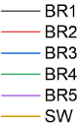
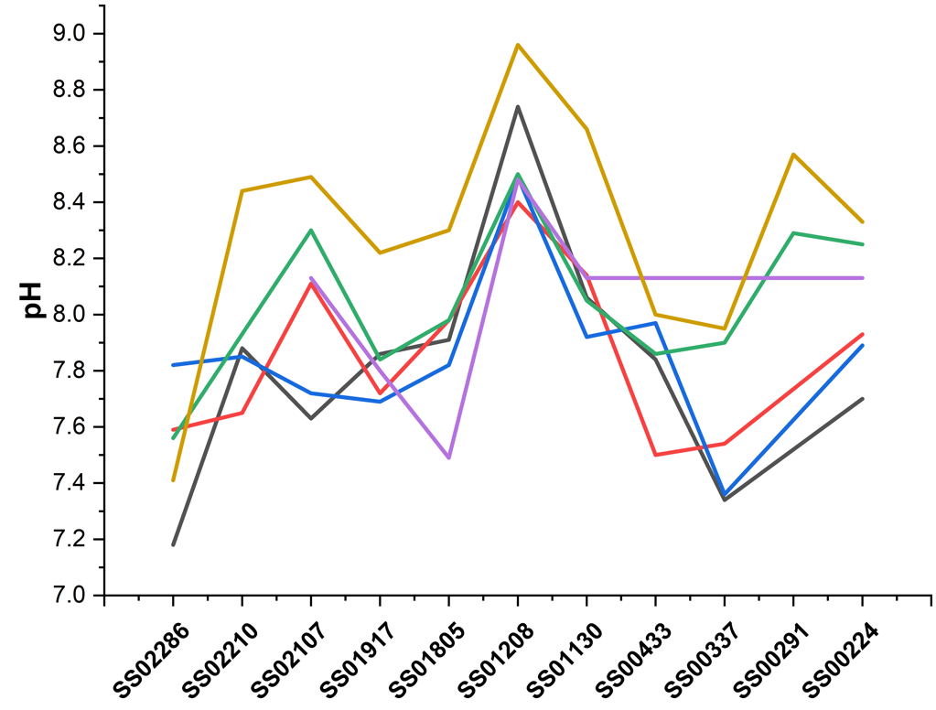
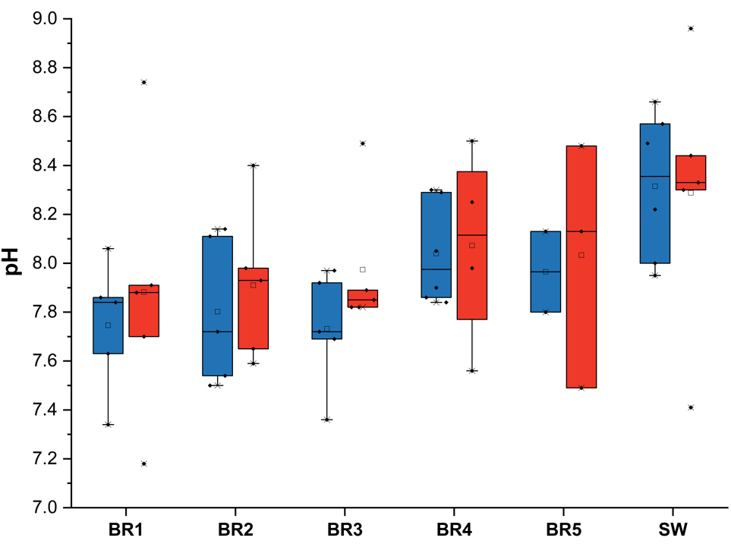
A

A

A

A
B

B

B

B

Carbonates
Mudstone/Siltstone
Sandstone
Conglomerate

Figure A.1. Changes in pH values for each Bou Rouch (BR) sampler and surface water (SW) samples along the river flow path and corresponding to major changes in lithology. Lithology symbols are noted for carbonate, shale, sandstone, and conglomerate rock types. (B) pH values for all spike samples by hydrological condition (gaining conditions in blue or losing conditions in red).
Downstream Direction

Downstream Direction

Downstream Direction

Downstream Direction

carbonate
sandstone
shale
conglomerate
carbonate
carbonate
shale
sandstone
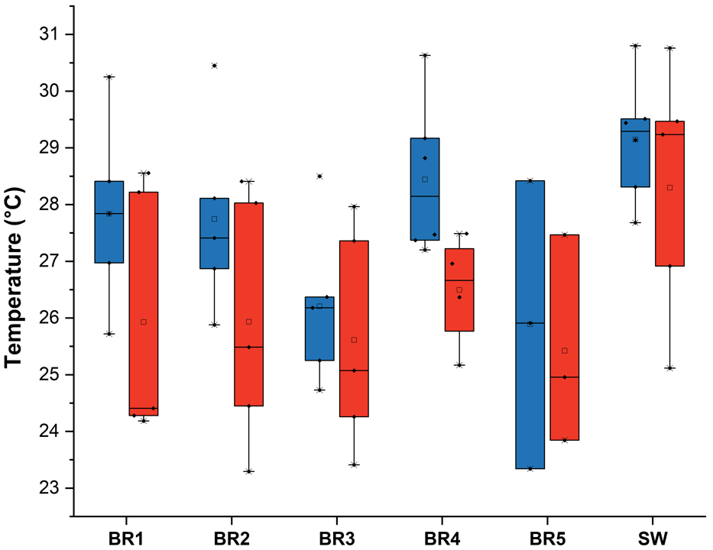
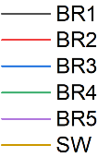
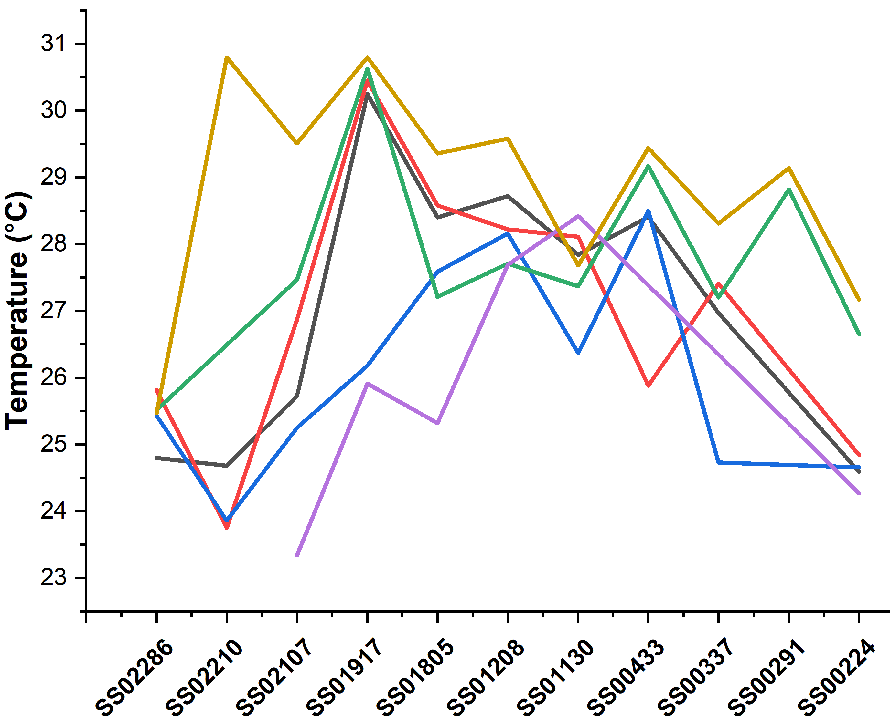
Carbonates
Mudstone/Siltstone
Sandstone
Conglomerate

B

B

B

B
A

A

A

A
Figure A.2. (A) Changes in temperature values, in degrees Celsius, for each Bou Rouch (BR) sampler and surface water (SW) samples along the river flow path. (B) pH values for all spike samples by hydrological condition (gaining conditions in blue or losing conditions in red).
Figure A.3. Changes in specific conductance values for each Bou Rouch (BR) sampler and surface water (SW) samples along the river flow path. (B) Specific conductance values for all spike samples by hydrological condition (gaining conditions in blue or losing conditions in red).
A

A

A

A
B

B

B

B
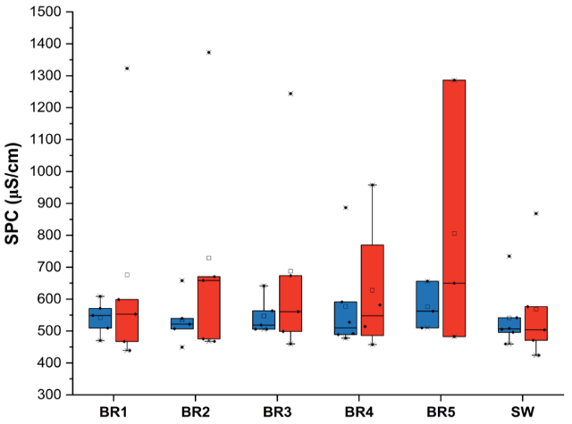
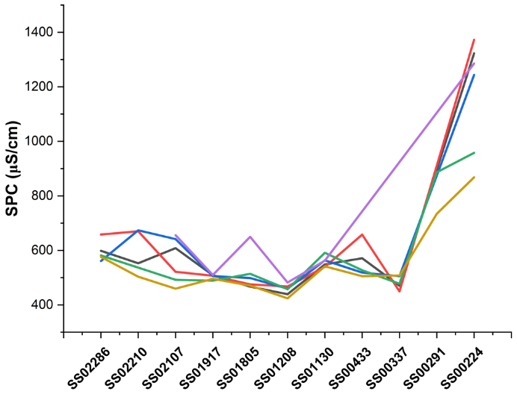
Carbonates
Mudstone/Siltstone
Sandstone
Conglomerate

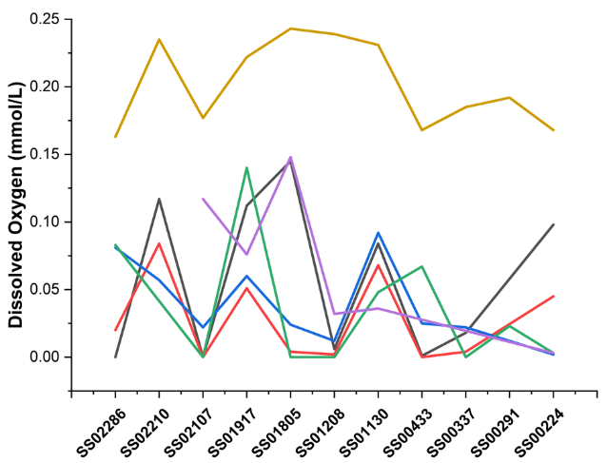
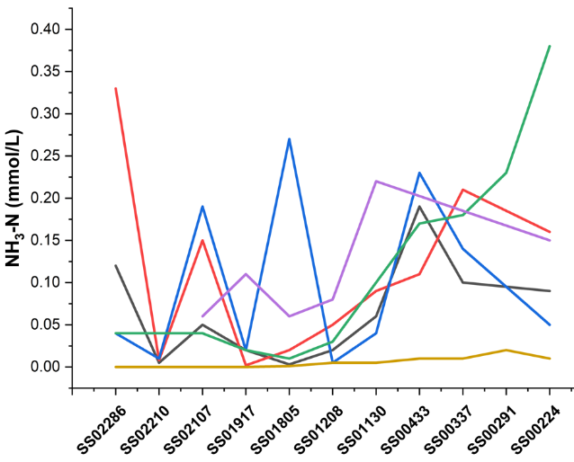
Carbonates
Mudstone/Siltstone
Sandstone
Conglomerate

Figure A.4. Changes for each Bou Rouch (BR) sampler and surface water (SW) samples along the flow path for (A) dissolved oxygen and (B) soluble ammonia-nitrogen concentrations. Values listed at zero on the graphs represent values below each of the respective detection limits.
A

A

A

A
B

B

B

B
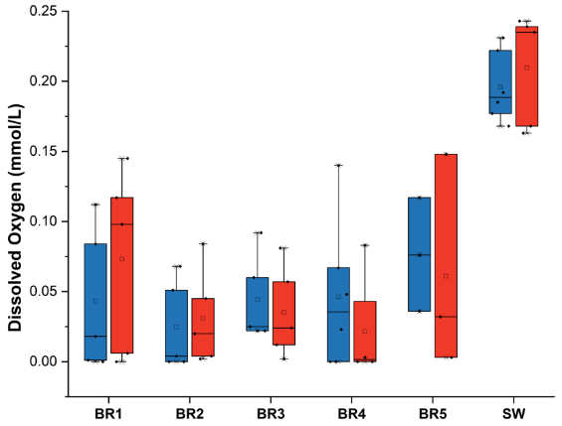
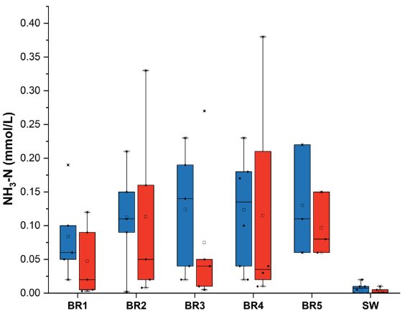
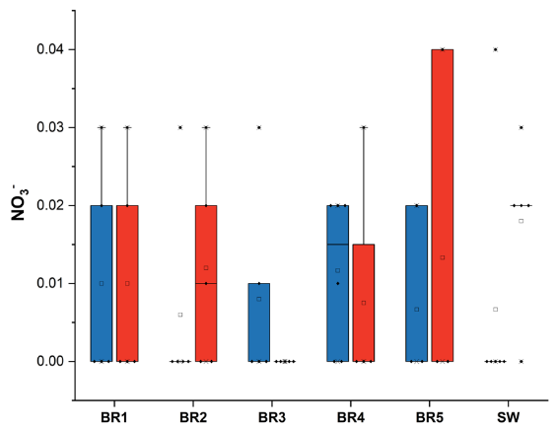
C
B

B

B
A
Figure A.5. Split bar graphs arranged by hydrologic condition (i.e., losing versus gaining) and Bou Rouch (BR) samplers and surface water (SW) samples for (A) dissolved oxygen concentrations, (B) soluble ammonia-nitrogen concentrations, and (C) nitrate concentrations. Red indicates losing conditions, and blue indicates gaining conditions. Solid lines in the bards indicate 25% and 75% interquartile range and dashed lines indicate the median, and small black squares represent mean concentrations.
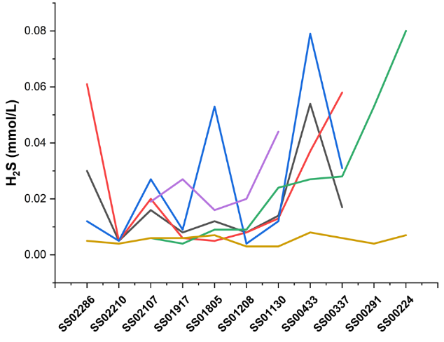
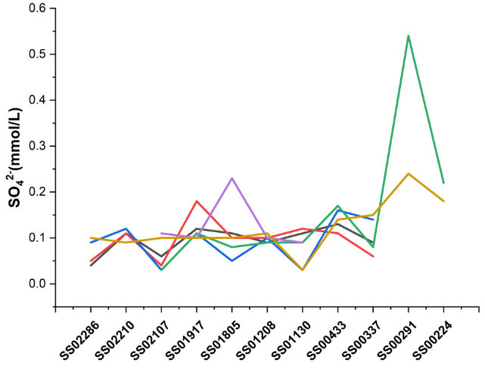

Carbonates
Mudstone/Siltstone
Sandstone
Conglomerate
Figure A.6. Changes for each Bou Rouch (BR) sampler and surface water (SW) samples along the flow path for (A) sulfide and (B) sulfate concentrations.
A

A

A

A
B

B

B

B
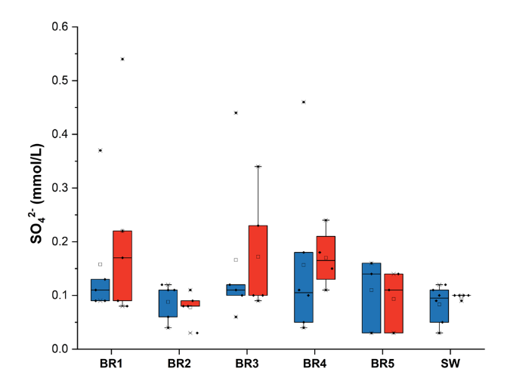
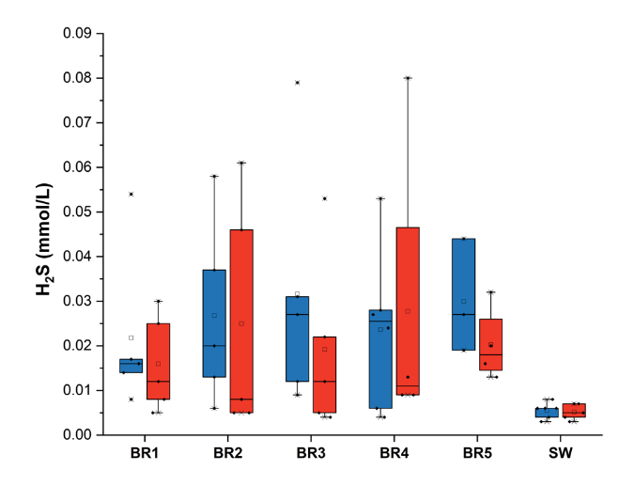
Figure A.7. Split bar graphs arranged by hydrologic condition (i.e., losing versus gaining) and Bou Rouch (BR) samplers and surface water (SW) samples for (A) dissolved sulfide and (B) sulfate concentrations. Red indicates losing conditions, and blue indicates gaining conditions. Solid lines indicate 25% and 75% interquartile range and dashed lines indicate the median, and small black square represents mean concentrations.
A

A

A

A
B

B

B

B
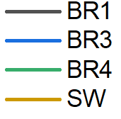
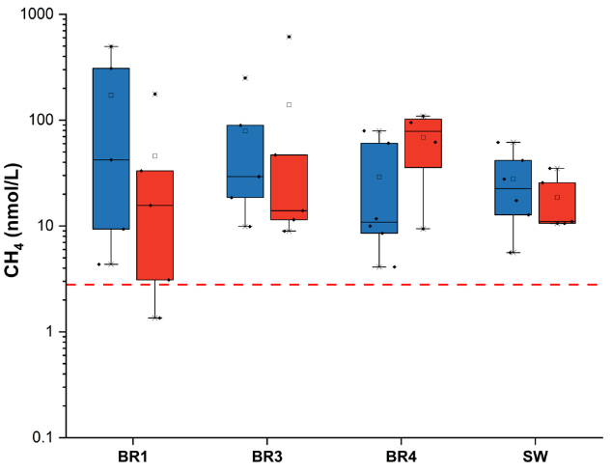
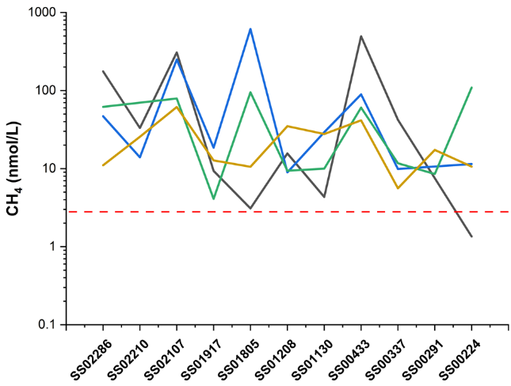
Carbonates
Mudstone/Siltstone
Sandstone
Conglomerate

Figure A.8. (A) Changes in methane concentrations for each Bou Rouch (BR) sampler and surface water (SW) samples along the flow path. The red dashed line indicates a projected equilibrium concentration of 2.8 nmol/L. (B) Split bar graphs of methane concentrations arranged by hydrologic condition (i.e., losing versus gaining) and BR spike. Blue indicates gaining conditions and red indicates losing conditions. Solid lines indicate 25% and 75% interquartile range and dashed line indicates median. Red dashed line indicates equilibrium concentration of 2.8 nmol/L. No methane measurements were taken from BR2 or BR5.
A

A

A

A
B

B

B

B
Figure 3.17. Scatter plot of sulfide values and soluble-ammonia nitrogen by hydrologic condition. All values in mmol/L. Red indicates losing conditions, and blue indicates gaining conditions.

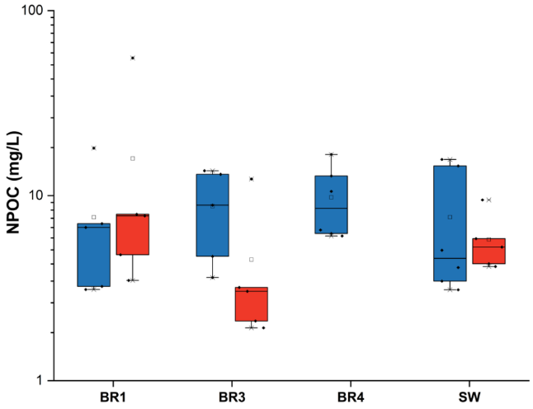
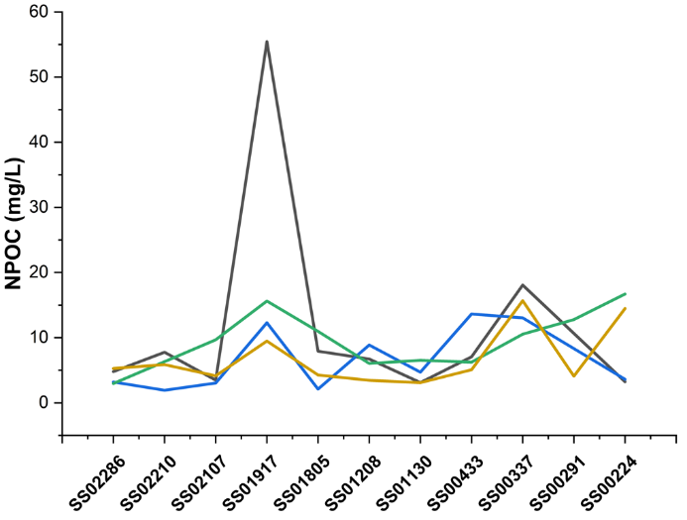
Figure A.9. Changes in non-purgeable organic carbon (NPOC) concentrations for each Bou Rouch (BR) sampler and surface water (SW) sample along the flow path. (B) Split bar graphs of NPOC concentrations arranged by hydrologic condition (i.e., losing versus gaining) and BR sampler and SW. Blue indicates gaining conditions and red indicates losing conditions. Solid lines indicate 25% and 75% interquartile range and dashed line indicates median. No NPOC measurements were taken from BR2 or BR5.
Carbonates
Mudstone/Siltstone
Sandstone
Conglomerate

B
A
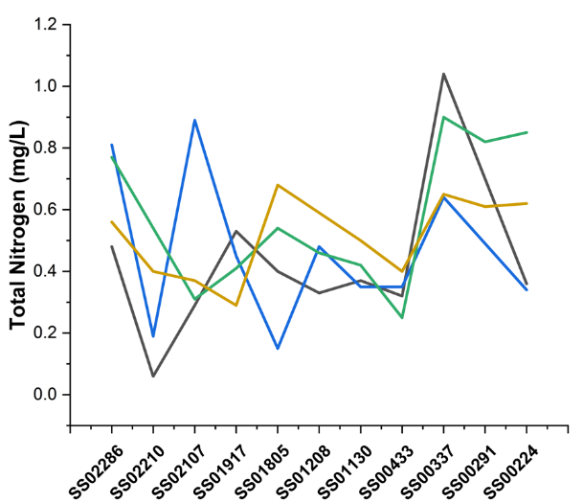
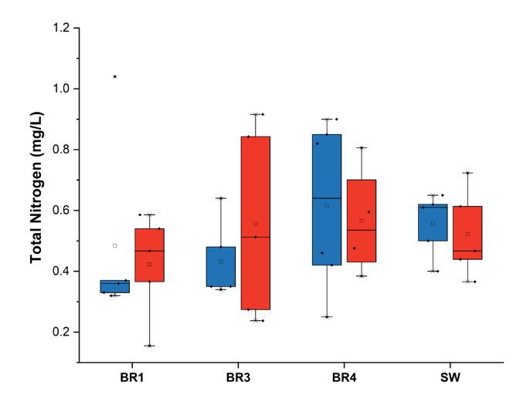
Figure A.10. (A) Changes in total nitrogen (TN) concentrations for each Bou Rouch (BR) sampler and surface water (SW) sample along the flow path. (B) Split bar graphs of TN concentrations arranged by hydrologic condition (i.e., losing versus gaining) and BR sampler and SW. Blue indicates gaining conditions and red indicates losing conditions. Solid lines indicate 25% and 75% interquartile range and dashed line indicates median. No TN measurements were taken from BR2 or BR5.
Carbonates
Mudstone/Siltstone
Sandstone
Conglomerate

A
B
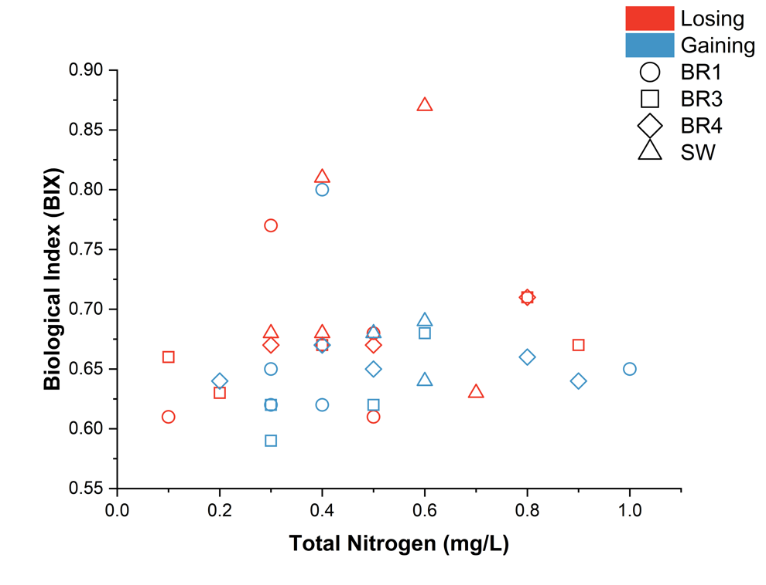
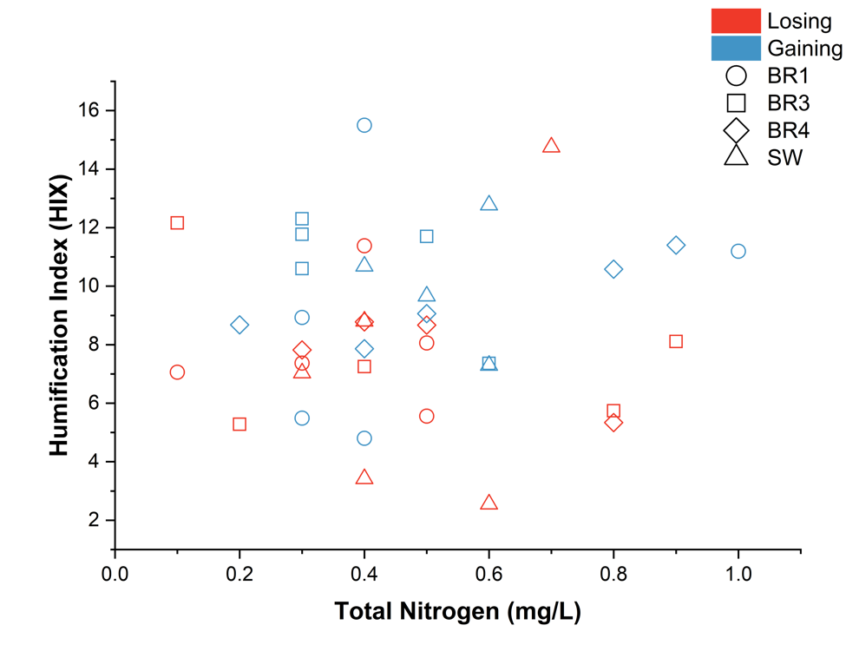
Figure A.11. (A) Scatter plot of Humification Index (HIX) and total nitrogen (TN) by hydrologic condition for all Bou Rouch (BR) samplers. (B) Scatter plot of Biological Index (BIX) values and TN. Red indicates losing conditions and blue indicates gaining conditions on both graphs.
Increasing Humification
Increasing Biological Activity
B

B

B

B
A

A

A

A
Table A.1. One-way PERMANOVA p-values based on Euclidian similarity for discharge according to lithology with 9999 permutations (global F-value = 2.58, p-value 0.06).
Lithology | Carbonate | Mixed Clastic | Sandstone | Mixed Clastics, Conglomerate
Carbonate | - | 0.0487 | 0.9413 | 0.7368
Mixed Clastic |  | - | 1 | 0.002
Sandstone |  |  | - | 0.0033
Mixed Clastics, Conglomerate |  |  |  | -

Table A.2. Spearman’s rho correlations (lower-half) for hydrological parameters with supporting the p-values (upper-half). Shaded values are significantly significant.
 | Distance | Hydraulic Conductivity | Hammered Depth | Discharge
Distance | - | 0.004 | 0.34 | 5.67E-20
Hydraulic Conductivity | 0.49 | - | 0.49 | 0.09
Hammered Depth | -0.14 | 0.12 | - | 0.71
Discharge | -0.92 | -0.30 | 0.054 | -

Table A.3. One-way PERMANOVA p-values based on Euclidian similarity for discharge according to vertical hydraulic gradient with 9999 permutations Shaded values are significantly significant. (global F-value = 5.36, p-value 0.04).
Vertical Hydraulic Gradient | Downwelling | Upwelling
Downwelling | - | 0.04
Upwelling |  | -

Table A.4. One-way PERMANOVA p-values based on Euclidian similarity for hammered depth according to lithology with 9999 permutations (global F-value = 3.34, p-value 0.03).
Lithology | Carbonate | Mixed Clastic | Sandstone |  | Mixed Clastics, Conglomerate
Carbonate | - | 0.10 | 0.02 | 0.99
Mixed Clastic |  | - | 0.06 | 0.15
Sandstone |  |  | - | 0.02
Mixed Clastics, Conglomerate |  |  |  | -

Table A.5. One-way PERMANOVA p-values based on Euclidian similarity for pH and Bou Rouch (BR) sampler and surface water (SW) with 9999 permutations (global F-value = 3.33, p-value 0.03).
Sampler Location |  | BR1 |  | BR3 |  | BR4 |  | SW
BR1 |  | - |  | 0.80 |  | 0.21 |  | 0.02
BR3 |  |  |  | - |  | 0.20 |  | 0.02
BR4 |  |  |  |  |  | - |  | 0.17
SW |  |  |  |  |  |  |  | -
Table A.6. One-way PERMANOVA p-values based on Euclidian similarity for all pH values at each river location (listed in km) with 9999 permutations (global F-value = 4.86, p-value 0.001).

River Location | 22.4 | 33.7 | 43.3 | 113 | 120.8 | 180.5 | 191.7 | 210.7 | 221.1 | 228.6
22.4 | - | 0.17 | 0.40 | 0.60 | 0.03 | 0.85 | 0.43 | 0.91 | 1.00 | 0.06
33.7 |  | - | 0.25 | 0.06 | 0.03 | 0.17 | 0.29 | 0.17 | 0.29 | 0.52
43.3 |  |  | - | 0.11 | 0.03 | 0.60 | 0.94 | 0.60 | 0.56 | 0.03
113 |  |  |  | - | 0.09 | 0.46 | 0.23 | 0.63 | 0.60 | 0.03
120.8 |  |  |  |  | - | 0.03 | 0.03 | 0.06 | 0.03 | 0.03
180.5 |  |  |  |  |  | - | 0.51 | 0.97 | 0.68 | 0.06
191.7 |  |  |  |  |  |  | - | 0.63 | 0.49 | 0.06
210.7 |  |  |  |  |  |  |  | - | 0.97 | 0.11
221 |  |  |  |  |  |  |  |  | - | 0.06
228.6 |  |  |  |  |  |  |  |  |  | -

Table A.7. One-way PERMANOVA p-values based on Euclidian similarity for dissolved oxygen (DO) and Bou Rouch (BR) sampler and surface water (SW) with 9999 permutations (global F-value = 29.44, p-value 0.0001).
Sampler Location | BR1 | BR3 | BR4 | SW
BR1 | - | 0.42 | 0.44 | 0.0001
BR3 |  | - | 0.89 | 0.0001
BR4 |  |  | - | 0.0001
SW |  |  |  | -

Sampler Location | BR1 | BR3 | BR4 | SW
BR1 | - | 0.34 | 0.37 | 0.0008
BR3 |  | - | 0.90 | 0.0001
BR4 |  |  | - | 0.0002
SW |  |  |  | -

Table A.8. One-way PERMANOVA p-values based on Euclidian similarity for ammonia-nitrogen (NH₃-N) and Bou Rouch (BR) sampler and surface water (SW) with 9999 permutations (global F-value = 3.35, p-value 0.03).

Table A.9. One-way PERMANOVA p-values based on Euclidian similarity for sulfide and Bou Rouch (BR) sampler and surface water (SW) with 9999 permutations (global F-value = 2.42, p-value 0.07).

Sampler Location | BR1 | BR3 | BR4 | SW
BR1 | - | 0.49 | 0.73 | 0.0003
BR3 |  | - | 0.78 | 0.0006
BR4 |  |  | - | 0.0015
SW |  |  |  | -

Lithology | Carbonate | Mixed Clastic | Sandstone | Conglomerate | Mixed Clastic/  Conglomerate
Carbonate | - | 0.02 | 0.73 | 0.68 | 0.26
Mixed Clastic |  | - | 0.17 | 0.26 | 0.08
Sandstone |  |  | - | 0.77 | 0.23
Conglomerate |  |  |  | - | 0.15
Mixed Clastic/  Conglomerate |  |  |  |  | -
Table A.10. One-way PERMANOVA p-values based on Euclidian similarity for sulfide according to lithology with 9999 permutations (global F-value = 2.38, p-value 0.08).

River Location | 22.4 | 33.7 | 43.3 | 113 | 120.8 | 180.5 | 191.7 | 210.7 | 221.1 | 228.6
22.4 | - | 0.03 | 0.03 | 0.03 | 0.03 | 0.03 | 0.03 | 0.03 | 0.05 | 0.03
33.7 |  | - | 0.17 | 0.18 | 0.52 | 0.32 | 0.94 | 0.11 | 0.82 | 0.26
43.3 |  |  | - | 0.03 | 0.03 | 0.03 | 0.03 | 0.03 | 0.03 | 0.03
113 |  |  |  | - | 0.29 | 0.37 | 0.11 | 0.83 | 0.26 | 0.74
120.8 |  |  |  |  | - | 0.54 | 0.17 | 0.12 | 0.43 | 0.26
180.5 |  |  |  |  |  | - | 0.17 | 0.23 | 0.37 | 0.60
191.7 |  |  |  |  |  |  | - | 0.03 | 0.42 | 0.03
210.7 |  |  |  |  |  |  |  | - | 0.09 | 0.43
221 |  |  |  |  |  |  |  |  | - | 0.14
228.6 |  |  |  |  |  |  |  |  |  | -
Table A.11. One-way PERMANOVA p-values based on Euclidian similarity for sulfate at each river location (listed in km) with 9999 permutations (global F-value = 1.21, p-value 0.97).

Table A.12. One-way PERMANOVA p-value results based on Euclidian similarity for methane at each river location (listed in km) with 9999 permutations (global F-value = 2.51, p-value 0.03).

River Location | 22.4 | 33.7 | 43.3 | 113 | 120.8 | 180.5 | 191.7 | 210.7 | 221.1 | 228.6
22.4 | - | 0.97 | 0.12 | 0.94 | 0.88 | 0.49 | 0.80 | 0.09 | 0.59 | 0.25
33.7 |  | - | 0.06 | 0.92 | 0.80 | 0.46 | 0.63 | 0.03 | 0.37 | 0.09
43.3 |  |  | - | 0.03 | 0.03 | 0.54 | 0.03 | 0.77 | 0.06 | 0.44
113 |  |  |  | - | 0.86 | 0.46 | 0.49 | 0.03 | 0.46 | 0.15
120.8 |  |  |  |  | - | 0.45 | 0.43 | 0.03 | 0.34 | 0.11
180.5 |  |  |  |  |  | - | 0.38 | 0.38 | 0.75 | 0.85
191.7 |  |  |  |  |  |  | - | 0.03 | 0.12 | 0.08
210.7 |  |  |  |  |  |  |  | - | 0.06 | 0.17
221 |  |  |  |  |  |  |  |  | - | 0.32
228.6 |  |  |  |  |  |  |  |  |  | -

Table A.13. One-way PERMANOVA p-values based on Euclidian similarity for methane according to lithology with 9999 permutations (global F-value = 1.94, p-value 0.13).

Lithology | Carbonate | Mixed Clastic | Sandstone | Conglomerate | Mixed Clastic/  Conglomerate
Carbonate | - | 0.06 | 0.32 | 0.64 | 0.14
Mixed Clastic |  | - | 0.03 | 0.54 | 0.03
Sandstone |  |  | - | 0.45 | 0.49
Conglomerate |  |  |  | - | 0.39
Mixed Clastic/  Conglomerate |  |  |  |  | -

Table A.14. Spearman’s rho correlations (lower-half) for nutrient geochemistry and calculated fluorescence indices, with supporting the p-values (upper-half). Shaded values are significantly significant.

Parameters | NPOC | C:N Ratio | Total Nitrogen | FI | HIX | BIX
NPOC | - | <0.00001 | 0.08 | 0.04 | 0.41 | 0.41
C:N Ratio | 0.80 | - | 0.09 | 0.03 | 0.85 | 0.16
Total Nitrogen | 0.28 | -0.28 | - | 0.48 | 0.53 | 0.20
FI | -0.33 | -0.36 | 0.12 | - | 0.22 | 0.15
HIX | 0.14 | 0.03 | 0.10 | -0.20 | - | 0.004
BIX | -0.14 | -0.23 | 0.21 | 0.23 | -0.61 | -
Table A.15. One-way PERMANOVA p-values based on Euclidian similarity for bicarbonate values in the hyporheic zone (HZ) according to lithology with 9999 permutations (global F-value = 3.157, p-value 0.04).

Lithology | Carbonate | Mixed Clastic | Sandstone | Mixed Clastics, Conglomerate
Carbonate | - | 0.743 | 0.0393 | 0.0767
Mixed Clastic |  | - | 0.1027 | 0.0201
Sandstone |  |  | - | 0.0149
Mixed Clastics, Conglomerate |  |  |  | -

Table A.16. One-way PERMANOVA p-values based on Euclidian similarity for bicarbonate values in surface water (SW) according to lithology with 9999 permutations (global F-value =0.54, p-value 0.63).

Lithology |  | Carbonate |  | Mixed Clastic |  | Sandstone |  | Mixed Clastics, Conglomerate
Carbonate | - |  | 0.7121 |  | 0.4255 |  | 0.7056
Mixed Clastic |  |  |  | - |  | 1 |  | 0.6642
Sandstone |  |  |  | 1 |  | - |  | 0.3353
Mixed Clastics, Conglomerate |  |  |  |  |  |  |  | -

APPENDIX B
Taxonomic Analysis of Surface Water and Hyporheic Zone Microbial Communities: Alpha-Diversity Indices, Shared Operational Taxonomic Units, and Beta Diversity

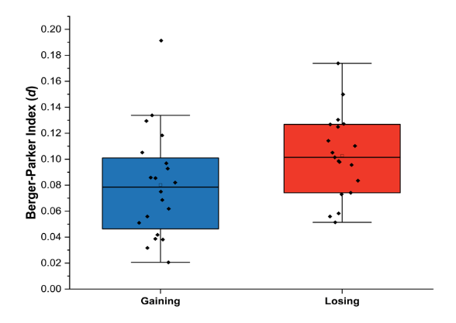
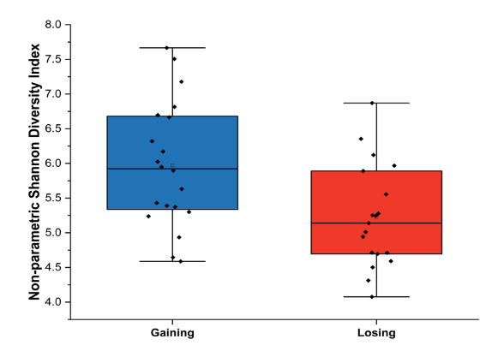
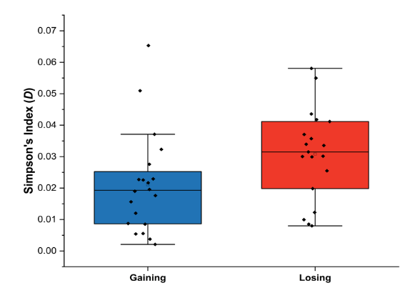
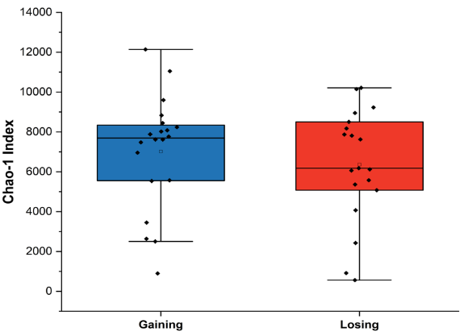
Figure B.1. (A) Box chart of Non-parametric Shannon Index values split by hydrologic condition. (B) Box chart of Chao-1 index values split by hydrologic condition. (C) Box chart of Simpson's index values split by hydrologic condition. (D) Box chart of Berger-Parker index values split by hydrologic condition. Whiskers designate 25% and 75% interquartile ranges and solid line indicates the median, and the small black square represents the mean.

A
C
B
D
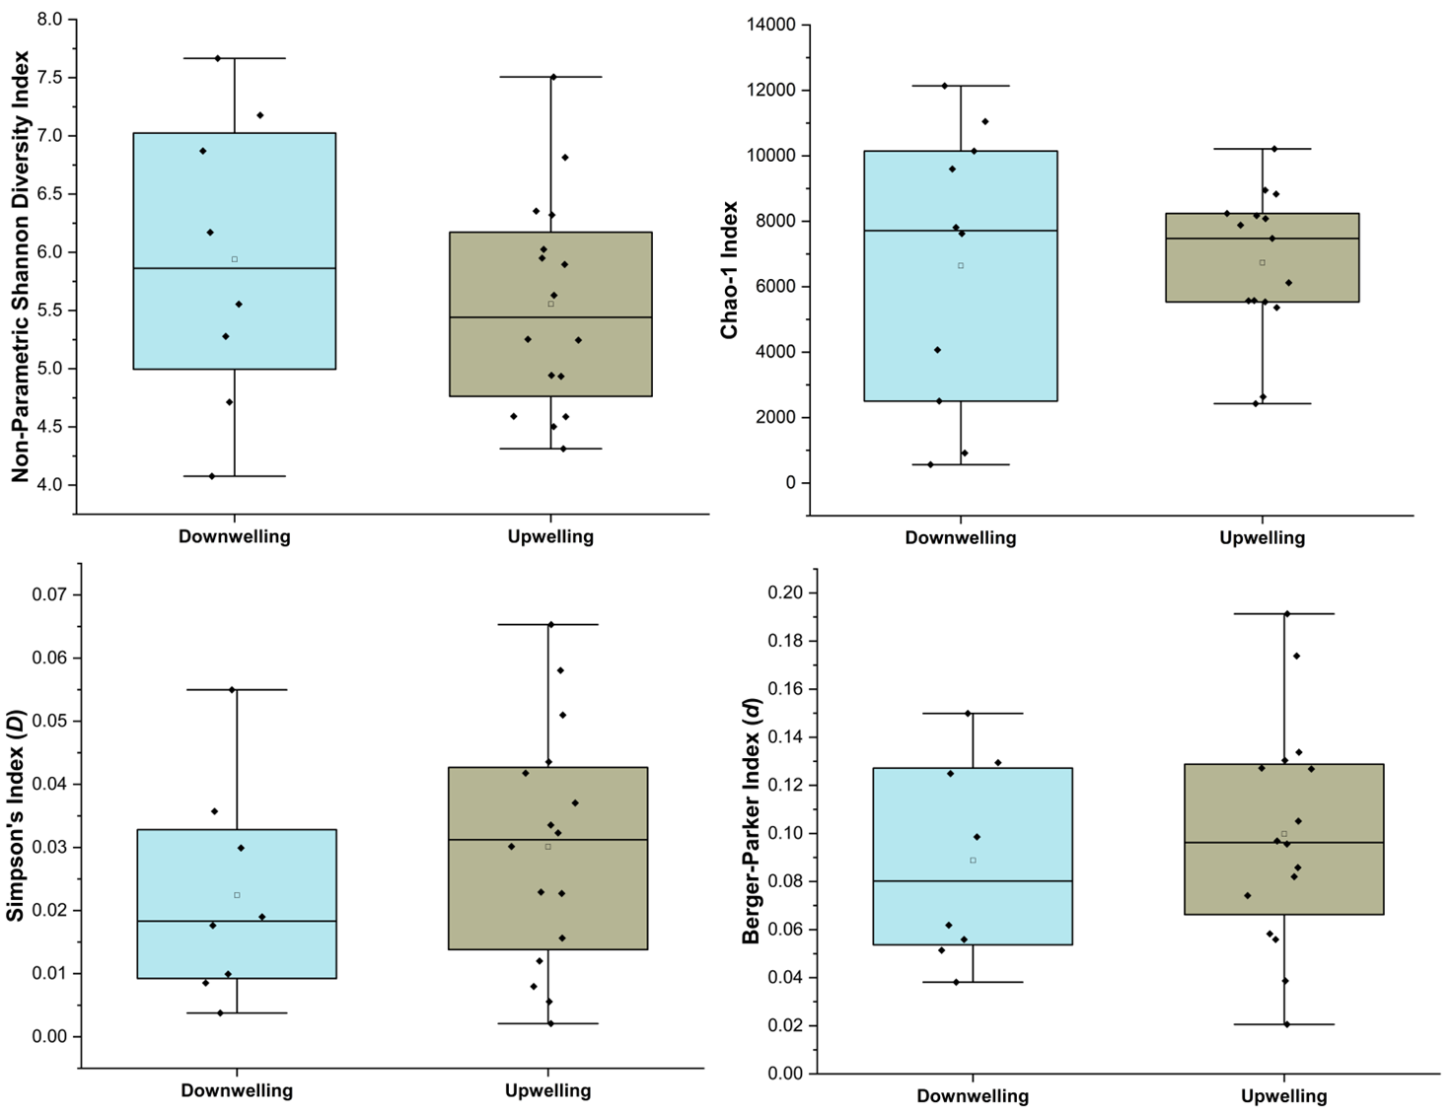
Figure B.2. (A) Box chart of Non-parametric Shannon Index values split by hydrologic condition. (B) Box chart of Chao-1 index values split by hydrologic condition. (C) Box chart of Simpson's index values split by hydrologic condition. (D) Box chart of Berger-Parker index values split by hydrologic condition. Whiskers designate 25% and 75% interquartile ranges and solid line indicates the median, and the small black square represents the mean.
B
D
A
C
Table B.1. An example of the taxonomic identification of operational taxonomic units (OTUs) identified for all the samples, showing on four sample locations and only 20 OTUs. For each OTU, the number of sequence reads in the whole data set are counted (listed on the “Number of Reads” column), and the number of sequences per sample are noted separately. Taxonomic identification done using SILVA reference database.
Domain | Phylum | Class | Order | Family | Genus | Number of Reads | OTU # | SS00224.BR1 | SS00224.BR3 | SS00224.BR4 | SS00224.SW
Bacteria | Actinobacteriota | Actinobacteria | Frankiales | Sporichthyaceae | Sporichthyaceae_ge | 421548 | Otu000001 | 0 | 125 | 4646 | 6076
Bacteria | Proteobacteria | Gammaproteobacteria | Burkholderiales | Burkholderiaceae | Polynucleobacter | 406141 | Otu000002 | 2 | 143 | 9008 | 19707
Bacteria | Proteobacteria | Gammaproteobacteria | Burkholderiales | Comamonadaceae | Comamonadaceae_unclassified | 284639 | Otu000003 | 1 | 0 | 6928 | 8879
Bacteria | Actinobacteriota | Actinobacteria | Frankiales | Sporichthyaceae | hgcI_clade | 274587 | Otu000004 | 0 | 0 | 4387 | 5686
Bacteria | Actinobacteriota | Actinobacteria | Frankiales | Sporichthyaceae | hgcI_clade | 178969 | Otu000005 | 480 | 0 | 3880 | 5114
Bacteria | Proteobacteria | Gammaproteobacteria | Pseudomonadales | Pseudomonadaceae | Pseudomonas | 152989 | Otu000006 | 16340 | 8717 | 24203 | 22
Bacteria | Proteobacteria | Gammaproteobacteria | Burkholderiales | Comamonadaceae | Comamonadaceae_unclassified | 144383 | Otu000007 | 3349 | 407 | 3134 | 3546
Bacteria | Proteobacteria | Gammaproteobacteria | Burkholderiales | Methylophilaceae | Candidatus_Methylopumilus | 142829 | Otu000008 | 2 | 0 | 5244 | 8652
Bacteria | Proteobacteria | Gammaproteobacteria | Burkholderiales | Comamonadaceae | Comamonadaceae_unclassified | 140441 | Otu000009 | 375 | 2 | 4088 | 5538
Bacteria | Bacteroidota | Bacteroidia | Chitinophagales | Chitinophagaceae | Sediminibacterium | 137273 | Otu000010 | 0 | 0 | 3047 | 4299
Bacteria | Cyanobacteria | Cyanobacteriia | Synechococcales | Cyanobiaceae | Cyanobium_PCC-6307 | 130192 | Otu000011 | 0 | 0 | 1747 | 2929
Bacteria | Proteobacteria | Gammaproteobacteria | Burkholderiales | MWH-UniP1_aquatic_group | MWH-UniP1_aquatic_group_ge | 113629 | Otu000012 | 0 | 0 | 829 | 1261
Bacteria | Proteobacteria | Gammaproteobacteria | Pseudomonadales | Moraxellaceae | Acinetobacter | 93407 | Otu000013 | 35158 | 17128 | 3166 | 70
Bacteria | Bdellovibrionota | Bdellovibrionia | Bacteriovoracales | Bacteriovoracaceae | Bacteriovorax | 90889 | Otu000014 | 0 | 0 | 0 | 5
Bacteria | Proteobacteria | Gammaproteobacteria | Burkholderiales | Comamonadaceae | Comamonadaceae_unclassified | 84216 | Otu000015 | 3376 | 693 | 2272 | 1758
Bacteria | Planctomycetota | Planctomycetes | Gemmatales | Gemmataceae | uncultured | 82386 | Otu000016 | 0 | 0 | 718 | 1709
Bacteria | Bacteroidota | Bacteroidia | Cytophagales | Spirosomaceae | Pseudarcicella | 78305 | Otu000017 | 1 | 0 | 1096 | 1423
Bacteria | Proteobacteria | Gammaproteobacteria | Burkholderiales | Comamonadaceae | Aquabacterium | 76199 | Otu000018 | 153 | 66 | 403 | 45
Bacteria | Bacteroidota | Bacteroidia | Cytophagales | Cyclobacteriaceae | Algoriphagus | 66506 | Otu000019 | 0 | 0 | 1867 | 2859
Bacteria | Proteobacteria | Gammaproteobacteria | Burkholderiales | Oxalobacteraceae | Oxalobacteraceae_unclassified | 63370 | Otu000020 | 624 | 393 | 1032 | 2102

Table B.2. One-way ANOSIM p-value results based on Bray-Curtis similarity for OTU-level diversity at each river location (listed in km) comparing all Bou Rouch samplers at a location and the surface water (SW) with 9999 permutations (R value = 0.51, p-value 0.0001).
River Location | 22.4 | 33.7 | 43.3 | 113 | 120.8 | 180.5 | 191.7 | 210.7 | 221.1 | 228.6 | SW
22.4 | - | 0.30 | 0.20 | 0.20 | 0.10 | 0.10 | 0.10 | 0.19 | 0.49 | 0.20 | 0.006
33.7 |  | - | 0.30 | 0.20 | 0.10 | 0.10 | 0.50 | 1 | 0.11 | 0.50 | 0.01
43.3 |  |  | - | 0.10 | 0.10 | 0.11 | 0.30 | 0.20 | 0.11 | 0.10 | 0.003
113 |  |  |  | - | 0.10 | 0.10 | 0.20 | 0.30 | 0.10 | 0.21 | 0.031
120.8 |  |  |  |  | - | 0.10 | 0.10 | 0.09 | 0.10 | 0.10 | 0.68
180.5 |  |  |  |  |  | - | 0.41 | 0.10 | 0.10 | 0.10 | 0.044
191.7 |  |  |  |  |  |  | - | 0.49 | 0.10 | 0.90 | 0.013
210.7 |  |  |  |  |  |  |  | - | 0.10 | 0.70 | 0.026
221 |  |  |  |  |  |  |  |  | - | 0.20 | 0.018
228.6 |  |  |  |  |  |  |  |  |  | - | 0.004
SW |  |  |  |  |  |  |  |  |  |  | -
Table B.3. Results of combined alpha-diversity indices for different hydrological conditions.

Statistical Parameters | Gaining / Losing | Upwelling / Downwelling
Permutation N: | 9999 | 9999
Mean rank within: | 153.1 | 116
Mean rank between: | 172.1 | 0.1868
R: | 0.1166 | 0.045
p-value | 0.05 | 0.04

Diversity Indices | One-way ANOSIM p-values
Simpson's Index (D) | 0.02
Berger-Parker Index (d) | 0.10
Non-Parametric Shannon Index (H’) | 0.006
Chao1 Index | 0.90
Table B.4. Uncorrected p-values obtained from a one-way ANOSIM analysis for alpha-diversity metrics. The analysis was conducted using Bray-Curtis similarity across hydrologic group (gaining or losing), specifically comparing all Bou Rouch sampler locations within the hyporheic zone. The statistical significance is determined using 9999 permutations.

Table B.5. Results of a three-way MANOVA test examining diversity indices concerning geology, hydrology (gaining or losing), and sample locations within the hydrologic zone (HZ).

Variable | Df | Pillai's Trace | F-statistic | Numerator DF | Denominator Df | Pr(>F)
geology | 4 | 2.16425 | 2.358 | 16 | 32 | 0.02
hydrology | 1 | 0.9336 | 17.575 | 4 | 5 | 0.0038
spike | 2 | 1.11739 | 1.90 | 8 | 12 | 0.15
geology:hydrology | 1 | 0.76659 | 4.105 | 4 | 5 | 0.077
geology:spike | 6 | 1.8133 | 1.106 | 24 | 32 | 0.39
hydrology:spike | 2 | 1.19153 | 2.21 | 8 | 12 | 0.104
geology:hydrology:spike | 1 | 0.65825 | 2.41 | 4 | 5 | 0.18

Sampler Location | BR1 | BR3 | BR4 | SW
BR1 | - | 1 | 0.05 | 0.002
BR3 |  | - | 0.009 | 0.0002
BR4 |  |  | - | 0.09
SW |  |  |  | -
Table B.6. One-way ANOSIM p-values for the “core” OTUs for Bou Rouch (BR) and surface water (SW) samples based on Bray-Curtis similarity with 9999 permutations (R value = 3.53, p-value = 0.004).

Table B.7. Statistical results of CCA plot scores for “core” OTUs and major geochemical and environmental parameters by sample locations in the hyporheic zone (HZ). Only axes that accounted for more than 1% of variation are shown.

Parameters | Axis 1 | Axis 2 | Axis 3 | Axis 4 | Axis 5
Sporichthyaceae | -0.208592 | -0.0493752 | -2.13069 | -0.380028 | -0.997161
Polynucleobacter | -0.0676093 | -0.374049 | -1.40549 | -0.660619 | 0.672571
Comamonadaceae (uncl.) (1) | -0.402835 | -0.502883 | -0.0305302 | 1.00922 | 1.04399
hgcI clade (1) | -0.528881 | -0.387461 | -0.34778 | 0.55404 | 0.0891625
hgcI clade (2) | -0.0676201 | -0.499137 | 1.90135 | -0.445564 | -2.07608
Pseudomonas | 2.42816 | 1.03542 | -0.597813 | 2.85825 | -1.02135
Comamonadaceae (uncl.) (2) | 0.740102 | 0.0976095 | 0.767506 | -1.07548 | -0.970351
Candidatus Methylopumilus | -0.473303 | -0.520525 | 0.279963 | 0.671507 | 0.430553
Comamonadaceae (uncl.) (3) | 0.40102 | -0.327083 | 1.59266 | 0.628598 | 1.57736
Sediminibacterium | -0.613227 | -0.420277 | -0.24809 | 0.137808 | -0.572496
Cyanobium PCC 6307 | -0.792812 | -0.492906 | 0.283125 | -0.0835047 | 0.890921
MWH UniP1 Aquatic Group | -0.820336 | -0.231932 | -0.47581 | 0.0726589 | -0.589641
Acinetobacter | 2.0303 | 1.00132 | -0.417801 | -2.08948 | 0.880531
Bacteriovorax | -2.64189 | 5.57172 | 0.671164 | 0.187407 | 0.195052
Comamonadaceae (uncl.) (4) | 1.02373 | 0.351652 | 0.284701 | -0.871931 | 1.08247
uncultured Planctomycetes | -0.832108 | -0.227736 | -0.0975684 | -0.371426 | -0.339441
SS00224.BR1 | 1.13218 | 0.320116 | 0.396563 | -0.16765 | -0.0418391
SS00337.BR1 | 1.21947 | 0.453039 | -0.399937 | -0.27063 | 0.00378043
SS00433.BR1 | 0.158037 | -0.10052 | -0.0259388 | 0.0592952 | 0.00190289
SS01130.BR1 | -0.0891943 | -0.129078 | 0.02275 | -0.0326039 | 0.0349765
SS01208.BR1 | 0.382744 | -0.00676769 | 0.0458247 | -0.0405565 | 0.12639
SS01805.BR1 | 0.0927149 | 0.135338 | 0.00699619 | 0.0537586 | 0.0132316
SS01917.BR1 | 0.0842584 | -0.136818 | -0.0182862 | 0.020746 | 0.0135798
SS02107.BR1 | -0.0795114 | -0.186269 | 0.0365067 | -0.0299297 | 0.0437919
SS02210.BR1 | 0.0248245 | 0.119473 | 0.0135933 | 0.0277338 | 0.0351816
SS02286.BR1 | 0.182262 | -0.0942832 | 0.0215051 | 0.0174544 | 0.0751332

Table B.7. Continued.
Parameters | Axis 1 | Axis 2 | Axis 3 | Axis 4 | Axis 5
SS00224.BR3 | 0.0557503 | 0.0296974 | 0.0160642 | 0.0698271 | 0.0139043
SS00337.BR3 | -0.0910106 | -0.167108 | 0.0330035 | -0.030075 | 0.0377631
SS00433.BR3 | 0.0882325 | -0.134508 | -0.0351119 | 0.0875959 | -0.072217
SS01130.BR3 | 0.172646 | -0.0841294 | -0.10227 | 0.127129 | -0.0966837
SS01208.BR3 | 0.096735 | -0.129637 | -0.0401587 | 0.0939131 | -0.0618152
SS01805.BR3 | -0.129498 | -0.177865 | -0.00505603 | -0.059135 | 0.0114273
SS01917.BR3 | -0.0889192 | -0.161612 | -0.0169322 | -0.0338897 | -0.0250704
SS02107.BR3 | -0.0288521 | -0.089147 | -0.0314016 | 0.00488627 | -0.0320745
SS02210.BR3 | -0.0748743 | -0.12684 | -0.0265686 | -0.0355503 | -0.0269138
SS02286.BR3 | -0.101292 | -0.135891 | -0.0170613 | -0.0441726 | 0.000517985
SS00224.BR4 | -0.197387 | 0.217796 | 0.00417237 | -0.00215332 | -0.0249487
SS00337.BR4 | -0.139732 | 0.169077 | 0.00455464 | 0.0133671 | -0.0343022
SS00433.BR4 | -0.220887 | 0.148719 | 0.0114903 | -0.014924 | -0.0314909
SS01130.BR4 | -0.174677 | -0.0366698 | -0.00581714 | -0.0412142 | -0.0281038
SS01208.BR4 | -0.184596 | 0.19668 | 0.0189208 | -0.0127061 | 0.00544609
SS01805.BR4 | -0.0436214 | 0.417048 | 0.091213 | -0.0257621 | 0.105942
SS01917.BR4 | -0.209719 | 0.169164 | 0.0218071 | 0.0200957 | -0.000508799
SS02107.BR4 | -0.176735 | 0.00756423 | 0.00337584 | -0.0228697 | 0.0103201
SS02286.BR4 | 0.0562932 | 0.00414915 | -0.0691215 | 0.0193699 | -0.0359887
Conductivity | 0.256807 | 0.151894 | 0.471501 | -0.092455 | -0.183576
pH | -0.266306 | 0.0451676 | 0.165485 | 0.282526 | 0.0187614
Discharge | 0.3159 | 0.352101 | 0.0597304 | -0.141365 | -0.251907
Dissolved Oxygen | 0.041624 | 0.0165658 | 0.119806 | 0.0784914 | -0.229707
Methane | -0.173328 | -0.222626 | -0.269116 | 0.0637071 | 0.10579
Sulfide | -0.0391703 | -0.0734497 | 0.0148994 | 0.0940059 | -0.230552
Soluble Ammonia Nitrogen | -0.0692893 | -0.00484038 | -0.0448698 | -0.0587367 | -0.250159
Bicarbonate | 0.290343 | -0.30337 | 0.0252532 | -0.115834 | 0.111259
Non-purgeable Organic Carbon | 0.0480423 | 0.246726 | -0.243513 | 0.0170537 | 0.0452153

Table B.7. Continued.
Parameters | Axis 1 | Axis 2 | Axis 3 | Axis 4 | Axis 5
Total Nitrogen | 0.174429 | 0.272568 | -0.351669 | -0.256491 | -0.122892
Carbon:Nitrogen Ratio | -0.0636905 | 0.0922015 | -0.0390306 | 0.163382 | 0.135381

Table B.8. Results of Indicator Species Analysis and sample location type (hyporheic zone or surface water). Unclassified OTUs are denoted by an asterisk (*), while uncultured OTUs are indicated by a double asterisk (**)
 | Hyporheic Zone (HZ) |  | Surface Water (SW)
OTU Taxonomic Affiliation | Indicator Value | p-value | Indicator Value | p-value
Sporichthyaceae | 43.48 | 0.67 | 53.3 | 0.27
Polynucleobacter | 31.67 | 1 | 67.2 | 0.01
hgcI clade | 38.05 | 0.83 | 57.56 | 0.12
hgcI clade | 43.21 | 0.70 | 53.59 | 0.25
Pseudomonas | 99.56 | 0.0001 | 0.4442 | 1
Comamonadaceae * | 46.2 | 0.72 | 53.8 | 0.28
Candidatus Methylopumilus | 30.64 | 1 | 67.09 | 0.004
Comamonadaceae * | 39.75 | 0.87 | 60.25 | 0.13
Sediminibacterium | 29.63 | 1 | 66.95 | 0.009
Cyanobium PCC-6307 | 20.52 | 1 | 77.96 | 0.003
MWH-UniP1 aquatic group | 31 | 0.93 | 65.42 | 0.05
Acinetobacter | 97.94 | 0.0001 | 2.055 | 1
Bacteriovorax | 67.81 | 0.15 | 1.673 | 0.97
Comamonadaceae * | 55.86 | 0.55 | 44.14 | 0.45
** Planctomycetes | 22.07 | 0.98 | 75.38 | 0.01
Pseudarcicella | 27.46 | 0.88 | 70.51 | 0.10
Aquabacterium | 91.6 | 0.06 | 8.404 | 0.94
Algoriphagus | 32.45 | 0.94 | 62.35 | 0.04
Oxalobacteraceae * | 32.56 | 0.99 | 67.44 | 0.01
Cyanobium PCC-6307 | 12.57 | 0.99 | 84.16 | 0.005
** Planctomycetes | 23.7 | 0.98 | 72.5 | 0.01
Cyanobium PCC-6307 | 14.9 | 0.98 | 81.22 | 0.008
Dinghuibacter | 19.8 | 1 | 77.03 | 0.0001
IMCC26134 | 29.33 | 0.80 | 59.5 | 0.09
hgcI clade | 36.39 | 0.82 | 57.79 | 0.12
Cyanobium PCC-6307 | 12.51 | 1 | 84.22 | 0.0001

Table B.8. Continued
 | Hyporheic Zone (HZ) |  | Surface Water (SW)
OTU Taxonomic Affiliation | Indicator Value | p-value | Indicator Value | p-value
Polynucleobacter | 25.46 | 1 | 71.6 | 0.003
Cyanobium PCC-6307 | 16.89 | 1 | 81.16 | 0.0002
Dinghuibacter | 25.17 | 0.98 | 69.59 | 0.01
Acinetobacter | 73.11 | 0.16 | 26.89 | 0.84
** Bacteroidia | 35.18 | 0.85 | 57.49 | 0.09
Sh765B-TzT-35 | 98.88 | 0.0001 | 1.118 | 1
Cyanobium PCC-6307 | 24.04 | 0.99 | 72.11 | 0.006
** Verrucomicrobiae | 23.41 | 0.92 | 70.49 | 0.04
Sva0485 | 99.01 | 0.0001 | 0.9856 | 1
NS11-12 marine group | 24.72 | 1 | 72.42 | 0.001
Bacteroides | 61.73 | 0.36 | 0.4928 | 0.74
Candidatus Aquiluna | 33.38 | 0.81 | 61.27 | 0.15
Sporichthyaceae * | 37.51 | 0.80 | 58.16 | 0.14
Hydrogenophaga | 58.34 | 0.45 | 39.57 | 0.54
Sva0485 | 96.26 | 0.0001 | 0.1783 | 1
Opitutus | 21.73 | 1 | 74.8 | 0.0006
MWH-UniP1 aquatic group | 29.02 | 0.88 | 64.94 | 0.07
Gammaproteobacteria * | 25.27 | 0.99 | 69.47 | 0.006
Candidatus Planktophila | 39.62 | 0.72 | 54.04 | 0.21
Acinetobacter | 88.21 | 0.12 | 1.616 | 0.99
Acetobacteroides | 54.68 | 0.43 | 0.8037 | 0.70
** Verrucomicrobiae | 19.6 | 0.92 | 70.09 | 0.02
Fluviicola | 24.45 | 0.84 | 67.77 | 0.07
** Chloroflexia | 26.95 | 1 | 69.95 | 0.003
Haloferula | 15.64 | 0.92 | 64.49 | 0.02
** Thermodesulfovibrionia | 99.19 | 0.0001 | 0.7318 | 1

Table B.8. Continued
 | Hyporheic Zone (HZ) |  |  | Surface Water (SW)
OTU Taxonomic Affiliation |  | Indicator Value | p-value |  | Indicator Value | p-value
Sva0485 |  | 99.11 | 0.0001 |  | 0.8015 | 1
Candidatus Aquiluna |  | 36.1 | 0.83 |  | 58.12 | 0.11
Clade III |  | 34.17 | 0.74 |  | 56.92 | 0.17
Halanaerobium |  | 55.15 | 0.01 |  | 0.007275 | 0.99
Gemmatimonas |  | 13.4 | 0.99 |  | 82.34 | 0.003
Bacteroides |  | 67.95 | 0.35 |  | 1.322 | 0.72
Cyanobium PCC-6307 |  | 21.25 | 0.94 |  | 62.27 | 0.04
Rheinheimera |  | 85.4 | 0.005 |  | 8.27 | 1
** Gammaproteobacteria |  | 36.58 | 0.89 |  | 60.71 | 0.09
Desulfatiglans |  | 80.98 | 0.009 |  | 16.13 | 0.99
Anaerolineaceae * |  | 98.48 | 0.0001 |  | 1.516 | 1
Candidatus Planktophila |  | 41.53 | 0.60 |  | 49.81 | 0.28
Bacteria * |  | 48.12 | 0.12 |  | 0.1263 | 0.97
Chitinophagaceae * |  | 8.047 | 0.81 |  | 23 | 0.26
Micrococcus |  | 61.79 | 0.11 |  | 0.2255 | 0.92
TRA3-20 |  | 86.21 | 0.04 |  | 3.846 | 0.99
Luteolibacter |  | 10.72 | 1 |  | 83.63 | 0.0006
Comamonadaceae * |  | 77.82 | 0.03 |  | 19.4 | 0.97
Acinetobacter |  | 56.79 | 0.49 |  | 30.71 | 0.50
NS11-12 marine group |  | 32.65 | 0.74 |  | 56.96 | 0.15
Comamonadaceae * |  | 22.29 | 1 |  | 74.14 | 0.0003
hgcI clade |  | 32.17 | 0.76 |  | 57.6 | 0.16
Novosphingobium |  | 76.1 | 0.37 |  | 11.72 | 0.64

Table B.9. Results of Indicator Species Analysis and hydrologic condition (gaining or losing). Unclassified OTUs are denoted by an asterisk (*), while uncultured OTUs are indicated by a double asterisk (**).
 | Losing |  | Gaining
OTU Taxonomic Affiliation | Indicator Value | p-value | Indicator Value | p-value
Sporichthyaceae | 56.62 | 0.15 | 36.72 | 0.90
Polynucleobacter | 50.66 | 0.41 | 46.53 | 0.60
Comamonadaceae * | 60.65 | 0.12 | 35.98 | 0.90
hgcI clade | 49.19 | 0.36 | 41.59 | 0.70
hgcI clade | 49.74 | 0.38 | 44.41 | 0.64
Pseudomonas | 35.39 | 0.81 | 64.61 | 0.18
Comamonadaceae * | 61.51 | 0.03 | 38.49 | 0.97
Candidatus Methylopumilus | 42.88 | 0.73 | 52.08 | 0.26
Comamonadaceae * | 53.18 | 0.36 | 46.82 | 0.64
Sediminibacterium | 56.01 | 0.12 | 35.53 | 0.90
Cyanobium PCC-6307 (1) | 38.73 | 0.71 | 56.72 | 0.27
MWH-UniP1 aquatic group | 41.22 | 0.67 | 51.05 | 0.33
Acinetobacter | 72.16 | 0.17 | 27.84 | 0.83
Bacteriovorax | 33.33 | 0.55 | 42.3 | 0.45
Comamonadaceae * | 33.72 | 0.90 | 66.28 | 0.10
** Planctomycetes | 48.47 | 0.43 | 42.44 | 0.61
Pseudarcicella | 71.34 | 0.10 | 20.27 | 0.90
Aquabacterium | 12.09 | 0.85 | 87.91 | 0.15
Algoriphagus | 45.46 | 0.47 | 43.71 | 0.54
Oxalobacteraceae * | 47.67 | 0.62 | 52.33 | 0.38
Cyanobium PCC-6307 (2) | 18.76 | 0.91 | 68.62 | 0.07
** Planctomycetes | 34.07 | 0.83 | 56.85 | 0.15
Cyanobium PCC-6307 (3) | 71.76 | 0.04 | 15.84 | 0.95
Dinghuibacter | 46.07 | 0.44 | 43.03 | 0.58
IMCC26134 | 64.99 | 0.04 | 10.03 | 1

Table B.9. Continued.
 | Losing |  | Gaining
OTU Taxonomic Affiliation | Indicator Value | p-value | Indicator Value | p-value
hgcI clade | 53.22 | 0.19 | 34.96 | 0.86
Cyanobium PCC-6307 (4) | 29.67 | 0.87 | 56.17 | 0.12
Polynucleobacter | 52.12 | 0.25 | 39.66 | 0.76
Cyanobium PCC-6307 (5) | 34.76 | 0.86 | 58.72 | 0.12
Dinghuibacter | 59.33 | 0.06 | 28.63 | 0.95
Acinetobacter | 64.82 | 0.18 | 35.18 | 0.82
** Bacteroidia | 54.83 | 0.11 | 29.02 | 0.96
Sh765B-TzT-35 | 43.84 | 0.59 | 56.16 | 0.41
Cyanobium PCC-6307 (6) | 27.93 | 0.96 | 64.62 | 0.03
** Verrucomicrobiae (1) | 70.98 | 0.03 | 9.087 | 0.99
Sva0485 | 44.82 | 0.68 | 55.18 | 0.31
NS11-12 marine group | 52.8 | 0.22 | 38.94 | 0.80
Bacteroides | 51.77 | 0.41 | 17.03 | 0.56
Candidatus Aquiluna | 62.02 | 0.12 | 25.03 | 0.91
Sporichthyaceae * | 51.98 | 0.28 | 38.27 | 0.78
Hydrogenophaga | 85.17 | 0.08 | 10.1 | 0.95
Sva0485 | 30.01 | 0.84 | 57.93 | 0.15
Cyanobium PCC-6307 (6) | 38.09 | 0.78 | 52.03 | 0.21
MWH-UniP1 aquatic group | 25.04 | 0.94 | 64.87 | 0.04
Gammaproteobacteria * | 35.28 | 0.82 | 52.55 | 0.17
Candidatus Planktophila | 45.47 | 0.48 | 43.7 | 0.53
Acinetobacter | 89.06 | 0.14 | 5.391 | 0.85
Acetobacteroides | 45.39 | 0.42 | 18.28 | 0.57
** Verrucomicrobiae (2) | 69.8 | 0.01 | 3.958 | 1
Fluviicola | 71.32 | 0.05 | 8.21 | 0.99
** Chloroflexia | 37.82 | 0.84 | 55.09 | 0.14

Table B.9. continued.
 | Losing |  | Gaining
OTU Taxonomic Affiliation | Indicator Value | p-value | Indicator Value | p-value
Haloferula | 44.24 | 0.20 | 16.51 | 0.89
** Thermodesulfovibrionia | 40.81 | 0.78 | 56.23 | 0.23
Sva0485 | 21.5 | 0.97 | 74.57 | 0.05
Candidatus Aquiluna | 51.78 | 0.23 | 36.58 | 0.82
Clade III | 24.84 | 0.90 | 61.68 | 0.08
Halanaerobium | 47.33 | 0.20 | 0.035 | 0.91
Gemmatimonas | 52.83 | 0.22 | 29.81 | 0.76
Bacteroides | 51.39 | 0.45 | 19.92 | 0.53
Cyanobium PCC-6307 | 39.84 | 0.40 | 33.42 | 0.62
Rheinheimera | 43.21 | 0.62 | 51.67 | 0.38
** Gammaproteobacteria | 56.26 | 0.16 | 38.58 | 0.85
Desulfatiglans | 52.1 | 0.44 | 45 | 0.56
Anaerolineaceae * | 60.54 | 0.35 | 39.46 | 0.65
Candidatus Planktophila | 44.55 | 0.46 | 41.4 | 0.59
Bacteria * | 42.19 | 0.16 | 7.936 | 0.75
Chitinophagaceae * | 47.31 | 0.006 | 0.02 | 1
Micrococcus | 60.69 | 0.12 | 2.147 | 0.85
TRA3-20 | 6.625 | 0.99 | 83.71 | 0.03
Luteolibacter | 47.6 | 0.22 | 27.8 | 0.75
Comamonadaceae * | 49.22 | 0.48 | 48.04 | 0.52
Acinetobacter | 83.23 | 0.03 | 5.932 | 0.98
NS11-12 marine group | 31.28 | 0.74 | 51.33 | 0.24
Comamonadaceae * | 43.48 | 0.57 | 45.95 | 0.44
hgcI clade | 63.89 | 0.11 | 11.96 | 0.90
Novosphingobium | 89.18 | 0.02 | 4.985 | 0.97
Vogesella | 59.07 | 0.33 | 30.58 | 0.68
Verrucomicrobiaceae * | 15.75 | 0.82 | 55.04 | 0.22

Table B.9. continued.
 | Losing |  | Gaining
OTU Taxonomic Affiliation | Indicator Value | p-value | Indicator Value | p-value

Sphingomonadaceae * | 55.62 | 0.23 | 39.22 | 0.77
Solitalea | 43.31 | 0.61 | 49.02 | 0.39
Bdellovibrio | 15.79 | 0.16 | 0.00133 | 0.89
Cyanobium PCC-6307 | 38.29 | 0.57 | 43.77 | 0.42
Dinghuibacter | 60.67 | 0.08 | 14.13 | 0.95
Rhodobacteraceae * | 58.23 | 0.16 | 34.92 | 0.88
Cyclobacteriaceae * | 8.53 | 0.35 | 1.896 | 0.71
** Alphaproteobacteria | 55.91 | 0.23 | 44.09 | 0.77
Beijerinckiaceae * | 35.34 | 0.86 | 55.13 | 0.13
Yersiniaceae * | 47.52 | 0.27 | 24.86 | 0.72
Actinobacteria * | 20.97 | 0.92 | 67.97 | 0.05
Comamonas | 22.54 | 0.96 | 55.53 | 0.05
MND1 | 10.54 | 0.99 | 88.23 | 0.006
Comamonadaceae * | 63.24 | 0.09 | 31.59 | 0.92
** Bacteroidia | 18.19 | 0.97 | 65.41 | 0.03
Flavobacterium | 57.78 | 0.001 | 0.03819 | 1
Xanthomonadaceae * | 62.34 | 0.004 | 0.3252 | 0.98
Tepidimonas | 4.92 | 0.36 | 0.652 | 0.51
SH3-11 | 40.38 | 0.70 | 49.45 | 0.29
Polaromonas | 38.75 | 0.63 | 45.83 | 0.36
Dinghuibacter | 32.01 | 0.79 | 50.53 | 0.19
AKYH767 | 31.04 | 0.58 | 38.15 | 0.41
Silanimonas | 21.86 | 0.80 | 69.23 | 0.20
Comamonadaceae * | 43.08 | 0.52 | 43.96 | 0.47
Fluviicola | 43.52 | 0.21 | 28.65 | 0.79

Table B.9. continued.
 | Losing |  | Gaining
OTU Taxonomic Affiliation | Indicator Value | p-value | Indicator Value | p-value

Anaerolineae * | 0.58 | 0.82 | 19.26 | 0.20
Inhella | 30.36 | 0.78 | 60.75 | 0.18
Desulfobacterota * | 36.68 | 0.50 | 37.11 | 0.50
BD1-7 clade | 51.55 | 0.15 | 27.77 | 0.87
Gammaproteobacteria * | 0.95 | 0.98 | 54.00 | 0.05

Table B.10. Results of Indicator Species Analysis and hydrologic condition (upwelling or downwelling). Unclassified OTUs are denoted by an asterisk (*), while uncultured OTUs are indicated by a double asterisk (**).

 | Upwelling |  | Downwelling
OTU Taxonomic Affiliation | Indicator Value | p-value | Indicator Value | p-value
Sporichthyaceae | 71.64 | 0.02 | 25.21 | 0.98
Polynucleobacter | 58.52 | 0.21 | 37.3 | 0.78
Comamonadaceae * | 76.83 | 0.02 | 20.6 | 0.98
hgcI clade | 73.77 | 0.009 | 20.4 | 0.99
hgcI clade | 66.57 | 0.05 | 29.72 | 0.95
Pseudomonas | 23.49 | 0.96 | 76.51 | 0.04
Comamonadaceae * | 66.62 | 0.05 | 33.38 | 0.95
Candidatus Methylopumilus | 62.28 | 0.08 | 33.53 | 0.92
Comamonadaceae * | 73.41 | 0.06 | 26.59 | 0.93
Sediminibacterium | 65.89 | 0.03 | 22.87 | 0.97
Cyanobium PCC-6307 | 67.25 | 0.05 | 25.47 | 0.94
MWH-UniP1 aquatic group | 73.84 | 0.02 | 20.34 | 0.97
Acinetobacter | 12.31 | 0.96 | 87.69 | 0.04
Bacteriovorax | 75.2 | 0.03 | 3.337 | 0.95
Comamonadaceae * | 68.34 | 0.27 | 31.66 | 0.73
** Planctomycetes | 71.85 | 0.07 | 17.91 | 0.91
Pseudarcicella | 84.18 | 0.06 | 14.06 | 0.92
Aquabacterium | 93.69 | 0.11 | 6.314 | 0.89
Algoriphagus | 63.53 | 0.05 | 24.84 | 0.94
Oxalobacteraceae * | 66.85 | 0.05 | 33.15 | 0.95
Cyanobium PCC-6307 | 69.69 | 0.05 | 15.24 | 0.96
** Planctomycetes | 70.12 | 0.09 | 19.34 | 0.89
Cyanobium PCC-6307 | 60.67 | 0.24 | 23.33 | 0.76

Table B.10. Continued.
 | Upwelling |  | Downwelling
OTU Taxonomic Affiliation | Indicator Value | p-value | Indicator Value | p-value
Dinghuibacter | 66.43 | 0.05 | 22.42 | 0.95
IMCC26134 | 76.44 | 0.03 | 12.07 | 0.96
hgcI clade | 78.19 | 0.007 | 16.96 | 0.99
Cyanobium PCC-6307 | 46.65 | 0.34 | 35.91 | 0.66
Polynucleobacter | 57.93 | 0.17 | 29.5 | 0.83
Cyanobium PCC-6307 | 54.83 | 0.19 | 32.09 | 0.81
Dinghuibacter | 83.83 | 0.002 | 10.78 | 1
Acinetobacter | 86.04 | 0.003 | 13.96 | 1
** Bacteroidia | 65.76 | 0.04 | 22.98 | 0.96
Sh765B-TzT-35 | 28.27 | 0.86 | 71.73 | 0.14
Cyanobium PCC-6307 | 48.18 | 0.38 | 37.63 | 0.65
** Verrucomicrobiae | 77.56 | 0.08 | 13.14 | 0.91
Sva0485 | 39.46 | 0.88 | 60.54 | 0.12
NS11-12 marine group | 67.79 | 0.02 | 21.28 | 0.98
Bacteroides | 0.07 | 0.98 | 66.59 | 0.15
Candidatus Aquiluna | 84.39 | 0.02 | 12.14 | 0.97
Sporichthyaceae * | 76.25 | 0.01 | 18.47 | 0.98
Hydrogenophaga | 35.87 | 0.75 | 57.0 | 0.32
Sva0485 | 29.56 | 0.90 | 62.61 | 0.16
Opitutus | 61.63 | 0.06 | 22.47 | 0.94
MWH-UniP1 aquatic group | 78.0 | 0.02 | 17.11 | 0.97
Gammaproteobacteria * | 53.1 | 0.18 | 30.13 | 0.81
Candidatus Planktophila | 75.68 | 0.01 | 18.92 | 0.99
Acinetobacter | 3.465 | 0.80 | 74.89 | 0.30
Acetobacteroides | 0.097 | 0.94 | 44.38 | 0.30
** Verrucomicrobiae | 67.21 | 0.09 | 10.66 | 0.91

Table B.10. Continued.
 | Upwelling |  | Downwelling
OTU Taxonomic Affiliation | Indicator Value | p-value | Indicator Value | p-value
Fluviicola | 85.14 | 0.05 | 6.83 | 0.94
** Chloroflexia | 68.2 | 0.03 | 24.73 | 0.96
Haloferula | 48.26 | 0.16 | 15.19 | 0.83
** Thermodesulfovibrionia | 43.24 | 0.75 | 56.76 | 0.25
Sva0485 | 46.47 | 0.62 | 53.53 | 0.38
Candidatus Aquiluna | 70.37 | 0.02 | 19.14 | 0.97
Clade III | 36.74 | 0.65 | 44.81 | 0.40
Halanaerobium | 0.017 | 0.99 | 77.75 | 0.02
Gemmatimonas | 62.22 | 0.14 | 18.8 | 0.84
Bacteroides | 0.33 | 0.91 | 55.34 | 0.34
Cyanobium PCC-6307 | 65.54 | 0.07 | 16.25 | 0.92
Rheinheimera | 60.09 | 0.23 | 35.47 | 0.78
** Gammaproteobacteria | 48.09 | 0.52 | 46.14 | 0.52
Desulfatiglans | 16.56 | 0.98 | 74.16 | 0.17
Anaerolineaceae * | 35.22 | 0.81 | 64.78 | 0.20
Candidatus Planktophila | 58.53 | 0.13 | 33.14 | 0.86
Bacteria * | 0.77 | 0.96 | 54.49 | 0.08
Chitinophagaceae * | 55.04 | 0.01 | 0.918 | 0.93
Micrococcus | 0.20 | 0.97 | 77.52 | 0.06
TRA3-20 | 45.54 | 0.51 | 45.52 | 0.49
Luteolibacter | 54.44 | 0.07 | 14.31 | 0.92
Comamonadaceae * | 53.53 | 0.37 | 41.3 | 0.65
Acinetobacter | 58.81 | 0.23 | 25 | 0.75
NS11-12 marine group | 70.89 | 0.04 | 14.16 | 0.97
Comamonadaceae * | 59.77 | 0.08 | 27.97 | 0.91
hgcI clade | 81.91 | 0.08 | 4.27 | 0.93

Table B.10. Continued.
 | Upwelling |  | Downwelling
OTU Taxonomic Affiliation | Indicator Value | p-value | Indicator Value | p-value
Novosphingobium | 18.73 | 0.75 | 62.17 | 0.31
Vogesella | 26.03 | 0.67 | 64.1 | 0.33
Verrucomicrobiaceae * | 66.87 | 0.05 | 9.117 | 0.94
Sphingomonadaceae * | 69.56 | 0.11 | 22.64 | 0.88
Solitalea | 46.82 | 0.48 | 41.36 | 0.61
Bdellovibrio | 6.67 | 0.0001 | 0 | 1
Cyanobium PCC-6307 | 60.4 | 0.14 | 20.21 | 0.84
Dinghuibacter | 61.55 | 0.21 | 19.32 | 0.75
Rhodobacteraceae * | 53.66 | 0.23 | 36.04 | 0.81
Cyclobacteriaceae * | 0 | 1 | 33.33 | 0.04
** Alphaproteobacteria | 36.17 | 0.91 | 63.83 | 0.09
Beijerinckiaceae * | 60.38 | 0.10 | 27.46 | 0.90
Yersiniaceae * | 1.46 | 0.92 | 76.47 | 0.13
Actinobacteria * | 32.98 | 0.74 | 48.18 | 0.31
Comamonas | 44.24 | 0.27 | 30.86 | 0.70
MND1 | 35.62 | 0.70 | 57.22 | 0.35
Comamonadaceae * | 59.85 | 0.27 | 31.89 | 0.72
** Bacteroidia | 45.26 | 0.43 | 28.95 | 0.57
Flavobacterium | 39.02 | 0.18 | 0.8132 | 0.83
Xanthomonadaceae * | 26.11 | 0.44 | 14.68 | 0.55
Tepidimonas | 0 | 1 | 22.22 | 0.0001
SH3-11 | 70.29 | 0.03 | 26.41 | 0.96
Polaromonas | 55.87 | 0.17 | 27.64 | 0.83
Dinghuibacter | 58.26 | 0.11 | 25.49 | 0.89
AKYH767 | 53.31 | 0.09 | 15.17 | 0.89
Silanimonas | 16.78 | 0.84 | 73.97 | 0.28

Table B.10. Continued.
 | Upwelling |  | Downwelling
OTU Taxonomic Affiliation | Indicator Value | p-value | Indicator Value | p-value
Comamonadaceae * | 64.59 | 0.03 | 19.81 | 0.98
Fluviicola | 60.25 | 0.04 | 13.71 | 0.96
Anaerolineae * | 0.94 | 0.71 | 21.44 | 0.27
Inhella | 27.81 | 0.92 | 54.61 | 0.20
Desulfobacterota * | 31.31 | 0.86 | 66.46 | 0.12
BD1-7 clade | 52.92 | 0.20 | 25.96 | 0.79
Gammaproteobacteria * | 25.68 | 0.64 | 38.14 | 0.33

Table B.11. Results of Indicator Species Analysis and sample location in pool-riffle sequences. “IndVal” is Indicator Value. Unclassified OTUs are denoted by an asterisk (*), while uncultured OTUs are indicated by a double asterisk (**)
 | BR1 |  | BR3 |  | BR4 |  | SW
OTU Taxonomic Affiliation | IndVal | p-value | IndVal | p-value | IndVal | p-value | IndVal | p-value
Sporichthyaceae | 15.85 | 0.86 | 15.75 | 0.87 | 37.26 | 0.04 | 27.19 | 0.31
Polynucleobacter | 15.72 | 0.89 | 12.49 | 0.97 | 29.89 | 0.23 | 40.16 | 0.01
Comamonadaceae * | 11.78 | 0.96 | 18.24 | 0.73 | 34.22 | 0.13 | 33.74 | 0.14
hgcI clade | 12.96 | 0.93 | 13.11 | 0.93 | 38.6 | 0.02 | 30.64 | 0.15
hgcI clade | 21.42 | 0.62 | 12.39 | 0.96 | 34.96 | 0.06 | 27.48 | 0.29
Pseudomonas | 27.73 | 0.40 | 31.45 | 0.30 | 40.67 | 0.13 | 0.1474 | 1
Comamonadaceae * | 22.5 | 0.67 | 21.63 | 0.73 | 28.04 | 0.28 | 27.84 | 0.29
Candidatus Methylopumilus | 16.54 | 0.88 | 10.94 | 0.99 | 29.41 | 0.20 | 40.06 | 0.004
Comamonadaceae * | 12.16 | 0.97 | 27.06 | 0.38 | 27.4 | 0.37 | 33.39 | 0.14
Sediminibacterium | 15.05 | 0.88 | 8.972 | 0.99 | 32.27 | 0.11 | 39.8 | 0.01
Cyanobium PCC-6307 (1) | 15.53 | 0.76 | 7.618 | 0.98 | 20.46 | 0.54 | 53.82 | 0.003
MWH-UniP1 aquatic group | 18.03 | 0.68 | 8.715 | 0.97 | 29.46 | 0.25 | 38.32 | 0.07
Acinetobacter | 51.74 | 0.11 | 39.94 | 0.25 | 7.611 | 0.82 | 0.7129 | 1
Bacteriovorax | 26.76 | 0.28 | 37.09 | 0.19 | 5.477 | 0.76 | 0.5783 | 0.96
Comamonadaceae * | 20.28 | 0.49 | 41.96 | 0.17 | 16.71 | 0.76 | 21.06 | 0.44
** Planctomycetes | 16.58 | 0.70 | 5.492 | 0.98 | 22.99 | 0.48 | 50.18 | 0.01
Pseudarcicella | 4.847 | 0.97 | 18.67 | 0.60 | 30.04 | 0.31 | 43.83 | 0.12
Aquabacterium | 8.634 | 0.46 | 82.42 | 0.03 | 5.893 | 0.70 | 3.049 | 0.94
Algoriphagus | 13.31 | 0.91 | 9.355 | 0.98 | 35.54 | 0.06 | 35.06 | 0.05
Oxalobacteraceae * | 19.25 | 0.80 | 12.72 | 0.98 | 27.52 | 0.35 | 40.52 | 0.01
Cyanobium PCC-6307 | 10.68 | 0.70 | 4.163 | 0.97 | 15.08 | 0.52 | 63.71 | 0.006
** Planctomycetes | 10.24 | 0.91 | 5.753 | 0.98 | 32.93 | 0.16 | 46.05 | 0.01
Cyanobium PCC-6307 | 8.895 | 0.80 | 11.93 | 0.72 | 11.06 | 0.72 | 59.19 | 0.01
Dinghuibacter | 9.913 | 0.97 | 8.182 | 0.98 | 25.1 | 0.37 | 52.28 | 0.0003
IMCC26134 | 12.07 | 0.71 | 7.764 | 0.86 | 32.24 | 0.16 | 32.54 | 0.14
hgcI clade | 12.07 | 0.91 | 13.83 | 0.87 | 36.49 | 0.06 | 30.9 | 0.15

Table B.11. Continued.
 | BR1 |  | BR3 |  | BR4 |  | SW
OTU Taxonomic Affiliation | IndVal | p-value | IndVal | p-value | IndVal | p-value | IndVal | p-value
Cyanobium PCC-6307 | 8.528 | 0.93 | 5.194 | 0.99 | 16.99 | 0.63 | 63.69 | 0.0003
Polynucleobacter | 13.85 | 0.89 | 11.53 | 0.95 | 24.84 | 0.41 | 45.36 | 0.003
Cyanobium PCC-6307 | 8.769 | 0.97 | 11.84 | 0.91 | 17.15 | 0.73 | 58.74 | 0.0004
Dinghuibacter | 7.758 | 0.97 | 10.56 | 0.93 | 33.08 | 0.12 | 42.65 | 0.02
Acinetobacter | 37.64 | 0.18 | 45.65 | 0.08 | 5.522 | 0.97 | 11.19 | 0.84
** Bacteroidia | 9.806 | 0.97 | 15.63 | 0.80 | 35.61 | 0.05 | 30.67 | 0.13
Sh765B-TzT-35 | 55.48 | 0.03 | 29.48 | 0.31 | 14.66 | 0.71 | 0.38 | 1
Cyanobium PCC-6307 | 8.36 | 0.97 | 16.76 | 0.74 | 23.4 | 0.44 | 46.04 | 0.007
** Verrucomicrobiae | 14.02 | 0.68 | 5.854 | 0.86 | 28.86 | 0.26 | 43.86 | 0.06
Sva0485 | 38.69 | 0.07 | 35.81 | 0.12 | 25.17 | 0.48 | 0.33 | 1
NS11-12 marine group | 14.88 | 0.88 | 7.046 | 1.00 | 28.49 | 0.24 | 46.17 | 0.002
Bacteroides | 5.611 | 0.57 | 1.536 | 0.70 | 67.98 | 0.06 | 0.1556 | 0.76
Candidatus Aquiluna | 4.514 | 0.99 | 18.7 | 0.60 | 38.84 | 0.12 | 33.93 | 0.18
Sporichthyaceae * | 10.65 | 0.94 | 15.0 | 0.82 | 38.87 | 0.05 | 31.14 | 0.18
Hydrogenophaga | 32.25 | 0.36 | 36.75 | 0.29 | 8.654 | 0.61 | 18.26 | 0.54
Sva0485 | 25.62 | 0.35 | 55.4 | 0.005 | 16.03 | 0.67 | 0.06 | 1
Cyanobium PCC-6307 | 14.09 | 0.87 | 7.755 | 0.99 | 23.29 | 0.44 | 49.4 | 0.001
MWH-UniP1 aquatic group | 12.45 | 0.81 | 3.665 | 1.00 | 41.85 | 0.06 | 37.34 | 0.10
Gammaproteobacteria * | 12.13 | 0.91 | 7.718 | 0.99 | 30.4 | 0.16 | 42.63 | 0.006
Candidatus Planktophila | 11.51 | 0.93 | 11.54 | 0.94 | 43.14 | 0.02 | 27.6 | 0.26
Acinetobacter | 90.17 | 0.04 | 6.767 | 0.27 | 1.361 | 0.90 | 0.5622 | 0.99
Acetobacteroides | 3.97 | 0.56 | 0.35 | 0.69 | 51.33 | 0.12 | 0.253 | 0.72
** Verrucomicrobiae | 6.063 | 0.84 | 7.58 | 0.80 | 28.8 | 0.22 | 43.41 | 0.05
Fluviicola | 2.644 | 0.96 | 13.46 | 0.60 | 33.15 | 0.18 | 40.64 | 0.12
** Chloroflexia | 13.89 | 0.91 | 9.56 | 0.99 | 28.78 | 0.23 | 43.24 | 0.004
Haloferula | 6.349 | 0.81 | 7.937 | 0.76 | 17.38 | 0.41 | 40.83 | 0.04

Table B.11. Continued.
 | BR1 |  | BR3 |  | BR4 |  | SW
OTU Taxonomic Affiliation | IndVal | p-value | IndVal | p-value | IndVal | p-value | IndVal | p-value
** Thermodesulfovibrionia | 45.94 | 0.01 | 34.66 | 0.12 | 19.13 | 0.71 | 0.2488 | 1
Sva0485 | 32.3 | 0.28 | 48.48 | 0.08 | 18.92 | 0.53 | 0.2727 | 1
Candidatus Aquiluna | 9.73 | 0.97 | 12.86 | 0.91 | 40.71 | 0.02 | 31.05 | 0.15
Clade III | 7.101 | 0.94 | 22.89 | 0.36 | 26.7 | 0.28 | 30.46 | 0.22
Halanaerobium | 28.16 | 0.24 | 4.219 | 0.26 | 0.051 | 0.45 | 0.002 | 0.99
Gemmatimonas | 7.567 | 0.85 | 9.437 | 0.80 | 13.05 | 0.66 | 60.85 | 0.004
Bacteroides | 3.282 | 0.59 | 1.461 | 0.68 | 71.54 | 0.06 | 0.418 | 0.74
Cyanobium PCC-6307 | 9.955 | 0.80 | 8.922 | 0.85 | 22.56 | 0.34 | 38.4 | 0.04
Rheinheimera | 57.34 | 0.003 | 13.32 | 0.79 | 23.07 | 0.49 | 2.946 | 1.00
** Gammaproteobacteria | 6.636 | 1 | 26.11 | 0.36 | 31.95 | 0.16 | 33.65 | 0.11
Desulfatiglans | 10.07 | 0.90 | 63.96 | 0.002 | 18.74 | 0.50 | 6.103 | 0.99
Anaerolineaceae * | 54.01 | 0.07 | 38.55 | 0.16 | 6.915 | 0.76 | 0.5242 | 1
Candidatus Planktophila | 16.13 | 0.77 | 13.04 | 0.89 | 33.99 | 0.07 | 24.63 | 0.35
Bacteria * | 17.74 | 0.27 | 34.21 | 0.13 | 0.6353 | 0.78 | 0.043 | 0.97
Chitinophagaceae * | 2.362 | 0.76 | 5.991 | 0.52 | 8.463 | 0.39 | 15.53 | 0.22
Micrococcus | 39.89 | 0.21 | 15.91 | 0.26 | 0.1055 | 0.85 | 0.078 | 0.91
TRA3-20 | 27.22 | 0.37 | 32.08 | 0.29 | 25.63 | 0.37 | 1.326 | 0.99
Luteolibacter | 5.985 | 0.91 | 5.717 | 0.92 | 13.87 | 0.60 | 62.66 | 0.001
Comamonadaceae * | 39.39 | 0.09 | 33.31 | 0.19 | 16.05 | 0.77 | 7.539 | 0.97
Acinetobacter | 39.03 | 0.25 | 26.62 | 0.28 | 2.228 | 0.90 | 13.61 | 0.49
NS11-12 marine group | 9.41 | 0.88 | 5.987 | 0.97 | 45.87 | 0.04 | 29.9 | 0.21
Comamonadaceae * | 8.702 | 0.99 | 13.06 | 0.93 | 24.57 | 0.38 | 48.49 | 0.0004
hgcI clade | 1.565 | 0.98 | 19.75 | 0.57 | 38.51 | 0.12 | 30.67 | 0.21
Novosphingobium | 48.6 | 0.25 | 20.77 | 0.28 | 3.125 | 0.74 | 4.365 | 0.64
Vogesella | 68.68 | 0.03 | 4.637 | 0.97 | 7.948 | 0.68 | 9.115 | 0.59
Verrucomicrobiaceae * | 8.675 | 0.62 | 1.894 | 0.97 | 13.86 | 0.41 | 63.27 | 0.01

Table B.11. Continued.
 | BR1 |  | BR3 |  | BR4 |  | SW
OTU Taxonomic Affiliation | IndVal | p-value | IndVal | p-value | IndVal | p-value | IndVal | p-value
Sphingomonadaceae * | 10.78 | 0.95 | 14.27 | 0.85 | 36.51 | 0.09 | 34.88 | 0.12
Solitalea | 9.013 | 0.97 | 10.58 | 0.95 | 34.96 | 0.10 | 42.01 | 0.02
Bdellovibrio | 7.506 | 0.15 | 4.984 | 0.28 | 0 | 1 | 0.001 | 0.64
Cyanobium PCC-6307 | 7.528 | 0.89 | 6.302 | 0.92 | 9.138 | 0.83 | 69.61 | 0.0003
Dinghuibacter | 14.74 | 0.59 | 4.246 | 0.94 | 32.22 | 0.17 | 34.72 | 0.13
Rhodobacteraceae * | 17.67 | 0.71 | 19.05 | 0.67 | 15.25 | 0.79 | 43.95 | 0.03
Cyclobacteriaceae * | 9.462 | 0.17 | 10.54 | 0.13 | 0 | 1 | 0 | 1
** Alphaproteobacteria | 10.61 | 0.99 | 17.15 | 0.88 | 31.63 | 0.17 | 40.62 | 0.01
Beijerinckiaceae * | 16.74 | 0.76 | 9.05 | 0.98 | 27 | 0.29 | 39.03 | 0.02
Yersiniaceae * | 22.19 | 0.41 | 42.16 | 0.12 | 1.185 | 0.64 | 1.11 | 0.68
Actinobacteria * | 7.907 | 0.89 | 28.61 | 0.25 | 26.15 | 0.25 | 21.69 | 0.33
Comamonas | 7.686 | 0.95 | 12.43 | 0.79 | 26.23 | 0.22 | 37.68 | 0.03
MND1 | 13.41 | 0.64 | 67.15 | 0.01 | 17.26 | 0.51 | 0.62 | 1
Comamonadaceae * | 10.99 | 0.94 | 14.8 | 0.80 | 39.44 | 0.08 | 31.91 | 0.22
** Bacteroidia | 7.184 | 0.89 | 8.5 | 0.86 | 29.29 | 0.22 | 46.28 | 0.03
Flavobacterium | 0.15 | 0.88 | 7.962 | 0.55 | 13.63 | 0.33 | 25.21 | 0.13
Xanthomonadaceae * | 50.72 | 0.05 | 3.723 | 0.43 | 0.2823 | 0.76 | 0.96 | 0.63
Tepidimonas | 20.0 | 0.01 | 0 | 1 | 0 | 1 | 0.001 | 0.45
SH3-11 | 15.15 | 0.85 | 7.017 | 1.00 | 24.42 | 0.40 | 47.87 | 0.0004
Polaromonas | 16.11 | 0.71 | 8.415 | 0.96 | 29.5 | 0.18 | 35.47 | 0.06
Dinghuibacter | 4.494 | 0.99 | 3.808 | 1.00 | 26.77 | 0.25 | 60.3 | 0.0002
AKYH767 | 6.606 | 0.84 | 5.465 | 0.88 | 17.95 | 0.41 | 51.3 | 0.01
Silanimonas | 31.89 | 0.29 | 42.42 | 0.20 | 13.08 | 0.51 | 1.8 | 1.00
Comamonadaceae * | 13.52 | 0.90 | 11.75 | 0.95 | 32.33 | 0.07 | 33.67 | 0.05

Table B.11. Continued.
 | BR1 |  | BR3 |  | BR4 |  | SW
OTU Taxonomic Affiliation | IndVal | p-value | IndVal | p-value | IndVal | p-value | IndVal | p-value
Fluviicola | 4.963 | 0.98 | 3.915 | 0.99 | 34.5 | 0.04 | 45.78 | 0.002
Anaerolineae * | 1.427 | 0.37 | 17.73 | 0.19 | 1.401 | 0.35 | 0 | 1
Inhella | 12.76 | 0.77 | 16.53 | 0.57 | 47.26 | 0.08 | 16.13 | 0.59
Desulfobacterota * | 34.79 | 0.11 | 33.19 | 0.12 | 23.63 | 0.32 | 0.018 | 1
BD1-7 clade | 14.8 | 0.68 | 8.662 | 0.92 | 19.49 | 0.48 | 42.49 | 0.02
Gammaproteobacteria * | 16.24 | 0.38 | 34.69 | 0.10 | 8.158 | 0.56 | 0.17 | 0.92

VITA
Ethan G. Sweet was born on April 23rd, 1996, in Jellico, Tennessee. He completed his elementary education in Williamsburg, Kentucky, graduating with honors from Whitley County High School in May 2014. At Eastern Kentucky University, Ethan earned a Bachelor of Science in Geology, a Bachelor of Science in Geographic Information Systems, and a certificate in Land Surveying, graduating Summa Cum Laude in May 2018. He worked as a Geologist at Stantec Inc. from October 2018 to December 2021. Currently, Ethan is pursuing a Master of Science in Geology at the University of Tennessee, while also working as an environmental consultant for the Tennessee Department of Environment and Conservation. He expects to graduate in December 2023.

