To the Graduate Council:

I am submitting herewith a thesis written by Sheetija Kaur Kathuria entitled “Content Analysis of Social Tags on Intersectionality for Works on Asian Women: An Exploratory Study of LibraryThing.” I have examined the final electronic copy of this thesis for form and content and recommend that it be accepted in partial fulfillment of the requirements for the degree of Master of Science, with a major in Information Science.

Dr. Bharat Mehra, Major Professor

We have read this thesis and recommend its acceptance:

Dr. Suzie Allard_________________

Dr. Kimberly Black_______________

Accepted for the Council
______________________________
Carolyn R. Hodges
Vice Provost and Dean of the Graduate School

(Original Signatures are on file with official student records)

Content Analysis of Social Tags on Intersectionality for Works on Asian Women: An Exploratory Study of LibraryThing

A Thesis Presented for the Master’s of Science
Degree
The University of Tennessee, Knoxville

Sheetija Kaur Kathuria
August 2011

Copyright ©2011 by Sheetija Kathuria
All rights reserved.

Acknowledgements
I would like to express my sincerest gratitude to the chair of my thesis committee, Dr. Bharat Mehra. He has provided invaluable guidance and constant support not only during the thesis process, but throughout the entirety of my graduate career. I’d also like to thank committee members Dr. Suzie Allard and Dr. Kimberly Black for their support, encouragement, and constructive feedback during this thesis process.

Abstract
This study explores how the social tags are employed by users of LibraryThing, a popular web 2.0 social networking site for cataloging books, to describe works on Asian women in representing themes within the context of intersectionality. Background literature in the domain of subject description of works has focused on race and gender representation within traditional controlled vocabularies such as the Library of Congress Subject Headings (LCSH). This study explores themes related to intersectionality in order to analyze how users construct meaning in their social tags. The collection of works used to search for social tags came from the Association of College and Research Libraries’ list on East Asian, South and Southeast Asian, and Middle Eastern women. A pilot study was conducted comprising of a limited sample in each of the three domains, which helped generate a framework of analysis that was used in application for the larger sample of works on Asian women. The full study analyzed 1231 social tags collected from 122 works on Asian women. Findings from this study showed that users construct a variety of intersections relating to gender and ethnicity for works on Asian women. Overall findings from this showed that gender and gender-related constructs were the most common subject of tags employed for works on Asian women. Users more often referred to geography rather than ethnicity when describing the materials on Asian women. Interesting themes to emerge involved how gender and other constructs differed among the three domains. Tags describing the majority of East Asia, such as Chinese and Japanese were most common in the East Asian dataset. Countries not considered the “majority” in South and Southeast Asia were often used, such as Indonesia and the Philippines. Themes of sexuality and religion were much more prevalent in the Middle Eastern set of tags. Social tags act as a mechanism for social commentary. Researchers have access to a plethora of constructions available to them through these social tags; such abundance of information is a valuable resource to understanding how the general populace understands intersections and constructs identity.

Table of Contents
Chapter 1: Introduction 1
1.1 Introduction 1
1.2 Research Questions 2
1.3 Research Methods 2
1.4 Context of Study 2
1.5 Significance of Research 4
1.6 Research Limitations 5
1.7 Future Implications 7
Chapter 2: Background Literature 8
2.1 Problem statement 8
2.2 Literature Review 9
2.2.1 Social tagging 9
2.2.2 Intersectionality 15
2.2.3 Subject Description 17
2.3 Final conclusion 22
Chapter 3: Research Methodology 23
3.1 Context of Study 24
3.1.1 Reflections on Resource Selection 24
3.1.2 Social Networking Site LibraryThing 24
3.1.3 LibraryThing Community 25
3.2 Data Collection Methods 27
3.2.1 Grounded theory analysis 28
3.2.2 Content Analysis 29
3.2.3 Data Collection 30
3.2.4 Data Coding 30
3.2.5 Data Analysis and Findings 31
3.2.6 Pilot Study 31
Chapter 4: Pilot Study 32
4.1 Data Collection 32
4.2 Data Coding 33
4.3 Data Analysis 34
4.3.1 Phrase Construction (Structure) Analysis 34
4.3.2 Form-related Analysis 35
4.3.3 Meaning-Related Analysis 38
4.4 Data Findings 39
4.4.1 Descriptive Findings 39
4.4.2 Analytical Findings 39
4.5 Discussion 39
4.5.1 Lessons learned from pilot study 39
Chapter 5: Study Findings 39
5.1 Data Collection 39
5.1.1 Social Tags 39
5.1.2 User Community 39
5.2 Data Coding 39
5.3 Data Analysis 39
5.4 Data Findings 39
5.4.1 Distribution of Categories 39
5.4.2 Distribution of Categories by Domain 39
5.5 Discussion 39
Chapter 6: Discussion of Intersections 39
6.1 Insights related to Gender 39
6.2 Insights related to Ethnicity 39
6.3 Insights related to Gender and Ethnicity 39
6.4 Insights related to Gender and Other Constructs 39
6.5 Insights related to Ethnicity and Other Constructs 39
6.6 Insights related to Gender, Ethnicity and Other Constructs 39
Chapter 7: Conclusions 39
7.1 Relevance of Research in Library and Information Science 39
7.2 Value of Research 39
7.2.1 Concept-related Value 39
7.2.2 Context-related Value 39
7.2.3 Method-related Value 39
7.3 Final Thoughts 39
List of References 39
Vita 39

List of Tables

Table 1. Description of ACRL/WGSS selections 4
Table 2. Dataset Universe 30
Table 3. Free-form coding example 33
Table 4. Single Phrase Construction (Structure) Example 34
Table 5. Multiple Phrase Construction (Structure) Example 35
Table 6. Part of Speech Examples 36
Table 7. Capitalization Examples 36
Table 8. Word or Phrase Examples 37
Table 9. Spelling Examples 37
Table 10. Singular or Plural Examples 37
Table 11. Abbreviation Example 38
Table 12. Category Examples 39
Table 13. Single vs. Multiple Word Phrases 39
Table 14. Single Phrase Construction (Structure) Number and Percentage of Dataset 39
Table 15. Multiple Phrase Construction (Structure) Number and Percentage of Dataset 39
Table 16. Part of Speech Number and Percentage of Dataset 39
Table 17. Capitalization Number and Percentage of Dataset 39
Table 18. Word or Phrase Number and Percentage of Dataset 39
Table 19. Spelling Number and Percentage of Dataset 39
Table 20. Singular or Plural Number and Percentage of Dataset 39
Table 21. Abbreviation Number and Percentage of Dataset 39
Table 22. Distribution of Categories Divided by Domain 39
Table 23. Descriptive Findings from Overall Collection 39
Table 24. Category Examples 39
Table 25. Distribution of Categories Divided by Domain 39
Table 26. Number of Bold Tags by Domain 39
Table 27. Frequency of Common Gender-related Tags in East Asian Dataset 39
Table 28. Other Gender-specific themes in East Asian Dataset 39
Table 29. Frequency of Common Gender-related Tags in South and Southeast Asian Dataset 39
Table 30. Other Gender-specific themes in South and Southeast dataset 39
Table 31. Frequency of Common Gender-related Tags in Middle Eastern Dataset 39
Table 32. Other Gender-specific themes in the Middle Eastern Dataset 39
Table 33. Frequency of Ethnicity Tags in East Asian Dataset 39
Table 34. Frequency of Ethnicity Tags in South and Southeast Asian Dataset 39
Table 35. Frequency of Ethnicity Tags in Middle Eastern Dataset 39
Table 36. Frequency of Gender + Ethnicity tags in East Asian Dataset 39
Table 37. Frequency of Gender + Ethnicity tags in South and Southeast Asian Dataset 39
Table 38. Frequency of Gender + Ethnicity tags in Middle Eastern Dataset 39
Table 39. Examples of Gender with other Intersections in East Asian Dataset 39
Table 40. Examples of Gender with other Intersections in South and Southeast Asian Dataset 39
Table 41. Examples of Gender with other Intersections in Middle Eastern Dataset 39
Table 42. Examples of Ethnicity and Other Intersections in East Asian Dataset 39
Table 43. Examples of Ethnicity and Other Intersections in South and Southeast Asian Dataset 39
Table 44. Examples of Ethnicity and Other Intersections in Middle Eastern Dataset 39
Table 45. Examples of Gender, Ethnicity and Other Intersections in East Asian Dataset 39
Table 46. Examples of Gender, Ethnicity and Other Intersections in South and Southeast Asian Dataset 39
Table 47. Examples of Gender, Ethnicity and Other Constructs in Middle Eastern Dataset 39

List of Figures
Figure 1. Age Distribution of LibraryThing Users 25
Figure 2. Sex Distribution of LibraryThing Users 26
Figure 3. Ethnicity Distribution of LibraryThing Users 26
Figure 4. Location Distribution of LibraryThing users 27
Figure 5. Example of Tag Screenshot 39
Figure 6. East Asian Category Distribution 39
Figure 7. South and Southeast Asian Category Distribution 39
Figure 8. Middle Eastern Category Distribution 39
Figure 9. Overall Category Distribution 39
Figure 10. Distribution of Date Category by Domain 39
Figure 11. Distribution of Discipline Category by Domain 39
Figure 12. Distribution of Ethnicity Category by Domain 39
Figure 13. Distribution of Format Category by Domain 39
Figure 14. Distribution of Gender Category by Domain 39
Figure 15. Distribution of Gender and Ethnicity Category by Domain 39
Figure 16. Distribution of Geography Category by Domain 39
Figure 17. Distribution of History Category by Domain 39
Figure 18. Distribution of Methods Category by Domain 39
Figure 19. Distribution of Miscellaneous Category by Domain 39
Figure 20. Distribution of Personal Category by Domain 39
Figure 21. Distribution of Religion Category by Domain 39
Figure 22. Distribution of Social Construct Category by Domain 39
Figure 23. Members with Book in Collection by Domain 39
Figure 24. Number of Reviews by Domain 39
Figure 25. Average Rank of Works as determined by LibraryThing users 39
Figure 26. Distribution of Bold Tags across Categories 39
Figure 27. Range of East Asian Intersections 39
Figure 28. Range of South and Southeast Asian Intersections 39
Figure 29. Range of Middle Eastern Intersections 39
Figure 30. Distribution of Gender-related Intersections in East Asian Dataset 39
Figure 31. Distribution of Gender-related Intersections in South and Southeast Asian Dataset 39
Figure 32. Distribution of Gender-related Intersections in Middle Eastern Dataset 39
Figure 33. Distribution of Ethnicity-related Intersections in East Asian Dataset 39
Figure 34. Distribution of Ethnicity and Other Intersections in South and Southeast Asian Dataset 39
Figure 35. Distribution of Ethnicity and Other Intersections in Middle Eastern Dataset 39
Figure 36. Distribution of Gender, Ethnicity and Other Constructs in Middle Eastern Dataset 39

Chapter 1: Introduction

1.1 Introduction

This study explores how the social tags are employed by users of LibraryThing, a popular web 2.0 social networking site for cataloging books, to describe works on Asian women in representing themes within the context of intersectionality. A social tag can be defined as a “keyword assigned by users to resources so that they can retrieve them later” (Thomas, 2009, p. 411). The research extends work in web 2.0 literature by analyzing the content users generate and analyze them using classic women’s studies framework of intersectionality theory. Intersectional theory is best described by Patricia Hill Collins (2000)in Black Feminist Thought when she states “as opposed to examining gender, sexuality, race, class, and nation as separate systems of oppression, the construct of intersectionality references how these systems mutually construct one another” (p. 47-48).
Background literature in the domain of subject description of works has focused on race and gender representation within traditional controlled vocabularies such as the Library of Congress Subject Headings (LCSH) (Dickinson, 1981). Emerging literature on social tags tackles issues of how tags can enhance subject access (Peterson, 2008). There has been little research done in analyzing the meaning of social tags and how they are constructed (Adler, 2009; Neal, 2010). This study explores themes related to intersectionality in order to analyze how users construct meaning in their social tags.
The social tagging site used to collect user-generated subject descriptions for this research is LibraryThing, a popular cataloging and networking site for avid book readers. Works were selected from the Association of College and Research Libraries (ACRL) s’ core book list on East Asian women, South and Southeast Asian women, and Middle Eastern women. Analyzing the social tags constructed for these works allows for insight into how users construct meanings of gender and ethnicity when describing such materials.
This research explores concepts of ethnicity, but is aware of the murkiness of how such concepts are related to race, geography, and nationality. Ethnicity in this research is defined by how the Central Intelligence Agency (CIA) defines ethnic groups in its World Factbook (cia.gov, 2011). Such an authoritative source provided a clear delineation of how to construct such identities which could be easily conflated with race or nationality. Since such research is in its early stages, those which are defined as ethnicity-related ideas could become further nuanced to incorporate ideas of race, geography, and nationality in the future.

1.2 Research Questions

This study addresses the following research questions:

RQ1) How is intersectionality constructed through social tags to describe works on Asian women?

RQ2) What does an analysis of social tags reveal about meanings of gender and ethnicity across domains of East Asian, South and Southeast Asian, and Middle Eastern women?

The first question is related an analysis of the intersectional content of the tags. It seeks to address how the social tag is constructed with relation to the meaning underlying the words. The second question is related to the interpretations and implications that can be derived from an analysis of the social tags, and how that can inform the development of a more intersectional approach to subject description of works on Asian women.

1.3 Research Methods

The methods used in this research involved collecting the social tags submitted by users of LibraryThing for 181 books works on Asian women. In order to understand the scope of the content in the three domains of works related to East Asian women, South and Southeast Asian women, and Middle Eastern women, a pilot study was conducted comprising of a limited sample in each of the three domains. Data analysis used involved open and axial coding to apply grounded theory principles. Findings from the pilot study are described in chapter 4. The pilot study helped generate a framework of analysis that was used in application for the larger sample of works on Asian women. Analysis and discussion of the results contributes to how an analysis of user-generated social tags can inform the development of an intersectional approach to subject description of works on Asian women.

1.4 Context of Study

Works on Asian women were searched using LibraryThing, because of its immense popularity as a social networking site. According to its founder Tim Spalding, LibraryThing is a “cataloging and social networking site for book lovers” (De Fino, 2008, p. 392). This site is often cited in Web 2.0 literature as a popular site for social tagging (Westcott, 2009). It is a very active site, with over 1 million members and 74 million social tags (LibraryThing.com, 2011). The resource proved to be an effective online context in which to analyze social tags for works on Asian women because many users use and contribute social tags to this site.
The ACRL core book list on East Asian women, South and Southeast Asian women, and Middle Eastern women provided an authoritative source since it offered a comprehensive and well-organized resource with an encompassing range of topics represented (ALA.org, 2011). The works on East Asian women, South and Southeast Asian women, and Middle Eastern women in the ACRL book list offered an intersectional context in which to explore social tags. These selected works captured both gender and ethnicity representation within their topics, and the assumption is that the social tags also capture this intersecting characteristic.
According to the ACRL Women’s & Gender Studies Section (ACRL/WGSS) website, all of the titles are selected by academic librarians who volunteer their time to make these selections (Sec. 1, 2011). Such a collection of materials available freely online is meant to assist “Women’s Studies librarians and collection development librarians in building Women’s Studies collections and can also serve as a guide to instructional faculty in selecting available course readings” (Sec. 1, 2011). Each domain of books comes with a specific explanation of the contributing librarian, affiliated university, and brief description of the types of materials. Table 1 below presents an explanation of the collection description and university affiliation of the contributors of each of the domains used in this research (Wisc.edu, 2011).

Table 1. Description of ACRL/WGSS selections
Domain | Description | University
East Asian | “English-language titles published in the United States…emphasis is on nonfiction and literature anthologies” | San Jose State University
South and Southeast Asian | “Works about South and Southeast Asian women from the fields of anthropology, history, politics, religion, and sociology. Literary works (with the exception of anthologies), single person biographies, and autobiographies are excluded, as well as books on South and Southeast Asian American women.” | University of Florida
Middle Eastern | “Non-fiction, English language books concentrating on feminism and the social condition of women mainly in Middle Eastern countries but also includes some North African countries. It deals with the history of women in this area only as background for more recent developments and does not include memoirs or biographies.” | University of Michigan

It is important to note the region defined as the Middle East include both Asian and North African countries. The Middle East will be referred to as an Asian region as this is an Asian-related study; however, in the process this research is not meant to denigrate the worldview of the Middle East as an African region.
Overall, the selection of books in this research study are in the English language, emphasis on nonfiction and do not contain memoirs or biographies. Such a strict selection can be seen as a research limitation in a study pursuing diverse meanings of intersectionality. However, this research is simply a starting point for further study based on a more diverse selection of materials.

1.5 Significance of Research

This research draws connections between two domains of knowledge, namely race and gender in subject description, that have not been explored in a significant manner in past work. The predominant discourse in this area has dealt with traditional controlled vocabularies such as LCSH. The studies contributed in making an initial attempt at analyzing the meaning in subject description, but were limited in only analyzing individual facets of identity, such as either race or gender (Berman, 1971; Clack, 1975; 1994; Olson, 2001). An exploratory study of this work can help to update the analysis of subject description in the web 2.0 environment. By analyzing works within an intersectional framework, the study updates how identity is explored in subject description in library and information science.
Furthermore, this research helps to contribute to the literature on intersectionality. Elizabeth V. Spelman (1988) in her landmark book Inessential Woman: Problems of Exclusion in Feminist Thought disclaims the assumption that “women must have something in common as women” and urges researchers to investigate “women of different races, classes, nationalities, historical periods, religions, sexual orientations, and so forth” (p. 137). Analyzing works that encapsulate gender and ethnicity, as studying how the tags emulate these relationships can not only contribute to using intersectional approaches in traditional subject description, but enhance how intersectionality theory can be applied in new and interesting ways.
Social tags allow for an uncontrolled multiple user interface to contribute any and all ideas about a subject, as opposed to LCSH where there are stringent rules, and often times only catalogers (one or more) assign subject headings. Social tags can act as an equalizer that allows the layperson how a book can be described. This provides a rich ground for analysis when the power of subject description is taken away from a small group and applied to a larger group of diverse end-users. This strategy contributes to a more intersectional way of describing materials of diverse nature.

1.6 Research Limitations

One limitation of this research lies in its analysis of users’ vocabularies and keywords for guidance on contributing to intersectionality as opposed to a focus on professionals’ subject description. LCSH is an example of subject description constructed by professionals in the field. To focus only on an uncontrolled form of subject description constructed by a variety of users may invalidate the research. However, it is exactly its uncontrolled nature which makes social tags an ideal resource for understanding construction of forms of meaning.
A second limitation of such a study is that the social tags are only collected from one specific site, LibraryThing. Other social cataloging resources were not pursued simply because there would have been too much data within the scope of time and effort for this research based on the volume of social tags anticipated from LibraryThing. There are other sites which are popular for social tagging, such as Amazon.com. Although Amazon.com was used in the early parts of the research, it was quickly eliminated due to too few tags. LibraryThing provided as an excellent resource for an exploratory study such as this, however, other social cataloging resources could be used in future research endeavors.
Another limitation of this study is that the research process did not compare the social tags for the same works against the LCSH assigned for the same works. Pre-coordinate indexing made it difficult to analyze LCSH with their corresponding social tags for the same book, due to the LCSHs’ rigid construction. A comparison of post-coordinate headings would have provided a more easily comparable dataset to identify similarities and differences with social tags owing to a parallel structure for analysis (Broughton, 2010).
Furthermore, the list of books used to search social tags was selected from only one source, the ACRL. Their core book list is an authoritative source for Women’s Studies resources selected for academic library collections (ALA.org, 2011). According to the description of work selections on the ACRL site, they are all in English and nonfiction. For this reason, the list of works could be subject to issues of ethnocentricity. However, since the ACRL is hand-selected by academic librarians whose subject specialty is Women’s Studies, the works were still pursued in this research study (ACRL.org, 2011). Further research in this area could use other works of a more diverse nature.
With regards to research methods, there is only a single coder used in this exploratory content analysis. Due to the nature of this particular research project, as well as this research being in a nascent stage, a single coder was the most viable method. However, as this research extends in the future, multiple coders will be employed in order to ensure validity and develop inter-coder reliability.
Another limitation involves not knowing enough about the exact user community assigning the social tags for these books. Despite various efforts to gather such demographics from LibraryThing, demographics were gathered from outside sources about use of the entire site. Knowing the gender and ethnic composition of the users who have such books in their collections in LibraryThing could have contributed to the exact “voice” contributing to the construction of meanings behind the social tags. Rather, overall assumptions were reached based on the entire user community of LibraryThing.
Finally, the social tags collected from LibraryThing are analyzed on their own, not in relation to the work they were describing. An analysis of the social tags in context will require an in-depth knowledge of all the works that are on the list, which would simply be out of the scope of this study owing to limitations of time and space. Rather, the tags are analyzed on their own as unique identifiers of identity and description. Such an analysis allowed for the meanings and categories of each word to emerge in relation to how they represent facets of identity and intersectionality.

1.7 Future Implications

Future research efforts can lead to diversifying subject description for information resources. Researchers in library science, race theory, and feminist theory can look to subject description generated by users to help them extend traditional controlled vocabularies to better represent these intersections of race, ethnicity, and gender
The literature on intersectional studies often has indicated that there is no set method for how to incorporate intersectional concepts in feminist literature (McCall, 2005). This research can help to advance research on race and gender in library science to represent multiple forms of identity in formal organizational systems and subject descriptions.
It will provide a guide on how users construct social tags in subject description with regards to form, phrase construction (structure), and meaning. Analyzing how lay users construct meaning using these concepts can help to influence how libraries generate their subject descriptions to better describe works representing themes in intersectionality.

Chapter 2: Background Literature

The literature review for this research is conducted in three research domains, namely social tags, intersectionality theory, and traditional subject description. An exploratory study of this nature will attempt to combine these three domains, in order to modernize and update how subject description is analyzed in a web 2.0 environment.
Firstly, literature regarding web 2.0 explores new technologies such as social tagging. The application of web 2.0 technologies in a library context can be defined as Library 2.0, which is the “application of interactive, collaborative, and multi-media Web-based technologies to Web-based library services and collections” (p. 4). In such an interactive environment, a shift to user participation is not only possible, but necessary. One way this participation has grown is through social tagging. Kroski defines social tagging as “the process of attaching descriptive keywords to digital objects for the purpose of future retrieval” (2007, p. 91). Popular sites such as LibraryThing and Amazon.com allow users to assign keywords in the form of social tags for books they have read.
Secondly, feminist theory made a progression towards intersectionality in the 1990s. This school of thought attempts to analyze the intersecting nature of multiple forms of identity for women. As early LCSH research captured only individual facets of identity such as either race or gender, intersectionality represents a more modern analysis of how minority groups can be represented in subject description.
Thirdly, there has already been a great effort by classic librarians such as Sanford Berman and Doris Clack with regards to race and gender representation in library-generated subject description, such as the Library of Congress Subject Headings (LCSH). The 1970s and 1980s were a profound time period of feminist and anti-sexism related criticisms on subject representation. Sanford Berman also tackled gender in Prejudices and Antipathies, and discusses such naming as women as (1971).

2.1 Problem statement

Much of the past research concerning gender and ethnic minorities groups in cataloging has not been updated to incorporate user-generated subject description such as social tags. The review of the literature has shown little analysis on intersectional representation in such forms of description. A study such as this will gain inspiration from classic literature regarding LCSH and modernize such analysis in a web 2.0 environment.
There is also little research done on the subject description of academic works. Rolla’s study focused on a small set of books that were popular in nature (2009). He suggests further research could be undertaken for specific academic disciplines to see if social tags can provide useful access to less popular materials (2009). Melissa Adler’s 2009 study looked at twenty books selected from a variety of genres, such as fiction, non-fiction, young adult, etc. Tiffany Smith (2007) also compared tags with LCSH, but also looked at fiction books.
This study seeks to study the subject description of academic books regarding intersectionality. I have chosen books that capture the experience of Asian women. The book list was selected from ACRLs’ core book list on East Asian, South and Southeast Asian, and Middle Eastern women. Analyzing the intersectional nature of such works allows for an analysis of how current LCSH can become more inclusive and representative of the works they seek to provide access to.

2.2 Literature Review

2.2.1 Social tagging

Users can now use web technologies in order to organize their online collections of bookmarks, books, DVDs, photos, blogs, scholarly articles and so forth (Spiteri, 2010, p. 94). Ellyssa Kroski, in chapter “Folksonomies and User-Based Tagging” in the book Library 2.0 and Beyond: Innovative Technologies defines social tagging as the “process of attaching descriptive keywords to digital objects for the purpose of future retrieval” (2007, p. 91). Guy and Tonkin (2006) define a tag as “any word that defines a relationship between the online resource and the concept in the user’s mind” (p. 3).
Mike Robinson’s chapter in the book Ubiquitous Cataloging (2008) describes any site that allows users to make their input “public” within a larger structure framework can be referred to a “double level language” (Dilger and Thompson, p. 48). This can be defined as a web application containing two languages; the first a formal language which structures and organizes a work (an example being AACR2 within a library catalog) and a cultural language, that of which is created by users through the use of tagging and contributing reviews (ibid). The cultural language can extend the works being described and extended in a “manner that does not sacrifice the integrity of the formal language” (ibid).
When social tags are amassed and combined to form a nonhierarchical ontology, then this is referred to as a folksonomy. Thomas Vander Wal, an information architect, originally dubbed the term “folksonomy” (Kroski, 2007, p. 94). In comparison to a traditional hierarchical taxonomy, such as the LCSH, the users are allowed to organize content to their own accord.
Emanuele Quintarelli distinguishes between a broad folksonomy and narrow folksonomy in his 2009 article “Folksonomies: Power to the People.” A broad folksonomy is characterized by many people tagging the same item (Quintarelli, 2009). As a result, he describes “the power law reveals that many people agree on using a few popular tags but also that smaller groups prefer less known items to describe their terms of interest” (Quintarelli, 2009, sec. 7). He describes Delicious as a broad folksonomy, as large groups of people are describing the same web resources. A narrow folksonomy is characterized by individuals tagging their own items for personal retrieval later. An example of a narrow folksonomy is Flickr, where individuals tag their own photos for efficient retrieval later (Quintarelli, 2009).
Scholars have attributed tagging to the “the long tail” effect first described by Chris Anderson in Wired magazine in 2004. In the article, Anderson describes the long tail as the emergence of a new form of Internet-based economic markets that allow for the demands of niche markets (Anderson, 2004). With regards to social tagging, Melissa Adler describes the long tail as the ability “to bring together minority and marginalized voices together with more popular and mainstream terms” (Adler, 2009, p. 316).
Furthermore, Kroski explores the various advantages and disadvantages of adapting such social tagging technologies. Advantages of incorporating a folksonomy into one’s website include inclusiveness, currency, low cost, and usability (Kroski, 2007). Social tagging allows anyone and everyone to contribute content without “cultural, social, or political bias” (Kroski, 2007, p. 94). Tags can be added instantaneously, which allows for current terminology use (Kroski, 2007). In terms of usability, folksonomies are easier to use and follow in comparison to top-down classification schemes, which require a skilled user to assign headings (Kroski, 2007). In terms of disadvantages, there is a lack of precision, hierarchy, and synonym control over the terms used (Kroski, 2007).
Louise Spiteri, in her 2010 article “Incorporating Facets into Social Tagging Applications: An Analysis of Current Trends,” discusses ways to better organize the browsing of tags into distinct categories. Currently, social tags can be searched in two ways: through keyword search or through tag clouds (Spiteri, 2010). The issue with this is that tags are usually not controlled for spelling, singular vs. plural form, synonyms, acronyms vs. full name, and polysemes (Spiteri, 2010). Spiteri proposes the use of facets to help serve this problem, as facets can “help clarify the meaning and context of tags, and create more efficient and structured browsing mechanisms for tags” (Spiteri 2010, p. 105).
With regards to an analysis as to specific tag trends, Scott Golder and Bernando Huberman in their 2006 article “Usage patterns of collaborative tagging systems” found that as the number of users increase, tags employed tend to stabilize. In their analysis of Del.icio.us bookmark tags, they found that general tag content analysis described: what or who it is about, what it is, who owns it, refining categories, self-reference, or task organizing (Golder and Huberman, 2006). As “stable patterns emerge in tag proportions, minority opinions can coexist alongside popular ones without disrupting the stable consensus choices made by many users” (Golder and Huberman 2006, p. 207).

2.2.1.2 Social Tags in Libraries

Karen Coyle, in her 2007 article “The Library Catalog in a 2.0 World” claimed that the catalog needed to go through a major reinvention in order to meet the changing needs of its users. In its current state, the catalog is a 1.0 tool as each “entry is an abstract representing something on the library’s shelf” (Coyle, 2007, p. 290). She explained that today’s users were more reliant on electronic resources, and needed to “interact” with their electronic resources, not “consume them passively” (Coyle, 2007, p. 290).
As libraries are shifting to the incorporation of Web 2.0 technologies, the user now has the capability to add their own contribution to library content. Tom Adamich, in his 2008 article “Making and Managing Metadata in K-12 Libraries: Catalog Authorities Education and Its Relation to Social Tagging and Social Networks” defines Library 2.0 as the “application of interactive, collaborative, and multi-media Web-based technologies to Web-based library services and collections” (p. 4). There are four major components to Library 2.0 elements; the technologies incorporated are user-centered, multimedia based, socially rich, and communally innovative. Michael Casey and Laura Savastiniuk in their 2007 book Library 2.0: A Guide to Participatory Library Service say that Library 2.0 “empowers library users b giving them the opportunity to assist in the creation and content management of services” (p. 6). They include social tags in this description, as it allows for users to assign their own keywords in addition to the librarian assigned subject headings (Casey and Savastinuk, 2007).
An early proponent of incorporating social tagging technologies into the library was Louis Spiteri, explored in her 2006 article “Use of folksonomies in public library catalogues.” In the article, she suggests that such technologies should be incorporate into public library catalogs to not only organize “personal information space” but also create “communities of interest” (Spiteri, 2006, p. 76). Another early proponent was Xan Arch, in the 2007 article “Creating the academic library folksonomy: Put social tagging to work at your institution.” Arch speculated upon such advantages such as immediate collaboration amongst librarians and faculty as well as bringing “gray literature” to the forefront (2007, p. 80). There is an abundant volume of literature online that cannot be found easily, even by experts. Adding tags can allow anyone affiliated with an institution to find such works easily (Arch, 2007).
Alton Chua and Dion H. Goh in their 2010 article, “A study of Web 2.0 applications in library websites,” offer a summary of how libraries are implementing social tagging into their library OPAC (online public access catalogs). Furthermore, they discussed how the use of tags can increase socialization amongst a “group of like-minded users” (p. 204). Therefore, a tagging system in a library’s catalog can lead to increased communal interactions amongst the patrons (Chua, 2010). The authors credit the University of Pennsylvania library as creating their own social tagging tool “PennTags.” Other libraries simply imported the option to export library records to existing social tagging sites such as Connotea, Del.ici.ous, and Digg (Chua, 2010). Some public libraries, such as the Santa Cruz Public Library implement AquaBrowser, which Chua defines as “an interface that enables users to search through its collection using free-form texts, allowing them to click on the dynamically generated tag cloud to explore new titles available” (2010, p. 208).
Scott McFadden and Jenna Venker Weidenbenner (2010) in their article “Collaborative Tagging: Traditional Cataloging Meets the ‘Wisdom of Crowds’” credits more libraries for implementing tagging into their catalogs. They found that Ball State University in Muncie, Indiana and the University of Michigan were early adopters of adding tags into the catalogs (McFadden et al, 2010). Ball State University adds one limitation, as the tags can only be added by professional librarians, keeping the tags somewhat controlled but characterized by more “natural language” (McFadden et al 2010, p. 57).
As both McFadden and Weidenbenner (2010) and Chua and Goh (2010) articles were written in 2010, it is important to note at the fast-changing nature of how social tagging technologies are being implemented into libraries. Another new incorporation of a social tagging application into libraries includes LibraryThing for Libraries (LTFL). This application is explored in “Subjecting the Catalog to Tagging,” and provides various features, including tag clouds, links to other editions of a work, and other book recommendations (Mendes, Skinner, and Skaggs, 2009). The tag clouds allows for resource discovery, but also as a “bridge from the users’ vernacular to the controlled vocabularies” (Mendes, et al 2009, p. 30).

2.2.1.3 Social Tagging vs. Traditional Subject Access

The current literature on social tagging implemented in libraries is often concerned with how tags complement traditional subject access. In general, scholars tend to find that social tagging can help subject access for materials; however it should not entirely replace Library of Congress defined subject description. Melissa Adler in her 2009 article “Transcending Library Catalogs: A Comparative Study of Controlled Terms in Library of Congress Subject Headings and User-Generated Tags in LibraryThing for Transgender Books” compares LCSH collected from WorldCat compared to user-generated tags collected from LibraryThing in twenty books dealing with transgendered people. She found that controlled vocabularies such as LCSH don’t allow room for “alternative expressions,” and user-generated content can help with this issue (Adler, 2009, p. 328).
Most studies like Melissa Adlers’ on social tagging tend to conclude that tagging is a useful enhancement to traditional LCSH subject access of materials. Constantia Kakali and Christos Papatheodorou (2010), in their article “Exploitation of folksonomies in subject analysis” offer an overall assessment of a library or organization adding tagging to their online services. They find that from a management point of view, tagging can and should be analyzed in comparison to traditional subject cataloging, and to “refresh their content with new terms or relations” (p. 200). Kwan Yi, in his 2010 article “A Semantic Similarity Approach to Predicting Library of Congress Subject Headings for Social Tags” indicates that the user-generated vocabulary can be used “for an application of suggesting probable controlled vocabularies, which might contribute to the enhancement of information retrieval” (Yi, 2010, p. 1670). Current research has theoretically proposed how social tags have the ability to influence how LCSH are implemented or enhanced; however no research has proposed new LCSH based on an in-depth content analysis of social tags.
In her analysis of how users utilize tagging systems, Karen G. Lawson found that although many tags employed by users were subjective in nature, about the same number of tags were objective and could be added to bibliographic records for enhanced subject access (2009). Lawson concludes her study by suggesting that social tagging can play an important role in improving traditional cataloging. She felt that the “perspective of the user can assist and inform the cataloger in enhancing controlled vocabularies and access points” (2009, p. 581). Marliese Thomas in her article “To tag or not to tag?” (2009) found similar results saying that social tagging augments traditional LCSH and provides additional access to resources. Kai Eckert, Christian Hanger, and Christof Niemann also found this result in their 2009 article “Tagging and automation: challenges and opportunities for academic libraries.” They found that tagging suited describing the literature “without compromising quality” (Eckert et al 2009, p. 568). Thomas describes this as “richer metadata and can be stronger than the sum of its parts, giving users the best of both worlds” (2009, p. 415).
Peter J. Rolla found in his 2009 article “User Tags versus Subject Headings” that in general, there are a higher number of social tags employed than LCSH per title. This higher number allows for more diverse description. For example, whereas the Library of Congress might assign a particular title “Mexican American,” users who social tag might employ “Mexico,” “Mexican,” “Latino,” “Chicano” amongst others in social cataloging site LibraryThing (Rolla 2009, p. 181). He also indicates that social tags have the capability of being more adaptable to changing terminologies than LCSH and controlled vocabularies. He concluded that social tags allow for a more diverse subject description of materials than Library of Congress subject headings.

2.2.1.4 Popular Social Tagging Environments

Two websites that have had an immense influence on how libraries can incorporate various Web 2.0 features is LibraryThing and Amazon.com. Both websites allow users to interact with the records by inputing metadata such as tags (Dilger and Thompson, 2008).
LibraryThing was created by a Tim Spalding, web developer based in Portland, Maine (LibraryThing, 2010). It is an online service that allows general users to help catalog their books and share their catalogs with other people (Yi, 2010). Users can then access these catalogs from anywhere, even via mobile phone (LibraryThing.com, 2010). There is both a free and paid account option, with the free account allowing a catalog of 200 books (LibraryThing.com, 2010). As of November 2010, there are 1,222,201 members and 57,006,679 books cataloged on the website (LibraryThing.com, 2010).
LibraryThing allows for searching of the Library of Congress, five national Amazon.com sites, and more than 80 world libraries (LibraryThing.com, 2010). According to the website, users can experience the “full-powered cataloging application,” as they can search, sort, and use Library of Congress and Dewey classification systems to organize their personal collections (LibraryThing, 2010). Perhaps what is it most known for though, is its capability for a user to tag books with their own subjects and keywords (LibraryThing, 2010). LibraryThing is a seminal site to study social tags, in that it is the only social tagging site that specifically catalogs books as opposed to sites such as Delicious that tag internet links and web resources (Steele, 2008).
Amazon.com is an e-commerce website that has experienced immense success since beginning in July 1995. Their tag line as an online retailer is to offer the “Earth’s Biggest Selection” of goods (General BusinessFile, 2010). Both a domestic and international presence, the company sells their own unique products as well as products from third parties across a multitude of categories (General BusinessFile, 2010).
It is difficult to deny the contribution Amazon.com has made to Web 2.0 implementations in the library. Elaine Peterson describes Amazon.com’s phenomena in her 2008 article “Parallel systems: The coexistence of subject cataloging and folksonomy,” and says it is a “premier example” of Web 2.0 applications (p. 3). It allows readers to “contribute reviews, comment on other reviews, and create lists of books that are keyed into records” (Dilger and Thompson, 2008, p. 47). Furthermore, Peterson describes Amazon.com as the “epitome of user engagement…Amazon.com has user reviews and invitations to participate in various ways on virtually every page” (Peterson, 2008, p. 3). Not only does this include user reviews and ratings, but also social tagging. Peterson attributes these features to why most libraries now have features that allow for some type of patron interaction. She suggests that Amazon.com provides a useful model to follow (2008).

2.2.1.5 Social tagging literature missing gaps

The missing gaps regarding this literature has not studied how the content of the words can be applied to controlled vocabularies in new and interesting ways. Users are generating both personally and socially relevant keywords to describe the books in their collection. This untapped resource can help to affect the language used to construct controlled vocabularies.

2.2.2 Intersectionality

Often times when scholars criticize the LCSH, they are capturing only one dimension of identity, such as race or gender. Intersectionality is a theoretical framework that attempts to identify all classifications of an individual. Such an approach began when women-of-color theorists attempted to explain that “women” are not a unified group, but rather experience “multiple oppressions” (Berger et al, 2009, p. 1). Kerner (2009) defines intersectionality as the “accounts of gender and of gender-related forms of inequality that acknowledge their complex interrelations with forms of inequality that are related to race, ethnicity, and religion, among others” (p. 36).
Elizabeth Spelman’s book Inessential Woman (1988) tackles the issue of the feminist movement erroneously attempting to identify a “universal woman” (p. 214). Such a definition of woman, she claims, has the standard description of a white, middle class woman (Spelman, 1988). However, Michele Berger et al identify how multiple intersections are “integral to individuals’ position in the social world” (2009, p. 1). In the book The Intersectional Approach: Transforming the Academy through Race, Class, and Gender, they refer to the “intersectional approach” which is the “research application” of such ideas (Berger et al, 2009, p. 1). It is important to capture the full dimensional nature of individuals, and thus this study hopes to contribute this approach to the existing literature on subject description and representation.
There has been little research attempting to capture the intersectional nature of LCSH and controlled vocabularies. In the chapter “Itelerating Women” in The Power to Name, Olson takes a critical look at how women of color are represented in Library of Congress assigned subject headings (2002). One example she uses is Paula Gunn Allen’s book The Sacred Hoop: Recovering the Feminine in American Indian Traditions. The headings used for this book are “Indian women” and “American literature—Indian authors—History and criticism” among others (Olson, 2002, p. 200). Olson argues firstly, that “Indian women” could get easily collocated with books about women from India (2002). There is no distinction in Library of Congress subject headings between Native American women or Indian women.
She also comments that headings for literature are insufficient for combining authors that are ethnic in descent and also happen to be women (Olson, 2002). She says “authors who happen to be men or who happen to be white Europeans are not usually distinguished in the context of American literature, being the perceived and canonical majority. These subject headings marginalize by distinguishing Others—one at a time” (Olson, 2002, p. 200).

2.2.2.1 Intersectionality Missing gaps

Aside from the Hope Olson’s few mentions of representation of ethnic women in LCSH, concepts of intersectionality are completely missing from Library and Information science research on subject description. Although there is research on how to incorporate intersectionality into other subject areas, such as psychology, sociology, and English, there is little direction given on how such a concept can be applied in library-oriented research. Michele Tracy Berger and Kathleen Guidroz’ 2009 book The Intersectional Approach: Transforming the Academy through Race, Class, and Gender discuss the opportunity for applied intersectionality in research to be both “trans-disciplinary as well as discipline-specific” (p. 13).

2.2.3 Subject Description

Library catalogs have long employed controlled vocabularies to provide subject access to materials. They are designed so they provide “uniformity and universality” and locating materials can be “predictable and precise” (Adler, 2009, p. 313). The most implemented controlled vocabulary in American libraries today is the Library of Congress Subject Headings (LCSH). Such headings implement contemporary American-English language and reflect the scope of the current literature (Adler, 2009). Lois Mai Chan (2005) states that new headings are established based on literary warrant, which is “the use of an actual collection of material” as opposed to creating new headings for literature that does not yet exist (p. 518).
However, in reality, LCSH have had a long scholarly history of being criticized for lack of and / or misrepresentation of minority groups. Susan Wood (2010) discusses how such systems of naming reflect a “glimpse into ideologies and systems of power and control” (p. 30). Scholars have long tackled such issues of naming and representation with regards to race, ethnicity, gender and sexuality. The following sections provide an overview to how issues of race and ethnicity have been tackled in controlled vocabularies such as the LCSH.

2.2.3.1 Race and Ethnicity in Library of Congress Subject Headings

Sanford Berman’s landmark book Prejudices and Antipathies: A Tract on the LC Subject Heads Concerning People (1971) is the leading piece of scholarly research concerning representation of minority groups in Library of Congress Subject Headings. In the introduction, he states “the LC list can only ‘satisfy’ parochial, jingoistic Europeans and North Americans… further it reflects a host of obsolete and arrogant assumptions with respect to young people and women” (Berman 1971, p. ix). Overall, Berman was the very first and most outspoken advocate for promoting change within LCSH. Burl Gilyard (1999) in his article “Sandy Berman’s Last Stand” states that Berman reputation in the library community is one of an “unyielding advocate for unbiased language” (p. 3).
In the book, he lists specific subject headings (implemented at the time) and expounds upon their inherent flaws in how they represent the material. He then prescribes an appropriate solution to “remedy” such a problem. For example he analyzes the heading Negro and it’s designated subdivisions, which at the time the book was written was the subject heading for all African American and black persons oriented materials (Berman, 1971, p. 45). Aside from criticizing the racial implications of that term, he also urged the Library of Congress to remedy such a situation by differentiating the race the peoples who live in Africa and those who are American. He derides this term for being blanket term regarding “other” and urges for a change in terminology (Berman, 1971, p. 45).
Francis Yocom originally identified a need for racial inclusive subject analysis in her 1940 book A List of Subject Headings for Books by and about the Negro. This book was seen to be the starting point for “adequate subject approach to black literature resources” (Clack, 1975, p. 8). Doris Clack, in her book Black Literature Resources: Analysis and Organization found that the majority of LCSH regarding black people between the years of 1897 and 1964 was virtually non-existent (1975). She used the New York Public Library’s Schomburg Collection to analyze and classify existing headings into seven levels of adequacy (Clack 1975, p. 3). She concluded that libraries provided very little access to black materials, and hence the “development of libraries has been made without the input of the black viewpoint” (Clack, 1975, p. 17).
In her article “Subject Access to African American Studies Resources in Online Catalogs” (1994) also analyzes subject headings for African American resources. In this study, she studied how race representation had changed with technological advances of online catalogs. Her updated study found that the assignment of subject headings had improved from her studies conducted in the 1970s; however there was still room for improvement (Clack, 1994). Many entries had the primary subject heading of “Afro-American” which Clack found commendable (1994). However, she found that using such a blanket term was a “hold over from a time when there were few materials on the subject…African American resources now reflect the full spectrum of knowledge” (Clack, 1994, p. 62). She suggested that the LCSH should be coordinated with other concepts on the list as needed (Clack, 1994). Rather, labeling works’ “Afro-American” but also incorporating their other subject when searching could lead to better retrievals of such items.
Marielena Fina analyzed the role in subject headings in providing subject access to Spanish-speaking patrons (1993). She found that the main heading for finding Spanish-related resources was “Libraries and the Socially Handicapped” in 1972. When she updated this study in 1993, the headings of both “Socially Handicapped” and “Culturally Handicapped” still remained (1993, p. 269). Fina suggested such solutions as supplementing LCSH with Bilindex (bilingual Spanish-English subject heading list), so there could be a subject heading list geared towards native speakers of Spanish (1993, p. 271).

2.2.3.2 Gender in Library of Congress Subject Headings

The 1970s and 1980s were a profound time period of feminist and anti-sexism related criticisms on subject representation. Sanford Berman also tackled gender in Prejudices and Antipathies, and discusses such naming as women as (1971). When applied to specific occupations, he says that this “as” suggests that women are not capable of performing such duties normally (Berman, 1971, p. 174). He also addresses headings that tackle occupations with the word “men” at the end, such as councilmen, fishermen, and lumbermen, which only establish the occupations as male territory (Berman, 1984).
Joan Marshall also provides an early feminist critique of LCSH. In her chapter “LC Labeling, an Indictment,” in the book Revolting Librarians, she also expounds upon the “Women as syndrome” (1972). She classifies the headings that use “Women as” [occupation] or [societal role] establishes them as inherently outside their established roles. She also critiqued the incorporation of such headings by disadvantaging the user, as these are created under the guise of a “homogeneous user.” She feels that the creation of headings should view “the reader as an aggregate who has varied social backgrounds and intellectual levels” (Marshall, 1972, p. 45). Such change in the view of reader could help to combat the problems affiliated with an “authoritative system of terminology” (Marshall, 1972, p. 48). Furthermore, in her 1977 book On Equal Terms: A Thesaurus for Nonsexist Indexing and Cataloging, she attempts to provide a thesaurus that provides an alternative to the LCSH. She confronts the exclusion of women from LCSH and uses more inclusive language.
In 1976, the ALA tried to combat such problems by forming a resolution on eradicating such forms of discrimination inherent in the library structure. Over the course of four years, a committee investigated into such issues in cataloging and published their research findings (Wood, 2010). This report concluded that classification and cataloging practices did promote sexism and racism, and prescribed changes in terminology and structure within Dewey, Library of Congress classification as well as LCSH (ibid).
Ellen Detlefsen conducted further analysis in her article, “Issues of access to information about women” (1984), where she explores how language can be fluid. She makes the point that “this is particularly true for subjects in which a variety of value judgments exist, such as politicized issues, especially if those values are not openly acknowledged” (Wood, 2010, p. 29). She uses this concept to explain how the literature uses terms that range in value, from value-neutral to value-laden (ibid). For example, while some literature discusses female-dominated professions as “semi-profession” (value-laden), others may refer to it neutrally, such as “traditionally female professions” (ibid).
Mary Ellen Capek developed a feminist-oriented controlled vocabulary in her 1987 book A Women’s thesaurus: An index of language used to describe and locate information by and about women. The thesaurus contains over 5,000 terms that can be used in subject areas such as communications, economics, social science, natural sciences, and visual arts (Capek, 1987). Her goal was to still standardize subjects, but not “quash diversity” in the process (Capek, 1987, p. xvii). She claims “suggesting standards that themselves call into question assumed norms” (Capek, 1987, p. xvii).
Ruth Dickstein et al also published a thesaurus in 1988, titled Women in LC’s terms: A thesaurus of Library of Congress Subject Headings relating to women. However, rather than creating a new thesaurus as Capek did, Dickstein sought to provide a “guide to LCSH used for women and topics of relevance to women’s lives,” using the 1983 edition of LCSH (1988, p. ix). The project organized such terms in a multitude of ways in order to provide multiple means of access for women-related issues (Wood, 2010).
Hope Olson also takes a critical feminist perspective on library-generated subject description, or LCSH. Her works, such as book The Power to Name (2002) as well as articles such as “How We Construct Subjects,” (2007) are often philosophical analyses of how the gendered language used in subject analysis are reflections of societal norms at large.
In her article, “The Power to Name: Representation in Library Catalogs,” (2001) Olson criticizes the notion of using “Women” as an exception to the norm. She uses the example of “gifted women,” whereas there is no analogous “gifted men” in LCSH (Olson, 2001, p. 646). She indicates that this is a reflection on the nature of works published. The LCSH are a reflection of the works they are describing, and more works have been published on “gifted” men rather than women. Therefore, the language “LCSH perceives books about gifted men as the norm” (Olson, 2001, p. 646).
Furthermore, she discusses the different ways in which men and women are construed hierarchically. She uses example with the term “Prostitutes,” which is hierarchically under the term “Women” (Olson, 2001). Historical male figures may have the subdivision of “relations with women.” However, there is no analogous subdivision for historical female figures. Olson presents this as an “anomaly, which reflects mainstream culture’s positioning of men as knowing subjects in our society and women as objects of men’s relationships” (Olson, 2001, p. 647).
Hope Olson analyzes the “untapped potential” of LCSH in her 2000 article of the same name. She says that LCSH has three different methods of misrepresentation of minority groups. LCSH engage in exclusions, marginalizations, and distortions (Olson, 2000). She gives the example of Wicca as an exclusion, as it is currently placed as an equivalent heading to witchcraft. She claims that material on Wicca cannot be found because such materials are lost under the much wider territory of “Witchcraft” (Olson, 2000, p. 60). Marginalization involves making a topic an “other,” such as headings that subdivide by “handicapped” “poor” or “aged” (Olson, 2000, p. 61). She finds that such a differentiation of a group by “using one defining characteristic to differentiate them from the cultural mainstream (Olson, 2000, p. 61). Finally, she finds that headings can distort certain concepts. For example, the heading of “Feminism” includes such narrower terms as liberal feminism, radical feminism, and socialist feminism, which all depict the feminist movement as still a “white, middle class, liberal movement” (Olson, 2000, p. 62).
Both Ellen Greenblatt and Ben Christensen explore how sexual orientation is represented in Library of Congress Subject Headings. In her 1990 article, Greenblatt studied the existing terms present to represent such materials; for example the heading homosexual was under the heading “sexual perversion” until the year 1946 (Wood, 2010). Up until then, homosexuality was “sandwiched between bestiality on one side, and prostitution, sadism, fetishism, masturbation, and emasculation on the other…[it was also] asserted that lesbians are not women” (Marcus, 2005, p. 92). Overall, Greenblatt found that LC was slow to adapt new headings regarding sexual orientation, even after becoming a part of societal vernacular for years and decades (Adler, 2009). She contended that a new heading should be created, where lesbians should be distinguished from gays in a heading such as “Lesbian and gays.”
When Christensen updated this study to see how representation of such materials has changed over time, he mentioned that a tension exists between how to implement such representation with regards to sexuality (Adler, 2009). Some scholars such as Grant Campbell value “unmarked representation of all parts of the population,” which can be defined as a “universalizing” view (Christensen, 2008, p. 229). However, Christensen agrees with Greenblatt, and concludes that headings should reflect currency and societal usage (Adler, 2009). In terms of the term “Queer,” Tatiana de la Tierra examines how such a term can represent a wide range of identities yet it is to this day not an authorized heading, nor is it a USE reference from other homosexual categories (2008, p. 98).

2.2.3.3 Implementing Change in Library of Congress Subject Headings

The process of creating a new entry or subject heading used to be simply up to the Library of Congress cataloger; however, today the process has become a more democratic process (Miller, 2010). Catalogers from various institutions can join the Subject Authority Cooperative Program, which is defined by the Library of Congress as “a means for libraries to submit subject headings and classification numbers to the Library of Congress via the Program for Cooperative Programming (Loc.gov, 2010, sec. 1). However, the reality is, subject heading proposals are frequently denied due to the existing heading sufficing for such a subject. Such an authorization would require an updating of all bibliographic headings containing the old heading, and LC may not think such costs will outweigh the benefits of new headings (Adler, 2009, p. 314).
With the proliferation of digital resources and “user created resources,” Kwan Yi et al reassess how LCSH must confront such a change in organization and access to massive amounts of online resources (2010, p. 686). Yi suggests collaboration with sources such as user-generated folksonomies to allow for automatic assigning of subject terms; such collaboration could help for both forms of subject assignment to achieve an “enhanced interoperability” to use such systems to their best advantages (2010, p. 686).

2.2.3.4 Missing gaps

The background literature on subject description provides a historical context to such a research study. There were interesting strides and revelations made in the field on controlled vocabularies with regards to minority groups. However, most research often only capture one facet of identity. In order to update such a study, it is both necessary to update the environment in which the subject descriptors are captured, as well as how identity will be studied.

2.3 Final conclusion

The gaps in this area of research are simply connecting these three domains of research. Although social tag research has been analyzed, very little research has looked at the meaning behind the tags used for works dealing with ethnic and gender minorities.
This study will fill in all three of these research areas and apply them in a new direction. Although social tags have been studied since the advent of web 2.0 literature began, the content of the words have not been analyzed to be applied in an intersectional sense.

Chapter 3: Research Methodology

This chapter presents a description of the context of study and summarizes the research process followed in data collection and analysis. The content analysis of social tag for 181 books on Asian women’s studies in LibraryThing provided rich, encompassing, and relevant collection of user-generated keywords. Three geographical domains in the ACRL core book list encompass the regions of East Asia, South and Southeast Asia, and the Middle East. These regions encapsulate the entire continent of Asia. Focusing on ethnic-related works in women’s studies are personally relevant as the researcher is of South Asian descent. Furthermore, the voice of Asian minorities and gender issues are often excluded from overall feminist and Women’s Studies’ research. As South Asian feminist writer Gita Mehrotra notes, “I write, in part, to make myself theoretically legible” (418, 2010). It was an intentional decision to pick a marginalized group of ethnic women for this research when analyzing representation and identity in social tags.

3.1 Context of Study

3.1.1 Reflections on Resource Selection

Social tags for the works on Asian women were selected from LibraryThing during the time period of October 2010 to February 2011. During the early stages of the research process, social tags were also collected from Amazon.com, and they were eliminated due to insufficient social tag data found in this resource. This is presumably due to Amazon.com users not tagging books that are more academic, as opposed to popular in nature (Rolla, 2009).
Ninety-six LCSH terms for the works in the ACRL core booklist were also collected during the early stages of the research. However as data analysis began it was impossible to break apart and analyze each LCSH heading in a similar manner to the social tags. Due to pre-coordinate indexing, terms encompassing multiple concepts were strung together through the use of hyphens. Such rigid construction inherent made it impossible to analyze each term in terms of meaning and compare the keywords shared by users on LibraryThing.

3.1.2 Social Networking Site LibraryThing
LibraryThing is a very active and robust social networking site. It boasts 1,314,637 members, 61,256,004 books cataloged, and 74,502,356 tags on the site (LibraryThing.com, 2011, sec. 1). National Public Radio (NPR) published a story titled, “Web Sites Let Bibliophiles Share Books Virtually“ saying

“book-centered sites like LibraryThing…allow readers to keep track of books they have read or books they want to read or buy — and see what others are reading and recommending. LibraryThing allows users to search particular titles to see how many other readers have that book on their shelves, and how many have reviewed it. There are also suggestions of related books to read; it's a virtual feast of information.” (2009)

Such a reference in popular media shows how LibraryThing is well-revered in the social networking book community with regards to its role where users share information and communicate about books. Thus LibraryThing presented an ideal site to collect dedicated readers ideas on the topics of works they construct via their social tags. Such a site provided deep insight into how users construct meanings for the works they have read via the social tags that they use.
The website offers many interesting features that contribute to its incentives for sociality. When the tag in LibraryThing is clicked on, it leads to a new page with an abundance of information. Because it is a social networking site, much of the information is intended for discovery and connecting with other users with the same interests. This new page contains other books that have also been tagged as that particular term, other forms of the word used (variant spellings of the tag), how many times it has been tagged by how many members, other related terms, potential “tagmashes” with similar concepts, and a list of users who have also used that tag. Finally, LibraryThing has teamed up with the Google Books project to imbed an “NGgram Viewer” in this page, which shows how much such a term has been used over time. The user is allowed to manipulate the years, language, and the smoothing to see how the usage of the term has changed over time. Such features are very useful to building a community-like atmosphere for the users of the site.

3.1.3 LibraryThing Community

Although the exact statistics of the population of users assigning the tags in this research are unknown, one can generalize the users of LibraryThing based on overall user demographics. Pikimal is a marketing website that serves as a guide to choosing the “best” of select online services. In terms of social networking sites, Pikimal rates LibraryThing 113 out of 173 sites, ranking such sites based on membership demographics, sharing capabilities, profile customization, and exclusivity (for example, age to join). LibraryThing captures all intersections of users with regards to gender, race, age, and location. Figure 1 below presents the age distribution of LibraryThing users. Most members are over the age of 35, while half of the users are between the ages of 18-34.

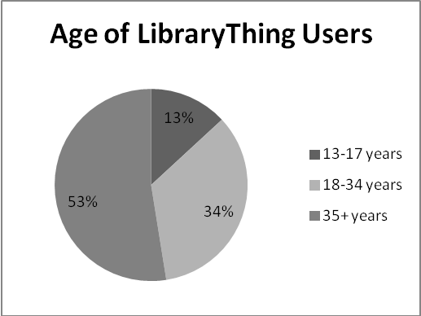
Figure 1. Age Distribution of LibraryThing Users
Figure 2 below shows that the sex of LibraryThing users is evenly distributed between males and females. Such equal distribution presumably allows for an equal distribution of male and female viewpoints when assigning social tags.

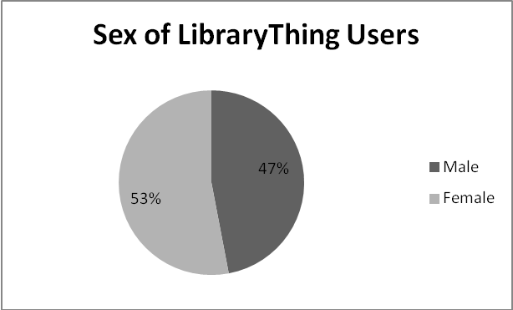
Figure 2. Sex Distribution of LibraryThing Users

Figure 3 below shows the ethnic demographics of LibraryThing users. The predominant users of LibraryThing are Caucasian. However, over 20% of users are people of color, with Pikimal providing statistic of Hispanic, Black, and Asian users. Such a plethora of ethnicities reveals a diversity of users who may construct such meanings of gender and ethnicity as analyzed in this study.

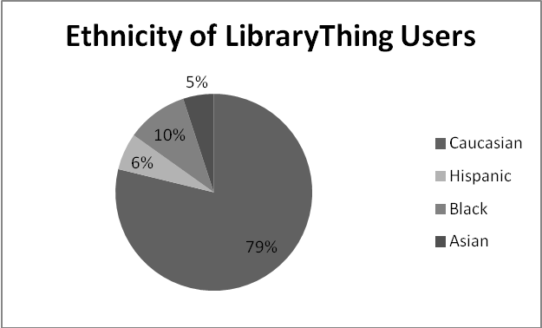
Figure 3. Ethnicity Distribution of LibraryThing Users

Figure 4 below shows the location of LibraryThing users. It is interesting to note that after the United States, the second largest group of users comes from India. According to website Sharenator, an equal share of users comes from Canada and Pakistan. Finally, there is an equal share of users from Japan and Phillipines, along with Germany, Australia, and Italy. Such a positioning of East and South Asian countries allows LibraryThing to offer good insight as to how Asian users construct social tags on Asian-related materials.

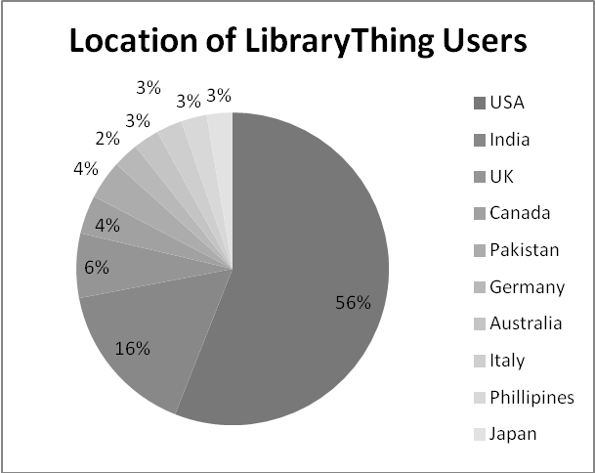
Figure 4. Location Distribution of LibraryThing users
It is interesting to note that about 25% of LibraryThing users come from Asian countries (India, Pakistan, Phillipines, and Japan), yet only about 6% of users report their ethnicity as Asian; indicating a difference between the location of the users and how the users in these locations define their own ethnicity. Studying the discrepancy between users demographics and how the users prefer to define themselves is worthy of looking into in future research.
Overall, the diversity of users using LibraryThing offers an intersectional environment in which users construct social tags. The plethora of age, ethnicity, gender, and locations represented allows for a diverse environment of viewpoints for intersectional forms of subject description to occur.

3.2 Data Collection Methods

Two areas in data collection involved first finding an appropriate site in which to collect social tags, and also finding an authoritative book list to identify works to search for in the social tagging site.
During an initial step in the research process, a study of academic library catalogs was conducted to explore their social tagging capabilities. However, after analyzing the US News & World Report’s top 100 universities’ library catalogs, it was decided that although many of the catalogs offered social tagging capabilities, the tool was simply not used enough to provide enough social tags for proper meaning analysis. Why social tagging is not used in academic library catalogs represents a direction for future research.
Subsequently, the researcher decided to shift focus on commercial sites that offer social tagging capabilities, such as Amazon.com, Barnes and Noble, Borders, LibraryThing, Delicious, Connotea, CiteULike, and Flickr. Such sites are well-cited in Web 2.0 literature as being rich sources for social tags (Spiteri, 2010). Delicious, Connotea, CiteULike, and Flickr were almost immediately disqualified as they are not common for tagging monographs, but rather allow users to tag other information sources such as web links, scholarly articles, and photographs. After conducting informal searches for works in Amazon.com, Barnes and Noble, Borders, and LibraryThing, Amazon.com and LibraryThing offered a manageable collection of social tags for analysis, whereas Barnes and Noble and Borders yielded none. As a result, Barnes and Noble and Borders were eliminated from further analysis for this research.
After an extensive search on appropriate book lists content related to Asian women, the researcher found that ACRL had the most authoritative and lengthy book list with regard to Women’s Studies resources. The book list on the Women’s Studies section of the ACRL website contains suggestions for book lists of “core” Women’s Studies collections in college and research libraries. ACRL has divided the overall core book list into a variety of domains, such as Aging, Disabilities, History, and Geography. In order to narrow the focus of this study on intersectional topics, the book lists used in this study will focus on collections that include capture both gender and ethnicity content. The total list of books for these three domains is 181 titles. Having a book list of 181 works that tackles both gender and ethnicity allows this research to build upon from other studies done in the past. An intersectional approach is necessary in order to update past research that has only analyzed one dimension.

3.2.1 Grounded theory analysis

The coding and analysis process of social tags in this research incorporated themes and processes from grounded theory and a content analysis approach.
Keith Punch (2005) gives an in-depth explanation of grounded theory analysis in his book Introduction to Social Research 2nd edition: Quantitative and Qualitative Approaches. Grounded theory can be defined as a “research strategy meant to generate theory from data” (Punch, 2005, p. 155). There are three levels of coding in grounded theory applications: open, axial, and selective. They can be done either sequentially or concurrently. This study mainly employs the first two levels: open and selective. Glaser and Strauss (2008) elaborate that the essential idea in analyzing data in grounded theory is to discover “core categories” grounded in the data (67). Open coding is the most free-form process, and the next level, axial coding, attempts to develop categories to interconnect the codes developed in the open coding process (Strauss, Corbin, 1990).
The collection of tags analyzed in this research provided for a unique dataset. It is unlike traditional qualitative data used in grounded theory analysis such as interview transcripts, where the qualitative data contains thoughts and full sentences. The data used in this research are individual social tags, which are individual words or phrases. Such an idiosyncratic dataset led to a unique form of data coding and analysis that was influenced by grounded theory in its analysis. The research process led to the study becoming more exploratory in nature, as few past studies have provided a framework in which to analyze such data (Glaser, 2004).

3.2.2 Content Analysis

Content analysis can be defined as an analysis of “data as representations not of physical events, but of texts, images, and expressions that are created to be seen, read, interpreted, and acted on for their meanings” (Krippendorf, 2004). Text includes many forms, such as books, interviews, essays, articles, or any instance of communication (Neuendorf, 2011). In the case of this research, the types of text analyzed were individual social tags assigned by users to the works indexed in the social cataloging site LibraryThing. One of the uses of conducting a content analysis is to analyze the communication trends of individuals (Krippendorff, 2004). For this specific research, conducting a content analysis of social tags can help define how individual users construct subject meanings with regards to race, gender, ethnicity, among other facets of identity when describing works on Asian women.
There are three different units described in this exploratory study. The collection is defined as the total number of books in the original list of works. The collection analyzed is defined as the list of works that had contained social tags in LibraryThing (works without tags were discarded from further analysis). Finally, the unit of analysis in this study is the social tags that were coded and analyzed. Table 2 below shows the dataset universe in both the pilot and full study.

Table 2. Dataset Universe
Dataset unit | Pilot Study | Full Study
Collection (Total number of works) | 30 works | 181 works
Collection Analyzed (Number of works with social tags in LibraryThing) | 21 works | 122 works
Unit of Analysis | 258 social tags | 1231 social tags

3.2.3 Data Collection

The total collection of works used in this research was 181 titles from the three domain lists from the ACRL core book list on Women’s Studies. Each book was searched for in LibraryThing. If the work was found in the search results with tags to analyze, then these tags were included in a Microsoft Excel table for further analysis. Works that were not retrieved in the search results were disqualified from further analysis as there were no tags to analyze.

3.2.4 Data Coding

After the works were searched for in LibraryThing, the total collection of tags were individually coded and analyzed. Rather than organizing tag results by each work, each tag was studied as its own individual unit. Coding the tags in this manner allowed for various and diverse themes inherent in the social tags’ words themselves to emerge, rather than simply narrowing the social tag definition in the context of the work it is describing. The social tags were coded as to what their meanings are on both a personal and societal level.
Because each tag is considered an individual unit unrelated to the work it is associated with, the initial coding process is s very free-form effort in order to gain a grasp of the themes inherent in the large volume of social tags. Categories emerged based on the various aspects of meanings associated with the tags. This process of data analysis had aspects of grounded theory coding, which Punch (2005) defines as “theory developed inductively from data” (p. 155).

3.2.5 Data Analysis and Findings

Data analysis emerged in two areas. Firstly, the tags were analyzed in their descriptive mode of representation, looking at the phrase construction (structure) and form of the tags used. Secondly, the tags were analyzed in a more interpretive manner, analyzing the meanings of the words used to describe the works at hand via the user-generated tags.
The findings will organize the most common forms of description employed by the users assigning the social tags. Findings will categorize the most common forms of phrase construction (structure), form, and types of meaning employed in the tags used. Such findings can implicate patterns of how users generate subject description for works on Asian women, and how they can contribute to a more intersectional approach in subject description.

3.2.6 Pilot Study

A pilot study was conducted to develop a framework as to how the full study was implemented. This formed an important step in the overall research methodology. The pilot study helped to achieve a systematic approach on how to collect, organize, manage, and analyze such a large volume of data such as social tags. Chapter 4 contains a full detailed analysis of the pilot study.

Chapter 4: Pilot Study

This chapter discusses the data collection and coding methods employed in the pilot study. Each of the 21 works selected represented the three domains of East Asian women, South and Southeast Asian women, and Middle Eastern women and was searched for in LibraryThing and free-form coded into a Microsoft Excel table. Analysis employed grounded theory techniques of open and selective coding. Tags were analyzed on the basis of phrase construction (structure), form, and meaning. The findings are discussed both in a descriptive and interpretive mode of analysis, looking at how users constructed phrase and form (descriptive), and meaning (interpretive) associated with the social tags they assigned for each of the works.
Within the context of this research, an exploratory driven pilot study helped contribute to building a framework of coding and analysis used in application for the larger sample of works on Asian women. Such a pilot study also provided a general overview of the form, phrase construction (structure), and meanings of social tags used to describe Asian-related materials.

4.1 Data Collection

The total list of works, or the sample size in this research, was a total of 181 titles for the three domains of East Asian women, South and Southeast Asian women, and Middle Eastern women. An appropriate sample size for a pilot study is 10% or more of the total sample size (Johanson, 2010). In order to have a larger dataset to work with, the pilot study initially included 30 titles, with 10 books from the domain of East Asian women, 10 books from the domain of South and Southeast Asian, and 10 books from the domain of Middle Eastern women.
The works in the pilot study were selected at random, with numbers generated from site Randomizer.org. Each book in the pilot study sample set was searched for by title in the advanced search feature of LibraryThing.com. Twenty-one of the thirty books in the pilot study sample were found in LibraryThing and had tags to analyze, forming about 70% of the pilot study sample set.

4.2 Data Coding

Based on the searches for 21 identified works selected in the pilot study, 258 social tags were found that were subsequently coded and analyzed. Rather than organizing tag results by work, each tag was studied as its own individual unit. This provided for each tag to be assigned a unique descriptor. Each descriptor consisted of a “T” (for tag) and a number assigned in chronological order. For example, tags range from “T-1” to “T-258” for the 258 social tags collected in the pilot study.
Because each tag was considered an individual unit unrelated to the work it was associated with, the initial coding process was conducted in a very free-form process. Every social tag in the dataset was free-form coded to reveal every definition, meaning, and representation such a word may take part in. An example of the free-form coding can be found in Table 3 for the social tag “women’s studies.” Social tags presented in this chapter are used within quotations (“…”) to represent them.

Table 3. Free-form coding example
Tag “women’s studies”
Noun
Lowercase
2 words
Phrase
Correct Spelling
Not abbreviated
Plural
Study pertaining to gender issues
Discipline
Feminist study
Gender studies

4.3 Data Analysis

After the free-form coding process completed, further analysis was conducted in three modes of dissection of the social tags: phrase construction (structure), form, as well as meaning. These modes of dissection were not mutually exclusive. Such analysis allowed for both a descriptive and interpretive understanding of how users developed social tags for works on Asian women. Descriptive because phrase construction (structure) and form describe how the tag is constructed and displayed according to the user. The tags also have interpretive meaning as to the related content and forms of identity given to the Asian-related works they are describing.
For example, the social tag of “women’s studies” can be described through its phrase construction (structure) since it is a multiple phrase consisting of two words. Its form consists of it being a proper noun, presented as lowercase, spelled correctly, plural, and not abbreviated. Its meaning can also be deconstructed as it is a type of discipline relating to women and gender.

4.3.1 Phrase Construction (Structure) Analysis

Tags were categorized based on construction of words. They were divided based on being single phrase or multiple phrase tags.
Single phrase tags were defined as words that had not been separated by any form of punctuation or conjunction, but were constructed as a singular entity. These were further subdivided into: 1) Abbreviation; 2) Single word separated by hyphen; 3) One word; 4) Two word; 5) Three word; 6) Four word; 7) Date.
Table 4 shows the categories of single phrases as well as a social tag example from the pilot study dataset that follows this construction pattern.

Table 4. Single Phrase Construction (Structure) Example
Type of Structure | Tag Example
Abbreviation | “jmu”; “ANTH”; “BU”
Single word separated by hyphen | “cross-cultural”; “non-fiction”
One word | “workplace”; “anthropology”; “Asia”
Two word | “gender issues”; “japanese society”; “social history”
Three word | “Asian American studies”; “Arab pop culture”; “Middle Eastern Studies”
Four word | “Egypt Women History Politics”
Date | “10-Oct-08”

Multiple Phrase tags were defined as tags that had been constructed or put together through the use of punctuation or conjunction. Multiple phrases were divided based on: 1) How many words were in the phrase total; 2) How it was connected (either through punctuation or conjunction); 3) How many words were there on either side of such “division” of punctuation or conjunction. This is represented below by 1 or 2 connected by hyphen; for example a tag such as “Asia-Japan” would be 1-1, while “feminist-middle east” would be 1-2.
Based on the tags collected for the pilot study, the following categories of multiple phrases were developed: Two phrase (punctuation) 1-1; Two phrase (conjunction) 1-1; Two phrase (conjunction) 2-1; Two phrase (punctuation) 1-2; Three phrase (punctuation) 1-1-1; Three phrase (punctuation) 1-1-2.
Table 5 shows each category of multiple phrase as well as a social tag example from the dataset that follows this construction pattern.

Table 5. Multiple Phrase Construction (Structure) Example
Type of Structure | Tag Example
Two phrase (punctuation) 1-1 | “Asia-Japan”; “Religion-Zen”; “Meridian:Feminisms”
Two phrase (conjunction) 1-1 | “read in 2008”; “anthropology of Indonesia”;”religion and politics”
Two phrase (conjunction) 2-1 | “business Class and Labor”; “social life and customs”
Two phrase (punctuation) 1-2 | “islam/middle east”
Three phrase (punctuation) 1-1-1 | “Asia - Japan –Women”; “Asia-Japan-Religion”; “Media & Art & Literature”
Three phrase (punctuation) 1-1-2 | “feminist--islam/middle east”; “history—islam/middle east”

4.3.2 Form-related Analysis

With regards to form, each of the social tags were coded and analyzed based on the following grammatical features: 1) part of speech; 2) capitalization; 3) word or phrase; 4) singular or plural; 5) spelling; 6) abbreviation form. Each facet of form-related analysis is accompanied by a table that defines the category as well as an example of a social tag that employs this type of form.
Part of speech refers to whether or not the tag word used is a noun, proper noun, verb, adjective, or pronoun. There were no other parts of speech present in the dataset. Table 6 below provides each part of speech and accompanying social tags from the pilot study dataset.

Table 6. Part of Speech Examples
Part of Speech | Tag Example
Noun | "television"; “religion”; “women”
Proper Noun | "Iran"; “Pakistan”; “Islam”
Adjectives | “non-fiction"; “modern”; “Japanese”
Verb | “owned”; “veiling”; “read”
Pronouns | "mine"

Capitalization refers to whether the first letter in the phrase was capitalized or not. If there were multiple words in a social tag phrase, the number of words capitalized out of the total number of words was noted. Table 7 below shows examples of social tags from the pilot study dataset that were capitalized and not capitalized.

Table 7. Capitalization Examples
Capitalization | Tag Example
Capitalized words | "Asia"; “Spring 2008”; “Haeri”
Not Capitalized | "anthropology"; “feminist theory”; “women”

Word or phrase refers to whether or not it was a single term or multiple words that were used in the social tag. Table 8 below presents examples of social tags that are either words or phrases from the pilot study dataset.

Table 8. Word or Phrase Examples
Words or Phrase | Tag Example
Word | "feminism"; “Iran”; “history”
Phrase | "cultural identity"; “Arab feminism”; “primary source”

Spelling was coded and analyzed as a binary variable, 1 for correct spelling or 0 for incorrect. Table 9 provides examples of correctly spelled and misspelled words from the pilot study dataset.

Table 9. Spelling Examples
Spelling | Tag Example
Correctly Spelled | "Egypt"; “feminist theory”; “Turkey”
Misspelled | "colonislism"; “priority:3”; “haifa11”

Whether or not the singular or plural form was used was also coded and analyzed. Table 10 provides examples of social tags from the pilot study dataset that were either plural or singular.

Table 10. Singular or Plural Examples
Singular or Plural | Example
Singular | "Islam"; “culture”; “textbook”
Plural | “women"; “Asian American studies”; “gender issues”

Abbreviation means this was either an acronym or a short version of the phrase, or the full word. Table 11 provides examples of full words or abbreviated words from the pilot study dataset.

Table 11. Abbreviation Example
Abbreviation | Tag Example
Full Words | “gender”; “self”; “India”
Abbreviated Words | "KLMJ"; “ANTH”; “ssewa”

4.3.3 Meaning-Related Analysis

4.3.3.1 Open Coding

This first stage, or “open coding” as referred to in grounded theory analysis, was a free-form listing of the definitions, synonyms, and categories of the terms (Punch, 2005). For example, social tag “Japan” was open coded as country, location, destination, East Asian country, and island nation. This phase was to account for every possible meaning, synonym, or categorization a specific tag could fall under.

4.3.3.2 Axial coding

After all of the initial coding was complete, the definitions were then revisited to see the broader categories that emerged from the open coding process. If one social tag had been coded as city, one tag had been coded as location, and another social tag coded as region, then “Geography” was as a broader theme of such terms.
After analyzing and revisiting the free-form definitions and categorizations that were made, all the tags fell into one or more of the following broader categories as seen below.
A definition of each category is presented as well:
- Discipline makes reference to a specific discipline or “study of.”
- Format is a word or phrase that describes a genre or type of material for an information resource.
- Gender makes reference to any aspect of the gendered experience.
- Gender and Race / Ethnicity refers to any term that combines the gender and ethnic experience.
- Geography refers to any specific geographic entity, whether it is continent, region, or country.
- History refers to a specific instance in history. Terms with history in their name (for example “social history”) but not specifically about an event do not count, as they do not refer to a specific moment in time.
- Methods refer to a specific research method within academic research.
- Miscellaneous refers to terms where the origin of meaning is unknown, or an abbreviation for which the definition is unknown.
- Personal words that have personal meaning to the author, but are difficult define in a larger societal context.
- Race and Ethnicity refers to any aspect of the ethnic experience.
- Reference to date refers to a tag which refers to a month, day, or year.
- Religion refers to any aspect of a religious or spiritual practice. Tags such as “religion” do not count, as they are not referring to a specific practice.
- Social constructivism refers to any existing social condition or construct. This is in direct opposition to the “Personal” category, as these terms are references to socially agreed upon definitions and concepts.
Table 12 provides examples of tags for each of the select categories.

Table 12. Category Examples
Category | Tag Example
Discipline | “anthropology”; “women studies”; “cultural studies”
Format | “non-fiction”; “reference”; “school books”
Gender | “feminism”; “gender”; “women”
Gender + Race / Ethnicity | “Arab feminism”; “the hijab”; “Japanese women”
Geography | “Japan”; “Middle East”; “java”
History | “Gulf war”; “French colonialism”
Methods | “Participant observation”; “ethnography”
Miscellaneous | “AN320”; “lplibrarymelbourne”; “Box B6”
Personal | “mine”; “unread”; “self”
Race + Ethnicity | “Japanese”; “orientalism”; “Arab pop culture”
Reference to Date | “Spring 2008”; “2005”; “read in 2008”
Religion | “Islam”; “Buddhism”; “Zen”
Social Constructivism | “tradition”; “nationalism”; “politics”

4.4 Data Findings

4.4.1 Descriptive Findings

4.4.1.1 Phrase Construction (Structure)

Single phrases accounted for 239 of the 258 social tags collected, about 92% of the total number of social tags. Table 13 presents the distribution of findings related to single and multiple word phrases.

Table 13. Single vs. Multiple Word Phrases
 | Number in Dataset | Percentage of Dataset
Single Word Phrases | 239 | 92.6%
Multiple Word Phrases | 19 | 7.4%
Total | 258 | 100.0%

The highest occurrence of single phrase representation was in the one word and two word category, which accounted for 80% of the total number of social tags collected. One word social tags represented 56% of the single phrase category, and 52% of the total social tags.

Table 14. Single Phrase Construction (Structure) Number and Percentage of Dataset
Type of Structure | Number in dataset | Percentage of dataset
Abbreviation | 10 | 3.9%
Single word separated by hyphen | 12 | 4.7%
One word | 134 | 51.9%
Two word | 76 | 28.3%
Three word | 5 | 2.7%
Four word | 1 | 0.4%
Date | 1 | 0.4%
Total | 239 | 92.4%
Overall, there were 19 occurrences of multiple phrase categories, about 7% of the overall dataset. Within the multiple phrase construction (structure) categories, the most common was 2 phrase (conjunction) 1-1. If users were to string together multiple terms, they would most likely do it connected with two words connected by conjunction such as “and.” Table 15 below shows the distribution of Multiple Phrase categories in relation to the pilot study dataset.

Table 15. Multiple Phrase Construction (Structure) Number and Percentage of Dataset
Type of Structure | Number in dataset | Percentage of dataset
Two phrase (punctuation) 1-1 | 3 | 1.2%
Two phrase (conjunction) 1-1 | 7 | 2.7%
Two phrase (conjunction) 2-1 | 2 | 0.8%
Two phrase (punctuation) 1-2 | 1 | 0.4%
Three phrase (punctuation) 1-1-1 | 4 | 1.6%
Three phrase (punctuation) 1-1-2 | 2 | 0.8%
Total | 19 | 7.6%

4.4.1.2 Form

In terms of part of speech, Table 14 shows that most social tags used to describe Asian-related works are nouns and pronouns. Over 55% of the tags were nouns, and 29% of the social tags were proper nouns. Please note for part of speech, all 258 tags were not coded. Abbreviations and miscellaneous-oriented slang were not classified as parts of speech.

Table 16. Part of Speech Number and Percentage of Dataset
Part of Speech | Number in dataset | Percentage of dataset
Noun | 143 | 59.3%
Proper Noun | 74 | 30.7%
Adjectives | 12 | 5.0%
Verb | 9 | 3.7%
Pronouns | 2 | 0.8%
Adverb | 1 | 0.4%
Total | 241 | 93.4%

Table 17 shows that users whose tags were analyzed for this research are less likely to capitalize words than capitalize them. Of the 380 words captured in the social tags, 66% of the words were not capitalized.

Table 17. Capitalization Number and Percentage of Dataset
Capitalization | Number in dataset | Percentage of dataset
Capitalized words | 129 | 33.9%
Not Capitalized | 251 | 66.1%
Total | 380 | 100.0%

Table 18 regarding word or phrase shows that this categorization is relatively split between the two categories.

Table 18. Word or Phrase Number and Percentage of Dataset
Word or Phrase | Number in dataset | Percentage of dataset
Word | 143 | 55.4%
Phrase | 115 | 44.6%
Total | 258 | 100.0%

The social tags in this dataset were overwhelmingly spelled correctly, with over 94% of the tags coded as correctly spelled. Table 19 shows the distribution of correctly spelled and misspelled social tags in the pilot study dataset.
Table 19. Spelling Number and Percentage of Dataset
Spelling | Number in dataset | Percentage of dataset
Correctly Spelled | 244 | 94.6%
Misspelled | 14 | 5.4%
Total | 258 | 100.0%

The social tags in this dataset were most often used in singular form more than in multiple form, with 87% of the social tags being in singular form. Table 20 presents the distribution of social tags in singular and plural form in the pilot study dataset.

Table 20. Singular or Plural Number and Percentage of Dataset
Singular or Plural | Number in dataset | Percentage
Singular | 224 | 86.8%
Plural | 34 | 13.2%
Total | 258 | 100.0%

With regards to abbreviation, there were only 16 occurrences of an abbreviation used, and 93.8% of the tags were full words. Table 21 shows the distribution of full and abbreviated words in the pilot study dataset.

Table 21. Abbreviation Number and Percentage of Dataset
Abbreviation | Number in dataset | Percentage
Full Words | 242 | 93.8%
Abbreviated Words | 16 | 6.2%
Total | 258 | 100.0%

With regards to form, the findings reveal that users are more likely to use certain grammatical features over others when constructing social tags. Noun was the most common part of speech used, words were more likely to not be capitalized than capitalized, singular words were used over phrases, words were mostly spelled correctly, and words were rarely used in their abbreviated forms.

4.4.2 Analytical Findings

Since this is a content analysis that employs qualitative methods, the following findings are the categories that emerge from grounded theory analysis and its application of multiple levels of coding. Table 22 below displays the number of tags that classified as a particular axial coding category, divided based on the domain of works. For example, in the category “Reference to Date,” there were two references to a date in the East Asian collection of social tags, two references to date in the South and Southeast Asian collection of tags, and two references to date in the Middle Eastern collection of tags. There is no implication of the specific users in these numbers, but rather the instances that the social tag in question could be defined and placed in a specific category.

Table 22. Distribution of Categories Divided by Domain
 | East Asian | South and Southeast Asian | Middle Eastern | Total by Category | Percentage
Discipline | 17 | 11 | 21 | 49 | 18.9%
Format | 9 | 6 | 14 | 29 | 11.2%
Gender | 8 | 7 | 17 | 32 | 12.4%
Gender + Ethnicity | 4 | 2 | 10 | 16 | 6.2%
Geography | 8 | 14 | 15 | 37 | 14.3%
History | 0 | 0 | 2 | 2 | 1.1%
Methods | 1 | 2 | 0 | 3 | 1.1%
Miscellaneous | 1 | 3 | 8 | 12 | 4.7%
Personal | 2 | 11 | 8 | 21 | 8.1%
Race + Ethnicity | 7 | 0 | 2 | 6 | 2.3%
Reference to Date | 2 | 2 | 2 | 6 | 2.3%
Religion | 7 | 2 | 5 | 14 | 5.4%
Social constructivism | 12 | 1 | 18 | 31 | 12.0%
Total by domain | 78 | 61 | 122 | 258 | 100.0%

Out of the 13 axial categories constructed out of the 258 tags collected, the most common categories tags fell into were discipline, gender, social constructivism, geography, and format. The five categories combined account for 69% of the total number of social tags collected in this pilot study.
The East Asian domain followed the same general pattern as the total pattern; meaning that discipline, social constructivism, format, gender, and geography were the highest represented categories. There was no representation of historical categories at all in the social tags applied to this theme.
The South and Southeast Asian domain had the highest representation in geography, discipline, personal, gender, and format. It is interesting to note that there was no reference made to ethnicity or history in these categories.
The Middle Eastern domain had the richest number of tags of the three domains, with 122 social tags represented in all the categories as compared to 78 in East Asian and 61 in South and Southeast Asian. This is 47% of the total number of social tags collected. The categories with the most representation in the Middle Eastern domain were discipline, social constructivism, gender, geography, and format.
The most highly represented theme in the tags overall is discipline, with 49 tags dealing with this topic. This is about 19% of the total number of tags collected. It is interesting to note that ethnicity did not make as much of an impact on the categories represented as originally anticipated, with only 9 tags dealing with such topics. Geography made much more of an impact than ethnicity, indicating that users often assign ethnic-related concepts through the name of a location as opposed to group of people.
Gender combined with ethnicity (for example “Arab women”) made a higher impact, with 16 tags on such topics. This indicates tags that capture intersectionality are more common than tags that just capture one facet of identity.

4.5 Discussion

The overall process of analyzing and deconstructing the form, meaning, and structure of social tags can contribute to how users construct social tags with regards to gender and ethnicity.
Users more often than not use a certain type of phrase construction (structure) and form when producing social tags to describe Asian-related feminist materials in LibraryThing. In terms of phrase construction (structure), users prefer to use 1 or 2 word tags. There are however, significant instances of users constructing together various terms through the use of punctuation or conjunction. Such multiple phrases seem to be an attempt on the user side to construct various unrelated terms together similarly to LCSH pre-coordinate indexing. In terms of form, users prefer to use nouns, in singular word form, non-capitalized, correctly spelled, in their full (as opposed to abbreviated) form.
Gita Mehrotra (2010) in “Toward a Continuum of Intersectionality Theorizing for
Feminist Social Work Scholarship,” says

“to articulate the experience of diverse groups of women throughout the world, these paradigms must go beyond the usual triumvirate of US-based race, class, and gender to include migration, colonization, sexuality, ability, and other processes of oppression and identity” (p. 417).

From the categories that emerged in data coding and analysis, social tags capture a broad range of experience and identification for Asian women. It can be further simplified by considering two facets of identity and experience of Asian women. The first is an active assignment of identity. The broader categories of the social tags capture not only gender or ethnicity, but geography, religion, and gender combined with ethnicity. The second theme emergent in these social tags is the idea of Asian women as subject of research. The broader categories of discipline, methods, history, and research capture this ideology. Asian women, through the process of social tag, can be an actively identified and described, as well as studied and analyzed as the object of the subject.

4.5.1 Lessons learned from pilot study

The pilot study contributed much value and meaning pursued in the full study. The entire categories established provided a solid framework in which to code the larger volume of tags in the full study. Rather than free-form coding various aspects and meanings for the social tags, the pilot study allowed the categories to already be established. The pilot study helped to provide clarity of understanding as well as an organizational scheme for the full study.
After conducting such an in-depth pilot study, a few decisions were made in order to proceed to the full study in the most meaningful way possible. In the full study, only the meaning of the social tags will be coded and analyzed. Although form and phrase construction of a social tag can be useful, it is more appropriate for a linguistic-oriented study. Since this research sets out to study meaning and how they relate to intersectionality, form and phrase construction (structure) is simply beyond the scope of such a study. As a result, henceforward form and phrase construction (structure) of the social tags will not be coded and evaluated.
Another lesson learned from this pilot study was to revise the definition of some of the categories established in the pilot study. One example of the redefinition is for the category “Ethnicity.” In the pilot study, the social tag “ethnicity” would have been coded as a “Social Construct,” however henceforward it will be coded as “Ethnicity.” The full list of redefinitions can be found in the full study in Chapter 5.

Chapter 5: Study Findings

This chapter discusses the data collection, coding, and analysis methods employed in the full study of social tags in LibraryThing. The selection of works used in the full study represented the three domains of East Asian women, South and Southeast Asian women, and Middle Eastern women and was searched for in LibraryThing and coded into a Microsoft Excel table. The exploratory driven pilot study contributed a framework of coding and analysis used in application for the larger sample of works on Asian women. As a result the full study proceeded using a more controlled coding system. The same categories developed from the pilot study were used in the full study, though some categories defined in the pilot study were readjusted slightly.
Tags were strictly analyzed on the basis of their meaning, within the context of the community of users assigning the tags as well as within the domain of materials in which the social tags are assigned. The findings are discussed in a meaning-related context, as well as within the domain in which the book is assigned and in relation to the user community in which is describing the tags.

5.1 Data Collection

The total list of works was 181 titles for the three domains of East Asian women, South and Southeast Asian women, and Middle Eastern women. After conducting a search for each of the 181 titles, 122 of the titles had relevant social tags to code and analyze. Statistics on the user community were also collected for each work. For example, each work is rated on a system of five stars. Such facets gave further insight into how the user community values the particular work.
Below is an example of a screenshot taken of each of the tag clouds affiliated with each book in the list. Each word was taken out of the cloud and coded individually.

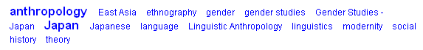
Figure 5. Example of Tag Screenshot

5.1.1 Social Tags

Descriptive statistics presented below in Table 23 captures of the number of books as well as social tags collected from each domain, along with the average number of social tags per book in each domain. Overall, the largest number of tags was collected in the East Asian domain. It is interesting to note that although the Middle Eastern domain had the lowest number of overall books in the sample of 122 books, they had the richest volume of tags per book on average.

Table 23. Descriptive Findings from Overall Collection
 | East Asian | South/Southeast Asian | Middle Eastern | Total Number
Books with tags | 55 | 42 | 25 | 122
Number of tags | 577 | 345 | 307 | 1229
Average number of tags per book | 10.49 | 8.21 | 12.28 | 10.07

5.1.2 User Community

LibraryThing provides demographics of how members discuss and analyze the materials within their online collection. Therefore, along with gathering the social tags for each book, data on the member contributions was also gathered. This included statistics on how many members had the book in their collection on LibraryThing, the number of reviews assigned for each book, the average ranking in popularity of each book on LibraryThing, the rating out of 5 stars assigned for each book, as well as any “conversations” amongst members on each book. Such data provides a connection to how specific members or users construct such meaning on materials of this nature.

5.2 Data Coding

Based on the results for the 122 identified works in the full study, 1231 social tags were subsequently coded and analyzed. Rather than organizing tag results by work, each tag was studied as its own individual unit. Since tags were delineated into 13 main categories in the pilot study (Chapter 4), the coding for the full study involved placing each of the tags into one of those categories. It is important to note that each tag was coded only once in each category, even though the majority of tags are appropriate for a multitude of the categories.

5.3 Data Analysis

The tags in the full study followed the same basic categorization established in the pilot study. Some definitions were redefined within the larger numbers of social tags collected. The exhaustive list of all 13 categories is as follows:

- Dates refer to tags that refer to a month, day, or year.
- Discipline makes reference to a specific discipline or “study of.”
- Ethnicity and Ethnicity Social Construct refers to any aspect of the ethnic experience.
Ethnicity coding was defined as the CIA defines it in their World Factbook (cia.gov, 2011). Such a source provides an authoritative definition of terms that can differ depending on the particular cultural construction used. For example, the tag “Japanese” was denoted as an “Ethnicity” as opposed to another potential construction of it as “Nationality.” This is because the CIA World Factbook defines it as such.

Ethnicity Social Construct encompasses tags that do not capture a specific ethnicity, but rather make reference to the term “ethnicity.”
- Format is a word or phrase that describes a genre of material for an information resource.
- Gender and Gender Social Construct makes reference to any aspect of the gendered experience. Gender Social Construct encompasses tags that do not capture a specific gender, but rather make reference to the term “gender.”
- Gender and Ethnicity refers to any term that combines the gender and ethnic experience.
- Geography refers to any specific or distinct geographic entity, whether it is continent, region, or country.
- History and History Social Construct refers to a specific instance in history as well as historical periods of time. Terms that include the word history were also coded in this category.
- Methods refer to a specific research method within academic research.
- Miscellaneous refers to terms where the origin of meaning is unknown, or an abbreviation for which the definition is unknown. Such tags presumably have idiosyncratic meaning to the author of the social tag.
- Personal are words that have personal meaning to the author, but are difficult define in a larger societal context.
- Religion and Religion Social Construct refers to any aspect of a religious or spiritual practice. Religion Social Construct encompasses tags that do not capture a specific religion, but rather make reference to the term “religion.”
- Social constructs refers to any existing social condition or construct. This is in direct opposition to the “Personal” category, as these terms are references to socially agreed upon definitions and concepts. It is assumed that categories such as Gender and Ethnicity are also “Social Constructs,” however since such research is focusing on gender, ethnicity and their intersections, it was deemed necessary to have a separate and distinct analyses of such concepts.

Table 24 below provides examples of tags for each of the select categories.

Table 24. Category Examples
Category | Tag Example
Date | “2007”; “read in 2008”; “november 2007”
Discipline | “gender studies”; “middle eastern studies”; “anthropology”
Ethnicity and Ethnicity Social Construct | “Asian”; “ethnicity”; “Japanese art”
Format | “literary criticism”; “adult non-fiction”; “ebook”
Gender and Gender Social Construct | “feminism”; “gender”; “Women & Judaism”
Gender + Ethnicity | “women of color”; “Muslim women”; “Japanese Women Poets”
Geography | “Japan”; “India”; “Middle East”
History | “Iraqi History”; “colonialism”; “partition”
Methods | “critical theory”; “literary criticism”; “ethnography”
Miscellaneous | “haifa11”; “mnl”; “moving:box 16”
Personal | “all”; “new titles”; “read”
Religion | “Islam”; “religion”; “Buddhism”
Social Construct | “media”; “tradition”; “resistance”

5.4 Data Findings

5.4.1 Distribution of Categories

Table 25 displays the number of tags coded in each category, divided based on the domain of works. Such a table is important as it shows the number of tags in each category, by the domain of book, as well as how many a certain category is represented in the entire dataset. This allows the researcher to see how much gender, ethnicity, as well as gender and ethnicity combined terms accounted for the data divided amongst domains as well as represented within the entire dataset.

Table 25. Distribution of Categories Divided by Domain
 | East Asian | South and Southeast Asian | Middle Eastern | Total by Category | Percentage of Dataset
Dates | 13 | 8 | 5 | 26 | 2.11%
Discipline | 67 | 35 | 21 | 123 | 9.99%
Ethnicity/Construct | 55 | 20 | 11 | 86 | 6.99%
Format | 68 | 28 | 27 | 123 | 9.99%
Gender/Construct | 91 | 57 | 64 | 212 | 17.22%
Gender + Ethnicity | 13 | 3 | 8 | 24 | 1.95%
Geography | 66 | 56 | 44 | 166 | 13.48%
History/Construct | 27 | 12 | 25 | 64 | 5.20%
Methods | 8 | 13 | 3 | 24 | 1.95%
Miscellaneous | 25 | 24 | 13 | 62 | 5.04%
Personal | 56 | 27 | 30 | 113 | 9.18%
Religion/Construct | 7 | 35 | 28 | 70 | 5.69%
Social Construct | 82 | 28 | 28 | 138 | 11.21%
Total | 578 | 346 | 307 | 1231 | 100.00%

Out of the 13 axial categories coded for the 1231 tags collected, the most highly represented categories were Gender, Geography, Social construct, Format, and Discipline. The five categories combined account for 762 of the total number of social tags collected in this pilot study.
The East Asian domain had different patterns from the overall; Discipline, Social Construct, Format, Gender, and Geography were the highest represented categories. Religion and Methods were the lowest represented category in this domain. Figure 6 below shows the overall distribution within the East Asian domain.

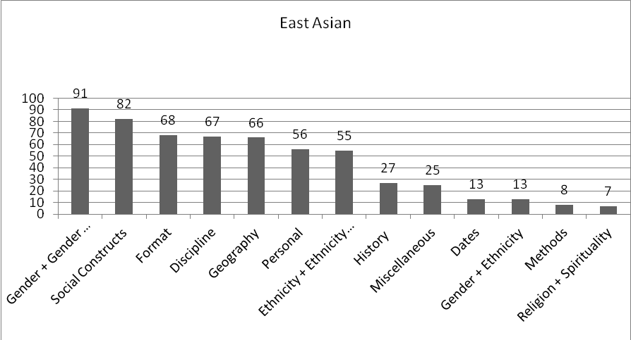
Figure 6. East Asian Category Distribution

The South and Southeast Asian domain had the highest representation in Gender, Geography, Discipline, Religion, and Social Constructs. The lowest categories represented in this domain were in Gender and Ethnicity. Figure 7 below shows the distribution of categories within the South and Southeast Asian domain.

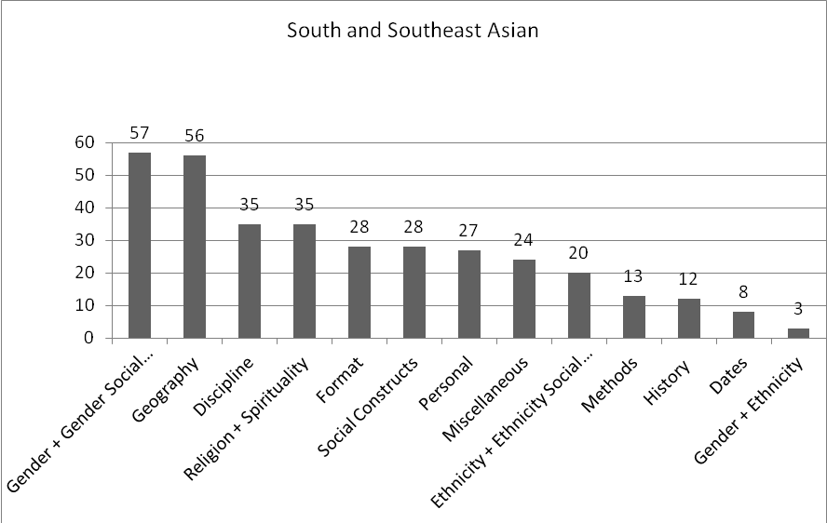
Figure 7. South and Southeast Asian Category Distribution
The Middle Eastern domain had the richest number of tags per book of the three domains. The categories with the most representation in the Middle Eastern domain were Gender, Geography, Format, Personal, and Religion.

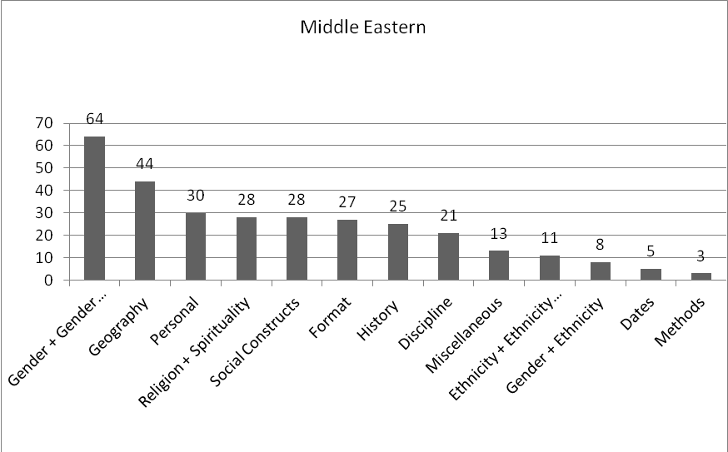
Figure 8. Middle Eastern Category Distribution

The most highly represented theme in the tags overall is Gender, with 212 of the 1231 tags dealing with this topic. This is about 17% of the total number of tags collected. It is interesting to note that Format and Personal made a bigger impact on the distribution of categories than originally anticipated, with only 236 tags dealing with such topics. As seen in the pilot study, Geography made much more of an impact than ethnicity, indicating that users often assign ethnic-related concepts through the name of a location as opposed to group of people.
Gender combined with ethnicity (for example “Arab women”) made a lower impact, with 24 tags on such topics. This indicates tags that capture intersectionality are equally common with social tags dealing with Methods and Dates. Figure 9 below shows the overall distribution of categories in the dataset.
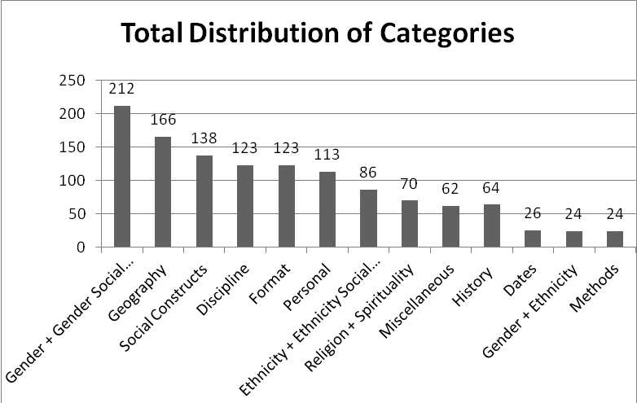
Figure 9. Overall Category Distribution

5.4.2 Distribution of Categories by Domain

The following is a presentation of the distribution of each category of meaning as they spread across the three domains, East Asian, South and Southeast Asian, and Middle Eastern. Since the East Asian domain had the largest volume of tags, it was necessary to calculate the distribution proportionately. This was accomplished by calculating the number of tags in the category out of the total number of tags for that domain. For example, the East Asian proportion of category Dates was calculated as 13 out of 578 tags in the East Asian domain total, which was directly compared to the number of the Date tags in the South Asian domain out of the total number of tags in the South Asian domain. Such a calculation presents how the category is represented out of the total number of tags.

Dates
The total number of date related social tag in this dataset was 26. Dates were slightly more represented in the East Asian and South and Southeast Asian domain.

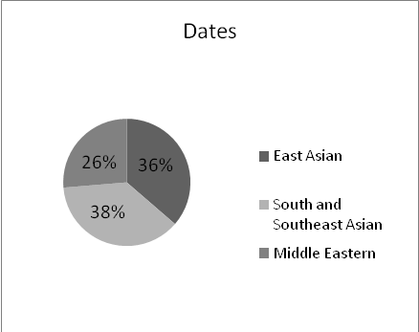
Figure 10. Distribution of Date Category by Domain

Discipline
Overall, there were 123 social tags relating to discipline, the majority of which came from the East Asian domain.
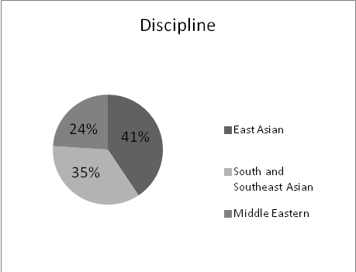
Figure 11. Distribution of Discipline Category by Domain

Ethnicity and Ethnicity Social Construct
There were 86 tags collected overall in the Ethnicity category. Half of the ethnicity and ethnicity construct related tags came from the East Asian domain, and the lowest proportion coming from the Middle Eastern domain.

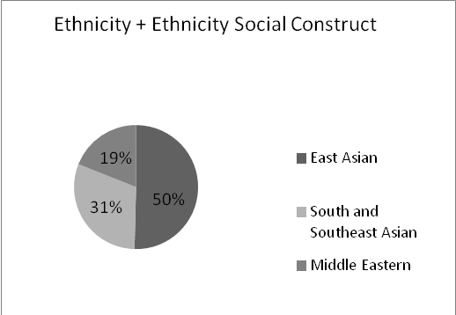
Figure 12. Distribution of Ethnicity Category by Domain

Format
Overall there were 123 tags collected in the Format category. This category was equally represented in the South and Southeast and Middle Eastern category, and predominantly in the East Asian category.
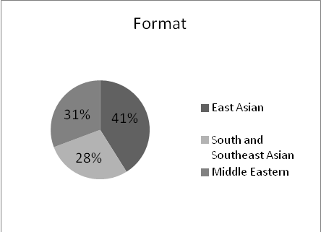
Figure 13. Distribution of Format Category by Domain

Gender and Gender Social Construct
Overall there were 212 social tags coded as Gender. This category is equally distributed amongst all three domains. This is a logical finding since the books in this study are women’s studies related materials.

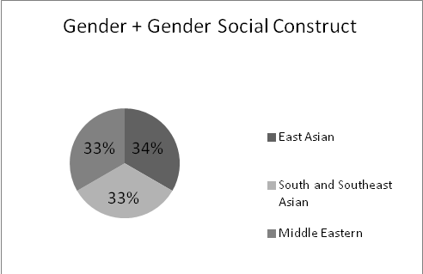
Figure 14. Distribution of Gender Category by Domain

Gender and Ethnicity
Overall, there were 24 tags that captured Gender and Ethnicity. Social tags that captured both gender and ethnic related concepts were most highly represented in the Middle Eastern and East Asian category, and the lowest in the South and Southeast Asian category.

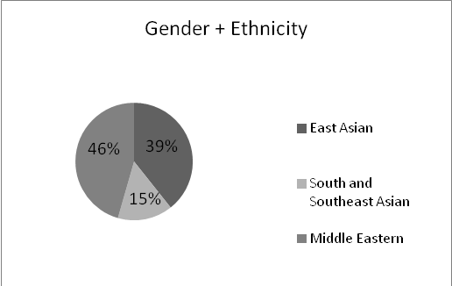
Figure 15. Distribution of Gender and Ethnicity Category by Domain

Geography
Overall there were 166 tags coded as Geography. The highest proportion of tags referring to a geographical entity was most highly represented in the South and Southeast Asian domain.

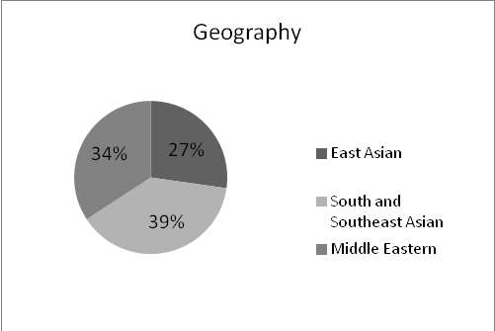
Figure 16. Distribution of Geography Category by Domain

History
Overall there were 64 tags coded as History. This category was equally represented in East Asian and Middle Eastern domains, and lowest in the South and Southeast Asian domain.

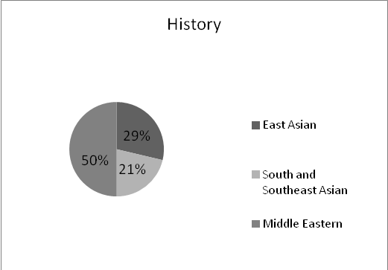
Figure 17. Distribution of History Category by Domain

Methods
Overall there were 24 tags coded as Methods. This is the one of few categories that is most highly represented in the South and Southeast Asian domain. Such a finding indicates that the topic of books selected in the South and Southeast Asian categories lend themselves to more method-related concepts.

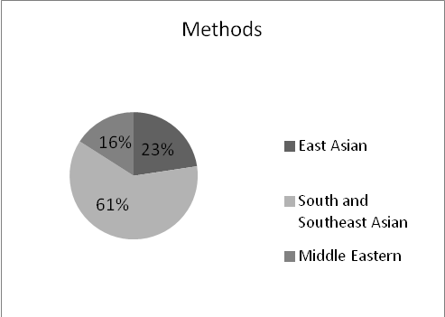
Figure 18. Distribution of Methods Category by Domain

Miscellaneous
Overall there were 62 tags coded as Miscellaneous. This category is most highly represented in the South and Southeast Asian domain, and equally distributed in the East Asian and Middle Eastern domains.
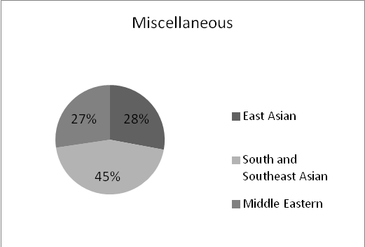
Figure 19. Distribution of Miscellaneous Category by Domain

Personal
Overall there were 113 social tags coded in the Personal category. This was most highly represented in the Middle Eastern and East Asian domain.

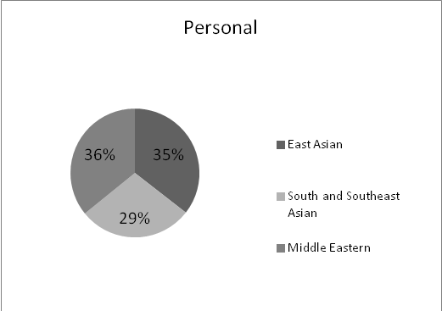
Figure 20. Distribution of Personal Category by Domain

Religion and Spirituality
Of the 70 tags coded as Religion, this was most highly represented in the South and Southeast Asian domain; however, it is almost as represented in the Middle Eastern domain. It is interesting to note that this is the one category that is the lowest in the East Asian domain, indicating that books of a religious nature were not as common in the East Asian domain as much as in the other two domains.

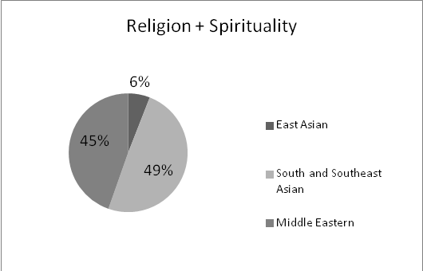
Figure 21. Distribution of Religion Category by Domain

Social Constructs
Overall there were 138 social tags coded as Social Constructs, with the majority being in the East Asian domain and equally distributed across the Middle Eastern and South and Southeast Asian domain.

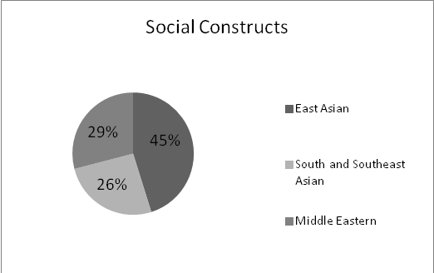
Figure 22. Distribution of Social Construct Category by Domain

5.5 Discussion

5.5.1 Member Community

LibraryThing offers some insight into how users share and discuss the specific materials of this population. The total number of members have the book in their collection is relevant as it indicates how many users on LibraryThing have selected a book on Asian women’s materials to be a part of their online catalog on LibraryThing. Overall, many more users had books on East Asian women’s materials than South and Southeast Asian and Middle Eastern materials.

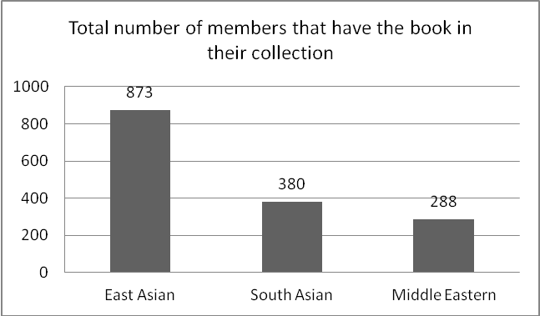
Figure 23. Members with Book in Collection by Domain

The total number of reviews refers to how many users have written an opinion or critique of the material in question. As seen below, there were many more reviews written on East Asian materials than the other two domains combined.

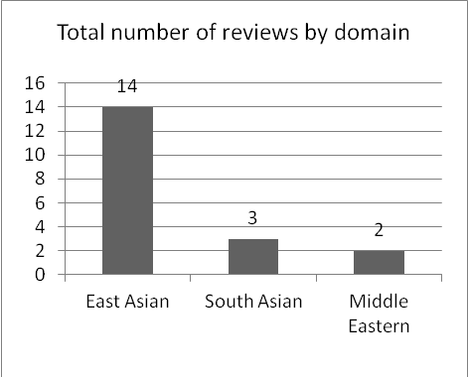
Figure 24. Number of Reviews by Domain

In terms of the average popularity of the materials, the rankings of East Asian and Southeast Asian books ranked a bit lower than Middle Eastern materials, which ranked around 959,000 out of the entire LibraryThing catalog of materials on the site. East Asian and South and Southeast Asian materials ranked around 150,000. To provide the rankings with context, overall there are over 63,000,000 books cataloged on the LibraryThing site (LibraryThing.com, 2011).

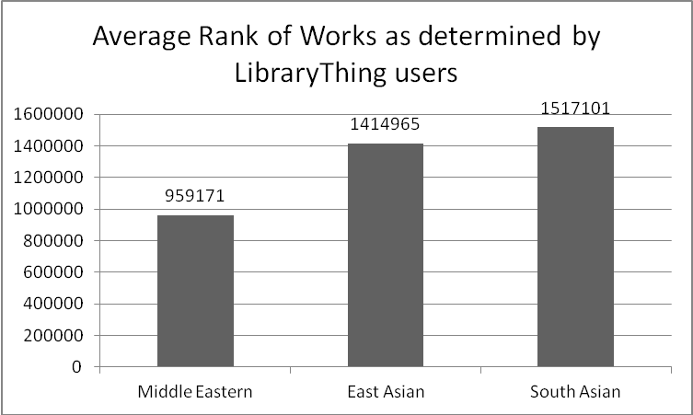
Figure 25. Average Rank of Works as determined by LibraryThing users

Number of bold tags

Tags that are bolded within the tag cloud indicate that more users have assigned that social tag. From the perspective of a user on LibraryThing, this indicates popularity in the selection of specific terms. Table 26 below shows the number of bold social tags by domain.

Domain | Number of Bold Tags | Percentage of Dataset
East Asian | 103 | 17.8%
South and Southeast Asian | 42 | 12.1%
Middle Eastern | 59 | 19.2%
Total | 204 | 16.6%
Table 26. Number of Bold Tags by Domain

Overall, about 16% of the social tags in the full dataset were tags that were bold, or considered more popular as terms used to describe materials.
In terms of the types of tags that were bolded, below is a distribution of the tags that were bolded and what category they were. Terms that are most popular amongst users tagging these materials are Geography, Gender, Format and Discipline related. Personal tags are the lowest as these tags are more idiosyncratic, which have special meaning specifically to the user.

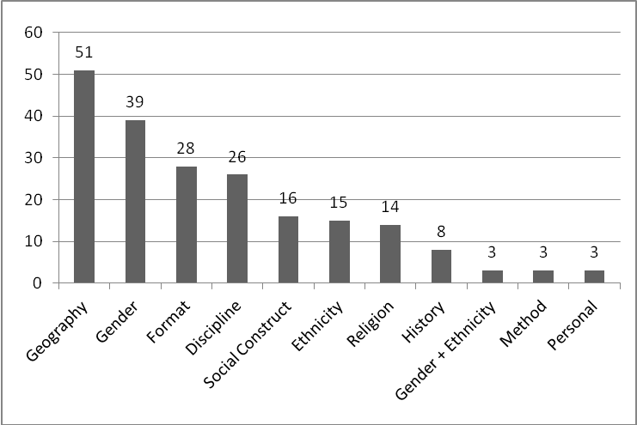
Figure 26. Distribution of Bold Tags across Categories

From the categories that emerged in data coding and analysis, social tags capture a broad range of experience and intersections for Asian women. Based on findings found on the members and user community of LibraryThing, the diversity of users leads to a more intersectional form of subject description.
A more specific analysis of each of other intersections as they relate to gender and ethnicity can be found in Chapter 6.

Chapter 6: Discussion of Intersections

Upon further analysis of the social tags in the full dataset, a multitude of intersections was found involving gender, ethnicity, and other social constructs such a religion, history, and discipline. This chapter will analyze the tags that discuss gender, ethnicity, and a combination of gender and ethnicity with other social constructs across the three domains. Although statistics on the types of intersections captured across the three domains will be discussed, an individual analysis of specific tags will also be included. Such an analysis further reveals how users construct meaning in relation to gender and ethnicity when describing books of East Asian, South and Southeast Asian, and Middle Eastern gender-related materials. This chapter presents a deeper analysis on the tags that were gender and ethnic related, and how the intersections differ across domain of East Asian, South and Southeast Asian, and Middle Eastern gender-related materials. This chapter presents an in-depth analysis for individual tags, so the numbers for comparison are much fewer than those presented in Chapter 4 and 5.
The tables below present the range of specific intersections present in the East Asian, South and Southeast Asian, and Middle Eastern datasets. The tags coded as either gender or ethnicity in Chapter 5 was broken down further to see which other intersections were present.
Figure 27 below presents the range of gender and ethnic-related categories in the East Asian dataset.
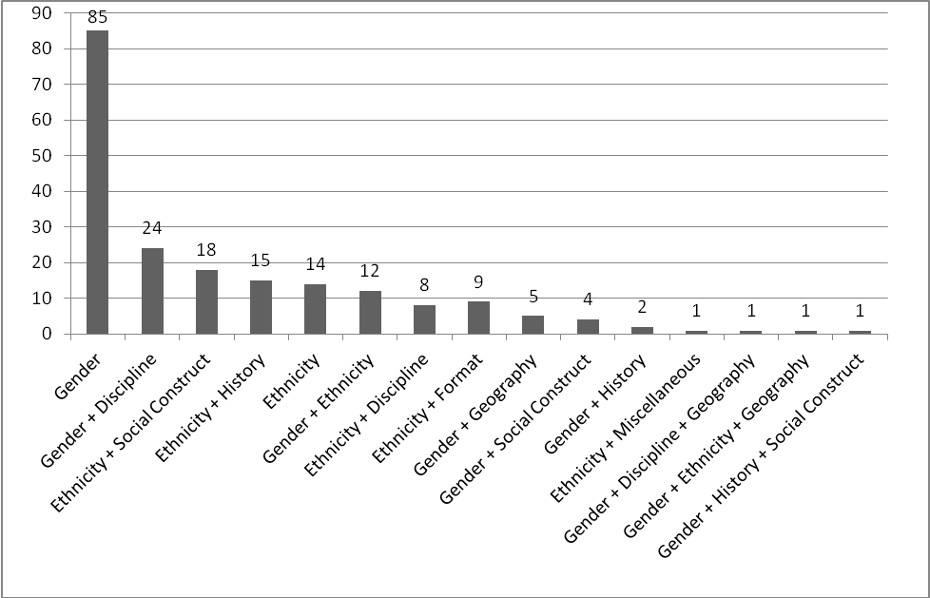
Figure 27. Range of East Asian Intersections

Figure 28 below presents the range of gender and ethnic-related categories in the South and Southeast Asian dataset.

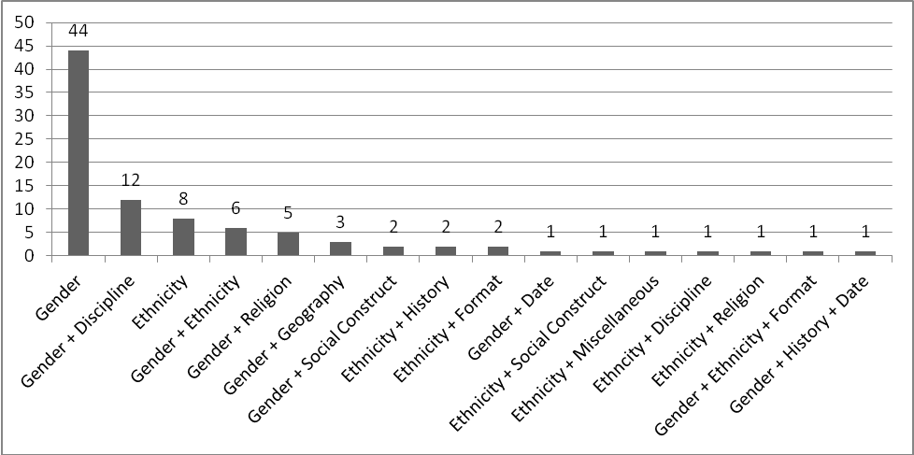
Figure 28. Range of South and Southeast Asian Intersections

Figure 29 below presents the range of gender and ethnic-related categories in the Middle Eastern dataset.

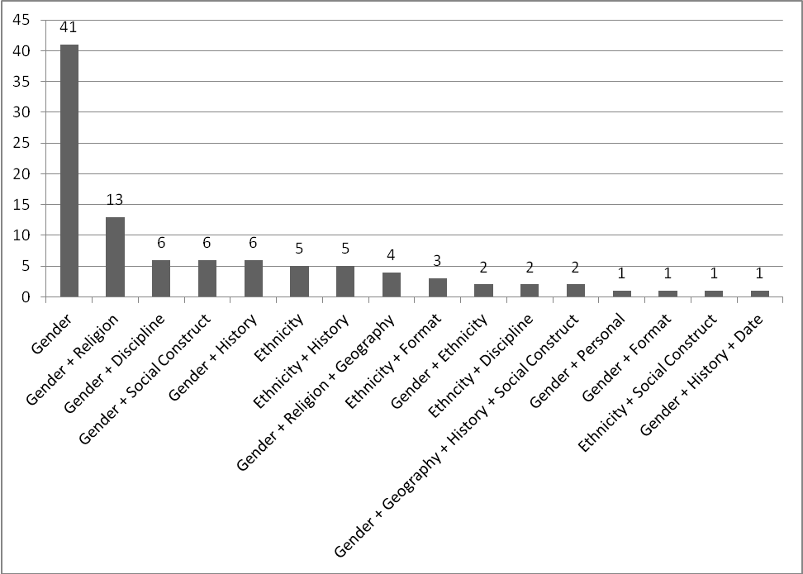

Figure 29. Range of Middle Eastern Intersections

6.1 Insights related to Gender

After recoding and analyzing tags specifically coded as only gender-related, the most frequent social tags assigned were “women”, “feminism,” and “gender.” As Table 27 below shows, of the 85 tags pertaining to specifically gender in the East Asian category, 55 of the tags were “feminism,” “gender,” or “women.”
Table 27. Frequency of Common Gender-related Tags in East Asian Dataset
East Asian Gender Tags | Number of Tags | Percentage of Gender Dataset
feminist or feminism | 9 | 10.59%
gender | 18 | 21.18%
women | 28 | 32.94%
Total | 55 | 64.71%
Because East Asian had a larger volume of social tags to analyze, they had more diverse terms other than these three terms to describe the materials. Other tags relating to gender in the East Asian dataset related to traditional male roles, traditional women’s roles, and the spectrum of sexuality. Table 28 below presents examples of other gender-related social tags present in the East Asian dataset.

Table 28. Other Gender-specific themes in East Asian Dataset
Men's roles | fathers
 | men
 | masculinity
Women's roles | girls
 | Businesswomen
 | hostess
 | hostesses
 | daughters
Sexuality | sex
 | sexuality
 | sex
 | sexuality
 | prostitution
 | sexuality
 | glbt
 | LGBT
 | queer
 | sexuality
 | josei
 | josei manga
 | sex

As feminism, gender, and women were the most common terms to use, it is apparent that users assign the majority of tags from the worldview of the female sex. The majority of leftover tags address males or gender challenged roles in terms of sexual minorities.
Table 29 below shows that of the 34 out of the 44 gender-related tags in the South and Southeast Asian category were either “feminism,” “women,” or “gender.”

Table 29. Frequency of Common Gender-related Tags in South and Southeast Asian Dataset
South Asian Gender Tags | Number of Tags | Percentage of Gender Dataset
feminist or feminism | 7 | 15.91%
women | 11 | 25.00%
gender | 16 | 36.36%
Total | 34 | 77.27%

Other gender-related themes inherent in the remaining terms include traditional women’s roles, and terms relating to sexuality. One interesting theme present in this dataset that was not present in the East Asian set is more politically charged gender terms. Such terms present a challenge to traditional gender roles. Table 30 below presents the other gender-specific tags in the South and Southeast Asian dataset.

Table 30. Other Gender-specific themes in South and Southeast dataset
Sexuality | sex
 | sexuality
 | Gay and Lebian
 | GLBT Pride Book Display '08
 | lesbian
 | sexuality
 | queer
Women's roles | mothers
Challenges to Gender Roles | patriarchy
 | transgender
 | transgender I TG
 | transsexual I TS

Table 31 below shows that 36 out 41 gender-related tags in the Middle Eastern category were assigned as “feminism,” “gender,” or “women.”

Table 31. Frequency of Common Gender-related Tags in Middle Eastern Dataset
Middle Eastern Gender Tags | Number of Tags | Percentage of Gender Dataset
feminist or feminism | 10 | 24.39%
gender | 10 | 24.39%
women | 16 | 39.02%
Total | 36 | 87.80%

The remaining tags in the Middle Eastern dataset are solely relating to terms regarding sexuality. Table 32 shows the remaining gender-specific tags that were not “feminist,” “gender,” or “women.”

Table 32. Other Gender-specific themes in the Middle Eastern Dataset
Sexuality | sexuality
 | women's sexuality
 | sexuality
 | harems

Presumably, since most users of LibraryThing are from the United States, the idea that sexuality is the common theme to emerge for gender-related themes in the Middle East makes sense. There is often a point of contention from the American perspective that women of Middle Eastern descent are limited in their displays of sexuality, so either the materials chosen or users labeling such books would assign subjects that fit this worldview.
Because of the nature of the materials at hand, it is clear that users would assign such terms as feminism, gender, and women as social tags to describe these materials. The materials within the three domains are predominantly gender and feminist related materials. Other interesting themes to emerge from the gender-specific terms in this dataset include the politically charged gender role challenges in the South Asian data, as well as the strong focus on women’s sexuality in the Middle Eastern dataset.

6.2 Insights related to Ethnicity

Similar to the gender-specific themes, common terms repeatedly appeared relating to ethnicity. However, these terms differed across the categories, whereas gender repeatedly used the same three terms across the three categories.
Table 33 below shows the frequency of the term Japanese in the Ethnicity specific terms in the East Asian dataset. Out of the 14 terms, Japanese appears 12 times.

Table 33. Frequency of Ethnicity Tags in East Asian Dataset
East Asian Ethnicity Tags | Number of Tags | Percentage of Ethnicity Dataset
Japanese | 12 | 85.71%

Table 34 below shows the frequency of terms relating specifically to ethnicity in the South and Southeast dataset. Unlike the East Asian, there was less reference to a specific ethnicity group (only two occurrences), and more reference to Asian or South Asian groups overall. The two specific references to an ethnic group were Thai and Hmong.

Table 34. Frequency of Ethnicity Tags in South and Southeast Asian Dataset
South and Southeast Asian Ethnicity Tags | Number of Tags | Percentage of Ethnicity Dataset
Asian | 4 | 50.00%
South / Southeast Asian | 2 | 25.00%
Specific Ethnicity Group | 2 | 25.00%
Total | 8 | 100.00%

There were five references specifically to ethnicity and ethnic groups in the Middle Eastern dataset, 4 of which were the term Arab.

Table 35. Frequency of Ethnicity Tags in Middle Eastern Dataset
Middle Eastern Ethnicity Tags | Number of Tags | Percentage of Ethnicity Dataset
Arab | 4 | 80.00%

It is important to note that since most of the users are from the United States. Most of the labeled intersections presumably come from an American perspective, although one cannot confirm that these users are specifically assigning the tags analyzed in this study. It is a common American experience to label those from the Middle East as uniformly “Arab.” However, the Arab American Institute defines Arab populations as having ancestral ties to Lebanon, Syria, Palestine, Egypt, and Iraq, and spanning both Christian and Muslim communities (aaiusa.org, Sec. 3). Inquiring users what they mean by particular terms is a point worthy of further research.
Both the East Asian and Middle Eastern social tags made reference to a specific ethnicity group, namely Japanese and Arab groups. The South Asian dataset had more references to Asian and South Asian overall.

6.3 Insights related to Gender and Ethnicity

The following section provides an in-depth analysis of the specific social tags that capture the intersections of gender and ethnicity.
Table 36 shows the terms that incorporate references to both gender and ethnicity in the East Asian dataset. The majority of terms referenced either Japanese women or Chinese women.

Table 36. Frequency of Gender + Ethnicity tags in East Asian Dataset
East Asian Gender + Ethnicity Tags | Number of Tags | Percentage of Gender + Ethnicity Dataset
Chinese women | 2 | 16.67%
Japanese women | 7 | 58.33%
Total | 9 | 75.00%

The intersectional tags of gender and ethnicity in the South and Southeast Asian dataset did not use the term women or females at all. Rather, the terms implicated gender through the use of an “a” or “o” at the end of the term. Traditionally, terms in the Spanish language implicate women with an “a” at the end, and men with an “o” at the end of the word. Interestingly, one tag in the dataset was assigned with a “@” at the end, implicating that both genders are inherent in the term.

Table 37. Frequency of Gender + Ethnicity tags in South and Southeast Asian Dataset
South Asian Gender + Ethnicity Tag | Number of Tags | Percentage of Gender + Ethnicity Dataset
Pilipin@ | 1 | 16.67%
Filipino | 2 | 33.33%
Filipina | 3 | 50.00%
Total | 6 | 100.00%

There were few references to gender in conjunction with ethnicity in the Middle Eastern dataset. The following table presents the only two tags coded as such within this dataset. The tag “intersections” was difficult to code in any particular category, but when seen in relation to the book it was tagged with, gender + ethnicity was deemed the most appropriate categorization. Like in the ethnic-specific analysis, the reference to ethnicity in this group was specifically to Arabs. Also, the reference to gender through the term feminism as opposed to women implicates a political struggle as opposed to describing a group of women.

Table 38. Frequency of Gender + Ethnicity tags in Middle Eastern Dataset
Middle Eastern Gender + Ethnicity Tag | Number of Tags | Percentage of Gender + Ethnicity Dataset
intersections | 1 | 50.00%
Arab feminism | 1 | 50.00%
Total | 2 | 100.00%

References to gender and ethnicity across the three domains differed in a few ways. Firstly, East Asian intersections referenced specific groups of women. Japanese and Chinese are the largest countries classified in the East Asian category, so these make reference to the dominant groups of women in this region. The South and Southeast Asian and Middle Eastern intersectional tags are a bit more politically charged in both their content and delivery. The tags describing Pilipino people using “a,” “o,” and “@” implicate an incorporation of all genders. Finally, the Middle Eastern tag of intersections and Arab feminism implicate a political awareness of gender intersections with ethnicity.

6.4 Insights related to Gender and Other Constructs

In Chapter 5, tags were either coded as gender-related or gender + ethnicity related. However, upon further analysis, the tags that were originally coded as only gender-related (if they didn’t reference ethnicity) could be further broken down to incorporate other intersections. The following section analyzes how the gender-related intersections differ across the three domains.
Table 39 shows examples of other gender-related intersections present in the East Asian dataset, as well as accompanying examples.
Table 39. Examples of Gender with other Intersections in East Asian Dataset
Construct | Tag Example
Gender + Geography | Asia-Japan-Women
Gender + Discipline | gender studies
Gender + History | women's history
Gender + Social Construct | motherhood in popular culture

Figure 30 shows the distributions of such intersections in the dataset. Gender with Discipline was the highest showing category, with many tags referencing women’s studies or gender studies.

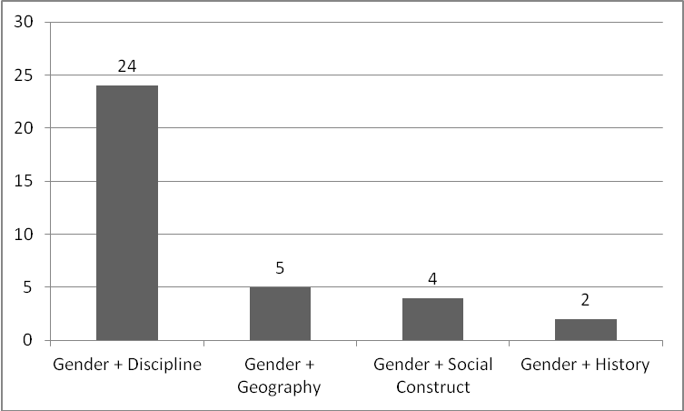
Figure 30. Distribution of Gender-related Intersections in East Asian Dataset

Table 40 shows the gender-related intersections in the South and Southeast Asian dataset and some accompanying examples.

Table 40. Examples of Gender with other Intersections in South and Southeast Asian Dataset
Construct | Tag Example
Gender + Date | Pride Week / Drag Show Display - 2009
Gender + Discipline | Feminist Studies
Gender + Geography | International Women
Gender + Religion | nuns
Gender + Social Construct | women's roles

Figure 31 below shows the distribution of the different intersections. Similarly to the East Asian dataset, the highest represented category was Gender with Discipline. Unlike in the East Asian dataset, some social tags incorporated intersections of Gender with Religion.

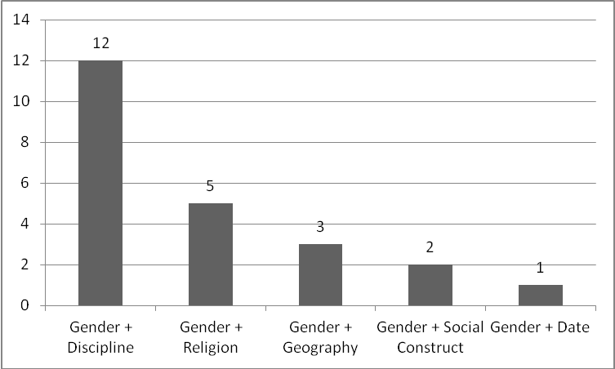
Figure 31. Distribution of Gender-related Intersections in South and Southeast Asian Dataset

Table 41 below presents the gender-related intersections in the Middle Eastern dataset, and some accompanying examples.

Table 41. Examples of Gender with other Intersections in Middle Eastern Dataset
Construct | Tag Example
Gender + Discipline | women's studies
Gender + Format | women's literature
Gender + History | gender history
Gender + Personal | Women's Resource Center
Gender + Religion | women in Islam
Gender + Social Construct | women of color

Figure 32 shows the distribution of the gender-related intersections in the Middle Eastern dataset.

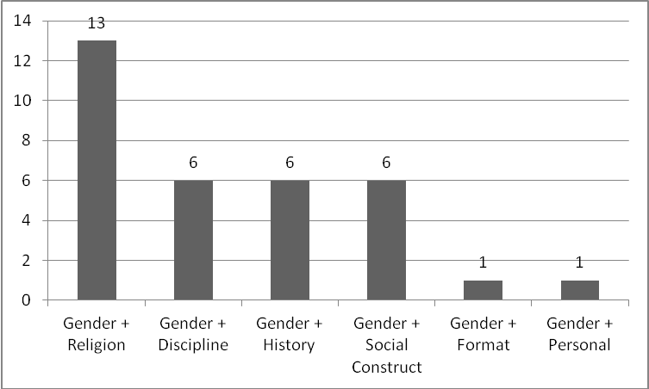
Figure 32. Distribution of Gender-related Intersections in Middle Eastern Dataset

Interestingly, Gender with Religion was the most highly represented intersection. This is seemingly due to the common discussion of women’s roles within Islam in Women’s Studies literature. It makes sense that this is a more highly represented intersection in the Middle Eastern dataset as opposed to the East Asian and South and Southeast Asian dataset.

6.5 Insights related to Ethnicity and Other Constructs

Tags that were originally coded as only ethnicity-related could be further broken down to incorporate other intersections. The following section analyzes how the ethnicity-related intersections differ across the three domains.
Table 42 below presents some of the ethnicity-related intersections in the East Asian dataset, as well as some accompanying examples.
Table 42. Examples of Ethnicity and Other Intersections in East Asian Dataset
Construct | Tag Example
Ethnicity + Discipline | Japanese sociology
Ethnicity + Format | japanese literature
Ethnicity + History | Chinese History
Ethnicity + Miscellaneous | Chinese rt
Ethnicity + Social Construct | asian transnationalism
Figure 33 below shows the distribution of ethnicity-related intersections in the East Asian dataset. Ethnicity with Social Construct and Ethnicity with History were the most highly represented intersections. Unlike in the gender-related intersections, ethnicity intersections with discipline did not rank as high in the East Asian dataset.

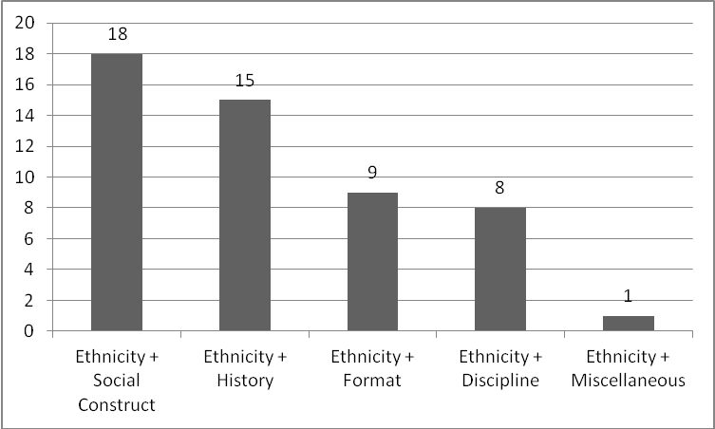
Figure 33. Distribution of Ethnicity-related Intersections in East Asian Dataset

Table 43 below shows the ethnicity-related intersections in the South and Southeast Asian dataset. Ethnicity with Religion makes an appearance in the South and Southeast Asian dataset, where it did not in the East Asian dataset.

Table 43. Examples of Ethnicity and Other Intersections in South and Southeast Asian Dataset
Construct | Tag Example
Ethnicity + Date | Asian Pacific Islander Month '08
Ethncity + Discipline | asian studies
Ethnicity + Format | Phillipine Literature
Ethnicity + History | Asian History
Ethnicity + Religion | Indonesian Islam
Ethnicity + Social Construct | Indonesian culture
Figure 34 below shows the distribution of such intersections in the dataset. Ethnicity with History and Format were the most highly represented, with one reference of each to Ethnicity with Date, Ethnicity with Discipline, Ethnicity with Religion, and Ethnicity with Social Construct.

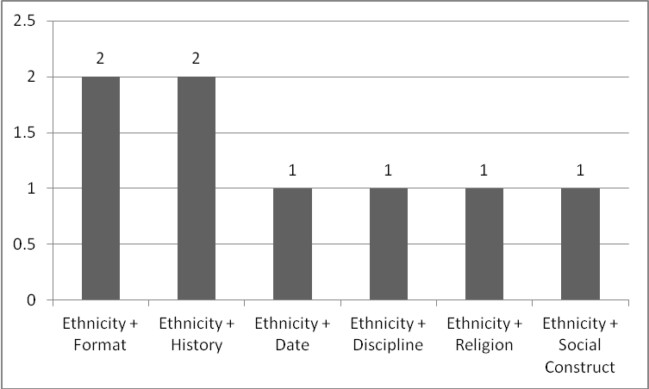
Figure 34. Distribution of Ethnicity and Other Intersections in South and Southeast Asian Dataset

Table 44 below presents the different intersections in the Middle Eastern dataset with accompanying examples. Interestingly, Ethnicity with Religion does not make an appearance.

Table 44. Examples of Ethnicity and Other Intersections in Middle Eastern Dataset
Construct | Tag Example
Ethnicity + Discipline | middle eastern studies
Ethnicity + Format | Arabic literature
Ethnicity + History | French colonialism
Ethnicity + Social Construct | Arab World

Figure 35 below shows a distribution of the ethnicity-related intersections in the Middle Eastern dataset, with Ethnicity with History ranking the highest.

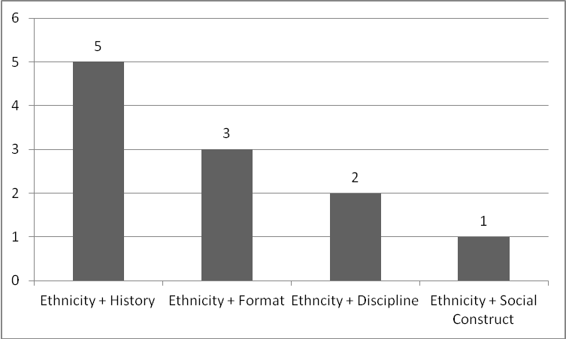
Figure 35. Distribution of Ethnicity and Other Intersections in Middle Eastern Dataset

Like in the gender-related intersections, Ethnicity with Discipline makes an appearance in all three domains. Interestingly, Ethnicity with Religion was more apparent in the South and Southeast Asian dataset than in the Middle Eastern dataset.

6.6 Insights related to Gender, Ethnicity and Other Constructs

Finally, some tags incorporated more than two intersections. The following section presents tags that incorporate 3-4 intersections across the three domains.
Table 45 presents the three examples of such constructs in the East Asian dataset. The distribution of the three tags was equal across all intersections, with a count of 1.

Table 45. Examples of Gender, Ethnicity and Other Intersections in East Asian Dataset
Construct | Tag Example
Gender + Discipline + Geography | Gender Studies - Japan
Gender + Ethnicity + Geography | Asian-Japan-Women
Gender + History + Social Construct | Available/History/Economic Gender Studies

Table 46 below shows the multiple constructs in the South and Southeast Asian dataset. Similarly to the East Asian dataset, there was only 1 tag of each construct represented.

Table 46. Examples of Gender, Ethnicity and Other Intersections in South and Southeast Asian Dataset
Construct | Tag Example
Gender + Ethnicity + Format | Filipiniana poetry and short fiction
Gender + History + Date | Women's History Month ' 08

Table 47 below shows the multiple intersectional constructs in the Middle Eastern dataset, as well as accompanying examples.

Table 47. Examples of Gender, Ethnicity and Other Constructs in Middle Eastern Dataset
Construct | Tag Example
Gender + History + Date | Women's History Month 2010: "Hear Us Roar!"
Gender + Religion + Geography | feminist--islam/middle east
Gender + Geography + History + Social Construct | Middle East Iraq Women History Politics Occupation

Figure 36 below shows the distribution of the multiple constructs in the Middle Eastern category. This dataset had the most number of multiple constructs, with 7 instances of social tags that captured 3-4 intersections in one tag. Gender with Religion and Geography was the strongest presence, with 4 tags capturing such intersections.
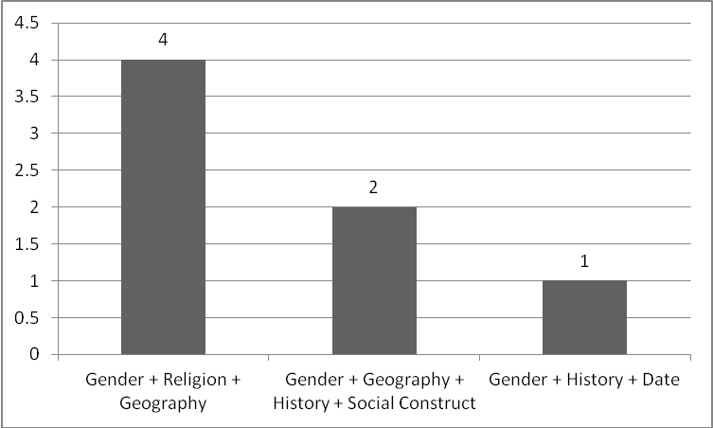
Figure 36. Distribution of Gender, Ethnicity and Other Constructs in Middle Eastern Dataset

This chapter presented a deeper revisiting and analysis of all the social tags that captured some nature of the gendered and ethnic experience. Points of interest from such analysis include how the users themselves construct intersections relating to both gender and ethnicity.

Chapter 7: Conclusions

This chapter provides an overall summary and conclusion to the findings from this research study on exploring themes of intersectionality for works on Asian women. Because there was no clear study that had attempted to explore such issues in the context that they occurred, this study can act as a framework of how to pursue intersectionality within the context of library and information Web 2.0 research.
Findings from this study showed that users construct a variety of intersections relating to gender and ethnicity for works on Asian women. Such intersections differ across the domains used in this study. Chapter 5 presented an overall summary of the various categories, and how they differed across the three domains. Overall findings from this showed that gender and gender-related constructs were the most common subject of tags employed for works on Asian women. Rather than ethnicity being the next highest category, users more often referred to geography when describing the materials on Asian women. In terms of tags that were bolded, or considered more popular for use, geography was the highest represented category. This indicates that describing a country or region of origin is more popular for users than describing the groups of people that come from these geographical regions.
Gender combined with ethnic construct in social tags may have been one of the lowest represented categories overall, however chapter 6 provided a deeper analysis and discussion of the exact intersections regarding gender and ethnicity. The types of gender and ethnic related tags used to describe each group of women differed across domains. Interesting themes to emerge involved how gender and other constructs differed among East Asian, South and Southeast Asian, and Middle Eastern domains. Tags describing the majority of East Asia, such as Chinese and Japanese were most common in the East Asian dataset. Countries not considered the “majority” in South and Southeast Asia were often used, such as Indonesia and the Philippines. Themes of sexuality and religion were much more prevalent in the Middle Eastern set of tags.
Since the majority of LibraryThing users are from the United States, one can’t help but wonder whether or not the constructions of meaning are predominantly from an American perspective. The fact that the East Asian social tag set largely refers to the predominant groups and religion is a predominant topic in the Middle Eastern dataset confirms this idea. Furthermore, the selection of works is deemed appropriate for American college association. It is safe to assume that the audience assigning tags come from a well-educated, middle class, and scholarly background. Implications can be derived that the audience is presumably privileged. This is not viewed as a limitation in this research, since it is of such an exploratory nature. However, this research is not intended to only view these audiences as appropriate for constructing meanings related to gender and ethnicity. As the research in this field progresses in the future, works intended for different audiences will be included in order to capture how the full perspective of intersectionality is constructed across cultural lines.

7.1 Relevance of Research in Library and Information Science

This study addressed the missing gaps established in the background literature in many ways. Firstly, an in-depth content analysis of social tags for meanings can reveal interesting ways to apply meanings to controlled vocabularies. Secondly, this study explored the concept of intersectionality, which was missing from much of the work on subject description that either tackled race or gender. This research not only incorporated Asian ethnicities (rather than race), but looked at ways of how that interacts with gender to create a unique form of identity. In terms of intersectionality literature gaps, there was little direction given on how to analyze such ideas within the library science field. Such research can act as a framework of how to incorporate such ideas into library-oriented research.
One of the primary facets of a content analysis is that is it replicable (Stemler, 2001). The framework established in this research allows for intersectionality of social tags to be analyzed using different samples of works as well as other constructs of intersectionality. This study collected the individual tags for a large sample of works on Asian women in LibraryThing, and then free-form coded the words as to what their larger societal meanings were. Tags that incorporated meanings of intersectional nature, such as gender, ethnicity, religion, etc. were of particular importance. How the meanings and intersections differed across the three domains with relation to East Asian, South and Southeast Asian, and Middle Eastern works was also discussed and analyzed. Further studies can use this framework depending on the selection of works and Web 2.0 resource used.
Such research can have an impact on the research on cataloging and subject description. It is becoming increasingly important to look at themes that emerge in end-user subject descriptions. A Web 2.0 environment such as LibraryThing provided a fertile ground of user-constructed subject description. The implications of analyzing such tags in the in-depth manner can impact how librarians construct more intersectional and diverse subject descriptors.

7.2 Value of Research

7.2.1 Concept-related Value

The literature on intersectional studies often has indicated that there is not one particular method on how to incorporate intersectional concepts in feminist-oriented studies. Earlier race and gender related analysis of subject description were limited in only analyzing individual facets of identity, such as either race or gender (Berman, 1971; Clack, 1975; 1994; Olson, 2001). This research made an initial attempt at analyzing a large volume of user-generated social tags to discover various themes of intersectionality as they relate to both gender and ethnicity.
The significance of this research lies in exploring the potential development of an exact framework when analyzing how users approach intersectionality with regards to any construct, not just gender and ethnicity. Analyzing works that encapsulate gender and ethnicity, as studying how the tags emulate these relationships can not only contribute to using intersectional approaches in traditional subject description, but enhance how intersectionality theory can be applied in to the field of cataloging and subject description.

7.2.2 Context-related Value

Social tags allow for uncontrolled and spontaneous user input for ideas on a particular work or subject opinion. This is directly opposed to a subject description system such as LCSH where there are specific rules, where often time’s only one person who may or may not have read said book is assigning subject headings. Social tags can act as an equalizer where anyone can decide how to describe a work that has particular interest to them. This provides a rich ground for analysis when the power of subject description is taken away from one person and applied to a larger group of diverse end-users. This contributes to a more intersectional way of describing materials of gender and ethnic nature, and can presumably contribute thoughtful ideas to any intersectional construct.
LibraryThing provides an ideal environment for studying user-generated subject description, as it is a web 2.0 environment for self-proclaimed “book lovers” to catalog and discuss their book collections. Presumably such users would have read the works and provide thoughtful and meaningful descriptions of the works at hand.
The users of LibraryThing also compose of a variety of intersections. Though exact education levels are unknown, the majority of users are over the age of 18 years. In terms of the sex of users, they are equal male and female, allowing the voices of both sexes to equally contribute social tags to works of their choosing. Geographically, the majority of the users of LibraryThing come from the United States; however, there is equal parts representation from Asian countries as well as European countries. Such users can contribute a unique voice to works on Asian women, from an Asian, American, and European viewpoint.

7.2.3 Method-related Value

The early parts of data coding was highly exploratory in nature, however eventually a straightforward coding and analysis framework emerged. This research can provide an exact framework of how to collect, code, and analyze data both in quantitative and qualitative forms in order to help to advance research on ethnicity and gender in subject description and cataloging, along with analyzing any other constructs to represent multiple forms of identity in subject description.
The coding strategies employed in this research have implications rooted in faceted classification. The different categories captured the various identities and intersections of each word of each social tag. Each category employed in this research is just in its early stages of specificity and diversity of meaning and can be nuanced and redefined in a multitude of ways to capture the full meaning of each social tag. An important application of faceted classification is that it is a non-hierarchical approach to classifying terms, so no one form of identity of meaning take precedence over the other. For future studies in this research area, a faceted approach to coding can be employed in order to capture the full nature of the words and phrases being used to describe materials.
The methodological implications of this research can expand in numerous ways in future research. The research can expand across disciplines. For example, the using multiple coders across a variety of disciplines would help to establish new and more meaningful categories. The types of works can also expand disciplines to incorporate multiple viewpoints and perspectives. User populations are also an invaluable resource which can be analyzed in a variety of ways. One method would be to interview users about the meanings of the social tags they assign. Further research in this area can also analyze how users interact with the site and study implications for usability.

7.3 Final Thoughts

Future research efforts in this area can lead to diversifying subject description for information resources. Researchers in library science, specifically cataloging with interest in ethnic and feminist theory can look to subject description generated by users to help them extend traditional controlled vocabularies to better represent these intersections of gender and ethnicity.
Such research has many implications for society as a whole. Social tags act as a mechanism for social commentary, as anyone with access to an internet connection has the power to construct forms of identity and meaning to an information resource. Researchers have access to a plethora of constructions available to them through these social tags; such abundance of information is a valuable resource to understanding how the general populace understands intersections and constructs identity.
On a professional and scholarly level, the researcher gained invaluable insight into the research process during course of this experience. However, on a more personal level, this process allowed the researcher to develop a voice. The entire experience was a perpetual exercise in confidence building. Such exercises eventually led to an immutable strength and conviction in the value of such research, which will allow both the researcher and research to grow in a multitude of ways in the future.

List of References

Association of College and Research Libraries (ACRL). (2011). Women & Gender Studies Section. Retrieved April 22, 2011, from http://www.acrl.org/ala/mgrps/divs/acrl/resources/leadership/sections/wss/acr-wssec.cfm

American Library Association (ALA). (2011). Index to ACRL Section Resources. Retrieved April 21, 2011, from http://www.ala.org/ala/mgrps/divs/acrl/proftools/resources.cfm

Adamich, T. (2008). Making and Managing Metadata in K-12 Libraries-Catalog Authorities Education and Its Relation to Social Tagging and Social Networks. Technicalities, 28(4), 3-5.

Adler, M. (2009). Transcending Library Catalogs: A Comparative Study of Controlled Terms in Library of Congress Subject Headings and User-Generated Tags in LibraryThing for Transgender Books. Journal of Web Librarianship, 3(4), 309-331.

Anderson, C. (Producer). (2004). The Long Tail. Wired. Retrieved from http://www.wired.com/wired/archive/12.10/tail.html?pg=1&topic=tail&topic_set=

Arab American Institute. (2011). Arab Americans. Arab American Institute. Retrieved from http://www.aaiusa.org/pages/arab-americans/

Arch, X. (2007). Creating the academic library folksonomy: Put social tagging to work at your institution. College & Resource Library News, 68(2), 80-81.

Association, N. W. s. (1988). NWSA Resolution WLW Journal (Vol. 12, pp. 19-20).

Berger, M. T., & Guidroz, K. (2009). The Intersectional Approach: Transforming the Academy Through Race, Class, and Gender. Chapel Hill, NC: The University of North Carolina Press.

Berman, S. (1971). Prejudices and Antipathies: A Tract of the LC Subject Heads Concerning People. Netuchen, NJ: Scarecrow Press.

Berman, S. (1984). Out of the kitchen--but not into the catalog. Technical Services Quarterly, 2(1-2), 167-171.

Berman, S. (2008). Introduction: Cataloging Reform, LC, and Me. In K. Roberto (Ed.), Radical Cataloging: Essays at the Front. Jefferson, NC: McFarland & Company, Inc.

Braidotti, R. (2002). The power of naming. In H. Olson (Ed.), Information Sources in Women's Studies and Feminism (pp. 167-177). Munich: K.G. Saur.

Broughton, V. (2010). Emergent Vocabulary Control in Web 2.0: Comparisons with conventional LIS theory and practice. Les Cahiers du numérique, 3(6).

Capek, M. E. S. (1987). A Women's thesaurus: An index of language used to describe and locate information by and about women. New York: Harper & Row.

Casey, M., & Savastinuk, L. (2007). Library 2.0: A Guide to Participatory Library Service. New Jersey: Information Today, Inc.

Central Intelligence Agency (CIA) (2011). Field Listing: Ethnic Groups. Retrieved June 1 2011 from https://www.cia.gov/library/publications/the-world-factbook/fields/2075.html

Chan, L. M. (1995). Library of Congress Subject Headings: Principles and Applications 3rd Edition. Westport, CT: Libraries Unlimited.

Christensen, B. (2008). Minoritization and universalization: Lesbianism and male homosexuality in LCSH and LCC. Knowledge Organization, 35(4), 229-238.

Chua, A., & Goh, D. H. (2010). A study of Web 2.0 applications in library websites. Library and Information Science Research, 32, 203-211.

Clack, D. (1975). Black Literature Resources: Analysis and Organization. New York: Marcel Dekker, Inc.

Clack, D. (1994). Subject Access to African American Studies Resources in Online Catalogs: Issues and Answers. Cataloging and Classification Quarterly, 19(2), 49-66.

Colorado State University (2011). An Introduction to Content Analysis Retrieved March 24, 2011, from http://writing.colostate.edu/guides/research/content/pop2a.cfm

Collins, P. H. (2000). Black feminist thought (2nd ed.). New York: Routledge.

Coyle, K. (2007). Managing Technology - The Library Catalog in a 2.0 World. The Journal of Academic Librarianship, 33(2), 289-291.

Detlefsen, E. G. (1984). Issues of access to information about women. Special Collections, 3(3-4), 163-171.

Dickinson, E. (1981). Report of the Racism and Sexism in Subject Analysis Subcommittee to the RTSA/CCS Subject Analysis Committee. Arlington, VA: ERIC Document Reproduction Service.

Dickstein, R., Mills, V. A., & Waite, E. J. (1988). Women in LC's terms: A thesaurus of Library of Congress subject headings relating to women. Phoenix: Oryx Press.

Dilger, B., & Thompson, W. (2008). Ubiquitous cataloging. In K. Roberto (Ed.), Radical Cataloging: Essays at the front (pp. 40-52). Jefferson, NC: McFarland & Company, Inc.

Eckert, K., Hanger, C., & Niemann, C. (2009). Tagging and automation: challenges and opportunities for academic libraries. Library Hi Tech, 27(4), 557-569.

Fina, M. (1993). The role of subject headings in access to information: The experience of one Spanish-speaking patron. Cataloging and Classification Quarterly, 17(1-2), 367-374.

Gerhard, K., Su, M. C., & Rubens, C. C. (1998). An empirical examination of subject headings for women's studies core materials. College and Research Libraries, 59(2), 130-138.

Gilyard, B. (1999). Sandy Berman's Last Stand Retrieved April 17, 2011, 2011, from http://www.sanfordberman.org/cityp/ber3t.htm
Glaser, B. G. (2004). Remodeling Grounded Theory. Forum: Qualitative Research, 5(2), 17.

Glaser, B. G., & Strauss, A. L. (2008). The discovery of grounded theory: strategies for qualitative research: Transaction Publishers.

Golder, S., & Huberman, B. (2006). Usage patterns of collaborative tagging systems. Journal of Information Science, 32, 198-208.

Greenblatt, E. (1990). Homosexuality: The evolution of a concept in the Library of Congress Subject Headings. In C. Gough & E. Greenblatt (Eds.), Gay and lesbian library service (pp. 75-101). Jefferson, NC: McFarland.

Group, G. (2009). Amazon.com Inc., from Gale Group

Haykin, D. J. (1951). Subject headings: a practical guide. Washington DC: Library of Congress.

Johanson, G. A., & Brooks, G. P. (2010). Initial Scale Development: Sample Size for Pilot Studies. Educational and Psychological Measurement, 70(3), 394-400.

Johnson, M. (2008). A Hidden History of Queer Subject Access. In K. Roberto (Ed.), Radical Cataloging: Essays at the Front. Jefferson, NC: McFarland & Company, Inc.

Kakali, C., & Papatheodorou, C. (2010). Exploitation of folksonomies in subject analysis. Library and Information Science Research, 32, 192-202.

Kerner, I. (2009). Is It All Intersectional? On the Relation of Racism and Sexism. Feministische Studien, 27(1), 36-+.

Krippendorff, K. (2004). Content analysis: an introduction to its methodology. Thousand Oaks: Sage Publications.

Kroski, E. (2007). Folksonomies and User-Based Tagging. In N. Courtney (Ed.), Library 2.0 and Beyond: Innovative Technologies ad Tomorrow's User (pp. 91-103). Westport, CT: Libraries Unlimited.

Larson, R. R. (1991). The decline of subject searching - long-term trends and patterns of index use in an online catalog. Journal of the American Society for Information Science, 42(3), 197-215.

Lawson, K. (2009). Mining Social Tagging Data for Enhanced Subject Access for Readers and Researchers. The Journal of Academic Librarianship, 35(6), 574-582.

Library of Congress. (2011). About the SACO Program Retrieved April 17, 2011, from http://www.loc.gov/catdir/pcc/saco/sacopara.html

LibraryThing. (2011). Zeitgest Overview. Retrieved June 1 2011, from http://www.librarything.com/zeitgeist

Mahalingam, R., & Leu, J. (2005). Culture, essentialism, immigration and representations of gender. [Proceedings Paper]. Theory & Psychology, 15(6), 839-860. doi: 10.1177/0959354305059335

Marcus, S. (2005). Queer Theory for Everyone: A Review Essay. Signs: Journal of Women in Culture & Society, 31(1), 191-218.

Marshall, J. K. (1972). LC Labeling: an indictment. In C. West & E. Katz (Eds.), Revolting Librarians (pp. 45-49). San Francisco: Booklegger Press.

Marshall, J. K. (1977). On equal terms: A thesaurus for nonsexist indexing and cataloging. New York: Neal-Schuman Publishers.

Mayuzumi, K. (2008). 'In-between' Asia and the West: Asian women faculty in the transnational context. [Article]. Race Ethnicity and Education, 11(2), 167-182. doi: 10.1080/13613320802110274

McCall, L. (2005). The Complexity of Intersectionality. Signs: Journal of Women in Culture and Society, 30, 1771-1794.

McFadden, S., & Venker Weidenbenner, J. (2010). Collaborative Tagging: Traditional Cataloging Meets the "Wisdom of Crowds". The Serials Librarian, 58(1), 55-60. doi: 10.1080/03615261003623021

Mehrotra, G. (2010). Toward a Continuum of Intersectionality Theorizing for Feminist Social Work Scholarship. [Article]. Affilia-Journal of Women and Social Work, 25(4), 417-430. doi: 10.1177/0886109910384190

Mendes, L. H., Quinonez-Skinner, J., & Skaggs, D. (2009). Subjecting the catalog to tagging. Library Hi-Tech, 27(1), 30-41.

Miller, D. (2010). The SACO Program in the Lives of Our Institutions. [Article]. Cataloging & Classification Quarterly, 48(2/3), 194-220. doi: 10.1080/01639370903535718

Neal, D. M. (2010). Emotion-based tags in photographic documents: The interplay of text, image, and social influence. [Article]. Canadian Journal of Information and Library Science-Revue Canadienne Des Sciences De L Information Et De Bibliotheconomie, 34(3), 329-353.

Neuendorf, K. A. (2011). Content Analysis-A Methodological Primer for Gender Research. [Article]. Sex Roles, 64(3-4), 276-289. doi: 10.1007/s11199-010-9893-0

Olson, H. (1992). Subject access to Women's Studies materials. Paper presented at the Congress for Librarians, Medford, NJ.

Olson, H. (1996). The power to name: Marginalization and exclusions of subject representation in library catalogues. PhD, University of Wisconsin-Madison, Madison, Wisconsin.

Olson, H. (2007). How We Construct Subjects: A Feminist Analysis. Library Trends, 56(2), 509-541.

Olson, H. A. (2000). Difference, culture, and change: The untapped potential of LCSH. Cataloging and Classification Quarterly, 29(1), 53-71.

Olson, H. A. (2001). The power to name: Representation in library catalogs. Signs, 26(3), 639-668.

Olson, H. A. (2002). The power to name: locating the limits of subject representation in libraries. Dordrecht [The Netherlands]: Kluwer Academic.

Peterson, E. (2008). Parallel systems: The coexistence of subject cataloging and folksonomy. Library Philosophy & Practice, 10(1), 1-5.

Pikimal. (2010). LibraryThing. Retrieved June 1 2011 from http://social-network.pikimal.com/librarything

Punch, K. (2005). Introduction to Social Research 2nd edition: Quantitative and Qualitative Approaches. Los Angeles: Sage Publications.

Quintarelli, E. (2005). Folksonomies: Power to the People. Paper presented at the ISKO Italy, Milano Biococca University, Milan, Italy. http://www.iskoi.org/doc/folksonomies.htm

Rogers, M. (1993). Are we on equal terms yet? Subject headings concerning women in LCSH, 1975-1991. Library resources & Technical services, 37(2), 181-196.

Rolla, P. (2009). User Tags versus Subject Headings. Library Resources and Technical Services, 53(3), 174-184.

Sharenator. (2010). Librarything.com visualized. Retrieved June 1 2011 from http://www.sharenator.com/w/librarything.com#mon

Shirky, C. (2005, December 3). Ontology is Overrated: Categories, Links, and Tags. Retrieved from http://www.shirky.com/writings/ontology_overrated.html

Smith, T. (2007). Cataloging and you: Measuring the efficacy of a folksonomy for subject analysis. Paper presented at the Proceedings 18th Workshop of the American Society for Information Science and Technology Special Interest Group in Classification Research, Milwaukee.

Spelman, E. V. (1988). Inessential Woman. Boston: Beacon Press.

Spiteri, L. (2006). Use of folksonomies in public library catalogues. Serials Librarian, 51(2), 75-89.

Spiteri, L. (2009). The impact of social cataloging sites on the construction of bibliographic records in the public library catalog. Cataloging and Classification Quarterly, 48(1), 94-109.

Steele, T. (2009). The new cooperative cataloging. Library Hi Tech, 27(1), 68-77. doi: 10.1108/07378830910942928

Steele, T. (2009). The new cooperative cataloging. Library Hi Tech, 27(1), 68-77. doi: 10.1108/07378830910942928

Stemler, S. (2001) An overview of content analysis. Practical Assessment, Research & Evaluation, 17( 7).

Strauss, A., & Corbin, J. M. (1990). Basics of qualitative research: Grounded theory procedures and techniques. Sage Publications: Thousand Oaks, CA.

Thomas, M., Caudle, D. M., & Schmitz, C. M. (2009). To tag or not to tag? Library Hi Tech, 27(3), 411-434. doi: 10.1108/07378830910988540

tierra, t. d. l. (2008). Latina Lesbian Subject Headings: The Power of Naming. In K. Roberto (Ed.), Radical Cataloging: Essays at the Front. Jefferson, NC: McFarland and Company, Inc.

University of Wisconsin Digital Collections. (2011). Women's Studies: Core Books (ACRL/WSS). Retrieved June 1 2011 from http://uwdc.library.wisc.edu/collections/ACRLWSS/about

Westcott, J., Chappell, A., & Lebel, C. (2009). LibraryThing for libraries at Claremont. [Article]. Library Hi Tech, 27(1), 78-81. doi: 10.1108/07378830910942937

Wood, S. (2010). The Subject Representation of Core Works in Women's Studies: A Critical Analysis of Library of Congress Subject Headings. Master's Degree, University of Tennessee - Knoxville, Knoxville.

Yi, K. (2010). A Semantic Similarity Approach to Predicting Library of Congress Subject Headings for Social Tags. Journal of the American Society for Information Science and Technology, 61(8), 1658-1672.

Yi, K., & Chan, L. M. (2010). Revisiting the Syntactical and Structural Analysis of LCSH for the Digital Environment. Journal of the American Society for Information Science and Technology, 61(4), 677-687.

Yocom, F. (1940). A List of Subject Headings for Books by and about the Negro. New York: H.W. Wilson.

Vita

Sheetija Kathuria was born and raised in Atlanta, Georgia. She obtained a bachelor of arts in Sociology at the University of Georgia. She accepted a graduate teaching assistantship at the University of Tennessee, Knoxville in the School of Information Sciences. She graduated with a Master’s of Information Science degree from the University of Tennessee, Knoxville in August 2011. Her research interests include social tags, intersectionality theory, and academic library services to underserved populations.

