Metabolism in the Colonocyte:
Where Bacteria and Diet Meet

A Dissertation Presented for the
Doctor of Philosophy
Degree
The University of Tennessee, Knoxville

Bohye Park
May 2022

Copyright © 2022 by Bohye Park
All rights reserved.

ACKNOWLEDGEMENTS
I offer my sincerest gratitude to my dissertation committee members – Professor Dallas Donohoe, Ahmed Bettaieb, Ling Zhao, and Brynn Voy – for their invaluable advice and guidance. I would like to thank you for providing valuable scientific advice and guidance. Dr. Dallas Donohoe is the best advisor, mentor, and professor for me. I sincerely would like to appreciate that he has always supported and encouraged me to do my best as a graduate student and scientist. I also genuinely thank professors, colleagues, and staff members in the Nutrition Department at the University of Tennessee.
Special thanks and heartfelt appreciation are reserved for my parents, 박정훈, 김은경, parents-in-law, 장태현, 김순희, husband, 장은식, brother 박재익, brother-in-law 장형택, and sister-in-law 홍윤지. All my family has prayed for me so that I could overcome all difficulties throughout my graduate program and life. In the lab, I have been working with great individuals, Dr. Johnson Jeremiah, Jiyeon Kim, Olivia Riffey, Emily Simon, and Presley Dowker. I would like to thank their support and respect for me. I also thank my friends in Christ Billy and Mary Blount for their prayer support.
ABSTRACT
The host-microbiome interaction and the functions of microbial-derived metabolites, including butyrate, are important in colonic health. Butyrate is the preferred energy substrate in colonocytes and has multiple physiological functions in the colon. A metabolic shift in colonocytes toward increased glucose utilization from butyrate oxidation is associated with several critical genetic modifications in cancerous colonocytes. Moreover, it has been suggested that the gut-microbiota composition is influenced by environmental factors, such as diet and the host's physiological status. Therefore, an understanding of the role of colonocyte metabolism toward impacting the host-microbiota commensal relationship would be an important step in characterizing the functional importance of how diet, microbiome, and the host interact in colonic physiology.
This dissertation demonstrates that (1) colorectal cancer cells exhibit a metabolic shift from butyrate oxidation toward glycolysis; (2) the key factor in the metabolic shift is decreased pyruvate kinase M1 (PKM1), rather than increased pyruvate kinase M2 (PKM2); (3) an increase in HIF1⍺ through a reduction in pyruvate as a result of decreased PKM1 is a critical mechanism that serves to repress butyrate oxidation in colorectal cancer cells. Also, this dissertation defines the functional importance of butyrate oxidation and explains that (1) a diminishment of short-chain acyl dehydrogenase (SCAD) in a non-disease mouse model reduces butyrate oxidation in colonocytes and instead uses energy from glycolysis as a compensatory mechanism; (2) the reduction of butyrate oxidation in SCAD-deficient mice results in a large decrease in the butyrate-producing bacteria population, thus linking host cellular metabolism with microbiome composition as it relates to the dietary metabolites or SCFAs; (3) these SCAD-deficient mice fail to respond in a prebiotic manner to dietary fiber.
These findings begin to characterize the different roles of the PKM isoforms in the cancerous colonocytes and show how these proteins change metabolism in a disease model. Also, the results allude to how colonocyte metabolism affects the population of gut microbiota in the gastrointestinal (GI) tract, which defines a significant relationship between butyrate and SCFAs metabolism in the colonocyte and colonic gut microbiota homeostasis.

Table of Contents
Introduction 1
CHAPTER 1 LITERATURE REVIEW 3
1.1. Colorectal Cancer 4
1.1.1. Development of CRC 4
1.1.2. Screening and Diagnosis of CRC 8
1.1.3. Risk Factors of CRC 10
1.2. Dietary Fiber and Gut Microbiota in the Colon 19
1.2.1. Dietary Fiber 20
1.2.2. Prebiotics 21
1.2.3. Gut Microbiota 22
1.2.4. Gut Microbiota in IBDs and CRC 25
1.3. Butyrate 27
1.3.1. Butyrate Synthesis and Metabolism in Colonocytes 28
1.3.2. The Function of Butyrate in Colonocytes 30
1.4. A Metabolic Shift in Cancer cells 34
1.4.1. Hypoxia-Inducible Transcription Factor-1 (HIF1) 35
1.4.2. Pyruvate Kinase M1/2 (PKM1/2) 36
Appendix 40
CHAPTER 2 PYRUVATE KINASE M1 REGULATES BUTYRATE METABOLISM IN CANCEROUS COLONOCYTES 52
2.1. Abstract 46
2.2. Introduction 46
2.3. Materials and Methods 48
Cell Culture and shRNA Transfection 48
Flux Experiments 49
Western Blot Analysis 50
Immunofluorescence staining 51
Statistical Analysis 52
2.4. Results 52
2.5. Discussion 58
Appendix 61
CHAPTER 3 CROSSTALK BETWEEN BUTYRATE OXIDATION IN THE COLONOCYTE AND BUTYRATE-PRODUCING BACTERIA 76
3.1. Abstract 74
3.2. Introduction 74
3.3. Materials and Methods 77
Animals 77
Diets 78
Primary Colonocytes Isolation 78
Flux Experiments 78
Western Blot Analysis 79
Microbial DNA preparation and Quantitative Real-Time PCR Analysis 80
Statistical Analysis 81
3.4. RESULTS 81
Characterization of BALB/cBy colonocytes and their reduced butyrate oxidation 81
Diminished Butyrate-Producing Bacteria in SCAD mutant BALB/cBy Mice 84
Butyrate-Producing Bacteria Responded in a High-Fiber Diet in Wild Type Mice 85
3.5. DISCUSSION 86
Appendix 89
Conclusion and Future Direction 99
List of References 101
VITA …………………………………………………………………………………..127

LIST OF TABLES

Table 1. Four Clinically Meaningful Dietary Fiber Categories 41
Table 2. The molecular alterations in cancer cells causing the metabolic shift toward glycolysis 42
Table 3. Primer Sequences used in this study 95

LIST OF FIGURES

Figure 1. Colorectal Carcinogenesis Pathways 43
Figure 2. The process of genetic alteration in colorectal cancer development 44
Figure 3. Risk factors of colorectal cancer 45
Figure 4. The physiological benefits of the metabolites derived from bacterial fermentation and their underlying mechanism 46
Figure 5. Effects of host, diet, and environmental factors on the composition of gut microbiota and its impacts of the colonic health 47
Figure 6. The different metabolism between normal colonocyte and cancerous colonocyte 48
Figure 7. The butyrate synthesis pathways and the related butyrate-producing bacteria 49
Figure 8. Butyrate increases histone acetylation by two distinct mechanisms. 50
Figure 9. Biosynthetic intermediates by the metabolic shift in cancer cells 51
Figure 10. Expression of PKM isoform in human non-cancerous and cancerous colorectal tissues 62
Figure 11. Butyrate oxidation in PKM2 knockdown HCT116 colorectal cancer cells 63
Figure 12. Butyrate oxidation is PKM1 dependent rather than PKM2 in HCT116 colorectal cancer cells. 64
Figure 13. PKM1 is responsible for mitochondrial function in HCT116 colorectal cancer cells. 65
Figure 14. Molecular consequences in PKM1- and PKM2-diminished HCT116 colorectal cancer cells 66
Figure 15. The expression of HIF1α and SCAD is affected by PKM1. 67
Figure 16. The role of HIF1α in regulating butyrate oxidation 68
Figure 17. Model of PKM1 regulation of cellular metabolism in cancerous colonocytes 69
Figure 18. Expression of PTBP1 in different PKM1/2 expressed cell line. 70
Figure 19. Confirmation of the expression of PKM1/2 in different Passage. 71
Figure 20. Butyrate oxidation is PKM1 dependent in HEK293 cells. 72
Figure 21. Re-addition of PKM2 doesn’t impact various parameters associated with mitochondrial function in colorectal cancer cells. 73
Figure 22. Relative expression of phospho-ACC/ACC in PKM1- and PKM2-diminished HCT116 colorectal cancer cells 74
Figure 23. The expression of HIF1α in HCT116 cells and HIF1aKO cells 75
Figure 24. Molecular consequences in short-chain acyl dehydrogenase (SCAD) mutant mouse colonocytes 90
Figure 25. SCAD mutant mice prefer glucose rather than butyrate as an energy source 91
Figure 26. Analysis of the level of butyrate synthesis enzyme as a biomarker of butyrate-producing bacteria (BPB) 92
Figure 27. Exploring the butyrate-producing bacteria (BPB) community based on qPCR analysis 93
Figure 28. Impact of different dietary fiber diets on the composition of butyrate-producing bacteria 94
Figure 29. Experimental model for collected fecal samples for 16S rRNA and 1PCR analysis 96
Figure 30. The process of generating specific butyrate kinase (buk) and the large variabilities of the collected fecal samples 97
Figure 31. Impact of different dietary fiber diets on the composition of butyrate-producing bacteria in the small intestine of BALB/c and BALB/cBy 98

Introduction

Colorectal cancer (CRC) is the third most diagnosed malignancy and the second leading mortal cancer (Siegel et al., 2020). The National Cancer Institute (NCI) estimates that 149,500 new cases of CRC arise, and about 52,980 individuals will succumb to this disease in the 2021 (Siegel, Miller, Fuchs, & Jemal, 2021). CRC development can take several years for an adenoma to develop into invasive carcinoma. Carcinoma is defined when the tumor invades into the muscular layer and thereby signifies metastasis. During this process to become a carcinoma, the adenoma must acquire key genomic and metabolic modifications to promote tumor growth and aggressive characteristics (Jasperson, Tuohy, Neklason, & Burt, 2010). In addition to genetic contributions, modifiable lifestyle, dietary factors, and the composition of gut microbiota can increase or decrease the risk of developing CRC (Keum & Giovannucci, 2019; S. H. Wong & Yu, 2019).
Inter-individual variability is one of the important characteristics of the gut microbiota due to environmental and genetic factors (Bibbò et al., 2016). Among environmental factors, different diets affect the gut microbiota composition regulating the amount of SCFAs, including acetate, propionate, and butyrate, produced by the fermentation of dietary fibers by resident microbiota (De Almeida, de Camargo, Russo, & Amedei, 2019). A balanced gut microbiota composition is important for colonic health in the host. Cellular processes, including metabolism, development and maintenance of the immune system, and protection against pathogens, are important in mediating colonic physiology (Aune et al., 2011; Guinane & Cotter, 2013; Holscher, 2017). In contrast, disturbance of the gut microbiota composition is associated with the development and progression of CRC and ulcerative colitis (Ni, Wu, Albenberg, & Tomov, 2017; Zou, Fang, & Lee, 2018), thereby associating the gut microbiota with colonic diseases. However, the factors leading to these microbial differences are not entirely clear.
Of the microbial-derived SCFAs, butyrate serves as the primary energy source for colonocytes, while acetate and propionate are rapidly taken up and reach systemic circulation to contribute to the overall energetic homeostasis (Donohoe et al., 2011; Roediger, 1982). In addition to being an energetic substrate, butyrate has anti-cancer effects through the induction of epigenetic modifications that alter the expression of genes involved in cell proliferation, apoptosis, and differentiation. Butyrate has this action by inhibiting histone deacetylases and is identified as an HDAC inhibitor (HDACi) (Davie, 2003). During the development of colorectal cancer, cancerous colonocytes primarily utilize glucose and undergo high levels of glycolysis (the Warburg effect) with relatively low levels of mitochondrial butyrate oxidation (Bultman, 2014; Vander Heiden, Cantley, & Thompson, 2009; Warburg, 1956). However, the impact of this metabolic shift and the mechanisms that contribute to diminished butyrate oxidation is not entirely clear.
Therefore, this dissertation starts with comprehensive information on CRC, the significance of dietary fibers and gut microbiota in colon health, the role of butyrate in the colonocytes, and how metabolic enzymes such as PKM mediate the metabolic shift in colorectal cancer cells. Specifically, Chapter 2 demonstrates the role of pyruvate kinase M1 in the metabolic changes of cancerous colonocytes. Continuing on this aspect of butyrate oxidation, Chapter 3 addresses whether this oxidation of butyrate and other SCFAs in the colonocyte (and other host cells) regulates the amounts of butyrate-producing bacteria, thereby providing other outcomes of altered metabolism in the colonocyte.

CHAPTER 1

LITERATURE REVIEW

Colorectal Cancer
Colorectal cancer (CRC) is the second most common cause of cancer death in the United States, and the National Cancer Institute (NCI) estimates that CRC is the third most diagnosed malignancy globally in the 2020 (Siegel et al., 2020). CRC development is a complex process resulting from various etiological factors, both genetic and environmental.
Over the past several decades, recent studies have suggested the biological and molecular characteristics of CRC while also elucidating the underpinnings that give rise to CRC development. Significant progress has been made in understanding genetic and epigenetic alterations in the CRC genome, which supports the genetic perspective of CRC. However, more than 42% of all cases and deaths are associated with environmental and modifiable risk factors such as smoking, high alcohol consumption, unhealthy diets, physical inactivity, and excess body weight, many of which could be prevented by effective strategies (Islami et al., 2018). Therefore, it represents the importance of modifiable factors in CRC development.
Understanding the associations between the modifiable risk factors and the pathology of CRC is important in reducing CRC incidence and mortality. One of the major modifiable risk factors is diet. The first part of this dissertation begins with the general background of CRC, including genetic approaches to carcinogenesis and modifiable risk factors.

Development of CRC
Colorectal cancer (CRC) is a disease of developing a malignant neoplasm, often referred to as an adenocarcinoma, derived from granular epithelial cells in the colon or rectum (Board, 2002). CRC is considered an important disease model to better understand general tumor progression and metastasis because gradually changing phenotypes are associated with measurable genetic mutations (Yeatman & Chambers, 2003). CRC shows a variety of genomic alterations from small-scale changes, such as deletions or point mutations, to large-scale chromosomal rearrangements or copy number changes (T. M. Kim, Lee, & Chung, 2013). The loss of genomic stability can drive the development of CRC by facilitating multiple tumor-associated mutations. Several studies combine the perspectives of genetics, epigenetics, and signaling pathways to focus on developing colon tumors from a gene perspective (Dwyer, Colombo, & Bozzi, 1989; Fearon, Hamilton, & Vogelstein, 1987; Hassold, Kumlin, Takaesu, & Leppert, 1985).
Colonic crypts comprise the basic structure of the large intestine. These crypts consist of a monolayer of epithelial cells with a very high cell turnover (van der Flier & Clevers, 2009). The colonic crypt, the functional unit of the intestine, is comprised of stem cells, proliferating cells, and differentiated cells, which all form a finger-like introversion structure into the connective tissue (Munro, Wickremesekera, Peng, Tan, & Itinteang, 2018). The columnar stem cells, located at the crypt base, migrate toward the lumen through proliferation and undergo differentiation as they move up the crypt (van der Flier & Clevers, 2009). The development and turnover of these stem cells are affected by the host genetic programs associated with Wnt, Hedgehog, and Noggin signals (Humphries & Wright, 2008).
CRC arises in the epithelium layer of the colonic crypt (Kowalczyk et al., 2020). Aberrant crypt foci (ACF) are the earliest manifestation of colorectal neoplasia in the epithelium. ACF eventually form adenomatous polyps, although not always (Fodde, 2002). In this regard, several studies have shown that additional mutations of tumor-suppressor genes and oncogenes are required to develop into neoplasia that becomes cancerous (Markowitz & Bertagnolli, 2009).
Three major pathways are involved in the development of CRC. These include adenoma-carcinoma sequence, serrated pathway, and inflammatory pathway (Keum & Giovannucci, 2019). The adenoma-carcinoma sequence is the conventional pathway of CRC development (Figure 1A). In this model, the gradual accumulation of genetic and epigenetic mutations promotes the conversion of normal cells into a small adenoma, large adenoma, and finally to cancer or carcinoma (Armaghany, Wilson, Chu, & Mills, 2012). Colorectal tumors develop from benign to malignant over time by obtaining a series of mutations (Vogelstein et al., 2013). Bert Vogelstein was the first to identify these series of mutations, which predispose benign tumors to become adenocarcinomas. The Vogelgram represents four major genetic mutations in CRC development: adenomatous polyposis coli (APC), K-Ras, SMAD2, and SMAD4, TP53. Figure 2 shows the associated signaling pathways and a gradual series of histological phenotype changes, which provide a better understanding of genetic modification in the CRC development (Fodde, 2002; Vogelstein et al., 2013). The most common mutation in CRC initiation is the APC, a tumor-suppressor gene, which functions as a gatekeeper (Kinzler & Vogelstein, 1997). As a consequence of the APC mutation, Wnt/β-catenin signaling is inappropriately activated because APC is an essential cytoplasmic protein that targets β-catenin for the destruction (Parker & Neufeld, 2020). In the absence of functional APC, the accumulated β-catenin translocates to the nucleus, where it stimulates the transcription of proto-oncogenes that promote cell cycle progression, including the DNA-binding proteins of T-cell factor (TCF) family, which help in the epithelial transition to adenoma (Bian, Dannappel, Wan, & Firestein, 2020). Together with other genetic mutations such as KRAS oncogene, APC mutations are necessary for the transition to a large adenoma. KRAS activates MAPK leading to increased proliferation and invasion. Mutations in the PI3K/AKT pathways represent another way to promote cell survival (S. Jones et al., 2008). The transforming growth factor-β (TGF-β) pathway phosphorylates the tumor suppressor gene products SMAD2 and SMAD4, reducing apoptosis and promoting proliferation (H. Li et al., 2019). Several studies have shown that mutations that occur in TGF-β, SMAD2, and SMAD4 genes are increased and vital in promoting CRC progression (Jung, Staudacher, & Beauchamp, 2017). TP53 is the other critical tumor-suppressor gene, whose gene product is involved in CRC development. Acquired mutations in TP53 are widespread in malignant colorectal tumors. The absence of p53 leads to loss of this DNA damage checkpoint during the cell cycle after the G phase, which is followed by increased cell proliferation, reduced apoptosis, and induced malignant transformation (X. L. Li, Zhou, Chen, & Chng, 2015). Therefore, mutations of these proto-oncogenes and tumor-suppressor genes play a pivotal role in the metastasis, metabolic modification, and progression of the CRC (Markowitz & Bertagnolli, 2009; Vogelstein et al., 2013). Most importantly, multiple mutations and events are required to develop CRC. The order or sequence of these mutations is also important in this process.
The serrated pathway is an alternative pathway in CRC development through serrated adenomas (Figure 1B). This model is explained by the development from normal cells to hyperplastic polyps, sessile serrated adenoma, and then to CRC (Leggett & Whitehall, 2010). Mutations in the proto-oncogene BRAF induce uncontrolled cell proliferation through activation of MAPK pathways that result in the formation of hyperplastic polyps (Kedrin & Gala, 2015). The inflammatory pathway is the other distinct carcinogenic pathway (Figure 1C). In this model, carcinogenesis is developed from normal cells to indefinite dysplasia, low-grade dysplasia, high-grade dysplasia, and to CRC (Itzkowitz & Yio, 2004). Unlike the conventional adenomas or serrated adenomas pathways, dysplasia is frequently present in flat mucosa with multifocality. Thus, high-definition endoscopy or chromoendoscopy are recommended for patients with IBD over the traditional white-light colonoscopy (Buchner & Lichtenstein, 2016). The molecular events and timing are also distinct from the adenoma-carcinoma sequence (Keum & Giovannucci, 2019). In the inflammatory pathway, mutations in TP53 and APC respectively occur early and late in CRC development (Robles et al., 2016).
CRC is staged by the TNM classification and staging system, which confers accurate prognostic information and proper treatment plans for CRC patients (Ueno et al., 2012). This system assigns the stage of CRC with the characteristics of the primary tumor (T), lymph node involvement (N), and degree of metastasis (M) (Weiser, 2018). Stage I – cancer has dispersed to the submucosa and slightly invaded the muscle layer of the colon wall; Stage II – cancer has spread throughout the colon wall and close to the organs but not to the lymph nodes; Stage III – cancer has dispersed to regional lymph nodes, but not to other normal organs; and Stage IV – cancer has spread through the blood and lymph circulation to distant organs (Ueno et al., 2012)

Screening and Diagnosis of CRC
Incidence and mortality rates of CRC have been declining for several decades because of earlier diagnosis through screening and better treatment modalities. Especially, screening enables removing precancerous lesions before malignant transformation or early detection and treatment of CRC (Provenzale et al., 2020).
CRC screening can be divided into stool tests and structural examinations (Quintero et al., 2012). As stool tests, fecal occult blood tests (FOBTs), fecal immunochemical tests (FITs), and multitarget stool DNA testing (FIT-DNA) can be applied, and a positive result from either test will lead to further screening, such as a sigmoidoscopy or a colonoscopy (Imperiale et al., 2014). The FOBTs and FITs can detect precancerous lesions or cancer with small amounts of blood in stool samples (Wieten et al., 2019). The FIT-DNA indicates molecular aberrations associated with CRC biomarkers such as KRAS mutations and aberrant BMP3 and NDRG4 methylation (Imperiale et al., 2014). Also, another tool for CRC diagnosis involves the analysis of molecular biomarkers such as microsatellite instability (MSI), chromosomal instability (CIN), and the CpG island methylator phenotype (CIMP) analysis in fecal samples, which reflect the mechanisms of malignant cells (Gonzalez-Pons & Cruz-Correa, 2015).
Structural examinations, including colonoscopy, computed tomography (CT), 18-fluor-labeled fluorodeoxyglucose (FDG)-positron emission tomography (PET)/computed tomography (CT), and magnetic resonance imaging (MRI), can be used for detailed CRC screening and diagnosis (Quintero et al., 2012). Cross-sectional imaging studies show the exact stage of preoperative colorectal cancer, which provides important information in determining patient prognosis and optimized treatment strategies (Kijima et al., 2014). First, colonoscopy is recommended as a primary screening tool due to its high sensitivity for early detection of CRC and its ability to take biopsies and remove polyps (Dominitz et al., 2017). Several population-based case-control studies have shown that colonoscopy screening significantly lowers CRC risk (Brenner, Chang-Claude, Seiler, Rickert, & Hoffmeister, 2011; Brenner et al., 2010; Click, Pinsky, Hickey, Doroudi, & Schoen, 2018). As such, it is now recommended to begin at age 45 by the American Cancer Society (Wolf et al., 2018). However, colonoscopy is an imperfect screening because of the sessile serrated adenoma/polyps (SSA/Ps) (Rashtak, Rego, Sweetser, & Sinicrope, 2017). SSA/Ps are difficult to visualize at colonoscopy because they are flat and have adherent mucus that makes them easier to overlook than conventional adenomas (Pohl et al., 2013). Second, CT colonography has been widely used as an alternative to endoscopy because of its safety, clinical performance, and cost-effectiveness in CRC screening (Yee, Weinstein, Morgan, Alore, & Aslam, 2013). Although detecting SSA/Ps is difficult with colonoscopy, CT colonography can detect SSA/Ps (D. H. Kim, Lubner, Cahoon, Pooler, & Pickhardt, 2018). CT colonography allows visualizing SSA/Ps despite the flat formation using an oral tagging agent that mixes with adherent mucus to highlight the flat lesion (D. H. Kim et al., 2016). CT identifies the colon and mesenteric and mesocolic infiltration and extracolonic organs metastasis such as liver, lung, and lymph nodes with high accuracy (Mainenti et al., 2006). The superior spatial resolution of CT scan allows the creation of three-dimension (3D) reconstructions. It is possible to detect polyps or tumors specifically with accurate quantification of the lesion size and metastasis identification, which cannot be seen with the endoscope (Pickhardt et al., 2003; Sosna, Kruskal, Bar-Ziv, Copel, & Sella, 2005). Third, FDG-PET/CT is a practical clinical methodology for evaluating CRC patients for tumor imaging because the metabolic shift toward glycolysis occurs in many cancers, including CRC (Maffione et al., 2020). This clinical technique illustrates the characteristics of CRC as a metabolic disease characterized by reduced butyrate oxidation and increased glucose uptake and utilization (R. E. Brown, Short, & Williams, 2018). The principle of FDG-PET/CT is to detect FDG, a highly accumulated non-metabolized glucose form within CRC cells, compared to non-cancerous colonocytes. This elevated FDG uptake is due to increased aerobic glycolysis in the CRC cells (Chalabi, Bassiouny, & El Sedek, 2020). Therefore, FDG-PET/CT can detect undetermined lesions suspected of recurrent diseases and identify the metastatic status of the CRC (Heriot et al., 2004).

Risk Factors of CRC
The risk factors of CRC include the following: demographic characteristics (age) (Brändstedt et al., 2012); medical conditions [family history, individual history with inflammatory bowel diseases (IBDs), familial adenomatous polyposis (FAP), and metabolic diseases]; lifestyle-related factors (low-physical activity, smoking, and alcohol consumption); and dietary factors (elevated consumption of red or processed meat, and low intake of vegetables and fruits) (Bailey et al., 2015) (Figure 3).
Among these risk factors, IBDs and a history of CRC in first-degree relatives are associated with a much higher risk of CRC. On the other hand, an increased body mass index (BMI), red or processed meat intake, cigarette smoking, low physical activity, low vegetable and fruit consumption were associated with a moderately increased risk of CRC (Tsoi et al., 2009).

      - Age
According to the National Cancer Institute (NCI), CRC incidence and mortality rates increase with age (Siegel et al., 2020). Even though over 50 years is an obvious risk factor for CRC, the overall incidence and mortality rates in those populations have been decreasing in recent years due to early screening and detection (Zauber et al., 2012). On the other hand, the incidence of CRC has been rising in the population under the age of 50 over the last several decades due to low physical activity and Westernized diet patterns (S. G. Patel & Ahnen, 2018). Following this trend, screening for CRC in average-risk patients (no predisposing conditions or family history) is recommended at 45 years rather than 50 years by the American Cancer Society (Wolf et al., 2018).
The gastrointestinal microbiome may be one factor impacting age-associated CRC development. The trillions of microbes inhabiting the gastric intestinal tract comprise complex communities, which significantly change across a lifetime through age, diet, environment, and disease (Heintz & Mair, 2014; Kumar, Babaei, Ji, & Nielsen, 2016). As we age, the increased rate of gram-negative bacteria and the secretion of lipopolysaccharide (LPS) induce inflammation in the gut (Schiffrin, Morley, Donnet-Hughes, & Guigoz, 2010). Also, the gut microbiome modulates diverse signaling pathways, such as promoting inflammation and oncogenesis (Murphy, Dias, & Thuret, 2014). Accordingly, the microbial alterations (dysbiosis) in the gut during aging can be linked to intestinal permeability and clinically relevant conditions, including IBDs (J. Choi, Hur, & Hong, 2018).

      - Gender
Many researchers have suggested that men have higher CRC incidence and mortality rates than women, even though the impact of gender on CRC incidence and mortality still needs to be studied more (Brenner, Hoffmeister, & Haug, 2008; Matanoski, Tao, Almon, Adade, & Davies-Cole, 2006). This increased susceptibility of men to developing CRC might relate to a combination of multiple factors such as gender-related behavioral and biological causes (Cook, McGlynn, Devesa, Freedman, & Anderson, 2011).
Compared to women, men usually are heavier smokers (Chang et al., 2014), consume more alcohol (Schütze et al., 2011), and generally have worse dietary patterns (Churuangsuk, Lean, & Combet, 2020; Imamura et al., 2015), which are all CRC risk factors, than women. The anthropometric variables such as increasing quartiles of weight, hip and waist circumference, BMI, and waist-hip ratio (WHR) could also be why men have higher rates of CRC incidence than women (Brändstedt et al., 2012). Especially, men have a more outstanding excess intra-abdominal adipose tissue accumulation, which is visceral fat, than women, and it could be associated with an increased risk of CRC development (Tchernof & Després, 2013). Several epidemiological studies have also reported that the anthropometric variables, the risk factors of CRC incidence, are significantly higher in men than women (Johnson et al., 2013; Moghaddam, Woodward, & Huxley, 2007).
From a genetic perspective, the differences in genetic factors and hormones between men and women have been suggested as rationales for gender-related differences in the colonic carcinomas (Press et al., 2008). Both estrogen-β and androgen receptors and sex steroid hormone receptors are expressed in the colon (Catalano et al., 2000; Fiorelli, Picariello, Martineti, Tonelli, & Brandi, 1999) interacting with epidermal growth factor receptor (EGFR), a gene widely expressed in the colonic tissue (Bonaccorsi et al., 2004; Levin, 2003). Increased EGFR expression is related to poor prognosis and increased risk of invasion and metastasis in the CRC (Press et al., 2008). Among two functional polymorphisms of EGFR, the variant HER-1 497K observed in some females has been shown to attenuate ligand binding, decrease the expression of proto-oncogenes, diminish tyrosine kinase activation, and reduce the growth stimulation (Moriai, Kobrin, Hope, Speck, & Korc, 1994). Thus, these polymorphic variants of EGFR could represent a rationale for gender-dependent differences in CRC development.

      - Family History
The risk of CRC in a lifetime is significantly increased when individuals have a CRC family history (Jasperson et al., 2010). About 20% of CRC cases occur among patients with a family history of this disease (Clinton, Giovannucci, & Hursting, 2020). A meta-analysis of observational studies showed that the risk of CRC is increased up to 2.24 times for individuals with at least one affected first-degree relative (parents, siblings, and children) and up to 3.97 times for those with at least two affected first-degree relatives. Also, the degree of association increased further when relatives were diagnosed with CRC before the age of 50 (Butterworth, Higgins, & Pharoah, 2006). Since the early onset of CRC is mainly caused by genetic alteration, a reasonable explanation of the strong association between family history and CRC can be attributed to inherited genetic patterns (Haggar & Boushey, 2009). In connection with inherited genes, shared environmental factors, or a combination of these also contributes to CRC development (Slattery, Edwards, Ma, & Friedman, 2000).

      - Familial Adenomatous Polyposis (FAP)
Familial Adenomatous Polyposis (FAP) is an inherited syndrome characterized by the formation of hundreds to thousands of adenomas in the colorectum (Vasen et al., 2008). FAP patients account for < 1% of all CRC cases (Bülow, 2003), and almost all FAP diagnostic patients develop CRC without initial treatment at an early stage (Cruz-Correa & Giardiello, 2003). FAP is caused by APC gene mutation or bi-allelic MUTYH gene mutation (Al-Tassan et al., 2002; Nielsen et al., 2007). The APC gene mutation is inherited in a way by an autosomal dominant manner (Bisgaard, Fenger, Bülow, Niebuhr, & Mohr, 1994). The MUTYH gene mutation is inherited in an autosomal recessive manner (Al-Tassan et al., 2002). Most FAP patients with gene mutations develop hundreds of colorectal adenomas in childhood and adolescence. Without surgical intervention, CRC will inevitably develop when the average age is 40-50 years old (Knudsen, Bisgaard, & Bülow, 2003). Therefore, regular surveillance of FAP patients can reduce CRC and CRC-associated mortality (Vasen et al., 2008).

      - Inflammatory Bowel Disease (IBD)
Inflammatory Bowel Diseases (IBDs), including ulcerative colitis (UC) and Crohn’s disease, are considered a critical risk factor for CRC development (Haggar & Boushey, 2009). The tissue samples from IBDs-related colitis patients demonstrated the increased expression of nitric oxygen synthase (NOS) and reactive oxygen species (ROS) (Hofseth et al., 2003; Xavier & Podolsky, 2007). This oxidative stress might lead to developing graded dysplasia that could convert into colitis-associated CRC (Bye, Nguyen, Parker, Jairath, & East, 2017). Also, as the IBD patients grow older with an increased duration of chronic inflammation and more prolonged exposure to immunosuppression, the risk of CRC development increases (Axelrad, Lichtiger, & Yajnik, 2016). Therefore, patients diagnosed with IBDs are recommended to have regular CRC screening as early detection and treatment of IBDs can reduce its progression to CRC (E. R. Kim & Chang, 2014).

      - Metabolic Disease: Obesity and Diabetes
The development of CRC is strongly associated with obesity, which is supported by epidemiological studies utilizing various anthropometric measures such as body mass index (BMI) and waist circumference (WC) (Calle & Kaaks, 2004; Dong et al., 2017; Renehan, Tyson, Egger, Heller, & Zwahlen, 2008). BMI can reflect overall body adiposity, and WC represents abdominal adiposity (Keum & Giovannucci, 2019). Several epidemiological studies have shown that WC is a more significant risk factor for CRC than BMI, which suggests that abdominal adiposity, independent of overall body adiposity, is associated with an increased risk of CRC compared to the BMI (Moore et al., 2004; Song et al., 2016). Abdominal fat is divided into visceral adipose tissue (VAT) and subcutaneous adipose tissue (SAT). VAT increases the production of pro-inflammatory cytokines such as TNF-⍺ and reduces the production of the insulin-sensitizing hormone adiponectin (Samaras, Botelho, Chisholm, & Lord, 2010), which also promotes the recruitment and penetration of immune cells such as macrophages as compared to SAT (Bruun, Lihn, Pedersen, & Richelsen, 2005). Together these phenomena result in insulin resistance and a chronic inflammatory state (Ouchi, Parker, Lugus, & Walsh, 2011) that promotes tumor progression by altering the microenvironment (J. Park, Morley, Kim, Clegg, & Scherer, 2014).
Type II diabetes has been correlated with CRC development (Flood, Strayer, Schairer, & Schatzkin, 2010). Insulin resistance and hyperinsulinemia increase the free insulin-like growth factor 1 (IGF-1), which is a causal factor for CRC development because it stimulates cell proliferation and reduces apoptosis (Calle & Kaaks, 2004; Deng, Gui, Zhao, Wang, & Shen, 2012). Since diabetes and obesity are linked together, it is not easy to separate the individual contributions of these conditions regarding the development of CRC.

      - Sedentary Lifestyle and Physical Activity
A sedentary lifestyle and lack of physical activity are modifiable risk factors that may contribute to the development of the CRC (Rezende et al., 2018). CRC development is decreased by 24% when individuals participate in regular physical activity (Wolin, Yan, Colditz, & Lee, 2009). The American Cancer Society (ACS) also recommends at least 75-150 min of vigorous exercise, 150-300 min of moderate-intensity exercise, or an equivalent combination in a week for the CRC prevention (Rock et al., 2020). Physical activity might attenuate CRC incidence through elevated gut motility, reducing intestinal transit time, enhanced insulin sensitivity, increased metabolic efficiency, decreased inflammation, and improved immune system function (Haggar & Boushey, 2009; Ruiz-Casado et al., 2017; Wolin et al., 2009). The effects of physical activity on reducing CRC incidence might also be affected by visceral adipose tissue (VAT) loss (Giovannucci & Martínez, 1996).
      - Smoking
Many studies have shown that smoking is one of the risk factors for lung cancer and CRC (Haggar & Boushey, 2009; P. Patel & De, 2016; S. G. Patel & Ahnen, 2018; Tsoi et al., 2009). A mixture of compounds in cigarette smoke can reach the colorectal mucosa through direct ingestion or the circulatory system, thereby causing genetic and epigenetic aberration (Giovannucci & Martínez, 1996). Tsoi et al. showed a 20% increased risk of CRC in current smokers compared to never smokers (Tsoi et al., 2009). Liang et al. showed a 50% greater risk in 60 pack-smokers in a year, and this percentage lowers as the smoking initiation age goes up (Liang, Chen, & Giovannucci, 2009). Moreover, a prospective study found that smoking cessation for at least 10 years reduced CRC risk by about 50% compared to current smokers (Nishihara et al., 2013). Several genome-wide methylation studies have suggested that epigenetic alterations appear to be a significant contributor to smoking-induced CRC development, as extensive changes in DNA methylation patterns have been found in smokers compared to non-smokers (Figueiredo et al., 2015; Zeilinger et al., 2013). The effect of smoking on CRC development can also be explained by carcinogens such as polycyclic aromatic hydrocarbons (PAH) in tobacco, which form DNA adducts that promote irreversible DNA lesions, resulting in tumor formation (Botteri, Iodice, Raimondi, Maisonneuve, & Lowenfels, 2008; Giovannucci & Martínez, 1996).

      - Alcohol Consumption
Alcohol consumption is associated with increased CRC incidence, in part, due to the function of acetaldehyde, which is a known carcinogen in the human (Haggar & Boushey, 2009). In a meta-analysis of 14 cohort studies, even light drinking (less than 1 alcoholic drink per day) significantly increased CRC risk compared to no or occasional alcohol consumption (Y. J. Choi, Myung, & Lee, 2018). Orally ingested alcohol reaches the colonocyte through blood circulation and diffuses into the colon lumen (Salaspuro, 1997). In the lumen, microbial alcohol dehydrogenase metabolizes ethanol into toxic acetaldehyde, which enters the colonic epithelial cells, causing damage to the mucosal membrane and enhancing the proliferation of regenerative cells (Seitz & Stickel, 2007). The acetaldehyde is metabolized by microbial or colonic mucosal acetaldehyde dehydrogenase (ALDH) to the acetate (Salaspuro, 1997). Non-metabolized acetaldehyde may function as a carcinogen in the colon by causing DNA damage and inhibiting DNA repair systems (Haggar & Boushey, 2009).

      - Dietary Factors
Dietary patterns could be divided into two groups. A “healthy” pattern, related to lower CRC risk, is characterized by high intakes of fruits and vegetables, whole grains, fish or other seafood, nuts or legumes, and low-fat milk or products. In contrast, the “unhealthy” pattern, associated with higher CRC risk, is characterized by high intakes of red and processed meat, refined grain, and sugar-sweetened beverages and desserts (Tabung, Brown, & Fung, 2017).
Red and processed meat could directly contribute to CRC incidence (Chan et al., 2011). A meta-analysis of prospective studies showed that every 100g increase in red and processed meat intake per day elevated CRC risk by 12% (A. R. Vieira et al., 2017). The effect of red and processed meat on CRC development may be caused by carcinogenic compounds such as heme iron in red meat, N-nitroso compounds in processed meat, and secondary bile acids or ionized fatty acids from fats in the meats (Bastide, Pierre, & Corpet, 2011; Cascella et al., 2018). The high cooking temperature and prolonged cooking time of meats can also produce carcinogenic compounds such as heterocyclic amines and polycyclic aromatic hydrocarbons (Gamage, Dissabandara, Lam, & Gopalan, 2018; Helmus, Thompson, Zelenskiy, Tucker, & Li, 2013).
As a healthy diet pattern, high consumption of dietary fiber has been postulated to reduce the risk of CRC (Aune et al., 2011). Mechanistically, indigestible fiber reduces colorectal epithelium’s exposure to carcinogens by increasing the feces bulk and decreasing the transit time (Holscher, 2017). The interaction between soluble fiber and the gut microbiota is also proposed to reduce CRC risk. Soluble fiber, which has reached the colonic lumen, is fermented by the gut microbiota into short-chain fatty acids, including acetate, propionate, and butyrate (Zeng, Lazarova, & Bordonaro, 2014). In several in vitro studies with human intestinal cell lines, butyrate increased the growth of normal colonocytes as a primary energy source; however, it slowed proliferation and promoted apoptosis of cancerous colonocytes as an HDAC inhibitor. Butyrate also significantly downregulated numerous pro-inflammatory pathways such as nuclear factor kappa beta (NF-kB), interferon-gamma (IFN-γ), toll-like receptor 2 (TLR2), and tumor necrosis factor-alpha (TNF-⍺) (Donohoe, Curry, & Bultman, 2013; Elce et al., 2017; Zeng, Taussig, Cheng, Johnson, & Hakkak, 2017). Numerous epidemiological studies have come to mixed or controversial results regarding the effect of dietary fiber on the CRC development (Kunzmann et al., 2015; Y. Park et al., 2005; Song et al., 2018).

Dietary Fiber and Gut Microbiota in the Colon
Dietary fibers (DFs) have been considered an important factor in decreasing CRC risk, as described in section 1. Many researchers have recently focused more on the relationship between DFs, the gut microbiota, and the host. Gut microbiota helps regulate metabolic and immunologic functions in the host through continuous communication with the host, which plays a crucial role in the gut health (Finlay et al. 2019; Goldsmith JR 2014). Section 2 describes a general introduction to DFs and the gut microbiota in the colon and their role in CRC development.

Dietary Fiber
Dietary fibers (DFs) are defined as “carbohydrate polymers with at least three monomeric units, neither digested nor absorbed in the small intestine” by the Codex Alimentarius Commission (J. M. Jones, 2014). Various classification criteria describe DFs due to the heterogeneous characterization of origin, physicochemical characteristics, and chemical properties (Holscher, 2017). Understanding these multiple properties is very important because each factor can affect microbial fermentation. Table 1 shows four different clinically meaningful dietary fiber categories.
Regarding origin criteria, plant-based DFs can be derived from diverse sources such as fruits, vegetables, grains, nuts, and legumes. Also, the fibers from different types of plants all have different chemical compositions and physicochemical properties (Müller, Canfora, & Blaak, 2018). For instance, apple contains pectin, while banana can be a source of inulin-type fructans and resistant starch. Various DFs from plant-rich diets support gut microbiota complexes to produce more SCFAs for the host (Titgemeyer, Bourquin, Fahey, & Garleb, 1991).
Chemical and physicochemical characteristics of DFs, including solubility, viscosity, and fermentability, can affect the role of the gut microbiota in colonic health and provide benefits to the host. DFs can also be divided into four clinically meaningful categories (Müller et al., 2018) (Table1). Although insoluble DFs such as cellulose, fruit fiber, and wheat bran are not soluble in water and resist fermentation by gut microbiota, they still provide laxative benefits by increasing gut transit rate (Titgemeyer et al., 1991). In contrast, soluble, non-viscous fibers such as inulin, resistant starch, resistant maltodextrin, polydextrose, and oligosaccharides are readily fermented by gut microbiota (Holscher, 2017). These soluble and non-viscous DFs naturally found in the diets of wheat, artichokes, asparagus, agave, banana, garlic, onion, and leek (Moshfegh, Friday, Goldman, & Ahuja, 1999). ß-glucan and pectin, which have high solubility, viscosity, and fermentability, are naturally found in barley and oats (ß-glucan) and apple (pectin) (Schieber, Stintzing, & Carle, 2001). Psyllium is a non-fermentable fiber that is also highly soluble and viscous, which provides unique health benefits, including lowering blood cholesterol, improving glycemic control, and weight loss (McRorie, 2015).

Prebiotics
Most prebiotics can be classified as DFs, but not all fibers can be classified as prebiotics (Slavin, 2013). Gibson and Roberfroid introduced the concept of prebiotics, and they defined them as “nondigestible food ingredients that beneficially affect the host by selectively stimulating the growth and/or activity of one or a limited number of bacteria in the colon, and thus improving host health” in 1995 (G. R. Gibson & Roberfroid, 1995). In 2004, the definition of prebiotics was updated with three scientific demonstrations: 1) resistance to gastric acidity, hydrolysis by mammalian enzymes, and gastrointestinal absorption; 2) fermented by gut microbiota; 3) selectively stimulate the growth and/or activity of intestinal bacteria potentially associated with health and well-being (G. R. Gibson, Probert, Loo, Rastall, & Roberfroid, 2004). Also, in 2010, as molecular analysis methods developed, the prebiotics definition was revised to “a selectively fermented ingredient that allows specific changes, both in the composition and/or activity of the gastrointestinal microbiota that confers benefits” (Glenn R. Gibson et al., 2010). Prebiotics can be found naturally in asparagus, Jerusalem artichoke, chicory, garlic, leek, onion, oat, soybean, and wheat (Moshfegh et al., 1999). Several studies have suggested that oligofructose and inulin, resistant starch (RS), and lactulose satisfy all criteria of the recent definition of prebiotics, including the stimulation of the beneficial bacterial genus Bifidobacterium (Costabile et al., 2010).
The beneficial effects of prebiotics consist of reducing potential pathogenic bacterial subpopulations, improving host immunity by strengthening gut barriers, and increasing SCFAs production (Slavin, 2013). Prebiotics inulin in asparagus, garlic, and onions promote the growth of Bifidobacteria while limiting the growth of potentially pathogenic bacteria E. coli, Salmonella, and Listeria (Chong, 2014; G. R. Gibson & Roberfroid, 1995). The consumption of the prebiotics oligofructose showed benefits through decreased antibiotic use in infants and reduced the possibility of illness, including diarrhea or respiratory events (Saavedra & Tschernia, 2002). Polydextrose consumption also resulted in a beneficial effect by lowering Bacteroides and increasing Lactobacilli and Bifidobacteria in a dose-dependent manner (Hengst, Ptok, Roessler, Fechner, & Jahreis, 2009; Jie et al., 2000). Wheat dextrin decreased the amount of Clostridium perfringens and increased Lactobacilli and Bifidobacteria (Lefranc-Millot et al., 2012). Several epidemiological studies have also shown that banana and maize-based whole-grain breakfast cereal increase the bifidobacterial genus of the gut microbiota (Carvalho-Wells et al., 2010; Mitsou et al., 2011).

Gut Microbiota
The trillions of microbes that inhabit the gastrointestinal (GI) tract comprise a diverse and complex ecosystem dynamic through different life stages. The composition of this microbial ecosystem is impacted by diets, environmental circumstances, health status, and age (Heintz & Mair, 2014; Kumar et al., 2016). The environment of the colon is satisfactory for gut microbiota growth because of readily available nutrients, favorable pH, and the slow transit time (Cummings & Macfarlane, 1991). Through the NIH Human Microbiome Project, the composition and functions of gut microbiota have been identified and characterized as to the influence in shaping human health and diseases (Peterson et al., 2009).
The type of diets can change the composition of gut microbiota, which could affect the relative amount of different SCFAs produced through microbial fermentation (Tan et al., 2014). Soluble DFs and prebiotics, including pectin, guar gum, fructo-oligomers, inulin, and resistant starch, are the primary substrates for the fermentation by colonic bacteria (Slavin, 2013). These substrates can be fermented into various end-products, including gases (H₂, CO₂, and CH₄) and SCFAs such as acetate, propionate, and butyrate (Holmes, Li, Athanasiou, Ashrafian, & Nicholson, 2011). The end-products contribute to many physiological processes, including promoting nutrient digestion and metabolism, maintaining epithelial barrier homeostasis, and regulating immune-cell development to support the host health (Holmes et al., 2011; Macfarlane & Macfarlane, 2012). Figure 4 shows the physiological benefits of the metabolites derived from bacterial fermentation and their underlying mechanisms (Macfarlane & Macfarlane, 2012; Slavin, 2013).
The gut microbiome composition is different among healthy individuals, which signifies various capacities to digest DFs. The level of metabolites by microbiota fermentation of DFs could be different due to the different individual microbiomes (Huttenhower et al., 2012). Firmicutes and Bacteroidetes account for more than 90% of the microbiome in the gut, and the rest are Actinobacteria, Verrucomicrobia, Fusobacteria, and Proteobacteria (Kuo, 2013). The diversity in microbial communities is changed significantly during the entire life span and is impacted by dietary patterns, environmental circumstances, and drug administration (Costello, Stagaman, Dethlefsen, Bohannan, & Relman, 2012). Under a healthy homeostatic condition, a diverse gut microbiota regulates mucous production and antimicrobial peptides (AMPs) secretion and increases the gut barrier integrity by producing SCFAs (Nagpal et al., 2018).
Reduced gut microbiota diversity under dysbiotic conditions may have various systemic immune and inflammatory effects (Macpherson & Harris, 2004). For example, the decreased ratio of Firmicutes/Bacteroidetes can cause Inflammatory Bowel Diseases (IBDs), which are related to the increased production of pro-inflammatory cytokines by pathogenic bacteria (Al-Asmakh & Hedin, 2015). On the other hand, the increased ratio of Firmicutes/Bacteroidetes can lead to obesity due to Firmicutes having a better capacity to produce SCFAs, and indirectly metabolizing carbohydrates and lipids (Stojanov, Berlec, & Štrukelj, 2020).
Diets also significantly affect gut microbiota composition and the production of microbial-derived metabolites (Scott, Gratz, Sheridan, Flint, & Duncan, 2013). The presence of high-DFs, prebiotics, and polyphenol contributes to balanced microbiota formation by increasing Bifidobacteria, Lactobacillus, and Firmicutes (Sokol et al., 2008; Takahashi et al., 2016; W. Wang et al., 2014). On the other hand, low-DFs, low-polyphenol, and high-fat diets increase the gram-negative bacterial population producing toxic metabolites causing disease development (Holmes et al., 2011; Kuo, 2013). Polyphenol-derived metabolites and SCFAs production from high-DFs diets and/or polyphenols are associated with less inflammation and inflammatory disease development (Carding, Verbeke, Vipond, Corfe, & Owen, 2015). Therefore, gut microbiota homeostasis is an important factor in maintaining a healthy colonic environment while also reducing the risk of IBDs and CRC.

Gut Microbiota in IBDs and CRC
Gut microbiota has several significant functions to contribute to the host colon health. The microbiota interacts with the host immune system to protect against pathogen invasion and colonization. It also provides essential nutrients and energy, such as amino acids and short-chain fatty acids (SCFAs) (Carding et al., 2015). Various environmental factors, including diets, toxins, and pathogens, can alter the composition of gut microbiota and lead to disease development such as IBDs and CRC resulting from the alterations of metabolite composition derived from microbial fermentation (Holmes et al., 2011; Kinross, Darzi, & Nicholson, 2011) (Figure 5).
The characteristic of the gut microbiota in IBDs patients is the loss of diversity in individuals with a lower abundance of Firmicutes and a higher percentage of Proteobacteria (Sokol et al., 2008). In particular, the concentration of luminal butyrate is decreased due to the reduction of butyrate-producing bacteria such as Clostridium lavalense, Faecalibacterium prausnitzii, Ruminococcus torques, and Roseburia inulinivorans (Becker, Neurath, & Wirtz, 2015; Frank et al., 2007), which increases the levels of C-reactive protein, reflecting a high inflammatory status (Takahashi et al., 2016). Several studies have shown that mucous-associated microbiota in IBDs patients is rich in E. coli without any difference between inflammatory and non-inflammatory areas (Olaisen et al., 2021; Vidal et al., 2015). Adhesive E. coli has been observed in more than 30% of these patients, which can invade epithelial cells, replicate in epithelial cells and macrophages, and produce inflammatory reactions in which IL-1β degradation through NLRP3-inflammasome activation (Rolhion & Darfeuille-Michaud, 2007). In addition, in Crohn’s disease patients, mucosal-related fungi such as Basidiomycota and Ascomycota phyla, Cystofilobasidiaceae family, and Candida glabrata genus were increased, which can contribute to mucosal inflammation (Liguori et al., 2016).
Regarding CRC development, the production of carcinogenic metabolites derived from pathogenic bacteria, including Streptococcus spp., Escherichia Coli, Fusobacterium nucleatum, and Bacteroides, provide a possible causative mechanism (Sobhani et al., 2011). The pathogenic bacteria, such as Clostridium difficile, Fusobacterium spp., and Campylobacter spp., promote the pro-inflammatory reactions of mucosal tissues by producing reactive oxygen species (ROSs) and subsequently contribute to the development of CRC by causing DNA damage (Louis & Flint, 2009). Desulfovibrio Vulgaris is one of the sulfur-reducing bacteria and increases with higher meat consumption. The increased level of Desulfovibrio Vulgaris produces carcinogenic compounds hydrogen sulfide and causes DNA damage, mucosal inflammation, and cell death, resulting in CRC development (O'Keefe, 2008).
IBDs patients have a higher risk of developing CRC with a worse prognosis than sporadic CRC. However, the pathological mechanisms contributing to the transition from IBDs to CRC remain unclear (Gasaly, Hermoso, & Gotteland, 2021). Wong, S. H. et al. suggest that the gut microbiota play a role in the pathological mechanisms contributing to IBDs and CRC. This study supported the importance of the gut microbiota in CRC development by administering fecal samples of CRC patients to germ-free and conventional mice. The fecal samples of CRC patients increased polyp numbers, intestinal dysplasia and proliferation, inflammation markers, and the colonic Th1 and Th17 cells in the experimental animals compared to those treated with non-CRC individuals' fecal samples (S. H. Wong et al., 2017).
Therefore, it is very important to understand the function of gut microbiota and the potential carcinogenic metabolites produced by these bacteria in preventing CRC development (Sears & Garrett, 2014). In particular, diet interventions, including DFs, prebiotics, and probiotics, help prevent CRC development or reduce the size and number of progressing tumors by improving the diversity and community of gut microbiota and promoting SCFAs production (Geier, Butler, & Howarth, 2006). In conclusion, it is expected that ways to target specific pathogenic bacteria or improve the overall gut microbiota composition through probiotics or prebiotics will be an effective strategy in CRC prevention.

Butyrate
Butyrate is one of three major short-chain fatty acids (SCFAs) derived from the bacterial fermentation of DFs (Hamer et al., 2008). Butyrate has been shown to affect the growth and differentiation of colonocytes in vitro and has beneficial effects in vivo on CRC prevention (McNabney & Henagan, 2017). Butyrate is a primary energy source for non-cancerous colonocytes, where it is oxidized in the mitochondria as a fatty acid. This role as an energetic source promotes colonocyte proliferation (Fleming, Fitch, DeVries, Liu, & Kight, 1991; Roediger, 1982). In contrast, butyrate is not fully metabolized by mitochondrial oxidation in cancerous colonocytes due to the Warburg effect (Donohoe, Collins, et al., 2012). As a result of this diminished oxidation, butyrate accumulates in the nucleus. It may function as a histone deacetylase (HDAC) inhibitor to regulate gene expression, thereby inhibiting cell proliferation and promoting apoptosis (Archer, Meng, Shei, & Hodin, 1998; Chopin, Toillon, Jouy, & Le Bourhis, 2002). This is called the “Butyrate Paradox” (Comalada et al., 2006) (Figure 6). In addition, butyrate has many roles in colonocytes, such as reducing oxidative stress, modulating the immune system, inducing cell differentiation. Butyrate also systemically decreases adiposity and improves insulin sensitivity. Section 3 will provide detailed information on the synthesis of butyrate, its metabolism, and its various functions in the cell depending on cellular phenotype.

Butyrate Synthesis and Metabolism in Colonocytes
Butyrate is synthesized by several gut bacteria species belonging to the phylum Firmicutes, particularly Eubacterium rectale and Roseburia spp. within Clostridial cluster XIVa, and Clostridium leptum and Facalibacterium prausnitzii within Clostridial cluster IV (Louis & Flint, 2009, 2017). Two acetyl-CoA molecules form Butyryl-CoA in a process resembling reversed β-oxidation (Duncan, Louis, Thomson, & Flint, 2009). After that, two final enzymes are utilized alternatively to convert butyryl-CoA to butyrate (Figure 7). The butyryl-CoA: acetate CoA-transferase is used in most gut microbiota, while the butyrate kinase is found in a few strains from the butyrate-producing bacteria (Louis & Flint, 2009). The gut microbiota species using the butyryl-CoA: acetate CoA-transferase pathway are Eubacterium rectale, Roeseburia spp, Coprococcus catus, Anaerostipes spp., and Faecalibacterium prausnitizii. Alternatively, Coprococcus eutactus and Coprocuccus comes produce butyrate with the butyrate kinase pathway (Duncan et al., 2009; Louis & Flint, 2009).
In addition to these two pathways, butyrate can also be synthesized using other metabolites through cross-feeding (De Vuyst & Leroy, 2011). Bifidobacteria cannot synthesize butyrate because it does not have the required enzymes used in the butyrate production (Klijn, Mercenier, & Arigoni, 2005). However, the degradation of inulin or oligofructose by Bifidobacteria can be utilized to produce acetate, which is then cross-fed to butyrate-producing bacteria, so the bifidogenic effect is accompanied by a butyrogenic result (Moens, Weckx, & De Vuyst, 2016). Also, the lactate and acetate, produced by Biciodobacteria and Lactobacilli through metabolizing fructans as an energy source, are used by other butyrate-producing bacteria, including Faecalibacterium, Eubacterium, and Roseburia to produce butyrate (Gwen Falony & De Vuyst, 2009; Schwiertz, 2016). Thus, both acetate and lactate can be used as substrates to produce butyrate via cross-feeding.
Butyrate production is affected by several factors, including an individual’s different gut microbiota composition, intestinal pH, source of DFs, and other bacteria-derived metabolites and environmental factors (Flint, Duncan, Scott, & Louis, 2015). As mentioned above, an individual’s gut microbiota composition affects butyrate synthesis because other metabolites such as acetate and lactate, which are produced by different microbial species, can be cross-fed for the butyrate synthesis (Pryde, Duncan, Hold, Stewart, & Flint, 2002). Also, appropriate intestinal pH is essential to maintain butyrate-producing bacteria and the butyrate levels in the colon (Duncan et al., 2009). An in vitro fermentation study utilizing human fecal samples found that more acidic conditions promoted the growth of butyrate-producing bacteria Firmicutes while showing a decreased amount of the acid-sensitive Bacteroides spp. (Walker, Duncan, McWilliam Leitch, Child, & Flint, 2005). Lastly, while most fermentable DFs produce SCFAs, resistant starches and fructo-oligosaccharides are considered the most effective butyrogenic DFs (Guilloteau et al., 2010).
The physiological level of butyrate in the human colon is from 10 to 30 mM, and 95% of butyrate is rapidly absorbed into and utilized by colonic epithelial cells (Louis, Hold, & Flint, 2014). Butyrate synthesized by the gut microbiota is absorbed by nonionic diffusion across the colonocyte, or it can be transported inside the colonocyte via monocarboxylate transport protein1 (MCT1). MCT1 is coupled to a transmembrane H+-gradient and sodium-coupled monocarboxylate transporter 1 (SMCT1), a Na+-coupled co-transporter (Counillon, Bouret, Marchiq, & Pouysségur, 2016; Cresci, Thangaraju, Mellinger, Liu, & Ganapathy, 2010; Tan et al., 2014). After transport into the cell, butyrate undergoes mitochondrial β-oxidation to produce acetyl-CoA, which then enters the TCA cycle and is used for ATP production (Hagland & Søreide, 2015). In the mitochondria, short-chain acyl-CoA dehydrogenase (SCAD) catalyzes the first step of the β-oxidation (Astbury & Corfe, 2012). SCAD deficiency by deletion and/or mutation reduces butyrate catabolism by up to 60% and increases butyrate excretion, resulting in inefficient butyrate metabolism as an energy source (Augenlicht et al., 1999).

The Function of Butyrate in Colonocytes
The primary role of butyrate in non-cancerous colonocytes is as an energy substrate (Roediger, 1982). The importance of this role was reflected in one study, where the loss of butyrate and the microbiome resulted in an energy deficiency status that was included a significant reduction in enzymes that function in the TCA cycle and an overall lower ATP level in isolated colonocytes. This energy deficiency ultimately caused germ-free (GF) colonocytes to undergo autophagy, a self-degradation process of cellular components to maintain energy homeostasis (C. He & Klionsky, 2009; Z. Yang & Klionsky, 2009). Recolonization of butyrate-producing bacteria in GF mice and treatment of GF colonocytes with butyrate rescued the defects in mitochondrial respiration and reduced autophagy (Donohoe et al., 2011). This study outlined the importance of host-microbe interaction about colonocyte energy metabolism. Donohoe et al. (2012) showed that the proximal colon of GF mice was found to have lower ATP levels than other tissues suggesting that butyrate is utilized as a primary energy source for colonocytes. It was also found that butyrate is a key factor in recovering mitochondrial oxidation and cell-cycle defects by being used as a major energy source in GF mice colonocytes (Donohoe, Wali, Brylawski, & Bultman, 2012).
Butyrate is also an important substrate for lipogenesis through the production of citrate via the TCA cycle and conversion to the cytoplasmic acetyl-CoA (Gee, Blackburn, & Johnson, 1983). In the mitochondria, citrate is formed from butyrate-derived acetyl-CoA, combined with Oxaloacetate (OAA). The generated citrate is exported to the cytosol and converted into OAA and acetyl-CoA to provide the initial backbone for the de novo fatty acid synthesis (Bultman, 2014).
Another primary function of butyrate is its role as a histone deacetylase inhibitor (HDACi). By inhibiting the recruitment of HDACs to the promoters of many genes (Davie, 2003; Macfarlane & Macfarlane, 2012), butyrate relax the wrapped chromatin around histones and increases the accessibility of transcription factors to DNA, which changes the expression of subsequent genes (Encarnação, Abrantes, Pires, & Botelho, 2015). The effect of butyrate as HDACi slows the cell cycle and reduces cell proliferation by targeting the p21 cyclin-dependent kinase inhibitor and stimulating apoptosis by increasing the expression of proapoptotic BAX and FAS genes (Hamer et al., 2008; Sengupta, Muir, & Gibson, 2006).
Butyrate also affects histone acetylation by providing acetyl groups, the substrate in acetyltransferase reactions. Recent studies have shown that the role of butyrate in histone acetylation through this mechanism is more complicated than previously described (Bultman, 2014; Donohoe et al., 2013). Two distinct mechanisms, ACL-dependent and/or ACL-independent, increase histone acetylation by butyrate (Figure 8A). These mechanisms are selected by the butyrate concentration in the colonocytes (Donohoe, Collins, et al., 2012). At a lower butyrate concentration (0.5-1mM), it stimulates HATs activity through an ACL-dependent mechanism, where it is metabolized oxidatively, producing acetyl-CoA via ACL. Although acetyl-CoA in the cytosol is utilized for lipogenesis, acetyl-CoA in the nucleus serves as a cofactor for histone acetyltransferases (HATs) (Wellen et al., 2009). Thus, in the ACL-dependent mechanism, the generated acetyl-CoA is utilized for the HAT cofactor, promotes histone acetylation, and has been shown to increase cell proliferation and decrease apoptosis (Donohoe, Collins, et al., 2012). However, when oxidation is saturated at a high butyrate concentration (2-5mM), the unmetabolized butyrate can accumulate in the nucleus and increase histone acetylation through the ACL-independent mechanism or presumably as an HDACi (Bultman, 2014) (Figure 8B). This butyrate dose-dependent shift in epigenetic mechanisms is significant in regulating cell proliferation and apoptosis in the colonocytes (Donohoe, Collins, et al., 2012). Therefore, the selection between HATs and HDACi, the epigenetic mechanisms of butyrate, depends on the butyrate concentration of colonocytes (Donohoe et al., 2013).
Since both ACL-dependent/independent mechanisms are butyrate concentration-dependent, understanding how butyrate levels fluctuate and are different throughout the colonic crypt is significant. Butyrate concentration exists in a gradient along the colonic crypt-villus axis, with a lower level around the stem/progenitor cells and a higher level around the upper side of the crypt due to the structure (Donohoe, Collins, et al., 2012). The colonic crypt is a protective structure to the stem cells through utilizing butyrate by colonocytes at the upper part (Kaiko et al., 2016) (Figure 8A). The upper part of the colonic crypt is composed of apoptotic epithelium for luminal exfoliation, while the crypt base is filled with proliferative cells (L. C. Yu, Wang, Wei, & Ni, 2012). As mentioned earlier, the high butyrate concentration in the colonocytes around the upper part of the colonic lumen enters the nucleus and functions as HDACi leading to apoptosis, which exfoliates colonocytes into the lumen (Bultman, 2014). In contrast, at the bottom of the crypts with a low butyrate concentration (0.5mM), butyrate is metabolized by β-oxidation, producing acetyl-CoA, which serves as a cofactor for histone acetyltransferases (HATs) in the nucleus (Wellen et al., 2009). With an ACL-dependent mechanism, the generated acetyl-CoA is utilized for HATs cofactor and promotes histone acetylation, increasing cell proliferation and decreasing apoptosis (Donohoe, Collins, et al., 2012). Therefore, the homeostasis of the colonic crypt and the colonocytes can be maintained by these butyrate epigenetic mechanisms (ACL-dependent and/or ACL-independent) that regulate the gene expression (Bultman, 2014; Donohoe, Collins, et al., 2012) (Figure 8).
Butyrate has anti-inflammatory activity through several mechanisms (Leonel & Alvarez-Leite, 2012). The effect of butyrate to regulate inflammation is exerted by inhibiting HDAC or stimulating G-protein-coupled receptors (GPRs) present in epithelial and immune cells, suppressing the activation of nuclear factor B (NF-kB) and increasing PPAR- ɣ genes transcription (Gasaly et al., 2021; Segain et al., 2000). These mechanisms include the reduction of pro-inflammatory cytokines such as IL-6, IL-8, TNF-⍺, and INF-ɣ, the induction of anti-inflammatory cytokines such as IL-10 and TNF-β, the increase of metalloproteinases and nitric oxide synthase (iNOS), and the diminishment of lymphocyte activation and proliferation (Cao et al., 2011; Hudcovic et al., 2012; E. L. Vieira et al., 2012; Vinolo et al., 2011).
The other effects of butyrate in regulating biological mechanisms come from interactions with GPRs, which function on the cell surface to activate cAMP and phosphatidylinositol signaling pathways that may modulate several effects (Louis et al., 2014). Butyrate is a primary ligand for GPR41, GPR43, and GPR109A, expressed along with the entire GI tract (Guilloteau et al., 2010). GPR41 and GPR43 are primarily found on the surface of the intestinal endocrine L-cells, where they stimulate the release of intestinal peptide YY (PYY) and glucagon-like peptide 1 (GLP-1) (Kasubuchi, Hasegawa, Hiramatsu, Ichimura, & Kimura, 2015). PYY and GLP-1 are involved in energy homeostasis by controlling food intake and insulin secretion (Larraufie et al., 2018). GPR41 and GPR43 deficient mice showed a reduction of butyrate-induced PYY and GLP1 (Hong et al., 2005; Tolhurst et al., 2012). Therefore, the stimulation of GPR41 and GPR43 by butyrate has beneficial effects on energy metabolism through PYY and GLP-1 secretion in the gut (Kasubuchi et al., 2015). GPR109A is expressed in the apical membrane (towards the lumen) of the colonocyte, adipose tissue, and immune cells (Ganapathy, Thangaraju, Prasad, Martin, & Singh, 2013). The expression of GPR109A is decreased in cancerous colonocytes, which is associated with altering DNA methylation in these cells. Also, NF-kB activation by LPS in non-cancerous and cancerous colonocytes is blocked by GPR109A/butyrate, thereby suggesting this receptor is important in mediating the anti-inflammatory effects of the butyrate (Thangaraju et al., 2009).

A Metabolic Shift in Cancer cells
Cancer cells metabolize glucose with rapid glycolysis producing lactate, even under abundant oxygen conditions. Non-cancerous cells metabolize glucose with low rates of glycolysis followed by mitochondrial oxidation through the tricarboxylic acid (TCA) cycle (Hsu & Sabatini, 2008; Vander Heiden et al., 2009; Warburg, 1956). Although the Warburg Effect is a less efficient way to produce ATP compared to mitochondrial oxidative phosphorylation, the abnormal rate of glycolysis can counteract the low efficiency as well as it is a crucial metabolic adaptation in cancer cells to obtain biosynthetic intermediates such as nucleotides, fatty acids, membrane lipids, and proteins for rapid cancer cell growth and proliferation (Hsu & Sabatini, 2008; Warburg, 1956) (Figure 9). This metabolic shift in cancer cells is stimulated by cell signaling caused by the status of the microenvironment, activation of oncogenes, and/or inactivation of tumor-suppressor genes related to the metabolic activity (Table 2) (Ward & Thompson, 2012).

Hypoxia-Inducible Transcription Factor-1 (HIF1)
Tumor growth restricts blood supply and creates a hypoxic condition that stabilizes the hypoxia-inducible transcription factor-1(HIF-1), promoting transcriptional programs that help the cell resist hypoxic stress (Kaelin & Ratcliffe, 2008). HIF-1 is a heterodimeric structure composed of two subunits, HIF-1⍺ and HIF-1β (G. L. Wang, Jiang, Rue, & Semenza, 1995). HIF-1⍺ is an oxygen-sensitive subunit and stabilizes under hypoxic conditions, while HIF-1β is stably expressed (Masoud & Li, 2015). Thus, HIF-1⍺ plays an important role in the adaptation response of cancer cells to hypoxic conditions and shifts the primary metabolism of cancer cells from oxidative phosphorylation toward glycolysis by regulating more than 60 target genes, which are involved in two characteristics of tumors: glycolysis and angiogenesis (Semenza, 2003).
HIF-1 increases the expression of glucose transporters (GLUTs), induces the expression of enzymes involved in the glycolysis pathway, and decreases mitochondrial oxidation (Semenza, 2010). Pyruvate, the final product of glycolysis, is an essential metabolic control point because it can be converted into lactic acid by lactate dehydrogenase (LDHA) or acetyl-CoA by pyruvate dehydrogenase (PDH) to enter the TCA cycle. HIF-1 activates the expression of pyruvate dehydrogenase kinase 1 (PDK1), thus inactivating PDH via phosphorylation of the E1 subunit (J. W. Kim, Tchernyshyov, Semenza, & Dang, 2006). As a result of activation of PDK1 by HIF-1, pyruvate is shunted away from the mitochondrial oxidative phosphorylation. This shift is an adaptive response to hypoxic conditions (Papandreou, Cairns, Fontana, Lim, & Denko, 2006). HIF-1⍺ induces the expression of LDHA, converting pyruvate to lactate, and monocarboxylate transporter 4 (MCT4), transporting lactate out of the cell (Ullah, Davies, & Halestrap, 2006). Here, produced lactate in hypoxic cancer cells is taken up by non-hypoxic cells to be utilized as an energy source (Sonveaux et al., 2008). Also, HIF-1 increases the expression of BNIP3 protein, which selectively triggers mitochondrial autophagy to reduce ROS generation under hypoxic conditions and once again protects the cancer cells (Zhang et al., 2008). In addition, HIF-1 induces proto-oncogene Ras expression to promote vascular endothelial growth factor (VEGF), a pro-angiogenic factor, and stimulates new vascular development to supply oxygen for tumor cell growth (Conway, Collen, & Carmeliet, 2001).
Induced proto-oncogenes and suppressed tumor suppressor genes can also stimulate metabolic changes. The mutation of a proto-oncogene Ras promotes glycolysis by stabilizing HIF-1 (C. V. Dang & Semenza, 1999). Another oncogenic transcription factor, MYC, promotes glycolysis and lactate production by increasing LDHA expression (Mazure, Chen, Yeh, Laderoute, & Giaccia, 1996). In addition, loss of tumor suppressor transcription factor p53 stimulates the transcription of hexokinase promoter to induce glycolysis, simultaneously reducing the expression of synthesis of cytochrome c oxidase (SCO2) protein, thereby decreasing the function of mitochondrial respiration (Matoba et al., 2006).

Pyruvate Kinase M1/2 (PKM1/2)
Proliferating cancer cells require cancer-specific energy metabolism, Warburg Effect, which needs ATP and biosynthetic building blocks (Vander Heiden et al., 2009). As one of the ways to enhance biosynthetic ability, increased glycolysis has been considered as a hallmark of cancer cells (Hanahan & Weinberg, 2011). Pyruvate kinase is a rate-limiting glycolytic enzyme that catalyzes the last step in glycolysis, converting phosphoenolpyruvate (PEP) to pyruvate producing ATP (Cruz et al., 2017). PKM1 and PKM2 are alternatively spliced isoforms from the PKM gene (Takenaka et al., 1991). Importantly, each isoform has a different expression pattern, functions, enzyme kinetics (Sun, Zhao, Zhou, & Hu, 2012). PKM1 is generally expressed in differentiated tissues such as the brain, muscle, and colon, where it tends to oxidative metabolism. In contrast, PKM2 is expressed in proliferating cells, including colorectal cancer cells, where it enhances the aerobic glycolysis (Christofk, Vander Heiden, Harris, et al., 2008; Christofk, Vander Heiden, Wu, Asara, & Cantley, 2008).
PKM1 and PKM2 are alternatively spliced isoforms from the Pyruvate Kinase M gene, containing exon 9 or exon 10, respectively (Israelsen & Vander Heiden, 2015; Takenaka et al., 1991). Several splicing factors, such as heterogeneous nuclear ribonucleoproteins family (hnRNP), serine/arginine-rich splicing factor (SRSF), and RNA-binding motif 4 (RBM4), regulate the alternative splicing of the PKM gene (Alquraishi et al., 2019). Among the hnRNP family, polypyrimidine tract binding protein 1 (PTBP1) promotes the elimination of exon 9 to produce PKM2 (Clower et al., 2010). The serine/arginine-rich splicing factor 3 (SRSF3) encourages the production of PKM2 by increasing the addition of exon 10 (Kuranaga et al., 2018). In contrast, the RNA-binding motif 4 (RBM4) splicing factor inhibits splicing factor PTBP1, thereby reducing the expression of PKM2 (Su, Hung, Hung, & Tarn, 2017).
While PKM1 continually maintains an active R-state tetramer conformation, PKM2 has four different enzymatic states, which are an inactive monomer, a nearly inactive dimer, an inactive T-state tetramer, and an active R-state tetramer (N. Wong, Ojo, Yan, & Tang, 2015). PKM2 is allosterically activated by the glycolytic intermediate fructose-bisphosphate (FBP) or fructose 2,6-bisphosphate (F-2,6-BP), while PKM1 is not regulated by FBP (Valentini et al., 2000). Moreover, the active tetramer formation of PKM2 is allosterically activated by serine binding to each monomer (Chaneton et al., 2012). On the other hand, PKM2 is allosterically inactivated by ATP, oxalate, alanine, and phenylalanine (Morgan et al., 2013).
The post-translational modification also can modify PKM2 enzymatic activity, including phosphorylation, acetylation, and methylation (Prakasam, Iqbal, Bamezai, & Mazurek, 2018). First, phosphorylation of PKM2 is one of the major post-translational modifications, which inhibits PKM2 enzymatic properties and enhances nuclear translocation of the PKM2 (Alquraishi et al., 2019). The phosphorylation of PKM2 at tyrosine-105 changes the formation of PKM2 from tetramer to dimer states that inhibits catalytic activity and induces aerobic glycolysis (Warburg Effect) (Hitosugi et al., 2009). In addition, the phosphorylation of PKM2 at threonine-454 and serine-37 promotes aerobic glycolysis by increasing the PKM2 nuclear translocation (W. Yang et al., 2012; Z. Yu et al., 2016). The phosphorylation of PKM2 decreases catalytic activity by reducing mitochondrial function and induces tumorigenesis. In contrast, the dephosphorylation of PKM2 appears to reduce cell growth and invasiveness in cancerous cells (Lori et al., 2018). Second, the acetylation of PKM2 at lysine-433 encourages nuclear translocation of PKM2 and enhances its contributions toward tumorigenesis, while the deacetylation of PKM2 by SIRT6 causes exporting PKM2 from the nucleus and decreases cancer cell proliferation and migration (Bhardwaj & Das, 2016; Lv et al., 2013). On the other hand, co-activator-associated arginine methyltransferase 1 (CARM1) induces the methylation of PKM2 at arginine-455/477 and promotes enzymatic activity by PKM2 tetramerization, which may have therapeutic properties (Abeywardana et al., 2018).
Several researchers have found that cancer cells, including cancerous colonocytes, prefer the tumor-specific form of pyruvate kinase M2 (PKM2) expression among PKM1/2 isoforms and are associated with a poor prognosis in patients (Alquraishi et al., 2019; Christofk, Vander Heiden, Wu, et al., 2008). The increase in PKM2 has been coined as a potential colorectal cancer biomarker (Christofk, Vander Heiden, Wu, et al., 2008; Radeva et al., 2008; Yeh et al., 2008). The main advantage of PKM2 in cancer cells is that it is possible to convert glycolytic intermediates upstream of PEP can be shunted into other synthetic processes, such as increasing the incorporation of glucose carbon into the lipids synthesis (Christofk, Vander Heiden, Harris, et al., 2008; Christofk, Vander Heiden, Wu, et al., 2008).

Appendix

Table 1. Four Clinically Meaningful Dietary Fiber Categories
Clinically Meaningful Category | Health Benefits | Representative Fibers
Insoluble | Laxative Effect | Cellulose
Insoluble | Laxative Effect | Corn bran
Insoluble | Laxative Effect | Fruit fiber
Insoluble | Laxative Effect | Rice bran
Insoluble | Laxative Effect | Wheat bran
Soluble/Non-viscous/Readily Fermented |  | Wheat dextrin
Soluble/Non-viscous/Readily Fermented |  | Inulin
Soluble/Non-viscous/Readily Fermented |  | Oligosaccharides
Soluble/Non-viscous/Readily Fermented | Rapidly Fermented | ⍺-Cyclodextrin
Soluble/Non-viscous/Readily Fermented | Considered a Prebiotic | Resistant maltodextrins
Soluble/Non-viscous/Readily Fermented |  | Polydextrose
Soluble/Non-viscous/Readily Fermented |  | Resistant starch
Soluble/Non-viscous/Readily Fermented |  | Soy fiber
Soluble/Viscous/Readily Fermented |  | β-glucan (oats and barley)
Soluble/Viscous/Readily Fermented | Lowering Cholesterol | Guar gum
Soluble/Viscous/Readily Fermented | Improved Glycemic Control | Glucomannan (Konjac)
Soluble/Viscous/Readily Fermented |  | Pectins
Soluble/Viscous/Readily Fermented |  | Gum arabic
Soluble/Viscous/Non-fermented | Lowering Cholesterol | Psyllium
Soluble/Viscous/Non-fermented | Improved Glycemic Control | Psyllium
Soluble/Viscous/Non-fermented | Stool Normalization | Psyllium
Soluble/Viscous/Non-fermented | Weight Loss | Psyllium

Dietary fibers are categorized regarding their clinically meaningful properties and physicochemical characteristics, including solubility, viscosity, and fermentability.

Table 2. The molecular alterations in cancer cells causing the metabolic shift toward glycolysis
 | Mechanisms | Results
Gene Expression | ↑ HIF1⍺ | ↑ Glucose Transporter Expression
Gene Expression | ↑ HIF1⍺ | ↑ Glycolytic Enzymes Expression
Gene Expression | ↑ HIF1⍺ | à PDK and LDHA
Gene Expression | ↑ HIF1⍺ | ↑ Aerobic Glycolysis & ↓ β-oxidation
Gene Expression | ↑ c-MYC | ↑ Glucose Transporter Expression
Gene Expression | ↑ c-MYC | ↑ Glycolytic Enzymes Expression
Gene Expression | ↑ c-MYC | à PDK and LDHA
Gene Expression | ↑ c-MYC | ↑ Aerobic Glycolysis & ↓ β-oxidation
Gene Expression | ↓ p53 | ↑ Glycolytic Enzymes Expression
Gene Expression | ↓ p53 | ↓ β-oxidation Enzymes Expression
Gene Expression | ↓ p53 | à cytochrome C oxidase 2
Cell Signaling Pathway | PI3K/Akt | ↑ Glucose Transporter Expression
Cell Signaling Pathway | PI3K/Akt | ↑ Glycolytic Enzymes Expression
Cell Signaling Pathway | PI3K/Akt | ↑ Lipogenic Gene Expression
Cell Signaling Pathway | PI3K/Akt | à ACL, ACC, and FAS
Cell Signaling Pathway | PI3K/Akt | ↓ β-oxidation
Cell Signaling Pathway | PI3K/Akt | ↑ HIF1⍺
Cell Signaling Pathway | PI3K/Akt | ↑ mTOR pathway
Cell Signaling Pathway | mTOR | ↑ Protein Synthesis
Enzymes | LDH | ↑ Lactate conversion from Pyruvate
Enzymes | PDK | ↑ PDH Inactivation
Enzymes | PDK | ↓ Pyruvate Transport into the TCA cycle
Enzymes | ACL | ↑ Cytosolic Citrate Conversion into Acetyl-CoA and OAA
Enzymes | ACL | ↑Fatty Acids Synthesis

The alteration of gene expression, cell signaling pathways, and metabolic enzyme expression cause the metabolic changes in cancer cells for efficient energy and biosynthetic mechanisms. hypoxia-inducible factor 1 ⍺, HIF1⍺; pyruvate dehydrogenase kinase, PDK; lactate dehydrogenase A, LDHA; phosphatidylinositol 3’ kinase, PI3K; ATP-citrate lyase, ACL; acetyl-CoA carboxylase, ACC; mammalian target of rapamycin, mTOR; pyruvate dehydrogenase, PDH; oxaloacetate, OAA.
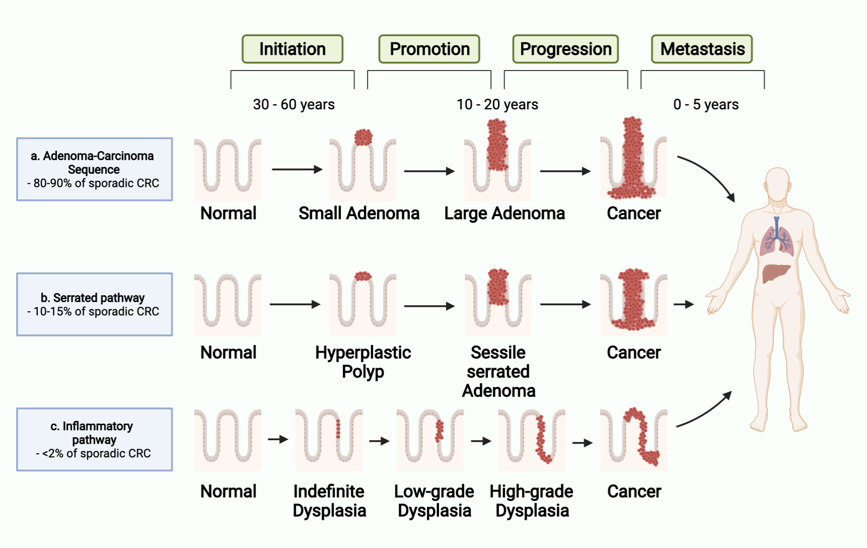
Figure 1. Colorectal Carcinogenesis Pathways
Four stages of colorectal carcinogenesis: Initiation, Promotion, Progression, and Metastasis. Each stage takes several years and several decades are required for all stages to be processed. Three distinctive pathways of colorectal cancer (CRC) development.
a. Adenoma-Carcinoma Sequence accounts for 80-90% of sporadic CRC. This pathway is a canonical pathway that normal colonocytes develop to small adenoma, to large adenoma, and to cancer. b. Serrated pathway accounts for 10-15% of sporadic CRC. In this pathway, normal colonocytes develop to hyperplastic polyp, to sessile serrated adenoma, and to cancer. c. Inflammatory pathway accounts for less than 2% of sporadic CRC. Chronic inflammation causes normal cells to develop indefinite dysplasia, to low-grade dysplasia, to high-grade dysplasia, and to cancer.

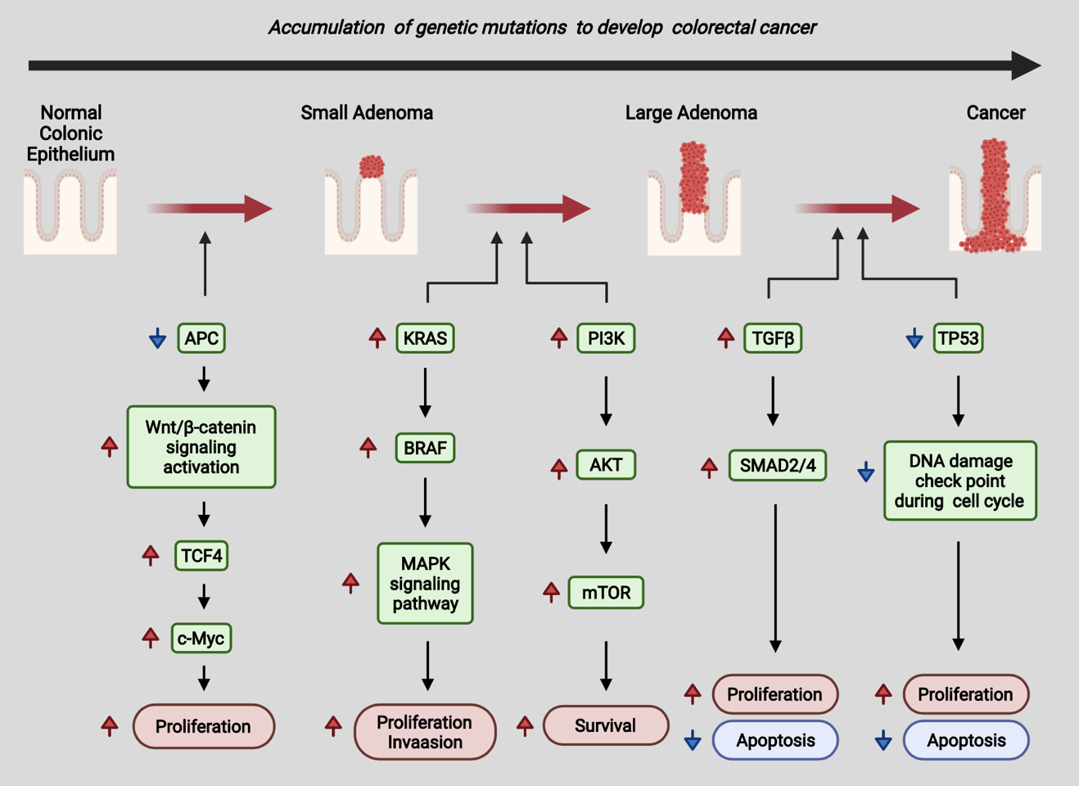
Figure 2. The process of genetic alteration in colorectal cancer development

The associated signaling pathways and following histological phenotype changes. At the beginning of CRC development, mutation of the tumor suppressor APC gene triggers the adenomatous process. Next, activation of KRAS and PI3K promote adenoma growth and proliferation. The activation of TGF-β phosphorylates SMAD2/4, where promotes proliferation and reduces apoptosis. The absence of TP53 increases proliferation and decreases apoptosis by loss of DNA damage checkpoint during the cell cycle.

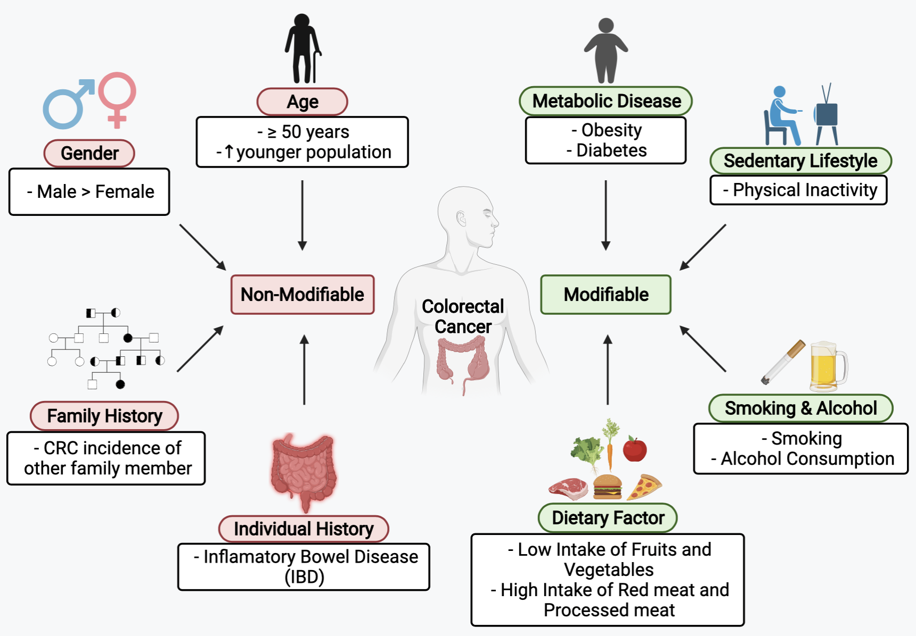
Figure 3. Risk factors of colorectal cancer
The risk factors of colorectal cancer (CRC) are categorized with non-modifiable factors (age, gender, family history, and individual history) and modifiable factors (metabolic disease, sedentary lifestyle, smoking and alcohol consumption, and dietary factors.

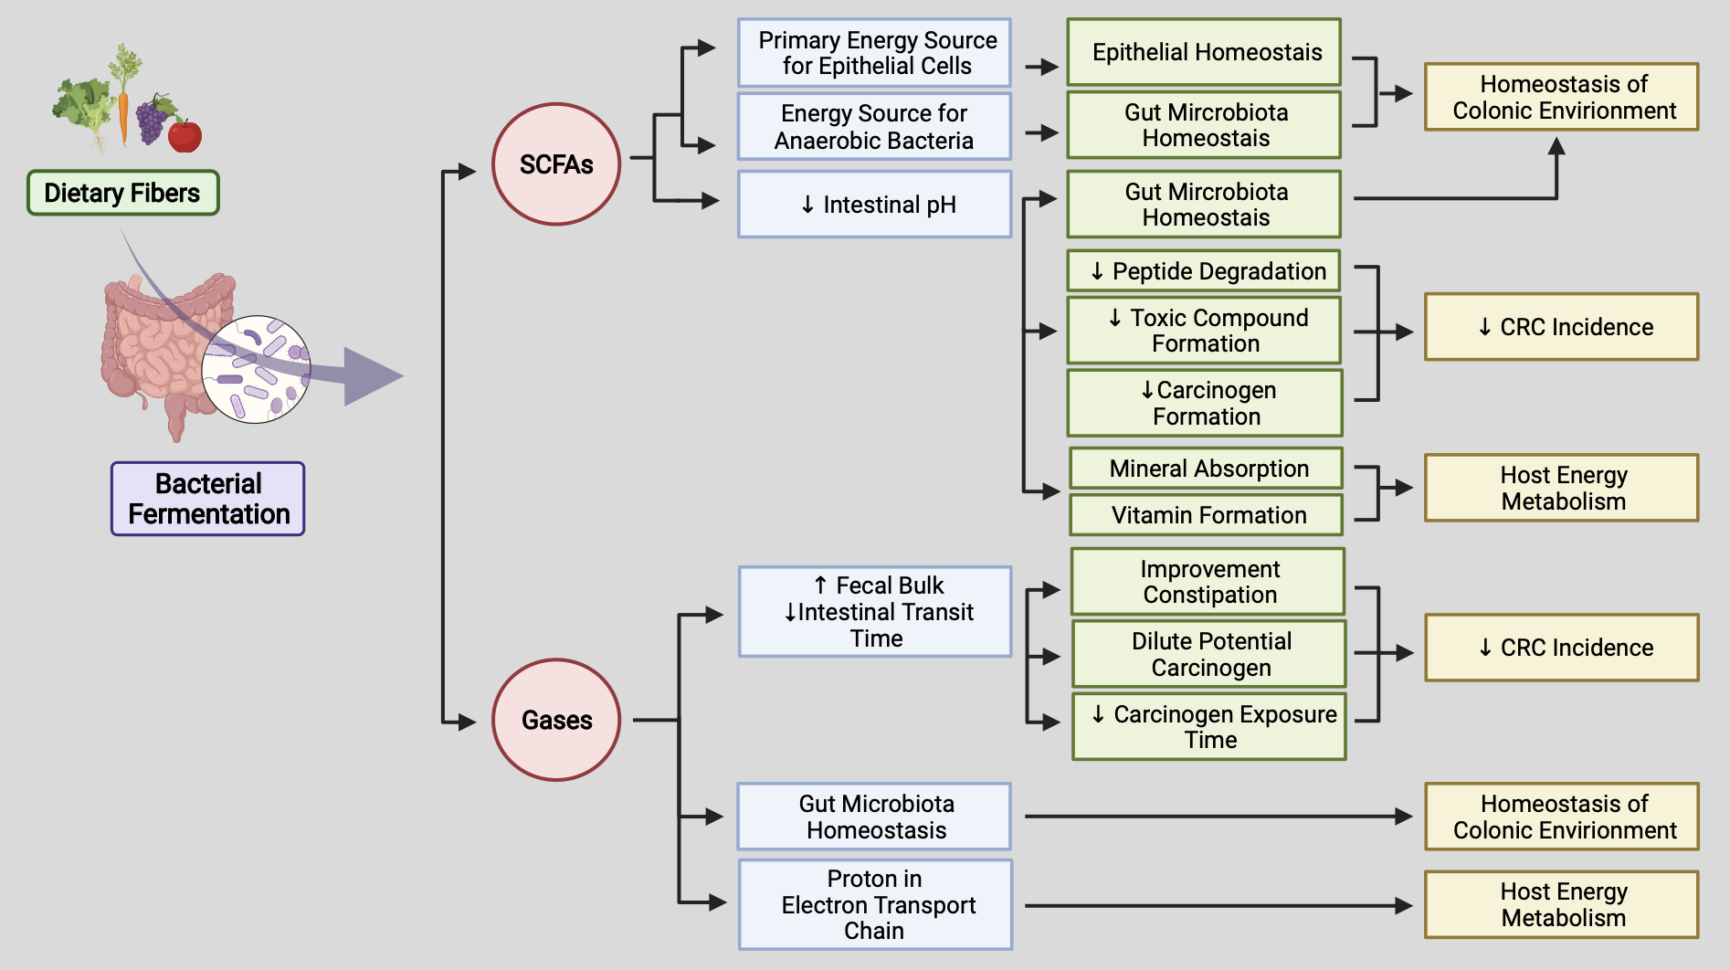
Figure 4. The physiological benefits of the metabolites derived from bacterial fermentation and their underlying mechanism
Dietary fiber is fermented by gut microbiota producing various physiological beneficial metabolites. SCFAs and gases, bacterial-derived metabolites, maintain colonic health, gut microbiota homeostasis, and host energy metabolism. short-chain fatty acids, SCFAs; colorectal cancer, CRC.

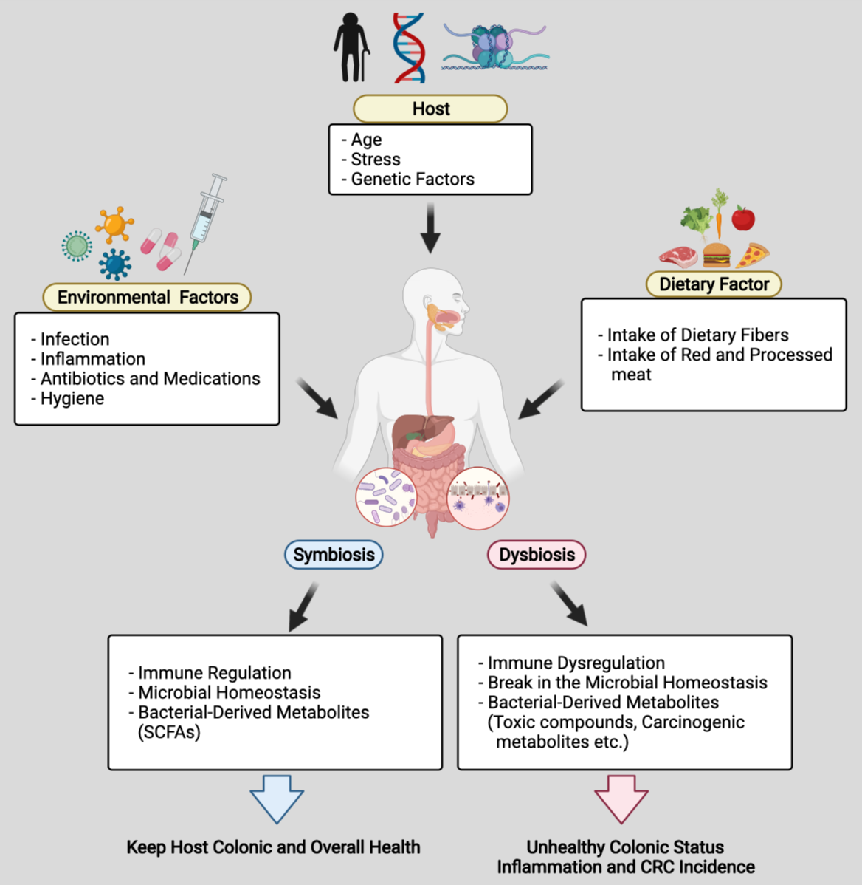
Figure 5. Effects of host, diet, and environmental factors on the composition of gut microbiota and its impacts of the colonic health
Several factors impact on the homeostasis of gut microbiota in the gastrointestinal (GI) tract. The factors of the host (age, stress, genetic), environmental factors (infection, inflammation, antibiotics and medications, and hygiene), and dietary factors (dietary fibers and red and processed meat) can affect to the homeostasis of gut microbiota composition and their outcomes (bacterial fermented metabolites). Dysbiosis of gut microbiota can cause immune dysregulation and produce toxic compound and the potential carcinogenic molecules leading to unhealthy colon status (inflammation and CRC incidence). short-chain fatty acids, SCFAs; colorectal cancer, CRC.

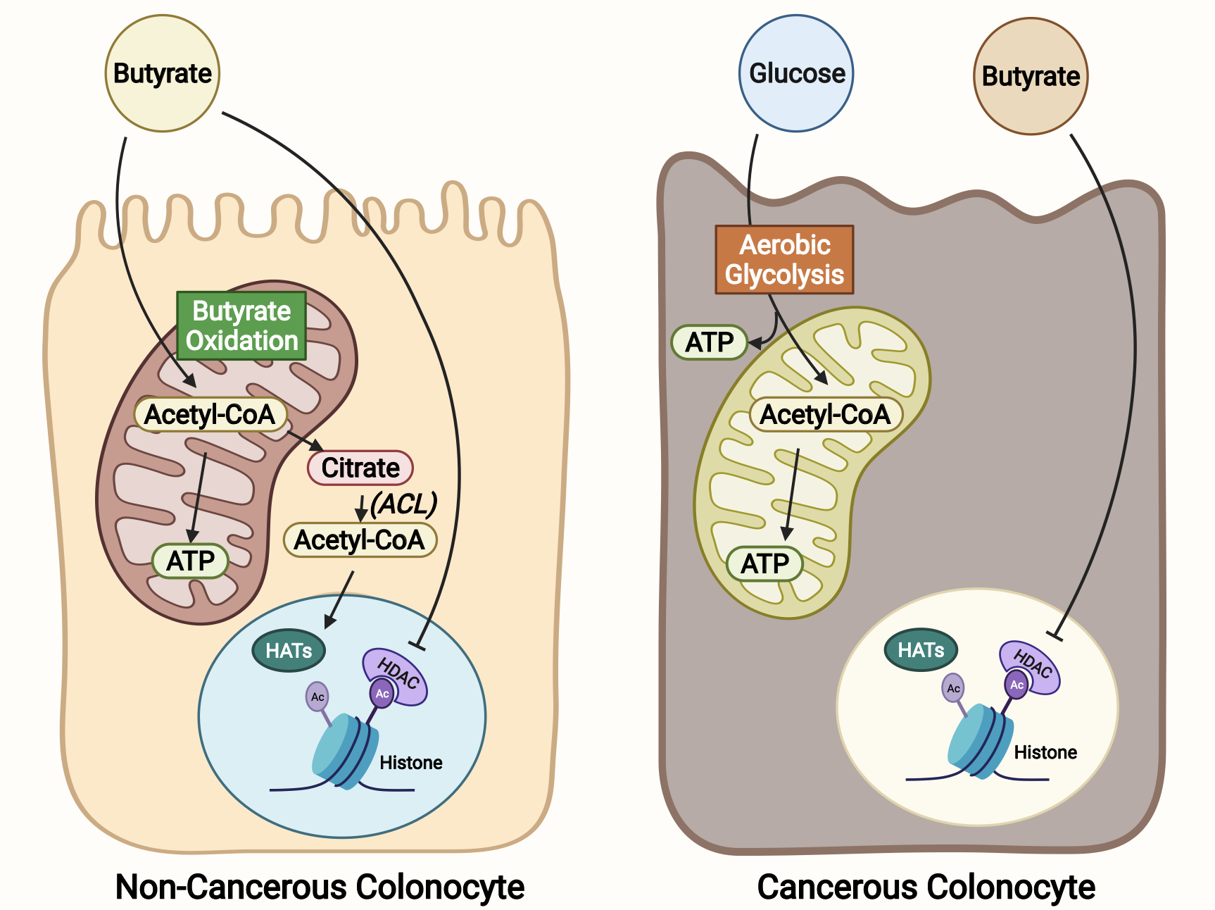
Figure 6. The different metabolism between normal colonocyte and cancerous colonocyte
Butyrate is utilized as a primary energy source in non-cancerous colonocytes by the mitochondrial β-oxidation. In contrast, cancerous colonocytes prefer to use glucose than butyrate as an energy source due to the Warburg effect resulting in butyrate accumulation in the nucleus. ATP-citrate lyase, ACL; histone acetyltransferases, HATs; histone deacetylase, HDACs; adenosine triphosphate, ATP.

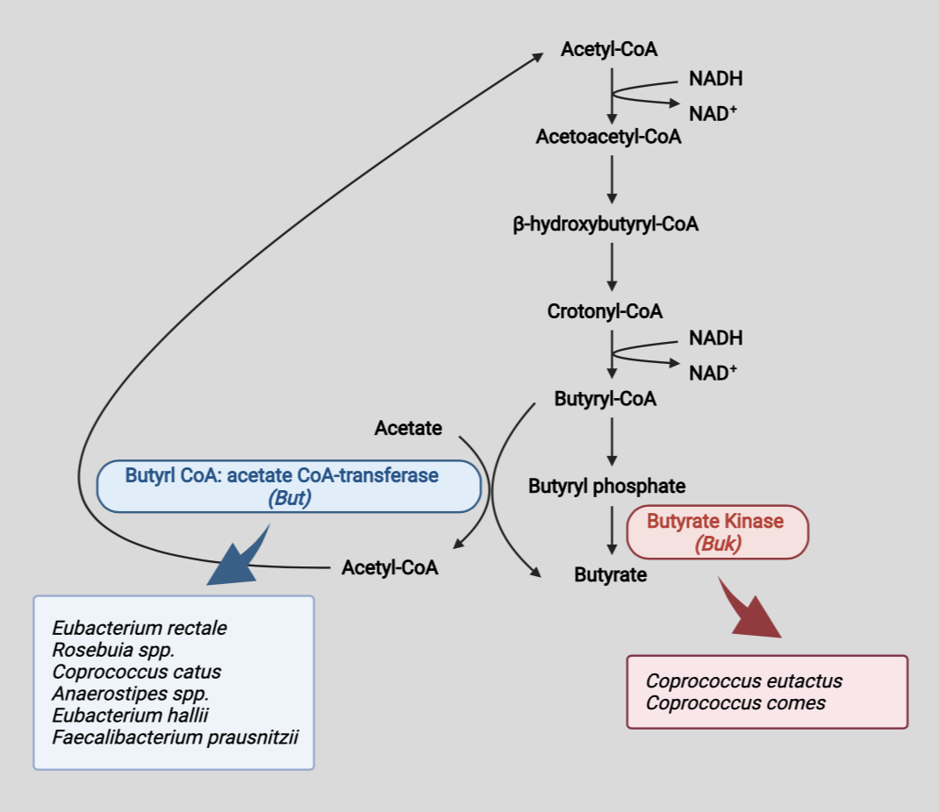
Figure 7. The butyrate synthesis pathways and the related butyrate-producing bacteria
Several bacteria produce butyrate in the gastrointestinal (GI) tract. Two final enzymes, butyrate-CoA: acetate CoA-transferase (but) and butyrate kinase (buk), are alternatively utilized for the butyrate synthesis. Butyrate-producing bacteria can be categorized into two groups according to the enzymes that they use at the end of the pathway, either butyrate-CoA: acetate CoA-transferase (but) or butyrate kinase (buk).

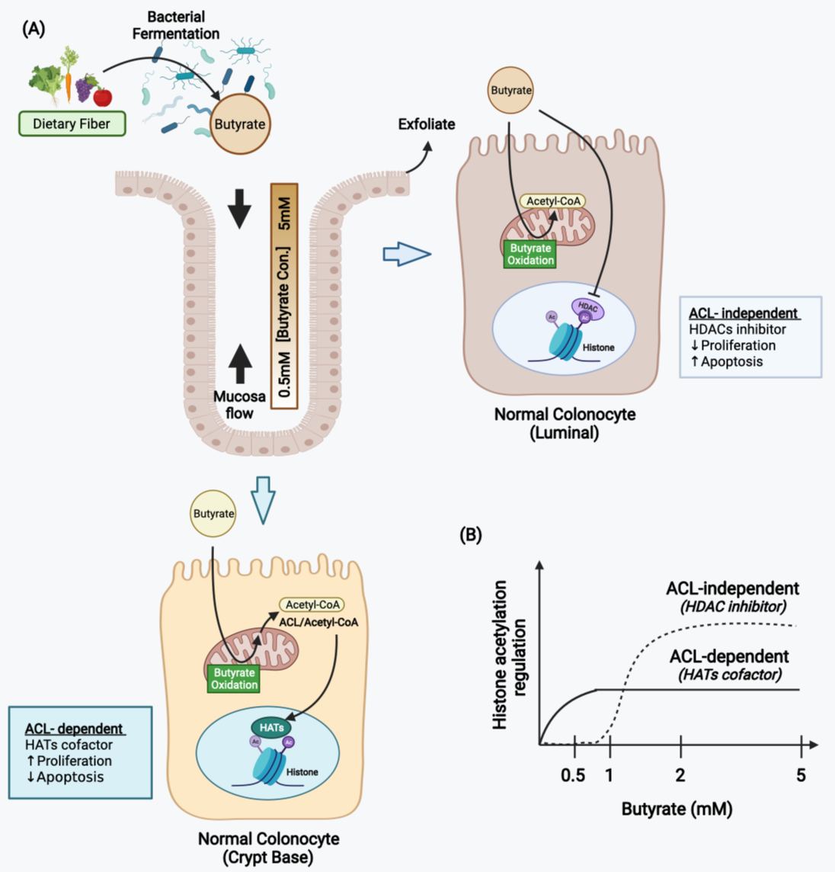
Figure 8. Butyrate increases histone acetylation by two distinct mechanisms.
(A) Gradient concentration of butyrate through the crypts due to the mucosa flow, which is relates to the butyrate mechanisms in histone acetylation. The higher concentration of butyrate near the colonic lumen decreases cell proliferation and increases apoptosis as HDAC inhibitor (ACL-independent mechanism) for the exfoliation. In contrast, the lower concentration of butyrate near the crypt base is metabolized by mitochondrial oxidation and produce Acetyl-CoA, which can be used as a cofactor for HATs (ACL-dependent mechanism). This mechanism increases cell proliferation and decreases apoptosis to maintain colonic crypt homeostasis. (B) Two distinct mechanisms of butyrate in histone acetylation depends on its concentration. At a low level of butyrate (0.5-1mM) in colonocytes, butyrate selects ACL-dependent mechanism by stimulating HATs. In contrast, at a high level of butyrate (2-5mM), butyrate oxidation is saturated and the unmetabolized butyrate selects ACL-independent mechanism by inhibiting HDACs. ATP-citrate lyase, ACL; histone-acetyltransferases, HATs; histone deacetylases, HDACs.
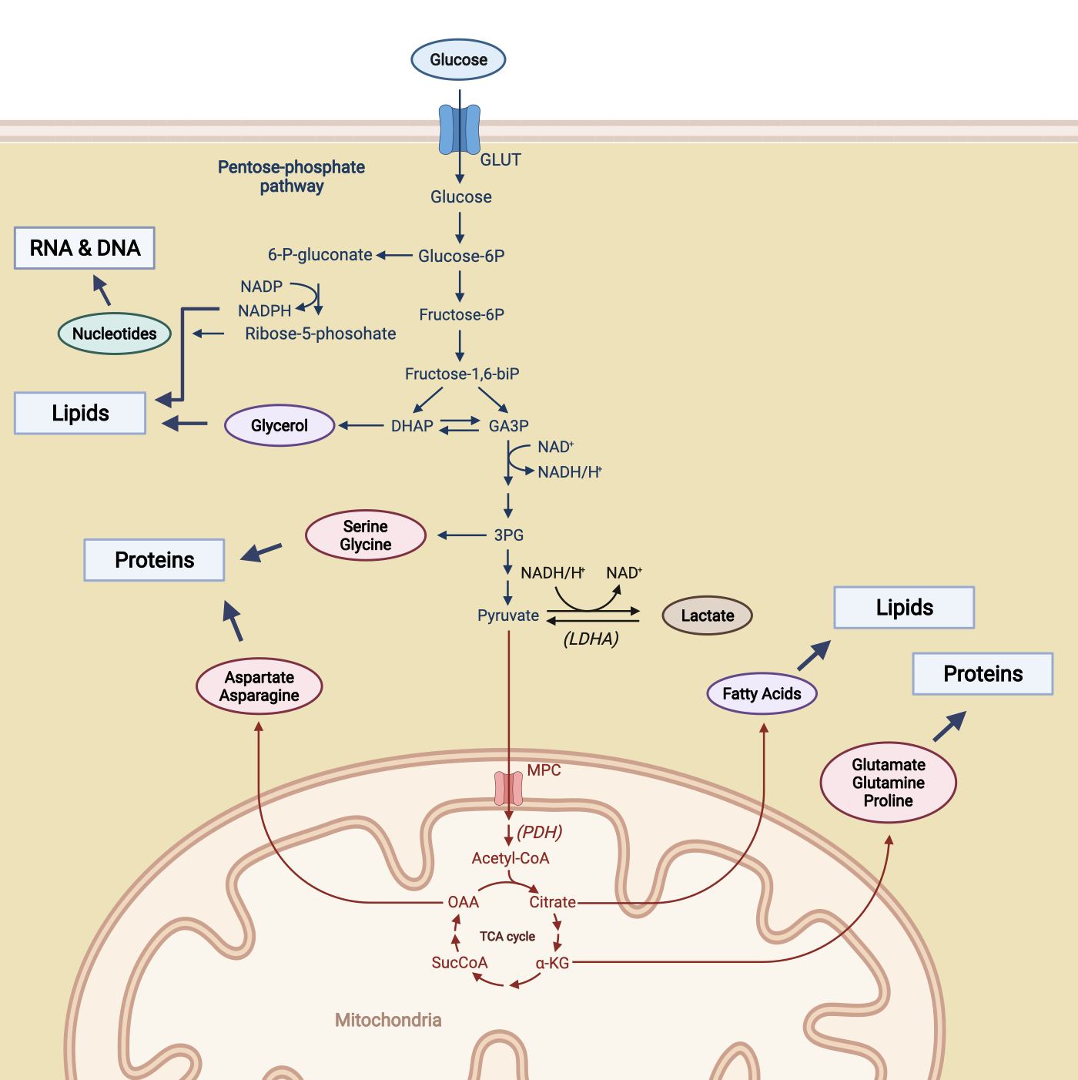
Figure 9. Biosynthetic intermediates by the metabolic shift in cancer cells
Cancer cells get lots of biosynthetic substrates from the increased glycolysis for the rapid cell proliferation. The pentose phosphate pathway generates nucleotides for RNA and DNA synthesis. NADPH from the pentose phosphate pathway, glycerol from DHAP, and fatty acids from citrate of TCA cycle can be used for lipid synthesis. Serine and glycine from 3PG, aspartate and asparagine from OAA, and glutamate, glutamine, and proline from α-KG can be utilized for protein synthesis. nicotinamide adenine dinucleotide phosphate, NADP; ribonucleic acid, RNA; deoxyribonucleic acid, DNA; lactate dehydrogenase A, LDHA; pyruvate dehydrogenase, PDH; tricarboxylic acid, TCA; oxaloacetate, OAA; α-ketoglutarate, α-KG

CHAPTER 2
Pyruvate Kinase M1 Regulates Butyrate Metabolism in Cancerous Colonocytes

Pyruvate Kinase M1 Regulates Butyrate Metabolism in Cancerous Colonocytes

Bohye Park¹, Ji Yeon Kim¹, Olivia F. Riffey², Presley Dowker¹, Antje Bruckbauer⁵, James McLoughlin⁵, Ahmed Bettaieb^{1,3,4}, and Dallas R. Donohoe^{1, 2,*}

¹Department of Nutrition, University of Tennessee, Knoxville, TN 37996, USA
²Department of Microbiology, University of Tennessee, Knoxville, TN 37996, USA
³Graduate School of Genome Science and Technology, University of Tennessee, Knoxville, TN 37996, USA
⁴Department of Biochemistry, Cellular and Molecular Biology, University of Tennessee, Knoxville, TN 37996, USA
⁵University of Tennessee Medical Center Biorepository, Knoxville, TN 37920, USA
*Correspondence: Dallas R. Donohoe, Ph.D.

1215 W. Cumberland Ave. Knoxville, TN 37996
Office – (865) 974-6238; ddonohoe@utk.edu

Running title: PKM1 Regulates Butyrate Oxidation
Key words:

- Butyrate
- PKM1
- β-oxidation
- Glycolysis
- HIF-1alpha

Total Number of Figures – 8 and 2 Supplemental Figures

2.1. Abstract
Colorectal cancer (CRC) cells shift metabolism toward aerobic glycolysis and away from using oxidative substrates such as butyrate. Pyruvate kinase M1/2 (PKM) is an enzyme that catalyzes the last step in glycolysis, which converts phosphoenolpyruvate to pyruvate. M1 and M2 are alternatively spliced isoforms of the Pkm gene. The PKM1 isoform promotes oxidative metabolism, whereas PKM2 enhances aerobic glycolysis. We hypothesize that the PKM isoforms are involved in the shift away from butyrate oxidation towards glycolysis in CRC cells. Here, we find that PKM2 is increased and PKM1 is decreased in human colorectal carcinomas as compared to non-cancerous tissue. To test whether PKM1/2 alter colonocyte metabolism, we created a knockdown of PKM2 and PKM1 in CRC cells to analyze how butyrate oxidation and glycolysis would be impacted. We report that butyrate oxidation in CRC cells is regulated by PKM1 levels, not PKM2. Decreased butyrate oxidation observed through knockdown of PKM1 and PKM2 is rescued through re-addition of PKM1. Diminished PKM1 lowered mitochondrial basal respiration and decreased mitochondrial spare capacity. We demonstrate that PKM1 suppresses glycolysis and inhibits hypoxia-inducible factor-1 alpha. These data suggest that reduced PKM1 is, in part, responsible for increased glycolysis and diminished butyrate oxidation in CRC cells.

2.2. Introduction
Colorectal cancer (CRC) is the second leading cause of cancer deaths in the United States (Siegel et al., 2020). Cancer cells primarily undergo rapid glycolysis instead of oxidative metabolism, and this metabolic shift is associated with several critical genetic modifications (Vander Heiden et al., 2009). Specifically, colorectal cancer cells increase glycolysis and decrease the oxidation of butyrate (Andriamihaja, Chaumontet, Tome, & Blachier, 2009; Donohoe, Collins, et al., 2012). Butyrate is a short-chain fatty acid (SCFA) that is a bacterial-derived product from the fermentation of dietary fiber (Hamer et al., 2008). Normal colonocytes use butyrate as their primary energy source (Fleming et al., 1991; Roediger, 1982). In contrast, cancerous colonocytes prefer to utilize glucose, and there is a concomitant diminishment in butyrate oxidation (Donohoe, Collins, et al., 2012; Donohoe et al., 2013). The metabolic shift toward increased glucose utilization is caused by an upregulation of enzymes that promote glycolysis in CRC (La Vecchia & Sebastián, 2020). Therefore, it is important to understand the mechanisms that contribute to the metabolic shift away from butyrate oxidation toward glycolysis in the cancerous colonocyte.
Much effort has been put forth to identify and characterize the genetic and environmental factors that influence the development of CRC. The isoform of the metabolic enzyme pyruvate kinase called PKM2 has been repeatedly identified in clinical studies as being upregulated in colorectal cancer biopsies (Cruz et al., 2017; Kress et al., 1998; Radeva et al., 2008; Taniguchi, Ito, et al., 2015; Yeh et al., 2008; Zhou et al., 2012). PKM2 is one of four isoforms (PKL, PKR, and PKM1 are the others) that catalyze the final step in glycolysis, where phosphoenolpyruvate is converted to pyruvate, and ATP is formed (Jurica et al., 1998). Importantly, each isoform has different enzyme kinetics and a distinct function. PKM2 and PKM1 are both expressed in the colon, however, PKM1 is generally associated with differentiated colonocytes to promote oxidative metabolism and PKM2 is associated with proliferating and colorectal cancer cells to enhance aerobic glycolysis (Christofk, Vander Heiden, Harris, et al., 2008; Christofk, Vander Heiden, Wu, et al., 2008). Studies have found that elevated PKM2 expression in human cancers, including CRC, is associated with a poor prognosis and outcome in patients (Cui & Shi, 2015). This increase in PKM2 is so apparent that PKM2 has even been coined as a potential CRC biomarker (Cui & Shi, 2015; Radeva et al., 2008; Yeh et al., 2008). Nevertheless, the importance of PKM2 in the development and progression of CRC is unclear. However, given its place in the glycolytic pathway, a metabolic role seems plausible.
In this study, experiments were conducted to distinguish the role of two different pyruvate kinase isoforms in CRC cell metabolism. There was a particular emphasis toward characterizing the mechanism by which PKM1/2 alters butyrate metabolism in the cancerous colonocyte. Similar to other studies, we report that PKM2 is upregulated in CRC patient biopsies compared to the normal colon tissues. In addition, we also find that PKM1 expression was significantly diminished in CRC samples, suggesting a potential role of this isoform. Towards this end, we show that PKM1, rather than PKM2, regulates butyrate oxidation in CRC cells. We further demonstrate that diminished PKM1 causes the cell to shunt metabolism toward glycolysis away from butyrate oxidation. This shift in metabolism is mediated through elevated hypoxia-inducible factor 1 alpha (HIF1α), a transcription factor that promotes glycolysis. Moreover, short-chain acyl dehydrogenase (SCAD), a necessary enzyme in the oxidation of butyrate, decreased as HIF1α increased in CRC cells. Therefore, diminished PKM1 expression along with upregulated HIF1α and downregulated SCAD is a key mechanism responsible for the metabolic shift in CRC cells.

2.3. Materials and Methods

Cell Culture and shRNA Transfection
The human colon cancer cell line HCT116 (ATCC, CCL-247) was grown in DMEM supplemented with 25mM glucose and 10% FBS. PKM1 and PKM2 silencing in HCT116 was achieved using five different hairpins (GeneCopoeia, Inc.; Rockville, MD). Lentivirus packaging system (GeneCopoeia) was used to generate the shRNA-containing lentivirus particles in HEK293FT cells (GeneCopoeia) following the manufacturer’s guidelines and then used to infect HCT116. Two scrambled non-silencing shRNA were used as controls. Cells were selected using puromycin (2 μg/ml). For PKM1 and PKM2 overexpression, colorectal cells were infected with EX-Lv244-mCherry-PKM1 or EX-Lv122-eGFP-PKM2 lentiviruses (GeneCopoeia) respectively, selected using a combination of puromycin (2 μg/ml) and hygromycin (200 μg/ml), and propagated.

Flux Experiments
To measure butyrate oxidation and mitochondrial function, Seahorse XF²⁴ Analyzer (Seahorse Bioscience) was used. All Seahorse assay experiments were conducted following the manufacturer's guidelines. The % change of the oxygen consumption rates (OCR) after butyrate injection was measured. Cells were seeded at 4.5x10⁵/well in XF²⁴ cell culture microplates (Agilent Technologies, 100850). One hour before measurement, the culture medium was replaced with 1x Krebs-Henseleit Buffer (KHB) (5mM glucose and 500 μM carnitine) for the butyrate oxidation analysis and with Seahorse XF DMEM medium (5mM glucose, 2mM glutamine, and 1mM pyruvate) for the mitochondrial function test, and the cell plate was incubated in a non-CO₂ incubator at 37 °C for 1hr. All Seahorse experiments were run with identical conditions (unless otherwise noted). Briefly, for the butyrate oxidation analysis, 1x KHB media or sodium butyrate (Sigma, B5887) at 5mM final concentration were injected, and the change in OCR was measured from baseline (%OCR). Next, 2-deoxyglucose (2DG) 50mM (Sigma, D8375) was injected to competitively inhibit glucose utilization and leave butyrate as the only exogenous energy substrate. Finally, 10% sodium azide was injected to block mitochondrial respiration by inhibiting complex IV. For the mitochondrial function test, 1x KHB media or sodium butyrate (Sigma, B5887) at 5mM final concentration were treated 15 mins before measurement. Then, Oligomycin 1μM (Alfa Aesar, AAJ61898MA) was injected into the wells to inhibit ATP synthase (complex V) following basal measurement. Next, Carbonyl cyanide-4 (trifluoromethoxy) phenylhydrazone (FCCP) 10μM (Cayman Chemical, NC0904863), which is an uncoupling agent that collapses the proton gradient and disrupts the mitochondrial membrane potential, was injected into the wells. At last, a mixture of rotenone 1μM (Enzo Life Science, 03-1755), a complex I inhibitor, and antimycin A 1μM (Sigma Aldrich, A8674), a complex III inhibitor were injected into the wells to shut down mitochondrial respiration and calculate the nonmitochondrial respiration. After the measurements, cells were lysed with 1x RIPA buffer (Cell Signaling, 9806s), and proteins were quantified using Pierce BCA Protein Assay Kit (Thermo Fisher, PI23228) for normalization.

Western Blot Analysis
Proteins from cell lines were extracted with 1x RIPA buffer (Cell Signaling, 9806s), 1mM PMSF (Cell Signaling, 8553), 0.5M EDTA Solution (Thermo Scientific, R1021), and HaltTM Phosphatase Inhibitor Cocktail (Thermo Scientific, PI87786). Samples were spun in a centrifuge at 13,000 x g for 10 mins at 4°C, and protein supernatant was transferred to a new 1.5 ml Eppendorf tube. Protein concentrations were determined by Pierce BCA Protein Assay Kit (Thermo Fisher, PI23228). Proteins were separated on 8 and 10% SDS-polyacrylamide gels and transferred onto the PVDF membrane. Membranes were incubated on a rotator in 5% BSA in 1x TBST (0.1%) for 1hr at room temperature (RT). Blocked membranes were incubated overnight at 4°C with the respective primary antibodies on a rotator. Antibodies that were used included PKM1 (Cell Signaling, 7067), PKM2 (Cell Signaling, 4053s), HIF1-α (Cell Signaling, 3716s), SCAD (Abcam, ab154823), AMPKα (Cell Signaling, 5831), phosphor-AMPKα (Thr172) (Cell Signaling, 2535), PDH (Cell Signaling, 3205), phosphor-PDHA1 (Abcam, ab92696), and ß-actin (Cell Signaling, 3700). Blots were washed 3 times for 10 min/wash in 1 x TBST (0.1%) at RT and incubated with fluorescent secondary antibody for 2hr on rotator at RT following 3 times for 10 min/wash in 1x TBST (0.1%) at RT. Fluorescent detection or chemiluminescence detection of PVDF membrane was performed with the Odyssey Fc and bands were quantified with Image Studio Software (LI-COR Biosciences, Lincoln, NE).

Immunofluorescence staining
The clinical samples were obtained from the University of Tennessee Medical Center Biobank with IRB# 4044. Human normal and tumor colon tissues were fixed with neutral buffered 10% formalin for 24-36 hours, dehydrated with 70% to 100% ethanol and processed for the production of 4-μm paraffine sections. (UTMC) Formalin-fixed paraffin-embedded tissue sections were deparaffinized and rehydrated with xylene, ethanol, and PBS. The rehydrated sections were blocked with 1% BSA and 5% Horse serum in PBS for 1hr at room temperature (RT), and stained with PKM1 (Cell Signaling, 7067) and PKM2 (Cell Signaling, 4053s) primary antibodies overnight at 4°C. Tissue sections were washed in PBS, incubated with donkey anti-mouse IgG (H+L) Texas Red secondary antibodies at RT for 1h, and mounted with Prolong Gold Antifade Mountant with DAPI (Thermo Scientific, P36931) and coverslips. Tissues were analyzed with LEICA DMi8 microscope equipped with FITC, DAPI, Texas Red, and EMP_BF filters. All images were acquired with the same exposure and focal plane. Integrated density (total fluorescent) per cell was quantified by the Image J (Bethesda, MD) program.

Statistical Analysis
For seahorse experiments, western blotting, and immunofluorescence, ANOVA was used to test for differences between experimental groups followed by a Tukey post-hoc test. All data are expressed as mean $±$ SEM.

2.4. Results
PKM2 expression is increased in colorectal cancer
Several groups have reported that PKM2 is elevated in colorectal cancer samples (Christofk, Vander Heiden, Harris, et al., 2008; Cruz et al., 2017; Cui & Shi, 2015). However, it is unclear whether this increase in PKM2 plays any role in disease progression or outcome. In collaboration with the University of Tennessee Medical Center Biobank, we obtained clinical samples of colorectal cancer tissue and adjacent non-cancerous colon tissue. We performed immunofluorescence staining on these samples to compare the different PKM isoforms in cancerous and non-cancerous colorectal tissue. PKM2 expression was found to be increased in colorectal carcinomas as opposed to PKM1, which was decreased when compared to adjacent non-cancerous tissue (Figure 10A). In CRC tissues, PKM1 was barely detectable and showed a significant diminishment in colorectal carcinomas (Figure 10B). These data suggest that the PKM isoforms are differentially expressed in colorectal cancer and may allude to the functional or metabolic importance of these proteins in the disease.

Targeting of PKM2 in colorectal cancer cells and its role in butyrate oxidation
To study the role of PKM2 in colorectal cancer cells, we targeted PKM2 with shRNA and attempted to generate a stable knockdown cell line. Derived from the parental HCT116 colon carcinoma cell line, we isolated three clones (C4, C5, and C6) and analyzed the knockdown of PKM2 by western blot. As shown in Figure 11A, PKM2 was barely detected in clone 4 (C4) and clone 5 (C5) and was diminished in clone 6 (C6) compared to the parental HCT116 and scrambled mock cell lines. In addition, we found that PKM1 expression in the clones differed (Figure 11A). This was most apparent in C4, where PKM1 expression was almost abolished, and C5, which showed overexpression of PKM1 compared to scrambled and HCT116 cells. We are not sure how or why this happened; however, these clones provide us an opportunity to study the role of PKM1 and PKM2 in colorectal cancer cell metabolism. So, we checked the expression of Polypyrimidine tract-binding protein 1 (PTBP1), which is one of the PKM splicer genes promoting PKM2 expression (Calabretta et al., 2016; X. He et al., 2014; Hwang et al., 2017; Xie et al., 2019). Dysregulation of microRNA (miRNA) causes increased PTBP1 and PKM2 during carcinogenesis (Van Roosbroeck & Calin, 2017). In addition, PTBP1 is negatively regulated by tissue-specific miRNA (Taniguchi, Uchiyama, & Akao, 2021). Specifically, reduced miRNA, MIR1-3p, MIR124-3p, and MIR133b, has been observed in CRC (Sugiyama et al., 2016; Taniguchi et al., 2016; Taniguchi, Sugito, et al., 2015; Taniguchi et al., 2021). In different PKM2 knocked down cones, we find that the level of PTBP1 is decreased in scrambled and C4, whereas PTBP1 in C5 is significantly increased (Figure 18). Furthermore, we verified whether the knockdown or expression patterns of PKM1/PKM2 are maintained in each clone through several passages (Figure 19). No experiments used the generated cell lines past passage 3.
Since bacterial-derived butyrate is an energetic substrate for colonocytes, and cancerous colonocytes have been reported to show diminished oxidation of butyrate, we decided to examine changes in butyrate oxidation in C4 and C5. The Seahorse XFe24 Extracellular Flux Analyzer, which is an instrument that measures oxidative (oxygen consumption) and non-oxidative (glycolysis or lactate production) metabolism in cells was utilized to analyze butyrate oxidation in actively respiring cells (Andriamihaja et al., 2009; Gerencser et al., 2009; Ho et al., 2012). Data acquired with this instrument showed that butyrate oxidation was enhanced in C5 cells as compared to the cell line expressing the scrambled mock shRNA (Figure 11B). This was in line with diminished PKM2 expression leading to an increase in butyrate oxidation. However, when we tested C4, we found that butyrate oxidation was significantly diminished in this clone compared to the scramble control cells (Figure 11C). Importantly, C4 cells were able to oxidize butyrate, however, to a lower level than scrambled cells. Subsequently, C4 and C5 both have reduced PKM2, to a similar extent, therefore these data suggest that PKM2 diminishment is not the key factor in regulating the oxidation of butyrate. Instead, PKM1, which was overexpressed in C5, and almost abolished in C4, was the more likely factor in explaining these opposing results.

Rescue with PKM1 in C4 restores butyrate oxidation
To test whether PKM1 is the factor regulating differential butyrate oxidation in these colorectal cancer cells, we re-expressed PKM1 in C4 cells to observe whether this rescued the oxidation of butyrate to a level comparable to scrambled control cells. In addition, we re-expressed only PKM2 in C4 cells to analyze how that would affect butyrate oxidation. In the C4 cells, PKM1 (M1R) or PKM2 (M2R) protein was increased as compared to C4 non-rescue cells (Figure 12A). In the M1 rescue (M1R) cells, we found that the oxidation of butyrate was significantly increased compared to C4 non-rescue cells (Figure 12B). However, expressing PKM2 in C4 cells (M2R) showed no change in butyrate oxidation compared to C4 non-rescue cells (Figure 12C). Taken together, these data suggested that PKM1 is largely responsible for regulating butyrate oxidation. However, these data do not preclude a role for PKM2 in the process, but rather point to PKM1 as having the biggest impact on butyrate oxidation in these CRC cells. Furthermore, we confirmed the role of PKM1 in butyrate oxidation using the HEK293 (human embryonic kidney) cell line, which expresses PKM2, but not PKM1 (Prakasam et al., 2017). To test whether PKM1 is the major factor regulating butyrate oxidation, we transfected PKM1 (M1R) in the HEK293 cell line, and PKM1 was stably expressed in clone 2 (C2) cells (Figure 20A). In the C2 HEK293 cell line that expressed PKM1, we found that the butyrate oxidation was significantly increased compared to scramble HEK293 cells (Figure 20B). These data further support the role of PKM1 promoting butyrate oxidation and show that PKM1 also has this effect in a non-cancerous or colorectal cell line.
To test whether mitochondrial function, in regard to response to butyrate, is altered in C4 cells, we used oligomycin and FCCP to measure how scrambled control and C4 cells would respond. Oligomycin is an inhibitor of ATP synthase that reduces ATP-linked oxygen consumption, while FCCP is an uncoupling agent used to show the maximal respiratory capacity. After injection of FCCP, butyrate caused an increased electron transport chain (ETC) accelerator response in scramble control cells (Figure 13A). However, C4 cells, which show a large diminishment in PKM2 and PKM1, did not show this same response. The C4 cells also showed no response to butyrate in regard to basal respiration. This diminishment in ETC accelerator response and basal respiration was rescued by re-addition of PKM1 in M1R cells (Figure 13B). Also, to test whether PKM2 re-addition affects mitochondrial function response to butyrate, we compared C4 cells and M2R cells. Here, we found that the diminishment in ETC accelerator response and basal respiration in C4 was not rescued by re-addition of PKM2 in M2R cells (Figure 21). Thus, these data show that PKM1 is responsible for the differences in mitochondrial function and an overall diminishment in basal respiration in C4 cells as compared to scrambled control cells that are rescued by PKM1 re-expression.

Molecular Consequences of diminished PKM1 and PKM2
Since C4 cells had decreased basal respiration, we next sought to test whether they also showed an increase in the phosphorylation of AMPK (Thr172) as a proxy of energetic stress. As expected, C4 cells showed an elevation in phospho-AMPK compared to parental HCT116 and scrambled control cells (Figure 14A). Re-expression of PKM1 in M1R cells diminished this activation of phospho-AMPK. Despite this activation of AMPK, one of many downstream targets, ACC, did not show elevated phosphorylation (Figure 22).
C4 cells that also showed a significant diminishment in PKM1 and PKM2 displayed a decrease in oxidation of butyrate, which may result in the cells shunting metabolism toward glycolysis. In such a case, the pyruvate dehydrogenase complex (PDH) becomes inactivated through the phosphorylation of the E1 complex member. Towards this end, C4 cells exhibited an increase in phospho-PDH as compared to parental HCT116 cells and scrambled control cells. However, this increase in phospho-PDH was blocked in M1R cells (Figure 14B). This suggested that the loss of PKM1 decreases oxidative metabolism of glucose and promotes glycolysis.

Loss of PKM1 induces HIF-1alpha that decreases short-chain acyl dehydrogenase
Hypoxia-inducible factor 1 alpha (HIF1α) is a transcription factor that promotes glycolysis in cells. Consistent with C4 cells attempting to upregulate glycolysis, HIF1α is increased. However, re-expression of PKM1 in M1R cells reduced HIF1α back to scrambled control cell levels (Figure 15A). Based on these data and the role of pyruvate kinase in regulating the conversion of phosphoenolpyruvate (PEP) to pyruvate in the glycolytic pathway, we next sought to test whether HIF1α levels could also be reduced in C4 cells through the addition of pyruvate. Importantly, the DMEM media we use to grow the cells and in some of the experiments lacks pyruvate. The addition of pyruvate to the media decreased HIF1α in C4 cells as compared to scramble control cells (Figure 15B). This alludes to the lack of pyruvate through the diminishment of PKM1 in C4 cells as the primary factor in the upregulation of HIF1α. Concomitant with the increase in HIF1α observed in C4 cells, short-chain acyl dehydrogenase (SCAD) was found to be decreased. SCAD mediates butyrate oxidation, and therefore any diminishment in this enzyme would result in a decrease in butyrate oxidation. Re-expression of PKM1 in M1R cells increased SCAD levels (Figure 16C). SCAD is the first enzyme required for short-chain fatty acids (SCFAs), including butyrate, oxidation in the mitochondria (Bhala et al., 1995). Furthermore, when HCT116 cells were cultured under a hypoxic condition for 24 hours to induce HIF1α, we found that SCAD levels were significantly diminished (Figure 15D). These data suggested that loss of PKM1 in C4 cells resulted in the cells attempting to increase glycolysis, likely through diminished pyruvate levels, and a reduction in SCAD levels was observed in conjunction with the increase in HIF1α. An increase in HIF1α and a decrease in SCAD may underlie lower butyrate oxidation observed in C4 cells.

Knockout of HIF1α increases butyrate oxidation in colorectal cancer cells
To test whether HIF1α plays a role in regulating butyrate oxidation, we obtained a HIF1α knockout cell line (HIF1α -/-) (D. T. Dang et al., 2006), which was derived from a parental HCT116 cell line. HIF1α was indeed absent in this cell line (Figure 23). In line with HIF1α, suppressing oxidative metabolism, we found that knockout of HIF1α resulted in an increase in the oxidation of butyrate (Figure 16A). Moreover, CRC cells that lack HIF1α showed a diminishment in glycolysis as judged by the decreased extracellular acidification rate (ECAR) after the addition of glucose (Figure 16B). ECAR is used as an indirect measurement of lactate production, which is an indication of glycolysis. Taken together, these data allude to lower PKM1 levels in stabilizing HIF1α, which subsequently results in increased glycolysis and decreased butyrate oxidation in CRC cells.

2.5. Discussion
The data surrounding PKM2 and colorectal cancer (CRC) is controversial. Originally, studies seemed to show a role for PKM2 in promoting glycolysis and CRC (Sun et al., 2012; Yeh et al., 2008; Zhou et al., 2012). However, more recent studies have found either no role for PKM2 or the opposite result toward suppressing CRC (Y. Kim et al., 2019; Lau et al., 2017). In one study, loss of PKM2 in colonic stem cells increased colorectal tumorigenesis in an inflammation-associated colorectal tumor mouse model (Y. Kim et al., 2019). This would suggest that PKM2 has tumor suppressor activity as opposed to being a proto-oncogene. Compared to PKM2, little to nothing is known in regard to PKM1 as it relates to colorectal cancer. In a carcinogen-induced small lung cancer mouse model, PKM1 was reported to be the main important factor in tumor growth, development, and malignancy (Morita et al., 2018). The data presented here also support a role for PKM1, as opposed to PKM2, in colorectal cancer. However, in contrast to PKM1 promoting small lung cancer, our data suggest that PKM1 may play an inhibitory role in colorectal cancer as human carcinoma biopsies showed very little PKM1 compared to non-cancerous colorectal tissue.
Colorectal cancer cells that are significantly diminished in PKM1 and PKM2 continue to grow and proliferate, albeit slower than colorectal cancer cells that express both of these isoforms at full levels. As such, we found that these PKM1 and PKM2 deficient cells show a major shift in metabolism. Going into these experiments, it was expected that PKM2 was the major isoform promoting glycolysis, whereas PKM1 would promote oxidative metabolism. Thus, in initial experiments, where two CRC clone cell lines both lacked PKM2 (C4 and C5), the opposing results in terms of butyrate oxidation were surprising and provided the first hint that other factors besides PKM2 may be important for regulating cell metabolism in regard to butyrate oxidation. Importantly, PKM1 expression (C4 PKM1 was minimally detected by western blot, and C5 PKM1 was overexpressed) was significantly different among the clones. Thus, it became important to test whether butyrate oxidation could be rescued through re-expressing the PKM1 isoform in the C4 cells. In fact, the addition of PKM1 increased butyrate oxidation and provided evidence that it is an important player in the oxidation of butyrate in colorectal cancer cells. However, we cannot exclude the involvement of PKM2 in regulating butyrate oxidation, although PKM1 appears to have a much greater regulatory role in positively impacting this process. Moreover, it has been suggested that butyrate oxidation is decreased in colorectal cancer cells (Donohoe et al., 2011), which is in line with the diminished PKM1 expression in colorectal cancer biopsies. These results also support other studies defining a function of PKM1 toward regulating and promoting oxidative metabolism in cells (J. Han et al., 2021).
Regarding this role in regulating oxidative metabolism, PKM1, but not PKM2, has been reported to localize to the mitochondria in H1299 and A549 lung cancer cell lines (Prakasam et al., 2017). In addition, stable knockdown of the PKM1/2 isoforms activated AMPK in these cells, suggesting that loss of these isoforms results in energetic stress (Prakasam et al., 2017). In the colorectal cancer cells used in our study, it was determined that loss of both isoforms resulted in AMPK activation, which was rescued by the re-addition of PKM1. Since colorectal cancer cells deficient in PKM1 and PKM2 showed reduced butyrate oxidation that was PKM1 dependent, it was assumed that these cells would compensate, perhaps through increasing glycolysis.
Taken together, our data indicate that the diminishment of PKM1, rather than increased PKM2, is a key factor in the metabolic shift of CRC cells by reducing oxidative metabolism and promoting glycolysis. In our model, a diminishment in PKM1 is a mechanism to explain the metabolic shift in CRC cells (Fig. 8). A decrease in PKM1 causes an increase in HIF1α through reduced concentration of pyruvate, resulting in lower SCAD expression, and ultimately suppressing butyrate oxidation and promoting glycolysis.

Appendix

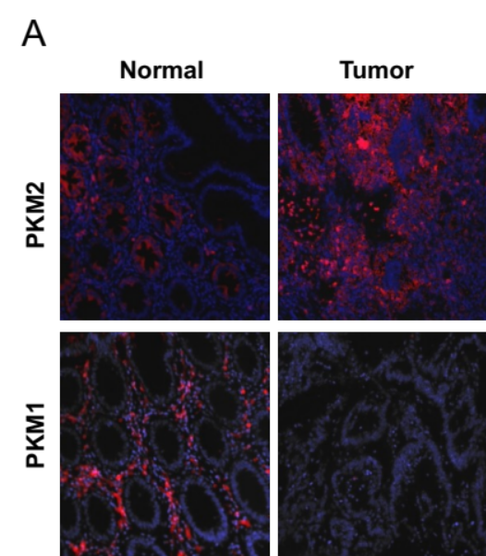
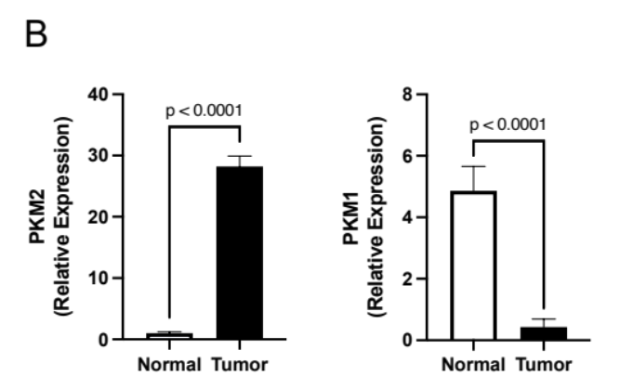

Figure 10. Expression of PKM isoform in human non-cancerous and cancerous colorectal tissues

(A) Immunofluorescence staining for PKM2 and PKM1 expression on non-cancerous colorectal tissue and colorectal cancer tissue (B) Quantification of immunofluorescence data with relative expression of PKM2 and PKM1 in each group. Error bars are mean ± SEM for ten independent sections.

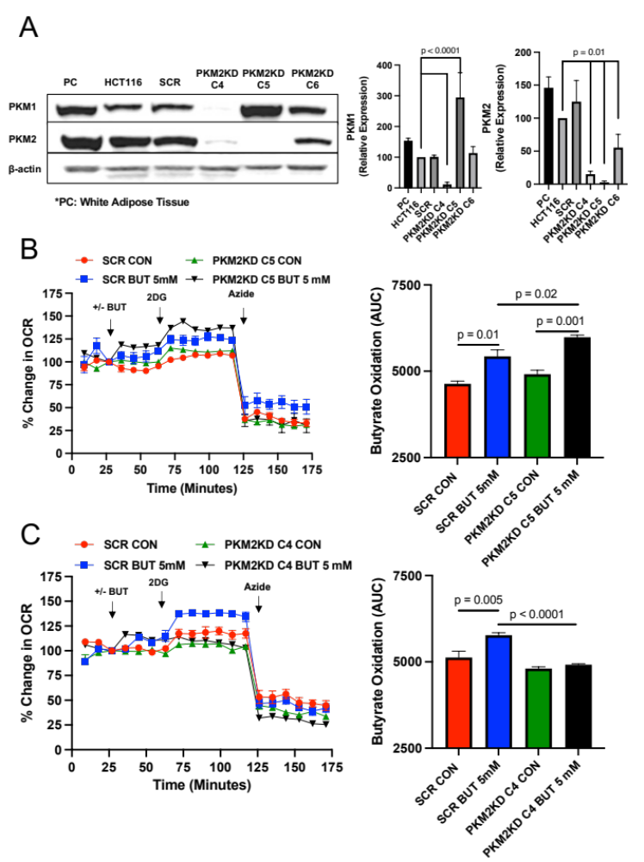

Figure 11. Butyrate oxidation in PKM2 knockdown HCT116 colorectal cancer cells

(A) Western blot analysis of PKM1 and PKM2 expression in the positive control (PC; Mouse White Adipose Tissue), HCT116, scramble (SCR), and different PKM1/2 targeted knockdown cells with β-actin as a loading control. Quantification of the western blot is shown in the right panel. For statistical analysis, western blot was conducted 5 times. Error bars are mean ± SEM. (B) Percent change in oxygen consumption rate (OCR) relative to baseline in which SCR and PKM2 KD C5 cells treated with and without butyrate (5mM). Total contribution of butyrate toward OCR (%) is observed after injection of 2-deoxyglucose (2DG). The right panel shows the area under the curve (AUC) analysis from OCR measurements taken after 2DG injection but before azide injection. These measurements represent butyrate oxidation (arbitrary units). (C) Percent change in OCR relative to baseline in which SCR and PKM2 KD C4 cells treated with and without butyrate (5mM). The right panel shows AUC analysis from OCR measurements taken after 2DG injection but before azide injection. These measurements represent butyrate oxidation (arbitrary units). Data points represent the average OCR (%) over 3-5 replicates per condition for butyrate oxidation measurements. Error bars are mean ± SEM.
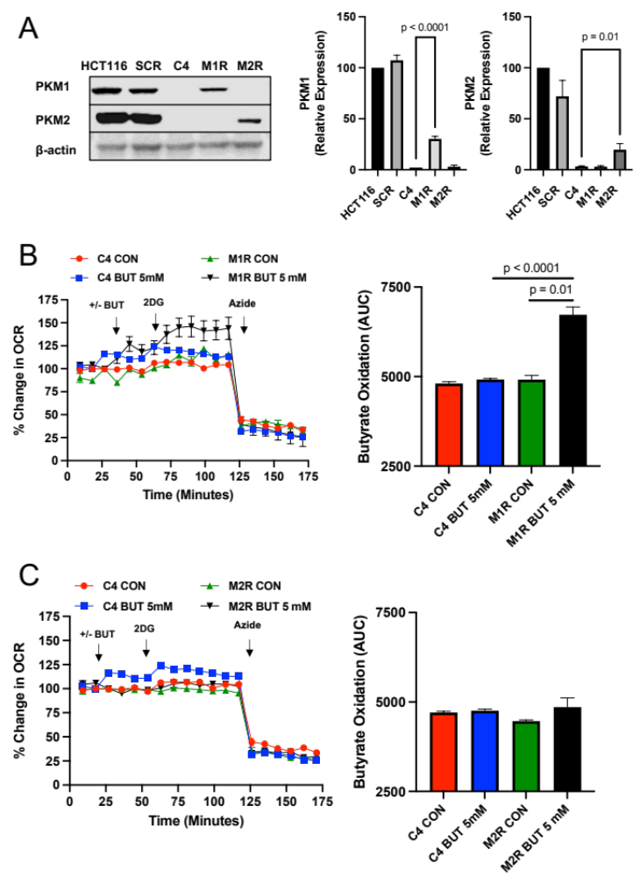

Figure 12. Butyrate oxidation is PKM1 dependent rather than PKM2 in HCT116 colorectal cancer cells.
(A) Western blot analysis of PKM1 and PKM2 expressions in HCT116, SCR, and re-expressed PKM1 (M1R) and PKM2 (M2R) cells with β-actin as a loading control. Quantification of the western blot is shown in the right panel. For statistical analysis, western blot was conducted 5 times. (B) Percent change in oxygen consumption rate (OCR) relative to baseline in which C4 and M1R cells treated with and without butyrate (5mM). Total contribution of butyrate toward OCR (%) is observed after injection of 2-deoxyglucose (2DG). The right panel shows the area under the curve (AUC) analysis from OCR measurements taken after 2DG injection but before azide injection. These measurements represent butyrate oxidation (arbitrary units). (C) Percent change in OCR relative to baseline in which C4 and M2R cells treated with and without butyrate (5mM). The right panel shows the area under the curve analysis from OCR measurements taken after 2DG injection but before azide injection. These measurements represent butyrate oxidation (arbitrary units). Data points represent the average OCR (%) over 3-5 replicates per condition for butyrate oxidation measurements. Error bars are mean ± SEM.

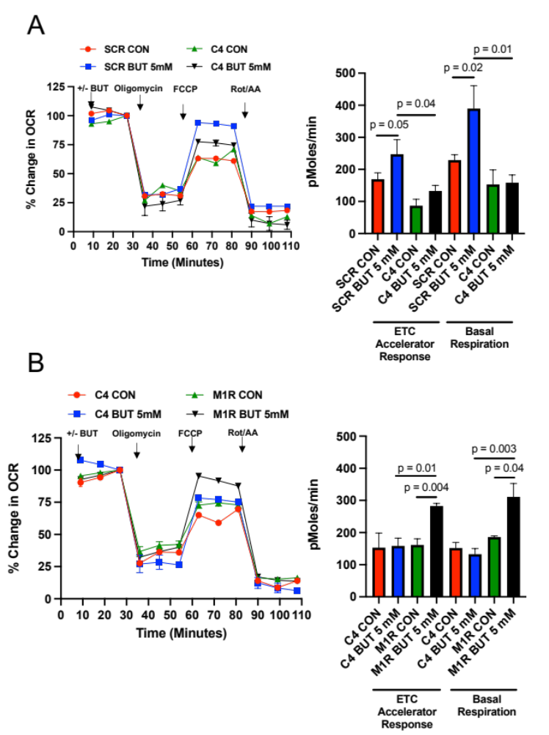

Figure 13. PKM1 is responsible for mitochondrial function in HCT116 colorectal cancer cells.
(A) Percent change in oxygen consumption rate (OCR) relative to baseline in which SCR and C4 cells respond to oligomycin, FCCP, and Antimycin A/Rotenone. The right panel shows the calculated electron transport chain (ETC) accelerator response and basal respiration. (B) Percent change in OCR relative to baseline in which SCR and M1R cells respond to oligomycin, FCCP, and Antimycin A/Rotenone. The right panel shows the calculated ETC accelerator response and basal respiration. For these experiments, each cell line was treated with or without butyrate (5mM). These measurements represent the mitochondrial function. Each data point represents the average OCR (%) over 3-5 replicates per condition. Error bars are mean ± SEM.

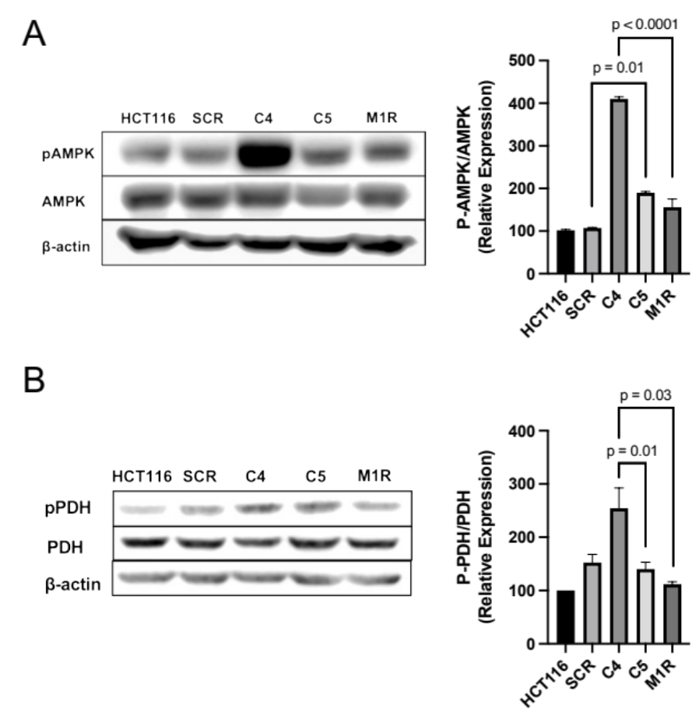

Figure 14. Molecular consequences in PKM1- and PKM2-diminished HCT116 colorectal cancer cells
(A) Western blot analysis of phospho-AMPK (Thr172) and total AMPK levels in HCT116, SCR, C4, C5, and M1R cells with β-actin as a loading control. The right panel shows the quantification of p-AMPK levels relative to total AMPK levels. (B) Western blot analysis of phospho-PDH (Ser293) and total PDH levels in HCT116, SCR, C4, C5, and M1R cells with β-actin as loading controls. The right panel shows the quantification of p-PDH levels relative to total PDH levels. For statistical analysis, western blot was conducted 5 times. Error bars are mean ± SEM.

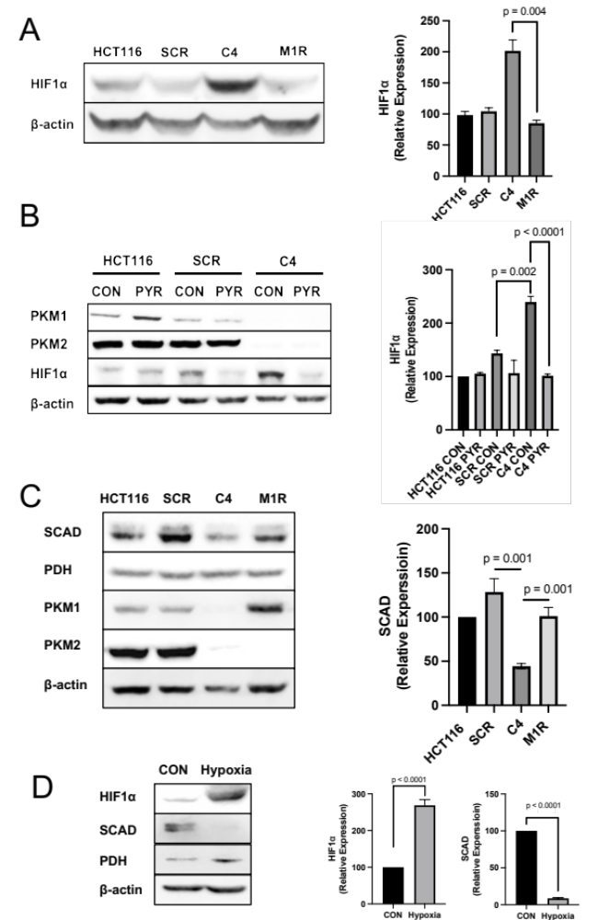

Figure 15. The expression of HIF1α and SCAD is affected by PKM1.

HIF1α levels in HCT116, SCR, C4, and M1R cells with β-actin as a loading control. The right panel shows the quantification of HIF1a expression. (B) Western blot analysis of HIF1α levels in HCT116, SCR, and C4 cells treated with and without pyruvate (5mM). β-actin served as a loading control. (C) Western blot analysis of SCAD levels in HCT116, SCR, C4, and M1R cells with PDH as loading controls. (D) Western blot analysis of HIF1α and SCAD levels in HCT116 cells with and without hypoxic conditions for 24 hours. β-actin served as loading control for HIF1α, and PDH served as loading control for SCAD. For statistical analysis, western blot was conducted 5 times. Error bars are mean ± SEM
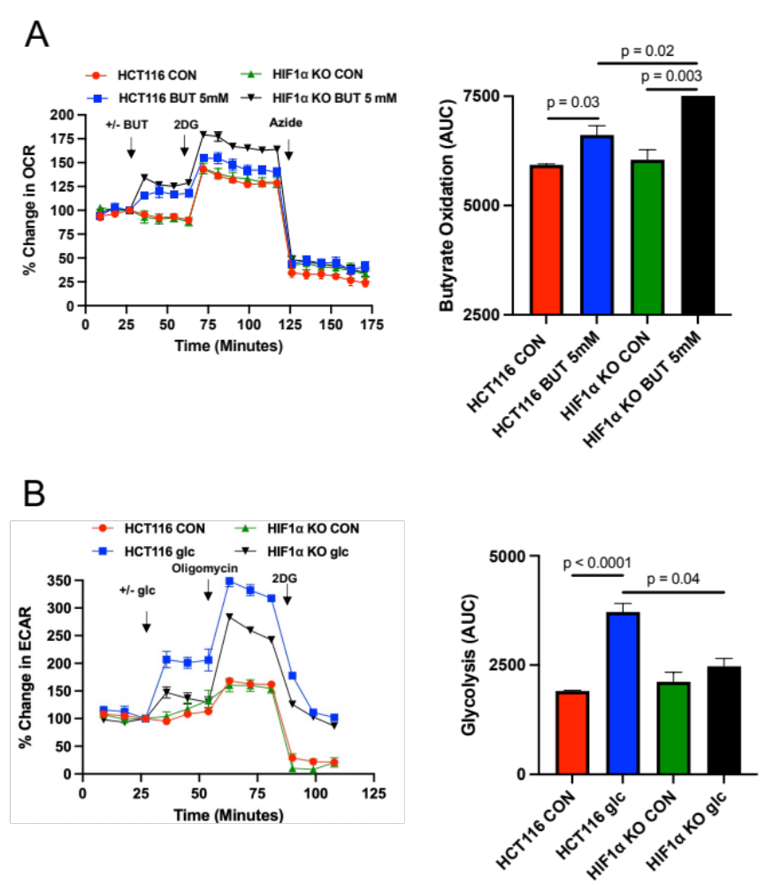

Figure 16. The role of HIF1α in regulating butyrate oxidation

(A) Percent change in oxygen consumption rate (OCR) relative to baseline in which HCT116 and HIF1α KO cells treated with and without butyrate (5mM). Total contribution of butyrate toward OCR (%) is observed after injection of 2-deoxyglucose (2DG). The right panel shows the area under the curve (AUC) analysis from OCR measurements taken after 2DG injection but before azide injection. These measurements represent butyrate oxidation (arbitrary units). Data points represent the average OCR (%) over 3-5 replicates per condition for butyrate oxidation measurements. (B) Percent change in extracellular acidification rate (ECAR) relative to baseline in which HCT116 and HIF1α KO cells respond to glucose, 2DG, and azide. The right panel shows AUC from ECAR measurements taken after glucose injection but before 2DG injection. These measurements represent glycolysis (arbitrary units). Data points represent the average ECAR (%) over 3-5 replicates per condition for glycolysis measurements. Error bars are mean ± SEM.

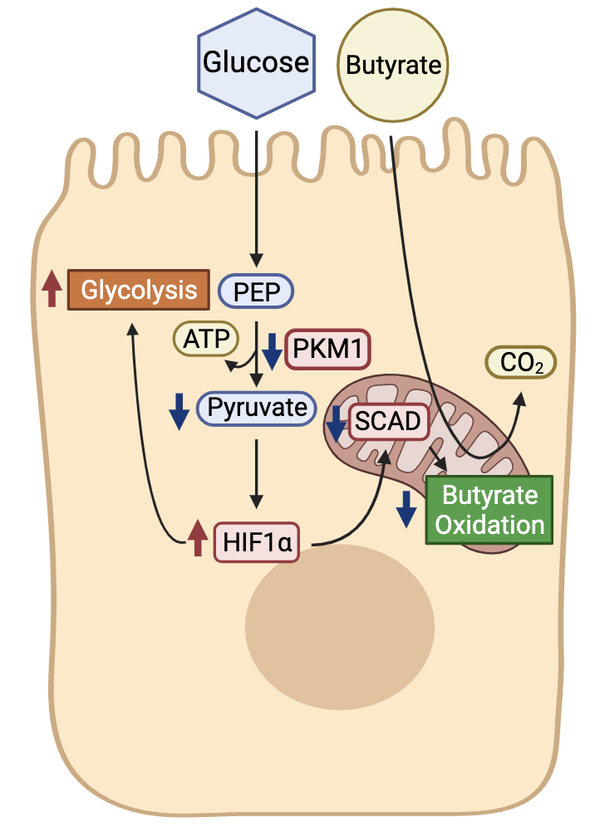

Figure 17. Model of PKM1 regulation of cellular metabolism in cancerous colonocytes
Working model of pathways regulating butyrate oxidation. In this model, the downregulated metabolic enzyme PKM1 is a key factor in the shift of cancerous colonocytes from oxidative metabolism toward aerobic glycolysis. The loss of PKM1 in cancerous colonocytes leads cells to increase glycolysis through reduction of SCAD along with an increase in HIF1α due to a decrease in pyruvate levels. The increase in HIF1α and the decrease in SCAD together explain the lower butyrate oxidation in CRC cells.

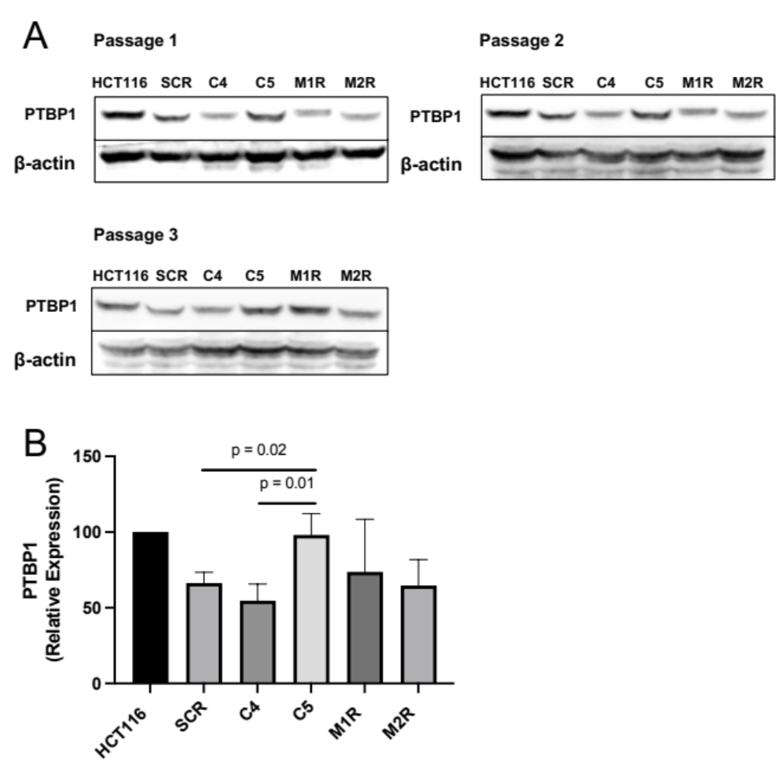
Figure 18. Expression of PTBP1 in different PKM1/2 expressed cell line.
(A) Western blot analysis of PTBP1 expression with β-actin as a loading control. (B) Quantification of the western blot. For statistical analysis, western blot was conducted 3 times. Error bars are mean ± SEM.

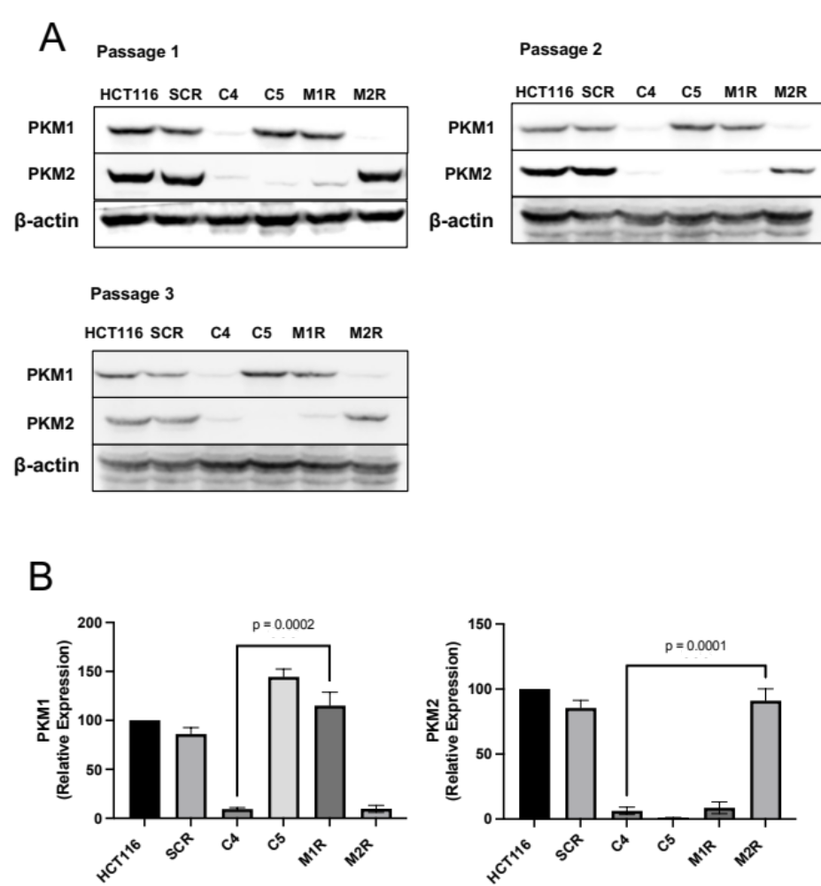

Figure 19. Confirmation of the expression of PKM1/2 in different Passage.
(A) Western blot analysis of PKM1 and PKM2 expression in different passage with β-actin as a loading control. (B) Quantification of the western blot. For statistical analysis, western blot was conducted 3 times. Error bars are mean ± SEM.

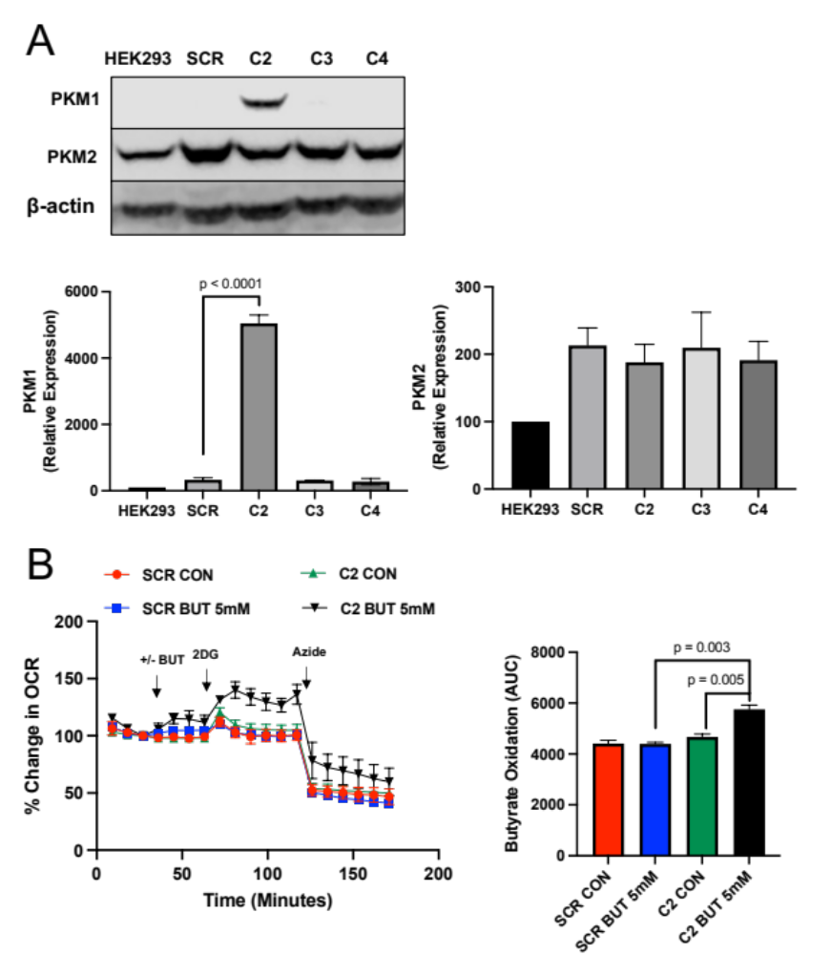

Figure 20. Butyrate oxidation is PKM1 dependent in HEK293 cells.
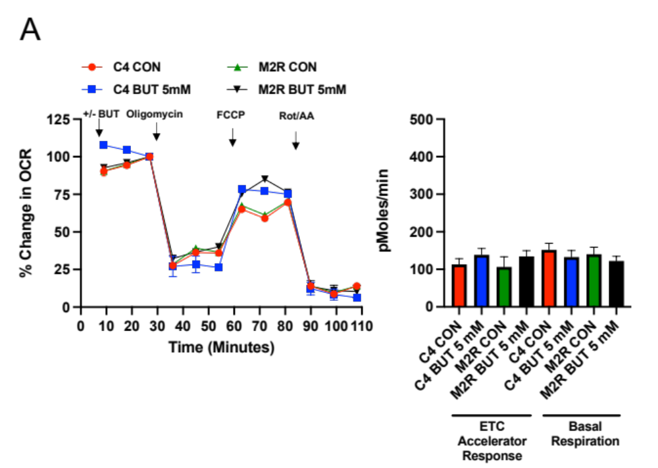
(A) Western blot analysis of PKM1 and PKM2 expression in HEK293, SCR, and different re-expressed PKM1 clones (C2, C3, and C4) with β-actin as a loading control. Quantification of the western blot. For statistical analysis, western blot was conducted 3 times. Error bars are mean ± SEM. (B) Percent change in oxygen consumption rate (OCR) relative to baseline in which SCR and C2 cells treated with and without butyrate (5mM). Total contribution of butyrate toward OCR (%) is observed after injection of 2-deoxyglucose (2DG). The right panel shows the area under the curve (AUC) analysis from OCR measurements taken after 2DG injection but before azide injection. These measurements represent butyrate oxidation (arbitrary units).
Figure 21. Re-addition of PKM2 doesn’t impact various parameters associated with mitochondrial function in colorectal cancer cells.

(A) Percent change in oxygen consumption rate (OCR) relative to baseline in which C4 and M2R cells respond to oligomycin, FCCP, and Antimycin A/Rotenone. The right panel shows the calculated electron transport chain (ETC) accelerator response and basal respiration.

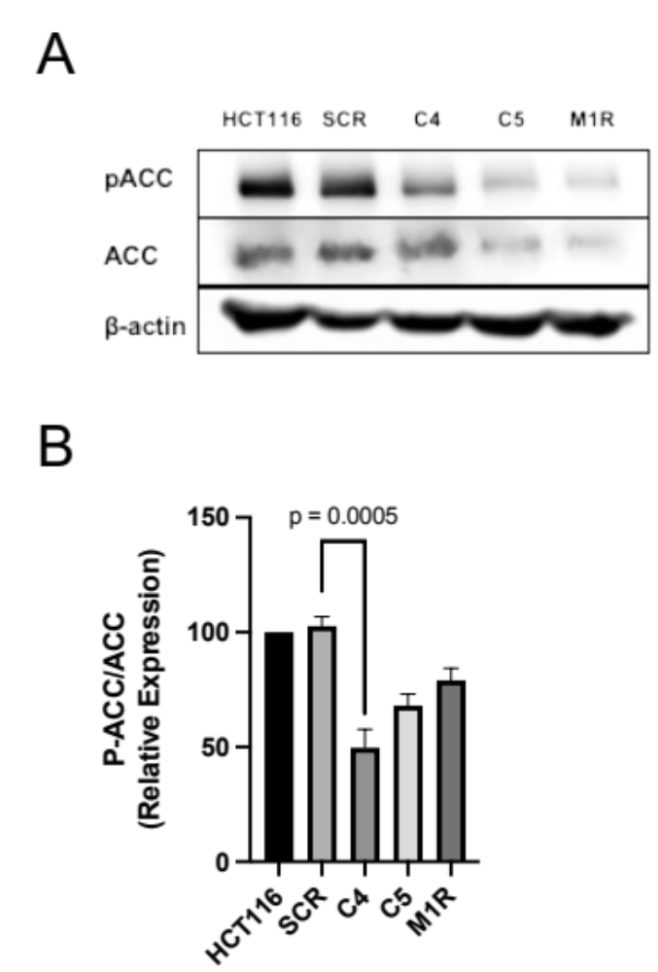

Figure 22. Relative expression of phospho-ACC/ACC in PKM1- and PKM2-diminished HCT116 colorectal cancer cells
(A) Western blot analysis of phospho-ACC (Ser 79) and total ACC levels in HCT116, SCR, C4, C5, and M1R cells with β-actin as a loading control. (B) Quantification of p-ACC levels relative to total ACC levels. For statistical analysis, western blot was conducted 5 times. Error bars are mean ± SEM.

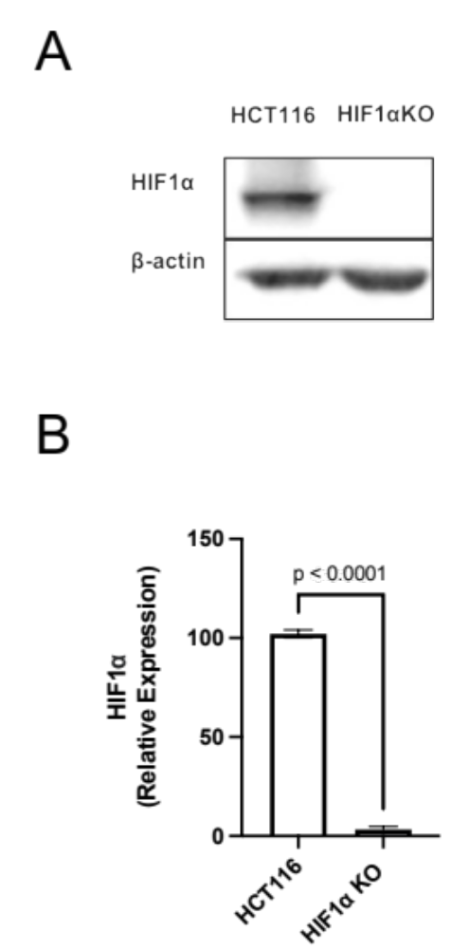

Figure 23. The expression of HIF1α in HCT116 cells and HIF1aKO cells
(A) Western blot analysis of HIF1α in HCT116 and HIF1α KO cells with β-actin as a loading control. (B) Quantification of HIF1α levels relative to β-actin levels. For statistical analysis, western blot was conducted 5 times. Error bars are mean ± SEM.

CHAPTER 3

CROSStalk between butyrate oxidation in the colonocyte and butyrate-producing bacteria

Crosstalk between butyrate oxidation in the colonocyte and
butyrate-producing bacteria
Bohye Park¹, Ji Yeon Kim¹, Olivia F. Riffey², Triston J. Walsh², Jeremiah Johnson², and Dallas R. Donohoe^{1, 2,*}

¹Department of Nutrition, University of Tennessee, Knoxville, TN 37996, USA
²Department of Microbiology, University of Tennessee, Knoxville, TN 37996, USA
*Correspondence: Dallas R. Donohoe, Ph.D.

1215 W. Cumberland Ave. Knoxville, TN 37996
Office – (865) 974-6238; ddonohoe@utk.edu

Running title: Cellular Metabolism Regulates Butyrate-Producing Bacteria
Keywords:

- Butyrate
- β-oxidation
- High Fiber Diet
- Butyrate Producing Bacteria

3.1. Abstract
The host-microbiome interaction is an important component regulating colonic health. The microbial metabolite butyrate is preferentially utilized as an energetic substrate in colonocytes, where it mediates several beneficial functions. The composition of gut microbiota, including butyrate-producing bacteria (BPB) is influenced by diet and physiological conditions. As such, given the importance of butyrate as an energetic substrate it is unclear whether the host would select for BPB, thus defining a host-microbiome mutualistic relationship based on cellular metabolism. Here, it is shown through utilizing mice that lack short-chain acyl dehydrogenase (SCAD), which is the first enzyme in the beta-oxidation pathway for SCFAs, there is a significant diminishment in BPB at the phylum, class, species, and genus level compared to the mice that have SCAD. Furthermore, SCAD-deficient mice lack a prebiotic response from dietary fiber. Thus, oxidation of SCFAs, including butyrate, are important in promoting BPB. These data help define the functional importance of diet-microbiome-host interactions toward microbiome composition, as it relates to function.

3.2. Introduction
Trillions of microbes inhabit the gastrointestinal tract comprising a diverse and complex ecosystem, fluctuating based on environmental factors, including diet and its interaction with the host (Heintz & Mair, 2014). Evidence indicates that the host-microbiome commensal relationships and the functions of microbial-derived metabolites, including short-chain fatty acids (SCFAs) coming from the fermentation of dietary fiber by specific bacteria, play a key role in the colonic health (Jha, Fouhse, Tiwari, Li, & Willing, 2019). Metagenomic studies have demonstrated variability and individual differences in the bacteria species in healthy and diseased populations (Adak & Khan, 2019; Saito et al., 2019; Yachida et al., 2019). However, despite the differences, many of these bacteria species share similar functions, such as the ability to ferment complex polysaccharides or dietary fiber (Holscher, 2017; Turnbaugh et al., 2009). Microbiota with the capacity to ferment fiber into SCFAs are sometimes referred to as butyrate-producing bacteria (BPB), and variation in these bacteria between individuals provide a source of nutritional diversity. There is an important interrelationship between butyrate-producing bacteria and host physiology in regulating metabolic and immunological functions (Finlay, Pettersson, Melby, & Bosch, 2019; Goldsmith & Sartor, 2014; Makki, Deehan, Walter, & Bäckhed, 2018). How diet impacts this relationship is not entirely understood.
Firmicutes and Bacteroidetes account for more than 90% of the microbiome in the colon (Kuo, 2013; Rinninella et al., 2019). In regard to the production of SCFAs, the majority of BPB belong to the Firmicutes phylum (gram-negative) and mainly generate butyrate, while the Bacteroidetes phylum (gram-positive) are characterized by producing the other SCFAs acetate and propionate (Louis & Flint, 2009, 2017). For example, Clostridium cluster IV and XIVa, which are generally accepted to be butyrate producers, belong to Firmicutes phylum, and are highly oxygen-sensitive anaerobic bacteria (Guo, Zhang, Ma, & He, 2020). The two dominant BPB species, Facalibacterium prausnitzii within Clostridium cluster IV and Eubacterium rectale within Clostridium cluster XIVa, are two major producers of SCFAs including butyrate (Louis & Flint, 2009, 2017). For butyrate production in these bacteria, two acetyl-CoA molecules form Butyryl-CoA in a process resembling reversed butyrate oxidation. After that, two final enzymes, butyryl-CoA: acetate CoA-transferase (but) and butyrate kinase (buk), are alternatively utilized to convert butyryl-CoA to butyrate (Duncan, Barcenilla, Stewart, Pryde, & Flint, 2002).
Butyrate itself has multiple physiological functions to the host including being the primary energy source of the colon (Nicholson et al., 2012; Roediger, 1982). In addition, butyrate suppresses inflammation by stimulating the production and release of anti-inflammatory cytokines, regulates tight junctions between colonocytes, and slows cell proliferation in cancer cells by inhibiting histone deacetylases (Davie, 2003; Donohoe et al., 2011; Hamer et al., 2008; Koh, De Vadder, Kovatcheva-Datchary, & Bäckhed, 2016; Parada Venegas et al., 2019; Peng, Li, Green, Holzman, & Lin, 2009; Roediger, 1982). Thus, the colonocyte directly, and indirectly benefits from butyrate creating a relationship between the host and BPB. The importance of butyrate as a primary energy source for the colonocyte and whether this impacts the microbiome, specifically BPB, provides an interesting host-microbe selection scenario and question. Does the colonocyte, through utilizing butyrate as a primary energetic substrate, select for, or promote BPB? Gastrointestinal diseases such as ulcerative colitis, and colorectal cancer, which have both been shown to have diminished butyrate oxidation, also have decreased BPB (De Preter et al., 2012; Donohoe, Collins, et al., 2012; Machiels et al., 2014; T. Wang et al., 2012; W. Wang et al., 2014).
The mouse BALB/cBy substrain diverged from the parental BALB/c strain approximately 75 years ago (Gan et al., 2020). BALB/cBy mice have been reported to lack short-chain acyl CoA dehydrogenase (SCAD), an enzyme used in the oxidation of SCFAs (Bhala et al., 1995). Thus, this mouse strain provides a disease-free model to test the impact of reduced oxidation of SCFAs on the microbiome and BPB. Here, we demonstrate an overall diminishment in the relative abundance of BPB in SCAD-deficient BALB/cBy mice when compared to BALB/c mice. Moreover, we find that a high-fiber diet elicits a prebiotic response in regard to BPB in BALB/c, whereas BALB/cBy mice fail to show this same prebiotic response. Therefore, oxidation of SCFAs by the host, especially butyrate, positively feeds back to increase the relative abundance of BPB and alter the composition of the microbiome.

3.3. Materials and Methods

Animals
All mice in this study were obtained from The Jackson Laboratories (Bar Harbor, ME) (BALB/c JAX #000651; BALB/cBy JAX #001026) or were bred in-house from these stocks. All mouse experiments were performed on mice 8-10 weeks of age at 22-23°C with 12hr light/dark shift. The International Animal Care and Use Committee (IACUC) reviewed and approved animal research at the University of Tennessee, Knoxville (Protocol #2673). All experiments were performed according to relevant guidelines and regulations.

Diets
Each diet was from Research Diet. The low-fiber diet (D11112201, Formula 1) contained 2 % cellulose, whereas the high-fiber diet (D11112201, Formula 3) contained 8% inulin. BALB/c and BALB/cBy mice were fed each diet for 2 weeks.

Primary Colonocytes Isolation
Mouse colonic epithelial cells were isolated from excluding enteric neurons, immune cells, and smooth muscle. The colons were dissected from the euthanized mice, flushed with sterile phosphate-buffered saline (PBS), and placed in PBS solution containing 5mM EDTA and 1% FBS. The submerged colon was incubated for ~30 min at 37°C on a rotator. The colon tissues were removed, and the left isolated colonocytes were collected by centrifuge and used for experiments.

Flux Experiments
Seahorse XF24 Analyzer (Seahorse Bioscience, North Billerica, MA) was used to measure butyrate oxidation and glycolysis. All Seahorse assay experiments were conducted following the manufacturer's instructions. The % change of the oxygen consumption rates (OCR) after butyrate injection was measured. The collected mouse primary colonocytes were seeded in XF²⁴ cell culture microplates (Agilent Technologies, #100850). 1x Krebs-Henseleit Buffer (KHB) (5mM glucose and 500uM carnitine) were used as the culture medium for the butyrate oxidation analysis. Briefly, for the butyrate oxidation analysis, 1x KHB media or sodium butyrate (Sigma, #B5887) at 5mM final concentration were injected, and the change in OCR was measured from baseline (%OCR). Next, 2-deoxyglucose (2DG) 50mM (Sigma, #D8375) was injected to competitively inhibit glucose utilization and leave butyrate as the only exogenous energy substrate. Finally, 10% sodium azide was injected to block mitochondrial respiration by inhibiting complex IV. Also, for the glycolysis stress test, 1x KHB media or glucose (Sigma, #G8270) at 10mM final concentration were injected, and the change in ECAR was measured from baseline (%ECAR). Then, Oligomycin 2uM (Alfa Aesar, #AAJ61898MA) was injected to inhibit ATP synthase (complex V), resulting in an increased dependence on glycolysis following basal measurement. At last, 2-deoxyglucose (2DG) 50mM (Sigma, #D8375) was injected to inhibit glucose utilization competitively and functioned to shut down glycolysis.

Western Blot Analysis
Proteins from the collected mouse primary colonocytes were extracted with 1x RIPA buffer (Cell Signaling, #9806s), 1mM PMSF (Cell Signaling, #8553), 0.5M EDTA Solution (Thermo Scientific, #R1021), and Halt Phosphatase Inhibitor Cocktail (Thermo Scientific, #PI87786). Protein samples were collected by centrifuge at 13,000 x g for 10 mins at 4°C, and protein supernatant was transferred to a new 1.5 ml Eppendorf tube. Protein concentrations were determined by Pierce BCA Protein Assay Kit (Thermo Fisher, #PI23228). Proteins were separated on 10 and 12% SDS-polyacrylamide gels and transferred onto the PVDF membrane. Membranes were incubated on a rotator in 5% BSA in 1x TBST (0.1%) for 1hr at room temperature (RT). Blocked membranes were incubated overnight at 4°C with the respective primary antibodies on a rotator. Antibodies that were used included SCAD (Abcam, #ab154823), MCT1 (Abcam, #ab179832), AMPKα (Cell Signaling, #5831), pAMPKα (Cell Signaling, #2535s), ACC (Cell Signaling, #3676s), pACC (Cell Signaling, #11818s), and ß-actin (Cell Signaling, #3700). Blots were washed 3 times for 10 min/wash in 1 x TBST (0.1%) at RT and incubated with secondary antibody for 2hr on rotator at RT following 3 times for 10 min/wash in 1x TBST (0.1%) at RT. Fluorescent or chemiluminescence detection was performed with the Odyssey Fc, and bands were quantified with Image Studio Software (LI-COR Biosciences, Lincoln, NE).

Microbial DNA preparation and Quantitative Real-Time PCR Analysis
Microbial DNA was isolated from the collected feces, dissected cecum, colon, and flushed feces from the dissected colon. Total bacterial DNA was isolated using DNeasy PowerSoil Pro Kit (QIAGEN Sciences Inc. Germantown, MD) according to the manufacturer’s instructions. Total DNA was quantified using the NanoDrop ND-1000 spectrophotometer (NanoDrop Technologies, Wilmington, DE). About 100ng of DNA from each sample was used to analyze the bacterial population. Primers for quantifying specific bacterial groups and the butyrate kinase (buk) and butyryl-CoA:acetate CoA-transferase (but) gene are given in Supplemental Table1. Targeted DNA expression was measured quantitatively using the Power Up SYBR master mix (Life technologies, #A25742). Thermocycling was done as follows; 2min at 95°C; 45s at 95°C, 45s at 54°C, 45s at 72°C (x35); 10min at 72°C.

Statistical Analysis
For seahorse experiments, western blotting, and qPCR, an ANOVA was used to test for differences between experimental groups followed by a Tukey post-hoc test. All data are expressed as mean $±$ SEM.

3.4. RESULTS

Characterization of BALB/cBy colonocytes and their reduced butyrate oxidation
Colonocytes were isolated from BALB/c and BALB/cBy mice and the expression of SCAD was analyzed by western blot. As shown in Figure 24A, the levels of SCAD were significantly diminished, but they were not completely abolished as we still could detect the protein. Since BALB/cBy mice are deficient in SCAD, the relative levels of monocarboxylate transporter 1 (MCT1), a major butyrate transporter, were measured in comparison to BALB/c to assess whether SCAD-deficient colonocytes increased MCT1 as a compensatory mechanism (Figure 24A). However, the levels of MCT1 did not show a significant change in BALB/cBy colonocytes. AMP kinase (AMPK) is a proxy for cellular energetics, as phosphorylation of this protein at Thr172 occurs under energetic stress or deprivation (Herzig & Shaw, 2018). Phosphorylation of AMPK (Thr172) was significantly higher in SCAD-deficient (BALB/cBy) compared to non-deficient (BALB/c) colonocytes (Figure 24B). Thus, it is likely that the diminishment in SCAD results in decreased butyrate oxidation and energetic stress in the colonocyte. Furthermore, SCAD-deficient colonocytes showed increased phosphorylation and thus inactivation of Acetyl-CoA Carboxylase (ACC), which is also a downstream target of AMPK (Figure 24C). Inactivation of ACC would increase fatty acid transport via carnitine palmityl transferase (CPT) as a result of reduced malonyl-CoA levels (Lipovka & Konhilas, 2015). However, given the diminishment in SCAD, which is located in the mitochondria, and is the first step in the beta-oxidation process for SCFAs, it is unlikely that inactivation of ACC would have a significant impact on the oxidation of butyrate.
The Seahorse XFe24 Extracellular Flux Analyzer, which measures oxidative (oxygen consumption) and non-oxidative (lactate production or glycolysis) metabolism in cells, was utilized to test whether reduced levels of SCAD in the colonocytes resulted in decreased butyrate oxidation (Andriamihaja et al., 2009; Gerencser et al., 2009). Isolated colonocytes derived from SCAD-deficient mice did not respond to butyrate as judged by the change in their oxygen consumption rate after injection butyrate or 2-deoxyglucose (2DG), which is used to block glucose oxidation leaving butyrate as the only exogenous energy source for the colonocyte (Figure 25A). In fact, the oxygen consumption rate in the butyrate 5mM treated BALB/cBy group was almost identical to the control group that had no butyrate. If butyrate, which is the primary energy source of colonocytes, is abolished, then the colonocyte may compensate through increasing glycolysis. This was indeed the case as SCAD-deficient colonocytes displayed elevated glycolysis as judged by the increased extracellular acidification rate (ECAR) after the addition of glucose (Figure 25B). The ECAR measurement represents an indirect measurement of lactate secretion and glycolysis. Taken together, these data demonstrate that diminishment in SCAD impacts cellular metabolism by reducing butyrate oxidation and increasing glycolysis in the primary isolated colonocytes.

Analyzing the Butyrate Synthesis Enzyme as a Biomarker of Butyrate-Producing Bacteria in BALB/c and BALB/cBy
A gene-targeted quantitative polymerase chain reaction (qPCR) was utilized to analyze butyrate-producing bacteria (BPB) in BALB/c and BALB/cBy mice. The two final enzymes in the bacterial butyrate synthesis pathways, butyryl-CoA:acetate CoA-transferase (but) and butyrate kinase (buk), were targeted for amplification and each represented a biomarker for relative BPB amounts. A qPCR for total 16S was used to analyze but or buk relative to total bacteria. Initially, degenerative primers designed by Louis and Flint (2003, 2007) were utilized for but and buk genes, but these PCR reactions yielded several unexpected bands, which precluded their use in qPCR. From the but and buk PCR reactions, the expected amplicons were sequenced, and several new primers were designed and tested. Importantly, PCR reactions with these new primers gave the expected amplicon, while having no non-specific bands. The process to get the specific buk primer from the degenerative primers is explained in Figure 30A.
Comparison of but and buk between BALB/c and SCAD-deficient BALB/cBy mice from collected individual fecal pellets yielded significant variability, even following the same mouse day-to-day (Figure 30B and C). The pH conditions in the colon can have a significant impact on microbial survival, and there is an increase in pH moving from the proximal to the distal part of the colon (Macfarlane, Gibson, & Cummings, 1992; Nugent, Kumar, Rampton, & Evans, 2001). Dietary fibers are fermented by intestinal microbes to produce SCFAs, which lower the pH in the proximal colon (Walker et al., 2005). The more acidic conditions in the proximal colon favor the growth of BPB. Thus, it was not clear whether the variability was an inherent part of the BPB or was due to where and how we collected samples. Taking a more location-centric approach, such as taking feces directly from the colon would maybe decrease variability in our samples. Thus, a new experimental approach was used to collect bacterial DNA (Figure 26A). The bacterial DNA was isolated from the dissected cecum, colon, and feces from the sacrificed mice. Cecum was also used because it is the primary site of fermentation in mice (K. Brown, Abbott, Uwiera, & Inglis, 2018). With this experimental approach, the variability was diminished, and the amount of both butyrate synthesis enzymes (but and buk) were significantly decreased in bacterial DNA samples of the cecum, colon, and feces in SCAD-deficient BALB/cBy mice compared to BALB/c mice (Figure 26B and C). These data demonstrate deficient SCFAs and butyrate oxidation in the host results in a decrease in the BPB population.

Diminished Butyrate-Producing Bacteria in SCAD mutant BALB/cBy Mice
To compare the abundance of specific butyrate-producing bacteria (BPB) populations, we investigated BPB from phylum to species level with collected bacterial DNA samples isolated from the dissected cecum, colon, and feces of BALB/c and BALB/cBy mice using qPCR. Sequence information for the primers of specific bacterial groups is given in Table 3. At the phylum level, the amount of Firmicutes in the cecum, colon, and feces of SCAD-deficient BALB/cBy mice was significantly decreased compared to those in BALB/c mice (Figure 27A). However, the relative amount of Bacteroidetes, which are mainly non-butyrate-producing bacteria (non-BPB), showed an opposite trend of being slightly increased in BALB/cBy, although only reaching a significant difference in the colon (Figure 27B). Looking at the class cluster level, the amount of Clostridium IV and XIVa, known butyrate-producers (Louis & Flint, 2009, 2017), were significantly diminished in BALB/cBy compared to BALB/c mice when analyzing the cecum, colon, and feces (Figure 27C and D). At the species level, the amount of Facalibacterium prausnitzii and Eubacterium rectale at each location decreased in BALB/cBy mice compared to BALB/c mice (Figure 27E and F). However, Facalibacterium prausnitzii was not detected at all in the fecal samples, which suggests that location and collection method is particularly important for detecting bacteria. These data demonstrate, in this non-disease model, that decreased butyrate and SCFAs oxidation of SCAD-deficient mice is associated with a significant diminishment in BPB, thereby defining an important relationship between host cellular metabolism and the gut microbiota as it pertains to BPB.

Butyrate-Producing Bacteria Responded in a High-Fiber Diet in Wild Type Mice
Fermentable dietary fiber contributes to an increased butyrate-producing bacteria (BPB) population, associated with less inflammation and inflammatory disease development (Carding et al., 2015) Differences in the prebiotic effect derived from fiber have been observed, where selective individuals don’t increase BPB (Deschasaux et al., 2018; G. Falony et al., 2016; J. Li et al., 2014; Murga-Garrido et al., 2021).
Since SCAD-deficient BALB/cBy mice showed a diminishment in BPB as compared to BALB/c mice on a standard chow diet, a defined low-fiber diet (LFD) and high-fiber diet (HFD) were used to test whether BALB/cBy mice would show a prebiotic effect represented by an increase in BPB from low-fiber to high fiber diet. To study how dietary fibers affect BPB, BALB/c and BALB/cBy mice were randomly divided into four groups based on diet. They were fed a calorically matched LFD with cellulose and HFD with inulin to analyze the effects of diet on relative BPB levels.
The level of but and buk in BALB/c mice increased from LFD to HFD conditions, however, SCAD-deficient BALB/cBy mice showed no difference (Figure 28A and B). A similar result was found in analyzing Eubacterium rectale and Facalibacterium Prusnitzii where both were increased in the HFD condition of BALB/c mice, but there was no response in BALB/cBy mice in HFD compared to LFD group (Figure 28C and D). Furthermore, in conditions of low butyrate production and levels, there were no differences in the LFD groups between BALB/c and BALB/cBy when analyzing but and buk or the species Eubacterium rectale and Facalibacterium Prusnitzii (Figure 28). These data are consistent with the idea that reduced butyrate oxidation in SCAD mutant colonocytes causes a decrease in the amount of BPB even with enough fermentable substrates.

3.5. DISCUSSION
The gastrointestinal (GI) tract is a complex ecosystem in which host intestinal epithelium, immune cells, and gut microbiota live in symbiotic relationships (Bäckhed, Ley, Sonnenburg, Peterson, & Gordon, 2005). Changes in the GI tract environment, including dietary fiber, antibiotics, hygiene, and host physiology, can re-shape the gut microbiota community and is associated with diseases such as inflammatory bowel diseases (IBDs) or colorectal cancer (CRC) (Holmes et al., 2011; Kinross et al., 2011; Sommer & Bäckhed, 2013). The loss of gut microbiota diversity and decreased butyrate oxidation are major characteristics of CRC patients (Donohoe, Collins, et al., 2012; T. Wang et al., 2012). However, the causative mechanism has not been well understood yet as to how or what drives gut microbial dysbiosis in colon disease patients compared to healthy controls. In this study, we report that diminished butyrate and SCFA oxidation results in decreased butyrate-producing bacteria (BPB) levels in a non-disease SCAD-deficient mouse model.
SCAD-deficient mouse colonocytes show a decrease in butyrate oxidation and an increase in glycolysis. Similarly, colonocytes transforming to become cancerous display this same metabolic shift called the Warburg effect (Andriamihaja et al., 2009; Donohoe, Collins, et al., 2012). Although these metabolic patterns are similar between SCAD-deficient colonocytes and cancerous colonocytes, it is likely that the reason for the increase in glycolysis is not because of the Warburg effect in SCAD-deficient colonocytes, but rather because they can obtain energy from glycolysis as a compensatory mechanism. This is supported through the fact that AMPK is activated in the SCAD-deficient colonocytes.
The decreased level of butyrate-producing bacteria is another feature in CRC patients where SCAD reduction is observed (Ferreira-Halder, Faria, & Andrade, 2017; A. Han, Bennett, Ahmed, Whelan, & Donohoe, 2018; Miquel et al., 2013; Sobhani et al., 2011). Figure 26 and Figure 27 show that the level of butyrate-producing bacteria is significantly diminished in the cecum, colon, and feces of SCAD-deficient mice compared to the wild-type mice. These data would suggest that decreased butyrate oxidation in non-disease SCAD-deficient mice leads to a decrease in the population of butyrate-producing bacteria.
Butyrate-producing bacteria are anaerobic bacteria, and the low oxygen levels in the GI tract provide them with a favorable environment (Parada Venegas et al., 2019). In addition, the butyrate oxidation consumes considerable oxygen in the host colonocyte, thereby making hypoxic conditions (<1% O2 or <7.6 mmHg) (Colgan & Taylor, 2010; Kelly et al., 2015). However, going into our data, the reduction of SCAD in the BALB/cBy mice colonocyte decreased butyrate oxidation, thereby we can predict conserving and increasing the oxygen level within the colonocyte. Since oxygen diffuses freely across epithelial membranes, the elevated oxygen concentration in the colonocytes can drive an increased oxygen availability in the intestinal lumen. The aerobic environment in the gastrointestinal tract could deplete butyrate-producing bacteria and drive a pathogen expansion (Espey, 2013; Rivera-Chávez et al., 2016).
Different types of diets affect the composition of gut microbiota, which could affect the production of microbial-derived metabolites, including butyrate (Makki et al., 2018; Scott et al., 2013; Tan et al., 2014). Particularly, fermentable dietary fiber contributes to an increased butyrate-producing bacteria population, associated with less inflammation and inflammatory disease development (Carding et al., 2015). Among the various dietary fiber groups in our study, it was determined that the level of butyrate-producing bacteria in wild-type mice increased in response to the high-fermentable dietary fiber, while its level in SCAD-deficient mice did not respond under the same condition (Figure 28). These results support the functional importance of diet-microbiome-host interactions toward host colon health.

Appendix

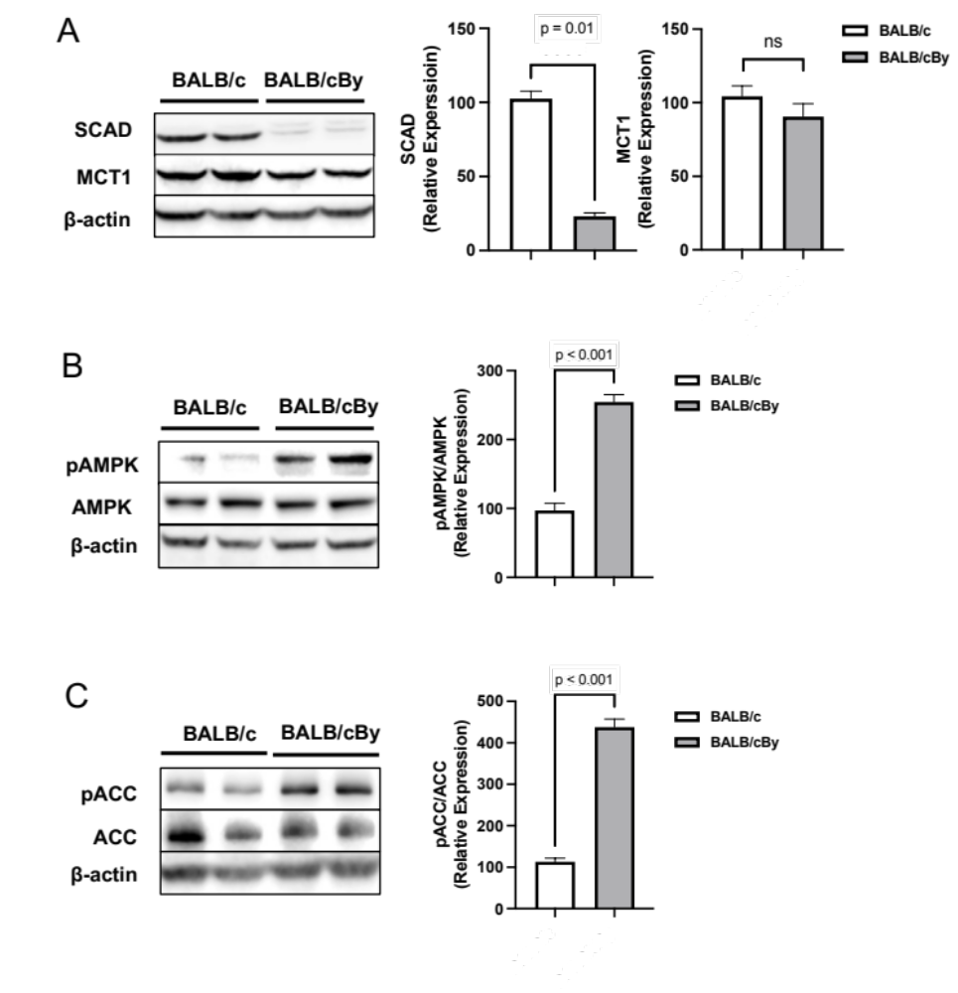

Figure 24. Molecular consequences in short-chain acyl dehydrogenase (SCAD) mutant mouse colonocytes

(A) Western blot analysis of short-chain acyl dehydrogenase (SCAD) and monocarboxylate transporter 1 (MCT1) levels in the isolated colonocytes from BALB/c and BALB/cBy mice with β-actin as a loading control. Quantification of the western blot is shown in the right panel. For statistical analysis, western blot was conducted 5 times. Error bars are mean ± SEM. (B) Western blot analysis of phospho-AMPK (Thr172) and total AMPK levels in the isolated colonocytes from BALB/c and BALB/cBy mice with β-actin as a loading control. The right panel shows the quantification of p-AMPK levels relative to total AMPK levels. (C) Western blot analysis of phospho-ACC (Ser 79) and total ACC levels in the isolated colonocytes from BALB/c and BALB/cBy mice with β-actin as a loading control. The right panel shows the quantification of p-ACC levels relative to total ACC levels. For statistical analysis, western blot was conducted 5 times. Error bars are mean ± SEM.
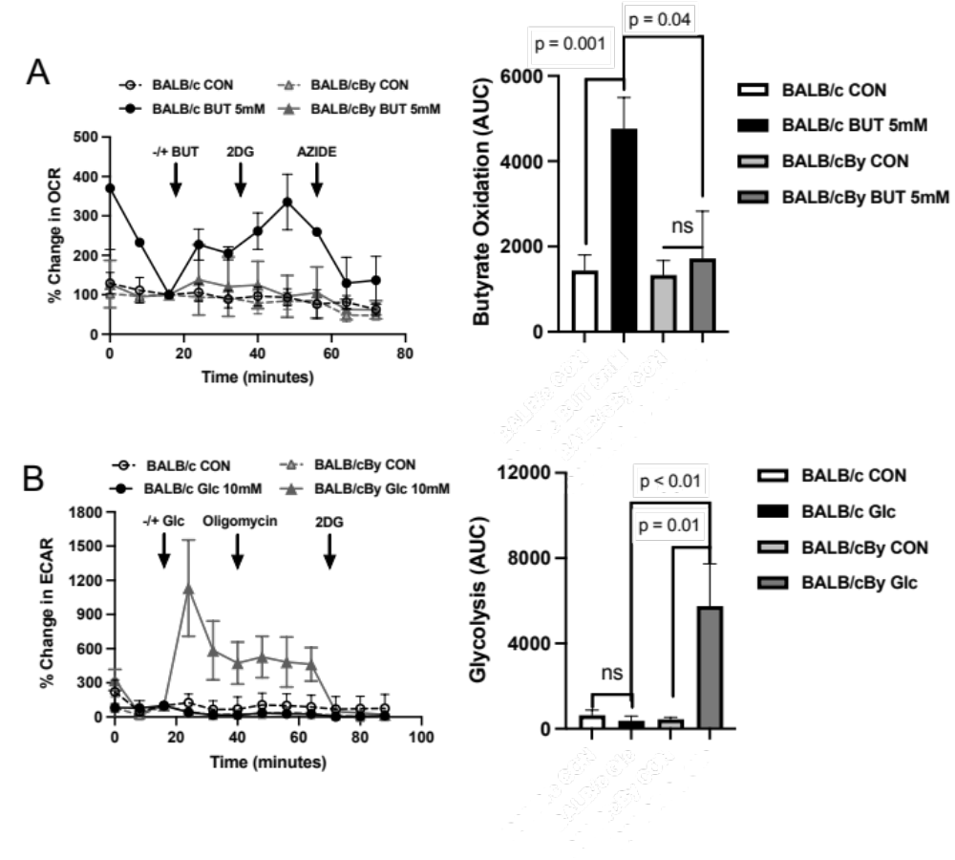
(A) Percent change in oxygen consumption rate (OCR) relative to baseline in which isolated colonocytes from BALB/c and BALB/cBy mice treated with and without butyrate (5mM). Total contribution of butyrate toward OCR (%) is observed after injection of 2-deoxyglucose (2DG). The right panel shows the area under the curve (AUC) analysis from OCR measurements taken after 2DG injection but before azide injection. These measurements represent butyrate oxidation (arbitrary units). Data points represent the average OCR (%) over 3-5 replicates per condition for butyrate oxidation measurements. Error bars are mean ± SEM. (B) Percent change in extracellular acidification rate (ECAR) relative to baseline in which isolated colonocytes from BALB/c and BALB/cBy mice respond to glucose, 2DG, and azide. The right panel shows AUC from ECAR measurements taken after glucose injection but before 2DG injection. These measurements represent glycolysis (arbitrary units). Data points represent the average ECAR (%) over 3-5 replicates per condition for glycolysis measurements. Error bars are mean ± SEM.
Figure 25. SCAD mutant mice prefer glucose rather than butyrate as an energy source

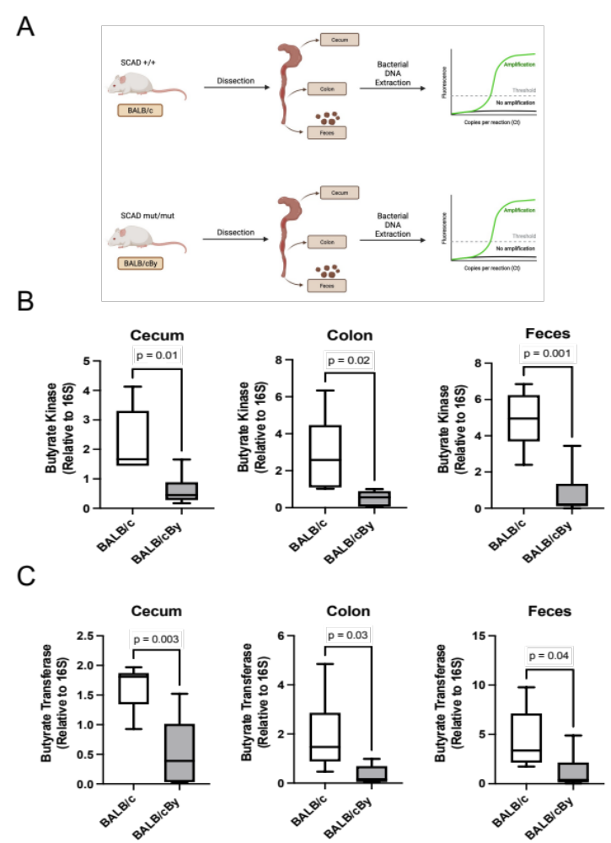

Figure 26. Analysis of the level of butyrate synthesis enzyme as a biomarker of butyrate-producing bacteria (BPB)
(A) The diagram shows the locations where microbial DNA samples were collected. (B) and (C) Quantification of butyrate kinase (buk) and the level of butyrate synthesis enzyme butyryl-CoA: acetate CoA-transferase (but) in different gut locations and feces of BALB/c and BALB/cBy mice relative to 16S rRNA. Error bars are mean ± SEM.

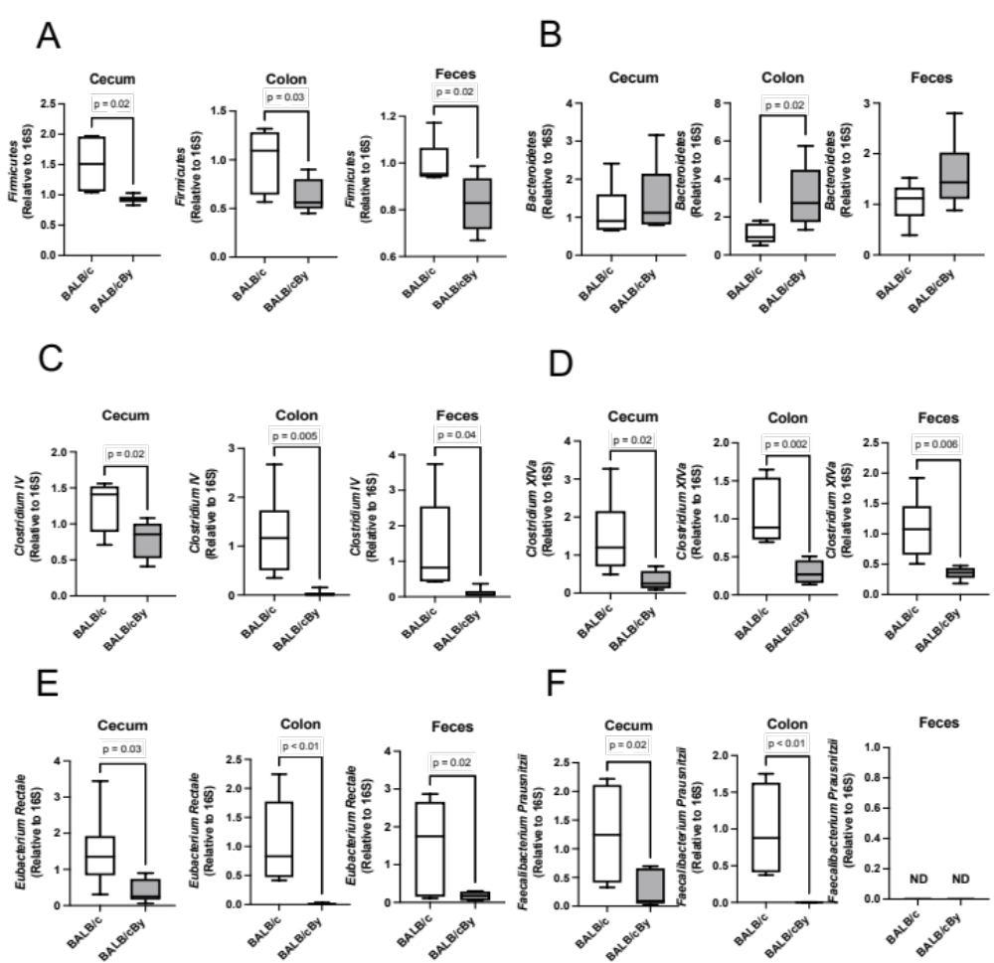

Figure 27. Exploring the butyrate-producing bacteria (BPB) community based on qPCR analysis
(A) Quantification of the level of Firmicutes in different gut locations and feces of BALB/c and BALB/cBy mice relative to 16S. (B) Quantification of the level of Bacteroidetes in different gut locations and feces of BALB/c and BALB/cBy mice relative to 16S. (C) Quantification of the level of Clostridium XIVa in different gut locations and feces of BALB/c and BALB/cBy mice relative to 16S. (D) Quantification of the level of Clostridium IV in different gut locations and feces of BALB/c and BALB/cBy mice relative to 16S. (E) Quantification of the level of Eubacterium rectale in different gut locations and feces of BALB/c and BALB/cBy mice relative to 16S. (F) Quantification of the level of Faecalibacterium prausnitzii in different gut locations and feces of BALB/c and BALB/cBy mice relative to 16S rRNA. For statistical analysis, qPCR was conducted three times per condition. Error bars are mean ± SEM.

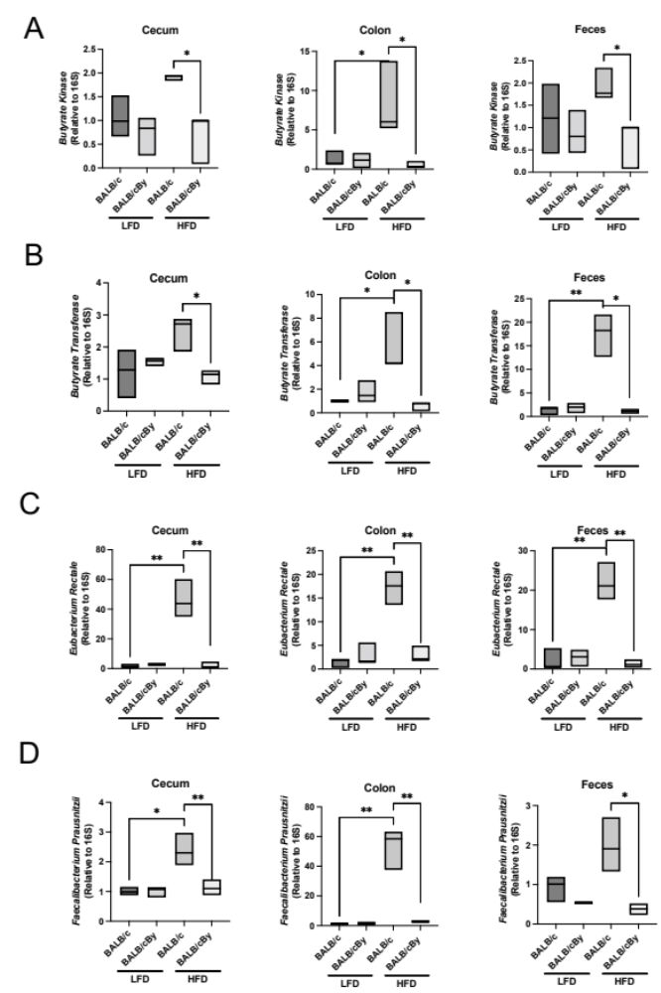

Figure 28. Impact of different dietary fiber diets on the composition of butyrate-producing bacteria
BALB/c and BALB/cBy mice were fed the low-fiber diet contained 2 % cellulose, or the high-fiber diet contained 8% inulin for 2 weeks. (A) Quantification of the level of butyrate kinase (buk) in different gut locations and feces of BALB/c and BALB/cBy mice in each diet group relative to 16S. (B) Quantification of the level of butyryl-CoA: acetate CoA-transferase (but) in different gut locations and feces of BALB/c and BALB/cBy mice in each diet group relative to 16S. (C) Quantification of the level of Eubacterium rectale in different gut locations and feces of BALB/c and BALB/cBy mice in each diet group relative to 16S. (D) Quantification of the level of Faecalibacterium prausnitzii in different gut locations and feces of BALB/c and BALB/cBy mice in each diet group relative to 16S rRNA. For statistical analysis, qPCR was conducted three times per condition. Error bars are mean ± SEM.
Table 3. Primer Sequences used in this study

Primer | Target | Sequence (5' - 3') | Reference
1132_F | 16s | ATGGYTGTCGTCAGCTCGTG | M. Vital et al. (2013)
1108_R | 16s | GGGTTGCGCTCGTTGC | M. Vital et al. (2013)
ButyrateKinase_F | Butyrate Kinase | CAATCGTGGACCAGAAGGATTT | This paper
ButyrateKinase_R | Butyrate Kinase | ACCGATGGAATCAGCAATTTCCCG | This paper
ButyrateTransferase_F | Butyrate Transferase | GCIGAICATTTCACITGGAAYWSITGGCAYATG | P. Louis and H.Flint (2007)
ButyrateTransferase_R | Butyrate Transferase | CCTGCCTTTGCAATRTCIACRAANGC | P. Louis and H.Flint (2007)
Firmicutes_F | Firmicutes | GGAGYATGTGGTTTAATTCGAAGCA | L. Jia et al. (2017)
Firmicutes_R | Firmicutes | AGCTGACGACAACCATGCAC | L. Jia et al. (2017)
ClostridiumXIVa_F | Clostridium XIVa | CGGTACCTGACTAAGAAGC | L. Jia et al. (2017)
ClostridiumXIVa_R | Clostridium XIVa | AGTTTYATTCTTGCGAACG | L. Jia et al. (2017)
ClostridiumIV_F | Clostridium IV | TTACTGGGTGTAAAGGG | L. Jia et al. (2017)
ClostridiumIV_R | Clostridium IV | TAGAGTGCTCTTGCGTA | L. Jia et al. (2017)
Bacteroidetes_F | Bacteroidetes | GAAGGTCCCCCACATTG | L. Jia et al. (2017)
Bacteroidetes_R | Bacteroidetes | CAATCGGAGTTCTTCGTG | L. Jia et al. (2017)
Eubacterium Rectale_F | Eubacterium Rectale | GCGGTRCGGCAAGTCTGA | C. Ramirez-Ferias et al. (2008)
Eubacterium Rectale_R | Eubacterium Rectale | CCTCCGACACTCTAGTMCGAC | C. Ramirez-Ferias et al. (2008)
Faecalibacterium Prausnitzii_F | Faecalibacterium Prausnitzii | GATGGCCTCGCGTCCGATTAG | R. Kumari et al. (2013)
Faecalibacterium Prausnitzii_R | Faecalibacterium Prausnitzii | CCGAAGACCTTCTTCCTC | R. Kumari et al. (2013)

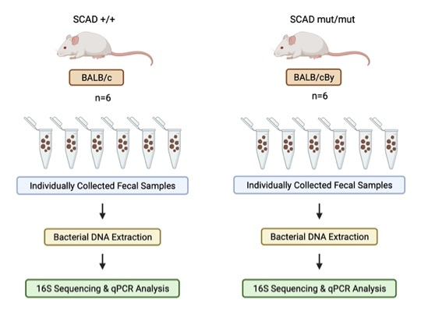
Figure 29. Experimental model for collected fecal samples for 16S rRNA and 1PCR analysis
Bacterial DNA was extracted from the individually collected fecal samples for the 16S rRNA sequencing and qPCR.

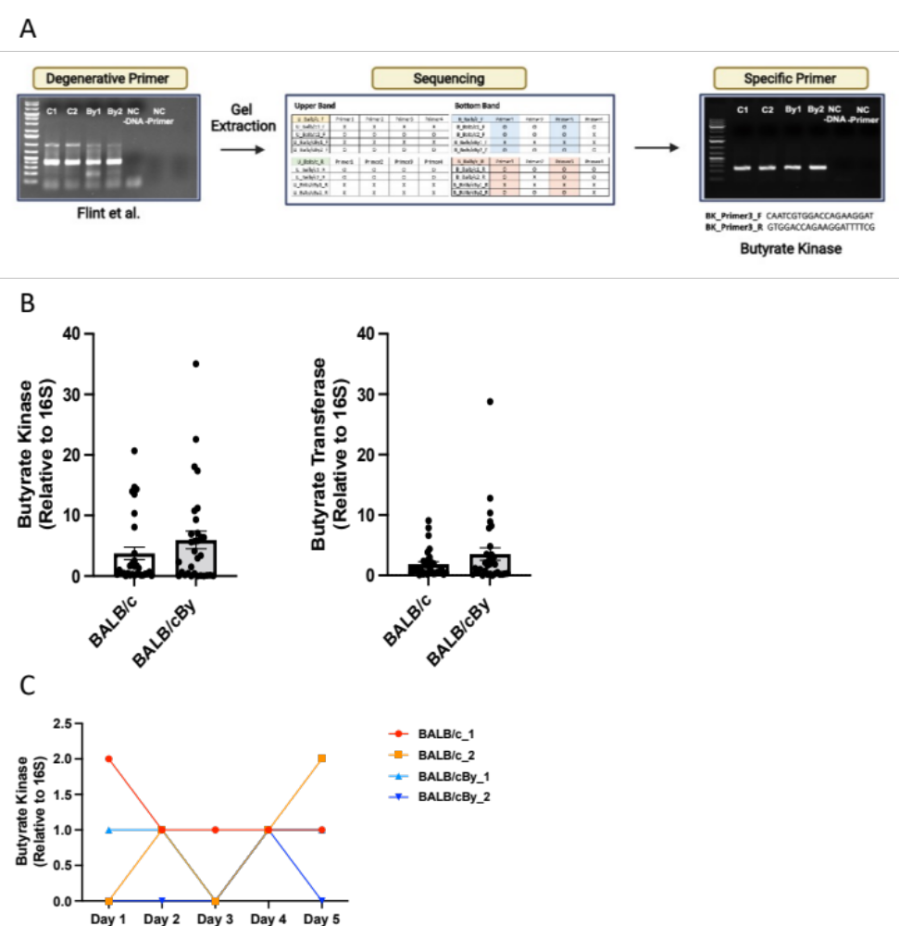
(A) The process of generating a specific butyrate kinase (buk) primer from the degenerative primer. (B) Quantification of the level of butyrate kinase (buk) and butyryl-CoA: acetate CoA-transferase (but) in the collected fecal samples. (C) Quantification of the level of butyrate kinase (buk) in the collected fecal samples with the day-to-day experiment. For statistical analysis, qPCR was conducted three times per condition. Error bars are mean ± SEM.
Figure 30. The process of generating specific butyrate kinase (buk) and the large variabilities of the collected fecal samples

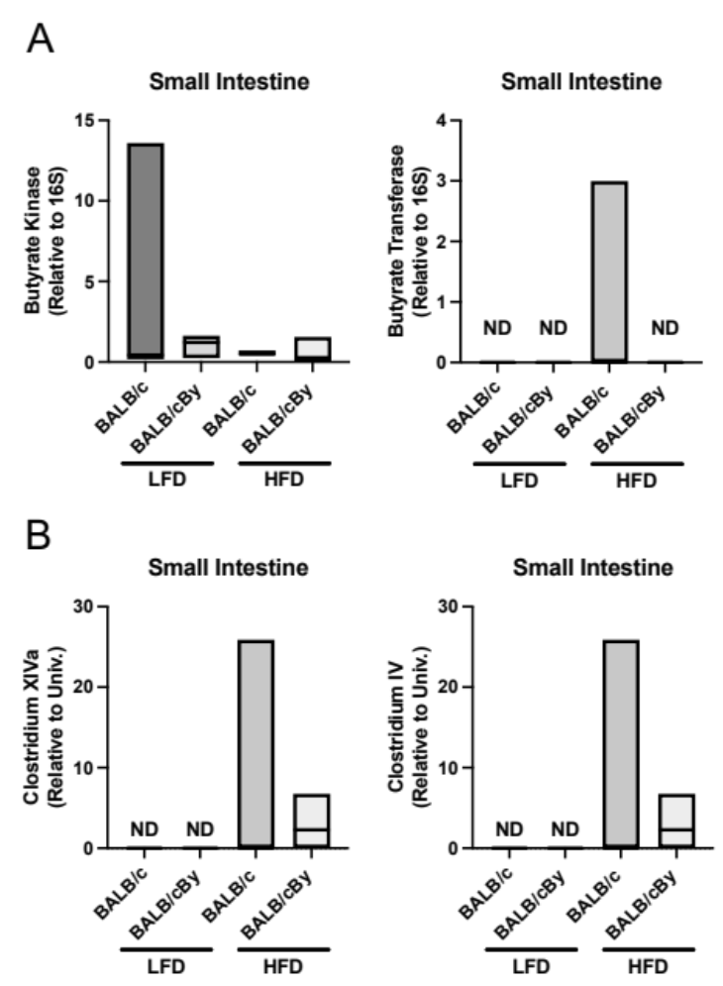

Figure 31. Impact of different dietary fiber diets on the composition of butyrate-producing bacteria in the small intestine of BALB/c and BALB/cBy
(A) Quantification of the level of butyrate kinase (buk) and butyryl-CoA: acetate CoA-transferase (but) in the small intestine of BALB/c and BALB/cBy mice in each diet group relative to 16S rRNA. (B) Quantification of the level of Clostridium XIVa and Clostridium IV in the small intestine of BALB/c and BALB/cBy mice in each diet group relative to 16S rRNA. For statistical analysis, qPCR was conducted three times per condition. Error bars are mean ± SEM.

Conclusion and future Direction
In this dissertation, it has been reported that (1) butyrate oxidation in cancerous colonocytes is regulated by PKM1, not by PKM2; (2) the reduced PKM1 in cancerous colonocytes lowered mitochondrial functions; (3) a decrease in PKM1 causes an increase in HIF1α, through a reduction of pyruvate, thereby lowers SCAD expression, suppressing butyrate oxidation and promoting glycolysis; (4) butyrate oxidation was significantly lowered in SCAD mutant non-disease mice model (5) the butyrate-producing bacteria (|BPB) population was significantly reduced in SCAD mutant mice (6) SCAD-deficient mice fail to respond the fermentable fiber in a high-fiber diet condition.
Our findings suggest a better understanding of butyrate metabolism and the different roles of PKM isoforms in cancerous colonocytes. Moreover, we explain how colonocyte metabolism affects the BPB composition in the host colon. This may suggest an even more profound aspect. If the colonocytes no longer utilize butyrate to its benefit as an energy source, it may not promote or select for bacteria that produce it.
In the future, based on the results of in vitro models suggested in chapter 2, research on the role of PKM isoforms in the development and progression of colorectal tumors would be necessary by using animal models. Successful animal studies will explore the impacts of PKM isoforms during colorectal tumor initiation, development, and progression into a carcinoma. Moreover, based on the findings of chapter 3, we need to study how the host-microbiome relationship affects colon disease development, such as IBDs and CRC. These future studies will illustrate the importance of a host-microbiome relationship in establishing the gastrointestinal microbiome and would help explain the reason why certain colon diseases show diminished butyrate oxidation have decreased BPB.

List of References
Abeywardana, T., Oh, M., Jiang, L., Yang, Y., Kong, M., Song, J., & Yang, Y. (2018). CARM1 suppresses de novo serine synthesis by promoting PKM2 activity. J Biol Chem, 293(39), 15290-15303. doi:10.1074/jbc.RA118.004512
Adak, A., & Khan, M. R. (2019). An insight into gut microbiota and its functionalities. Cell Mol Life Sci, 76(3), 473-493. doi:10.1007/s00018-018-2943-4
Al-Asmakh, M., & Hedin, L. (2015). Microbiota and the control of blood-tissue barriers. Tissue Barriers, 3(3), e1039691. doi:10.1080/21688370.2015.1039691
Al-Tassan, N., Chmiel, N. H., Maynard, J., Fleming, N., Livingston, A. L., Williams, G. T., . . . Cheadle, J. P. (2002). Inherited variants of MYH associated with somatic G:C-->T:A mutations in colorectal tumors. Nat Genet, 30(2), 227-232. doi:10.1038/ng828
Alquraishi, M., Puckett, D. L., Alani, D. S., Humidat, A. S., Frankel, V. D., Donohoe, D. R., . . . Bettaieb, A. (2019). Pyruvate kinase M2: A simple molecule with complex functions. Free Radic Biol Med, 143, 176-192. doi:10.1016/j.freeradbiomed.2019.08.007
Andriamihaja, M., Chaumontet, C., Tome, D., & Blachier, F. (2009). Butyrate metabolism in human colon carcinoma cells: implications concerning its growth-inhibitory effect. J Cell Physiol, 218(1), 58-65. doi:10.1002/jcp.21556
Archer, S. Y., Meng, S., Shei, A., & Hodin, R. A. (1998). p21(WAF1) is required for butyrate-mediated growth inhibition of human colon cancer cells. Proc Natl Acad Sci U S A, 95(12), 6791-6796. doi:10.1073/pnas.95.12.6791
Armaghany, T., Wilson, J. D., Chu, Q., & Mills, G. (2012). Genetic alterations in colorectal cancer. Gastrointest Cancer Res, 5(1), 19-27.
Astbury, S. M., & Corfe, B. M. (2012). Uptake and metabolism of the short-chain fatty acid butyrate, a critical review of the literature. Curr Drug Metab, 13(6), 815-821. doi:10.2174/138920012800840428
Augenlicht, L. H., Anthony, G. M., Church, T. L., Edelmann, W., Kucherlapati, R., Yang, K., . . . Heerdt, B. G. (1999). Short-chain fatty acid metabolism, apoptosis, and Apc-initiated tumorigenesis in the mouse gastrointestinal mucosa. Cancer Res, 59(23), 6005-6009.
Aune, D., Chan, D. S., Lau, R., Vieira, R., Greenwood, D. C., Kampman, E., & Norat, T. (2011). Dietary fibre, whole grains, and risk of colorectal cancer: systematic review and dose-response meta-analysis of prospective studies. Bmj, 343, d6617. doi:10.1136/bmj.d6617
Axelrad, J. E., Lichtiger, S., & Yajnik, V. (2016). Inflammatory bowel disease and cancer: The role of inflammation, immunosuppression, and cancer treatment. World J Gastroenterol, 22(20), 4794-4801. doi:10.3748/wjg.v22.i20.4794
Bäckhed, F., Ley, R. E., Sonnenburg, J. L., Peterson, D. A., & Gordon, J. I. (2005). Host-bacterial mutualism in the human intestine. Science, 307(5717), 1915-1920. doi:10.1126/science.1104816
Bailey, C. E., Hu, C. Y., You, Y. N., Bednarski, B. K., Rodriguez-Bigas, M. A., Skibber, J. M., . . . Chang, G. J. (2015). Increasing disparities in the age-related incidences of colon and rectal cancers in the United States, 1975-2010. JAMA Surg, 150(1), 17-22. doi:10.1001/jamasurg.2014.1756
Bastide, N. M., Pierre, F. H., & Corpet, D. E. (2011). Heme iron from meat and risk of colorectal cancer: a meta-analysis and a review of the mechanisms involved. Cancer Prev Res (Phila), 4(2), 177-184. doi:10.1158/1940-6207.Capr-10-0113
Becker, C., Neurath, M. F., & Wirtz, S. (2015). The Intestinal Microbiota in Inflammatory Bowel Disease. Ilar j, 56(2), 192-204. doi:10.1093/ilar/ilv030
Bhala, A., Willi, S. M., Rinaldo, P., Bennett, M. J., Schmidt-Sommerfeld, E., & Hale, D. E. (1995). Clinical and biochemical characterization of short-chain acyl-coenzyme A dehydrogenase deficiency. J Pediatr, 126(6), 910-915. doi:10.1016/s0022-3476(95)70207-5
Bhardwaj, A., & Das, S. (2016). SIRT6 deacetylates PKM2 to suppress its nuclear localization and oncogenic functions. Proc Natl Acad Sci U S A, 113(5), E538-547. doi:10.1073/pnas.1520045113
Bian, J., Dannappel, M., Wan, C., & Firestein, R. (2020). Transcriptional Regulation of Wnt/β-Catenin Pathway in Colorectal Cancer. Cells, 9(9). doi:10.3390/cells9092125
Bibbò, S., Ianiro, G., Giorgio, V., Scaldaferri, F., Masucci, L., Gasbarrini, A., & Cammarota, G. (2016). The role of diet on gut microbiota composition. Eur Rev Med Pharmacol Sci, 20(22), 4742-4749.
Bisgaard, M. L., Fenger, K., Bülow, S., Niebuhr, E., & Mohr, J. (1994). Familial adenomatous polyposis (FAP): frequency, penetrance, and mutation rate. Hum Mutat, 3(2), 121-125. doi:10.1002/humu.1380030206
Board, P. D. Q. A. T. E. (2002). Colon Cancer Treatment (PDQ®): Patient Version. In PDQ Cancer Information Summaries. Bethesda (MD): National Cancer Institute (US).
Bonaccorsi, L., Muratori, M., Carloni, V., Marchiani, S., Formigli, L., Forti, G., & Baldi, E. (2004). The androgen receptor associates with the epidermal growth factor receptor in androgen-sensitive prostate cancer cells. Steroids, 69(8-9), 549-552. doi:10.1016/j.steroids.2004.05.011
Botteri, E., Iodice, S., Raimondi, S., Maisonneuve, P., & Lowenfels, A. B. (2008). Cigarette smoking and adenomatous polyps: a meta-analysis. Gastroenterology, 134(2), 388-395. doi:10.1053/j.gastro.2007.11.007
Brändstedt, J., Wangefjord, S., Nodin, B., Gaber, A., Manjer, J., & Jirström, K. (2012). Gender, anthropometric factors and risk of colorectal cancer with particular reference to tumour location and TNM stage: a cohort study. Biol Sex Differ, 3(1), 23. doi:10.1186/2042-6410-3-23
Brenner, H., Chang-Claude, J., Seiler, C. M., Rickert, A., & Hoffmeister, M. (2011). Protection from colorectal cancer after colonoscopy: a population-based, case-control study. Ann Intern Med, 154(1), 22-30. doi:10.7326/0003-4819-154-1-201101040-00004
Brenner, H., Haug, U., Arndt, V., Stegmaier, C., Altenhofen, L., & Hoffmeister, M. (2010). Low risk of colorectal cancer and advanced adenomas more than 10 years after negative colonoscopy. Gastroenterology, 138(3), 870-876. doi:10.1053/j.gastro.2009.10.054
Brenner, H., Hoffmeister, M., & Haug, U. (2008). Family history and age at initiation of colorectal cancer screening. Am J Gastroenterol, 103(9), 2326-2331. doi:10.1111/j.1572-0241.2008.01978.x
Brown, K., Abbott, D. W., Uwiera, R. R. E., & Inglis, G. D. (2018). Removal of the cecum affects intestinal fermentation, enteric bacterial community structure, and acute colitis in mice. Gut Microbes, 9(3), 218-235. doi:10.1080/19490976.2017.1408763
Brown, R. E., Short, S. P., & Williams, C. S. (2018). Colorectal Cancer and Metabolism. Curr Colorectal Cancer Rep, 14(6), 226-241. doi:10.1007/s11888-018-0420-y
Bruun, J. M., Lihn, A. S., Pedersen, S. B., & Richelsen, B. (2005). Monocyte chemoattractant protein-1 release is higher in visceral than subcutaneous human adipose tissue (AT): implication of macrophages resident in the AT. J Clin Endocrinol Metab, 90(4), 2282-2289. doi:10.1210/jc.2004-1696
Buchner, A. M., & Lichtenstein, G. R. (2016). Evaluation and Detection of Dysplasia in IBD: the Role of Chromoendoscopy and Enhanced Imaging Techniques. Curr Treat Options Gastroenterol, 14(1), 73-82. doi:10.1007/s11938-016-0078-y
Bülow, S. (2003). Results of national registration of familial adenomatous polyposis. Gut, 52(5), 742-746. doi:10.1136/gut.52.5.742
Bultman, S. J. (2014). Molecular pathways: gene-environment interactions regulating dietary fiber induction of proliferation and apoptosis via butyrate for cancer prevention. Clin Cancer Res, 20(4), 799-803. doi:10.1158/1078-0432.Ccr-13-2483
Butterworth, A. S., Higgins, J. P., & Pharoah, P. (2006). Relative and absolute risk of colorectal cancer for individuals with a family history: a meta-analysis. Eur J Cancer, 42(2), 216-227. doi:10.1016/j.ejca.2005.09.023
Bye, W. A., Nguyen, T. M., Parker, C. E., Jairath, V., & East, J. E. (2017). Strategies for detecting colon cancer in patients with inflammatory bowel disease. Cochrane Database Syst Rev, 9(9), Cd000279. doi:10.1002/14651858.CD000279.pub4
Calabretta, S., Bielli, P., Passacantilli, I., Pilozzi, E., Fendrich, V., Capurso, G., . . . Sette, C. (2016). Modulation of PKM alternative splicing by PTBP1 promotes gemcitabine resistance in pancreatic cancer cells. Oncogene, 35(16), 2031-2039. doi:10.1038/onc.2015.270
Calle, E. E., & Kaaks, R. (2004). Overweight, obesity and cancer: epidemiological evidence and proposed mechanisms. Nat Rev Cancer, 4(8), 579-591. doi:10.1038/nrc1408
Cao, Y., Gao, X., Zhang, W., Zhang, G., Nguyen, A. K., Liu, X., . . . Ko, T. C. (2011). Dietary fiber enhances TGF-β signaling and growth inhibition in the gut. Am J Physiol Gastrointest Liver Physiol, 301(1), G156-164. doi:10.1152/ajpgi.00362.2010
Carding, S., Verbeke, K., Vipond, D. T., Corfe, B. M., & Owen, L. J. (2015). Dysbiosis of the gut microbiota in disease. Microb Ecol Health Dis, 26, 26191. doi:10.3402/mehd.v26.26191
Carvalho-Wells, A. L., Helmolz, K., Nodet, C., Molzer, C., Leonard, C., McKevith, B., . . . Tuohy, K. M. (2010). Determination of the in vivo prebiotic potential of a maize-based whole grain breakfast cereal: a human feeding study. Br J Nutr, 104(9), 1353-1356. doi:10.1017/s0007114510002084
Cascella, M., Bimonte, S., Barbieri, A., Del Vecchio, V., Caliendo, D., Schiavone, V., . . . Cuomo, A. (2018). Dissecting the mechanisms and molecules underlying the potential carcinogenicity of red and processed meat in colorectal cancer (CRC): an overview on the current state of knowledge. Infect Agent Cancer, 13, 3. doi:10.1186/s13027-018-0174-9
Catalano, M. G., Pfeffer, U., Raineri, M., Ferro, P., Curto, A., Capuzzi, P., . . . Fortunati, N. (2000). Altered expression of androgen-receptor isoforms in human colon-cancer tissues. Int J Cancer, 86(3), 325-330. doi:10.1002/(sici)1097-0215(20000501)86:3<325::aid-ijc4>3.0.co;2-g
Chalabi, N. A. M., Bassiouny, R. H., & El Sedek, M. A. (2020). FDG-PETCT versus contrast-enhanced computed tomography in diagnosis of post-therapeutic colorectal cancer recurrence and metastases. Egyptian Journal of Radiology and Nuclear Medicine, 51(1), 3. doi:10.1186/s43055-019-0083-y
Chan, D. S., Lau, R., Aune, D., Vieira, R., Greenwood, D. C., Kampman, E., & Norat, T. (2011). Red and processed meat and colorectal cancer incidence: meta-analysis of prospective studies. PLoS One, 6(6), e20456. doi:10.1371/journal.pone.0020456
Chaneton, B., Hillmann, P., Zheng, L., Martin, A. C. L., Maddocks, O. D. K., Chokkathukalam, A., . . . Gottlieb, E. (2012). Serine is a natural ligand and allosteric activator of pyruvate kinase M2. Nature, 491(7424), 458-462. doi:10.1038/nature11540
Chang, L. C., Wu, M. S., Tu, C. H., Lee, Y. C., Shun, C. T., & Chiu, H. M. (2014). Metabolic syndrome and smoking may justify earlier colorectal cancer screening in men. Gastrointest Endosc, 79(6), 961-969. doi:10.1016/j.gie.2013.11.035
Choi, J., Hur, T. Y., & Hong, Y. (2018). Influence of Altered Gut Microbiota Composition on Aging and Aging-Related Diseases. J Lifestyle Med, 8(1), 1-7. doi:10.15280/jlm.2018.8.1.1
Choi, Y. J., Myung, S. K., & Lee, J. H. (2018). Light Alcohol Drinking and Risk of Cancer: A Meta-Analysis of Cohort Studies. Cancer Res Treat, 50(2), 474-487. doi:10.4143/crt.2017.094
Chong, E. S. (2014). A potential role of probiotics in colorectal cancer prevention: review of possible mechanisms of action. World J Microbiol Biotechnol, 30(2), 351-374. doi:10.1007/s11274-013-1499-6
Chopin, V., Toillon, R. A., Jouy, N., & Le Bourhis, X. (2002). Sodium butyrate induces P53-independent, Fas-mediated apoptosis in MCF-7 human breast cancer cells. Br J Pharmacol, 135(1), 79-86. doi:10.1038/sj.bjp.0704456
Christofk, H. R., Vander Heiden, M. G., Harris, M. H., Ramanathan, A., Gerszten, R. E., Wei, R., . . . Cantley, L. C. (2008). The M2 splice isoform of pyruvate kinase is important for cancer metabolism and tumour growth. Nature, 452(7184), 230-233. doi:10.1038/nature06734
Christofk, H. R., Vander Heiden, M. G., Wu, N., Asara, J. M., & Cantley, L. C. (2008). Pyruvate kinase M2 is a phosphotyrosine-binding protein. Nature, 452(7184), 181-186. doi:10.1038/nature06667
Churuangsuk, C., Lean, M. E. J., & Combet, E. (2020). Lower carbohydrate and higher fat intakes are associated with higher hemoglobin A1c: findings from the UK National Diet and Nutrition Survey 2008-2016. Eur J Nutr, 59(6), 2771-2782. doi:10.1007/s00394-019-02122-1
Click, B., Pinsky, P. F., Hickey, T., Doroudi, M., & Schoen, R. E. (2018). Association of Colonoscopy Adenoma Findings With Long-term Colorectal Cancer Incidence. Jama, 319(19), 2021-2031. doi:10.1001/jama.2018.5809
Clinton, S. K., Giovannucci, E. L., & Hursting, S. D. (2020). The World Cancer Research Fund/American Institute for Cancer Research Third Expert Report on Diet, Nutrition, Physical Activity, and Cancer: Impact and Future Directions. J Nutr, 150(4), 663-671. doi:10.1093/jn/nxz268
Clower, C. V., Chatterjee, D., Wang, Z., Cantley, L. C., Vander Heiden, M. G., & Krainer, A. R. (2010). The alternative splicing repressors hnRNP A1/A2 and PTB influence pyruvate kinase isoform expression and cell metabolism. Proc Natl Acad Sci U S A, 107(5), 1894-1899. doi:10.1073/pnas.0914845107
Colgan, S. P., & Taylor, C. T. (2010). Hypoxia: an alarm signal during intestinal inflammation. Nat Rev Gastroenterol Hepatol, 7(5), 281-287. doi:10.1038/nrgastro.2010.39
Comalada, M., Bailón, E., de Haro, O., Lara-Villoslada, F., Xaus, J., Zarzuelo, A., & Gálvez, J. (2006). The effects of short-chain fatty acids on colon epithelial proliferation and survival depend on the cellular phenotype. J Cancer Res Clin Oncol, 132(8), 487-497. doi:10.1007/s00432-006-0092-x
Conway, E. M., Collen, D., & Carmeliet, P. (2001). Molecular mechanisms of blood vessel growth. Cardiovasc Res, 49(3), 507-521. doi:10.1016/s0008-6363(00)00281-9
Cook, M. B., McGlynn, K. A., Devesa, S. S., Freedman, N. D., & Anderson, W. F. (2011). Sex disparities in cancer mortality and survival. Cancer Epidemiol Biomarkers Prev, 20(8), 1629-1637. doi:10.1158/1055-9965.Epi-11-0246
Costabile, A., Kolida, S., Klinder, A., Gietl, E., Bäuerlein, M., Frohberg, C., . . . Gibson, G. R. (2010). A double-blind, placebo-controlled, cross-over study to establish the bifidogenic effect of a very-long-chain inulin extracted from globe artichoke (Cynara scolymus) in healthy human subjects. Br J Nutr, 104(7), 1007-1017. doi:10.1017/s0007114510001571
Costello, E. K., Stagaman, K., Dethlefsen, L., Bohannan, B. J., & Relman, D. A. (2012). The application of ecological theory toward an understanding of the human microbiome. Science, 336(6086), 1255-1262. doi:10.1126/science.1224203
Counillon, L., Bouret, Y., Marchiq, I., & Pouysségur, J. (2016). Na(+)/H(+) antiporter (NHE1) and lactate/H(+) symporters (MCTs) in pH homeostasis and cancer metabolism. Biochim Biophys Acta, 1863(10), 2465-2480. doi:10.1016/j.bbamcr.2016.02.018
Cresci, G. A., Thangaraju, M., Mellinger, J. D., Liu, K., & Ganapathy, V. (2010). Colonic gene expression in conventional and germ-free mice with a focus on the butyrate receptor GPR109A and the butyrate transporter SLC5A8. J Gastrointest Surg, 14(3), 449-461. doi:10.1007/s11605-009-1045-x
Cruz, M. D., Ledbetter, S., Chowdhury, S., Tiwari, A. K., Momi, N., Wali, R. K., . . . Roy, H. K. (2017). Metabolic reprogramming of the premalignant colonic mucosa is an early event in carcinogenesis. Oncotarget, 8(13), 20543-20557. doi:10.18632/oncotarget.16129
Cruz-Correa, M., & Giardiello, F. M. (2003). Familial adenomatous polyposis. Gastrointest Endosc, 58(6), 885-894. doi:10.1016/s0016-5107(03)02336-8
Cui, R., & Shi, X. Y. (2015). Expression of pyruvate kinase M2 in human colorectal cancer and its prognostic value. Int J Clin Exp Pathol, 8(9), 11393-11399.
Cummings, J. H., & Macfarlane, G. T. (1991). The control and consequences of bacterial fermentation in the human colon. J Appl Bacteriol, 70(6), 443-459. doi:10.1111/j.1365-2672.1991.tb02739.x
Dang, C. V., & Semenza, G. L. (1999). Oncogenic alterations of metabolism. Trends Biochem Sci, 24(2), 68-72. doi:10.1016/s0968-0004(98)01344-9
Dang, D. T., Chen, F., Gardner, L. B., Cummins, J. M., Rago, C., Bunz, F., . . . Dang, L. H. (2006). Hypoxia-inducible factor-1alpha promotes nonhypoxia-mediated proliferation in colon cancer cells and xenografts. Cancer Res, 66(3), 1684-1936. doi:10.1158/0008-5472.CAN-05-2887
Davie, J. R. (2003). Inhibition of histone deacetylase activity by butyrate. J Nutr, 133(7 Suppl), 2485s-2493s. doi:10.1093/jn/133.7.2485S
De Almeida, C. V., de Camargo, M. R., Russo, E., & Amedei, A. (2019). Role of diet and gut microbiota on colorectal cancer immunomodulation. World J Gastroenterol, 25(2), 151-162. doi:10.3748/wjg.v25.i2.151
De Preter, V., Arijs, I., Windey, K., Vanhove, W., Vermeire, S., Schuit, F., . . . Verbeke, K. (2012). Impaired butyrate oxidation in ulcerative colitis is due to decreased butyrate uptake and a defect in the oxidation pathway. Inflamm Bowel Dis, 18(6), 1127-1136. doi:10.1002/ibd.21894
De Vuyst, L., & Leroy, F. (2011). Cross-feeding between bifidobacteria and butyrate-producing colon bacteria explains bifdobacterial competitiveness, butyrate production, and gas production. Int J Food Microbiol, 149(1), 73-80. doi:10.1016/j.ijfoodmicro.2011.03.003
Deng, L., Gui, Z., Zhao, L., Wang, J., & Shen, L. (2012). Diabetes mellitus and the incidence of colorectal cancer: an updated systematic review and meta-analysis. Dig Dis Sci, 57(6), 1576-1585. doi:10.1007/s10620-012-2055-1
Deschasaux, M., Bouter, K. E., Prodan, A., Levin, E., Groen, A. K., Herrema, H., . . . Nieuwdorp, M. (2018). Depicting the composition of gut microbiota in a population with varied ethnic origins but shared geography. Nat Med, 24(10), 1526-1531. doi:10.1038/s41591-018-0160-1
Dominitz, J. A., Robertson, D. J., Ahnen, D. J., Allison, J. E., Antonelli, M., Boardman, K. D., . . . Guarino, P. D. (2017). Colonoscopy vs. Fecal Immunochemical Test in Reducing Mortality From Colorectal Cancer (CONFIRM): Rationale for Study Design. Am J Gastroenterol, 112(11), 1736-1746. doi:10.1038/ajg.2017.286
Dong, Y., Zhou, J., Zhu, Y., Luo, L., He, T., Hu, H., . . . Teng, Z. (2017). Abdominal obesity and colorectal cancer risk: systematic review and meta-analysis of prospective studies. Biosci Rep, 37(6). doi:10.1042/bsr20170945
Donohoe, D. R., Collins, L. B., Wali, A., Bigler, R., Sun, W., & Bultman, S. J. (2012). The Warburg effect dictates the mechanism of butyrate-mediated histone acetylation and cell proliferation. Mol Cell, 48(4), 612-626. doi:10.1016/j.molcel.2012.08.033
Donohoe, D. R., Curry, K. P., & Bultman, S. J. (2013). Microbial oncotarget: bacterial-produced butyrate, chemoprevention and Warburg effect. Oncotarget, 4(2), 182-183. doi:10.18632/oncotarget.915
Donohoe, D. R., Garge, N., Zhang, X., Sun, W., O'Connell, T. M., Bunger, M. K., & Bultman, S. J. (2011). The microbiome and butyrate regulate energy metabolism and autophagy in the mammalian colon. Cell Metab, 13(5), 517-526. doi:10.1016/j.cmet.2011.02.018
Donohoe, D. R., Wali, A., Brylawski, B. P., & Bultman, S. J. (2012). Microbial regulation of glucose metabolism and cell-cycle progression in mammalian colonocytes. PLoS One, 7(9), e46589. doi:10.1371/journal.pone.0046589
Duncan, S. H., Barcenilla, A., Stewart, C. S., Pryde, S. E., & Flint, H. J. (2002). Acetate utilization and butyryl coenzyme A (CoA):acetate-CoA transferase in butyrate-producing bacteria from the human large intestine. Appl Environ Microbiol, 68(10), 5186-5190. doi:10.1128/aem.68.10.5186-5190.2002
Duncan, S. H., Louis, P., Thomson, J. M., & Flint, H. J. (2009). The role of pH in determining the species composition of the human colonic microbiota. Environ Microbiol, 11(8), 2112-2122. doi:10.1111/j.1462-2920.2009.01931.x
Dwyer, M. L., Colombo, A., & Bozzi, G. (1989). Retrieval technique of a PTCA guidewire. G Ital Cardiol, 19(2), 170-172.
Elce, A., Amato, F., Zarrilli, F., Calignano, A., Troncone, R., Castaldo, G., & Canani, R. B. (2017). Butyrate modulating effects on pro-inflammatory pathways in human intestinal epithelial cells. Benef Microbes, 8(5), 841-847. doi:10.3920/bm2016.0197
Encarnação, J. C., Abrantes, A. M., Pires, A. S., & Botelho, M. F. (2015). Revisit dietary fiber on colorectal cancer: butyrate and its role on prevention and treatment. Cancer Metastasis Rev, 34(3), 465-478. doi:10.1007/s10555-015-9578-9
Espey, M. G. (2013). Role of oxygen gradients in shaping redox relationships between the human intestine and its microbiota. Free Radic Biol Med, 55, 130-140. doi:10.1016/j.freeradbiomed.2012.10.554
Falony, G., & De Vuyst, L. (2009). Ecological Interactions of Bacteria in the Human Gut. In D. Charalampopoulos & R. A. Rastall (Eds.), Prebiotics and Probiotics Science and Technology (pp. 639-679). New York, NY: Springer New York.
Falony, G., Joossens, M., Vieira-Silva, S., Wang, J., Darzi, Y., Faust, K., . . . Raes, J. (2016). Population-level analysis of gut microbiome variation. Science, 352(6285), 560-564. doi:10.1126/science.aad3503
Fearon, E. R., Hamilton, S. R., & Vogelstein, B. (1987). Clonal analysis of human colorectal tumors. Science, 238(4824), 193-197. doi:10.1126/science.2889267
Ferreira-Halder, C. V., Faria, A. V. S., & Andrade, S. S. (2017). Action and function of Faecalibacterium prausnitzii in health and disease. Best Pract Res Clin Gastroenterol, 31(6), 643-648. doi:10.1016/j.bpg.2017.09.011
Figueiredo, J. C., Crockett, S. D., Snover, D. C., Morris, C. B., McKeown-Eyssen, G., Sandler, R. S., . . . Baron, J. A. (2015). Smoking-associated risks of conventional adenomas and serrated polyps in the colorectum. Cancer Causes Control, 26(3), 377-386. doi:10.1007/s10552-014-0513-0
Finlay, B. B., Pettersson, S., Melby, M. K., & Bosch, T. C. G. (2019). The Microbiome Mediates Environmental Effects on Aging. Bioessays, 41(10), e1800257. doi:10.1002/bies.201800257
Fiorelli, G., Picariello, L., Martineti, V., Tonelli, F., & Brandi, M. L. (1999). Functional estrogen receptor beta in colon cancer cells. Biochem Biophys Res Commun, 261(2), 521-527. doi:10.1006/bbrc.1999.1062
Fleming, S. E., Fitch, M. D., DeVries, S., Liu, M. L., & Kight, C. (1991). Nutrient utilization by cells isolated from rat jejunum, cecum and colon. J Nutr, 121(6), 869-878. doi:10.1093/jn/121.6.869
Flint, H. J., Duncan, S. H., Scott, K. P., & Louis, P. (2015). Links between diet, gut microbiota composition and gut metabolism. Proc Nutr Soc, 74(1), 13-22. doi:10.1017/s0029665114001463
Flood, A., Strayer, L., Schairer, C., & Schatzkin, A. (2010). Diabetes and risk of incident colorectal cancer in a prospective cohort of women. Cancer Causes Control, 21(8), 1277-1284. doi:10.1007/s10552-010-9555-0
Fodde, R. (2002). The APC gene in colorectal cancer. Eur J Cancer, 38(7), 867-871. doi:10.1016/s0959-8049(02)00040-0
Frank, D. N., St Amand, A. L., Feldman, R. A., Boedeker, E. C., Harpaz, N., & Pace, N. R. (2007). Molecular-phylogenetic characterization of microbial community imbalances in human inflammatory bowel diseases. Proc Natl Acad Sci U S A, 104(34), 13780-13785. doi:10.1073/pnas.0706625104
Gamage, S. M. K., Dissabandara, L., Lam, A. K., & Gopalan, V. (2018). The role of heme iron molecules derived from red and processed meat in the pathogenesis of colorectal carcinoma. Crit Rev Oncol Hematol, 126, 121-128. doi:10.1016/j.critrevonc.2018.03.025
Gan, P., Patterson, M., Watanabe, H., Wang, K., Edmonds, R. A., Reinholdt, L. G., & Sucov, H. M. (2020). Allelic variants between mouse substrains BALB/cJ and BALB/cByJ influence mononuclear cardiomyocyte composition and cardiomyocyte nuclear ploidy. Sci Rep, 10(1), 7605. doi:10.1038/s41598-020-64621-0
Ganapathy, V., Thangaraju, M., Prasad, P. D., Martin, P. M., & Singh, N. (2013). Transporters and receptors for short-chain fatty acids as the molecular link between colonic bacteria and the host. Curr Opin Pharmacol, 13(6), 869-874. doi:10.1016/j.coph.2013.08.006
Gasaly, N., Hermoso, M. A., & Gotteland, M. (2021). Butyrate and the Fine-Tuning of Colonic Homeostasis: Implication for Inflammatory Bowel Diseases. Int J Mol Sci, 22(6). doi:10.3390/ijms22063061
Gee, J. M., Blackburn, N. A., & Johnson, I. T. (1983). The influence of guar gum on intestinal cholesterol transport in the rat. Br J Nutr, 50(2), 215-224. doi:10.1079/bjn19830091
Geier, M. S., Butler, R. N., & Howarth, G. S. (2006). Probiotics, prebiotics and synbiotics: a role in chemoprevention for colorectal cancer? Cancer Biol Ther, 5(10), 1265-1269. doi:10.4161/cbt.5.10.3296
Gerencser, A. A., Neilson, A., Choi, S. W., Edman, U., Yadava, N., Oh, R. J., . . . Brand, M. D. (2009). Quantitative microplate-based respirometry with correction for oxygen diffusion. Anal Chem, 81(16), 6868-6878. doi:10.1021/ac900881z
Gibson, G. R., Probert, H. M., Loo, J. V., Rastall, R. A., & Roberfroid, M. B. (2004). Dietary modulation of the human colonic microbiota: updating the concept of prebiotics. Nutr Res Rev, 17(2), 259-275. doi:10.1079/nrr200479
Gibson, G. R., & Roberfroid, M. B. (1995). Dietary modulation of the human colonic microbiota: introducing the concept of prebiotics. J Nutr, 125(6), 1401-1412. doi:10.1093/jn/125.6.1401
Gibson, G. R., Scott, K. P., Rastall, R. A., Tuohy, K. M., Hotchkiss, A., Dubert-Ferrandon, A., . . . Buddington, R. (2010). Dietary prebiotics: current status and new definition. Food Science & Technology Bulletin Functional Foods, 7(1), 1-19. doi:10.1616/1476-2137.15880
Giovannucci, E., & Martínez, M. E. (1996). Tobacco, colorectal cancer, and adenomas: a review of the evidence. J Natl Cancer Inst, 88(23), 1717-1730. doi:10.1093/jnci/88.23.1717
Goldsmith, J. R., & Sartor, R. B. (2014). The role of diet on intestinal microbiota metabolism: downstream impacts on host immune function and health, and therapeutic implications. J Gastroenterol, 49(5), 785-798. doi:10.1007/s00535-014-0953-z
Gonzalez-Pons, M., & Cruz-Correa, M. (2015). Colorectal Cancer Biomarkers: Where Are We Now? Biomed Res Int, 2015, 149014. doi:10.1155/2015/149014
Guilloteau, P., Martin, L., Eeckhaut, V., Ducatelle, R., Zabielski, R., & Van Immerseel, F. (2010). From the gut to the peripheral tissues: the multiple effects of butyrate. Nutr Res Rev, 23(2), 366-384. doi:10.1017/s0954422410000247
Guinane, C. M., & Cotter, P. D. (2013). Role of the gut microbiota in health and chronic gastrointestinal disease: understanding a hidden metabolic organ. Therap Adv Gastroenterol, 6(4), 295-308. doi:10.1177/1756283x13482996
Guo, P., Zhang, K., Ma, X., & He, P. (2020). Clostridium species as probiotics: potentials and challenges. Journal of Animal Science and Biotechnology, 11(1), 24. doi:10.1186/s40104-019-0402-1
Haggar, F. A., & Boushey, R. P. (2009). Colorectal cancer epidemiology: incidence, mortality, survival, and risk factors. Clin Colon Rectal Surg, 22(4), 191-197. doi:10.1055/s-0029-1242458
Hagland, H. R., & Søreide, K. (2015). Cellular metabolism in colorectal carcinogenesis: Influence of lifestyle, gut microbiome and metabolic pathways. Cancer Lett, 356(2 Pt A), 273-280. doi:10.1016/j.canlet.2014.02.026
Hamer, H. M., Jonkers, D., Venema, K., Vanhoutvin, S., Troost, F. J., & Brummer, R. J. (2008). Review article: the role of butyrate on colonic function. Aliment Pharmacol Ther, 27(2), 104-119. doi:10.1111/j.1365-2036.2007.03562.x
Han, A., Bennett, N., Ahmed, B., Whelan, J., & Donohoe, D. R. (2018). Butyrate decreases its own oxidation in colorectal cancer cells through inhibition of histone deacetylases. Oncotarget, 9(43), 27280-27292. doi:10.18632/oncotarget.25546
Han, J., Zhao, Z., Zhang, N., Yang, Y., Ma, L., Feng, L., . . . Wang, G. (2021). Transcriptional dysregulation of TRIM29 promotes colorectal cancer carcinogenesis via pyruvate kinase-mediated glucose metabolism. Aging (Albany NY), 13(4), 5034-5054. doi:10.18632/aging.202414
Hanahan, D., & Weinberg, R. A. (2011). Hallmarks of cancer: the next generation. Cell, 144(5), 646-674. doi:10.1016/j.cell.2011.02.013
Hassold, T., Kumlin, E., Takaesu, N., & Leppert, M. (1985). Use of restriction fragment length polymorphisms to study the origin of human aneuploidy. Ann N Y Acad Sci, 450, 179-189. doi:10.1111/j.1749-6632.1985.tb21492.x
He, C., & Klionsky, D. J. (2009). Regulation mechanisms and signaling pathways of autophagy. Annu Rev Genet, 43, 67-93. doi:10.1146/annurev-genet-102808-114910
He, X., Arslan, A. D., Ho, T. T., Yuan, C., Stampfer, M. R., & Beck, W. T. (2014). Involvement of polypyrimidine tract-binding protein (PTBP1) in maintaining breast cancer cell growth and malignant properties. Oncogenesis, 3(1), e84. doi:10.1038/oncsis.2013.47
Heintz, C., & Mair, W. (2014). You are what you host: microbiome modulation of the aging process. Cell, 156(3), 408-411. doi:10.1016/j.cell.2014.01.025
Helmus, D. S., Thompson, C. L., Zelenskiy, S., Tucker, T. C., & Li, L. (2013). Red meat-derived heterocyclic amines increase risk of colon cancer: a population-based case-control study. Nutr Cancer, 65(8), 1141-1150. doi:10.1080/01635581.2013.834945
Hengst, C., Ptok, S., Roessler, A., Fechner, A., & Jahreis, G. (2009). Effects of polydextrose supplementation on different faecal parameters in healthy volunteers. Int J Food Sci Nutr, 60 Suppl 5, 96-105. doi:10.1080/09637480802526760
Heriot, A. G., Hicks, R. J., Drummond, E. G., Keck, J., Mackay, J., Chen, F., & Kalff, V. (2004). Does positron emission tomography change management in primary rectal cancer? A prospective assessment. Dis Colon Rectum, 47(4), 451-458. doi:10.1007/s10350-003-0089-3
Herzig, S., & Shaw, R. J. (2018). AMPK: guardian of metabolism and mitochondrial homeostasis. Nat Rev Mol Cell Biol, 19(2), 121-135. doi:10.1038/nrm.2017.95
Hitosugi, T., Kang, S., Vander Heiden, M. G., Chung, T. W., Elf, S., Lythgoe, K., . . . Chen, J. (2009). Tyrosine phosphorylation inhibits PKM2 to promote the Warburg effect and tumor growth. Sci Signal, 2(97), ra73. doi:10.1126/scisignal.2000431
Ho, J., de Moura, M. B., Lin, Y., Vincent, G., Thorne, S., Duncan, L. M., . . . Moschos, S. J. (2012). Importance of glycolysis and oxidative phosphorylation in advanced melanoma. Mol Cancer, 11, 76. doi:10.1186/1476-4598-11-76
Hofseth, L. J., Saito, S., Hussain, S. P., Espey, M. G., Miranda, K. M., Araki, Y., . . . Harris, C. C. (2003). Nitric oxide-induced cellular stress and p53 activation in chronic inflammation. Proc Natl Acad Sci U S A, 100(1), 143-148. doi:10.1073/pnas.0237083100
Holmes, E., Li, J. V., Athanasiou, T., Ashrafian, H., & Nicholson, J. K. (2011). Understanding the role of gut microbiome-host metabolic signal disruption in health and disease. Trends Microbiol, 19(7), 349-359. doi:10.1016/j.tim.2011.05.006
Holscher, H. D. (2017). Dietary fiber and prebiotics and the gastrointestinal microbiota. Gut Microbes, 8(2), 172-184. doi:10.1080/19490976.2017.1290756
Hong, Y. H., Nishimura, Y., Hishikawa, D., Tsuzuki, H., Miyahara, H., Gotoh, C., . . . Sasaki, S. (2005). Acetate and propionate short chain fatty acids stimulate adipogenesis via GPCR43. Endocrinology, 146(12), 5092-5099. doi:10.1210/en.2005-0545
Hsu, P. P., & Sabatini, D. M. (2008). Cancer cell metabolism: Warburg and beyond. Cell, 134(5), 703-707. doi:10.1016/j.cell.2008.08.021
Hudcovic, T., Kolinska, J., Klepetar, J., Stepankova, R., Rezanka, T., Srutkova, D., . . . Kozakova, H. (2012). Protective effect of Clostridium tyrobutyricum in acute dextran sodium sulphate-induced colitis: differential regulation of tumour necrosis factor-α and interleukin-18 in BALB/c and severe combined immunodeficiency mice. Clin Exp Immunol, 167(2), 356-365. doi:10.1111/j.1365-2249.2011.04498.x
Humphries, A., & Wright, N. A. (2008). Colonic crypt organization and tumorigenesis. Nat Rev Cancer, 8(6), 415-424. doi:10.1038/nrc2392
Huttenhower, C., Gevers, D., Knight, R., Abubucker, S., Badger, J. H., Chinwalla, A. T., . . . The Human Microbiome Project, C. (2012). Structure, function and diversity of the healthy human microbiome. Nature, 486(7402), 207-214. doi:10.1038/nature11234
Hwang, S. R., Murga-Zamalloa, C., Brown, N., Basappa, J., McDonnell, S. R., Mendoza-Reinoso, V., . . . Lim, M. S. (2017). Pyrimidine tract-binding protein 1 mediates pyruvate kinase M2-dependent phosphorylation of signal transducer and activator of transcription 3 and oncogenesis in anaplastic large cell lymphoma. Lab Invest, 97(8), 962-970. doi:10.1038/labinvest.2017.39
Imamura, F., Micha, R., Khatibzadeh, S., Fahimi, S., Shi, P., Powles, J., & Mozaffarian, D. (2015). Dietary quality among men and women in 187 countries in 1990 and 2010: a systematic assessment. Lancet Glob Health, 3(3), e132-142. doi:10.1016/s2214-109x(14)70381-x
Imperiale, T. F., Ransohoff, D. F., Itzkowitz, S. H., Levin, T. R., Lavin, P., Lidgard, G. P., . . . Berger, B. M. (2014). Multitarget stool DNA testing for colorectal-cancer screening. N Engl J Med, 370(14), 1287-1297. doi:10.1056/NEJMoa1311194
Islami, F., Goding Sauer, A., Miller, K. D., Siegel, R. L., Fedewa, S. A., Jacobs, E. J., . . . Jemal, A. (2018). Proportion and number of cancer cases and deaths attributable to potentially modifiable risk factors in the United States. CA Cancer J Clin, 68(1), 31-54. doi:10.3322/caac.21440
Israelsen, W. J., & Vander Heiden, M. G. (2015). Pyruvate kinase: Function, regulation and role in cancer. Semin Cell Dev Biol, 43, 43-51. doi:10.1016/j.semcdb.2015.08.004
Itzkowitz, S. H., & Yio, X. (2004). Inflammation and cancer IV. Colorectal cancer in inflammatory bowel disease: the role of inflammation. Am J Physiol Gastrointest Liver Physiol, 287(1), G7-17. doi:10.1152/ajpgi.00079.2004
Jasperson, K. W., Tuohy, T. M., Neklason, D. W., & Burt, R. W. (2010). Hereditary and familial colon cancer. Gastroenterology, 138(6), 2044-2058. doi:10.1053/j.gastro.2010.01.054
Jha, R., Fouhse, J. M., Tiwari, U. P., Li, L., & Willing, B. P. (2019). Dietary Fiber and Intestinal Health of Monogastric Animals. Front Vet Sci, 6, 48. doi:10.3389/fvets.2019.00048
Jie, Z., Bang-Yao, L., Ming-Jie, X., Hai-Wei, L., Zu-Kang, Z., Ting-Song, W., & Craig, S. A. (2000). Studies on the effects of polydextrose intake on physiologic functions in Chinese people. Am J Clin Nutr, 72(6), 1503-1509. doi:10.1093/ajcn/72.6.1503
Johnson, C. M., Wei, C., Ensor, J. E., Smolenski, D. J., Amos, C. I., Levin, B., & Berry, D. A. (2013). Meta-analyses of colorectal cancer risk factors. Cancer Causes Control, 24(6), 1207-1222. doi:10.1007/s10552-013-0201-5
Jones, J. M. (2014). CODEX-aligned dietary fiber definitions help to bridge the 'fiber gap'. Nutr J, 13, 34. doi:10.1186/1475-2891-13-34
Jones, S., Chen, W. D., Parmigiani, G., Diehl, F., Beerenwinkel, N., Antal, T., . . . Markowitz, S. D. (2008). Comparative lesion sequencing provides insights into tumor evolution. Proc Natl Acad Sci U S A, 105(11), 4283-4288. doi:10.1073/pnas.0712345105
Jung, B., Staudacher, J. J., & Beauchamp, D. (2017). Transforming Growth Factor β Superfamily Signaling in Development of Colorectal Cancer. Gastroenterology, 152(1), 36-52. doi:10.1053/j.gastro.2016.10.015
Jurica, M. S., Mesecar, A., Heath, P. J., Shi, W., Nowak, T., & Stoddard, B. L. (1998). The allosteric regulation of pyruvate kinase by fructose-1,6-bisphosphate. Structure, 6(2), 195-210. doi:10.1016/s0969-2126(98)00021-5
Kaelin, W. G., Jr., & Ratcliffe, P. J. (2008). Oxygen sensing by metazoans: the central role of the HIF hydroxylase pathway. Mol Cell, 30(4), 393-402. doi:10.1016/j.molcel.2008.04.009
Kaiko, G. E., Ryu, S. H., Koues, O. I., Collins, P. L., Solnica-Krezel, L., Pearce, E. J., . . . Stappenbeck, T. S. (2016). The Colonic Crypt Protects Stem Cells from Microbiota-Derived Metabolites. Cell, 165(7), 1708-1720. doi:https://doi.org/10.1016/j.cell.2016.05.018
Kasubuchi, M., Hasegawa, S., Hiramatsu, T., Ichimura, A., & Kimura, I. (2015). Dietary gut microbial metabolites, short-chain fatty acids, and host metabolic regulation. Nutrients, 7(4), 2839-2849. doi:10.3390/nu7042839
Kedrin, D., & Gala, M. K. (2015). Genetics of the serrated pathway to colorectal cancer. Clin Transl Gastroenterol, 6(4), e84. doi:10.1038/ctg.2015.12
Kelly, C. J., Zheng, L., Campbell, E. L., Saeedi, B., Scholz, C. C., Bayless, A. J., . . . Colgan, S. P. (2015). Crosstalk between Microbiota-Derived Short-Chain Fatty Acids and Intestinal Epithelial HIF Augments Tissue Barrier Function. Cell Host Microbe, 17(5), 662-671. doi:10.1016/j.chom.2015.03.005
Keum, N., & Giovannucci, E. (2019). Global burden of colorectal cancer: emerging trends, risk factors and prevention strategies. Nat Rev Gastroenterol Hepatol, 16(12), 713-732. doi:10.1038/s41575-019-0189-8
Kijima, S., Sasaki, T., Nagata, K., Utano, K., Lefor, A. T., & Sugimoto, H. (2014). Preoperative evaluation of colorectal cancer using CT colonography, MRI, and PET/CT. World J Gastroenterol, 20(45), 16964-16975. doi:10.3748/wjg.v20.i45.16964
Kim, D. H., Lubner, M. G., Cahoon, A. R., Pooler, B. D., & Pickhardt, P. J. (2018). Flat Serrated Polyps at CT Colonography: Relevance, Appearance, and Optimizing Interpretation. Radiographics, 38(1), 60-74. doi:10.1148/rg.2018170110
Kim, D. H., Matkowskyj, K. A., Lubner, M. G., Hinshaw, J. L., Munoz Del Rio, A., Pooler, B. D., . . . Pickhardt, P. J. (2016). Serrated Polyps at CT Colonography: Prevalence and Characteristics of the Serrated Polyp Spectrum. Radiology, 280(2), 455-463. doi:10.1148/radiol.2016151608
Kim, E. R., & Chang, D. K. (2014). Colorectal cancer in inflammatory bowel disease: the risk, pathogenesis, prevention and diagnosis. World J Gastroenterol, 20(29), 9872-9881. doi:10.3748/wjg.v20.i29.9872
Kim, J. W., Tchernyshyov, I., Semenza, G. L., & Dang, C. V. (2006). HIF-1-mediated expression of pyruvate dehydrogenase kinase: a metabolic switch required for cellular adaptation to hypoxia. Cell Metab, 3(3), 177-185. doi:10.1016/j.cmet.2006.02.002
Kim, T. M., Lee, S. H., & Chung, Y. J. (2013). Clinical applications of next-generation sequencing in colorectal cancers. World J Gastroenterol, 19(40), 6784-6793. doi:10.3748/wjg.v19.i40.6784
Kim, Y., Lee, Y. S., Kang, S. W., Kim, S., Kim, T. Y., Lee, S. H., . . . Kweon, M. N. (2019). Loss of PKM2 in Lgr5(+) intestinal stem cells promotes colitis-associated colorectal cancer. Sci Rep, 9(1), 6212. doi:10.1038/s41598-019-42707-8
Kinross, J. M., Darzi, A. W., & Nicholson, J. K. (2011). Gut microbiome-host interactions in health and disease. Genome Med, 3(3), 14. doi:10.1186/gm228
Kinzler, K. W., & Vogelstein, B. (1997). Cancer-susceptibility genes. Gatekeepers and caretakers. Nature, 386(6627), 761, 763. doi:10.1038/386761a0
Klijn, A., Mercenier, A., & Arigoni, F. (2005). Lessons from the genomes of bifidobacteria. FEMS Microbiol Rev, 29(3), 491-509. doi:10.1016/j.femsre.2005.04.010
Knudsen, A. L., Bisgaard, M. L., & Bülow, S. (2003). Attenuated familial adenomatous polyposis (AFAP). A review of the literature. Fam Cancer, 2(1), 43-55. doi:10.1023/a:1023286520725
Koh, A., De Vadder, F., Kovatcheva-Datchary, P., & Bäckhed, F. (2016). From Dietary Fiber to Host Physiology: Short-Chain Fatty Acids as Key Bacterial Metabolites. Cell, 165(6), 1332-1345. doi:10.1016/j.cell.2016.05.041
Kowalczyk, M., Orłowski, M., Klepacki, Ł., Zinkiewicz, K., Kurpiewski, W., Kaczerska, D., . . . Siermontowski, P. (2020). Rectal aberrant crypt foci (ACF) as a predictor of benign and malignant neoplastic lesions in the large intestine. BMC Cancer, 20(1), 133. doi:10.1186/s12885-020-6590-4
Kress, S., Stein, A., Maurer, P., Weber, B., Reichert, J., Buchmann, A., . . . Schwarz, M. (1998). Expression of hypoxia-inducible genes in tumor cells. J Cancer Res Clin Oncol, 124(6), 315-320. doi:10.1007/s004320050175
Kumar, M., Babaei, P., Ji, B., & Nielsen, J. (2016). Human gut microbiota and healthy aging: Recent developments and future prospective. Nutr Healthy Aging, 4(1), 3-16. doi:10.3233/nha-150002
Kunzmann, A. T., Coleman, H. G., Huang, W. Y., Kitahara, C. M., Cantwell, M. M., & Berndt, S. I. (2015). Dietary fiber intake and risk of colorectal cancer and incident and recurrent adenoma in the Prostate, Lung, Colorectal, and Ovarian Cancer Screening Trial. Am J Clin Nutr, 102(4), 881-890. doi:10.3945/ajcn.115.113282
Kuo, S. M. (2013). The interplay between fiber and the intestinal microbiome in the inflammatory response. Adv Nutr, 4(1), 16-28. doi:10.3945/an.112.003046
Kuranaga, Y., Sugito, N., Shinohara, H., Tsujino, T., Taniguchi, K., Komura, K., . . . Akao, Y. (2018). SRSF3, a Splicer of the PKM Gene, Regulates Cell Growth and Maintenance of Cancer-Specific Energy Metabolism in Colon Cancer Cells. Int J Mol Sci, 19(10). doi:10.3390/ijms19103012
La Vecchia, S., & Sebastián, C. (2020). Metabolic pathways regulating colorectal cancer initiation and progression. Semin Cell Dev Biol, 98, 63-70. doi:10.1016/j.semcdb.2019.05.018
Larraufie, P., Martin-Gallausiaux, C., Lapaque, N., Dore, J., Gribble, F. M., Reimann, F., & Blottiere, H. M. (2018). SCFAs strongly stimulate PYY production in human enteroendocrine cells. Sci Rep, 8(1), 74. doi:10.1038/s41598-017-18259-0
Lau, A. N., Israelsen, W. J., Roper, J., Sinnamon, M. J., Georgeon, L., Dayton, T. L., . . . Vander Heiden, M. G. (2017). PKM2 is not required for colon cancer initiated by APC loss. Cancer Metab, 5, 10. doi:10.1186/s40170-017-0172-1
Lefranc-Millot, C., Guérin-Deremaux, L., Wils, D., Neut, C., Miller, L. E., & Saniez-Degrave, M. H. (2012). Impact of a resistant dextrin on intestinal ecology: how altering the digestive ecosystem with NUTRIOSE®, a soluble fibre with prebiotic properties, may be beneficial for health. J Int Med Res, 40(1), 211-224. doi:10.1177/147323001204000122
Leggett, B., & Whitehall, V. (2010). Role of the serrated pathway in colorectal cancer pathogenesis. Gastroenterology, 138(6), 2088-2100. doi:10.1053/j.gastro.2009.12.066
Leonel, A. J., & Alvarez-Leite, J. I. (2012). Butyrate: implications for intestinal function. Curr Opin Clin Nutr Metab Care, 15(5), 474-479. doi:10.1097/MCO.0b013e32835665fa
Levin, E. R. (2003). Bidirectional signaling between the estrogen receptor and the epidermal growth factor receptor. Mol Endocrinol, 17(3), 309-317. doi:10.1210/me.2002-0368
Li, H., Zhang, Z., Chen, L., Sun, X., Zhao, Y., Guo, Q., . . . Zhang, S. (2019). Cytoplasmic Asporin promotes cell migration by regulating TGF-β/Smad2/3 pathway and indicates a poor prognosis in colorectal cancer. Cell Death Dis, 10(2), 109. doi:10.1038/s41419-019-1376-9
Li, J., Jia, H., Cai, X., Zhong, H., Feng, Q., Sunagawa, S., . . . Wang, J. (2014). An integrated catalog of reference genes in the human gut microbiome. Nat Biotechnol, 32(8), 834-841. doi:10.1038/nbt.2942
Li, X. L., Zhou, J., Chen, Z. R., & Chng, W. J. (2015). P53 mutations in colorectal cancer - molecular pathogenesis and pharmacological reactivation. World J Gastroenterol, 21(1), 84-93. doi:10.3748/wjg.v21.i1.84
Liang, P. S., Chen, T. Y., & Giovannucci, E. (2009). Cigarette smoking and colorectal cancer incidence and mortality: systematic review and meta-analysis. Int J Cancer, 124(10), 2406-2415. doi:10.1002/ijc.24191
Liguori, G., Lamas, B., Richard, M. L., Brandi, G., da Costa, G., Hoffmann, T. W., . . . Sokol, H. (2016). Fungal Dysbiosis in Mucosa-associated Microbiota of Crohn's Disease Patients. J Crohns Colitis, 10(3), 296-305. doi:10.1093/ecco-jcc/jjv209
Lipovka, Y., & Konhilas, J. P. (2015). AMP-Activated Protein Kinase Signalling in Cancer and Cardiac Hypertrophy. Cardiovasc Pharm Open Access, 4(3). doi:10.4172/2329-6607.1000154
Lori, G., Gamberi, T., Paoli, P., Caselli, A., Pranzini, E., Marzocchini, R., . . . Raugei, G. (2018). LMW-PTP modulates glucose metabolism in cancer cells. Biochim Biophys Acta Gen Subj, 1862(12), 2533-2544. doi:10.1016/j.bbagen.2018.08.003
Louis, P., & Flint, H. J. (2009). Diversity, metabolism and microbial ecology of butyrate-producing bacteria from the human large intestine. FEMS Microbiol Lett, 294(1), 1-8. doi:10.1111/j.1574-6968.2009.01514.x
Louis, P., & Flint, H. J. (2017). Formation of propionate and butyrate by the human colonic microbiota. Environ Microbiol, 19(1), 29-41. doi:10.1111/1462-2920.13589
Louis, P., Hold, G. L., & Flint, H. J. (2014). The gut microbiota, bacterial metabolites and colorectal cancer. Nat Rev Microbiol, 12(10), 661-672. doi:10.1038/nrmicro3344
Lv, L., Xu, Y. P., Zhao, D., Li, F. L., Wang, W., Sasaki, N., . . . Xiong, Y. (2013). Mitogenic and oncogenic stimulation of K433 acetylation promotes PKM2 protein kinase activity and nuclear localization. Mol Cell, 52(3), 340-352. doi:10.1016/j.molcel.2013.09.004
Macfarlane, G. T., Gibson, G. R., & Cummings, J. H. (1992). Comparison of fermentation reactions in different regions of the human colon. J Appl Bacteriol, 72(1), 57-64. doi:10.1111/j.1365-2672.1992.tb04882.x
Macfarlane, G. T., & Macfarlane, S. (2012). Bacteria, colonic fermentation, and gastrointestinal health. J AOAC Int, 95(1), 50-60. doi:10.5740/jaoacint.sge_macfarlane
Machiels, K., Joossens, M., Sabino, J., De Preter, V., Arijs, I., Eeckhaut, V., . . . Vermeire, S. (2014). A decrease of the butyrate-producing species Roseburia hominis and Faecalibacterium prausnitzii defines dysbiosis in patients with ulcerative colitis. Gut, 63(8), 1275-1283. doi:10.1136/gutjnl-2013-304833
Macpherson, A. J., & Harris, N. L. (2004). Interactions between commensal intestinal bacteria and the immune system. Nat Rev Immunol, 4(6), 478-485. doi:10.1038/nri1373
Maffione, A. M., Montesi, G., Caroli, P., Colletti, P. M., Rubello, D., & Matteucci, F. (2020). Is It Time to Introduce PET/CT in Rectal Cancer Guidelines? Clin Nucl Med, 45(8), 611-617. doi:10.1097/rlu.0000000000003132
Mainenti, P. P., Cirillo, L. C., Camera, L., Persico, F., Cantalupo, T., Pace, L., . . . Salvatore, M. (2006). Accuracy of single phase contrast enhanced multidetector CT colonography in the preoperative staging of colo-rectal cancer. Eur J Radiol, 60(3), 453-459. doi:10.1016/j.ejrad.2006.08.001
Makki, K., Deehan, E. C., Walter, J., & Bäckhed, F. (2018). The Impact of Dietary Fiber on Gut Microbiota in Host Health and Disease. Cell Host Microbe, 23(6), 705-715. doi:10.1016/j.chom.2018.05.012
Markowitz, S. D., & Bertagnolli, M. M. (2009). Molecular origins of cancer: Molecular basis of colorectal cancer. N Engl J Med, 361(25), 2449-2460. doi:10.1056/NEJMra0804588
Masoud, G. N., & Li, W. (2015). HIF-1α pathway: role, regulation and intervention for cancer therapy. Acta Pharm Sin B, 5(5), 378-389. doi:10.1016/j.apsb.2015.05.007
Matanoski, G., Tao, X., Almon, L., Adade, A. A., & Davies-Cole, J. O. (2006). Demographics and tumor characteristics of colorectal cancers in the United States, 1998-2001. Cancer, 107(5 Suppl), 1112-1120. doi:10.1002/cncr.22008
Matoba, S., Kang, J. G., Patino, W. D., Wragg, A., Boehm, M., Gavrilova, O., . . . Hwang, P. M. (2006). p53 regulates mitochondrial respiration. Science, 312(5780), 1650-1653. doi:10.1126/science.1126863
Mazure, N. M., Chen, E. Y., Yeh, P., Laderoute, K. R., & Giaccia, A. J. (1996). Oncogenic transformation and hypoxia synergistically act to modulate vascular endothelial growth factor expression. Cancer Res, 56(15), 3436-3440.
McNabney, S. M., & Henagan, T. M. (2017). Short Chain Fatty Acids in the Colon and Peripheral Tissues: A Focus on Butyrate, Colon Cancer, Obesity and Insulin Resistance. Nutrients, 9(12). doi:10.3390/nu9121348
McRorie, J. W., Jr. (2015). Psyllium is not fermented in the human gut. Neurogastroenterol Motil, 27(11), 1681-1682. doi:10.1111/nmo.12649
Miquel, S., Martín, R., Rossi, O., Bermúdez-Humarán, L. G., Chatel, J. M., Sokol, H., . . . Langella, P. (2013). Faecalibacterium prausnitzii and human intestinal health. Curr Opin Microbiol, 16(3), 255-261. doi:10.1016/j.mib.2013.06.003
Mitsou, E. K., Kougia, E., Nomikos, T., Yannakoulia, M., Mountzouris, K. C., & Kyriacou, A. (2011). Effect of banana consumption on faecal microbiota: a randomised, controlled trial. Anaerobe, 17(6), 384-387. doi:10.1016/j.anaerobe.2011.03.018
Moens, F., Weckx, S., & De Vuyst, L. (2016). Bifidobacterial inulin-type fructan degradation capacity determines cross-feeding interactions between bifidobacteria and Faecalibacterium prausnitzii. Int J Food Microbiol, 231, 76-85. doi:10.1016/j.ijfoodmicro.2016.05.015
Moghaddam, A. A., Woodward, M., & Huxley, R. (2007). Obesity and risk of colorectal cancer: a meta-analysis of 31 studies with 70,000 events. Cancer Epidemiol Biomarkers Prev, 16(12), 2533-2547. doi:10.1158/1055-9965.Epi-07-0708
Moore, L. L., Bradlee, M. L., Singer, M. R., Splansky, G. L., Proctor, M. H., Ellison, R. C., & Kreger, B. E. (2004). BMI and waist circumference as predictors of lifetime colon cancer risk in Framingham Study adults. Int J Obes Relat Metab Disord, 28(4), 559-567. doi:10.1038/sj.ijo.0802606
Morgan, H. P., O'Reilly, F. J., Wear, M. A., O'Neill, J. R., Fothergill-Gilmore, L. A., Hupp, T., & Walkinshaw, M. D. (2013). M2 pyruvate kinase provides a mechanism for nutrient sensing and regulation of cell proliferation. Proc Natl Acad Sci U S A, 110(15), 5881-5886. doi:10.1073/pnas.1217157110
Moriai, T., Kobrin, M. S., Hope, C., Speck, L., & Korc, M. (1994). A variant epidermal growth factor receptor exhibits altered type alpha transforming growth factor binding and transmembrane signaling. Proc Natl Acad Sci U S A, 91(21), 10217-10221. doi:10.1073/pnas.91.21.10217
Morita, M., Sato, T., Nomura, M., Sakamoto, Y., Inoue, Y., Tanaka, R., . . . Tanuma, N. (2018). PKM1 Confers Metabolic Advantages and Promotes Cell-Autonomous Tumor Cell Growth. Cancer Cell, 33(3), 355-367.e357. doi:10.1016/j.ccell.2018.02.004
Moshfegh, A. J., Friday, J. E., Goldman, J. P., & Ahuja, J. K. (1999). Presence of inulin and oligofructose in the diets of Americans. J Nutr, 129(7 Suppl), 1407s-1411s. doi:10.1093/jn/129.7.1407S
Müller, M., Canfora, E. E., & Blaak, E. E. (2018). Gastrointestinal Transit Time, Glucose Homeostasis and Metabolic Health: Modulation by Dietary Fibers. Nutrients, 10(3). doi:10.3390/nu10030275
Munro, M. J., Wickremesekera, S. K., Peng, L., Tan, S. T., & Itinteang, T. (2018). Cancer stem cells in colorectal cancer: a review. J Clin Pathol, 71(2), 110-116. doi:10.1136/jclinpath-2017-204739
Murga-Garrido, S. M., Hong, Q., Cross, T. L., Hutchison, E. R., Han, J., Thomas, S. P., . . . Rey, F. E. (2021). Gut microbiome variation modulates the effects of dietary fiber on host metabolism. Microbiome, 9(1), 117. doi:10.1186/s40168-021-01061-6
Murphy, T., Dias, G. P., & Thuret, S. (2014). Effects of diet on brain plasticity in animal and human studies: mind the gap. Neural Plast, 2014, 563160. doi:10.1155/2014/563160
Nagpal, R., Mainali, R., Ahmadi, S., Wang, S., Singh, R., Kavanagh, K., . . . Yadav, H. (2018). Gut microbiome and aging: Physiological and mechanistic insights. Nutr Healthy Aging, 4(4), 267-285. doi:10.3233/nha-170030
Ni, J., Wu, G. D., Albenberg, L., & Tomov, V. T. (2017). Gut microbiota and IBD: causation or correlation? Nat Rev Gastroenterol Hepatol, 14(10), 573-584. doi:10.1038/nrgastro.2017.88
Nicholson, J. K., Holmes, E., Kinross, J., Burcelin, R., Gibson, G., Jia, W., & Pettersson, S. (2012). Host-gut microbiota metabolic interactions. Science, 336(6086), 1262-1267. doi:10.1126/science.1223813
Nielsen, M., Hes, F. J., Nagengast, F. M., Weiss, M. M., Mathus-Vliegen, E. M., Morreau, H., . . . Vasen, H. F. (2007). Germline mutations in APC and MUTYH are responsible for the majority of families with attenuated familial adenomatous polyposis. Clin Genet, 71(5), 427-433. doi:10.1111/j.1399-0004.2007.00766.x
Nishihara, R., Morikawa, T., Kuchiba, A., Lochhead, P., Yamauchi, M., Liao, X., . . . Ogino, S. (2013). A prospective study of duration of smoking cessation and colorectal cancer risk by epigenetics-related tumor classification. Am J Epidemiol, 178(1), 84-100. doi:10.1093/aje/kws431
Nugent, S. G., Kumar, D., Rampton, D. S., & Evans, D. F. (2001). Intestinal luminal pH in inflammatory bowel disease: possible determinants and implications for therapy with aminosalicylates and other drugs. Gut, 48(4), 571-577. doi:10.1136/gut.48.4.571
O'Keefe, S. J. (2008). Nutrition and colonic health: the critical role of the microbiota. Curr Opin Gastroenterol, 24(1), 51-58. doi:10.1097/MOG.0b013e3282f323f3
Olaisen, M., Flatberg, A., Granlund, A. V. B., Røyset, E. S., Martinsen, T. C., Sandvik, A. K., & Fossmark, R. (2021). Bacterial Mucosa-associated Microbiome in Inflamed and Proximal Noninflamed Ileum of Patients With Crohn's Disease. Inflamm Bowel Dis, 27(1), 12-24. doi:10.1093/ibd/izaa107
Ouchi, N., Parker, J. L., Lugus, J. J., & Walsh, K. (2011). Adipokines in inflammation and metabolic disease. Nat Rev Immunol, 11(2), 85-97. doi:10.1038/nri2921
Papandreou, I., Cairns, R. A., Fontana, L., Lim, A. L., & Denko, N. C. (2006). HIF-1 mediates adaptation to hypoxia by actively downregulating mitochondrial oxygen consumption. Cell Metab, 3(3), 187-197. doi:10.1016/j.cmet.2006.01.012
Parada Venegas, D., De la Fuente, M. K., Landskron, G., González, M. J., Quera, R., Dijkstra, G., . . . Hermoso, M. A. (2019). Short Chain Fatty Acids (SCFAs)-Mediated Gut Epithelial and Immune Regulation and Its Relevance for Inflammatory Bowel Diseases. Front Immunol, 10, 277. doi:10.3389/fimmu.2019.00277
Park, J., Morley, T. S., Kim, M., Clegg, D. J., & Scherer, P. E. (2014). Obesity and cancer--mechanisms underlying tumour progression and recurrence. Nat Rev Endocrinol, 10(8), 455-465. doi:10.1038/nrendo.2014.94
Park, Y., Hunter, D. J., Spiegelman, D., Bergkvist, L., Berrino, F., van den Brandt, P. A., . . . Smith-Warner, S. A. (2005). Dietary fiber intake and risk of colorectal cancer: a pooled analysis of prospective cohort studies. Jama, 294(22), 2849-2857. doi:10.1001/jama.294.22.2849
Parker, T. W., & Neufeld, K. L. (2020). APC controls Wnt-induced β-catenin destruction complex recruitment in human colonocytes. Sci Rep, 10(1), 2957. doi:10.1038/s41598-020-59899-z
Patel, P., & De, P. (2016). Trends in colorectal cancer incidence and related lifestyle risk factors in 15-49-year-olds in Canada, 1969-2010. Cancer Epidemiol, 42, 90-100. doi:10.1016/j.canep.2016.03.009
Patel, S. G., & Ahnen, D. J. (2018). Colorectal Cancer in the Young. Curr Gastroenterol Rep, 20(4), 15. doi:10.1007/s11894-018-0618-9
Peng, L., Li, Z. R., Green, R. S., Holzman, I. R., & Lin, J. (2009). Butyrate enhances the intestinal barrier by facilitating tight junction assembly via activation of AMP-activated protein kinase in Caco-2 cell monolayers. J Nutr, 139(9), 1619-1625. doi:10.3945/jn.109.104638
Peterson, J., Garges, S., Giovanni, M., McInnes, P., Wang, L., Schloss, J. A., . . . Guyer, M. (2009). The NIH Human Microbiome Project. Genome Res, 19(12), 2317-2323. doi:10.1101/gr.096651.109
Pickhardt, P. J., Choi, J. R., Hwang, I., Butler, J. A., Puckett, M. L., Hildebrandt, H. A., . . . Schindler, W. R. (2003). Computed tomographic virtual colonoscopy to screen for colorectal neoplasia in asymptomatic adults. N Engl J Med, 349(23), 2191-2200. doi:10.1056/NEJMoa031618
Pohl, H., Srivastava, A., Bensen, S. P., Anderson, P., Rothstein, R. I., Gordon, S. R., . . . Robertson, D. J. (2013). Incomplete polyp resection during colonoscopy-results of the complete adenoma resection (CARE) study. Gastroenterology, 144(1), 74-80.e71. doi:10.1053/j.gastro.2012.09.043
Prakasam, G., Iqbal, M. A., Bamezai, R. N. K., & Mazurek, S. (2018). Posttranslational Modifications of Pyruvate Kinase M2: Tweaks that Benefit Cancer. Front Oncol, 8, 22. doi:10.3389/fonc.2018.00022
Prakasam, G., Singh, R. K., Iqbal, M. A., Saini, S. K., Tiku, A. B., & Bamezai, R. N. K. (2017). Pyruvate kinase M knockdown-induced signaling via AMP-activated protein kinase promotes mitochondrial biogenesis, autophagy, and cancer cell survival. J Biol Chem, 292(37), 15561-15576. doi:10.1074/jbc.M117.791343
Press, O. A., Zhang, W., Gordon, M. A., Yang, D., Lurje, G., Iqbal, S., . . . Lenz, H. J. (2008). Gender-related survival differences associated with EGFR polymorphisms in metastatic colon cancer. Cancer Res, 68(8), 3037-3042. doi:10.1158/0008-5472.Can-07-2718
Provenzale, D., Ness, R. M., Llor, X., Weiss, J. M., Abbadessa, B., Cooper, G., . . . Ogba, N. (2020). NCCN Guidelines Insights: Colorectal Cancer Screening, Version 2.2020. J Natl Compr Canc Netw, 18(10), 1312-1320. doi:10.6004/jnccn.2020.0048
Pryde, S. E., Duncan, S. H., Hold, G. L., Stewart, C. S., & Flint, H. J. (2002). The microbiology of butyrate formation in the human colon. FEMS Microbiol Lett, 217(2), 133-139. doi:10.1111/j.1574-6968.2002.tb11467.x
Quintero, E., Castells, A., Bujanda, L., Cubiella, J., Salas, D., Lanas, Á., . . . González-Navarro, A. (2012). Colonoscopy versus fecal immunochemical testing in colorectal-cancer screening. N Engl J Med, 366(8), 697-706. doi:10.1056/NEJMoa1108895
Radeva, M., Hofmann, T., Altenberg, B., Mothes, H., Richter, K. K., Pool-Zobel, B., & Greulich, K. O. (2008). The database dbEST correctly predicts gene expression in colon cancer patients. Curr Pharm Biotechnol, 9(6), 510-515. doi:10.2174/138920108786786330
Rashtak, S., Rego, R., Sweetser, S. R., & Sinicrope, F. A. (2017). Sessile Serrated Polyps and Colon Cancer Prevention. Cancer Prev Res (Phila), 10(5), 270-278. doi:10.1158/1940-6207.Capr-16-0264
Renehan, A. G., Tyson, M., Egger, M., Heller, R. F., & Zwahlen, M. (2008). Body-mass index and incidence of cancer: a systematic review and meta-analysis of prospective observational studies. Lancet, 371(9612), 569-578. doi:10.1016/s0140-6736(08)60269-x
Rezende, L. F. M., Sá, T. H., Markozannes, G., Rey-López, J. P., Lee, I. M., Tsilidis, K. K., . . . Eluf-Neto, J. (2018). Physical activity and cancer: an umbrella review of the literature including 22 major anatomical sites and 770 000 cancer cases. Br J Sports Med, 52(13), 826-833. doi:10.1136/bjsports-2017-098391
Rinninella, E., Raoul, P., Cintoni, M., Franceschi, F., Miggiano, G. A. D., Gasbarrini, A., & Mele, M. C. (2019). What is the Healthy Gut Microbiota Composition? A Changing Ecosystem across Age, Environment, Diet, and Diseases. Microorganisms, 7(1). doi:10.3390/microorganisms7010014
Rivera-Chávez, F., Zhang, L. F., Faber, F., Lopez, C. A., Byndloss, M. X., Olsan, E. E., . . . Bäumler, A. J. (2016). Depletion of Butyrate-Producing Clostridia from the Gut Microbiota Drives an Aerobic Luminal Expansion of Salmonella. Cell Host Microbe, 19(4), 443-454. doi:10.1016/j.chom.2016.03.004
Robles, A. I., Traverso, G., Zhang, M., Roberts, N. J., Khan, M. A., Joseph, C., . . . Papadopoulos, N. (2016). Whole-Exome Sequencing Analyses of Inflammatory Bowel Disease-Associated Colorectal Cancers. Gastroenterology, 150(4), 931-943. doi:10.1053/j.gastro.2015.12.036
Rock, C. L., Thomson, C., Gansler, T., Gapstur, S. M., McCullough, M. L., Patel, A. V., . . . Doyle, C. (2020). American Cancer Society guideline for diet and physical activity for cancer prevention. CA Cancer J Clin, 70(4), 245-271. doi:10.3322/caac.21591
Roediger, W. E. (1982). Utilization of nutrients by isolated epithelial cells of the rat colon. Gastroenterology, 83(2), 424-429.
Rolhion, N., & Darfeuille-Michaud, A. (2007). Adherent-invasive Escherichia coli in inflammatory bowel disease. Inflamm Bowel Dis, 13(10), 1277-1283. doi:10.1002/ibd.20176
Ruiz-Casado, A., Martín-Ruiz, A., Pérez, L. M., Provencio, M., Fiuza-Luces, C., & Lucia, A. (2017). Exercise and the Hallmarks of Cancer. Trends Cancer, 3(6), 423-441. doi:10.1016/j.trecan.2017.04.007
Saavedra, J. M., & Tschernia, A. (2002). Human studies with probiotics and prebiotics: clinical implications. Br J Nutr, 87 Suppl 2, S241-246. doi:10.1079/bjnbjn/2002543
Saito, K., Koido, S., Odamaki, T., Kajihara, M., Kato, K., Horiuchi, S., . . . Ohkusa, T. (2019). Metagenomic analyses of the gut microbiota associated with colorectal adenoma. PLoS One, 14(2), e0212406. doi:10.1371/journal.pone.0212406
Salaspuro, M. (1997). Microbial metabolism of ethanol and acetaldehyde and clinical consequences. Addict Biol, 2(1), 35-46. doi:10.1080/13556219772840
Samaras, K., Botelho, N. K., Chisholm, D. J., & Lord, R. V. (2010). Subcutaneous and visceral adipose tissue gene expression of serum adipokines that predict type 2 diabetes. Obesity (Silver Spring), 18(5), 884-889. doi:10.1038/oby.2009.443
Schieber, A., Stintzing, F. C., & Carle, R. (2001). By-products of plant food processing as a source of functional compounds — recent developments. Trends in Food Science & Technology, 12(11), 401-413. doi:https://doi.org/10.1016/S0924-2244(02)00012-2
Schiffrin, E. J., Morley, J. E., Donnet-Hughes, A., & Guigoz, Y. (2010). The inflammatory status of the elderly: the intestinal contribution. Mutat Res, 690(1-2), 50-56. doi:10.1016/j.mrfmmm.2009.07.011
Schütze, M., Boeing, H., Pischon, T., Rehm, J., Kehoe, T., Gmel, G., . . . Bergmann, M. M. (2011). Alcohol attributable burden of incidence of cancer in eight European countries based on results from prospective cohort study. Bmj, 342, d1584. doi:10.1136/bmj.d1584
Schwiertz, A. (2016). Microbiota of the Human Body: Implications in Health and Disease. Preface. Adv Exp Med Biol, 902, v.
Scott, K. P., Gratz, S. W., Sheridan, P. O., Flint, H. J., & Duncan, S. H. (2013). The influence of diet on the gut microbiota. Pharmacol Res, 69(1), 52-60. doi:10.1016/j.phrs.2012.10.020
Sears, C. L., & Garrett, W. S. (2014). Microbes, microbiota, and colon cancer. Cell Host Microbe, 15(3), 317-328. doi:10.1016/j.chom.2014.02.007
Segain, J. P., Raingeard de la Blétière, D., Bourreille, A., Leray, V., Gervois, N., Rosales, C., . . . Galmiche, J. P. (2000). Butyrate inhibits inflammatory responses through NFkappaB inhibition: implications for Crohn's disease. Gut, 47(3), 397-403. doi:10.1136/gut.47.3.397
Seitz, H. K., & Stickel, F. (2007). Molecular mechanisms of alcohol-mediated carcinogenesis. Nat Rev Cancer, 7(8), 599-612. doi:10.1038/nrc2191
Semenza, G. L. (2003). Targeting HIF-1 for cancer therapy. Nat Rev Cancer, 3(10), 721-732. doi:10.1038/nrc1187
Semenza, G. L. (2010). HIF-1: upstream and downstream of cancer metabolism. Curr Opin Genet Dev, 20(1), 51-56. doi:10.1016/j.gde.2009.10.009
Sengupta, S., Muir, J. G., & Gibson, P. R. (2006). Does butyrate protect from colorectal cancer? J Gastroenterol Hepatol, 21(1 Pt 2), 209-218. doi:10.1111/j.1440-1746.2006.04213.x
Siegel, R. L., Miller, K. D., Fuchs, H. E., & Jemal, A. (2021). Cancer Statistics, 2021. CA Cancer J Clin, 71(1), 7-33. doi:10.3322/caac.21654
Siegel, R. L., Miller, K. D., Goding Sauer, A., Fedewa, S. A., Butterly, L. F., Anderson, J. C., . . . Jemal, A. (2020). Colorectal cancer statistics, 2020. CA Cancer J Clin, 70(3), 145-164. doi:10.3322/caac.21601
Slattery, M. L., Edwards, S. L., Ma, K. N., & Friedman, G. D. (2000). Colon cancer screening, lifestyle, and risk of colon cancer. Cancer Causes Control, 11(6), 555-563. doi:10.1023/a:1008924115604
Slavin, J. (2013). Fiber and prebiotics: mechanisms and health benefits. Nutrients, 5(4), 1417-1435. doi:10.3390/nu5041417
Sobhani, I., Tap, J., Roudot-Thoraval, F., Roperch, J. P., Letulle, S., Langella, P., . . . Furet, J. P. (2011). Microbial dysbiosis in colorectal cancer (CRC) patients. PLoS One, 6(1), e16393. doi:10.1371/journal.pone.0016393
Sokol, H., Pigneur, B., Watterlot, L., Lakhdari, O., Bermúdez-Humarán, L. G., Gratadoux, J. J., . . . Langella, P. (2008). Faecalibacterium prausnitzii is an anti-inflammatory commensal bacterium identified by gut microbiota analysis of Crohn disease patients. Proc Natl Acad Sci U S A, 105(43), 16731-16736. doi:10.1073/pnas.0804812105
Sommer, F., & Bäckhed, F. (2013). The gut microbiota — masters of host development and physiology. Nature Reviews Microbiology, 11(4), 227-238. doi:10.1038/nrmicro2974
Song, M., Hu, F. B., Spiegelman, D., Chan, A. T., Wu, K., Ogino, S., . . . Giovannucci, E. L. (2016). Long-term status and change of body fat distribution, and risk of colorectal cancer: a prospective cohort study. Int J Epidemiol, 45(3), 871-883. doi:10.1093/ije/dyv177
Song, M., Wu, K., Meyerhardt, J. A., Ogino, S., Wang, M., Fuchs, C. S., . . . Chan, A. T. (2018). Fiber Intake and Survival After Colorectal Cancer Diagnosis. JAMA Oncol, 4(1), 71-79. doi:10.1001/jamaoncol.2017.3684
Sonveaux, P., Végran, F., Schroeder, T., Wergin, M. C., Verrax, J., Rabbani, Z. N., . . . Dewhirst, M. W. (2008). Targeting lactate-fueled respiration selectively kills hypoxic tumor cells in mice. J Clin Invest, 118(12), 3930-3942. doi:10.1172/jci36843
Sosna, J., Kruskal, J. B., Bar-Ziv, J., Copel, L., & Sella, T. (2005). Extracolonic findings at CT colonography. Abdom Imaging, 30(6), 709-713. doi:10.1007/s00261-005-0333-5
Stojanov, S., Berlec, A., & Štrukelj, B. (2020). The Influence of Probiotics on the Firmicutes/Bacteroidetes Ratio in the Treatment of Obesity and Inflammatory Bowel disease. Microorganisms, 8(11). doi:10.3390/microorganisms8111715
Su, C. H., Hung, K. Y., Hung, S. C., & Tarn, W. Y. (2017). RBM4 Regulates Neuronal Differentiation of Mesenchymal Stem Cells by Modulating Alternative Splicing of Pyruvate Kinase M. Mol Cell Biol, 37(3). doi:10.1128/mcb.00466-16
Sugiyama, T., Taniguchi, K., Matsuhashi, N., Tajirika, T., Futamura, M., Takai, T., . . . Yoshida, K. (2016). MiR-133b inhibits growth of human gastric cancer cells by silencing pyruvate kinase muscle-splicer polypyrimidine tract-binding protein 1. Cancer Sci, 107(12), 1767-1775. doi:10.1111/cas.13091
Sun, Y., Zhao, X., Zhou, Y., & Hu, Y. (2012). miR-124, miR-137 and miR-340 regulate colorectal cancer growth via inhibition of the Warburg effect. Oncol Rep, 28(4), 1346-1352. doi:10.3892/or.2012.1958
Tabung, F. K., Brown, L. S., & Fung, T. T. (2017). Dietary Patterns and Colorectal Cancer Risk: A Review of 17 Years of Evidence (2000-2016). Curr Colorectal Cancer Rep, 13(6), 440-454. doi:10.1007/s11888-017-0390-5
Takahashi, K., Nishida, A., Fujimoto, T., Fujii, M., Shioya, M., Imaeda, H., . . . Andoh, A. (2016). Reduced Abundance of Butyrate-Producing Bacteria Species in the Fecal Microbial Community in Crohn's Disease. Digestion, 93(1), 59-65. doi:10.1159/000441768
Takenaka, M., Noguchi, T., Sadahiro, S., Hirai, H., Yamada, K., Matsuda, T., . . . Tanaka, T. (1991). Isolation and characterization of the human pyruvate kinase M gene. Eur J Biochem, 198(1), 101-106. doi:10.1111/j.1432-1033.1991.tb15991.x
Tan, J., McKenzie, C., Potamitis, M., Thorburn, A. N., Mackay, C. R., & Macia, L. (2014). The role of short-chain fatty acids in health and disease. Adv Immunol, 121, 91-119. doi:10.1016/b978-0-12-800100-4.00003-9
Taniguchi, K., Ito, Y., Sugito, N., Kumazaki, M., Shinohara, H., Yamada, N., . . . Akao, Y. (2015). Organ-specific PTB1-associated microRNAs determine expression of pyruvate kinase isoforms. Sci Rep, 5, 8647. doi:10.1038/srep08647
Taniguchi, K., Sakai, M., Sugito, N., Kumazaki, M., Shinohara, H., Yamada, N., . . . Akao, Y. (2016). PTBP1-associated microRNA-1 and -133b suppress the Warburg effect in colorectal tumors. Oncotarget, 7(14), 18940-18952. doi:10.18632/oncotarget.8005
Taniguchi, K., Sugito, N., Kumazaki, M., Shinohara, H., Yamada, N., Nakagawa, Y., . . . Akao, Y. (2015). MicroRNA-124 inhibits cancer cell growth through PTB1/PKM1/PKM2 feedback cascade in colorectal cancer. Cancer Lett, 363(1), 17-27. doi:10.1016/j.canlet.2015.03.026
Taniguchi, K., Uchiyama, K., & Akao, Y. (2021). PTBP1-targeting microRNAs regulate cancer-specific energy metabolism through the modulation of PKM1/M2 splicing. Cancer Sci, 112(1), 41-50. doi:10.1111/cas.14694
Tchernof, A., & Després, J. P. (2013). Pathophysiology of human visceral obesity: an update. Physiol Rev, 93(1), 359-404. doi:10.1152/physrev.00033.2011
Thangaraju, M., Cresci, G. A., Liu, K., Ananth, S., Gnanaprakasam, J. P., Browning, D. D., . . . Ganapathy, V. (2009). GPR109A is a G-protein-coupled receptor for the bacterial fermentation product butyrate and functions as a tumor suppressor in colon. Cancer Res, 69(7), 2826-2832. doi:10.1158/0008-5472.Can-08-4466
Titgemeyer, E. C., Bourquin, L. D., Fahey, G. C., Jr., & Garleb, K. A. (1991). Fermentability of various fiber sources by human fecal bacteria in vitro. Am J Clin Nutr, 53(6), 1418-1424. doi:10.1093/ajcn/53.6.1418
Tolhurst, G., Heffron, H., Lam, Y. S., Parker, H. E., Habib, A. M., Diakogiannaki, E., . . . Gribble, F. M. (2012). Short-chain fatty acids stimulate glucagon-like peptide-1 secretion via the G-protein-coupled receptor FFAR2. Diabetes, 61(2), 364-371. doi:10.2337/db11-1019
Tsoi, K. K., Pau, C. Y., Wu, W. K., Chan, F. K., Griffiths, S., & Sung, J. J. (2009). Cigarette smoking and the risk of colorectal cancer: a meta-analysis of prospective cohort studies. Clin Gastroenterol Hepatol, 7(6), 682-688.e681-685. doi:10.1016/j.cgh.2009.02.016
Turnbaugh, P. J., Ridaura, V. K., Faith, J. J., Rey, F. E., Knight, R., & Gordon, J. I. (2009). The effect of diet on the human gut microbiome: a metagenomic analysis in humanized gnotobiotic mice. Sci Transl Med, 1(6), 6ra14. doi:10.1126/scitranslmed.3000322
Ueno, H., Mochizuki, H., Akagi, Y., Kusumi, T., Yamada, K., Ikegami, M., . . . Sugihara, K. (2012). Optimal colorectal cancer staging criteria in TNM classification. J Clin Oncol, 30(13), 1519-1526. doi:10.1200/jco.2011.39.4692
Ullah, M. S., Davies, A. J., & Halestrap, A. P. (2006). The plasma membrane lactate transporter MCT4, but not MCT1, is up-regulated by hypoxia through a HIF-1alpha-dependent mechanism. J Biol Chem, 281(14), 9030-9037. doi:10.1074/jbc.M511397200
Valentini, G., Chiarelli, L., Fortin, R., Speranza, M. L., Galizzi, A., & Mattevi, A. (2000). The allosteric regulation of pyruvate kinase. J Biol Chem, 275(24), 18145-18152. doi:10.1074/jbc.M001870200
van der Flier, L. G., & Clevers, H. (2009). Stem cells, self-renewal, and differentiation in the intestinal epithelium. Annu Rev Physiol, 71, 241-260. doi:10.1146/annurev.physiol.010908.163145
Van Roosbroeck, K., & Calin, G. A. (2017). Cancer Hallmarks and MicroRNAs: The Therapeutic Connection. Adv Cancer Res, 135, 119-149. doi:10.1016/bs.acr.2017.06.002
Vander Heiden, M. G., Cantley, L. C., & Thompson, C. B. (2009). Understanding the Warburg effect: the metabolic requirements of cell proliferation. Science, 324(5930), 1029-1033. doi:10.1126/science.1160809
Vasen, H. F., Möslein, G., Alonso, A., Aretz, S., Bernstein, I., Bertario, L., . . . Wijnen, J. (2008). Guidelines for the clinical management of familial adenomatous polyposis (FAP). Gut, 57(5), 704-713. doi:10.1136/gut.2007.136127
Vidal, R., Ginard, D., Khorrami, S., Mora-Ruiz, M., Munoz, R., Hermoso, M., . . . Rosselló-Móra, R. (2015). Crohn associated microbial communities associated to colonic mucosal biopsies in patients of the western Mediterranean. Syst Appl Microbiol, 38(6), 442-452. doi:10.1016/j.syapm.2015.06.008
Vieira, A. R., Abar, L., Chan, D. S. M., Vingeliene, S., Polemiti, E., Stevens, C., . . . Norat, T. (2017). Foods and beverages and colorectal cancer risk: a systematic review and meta-analysis of cohort studies, an update of the evidence of the WCRF-AICR Continuous Update Project. Ann Oncol, 28(8), 1788-1802. doi:10.1093/annonc/mdx171
Vieira, E. L., Leonel, A. J., Sad, A. P., Beltrão, N. R., Costa, T. F., Ferreira, T. M., . . . Alvarez-Leite, J. I. (2012). Oral administration of sodium butyrate attenuates inflammation and mucosal lesion in experimental acute ulcerative colitis. J Nutr Biochem, 23(5), 430-436. doi:10.1016/j.jnutbio.2011.01.007
Vinolo, M. A., Rodrigues, H. G., Hatanaka, E., Sato, F. T., Sampaio, S. C., & Curi, R. (2011). Suppressive effect of short-chain fatty acids on production of proinflammatory mediators by neutrophils. J Nutr Biochem, 22(9), 849-855. doi:10.1016/j.jnutbio.2010.07.009
Vogelstein, B., Papadopoulos, N., Velculescu, V. E., Zhou, S., Diaz, L. A., Jr., & Kinzler, K. W. (2013). Cancer genome landscapes. Science, 339(6127), 1546-1558. doi:10.1126/science.1235122
Walker, A. W., Duncan, S. H., McWilliam Leitch, E. C., Child, M. W., & Flint, H. J. (2005). pH and peptide supply can radically alter bacterial populations and short-chain fatty acid ratios within microbial communities from the human colon. Appl Environ Microbiol, 71(7), 3692-3700. doi:10.1128/aem.71.7.3692-3700.2005
Wang, G. L., Jiang, B. H., Rue, E. A., & Semenza, G. L. (1995). Hypoxia-inducible factor 1 is a basic-helix-loop-helix-PAS heterodimer regulated by cellular O2 tension. Proc Natl Acad Sci U S A, 92(12), 5510-5514. doi:10.1073/pnas.92.12.5510
Wang, T., Cai, G., Qiu, Y., Fei, N., Zhang, M., Pang, X., . . . Zhao, L. (2012). Structural segregation of gut microbiota between colorectal cancer patients and healthy volunteers. ISME J, 6(2), 320-329. doi:10.1038/ismej.2011.109
Wang, W., Chen, L., Zhou, R., Wang, X., Song, L., Huang, S., . . . Xia, B. (2014). Increased proportions of Bifidobacterium and the Lactobacillus group and loss of butyrate-producing bacteria in inflammatory bowel disease. J Clin Microbiol, 52(2), 398-406. doi:10.1128/jcm.01500-13
Warburg, O. (1956). On the origin of cancer cells. Science, 123(3191), 309-314. doi:10.1126/science.123.3191.309
Ward, P. S., & Thompson, C. B. (2012). Metabolic reprogramming: a cancer hallmark even warburg did not anticipate. Cancer Cell, 21(3), 297-308. doi:10.1016/j.ccr.2012.02.014
Weiser, M. R. (2018). AJCC 8th Edition: Colorectal Cancer. Ann Surg Oncol, 25(6), 1454-1455. doi:10.1245/s10434-018-6462-1
Wellen, K. E., Hatzivassiliou, G., Sachdeva, U. M., Bui, T. V., Cross, J. R., & Thompson, C. B. (2009). ATP-citrate lyase links cellular metabolism to histone acetylation. Science, 324(5930), 1076-1080. doi:10.1126/science.1164097
Wieten, E., Schreuders, E. H., Grobbee, E. J., Nieboer, D., Bramer, W. M., Lansdorp-Vogelaar, I., . . . Spaander, M. C. W. (2019). Incidence of faecal occult blood test interval cancers in population-based colorectal cancer screening: a systematic review and meta-analysis. Gut, 68(5), 873-881. doi:10.1136/gutjnl-2017-315340
Wolf, A. M. D., Fontham, E. T. H., Church, T. R., Flowers, C. R., Guerra, C. E., LaMonte, S. J., . . . Smith, R. A. (2018). Colorectal cancer screening for average-risk adults: 2018 guideline update from the American Cancer Society. CA Cancer J Clin, 68(4), 250-281. doi:10.3322/caac.21457
Wolin, K. Y., Yan, Y., Colditz, G. A., & Lee, I. M. (2009). Physical activity and colon cancer prevention: a meta-analysis. Br J Cancer, 100(4), 611-616. doi:10.1038/sj.bjc.6604917
Wong, N., Ojo, D., Yan, J., & Tang, D. (2015). PKM2 contributes to cancer metabolism. Cancer Lett, 356(2 Pt A), 184-191. doi:10.1016/j.canlet.2014.01.031
Wong, S. H., & Yu, J. (2019). Gut microbiota in colorectal cancer: mechanisms of action and clinical applications. Nat Rev Gastroenterol Hepatol, 16(11), 690-704. doi:10.1038/s41575-019-0209-8
Wong, S. H., Zhao, L., Zhang, X., Nakatsu, G., Han, J., Xu, W., . . . Yu, J. (2017). Gavage of Fecal Samples From Patients With Colorectal Cancer Promotes Intestinal Carcinogenesis in Germ-Free and Conventional Mice. Gastroenterology, 153(6), 1621-1633.e1626. doi:10.1053/j.gastro.2017.08.022
Xavier, R. J., & Podolsky, D. K. (2007). Unravelling the pathogenesis of inflammatory bowel disease. Nature, 448(7152), 427-434. doi:10.1038/nature06005
Xie, R., Chen, X., Chen, Z., Huang, M., Dong, W., Gu, P., . . . Lin, T. (2019). Polypyrimidine tract binding protein 1 promotes lymphatic metastasis and proliferation of bladder cancer via alternative splicing of MEIS2 and PKM. Cancer Lett, 449, 31-44. doi:10.1016/j.canlet.2019.01.041
Yachida, S., Mizutani, S., Shiroma, H., Shiba, S., Nakajima, T., Sakamoto, T., . . . Yamada, T. (2019). Metagenomic and metabolomic analyses reveal distinct stage-specific phenotypes of the gut microbiota in colorectal cancer. Nat Med, 25(6), 968-976. doi:10.1038/s41591-019-0458-7
Yang, W., Zheng, Y., Xia, Y., Ji, H., Chen, X., Guo, F., . . . Lu, Z. (2012). ERK1/2-dependent phosphorylation and nuclear translocation of PKM2 promotes the Warburg effect. Nat Cell Biol, 14(12), 1295-1304. doi:10.1038/ncb2629
Yang, Z., & Klionsky, D. J. (2009). An overview of the molecular mechanism of autophagy. Curr Top Microbiol Immunol, 335, 1-32. doi:10.1007/978-3-642-00302-8_1
Yeatman, T. J., & Chambers, A. F. (2003). Osteopontin and colon cancer progression. Clin Exp Metastasis, 20(1), 85-90. doi:10.1023/a:1022502805474
Yee, J., Weinstein, S., Morgan, T., Alore, P., & Aslam, R. (2013). Advances in CT Colonography for Colorectal Cancer Screening and Diagnosis. J Cancer, 4(3), 200-209. doi:10.7150/jca.5858
Yeh, C. S., Wang, J. Y., Chung, F. Y., Lee, S. C., Huang, M. Y., Kuo, C. W., . . . Lin, S. R. (2008). Significance of the glycolytic pathway and glycolysis related-genes in tumorigenesis of human colorectal cancers. Oncol Rep, 19(1), 81-91.
Yu, L. C., Wang, J. T., Wei, S. C., & Ni, Y. H. (2012). Host-microbial interactions and regulation of intestinal epithelial barrier function: From physiology to pathology. World J Gastrointest Pathophysiol, 3(1), 27-43. doi:10.4291/wjgp.v3.i1.27
Yu, Z., Huang, L., Qiao, P., Jiang, A., Wang, L., Yang, T., . . . Ren, C. (2016). PKM2 Thr454 phosphorylation increases its nuclear translocation and promotes xenograft tumor growth in A549 human lung cancer cells. Biochem Biophys Res Commun, 473(4), 953-958. doi:10.1016/j.bbrc.2016.03.160
Zauber, A. G., Winawer, S. J., O'Brien, M. J., Lansdorp-Vogelaar, I., van Ballegooijen, M., Hankey, B. F., . . . Waye, J. D. (2012). Colonoscopic polypectomy and long-term prevention of colorectal-cancer deaths. N Engl J Med, 366(8), 687-696. doi:10.1056/NEJMoa1100370
Zeilinger, S., Kühnel, B., Klopp, N., Baurecht, H., Kleinschmidt, A., Gieger, C., . . . Illig, T. (2013). Tobacco smoking leads to extensive genome-wide changes in DNA methylation. PLoS One, 8(5), e63812. doi:10.1371/journal.pone.0063812
Zeng, H., Lazarova, D. L., & Bordonaro, M. (2014). Mechanisms linking dietary fiber, gut microbiota and colon cancer prevention. World J Gastrointest Oncol, 6(2), 41-51. doi:10.4251/wjgo.v6.i2.41
Zeng, H., Taussig, D. P., Cheng, W. H., Johnson, L. K., & Hakkak, R. (2017). Butyrate Inhibits Cancerous HCT116 Colon Cell Proliferation but to a Lesser Extent in Noncancerous NCM460 Colon Cells. Nutrients, 9(1). doi:10.3390/nu9010025
Zhang, H., Bosch-Marce, M., Shimoda, L. A., Tan, Y. S., Baek, J. H., Wesley, J. B., . . . Semenza, G. L. (2008). Mitochondrial autophagy is an HIF-1-dependent adaptive metabolic response to hypoxia. J Biol Chem, 283(16), 10892-10903. doi:10.1074/jbc.M800102200
Zhou, C. F., Li, X. B., Sun, H., Zhang, B., Han, Y. S., Jiang, Y., . . . Wu, G. H. (2012). Pyruvate kinase type M2 is upregulated in colorectal cancer and promotes proliferation and migration of colon cancer cells. IUBMB Life, 64(9), 775-782. doi:10.1002/iub.1066
Zou, S., Fang, L., & Lee, M. H. (2018). Dysbiosis of gut microbiota in promoting the development of colorectal cancer. Gastroenterol Rep (Oxf), 6(1), 1-12. doi:10.1093/gastro/gox031

VITA
Bohye Park was born in Seoul, South Korea in 1988. She earned a Doctoral Philosophy degree in Nutritional Science from the University of Tennessee in 2022. Previously, she earned a Master’s degree in Food and Nutrition from Yonsei University in 2016. She completed her Bachelor’s degree in Food and Nutrition from Yonsei University in 2014.

