Evolution and resurrection ecology of a foundational coastal marsh plant

A Dissertation Presented for the

Doctor of Philosophy

The University of Tennessee, Knoxville

Jennifer Summers

May 2021

Copyright © 2021 by Jennifer Summers.
All rights reserved.

DEDICATION

Black Lives Matter. Facts Matter. I dedicate this dissertation to the movements that are ongoing in 2020 for civil rights for everyone, no matter what.

ACKNOWLEDGEMENTS

An enormous thank you to Brian O’Meara for his incredible advising and life-changing advocacy. A huge thank you to Susan Kalisz for her thoughtful advice and enthusiastic support in overcoming any obstacle. Thank you to my parents for doing so much for me to make this happen – glad I had someone to tell me I could do anything. Thank you to Mikey and Jamie, my wonderful siblings, who always listened to my innumerable complaints and who shared a fabulous playlist that powered me through the final edits of this dissertation. Thank you, a million times, to Kristine Moody, Anna Peterson, Rosalyn Rael, Avery Scherer, and Candice Lumibao who made a world of difference and became my best friends Kristine Moody you did so much for me, picking me back up and urging me to keep going when I was ready to quit. I want to thank my dog Juniper who I adopted in 2017 and who is very cute. A big thank you to the Pink TriCams, Nicole Bryant and Chantell Murphy. Thanks to lab cousins Casey Coomes and Mike Harvey. Thank you to Mike Cyrana for everything. A world of thanks to the National Science Foundation for the grant that supported my research, my graduate research assistantship, as well as NSF INTERN funding to be an intern at the Oak Ridge National Lab. A huge thank you to Dave Weston for being so inclusive and kind in a competitive research world and thank you to his lab for all their help and their warm welcome, especially Megan Patel, Travis Lawrence, and Dana Carper-Lawrence. Thanks to Rachel Swenie, Kendall Bealls, Stephanie Kors, Amanda Hyman, and Margi Whitmore for being good friends! Thank you to Tulane University for being an incredible place to start a degree and to my friends there: Steve Formel, Peter Tellez, Stephanie McClelland, Sarah Khalil, Liz Kimbrough, Christen Steele and many more. Thank you to the University of Tennessee department of Ecology and Evolutionary Biology for being an ideal place to finish my degree. Thank you to Travis Perry and the Root Family from Wild Semester 2011 for inspiring me to switch majors. Thank you to Marianne Bessy for taking me to my first academic conference. A shout-out to AOC and the squad for giving me hope for my political system.

ABSTRACT

Stratified storage of dormant seeds in soil can result in natural archives useful for studying evolutionary responses to environmental change. For some species, dormant seeds can be harvested and revived or “resurrected” to compare with extant individuals and with other age cohorts across time. This approach, known as resurrection ecology, is especially useful when attempting to understand evolutionary potential, which provides the basis for projections about future evolutionary trajectories. In this dissertation, I examine the persistent seed bank of Schoenoplectus americanus, a foundational brackish marsh sedge, to a) determine whether it can serve as a resource for reconstructing demographic and population genetic trends over time, b) whether and how evolution may be occurring across a century. After extracting seeds from radionuclide-dated soil cores taken across the Chesapeake Bay, I “resurrected” age cohorts spanning the 20th century. In Chapter 1, I use microsatellites to assess genetic diversity/differentiation among age cohorts, drawing comparisons to extant plants at the study site and to extant plants in nearby and more distant marshes. I found genotypic differences among cohorts and between cohorts and extant plants. Genetic diversity did not decline with depth, suggesting differentiation is likely not due to attrition. In Chapter 2, I use single nucleotide polymorphisms (SNPs) to examine population diversity/differentiation for resurrected plants taken from multiple marshes to understand how regional-scale geography interacts with temporal change. I found that location explained genetic clustering better than temporal differences, suggesting that habitat differences and relatively small geographic distance between marshes are consequential for S. americanus evolution. In Chapter 3, I deployed two resurrected age cohorts from one marsh in a greenhouse experiment to assess phenotypic differences. I cloned plants across triply crossed conditions: simulated sea level rise (salinity, inundation) and competition. Biomass by treatment did not significantly differ when averaging by cohort. However, variance was smaller for young versus old cohorts, suggesting reduction in phenotypic plasticity across time. In Chapter 4 I compare the gene expression of S. americanus across time to understand plastic and genomic responses to salinity across time. I also compared gene expression differences in response to salinity for stem/root tissue and between cohorts. I found that salinity treatment resulted in significantly different expression levels and some evidence of differentiation by age cohort, but only for root tissue. Overall, this work describes complex, geographically variable, and small evolutionary shifts across time in S. americanus. This suggests that local population and/or habitat differences mitigate change through time, which may be in response to climate change corollaries.

TABLE OF CONTENTS

INTRODUCTION 1
Resurrection Ecology and Eco-Evolution 1
Resurrection ecology is a powerful approach for understanding the past and predicting the future 1
Rapid and eco-evolution and resurrection ecology 2
Leveraging population genetics and genomics for understanding future trajectories 2
Coastal Wetlands and Climate Change 3
Major climate change corollaries threaten coastal wetland communities 3
CHAPTER I A century of genetic variation inferred from a persistent soil-stored seed bank 5
Abstract 6
Introduction 6
Methods 9
Seed germination and tissue sampling of “resurrected” cohorts 10
Tissue sampling of extant populations 11
Genetic data collection 11
Genetic data analysis 12
Clonality, genetic diversity, and effective population size. 12
Genetic and genotypic differentiation. 13
Results 14
Seed bank profile, seed ages and seed germination 14
Genetic diversity and effective population size through time 15
Genetic and genotypic differentiation through time 16
Comparison of historical and extant genetic variation in Kirkpatrick Marsh 16
Genetic variation in extant S. americanus 17
Discussion 18
References 24
Appendix 33
CHAPTER II Population genomics of a foundational coastal wetland plant across space and time 40
Abstract 41
Introduction 42
Rapid evolution, climate change and vulnerable plant communities 42
Resurrection ecology across the landscape 42
Approach 43
Methods 43
Study sites and tissue sampling. 43
DNA extraction and ddRAD sequencing 44
Read trimming and SNP calling with Stacks2 44
Population genomics analyses. 45
Results 46
ddRAD sequencing and single nucleotide polymorphisms 46
Differences by marsh location 46
Differences across time 47
Discussion 48
Implications of differences across space and time 49
Implications of differences across time and resurrection ecology 49
Caveats 50
References 50
Appendix 67
CHAPTER III Heritable variation in functional responses 79
of a foundational salt marsh sedge to global change over time 79
Abstract 80
Introduction 80
Impact of climate change on populations at risk 80
Methods 82
Seed recovery, revival, and propagation. 82
Experimental design. 83
Phenotypic assays of growth, phenology, and sexual reproduction. 84
Statistical analysis of phenotypic variation. 85
Biomass analyses. 85
Death and reproduction analyses. 86
Results 86
Overall variance in trait responses to stressor exposure. 86
Summarizing trait responses to stressors. 87
Modelling trait responses to stressors. 88
Discussion 90
Ecological outcomes of individual response to stressors 91
Broader implications: evolutionary dynamics 92
Caveats 93
Future directions 94
References 94
Appendix 123
CHAPTER IV temporal variation in gene expression in response to a climate change pressure 151
Abstract 152
Introduction 152
Rapid evolutionary change 152
Gene expression 153
Resurrection ecology 154
Salinity and its impacts on coastal marshes 154
Methods 156
RNAseq experiment. 156
RNAseq analysis. 156
Results 158
Ordination of expression differences 158
Differential gene expression analyses and annotation 159
Discussion 159
Caveats 160
Differential gene expression, change over time, and salinity 160
Annotations and response to salinity 161
References 162
Appendix 178
Conclusion 188
VITA 190

LIST OF TABLES
Table 1: Provenance of seeds / seed depth cohorts represented in this study. 68
Table 2: Population genomics statistics summarized for all provenances 69
Table 3: Pairwise F_{st} table for only resurrected samples 73
Table 4. Population genomic statistics for only resurrected provenances 74
Table 5: Population genomic statistics across downcore samples 75
Table 6: Effect sizes for the net biomass LMM with genotype as a random effect 122
Table 7: Effect sizes for the binomial mortality GLMM with genotype as a random effect 125
Table 8: Effect sizes of the GLMM for node count with genotype as a random effect 128
Table 9: Effect sizes for the stem width with genotype as a random effect 131
Table 10: Effect sizes and model coefficients for belowground biomass 134
Table 11: Effect sizes and model coefficients for stem density negative binomial model 137
Table 12: Gene expression counts and percentage of genes with log-fold change greater than 0 174
Table S1: RNAseq samples and pairing across treatment ……………………..180

LIST OF FIGURES
Figure 1: Profile of the Schoenoplectus americanus seed bank in Kirkpatrick Marsh. 34
Figure 2: Neighbor-Joining tree and FCA of historical and extant genotypes from Kirkpatrick Marsh 35
Figure 3: Clonal map and genetic heat maps of fastSTRUCTURE results across space and time.. 37
Figure S1: Mantel plots comparing genetic and temporal or geographic distance. 39
Figure S2: Chesapeake populations and inferred migration between and among sites.. 40
Figure 4: PCAs for all samples with the S. pungens outgroup (A) and without (B) 70
Figure 5: fastSTRUCTURE plots for the five populations (all populations included in the total sample set) and the optimal K values (K=12, top; K=13, bottom) 72
Figure 6: PCA of the spread in the variance for all resurrected individuals, excluding individuals from Hog Island and samples of the sister species, S. pungens (outgroup), which were outliers in terms of their differences from the other populations 77
Figure 7: FastSTRUCTURE graphs for a range of potential optimal K values (K=4, K=5, K=11, K=13) based on the chooseK algorithm 78
Figure S3: Map of sampling sites for ddRADseq samples across the Chesapeake Bay 79
Figure 8: LDAs of age cohort and treatment. A. LDA of age cohort and competition treatment as response variables. 117
Figure 9: Line graphs depicting final belowground biomass in grams (y-axis versus flooding treatment (x-axis) 119
Figure 10: Line graphs depicting final aboveground biomass and height in grams and centimeters (y-axis) versus flooding treatment (x-axis). 120
Figure 11: Representation of the MuMIn AIC model dredge table for the LMM with net final total biomass. Rows represent models sorted by decreasing empirical support. 121
Figure 12: Graph of multi-model approximation of most important predictors across all iterations of the full model for mortality, as analyzed using a GLMM with presence or absence of tissue as a response. 124
Figure 13: Representation of the MuMIn AIC model dredge table for node counts (asexual reproduction). 127
Figure 14: Graph of multi-model approximation of most important predictors across all iterations of the full model for stem width.. 130
Figure 15: Graph of multi-model approximation of most important predictors across all iterations of the full model for belowground biomass, as analyzed using a LMM with presence or absence of tissue as a response 133
Figure 16 : Graph of multi-model approximation of most important predictors across all iterations of the full model for stem density/ stem count, as analyzed using a negative binomial GLMM with final stem count as a response variable. 136
Figure S4: Trait comparisons across treatments 139
Figure 17: PCAs of gene expression by treatment, tissue, and age cohort 171
Figure 18: Graph of log fold changes in gene expression (x-axis) versus number of genes with significant expression change (y-axis) based on three contrasts, Century, Tissue, and Treatment.. 173
Figure 19: Heat map of gene expression by tissue, age group, and treatment 175
Figure 20: Log2 fold change of genes grouped by functional bin 176

LIST OF ATTACHMENTS

Table_Attachment_1
Table_Attachment_2
Table_Attachment_S1
Table_Attachment_S2

INTRODUCTION

Resurrection Ecology and Eco-Evolution

Resurrection ecology is a powerful approach for understanding the past and predicting the future
Studying history to predict the future is common across many academic fields. In evolutionary biology and ecology, several classic approaches to understanding how populations and species may evolve in the future include experimental evolution and space-for-time studies (e.g. Elena and Lenski 2003; Hart et al. 2019). Experimental evolution, the study of evolutionary processes in experimental populations in response to artificial conditions, is increasingly used to study adaptation and evolutionary hypotheses (Kawecki et al. 2012). Experimental evolution has been successfully leveraged to examine how microorganismal genomes and phenotypes evolve over generations (Elena and Lenski 2003). Space-for-time studies are perhaps even more common for understanding evolutionary trajectories; this approach involves comparing species’ populations from different points along a species’ range to determine possible responses to future or historical climate change (Blois et al. 2013). However, these techniques include many confounding variables that prevent inferring directly how evolution may have occurred historically or is likely to progress in future (Blois et al. 2013; Lässig et al. 2017). In contrast to this, resurrection ecology is an increasingly popular and powerful approach to studying the past. Resurrection ecology enables researchers to look back in time, gather data on historical populations, and leverage this information to better predict evolutionary trajectories. Resurrection ecology is defined as the revival of dormant life stages (e.g. seeds, eggs, spores) to quantify phenotypic and genotypic patterns that span centuries to millennia (Kerfoot et al. 1999; Kerfoot and Weider 2004; Weider et al. 2018a). Popularity of resurrection ecology has increased as more numerous studies, particularly in zooplankton systems, demonstrate its capacity to demonstrate evolutionary shifts, sometimes rapid ones, and to attribute these shifts to anthropogenic change or stress in some cases (Hairston et al. 1996; Cousyn et al. 2001; Brendonck and De Meester 2003; Brans and De Meester 2018). For example, the zooplankton, Daphnia, produces resting-stage eggs known as ephippia that become buried in sediments, particularly in lakes (Hairston et al. 1996; Weider et al. 1997). Coring lake sediments, extracting ephippia, reviving them and comparing traits and genetics across time enabled researchers to detect population shifts in response to cultural eutrophication (Frisch et al. 2014a), to characterize recolonization of a lake recovering from heavy metal contamination (Pollard et al. 2003), and interspecific hybridization as a function of anthropogenic pollution (Brede et al. 2009). Given the potential and demonstrated benefits of leveraging resurrection ecology, others have extended the approach to include revival of seeds from human-collected seed banks as well (Franks et al. 2018). Similarly, studies in serendipitously hand-collected seeds of Brassica rapa demonstrate that multi-year drought resulted in phenology shifts (Franks et al. 2007; Franks and Weiss 2008; Franks 2011). There have also been some resurrection studies in species like monkeyflowers (Wooliver et al. 2020) and other species that generally examine presence and absence of species relative to standing diversity (Hill and Vander Kloet 2005; Mandák et al. 2006; Cabin 2008). In general leveraging of naturally formed seed banks of plants that span longer than a few decades is uncommon (but see Bennington et al. 1991; McGraw et al. 1991; Vavrek et al. 1991) with fewer studies that examine phenotypic and genotypic shifts together over time. Overall, resurrection ecology can improve the details of the intimate connection between ecological processes and evolutionary processes across time.

Rapid and eco-evolution and resurrection ecology
The timeframe of evolutionary change is generally understood to unfold over millions of years. However, microevolution, also called rapid evolution, occurs at the same rate as ecological processes in just a few generations, with large effects for population fitness and survival (Hairston et al. 2005; Carroll et al. 2007). In recent years, rapid evolution has garnered increased interest as questions of species survival depend on concomitant response to climate change (Yin 2012; Merilä and Hendry 2014; Becklin et al. 2016). Worsening climate change corollaries requires many species to respond in some way, either via plasticity, migration, or adaptation (Davis, Shaw, Etterson 2005; Alberto et al. 2013). This is especially true for sessile organisms like plants which have limited capacity to migrate. Numerous studies document adaptive shifts in plant populations in response to climate change corollaries (Mitchell et al. 2018; Hamann et al. 2018; Saban et al. 2019; Walker et al. 2019). Thus, understanding how quickly populations are capable of adapting will prove vital to predicting species persistence (Hoffman and Sgro 2011; Alexander 2013) especially as climate change worsens. Resurrection ecology provides a useful approach for directly comparing older and younger iterations of a population, better enabling the detection of rapid evolution. Several studies in Daphnia demonstrate the capacity of the resurrection approach to detect rapid evolutionary change to climate change corollaries (Geerts et al. 2015; Zhang et al. 2018). As more species and populations face threats from climate change, leveraging of approaches like resurrection ecology in appropriate systems can provide valuable insight into evolutionary futures of threatened species.

Leveraging population genetics and genomics for understanding future trajectories
A key tool in understanding evolutionary potential of species suitable for resurrection ecology are molecular techniques that enable population genetic and genomic analyses. Population genetics and genomics methodologies are becoming increasingly accessible and commonplace for non-model organism studies. Leveraging genetic and genomic data provides insight into genetic diversity within and between populations (Travis et al. 2004; Hines et al. 2014; Lavretsky et al. 2019), can enable detection of potentially adaptive hybridization across populations or species (Macaya-Sanz et al. 2016; Mitchell et al. 2019), and enable detection of mutations or outlier loci that could indicate selection events (Hoban et al. 2016; Perrier et al. 2018). More recently use of RNA sequencing has also proven useful to understanding evolutionary change and its interplay with plasticity (Alvarez et al. 2015; De Biasse et al. 2018; Harder et al. 2020). The use of genetics and genomics techniques, especially in combination with resurrection ecology can be a valuable way to untangle evolutionary shifts across time, and potentially as responses to climate change.

Coastal Wetlands and Climate Change

Climate change threatens many species with shifts in environmental conditions outside of their optimal range (Hoffman and Sgro 2011; Yin 2012; Fischer and Knutti 2016; Grant et al. 2017). Stress from rising ambient CO₂, rising seas, altered precipitation regimes and extreme heat events have all demonstrated devastating effects on a range of ecosystems and their constituent species (Angeler 2007; IPCC 2014; Wiens 2016). Ecosystems like coastal wetlands, which exist at the junction of terrestrial and oceanic influences, face many environmental stressors as climate change worsens (Osland et al. 2016; Schuerch et al. 2018). Numerous studies examine impacts of these combined stressors on coastal wetland plant communities, namely rising ambient CO₂ and sea level rise (Kearney et al. 1991; Cherry et al. 2009; Langley et al. 2009; Adam Langley et al. 2013). Overall, coastal wetlands respond in complex and nuanced ways to mild shifts in environmental conditions but are imminently threatened by the worst climate change projections (IPCC 2014).

Major climate change corollaries threaten coastal wetland communities
Coastal wetlands provide invaluable services to human society and their surround ecosystem. Wetlands buffer coastal communities from storm surge (Gedan et al. 2011), filter run-off as it flows into major water bodies, serves as nurseries for numerous fish species that form the backbone of food webs and store vast amounts of carbon (i.e. “blue” carbon) (Chmura et al. 2003; Mcleod et al. 2011). In addition, many coastal wetlands hold incalculable cultural value for Native American communities and other parts of society (Mitsch and Gosselink 2007).

Sea level rise and its impact on coastal wetlands is of particular interest for coastal wetland researchers as the rate of sea level rise could inundate marshes (Kirwan and Guntenspergen 2012; Kirwan and Megonigal 2013). As sea level rise worsens, increased salinity and inundation of wetland plant communities can result in mass die-offs (Schile et al. 2014; Schile et al. 2017). Lack of vegetation in wetlands can ultimately result in conversion of land to open water as vegetation’s contribution to soil organic matter and capacity to trap sediment are vital for maintenance of marsh elevation (van der Wal and Pye 2004; Schile et al. 2014; Mueller et al. 2016).

Understanding how coastal wetland plant communities may respond to future climate change can thus impact both human and ecological communities immensely. One foundational coastal marsh plant, found across the Atlantic and Gulf Coasts is Olney’s bulrush (Schoenoplectus americanus), which forms a seed bank in marsh sediments as a function of its small, hard and highly dormant seeds (Sipple 1978; Smith 2012). Leveraging the seed bank of S. americanus in a resurrection ecology study can better inform how it and co-occurring species will likely respond to climate change corollaries in the future.
Here, I examine the persistent seed bank of Schoenoplectus americanus to a) determine whether it can serve as a resource for reconstructing demographic and population genetic/genomic variation, b) whether and how evolution may be occurring across a century. After extracting seeds from radionuclide-dated soil cores taken across the Chesapeake Bay, I “resurrected” age cohorts spanning the 20th century. In Chapter 1, I use microsatellites to assess genetic diversity/differentiation among age cohorts, drawing comparisons to extant plants at the study site and to extant plants in nearby and more distant marshes. In Chapter 2, I use SNPs to examine population diversity/differentiation for resurrected plants taken from multiple marshes to understand how regional-scale geography interacts with temporal change. In Chapter 3, I deployed 2 resurrected age cohorts from one marsh in a greenhouse experiment to assess phenotypic differences. I cloned plants across triply crossed conditions: simulated sea level rise (salinity, inundation) and competition. In Chapter 4 I compare the gene expression of S. americanus across time to understand plastic and genomic responses to salinity across time. This work aims to characterize the genetic and genomic signatures of change over time in a sedge that has faced major environmental change over the past century and to use this work to improve understanding potential future change.

CHAPTER I
A century of genetic variation inferred from a persistent soil-stored seed bank

A version of this chapter was originally published by Jennifer L. Summers, Brittany Bernik, Colin J. Saunders, Jason S. McLachlan, Michael J. Blum:

Summers JL, Bernik B, Saunders CJ, McLachlan JS, Blum MJ. 2018 Jul 29. A
century of genetic variation inferred from a persistent soil-stored seed
bank. Evol. Appl. http://doi.wiley.com/10.1111/eva.12675

Abstract
Stratigraphic accretion of dormant propagules in soil can result in natural archives useful for studying ecological and evolutionary responses to environmental change. Few attempts have been made, however, to use soil- stored seed banks as natural archives, in part because of concerns over nonrandom attrition and mixed stratification. Here, I examine the persistent seed bank of Schoenoplectus americanus, a foundational brackish marsh sedge, to determine whether it can serve as a resource for reconstructing historical records of demographic and population genetic variation. After assembling profiles of the seed bank from radionuclide-dated soil cores, I germinated seeds to “resurrect” cohorts spanning the 20th century. Using microsatellite markers, I assessed genetic diversity and differentiation among depth cohorts, drawing comparisons to extant plants at the study site and in nearby and more distant marshes. I found that seed density peaked at intermediate soil depths. I also detected genotypic differences among cohorts as well as between cohorts and extant plants. Genetic diversity did not decline with depth, indicating that the observed pattern of differentiation is not due to attrition. Patterns of differentiation within and among extant marshes also suggest that local populations persist as aggregates of small clones, likely reflecting repeated seedling recruitment and low immigration from admixed regional gene pools. These findings indicate that persistent and stratified soil- stored seed banks merit further consideration as resources for reconstructing decadal- to century-long records that can lend insight into the tempo and nature of ecological and evolutionary processes that shape populations over time.

Introduction

Stratigraphic accretion of dormant propagules in soil can result in natural archives useful for studying ecological and evolutionary responses to environmental change (Hansen, 2012). Ephippia (i.e., resting stage eggs) of freshwater zooplankton recovered from lake sediments, for example, have been leveraged to reconstruct decadal- to century- long records of response to environmental degradation including acidification, eutrophication, heavy metal contamination, and warming (e.g., Brede et al., 2009; Brendonck & De Meester, 2003; De Meester, Van Doorslaer, Geerts, Orsini, & Stoks, 2011; Derry, Arnott, & Boag, 2010; Hairston et al., 1999; Kerfoot, Robbins, & Weider, 1999; Limburg & Weider, 2002; Mergeay, Vanoverbeke, Verschuren, & Meester, 2007; Pollard, Colbourne, & Keller, 2003; Weider, Lampert, Wessels, Colbourne, & Limburg, 1997). Like resting eggs in lake sediments, seed banks have proven to be useful natural archives. Seeds recovered from shallow soils and aerial banks (i.e., seeds retained on parent trees) can serve as resources for understanding the magnitude and structure of genetic variation across successive life history stages (Ayre, O’Brien, OtteIll, & Whelan, 2010; Barrett, He, Lamont, & Krauss, 2005; Cabin, Mitchell, & Marshall, 1998; Hock, Szövényi, Schneller, Tóth, & Urmi, 2008; Zipperle, Coyer, Reise, Stam, & Olsen, 2009). Seeds have been revived from stored collections to assess microevolutionary responses to recent climate- related environmental change (Franks, 2011; Franks, Sim, & Weis, 2007; Franks & Weis, 2008; Franks & Weis, 2009; Sultan, Horgan- Kobeweski, Nichols, Riggs, & Waples, 2013). Seeds in time-stratified sediments also are often used for paleoecological reconstruction of plant community composition over time (e.g., Jarrell, Kolker, Campbell, & Blum, 2016; Törnqvist et al., 2004). Few attempts have been made, however, to reconstruct historical records of genetic variation to infer ecological and evolutionary responses of plants to environmental change from time-stratified soil-stored seed banks (Bennington, McGraw, & Vavrek, 1991; Gugerli, Parducci, & Petit, 2005; McGraw, 1993; Morris, Baucom, & Cruzan, 2002; Vavrek, McGraw, & Bennington, 1991). Biased representation and poor stratification are two well-recognized concerns that have deterred use of soil-stored seed banks for reconstructing records of genetic variation and other aspects of organismal evolution (Brendonck & De Meester, 2003; Franks & Weis, 2008; Weis, 2018). Bias can arise because, for many plants, only a fraction of seeds that fall to the ground enter the seed bank (Templeton & Levin, 1979). Nonrandom attrition of buried seeds or selection acting on traits associated with germination can further bias the composition of a seed bank over time (Weis, 2018). Mixing or weak stratification of soil layers also can confound relative and absolute aging of buried propagules (Brendonck & De Meester, 2003; Franks & Weis, 2008; Hairston & Kearns, 2002). Steps can be taken, however, to mitigate both concerns. For example, targeting a species with prolific seed production can reduce the likelihood of biased representation and false signatures of selection (Brendonck & De Meester, 2003; Weider et al., 1997). In addition, seeds from distinct depth ranges can be treated as age-relative “cohorts” (Morris et al., 2002) and, like resting stage eggs, seeds can be precisely dated when recovered from depositional environments, such as freshwater lakes and coastal wetlands, with highly stratified sediments (Bennington et al., 1991; Brendonck & De Meester, 2003; Jarrell et al., 2016; Törnqvist et al., 2004; Vavrek et al., 1991). Prior use of the soil-stored seed bank of the foundational coastal marsh sedge Schoenoplectus americanus (Pers.) Volkart ex Schinz & R. Keller (Cyperaceae) for studying paleoecological responses to environmental change (e.g., Jarrell et al., 2016; Saunders, 2003; Törnqvist et al., 2004) indicates that it also could be a valuable resource for reconstructing historical records of genetic variation. Formerly known as Scirpus olneyi (and commonly known as chair-maker’s bulrush and Olney’s bulrush), S. americanus has been the focus of more than three decades of research on coastal marsh responses to climate change (e.g., Arp, Drake, Pockman, Curtis, & Whigham, 1993; Blum, McLachlan, Saunders, & Herrick, 2005; Broome, Mendelssohn, & McKee, 1995; Drake, 2014; Langley, McKee, Cahoon, Cherry, & Megonigal, 2009; Langley & Megonigal, 2010; Langley, Mozdzer, Shepard, Hagerty, & Megonigal, 2013; Rasse, Peresta, & Drake, 2005; Saunders, Megonigal, & Reynolds, 2006). Annual production of a prolific number of seeds with exceptionally durable coats (Miller, Smeins, Webb, & Longnecker, 1997; Sherfy & Kirkpatrick, 1999) can result in highly stratified seed banks that persist for decades to millennia (Brush, 2001; Jarrell et al., 2016; Saunders, 2003; Törnqvist et al., 2004). Profiles of S. americanus seed banks have been used to infer shifts in relative abundance over time, as S. americanus seed production correlates with peak season aboveground biomass (Jarrell et al., 2016; Saunders, 2003). Seed bank profiles of S. americanus also have served as a resource for paleoecological reconstruction of marsh responses to sea level rise (Jarrell et al., 2016; Saunders, 2003; Törnqvist et al., 2004) because the contribution of S. americanus primary production to soil organic matter accumulation is mediated by estuarine salinity (Choi, Wang, Hsieh, & Robinson, 2001; Rasse et al., 2005; Ross & Chabreck, 1972). Depending on the condition of buried seeds, it also might be possible to characterize genetic variation over time to draw further inferences about the tempo and nature of S. americanus responses to environmental change. In this study, I evaluated the extent to which soil-stored seed banks of S. americanus can serve as natural archives for reconstructing historical records of demographic and genetic variation. I first assessed whether sediments exhibited a time-stratified structure characteristic of recurring deposition and accumulation. I then assessed whether seed densities steadily declined with soil depths or exhibited variation consistent with shifts in the abundance of S. americanus through time (Jarrell et al., 2016). I also assessed whether genetic diversity declined with increasing soil depth, which can result from attrition or differences in germination bias (Orsini et al., 2016). In addition, I assessed whether estimates of genetic structure and pairwise measures of genetic distance varied erratically with increasing soil depth, which can also result from non-random attrition and bias. I did so by first reconstructing the stratigraphy of buried seeds from ²¹⁰Pb and ¹³⁷Cs dated soil cores. I then germinated seeds to “resurrect” and genotype cohorts spanning the 20th century. Using a suite of microsatellite markers, I inferred patterns of genetic diversity and differentiation among “resurrected” cohorts, drawing comparisons to extant plants at the coring site as well as in nearby and more distant marshes across the Atlantic and Gulf coasts. In addition to offering perspective on the potential importance of nonrandom bias, this approach enabled me to infer whether patterns of temporal variation reflect immigration or local population differentiation (Holt, 1990). It also enabled me to bypass concerns about DNA contamination of buried seeds (Anderson-Carpenter et al., 2011; Gugerli et al., 2005) and assess whether soil-stored seed banks can serve as resources for assembling experimental populations to study adaptive evolution to contemporary environmental change (Franks et al., 2007).

Methods
I excavated sediment cores from Kirkpatrick Marsh (Table_Attachment_1), which is the site of the Global Change Research Wetland (GCReW) operated by the Smithsonian Environmental Research Center (Arp et al., 1993; Broome et al., 1995; Rasse et al., 2005). The GCReW has supported several studies that span 30+ years of investigation (e.g., Curtis, Drake, & Whigham, 1989; Lu et al., 2016) of ecosystem-level responses to elevated CO₂ (Drake, 2014), nitrogen (Langley & Megonigal, 2010), invasive species (Caplan, Hager, Megonigal, & Mozdzer, 2015), and warming (Megonigal et al., 2016). As a dominant species of the GCReW plant community, S. americanus has featured prominently in much of this work. Kirkpatrick Marsh borders the Rhode River, a sub-estuary of Chesapeake Bay near Edgewater, Maryland (38º 51′N, 76º 32′W). Elevation of the marsh is 40–60 cm above mean low water, with 20% of high tides flooding the site (Jordan, Pierce, & Correll, 1986). Soil salinity ranges from 2 ppt to 18 ppt during the growing season (May to September), where inter-annual variation in growing season salinity is inversely correlated with rainfall (Saunders, 2003). I reconstructed soil stratigraphy and seed bank profiles from a set of soil cores taken in Kirkpatrick Marsh. As described by Saunders (2003) and Saunders et al. (2006), a series of 70-cm deep piston cores (5.1 cm diameter) were excavated between 1997 and 2000 at four-month intervals for a study quantifying depth profiles of C3 and C4 belowground biomass in eleven 1.5- m² plots in the marsh. Soil core samples from a 1.5- m² plot with equal amounts of C3 (S. americanus) and C4 (e.g., Spartina patens, Distichlis spicata) aboveground biomass were used to quantify a vertical profile of S. americanus seeds (Table_Attachment_1, Figure 1). In October 2002, I removed a supplemental 30 cm diameter × 35 cm deep core (hereafter referred to as a “soil monolith”) to recover additional S. americanus seeds for germination assays. The soil monolith was taken adjacent to the mixed C3-C4 study plot (Plot #15; Table_Attachment_2) where the 1997–2000 cores were taken to reconstruct the seed bank profile. In addition, in February 2004, I removed two more piston cores (15.2 cm diameter, 30 cm apart) 2 m from where the soil monolith was taken to further quantify the vertical profile of S. americanus seeds (Figure 1), to recover more seeds for germination assays (Table_Attachment_1), and to estimate accretion rates. Following removal, all sampled soil was transported to Duke University for processing and analysis. The 2002 soil monolith was sliced into 2 cm increments perpendicular to the vertical axis for recovery and germination of S. americanus seed cohorts (Table_Attachment_1). The first 2004 piston core (“core 2004-A,” 65 cm deep) was also cut into 2 cm layers, with one half of each layer dry-sieved over a 2 mm mesh (to remove large roots and rhizomes) in preparation for radio-nuclide analysis of ²¹⁰Pb and ¹³⁷Cs (Saunders, 2003). Soil dates from ²¹⁰Pb radionuclide data Ire estimated according to the constant rate of supply model (Appleby & Oldfield, 1978) to allow for variable accretion over time, as accretion rates in Chesapeake Bay marshes have fluctuated over the last 200 years (Kearney, 1996; Kearney, Stevenson, & Ward, 1994). Variability in soil dates was calculated by first-order error analysis of counting uncertainty (Binford, 1990). The depth of peak ¹³⁷Cs activity was used as an independent marker of the depth corresponding to 1964, the year when ¹³⁷Cs reached peak concentrations in the atmosphere. The remaining soil from core 2004-A was used to recover additional seeds for germination and for reconstructing the seed bank profile (Table_Attachment_1, Figure 1). The second piston core (“core 2004-B”; 40 cm deep) was used to recover additional seeds from soil horizons deeper than 8 cm for germination assays

Seed germination and tissue sampling of “resurrected” cohorts
I conducted two germination assays to assess seed viability as well as to “resurrect” and genotype plants from buried seeds (e.g., Härnström, Ellegaard, Andersen, & Godhe, 2011; Kerfoot, Budd, Eadie, Vanderploeg, & Agy, 2004; Kerfoot & Weider, 2004; Zipperle et al., 2009). I conducted the first germination assay from February to March 2003 to evaluate the viability of seeds recovered from the 2002 soil monolith. Seeds from the 2–4, 8–10, 14–16, 20–22, and 22–24 cm layers (Table_Attachment_1) of the monolith were planted in a 1:2 mixture of sterile sand and Ferry & Morse Seed Starter Mix ® (Ferry & Morse, Fulton, KY, USA). I filled 32 pots with the mixture and arrayed the pots in a rectangular grid within a 6 cm deep tray (24 × 48 cm²). The tray was filled with water, and water levels were kept at approximately 1 cm below the soil surface. Seeds from each of the five soil layers were randomly assigned to 2–4 pots per layer with 10–30 seeds placed in each pot. The tray was placed in a growth cabinet with a 15-hr light:9-hr dark photoperiod and 30°C constant temperature (due to a mechanical problem, the photoperiod during the first 6 days was 24-hr light:0-hr dark). The number of germinating seeds was recorded daily for the first 7 days and again at 10, 12, 14, and 19 days after planting. The second germination assay was conducted from May to July 2004 involving (a) 328 additional seeds recovered from depths 2–4, 8–10, 14–16, 20–22, and 22–24 cm of the 2002 soil monolith; (b) 1,136 seeds recovered from all depths (0–64 cm) of core 2004- A; and (c) 480 seeds recovered from depths 8–10, 14–16, 20–22, and 22–24 cm of core 2004-B (Table_Attachment_1). All seeds were planted in separate pots, each filled with one part sand and two parts Fafard Professional Formula Seed Starter Potting Mix ® (Conrad Fafard, Inc., Agawam, MA, USA). The assay was conducted in a growth room with a 15-hr light:9-hr dark photoperiod and 30°C constant temperature. Germination success was recorded as in the first assay. Differences in germination among seed cohorts Ire assessed using analysis of variance (ANOVA) in Systat v.13 (SPSS, Chicago, IL, USA). Bonferroni-corrected post hoc least-squares means tests were conducted to compare cohorts. Approximately 0.30 g of leaf tissue was taken from each of 75 individual seedlings resulting from the two germination assays for genetic analysis of the 2–4, 8–10, 12–14, 14–16, 20–22, and 22–24 cm depth cohorts (Table_Attachment_1 and Table_Attachment_2).

Tissue sampling of extant populations
Tissues were collected for genetic analysis of extant individuals in Kirkpatrick Marsh to better understand patterns of temporal genetic variation. In the growing seasons of 2002 and 2003, a total of 109 tissue samples were collected from S. americanus in 27 1.5 m² plots located within a 130 x 80 m² section of Kirkpatrick Marsh (Table_Attachment_2). A 10 cm long tissue sample was trimmed from one to six green shoots per plot (Table_Attachment_2). Since S. americanus can reproduce asexually through vegetative tillering, care was taken to sample evenly across each plot to minimize repeated sampling of the same genet. The relative location of each sample was noted according to the UTM coordinates of the plot, which were spaced ≥2.5 m apart.
The majority of the plots were established in 1987 to study ecological and physiological responses of S. americanus and co-occurring C4 species to elevated atmospheric CO₂ (Arp et al., 1993). Accordingly, these plots differ in CO₂ exposure regime (Table_Attachment_2). The remaining plots were established in 1997 for the study of marsh biogeochemistry (Saunders, 2003; Saunders et al., 2006). The vegetative composition of the plots ranged from monospecific stands of S. americanus, to mixed communities where S. americanus co-occurs with S. patens and other C4 plant species, to stands dominated by S. patens (Arp et al., 1993; Saunders, 2003; Table_Attachment_2).
An additional 111 tissues samples were collected from S. americanus in nine other marshes across Chesapeake Bay during the 2003 growing season (Table_Attachment_S1). From nine to nineteen samples were collected from each location (Table_Attachment_S1). Between 2002 and 2008, another 138 samples were collected from nine other marshes along the Atlantic coast, and 296 samples were collected from 17 marshes along the Gulf of Mexico coast (Table_Attachment_S1). At each location, complete or nearly complete shoots with seed-bearing inflorescences were taken from plants spaced ≥3 m apart. The coordinates of individual samples from these marshes were not taken. All tissue samples were stored in coolers with ice packs for transport to long term storage in -20ºC freezers.

Genetic data collection
I genotyped all resurrected and extant specimens at 11 microsatellite loci to examine patterns of temporal and spatial genetic variation (Blum et al., 2005). Genomic DNA was extracted from shoot tissue from all samples using DNeasy plant extraction kits (Qiagen, Inc.). The loci SCAM.4, SCAM.5, SCAM.7, SCAM.8, SCAM.11, SCAM.13, SCAM.14, and SCAM.16 described in Blum et al. (2005) were used to genotype all individuals. Three additional loci, corresponding to the following primer sets were also used in this study: SCAM.17 (forward: 5'-GCTGACGCTTCCGTAAAAC-'3; reverse: 5'-TCCGTTGAG TCCTTGCTCT-'3), SCAM.18 (forward: 5'-GTTTCCTGCTTGTCTTTCTG-'3; reverse: 5'-CACACCTCTTCTTCCTCTCTT-'3), and SCAM.19 (forward: 5'-AACTCCAA AGAACAAACCTTC-'3; reverse: 5'-GTGGGAAACAGACTGGTAGTAG-'3). All 11 loci were designed to anneal at 53˚C. Following Blum et al. (2010), I implemented a chloroplast DNA PCR-RFLP assay to confirm species-level maternal ancestry to assess whether specimens were of hybrid origin (i.e., to differentiate S. americanus from S. pungens ancestry) (Blum et al., 2005; Blum et al., 2010). This confirmed that all 729 tissue samples used for this study exhibited S. americanus species-level cpDNA ancestry and none exhibited evidence of admixed genotypes (Blum et al., 2010).
For each individual and each microsatellite locus, 10-50 ηg of genomic DNA was used as template in 15 µl PCR mixtures that also included 1U of Taq polymerase (Invitrogen), 75 μM of each dNTP, 1 pmole of each primer, and 1x PCR buffer (200 mM Tris HCl, pH 8.4; 500 mM KCl). The forward primer was fluorescently labeled with HEX, 6-FAM, or TET for each primer pair. All PCR amplifications Ire generated with a thermal regime of 35 cycles of 94˚C for 45 seconds, 53˚C for 30 seconds, and 72˚C for 90 seconds, followed by a final extension stage at 72˚C for 5 minutes. The labeled PCR amplicons Ire sized against a CST ROX 50-500 standard (BioVentures, Inc.) on an ABI 3100 Genetic Analyzer (Applied Biosystems, Life Technologies) and scored with Genemarker software (Softgenetics, Inc.).

Genetic data analysis

Clonality, genetic diversity, and effective population size.
I first determined the number of multilocus genotypes (G) and the proportion of samples exhibiting a distinct genotype (R) for each depth cohort and sample site using the program GenAlEx v.6.41 (Table_Attachment_2, Table_Attachment_S1) (Peakall & Smouse, 2006). I also assessed the probability that shoots with identical genotypes Ire members of the same clone using the Pgen routine in the program GenClone v.2.1 (Parks & Werth, 1993; Arnaud-Haond & Belkhir, 2007). Additionally, I calculated the probability of sampling a second occurrence of each genotype given the number of genets sampled using Psex (Parks & Werth, 1993), and I used GenClone v.2.1 to calculate the clonal subrange (Alberto et al., 2005; Harada et al., 1997) of extant S. americanus in Kirkpatrick Marsh.

I estimated genetic diversity by first calculating expected heterozygosity (He) and Shannon Diversity (S) including all samples (i.e., without discarding clones) per depth cohort and sample site using Microsatellite Analyzer (MSA) (Dieringer & Schlotterer, 2003). I also calculated He, S and rarified values of allelic richness (AR) excluding putative clones to account for the possibility of repeated sampling of genetically identical specimens. Additionally, I estimated effective population size (Ne) for each depth cohort and for sites sampled for extant S. americanus, based on Burrow’s composite measure of disequilibrium as implemented in the program LDNe (Waples, 2008). Unless otherwise noted, all subsequent analyses were carried out with estimates derived from datasets without putative clones.

With depth serving as a proxy for age, I determined whether genetic diversity differed according to age and location using post hoc least square linear regressions in Fstat v.2.93 (Goudet, 1995). I assessed whether there were differences among (1) depth cohorts; (2) all depth cohorts versus all extant S. americanus sampled in Kirkpatrick Marsh; (3) extant S. americanus in Kirkpatrick Marsh first according to community type (i.e., samples from monospecific stands versus mixed communities) and by CO₂ regime (i.e., ‘ambient’ versus ‘elevated’ plots); (4) extant S. americanus from Kirkpatrick Marsh versus other Chesapeake marshes; and (5) extant S. americanus from Atlantic versus Gulf coast locations. The significance of the outcome of each test was determined by comparison of the observed value to 10,000 permutations of samples between groups, with α representing the proportion of randomized data sets giving a larger value than the observed value. All comparisons excluded sites with <3 distinct genotypes.

I tested for declines in genetic diversity with increasing depth- an expected outcome of attrition and germination bias (Orsini et al., 2016) using a linear regression and a Kolmogrov-Smirnov test with two potential expected outcomes (i.e. declines in diversity and no change in diversity) both of which were implemented in R v.3.4.0 (R Core Team, 2013). I similarly tested for declines in Ne with depth. Using the R v.3.4.0 core package (R Core Team, 2013), I also examined correlations between estimates of genetic diversity and N_{e} with seed density, which has served as a proxy measure for the relative abundance of S. americanus over time (Saunders, 2003; Jarrell et al., 2016

Genetic and genotypic differentiation.
I used GenAlEx v.6.41 to conduct an analysis of molecular variance (AMOVA) to examine the distribution of genetic variation across depth cohorts. I also performed AMOVAs with samples grouped according to age (i.e., depth cohorts vs. extant S. americanus in Kirkpatrick Marsh) and location (i.e., among Chesapeake Bay marshes, Atlantic versus Gulf coast marshes). Additionally, I conducted AMOVAs to assess whether genetic variation in extant S. americanus reflects CO₂ exposure regime and community type (respectively) across the sampled plots in Kirkpatrick Marsh.

I assessed patterns of genetic structure according to allele frequency variation using several complementary methods. Using Genetix v.4.05 (Belkhir et al., 1996), I conducted a factorial correspondence analysis (FCA) of genetic variation in depth cohorts and extant S. americanus in Kirkpatrick Marsh. MSA was used to calculate and bootstrap the variance in the proportion of shared alleles 1000 times across depth cohorts and a selection of extant populations to construct a UPGMA dendrogram using the “Neighbor” and “Consense” subroutines of PHYLIP v3.63 (Bowcock et al., 1994; Felsenstein, 2004) and visualized with FigTree v.1.43 (Rambaut, 2012). I also used MSA to calculate pair-wise values of F_{ST} values according to depth and among extant populations. I then used the ape package in R to conduct Mantel tests comparing pair-wise values of linearized F_{ST} with depth or geographic distance, with estimates of significance based on 999 permutations. I undertook a Bayesian analysis implemented in the program MIGRATE v3.6.11 to determine historical migration rates among sites within the Chesapeake (Beerli & Felsenstein 1999) (Figure S2) with uniform priors and starting parameters set to Brownian motion for microsatellite data. I also used F_{ST} calculations to determine theta and M values.

I also estimated genetic structure and genotypic variation using Bayesian approaches as implemented in STRUCTURE v.2.3.3 (Pritchard et al., 2000; Farrington & Petren, 2011). Separate analyses were carried out with data sets consisting of (1) depth cohorts; (2) depth cohorts and extant S. americanus in Kirkpatrick Marsh; (3) all samples from Chesapeake Bay; (4) all samples from the Atlantic coast; and (5) all samples from the Atlantic and Gulf coasts. A parallel series of analyses were completed with the full set of specimens for comparison to outcomes based on data sets excluding putative clones. For each STRUCTURE analysis, I allowed for admixture and correlated allele frequencies for three independent runs at iterative values of K, with the burn-in period set to 30,000 iterations and data collected from an additional 500,000 iterations. Values of K were set to range from one to as high as 36 (i.e., across all sites where I sampled extant plants). The likeliest value of K was estimated according to the maximum Pr(X | K) value (Pritchard et al., 2000) and the break in the slope of the distribution of Pr(X | K) values (Evanno et al., 2005).

I visualized patterns of differentiation with genetic heat maps of optimal K estimates from STRUCTURE runs. Genetic cluster membership per individual served as the basis for interpolation using the Spatial Analyst Inverse Distance weighted (IDW) Interpolation tool in ArcGIS (ESRI ArcMap v10.3). IDW utilizes a power function that assumes each sample site has a local influence that diminishes with increased distance; this function is used to weigh the points closer to the prediction location greater than those farther away. The result is a heat map of genetic relatedness between points based on cluster assignments and the distance between sites.

Results

Seed bank profile, seed ages and seed germination
Seeds of S. americanus were recovered across the full length of the sediment cores taken in Kirkpatrick Marsh (Table_Attachment_1, Figure 1). The maximum density of seeds from the 1997-2000 cores and core 2004-A occurred between 18 cm and 24 cm (Table_Attachment_1, Figure 1). The density of seeds declined precipitously at depths past 26 cm, although a spike in density was found at the 36-38 cm layer. ²¹⁰Pb and ¹³⁷Cs analysis of soil from core 2004-A indicates that seeds recovered from layers above 30 cm correspond to a time period spanning 1875 (± 92.8) to 2002 (± 0.1).

I successfully germinated seeds that were recovered from depth layers dating from 1900 (± 32.8) to 2002 (± 0.1). At least one seed was recovered and germinated from soil layers spanning 0 cm to 24 cm depth intervals (Table_Attachment_1). Seeds recovered from ≤24 cm depths germinated on average 6 days after planting (SD = 2.6) and no seeds germinated 14 days after planting. Germination rates differed according to seed age (F3,10 = 18.70, p = 0.0002). Post hoc comparisons of seeds recovered from the soil monolith indicate that seeds deposited in the 8-10 cm (1984 ± 1.2) depth had a significantly higher germination rate (52.2% ± 10.6 SE) compared to all other depth cohorts (range 3.3-13.3%; Table_Attachment_1). However, germination rates were highest for seeds recovered from the 6-8 cm (1990 ± 1.3) and 10-12 cm (1984 ± 1.2) depths in core 2004-A. When all sources were grouped, the highest germination rates occurred in cohorts recovered from 6-8 cm (1990 ± 1.3) and 10-12 cm (1976 ± 1.2) depths (Table_Attachment_1). However, germination rates were statistically equivalent in soil depths above 14-16 cm (1947 ± 4.2), after which rates dropped by as much as 90% (Table_Attachment_1). Germination rates Ire generally lower in my second assay than in my initial trial, particularly for seeds recovered from depths below 14 cm (Table_Attachment_1).

Genetic diversity and effective population size through time
I examined 75 ‘resurrected’ plants from six horizons spanning the 20th century: 2-4 cm (1998 ± 0.4), 8-10 cm (1984 ± 1.2), 12-14 cm (1963 ± 3.0), 14-16 cm (1947 ± 4.2), 20-22 cm (1908 ± 25), and 22-24 cm (1900 ± 32.2) (Table_Attachment_2). To minimize potential artefacts due to small sample sizes, I grouped the single individual genotyped from the 1900 horizon with the individuals genotyped from the 1908 horizon, resulting in a single cohort spanning 1900-1908, and a total of five depth cohorts. An average of 15 individuals Ire genotyped per depth cohort, with the number of individuals per cohort varying between 5 and forty individuals (Table_Attachment_2). All ‘resurrected’ individuals exhibited distinct genotypes.

No relationship was found between measures of genetic diversity and depth according to post hoc least-square linear regressions (all r² < 0.08, all p > 0.05). Genetic diversity across the length of the core could not be distinguished from a null, even distribution (p=0.329). Similarly, N_{e} was not related to depth (r² = 0.38, p=0.16), nor did it deviate from an even distribution of N_{e} (p=0.081) (Table_Attachment_2). However, the 2-4 cm depth cohort exhibited a notably larger N_{e} than all the other depth cohorts (Table_Attachment_2). Non-significant trends were recovered between estimates of genetic diversity and N_{e} with seed density (r= 0.63, p=0.26; r= -0.40, p=0.26, respectively).

Genetic and genotypic differentiation through time
I detected evidence of genetic structure and genotypic shifts among depth cohorts. Approximately 3% of genetic variation was attributable to differences among depth cohorts, compared to 70% of variation attributable to differences within cohorts (Table_Attachment_S2). Mantel tests illustrated that genetic differentiation increased with increasing differences in depth (i.e., time) (Figure S1). STRUCTURE runs at K = 3 and K = 5 also showed that the genotypic composition of depth cohorts has shifted over time (Figure 3). Both the NJ dendrogram and FCA illustrated that a distinct shift between cohorts occurred across a depth horizon corresponding to circa 1947 (Figure 2).

Comparison of historical and extant genetic variation in Kirkpatrick Marsh
With one exception (the N_{e} estimate for the 2-4 cm depth cohort), estimates of genetic diversity and N_{e} for individual depth cohorts were comparable to those estimated for extant S. americanus in Kirkpatrick Marsh and elsewhere (Table_Attachment_2, Table_Atttachment_S1). Combined estimates of genetic diversity and N_{e} for all cohorts were significantly higher than estimates for extant S. americanus in Kirkpatrick Marsh when all specimens were considered (Table_Attachment_2). However, estimates were comparable between historical and extant S. americanus when putative clones were excluded from consideration (Table_Attachment_2).

I detected evidence of genetic similarity among historical and extant S. americanus, as well as fine-scale genetic structure among extant S. americanus across Kirkpatrick Marsh. The comparison of pairwise temporal distance and genetic distance between depth cohorts and extant individuals recovered a significant positive relationship, indicating that genetic differentiation between extant plants and cohorts progressively increases with time (Figure S1). The FCA of depth cohorts and extant S. americanus in Kirkpatrick Marsh (Figure 2) illustrates that extant plants from where the cores and monolith were recovered more closely resemble historical genotypes recovered from the three shallowest soil depths. STRUCTURE analyses further illustrate that extant plants in Kirkpatrick Marsh more closely resemble revived plants than extant plants from elsewhere in the Chesapeake (Figure 3). STRUCTURE analyses also show that variation in extant plants reflects fine-scale differentiation corresponding to distance and community across Kirkpatrick Marsh (Figure 3). A Mantel test affirmed that genetic variation is associated with geographic distance across the marsh (Figure S1). An AMOVA showed that 23% of genetic variation is attributable to differences among plots when grouped by community (Table_Attachment_S2). The AMOVA of plots grouped by experimental treatment indicates that variance is not attributable to CO₂ exposure regime (Table_Attachment_S2). Estimates of genetic diversity also did not differ according to exposure regime (all comparisons, p > 0.05), but mixed community plots exhibited significantly lower estimates of genetic diversity than both Schoenoplectus-dominated plots (all comparisons; p ≤ 0.05) and Spartina-dominated plots (all comparisons p ≤ 0.05). No differences were found between Schoenoplectus and Spartina dominated plots.

Patterns of fine-scale variation that appear to correspond to community type also parallel clone size and distribution across Kirkpatrick Marsh (Figure 3). Whereas all individuals from depth cohorts exhibited distinct genotypes, duplicate genotypes were detected at nearly every site where I sampled extant S. americanus (Table_Attachment_2). Consequently, site-level genotypic richness ranged from 0 to 1 (Table_Attachment_2). In total, I detected duplicate genotypes in 333 samples (Table_Attachment_2), including about half (55 of 109) of the specimens collected from Kirkpatrick Marsh plots (Table_Attachment_2). This corresponded to a probability of <1.44e-07 that shoots with identical genotypes were members of the same clone across the marsh, and a probability of <3.44e-06 of sampling a second occurrence of each genotype given the number of genets sampled in the marsh. A clonal subrange value, which corresponds to the minimum estimate of the maximum distance between two identical genotypes (i.e., reflecting the distance for which the probability of clonal identity becomes zero), was estimated at approximately 43 m in Kirkpatrick Marsh (Alberto et al., 2005; Harada et al., 1997).

Genetic variation in extant S. americanus
Genetic diversity of depth cohorts and of extant S. americanus (excluding duplicate genotypes) in Kirkpatrick Marsh was comparable to levels of genetic diversity found in other Chesapeake Bay marshes (all comparisons p > 0.05). Estimates of genetic diversity also did not differ among Atlantic and Gulf coast sites (all comparisons p > 0.05), and no clear geographic patterns in diversity were observed across either coastline (Table_Attachment_S1).

I detected evidence of genetic structure across Chesapeake Bay marshes and across coastlines (Figure 3). Excluding duplicate genotypes, pair-wise values of F_{ST} ranged from 0.06 to 0.48 among sample sites in Chesapeake Bay. An AMOVA attributed 27% (p < 0.001) of genetic variance to differences among sample sites. A Mantel test indicated that genetic distance corresponds to geographic distance (Figure S1), however STRUCTURE runs at optimal K values (K = 4) revealed a more complex configuration of spatial differentiation in the embayment (Figure 3). Clusters aggregated nearby sites with one or two disjunct locations (Figure 3). Estimates of N_{m} between clusters ranged from 0.30 to 4.56 (Figure S2). I also detected a significant relationship between genetic distance and geographic distance across coastlines (Figure S1), and an AMOVA of all sites grouped by coast recovered a significant global F_{ST} of 0.23 (p < 0.001, Table_Attachment_S2). STRUCTURE runs with all unique genotypes (i.e., historical and extant samples) recovered clusters reflecting biogeographic breaks (i.e., Atlantic versus Gulf coast sites), as well as regional differences along coastlines (e.g., south Atlantic versus mid-Atlantic sites). STRUCTURE runs with all unique genotypes also demonstrated that depth cohorts bear the greatest resemblance to extant S. americanus in Kirkpatrick Marsh (Figure 3).

Discussion
Here I illustrate that, like other dormant propagule pools, soil-stored seed banks can serve as a resource for studying demographic and genetic variation over time. Though concerns about biased representation and stratification have discouraged interest in soil-stored seed banks as natural archives, my findings indicate that both can be constrained and potentially overcome. For example, concerns about biased representation can be minimized by examining species, like S. americanus, that exhibit prolific seed production and that produce highly persistent seeds that readily incorporate into the seed bank. Similarly, concerns about stratification can be overcome by examining seed banks that develop through sedimentary deposition. Though stringent, I have illustrated that it is possible to meet these conditions under relatively ordinary circumstances (i.e., by examining a widespread species found in a common environment). I have shown that S. americanus seeds can be recovered from radionuclide-dated sedimentary layers spanning 100+ years. Comparisons of genetic diversity among contemporary populations and depth cohorts constructed from recovered seeds also indicate that post-burial attrition and potential germination bias exert little influence on genetic measures of local demography. Evidence of shifting abundance, alongside spatial and temporal patterns of differentiation, further illustrate that soil-stored seed banks can lend insight into the tempo and nature of ecological and evolutionary processes that shape populations over time.

Sedimentary records of coastal marshes, which have proven to be an exceptional resource for paleoecological reconstruction, exhibit features that facilitate use of soil-stored seed banks as natural archives. Like sediments found in lakes (Hairston & Kearns, 2002) and coastal fjords (Härnström et al., 2010; Ribeiro et al., 2013; Lundholm et al., 2017), brackish marsh sediments are characteristically time-stratified because of recurring deposition and accumulation (Kirwan & Murray, 2007). Bioturbation from animals like muskrats can be disruptive, but bioturbation is often highly localized; thus, the stratigraphic structure of marsh sediments typically remains well-preserved (Stevenson et al, 2005; Kirwan & Murray, 2007). Sediment deposition and accumulation in marshes also can result in recurring burial and storage of seeds, particularly of seeds with durable coats (Honda, 2007; Fox, 1983; Moody-Weis & Alexander, 2007) like those produced by Schoenoplectus sedges. Additionally, other buried contents (e.g., diatoms) and attributes (e.g., mineral versus organic content, isotopic profiles) of marsh sediments can be examined to obtain information about past environmental conditions (e.g., inundation, salinity regimes) that determine plant performance (Park et al., 2012; Kirwan & Murray, 2007). This can afford opportunities to relate proxy measures of plant demography like seed abundance with measures of environmental change over time (e.g., Saunders, 2003; Jarrell et al., 2016).

This study explores the prospects of exploiting a virtually untapped dimension of soil-stored seed banks. Prior studies have largely utilized soil-stored seed banks as resources to reconstruct records of past geological, climate-related environmental conditions (e.g., Törnqvist et al., 2004, Jarrell et al., 2016). There is also an extensive literature on the contribution of seed banks to demography and genetic diversity (e.g., Templeton & Levin, 1979; Cabin et al., 2000; Hegazy et al., 2014; Liu et al., 2014). Little work has been done, however, on the use of soil-stored seed banks for reconstructing records of genetic variation over time. Notably, McGraw et al. (1991) highlighted the potential to do so by germinating Carex bigelowii and Luzula parviflora seeds recovered from tundra soil. Associated common garden experiments showed that depth cohorts of both species spanning ~150-200 years exhibited heritable differences in growth and morphological traits (Bennington et al., 1991; Vavrek et al., 1991). Using protein electrophoresis, Morris et al. (2002) also detected evidence of temporal variation among plants germinated from Astragalus bibullatus seeds recovered from successively deeper soil horizons sampled from the periphery of cedar glades in central Tennessee (US). My work further illustrates that genetic information can be extracted from soil-stored seed banks and that it can be contextualized by a well-constrained stratigraphic record as well as complementary information on local demography (i.e., shifts in seed densities) to draw inferences about ecological and evolutionary processes that shape populations over time.

I have shown that it is possible to overcome concerns about biased representation. As work on ephippia banks has demonstrated, a priori targeting a species with prolific seed production, like S. americanus, can reduce the likelihood of biased representation (Weider et al., 1997; Brendonck & De Meester, 2003; Cabin 1996). Nonetheless, stochastic attrition and selection can bias the composition of dormant propagule banks over time (Weis, 2018). Biases can arise due to differences in germination at the time of seed production (Levin, 1990; Cabin, 2000; Mandák et al., 2006) or if some seeds are more prone to decomposition or are less resilient to burial than others (Weis, 2018). Similarly, seed viability might vary, where some seeds are less likely to germinate after prolonged dormancy than others (Honda, 2007; Wagner & Oplinger, 2016; Levin, 1990; Weis, 2018). The S. americanus seed profile reconstructed from Kirkpatrick Marsh suggests that decomposition may have reduced seed abundance at depths greater than 40 cm, although it is possible that the decline in abundance instead reflects environmental conditions unfavorable to S. americanus (Jarrell et al., 2016). Thus, the observed decline may reflect historical trends in relative abundance and associated metrics like seed production rather than decomposition (Saunders, 2003; Jarrell et al., 2016). Germination rates, however, were only statistically equivalent for seeds recovered from depths up to 16 cm; rates dropped at greater depths (Table_Attachment_1). Though this suggests that burial is an important consideration, I did not detect genetic evidence that attrition or differences in germination biased the diversity of revived depth cohorts (Orsini et al., 2016). For example, I did not detect a loss of genetic diversity with increasing depth. This differs from prior studies that have detected aggregate measures of reduced genetic diversity (Cheliak, 1985; McCue & Holtsford, 1998; Orsini et al., 2016) and elevated genetic diversity in soil-stored seed banks (Cabin, 2000; Mandák et al., 2006; Tonsor et al., 1993), which can arise due to selective differences in seed germination (Levin, 1990; Cabin, 2000; Mandák et al., 2006). Notably, I found that the genetic diversity of depth cohorts was comparable to the extant population, which is consistent with reports of genetic diversity in seed banks being a representative measure of local genetic variation (Honnay et al., 2008).

I also have demonstrated that it is possible to overcome concerns about stratigraphy. No signs of sediment mixing were evident in this study. Consistent with prior work in tundra and interior wetlands showing that dormant seeds can be recovered from age-stratified soils (Bennington et al., 1991; McGraw et al., 1991; Vavrek et al., 1991), the laminate structure and radionuclide-based age estimates of sediment sampled from Kirkpatrick Marsh demonstrated patterns of historical accumulation over a 150+ year period. A key next step, however, will be to reduce error rates of sediment age estimates. Error rates from ²¹⁰Pb dating typically increase with depth (Table_Attachment_1) (Binford, 1987; MacKenzie et al., 2011), and while ¹³⁷Cs profiles can serve as referential benchmarks, more precise age estimates might be achieved through other approaches such as ⁷Be radionuclide dating (Olsen et al., 1986) or optically stimulated luminescence dating (Madsen et al., 2005). Nevertheless, the observed pattern of progressive genetic differentiation over time (i.e., as opposed to genetic homogeneity) serves as supporting evidence that mixing did not disturb the sequence of the sampled stratigraphy (Orsini et al., 2016), as diversity and autocorrelation have been found to be lower in mixed sediment compared to undisturbed seed banks (England et al., 2003).

Local and range-wide geographic comparisons offer an informative context for interpreting temporal patterns of genetic variation. I found that S. americanus exhibits a pattern of increasing dissimilarity with greater geographic distance, which is similar to patterns exhibited by other marsh plants (Mahy et al., 1998; Travis et al., 2004; Travis & Hester, 2005; Blum et al., 2007). This, alongside evidence of genetic continuity and similarity between the seed bank and spatially proximate extant individuals in Kirkpatrick Marsh (Figure 2), indicates that immigration into the marsh is low (Figure S2), and that recruitment consistently draws from a local propagule pool (Honnay et al., 2008). Evidence that temporal variation is nested within spatial variation also indicates that genotypes ‘archived’ in the soil-stored seed bank are likely ancestral to genotypes in the extant population. Consistent with this, the observed patterns of hierarchically structured spatial genetic variation across the Chesapeake Bay suggest that individual or spatially proximate marsh complexes constitute (sub)populations connected by relatively low gene flow (Figures S1 and S2). Comparisons among marshes elsewhere on the Atlantic and Gulf Coasts support this inference (results not shown), though I also detected genetic breaks corresponding to well-recognized biogeographic discontinuities in North Atlantic coastal biota (Avise, 2000; Wares, 2002; Blum et al., 2007).

Our findings suggest that genetic variation in S. americanus reflects responses to biotic and abiotic conditions within marshes. Evidence of genetic continuity over time and low gene flow suggests that in situ (i.e., local) conditions likely exert a strong influence on genetic variation within marshes (Orsini et al., 2016). A number of factors are known to influence genetic variation in coastal marsh plants. Intrinsic organismal factors such as variation in asexual (i.e. vegetative tillering) and sexual reproduction can result in genetic mosaics like the one observed in Kirkpatrick Marsh, where diverse patches of small clones are juxtaposed with large swaths of individual clones (Leck & Simpson, 1987; Richards et al., 2004; Hämälä et al., 2017). Estimates of Ne can similarly reflect the balance of asexual and sexual reproduction (López-Villalobos & Eckert, 2018), as illustrated by the similar estimates of N_{e} recovered for all but one of the depth cohorts (Table_Attachment_2), which are a product of sexual reproduction. Like other studies of marsh plants (Proffitt et al., 2005), I also found evidence suggesting that intraspecific and interspecific interactions (i.e., competition) play a role in structuring genetic variation in S. americanus. The observed pattern of differentiation in Kirkpatrick Marsh closely aligns with community type (i.e., Schoenoplectus-dominated, Spartina-dominated, or mixed), as do the size, number, and distribution of S. americanus clones (Emery et al., 2001, Erickson et al., 2007). It is possible, however, that this is a derivative outcome of micro-environmental shifts in stressors (e.g., salinity, inundation) that structure coastal marsh communities (Bertness & Ellison, 1987; Pennings et al., 2005).

Like the observed patterns of spatial variation, shifts in genotypic composition across depth cohorts might reflect responses to local selective pressures. Though it is possible that the observed pattern is a consequence of stochasticity (i.e., genetic drift), relatively modest changes in stressor exposure can structure whole marsh communities (Bertness & Ellison ,1987; Pennings et al., 2005), so by extension, shifts in stressor exposure might also structure genotypic composition within foundational marsh plants over time. Work on Spartina alterniflora supports this inference. For example, evidence has been found that stressor exposure (e.g., to oil, inundation) structures genetic variation across shoreline gradients (Anderson & Treshow, 1980; Gallagher et al., 1988; Robertson et al., 2017), though stressor responses may also reflect plasticity and epigenetic variation (Proffitt et al., 2003; Foust et al., 2016; Robertson et al., 2017). I assessed whether stressor exposure elicits genetic differentiation in S. americanus by drawing comparisons among FACE enclosures across Kirkpatrick Marsh. Prior work has shown that exposure to elevated CO₂ increases S. americanus growth and reproduction (e.g., flowering), enough to shift the balance of competition in mixed communities towards S. americanus dominance (Arp et al., 1993; Rasse et al., 2005; Langley & Megonigal, 2010). Evidence also has been found for genotypic variation in responses of S. americanus to CO₂ exposure (Gentile, 2015), and studies conducted at other FACE sites have shown that experimental exposure to CO₂ can result in rapid adaptive responses in plants (Grossman & Rice, 2014). Yet I did not find evidence that genetic variation is associated with CO₂ exposure across the GCReW site. A more thorough assessment (e.g., SNP-based genomic analyses) might uncover signatures of responses to CO₂ exposure, though it is also possible that responses to stressors that reduce fitness and elevate mortality (e.g., increasing salinity and inundation) might supersede signatures of response to CO₂.

Addressing some of the methodological limitations that I encountered could help foster further development and use of soil-stored seed banks as natural archives. Achieving larger sample sizes, for example, would offer a stronger basis for inferring patterns of genetic variation over time. As reconstituting depth cohorts is a process of diminishing returns, future work could improve upon my efforts by sampling a larger volume of soil (i.e., by taking more and/or larger sediment cores). This would help overcome limitations set by shifts in abundance over time (Jarrell et al., 2016) and low germination rates, particularly for reconstituting cohorts from deeper (i.e., >16 cm) soil layers. Reconstituting cohorts from finer-scale depth intervals could also minimize discontinuities (i.e., time-steps) and thus offer a stronger basis for examining dynamic demographic processes like population turnover (Ponnikas et al., 2017). It may be possible to increase sample sizes by increasing germination rates, though trials so far conducted suggest that methodological modifications may only lead to marginal improvements (Gentile, 2015). Drawing comparisons across sites (i.e., by examining depth cohorts reconstituted from cores taken at multiple locations) would clarify whether the patterns observed in this study reflect general phenomena or conditions idiosyncratic to Kirkpatrick Marsh. Separately genotyping seed coats and germplasm would also be a key step towards understanding the limits of inferences that can be drawn from plants derived from buried seeds. This would not only clarify whether depth cohorts are representative of the seed bank, it would offer a basis for inferring relatedness and possibly a basis for reconstructing pedigrees (i.e., seed coats are typically maternally derived, whereas germplasm reflect biparental contributions).

Besides demonstrating that soil-stored seed banks can offer perspectives on demographic and genetic change over time, my work illustrates that dormant soil-stored seeds can be a resource for experimental ‘resurrection’ approaches for studying ecological and evolutionary responses of plants to environmental change over time. In many ways, the process of reconstituting depth cohorts from soil-stored seed banks parallels the steps required to assemble experimental cohorts from dormant zooplankton ephippia and curated seed collections (Franks et al., 2007; Franks et al., 2008). Thus, the literature on both can serve as guides for pursuing further work to improve use of soil-stored seed banks as a resource for ‘resurrection’ studies. For example, besides improvement of propagation and germination methods, conducting test crosses to develop pedigreed lines could help augment sample sizes and enable the analysis of trait heritability (e.g., Franks et al., 2007), including traits that contribute to seed survival and germination. And, as has been done with zooplankton hatched from dormant ephippia, elaborating on the genomic and transcriptomic variation in responses to stressor exposure could offer greater insight into the role of drift and selection in shaping temporal patterns of genetic variation (Orsini et al., 2016). Likewise, stronger inferences could be drawn by characterizing longer time horizons (e.g., Frisch et al., 2014) and drawing comparisons to independent records of environmental change. Doing so would not only increase confidence in the use of soil-stored seed banks for the study of coastal marshes, but it would also foster further interest in the use of soil-stored seed banks (Bennington et al., 1991; McGraw et al., 1991; Vavrek et al., 1991; Morris et al., 2002) for examining other ecosystems (e.g., tundra, interior wetlands) that are highly vulnerable to climate change and land use intensification.

References
Alberto, F., Gouveia, L., Arnaud-Haond, S. O., Pérez‐Lloréns, J. L., Duarte, C. M., & Serrao, E. A. (2005). Within‐population spatial genetic structure, neighbourhood size and clonal subrange in the seagrass Cymodocea nodosa. Molecular Ecology, 14, 2669-81.
Anderson, C. M., & Treshow, M. (1980). A review of environmental and genetic factors that affect height in Spartina alterniflora Loisel. (salt marsh cord grass). Estuaries, 3, 168-176.
Anderson-Carpenter, L. L., McLachlan, J. S., Jackson, S. T., Kuch, M., Lumibao, C. Y., & Poinar, H. N. (2011). Ancient DNA from lake sediments: bridging the gap between paleoecology and genetics. BMC evolutionary biology, 11, 30.
Appleby, P. G., & Oldfield, F. (1978). The calculation of lead-210 dates assuming a constant rate of supply of unsupported 210Pb to the sediment. Catena, 5, 1-8.
Arnaud‐Haond, S. O., & Belkhir, K. (2007). GENCLONE: a computer program to analyse genotypic data, test for clonality and describe spatial clonal organization. Molecular Ecology Resources, 7, 15-17.
Arp, W. J., Drake, B. G., Pockman, W. T., Curtis, P. S., & Whigham, D. F. (1993). Interactions between C3 and C4 salt marsh plant species during four years of exposure to elevated atmospheric CO2. In CO2 and biosphere (pp. 133-143). Springer, Dordrecht.
Avise, J. C. (2000). Phylogeography: the history and formation of species. Harvard University press.
Ayre, D., O’Brien, E. L., OtteIll, K., & Whelan, R. (2010). The accumulation of genetic diversity within a canopy‐stored seed bank. Molecular Ecology, 19, 2640-50.
Barrett, L. G., He, T., Lamont, B. B., & Krauss, S. L. (2005). Temporal patterns of genetic variation across a 9‐year‐old aerial seed bank of the shrub Banksia hookeriana (Proteaceae). Molecular Ecology, 14, 4169-4179.
Beerli P, & Felsenstein J (1999) Maximum-likelihood estimation of migration rates and effective population numbers in two populations using a coalescent approach. Genetics, 152, 763–773.
Belkhir, K., Borsa, P., Chikhi, L., Goudet, J., & Bonhomme, F. (1996). GENETIX 4.00 WindowsTM software for sample genetics. Laboratoire Genome, Populations. Interactions, University of Montpellier, France.
Bennington, C. C., McGraw, J. B., & Vavrek, M. C. (1991). Ecological genetic variation in seed banks. II. Phenotypic and genetic differences betIen young and old subpopulations of Luzula parviflora. Journal of Ecology, 79, 627-643.
Bertness, M. D., & Ellison, A. M. (1987). Determinants of pattern in a New England salt marsh plant community. Ecological Monographs, 57, 129-147.
Binford, M. W. (1990). Calculation and uncertainty analysis of 210 Pb dates for PIRLA project lake sediment cores. Journal of Paleolimnology, 3, 253-267.
Blum, M. J., McLachlan, J. S., Saunders, C. J., & Herrick, J. D. (2005). Characterization of microsatellite loci in Schoenoplectus americanus (Cyperaceae). Molecular Ecology Resources, 5, 661-663.

Blum, M. J., Jun Bando, K., Katz, M., & Strong, D. R. (2007). Geographic structure, genetic diversity and source tracking of Spartina alterniflora. Journal of Biogeography, 34, 2055-2069.
Blum, M. J., Knapke, E., McLachlan, J. S., Snider, S. B., & Saunders, C. J. (2010). Hybridization between Schoenoplectus sedges across Chesapeake Bay marshes. Conservation Genetics, 11, 1885-1898.
Bowcock, A. M., Ruiz-Linares, A., Tomfohrde, J., Minch, E., Kidd, J. R., & Cavalli-Sforza, L. L. (1994). High resolution of human evolutionary trees with polymorphic microsatellites. Nature, 368(6470), 455.
Brede, N., Sandrock, C., Straile, D., Spaak, P., Jankowski, T., Streit, B., & Schwenk, K. (2009). The impact of human-made ecological changes on the genetic architecture of Daphnia species. Proceedings of the National Academy of Sciences, 106, 4758-4763.
Brendonck, L., & De Meester, L. (2003). Egg banks in freshwater zooplankton: evolutionary and ecological archives in the sediment. Hydrobiologia, 491, 65-84.
Broome, S. W., Mendelssohn, I. A., & McKee, K. L. (1995). Relative growth of Spartina patens (Ait) Muhl and Scirpus olneyi Gray occurring in a mixed stand as affected by salinity and flooding depth. Wetlands, 15, 20-30.
Brush, G. S. (2001). Natural and anthropogenic changes in Chesapeake Bay during the last 1000 years. Human and Ecological Risk Assessment: An International Journal, 7, 1283-1296.
Cabin, R. J. (1996). Genetic comparisons of seed bank and seedling populations of a perennial desert mustard, Lesquerella fendleri. Evolution, 50, 1830-1841.
Cabin, R. J., Mitchell, R. J., & Marshall, D. L. (1998). Do surface plant and soil seed bank populations differ genetically? A multipopulation study of the desert mustard Lesquerella fendleri (Brassicaceae). American Journal of Botany, 85, 1098-1109.
Cabin, R. J., Marshall, D. L., & Mitchell, R. J. (2000). The demographic role of soil seed banks. II. Investigations of the fate of experimental seeds of the desert mustard Lesquerella fendleri. Journal of Ecology, 88, 293-302.
Caplan, J. S., Hager, R. N., Megonigal, J. P., & Mozdzer, T. J. (2015). Global change accelerates carbon assimilation by a wetland ecosystem engineer. Environmental Research Letters, 10, 115006.
Cheliak, W. M., Dancik, B. P., Morgan, K., Yeh, F. C. H., & Strobeck, C. (1985). Temporal variation of the mating system in a natural population of jack pine. Genetics, 109, 569-584.
Choi, Y., Wang, Y., Hsieh, Y. P., & Robinson, L. (2001). Vegetation succession and carbon sequestration in a coastal wetland in northwest Florida: evidence from carbon isotopes. Global Biogeochemical Cycles, 15, 311-9.
Curtis, P. S., Drake, B. G., & Whigham, D. F. (1989). Nitrogen and carbon dynamics in C3 and C4 estuarine marsh plants grown under elevated CO2 in situ. Oecologia, 78, 297-301.
De Meester, L., Van Doorslaer, W., Geerts, A., Orsini, L., & Stoks, R. (2011). Thermal genetic adaptation in the water flea Daphnia and its impact: an evolving metacommunity approach. Integrative and Comparative Biology, 703-718.
Derry, A. M., Arnott, S. E., & Boag, P. T. (2010). Evolutionary shifts in copepod acid tolerance in an acid-recovering lake indicated by resurrected resting eggs. Evolutionary Ecology, 24, 133-145.
Dieringer, D., & Schlotterer, C. (2003). Microsatellite Analyser (MSA): a platform independent analysis tool for large microsatellite data sets. Molecular Ecology Notes, 3, 167-169.
Drake, B. G. (2014). Rising sea level, temperature, and precipitation impact plant and ecosystem responses to elevated CO2 on a Chesapeake Bay Itland: review of a 28‐year study. Global Change Biology, 20, 3329-43.
Emery, N. C., Ewanchuk, P. J., & Bertness, M. D. (2001). Competition and salt‐marsh plant zonation: stress tolerators may be dominant competitors. Ecology, 82, 2471-2485.
England, P. R., Osler, G. H., Woodworth, L. M., Montgomery, M. E., Briscoe, D. A., & Frankham, R. (2003). Effects of intense versus diffuse population bottlenecks on microsatellite genetic diversity and evolutionary potential. Conservation Genetics, 4, 595-604.
Erickson, J. E., Megonigal, J. P., Peresta, G., & Drake, B. G. (2007). Salinity and sea level mediate elevated CO2 effects on C3–C4 plant interactions and tissue nitrogen in a Chesapeake Bay tidal wetland. Global Change Biology, 13, 202-215.
Evanno, G., Regnaut, S., & Goudet, J. (2005). Detecting the number of clusters of individuals using the software STRUCTURE: a simulation study. Molecular Ecology, 8, 2611-2620.
Farrington, H. L., & Petren, K. (2011). A century of genetic change and metapopulation dynamics in the Galápagos warbler finches (Certhidea). Evolution, 65, 3148-61.
Felsenstein, J. (2004). Inferring phylogenies. Sunderland, MA: Sinauer associates
Foust, C. M., Preite, V., Schrey, A. W., Alvarez, M., Robertson, M. H., Verhoeven, K. J. F., & Richards, C. L. (2016). Genetic and epigenetic differences associated with environmental gradients in replicate populations of two salt marsh perennials. Molecular Ecology, 25, 1639-1652.
Fox, J. F. (1983). Germinable seed banks of interior Alaskan tundra. Arctic Alpine Research, 15, 405–411.
Franks, S. J. (2011). Plasticity and evolution in drought avoidance and escape in the annual plant Brassica rapa. New Phytologist, 190, 249-257.
Franks, S. J., Sim, S., & Weis, A. E. (2007). Rapid evolution of flowering time by an annual plant in response to a climate fluctuation. Proceedings of the National Academy of Sciences, 104, 1278-82.
Franks, S. J., & Iis, A. E. (2008). A change in climate causes rapid evolution of multiple life‐history traits and their interactions in an annual plant. Journal of Evolutionary Biology, 21, 1321-1334
Franks, S. J., & Iis, A. E. (2009). Climate change alters reproductive isolation and potential gene flow in an annual plant. Evolutionary Applications, 2, 481-488.
Frisch, D., Morton, P. K., Chowdhury, P. R., Culver, B. W., Colbourne, J. K., Weider, L. J., & Jeyasingh, P. D. (2014). A millennial‐scale chronicle of evolutionary responses to cultural eutrophication in Daphnia. Ecology Letters, 17, 360-368.
Gallagher, J. L., Somers, G. F., Grant, D. M., & Seliskar, D. M. (1988). Persistent differences in two forms of Spartina alterniflora: a common garden experiment. Ecology, 69, 1005-1008.
Gentile, R.M. (2015). Eco-evolutionary dynamics in a coastal marsh sedge resurrected from a century-long seed bank. Ph.D. thesis, University of Notre Dame.
Goudet, J. (1995). FSTAT (version 1.2): a computer program to calculate F-statistics. Journal of Heredity, 86, 485-6.
Grossman, J. D., & Rice, K. J. (2014). Contemporary evolution of an invasive grass in response to elevated atmospheric CO2 at a Mojave Desert FACE site. Ecology Letters, 17, 710-716.
Gugerli, F., Parducci, L., & Petit, R. J. (2005). Ancient plant DNA: review and prospects. New Phytologist, 166, 409-418.
Hansen, T. F. (2012). Adaptive landscapes and macroevolutionary dynamics. In Svensson, E. & Calsbeek, R. (Eds.), The adaptive landscape in evolutionary biology, (pp. 205-226). Oxford, UK: Oxford University Press.
Härnström, K., Ellegaard, M., Andersen, T. J., & Godhe, A. (2011). Hundred years of genetic structure in a sediment revived diatom population. Proceedings of the National Academy of Sciences, 108, 4252-4257.
Hairston Jr, N. G., & Kearns, C. M. (2002). Temporal dispersal: ecological and evolutionary aspects of zooplankton egg banks and the role of sediment mixing. Integrative and Comparative Biology, 42, 481-491.
Hairston, Jr N. G., Lampert, W., Cáceres, C. E., Holtmeier, C. L., Weider, L. J., Gaedke, U., & Post, D. M. (1999). Lake ecosystems: rapid evolution revealed by dormant eggs. Nature, 401(6752), 446.
Hämälä, T., Mattila, T. M., Leinonen, P. H., Kuittinen, H., & Savolainen, O. (2017). Role of seed germination in adaptation and reproductive isolation in Arabidopsis lyrata. Molecular Ecology, https://doi.org/10.1111/mec.14135
Harada Y, Kawano S, & Iwasa Y (1997) Probability of clonal identity: inferring the relative success of sexual versus clonal reproduction from spatial genetic patterns. Journal of Ecology, 85, 591–600.
Hegazy, A. K., Kabiel, H. F., Al-Rowaily, S. L., Faisal, M., & Doma, E. (2014). Temporal genetic and spatial pattern variations within and among Anastatica hierochuntica populations. Rendiconti Lincei, 25, 155-166.
Hock, Z., Szövényi, P., Schneller, J. J., Tóth, Z., & Urmi, E. (2008). Bryophyte diaspore bank: a genetic memory? Genetic structure and genetic diversity of surface populations and diaspore bank in the liverwort Mannia fragrans (Aytoniaceae). American Journal of Botany, 95, 542-548.
Holt, R. H. (1990). The microevolutionary consequences of climate change. Trends in Ecology and Evolution, 5, 311-315.
Honda, Y. (2008). Ecological correlations between the persistence of the soil seed bank and several plant traits, including seed dormancy. Plant Ecology, 196, 301-309.
Honnay, O., Bossuyt, B., Jacquemyn, H., Shimono, A., & Uchiyama, K. (2008). Can a seed bank maintain the genetic variation in the above ground plant population?. Oikos, 117, 1-5.
Jarrell, E. R., Kolker, A. S., Campbell, C., & Blum, M. J. (2016). Brackish marsh plant community responses to regional precipitation and relative sea-level rise. Wetlands, 36, 607-619.
Jordan, T. E., Pierce, J. W., & Correll, D. L. (1986). Flux of particulate matter in the tidal marshes and subtidal shallows of the Rhode River estuary. Estuaries, 9, 310-319.
Kearney, M. S. (1996). Sea-level change during the last thousand years in Chesapeake Bay. Journal of Coastal Research, 977-83.
Kearney, M. S., Stevenson, J. C., & Ward, L. G. (1994). Spatial and temporal changes in marsh vertical accretion rates at Monie Bay: Implications for sea-level rise. Journal of Coastal Research, 1010-1020.
Kerfoot, W. C., Robbins, J. A., & Weider, L. J. (1999). A new approach to historical reconstruction: combining descriptive and experimental paleolimnology. Limnology and Oceanography, 44, 1232-1247.
Kerfoot, W. C., & Weider, L. J. (2004). Experimental paleoecology (resurrection ecology): chasing Van Valen's Red Queen hypothesis. Limnology and Oceanography, 49, 1300-1316.
Kirwan, M. L., & Murray, A. B. (2007). A coupled geomorphic and ecological model of tidal marsh evolution. Proceedings of the National Academy of Sciences, 104, 6118-6122.
Langley, J. A., & Megonigal, J. P. (2010) Ecosystem response to elevated CO2 levels limited by nitrogen-induced plant species shift. Nature, 466, 96.
Langley, J. A., McKee, K. L., Cahoon, D. R., Cherry, J. A., & Megonigal, J. P. (2009). Elevated CO2 stimulates marsh elevation gain, counterbalancing sea-level rise. Proceedings of the National Academy of Sciences, 106, 6182-6186.
Langley, J. A., Mozdzer, T. J., Shepard, K. A., Hagerty, S. B., & Megonigal, J. P. (2013). Tidal marsh plant responses to elevated CO2, nitrogen fertilization, and sea level rise. Global Change Biology, 19, 1495-1503.
Leck, M. A., & Simpson, R. L. (1987). Seed bank of a freshwater tidal wetland: turnover and relationship to vegetation change. American Journal of Botany, 360-370.
Levin, D. A. (1990). The seed bank as a source of genetic novelty in plants. The American Naturalist, 135, 563-572.
Limburg, P. A., & Weider, L. J. (2002). ‘Ancient’ DNA in the resting egg bank of a microcrustacean can serve as a palaeolimnological database. Proceedings of the Royal Society of London B: Biological Sciences, 269, 281-287.
Liu, F., Wan, T., Han, Q. X., Hu, B., Chen, Y. Y., Wang, G. X., & Li, W. (2014). Comparison of genetic variation between the seed bank and above ground vegetation of a wetland species. Biochemical Systematics and Ecology, 56, 144-150.
López‐Villalobos, A., & Eckert, C. G. (2018). Consequences of multiple mating‐system shifts for population and range‐wide genetic structure in a coastal dune plant. Molecular Ecology, https://doi.org/10.1111/mec.14484
Lu, M., Caplan, J. S., Bakker, J. D., Adam Langley, J., Mozdzer, T. J., Drake, B. G., & Megonigal,P. J. (2016). Allometry data and equations for coastal marsh plants. Journal of Ecology, 97, 3554-3554.
Lundholm, N., Ribeiro, S., Godhe, A., Rostgaard Nielsen, L., & Ellegaard, M. (2017). Exploring the impact of multidecadal environmental changes on the population genetic structure of a marine primary producer. Ecology and Evolution, 7, 3132-3142.
MacKenzie, A. B., Hardie, S. M. L., Farmer, J. G., Eades, L. J., & Pulford, I. D. (2011). Analytical and sampling constraints in 210Pb dating. Science of the Total Environment, 409, 1298-1304.
Mahy, G., Sloover, J. D., & Jacquemart, A. L. (1998). The generalist pollination system and reproductive success of Calluna vulgaris in the Upper Ardenne. Canadian Journal of Botany, 76, 1843-1851.
Mandák, B., Bímová, K., Mahelka, V., & Plačková, I. (2006). How much genetic variation is stored in the seed bank? A study of Atriplex tatarica (Chenopodiaceae). Molecular Ecology, 15, 2653-2663.
Madsen, A.T., Murray, A.S., Andersen, T.J., Pejrup, M., & Breuning-Madsen, H. (2005). Optically stimulated luminescence dating of young estuarine sediments: a comparison with 210Pb and 137Cs dating. Marine Geology, 214, 251-268.
McCue, K., & Holtsford, T. (1998). Seed bank influences on genetic diversity in the rare annual Clarkia springvillensis (Onagraceae). American Journal of Botany, 85, 30-30.
McGraw, J. B. (1993). Ecological genetic variation in seed banks. IV. Differentiation of extant and seed bank-derived populations of Eriophorum vaginatum. Arctic and Alpine Research, 45-49.
McGraw, J. B., Vavrek, M. C., & Bennington, C. C. (1991). Ecological genetic variation in seed banks I. Establishment of a time transect. Journal of Ecology, 79, 617-625.
Megonigal, J. P., Chapman, S., Crooks, S., Dijkstra, P., Kirwan, M., & Langley, J. A. (2016). Impacts and effects of ocean warming on tidal marsh and tidal freshwater forest ecosystems. In: Laffoley, D., & Baxter, J. M. (Eds). Explaining ocean warming: Causes, scale, effects and consequences (pp. 105-122). Gland, Switzerland: IUCN
Mergeay, J., Vanoverbeke, J., Verschuren, D., & Meester, L. D. (2007). Extinction, recolonization, and dispersal through time in a planktonic crustacean. Journal of Ecology, 88, 3032-3043.
Miller, D. L., Smeins, F. E., Ibb, J. W., & Longnecker, M. T. (1997). Regeneration of Scirpus americanus in a Texas coastal marsh following lesser snow goose herbivory. Wetlands, 17, 31-42.
Moody‐Weis, J. E., & Alexander, H. M. (2007). The mechanisms and consequences of seed bank formation in wild sunflowers (Helianthus annuus). Journal of Ecology, 95, 851-64.
Morris, A. B., Baucom, R. S., & Cruzan, M. B. (2002). Stratified analysis of the soil seed bank in the cedar glade endemic Astragalus bibullatus: evidence for historical changes in genetic structure. American Journal of Botany, 89, 29-36.
Olsen, C.R., Larsen, I.L., Lowry, P.D., Cutshall, N.H., & Nichols, M.M. (1986). Geochemistry and deposition of 7Be in river‐estuarine and coastal waters. Journal of Geophysical Research: Oceans, 91, 896-908.
Orsini, L., Marshall, H., Cuenca, C. M., Chaturvedi, A., Thomas, K. W., Pfrender, M. E., Spanier, K. I., & De Meester, L. (2016). Temporal genetic stability in natural populations of the waterflea Daphnia magna in response to strong selection pressure. Molecular Ecology, 25, 6024-38.
Park, J., Yu, K. B., Lim, H. S., & Shin, Y. H. (2012). Multi-proxy evidence for late Holocene anthropogenic environmental changes at Bongpo marsh on the east coast of Korea. Quaternary Research, 78, 209-216.
Parks, J.C., & Werth, C. R. (1993). A study of spatial features of clones in a population of bracken fern, Pteridium aquilinum (Dennstaedtiaceae). American Journal of Botany, 80, 537-44.
Peakall, R., & Smouse, P. E. (2006). GENALEX 6: genetic analysis in Excel. Population genetic software for teaching and research. Molecular Ecology Notes, 1, 288-295.
Pennings, S. C., & Callaway, R. M. (2000). The advantages of clonal integration under different ecological conditions: a community-wide test. Journal of Ecology, 81, 709-716.
Pennings, S. C., Grant, M. B., & Bertness, M. D. (2005). Plant zonation in low‐latitude salt marshes: disentangling the roles of flooding, salinity and competition. Journal of Ecology, 93, 159-167.
Pollard, H. G., Colbourne, & J. K., Keller, W. (2003). Reconstruction of centuries-old Daphnia communities in a lake recovering from acidification and metal contamination. AMBIO: A Journal of the Human Environment, 32, 214-8.
Ponnikas, S., Ollila, T., & Kvist, L. (2017). Turnover and post‐bottleneck genetic structure in a recovering population of Peregrine Falcons Falco peregrinus. Ibis, 159, 311-323.
Pritchard, J. K., Stephens, M., & Donnelly, P. (2000). Inference of population structure using multilocus genotype data. Genetics, 2, 945-959.
Proffitt, C. E., Travis, S. E., & Edwards, K. R. (2003). Genotype and elevation influence Spartina alterniflora colonization and growth in a created salt marsh. Ecological Applications, 13, 180-192.
Proffitt, C. E., Chiasson, R. L., Owens, A. B., Edwards, K. R., & Travis, S. E. (2005). Spartina alterniflora genotype influences facilitation and suppression of high marsh species colonizing an early successional salt marsh. Journal of Ecology, 93, 404-416.
R Core Team. (2013). R: A language and environment for statistical computing. R
Foundation for Statistical Computing, Vienna, Austria. ISBN 3-900051-07-0, http://www.R-project.org/.
Rambaut, A. (2012). FigTree v1. 4. Molecular evolution, phylogenetics and epidemiology. Edinburgh, UK: University of Edinburgh, Institute of Evolutionary Biology.
Rasse, D. P., Peresta, G., & Drake, B. G. (2005). Seventeen years of elevated CO2 exposure in a Chesapeake Bay Itland: sustained but contrasting responses of plant growth and CO2 uptake. Global Change Biology, 11, 369-377.
Ribeiro, S., Berge, T., Lundholm, N., & Ellegaard, M. (2013). Hundred years of environmental change and phytoplankton ecophysiological variability archived in coastal sediments. PloS One, 8, e61184.
Richards, C. L., Hamrick, J. L., Donovan, L. A., & Mauricio, R. (2004). Unexpectedly high clonal diversity of two salt marsh perennials across a severe environmental gradient. Ecology Letters, 7, 1155-1162.
Robertson, M., Schrey, A., Shayter, A., Moss, C. J., & Richards, C. (2017). Genetic and epigenetic variation in Spartina alterniflora following the Deepwater Horizon oil spill. Evolutionary Applications, 10, 792-801.
Ross, W. M., & Chabreck, R. H. (1972). Factors affecting the growth and survival of natural and planted stands of Scirpus olneyi. Proceedings of the Annual Conference, Southeastern Association of Game and Fish Commissioners.
Saunders, C. J. (2003). Soil accumulation in a Chesapeake Bay salt marsh: modeling 500 years of global change, vegetation change, and rising atmospheric CO₂. Ph.D. thesis, Duke University
Saunders, C. J., Megonigal, J. P., & Reynolds, J. F. (2006). Comparison of belowground biomass in C3- and C4-dominated mixed communities in a Chesapeake Bay brackish marsh. Plant and Soil, 280, 305-322.
Sherfy, M. H., & Kirkpatrick, R. L. (1999). Additional regression equations for predicting seed yield of moist-soil plants. Wetlands, 19, 709-714
Stevenson, J., & Hope, G. (2005). A comparison of late Quaternary forest changes in New Caledonia and northeastern Australia. Quaternary Research, 64, 372-83.
Sultan, S. E., Horgan‐Kobelski, T., Nichols, L. M., Riggs, C. E., & Waples, R. K. (2013). A resurrection study reveals rapid adaptive evolution within populations of an invasive plant. Evolutionary Applications, 6, 266-278.
Templeton, A. R., & Levin, D. A. (1979). Evolutionary consequences of seed pools. The American Naturalist, 114, 232-249.
Tonsor, S. J., Kalisz, S., Fisher, J., & Holtsford, T. P. (1993). A life‐history based study of population genetic structure: seed bank to adults in Plantago lanceolata. Evolution, 47, 833-843.
Törnqvist, T. E., González, J. L., Newsom, L. A., van der Borg, K., de Jong, A. F., Kurnik, C. W. (2004). Deciphering Holocene sea-level history on the me Gulf Coast: A high-resolution record from the Mississippi Delta. Geological Society of America Bulletin, 116, 1026-1039.
Travis, S. E., Proffitt, C. E., & Ritland, K. (2004). Population structure and inbreeding vary with successional stage in created Spartina alterniflora marshes. Ecological Applications, 14, 1189–1202.
Travis, S. E., & Hester, M. W. (2005). A space-for-time substitution reveals the long-term decline in genotypic diversity of a widespread salt marsh plant, Spartina alterniflora, over a span of 1500 years. Journal of Ecology, 93, 417-430.
Vavrek, M. C., McGraw, J. B., & Bennington, C. C. (1991). Ecological genetic variation in seed banks. III. Phenotypic and genetic differences between young and old seed populations of Carex bigelowii. Journal of Ecology, 79, 645-662.
Wagner, E. J., & Oplinger, R. W. (2017). Effect of overwinter hydration, seed storage time, temperature, and photoperiod on germination of some Carex, Juncus, and Alopecurus species. Aquatic Botany, 137, 39-49.
Waples, R. S., & Do, C. H. (2008). LDNE: a program for estimating effective population size from data on linkage disequilibrium. Molecular Ecology Resources, 8, 753-6.
Wares, J. P. (2002). Community genetics in the northwestern Atlantic intertidal. Molecular Ecology, 11, 1131-1144.
Weider, L. J., Lampert, W., Wessels, M., Colbourne, J. K., & Limburg, P. (1997). Long–term genetic shifts in a microcrustacean egg bank associated with anthropogenic changes in the Lake Constance ecosystem. Proceedings of the Royal Society of London: Biological Sciences, 264, 1613-1618.
Weis, A. E. (2018). Detecting the “invisible fraction” bias in resurrection experiments. Evolutionary Applications, 11, 88-95.
Zipperle, A. M., Coyer, J. A., Reise, K., Stam, W. T., & Olsen, J. L. (2009). Evidence for persistent seed banks in dwarf eelgrass Zostera noltii in the German Wadden Sea. Marine Ecology Progress Series, 380, 73-80.

FIGURE LEGENDS
Figure 1: Profile of the Schoenoplectus americanus seed bank in Kirkpatrick Marsh. Relative abundance of S. americanus seeds recovered from a series of soil cores taken in Kirkpatrick Marsh. Estimated dates of soil depths from ¹³⁷Cs (blue line=max concentration) and ²¹⁰Pb (right outset) according to a Constant-Flux variable sedimentation rate model.

Figure 2: Neighbor-Joining tree and FCA of historical and extant genotypes from Kirkpatrick Marsh.

Figure 3: Clonal map and genetic heat maps of fastSTRUCTURE results across space and time. (A) Map of extant genotypic and clonal identity of S. americanus across Kirkpatrick Marsh. Genetic interpolation heat maps illustrating genetic relatedness based on optimal K from STRUCTURE of microsatellite allelic variation (B) within S. americanus depth cohorts from the Kirkpatrick marsh seed bank and extant samples from Kirkpatrick Marsh; (C) Chesapeake Bay marshes; (D) Atlantic and Gulf coast marshes. Shown for the best supported values of K as presented in the text. (A-B) Map of sample plots within Kirkpatrick Marsh.

Figure S1: Mantel plots comparing pairwise linearized F_{ST} with spatial distance (A, C-F) or depth (B) illustrating the positive correlation between genetic differentiation and distance across space and time.

Figure S2: Chesapeake samples grouped according to STRUCTURE optimal K value (K=3). Numbers along arrows signify estimates of number of migrants per generation (N_{m}) as estimated in the program Migrate-N v3.4.4 (Beerli, 2013). The size of each population’s circle corresponds to estimated N_{e}.
Appendix
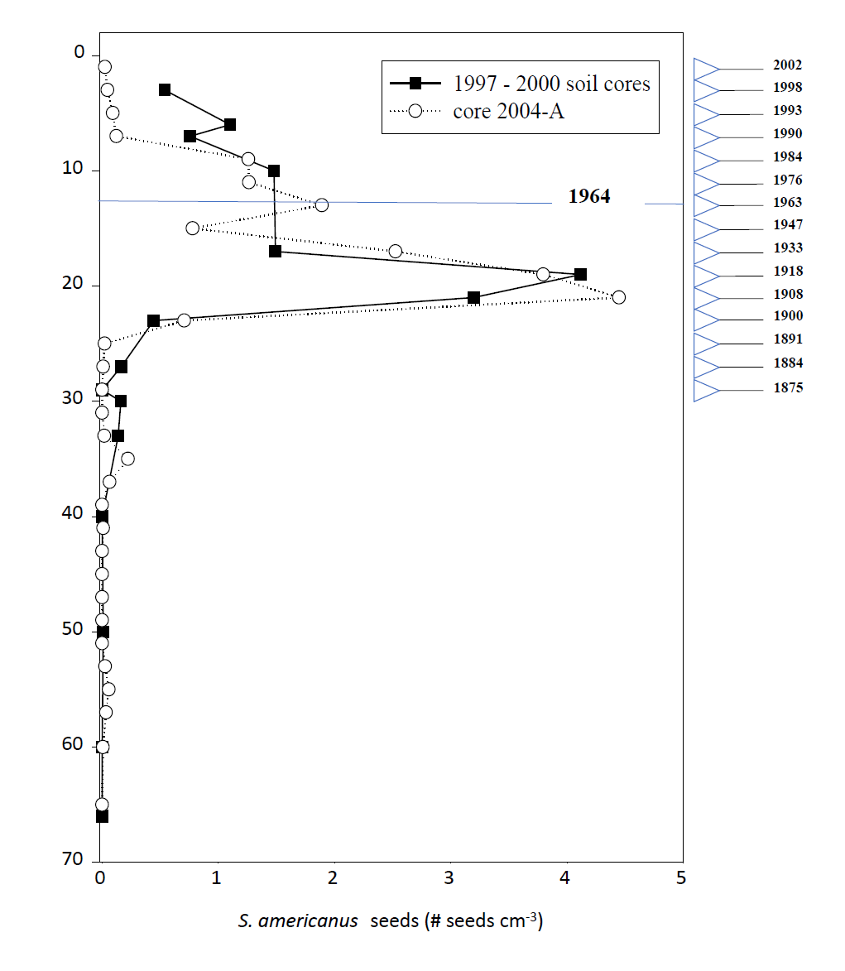
Figure 1: Profile of the Schoenoplectus americanus seed bank in Kirkpatrick Marsh.

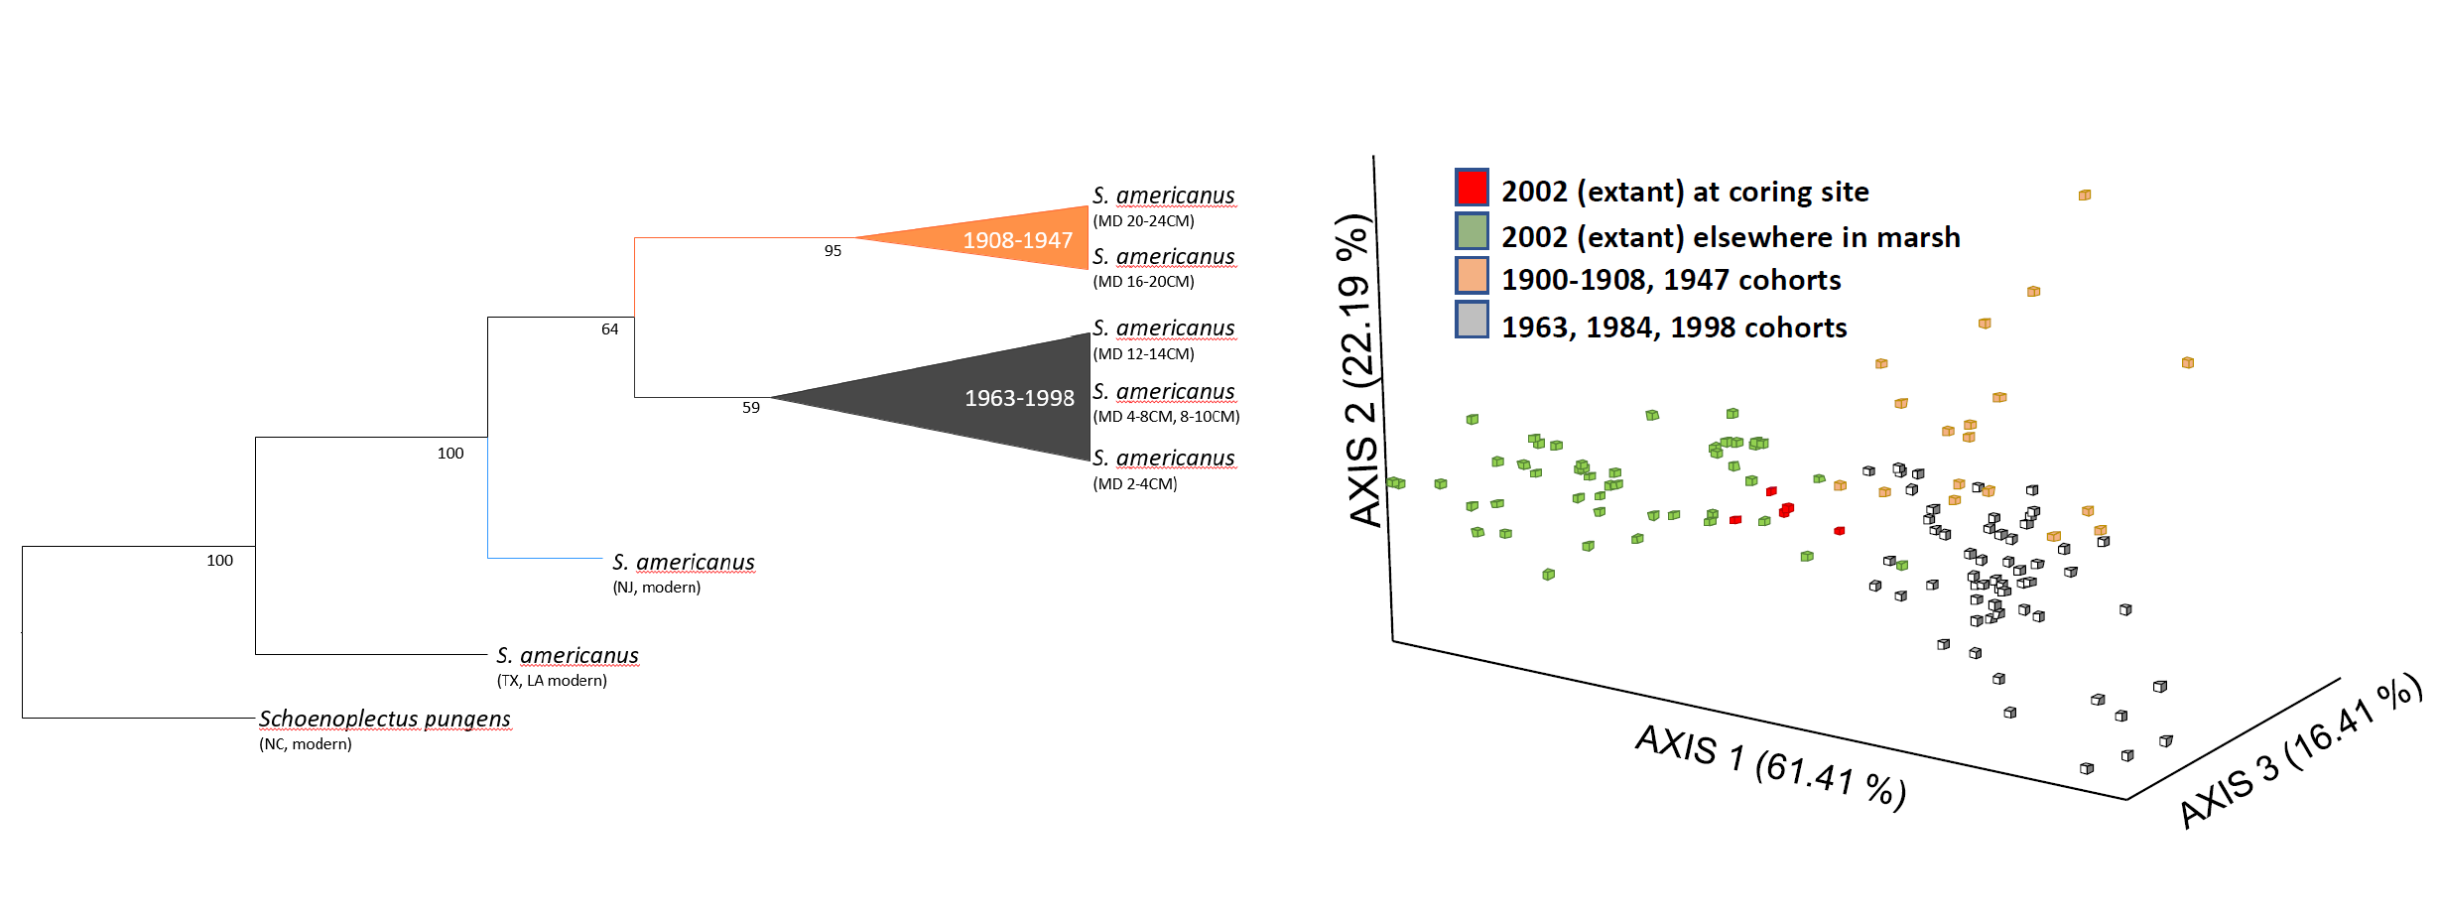

Figure 2: Neighbor-Joining tree and FCA of historical and extant genotypes from Kirkpatrick Marsh

Figure 2: continued
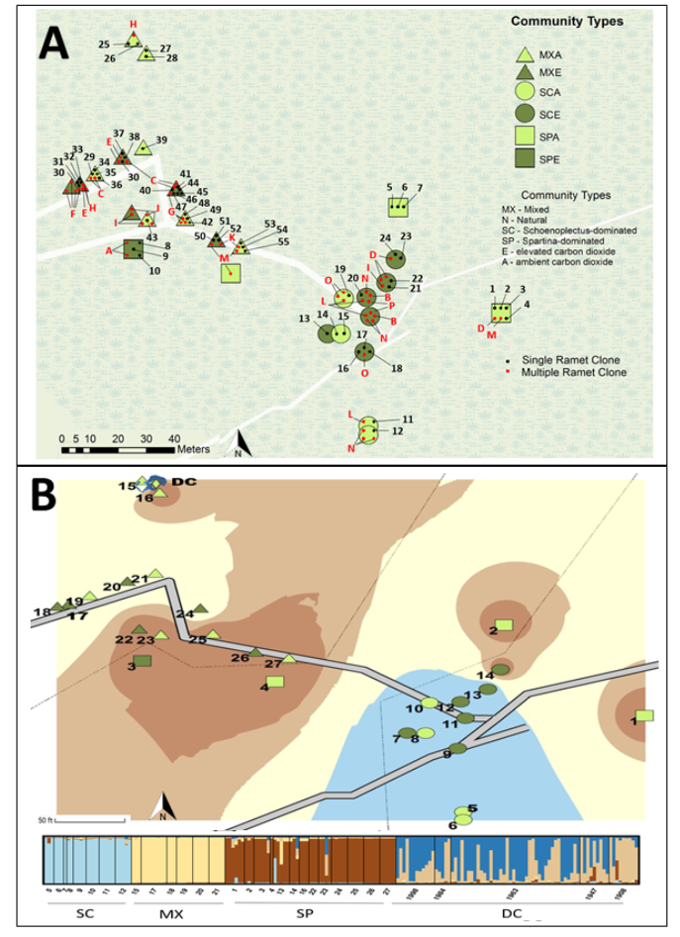
Figure 3: Clonal map and genetic heat maps of fastSTRUCTURE results across space and time. (A) Map of extant genotypic and clonal identity of S. americanus across Kirkpatrick Marsh. Genetic interpolation heat maps illustrating genetic relatedness based on optimal K from STRUCTURE of microsatellite allelic variation (B) within S. americanus depth cohorts from the Kirkpatrick marsh seed bank and extant samples from Kirkpatrick Marsh; (C) Chesapeake Bay marshes; (D) Atlantic and Gulf coast marshes. Shown for the best supported values of K as presented in the text. (A-B) Map of sample plots within Kirkpatrick Marsh.

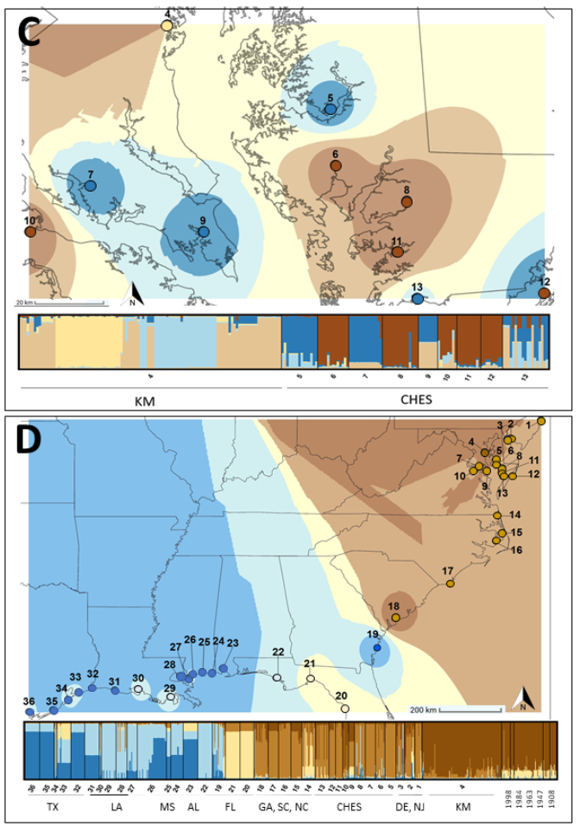
Figure 3 continued

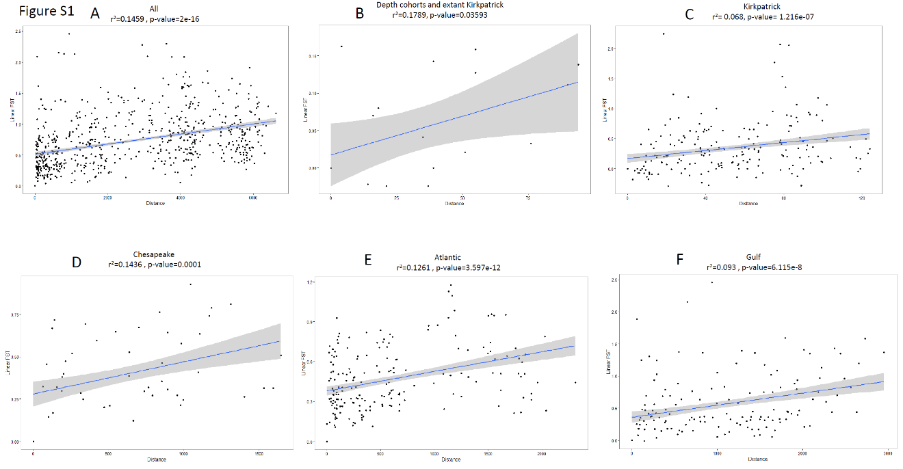

Figure S1: Mantel plots comparing genetic and temporal or geographic distance. Plots demonstrate pairwise linearized F_{ST} with spatial distance (A, C-F) or depth (B) illustrating the positive correlation between genetic differentiation and distance across space and time.

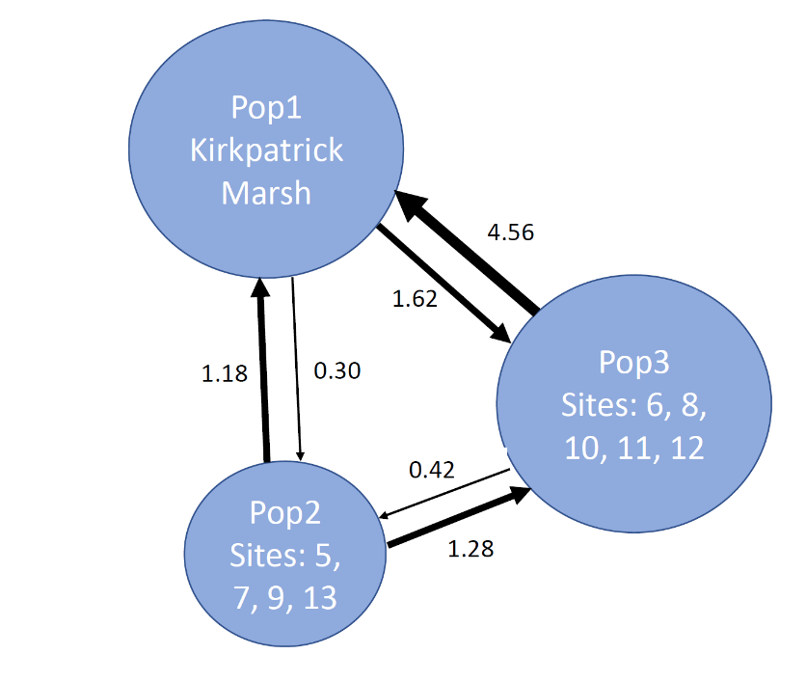

Figure S2: Chesapeake populations and inferred migration between and among sites. Populations are grouped according to STRUCTURE optimal K value (K=3). Numbers along arrows signify estimates of number of migrants per generation (Nm) as estimated in the program Migrate-N v3.4.4 (Beerli, 2013). The size of each population’s circle corresponds to estimated N_{e}.

CHAPTER II
Population genomics of a foundational coastal wetland plant across space and time

Abstract
Predicting how populations will respond to rapidly changing environments is of increasing interest as climate change worsens. This is important for sessile organisms (e.g., plants) as fewer avenues are available to cope with the impacts of swift environmental changes (i.e., insufficiently rapid migration). The interplay of rapid evolution and plasticity is only beginning to be characterized as a response mechanism to climate change corollaries. The capacity to evolve and /or to evolve plasticity to tolerate a wider range of conditions (i.e., evolutionary potential) depends in part on demographic characteristics (e.g., generation time, immigration/emigration) and genetic diversity. However, an understanding of baseline diversity for populations at risk is rarely well-characterized in wild populations and can be difficult to project into the future. Further, gauging how capable species are of adapting to environmental change and how rapidly microevolution can occur in wild populations remain outstanding questions. Resurrection ecology is an approach that can enable more accurate projection of population futures in the face of global change, as it permits comparison of older and younger iterations of a population to understand historical genetic and phenotypic shifts. Though classically applied in zooplankton systems, resurrection ecology has also proven useful in some plant systems, particularly that of S. americanus, a foundational brackish marsh sedge. Here, I examine populations of S. americanus across the Chesapeake Bay, where wetlands face threats from accelerated relative sea level rise and anthropogenic changes. Understanding if and how foundational plant species in these communities can evolve may improve projection of wetland futures, particularly since presence of vegetation and plants traits affect processes like accretion that prevent conversion of land to open water. Foundational plants like S. americanus are rarely studied to understand their capacity to adapt and their genomic or genetic diversity across space, despite the possibility that characterizing these aspects of the ecosystem could have large impacts on the outcomes of future climate change for an ecosystem that provides invaluable services. Here, I examine the population genomics of S. americanus samples that span time and space in the Chesapeake Bay region. Using resurrection ecology, I and my research group have revived dormant S. americanus seeds from soil cores taken from marshes across the Bay to ask whether and how these populations differ across time and space. Based on double digest restriction site associated sequencing, I called single nucleotide polymorphisms and performed population genomic analyses. Overall, there were high levels of homozygosity for each provenance and generally low F_{st} values when comparing pairwise across provenances, regardless of age cohort. In addition, some populations showed greater evidence of genomic shifts over time, namely Blackwater (east shore of the Bay) and Corn Island (western shore of the Bay). This work demonstrates that small distances can correspond with different genomic histories, which may reflect differences in local environmental conditions. Further, this work illustrates an important extension of resurrection ecology such that differences across geography are incorporated to better understand population dynamics across time.

Introduction

Rapid evolution, climate change and vulnerable plant communities
Rapid evolution, sometimes called microevolution, is evolutionary change that occurs at the same rate as ecological processes (Thompson 1998; Hendry and Kinnison 1999; Carroll et al. 2007; Hendry et al. 2008). There is growing evidence that climate change has profound impacts on the ecology and rapid evolutionary responses of several species (Alberti et al. 2017; Bay et al. 2018; Trinder et al. 2020). Thus, rapid evolution is of increasing interest as climate change worsens and threatens a wider array of species (IPCC 2014). The potential to rapidly evolve can be a mechanism by which species survive in the face of climate change corollaries like sea level rise, rising ambient CO₂, and increased heat events (Purcell et al. 2008; Diamond 2017; Saban et al. 2019). Rapid evolution is especially important for sessile species for which migration is less feasible, namely plants (Davis et al. 2005; Szövényi et al. 2009). Coastal wetland plants are threatened by pressures from rising sea levels, and though there is some work suggesting wetland plant communities can migrate inland, human development of coastal properties and limits on the rate of that migration may make this mechanism irrelevant. Though plasticity is an option for coping with climate change corollaries, evolution of plasticity is also possible and potentially a vital mechanism by which species can endure through stress events (Franks et al. 2014; Walker et al. 2019; Anderson and Song 2020). Thus it will be increasingly important to consider the evolutionary capacity of plant species to rapidly adapt to changing environmental conditions and the consequences of these shifts (or lack thereof) (Waldvogel et al. 2020).

Resurrection ecology across the landscape
The evaluation of rapid evolutionary potential can be improved via resurrection ecology. Resurrection ecology is the technique of reviving dormant propagules and comparing ancestors and descendants directly to better understand historical evolution (Stoks et al. 2016; Goitom et al. 2018; Lenormand et al. 2018).This approach has become increasingly popular as a tool for understanding how anthropogenic and climate change impact vulnerable populations, including effects on evolutionary trajectory. For example, studies in the zooplankton Daphnia have demonstrated that eutrophication of lakes at the onset of industrial agriculture and urban heat stress all leave evolutionary fingerprints on the impacted Daphnia populations, shifting their future trajectories in ways that impact fitness (Frisch et al. 2014b; Brans and De Meester 2018).

What is less common is consideration of evolution across both time and space (i.e., studying multiple resurrected populations across geographic space). Consideration of multiple geographic locations with differing environmental conditions has proven a potent and important factor in understanding how a species as a whole evolves (Thompson et al. 2016; Ware et al. 2019; Metz et al. 2020). Doing so can improve understanding of how a species may evolve at a regional or range-wide scale, providing necessary context rather than considering a single representative population (Kuester et al. 2015). For example, population genetic analyses in a space-for-time framework of Spartina alterniflora demonstrate that marshes differing in age underwent reduction in clonal richness but that marshes overall maintained high levels of genetic diversity (Travis and Hester 2005; Messer et al. 2016). Leveraging a similar approach but with inclusion of resurrected individuals across a region can provide similar insight into populations’ futures and capacities to survive in the face of worsening climate change corollaries.

Approach
Here I use population genomics to characterize the foundational coast marsh plant S. americanus across a temporal gradient and from multiple marshes located around the Chesapeake Bay, the largest estuary in the United States. As a region facing higher than the global average of relative sea level rise, this work can provide greater insight into whether and how perennial marsh plants like S. americanus may fare in future sea level rise scenarios, including an understanding of gene flow across the Bay and how both small and large geographic distances may have large effects on population evolutionary trajectories (Najjar et al. 2010; Eggleston and Pope 2013). With this work I aim to answer several questions. I address whether the connectivity of populations across time and space in S. americanus in the Chesapeake Bay is important for maintenance of diversity across time. Further, I ask if historical genetic diversity has declined or remained steady across space and time, and how nearby populations may vary in their contributions to each sampled marsh’s diversity rates. I will address whether evolutionary shifts have occurred and whether there are patterns indicative of a particular mechanism of evolution (e.g., adaptation, drift, mutation, gene flow). Describing these factors will contribute to my overarching question: are there trends in the history of S. americanus in the Chesapeake Bay that suggest the capacity to evolve and respond to climate change corollaries, or is there evidence to suggest some or all of the sampled populations may be at risk?

Methods

Study sites and tissue sampling.
I took 413 tissue samples from both fresh and archived (frozen) sources, which were resurrected from soil cores or sampled from extant plants taken in and around the Chesapeake Bay, largest estuary in the United States (Table 1, Figure S3). Most samples came from marshes owned by the Smithsonian Environmental Research Center (SERC) in Edgewater, MD. However, 76 samples resulted from soil cores taken in Blackwater National Wildlife Refuge (BNWR) on the eastern shore of the Chesapeake Bay. BNWR suffers unusually high rates of land loss due to sea level rise and erosion and has a contrasting management history and accretion rate, making it an interesting point of comparison with SERC marshes (Wills et al. 2017). Namely, BNWR was managed as a fur farm for muskrat and nutria trapping, though nutria have been culled from the refuge to prevent destruction of the wetland plants. Some samples were archived tissues from Summers et al. (2018) that had been genotyped at 11 microsatellite loci, all of which came from SERC’s Global Change Research Wetland (GCReW) (n=227) (See Summers et. al. 2018, Table 1). In 2016 and 2017 additional cores were taken from Kirkpatrick Marsh (41 samples), which encompasses the GCReW; Corn Island Marsh (n=110), which is just adjacent to Kirkpatrick Marsh; Hog Island (n=11), which is also part of SERC property; Sellman Marsh (58 samples), also part of SERC; and finally, five samples of the closely related sister species Schoenoplectus pungens were taken close to the GCReW. Ages of plants are approximate and based on ²¹⁰Pb and ¹³⁷Cs dating of a core taken from Kirkpatrick Marsh (Summers et al. 2018). All samples were either germinated, reared in the greenhouse, and then had tissue sampled, or were sampled extant in the field. I took 10cm long stem tissue cuttings, placed them in sterile 2mL tubes and stored them immediately in a -80 freezer until DNA extraction.

DNA extraction and ddRAD sequencing
I shipped samples to Texas A&M Corpus Christie for DNA extraction and double digest restriction site associated sequencing (ddRADseq) in May 2019 (Peterson et al. 2012). The DNA extractions were performed as follows. Tissues were disrupted with a Qiagen TissueLyser using 3mm tungsten carbide beads in 96-well plates for 1 minute at 25Hz. Genomic DNA was then extracted from the tissue slurries using Omega Mag-Bind plate DNA DS kits, following manufacturer protocols, except that multiple elutions were performed for each sample and each elution was kept as a separate aliquot to source additional DNA if necessary. Double digest restriction site associated (ddRAD) sequencing (Peterson et al. 2012) was then performed on an Illumina NovaSeq 6000 using two restriction enzymes: ApoI and Sphl. Due to low coverage, 179 samples were resequenced using an Illumina HiSeq 4000.

Read trimming and SNP calling with Stacks2
I received raw reads from the sequencing center in multiplexed format. I de-multiplexed reads using the process_radtags module of Stacks2 (Rochette et al. 2019) using flags to trim reads with a phred score lower than 10 within a sliding window and to trim uncalled bases. I then assessed read quality using fastQC (Andrews 2010). Some of the sequences demonstrated adapter contamination or low-quality bases Ire detected near the ends of reads. In these cases, additional trimming was done with Atropos with flags for forward and reverse adapter sequences (-A -a) and hard trims of 5’ and 3’ ends of reads (-u -U) for paired-end reads (Didion et al. 2017). I then proceeded with the rest of the modules in the Stacks2 software. First, I optimized parameter settings for a subsample of individuals following the r80 method outlined in Rochette and Catchen (2017). Parameters set to run the data through the pipeline included a minimum number of raw reads required to form a stack (i.e., a putative allele) of 4, the number of mismatches allowed between stacks to merge them into a putative locus of 3, and the number of mismatches allowed between stacks (i.e., putative loci) during catalog construction of 4 (Paris, Stevens, & Catchen, 2017). I then ran each module of Stacks2 (ustacks, cstacks, sstacks, tsv_bam, gstacks, populations) (Rochette, Rivera-Colón, & Catchen, 2019) “by hand” rather than all at once using the Cypress supercomputing cluster at Tulane University. The ustacks, cstacks, gstacks, and tsv_bam components of the pipeline Ire run without adjusting module-specific default flags. I ran the final populations module with filtering such that any SNPs that occurred in fewer than 80% of individuals Ire excluded. In addition, the write-random-snp flag was used to eliminate calling of linked SNPs per locus.

Population genomics analyses.
To confirm that each individual exhibited a distinct genotype and to characterize within and between population diversity, I examined estimates of fixation indices that were calculated in the populations module. I then converted genepop output from Stacks2 into str and other formats for analyses in downstream software using pgdspider 2.1.1.3 (Lischer and Excoffier 2012). I estimated population structure and visualized optimal clustering using fastSTRUCTURE (Raj, Stephens, and Pritchard 2014) with default specifications. I then performed estimation of optimal K (i.e., inferred genetic clusters) using the program distruct and examination of subsequent bar graphs to infer the strongest clustering pattern (as per distruct documentation) (Rosenberg 2004). To customize fastSTRUCTURE bar graphs, I used the edited distruct python script, distruct v2.3 (Chhatre 2019), to produce genetic structure barplots. I assessed overall variance among samples via a Principal Components Analysis (PCA) using the R package adegenet v. 2.1.2 (Jombart & Ahmed 2011). For the PCAs, I graphed variation according to ellipses drawn around shared age cohorts and with ellipses drawn around geographic provenance to better assess differentiation across space and time. I tested for isolation by distance (IBD) using a Mantel test via the mantel.randtest function in the package adegenet v. 2.1.2 (Jombart & Ahmed 2011). For the Mantel tests, geographic distance was calculated based on decimal degree coordinates. I calculated genetic Euclidean distance using the dist function in adegenet v.2.1.2. The Mantel test produces a p-value based on the likelihood the correlation of the matrices comes from a distribution of permuted data that simulates patterns expected in the absence of spatial structure.

Results
Here, I examined the population genomics of five marshes across the Chesapeake Bay across space and time to ascertain whether and how populations may be evolving and whether they may be capable of responding to future environmental change. I also included an outgroup sister species (S. pungens) with which S. americanus hybridizes in more freshwater habitats. Overall, I found that marshes, regardless of age, demonstrated very low F_{st} and therefore demonstrated low genomic differentiation. Within population variance was higher than among population variance overall, with only weak support for isolation by distance. Age proved to be a less important factor explaining genetic clustering when considering all populations, but there was differentiation by age/ depth cohort within populations. Overall, there is evidence that populations in the Chesapeake Bay do differ across time

ddRAD sequencing and single nucleotide polymorphisms
A total of 530 samples underwent double digest restriction site associated sequencing. Samples were demultiplexed using Stacks2 process_radtags and returned. A subset of samples had low coverage (<10x). All samples were included in an initial run of the entire pipeline, and afterwards were excluded from subsequent analyses (<10x). For the remaining samples (n=317) the average coverage was 28.178x. A total of 8646 SNPs were recovered across samples when running the final populations pipeline with the write-random-snp flag per variable site (to prevent identification of linked SNPs) (Catchen et al. 2011). I calculated population genomic statistics using the populations module of Stacks2, including pi, a measure of nucleotide diversity in which the average number of nucleotide differences per site between individuals in the population (pi) (Nei and Li 1979), F_{st}, wherein the value can be interpreted as a measurement of how close two individuals from a subpopulation are from the total population (Wright 1950), and F_{is}, the inbreeding coefficient for an individual relative to its subpopulation (Wright 1950). Only biallelic SNPs were retained.

Differences by marsh location
For all samples, there was a high rate of homozygosity across provenances (Table 2), which consistently exceed expected homozygosity. Heterozygosity was lower in resurrected populations (Blackwater, Corn, Hog, Kirkpatrick, Kirkpatrick (2002-3)) when compared to extant (Kirkpatrick, extant), and the outgroup (S. pungens). Inbreeding coefficients were relatively low except for Sellman and Kirkpatrick (2002-3), which demonstrated higher F_{is} (Table 2). S. pungens samples exhibited the highest number of private alleles, as expected, and Corn Island demonstrated the second highest number of private alleles (Table 2). However, the PCA shows that Corn Island correlates most closely with PC1 (28.81% variance), and an equivalent amount of variance is explained by the difference between S. americanus and S. pungens samples (PC2, 27.16%) (Figure 4A). Excluding S. pungens from this analysis enables visual separation of variance with S. americanus samples (Figure 4B). Corn Island still correlates strongly with PC1 (34.82%), with some additional spread for Hog Island and Blackwater along PC1 (Figure 4B). Blackwater and Kirkpatrick, extant populations (SERC) variance correlates with PC2 (19.56%). The Kirkpatrick (2002-3) samples demonstrated little spread overall (Figure 4B). The fastSTRUCTURE plots for the estimated optimal number of clusters (K=11, 12) with all samples demonstrate heterogeneity within populations, but some clear clusters that define populations (Figure 5). Kirkpatrick (2002-3), Blackwater, and Corn have the most distinct defining clusters. Kirkpatrick, extant (SERC) shows the most shared ancestry with the Kirkpatrick (2002-3) samples. When considering just the resurrected samples, the values shift to uncover more fine detail across time (Table 4). The highest observed heterozygosity occurs in Blackwater and Corn populations, which is reflected by the largest variances in the PCA correlating with PC1 (Corn, 11.27% variance explained) and PC2 (Blackwater, 8.11% variance) (Figure 6). Kirkpatrick samples also tend to correlate with PC2, which may in part reflect having a higher level of heterozygosity (Figure 6, Table 4). Interestingly, the samples from 2002-3 coring in Kirkpatrick demonstrated the highest number of private alleles and the highest F_{is}, highest homozygosity and lowest heterozygosity (Table 4). This pattern tracks for the PCA, as these samples (labelled “downcore”) cluster tightly (Figure 6). The Mantel test for isolation by distance showed some support for IBD, though the pattern was not significant (p=0.062).

Differences across time
Samples taken from the same soil horizons (i.e., the same depth from different provenance) cluster based on geographic location rather than age (Figure 7). Individuals are grouped according to age es estimated from Kirkpatrick Marsh due to lack of dating in other sites. Figure 7 depicts a range of potential optimal K values for only the resurrected samples (K=4, 5, 11, 13). For fastSTRUCTURE graphs, each vertical line represents an individual and the individuals are arranged from shallowest or youngest (far left) to deepest or oldest (far right). If age cohort proved to be an important factor, a fade of colors should move from left to right. There are some indications of this pattern of shifting across time for K=4. However, the Kirkpatrick (2002-3) samples (here called “dc” for downcore) disrupt this pattern due to their distinct genetic clustering. Overall genetic clustering patterns appear to adhere more to provenance. Within provenance, however, there are some strong indications of variance attributable to change through time. This pattern is not consistent across provenance, however. Namely, Corn Island comprises the strongest explanation of variance for PC1 of the PCA (Figure 4), the highest number of private alleles, and the highest rate of heterozygosity (Table 4). When examining the fastSTRUCTURE plots, there is more of a pattern when just considering Corn samples in each of the optimal K figures. For example, for K=13, the youngest Corn samples (“C0-3”, “C0-2.35”, etc.) form a light blue cluster with some admixture of pink that dominates older samples (“C18.75-20.75”, etc.) to the right of the graph. This pattern indicates a shift across time. There is also some indication of a similar pattern for Blackwater. Like Corn, Blackwater variance correlates strongly with PC2 (8.11%). When examining the fastSTRUCTURE plots (Figure 7), there are similar indications of admixture from left to right when only looking at Blackwater samples (“BW0-2, “BW10-12”, etc.). For example, for K=11, the bright pink bars to the left are nearly solid and older samples towards the middle of the graph show increasing admixture with another, light pink cluster indicating shifts over time. One provenance that fails to demonstrate this pattern is Kirkpatrick (2002-3). Labelled “dc” in Figure 7, for each iteration of K there are clear clusters for this group with little indication of admixture correlating with time or with other provenances. Sellman (labelled “S0-2”, “S4-6”, etc.) demonstrates distinct clusters with little admixture as well. For example, in K=11 dark purple bands are solid and do not appear to vary across time.
When examining population genomic statistics across time within each provenance, several patterns emerge. Heterozygosity across time remains comparable across age cohorts in each provenance. However, there are differences between provenances in heterozygosity and homozygosity. Kirkpatrick Marsh samples from 2002-3 (dc) demonstrate relatively low heterozygosity and higher homozygosity, and these values remain comparable across time. Samples from elsewhere in Kirkpatrick Marsh demonstrate higher heterozygosity that is comparable to that seen in Blackwater and Corn Island (Table 5). Hog Island samples demonstrated higher rates of heterozygosity than Kirkpatrick samples in general. Private alleles per depth cohort are highest in the youngest group from Kirkpatrick 2002-3 (dc2-4) and for the middle depths (dc12-14, 1963 ± 3.0, Table 5). Blackwater demonstrates consistent heterozygosity across depths and higher rates of homozygosity in general. There are some private alleles per age cohort that correlate with individuals sequenced that peak for BW2-4cm and BW 8-10 (Table 5). Corn Island Marsh is comparable to Blackwater in its heterozygosity and homozygosity. One age cohort had a low overall heterozygosity and inflated homozygosity at 10.25-12.75cm (1976 ± 1.2) deep. Private alleles were highest at 18.75-20.75 cm (1918 ± 15.6) and 0-3 cm (2002 ± 0.1) for Corn Island (Table 5). Sellman, which demonstrated low variance overall, had low heterozygosity compared to other provenances and higher homozygosity (Table 5). Overall, the differences seen across time differ based on provenance.

Discussion
Here I compared populations of a foundational marsh sedge across space and time to determine if and how the populations may differ in terms of evolutionary potential and change over time across a relatively small region and short period of time (~100 years). Addressing this question also contributes to a general understanding of how resurrection ecology may be extrapolated to sessile organisms like plants, particularly those that are wind pollinated.

Implications of differences across space and time
Overall, there are higher rates of homozygosity than heterozygosity for all provenances. Heterozygosity is a proxy for diversity within a population and is generally associated with improved resilience to drift and greater diversity upon which selection may act (Nei and Li 1979). Further, this finding contrasts somewhat with the outcomes of prior work (using neutral microsatellite markers) that suggest higher rates of heterozygosity are common across time, specifically in the Kirkpatrick (2002-3) population (Summers et al. 2018). There were indications of low F_{st} across all provenances, which suggests sustained gene flow, likely via pollen transported by wind as S. americanus is wind pollinated (Sipple 1978; Smith 2012). However, there are some patterns that suggest as climate change worsens, some populations will fare better than others. First, Corn Island and Blackwater tend to exhibit higher rates of heterozygosity and demonstrate greater shifts over time. In the case of Blackwater, with its high rates of subsidence and land loss (Schepers et al. 2020; FBNWR 2020), it is possible this indicates response to change in environment, namely inundation. However, it is also possible that the shifts across time seen in Blackwater correspond with other evolutionary mechanisms, including drift, mutation and gene flow alterations over time. For Corn Island, which has been preserved as part of the Smithsonian for the past several decades, there is less evidence for dramatic shifts in inundation. However, the fact of the shifts across time do indicate that 100 years or so is sufficient for evolution to occur in a perennial, clonally growing species, which may imply capacity to respond to some environmental change in the future.

Implications of differences across time and resurrection ecology
The fact that private alleles were discovered for individual depth cohorts within provenance and the patterns of some differentiation seen in fastSTRUCTURE plots, particularly for Blackwater and Corn Island, suggest that it is possible for evolution to have occurred across time at these sites. There is good reason to expect that evolution has occurred over the past century in S. americanus. There have been shifts in sea level rise, nutrient supply and invasive species (Kearney 1996; Najjar et al. 2010; Kirwan, Murray, Donnelly 2011; Ameen et al. 2018; Lu et al. 2019). Thus, there are many stressors that could act as drift events or inflict selection pressures. The maintenance of genetic diversity across time for multiple provenances is reassuring for assessing the utility of performing resurrection ecology across other marsh for S. americanus. One issue with the resurrection approach is the potential for attrition or bias in resurrected samples (Weider et al. 2018b). The finding that genomic diversity remains consistent across multiple provenances suggests that, as described in Summers et al. (2018), S. americanus seed banks are reliable archives of genetic diversity of populations through time.

Caveats
Here, the cores come from parts of the Bay with potentially different accretion rates. Thus, the cores may represent different amounts of time and not be directly comparable across age cohorts (Binford 1990). This means age estimates may also be inaccurate, particularly for Blackwater NWR, which is the furthest from the Kirkpatrick Marsh coring site. Furthermore, there are relatively few SNPs called from the samples, making outlier analysis challenging (to detect selection) and weakening general inferences about genomic variation.

References

Alberti M, Correa C, Marzluff JM, Hendry AP, Palkovacs EP, Gotanda KM, Hunt VM, Apgar TM, Zhou Y. 2017. Global urban signatures of phenotypic change in animal and plant populations. Proc. Natl. Acad. Sci. U. S. A. 114:8951–8956. [accessed 2020 Jul 31]. https://www.pnas.org/content/114/34/8951
Alberto FJ, Aitken SN, Alía R, González-Martínez SC, Hänninen H, Kremer A, Lefèvre F, Lenormand T, Yeaman S, Whetten R, et al. 2013. Potential for evolutionary responses to climate change - evidence from tree populations. Glob. Chang. Biol. 19:1645–1661.
Alexander JM. 2013. Evolution under changing climates: Climatic niche stasis despite rapid evolution in a non-native plant. Proc. R. Soc. B Biol. Sci. 280:9.
Alvarez M, Schrey AW, Richards CL. 2015. Ten years of transcriptomics in wild populations: what have we learned about their ecology and evolution? Mol. Ecol. 24:710–725. [accessed 2019 Mar 25]. http://doi.wiley.com/10.1111/mec.13055
Ameen AD, Kolker AS, Taylor CM. 2018. Morphological responses to competition modulated by abiotic factors in two monoculture-forming wetland plants. Aquat. Bot. 147:61–67. [accessed 2019 Feb 10]. https://www.sciencedirect.com/science/article/pii/S0304377017302371
Anderson JT, Song B. 2020. Plant adaptation to climate change—Where are we? J. Syst. Evol. 58:533–545. [accessed 2020 Nov 16]. https://onlinelibrary.wiley.com/doi/10.1111/jse.12649
Angeler DG. 2007. Resurrection ecology and global climate change research in freshwater ecosystems. Benthol. Soc 26:12–22. [accessed 2018 Feb 16]. http://www.journals.uchicago.edu.proxy.lib.utk.edu:90/doi/pdfplus/10.1899/0887-3593%282007%2926%5B12%3AREAGCC%5D2.0.CO%3B2
Baustian JJ, Mendelssohn IA, Hester MW. 2012. Vegetation’s importance in regulating surface elevation in a coastal salt marsh facing elevated rates of sea level rise. Glob. Chang. Biol. 18:3377–3382. [accessed 2018 Sep 9]. http://doi.wiley.com/10.1111/j.1365-2486.2012.02792.x
Bay RA, Harrigan RJ, Underwood V Le, Gibbs HL, Smith TB, Ruegg K. 2018. Genomic signals of selection predict climate-driven population declines in a migratory bird. Science (80-. ).
Becklin KM, Anderson JT, Gerhart LM, Wadgymar SM, Wessinger CA, Ward JK. 2016. Examining plant physiological responses to climate change through an evolutionary lens. Plant Physiol.
Bennington C. C., McGraw J. B, Vavrek M. C. 1991. Ecological Genetic Variation in Seed Banks . II . Phenotypic and Genetic Differences Between Young and Old Subpopulations of Luzula Parviflora. Br. Ecol. Soc. S 79:627–643.
Bertness MD, Ellison AM. 1987. Determinants of Pattern in a New England Salt Marsh Plant Community. Ecol. Monogr. 57:129–147. [accessed 2019 Feb 10]. http://doi.wiley.com/10.2307/1942621
Bertness MD, Leonard GH, Levine JM, Schmidt PR, Ingraham AO. 2013. Testing the Relative Contribution of Positive and Negative Interactions in Rocky Intertidal Communities TESTING THE RELATIVE CONTRIBUTION OF POSITIVE AND NEGATIVE INTERACTIONS IN ROCKY INTERTIDAL COMMUNITIES. 80:2711–2726.
De Biasse MB, Kawji Y, Kelly MW. 2018 Mar 6. Phenotypic and transcriptomic responses to salinity stress across genetically and geographically divergent Tigriopus californicus populations. Mol. Ecol. [accessed 2018 Mar 12]. http://doi.wiley.com/10.1111/mec.14547
Binford MW. 1990. Calculation and uncertainty analysis of 210Pb dates for PIRLA project lake sediment cores. J. Paleolimnol. 3:252–267.
Blois JL, Williams JW, Fitzpatrick MC, Jackson ST, Ferrier S. 2013. Space can substitute for time in predicting climate-change effects on biodiversity. Proc. Natl. Acad. Sci. U. S. A. 110:9374–9379. [accessed 2021 Jan 5]. http://dx.doi.org/doi:10.5061/dryad.d5f1r.Thisarticlecontainssupportinginformationonlineatwww.pnas.org/lookup/suppl/doi:10.1073/pnas.1220228110/-/DCSupplemental.9374-9379www.pnas.org/cgi/doi/10.1073/pnas.1220228110
Boon JD, Brubaker JM, Forrest DR. 2010. Chesapeake Bay Land Subsidence and Sea Level Change An Evaluation of Past and Present Trends and Future Outlook. Virginia Institute of Marine Science Special Report No. 425 in Applied Marine Science and Ocean Engineering.
Brans KI, De Meester L. 2018. City life on fast lanes: Urbanization induces an evolutionary shift towards a faster lifestyle in the water flea Daphnia. Funct. Ecol. 32.
Brede N, Sandrock C, Straile D, Spaak P, Jankowski T, Streit B, Schwenk K. 2009. The impact of human-made ecological changes on the genetic architecture of Daphnia species. [accessed 2017 Nov 11]. http://www.pnas.org/content/106/12/4758.full.pdf
Brendonck L, De Meester L. 2003. Egg banks in freshwater zooplankton: evolutionary and ecological archives in the sediment. Hydrobiologia 491:65–84. [accessed 2019 Feb 10]. http://link.springer.com/10.1023/A:1024454905119
Broome SW, Mendelssohn IA, Mckee KL. 1995. Relative growth of Spartina patens (Ait.) Muhl. and Scirpus olneyi Gray occurring in a mixed stand as affected by salinity and flooding depth. Wetlands 15:20–30. [accessed 2017 Oct 2]. https://utk.hosts.atlas-sys.com/illiad/illiad.dll?Action=10&Form=75&Value=1223193
Brush GS. 2001. Natural and Anthropogenic Changes in Chesapeake Bay During the Last 1000 Years. Hum. Ecol. Risk Assess. An Int. J. 7:1283–1296.
Bushmanova E, Antipov D, Lapidus A, Prjibelski AD. 2019. RnaSPAdes: A de novo transcriptome assembler and its application to RNA-Seq data. Gigascience 8:1–13.
Cabin RJ. 2008. Genetic Comparisons of Seed Bank and Seedling Populations of a Perennial Desert Mustard , Lesquerella fendleri Author ( s ): Robert J . Cabin Published by : Society for the Study of Evolution Stable URL : http://www.jstor.org/stable/2410740. 50:1830–1841.
Campbell-Staton SC, Cheviron ZA, Rochette N, Catchen J, Losos JB, Edwards S V. 2017. Winter storms drive rapid phenotypic, regulatory, and genomic shifts in the green anole lizard. Science (80-. ). 357:495–498.
Carroll SP, Hendry AP, Reznick DN, Fox CW. 2007. Evolution on ecological time-scales. Funct. Ecol. 21:387–393.
Catchen JM, Amores A, Hohenlohe P, Cresko W, Postlethwait JH, De Koning D-J. 2011. Stacks: Building and Genotyping Loci De Novo From Short-Read Sequences. G3&amp;#58; Genes|Genomes|Genetics 1:171–182.
Cerveau N, Jackson DJ. 2016. Combining independent de novo assemblies optimizes the coding transcriptome for nonconventional model eukaryotic organisms. BMC Bioinformatics 17.
Cherry JA, McKee KL, Grace JB. 2009. Elevated CO ₂ enhances biological contributions to elevation change in coastal wetlands by offsetting stressors associated with sea-level rise. J. Ecol. 97:67–77. [accessed 2018 Aug 14]. http://doi.wiley.com/10.1111/j.1365-2745.2008.01449.x
Chhatre V. 2019. Distruct v2.3, A modified cluster membership plotting script.
Chmura GL, Anisfeld SC, Cahoon DR, Lynch JC. 2003. Global carbon sequestration in tidal, saline wetland soils. Global Biogeochem. Cycles 17:n/a-n/a. [accessed 2019 Mar 24]. http://doi.wiley.com/10.1029/2002GB001917
Cho L-H, Yoon J, An G. 2017. The control of flowering time by environmental factors. Plant J. 90:708–719. [accessed 2018 Aug 26]. http://doi.wiley.com/10.1111/tpj.13461
Clark K, Karsch-Mizrachi I, Lipman DJ, Ostell J, Sayers EW. 2016. GenBank. Nucleic Acids Res. 44:D67–D72.
Courtney AJ, Xu J, Xu Y. 2016. Responses of growth, antioxidants and gene expression in smooth cordgrass (Spartina alterniflora) to various levels of salinity. Plant Physiol. Biochem. 99:162–170.
Cousyn C, De Meester L, Colbourne JK, Brendonck L, Verschuren D, Volckaert F. 2001. Rapid, local adaptation of zooplankton behavior to changes in predation pressure in the absence of neutral genetic changes. Proc. Natl. Acad. Sci. U. S. A. 98:6256–6260.
Davis M, Shaw R, Etterson J. 2005. Evolutionary responses to changing climate. Ecology 86:1704–1714.
Davis MB, Shaw RG, Etterson JR. 2005. Evolutionary responses to changing climate. Ecology 86:1704–1714. [accessed 2020 Apr 14]. http://doi.wiley.com/10.1890/03-0788
DeJong BD, Bierman PR, Newell WL, Rittenour TM, Mahan SA, Balco G, Rood DH. 2015 Aug 1. Pleistocene relative sea levels in the Chesapeake Bay region and their implications for the next century. GSA Today:4–10. [accessed 2019 Mar 27]. http://www.geosociety.org/gsatoday/archive/25/8/abstract/i1052-5173-25-8-4.htm
Diamond SE. 2017. Evolutionary potential of upper thermal tolerance: biogeographic patterns and expectations under climate change. Ann. N. Y. Acad. Sci. 1389.
Dickman EE, Pennington LK, Franks SJ, Sexton JP. 2019. Evidence for adaptive responses to historic drought across a native plant species range. Evol. Appl. 12:1569–1582. [accessed 2020 Jul 4]. https://onlinelibrary.wiley.com/doi/abs/10.1111/eva.12803
Didion JP, Martin M, Collins FS. 2017. Atropos: specific, sensitive, and speedy trimming of sequencing reads. PeerJ 5:e3720. [accessed 2019 Jun 19]. https://peerj.com/articles/3720
Donelson JM, Salinas S, Munday PL, Shama LNS. 2018. Transgenerational plasticity and climate change experiments: Where do we go from here? Glob. Chang. Biol. 24.
Drake BG. 2014. Rising sea level, temperature, and precipitation impact plant and ecosystem responses to elevated CO2 on a Chesapeake Bay wetland: Review of a 28-year study. Glob. Chang. Biol. 20:3329–3343.
Dunton KH, Hardegree B, Whitledge TE. 2001. Response of Estuarine Marsh Vegetation to Interannual Variations in Precipitation. Estuaries 24:851. [accessed 2019 Jun 4]. http://link.springer.com/10.2307/1353176
Eggleston J, Pope J. 2013. Land Subsidence and Relative Sea-Level Rise in the Southern Chesapeake Bay Region. U.S. Geol. Surv. Circ. 1392:1–30. [accessed 2020 Nov 11]. https://pubs.usgs.gov/circ/1392/
Elbers JP, Clostio RW, Taylor SS. 2017. Population genetic inferences using immune gene SNPs mirror patterns inferred by microsatellites. Mol. Ecol. Resour. 17:481–491. [accessed 2017 Oct 8]. http://doi.wiley.com/10.1111/1755-0998.12591
Elena SF, Lenski RE. 2003. Evolution experiments with microorganisms: The dynamics and genetic bases of adaptation. Nat. Rev. Genet. 4:457–469.
Eller F, Lambertini C, Nguyen LX, Achenbach L, Brix H. 2013. Interactive effects of elevated temperature and CO2 on two phylogeographically distinct clones of common reed (Phragmites australis). AoB Plants 5:1–13.
Eller F, Lambertini C, Nielsen MW, Radutoiu S, Brix H. 2014. Expression of major photosynthetic and salt-resistance genes in invasive reed lineages grown under elevated CO ₂ and temperature. Ecol. Evol. 4:4161–4172. [accessed 2019 Mar 24]. http://doi.wiley.com/10.1002/ece3.1282
Ellner SP, Geber MA, Hairston NG. 2011. Does rapid evolution matter? Measuring the rate of contemporary evolution and its impacts on ecological dynamics. Ecol. Lett. 14:603–614. [accessed 2017 Mar 4]. http://doi.wiley.com/10.1111/j.1461-0248.2011.01616.x
Emery NC, Ewanchuk PJ, Bertness MD. 2001a. Competition and salt-marsh plant zonation: stress tolerators may be dominant competitors. Ecology 82:2471–2485. [accessed 2019 Jan 21]. https://esajournals.onlinelibrary.wiley.com/doi/abs/10.1890/0012-9658%282001%29082%5B2471%3ACASMPZ%5D2.0.CO%3B2
Emery NC, Ewanchuk PJ, Bertness MD. 2001b. Competition and Salt‐Marsh Plant Zonation: Stress Tolerators May Be Dominant Competitors. Ecology 82:2471–2485.
Ezer T, Corlett WB. 2012. Is sea level rise accelerating in the Chesapeake Bay? A demonstration of a novel new approach for analyzing sea level data. Geophys. Res. Lett. 39. [accessed 2020 Nov 8]. https://agupubs.onlinelibrary.wiley.com/doi/full/10.1029/2012GL053435
Farnsworth EJ, Meyerson LA. 2003. Comparative ecophysiology of four wetland plant species along a continuum of invasiveness. Wetlands 23:750–762.
FBNWR. 2020. History of Blackwater National Wildlife Refuge.
Fischer EM, Knutti R. 2016. Observed heavy precipitation increase confirms theory and early models. Nat. Clim. Chang. 6:986–991. [accessed 2018 Aug 25]. http://www.nature.com/articles/nclimate3110
Franks SJ. 2011. Plasticity and evolution in drought avoidance and escape in the annual plant Brassica rapa. New Phytol. 190:249–257.
Franks SJ, Avise JC, Bradshaw WE, Conner JK, Julie R, Mazer SJ, Shaw RG, Weis AE, Etterson JR. 2008. The Resurrection Initiative: Storing Ancestral Genotypes to Capture Evolution in Action. Bioscience 58:870–873.
Franks SJ, Hamann E, Weis AE. 2018. Using the resurrection approach to understand contemporary evolution in changing environments. Evol. Appl.
Franks SJ, Hoffmann AA. 2012. Genetics of climate change adaptation. Annu. Rev. Genet. 46:185–208.
Franks SJ, Sim S, Weis AE. 2007. Rapid evolution of flowering time by an annual plant in response to a climate fluctuation. Proc. Natl. Acad. Sci. U. S. A. 104:1278–82. [accessed 2018 Aug 27]. http://www.ncbi.nlm.nih.gov/pubmed/17220273
Franks SJ, Weber JJ, Aitken SN. 2014. Evolutionary and plastic responses to climate change in terrestrial plant populations. Evol. Appl. 7:123–139.
Franks SJ, Weis AE. 2009. Climate change alters reproductive isolation and potential gene flow in an annual plant. Evol. Appl. 2:481–488.
Franks SJ, Weiss AE. 2008. A change in climate causes rapid evolution of multiple life-history traits and their interactions in an annual plant. J. Evol. Biol. 21:1321–1334. [accessed 2019 Jul 1]. http://doi.wiley.com/10.1111/j.1420-9101.2008.01566.x
Freedman AH, Clamp M, Sackton TB. 2019 Apr 30. Error, noise and bias in de novo transcriptome assemblies. bioRxiv:585745. [accessed 2019 Jun 29]. https://www.biorxiv.org/content/10.1101/585745v2
Frisch D, Morton PK, Chowdhury PR, Culver BW, Colbourne JK, Weider LJ, Jeyasingh PD. 2014a. A millennial-scale chronicle of evolutionary responses to cultural eutrophication in Daphnia. Post D, editor. Ecol. Lett. 17:360–368. [accessed 2018 Apr 15]. http://doi.wiley.com/10.1111/ele.12237
Frisch D, Morton PK, Chowdhury PR, Culver BW, Colbourne JK, Weider LJ, Jeyasingh PD. 2014b. A millennial-scale chronicle of evolutionary responses to cultural eutrophication in Daphnia. Ecol. Lett. 17:360–368.
Fu L, Niu B, Zhu Z, Wu S, Li W. 2012. CD-HIT: Accelerated for clustering the next-generation sequencing data. Bioinformatics 28:3150–3152.
Galen Smith S. 2012. Schoenoplectus americanus. Jepson Flora Proj. [accessed 2019 Feb 2]. http://ucjeps.berkeley.edu/eflora/eflora_display.php?tid=80328
Gedan KB, Kirwan ML, Wolanski E, Barbier EB, Silliman BR. 2011. The present and future role of coastal wetland vegetation in protecting shorelines: Answering recent challenges to the paradigm. Clim. Change 106:7–29.
Gedye K, Gonzalez-Hernandez J, Ban Y, Ge X, Thimmapuram J, Sun F, Wright C, Ali S, Boe A, Owens V. 2010. Investigation of the Transcriptome of Prairie Cord Grass, a New Cellulosic Biomass Crop. Plant Genome J. 3:69. [accessed 2017 Mar 5]. https://www.crops.org/publications/tpg/abstracts/3/2/69
Geerts AN, Vanoverbeke J, Vanschoenwinkel B, Van Doorslaer W, Feuchtmayr H, Atkinson D, Moss B, Davidson TA, Sayer CD, De Meester L. 2015. Rapid evolution of thermal tolerance in the water flea Daphnia. Nat. Clim. Chang. 5.
Ghalambor CK, Hoke KL, Ruell EW, Fischer EK, Reznick DN, Hughes KA. 2015. Non-adaptive plasticity potentiates rapid adaptive evolution of gene expression in nature. Nature 525.
Goitom E, Kilsdonk LJ, Brans K, Jansen M, Lemmens P, De Meester L. 2018. Rapid evolution leads to differential population dynamics and top-down control in resurrected Daphnia populations. Evol. Appl. 11:96–111.
Goodwin S, McPherson JD, McCombie WR. 2016. Coming of age: ten years of next-generation sequencing technologies. Nat Rev Genet 17:333–351.
Gossett DR, Millhollon EP, Lucas MC. 1994. Antioxidant response to NaCl stress in salt-tolerant and salt-sensitive cultivars of cotton. Crop Sci. 34:706–714.
Grant PR, Rosemary Grant B, Huey RB, Johnson MTJ, Knoll AH, Schmitt J. 2017. Evolution caused by extreme events. Philos. Trans. R. Soc. B Biol. Sci. 372.
Groen SC, Ćalić I, Joly-Lopez Z, Platts AE, Choi JY, Natividad M, Dorph K, Mauck WM, Bracken B, Cabral CLU, et al. 2020. The strength and pattern of natural selection on gene expression in rice. Nature 578:572–576. [accessed 2020 Jul 4]. https://www.nature.com/articles/s41586-020-1997-2
Haas BJ, Papanicolaou A, Yassour M, Grabherr M, Blood PD, Bowden J, Couger MB, Eccles D, Li B, Lieber M, et al. 2013. De novo transcript sequence reconstruction from RNA-seq using the Trinity platform for reference generation and analysis. Nat. Protoc. 8:1494–1512. [accessed 2018 Aug 13]. http://www.ncbi.nlm.nih.gov/pubmed/23845962
Hairston N., Ellner S, Kearns CM. 1996. Overlapping Generations: The Storage Effect and the Maintenance of Biotic Diversity. Popul. Dyn. Ecol. Sp. Time:109–145.
Hairston NG, Ellner SP, Geber MA, Yoshida T, Fox JA. 2005. Rapid evolution and the convergence of ecological and evolutionary time. Ecol. Lett. 8:1114–1127. [accessed 2017 Mar 4]. http://www.imaginiquebengals.com/evoeco.pdf
Hairston NG, Kearns CM. 2002. Temporal Dispersal: Ecological and Evolutionary Aspects of Zooplankton Egg Banks and the Role of Sediment Mixing. Integr. Comp. Biol. 42:481–491. [accessed 2019 Feb 10]. https://academic.oup.com/icb/article-lookup/doi/10.1093/icb/42.3.481
Hairston NG, Kearns CM, Ellner SP. 1996. Phenotypic variation in a zooplankton egg bank. Ecology 77:2382–2392.
Hales NR, Schield DR, Andrew AL, Card DC, Walsh MR, Castoe TA. 2017. Contrasting gene expression programs correspond with predator-induced phenotypic plasticity within and across generations in Daphnia. Mol. Ecol. 26:5003–5015.
Hamann E, Pauli CS, Joly‐Lopez Z, Groen SC, Rest JS, Kane NC, Purugganan MD, Franks SJ. 2020 Aug 6. Rapid evolutionary changes in gene expression in response to climate fluctuations. Mol. Ecol.:mec.15583. [accessed 2020 Aug 12]. https://onlinelibrary.wiley.com/doi/abs/10.1111/mec.15583
Hamann E, Weis AE, Franks SJ. 2018. Two decades of evolutionary changes in Brassica rapa in response to fluctuations in precipitation and severe drought. Evolution (N. Y).
Harder AM, Willoughby JR, Ardren WR, Christie MR. 2020. Among‐family variation in survival and gene expression uncovers adaptive genetic variation in a threatened fish. Mol. Ecol. 29:1035–1049. [accessed 2020 Jul 4]. https://onlinelibrary.wiley.com/doi/abs/10.1111/mec.15334
Hart SP, Turcotte MM, Levine JM. 2019. Effects of rapid evolution on species coexistence. Proc. Natl. Acad. Sci. U. S. A. 116:2112–2117.
Hatton RS, DeLaune RD, Patrick WH. 1983. Sedimentation, accretion, and subsidence in marshes of Barataria Basin, Louisiana1. Limnol. Oceanogr. 28:494–502. [accessed 2017 Aug 25]. http://doi.wiley.com/10.4319/lo.1983.28.3.0494
Hendry AP 2016. Eco-evolutionary dynamics. [accessed 2018 Sep 6]. https://books.google.com/books?id=QMtIDAAAQBAJ&lr=&source=gbs_navlinks_s
Hendry AP, Farrugia TJ, Kinnison MT. 2008. Human influences on rates of phenotypic change in wild animal populations. Mol. Ecol. 17:20–29.
Hendry AP, Kinnison MT. 1999. Perspective: The Pace of Modern Life: Measuring Rates of Contemporary Microevolution. Evolution (N. Y). 53:1637. [accessed 2018 Feb 25]. http://www.jstor.org/stable/2640428?origin=crossref
Hernández-Nistal J, Dopico B, Labrador E. 2002. Cold and salt stress regulates the expression and activity of a chickpea cytosolic Cu/Zn superoxide dismutase. Plant Sci. 163:507–514.
Hernández JA, Campillo A, Jiménez A, Alarcón JJ, Sevilla F. 1999. Response of antioxidant systems and leaf water relations to NaCl stress in pea plants. New Phytol. 141:241–251.
Hill NM, Vander Kloet SP. 2005. Longevity of experimentally buried seed in Vaccinium: Relationship to climate, reproductive factors and natural seed banks. J. Ecol. 93:1167–1176.
Hilton TW, Najjar RG, Zhong L, Li M. 2008a. Is there a signal of sea-level rise in Chesapeake Bay salinity? J. Geophys. Res. Ocean. 113:1–12.
Hilton TW, Najjar RG, Zhong L, Li M. 2008b. Is there a signal of sea-level rise in Chesapeake Bay salinity? J. Geophys. Res. 113:C09002. [accessed 2018 Feb 5]. http://doi.wiley.com/10.1029/2007JC004247
Hines J, Reyes M, Mozder TJ, Gessner MO. 2014. Genotypic trait variation modifies effects of climate warming and nitrogen deposition on litter mass loss and microbial respiration. Glob. Chang. Biol. 20:3780–3789.
Hoban S, Kelley JL, Lotterhos KE, Antolin MF, Bradburd G, Lowry DB, Poss ML, Reed LK, Storfer A, Whitlock MC. 2016. Finding the Genomic Basis of Local Adaptation: Pitfalls, Practical Solutions, and Future Directions. Am. Nat. 188. [accessed 2017 Oct 10]. http://www.journals.uchicago.edu/doi/pdfplus/10.1086/688018
Hodgins-Davis A, Townsend JP. 2009. Evolving gene expression: from G to E to G × E. Trends Ecol. Evol. 24:649–658.
Hoffman A, Sgro C. 2011. Climate change and evolutionary adaptation.: EBSCOhost. Nature. [accessed 2017 Nov 12]. http://web.a.ebscohost.com.proxy.lib.utk.edu:90/ehost/pdfviewer/pdfviewer?vid=1&sid=163b7a34-1001-43d0-b237-869f03c4f1ef%40sessionmgr4008
Holmes GD, Hall NE, Gendall AR, Boon PI, James EA. 2016. Using Transcriptomics to Identify Differential Gene Expression in Response to Salinity among Australian Phragmites australis Clones. Front. Plant Sci. 7:1–12.
Hölzer M, Marz M. 2019. De novo transcriptome assembly: A comprehensive cross-species comparison of short-read RNA-Seq assemblers. Gigascience 8:1–16.
Hong B, Shen J. 2012. Responses of estuarine salinity and transport processes to potential future sea-level rise in the Chesapeake Bay. Estuar. Coast. Shelf Sci. 104–105:33–45. [accessed 2019 Feb 28]. https://www.sciencedirect.com/science/article/pii/S027277141200087X
Ikegami M, Whigham DF, Werger MJA. 2009. Ramet phenology and clonal architectures of the clonal sedge Schoenoplectus americanus (Pers.) Volk. ex Schinz &amp; R. Keller. Plant Ecol. 200:287–301. [accessed 2019 Feb 21]. http://link.springer.com/10.1007/s11258-008-9453-7
Jankowski KL, Törnqvist TE, Fernandes AM. 2017. Vulnerability of Louisiana’s coastal wetlands to present-day rates of relative sea-level rise. Nat. Commun. 8.
Jannesar M, Seyedi SM, Moazzam Jazi M, Niknam V, Ebrahimzadeh H, Botanga C. 2020. A genome-wide identification, characterization and functional analysis of salt-related long non-coding RNAs in non-model plant Pistacia vera L. using transcriptome high throughput sequencing. Sci. Rep. 10:1–23.
Jarrell ER, Kolker AS, Campbell C, Blum MJ. 2016. Brackish Marsh Plant Community Responses to Regional Precipitation and Relative sea-Level Rise. Wetlands 36:607–619. [accessed 2017 Aug 27]. http://link.springer.com/10.1007/s13157-016-0769-0
Karan R, Subudhi PK. 2012. Overexpression of a nascent polypeptide associated complex gene (SaβNAC) of Spartina alterniflora improves tolerance to salinity and drought in transgenic Arabidopsis. Biochem. Biophys. Res. Commun. 424:747–752. [accessed 2019 Mar 25]. https://www.sciencedirect.com/science/article/pii/S0006291X1201306X
Karan R, Subudhi PK. 2014. Overexpression of an adenosine diphosphate-ribosylation factor gene from the halophytic grass Spartina alterniflora confers salinity and drought tolerance in transgenic Arabidopsis. Plant Cell Rep. 33:373–384.
Kawecki TJ, Lenski RE, Ebert D, Hollis B, Olivieri I, Whitlock MC. 2012. Experimental evolution. Trends Ecol. Evol. 27:547–560.
Kearney MS. 1996. Sea-level Change during the Last Thousand Years in Chesapeake Bay. J. Coast. Res. 12:977–983.
Kearney MS, Stevenson JC, Kearneyt MS, Stevensont JC. 1991. Island Land Loss and Marsh Vertical Accretion Rate Evidence for Historical Sea-Level Changes in Chesapeake Bay Evidence for Historical Sea-Level Changes in Chesapeake Bay1 Rate Evidence for Historical Sea-Level Changes in Chesapeake Bay. Journal of Coastal. Source J. Coast. Res. J. Coast. Res. 7:403–415. [accessed 2017 Aug 25]. http://www.jstor.org/stable/4297845
Kelleway JJ, Saintilan N, Macreadie PI, Baldock JA, Ralph PJ. 2017. Sediment and carbon deposition vary among vegetation assemblages in a coastal salt marsh. Biogeosciences 145194:3763–3779. [accessed 2017 Aug 22]. https://www.biogeosciences.net/14/3763/2017/bg-14-3763-2017.pdf
Kelley JL, Desvignes T, McGowan KL, Perez M, Arias Rodriguez L, Brown AP, Culumber Z, Tobler M. 2020. microRNA expression variation in a natural system as a potential molecular mechanism contributing to adaptation to hydrogen sulfide.
Kerfoot WC, Robbins J a., Weider LJ. 1999. A new approach to historical reconstruction: Combining descriptive and experimental paleolimnology. Limnol. Oceanogr. 44:1232–1247.
Kerfoot WC, Weider LJ. 2004. Experimental paleoecology (resurrection ecology): Chasing Van Valen’s Red Queen hypothesis. Limnol. Oceanogr. 49:1300–1316. [accessed 2018 Sep 8]. http://doi.wiley.com/10.4319/lo.2004.49.4_part_2.1300
King M-C, Wilson AC. 1975. Evolution at Two Levels in Humans and Chimpanzees on JSTOR. Science (80-. ). 188:107–116. [accessed 2020 Nov 23]. https://www.jstor.org/stable/1739875?casa_token=LUjXETJslTsAAAAA%3A9fEAz6MSnXYad9ttORRZlxvk7tF9lbBNy-cLuS0_68O-7klNLDVhXQwzyrH0WZo3Lae6b4KhZ6oScC0p1ZeXvF6uSotKwd8gfSBbbtuzVGIppXUcNkA&seq=1#metadata_info_tab_contents
Kirwan ML, Guntenspergen GR. 2012. Feedbacks between inundation, root production, and shoot growth in a rapidly submerging brackish marsh. J. Ecol. 100:764–770.
Kirwan ML, Megonigal JP. 2013. Tidal wetland stability in the face of human impacts and sea-level rise. Nature 504:53–60. [accessed 2018 Jan 16]. http://www.nature.com/articles/nature12856
Kirwan ML, Murray AB. 2007. A coupled geomorphic and ecological model of tidal marsh evolution. [accessed 2018 Apr 22]. http://www.pnas.org/content/pnas/104/15/6118.full.pdf
Kirwan ML, Murray AB, Boyd WS. 2008. Temporary vegetation disturbance as an explanation for permanent loss of tidal wetlands. Geophys. Res. Lett. 35:L05403. [accessed 2018 Apr 23]. http://doi.wiley.com/10.1029/2007GL032681
Kolde R. 2019. pheatmap: Pretty Heatmaps. R Packag. version 1.0.12.
Kuester A, Chang S-M, Baucom RS. 2015. The geographic mosaic of herbicide resistance evolution in the common morning glory, Ipomoea purpurea : Evidence for resistance hotspots and low genetic differentiation across the landscape. Evol. Appl. 8:821–833. [accessed 2018 Apr 30]. http://doi.wiley.com/10.1111/eva.12290
Kukurba KR, Montgomery SB. 2015. RNA sequencing and analysis. Cold Spring Harb. Protoc. 2015:951–969.
Lande R. 2015. Evolution of phenotypic plasticity in colonizing species. Mol. Ecol. 24.
Langley JA, Chapman SK, La Pierre KJ, Avolio M, Bowman WD, Johnson DS, Isbell F, Wilcox KR, Foster BL, Hovenden MJ, et al. 2018 Oct 18. Ambient changes exceed treatment effects on plant species abundance in global change experiments. Glob. Chang. Biol. [accessed 2018 Nov 10]. http://doi.wiley.com/10.1111/gcb.14442
Langley JA, McKee KL, Cahoon DR, Cherry JA, Megonigal JP. 2009. Elevated CO2 stimulates marsh elevation gain, counterbalancing sea-level rise. Proc. Natl. Acad. Sci. 106:6182–6186.
Langley J, Mozdzer TJ, Shepard KA, Hagerty SB, Patrick Megonigal J. 2013. Tidal marsh plant responses to elevated CO2, nitrogen fertilization, and sea level rise. Glob. Chang. Biol. 19:1495–1503
Lässig M, Mustonen V, Walczak AM. 2017. Predicting evolution. Nat. Ecol. Evol. 1:1–9.
Lavretsky P, DaCosta JM, Sorenson MD, McCracken KG, Peters JL. 2019. ddRAD-seq data reveal significant genome-wide population structure and divergent genomic regions that distinguish the mallard and close relatives in North America. Mol. Ecol. 28:2594–2609. [accessed 2020 Mar 18]. https://onlinelibrary.wiley.com/doi/abs/10.1111/mec.15091
Lenormand T, Nougué O, Jabbour-Zahab R, Arnaud F, Dezileau L, Chevin L-M, Sánchez MI. 2018. Resurrection ecology in Artemia. Evol. Appl. 11:76–87. [accessed 2018 Feb 16]. http://doi.wiley.com/10.1111/eva.12522
Levine J, Brewer S, Bertness MD, Jonathan M. 1998. Nutrients, competition and plant zonation in a New England salt marsh competitive reversal, Distichlis, Juncus, nutrients, Spartina, stress gradient. J. Ecol. 86:285–292.
Li H, Durbin R. 2010. Fast and accurate long-read alignment with Burrows-Wheeler transform. Bioinformatics 26:589–595.
Liao Y, Smyth GK, Shi W. 2013. The Subread aligner: Fast, accurate and scalable read mapping by seed-and-vote. Nucleic Acids Res. 41.
Lohse M, Nagel A, Herter T, May P, Schroda M, Zrenner R, Tohge T, Fernie AR, Stitt M, Usadel B. 2014. Mercator: A fast and simple web server for genome scale functional annotation of plant sequence data. Plant, Cell Environ. 37:1250–1258.
Love MI, Huber W, Anders S. 2014. DESeq2 Manual. [accessed 2020 Aug 3]. http://biorxiv.org/lookup/doi/10.1101/002832
Lu IF, Sung MS, Lee TM. 2006. Salinity stress and hydrogen peroxide regulation of antioxidant defense system in Ulva fasciata. Mar. Biol. 150:1–15.
Lu M, Herbert ER, Langley JA, Kirwan ML, Megonigal JP. 2019. Nitrogen status regulates morphological adaptation of marsh plants to elevated CO2. Nat. Clim. Chang. 9:764–768. [accessed 2020 Jul 18]. https://doi.org/10.1038/s41558-019-0582-x
Macaya-Sanz D, Heuertz M, Lindtke D, Vendramin GG, Lexer C, González-Martínez SC. 2016. Causes and consequences of large clonal assemblies in a poplar hybrid zone. Mol. Ecol. 25:5330–5344.
Mandák B, Bimova K, Mahelka V, Plackova I. 2006. How much genetic variation is stored in the seed bank? A study of Atriplex tatarica (Chenopodiaceae). Mol. Ecol. 15:2653–2663. [accessed 2019 Feb 10]. http://doi.wiley.com/10.1111/j.1365-294X.2006.02953.x
McGowan KL, Passow CN, Arias-Rodriguez L, Tobler M, Kelley JL. 2019. Expression analyses of cave mollies ( Poecilia mexicana ) reveal key genes involved in the early evolution of eye regression. Biol. Lett. 15:20190554. [accessed 2020 Jul 4]. https://royalsocietypublishing.org/doi/10.1098/rsbl.2019.0554
McGraw JB, Vavrek MC, Bennington CC. 1991. Ecological Genetic Variation in Seed Banks I. Establishment of a Time Transect. J. Ecol. 79:617. [accessed 2018 Sep 9]. https://www.jstor.org/stable/2260657?origin=crossref
Mcleod E, Chmura GL, Bouillon S, Salm R, Björk M, Duarte CM, Lovelock CE, Schlesinger WH, Silliman BR. 2011. A blueprint for blue carbon: toward an improved understanding of the role of vegetated coastal habitats in sequestering CO ₂. Front. Ecol. Environ. 9:552–560. [accessed 2019 Mar 24]. http://doi.wiley.com/10.1890/110004
Mergeay J, Vanoverbeke J, Verschuren D, De Meester L. 2007. Extinction, recolonization, and dispersal through time in a planktonic crustacean. Ecology 88:3032–3043. [accessed 2017 Nov 11]. https://perswww.kuleuven.be/~u0037361/JMergeay_pdf/Ecology_2007_88_3032-3043_Mergeay.pdf
Merilä J, Hendry AP. 2014. Climate change, adaptation, and phenotypic plasticity: The problem and the evidence. Evol. Appl. 7.
Messer PW, Ellner SP, Hairston NG. 2016. Can Population Genetics Adapt to Rapid Evolution? Trends Genet. 32:408–418.
Metz J, Lampei C, Bäumler L, Bocherens H, Dittberner H, Henneberg L, Meaux J, Tielbörger K. 2020. Rapid adaptive evolution to drought in a subset of plant traits in a large‐scale climate change experiment. Salguero‐Gomez R, editor. Ecol. Lett. 23:1643–1653. [accessed 2020 Nov 10]. https://onlinelibrary.wiley.com/doi/10.1111/ele.13596
De Meyer J, Maes GE, Dirks RP, Adriaens D. 2017. Differential gene expression in narrow- and broad-headed European glass eels ( Anguilla anguilla ) points to a transcriptomic link of head shape dimorphism with growth rate and chemotaxis. Mol. Ecol. 26:3943–3953. [accessed 2018 Apr 20]. http://doi.wiley.com/10.1111/mec.14155
Mitchell N, Carlson JE, Holsinger KE. 2018. Correlated evolution between climate and suites of traits along a fast-slow continuum in the radiation of Protea. Ecol. Evol. 8:1853–1866. [accessed 2020 Aug 4]. http://doi.wiley.com/10.1002/ece3.3773
Mitchell N, Owens GL, Hovick SM, Rieseberg LH, Whitney KD. 2019. Hybridization speeds adaptive evolution in an eight-year field experiment. Sci. Rep. 9:1–12. [accessed 2020 Aug 4]. https://doi.org/10.1038/s41598-019-43119-4
ML Kirwan, AB Murray, JP Donnelly DC. 2011. Rapid wetland expansion during European settlement and its implication for marsh survival under modern sediment delivery rates. Geology 39. [accessed 2017 Aug 24]. http://geology.geoscienceworld.org.proxy.lib.utk.edu:90/content/geology/39/5/507.full.pdf
Morris J, Sundareshwar P, Nietch C. 2002. Responses of coastal wetlands to rising sea level. Ecology 83:2869–2877.
Mudd SM, D’Alpaos A, Morris JT. 2010. How does vegetation affect sedimentation on tidal marshes? Investigating particle capture and hydrodynamic controls on biologically mediated sedimentation. J. Geophys. Res. Earth Surf. 115. [accessed 2020 Nov 8]. https://agupubs.pericles-prod.literatumonline.com/doi/full/10.1029/2009JF001566
Mueller P, Jensen K, Megonigal JP. 2016. Plants mediate soil organic matter decomposition in response to sea level rise. Glob. Chang. Biol. 22:404–414.
Munns R, Termaat A. 1986. Whole-Plant Responses to Salinity. Funct. Plant Biol. 13:143. [accessed 2019 Apr 15]. http://www.publish.csiro.au/?paper=PP9860143
Najjar RG, Pyke CR, Adams MB, Breitburg D, Hershner C, Kemp M, Howarth R, Mulholland MR, Paolisso M, Secor D, et al. 2010. Potential climate-change impacts on the Chesapeake Bay. Estuar. Coast. Shelf Sci. 86:1–20.
Nayak SS, Pradhan S, Sahoo D, Parida A. 2020. De novo transcriptome assembly and analysis of Phragmites karka, an invasive halophyte, to study the mechanism of salinity stress tolerance. Sci. Rep. 10:1–12.
Nei M, Li WH. 1979. Mathematical model for studying genetic variation in terms of restriction endonucleases. Proc. Natl. Acad. Sci. U. S. A. 76:5269–5273. [accessed 2020 Nov 18]. /pmc/articles/PMC413122/?report=abstract
Noble DWA, Radersma R, Uller T. 2019. Plastic responses to novel environments are biased towards phenotype dimensions with high additive genetic variation. Proc. Natl. Acad. Sci. U. S. A. 116:13452–13461.
Nyman JA, Walters RJ, Delaune RD, Patrick WH. 2006. Marsh vertical accretion via vegetative growth. Estuar. Coast. Shelf Sci. 69:370–380. [accessed 2018 Sep 9]. https://www.sciencedirect.com/science/article/pii/S0272771406001843
Oleksiak MF, Roach JL, Crawford DL. 2005. Natural variation in cardiac metabolism and gene expression in Fundulus heteroclitus. Nat. Genet. 37:67–72. [accessed 2019 Mar 25]. http://www.nature.com/articles/ng1483
Osland MJ, Enwright NM, Day RH, Gabler CA, Stagg CL, Grace JB. 2016. Beyond just sea-level rise: considering macroclimatic drivers within coastal wetland vulnerability assessments to climate change. Glob. Chang. Biol. 22:1–11. [accessed 2019 Jun 9]. http://doi.wiley.com/10.1111/gcb.13084
Pantel JH, Duvivier C, Meester L De. 2015. Rapid local adaptation mediates zooplankton community assembly in experimental mesocosms. Vellend M, editor. Ecol. Lett. 18:992–1000. [accessed 2019 Feb 4]. http://doi.wiley.com/10.1111/ele.12480
Pennings SC, Selig ER, Houser LT, Bertness MD. 2003. GEOGRAPHIC VARIATION IN POSITIVE AND NEGATIVE INTERACTIONS AMONG SALT MARSH PLANTS. Ecology 84:1527–1538. [accessed 2019 Jun 10]. https://esajournals.onlinelibrary.wiley.com/doi/abs/10.1890/0012-9658(2003)084%5B1527:GVIPAN%5D2.0.CO%3B2
Pérez-Portela R, Riesgo A, Wangensteen OS, Palacín C, Turon X. 2020. Enjoying the warming Mediterranean: Transcriptomic responses to temperature changes of a thermophilous keystone species in benthic communities. Mol. Ecol. 29:3299–3315.
Perrier C, Lozano del Campo A, Szulkin M, Demeyrier V, Gregoire A, Charmantier A. 2018. Great tits and the city: Distribution of genomic diversity and gene-environment associations along an urbanization gradient. Evol. Appl. 11:593–613. [accessed 2020 Apr 19]. http://doi.wiley.com/10.1111/eva.12580
Pickett STA. 1989. Space-for-Time Substitution as an Alternative to Long-Term Studies. In: Long-Term Studies in Ecology. New York, NY: Springer New York. p. 110–135. [accessed 2019 Jun 12]. http://link.springer.com/10.1007/978-1-4615-7358-6_5
Pollard HG, Colbourne JK, Keller W (Bill). 2003. Reconstruction of Centuries-old Daphnia Communities in a Lake Recovering from Acidification and Metal Contamination. AMBIO A J. Hum. Environ. 32:214–218.
Purcell KM, Hitch AT, Klerks PL, Leberg PL. 2008. Adaptation as a potential response to sea-level rise: a genetic basis for salinity tolerance in populations of a coastal marsh fish. Evol. Appl. 1:155–160. [accessed 2020 Jul 4]. http://doi.wiley.com/10.1111/j.1752-4571.2007.00001.x
Repoila F, Majdalani N, Gottesman S. 2003. Small non-coding RNAs, co-ordinators of adaptation processes in Escherichia coli: The RpoS paradigm. Mol. Microbiol. 48:855–861.
Reusch TBH. 2014. Climate change in the oceans: evolutionary versus phenotypically plastic responses of marine animals and plants. Evol. Appl. 7:104–122. [accessed 2018 Nov 12]. http://doi.wiley.com/10.1111/eva.12109
Rice KC, Hong B, Shen J. 2012. Assessment of salinity intrusion in the James and Chickahominy Rivers as a result of simulated sea-level rise in Chesapeake Bay, East Coast, USA. J. Environ. Manage. 111:61–69.
Robben M, Thibault E, Tran M, Wu Y, Boe A, Gonzalez-Hernandez JL. 2018. Transcriptome Analysis of the Heritable Salt Tolerance of Prairie Cordgrass (Spartina pectinata Link). Bioenergy Res. 11:106–114.
Rochette NC, Rivera-Colón AG, Catchen JM. 2019. Stacks 2: Analytical methods for paired-end sequencing improve RADseq-based population genomics. Mol. Ecol. 28:4737–4754. [accessed 2020 Mar 10]. https://onlinelibrary.wiley.com/doi/abs/10.1111/mec.15253
Román-Palacios C, Wiens JJ. 2020. Recent responses to climate change reveal the drivers of species extinction and survival. Proc. Natl. Acad. Sci. U. S. A. 117:4211–4217.
Rus A, Baxter I, Muthukumar B, Gustin J, Lahner B, Yakubova E, Salt DE. 2006. Natural Variants of AtHKT1 Enhance Na þ Accumulation in Two Wild Populations of Arabidopsis. PLoS Genet. 2. [accessed 2018 Apr 9]. http://journals.plos.org/plosgenetics/article/file?id=10.1371/journal.pgen.0020210&type=printable
Saban JM, Chapman MA, Taylor G. 2019. FACE facts hold for multiple generations; Evidence from natural CO ₂ springs. Glob. Chang. Biol. 25:1–11. [accessed 2019 Jan 8]. https://onlinelibrary.wiley.com/doi/abs/10.1111/gcb.14437
Schepers L, Kirwan ML, Guntenspergen GR, Temmerman S. 2020. Evaluating indicators of marsh vulnerability to sea level rise along a historical marsh loss gradient. Earth Surf. Process. Landforms 45:2107–2117. [accessed 2020 Nov 16]. https://onlinelibrary.wiley.com/doi/abs/10.1002/esp.4869
Schile LM, Callaway JC, Morris JT, Stralberg D, Parker VT, Kelly M. 2014. Modeling Tidal Marsh Distribution with Sea-Level Rise: Evaluating the Role of Vegetation, Sediment, and Upland Habitat in Marsh Resiliency. Cebrian J, editor. PLoS One 9:e88760. [accessed 2018 Aug 14]. http://dx.plos.org/10.1371/journal.pone.0088760
Schile LM, Callaway JC, Morris JT, Stralberg D, Thomas Parker V, Kelly M. 2014. Modeling tidal marsh distribution with sea-level rise: Evaluating the role of vegetation, sediment, and upland habitat in marsh resiliency. PLoS One 9.
Schile LM, Callaway JC, Suding KN, Kelly NM. 2017. Can community structure track sea-level rise? Stress and competitive controls in tidal wetlands. Ecol. Evol. 7.
Schuerch M, Spencer T, Temmerman S, Kirwan ML, Wolff C, Lincke D, McOwen CJ, Pickering MD, Reef R, Vafeidis AT, et al. 2018. Future response of global coastal wetlands to sea-level rise. Nature 561:231–234. [accessed 2018 Nov 16]. http://www.nature.com/articles/s41586-018-0476-5
Schwacke R, Ponce-Soto GY, Krause K, Bolger AM, Arsova B, Hallab A, Gruden K, Stitt M, Bolger ME, Usadel B. 2019. MapMan4: A Refined Protein Classification and Annotation Framework Applicable to Multi-Omics Data Analysis. Mol. Plant 12:879–892.
Shefferson RP, Salguero-Gómez R. 2015. Eco-evolutionary dynamics in plants: interactive processes at overlapping time-scales and their implications. Rees M, editor. J. Ecol. 103:789–797. [accessed 2018 Aug 20]. http://doi.wiley.com/10.1111/1365-2745.12432
Silvestri S, Defina A, Marani M. 2005. Tidal regime, salinity and salt marsh plant zonation. Estuar. Coast. Shelf Sci. 62:119–130.
Sipple WS. 1978. A review of the biology, ecology and management of Scirpus Olneyi. Volume 1: An annotated bibliography of selected references. [accessed 2019 Feb 13]. http://aquaticcommons.org/3736/
Smith SG. 2012. Schoenoplectus americanus, from Jepson Flora Project. Jepson eFlora.
Stevenson JC, Kearney MS, Pendleton EC. 1985. Sedimentation and erosion in a Chesapeake Bay brackish marsh system. Mar. Geol. 67:213–235. [accessed 2017 Apr 7]. http://linkinghub.elsevier.com/retrieve/pii/0025322785900933
Stockwell CA, Hendry AP, Kinnison MT. 2003. Contemporary evolution meets conservation biology. Trends Ecol. Evol. 18:94–101.
Stoks R, Govaert L, Pauwels K, Jansen B, De Meester L. 2016. Resurrecting complexity: The interplay of plasticity and rapid evolution in the multiple trait response to strong changes in predation pressure in the water flea Daphnia magna. Ecol. Lett. 19.
Summers JL, Bernik B, Saunders CJ, McLachlan JS, Blum MJ. 2018 Jul 29. A century of genetic variation inferred from a persistent soil-stored seed bank. Evol. Appl. [accessed 2018 Sep 9]. http://doi.wiley.com/10.1111/eva.12675
Szövényi P, Hock Z, Korpelainen H, Shaw AJ. 2009. Spatial pattern of nucleotide polymorphism indicates molecular adaptation in the bryophyte Sphagnum fimbriatum. Mol. Phylogenet. Evol. 53:277–286. [accessed 2019 Jun 12]. https://www.sciencedirect.com/science/article/pii/S1055790309002309
Tahmasebi A, Aram F, Pakniyat H, Niazi A, Tavakol E, Ebrahimie E. 2018. Global Analysis of Gene Expression and Identification of Modules in Echinacea purpurea Using Systems Biology Approach. 10:18–26.
Thompson JN. 1998. Rapid evolution as an ecological process. Trends Ecol. Evol. 13:329–332. [accessed 2018 Sep 8]. https://www-sciencedirect-com.proxy.lib.utk.edu/science/article/pii/S0169534798013780
Thompson KA, Renaudin M, Johnson MTJ. 2016. Urbanization drives the evolution of parallel clines in plant populations. Proc. R. Soc. B Biol. Sci. 283:20162180. [accessed 2019 Jan 21]. http://rspb.royalsocietypublishing.org/lookup/doi/10.1098/rspb.2016.2180
Thorne K, MacDonald G, Guntenspergen G, Ambrose R, Buffington K, Dugger B, Freeman C, Janousek C, Brown L, Rosencranz J, et al. 2018. U.S. Pacific coastal wetland resilience and vulnerability to sea-level rise. Sci. Adv. 4:eaao3270. [accessed 2019 Mar 28]. http://advances.sciencemag.org/lookup/doi/10.1126/sciadv.aao3270
Travis SE, Hester MW. 2005. A space-for-time substitution reveals the long-term decline in genotypic diversity of a widespread salt marsh plant, Spartina alterniflora, over a span of 1500 years. J. Ecol. 93:417–430. [accessed 2019 Feb 10]. http://doi.wiley.com/10.1111/j.0022-0477.2005.00985.x
Travis SE, Proffitt CE, Ritland K. 2004. Population structure and inbreeding vary with successful stage in created Spartina alterniflora marshes. Ecol. Appl. 14:1189–1202. [accessed 2019 Feb 11]. http://doi.wiley.com/10.1890/03-5135
Trinder S, Askew AP, Whitlock R. 2020. Climate-driven evolutionary change in reproductive and early-acting life-history traits in the perennial grass Festuca ovina. J. Ecol. 108:1398–1410. [accessed 2020 Jul 4]. https://besjournals.onlinelibrary.wiley.com/doi/full/10.1111/1365-2745.13304
Valiela I, Teal JM, Deuser WG. 1978. The Nature of Growth Forms in the Salt Marsh Grass Spartina alterniflora. Am. Nat. 112:461–470. [accessed 2020 Nov 8]. https://www.journals.uchicago.edu/doi/abs/10.1086/283290
Vavrek M. C., MccGraw J. B., Bennington C. C. 1991. Ecological Genetic Variation in Seed Banks . III . Phenotypic and Genetic Differences Between Young and Old Seed Populations of Carex Bigelowii. Br. Ecol. Soc. 79:645–662.
van der Wal D, Pye K. 2004. Patterns, rates and possible causes of saltmarsh erosion in the Greater Thames area (UK). Geomorphology 61:373–391.
Waldvogel A, Feldmeyer B, Rolshausen G, Exposito‐Alonso M, Rellstab C, Kofler R, Mock T, Schmid K, Schmitt I, Bataillon T, et al. 2020. Evolutionary genomics can improve prediction of species’ responses to climate change. Evol. Lett. 4:4–18. [accessed 2020 Nov 16]. https://onlinelibrary.wiley.com/doi/10.1002/evl3.154
Walker TWN, Weckwerth W, Bragazza L, Fragner L, Forde BG, Ostle NJ, Signarbieux C, Sun X, Ward SE, Bardgett RD. 2019. Plastic and genetic responses of a common sedge to warming have contrasting effects on carbon cycle processes. Penuelas J, editor. Ecol. Lett. 22:159–169. [accessed 2020 Jul 4]. https://onlinelibrary.wiley.com/doi/abs/10.1111/ele.13178
Wang D, Liu D, Shi X, Yang Y, Zhang N, Shang Z. 2020. Transcriptome profiling revealed potentially important roles of defensive gene expression in the divergence of insect biotypes: A case study with the cereal aphid Sitobion avenae. BMC Genomics 21:1–15.
Ware IM, Fitzpatrick CR, Senthilnathan A, Bayliss SLJ, Beals KK, Mueller LO, Summers JL, Wooliver RC, Van Nuland ME, Kinnison MT, et al. 2019. Feedbacks link ecosystem ecology and evolution across spatial and temporal scales: Empirical evidence and future directions. Brunner F, editor. Funct. Ecol. 33:31–42. [accessed 2020 Mar 15]. https://onlinelibrary.wiley.com/doi/abs/10.1111/1365-2435.13267
Weider LJ, Jeyasingh PD, Frisch D. 2018a. Evolutionary aspects of resurrection ecology: Progress, scope, and applications-An overview. Evol. Appl. 11:3–10. [accessed 2020 Apr 2]. http://doi.wiley.com/10.1111/eva.12563
Weider LJ, Jeyasingh PD, Frisch D. 2018b. Evolutionary aspects of resurrection ecology: Progress, scope, and applications-An overview. Evol. Appl. 11:3–10. [accessed 2018 Sep 9]. http://doi.wiley.com/10.1111/eva.12563
Weider LJ, Lampert W, Wessels M, Colbourne JK, Limburg P. 1997. Long-term genetic shifts in a microcrustacean egg bank associated with anthropogenic changes in the Lake Constance ecosystem. Proc. R. Soc. B Biol. Sci. 264:1613–1618.
Wiens JJ. 2016. Climate-Related Local Extinctions Are Already Widespread among Plant and Animal Species. Barnosky A, editor. PLOS Biol. 14:e2001104. [accessed 2018 Aug 26]. http://dx.plos.org/10.1371/journal.pbio.2001104
Wills SA, Needelman BA, Weil RR. 2017. Archives of Agronomy and Soil Science Carbon distribution in restored and reference marshes at Blackwater National Wildlife Refuge Carbon distribution in restored and reference marshes at Blackwater National Wildlife Refuge. [accessed 2017 Apr 7]. http://www.tandfonline.com/action/journalInformation?journalCode=gags20
Wooliver R, Tittes SB, Sheth SN. 2020 Feb 14. A resurrection study reveals limited evolution of thermal performance in response to recent climate change across the geographic range of the scarlet monkeyflower. bioRxiv:2020.02.14.934166.
Wright S. 1950. Genetical Structure of Populations. Nature 166:247–249.
Yin J. 2012. Century to multi-century sea level rise projections from CMIP5 models. Geophys. Res. Lett. 39:n/a-n/a. [accessed 2018 Aug 25]. http://doi.wiley.com/10.1029/2012GL052947
Yousey AM, Chowdhury PR, Biddinger N, Shaw JH, Jeyasingh PD, Weider LJ. 2018. Resurrected ‘ancient’ Daphnia genotypes show reduced thermal stress tolerance compared to modern descendants. R. Soc. Open Sci. 5:172193. [accessed 2019 Jun 30]. http://rsos.royalsocietypublishing.org/lookup/doi/10.1098/rsos.172193
Zhang C, Jansen M, De Meester L, Stoks R. 2018. Thermal evolution offsets the elevated toxicity of a contaminant under warming: A resurrection study in Daphnia magna. Evol. Appl. 11:1425–1436. [accessed 2020 Apr 7]. http://doi.wiley.com/10.1111/eva.12637

Appendix
Table 1: Provenance of seeds / seed depth cohorts represented in this study.
Marsh Name | Shorthand core name | Latitude | Longitude | No of samples | Depth cohorts (cm) | Estimated Age
Kirkpatrick Marsh  SERC (Smithsonian Environmental Research Center)  “downcore” | KM1B1  SERC  dc | N 38.876008  N 38.874417 | W 76.549451  W 76.548711 | 138 | extant | --
 |  |  |  | 20 | 0-2 | 2002 ± 0.1
 |  |  |  | 1 | 0-3.5 | 2002 ± 0.1
 |  |  |  | 7 | 2-4 | 1998 ± 0.4
 |  |  |  | 5 | 8-10 | 1984 ± 1.2
 |  |  |  | 31 | 12-14 | 1963 ± 3.0
 |  |  |  | 7 | 14-16 | 1947 ± 4.2
 |  |  |  | 5 | 20-22 | 1908±25.0
 |  |  |  | 2 | 22-24 | 1900±32.8
Blackwater National Wildlife Refuge | BW10A | N 38 22.886 | W 76 04.112 | 8 | 0-2 | 2002 ± 0.1
 |  |  |  | 10 | 2-4 | 1998 ± 0.4
 |  |  |  | 12 | 4-6 | 1993 ± 0.6
 |  |  |  | 4 | 6-8 | 1990 ± 1.3
 |  |  |  | 18 | 8-10 | 1984 ± 1.2
 |  |  |  | 15 | 10-12 | 1976 ± 1.2
 |  |  |  | 2 | 12-14 | 1963 ± 3.0
 |  |  |  | 1 | 16-18 | 1933 ± 7.2
Corn Island | C1B  C2A  C3B  C4A | N 38.875369  N 38.875662  N 38.875910  N 38.876527 | W 76.543292  W 76.543610  W 76.543235  W 76.543571 | 31 | 0-3 | 2002 ± 0.1
 |  |  |  | 10 | 3.25-4.75 | 1998 ± 0.4
 |  |  |  | 15 | 4.75-6.75 | 1993 ± 0.6
 |  |  |  | 1 | 9.5-11.75 | 1976 ± 1.2
 |  |  |  | 1 | 10.25-12.75 | 1976 ± 1.2
 |  |  |  | 1 | 15-16 | 1947 ± 4.2
 |  |  |  | 3 | 16.5-18.75 | 1933 ± 7.2
 |  |  |  | 12 | 18.75-20.75 | 1918 ±15.6
 |  |  |  | 13 | 20.75-22.75 | 1908± 25.0
Sellman Marsh | S1A  S1B  S1C  S1D | N 38.895960  N 38.895778  N 38.895719  N 38.895493 | W 76.538376  W 76.538488  W 76.538187  W 76.538240 | 8 | 2-4 | 1998 ± 0.4
 |  |  |  | 13 | 4-6 | 1993 ± 0.6
 |  |  |  | 6 | 6-8 | 1990 ± 1.3
 |  |  |  | 3 | 8-10 | 1984 ± 1.2
 |  |  |  | 2 | 10-12 | 1976 ± 1.2
 |  |  |  | 1 | 15.25-17.25 | 1947 ± 4.2
Hog Island | H2A | N 38.879583 | W 76.551638 | 1 | 8-10 | 1984 ± 1.2
 |  |  |  | 1 | 0-3 | 2002 ± 0.1
S. pungens | n/a | N 38.875681 | W 76.543557 | 5 | Extant | --
Total |  |  |  | 413
Table 2 Population genomics statistics summarized for all provenances
# Pop ID | Private | Num_Indv | P | Obs_Het | Obs_Hom | Exp_Het | Exp_Hom | Pi | F_{is}
Kirkpatrick, extant | 24 | 115.06 | 0.874 | 0.169 | 0.830 | 0.172 | 0.827 | 0.173 | 0.066
S. pungens | 380 | 4.41 | 0.704 | 0.553 | 0.446 | 0.338 | 0.661 | 0.382 | -0.288
Blackwater | 71 | 62.32 | 0.888 | 0.140 | 0.859 | 0.153 | 0.846 | 0.154 | 0.109
Corn | 112 | 95.24 | 0.859 | 0.156 | 0.843 | 0.189 | 0.810 | 0.190 | 0.149
Hog | 53 | 11.60 | 0.864 | 0.191 | 0.808 | 0.185 | 0.814 | 0.194 | 0.039
Kirkpatrick | 0 | 37.79 | 0.913 | 0.127 | 0.872 | 0.120 | 0.879 | 0.122 | 0.061
Sellman | 11 | 47.82 | 0.829 | 0.023 | 0.976 | 0.273 | 0.726 | 0.276 | 0.844
Kirkpatrick (2002-3) | 37 | 62.55 | 0.946 | 0.062 | 0.937 | 0.083 | 0.916 | 0.083 | 0.388
Population name (Pop ID), Private alleles (Private), Mean number of individuals per locus in this population (Num_Indv), Mean frequency of the most frequent allele at each locus in this population (P), Observed heterozygosity (Obs_Het), Observed homozygosity (Obs_Hom), Mean expected heterozygosity in this population (Exp_Het), Mean expected homozygosity (Exp_Hom), Mean value of pi in this population (Pi), Mean measure of F_{is} in this population (F_{is})

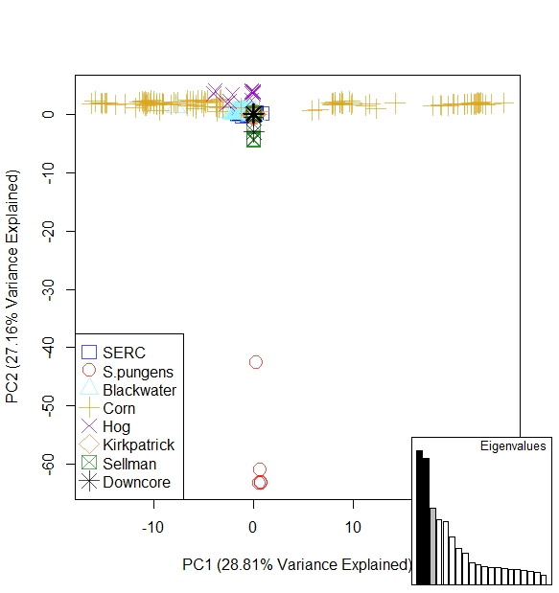
A
Figure 4: PCAs for all samples with the S. pungens outgroup (A) and without (B)

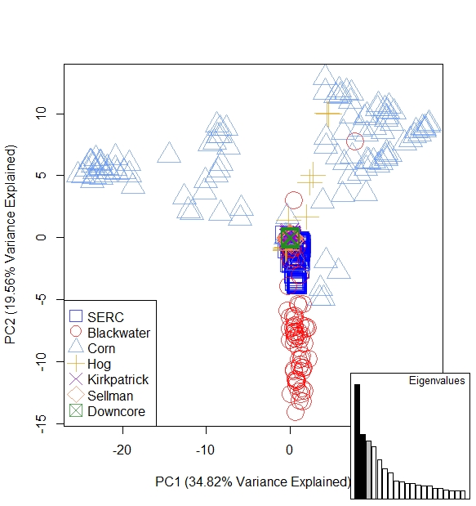
B

Figure 4 continued

K=12
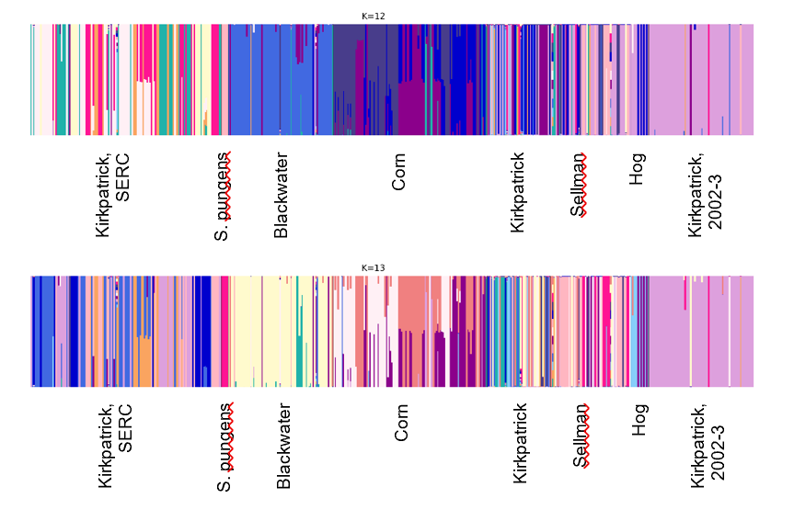
K=13

Figure 5: fastSTRUCTURE plots for the five populations (all populations included in the total sample set) and the optimal K values (K=12, top; K=13, bottom). There are distinct clusters by geographic location and within geographic locations. The fewest genetic clusters within geographic locations occur with Blackwater NWR samples and those from “downcore” or the Kirkpatrick Marsh samples from the 2002/2003 sampling period (Summers et al. 2018).

Table 3: Pairwise F_{st} table for only resurrected samples
 |  | Corn | Kirkpatrick | Sellman | Kirkpatrick (2002-3)
Blackwater |  | 0.067 | 0.079 | 0.064 | 0.0642
Corn |  |  | 0.026 | 0.034 | 0.028
Kirkpatrick |  |  |  | 0.042 | 0.027
Sellman |  |  |  |  | 0.045
Table of F_{st} values by population for only the resurrected samples with Hog Island and S. pungens samples excluded. F_{st} values were consistently low between populations.

Table 4. Population genomic statistics for only resurrected provenances
# Pop ID | Private | Num_Indv | P | Obs_  Het | Obs_  Hom | Exp_Het | Exp_Hom | Pi | Fis
Blackwater | 95 | 57.08 | 0.856 | 0.192 | 0.807 | 0.198 | 0.801 | 0.199 | 0.104
Corn | 173 | 82.87 | 0.817 | 0.194 | 0.805 | 0.246 | 0.753 | 0.247 | 0.230
Kirkpatrick | 42 | 16.71 | 0.856 | 0.174 | 0.825 | 0.197 | 0.802 | 0.204 | 0.114
Sellman | 4 | 37.54 | 0.878 | 0.148 | 0.851 | 0.168 | 0.831 | 0.171 | 0.282
Kirkpatrick (2002-3) | 177 | 62.58 | 0.945 | 0.064 | 0.935 | 0.083 | 0.916 | 0.084 | 0.368
Population name (Pop ID), Private alleles (Private), Mean number of individuals per locus in this population (Num_Indv), Mean frequency of the most frequent allele at each locus in this population (P), Observed heterozygosity (Obs_Het), Observed homozygosity (Obs_Hom), Mean expected heterozygosity in this population (Exp_Het), Mean expected homozygosity (Exp_Hom), Mean value of pi in this population (Pi), Mean measure of Fis in this population (Fis).

Table 5: Population genomic statistics across downcore samples
# Pop ID | Private | Num_Indv | P | Obs_Het | Obs_Hom | Exp_Het | Exp_Hom | Pi | Fis
Kirkpatrick + Hog Island
KM0-2 | 8 | 17.565 | 0.839 | 0.278 | 0.722 | 0.216 | 0.784 | 0.222 | -0.115
KM0-3.5 | 3 | 1.000 | 0.864 | 0.273 | 0.727 | 0.136 | 0.864 | 0.273 | 0.000
dc2-4 | 104 | 6.509 | 0.924 | 0.097 | 0.903 | 0.112 | 0.888 | 0.122 | 0.029
dc8-10 | 42 | 4.646 | 0.933 | 0.099 | 0.901 | 0.094 | 0.906 | 0.105 | 0.166
dc12-14 | 192 | 25.805 | 0.926 | 0.091 | 0.909 | 0.113 | 0.887 | 0.115 | 0.069
dc14-16 | 49 | 6.444 | 0.930 | 0.098 | 0.902 | 0.100 | 0.900 | 0.109 | 0.039
dc20-22 | 28 | 4.024 | 0.926 | 0.102 | 0.898 | 0.104 | 0.896 | 0.119 | 0.017
dc22-24 | 3 | 2.000 | 0.880 | 0.093 | 0.907 | 0.134 | 0.866 | 0.179 | 0.130
H0-3 | 80 | 1.000 | 0.821 | 0.357 | 0.643 | 0.179 | 0.821 | 0.357 | 0.000
H8-10 | 148 | 1.000 | 0.718 | 0.564 | 0.436 | 0.282 | 0.718 | 0.564 | 0.000
Blackwater
BW0-2 | 29 | 7.006 | 0.843 | 0.223 | 0.777 | 0.212 | 0.788 | 0.228 | 0.023
BW2-4 | 35 | 8.763 | 0.845 | 0.163 | 0.837 | 0.210 | 0.790 | 0.223 | 0.195
BW4-6 | 1 | 10.000 | 0.833 | 0.222 | 0.778 | 0.232 | 0.768 | 0.244 | 0.142
BW6-8 | 11 | 4.000 | 0.834 | 0.271 | 0.729 | 0.226 | 0.774 | 0.258 | -0.022
BW8-10 | 34 | 15.148 | 0.837 | 0.223 | 0.777 | 0.228 | 0.772 | 0.236 | 0.054
BW10-12 | 21 | 12.225 | 0.817 | 0.252 | 0.748 | 0.244 | 0.756 | 0.255 | 0.040
BW12-14 | 10 | 2.000 | 0.845 | 0.251 | 0.749 | 0.195 | 0.805 | 0.260 | 0.013
BW16-18 | 0 | 1.000 | 0.858 | 0.285 | 0.715 | 0.142 | 0.858 | 0.285 | 0.000
Corn Island
C0-3 | 70 | 26.644 | 0.823 | 0.192 | 0.808 | 0.240 | 0.760 | 0.244 | 0.077
C3.25-4.75 | 10 | 8.983 | 0.850 | 0.188 | 0.812 | 0.188 | 0.812 | 0.200 | -0.036
C4.75-6.75 | 30 | 13.927 | 0.840 | 0.205 | 0.795 | 0.205 | 0.795 | 0.213 | 0.000
C5.25-7.25 | 2 | 1.000 | 0.894 | 0.213 | 0.787 | 0.106 | 0.894 | 0.213 | 0.000
C9.5-11.75 | 4 | 1.000 | 0.876 | 0.248 | 0.752 | 0.124 | 0.876 | 0.248 | 0.000
C10.25-12.75 | 3 | 1.000 | 0.967 | 0.066 | 0.934 | 0.033 | 0.967 | 0.066 | 0.151
C14.75-16.75 | 2 | 4.000 | 0.816 | 0.195 | 0.805 | 0.233 | 0.767 | 0.267 | 0.028
C16.75-18.75 | 13 | 4.406 | 0.802 | 0.264 | 0.736 | 0.263 | 0.737 | 0.297 | 0.040
C18.75-20.75 | 52 | 13.842 | 0.816 | 0.235 | 0.765 | 0.247 | 0.753 | 0.257 | 0.205
C20.75-22.75 | 8 | 11.969 | 0.837 | 0.247 | 0.753 | 0.217 | 0.783 | 0.227 | 0.068
Sellman
S2-4 | 1 | 7.878 | 0.980 | 0.021 | 0.979 | 0.029 | 0.971 | 0.031 | 0.023
S4-6 | 40 | 12.595 | 0.893 | 0.066 | 0.934 | 0.189 | 0.811 | 0.197 | 0.652
S8-10 | 0 | 3.000 | 0.979 | 0.021 | 0.979 | 0.028 | 0.972 | 0.033 | 0.023
S10-12 | 0 | 2.000 | 1.000 | 0.000 | 1.000 | 0.000 | 1.000 | 0.000 | 0.000
S14-16 | 0 | 2.000 | 0.974 | 0.000 | 1.000 | 0.026 | 0.974 | 0.035 | 0.053
S15.25-17.75 | 0 | 1.000 | 0.987 | 0.026 | 0.974 | 0.013 | 0.987 | 0.026 | 0.000
Population name (Pop ID), Private alleles (Private), Mean number of individuals per locus in this population (Num_Indv), Mean frequency of the most frequent allele at each locus in this population (P), Observed heterozygosity (Obs_Het), Observed homozygosity (Obs_Hom), Mean expected heterozygosity in this population (Exp_Het), Mean expected homozygosity (Exp_Hom), Mean value of pi in this population (Pi), Mean measure of F_{is} in this population (F_{is}).

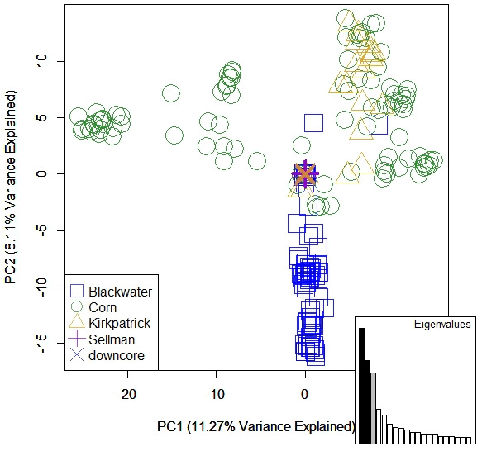

Figure 6: PCA of the spread in the variance for all resurrected individuals, excluding individuals from Hog Island and samples of the sister species, S. pungens (outgroup), which were outliers in terms of their differences from the other populations. The first PC correlates with the spread of the samples from Corn Island. PC2 correlates with the spread in Blackwater samples as well as variance in Kirkpatrick samples. Interestingly, the “downcore” or Kirkpatrick samples cored in 2002-3 do not exhibit variance on the same scale as the other marshes / Kirkpatrick sampled in 2018 (“Kirkpatrick”).

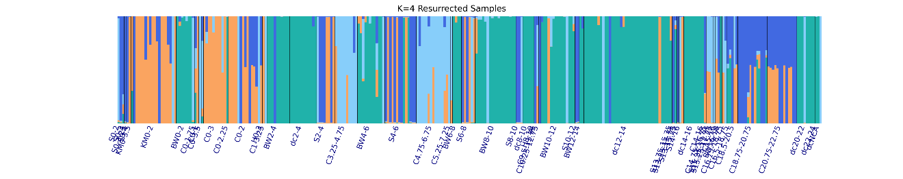
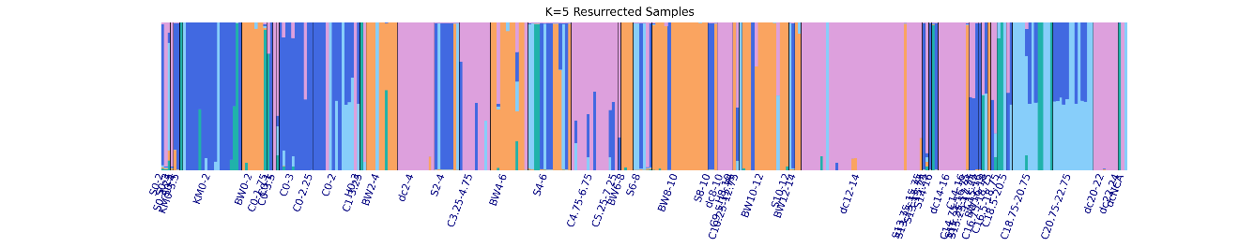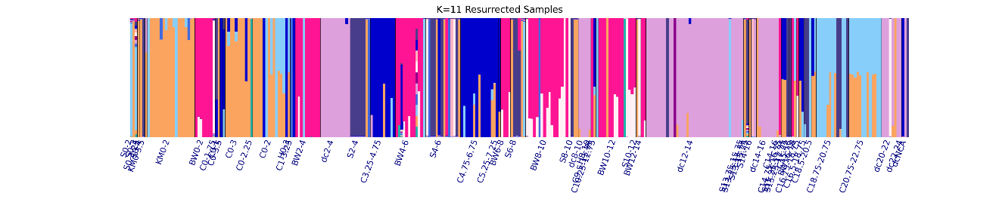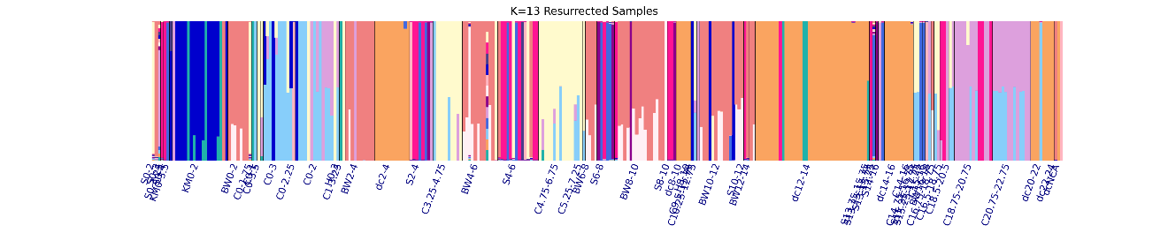
Figure 7: FastSTRUCTURE graphs for a range of potential optimal K values (K=4, K=5, K=11, K=13) based on the chooseK algorithm in the fastSTRUCTURE program. Samples are arranged from youngest or shallowest depths (far left) to the oldest or deepest depths (far right) rather than provenance. The clusters form on the basis of provenance rather than age cohort. From left to right: Sellman 0-3, Kirkpatrick 0-2, Blackwater 0-2, Corn 0-3, Hog 0-3, Blackwater 2-4, Kirkpatrick(2002) 2-4, Corn 3.25-4.75, Blackwater 4-6, Sellman 4-6, Corn 4.75-6.75, Corn 5.25-7.25, Blackwater 6-8, Sellman 6-8, Blackwater 8-10, Sellman 8-10, Kirkpatrick(2002) 8-10, Hog 8-10, Corn 10.25-12.75, Blackwater 10-12, Sellman 10-12, Blackwater 12-14, Kirkpatrick(2002) 12-14, Sellman 13.75-15.75, Sellman 14-16, Corn 14-16, Corn 16.75-18.75,Corn 18.75-20.75, Corn 20.75-22.75, Kirkpatrick(2002) 20-22, Kirkpatrick(2002) 22-24

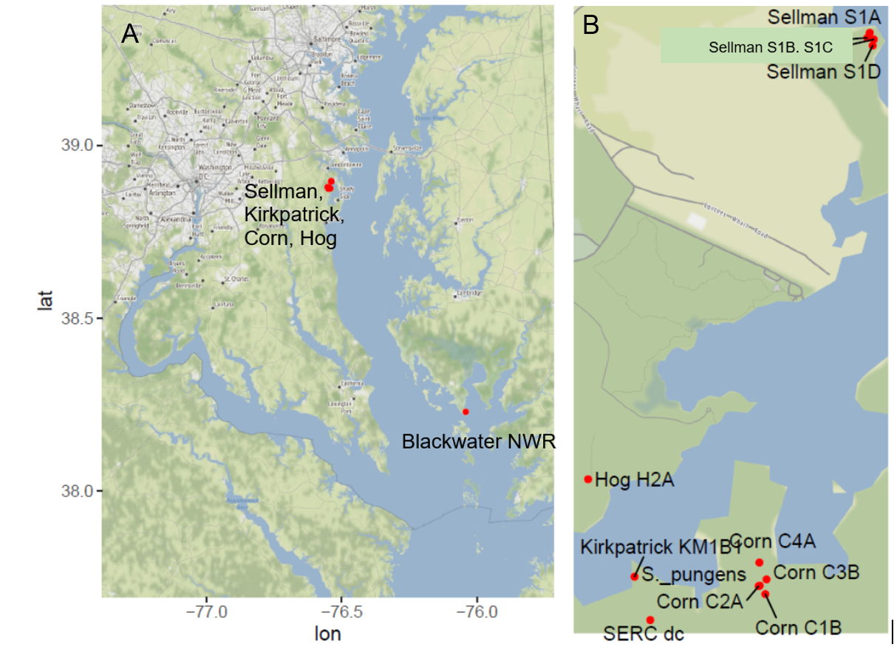
Figure S3: Map of sampling sites for ddRADseq samples across the Chesapeake Bay

CHAPTER III
Heritable variation in functional responses

of a foundational coastal marsh sedge to global change over time

Abstract
Many species, including some that undergird entire ecosystems, may perish because of rapid changes in climate conditions unless the species are able to respond suitably. Understanding the nature historical phenotypes can illustrate the capacity for at-risk species to persist under future scenarios. In this study, I utilized a century-long seed bank of the foundational coastal marsh sedge Schoenoplectus americanus to assess the nature of responses to corollaries of sea level rise. I resurrected “20th century” (1908-1918 ± 15.6-25.0 years) and “21st century” (1998-2002 ± 1 year) age cohorts by germinating seeds of S. americanus from time-stratified sediments sampled from a Chesapeake Bay marsh. I compare phenotypic responses of the 20th century and 21st century cohorts to determine whether and how responses to salinity, inundation, and competition have changed over time. Cross-generational comparisons also allowed me to evaluate how interspecific interactions modify exposure responses in a greenhouse experiment where I imposed salinity, inundation, and competition treatments in a fully crossed design. I detected few overall differences in biomass between 20th century and 21st century cohorts. However, 21st century plants tended to demonstrate a subset of 20th century variability in response to stressors, perhaps suggesting the evolution of plasticity through time. In addition, there were significant effects of competition, inundation, salinity, and their interactions on a suite of phenotypic traits. Notably, stem density, a trait that can influence sediment capture and maintenance of marsh elevation, increased with the presence of competitor. Overall, this work suggests evolutionary change in this perennial foundational plant with meaningful ecological impacts over the course of just a century. Increased salinity and inundation (i.e., simulated sea level rise) severely impact productivity and this impact, though invariably negative, varies by genotype regardless of age cohort.

Introduction

Impact of climate change on populations at risk
Unfolding changes in climate have resulted in potent new pressures that could put many species, including some that undergird entire ecosystems, at greater risk of extinction (Hoffmann & Sgrò, 2011; Román-Palacios & Wiens, 2020). Several corollaries of climate change, including rising temperatures and rising sea level, are shifting at increasing rates towards conditions that exceed current physiological thresholds and performance limits (Deutsch et al., 2008; Hoegh-Guldberg & Bruno, 2010). Organisms can potentially cope with rapidly changing environmental conditions through acclimation (i.e., phenotypic plasticity), rapid evolution (i.e., shifts in allelic or heritable phenotypic variation) (Ghalambor et al. 2007, Bernatchez 2016), migration, or some combination thereof. Acclimation is frequently treated as a default explanation for exposure responses, which is reinforced by evidence indicating that phenotypic plasticity can promote persistence to unfolding climate conditions (Carroll et al., 2007; Fox et al., 2019; Toyota et al., 2019). It remains unclear whether rapid evolution in response to climate change is commonplace and important (Carroll et al., 2007). There is compelling evidence, however, indicating that exposure to corollary pressures like heat stress (Diamond, 2017; Palumbi, Barshis, Traylor-Knowles, & Bay, 2014) and drought (Franks & Beerling, 2009; Franks et al., 2014) can elicit rapid evolution, suggesting that further study is needed to clarify the risks posed by climate change.

Evolution can sometimes proceed at a pace comparable to climate-driven changes in environmental and ecological conditions (Kinnison and Hairston 2007; Pelletier et al. 2009; Shefferson and Salguero-Gómez 2015; Hendry 2016). Rapid evolution can occur over months to years, involving changes that unfold over just a single generation (Reznick, Losos, & Travis, 2019). Evidence of rapid evolution has been found in studies of natural populations along geographic clines and climatic gradients (Bradshaw and Holzapfel 2001; Huey 2000; Colautti and Barrett 2013). Other studies illustrate that exposure to climate-related pressures (e.g., drought, elevated CO₂) can elicit selection-driven responses in experimental populations (Franks et al. 2007, Grossman and Rice 2014). For instance, exposure can lead to rapid loss of genetic (i.e., allelic) diversity and divergence (Avolio et al. 2013, Ravenscroft et al. 2015) as well as shift heritable trait variation linked to ecosystem processes (Barton, Hermisson, & Nordborg, 2019; García-Carreras et al., 2018; Lohbeck, Riebesell, & Reusch, 2012; Monroe et al., 2018). It is nonetheless questionable whether rapid evolution is relevant to species persistence, in part because responses to selection can be dampened, altered, or superseded by plasticity and other factors like competition (Bazzaz, Jasieński, Thomas, & Wayne, 1995; Lau, Shaw, Reich, & Tiffin, 2014; Ward, Antonovics, Thomas, & Strain, 2000). While this helps explain the widely held perspective that microevolution is likely inconsequential as a response to climate change, only a few studies have quantified how evolutionary responses compare to plasticity, competition and combinations thereof (Bazzaz et al. 1995, Lau et al. 2014, Ellner et al. 2011, Merilä and Hendry 2014). It is thus possible that evolutionary contributions to species persistence are more important and more common than previously imagined.

In this study, I utilized a century-long seed bank of the foundational coastal marsh sedge Schoenoplectus americanus to assess the nature and relative importance of evolutionary responses to corollaries of sea level rise. My aim was to compare phenotypic responses of 20th century and 21st century generations to determine whether and how exposure responses have changed over time, accounting for the possibility that interspecific interactions may modify exposure responses. This involved reconstituting age cohorts from seeds recovered from two contrasting soil depths for use in a fully crossed, multifactorial common garden experiment designed to reveal potential differences in response to inundation and salinity stress in the presence of a naturally co-occurring competitor. Functional traits were measured to characterize the range of phenotypic variation within and between cohorts for all treatments. Because corollaries of sea level rise can be strong selective agents (e.g., Purcell et al., 2008; Schile et al., 2017; Watson et al., 2016), I expected to find signatures of evolutionary differentiation in exposure responses between age cohorts. For example, 21st century cohort responses might manifest as a subset or narrower range of functional trait variation compared to variation exhibited by the 20th century cohort. The 21st century cohort might also exhibit greater survival or fitness according to proxy measures of reproduction (e.g., biomass production) under more severe exposure stress (Gentile, 2015; Blum et al., in review). Likewise, competition might be less of a constraint for 21st century than 20th century plants. It is also possible, however, that cohorts exhibit little to no evolutionary differentiation, or that heritable differences are of marginal importance in comparison to those attributable to environment (i.e., plasticity) or competition.

Methods

Seed recovery, revival, and propagation.
Seeds of Schoenoplectus americanus were recovered from soil cores, germinated, and then propagated for use in a multifactorial common garden greenhouse experiment to test for evolutionary differentiation and to determine how it compares to other forms of response to global change pressures. Soil cores were sampled from Corn Island Marsh (CIM), a marsh adjacent to the Global Change Research Wetland (GCReW) at the Smithsonian Environmental Research Center (SERC) near Edgewater, Maryland. Like GCReW, CIM hosts a plant community dominated by S. americanus. In 2016, four pairs of cores were taken from CIM with each core measuring approximately 30 cm in length and 6 cm in width. Pairs of cores were taken within 10 cm of one another, with one used for seed recovery and one used for ¹³⁷Cs and ²¹⁰Pb radionuclide dating of sediment stratigraphy (Appleby & Oldfield, 1978; Kerfoot et al., 1999; Summers et al., 2018). Seeds were sieved from the two cores from summer 2016 through spring 2017. Sieving consisted of sectioning each core perpendicular to the vertical axis at 2 cm depth intervals. Each 2 cm section was placed in a 2 mm mesh sieve (Fisher Scientific Company Sieve No. 10) stacked on a 710 μm mesh sieve (W.S. Tyler, Incorporated Sieve No. 25) and washed with water to isolate seeds from inorganic and larger organic matter. Seeds recovered from different sections were stored in separate 2 ml tubes in de-ionized water until subsequent use.

I attempted to germinate all recovered seeds. Following Summers et al. (2018), every seed was planted in a separate 7.62 cm square cell in a gridded flat of 9 cells containing 1:2 sterile sand and Jiffy Organic Seed Starting Mix (Jiffy, Oslo, Norway). Each flat was placed in a 10 cm deep tray filled with water to within 1 cm of the soil surface. Planted flats in trays were then placed in a Conviron CMP 6010 growth chamber with a light regime of 12 hours of light to 12 hours dark, and with a temperature regime of 27°C during period of light and 15°C during period of dark. Seeds were checked every other day for germination or mortality (e.g., the seed had molded, or germinated and then perished), and water was replenished to maintain a constant level of inundation. After 20 days, seeds that did not germinate were recovered, placed in separate 2 mL microtubes filled with deionized water, and stored in a refrigerator for later use in viability assays. Plants from germinated seeds were grown in the growth chamber for an additional two weeks before being transferred to a greenhouse. To reduce possible residual effects of dormancy, all plants were reared in the greenhouse for a full year before clones were propagated for experimental use in summer 2018 (Bennington, McGraw, & Vavrek, 1991; Vavrek, McGraw, & Bennington, 1991). Clones of all genotypes were propagated from ≤5 cm long rhizomes planted in separate 5 cm wide cells in gridded flats placed in flooded trays. Propagules were grown in a 50/50 Baccto™ (Baccto, Houston, TX) Premium Potting Soil and sand mixture for two months in the greenhouse prior to the start of the experiment.

Experimental design.
A common garden experiment was undertaken to compare responses of an 20th century cohort and a 21st century cohort (Summers et al., 2018) to inundation, salinity, and interspecific competition. The 20th century cohort was composed of nine genotypes revived from the 18-22 cm stratigraphic layer (ca. 87-112 years old; Summers et al., 2018). The 21st century cohort was composed of nine genotypes revived from the 2-4 cm stratigraphic later (ca. 22 years old; Summers et al., 2018). Note that while the 21st century cohort is in the same area as the 20th century, I do not know detailed family relationships: the 20th century cohort may not be direct ancestors of the 21st plants. Clones of each genotype were used to standardize assessment of responses to the following conditions: (1) freshwater (0 ppt) and saline conditions (15 ppt), under (2) six levels of inundation ranging from -20 cm (i.e., the water level was 20 cm below the soil level in the pot) to +30 cm, in 10 cm increments, (3) with or without the naturally co-occurring C₄ competitor, Spartina patens.

These conditions approximate stressors S. americanus may encounter currently or in the near future in the Chesapeake Bay. Elevation of the study site is 40–60 cm above the mean low water (Jordan, Pierce, & Correll, 1986). Future relative sea level rise in the Chesapeake Bay is likely to be worse than the global average due to subsidence, making it likely that a moderate projected sea level rise of 1 meter will result in complete inundation of some marshes (Eggleston and Pope 2013). In the Chesapeake Bay, soil salinity ranges from 2 ppt to 18 ppt during the growing season (May to September), where inter-annual variation in growing season salinity is inversely correlated with rainfall (Saunders, 2003). The experimental treatments were fully crossed to determine how responses varied according to stressor interactions (e.g., greater inundation under high salinity conditions) and to determine whether interspecific competition influences exposure responses (Figure S4). All Spartina patens plants were sourced as seedlings from a Chesapeake Bay wetland restoration company (Environmental Concern, St. Michaels, MD) that obtained seeds from plants growing in coastal marshes in Virginia.

The experiment was conducted using four 1,325 L mesocosm tubs outfitted with “marsh organs” (Morris, 2007) located in a greenhouse at the University of Tennessee – Knoxville. Three mesocosms were configured in a row on one side of the greenhouse (Figure S5). The fourth unit was in a second row approximately 3 m away towards the interior of the greenhouse. The greenhouse was climate-controlled, with temperatures ranging from 26-30 °C during the day and 24-26 °C at night with humidity averaging 60% over the summer months. Three-month temperature averages from the Chesapeake Bay ranged from 24-26°C at night to 26-39°C during the typical summer (NOAA National Weather Service Forecast Center). The mesocosms were paired according to salinity regime, with two mesocosms filled with 15 ppt water and the other two filled with 0 ppt water. The two treatments bracket the typical natural range of estuarine salinity that occurs in the Rhode River basin (Mozdzer & Caplan, 2018). Each pair was outfitted with PVC piping and an Eheim™ 1048 Pump on a timer to simulate an alternating 6-hour tidal inundation cycle, where one mesocosm drained while the other filled with water.

Each clone was planted in a 10 cm diameter x 30.5 cm tall PVC pot with a slotted drain enclosure at the bottom. Pots were filled to ≤ 3 cm from the top with a 50/50 mixture of Baccto™ Premium Potting Soil and sand. Each clone consisted of a standardized 7 cm length of root with 2 cm of stem tissue, which were weighed prior to planting. The experiment was run from May through August, which approximates the peak growing season of S. americanus in the Chesapeake Bay region (Curtis, Drake, & Whigham, 1989). Each month, plants were rotated on their respective shelves and plants were rotated between mesocosms (within each salinity treatment) to control for possible chamber effects. Clones that died during the first month of the experiment were replaced with a new clone of the same genotype, with most plants being replaced in the first two weeks.

Phenotypic assays of growth, phenology, and sexual reproduction.
A suite of phenotypic traits was measured for all S. americanus plants used in the experiment. Each week, flowers were counted and removed, and survival was noted (i.e., whether the plant was dead or alive). Each month, all stems were counted and ≤20 stems per plants were measured for height. Upon completion of the experiment, additional measures were taken for all plants, including stem height, stem density, stem width, and aboveground biomass partitioned into green and senescent (i.e., brown) tissue. Rooting depth was recorded categorically across 5 cm increments (6 possible depths from 0 to 30 cm) of the pot, noting presence of thick and thin roots and counts of root nodes. Belowground biomass was partitioned according to rhizome and root tissue, allowing me to estimate total biomass.

Statistical analysis of phenotypic variation.
I first characterized differences among cohorts and genotypes by undertaking principal components analyses of continuous trait variation using the function prcomp in the R v3.6 package stats v3.6.2 (R Core Team, 2019). PCAs were visualized with the package ggbiplot (Vu, 2011) and the post-hoc graphical package phia (De Rosario-Martinez 2015) was used to visualize comparisons of variation according to treatment and age cohort. Linear discriminant analyses (LDAs) also were performed to assess whether and how plant traits varied by (1) age cohort relative to salinity, and (2) age cohort relative to competition using the lda function in the R v 3.6 package MASS with the “mle” method (Venables and Ripley, 2002) (R Core Team, 2016). Predictor variables included initial weight as a covariate to understand if there were unintended correlations with age cohort and treatment. In addition, final green height, final stem width, final stem density, rhizome node count, and thin root length were also included as predictor variables. All variables were cube root transformed prior to inclusion in the LDAs.

Biomass analyses.
To understand the overall effect of treatment, genotype and age cohort on net final biomass, exploratory multi-model inference was conducted to assess the relative importance of predictor variables for change in net final biomass. Net biomass was calculated by aggregating below and aboveground biomass minus the initial weight. To eliminate negative values, the data were transformed using the boxCox function using the Yeo-Johnson power family in the R package car (Fox & Weisberg, 2019) prior to building the model. Response variables included salinity, competition, inundation level, age cohort, and interactions thereof as fixed effects, with genotype as a random effect. The model was built using the lmer function in the R package lme4 (Bates, Mächler, Bolker, & Walker, 2015). The relative importance of predictor variables was calculated as the sum of the Akaike weights of all models containing a particular predictor variable using the dredge function from the R package MuMIn version 1.43.17 (Bartoń, 2020). Models were also ranked through all iterations and possible combinations of the global model as defined above, calculating the relative importance of the predictor variables based on averages of weights across all models (Alberti et al., 2017). Further, I examined the relative effect sizes of age cohort, salinity, competition, and inundation level by building models with each treatment / condition as a fixed effect and genotype as a random effect, then passing the simplified model to MuMIn’s r.squaredGLMM function.

Death and reproduction analyses.
To analyze mortality across treatments and age cohort, generalized linear mixed models (GLMMs) were constructed with the R package lme4 (Bates et al., 2015) to determine whether variation in biomass and key traits was attributable to environment (i.e., treatments and interactions thereof), age cohort, and genotype. The full model consisted of a binary state (i.e., presence vs. absence) at the end of the experiment, with salinity, competition, inundation level, age cohort, and their interactions as fixed effects and genotype as a random effect. Effect sizes were estimated using the trigamma calculation using the r.squaredGLMM function in MuMIn as above. The same model was constructed for flowering as a binary response condition (i.e., presence vs. absence), with treatment, age cohort, and their interactions as fixed effects and individual genotype as a random effect to account for zero-inflated data since most of the plants did not flower over the duration of the experiment. For analysis of asexual reproduction, rhizome node counts were compared across age cohorts and treatments using a GLMM with a Poisson distribution with the same structure as the binary models of mortality and flowering. For each response variable, all possible combinations of predictors were included in models for comparison of AIC values (Xu, 2003) using the MuMIn R package as described above. Mortality was additionally analyzed among cohorts and across treatments using the survival package (Therneau 2020) in R v3.6 (R Core Team 2019). This approach determines the distribution of time to the event (i.e., death), testing for equality of two distributions, and regression modelling of the rate at which events occur according to the Kaplan-Meier Method and Log Rank Test.

Results

Overall variance in trait responses to stressor exposure.
Linear discriminant analyses depict the distribution of variance by treatment and age cohort. The first LDA depicts variance in stem width, stem height, stem density, thick and thin root length, node count and initial weight grouped by age cohort and competition (Figure 8A). The first canonical function explains 90.07% of variance and correlates strongly with stem count and stem weight (aboveground biomass). The second canonical function explains 9.18% of variance and is correlated most closely with stem width and stem height. Overall, aboveground traits most strongly correlate with the differences by treatment and age cohort. The 20th century and 21st century ellipses overlap within each experimental condition. The greatest separation of ellipses is between 20th century or 21st century competition and 20th century or 21st century no competition. Under competition 20th century and 21st century ellipses align closely; however, when the competitor is absent, the two cohorts tend to differ such that the 21st century no competition treatment reflects a different, but less variable subset of 20th century no competition (Figure 8b). In general, the two cohorts exhibit similar variance and release from competition enhances trait variance for both cohorts.

The second LDA depicts the distribution of variance by salinity and age cohort. The same traits were included as above: stem width, stem height, stem density, thick and thin root length, node count and initial weight (Figure 8B). The first canonical function explains 91.06% of variance and correlates best with thick root weight and stem width. The second canonical function explains 6.81% of variance and correlates with stem height, thick root length and somewhat with stem width as well. The 20th century freshwater ellipse is the largest and encompasses the other ellipses across cohort and treatment. The most variance difference is between freshwater and salinity treatments for both cohorts. Salinity reduces variance for both cohorts, though the reduction is greater for the 20th century cohort which has a larger ellipse in the freshwater condition. Within the freshwater condition, the 21st century cohort is a subset of the variance seen for the 20th century cohort. This is also true for the salinity condition where the 20th century salinity condition ellipse almost fully contains the 21st century salinity condition ellipse. In sum, there are a range of below- and aboveground traits that drive variance in response to salinity and 21st century variance overall is a subset of 20th century variance.

The principal components analyses (PCAs) represented the total variance of aboveground and belowground measures by treatment (age cohort x salinity, age cohort x competition). The PCAs demonstrated that 21st century plants tend to exhibit constrained variation by tissue type relative to 20th century trait variation. This was especially true for the interaction of age cohort and competition. For example, Figures S5B and S5D show that 21st century plants represent a subset of below- and aboveground trait variation for 20th century plants when including differences by competition treatment. Below- and aboveground traits for salinity and age cohort demonstrate a different pattern: though 21st century and 20th century groups overlap, the 21st century group ellipse tends to expand beyond the variance of age cohort, though this correlates with the second principal component which explains less of the overall variance for both above- and belowground traits (Figure S5A, C).

Summarizing trait responses to stressors.
All experimental treatments (salinity, competition, and inundation) resulted in dramatic shifts in productivity and other phenotypic traits (Figures 9, 10). The highest levels of aboveground and belowground productivity occurred at +10 cm, inundation, which mean S. americanus thrived when partially inundated. There was some variation by trait as to whether the +10 cm condition resulted in optimal biomass production, however. For example, stem density remained consistently high for all inundation levels except the deepest, most inundated (Figure S4A). For the other stressors, optimal growth occurred in least stressful conditions (freshwater, no competition). Comparable reduction in above- and belowground productivity occurred with introduction of the competitor and exposure to salinity treatment (Figures 9, 10; Figure S4). The 20th century and 21st century plants generally exhibited similar patterns of response, with some notable exceptions. For example, 21st century thick root weight was higher than 20th century thick root weight when planted with a competitor (Figure 9b). In addition, 21st century plants exhibited higher mean green stem height at 0 cm inundation, under no competition (Figure 10c) and 21st century plants exhibited higher mean green weight at 0 cm inundation under competition (Figure 10B). Overall, however, the age cohorts responded similarly to stressors. With competition for example, across all models the no competition treatment results in a positive effect on biomass, though interestingly no competition tends to have a slight negative effect on mortality (Table 7). The strongest benefits to no competition are seen with belowground biomass (Table 10), node count (Table 8), and net biomass (Table 6). Salinity has strong negative effects on biomass and other traits as well. The strongest negative coefficient of salinity is seen in the model for mortality (Table 7). There was a slight positive effect of salinity for stem width (Table 9).

Modelling trait responses to stressors.
Decomposition of all possible iterations of a global model were done for all traits below. In each model, genotype ID was included as a random effect and predictors included age cohort, salinity, competition, and inundation level plus their interactions. The global model for net final biomass global model showed that the top ranked fixed effects were all experimental treatments, namely level and the interaction of competition and salinity (Figure 11). To a slightly lesser extent, competition and salinity alone were also important predictors (Figure 11). The second-best model also included the interaction between level and salinity. When weighing the importance of predictors across all models, age cohort is closely ranked near the top, with the third best model including age cohort as a strong predictor. The top three models had AIC scores differing by less than two units. Effect sizes for net biomass varied by treatment and age. The interaction between salinity and inundation (simulating sea level rise) resulted in the strongest marginal effect size (Table 6). Conditional R² values reflect the combined effect sizes of fixed and random effects. Overall, the random effect of genotype demonstrated moderate effects across all models (Conditional R²=0.30, Marginal R² = 0.156). Salinity comprises the largest effect size for a sole fixed effect while age cohort represented the smallest effect on net biomass (Table 6). In general, the effect sizes of all fixed effects were small.

Mortality, as analyzed using a GLMM with presence or absence of tissue as a response, showed that treatments simulating sea level rise (i.e., salinity and inundation level) were the most impactful and important in the best-supported model. Based on averaging across all iterations of the global model, the best-supported model included level and the interaction between level and salinity (Figure 12). Salinity was also important for the top model (Figure 12). Competition and salinity were important predictors in the second best-supported model in addition to the corollaries of sea level rise (Figure 12). Effect size calculations revealed that there were relatively weak effects of all treatments, with the largest effects seen for salinity and for the combined salinity and inundation (Table 7). The lowest effect size was for the age cohort (Table 7). Like the biomass analyses, the mortality response variable exhibited impacts of genotype ID (Conditional R²=0.900, Marginal R²=0.899). When examining model coefficients, the strongest effect results from the salinity treatment (Table 7). Based on time to death analyses in the survival package, there were no significant differences by age cohort for death.

Sexual reproduction did not strongly differ according to age cohort or treatment. Relatively few plants flowered, with a total of 30 flowers removed from only 14 S. americanus plants over the duration of the experiment. The model for flowering indicated no pattern according to age cohort (p=0.294) or treatment (salinity, p=0.951, competition, p=0.982). Asexual reproduction (i.e., root node counts) occurred more frequently across all treatments. The model for S. americanus node counts revealed differences by treatment but not by age cohort (Figure 13, Table 8). The model with the best AIC included genotype as a random effect, with salinity, inundation level and competition as fixed effects. Level was the most important predictor in the top-ranked model. The second best-supported model for node counts included the interaction between competition and salinity. Age cohort appears as weakly important in the third best-supported model (Figure 13). For effect sizes, the strongest effect is from the positive impact of growing without a competitor (Coefficient = 0.917, Table 8). There was also a strong signal of genotype ID, (Conditional R² = 0.436, Marginal R² = 0.274).

Stem width exhibited similar patterns to reproductive traits. Overall, the strongest response was to the interaction of salinity and competition. The global model decomposition for stem width largely consisted of a single highly probable model (Figure 14). The second best-supported model included the weakly important predictors level and the interaction of level and salinity. The effect sizes of salinity and competition were comparable (Table 9) and model coefficients suggest that competition and salinity had only slight effects on stem width. The random effect of genotype ID had a larger influence on stem width in general (Conditional R²=0.362, Marginal R² =0.277).

Decomposition of the global model for belowground biomass shows that the best-supported model includes the interaction between competition and salinity as the most important predictor while competition alone and salinity alone are less important predictors (Figure 15). Salinity had a strong negative effect on belowground biomass (Coefficient -0.169; Table 10). Competition additionally reduced belowground biomass, with the no competition resulting in the highest overall effect (Coefficient = 0.93, Table 10). Like other models, there was some substantial variance associated with genotype ID (Conditional R² =0.225, Marginal R² =0.111).

Stem density exhibited a somewhat unique pattern relative to the previously examined traits. In the presence of a competitor stem density increased rather than decreased (Figure S4A). In the top supported model inundation level, the interaction between competition and salinity and the interaction between level and salinity were the most important predictors (Figure 16). In the second best-supported model age cohort is a moderately important predictor (Figure 16). The coefficients for competition (Coefficient=-0.27, Table 11) indicate that no competition treatment negatively impacts stem density. Salinity and level also had negative effects, with salinity having a larger negative effect than competition (Coefficient=-0.38, -0.09, respectively). Finally, there was a slightly negative coefficient for age cohort, suggesting only a weak effect (Coefficient=-0.0187, Table 11). Here, genotype ID proved less important (Conditional R² =0.496, Marginal R² =0.473).

Discussion
I analyzed functional trait variation for two resurrected age cohorts of S. americanus in response to simulated sea level rise and competition to provide insight into possible trait shifts over time in a foundational coastal marsh sedge. The overarching goal was to understand evolutionary potential in a species threatened by climate change corollaries by characterizing possibly heritable shifts in traits that scale up to affect the entire brackish marsh plant community and wetland ecosystem (Morris et al. 2002; Kirwan et al. 2008; Schile et al. 2014). While age cohort identity, salinity, competition, and inundation all shaped S. americanus functional traits, it was genotype ID, salinity and inundation that explained most trait variation. Age cohort was not an important predictor for any of the top two best-supported models for any traits and overall demonstrated the smallest relative effect size for most traits. However, when visualizing trait variance in response to stressors, 21st century plants represented a subset of the variance exhibited by 20th century plants, which is something I had hypothesized may occur and may imply some evolutionary shifts in plasticity over time. Though the evolution of plasticity has the potential to be adaptive (Lande 2015), the fact that traits overall did not differ may suggest neutral impacts, potential future adaptive benefits, and/or maladaptation (Ghalambor et al. 2015; Hendry 2016). Further, it is worth emphasizing that the signal of age cohort is expected to be weaker than the impact of salinity and inundation, and that despite that being true, age cohort was present as a moderately important predictor in the third best-supported model for net biomass. The strongest predictor of plant trait responses was individual genotype. In addition, simulated sea-level rise repressed productivity dramatically. These findings lead me to predict that under increasing sea-level rise, extant S. americanus marshes will be increasingly dependent on genotypic diversity for survival, and that there may be limited potential for short-term, rapid evolution if the rate of sea level rise is not the worst case .

Ecological outcomes of individual response to stressors
Overall, this study demonstrates that threats from simulated sea level rise will strongly negatively impact productivity of S. americanus, as well as affecting functional traits that contribute to the maintenance of marsh elevation. This work showed that salinity powerfully effects traits and productivity. S. americanus is considered a halophyte (Sipple 1978) but this study showed that it actually does better with lower salinity; its presence in salty environments may reflect exclusion from less stressful habitats by competitors. Salinity is projected to increase as sea-level rise worsens and ocean water invades previously brackish systems (Hilton et al. 2008a). Salinity is well-understood as a stressor that plays a role in, for example, Spartina alterniflora growing in either short-form or tall-form (Valiela et al. 1978). Salinity also plays a role in marsh zonation, though it is not the most decisive factor in dictating the distribution of halophytes across a gradient of low to high marsh (Silvestri et al. 2005). Rather, it is likely that a complex combination of interspecific interactions (Emery et al. 2001a; Pennings et al. 2003; Bertness et al. 2013), water flow in the soil ((Silvestri et al. 2005), nutrient availability (Broome et al. 1995; Levine et al. 1998), and tolerance of inundation (e.g. Schile et al., 2014), among other factors, dictates optimal distribution of halophytes like S. americanus on the marsh. Additionally, it is possible for S. americanus to be supplied with freshwater via increased rainfall, which is another potential corollary of climate change and a documented determinant of estuarine salinity (Dunton et al. 2001; Jarrell et al. 2016), which may help its survival. The combined stress of inundation and salinity logically results in increased mortality and reduction in productivity. These two stressors can severely impact the futures of marshes dominated by S. americanus, especially given that relative sea level rise in the Chesapeake Bay is worse than the global average due to high rates of subsidence and the general topography of the bay (Ezer & Corlett, 2012; IPCC 2014; Thorne et al., 2018). I had hypothesized the possibility that the competitor, S. patens, may serve to facilitate survival and productivity rather than serve as an additional stressor. This premise is based on extensive work in coastal marshes that suggests facilitation is a key factor in persistence, whereby the presence of the same or neighboring species can create a microclimate that facilitates persistence in the face of stress (Bertness and Ellison 1987; Bertness et al. 2013). There was mixed evidence to support this idea. First of all, productivity overall declines sharply in the presence of a competitor, strongly implying that the presence of a competitor would likely reduce S. americanus’ contribution to organic material and sediment trapping (Mudd et al. 2010). However, the density of S. americanus stems increased when grown with S. patens (Figure S4A), which would likely increase the capacity for S. americanus to capture sediment and improve sediment settling, thus likely increasing accretion rates overall (Baustian et al., 2012; Ikegami et al., 2009; Kirwan & Guntenspergen, 2012; Kirwan & Murray, 2007; Mudd et al., 2010; Schile et al., 2014). Asexual reproduction, or node counts, demonstrated strong negative responses to competition as well, suggesting that clonal growth would be repressed by presence of a competitor.

Broader implications: evolutionary dynamics
A growing number of experiment-based studies have quantified the impact of rapid evolution on ecological processes and patterns (Franks et al. 2014; Shefferson and Salguero-Gómez 2015; Donelson et al. 2018; Metz et al. 2020). This study contributes to this body of work by providing insight into the evolutionary trajectory of S. americanus through leveraging a naturally-formed seed bank that spans a historical time period during which environmental conditions have shifted considerably (Brush 2001; DeJong et al. 2015). Abiotic stress like climate change corollaries (e.g., sea-level rises) can affect eco‐evolutionary dynamics by altering the strength of selection, the response to selection for ecologically relevant traits, and/or by directly altering the population dynamics. This in turn can feed back to affect trait evolution (Stockwell et al. 2003; Hendry 2016). Direct comparison of a population at different time points can provide insight into whether and how historical environmental change impact traits. In this study, two age cohorts provided a snapshot of potential change through time.

Regarding age cohort identity, there is only weak signal for a subset of traits that suggests age cohort is an important predictor. Net biomass and node counts both included age cohort as an important predictor in the third best-supported model. The other traits showed only a weak importance for the importance of age cohort as a predictor. Overall, across traits the effect of age cohort was small. One possible explanation for this weak effect of age cohort is that S. americanus is capable of high levels of plasticity to buffer against a stochastic natural environment; thus, understanding differences between two time points may be too coarse, perhaps requiring a greater number of age cohorts to detect fine differences. As a long-lived perennial with facultative clonal growth, there may also not have been many effective generations from the early 20th century cohort to the early 21st century cohorts examined here, limiting the scope of potential evolutionary change.

The predictor that proved more important than age cohort was the genotype identity, which was included as a random effect in all models. The importance of genotype for variance in trait response suggests that more diverse marshes may fare better in the face of worsening climate change as the range of traits improves the odds of persistence.

One noteworthy finding regarding signatures of evolutionary change over time is the fact that 21st century plants tended to exhibit a subset of the total variance seen in 20th century plants. This finding has several possible explanations. It is possible that the individuals selected for the study are not fully representative of the total variance possible for the 21st century cohort, thus erroneously providing the impression that 21st century groups are a subset of the 20th century groups. However, if we assume the 21st century cohort is representative, it is possible that selection may drive the pattern of reduce variance in the 21st century cohort. In this case, it is possible that plasticity has shifted over time, with 21st century groups expressing a narrower range of traits than 20th century individuals. Another possible scenario is that the reduce variance in 21st century groups can occur due to other evolutionary mechanisms. Immigration/emigration is less of a factor in this wind-pollinated species in which increasing geographic distance corresponds with increasing genetic distance (Summers et al. 2018). More likely is the possibility of genetic drift events that could result in a subset of the 20th century population persisting.

Caveats
There are several aspects to this study which limit the extent to which inferences can be made about change over time and to stressors. First, only two time points are represented rather than a true temporal gradient. As a result, a trend in trait expression may not reflect a directional change. The limited spatial extent of the study can also restrict broader inferences. For example, as sea level has risen over the 20th century, seeds at sampled sites in the older cohort may have been deposited during a period of lower salinity from parental plants in 21st century seeds (Hilton et al. 2008b; Eggleston and Pope 2013). In addition, there are relatively few (9) genotypes per age cohort. This could mean that this relatively small subset of individuals from each age cohort may not be fully representative of the historical populations. However, given the high levels of diversity seen across the depths of the seed bank, there is good reason to believe the seed bank is representative (Summers et al 2018). Further, it is difficult to assess what phenological shifts may be affected by change over time as flowering was a rare occurrence over the course of the experiment. The rarity of flowering is likely a function of the experimental conditions as S. americanus in nature flowers annually, though likely not a function of plant size as S. americanus is known to flower shortly after germinating. Thus, it is possible that important shifts in phenology could not be captured in this study.

The replacement of dead plants early in the experiment may have had an effect: replaced plants would have had up to a month shorter growing time. This is unlikely to have had a major effect, as re-analyzing models with the exclusion of replaced plants does not alter the general conclusions or important predictors for models of total biomass. Coefficients for the global model fixed effects do no shift dramatically and the R² values remain essentially the same. This is likely because many of the plants that were replaced later died. In addition, some plants showed negative net biomass at the end of the experiment, wherein final biomass was zero compared to the initial weight. While the mean amount of growth was in line with other single season S. americanus and Spartina studies (Langley et al. 2013), having negative growth was unexpected. If these plants are removed from the analyses, the results differ in that the global model with negative values removed shows fewer negative model coefficients across treatments. For example, the majority of positive coefficients remained comparable across the two models but there were some negative coefficients unique to the model with negative values excluded (i.e., the interaction of age cohort and salinity, the interaction of competition and salinity) (Table S1). Further, coefficients for salinity, level, competition*salinity, competition*level, and age*salinity*level were negative in the model with negative values included and positive in the model without negative values. This makes sense, as the stressors that resulted in increased mortality, and thus a zero value for final biomass, are often

Future directions
Additional work demonstrating whether responses to exposure are underpinned by heritable variation would clarify the range of conditions that can elicit rapid evolution. This could be facilitated by conducting controlled crosses and building pedigrees, then deploying pedigreed families in greenhouse experiments. Increasing the number of age cohorts represented extending further back in time can also augment similar studies going forward. Examination of the contributions of nitrogen exposure for plants like S. americanus may also be a warranted trajectory for future studies as nitrogen deposition due to runoff and pollution will likely shift outcomes of climate change corollaries (Langley et al. 2018). One final possible extension of this work is to tease apart whether stem density increases as a function of interspecific interactions more so than intraspecific interactions.

References
Alberti M, Correa C, Marzluff JM, Hendry AP, Palkovacs EP, Gotanda KM, Hunt VM, Apgar TM, Zhou Y. 2017. Global urban signatures of phenotypic change in animal and plant populations. Proc. Natl. Acad. Sci. U. S. A. 114:8951–8956. [accessed 2020 Jul 31]. https://www.pnas.org/content/114/34/8951
Alberto FJ, Aitken SN, Alía R, González-Martínez SC, Hänninen H, Kremer A, Lefèvre F, Lenormand T, Yeaman S, Whetten R, et al. 2013. Potential for evolutionary responses to climate change - evidence from tree populations. Glob. Chang. Biol. 19:1645–1661.
Alexander JM. 2013. Evolution under changing climates: Climatic niche stasis despite rapid evolution in a non-native plant. Proc. R. Soc. B Biol. Sci. 280:9.
Alvarez M, Schrey AW, Richards CL. 2015. Ten years of transcriptomics in wild populations: what have we learned about their ecology and evolution? Mol. Ecol. 24:710–725. [accessed 2019 Mar 25]. http://doi.wiley.com/10.1111/mec.13055
Ameen AD, Kolker AS, Taylor CM. 2018. Morphological responses to competition modulated by abiotic factors in two monoculture-forming wetland plants. Aquat. Bot. 147:61–67. [accessed 2019 Feb 10]. https://www.sciencedirect.com/science/article/pii/S0304377017302371
Anderson JT, Song B. 2020. Plant adaptation to climate change—Where are we? J. Syst. Evol. 58:533–545. [accessed 2020 Nov 16]. https://onlinelibrary.wiley.com/doi/10.1111/jse.12649
Angeler DG. 2007. Resurrection ecology and global climate change research in freshwater ecosystems. Benthol. Soc 26:12–22. [accessed 2018 Feb 16]. http://www.journals.uchicago.edu.proxy.lib.utk.edu:90/doi/pdfplus/10.1899/0887-3593%282007%2926%5B12%3AREAGCC%5D2.0.CO%3B2
Baustian JJ, Mendelssohn IA, Hester MW. 2012. Vegetation’s importance in regulating surface elevation in a coastal salt marsh facing elevated rates of sea level rise. Glob. Chang. Biol. 18:3377–3382. [accessed 2018 Sep 9]. http://doi.wiley.com/10.1111/j.1365-2486.2012.02792.x
Bay RA, Harrigan RJ, Underwood V Le, Gibbs HL, Smith TB, Ruegg K. 2018. Genomic signals of selection predict climate-driven population declines in a migratory bird. Science (80-. ).
Becklin KM, Anderson JT, Gerhart LM, Wadgymar SM, Wessinger CA, Ward JK. 2016. Examining plant physiological responses to climate change through an evolutionary lens. Plant Physiol.
Bennington C. C., McGraw J. B, Vavrek M. C. 1991. Ecological Genetic Variation in Seed Banks . II . Phenotypic and Genetic Differences Between Young and Old Subpopulations of Luzula Parviflora. Br. Ecol. Soc. S 79:627–643.
Bertness MD, Ellison AM. 1987. Determinants of Pattern in a New England Salt Marsh Plant Community. Ecol. Monogr. 57:129–147. [accessed 2019 Feb 10]. http://doi.wiley.com/10.2307/1942621
Bertness MD, Leonard GH, Levine JM, Schmidt PR, Ingraham AO. 2013. Testing the Relative Contribution of Positive and Negative Interactions in Rocky Intertidal Communities TESTING THE RELATIVE CONTRIBUTION OF POSITIVE AND NEGATIVE INTERACTIONS IN ROCKY INTERTIDAL COMMUNITIES. 80:2711–2726.
De Biasse MB, Kawji Y, Kelly MW. 2018 Mar 6. Phenotypic and transcriptomic responses to salinity stress across genetically and geographically divergent Tigriopus californicus populations. Mol. Ecol. [accessed 2018 Mar 12]. http://doi.wiley.com/10.1111/mec.14547
Binford MW. 1990. Calculation and uncertainty analysis of 210Pb dates for PIRLA project lake sediment cores. J. Paleolimnol. 3:252–267.
Blois JL, Williams JW, Fitzpatrick MC, Jackson ST, Ferrier S. 2013. Space can substitute for time in predicting climate-change effects on biodiversity. Proc. Natl. Acad. Sci. U. S. A. 110:9374–9379. [accessed 2021 Jan 5]. http://dx.doi.org/doi:10.5061/dryad.d5f1r.Thisarticlecontainssupportinginformationonlineatwww.pnas.org/lookup/suppl/doi:10.1073/pnas.1220228110/-/DCSupplemental.9374-9379www.pnas.org/cgi/doi/10.1073/pnas.1220228110
Boon JD, Brubaker JM, Forrest DR. 2010. Chesapeake Bay Land Subsidence and Sea Level Change An Evaluation of Past and Present Trends and Future Outlook. Virginia Institute of Marine Science Special Report No. 425 in Applied Marine Science and Ocean Engineering.
Brans KI, De Meester L. 2018. City life on fast lanes: Urbanization induces an evolutionary shift towards a faster lifestyle in the water flea Daphnia. Funct. Ecol. 32.
Brede N, Sandrock C, Straile D, Spaak P, Jankowski T, Streit B, Schwenk K. 2009. The impact of human-made ecological changes on the genetic architecture of Daphnia species. [accessed 2017 Nov 11]. http://www.pnas.org/content/106/12/4758.full.pdf
Brendonck L, De Meester L. 2003. Egg banks in freshwater zooplankton: evolutionary and ecological archives in the sediment. Hydrobiologia 491:65–84. [accessed 2019 Feb 10]. http://link.springer.com/10.1023/A:1024454905119
Broome SW, Mendelssohn IA, Mckee KL. 1995. Relative growth of Spartina patens (Ait.) Muhl. and Scirpus olneyi Gray occurring in a mixed stand as affected by salinity and flooding depth. Wetlands 15:20–30. [accessed 2017 Oct 2]. https://utk.hosts.atlas-sys.com/illiad/illiad.dll?Action=10&Form=75&Value=1223193
Brush GS. 2001. Natural and Anthropogenic Changes in Chesapeake Bay During the Last 1000 Years. Hum. Ecol. Risk Assess. An Int. J. 7:1283–1296.
Bushmanova E, Antipov D, Lapidus A, Prjibelski AD. 2019. RnaSPAdes: A de novo transcriptome assembler and its application to RNA-Seq data. Gigascience 8:1–13.
Cabin RJ. 2008. Genetic Comparisons of Seed Bank and Seedling Populations of a Perennial Desert Mustard , Lesquerella fendleri Author ( s ): Robert J . Cabin Published by : Society for the Study of Evolution Stable URL : http://www.jstor.org/stable/2410740. 50:1830–1841.
Campbell-Staton SC, Cheviron ZA, Rochette N, Catchen J, Losos JB, Edwards S V. 2017. Winter storms drive rapid phenotypic, regulatory, and genomic shifts in the green anole lizard. Science (80-. ). 357:495–498.
Carroll SP, Hendry AP, Reznick DN, Fox CW. 2007. Evolution on ecological time-scales. Funct. Ecol. 21:387–393.
Catchen JM, Amores A, Hohenlohe P, Cresko W, Postlethwait JH, De Koning D-J. 2011. Stacks: Building and Genotyping Loci De Novo From Short-Read Sequences. G3&amp;#58; Genes|Genomes|Genetics 1:171–182.
Cerveau N, Jackson DJ. 2016. Combining independent de novo assemblies optimizes the coding transcriptome for nonconventional model eukaryotic organisms. BMC Bioinformatics 17.
Cherry JA, McKee KL, Grace JB. 2009. Elevated CO ₂ enhances biological contributions to elevation change in coastal wetlands by offsetting stressors associated with sea-level rise. J. Ecol. 97:67–77. [accessed 2018 Aug 14]. http://doi.wiley.com/10.1111/j.1365-2745.2008.01449.x
Chhatre V. 2019. Distruct v2.3, A modified cluster membership plotting script.
Chmura GL, Anisfeld SC, Cahoon DR, Lynch JC. 2003. Global carbon sequestration in tidal, saline wetland soils. Global Biogeochem. Cycles 17:n/a-n/a. [accessed 2019 Mar 24]. http://doi.wiley.com/10.1029/2002GB001917
Cho L-H, Yoon J, An G. 2017. The control of flowering time by environmental factors. Plant J. 90:708–719. [accessed 2018 Aug 26]. http://doi.wiley.com/10.1111/tpj.13461
Clark K, Karsch-Mizrachi I, Lipman DJ, Ostell J, Sayers EW. 2016. GenBank. Nucleic Acids Res. 44:D67–D72.
Courtney AJ, Xu J, Xu Y. 2016. Responses of growth, antioxidants and gene expression in smooth cordgrass (Spartina alterniflora) to various levels of salinity. Plant Physiol. Biochem. 99:162–170.
Cousyn C, De Meester L, Colbourne JK, Brendonck L, Verschuren D, Volckaert F. 2001. Rapid, local adaptation of zooplankton behavior to changes in predation pressure in the absence of neutral genetic changes. Proc. Natl. Acad. Sci. U. S. A. 98:6256–6260.
Davis M, Shaw R, Etterson J. 2005. Evolutionary responses to changing climate. Ecology 86:1704–1714.
Davis MB, Shaw RG, Etterson JR. 2005. Evolutionary responses to changing climate. Ecology 86:1704–1714. [accessed 2020 Apr 14]. http://doi.wiley.com/10.1890/03-0788
DeJong BD, Bierman PR, Newell WL, Rittenour TM, Mahan SA, Balco G, Rood DH. 2015 Aug 1. Pleistocene relative sea levels in the Chesapeake Bay region and their implications for the next century. GSA Today:4–10. [accessed 2019 Mar 27]. http://www.geosociety.org/gsatoday/archive/25/8/abstract/i1052-5173-25-8-4.htm
Diamond SE. 2017. Evolutionary potential of upper thermal tolerance: biogeographic patterns and expectations under climate change. Ann. N. Y. Acad. Sci. 1389.
Dickman EE, Pennington LK, Franks SJ, Sexton JP. 2019. Evidence for adaptive responses to historic drought across a native plant species range. Evol. Appl. 12:1569–1582. [accessed 2020 Jul 4]. https://onlinelibrary.wiley.com/doi/abs/10.1111/eva.12803
Didion JP, Martin M, Collins FS. 2017. Atropos: specific, sensitive, and speedy trimming of sequencing reads. PeerJ 5:e3720. [accessed 2019 Jun 19]. https://peerj.com/articles/3720
Donelson JM, Salinas S, Munday PL, Shama LNS. 2018. Transgenerational plasticity and climate change experiments: Where do we go from here? Glob. Chang. Biol. 24.
Drake BG. 2014. Rising sea level, temperature, and precipitation impact plant and ecosystem responses to elevated CO2 on a Chesapeake Bay wetland: Review of a 28-year study. Glob. Chang. Biol. 20:3329–3343.
Dunton KH, Hardegree B, Whitledge TE. 2001. Response of Estuarine Marsh Vegetation to Interannual Variations in Precipitation. Estuaries 24:851. [accessed 2019 Jun 4]. http://link.springer.com/10.2307/1353176
Eggleston J, Pope J. 2013. Land Subsidence and Relative Sea-Level Rise in the Southern Chesapeake Bay Region. U.S. Geol. Surv. Circ. 1392:1–30. [accessed 2020 Nov 11]. https://pubs.usgs.gov/circ/1392/
Elbers JP, Clostio RW, Taylor SS. 2017. Population genetic inferences using immune gene SNPs mirror patterns inferred by microsatellites. Mol. Ecol. Resour. 17:481–491. [accessed 2017 Oct 8]. http://doi.wiley.com/10.1111/1755-0998.12591
Elena SF, Lenski RE. 2003. Evolution experiments with microorganisms: The dynamics and genetic bases of adaptation. Nat. Rev. Genet. 4:457–469.
Eller F, Lambertini C, Nguyen LX, Achenbach L, Brix H. 2013. Interactive effects of elevated temperature and CO2 on two phylogeographically distinct clones of common reed (Phragmites australis). AoB Plants 5:1–13.
Eller F, Lambertini C, Nielsen MW, Radutoiu S, Brix H. 2014. Expression of major photosynthetic and salt-resistance genes in invasive reed lineages grown under elevated CO ₂ and temperature. Ecol. Evol. 4:4161–4172. [accessed 2019 Mar 24]. http://doi.wiley.com/10.1002/ece3.1282
Ellner SP, Geber MA, Hairston NG. 2011. Does rapid evolution matter? Measuring the rate of contemporary evolution and its impacts on ecological dynamics. Ecol. Lett. 14:603–614. [accessed 2017 Mar 4]. http://doi.wiley.com/10.1111/j.1461-0248.2011.01616.x
Emery NC, Ewanchuk PJ, Bertness MD. 2001a. Competition and salt-marsh plant zonation: stress tolerators may be dominant competitors. Ecology 82:2471–2485. [accessed 2019 Jan 21]. https://esajournals.onlinelibrary.wiley.com/doi/abs/10.1890/0012-9658%282001%29082%5B2471%3ACASMPZ%5D2.0.CO%3B2
Emery NC, Ewanchuk PJ, Bertness MD. 2001b. Competition and Salt‐Marsh Plant Zonation: Stress Tolerators May Be Dominant Competitors. Ecology 82:2471–2485.
Ezer T, Corlett WB. 2012. Is sea level rise accelerating in the Chesapeake Bay? A demonstration of a novel new approach for analyzing sea level data. Geophys. Res. Lett. 39. [accessed 2020 Nov 8]. https://agupubs.onlinelibrary.wiley.com/doi/full/10.1029/2012GL053435
Farnsworth EJ, Meyerson LA. 2003. Comparative ecophysiology of four wetland plant species along a continuum of invasiveness. Wetlands 23:750–762.
FBNWR. 2020. History of Blackwater National Wildlife Refuge.
Fischer EM, Knutti R. 2016. Observed heavy precipitation increase confirms theory and early models. Nat. Clim. Chang. 6:986–991. [accessed 2018 Aug 25]. http://www.nature.com/articles/nclimate3110
Franks SJ. 2011. Plasticity and evolution in drought avoidance and escape in the annual plant Brassica rapa. New Phytol. 190:249–257.
Franks SJ, Avise JC, Bradshaw WE, Conner JK, Julie R, Mazer SJ, Shaw RG, Weis AE, Etterson JR. 2008. The Resurrection Initiative: Storing Ancestral Genotypes to Capture Evolution in Action. Bioscience 58:870–873.
Franks SJ, Hamann E, Weis AE. 2018. Using the resurrection approach to understand contemporary evolution in changing environments. Evol. Appl.
Franks SJ, Hoffmann AA. 2012. Genetics of climate change adaptation. Annu. Rev. Genet. 46:185–208.
Franks SJ, Sim S, Weis AE. 2007. Rapid evolution of flowering time by an annual plant in response to a climate fluctuation. Proc. Natl. Acad. Sci. U. S. A. 104:1278–82. [accessed 2018 Aug 27]. http://www.ncbi.nlm.nih.gov/pubmed/17220273
Franks SJ, Weber JJ, Aitken SN. 2014. Evolutionary and plastic responses to climate change in terrestrial plant populations. Evol. Appl. 7:123–139.
Franks SJ, Weis AE. 2009. Climate change alters reproductive isolation and potential gene flow in an annual plant. Evol. Appl. 2:481–488.
Franks SJ, Weiss AE. 2008. A change in climate causes rapid evolution of multiple life-history traits and their interactions in an annual plant. J. Evol. Biol. 21:1321–1334. [accessed 2019 Jul 1]. http://doi.wiley.com/10.1111/j.1420-9101.2008.01566.x
Freedman AH, Clamp M, Sackton TB. 2019 Apr 30. Error, noise and bias in de novo transcriptome assemblies. bioRxiv:585745. [accessed 2019 Jun 29]. https://www.biorxiv.org/content/10.1101/585745v2
Frisch D, Morton PK, Chowdhury PR, Culver BW, Colbourne JK, Weider LJ, Jeyasingh PD. 2014a. A millennial-scale chronicle of evolutionary responses to cultural eutrophication in Daphnia. Post D, editor. Ecol. Lett. 17:360–368. [accessed 2018 Apr 15]. http://doi.wiley.com/10.1111/ele.12237
Frisch D, Morton PK, Chowdhury PR, Culver BW, Colbourne JK, Weider LJ, Jeyasingh PD. 2014b. A millennial-scale chronicle of evolutionary responses to cultural eutrophication in Daphnia. Ecol. Lett. 17:360–368.
Fu L, Niu B, Zhu Z, Wu S, Li W. 2012. CD-HIT: Accelerated for clustering the next-generation sequencing data. Bioinformatics 28:3150–3152.
Galen Smith S. 2012. Schoenoplectus americanus. Jepson Flora Proj. [accessed 2019 Feb 2]. http://ucjeps.berkeley.edu/eflora/eflora_display.php?tid=80328
Gedan KB, Kirwan ML, Wolanski E, Barbier EB, Silliman BR. 2011. The present and future role of coastal wetland vegetation in protecting shorelines: Answering recent challenges to the paradigm. Clim. Change 106:7–29.
Gedye K, Gonzalez-Hernandez J, Ban Y, Ge X, Thimmapuram J, Sun F, Wright C, Ali S, Boe A, Owens V. 2010. Investigation of the Transcriptome of Prairie Cord Grass, a New Cellulosic Biomass Crop. Plant Genome J. 3:69. [accessed 2017 Mar 5]. https://www.crops.org/publications/tpg/abstracts/3/2/69
Geerts AN, Vanoverbeke J, Vanschoenwinkel B, Van Doorslaer W, Feuchtmayr H, Atkinson D, Moss B, Davidson TA, Sayer CD, De Meester L. 2015. Rapid evolution of thermal tolerance in the water flea Daphnia. Nat. Clim. Chang. 5.
Ghalambor CK, Hoke KL, Ruell EW, Fischer EK, Reznick DN, Hughes KA. 2015. Non-adaptive plasticity potentiates rapid adaptive evolution of gene expression in nature. Nature 525.
Goitom E, Kilsdonk LJ, Brans K, Jansen M, Lemmens P, De Meester L. 2018. Rapid evolution leads to differential population dynamics and top-down control in resurrected Daphnia populations. Evol. Appl. 11:96–111.
Goodwin S, McPherson JD, McCombie WR. 2016. Coming of age: ten years of next-generation sequencing technologies. Nat Rev Genet 17:333–351.
Gossett DR, Millhollon EP, Lucas MC. 1994. Antioxidant response to NaCl stress in salt-tolerant and salt-sensitive cultivars of cotton. Crop Sci. 34:706–714.
Grant PR, Rosemary Grant B, Huey RB, Johnson MTJ, Knoll AH, Schmitt J. 2017. Evolution caused by extreme events. Philos. Trans. R. Soc. B Biol. Sci. 372.
Groen SC, Ćalić I, Joly-Lopez Z, Platts AE, Choi JY, Natividad M, Dorph K, Mauck WM, Bracken B, Cabral CLU, et al. 2020. The strength and pattern of natural selection on gene expression in rice. Nature 578:572–576. [accessed 2020 Jul 4]. https://www.nature.com/articles/s41586-020-1997-2
Haas BJ, Papanicolaou A, Yassour M, Grabherr M, Blood PD, Bowden J, Couger MB, Eccles D, Li B, Lieber M, et al. 2013. De novo transcript sequence reconstruction from RNA-seq using the Trinity platform for reference generation and analysis. Nat. Protoc. 8:1494–1512. [accessed 2018 Aug 13]. http://www.ncbi.nlm.nih.gov/pubmed/23845962
Hairston N., Ellner S, Kearns CM. 1996. Overlapping Generations: The Storage Effect and the Maintenance of Biotic Diversity. Popul. Dyn. Ecol. Sp. Time:109–145.
Hairston NG, Ellner SP, Geber MA, Yoshida T, Fox JA. 2005. Rapid evolution and the convergence of ecological and evolutionary time. Ecol. Lett. 8:1114–1127. [accessed 2017 Mar 4]. http://www.imaginiquebengals.com/evoeco.pdf
Hairston NG, Kearns CM. 2002. Temporal Dispersal: Ecological and Evolutionary Aspects of Zooplankton Egg Banks and the Role of Sediment Mixing. Integr. Comp. Biol. 42:481–491. [accessed 2019 Feb 10]. https://academic.oup.com/icb/article-lookup/doi/10.1093/icb/42.3.481
Hairston NG, Kearns CM, Ellner SP. 1996. Phenotypic variation in a zooplankton egg bank. Ecology 77:2382–2392.
Hales NR, Schield DR, Andrew AL, Card DC, Walsh MR, Castoe TA. 2017. Contrasting gene expression programs correspond with predator-induced phenotypic plasticity within and across generations in Daphnia. Mol. Ecol. 26:5003–5015.
Hamann E, Pauli CS, Joly‐Lopez Z, Groen SC, Rest JS, Kane NC, Purugganan MD, Franks SJ. 2020 Aug 6. Rapid evolutionary changes in gene expression in response to climate fluctuations. Mol. Ecol.:mec.15583. [accessed 2020 Aug 12]. https://onlinelibrary.wiley.com/doi/abs/10.1111/mec.15583
Hamann E, Weis AE, Franks SJ. 2018. Two decades of evolutionary changes in Brassica rapa in response to fluctuations in precipitation and severe drought. Evolution (N. Y).
Harder AM, Willoughby JR, Ardren WR, Christie MR. 2020. Among‐family variation in survival and gene expression uncovers adaptive genetic variation in a threatened fish. Mol. Ecol. 29:1035–1049. [accessed 2020 Jul 4]. https://onlinelibrary.wiley.com/doi/abs/10.1111/mec.15334
Hart SP, Turcotte MM, Levine JM. 2019. Effects of rapid evolution on species coexistence. Proc. Natl. Acad. Sci. U. S. A. 116:2112–2117.
Hatton RS, DeLaune RD, Patrick WH. 1983. Sedimentation, accretion, and subsidence in marshes of Barataria Basin, Louisiana1. Limnol. Oceanogr. 28:494–502. [accessed 2017 Aug 25]. http://doi.wiley.com/10.4319/lo.1983.28.3.0494
Hendry AP (Andrew P. 2016. Eco-evolutionary dynamics. [accessed 2018 Sep 6]. https://books.google.com/books?id=QMtIDAAAQBAJ&lr=&source=gbs_navlinks_s
Hendry AP, Farrugia TJ, Kinnison MT. 2008. Human influences on rates of phenotypic change in wild animal populations. Mol. Ecol. 17:20–29.
Hendry AP, Kinnison MT. 1999. Perspective: The Pace of Modern Life: Measuring Rates of Contemporary Microevolution. Evolution (N. Y). 53:1637. [accessed 2018 Feb 25]. http://www.jstor.org/stable/2640428?origin=crossref
Hernández-Nistal J, Dopico B, Labrador E. 2002. Cold and salt stress regulates the expression and activity of a chickpea cytosolic Cu/Zn superoxide dismutase. Plant Sci. 163:507–514.
Hernández JA, Campillo A, Jiménez A, Alarcón JJ, Sevilla F. 1999. Response of antioxidant systems and leaf water relations to NaCl stress in pea plants. New Phytol. 141:241–251.
Hill NM, Vander Kloet SP. 2005. Longevity of experimentally buried seed in Vaccinium: Relationship to climate, reproductive factors and natural seed banks. J. Ecol. 93:1167–1176.
Hilton TW, Najjar RG, Zhong L, Li M. 2008a. Is there a signal of sea-level rise in Chesapeake Bay salinity? J. Geophys. Res. Ocean. 113:1–12.
Hilton TW, Najjar RG, Zhong L, Li M. 2008b. Is there a signal of sea-level rise in Chesapeake Bay salinity? J. Geophys. Res. 113:C09002. [accessed 2018 Feb 5]. http://doi.wiley.com/10.1029/2007JC004247
Hines J, Reyes M, Mozder TJ, Gessner MO. 2014. Genotypic trait variation modifies effects of climate warming and nitrogen deposition on litter mass loss and microbial respiration. Glob. Chang. Biol. 20:3780–3789.
Hoban S, Kelley JL, Lotterhos KE, Antolin MF, Bradburd G, Lowry DB, Poss ML, Reed LK, Storfer A, Whitlock MC. 2016. Finding the Genomic Basis of Local Adaptation: Pitfalls, Practical Solutions, and Future Directions. Am. Nat. 188. [accessed 2017 Oct 10]. http://www.journals.uchicago.edu/doi/pdfplus/10.1086/688018
Hodgins-Davis A, Townsend JP. 2009. Evolving gene expression: from G to E to G × E. Trends Ecol. Evol. 24:649–658.
Hoffman A, Sgro C. 2011. Climate change and evolutionary adaptation.: EBSCOhost. Nature. [accessed 2017 Nov 12]. http://web.a.ebscohost.com.proxy.lib.utk.edu:90/ehost/pdfviewer/pdfviewer?vid=1&sid=163b7a34-1001-43d0-b237-869f03c4f1ef%40sessionmgr4008
Holmes GD, Hall NE, Gendall AR, Boon PI, James EA. 2016. Using Transcriptomics to Identify Differential Gene Expression in Response to Salinity among Australian Phragmites australis Clones. Front. Plant Sci. 7:1–12.
Hölzer M, Marz M. 2019. De novo transcriptome assembly: A comprehensive cross-species comparison of short-read RNA-Seq assemblers. Gigascience 8:1–16.
Hong B, Shen J. 2012. Responses of estuarine salinity and transport processes to potential future sea-level rise in the Chesapeake Bay. Estuar. Coast. Shelf Sci. 104–105:33–45. [accessed 2019 Feb 28]. https://www.sciencedirect.com/science/article/pii/S027277141200087X
Ikegami M, Whigham DF, Werger MJA. 2009. Ramet phenology and clonal architectures of the clonal sedge Schoenoplectus americanus (Pers.) Volk. ex Schinz &amp; R. Keller. Plant Ecol. 200:287–301. [accessed 2019 Feb 21]. http://link.springer.com/10.1007/s11258-008-9453-7
Jankowski KL, Törnqvist TE, Fernandes AM. 2017. Vulnerability of Louisiana’s coastal wetlands to present-day rates of relative sea-level rise. Nat. Commun. 8.
Jannesar M, Seyedi SM, Moazzam Jazi M, Niknam V, Ebrahimzadeh H, Botanga C. 2020. A genome-wide identification, characterization and functional analysis of salt-related long non-coding RNAs in non-model plant Pistacia vera L. using transcriptome high throughput sequencing. Sci. Rep. 10:1–23.
Jarrell ER, Kolker AS, Campbell C, Blum MJ. 2016. Brackish Marsh Plant Community Responses to Regional Precipitation and Relative sea-Level Rise. Wetlands 36:607–619. [accessed 2017 Aug 27]. http://link.springer.com/10.1007/s13157-016-0769-0
Karan R, Subudhi PK. 2012. Overexpression of a nascent polypeptide associated complex gene (SaβNAC) of Spartina alterniflora improves tolerance to salinity and drought in transgenic Arabidopsis. Biochem. Biophys. Res. Commun. 424:747–752. [accessed 2019 Mar 25]. https://www.sciencedirect.com/science/article/pii/S0006291X1201306X
Karan R, Subudhi PK. 2014. Overexpression of an adenosine diphosphate-ribosylation factor gene from the halophytic grass Spartina alterniflora confers salinity and drought tolerance in transgenic Arabidopsis. Plant Cell Rep. 33:373–384.
Kawecki TJ, Lenski RE, Ebert D, Hollis B, Olivieri I, Whitlock MC. 2012. Experimental evolution. Trends Ecol. Evol. 27:547–560.
Kearney MS. 1996. Sea-level Change during the Last Thousand Years in Chesapeake Bay. J. Coast. Res. 12:977–983.
Kearney MS, Stevenson JC, Kearneyt MS, Stevensont JC. 1991. Island Land Loss and Marsh Vertical Accretion Rate Evidence for Historical Sea-Level Changes in Chesapeake Bay Evidence for Historical Sea-Level Changes in Chesapeake Bay1 Rate Evidence for Historical Sea-Level Changes in Chesapeake Bay. Journal of Coastal. Source J. Coast. Res. J. Coast. Res. 7:403–415. [accessed 2017 Aug 25]. http://www.jstor.org/stable/4297845
Kelleway JJ, Saintilan N, Macreadie PI, Baldock JA, Ralph PJ. 2017. Sediment and carbon deposition vary among vegetation assemblages in a coastal salt marsh. Biogeosciences 145194:3763–3779. [accessed 2017 Aug 22]. https://www.biogeosciences.net/14/3763/2017/bg-14-3763-2017.pdf
Kelley JL, Desvignes T, McGowan KL, Perez M, Arias Rodriguez L, Brown AP, Culumber Z, Tobler M. 2020. microRNA expression variation in a natural system as a potential molecular mechanism contributing to adaptation to hydrogen sulfide.
Kerfoot WC, Robbins J a., Weider LJ. 1999. A new approach to historical reconstruction: Combining descriptive and experimental paleolimnology. Limnol. Oceanogr. 44:1232–1247.
Kerfoot WC, Weider LJ. 2004. Experimental paleoecology (resurrection ecology): Chasing Van Valen’s Red Queen hypothesis. Limnol. Oceanogr. 49:1300–1316. [accessed 2018 Sep 8]. http://doi.wiley.com/10.4319/lo.2004.49.4_part_2.1300
King M-C, Wilson AC. 1975. Evolution at Two Levels in Humans and Chimpanzees on JSTOR. Science (80-. ). 188:107–116. [accessed 2020 Nov 23]. https://www.jstor.org/stable/1739875?casa_token=LUjXETJslTsAAAAA%3A9fEAz6MSnXYad9ttORRZlxvk7tF9lbBNy-cLuS0_68O-7klNLDVhXQwzyrH0WZo3Lae6b4KhZ6oScC0p1ZeXvF6uSotKwd8gfSBbbtuzVGIppXUcNkA&seq=1#metadata_info_tab_contents
Kirwan ML, Guntenspergen GR. 2012. Feedbacks between inundation, root production, and shoot growth in a rapidly submerging brackish marsh. J. Ecol. 100:764–770.
Kirwan ML, Megonigal JP. 2013. Tidal wetland stability in the face of human impacts and sea-level rise. Nature 504:53–60. [accessed 2018 Jan 16]. http://www.nature.com/articles/nature12856
Kirwan ML, Murray AB. 2007. A coupled geomorphic and ecological model of tidal marsh evolution. [accessed 2018 Apr 22]. http://www.pnas.org/content/pnas/104/15/6118.full.pdf
Kirwan ML, Murray AB, Boyd WS. 2008. Temporary vegetation disturbance as an explanation for permanent loss of tidal wetlands. Geophys. Res. Lett. 35:L05403. [accessed 2018 Apr 23]. http://doi.wiley.com/10.1029/2007GL032681
Kolde R. 2019. pheatmap: Pretty Heatmaps. R Packag. version 1.0.12.
Kuester A, Chang S-M, Baucom RS. 2015. The geographic mosaic of herbicide resistance evolution in the common morning glory, Ipomoea purpurea : Evidence for resistance hotspots and low genetic differentiation across the landscape. Evol. Appl. 8:821–833. [accessed 2018 Apr 30]. http://doi.wiley.com/10.1111/eva.12290
Kukurba KR, Montgomery SB. 2015. RNA sequencing and analysis. Cold Spring Harb. Protoc. 2015:951–969.
Lande R. 2015. Evolution of phenotypic plasticity in colonizing species. Mol. Ecol. 24.
Langley JA, Chapman SK, La Pierre KJ, Avolio M, Bowman WD, Johnson DS, Isbell F, Wilcox KR, Foster BL, Hovenden MJ, et al. 2018 Oct 18. Ambient changes exceed treatment effects on plant species abundance in global change experiments. Glob. Chang. Biol. [accessed 2018 Nov 10]. http://doi.wiley.com/10.1111/gcb.14442
Langley JA, McKee KL, Cahoon DR, Cherry JA, Megonigal JP. 2009. Elevated CO2 stimulates marsh elevation gain, counterbalancing sea-level rise. Proc. Natl. Acad. Sci. 106:6182–6186.
Langley J, Mozdzer TJ, Shepard KA, Hagerty SB, Patrick Megonigal J. 2013. Tidal marsh plant responses to elevated CO2, nitrogen fertilization, and sea level rise. Glob. Chang. Biol. 19:1495–1503
Lässig M, Mustonen V, Walczak AM. 2017. Predicting evolution. Nat. Ecol. Evol. 1:1–9.
Lavretsky P, DaCosta JM, Sorenson MD, McCracken KG, Peters JL. 2019. ddRAD-seq data reveal significant genome-wide population structure and divergent genomic regions that distinguish the mallard and close relatives in North America. Mol. Ecol. 28:2594–2609. [accessed 2020 Mar 18]. https://onlinelibrary.wiley.com/doi/abs/10.1111/mec.15091
Lenormand T, Nougué O, Jabbour-Zahab R, Arnaud F, Dezileau L, Chevin L-M, Sánchez MI. 2018. Resurrection ecology in Artemia. Evol. Appl. 11:76–87. [accessed 2018 Feb 16]. http://doi.wiley.com/10.1111/eva.12522
Levine J, Brewer S, Bertness MD, Jonathan M. 1998. Nutrients, competition and plant zonation in a New England salt marsh competitive reversal, Distichlis, Juncus, nutrients, Spartina, stress gradient. J. Ecol. 86:285–292.
Li H, Durbin R. 2010. Fast and accurate long-read alignment with Burrows-Wheeler transform. Bioinformatics 26:589–595.
Liao Y, Smyth GK, Shi W. 2013. The Subread aligner: Fast, accurate and scalable read mapping by seed-and-vote. Nucleic Acids Res. 41.
Lohse M, Nagel A, Herter T, May P, Schroda M, Zrenner R, Tohge T, Fernie AR, Stitt M, Usadel B. 2014. Mercator: A fast and simple web server for genome scale functional annotation of plant sequence data. Plant, Cell Environ. 37:1250–1258.
Love MI, Huber W, Anders S. 2014. DESeq2 Manual. [accessed 2020 Aug 3]. http://biorxiv.org/lookup/doi/10.1101/002832
Lu IF, Sung MS, Lee TM. 2006. Salinity stress and hydrogen peroxide regulation of antioxidant defense system in Ulva fasciata. Mar. Biol. 150:1–15.
Lu M, Herbert ER, Langley JA, Kirwan ML, Megonigal JP. 2019. Nitrogen status regulates morphological adaptation of marsh plants to elevated CO2. Nat. Clim. Chang. 9:764–768. [accessed 2020 Jul 18]. https://doi.org/10.1038/s41558-019-0582-x
Macaya-Sanz D, Heuertz M, Lindtke D, Vendramin GG, Lexer C, González-Martínez SC. 2016. Causes and consequences of large clonal assemblies in a poplar hybrid zone. Mol. Ecol. 25:5330–5344.
Mandák B, Bimova K, Mahelka V, Plackova I. 2006. How much genetic variation is stored in the seed bank? A study of Atriplex tatarica (Chenopodiaceae). Mol. Ecol. 15:2653–2663. [accessed 2019 Feb 10]. http://doi.wiley.com/10.1111/j.1365-294X.2006.02953.x
McGowan KL, Passow CN, Arias-Rodriguez L, Tobler M, Kelley JL. 2019. Expression analyses of cave mollies ( Poecilia mexicana ) reveal key genes involved in the early evolution of eye regression. Biol. Lett. 15:20190554. [accessed 2020 Jul 4]. https://royalsocietypublishing.org/doi/10.1098/rsbl.2019.0554
McGraw JB, Vavrek MC, Bennington CC. 1991. Ecological Genetic Variation in Seed Banks I. Establishment of a Time Transect. J. Ecol. 79:617. [accessed 2018 Sep 9]. https://www.jstor.org/stable/2260657?origin=crossref
Mcleod E, Chmura GL, Bouillon S, Salm R, Björk M, Duarte CM, Lovelock CE, Schlesinger WH, Silliman BR. 2011. A blueprint for blue carbon: toward an improved understanding of the role of vegetated coastal habitats in sequestering CO ₂. Front. Ecol. Environ. 9:552–560. [accessed 2019 Mar 24]. http://doi.wiley.com/10.1890/110004
Mergeay J, Vanoverbeke J, Verschuren D, De Meester L. 2007. Extinction, recolonization, and dispersal through time in a planktonic crustacean. Ecology 88:3032–3043. [accessed 2017 Nov 11]. https://perswww.kuleuven.be/~u0037361/JMergeay_pdf/Ecology_2007_88_3032-3043_Mergeay.pdf
Merilä J, Hendry AP. 2014. Climate change, adaptation, and phenotypic plasticity: The problem and the evidence. Evol. Appl. 7.
Messer PW, Ellner SP, Hairston NG. 2016. Can Population Genetics Adapt to Rapid Evolution? Trends Genet. 32:408–418.
Metz J, Lampei C, Bäumler L, Bocherens H, Dittberner H, Henneberg L, Meaux J, Tielbörger K. 2020. Rapid adaptive evolution to drought in a subset of plant traits in a large‐scale climate change experiment. Salguero‐Gomez R, editor. Ecol. Lett. 23:1643–1653. [accessed 2020 Nov 10]. https://onlinelibrary.wiley.com/doi/10.1111/ele.13596
De Meyer J, Maes GE, Dirks RP, Adriaens D. 2017. Differential gene expression in narrow- and broad-headed European glass eels ( Anguilla anguilla ) points to a transcriptomic link of head shape dimorphism with growth rate and chemotaxis. Mol. Ecol. 26:3943–3953. [accessed 2018 Apr 20]. http://doi.wiley.com/10.1111/mec.14155
Mitchell N, Carlson JE, Holsinger KE. 2018. Correlated evolution between climate and suites of traits along a fast-slow continuum in the radiation of Protea. Ecol. Evol. 8:1853–1866. [accessed 2020 Aug 4]. http://doi.wiley.com/10.1002/ece3.3773
Mitchell N, Owens GL, Hovick SM, Rieseberg LH, Whitney KD. 2019. Hybridization speeds adaptive evolution in an eight-year field experiment. Sci. Rep. 9:1–12. [accessed 2020 Aug 4]. https://doi.org/10.1038/s41598-019-43119-4
ML Kirwan, AB Murray, JP Donnelly DC. 2011. Rapid wetland expansion during European settlement and its implication for marsh survival under modern sediment delivery rates. Geology 39. [accessed 2017 Aug 24]. http://geology.geoscienceworld.org.proxy.lib.utk.edu:90/content/geology/39/5/507.full.pdf
Morris J, Sundareshwar P, Nietch C. 2002. Responses of coastal wetlands to rising sea level. Ecology 83:2869–2877.
Mudd SM, D’Alpaos A, Morris JT. 2010. How does vegetation affect sedimentation on tidal marshes? Investigating particle capture and hydrodynamic controls on biologically mediated sedimentation. J. Geophys. Res. Earth Surf. 115. [accessed 2020 Nov 8]. https://agupubs.pericles-prod.literatumonline.com/doi/full/10.1029/2009JF001566
Mueller P, Jensen K, Megonigal JP. 2016. Plants mediate soil organic matter decomposition in response to sea level rise. Glob. Chang. Biol. 22:404–414.
Munns R, Termaat A. 1986. Whole-Plant Responses to Salinity. Funct. Plant Biol. 13:143. [accessed 2019 Apr 15]. http://www.publish.csiro.au/?paper=PP9860143
Najjar RG, Pyke CR, Adams MB, Breitburg D, Hershner C, Kemp M, Howarth R, Mulholland MR, Paolisso M, Secor D, et al. 2010. Potential climate-change impacts on the Chesapeake Bay. Estuar. Coast. Shelf Sci. 86:1–20.
Nayak SS, Pradhan S, Sahoo D, Parida A. 2020. De novo transcriptome assembly and analysis of Phragmites karka, an invasive halophyte, to study the mechanism of salinity stress tolerance. Sci. Rep. 10:1–12.
Nei M, Li WH. 1979. Mathematical model for studying genetic variation in terms of restriction endonucleases. Proc. Natl. Acad. Sci. U. S. A. 76:5269–5273. [accessed 2020 Nov 18]. /pmc/articles/PMC413122/?report=abstract
Noble DWA, Radersma R, Uller T. 2019. Plastic responses to novel environments are biased towards phenotype dimensions with high additive genetic variation. Proc. Natl. Acad. Sci. U. S. A. 116:13452–13461.
Nyman JA, Walters RJ, Delaune RD, Patrick WH. 2006. Marsh vertical accretion via vegetative growth. Estuar. Coast. Shelf Sci. 69:370–380. [accessed 2018 Sep 9]. https://www.sciencedirect.com/science/article/pii/S0272771406001843
Oleksiak MF, Roach JL, Crawford DL. 2005. Natural variation in cardiac metabolism and gene expression in Fundulus heteroclitus. Nat. Genet. 37:67–72. [accessed 2019 Mar 25]. http://www.nature.com/articles/ng1483
Osland MJ, Enwright NM, Day RH, Gabler CA, Stagg CL, Grace JB. 2016. Beyond just sea-level rise: considering macroclimatic drivers within coastal wetland vulnerability assessments to climate change. Glob. Chang. Biol. 22:1–11. [accessed 2019 Jun 9]. http://doi.wiley.com/10.1111/gcb.13084
Pantel JH, Duvivier C, Meester L De. 2015. Rapid local adaptation mediates zooplankton community assembly in experimental mesocosms. Vellend M, editor. Ecol. Lett. 18:992–1000. [accessed 2019 Feb 4]. http://doi.wiley.com/10.1111/ele.12480
Pennings SC, Selig ER, Houser LT, Bertness MD. 2003. GEOGRAPHIC VARIATION IN POSITIVE AND NEGATIVE INTERACTIONS AMONG SALT MARSH PLANTS. Ecology 84:1527–1538. [accessed 2019 Jun 10]. https://esajournals.onlinelibrary.wiley.com/doi/abs/10.1890/0012-9658(2003)084%5B1527:GVIPAN%5D2.0.CO%3B2
Pérez-Portela R, Riesgo A, Wangensteen OS, Palacín C, Turon X. 2020. Enjoying the warming Mediterranean: Transcriptomic responses to temperature changes of a thermophilous keystone species in benthic communities. Mol. Ecol. 29:3299–3315.
Perrier C, Lozano del Campo A, Szulkin M, Demeyrier V, Gregoire A, Charmantier A. 2018. Great tits and the city: Distribution of genomic diversity and gene-environment associations along an urbanization gradient. Evol. Appl. 11:593–613. [accessed 2020 Apr 19]. http://doi.wiley.com/10.1111/eva.12580
Pickett STA. 1989. Space-for-Time Substitution as an Alternative to Long-Term Studies. In: Long-Term Studies in Ecology. New York, NY: Springer New York. p. 110–135. [accessed 2019 Jun 12]. http://link.springer.com/10.1007/978-1-4615-7358-6_5
Pollard HG, Colbourne JK, Keller W (Bill). 2003. Reconstruction of Centuries-old Daphnia Communities in a Lake Recovering from Acidification and Metal Contamination. AMBIO A J. Hum. Environ. 32:214–218.
Purcell KM, Hitch AT, Klerks PL, Leberg PL. 2008. Adaptation as a potential response to sea-level rise: a genetic basis for salinity tolerance in populations of a coastal marsh fish. Evol. Appl. 1:155–160. [accessed 2020 Jul 4]. http://doi.wiley.com/10.1111/j.1752-4571.2007.00001.x
Repoila F, Majdalani N, Gottesman S. 2003. Small non-coding RNAs, co-ordinators of adaptation processes in Escherichia coli: The RpoS paradigm. Mol. Microbiol. 48:855–861.
Reusch TBH. 2014. Climate change in the oceans: evolutionary versus phenotypically plastic responses of marine animals and plants. Evol. Appl. 7:104–122. [accessed 2018 Nov 12]. http://doi.wiley.com/10.1111/eva.12109
Rice KC, Hong B, Shen J. 2012. Assessment of salinity intrusion in the James and Chickahominy Rivers as a result of simulated sea-level rise in Chesapeake Bay, East Coast, USA. J. Environ. Manage. 111:61–69.
Robben M, Thibault E, Tran M, Wu Y, Boe A, Gonzalez-Hernandez JL. 2018. Transcriptome Analysis of the Heritable Salt Tolerance of Prairie Cordgrass (Spartina pectinata Link). Bioenergy Res. 11:106–114.
Rochette NC, Rivera-Colón AG, Catchen JM. 2019. Stacks 2: Analytical methods for paired-end sequencing improve RADseq-based population genomics. Mol. Ecol. 28:4737–4754. [accessed 2020 Mar 10]. https://onlinelibrary.wiley.com/doi/abs/10.1111/mec.15253
Román-Palacios C, Wiens JJ. 2020. Recent responses to climate change reveal the drivers of species extinction and survival. Proc. Natl. Acad. Sci. U. S. A. 117:4211–4217.
Rus A, Baxter I, Muthukumar B, Gustin J, Lahner B, Yakubova E, Salt DE. 2006. Natural Variants of AtHKT1 Enhance Na þ Accumulation in Two Wild Populations of Arabidopsis. PLoS Genet. 2. [accessed 2018 Apr 9]. http://journals.plos.org/plosgenetics/article/file?id=10.1371/journal.pgen.0020210&type=printable
Saban JM, Chapman MA, Taylor G. 2019. FACE facts hold for multiple generations; Evidence from natural CO ₂ springs. Glob. Chang. Biol. 25:1–11. [accessed 2019 Jan 8]. https://onlinelibrary.wiley.com/doi/abs/10.1111/gcb.14437
Schepers L, Kirwan ML, Guntenspergen GR, Temmerman S. 2020. Evaluating indicators of marsh vulnerability to sea level rise along a historical marsh loss gradient. Earth Surf. Process. Landforms 45:2107–2117. [accessed 2020 Nov 16]. https://onlinelibrary.wiley.com/doi/abs/10.1002/esp.4869
Schile LM, Callaway JC, Morris JT, Stralberg D, Parker VT, Kelly M. 2014. Modeling Tidal Marsh Distribution with Sea-Level Rise: Evaluating the Role of Vegetation, Sediment, and Upland Habitat in Marsh Resiliency. Cebrian J, editor. PLoS One 9:e88760. [accessed 2018 Aug 14]. http://dx.plos.org/10.1371/journal.pone.0088760
Schile LM, Callaway JC, Morris JT, Stralberg D, Thomas Parker V, Kelly M. 2014. Modeling tidal marsh distribution with sea-level rise: Evaluating the role of vegetation, sediment, and upland habitat in marsh resiliency. PLoS One 9.
Schile LM, Callaway JC, Suding KN, Kelly NM. 2017. Can community structure track sea-level rise? Stress and competitive controls in tidal wetlands. Ecol. Evol. 7.
Schuerch M, Spencer T, Temmerman S, Kirwan ML, Wolff C, Lincke D, McOwen CJ, Pickering MD, Reef R, Vafeidis AT, et al. 2018. Future response of global coastal wetlands to sea-level rise. Nature 561:231–234. [accessed 2018 Nov 16]. http://www.nature.com/articles/s41586-018-0476-5
Schwacke R, Ponce-Soto GY, Krause K, Bolger AM, Arsova B, Hallab A, Gruden K, Stitt M, Bolger ME, Usadel B. 2019. MapMan4: A Refined Protein Classification and Annotation Framework Applicable to Multi-Omics Data Analysis. Mol. Plant 12:879–892.
Shefferson RP, Salguero-Gómez R. 2015. Eco-evolutionary dynamics in plants: interactive processes at overlapping time-scales and their implications. Rees M, editor. J. Ecol. 103:789–797. [accessed 2018 Aug 20]. http://doi.wiley.com/10.1111/1365-2745.12432
Silvestri S, Defina A, Marani M. 2005. Tidal regime, salinity and salt marsh plant zonation. Estuar. Coast. Shelf Sci. 62:119–130.
Sipple WS. 1978. A review of the biology, ecology and management of Scirpus Olneyi. Volume 1: An annotated bibliography of selected references. [accessed 2019 Feb 13]. http://aquaticcommons.org/3736/
Smith SG. 2012. Schoenoplectus americanus, from Jepson Flora Project. Jepson eFlora.
Stevenson JC, Kearney MS, Pendleton EC. 1985. Sedimentation and erosion in a Chesapeake Bay brackish marsh system. Mar. Geol. 67:213–235. [accessed 2017 Apr 7]. http://linkinghub.elsevier.com/retrieve/pii/0025322785900933
Stockwell CA, Hendry AP, Kinnison MT. 2003. Contemporary evolution meets conservation biology. Trends Ecol. Evol. 18:94–101.
Stoks R, Govaert L, Pauwels K, Jansen B, De Meester L. 2016. Resurrecting complexity: The interplay of plasticity and rapid evolution in the multiple trait response to strong changes in predation pressure in the water flea Daphnia magna. Ecol. Lett. 19.
Summers JL, Bernik B, Saunders CJ, McLachlan JS, Blum MJ. 2018 Jul 29. A century of genetic variation inferred from a persistent soil-stored seed bank. Evol. Appl. [accessed 2018 Sep 9]. http://doi.wiley.com/10.1111/eva.12675
Szövényi P, Hock Z, Korpelainen H, Shaw AJ. 2009. Spatial pattern of nucleotide polymorphism indicates molecular adaptation in the bryophyte Sphagnum fimbriatum. Mol. Phylogenet. Evol. 53:277–286. [accessed 2019 Jun 12]. https://www.sciencedirect.com/science/article/pii/S1055790309002309
Tahmasebi A, Aram F, Pakniyat H, Niazi A, Tavakol E, Ebrahimie E. 2018. Global Analysis of Gene Expression and Identification of Modules in Echinacea purpurea Using Systems Biology Approach. 10:18–26.
Thompson JN. 1998. Rapid evolution as an ecological process. Trends Ecol. Evol. 13:329–332. [accessed 2018 Sep 8]. https://www-sciencedirect-com.proxy.lib.utk.edu/science/article/pii/S0169534798013780
Thompson KA, Renaudin M, Johnson MTJ. 2016. Urbanization drives the evolution of parallel clines in plant populations. Proc. R. Soc. B Biol. Sci. 283:20162180. [accessed 2019 Jan 21]. http://rspb.royalsocietypublishing.org/lookup/doi/10.1098/rspb.2016.2180
Thorne K, MacDonald G, Guntenspergen G, Ambrose R, Buffington K, Dugger B, Freeman C, Janousek C, Brown L, Rosencranz J, et al. 2018. U.S. Pacific coastal wetland resilience and vulnerability to sea-level rise. Sci. Adv. 4:eaao3270. [accessed 2019 Mar 28]. http://advances.sciencemag.org/lookup/doi/10.1126/sciadv.aao3270
Travis SE, Hester MW. 2005. A space-for-time substitution reveals the long-term decline in genotypic diversity of a widespread salt marsh plant, Spartina alterniflora, over a span of 1500 years. J. Ecol. 93:417–430. [accessed 2019 Feb 10]. http://doi.wiley.com/10.1111/j.0022-0477.2005.00985.x
Travis SE, Proffitt CE, Ritland K. 2004. Population structure and inbreeding vary with successful stage in created Spartina alterniflora marshes. Ecol. Appl. 14:1189–1202. [accessed 2019 Feb 11]. http://doi.wiley.com/10.1890/03-5135
Trinder S, Askew AP, Whitlock R. 2020. Climate-driven evolutionary change in reproductive and early-acting life-history traits in the perennial grass Festuca ovina. J. Ecol. 108:1398–1410. [accessed 2020 Jul 4]. https://besjournals.onlinelibrary.wiley.com/doi/full/10.1111/1365-2745.13304
Valiela I, Teal JM, Deuser WG. 1978. The Nature of Growth Forms in the Salt Marsh Grass Spartina alterniflora. Am. Nat. 112:461–470. [accessed 2020 Nov 8]. https://www.journals.uchicago.edu/doi/abs/10.1086/283290
Vavrek M. C., MccGraw J. B., Bennington C. C. 1991. Ecological Genetic Variation in Seed Banks . III . Phenotypic and Genetic Differences Between Young and Old Seed Populations of Carex Bigelowii. Br. Ecol. Soc. 79:645–662.
van der Wal D, Pye K. 2004. Patterns, rates and possible causes of saltmarsh erosion in the Greater Thames area (UK). Geomorphology 61:373–391.
Waldvogel A, Feldmeyer B, Rolshausen G, Exposito‐Alonso M, Rellstab C, Kofler R, Mock T, Schmid K, Schmitt I, Bataillon T, et al. 2020. Evolutionary genomics can improve prediction of species’ responses to climate change. Evol. Lett. 4:4–18. [accessed 2020 Nov 16]. https://onlinelibrary.wiley.com/doi/10.1002/evl3.154
Walker TWN, Weckwerth W, Bragazza L, Fragner L, Forde BG, Ostle NJ, Signarbieux C, Sun X, Ward SE, Bardgett RD. 2019. Plastic and genetic responses of a common sedge to warming have contrasting effects on carbon cycle processes. Penuelas J, editor. Ecol. Lett. 22:159–169. [accessed 2020 Jul 4]. https://onlinelibrary.wiley.com/doi/abs/10.1111/ele.13178
Wang D, Liu D, Shi X, Yang Y, Zhang N, Shang Z. 2020. Transcriptome profiling revealed potentially important roles of defensive gene expression in the divergence of insect biotypes: A case study with the cereal aphid Sitobion avenae. BMC Genomics 21:1–15.
Ware IM, Fitzpatrick CR, Senthilnathan A, Bayliss SLJ, Beals KK, Mueller LO, Summers JL, Wooliver RC, Van Nuland ME, Kinnison MT, et al. 2019. Feedbacks link ecosystem ecology and evolution across spatial and temporal scales: Empirical evidence and future directions. Brunner F, editor. Funct. Ecol. 33:31–42. [accessed 2020 Mar 15]. https://onlinelibrary.wiley.com/doi/abs/10.1111/1365-2435.13267
Weider LJ, Jeyasingh PD, Frisch D. 2018a. Evolutionary aspects of resurrection ecology: Progress, scope, and applications-An overview. Evol. Appl. 11:3–10. [accessed 2020 Apr 2]. http://doi.wiley.com/10.1111/eva.12563
Weider LJ, Jeyasingh PD, Frisch D. 2018b. Evolutionary aspects of resurrection ecology: Progress, scope, and applications-An overview. Evol. Appl. 11:3–10. [accessed 2018 Sep 9]. http://doi.wiley.com/10.1111/eva.12563
Weider LJ, Lampert W, Wessels M, Colbourne JK, Limburg P. 1997. Long-term genetic shifts in a microcrustacean egg bank associated with anthropogenic changes in the Lake Constance ecosystem. Proc. R. Soc. B Biol. Sci. 264:1613–1618.
Wiens JJ. 2016. Climate-Related Local Extinctions Are Already Widespread among Plant and Animal Species. Barnosky A, editor. PLOS Biol. 14:e2001104. [accessed 2018 Aug 26]. http://dx.plos.org/10.1371/journal.pbio.2001104
Wills SA, Needelman BA, Weil RR. 2017. Archives of Agronomy and Soil Science Carbon distribution in restored and reference marshes at Blackwater National Wildlife Refuge Carbon distribution in restored and reference marshes at Blackwater National Wildlife Refuge. [accessed 2017 Apr 7]. http://www.tandfonline.com/action/journalInformation?journalCode=gags20
Wooliver R, Tittes SB, Sheth SN. 2020 Feb 14. A resurrection study reveals limited evolution of thermal performance in response to recent climate change across the geographic range of the scarlet monkeyflower. bioRxiv:2020.02.14.934166.
Wright S. 1950. Genetical Structure of Populations. Nature 166:247–249.
Yin J. 2012. Century to multi-century sea level rise projections from CMIP5 models. Geophys. Res. Lett. 39:n/a-n/a. [accessed 2018 Aug 25]. http://doi.wiley.com/10.1029/2012GL052947
Yousey AM, Chowdhury PR, Biddinger N, Shaw JH, Jeyasingh PD, Weider LJ. 2018. Resurrected ‘ancient’ Daphnia genotypes show reduced thermal stress tolerance compared to modern descendants. R. Soc. Open Sci. 5:172193. [accessed 2019 Jun 30]. http://rsos.royalsocietypublishing.org/lookup/doi/10.1098/rsos.172193
Zhang C, Jansen M, De Meester L, Stoks R. 2018. Thermal evolution offsets the elevated toxicity of a contaminant under warming: A resurrection study in Daphnia magna. Evol. Appl. 11:1425–1436. [accessed 2020 Apr 7]. http://doi.wiley.com/10.1111/eva.12637

Appendix
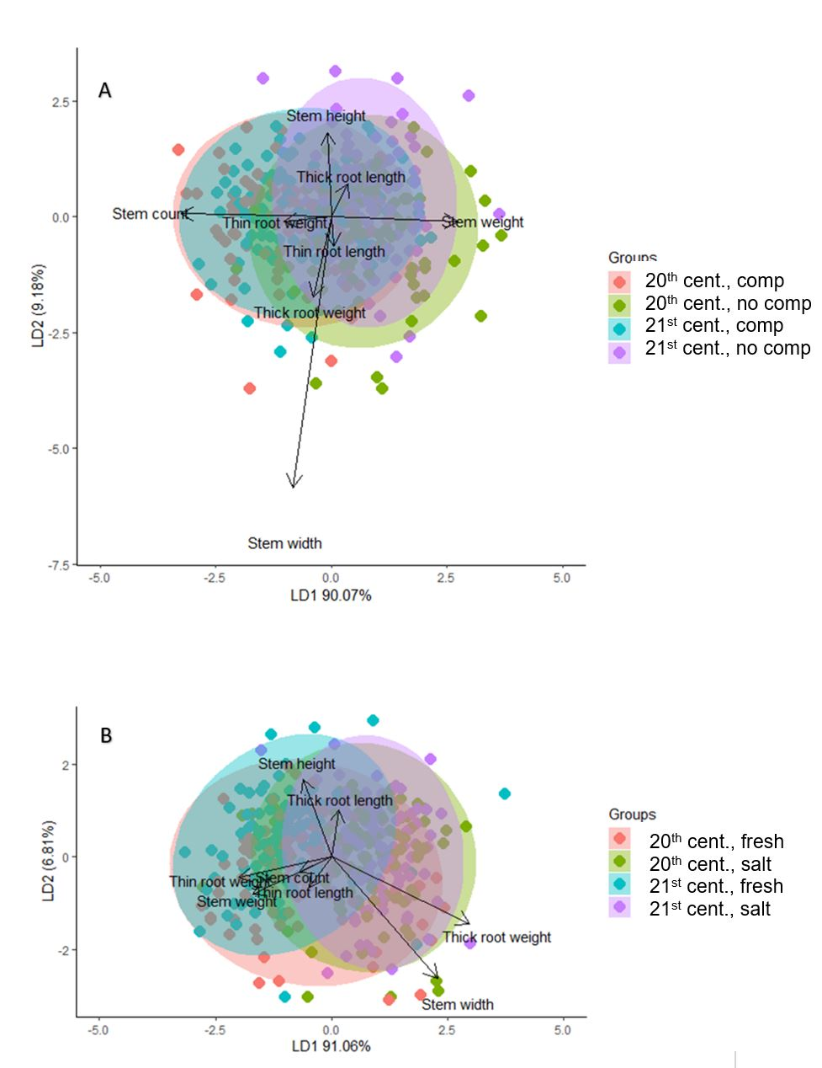
Figure 8: LDAs of age cohort and treatment. A. LDA of age cohort and competition treatment as response variables. Predictors include stem height, stem width, stem count (density), stem weight (weights of all stems), thick root weight, thin root weight, thick root length, thin root length at the end of the experiment. The first canonical function explains 90.07% of variance and correlates best with stem count, stem width, and thin root weight. The second canonical function explains 9.18% of variance and is closely related to stem width, stem height, thick and thin root length, and thick root weight. LD1 correlates with the spread by treatment within age cohort more so than between age cohorts. The 21st century plants overlap with the variance exhibited by 20th century plants overall especially along LD1, which seems to correlate most strongly with the competition treatment rather than age cohort. LD2 correlates with the spread of variance between cohorts, which is minimal. Interestingly, the 21st century cohort appears to be a subset of 20th century cohort variance within each treatment condition.
B. This LDA depicts variance in traits based on age cohort and salinity, with the same predictor variables as above. The first canonical function explains 91.06% of variance and correlates with thick root weight, thin root weight thin root length, stem weight and stem count. The second canonical function explains 6.81% of variance and is correlated largely stem height, thick root length, and stem width. For age cohort we see that there is a great deal of overlap but that the 20th century groups tend to encompass the variance of the 21st century cohort, which represents a subset of 20th century cohort variance. For treatment, the freshwater condition exhibits a broader amount of variance for both 20th century and 21st century, with salinity reducing variance for both cohorts.

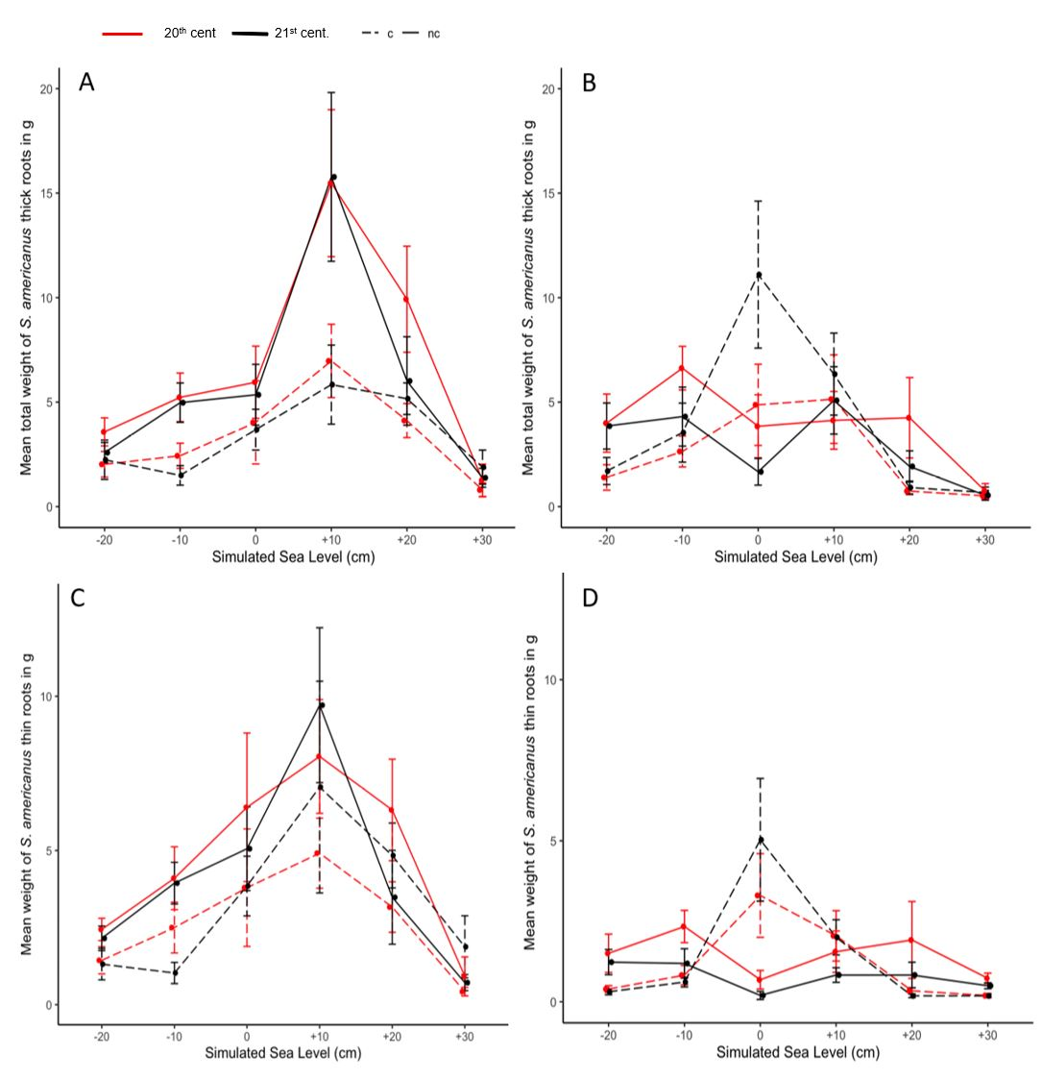
Figure 9: Line graphs depicting final belowground biomass in grams (y-axis versus flooding treatment (x-axis). Flooding ranges from -20 cm (least inundated) to +30 cm (most inundated). The panels depict differences in final belowground tissues of S. americanus from 20th century (red lines) and 21st century plants (black lines) under competition with naturally co-occurring Spartina patens (c, dotted lines) and planted alone (nc, solid lines). Panels on the left side are just those plants exposed to freshwater (p ppt salinity) and those on the right are exposed to salinity (15 ppt). A and B depict the total weight of thick roots and C and D depict the total weight of thin roots.

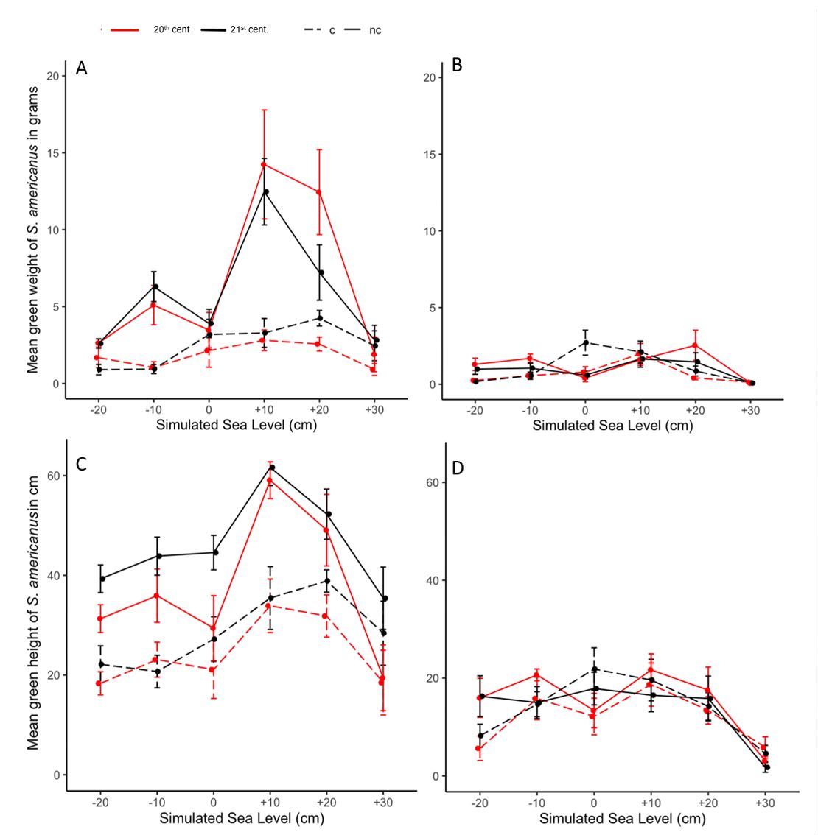
Figure 10: Line graphs depicting final aboveground biomass and height in grams and centimeters (y-axis) versus flooding treatment (x-axis). Flooding ranges from -20 cm (least inundated) to +30 cm (most inundated). The panels depict differences in green aboveground tissues of S. americanus from 20th century (red lines) and 21st century plants (black lines) under competition with naturally co-occurring Spartina patens (c, dotted lines) and planted alone (nc, solid lines). Panels on the left side are just those plants exposed to freshwater (p ppt salinity) and those on the right are exposed to salinity (15 ppt). A + B depict differences in green weight by treatment. C +D represent differences in mean green height by treatment.

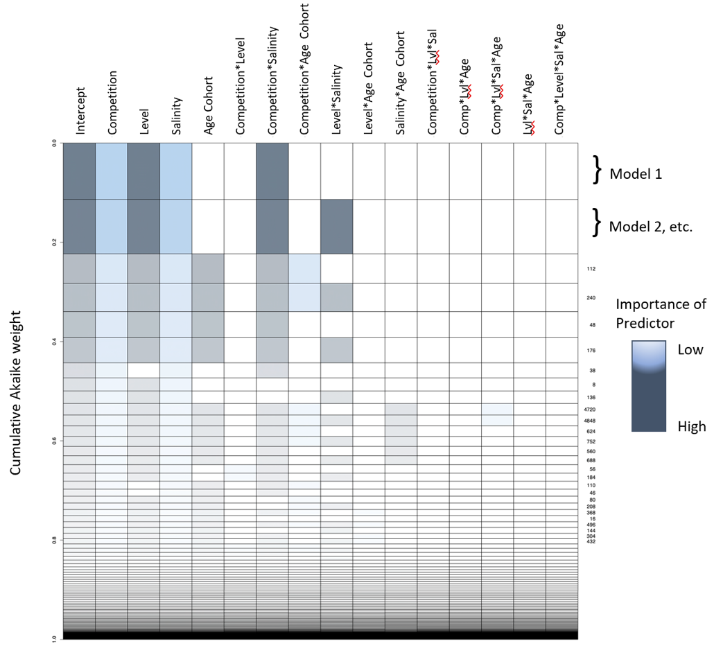
Figure 11: Representation of the MuMIn AIC model dredge table for the LMM with net final total biomass. Rows represent models sorted by decreasing empirical support. Row height represents model probability conditional on the full model set. Color shade corresponds to estimated relative importance of variables. All high-ranked models include competition, level, salinity, and competition x salinity. Age cohort becomes relevant mostly at the third most empirically supported model and consistently on down.

Table 6: Effect sizes for the net biomass LMM with genotype as a random effect
Fixed effect(s) | Coefficients | 2.5% CI | 97.5% CI | Cond eff
(Intercept) | 1.539 | 0.303 | 2.776 | --
Age cohort | -0.215 | -1.964 | 1.533 | 20th cent
Competition | 1.227 | -0.304 | 2.757 | Comp
Salinity | -1.283 | -2.814 | 0.247 | Fresh
Level2 | 0.128 | -1.402 | 1.659 | Level1
Level3 | 0.240 | -1.290 | 1.771 | Level1
Level4 | 1.447 | -0.083 | 2.978 | Level1
Level5 | 1.273 | -0.257 | 2.804 | Level1
Level6 | -2.054 | -3.584 | -0.523 | Level1
Age cohort:Competition | -0.325 | -2.489 | 1.840 | --
Age cohort:Salinity | 0.461 | -1.703 | 2.626 | --
Competition:Salinity | 0.295 | -1.870 | 2.459 | --
Age cohort:Level2 | -0.526 | -2.690 | 1.639 | --
Age cohort:Level3 | 0.747 | -1.417 | 2.912 | --
Age cohort:Level4 | 0.332 | -1.832 | 2.497 | --
Age cohort:Level5 | 1.103 | -1.061 | 3.267 | --
Age cohort:Level6 | 1.813 | -0.351 | 3.977 | --
Competition:Level2 | 0.484 | -1.680 | 2.648 | --
Competition:Level3 | -0.073 | -2.237 | 2.091 | --
Competition:Level4 | 1.275 | -0.890 | 3.439 | --
Competition:Level5 | 0.307 | -1.857 | 2.472 | --
Competition:Level6 | -0.475 | -2.640 | 1.689 | --
Salinity:Level2 | 1.060 | -1.104 | 3.225 | --
Salinity:Level3 | 1.046 | -1.119 | 3.210 | --
Salinity:Level4 | 0.167 | -1.997 | 2.332 | --
Salinity:Level5 | -2.221 | -4.386 | -0.057 | --
Salinity:Level6 | 1.364 | -0.800 | 3.529 | --
Age cohort:Competition:Salinity | 0.178 | -2.883 | 3.239 | --
Age cohort:Competition:Level2 | 1.430 | -1.631 | 4.491 | --
Age cohort:Competition:Level3 | 0.177 | -2.883 | 3.238 | --
Age cohort:Competition:Level4 | 0.354 | -2.707 | 3.415 | --
Age cohort:Competition:Level5 | -1.338 | -4.399 | 1.723 | --
Age cohort:Competition:Level6 | 0.009 | -3.052 | 3.070 | --
Age cohort:Salinity:Level2 | 0.295 | -2.766 | 3.356 | --
Age cohort:Salinity:Level3 | 1.040 | -2.021 | 4.101 | --
Age cohort:Salinity:Level4 | -0.147 | -3.208 | 2.914 | --
Age cohort:Salinity:Level5 | 0.013 | -3.048 | 3.074 | --
Age cohort:Salinity:Level6 | -2.260 | -5.321 | 0.801 | --
Table 6 continued
Fixed effect(s) | Coefficients | 2.5% CI | 97.5% CI | Cond eff
Competition:Salinity:Level2 | -0.551 | -3.612 | 2.510 | --
Competition:Salinity:Level3 | -1.832 | -4.893 | 1.229 | --
Competition:Salinity:Level4 | -2.253 | -5.314 | 0.808 | --
Competition:Salinity:Level5 | 0.235 | -2.826 | 3.296 | --
Competition:Salinity:Level6 | -0.356 | -3.417 | 2.705 | --
Age cohort:Competition:Salinity:Level2 | -2.287 | -6.616 | 2.042 | --
Age cohort:Competition:Salinity:Level3 | -2.523 | -6.851 | 1.806 | --
Age cohort:Competition:Salinity:Level4 | -0.541 | -4.870 | 3.788 | --
Age cohort:Competition:Salinity:Level5 | -0.331 | -4.659 | 3.998 | --
Age cohort:Competition:Salinity:Level6 | 0.016 | -4.313 | 4.345 | --

Table 6 demonstrates the model coefficients for the LMM for net biomass with genotype as a random effect. The fixed effects and their interactions are listed, as well as the model coefficients, and the confidence intervals (2.5%, 97.5%). Also provided are the reference condition for calculating the coefficient (Cond eff). Level 6 corresponds with the deepest flooding level (+30 cm, most inundated) while Level 1 corresponds with being completely unflooded (-20 cm, least inundated)

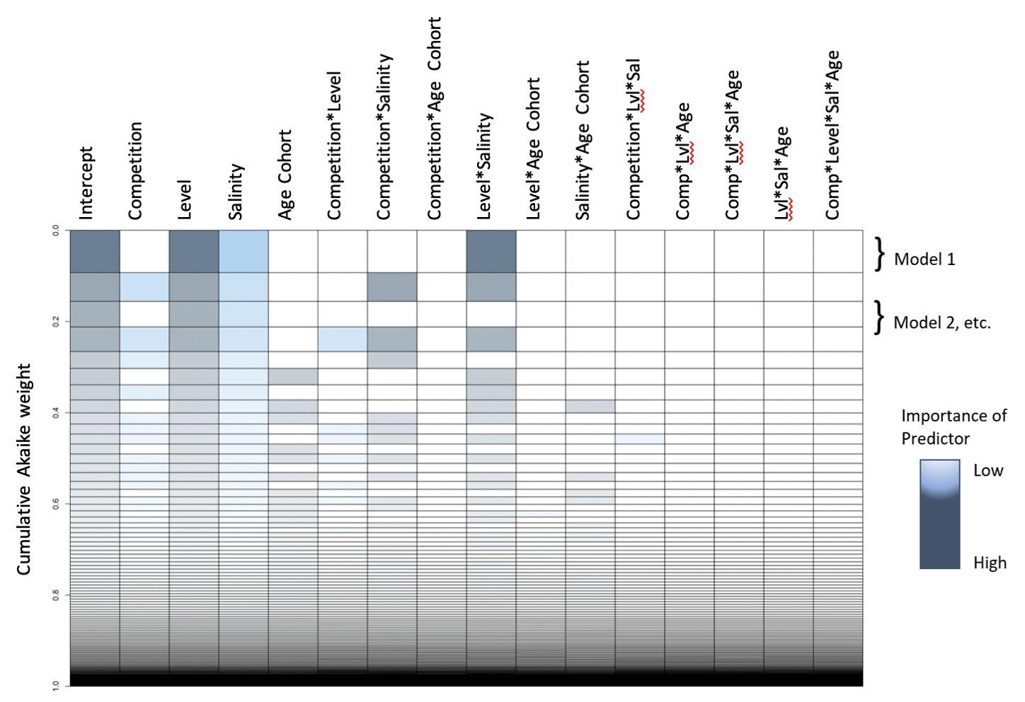
Figure 12: Graph of multi-model approximation of most important predictors across all iterations of the full model for mortality, as analyzed using a GLMM with presence or absence of tissue as a response. Representation of the MuMIn AIC model dredge table. Rows represent models sorted by decreasing empirical support. Row height represents model probability conditional on the full model set. Color shade corresponds to estimated relative importance of variables. Plot of model weights for the binomial model for presence and absence of green tissue at the end of the experiment. For mortality, level and the interaction between level and salinity were of highest importance, with salinity also falling out as an important predictor.

Table 7: Effect sizes for the binomial mortality GLMM with genotype as a random effect
Fixed effect(s) | Coefficients | 2.5% CI | 97.5% CI | Cond eff
(Intercept) | 19.823 | -60.800 | 100.446 | --
Age cohort | -0.066 | -121.773 | 121.641 | 20th cent
Competition | 0.050 | -102.200 | 102.301 | Comp
Salinity | -19.568 | -100.184 | 61.049 | Fresh
Level2 | 0.020 | -125.854 | 125.894 | Level1
Level3 | -18.352 | -98.985 | 62.280 | Level1
Level4 | -17.413 | -98.050 | 63.225 | Level1
Level5 | -17.413 | -98.043 | 63.218 | Level1
Level6 | -19.009 | -99.640 | 61.622 | Level1
Age cohort:Competition | -0.031 | -159.428 | 159.366 | --
Age cohort:Salinity | 0.606 | -121.091 | 122.302 | --
Competition:Salinity | 1.165 | -101.086 | 103.417 | --
Age cohort:Level2 | -17.460 | -164.422 | 129.502 | --
Age cohort:Level3 | 0.912 | -120.812 | 122.637 | --
Age cohort:Level4 | -0.027 | -121.749 | 121.694 | --
Age cohort:Level5 | 17.471 | -220.836 | 255.778 | --
Age cohort:Level6 | 0.674 | -121.048 | 122.396 | --
Competition:Level2 | -17.483 | -154.653 | 119.687 | --
Competition:Level3 | 0.889 | -101.384 | 103.163 | --
Competition:Level4 | 17.459 | -176.175 | 211.093 | --
Competition:Level5 | -0.050 | -102.324 | 102.223 | --
Competition:Level6 | 0.606 | -101.659 | 102.872 | --
Salinity:Level2 | 1.196 | -124.687 | 127.079 | --
Salinity:Level3 | 18.911 | -61.728 | 99.551 | --
Salinity:Level4 | 18.628 | -62.018 | 99.274 | --
Salinity:Level5 | 18.628 | -62.010 | 99.266 | --
Salinity:Level6 | 19.568 | -61.071 | 100.207 | --
Age cohort:Competition:Salinity | -1.185 | -160.580 | 158.211 | --
Age cohort:Competition:Level2 | 34.908 | -219.603 | 289.419 | --
Age cohort:Competition:Level3 | 16.576 | -345.041 | 378.193 | --
Age cohort:Competition:Level4 | 0.002 | -291.232 | 291.237 | --
Age cohort:Competition:Level5 | 0.005 | -316.552 | 316.561 | --
Age cohort:Competition:Level6 | 0.270 | -159.136 | 159.676 | --
Age cohort:Salinity:Level2 | 17.767 | -129.211 | 164.744 | --
Age cohort:Salinity:Level3 | -0.844 | -122.576 | 120.887 | --
Age cohort:Salinity:Level4 | -0.561 | -122.290 | 121.167 | --
Age cohort:Salinity:Level5 | -17.164 | -255.461 | 221.134 | --
Age cohort:Salinity:Level6 | -1.769 | -123.498 | 119.960 | --
Table 7 continued
Fixed effect(s) | Coefficients | 2.5% CI | 97.5% CI | Cond eff
Competition:Salinity:Level2 | 34.670 | -186.632 | 255.972 | --
Competition:Salinity:Level3 | -3.195 | -105.488 | 99.098 | --
Competition:Salinity:Level4 | -17.735 | -211.369 | 175.899 | --
Competition:Salinity:Level5 | -1.822 | -104.117 | 100.473 | --
Competition:Salinity:Level6 | -2.912 | -105.192 | 99.368 | --
Age cohort:Competition:Salinity:Level2 | -52.990 | -313.128 | 207.148 | --
Age cohort:Competition:Salinity:Level3 | -15.434 | -377.073 | 346.205 | --
Age cohort:Competition:Salinity:Level4 | 0.273 | -290.957 | 291.504 | --
Age cohort:Competition:Salinity:Level5 | 0.345 | -316.227 | 316.917 | --
Age cohort:Competition:Salinity:Level6 | 1.522 | -157.896 | 160.940 | --

Table 7 demonstrates the model coefficients for the binomial model for mortality with genotype as a random effect. The fixed effects and their interactions are listed, as well as the model coefficients, and the confidence intervals (2.5%, 97.5%). Also provided are the reference condition for calculating the coefficient (Cond eff). Level 6 corresponds with the deepest flooding level while Level 1 corresponds with being completely unflooded.

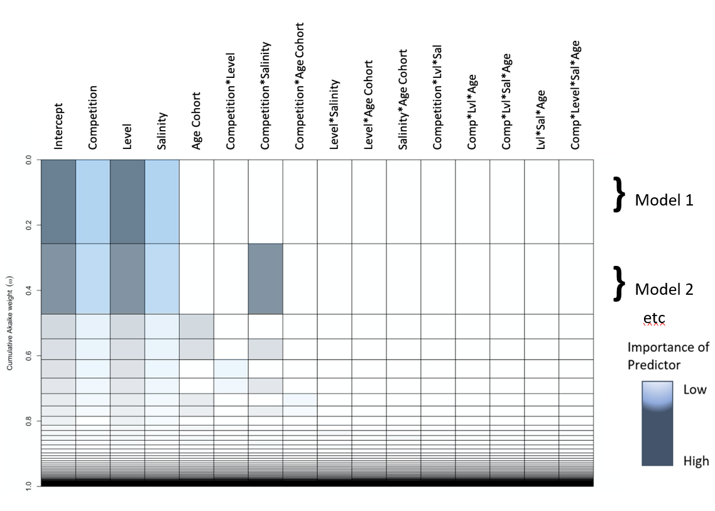

Figure 13: Representation of the MuMIn AIC model dredge table for node counts (asexual reproduction). Rows represent models sorted by decreasing empirical support. Row height represents model probability conditional on the full model set. Color shade corresponds to estimated relative importance of variables. Level is the most important predictor in the best supported model, along with competition and salinity.

Table 8: Effect sizes of the GLMM for node count with genotype as a random effect
Fixed effect(s) | Coefficients | 2.5% CI | 97.5% CI | Cond eff
(Intercept) | 2.613 | 1.913 | 3.313 | --
Age cohort | 0.072 | -0.919 | 1.063 | 20th cent
Competition | 1.001 | 0.129 | 1.873 | Comp
Salinity | -0.730 | -1.609 | 0.149 | Fresh
Level2 | -0.154 | -1.026 | 0.718 | Level1
Level3 | -0.209 | -1.081 | 0.663 | Level1
Level4 | 0.454 | -0.418 | 1.326 | Level1
Level5 | -0.360 | -1.232 | 0.512 | Level1
Level6 | -1.292 | -2.164 | -0.420 | Level1
Age cohort:Competition | -0.478 | -1.711 | 0.755 | --
Age cohort:Salinity | 0.113 | -1.125 | 1.351 | --
Competition:Salinity | -0.670 | -1.908 | 0.568 | --
Age cohort:Level2 | -0.310 | -1.543 | 0.923 | --
Age cohort:Level3 | 0.354 | -0.880 | 1.587 | --
Age cohort:Level4 | 0.001 | -1.232 | 1.234 | --
Age cohort:Level5 | 0.440 | -0.793 | 1.674 | --
Age cohort:Level6 | 0.473 | -0.761 | 1.706 | --
Competition:Level2 | -0.300 | -1.533 | 0.933 | --
Competition:Level3 | -0.881 | -2.114 | 0.352 | --
Competition:Level4 | -0.380 | -1.613 | 0.854 | --
Competition:Level5 | -0.466 | -1.699 | 0.768 | --
Competition:Level6 | -0.762 | -1.996 | 0.471 | --
Salinity:Level2 | 0.717 | -0.521 | 1.955 | --
Salinity:Level3 | 0.441 | -0.797 | 1.679 | --
Salinity:Level4 | 0.002 | -1.236 | 1.240 | --
Salinity:Level5 | 0.209 | -1.029 | 1.447 | --
Salinity:Level6 | 0.569 | -0.669 | 1.807 | --
Age cohort:Competition:Salinity | 0.905 | -0.843 | 2.652 | --
Age cohort:Competition:Level2 | 1.225 | -0.519 | 2.969 | --
Age cohort:Competition:Level3 | 0.306 | -1.438 | 2.050 | --
Age cohort:Competition:Level4 | 0.535 | -1.210 | 2.279 | --
Age cohort:Competition:Level5 | 0.041 | -1.703 | 1.785 | --
Age cohort:Competition:Level6 | 0.320 | -1.424 | 2.064 | --
Age cohort:Salinity:Level2 | 0.445 | -1.303 | 2.192 | --
Age cohort:Salinity:Level3 | 0.651 | -1.097 | 2.398 | --
Age cohort:Salinity:Level4 | 0.011 | -1.737 | 1.758 | --
Age cohort:Salinity:Level5 | -0.293 | -2.040 | 1.455 | --
Age cohort:Salinity:Level6 | -0.553 | -2.300 | 1.195 | --
Table 8 continued
Fixed effect(s) | Coefficients | 2.5% CI | 97.5% CI | Cond eff
Competition:Salinity:Level2 | 1.223 | -0.525 | 2.970 | --
Competition:Salinity:Level3 | 0.549 | -1.199 | 2.296 | --
Competition:Salinity:Level4 | 0.424 | -1.323 | 2.172 | --
Competition:Salinity:Level5 | 0.434 | -1.313 | 2.182 | --
Competition:Salinity:Level6 | 0.551 | -1.196 | 2.299 | --
Age cohort:Competition:Salinity:Level2 | -2.965 | -5.434 | -0.496 | --
Age cohort:Competition:Salinity:Level3 | -2.569 | -5.038 | -0.100 | --
Age cohort:Competition:Salinity:Level4 | -0.959 | -3.428 | 1.510 | --
Age cohort:Competition:Salinity:Level5 | -0.646 | -3.115 | 1.823 | --
Age cohort:Competition:Salinity:Level6 | -0.948 | -3.417 | 1.521 | --

Table 8 demonstrating the model coefficients for the model for node count with genotype as a random effect. The fixed effects and their interactions are listed, as well as the model coefficients, and the confidence intervals (2.5%, 97.5%). Also provided are the reference condition for calculating the coefficient (Cond eff). Level 6 corresponds with the deepest flooding level (+30 cm, most inundated) while Level 1 corresponds with being completely unflooded (-20 cm, least inundated).

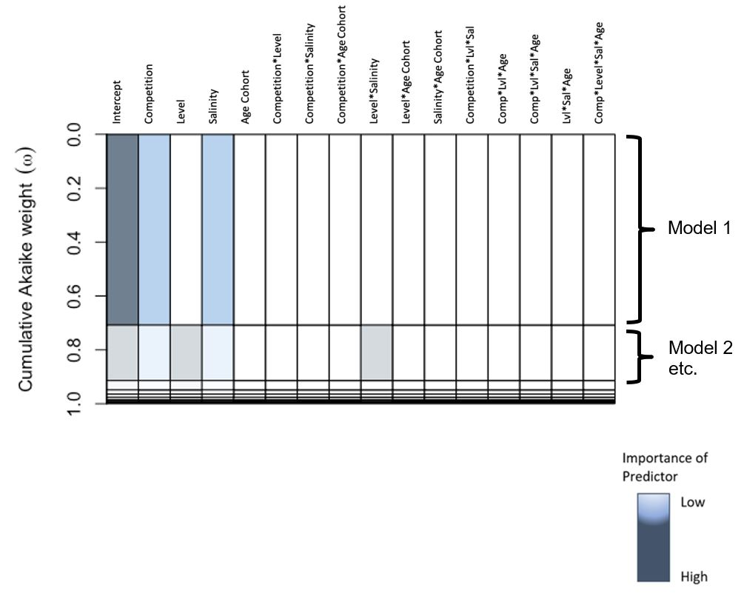
Figure 14: Graph of multi-model approximation of most important predictors across all iterations of the full model for stem width. Representation of the MuMIn AIC model dredge table. Rows represent models sorted by decreasing empirical support. Row height represents model probability conditional on the full model set. Color shade corresponds to estimated relative importance of variables. For stem width, level and the interaction between level and salinity were of highest importance, with salinity also falling out as an important predictor.

Table 9 Effect sizes for the stem width with genotype as a random effect
Fixed effect(s) | Coefficients | 2.50% | 97.50% | Cond eff
(Intercept) | 0.163 | 0.119 | 0.206 | --
Age cohort | -0.020 | -0.081 | 0.042 | 20th cent
Competition | 0.033 | -0.024 | 0.091 | Comp
Salinity | -0.003 | -0.061 | 0.055 | Fresh
Level2 | 0.024 | -0.034 | 0.081 | Level1
Level3 | -0.032 | -0.089 | 0.026 | Level1
Level4 | 0.010 | -0.048 | 0.068 | Level1
Level5 | 0.007 | -0.051 | 0.065 | Level1
Level6 | 0.105 | 0.048 | 0.163 | Level1
Age cohort:Competition | -0.008 | -0.090 | 0.073 | --
Age cohort:Salinity | 0.000 | -0.082 | 0.081 | --
Competition:Salinity | -0.013 | -0.095 | 0.069 | --
Age cohort:Level2 | -0.010 | -0.092 | 0.072 | --
Age cohort:Level3 | 0.064 | -0.018 | 0.145 | --
Age cohort:Level4 | 0.036 | -0.046 | 0.117 | --
Age cohort:Level5 | 0.062 | -0.020 | 0.144 | --
Age cohort:Level6 | 0.022 | -0.060 | 0.103 | --
Competition:Level2 | -0.007 | -0.088 | 0.075 | --
Competition:Level3 | 0.024 | -0.058 | 0.106 | --
Competition:Level4 | 0.119 | 0.037 | 0.200 | --
Competition:Level5 | 0.048 | -0.033 | 0.130 | --
Competition:Level6 | -0.104 | -0.186 | -0.023 | --
Salinity:Level2 | -0.034 | -0.116 | 0.047 | --
Salinity:Level3 | 0.008 | -0.074 | 0.089 | --
Salinity:Level4 | -0.001 | -0.083 | 0.081 | --
Salinity:Level5 | -0.065 | -0.147 | 0.016 | --
Salinity:Level6 | -0.129 | -0.211 | -0.048 | --
Age cohort:Competition:Salinity | -0.005 | -0.120 | 0.110 | --
Age cohort:Competition:Level2 | 0.049 | -0.066 | 0.164 | --
Age cohort:Competition:Level3 | -0.021 | -0.137 | 0.094 | --
Age cohort:Competition:Level4 | -0.059 | -0.175 | 0.056 | --
Age cohort:Competition:Level5 | -0.068 | -0.184 | 0.047 | --
Age cohort:Competition:Level6 | 0.006 | -0.109 | 0.121 | --
Age cohort:Salinity:Level2 | 0.024 | -0.092 | 0.139 | --
Age cohort:Salinity:Level3 | -0.019 | -0.134 | 0.097 | --
Age cohort:Salinity:Level4 | -0.037 | -0.152 | 0.079 | --
Age cohort:Salinity:Level5 | -0.037 | -0.152 | 0.079 | --
Age cohort:Salinity:Level6 | 0.039 | -0.076 | 0.155 | --
Competition:Salinity:Level2 | 0.052 | -0.063 | 0.167 | --
Table 9 continued
Fixed effect(s) | Coefficients | 2.50% | 97.50% | Cond eff
Competition:Salinity:Level3 | -0.031 | -0.147 | 0.084 | --
Competition:Salinity:Level4 | -0.136 | -0.252 | -0.021 | --
Competition:Salinity:Level5 | 0.008 | -0.107 | 0.124 | --
Competition:Salinity:Level6 | 0.122 | 0.007 | 0.237 | --
Age cohort:Competition:Salinity:Level2 | -0.056 | -0.219 | 0.107 | --
Age cohort:Competition:Salinity:Level3 | 0.021 | -0.143 | 0.184 | --
Age cohort:Competition:Salinity:Level4 | 0.056 | -0.108 | 0.219 | --
Age cohort:Competition:Salinity:Level5 | 0.070 | -0.093 | 0.233 | --
Age cohort:Competition:Salinity:Level6 | -0.060 | -0.223 | 0.103 | --

Table 9 demonstrates the model coefficients for the model for stem width with genotype as a random effect. The fixed effects and their interactions are listed, as well as the model coefficients, and the confidence intervals (2.5%, 97.5%). Also provided are the reference condition for calculating the coefficient (Cond eff). Level 6 corresponds with the deepest flooding level (+30 cm, most inundated) while Level 1 corresponds with being completely unflooded (-20 cm, least inundated).

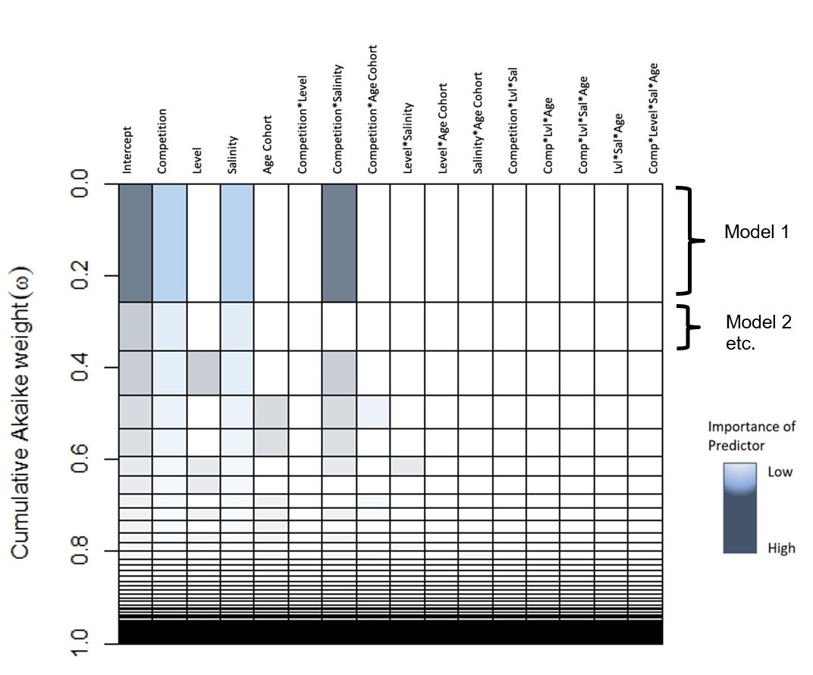
Figure 15: Graph of multi-model approximation of most important predictors across all iterations of the full model for belowground biomass, as analyzed using a LMM with presence or absence of tissue as a response. Representation of the MuMIn AIC model dredge table. Rows represent models sorted by decreasing empirical support. Row height represents model probability conditional on the full model set. Color shade corresponds to estimated relative importance of variables. For total belowground biomass, the interaction between competition and salinity were of highest importance, with salinity and competition alone also falling out as important predictors.

Table 10: Effect sizes and model coefficients for belowground biomass
Fixed effect(s) | Coefficients | 2.5% CI | 97.5% CI | Cond eff
(Intercept) | 1.695 | 0.913 | 2.478 | --
Age cohort | -0.090 | -1.199 | 1.017 | 20th cent
Competition | 0.707 | -0.296 | 1.711 | Comp
Salinity | -0.458 | -1.468 | 0.552 | Fresh
Level2 | 0.316 | -0.688 | 1.320 | Level1
Level3 | 0.447 | -0.557 | 1.451 | Level1
Level4 | 1.385 | 0.381 | 2.388 | Level1
Level5 | 0.781 | -0.223 | 1.785 | Level1
Level6 | -0.744 | -1.747 | 0.260 | Level1
Age cohort:Competition | -0.259 | -1.678 | 1.161 | --
Age cohort:Salinity | 0.058 | -1.366 | 1.482 | --
Competition:Salinity | -0.072 | -1.496 | 1.352 | --
Age cohort:Level2 | -0.483 | -1.902 | 0.937 | --
Age cohort:Level3 | 0.424 | -0.995 | 1.844 | --
Age cohort:Level4 | 0.017 | -1.402 | 1.437 | --
Age cohort:Level5 | 0.681 | -0.738 | 2.101 | --
Age cohort:Level6 | 0.702 | -0.717 | 2.122 | --
Competition:Level2 | 0.070 | -1.349 | 1.490 | --
Competition:Level3 | 0.097 | -1.323 | 1.516 | --
Competition:Level4 | 0.762 | -0.657 | 2.182 | --
Competition:Level5 | 0.423 | -0.997 | 1.842 | --
Competition:Level6 | -0.509 | -1.928 | 0.911 | --
Salinity:Level2 | 0.162 | -1.262 | 1.586 | --
Salinity:Level3 | 0.756 | -0.668 | 2.181 | --
Salinity:Level4 | -0.435 | -1.859 | 0.989 | --
Salinity:Level5 | -1.050 | -2.474 | 0.374 | --
Salinity:Level6 | 0.315 | -1.109 | 1.739 | --
Age cohort:Competition:Salinity | 0.407 | -1.604 | 2.418 | --
Age cohort:Competition:Level2 | 0.905 | -1.102 | 2.913 | --
Age cohort:Competition:Level3 | -0.165 | -2.172 | 1.843 | --
Age cohort:Competition:Level4 | 0.442 | -1.565 | 2.450 | --
Age cohort:Competition:Level5 | -1.352 | -3.360 | 0.655 | --
Age cohort:Competition:Level6 | -0.262 | -2.269 | 1.746 | --
Age cohort:Salinity:Level2 | 0.581 | -1.429 | 2.592 | --
Age cohort:Salinity:Level3 | 0.618 | -1.393 | 2.629 | --
Age cohort:Salinity:Level4 | 0.339 | -1.672 | 2.349 | --
Age cohort:Salinity:Level5 | -0.651 | -2.662 | 1.359 | --
Age cohort:Salinity:Level6 | -0.666 | -2.676 | 1.345 | --
Competition:Salinity:Level2 | 0.482 | -1.529 | 2.492 | --
Table 10 continued
Fixed effect(s) | Coefficients | 2.5% CI | 97.5% CI | Cond eff
Competition:Salinity:Level3 | -1.400 | -3.410 | 0.611 | --
Competition:Salinity:Level4 | -1.285 | -3.295 | 0.726 | --
Competition:Salinity:Level5 | -0.151 | -2.162 | 1.860 | --
Competition:Salinity:Level6 | 0.195 | -1.815 | 2.206 | --
Age cohort:Competition:Salinity:Level2 | -2.099 | -4.940 | 0.742 | --
Age cohort:Competition:Salinity:Level3 | -1.732 | -4.573 | 1.109 | --
Age cohort:Competition:Salinity:Level4 | -0.797 | -3.638 | 2.045 | --
Age cohort:Competition:Salinity:Level5 | 0.660 | -2.181 | 3.501 | --
Age cohort:Competition:Salinity:Level6 | -0.093 | -2.934 | 2.749 | --
Table 10 demonstrates the model coefficients for the model for belowground biomass with genotype as a random effect. The fixed effects and their interactions are listed, as well as the model coefficients, and the confidence intervals (2.5%, 97.5%). Also provided are the reference condition for calculating the coefficient (Cond eff). Level 6 corresponds with the deepest flooding level (+30 cm, most inundated) while Level 1 corresponds with being completely unflooded (-20 cm, least inundated).

Figure 16: Graph of multi-model approximation of most important predictors across all iterations of the full model for stem density/ stem count, as analyzed using a negative binomial GLMM with final stem count as a response variable. Representation of the MuMIn AIC model dredge table. Rows represent models sorted by decreasing empirical support. Row height represents model probability conditional on the full model set. Color shade corresponds to estimated relative importance of variables. For stem count, the interaction between competition and salinity, level and salinity, level alone were of highest importance, with salinity and competition alone and the interaction between competition and level also falling out as important predictors. The second best-supported model included age cohort as an important predictor as well.

Table 11: Effect sizes and model coefficients for stem density negative binomial model
Fixed effect(s) | Coefficients | 2.5% CI | 97.5% CI | Cond eff
(Intercept) | 2.374 | 2.211 | 2.536 | --
Age cohort | 0.022 | -0.202 | 0.246 | 20th cent
Competition | -0.271 | -0.481 | -0.060 | Comp
Salinity | -0.567 | -0.794 | -0.341 | Fresh
Level2 | 0.030 | -0.193 | 0.254 | Level1
Level3 | -0.132 | -0.366 | 0.102 | Level1
Level4 | -0.097 | -0.331 | 0.136 | Level1
Level5 | -0.097 | -0.335 | 0.140 | Level1
Level6 | -0.725 | -0.994 | -0.455 | Level1
Age cohort:Competition | -0.034 | -0.325 | 0.257 | --
Age cohort:Salinity | -0.267 | -0.581 | 0.048 | --
Competition:Salinity | 0.234 | -0.062 | 0.530 | --
Age cohort:Level2 | -0.082 | -0.393 | 0.229 | --
Age cohort:Level3 | 0.162 | -0.158 | 0.481 | --
Age cohort:Level4 | -0.009 | -0.330 | 0.312 | --
Age cohort:Level5 | 0.046 | -0.281 | 0.372 | --
Age cohort:Level6 | 0.155 | -0.207 | 0.516 | --
Competition:Level2 | -0.072 | -0.383 | 0.239 | --
Competition:Level3 | 0.048 | -0.279 | 0.374 | --
Competition:Level4 | 0.188 | -0.132 | 0.508 | --
Competition:Level5 | 0.084 | -0.249 | 0.416 | --
Competition:Level6 | -0.178 | -0.558 | 0.201 | --
Salinity:Level2 | 0.462 | 0.139 | 0.785 | --
Salinity:Level3 | 0.429 | 0.109 | 0.748 | --
Salinity:Level4 | 0.567 | 0.240 | 0.895 | --
Salinity:Level5 | 0.484 | 0.161 | 0.808 | --
Salinity:Level6 | 0.478 | 0.090 | 0.866 | --
Age cohort:Competition:Salinity | 0.421 | 0.013 | 0.829 | --
Age cohort:Competition:Level2 | 0.252 | -0.176 | 0.680 | --
Age cohort:Competition:Level3 | -0.077 | -0.528 | 0.373 | --
Age cohort:Competition:Level4 | 0.106 | -0.328 | 0.539 | --
Age cohort:Competition:Level5 | -0.103 | -0.564 | 0.358 | --
Age cohort:Competition:Level6 | 0.370 | -0.131 | 0.870 | --
Age cohort:Salinity:Level2 | 0.294 | -0.149 | 0.738 | --
Age cohort:Salinity:Level3 | 0.187 | -0.254 | 0.628 | --
Age cohort:Salinity:Level4 | 0.321 | -0.131 | 0.773 | --
Age cohort:Salinity:Level5 | 0.260 | -0.190 | 0.711 | --
Age cohort:Salinity:Level6 | 0.337 | -0.175 | 0.850 | --
Table 11 continued
Fixed effect(s) | Coefficients | 2.5% CI | 97.5% CI | Cond eff
Competition:Salinity:Level2 | -0.047 | -0.482 | 0.388 | --
Competition:Salinity:Level3 | -0.486 | -0.946 | -0.026 | --
Competition:Salinity:Level4 | -0.621 | -1.058 | -0.183 | --
Competition:Salinity:Level5 | -0.529 | -0.980 | -0.078 | --
Competition:Salinity:Level6 | -0.250 | -0.769 | 0.269 | --
Age cohort:Competition:Salinity:Level2 | -0.790 | -1.394 | -0.186 | --
Age cohort:Competition:Salinity:Level3 | -0.456 | -1.098 | 0.185 | --
Age cohort:Competition:Salinity:Level4 | -0.471 | -1.077 | 0.135 | --
Age cohort:Competition:Salinity:Level5 | -0.472 | -1.101 | 0.157 | --
Age cohort:Competition:Salinity:Level6 | -1.303 | -2.024 | -0.582 | --
Table 11 demonstrates the model coefficients for the model for stem density with genotype as a random effect. The fixed effects and their interactions are listed, as well as the model coefficients, and the confidence intervals (2.5%, 97.5%). Also provided are the reference condition for calculating the coefficient (Cond eff). Level 6 corresponds with the deepest flooding level (+30 cm, most inundated) while Level 1 corresponds with being completely unflooded (-20 cm, least inundated)

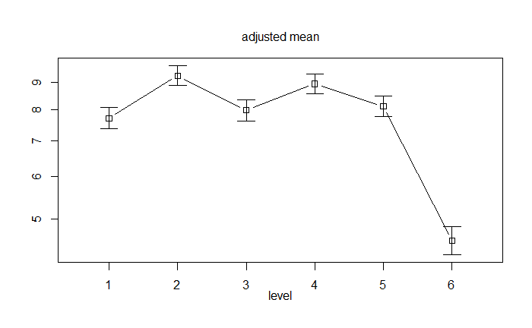
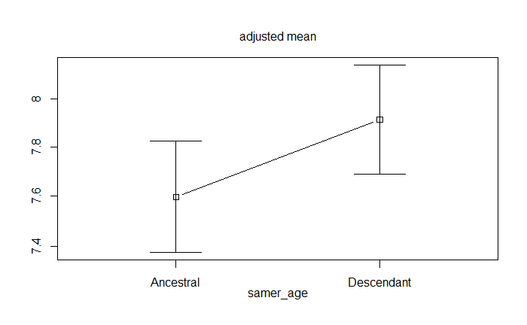
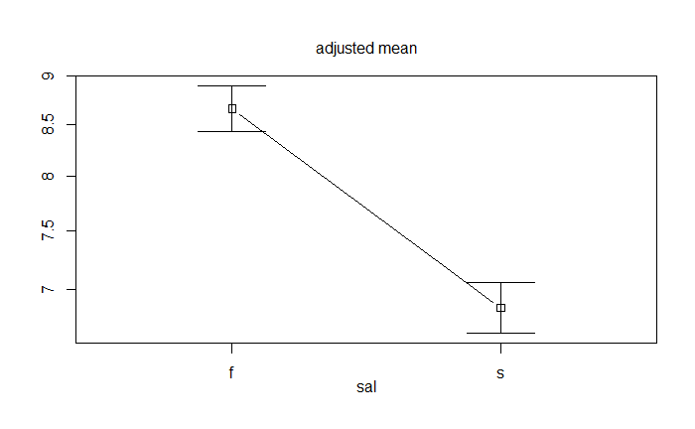
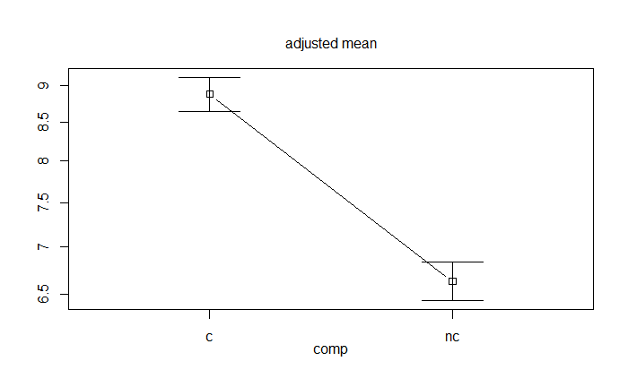
SUPPLEMENTAL FIGURES AND TABLES
20th cent.
21st cent.
A
A
A

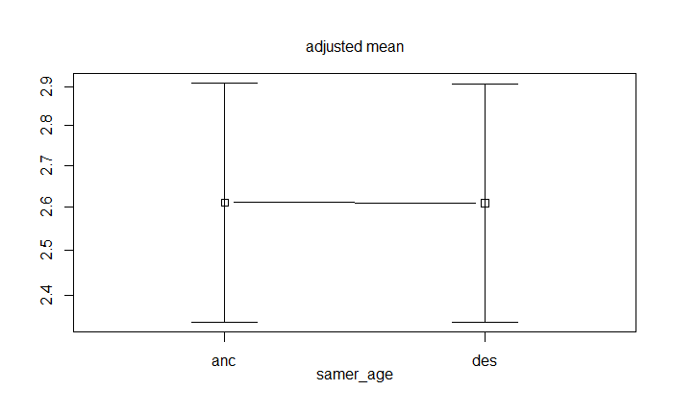
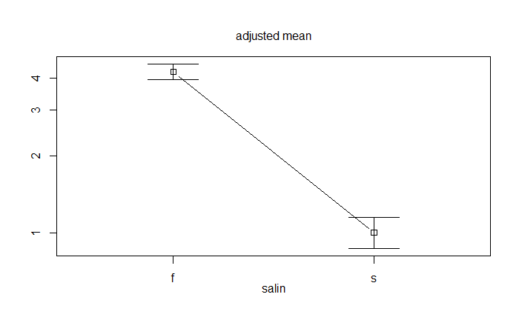
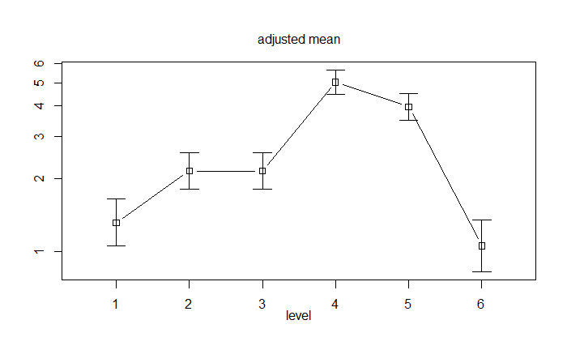
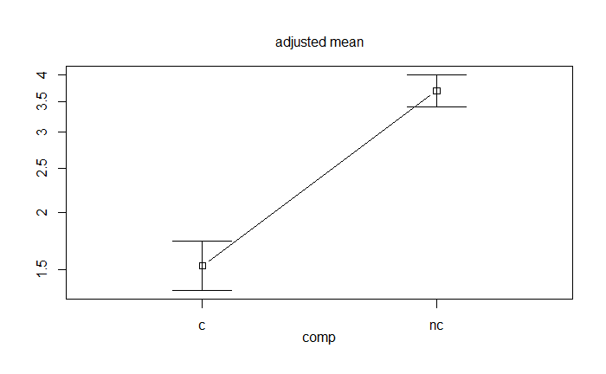
20th cent.
21st cent.
B
B
B

Figure S4: Trait comparisons across treatments

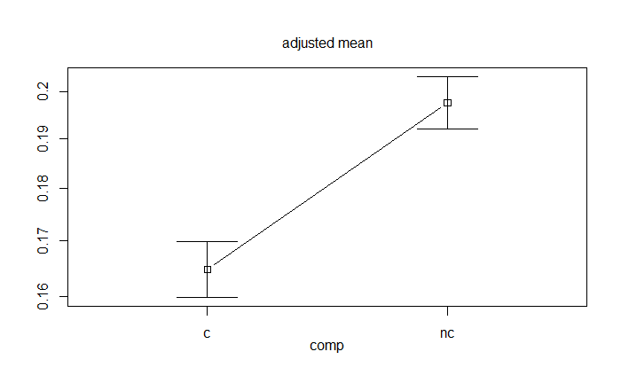
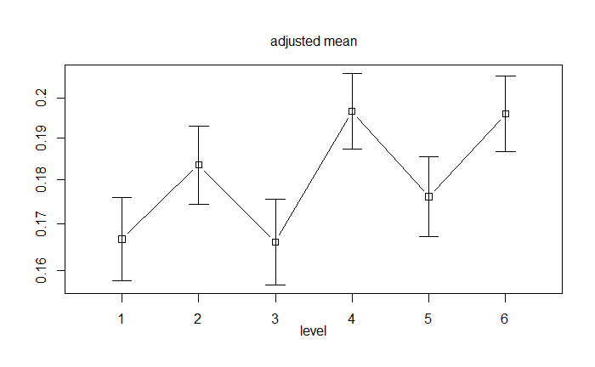
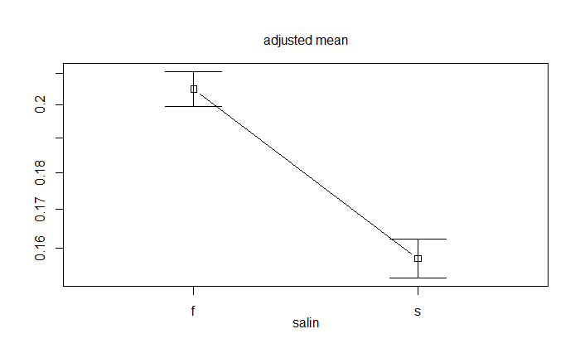
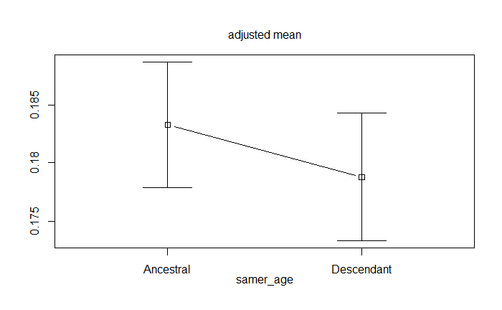
20th cent.
21st cent.
C
C

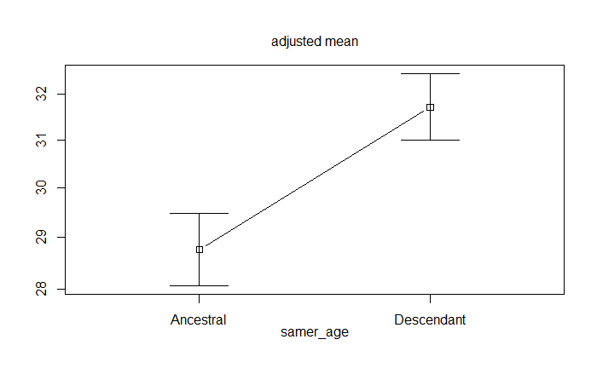
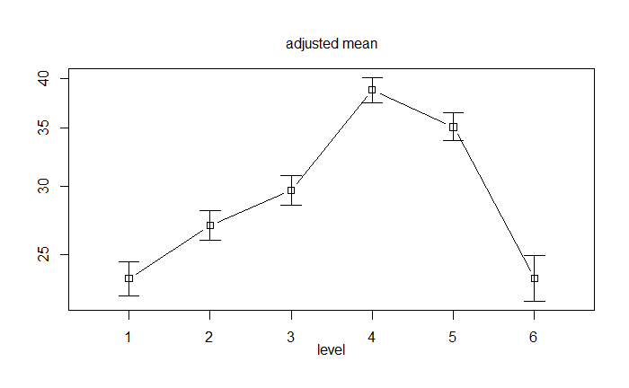
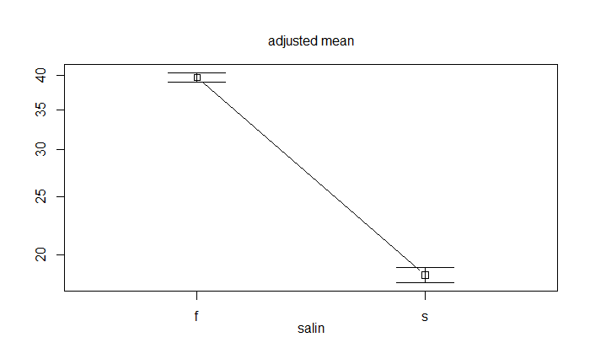
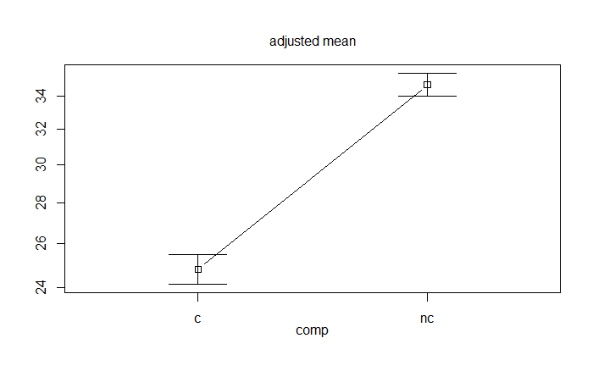
20th cent.
21st cent.
D
D

Figure S4 continued

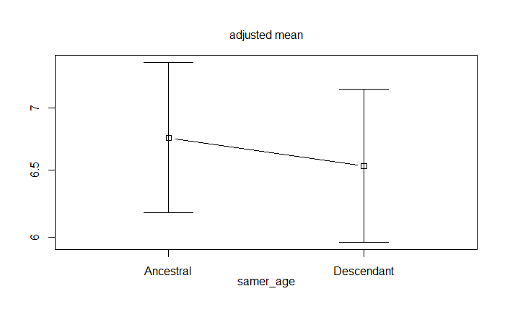
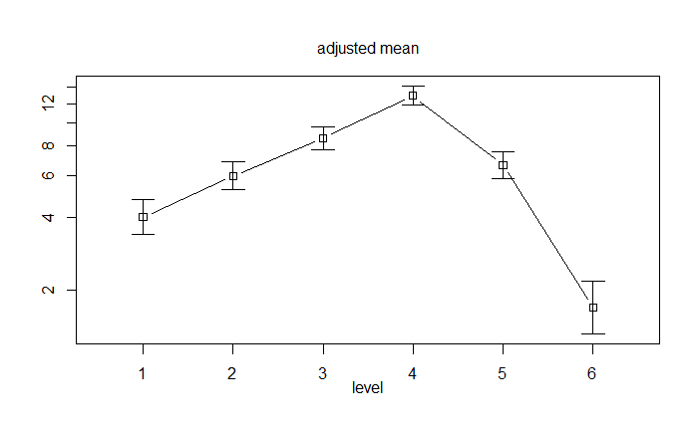
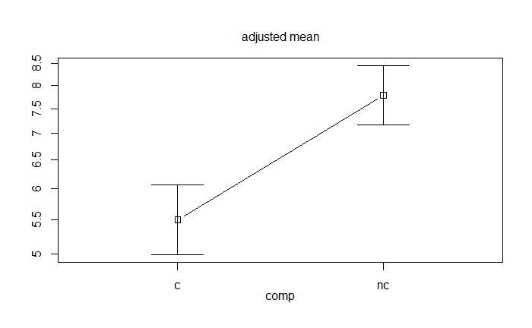
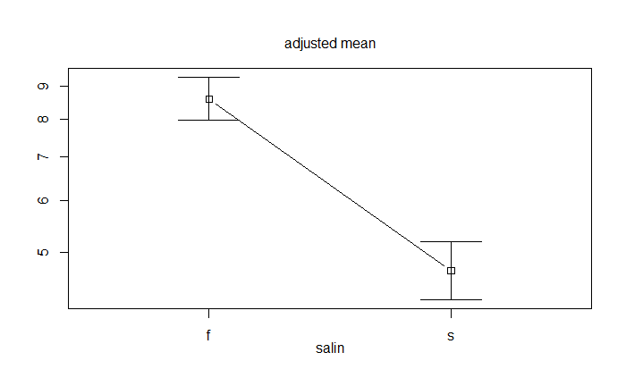
E
21st cent.
20th cent.

Figure S4 continued. Interaction plots built to show the impact of treatments and age cohort broken out by the traits measured. The upper left graph in each panel depicts the differences by salinity treatment (f – freshwater, s – salinity). The upper right graph in each panel depicts differences between age cohorts. The bottom left graph depicts differences in competition treatments (c – competition, nc – no competition). The bottom right graph depicts differences across inundation level (1 = +20cm 6 = -30cm, from least to most inundated). A – Differences in stem density of S. americanus across treatments and age cohort, indicating that the largest differences are by treatment, particularly with a reduction in stem density with the introduction of salinity and an increase in stem density in the presence of a competitor. Stem density dramatically decreases under increased inundation. Overall, 20th century plants exhibit lower stem density versus 21st century plants. B – Differences in final green weight for S. americanus across treatments and age cohorts. Again, large reductions in productivity occur in response to salinity and competition. C – Differences in stem width for S. americanus across treatments and age cohort, indicating that this trait, like green biomass, is plastic and strongly reduced by salinity and competition. The 20th century plants have a slightly higher average stem width versus 21st century plants. D – Differences in stem height for S. americanus closely tracks with green biomass across salinity and competition treatments. However, there are significant differences overall between 20th century and 21st E – Differences in total belowground weight by treatments and age cohort.
A
B
C
D
Figure S5: PCAs of trait variance across treatments
Principal components analyses depicting the variation in traits for belowground (top row) and aboveground (bottom row). Ellipses represent age cohorts (20th century – red, 21st century – black) and vectors show the co-variation and spread of traits included in the PCA. Panel A – depicts variation by salinity for S. americanus belowground data. Plan B – Competition vs. no competition for S. americanus belowground data. Panel C – salinity vs. fresh for S. americanus aboveground data. Panel D - Competition vs. no competition for S. americanus aboveground data

CHAPTER IV
temporal variation in halophytic plant gene expression in response to a climate change pressure

Abstract
Climate change corollaries threaten numerous species, especially coastal species, which must cope with the brunt of combined stressors. Coastal plant communities in particular face threats from rising ambient CO₂, inundation from sea-level rise, and saltwater intrusion from sea-level rise. Salinity is of special interest to the scientific community as it threatens both natural coastal marsh systems (via sea level rise) as well as agricultural species facing arable land salinization. One means of better predicting the future of response to salinity is direct comparison of populations through time to examine how a species has evolved over the last century using the extant population and its dormant propagules. This approach, known as resurrection ecology, enables on to gauge evolutionary potential of the studied populations. Resurrection ecology involves reviving dormant propagules and comparing their phenotypes in common conditions, often coupled with genomic data. In this study, I utilized a century-old seed bank of the foundational coastal marsh sedge Schoenoplectus americanus to assess the nature of responses to salinity. Gene expression differences by age cohort were largely seen in belowground tissues, with some indications of separation by age cohort based on gene identity and expression level. Aboveground tissues revealed more differential expression based on treatment rather than age cohort. Belowground gene expression exhibits the clearest differences by age cohort. Salinity causes major shifts in gene expression, with some shifts by age cohort in belowground tissue gene expression. Samples were taken for root and stem tissues. RNA sequences were assembled to create a draft transcriptome, annotated, and differential gene expression analyses performed. Overall, the strongest signals were by tissue type, wherein root and stem tissues differed. Differences by salinity treatment were the next most significant overall, though this pattern varied by genotype. Finally, 20th century and 21st century groups tended to exhibit similar gene expression patterns. Annotations demonstrated antioxidant action may be a key mechanism for salinity tolerance in S. americanus. This work represents the first gene expression analysis for this foundational brackish marsh species.

Introduction

Rapid evolutionary change
The potential for rapid phenotypic evolution over brief evolutionary time has garnered increasing interest in recent years. This is in part due to the swift onset of climate change corollaries (e.g., worsening storms, drought, flooding, sea-level rise) (IPCC 2014). Species that survive precipitous shifts in environmental conditions must respond by migration, phenotypic plasticity, and/or evolutionary response (Wiens 2016; Román-Palacios and Wiens 2020). Rapid phenotypic shifts in the short term may prove consequential if they can confer improved fitness on populations facing the brunt of climate change (i.e. if they are adaptive) (Merilä and Hendry 2014; Reusch 2014). Determining if shifts in phenotype are attributable to rapid evolution or plasticity is challenging, in part because rapid evolution is difficult to detect due to its likely being ubiquitous and incremental (but see Franks et al. 2011)(Noble et al. 2019; Hendry et al. 2008; Donelson et al. 2018; Dickman et al. 2019). One means of better detecting small evolutionary changes is the examination of shifts on a molecular genetic level (Messer et al. 2016). Prior studies focus on shifts in allele frequencies to look for signatures of selection by leveraging genomics approaches like microsatellite genotyping, ddRADseq, and RNAseq (Alvarez et al. 2015; Goodwin et al. 2016; Elbers et al. 2017; Lavretsky et al. 2019). Perhaps the least frequently used method for discovering evidence of evolutionary shifts over time is RNAseq. This is despite the fact that gene expression shifts can be associated with phenotypic shifts, which can in turn affect fitness (Hales et al. 2017; Tahmasebi et al. 2018).

Gene expression
Gene expression (i.e., transcriptional) variation is an informative approach for determining the balance of ecological and evolutionary mechanisms underlying responses to environmental pressures (Harder, Willoughby, Ardren, & Christie, 2020; Meek, 2020). Profiling gene expression under contrasting exposure regimes may, for example, reveal the physiology and genes associated with observable phenotypic change (Eller et al. 2014; McGowan et al. 2019; Nayak et al. 2020). Comparisons of transcriptomic variation within and among populations offers insight into plasticity, adaptive potential, and adaptive differentiation in stress exposure response (Groen et al. 2020; Hamann et al. 2020). RNAseq studies have revealed extensive individual-level heritable variation in gene expression upon which selection might act (Oleksiak et al. 2005; Pérez-Portela et al. 2020) as well as signatures of adaptive variation in gene expression associated with differences in fitness (Eller et al. 2013; Holmes et al. 2016; Harder et al. 2020). Changes in the expression of genes that influence traits under selection can be a route to rapid evolution as well as a means of understanding if shifts reflect plasticity rather than adaptation. For example, the use of biological replicates and cloned individuals across experimental treatments in RNAseq experiments enables estimation of individual-level variation relative to inter-generational differences (Hamann et al., 2020). Cross-generational comparisons of trait and transcriptional variation have also illustrated how the emergence of adaptive phenotypes relates to shifts in environmental conditions over time (Hamann et al., 2020; Chowdhury et al., 2015; Yousey et al., 2018). Because gene expression varies strongly by tissue, time, developmental stage and in response to the environment, it can be a difficult tool to use to study evolutionary shifts. Nevertheless, there are some clear examples in the literature associating gene expression with change over time (Ghalambor et al. 2015; Campbell-Staton et al. 2017; Hamann et al. 2020).

Resurrection ecology
Direct comparison of individuals from the same population over time provides a useful context for understanding if and how evolution occurs (Kerfoot et al. 1999; Hairston and Kearns 2002; Franks et al. 2007; Ellner et al. 2011; Frisch et al. 2014a; Franks et al. 2018). Classical methods to understand responses to future climate conditions include space-for-time studies, wherein one samples individuals across an environmental gradient of a species range to capture conditions that mimic progression of expected future climate change scenarios (Pickett 1989; Ware et al. 2019). Resurrection ecology is a more powerful approach as it samples different iterations of a population through time, thus theoretically comparing descendant populations with ancestral ones from a single site (Kerfoot and Weider 2004; Franks et al. 2008). This framework is especially useful when combined with genomics tools to compare between older and younger revived propagules to potentially uncover genetic mechanisms underlying adaptive responses (Franks and Hoffmann 2012; Dickman et al. 2019). Most of the work demonstrating the utility and challenges of resurrection ecology focuses on zooplankton and resting stage egg revival (Weider et al. 1997; Mergeay et al. 2007; Pantel et al. 2015; Yousey et al. 2018; Zhang et al. 2018). Use of naturally formed seed banks in plants is less common (Tonsor et al. 21193), though there have been exciting advances in human-stored seeds of Brassica rapa (Franks and Weis 2009). The rarity of resurrection ecology in plant species is in part due to the difficulty of finding undisturbed, well-stratified sediments that store highly dormant and durable seeds capable of being revived. However, prior work demonstrates that the foundational brackish marsh sedge Schoenoplectus americanus forms a century-long seed bank useful for resurrection studies (Summers et al. 2018). Leveraging the S. americanus seed bank is particularly useful given the imminent impacts of rising sea levels and other climate change corollaries (Kearney 1996). Further, prior work suggests that microsatellite genotypes of resurrected S. americanus plants shifted across a century, indicating evolutionary change occurred though the mechanism and impacts for phenotype remain unclear (Summers et al. 2018). Further, prior work deploying old and young revived plants from in and around the Chesapeake Bay demonstrated some subtle changes in functional traits in response to salinity and inundation (i.e., simulated sea-level rise) (Summers et al. in prep). Thus, combining the powerful approach of resurrection ecology with RNAseq may improve understanding of the molecular mechanisms of any evolutionary shift and provide details on plasticity in gene expression responses to simulated sea- level rise, particularly the increase of salinity.

Salinity and its impacts on coastal marshes
Salinity exposure elicits stress responses in most plants, though salt-tolerant species can persist at certain salinity thresholds (i.e. halophytes) (Munns and Termaat 1986; Courtney et al. 2016). Some of the best studied halophytes are found in coastal marshes where marsh zonation in plant communities from low to high elevation is determined in part by wetland salinity (Emery et al. 2001b). Salinity in coastal systems is projected to increase along with sea-level rise, resulting in inland migration of coastal plants and/ or elimination of vegetation and land loss (Gedye et al. 2010; Najjar et al. 2010). Studies on how salinity may affect coastal halophytes suggest that evolution could be possible in plants like Spartina pectinata as traits associated with salinity tolerance demonstrate relatively high heritability (Robben et al. 2018). Vegetation loss in coastal wetlands negatively impacts accretion because wetlands plants capture sediment and contribute organic matter via root and stem biomass that maintains wetland elevation (Farnsworth and Meyerson 2003; Kirwan et al. 2008; Baustian et al. 2012; Kelleway et al. 2017). Thus, vegetation die-off can result in conversion of marshland to open water (Kearney et al. 1991; Nyman et al. 2006). This process is vividly illustrated by the loss of a land the size of a football field per day along Louisiana’s coasts (Hatton et al. 1983; Jankowski et al. 2017). The Chesapeake Bay, the largest estuary in the United States, also experiences high rates of relative sea level rise in part due to land subsidence and topography (Stevenson et al. 1985; Kearney et al. 1991; Kearney 1996; Boon et al. 2010). Relative sea level trends of the lower Bay is 4.4501 ± 0.1850 mm/year (Boon et al. 2010). Over the second half of the twentieth century salinity has increased in the Chesapeake Bay and is projected to increase as sea level rise worsens (Hilton et al. 2008a; Boon et al. 2010; Hong and Shen 2012). Salinity varies based on distance from the mouth of the Bay and the effect of freshwater flowing in from the Susquehanna River at the opposite end of the Bay. Further, dredging of the bay to maintain depths accessible to ships going to Baltimore harbor increases the flow of salt water into the Bay as salt water is denser than fresh and flows inland at depth (Hilton et al. 2008a). If sea level rises 50 cm, salinity would increase by 2 ppt and with a rise in sea levels of 100 cm, salinity would rise by 4 ppt (Rice et al. 2012). If sea level rises 100 cm, which may be a conservative estimate by some accounts, the volume of water registering 10 and 20 ppt salinity would increase greatly (Rice et al. 2012). Despite being halophytic, S. americanus exhibits strong reactions to high salinity, including repression of productivity (Drake 2014; Schile et al. 2017; Summers et al. in prep) and environmental stress can impact flowering and other reproductive traits (Cho et al. 2017). Thus, there is considerable potential for evolutionary response to salinity.

Here, I ask how S. americanus may have responded to historical shifts in salinity and what that can tell us about its ability to respond to increasing salinity as sea level rises and associated saltwater intrusion worsens. Specifically, I will examine gene expression differences via RNA sequencing of resurrected plants exposed to salinity (15 ppt). Based on prior work demonstrating evolutionary shifts after just 100 years at neutral loci and generally high levels of genetic diversity in S. americanus populations indicative of frequent outcrossing, I expect plants resurrected from different cohorts to differ significantly in their gene expression. I further ask if S. americanus exhibits any novel genomic pathways in its response to salinity when compared with commonly studied organisms (e.g., Arabidopsis, Spartina, Oryza).

Methods

RNAseq experiment.
To characterize potential differences in gene expression responses to salinity exposure, I exposed resurrected genotypes recovered from Corn Island Marsh in the Chesapeake Bay (Edgewater, MD) to salinity (15 ppt) and freshwater (0 ppt) for 2 months. Plants were either from the 20th century or the 21st century based on soil cores dated using ²¹⁰Pb and ¹³⁷Cs (Summers et al. 2018). The 20th century cohort was composed of nine genotypes germinated from the 18-22 cm stratigraphic layer (ca. 87-112 years old; Summers et al., 2018). The 21st century cohort was composed of nine genotypes germinated from the 2-4 cm stratigraphic later (ca. 22 years old; Summers et al., 2018). Note that while the 21st century cohort is in the same area as the 20th century, I do not know detailed family relationships: the 20th century cohort may not be direct ancestors of the 21st plants. Clones of each genotype were used to standardize assessment of responses to salinity (i.e., one clone in each condition). The plants were grown in a greenhouse at the University of Tennessee, Knoxville during Summer 2018 in flooded tubs. Tides were simulated such that water levels rose and fell twice a day; at “high tide” water levels were at the top of the 12-inch PVC pots and at low tide water levels were below the bottom of the pots. Throughout the experiment salinity levels were checked to ensure root and stem tissues were sampled from individuals (n total = 31) in low salinity (n = 20) and high salinity (n = 11) treatments at 0 cm inundation (Table S6). I took samples of stem tissues (n = 24) and root tissues (n = 7). Unequal sampling resulting in part due to mortality of plants and in part due to tissues being used in initial RNA extractions (Table S6). All tissues samples were immediately preserved in liquid nitrogen before shipping to the sequencing center.

RNAseq analysis.
Preserved tissues were subsequently shipped to Novogene Corporation (Sacramento, CA), which performed RNA extractions, library development and paired-end (2x 150bp) sequencing. RNA was extracted with TIANGEN kit and mRNA libraries were generated using a NEBNext Ultra™ II RNA Library Prep Kit for Illumina according to the manufacturer’s protocol, with unique indices added to each sample. Briefly, mRNA was enriched using oligo(dT) beads. The mRNA was then randomly fragmented, and cDNA was synthesized by using mRNA template and a random hexamer primer. The second strand of cDNA synthesis was synthesized using DNA Polymerase I and RNase H. Overhangs of the cDNA were converted into blunt ends via exonuclease and polymerase trimming. After adenylation of 3' ends of DNA fragments, NEBNEXT adapters were ligated to prepare for hybridization. To select 250-300bp cDNA fragments, the libraries were purified with the AMPure XP system, after which the libraries were subject to PCR amplification. The cDNA library preparations included mRNA targeting to reduce rRNA contamination. Paired-end sequencing of 150bp fragments was conducted on an Illumina NovaSeq instrument.

Average sequence length and quality scores for all 31 individuals were determined using a custom Python script. All paired-end reads were trimmed using Atropos v. 1.1.22 (Didion et al. 2017), with flags for automatically detecting Illumina adapters, to eliminate reads with a phred score of less than 15 and to ensure a minimum length of 50 base pairs. Sequences were then screened for rRNA contamination by aligning reads against all Arabidopsis thaliana rRNA accessions downloaded as a single fasta file from GenBank (Taxonomy ID:3701; 21 accessions). The program Burrows Wheeler Aligner (BWA) mem algorithm (optimized for sequences longer than 75 bp) was used to align the sequences, as it has been demonstrated to work well for shorter, partial alignments with error rates ranging from 2-10% (Li and Durbin 2010; Clark et al. 2016).

The program rnaSPADES (Bushmanova et al. 2019) was used to create individual sample assemblies. The program rnaSPAdes is an extension of SPAdes (Saint Petersburg Aligner), which performs iterative short-read assembly for values of K (i.e., fragment length) that are automatically selected based on read length and data type. SPAdes has a lower memory requirement and achieves more rapid processing speeds than more widely used programs like Trinity (Hölzer and Marz 2019). Paired end reads for each sample were run with the flag for data limitation at 250 GB, with K-mer size automatically selected at 49 and 73 for 150 bp long reads. Notably, the large size of fastq files required a computationally tractable individual assembly approach. The quality of individual assemblies was assessed using TransRate (Smith-Unna, Boursnell, Patro, Hibberd, & Kelly, 2016), which provides an assembly quality score based on contig length and read mapping rates. The protocol outlined in Cerveau and Jackson (2016) was then used to create a consensus assembly across samples, which involved concatenating individual assemblies and using the program CD-HIT to remove redundant sequences (Fu et al. 2012).

Open reading frames (ORFs), peptides, and coding sequences for individual assemblies and the concatenated assembly were predicted using TransDecoder (Haas et al. 2013). Mercator MapMan4 web service was used to annotate the reads in MapMan bins organized by general functional groups (Lohse et al. 2014; Schwacke et al. 2019). The input files for MapMan4 were output coding sequence (*.cds) files from TransDecoder (Schwacke et al. 2019). Reads were then aligned against the concatenated assembly using align from the Rsubread package (Lia et al. 2013). Read counting was performed using the featureCounts function implemented in the R package Rsubread (Liao et al. 2013). Using the resulting read count table, a differential gene expression analysis was performed using the R package DESeq2 version 1.28.1 (Love et al. 2014). DESeq2 is an extension of the original DESeq methodology, which uses generalized linear models (GLMs) of read count data to estimate expression strength of a gene for a treatment group as well as the magnitude of change in expression between groups. Wald tests were then conducted to determine whether each model-based estimate (i.e., coefficient) significantly differed from zero. The spread of differences in gene expression was visualized using a PCA approach implemented in DESeq2 (Love et al. 2014). I built heat maps of differentially expressed genes using pheatmap function in the pheatmap R package v1.0.12. (Kolde 2019). To confirm that each individual exhibited a distinct genotype and to characterize within and between population diversity, estimates of fixation indices were calculated using the populations module in Stacks2 (Rochette et al. 2019).

Results
I performed RNA sequencing on samples taken from two resurrected age cohorts exposed to saline (15 ppt) and freshwater (0 ppt) conditions. Samples were taken for root and stem tissues. RNA sequences were assembled to create a draft transcriptome, annotated, and differential gene expression analyses performed. Overall, the strongest signals were by tissue type, wherein root and stem tissues differed. Differences by salinity treatment were the next most significant overall, though this pattern varied by genotype. Finally, 20th century and 21st century groups tended to exhibit similar gene expression patterns. Based on analysis using the Stacks2 pipeline, all samples included in this experiment were unique genotypes. A total of 2.3 billion raw reads were sequenced. Based on fastQC analysis, there was no adapter contamination after trimming. There were warnings for per tile sequence quality that suggest possible flaws for sequencing at the flow cell level. An average of 12,556,851 reads were mapped for each sample.

Ordination of expression differences
Ordination of gene expression profiles of the samples revealed several clear patterns based on treatment and age cohort. The PCAs illustrated that root and stem tissue exhibited strikingly distinct expression profiles. When examining the combined effects of treatment and age, variance based on treatment was best explained by PC2 (7%) (Figure 17A). However, the strongest pattern when considering all reads is the difference between tissues, with the differences between root and stem correlating with PC1 (68%) (Figure 17A). Stem tissues alone clearly demonstrate differences by treatment in expression profiles, but there were few clear differences by age cohort (Figure 17B). Rather, the 20th century and 21st century groups overlap considerably. The freshwater versus salinity treatment differ more clearly in correlation with PC2 (13%), though several samples cluster closely with salinity treatments (Figure 17B). When examining just root tissues, there is a much clearer pattern of response based on age cohort in correlation with PC2 (28%) (Figure 17C). Differences by treatment for root tissues correlate slightly with both PCs (Figure 17C). The spread along PC1 seems best explained by differences between a major cluster and a slight outlier in the freshwater and 21st century group. Overall, some patterns suggest differences in age cohort in gene expression, though this pattern is only seen in the few root tissues. In addition, the response to salinity treatment is not uniform, with some overlap in gene expression by treatment. Overall, the importance of tissue underlies the greatest amount of variance, followed by treatment. Based on ordination the patterns in gene expression do not group based on age cohort with the exception of root tissue.

Differential gene expression analyses and annotation
Overall, the DEG analysis showed that 8420 genes (32% of reads above counts of zero) were differentially expressed at a p-value of <0.05 when plants were grown with higher salinity. Examining log-fold change across comparisons, I see that tissue demonstrates the greatest differences in expression levels (Figure 18, Table 12). Treatment (salt vs. fresh) contrast results in much fewer genes being differentially expressed (Figure 18, Table 12). Finally, the contrast between 20th and 21st century demonstrates the smallest differences in log2fold gene expression. The heat map of differential gene expression depicts differences in log2fold change with significant differential gene expression (Figure 19). The log2fold changes were fairly low in magnitude. Some of the uniquely DEGs included many associated with cellular organization and photosynthesis. Also of note, a heat shock protein and senescence associated kinases were down regulated most pronouncedly when comparing 20th to 21st century (Figure 19).
Approximately 90% of the genes were not annotated, making it impossible to determine the functional characteristics of every gene that evolved differential expression. However, the genes that were differentially expressed based on DESeq2 analysis, were primarily categorized into MapMan annotation terms related to metabolism (Figure 20). Overall, the significant genes between root and stem tissue have the highest concentration of annotated genes. Several gene ontology (GO) categories contained higher numbers of differentially expressed genes across groups: solute transport, RNA production and biosynthesis (RNAprodbiosyn), metabolism, and enzyme classification (Figure 20).

Discussion
The value of examining gene expression is based, in part, on the fact that it can precede morphological divergence (King and Wilson 1975), and further, that evolution of gene regulation can relate to rapid adaptation in response to change in environment. In this case, the evidence for the occurrence of rapid evolution was limited but did demonstrate some weak signal indicative that gene expression responses to salinity may have shifted between the 20th and 21st century cohorts. This is the first study of gene expression in this foundational marsh sedge and there are several key insights into next steps and general understanding of molecular level response to salinity in S. americanus.

Caveats
The annotation rate for these sequences was extremely low (92% unannotated). This was due to insufficient matches in the existing repository of Mercator MapMan sequences. Low annotation is likely attributable to low quality or low yield RNA extractions of my samples. Thus, these results should be interpreted as preliminary. However, the findings presented above for the annotated genes had high match rates and demonstrate comprehensible biological patterns. Another consideration when working with RNA data is tissue and developmental stage of organisms of interest can differ in expression levels because of slightly different sampling time (Hodgins-Davis and Townsend 2009; De Meyer et al. 2017), though my samples were all taken within an hour of one another. In addition, there are only two points in time being compared in this study, 20th century and 21st century. These points do not represent a true gradient through time and thus any shifts should not be assumed to be directional without additional sampling. Considering this, I recommend future studies leveraging resurrection ecology incorporate multiple time points to establish a more complete temporal gradient.

Differential gene expression, change over time, and salinity
Differences in gene expression were more pronounced based on tissue and treatment rather than age cohort. This can be due to flawed sequence quality and unequal sampling. However, there are biological explanations that suggest this finding makes sense. First, evolution over the course of just a century in a perennial plant is logically expected to result in a smaller signal relative to that of differences of exposure to salt and between tissues (Karan and Subudhi 2012; Freedman et al. 2019). Further, though I had predicted there would be a stronger signal based on age cohort, the findings of some differences suggest shifts over time to accommodate salinity stress may indeed have occurred and that the changes are incremental as major shifts in salinity tolerance could be maladaptive. Salinity in the Chesapeake Bay fluctuates across seasons and with precipitation events – thus it is a stochastic environmental condition that requires S. americanus to tolerate a broad range of salinity exposure (Hong and Shen 2012; Rice et al. 2012). The lack of a strong signal in response to age and treatment relative to tissue type may also be a function of the type of RNA sequencing used here. Messenger RNA sequencing is a useful tool for detecting changes in coding sequences (Kukurba and Montgomery 2015). However, other studies examining exclusively microRNAs (Jannesar et al. 2020; Kelley et al. 2020) as well as small non-coding RNAs (Repoila et al. 2003) demonstrate that these previously understudied molecules also play important roles in facilitating evolutionary change.

In addition, the pattern in belowground tissues suggests that some amount of differential gene expression may have occurred, though a larger sample size would better characterize this pattern. Root gene expression may demonstrate the greatest responses to salinity, as models like Arabidopsis demonstrate differential expression of sodium potassium pumps associated with salinity tolerance (Rus et al. 2006). However, Spartina alterniflora, a halophytic species, expresses genes that confer tolerance to salinity in stem and root tissue (Karan and Subudhi 2014). Thus, my results suggest additional examination of root tissue to better characterize shifts in S. americanus root gene expression is warranted.

Annotations and response to salinity
There was a significant lack of annotations for sequences recovered in this study, including those that were differentially expressed across treatment, tissue, and century. However, genes that did demonstrate differences based on age cohort could suggest shifts in how S. americanus copes with salinity. First, there were several genes related to photosynthate and glycolysis that were differentially expressed across the three comparisons. In similar studies in the invasive reed Phragmites australis, increased expression of genes related to photosynthesis was linked to improved aboveground productivity under salinity stress (Eller et al. 2014). In addition, the up-regulated heat shock protein for all three comparisons could indicate a general stress response in S. americanus. For example, S alterniflora expresses a small nucleotide-binding protein that plays a role in intracellular protein trafficking that is known to confer salinity tolerance in transgenic Arabidopsis (Karan and Subudhi 2014). These proteins are associated with tolerance of a broad range of stressors, including drought and heat, in other species. In addition, another differentially expressed gene was associated with redox homeostasis and hydrogen peroxide removal (Figure 4). Hydrogen peroxide is a reactive oxygen species by-product of oxidative stress that causes the disruption of cellular homeostasis (Lu et al. 2006). In Ulva fasciata, a green algae, Gossypium (cotton), chickpeas, and pea plants, regulation of hydrogen peroxide and antioxidant action is associated with salinity stress tolerance and improves survival (Gossett et al. 1994; Hernández et al. 1999; Hernández-Nistal et al. 2002; Lu et al. 2006). Thus, this may be a possible mechanism employed by S. americanus to cope with salinity stress.
Overall, though, the annotations were not numerous, those that were annotated suggest that S. americanus may leverage a suite of genomic alterations to cope with salinity stress.

References
Andrews, S. (2010). FastQC: a quality control tool for high throughput sequence data.
Alberti M, Correa C, Marzluff JM, Hendry AP, Palkovacs EP, Gotanda KM, Hunt VM, Apgar TM, Zhou Y. 2017. Global urban signatures of phenotypic change in animal and plant populations. Proc. Natl. Acad. Sci. U. S. A. 114:8951–8956. [accessed 2020 Jul 31]. https://www.pnas.org/content/114/34/8951
Alberto FJ, Aitken SN, Alía R, González-Martínez SC, Hänninen H, Kremer A, Lefèvre F, Lenormand T, Yeaman S, Whetten R, et al. 2013. Potential for evolutionary responses to climate change - evidence from tree populations. Glob. Chang. Biol. 19:1645–1661.
Alexander JM. 2013. Evolution under changing climates: Climatic niche stasis despite rapid evolution in a non-native plant. Proc. R. Soc. B Biol. Sci. 280:9.
Alvarez M, Schrey AW, Richards CL. 2015. Ten years of transcriptomics in wild populations: what have we learned about their ecology and evolution? Mol. Ecol. 24:710–725. [accessed 2019 Mar 25]. http://doi.wiley.com/10.1111/mec.13055
Ameen AD, Kolker AS, Taylor CM. 2018. Morphological responses to competition modulated by abiotic factors in two monoculture-forming wetland plants. Aquat. Bot. 147:61–67. [accessed 2019 Feb 10]. https://www.sciencedirect.com/science/article/pii/S0304377017302371
Anderson JT, Song B. 2020. Plant adaptation to climate change—Where are we? J. Syst. Evol. 58:533–545. [accessed 2020 Nov 16]. https://onlinelibrary.wiley.com/doi/10.1111/jse.12649
Angeler DG. 2007. Resurrection ecology and global climate change research in freshwater ecosystems. Benthol. Soc 26:12–22. [accessed 2018 Feb 16]. http://www.journals.uchicago.edu.proxy.lib.utk.edu:90/doi/pdfplus/10.1899/0887-3593%282007%2926%5B12%3AREAGCC%5D2.0.CO%3B2
Baustian JJ, Mendelssohn IA, Hester MW. 2012. Vegetation’s importance in regulating surface elevation in a coastal salt marsh facing elevated rates of sea level rise. Glob. Chang. Biol. 18:3377–3382. [accessed 2018 Sep 9]. http://doi.wiley.com/10.1111/j.1365-2486.2012.02792.x
Bay RA, Harrigan RJ, Underwood V Le, Gibbs HL, Smith TB, Ruegg K. 2018. Genomic signals of selection predict climate-driven population declines in a migratory bird. Science (80-. ).
Becklin KM, Anderson JT, Gerhart LM, Wadgymar SM, Wessinger CA, Ward JK. 2016. Examining plant physiological responses to climate change through an evolutionary lens. Plant Physiol.
Bennington C. C., McGraw J. B, Vavrek M. C. 1991. Ecological Genetic Variation in Seed Banks . II . Phenotypic and Genetic Differences Between Young and Old Subpopulations of Luzula Parviflora. Br. Ecol. Soc. S 79:627–643.
Bertness MD, Ellison AM. 1987. Determinants of Pattern in a New England Salt Marsh Plant Community. Ecol. Monogr. 57:129–147. [accessed 2019 Feb 10]. http://doi.wiley.com/10.2307/1942621
Bertness MD, Leonard GH, Levine JM, Schmidt PR, Ingraham AO. 2013. Testing the Relative Contribution of Positive and Negative Interactions in Rocky Intertidal Communities TESTING THE RELATIVE CONTRIBUTION OF POSITIVE AND NEGATIVE INTERACTIONS IN ROCKY INTERTIDAL COMMUNITIES. 80:2711–2726.
De Biasse MB, Kawji Y, Kelly MW. 2018 Mar 6. Phenotypic and transcriptomic responses to salinity stress across genetically and geographically divergent Tigriopus californicus populations. Mol. Ecol. [accessed 2018 Mar 12]. http://doi.wiley.com/10.1111/mec.14547
Binford MW. 1990. Calculation and uncertainty analysis of 210Pb dates for PIRLA project lake sediment cores. J. Paleolimnol. 3:252–267.
Blois JL, Williams JW, Fitzpatrick MC, Jackson ST, Ferrier S. 2013. Space can substitute for time in predicting climate-change effects on biodiversity. Proc. Natl. Acad. Sci. U. S. A. 110:9374–9379. [accessed 2021 Jan 5]. http://dx.doi.org/doi:10.5061/dryad.d5f1r.Thisarticlecontainssupportinginformationonlineatwww.pnas.org/lookup/suppl/doi:10.1073/pnas.1220228110/-/DCSupplemental.9374-9379www.pnas.org/cgi/doi/10.1073/pnas.1220228110
Boon JD, Brubaker JM, Forrest DR. 2010. Chesapeake Bay Land Subsidence and Sea Level Change An Evaluation of Past and Present Trends and Future Outlook. Virginia Institute of Marine Science Special Report No. 425 in Applied Marine Science and Ocean Engineering.
Brans KI, De Meester L. 2018. City life on fast lanes: Urbanization induces an evolutionary shift towards a faster lifestyle in the water flea Daphnia. Funct. Ecol. 32.
Brede N, Sandrock C, Straile D, Spaak P, Jankowski T, Streit B, Schwenk K. 2009. The impact of human-made ecological changes on the genetic architecture of Daphnia species. [accessed 2017 Nov 11]. http://www.pnas.org/content/106/12/4758.full.pdf
Brendonck L, De Meester L. 2003. Egg banks in freshwater zooplankton: evolutionary and ecological archives in the sediment. Hydrobiologia 491:65–84. [accessed 2019 Feb 10]. http://link.springer.com/10.1023/A:1024454905119
Broome SW, Mendelssohn IA, Mckee KL. 1995. Relative growth of Spartina patens (Ait.) Muhl. and Scirpus olneyi Gray occurring in a mixed stand as affected by salinity and flooding depth. Wetlands 15:20–30. [accessed 2017 Oct 2]. https://utk.hosts.atlas-sys.com/illiad/illiad.dll?Action=10&Form=75&Value=1223193
Brush GS. 2001. Natural and Anthropogenic Changes in Chesapeake Bay During the Last 1000 Years. Hum. Ecol. Risk Assess. An Int. J. 7:1283–1296.
Bushmanova E, Antipov D, Lapidus A, Prjibelski AD. 2019. RnaSPAdes: A de novo transcriptome assembler and its application to RNA-Seq data. Gigascience 8:1–13.
Cabin RJ. 2008. Genetic Comparisons of Seed Bank and Seedling Populations of a Perennial Desert Mustard , Lesquerella fendleri Author ( s ): Robert J . Cabin Published by : Society for the Study of Evolution Stable URL : http://www.jstor.org/stable/2410740. 50:1830–1841.
Campbell-Staton SC, Cheviron ZA, Rochette N, Catchen J, Losos JB, Edwards S V. 2017. Winter storms drive rapid phenotypic, regulatory, and genomic shifts in the green anole lizard. Science (80-. ). 357:495–498.
Carroll SP, Hendry AP, Reznick DN, Fox CW. 2007. Evolution on ecological time-scales. Funct. Ecol. 21:387–393.
Catchen JM, Amores A, Hohenlohe P, Cresko W, Postlethwait JH, De Koning D-J. 2011. Stacks: Building and Genotyping Loci De Novo From Short-Read Sequences. G3&amp;#58; Genes|Genomes|Genetics 1:171–182.
Cerveau N, Jackson DJ. 2016. Combining independent de novo assemblies optimizes the coding transcriptome for nonconventional model eukaryotic organisms. BMC Bioinformatics 17.
Cherry JA, McKee KL, Grace JB. 2009. Elevated CO ₂ enhances biological contributions to elevation change in coastal wetlands by offsetting stressors associated with sea-level rise. J. Ecol. 97:67–77. [accessed 2018 Aug 14]. http://doi.wiley.com/10.1111/j.1365-2745.2008.01449.x
Chhatre V. 2019. Distruct v2.3, A modified cluster membership plotting script.
Chmura GL, Anisfeld SC, Cahoon DR, Lynch JC. 2003. Global carbon sequestration in tidal, saline wetland soils. Global Biogeochem. Cycles 17:n/a-n/a. [accessed 2019 Mar 24]. http://doi.wiley.com/10.1029/2002GB001917
Cho L-H, Yoon J, An G. 2017. The control of flowering time by environmental factors. Plant J. 90:708–719. [accessed 2018 Aug 26]. http://doi.wiley.com/10.1111/tpj.13461
Clark K, Karsch-Mizrachi I, Lipman DJ, Ostell J, Sayers EW. 2016. GenBank. Nucleic Acids Res. 44:D67–D72.
Courtney AJ, Xu J, Xu Y. 2016. Responses of growth, antioxidants and gene expression in smooth cordgrass (Spartina alterniflora) to various levels of salinity. Plant Physiol. Biochem. 99:162–170.
Cousyn C, De Meester L, Colbourne JK, Brendonck L, Verschuren D, Volckaert F. 2001. Rapid, local adaptation of zooplankton behavior to changes in predation pressure in the absence of neutral genetic changes. Proc. Natl. Acad. Sci. U. S. A. 98:6256–6260.
Davis M, Shaw R, Etterson J. 2005. Evolutionary responses to changing climate. Ecology 86:1704–1714.
Davis MB, Shaw RG, Etterson JR. 2005. Evolutionary responses to changing climate. Ecology 86:1704–1714. [accessed 2020 Apr 14]. http://doi.wiley.com/10.1890/03-0788
DeJong BD, Bierman PR, Newell WL, Rittenour TM, Mahan SA, Balco G, Rood DH. 2015 Aug 1. Pleistocene relative sea levels in the Chesapeake Bay region and their implications for the next century. GSA Today:4–10. [accessed 2019 Mar 27]. http://www.geosociety.org/gsatoday/archive/25/8/abstract/i1052-5173-25-8-4.htm
Diamond SE. 2017. Evolutionary potential of upper thermal tolerance: biogeographic patterns and expectations under climate change. Ann. N. Y. Acad. Sci. 1389.
Dickman EE, Pennington LK, Franks SJ, Sexton JP. 2019. Evidence for adaptive responses to historic drought across a native plant species range. Evol. Appl. 12:1569–1582. [accessed 2020 Jul 4]. https://onlinelibrary.wiley.com/doi/abs/10.1111/eva.12803
Didion JP, Martin M, Collins FS. 2017. Atropos: specific, sensitive, and speedy trimming of sequencing reads. PeerJ 5:e3720. [accessed 2019 Jun 19]. https://peerj.com/articles/3720
Donelson JM, Salinas S, Munday PL, Shama LNS. 2018. Transgenerational plasticity and climate change experiments: Where do we go from here? Glob. Chang. Biol. 24.
Drake BG. 2014. Rising sea level, temperature, and precipitation impact plant and ecosystem responses to elevated CO2 on a Chesapeake Bay wetland: Review of a 28-year study. Glob. Chang. Biol. 20:3329–3343.
Dunton KH, Hardegree B, Whitledge TE. 2001. Response of Estuarine Marsh Vegetation to Interannual Variations in Precipitation. Estuaries 24:851. [accessed 2019 Jun 4]. http://link.springer.com/10.2307/1353176
Eggleston J, Pope J. 2013. Land Subsidence and Relative Sea-Level Rise in the Southern Chesapeake Bay Region. U.S. Geol. Surv. Circ. 1392:1–30. [accessed 2020 Nov 11]. https://pubs.usgs.gov/circ/1392/
Elbers JP, Clostio RW, Taylor SS. 2017. Population genetic inferences using immune gene SNPs mirror patterns inferred by microsatellites. Mol. Ecol. Resour. 17:481–491. [accessed 2017 Oct 8]. http://doi.wiley.com/10.1111/1755-0998.12591
Elena SF, Lenski RE. 2003. Evolution experiments with microorganisms: The dynamics and genetic bases of adaptation. Nat. Rev. Genet. 4:457–469.
Eller F, Lambertini C, Nguyen LX, Achenbach L, Brix H. 2013. Interactive effects of elevated temperature and CO2 on two phylogeographically distinct clones of common reed (Phragmites australis). AoB Plants 5:1–13.
Eller F, Lambertini C, Nielsen MW, Radutoiu S, Brix H. 2014. Expression of major photosynthetic and salt-resistance genes in invasive reed lineages grown under elevated CO ₂ and temperature. Ecol. Evol. 4:4161–4172. [accessed 2019 Mar 24]. http://doi.wiley.com/10.1002/ece3.1282
Ellner SP, Geber MA, Hairston NG. 2011. Does rapid evolution matter? Measuring the rate of contemporary evolution and its impacts on ecological dynamics. Ecol. Lett. 14:603–614. [accessed 2017 Mar 4]. http://doi.wiley.com/10.1111/j.1461-0248.2011.01616.x
Emery NC, Ewanchuk PJ, Bertness MD. 2001a. Competition and salt-marsh plant zonation: stress tolerators may be dominant competitors. Ecology 82:2471–2485. [accessed 2019 Jan 21]. https://esajournals.onlinelibrary.wiley.com/doi/abs/10.1890/0012-9658%282001%29082%5B2471%3ACASMPZ%5D2.0.CO%3B2
Emery NC, Ewanchuk PJ, Bertness MD. 2001b. Competition and Salt‐Marsh Plant Zonation: Stress Tolerators May Be Dominant Competitors. Ecology 82:2471–2485.
Ezer T, Corlett WB. 2012. Is sea level rise accelerating in the Chesapeake Bay? A demonstration of a novel new approach for analyzing sea level data. Geophys. Res. Lett. 39. [accessed 2020 Nov 8]. https://agupubs.onlinelibrary.wiley.com/doi/full/10.1029/2012GL053435
Farnsworth EJ, Meyerson LA. 2003. Comparative ecophysiology of four wetland plant species along a continuum of invasiveness. Wetlands 23:750–762.
FBNWR. 2020. History of Blackwater National Wildlife Refuge.
Fischer EM, Knutti R. 2016. Observed heavy precipitation increase confirms theory and early models. Nat. Clim. Chang. 6:986–991. [accessed 2018 Aug 25]. http://www.nature.com/articles/nclimate3110
Franks SJ. 2011. Plasticity and evolution in drought avoidance and escape in the annual plant Brassica rapa. New Phytol. 190:249–257.
Franks SJ, Avise JC, Bradshaw WE, Conner JK, Julie R, Mazer SJ, Shaw RG, Weis AE, Etterson JR. 2008. The Resurrection Initiative: Storing Ancestral Genotypes to Capture Evolution in Action. Bioscience 58:870–873.
Franks SJ, Hamann E, Weis AE. 2018. Using the resurrection approach to understand contemporary evolution in changing environments. Evol. Appl.
Franks SJ, Hoffmann AA. 2012. Genetics of climate change adaptation. Annu. Rev. Genet. 46:185–208.
Franks SJ, Sim S, Weis AE. 2007. Rapid evolution of flowering time by an annual plant in response to a climate fluctuation. Proc. Natl. Acad. Sci. U. S. A. 104:1278–82. [accessed 2018 Aug 27]. http://www.ncbi.nlm.nih.gov/pubmed/17220273
Franks SJ, Weber JJ, Aitken SN. 2014. Evolutionary and plastic responses to climate change in terrestrial plant populations. Evol. Appl. 7:123–139.
Franks SJ, Weis AE. 2009. Climate change alters reproductive isolation and potential gene flow in an annual plant. Evol. Appl. 2:481–488.
Franks SJ, Weiss AE. 2008. A change in climate causes rapid evolution of multiple life-history traits and their interactions in an annual plant. J. Evol. Biol. 21:1321–1334. [accessed 2019 Jul 1]. http://doi.wiley.com/10.1111/j.1420-9101.2008.01566.x
Freedman AH, Clamp M, Sackton TB. 2019 Apr 30. Error, noise and bias in de novo transcriptome assemblies. bioRxiv:585745. [accessed 2019 Jun 29]. https://www.biorxiv.org/content/10.1101/585745v2
Frisch D, Morton PK, Chowdhury PR, Culver BW, Colbourne JK, Weider LJ, Jeyasingh PD. 2014a. A millennial-scale chronicle of evolutionary responses to cultural eutrophication in Daphnia. Post D, editor. Ecol. Lett. 17:360–368. [accessed 2018 Apr 15]. http://doi.wiley.com/10.1111/ele.12237
Frisch D, Morton PK, Chowdhury PR, Culver BW, Colbourne JK, Weider LJ, Jeyasingh PD. 2014b. A millennial-scale chronicle of evolutionary responses to cultural eutrophication in Daphnia. Ecol. Lett. 17:360–368.
Fu L, Niu B, Zhu Z, Wu S, Li W. 2012. CD-HIT: Accelerated for clustering the next-generation sequencing data. Bioinformatics 28:3150–3152.
Galen Smith S. 2012. Schoenoplectus americanus. Jepson Flora Proj. [accessed 2019 Feb 2]. http://ucjeps.berkeley.edu/eflora/eflora_display.php?tid=80328
Gedan KB, Kirwan ML, Wolanski E, Barbier EB, Silliman BR. 2011. The present and future role of coastal wetland vegetation in protecting shorelines: Answering recent challenges to the paradigm. Clim. Change 106:7–29.
Gedye K, Gonzalez-Hernandez J, Ban Y, Ge X, Thimmapuram J, Sun F, Wright C, Ali S, Boe A, Owens V. 2010. Investigation of the Transcriptome of Prairie Cord Grass, a New Cellulosic Biomass Crop. Plant Genome J. 3:69. [accessed 2017 Mar 5]. https://www.crops.org/publications/tpg/abstracts/3/2/69
Geerts AN, Vanoverbeke J, Vanschoenwinkel B, Van Doorslaer W, Feuchtmayr H, Atkinson D, Moss B, Davidson TA, Sayer CD, De Meester L. 2015. Rapid evolution of thermal tolerance in the water flea Daphnia. Nat. Clim. Chang. 5.
Ghalambor CK, Hoke KL, Ruell EW, Fischer EK, Reznick DN, Hughes KA. 2015. Non-adaptive plasticity potentiates rapid adaptive evolution of gene expression in nature. Nature 525.
Goitom E, Kilsdonk LJ, Brans K, Jansen M, Lemmens P, De Meester L. 2018. Rapid evolution leads to differential population dynamics and top-down control in resurrected Daphnia populations. Evol. Appl. 11:96–111.
Goodwin S, McPherson JD, McCombie WR. 2016. Coming of age: ten years of next-generation sequencing technologies. Nat Rev Genet 17:333–351.
Gossett DR, Millhollon EP, Lucas MC. 1994. Antioxidant response to NaCl stress in salt-tolerant and salt-sensitive cultivars of cotton. Crop Sci. 34:706–714.
Grant PR, Rosemary Grant B, Huey RB, Johnson MTJ, Knoll AH, Schmitt J. 2017. Evolution caused by extreme events. Philos. Trans. R. Soc. B Biol. Sci. 372.
Groen SC, Ćalić I, Joly-Lopez Z, Platts AE, Choi JY, Natividad M, Dorph K, Mauck WM, Bracken B, Cabral CLU, et al. 2020. The strength and pattern of natural selection on gene expression in rice. Nature 578:572–576. [accessed 2020 Jul 4]. https://www.nature.com/articles/s41586-020-1997-2
Haas BJ, Papanicolaou A, Yassour M, Grabherr M, Blood PD, Bowden J, Couger MB, Eccles D, Li B, Lieber M, et al. 2013. De novo transcript sequence reconstruction from RNA-seq using the Trinity platform for reference generation and analysis. Nat. Protoc. 8:1494–1512. [accessed 2018 Aug 13]. http://www.ncbi.nlm.nih.gov/pubmed/23845962
Hairston N., Ellner S, Kearns CM. 1996. Overlapping Generations: The Storage Effect and the Maintenance of Biotic Diversity. Popul. Dyn. Ecol. Sp. Time:109–145.
Hairston NG, Ellner SP, Geber MA, Yoshida T, Fox JA. 2005. Rapid evolution and the convergence of ecological and evolutionary time. Ecol. Lett. 8:1114–1127. [accessed 2017 Mar 4]. http://www.imaginiquebengals.com/evoeco.pdf
Hairston NG, Kearns CM. 2002. Temporal Dispersal: Ecological and Evolutionary Aspects of Zooplankton Egg Banks and the Role of Sediment Mixing. Integr. Comp. Biol. 42:481–491. [accessed 2019 Feb 10]. https://academic.oup.com/icb/article-lookup/doi/10.1093/icb/42.3.481
Hairston NG, Kearns CM, Ellner SP. 1996. Phenotypic variation in a zooplankton egg bank. Ecology 77:2382–2392.
Hales NR, Schield DR, Andrew AL, Card DC, Walsh MR, Castoe TA. 2017. Contrasting gene expression programs correspond with predator-induced phenotypic plasticity within and across generations in Daphnia. Mol. Ecol. 26:5003–5015.
Hamann E, Pauli CS, Joly‐Lopez Z, Groen SC, Rest JS, Kane NC, Purugganan MD, Franks SJ. 2020 Aug 6. Rapid evolutionary changes in gene expression in response to climate fluctuations. Mol. Ecol.:mec.15583. [accessed 2020 Aug 12]. https://onlinelibrary.wiley.com/doi/abs/10.1111/mec.15583
Hamann E, Weis AE, Franks SJ. 2018. Two decades of evolutionary changes in Brassica rapa in response to fluctuations in precipitation and severe drought. Evolution (N. Y).
Harder AM, Willoughby JR, Ardren WR, Christie MR. 2020. Among‐family variation in survival and gene expression uncovers adaptive genetic variation in a threatened fish. Mol. Ecol. 29:1035–1049. [accessed 2020 Jul 4]. https://onlinelibrary.wiley.com/doi/abs/10.1111/mec.15334
Hart SP, Turcotte MM, Levine JM. 2019. Effects of rapid evolution on species coexistence. Proc. Natl. Acad. Sci. U. S. A. 116:2112–2117.
Hatton RS, DeLaune RD, Patrick WH. 1983. Sedimentation, accretion, and subsidence in marshes of Barataria Basin, Louisiana1. Limnol. Oceanogr. 28:494–502. [accessed 2017 Aug 25]. http://doi.wiley.com/10.4319/lo.1983.28.3.0494
Hendry AP (Andrew P. 2016. Eco-evolutionary dynamics. [accessed 2018 Sep 6]. https://books.google.com/books?id=QMtIDAAAQBAJ&lr=&source=gbs_navlinks_s
Hendry AP, Farrugia TJ, Kinnison MT. 2008. Human influences on rates of phenotypic change in wild animal populations. Mol. Ecol. 17:20–29.
Hendry AP, Kinnison MT. 1999. Perspective: The Pace of Modern Life: Measuring Rates of Contemporary Microevolution. Evolution (N. Y). 53:1637. [accessed 2018 Feb 25]. http://www.jstor.org/stable/2640428?origin=crossref
Hernández-Nistal J, Dopico B, Labrador E. 2002. Cold and salt stress regulates the expression and activity of a chickpea cytosolic Cu/Zn superoxide dismutase. Plant Sci. 163:507–514.
Hernández JA, Campillo A, Jiménez A, Alarcón JJ, Sevilla F. 1999. Response of antioxidant systems and leaf water relations to NaCl stress in pea plants. New Phytol. 141:241–251.
Hill NM, Vander Kloet SP. 2005. Longevity of experimentally buried seed in Vaccinium: Relationship to climate, reproductive factors and natural seed banks. J. Ecol. 93:1167–1176.
Hilton TW, Najjar RG, Zhong L, Li M. 2008a. Is there a signal of sea-level rise in Chesapeake Bay salinity? J. Geophys. Res. Ocean. 113:1–12.
Hilton TW, Najjar RG, Zhong L, Li M. 2008b. Is there a signal of sea-level rise in Chesapeake Bay salinity? J. Geophys. Res. 113:C09002. [accessed 2018 Feb 5]. http://doi.wiley.com/10.1029/2007JC004247
Hines J, Reyes M, Mozder TJ, Gessner MO. 2014. Genotypic trait variation modifies effects of climate warming and nitrogen deposition on litter mass loss and microbial respiration. Glob. Chang. Biol. 20:3780–3789.
Hoban S, Kelley JL, Lotterhos KE, Antolin MF, Bradburd G, Lowry DB, Poss ML, Reed LK, Storfer A, Whitlock MC. 2016. Finding the Genomic Basis of Local Adaptation: Pitfalls, Practical Solutions, and Future Directions. Am. Nat. 188. [accessed 2017 Oct 10]. http://www.journals.uchicago.edu/doi/pdfplus/10.1086/688018
Hodgins-Davis A, Townsend JP. 2009. Evolving gene expression: from G to E to G × E. Trends Ecol. Evol. 24:649–658.
Hoffman A, Sgro C. 2011. Climate change and evolutionary adaptation.: EBSCOhost. Nature. [accessed 2017 Nov 12]. http://web.a.ebscohost.com.proxy.lib.utk.edu:90/ehost/pdfviewer/pdfviewer?vid=1&sid=163b7a34-1001-43d0-b237-869f03c4f1ef%40sessionmgr4008
Holmes GD, Hall NE, Gendall AR, Boon PI, James EA. 2016. Using Transcriptomics to Identify Differential Gene Expression in Response to Salinity among Australian Phragmites australis Clones. Front. Plant Sci. 7:1–12.
Hölzer M, Marz M. 2019. De novo transcriptome assembly: A comprehensive cross-species comparison of short-read RNA-Seq assemblers. Gigascience 8:1–16.
Hong B, Shen J. 2012. Responses of estuarine salinity and transport processes to potential future sea-level rise in the Chesapeake Bay. Estuar. Coast. Shelf Sci. 104–105:33–45. [accessed 2019 Feb 28]. https://www.sciencedirect.com/science/article/pii/S027277141200087X
Ikegami M, Whigham DF, Werger MJA. 2009. Ramet phenology and clonal architectures of the clonal sedge Schoenoplectus americanus (Pers.) Volk. ex Schinz &amp; R. Keller. Plant Ecol. 200:287–301. [accessed 2019 Feb 21]. http://link.springer.com/10.1007/s11258-008-9453-7
Jankowski KL, Törnqvist TE, Fernandes AM. 2017. Vulnerability of Louisiana’s coastal wetlands to present-day rates of relative sea-level rise. Nat. Commun. 8.
Jannesar M, Seyedi SM, Moazzam Jazi M, Niknam V, Ebrahimzadeh H, Botanga C. 2020. A genome-wide identification, characterization and functional analysis of salt-related long non-coding RNAs in non-model plant Pistacia vera L. using transcriptome high throughput sequencing. Sci. Rep. 10:1–23.
Jarrell ER, Kolker AS, Campbell C, Blum MJ. 2016. Brackish Marsh Plant Community Responses to Regional Precipitation and Relative sea-Level Rise. Wetlands 36:607–619. [accessed 2017 Aug 27]. http://link.springer.com/10.1007/s13157-016-0769-0
Karan R, Subudhi PK. 2012. Overexpression of a nascent polypeptide associated complex gene (SaβNAC) of Spartina alterniflora improves tolerance to salinity and drought in transgenic Arabidopsis. Biochem. Biophys. Res. Commun. 424:747–752. [accessed 2019 Mar 25]. https://www.sciencedirect.com/science/article/pii/S0006291X1201306X
Karan R, Subudhi PK. 2014. Overexpression of an adenosine diphosphate-ribosylation factor gene from the halophytic grass Spartina alterniflora confers salinity and drought tolerance in transgenic Arabidopsis. Plant Cell Rep. 33:373–384.
Kawecki TJ, Lenski RE, Ebert D, Hollis B, Olivieri I, Whitlock MC. 2012. Experimental evolution. Trends Ecol. Evol. 27:547–560.
Kearney MS. 1996. Sea-level Change during the Last Thousand Years in Chesapeake Bay. J. Coast. Res. 12:977–983.
Kearney MS, Stevenson JC, Kearneyt MS, Stevensont JC. 1991. Island Land Loss and Marsh Vertical Accretion Rate Evidence for Historical Sea-Level Changes in Chesapeake Bay Evidence for Historical Sea-Level Changes in Chesapeake Bay1 Rate Evidence for Historical Sea-Level Changes in Chesapeake Bay. Journal of Coastal. Source J. Coast. Res. J. Coast. Res. 7:403–415. [accessed 2017 Aug 25]. http://www.jstor.org/stable/4297845
Kelleway JJ, Saintilan N, Macreadie PI, Baldock JA, Ralph PJ. 2017. Sediment and carbon deposition vary among vegetation assemblages in a coastal salt marsh. Biogeosciences 145194:3763–3779. [accessed 2017 Aug 22]. https://www.biogeosciences.net/14/3763/2017/bg-14-3763-2017.pdf
Kelley JL, Desvignes T, McGowan KL, Perez M, Arias Rodriguez L, Brown AP, Culumber Z, Tobler M. 2020. microRNA expression variation in a natural system as a potential molecular mechanism contributing to adaptation to hydrogen sulfide.
Kerfoot WC, Robbins J a., Weider LJ. 1999. A new approach to historical reconstruction: Combining descriptive and experimental paleolimnology. Limnol. Oceanogr. 44:1232–1247.
Kerfoot WC, Weider LJ. 2004. Experimental paleoecology (resurrection ecology): Chasing Van Valen’s Red Queen hypothesis. Limnol. Oceanogr. 49:1300–1316. [accessed 2018 Sep 8]. http://doi.wiley.com/10.4319/lo.2004.49.4_part_2.1300
King M-C, Wilson AC. 1975. Evolution at Two Levels in Humans and Chimpanzees on JSTOR. Science (80-. ). 188:107–116. [accessed 2020 Nov 23]. https://www.jstor.org/stable/1739875?casa_token=LUjXETJslTsAAAAA%3A9fEAz6MSnXYad9ttORRZlxvk7tF9lbBNy-cLuS0_68O-7klNLDVhXQwzyrH0WZo3Lae6b4KhZ6oScC0p1ZeXvF6uSotKwd8gfSBbbtuzVGIppXUcNkA&seq=1#metadata_info_tab_contents
Kirwan ML, Guntenspergen GR. 2012. Feedbacks between inundation, root production, and shoot growth in a rapidly submerging brackish marsh. J. Ecol. 100:764–770.
Kirwan ML, Megonigal JP. 2013. Tidal wetland stability in the face of human impacts and sea-level rise. Nature 504:53–60. [accessed 2018 Jan 16]. http://www.nature.com/articles/nature12856
Kirwan ML, Murray AB. 2007. A coupled geomorphic and ecological model of tidal marsh evolution. [accessed 2018 Apr 22]. http://www.pnas.org/content/pnas/104/15/6118.full.pdf
Kirwan ML, Murray AB, Boyd WS. 2008. Temporary vegetation disturbance as an explanation for permanent loss of tidal wetlands. Geophys. Res. Lett. 35:L05403. [accessed 2018 Apr 23]. http://doi.wiley.com/10.1029/2007GL032681
Kolde R. 2019. pheatmap: Pretty Heatmaps. R Packag. version 1.0.12.
Kuester A, Chang S-M, Baucom RS. 2015. The geographic mosaic of herbicide resistance evolution in the common morning glory, Ipomoea purpurea : Evidence for resistance hotspots and low genetic differentiation across the landscape. Evol. Appl. 8:821–833. [accessed 2018 Apr 30]. http://doi.wiley.com/10.1111/eva.12290
Kukurba KR, Montgomery SB. 2015. RNA sequencing and analysis. Cold Spring Harb. Protoc. 2015:951–969.
Lande R. 2015. Evolution of phenotypic plasticity in colonizing species. Mol. Ecol. 24.
Langley JA, Chapman SK, La Pierre KJ, Avolio M, Bowman WD, Johnson DS, Isbell F, Wilcox KR, Foster BL, Hovenden MJ, et al. 2018 Oct 18. Ambient changes exceed treatment effects on plant species abundance in global change experiments. Glob. Chang. Biol. [accessed 2018 Nov 10]. http://doi.wiley.com/10.1111/gcb.14442
Langley JA, McKee KL, Cahoon DR, Cherry JA, Megonigal JP. 2009. Elevated CO2 stimulates marsh elevation gain, counterbalancing sea-level rise. Proc. Natl. Acad. Sci. 106:6182–6186.
Langley J, Mozdzer TJ, Shepard KA, Hagerty SB, Patrick Megonigal J. 2013. Tidal marsh plant responses to elevated CO2, nitrogen fertilization, and sea level rise. Glob. Chang. Biol. 19:1495–1503
Lässig M, Mustonen V, Walczak AM. 2017. Predicting evolution. Nat. Ecol. Evol. 1:1–9.
Lavretsky P, DaCosta JM, Sorenson MD, McCracken KG, Peters JL. 2019. ddRAD-seq data reveal significant genome-wide population structure and divergent genomic regions that distinguish the mallard and close relatives in North America. Mol. Ecol. 28:2594–2609. [accessed 2020 Mar 18]. https://onlinelibrary.wiley.com/doi/abs/10.1111/mec.15091
Lenormand T, Nougué O, Jabbour-Zahab R, Arnaud F, Dezileau L, Chevin L-M, Sánchez MI. 2018. Resurrection ecology in Artemia. Evol. Appl. 11:76–87. [accessed 2018 Feb 16]. http://doi.wiley.com/10.1111/eva.12522
Levine J, Brewer S, Bertness MD, Jonathan M. 1998. Nutrients, competition and plant zonation in a New England salt marsh competitive reversal, Distichlis, Juncus, nutrients, Spartina, stress gradient. J. Ecol. 86:285–292.
Li H, Durbin R. 2010. Fast and accurate long-read alignment with Burrows-Wheeler transform. Bioinformatics 26:589–595.
Liao Y, Smyth GK, Shi W. 2013. The Subread aligner: Fast, accurate and scalable read mapping by seed-and-vote. Nucleic Acids Res. 41.
Lohse M, Nagel A, Herter T, May P, Schroda M, Zrenner R, Tohge T, Fernie AR, Stitt M, Usadel B. 2014. Mercator: A fast and simple web server for genome scale functional annotation of plant sequence data. Plant, Cell Environ. 37:1250–1258.
Love MI, Huber W, Anders S. 2014. DESeq2 Manual. [accessed 2020 Aug 3]. http://biorxiv.org/lookup/doi/10.1101/002832
Lu IF, Sung MS, Lee TM. 2006. Salinity stress and hydrogen peroxide regulation of antioxidant defense system in Ulva fasciata. Mar. Biol. 150:1–15.
Lu M, Herbert ER, Langley JA, Kirwan ML, Megonigal JP. 2019. Nitrogen status regulates morphological adaptation of marsh plants to elevated CO2. Nat. Clim. Chang. 9:764–768. [accessed 2020 Jul 18]. https://doi.org/10.1038/s41558-019-0582-x
Macaya-Sanz D, Heuertz M, Lindtke D, Vendramin GG, Lexer C, González-Martínez SC. 2016. Causes and consequences of large clonal assemblies in a poplar hybrid zone. Mol. Ecol. 25:5330–5344.
Mandák B, Bimova K, Mahelka V, Plackova I. 2006. How much genetic variation is stored in the seed bank? A study of Atriplex tatarica (Chenopodiaceae). Mol. Ecol. 15:2653–2663. [accessed 2019 Feb 10]. http://doi.wiley.com/10.1111/j.1365-294X.2006.02953.x
McGowan KL, Passow CN, Arias-Rodriguez L, Tobler M, Kelley JL. 2019. Expression analyses of cave mollies ( Poecilia mexicana ) reveal key genes involved in the early evolution of eye regression. Biol. Lett. 15:20190554. [accessed 2020 Jul 4]. https://royalsocietypublishing.org/doi/10.1098/rsbl.2019.0554
McGraw JB, Vavrek MC, Bennington CC. 1991. Ecological Genetic Variation in Seed Banks I. Establishment of a Time Transect. J. Ecol. 79:617. [accessed 2018 Sep 9]. https://www.jstor.org/stable/2260657?origin=crossref
Mcleod E, Chmura GL, Bouillon S, Salm R, Björk M, Duarte CM, Lovelock CE, Schlesinger WH, Silliman BR. 2011. A blueprint for blue carbon: toward an improved understanding of the role of vegetated coastal habitats in sequestering CO ₂. Front. Ecol. Environ. 9:552–560. [accessed 2019 Mar 24]. http://doi.wiley.com/10.1890/110004
Mergeay J, Vanoverbeke J, Verschuren D, De Meester L. 2007. Extinction, recolonization, and dispersal through time in a planktonic crustacean. Ecology 88:3032–3043. [accessed 2017 Nov 11]. https://perswww.kuleuven.be/~u0037361/JMergeay_pdf/Ecology_2007_88_3032-3043_Mergeay.pdf
Merilä J, Hendry AP. 2014. Climate change, adaptation, and phenotypic plasticity: The problem and the evidence. Evol. Appl. 7.
Messer PW, Ellner SP, Hairston NG. 2016. Can Population Genetics Adapt to Rapid Evolution? Trends Genet. 32:408–418.
Metz J, Lampei C, Bäumler L, Bocherens H, Dittberner H, Henneberg L, Meaux J, Tielbörger K. 2020. Rapid adaptive evolution to drought in a subset of plant traits in a large‐scale climate change experiment. Salguero‐Gomez R, editor. Ecol. Lett. 23:1643–1653. [accessed 2020 Nov 10]. https://onlinelibrary.wiley.com/doi/10.1111/ele.13596
De Meyer J, Maes GE, Dirks RP, Adriaens D. 2017. Differential gene expression in narrow- and broad-headed European glass eels ( Anguilla anguilla ) points to a transcriptomic link of head shape dimorphism with growth rate and chemotaxis. Mol. Ecol. 26:3943–3953. [accessed 2018 Apr 20]. http://doi.wiley.com/10.1111/mec.14155
Mitchell N, Carlson JE, Holsinger KE. 2018. Correlated evolution between climate and suites of traits along a fast-slow continuum in the radiation of Protea. Ecol. Evol. 8:1853–1866. [accessed 2020 Aug 4]. http://doi.wiley.com/10.1002/ece3.3773
Mitchell N, Owens GL, Hovick SM, Rieseberg LH, Whitney KD. 2019. Hybridization speeds adaptive evolution in an eight-year field experiment. Sci. Rep. 9:1–12. [accessed 2020 Aug 4]. https://doi.org/10.1038/s41598-019-43119-4
ML Kirwan, AB Murray, JP Donnelly DC. 2011. Rapid wetland expansion during European settlement and its implication for marsh survival under modern sediment delivery rates. Geology 39. [accessed 2017 Aug 24]. http://geology.geoscienceworld.org.proxy.lib.utk.edu:90/content/geology/39/5/507.full.pdf
Morris J, Sundareshwar P, Nietch C. 2002. Responses of coastal wetlands to rising sea level. Ecology 83:2869–2877.
Mudd SM, D’Alpaos A, Morris JT. 2010. How does vegetation affect sedimentation on tidal marshes? Investigating particle capture and hydrodynamic controls on biologically mediated sedimentation. J. Geophys. Res. Earth Surf. 115. [accessed 2020 Nov 8]. https://agupubs.pericles-prod.literatumonline.com/doi/full/10.1029/2009JF001566
Mueller P, Jensen K, Megonigal JP. 2016. Plants mediate soil organic matter decomposition in response to sea level rise. Glob. Chang. Biol. 22:404–414.
Munns R, Termaat A. 1986. Whole-Plant Responses to Salinity. Funct. Plant Biol. 13:143. [accessed 2019 Apr 15]. http://www.publish.csiro.au/?paper=PP9860143
Najjar RG, Pyke CR, Adams MB, Breitburg D, Hershner C, Kemp M, Howarth R, Mulholland MR, Paolisso M, Secor D, et al. 2010. Potential climate-change impacts on the Chesapeake Bay. Estuar. Coast. Shelf Sci. 86:1–20.
Nayak SS, Pradhan S, Sahoo D, Parida A. 2020. De novo transcriptome assembly and analysis of Phragmites karka, an invasive halophyte, to study the mechanism of salinity stress tolerance. Sci. Rep. 10:1–12.
Nei M, Li WH. 1979. Mathematical model for studying genetic variation in terms of restriction endonucleases. Proc. Natl. Acad. Sci. U. S. A. 76:5269–5273. [accessed 2020 Nov 18]. /pmc/articles/PMC413122/?report=abstract
Noble DWA, Radersma R, Uller T. 2019. Plastic responses to novel environments are biased towards phenotype dimensions with high additive genetic variation. Proc. Natl. Acad. Sci. U. S. A. 116:13452–13461.
Nyman JA, Walters RJ, Delaune RD, Patrick WH. 2006. Marsh vertical accretion via vegetative growth. Estuar. Coast. Shelf Sci. 69:370–380. [accessed 2018 Sep 9]. https://www.sciencedirect.com/science/article/pii/S0272771406001843
Oleksiak MF, Roach JL, Crawford DL. 2005. Natural variation in cardiac metabolism and gene expression in Fundulus heteroclitus. Nat. Genet. 37:67–72. [accessed 2019 Mar 25]. http://www.nature.com/articles/ng1483
Osland MJ, Enwright NM, Day RH, Gabler CA, Stagg CL, Grace JB. 2016. Beyond just sea-level rise: considering macroclimatic drivers within coastal wetland vulnerability assessments to climate change. Glob. Chang. Biol. 22:1–11. [accessed 2019 Jun 9]. http://doi.wiley.com/10.1111/gcb.13084
Pantel JH, Duvivier C, Meester L De. 2015. Rapid local adaptation mediates zooplankton community assembly in experimental mesocosms. Vellend M, editor. Ecol. Lett. 18:992–1000. [accessed 2019 Feb 4]. http://doi.wiley.com/10.1111/ele.12480
Pennings SC, Selig ER, Houser LT, Bertness MD. 2003. GEOGRAPHIC VARIATION IN POSITIVE AND NEGATIVE INTERACTIONS AMONG SALT MARSH PLANTS. Ecology 84:1527–1538. [accessed 2019 Jun 10]. https://esajournals.onlinelibrary.wiley.com/doi/abs/10.1890/0012-9658(2003)084%5B1527:GVIPAN%5D2.0.CO%3B2
Pérez-Portela R, Riesgo A, Wangensteen OS, Palacín C, Turon X. 2020. Enjoying the warming Mediterranean: Transcriptomic responses to temperature changes of a thermophilous keystone species in benthic communities. Mol. Ecol. 29:3299–3315.
Perrier C, Lozano del Campo A, Szulkin M, Demeyrier V, Gregoire A, Charmantier A. 2018. Great tits and the city: Distribution of genomic diversity and gene-environment associations along an urbanization gradient. Evol. Appl. 11:593–613. [accessed 2020 Apr 19]. http://doi.wiley.com/10.1111/eva.12580
Pickett STA. 1989. Space-for-Time Substitution as an Alternative to Long-Term Studies. In: Long-Term Studies in Ecology. New York, NY: Springer New York. p. 110–135. [accessed 2019 Jun 12]. http://link.springer.com/10.1007/978-1-4615-7358-6_5
Pollard HG, Colbourne JK, Keller W (Bill). 2003. Reconstruction of Centuries-old Daphnia Communities in a Lake Recovering from Acidification and Metal Contamination. AMBIO A J. Hum. Environ. 32:214–218.
Purcell KM, Hitch AT, Klerks PL, Leberg PL. 2008. Adaptation as a potential response to sea-level rise: a genetic basis for salinity tolerance in populations of a coastal marsh fish. Evol. Appl. 1:155–160. [accessed 2020 Jul 4]. http://doi.wiley.com/10.1111/j.1752-4571.2007.00001.x
Repoila F, Majdalani N, Gottesman S. 2003. Small non-coding RNAs, co-ordinators of adaptation processes in Escherichia coli: The RpoS paradigm. Mol. Microbiol. 48:855–861.
Reusch TBH. 2014. Climate change in the oceans: evolutionary versus phenotypically plastic responses of marine animals and plants. Evol. Appl. 7:104–122. [accessed 2018 Nov 12]. http://doi.wiley.com/10.1111/eva.12109
Rice KC, Hong B, Shen J. 2012. Assessment of salinity intrusion in the James and Chickahominy Rivers as a result of simulated sea-level rise in Chesapeake Bay, East Coast, USA. J. Environ. Manage. 111:61–69.
Robben M, Thibault E, Tran M, Wu Y, Boe A, Gonzalez-Hernandez JL. 2018. Transcriptome Analysis of the Heritable Salt Tolerance of Prairie Cordgrass (Spartina pectinata Link). Bioenergy Res. 11:106–114.
Rochette NC, Rivera-Colón AG, Catchen JM. 2019. Stacks 2: Analytical methods for paired-end sequencing improve RADseq-based population genomics. Mol. Ecol. 28:4737–4754. [accessed 2020 Mar 10]. https://onlinelibrary.wiley.com/doi/abs/10.1111/mec.15253
Román-Palacios C, Wiens JJ. 2020. Recent responses to climate change reveal the drivers of species extinction and survival. Proc. Natl. Acad. Sci. U. S. A. 117:4211–4217.
Rus A, Baxter I, Muthukumar B, Gustin J, Lahner B, Yakubova E, Salt DE. 2006. Natural Variants of AtHKT1 Enhance Na þ Accumulation in Two Wild Populations of Arabidopsis. PLoS Genet. 2. [accessed 2018 Apr 9]. http://journals.plos.org/plosgenetics/article/file?id=10.1371/journal.pgen.0020210&type=printable
Saban JM, Chapman MA, Taylor G. 2019. FACE facts hold for multiple generations; Evidence from natural CO ₂ springs. Glob. Chang. Biol. 25:1–11. [accessed 2019 Jan 8]. https://onlinelibrary.wiley.com/doi/abs/10.1111/gcb.14437
Schepers L, Kirwan ML, Guntenspergen GR, Temmerman S. 2020. Evaluating indicators of marsh vulnerability to sea level rise along a historical marsh loss gradient. Earth Surf. Process. Landforms 45:2107–2117. [accessed 2020 Nov 16]. https://onlinelibrary.wiley.com/doi/abs/10.1002/esp.4869
Schile LM, Callaway JC, Morris JT, Stralberg D, Parker VT, Kelly M. 2014. Modeling Tidal Marsh Distribution with Sea-Level Rise: Evaluating the Role of Vegetation, Sediment, and Upland Habitat in Marsh Resiliency. Cebrian J, editor. PLoS One 9:e88760. [accessed 2018 Aug 14]. http://dx.plos.org/10.1371/journal.pone.0088760
Schile LM, Callaway JC, Morris JT, Stralberg D, Thomas Parker V, Kelly M. 2014. Modeling tidal marsh distribution with sea-level rise: Evaluating the role of vegetation, sediment, and upland habitat in marsh resiliency. PLoS One 9.
Schile LM, Callaway JC, Suding KN, Kelly NM. 2017. Can community structure track sea-level rise? Stress and competitive controls in tidal wetlands. Ecol. Evol. 7.
Schuerch M, Spencer T, Temmerman S, Kirwan ML, Wolff C, Lincke D, McOwen CJ, Pickering MD, Reef R, Vafeidis AT, et al. 2018. Future response of global coastal wetlands to sea-level rise. Nature 561:231–234. [accessed 2018 Nov 16]. http://www.nature.com/articles/s41586-018-0476-5
Schwacke R, Ponce-Soto GY, Krause K, Bolger AM, Arsova B, Hallab A, Gruden K, Stitt M, Bolger ME, Usadel B. 2019. MapMan4: A Refined Protein Classification and Annotation Framework Applicable to Multi-Omics Data Analysis. Mol. Plant 12:879–892.
Shefferson RP, Salguero-Gómez R. 2015. Eco-evolutionary dynamics in plants: interactive processes at overlapping time-scales and their implications. Rees M, editor. J. Ecol. 103:789–797. [accessed 2018 Aug 20]. http://doi.wiley.com/10.1111/1365-2745.12432
Silvestri S, Defina A, Marani M. 2005. Tidal regime, salinity and salt marsh plant zonation. Estuar. Coast. Shelf Sci. 62:119–130.
Sipple WS. 1978. A review of the biology, ecology and management of Scirpus Olneyi. Volume 1: An annotated bibliography of selected references. [accessed 2019 Feb 13]. http://aquaticcommons.org/3736/
Smith SG. 2012. Schoenoplectus americanus, from Jepson Flora Project. Jepson eFlora.
Stevenson JC, Kearney MS, Pendleton EC. 1985. Sedimentation and erosion in a Chesapeake Bay brackish marsh system. Mar. Geol. 67:213–235. [accessed 2017 Apr 7]. http://linkinghub.elsevier.com/retrieve/pii/0025322785900933
Stockwell CA, Hendry AP, Kinnison MT. 2003. Contemporary evolution meets conservation biology. Trends Ecol. Evol. 18:94–101.
Stoks R, Govaert L, Pauwels K, Jansen B, De Meester L. 2016. Resurrecting complexity: The interplay of plasticity and rapid evolution in the multiple trait response to strong changes in predation pressure in the water flea Daphnia magna. Ecol. Lett. 19.
Summers JL, Bernik B, Saunders CJ, McLachlan JS, Blum MJ. 2018 Jul 29. A century of genetic variation inferred from a persistent soil-stored seed bank. Evol. Appl. [accessed 2018 Sep 9]. http://doi.wiley.com/10.1111/eva.12675
Szövényi P, Hock Z, Korpelainen H, Shaw AJ. 2009. Spatial pattern of nucleotide polymorphism indicates molecular adaptation in the bryophyte Sphagnum fimbriatum. Mol. Phylogenet. Evol. 53:277–286. [accessed 2019 Jun 12]. https://www.sciencedirect.com/science/article/pii/S1055790309002309
Tahmasebi A, Aram F, Pakniyat H, Niazi A, Tavakol E, Ebrahimie E. 2018. Global Analysis of Gene Expression and Identification of Modules in Echinacea purpurea Using Systems Biology Approach. 10:18–26.
Thompson JN. 1998. Rapid evolution as an ecological process. Trends Ecol. Evol. 13:329–332. [accessed 2018 Sep 8]. https://www-sciencedirect-com.proxy.lib.utk.edu/science/article/pii/S0169534798013780
Thompson KA, Renaudin M, Johnson MTJ. 2016. Urbanization drives the evolution of parallel clines in plant populations. Proc. R. Soc. B Biol. Sci. 283:20162180. [accessed 2019 Jan 21]. http://rspb.royalsocietypublishing.org/lookup/doi/10.1098/rspb.2016.2180
Thorne K, MacDonald G, Guntenspergen G, Ambrose R, Buffington K, Dugger B, Freeman C, Janousek C, Brown L, Rosencranz J, et al. 2018. U.S. Pacific coastal wetland resilience and vulnerability to sea-level rise. Sci. Adv. 4:eaao3270. [accessed 2019 Mar 28]. http://advances.sciencemag.org/lookup/doi/10.1126/sciadv.aao3270
Travis SE, Hester MW. 2005. A space-for-time substitution reveals the long-term decline in genotypic diversity of a widespread salt marsh plant, Spartina alterniflora, over a span of 1500 years. J. Ecol. 93:417–430. [accessed 2019 Feb 10]. http://doi.wiley.com/10.1111/j.0022-0477.2005.00985.x
Travis SE, Proffitt CE, Ritland K. 2004. Population structure and inbreeding vary with successful stage in created Spartina alterniflora marshes. Ecol. Appl. 14:1189–1202. [accessed 2019 Feb 11]. http://doi.wiley.com/10.1890/03-5135
Trinder S, Askew AP, Whitlock R. 2020. Climate-driven evolutionary change in reproductive and early-acting life-history traits in the perennial grass Festuca ovina. J. Ecol. 108:1398–1410. [accessed 2020 Jul 4]. https://besjournals.onlinelibrary.wiley.com/doi/full/10.1111/1365-2745.13304
Valiela I, Teal JM, Deuser WG. 1978. The Nature of Growth Forms in the Salt Marsh Grass Spartina alterniflora. Am. Nat. 112:461–470. [accessed 2020 Nov 8]. https://www.journals.uchicago.edu/doi/abs/10.1086/283290
Vavrek M. C., MccGraw J. B., Bennington C. C. 1991. Ecological Genetic Variation in Seed Banks . III . Phenotypic and Genetic Differences Between Young and Old Seed Populations of Carex Bigelowii. Br. Ecol. Soc. 79:645–662.
van der Wal D, Pye K. 2004. Patterns, rates and possible causes of saltmarsh erosion in the Greater Thames area (UK). Geomorphology 61:373–391.
Waldvogel A, Feldmeyer B, Rolshausen G, Exposito‐Alonso M, Rellstab C, Kofler R, Mock T, Schmid K, Schmitt I, Bataillon T, et al. 2020. Evolutionary genomics can improve prediction of species’ responses to climate change. Evol. Lett. 4:4–18. [accessed 2020 Nov 16]. https://onlinelibrary.wiley.com/doi/10.1002/evl3.154
Walker TWN, Weckwerth W, Bragazza L, Fragner L, Forde BG, Ostle NJ, Signarbieux C, Sun X, Ward SE, Bardgett RD. 2019. Plastic and genetic responses of a common sedge to warming have contrasting effects on carbon cycle processes. Penuelas J, editor. Ecol. Lett. 22:159–169. [accessed 2020 Jul 4]. https://onlinelibrary.wiley.com/doi/abs/10.1111/ele.13178
Wang D, Liu D, Shi X, Yang Y, Zhang N, Shang Z. 2020. Transcriptome profiling revealed potentially important roles of defensive gene expression in the divergence of insect biotypes: A case study with the cereal aphid Sitobion avenae. BMC Genomics 21:1–15.
Ware IM, Fitzpatrick CR, Senthilnathan A, Bayliss SLJ, Beals KK, Mueller LO, Summers JL, Wooliver RC, Van Nuland ME, Kinnison MT, et al. 2019. Feedbacks link ecosystem ecology and evolution across spatial and temporal scales: Empirical evidence and future directions. Brunner F, editor. Funct. Ecol. 33:31–42. [accessed 2020 Mar 15]. https://onlinelibrary.wiley.com/doi/abs/10.1111/1365-2435.13267
Weider LJ, Jeyasingh PD, Frisch D. 2018a. Evolutionary aspects of resurrection ecology: Progress, scope, and applications-An overview. Evol. Appl. 11:3–10. [accessed 2020 Apr 2]. http://doi.wiley.com/10.1111/eva.12563
Weider LJ, Jeyasingh PD, Frisch D. 2018b. Evolutionary aspects of resurrection ecology: Progress, scope, and applications-An overview. Evol. Appl. 11:3–10. [accessed 2018 Sep 9]. http://doi.wiley.com/10.1111/eva.12563
Weider LJ, Lampert W, Wessels M, Colbourne JK, Limburg P. 1997. Long-term genetic shifts in a microcrustacean egg bank associated with anthropogenic changes in the Lake Constance ecosystem. Proc. R. Soc. B Biol. Sci. 264:1613–1618.
Wiens JJ. 2016. Climate-Related Local Extinctions Are Already Widespread among Plant and Animal Species. Barnosky A, editor. PLOS Biol. 14:e2001104. [accessed 2018 Aug 26]. http://dx.plos.org/10.1371/journal.pbio.2001104
Wills SA, Needelman BA, Weil RR. 2017. Archives of Agronomy and Soil Science Carbon distribution in restored and reference marshes at Blackwater National Wildlife Refuge Carbon distribution in restored and reference marshes at Blackwater National Wildlife Refuge. [accessed 2017 Apr 7]. http://www.tandfonline.com/action/journalInformation?journalCode=gags20
Wooliver R, Tittes SB, Sheth SN. 2020 Feb 14. A resurrection study reveals limited evolution of thermal performance in response to recent climate change across the geographic range of the scarlet monkeyflower. bioRxiv:2020.02.14.934166.
Wright S. 1950. Genetical Structure of Populations. Nature 166:247–249.
Yin J. 2012. Century to multi-century sea level rise projections from CMIP5 models. Geophys. Res. Lett. 39:n/a-n/a. [accessed 2018 Aug 25]. http://doi.wiley.com/10.1029/2012GL052947
Yousey AM, Chowdhury PR, Biddinger N, Shaw JH, Jeyasingh PD, Weider LJ. 2018. Resurrected ‘ancient’ Daphnia genotypes show reduced thermal stress tolerance compared to modern descendants. R. Soc. Open Sci. 5:172193. [accessed 2019 Jun 30]. http://rsos.royalsocietypublishing.org/lookup/doi/10.1098/rsos.172193
Zhang C, Jansen M, De Meester L, Stoks R. 2018. Thermal evolution offsets the elevated toxicity of a contaminant under warming: A resurrection study in Daphnia magna. Evol. Appl. 11:1425–1436. [accessed 2020 Apr 7]. http://doi.wiley.com/10.1111/eva.12637

Appendix
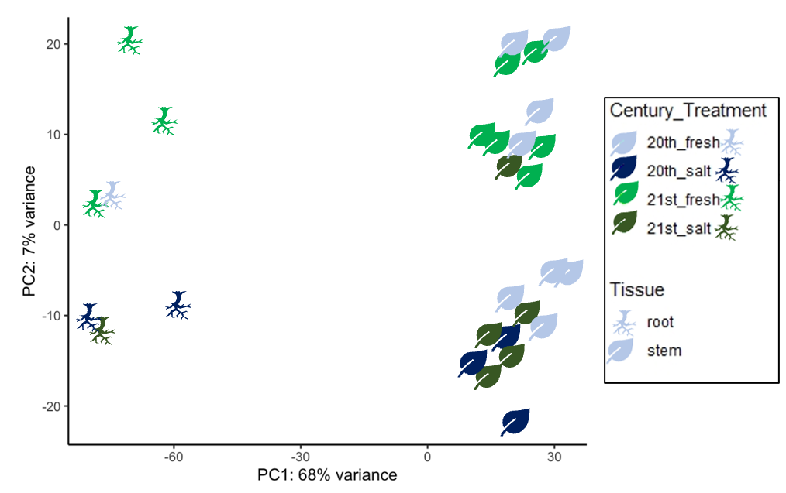
A
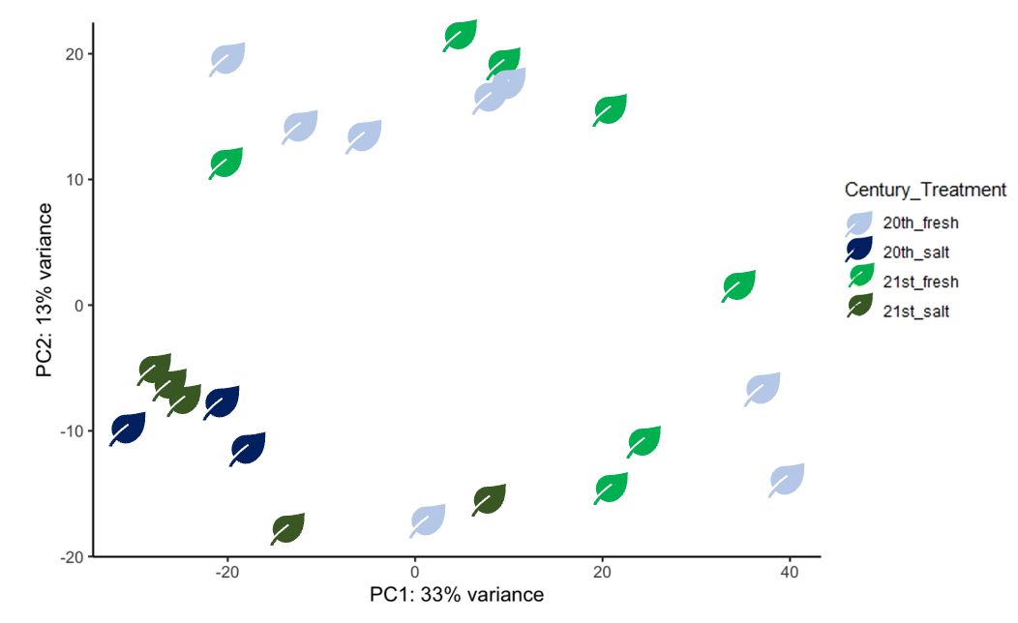 Figure 17: PCAs of gene expression by treatment, tissue, and age cohort
B

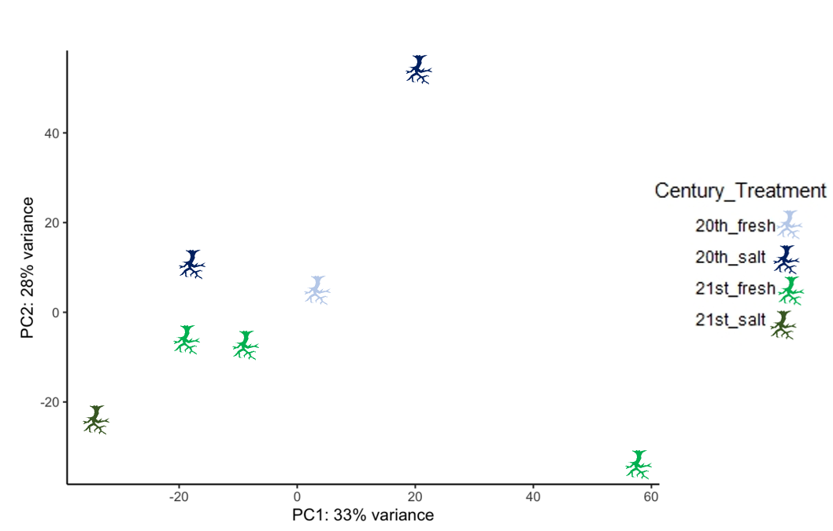
C
Figure 17 continued

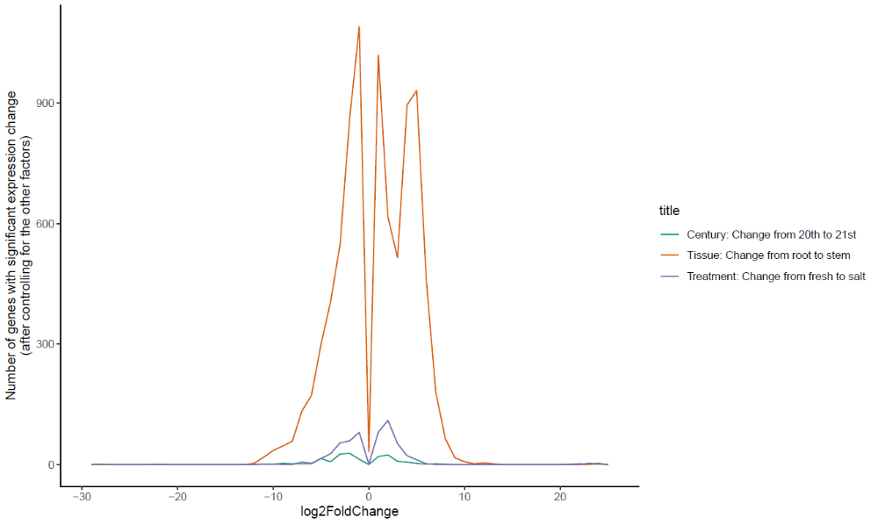
Figure 18: Graph of log fold changes in gene expression (x-axis) versus number of genes with significant expression change (y-axis) based on three contrasts, Century, Tissue, and Treatment. The largest differences occurred between tissue types, the second largest related to treatment and the smallest were related to century contrasts.

Table 12: gene expression counts and percentage of genes with log-fold change greater than 0
 | Century contrasts | Treatment contrasts | Tissue contrasts
LFC > 0 (up) | 124, 0.48% | 447, 1.7% | 5481, 21%
LFC < 0 (down) | 161, 0.63% | 395, 1.5% | 4267, 17%
outliers | 0, 0% | 0, 0% | 0, 0%
low counts | 4190, 16% | 5237, 20% | 3142, 12%
Table of counts and percentage of genes with log fold change of greater than or less than 0 taken from out of 25666 with nonzero total read counts. The adjusted p-value cutoff was < 0.1. Low counts are labelled as such if the mean count < 4 (Century), <8 (Treatment), <1 (Tissue).

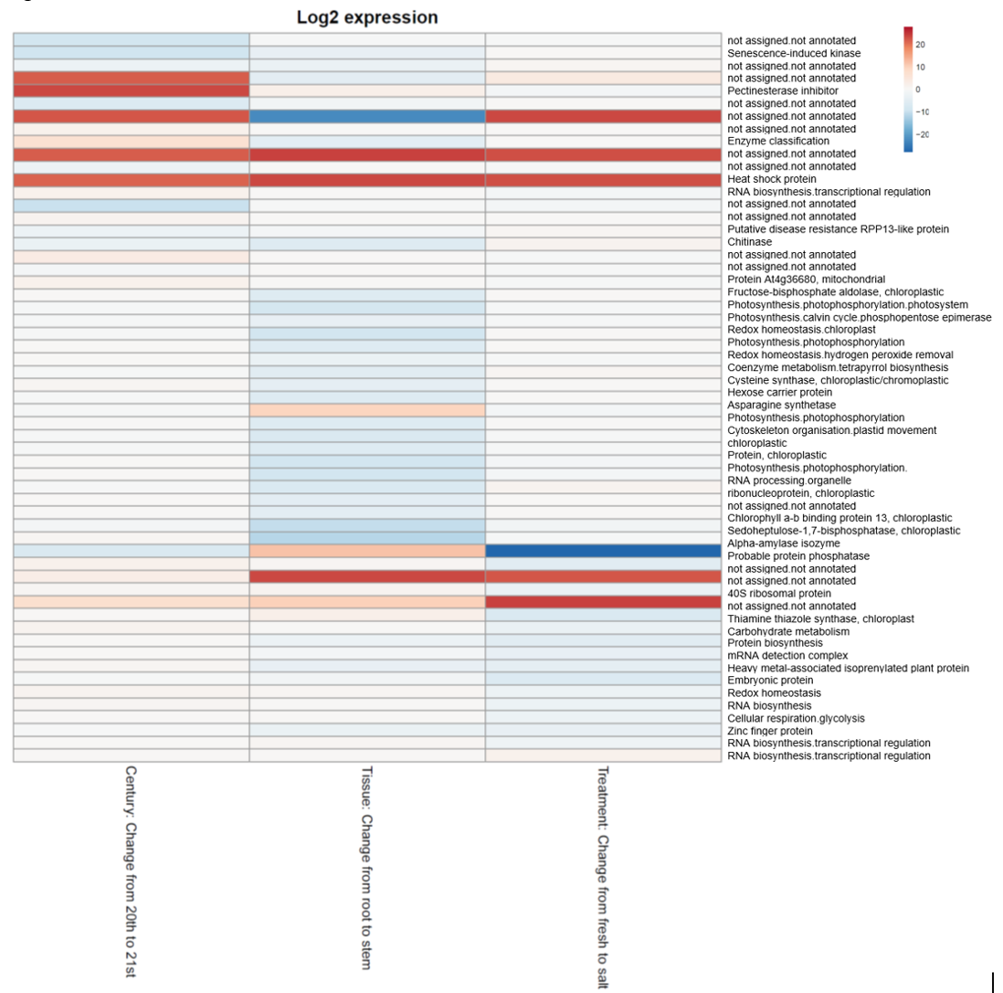

Figure 19: Heat map of gene expression by tissue, age group, and treatment

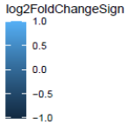
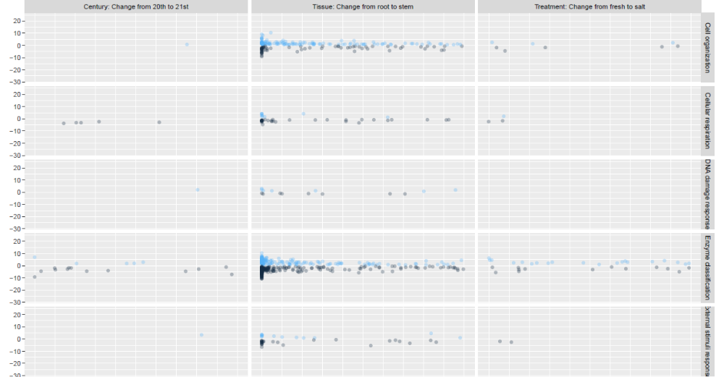

Figure 20: Log2 fold change of genes grouped by functional bin

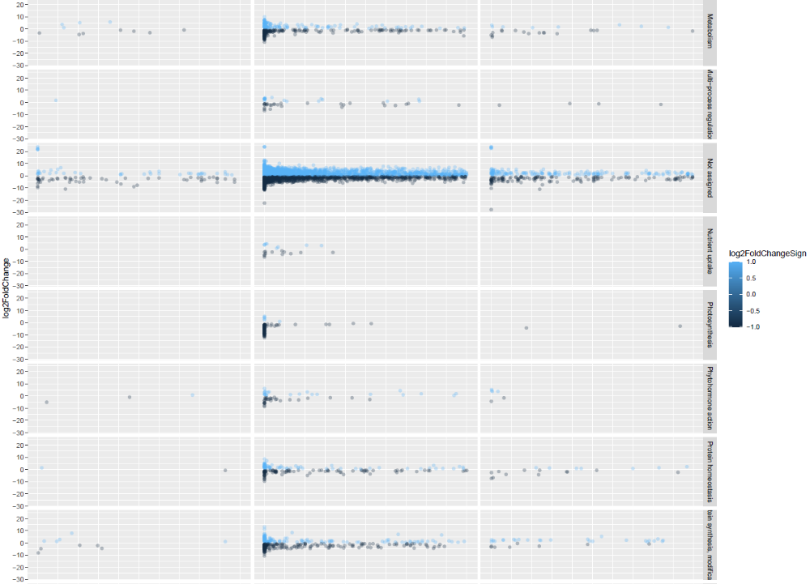
Protein syn/mod
Figure 20 continued

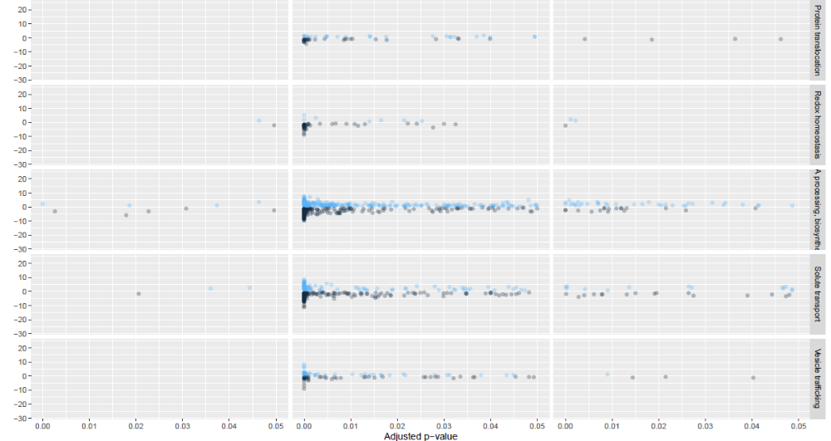
RNAproc/biosyn

Figure 20 continued: Plots of log2fold change differences by adjusted p-value based on the contrasts of the (Left) 20th century vs. 21st century (Middle) change from root to stem and (Right) change from fresh to salt treatments. The Genome Ontology terms are along the y-axis to the right. Each dot represents a gene, colored light blue for positive log2fold change and dark blue for negative log2fold change.

Table S1: RNAseq samples and pairing across treatment
 | Freshwater sample | Salt stressed sample
 | FC4AS1 | SC4AS1
 | FC4AS11 | SC4AS11
 | FC4AS2 | SC4AS2
Descendant Stem Samples | FC4AS3 | SC4AS3
 | FC4AS4 | --
 | FC4AS5 | --
 | FC4AS6 | --
 | FC4AS8 | --
Descendant Root Samples | FC4AS1R | --
 | FC4AS3R | SC4AS3R
 | FC4BH11 | SC4BH11
 | FC4BH6 | --
 | FC4BH9 | --
 | FC4BI3 | SC4BI3
Ancestral Stem Samples | FC4BI5 | --
 | FC4BI6 | --
 | FC4BI7 | --
 | FC4BI8 | --
 | -- | SC4AS7
 | -- | SC4BH16
Ancestral Root Samples | FC4BI3R | SC4BI3R
 | FC4BH11R | SC4BH11R

Conclusion

Here I used resurrection ecology to study historical evolution in the foundational coastal marsh sedge Schoenoplectus americanus. In Chapter 1, I assessed the utility and reliability of the S. americanus seed bank as a resource for understanding historical change. I demonstrated that the seed bank could be sampled reliably with preserved sedimentary layers, and that the seeds recovered exhibited comparable genetic diversity relative to other age cohorts within the soil core and compared with extant S. americanus across its geographic range. In addition, microsatellite genotyping revealed that S. americanus showed a shift in genotypic makeup from the older age cohort to the younger, suggesting evolutionary change occurred in the foundational sedge over just 100 years.
In Chapter 2, I found somewhat contrasting evidence to that in Chapter 1. Based on whole genome ddRAD sequencing and calling of SNPs in both coding and neutral regions of the genome, I was able to reconstruct genomic variation across marshes in the Chesapeake Bay and across time at each sampled site. Based on this work, which was based on relatively few SNPs, there were strong patterns of genomic clustering by geographic location. Despite this, estimated Fst values were relatively low, suggesting that though genomic clusters could be identified on the based on geographic distance, there is still ample gene flow across populations. In addition, overall heterozygosity was low for all age cohorts and provenances. This finding may prove important as higher levels of genomic diversity are generally associated with improved population-level fitness in the face of selection and drift events. Further, only two of the populations demonstrated patterns of differentiation over time suggestive of possible evolutionary change. Blackwater and Corn Island showed a transition of genomic cluster from oldest to youngest. In addition, they exhibited the highest amount of spread in ordination analyses. Overall, it appears that shifts over time are tied to local conditions, varying by marsh even when marshes are located relatively close together.
In Chapter 3, I examined two age cohorts differing in age by approximately 100 years and their response to simulated sea level rise and competition. This chapter asked if there were detectable differences in how S. americanus was responding to increased salt and inundation with and without a co-occurring species as salinity and sea level rise have both increased in the Chesapeake Bay over the past 100 years. Overall, the suite of phenotypic traits did not differ significantly by age cohort. Rather the effect of treatment was much stronger than any signal related to evolutionary shift. However, two of the traits demonstrated importance of age cohort when controlling for genotype ID, suggesting that it is possible for small evolutionary changes to have occurred. Furthermore, there were clear indications that predicted sea level rise would greatly reduce productivity in S. americanus. However, when planted with a competitor, evidence for facilitation was seen, wherein S. americanus exhibited higher stem density when planted with a competitor. This could have significant implications on an ecosystem scale as stem density is a trait known to positively affect a plant’s capacity to trap sediment and improve accretion rates. In addition, I found that 21st century plants exhibited a contraction in the expression of trait variance relative to 20th century plants when exposed to stress. This finding could suggest that the Corn Island genotypes, there was an evolutionary shift in plasticity over time – as opposed to direct adaptation - in response to salinity (and sea level rise).
In Chapter 4, I dug into this response by examining differential gene expression and annotation of genes expressed in S. americanus from Corn Island when exposed to high salinity. I found that, like in Chapter 3, gene expression differed based on tissue sampled and treatment, with only a weak signature of age cohort. However, I did observe shifts in log-fold change between the age cohorts, which supports the idea that either plasticity or evolution may have occurred in the past century. In addition, some of the annotated genes indicate that S. americanus may cope with salinity by increasing photosynthetic capacity and augmenting antioxidant activity, responses seen in other plant species.
Overall, there was subtle, nuanced evidence that S. americanus may have responded to sea level rise and other stressors via evolutionary change in the past century. Although I had predicted that changes through time would be larger, interpreting the small changes observed in this work is in keeping with the idea that rapid or microevolution is ubiquitous and often incremental (Carroll et al. 2007; Messer et al. 2016). It appears likely that S. americanus has shifted in its response and capacity to respond to corollaries of sea level rise in the past century. These implications should be more fully explored along a true temporal gradient (i.e., a greater number of age cohorts) and include greater replication per age cohort to ensure single genotypes do not bias outcomes. Finally, I found that the impacts of sea level rise are powerfully negative and that S. americanus faces potential extirpation in the worst projected sea level rise scenarios. My findings provide several take-home messages for future work in and management of this system regarding the stability of marsh ecosystems worldwide.

VITA

Jennifer L. Summers was born in Jupiter, Florida and grew up in Simpsonville, South Carolina. She attended Woodmont High School in Piedmont, SC and graduated magna cum laude from Furman University in Greenville, SC. During her undergraduate years she was able to study abroad extensively while focusing on her interest in environmental justice worldwide and the impacts of climate change and unequal development. She has traveled and studied in France, Japan, South Africa, Iceland, Guatemala, Nicaragua, El Salvador, and Cuba. She spent a summer working with DESGUA, a non-profit organization in Guatemala, to develop educational materials about traditional Mayan plants and herbs. She took courses in French and Spanish and became fluent and conversant in these languages, respectively. She also became involved in research into the sustainability perspectives of local Upstate South Carolina small farmers via the Shi Center for Sustainability at Furman University. Combining her interest in sustainable, small-scale agriculture with the French language, Summers was invited to work at a community college known as CFFL in Corporant, Haiti through the non-profit Partners in Agriculture. She worked abroad in Haiti for a year teaching English and biology before returning to the United States. From 2014 to 2015 she worked on a sustainable lily farm and at a folk arts school before starting her PhD at Tulane University in 2015. Her PhD work initially focused on the impact of aquatic invasive species on endemic fish, resulting in two field seasons working in Hawaii on the island of Oahu. However, Summers’ focus shifted to a resurrection ecology study after she developed an interest in rapid and eco-evolution, for which the S. americanus system described above provided ample opportunities. She later moved to the University of Tennessee Knoxville in 2017. She graduated with her PhD in 2020 with Brian O’Meara as her advisor. Her research focuses on the evolution of a foundational coastal marsh plant. She will pursue a career at the cross-section of research and policy following graduation, which will include a stint as a National Academy of Science Gulf Research Program policy fellow hosted at the RESTORE Council office in New Orleans, LA.

