Role of microRNA-155 in Herpes Simplex Virus Pathogenesis

A Dissertation Presented for the
Doctor of Philosophy
Degree
The University of Tennessee, Knoxville

Siddheshvar Bhela
May 2015

Copyright © 2015 by Siddheshvar Bhela
All rights reserved

DEDICATION

This dissertation is dedicated to my parents Dr. Sham Lal Bhela and Dr. Anita Bhela, who have always loved me unconditionally and whose good examples have taught me to work hard for the things that I aspire to achieve. Also, I am grateful to them for their continuous support throughout my life and always encouraging me to do my best. I also dedicate my thesis to my mentor and advisor Dr. Barry T Rouse who always believed in my abilities, presented me with opportunities to grow and succeed, and most of all always kept me entertained and made graduate student life exciting.

ACKNOWLEDGEMENTS
I express my sincere gratitude to my advisor Dr. Barry T. Rouse for giving the opportunity to join his lab, and for his guidance, interest, encouragement, constructive criticism, scientific suggestions and for helping and supporting me throughout the course of my research. I also want to thank my committee members, Dr. Seung Baek, Dr. Melissa Kennedy, and Dr. Nathan Schmidt and Dr. Sarah Lebeis, for their interest in my research and for their valuable suggestions and insights. Additionally, I extend my sincere thanks to Dr. Alexander Osmand and Dr. Patrick Stuart who collaborated with me.
I also express my thanks to all the members of the lab for providing a stimulating and fun environment to learn and grow. Specially, I would like to thank Sachin Mulik, Fernanda Gimenez, Naveen K. Rajasagi, Pradeep BJ Reddy, Raphael L Richardson, Siva Karthik Varanasi, Ujjaldeep Jaggi, and Tamara V. Parga for their help and time in my projects. It has been a great pleasure to interact with other lab members and colleagues Pranay Dogra, Lorena Harvey, Penny McWilliams-Koeppen, Nicolas Villarino, and Sujata Aggarwal and Nancy Neilson. Also I am thankful to Kim Rutherford and Misty Bailey for always helping me throughout my graduate program.
My special thanks to Dr. Vijay Kuchroo for his unconditional support, help and inspiration. Also, I would like to thank my mentors Dr. David Hafler, Dr. Markus Kleinewietfeld and Dr. Clare Beacher-Allan for inculcating in me the passion for Immunology and giving me the opportunity to work with them. Finally, I want to express my deepest gratitude to my extended family, brother, Siddharth Bhela, and friends for their constant encouragement, patience, moral support, and faith in my capabilities.
ABSTRACT
Ocular infection with herpes simplex virus 1 (HSV-1) can result in a chronic immunoinflammatory stromal keratitis (SK) lesion that is a significant cause of human blindness. These lesions are mainly orchestrated by IFN-gamma producing CD4+ T cells (Th1) and neutrophils. HSV being neurotropic in nature can also disseminate into the brain and lead to herpes simplex encephalitis (HSE). In this study we investigated the role of miR-155 in the pathogenesis of HSK and HSE.
The first part of the dissertation (I) reviews literature regarding the contribution of miRNAs in innate and adaptive immune responses. It also focuses on their involvement in neuroinflammation during inflammatory and viral diseases.
In the second part (II) we investigated the role of miR-155 in HSV-1 latency and HSE. We observed that miR-155-/- (microRNA-155 knockout) mice are highly susceptible to HSE and zosteriform lesions. These miR-155-/- animals also show increased viral reactivation from latency when compared to the control WT (wild type) animals. One explanation for these observations was diminished CD8 T cell effector responses in miR-155-/- animals.
In the third part (III) we evaluate the role of miR-155 in the pathogenesis of SK. Our results showed that miR-155 expression is increased in corneas after HSV-1 infection and suppression of miR-155 production resulted in milder lesions that was associated with diminished Th1 and Th17 responses as well as reduced inflammatory cytokine production.
Collectively, these studies identified a novel role for miR-155 in regulating HSE and promoting inflammation during HSK.

TABLE OF CONTENTS
CHAPTER I BACKGROUND AND OVERVIEW 1
Herpes Simplex Virus-1 infection 2
Biogenesis of miRNAs 2
miR-155 and inflammation 3
miRNAs and Herpes Stromal Keratitis 6
Innate immunity 6
Adaptive immunity 8
miRNAs and Herpes Simplex Encephalitis 11
Microglia 11
Astrocytes 14
Neurons 15
miRNAs and antiviral immunity 16
Host miRNAs regulating viral and cellular genes 16
Viral miRNAs regulating host and viral genes 18
LIST OF REFERENCES 22
APPENDIX 31
CHAPTER II CRITICAL ROLE OF MIR-155 IN HERPES SIMPLEX ENCEPHALITIS 33
Abstract 35
Introduction 35
Materials and methods 37
Results 42
Discussion 48
LIST OF REFERENCES 54
APPENDIX 58
CHAPTER III ROLE OF MIR-155 IN THE PATHOGENESIS OF HERPES STROMAL KERATITIS 72
Abstract 74
Introduction 74
Materials and Methods 76
Results 81
Discussion 86
LIST OF REFERENCES 92
APPENDIX 96
CHAPTER IV CONCLUSION AND FUTURE PERSPECTIVES 116
VITA 119

LIST OF FIGURES
Figure 1.1 miRNA biogenesis 32
Figure 2.1 miR-155KO mice are highly susceptible to encephalitis after HSV-1 infection and have elevated viral titers in the brain but no difference in the cornea 59
Figure 2.2 Infiltration of CD8 T cells and astrocytosis by immunohistochemistry of HSV-infected WT and miR-155KO mice. 61
Figure 2.3 Viral replication in the brain is the cause of encephalitis in the miR-155 KO mice. 62
Figure 2.4 miR-155 KO mice mount weaker CD8 T cell responses compared to WT mice after HSV-1 footpad infection. 64
Figure 2.5 miR155 KO mice mount impaired CD8+ T cell responses in TG compared with WT mice. 66
Figure 2.6 Survival in miR-155KO mice after receiving HSV immune CD8 T cells 68
Figure 2.7 Comparison of ex vivo HSV-1 reactivation between miR155 KO and WT mice. 69
Figure 2.8 Zosteriform lesions are more severe in miR-155KO mice compared to WT mice and miR-155KO mice show impaired viral clearance from both brain and skin. 70
Figure 3.1 Expression of miR-155 after HSV-1 infection. 97
Figure 3.2 miR-155-/- mice were resistant to SK. 100
Figure 3.3 miR-155-/- mice exhibited reduced frequencies and numbers of Th1 and Th17 cells in DLN and spleen post HSV-1 infection. 101
Figure 3.4 miR-155-/- CD4+ T cells showed defective proliferation but not survival. 103
Figure 3.5 Preventive administration of antagomir-155 diminished SK lesion severity and cellular infiltration. 105
Figure 3.6 Antagomir-155 treatment reduced cytokine and chemokine levels in corneas of HSV-1 infected animals. 108
Figure 3.7 Increased expression of Ship1 and IFN-γRα in miR-155-/- activated CD4+ T cells. 109
Figure 3.8 Illustration of miR-155 induced regulation of inflammatory response during HSV-1 infection. 112
Figure S3.1 UV inactivated HSV-1 virus upregulates miR-155……………...…………….113
Figure S3.2 Therapeutic administration of antagomir-155 diminishes SK lesion severity
and cellular infiltrates………………………………………………………….………..114

ABBREVIATIONS
DLN Draining lymph node
HSE Herpes simplex encephalitis
KO Knockout
miR MicroRNA
miR-155KO or miR-155-/- MicroRNA-155 knockout
p.i. Post infection
PLN Popliteal lymph node
PNS Peripheral nervous system
rGal-9 Recombinant Galectin-9
SK Stromal keratitis
TG Trigeminal ganglia
WT Wild type
HSV-1 Herpes simplex virus 1
IVIG Intravenous immunoglobulins
PMA Phorbol 12-myristate 13-acetate
Ship1 Phosphatidylinositol-3, 4, 5-trisphosphate 5-phosphatase 1
SOCS1 Suppressor of cytokine signaling 1
IFN-γRα IFN-gamma receptor alpha
Th1 T helper 1 cells (IFN-γ producing CD4+ T cells)
Th17 T helper 17 cells (IL-17 producing CD4+ T cells)
TLR Toll like receptor
PFU Plaque forming unit
Q-RT-PCR Quantitative RT-PCR
SnoRNA202 Small nucleolar RNA 202
FACS Fluorescence-activated cell sorter;
H&E Hematoxylin and eosin
IFN-γ Interferon-γ
SSC Side scatter
CCL-2 Chemokine (C-C motif) ligand 2
CXCL-1 Chemokine (C-X-C motif) ligand 1

BACKGROUND AND OVERVIEW

Herpes Simplex Virus-1 infection
Herpes Simplex Virus-1 (HSV-1) is a pathogen in all human societies with up to 70-80% prevalence in some adult populations (1). The transmission of HSV occurs via contact with secretions, skin and mucosal membranes from symptomatic or asymptomatic individuals that shed virus (2). HSV-1 mostly affects the face and other mucosal sites, although in some communities the genital mucosa, the usual site of infection for HSV-2, can be affected (3). HSV-1 initially replicates in the epithelial layer, and then via retrograde transport, establishes latency in the trigeminal ganglia (TG). During latency the virus does not replicate, however, immune suppression and several stress related events in the host could result in reactivation of the virus from latently infected TG (4). After reactivation, the virus can migrate to the initial site of infection and can cause inflammatory reactions in that site which in some cases can be the eye and the brain (5, 6).
When the virus enters the cornea, a chronic vision impairing immunoinflammatory condition may result, which is termed herpetic stromal keratitis (HSK) (7). When virus enters the brain it causes acute inflammation and significant pathological damage which gives rise to herpes simplex encephalitis (HSE) (8). If untreated, HSK leads to blindness and HSE mediated damage leads to nearly 70% lethality (8). The role of microRNAs (miRNAs) in both HSK and HSE is new field and has just started to be explored.

Biogenesis of miRNAs
The canonical process of miRNA biogenesis begins in the nucleus where the enzyme Drosha and its partner protein DGCR8 process the nuclear pri-miRNA into a ~ 70 nucleotide precursor miRNA (pre-miRNA). The pre-miRNA is then exported from the nucleus to the cytoplasm with the help of Exportin-5/RanGTP (GTP-binding nuclear protein Ran), which specifically recognizes the structure of pre-miRNA molecules. In the cytoplasm, an enzyme dicer digests the pre-miRNA into a 21–25 nucleotide miRNA duplex. After this step the miRNA duplex is loaded into the miRNA-induced silencing complex (miRISC) that also contains argonaute proteins where the sense strand is degraded. miRNA antisense strand guides miRISC to its target mRNA resulting in target mRNA degradation or translational repression. (Please see figure 1). Accordingly, if the miRNA has a complete complementary sequence to the target mRNA, it degrades target mRNA with the help of argonaut proteins. If the miRNA has partial complementarity to the target mRNA, translational repression results via different mechanisms including co-translational protein degradation, inhibition of translational elongation, premature termination of translation, and inhibition of translation initiation (9). Although, most miRNAs are generated as described above, there are some exceptions, which could use a different pathway such as mirtrons, which resemble pre-miRNA hairpins, bypassing the need for Drosha, and only require Dicer for maturation. This has been reviewed in detail by others (10).

miR-155 and inflammation
miRNA-155 is one of the most studied miRNA with respect to both innate and acquired immune responses. miR-155 expression is expressed at low levels in monocytes and macrophages, however the level increases soon after toll like receptor (TLR)-2,3,4 and 9 stimulation during both bacterial and viral infections (11). Moreover, cytokines such as Tumor necrosis factor (TNF) and interferon’s (IFNs) also induce expression of miR-155 in macrophages (11, 12). Various studies have shown that transient increase in miR-155 after TLR stimulation mediated by TNF receptor associated factor 6 (TRAF-6), activator protein 1 (AP-1), c-Jun N-terminal kinase (JNK) and nuclear factor kappa-light-chain-enhancer of activated B cells (NF-kB) transcription factors and leads to granulocyte/monocyte expansion. Apart from its role in differentiation, Rodriguez, A. et al have shown that miR-155 is also essential for antigen presentation where the loss of miRNA-155 impaired the ability of myeloid dendritic cells (DCs) to present antigen and trigger T cell activation (13). Moreover, miRNA-155 positively regulates the development, apoptosis and interleukin-12 (IL-12) production in human DCs (14). miRNA-155 also promotes autophagy, phagocytosis, endocytosis and cytokine secretion in macrophages by targeting its negative regulators such as Ras homolog enriched in brain (Rheb) and Phosphatidylinositol-3,4,5-trisphosphate 5-phosphatase 1 (SHIP-1) (11, 15, 16). While over expression of miR-155 leads to Acute Myeloid Leukemia (AML) in certain cases, blocking its induction by antagomirs have shown to repress the production of pro-inflammatory cytokines, phagosome maturation and macrophage survival (17). Also, reduction in miRNA-155 promoted M2 macrophages by directly upregulating its target CCAAT/enhancer-binding protein beta (C/EBPβ) and Arginase-1 expression (18).

In terms of adaptive immunity miR-155 has been shown to have a critical role in T cells. miR-155 is expressed by both activated CD4 and CD8 T cells and T cell receptor (TCR) engagement has been shown to induce upregulation of this miRNA (19, 20). TCR signaling cascade activates nuclear factor of activated T cells (NFAT) and NF-κB, both of which induce the upregulation of miR-155 expression. microRNA-155 knockout (miR-155KO) T cells show a type 2 helper cells (Th2) bias under neutral conditions with more CD4 T cells producing IL-4 than IFN-γ. This bias was reflected by increased levels of c-maf (miR-155 target), which is important for the production of IL-4 (13). Animals deficient in miR-155 because of gene knockout (KO) are resistant to the induction of some autoimmune diseases such as experimental autoimmune encephalomyelitis (EAE), colitis and collagen induced arthritis (21-23). Additionally, in humans high levels of mir-155 have been associated with several autoimmune diseases which include multiple sclerosis (MS), rheumatoid arthritis (RA), and atopic dermatitis (24-26). The resistance of miR-155KO mice to autoimmune diseases was contributed in part due to defective Type 1 helper cells (Th1) and T helper 17 cells (Th17) cell responses. miR-155 targets Ship1 and Interferon receptor α (IFN-yRa) in CD4 T cells and promotes Th1 cell differentiation (20). miR-155 promotes Th17 cell responses by targeting Ets-1 which is a negative regulator of Th17 differentiation (27). Additionally, miR-155KO Th17 cells show reduced expression of IL-23 resulting in these cells being hypo responsive to IL-23 signaling (27). miR-155 is also expressed by regulatory T cells (Tregs) and regulates Treg homeostasis in a competitive setting. In fact forkhead box P3 (Foxp3) the major transcription factor for Tregs has been shown to regulate mir-155 expression in Tregs. miR-155 targets Suppressor of cytokine signaling 1 (SOCS1) and thus miR-155KO Tregs have increased SOCS1 mRNA levels. Increased SOCS1 levels results in reduced signal transducer and activator of transcription 5 (STAT5) phosphorylation, downstream of interlukin-12 receptor (IL-2R) signaling and a well-established role of IL-2 signaling in the survival of Treg cells has been established suggesting that defective IL-2 signaling could be responsible for defective Treg homeostasis (28). Additionally, miR-155KO Tregs showed reduced proliferative activity in a competitive environment, which could also in part explain defective Treg homeostasis. Some reports also suggest defective T follicular helper cell differentiation in miR-155KO animals following immunization, viral infection, or during age-related inflammatory disease. This was attributed to increased levels of miR-155 targets FOS-like antigen 2 (Fosl2) and pellino E3 ubiquitin protein ligase 1 (Peli 1). Fosl2 is a repressor of T follicular helper cell (Tfh) development and Peli 1 inhibits NFκB activation, which is required for the induction of Tfh cell associated genes. These defective Tfh cell responses in turn lead to defective humoral immune response and reduced germinal center (GC) formation (29). Another report by Rodriguez et al. showed that miR-155KO mice have defective GC formation and fail to produce high-affinity IgG1 antibodies to thymus dependent and independent antigens and this was attributed to a B cell intrinsic defect (13). miR-155 targeting PU.1 in B cells leads to increased B cell maturation and IgG1 class-switched differentiation (13). Cytotoxic CD8 T cell function is also shown to be regulated by miR-155 (19, 30-32). The effector CD8 T cell responses to virus and bacterial infections and in cancer depend on miR-155 (30, 31). The reduced AKT (also known as protein kinase B) phosphorylation by miR-155 was observed after L. monocytogenes infection (31). Moreover, components associated with IFN signaling were also found to be increased in miR-155KO CD8 T cells (19). In conclusion, miR-155 impacts various aspects of immunity and likely to be a good therapeutic target against human autoimmune and inflammatory diseases.

miRNAs and Herpes Stromal Keratitis

Innate immunity
HSV infection of the corneal epithelial cells leads to induction of innate immune responses. HSV sensors include TLR 2, 3, and 9 and some other such as retinoic acid-inducible gene 1 (RIG 1) and inflammasomes (33-35). Ligation of TLR’s causes activation of the NFkB pathway, which leads to the production of several pro-inflammatory cytokines, chemokines, interferons and angiogenic factors that are involved in the pathogenesis of HSK (33, 35). TLR 2 and 9 ligation has been shown to be critical in HSK as mice lacking TLR2, TLR 9 or myeloid differentiation primary response 88 (MYD88) lead to reduced HSK lesions and neo-vascularization (36). It is suggested that TLR ligand activity of HSV may be a major mechanism by which the virus induces early events necessary for the development of the inflammatory disease. These include the induction of cytokines such as IL-6, IL-1β, and TNF-α, the chemokines macrophage inflammatory protein (MIP)-1 alpha (MIP-1α) and MIP-2, enzymes such as cyclooxygenase-2 (COX-2), associated with the production of inflammatory molecules, and molecules responsible for neovascularization of the usually avascular eye, such as vascular endothelial growth factor (VEGF) and matrix metallopeptidase 9 (MMP9) (33) . The accumulating evidence shows that TLR function is subject to regulation by numerous miRNA species (37). It is of interest to note that that these miRNAs do not directly target the TLR’s but instead target molecules that are required for the TLR signaling cascade such as MyD88, interleukin-1 receptor-associated kinase (IRAK), TRAF6, and IκB kinase (IKK) (37). Moreover, TLR induced transcriptional factors are also subject to miRNA regulation. Thus miRNAs that either targets the TLR cascade or the cytokines produced during the innate phase might be of interest. However, what role if any these aforementioned miRNAs such as miR-146a, miR-155 and miR-21 (discussed below) play during the innate phase of HSK pathogenesis remains to be seen.
Innate immune cells such as DCs, natural killer (NK) cells, γδ-T cells, neutrophils and macrophages participate in viral clearance and the subsequent ocular inflammation by secreting various effector molecules such as type I interferons, cytokines and chemokines (IL-17, IL-1β, IL-12, MIP-2, TNF-α, IFN-γ, IL-23) (33). The function of all of these cell types is influenced by miRNA expression (38-41). For example miR-146a, miR-155, miR-21, miR-147 and miR-125b regulate the function of macrophages (42, 43). miR-223 has been shown to regulate the migration, proliferation an activation of neutrophils (41, 44). Also, miRNAs such as miR-21, miR-155, miR-221 and miR-146a control DC function, differentiation and activation (40). Similarly, NK cell cytokine production can be regulated by miR-150, miR-155, miR-29, and miR-15/16 while the production of cytotoxic molecules such as granzyme B and perforin can be regulated by miR-223, miR-378, miR-30e, and miR-27a* (38). It is becoming evident that several miRNAs can play a critical role during the innate phase of an inflammatory response and it could be the magnitude and balance of this innate response is regulated by miRNAs. This also sets the stage for an adaptive immune response, which in some cases might lead to pathogen clearance, while in others leads to immunopathology as is the outcome in HSK.

Adaptive immunity
The HSK pathogenesis is very complex, but it is mainly thought to be a T cell inflammatory reaction. Studies in animal models have revealed that these HSK lesions are orchestrated mainly by IFN-γ–producing CD4⁺ T cells (Th1) and, to a lesser extent, by IL-17–producing CD4⁺ T cells (Th17) (45, 46). Stromal lesions do not occur in animals that lack T cells, but lesions can be restored with adoptive transfer of CD4+ T cells (33). The ocular lesion severity is controlled by Tregs as removing or expanding Tregs from the onset of lesion induction results in exacerbated or diminished lesions, respectively (33). Multiple miRNAs are in involved in the activation, differentiation, effector function and recruitment of both effector CD4 T cells and Tregs (47). However, we mention only relevant miRNAs that could be involved in the pathogenesis of HSK and hence might be used as a good therapeutic target.
One report by our lab has already shown the involvement of one such miRNAs, miR-155 in T cell biology and in the pathogenesis of HSK lesions. miR-155 is a proinflammatory miRNA which is required for normal immune function (48). The increased ocular expression of miR-155 was associated with Th-1 and Th-17 cell responses, and reduced levels of miR-155 targets IFN-γRα and Ship1, which are required for T cell differentiation and function. miR-155KO mice were resistant to developing HSK. We were also able to show that anti-155 sequences given in the form of antagomir nanoparticles provided resistance against HSK in WT mice. Thus manipulating miRNAs show promise and could be used to target other miRNAs that are involved in inflammatory or resolution components of HSK. One such miRNA is miR-146a which is expressed in Tregs and conventional T cells, and its absence leads to elevated expression of one of its targets, STAT1, and an unchecked Th1 response (49). miR-146a also regulates NF-κB activity, at least partly through repressing the NF-κB signaling transducers TRAF6 and IRAK1 (50). It will be interesting to evaluate the contribution of miR-146a in the pathogenesis of HSK; we expect rapid onset of HSK and severe ocular lesions in mice lacking miR-146a. Another miRNA that regulates Th1 responses is miR-29 which targets T-box transcription factor TBX21 (Tbet) and Eomesodermin (Eomes) transcription factors and suppresses IFN-γ production (51). The proliferative response of Th-1 cells and IFN-γ production are also controlled by a species of miRNA, miR-17-92. The mice lacking miR-17-92 demonstrated attenuated delayed hypersensitivity response and reduced tumor rejection (52). Thus it would be of interest to see if any of these miRNAs play a role during the pathogenesis of HSK. Other miRNAs that might influence the pathogenesis of HSK are those that regulate Th17 differentiation or the production of IL-17A. IL-17A was shown to have a pathogenic role in the progression of HSK. Accordingly, miR-21, miR-155 miR-301a, and miR-326 were shown to promote Th17 differentiation (53-55). Therefore blunting the expression of these miRNAs might reduce IL-17A, which might lead to diminished HSK lesions. This merits further investigation.
Treg function is also subject to modulation by species of miRNAs. The most studied miRNAs are miR-146a, miR-17-92, miR-10a and miR-155. Deficiency of miR-146a in Tregs leads to fatal Th1 cell mediated pathology, a phenotype previously observed with mice in which Treg cells lack the miRNA generating machinery (Dicer/Drosha) (49). These experiments were performed using bone marrow chimeras so the contribution of miR-146a in impacting myeloid cells cannot be nullified (49). The intrinsic role of miR-146a in Tregs remains to be verified using conditional mutant mice. Another well-studied miRNA in Tregs is miR-17-92 cluster (56). This cluster influences IL-10 production in Tregs as mice deficient in miR-17-92 developed severe EAE lesions. Tregs function can be regulated at the epigenetic level thus restraining Treg plasticity into effector T cells. One such miRNA is miR-10a that stabilizes the Treg phenotype by maintaining stable FoxP3 expression (57). miR-10a also restrains Treg transition into T_{FH} cells as well as it shows inhibitory effect on Th-17 cells (58). Similarly, another miRNA, miR-155 is required to provide competitive fitness to Tregs (28). Consequently, miR-155 deficient mice show reduced Treg numbers in peripheral organs (28). Finally, Tregs were shown to transfer miRNAs in exosomes to effector T cells leading to suppression. Treg exosomes revealed a critical miRNA, Let-7d in this process (59). Although, several aspects such as how Treg suppression is regulated by miRNAs, or miRNA signature between natural Treg (nTreg) and induced Treg (iTreg), details as to how miRNAs contribute to Treg plasticity needs to be worked out.

miRNAs and Herpes Simplex Encephalitis
HSE is an infection of the brain by herpes virus. It affects 1 in 500,000 individuals every year. The majority of the cases result from virus reactivation in the peripheral ganglion and in the small number of individuals with mutations in toll like receptor 3, HSE is a common problem (60). Treatment includes high doses of intravenous acyclovir or other antivirals, but 20% of the affected patients are left with neurological sequelae. The underlying processes that drive HSE seem to involve both direct insult by the virus as well as bystander damage by a host response to the virus. It is conceivable that miRNAs expressed by the cells of the CNS or the immune system could influence the susceptibility of these cells to viral infection and also contribute to the inflammation thus leading to encephalitis. Currently the involvement of miRNAs in HSE is still in its infancy and needs to be further investigated.

Microglia
Microglial cells make up the first line of defense against virus infection and are the resident macrophages of the central nervous system (CNS) (61). Microglia do not originate from the same precursor cells as the astrocytes, oligodendrocytes, or neurons but are instead derived from myeloid progenitor cells and share several characteristics with monocytes, macrophages and dendritic cells. Similar to macrophages, microglia can express essentially all of the many TLR family members (61). HSV has the ability to trigger TLRs in microglia and is associated with production of considerable amounts of ROS, TNF-α, IL-1β, CXCL10/IP-10, and CCL5/RANTES, together with smaller amounts of IL-6, CXCL8/IL-8, and CCL3/MIP-1α, in response to nonproductive infection (62). While these cytokines and chemokines might be beneficial to clearing invading pathogens, they can also cause irreparable harm through bystander damage to crucial host cells particularly neurons. Whether miRNA are involved in driving such harmful processes after HSV infection as would seem likely merit further investigation.
One such miRNA influencing microglial function is miR-124 (63). One group showed that miR-124 is required to keep the microglia in a resting state in EAE, the mouse model for MS (63). miR-124 is highly expressed in resting microglia but upon activation of these microglia, miR-124 expression goes down. During the resting state miR-124 directly inhibits the expression of the transcription factor CEBPα that results in down regulation of PU.1 expression. PU.1 is a master regulator of macrophage cell differentiation, and proliferation and it plays a critical role in activation of macrophages (64, 65). Thus, when miR-124 is downregulated during EAE it increases the expression of PU.1, which promotes microglia activation, proliferation and differentiation thereby contributing to neuroinflammation. After HSV-1 infection of the brain, microglial cells express increased MHC Class 1 and class II glycoproteins and show an activated phenotype (66). Thus it will be of interest to see if miR-24 is upregulated in microglia after HSV -1 infection and if providing antagomir-124 after HSV-1 infection would dampen the proinflammatry milieu generated as a consequence of activated microglia. Moreover the outcome of miR-124 on the severity of HSE marks investigation.
Another miRNA that has received interest is miR-181c, which is downregulated in microglia after oxygen-glucose deprivation (67). This miRNA seems to regulate TNF-α production from microglia, as it could directly target TNF-α mRNA (67). Downregulation of this miRNA after oxygen-glucose deprivation leads to increased levels of TNF-α, which results in neuronal apoptosis (67). TNF-α inhibits HSV replication in astrocytes, and in addition TNF-α knockout mice are much more susceptible to HSE (68, 69). Thus TNF-α seems to have a protective role in HSE and it is conceivable that provision of antagomir-181c to mice might provide protection against HSE by increasing the production of TNF-α.
miR-155 was previously shown to be upregulated in microglial cells after stimulation with LPS as well as after Japanese encephalitis virus challenge (70, 71). In both cases, miR-155 targeted anti-inflammatory proteins in the microglia namely SOCS1 and Ship1 which led in turn to the upregulation of several inflammatory mediators. The finding reported in this thesis support the role of miR-155 in inflammation, which was associated with proinflammatory Th1 and Th17 cell responses. However, its role in microglia after HSV infection remains to be seen. There are some contradictory reports on the anti viral role of miR-155 in microglia after Japanese encephalitis virus infection. One report suggests that JEV infection of microglia cell line that is over expressing miR-155 causes decreased production of IFN-β probably due to miR-155 targeting IRF8 a molecule required for the production of type 1 interferons (71). However the other report suggests that miR-155 induction after JEV infection increased IFN-β and proinflammatory cytokine production that was reflected by miR-155 targeting Ship1 (70). This decrease in Ship 1 results in hyperphosphorylation of Serine/threonine-protein kinase TBK1 (TBK-1) and subsequent phosphorylation of Interferon regulatory factor (IRF)3/7 and NF-κB, resulting in augmented IFN-β production and induction of proinflammatory cytokines. The difference in these two reports could be due to different cell lines used in vitro. It would therefore be interesting to analyze the effects of HSV infection on miR-155 sufficient and deficient microglial cells and its association to CNS infection by HSV.

Astrocytes
Astrocytes, together with microglia and macrophages, participate in innate inflammatory responses in the CNS (72). Just like microglia, murine astrocytes also express a wide variety of TLRs, albeit at lower levels (73). Moreover, interferon production by astrocytes is considered to be a crucial CNS defense mechanism against various invading pathogens (74-76). For example in the case of HSV-2, HSV triggering of TLR-3 in murine astrocytes leads to the production of IFN-β, which in turn provides protection against HSE. This is also true for humans, as patients with mutation in the TLR-3 gene were shown to be highly susceptible to HSE (60, 77). Additionally, astrocytes can produce TNF-α and IL-6 in a TLR-3 dependent manner, which were shown to have antiviral functions. It is thus conceivable that dysregulation of miRNAs after HSV-1 infection of the astrocytes could contribute to the increased susceptibility of these cells to HSV-1 infection. This area has received minimum attention and needs to be further investigated.
One study by Iyer et al. reported a role of miR-146a in astrocyte mediated inflammatory responses (78). They showed that miR-146a was upregulated upon exposure of human astrocytes to IL-1β or LPS. This miRNA downregulated the expression levels of IRAK-1, IRAK-2 and TRAF-6 mRNA, all of which could eventually lead to the induction of proinflammatory cytokines such as IL-6 and TNF-α as well as antiviral type 1 interferon production (50, 79). It is well known that TNF-α, IL-6 and IFN-β have antiviral roles in HSE (62). Thus it would of interest to see if miR-146a is dysregulated during HSE and if providing antagomir-146a nanoparticles might provide protection against HSE. This aspect merits investigation.
A recent study has also evaluated the role of miR-21 and miR-145 in astrocytes after spinal cord injury (SCI). Bhalal et al. report that miR-21 is upregulated after SCI and using transgenic mice that overexpress miR-21 specifically in astrocytes showed that miR-21 attenuates hypertrophic reactive responses of astrocytes to injury (80). Wang et al. showed that miR-145 is downregulated in both astrocytes and neurons after SCI and this down regulation is associated with astrogliosis and formation of glial scarring (81). They suggest that miR-145 targeting of c-Myc and GFAP could be an explanation for the astrogliosis after SC1. These two miRNAs might also play a role in HSE and this possibility needs to be investigated.
Lastly a proinflammatory function of miR-155 has been linked to human astrocytes. miR-155 was induced by TLR-3 ligation and by various cytokines such as IL-1β and TNF-α (82). miR-155 upregulation leads to decreased levels of its target SOCS1. Lower levels of SOCS1 leads to increased production of pro-inflammatory cytokines IL-6, TNF-α and IL-8. In the studies reported in this thesis, we find that miR-155KO mice are more susceptible to HSE. Since miR-155 is playing a pro-inflammatory role in astrocytes it is unlikely that miR-155KO mice are dying from inflammation, rather it is conceivable that the anti-viral role of some of these cytokines might be defective which leads to excessive viral replication. This area is being further analyzed.

Neurons
Neurons employ various strategies to counteract viral infection. Such strategies include production of interferons, and induction of autophagy, which operate in parallel to defend against HSV-1 infection (83). Genetic ablation or viral inhibition of host autophagy results in significantly higher levels of HSV-1 replication in neuronal cells (83). It is well known that multiple miRNAs play roles in cell autophagy. In fact miR-155 was shown to positively regulate autophagy (15). Forced expression of miR-155 in mycobacterial infected macrophages led to accelerated autophagic response and decreased survival rate of intracellular mycobacteria (15). It is therefore conceivable that increased expression of miR-155 in neurons after HSV infection may lead to an increased autophagic response, which in turn could counteract HSV infection of the neurons. As mentioned before, miR-155KO mice are more susceptible to HSE. It is therefore possible that miR-155 deficiency in neurons could lead to a diminished autophagic response and hence increased virus susceptibility. This area is currently under investigation in our laboratory.
Another recent study illustrates the role of neurons in antiviral defense. Accordingly a study by Pan et al. found that neurons express miR-138, which targets ICP0, a viral transactivator of lytic gene expression and promotes host survival and viral latency. They showed that a mutant HSV-1 (M138) with disrupted miR-138 target sites in ICP0 mRNA exhibits enhanced expression of ICP0. Moreover lytic transcripts in TG during the establishment of latency resulted in increased mortality and encephalitis symptoms (84). Thus although the neuronal miRNAs did not seem to directly influence the neuroinflammation they indirectly could lead to exacerbated immune responses or viral growth thus resulting in neuroinflammation.

miRNAs and antiviral immunity

Host miRNAs regulating viral and cellular genes
Several groups have reported changes in the cellular miRNA expression profile following viral infection (37). There could be two scenarios when it comes to host miRNAs regulating antiviral immunity. Accordingly, host miRNAs could target host cell genes with the outcome being greater susceptibility or resistance. The other situation, which is being explored, is the possibility of host miRNAs targeting viral genes and regulating antiviral immunity.
A report by Jopling et al. revealed that hepatitis C virus (HCV) viral replication increases as a consequence of changes in host miRNA (85). These studies showed that liver specific cellular miR-122 enhanced HCV virion production. Interestingly, miR-122 exerts this pro-viral activity in an unconventional manner. miR-122 binds to two sites near the 5' end of HCV genomic RNA and interferes with the recognition by the innate immune system (85). Pharmacological inhibition of miR-122 led to significant control of HCV in the blood and liver of infected chimpanzees (86). Another recent report by Zhao et al. showed that hepatitis B virus (HBV) infection down-regulated miR-26b levels in human liver cells and that miR-26b targeted cysteine and histidine rich domain containing 1 (CHORDC1), which is involved in regulating HBV transcription and replication (87). Thus down regulation of miR-26b, as a consequence of HBV infection, helped to increase viral replication and transcription (87). It was also noted during Epstein–Barr virus (EBV) latency, that viral protein latent membrane protein 1 (LMP1) activated the miR-146a promoter leading to miR-146 induction. The miR-146a then attenuated expression of several interferon responsive genes (88). Moreover, LMP1 also induced miR-29b, which reduced expression of T cell leukemia protein that is involved in cell survival and proliferation (89).
miRNA modulation of viral tropism is supported by another recent report (90). In this study, Trobaugh et al show that miR-142-3p is expressed by the cells of the myeloid-lineage (90). miR-142-3p limited replication of North American Eastern Equine Encephalitis virus (EEEV) by binding to the sites of 3' non translated regions of viral RNA. However, restriction of myeloid cell tropism and subsequent reduction in innate immune response promoted neurological manifestations, which are characteristics of EEEV infection in humans (90).
Host miRNAs are not always beneficial for the virus but can also inhibit viral replication. Accordingly, a recent report demonstrated that IFN-β, an antiviral cytokine, induces numerous cellular miRNAs (such as miR-196, miR-296, miR-351, miR-431 and miR-448), with sequence-predicted targets within the HCV genomic RNA (91). Overexpression of these miRNAs in infected liver cells substantially attenuated viral replication demonstrating the importance of miRNAs in anti-viral immunity. In another study, cellular miRNAs such as miR-28, miR-125b, miR-150, miR-223 and miR-382 were shown to restrict human immunodeficiency virus (HIV) replication by binding to sites located in the viral genome (92).
Herpes simplex virus establishes latency in sensory neurons. Accordingly, herpes viral lytic gene expression could be modulated by neuronal miRNAs, which can act to drive virus into latency. This area has received minimal attention so far. The role of neuronal miRNAs in establishing HSV latency was shown in a recent report by Pan et al. which demonstrated that neuron specific miRNA, miR-138 repressed expression of ICP0, a viral transactivator of lytic gene expression of HSV-1. This effect promoted viral latency (84). Another recent report by O’Connor and colleagues demonstrated that miR-200, a miRNA enriched in the CD34+ myeloid lineage targeted immediate early genes of human cytomegalovirus (hCMV) and promoted viral latency in those cells (93). Thus, host miRNAs may have evolved to target viral genes and thereby inhibit viral replication and represent a part of the host’s antiviral immune response.

Viral miRNAs regulating host and viral genes
More than 250 virus-encoded miRNAs have been discovered. However, detailed understanding for most of them is in its infancy. Herpes viruses, adenovirus, and members of polyomavirus family encode for miRNAs. Since all these viruses are DNA viruses, it reflects the fact that they might use cellular Drosha and DGCR8 to process the pre-miRNA within the nucleus. Most RNA viruses that replicate in the cytoplasm of the cell most likely do not encode miRNAs since they do not have access to Drosha and DGCR8. Just like host miRNAs, which are capable of regulating host and viral genes, viral miRNAs, can also target host and viral mRNAs. This could establish a favorable environment in the host cell for virus replication or on the contrary make the cell less susceptible to viral replication. Evidence for both these scenarios exists and is discussed below.

Viral miRNAs regulating host genes
Kaposis Sarcoma-associated Herpes virus (KSHV), EBV and hCMV are some of the herpes virus family agents that encode miRNAs. These miRNAs are involved in modulating the lifespan of infected cells, immune evasion and the regulation of latency. Accordingly, KSHV expresses at least 18 different mature microRNAs, which it employs for various functions. KSHV miRNAs (miR-K5, miR-K9, miR-K10) were shown to target BCLAF1 which is an apoptotic factor (94). Blockade of miR-K5, miR-K9 or miR-K10 in latently infected cells attenuated virus production even after reactivation signals, suggesting involvement of these miRNAs in stabilizing latency. Also miR-K10 was shown to target TGF-β type- II receptor thereby inhibiting TGF-β signaling (95). TGF-β was shown to be a tumor suppressor due to its growth-inhibitory effect and is also known to be proapoptotic (96). Thus KSHV viral miRNAs can promote viral latency and contribute to malignant cellular transformations by targeting host cellular proapoptotic factors. Additionally, miR-K9 could target IRAK1 and miR-K5 targeted MYD88, both of which are critical factors in TLR/IL-1R signaling pathways (97). Thus KSHV miR-K9 and K5 could potentially suppress the innate immune response to make the environment favorable for its replication. Not only could KSHV viral miRNAs employ methods to suppress the innate immune response but KSHV miR-K1, miR-K3-3p, miR-K6-3p, and miR-K11, could also downregulate thrombospondin 1 (THBS1) and help the virus to evade adaptive immunity (98). THBS1 functions as a chemoattractant and helps in recruitment of monocytes and T cells to sites of infection (99). Thus dowregulation of THBS1 by KSHV viral miRNAs could help KSHV-infected cells avoid detection by host T cells. Lastly it was shown that KSHV has a viral miRNA (miR-K12-11) that can function as an analog of the host miRNA miR-155 and targets similar host genes as does miR-155 itself (100). It is well known that miR-155 is an oncogeneic miRNA (reviewed in (101)). It could be possible that the miR-155 analog of KSHV could cause the cell to become oncogenic.
Other viruses such as EBV also employ similar strategies. EBV viral miRNA (miR-BART5) can target host cellular mRNA p53 upregulated modulator of apoptosis (PUMA), which is a pro apoptotic factor (102). Additionally, another EBV viral miRNA (miR-BHRF1-3) was shown to target CXCL11, which is a chemotractant for T cells (103). Thus it is conceivable that downregulation of CXCL11 by the viral miRNA may allow infected cells to avoid T-cell detection and killing.
hCMV also encodes for viral miRNAs and one viral miRNA (miR-UL112-1) targeted MHC class I polypeptide-related sequence B (MICB) host cell mRNA (104, 105). MICB is expressed by stressed cells, which is recognized by the NKG2D receptor on NK cells resulting in NK cell activation and elimination of the MICB expressing target cells (104-106). Thus, targeting of MICB by miR-UL112-1 could help hCMV to evade NK cell attack.

Viral miRNA regulating viral genes
Viral miRNAs not only target host genes but can also target viral mRNAs and facilitate viral replication by inhibiting the ability of the host antiviral immune response to identify and eliminate infected cells and also in its ability to establish latency.
The first report about viral miRNA regulating viral genes was described in EBV as viral DNA polymerase was found to be a target of EBV-miR-BART2. Accordingly, forced expression of miR-BART2 lead to downregulation of BALF-5 and lesser amounts of virus released from EBV-infected cells (107). This indicated that EBV-miR-BART2 inhibits transition from latent to lytic viral replication.
Another virus that might utilize its own miRNAs to establish latency is HSV-1. HSV-1 establishes long term latent infection in neuron of the TG and can reactivate occasionally, leading to localized productive viral replication and infection. HSV expresses the transcript latency associated transcript (LAT) exclusively during latency and this transcript serves as the primary miRNA precursor that encodes four different viral miRNAs of which miR-H2-3p and miR-H6 were shown to influence latency in ex-vivo neuronal cultures (108). miR-H2-3p regulated the expression of ICP0 while miR-H6 reduced the expression of ICP4. However, the contribution of viral-encoded miRNAs in regulating HSV latency in vivo remains to be seen.
Another virus where viral miRNA might affect either establishment or maintenance of latency is hCMV. Accordingly two reports have shown that hCMV miRNA miR-UL112-1 is able to target the viral gene IE1 (109, 110). IE1 is an immediate-early gene product required for activating transcription of hCMV early genes. Moreover, when miR-UL112-1 was prematurely expressed early in hCMV infection, production of less virions was observed (110). It is still not known whether miR-UL112-1 is expressed during latency; however it is speculated that this miRNA could play a role in and results in reduced early viral gene expression at late times of lytic infection thus resulting in increased viral latency.

LIST OF REFERENCES
1. Pepose, J., Leib DA, S. PM, and E. EL. 1996. Herpes simplex virus disease: Anterior segment of the eye. In Ocular Infection and Immunity, St. Louis, MO.
2. Spruance, S. L. 1992. The natural history of recurrent oral-facial herpes simplex virus infection. Seminars in dermatology 11: 200-206.
3. Sucato, G., C. Celum, D. Dithmer, R. Ashley, and A. Wald. 2001. Demographic rather than behavioral risk factors predict herpes simplex virus type 2 infection in sexually active adolescents. The Pediatric infectious disease journal 20: 422-426.
4. Daheshia, M., L. T. Feldman, and B. T. Rouse. 1998. Herpes simplex virus latency and the immune response. Current opinion in microbiology 1: 430-435.
5. Enquist, L. W., P. J. Husak, B. W. Banfield, and G. A. Smith. 1998. Infection and spread of alphaherpesviruses in the nervous system. Advances in virus research 51: 237-347.
6. Fraser, N. W., and T. Valyi-Nagy. 1993. Viral, neuronal and immune factors which may influence herpes simplex virus (HSV) latency and reactivation. Microbial pathogenesis 15: 83-91.
7. Streilein, J. W., M. R. Dana, and B. R. Ksander. 1997. Immunity causing blindness: five different paths to herpes stromal keratitis. Immunology today 18: 443-449.
8. Whitley, R. J. 2006. Herpes simplex encephalitis: adolescents and adults. Antiviral Res 71: 141-148.
9. Gu, S., and M. A. Kay. 2010. How do miRNAs mediate translational repression? Silence 1: 11.
10. Westholm, J. O., and E. C. Lai. 2011. Mirtrons: microRNA biogenesis via splicing. Biochimie 93: 1897-1904.
11. O'Connell, R. M., K. D. Taganov, M. P. Boldin, G. Cheng, and D. Baltimore. 2007. MicroRNA-155 is induced during the macrophage inflammatory response. Proc Natl Acad Sci U S A 104: 1604-1609.
12. Tili, E., J. J. Michaille, A. Cimino, S. Costinean, C. D. Dumitru, B. Adair, M. Fabbri, H. Alder, C. G. Liu, G. A. Calin, and C. M. Croce. 2007. Modulation of miR-155 and miR-125b levels following lipopolysaccharide/TNF-alpha stimulation and their possible roles in regulating the response to endotoxin shock. J Immunol 179: 5082-5089.
13. Rodriguez, A., E. Vigorito, S. Clare, M. V. Warren, P. Couttet, D. R. Soond, S. van Dongen, R. J. Grocock, P. P. Das, E. A. Miska, D. Vetrie, K. Okkenhaug, A. J. Enright, G. Dougan, M. Turner, and A. Bradley. 2007. Requirement of bic/microRNA-155 for normal immune function. Science 316: 608-611.
14. Lu, C., X. Huang, X. Zhang, K. Roensch, Q. Cao, K. I. Nakayama, B. R. Blazar, Y. Zeng, and X. Zhou. 2011. miR-221 and miR-155 regulate human dendritic cell development, apoptosis, and IL-12 production through targeting of p27kip1, KPC1, and SOCS-1. Blood 117: 4293-4303.
15. Wang, J., K. Yang, L. Zhou, Minhaowu, Y. Wu, M. Zhu, X. Lai, T. Chen, L. Feng, M. Li, C. Huang, Q. Zhong, and X. Huang. 2013. MicroRNA-155 promotes autophagy to eliminate intracellular mycobacteria by targeting Rheb. PLoS Pathog 9: e1003697.
16. Yang, K., M. Wu, M. Li, D. Li, A. Peng, X. Nie, M. Sun, J. Wang, Y. Wu, Q. Deng, M. Zhu, K. Chen, J. Yuan, and X. Huang. 2014. miR-155 Suppresses Bacterial Clearance in Pseudomonas aeruginosa-Induced Keratitis by Targeting Rheb. J Infect Dis.
17. Xue, H., L. M. Hua, M. Guo, and J. M. Luo. 2014. SHIP1 is targeted by miR-155 in acute myeloid leukemia. Oncology reports 32: 2253-2259.
18. Arranz, A., C. Doxaki, E. Vergadi, Y. Martinez de la Torre, K. Vaporidi, E. D. Lagoudaki, E. Ieronymaki, A. Androulidaki, M. Venihaki, A. N. Margioris, E. N. Stathopoulos, P. N. Tsichlis, and C. Tsatsanis. 2012. Akt1 and Akt2 protein kinases differentially contribute to macrophage polarization. Proc Natl Acad Sci U S A 109: 9517-9522.
19. Gracias, D. T., E. Stelekati, J. L. Hope, A. C. Boesteanu, T. A. Doering, J. Norton, Y. M. Mueller, J. A. Fraietta, E. J. Wherry, M. Turner, and P. D. Katsikis. 2013. The microRNA miR-155 controls CD8(+) T cell responses by regulating interferon signaling. Nat Immunol 14: 593-602.
20. Banerjee, A., F. Schambach, C. S. DeJong, S. M. Hammond, and S. L. Reiner. 2010. Micro-RNA-155 inhibits IFN-gamma signaling in CD4+ T cells. Eur J Immunol 40: 225-231.
21. Murugaiyan, G., V. Beynon, A. Mittal, N. Joller, and H. L. Weiner. 2011. Silencing microRNA-155 ameliorates experimental autoimmune encephalomyelitis. J Immunol 187: 2213-2221.
22. Singh, U. P., A. E. Murphy, R. T. Enos, H. A. Shamran, N. P. Singh, H. Guan, V. L. Hegde, D. Fan, R. L. Price, D. D. Taub, M. K. Mishra, M. Nagarkatti, and P. S. Nagarkatti. 2014. miR-155 deficiency protects mice from experimental colitis by reducing T helper type 1/type 17 responses. Immunology 143: 478-489.
23. Bluml, S., M. Bonelli, B. Niederreiter, A. Puchner, G. Mayr, S. Hayer, M. I. Koenders, W. B. van den Berg, J. Smolen, and K. Redlich. 2011. Essential role of microRNA-155 in the pathogenesis of autoimmune arthritis in mice. Arthritis Rheum 63: 1281-1288.
24. Li, X., F. Tian, and F. Wang. 2013. Rheumatoid arthritis-associated microRNA-155 targets SOCS1 and upregulates TNF-alpha and IL-1beta in PBMCs. International journal of molecular sciences 14: 23910-23921.
25. Moore, C. S., V. T. Rao, B. A. Durafourt, B. J. Bedell, S. K. Ludwin, A. Bar-Or, and J. P. Antel. 2013. miR-155 as a multiple sclerosis-relevant regulator of myeloid cell polarization. Annals of neurology 74: 709-720.
26. Sonkoly, E., P. Janson, M. L. Majuri, T. Savinko, N. Fyhrquist, L. Eidsmo, N. Xu, F. Meisgen, T. Wei, M. Bradley, J. Stenvang, S. Kauppinen, H. Alenius, A. Lauerma, B. Homey, O. Winqvist, M. Stahle, and A. Pivarcsi. 2010. MiR-155 is overexpressed in patients with atopic dermatitis and modulates T-cell proliferative responses by targeting cytotoxic T lymphocyte-associated antigen 4. The Journal of allergy and clinical immunology 126: 581-589 e581-520.
27. Hu, R., T. B. Huffaker, D. A. Kagele, M. C. Runtsch, E. Bake, A. A. Chaudhuri, J. L. Round, and R. M. O'Connell. 2013. MicroRNA-155 confers encephalogenic potential to Th17 cells by promoting effector gene expression. J Immunol 190: 5972-5980.
28. Lu, L. F., T. H. Thai, D. P. Calado, A. Chaudhry, M. Kubo, K. Tanaka, G. B. Loeb, H. Lee, A. Yoshimura, K. Rajewsky, and A. Y. Rudensky. 2009. Foxp3-dependent microRNA155 confers competitive fitness to regulatory T cells by targeting SOCS1 protein. Immunity 30: 80-91.
29. Hu, R., D. A. Kagele, T. B. Huffaker, M. C. Runtsch, M. Alexander, J. Liu, E. Bake, W. Su, M. A. Williams, D. S. Rao, T. Moller, G. A. Garden, J. L. Round, and R. M. O'Connell. 2014. miR-155 Promotes T Follicular Helper Cell Accumulation during Chronic, Low-Grade Inflammation. Immunity 41: 605-619.
30. Dudda, J. C., B. Salaun, Y. Ji, D. C. Palmer, G. C. Monnot, E. Merck, C. Boudousquie, D. T. Utzschneider, T. M. Escobar, R. Perret, S. A. Muljo, M. Hebeisen, N. Rufer, D. Zehn, A. Donda, N. P. Restifo, W. Held, L. Gattinoni, and P. Romero. 2013. MicroRNA-155 is required for effector CD8+ T cell responses to virus infection and cancer. Immunity 38: 742-753.
31. Lind, E. F., A. R. Elford, and P. S. Ohashi. 2013. Micro-RNA 155 is required for optimal CD8+ T cell responses to acute viral and intracellular bacterial challenges. J Immunol 190: 1210-1216.
32. Tsai, C. Y., S. R. Allie, W. Zhang, and E. J. Usherwood. 2013. MicroRNA miR-155 affects antiviral effector and effector Memory CD8 T cell differentiation. J Virol 87: 2348-2351.
33. Biswas, P. S., and B. T. Rouse. 2005. Early events in HSV keratitis--setting the stage for a blinding disease. Microbes Infect 7: 799-810.
34. Sato, A., M. M. Linehan, and A. Iwasaki. 2006. Dual recognition of herpes simplex viruses by TLR2 and TLR9 in dendritic cells. Proc Natl Acad Sci U S A 103: 17343-17348.
35. Wang, J. P., G. N. Bowen, S. Zhou, A. Cerny, A. Zacharia, D. M. Knipe, R. W. Finberg, and E. A. Kurt-Jones. 2012. Role of specific innate immune responses in herpes simplex virus infection of the central nervous system. J Virol 86: 2273-2281.
36. Sarangi, P. P., B. Kim, E. Kurt-Jones, and B. T. Rouse. 2007. Innate recognition network driving herpes simplex virus-induced corneal immunopathology: role of the toll pathway in early inflammatory events in stromal keratitis. J Virol 81: 11128-11138.
37. O'Neill, L. A., F. J. Sheedy, and C. E. McCoy. 2011. MicroRNAs: the fine-tuners of Toll-like receptor signalling. Nat Rev Immunol 11: 163-175.
38. Sullivan, R. P., J. W. Leong, and T. A. Fehniger. 2013. MicroRNA regulation of natural killer cells. Frontiers in immunology 4: 44.
39. Squadrito, M. L., M. Etzrodt, M. De Palma, and M. J. Pittet. 2013. MicroRNA-mediated control of macrophages and its implications for cancer. Trends in immunology 34: 350-359.
40. Turner, M. L., F. M. Schnorfeil, and T. Brocker. 2011. MicroRNAs regulate dendritic cell differentiation and function. J Immunol 187: 3911-3917.
41. Dorhoi, A., M. Iannaccone, M. Farinacci, K. C. Fae, J. Schreiber, P. Moura-Alves, G. Nouailles, H. J. Mollenkopf, D. Oberbeck-Muller, S. Jorg, E. Heinemann, K. Hahnke, D. Lowe, F. Del Nonno, D. Goletti, R. Capparelli, and S. H. Kaufmann. 2013. MicroRNA-223 controls susceptibility to tuberculosis by regulating lung neutrophil recruitment. J Clin Invest 123: 4836-4848.
42. O'Connell, R. M., D. S. Rao, and D. Baltimore. 2012. microRNA regulation of inflammatory responses. Annu Rev Immunol 30: 295-312.
43. O'Connell, R. M., D. S. Rao, A. A. Chaudhuri, and D. Baltimore. 2010. Physiological and pathological roles for microRNAs in the immune system. Nat Rev Immunol 10: 111-122.
44. Izumi, B., T. Nakasa, N. Tanaka, K. Nakanishi, N. Kamei, R. Yamamoto, T. Nakamae, R. Ohta, Y. Fujioka, K. Yamasaki, and M. Ochi. 2011. MicroRNA-223 expression in neutrophils in the early phase of secondary damage after spinal cord injury. Neurosci Lett 492: 114-118.
45. Niemialtowski, M. G., and B. T. Rouse. 1992. Predominance of Th1 cells in ocular tissues during herpetic stromal keratitis. J Immunol 149: 3035-3039.
46. Suryawanshi, A., T. Veiga-Parga, N. K. Rajasagi, P. B. Reddy, S. Sehrawat, S. Sharma, and B. T. Rouse. 2011. Role of IL-17 and Th17 cells in herpes simplex virus-induced corneal immunopathology. J Immunol 187: 1919-1930.
47. Jeker, L. T., and J. A. Bluestone. 2013. MicroRNA regulation of T-cell differentiation and function. Immunol Rev 253: 65-81.
48. O'Connell, R. M., D. Kahn, W. S. Gibson, J. L. Round, R. L. Scholz, A. A. Chaudhuri, M. E. Kahn, D. S. Rao, and D. Baltimore. 2010. MicroRNA-155 promotes autoimmune inflammation by enhancing inflammatory T cell development. Immunity 33: 607-619.
49. Lu, L. F., M. P. Boldin, A. Chaudhry, L. L. Lin, K. D. Taganov, T. Hanada, A. Yoshimura, D. Baltimore, and A. Y. Rudensky. 2010. Function of miR-146a in controlling Treg cell-mediated regulation of Th1 responses. Cell 142: 914-929.
50. Taganov, K. D., M. P. Boldin, K. J. Chang, and D. Baltimore. 2006. NF-kappaB-dependent induction of microRNA miR-146, an inhibitor targeted to signaling proteins of innate immune responses. Proc Natl Acad Sci U S A 103: 12481-12486.
51. Steiner, D. F., M. F. Thomas, J. K. Hu, Z. Yang, J. E. Babiarz, C. D. Allen, M. Matloubian, R. Blelloch, and K. M. Ansel. 2011. MicroRNA-29 regulates T-box transcription factors and interferon-gamma production in helper T cells. Immunity 35: 169-181.
52. Jiang, S., C. Li, V. Olive, E. Lykken, F. Feng, J. Sevilla, Y. Wan, L. He, and Q. J. Li. 2011. Molecular dissection of the miR-17-92 cluster's critical dual roles in promoting Th1 responses and preventing inducible Treg differentiation. Blood 118: 5487-5497.
53. Murugaiyan, G., A. P. da Cunha, A. K. Ajay, N. Joller, L. P. Garo, S. Kumaradevan, N. Yosef, V. S. Vaidya, and H. L. Weiner. 2015. MicroRNA-21 promotes Th17 differentiation and mediates experimental autoimmune encephalomyelitis. J Clin Invest 125: 1069-1080.
54. Mycko, M. P., M. Cichalewska, A. Machlanska, H. Cwiklinska, M. Mariasiewicz, and K. W. Selmaj. 2012. MicroRNA-301a regulation of a T-helper 17 immune response controls autoimmune demyelination. Proc Natl Acad Sci U S A 109: E1248-1257.
55. Du, C., C. Liu, J. Kang, G. Zhao, Z. Ye, S. Huang, Z. Li, Z. Wu, and G. Pei. 2009. MicroRNA miR-326 regulates TH-17 differentiation and is associated with the pathogenesis of multiple sclerosis. Nat Immunol 10: 1252-1259.
56. de Kouchkovsky, D., J. H. Esensten, W. L. Rosenthal, M. M. Morar, J. A. Bluestone, and L. T. Jeker. 2013. microRNA-17-92 regulates IL-10 production by regulatory T cells and control of experimental autoimmune encephalomyelitis. J Immunol 191: 1594-1605.
57. Jeker, L. T., X. Zhou, K. Gershberg, D. de Kouchkovsky, M. M. Morar, G. Stadthagen, A. H. Lund, and J. A. Bluestone. 2012. MicroRNA 10a marks regulatory T cells. PLoS One 7: e36684.
58. Takahashi, H., T. Kanno, S. Nakayamada, K. Hirahara, G. Sciumè, S. A. Muljo, S. Kuchen, R. Casellas, L. Wei, Y. Kanno, and J. J. O'Shea. 2012. TGF-β and retinoic acid induce the microRNA miR-10a, which targets Bcl-6 and constrains the plasticity of helper T cells. Nat Immunol 13: 587-595.
59. Okoye, I. S., S. M. Coomes, V. S. Pelly, S. Czieso, V. Papayannopoulos, T. Tolmachova, M. C. Seabra, and M. S. Wilson. 2014. MicroRNA-containing T-regulatory-cell-derived exosomes suppress pathogenic T helper 1 cells. Immunity 41: 89-103.
60. Zhang, S. Y., E. Jouanguy, S. Ugolini, A. Smahi, G. Elain, P. Romero, D. Segal, V. Sancho-Shimizu, L. Lorenzo, A. Puel, C. Picard, A. Chapgier, S. Plancoulaine, M. Titeux, C. Cognet, H. von Bernuth, C. L. Ku, A. Casrouge, X. X. Zhang, L. Barreiro, J. Leonard, C. Hamilton, P. Lebon, B. Héron, L. Vallée, L. Quintana-Murci, A. Hovnanian, F. Rozenberg, E. Vivier, F. Geissmann, M. Tardieu, L. Abel, and J. L. Casanova. 2007. TLR3 deficiency in patients with herpes simplex encephalitis. Science 317: 1522-1527.
61. Olson, J. K., and S. D. Miller. 2004. Microglia initiate central nervous system innate and adaptive immune responses through multiple TLRs. J Immunol 173: 3916-3924.
62. Conrady, C. D., D. A. Drevets, and D. J. Carr. 2010. Herpes simplex type I (HSV-1) infection of the nervous system: is an immune response a good thing? J Neuroimmunol 220: 1-9.
63. Ponomarev, E. D., T. Veremeyko, N. Barteneva, A. M. Krichevsky, and H. L. Weiner. 2011. MicroRNA-124 promotes microglia quiescence and suppresses EAE by deactivating macrophages via the C/EBP-alpha-PU.1 pathway. Nat Med 17: 64-70.
64. Feng, R., S. C. Desbordes, H. Xie, E. S. Tillo, F. Pixley, E. R. Stanley, and T. Graf. 2008. PU.1 and C/EBPalpha/beta convert fibroblasts into macrophage-like cells. Proc Natl Acad Sci U S A 105: 6057-6062.
65. Anderson, K. L., S. L. Nelson, H. B. Perkin, K. A. Smith, M. J. Klemsz, and B. E. Torbett. 2001. PU.1 is a lineage-specific regulator of tyrosine phosphatase CD45. J Biol Chem 276: 7637-7642.
66. Marques, C. P., M. C. Cheeran, J. M. Palmquist, S. Hu, S. L. Urban, and J. R. Lokensgard. 2008. Prolonged microglial cell activation and lymphocyte infiltration following experimental herpes encephalitis. J Immunol 181: 6417-6426.
67. Zhang, L., L. Y. Dong, Y. J. Li, Z. Hong, and W. S. Wei. 2012. The microRNA miR-181c controls microglia-mediated neuronal apoptosis by suppressing tumor necrosis factor. Journal of neuroinflammation 9: 211.
68. Sergerie, Y., S. Rivest, and G. Boivin. 2007. Tumor necrosis factor-alpha and interleukin-1 beta play a critical role in the resistance against lethal herpes simplex virus encephalitis. J Infect Dis 196: 853-860.
69. Lokensgard, J. R., S. Hu, W. Sheng, M. vanOijen, D. Cox, M. C. Cheeran, and P. K. Peterson. 2001. Robust expression of TNF-alpha, IL-1beta, RANTES, and IP-10 by human microglial cells during nonproductive infection with herpes simplex virus. Journal of neurovirology 7: 208-219.
70. Thounaojam, M. C., K. Kundu, D. K. Kaushik, S. Swaroop, A. Mahadevan, S. K. Shankar, and A. Basu. 2014. MicroRNA 155 regulates Japanese encephalitis virus-induced inflammatory response by targeting Src homology 2-containing inositol phosphatase 1. J Virol 88: 4798-4810.
71. Pareek, S., S. Roy, B. Kumari, P. Jain, A. Banerjee, and S. Vrati. 2014. MiR-155 induction in microglial cells suppresses Japanese encephalitis virus replication and negatively modulates innate immune responses. Journal of neuroinflammation 11: 97.
72. Carpentier, P. A., D. S. Duncan, and S. D. Miller. 2008. Glial toll-like receptor signaling in central nervous system infection and autoimmunity. Brain, behavior, and immunity 22: 140-147.
73. McKimmie, C. S., and J. K. Fazakerley. 2005. In response to pathogens, glial cells dynamically and differentially regulate Toll-like receptor gene expression. J Neuroimmunol 169: 116-125.
74. Reinert, L. S., L. Harder, C. K. Holm, M. B. Iversen, K. A. Horan, F. Dagnaes-Hansen, B. P. Ulhoi, T. H. Holm, T. H. Mogensen, T. Owens, J. R. Nyengaard, A. R. Thomsen, and S. R. Paludan. 2012. TLR3 deficiency renders astrocytes permissive to herpes simplex virus infection and facilitates establishment of CNS infection in mice. J Clin Invest 122: 1368-1376.
75. Carr, D. J., L. A. Veress, S. Noisakran, and I. L. Campbell. 1998. Astrocyte-targeted expression of IFN-alpha1 protects mice from acute ocular herpes simplex virus type 1 infection. J Immunol 161: 4859-4865.
76. Kallfass, C., A. Ackerman, S. Lienenklaus, S. Weiss, B. Heimrich, and P. Staeheli. 2012. Visualizing production of beta interferon by astrocytes and microglia in brain of La Crosse virus-infected mice. J Virol 86: 11223-11230.
77. Guo, Y., M. Audry, M. Ciancanelli, L. Alsina, J. Azevedo, M. Herman, E. Anguiano, V. Sancho-Shimizu, L. Lorenzo, E. Pauwels, P. B. Philippe, R. Pérez de Diego, A. Cardon, G. Vogt, C. Picard, Z. Z. Andrianirina, F. Rozenberg, P. Lebon, S. Plancoulaine, M. Tardieu, Valérie Doireau, E. Jouanguy, D. Chaussabel, F. Geissmann, L. Abel, J. L. Casanova, and S. Y. Zhang. 2011. Herpes simplex virus encephalitis in a patient with complete TLR3 deficiency: TLR3 is otherwise redundant in protective immunity. J Exp Med 208: 2083-2098.
78. Iyer, A., E. Zurolo, A. Prabowo, K. Fluiter, W. G. Spliet, P. C. van Rijen, J. A. Gorter, and E. Aronica. 2012. MicroRNA-146a: a key regulator of astrocyte-mediated inflammatory response. PLoS One 7: e44789.
79. Hou, J., P. Wang, L. Lin, X. Liu, F. Ma, H. An, Z. Wang, and X. Cao. 2009. MicroRNA-146a feedback inhibits RIG-I-dependent Type I IFN production in macrophages by targeting TRAF6, IRAK1, and IRAK2. J Immunol 183: 2150-2158.
80. Bhalala, O. G., L. Pan, V. Sahni, T. L. McGuire, K. Gruner, W. G. Tourtellotte, and J. A. Kessler. 2012. microRNA-21 regulates astrocytic response following spinal cord injury. The Journal of neuroscience : the official journal of the Society for Neuroscience 32: 17935-17947.
81. Wang, C. Y., S. H. Yang, and S. F. Tzeng. 2015. MicroRNA-145 as one negative regulator of astrogliosis. Glia 63: 194-205.
82. Tarassishin, L., O. Loudig, A. Bauman, B. Shafit-Zagardo, H. S. Suh, and S. C. Lee. 2011. Interferon regulatory factor 3 inhibits astrocyte inflammatory gene expression through suppression of the proinflammatory miR-155 and miR-155*. Glia 59: 1911-1922.
83. Yordy, B., N. Iijima, A. Huttner, D. Leib, and A. Iwasaki. 2012. A neuron-specific role for autophagy in antiviral defense against herpes simplex virus. Cell host & microbe 12: 334-345.
84. Pan, D., O. Flores, J. L. Umbach, J. M. Pesola, P. Bentley, P. C. Rosato, D. A. Leib, B. R. Cullen, and D. M. Coen. 2014. A neuron-specific host microRNA targets herpes simplex virus-1 ICP0 expression and promotes latency. Cell host & microbe 15: 446-456.
85. Jopling, C. L., M. Yi, A. M. Lancaster, S. M. Lemon, and P. Sarnow. 2005. Modulation of hepatitis C virus RNA abundance by a liver-specific MicroRNA. Science 309: 1577-1581.
86. Lanford, R. E., E. S. Hildebrandt-Eriksen, A. Petri, R. Persson, M. Lindow, M. E. Munk, S. Kauppinen, and H. Orum. 2010. Therapeutic silencing of microRNA-122 in primates with chronic hepatitis C virus infection. Science 327: 198-201.
87. Zhao, F., G. Xu, Y. Zhou, L. Wang, J. Xie, S. Ren, S. Liu, and Y. Zhu. 2014. MicroRNA-26b inhibits hepatitis B virus transcription and replication by targeting the host factor CHORDC1 protein. J Biol Chem 289: 35029-35041.
88. Cameron, J. E., Q. Yin, C. Fewell, M. Lacey, J. McBride, X. Wang, Z. Lin, B. C. Schaefer, and E. K. Flemington. 2008. Epstein-Barr virus latent membrane protein 1 induces cellular MicroRNA miR-146a, a modulator of lymphocyte signaling pathways. J Virol 82: 1946-1958.
89. Anastasiadou, E., F. Boccellato, S. Vincenti, P. Rosato, I. Bozzoni, L. Frati, A. Faggioni, C. Presutti, and P. Trivedi. 2010. Epstein-Barr virus encoded LMP1 downregulates TCL1 oncogene through miR-29b. Oncogene 29: 1316-1328.
90. Trobaugh, D. W., C. L. Gardner, C. Sun, A. D. Haddow, E. Wang, E. Chapnik, A. Mildner, S. C. Weaver, K. D. Ryman, and W. B. Klimstra. 2014. RNA viruses can hijack vertebrate microRNAs to suppress innate immunity. Nature 506: 245-248.
91. Pedersen, I. M., G. Cheng, S. Wieland, S. Volinia, C. M. Croce, F. V. Chisari, and M. David. 2007. Interferon modulation of cellular microRNAs as an antiviral mechanism. Nature 449: 919-922.
92. Huang, J., F. Wang, E. Argyris, K. Chen, Z. Liang, H. Tian, W. Huang, K. Squires, G. Verlinghieri, and H. Zhang. 2007. Cellular microRNAs contribute to HIV-1 latency in resting primary CD4+ T lymphocytes. Nat Med 13: 1241-1247.
93. O'Connor, C. M., J. Vanicek, and E. A. Murphy. 2014. Host microRNA regulation of human cytomegalovirus immediate early protein translation promotes viral latency. J Virol 88: 5524-5532.
94. Ziegelbauer, J. M., C. S. Sullivan, and D. Ganem. 2009. Tandem array-based expression screens identify host mRNA targets of virus-encoded microRNAs. Nat Genet 41: 130-134.
95. Lei, X., Y. Zhu, T. Jones, Z. Bai, Y. Huang, and S. J. Gao. 2012. A Kaposi's sarcoma-associated herpesvirus microRNA and its variants target the transforming growth factor beta pathway to promote cell survival. J Virol 86: 11698-11711.
96. Schmierer, B., and C. S. Hill. 2007. TGFbeta-SMAD signal transduction: molecular specificity and functional flexibility. Nature reviews. Molecular cell biology 8: 970-982.
97. Abend, J. R., D. Ramalingam, P. Kieffer-Kwon, T. S. Uldrick, R. Yarchoan, and J. M. Ziegelbauer. 2012. Kaposi's sarcoma-associated herpesvirus microRNAs target IRAK1 and MYD88, two components of the toll-like receptor/interleukin-1R signaling cascade, to reduce inflammatory-cytokine expression. J Virol 86: 11663-11674.
98. Samols, M. A., R. L. Skalsky, A. M. Maldonado, A. Riva, M. C. Lopez, H. V. Baker, and R. Renne. 2007. Identification of cellular genes targeted by KSHV-encoded microRNAs. PLoS Pathog 3: e65.
99. Narizhneva, N. V., O. V. Razorenova, E. A. Podrez, J. Chen, U. M. Chandrasekharan, P. E. DiCorleto, E. F. Plow, E. J. Topol, and T. V. Byzova. 2005. Thrombospondin-1 up-regulates expression of cell adhesion molecules and promotes monocyte binding to endothelium. FASEB J 19: 1158-1160.
100. Gottwein, E., N. Mukherjee, C. Sachse, C. Frenzel, W. H. Majoros, J. T. Chi, R. Braich, M. Manoharan, J. Soutschek, U. Ohler, and B. R. Cullen. 2007. A viral microRNA functions as an orthologue of cellular miR-155. Nature 450: 1096-1099.
101. Mattiske, S., R. J. Suetani, P. M. Neilsen, and D. F. Callen. 2012. The oncogenic role of miR-155 in breast cancer. Cancer epidemiology, biomarkers & prevention : a publication of the American Association for Cancer Research, cosponsored by the American Society of Preventive Oncology 21: 1236-1243.
102. Choy, E. Y., K. L. Siu, K. H. Kok, R. W. Lung, C. M. Tsang, K. F. To, D. L. Kwong, S. W. Tsao, and D. Y. Jin. 2008. An Epstein-Barr virus-encoded microRNA targets PUMA to promote host cell survival. J Exp Med 205: 2551-2560.
103. Xia, T., A. O'Hara, I. Araujo, J. Barreto, E. Carvalho, J. B. Sapucaia, J. C. Ramos, E. Luz, C. Pedroso, M. Manrique, N. L. Toomey, C. Brites, D. P. Dittmer, and W. J. Harrington, Jr. 2008. EBV microRNAs in primary lymphomas and targeting of CXCL-11 by ebv-mir-BHRF1-3. Cancer Res 68: 1436-1442.
104. Nachmani, D., D. Lankry, D. G. Wolf, and O. Mandelboim. 2010. The human cytomegalovirus microRNA miR-UL112 acts synergistically with a cellular microRNA to escape immune elimination. Nat Immunol 11: 806-813.
105. Stern-Ginossar, N., N. Elefant, A. Zimmermann, D. G. Wolf, N. Saleh, M. Biton, E. Horwitz, Z. Prokocimer, M. Prichard, G. Hahn, D. Goldman-Wohl, C. Greenfield, S. Yagel, H. Hengel, Y. Altuvia, H. Margalit, and O. Mandelboim. 2007. Host immune system gene targeting by a viral miRNA. Science 317: 376-381.
106. Gonzalez, S., V. Groh, and T. Spies. 2006. Immunobiology of human NKG2D and its ligands. Current topics in microbiology and immunology 298: 121-138.
107. Barth, S., T. Pfuhl, A. Mamiani, C. Ehses, K. Roemer, E. Kremmer, C. Jaker, J. Hock, G. Meister, and F. A. Grasser. 2008. Epstein-Barr virus-encoded microRNA miR-BART2 down-regulates the viral DNA polymerase BALF5. Nucleic Acids Res 36: 666-675.
108. Umbach, J. L., M. F. Kramer, I. Jurak, H. W. Karnowski, D. M. Coen, and B. R. Cullen. 2008. MicroRNAs expressed by herpes simplex virus 1 during latent infection regulate viral mRNAs. Nature 454: 780-783.
109. Murphy, E., J. Vanicek, H. Robins, T. Shenk, and A. J. Levine. 2008. Suppression of immediate-early viral gene expression by herpesvirus-coded microRNAs: implications for latency. Proc Natl Acad Sci U S A 105: 5453-5458.
110. Grey, F., H. Meyers, E. A. White, D. H. Spector, and J. Nelson. 2007. A human cytomegalovirus-encoded microRNA regulates expression of multiple viral genes involved in replication. PLoS Pathog 3: e163.

APPENDIX

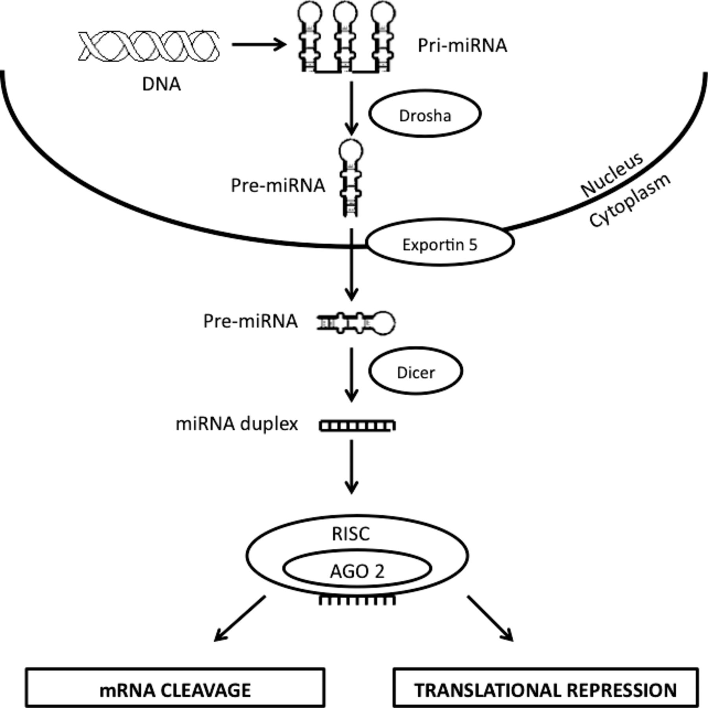
Figure I.1 miRNA biogenesis
The generation of miRNAs involves nuclear and cytoplasmic processing steps. In the nucleus, pri-miRNAs, transcribed by RNA polymerase from DNA, are processed by Drosha into pre-miRNAs that are then transported to cytoplasm via exportin 5. Once in the cytoplasm, these pre-miRNAs are recognized and cleaved by Dicer into 20 to 22 bp duplexes that enter RISC. In RISC, the passenger strand is cleaved while the guide strand directs RISC machinery to target mRNAs resulting in mRNA degradation or inhibition of protein translation.

CRITICAL ROLE OF MIR-155 IN HERPES SIMPLEX ENCEPHALITIS

Research described in this chapter is reproduced from a publication accepted in Journal of Immunology by Siddheshvar Bhela, Sachin Mulik, Pradeep B.J Reddy, Raphael L. Ricardson, Fernanda Gimenez, Naveen K Rajasagi, Tamara Veiga-Parga, Alexander P. Osmand, Barry T. Rouse.

Siddheshvar Bhela, Sachin Mulik, Pradeep B.J Reddy, Raphael L. Ricardson, Fernanda Gimenez, Naveen K Rajasagi, Tamara Veiga-Parga, Alexander P. Osmand, Barry T. Rouse. Critical role of miR-155 in herpes simplex encephalitis, J Immunol. 2014 Mar;192(6). Copyright © 2014 by The American Association of Immunologists, Inc.

Abstract
Herpes simplex virus (HSV) infection of adult humans occasionally results in life-threatening herpes simplex encephalitis (HSE) for reasons that remain to be defined. An animal system that could prove useful to model HSE could be miR-155 knockout mice (miR-155KO). Thus we observe that mice with a deficiency of miR-155 are highly susceptible to HSE with a majority of animals (75-80%) developing HSE after ocular infection with HSV-1. The lesions appeared to primarily represent the destructive consequences of viral replication and animals could be protected from HSE by acyclovir treatment provided 4 days after ocular infection. The miR-155KO animals were also more susceptible to develop zosteriform lesions, a reflection of viral replication and dissemination within the nervous system. One explanation for the heightened susceptibility to HSE and zosteriform lesions could be because miR-155KO animals develop diminished CD8 T cell responses when the numbers, functionality and homing capacity of effector CD8 T cell responses were compared. Indeed, adoptive transfer of HSV-immune CD8 T cells to infected miR-155KO mice at 24 hours post infection provided protection from HSE. Deficiencies in CD8 T cell numbers and function also explained the observation that miR-155KO animals were less able than control animals to maintain HSV latency. Our observations may be the first to link miR-155 expression with increased susceptibility of the nervous system to virus infection.

Introduction
Infections with herpes simplex virus (HSV) usually cause lesions at body surfaces such as the skin, mucosal surface and the eye. Characteristically, after primary infection HSV establishes a non-replicating persistent (latent) infection in neuronal tissue, which can break down periodically and give rise to recurrent lesions at primary lesion sites (1). A rare yet often tragic manifestation of HSV infection is dissemination to the brain with resultant herpes simplex encephalitis (HSE) (2). In adult humans HSE is usually caused by HSV-1 and can occur in persons whom are seropositive and latently infected with virus (2). Additionally, infants can develop encephalitis if seronegative and incur primary infection usually with HSV-2 (2). A rare form of HSE also occurs in children with genetic defects in innate immune defenses (3-5). Once virus enters the brain, the lesions that follow are considered to either be the consequence of viral replication in critical cells (3, 6) and/or be caused by an inflammatory response to the infection (7-9). Support for the latter ideas comes mainly from studies in rodents. For example, mild lesions occur in gene knockout animals that lack the expression of some innate immune receptors involved in causing inflammatory responses (7, 8). Further support for the inflammation hypothesis came from studies showing that whereas antiviral therapy had no effect on disease outcome inflammatory cell depletion markedly diminished HSE (9).Conceivably, the pathogenesis of herpes encephalitis could differ in the natural host from that studied in animal model systems.
MicroRNAs regulate gene expression post transcriptionally and are implicated in some immunoinflammatory diseases in humans and in various mouse models of human diseases (10, 11). For example, animals deficient in miR-155 are relatively resistant to develop autoimmune disease, such as EAE an animal model for the human disease multiple sclerosis (12, 13). MicroRNA-155 also plays a critical role in the pathogenesis of human rheumatoid arthritis with miR-155 being upregulated in the synovial membrane cells and assumed to function by promoting inflammatory cytokine production (14, 15). Mouse studies have indicated that miR-155 influences inflammatory disease by both promoting the expansion of pro-inflammatory Th1 and Th17 cells as well as amplifying effects on inflammatory gene expression in macrophages and T cells (12, 14).
Few studies have evaluated the role of miRNAs in the pathogenesis of virus infections. In the present report, we have evaluated the susceptibility of animals with a deficiency for miR-155 because of gene knockout to ocular and intradermal infection with HSV-1. We demonstrate that miR-155KO mice show heightened susceptibility to HSV ocular infection, with the majority of animals succumbing to HSE under conditions where wild type (WT) animals remained normal. miR-155KO mice were also markedly more susceptible than WT to develop zosteriform lesions upon intradermal infection, a lesion that reflects viral dissemination into the nervous system (16). Additionally, ganglionic latent infection with HSV-1 reactivated more abundantly from miR-155KO than WT latently infected ganglia upon ex-vivo culture. One explanation for the observations was that miR-155KO animals developed diminished virus specific CD8 T cell responses, particularly those that were functionally effective. Other mechanistic explanations were also discussed.

Materials and methods
Mice: Female 5-6wks old C57BL/6 mice were purchased from Harlan Sprague Dawley Inc. (Indianapolis, Indiana, USA). Breeder pair’s of miR-155KO mice on C57BL/6 background were obtained from Jackson laboratories (Bar Harbor, ME) and additional mice were bred in the Walters Life Sciences animal facility at the University of Tennessee, Knoxville. HSV-specific TCR transgenic mice (gBT-I.3- referred to in the text as gBT mice) were produced in the laboratory of Francis Carbone (University of Melbourne, Melbourne, Australia). The animals were housed in American Association of Laboratory Animal Care-approved facilities at the University of Tennessee, Knoxville. All investigations followed guidelines of the institutional animal care and use committee.

Virus: Three different strains of virus were used. HSV-1 Tumpey (obtained from Dr. Robert Lausch, University of South Alabama), HSV-1 RE (obtained from Dr. Robert Hendricks, University of Pittsburgh) and HSV-1 KOS (obtained from Dr. David Knipe, Harvard University) were used. All strains were propagated and titrated on monolayers of Vero cells (ATCC CCL81) using standard protocols. All virus stocks were aliquoted and stored at -80°C.

Infection of mice: Infections of all mice groups (5-8 week old) were conducted under deep anesthesia with avertin (Tribromoethanol). For corneal infection, the mice were scarified on their corneas with a 27-gauge needle, and a 3 µl drop containing 10⁴ PFU of HSV-1 Tumpey was applied to one eye and was used to monitor the development of encephalitis. In experiments involving HSV reactivation, mice were infected with 10⁵ PFU of HSV-RE for corneal infection. The zosterifrom infection was used in some of the experiments. The zosteriform infection was performed as described earlier (16). Briefly, hair was clipped on each left flank and depilated with Veet hair removal cream after anesthetizing the mice using avertin intraperitoneal injection. A small area of skin (1cm²) near the top of the spleen was scarified with a 27 gauge needle, and 20 μl of HSV-1 Tumpey containing 10⁶ PFU of virus was applied to hair-depleted area of the skin and massaged. Additionally, in some experiments HSV footpad model was used. Mice were injected subcutaneously in each hind footpad (FP) with 4x10⁵ PFU HSV-1 KOS in 30μl of phosphate-buffered saline (PBS). Mice were sacriﬁced at day 5 pi, and the PLN were isolated for analysis.

Adoptive transfer of HSV-immune CD8+ T cells
To generate HSV-immune CD8+ T cells, gBT mice were scarified on their corneas with a 27-gauge needle, and a 3µl drop containing 10⁴ PFU of HSV-1 Tumpey was applied to one eye. Single-cell suspensions of pooled spleens and popliteal lymph nodes were prepared from immunized mice 7–8 days later, and CD8+ T cells were purified using a mouse CD8 T cell isolation kit from miltenyl biotec. By flow cytometry analysis, the purified population consisted of 85% CD8+ T cells. Ocularly infected miR-155KO animals received an intra venous injection of 20 × 10⁶ purified cells at 24 hours pi.

Immunohistochemistry
Groups of miR-155KO mice and WT mice were ocularly infected with 10⁶ PFU of HSV-1 Tumpey and mice showing signs of encephalitis from each group (day 8 pi) were anesthetized with avertin and transcardially perfused with isotonic sucrose solution; sucrose perfusion was followed by perfusion with a solution of 4% paraformaldehyde (PFA). Post fixation of the brain samples were done by immersion of the skull in the same 4% PFA fixative for 1 day. After brain extraction from the skull, cryoprotection was done in 10% glycerol on day 1 and 20% glycerol on day 2. Mouse brains were embedded within a single gelatin matrix, freeze cut into 35μm coronal sections, and collected into 24 series (Neuroscience Associates Knoxville, TN). Each 12th section was then stained as free-floating section. High-sensitivity immunohistochemistry on multibrain sections was performed essentially following the protocol described by Osmand et al. and Hoffman et al. (17, 18) This involved treatment with sodium borohydride, blocking with 0.5% Triton X-100, and overnight incubation in a solution of primary antibody at a predetermined optimal concentration, followed by exposure to biotinylated species-specific secondary antibody and enzymatic detection using a 1:500 dilution of reagents A and B from the ABC Elite reagent (Vector Laboratories) and Ni–DAB–glucose-glucose oxidase (19). Sections were mounted and cover slipped without the use of counter stains.

Abs and reagents
APC-conjugated anti-mouse CD8a (53-6.7), FITC-conjugated anti-mouse TNF-α, allophycocyanin-conjugated anti-mouse IFN-γ, FITC-conjugated anti-mouse CD49d, FITC-conjugated anti-mouse CD44 and Golgi transport inhibitor (brefeldin A) were purchased from BD Biosciences. Allophycocyanin-conjugated and PE-conjugated H-2Kb/gB498–505 (SSIEFARL) tetramers were provided by the National Institutes of Health Tetramer Core Facility (Emory University, Atlanta, GA). Recombinant mouse Gal-9 was provided by GalPharma, Japan. CD8 T cell isolation kit was obtained from Miltenyi Biotec. Primary antibodies Rat Anti- Mouse CD8a and Rabbit Anti-Glial Fibrillary Acidic Protein (GFAP) for immunohistochmeistry staining were purchased from BD Biosceince and DAKO respectively. The secondary antibodies Donkey Anti-Rat IgG (H+L) and Donkey Anti Rabbit IgG (H+L) were purchased from Jackson Immunoresearch.

Preparation of TG single-cell suspensions
At 14 days after HSV-1 RE ocular infection, mice were anaesthetized and euthanized by exsanguinations (20). TGs were excised and subjected to collagenase type I treatment (Sigma-Aldrich, St. Louis, MO) at a concentration of 3 mg/ml for 90 min at 37°C. After incubation, the TGs were dispersed into single cells by trituration. Each single cell suspension was then plated in 48-well tissue culture plates. The cells were cultured in DMEM with 10% FCS and 10 U/ml recombinant murine IL-2 (R&D Systems) as described (20).

Ex vivo reactivation experiments
Each TG sample isolated from miR155KO mice was divided into 2 aliquots. One aliquot was left unmanipulated and the other aliquot received 1x10⁵ CD8 T cells isolated at day 8 pi from lymph nodes of HSV-1 infected WT mice. Similarly, each WT TG was divided into 2 aliquots and one aliquot was left unmanipulated whereas, the other aliquot received 1μM rGal-9 a procedure shown in a previous report to block CD8 T cell function and result in viral reactivation (21). TG cultures were incubated in DMEM in a 5% CO2 humidified incubator at 37°C for a 10 day period and culture supernatant samples were collected at 24-h intervals and assayed for infectious virus by plaque titrations on Vero cells. Gal-9 (1μM) and IL-2 (10U/ml) concentrations were constantly maintained throughout the culture period.

Flow Cytometry: Single-cell suspensions isolated from draining cervical lymph nodes, and TG samples of mice ocularly infected with HSV-1 were collected at different time points. Additionally in separate experiments were foot infection was used; PLN were isolated and made into single cell suspensions after HSV-1 footpad infection. Aliquots of the above single-cell suspensions were stained for CD8 and Kb-gB tetramer cell surface markers. To enumerate the functionality of CD8 T cell, intracellular staining was performed with freshly isolated DLN, PLN or TG suspensions from WT and miR-155KO mice. The cells were cultured in U-bottom 96-well plates and left untreated or stimulated with gB498–505 (SSIEFARL) peptide (1 μg/ml) and incubated for 6 h at 37°C in 5% CO². Brefeldin A (5μg/ml) was added for the duration of the culture period to facilitate intracellular cytokine accumulation. After this period, cell surface staining was performed, followed by intracellular cytokine staining using a Cytofix/Cytoperm kit (BD Pharmingen) to enumerate the number of IFN-γ and TNF-α producing CD8 T cells as previously described (22). Finally, the cells were washed three times and re-suspended in 1% para-formaldehyde. The stained samples were acquired with a FACS Calibur (BD Biosciences) and the data were analyzed using the FlowJo software.

Viral plaque assay: Virus titers were measured in the brain, TG and skin of HSV infected mice as described previously by others (9, 21, 23). Additionally, mouse corneas were swabbed with sterile swabs (Fisher HealthCare, USA) at 6 days after ocular infection. Virus titers in all samples were measured using standard plaque assay as described previously (24).

Statistics: Mortality data were analyzed by log-rank testing (taking into account both time of death and final mortality). The statistical significance between two groups was determined using unpaired two-tailed student's t test. One-way ANOVA with Bonferroni’s post hoc test was used to calculate the level of significance for some experiments. P ≤ 0.001 (***), P ≤ 0.01 (**), P ≤ 0.05 (*) were considered as significant and results are expressed as mean ± SEM. For all statistical analysis, GraphPad Prism software was used.

Results
Differential susceptibility of miR-155KO and WT mice to ocular infection with HSV
Upon ocular infection with HSV, mice develop a T cell orchestrated immnoinflammatory lesion in the cornea (stromal keratitis (SK)) and susceptible strains may succumb to encephalitis (25, 26). The latter outcome has also been advocated to represent an immunoinflammatory reaction to virus replication (8, 9). Since miR-155KO animals express higher resistance than WT animals to the induction of some immunoinflammatory diseases (12, 13), we anticipated that miR-155KO animals would be more refractory than WT animals to both SK and HSE. We did observe significantly heightened resistance to SK (these data will be documented in a separate manuscript), but unexpectedly miR-155KO animals were markedly more susceptible to HSE than were the WT animals. Thus under infectious conditions with a strain of HSV-1 virus which failed to cause detectable illness or symptoms of encephalitis in WT animals, 75-80% (in three separate experiments) of miR-155KO animals developed encephalitis and most had to be terminated by 9 days post infection (pi) (Figure 2.1A). By 6 days pi, affected animals became lethargic, lost weight, showed ruffled fur, hunched appearance and signs of incoordination. To cause encephalitis with the same virus strain in WT required a virus dose that was 1000 times greater, and then fewer than 20% developed encephalitis. Brains were collected from encephalitic miR-155KO animals, both to investigate pathological changes as well as to quantify levels of virus present. High virus levels of HSV were detectable in brain homogenates in all showing signs of encephalitis by day 9 pi, although none had detectable virus in ocular swabs at day 6 pi (Figure 2.1B and C). Virus could not be detected in the brains at day 9 pi or in the ocular tissue at day 6 pi in the WT animals when infected at the low virus dose that caused encephalitis in the miR-155KO animals (Figure 1C).
Brain sections from miR-155KO and WT animals examined 8 days pi and showing signs of encephalitis revealed differences in the nature of pathological changes. Thus the density of CD8 T cell infiltration in the posterior temporal lobe was notably more abundant in the WT animals than in the miR-155KO animals (Figure 2.2A). There was also marked differences in the extent of astrocytosis indicative of inflammatory reactions to infection with the response more abundant in WT animals (Figure 2.2B).
The above observations are consistent with the viewpoint that the CNS damage in the miR-155KO animals was likely the consequence of the direct effects of virus infection rather than an immunopathological response to infection. Further support for this notion also came from experiments, which showed that ocularly infected miR-155KO animals could be protected from developing encephalitis if treated with acyclovir starting at 4 days pi (Figure 2.3A and B). Moreover animals killed 5 days after treatment expressed minimal levels of virus in brain extracts compared to untreated animals (Figure 2.3C). In separate experiments we could recover infectious virus from the brains of both miR-155KO and WT mice one day before acyclovir treatment. However, higher viral titers were evident at day 4 pi in the miR-155KO animals (Figure 2.3D).
Our results are consistent with the notion that miR-155KO animals succumb to encephalitis with lesions in the brains likely the direct consequence of viral infection rather than representing the result of an inflammation reaction to infection, as some advocate accounts for encephalitis in WT mice (9).

miR-155 is required for optimal CD8 T cell responses
To investigate whether or not miR-155 influences the nature of HSV-1 specific CD8 T cell responses, miR-155KO and WT mice were infected intradermally in the hind footpads with HSV-1 strain KOS and effector CD8 T cell responses were measured in the draining popliteal lymph nodes (PLN) at day 5 pi when responses are at their peak (27, 28). The results show that the total numbers of HSV gB tetramer specific CD8 T cells per lymph node were significantly reduced (~3 fold) in miR-155KO mice compared to WT control animals (Figure 2.4A). We also investigated the homing capacity of CD8 T cells in the miR-155KO animals. Analyzing expression of the homing molecules VLA-4 and CD44, we found ~1.5-3 fold reduced expression in the infected miR-155KO animals compared to the WT animals (Figure 2.4B and C). Additionally, no differences were evident in the expression of the homing molecule LFA-1 between the infected WT and miR-155KO animals (data not shown). When cell numbers were compared using the intracellular cytokine staining (ICS) assay to detect virus specific IFN-γ producing cells, differences between miR-155KO and WT responses were of even greater magnitude (average of 5 fold) (Figure 2.4D). As an additional measure of functional responses, numbers of CD8 T cells that produced both IFN-γ and TNF-α or a single cytokine alone were compared in the two groups. This approach revealed that dual cytokine producing CD8 T cells were reduced ~10 fold in miR-155KO compared to WT (Figure 2.4E), a result we take to indicate that the CD8 virus specific response in miR-155KO mice was functionally impaired. In additional experiments this trend was also seen in the DLN at day 9 after ocular infection with the HSV-1 strain that caused encephalitis in miR-155KO mice (data not shown).
In separate experiments, WT and miR-155KO mice were infected with another strain of HSV-1 (HSV-1 RE) that did not cause HSE in miR-155KO mice. In such experiments, trigeminal ganglia (TG) were collected 14 days pi and processed either for viral reactivation experiments (described in a subsequent section) or to recover T cells to measure virus specific CD8 T cell responses by using both tetramer and the ICS assay to quantify cytokine producers. The total numbers of gB tetramer specific CD8 T cells were ~2 fold higher in WT compared to miR-155KO mice (Figure 2.5A). The number of total CD8 T cells that produced IFN-γ in the WT group was ~4 fold higher compared with miR-155KO animals. Additionally, the dual cytokine (IFN-γ and TNF-α)-producing cells were ~4.5 fold more frequent in WT mice as compared with miR-155KO mice (Figure 2.5B and C).
Taken together the above data demonstrate that the absence of miR155 results in diminished CD8 T cell response, which is particularly evident when using assays that measure numbers of functional CD8 T cells.

HSV-immune CD8+ T cells from gBT mice protect miR-155O animals from lethal herpetic encephalitis
To see if the reduced number and function of CD8 T cells is one of the reasons for HSE, we carried out adoptive transfer experiments. Infected miR-155KO mice were given HSV-immune CD8+ T cell transfers from gBT mice at 24h pi, and recipients were monitored clinically over the next 9 days. 80% of the miR-155KO mice succumbed to death by day 9 pi, however 100% of the miR-155KO mice that received HSV-immune CD8 T cells at 24h pi survived (Figure 2.6A). Animals were subsequently sacrificed at day 9 pi and brains were collected to quantify levels of virus present. High virus levels were detectable in the brain homogenates in all miR-155KO animals showing signs of encephalitis by day 9 pi, although none had detectable virus in the group of animals that received CD8 T cell adoptive transfers (Figure 2.6B).

Virus reactivation differences between latently infected miR-155KO and WT mice
In additional experiments, WT and miR-155KO mice were infected with a strain of HSV-1 (HSV-1RE) that did not cause HSE in KO mice. In such experiments TG were collected 14 days pi and processed to induce viral reactivation ex vivo (20, 21). In these experiments, multiple TG cultures from individual miR-155KO and WT infected mice were established 14 days pi and aliquots were exposed to different treatments. The culture supernatants were tested daily to detect infectious virus over a 10 day period. Unmanipulated cultures revealed differences in the viral reactivation pattern between miR-155KO and WT TG. Whereas ~15% of WT cultures showed reactivation, ~ 90% of the miR-155KO cultures reactivated (Figure 2.7). Infectious virus was detectable in the miR-155KO culture supernatants by day 2 post culture but not until day 3 in the WT cultures that reactivated. Although the majority of WT cultures did not reactivate all were judged to be latently infected since the addition of 1mM rGal-9 (a procedure shown previously to cause ex-vivo reactivation (21)) caused virus reactivation in all cultures (Figure 2.7).
With the miR-155KO cultures CD8 T cells isolated from the lymph nodes of WT HSV infected mice were added to culture aliquots to determine the effect on virus reactivation. This procedure prevented virus reactivation in all cultures (Figure 2.7). Accordingly, our results demonstrate that viral reactivation from latency occurs far more readily with cultures from miR-155KO animals than WT and this observation might be attributed at least in part to differences in CD8 T cell function.

Differential susceptibility of miR-155KO and WT mice to intradermal infection with HSV
Animals infected in the scarified skin with HSV develop so called zosteriform skin lesions which as first demonstrated by Nash and colleagues, reflect the consequence of viral entrance into sensory nerve endings followed by viral replication in the dorsal root ganglia and subsequent spread to the dermatome (16). When groups of WT and mir-155KO were infected intra-dermally with identical viral dosage of HSV, the outcome was significantly different in the development of zosteriform lesions. Thus a greater proportion of miR-155KO mice developed lesions compared to WT mice. By day 6 pi, 100 % of the miR-155KO mice had developed lesions compared to only 25 % in the WT mice. In addition, miR-155KO mice exhibited lesions that were far larger in size than in those in WT that developed lesions (Figure 2.8A). In addition whereas, by day 7 pi, the majority of the miR-155KO mice developed hind limb paralysis all of the WT mice remained free from any neurological signs (Figure 2.8B). In some experiments, test mice were terminated at day 6 pi and virus levels were assayed in the skin encompassing the inoculation site as well as in the brain. In such experiments, it was only possible to detect virus in the brains and skin isolated from miR-155KO animals (Figure 2.8C and D). Thus our results demonstrate a marked increase in susceptibility of miR-155KO to HSV infection in a model that reflects spread within the nervous system.

Discussion
Herpes simplex virus infection usually causes lesions at body surface sites but occasionally the virus spreads to the brain inducing life threatening encephalitis (2). We show in this report that mice unable to produce miR-155 may develop HSE following ocular infection with the lesion primarily the direct consequence of virus replication in the CNS. Affected animals could be protected from HSE by acyclovir treatment commenced 4 days after infection and pathological features in the CNS were consistent with direct viral destructive effects. miR-155KO animals were also more susceptible to develop zosteriform lesions, a reflection of viral replication and dissemination within the nervous system. One explanation for the heightened susceptibility to HSE and zosteriform lesions could be because miR-155KO animals develop diminished CD8 T cell responses especially when the numbers of functional effector CD8 T cell responses were compared. Indeed, adoptive transfer of HSV-immune CD8 T cells into infected miR-155KO mice provided protection from HSE. Deficiencies in CD8 T cell numbers, function and homing capacity may also explain the observation that miR-155KO animals were less able than WT animals to maintain latency upon ex-vivo culture. Our observations may be the first to link miR-155 expression with susceptibility of the nervous system to virus infection.
HSE is a rare manifestation of HSV infection and can be a devastating disease especially if not treated promptly (2). Most cases in adult humans are caused by HSV-1 and these usually occur in latently infected persons whose previous clinical consequences of infection were either not observed, or were only mild surface lesions. Little is understood regarding the triggers that cause reactivated virus to traffic to the brain or the pathogenic mechanisms involved at causing the brain damage. Occasional cases of human HSE can occur in children with genetic defects in TLR3 dependent interferon responses (3-5), but in the great majority of HSE cases genetic defects in immune function have not been demonstrated (2). Moreover, even profound immunosuppression, as can occur during AIDS or immunosuppressive therapy, very rarely results in HSE. In HSE in humans, encephalitis appears to be largely the consequence of virus replicating in and destroying cells, an idea supported by the success that can be achieved using antiviral drug therapy (2). However, others advocate that an inflammatory reaction to the brain infection can also contribute or perhaps be mainly responsible for the encephalitis (9). Enthusiasm for the later idea has mainly come from experimental studies in mice where innate immune signaling dependent activation of PMN and macrophages and the production of inflammatory mediators in response to HSV were shown necessary for the development of fulminate lesions of encephalitis (7, 8). Other studies indicate that encephalitis in susceptible mouse strains may represent an immunopathological response since it fails to respond to antiviral therapy but is controllable by procedures that diminish inflammatory cells (9). More than likely, the pathogenesis of HSE involves multiple mechanisms with studies in mice not accurately reflecting the pathogenesis of the natural human disease. We advocate, however that the miR-155KO mice could represent a more appropriate model than other mouse systems to understand the pathogenesis of human HSE and to evaluate novel therapies. Accordingly, the encephalitis in miR-155KO animals appeared to represent primarily the consequences of viral replication events. Thus the disease was readily controllable with antiviral therapy even when this was begun 4 days pi, a time point when HSV was readily detectable in the brains of miR-155KO animals and presumably could be inducing an inflammatory response. Immunohistochemical analysis of brain lesions of miR-155KO animals revealed lesser T cell inflammatory infiltrates in affected areas along with less reactive astrocytosis as compared to WT animals with encephalitis. We interpret this to mean that the nature of lesions in miR-155KO animals are less immunoinflammatory than those in the WT animals.
We suspect that one reason miR-155KO animals readily developed HSE was because of their reduced virus specific T cell responses to infection. Another might relate to the role that miR-155 could play in susceptibility of neural tissue to HSV infection (discussed subsequently). It is well known that the CD8 T cell response plays a critical role in protecting both the CNS and peripheral nervous tissues (PNS) from HSV infection (20, 29, 30). Particularly strong evidence for the protective effects of CD8 T cells in the PNS has come from the Hendricks and Carbone laboratories (20, 23, 31). In addition, our own past studies showed how CD8 T cells are needed to protect the CNS (29). The present observations showed that miR-155KO mice had significantly diminished virus specific CD8 T cell responses, especially when numbers of functionally competent CD8 T cells were compared where differences could be as much as 10 fold. This is consistent with the recent observations made by other groups who noted compromised CD8 T cell responses in miR-155KO animals in response to LCMV and influenza virus infection, as well as in some tumor models (32-35). Additionally, it is conceivable that brain homing capacity of CD8 T cells differed between KO and WT animals. In support of this we could show that KO CD8 T cells showed diminished levels of VLA-4 and CD44 both shown in other systems to influence brain homing of T cells (36, 37). We suspect that the diminished protective CD8 T cell response permitted virus to traffic effectively to the brain and PNS and that once there fewer protective CD8 T cells were around to abort infection. This is consistent with the previous reports showing that CD8 deficient animals failed to control HSV in the brain and developed encephalitis (30). This argument was also supported by the adoptive transfer experiments where HSV immune CD8 T cells adoptively transferred to miR-155KO mice were shown to be fully protective. However further experiments are needed to clarify if the apparent defect in miR-155KO CD8 T cells is a problem with priming, effector cytokine production, homing defects or additional events such as the numbers of cells that can access the nervous system. Furthermore although we favor the idea that differences in CD8 T cell activity accounted for the difference in outcome in miR-155KO and WT mice other explanations merit exploration such as differences in NK cell homeostasis or levels of interferon induced which have both been implicated as providing protection in herpetic encephalitis (7, 38-40).
A diminished protective CD8 response in miR-155KO animals was also demonstrated using two models that reflect the activity of CD8 T cells. First in a food pad infection model we could show that miR-155KO animals generated lesser numbers of HSV specific CD8 T cells than WT animals in draining lymph nodes which was especially evident when IFN-γ producing cell responses were compared. CD8 T cells are required to contain HSV replication in ganglia and they orchestrate this response largely by IFN-γ production and the release of granzyme B in HSV infected neurons (20, 41, 42). In studies reported herein, we could show that ganglionic virus specific CD8 T cells were diminished and less polycytokine producers in miR-155KO animals compared to WT which might account for their more rapid and abundant reactivation.
In addition to encephalitis we also observed that miR-155KO mice were more susceptible than the WT animals to develop zosteriform lesions, an event that requires dissemination of virus within the nervous system (16). Accordingly, with doses of virus that produced barely noticeable lesions in WT, almost all miR-155KO animals developed overt lesions and many had to be killed because of hind limb paralysis. The miR-155KO animals failed to control HSV and virus was easily detectable in the brains of miR-155KO animals, but could not be demonstrated in the brains of WT animals.
Currently it is not clear how miR-155 influences the magnitude and functionality of CD8 T cell responses, but there are several possibilities. Firstly it might result from the fact that miR-155KO mice also generate impaired helper T cell responses (12, 13), and optimum CD8 T cell responses are known to require signals from CD4 helper T cells (43, 44). It is also conceivable that miR-155 plays a direct role during CD8 T cell differentiation. Thus some have observed that in the absence of miR-155 type 1 interferon driven proliferative responses of CD8 T cell are defective (33, 34) while others suggest that CD8 T cells survive less well and show defective responses to PI3K/AKT signaling (34). It has also been suggested that in the absence of miR-155, SOCS1 is upregulated which expresses suppressive effects on T cell function (32). Further studies are clearly needed to clarify how miR-155 expression influences the CD8 T cell response.
Our results also raise the issue as to whether miR-155 expression somehow influences the dissemination of HSV to and replication within the nervous system. Thus miRNAs could influence expression of proteins involved in axon transport but this point has not been investigated to our knowledge. Alternatively miRNAs could influence the infectivity and replication efficiency in target cells within the nervous system. It is known for example that miR-155 regulates microglia immune responses by targeting SOCS-1 and promoting cytokine and nitric oxide production (45, 46). So it is conceivable that the glial cells in miR-155KO mice could be defective in cytokine and nitric oxide production, a possibility we are currently investigating. We are also investigating if different cell types taken from miR-155KO and WT mice show differential susceptibility to HSV replication events.
In conclusion our report makes the novel observation that deficiency of a single species of miRNA can result in enhanced susceptibility of the nervous system to a virus infection. Our observations lead us to wonder if miRNA defects could be involved in some cases of human HSE. Moreover, it is also curious to note that glucocorticoids which are upregulated during stressful situations that cause herpes reactivation may selectively inhibit miR-155 expression (10, 47). Thus the relationship of miR-155 expression to changing events in HSV pathogenesis merits further investigation.

Acknowledgments: We thank Ujjaldeep Jaggi, Pranay Dogra, Sujata Agarwal, and Nancy Nielsen for assistance during research and manuscript preparation. We also thank H. Penny McWilliams-Koeppen in helping us with immunohistochemistry staining.
Mulik S is currently at Immune Disease Institute and Program in Cellular and Molecular Medicine, Children’s Hospital Boston, Harvard Medical School, Boston, Massachusetts, USA

LIST OF REFERENCES
1. Roizman, B., D.M. Knipe and R. Whitley. 2007. "Herpes Simplex Viruses" In: Fields Virology, Fifth Edition, D.M. Knipe, P.M. Howley et al., eds., Lippincott, Williams & Wilkins, Philadelphia, PA, pp. 2501-601.
2. Whitley, R. J. 2006. Herpes simplex encephalitis: adolescents and adults. Antiviral Res 71: 141-148.
3. Zhang, S. Y., E. Jouanguy, S. Ugolini, A. Smahi, G. Elain, P. Romero, D. Segal, V. Sancho-Shimizu, L. Lorenzo, A. Puel, C. Picard, A. Chapgier, S. Plancoulaine, M. Titeux, C. Cognet, H. von Bernuth, C. L. Ku, A. Casrouge, X. X. Zhang, L. Barreiro, J. Leonard, C. Hamilton, P. Lebon, B. Héron, L. Vallée, L. Quintana-Murci, A. Hovnanian, F. Rozenberg, E. Vivier, F. Geissmann, M. Tardieu, L. Abel, and J. L. Casanova. 2007. TLR3 deficiency in patients with herpes simplex encephalitis. Science 317: 1522-1527.
4. Guo, Y., M. Audry, M. Ciancanelli, L. Alsina, J. Azevedo, M. Herman, E. Anguiano, V. Sancho-Shimizu, L. Lorenzo, E. Pauwels, P. B. Philippe, R. Pérez de Diego, A. Cardon, G. Vogt, C. Picard, Z. Z. Andrianirina, F. Rozenberg, P. Lebon, S. Plancoulaine, M. Tardieu, Valérie Doireau, E. Jouanguy, D. Chaussabel, F. Geissmann, L. Abel, J. L. Casanova, and S. Y. Zhang. 2011. Herpes simplex virus encephalitis in a patient with complete TLR3 deficiency: TLR3 is otherwise redundant in protective immunity. J Exp Med 208: 2083-2098.
5. Zhang, S. Y., M. Herman, M. J. Ciancanelli, R. Pérez de Diego, V. Sancho-Shimizu, L. Abel, and J. L. Casanova. 2013. TLR3 immunity to infection in mice and humans. Curr Opin Immunol 25: 19-33.
6. Whitley R. J. (1990) Herpes simplex viruses. in Fields virology. eds Fields B. N., K. D. M., Howley P. M. (Lippenscott-Raven, Philadelphia, Pa), pp 1843–1845.
7. Wang, J. P., G. N. Bowen, S. Zhou, A. Cerny, A. Zacharia, D. M. Knipe, R. W. Finberg, and E. A. Kurt-Jones. 2012. Role of specific innate immune responses in herpes simplex virus infection of the central nervous system. J Virol 86: 2273-2281.
8. Kurt-Jones, E. A., M. Chan, S. Zhou, J. Wang, G. Reed, R. Bronson, M. M. Arnold, D. M. Knipe, and R. W. Finberg. 2004. Herpes simplex virus 1 interaction with Toll-like receptor 2 contributes to lethal encephalitis. Proc Natl Acad Sci U S A 101: 1315-1320.
9. Lundberg, P., C. Ramakrishna, J. Brown, J. M. Tyszka, M. Hamamura, D. R. Hinton, S. Kovats, O. Nalcioglu, K. Weinberg, H. Openshaw, and E. M. Cantin. 2008. The immune response to herpes simplex virus type 1 infection in susceptible mice is a major cause of central nervous system pathology resulting in fatal encephalitis. J Virol 82: 7078-7088.
10. Mulik, S., S. Bhela, and B. T. Rouse. 2013. Potential function of miRNAs in herpetic stromal keratitis. Invest Ophthalmol Vis Sci 54: 563-573.
11. O'Connell, R. M., D. S. Rao, and D. Baltimore. 2012. microRNA regulation of inflammatory responses. Annu Rev Immunol 30: 295-312.
12. O'Connell, R. M., D. Kahn, W. S. Gibson, J. L. Round, R. L. Scholz, A. A. Chaudhuri, M. E. Kahn, D. S. Rao, and D. Baltimore. 2010. MicroRNA-155 promotes autoimmune inflammation by enhancing inflammatory T cell development. Immunity 33: 607-619.
13. Murugaiyan, G., V. Beynon, A. Mittal, N. Joller, and H. L. Weiner. 2011. Silencing microRNA-155 ameliorates experimental autoimmune encephalomyelitis. J Immunol 187: 2213-2221.
14. Kurowska-Stolarska, M., S. Alivernini, L. E. Ballantine, D. L. Asquith, N. L. Millar, D. S. Gilchrist, J. Reilly, M. Ierna, A. R. Fraser, B. Stolarski, C. McSharry, A. J. Hueber, D. Baxter, J. Hunter, S. Gay, F. Y. Liew, and I. B. McInnes. 2011. MicroRNA-155 as a proinflammatory regulator in clinical and experimental arthritis. Proc Natl Acad Sci U S A 108: 11193-11198.
15. Blüml, S., M. Bonelli, B. Niederreiter, A. Puchner, G. Mayr, S. Hayer, M. I. Koenders, W. B. van den Berg, J. Smolen, and K. Redlich. 2011. Essential role of microRNA-155 in the pathogenesis of autoimmune arthritis in mice. Arthritis Rheum 63: 1281-1288.
16. Simmons, A., and A. A. Nash. 1984. Zosteriform spread of herpes simplex virus as a model of recrudescence and its use to investigate the role of immune cells in prevention of recurrent disease. J Virol 52: 816-821.
17. Osmand, A. P., V. Berthelier, and R. Wetzel. 2006. Imaging polyglutamine deposits in brain tissue. Methods Enzymol 412: 106-122.
18. Hoffman, G. E., W. W. Le, and L. V. Sita. 2008. The importance of titrating antibodies for immunocytochemical methods. Curr Protoc Neurosci Chapter 2: Unit 2.12.
19. Llewellyn-Smith IJ, M. J., Pilowsky PM. Retrograde tracing with cholera toxin B-gold or with immunocytochemically detected cholera toxin B in central nervous system. In Methods in Neurosciences, Academic Press, San Diego, Vol. 8., 180-201 (1992).
20. Liu, T., K. M. Khanna, X. Chen, D. J. Fink, and R. L. Hendricks. 2000. CD8(+) T cells can block herpes simplex virus type 1 (HSV-1) reactivation from latency in sensory neurons. J Exp Med 191: 1459-1466.
21. Reddy, P. B., S. Sehrawat, A. Suryawanshi, N. K. Rajasagi, S. Mulik, M. Hirashima, and B. T. Rouse. 2011. Influence of galectin-9/Tim-3 interaction on herpes simplex virus-1 latency. J Immunol 187: 5745-5755.
22. Sehrawat, S., P. B. Reddy, N. Rajasagi, A. Suryawanshi, M. Hirashima, and B. T. Rouse. 2010. Galectin-9/TIM-3 interaction regulates virus-specific primary and memory CD8 T cell response. PLoS Pathog 6: e1000882.
23. van Lint, A., M. Ayers, A. G. Brooks, R. M. Coles, W. R. Heath, and F. R. Carbone. 2004. Herpes simplex virus-specific CD8+ T cells can clear established lytic infections from skin and nerves and can partially limit the early spread of virus after cutaneous inoculation. J Immunol 172: 392-397.
24. Mulik, S., J. Xu, P. B. Reddy, N. K. Rajasagi, F. Gimenez, S. Sharma, P. Y. Lu, and B. T. Rouse. 2012. Role of miR-132 in angiogenesis after ocular infection with herpes simplex virus. Am J Pathol 181: 525-534.
25. Lopez, C. 1975. Genetics of natural resistance to herpesvirus infections in mice. Nature 258: 152-153.
26. Biswas, P. S., and B. T. Rouse. 2005. Early events in HSV keratitis--setting the stage for a blinding disease. Microbes Infect 7: 799-810.
27. Coles, R. M., S. N. Mueller, W. R. Heath, F. R. Carbone, and A. G. Brooks. 2002. Progression of armed CTL from draining lymph node to spleen shortly after localized infection with herpes simplex virus 1. J Immunol 168: 834-838.
28. Pfizenmaier, K., H. Jung, A. Starzinski-Powitz, M. Röllinghoff, and H. Wagner. 1977. The role of T cells in anti-herpes simplex virus immunity. I. Induction of antigen-specific cytotoxic T lymphocytes. J Immunol 119: 939-944.
29. Banerjee, K., P. S. Biswas, U. Kumaraguru, S. P. Schoenberger, and B. T. Rouse. 2004. Protective and pathological roles of virus-specific and bystander CD8+ T cells in herpetic stromal keratitis. J Immunol 173: 7575-7583.
30. Lang, A., and J. Nikolich-Zugich. 2005. Development and migration of protective CD8+ T cells into the nervous system following ocular herpes simplex virus-1 infection. J Immunol 174: 2919-2925.
31. Gebhardt, T., P. G. Whitney, A. Zaid, L. K. Mackay, A. G. Brooks, W. R. Heath, F. R. Carbone, and S. N. Mueller. 2011. Different patterns of peripheral migration by memory CD4+ and CD8+ T cells. Nature 477: 216-219.
32. Dudda, J. C., B. Salaun, Y. Ji, D. C. Palmer, G. C. Monnot, E. Merck, C. Boudousquie, D. T. Utzschneider, T. M. Escobar, R. Perret, S. A. Muljo, M. Hebeisen, N. Rufer, D. Zehn, A. Donda, N. P. Restifo, W. Held, L. Gattinoni, and P. Romero. 2013. MicroRNA-155 is required for effector CD8+ T cell responses to virus infection and cancer. Immunity 38: 742-753.
33. Gracias, D. T., E. Stelekati, J. L. Hope, A. C. Boesteanu, T. A. Doering, J. Norton, Y. M. Mueller, J. A. Fraietta, E. J. Wherry, M. Turner, and P. D. Katsikis. 2013. The microRNA miR-155 controls CD8(+) T cell responses by regulating interferon signaling. Nat Immunol 14: 593-602.
34. Lind, E. F., A. R. Elford, and P. S. Ohashi. 2013. Micro-RNA 155 is required for optimal CD8+ T cell responses to acute viral and intracellular bacterial challenges. J Immunol 190: 1210-1216.
35. Huffaker, T. B., R. Hu, M. C. Runtsch, E. Bake, X. Chen, J. Zhao, J. L. Round, D. Baltimore, and R. M. O'Connell. 2012. Epistasis between microRNAs 155 and 146a during T cell-mediated antitumor immunity. Cell Rep 2: 1697-1709.
36. Brocke, S., C. Piercy, L. Steinman, I. L. Weissman, and T. Veromaa. 1999. Antibodies to CD44 and integrin alpha4, but not L-selectin, prevent central nervous system inflammation and experimental encephalomyelitis by blocking secondary leukocyte recruitment. Proc Natl Acad Sci U S A 96: 6896-6901.
37. Irani, D. N., and D. E. Griffin. 1996. Regulation of lymphocyte homing into the brain during viral encephalitis at various stages of infection. J Immunol 156: 3850-3857.
38. Adler, H., J. L. Beland, N. C. Del-Pan, L. Kobzik, R. A. Sobel, and I. J. Rimm. 1999. In the absence of T cells, natural killer cells protect from mortality due to HSV-1 encephalitis. J Neuroimmunol 93: 208-213.
39. Wang, P., J. Hou, L. Lin, C. Wang, X. Liu, D. Li, F. Ma, Z. Wang, and X. Cao. 2010. Inducible microRNA-155 feedback promotes type I IFN signaling in antiviral innate immunity by targeting suppressor of cytokine signaling 1. J Immunol 185: 6226-6233.
40. Zawislak, C. L., A. M. Beaulieu, G. B. Loeb, J. Karo, D. Canner, N. A. Bezman, L. L. Lanier, A. Y. Rudensky, and J. C. Sun. 2013. Stage-specific regulation of natural killer cell homeostasis and response against viral infection by microRNA-155. Proc Natl Acad Sci U S A 110: 6967-6972.
41. Knickelbein, J. E., K. M. Khanna, M. B. Yee, C. J. Baty, P. R. Kinchington, and R. L. Hendricks. 2008. Noncytotoxic lytic granule-mediated CD8+ T cell inhibition of HSV-1 reactivation from neuronal latency. Science 322: 268-271.
42. Decman, V., P. R. Kinchington, S. A. Harvey, and R. L. Hendricks. 2005. Gamma interferon can block herpes simplex virus type 1 reactivation from latency, even in the presence of late gene expression. J Virol 79: 10339-10347.
43. Rajasagi, N. K., S. H. Kassim, C. M. Kollias, X. Zhao, R. Chervenak, and S. R. Jennings. 2009. CD4+ T cells are required for the priming of CD8+ T cells following infection with herpes simplex virus type 1. J Virol 83: 5256-5268.
44. Nakanishi, Y., B. Lu, C. Gerard, and A. Iwasaki. 2009. CD8(+) T lymphocyte mobilization to virus-infected tissue requires CD4(+) T-cell help. Nature 462: 510-513.
45. Cardoso, A. L., J. R. Guedes, L. Pereira de Almeida, and M. C. Pedroso de Lima. 2012. miR-155 modulates microglia-mediated immune response by down-regulating SOCS-1 and promoting cytokine and nitric oxide production. Immunology 135: 73-88.
46. Ponomarev, E. D., T. Veremeyko, and H. L. Weiner. 2013. MicroRNAs are universal regulators of differentiation, activation, and polarization of microglia and macrophages in normal and diseased CNS. Glia 61: 91-103.
47. Zheng, Y., S. Xiong, P. Jiang, R. Liu, X. Liu, J. Qian, X. Zheng, and Y. Chu. 2012. Glucocorticoids inhibit lipopolysaccharide-mediated inflammatory response by downregulating microRNA-155: a novel anti-inflammation mechanism. Free Radic Biol Med 52: 1307-1317.

APPENDIX

Figure II.1 miR-155KO mice are highly susceptible to encephalitis after HSV-1 infection and have elevated viral titers in the brain but no difference in the cornea
Groups of WT and miR-155KO (KO) animals were ocularly infected with 1x10⁴ HSV-1 Tumpey. (A) Survival of age matched WT and miR-155 KO was established over 9 days. (B) Brains were harvested from WT and miR-155 KO mice at day 9 pi. Brains were homogenized and centrifuged, and supernatants were tested for virus titers. (C) The presence of virus in the cornea was measured at day 6 pi by swabbing the HSV infected eye with a sterile swab and assaying for the virus by plaque assay. The level of significance was determined by a Student t test (unpaired). Error bars represent means ± SEM (n = 5–8 mice/group). Experiments were repeated at least three times. *p ≤ 0.05, **p ≤ 0.005, ***p ≤ 0.001.

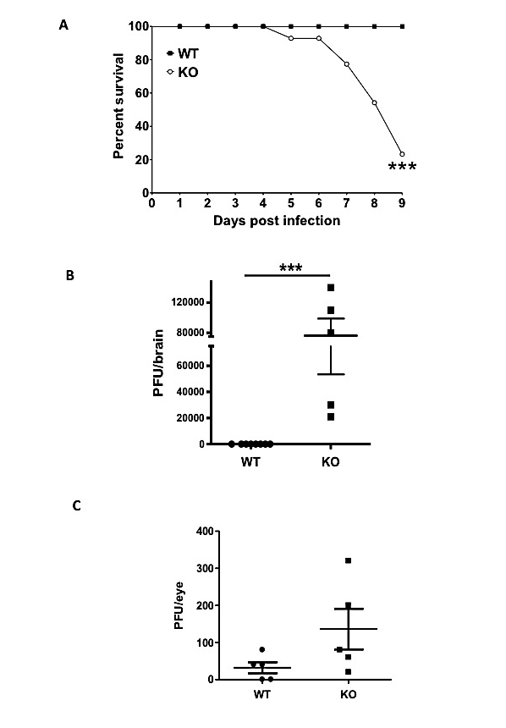

Figure 2.1
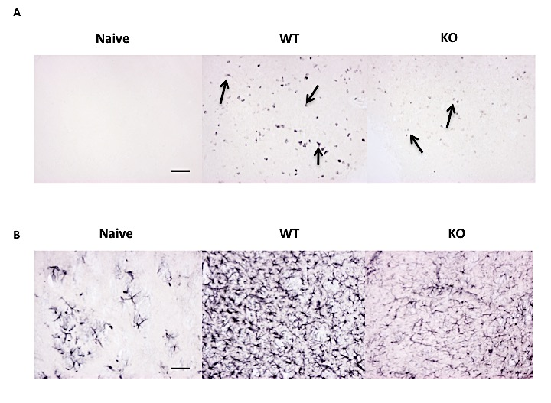
Figure II.2 Infiltration of CD8 T cells and astrocytosis by immunohistochemistry of HSV-infected WT and miR-155KO mice.
Brains were collected from WT and miR-155KO mice that showed signs of encephalitis after ocular infection with 1x10⁶ HSV-1 Tumpey at day 8 pi. Brains were embedded in gelatin and sections were stained with different antibodies. (A) Posterior temporal lobe staining of naïve (Left) infected WT (center) and infected miR-155KO (right) mice for CD8 T cells (black arrows) (15.03 ± 4.713 arbitrary units, p≤ 0.05) (B) Striatum staining of naïve (left) and infected WT (center) and infected miR-155KO (right) mice for astrocytes (39.10 ± 7.804 arbitrary units, p≤ 0.005). The figure shows the pictures of the sections taken at 20X magnification. Bar = 50μ. Statistical analysis was performed by gray scaling and inverting the images and then calculating the staining intensities using Photoshop. Statistical significance was determined by a Student t test (unpaired). (n = 3–4 mice/group).
Figure II.3 Viral replication in the brain is the cause of encephalitis in the miR-155 KO mice.
(A) WT and miR-155KO mice ocularly infected with 10⁴ PFU HSV-1 Tumpey were either given 1mg acyclovir or vehicle intraperitonealy (i.p.) daily starting day 4 pi until day 8 pi. (B) Survival for all the groups of mice was established over a 9 day period. (C) Brains were harvested and homogenized from these different groups of mice at day 9 pi and the supernatants were measured for virus titer. (D) In separate experiments WT and miR-155KO mice were ocularly infected with 10⁴ PFU HSV-1 Tumpey and brains were harvested and homogenized at days 1,2,3 and 4 pi and supernatants were measured for virus titer. Data are representative of three independent experiments and show mean values ± SEM (n = 4-8mice/group). Statistical levels of significance were analyzed by one-way ANOVA test with Tukeys post test settings. *p ≤ 0.05 , **p ≤ 0.005, ***p ≤ 0.001

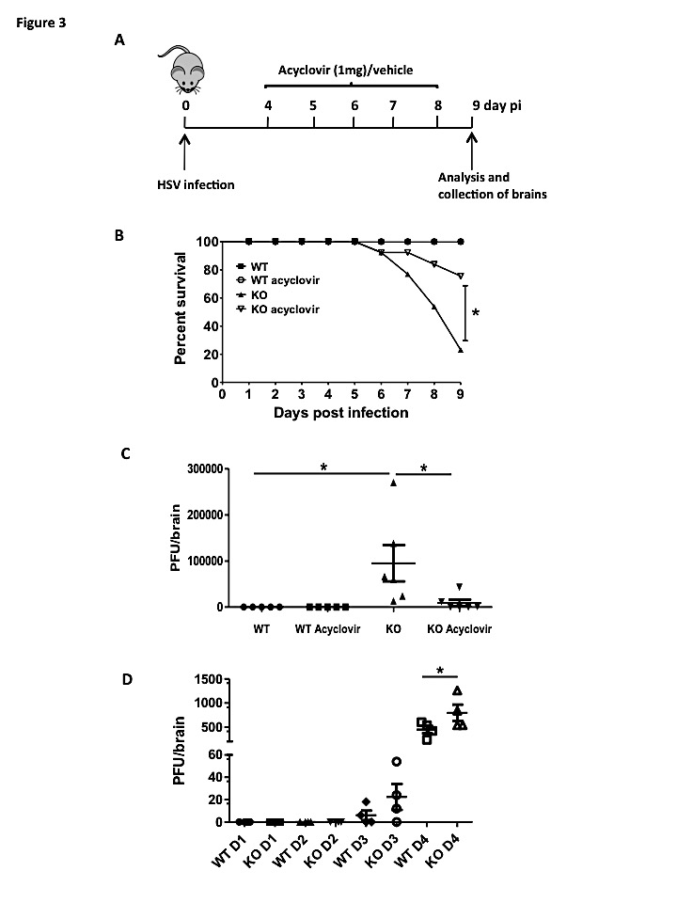

Figure 2.3
Figure II.4 miR-155 KO mice mount weaker CD8 T cell responses compared to WT mice after HSV-1 footpad infection.
Groups of wild type (WT) and miR-155KO (KO) animals were infected in the hind footpads with HSV-1 strain KOS. PLN were collected at day 5 pi and aliquots of single-cell suspensions were stained for cell surface markers CD8 and Kb-gB tetramer (A) Representative FACS plots, frequencies and numbers of tetramer specific CD8 T cells in WT versus miR-155KO mice. To measure Kb-gB tetramer specific CD8 T cell responses aliquots of single cell suspension of PLN’s were stimulated for 6 hours with HSV-1 gB peptide in the presence of brefeldin A. After stimulation the cells were stained for the surface marker CD8 and cytokines IFN-γ and TNF-α. (B) Representative FACS plots, frequencies and numbers depicting IFN-y producing CD8 T cells and (C) IFN-γ and TNF-α double producing CD8 T cells in WT versus miR-155KO mice. The level of significance was determined by a Student t test (unpaired). Error bars represent means ± SEM (n = 3 – 5 mice/group). Experiments were repeated at least three times. *p ≤ 0.05, **p ≤ 0.005, ***p ≤ 0.001.

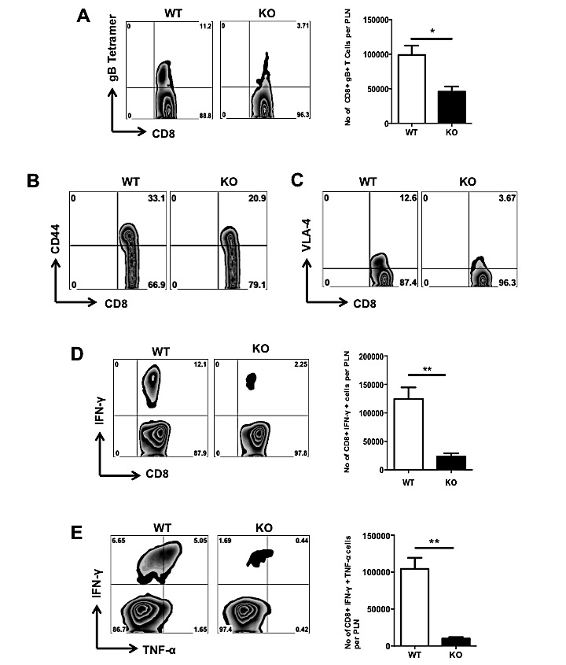

Figure 2.4

Figure II.5 miR155 KO mice mount impaired CD8+ T cell responses in TG compared with WT mice.
Kb-gB tetramer-specific CD8 T cell responses in TG of HSV-1– ocularly infected mice were compared among age- and gender-matched HSV-1 infected WT and miR155 KO animals on day 14 pi. TGs were excised and individual TGs (n=8) from WT and miR155 KO mice were dispersed into single cell suspensions and stained for cell surface markers CD8 and Kb-gB tetramer (A) Representative numbers of tetramer specific CD8+ T cells in WT versus miR-155KO mice. To measure Kb-gB tetramer specific CD8+ T cell responses single cell suspension of TG’s were stimulated for 6 hours with HSV-1 gb peptide in the presence of brefeldin A. After incubation, the cells were stained for surface marker CD8 and cytokines IFN-γ and TNF-α by ICS and analyzed by flow cytometry. (B) Representative FACS plots, frequencies and numbers depicting IFN-γ producing CD8 T cells and (C) IFN-γ and TNF-α double producing CD8+ T cells in WT versus miR-155KO mice. The level of significance was determined by a Student t test (unpaired). Error bars represent means ± SEM (n = 3–5 mice/group). Experiments were repeated at least three times. *p ≤ 0.05, **p ≤ 0.005, ***p ≤ 0.001

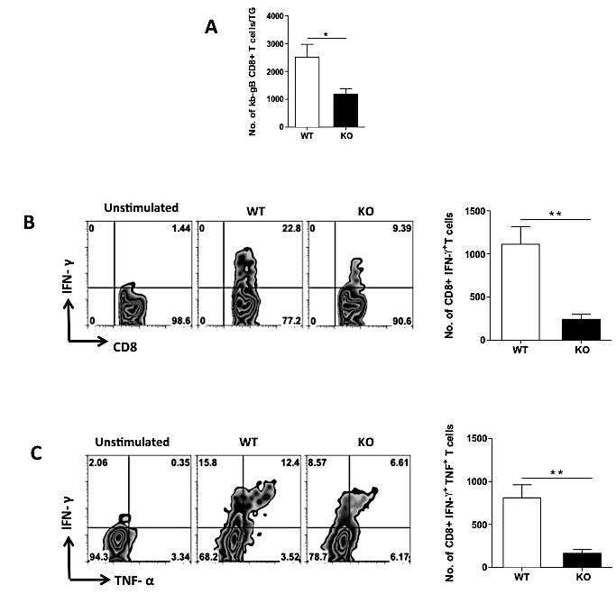
Figure 2.5

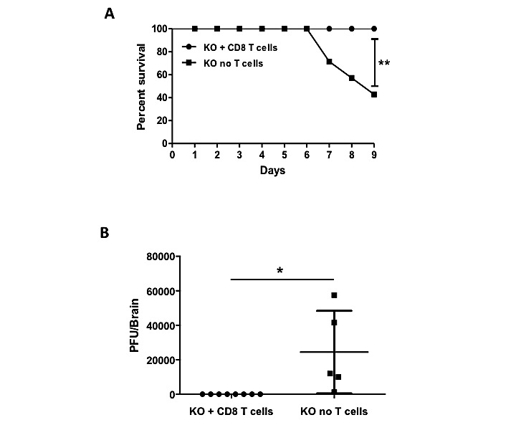

Figure II.6 Survival in miR-155KO mice after receiving HSV immune CD8 T cells
miR- 155KO (KO) animals were ocularly infected with 1x10⁴ HSV-1 Tumpey and were divided in two groups. One group (n=8) received adoptive transfer of HSV immune CD8+ T cells via tail vein at 24 h pi (A) while other group served as a control. Survival of age matched miR-155ko mice and miR-155 KO animals that received CD8 T cell adoptive transfer was established over 9 days. (B) Brains were harvested from mir-155KO animals and miR-155 KO mice that received CD8 T cell adoptive transfer mice at day 9 pi. Brains were homogenized and centrifuged, and supernatants were tested for virus levels.

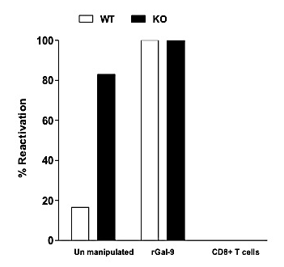
Figure II.7 Comparison of ex vivo HSV-1 reactivation between miR155 KO and WT mice.
Individual TGs excised on day 14 pi from HSV-1 (RE) infected WT and miR155KO mice were dispersed into single-cell suspensions and the cultures were established in a 48 well plate. Each TG (n=6) sample from miR155 KO mice was divided into 2 aliquots. One aliquot was left unmanipulated and the other aliquot received 1x10⁵ CD8 T cells isolated at day 8 pi from lymph nodes of HSV-1 infected WT mice. Similarly, each WT TG was divided into 2 aliquots and one aliquot was left unmanipulated whereas, the other aliquot received 1mM rGal-9. TG cultures were incubated in DMEM medium for a 10 day period and samples of culture supernatant were collected at 24-h intervals and assayed for infectious virus by plaque titrations on Vero cells. Bar graph represents the percentage of virus reactivation from various experimental combinations. The experiment has been repeated 3 times.

Figure II.8 Zosteriform lesions are more severe in miR-155KO mice compared to WT mice and miR-155KO mice show impaired viral clearance from both brain and skin.
A group of WT and miR-155KO mice was infected with 1x10⁶ HSV-1 Tumpey using flank scarification. (A) Mice were examined on day 6 pi for secondary lesion development. (B) Mice were observed for lesion development for up to 7 days pi and scored as following: scores of 1 or 2: local site lesions, characterized by ulceration and swelling around the site of infection; Score of 3: progression of vesicles and then ulcers (Score of 4 or 5) down the flank of the mouse; Score of 6: significant morbidity, characterized by partial immobility (C) Brains were harvested from WT and miR-155 KO mice at day 6 pi. Brains were homogenized and centrifuged, and supernatants were tested for virus titers using plaque assay. (D) The primary site of skin inoculation was examined for viral titers at day 6 pi using plaque assay. The level of significance was determined by a Student t test (unpaired). Error bars represent means ± SEM (n=4–8 mice/group). Experiments were repeated at least three times. *p ≤ 0.05, **p ≤ 0.005, ***p ≤ 0.001

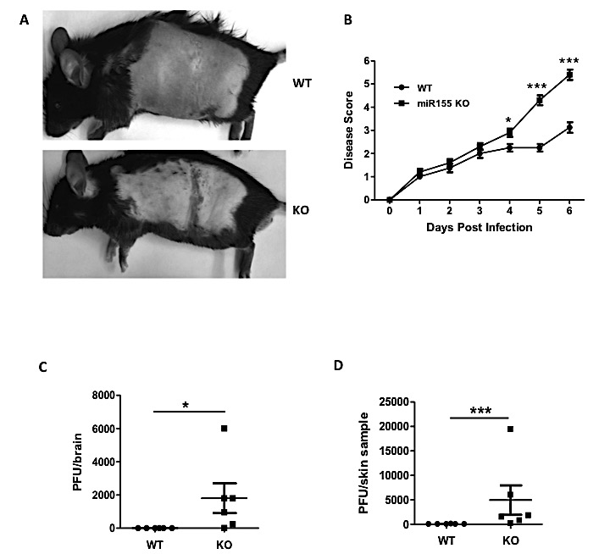
Figure 2.8

ROLE OF MIR-155 IN THE PATHOGENESIS OF HERPES STROMAL KERATITIS

Research described in this chapter is reproduced from a publication accepted in American
journal of pathology by Siddheshvar Bhela, Sachin Mulik, Fernanda Gimenez, Pradeep BJ Reddy, Raphael L Richardson, Siva Karthik Varanasi, Ujjaldeep Jaggi, John Xu, Patrick Y Lu, Barry T. Rouse.

Siddheshvar Bhela, Sachin Mulik, Fernanda Gimenez, Pradeep BJ Reddy, Raphael L Richardson, Siva Karthik Varanasi, Ujjaldeep Jaggi, John Xu, Patrick Y Lu, Barry T. Rouse. Role of miR-155 in the Pathogenesis of Herpetic Stromal Keratitis. Am J Pathol. 2015 Feb. pii: S0002-9440(15)00033-4. Copyright © 2015 by American journal of pathology

Abstract
Ocular infection with herpes simplex virus 1 (HSV-1) can result in a chronic immunoinflammatory lesion that is a significant cause of human blindness. A key to controlling stromal keratitis (SK) lesion severity is to identify cellular and molecular events responsible for tissue damage and manipulate them therapeutically. Potential targets for therapy are microRNAs (miRNAs), but these have been minimally explored especially in responses to infection. In this study, we demonstrated that miR-155 expression was upregulated after ocular HSV-1 infection, with the increased miR-155 expression occurring mainly in macrophages and CD4+ T cells and to a lesser extent in neutrophils. In vivo studies demonstrated that microRNA-155 knockout (miR-155-/-) mice were more resistant to herpes SK with marked suppression of Th1 and Th17 cell responses both in the ocular lesions and the lymphoid organs. The reduced SK lesion severity was reflected by increased phosphatidylinositol-3,4,5-trisphosphate 5-phosphatase 1 (Ship1) and IFN-gamma receptor alpha-chain (IFN-γRα) levels in activated CD4+ T cells in the lymph nodes. Finally, in vivo silencing of miR-155 by the provision of antagomir-155 nanoparticles to HSV-1 infected mice led to diminished SK lesions and corneal vascularization. In conclusion, our results demonstrate that miR-155 contributes to the pathogenesis of SK and represents a promising target to control SK severity.

Introduction
Ocular infection with herpes simplex virus 1 (HSV-1) can result in a chronic tissue damaging response in the stroma, which is considered to be largely the consequence of a host inflammatory response to the infection (1). This concept has been strongly supported by animal model studies where lesions were shown to be mainly orchestrated by CD4+ T cells with neutrophils and macrophage largely responsible for the tissue damage (2-5). Several effective control measures for stromal keratitis (SK) have been suggested (6). These include approaches that influence cellular infiltration and activation of the proinflammatory mediators of SK (6). One potential means of modulating SK lesions that so far has received minimal attention is to manipulate the expression of microRNA (miRNA) species that affect either virus or host events during SK.
A prime miRNA candidate for consideration is miR-155 since this miRNA can influence the expression of several immune events that contribute to tissue damage (7-10). For example, animals unable to produce miR-155 because of gene knockout may develop milder lesions in some models of autoimmunity, (8, 11-13) and suppressing miR-155 expression, as can be achieved by treatment with antagomirs, holds promise as a means of therapy for autoimmunity (13). However, the absence of miR-155 can result in higher susceptibility to some virus infections as well as some tumors in part because protective CD8+ T cell responses are diminished (14-17). In fact, overexpression of miRNA can result in enhanced CD8+ T cell mediated immune protection with some tumors (17).
Few studies have focused on the role of miR-155 in situations where the immune response to an infectious agent may be a principal cause of tissue damage. This is the situation in ocular lesions of the cornea following HSV-1 infection. In the present study, we have compared the disease outcome after HSV-1 infection in microRNA-155 knockout (miR-155-/-) animals as well as in animals in which miR-155 was suppressed by antagomir therapy with controls. We show that HSV-1 infection resulted in upregulation of miR-155, which was mainly produced by the inflammatory cells and T cells in the cornea. Suppression of miR-155 production resulted in milder lesions that were associated with diminished Th1 and Th17 responses as well as reduced inflammatory cytokine production. We also demonstrated that miR-155 suppression resulted in increased phosphatidylinositol-3,4,5-trisphosphate 5-phosphatase 1 (Ship1) and IFN-gamma receptor alpha-chain (IFN-γRα) levels, molecules known to be required for IFN-γ expression and Th1 differentiation (17, 18). These results indicates that miR-155 regulates differentiation as well as effector function of Th1 cells. Thus, our results suggest that miR-155 could be a promising therapeutic target to treat SK.

Materials and Methods
Mice: Female 6-8-week-old C57 BL/6 mice were purchased from Harlan Sprague Dawley Inc. (Indianapolis, IN). miR-155-/- mice on C57BL/6 background were obtained from Jackson laboratories. The animals were housed in American Association of Laboratory Animal Care-approved facilities at the University of Tennessee, Knoxville. All investigations followed guidelines of the institutional animal care and use committee.

Virus
HSV-1 strain RE Tumpey was propagated in Vero cell monolayers (American Type Culture Collection [ATCC], Manassas, VA; no: CCL81). Virus was grown in Vero cell monolayers, titrated, and stored in aliquots at –80˚C until used. Ultraviolet (UV) inactivation of the wild-type HSV virus (1.5 x 10⁵ PFU) was carried out for 8 minutes.

Corneal HSV-1 infection and scoring
Corneal infections of mice were performed under deep anesthesia. The mice were lightly scarified on their corneas with a 27-gauge needle, and a 3 µL drop containing 10⁴ PFU of HSV-1 RE was applied to one eye. Mock-infected animals were used as controls. These mice were monitored for the development of SK lesions. The SK lesion severity and angiogenesis in the eyes of mice were examined by slit-lamp biomicroscopy (Kowa Company, Nagoya, Japan). The scoring system was as follows: 0, normal cornea; +1, mild corneal haze; +2, moderate corneal opacity or scarring; +3, severe corneal opacity but iris visible; +4, opaque cornea and corneal ulcer; and +5, corneal rupture and necrotizing keratitis (19). The severity of angiogenesis was recorded as described previously (20). According to this system, a grade of 4 for a given quadrant of the circle represents a centripetal growth of 1.5 mm toward the corneal center. The score of the four quadrants of the eye were then summed to derive the neovessel index (range 0–16) for each eye at a given time point.

Subconjunctival injections
Subconjunctival injections were performed as previously reported (21). Briefly, these injections were performed using a 2-cm, 32-gauge needle and syringe (Hamilton, Reno, NV) to penetrate the perivascular region of conjunctiva, and 1μg scrambled sequences/antagomir-155 nanoparticles was administered into the subconjunctival space.

Antagomir sequences
Antagomir-155 and scrambled sequences were procured from Ambion (Austin, TX) and used as previously reported (22).

Nanoparticle preparation
Optimized histidine-lysine polymers have been applied for small-interfering RNA deliveries in vitro and in vivo (23). One HK polymer species, H3K4b, having a lysine backbone with four branches containing multiple repeats of histidine and lysine, was used for packaging small-interfering RNAs against miR-155 or scrambled sequences, with a nanoparticle to sequence ratio of 4:1 by mass. The nanoparticles (average size, 150 nm diameter) were self-assembled, and these histidine-lysine polymers-small-interfering RNA nanoparticles were used in mice.

Murine treatment with antagomir-155 nanoparticles
Mice ocularly infected with HSV-1 RE Tumpey were separated into two groups. Antagomir-155 nanoparticle treatment was begun at day 1, with additional doses on alternate days until day 13 after infection. In another group of experiments, the antagomir-155 treatment was started at day 5, with additional doses every day until day 13 after infection. The control group received nanoparticles containing scrambled sequences subconjunctively with the same regimen for respective experiments. These animals were carefully followed for the progression of angiogenesis and SK development.

Administration of intravenous immunoglobulins (IVIG)
IVIG (Carimmune, NF) was obtained from Gammagard Liquid. Wild type (WT) and miR-155-/- mice were intraperitonealy (ip) injected with IVIG (3.75 mg/mouse) at day 4 post-infection (pi). The dose of IVIG was chosen to be 3.75mg/mouse based on previous studies (24).

Flow Cytometry
Single cell suspensions from cornea, cervical draining lymph nodes (DLN), and spleen of mice ocularly infected with HSV-1 were collected at day 15 pi. Aliquots of the above single-cell suspensions were stained for CD4, CD45, CD11b, and Ly6G cell surface markers. In apoptosis studies, single cell suspensions of DLN were stained for Annexin V using a kit from BD Biosciences. Additionally, cells were also co-stained for CD4, CD44, and viability (Live/Dead fixable dead cell staining kit from Invitrogen). To enumerate the functionality of CD4+ T cell, intracellular staining was performed. Briefly, 10⁶ cells freshly isolated from DLN and spleens or the entire corneal samples were left untreated or stimulated with phorbol 12-myristate 13-acetate (PMA) plus ionomycin along with Golgi plug and incubated for 4 hours at 37°C in 5% CO₂. After this period, cell surface staining was performed, followed by intracellular cytokine staining using a Cytofix/Cytoperm kit (BD Pharmingen) to enumerate the number of IFN-γ and IL-17A producing CD4+ T cells as previously described (25). Finally, the cells were washed twice and re-suspended in 1% para-formaldehyde. For intracellular staining of Ki-67 (BD Bioscience), cells were fixed and permeabilized using the FoxP3 Staining Buffer Set (eBioscience) according to the manufacturer’s recommendations. All the stained samples were acquired with a FACS LSR (BD Biosciences) and the data were analyzed using the FlowJo software. For DLN and spleen samples approximately 200,000 events were recorded. For corneal samples depending on the number of corneas pooled approximately 300,000 to 1.5 × 10⁶ events were recorded.

Purification of macrophages, CD4+ T cells, and neutrophils
Briefly, the excised corneas were pooled and digested with 60 U/mL Liberase for 35 minutes at 37°C in a humidified atmosphere of 5% CO₂. A single-cell suspension was prepared and stained with different combinations of the following antibodies anti-CD4 APC, anti-CD45 Percp, anti- CD11b PE, anti- Ly6G FITC or F4/80 FITC for 30 minutes on ice. Approximately 50,000-120,000 CD4+ T cells, macrophages (CD45+, CD11b+, F4/80+), and neutrophils (CD45+, CD11b+, Ly6G+) were sorted using a fluorescence-activated cell sorter (FACS). The expression of miR-155 was measured on these sorted cells. In separate experiments, lymph nodes from HSV-1 infected WT and miR-155KO animals were collected at day 15 pi. A single-cell suspension was prepared and stained with different combinations of the following antibodies anti-CD4 APC, anti-CD44 FITC, and anti-CD62L PE for 30 minutes on ice. 2.5 × 10⁵ naïve CD4+ T cells (CD4+ CD62L^{hi} CD44^{lo}) and activated CD4+ T cells (CD4+ CD62L^{lo} CD44^{hi}) were FACS sorted. Purity to an extent of 80-90% was achieved. The expression of miR-155, Ship1 and IFN-γRα were measured on these sorted cells.

Quantification of mRNA and miRNA expression levels by quantitative real time PCR (Q-RTPCR)
Total mRNA and miRNA was isolated from corneal and lymph node cells using mirVana miRNA Isolation Kit (Ambion). For RNA, cDNA was made with 500 ng RNA using oligo (dT) primer and ImProm-II™ Reverse Transcription System (Promega). For miRNA, cDNA was made with 5ng of miRNA using the taqMan microRNA reverse transcription kit (Applied Biosystems) and primers for miR-155 and small nucleolar RNA 202 (SnoRNA202). TaqMan microRNA Assays (miR-155 and SnoRNA202) and taqman gene expression assays (IL-6, IL-1β, IL-17A, IFN-γ, CCL-2 and CXCL-1, Ship1, and IFN-γRα) were purchased from Applied Biosystems and were used to quantify microRNAs and mRNAs using a 7500 Fast Real-Time PCR System (Applied Biosystems). The expression levels of the target genes were normalized to β-actin for mRNA and SnoRNA202 for miRNA with the ΔCT method, and relative quantification between control and infected mice was performed using the (2^{-ΔΔCT}) *1000 formula.

Statistics:
Statistical significance for SK lesion severity and angiogenesis between the two groups was determined using unpaired two-tailed student's t test. One-way ANOVA with Tukey’s multiple comparison tests was used to calculate the level of significance for some experiments, where noted in the results. P ≤ 0.001 (***), P ≤ 0.01 (**), P ≤ 0.05 (*) were considered as significant and results are expressed as mean ± SEM. For all statistical analysis, GraphPad Prism software was used.

Results
miR-155 Was Upregulated in Murine Corneas after Ocular Infection with Herpes Simplex Virus
To investigate the potential role of miR-155 in mediating tissue damage during SK, mice were ocularly infected with HSV-1 and miRNAs levels were quantified by Q-RTPCR in pools of corneal extracts at various times pi. The results showed that miR-155 expression was upregulated by day 2 pi (approximately 10 fold when compared to uninfected corneas) and increased with progression of diseases at day 7 and 14 pi (approximately 20 fold when compared to uninfected corneas) (Figure 3.1A). To demonstrate if replicating virus was required to upregulate miR-155 in eyes, mice were infected with live WT/UV-inactivated HSV and miR-155 expression was analyzed. Our results show that UV inactivated virus upregulated the miR-155 equivalent to live WT virus indicating that replicating virus is not required for miR-155 induction in eyes (Figure S3.1). To further determine the cellular source of SK induced miR-155; neutrophils, macrophages, and CD4+ T cells were purified from WT HSV-1 infected corneas at day 15 pi, and miRNA extracts were tested by Q-RTPCR. CD4+ T cells taken from the lymph node of miR-155-/- mice served as a negative control for these experiments. Data showed miR-155 expression in neutrophils, macrophages and CD4+ T cells with the highest expression being observed in CD4+ T cells and macrophages (Figure 3.1B). Collectively, these data demonstrated that miR-155 expression was elevated at multiple time points after ocular HSV-1 infection and that macrophages and CD4+ T cells were the major source of the miR-155 during the clinical phase of the lesions.

miR-155-/- Mice Showed Defective CD4+ T Cell Responses and Reduced SK Lesion Severity
To further study the role of miR-155 in SK pathogenesis, the outcome of HSV-1 infection was compared in WT animals and mice lacking miR-155 because of gene knockout. Because HSV-1 infected miR-155-/- mice usually develop lethal herpetic encephalitis, (26) infected mice were given a source of anti-HSV antibody (human IVIG) 4 days after infection, which protects them against encephalitis, but does not interfere in the WT animals with the extent of SK lesion severity. As shown in Figure 3.2A, animals in all groups were infected, but levels of SK disease severity and the extent of angiogenesis were significantly diminished in the miR-155-/- animals. The administration of IVIG had no effect on the severity of lesions in the WT animals (Figure 3.2A). Further documentation of reduced severity in miR-155-/- animals could be shown by histological evaluation (Figure 3.2B), as well as by quantifying the extent of the inflammatory cellular events in sub pools of corneas taken from WT and miR-155-/- animals at day 15 pi. As shown in Figure 3.2 C and D, the frequencies and numbers of total CD4+ T cells, Th1 cells, and Th17 cells in the pooled corneal samples were decreased 5-6 fold in the miR-155-/- mice compared with those in the WT mice. Additionally, analysis of DLNs and spleens of WT and miR-155-/- mice showed 2-3 fold reduced frequencies and total cell numbers of each population (Figure 3.3 A and B). Taken together the results demonstrate that the inflammatory response set off by ocular infection with HSV-1 was markedly decreased in mice unable to express miR-155.

miR-155 Promoted CD4+ T Cell Proliferation after HSV-1 Infection
Prior studies have shown that miR-155 targets several pathways involved in survival and proliferation of effector T cells (16, 27). We determined if proliferation or apoptosis could account for the reduced number of effector T cells in miR-155 deficient animals. WT and miR-155-/- mice were ocularly infected with HSV-1 and treated with IVIG at day 4 pi as described above. Mice were sacrificed on day 14 pi and proliferation and apoptosis were detected by Ki67 and Annexin V staining respectively. Our results reveal that miR-155-/- CD4+ T cells show significantly reduced proliferative response both in the DLN as well as in the cornea (Figure 3.4 A and B). However no differences were found in Annexin V+ CD4+ CD44hi cells in the DLN of WT and miR-155-/- mice (Figure 3.4C). Thus, our data suggest that reduced numbers of Th1 and Th17 responses seen in miR-155-/- mice could be a due to defective proliferation of CD4+ T cells both in the DLN and the cornea.

Provision of Antagomir-155 Nanoparticles Diminished SK lesion severity
To evaluate the effect of locally inhibiting miR-155 expression on the extent of stromal keratitis, animals were subconjunctively given antagomir-155, or control scrambled sequence nanoparticles, with treatment starting on either day 1 (preclinical phase) or day 5 (early clinical phase) pi (Figure 3.5A and Figure S3.2A respectively). As shown in Figure 3.5B, treatment begun on day 1 resulted in significantly reduced SK scores in the antagomir-155 treated animals and angiogenesis was also significantly reduced. Furthermore, histopathological analysis on day 14 pi showed that corneas from control scramble sequence treated mice were inflamed and contained a massive infiltrate of inflammatory cells compared with antagomir-155 treated mice (Figure 3.5C). An examination of sub pools of collagen-digested corneas at the termination of experiments on day 14 revealed that the number and frequencies of inflammatory cells (CD4+ T cells and neutrophils) were significantly diminished in the antagomir-155–treated group compared to the control scramble sequence treated group (Figure 3.5D).
In the experiments in which treatment was begun in the early clinical phase on day 5 pi when replicating virus is mostly cleared from the HSV-1-infected corneas, SK and angiogenesis scores were also significantly diminished in the antagomir-155–treated animals (Figure S3.2B). Additionally, histopathological analysis showed decreased cellular infiltration and inflammation in the cornea in the antagomir-155–treated group compared to the scramble sequence treated control group (Figure S3.2C). At the end of experiments on day 14, sub pools of corneal collagen digests were analyzed by flow cytometry to enumerate the numbers and frequencies of CD4+ T cells and neutrophils (Figure S3.2D). Both cell populations were significantly reduced in frequency and number in the recipients of antagomir-155 compared with those that received the scramble sequence control nanoparticles. Taken together, our results demonstrated that the silencing of miR-155 at both preclinical and early clinical stages after HSV-1 infection diminished pathological lesions and leukocyte infiltration.

Antagomir-155 Nanoparticles Treatment Reduced Proinflammatory Cytokine and Chemokine Levels in the Corneas of HSV-1 Infected Animals
To assess the effect of antagomir-155 treatment on proinflammatory cytokine and chemokine production in SK, mRNA was prepared from corneal extracts on day 14 pi following treatment that was started on day 1 pi. As shown in Figure 3.6A, samples from animals treated with antagomir-155 showed a 7-8-fold reduction of proinflammatory cytokines IL-1β and IL-6 and a 3-4 fold reduction of IFN-γ and IL-17A when compared to scrambled sequence control treated animals. Additionally, levels of chemokines involved in neutrophil (CXCL-1) and monocyte (CCL-2) migration were significantly decreased in antagmoir-155 treated animals (Figure 3.6B). These data indicate that the provision of antagomir-155 to HSV–1 infected mice resulted in marked reduction of pro-inflammatory cytokines and chemokines.

miR-155 Targets Ship1 and IFN-γRα were Downregulated in Activated CD4+ T Cells
Observations in non-viral systems had indicated that miR-155 might influence several immune events (7-10). Since CD4+ T cells of mainly the Th1 phenotype primarily orchestrate SK, we chose to evaluate the Ship1 and IFN-γRα response since these are involved in regulating IFN-γ expression and Th1 differentiation respectively (2, 17, 18). Experiments were performed to measure the effects of miR-155 on levels of Ship1 and IFN-γRα in naïve and activated CD4+ T cells. Accordingly, WT and miR-155-/- mice were ocularly infected with HSV-1. At day 15 pi, naïve CD4+ T cells (CD4+ CD62L^{hi} CD44^{lo}) and activated CD4+ T cells (CD4+ CD62L^{lo} CD44^{hi}) were FACS sorted from the lymph nodes and levels of miR-155, Ship1, and IFN-γRα were quantified. As expected, there was a minimal level of miR-155 in naïve CD4+ T cells, but activated CD4+ T cells showed an approximate, 20 fold upregulation (Figure 3.7A). The mRNA levels of Ship1 and IFN-γRα were elevated in the activated CD4+ T cells of miR-155-/- mice compared to the WT mice, but no differences were observed in naïve CD4+ T cells among WT and miR-155-/- mice (Figure 3.7 B and C). Collectively, these results indicated that miR-155 was upregulated in activated CD4+ T cells, which correlated with low Ship1 and IFN-γRα mRNA levels in those T cells.

Discussion
In this report, we describe the influence of miR-155 on the expression of ocular lesions caused by infection with HSV-1. The expression of miR-155 was shown to contribute to lesion development, as animals unable to produce miR-155 because of gene knockout show significantly reduced severity of stromal keratitis. That miR-155 was associated with the development of SK lesions could also be shown by administration of miR-155 antagomirs in WT animals early after infection, or around the time when lesions start to develop. Such animals had suppressed SK lesions. Cells in SK lesions that were the main producers of miR-155 were CD4+ T cells and macrophages. The effect of miR-155 in lesion development was associated with down regulation of Ship1 and IFN-γRα, genes involved in IFN-γ expression and Th1 differentiation respectively (17, 18). Increased miR-155 levels led to heightened production of pro-inflammatory cytokines and chemokines and generation of pathogenic Th1 and Th17 cells in the eyes during SK. Additionally we could see that miR-155 null CD4+ T cells showed impaired proliferation following HSV-1 infection. These overall results were summarized in Figure 3.8. The finding that a normal miR-155 response is needed to generate consequential SK lesions implies that modulation of the expression levels could be a useful therapeutic strategy to limit the severity of viral induced inflammatory lesions.
Our study focused on miR-155 since this molecule was known to be involved in immune and inflammatory reactions, (7-10) yet its role during viral infections had received minimal investigation. Two reports showed that miR-155 influenced the magnitude of CD8+ T cell responses to a virus infection (15, 28) and another showed that diminished miR-155 responses led to more severe virus induced lesions in nervous tissue with animals more susceptible to encephalitis (26). This latter outcome was at least in part the consequence of diminished CD8+ T cell responses known to participate in protection of the central nervous system against HSV infection (26). The present report evaluates the impact of miR-155 expression on the inflammatory consequences of a virus infection, which in the model investigated occurs because of an inflammatory process orchestrated by CD4+ T cells (1, 2). Our results clearly showed that when miR-155 expression was suppressed, either because of gene knockout or the administration of miR-155 specific antagomirs, lesions of SK were markedly reduced. In fact, our results reflect observations made in some mouse models of autoimmune inflammation where lesions were less evident in situations when miR-155 expression was limited (8, 12, 13). In addition, some human auto-inflammatory lesions appear to be influenced by the magnitude of the miR-155 response (9, 29). In our viral immunoinflammatory model, the major effect of miR-155 suppression was a significantly reduced CD4+ Th1 T cell reaction along with diminished non antigen specific inflammatory cell infiltration into the cornea, with the latter cells mainly responsible for tissue damage (3, 5). These effects were apparently the consequence of miR-155 affecting the levels of Ship1 as well as IFN-γRα in activated CD4+ T cells both of which were significantly elevated when miR-155 expression was inhibited. Ship1 is a phosphatase that negatively regulates cytokine signaling via repression of the PI3K pathway, (30) and its deletion from CD4+ T cells results in elevated IFN-γ expression (31). Thus in our system since activated CD4+ T cells in miR-155KO mice showed higher levels of Ship1, it is likely that these cells would have lower IFN-γ expression as has been shown in other models (17). Additionally, lower IFN-γ expression could also be explained by defective differentiation of Th1 cells in miR-155KO mice. Regulation of IFN-γ signaling through the IFN-γR is necessary for the differentiation of Th1 cells (18, 32-34). miR-155, by targeting IFN-γRα mRNA might downregulate the IFNγ receptor in activated CD4+ T cells that differentiate into Th1 cells (18). We also observed much higher levels of IFN-γRα in the activated CD4+ T cells suggesting defective Th1 differentiation in the miR-155-/- mice. The observed phenotype of reduction in Th1 and Th17 cell numbers could also be explained by impaired proliferation and/or survival of responding T cells. Our data supports reduced proliferation of miR-155-/- CD4+ T cells rather than reduced survival based on the use of markers to indicate such effects.
As shown in some other systems, miR-155 could also degrade additional crucial targets such as suppressor of cytokine signaling 1 (SOCS1) that negatively regulates T cell function.(35) T cell specific deletion of SOCS1 results in multi-organ inflammatory lesions, which are correlated with high levels of IFN-γ (35). We measured and compared the expression of SOCS1 in activated CD4+ T cells from WT and miR-155-/- mice but observed no significant differences between the two (data not shown), suggesting that Ship1 and IFN-γRα were the major targets of miR-155 in our study. miR-155 was also shown in in vitro cultures of CD4+ T cells to influence IL-10 production with a higher fraction of miR-155-/- CD4+ T cells producing IL-10 (36). However in the SK situation we failed to observe enhanced IL-10 production in the corneas of either miR-155-/- or antagomir-155 treated mice (data not shown). Nevertheless, we observed significantly reduced numbers of Th17 cells in HSV infected miR-155-/- mice. This is consistent with the previous reports that show the role of miR-155 in Th17 cell differentiation (8, 37, 38). Targets other than Ship1 and IFN-γRα could be subject to modulation by miR-155 and this issue is under further investigation.
It was interesting to observe that soon after HSV ocular infection, levels of miR-155 were increased in corneal tissue. The stimulus for this early expression would likely not be the direct result of viral infection of epithelial cells but would more likely represent the innate immune stimulating activity of the virus. This was supported by our data showing UV-inactivated virus could trigger miR-155 upregulation at day 2 pi. Thus HSV-1 is known to express at least three Toll-like receptor (TLR) ligand activities, (39-41) and others have documented that TLR stimulation can be a potent agonist for miR-155 production (10). Some herpes viruses do themselves express several miRNAs but homologues of miR-155 are not one of them. In the case of HSV-1, the miRNAs expressed by the virus are mainly involved in decisions between productive and latent cycles of replication (42). In the clinical phase of SK, virus is no longer present in the cornea, and at this time we could show that the major producers of miR-155 were proinflammatory T cells along with non-specific inflammatory cells, especially macrophages. Macrophages form a minor cell population infiltrating corneas during SK. Some reports suggest that macrophages have antiviral activity, which helps in clearing the virus from the cornea (43). While other studies show that macrophages are in involved in the development of immunologically driven stromal keratitis (5).
The stimulus for miR-155 production was not identified, but was most likely to include either TLR ligand activity of the virus or cytokines such as IFN-β, IFN-γ, and TNF-α that are present during SK and which were shown in other systems to act as miR-155 agonists (10). Additionally, miR-155 also signals innate cells, such as neutrophils and macrophages, to produce pro-inflammatory cytokines and chemokines (9, 10, 44). In cystic fibrosis patients, for example increased miR-155 expression in neutrophils led to increased neutrophil recruitment via IL-8 activity (9). It was also reported that miR-155 mediated degradation of BCL-6 in macrophages leads to attenuation of NF-kB signaling resulting in diminished production of pro-inflammatory cytokines and chemokines (44). Conversely, miR-155 induced repression of SOCS1 in macrophages enhanced type I IFN signaling (45). In a collagen induced arthritis model, miR-155-/- animals exhibited very low levels of inflammatory mediators in joints.¹¹ miR-155 null mice were also seen to be resistant to bacterial keratitis an effect mediated by miR-155 activity on macrophages (46). In agreement with these observations, we could show in our study that diminished miR-155 activity led to a dampened pro-inflammatory milieu in the eyes. Therefore, the SK resistance phenotype observed in miR-155-/- animals is likely the consequence of multiple events such as poor neutrophil and macrophage activity, dampened pro-inflammatory milieu and attenuated Th1 and Th17 cell responses. This activity of miR-155 could make it a viable therapeutic target to treat HSV induced ocular lesions.
One major rationale for research on miRNAs is the prospect that manipulating their levels could represent a viable new approach to therapy. In fact accumulating evidence indicates that the miRNA environment changes in the course of an inflammatory response with the miRNA species present in the proinflammatory phase differing from those prominent during the resolution phase of an inflammatory response (47, 48). It is still not clear if miRNAs are primarily responsible for this switch of events but evidence is accumulating to support the concept (48). In such a scenario, miR-155 may act as a facilitator of the resolution phase of an inflammatory reaction. In support of this, we could show that the use of an antagomir to miR-155 at the early clinical phase diminished the severity of lesions. It seems likely that in a disease situation, manipulating the expression of multiple miRNA species that are involved in different aspect of pathogenesis might be the most fruitful approach to therapy. In favor of this idea, in our preliminary results we have observed that manipulating miR-155 along with miR-132, a miRNA involved in angiogenesis, (22) may provide more therapeutic value than using either miRNA alone. Current ongoing research is evaluating the value of manipulating the levels of multiple miRNA in an attempt to achieve a more effective resolution of ocular inflammatory reactions.

Acknowledgments: We thank Naveen Rajasagi, Nicolas Villarino, Pranay Dogra, Sujata Agarwal, Lorena Harvey, Jamie Raby and Misty Bailey for assistance during research and manuscript preparation. We also thank Nancy Neilsen for help in sorting of cells.

LIST OF REFERENCES
1. Biswas, P. S., and B. T. Rouse. 2005. Early events in HSV keratitis--setting the stage for a blinding disease. Microbes Infect 7: 799-810.
2. Niemialtowski, M. G., and B. T. Rouse. 1992. Predominance of Th1 cells in ocular tissues during herpetic stromal keratitis. J Immunol 149: 3035-3039.
3. Thomas, J., S. Gangappa, S. Kanangat, and B. T. Rouse. 1997. On the essential involvement of neutrophils in the immunopathologic disease: herpetic stromal keratitis. J Immunol 158: 1383-1391.
4. Daheshia, M., S. Kanangat, and B. T. Rouse. 1998. Production of key molecules by ocular neutrophils early after herpetic infection of the cornea. Exp Eye Res 67: 619-624.
5. Bauer, D., S. Mrzyk, N. van Rooijen, K. P. Steuhl, and A. Heiligenhaus. 2000. Macrophage-depletion influences the course of murine HSV-1 keratitis. Curr Eye Res 20: 45-53.
6. Gimenez, F., A. Suryawanshi, and B. T. Rouse. 2013. Pathogenesis of herpes stromal keratitis--a focus on corneal neovascularization. Prog Retin Eye Res 33: 1-9.
7. Rodriguez, A., E. Vigorito, S. Clare, M. V. Warren, P. Couttet, D. R. Soond, S. van Dongen, R. J. Grocock, P. P. Das, E. A. Miska, D. Vetrie, K. Okkenhaug, A. J. Enright, G. Dougan, M. Turner, and A. Bradley. 2007. Requirement of bic/microRNA-155 for normal immune function. Science 316: 608-611.
8. O'Connell, R. M., D. Kahn, W. S. Gibson, J. L. Round, R. L. Scholz, A. A. Chaudhuri, M. E. Kahn, D. S. Rao, and D. Baltimore. 2010. MicroRNA-155 promotes autoimmune inflammation by enhancing inflammatory T cell development. Immunity 33: 607-619.
9. Bhattacharyya, S., N. S. Balakathiresan, C. Dalgard, U. Gutti, D. Armistead, C. Jozwik, M. Srivastava, H. B. Pollard, and R. Biswas. 2011. Elevated miR-155 promotes inflammation in cystic fibrosis by driving hyperexpression of interleukin-8. J Biol Chem 286: 11604-11615.
10. O'Connell, R. M., K. D. Taganov, M. P. Boldin, G. Cheng, and D. Baltimore. 2007. MicroRNA-155 is induced during the macrophage inflammatory response. Proc Natl Acad Sci U S A 104: 1604-1609.
11. Kurowska-Stolarska, M., S. Alivernini, L. E. Ballantine, D. L. Asquith, N. L. Millar, D. S. Gilchrist, J. Reilly, M. Ierna, A. R. Fraser, B. Stolarski, C. McSharry, A. J. Hueber, D. Baxter, J. Hunter, S. Gay, F. Y. Liew, and I. B. McInnes. 2011. MicroRNA-155 as a proinflammatory regulator in clinical and experimental arthritis. Proc Natl Acad Sci U S A 108: 11193-11198.
12. Bluml, S., M. Bonelli, B. Niederreiter, A. Puchner, G. Mayr, S. Hayer, M. I. Koenders, W. B. van den Berg, J. Smolen, and K. Redlich. 2011. Essential role of microRNA-155 in the pathogenesis of autoimmune arthritis in mice. Arthritis Rheum 63: 1281-1288.
13. Murugaiyan, G., V. Beynon, A. Mittal, N. Joller, and H. L. Weiner. 2011. Silencing microRNA-155 ameliorates experimental autoimmune encephalomyelitis. J Immunol 187: 2213-2221.
14. Dudda, J. C., B. Salaun, Y. Ji, D. C. Palmer, G. C. Monnot, E. Merck, C. Boudousquie, D. T. Utzschneider, T. M. Escobar, R. Perret, S. A. Muljo, M. Hebeisen, N. Rufer, D. Zehn, A. Donda, N. P. Restifo, W. Held, L. Gattinoni, and P. Romero. 2013. MicroRNA-155 is required for effector CD8+ T cell responses to virus infection and cancer. Immunity 38: 742-753.
15. Gracias, D. T., E. Stelekati, J. L. Hope, A. C. Boesteanu, T. A. Doering, J. Norton, Y. M. Mueller, J. A. Fraietta, E. J. Wherry, M. Turner, and P. D. Katsikis. 2013. The microRNA miR-155 controls CD8(+) T cell responses by regulating interferon signaling. Nat Immunol 14: 593-602.
16. Lind, E. F., A. R. Elford, and P. S. Ohashi. 2013. Micro-RNA 155 is required for optimal CD8+ T cell responses to acute viral and intracellular bacterial challenges. J Immunol 190: 1210-1216.
17. Huffaker, T. B., R. Hu, M. C. Runtsch, E. Bake, X. Chen, J. Zhao, J. L. Round, D. Baltimore, and R. M. O'Connell. 2012. Epistasis between microRNAs 155 and 146a during T cell-mediated antitumor immunity. Cell Rep 2: 1697-1709.
18. Banerjee, A., F. Schambach, C. S. DeJong, S. M. Hammond, and S. L. Reiner. 2010. Micro-RNA-155 inhibits IFN-gamma signaling in CD4+ T cells. Eur J Immunol 40: 225-231.
19. Suryawanshi, A., S. Mulik, S. Sharma, P. B. Reddy, S. Sehrawat, and B. T. Rouse. 2011. Ocular neovascularization caused by herpes simplex virus type 1 infection results from breakdown of binding between vascular endothelial growth factor A and its soluble receptor. J Immunol 186: 3653-3665.
20. Rajasagi, N. K., P. B. Reddy, A. Suryawanshi, S. Mulik, P. Gjorstrup, and B. T. Rouse. 2011. Controlling herpes simplex virus-induced ocular inflammatory lesions with the lipid-derived mediator resolvin E1. J Immunol 186: 1735-1746.
21. Dana, M. R., S. N. Zhu, and J. Yamada. 1998. Topical modulation of interleukin-1 activity in corneal neovascularization. Cornea 17: 403-409.
22. Mulik, S., J. Xu, P. B. Reddy, N. K. Rajasagi, F. Gimenez, S. Sharma, P. Y. Lu, and B. T. Rouse. 2012. Role of miR-132 in angiogenesis after ocular infection with herpes simplex virus. Am J Pathol 181: 525-534.
23. Leng, Q., P. Scaria, P. Lu, M. C. Woodle, and A. J. Mixson. 2008. Systemic delivery of HK Raf-1 siRNA polyplexes inhibits MDA-MB-435 xenografts. Cancer gene therapy 15: 485-495.
24. Dalai, S. K., L. Pesnicak, G. F. Miller, and S. E. Straus. 2002. Prophylactic and therapeutic effects of human immunoglobulin on the pathobiology of HSV-1 infection, latency, and reactivation in mice. Journal of neurovirology 8: 35-44.
25. Rajasagi, N. K., A. Suryawanshi, S. Sehrawat, P. B. Reddy, S. Mulik, M. Hirashima, and B. T. Rouse. 2012. Galectin-1 reduces the severity of herpes simplex virus-induced ocular immunopathological lesions. J Immunol 188: 4631-4643.
26. Bhela, S., S. Mulik, P. B. Reddy, R. L. Richardson, F. Gimenez, N. K. Rajasagi, T. Veiga-Parga, A. P. Osmand, and B. T. Rouse. 2014. Critical role of microRNA-155 in herpes simplex encephalitis. J Immunol 192: 2734-2743.
27. Hu, R., D. A. Kagele, T. B. Huffaker, M. C. Runtsch, M. Alexander, J. Liu, E. Bake, W. Su, M. A. Williams, D. S. Rao, T. Moller, G. A. Garden, J. L. Round, and R. M. O'Connell. 2014. miR-155 Promotes T Follicular Helper Cell Accumulation during Chronic, Low-Grade Inflammation. Immunity 41: 605-619.
28. Tsai, C. Y., S. R. Allie, W. Zhang, and E. J. Usherwood. 2013. MicroRNA miR-155 affects antiviral effector and effector Memory CD8 T cell differentiation. J Virol 87: 2348-2351.
29. Paraboschi, E. M., G. Solda, D. Gemmati, E. Orioli, G. Zeri, M. D. Benedetti, A. Salviati, N. Barizzone, M. Leone, S. Duga, and R. Asselta. 2011. Genetic association and altered gene expression of mir-155 in multiple sclerosis patients. International journal of molecular sciences 12: 8695-8712.
30. Kerr, W. G. 2011. Inhibitor and activator: dual functions for SHIP in immunity and cancer. Annals of the New York Academy of Sciences 1217: 1-17.
31. Tarasenko, T., H. K. Kole, A. W. Chi, M. M. Mentink-Kane, T. A. Wynn, and S. Bolland. 2007. T cell-specific deletion of the inositol phosphatase SHIP reveals its role in regulating Th1/Th2 and cytotoxic responses. Proc Natl Acad Sci U S A 104: 11382-11387.
32. Bach, E. A., S. J. Szabo, A. S. Dighe, A. Ashkenazi, M. Aguet, K. M. Murphy, and R. D. Schreiber. 1995. Ligand-induced autoregulation of IFN-gamma receptor beta chain expression in T helper cell subsets. Science 270: 1215-1218.
33. Pernis, A., S. Gupta, K. J. Gollob, E. Garfein, R. L. Coffman, C. Schindler, and P. Rothman. 1995. Lack of interferon gamma receptor beta chain and the prevention of interferon gamma signaling in TH1 cells. Science 269: 245-247.
34. Tau, G. Z., T. von der Weid, B. Lu, S. Cowan, M. Kvatyuk, A. Pernis, G. Cattoretti, N. S. Braunstein, R. L. Coffman, and P. B. Rothman. 2000. Interferon gamma signaling alters the function of T helper type 1 cells. J Exp Med 192: 977-986.
35. Tanaka, K., K. Ichiyama, M. Hashimoto, H. Yoshida, T. Takimoto, G. Takaesu, T. Torisu, T. Hanada, H. Yasukawa, S. Fukuyama, H. Inoue, Y. Nakanishi, T. Kobayashi, and A. Yoshimura. 2008. Loss of suppressor of cytokine signaling 1 in helper T cells leads to defective Th17 differentiation by enhancing antagonistic effects of IFN-gamma on STAT3 and Smads. J Immunol 180: 3746-3756.
36. Thai, T. H., D. P. Calado, S. Casola, K. M. Ansel, C. Xiao, Y. Xue, A. Murphy, D. Frendewey, D. Valenzuela, J. L. Kutok, M. Schmidt-Supprian, N. Rajewsky, G. Yancopoulos, A. Rao, and K. Rajewsky. 2007. Regulation of the germinal center response by microRNA-155. Science 316: 604-608.
37. Hu, R., T. B. Huffaker, D. A. Kagele, M. C. Runtsch, E. Bake, A. A. Chaudhuri, J. L. Round, and R. M. O'Connell. 2013. MicroRNA-155 confers encephalogenic potential to Th17 cells by promoting effector gene expression. J Immunol 190: 5972-5980.
38. Escobar, T. M., C. Kanellopoulou, D. G. Kugler, G. Kilaru, C. K. Nguyen, V. Nagarajan, R. K. Bhairavabhotla, D. Northrup, R. Zahr, P. Burr, X. Liu, K. Zhao, A. Sher, D. Jankovic, J. Zhu, and S. A. Muljo. 2014. miR-155 activates cytokine gene expression in Th17 cells by regulating the DNA-binding protein Jarid2 to relieve polycomb-mediated repression. Immunity 40: 865-879.
39. Sarangi, P. P., B. Kim, E. Kurt-Jones, and B. T. Rouse. 2007. Innate recognition network driving herpes simplex virus-induced corneal immunopathology: role of the toll pathway in early inflammatory events in stromal keratitis. J Virol 81: 11128-11138.
40. Sato, A., M. M. Linehan, and A. Iwasaki. 2006. Dual recognition of herpes simplex viruses by TLR2 and TLR9 in dendritic cells. Proc Natl Acad Sci U S A 103: 17343-17348.
41. Zhang, S. Y., E. Jouanguy, S. Ugolini, A. Smahi, G. Elain, P. Romero, D. Segal, V. Sancho-Shimizu, L. Lorenzo, A. Puel, C. Picard, A. Chapgier, S. Plancoulaine, M. Titeux, C. Cognet, H. von Bernuth, C. L. Ku, A. Casrouge, X. X. Zhang, L. Barreiro, J. Leonard, C. Hamilton, P. Lebon, B. Heron, L. Vallee, L. Quintana-Murci, A. Hovnanian, F. Rozenberg, E. Vivier, F. Geissmann, M. Tardieu, L. Abel, and J. L. Casanova. 2007. TLR3 deficiency in patients with herpes simplex encephalitis. Science 317: 1522-1527.
42. Umbach, J. L., M. F. Kramer, I. Jurak, H. W. Karnowski, D. M. Coen, and B. R. Cullen. 2008. MicroRNAs expressed by herpes simplex virus 1 during latent infection regulate viral mRNAs. Nature 454: 780-783.
43. Cheng, H., T. M. Tumpey, H. F. Staats, N. van Rooijen, J. E. Oakes, and R. N. Lausch. 2000. Role of macrophages in restricting herpes simplex virus type 1 growth after ocular infection. Invest Ophthalmol Vis Sci 41: 1402-1409.
44. Nazari-Jahantigh, M., Y. Wei, H. Noels, S. Akhtar, Z. Zhou, R. R. Koenen, K. Heyll, F. Gremse, F. Kiessling, J. Grommes, C. Weber, and A. Schober. 2012. MicroRNA-155 promotes atherosclerosis by repressing Bcl6 in macrophages. J Clin Invest 122: 4190-4202.
45. Wang, P., J. Hou, L. Lin, C. Wang, X. Liu, D. Li, F. Ma, Z. Wang, and X. Cao. 2010. Inducible microRNA-155 feedback promotes type I IFN signaling in antiviral innate immunity by targeting suppressor of cytokine signaling 1. J Immunol 185: 6226-6233.
46. Yang, K., M. Wu, M. Li, D. Li, A. Peng, X. Nie, M. Sun, J. Wang, Y. Wu, Q. Deng, M. Zhu, K. Chen, J. Yuan, and X. Huang. 2014. miR-155 Suppresses Bacterial Clearance in Pseudomonas aeruginosa-Induced Keratitis by Targeting Rheb. J Infect Dis.
47. O'Neill, L. A., F. J. Sheedy, and C. E. McCoy. 2011. MicroRNAs: the fine-tuners of Toll-like receptor signalling. Nat Rev Immunol 11: 163-175.
48. Fredman, G., Y. Li, J. Dalli, N. Chiang, and C. N. Serhan. 2012. Self-limited versus delayed resolution of acute inflammation: temporal regulation of pro-resolving mediators and microRNA. Sci Rep 2: 639.

APPENDIX

Figure III.1 Expression of miR-155 after HSV-1 infection.
(A) WT mice were infected with HSV-1 RE, and corneas were collected and pooled for miRNA analysis by Q-RTPCR to measure the expression of miR-155 at days 2, 7 and 15 after HSV-1 infection. The expression levels of miR-155 were normalized to SnoRNA202 using the ΔCt calculation. Relative expression was calculated using the 2^{−ΔΔCt} formula. miRNA-155 levels in mock-infected mice were set to 1 and used for relative fold upregulation. Data are representative of three independent experiments and show mean values ± SEM (n = 9 mice per group; each sample is representative of three corneas). (B) miR-155 expression was measured by Q-RTPCR in sorted neutrophils, macrophages and CD4+ T cells from WT infected corneas at day 15 pi. CD4+ T cells were isolated from the lymph nodes of miR-155-/- mice at day 15 after HSV-1 infection and served as a negative control. The expression levels of miR-155 were normalized to SnoRNA202 using the ΔCt calculation. Relative expression was calculated using the 2^{−ΔΔCt} formula. Data are representative of two independent experiments and show mean values ± SEM (n = 15 mice). Statistical significance was calculated by one-way ANOVA with Tukey’s multiple comparison tests. *p ≤ 0.05, **p ≤ 0.01, ***p ≤ 0.001.
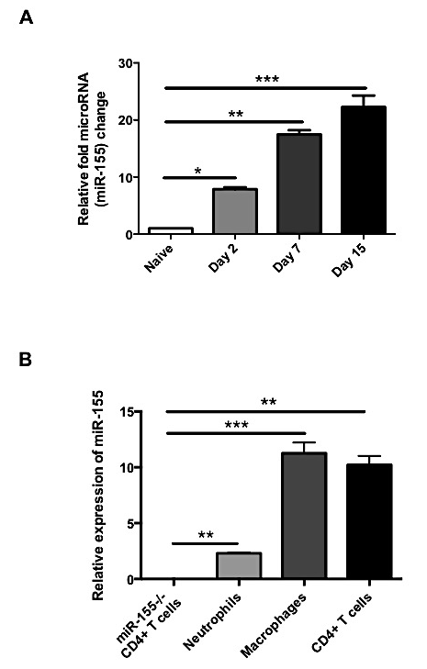

Figure 3.1
Figure III.2 miR-155-/- mice were resistant to SK.
C57BL/6 and miR-155-/- mice ocularly infected with 1× 10⁴ PFU of HSV-1 RE were divided into three groups of eight to twelve mice. One group of WT mice received IVIG intraperitonealy at day 4 pi (WT D4 IVIG). One group of miR-155-/- mice received IVIG at day 4 pi (miR-155-/- D4 IVIG) and one group of WT mice received no treatment (WT no IVIG). Disease severity and immune parameters were evaluated at day 15 pi (A) SK lesion severity and angiogenesis at day 15 pi are shown. A one-way ANOVA, with Tukey’s multiple comparison tests, was used to calculate the level of significance. . *p ≤ 0.05, **p ≤ 0.01, ***p ≤ 0.001. This experiments was repeated three times. (B) Representative H&E-stained corneal sections (× 40 magnification) from WT (WT D4 IVIG) and miR-155-/- (miR-155-/- D4 IVIG) mice collected on day 15 pi. (C-D) Mice were sacrificed on day 15 pi, and corneas were harvested and pooled group wise for the analysis of various cell types (n = 8–12 per group). (C) Representative FACS plots for corneal infiltrating total CD4+ T cells. Intracellular staining was conducted to quantify Th1 and Th17 cells by stimulating them with PMA/ionomycin (D) Representative plots show percentage of CD4+ cells producing IFN-γ or IL-17 following stimulation with PMA/ionomycin in the cornea of infected WT (WT D4 IVIG) and miR-155-/- (miR-155-/- D4 IVIG) animals. Plots shown were gated on CD4+ T cells. The bar graph represents total numbers of corneal infiltrating CD4+ T cells, Th1 and Th17 cells in the corneas of WT (WT D4 IVIG) and miR-155-/- (miR-155-/- D4 IVIG) mice. Data are representative of three independent experiments and show mean values ± SEM (n = 8–12 mice per group). Statistical significance was analyzed by the Student t test (unpaired). **p ≤ 0.01, ***p ≤ 0.001.
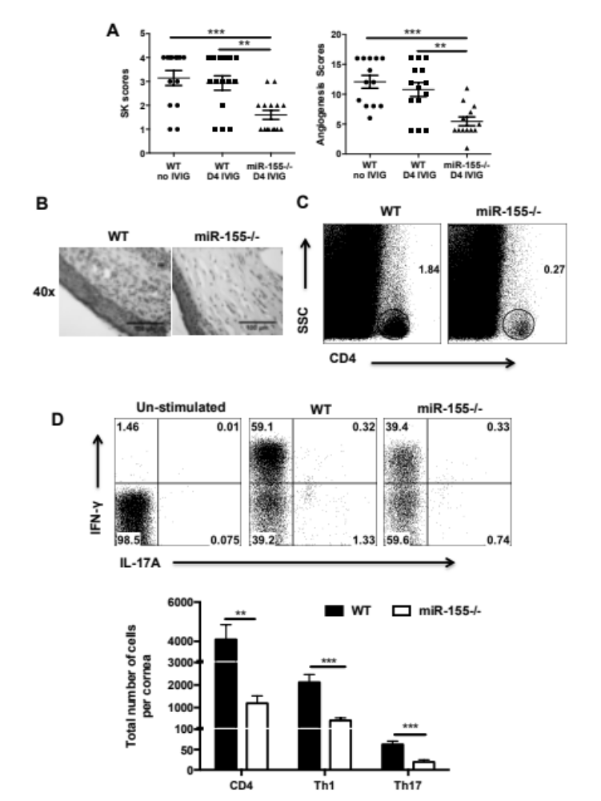
Figure 3.2
Figure III.3 miR-155-/- mice exhibited reduced frequencies and numbers of Th1 and Th17 cells in DLN and spleen post HSV-1 infection.
C57BL/6 and miR-155-/- mice were ocularly infected with 1× 10⁴ PFU of HSV-1 RE. Both groups of mice received IVIG intraperitonealy at day 4 pi. Mice were sacrificed on day 14 pi and single cell suspensions of the individual spleen and DLN were prepared. (A) Representative FACS plots show percentage of CD4+ T cells producing IFN-γ or IL-17A following stimulation with PMA/ionomycin in the infected animals from the DLN and spleen. Plots shown were gated on CD4+ T cells. (B) The bar graph represents total numbers of CD4+ T cells, Th1, and Th17 cells in the DLN and spleen of WT (WT D4 IVIG) and miR-155-/- (miR-155-/- D4 IVIG) mice. Data are representative of three independent experiments and show mean values ± SEM (n = 5–6 mice per group). Statistical significance was analyzed by the Student t test (unpaired). *p ≤ 0.05, ***p ≤ 0.001.

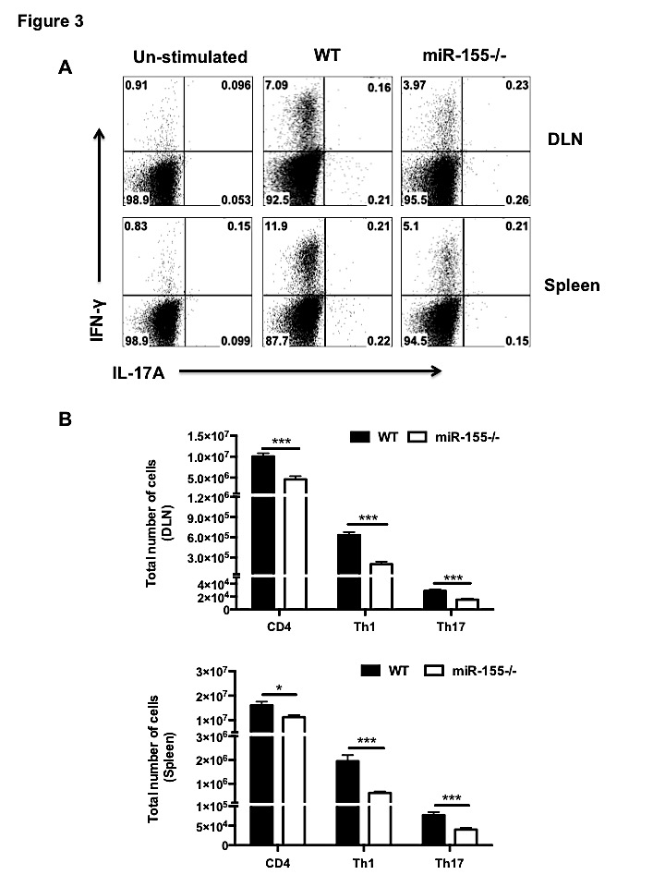

Figure 3.3

Figure III.4 miR-155-/- CD4+ T cells showed defective proliferation but not survival.
C57BL/6 and miR-155-/- mice were ocularly infected with 1× 104 PFU of HSV-1 RE. Both groups of mice received IVIG intraperitonealy at day 4 pi. Mice were sacrificed on day 14 pi and single cell suspensions of the individual DLN and sub pools of corneas were prepared and stained for Ki67 and Annexin V. (A) Representative FACS plots, frequencies and cell numbers of Ki67+ CD4+ T cells in the cornea of WT (WT D4 IVIG) and miR-155-/- (miR-155-/- D4 IVIG) mice are shown. Plots shown were gated on CD4+ T cells. (B) Representative FACS plots, frequencies and cell numbers of Ki67+ CD4+ T cells in the DLN of WT (WT D4 IVIG) and miR-155-/- (miR-155-/- D4 IVIG) mice are shown. Plots shown were gated on CD4+ T cells. (C) Representative FACS plots and frequencies of Annexin V+ CD4+ CD44hi T cells in the DLN of WT (WT D4 IVIG) and miR-155-/- (miR-155-/- D4 IVIG) mice are shown. Plots shown were gated on live CD44hi CD4+ T cells. Data are representative of two independent experiments and show mean values ± SEM (n = 6–8 mice per group). Statistical significance was analyzed by the Student t test (unpaired). *p ≤ 0.05, **p ≤ 0.01, ***p ≤ 0.001.

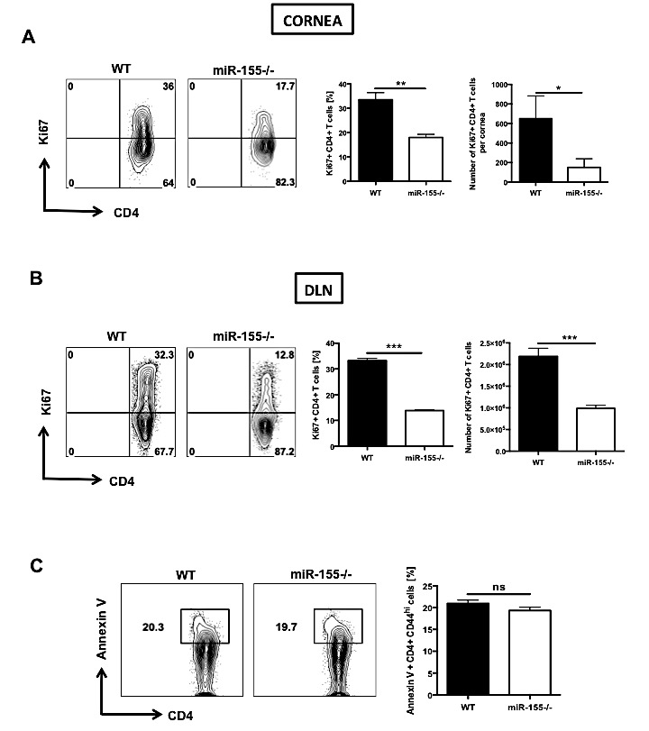

Figure 3.4
Figure III.5 Preventive administration of antagomir-155 diminished SK lesion severity and cellular infiltration.
C57BL/6 mice were ocularly infected with 1× 10⁴ PFU of HSV-1 RE. (A) Antagomir-155/scrambled sequence (scrambled seq) (5'-AUUUCAUGACUGUUACUGACCU-3') nanoparticle treatment was given subconjunctively as shown. Disease severity and immune parameters were analyzed at day 14 pi. (B) SK lesion severity and angiogenesis at day 14 are shown. (C) Representative H&E stained corneal sections (× 40 magnification) of scrambled seq treated (left) and antagomir-155 treated (right) mice were collected on day 14 pi. Mice were sacrificed on day 14 pi, and corneas were harvested and pooled group wise for analysis of various cell types. (D) The frequency and total cell number of CD4+ T cells and neutrophils (CD45+ CD11b+ Ly6G+) (plot was gated on CD45+ cells) infiltrated in the corneas of control (scrambled sequence) (left panel) and antagomir-155 (right panel) treated mice are shown. Data are representative of two independent experiments and show mean values ± SEM (n = 8–12 mice per group). Statistical significance was analyzed by the Student t test (unpaired). ***p ≤ 0.001.

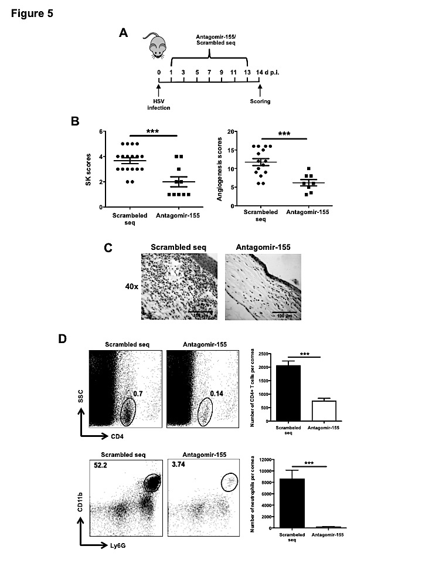
Figure 3.5
Figure III.6 Antagomir-155 treatment reduced cytokine and chemokine levels in corneas of HSV-1 infected animals.
C57BL/6 mice were ocularly infected with 1× 10⁴ PFU of HSV-1 RE. The antagomir-155/scrambled sequence (scrambled seq) nanoparticle treatment was given subconjunctively every other day starting day 1 pi. Mice were sacrificed on day 14 pi, and corneal extracts were collected for measuring inflammatory factors, using Q-RTPCR. (A) Relative fold change in mRNA expression of the proinflammatory cytokines IL-6, IL-1β, IFN-γ and IL-17A was examined and compared between control (scrambeled sequence) and antagomir-155 treated mice on day 14 pi (B) Relative fold change in mRNA expression of chemokines CCL-2 and CXCL-1 was examined and compared between control (scrambled sequence) and antagomir-155 treated mice on day 14 pi. The expression levels of different cytokines and chemokines were normalized to β-actin using the ΔCt calculation. Relative expression was calculated using the 2^{−ΔΔCt} formula. mRNA levels for the different cytokines and chemokines in mock-infected mice were set to 1 and used for relative fold upregulation. Data are representative of two independent experiments and show mean values ± SEM (n = 12 mice per group; each sample is representative of four corneas). Statistical significance was analyzed by the Student t test (unpaired). *p ≤ 0.05, **p ≤ 0.01.

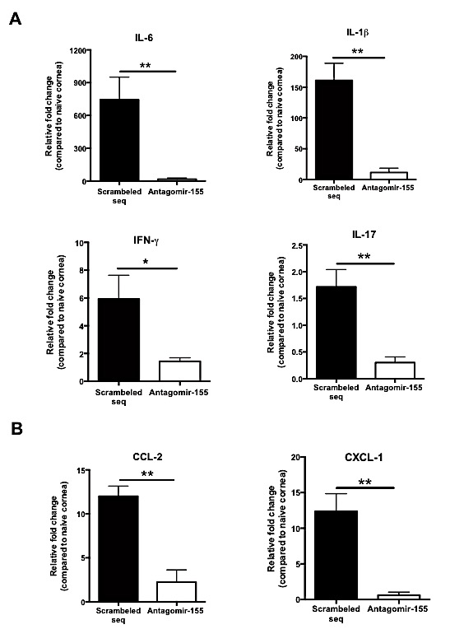
Figure 3.6
Figure III.7 Increased expression of Ship1 and IFN-γRα in miR-155-/- activated CD4+ T cells.
C57BL/6 and miR-155-/- mice ocularly infected with 1× 10⁴ PFU of HSV-1 RE. Both groups of mice received IVIG intraperitonealy at day 4 pi. Mice were sacrificed on day 14 pi and single cell suspensions of the individual cervical DLN were stained for CD4+, CD44 and CD62L. Cells were then FACS sorted as CD4+ CD44^{hi} CD62L^{lo} (activated) and CD4+ CD44^{lo} CD62L^{hi} (naïve) from both the HSV-1 infected WT (WT D4 IVIG) and miR-155-/- (miR-155-/- D4 IVIG) mice at day 14 pi. (A) miR-155 expression by Q-RTPCR in sorted naïve and activated cells. Expression levels of miR-155 were normalized to SnoRNA202 using the ΔCt calculation. Relative expression was calculated using the 2^{−ΔΔCt} formula. (B) Expression of Ship1 mRNA in sorted naïve and activated cells by Q-RTPCR. (C) Expression of IFN-γRα in sorted naïve and activated cells by Q-RTPCR. Expression levels of Ship1 and IFN- γRα were normalized to β-actin using the ΔCt calculation. Relative expression was calculated using the 2^{−ΔΔCt} formula. Data are representative of two independent experiments and show mean values ± SEM (n = 5–6 mice per group). Statistical significance was calculated by one-way ANOVA with Tukey’s multiple comparison tests. *p ≤ 0.05, **p ≤ 0.01.
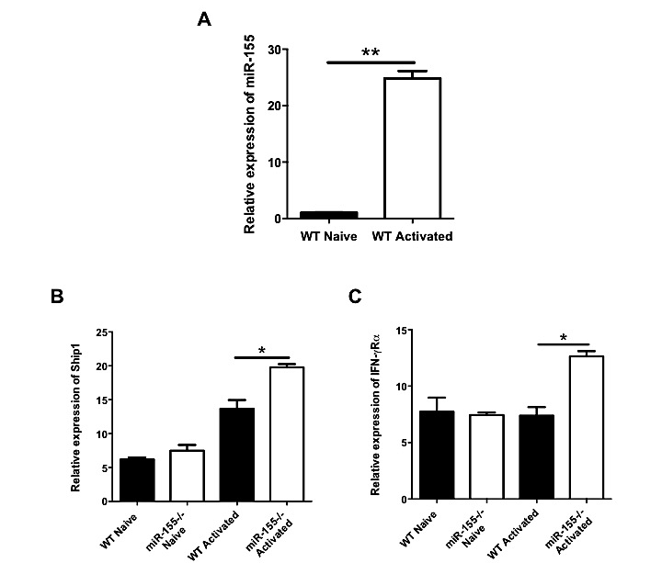

Figure 3.7

Figure III.8 Illustration of miR-155 induced regulation of inflammatory response during HSV-1 infection.
Left panel: Outcome (SK) in HSV-1-infected WT (miR-155 +/+) mice. HSV-1 infection leads to ocular infiltration of Th1 and Th17 cells, the major orchestrators of SK. miR-155 degrades IFN-γRα, Ship1, and conceivably other targets that cause increased numbers of these cells, along with their heightened effector function. This increased proinflammatory response leads to severe stromal keratitis. Right panel: Outcome (SK) in HSV-1-infected miR-155 -/- mice. HSV-1 infection of miR-155-/- mice leads to higher levels of IFN-γRα and Ship1 resulting in reduced numbers and functionality of Th1 and Th17 cells. This results in attenuation of SK lesions.

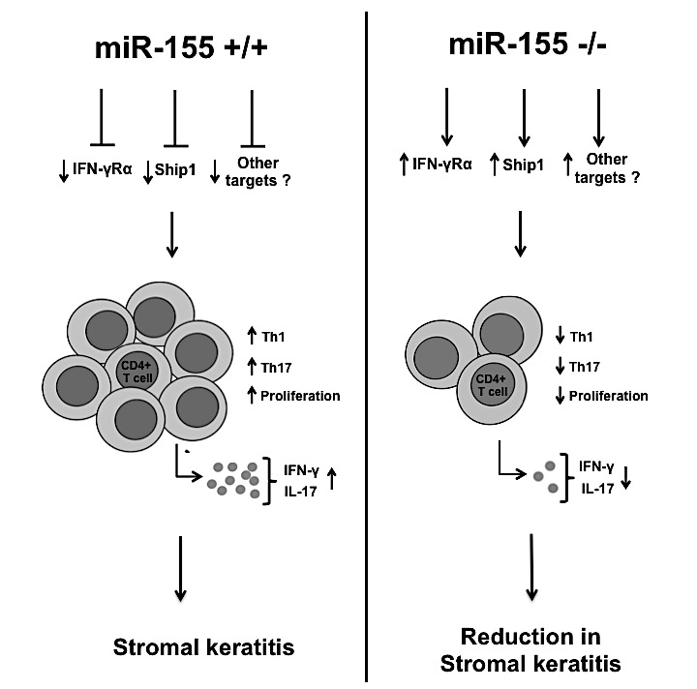

Figure 3.8

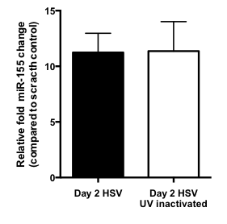
Figure S3.1 UV inactivated HSV-1 virus upregulates miR-155.
C57BL/6 mice were ocularly infected with 1× 10⁴ PFU of live HSV-1 or UV-inactivated HSV-1 virus. At day 2 after infection, animals were sacrificed, and corneas were collected and pooled for miRNA analysis to measure the expression of miR-155. The expression levels of miR-155 were normalized to SnoRNA202 using the ΔCt calculation. Relative expression was calculated using the 2^{−ΔΔCt} formula. miRNA-155 levels in mock-infected mice were set to 1 and used for the relative fold upregulation. Data are representative of two independent experiments and show mean values ± SEM. Statistical significance was analyzed by the Student t test (unpaired).

Figure S3.2 Therapeutic administration of antagomir-155 diminishes SK lesion severity and cellular infiltrates.
C57BL/6 mice were ocularly infected with 1× 10⁴ PFU of HSV-1 RE. (A) The antagomir-155/scrambled seq nanoparticle treatment was given subconjunctively as shown. Disease severity and immune parameters were analyzed at day 14 pi. (B) SK lesion severity and angiogenesis at day 14 are shown. (C) Representative H&E stained corneal sections (× 40 magnification) of scrambled seq treated (left) and antagomir-155 treated (right) mice collected on day 14 pi. Mice were sacrificed on day 14 pi, and corneas were harvested and pooled group wise for the analysis of various cell types. (D) The frequency and total cell number of CD4+ T cells and neutrophils (CD45+ CD11b+ Ly6G+) (plot was gated on CD45+ cells) infiltrated in the corneas of control (scrambled sequence) (left panel) and antagomir-155 (right panel) treated mice are shown. Data are representative of two independent experiments and show mean values ± SEM (n = 8–12 mice per group). Statistical significance was analyzed by the Student t test (unpaired). *p ≤ 0.05, ***p ≤ 0.001.

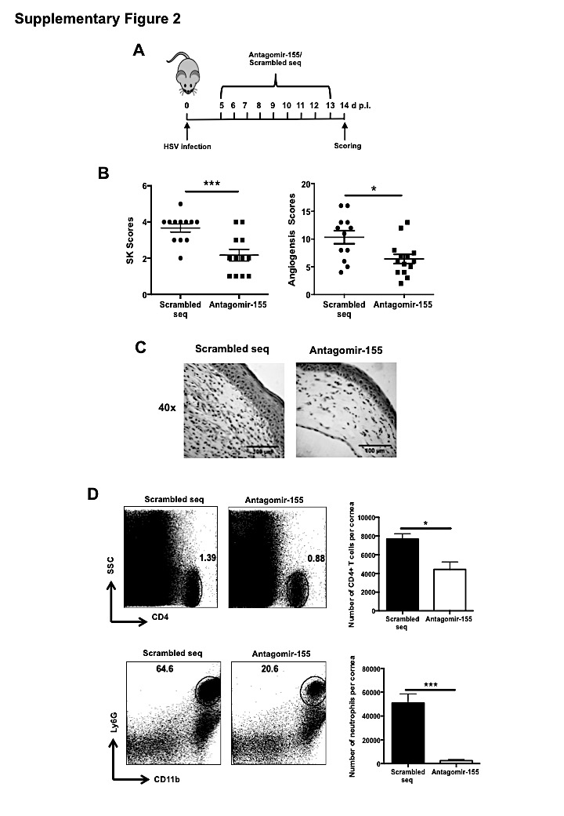
Figure S3.2

CONCLUSION AND FUTURE PERSPECTIVES

Herpes simplex virus infection generally leads to lesions on oral surface. In rare instances, virus causes ocular lesions (herpetic stromal keratitis) or infection of the central nervous system (herpes simplex encephalitis). Little is known about the involvement of miRNAs in the pathogenesis of herpetic stromal keratitis and/or herpex simplex encephalitis. In our study we focused on miR-155 involvement in both the diseases.
When miR-155 expression was analyzed after ocular HSV infection, we found significantly higher levels in eyes at different time points. miR-155 plays critical role in immunity as well as in inflammation. Thus, we set out to characterize the role of miR-155 after HSV infection. In my first report I established that microRNA-155 knockout (miR-155KO) mice are highly susceptible to HSE following ocular inoculation; mice were also more susceptible to the development of zosteriform lesions following viral replication and dissemination within the central nervous system. Additionally, the miR-155KO mice were unable to maintain HSV-1 latency. All theses phenotypes could be in part explained by defective CD8 T cell responses in the miR-155KO animals. Future experiments will need to be done to evaluate the different targets of miR-155 in CD8 T cells, which make them defective. Additionally, while evidence suggested defective CD8 T cell responses contributed to the heightened susceptibility of the miR-155KO mice to HSE, a role of CNS elements in influencing the dissemination and replication of HSV within the brain under differential control of miR-155 could not be eliminated. This area is currently being investigated in our lab.
In my second report I demonstrated that microRNA-155KO mice were also more resistant to herpes SK with marked suppression of Th1 and Th17 cell responses both in the ocular lesions and the lymphoid organs. The reduced SK lesion severity was reflected by increased phosphatidylinositol-3,4,5-trisphosphate 5-phosphatase 1 (Ship1) and IFN-gamma receptor alpha-chain (IFN-γRα) levels in activated CD4+ T cells which could explain defective Th1 cell responses. Future experiments would need to be done to investigate different targets of miR-155 that lead to defective th17 responses. Finally, in vivo silencing of miR-155 by the provision of antagomir-155 nanoparticles to HSV-1 infected mice led to diminished SK lesions and corneal vascularization.

VITA
Siddheshvar Bhela was born on July 20, 1987, in New Delhi, India. He obtained his Bachelor of Science degree in Biomedical Engineering from Texas A&M University, College Station, TX in 2009. He then worked as a Technical Research Assistant in the Hafler Laboratory of Molecular Immunology at Harvard Medical School/Brigham and Women’s Hospital from 2009 to 2011. In 2011, he joined the lab of Dr. Barry T Rouse at University of Tennessee, Knoxville, TN and received his Master of Science Degree in Comparative and Experimental Medicine in 2014 and his PhD in Comparative and Experimental Medicine in 2015.

