Urea as a Nitrogen Source for Microcystis aeruginosa

A Thesis Presented for the
Masters of Science Degree
The University of Tennessee, Knoxville

Bernard Shafer Belisle
August 2014
Acknowledgments
The culmination of my graduate research involvement within the Wilhelm lab has been an irreplaceable and rewarding experience. The completion of this Master program would not have been possible without the mentorship and support from the members of the Wilhelm lab and those in the UTK Microbiology Department. I would like to specifically acknowledge a few people that contributed most to my graduate experience.

I would like to thank my mentor and primary investigator Dr. Steven Wilhelm for all the support and guidance he provided throughout my time in the Wilhelm lab. I cannot express the level of my gratitude to Dr. Wilhelm for allowing me the opportunity to pursue this fascinating research project and sparking my interest in aquatic microbial ecology. I also would like to congratulate Dr. Wilhelm on recently becoming a father.

I would like to thank Dr. Erik Zinser and Dr. Jill Mikucki, members of my graduate committee, for contributing this research project by providing comments, advice, and insight. I am also grateful to the many collaborators associated with Environment Canada and those involved in the Microbial Ecology of the Lake Erie Ecosystem (MELEE) project. The completion of this research project would have been impossible without the support provided from my collaborators and committee members.

Finally I would like to thank all the members of the Wilhelm and members of the 6th floor Aquatic Microbial Ecology Research Group (AMERG) for providing an invaluable support system that has greatly contributed to my graduate experience. I would specially like to thank Dr. Gary LeCleir and Dr. Morgan Steffen for their leadership within the Wilhelm lab.

Abstract
Over the last decade, Lake Erie has experienced annual harmful algal blooms events dominated by the toxic cyanobacterium Microcystis aeruginosa. It is still unclear what causes Microcystis blooms to occur, but there is broad agreement that eutrophication of freshwater systems from anthropogenic sources (urban, industrial, etc.), has led to their proliferation. In particular, the organic compound urea has been implicated as an important source of anthropogenic nitrogen, due to its increased use in agricultural practices. Currently, urea constitutes more than 50% of the nitrogen used for agricultural fertilizer globally, and its usage has increased more than a 100-fold over the past four decades. To determine the effects of urea on Lake Erie phytoplankton, environmental surveys were conducted for urease enzymatic activity, phytoplankton biomass, nutrient concentrations, and phytoplankton community composition. 48-hour in situ microcosm experiments, spiked with various nitrogen species (nitrate, ammonium, and urea), were also performed to identify if the species of nitrogen influences phytoplankton biomass in Lake Erie. Results from this study confirm the presence of urea as a bioavailable form of nitrogen in Lake Erie, and indicated that as the bloom prolongs in duration the primary nutrient limiting phytoplankton biomass shifts from phosphorus to nitrogen. These results reinforce the importance of understanding the role of both nitrogen and phosphorous in driving harmful algal blooms in freshwater systems, and present the new idea that seasonal nitrogen limitation of plankton growth may be crucial in determining the size and extent of Microcystis blooms in Lake Erie.

Table of Contents
Page
I. Introduction…………………………………………………………………………….………...…….….…..1
Harmful Algal Booms in Lake Erie………………………………………………………..….....1
Reemergence of Blooms in Lake Erie………………………………………………….…....…4
Success of Microcystis in Lake Erie………………………………………………………..….…5
Morphology of Microcystis………………………………………………………………….….…..5
Buoyancy Regulation…………………………………………………………………………..….....5
UV Adaptation………………………………………………………………………………………..…6
The Role of Phosphorus as a Nutrient in Microcystis Growth…………….….…...…7
Importance of Nitrogen…………………………………………………………………………......9
Nitrogen Utilization…………………………………………………………………………………10
Urea as a Nitrogen Source…………………………………………………………….………….11
II. Research Objectives………………………………………………………………………….…………16
III. Methods and Materials…………………………………………………………………….…………17
Microcystis Culture Work……………………………………………………………….………...17
Environmental Sample Collection…………………………………………………….………19
Chlorophyll a Measurements…………………………………………………………….……..19
Measuring Urease Activity………………………………………………………………….……20
Urea Measurements.……………………………………………………………………………..…20
Microscopic Enumeration…………………………………………………………………….….21
Water Chemistry Analysis…………………………………………………………………...…...21
Microcosm Experiments…………………………………………………………………………..22
IV. Results.………………………………………………………………………………………………………..24
Laboratory Culture Work………………………………………………………………………...24
Field Surveys and Experiments……………………………………………….………………..27
Microcosm Experiments………………………………………………………….……………….40
V. Discussion…………………………………………………………………………………….………………50
Microcystis Growth on Various Chemical Forms of Nitrogen…………….…..…....50
Urease Activity of PCC 7806 and NIES 843…..…..........................................................51
Page
Environmental Samples…………………………..………………………………………..…52
Lake Erie Microcosm Experiments………………………………………………….……54
Conclusions………………………………………………………………………………….……..60
References……………………………………….…………………………………………………….…….62
Vita……………………………………………………………………………………………………………....69

List of Tables
Table Page
- NIES 843 and PCC 7806 Growth Rates……………………………………….…….18
- Microcosm Experimental Treatments…………………………………...…………23
- Lake Erie Station Data from August 2012, May 2013, July 2013……......30
- Lake Erie Station Nutrient Measurements………………………………….....…32
- August 2012 Microcosm Measurements…………………………………….…....42
- August 2012 Microcosm P-values……………………………………………….......43
- May and July 2013 Microcosm Chl a Measurements………………….……..47
- May and July 2013 Microcosm P-values………………………………….……….48

List of Figures
Figure Page
- US Fertilizer Nitrogen sources………………………………………………………..13
- PCC 7806 Growth on Various N sources……………………………………….....25
- NIES 843 Growth on Various N sources…………………………………………..26
- Urease Activity for PCC 7806 and NIES 843………………………………….....28
- Lake Erie Environmental Station Map……………………………………………..29
- August 2012 Lake Erie Station Chl a vs. Urease Activity…………………...35
- May 2013 Lake Erie Station Chl a vs. Urease Activity……………………….36
- July 2013 Lake Erie Station Chl a vs. Urease Activity………………………..37
- Urease vs. Urea conc. for August 2012, May 2013, July 2013……………38
- Chl a vs. Urea conc. for August 2012, May 2013, July 2013……………….39
- August 2012 Microcosm Experiments for Stations 973 and 885……....41
- May and July 2013 Microcosm Chl a for Stations 973 and 885………….46
- August 2012 Lake Erie MODIS Satellite Image…………………………………56
- May 2013 Lake Erie MODIS Satellite Image……………………………………..57
- July 2013 Lake Erie MODIS Satellite Image……………………………………...58

I. Introduction
Harmful Algal Blooms in Lake Erie
The Great Lakes basin consists of the Laurentian Great Lakes (Superior, Michigan, Huron, Erie, and Ontario) and the surrounding urban and agricultural areas that forms a large drainage basin that flows into the lake systems (Fuller et al. 2012). Currently, one-tenth of the population of the United States and one-quarter of the population of Canada reside in the Great Lakes basin. Additionally, 7% of the United States and 25% of Canadian total agricultural production occurs in the Great Lakes basin (Fuller et al. 2012). The presence of urban and agricultural lands in the Great Lakes watershed provides an input of point source and non-point source pollution, in the form of nitrogen and phosphorus, to the system. The excessive nutrient input leads to eutrophic conditions, resulting in annual increased algae biomass formation (Paerl et al. 2013).
Over the past several decades’ large phytoplankton blooms have become an annual event for large freshwater systems around the world, such as Lake Erie and China’s Lake Tai (or Taihu) (Rinta-Kanto et al. 2009, Qin et al. 2010, Steffen et al. 2014). The phytoplankton communities within these blooms consist of diverse phototrophic members of the plankton community, and include members such as diatoms, eukaryotic microalgae, and cyanobacteria (Oliver et al. 2012). Large phytoplankton blooms are often referred to as harmful algal blooms (HABs), because they have a negative impact on human activities or the environment (Zingone et al. 2000). The “harmful” aspects of these blooms can include oxygen depletion (hypoxia and anoxia), deterioration of water quality and clarity, and/or the production of toxic metabolites, such as microcystin (Paerl et al. 2013).
Bloom-forming cyanobacteria tend to dominate freshwater systems because of physiological advantages, such as the ability to fix atmospheric nitrogen, regulate buoyance within the water column and the ability to form colonies and filaments (Oliver et al. 2012, Paerl et al. 2013). These physiological traits have allowed some cyanobacterial species to outcompete native phytoplankton species in aquatic system (Boyer 2006). The shift in phytoplankton community composition to cyanobacterial dominance can alter flow paths of energy and nutrients, thus altering the structure and trophic functionality of aquatic ecosystems (Oliver et al. 2012).
The greatest impacts of eutrophication from anthropogenic sources are observed in Lake Erie, compared to the other Great Lakes, due primarily to the physical characteristics and input of nutrients from waterways, such as the Maumee River (Koslow et al. 2013, Steffen et al. 2014). The Maumee River drains an area of 16,376 km², with 87% being used for agricultural purposes (Chaffin et al. 2013). Because of this, the Maumee River is considered the largest source of nutrient elements into Lake Erie (Koslow et al. 2013).
Lake Erie is the smallest of the Great Lakes by volume (26,000 km²), with an average depth of 19 meters and a short retention time of 2.6 years (Fuller et al. 2012). It is geographically divided into three separate basins: eastern, central, and western (Chaffin et al. 2013). The eastern basin is the deepest of the three basins, with a max depth of 69 meters, and is generally oligotrophic, nutrient limited. The average depth of the central basin is 19 meters and can shift between oligotrophic and mesotrophic conditions. The western basin is the shallowest, with 8 meters as an average depth, and is considered eutrophic to mesotrophic (Chaffin et al. 2013).
During the late 1960s, HABs emerged as a public concern for Lake Erie due to the decline in dissolved oxygen concentrations and water quality, forming large anoxic zones. Anoxic zones are regularly formed when dissolved oxygen is consumed in the degradation of algal biomass (Fuller et al. 2012). Conditions became so dire that, Lake Erie was described as being “dead” by the popular press in the early 1970s (Charlton 1980, Steffen et al. 2014). Scientists focused on identifying and managing limiting nutrients, in an attempt to reduce biomass in Lake Erie. Nutrient limitation is often considered the primary constraint on growth of phytoplankton and is an important driver of competition that can influence community composition in aquatic systems (Oliver et al. 2012). In freshwater ecosystems, phosphorus has been the conventional limiting nutrient for primary productivity and algal biomass (Vollenweider 1968, Schindler 1977, Sterner 2008).
The Great Lakes Water Quality Agreement (GLWQA) was implemented in 1972, partially due to pressure from the public and scientific communities(Fuller et al. 2012). The GLWQA was a joint effort by the Canadian and American government to reduce point source phosphorous loading into the great lakes (Morrison et al. 1986, Fuller et al. 2012). The U.S. Environmental Protection Agency (EPA) defines point source pollution as “any single identifiable source of pollution from which pollutants are discharged, such as a pipe, ditch, ship or factory smokestack” (Hill 1997). In the 1970s and 80s, Lake Erie HAB phytoplankton biomass began to decline in response to the GLWQA action to reduce point source phosphorous loading (Fuller et al. 2012). By the 1980s, the observed increase of fish populations, reduction in algal biomass, and overall improvement of water quality suggested a recovery trend for the Lake Erie ecosystem.

Reemergence of Blooms in Lake Erie
Despite an apparent improvement in the overall health of the lake, in the mid-1990s a reemergence of cyanobacterial blooms began to occur in Lake Erie (Conroy et al. 2005). The cyanobacterial communities responsible for the mid-1990s blooms have shifted from the cyanobacterial species observed in blooms prior to GLWQA management (Conroy et al. 2005). During the 1960s, surveys of phytoplankton communities in Lake Erie identified that cyanobacterial biomass was dominated by nitrogen-fixing taxa such as Aphanizomenon spp. and Anabaena spp. (Conroy et al. 2005, Steffen et al. 2014). In contrast, the blooms occurring in the mid-1990s were dominated by, the non-nitrogen-fixing cyanobacterium, Microcystis spp. (Conroy et al. 2005), with other filamentous and N₂ fixing genera occurring in conjunction (e.g. Anabaena spp.) (Rinta-Kanto et al. 2006).
The switch to Microcystis spp., dominance suggests a shift in conditions that favored the competition between cyanobacterial taxa (Conroy et al. 2005). The need for nitrogen fixing cyanobacteria to meet nitrogen demands for the ecosystem has been reduced due to the increase loading of nitrogen into aquatic ecosystems. (Paerl et al. 2013). Because of the high energy requirements involved in nitrogen fixation, access to energetically favorable forms of nitrogen may provide a potential advantage for non-N₂ fixing cyanobacteria, over their N₂ fixing counterparts. This may be an explanation for the success of Microcystis in Lake Erie, compared to the N₂ fixing species observed in the 1960s.

SUCCESS OF MICROCYSTIS IN LAKE ERIE
Morphology of Microcystis
The Microcystis genus consists of spherical cells that are irregularly grouped into colonies of various sizes and densities. Microcystis colonies may or may not have stratified, colorless mucilage that can differ by sizes ranging from micro- to macroscopic and morphologically depending on environmental conditions. (Šejnohová et al. 2012). This makes species level identification of Microcystis difficult, but a combination of morphological and molecular markers have divided Microcystis spp., into three clusters or “morphospecies”: small (S) cell-size groups such as M. flos-aquae, middle (M) cell-size groups represented by M. aeruginosa, and large (L) cell-sized group represented by M. wesenbergii (Šejnohová et al. 2012). The grouping of cells into colonies is generally associated with the increase in exudation of polysaccharides (Oliver et al. 2012). These morphospecies vary in their response to abiotic factors, such as wind and temperature.

Buoyancy Regulation
Microcystis has the ability to regulate its buoyancy in response to changing environmental conditions by the use of gas vesicles. These gas vesicles are comprised of gas-filled hollow structures with conical end caps (Šejnohová et al. 2012). In Microcystis spp., the gas vesicle membrane was shown to have three thin layers, and comprised mainly of protein (Šejnohová et al. 2012). Gas vesicle membranes are impermeable to liquid due to a hydrophobic inner membrane, they are permeable to small gas molecules, such as H₂, N₂, O_{2,} CO₂, CO, CH₄, and Ar (Šejnohová et al. 2012). The internal gas compositions of these gas vesicles are equal to those of the surrounding environment. Microcystis is able to regulate its buoyance through changes in the development of gas vacuoles or by the balance of cellular constituents of different density such as proteins and carbohydrates (Oliver et al. 2012).
Buoyancy and regulation of depth in the water column allows Microcystis to bridge the vertical separation that develops in stratified waters between higher availability of nutrients (at depth) and access to greater illumination in surface waters (Oliver et al. 2012). Photosynthesis results in greater accumulation of cellular carbohydrate reserves, which decreases the buoyancy of the colony, and results in colonies from the surface layer becoming less buoyant during the day and more so at night (Šejnohová et al. 2012). The vertical movement in the water column regulates the amount of incident light available for photosynthetic activity. This access to both additional light and nutrients provides a clear competitive advantage of increased photosynthetic ability over other species that may be restricted to surface waters with limited nutrients or deep waters.

UV Adaptation
Phytoplankton, located in surface waters, are exposed to high levels of solar radiation (UV-A and UV-B), which can damage DNA and cause photo-oxidization of the photosynthetic apparatus, under prolonged exposure (Hader et al. 2007). Microcystis has developed many strategies to cope with high solar radiation (specifically UV-B), including a screening mechanism by d-galacturonic acid, a main component of the mucilage layer surrounding the colony (Hader et al. 2007, Šejnohová et al. 2012). This suggests that the formation of large colonies allows for internal self-shading and is important in UV protection. Additionally, M. aeruginosa can cope with enhanced UV-B through: an increasing the synthesis of carotenoids to counteract reactive oxidants caused by exposure to UV-B, degrading phycocyanin and allophycocyanin to avoid further damage to DNA and reaction centers, and enhancing the repair of UV-B induced damage to the photosynthesis mechanism (Hader et al. 2007, Šejnohová et al. 2012).

The role of phosphorus as a nutrient in Microcystis growth
Phosphorus (P) is traditionally accepted as the primary nutrient controlling the development of cyanobacterial biomass in freshwater systems because of the extensive evidence that correlates growth rates to available concentrations of phosphorus (Schindler 1977, Dokulil et al. 2000, DeBruyn et al. 2004, Xu et al. 2010). Phosphorus is a required element for many integral cellular processes, including metabolism (adenosine phosphates) and the formation of new nucleic acids (sugar phosphates) (Correll 1999). An important source of phosphorus for assimilation into biomass for aquatic phytoplankton, including Microcystis spp., is in the form of orthophosphates, inorganic forms of phosphorous (Osmond et al. 1995, Šejnohová et al. 2012). Under phosphorus limiting conditions, cellular phosphorus concentrations decline as the growth rate declines and phosphorus uptake potential increases (Oliver et al. 2012, Saxton et al. 2012). Additionally, Microcystis spp. can accumulate excess phosphorus in the form of polyphosphate granules, also known as the phosphate ‘overplus’ phenomenon (Saxton et al. 2012, Šejnohová et al. 2012). This provides a competitive advantage over other microalgae that are unable to store excess phosphorus, under P-limiting conditions.
In aquatic systems, phosphorus exists in the form of phosphates (PO₄³⁻) that can vary in molecular formation (organic or inorganic), and are often categorized based upon the differences in particle size and chemical characterization. Phosphorus material categorized by size is referred to as “dissolved ” (also known as soluble), material smaller than 0.2 μm, or “particulate”, material larger 0.2 μm (Jiao et al. 2010). The terms “reactive” and “unreactive” are used to describe fractions of phosphorus that are in a form that is readably available for use in cellular processes and fractions that are unable for immediate use, respectively (Carlson et al. 1996).
Using these parameters, classifications of phosphorus in these systems are typically divided into three different components: soluble reactive phosphorus (SRP), soluble unreactive phosphorus (SUP), and particulate phosphorus (PP) (Carlson et al. 1996). The sum of the SRP and SUP fractions represents the soluble phosphorus (SP) portion, and the sum of all phosphorus components represents the total phosphorus (TP) measurement. The SRP fraction consists mostly of orthophosphates, which is bioavailable for use by bacteria, algae, and plants (Correll 1999). Conversely, the SUP fraction is comprised mostly of organic forms of phosphorus and inorganic polyphosphates, and historically has not been considered immediately available for use in cellular processes.
The traditional “Phosphorus Limitation Paradigm” suggests that lake ecosystems will tap into atmospheric sources of carbon (C) and nitrogen (N) to overcome any limitation of these two elements; the same is not true for phosphorus (Schindler 1977, Sterner 2008). Based upon this rational, short-term deficiencies of C and N may exist, but phosphorus limitation is the primary controlling variable. Therefore, it was argued by the GLWQA that control of N input was unnecessary. The GLWQA successfully used this reasoning to target P loads to reduce annual Lake Erie HAB biomass in the early 1970s, while N inputs remained less strictly controlled. The mid 1990s reemergence of HABs in Lake Erie dominated by non-N₂ fixing cyanobacteria, primarily Microcystis sp., is in response to changes in nutrient loading dynamics, compared to blooms preceding GLWQA management. Nutrient loading from agricultural, urban, and industrial expansion have increased both N and P loading, into Lake Erie (Paerl et al. 2014).

Importance of Nitrogen
Cyanobacteria are able to utilize a wide range of nitrogen sources, such as ammonium (NH₄⁺), nitrate (NO₃⁻), nitrite (NO₂⁻), and urea (CO(NH₂)₂), each having specific energetic properties relative to nutrient limitation in lakes (Sterner 2008, Solomon et al. 2010, Oliver et al. 2012). Some cyanobacteria species, including Anabaena, Aphanizomenon and Cylindrospermopsis, species possess the nitrogenase enzyme, (Boyer 2006), which allows for the fixation of atmospheric nitrogen (N₂), but is energetically costly (Stainer et al. 1977, Flores et al. 2005, Fuller et al. 2012). Generally freshwater systems that are phosphorus rich, relative to nitrogen (low N:P ratio), favor the growth of N₂-fixing cyanobacteria that are able to fix N for cellular demands (Paerl et al. 2014). The order of energetically favorable forms of inorganic nitrogen for cyanobacteria is NH₄⁺ > NO₃⁻ > NO₂⁻ > N₂ (Oliver et al. 2012, Šejnohová et al. 2012). NH₄⁺ is energetically favorable to NO₃ because the latter requires nine NAD(P)H or ferredoxin and one ATP to assimilate into the glutamate pathway, while NH₄⁺ assimilation requires only one reductant and one ATP (Oliver et al. 2012). These energetic substrates for nitrogen assimilation are provided by the photosynthetic process and are also utilized by the carbon fixation pathway. Therefore, the form of nitrogen utilized by an organism influences other cellular processes, by diminishing the pool of energetic substrates (Stainer et al. 1977, Šejnohová et al. 2012).

Nitrogen Utilization
In cyanobacteria, the global nitrogen transcription regulator, NtcA, mediates nitrogen control by responding to environmental levels of nitrogen availability (Solomon et al. 2010). The acquisition of nitrate, nitrite, urea, and various amino acids are mediated by active transport using membrane permeases, a membrane transport protein (Herrero et al. 2001, Flores et al. 2005). After nitrogen is acquired, it is reduced to NH₄⁺ and incorporated into the carbon skeleton of the cyanobacterium, via the glutamine synthase-glutamate synthase cycle (GS-GOGAT) (Flores et al. 2005, Oliver et al. 2012). This is done by the reduction of intracellular NO₃⁻ to NO₂⁻ by nitrate reductase, and then NO₂⁻ is reduced to NH₄⁺ by nitrite reductase (Herrero et al. 2001). The acquisition of NH₄⁺ is mediated by membrane transporters that are permeable to NH₄⁺ when extracellular concentrations are lower than 1 μM per liter (Herrero et al. 2001, Flores et al. 2005). When NH₄⁺ is present, its uptake and utilization in the GS-GOGAT pathway represses the genes that are responsible for permeases and enzymes involved in the assimilation of less favorable nitrogen sources, a process known as ‘nitrogen control’ (Oliver et al. 2012). Excessive nitrogen can be stored intracellularly in the form of phycocyanin, a component pigment of the light harvesting antenna, and cyanophycin, a co-polymer of aspartate and arginine. The storage of nitrogen as cyanophycin is controlled by the N-acetylglutamate kinase (NAGK) enzyme, which produces sufficient quantities of arginine for by the cyanophycin synthase (Oliver et al. 2012). Under nitrogen limiting conditions, phycocyanin and cyanophycin are both at low concentrations, due to consumption and/or inability to secure sufficient nitrogen for storage. The limited availability of nitrogen inhibits the storage pathway by the accumulation of 2-oxo-glutarate, which binds to the photosystem II complex (PSII), and leads to the dissociation of the PSII-NAGK complex (Herrero et al. 2001, Oliver et al. 2012). The dissociation of the PSII-NAGK complex, under nitrogen limited conditions, restricts the production of arginine and therefore inhibits the nitrogen storage mechanism.

Urea as a Nitrogen Source
Urea (CO(NH₂)₂) is a stable form of organic nitrogen, often used in agricultural fertilizer, and is utilizable by cyanobacteria and phytoplankton in freshwater and marine environments (Solomon et al. 2010). Urea currently constitutes more than 50% of the nitrogen used globally for agricultural fertilizer, more than a 100-fold increase in the past 4 decades (Figure 1; (Glibert et al. 2006)). Urea is a favorable source nitrogen for agricultural fertilizer because of its solubility in water, low cost, and reduced damage to root crops. In general, urea concentrations in aquatic ecosystems are less than those of NH₄⁺ and NO₃⁻, but may exceed these inorganic nitrogen sources for short periods of time, particularly when runoff from heavily fertilized areas occurs (Solomon et al. 2010).
The use of urea as a fertilizer is effective for agricultural practices, but resulting urea runoff can degrade the water quality of neighboring aquatic systems (Glibert et al. 2006, Finlay et al. 2010). In the last decade, bloom events in Lake Erie have increased in size and duration. The bloom in 2011 was the most extensive in recent history (Michalak et al. 2013). Recent published reports have linked heavy rainfall years (1998, 2003, 2008, 2011) and increased bloom size, while drought years (1999, 2001, 2012) have been associated with below average bloom events (Koslow et al. 2013). For Lake Erie, increased precipitation is believed to contribute to elevated levels of nutrient loading, which exacerbates the levels of cyanobacteria in the lake (Michalak et al. 2013).
The preferential use of urea over other inorganic nitrogen sources, high rates of urea uptake, and increased urease activity have been shown to occur in many phytoplankton species, some of which are associated with HAB forming genera (Fan et al. 2003, Glibert et al. 2006, Solomon et al. 2010). Furthermore, the presence of
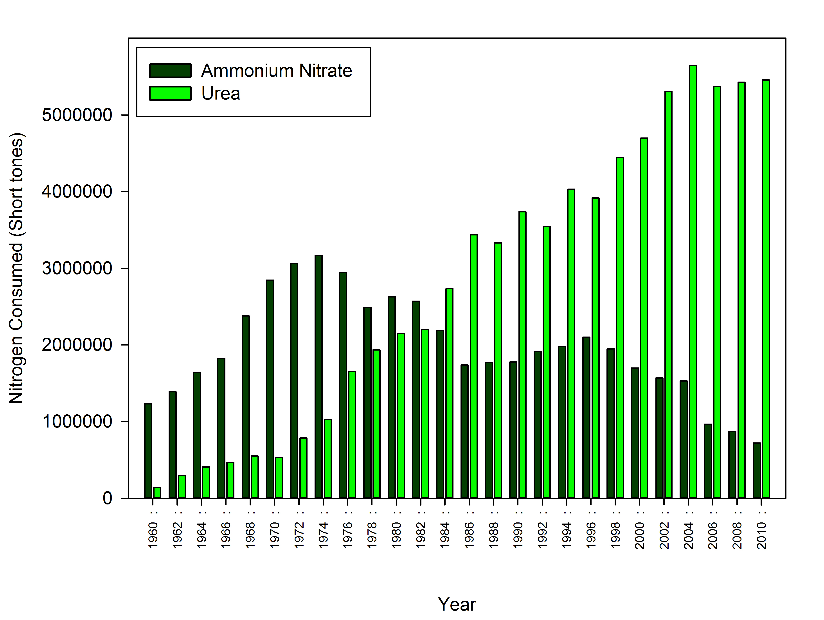
Figure 1: Ammonium Nitrate (Dark Green) and Urea (Light Green) usage as a nitrogen source for fertilizer in the United States, from 1960 to 2010. Source United States Department of Agriculture Economic Research Service (USDA-ERA 2013).

chemically reduced forms of nitrogen (NH₄⁺, urea) have been shown to specifically suppress N₂-fixing cyanobacteria (Aphanizomenon, Anabaena) and stimulate growth in non-N₂-fixing cyanobacteria (Microcystis, Planktothrix) in pure culture (Finlay et al. 2010). This occurs because reduced forms of nitrogen are rapidly acquired by cyanobacteria increasing the intracellular concentrations of NH₄⁺, which alters glutamate concentrations and represses transcription NtcA promoter activity, thus immediately suppressing N₂-fixation in heterocysts (Finlay et al. 2010).
Extracellular urea uptake utilizes the same mechanism of diffusion and permeases involved in the extracellular uptake of NH₄⁺ (Fan et al. 2003, Finlay et al. 2010). The use of urea as a nitrogen source for cellular processes requires the urease enzyme (Solomon et al. 2010). The urease enzyme is a nickel (Ni) dependent enzyme that hydrolyzes urea into one CO₂ and two NH₄⁺ molecules (Manunza et al. 1999, Fan et al. 2003). The fate of anthropogenic (agricultural) sources of urea can vary based on environmental factors such as temperature, timing of application, and pH. Hydrolysis of urea-based fertilizer can occur initially after application to the field by soil microbes containing the urease enzyme. Additionally, hydrolysis can occur by aquatic cyanobacteria and heterotrophs possessing the urease enzyme, when direct runoff of urea occurs (Glibert et al. 2006).
Agricultural practices, such as no-till farming and application of urease inhibitors with fertilizer, may exacerbate the amount of urea directly transferred to aquatic ecosystems (Glibert et al. 2006). AgrotainTM is an example of a commercial fertilizer additive that reduces urea loss. AgrotainTM reduces urea loss occurring via hydrolysis and NH₄⁺ volatilization by soil microbes, by inhibiting urease activity (Boyer 2013). AgrotainTM uses N-(n-butyl)-thiophosphoric triamide (NBPT) to inhibit urease activity via binding to the active site of the urease enzyme to form a stable complex (Manunza et al. 1999). Under normal conditions, urea is able to coordinate with the active site of the urease enzyme by the interaction of urea’s oxygen (O) atom to one Ni atom in the active site. NBPT inhibits the urease enzyme by targeting both Ni atoms in the active site with its amide group and oxygen atom, to form a stable complex (NBPT-urease), which inhibits the ability of urea to interact with the Ni atoms of the active site (Manunza et al. 1999).

II. Research Objectives

The goal of this study was to confirm whether Microcystis aeruginosa is capable of utilizing urea as a nitrogen source in Lake Erie. To identify the role of urea in promoting Microcystis blooms occurring in Lake Erie, environmental measurements of urease enzymatic activity, phytoplankton biomass, nutrient concentrations, and phytoplankton community composition were measured during three sampling cruises (August 2012, May 2013, July 2013). 48-hour in situ microcosm experiments, spiked with various nitrogen species (urea, nitrate, ammonium, Agrotain (NBPT+Urea) and environmental control), were performed to determine if the species of nitrogen influences phytoplankton biomass in Lake Erie.

The specific hypotheses of this thesis are:
H1: Higher phytoplankton biomass, nutrient concentrations, toxin levels, and greater phytoplankton community diversity will be observed in the western basin of Lake Erie compared to the central and eastern basin, because of the high input from major water sources that empty into the western basin.

H2a: Urease activity in Lake Erie is correlated to phytoplankton biomass.

H2b: Urease activity in Lake Erie is correlated to urea concentrations.

H3a: Phytoplankton biomass and urease activity, of the microcosm experiment, will vary based on the nitrogen species provided.

H3b: Microcosm treatments that contain nitrogen and phosphorous will have increased phytoplankton biomass and urease activity, compared to treatments with nitrogen only, regardless of the nitrogen source.

III. Methods and Materials
Microcystis Culture Work
The ability of Microcystis aeruginosa to use ammonium (NH₄⁺), nitrate (NO₃), and urea (CO(NH₂)₂) as a sole nitrogen source was examined by growing unialgal cultures in modified CT growth media (Watanabe et al. 1977). CT media was prepared for each species of nitrogen by replacing the standard source of nitrogen, (KNO₃ and Ca(NO₃)₂), with 180 μM N of NH₄⁺, NO₃, or urea. This represents 10% of N contained in standard CT media, as seen in Table 1. Experiments were performed using two laboratory strains of M. aeruginosa: (1) PCC 7806, obtained from the Pasteur Culture Collection (PCC), and (2) NIES 843, from the National Institute for Environmental Studies (NIES) (Kaneko et al. 2007). PCC 7806 was selected because it is a strain used globally for laboratory work, and NIES 843 was chosen because it is the only strain of Microcystis with a fully sequenced genome (Kaneko et al. 2007).
Each strain was grown in 50 mL glass culture tubes (Kimble, Vineland, NJ) at 24°C with ~30 μmol photons m^{‐2} s^{‐1} illumination under a 12h‐12h day‐night light cycle. Prior to use, all culture tubes were soaked overnight in 1% HCl and rinsed thoroughly with Milli-Q® water (Millipore Corp., Billerica, MA, USA), prior to autoclaving. Samples were grown in triplicate under each form of nitrogen and transferred three times to a starting density of ~10⁴ cells per mL, prior to data collection. This was done to ensure that cell cultures had exhausted any intracellular sources of nitrogen and only utilized the nitrogen source provided for cell growth. Cyanobacterial growth was monitored daily using a Turner Designs TD‐700 fluorometer (Sunnyvale, CA, USA).

Table 1: M. aeruginosa strain NIES 843 and PCC 7806 growth rates on various chemical species of nitrogen. Samples were grown in triplicate at 24°C under a 12h-12h day-night light cycle, for each nitrogen treatment. Measurements of biomass accumulation were taken over a sixteen-day growth period, on the third transfer.
Organism | Treatment | Growth Media  N concentration | Growth Rate  (per day ± SD)
M. aeruginosa NIES 843 | Positive Control | 1.8 mM KNO₃ + Ca(NO₃)₂ | 0.256 ± 0.007
M. aeruginosa NIES 843 | Nitrate | 180 μM NO₃ | 0.252 ± 0.008
M. aeruginosa NIES 843 | Urea | 180 μM Urea | 0.228 ± 0.011
M. aeruginosa NIES 843 | NBPT | 180 μM NBPT | 0.209 ± 0.011
M. aeruginosa NIES 843 | No N Control | 0.0 μM-N | 0.0 ± 0.0
M. aeruginosa PCC 7806 | Positive Control | 1.8 mM KNO₃ + Ca(NO₃)₂ | 0.247 ± 0.008
M. aeruginosa PCC 7806 | Nitrate | 180 μM NO₃ | 0.245 ± 0.010
M. aeruginosa PCC 7806 | Urea | 180 μM Urea | 0.238 ± 0.006
M. aeruginosa PCC 7806 | NBPT | 180 μM NBPT | 0.227 ± 0.014
M. aeruginosa PCC 7806 | No N Control | 0.0 μM-N | 0.0 ± 0.0

Environmental sample collection

Field samples and in situ microcosm experiments were conducted aboard the CCGS Limnos during three Lake Erie environmental sampling cruises: August 13-17, 2012, May 27-31, 2013, and July 22-26, 2013. Surface water (1 meter depth) was collected from each station using 10 L Niskin sampling bottles and transferred to the ship’s laboratory in 3 L acid-cleaned polycarbonate bottles. Prior to use, all polycarbonate bottles were soaked in 1% HCl and rinsed thoroughly with Milli-Q® water (Millipore Corp., Billerica, MA, USA). Environmental water samples from each station were then filtered through 0.2-μm nominal pore-size polycarbonate membrane filters (25 mm diam., Millipore) and analyzed for urease activity, chlorophyll a concentrations, urea concentrations, and nutrient measurements.

Chlorophyll a measurements
Chlorophyll a (chla) concentrations were determined using the non-acidification method (Welschmeyer 1994, Wetzel et al. 2000), and served as a proxy for total phytoplankton biomass. A 50 mL volume of surface water from each station was filtered through 0.2-μm nominal pore-size polycarbonate membrane filters (25 mm diam., Millipore) and deposited into a 2.0 mL cryovial (Corning, NY). The sample was then flash frozen in liquid nitrogen and transferred to -80°C, until analyzed. Chla concentrations were then determined by placing the filter into 90% acetone overnight (24 hours) at -20°C and measured using a fluorometer (Turner Designs 10-AU; Sunnyvale, CA, USA).

Measuring urease activity
Urease activity was determined by measuring the accumulation of NH₄⁺, which is a product of urea metabolism. A 50 mL volume of surface water from each station was filtered through pre-combusted (450°C for 4 h) 25 mm Whatman (Kent, UK) GF/F glass fiber filters. Urease activity was measured using the indophenol method optimized for aquatic environmental samples (Solomon et al. 2007). Each sample was performed in triplicate and analyzed using a BioMate 5 UV-Visible Spectrophotometer, at 640 nm. An external calibration was measured for each assay performed, using a range of NH₄⁺ stock solutions (0, 1.0, 2.5, 5.0, 7.5, and 10.0 μM). The NH₄⁺ solutions were prepared from a 10 mM NH₄Cl standard stock solution, 0.267 g NH₄Cl into 500 mL Milli-Q® water (Millipore Corp., Billerica, MA, USA).

Urea Measurements
Urea concentrations for field samples were measured using the ‘Direct Method’, a colormetric assay based on the reaction of urea with diacetylmonoxime, as outlined by Revilla et al., 2005. Whole water samples were collected from each station and filtered through pre-combusted 25 mm Glass Fiber Filters (GF/F) (Kent, UK). Filtrate was stored at -20°C until analyzed in a laboratory setting. Water samples were measured in triplicate and analyzed using a BioMate 5 UV-Visible Spectrophotometer at 520 nm (Revilla et al. 2005). Standard curves were performed for each experiment by using a range of urea stock solutions (0, 0.5, 2.0, 5.0, 7.5, and 10.0 μM).

Microscopic enumeration
Phytoplankton identification and enumeration of environmental samples was performed using Lugol’s Iodine-preserved samples and microscopic morphometrics (Wehr et al. 2003, Auinger et al. 2008, Saxton et al. 2012). Samples (50 mL) were collected and preserved with 0.5 mL of Lugol’s Iodine (100 g KI liter⁻¹ and 50 g I₂ liter⁻¹), and stored at 4°C (Auinger et al. 2008). Fixed samples were allowed to settle (3-5 min) in a 1 mL Sedgwick-Rafter counting slide (Chorus et al. 1999) then analyzed on a Micromaster light microscope (ThermoFisher). Each sample was analyzed by taking four horizontal transects, ten fields of view each, which encompassed the full height and width of the slide (Chorus et al., 1999 and Saxton et al., 2012). The resulting 40 randomly selected fields of view were imaged and saved using Micron imaging software (Westover Scientific), for later identification using taxonomic features (Wehr et al. 2003, Guillard et al. 2005). Organisms observed for each sample were identified and counted from the 40 randomly selected fields of view.

Water Chemistry Analysis
Water samples for nutrient analysis was collected at each environmental station and analyzed for total dissolved nitrogen (TDN), total kjeldahl nitrogen (TKN), total dissolved phosphorous (TDP), soluble reactive phosphorus (SRP), NH₃-N (ammonia), NO₃NO₂ –N (nitrate/nitrite), and silicate (SiO₂). TDN is the measurement of all dissolved forms of nitrogen, such as nitrate, nitrite, and TKN (ammonia + organic nitrogen). The National Laboratory for Environmental Testing (Environment Canada) performed chemical analyses of the environmental samples using their standard techniques (NLET 1994). Environment Canada provided pH and surface temperature at the time of sampling, for each station, attained from the ship’s automated water column profiler (NLET 1994).

Microcosm Experiments
Nutrient enrichment microcosm experiments were conducted under in situ conditions during three CCGS Limnos cruises. Microcosm experiments were performed at two ecologically relevant stations, Station 885 and Station 973. Station 885 was chosen due to the diversity of cyanobacteria historically present at this station, and Station 973 was chosen due to its proximity to the entrance of the Maumee River into Lake Erie. Surface water (1 m) from each station was dispensed into acid washed 1.2 L polycarbonate flasks and enriched with one of four chemical species of nitrogen, as shown in Table 2. Treatments for each microcosm experiment included: Nitrogen only treatments (N-only) enriched with only 180 μM N for each nitrogen species, Nitrogen plus Phosphorous treatments (N+P) enriched with 180 μM N for each nitrogen species in addition to 1 μM phosphorus, Environmental Control (Control) of whole water with no nutrient enrichment, and Environmental Control plus Phosphorus (Control +P) of whole water with only with 1 μM phosphorus added (Table 2). Each treatment was performed in triplicate and incubated in a deck incubator for 72 hours under in situ conditions. After incubation, aliquots from each treatment was collected and analyzed for chla concentrations, microscopic enumeration, and nutrient concentration, as previously described.

Table 2: Microcosm experimental treatments utilized for three Lake Erie sampling cruises, at Station 973 and 885.
Each treatment was performed in triplicate and incubated in a deck incubator for 72 hours under in situ conditions.
Whole water, from each station, was spiked to a final concentration of 180μM-N (Nitrogen only Treatments) and
180μM-N + 1μM Phosphorous (Nitrogen +PO₄ treatments), for each species of Nitrogen.
Treatment | Treatment Label | Added Nutrient concentration
Nitrogen Only | Environmental Control | No-N added
Nitrogen Only | NO₃ | 180 μM NO₃
Nitrogen Only | Urea | 180 μM Urea
Nitrogen Only | NBPT | 180 μM NBPT
Nitrogen Only | NH₄ | 180 μM NH₄
Nitrogen + Phosphorus | Environmental Control + P | No-N added; +1μM PO₄
Nitrogen + Phosphorus | NO₃ + P | 180 μM NO₃ + 1μM PO₄
Nitrogen + Phosphorus | Urea +P | 180 μM Urea + 1μM PO₄
Nitrogen + Phosphorus | NBPT + P | 180 μM NBPT + 1μM PO₄
Nitrogen + Phosphorus | NH₄ + P | 180 μM NH₄ + 1μM PO₄

IV. Results

Microcystis Laboratory Culture Work
Biomass accumulation for PCC 7806 and NIES 843, compared to the no nitrogen control, demonstrates the ability of M. aeruginosa to successfully utilize several different chemical forms of nitrogen for cellular processes, as shown in Figure 2 and Figure 3 respectively. Nitrogen-limited treatments exhibited similar patterns of overall biomass accumulation, for both strains of M. aeruginosa. Furthermore, strains of M. aeruginosa exhibited the highest biomass accumulation for the Positive Control treatment and lowest for the No N Control treatment. The absence of growth in the No N Control treatment ensures that the observed biomass accumulation was from the nitrogen species provided and not from contamination and/or other components of the CT growth media.
M. aeruginosa PCC 7806 growth rates ranged between 0.247 ± 0.008 to 0.227 ± 0.014 divisions per day and NIES 843 ranged between 0.256 ± 0.007 to 0.209 ± 0.011 divisions per day (Table 1). Growth rates were highest in the 1.8 mM N Positive Control treatments and lowest in the 180 μM N NBPT+Urea treatments for both strains. PCC 7806 growth rates for all treatments were statistically similar to each other (p>0.05). Growth rates for NIES 843 Positive Control and Nitrate treatments were statistically similar to each other and statistically different for all other treatments (p<0.05). Even though growth rates varied between M. aeruginosa strains, biomass was notably lower for the nitrogen-limited treatments (180 μM N), compared to the high N (1.8 mM N) Positive Control treatment.
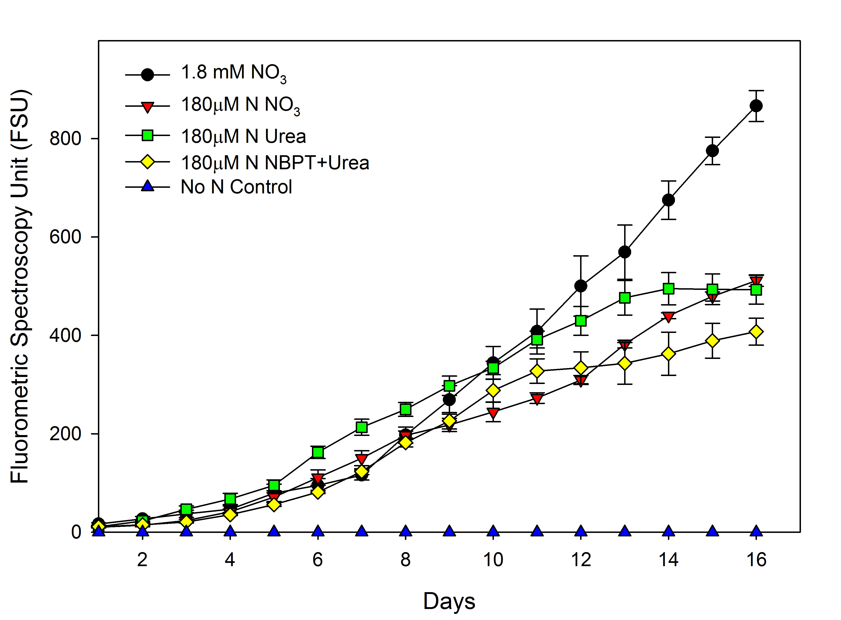
Figure 2: M. aeruginosa culture strain PCC 7806 growth over sixteen days on various chemical species of nitrogen, as the sole nitrogen source. Nitrogen limited treatments (180 μM N) for NO₃, Urea, and NBPT are represented by a red triangle, green square, and yellow diamond, respectively. Positive Control (1.8 mM KNO₃ and Ca(NO₃)₂) and No N Control treatments are represented by a black circle, and blue triangle, respectively.

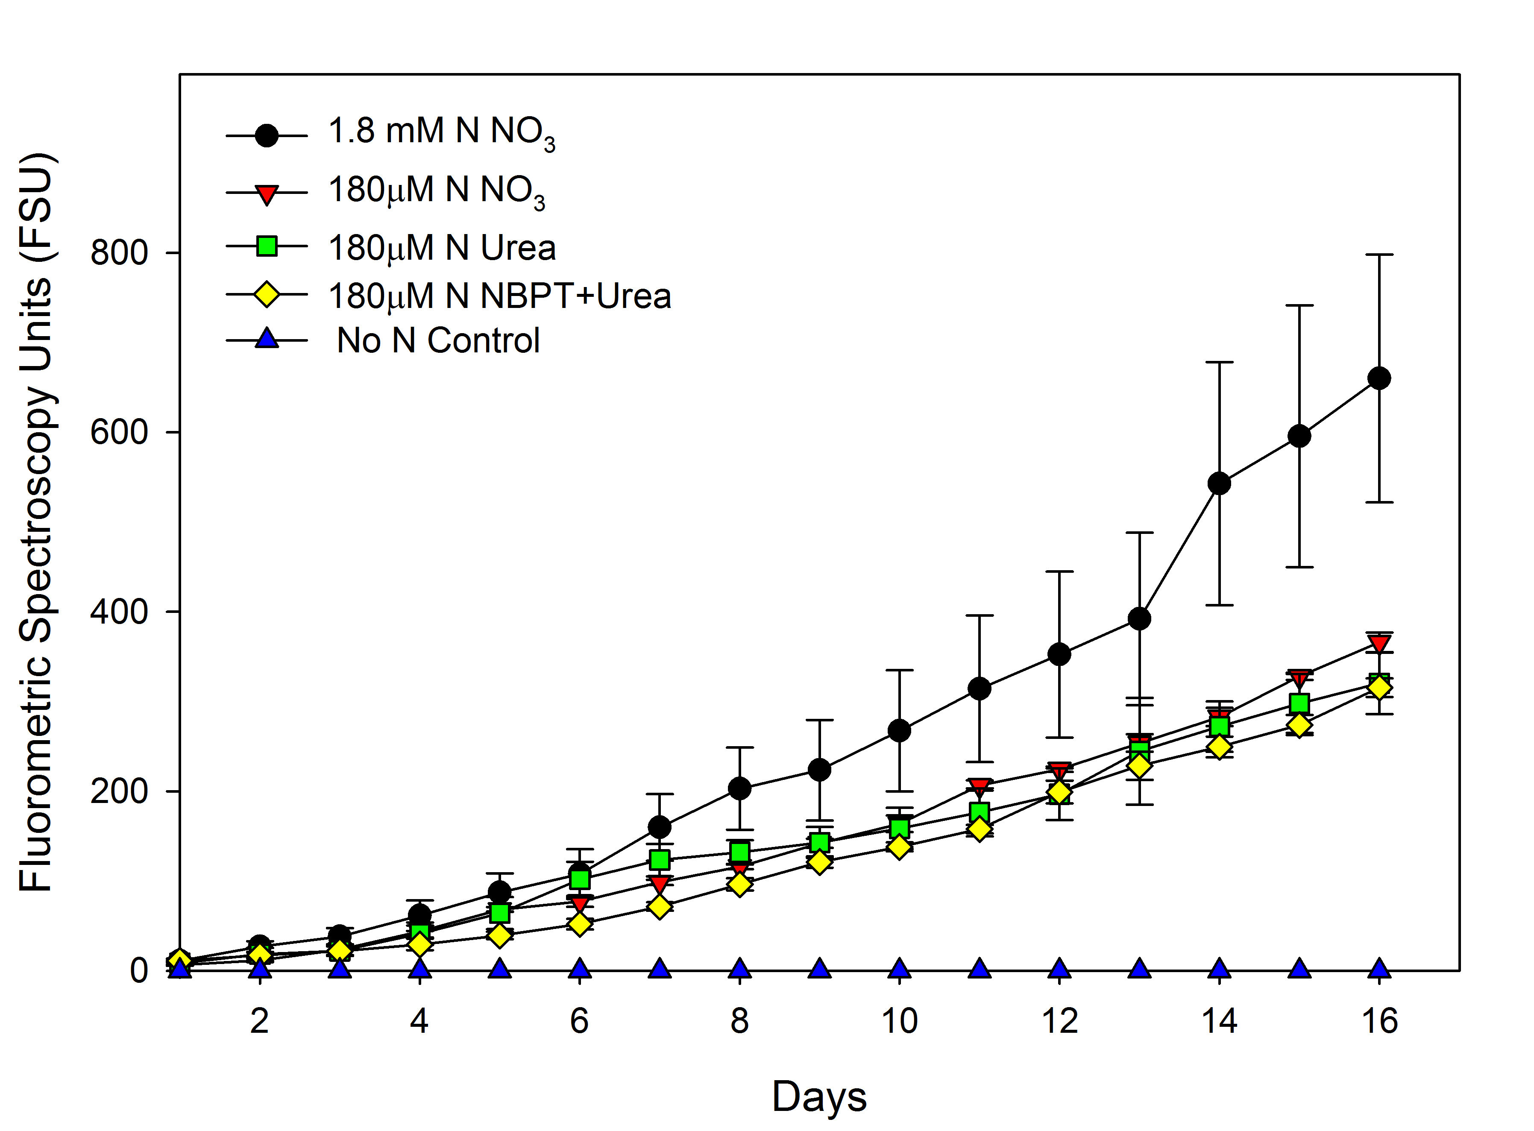
Figure 3: M. aeruginosa culture strain NIES 843 growth over sixteen days on various chemical species of nitrogen, as the sole nitrogen source. Nitrogen limited treatments (180 μM N) for NO₃, Urea, and NBPT are represented by a red triangle, green square, and yellow diamond, respectively. Positive Control (1.8 mM KNO₃ and Ca(NO₃)₂) and No N Control treatments are represented by a black circle, and blue triangle, respectively.

The low ammonium (180 μM-NH₄) treatment failed to exhibit growth through multiple transfers, in spite of repeated attempts.
Urease activity for PCC 7806 strain was significantly higher for the low Nitrate and Urea treatments compared to Positive Control treatment (Figure 4). M. aeruginosa NIES 843 urease activity was also highest in the low Urea treatment, but significantly lower for all other treatments compared to the Positive Control treatment (p < 0.05). For both PCC 7806 and NIES 843, urease activity was lowest for the low NBPT+Urea treatment, suggesting inhibition of the urease enzyme by NBPT.

Field surveys and experiments

Lake Conditions. Environmental conditions were surveyed during August 2012, May 2013, and July 2013 by collecting water samples at 21 stations (Figure 5) across Lake Erie. Chlorophyll a measurements for August 2012, May 2013 and July 2013 ranged from 1.56 - 25.4 μg/L, 0.726 – 37.35 μg/L, and 1.0 – 72.45 μg/L respectively (Table 3). Station 1163 exhibited the highest chlorophyll biomass for May 2013 and July 2013, with only Station 973 being higher for August 2012 measurements. Water samples for nutrient analysis was taken for each station and measured for: total kjeldahl nitrogen (TKN), total nitrogen (TN), total phosphorus (TP), soluble reactive phosphorus (SRP), nitrate/nitrite (NO₃/NO₂), ammonia (NH₃), and silica (SiO₂), as shown in Table 4. August 2012 TN, TP, and SRP measurements
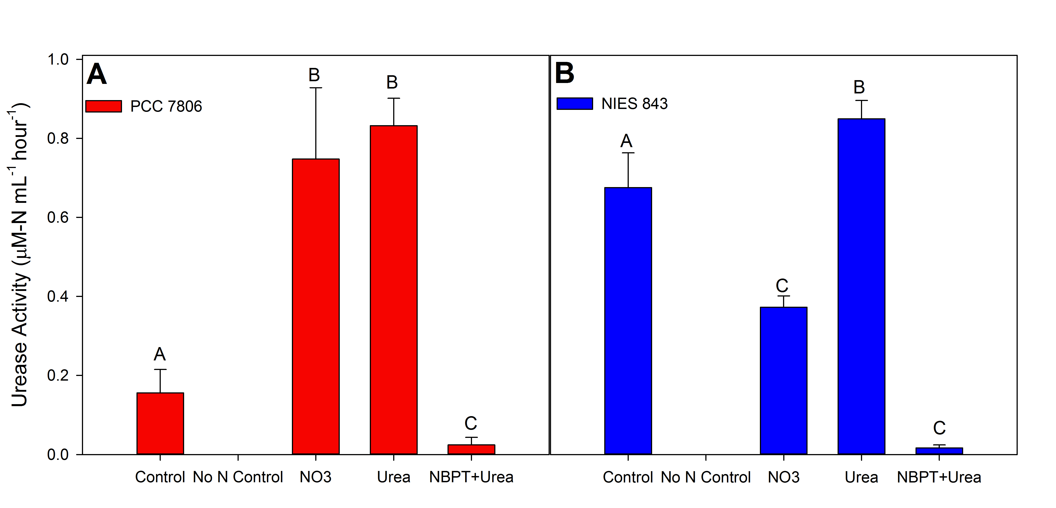

Figure 4: Urease activity for M. aeruginosa strains PCC 7806 (A) and NIES 843 (B) grown on various species of nitrogen as the sole nitrogen source. Letters (A/B/C) compare the nitrogen treatment to the ‘Positive Control’ treatment. Identical letters indicate no statistical difference (p> 0.05); different letters represent statistical difference (p < 0.05).

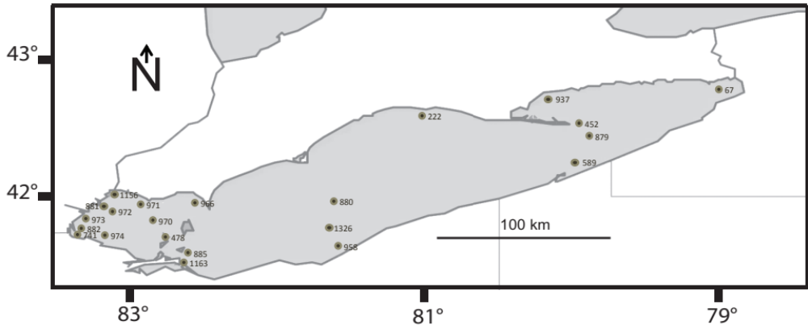
Figure 5: Lake Erie map of environmental sampling stations visited during the August 2012, May 2013, and July 2013 sampling cruises, aboard the CCGS Limnos.

Table 3: Lake Erie station measurements for the August 2012, May 2013, and July 2013 sampling cruises were collected from a 1-meter depth and analyzed for Chlorophyll a concentration, Urea concentration, and Urease activity aboard the C.C.G.S. Limnos. Environmental measurements of Microcystin concentration, Dissolved oxygen, Temperature, Transmission, and Specific conductance were also taken at the time of sampling by Environment Canada (NLET 1994); (N.D.) indicates samples that were not determined.
Station Number | Sample Date | Chlorophyll a Conc. (μg/L) | Urea Conc. (μg/L) | Urease Activity  (μM-N per hour) | Microcystin Conc. (μg/L) | Dissolved O₂ (mg/L) | Temp. (°C) | Transmission (%) | Specific Conductance (µS/cm)
August 2012 Cruise
879 | 8/16/12 | 2.305 | 1.225 | 0.0182 | N.D. | 9.41 | 23.2 | 1 | 74
478 | 8/15/12 | 6.615 | 1.544 | 0.4147 | 0.017 | 8.75 | 23.9 | 1 | 44
589 | 8/16/12 | 9.43 | 1.624 | 0.0125 | 0.042 | 10.1 | 23.9 | 1 | 41
741 | 8/15/12 | 14.9 | 6.203 | 0.2976 | 0.048 | 5.31 | 23.7 | 1 | 1
880 | 8/14/12 | 3.08 | 1.065 | 0.0073 | 0.006 | 8.72 | 23.9 | 1 | 74
882 | 8/15/12 | 16.05 | 0.932 | 0.4406 | 0.8 | 10.1 | 23.4 | 1 | 35
885 | 8/14/12 | 12.85 | 0.932 | 0.0228 | 0.14 | 10.3 | 24.5 | 1 | 25
937 | 8/16/12 | 1.56 | 1.225 | 0.0242 | N.D. | 9.71 | 22.5 | 1 | 72
966 | 8/13/12 | 5.65 | 1.735 | 0.0824 | 0.03 | 8.85 | 24.5 | 1 | 44
970 | 8/13/12 | 4.985 | 1.708 | 0.0688 | >0.05 | 9.51 | 24.1 | 1 | 56
971 | 8/13/12 | 2.055 | 2.536 | 0.1327 | 0.025 | 9.22 | 23.2 | 1 | 52
972 | 8/15/12 | 7.405 | 1.735 | 0.0154 | 0.007 | 10.7 | 23.3 | 1 | 59
973 | 8/15/12 | 25.4 | 2.269 | 0.4863 | >0.06 | 10.9 | 23.7 | 1 | 30
974 | 8/15/12 | 9.015 | 1.495 | 0.2145 | 0.09 | N.D. | 22.8 | 1 | N.D.
1163 | 8/14/12 | 15.6 | 1.495 | 0.0248 | 0.59 | 8.72 | 23.9 | 1 | 74
1326 | 8/14/12 | 3.16 | 5.605 | 0.2985 | 0.026 | N.D. | 23.9 | 1 | N.D.
May 2013 Cruise
67 | 5/29/13 | 8.865 | 0.823 | 0.6562 | <0.02 | 9.52 | 14.9 | 1 | 485
222 | 5/28/13 | 3.4 | 0.415 | 0.7659 | <0.00 | 11.5 | 11.2 | 63 | 280
478 | 5/30/13 | 6.555 | 0.431 | N.D. | <0.00 | 10.1 | 17.2 | 57 | 274
879 | 5/29/13 | 0.726 | 0.183 | 0.8698 | <0.00 | 11.9 | 10.4 | 72 | 282
880 | 5/30/13 | 3.8 | 0.375 | N.D. | <0.00 | 12.5 | 10.7 | 63 | 273
881 | 5/27/13 | 13 | 0.383 | 1.7239 | <0.01 | 9.6 | 14.9 | 33 | 263
885 | 5/28/13 | 5.43 | 0.534 | 1.0238 | <0.01 | 9.9 | 15.17 | 32 | 291
937 | 5/29/13 | 1.45 | 0.175 | 0.9851 | <0.00 | 10.3 | 11.42 | 70 | 282
958 | 5/28/13 | 4.31 | 0.606 | 1.5911 | <0.01 | 9.88 | 15.58 | 27 | 290
Table 3: Continued
Station Number | Sample Date | Chlorophyll a Conc. (μg/L) | Urea Conc. (μg/L) | Urease Activity  (μM-N per hour) | Microcystin Conc. (μg/L) | Dissolved O₂ (mg/L) | Temp. (°C) | Transmission (%) | Specific Conductance (µS/cm)
966 | 5/28/13 | 2.79 | 0.327 | 1.5716 | <0.00 | 9.62 | 14.95 | 55 | 258
970 | 5/30/13 | 3.3 | 0.431 | N.D. | <0.00 | 3.68 | 17.26 | 34 | 294
971 | 5/30/13 | 1.55 | 0.447 | N.D. | <0.01 | 10.4 | 16.79 | 38 | 245
973 | 5/27/13 | 2.605 | 0.574 | 1.5589 | <0.03 | 8.51 | 16.79 | 3 | 334
1156 | 5/27/13 | 5.35 | 0.327 | 0.9481 | <0.01 | N.D. | N.D. | N.D. | N.D.
1163 | 5/28/13 | 37.35 | 0.510 | 1.3949 | 0.418 | N.D. | N.D | N.D. | N.D.
1326 | 5/28/13 | 3.33 | 0.877 | 1.9628 | <0.00 | 11.8 | 11.42 | 59 | 282
July 2013 Cruise
452 | 7/25/13 | 1.3855 | 0.734 | 0.1118 | <0.00 | 9.78 | 21.25 | 74 | 280
478 | 7/23/13 | 4.795 | 1.244 | 0.1152 | 0.03 | 8.84 | 26.45 | 59 | 260
741 | 7/24/13 | 18 | 3.333 | 0.4944 | <0.03 | 6.05 | 26.89 | 2 | 411
880 | 7/25/13 | 1.445 | 1.069 | 0.1493 | <0.00 | 9.28 | 23.61 | 84 | 275
882 | 7/24/13 | 6.535 | 1.427 | 0.1061 | 0.13 | 7.39 | 25.15 | 52 | 325
885 | 7/23/13 | 21 | 0.710 | 0.2253 | 0.235 | 9.05 | 25.67 | 29 | 294
937 | 7/22/13 | 4.455 | 1.148 | 0.0540 | <0.00 | 10.2 | 19.82 | 77 | 286
958 | 7/24/13 | 1.06 | 1.364 | 0.1041 | 0.04 | 8.77 | 25.52 | 59 | 301
970 | 7/23/13 | 3.465 | 0.893 | 0.0487 | 0.03 | 7.33 | 25.49 | 73 | 259
971 | 7/23/13 | 4.24 | 1.643 | 0.1726 | <0.00 | 8.02 | 25.85 | 54 | 231
973 | 7/24/13 | 3.44 | 2.113 | 0.1569 | 0.07 | 7.25 | 25.19 | 27 | 339
1163 | 7/23/13 | 72.45 | 2.041 | 0.1996 | 0.11 | 9.07 | 26.37 | 1 | 330
1326 | 7/24/13 | 3.04 | 1.388 | 0.1873 | <0.00 | 9.77 | 23.62 | 81 | 274

Table 4: Lake Erie station nutrient measurements for Total Kjeldahl Nitrogen (TKN), Total Nitrogen (TN), Total Phosphorus (TP), Soluble Reactive Phosphorus (SRP), Nitrate/Nitrite (NO₃NO₂), Ammonia (NH₃), Silicon Dioxide (SiO₂) for the August 2012, May 2013, and July 2013 sampling cruises. All environmental water samples were collected from a 1-meter depth and chemically analyzed by the National Laboratory for Environmental Testing (NLET 1994); (N.D.) indicates samples that were not determined.
Station Number | Sampling Date | TKN (mg/L) | TN (mg/L) | TP (mg/L) | SRP (mg/L) | NO₃NO₂  (mg/L) | NH₃ (mg/L) | SiO₂ (mg/L)
August 2012 Cruise
879 | 8/16/12 | 0.209 | 0.356 | 0.0044 | < 0.0002 | 0.078 | 0.009 | 0.38
478 | 8/15/12 | 0.174 | 0.203 | 0.016 | 0.008 | 0.006 | < 0.005 | 1.79
589 | 8/16/12 | N.D. | N.D. | 0.0126 | N.D. | N.D. | N.D. | 1.77
741 | 8/15/12 | 1.03 | 1.63 | 0.153 | 0.14 | 0.683 | 0.249 | 1.81
880 | 8/14/12 | 0.198 | 0.216 | 0.0055 | 0.0008 | 0.006 | 0.007 | 0.34
882 | 8/15/12 | 0.298 | 0.343 | 0.0107 | 0.0004 | 0.006 | < 0.005 | 0.95
885 | 8/14/12 | 0.211 | 0.233 | 0.0092 | 0.0004 | 0.005 | 0.007 | 1.16
937 | 8/16/12 | N.D. | N.D. | N.D. | N.D | N.D. | N.D. | 0.22
966 | 8/13/12 | 0.16 | 0.234 | 0.005 | 0.0002 | 0.045 | 0.005 | 2.29
970 | 8/13/12 | N.D. | N.D. | N.D | N.D. | N.D. | N.D. | N.D.
971 | 8/13/12 | 0.139 | 0.339 | 0.0035 | 0.0003 | 0.146 | < 0.005 | 1.56
972 | 8/15/12 | 0.178 | 0.464 | 0.0045 | 0.0004 | 0.258 | 0.023 | 1.64
973 | 8/15/12 | 0.346 | 0.375 | 0.0113 | 0.0003 | 0.01 | 0.017 | 1.73
974 | 8/15/12 | 0.218 | 0.245 | 0.0155 | 0.0087 | 0.005 | < 0.005 | 0.79
1163 | 8/14/12 | 0.281 | 0.294 | 0.0189 | 0.0088 | 0.005 | < 0.005 | 2.6
1326 | 8/14/12 | 0.209 | 0.288 | 0.006 | 0.0003 | 0.03 | 0.025 | 0.75
May 2013 Cruise
67 | 5/29/13 | 0.485 | N.D. | N.D. | 0.0199 | 1.3855 | 0.07 | N.D.
222 | 5/28/13 | 0.247 | N.D. | N.D. | < 0.0002 | 0.0875 | 0.022 | N.D.
478 | 5/30/13 | 0.189 | N.D. | N.D. | 0.0021 | 0.726 | 0.011 | N.D.
879 | 5/29/13 | 0.21 | N.D. | N.D. | 0.0009 | 0.159 | 0.011 | N.D.
880 | 5/30/13 | 0.2615 | N.D. | N.D. | 0.0034 | 0.0685 | 0.012 | N.D.
881 | 5/27/13 | 0.349 | N.D. | N.D. | < 0.0002 | 0.75 | 0.1155 | N.D.
885 | 5/28/13 | 0.2755 | N.D. | N.D. | 0.0018 | 0.681 | 0.018 | N.D.
937 | 5/29/13 | 0.263 | N.D. | N.D. | < 0.0002 | 0.0755 | 0.0215 | N.D.
Table 4: Continued
958 | 5/28/13 | 0.217 | N.D. | N.D. | 0.0056 | 0.4985 | 0.0245 | N.D.
966 | 5/28/13 | 0.1905 | N.D. | N.D. | < 0.0002 | 0.571 | 0.014 | N.D.
970 | 5/30/13 | 0.253 | N.D. | N.D. | 0.0004 | 0.736 | 0.011 | N.D.
971 | 5/30/13 | 0.15 | N.D. | N.D. | 0.0002 | 0.398 | 0.018 | N.D.
973 | 5/27/13 | 0.359 | N.D. | N.D. | N.D. | 0.441 | 0.021 | N.D.
1156 | 5/27/13 | N.D. | N.D. | N.D. | N.D. | N.D. | N.D. | N.D.
1163 | 5/28/13 | N.D. | N.D. | N.D. | 0.0007 | N.D. | N.D. | N.D.
1326 | 5/28/13 | N.D. | N.D. | N.D. | N.D. | N.D. | N.D. | N.D.
July 2013 Cruise
452 | 7/25/13 | N.D. | N.D. | N.D. | N.D | N.D. | N.D. | N.D.
478 | 7/23/13 | N.D. | 0.674 | 0.0791 | 0.0006 | 0.414 | < 0.005 | N.D.
741 | 7/24/13 | N.D. | 3.65 | 0.154 | 0.0827 | 2.88 | 0.163 | N.D.
880 | 7/25/13 | N.D. | 0.444 | 0.051 | 0.0002 | 0.164 | 0.007 | N.D.
882 | 7/24/13 | N.D. | 1.92 | 0.0682 | 0.0012 | 1.73 | 0.014 | N.D.
885 | 7/23/13 | N.D. | 0.902 | 0.053 | 0.0005 | 0.567 | 0.012 | N.D.
937 | 7/22/13 | N.D. | 0.369 | 0.0627 | 0.0004 | 0.124 | 0.018 | N.D.
958 | 7/24/13 | N.D. | 0.678 | 0.0575 | 0.0003 | 0.412 | < 0.005 | N.D.
970 | 7/23/13 | N.D. | 0.754 | 0.0479 | 0.0006 | 0.532 | 0.006 | N.D.
971 | 7/23/13 | N.D. | 0.55 | 0.0504 | 0.0004 | 0.352 | < 0.005 | N.D.
973 | 7/24/13 | N.D. | 2.13 | 0.0706 | 0.0081 | 1.93 | 0.009 | N.D.
1163 | 7/23/13 | N.D. | 1.83 | 0.0747 | 0.0005 | 1.53 | < 0.005 | N.D.
1326 | 7/24/13 | N.D. | 0.349 | 0.0528 | < 0.0002 | 0.126 | < 0.005 | N.D.

ranged from 0.203 – 1.63 mg/L, 0.0035 – 0.153 mg/L, and 0.0003 – 0.14 mg/L respectively, with the Station 741 exhibiting the highest measurements for all three. Similarly, July 2013 measurements for TN, TP, and SRP were highest at Station 741 and ranged from 0.349 – 3.65 mg/L, 0.0479 – 0.154 mg/L, and 0.0002 – 0.0827 mg/L respectively. May 2013 station measurements for SRP ranged from 0.0002 – 0.0199 mg/L. Unfortunately, May 2013 measurements for TN and TP were unavailable and Station 741 was not sampled for this cruise.
A significant correlation between urease activity and chlorophyll biomass was observed only for the August 2012 cruise (Figure 6; p = 0.0343), and not for the May 2013 (Figure 7; p = 0.403) or July 2013 cruises (Figure 8; p = 0.312). Notably higher urease activity was observed during the May 2013 cruise, compared to August 2012 July 2013 data, ranging from 0.656 - 1.963 μM-N per hour. August 2012 and July 2013 urease activity ranged from 0.007 - 0.441 μM-N per hour and 0.049 - 0.225 μM-N per hour, respectively.
Station measurements of urease activity vs. urea concentration for August 2012, May 2013, and July 2013 are show in Figure 9. A significant correlation between urease activity and urea concentration was observed only for the July 2013 cruise (p = 0.003), and not for the August 2012 (p = 0.181) or May 2013 cruises (p = 0.285). Additionally, no correlation (p > 0.05) was observed between chlorophyll biomass and urea concentration, for any of the three cruises (Figure 10).
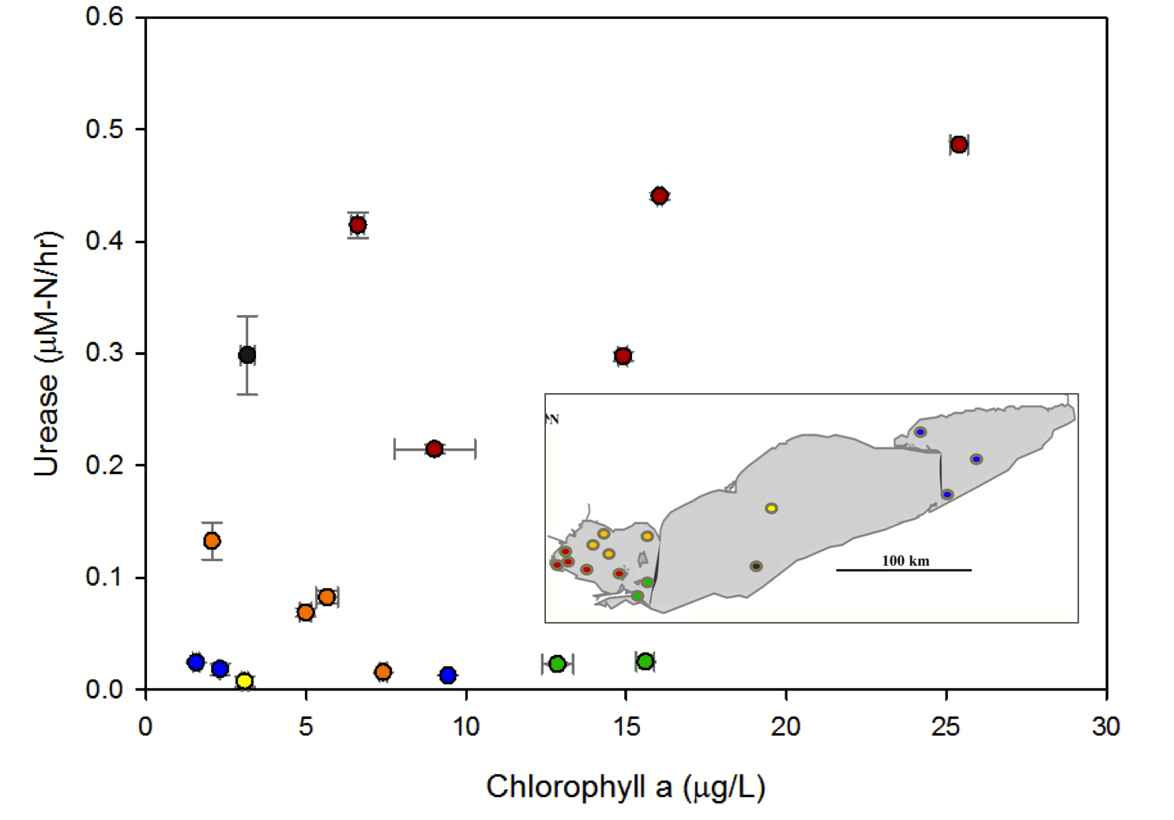

Figure 6: August 2012 Lake Erie station measurements of chlorophyll a and urease activity. Color correlates to sample station location, as indicated by the map insert. The station color categories are: Northwestern basin (Orange), Southwestern basin (Red), Central basin (Yellow), Eastern basin (Blue), Stations in proximity to Sandusky bay (Green), Stations in proximity to Cleveland, OH (Black). P-value = 0.0343

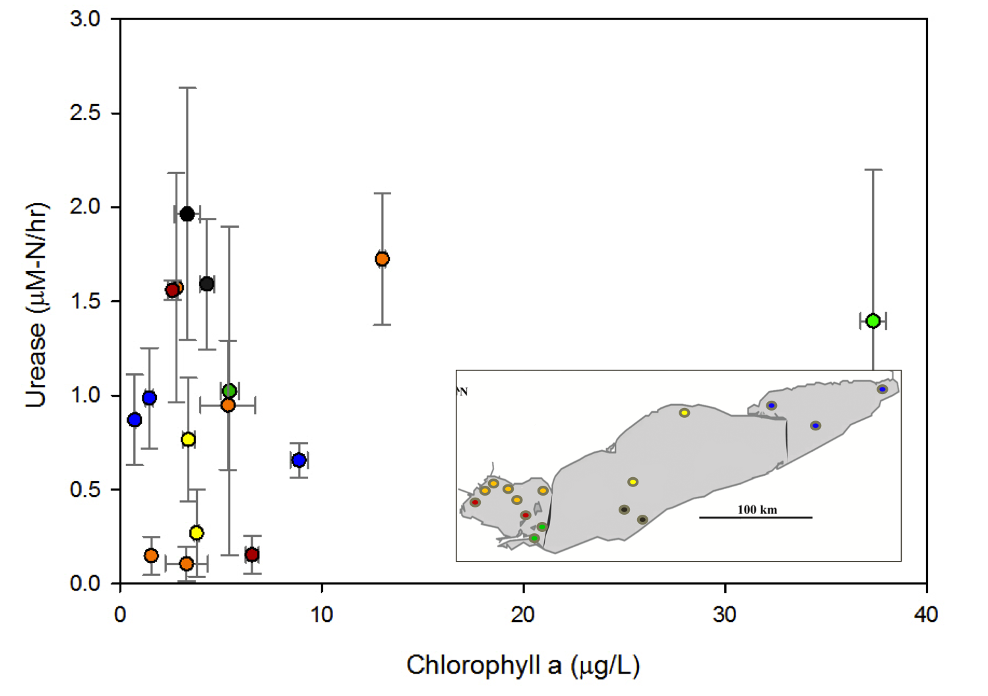
Figure 7: May 2013 Lake Erie station measurements of chlorophyll a and urease activity. Color correlates to sample station location, as indicated by the map insert. Color schemes are the same as those previously described in Figure 6. P-value = 0.4029

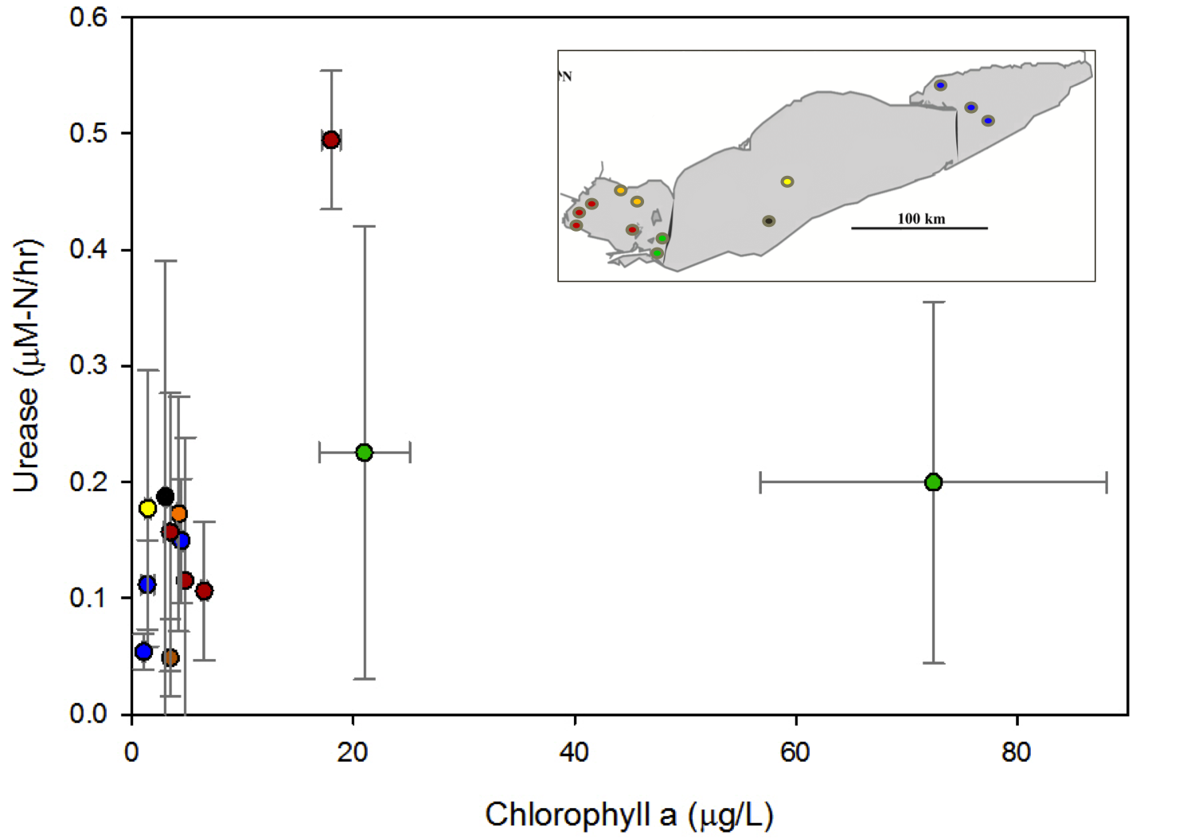
Figure 8: July 2013 Lake Erie station measurements of chlorophyll a and urease activity. Color correlates to sample station location, as indicated by the map insert. Color schemes are the same as those previously described in Figure 6. P-value = 0.3115

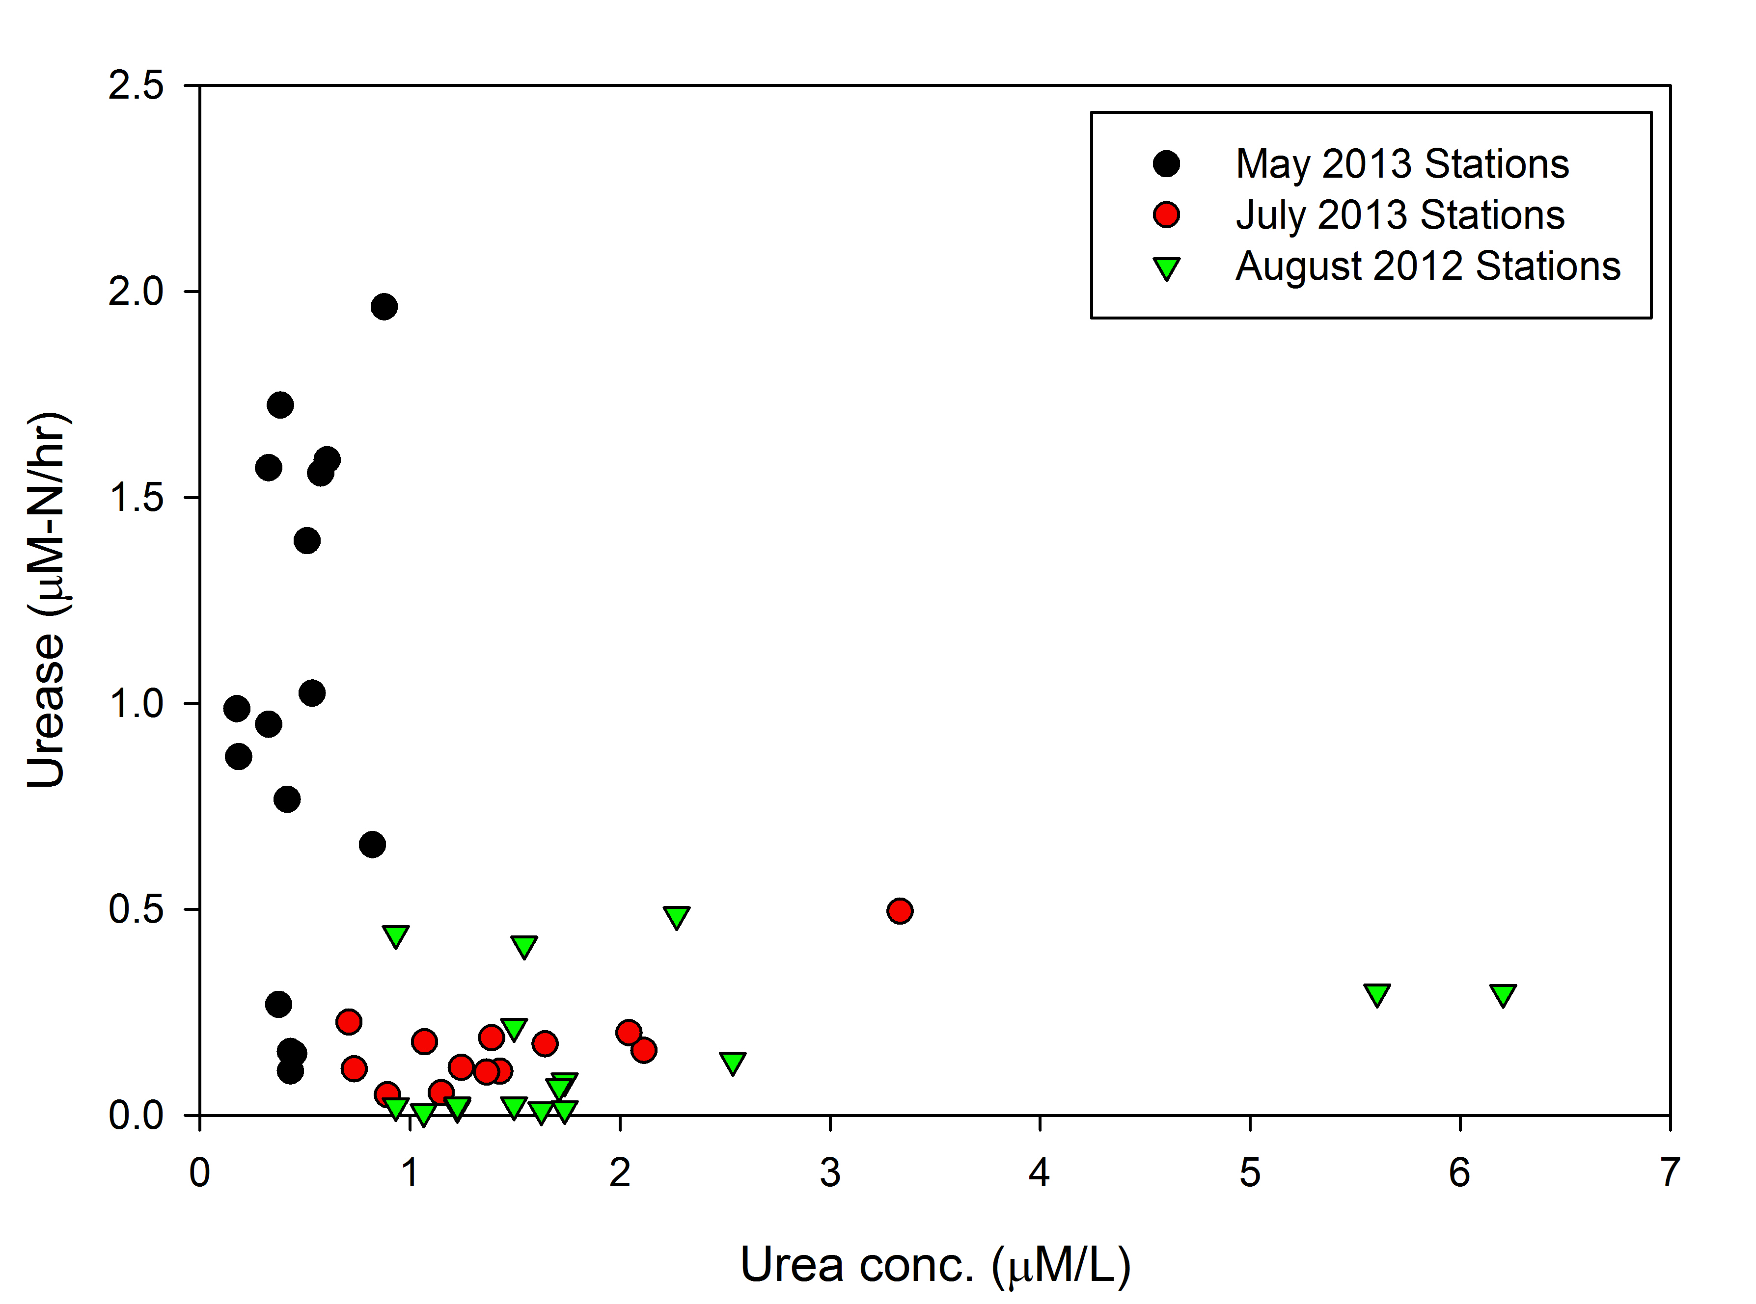
Figure 9: Lake Erie station measurements of urease activity and urea concentration, for three sampling cruises (August ’12, May ’13, July ’13). Symbol color discerns between each sampling cruise: August 2012 stations (Green), May 2013 stations (Black), July 2013 stations (Red). P-values for May 2013, July 2013, and August 2012 are 0.285, 0.003, and 0.181, respectively.

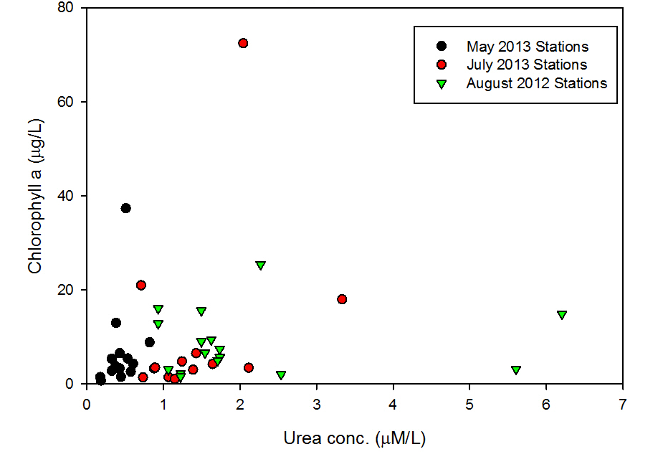
Figure 10: Lake Erie station measurements of chlorophyll a and urea concentrations, for three sampling cruises (August ’12, May ’13, July ’13). Symbol color discerns between each sampling cruise, as previously described in Figure 9. P-values for May 2013, July 2013, and August 2012 are 0.5647, 0.286, and 0.819, respectively.

Microcosm Experiments
August 2012 microcosm measurements of chlorophyll a biomass for the ambient whole water “Control” treatment and the “Control + 1μM Phosphorous” treatment were statistically similar for Stations 973 and 885 (Figure 11 A, D). These results suggest that the addition of phosphorus did not stimulate biomass at the time of sampling for either station. The addition of 180μM-N NH₄, NO₃, Urea, and NBPT stimulated biomass accumulation in all “Nitrogen only” treatments, compared to the “Control” treatment, for both Stations 973 and 885 (p-values shown in Table 6). August 2012 microcosm chlorophyll a measurements for the “Nitrogen only” treatments ranged from 23.7 μg/L, for the “Control” treatment, and 36.0 μg/L, for the NO₃ treatment at Station 973, and 10.6 μg/L, for the “control” treatment, and 30.65 μg/L, for the NO₃ treatment at Station 885. Similar results were observed for the all “Nitrogen +PO₄” treatments at Station 885, but only NH₄ + 1μM PO₄ and NO₃+1μM PO₄ were statistically different for Station 973, compared to the Control +PO₄ treatment (Table 6). Chlorophyll a measurements for the “Nitrogen +PO₄” treatments ranged from 25.7 μg/L, for the “Control +P” treatment, and 46.57 μg/L, for the NO₃+P treatment at Station 973, and 13.37 μg/L, for the “Control +P” treatment, and 38.7 μg/L, for the Urea +P treatment at station 885.
For all nitrogen treatments at Stations 973 and 885, Microcystis cell densities were statistically similar to their respective control treatments (Figure 11 B, E). Similar results were observed for Anabaena cell counts for Station 885 (Figure 11 F) and Station 973 (Figure 11 C), with the NO₃ and Urea Nitrogen only

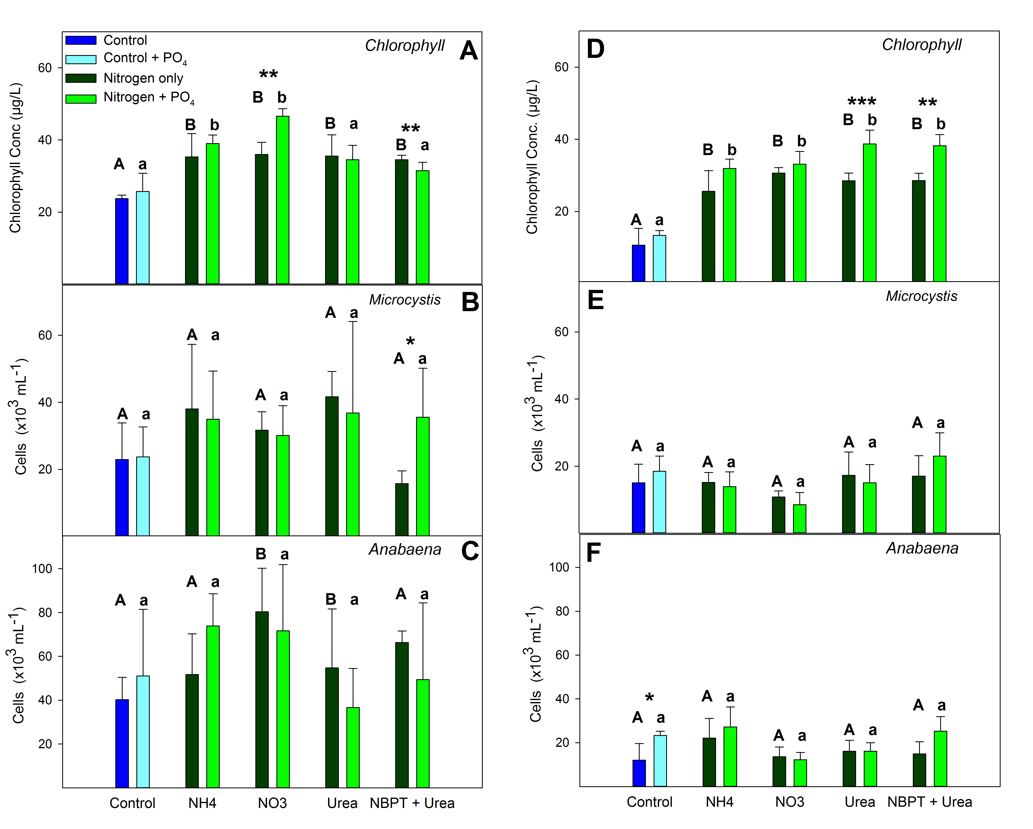
Figure 11: Station 973 (A, B, C) and Station 885 (D, E, F) August 2012 Microcosm measurements of Chlorophyll a conc., Microcystis cell counts, and Anabaena cell counts, after 48 h of incubation. Whole water from each station was spiked with 180μM-Nitroegen (Nitrogen only Treatments) and 180μM-N + 1μM Phosphorous (Nitrogen +PO₄ treatments), for each chemical form of Nitrogen. Letters above each bar represent levels of statistical significance compared to the control for each treatment. Letters (A/B) compare the Nitrogen only treatment to the nitrogen only ‘Control’ (Dark Blue). Letters (a/b) compare the Nitrogen +PO₄ treatments to the ‘Control + PO₄’ (Light Blue). Identical letters indicate no statistical difference (p> 0.05); different letters represent statistical difference (p < 0.05).
Asterisks represent comparison of the Nitrogen only and Nitrogen + P treatment, for each species of nitrogen (e.g. NH₄ only treatment compared to the NH₄ +PO₄ treatment). (*), (**), (***) represent the p-value (0.1-0.05), (0.05-0.01), (<0.01) respectively.

Table 5: August 2012 microcosm measurements of Chlorophyll a (Chl a), Microcystis cell counts, and
Anabaena cell counts, after 48 h of incubation, for Station 973 and Station 885. Whole water from each
station was spiked with 180μM-N (Nitrogen only Treatments) and 180μM-N + 1μM Phosphorous
(Nitrogen +PO₄ treatments), for each species of nitrogen.
Stations and Treatments | Nutrient Addition | Chl a conc.  (μg per L) | Microcystis  (cells per mL) | Anabaena  (cells per mL)
Station 973
Nitrogen Only Treatments | NO₃ | 36.00 | 31686 | 80368
Nitrogen Only Treatments | Urea | 35.57 | 41615 | 54735
Nitrogen Only Treatments | NBPT + Urea | 34.50 | 15754 | 66311
Nitrogen Only Treatments | NH₄ | 35.33 | 38044 | 51721
Nitrogen Only Treatments | Control | 23.73 | 22922 | 40247
Station 973
Nitrogen + 1μM  Phosphorous Treatments | NO₃ +1μM P | 46.57 | 30090 | 71757
Nitrogen + 1μM  Phosphorous Treatments | Urea +1μM P | 34.50 | 36828 | 36701
Nitrogen + 1μM  Phosphorous Treatments | NBPT+1μM P | 31.53 | 35561 | 49340
Nitrogen + 1μM  Phosphorous Treatments | NH₄ + 1μM P | 39.03 | 34954 | 73960
 | Control +1μM P | 25.70 | 23733 | 51012
Station 885
Nitrogen Only Treatments | NO₃ | 30.65 | 10790 | 13601
Nitrogen Only Treatments | Urea | 28.52 | 17274 | 16058
Nitrogen Only Treatments | NBPT + Urea | 28.53 | 17046 | 14944
Nitrogen Only Treatments | NH₄ | 25.58 | 15146 | 22087
 | Control | 10.65 | 15045 | 12031
Station 885
Nitrogen + 1μM  Phosphorous Treatments | NO₃ +1μM P | 33.12 | 8535 | 12234
Nitrogen + 1μM  Phosphorous Treatments | Urea +1μM P | 38.70 | 15070 | 16160
Nitrogen + 1μM  Phosphorous Treatments | NBPT+1μM P | 38.23 | 22998 | 25227
Nitrogen + 1μM  Phosphorous Treatments | NH₄ + 1μM P | 31.90 | 13905 | 27178
Nitrogen + 1μM  Phosphorous Treatments | Control +1μM P | 13.37 | 18490 | 23302
Table 6: August 2012 microcosm p-values of Chlorophyll a measurements, Microcystis cell counts, and Anabaena cell counts, after 48 h of incubation, for Station 973 and Station 885. (A/a) indicate no statistical difference (p> 0.05) from the control; (B/b) represent statistical difference (p < 0.05) from the control. Uppercase letters (A; B) compare the Nitrogen only treatment to the nitrogen only ‘Control’ and lowercase letters (a/b) compare the Nitrogen +PO₄ treatments to the ‘Control + PO₄’. Asterisks represent comparison of the Nitrogen only and Nitrogen + P treatment, for each species of nitrogen (e.g. NH₄ only treatment compared to the NH₄ +PO₄ treatment). (*), (**), (***) represent the p-value (0.1-0.05), (0.05-0.01), (<0.01) respectively; (N.A.) is used when no symbol is applicable.
Pairwise T-test Statistical Comparison | Treatments Compared | Chl a  P-Value | Symbol | Microcystis  P-Value | Symbol | Anabaena  P-Value | Symbol
Station 973
Treatments With and Without Phosphorus | NO₃ and NO₃ + 1μM P | 0.0100 | ** | 0.8054 | N.A. | 0.7009 | N.A.
Treatments With and Without Phosphorus | Urea and Urea + 1μM P | 0.8071 | N.A. | 0.7846 | N.A. | 0.3886 | N.A.
Treatments With and Without Phosphorus | NBPT and NBPT + 1μM P | 0.0116 | ** | 0.0858 | * | 0.4536 | N.A.
Treatments With and Without Phosphorus | NH₄ and NH₄ + 1μM P | 0.4027 | N.A. | 0.8346 | N.A. | 0.1789 | N.A.
Treatments With and Without Phosphorus | Control and Control +1μM P | 0.5438 | N.A. | 0.9253 | N.A. | 0.5927 | N.A.
Station 973
Nitrogen Only Treatments | NO₃ and Control | 0.0037 | B | 0.2821 | A | 0.0358 | B
Nitrogen Only Treatments | Urea and Control | 0.0259 | B | 0.0717 | A | 0.4332 | A
Nitrogen Only Treatments | NBPT and Control | 0.0003 | B | 0.3425 | A | 0.0170 | B
Nitrogen Only Treatments | NH₄ and Control | 0.0367 | B | 0.3019 | A | 0.4017 | A
Station 973
Nitrogen + 1μM Phosphorous Treatments | NO₃ +1μM P and Control +P | 0.0027 | b | 0.4315 | a | 0.4492 | a
Nitrogen + 1μM Phosphorous Treatments | Urea +1μM P and Control +P | 0.0770 | a | 0.474 | a | 0.5212 | a
Nitrogen + 1μM Phosphorous Treatments | NBPT+1μM P and Control +P | 0.1412 | a | 0.2977 | a | 0.9533 | a
Nitrogen + 1μM Phosphorous Treatments | NH₄ + 1μM P and Control +P | 0.0143 | b | 0.3144 | a | 0.3048 | a
Station 885
Treatments With and Without Phosphorus | NO₃ and NO₃ + 1μM P | 0.4509 | N.A. | 0.3919 | N.A. | 0.6907 | N.A.
Treatments With and Without Phosphorus | Urea and Urea + 1μM P | 0.0024 | *** | 0.6871 | N.A. | 0.9793 | N.A.
Treatments With and Without Phosphorus | NBPT and NBPT + 1μM P | 0.0151 | ** | 0.326 | N.A. | 0.1074 | N.A.
Treatments With and Without Phosphorus | NH₄ and NH₄ + 1μM P | 0.1767 | N.A. | 0.7063 | N.A. | 0.5281 | N.A.
Table 6: Continued
Pairwise T-test Statistical Comparison | Treatments Compared | Chl a  P-Value | Symbol | Microcystis  P-Value | Symbol | Anabaena  P-Value | Symbol
 | Control and Control +1μM P | 0.1705 | N.A. | 0.4515 | N.A. | 0.0658 | *
Station 885
Nitrogen Only Treatments | NO₃ and Control | 0.0009 | B | 0.2752 | A | 0.7705 | A
Nitrogen Only Treatments | Urea and Control | 0.0012 | B | 0.6868 | A | 0.4845 | A
Nitrogen Only Treatments | NBPT and Control | 0.0025 | B | 0.6948 | A | 0.6156 | A
Nitrogen Only Treatments | NH₄ and Control | 0.0014 | B | 0.9791 | A | 0.2109 | A
Station 885
Nitrogen + 1μM Phosphorous Treatments | NO₃ +1μM P and Control +P | 0.0008 | b | 0.0413 | b | 0.0078 | b
Nitrogen + 1μM Phosphorous Treatments | Urea +1μM P and Control +P | 3.0 e-5 | b | 0.4478 | a | 0.0456 | b
Nitrogen + 1μM Phosphorous Treatments | NBPT+1μM P and Control +P | 3.31 e-5 | b | 0.3996 | a | 0.6565 | a
Nitrogen + 1μM Phosphorous Treatments | NH₄ + 1μM P and Control +P | 0.0002 | b | 0.2775 | a | 0.5107 | a

treatments being the only treatments that were statically different from the Control, for the latter.
May 2013 and July 2013 microcosm chlorophyll a measurements (Figure 12; Table 7) were notably higher during July 2013, compared to May 2013, for both Stations 973 and 885. Chlorophyll biomass for May 2013 was statistically similar to their respective controls for all treatments at Station 973 (Figure 12 A) and for all treatments, except NBPT+Urea Nitrogen only treatment, for Station 885 (Figure 12 C), p-values are reported in Table 8. Chlorophyll biomass for July 2013 was statistically similar to their respective controls for all treatments at Station 973 (Figure 12 B) and for all treatments, except NH₄ + 1μM PO₄ treatment, for Station 885 (Figure 12 D). Interestingly, the addition of 1μM PO₄ showed a statistical increase in chlorophyll biomass for all nitrogen treatments for July 2013, at Station 885, and for the NH₄ treatment, at Station 973 (Table 8).
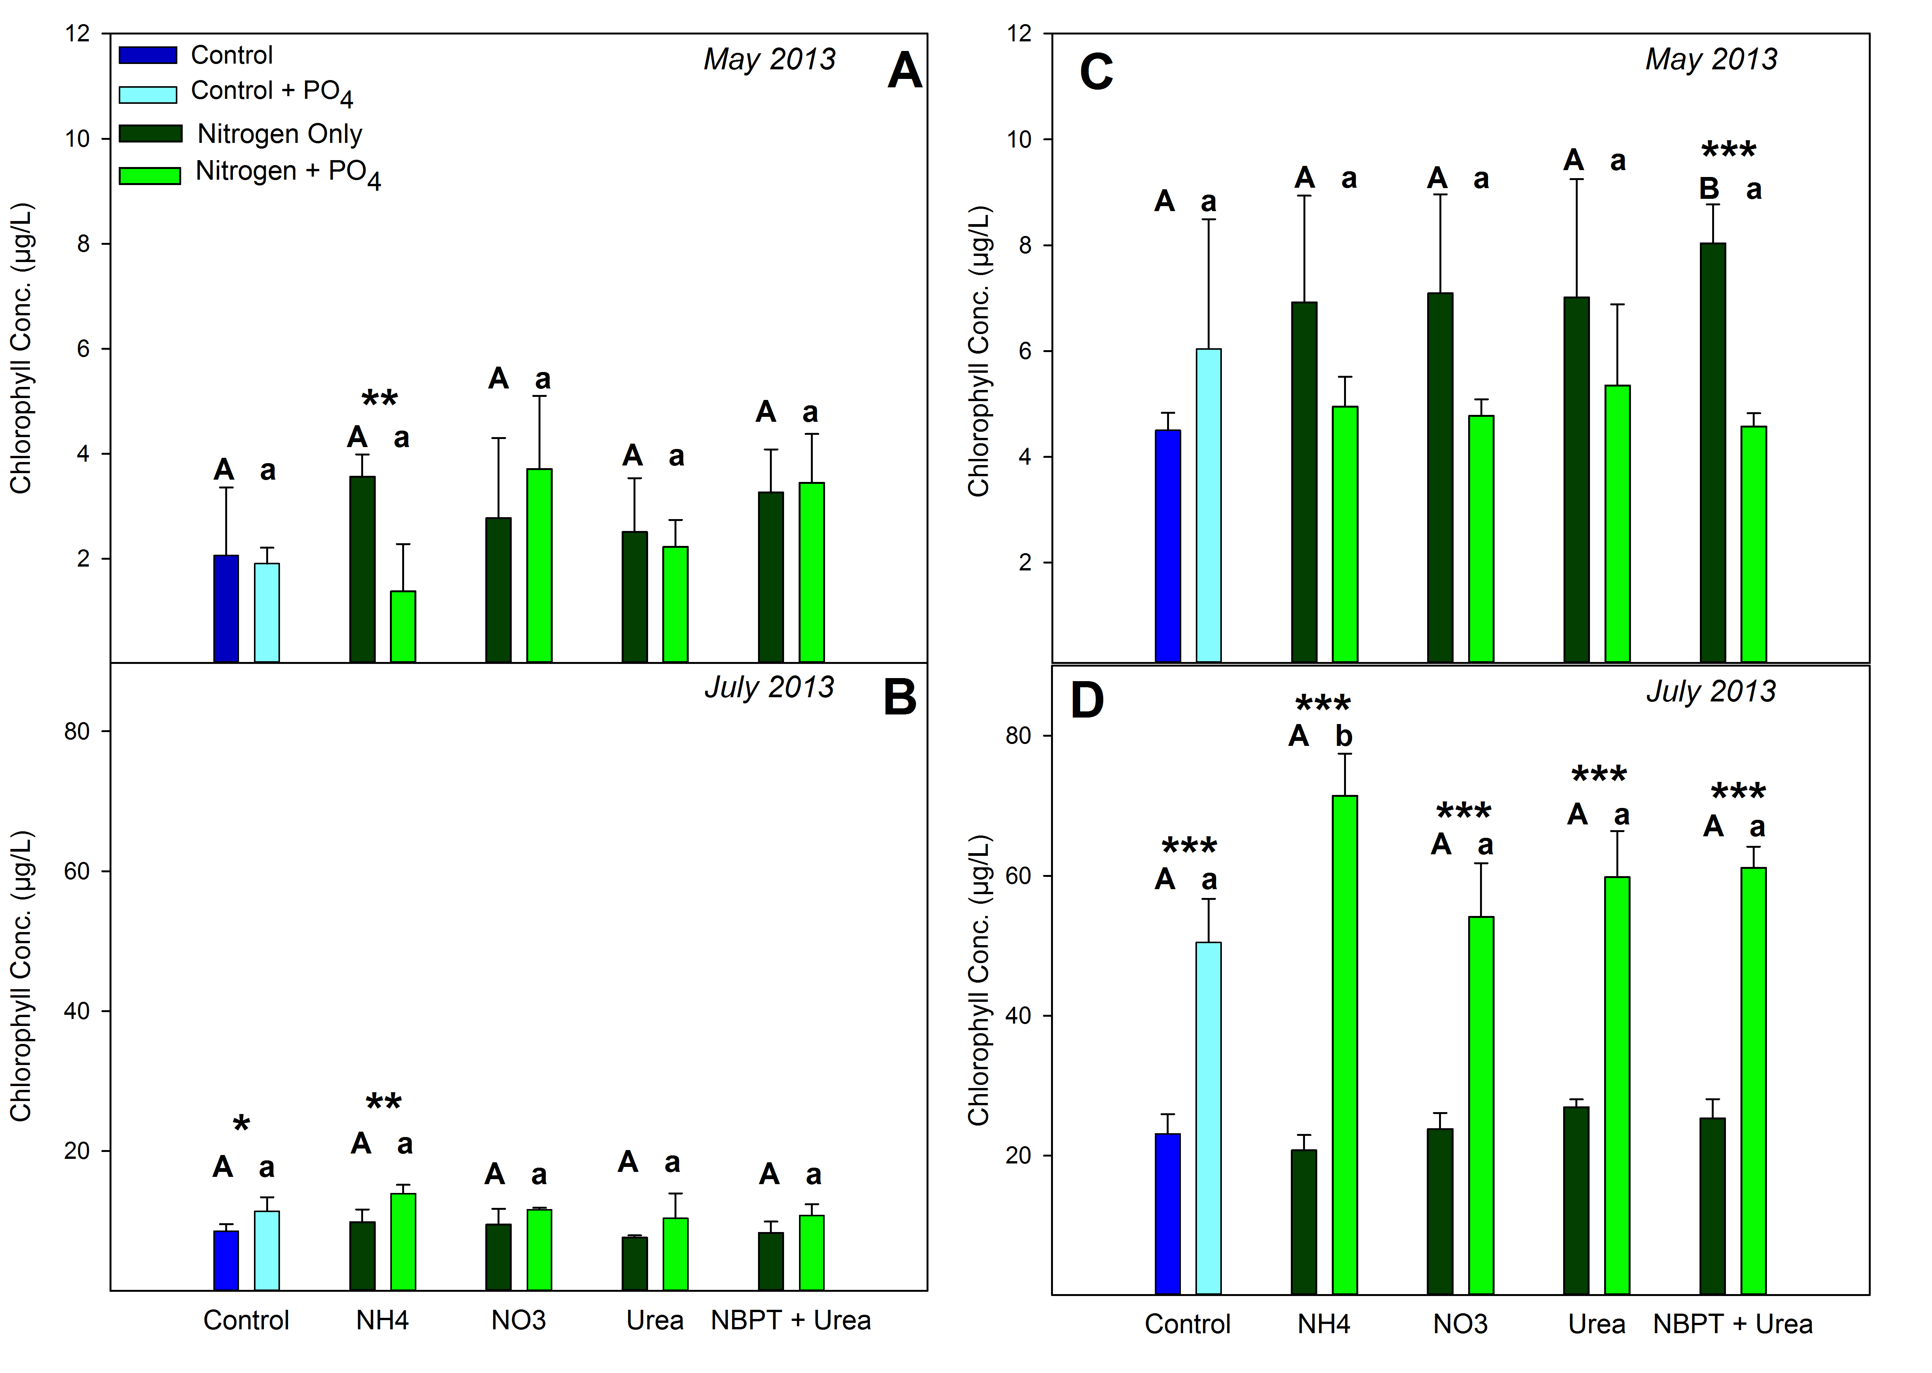
Figure 12: Station 973 (A, B) and Station 885 (C, D) microcosm measurements of chlorophyll a concentrations after 48 h of incubation, during May and July 2013 sampling cruises. Whole water, from each station, was spiked with 180μM of nitrogen (Nitrogen only Treatments) and 180μM-N + 1μM Phosphorous (Nitrogen +PO₄ treatments), for each species of Nitrogen. Letters above each bar represent levels of statistical significance compared to the control for each treatment, as previously described in Figure 11.
Table 7: May 2013 and July 2013 microcosm measurements for Chlorophyll a (Chl a), Total Nitrogen (TN), and Total Phosphorus (TP), for Stations 973 and 885.
Stations and Treatments | Nutrient Addition | May 2013  Chl a (μg/L) | May 2013  TP (mg/L) | May 2013 TN (mg/L) | July 2013  Chl a (μg/L) | July 2013  TN (mg/L) | July 2013  TP (mg/L)
Station 973
Nitrogen Only Treatments | NO₃ | 2.77 | 4.337 | 0.024 | 9.49 | 4.91 | 0.092
Nitrogen Only Treatments | Urea | 2.51 | 4.443 | 0.017 | 7.61 | 5.0 | 0.067
Nitrogen Only Treatments | NBPT + Urea | 3.27 | 4.350 | 0.020 | 8.31 | 4.79 | 0.041
Nitrogen Only Treatments | NH₄ | 3.56 | 4.457 | 0.014 | 9.84 | 5.03 | 0.043
Nitrogen Only Treatments | Control | 2.06 | 2.057 | 0.015 | 8.54 | 2.11 | 0.051
Station 973
Nitrogen + 1μM  Phosphorous Treatments | NO₃ +1μM P | 3.71 | 4.42 | 31.30 | 11.60 | 4.78 | 34.33
Nitrogen + 1μM  Phosphorous Treatments | Urea +1μM P | 2.22 | 4.01 | 30.40 | 10.36 | 4.81 | 33.97
Nitrogen + 1μM  Phosphorous Treatments | NBPT+1μM P | 3.45 | 3.91 | 30.55 | 10.79 | 4.72 | 34.2
Nitrogen + 1μM  Phosphorous Treatments | NH₄ + 1μM P | 1.38 | 4.69 | 31.00 | 13.90 | 4.76 | 33.4
 | Control +1μM P | 1.91 | 1.64 | 29.20 | 11.39 | 2.12 | 34.5
Station 885
Nitrogen Only Treatments | NO₃ | 7.09 | 3.54 | 0.009 | 23.80 | 3.42 | 0.729
Nitrogen Only Treatments | Urea | 7.01 | 3.46 | 0.010 | 26.97 | 3.36 | 0.549
Nitrogen Only Treatments | NBPT + Urea | 8.04 | 3.42 | 0.011 | 25.33 | 3.13 | 0.026
Nitrogen Only Treatments | NH₄ | 6.92 | 3.40 | 0.019 | 20.77 | 3.26 | 0.042
 | Control | 4.50 | 1.20 | 0.012 | 23.10 | 0.66 | 0.055
Station 885
Nitrogen + 1μM  Phosphorous Treatments | NO₃ +1μM P | 4.77 | 3.55 | 29.40 | 54.13 | 3.02 | 33.97
Nitrogen + 1μM  Phosphorous Treatments | Urea +1μM P | 5.35 | 3.40 | 29.35 | 59.80 | 2.92 | 34.57
Nitrogen + 1μM  Phosphorous Treatments | NBPT+1μM P | 4.58 | 3.39 | 31.35 | 61.13 | 2.67 | 34.5
Nitrogen + 1μM  Phosphorous Treatments | NH₄ + 1μM P | 4.49 | 3.49 | 30.05 | 71.40 | 2.85 | 41.3
Nitrogen + 1μM  Phosphorous Treatments | Control +1μM P | 6.04 | 1.20 | 29.70 | 50.50 | 0.34 | 34.93

Table 8: May 2013 and July 2013 microcosm P-values for Chlorophyll a (Chl a), at Station 973 and Station 885. (A/a) indicate no statistical difference (p> 0.05) from the control; (B/b) represent statistical difference (p < 0.05) from the control. Uppercase letters (A; B) compare the Nitrogen only treatment to the nitrogen only ‘Control’ and lowercase letters (a/b) compare the Nitrogen +PO₄ treatments to the ‘Control + PO₄’. Asterisks represent comparison of the Nitrogen only and Nitrogen + P treatment, for each species of nitrogen (e.g. NH₄ only treatment compared to the NH₄ +PO₄ treatment).
(*), (**), (***) represent the p-value (0.1-0.05), (0.05-0.01), (<0.01) respectively. (N.A.) is used when no symbol is applicable.
Pairwise T-test  Statistical Comparison | Treatments Compared | May 2013  Chl a P-Value | Symbol | July 2013  Chl a P-Value | Symbol
Station 973
Treatments With and Without Phosphorus | NO₃ and NO₃ + 1μM P | 0.477 | N.A. | 0.182 | N.A.
Treatments With and Without Phosphorus | Urea and Urea + 1μM P | 0.692 | N.A. | 0.247 | N.A.
Treatments With and Without Phosphorus | NBPT and NBPT + 1μM P | 0.812 | N.A. | 0.131 | N.A.
Treatments With and Without Phosphorus | NH₄ and NH₄ + 1μM P | 0.019 | ** | 0.033 | **
Treatments With and Without Phosphorus | Control and Control +1μM P | 0.850 | N.A. | 0.094 | *
Station 973
Nitrogen Only Treatments | NO₃ and Control | 0.571 | A | 0.538 | A
Nitrogen Only Treatments | Urea and Control | 0.665 | A | 0.205 | A
Nitrogen Only Treatments | NBPT and Control | 0.245 | A | 0.843 | A
Nitrogen Only Treatments | NH₄ and Control | 0.130 | A | 0.335 | A
Station 973
Nitrogen + 1μM Phosphorous Treatments | NO₃ +1μM P and Control +P | 0.094 | a | 0.867 | a
Nitrogen + 1μM Phosphorous Treatments | Urea +1μM P and Control +P | 0.410 | a | 0.698 | a
Nitrogen + 1μM Phosphorous Treatments | NBPT+1μM P and Control +P | 0.052 | a | 0.708 | a
Nitrogen + 1μM Phosphorous Treatments | NH₄ + 1μM P and Control +P | 0.390 | a | 0.141 | a
Station 885
Treatments With and Without Phosphorus | NO₃ and NO₃ + 1μM P | 0.102 | N.A. | 0.003 | ***
Treatments With and Without Phosphorus | Urea and Urea + 1μM P | 0.347 | N.A. | 0.001 | ***
Treatments With and Without Phosphorus | NBPT and NBPT + 1μM P | 0.009 | *** | 0.0001 | ***
Treatments With and Without Phosphorus | NH₄ and NH₄ + 1μM P | 0.178 | N.A. | 0.0002 | ***
Treatments With and Without Phosphorus | Control and Control +1μM P | 0.343 | N.A. | 0.002 | ***
Table 8: Continued
Pairwise T-test  Statistical Comparison | Treatments Compared | May 2013  Chl a P-Value | Symbol | July 2013  Chl a P-Value | Symbol
Station 885
Nitrogen Only Treatments | NO₃ and Control | 0.077 | A | 0.759 | A
Nitrogen Only Treatments | Urea and Control | 0.127 | A | 0.094 | A
Nitrogen Only Treatments | NBPT and Control | 0.002 | B | 0.387 | A
Nitrogen Only Treatments | NH₄ and Control | 0.110 | A | 0.323 | A
Station 885
Nitrogen + 1μM Phosphorous Treatments | NO₃ +1μM P and Control +P | 0.425 | a | 0.559 | a
Nitrogen + 1μM Phosphorous Treatments | Urea +1μM P and Control +P | 0.700 | a | 0.150 | a
Nitrogen + 1μM Phosphorous Treatments | NBPT+1μM P and Control +P | 0.483 | a | 0.057 | a
Nitrogen + 1μM Phosphorous Treatments | NH₄ + 1μM P and Control +P | 0.495 | a | 0.014 | b

V. Discussion
Microcystis Growth on Various Chemical Forms of Nitrogen
Urea represents a significant source of anthropogenic nitrogen due to its increased usage as a form of nitrogen for agricultural fertilizers; therefore, the ability of M. aeruginosa to use urea as a nitrogen source is ecologically relevant for freshwater systems that receive large loads of anthropogenic pollution, such as Lake Erie. Laboratory strains of M. aeruginosa PCC 7806 and NIES 843 have demonstrated the ability to use urea as a sole nitrogen source, similar to other species of nitrogen (Figure 2 and Figure 3). Likewise, observed growth rates for both PCC 7806 and NIES 843 (Table 1) were equivalent to other published growth rates of unialgal cultures of M. aeruginosa grown on nitrate and urea as the sole nitrogen substrate (Solomon et al. 2010).
Solomon et al., (2010) reported that not all phytoplankton possess the ability use urea as a source of nitrogen, because they may lack enzymes essential for the uptake or catabolism of urea. From this, it has been suggested that the ability to use urea as a nitrogen source is a reason for promoting the success of bloom forming cyanobacterial species, such as M. aeruginosa (Huang et al. 2014). This concept is supported by previous field studies from phosphorus rich freshwater lakes that have demonstrated that the addition of urea suppressed N₂-fixing cyanobacteria, such as Anabaena and Aphanizomenon, and stimulated the growth of non-N₂ fixing cyanobacteria, such as Microcystis and Planktothrix (Flores et al. 2005, Finlay et al. 2010, Solomon et al. 2010). Consequently, the increased practice of using urea for agricultural purposes and these advantages that favor growth of HAB forming species of cyanobacteria, over native phytoplankton species, may result in increased occurrences of M. aeruginosa blooms in freshwater systems.
Urease Activity of PCC 7806 and NIES 843
The urease enzyme converts urea and water into NH₄⁺ and CO₂, which is subsequently used in biochemical processes within the cell (Solomon et al. 2007). Urease activity was measured for both PCC 7806 and NIES 843 (Figure 4) during mid-exponential phase using the indophenol method (Solomon et al. 2007). These results provide the first reported measurements of urease activity for M. aeruginosa strains PCC 7806 and NIES 843. Urease activity was highest, for both strains, when urea was the sole nitrogen source provided, and lowest for the NBPT+Urea treatments. These results suggest that exposure to urea as a nitrogen source may promote increased urease activity and demonstrated that NBPT successfully inhibited urease activity for our experiments. These observations are consistent with previous urease studies of phytoplankton, that have shown that basal levels of urease activity are always detectable, but the level of urease activity varies with the nitrogen source provided (Solomon et al. 2008). This supports the rational that urease activity is regulated by external and/or internal factors.
The control of urease activity, based upon the chemical species of nitrogen present, is most apparent with available concentrations of NH₄⁺ (Flores et al. 2005, Finlay et al. 2010, Solomon et al. 2010). When insufficient NH₄⁺ is available to meet the nitrogen demands for the cell, urease activity may increase in response to the limitation of inorganic nitrogen (Glibert et al. 2006). Conversely, high concentrations of NH₄⁺ results in increased 2-oxoglutarate concentrations, via the glutamate synthase incorporation of nitrogen into new amino acids, allowing for the regulation of nitrogen assimilation and repression of urease activity in cyanobacteria (Solomon et al. 2008).
Environmental Samples
Station measurements of chlorophyll a and urease activity was highest for stations located in the western basin of Lake Erie, compared to central and eastern basin stations, for the August 2012, May 2013, and July 2013 sampling cruises. These results most likely reflect the influence of major waterways, such as the Maumee River, that influx point and nonpoint sources of nutrients into the western basin of Lake Erie. These results provide the first reported measurements of environmental levels of urease activity in Lake Erie.
August 2012 measurements of urease activity and chlorophyll a concentration, a proxy for biomass, exhibited a significant correlation (Figure 6; p = 0.034). However, no significant correlation was observed for May and July 2013 station samples (Figure 7 and 8 respectively). In previous field measurements of urease activity with diverse phytoplankton assemblages, similar to Lake Erie, researchers have had difficulty in distinguishing which phytoplankton species contributes the largest percentage of community urease activity (Solomon 2006). The lack of a correlation between urease activity and chlorophyll a biomass may indicate that non-photosynthetic members of the community (e.g. heterotrophic bacteria) may be responsible for the observed urease activity. Conversely, results from published in vivo experiments found that measurements of urease activity decreased as chlorophyll biomass increased (Solomon et al. 2007). The inability to identify the degree to which species are contributing to the observed community urease activity indicates the need for additional research to address to this problem.
Significantly higher urease activity was observed for the May 2013 cruise compared to the August 2012 and July 2013 cruises (Figure 9). These trends are similar to published field rates of urease activity that found a 5-fold higher urease activity in the summer months, compared to fall months (Solomon 2006). This seasonal pattern could be influenced by direct or indirect effects of phytoplankton community, temperature, and/or urea concentration (Solomon et al. 2010).
Urea concentrations measured across Lake Erie appeared to follow an inverse relationship to observed measurements of urease activity. Urea concentrations were lowest during sampling cruises conducted during the early summer months (May/June), and highest during warmer sampling cruises occurring in the late summer and fall months (July/August). Previously published reports have shown that higher temperatures, during summer months, can increase levels of heterotrophic bacteria activity and results in increased urea production from purines, compared to other seasons (Berg et al. 2006). It has been suggested that phytoplankton taxa that proliferate during the summer months and can utilize urea as a nitrogen source, such as cyanobacteria and dinoflagellates, may be able to use this increased supply of urea to their advantage (Solomon et al. 2010). Our measured concentrations of urea in Lake Erie appeared to follow this trend of increasing as water temperature increases; however, we did not observe an increase in urease activity with the increase in water temperature.
Lake Erie Microcosm Experiments
Chlorophyll measurements for the August 2012 microcosm experiments (Figure 11) indicated that there was no statistical difference between the whole water “Control” and the “Control + 1μM Phosphorous” for Stations 973 and 885, suggesting that the addition of phosphorus did not increase biomass during this sampling period. However, there was a significant increase in biomass for all “Nitrogen only” treatments compared to the Control, indicating that water conditions were nitrogen limited. The stimulation of biomass by all chemical species of nitrogen demonstrates the ability of cyanobacteria to utilize multiple bioavailable forms of nitrogen (nitrate, urea, and ammonia), to support growth. Therefore, any future nitrogen management practices in Lake Erie should consider constraining all bioavailable from of nitrogen that promote eutrophic water conditions.
Microscopic analysis of all treatments from the August 2012 microcosm indicated no statistical difference in the phytoplankton communities (Figure 11; Table 6). Phytoplankton communities, at Stations 973 and 885, were comprised primarily of the cyanobacteria Microcystis and Anabaena. The overall stimulation of biomass and similar phytoplankton communities observed for all nitrogen treatments suggests no preference in the chemical form of nitrogen under nitrogen limiting conditions. The similar community composition may be due to the limited 48-hour incubation, which may not allow enough time to observe a shift in the phytoplankton community. Future microcosm experiments that examine the community composition would benefit from a longer incubation period under in situ conditions, if sampling constraints allow.
Chlorophyll measurements for the July 2013 microcosm experiment were notably higher than the May 2013 measurements, for both Stations 973 and 885 (Figure 12). These results are not surprising because Lake Erie HABs occur annually in late May/ early June and often last until October, with temperature being an important abiotic factor that regulates bloom duration (Šejnohová et al. 2012). Therefore, May 2013 sampling was conducted at an early stage of the bloom formation, while the July 2013 sampling cruise was conducted as the bloom increased in intensity. Satellite images from the Moderate Resolution Imaging Spectroradiometer (MODIS) system displays the difference bloom conditions of Lake Erie during the August 2012 (Figure 13), May 2013 (Figure 14), and July 2013 (Figure 15) sampling cruises. The MODIS images represent the volume of cyanobacteria present, with cooler colors (blue, purple) indicating low volumes cyanobacteria and warmer colors (orange, red, yellow) indicating high volumes of cyanobacteria.
Measurements of chlorophyll biomass for the May 2013 microcosm was significantly similar for all treatments relative to the Control treatment at Station 973 (Figure 12 A) and for all treatments, except NBPT+Urea “Nitrogen only” treatment, for Station 885 (Figure 12 C). Because the addition of both N and P did

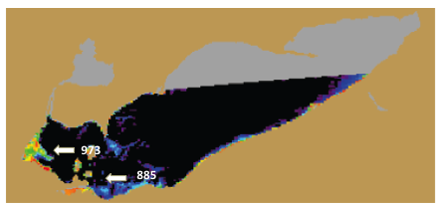
Figure 13: Moderate Resolution Imaging Spectroradiometer (MODIS) Cyanobacterial index of Lake Erie, for August 18th 2012. Lighter colors represent high concentrations of cyanobacteria, and dark blues and black represent low to no activity respectively. Gray areas indicate no data available. Source: NOAA; www.glerl.noaa.gov

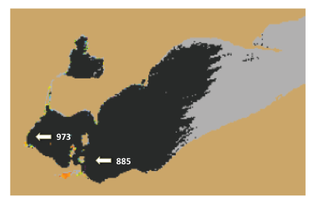
Figure 14: Moderate Resolution Imaging Spectroradiometer (MODIS) Cyanobacterial index of Lake Erie, for May 31st 2013. Lighter Colors represent high concentrations of cyanobacteria, and dark blues and black represent low to no activity respectively. Source: NOAA; www.glerl.noaa.gov

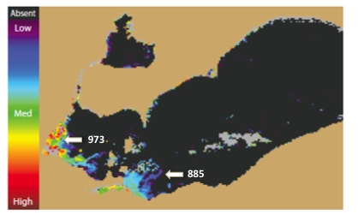
Figure 15: Moderate Resolution Imaging Spectroradiometer (MODIS) Cyanobacterial index of Lake Erie, for July 30st 2013. Lighter Colors represent high concentrations of cyanobacteria, and dark blues and black represent low to no activity respectively. Source: NOAA; www.glerl.noaa.gov
not stimulate biomass, these results suggest that neither nitrogen nor phosphorus was limiting at these sampling locations. These results may be due to the low amount of biomass observed in Lake Erie at the time of sampling. As shown in Figure 14, the concentrations of cyanobacteria were very low in all basins of Lake Erie, with observable amounts of cyanobacteria only occurring in the near shore/shallow regions of the western basin. The low amount of biomass may be a result of other abiotic factors such as temperature. Average water temperatures for sampling station for the May 2013 cruise was 14.2°C (Table 3), below the 19-25°C preferred growth range of Microcystis (Varis 1993, Šejnohová et al. 2012). Conversely, measurements of chlorophyll biomass for July 2013 were much higher compared to May 2013 measurements, with the average station water temperature being 24.4°C. As shown in Figure 15, the bloom at this time was extensive throughout the western basin, with highest concentrations of cyanobacteria being near the Maumee River entrance into Lake Erie. Higher temperatures favor buoyant cyanobacteria, such as Microcystis, because it increases the stability of the water column and reduces the vertical turbulent mixing (Šejnohová et al. 2012).
July 2013 chlorophyll measurements were statistically similar to their relative controls for all treatments at Station 973 (Figure 12 B) and for all treatments, except NH₄ + 1μM PO₄ treatment, for Station 885 (Figure 12 D). The addition of 1μM PO₄ resulted in a significant increase of chlorophyll biomass for all nitrogen treatments for July 2013, at Station 885, and for the NH₄ treatment, at Station 973. These results suggest that water conditions were phosphorus limited during this time. This was confirmed by the low TP and SRP concentrations observed for the July 2013 stations at the time of sampling (Table 4). The phosphorus-limited conditions of the lake at the time of sampling were due to its drawdown via the incorporation of phosphorus into biomass by phytoplankton species. Microcystis has developed the ability to adjust to these conditions by increasing its phosphorus uptake potential during phosphorus-limited conditions and store surplus phosphorus, in the form of polyphosphates (Oliver et al. 2012). This ability to maintain growth during periods of nutrient scarcity provides another advantage for M. aeruginosa to outcompete other phytoplankton in freshwater ecosystems.
The results from the July 2013 microcosm experiment presented here supports the GLWQA’s nutrient management practices, that phosphorous is the limiting nutrient for phytoplankton biomass in freshwater systems. Therefore, by reducing phosphorus loads to eutrophic systems will result in reduced algal biomass accumulation (Schindler 1977, Schindler et al. 2008). However, lake conditions have been shown to become nitrogen limited in Lake Erie, as exhibited by the August 2012 microcosm experiment.
Conclusions
There is growing support for the idea that algal biomass is controlled by Phosphorus availability during the spring, and that the duration and magnitude of the bloom may be determined by nitrogen availability, during the summer and fall (Paerl et al. 2011). Results from the sampling cruises support this idea and indicate that during early bloom conditions neither element was limiting. Lake conditions were found to be phosphorus limited when phytoplankton biomass increased, and conditions became nitrogen limited as the extent of the bloom progressed from summer into fall, prior to collapse. From these observations, we present the new idea that seasonal nitrogen limitation of phytoplankton growth may be a crucial in determining the extent and community composition of late season harmful algal blooms in Lake Erie. With this information, we are closer to understanding the impact that nitrogen and phosphorous have on Microcystis blooms in Lake Erie.
The continued reduction of phosphorus into eutrophic systems is important for future management practices, however failure to address point and nonpoint sources of nitrogen pollution may result in the continued proliferation of cyanobacterial blooms in freshwater eutrophic systems. The ability of cyanobacteria to use urea as a nitrogen source in Lake Erie and the 100-fold increase of the use of urea as a nitrogen source for agricultural fertilizer (Glibert et al. 2006), supports the ecological importance for comprehending the linkages between urea fertilization and its transport to downstream aquatic systems. There is hope that the continued research of nitrogen utilization by cyanobacteria and a better understanding of the factors involved in eutrophication of freshwater systems will contribute to future mitigation of harmful algal bloom events.

List of References

Auinger, B. M., K. Pfandl and J. Boenigk (2008). "Improved methodology for identification of protists and microalgae from plankton samples preserved in Lugol's iodine solution: Combining microscopic analysis with single-cell PCR." Applied and Environmental Microbiology 74(8): 2505-2510.

Berg, G. M. and N. O. G. Jorgensen (2006). "Purine and pyrimidine metabolism by estuarine bacteria." Aquatic Microbial Ecology 42(3): 215-226.

Boyer, G. L. (2006). "Monitoring Harmful Algal Blooms." Great Lakes Research Review 7(1): 1-7.

Boyer, G. L. (2013). Analysis of N-(n-butyl)-thiophosphoric triamide in Lake Erie waters. Status Report. Syracuse NY, State Univeristy of New York, College of Environmental Science and Forestry.

Carlson, R. E. and J. Simpson (1996). Phosphorus. A Coordinator's Guide to Volunteer Lake Monitoring Methods. North American Lake Managment.

Chaffin, J. D., T. B. Bridgeman and D. L. Bade (2013). "Nitrogen Constrains the Growth of Late Summer Cyanobacterial Blooms in Lake Erie." Advances in Microbiology(3): 16-29.

Charlton, M. N. (1980). "OXYGEN DEPLETION IN LAKE ERIE - HAS THERE BEEN ANY CHANGE." Canadian Journal of Fisheries and Aquatic Sciences 37(1): 72-81.

Chorus, I., J. Bartram, I. Chorus and J. Bartram (1999). Toxic cyanobacteria in water : a guide to their public health consequences, monitoring, and management. London ; New York, London ; New York : E &amp; FN Spon.

Conroy, J. D., D. D. Kane, D. M. Dolan, W. J. Edwards, M. N. Charlton and D. A. Culver (2005). "Temporal trends in Lake Erie plankton biomass: Roles of external phosphorus loading and dreissenid mussels." Journal of Great Lakes Research 31: 89-110.

Correll, D. L. (1999). "Phosphorus: A rate limiting nutrient in surface waters." Poultry Science 78(5): 674-682.

DeBruyn, J. M., J. A. Leigh-Bell, R. M. L. McKay, R. A. Bourbonniere and S. W. Wilhelm (2004). "Microbial distributions and the impact of phosphorus on bacterial activity in Lake Erie." Journal of Great Lakes Research 30(1): 166-183.

Dokulil, M. T. and K. Teubner (2000). "Cyanobacterial dominance in lakes." Hydrobiologia 438(1-3): 1-12.

Donald, D. B., M. J. Bogard, K. Finlay, L. Bunting and P. R. Leavitt (2013). "Phytoplankton-Specific Response to Enrichment of Phosphorus-Rich Surface Waters with Ammonium, Nitrate, and Urea." Plos One 8(1): 14.

Fan, C., P. M. Glibert, J. Alexander and M. W. Lomas (2003). "Characterization of urease activity in three marine phytoplankton species, Aureococcus anophagefferens, Prorocentrum minimum, and Thalassiosira weissflogii." Marine Biology 142(5): 949-958.

Finlay, K., A. Patoine, D. B. Donald, M. J. Bogard and P. R. Leavitt (2010). "Experimental evidence that pollution with urea can degrade water quality in phosphorus-rich lakes of the Northern Great Plains." Limnology and Oceanography 55(3): 1213-1230.

Flores, E. and A. Herrero (2005). "Nitrogen assimilation and nitrogen control in cyanobacteria." Biochemical Society Transactions 33: 164-167.

Fuller, K., H. Sherar and J. Wittig (2012). The Great Lakes, An Evnironmental Atlas and Resource Book, 3rd. Great Lakes National Program Office: C. a. U. S. E. P. A. Goverment of Canada.

Glibert, P. M., J. Harrison, C. Heil and S. Seitzinger (2006). "Escalating worldwide use of urea - a global change contributing to coastal eutrophication." Biogeochemistry 77(3): 441-463.

Guillard, R. L. and M. S. Sieracki (2005). Counting Cells in Cultures with the Light Microscope. Algae Culturing Techniques: 239-252.

Hader, D. P., H. D. Kumar, R. C. Smith and R. C. Worrest (2007). "Effects of solar UV radiation on aquatic ecosystems and interactions with climate change." Photochemical & Photobiological Sciences 6(3): 267-285.

Herrero, A., A. M. Muro-Pastor and E. Flores (2001). "Nitrogen control in cyanobacteria." Journal of Bacteriology 183(2): 411-425.

Hill, M. S. (1997). Understanding Environmental Pollution. Cambridge, UK, Cambridge University Press.

Huang, W. M., Y. H. Bi and Z. Y. Hu (2014). "Effects of Fertilizer-Urea on Growth, Photosynthetic Activity and Microcystins Production of Microcystis aeruginosa Isolated from Dianchi Lake." Bulletin of Environmental Contamination and Toxicology 92(5): 514-519.

Jiao, N., G. J. Herndl, D. A. Hansell, R. Benner, G. Kattner, S. W. Wilhelm, D. L. Kirchman, M. G. Weinbauer, T. W. Luo, F. Chen and F. Azam (2010). "Microbial production of recalcitrant dissolved organic matter: long-term carbon storage in the global ocean." Nature Reviews Microbiology 8(8): 593-599.

Kaneko, T., N. Nakajima, S. Okamoto, I. Suzuki, Y. Tanabe, M. Tamaoki, Y. Nakamura, F. Kasai, A. Watanabe, K. Kawashima, Y. Kishida, A. Ono, Y. Shimizu, C. Takahashi, C. Minami, T. Fujishiro, M. Kohara, M. Katoh, N. Nakazaki, S. Nakayama, M. Yamada, S. Tabatai and M. M. Watanabe (2007). "Complete genomic structure of the bloom-forming toxic cyanobacterium Microcystis aeruginosa NIES-843." DNA Research 14(6): 247-256.

Koslow, M., E. Lillard and V. Benka (2013). Taken By Storm: How Heavy Rain is Worsening Alagal Blooms in Lake Erie, With a Focus on the Maumee River in Ohio. National Wildlife Federation, National Wildlife Federation: 1-23.

Manunza, B., S. Deiana, M. Pintore and C. Gessa (1999). "The binding mechanism of urea, hydroxamic acid and N-(N-butyl)-phosphoric triamide to the urease active site. A comparative molecular dynamics study." Soil Biology & Biochemistry 31(5): 789-796.

Michalak, A. M., E. J. Anderson, D. Beletsky, S. Boland, N. S. Bosch, T. B. Bridgeman, J. D. Chaffin, K. Cho, R. Confesor, I. Daloglu, J. V. DePinto, M. A. Evans, G. L. Fahnenstiel, L. L. He, J. C. Ho, L. Jenkins, T. H. Johengen, K. C. Kuo, E. LaPorte, X. J. Liu, M. R. McWilliams, M. R. Moore, D. J. Posselt, R. P. Richards, D. Scavia, A. L. Steiner, E. Verhamme, D. M. Wright and M. A. Zagorski (2013). "Record-setting algal bloom in Lake Erie caused by agricultural and meteorological trends consistent with expected future conditions." Proceedings of the National Academy of Sciences of the United States of America 110(16): 6448-6452.

Morrison, J., D. Urban, J. Bland, J. Lowery, E. Savage and T. Davenport (1986). A phosphorus diet for the lower lakes : executive summary of the U.S. Task Force plans for phosphorus load reductions to Lake Erie, Lake Ontario, and Saginaw Bay., EPA: G. L. P. T. Force.

NLET (1994). Manual of Analytical Methods: Major Ion and Nutrients, Vol. 1. Burlington, ON: E. Canada.

Oliver, R. L., D. P. Hamilton, J. D. Brookes and G. G. Ganf (2012). Physiology, Blooms and Prediction of Planktonic Cyanobacteria. Ecology of Cyanobacteria II: Their Diversity in Space and Time. B. A. Whitton, Springer Science. 2: 115 - 187.

Osmond, D. L., D. E. Line, J. A. Gale, R. W. Gannon, C. B. Knott, K. A. Bartenhagen, M. H. Turner, S. W. Coffey, J. Spooner, J. Wells, J. C. Walker, L. L. Hargrove, M. A. Foster, P. D. Robillard and D. W. Lehning (1995). "WATERSHEDSS: Water, Soil and Hydro-Environmental Decision Support System." from http://www.water.ncsu.edu/watershedss/info/phos.html.

Paerl, H. W., N. S. Hall, B. L. Peierls and K. L. Rossignol (2014). "Evolving Paradigms and Challenges in Estuarine and Coastal Eutrophication Dynamics in a Culturally and Climatically Stressed World." Estuaries and Coasts 37(2): 243-258.

Paerl, H. W. and T. G. Otten (2013). "Harmful Cyanobacterial Blooms: Causes, Consequences, and Controls." Microbial Ecology 65(4): 995-1010.

Paerl, H. W., H. Xu, M. J. McCarthy, G. W. Zhu, B. Q. Qin, Y. P. Li and W. S. Gardner (2011). "Controlling harmful cyanobacterial blooms in a hyper-eutrophic lake (Lake Taihu, China): The need for a dual nutrient (N & P) management strategy." Water Research 45(5): 1973-1983.

Qin, B., G. Zhu, G. Gao, Y. Zhang, W. Li, H. Paerl and W. Carmichael (2010). "A Drinking Water Crisis in Lake Taihu, China: Linkage to Climatic Variability and Lake Management." Environmental Management 45(1): 105-112.

Revilla, M., J. Alexander and P. M. Glibert (2005). "Urea analysis in coastal waters: comparison of enzymatic and direct methods." Limnology and Oceanography-Methods 3: 290-299.

Rinta-Kanto, J. M., M. A. Saxton, J. M. DeBruyn, J. L. Smith, C. H. Marvin, K. A. Krieger, G. S. Sayler, G. L. Boyer and S. W. Wilhelm (2009). "The diversity and distribution of toxigenic Microcystis spp. in present day and archived pelagic and sediment samples from Lake Erie." Harmful Algae 8(3): 385-394.

Rinta-Kanto, J. M. and S. W. Wilhelm (2006). "Diversity of microcystin-producing cyanobacteria in spatially isolated regions of Lake Erie." Applied and Environmental Microbiology 72(7): 5083-5085.

Saxton, M. A., R. J. Arnold, R. A. Bourbonniere, R. M. L. McKay and S. W. Wilhelm (2012). "Plasticity of total and intracellular phosphorus quotas in Microcystis aeruginosa cultures and Lake Erie algal assemblages." Frontiers in Microbiology 3(January): Article 3.

Schindler, D. W. (1977). "Evaluation of phosphorus limitation in lakes." Science: 260-262.

Schindler, D. W., R. E. Hecky, D. L. Findlay, M. P. Stainton, B. R. Parker, M. J. Paterson, K. G. Beaty, M. Lyng and S. E. M. Kasian (2008). "Eutrophication of lakes cannot be controlled by reducing nitrogen input: Results of a 37-year whole-ecosystem experiment." Proceedings of the National Academy of Sciences of the United States of America 105(32): 11254-11258.

Šejnohová, L. and B. Maršálek (2012). Microcystis. Ecology of Cyanobacteria II: Their Diversity in Space and Time. B. A. Whitton, Springer Science. 2: 195-277.

Solomon, C. M. (2006). Regulation of estuarine phytoplankton and bacterial urea uptake and urease activity by environmental factors. University of Maryland. Published.

Solomon, C. M., J. A. Alexander and P. M. Glibert (2007). "Measuring urease activity in aquatic environmental samples." Limnology and Oceanography-Methods 5: 280-288.

Solomon, C. M., J. L. Collier, G. M. Berg and P. M. Glibert (2010). "Role of urea in microbial metabolism in aquatic systems: a biochemical and molecular review." Aquatic Microbial Ecology 59(1): 67-88.

Solomon, C. M. and P. M. Glibert (2008). "Urease activity in five phytoplankton species." Aquatic Microbial Ecology 52(2): 149-157.

Stainer, R. Y. and G. Cohen-Bazire (1977). "Phototrophic Prokaryotes: The Cyanobacteria." Annual Review Microbiology 31: 225-274.

Steffen, M. M., B. S. Belisle, S. B. Watson, G. L. Boyer and S. W. Wilhelm (2014). "Status, causes and controls of cyanobacterial blooms in Lake Erie." Journal of Great Lakes Research.

Sterner, R. W. (2008). "Review Paper: On the Phosphorus Limitation Paradigm for Lakes." International Review of Hydrobiology 93(4-5): 433-445.

USDA-ERA (2013, July 12th, 2013). "Table 4-U.S. consumption of selected nitrogen materials, 1960-2011." Fertilizer Consumption and Use - By Year. from http://www.ers.usda.gov/data-products/fertilizer-use-and-price.aspx - 26720.

Varis, O. (1993). "CYANOBACTERIA DYNAMICS IN A RESTORED FINNISH LAKE - A LONG-TERM SIMULATION STUDY." Hydrobiologia 268(3): 129-145.

Vollenweider, R. A. (1968). "Scientific Fundamentals of the eutrophication of lakes and flowing waters, with a particular reference tophosphorus and nitrogen as a factor of eutrophication." Organization for Economic Co-operation and Development(35): 250.

Watanabe, M. M. and T. Ichimura (1977). "Fresh and salt-water forms of Spirulina platensis in axenic cultures." Japanese Society of Phycology(25): 371-377.

Wehr, J. D. and R. G. Sheath (2003). Freshwater Algae of North Ameraica: Ecology and Classification, Elsevier Inc.

Welschmeyer, N. A. (1994). "FLUOROMETRIC ANALYSIS OF CHLOROPHYLL-A IN THE PRESENCE OF CHLOROPHYLL-B AND PHEOPIGMENTS." Limnology and Oceanography 39(8): 1985-1992.

Wetzel, R. G. and G. E. Likens (2000). Limnological Analyses. New York, Springer.

Xu, H., H. W. Paerl, B. Q. Qin, G. W. Zhu and G. Gao (2010). "Nitrogen and phosphorus inputs control phytoplankton growth in eutrophic Lake Taihu, China." Limnology and Oceanography 55(1): 420-432.

Zingone, A. and H. O. Enevoldsen (2000). "The diversity of harmful algal blooms: a challenge for science and management." Ocean & Coastal Management 43(8-9): 725-748.

Vita

Bernard Shafer Belisle was born in Newbrunswick, New Jersey on March 28th 1990. He graduated from Oneida High School in 2008. He received his Bachelor of Science degree with a major in Microbiology from the University of Tennessee - Knoxville in May 2012. In August 2012, he entered the graduate program in Microbiology at the University of Tennessee - Knoxville in the lab of Dr. Steven Wilhelm. He completed the requirements for the Masters of Science degree in August 2014.

