Airfield Pavement Management and Policy

By
Christopher Starr, P.E.

Dissertation Proposal
January 17, 2024

Acknowledgements
Future

Abstract

General aviation (GA) airports are one of many critical infrastructures to a community. The community may use the airport for business purposes by transporting people and/or goods, helicopter lifesaving flight operations to and from hospitals or act as a reliver airport for commercial flight services. The airport may also be used for regional mobility connecting communities. It is asserted here that the effectiveness of the general aviation airports to their communities is relative to how well the airport is maintained. To create an acceptable state-of-good repair or maintenance expectations concerning the airport’s assets, a comprehensive maintenance plan in addition to a capital plan is required. The first chapter showcases the importance of this research as industry places high importance on Pavement Condition Index (PCI) and plans on budget forecast without including constraints needed for a project level understanding of what can and will be accomplished for each calendar year. The second chapter dives in several relevant literature survey’s that was utilized to have a further understanding where the gap of other researches are, what hasn’t been accomplished and what still needs to be further research in gaps within my research. Chapter three focuses on creating the problem definition while Chapter four displays the probable solution methods. Chapter 5 is the conclusion of what was the best method and other consideration.

Table of Contents

Chapter 1: Introduction 1
Chapter 2: Relevant Literature Survey 8
2.1 Creation of a Pavement Management Program and their Dataset 8
2.2 Examples of Surface Treatments 14
2.2 Utilizing PCI to Create Maintenance Work 17
2.3 Utilization of Data Models and Algorithms to Optimize Treatments and Work 18
2.4 Literature Gap Analysis 19
Chapter 3: Problem Definition 29
3.1 Overall Distresses in the State 29
3.2 Types of Distresses in Pavement 29
3.3 Types of Maintenance for Pavement 33
3.4 Pros and Cons of the Existing PCI Method 34
3.5 Maintenance Objective 39
Chapter 4: Solution Approach and Methodology 41
4.1 Data Input 42
4.2 Treatment Flow Chart and Policies 43
4.3 PCI Model 46
4.4 Historical Maintenance Data 46
4.5 Resource Availability 47
4.6 Heuristic Algorithm 47
4.7 Gurobi Commercial Solver 49
4.7.1 Decision Variables and Constraints 49
4.7.2 Mathematical Model 50
4.8 Maintenance Work Plan and Schedule 52
Chapter 5: Results 52
5.1 Computation Setup 52
5.2 Results for the two methodologies 52
5.3 Comparisons and Improvements 52
Chapter 6: Business Insights 53
Chapter 7: Conclusion 55
References 56
Appendix A 58
Decision Tree and Policies for Preprocessing: 58
Evaluation Function : 69
Gurobi Commercial Solver: 72
Heuristic Solver: 79

List of Tables

Table 3.0.1: SNH TH01SA-001 Distress Data 26
Table 3.0.2: SNH TH01SA-001 Rehabilitation versus Maintenance 27
Table 3.0.3: PAVER Maintenance List 28
Table 4.2.1: Distress Database 31
Table 4.3.1: Maintenance Database 33
Table 5.1.1: PAVER Data Export 41
Table 5.1.2: Cost Factors and Resource Availability 41
Table 5.2.1: List of Possible Distresses 43
Table 5.2.2: Example of Distresses and Maintenance Treatment without Local Policy 43
Table 5.2.3: Global Policies 44
Table 5.3.1: Notations for Solver 46
Table 6.4.1: Example Decision Tree with Policies in Tabular Form Prioritized by Heuristic Solver 51
List of Figures

Figure 1.0.1: Map of Tennessee Airports and Classification of Airports 2
Figure 1.0.2: Pavement Condition Index (PCI) and Repair Types 2
Figure 1.0.3: Asset Pavement Treatment Options 3
Figure 1.0.4: Asset Pavement Treatment Options (Future) 4
Figure 1.0.5: Example of Pavement Treatment Options 6
Figure 3.0.1: PCI Scale 20
Figure 3.0.2: Savannah-Hardin County (SNH) Airport Pavement Information 21
Figure 3.0.3: SNH Airport Pavement Section TH01SA-001 PCI 22
Figure 3.0.4: SNH TH01SA-001 Maintenance Recommendation 23
Figure 3.0.5: SNH TH01SA-001 Pavement Photo L&T Cracking 24
Figure 3.0.6: SNH TH01SA-001 Pavement Photo Alligator Cracking 25
Figure 4.2.1: Airfield Identification 30
Figure 4.2.2: Pavement Distress Examples 32
Figure 4.3.1: Crack Seal Application 34
Figure 4.3.2: Seal Coat (P-623) Application Post 1 month 35
Figure 4.3.3: Seal Coat (P-608) Application Post 1 month 36
Figure 4.3.4: Seal Coat (P-623) Application Coring Photo 37
Figure 5.0.1: The Overall Process of Running the Model 40
Figure 5.2.1: Example Decision Tree 42

Chapter 1: Introduction

Tennessee Department of Transportation Aeronautics Division (TAD) has an annual budget of approximately $24 million State and $24 million non-primary entitlement federal before any additional discretionary funding is given. In Figure 1.0.1, TAD oversees 77 public-use airports, but mainly on a monthly basis, 72 public-use airports is where the bulk of the work is conducted as the air carriers are unique and self-reliant. With the cost of construction continuing to increase every year and budgets not increasing quickly enough the match, future dollars have less buying potential. In addition to existing assets in need of maintenance, additional assets like hangars are sought after for revenue generation for the airport as they can charge a rental fee. According to TAD (2023), it was found that for TAD to maintain their system at a PCI of 73 (reference Figure 1.0.2), $30.5 million was needed while $41.5 million would be needed for a 75, which is TAD’s true target goal for the system performance. This is not plausible with a $48 million budget. Since the Pavement Management Program (PMP) evaluates at a system level and uses PCI as target thresholds, the system and PCI by design is very conservative in the PCI reductions due to distresses and recommendation of work.

Figure 1.0.1
Map of Tennessee Airports and Classification of Airports
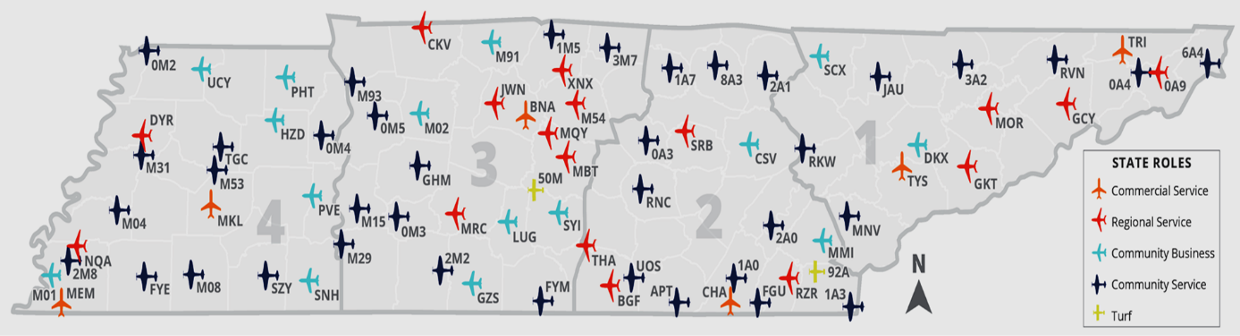
Source: Tennessee IDEA, Tennessee Department of Transportation, 2023, idea.appliedpavement.com/hosting/tennessee/index.html.

Figure 1.0.2
Pavement Condition Index (PCI) and Repair Types
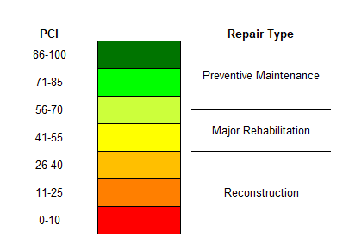
Source: Tennessee IDEA, Tennessee Department of Transportation, 2023, idea.appliedpavement.com/hosting/tennessee/index.html.

TAD goal is to apply the “Maintenance” aspect shown below in Figure 1.0.2 and in the future, Figure 1.0.3, at the appropriate time with the appropriate budget to extend the asphalt life by achieving system goals while maintaining minimum values for individual sections.
Figure 1.0.3
Asset Pavement Treatment Options
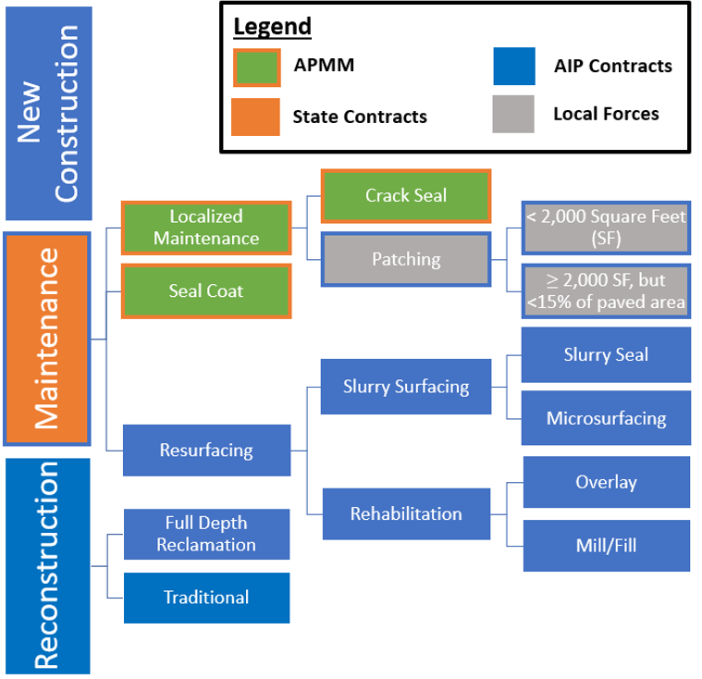

Figure 1.0.4
Asset Pavement Treatment Options (Future)
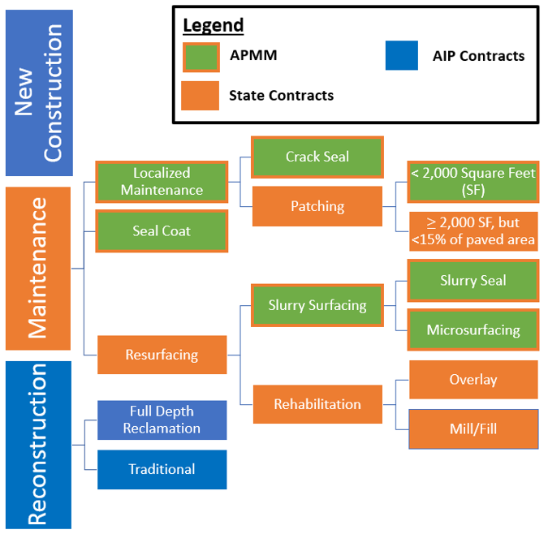

Tennessee, like the other states, uses the PAVER software that was developed by the United State Department and Defense, et al. and American Society for Testing Materials’ (ASTM) Pavement Condition Index (PCI) as the primary metric to specify condition of the airfield pavement by an Integer and condition label of “Good”, “Fair”, “Poor” and “Failed”. Other research has taken it further to specify when treatments are applied based on the integer and condition label.
Talking to industry experts and from the literature reviews, PCI is a sound methodology to understand system-wide performance and future budgetary needs, but not on a project-level performance and needs as other metrics and constraints are needed to formulate a better plan. For example, Tennessee’s pubic-use general aviation airports are currently set to the industry standard of PCI equal or less than 60 for runways to be considered for rehabilitation of the pavement by removing and replacing a layer of asphalt or overlaying a layer of asphalt. At 40 or less, the pavement would then be possibly ready for reconstruction, which would mean all layers of asphalt are removed and replaced including base stone being reconstructed and replaced with new asphalt. This can be very misleading as maintenance as a combination of PCI plus distresses conducted by means of patching and crack-filling (shown in Figure 1.0.4) can significantly increase the PCI to an acceptable number, whereas the PCI number would indicate something ten times more expensive like rehabilitation or reconstruction if followed blindly.

Figure 1.0.5
Example of Pavement Treatment Options

Project-level maintenance selection and execution is a major gap that the industry is trying to better understand to properly execute routine and proactive maintenance. Unfortunately, many of the industry either attempted to implement the system-wide data at a project-level or uses a separate system to try and create a list of projects that still isn’t optimized per airport. It is very time consuming or an impractical solution.
To correct the problem, this research is focused on project-level planning and scheduling of work to be completed by the use of a decisions tree and two possible solutions with one (1) being a heuristic solution and two (2) being a Guobi commercial solver with a mathematical model developed in this research to implement and identify the best solution approach. The current approach looks like a quilted patterned rug for the airport as it will have a dozen different treatments based on severity levels of “Low”, “Medium” and “High” at low quantities, which will make for higher bid prices and more mobilization cost to bring in different materials and equipment. The revised approach at the airports will select related treatments at each airport based on proportions of severity via decision tree to select one treatment for that distress to reduce the amount of types of treatments and increasing the quantities that would maximize the number of airports selected for work to conduct while optimizing the budget via unit cost and contractor available time at the airport.
In Chapter 2, we will be reviewing several literatures that include background information of the industry on how PCI plus distresses selects the applicable treatment. This is limited as it is only a single treatment for a single distress. We will take a basic look at PCI. We will then look at the highway side of the Tennessee Department of Transportation (TDOT) pavement program and later, the current pavement management program for airports that TDOT is currently utilizing as required by the Federal Aviation Administration (FAA). We will also review several studies completed by researchers on ideas and related topics. In Chapter 3, we will discuss what hasn’t been completed yet as part of the Gap Analysis. In Chapter 4, we will define the problem and in Chapter 5, we will discuss the data input, the decision tree as part of the data preprocessing stage plus other variables and mathematical model that was used as a basis for the heuristic and Gurobi approaches. We will briefly discuss the objectives in detail. That will lead us into Chapter 6 where we will analyze both solutions and develop goals to improve the heuristic solver. We will then talk about the next steps on the solution that leads to the conclusion in Chapter 7.
Overall, this dissertation contributes a different approach to routine and proactive maintenance planning and scheduling for multiple airports being managed as most states are either funding or actively assigning work to be completed at General Aviation airports. The end result is a printable list of work to be conducted that would allow the user to request bids from contractors through a work-order based contracting method to execute work that would be achievable both by budget and time availability of the contractor.

Chapter 2: Relevant Literature Survey

Creation of a Pavement Management Program and their Dataset

ASTM D5340-23 (2023) establishes the appropriate method to calculate the pavement condition index associated to distresses found in a sampling that are then extrapolated to the entire pavement area. The user starts with dividing the pavement section into sample units then select the confidence level and then select the sample units to be inspected. There are statistical derivations to ensure that the correct sample size is selected for this process. As part of the inspection process, each randomly selected area is inspected. The branch, section number and type are recorded as well as a sketch is performed. Distresses observed are measured and recorded. The process is then repeated for each sample unit. There are a total of 13 possible distresses for asphalt, while for concrete pavements, there are 15. After the inspection is completed, the data is then compiled into PAVER to compute the PCI. An inspection report is then generated and the deduct value is given for each distress. From there, a total deduct value is created that ensure the pavement is not being reduced due to several distresses present compounding the results as that is not intended. The final adjusted value is the PCI of the entire section of the pavement. From there, it is a weighted average to find the entire branch then airfield itself. There are many advantages to conducting PCI. There are a couple of limitations though.
Advantage:
- It is objective in evaluating condition as it standardizes the methodology of collection.
- It is repeatable to obtain similar scores.
- No special equipment is needed.
- Inexpensive compared to alternatives.
Disadvantage:
- Only visible distresses are measured.
- Simplified graphs can be misleading if not understood.

Reviewing the United States Department of Transportation (USDOT) Airport Pavement Management Program (PMP, 2014) advisory circular (AC) discusses the cost-effective decisions about pavement maintenance and rehabilitation (M&R). The document talks about the usefulness in PMP’s assisting airports in finding optimum strategies for “maintaining pavements in a safe serviceable condition over a given period for the least cost”. USDOT further specifies that federally obligated airport must perform detailed inspection of the airfield pavements at least once a year. When PCI is conducted, ASTM D5340 must be adhered to. The document continues to specify that historically, airports focused on immediate need rather than long-term planning or documented M&R methods. Without that, alternative strategies were not taken into consideration, which led to inefficient use of funding. With any treatment, there is a life-cycle cost that can be compared to validate the most appropriate treatment to be selected. The document also goes over budgeting and the appropriate use of planning associates to future major cost. It concludes with using prediction and other analysis tools to evaluate the choices made to ensure that consistent decisions are being made throughout the organization to prevent staff or management turnover from affecting the long-term strategies. The main importance of an Airport Pavement Management Program (PMP) is the ability to understand deterioration over time to create the asset’s lifecycle to better understand when appropriate treatments are necessary. This then allows for funding strategies to determine budgetary needs of the system. The user would then have an understanding of how many years a pavement stays in “good” condition versus the other conditions. Normally when pavement reaches “Fair”, it has less time before reaching “Poor”, “Very Poor”, “Serious” and then “Failed”. Rehabilitation strategies starts with “Fair” condition pavements. Design criteria of pavements are also a critical topic as overloaded or under designed pavements will fail earlier than anticipated. With a successful PMP and M&R techniques being utilized, the asset should see a steady decline ensuring that the pavement has many more useful years plus prevent the need of lengthy closures to the airport due to the need of reconstruction. The components of a PMP include a database for work history, pavement inventory, pavement structure, M&R history that includes cost, pavement condition data, traffic data, system capabilities, predicting current and future pavement condition, determining optimum M&R plans for a given budget, determining budget requirements to meet management objectives and facilitating the formulation and prioritization of M&R projects. In a Pavement Management Program, the pavement network, pavement branch and pavement section are defined. Network-level and Project-level management are then executed and validated with reporting tools. USDOT then recommends PMP’s like PAVER that was developed by the United States Army Construction Engineering Research Laboratory sponsored by the FAA. FAA PAVEAIR is an online version using the original concepts of what PAVER provides. The document concludes that if the system can contain pavement Inventory, inspection Schedule, record keeping, and information retrieval then that will satisfy as a PMP.
The Transportation Research Board sponsored a report numbered ACRP Report 138 (National Academics of Science, Engineering, and Medicine, 2015) that addresses preventative maintenance at a general aviation airport. In the report, it talks about preventative maintenance being given low to no priority when creating budgets. The report also talks about the importance of a maintenance program to extend the life of the asset. It also talks about the economic impact of Georgia general aviation airports by supporting 10,000 jobs, $354 million in payroll and $1.2 billion in state economic impact from a 2011 report. The report also illustrates that one runway can cost from $20 million to $100 million to build. It also shows the different asset groups on the airport in addition to airside pavements. It goes on to illustrate that few airports have a comprehensive preventative maintenance program that includes a regular assessment. Maintenance is derived as Operational, Reactive, Preventative and Predictive. Operational is maintenance due to external condition like snow/ice removal or adjustment of equipment due to wind. Reactive is maintenance associated to use it till it breaks. This is considered poor customer service as the asset could be damaged beyond repair when the user desires to fly. Preventive is maintenance that is scheduled, and the purpose is to mitigate the degradation of the system or component. Predictive is maintenance that utilizes testing and monitoring to predict when the asst will fail. The paper then specifies that airport preventative maintenance is important to apply treatments early in the deterioration curve to extend the asset life and minimize cost to rehabilitate or reconstruct till after the asset life is achieved.
The National Academies of Sciences, Engineering and Medicine (2011) created guidelines to help provide agencies direction on utilizing preservation treatments for high-volume roadways. The document adds yet more definitions to what was established by National Academics of Science, Engineering and Medicine (2015) in a previous publication. “Pavement Preservation” is defined as a network-level strategy of enhancing performance of pavements. “Preventative Maintenance” is considered treatments applied to the pavement to preserve the system and prevent early deterioration. “Minor Rehabilitation” is considered non-structural enhancements like a thin asphalt overlay or mill and thin overlay as a surface correction. “Routine Maintenance” is planned work to maintain and preserve the system like “Crack Filling and Sealing plus drainage maintenance”. “Corrective Maintenance” is a response to address issues relative to safe, efficient operations like pothole patching and concrete slab replacements. “Major Rehabilitation” is structural enhancements that improves load-carrying capacity and extends the service life. “Reconstruction” is replacement of all existing pavement and restarts the lifecycle.
Reviewing the Tennessee Department of Transportation’s (TDOT) Pavement Resurfacing Program Standard Operating Guidelines (2018) showcases TDOT’s methodology of maintaining the roadways of Tennessee. TDOT uses a Pavement Management System (PMS) with data entered from scanning the roadways. The metric chosen to evaluate the roadway’s performance is called Pavement Quality Index (PQI) that encompasses 70% of Pavement Distress Index (PDI) and 30% of the Pavement Smoothness Index (PSI). Within PMS, construction history is also entered to ensure that treatments, rehabilitation, or reconstruction recommendations would overlap with the pavement cross-sections. To optimize the roadways, TDOT uses lane-mile-years. Each treatment will give a certain number of years of life extension and the amount of lane miles it covers will yield the lane-mile-years. When developing a resurfacing list, teams are created statewide that evaluate the reports from the pavement system and budgets. Pavement age and a draft of possible locations are given to the team to evaluate. Field visits are conducted to evaluate project worthiness. During the field trip, visual inspections are conducted to confirm whether maintenance is an option or additional measures like pavement treatments, rehabilitation or reconstruction is needed. Once all the districts complete their assessments, a list is then created with the leaders of those teams and the region to combine into a regional list then sent to headquarters to create a single list statewide. The State Pavement Engineer then evaluates the results and enters them into the Program/Project/Resource Management System (PPRM). This will include project dates for turn-in and construction bidding including project completion. The next step is the development of Plans, Specification and Estimates (PS&E) forms. During field site visits, roadways are then measured, and identification of any ancillary assets are taken into consideration.
The types of treatments that could be selected are the following:
- Crack Sealing
- Fog Sealing
- Joint Stabilization
- Slurry Seal
- Microsurfacing
- Srub Seal
- Chip Seal
- Cape Seal
- Thin Overlay
- Chip Seal with Thin Overlay
- Open-Graded Friction Course
- Hot In-Place Recycling
For minor and major rehabilitation, spot or full Mill and Overlay at different thicknesses would be the appropriate treatment. After everything is completed, work history is updated and then the entire process is repeated to maintain the system.

Examples of Surface Treatments

As an example of a seal coat treatment, P-608 (ASI, 2019) is an emulsified asphalt seal coat designed as a preventative maintenance to preserve asphalt pavement in fair or better condition as defined by the Pavement Condition Index score. It is also suitable for weathered surfaces in low to moderate severity. For new pavements, P-608 can also be utilized as a construction seal coat to help provide immediate protection to the new pavement from the environmental elements. If a previous coal application was placed on the asphalt, the document specifies that it is generally not recommended for this product to be applied. P-608 has been deemed by the Federal Aviation Administration to be applied to all airfield pavements without restrictions. A caution given is using a sand aggregate in addition to the emulsion to ensure friction numbers are maintained on runways and taxiways until the pavement’s natural friction return from the initial wearing. The cost of the emulsion and aggregate is considered minimal in comparison to asphalt and crack repair that would be required if a seal coat isn’t applied. The greatest cost savings are dependent on the pavement’s condition at the time of application thus the pavement with the least distresses will benefit the most from a seal coat treatment. Glisonite creates the very high nitrogen element that makes the treatment resistant to UV rays, water and oxidation. The rest of the document goes over the installation process.
As an example of another seal coat treatment, Polymer-Modified Masterseal (PMM) Ultra Pavement Sealer (2023) or P-623 (PMM Ultra) is an emulsified asphalt sealer blended with polymers and special surfactants for flexibility, durability, and adhesion. It’s use case is for protecting pavement surfaces. It is applied by squeegee or spray equipment with sand aggregate mixed. P-623 is applied with two coats while a third coat would be used for heavily trafficked area. After final coat, 24 hours is needed to then open to traffic.
Cape seals according to Joslin, Kimberly, et al. (2019) are defined as a chip seal with microsurface or slurry seal placed on top. In this report, a literature review was conducted to evaluate the treatment. Cape seals last from 3 years to 9 years based on site condition. 5 to 7 years are the typical timeline that was observed. In South Africa, cape seals are lasting 10 years and able to take heavy turning traffic as well as sustain cold temperatures without raveling. Early cracking is found in the cape seal and it is assumed that the prolonged cold weather is what creates it.
The advantages are as follows:
- Seals existing pavements to prevent air and moisture from entering the cracks
- Prevents raveling
- Provides a skid-resistant driving surface
- Provides a smooth, durable surface treatment
- Prevents loss of chips when bonded to slurry
- Prevents abrasion and erosion
- Is appropriate for city use
- Has higher benefit-cost ratio for microsurfacing cape seals in comparison to slurry seal cape seals
- Resist raveling in colder weather and can handle turning traffic
The Disadvantages are as follows:
- Slurry seal Cape seals cannot be applied in cold weather
- Lower benefit-cost ratio for slurry seal cape seals in comparison to microsurfacing cape seals
- More construction time because it requires a PME chip seal to cure before slurry or micro is applied as a wearing surface
- Higher cost than the other treatments

Utilizing PCI to Create Maintenance Work

According to Boyapati, Bharath and R. Prasanna Kumar (2015), their goal in their research was to create a prioritization of maintenance based on the PCI of the pavement to rationalize which pavement group received treatment first. Their methodology was formulated into: Study area characteristics and identification of study sections, Visual inspection on selected locations, Collection of Data, Identification of distress and its severity level, Assigning acceptability levels and weightages, Determination of PCI, Determination of priorities for maintenance. Marquez a Crespo, et al. took it a step further and created a framework to help classify decision making by a series of models to help management make decisions on when to execute decision making for maintenance. According to Peshkin, David G., et. al (2004), Preventative Maintenance is a systematic process of applying a series of preventative maintenance treatments over the life of the pavement to maintain a good condition, extend pavement life and minimize life-cycle cost. The purpose of the paper was to determine the best timing to apply the treatments to flexible and rigid pavements. The categorized all the different treatments associated to climate, traffic, conditions that were being addressed and potential issues/restrictions. Creating a relationship between age and condition, there were able to analyze the proper timing of each treatment group and made those recommendations.

Utilization of Data Models and Algorithms to Optimize Treatments and Work

Another methodology was using sensors to collect pavement data and then applying data analytics to optimize the predicative modeling to determine when the best treatments should be applied (Sirvio, Konsta M., 2015). The model was able to project the deterioration curve of the pavement asset to specify when treatments should be applied.
For roadway systems, Pavement Management Systems (PMS) are commonly used. The next idea was utilizing machine learning algorithms to evaluate PCI and prediction models using multiple linear regression, artificial neural networks and fuzzy logic models for flexible pavement sections. Eight pavement distresses were modeled. The end result was that the artificial neural networks yield the best results on correlating surface pavement distress and PCI. Another example of using artificial neural networks (ANN) for predicting pavement condition index was conducted using data from Nablus City in Palastine as the objective goal was to remove manholes as a principle of reducing the PCI score (Issa, Amjad, et al. 2021).
An important idea was the utilization of an integer programming approach to determine the optimal solution to aircraft maintenance planning and scheduling to create a more efficient and effective process (Chung, Nick and George Ho, 2010). Three groupings were proposed that consist of initial maintenance demand schedule, maintenance pairing and maintenance group assignments. The end goal was to improve the manual scheduling process of work and balance the workload between the different groups. The end results were that they were able to use excel solver to create a scheduling system based on staffing availability.
An interesting idea was using a statistical outliers analysis to help clean data errors by grouping the data into similar pavement families such as pavement type, pavement use, and pavement rank from functional classification first then use a straight-line regression to analyze the residuals (Nunez, Maria M and Mohamed Y Shahin, 1986).

Literature Gap Analysis

Reviewing the literature in Chapter 2 illustrated a gap on how industry uses PCI at a network-level and tries to implement at a project-level. As shown in figure 3.0.1, a low PCI is assumed to be reconstruction. This can yield up to 10 times than what needs to be spent if the section is repairable. As an example, using Tennessee IDEA (2023), in Figure 3.0.2, we reviewed this section of the airport and the PCI’s in Figure 3.0.3 indicates that the section is in need of reconstruction from a PCI of 36 and illustrated in Figure 3.0.4. Reviewing Figure 3.0.5 and the distresses in Table 3.0.1 indicate that patching and a slurry surfacing would correct all the deficiencies that would remove the need of reconstruction.

Figure 2.5.1
PCI Scale
Source: Tennessee IDEA, Tennessee Department of Transportation, 2023, idea.appliedpavement.com/hosting/tennessee/index.html.

Figure 2.5.2
Savannah-Hardin County (SNH) Airport Pavement Information
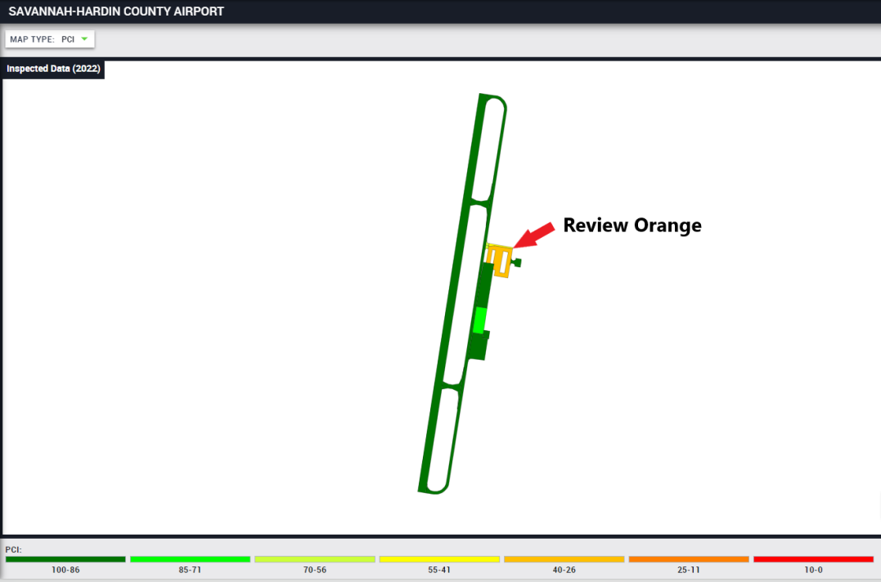
Source: Tennessee IDEA, Tennessee Department of Transportation, 2023, idea.appliedpavement.com/hosting/tennessee/index.html.

Figure 2.5.3
SNH Airport Pavement Section TH01SA-001 PCI
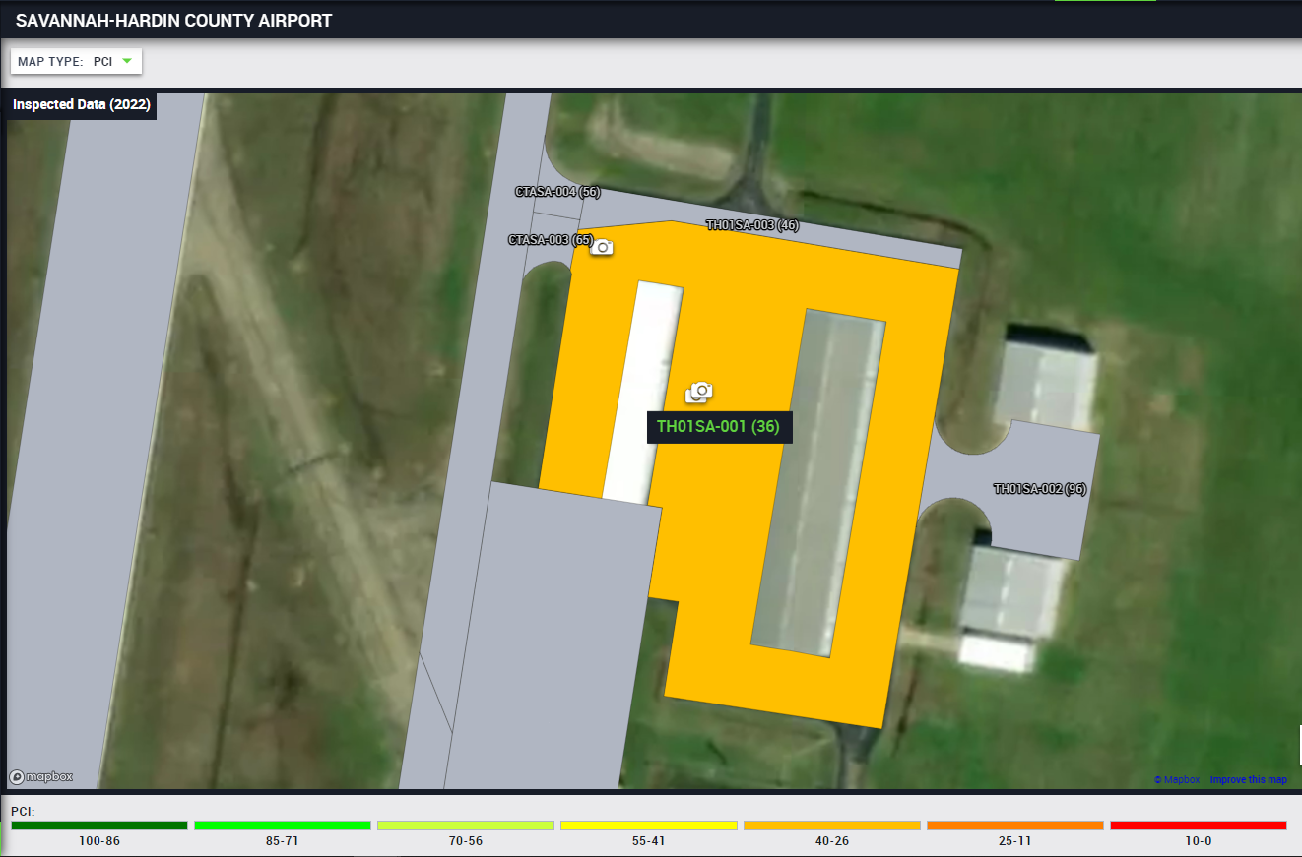
Source: Tennessee IDEA, Tennessee Department of Transportation, 2023, idea.appliedpavement.com/hosting/tennessee/index.html.

Figure 2.5.4
TH01SA-001 Maintenance Recommendation
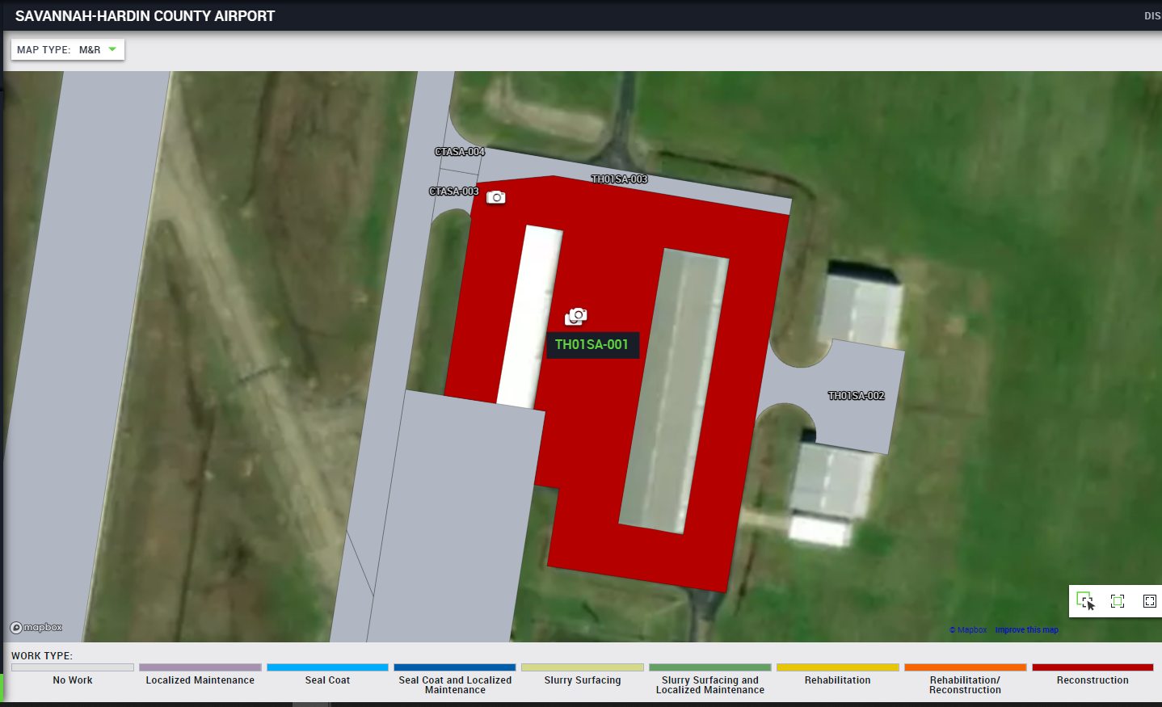
Source: Tennessee IDEA, Tennessee Department of Transportation, 2023, idea.appliedpavement.com/hosting/tennessee/index.html.

Figure 2.5.5
TH01SA-001 Pavement Photo L&T Cracking
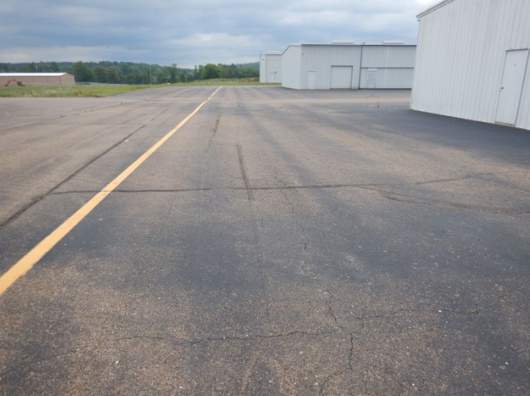
Source: Tennessee IDEA, Tennessee Department of Transportation, 2023, idea.appliedpavement.com/hosting/tennessee/index.html.

Figure 2.5.6
TH01SA-001 Pavement Photo Alligator Cracking
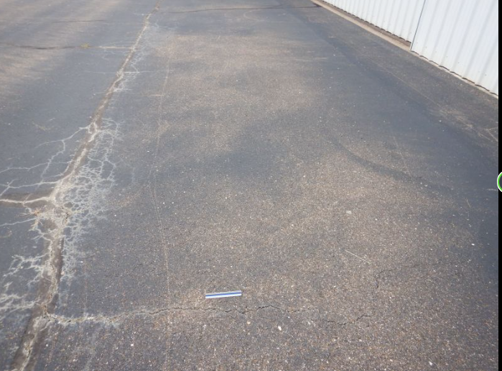
Source: Tennessee IDEA, Tennessee Department of Transportation, 2023, idea.appliedpavement.com/hosting/tennessee/index.html.

Table 2.5.7
SNH TH01SA-001 Distress Data
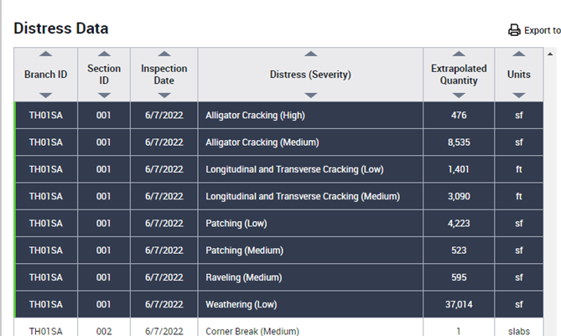
Source: Tennessee IDEA, Tennessee Department of Transportation, 2023, idea.appliedpavement.com/hosting/tennessee/index.html.

Reviewing Table 2.5.8, conducting maintenance of patching, crack repair and microsurfacing can yield a higher cost/benefit ratio associated to the amount of area x 1 point of PCI increase per dollar versus a traditional reconstruction. With maintenance, the condition improves from poor to fair condition and spending a 1/10 of the cost.

Table 2.5.8
TH01SA-001 Rehabilitation versus Maintenance
Pavement Type | 2022 PCI | Area (sf) | Unit Cost ($/SF) | Treatment | New PCI | Square Foot PCI point increase per dollar
Asphalt | 36 | 68,722 | 14.75 | Mill/Fill/Remarking | 100 | 4.3
Asphalt | 36 | 68,722 | 1.41 | Patching/Crack Sealing/Microsurface/Remarking | 69 | 23.3

The PAVER application can derive work from distresses as show in Table 3.0.2, but the problem is not having local policies to help group the treatments at a single airport to help with optimizing the repair options. For example, if a small section of the airport is a seal coat while the majority is a slurry surfacing, for contracting unit cost and mobilization, it is better to have the entire sections at the airport to be slurry surfacing or one treatment. The other issue is not being able to optimize based on airport classification and then optimize based on quantities at each airport within that classification. Taking it a further step is ensuring other policies and contraints are taken into consideration to ensure the final results is a list of work to be accompolished for the the year while obtaining acceptible unit cost and contractor production due to the values being optimized.

Table 2.5.9
PAVER Maintenance List 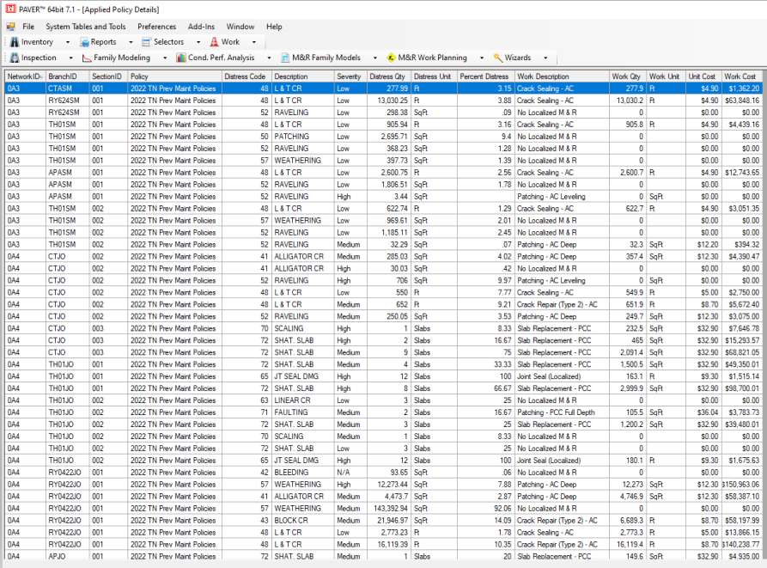
Source: PAVER. Colorado State University, Version 7.1. https://www.paver.colostate.edu/
The other gap that is not solved in this research is understanding what maintenance can be accomplished by the workforce to optimize the PCI recovered at the airport at a project-level basis. The issue is the need of better understanding the PCI deductions and the normalization that is completed during the ASTM PCI inspection. If this is also completed, then a system level target can be set to optimize the PCI associated to the budget.

Chapter 3: Problem Definition

Overall Distresses in the State

The Tennessee Department of Transportation (TDOT) Aeronautics Division (TAD) recently released their Pavement Management Program (PMP) update (TAD 2023). In the report, it shows that TAD has 72 public use airports (excluded 5 airports) that associates with 78.7 million square feet of pavement and the area-weighted age as of 2022 is 21 years. This is a significant number as pavement especially asphalt useful life is 30 years and this does not reset unless rehabilitation via replacement is conducted. As a system, the Pavement Condition Index (PCI) was rated at a 73. Running What-If scenarios in the commercial application specify that maintaining the PCI of 73 at a system level will cost $30.5 million annually in rehabilitation and reconstruction while increasing to a PCI of 75 would cost $41.5 million annually. To complete all the maintenance and rehabilitation needs of the system would cost $80.8 million per year for 5 years. In the pavement inventory, it showed at 43% are runways, 24% are Taxiways, 23% are Apron/Helipad and 10% are T-Hangar. A table was then attached showing localized preventive maintenance plan of patching and crack sealing.

Types of Distresses in Pavement

From Tennessee IDEA (2023), General Aviation airport account for 78.7 million Sq.FT. of pavement area with the following percentages accounting for the different use types as illustrated in Figure 4.2.1:

- Runways: 43%
- Taxiways: 24%
- Apron/Helipad: 23%
- Hangar Pavement: 10%

Figure 3.2.1
Airfield Identification
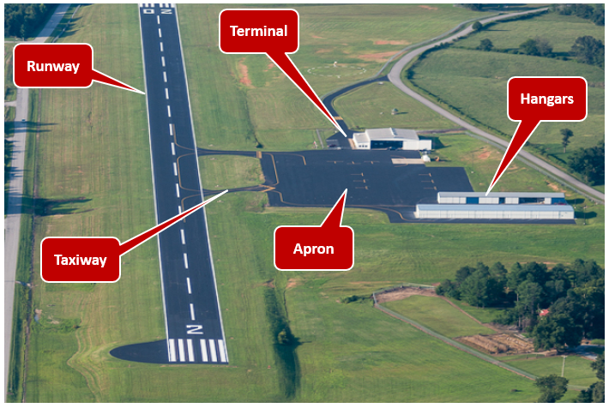
Applying the proper airfield pavement treatment due to distresses present has been previously researched by the Transportation Research Board through ACRP Project 09-11 by Freeman, Thomas J, et al. (2016). The purpose of the study was to use the airport classification, climate zone, and distresses present in the pavement to determine the treatment to solve or slow the deterioration. The treatments were set up as “recommended” and “acceptable”. The user is able to add several sections together to create options on a plausible solution to a singular location. It also changes the treatment based on criteria like Airport Classification as the weight of the aircraft would change with it. The user is able to also add a cost basis and calculate the overall cost and benefit of the project. Reviewing TAD 2023’s statewide report, distresses were extracted from the PAVER application as the consultant who compiled the report using the application followed ACRP Project 09-11 recommendations as plausible defects as shown in Table 4.2.1 and examples of some of the distresses in Figure 4.2.3.
Table 3.2.1
Distress Database 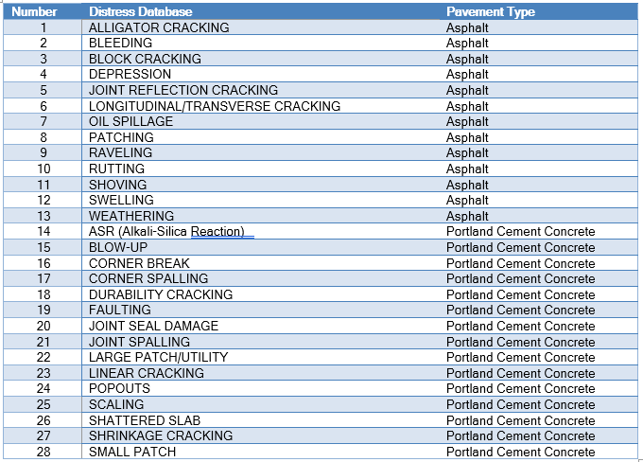
Figure 3.2.2
Pavement Distress Examples

Types of Maintenance for Pavement

Insights from previously conducted research by the Transportation Research Board, American Society for Testing Materials (ASTM) for Pavement Condition Index (PCI) and data from Tennessee’s general aviation Airfield Pavement Management Software (APMS) called PAVER were used. To create the PCI, inspections are conducted then the data is uploaded into an Airfield Pavement Management Software (APMS) called PAVER that helps to create branches then sections and deterioration curve modeling. As more data is fed into the system, the deterioration curve modeling improves. Between new construction to reconstruction is the maintenance phase of an asset’s life. To have a robust maintenance program to slow the aging process, maintenance treatment recommendations are needed at the right time associated to an available budget. A deeper dive into ASTM D6420-XX was necessary to discover the pros and cons of the existing PCI methodology and if a new methodology could be defined to recover pavement life at a discount rate.

Pros and Cons of the Existing PCI Method

fdsaf

To make this probable, a list of recommended projects with constraints of what can be achievable by a contractor from historic completion rates are needed as an output for maintenance and reconstruction to take place.
Table 4.3.1 list possible maintenance treatment associates to the different pavement types. Figures 4.3.1, 4.3.2 and 4.3.3 shows larger photos of a couple of distresses shown in Figure 1.0.3. Figure 4.3.4 shows a coring that was completed and how the seal coat is a surface treatment as discusses beforehand.
In Chapter 4, we associate the distresses and maintenance treatments into a decision tree that preprocesses the data with local policies. We then apply global policies.
Table 3.3.1
Maintenance Database
Maintenance Treatment | Pavement Type
AC Patch | Asphalt
Crack Seal (Type 1) | Asphalt
Crack Seal (Type 2) | Asphalt
Crack Seal (Type 3) | Asphalt
Microsurface | Asphalt
Slurry Seal | Asphalt
Cape Seal | Asphalt
Monitor | Asphalt
Seal Coat | Asphalt
Crack/Joint Seal | Portland Cement Concrete
Grinding/Grooving | Portland Cement Concrete
Monitor | Portland Cement Concrete
PCC Patching (Full) | Portland Cement Concrete
PCC Patching (Partial) | Portland Cement Concrete
Statewide Contract | Asphalt
Invitation to Bid | Asphalt

Figure 3.3.1
Crack Seal Application
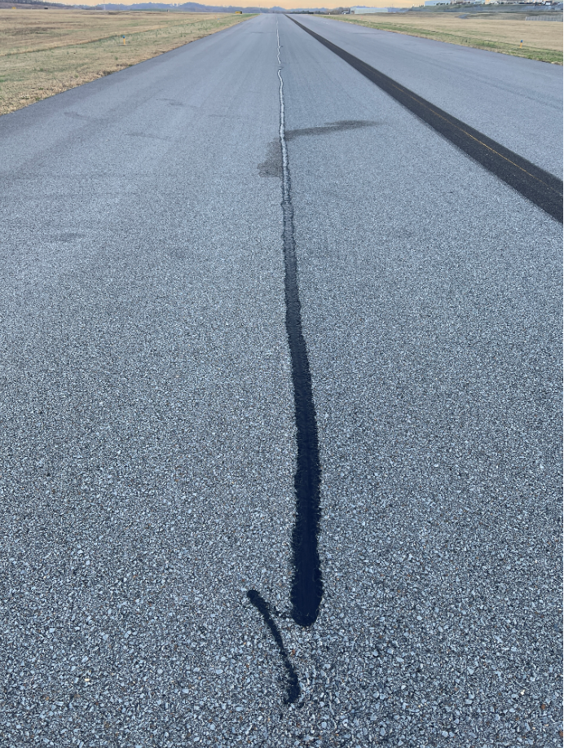
Figure 3.3.2
Seal Coat (P-623) Application Post 1 month 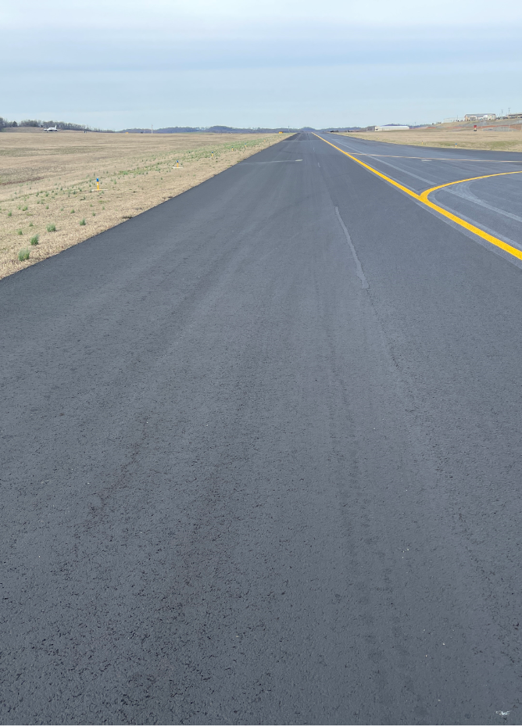
Figure 3.3.3
Seal Coat (P-608) Application Post 1 month
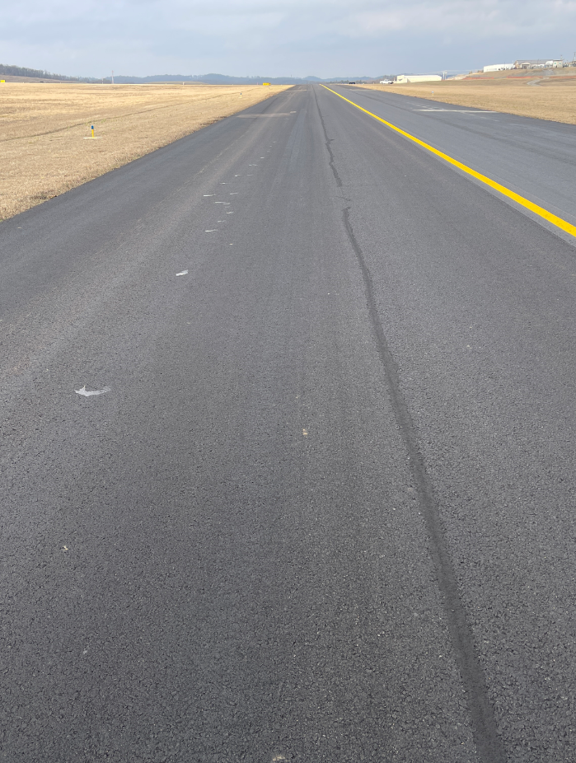
Figure 3.3.4
Seal Coat (P-623) Application Coring Photo
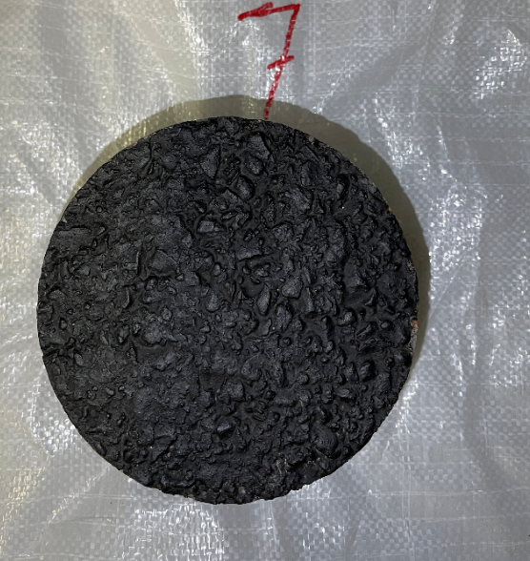
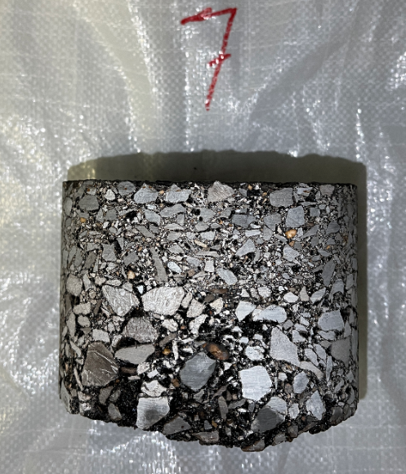

Maintenance Objective

As discussed in previous chapters, the number of airports is constraint to 72 airports. The budget available for maintenance is between $4 million to $8 million annually and there is a contracting company that works for TAD. The PCI scores from the TAD Pavement Management Program was set to 75 as a target goal of the system by reviewing data history. Using maintenance history of 4 years would help to outline what work was possible to accomplish in a given calendar year to help with the inputs of the model.
Some policies will be introduced associated to limit the number of different treatments at a single airport due to mobilization cost and downtime from switching material types. Some treatments will require multiple sources of contracting to be performed like a construction letting and different maintenance contracts. The Airfield Pavement and Marking Maintenance (APMM) contract consist of crack routing/sealing, seal coating, slurry surfacing (slurry seal or microsurfacing), minor patching (< 2,500 Square Feet) and remarking. The algorithms would make several passes to find the most favorable solution. Since each airport is unique and the possible work at the airport is determined by its parts versus a universal treatment, the best outcome will be derived.

Chapter 4: Solution Approach and Methodology

As shown in figure 5.1.1, the first data input is derived from the PAVER application that holds the location, distress, severity and quantities. The second data input is deriving cost associated to potential available maintenance treatments. The third data input is derived on budget and contractor availability. These three are input into the data preprocessing starting with the decision tree. The decision tree matching the distress and severity with the maintenance treatment as a result. Local policy then can change the maintenance treatment based on certain parameters associated with that distress in a pavement section. The global policy associates all the pavement section distresses and matches the maintenance treatment totals for each airport. For each airport, the data is then manipulated to apply holistically the treatment that would proportionalize to an acceptable quantity for a contractor to perform. If not enough treatment quantities are present, the maintenance treatment would be upgraded to match the other section with similar distresses. The results are associated with an exported excel file.
That exported excel file that is considered to be our data preprocessing results is then applied to two different methodologies. The first methodology is a heuristic algorithm. The first policy is ensuring that airport classification is maintained from the greatest to least importance and then maximizing the budget and technically major work to have the greatest impact to each airport classification grouping. Available budget and time is then displayed with the output file showing what airports where selected and organized from top to bottom on work that should be executed first. The second methodology utilizes the commercial solver: Gurobi with inputs associated to the mathematical model and constraints being input into the solver. The goal is to maximize the total number of airports with distress while respecting the airport classifications and other constraints.
Figure 5.0.1
Methodology of Airfield Pavement Management and Policy
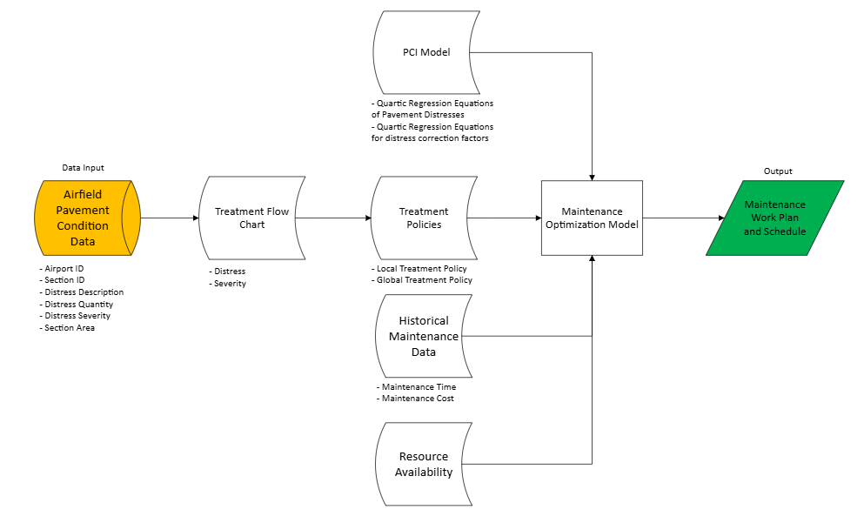

Data Input

The data input consists of an excel export from the PAVER application (example shown in Table 5.1.1) that contains all the condition data and other relevant information like pavement section area. The cost factor is the budget that is being exercised and also the unit cost for the maintenance type shown in Table 5.1.2. Resource availability also shown in table 5.1.2 are set amounts using historical values of what was accomplishable daily for each maintenance type.

Table 5.1.1
PAVER Data Export
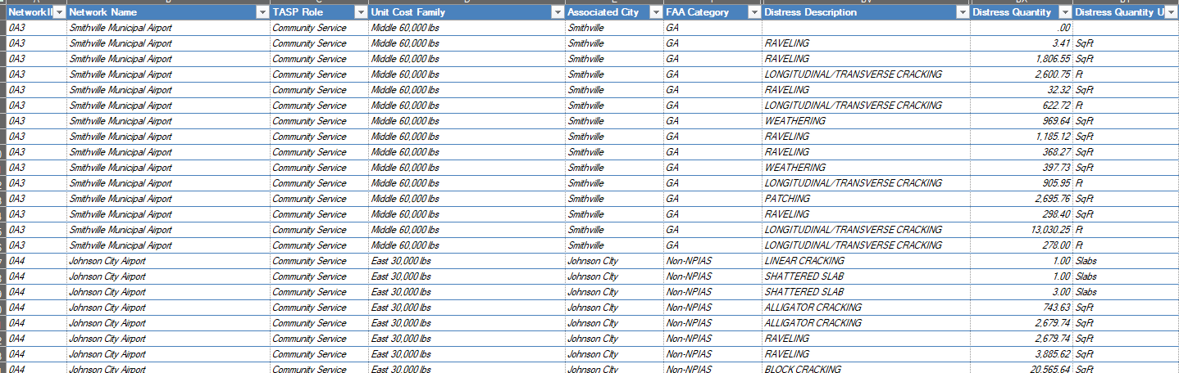
Source: PAVER. Colorado State University, Version 7.1. https://www.paver.colostate.edu/

Table 5.1.2
Cost Factors and Resource Availability
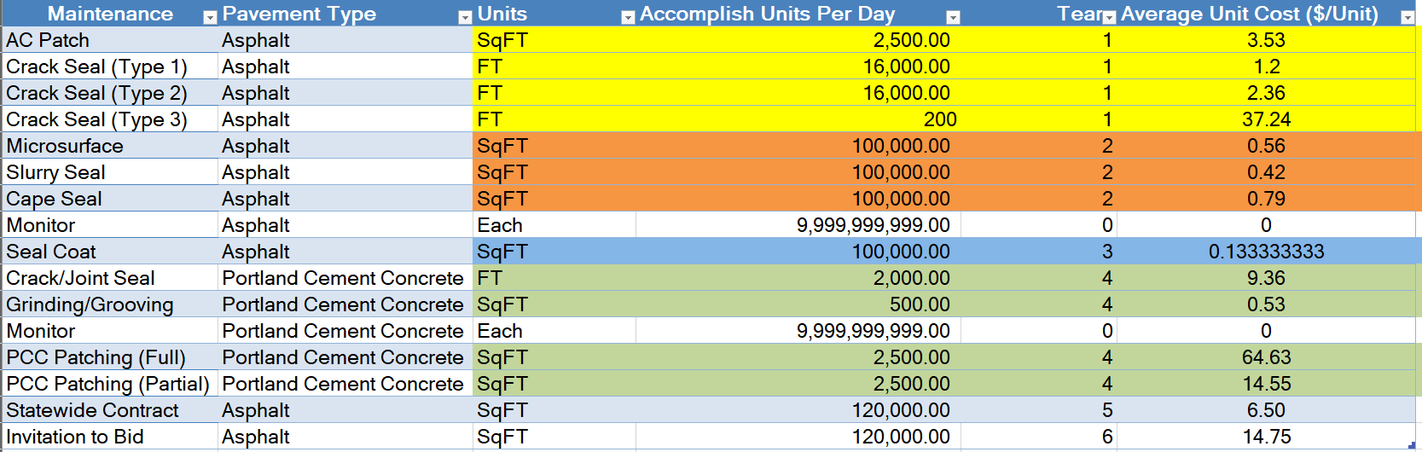

Treatment Flow Chart and Policies

The decision tree shown below in Figure 5.2.1 was first developed to utilize the distresses present and the severity to categorize the type of treatment that would be received. The result was then logged in the excel output file. This was completed for all 28 possible distresses shown below in Table 5.2.1 with associated treatments in Table 5.2.2 as a sample.
Figure 5.2.1
Example Decision Tree
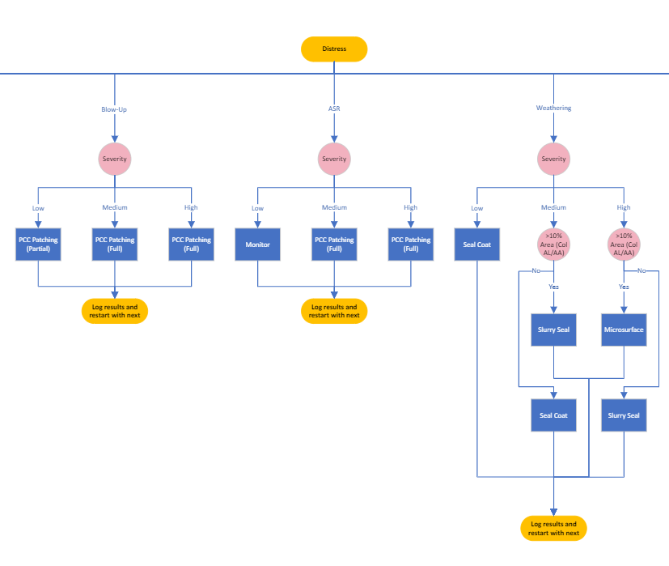

Table 5.2.1
List of Possible Distresses
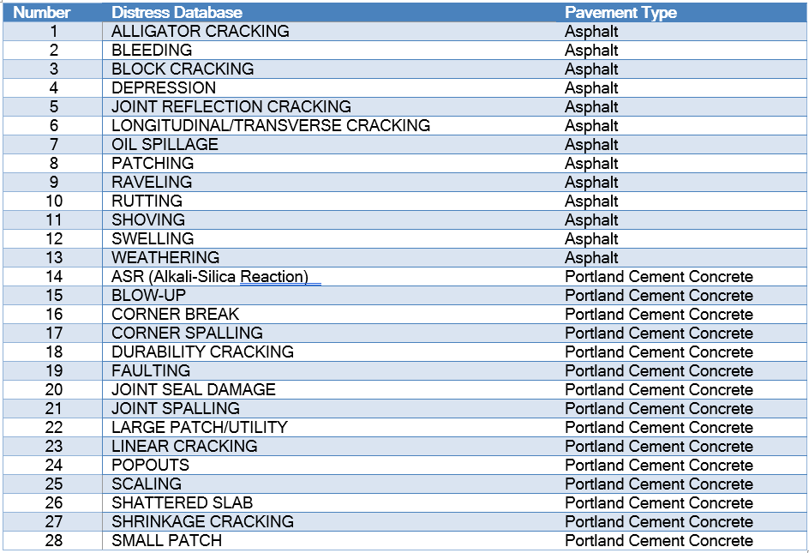
Table 5.2.2
Example of Distresses and Maintenance Treatment without Local Policy
Database Distress | Maintenance
ALLIGATOR CRACKING | AC Patch
ALLIGATOR CRACKING | AC Patch
ALLIGATOR CRACKING | AC Patch
BLEEDING | Monitor
BLOCK CRACKING | Crack Seal (Type 2)
BLOCK CRACKING | Crack Seal (Type 1)
BLOCK CRACKING | Crack Seal (Type 3)
DEPRESSION | AC Patch
DEPRESSION | AC Patch
DEPRESSION | AC Patch
JOINT REFLECTION CRACKING | Crack Seal (Type 2)
JOINT REFLECTION CRACKING | Crack Seal (Type 1)
JOINT REFLECTION CRACKING | Crack Seal (Type 3)
LONGITUDINAL/TRANSVERSE CRACKING | Crack Seal (Type 2)
LONGITUDINAL/TRANSVERSE CRACKING | Crack Seal (Type 1)
LONGITUDINAL/TRANSVERSE CRACKING | Crack Seal (Type 3)

Global Policies shown in Table 5.2.3 are also established during the pre-processing step and held as a constraint in both solvers that are discussed in the next section.
Table 5.2.3
Global Policies
Priority | Instructions
Change "Seal Coat" or "Slurry Seal" to "Microsurface" | If "Block Cracking", "Joint Reflective Cracking" and/or "Logitudinal/Transverse Cracking" = "Crack Seal (Type 2)" and "Seal Coat", "Slurry Seal" or "Microsurface" is also recommended in the same section, change to "Microsurface".
Change "Microsurface" to "Cape Seal" | If "Block Cracking", "Joint Reflective Cracking" and/or "Logitudinal/Transverse Cracking" = "Crack Seal (Type 3)" and "Seal Coat", "Slurry Seal" or "Microsurface" is also recommended in the same section, change to "Cape Seal".
Change "Slurry Seal" to "Microsurface" | If "Microsurface" and "Slurry Seal" are on the same airport and "Slurry Seal" is <30% of surface area, change "Slurry Seal" to "Microsurfacing".
Change "Microsurface" to "Slurry Seal" | If "Microsurface" and "Slurry Seal" are on the same airport and "Microsurface" is <10% of surface area and less than 20,000 SqFT, change "Microsurface" to "Slurry".
Airport Classification | (1) Commercial Service, (2) Regional Service, (3) Community Business and (4) Community Service
Quantities | Higher Total Cost at one airport first: Single large quantities first (AL) or multiple smaller quantities to be corrected at the airport (Crack Seal plus Seal Coat/Slurry Seal/Microsurface/Cape Seal)

PCI Model

For the heuristic

Historical Maintenance Data

Dfsajkfhdskaj

Resource Availability

Heuristic Algorithm

For the heuristic algorithm, the main goal was to reorganize all the preprocessed data to associated a level of importance for each airport classification and then group the cost of each classification to ensure that the contractor remained active and yielded the best unit pricing due to available work at each airport. The pseudo-code for the algorithm is below:
Sorting distresses according to heuristic rules was the first process.
- Step 1: Read preprocessed file
- Step 2: If in the exclude column has a “1” for that pavement section, data is excluded
- Step 3: If distress data does not exist in the distress column for the pavement section, label condition for that section as “Good”.
- Step 4: Define airport classification by “Commercial Service”, “Regional Service”, “Community Business”, “Community Service” with the first being the greatest importance to the lease at the end.
- Step 5: Sort values by using the following order: Step 2, Step 3, Step 4 and then largest cost of airport and largest cost of distress by ascending the order.
The next step was associating the distresses being repaired by the remaining budget and remaining days.
- Step 1: Read the global constraints from the excel file
  - Consist of Total budget and remaining days
- Step 2: Counting the number of airports that are repaired
- Step 3: Initialize remaining budget and teams days columns being added
- Step 4: Calculate the remaining budget and days for each team iteratively
- Step 5: Subtract cost from remaining budget
- Step 6: Verify enough budget and days to repair the distresses

Maintenance Optimization Model

Decision Variables and Constraints

Table 5.3.1
Notations for Solver
$x_{i}^{d}$: | Decision variable $x_{i}^{d}$ are binary variables, where $i$ represents the distress and $d$ the type of decision.
$$y_{a}^{d}:$$ | Auxiliary variable $y_{a}^{d}$ is integer variables representing the total days required to address all distresses in the airport $a$ with decision $d$. This variable ensures that the days are appropriately rounded up at the decision level.
$$z_{a}:$$ | Auxiliary variable $z_{a}$ is binary and indicates whether all distresses in airport $a$ will be addressed.
$$A:$$ | Public-Use and Publicly Owned Airports in the State of Tennessee
$$A_{1}:$$ | The set of airports categorized as “Commercial Service”.
$$A_{2}:$$ | The set of airports categorized as “Regional Service”.
$$A_{3}:$$ | The set of airports categorized as “Community Business”.
$$A_{4}:$$ | The set of airports categorized as “Community Service”.
$I$: | The set of distresses present in the airport pavement sections.
$$D:$$ | The set of decisions.
$U$: | An exclusion set comprised of distresses that must be omitted from consideration.
$S_{a}$: | The set of distresses in the airport $a$.
$c^{d}$: | It denotes the unit cost for each decision type $d$.
$m^{d}$: | It represents the accomplishment amount per day for each decision $d$.
$q_{i}$: | This is the quantity of distress $i$.
$p_{i}^{d}$: | This parameter indicates the acceptable decision for a distress. It is important to note that each distress has only one acceptable decision where $p_{i}^{d}=$1, signifying the feasibility of that decision. In contrast, a value of $p_{i}^{d}=0$ implies that decision $d$ is not applicable for the distress $l$.
$$B:$$ | It is the total allocated budget for the project.
$\overline{B}$: | This parameter sets a threshold for the maximum allowable remaining budget.
$$T:$$ | It represents the total days available to work on projects.
$$\overline{T}:$$ | This parameter sets a threshold for the maximum allowable remaining days.
$$N_{a}:$$ | The number of distresses in the airport $a$.
$N$: | The total number of airports.

Mathematical Model

Maximize: $N^{3}\sum_{a∈A_{1}}{z_{a}}+N^{2}\sum_{a∈A_{2}}{z_{a}}+N^{1}\sum_{a∈A_{3}}{z_{a}}+\sum_{a∈A_{4}}{z_{a}}$

$$\sum_{i∈I}{\sum_{d∈D}{c^{d}q_{i}}x_{i}^{d}}≤B⋅⋅⋅⋅⋅⋅⋅⋅⋅⋅⋅⋅⋅⋅⋅⋅⋅⋅⋅⋅⋅⋅⋅(1)$$
$$y_{a}^{d}≥\sum_{i∈S_{a}}{\frac{q_{i}}{m_{d}}x_{i}^{d}}, ∀a∈A,d∈D ⋅⋅⋅⋅⋅(2)$$
$$\sum_{a∈A}{\sum_{d∈D}{y_{a}^{d}} }≤T ⋅⋅⋅⋅⋅⋅⋅⋅⋅⋅⋅⋅⋅⋅⋅⋅⋅⋅⋅⋅⋅⋅⋅⋅⋅⋅⋅⋅⋅(3)$$
$$\sum_{d∈D}{x_{i}^{d}}≤1 ∀i∈I⋅⋅⋅⋅⋅⋅⋅⋅⋅⋅⋅⋅⋅⋅⋅⋅⋅⋅⋅⋅⋅⋅⋅⋅⋅⋅⋅⋅\left(4\right)$$
$$(1-p_{i}^{d})x_{i}^{d}≤0 ∀i∈I,d∈D⋅⋅⋅⋅⋅⋅⋅⋅⋅⋅(5)$$
$$B-\sum_{i∈I}{\sum_{d∈D}{c^{d}x_{i}^{d}}}≤\overline{B} ⋅⋅⋅⋅⋅⋅⋅⋅⋅⋅⋅⋅⋅⋅⋅⋅⋅⋅⋅⋅(6)$$
$$T-\sum_{a∈A}{\sum_{d∈D}{y_{a}^{d}}}≤\overline{T} ⋅⋅⋅⋅⋅⋅⋅⋅⋅⋅⋅⋅⋅⋅⋅⋅⋅⋅⋅⋅⋅⋅⋅(7)$$
$$z_{a}\left(N_{a}-\sum_{i∈s_{a}}{\sum_{d∈D}{x_{i}^{d}}}\right)≤0 ∀a∈A⋅⋅(8)$$
$$\sum_{d∈D}{x_{i}^{d}}≤0, ∀i∈U⋅⋅⋅⋅⋅⋅⋅⋅⋅⋅⋅⋅⋅⋅⋅⋅⋅⋅⋅⋅⋅⋅⋅⋅⋅⋅(9)$$
$$x_{i}^{d}∈\left\{0, 1\right\} ∀i∈I,d∈D⋅⋅⋅⋅⋅⋅⋅⋅⋅⋅⋅⋅⋅⋅⋅⋅⋅(10)$$
$$y_{a}^{d}∈Z ∀a∈A,d∈D⋅⋅⋅⋅⋅⋅⋅⋅⋅⋅⋅⋅⋅⋅⋅⋅⋅⋅⋅⋅\left(11\right)$$
$$z_{a}∈\left\{0, 1\right\} ∀a∈A⋅⋅⋅⋅⋅⋅⋅⋅⋅⋅⋅⋅⋅⋅⋅⋅⋅⋅⋅⋅⋅⋅⋅⋅⋅⋅(12)$$

The objective function is designed to maximize the total number of airports, A, repaired. Constraint (1) ensures adherence to the total budget limit. Constraints (2) and (3) are in place to respect the total availability of days, with constraint (3) specifically limiting the contracting days needed to repair all distresses in airport $i$ under decision $d$. Constraint (4) ensures that only one decision is made for each distress. Constraint (5) defines the possible decision range for each distress, with parameters $b_{i}^{d}$ being determined by both local and global policies during the pre-processing stage. We considered improving constraint (5) by forgoing the pre-processing step, but found the pre-processing step was needed to evaluate by comparing the heuristic and Gurobi solutions. Constraints (6) and (7) ensures the remaining budget and contracting days do not exceed set thresholds. While these could be treated as soft constraints integrated into the objective function, doing so would necessitate balancing factors for multiple objectives; hence, we have retained them as hard constraints, as depicted in constraints (6) and (7). Constraint (8) checks whether all distresses in airport $i$ are addressed, setting $z_{i}$ to 0 if any distress remains uncompleted. Constraint (9) ensures that all distresses within the exclusion set must be omitted from consideration. Constraints (10), (11), and (12) stipulate that decision variables $x_{ijkl}^{d}$ and $z_{i}$ must be binary, while $y_{i}^{d}$ should be an integer.
The total number of binary decision variables for $x_{ijlk}^{d}$ is calculated as the product of the number of airports, branches, sections, types of distress, and decisions, amounting to approximately 1,176,000 (calculated as 28 airports * 5 branches * 20 sections * 28 distress types * 15 decisions).
TBD:
- Add constraints related to PCI score.
- Adding additional constraints for the blocklist.
- Revise the objective function.

Maintenance Work Plan and Schedule

Chapter 5: Results

5.1 Computation Setup

The formulation are coded in Python 3 and solved by the commercial solver Gurobi (version 8.1.0) running on an x64-based PC. This PC runs Windows 10 Pro with Intel Core i7 – 1165G7 CPU (2.80 GHz) and 8 GB of Ram. The heuristic algorithm is also coded in Python and run in PyCharm on the same machine.

5.2 Results for the two methodologies

The initial results between the two solvers are as follows:
- Heuristic Solver:
  - Number of airports repaired is: 15
  - Remaining Budget: $44,680.00
  - Remaining Days: 142 days
  - Number of Distresses Addressed: 1,466
- Commercial Solver – Gurobi
  - Number of airports repaired is: 24
  - Remaining Budget: $5,912.00
  - Remaining Days: 110 days
  - Number of Distresses Addressed: 1,908

5.3 Comparisons and Improvements

From initial comparisons, Gurobi can find 9 additional airports that was able to be repaired while also being able to maximize the available budget and days to minimize the remaining amounts. The number of distresses were also able to increase.
For next improvements, a comparison of the data will need to be accomplished and with additional data inputs, validate the days of work for each task. The Heuristic solver will need to be cross analysis to ensure the comparative analysis is a correct evaluation as some errors like organizing the airport classification was noticed to be in error at times. The goal will be to improve the heuristic solver to remove the need of a commercial solver to be able to be incorporated into reporting tools without the need of a license. Another interesting approach is the removal of a constraint like airport classification to see the different results and see if the budget and time can be better utilized.

Chapter 6: Business Insights

The original goal of this dissertation is being able to take the pavement management data and create work orders for work to be executed by TAD’s new work order-based contracting. The initial results as a partial solution is shown in Table 6.4.1 are promising as it took 71 airports worth of data to create a prioritized list of work to be accomplished. Since TAD now have a work order based contracting, fine tuning the solvers will be the next needed step.

Table 6.4.1
Example Decision Tree with Policies in Tabular Form Prioritized by Heuristic Solver
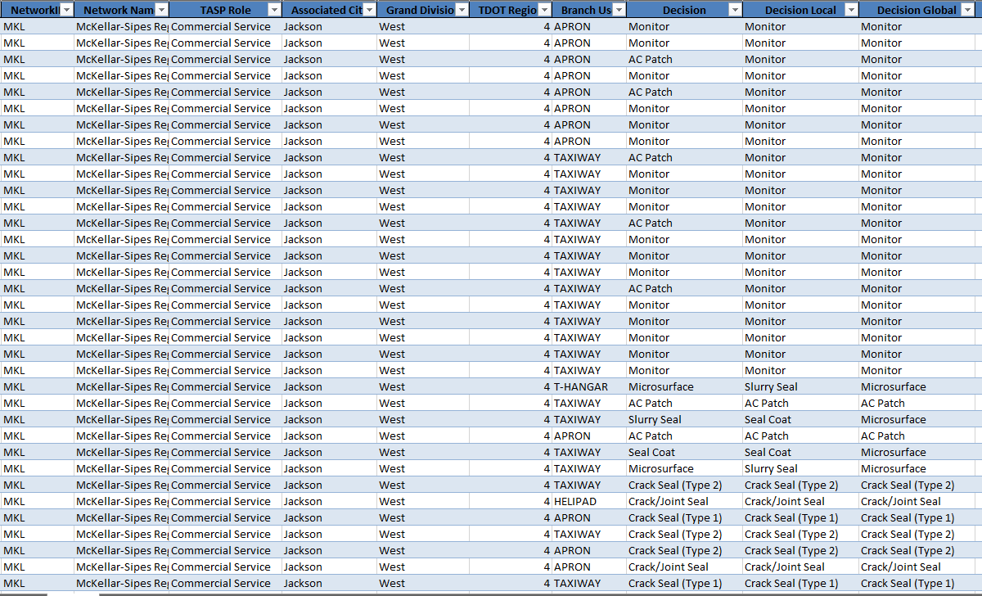

Chapter 7: Conclusion

This dissertation…..

References

“Airport Pavement Management Program (PMP).” AC 150/5380-7B - Airport Pavement Management Program (PMP), Federal Aviation Administration, 10 Oct. 2014, www.faa.gov/airports/resources/advisory_circulars/index.cfm/go/document.current/documentNumber/150_5380-7.
Ali, Abdualaziz, et al. Journal of Road Engineering, 2021, Predicting Pavement Condition Index Based on the Utilization of Machine Learning Techniques: A Case Study.
ASI, Salt Lake City, UT, 2019, Best Practices P-608 Emulsified Asphalt Seal Coat.
Boyapati, Bharath, and R. Prasanna Kumar. vol. 8, SASTRA Univrsity, Tamilnadu, India, 2015, Prioritisation of Pavement Maintenance Based on Pavement Condition Index .
Chung, Nick, and George Ho. In-Teh, Hong Kong, China, 2010, Using Integer Programming for Airport Service Planning in Staff Scheduling.
D5340 ed., ASTM International, West Conshohocken, PA, 2023, Standard Test Method for Airport Pavement Condition Index Surveys.
Freeman, Thomas J, et al. Pavement Maintenance Guidelines for General Aviation Airport Management, Transportation Research Board of the National Academies, Mar. 2016, acrp-pavement-tool.tti.tamu.edu/docs/ACRP-09-11-Guidebook.pdf.
Issa, Amjad, et al. Science Direct, 2021, Predicting Pavement Condition Index Using Artificial Neural Networks Approach.
Joslin, Kimberly, et al. “Literature Review on Performance, Best Practices, and Training Needs for Chip Seals, Slurry Surfacing, and Cape Seals.” California State University Transportation Consortium, Mineta Transportation Institute, Nov. 2019, transweb.sjsu.edu/sites/default/files/1845D-Cheng-Pavement-Maintenance-Literature-Review.pdf.
Marquez, A Crespo, et al. Taylor and Francis Group, London, England, 2009, The Maintenance Management Framework: A Practical View to Maintenance Management.
National Academies of Science, Engineering, and Medicine , Washington D.C, 2011, Guidelines for the Preservation of High-Traffic-Volume Roadways.
National Academies of Sciences, Engineering, and Medicine. 2015. Preventive Maintenance at General Aviation Airports Volume 1: Primer. Washington, DC: The National Academies Press. https://doi.org/10.17226/22117.
Nunez, Maria M, and Mohamed Y Shahin. “Pavement Condition Data Analysis and Modeling.” Transportation Research Record, no. 1070, 1986.
Peshkin, David G, et al. NCHRP, Washington, D.C., 2004, Optimal Timing of Pavement Preventative Maintenance Treatment Applications .
Polymer-Modified Masterseal (PMM) Ultra Pavement Sealer, SealMaster, 6 Apr. 2023, sealmaster.net/pdf/specification/Sealmaster%20spec%20sheets/polymer-modified-masterseal-PMM.pdf.
Sirvio, Konsta M. Intelligent Systems Reference Library, 2015, Intelligent Systems in Maintenance Planning and Management.
TDOT Pavement Resurfacing Program Standard Operating Guidelines, Tennessee Department of Transportation, Apr. 2018, www.tn.gov/content/dam/tn/tdot/maintenance/pavement-office/TDOT-ResurfacingGuidelines-27April2018.pdf.
Tennessee Department of Transportation Aeronautics Division (TAD), Nashville, TN, 2023, Tennessee Airport Pavement Management Program Update.
Tennessee IDEA, Tennessee Department of Transportation, 2023, idea.appliedpavement.com/hosting/tennessee/index.html.
Transportation Research Records, 1986, Pavement Condition Data Analysis and Modeling.

Appendix A

Decision Tree and Policies for Preprocessing:
import pandas as pd
import numpy as np
def generate_output(decision_file, data_file):
# Load raw data for decision tree and constraints
df_treatment = pd.read_excel(decision_file, sheet_name='Treatment')
df_annual_constraints = pd.read_excel(decision_file, sheet_name='Annual Global Constraints')
# Load raw data for processing
df_data = pd.read_excel(data_file, sheet_name='Sheet1')
# Generate decisions based on the decision tree and local/global policies
decision_tree = generate_decision_tree(df_treatment)
df_decision = generate_decision(df_data, decision_tree)
df_adjusted_local = decision_adjustment_local_policy(df_decision)
df_adjusted_global = decision_adjustment_global_policy(df_adjusted_local)
df_resource_requirements = generate_resources_requirement(df_adjusted_global, df_annual_constraints)
# Export the final DataFrame to an Excel file
output_file_name = 'output.xlsx'
df_resource_requirements.to_excel(output_file_name, index=False)
print(f"Results exported to {output_file_name}")
def generate_decision_tree(dataframe):
"""
The following codes generate the decision tree according to the dataframe, which is the "Treatment" tab
of the Excel "Data with Distresses".
"""
decision_tree = {}
for index, row in dataframe.iterrows():
distress_code = row['Distress Code']
severity = row['Severity']
maintenance = row['Maintenance']
decision_tree[distress_code, severity] = maintenance
return decision_tree
def generate_decision(dataframe, decision_tree):
"""The following codes generate initial decisions according to the decision tree."""
# Duplicate a new data frame
df = dataframe.copy()
# Add a new column 'DistressID' starting from 1
df.insert(0, 'DistressID', range(1, 1 + len(df)))
# Function to apply the decision tree
def apply_decision(row):
try:
distress = row['Distress Code']
except:
distress = 'N/A'
severity = row['Severity']
key = (distress, severity)
return decision_tree.get(key, float('nan'))
# Applying the decision function to each row
df['Decision'] = df.apply(apply_decision, axis=1)
return df
def decision_adjustment_local_policy(dataframe):
"""The following codes use local policies to adjust the decisions."""
df = dataframe.copy()
# Duplicate decisions
df['Decision Local'] = df['Decision']
# Update 'decision' based on local conditions
# ALLIGATOR CRACKING, Low Sevirity, <=30% pf area: AC Patch-> Monitor
df.loc[
(df['Distress Code'] == 41) &
(df['Severity'] == 'Low') &
(df['Distress Quantity'] <= 0.3 * df['Section True Area']),
'Decision Local'] = 'Monitor'
# ALLIGATOR CRACKING, Medium Sevirity, <=10% pf area: AC Patch-> Monitor
df.loc[
(df['Distress Code'] == 41) &
(df['Severity'] == 'Medium') &
(df['Distress Quantity'] <= 0.1 * df['Section True Area']),
'Decision Local'] = 'Monitor'
# ALLIGATOR CRACKING, High Sevirity, <=10% pf area: AC Patch-> Monitor
df.loc[
(df['Distress Code'] == 41) &
(df['Severity'] == 'High') &
(df['Distress Quantity'] <= 0.1 * df['Section True Area']),
'Decision Local'] = 'Monitor'
# DEPRESSION, Low Sevirity, <=30% pf area: AC Patch-> Monitor
df.loc[
(df['Distress Code'] == 45) &
(df['Severity'] == 'Low') &
(df['Distress Quantity'] <= 0.3 * df['Section True Area']),
'Decision Local'] = 'Monitor'
# DEPRESSION, Medium Sevirity, <=20% pf area: AC Patch-> Monitor
df.loc[
(df['Distress Code'] == 45) &
(df['Severity'] == 'Medium') &
(df['Distress Quantity'] <= 0.2 * df['Section True Area']),
'Decision Local'] = 'Monitor'
# DEPRESSION, High Sevirity, <=10% pf area: AC Patch-> Monitor
df.loc[
(df['Distress Code'] == 45) &
(df['Severity'] == 'High') &
(df['Distress Quantity'] <= 0.1 * df['Section True Area']),
'Decision Local'] = 'Monitor'
# PATCHING, Medium or High Severity, >=2500 SqFT, <30%: AC Patch -> Statewide Contract
df.loc[
(df['Distress Code'] == 50) &
((df['Severity'] == 'Medium') | (df['Severity'] == 'High')) &
(df['Distress Quantity'] >= 2500) &
(df['Distress Quantity'] < 0.3 * df['Section True Area']),
'Decision Local'] = 'Statewide Contract'
# PATCHING, Medium, >=2500 SqFT, >=30%: AC Patch -> Inventation to Bid
df.loc[
(df['Distress Code'] == 50) &
(df['Severity'] == 'Medium') &
(df['Distress Quantity'] >= 2500) &
(df['Distress Quantity'] >= 0.3 * df['Section True Area']),
'Decision Local'] = 'Inventation to Bid'
# RAVELING, Medium Severity, <=10%: Slurry Seal -> Seal Coat
df.loc[
(df['Distress Code'] == 52) &
(df['Severity'] == 'Medium') &
(df['Distress Quantity'] <= 0.1 * df['Section True Area']),
'Decision Local'] = 'Seal Coat'
# RAVELING, High Severity, <=10%: Microsurface -> Slurry Seal
df.loc[
(df['Distress Code'] == 52) &
(df['Severity'] == 'High') &
(df['Distress Quantity'] <= 0.1 * df['Section True Area']),
'Decision Local'] = 'Slurry Seal'
# WEATHERING, Medium Severity, <=10%: Slurry Seal -> Seal Coat
df.loc[
(df['Distress Code'] == 57) &
(df['Severity'] == 'Medium') &
(df['Distress Quantity'] <= 0.1 * df['Section True Area']),
'Decision Local'] = 'Seal Coat'
# WEATHERING, High Severity, <=10%: Microsurface -> Slurry Seal
df.loc[
(df['Distress Code'] == 57) &
(df['Severity'] == 'High') &
(df['Distress Quantity'] <= 0.1 * df['Section True Area']),
'Decision Local'] = 'Slurry Seal'
return df

def decision_adjustment_global_policy(dataframe):
"""The following codes use global policies to adjust the decisions."""
# Load the specific sheet ('Treatment') from the Excel file
df = dataframe.copy()
# Obtain each individual section according to the PID
pid = df['PID']
pid = pid.drop_duplicates().tolist()
# Duplicate decisions
df['Decision Global'] = df['Decision Local']
for _id in pid:
df_section = df.loc[df['PID'] == _id]
# Check if any row in this section has 'Crack Seal (Type 2)' in 'decision adjusted with constraints'
if 'Crack Seal (Type 2)' in df_section['Decision Local'].values:
# Change 'Seal Coat', 'Slurry Seal', and 'Microsurface' to 'Microsurface' in the main DataFrame
df.loc[(df['PID'] == _id) & (df['Decision Local'].isin(
['Seal Coat', 'Slurry Seal', 'Microsurface'])), 'Decision Global'] = 'Microsurface'
for _id in pid:
df_section = df.loc[df['PID'] == _id]
# Check if any row in this section has 'Crack Seal (Type 3)' in 'decision adjusted with constraints'
if 'Crack Seal (Type 3)' in df_section['Decision Local'].values:
# Change 'Seal Coat', 'Slurry Seal', and 'Microsurface' to 'Cape Seal' in the main DataFrame
df.loc[(df['PID'] == _id) & (df['Decision Local'].isin(
['Seal Coat', 'Slurry Seal', 'Microsurface'])), 'Decision Global'] = 'Cape Seal'
# Filter the DataFrame for rows where 'decision' is 'Microsurface' or "slurry seal"
microsurface_df = df[df['Decision Global'] == 'Microsurface']
slurryseal_df = df[df['Decision Global'] == 'Slurry Seal']
# Group by 'AirportID' and sum 'distress quantity' for each group
microsurface_quantity_sum = microsurface_df.groupby('NetworkID')['Distress Quantity'].sum()
slurryseal_quantity_sum = slurryseal_df.groupby('NetworkID')['Distress Quantity'].sum()
# Convert the Series to a dictionary
microsurface_quantity_dict = microsurface_quantity_sum.to_dict()
slurryseal_quantity_dict = slurryseal_quantity_sum.to_dict()
# Obtain each individual airport according to the PID
airportID = df['NetworkID'].drop_duplicates().tolist()
for airport in airportID:
# If "Microsurface" and "Slurry Seal" are on the same airport
if (airport in microsurface_quantity_dict) and (airport in slurryseal_quantity_dict):
# "Slurry Seal" is <30% of surface area
if slurryseal_quantity_dict[airport] < 0.3 * (
slurryseal_quantity_dict[airport] + microsurface_quantity_dict[airport]):
# Change 'Slurry Seal' to 'Microsurface' in the main DataFrame
df.loc[(df['NetworkID'] == airport) & (
df['Decision Global'] == 'Slurry Seal'), 'Decision Global'] = 'Microsurface'
# "Slurry Seal" is <30% of surface area
if (microsurface_quantity_dict[airport] < 0.1 * (
slurryseal_quantity_dict[airport] + microsurface_quantity_dict[airport])) and (
microsurface_quantity_dict[airport] <= 20000):
# Change 'Microsurface' to 'Slurry Seal' in the main DataFrame
df.loc[(df['NetworkID'] == airport) & (
df['Decision Global'] == 'Microsurface'), 'Decision Global'] = 'Slurry Seal'

return df
def generate_resources_requirement(dataframe, dataframe_annual):
"""The codes below calculate the cost and days to execute each individual distress."""
# Duplicate the current data
df = dataframe.copy()
# Create a dictionary with 'Maintenance' as keys
cost_factor_dict = dataframe_annual.set_index('Maintenance')['Average Unit Cost ($/Unit)'].to_dict()
accomplish_factor_dict = dataframe_annual.set_index('Maintenance')['Accomplish Units Per Day'].to_dict()
accomplish_team_dict = dataframe_annual.set_index('Maintenance')['Team'].to_dict()
# Function to apply the decision tree
def apply_cost(row):
if row['Distress Quantity']:
decision = row['Decision Global']
distress_quantity = row['Distress Quantity']
cost_factor = cost_factor_dict.get(decision, -1) # Returns 0 if decision is not found
if cost_factor == -1:
raise Exception(f'Missing Info: The cost factor for decision {decision} is unknown.')

return int(distress_quantity * cost_factor)
else:
return float('nan')
def apply_accomplish_days(row):
if row['Distress Quantity']:
quantity = row['Distress Quantity']
decision = row['Decision Global']
accomplish_per_day = accomplish_factor_dict.get(decision, -1) # Returns 0 if decision is not found
if accomplish_per_day == -1:
raise Exception(f'Missing Info: The labor factor for decision {decision} is unknown.')
accomplish_days = quantity / accomplish_per_day
return round(accomplish_days, 2)
else:
return float('nan')
def apply_accomplish_team(row):
if row['Distress Quantity']:
decision = row['Decision Global']
team = accomplish_team_dict.get(decision, -1) # Returns 0 if decision is not found
if team == -1:
raise Exception(f'Missing Info: The team for decision {decision} is unknown.')
return team
else:
return float('nan')
# Add column: Cost Distress
df['Cost Distress'] = df.apply(apply_cost, axis=1)
# Add colum: Cost Maintenance
total_cost_maintenance = df.groupby(['NetworkID', 'Decision Global'])['Cost Distress'].sum().reset_index(
name='Cost Maintenance')
total_cost_maintenance['Cost Maintenance'] = np.ceil(total_cost_maintenance['Cost Maintenance']).astype(
int) # Round up
df = df.merge(total_cost_maintenance, on=['NetworkID', 'Decision Global'], how='left')
# Add column: Cost Airport
total_cost_airport = df.groupby('NetworkID')['Cost Distress'].sum().reset_index(name='Cost Airport')
total_cost_airport['Cost Airport'] = np.ceil(total_cost_airport['Cost Airport']).astype(int) # Round up
df = df.merge(total_cost_airport, on='NetworkID', how='left')
# Add column: Days Distree
df['Days Distress'] = df.apply(apply_accomplish_days, axis=1)
# Add column: Days Maintenance
total_days_maintenance = df.groupby(['NetworkID', 'Decision Global'])['Days Distress'].sum().reset_index(
name='Days Maintenance')
total_days_maintenance['Days Maintenance'] = np.ceil(total_days_maintenance['Days Maintenance']).astype(
int) # Round up
df = df.merge(total_days_maintenance, on=['NetworkID', 'Decision Global'], how='left')
# Add column: Days Airport
total_days_airport = total_days_maintenance.groupby('NetworkID')['Days Maintenance'].sum().reset_index(
name='Days Airport')
df = df.merge(total_days_airport, on='NetworkID', how='left')
df['Team'] = df.apply(apply_accomplish_team, axis=1)
return df
Hjkhkj

Evaluation Function :
import pandas as pd
import numpy as np
def evaluation(df):
num_airport = check_num_airport(df)
rm_budget = check_remaining_budget(df)
rm_days = check_remaining_days(df)
print('The number of airports repaired is:', num_airport)
print('The remaining budget is:', rm_budget)
print('The ramining days is:', rm_days)
print('The number of distress addressed is:', df['Action'].sum())
return
def check_num_airport(df):
# Create a set 'A' from the 'NetworkID' column in the DataFrame
A = set(df['NetworkID'])
# Number of distress in the airports
N = {a: 0 for a in A}
for index, row in df.iterrows():
if row['Exclude'] != 1 and not pd.isna(row['Distress Code']):
N[row['NetworkID']] += 1
# Number of distress repaired in the airports
Nr = {a: 0 for a in A}
for index, row in df.iterrows():
if row['Action'] == 1:
Nr[row['NetworkID']] += 1
# Count the number of airports that will be repaired
num_airports_repaired = 0
for a in A:
if Nr[a] == N[a]:
num_airports_repaired += 1
if Nr[a] > N[a]:
raise Exception('Error: wrong results.')
return num_airports_repaired
def check_remaining_budget(df, budget = 7000000):
for index, row in df.iterrows():
action = row['Action']
cost = row['Cost Distress']
if action == 1:
budget -= cost
return budget
def check_remaining_days(df, initial_days=616):
# Create a set 'A' from the 'NetworkID' column in the DataFrame
A = set(df['NetworkID'])
D = set(df['Decision Global'])
count_days = {(a, d): 0 for a in A for d in D}
for index, row in df.iterrows():
decision = row['Decision Global']
airport = row['NetworkID']
distress = row['DistressID']
action = row['Action']
days_distress = row['Days Distress']
if action == 1:
count_days[airport, decision] += days_distress
for a in A:
for d in D:
count_days[a, d] = np.ceil(count_days[a, d])
return initial_days - sum(count_days.values())
# # Load raw data for decision tree and constraints
# df_gurobi = pd.read_excel('output_gurobi.xlsx', sheet_name='Sheet1')
# df_heuristic = pd.read_excel('output_heuristic.xlsx', sheet_name='Sheet1')
# evaluation(df_gurobi)
# evaluation(df_heuristic)

Gurobi Commercial Solver:
!pip install gurobipy
import gurobipy as gp
print("Gurobi Version:", gp.gurobi.version())
import pandas as pd
from util import evaluation
from decisionTree import generate_output
"""# Generate Initial Decisions
The code below generates potential decisions for addressing distresses, guided by the decision tree, local policy, and global policy. The required files are '*Data with Distresses.xlsx*' and '*Data.xlsx*'.
"""
generate_output(data_file='Data.xlsx', decision_file='Data with Distresses.xlsx')
"""# Prepare parameters
"""
# Load the sheets from the Excel file
file_name = 'Data with Distresses.xlsx'
df_treat = pd.read_excel(file_name, sheet_name='Treatment')
df_annual_global_constr = pd.read_excel(file_name, sheet_name='Annual Global Constraints')
df_other_global_constr = pd.read_excel(file_name, sheet_name='Other Global Constraints')
# File name of the Excel file containing the data
file_name = 'output.xlsx'
df_output = pd.read_excel(file_name, sheet_name='Sheet1')

# Create a set 'I' from the 'DistressID' column in the DataFrame
I = set(df_output['DistressID'])
# Create a set 'A' from the 'NetworkID' column in the DataFrame
A = set(df_output['NetworkID'])
A1 = set(df_output[df_output['TASP Role'] == 'Commercial Service']['NetworkID'])
A2 = set(df_output[df_output['TASP Role'] == 'Regional Service']['NetworkID'])
A3 = set(df_output[df_output['TASP Role'] == 'Community Business']['NetworkID'])
A4 = set(df_output[df_output['TASP Role'] == 'Community Service']['NetworkID'])
# Total number of airports
num = 80

# Create a set 'D' from the 'Maintenance' column in the DataFrame
D = set(df_annual_global_constr['Maintenance'])

# Create the ExclusionSet 'U'
U = set(df_output[df_output['Exclude'] == 1]['DistressID'])

# # Print the number of unique elements in each set
# print(f"The number of distress is {len(I)}. For example {list(I)[:5]}")
# print(f"The number of airports is {len(A)}. For example {list(A)[:5]}")
# print(f"The number of unique maintenance types is {len(D)}. For example {list(D)[:5]}")
# print(f"The number of distress in the ExclusionSet is {len(U)}. For example {list(U)[1:6]}")

# Dictionary: distresses within an airport
S = {}
for a in A:
S[a] = set(df_output[df_output['NetworkID'] == a]['DistressID'])
# Dictionary: cost factor for a specific maintenance
c = {}
for d in D:
c[d] = df_annual_global_constr[df_annual_global_constr['Maintenance'] == d]['Average Unit Cost ($/Unit)'].iloc[0]
# Dictionary: daily accomplishment
m = {}
for d in D:
m[d] = df_annual_global_constr[df_annual_global_constr['Maintenance'] == d]['Accomplish Units Per Day'].iloc[0]
# Dictionary: the quantity of a distress
q = {}
for i in I:
q[i] = df_output[df_output['DistressID'] == i]['Distress Quantity'].iloc[0]
# Dictionary: the acceptable decision of a distress
p = {(i,d): 0 for i in I for d in D}
for i in I:
d = df_output[df_output['DistressID'] == i]['Decision Global'].iloc[0]
if pd.isna(d):
continue
else:
p[i, d] = 1
# Budget
B = df_other_global_constr.loc[df_other_global_constr['Contraint'] == 'Total Budget', 'Quantity'].iloc[0]
B_bar = B
# Available Days
T = df_other_global_constr.loc[df_other_global_constr['Contraint'] == 'Number of Work Days', 'Quantity'].iloc[0]
T_bar = T
# Number of distress in the airports
N = {}
for a in A:
# Filter the dataframe for the given conditions
filtered_df = df_output[(df_output['NetworkID'] == a) & (df_output['Exclude'] != 1)]
# Remove rows where 'Distress Code' is NaN
filtered_df = filtered_df[~filtered_df['Distress Code'].isna()]
# Assign the count to the dictionary
N[a] = len(filtered_df)
# Create the mathmatical model
### Step 1: Create an environment with your WLS license
params = {
"WLSACCESSID": 'e5e8bc7d-f85b-43ca-9e29-8b2c3a054043',
"WLSSECRET": 'a7ac66fa-df1f-4a12-9513-2c001b447491',
"LICENSEID": 2411014
}
env = gp.Env(params=params)
model = gp.Model(env=env)
model.setParam('TimeLimit', 60*60)
### Step 2: Create decision variables
x = {}
for i in I:
for d in D:
x[i, d] = model.addVar(vtype=gp.GRB.BINARY)
y = {}
for a in A:
for d in D:
y[a, d] = model.addVar(vtype=gp.GRB.INTEGER)
z = {}
for a in A:
z[a] = model.addVar(vtype=gp.GRB.BINARY)
### Step 3: Set objective function
airports_repaired = (num**4) * gp.quicksum(z[a] for a in A1) + (num**3) * gp.quicksum(z[a] for a in A2) + (num**2) * gp.quicksum(z[a] for a in A3) + gp.quicksum(z[a] for a in A4)
model.setObjective(airports_repaired, gp.GRB.MAXIMIZE)

### Step 4: Create the constraints
# Constr (1)
model.addConstr(gp.quicksum(c[d] * q[i] * x[i,d] for i in I for d in D) <= B)
# Constr (2)
for a in A:
for d in D:
model.addConstr(y[a, d] >= gp.quicksum((q[i]/m[d])*x[i, d] for i in S[a]))
# Constr (3)
model.addConstr(gp.quicksum(y[a, d] for a in A for d in D) <= T)
# Constr (4)
for i in I:
for d in D:
model.addConstr(gp.quicksum(x[i, d] for d in D) <=1)
# Constr (5)
for i in I:
for d in D:
model.addConstr((1-p[i,d])*x[i,d] <= 0)
# Constr (6)
model.addConstr(B - gp.quicksum(c[d]*x[i,d] for i in I for d in D) <= B_bar)
# Constr (7)
model.addConstr(T - gp.quicksum(y[a,d] for a in A for d in D) <= T_bar)
# Constr (8)
for a in A:
model.addConstr(z[a]*(N[a] - gp.quicksum(x[i, d] for i in S[a] for d in D)) <= 0)

# Constr (9)
for i in U:
model.addConstr(gp.quicksum(x[i,d] for d in D) <= 0)
### Step 5: Solve the model
model.update()
model.optimize()
"""# Analyse the solution"""
# Obtain the solution
action = {i: 0 for i in I for d in D}
for i in I:
for d in D:
if x[i, d].x >= 0.5:
action[i] = 1
df_output['Action'] = [action[id] for id in df_output['DistressID']]
evaluation(df_output)
# Export the final DataFrame to an Excel file
output_file_name = 'output_gurobi.xlsx'
df_output.to_excel(output_file_name, index=False)
print(f"Results exported to {output_file_name}")

Heuristic Solver:
from util import evaluation
from decisionTree import generate_output
import pandas as pd

"""# Generate Initial Decisions

The code below generates potential decisions for addressing distresses, guided by the decision tree, local policy, and global policy. The required files are '*Data with Distresses.xlsx*' and '*Data.xlsx*'.
"""

generate_output(data_file='Data.xlsx', decision_file='Data with Distresses.xlsx')

"""# Heuristic Solutions

The following codes sort the distresses according to heuristic rules:
1. Put excluded distresses to the end
2. Put distresses in good condition to the end ("Distress Code" is None)
2. TASP rule
3. Total maintenance cost for the entire airport
4. Cost for individual distress
"""

# Read the current output file
df = pd.read_excel('output.xlsx')

# Assign a sort key for "Exclude" (1 at the end)
df['Exclude Sort'] = df['Exclude'].apply(lambda x: 1 if x == 1 else 0)

# Assign a sort key for "Distress Code" (NaN at the end)
df['Good Condition'] = df['Distress Code'].isna().astype(int)

# Define the custom order for "TASP Role"
tasp_role_order = ["Commercial Service", "Regional Service", "Community Business", "Community Service"]
df['TASP Role'] = pd.Categorical(df['TASP Role'], categories=tasp_role_order, ordered=True)

# Sort the DataFrame by "TASP Role", "Cost Airport", and "Cost".
# Exclude: False -> Push excluded distresses to the end
# Good Condition: True -> Push good distresses to the end
# TASP Role: True -> Commercial Service to Community Service
# Cost Airport: True -> Low to High
# Cost Distress: True -> Low to High
df = df.sort_values(by=['Exclude Sort', 'Good Condition', 'TASP Role', 'Cost Airport', 'Cost Distress'], ascending=[True, True, True, True, True])

"""The following codes determine if the distress can be reparied according to the remaining budget and remaining days."""

# Initialize initial budget and team days available
file_name = 'Data with Distresses.xlsx'
df_other_global_constr = pd.read_excel(file_name, sheet_name='Other Global Constraints')
remain_budget = df_other_global_constr.loc[df_other_global_constr['Contraint'] == 'Total Budget', 'Quantity'].iloc[0]
remain_days = df_other_global_constr.loc[df_other_global_constr['Contraint'] == 'Number of Work Days', 'Quantity'].iloc[0]

# Count the number of airports that can be repaired
airports_repaired = set()

# Initialize remaining budget and team days columns
df['Action'] = 0

# Calculate the remaining budget and days for each team iteratively
for index, row in df.iterrows():

# Subtract the cost from the remaining budget
cost_to_repair = row['Cost Distress']
days_to_repair = row['Days Distress']

# Check if there are enough budget and days to repair the distress
if remain_budget > cost_to_repair and remain_days > days_to_repair:
df.at[index, 'Action'] = 1
remain_budget -= cost_to_repair
remain_days -= days_to_repair
airports_repaired.add(row['NetworkID'])

else:
break

evaluation(df)

# Export the DataFrame with the new 'Total Cost Airport' column to an Excel file
df.to_excel('output_heuristic.xlsx', index=False)

