Optically Active Rare-Earth Doped Films Synthesized by Pulsed Laser Deposition for Biomedical Applications

A Dissertation Presented for the

Doctor of Philosophy

Degree

The University of Tennessee, Knoxville

Charles William Bond

May 2021
Copyright © 2021 by Charles William Bond.
All rights reserved.

DEDICATION

I dedicate this work to my family

ACKNOWLEDGEMENTS

I would like to express my sincere appreciation to my advisor, Dr. Jacqueline Johnson, for giving me the opportunity to research at the University of Tennessee Space Institute, allowing me to continue my education while being close to my family. Her generosity and support have allowed me to grow in many ways, and this dissertation is a product of that.

I would like to express my gratitude to my committee cochair, Dr. R Lee Leonard, for his guidance during this endeavor. He has served as a mentor to me since I began and through many hours in the laboratory, long meetings, and movie references I did not know; has helped me grow as a researcher and in many other ways.

I would like to thank Dr. Claudia Rawn and Dr. Feng-Yuan Zhang for their participation in my Dissertation Committee.

The research presented in this dissertation was a collaborative process that gave me the privilege to work with many different researchers. The specific contributions of each collaborator are acknowledged at the beginning of each experimental chapter.

I would like to thank all students, summer interns, faculty, and staff at UTSI that have made my time at UTSI so enjoyable. Especially my fellow BEAMS groupmates for their help and laughs throughout the years. Also, the technical assistance of Alexander Terekhov and Douglas Warnberg has been invaluable.

My time at UTSI has given me the opportunity to work with many outstanding researchers from other institutions. Special mention goes to Dr. Amanda Petford-Long from Northwestern University, Dr. Rosalia Serna and Dr. Jose Gonzalo from the CSIC Institute of Optics, and Dr. Richard Lubinsky from SUNY, Stony Brook.

I would like to thank Yu Jin from Northwestern University for working with me through many different projects. Her microscopy expertise aided in the directions of the projects and gives great detail to the work in this dissertation.

I would like the thank the Laser Processing Group from the CSIC Institute of Optics, who allowed me to come as a visitor to their lab. I have thoroughly enjoyed our collaboration and I am appreciative of their generosity.

All projects in this dissertation were supported by the Nation Science Foundation under grant number DMR 1600783 and DMR 1600837

The project described in CHAPTER II and III were supported by the Spanish Research Council under grants LINKA20044 and RTI2018-096498-B-100 (MCIU/AEI/FEDER, UE).

ABSTRACT

Optically active materials are used in many biomedical applications ranging from medical imaging to light therapies. Understanding the influence of composition and structure configuration on the optical performance of these materials can improve tunability, efficiency, and practicality for their respective applications. For this work, pulsed laser deposition (PLD) was employed, which allows for material synthesis control at the nanoscale level, to synthesize glass ceramics that were evaluated for different optical applications.

In computed radiography, scattering of the stimulation light by the storage phosphor crystal grain boundaries in imaging plates negatively impacts spatial resolution. Storage phosphor plates with thinner phosphor layers have been developed to reduce scattering distance and increase spatial resolution, although at the expense of reduced x-ray absorption. A transparent or translucent nanostructured film, containing a much higher percentage of storage phosphor crystals achievable in bulk glass-ceramic materials made by conventional methods, may have acceptable photostimulated luminescence efficiency and imaging performance characteristics greater than commercial imaging plates. In an attempt to achieve a nanostructured film with superior performance in x-ray imaging, a glass-ceramic imaging plate for computed radiography was synthesized via PLD for the first time. The imaging plate was comprised of Eu-doped BaCl₂ crystallites and an amorphous matrix.

Nanolayered films comprising of BaF₂, Eu₂O₃, and Al₂O₃ were synthesized via PLD with differing layered configurations to manipulate the coordinate surrounds of the europium dopant and determine its effects on optical properties. TEM cross-section analysis was conducted to verifying the desired nanolayering. Different post-deposition heat treatments were investigated, and the films were evaluated for applications as a phosphor layer for UV-pumped white light LEDs. A Mn dopant was added to europium to discover the threshold for the amount of manganese necessary to optical influence the nanolayered films. Although Mn/Eu codoping did not prove advantageous for white light LEDs, all nanostructures of Eu doped films have the potential for the desired application.

TABLE OF CONTENTS

INTRODUCTION 1
X-ray Imaging 1
Light-Emitting Diodes 5
Pulsed Laser Deposition 9
Summary of Work 11
CHAPTER I Europium-Doped Barium Chloride Storage Phosphor Plate Synthesized by Pulsed Laser Deposition 12
Abstract 13
Introduction 14
Materials and Methods 16
Results and discussion 21
Visual Characterization 21
X-ray Diffraction 25
Optical characterization 27
Computed Radiography 29
Future Work 32
Conclusion 35
CHAPTER II Optical properties of differing nanolayered structures of europium doped BaF₂ thin films synthesized by pulsed laser deposition 36
Abstract 37
Introduction 38
Materials and Methods 41
Results and Discussions 46
Microscopy 46
Optical characterization 47
Conclusion 61
CHAPTER III Optical characterization of Al₂O₃/BaF₂ layered thin films codoped with europium and manganese synthesized by pulsed laser deposition 62
Abstract 63
Introduction 63
Materials and Methods 65
Results and Discussions 69
Conclusion 74
CONCLUSION 78
REFERENCES 80
VITA 91

LIST OF TABLES

Table 1. Values from integrals of PSL decay curve fits along with data regarding to the amount of material. 30
Table 2. PLD parameters of all of the materials that were ablated. 43
Table 3. PLD parameters of all of the materials that were ablated. 65

LIST OF FIGURES

Figure 1. Overview of various types of x-ray imaging. 2
Figure 2.The process of computed radiography. Open access. Owner: Beevil. 4
Figure 3. (a) Scattering of the stimulating laser beam at the grain boundaries of a polycrystalline storage phosphor causing a decrease in spatial resolution and (b) reduced scattering in a glass-ceramic storage phosphor for improved spatial resolution. [12]. Used with permission. 6
Figure 4. Basic schematic of a light-emitting diode. 7
Figure 5. Basic schematic of pulsed laser deposition apparatus. 10
Figure 6. Pulsed laser deposition apparatus at UTSI. 10
Figure 7. Illustration of multi-component target showing a europium-doped barium chloride puck and a host material fixed to a target holder. 20
Figure 8. As-made BaCl₂:Eu²⁺ pulsed laser deposition target in (a) visible light and (b) excited by a 254 nm UV light exhibiting violet emission. 23
Figure 9. Sample composed of BaCl₂, Eu, and SiO₂ in (a) visible light and (b) excited by a 254 nm UV light exhibiting violet emission. 23
Figure 10. SEM (a) top view and (b) cross-section images of experimental BaCl₂ film with a Si matrix. A higher magnification image revealing voids in the film is included as an inset. The top view reveals mostly spherical particles on the surface. 24
Figure 11. X-ray diffraction results for two samples with different targets used for host matrices: (a) film grown with SiO₂ target, (b) film grown with Si target, (c) orthorhombic phase BaCl₂ powder diffraction file (ICSD 16915), (d) hexagonal phase BaCl₂ powder. 26
Figure 12. Normalized emission spectra of sample with (a) SiO₂ matrix, (b) Si matrix, and (c) material from the BaCl₂:Eu²⁺ PLD target. All samples were excited at 310 nm. The emission of the experimental films exhibited a blue shift when compared to the target, which is attributed to increased crystalline disorder. 28
Figure 13. PSL decay curves for experiment storage phosphor plates with a (a) SiO₂ matrix and a (b) Si matrix. Exponential decay curve fits are shown with a dashed line. A PSL curve for a commercial BFB storage phosphor plate is included as an inset. 30
Figure 14. Radiograph of line-pair phantom recorded using an experimental storage phosphor plate and the corresponding profile taken at 10 lp/mm. 31
Figure 15. Cross-sectional view of dual-screen sandwich indirect flat panel detector displaying a scintillating conversion thin film coated on a glass substrate. 34
Figure 16. Scintillating thin film prototype in (a) visible light and (b) exposed to 45 keV x-rays. 34
Figure 17. Partial energy level diagram of Eu²⁺ demonstrating how broadband emission is an outcome of crystal field splitting. 40
Figure 18. Illustration displaying different substrate positions used to deposit Al₂O₃ and Eu₂O₃ rotated 20° from the conventional 90° perpendicular to the target (substrate position 1), and BaF₂, rotated 180° from the conventional 90° perpendicular to the target (substrate position 2). 44
Figure 19. Illustration of different thin film layer configurations synthesized to investigate dopant incorporation. (a) Sample Structure 1, (b) Sample Structure 2, and (c) Sample Structure 3. 45
Figure 20. TEM cross-section images of as-made Sample Structure 1 Al₂O₃/BaF₂/Eu₂O₃ thin films synthesized with (a) 5 layers and (b) 10 layers. 49
Figure 21. Emission spectra from a 355 nm excitation source for as-made (a) Structure 1 with 5 layers, (b) Structure 2 with 5 layers, and (c) Structure 3 with 1 layer. 50
Figure 22. Emission spectra of Sample Structure 1 with 5 layers from 355 nm excitation source after (a) 1-hour heat treatment at 300 °C in ambient atmosphere, (b) 1-hour heat treatment at 300 °C in a nitrogen atmosphere, and (c) as-made sample. 51
Figure 23. Illustration showing atomic layers of a barium fluoride/aluminum oxide thin film and three different possible locations of a europium dopant. 52
Figure 24. Emission spectra from a 355 nm excitation source for Sample Structure 2 with 5 layers after (a) 1-hour heat treatment at 300 °C in ambient atmosphere, (b) 1-hour heat treatment at 300 °C in a nitrogen atmosphere, and (c) as-made. 53
Figure 25. Emission spectra of Sample Structure 3 with 5 layers from 355 nm excitation source after (a) 1-hour heat treatment at 300 °C in ambient atmosphere, (b) 1-hour heat treatment at 300 °C in a nitrogen atmosphere, and (c) as-made sample. 54
Figure 26. Emission spectra of Sample Structure 1 with 5 layers from a 355 nm excitation source after a 1-hour, 300 °C post-synthesis heat treatment in an ambient atmosphere. The spectra were obtained from consecutive measurements at the same sample location. Spectrum (a) is the first measurement, (b) is the second measurement, and (c) is the third measurement. 56
Figure 27. Emission spectra of Sample Structure 1 with 5 layers from a 355 nm excitation source after a 1-hour, 300 °C post-synthesis heat treatment in a nitrogen atmosphere. The spectra were obtained from consecutive measurements at the same sample location. Spectrum (a) is the first measurement and (b) is the second measurement. 57
Figure 28. Color points in the CIE 1931 chromaticity diagram of (1) Sample Structure 1, (2) Sample Structure 2, and (3) Sample Structure 3 after a 1-hour heat treatment at 300 °C in a nitrogen atmosphere. 59
Figure 29. Emission spectra of Sample Structure 1 from a 355 nm excitation source with a sample containing (a) 10 layers and (b) 5 layers. 60
Figure 30. Illustration of a proposed mechanism of energy transfer between Eu²⁺ and Mn²⁺ ions. 66
Figure 31. Illustration of samples with the same layered configuration and two different dopant amounts. 68
Figure 32. Emission spectra of the 0.5 nm MnO sample after a 1-hour heat treatment at 300 °C in (a) a nitrogen atmosphere and (b) as-made. A 355 nm excitation source was used. 71
Figure 33. Emission spectra of the 2 nm MnO sample after a 1-hour heat treatment at 300 °C in (a) a nitrogen atmosphere and (b) as-made. A 355 nm excitation source was used. 72
Figure 34. Emission spectra of (a) 2 nm MnO sample, (b) 0.5 nm MnO sample, and (c) sample without Mn. All samples were heat treated for 1-hour at 300 °C in a nitrogen atmosphere. A 355 nm excitation source was used. 73
Figure 35. Color points in the CIE 1931 chromaticity diagram of the (a) 0.5 nm MnO sample and the (b) 2 nm MnO sample after a 1-hour heat treatment at 300 °C in a nitrogen atmosphere. 75
Figure 36. Emission spectra of the 0.5 nm MnO sample from a 355 nm excitation source after a 1-hour post-synthesis heat treatment in a nitrogen atmosphere. The spectra were contained from consecutive measurements of the same sample location. Spectrum (a) is the first measurement and (b) is the second measurement. 76
Figure 37. Emission spectra of the 0.5 nm MnO sample from a 355 nm excitation source after a 1-hour post-synthesis heat treatment in a nitrogen atmosphere. The spectra were contained from consecutive measurements of the same sample location. Spectrum (a) is the first measurement and (b) is the second measurement. 77

INTRODUCTION

X-ray Imaging

Computed, digital, and screen-film are three different types of imaging modalities that are used in medical imaging to produce radiographs. An overview of these three modalities is shown in Figure 1. The traditional screen-film methods of producing x-ray images are largely outdated, and researchers have primarily focused on improving the modalities of computed and digital radiography since the late 1990s [1]. The screen-film method boasts advantageous characteristics such as simplicity and high information density, but these were overshadowed by the digital revolution and the ability of computed and digital radiography to produce digital images [2]. When compared to its analog counterpart, a digital x-ray image allows for easier storage, transport, and image data manipulation. Aside from digitalized images, computed and digital radiograph outperforms screen-film methods in increased dose efficiency, a larger dynamic range, and the ability reduce x-ray dose to the patient [3].

Digital radiography (DR) can be classified as either direct or indirect conversion, with multiple ways to achieve both. Direct conversion DR converts x-rays into electrical charges by using a photoconductor or a selenium drum [4]. Indirect conversion DR converts x-rays to visible light through a down-photon energy converting scintillator that is then quantified by a charge-coupled device or a thin film transistor array. Scintillators used for indirect conversion typically consist of Gd₂O₂S crystals in a polymer binder material [5]. Both indirect and direct conversation radiography develops an instantaneous digital radiograph.

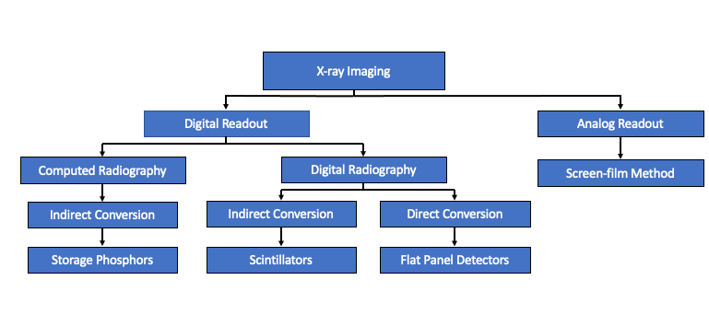
Figure 1. Overview of various types of x-ray imaging.

Computed radiograph (CR) is characterized as an indirect conversion and uses an imaging plate containing storage phosphors. The image is acquired in a two-step process that is comprised of an exposure phase and a read-out phase. First, the imaging plate is placed in a light-tight enclosure and placed behind the object that is to be imaged for the exposure phase. Following exposure, the read-out is achieved by raster scanning of the imaging plate with an excitation laser to trigger a process called photostimulated luminescence (PSL) [6]. A photomultiplier tube is used to quantify the PSL pixel-by-pixel to form the x-ray image. An illustration of the workflow of computed radiography is shown in Figure 2. The material in a CR imaging plate typically consists of BaFBr:Eu²⁺ (BFB) storage phosphors in a polymer binder material. BFB storage phosphors can hold a latent image for over 8 hours and can be optically bleached and used again [7]. When compared to its digital counterpart, the passive read-out plates used in CR allow for easier positioning and set-up when compared to a DR plate that must be connected to a computer. Another advantage of CR over DR is the cost of implementation and maintenance.

Although PSL has been extensively researched and many storage phosphor materials have been developed and compared to the traditional BFB, a detailed mechanism of PSL is complex and controversial [8]. When a material capable of storage phosphor characteristics is exposed to x-ray radiation, free charge carriers are trapped in electron and hole traps that are created due to impurities and lattice defects [9]. A large bandgap from the impurities and lattice defects results in a metastable state in which the free charge carrier remains in the trapped position. In the case of BFB, the trap is an F center with the bromine F center being the only one to contribute to photostimulability [10]. An electron trapped in the bromine F center transfers to Eu²⁺ complexes and not the conduction band when an excitation laser is applied to the metastable state, resulting in PSL [11].

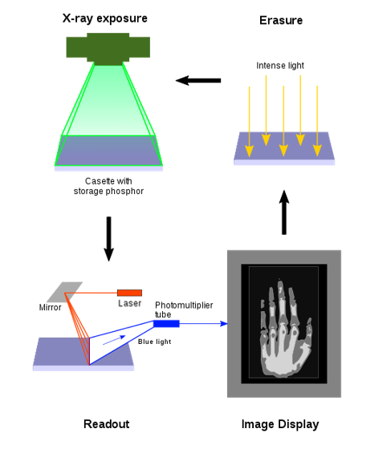
Figure 2.The process of computed radiography. Open access. Owner: Beevil.

Many different experimental storage phosphor plates have been developed in an attempt to compete with the spatial resolution and conversion efficiency of commercial BFB plates. The spatial resolution of commercial plates is limited due to crystalline grain boundaries which causes scattering of the stimulating laser beam during the readout step, as illustrated in Figure 3(a). A storage phosphor plate transparent to the stimulating laser beam mitigates the chances of scattering (Figure 3(b)) and allows for images with increased spatial resolution. Although superior spatial resolution has been accomplished, the conversion efficiency of transparent plates is less than that of commercial BFB plates.

Light-Emitting Diodes

A light-emitting diodes (LED) is a semiconductor device comprised of a P-N junction (a hole current and an electron current) and a phosphor layer. When a current is applied to the P-N junction, electrons are transferred from the N-type portion of the junction to the P-type portion. During this transition, electrons transfer through an energy bandgap, and a photon is ejected. The energy of the ejected photon is largely dependent on the type of semiconductor device, or LED chip, and can result in an emission from the ultraviolet to infrared [12]. A phosphor layer is applied to the transparent covering of the LED chip and can add additional tunability to the emission by using the up- or down-conversion process. An illustration of the basic make-up of an LED is shown in Figure 4.

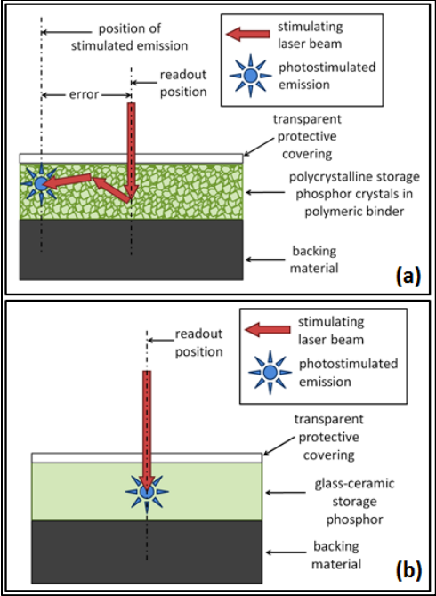
Figure 3. (a) Scattering of the stimulating laser beam at the grain boundaries of a polycrystalline storage phosphor causing a decrease in spatial resolution and (b) reduced scattering in a glass-ceramic storage phosphor for improved spatial resolution. [12]. Used with permission.

Figure 4. Basic schematic of a light-emitting diode.

LEDs are often referred to as solid-state lighting when they are employed in applications traditionally served by incandescent and fluorescent light sources. These applications include general indoor lighting, streetlights, automotive lights, and backlights in digital displays. Initially, LEDs were used as indicator lights and displays and were not considered as solid-state lighting until the early 2000s, when their energy-saving potential was recognized [13]. It was determined that the assimilation to solid-state lighting would decrease the electrical power used by lighting by more than 50% [14]. Another potential benefit of more widespread use of LED solid-state light sources includes reduced emission of greenhouse gases [15, 16].

The focus of the LED industry is dominated by solid-state light, but the furthering technology has been influential to human health and many different biomedical applications [17]. The most widely studied effect of lighting on human health pertains to its impact on the human circadian rhythm, in which receiving sufficient biologically active light benefits an individual’s well-being and productivity [18]. LED technology can also be beneficial to medical imaging, photobiomodulations, and optogenetics. With a simultaneous multiplane imaging technique, the ability of LEDs to produce a narrow band emission can be used to capture images at different depths. This is demonstrated in work conducted by Orsinger et al., in which a holographic image of ovarian cancer was reconstructed [19]. The same narrow band characteristics are used in narrow-band imaging to produce images with good contrast in capillaries and identify areas of increased vasculature [20]. Although traditional photobiomodulation treatment utilizes inert gas and semiconducting lasers, LEDs are quickly becoming a safer and more feasible alternative. LED photobiomodulation provides a safe treatment option with no side effects for a variety of different clinical applications [21].

Pulsed Laser Deposition

Pulsed laser deposition (PLD) is a thin film synthesis technique that uses high energy photons to create a directional plume of target material that is collected on a substrate. The high energy photons are applied via laser pulses to avoid melting of the target material and lessen the chances of a laser-plume interaction. The laser beam is typically focused on a target at a 45° angle of incidence. When the laser ablates the target, a transient plume is developed, comprised of many different species of the target material. The plume can be comprised of micron size particulates, atom clusters, ions, electrons, neutral atoms, and molten droplets [22]. The plume materials expand rapidly away from the target, with the densest portion of the plume ejected at a 90° angle relative to the target. A simplified schematic of a PLD apparatus is shown in Figure 5. A traditional PLD apparatus uses a UV excimer laser and a substrate that is largely dependent on the desired application of the thin film. Figure 6 shows an image of the PLD apparatus in the Center for Laser Applications at the University of Tennessee Space Institute.

When compared to other thin-film synthesis techniques, PLD is unique in its capability for stoichiometric transfer from target to substrate, the vast number of materials that can be used as a target, ease of film thickness control, and the ability to make multilayer films [23]. The technique is historically known for developing superconducting thin films but has been used for a large variety of applications. Some of these applications include electrical circuit components, complex ceramic oxides, optical materials, and coatings for medical applications [24].

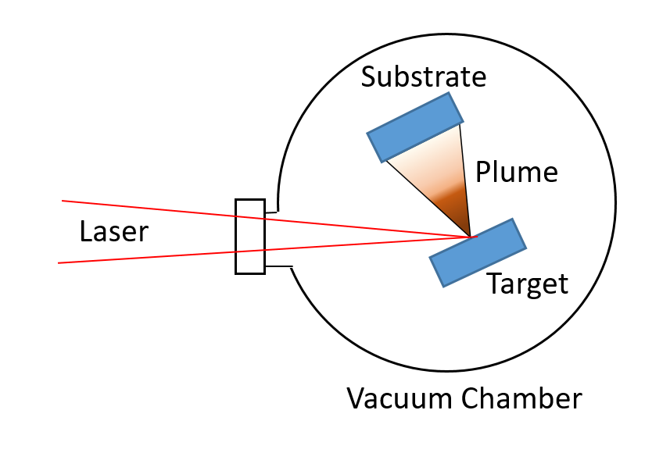
Figure 5. Basic schematic of pulsed laser deposition apparatus.

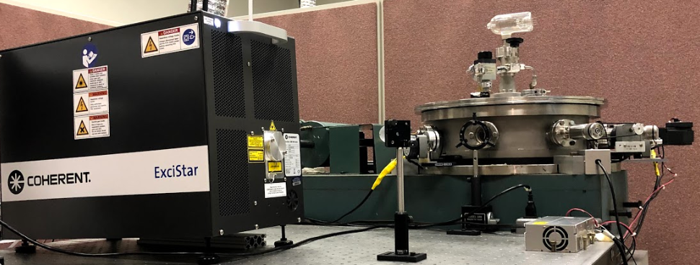
Figure 6. Pulsed laser deposition apparatus at UTSI.

Summary of Work

This work details the use of PLD to produce optically active rare-earth doped films that can be used for biomedical applications. Chapter I focuses on the development of a Eu doped BaCl₂ glass-ceramic storage phosphor film by exploring different glass matrix materials and evaluating their performance for computed radiography applications. Chapter II investigates different nanolayered configurations in a Eu doped BaF₂/Al₂O₃ thin film and determines their suitability to be used as a phosphor material in UV-pumped white-light LEDs. Chapter III explores the optical effects of adding a Mn dopant on the films developed in Chapter II.

CHAPTER I
Europium-Doped Barium Chloride Storage Phosphor Plate Synthesized by Pulsed Laser Deposition

A version of this chapter was originally published by C.W. Bond, Y. Jin, J.C. McDearman, A.F. Howansky, R.L. Leonard, A.R. Lubinsky, A.K.Petford-Long, and J.A. Johnson:

Input Citation

C.W. Bond was responsible for all writing and research activities in the original article except as noted: Y. Jin provided the SEM images. J.C. McDearman assisted with sample synthesis. A.F. Howansky and A.R. Lubinsky conducted PSL measurements. Y. Jin, J.C. McDearman, A.F. Howansky, R.L. Leonard, A.R. Lubinsky, A.K.Petford-Long, and J.A. Johnson provided critical feedback. J.A. Johnson provided overall guidance.

Abstract

In computed radiography, scattering of the stimulation light by the storage phosphor crystals in the imaging plates negatively impacts spatial resolution. Storage phosphor plates with thinner phosphor layers have been developed to reduce scattering distance and increase spatial resolution, although at the expense of reduced x-ray absorption. The authors hypothesize that a transparent or translucent nanostructured film, containing a much higher percentage of storage phosphor crystals than achievable in bulk glass-ceramic materials made by conventional methods, may have acceptable photostimulated luminescence efficiency and imaging performance characteristics greater than commercial imaging plates. Films have been produced via pulsed laser deposition by alternating target materials of the storage phosphor BaCl₂:Eu²⁺ and either silica or silicon. X-ray diffraction and photoluminescence characterization were conducted to confirm the presence of BaCl₂:Eu²⁺ crystallites. The films were able to store optical data and be read out to produce x-ray radiographs demonstrating 50 µm spatial resolution. The performance of the experimental storage phosphor plates was compared to commercially-available imaging plates. The authors demonstrate for the first time the synthesis of a glass-ceramic imaging plate for computed radiography by pulsed laser deposition.

Introduction

Optical data storage utilizes photons and electron trapping materials (ETM) to read and write information in applications such as radiography [25] and, more recently, big data storage [26, 27]. An irradiation light source is used to create electron-hole pairs within the ETM, followed by sequential recombination of the electron holes that release photons resulting in the rendering of the stored data through photostimulated luminescence (PSL). The electron-hole recombination is typically facilitated by an excitation laser in radiography or by heating for thermally stimulated luminescence in high-capacity storage systems [28-30]. Depending on the application, the importance of particular ETM characteristics will vary. With regards to medical imaging, adequate detective quantum efficiency (DQE) and modulation transfer function (MTF) are necessary to render quality radiographs [31, 32].

Computed radiography (CR) is a type of digital x-ray imaging technique that is used for medical imaging and nondestructive testing, where the ETM is referred to as a storage phosphor plate. The advantages of CR over other digital x-ray imaging modalities include its inexpensive implementation, ease of image plate placement, and dynamic range with a linear trend to X-ray exposure over four orders of magnitude [33, 34]. BaFBr:Eu²⁺ (BFB) is the most common commercially-used storage phosphor plate, followed by BaFI:Eu²⁺ [35, 36]. These crystalline materials are held together by an organic binder as powder plates, with particle size ranging up to 40 µm [37]. The primary limiting factor to spatial resolution in CR radiographs, which typically ranges from 10 – 20.0 lp/mm, is scattering of the stimulation light in the turbid phosphor layer [38].

Due to their ability to host small optically-active crystallites in a transparent amorphous matrix, rare-earth doped glass ceramics have been considered as an alternative storage phosphor plate material for high spatial resolution radiographs [39]. Fluorochlorozirconate (FCZ)-based glass ceramics utilizing europium-doped barium chloride nanocrystals in the orthorhombic phase [40] have been a popular material for radiographs recorded with CR. Experimental storage phosphor plates using barium chloride single crystals with a cerium rare-earth dopant, and lithium borate glass matrices with a europium dopant have also been developed [41-43]. When compared to commercially available BFB plates, FCZ storage phosphor plates have demonstrated high spatial resolution of 13 lp/mm, but with a 20% diminished relative PSL intensity [44, 45].

FCZ storage phosphor plates are initially synthesized as an amorphous material, and subsequent thermal annealing precipitates doped nanocrystals within the glass matrix, providing the optically-active luminescent centers [46, 47]. When more luminescent centers are introduced into the glass matrix, via more crystalline material or increased thermal treatment, aggregation of the crystallites becomes an issue [39, 48]. The aggregation results in diminished spatial resolution due to light scattering caused by increased crystalline size [40].

The goal of this study is to demonstrate a scalable synthesis option to produce storage phosphor plates with superior spatial resolution, coupled with comparable relative DQE intensity, by producing a nanostructured transparent glass-ceramic storage phosphor plate via pulsed laser deposition (PLD). The films contain small nanocrystals isolated by a surrounding amorphous matrix. Experimental thin films produced by this physical vapor deposition technique lack the amount of material found in commercially available or experimental bulk storage phosphor plates, but conclusions can be made by comparing a material ratio to optical performance. PLD has been used to produce films with a thickness of over 100 µm for alternate applications [49, 50]. With an automated synthesis process, this novel technique could be applied to produce samples with comparable thickness and amount of material as its commercial counterpart.

A piece of doped barium chloride was sintered and fixed along with a glass matrix material to create a multicomponent PLD target. Fused silica and silicon wafers were used as PLD targets for the glass matrix materials. Alternating target materials were ablated with a laser so that the glass matrix will isolate the crystalline material. This constrains the crystallites to a size much smaller than the wavelengths of visible light, allowing the samples to retain their transparent properties. The samples’ structural characteristics were determined by x-ray diffraction (XRD) and scanning electron microscopy (SEM) analysis and the luminescent properties were determined by phosphorimetry. The PSL intensity of the experimental storage phosphor plates was compared to that of commercially available BFB. A radiograph of a test phantom was produced, allowing determination of achievable spatial resolution.

Materials and Methods

Films were grown on four 25 x 25 mm substrates concurrently: three fused silica substrates and one silicon substrate were coated during each deposition procedure. The fused silica substrates were cut from a UV Grade Corning 7980 500 µm thick wafer and the silicon substrates were single-side polished test grade 475-575 µm thick wafers with <100> crystal orientation. Prior to film growth, the substrates were cleaned ultrasonically in high purity acetone for ten minutes, followed by ten minutes in high purity methanol. After the ultrasonic cleaning, the fused silica substrates were soaked in piranha solution (1:1 volume ratio of 93% H₂SO₄ and 35% H₂O₂) for two minutes, then soaked in ultrapure water for 1 minute and dried with compressed argon. Following ultrasonic cleaning, the silicon substrates were soaked in a buffered oxide etch solution (6:1 volume ratio of 40% NH₄F in water to 49% HF in water) for 20 seconds, and then rinsed with ultrapure water and dried with compressed argon. The mounting hardware used to affix the substrate to the sample holder creates masked areas, i.e. regions without film on the substrate.

Three different materials were used for PLD targets: fused silica, silicon, and europium-doped barium chloride. The silica and silicon specifications and cleaning procedures are identical to the aforementioned substrates. The europium-doped barium chloride target was synthesized in an argon atmosphere glovebox with an attached tube furnace. The barium chloride was doped with 1% europium (II) chloride, with a total sample mixture weight of 10 g used for the melt. Initially, the BaCl₂ powder was dried in a platinum crucible for 10 minutes at 300 °C. Following the drying, EuCl₂ was added to the crucible and mixed thoroughly. The crucible was then placed back in the furnace and heated to 1000 °C at a rate of 5 K/min. The sample was held at 1000 °C for 30 minutes before cooling to 25 °C at a rate of 1 K/min. The sample was removed from the crucible and polished before being fixed to an aluminum holder along with the respective host material target, illustrated in Figure 7. The target had an approximate diameter of 35 mm and thickness of 3 mm. A new BaCl₂:Eu²⁺ target was synthesized for each sample.

Samples were synthesized via pulsed laser deposition using an ArF excimer laser with a wavelength of 193 nm. A 200 Hz repetition rate was used with a rated pulsed length of 15 ns. The computer-controlled laser energy was set to 5.0 mJ, which equates to a laser fluence of 8.3 J/cm² based on a 0.06 mm² spot size. All samples were synthesized under vacuum with the background chamber pressure remaining below 3.0 x 10⁻⁶ Torr. During depositions, the substrate temperature remained below 27 °C. The targets were fixed to the holder with rotational movement controlled by a stepper motor. Two samples were made with different host materials (fused silica or silicon) and a BaCl₂:Eu²⁺ target. The matrix was deposited first using 1000 laser pulses on the respective host, followed by 5000 laser pulses on the BaCl₂:Eu²⁺. This bilayer was repeated for a total of 500 cycles and then capped with a final 1000 laser pulses on the glass matrix target material. The final deposition of the glass matrix target material is intended to be a protective layer to prevent oxidation of the sample.

The thickness was characterized with stylus profilometry. The 12.5 µm diamond tip stylus traveled from one masked portion of the substrate to another with a force of 6.50 mg, revealing the step height. The length of the scan was 500 µm with a duration of 120 seconds resulting in a resolution of 0.014 µm/sample. The masked portion was used as the reference and the plateau was averaged to determine an average step height and average roughness.

Scanning electron microscopy (SEM) was used to characterize the surface morphology and the cross-section structure of the film sample.

A Cu anode x-ray source was used for x-ray diffraction measurements. Scans were conducted over a 2Ɵ range of 20 ° to 80 ° with a step size of 0.05 ° and a dwell time of 10 s at each angle.

Photoluminescence (PL) data was collected with scans that used a 1 nm step size, 50 µs integration time, and a 100 Hz lamp frequency. The resultant data is the average of three subsequent scans and a background acquired prior to the measurements. The excitation scan ranged from 225 to 390 nm with an emission wavelength of 400 nm. The emission scan ranged from 310 to 525 nm with an excitation wavelength of 310 nm.

The ability of the films to store optical data was determined by measuring photostimulated luminescence using a 532 nm pumped diode Nd/YAG laser and a 4-inch integrating sphere with ports for the sample and for a photomultiplier tube module. A shutter controlled the stimulating laser light, and the photostimulated emission was collected by the integrating sphere and directed to the photomultiplier tube, where 2 colored bandpass filters block the laser light and pass the photostimulated light. The photostimulation signal vs. time was recorded by a digital storage oscilloscope. Before photostimulation, the samples were exposed to x-rays using a x-ray tube with a tungsten anode at 70 kVp. A comparison commercial sample was exposed for 320 msec at 10 mA, and with 20 mm of Al filtration, producing 27.7 mR of x-ray exposure at the sample. The experimental samples were exposed for 1.25 sec at 400 mA, producing 80 R of x-ray exposure at the sample.

To compare the photostimulated luminescence output, an exponential decay curve was fitted to the voltage data of the two experimental samples and a BFB commercial sample. The data was fitted using the CFTool in MATLAB to the following equation:

$I\left(t\right)=I_{0}e^{-λt}$ (1)

The initial signal intensity is I₀ and the stimulation speed is λ. The stimulation speed is a measure of how fast stored data can be retrieved from the phosphor plate. Because the PSL signal of samples lasted approximately 8 seconds, the following definite integral was performed for quantitative comparison:

$PSL Area=\int_{0}^{8}{I\left(t\right)dt}$ (2)

The values were determined both mathematically and graphically across a range of 800 points. The absorbed x-ray energy was determined separately for each experimental sample and for the commercial sample. The x-ray fluence per units of exposure was determined by the following equation [51]:

$ξ\left(E\right)=\frac{5.34 ×{10}^{5}}{{E(\frac{μ_{en}\left(E\right)}{ρ})}_{air}}$ (3)

Figure 7. Illustration of multi-component target showing a europium-doped barium chloride puck and a host material fixed to a target holder.

The energy of the x-ray in units of keV is E and the mass energy absorption coefficient for air in units of cm²/g is µ_{en}/$ρ$. An estimated 10:1 molar ratio of BaCl₂:Eu²⁺ (1% EuCl₂) to host matrix (Si or SiO₂) and a 3.8 g/cm³ density was used to calculate the x-ray mass attenuation coefficients for the experimental samples. The coefficients were calculated based on a 50:50 molar ratio BaF₂:BaBr₂ mixture and a 4.8 g/cm³ density for the commercial BFB sample.

For x-ray imaging, the sample was exposed to a copper anode x-ray tube with a wavelength of 1.54 Å operating at 45 kVp and 40 mA. The sample was exposed for 10 minutes and the readout was conducted 5 minutes after exposure. A line-pair phantom with a lead thickness of 0.03 mm and a resolution range of 1.5 – 20.0 lp/mm was placed on top of the storage phosphor plate during exposure. Image readout was obtained with a computed radiography scanning apparatus similar to the one detailed in Lubinsky et al. [52].

Results and discussion

Visual Characterization

One of the as-made europium-doped barium chloride targets is shown in visible light in Figure 8a. Visual observation of the target under a 254 nm UV lamp was conducted to ensure the europium had distributed into the crystalline BaCl₂ during synthesis. As seen in Figure 8b, the target exhibited a violet emission when excited by the UV lamp, which is characteristic of BaCl₂:Eu²⁺ emission.

The two sample types were visually similar, being translucent with a slight white coloration. A sample composed of BaCl₂, Eu, and SiO₂ is shown in Figure 9a, with half circles visible on the edges of the substrate due to masking during sample growth. The sample retained the characteristic BaCl₂:Eu²⁺ emission that was seen by the target when excited by UV light, shown in Figure 9b. The sample with a silicon matrix had a thickness of 12.70 µm with an average roughness of 4.49 µm while the fused silica matrix had a thickness of 12.71 µm with an average roughness of 12.76 µm. Although the sample containing the silicon matrix was smoother, both samples were much rougher than expected, which was undesirable for achieving a nanostructured sample. An explanation for the unexpected roughness is provided in the results of the SEM characterization. The films demonstrated adequate adhesion to the substrate with no delamination occurring during initial characterization.

SEM analysis validated the thickness measurements determined by profilometry. A top-view SEM image of the film with a Si matrix is shown in Figure 10a. The surface of the film is made up of mostly spherical particulates with a size range of 1–4 µm. The particulates are responsible for the rough topography of the films as well as for their translucent, cloudy appearance. Cross-section SEM analysis revealed voids throughout the sample due to the variation in size of the particulates within the film. A cross-section SEM image is shown in Figure 10b with an inset of a high magnification SEM image highlighting the voids within the film. After the sample was exposed to the atmosphere for approximately 1 hour, delamination of the film from the silica substrate occurred. The delamination suggests that the protective capping layer of the glass matrix was not continuous and allowed moisture penetration. Due to the hygroscopic nature of BaCl_{2,} the moisture penetration resulted in structural changes, causing the film adhesion to fail under ambient conditions.

Figure 8. As-made BaCl₂:Eu²⁺ pulsed laser deposition target in (a) visible light and (b) excited by a 254 nm UV light exhibiting violet emission.

Figure 9. Sample composed of BaCl₂, Eu, and SiO₂ in (a) visible light and (b) excited by a 254 nm UV light exhibiting violet emission.

Figure 10. SEM (a) top view and (b) cross-section images of experimental BaCl₂ film with a Si matrix. A higher magnification image revealing voids in the film is included as an inset. The top view reveals mostly spherical particles on the surface.

The authors hypothesize that the abundance of particulates within the sample is the result of BaCl₂:Eu²⁺ target degradation. Although the target was polished prior to ablation, its surface appeared rough after the deposition process was completed. Multiple laser passes on the target were required due to the relatively large amount of material necessary to synthesize a functional imaging plate. Ablation of the roughened surface on subsequent passes may have led to the ejection of large particulates, which negatively affected layered growth. The authors speculate a more transparent film with fewer particulates could be synthesized by using a lower laser fluence and more frequent target polishing. A technique that will be used in future work is positioning the substrate off-axis with respect to the target, which results in a film with fewer particulates.

X-ray Diffraction

The X-ray diffraction profile for the two experimental samples is shown in Figure 11 with indexes for orthorhombic barium chloride (ICSD 16915), hexagonal barium chloride (ICSD 2190), and cubic silicon (ICSD 51688). Both samples exhibited observed peaks at 21.0, 22.0, 23.9, 31.0, 38.1, and 39.3 degrees which is indicative of orthorhombic phase BaCl₂ crystallites. There is a possibility of hexagonal phase BaCl₂ in both films, which accounts for the small observed peaks at 32.0 degrees. Barium chloride predominately forms in the orthorhombic phase over the unstable hexagonal phase, but a small amount of hexagonal crystallites cannot be excluded [53]. The peaks in the X-ray diffraction pattern are broad, likely as a result of the small crystallite size in the BaCl₂ layer, but also as a result of crystalline disorder within the nanocrystals. No crystalline silicon was detected in the Si matrix sample, indicating that the silicon was deposited as an amorphous material. A broad amorphous peak is shown in the data that can be attributed to the matrix materials within the sample. The peak observed at 26.6 degrees is attributed to an unknown phase, which has previously been documented in literature [54-56]. Peaks observed at 35.2 and 43.7 degrees are indicative of aluminum and can be attributed to the sample stage.

Figure 11. X-ray diffraction results for two samples with different targets used for host matrices: (a) film grown with SiO₂ target, (b) film grown with Si target, (c) orthorhombic phase BaCl₂ powder diffraction file (ICSD 16915), (d) hexagonal phase BaCl₂ powder.

Optical characterization

The emission spectra for the ablation target and the two films are shown in Figure 12. All spectra display a broad emission peak associated with the 4f⁶5d¹ to 4f⁷ emission of Eu²⁺ [57]. However, the emission peaks of the films are blue shifted and slightly broader than that of the target, which can be explained by differences in the crystal field. Wang et al. proposed that different intrinsic stresses can weaken the Eu²⁺ crystal field splitting due to effects of neighboring cations and result in a blue-shifted emission [58]. The 5d electron transition for Eu²⁺ occurs in the outer orbitals, which allows the atomic coordination in the surrounding BaCl₂ host to influence the transition [59]. Due to the deposition process, the BaCl₂:Eu²⁺ crystallites in the two films are likely more crystallographically disordered than the BaCl₂ in the target, leading to a decreased crystal field and the blue shifting and broadening of the spectra. The formation of disordered crystalline phases as a consequence of PLD synthesis is detailed in work conducted by Bendersky et al. [60]. Additionally, for the thin films, the SiO₂ and Si amorphous matrices may influence the crystal field at their interface with the BaCl₂:Eu²⁺ crystallite surfaces, leading to additional differences in the spectra; the effects, however, would likely not be very pronounced, as they apply only to the surface of the crystallites and not the entirety of their volume. Peak analysis by deconvolution did not yield further insight into the source of the shifting and broadening of the peaks or their asymmetrical nature.

Figure 12. Normalized emission spectra of sample with (a) SiO₂ matrix, (b) Si matrix, and (c) material from the BaCl₂:Eu²⁺ PLD target. All samples were excited at 310 nm. The emission of the experimental films exhibited a blue shift when compared to the target, which is attributed to increased crystalline disorder.

Computed Radiography

The PSL curve fits for the experimental storage phosphor plates are shown in Figure 13, along with an inset of the fit curve of a commercial plate for a reference. It should be noted that the experimental samples and the commercial sample did not receive the same dosage of x-ray exposure, but differences in the absorbed x-ray energy have been accounted for in the comparison. The PSL area values, absorbed energies, and conversion efficiencies (CE) along with the CE ratio relative to the commercial plate are shown in Table 1.

The BFB commercial storage phosphor plate had a CE that is 1530 times higher than that of the experimental plate with a silica matrix and 4900 times higher than the experimental plate with a silicon matrix. The CE of both experimental plates is too low to be considered as a potential replacement to traditional BFB storage phosphor plates in dose-critical applications such as medical imaging. The sample with the silica matrix had a CE that is about three times higher than the sample with the silicon matrix, despite the much rougher surface. The authors hypothesize that SiO₂ provides a superior, more continuous, final protective layer, preventing degradation of the luminescent material, BaCl₂:Eu²⁺, which is hygroscopic, resulting in a more efficient imaging plate. Some degradation was visually observed in both samples, however.

Using a line-pair phantom, it was determined that the images rendered from the experimental storage phosphor plate with an SiO₂ matrix could resolve 10 lp/mm, or a spatial resolution of 50 µm. The spatial resolutions of the experimental plates are comparable to most commercially-used storage phosphor plates and, depending on scanner specifications, can be considered high-resolution [61]. A radiograph of the line-pair phantom achieved from an experiment plate is shown in Figure 14.

Figure 13. PSL decay curves for experiment storage phosphor plates with a (a) SiO₂ matrix and a (b) Si matrix. Exponential decay curve fits are shown with a dashed line. A PSL curve for a commercial BFB storage phosphor plate is included as an inset.

Table 1. Values from integrals of PSL decay curve fits along with data regarding to the amount of material.
Sample | PSL Area | Absorbed Energy (keV/mm²) | Conversion Efficiency (PSL/Energy) | Ratio
SiO₂ Matrix | 0.517 | 1.02 × 10¹⁰ | 5.05 × 10⁻¹¹ | 6.53 × 10⁻⁰⁴
Si Matrix | 0.157 | 9.96 × 10⁹ | 1.58 × 10⁻¹¹ | 2.04 × 10⁻⁰⁴
BFB | 9.27 | 1.20 × 10⁸ | 7.73 × 10⁻⁸ | 1

Figure 14. Radiograph of line-pair phantom recorded using an experimental storage phosphor plate and the corresponding profile taken at 10 lp/mm.

Although the CE of the experimental plates was much less than that of the traditional BFB storage phosphor plate, the potential remains for the favorable spatial resolution of the experimental plate to be utilized in nondestructive testing applications, where dose is of lesser concern when compared to medical imaging. Nondestructive testing is often used to detect welding discontinuities and defects using longer exposures and higher energy photons. Further experimentation would need to be conducted, using increased exposure dose and imaging thicker materials, to evaluate the practicality of applications for the experimental films in nondestructive testing.

Future Work

Although the experimental plates are not practical in computed radiography applications, this synthesis technique could be applied to develop a scintillating film that can be incorporated into a flat panel detector for use in indirect digital radiograph. PLD can be employed to synthesize a glass-ceramic film, with high scintillator to glass ratio, with the opportunity to utilize certain scintillating materials that may not be applicable with bulk glass ceramics synthesized via traditional methods.

Traditional indirect flat panel detectors (FPD) are typically comprised of an x-ray conversion screen of scintillating phosphors and a photodiode-thin film transistor (TFT) array deposited on a glass substrate that is not optically active. It is common, increasingly so in higher energy applications, for x-rays to pass through the conversion screen and the TFT array unattenuated, which can limit the performance of these devices. Developing a FPD with a sandwich of two x-ray conversion screens, in which the bottom screen is an optically active glass-ceramic screen that serves a substrate for a bidirectional TFT array, has shown the potential to enhance the performance of these devices in work conducted by Leonard et al. [62]. The glass-ceramic substrate has the ability to capture previously unattenuated x-rays and convert them to visible light so that they may contribute to the radiograph. A schematic of an indirect flat panel detector with a scintillating glass-ceramic film is shown in Figure 15. The schematic shows an optional glass thin film on top of the scintillating film, which can be used to facilitate the incorporation of the TFT array.

A prototype has been developed using PLD, consisting of BaCl₂:Eu²⁺, which serves as both luminescent and scattering centers, and a borosilicate glass top layer. Using an ArF excimer laser, 2.5 × 10⁶ laser pulses were applied to a BaCl₂:Eu²⁺ target, followed by 5.0 × 10⁴ laser pulses on a borosilicate target. The resultant film is shown in visible light and luminescing when exposed to 45 keV x-rays in Figure 16. Although the BaCl₂:Eu²⁺ film demonstrated the ability to use the synthesis technique for this application, further work needs to be conducted to investigate different luminescent materials to increase scintillation yield.

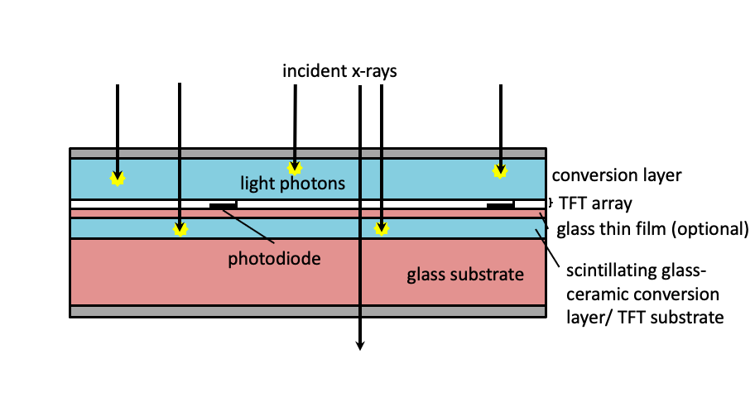
Figure 15. Cross-sectional view of dual-screen sandwich indirect flat panel detector displaying a scintillating conversion thin film coated on a glass substrate.

Figure 16. Scintillating thin film prototype in (a) visible light and (b) exposed to 45 keV x-rays.

Conclusion

Translucent layered thin films composed of alternate layers of europium-doped barium chloride nanocrystals and an amorphous glass matrix were synthesized via pulsed laser deposition. XRD was conducted to confirm that orthorhombic phase BaCl₂:Eu²⁺ crystallites were incorporated into the film. SEM results revealed that the desired nanostructured layered films were not achieved, which was hypothesized to be due to inclusion of large particulates caused by PLD target degradation. The silicon and silica-based films were similar in performance. The films exhibited a characteristic Eu²⁺ emission at 405 nm when excited by UV light. When the films storage phosphor capabilities were compared to a commercially available BFB plate, the conversion efficiency (CE) was approximately three orders of magnitude lower, even though the difference in amount of material and in x-ray attenuation were considered. However, for applications such as nondestructive testing, in which dose is not critical, the CE would be of lesser concern. The experimental storage phosphor plate was used to image a line-pair phantom through computed radiography. The radiograph revealed a spatial resolution of 10 lp/mm, which is commercially considered to be high-resolution. The authors demonstrate for the first time the synthesis of a glass-ceramic imaging plate for computed radiography by pulsed laser deposition. This synthesis technique has the ability to develop scintillating glass-ceramic substrates that can be used in indirect FPD, but further material investigation must be conducted.

CHAPTER II
Optical properties of differing nanolayered structures of europium doped BaF₂ thin films synthesized by pulsed laser deposition

Charles Bond was responsible for the writing of this chapter and all research activities presented, except as noted: Yu Jin provided the TEM images. Pilar Gómez-Rodríguez assisted with PLD synthesis and emission measurements. Eva Nieto-Pinero assisted with sample characterization. Jose Gonzalo, Rosa Serna, Amanda Petford-Long, Lee Leonard, and Jacqueline Johnson provided guidance for the overall project and critical feedback.

Abstract

Optically-active thin films are employed in a variety of applications, such as LEDs and photovoltaics, due to their ability to act as up- or down-photon energy converters. Their performance depends critically on their composition and structure; thus, the use of novel synthesis techniques that allow for their control at the nanoscale level can result in improved efficiency and practicality. Layered thin films consisting of Eu-doped BaF₂ nanocrystalline layers separated by amorphous Al₂O₃ were synthesized via sequential pulsed laser deposition using three separate targets for the different components; this synthesis technique provides precise control of layer thickness at the nanoscale along with dopant distribution within the film. Cross-sectional transmission electron microscopy analysis verified the desired nano-layering. Post-deposition heat treatments in a nitrogen atmosphere resulted in samples exhibiting steady and robust emission with a broad peak ranging from 400-600 nm and a shoulder at 410 nm. The CIE 1931 chromaticity coordinates are x = 0.26-0.29 and y = 0.32-0.35 as a function of the sample configuration. Because the chromaticity coordinates are close to those of a pure white light (x = 0.33, y = 0.33), these films demonstrate properties advantageous for applications with UV-pumped white light LEDs.

Introduction

Light-emitting diode (LED) solid-state lighting boasts many advantageous characteristics including low energy consumption, high brightness, and a long lifetime [63-65]. Currently, the most common commercially-available white-LEDs use an InGaN chip, which produces blue light, combined with the phosphor YAG: Ce³⁺, which downshifts a portion of the blue emission to create broadband emission [66-68]. A white light LED producing broadband visible emission and incorporating a single-phase host material would result in a simpler manufacturing process. Different materials are being investigated to improve commercially-available white-LEDs [59]. A possible concept that is in its infancy of development is an ultraviolet (UV)-pumped white-LED, in which UV photons are downshifted to provide broadband visible emission [69].

Although the recent progress of LED research has mainly been focused toward general lighting applications, there are many different health care applications that can benefit from the advantageous characteristics of LEDs compared to other light sources. As detailed in Dong and Xiong [17], LEDs have potential applications in medical imaging, light therapies, and photo-biomodulations. White LEDs have been combined with blue-light lasers to bypass the use of filters and mechanically-rotating wheels to give optimal signal-to-noise ratio in multi-spectral imaging [70, 71]. LED therapies with emissions in the visible range have proved to be beneficial in treating a broad range of medical conditions including Parkinson’s disease, osteoporosis and inflammation, and in wound healing [21, 72, 73].

Divalent europium can present broadband emission that is highly susceptible to crystal field splitting [74]. The broad tunable emission has made Eu²⁺ a popular doping candidate for single-phase host materials with white-LED applications [75]. The Eu²⁺ emission is associated with the 4f⁶5d¹ to 4f⁷ electron transition which occurs in the outer orbitals [57]. The location of this transition allows coordinate surroundings of the host to influence the energy of the emitted photon [59]. Changes in the nephelauxetic effect of different host lattices along with crystal field splitting allow Eu²⁺ emission to emit over the range of ultraviolet to red light [76]. The effects of crystal field splitting on Eu²⁺ emission is illustrated in Figure 17.

Glass-ceramics containing rare-earth doped fluoride crystalline material have been developed for potential applications such as wavelength shifters for solar cells and LEDs [46, 77]. The low phonon energy fluoride nanocrystalline matrix provides a favorable host for rare-earth dopants [78, 79]. Likewise, an oxyfluoride amorphous material provides a low phonon energy environment advantageous for optically-active dopants [80]. It has been shown that when europium is added to aluminum oxide, the Al³⁺ cation facilitates the reduction of Eu³⁺ to Eu²⁺ to develop materials capable of broadband emission ideal for white light LED applications [81, 82]. Their performance depends critically on their composition and structure; thus, the use of novel synthesis techniques that allow for control at the nanoscale level can result in improved efficiency and practicality.

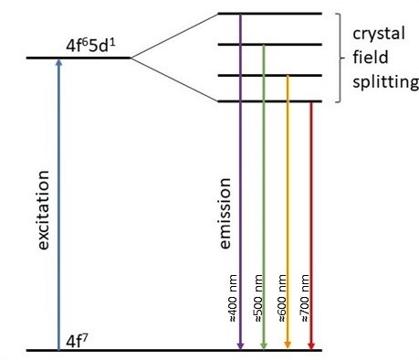
Figure 17. Partial energy level diagram of Eu²⁺ demonstrating how broadband emission is an outcome of crystal field splitting.

In this study, optical behavior of thin films with layers of nanocrystalline BaF₂, amorphous Al₂O₃, and a europium dopant, were synthesized by using sequential pulsed laser deposition. This synthesis technique provides precise control of layer thickness at the nanoscale level along with dopant distribution within the film. The amorphous Al₂O₃ layers contribute to encapsulating the fluoride host to prevent oxidation, which can limit optical performance. Different nanolayered structures were synthesized and photoluminescent (PL) emission measurements were obtained using a 355 nm excitation laser to determine the ability of the material to act as a UV-pumped LED. While all three experimental sample structures show promising optical characteristics for UV-pumped white-LED applications, the differences in the nanolayered structures give a better understanding as to how the emission is affected by the Eu²⁺ coordinate environment. Cross-section transmission electron microscopy (TEM) analysis was conducted to verify the nanolayered structure of the samples. A complementary article focusing on BaF₂ the structural evolution and film growth of BaF₂ films deposited by controlled PLD conditions will be published.

Materials and Methods

Commercially available targets of Al₂O₃, BaF₂, and Eu₂O₃ were ablated to produce layered thin films via pulsed laser deposition (PLD). The pressure in the system was maintained at below 3.0 x 10⁻⁶ Torr during deposition. An ArF excimer laser with a 193 nm wavelength beam with a rated pulse length of 20 ns was used. Films were deposited on single side polished, 475-575 µm thick, test grade silicon wafers in the <100> crystalline orientation. The substrates were cleaned with an acetone rinse, ultrasonically in ethanol for 5 minutes, then dried with compressed nitrogen prior to their placement in the deposition chamber.

Al₂O₃, BaF₂, and Eu₂O₃ deposition parameters are detailed in Table 2. The different substrates positions are illustrated in Figure 18.

Three different layer configurations were designed in order to explore the Eu doping of BaF₂ (Structures 1 and 3) and the potential of having the Eu doping at the BaF₂/Al₂O₃ interface (Structure 2). Schemes of the structure of the different sample are shown in Figure 19.

Sample Structure 1 (Figure 19a) was synthesized by sandwiching a Eu₂O₃ layer between two BaF₂ layers and the Al₂O₃ matrix layers. An initial 2000 laser pulses were used on the Al₂O₃ target, followed by 2140 laser pulses on BaF₂, 430 laser pulses on Eu₂O₃, and 2140 laser pulses on BaF₂. This sequence (Al₂O₃/BaF₂/Eu₂O₃/BaF₂) was initially repeated 5 times and a final 2000 pulse Al₂O₃ layer was grown as a protective cap. At this point in the process, a sample was removed from the deposition chamber, and an additional 5 layers with a final cap was grown on top of a sample that remained in the chamber.

Sample Structure 2 (Figure 19b) was synthesized by depositing a Eu₂O₃ layer on top of BaF₂ layers with Al₂O₃ base layers. An initial 2000 laser pulses were used on the Al₂O₃ target, followed by 4280 laser pulses on BaF₂ and 430 laser pulses on Eu₂O₃. This sequence (Al₂O₃/BaF₂/Eu₂O₃) was initially repeated 5 times and a final 2000 pulse Al₂O₃ layer was grown as a protective cap. Identical to the previous structure, a sample with 5 layers and another sample with 10 layers were grown.

Sample Structure 3 (Figure 19c) was synthesized by alternating BaF₂ and Eu₂O₃ between Al₂O₃ layers. After an initial 2000 laser pulses on the Al₂O₃ target, 1710 laser pulses were used on the BaF₂ target, followed by 100 laser pulses on the Eu₂O₃ target. The BaF₂/Eu₂O₃ sequence was repeated 10 times and a final 2000 pulse Al₂O₃ layer was grown as a protective cap. A sample was kept with 1 (Al₂O₃/(BaF₂/Eu₂O₃) x10) sequence and 2 additional sequences were grown on a separate sample, resulting in a total of 3 repeating sequences.

Cross-sectional TEM samples were prepared from Sample Structure 1 films by focused ion beam (FIB) milling. To protect the films from FIB damage, the samples were coated with a layer of Au using electron-beam evaporation before milling. TEM was carried out using a JEM-2100F instrument with 200 kV incident electron energy, in order to investigate the structure of the cross-section samples.

Heat treatments were performed in both ambient atmosphere and using nitrogen purge gas to determine the effects of the different heat treatment conditions. Samples heat treated in an ambient atmosphere will be referred to as (amb) and samples heat treated in a nitrogen atmosphere will be referred to as (N₂). The ambient atmosphere heat treatments were performed in a MESTRA HP-25 muffle furnace. The heat treatments in a nitrogen atmosphere were performed in a Thermconcept 50/250/12 tube furnace using a lab-grade N₂ purge gas. In both atmospheres, the samples were heat treated at a heating ramp of 10 K/ min to 300 °C, and held at that temperature for 1 hour, then allowed to cool to ambient temperature over time.

Table 2. PLD parameters of all of the materials that were ablated.
Material | Laser Fluence | Laser Frequency | Substrate Positionª | Target-substrate Distance
Al₂O₃ | 4.7 J·cm⁻² | 20 Hz | 20 ° | 37.8 mm
BaF₂ | 4.7 J·cm⁻² | 10 Hz | 180 ° | 86.0 mm
Eu₂O₃ | 1.3 J·cm⁻² | 10 Hz | 20 ° | 37.8 mm
ª Substrate position is angle off-axis relative to the shared axis position.

Figure 18. Illustration displaying different substrate positions used to deposit Al₂O₃ and Eu₂O₃, rotated 20° from the conventional 90° perpendicular to the target (substrate position 1), and BaF₂, rotated 180° from the conventional 90° perpendicular to the target (substrate position 2).

Figure 19. Illustration of different thin film layer configurations synthesized to investigate dopant incorporation. (a) Sample Structure 1, (b) Sample Structure 2, and (c) Sample Structure 3.

After the emission from the different sample structures were compared, the best sample configuration for UV-pumped white light LEDs was determined. Using this configuration, the emissions of a sample with 5 repeating sequences and 10 repeating sequences were compared to determine the effect of layer numbers on emission intensity. In addition, both samples were heat treated to 300 °C in a nitrogen atmosphere for 1 hour. Following the post-deposition heat treatments, emission data were collected, and emission intensities were compared.

Photoluminescence studies were conducted by using a 355 nm Genesis CX 355-200 Optically Pumped Semiconductor Laser (Coherent) with a power of approximately 8 mW as the excitation source. A monochromator (ActonSpectraPro300i, diffraction grating= 1200 g/mm (Vis)) filtered the light emitted by the samples, which was detected through a photomultiplier tube (EMI9659QB-S20). In addition, the signal was amplified with a standard lock-in technique. CIE 1931 chromatic coordinates were obtained by processing the emission data in Origin 2021 version 9.8 (OriginLab) and utilizing the Chromaticity Diagram v1.1 application.

Results and Discussions

Microscopy

Cross-section TEM analysis verified that the films were grown with the intended layered nanostructures. Figure 20 shows a TEM cross-section of Structure 1 as-made with 5 and 10 layers. Both samples show clear layering with the layers being uniform throughout the film. The darker contrast layers correspond to the Eu₂O₃ deposits, the lighter contrast layers are attributed to Al₂O₃, and the BaF₂ shows an intermediate contrast. The 5 layer film has a total thickness of 50 nm and the 10 layer sample has a total thickness of 99 nm. The 10 layer film (Figure 20b) presents an anomaly in the multilayer periodicity, two layers down from the gold protective cap, where the layer does not show the dark contrast associated with Eu₂O₃. This is hypothesized to be due to experimental error, possibly a malfunction of the stepper motor that controlled the target position, resulting in Eu₂O₃ not being ablated for that layer. The wide light layer in the middle of the sample seen in Figure 4b is because of the double thickness of Al₂O₃ deposited between the first and second 5 repeat sequences (see Figure 19a).

Optical characterization

The emission spectra of the three as-deposited sample structures are shown in Figure 21. The three sample structures resulted in distinctly different PL emissions. These differences demonstrate the consequence of their structural configuration on the emission of these materials. Structures 1 and 2 were synthesized with the same amount of Al₂O₃, BaF₂, and Eu₂O₃, with the only difference coming from the fact that in Structure 1, the Eu₂O₃ is sandwiched between two BaF₂ layers in each repeat, yet a difference in emission is seen. The layer sequence determines the local coordination environment of the luminescent center (Eu), which can be manipulated depending on the desired emission.

The emission spectra for Sample Structure 1 with 5 layers as-made and heat treated are shown in Figure 22. The as-made sample did not exhibit any measurable emission expected from crystalline BaF₂, thus indicating that all of the layers in the sample were amorphous, which was verified by electron diffraction patterns and detailed in the complementary article. A peak at 410 nm and a broad emission from 450 – 600 nm is seen in Structure 1 (amb). The 410 nm peak can be attributed to the 4f⁶5d¹ to 4f⁷ transition of Eu²⁺ incorporated in BaF₂ nanocrystals. The authors hypothesize that the broad emission from 400 – 600 nm can be attributed to Eu²⁺ in different environments such as the BaF₂ nanocrystalline matrix, the BaF₂/Al₂O₃ interface, and the Al₂O₃ layers as shown in Figure 23. In Structure 1 (N₂), the intensity of the broad emission increases, and the 410 nm emission is expressed as a shoulder indicating the movement of the Eu dopant into different environments.

The emission spectra for Sample Structure 2 with 5 layers as-made and heat treated are shown in Figure 24. The as-made film exhibited a broad emission centered at 540 nm. The spectrum of Structure 2 (amb) shows a 410 nm peak along with a broad emission that is comparable to Structure 1 (amb). Structure 2 (N₂) exhibits a broad emission from 400 – 600 nm and a shoulder at 410 nm is shown, but of lesser intensity when compared to Structure 2 (amb). Both the emission spectra of Structure 2 (N₂), and Structure 2 as-made, exhibit a slight peak at 610 nm that can be attributed to a ⁵D₀ to ⁷F₂ electron transition of Eu³⁺ [83]. This sample structure had the largest amount of Eu₂O₃/Al₂O₃ adjacent layers, which could prevent Eu from migrating into a reducing atmosphere due to the smaller percentage of adjacent BaF₂/Eu₂O₃ layers or the amount of oxygen present in the Al₂O₃ layers.

The emission spectra for Sample Structure 3 with 5 layers as-made and heat treated are shown in Figure 25. Unlike the previous two sample structures, the as-made Structure 3 exhibited the most intense emission when compared to the emissions after heat treatment. A sharp peak at 410 nm with a broader peak at 430 nm was found. Growing thicker layers of BaF₂ resulted in the layers being nanocrystalline as deposited, which then were able to luminesce prior to any post-synthesis heat treatment. With the Structure 3 (amb) emission, the 410 nm peak intensity decreased resulting in a broader, less intense, peak with a range from 400 - 500 nm. A broad emission with consistent intensity between 400 - 650 nm was measured in Structure 3 (N₂).

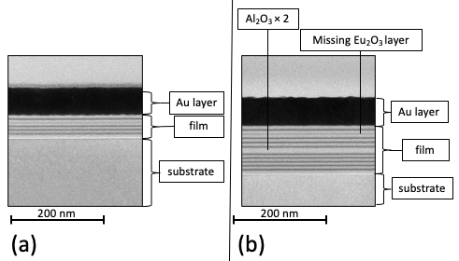
Figure 20. TEM cross-section images of as-made Sample Structure 1 Al₂O₃/BaF₂/Eu₂O₃ thin films synthesized with (a) 5 layers and (b) 10 layers.

Figure 21. Emission spectra from a 355 nm excitation source for as-made (a) Structure 1 with 5 layers, (b) Structure 2 with 5 layers, and (c) Structure 3 with 1 layer.

Figure 22. Emission spectra of Sample Structure 1 with 5 layers from 355 nm excitation source after (a) 1-hour heat treatment at 300 °C in ambient atmosphere, (b) 1-hour heat treatment at 300 °C in a nitrogen atmosphere, and (c) as-made sample.

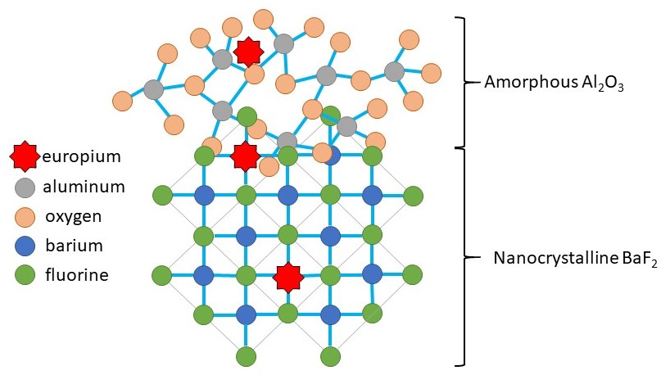
Figure 23. Illustration showing atomic layers of a barium fluoride/aluminum oxide thin film and three different possible locations of a europium dopant.

Figure 24. Emission spectra from a 355 nm excitation source for Sample Structure 2 with 5 layers after (a) 1-hour heat treatment at 300 °C in ambient atmosphere, (b) 1-hour heat treatment at 300 °C in a nitrogen atmosphere, and (c) as-made.

Figure 25. Emission spectra of Sample Structure 3 with 5 layers from 355 nm excitation source after (a) 1-hour heat treatment at 300 °C in ambient atmosphere, (b) 1-hour heat treatment at 300 °C in a nitrogen atmosphere, and (c) as-made sample.

The 410 nm peak, attributed to BaF₂:Eu²⁺, is seen in all three structures following heat treatment in an ambient atmosphere. This result shows that heat treatments facilitated Eu diffusion into the BaF₂ matrix and could have resulted in oxygen-aided emission quenching in the Al₂O₃ layers. Structure 3 exhibits the most intense BaF₂:Eu²⁺ emission due to an increased percentage of adjacent Eu₂O₃/BaF₂ layers when compared to Structure 1 and 2. The authors hypothesize that broadening of the emission peaks following heat treatments in an inert atmosphere could be caused by the Eu dopant diffusing into Al₂O₃ layers, but without the emission quenching that was found with ambient atmosphere heat treatments. The dramatic changes in the emission of Structure 3, a structure with a relatively small amount of Eu/Al₂O₃ adjacent layers, found after different heat treatment conditions, support this hypothesis.

When repeated emission measurements were conducted at the same sample location on films that had been heat treated in an ambient atmosphere, the emission intensity decreased as demonstrated by Structure 1 in Figure 27. The longer the excitation laser was focused on the same location, the more the emission intensity decreased. A decrease in emission intensity due to UV laser degradation was found for all sample structures following post synthesis heat treatments in an ambient environment and is repeatable for different sample locations. The main proposed mechanism in the literature for the degradation is photogeneration of defects [84, 85]. When Structure 1 was heat treated in nitrogen, no emission degradation occurred after exposure to the UV excitation laser, as shown in Figure 11. This could be related to the passivation of the Eu with nitrogen bonds, which leads to samples with a very robust response. These results agree with the work conducted by Amidani et al. [86], who stated that oxidation of Eu²⁺ to Eu³⁺ is the main mechanism that results in emission quenching. Further studies need to be conducted to determine if the degradation of these samples is reversible through heat treating or laser stimulation.

Figure 26. Emission spectra of Sample Structure 1 with 5 layers from a 355 nm excitation source after a 1-hour, 300 °C post-synthesis heat treatment in an ambient atmosphere. The spectra were obtained from consecutive measurements at the same sample location. Spectrum (a) is the first measurement, (b) is the second measurement, and (c) is the third measurement.

Figure 27. Emission spectra of Sample Structure 1 with 5 layers from a 355 nm excitation source after a 1-hour, 300 °C post-synthesis heat treatment in a nitrogen atmosphere. The spectra were obtained from consecutive measurements at the same sample location. Spectrum (a) is the first measurement and (b) is the second measurement.

Since emission intensity that does not significantly diminish overtime is necessary for the proposed LED application, and we have seen that the emission stability against UV laser degradation of the samples heat treated in nitrogen was superior to that of samples subject to an ambient atmosphere, we have only analyzed the chromatic coordinates of the nitrogen heat-treated samples. The chromatic coordinates of all three sample structures following a 1-hour, 300 °C post-synthesis heat treatment in nitrogen, using CIE 1931, are shown in Figure 28. The coordinates were (x = 0.26, y = 0.33) for Structure 1, (x = 0.26, y = 0.32) for Structure 2, and (x = 0.29, y = 0.35) for Structure 3. Pure white CIE 1931 chromatic coordinates are considered to be (x =0.33, y = 0.33). The chromatic coordinates show that all three sample structures emit white light that could be used for UV-pumped white-LED applications. Structure 1 (N₂) exhibits a white light emission that was more intense and had the best emission stability against UV laser degradation when compared to that of Structures 2 and 3; therefore, Structure 1 is the best layer configuration for the intended application.

The emission spectra of Structure 1 (N₂) consisting of 5 layers and 10 layers are shown in Figure 29. The emission exhibited a 39% increase in intensity at 472 nm when the number of layers doubled from 5 to 10. This demonstrates an increase of light output from the films when more material is deposited. The increase in emission due to increase in the number of layers is expected to reach an asymptote due to self-absorption. Although the emission intensity was increased, the emission spectrum became less favorable for white light applications. The spectrum exhibited a broad emission throughout the entire measured range, showing a broad apex peak from 440 – 460 nm, a shoulder at 410 nm, and a broad shoulder near 500 nm. This emission demonstrates chromaticity coordinates of (x = 0.25, y = 0.32).

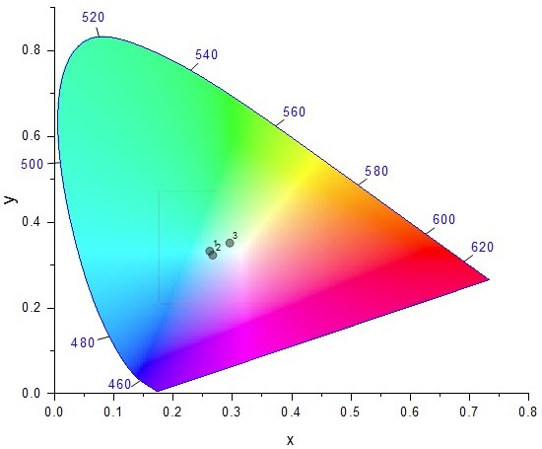
Figure 28. Color points in the CIE 1931 chromaticity diagram of (1) Sample Structure 1, (2) Sample Structure 2, and (3) Sample Structure 3 after a 1-hour heat treatment at 300 °C in a nitrogen atmosphere.

Figure 29. Emission spectra of Sample Structure 1 from a 355 nm excitation source with a sample containing (a) 10 layers and (b) 5 layers.

Conclusion

Nanolayered barium fluoride/ europium oxide/ aluminum oxide films were synthesized via sequential pulsed laser deposition using three different layer configurations. Cross-section TEM analysis of the samples showed that the layers are uniform throughout the film. The different sample structures were subjected to post-synthesis heat treatments in ambient and nitrogen atmospheres to precipitate optically-active nanocrystals. Photoluminescent emission was measured from the samples, both as-made and following heat treatments. All sample structures subject to ambient atmosphere heat treatments exhibited emission degradation when subject to the excitation laser. However, it is found that with heat treatments in a nitrogen atmosphere this degradation can be suppressed. Sample Structure 1, consisting of europium sandwiched between barium fluoride layers, was determined to be the best performing structural configuration based on its emission intensity and stability against UV laser degradation; after heat treatment in nitrogen, the film exhibited a broad emission from 400 - 600 nm with a shoulder at 410 nm. Chromaticity coordinates plotted from the acquired emission spectra ranged from x = 0.26-0.29 and y = 0.32-35, which demonstrates a potential application in UV-pumped white light LEDs. Emission intensity was compared to film thickness to show a 39% increase in light output when the number of sample layers was doubled from 5 to 10.

CHAPTER III
Optical characterization of Al₂O₃/BaF₂ layered thin films codoped with europium and manganese synthesized by pulsed laser deposition

Charles Bond was responsible for the writing of this chapter and all research activities presented, except as noted: Pilar Gómez-Rodríguez conducted PLD synthesis and emission measurements. Jose Gonzalo, Rosa Serna, Amanda Petford-Long, Lee Leonard, and Jacqueline Johnson provided guidance for the overall project and critical feedback.

Abstract

The Eu²⁺/Mn²⁺ complex is a popular dopant option in white light applications due to the broadband emission of the Eu²⁺ ion and the red component of the Mn²⁺ ion. This study investigates the optical effect of manganese on europium doped BaF₂/Al₂O₃ layered thin film synthesized by pulsed laser deposition. Using a layered configuration determined in previous studies, two different amounts of manganese were introduced into the films using a MnO target. The samples were subject to post-deposition thermal treatments in a nitrogen atmosphere, then emission measurements were conducted using a 355 nm excitation laser. The sample with a 1:8 Mn/Eu ratio showed no change in emission trends when compared to a sample with only Eu dopant. The sample with a 1:2 Mn/Eu ratio showed a blue shift in emission with chromic coordinates of x= 0.23 and y= 0.26, which is not favorable for applications with UV-pumped white-light LEDs.

Introduction

The use of transition metals is favorable for solar cell, semiconductor, and optical devices due to their large tunable bandgap and physical properties arising from the localized character of d-elections [87, 88]. The transition of an electron from an excited state to a ground state, or in terminology used for band gaps: a conduction band to a valance band, can produce the ejection of a photon which results in photoluminescence. The optical performance of the Mn²⁺ ion relies on 3d-3d electron transitions which are forbidden by the Laporte selection rule that states a change in parity must occur for allowed transitions. The Mn²⁺ ion is nearly colorless with poor emission performance which restricts its applications in luminescent materials [9, 89, 90]. The Laporte rule can be relaxed by coupling of the electronic transition with vibrations to result in a loss of symmetry, but the Mn²⁺ ion is typical paired with a sensitizer to increase optical performance [91].

The Eu²⁺ ion is a popular sensitizer to a Mn²⁺ activator that has yielded successful photoluminescent properties in several host lattices [92-94]. Even at low dopant concentrations, the Eu²⁺ to Mn²⁺ energy transfer has been observed in many different halide crystal matrices [95-98]. An excited 5d¹ electron in Eu²⁺ is at the ⁶P energy level, which is similar to the ⁴E(⁴D) energy level in an excited Mn²⁺ ion [99]. The similar energy levels allow for an electron transfer from Eu²⁺ to Mn²⁺ and emission from the Mn²⁺ ion through a mechanism illustrated in Figure 30. Emission from Mn²⁺ is typically in the red region of the visible spectrum but can range from 500 – 700 nm depending on the crystalline matrix it occupies. The Eu²⁺/Mn²⁺ dopant complex is a popular phosphor material for LED applications. Eu²⁺ contributes to broad emission in the blue region of the visible spectrum while Mn²⁺ contributes to broad emission in the red region resulting in a high-quality white-light LED.

The optical influence of the transition metal manganese is presented in this study by characterizing two samples with different amounts of MnO added to nanolayered thin films. The layered configuration and post-synthesis heat treatments used were based on results from Chapter II. One sample was synthesized with a 1:8 Mn to Eu dopant ratio and one with a 1:2 Mn to Eu ratio. The ratios are based on the quantities of cations and assuming similar densities. Samples as made and following post-synthesis heat treatments are compared by photoluminescent emission characterization achieved using a 355 nm excitation laser. The optical influence of the Mn dopant is determined by comparing the emission of a sample with only a Eu dopant. Comparing the two different amounts of MnO in the samples demonstrates a threshold of material needed for Mn optical influence in the regions measured. The chromic coordinates of the emission altered by Mn incorporation demonstrate a blue-shift, which is not favorable for UV-pumped white-LED applications.

Materials and Methods

Commercially available targets of Al₂O₃, BaF₂, Eu₂O₃, and MnO were ablated to produce layered thin films via pulsed laser deposition (PLD). The pressure in the system was maintained below 3 x 10⁻⁶ Torr during deposition. An ArF excimer laser with a 193 nm wavelength beam with a rated pulse length of 20 ns was used. Films were deposited on single side polished, 475-575 µm thick, test grade silicon wafers in the <100> crystalline orientation. The substrates were cleaned with an acetone rinse, ultrasonically in ethanol for 5 minutes, then dried with compressed nitrogen prior to their placement in the deposition chamber.

Al₂O₃, BaF₂, and Eu₂O₃ deposition parameters are detailed in Chapter II. The deposition parameters of the ablated materials, including MnO, are shown in Table 3.

Table 3. PLD parameters of all of the materials that were ablated.
Material | Laser Fluence | Laser Frequency | Relative Substrate Position | Target-substrate Distance
Al₂O₃ | 8.0 J/cm² | 20 Hz | 20 ° | 37.8 mm
BaF₂ | 8.0 J/cm² | 10 Hz | 180 ° | 86.0 mm
Eu₂O₃ | 2.0 J/cm² | 10 Hz | 20 ° | 37.8 mm
MnO | 8.0 J/cm² | 10 Hz | 20 ° | 37.8 mm

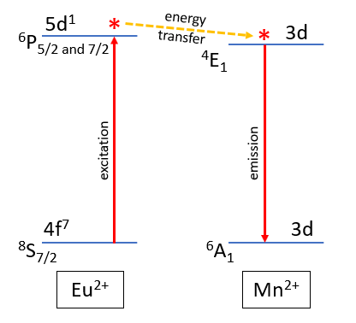
Figure 30. Illustration of a proposed mechanism of energy transfer between Eu²⁺ and Mn²⁺ ions.

Samples using the same layered configuration and two different Mn dopant amounts were grown, as illustrated in Figure 31.

Codoped Sample 1 (Figure 31a) was synthesized with a small amount of MnO relative to the amount of Eu₂O₃. An initial 2000 laser pulses were used on the Al₂O₃ target, followed by 4280 laser pulses on BaF₂, 430 laser pulses on Eu₂O₃, 100 laser pulses on MnO, and 4280 laser pulses on BaF₂. This sequence (Al₂O₃/BaF₂/Eu₂O₃/MnO/BaF₂) was repeated 5 times and a final 2000 pulse Al₂O₃ layer was grown as a protective cap. Based on preliminary in situ spectroscopic ellipsometry, the number of stated pulses will equate to layers of 10 nm Al₂O₃, 5 nm BaF₂, and 0.5 nm MnO.

Codoped Sample 2 (Figure 31b) was synthesized with a 1:1 Eu₂O₃ to MnO thickness ratio. An initial 2000 laser pulses were used on the Al₂O₃ target, followed by 4280 laser pulses on BaF₂, 430 laser pulses on Eu₂O₃, 400 laser pulses on MnO, and 4280 laser pulses on BaF₂. This sequence (Al₂O₃/BaF₂/Eu₂O₃/MnO/BaF₂) was repeated 5 times and a final 2000 pulse Al₂O₃ layer was grown as a protective cap. The project thickness of the layers is the same as Codoped Sample 1, except for a 2.0 nm layer of MnO instead of 0.5 nm.

The samples were heat treated in a nitrogen atmosphere at a heating ramp of 10 K/ min to 300 °C and held at that temperature for 1 hour, then allowed to cool to ambient temperature over time.

Photoluminescence studies were conducted by methods detailed in Chapter II.

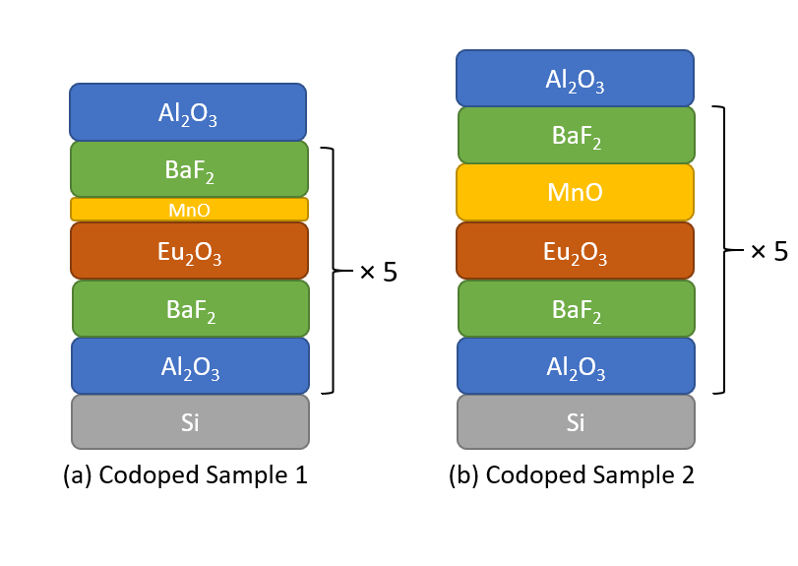
Figure 31. Illustration of samples with the same layered configuration and two different manganese dopant amounts.

Results and Discussions

The emission spectra of Codoped Sample 1 synthesized with 0.5 nm of MnO as-made and following a 1 hour 300 °C heat treatment in a nitrogen atmosphere achieved by a 355 nm excitation wavelength are shown in Figure 32. The as-made sample exhibited a sharp peak at 418 nm and a steady decrease in intensity throughout the rest of the visible spectrum with the exception of a shoulder at 446 nm. The sample heat treated in a nitrogen environment exhibited a broad emission with the most intensity found between 450 and 550 nm. A shoulder is seen at 420 nm and a steady decrease in intensity is exhibited from 550 nm through the remainder of the visible spectrum.

The emission spectra of Codoped Sample 2 synthesized with 2 nm of MnO as-made and following a 1 hour 300 °C heat treatment in a nitrogen atmosphere achieved by a 355 nm excitation wavelength are shown in Figure 33. When observing the 420-500 nm region, the sample heat treated in nitrogen exhibited an emission approximately four times greater than the as-made sample. The emission of both samples exhibited similar trends and spectral shapes. The most intense emission is exhibited in the 418-468 nm range with two broad peaks at 422 and 448 nm and a shoulder at 460 nm.

The optical influence of the Mn dopant on the Eu/Mn complex is shown in Figure 34 by comparing the emission of the two codoped samples to a sample with only Eu (Sample Structure 1) from Chapter II. In the sample with 2.0 nm MnO, the first broad peak at 420 nm can be attributed to the 4f⁶5d¹ to 4f⁷ electron transition of a Eu²⁺ ion in a BaF₂ matrix. This peak is similar to the emission of Eu doped samples heat treated in an ambient atmosphere and aligns with the shoulders found in the emission of samples heat treated in a nitrogen atmosphere. The second broad peak can be attributed to either emission from Eu²⁺/Mn²⁺ complexes or Mn₂O₃ nanoparticles [100, 101].

Because the phase diagram of Mn-O is comprised of MnO, MnO₂, Mn₂O₃, and Mn₃O₄, luminescence from Mn²⁺, Mn³⁺, and Mn⁴⁺ ions must be considered [102, 103]. Emission from the Eu²⁺/Mn²⁺ complexes would indicate electrons transferring from the excited ⁶P energy state of Eu²⁺ to the excited ⁴E(⁴D) energy level of Mn²⁺ followed by the emission of photons. Emission from Mn₂O₃ nanoparticles could indicate oxygen vacancy-related defects. Emission from Mn⁴⁺ can be ruled out as it is usually exhibited in the near-infrared region [104, 105]. To confirm the origins of the emission, an excitation spectrum would need to be measured. A peak at approximately 300 nm is expected in the excitation spectrum in photoluminescence attributed to ⁴E(⁴D) energy levels [106]. X-ray diffraction or Fourier transfer infrared spectroscopy could be used to determine the presence of Mn₂O₃ nanoparticles.

The emission of the codoped sample with 0.5 nm MnO showed similar trends and intensities when compared to the sample only doped with Eu, indicating no optical influence of the Mn dopant. Because optical characteristics were changed with an increased amount of MnO, it is hypothesized the 0.5 nm sample did not contain enough Mn²⁺ or Mn³⁺ ions to yield a measurable emission. Using a PLD target that has more favorable stoichiometry to producing Mn²⁺ ions, such as MnF₂, could increase the optical influence of Mn with less ablated material. Switching from an oxide to a fluoride target would introduce the disadvantages of increased material costs and the necessity for more intricate storage and handling procedures to avoid oxidation.

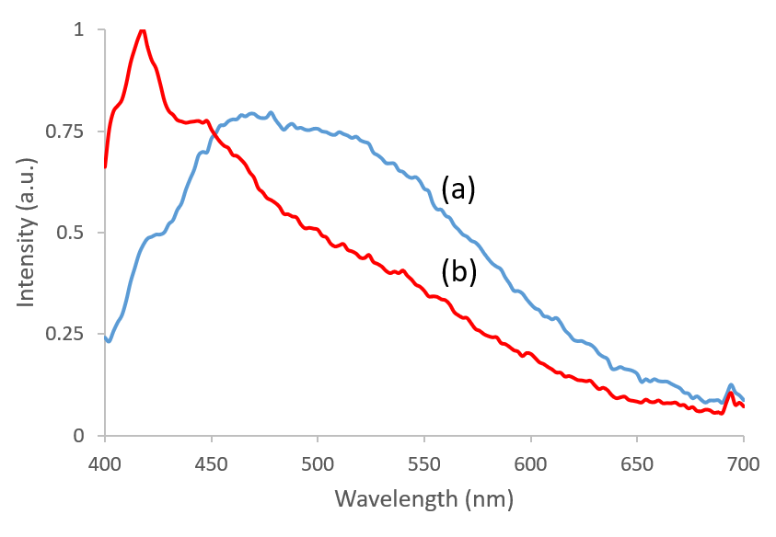
Figure 32. Emission spectra of the 0.5 nm MnO sample after a 1-hour heat treatment at 300 °C in (a) a nitrogen atmosphere and (b) as-made. A 355 nm excitation source was used.

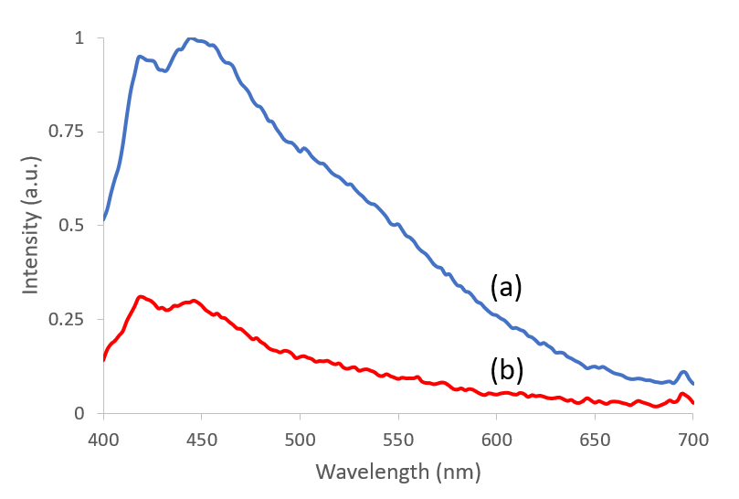
Figure 33. Emission spectra of the 2 nm MnO sample after a 1-hour heat treatment at 300 °C in (a) a nitrogen atmosphere and (b) as-made. A 355 nm excitation source was used.

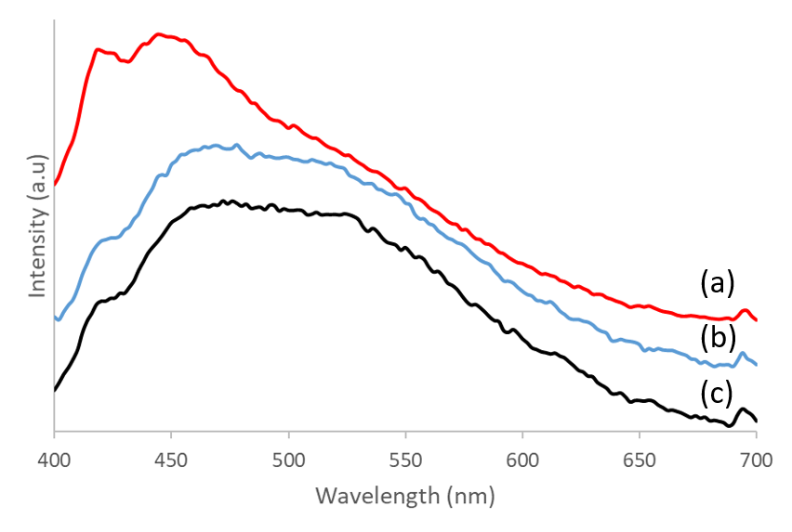
Figure 34. Emission spectra of (a) 2 nm MnO sample, (b) 0.5 nm MnO sample, and (c) sample without Mn. All samples were heat treated for 1-hour at 300 °C in a nitrogen atmosphere. A 355 nm excitation source was used.

The chromatic coordinates of the two codoped samples are plotted using CIE 1931 and shown in Figure 35. The emission of the 0.5 nm MnO sample had a similar trend to a sample with only Eu, so the chromic coordinates are identical (x=0.26, y=0.33) as expected. The coordinates of the sample with 2.0 nm MnO were (x= 0.23, y=0.26), which exhibits a blue-shift when compared to europium-doped samples. Because pure white CIE 1931 chromatic coordinates are (x=0.33, y=0.33), MnO dopant does not appear to be beneficial for UV-pumped white-LED applications.

Previous experiments demonstrated the possibility of decreased emission output with increased exposure time to an excitation source. The samples heat treated in a nitrogen atmosphere showed a steady emission intensity when exposed to an excitation laser source, which correspondences with results found in previous work. Figure 36 and Figure 37 show repeated emission measurements conducted on the same sample location for both codoped samples.

Conclusion

A threshold range was found for the amount of manganese necessary to optically influence nanolayered thin films of barium fluoride, europium oxide, and aluminum oxide synthesized via pulsed laser deposition. Samples were synthesized with two different amounts of manganese, one with a 1:8 Mn to Eu ratio (0.5 nm MnO) and one with a 1:2 Mn to Eu ratio (2.0 nm MnO) based on projected deposited material thickness. The 1:8 Mn to Eu ratio sample showed no change in emission trends when compared to a sample only doped with europium. The 1:2 Mn to Eu ratio exhibited a new emission at 448 nm that was not found in the other samples. The altered emission resulted in a blue-shift in the chromic coordinates (x= 0.23, y=0.26), which is not advantageous for white-light applications. The emission intensity of both samples was steady when exposed to a UV excitation laser.

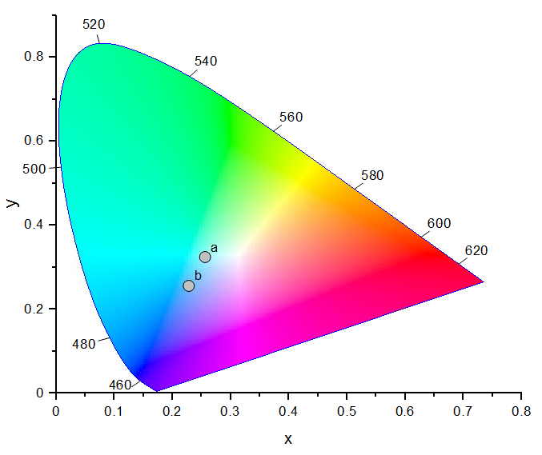
Figure 35. Color points in the CIE 1931 chromaticity diagram of the (a) 0.5 nm MnO sample and the (b) 2 nm MnO sample after a 1-hour heat treatment at 300 °C in a nitrogen atmosphere.

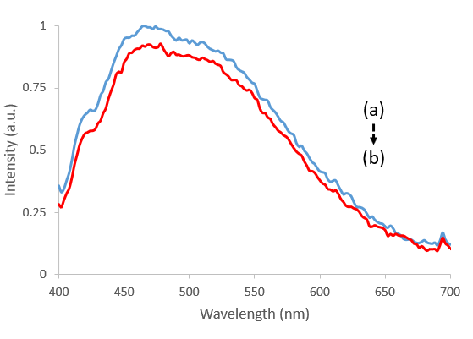
Figure 36. Emission spectra of the 0.5 nm MnO sample from a 355 nm excitation source after a 1-hour post-synthesis heat treatment in a nitrogen atmosphere. The spectra were contained from consecutive measurements of the same sample location. Spectrum (a) is the first measurement and (b) is the second measurement.

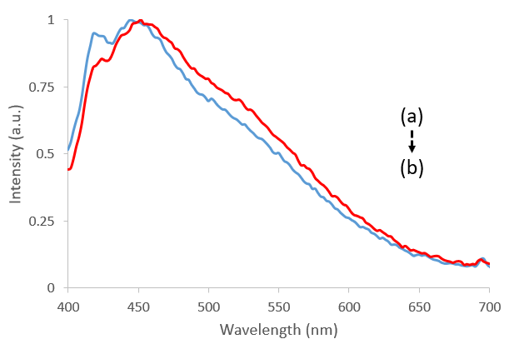
Figure 37. Emission spectra of the 0.5 nm MnO sample from a 355 nm excitation source after a 1-hour post-synthesis heat treatment in a nitrogen atmosphere. The spectra were contained from consecutive measurements of the same sample location. Spectrum (a) is the first measurement and (b) is the second measurement.

CONCLUSION

Optically active films were successfully synthesized via pulsed laser deposition and evaluated for applications in computed radiography or light-emitting diodes. The films were comprised of a halide crystal, a europium dopant, and an amorphous matrix material. The structural and optical characteristics of these films were dependent on target materials, pulsed laser deposition parameters, and post synthesis thermal treatments.

The incorporation of BaCl₂:Eu²⁺ crystallites into an amorphous matrix was confirmed in approximately 13 µm films via x-ray diffraction. The films’ storage phosphor capability was determined with the analysis of photostimulated luminescence. The investigation of two different amorphous matrices (Si and SiO₂) revealed that both materials make a suitable host for the crystallites. A radiograph was developed using computed radiography and an experimental film that demonstrated a spatial resolution of 10 lp/mm, which is commercially considered to be high-resolution. The conversion efficiency of a commercial BFB storage phosphor plate was superior to that of the experimental storage phosphor films demonstrating a lack of practicality in medical imaging. However, for applications such as nondestructive testing, in which dose is not critical, the CE would be of lesser concern. This synthesis technique has the ability to develop scintillating glass-ceramic substrates that can be used in indirect flat panel detectors. A prototype has been made, but additional material investigation must be conducted to improve scintillating efficiency.

The nanolayered configuration of BaF₂/ Eu₂O₃/ Al₂O₃ films was shown to influence their optical properties due to the europium dopant being in different coordinate environments. Three layered configurations were synthesized and optically characterized following different post-synthesis heat treatment procedures. Cross-sectional TEM showed that layers of each material were depositied as continuous, uniform layers. Films subject to ambient atmosphere heat treatments exhibited emission degradation when subject to an excitation laser. However, it is found that with heat treatments in a nitrogen atmosphere, this degradation can be suppressed. All sample structures demonstrated the potential for applications in UV-pumped white light LEDs. Manganese was used to synthesize codoped samples, and a threshold for the amount of Mn necessary to optical influence the nanolayered films was determined.

REFERENCES

1. Ritenour, E.R., Physics overview of screen-film radiography. Radiographics, 1996. 16(4): p. 903-16.
2. Bansal, G.J., Digital radiography. A comparison with modern conventional imaging. Postgraduate medical journal, 2006. 82(969): p. 425-428.
3. Korner, M., et al., Advances in digital radiography: Physical principles and system overview. Radiographics, 2007. 27(3): p. 675-686.
4. Yaffe, M.J. and J.A. Rowlands, X-ray detectors for digital radiography. Physics in Medicine and Biology, 1997. 42(1): p. 1-39.
5. Chotas, H.G., J.T. Dobbins, and C.E. Ravin, Principles of digital radiography with large-area, electronically readable detectors: A review of the basics. Radiology, 1999. 210(3): p. 595-599.
6. Fujita, H., et al., Basic imaging properties of a computed radiographic system with photostimulable phosphors. Med Phys, 1989. 16(1): p. 52-9.
7. H, K. Photostimulable phosphor radiography design considerations. in Specification, Acceptance Testing, and Quality Control of Diagnostic X-Ray Imaging Equipment. 1994.
8. Rowlands, J.A., The physics of computed radiography. Physics in Medicine and Biology, 2002. 47(23): p. R123-R166.
9. Blasse, G. and B.C. Grabmaier, Luminescent materials. 1994, Berlin; New York: Springer-Verlag.
10. Thoms, M., H. Vonseggern, and A. Winnacker, SPATIAL CORRELATION AND PHOTOSTIMULABILITY OF DEFECT CENTERS IN THE X-RAY-STORAGE PHOSPHOR BAFBR-EU2+. Physical Review B, 1991. 44(17): p. 9240-9247.
11. Fouassier, C., Luminescent materials. Current Opinion in Solid State and Materials Science, 1997. 2(2): p. 231-235.
12. Wierer, J.J., et al., High-power AlGaInN flip-chip light-emitting diodes. Applied Physics Letters, 2001. 78(22): p. 3379-3381.
13. Cho, J., et al., White light-emitting diodes: History, progress, and future. Laser & Photonics Reviews, 2017. 11(2).
14. Haitz, R.K., Fred; Tsao, Jeff; Nelson, Jeff The Case for a National Research Program on Semiconductor Lighting, in Sandia Report. 2000, Sandia National Laboratories.
15. Schubert, E.F. and J.K. Kim, Solid-state light sources getting smart. Science, 2005. 308(5726): p. 1274-1278.
16. Bergh, A., et al., The promise and challenge of solid-state lighting. Physics Today, 2001. 54(12): p. 42-47.
17. Dong, J.F. and D.X. Xiong, Applications of Light Emitting Diodes in Health Care. Annals of Biomedical Engineering, 2017. 45(11): p. 2509-2523.
18. van Bommel, W.J.M., Non-visual biological effect of lighting and the practical meaning for lighting for work. Applied Ergonomics, 2006. 37(4): p. 461-466.
19. Orsinger, G.V., et al., Simultaneous multiplane imaging of human ovarian cancer by volume holographic imaging. Journal of Biomedical Optics, 2014. 19(3).
20. Pigula, A., et al., Video-rate dual polarization multispectral endoscopic imaging. SPIE BiOS. Vol. 9333. 2015: SPIE.
21. Barolet, D., Light-Emitting Diodes (LEDs) in Dermatology. Seminars in Cutaneous Medicine and Surgery, 2008. 27(4): p. 227-238.
22. Ohring, M., Chapter 3 - Thin-Film Evaporation Processes, in Materials Science of Thin Films (Second Edition). 2002, Academic Press: San Diego. p. 95-144.
23. Lowndes, D.H., et al., Synthesis of novel thin-film materials by pulsed laser deposition. Science, 1996. 273(5277): p. 898-903.
24. Rao, M.C. Pulsed Laser Deposition — Ablation Mechanism and Applications. 2013.
25. Schweizer, S., A.R. Lubinsky, and J.A. Johnson, Fluorozirconate-based glass-ceramic storage phosphors for digital mammography, in Medical Imaging 2007: Physics of Medical Imaging, Pts 1-3, J. Hsieh and M.J. Flynn, Editors. 2007.
26. Wang, B., et al., Photostimulated near-infrared persistent luminescence Cr3+-doped Zn-Ga-Ge-O phosphor with high QE for optical information storage. Journal of Alloys and Compounds, 2020. 812.
27. Gu, M., X. Li, and Y. Cao, Optical storage arrays: a perspective for future big data storage. Light: Science & Applications, 2014. 3(5): p. e177-e177.
28. Schweizer, S., Physics and current understanding of X-ray storage phosphors. PHYSICA STATUS SOLIDI A-APPLICATIONS AND MATERIALS SCIENCE, 2001. 187(2): p. 335-393.
29. Hu, T., et al., Color-tunable persistent luminescence in oxyfluoride glass and glass ceramic containing Mn2+:alpha-Zn2SiO4 nanocrystals. Journal of Materials Chemistry C, 2017. 5(6): p. 1479-1487.
30. Zhuang, Y.X., et al., Optical Data Storage and Multicolor Emission Readout on Flexible Films Using Deep-Trap Persistent Luminescence Materials. Advanced Functional Materials, 2018. 28(8).
31. Johnson, J.A., S. Schweizer, and A.R. Lubinsky, A glass-ceramic plate for mammography. Journal of the American Ceramic Society, 2007. 90(3): p. 693-698.
32. Leonard, R.L., et al., Evaluation of a Fluorochlorozirconate Glass-Ceramic Storage Phosphor Plate for Gamma-Ray Computed Radiography. Journal of the American Ceramic Society, 2015. 98(8): p. 2541-2547.
33. Huda, W., L.N. Rill, and A.P. Bruner, Relative speeds of Kodak computed radiography phosphors and screen-film systems. Medical Physics, 1997. 24(10): p. 1621-1628.
34. Sonoda, M., et al., COMPUTED RADIOGRAPHY UTILIZING SCANNING LASER STIMULATED LUMINESCENCE. Radiology, 1983. 148(3): p. 833-838.
35. Nanto, H., et al., X-ray imaging plate using CsBr : Eu phosphors for computed radiography. Nuclear Instruments & Methods in Physics Research Section a-Accelerators Spectrometers Detectors and Associated Equipment, 2007. 580(1): p. 278-281.
36. Schweizer, S.R., U; Assmann, S; Spaeth, JM, RbBr and CsBr doped with Eu2+ as new competitive X-ray storage phosphors. Radiation Measurements, 2001. 33(5): p. 483 - 486.
37. Leblans, P., D. Vandenbroucke, and P. Willems, Storage Phosphors for Medical Imaging. Materials (Basel, Switzerland), 2011. 4(6): p. 1034-1086.
38. Vonseggern, H., X-RAY-IMAGING WITH PHOTOSTIMULABLE PHOSPHORS. Nuclear Instruments & Methods in Physics Research Section a-Accelerators Spectrometers Detectors and Associated Equipment, 1992. 322(3): p. 467-471.
39. Alvarez, C.J., et al., Structural and Kinetic Analysis of BaCl2 Nanocrystals in Fluorochlorozirconate Glass-Ceramics. Journal of the American Ceramic Society, 2015. 98(4): p. 1099-1104.
40. Evans, A.W., et al., The effect of trivalent iron on the properties of fluorochlorozirconate glass ceramics. Journal of Non-Crystalline Solids, 2018. 484: p. 8-13.
41. Selling, J., et al., Comparison of the luminescence properties of the x-ray storage phosphors BaCl2 : Ce3+ and BaBr2 : Ce. Journal of Physics-Condensed Matter, 2005. 17(50): p. 8069-8078.
42. Appleby, G.A., et al., Photostimulated luminescence from BaCl2 : Eu2+ nanocrystals in lithium borate glasses following neutron irradiation. Applied Physics Letters, 2006. 89(10).
43. Appleby, G.A. and P. Vontobel, Optimisation of lithium borate-barium chloride glass-ceramic thermal neutron imaging plates. Nuclear Instruments & Methods in Physics Research Section a-Accelerators Spectrometers Detectors and Associated Equipment, 2008. 594(2): p. 253-256.
44. Schweizer, S., et al., Photostimulated luminescence in Eu-doped fluorochlorozirconate glass ceramics. Applied Physics Letters, 2003. 83(3): p. 449-451.
45. Chen, G., et al., Fluorozirconate-based nanophase glass ceramics for high-resolution medical X-ray imaging. Journal of Non-Crystalline Solids, 2006. 352(6-7): p. 610-614.
46. Bond, C.W., et al., Pulsed laser deposition of transparent fluoride glass. Journal of Non-Crystalline Solids, 2018. 488: p. 19-23.
47. Leonard, R.L., A.R. Lubinsky, and J.A. Johnson, The effects of sodium fluoride content on the properties of fluorochlorozirconate glass-ceramic storage phosphors. Journal of the American Ceramic Society, 2017. 100(4): p. 1551-1560.
48. Alvarez, C.J., et al., Nanocrystallization in Fluorochlorozirconate Glass-Ceramics. Journal of the American Ceramic Society, 2013. 96(11): p. 3617-3621.
49. Cadieu, F.J., et al., INPLANE MAGNETIZED YIG SUBSTRATES SELF-BIASED BY SMCO BASED SPUTTERED FILM COATINGS. Journal of Applied Physics, 1994. 76(10): p. 6059-6061.
50. Cadieu, F.J., et al., High coercivity SmCo based films made by pulsed laser deposition. Journal of Applied Physics, 1998. 83(11): p. 6247-6249.
51. Beutel, J., et al., Handbook of medical imaging. Volume 1, Volume 1. 2000.
52. Lubinsky, A.R., et al., Scanning translucent glass-ceramic x-ray storage phosphors, in Medical Imaging 2010: Physics of Medical Imaging, E. Samei and N.J. Pelc, Editors. 2010.
53. Koughia, C., et al., Samarium-Doped Fluorochlorozirconate Glass-Ceramics as Red-Emitting X-Ray Phosphors. Journal of the American Ceramic Society, 2011. 94(2): p. 543-550.
54. Leonard, R.G., SK; Alvarez, CJ; Moses, AK; Arrowood, LF; Lubinsky, AR; Petford-Long, AK; Johnson, JA., Evaluation of a Fluorochlorozirconate Glass-Ceramic Storage Phosphor Plate for Gamma-Ray Computed Radiography. JOURNAL OF THE AMERICAN CERAMIC SOCIETY, 2015. 98(8): p. 2541-2547.
55. Pei, Z.L., et al., Luminescence property of Eu-doped fluorochlorozirconate glass-ceramics. Journal of Rare Earths, 2009. 27(2): p. 338-340.
56. Schweizer, S., et al., Photostimulated luminescence from fluorochlorozirconate glass ceramics and the effect of crystallite size. Journal of Applied Physics, 2005. 97(8).
57. Selling, J., et al., Europium-doped barium halide X-ray scintillators. physica status solidi c, 2007. 4(3): p. 976-979.
58. Ziyuan, W., et al., Blue-shift of Eu2+ emission in (Ba,Sr)(3)Lu(PO4)(3):Eu2+ eulytite solid-solution phosphors resulting from release of neighbouring-cation-induced stress. Dalton transactions (Cambridge, England : 2003), 2014. 43.
59. Shang, M.M., C.X. Li, and J. Lin, How to produce white light in a single-phase host? Chemical Society Reviews, 2014. 43(5): p. 1372-1386.
60. Bendersky, L.A., et al., Structural Studies of Pulsed-laser-deposited Ba4Fe4Ti3O16 Oxide Films. Journal of Materials Research, 2000. 15(6): p. 1389-1396.
61. Buchanan, A., et al., Perception versus reality-findings from a phosphor plate quality assurance study. Oral Surgery Oral Medicine Oral Pathology Oral Radiology, 2017. 123(4): p. 496-501.
62. Leonard, R.L., et al., Scintillating glass-ceramic substrates for indirect flat panel detectors in digital radiography. Journal of the American Ceramic Society, 2020. 103(12): p. 6893-6900.
63. Guo, H., et al., Preparation, structural and luminescent properties of Ba2Gd2Si4O13:Eu3+ for white LEDs. Optics Express, 2011. 19(6): p. A201-A206.
64. He, S.G., et al., A Mn4+-doped oxyfluoride phosphor with remarkable negative thermal quenching and high color stability for warm WLEDs. Chemical Engineering Journal, 2020. 392.
65. Lin, C.C. and R.S. Liu, Advances in Phosphors for Light-emitting Diodes. Journal of Physical Chemistry Letters, 2011. 2(11): p. 1268-1277.
66. Guo, H., et al., Ultraviolet light induced white light emission in Ag and Eu3+ co-doped oxyfluoride glasses. Optics Express, 2010. 18(18): p. 18900-18905.
67. Kim, J.S., et al., White-light generation through ultraviolet-emitting diode and white-emitting phosphor. Applied Physics Letters, 2004. 85(17): p. 3696-3698.
68. Gong, Y., et al., Ce3+,Dy3+ Co-Doped White-Light Long-Lasting Phosphor: Sr2Al2SiO7 Through Energy Transfer. Journal of the Electrochemical Society, 2010. 157(6): p. J208-J211.
69. Sheu, J.K., et al., Warm-white light-emitting diode with high color rendering index fabricated by combining trichromatic InGaN emitter with single red phosphor. Optics Express, 2015. 23(7): p. A232-A239.
70. Bouchard, M.B., et al., Ultra-fast multispectral optical imaging of cortical oxygenation, blood flow, and intracellular calcium dynamics. Optics Express, 2009. 17(18): p. 15670-15678.
71. Clancy, N.T., et al., Development and evaluation of a light emitting diode endoscopic light source, in Advanced Biomedical and Clinical Diagnostic Systems X, T. VoDinh, A. MahadevanJansen, and W.S. Grundfest, Editors. 2012.
72. Hennessy, M. and M.R. Hamblin, Photobiomodulation and the brain: a new paradigm. Journal of Optics, 2017. 19(1).
73. Sohn, H., et al., Effects of Light-Emitting Diode Irradiation on RANKL-Induced Osteoclastogenesis. Lasers in Surgery and Medicine, 2015. 47(9): p. 745-755.
74. Mao, Z.Y., et al., Tunable single-doped single-host full-color-emitting LaAlO3: Eu phosphor via valence state-controlled means. Chemical Communications, 2009(3): p. 346-348.
75. Wu, Z.C., et al., A new single-host white-light-emitting BaSrMg(PO4)(2): Eu2+ phosphor for white-light-emitting diodes. Journal of Alloys and Compounds, 2010. 498(2): p. 139-142.
76. Aull, B.F. and H.P. Jenssen, IMPACT OF ION-HOST INTERACTIONS ON THE 5D-TO-4F SPECTRA OF LANTHANIDE RARE-EARTH-METAL IONS .1. A PHENOMENOLOGICAL CRYSTAL-FIELD MODEL. Physical Review B, 1986. 34(10): p. 6640-6646.
77. Leonard, R.L., et al., Rare earth doped downshifting glass ceramics for photovoltaic applications. Journal of Non-Crystalline Solids, 2013. 366: p. 1-5.
78. Zhao, J.J., et al., Structural Origins of BaF2/Ba1 - xRxF2 + (x)/RF3 Nanocrystals Formation from Phase Separated Fluoroaluminosilicate Glass: A Molecular Dynamic Simulation Study. Advanced Theory and Simulations, 2019. 2(10).
79. Dejneka, M., The luminescence and structure of novel transparent oxyfluoride glass-ceramics. JOURNAL OF NON-CRYSTALLINE SOLIDS, 1998. 239(1-3): p. 149-155.
80. Fang, Z.J., et al., Phase-Separation Engineering of Glass for Drastic Enhancement of Upconversion Luminescence. Advanced Optical Materials, 2019. 7(8).
81. Camps, I., A. Mariscal, and R. Serna, Preparation and broadband white emission of Eu-doped thin films based on SiAION. Journal of Luminescence, 2017. 191: p. 97-101.
82. Zhang, Q., et al., Reduction of Eu3+ to Eu2+ in Eu-doped high silica glass prepared in air atmosphere. Optical Materials, 2010. 32(3): p. 427-431.
83. Hu, G.X., et al., Regulation of luminescence properties of SBGNA:Eu3+ glass by the content of B2O3 and Al2O3. Optical Materials, 2020. 106.
84. Howe, B. and A.L. Diaz, Characterization of host-lattice emission and energy transfer in BaMgAl10O17 : Eu2+. Journal of Luminescence, 2004. 109(1): p. 51-59.
85. Dawson, B., et al., Mechanisms of VUV damage in BaMgAl10O17 : Eu2+. Chemistry of Materials, 2004. 16(25): p. 5311-5317.
86. Amidani, L., et al., Oxidation and Luminescence Quenching of Europium in BaMgAI(10)O(17) Blue Phosphors. Chemistry of Materials, 2017. 29(23): p. 10122-10129.
87. Choi, W.S., et al., Wide bandgap tunability in complex transition metal oxides by site-specific substitution. Nature Communications, 2012. 3.
88. Capasso, F., BAND-GAP ENGINEERING - FROM PHYSICS AND MATERIALS TO NEW SEMICONDUCTOR-DEVICES. Science, 1987. 235(4785): p. 172-176.
89. Zhang, X.G., et al., Dopant preferential site occupation and high efficiency white emission in K2BaCa(PO4)(2):Eu2+,Mn2+ phosphors for high quality white LED applications. Inorganic Chemistry Frontiers, 2019. 6(5): p. 1289-1298.
90. Wu, L.W., et al., Analysis of the structure and abnormal photoluminescence of a red-emitting LiMgBO3:Mn2+ phosphor. Dalton Transactions, 2018. 47(37): p. 13094-13105.
91. Cotton, F.A., Chemical applications of group theory. 1990, New York: Wiley.
92. Yang, W.J., et al., Luminescence and energy transfer of Eu- and Mn-coactivated CaAl2Si2O8 as a potential phosphor for white-light UVLED. Chemistry of Materials, 2005. 17(15): p. 3883-3888.
93. Caldino, U., A. Munoz, and J. Rubio, LUMINESCENCE AND ENERGY-TRANSFER IN CAF2 SLIGHTLY DOPED WITH EUROPIUM AND MANGANESE. Journal of Physics-Condensed Matter, 1990. 2(27): p. 6071-6078.
94. Caldino, U.G., A.F. Munoz, and J.O. Rubio, ENERGY-TRANSFER IN CACL2-EU-MN CRYSTALS. Journal of Physics-Condensed Matter, 1993. 5(14): p. 2195-2202.
95. Mendez, A., et al., Energy transfer mechanisms in the KBr : Eu2+: Mn2+ phosphor. Journal of Materials Science Letters, 1999. 18(5): p. 399-402.
96. Rubio, J., A. Munoz, and J. Garcia, ENERGY-TRANSFER BETWEEN EUROPIUM AND MANGANESE CLOSE PAIRS IN MONOCRYSTALLINE SODIUM-BROMIDE. Physical Review B, 1987. 36(15): p. 8115-8121.
97. Rubio, J., et al., EU-2+- MN-2+ ENERGY-TRANSFER IN NACL. Physical Review B, 1985. 31(1): p. 59-67.
98. Camarillo, E. and J. Rubio, A SPECTROSCOPIC STUDY OF NAI CONTAINING EUROPIUM AND MANGANESE. Journal of Physics-Condensed Matter, 1989. 1(30): p. 4873-4883.
99. Chen, J., et al., Emission red shift and energy transfer behavior of color-tunable KMg4(PO4)(3):Eu2+,Mn2+ phosphors. Journal of Materials Chemistry C, 2015. 3(21): p. 5516-5523.
100. Yu, J.Y., et al., A new emission band of Eu2+ and its efficient energy transfer to Mn2+ in Sr2Mg3P4O15:Mn2+, Eu2+. Chemical Communications, 2011. 47(45): p. 12376-12378.
101. Karuppaiah, M., et al., Rapid microwave assisted synthesis of Mn 2 O 3 and Co 3 O 4 nanoparticles and their structural, optical and magnetic properties. 2018.
102. Kashir, A., et al., Pulsed Laser Deposition of Rocksalt Magnetic Binary Oxides. Thin Solid Films, 2019. 692.
103. Fritsch, S. and A. Navrotsky, Thermodynamic properties of manganese oxides. Journal of the American Ceramic Society, 1996. 79(7): p. 1761-1768.
104. Du, J.R., et al., LaAlO3:Mn4+ as Near-Infrared Emitting Persistent Luminescence Phosphor for Medical Imaging: A Charge Compensation Study. Materials, 2017. 10(12).
105. Jansen, T., F. Baur, and T. Jüstel, Red emitting K2NbF7:Mn4+ and K2TaF7:Mn4+ for warm-white LED applications. Journal of Luminescence, 2017. 192.
106. Teixeira, V.C., P.J.R. Montes, and M.E.G. Valerio, Structural and optical characterizations of Ca2Al2SiO7:Ce3+, Mn2+ nanoparticles produced via a hybrid route. Optical Materials, 2014. 36(9): p. 1580-1590.

VITA

Charles William Bond was born in Tullahoma, Tennessee to David and Tina Bond. He has a younger sister, Paige, and an older brother, Chris. He obtained his Bachelor of Science Degree at University of the Cumberlands in 2015. He majored in Chemistry. Charles obtained his Master of Science Degree from The University of Tennessee in Biomedical Engineering in 2018.

