To the Graduate Council:

I am submitting herewith a dissertation written by Yunhee Kim entitled “Improving Ozone SIP Modeling in Complex Terrain at a Fine Grid Resolution.” I have examined the final electronic copy of this dissertation for form and content and recommend that it be accepted in partial fulfillment of the requirements for the degree of Doctor of Philosophy, with a major in Civil Engineering.

Terry L. Miller, Major Professor
Joshua S. Fu, Co-major Professor

We have read this dissertation
and recommend its acceptance:

Wayne T. Davis

Bruce Ralston

Accepted for the Council:

Carolyn R. Hodges
Vice Provost and Dean of the Graduate School

(Original signatures are on file with official student records.)

Improving Ozone SIP Modeling in Complex Terrain at a Fine Grid Resolution

A Dissertation Presented for the Doctor of Philosophy Degree
The University of Tennessee, Knoxville

Yunhee Kim
May 2010

Copyright © 2010 by Yunhee Kim
All rights reserved

Dedication

This dissertation is dedicated to God and my family
for their love, support and constant encouragement

ACKNOWLEDGEMENTS

I would like to express my sincere gratitude to my major professor Dr. Terry L. Miller for his guidance throughout the course of my doctoral study. I express my sincere gratitude also to my co-major professor Dr. Joshua S. Fu for his assistance and guidance throughout my research and providing valuable thoughts. I would like to acknowledge the valuable time and assistance put in by each of the committee members Dr. Wayne T. Davis, and Dr. Bruce Ralston. Special thanks go to my parents for their patience and being a source of strength during this time.

Acknowledgment is made to the Visibility Improvement State and Tribal Association of the Southeast (VISTAS), which is sponsored by the Tennessee Department of Environment and Conservation (TDEC), for obtaining input data used in this research. Acknowledge to Jim Renfro from the Great Smoky Mountain National Park for providing observed data for 2002. Many have contributed indirectly to the success of this dissertation. I would like to acknowledge the help provided by Dr. David C. Wong from the U.S. EPA and Dr. James Boylan from Georgia Department of Natural Resources for sharing these model tools like software of nestdown and cmax for my research.

I would like to extend a special thanks to the Tennessee Department of Environment and Conservation for providing us the 2002 observed 8-hour ozone data for East Tennessee.
Finally, I would like to thank my parents and God for their constant loving support and encouragement.
ABSTRACT
Meteorological variables such as temperature, wind speed, wind directions, and Planetary Boundary Layer (PBL) heights have critical implications for air quality simulations. Sensitivity simulations with five different PBL schemes associated with three different Land Surface Models (LSMs) were conducted to examine the impact of meteorological variables on the predicted ozone concentrations using the Community Multiscale Air Quality (CMAQ) version 4.5 with local perspective. Additionally, the nudging analysis for winds was adopted with three different coefficients to improve the wind fields in the complex terrain at 4-km grid resolution. The simulations focused on complex terrain having valley and mountain areas for ozone SIPs (State Implementation Plans). The ETA M-Y (Mellor-Yamada) and G-S (Gayno-Seaman) PBL schemes were identified as favorite options and promote O₃ formation causing the higher temperature, slower winds, and lower mixing height among sensitivity simulations in the area of study.
It was found that PX simulation did not always give optimal meteorological and CMAQ model performances at mountain sites. The results of nudging analysis for winds with three different increased coefficients’ values (2.5, 4.5, and 6.0 x 10⁻⁴ per second) over seven sensitivity simulations show that the meteorological model performance was enhanced due to improved wind fields, indicating the FDDA (Four Dimensional Data Assimilation) nudging analysis can improve model performance considerably at 4-km grid resolution. Specifically, the sensitivity simulations with the coefficient value (6.0 x 10^{–4}) yielded more substantial improvements than with the other values (2.5 and 4.5 x 10⁻⁴). Hence, choosing the nudging coefficient of 6.0 x 10⁻⁴ per second for winds in MM5 may be the best choice to improve wind fields as an input, as well as, better model performance of CMAQ in the complex terrain area.
The sensitivity of RRFs (Relative Response Factors) to the PBL scheme may be considerably significant with about 1-3 ppb in difference in determining whether the attainment test is passed or failed. Finally, a finer grid resolution was necessary to evaluate and access of CMAQ results for giving a detailed representation of meteorological and chemical processes in the regulatory modeling.

TABLE OF CONTENTS

1.0 INTRODUCTION 1
  - Objective 6
2.0 Literature Review 8
  - Ozone SIP_{s} 8
  - METEOROLOGICAL MODELING SYSTEM (MM5) 11

  - BACKGROUND OF PLANETARY BOUNDARY LAYER (PBL) AND
LAND SURFACE MODELS (LSMs) ...........................................................13
  - description OF five PBL_{S} AND THREE LSM_{s} ……………………...16
  - description OF NUDGING METHOD IN MM5………………………19
- METHODOLOGY 21
  - MODELING COMPONENTS 21
  - EPISODE SELECTION 22
  - MODELING DOMAIN AND MONITORING SITES 22

METEOROLOGICAL CONFIGURATIONS……….....................................23

  - DESCRIPTION OF THE EMISSION MODELING………………………..25
  - DESCRIPTION OF THE CMAQ MODELING ……………………………27
  - DESCRIPTION OF MODLEED ATTAINMENT TEST………………….. 27
- RESULTS AND DISCUSSIONS 30
  - PART I 31
    - Statistics for meteorology to PBL schemes 31
    - Statistics for meteorology to nudging analysis 37
  - PART II 42
    - Influence daily maximum 8-hour ozone concentrations from CMAQ on all seven sensitivity simulations using default coefficients for winds……………………………………………42
    - Influence daily maximum 8-hour ozone concentrations on seven sensitivity simulations using three different nudging coefficients for winds…………………………………………………………47
  - PART III 53
    - Attainment demonstration 53
    - Modeling system for DVF (Design Value for future year) and RRFs (Relative Response Factors) 56
- SUMMARY AND CONCLUSIONS 61
  - PART I 61
  - PART II 64
  - PART III …………………………………………………………………….65
  - CONCLUSION ……………………………………………………………...67
- RECOMMENDATIONS FOR FUTURE RESEARCH 69
REFERENCES 71
APPENDIX.... 76
VITA 78

LIST OF TABLES

Table-1  Table-2  Table-3  Table-4  Table-5  Table-6  Table-7  Table-8  Table-9 | Classifications for 8-hr Ozone NAAQS ………………………………  PBL schemes coupled with LSMs schemes used for sensitivity test …  Vertical Layer Definition for MM5 and CMAQ ……………………...  Summary of the meteorological performance statistics of seven sensitivity simulations used in this study……………………………...  Summary of meteorological model performance statistics derived from the CMAQ simulations with three different nudging coefficients for wind speeds at overall, valley, and mountain areas……………….  Definition of statistical measures used in this study ………………….  Summary of August 2002 CMAQ model performance statistics for daily maximum 8-hour ozone concentrations…………………………  Summary of performance statistics derived from the CMAQ simulations with three different nudging coefficients at overall, valley, and mountain areas in August 2002…………………………...  Summary of results of the TKE sensitivity simulations at 4-km grid resolution and PX at 12- and 4-km grid resolution for DVCs, RRF, and DVFs at overall, valley, and mountain areas……………………... | 10  24  26  32  41  43  44  50  58

LIST OF FIGURES

Figure-1  Figure-2  Figure-3  Figure-4  Figure-5  Figure-6  Figure-7  Figure-8  Figure-9  Figure-10  Figure-11  Figure-12  Figure-13  Figure-14  Figure-15  Figure-16  Figure-17  Figure-18  Figure-19  Figure-20  Figure-21  Figure-22  Figure-23  Figure-24  Figure-A | Counties designated nonattainment areas for 8-hr ozone ……………  8-hr nonattainment areas in East Tennessee…………………………  MM5 modeling system flow chart …………………………………..  Explication of PBL processes ……………………………………….  Direct interactions of parameterizations …………………………….  Illustration of Surface Processes …………………………………….  The VISTAS’s 36 (D01) and 12km (D02) domains and nested 4km (D03) domain for the East Tennessee and total seven monitor sites for valley sites (Anderson, Mildred, Rutledge, Jefferson) and for mountain sites (Look Rock, Cove Mt., and Clingmans Dome) observed in East Tennessee ………………………………………….  Simplified flowchart of this study……………………………………  Mean Bias of MM5 for wind speed at 10m with 7 different sensitivity simulations for August in 2002…………………………...  RMSE of MM5 for Wind Speed at 10m with 7 different sensitivity simulations for August in 2002………………………………………  Mean Bias of MM5 for Temperature at 2m with 7 different sensitivity simulations for August in 2002…………………………..  Diurnal variations in the PBL height with seven scenarios at valley site on August 5, 2002 (EDT) ……………………………………….  Diurnal variations in the PBL height with seven scenarios at  mountain site on August 5, 2002 (EDT) …………………………….  Plots of bias for wind speed on seven scenario simulations with three different nudging coefficients (a (2.5), b (4.5), and c (6 x 10⁻⁴ /sec)) at the whole domain, valley, and mountain areas……………...  Plots of RMSE for wind speed on seven scenario simulations with three different nudging coefficients (a (2.5), b (4.5), and c (6 x 10⁻⁴ /sec)) at the whole domain, valley, and mountain areas ……………..  Plots of Bias for temperature on seven scenario simulations with three different nudging coefficients (a (2.5), b (4.5), and c (6 x 10⁻⁴ /sec)) at the whole domain, valley, and mountain area………………  NMB (Normalized Mean Bias) of daily Maximum 8-hour Ozone Concentration in August 2002 at overall, valley, and mountain areas.  NME (Normalized Mean Error) of daily Maximum 8-hour Ozone Concentration in August 2002 at overall, valley, and mountain areas.  UPA (Unpaired Peak Accuracy) of daily Maximum 8-hour Ozone Concentration in August 2002 at overall, valley, and mountain areas.  Skill Score of daily Maximum 8-hour Ozone Concentration in August 2002 at overall, valley, and mountain area 24-hr ………….  NMB (a), NME (b), skill score (c), and UPA (d) of daily maximum 8-hour ozone concentration at overall, valley, and mountain areas….  Mean normalized bias (MNB (%)) (left) and mean normalized gross error (MNGE (%)) (right) for 8-hr O₃ at overall, valley, and  mountain areas………………………………………………………  Mean normalized bias (MNB (%)) (left) and mean normalized gross error (MNGE (%)) (right) using 60 ppb cutoffs for 8-hr O₃ at overall, valley, and mountain areas………………………………….  Comparison of DVCs with base-case modeled O₃ for the TKE sensitivity simulations at 4-km and PX at 12- and 4-km grid resolutions at overall, valley, and mountain areas…………………...  Sensitivity to PBL spatial distribution of O₃………………………… | 9  11  12  14  15  19  23  28  32  33  33  36  36  39  39  40  48  48  48  49  54  55  56  59  77

INTRODUCTION

This chapter is revised based on a paper published and a paper submitted by Yunhee Kim, Joshua S. Fu, and Terry L. Miller:
Kim, Y., Fu, J.S., and Miller, T.L., 2009. Improving ozone modeling in complex terrain at a fine grid resolution: Part I – examination of analysis nudging and all PBL schemes associated with LSMs in meteorological model, Atmospheric Environment, 44 (4), pp.523-532
Kim, Y., Fu, J.S., and Miller, T.L., 2009. Improving ozone modeling in complex terrain at a fine grid resolution: Part II – Influence MM5 on Daily Maximum 8-hour Ozone Concentrations and RRFs (Relative Reduction Factors) for SIPs in the Nonattainment Areas, accepted in Atmospheric Environment.
My primary contributions to these papers include (i) development of the problem
into a work, (ii) identification of the study areas and objectives, (iii) design and
conducting of the simulations, (iv) gathering and reviewing literature, (v) processing,
analyzing and interpretation of simulation data, (vi) most of the writing.

Over the past decades, many of the urban areas in the United States have been committed in the development of plans for unhealthy and harmful effects of ozone (O₃) based on the National Ambient Air Quality Standards (NAAQS). The US EPA (United States Environmental Protection Agency) informed that 474 counties in the United States were designated as nonattainment for 8-hr O₃ NAAQS based on 8-hr O₃ measurements from 2001-2003.(Federal Register, 2004)
The three-dimensional (3D) Air Quality Models (AQMs) for the State Implementation Plans (SIPs) of ozone (O₃) have been gaining increased attention because of playing an important role in guiding the development of regulatory modeling with the National Ambient Air Quality Standards (NAAQS) (Zhang et al., 2006). The non-attainment areas for the 8-hr ozone designated by the U.S. Environmental Protection Agency (USEPA) must demonstrate the attainment using the 3D AQMs to see if the NAAQS for 8-hr ozone does or does not meet a monitoring area of interest. Thus, each State having 8-hr O₃ non-attainment areas are required to submit the SIPs to show for attainment of the 8-hr NAAQS which currently meets less than 85 ppb at a localized monitoring area. Models generally tend to concentrate on how well models represent real values. However, there are many uncertainties in meteorological model and photochemical model, and those responsibilities for decisions on control strategies need to use modeled scenarios without concern that inaccuracies and assumptions in the modeling may mislead them.
For the ozone SIPs modeling, air quality model performance at finer grid resolutions in the non-attainment areas is desirable because it is expected to propagate the actual structure of the atmosphere and show a more detailed representation of emissions, land use, meteorological, and chemical processes as well as ozone control strategy. Thus, US EPA recommends that using 4km horizontal grid may be desirable for urban and fine scales of nested regional grids (EPA, 2007). However, recent studies have presented the impacts of grid resolutions such as 36-, 12-, and 4-km for the evaluation of model performance. According to Mathur et al., (2005), 4-km simulation provided the most accurate and realistic ozone prediction while Arunachalam et al., 2006; Cohan et al., 2006; Queen and Zhang, 2008; Wu et al., 2008 found that 4-km grid resolution did not always provide the better model performance of meteorology and CMAQ (Byun and Schere, 2006). As a result, the 12-km grid simulation became more widely and properly chosen. In addition, for the Visibility Improvement State and Tribal Association of the Southeast (VISTAS)’s regional problem in the Southeast US was addressed by conducting the meteorological modeling at 36- and 12-km. Consequently, the PX PBL produced credible meteorological variables (VISTAS, 2004). As a result, the PX model was the preferred choice to provide meteorological inputs to AQMs. However, as indicated by Cohan et al., (2006), the results obtained from finer grid resolutions become necessary when localized variability is needed. Hence, sensitivity simulations from finer grid resolutions for ozone non-attainment areas would be necessary. This is critically important when CMAQ assessment and evaluation are performed in the regulatory modeling.
There are schemes and nudging analyses that may perform differently. Newtonian relaxation or nudging analysis is one method of four-dimensional data assimilation (FDDA). The nudging method described by Stauffer et al. (1991, 1994) was found to be an effective and economical method for performing FDDA. In particular, some studies have shown that using nudging analysis in MM5 is considered valuable because it can provide improved wind fields (Bao and Errico, 1997; Barna and Lamb, 2000; Cohan et al., 2006). At the fine scale, selecting the appropriate nudging coefficients may have impacts on MM5 and CMAQ simulation. The magnitude of the impact of nudging coefficients in MM5 on the CMAQ simulations has not been quantified at a fine grid resolution. Determining the appropriate value of nudging in MM5 to the CMAQ simulation can be useful to improve model performance at a finer grid resolution for SIPs in the non-attainment areas. When nudging is used in MM5 to create inputs for CMAQ, it is expected that the improvements of wind fields, shown in MM5 with nudging, would also improve daily maximum 8-hr ozone concentration in the CMAQ simulation.
The PBL height in meteorological models plays an important role for predicting and understanding ozone formation and other pollutants (Perez et al., 2006). The PBL has a thickness ranging from a hundred meters to a few kilometers and affects the dynamical and thermal forcing at the surface. Pollutants are emitted into the mixing layer (ML) and become gradually dispersed and mixed through the action of turbulence under convective (Seibert et al., 2000). Hence, the various PBL schemes in MM5 are needed to account for the influence of PBL or ML on ozone air quality during the typical ozone summer season in the complex terrain. CMAQ is then executed by forcing meteorological conditions as an input produced by a single configuration of MM5 (Mao et al., 2006). Some studies have shown how various PBL schemes affect the concentration of pollutants of CMAQ. Still, there is a lack of evaluation concerning how PBL schemes associated with LSMs affect CMAQ model performance at 4-km grid resolution.
In April 2004, US EPA designated non-attainment areas for 8-hour ozone NAAQS (National Ambient Air Quality Standard). The US EPA has set two NAAQS for O₃ from 1-hour standard of 120 ppb to 8-hour standard of 85 ppb. The 8-hour ozone NAAQS was revised by US EPA in 1991 based on the 1-hour NAAQS related to human health and welfare. The current 8-hour NAAQS requires that the three-year average of the fourth highest daily maximum 8-hour average ozone each year be less than or equal to 85 ppb at a given monitoring site. It is required more demanding than 1-hour ozone NAAQS for protecting human health. The new NAAQS for 8-hour O₃ was revised from 0.08 ppm to 0.075 ppm as of May 27 in 2008, expecting that this would result in more nonattainment areas in the United States.
Seven counties in East Tennessee are classified under the Clean Air Act (CAA) as 8-hour ozone nonattainment areas. These areas must demonstrate the ozone attainment whether NAAQS will be achieved through an effective state implementation plans (SIPs). Three-dimensional (3D) photochemical air quality models play an important role in demonstrating attainment of 8-hour ozone NAAQS and supporting of the SIPs at the nonattainment areas of interest. The CMAQ model is commonly and widely applied to determine if the NAAQS for 8-hour O₃ is met or not at a given monitoring site. The US EPA has updated a final modeling guidance document for demonstrating attainment of O₃ (USEPA, 2007) providing guidance on how to prepare 8-hour ozone attainment demonstrations using air quality models. Thus, users follow the instructions provided by US EPA to demonstrate attainment for 8-hour ozone NAAQS through the results from the CMAQ model.
Overall, the results of the study will provide a recommendation of the MM5 and CMAQ configurations for ozone SIP modeling exercises in the complex terrain areas. In addition, this study might provide thoughtful implications for giving a right decision that helps to improve the air quality management and their impacts on ozone SIPs to the State having 8-hr O₃ non-attainment areas.

- Objective

The primary objective of this study is to evaluate the performance of the meteorological model and CMAQ in the complex terrain at a 4-km grid resolution for ozone SIPs. We will also examine the impacts of nudging analysis for winds (and various PBL schemes associated with LSMs in MM5 on CMAQ simulation), to identify the most appropriate PBL schemes associated with LSMs and to determine the best nudging coefficient value for winds. We will present our results in three parts. These three parts are obtained from the submitted journal papers and also attached in Appendix A and B.
Part I describes the influence of various nudging coefficients for winds, and seven sensitivity simulations (five different PBL schemes associated with three different LSMs) in MM5 at 4-km horizontal grid resolution to provide a better representation of the meteorology. It presents impacts on grid size resolution between 12-km and 4-km for the 31-day period of August 2002 in a complex terrain area (East Tennessee) for the ozone SIPs. In addition, it also identifies the best nudging coefficient value for winds and preferred PBL schemes associated with LSMs in the area of the study.
Part II describes daily maximum 8-hour ozone concentrations from the 21 sensitivity simulation results of CMAQ. It illustrates seven sensitivity simulations with the best nudging coefficients, based on the results from Part I. We will also discuss the contribution of MM5 on 12-km grid resolution and 4-km grid resolution for PX model in order to study the impacts of grid size resolutions on O₃ formation in the nonattainment area.
Part III presents the effect on Relative Response Factors (RRFs) for ozone SIPs in the non-attainment areas of the study, for a 120-day period (from 15 May to 15 September) during a typical summer season. In addition, it evaluates monthly average daily maximum 8-hr O₃ concentration at 4-km horizontal grid resolution. The results of the study will provide a recommendation of the MM5 and CMAQ configurations for ozone SIP modeling exercises in the complex terrain areas.

LITERATURE REVIEW AND BACKGROUND

  - OZONE SIP_{s}

The Clean Air Act Amendments (CAA) established three-dimensional (3D) photochemical air quality models for analyzing the urban and regional problem of high O₃ across the US in 1990 as the recommended tools (USEPA, 1991; USEPA, 2007). These photochemical models such as the Community Multiscale Air Quality (CMAQ) or the Comprehensive Air Quality Models with extension (CMAx) are currently and widely applied to study and plan strategies for meeting NAAQS for 8-hr O₃ nonattainment areas. The nonattainment areas must submit the State Implementation Plans (SIPs) resulting from these models to the US EPA.
On July 18, 1997, the 1-hr ozone NAAQS of 0.120 parts per million (ppm) was amended to that of 0.08 parts per million (ppm) of 8-hr ozone based on human health and welfare effects resulting from the expended exposure of high O₃. This amended NAAQS for 8-hr O₃ is required more demanding than the standard of 1-hr O₃. (Federal Register, 2004)
On April 30, 2004, US EPA designated nonattainment areas for 8-hour ozone NAAQS. Figure-1 displays Counties designated nonattainment areas for 8-hr ozone in the United States. The CAA (Clean Air Act) includes two sets of provisions such as subpart I and subpart II. Subpart I which is referred to as basic nonattainment includes general, less prescriptive, requirements for nonattainment areas for any pollutants but

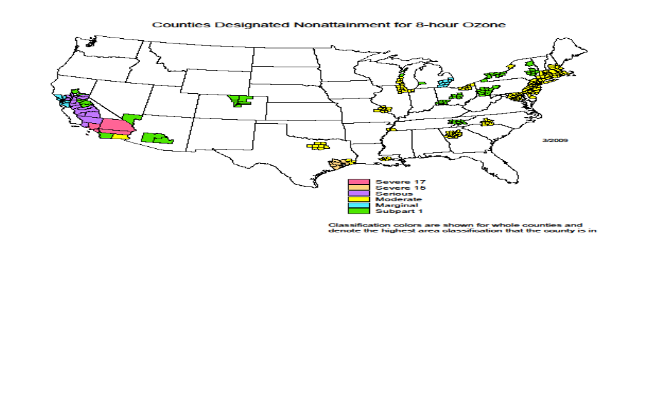

Figure-1. Counties designated nonattainment areas for 8-hr ozone (Source: US EPA, 2009)

subpart II necessitates additional specific provisions for ozone nonattainment areas. Under subpart II, areas are classified as listed in Table 1.
More serious areas are required with more recommended control requirements and given longer to attain the standards. Under EPA regulations at 40 CFR part 50, the current (1997) 8-hr NAAQS is attained when the three-year average of the fourth highest daily maximum 8-hr average ozone each year is less than equal to 0.08 ppm (i.e., 0.084 ppm when rounding is considered) at a given monitoring site.(Federal Register, 2004) The new NAAQS for 8-hr O₃ was revised from 0.08 ppm to 0.075 ppm as of May 27 in 2008, expecting that this would result in more nonattainment areas in the United States.

Table-1. Classifications for 8-hr Ozone NAAQS

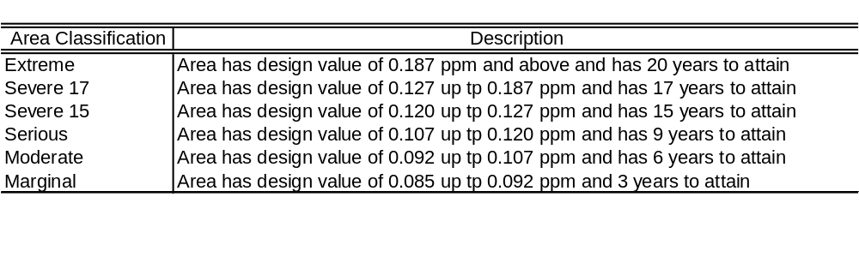

Seven counties in East Tennessee are classified under the Clean Air Act (CAA) as 8-hour ozone nonattainment areas and shown in Figure-2. These areas must demonstrate the ozone attainment whether NAAQS will be achieved through an effective state implementation plans (SIPs). Three-dimensional (3D) photochemical air quality models play an important role in demonstrating attainment of 8-hour ozone NAAQS and supporting of the SIPs at the nonattainment areas of interest. The CMAQ model is commonly and widely applied to determine if the NAAQS for 8-hour O₃ is met or not at a given monitoring site. The US EPA has updated a final modeling guidance document for demonstrating attainment of O₃ (USEPA, 2007) providing guidance on how to prepare 8-hour ozone attainment demonstrations using air quality models. Thus, users follow the instructions provided by US EPA to demonstrate attainment for 8-hour ozone NAAQS through the results from the CMAQ model.
A State Implementation Plans (SIPs) is federally approved and constrained regulations. Each state identifies how it will attain or maintain health and welfare of human related to NAAQS amended by CAA.

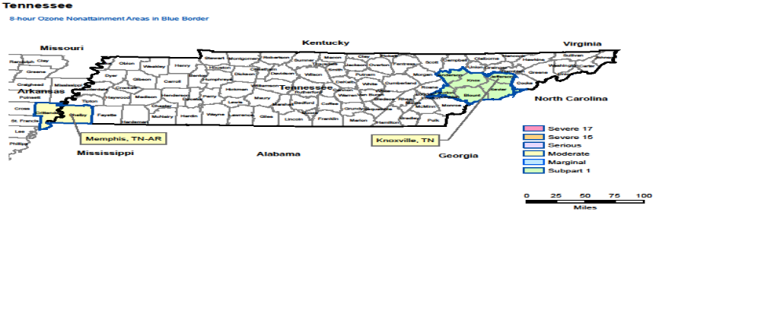

Figure-2. 8-hr nonattainment areas in East Tennessee (Source: US EPA)

SIPs documents containing a multiplicity of information including air control strategies, modeling demonstration and air quality goals must be approved by EPA.

  - METEOROLOGICAL MODELING SYSTEM (MM5)

The model established as MM5 is a non-hydrostatic, prognostic, and mesoscale meteorological model developed by the Fifth Generation Pennsylvania State University, National Center for Atmospheric Research to predict atmospheric circulation. (Dudhia, 2004) The MM5 involves (i) a multiple-nest capability, (ii) nonhydrostatic dynamics allowing the model to be used at a few-kilometer scale, (iii) a four-dimensional data-assimilation capability, and (iv) more physics options .(Dudhia, 2004)

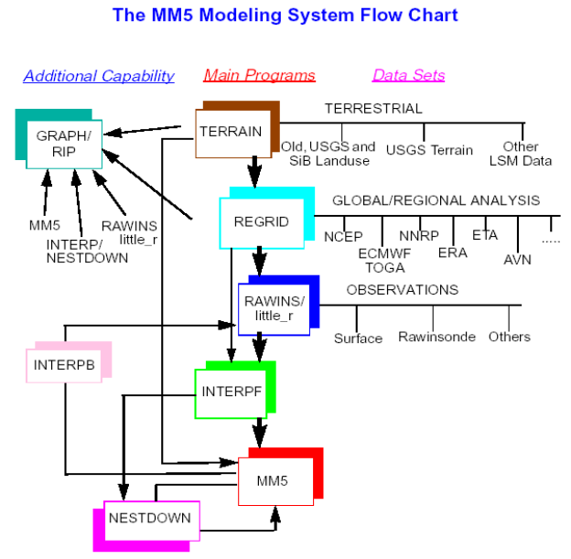

Figure-3. MM5 modeling system flow chart (Source:MM5 Community Model)

Briefly, the MM5 modeling system consists of five programs - terrain, regrid, littlr_r, interpf, and MM5 as shown in Figure-3. At first, the terrain program details model domain & map projection and generates terrain, landuse category data on model grids as well as vegetation & soil category data for MM5 model’s land surface model option. Second, the regrid program results in pressure level fields on model’s grids.
Third, the little_r program performs objective analysis with radiosonde and surface observations. Forth, the interpf program interpolates pressure level data from little_r to model’s sigma coordinate. And finally, the MM5 program performs time integration.
MM5 model insists on an initial condition as well as a boundary condition to run as a regional model. MM5 program has several physics options to produce boundary conditions.

  - BACKGROUND OF PLANETARY BOUNDARY LAYER (PBL) AND LAND SURFACE MODELS (LSMs)

Meteorological fields such as wind speeds, wind direction, temperature, and planetary boundary layer (PBL) have been examined on air quality for predicting ozone (O₃) concentration because they have direct impacts on air quality through dispersion and transport. Thus, they are used as input to air quality models (Byun et al., 2007; Jimenez et al., 2005; Perez et al., 2006; Queen and Zhang, 2008; Zhang et al., 2006). A complex topography with valley and mountain areas in East Tennessee is a good example in this study. There, stagnant air traps air pollutants within the valley airshed. The generally low wind speeds, slow the dispersion and transport of pollutants out of the valley. In this area, the breezes and winds of mountain and valley induced have important impacts on the dispersion of the pollutants emitted (Miller and Fu, 2006). The pattern of winds in the complex area can be even more complicated due to the land-use and the types of vegetation (Perez et al., 2006). Some studies have shown that the MM5 tends to predict well for temperature while wind speed tends to over predict in terms of overall-wide statistics and area-specific statistics at a 4-km grid resolution (Wu et al., 2008; Zhang et al., 2006). Jang et al., (1995) and Jimenez et al., (2005) suggest that the modeling of photochemical pollution in complex terrains requires a high horizontal grid resolution

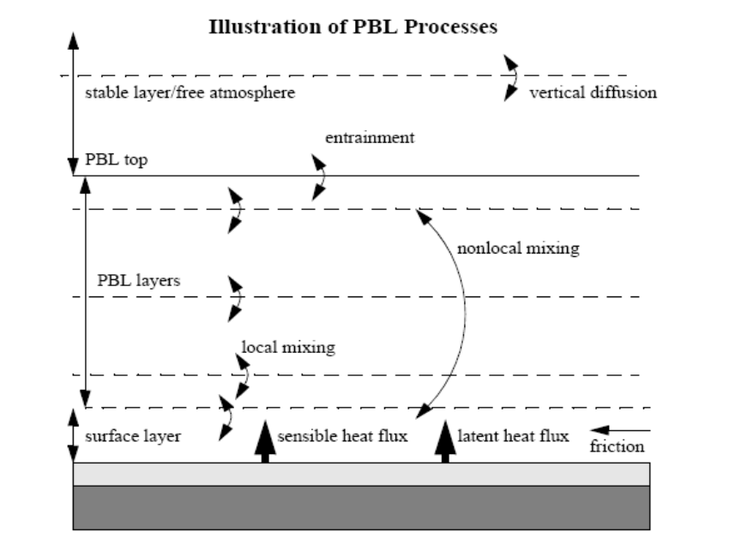

Figure-4. Explication of PBL processes

and needs to evaluate the meteorological variables such as wind speed, temperature, and wind direction with respect to the overall-wide statistics and area-specific statistics to provide insights into a local area.
It is divided by three layers such as surface layer, PBL layer known as mixing layer, and stable layer in the atmosphere as presented in Figure-4. It is well known that the PBL’s flow is turbulent as a major feature of PBL. The velocity, temperature, and humidity in a turbulent flow are random functions of space and time, resulting in one uses a statistical approach to compute the PBL structure. The structure of PBL turbulence is greatly influenced by surface conditions and temperature. Turbulent convective circulations are induced when the surface is warmer than the PBL air because of buoyant. Hence, boundary-layer convection would extend from a hundred meter to a few kilometers and settle the depth of the convective PBL. Under convective conditions, pollutants are released into the mixing layer (ML) and gradually mixed through the turbulence. And also boundary layer models depend on physical parameters like thermal conductivity in the soil, soil water content and roughness height. That is, PBL and surface land models have very strong relationships like couples. A land surface model (LSM) provides surface sensible and latent heat fluxes for momentum, heat, and water used to determine the quantities of flux between the land surface and the atmosphere as lower boundary conditions to the coupled PBL. These heat fluxes are then transported throughout the boundary layer and contribute to atmospheric temperature and moisture tendencies as shown in Figure-5. Basically, the LSM replaces the ground temperature prediction calculation based on the heat fluxes at the ground. The LSM strengthen by

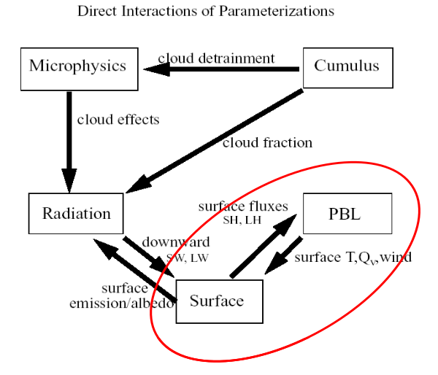

Figure-5. Direct interactions of parameterizations

soil and surface vegetation types, soil moisture, and topography and PBL forced by the ground surface have complex interactions. That’s the reason LSM and PBL schemes are applied in MM5 as a couple.

2.4 description OF five PBL_{S} AND THREE LSM_{s}

There are five available options for PBL schemes which users can choose for MM5. These are as follows: Pleim-Xiu (PX), Eta Mellor-Yamada (Eta M-Y), Medium Range Forecast (MRF), Blackadar (BK), and Gayno-Seaman (GS) PBL schemes. Each scheme is coupled to a different land surface model.

- Pleim-Xiu (PX) PBL scheme

The PX scheme is a simple non-local closure model called Asymmetrical Convective Model (ACM) developed for application in regional or mesoscale atmospheric chemistry models. It is based on the assumption that vertical transport within the mixing layer is asymmetrical. This scheme is only coupled with PX LSM and derived from Blackadar (BK) scheme.

- Eta Mellor-Yamada (Eta M-Y) PBL scheme

The Eta M-Y PBL scheme in MM5 is a local, one and half order closure scheme in the PBL with a prognostic equation for turbulent kinetic energy (TKE). This scheme is used to forecast the vertical mixing of horizontal wind, potential temperature, and mixing ratio. This scheme can be coupled with Noah LSM or 5-layer soil model.

- Medium Range Forecast (MRF) PBL scheme

The MRF PBL scheme is a non-local scheme and known as Hong and Pan PBL scheme. It illustrates large-eddy turbulence in a well-mixed PBL and is economical in computation because of its computational efficiency and its ability to simulate large-eddy turbulence in well-mixed PBLs. This scheme can be matched with Noah LSM or 5-layer soil model.

- Blackadar (BK) PBL scheme

This scheme is appropriate for multi-layer PBL and used to forecast the vertical mixing of horizontal wind, potential temperature, mixing ratio, cloud water, and cloud ice. It has different regimes such as stable, nocturnal and free-convective regimes. During the convective conditions, the non-local mixing of the BK PBL scheme assumes that buoyant plumes from the surface rise and mix across all layers over the boundary-layer, exchanging momentum, energy, and moisture. This scheme is mateched with a 5-layer soil model.

- Gayno-Seaman (G-S) PBL scheme

The GS scheme has the capability to provide cloud tendencies and its cost of computation is comparable with BL scheme. The local mixing of the GS PBL scheme calculates the turbulent kinetic energy (TKE) prognostically. The GS scheme is the most recent TKE-based scheme. The vertical diffusion is then determined based on the local value of TKE. This scheme is matched with a 5-layer soil model.
Three LSMs schemes are available in MM5 as specified in the descriptions of PBL schemes and as follows: PX, Noah, and 5-layer soil model LSMs.

- PX LSM

The PX (Pleim and Chang, 1992) is established by five different equations for soil temperature and soil moisture in two layers (1-com surface layer and 1-m root zone layer) and canopy moisture as displayed in Figure-6. Ground surface temperature is computed from the surface energy balance using a force-restore algorithm for heat exchange within the soil. Soil moisture coefficients used in the prognostic soil moisture equations are formulated. The coupled PX model can achieve 1.5 m air temperature.

- Noah LSM

The Noah LSM (Chen, 2001) in MM5 is used to predict soil moisture and temperature in 4 layers with thickness from top to bottom of 10, 30, 60, and 100 cm, as well as canopy moisture and water-equivalent snow depth. The Noah LSM has one canopy layer, and its total depth of soil layers is 2m. It can be coupled with Eta M-Y and
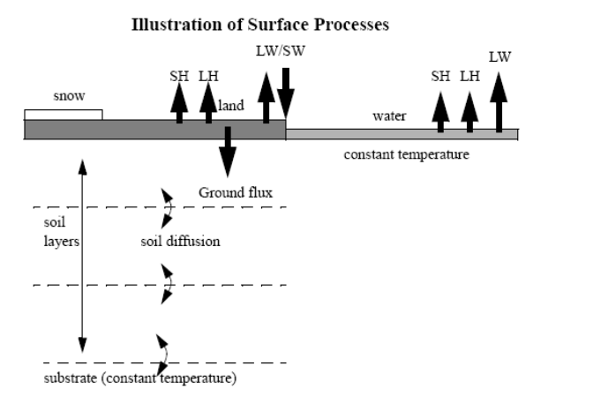

Figure-6. Illustration of Surface Processes

MRF PBL schemes, respectively. The coupled Eta M-Y-Noah model can diagnostically produce 2 m air temperature above ground level.

- 5-layer soil model LSM

The 5-layer soil model predicts soil temperature in 5 layers with thickness of 1, 2, 4, 8, and 16 cm and represents higher frequency changes than force-restore. This LSM can be associated with MRF, BK, and GS PBL schemes in MM5 configuration.

2.5 description OF NUDGING METHOD IN MM5
Stauffer et al., 1991 indicated that the technique of Newtonian relaxation, or nudging, was found to be an effective and economical method for performing Four Dimensional Data Assimilation (FDDA). Newtonian relaxation, or nudging (Stauffer and Seaman, 1994; Stauffer et al., 1991) is known to be a method of FDDA relaxing the model state toward the observed state by adding artificial forcing terms to the model equations based on the difference between the two states weighed by nudging coefficients in MM5. The nudging toward gridded analysis (based on the model’s time step as a simple method nudging FDDA) was used in this study.
The NCEP (National Centers for Environmental Prediction) final analysis data for REGRID and NCEP ADP Upper Air Observations and NCEP ADP Surface Observations for the surface FDDA were used. The FDDA 3D and surface analysis nudging is available in MM5 application and known to be useful to improve wind fields (Bao and Errico, 1997; Barna and Lamb, 2000; Cohan et al., 2006). The nudging term is weighted by a selected coefficient. Typically, the nudging coefficients range from 2.5 x 10 ^{–4} to 6.0 x 10⁻⁴ per second in the analysis nudging method. The FDDA 3D and surface analysis nudging was applied for temperature, winds, and mixing ratio. The nudging coefficients were 2.5 x 10⁻⁴ for temperature and 1.0 x 10⁻⁵ for mixing ratio used at each sensitivity simulation. According to Bao and Errico (1997), nudging only wind was more effective and dominant than temperature alone. Hence, we applied the nudging winds with increasing nudging coefficients that could produce better results than using the nudging coefficients for winds with a default value of 2.5 x 10⁻⁴ per second.
In this study, the nudging coefficients for winds of 2.5 x 10⁻⁴, 4.0 x 10⁻⁴, and 6.0 x 10⁻⁴ per second were utilized at each sensitivity simulation.

METHODOLOGY
This chapter is revised based on a paper published and a paper submitted by Yunhee Kim, Joshua S. Fu, and Terry L. Miller:
Kim, Y., Fu, J.S., and Miller, T.L., 2009. Improving ozone modeling in complex terrain at a fine grid resolution: Part I – examination of analysis nudging and all PBL schemes associated with LSMs in meteorological model, Atmospheric Environment, 44 (4), pp.523-532
Kim, Y., Fu, J.S., and Miller, T.L., 2009. Improving ozone modeling in complex terrain at a fine grid resolution: Part II – Influence MM5 on Daily Maximum 8-hour Ozone Concentrations and RRFs (Relative Reduction Factors) for SIPs in the Nonattainment Areas, accepted in Atmospheric Environment.
My primary contributions to these papers include (i) development of the problem
into a work, (ii) identification of the study areas and objectives, (iii) design and
conducting of the simulations, (iv) gathering and reviewing literature, (v) processing,
analyzing and interpretation of simulation data, (vi) most of the writing.

3.1 MODELING COMPONENTS

The MM5-MCIP-SMOKE-CMAQ modeling system is used in this study. Version 3.7 of MM5 is used to generate meteorological fields for CMAQ as inputs. The output from MM5 is processed by MCIP (Meteorology Chemistry Interface Processor) version 3.1. It is used and needed by SMOKE Version 2.1 and CMAQ Version 4.5 as a proper format.

3.2 EPISODE SELECTION

The 31-day episode is selected for the simulation to represent the typical summer condition. The summer episode is from 1 August to 31 August for the year of 2002 and included a 5-day spin-up period starting at 26 July 2002. The month of August is chosen for the simulation due to the fact that the model performance of the month of August showed generally poor conditions.

3.3 MODELING DOMAIN AND MONITORING SITES

The 4km modeling domain (ETN 4-km) covers East Tennessee, and a portion of several surrounding states including North Carolina (NC), South Carolina (SC), Georgia (GA), West Virginia (WV), and Alabama (AL). Figure-7 shows the Visibility Improvement State and Tribal Association of the Southeast (VISTAS)’s 36km and 12km domains, the nested 4km domains, and all seven monitoring sites representing valley sites (Anderson, Mildred, Rutledge, and Jefferson) and for mountain sites (Look Rock, Cove Mt., and Clingman’s Dome) observed in this study. The observed data for valley and mountain sites are collected by Jim Renfro at the Great Smoky Mountain National Park and the National Center for Atmospheric Research (NCAR) data (see: http://www.mmm.ucar.edu/mm5/mm5v3/data/free_data.html).
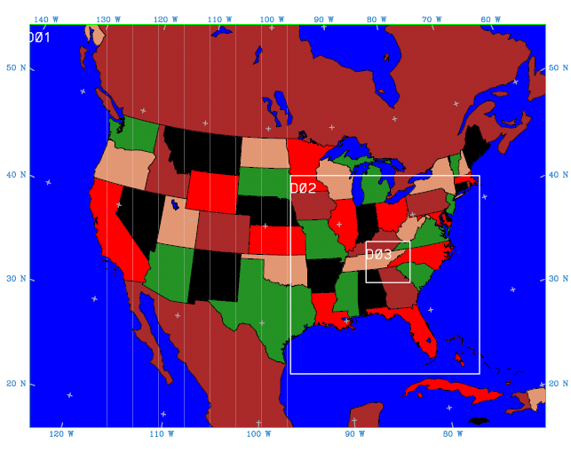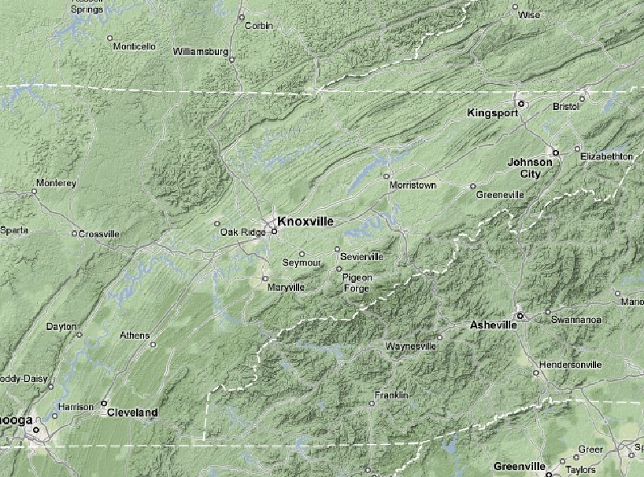

Valley Sites
Mountain Sites

Figure-7. The VISTAS’s 36 (D01) and 12km (D02) domains and nested 4km (D03) domain for the East Tennessee and total seven monitor sites for valley sites (Anderson, Mildred, Rutledge, Jefferson) and for mountain sites (Look Rock, Cove Mt., and Clingman’s Dome) observed in East Tennessee

METEOROLOGICAL CONFIGURATIONS

The 36 and 12km model domains had 34 layers, performed with PX PBL scheme, Kain-Fritsch2 (KF2) cloud scheme, RRTM radiation scheme, and mixed phase microphysics scheme in the current VISTAS’s model configuration. The 4-km grid resolution has 127 by 118 grids with 34 layers in MM5. The MM5 model is in Lambert conformal projection with true latitudes at 33° N and 45° N. The 4-km grid domain also performs with Kain-Fritsch2 (KF2) cloud scheme, RRTM radiation scheme, and mixed phase microphysics scheme, the same as 36-km and 12-km domains. The INTERPPX is a new preprocessor used to initialize soil moisture, temperature, and canopy moisture from a previous run and after NESTDOWN (Pleim and Chang, 1992). This method is known as a soil moisture nudging option and only applied for PX model. The PX model is generally known that it produces poorly forecasted precipitation due to the soil moisture.
Using the PX model with or without the soil moisture option is likely to impact the skill of the MM5 model. Hence, we need to test the PX model with INTERPPX and without INTERPPX for the purpose of this study. The NESTDOWN is used to generate inputs for finer grid resolution MM5 run from the coarser resolution MM5 output. One-way NESTDOWN method is selected to generate inputs for the 4-km grid resolution MM5 run. This takes output from MM5 run, together with TERRAIN output for a 4-km grid domain. Table-2 shows the PBL scheme coupled with LSMs scheme used for sensitivity test.

Table-2. PBL schemes coupled with LSMs schemes used for sensitivity test

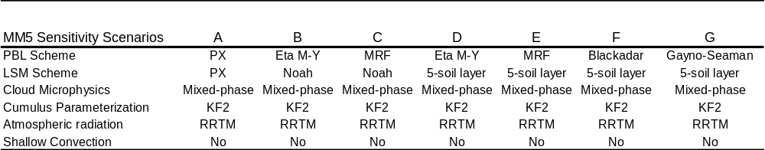

  - DESCRIPTION OF THE EMISSION MODELING

The SMOKE (Sparse Matrix Operator Kernel Emissions) modeling Version 2.1 is used to generate emissions for CMAQ required as inputs for the month of August. For the base case, all source categories are included and are as follows: area, area-fire, fire, EGU (Electric Generating Unit), NEGU (Non-Electric Generating Unit), on-road, non-road and marine emissions. These emissions data are obtained from VISTAS 2002 Base G typical emissions (See http://www.vistas-sesarm.org/). It is necessary to generate biogenic emissions using BELD3 (Biogenic Emissions Landuse Database Version 3) data to the 4-km grid resolution. SMOKE is produced to use the Biogenic Emission Inventory System Version 3.09 to generate the biogenic components for each sensitivity simulation.
For on-road, point combined EGU, NEGU and fire emissions, and biogenic sources, the emissions should be rerun by SMOKE because these source emissions are changed by meteorology. That is, these three source categories require meteorological data as an input in SMOKE. For each sensitivity simulation, those three source categories are rerun by SMOKE and then combined by other source categories that had already been done for the base case. The SMOKE CB-IV speciation profiles are used for CMAQ species in this study. Table-3 shows the definition of vertical layer for MM5 and CMAQ models.

Table-3. Vertical Layer Definition for MM5 and CMAQ
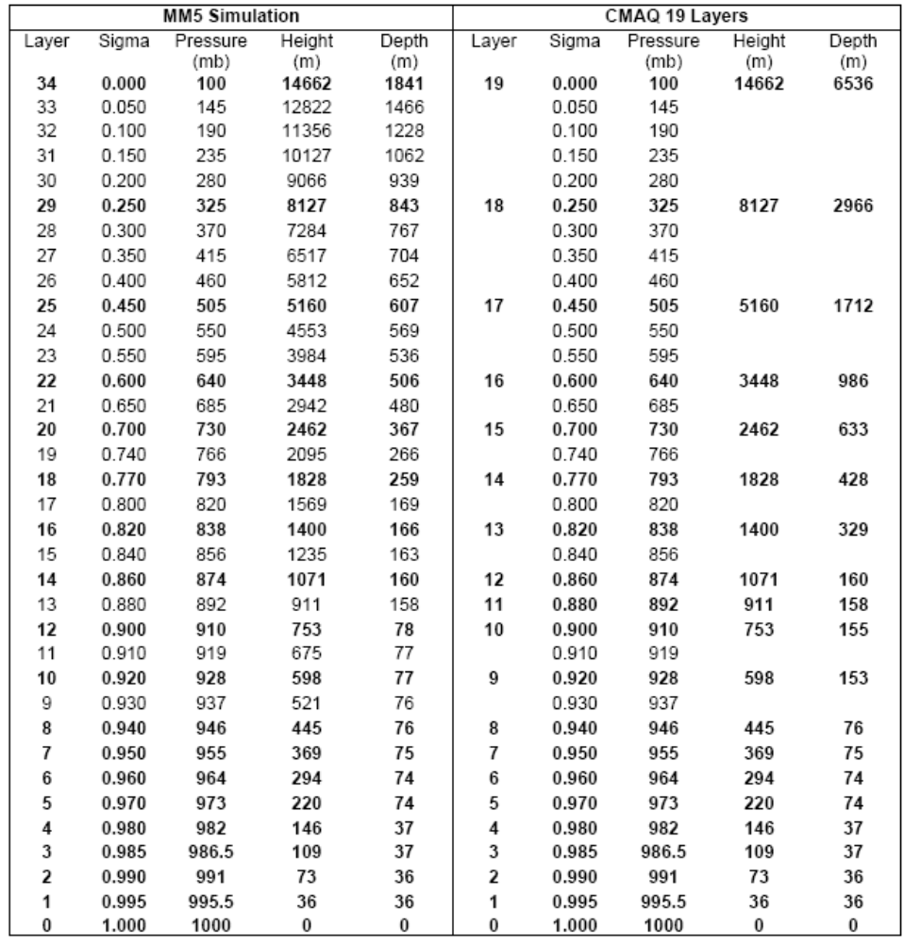

  - DESCRIPTION OF THE CMAQ MODELING

CMAQ Version 4.5 was used for the simulation in this study. The initial and boundary information of the 4-km grids is extracted from VISTAS’s 12-km grid resolution and obtained from VISTAS (VISTAS, 2004). Basically, the VISTAS’s 36- and 12-km grid resolutions are simulated on the PX scheme. The Carbon Bond-IV gas-phase chemistry mechanism, specifically cb4_ae4_aq mechanism, is selected for the ozone simulation. For all grid resolutions, 19 layers are utilized for SMOKE and CMAQ and then, the first layer (extended from the surface up to about 36m) is extracted for analysis of CMAQ. For the ozone SIPs modeling, the sizes of the array of nearby cells around each monitoring site for daily maximum 8-hr ozone values for the 4-km and 12-km grid resolutions are a 7 x 7 array and a 3 x 3 array, respectively, followed by the guidance. (EPA, 2007) Figure-8 shows the simplified flow chart for this study.

  - DESCRIPTION OF MODLEED ATTAINMENT TEST

For calculating the Relative Response Factors (RRFs) followed by the guidance, (EPA, 2007) we applied the modeled attainment test to seven monitoring sites in East Tennessee in the 4-km grid. The future year air quality for 2008 is computed as follows:

- Calculate the current design values (DVCs) from each monitoring site data. We calculate the DVCs at each site by using fourth highest daily

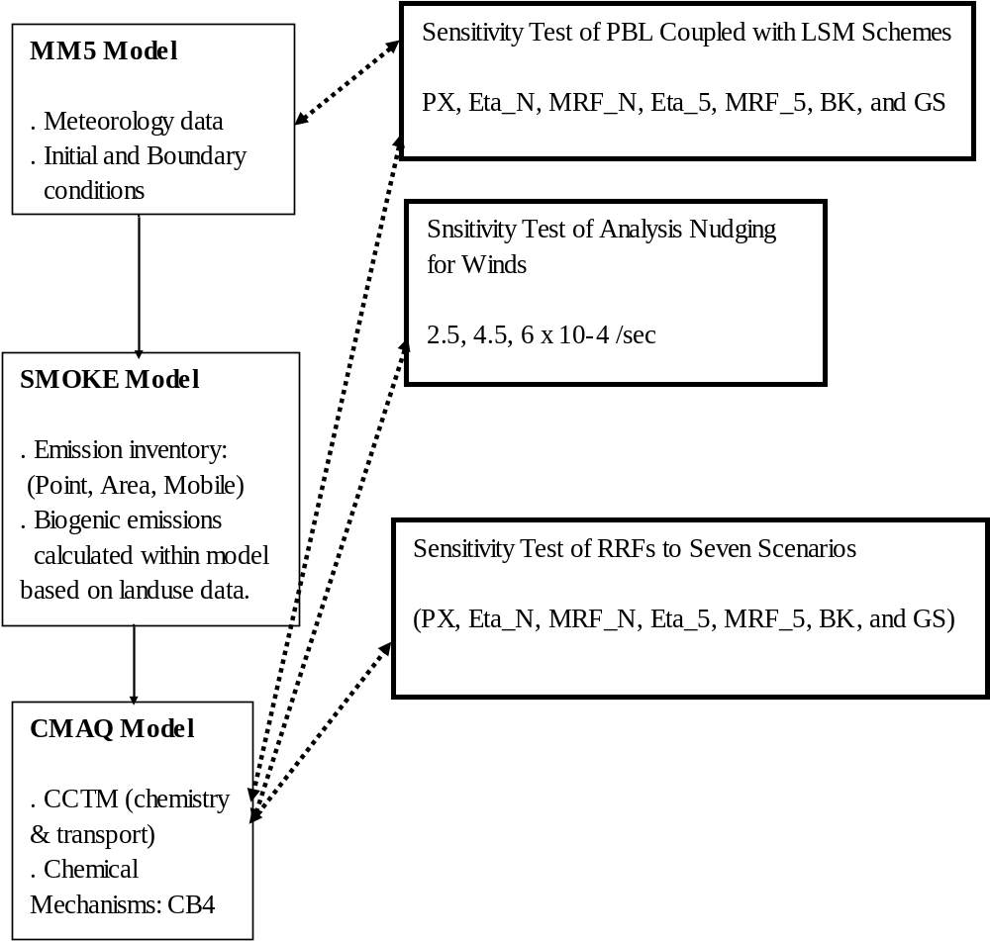

Figure-8. Simplified flowchart of this study

maximum 8-hr O3 concentration in each of three consecutive years
(2000 to 2005).
- Use air quality modeling results to estimate each monitoring site RRFs.
To do this, we need to determine surface grid cells that are considered
to be near monitoring site rather than just the cell containing the
monitor. The EPA guidance suggests that the size of the array of
nearby cells around each site varies for each grid resolution. For the 36-km resolution, it is a 1 x 1 array; for 12-km, a 3 x 3 array; and for 4-km, a 7 x 7 array. Then, calculate the daily maximum 8-hr O₃ concentration in every grid cell for each modeled day in the baseline. After that, find each day’s highest predicted daily maximum 8-hr O₃ concentration. Finally, compute the average of the highest values for all model days using only days when the highest is greater than 85 ppb to get a mean baseline value (BVs). For the future modeled values (FVs), repeat the above steps, using the same days to average in the future year calculation as are used in the baseline calculation.
- Calculate the RRFs using this equation; RRFs = mean FVs / mean BVs
- Compute DVFs (Future Design Values); DVFs = DVCs x RRFs

Compare all DVFs to 8-hr O₃ for NAAQS. If all the calculated DVFs are less than equal to 0.084 parts per million, the modeled attainment test has been passed and is set to be in attainment of 8-hr ozone NAAQS in the modeled future year.

RESULTS AND DISCUSSIONS
This chapter is revised based on a paper published and a paper submitted by Yunhee Kim, Joshua S. Fu, and Terry L. Miller:
Kim, Y., Fu, J.S., and Miller, T.L., 2009. Improving ozone modeling in complex terrain at a fine grid resolution: Part I – examination of analysis nudging and all PBL schemes associated with LSMs in meteorological model, Atmospheric Environment, 44 (4), pp.523-532
Kim, Y., Fu, J.S., and Miller, T.L., 2009. Improving ozone modeling in complex terrain at a fine grid resolution: Part II – Influence MM5 on Daily Maximum 8-hour Ozone Concentrations and RRFs (Relative Reduction Factors) for SIPs in the Nonattainment Areas, accepted in Atmospheric Environment.
My primary contributions to these papers include (i) development of the problem
into a work, (ii) identification of the study areas and objectives, (iii) design and
conducting of the simulations, (iv) gathering and reviewing literature, (v) processing,
analyzing and interpretation of simulation data, (vi) most of the writing.

The results are shown in three parts such as part I, part II, and part III. Part I presents the results from meteorological performance, part II focuses on the CMAQ model performance, and part III shows the results from model attainments using RRFs.

4.1 PART I
4.1.1 Statistics for meteorology to PBL schemes
The meteorological performance statistics of seven sensitivity simulations are shown in Table 4. The statistical measures of wind speed, wind direction, and temperature at the surface were calculated by METSTAT program (METSTAT, 2005). The METSTAT program reads predicted temperature at 2-m heights and predicted winds at 10-m heights (Louis, 1979). The observed temperature, wind speed, and wind direction at the valley, mountain sites, and entire 4-km domain (overall) was compared with predicted temperature, wind speed, and wind direction. The meteorological model performance statistics of all seven simulations were computed hourly and evaluated for mean bias (MB) and Root Mean Square Error (RMSE) with a benchmark of MB and RMSE. For the temperature, all schemes tend to over predict the surface temperature, as shown in the positive bias except sensitivity B (ETA M-Y PBL with Noah LSM) showed the lowest mean bias at valley sites. Sensitivity A (PX) showed the lower mean bias at overall and mountain sites while sensitivity G (5-layer soil model with Gayno-Seaman PBL) showed the over prediction with the higher mean bias at overall, valley, and mountain areas. The PX sensitivity simulation tends to predict better at overall and valley areas (except mountain areas) than other schemes. Especially, the PX model from 4-km grid resolution presents relatively smaller mean bias in predicting temperature than 12-km resolution. Because the interactions between surface characterization and PBL schemes are strongly associated, vertical transport is one of the most important keys of air quality modeling due to the boundary layer turbulence (Mao et al., 2006). Figures 9 through 11 show the
Table-4. Summary of the meteorological performance statistics of seven sensitivity simulations used in this study
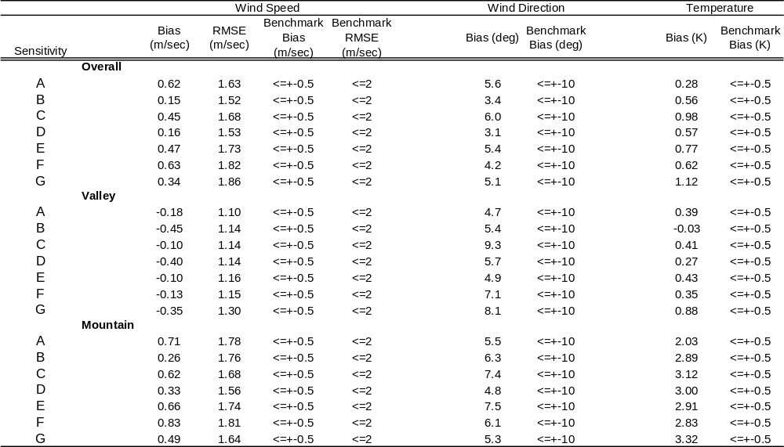

Figure-9. Mean Bias of MM5 for wind speed at 10m with 7 different sensitivity simulations for August in 2002
Overall Valley Mountain

Figure-10. RMSE of MM5 for Wind Speed at 10m with 7 different sensitivity simulations for August in 2002

Figure-11. Mean Bias of MM5 for Temperature at 2m with 7 different sensitivity simulations for August in 2002

mean bias of temperature at 2m and mean bias of wind speed at 10m for the overall domain of the study, valley, and mountain areas and RMSE (Root Mean Square Error) simulated by MM5 with 7 different sensitivity simulations (shown in Table 1) from 1 August through 31 August of Year 2002.
All seven sensitivity simulations for wind speed resulted in positive biases for overall and mountain sites except for valley sites where negative biases were shown. Interestingly, sensitivity B (ETA M-Y PBL with Noah LSM) and D (ETA M-Y PBL with 5-layer soil model), A (PX with PX LSM) and F (Blackadar with 5-layer soil model), and C (MRF PBL with Noah LSM) and E (MRF PBL with 5-layer soil model) show similar results for wind speed due to the same PBL scheme used with different LSM. This means that the PBL scheme selected, influences the meteorological fields more than LSM. Only sensitivity simulation B, D, and G can meet the benchmark of bias (0.5 m/sec) for wind speed at the whole domain (overall), valley, and mountain sites. The ETAM-Y PBL schemes with Noah LSM and 5-layer soil model show the lowest bias and RMSE for wind speed. For the wind direction, all seven sensitivity simulations meet the benchmark of bias, which is 10 degree in bias. However, as indicated in Han et al, 2008, (Han et al., 2008) the comparison for wind direction might be unreasonable due to the wind direction is a vector while in order to compare with observed values, it is a scalar, thus when wind direction is around is 0° or 360°.
It is noteworthy that the PX scheme (A) used primarily in the Southeast US (VISTAS, 2004), does not always give good meteorological model performance. When even comparing 12-km grid resolution to sensitivity simulations at 4-km grid resolution used PX scheme in order to study the impact of grid resolution on meteorological fields, as seen in Figure 9-11, the PX simulation at 4-km grid resolution for wind speed in bias shows over prediction at mountain areas whereas 12-km grid simulation present many under predictions. At valley areas, both of 4-km and 12-km grid resolution, generally show for wind speeds good model performance with small mean bias (-0.18 and -0.07 m/sec, respectively) even though 4-km grid resolution give much lower RMSE (Root Mean Square Error) with 1.1 m/sec than that of 12km grid resolution with 1.42 m/sec. Overall (valley and mountain areas), the impact of grid resolutions on meteorological variations in our local area is also not showing a significant difference, as indicated in Cohan et al., 2006 and Wu et al., 2008.
Figures 12 and 13 show the diurnal variations in the PBL height with all seven sensitivity simulations modeled at valley and mountain sites on 5 August 2002, which was shown as one of high ozone days. It is interesting that all sensitivity simulations show a similar variation pattern in PBL height during the daytime and nighttime at valley and mountain areas. Generally, as shown in Figures 12 and 13, all sensitivity simulations show higher in predicting PBL heights at valley areas during the daytime than at mountain areas. In particular, PX scheme (A) consistently produced the highest mixing depths while ETA M-Y PBL (B and D) and G-S (G) schemes showed relatively lower mixing depths than other simulations over the valley and mountain areas. With our attentions, these schemes (ETA M-Y and G-S schemes) consistently produced relatively lower mixing depths at any areas than other schemes, as found in Han et al, 2008. MRF PBL (C and E) scheme with Noah and 5-layer soil model looked similar in the mixing depths and ETA M-Y PBL scheme with Noah and 5-layer soil model looked similar as mentioned previously. Here, we can notice that the pattern of the PBL prediction from

Figure-12. Diurnal variations in the PBL height with seven scenarios at valley site on August 5, 2002 (EDT)

Figure-13. Diurnal variations in the PBL height with seven scenarios at mountain site on August 5, 2002 (EDT)

the TKE PBL schemes such as ETA M-Y (B and D) and G-S (G) are alike while that of the non-local schemes such as PX (A) and MRF (C and E) are similar. As indicated in Han et al., 2008, the PBL schemes are more associated with the PBL height prediction. Based on the results of the above analyses, the TKE scheme (B, D, and G) shows better model performance while the non-local scheme (A, C, E, and F) shows somewhat poor model performance in our study area. It is noted that the TKE schemes compute the mixing depths using the turbulent energy of the surface mixing layer (depending on the situation of convection) whereas Blackadar and PX schemes predict the PBL heights from potential temporal profile. Additionally, the mixing height in MRF scheme is determined by a critical bulk Richardson number at the top of PBL and near surface (Perez et al., 2006), resulting in considerable difference in PBL height computation.

4.1.2 Statistics for meteorology to nudging analysis

MM5 has two nudging methods that can be used commonly for improving meteorological variables such as winds, temperature, and mixing ratio. One is for gridded analysis and the other one is observational nudging. The gridded analysis nudging method defines adding an artificial forcing term to the model equation based on the difference between the observed state and the model state weighed by nudging coefficients (Stauffer and Seaman, 1994; Stauffer et al., 1991). FDDA analysis nudging was used for both 3D and surface fields in all sensitivity MM5 simulations. FDDA analysis nudging in MM5 is applied to winds, temperature, and mixing ratio. It supports air quality studies and has been of greater benefit to these variables (Mao et al., 2006). In this study, 2.5 x 10⁻⁴, 4.5 x 10⁻⁴, and 6.0 x 10⁻⁴ per second for wind nudging coefficients were applied for 3D and surface fields and 2.5 x 10⁻⁴ for temperature and 1.0 x 10⁻⁵ per second for mixing ratio were used in 3D and surface fields to improve wind speed.
Figures 14 to 16 show the results from MM5 using three different nudging coefficients (2.5, 4.5, and 6.0 x 10⁻⁴ per second) over seven sensitivity simulations at the whole domain, valley, and mountain areas. As increased with nudging coefficients for winds in MM5, wind speeds were decreased gradually at valley and mountain areas. All seven sensitivity simulations with three different nudging coefficients showed improved wind speed in mean bias and RMSE and no significant difference in temperature. Sensitivity simulation B and D (ETA M-Y PBL scheme with Noah and 5-layer soil model) with 6.0 x 10⁻⁴ had the slowest wind speed and sensitivity simulation G (Gayno-Seaman PBL scheme) with 6.0 x 10⁻⁴ also showed the second slowest wind speed. As a result, using 6.0 x 10⁻⁴ per second for winds in MM5 is a good option to improve wind speed in complex terrain at a fine grid resolution.

Table 5 also shows the summary of meteorological model performance of statistics among all sensitivity simulations used with three different nudging coefficients or winds at 4-km grid resolution. As already mentioned above, these TKE PBL schemes (sensitivity B, D, and G) with high nudging coefficient (6 x 10⁻⁴ per second) for winds produce better model performance of MM5 in statistics for wind speed with smaller mean bias than with other nudging coefficients. It can be explained due to the addition of artificial forcing terms to the model equation. Only PX (A) simulation with three

Figure-14. Plots of bias for wind speed on seven scenario simulations with three different nudging coefficients (a (2.5), b (4.5), and c (6 x 10⁻⁴ /sec)) at the whole domain, valley, and mountain areas

Figure-15. Plots of RMSE for wind speed on seven scenario simulations with three different nudging coefficients (a (2.5), b (4.5), and c (6 x 10⁻⁴ /sec)) at the whole domain, valley, and mountain areas

Figure-16. Plots of Bias for temperature on seven scenario simulations with three different nudging coefficients (a (2.5), b (4.5), and c (6 x 10⁻⁴ /sec)) at the whole domain, valley, and mountain area

nudging coefficients for winds meet the benchmark of bias for temperature at overall areas, however, all sensitivity simulations with the three nudging coefficients [except G-S (G) simulation] reach the biases of temperature and wind speeds at valley sites. At mountain areas, only the TKE schemes with increased nudging coefficients for winds are
somewhat superior to other schemes in predicting wind speeds. Instead, none of the schemes meets the benchmark of temperature. Obviously, all sensitivity simulations for the model performance of meteorology at valley sites yield better model performance with mean bias and RMSE than at mountain. With the view of overall points, modelers should be able to choose optimally with good agreement of model performance at any area. Therefore, these TKE PBL schemes at 4-km grid resolution generally predicted better at overall, valley, and mountain areas than other grid resolution in our results.

Table-5. Summary of meteorological model performance statistics derived from the CMAQ simulations with three different nudging coefficients for wind speeds at overall, valley, and mountain areas.
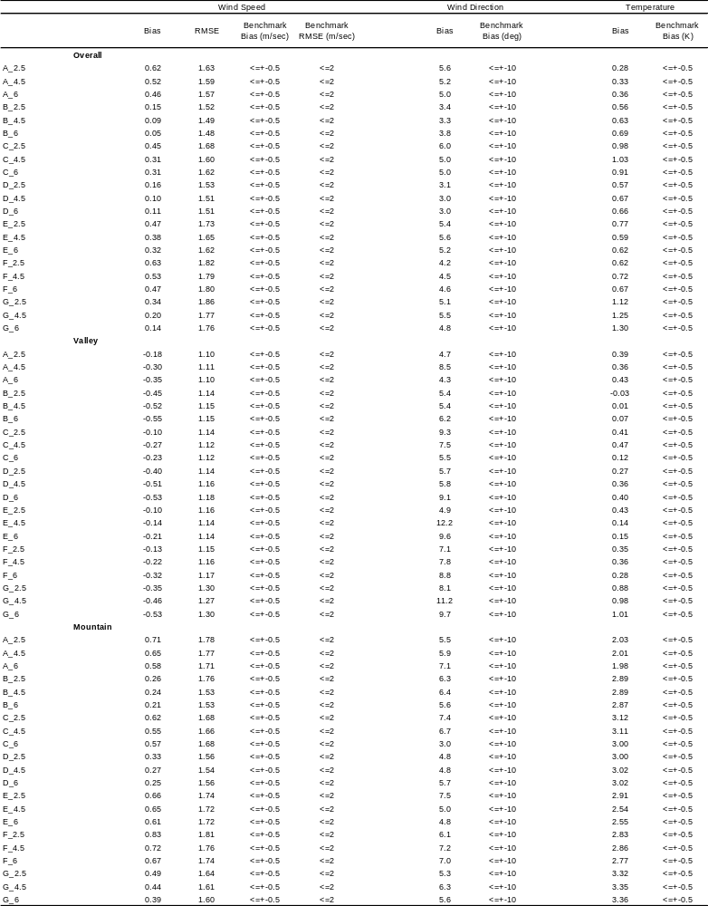

4.2 PART II

4.2.1 Influence daily Maximum 8-hour ozone concentrations from CMAQ on all seven sensitivity simulations using default coefficients for winds

The NME (Normalized Mean Error), NMB (Normalized Mean Bias), MB (Mean Bias), UPA (Unpaired Peak Accuracy), and skill score were adopted to analyze the evaluation of CMAQ model performance from all seven sensitivity simulations for the whole month of August in 2002 at the 4-km domain at overall, valley, and mountain sites. A variety of statistical measures have been used to evaluate the model performance of air quality (Hogrefe et al., 2004; Tong and Mauzerall, 2006). Our evaluation focuses on the impact of meteorological fields such as winds, temperature, and PBL height on CMAQ for daily maximum 8-hour ozone concentration at the surface. Statistical measures listed in Table 6 have been commonly and widely used in recent regional air quality model evaluations. Additionally, Mao et al., (2006) introduced the skill score using the equation based on RMSE (Root Mean Square Error), ABGE (Absolute Bias Gross Error) and MB (Mean Bias). The best model performance corresponds to high skill score. This skill score is formed to further enhance the assessment on model performance analysis (Mao et al., 2006). We therefore adopted this skill score to assess the model performance analysis of air quality on various meteorological sensitivities. Model performance was
calculated by the above statistics for the whole domain, valley, and mountain sites. Table 7 shows the summary of August 2002 CMAQ model performance statistics for daily
Table-6. Definition of statistical measures used in this study

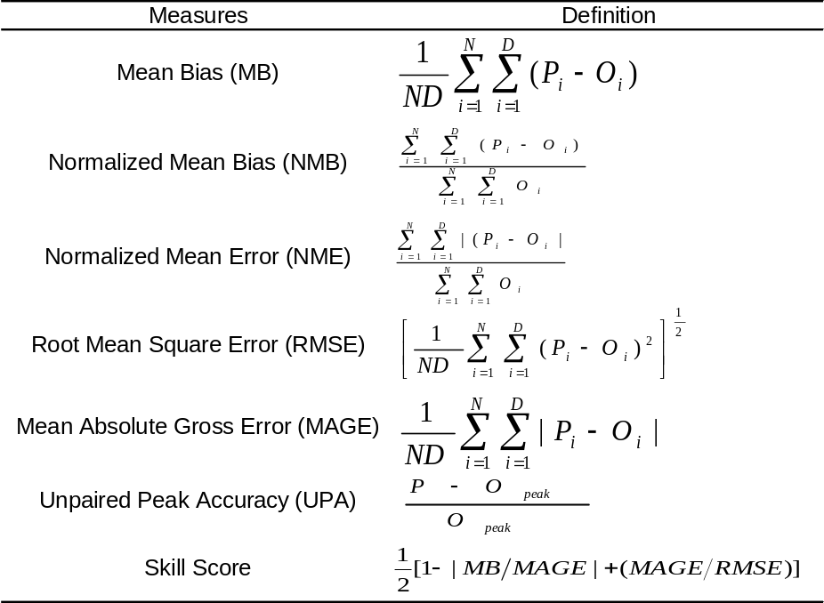

Table-7. Summary of August 2002 CMAQ model performance statistics for daily maximum 8-hour ozone concentrations
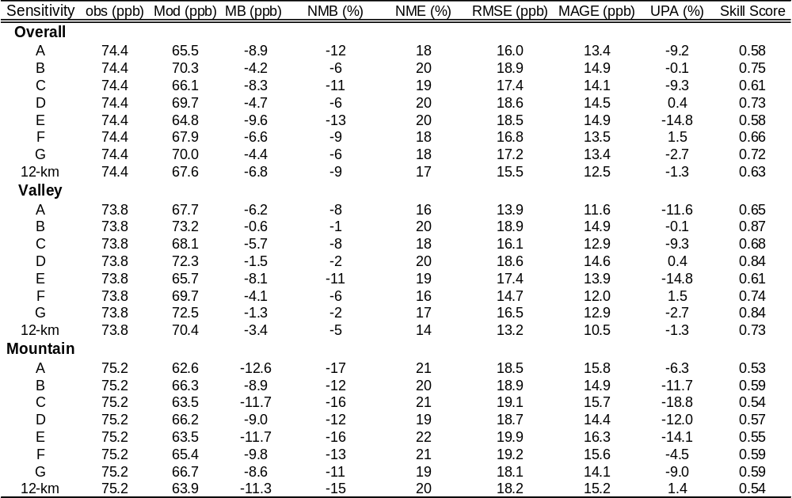

maximum 8-hour ozone concentrations at the 4-km domain (overall), valley, and mountain sites. All seven sensitivity simulations (using default coefficients for winds) under predict daily maximum 8-hour ozone concentrations at all areas. In particular, the difference between observed and predicted O₃ was much larger at mountain sites than valley sites, corresponding to the meteorological conditions at valley sites are smaller in biases of winds and temperature than those of mountain sites.
Air quality performance of the PX scheme (A) which has been used primarily in the Southeast US (VISTAS, 2004) showed the poorest statistical model performance with -12%, -8.3%, and -16.8% for NMB, with -8.9 ppb, -6.2 ppb, and -12.6 ppb for MB, with 0.58, 0.65, and 0.53 for skill score at the entire domain (overall), valley, and mountain sites, respectively at a 4-km grid resolution due to the poor meteorological performance. Furthermore, the CMAQ performance on PX scheme, showed quite high wind speeds with MB of 0.71 m/sec and relatively lowest MB of temperature at mountain sites presented the largest MB of -12.6 ppb, the lowest skill score of 0.53, and the exceeded NMB of -17 % over the values of ±5-15% suggested by US EPA, indicating again that the PX scheme is not an appropriate choice in predicting daily maximum 8-hr ozone concentration in the complex terrain having mountain and valley areas for SIPs modeling. However, the NME ranges from 14 % to 16 % for the PX simulation at both grid resolutions with regard to relatively lower RMSE (root mean square error) varying from 10.5 ppb to 11.6 ppb at valley sites when compared to other sensitivity simulations. This seems to suggest that the PX scheme is a better choice in simulating in a valley area. Additionally, the CMAQ results from 12-km grid resolution (PX) and 4-km grid resolution for PX scheme (A) also do not show significantly in difference even though the outputs from CMAQ at 12-km grid resolution give slightly better in statistical model performance than 4-km grid resolution like the results from the meteorological performance for PX.
CMAQ performance was quite consistent with the results of MM5. This means that accurate meteorological fields predicted in MM5 as an input resulted in good model performance of CMAQ. Overall, sensitivity B (ETA M-Y with Noah LSMs) had the best skill scores at overall, valley, and mountain sites while sensitivity E (MRF with 5-soil layers) generally showed the worst statistics in our study area. Sensitivity G (G-S PBL) also presented the good model performance of CMAQ with the lowest MB (Mean Bias) for 8.6 ppb, NMB (Normalized Mean Bias) for –11.4 %, NME (Normalized Mean error) for 18.8 %, and MAGE (Mean Absolute Gross Error) for 14.1 ppb at mountain areas.
Sensitivity simulation B (ETA M-Y with Noah LSMs) and D (ETA M-Y with 5-soil layers) presented similar CMAQ performance statistics for daily maximum 8-hour ozone concentration. The CMAQ model performance statistics of sensitivity simulation B and D, sensitivity simulation D and E, and sensitivity simulation A (PX) and F (Blackadar) achieved similar results. We can notice here that the difference between sensitivity simulation B and D, sensitivity simulation C and E, and sensitivity simulation A and F was simulated by only different land surface model (LSM) in MM5, indicating PBL schemes are more dominant than LSM at predicting daily maximum 8-hour ozone concentration due to the meteorological input variables. As a result, we found in our study that the Noah land surface model showed the slightly better model performance of CMAQ than 5-layer soil model when compared with the same PBL scheme on different LSM while PX LSM showed the relatively poor model performance of CMAQ when compared to Blackadar PBL scheme on 5-layer soil model. It also consistently shows the same results as Han et al., (2008) demonstrating that the PX and Noah LSMs provide more realistic moisture process in soil moisture. Furthermore, the TKE (sensitivity simulation B, D, and G) schemes also presented better CMAQ model performance than that of non-local PBL schemes (sensitivity A, C, E, and F) as mentioned in meteorological statistics model performance. Therefore, it is noteworthy that the TKE schemes are better options to predict ozone concentrations in the complex terrain.
The difference in CMAQ statistical analysis for daily maximum 8-hour ozone at overall of domain, valley, and mountain sites, respectively was 5.4ppb, 7.5ppb, and 4ppb for MB, 6.4%, 10.1%, and 5.4% for NMB, 2%, 4.5%, and 2.8% for NME, 2.9ppb, 5ppb, and 1.8ppb for RMSE, 1.5ppb, 3.3ppb, and 2.2ppb for MAGE, 14.7%, 14.7%, and 14.3 % for UPA, 0.17, 0.26, and 0.06 for skill score. These differences were bigger at valley than mountain areas. This suggests that the MM5 PBL schemes had significant impacts on the performance of CMAQ at valley areas while it had little effect at mountain areas. Based on our results, it is found that the MM5 PBL schemes had significant influences on CMAQ model performance, eventually resulting in determining attainment status for ozone SIPs. This yields totally opposite results from Mao et al, 2006 showing that no significant CMAQ sensitivity to any PBL schemes was observed. The results presented above indicated that the sensitivity B, D, and G were identified for favorite PBL schemes in complex terrain having valley and mountain areas at a finer grid resolution.

4.2.2 Influence daily Maximum 8-hour ozone concentrations on seven sensitivity simulations using three different nudging coefficients for winds

FDDA analysis nudging was used for both the surface and the 3D fields in all of the MM5 simulations. Three different nudging coefficients of 2.5, 4.5 and 6.0 x 10⁻⁴ per second (in FDDA analysis nudging with winds) were applied for all seven sensitivity simulations. A total of 21 runs were examined in this study. Figures 17 through 20 show NMB, NME, UPA, and skill score from 2002 August CMAQ sensitivity statistics
performance with three different nudging coefficients for winds (a, b, and c, respectively) in daily maximum 8-hour ozone concentrations. Table 8 also presents the summary of performance statistics derived from the 21 CMAQ simulations with three different
nudging coefficients for winds (2.5, 4.5. 6.0 x 10⁻⁴ per second) at overall, valley, and mountain sites in August 2002.
The MAGE ranges from 12.7 ppb for A_c (PX with 6 x 10⁻⁴) to 15.2 ppb for B_b (ETA M-Y on Noah with 4.5 x 10⁻⁴) at the entire domain of 4-km resolution. It ranges from 11.1 ppb for A_c to 15.7 ppb for B_c (ETA M-Y on Noah with 6.0 x 10⁻⁴) at valley and 13.6 ppb for G_c (G-S with 6 x 10⁻⁴) to 16.3 ppb for E_a (MRF on 5-layer soil model with 2.5 x 10⁻⁴) at mountain areas. This error has strong relationships with the RMSE (Root Mean Square Error) varying from 15.6 ppb for A_c, 13.6 ppb for A_c, and 17.6 ppb for G_c to 19.3 ppb for B_b, 19.6 ppb for B_c, and 19.9 ppb for E_a as well as NME varies from 17.1 % for A_c, 15 % for A_c, and 18.1 % for G_c to 20.4 % for B_b,

Figure-17. NMB (Normalized Mean Bias) of daily Maximum 8-hour Ozone Concentration in August 2002 at overall, valley, and mountain areas

Figure-18. NME (Normalized Mean Error) of daily Maximum 8-hour Ozone Concentration in August 2002 at overall, valley, and mountain areas

Figure-19. UPA (Unpaired Peak Accuracy) of daily Maximum 8-hour Ozone Concentration in August 2002 at overall, valley, and mountain areas

Figure-20. Skill Score of daily Maximum 8-hour Ozone Concentration in August 2002 at overall, valley, and mountain area

Table-8. Summary of performance statistics derived from the CMAQ simulations with three different nudging coefficients at overall, valley, and mountain areas in August 2002.
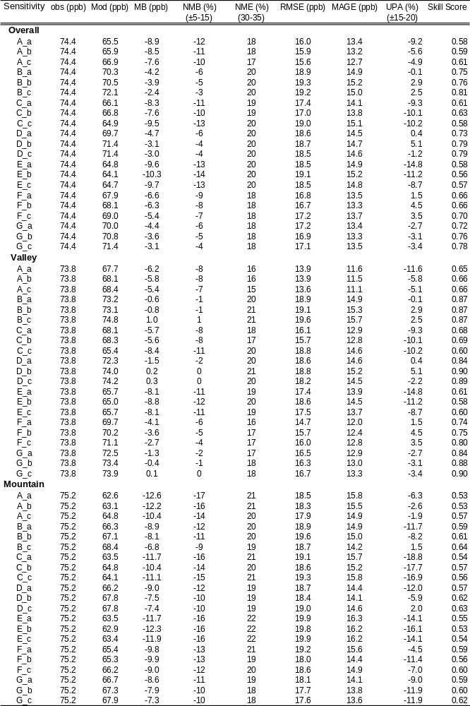

21.2 % for B_c, and 21.6 % for E_a at the entire domain (overall), valley, and mountain sites, respectively. The MB and the NNoah LSM with 6.0 x 10⁻⁴ per second), D_b (MRF PBL on 5-layer soil model with 4.5 x 10⁻⁴ per second), D_c (MRF PBL on 5-layer soil model with 6.0 x 10⁻⁴ per second), and G_c (Gayno-Seaman PBL on 5-layer soil model with 6.0 x 10⁻⁴ per second) at valley sites.
It indicates that CMAQ generally underestimates surface daily maximum 8-hour O_{3.} And this also indicates that CMAQ model performance shows better at valley sites than mountain sites showing underestimates with a larger bias. The results presented above suggest that using the FDDA nudging analysis for winds with the strongest value (6.0 x 10⁻⁴ per second) generally affected CMAQ performance significantly and improved statistics model performance.
US EPA has recommended that criteria for regulatory modeling are ±5 to 15% for NMB, 30-35% for NME, ±15 to ±20% for UPA (Russell and Dennis, 2000). The criteria are met at overall and valley sites except mountain sites. At mountain areas, PX PBL scheme with 2.5 and 4.5 x 10⁻⁴ per second (nudging coefficients for winds), MRF PBL scheme with 2.5 x 10⁻⁴ on Noah LSM and MRF PBL scheme with 2.5, 4.5, and 6.0 x 10⁻⁴ on 5-layer soil model are not met by the criteria for NMB indicating the larger differences between observed and predicted mean biases. Our results demonstrate that Noah ETA M-Y PBL with 6.0 x 10⁻⁴ (B_c), 5-layer ETA PBL with 6.0 x 10⁻⁴ (D_c), and Gayno-Seaman with 6.0 x 10⁻⁴ (G_c) yielded the best CMAQ model performance for daily maximum 8-hour O₃ at overall, valley, and mountain sites. It means that applying nudging analysis using a strong coefficient value (6.0 x 10⁻⁴) for winds is helpful toMB are only positive for B_c (ETA M-Y PBL on improve CMAQ model performance at any site and also shows again that these PBL schemes are favorable options in the complex terrain at a finer grid resolution and identified. The PX, Blackadar (BK), and Gayno-Seaman (G-S) PBL schemes with increasing nudging coefficients for winds were affected greatly on CMAQ model performance while the ETA M-Y (ETA) and MRF PBL schemes had little impact on CMAQ simulations at overall, valley, and mountain sites. MRF PBL (sensitivities C and E) schemes presented the lowest skill score, highest UPA values, larger ME, and NMB consistently at all sites while ETA M-Y (sensitivity B and D) and G-S (sensitivity G) were consistent with observed data in magnitude as well as high skill score, smaller NMB, and UPA values at all sites. Since the TKE (sensitivity simulation B, D, and G) and non-local schemes (A, C, E, and F) had displayed similar patterns and results with MB, NMB, and skill score each other as shown in Table 6, these two schemes with increasing nudging coefficients for winds also presented slightly more improved results for statistical analysis of CMAQ than using with default (2.5 x 10⁻⁴ per second) nudging coefficients for winds. Hence, one can find an interesting fact indicating that the non-local scheme and TKE scheme have shown different results for statistical analysis due to the different methods in the diagnosis to predict the PBL height. From our results, the TKE schemes (ETA M-Y and G-S PBL schemes) with strong nudging coefficients (6 x 10⁻⁴/sec) for winds predicting vertical TKE (Turbulent Kinetic Energy) show better model performance with good agreement at all areas than that of non-local schemes (PX and MRF PBL schemes) with increasing nudging coefficients for winds.

4.3 PART III

4.3.1 Attainment demonstration

In the modeling conducted to estimate more appropriate DVF (Design Value for the Future year) and RRFs (Relative Reduction Factors) in the O₃ nonattainment areas in East Tennessee, we performed 120 days during typical summer seasons of 2002 and 2008 as a base-case year and a future-year, respectively, using MM5 from three sensitivity simulations (ETA PBL schemes associated with Noah LSMs and 5-layer soil model and Gayno-Seaman PBL scheme) with a strong value of nudging coefficient for winds (already evaluated in Part I), SMOKE, and CMAQ modeling system. We performed simulations from May 16 to September 12 including a 5-day spin-up period starting on May 11, 2002.
As a result of our extended CMAQ model performance, Figure 21 shows the normalized mean bias (NMB), the normalized mean error (NME), the skill score, and unpaired peak accuracy (UPA) for 8-hr O₃ computed on PX_c (PX with 6 x 10⁻⁴ per second) as a base case, ETA_N_c (ETA PBL on Noah LSM with 6 x 10⁻⁴ per second), ETA-5_c (ETA PBL on 5-layer soil model with 6 x 10⁻⁴ per second), G_c (Gayno-Seaman PBL with 6 x 10⁻⁴ per second), and 12-km grid resolution (PX) at overall, valley, and mountain sites in East Tennessee. The daily maximum 8-hr O₃ mean biases on the TKE schemes (ETA M-Y on Noah, 5-layer soil, and Gayno-Seaman PBL schemes) achieved for 120 days are positive at all sites except mountain areas while the PX at both of 12-km and 4-km grid resolutions shows negative values with a larger MB ranging from -1.3 ppb to -8.8 ppb at all areas. This overall negative mean bias on the PX simulation may suggest that the O₃ formation in the complex topography (particularly at mountain areas) is not sufficiently efficient.
As shown in Figure 22, all four sensitivity simulations (PX_c, ETA_N_c, ETA_5_c, and G-c) at 4-km grid resolution and the PX at 12-km grid resolution are well within the statistical measures of MNB and MNGE as a suite of metrics for evaluating
model performance. However, the TKE simulations at 4-km grid resolution generally show over predictions with the positive bias at overall and valley sites (except mountain areas) while the PX model at 12-km and 4-km grid resolution presents under predictions with negative bias at all areas (except valley areas). The statistical model performance from the PX at both of 12- and 4-km grid resolutions in the extended period (4-month

Figure-21. NMB (a), NME (b), skill score (c), and UPA (d) of daily maximum 8-hour ozone concentration at overall, valley, and mountain areas

Figure-22. Mean normalized bias (MNB (%)) (left) and mean normalized gross error (MNGE (%)) (right) for 8-hr O₃ at overall, valley, and mountain areas

period) at the valley also shows consistently lower MNB and MNGE than those of the TKE sensitivity simulations at 4-km grid resolution whereas it produces higher MNB and
MNGE at mountain areas as mentioned in part II. In addition, we also compared the observed 8-hr ozone concentrations using 60 ppb cutoff to 8-hr modeled ozone concentrations with 60 ppb cutoff, giving more precise evaluation of the model’s capability due to the closer predictions to the 8-hr NAAQS and decreasing model errors at low observations (USEPA, 1991). The MNB and MNGE using 60 ppb cutoff for 8-hr ozone computed from the TKE sensitivity simulations at 4-km grid resolution as well as the PX at 4-and 12-km grid simulation as shown in Figure 23 yielded relatively smaller bias and errors than the PX at both of grid resolutions, illustrating that the models simulated at 4-km grid resolution tend to produce much higher ozone formations at valley and mountain sites and generally show better model performance in comparison with higher observations than the PX sensitivity simulation. With the purpose of attainment demonstration, this result seems to be more helpful to evaluate the capability of the model and reduce model errors by predicting concentrations closer to the NAAQS.

Figure-23 Mean normalized bias (MNB (%)) (left) and mean normalized gross error (MNGE (%)) (right) using 60 ppb cutoffs for 8-hr O₃ at overall, valley, and mountain areas

Overall, the sensitivity simulation G_c (Gayno-Seaman PBL scheme with 6 x 10⁻⁴ per second) presents significantly small bias and errors among them for a 4-month period at all areas in the East Tennessee.

4.3.2 Modeling System for DVF (Design Values for future year) and RRFs (Relative Response Factors)

The US EPA has developed the guidance on how to prepare an 8-hr ozone attainment demonstration using air quality models. In this study, the DVCs (Current Design Values) were calculated based on the average annual, fourth highest, daily maximum 8-hr ozone concentration, measured from each monitoring site over a three consecutive year period from 2000 to 2005. The guide outlines a procedure to derive RRFs (Relative Response Factors) that are computed by calculating the ratio between base-case daily maximum 8-hr ozone concentrations and future-year modeled concentrations at each given monitor. The future-year design values (DVFs) are then calculated by multiplying the RRFs and the DVCs. Finally, the modeled attainment test is passed if the DVFs are less than and equal to 84 ppb (NAAQS for 8-hr O₃) at a given monitor. We performed future-year (DVFs) simulations for 2008 emissions that were
obtained from VISTAS (the Visibility Improvement State and Tribal Association of the Southeast).
To facilitate comparisons, Table 9 summarizes the results of the TKE sensitivity simulations (ETA_N_c, ETA_5_c, and G_c) at 4-km grid resolutions and the PX simulation at 12-and 4-km grid resolutions for RRFs and 2008 DVFs, and the corresponding DVCs at overall, valley, and mountain sites. The difference of RRFs between 12-km and 4-km grid size for the PX sensitivity simulation is shown as 1% at overall, 2% at valley, and 1% at mountain sites. These differences in RRFs correspond to DVFs differences on average 0.9 to 2.1 ppb between 12- and 4-km grid resolutions for the PX simulation at valley and mountain sites. These results are quite similar to the findings by Arunachalam et al., 2006; Jones et al., 2005 that presented the DVFs in differences estimating the RRFs uncertainties about 1-3 ppb in modeling options. It is noteworthy that the difference of the DVFs computed from the RRFs at mountain areas is generally smaller than at valley sites when comparing 12-km to 4-km outputs for the PX simulation due to the relatively poorer meteorological model performance of the PX sensitivity at mountain than valley sites, which indicates the sensitivity of the DVFs computed from RRFs to the meteorological conditions modeled. Even when comparing among these TKE sensitivity simulations (ETA_N_c, ETA_5_c, and G_c) at a 4-km grid resolution, the differences of DVFs based on RRFs are obvious. This seems to indicate again that estimating the RRFs and then DVFs at a given monitor site is dependent upon
Table-9. Summary of results of the TKE sensitivity simulations at 4-km grid resolution and PX at 12- and 4-km grid resolution for DVCs, RRF, and DVFs at overall, valley, and mountain areas
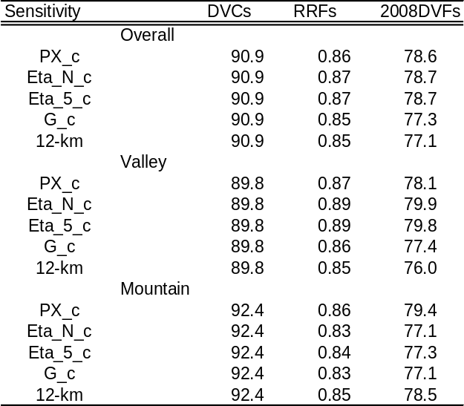

the meteorological model performance at a given grid resolution. Since the G_c (Gayno-Seaman with 6 x 10⁻⁴ per second for winds) sensitivity simulation produced quite good model performance in meteorological and CMAQ statistical analysis than other
sensitivity simulations, the RRFs and DVFs from G_c simulation also were computed with a consistent average value of 77.3 ppb.
Figure 24 shows the comparison of current design values (DVCs) with modeled base-case predictions for 8-hr O₃ at each area at the TKE sensitivity simulations at 4-km and the PX at 12- and 4-km grid resolutions. The DVCs computed were based on the average annual fourth highest daily maximum 8-hr ozone concentration, measured from each monitoring site, over three consecutive years, during the period from 2000 to 2005 are related to the modeled values for 2002 in order to calculate the DVFs computed from RRFs at each monitoring site. As presented in Fig. 8, daily maximum 8-hr ozone

Figure-24. Comparison of DVCs with base-case modeled O₃ for the TKE sensitivity simulations at 4-km and PX at 12- and 4-km grid resolutions at overall, valley, and mountain areas

predictions modeled from the TKE sensitivity simulations of 4-km grid resolution at valley (except PX simulation at 12- and 4-km grid resolutions) tend to over predict whereas all sensitivity simulations including 12-km grid resolution always have
tendencies to under predict at mountain. Specifically, the PX sensitivity simulation shows more under prediction with larger differences at mountain and the ETA_N_c and ETA_5_c simulations present over predictions at valley, resulting in higher DVFs and RRFs. Hence, it is believed that computing RRFs and then DVFs are dependent upon how well the modeling predicts at a given monitoring site.
As reported in Jones et al., 2005, RRFs differences may give opposite answers to determine if DVFs is met 8-hr NAAQS or not. Based on our results, the 2008 DVFs at all areas for all sensitivity simulations (including 12-km grid resolution) all met the 8-hr NAAQS. In this study, we found that the result of model performance is affected by estimating RRFs for attainment demonstration, indicating that it is necessary to improve model performance. As a result, G_c (Gayo-Seaman PBL scheme) sensitivity simulation predicts daily maximum 8-hr ozone concentration closer to observations at all areas during typical summer period from May to September and provides consistently low DVFs at valley and mountain areas than other simulations.

SUMMARY AND CONCLUSION
This chapter is revised based on a paper published and a paper submitted by Yunhee Kim, Joshua S. Fu, and Terry L. Miller:
Kim, Y., Fu, J.S., and Miller, T.L., 2009. Improving ozone modeling in complex terrain at a fine grid resolution: Part I – examination of analysis nudging and all PBL schemes associated with LSMs in meteorological model, Atmospheric Environment, 44 (4), pp.523-532
Kim, Y., Fu, J.S., and Miller, T.L., 2009. Improving ozone modeling in complex terrain at a fine grid resolution: Part II – Influence MM5 on Daily Maximum 8-hour Ozone Concentrations and RRFs (Relative Reduction Factors) for SIPs in the Nonattainment Areas, accepted in Atmospheric Environment.
My primary contributions to these papers include (i) development of the problem
into a work, (ii) identification of the study areas and objectives, (iii) design and
conducting of the simulations, (iv) gathering and reviewing literature, (v) processing,
analyzing and interpretation of simulation data, (vi) most of the writing.

PART I

Twenty-one sensitivity simulations were conducted over a 31-day period of August 2002 to various PBL schemes with three different LSM and three different nudging coefficients for winds used in MM5 in the complex terrain at a 4-km grid resolution. We evaluated the model performance to show which PBL schemes associated with LSMs are favorite options in the complex terrain and determined the best nudging coefficients for winds to use in MM5 at a 4-km grid resolution.
The meteorological model performance statistics of all seven simulations were computed hourly and evaluated for bias and RMSE with benchmark of mean bias and RMSE. All seven sensitivity simulations at 4-km grid resolution tend to under predict the wind speed at valley sites and over predict it at mountain sites. For temperature, all simulations overestimate except sensitivity B (Noah LSM with ETA PBL) at all areas. Sensitivity A (PX) showed the lowest bias for temperature at overall and mountain sites while sensitivity G (5-layer soil model with Gayno-Seaman PBL) showed the over prediction with the highest bias at all locations, making higher mixing height estimation due to the warmer surface temperature. Planetary boundary layers (PBL) have a critical parameter for air quality simulations (Byun et al., 2007; Perez et al., 2006; Queen and Zhang, 2008; Zhang et al., 2006). The MRF and PX are non-local schemes while ETA and G-S are local vertical TKE schemes. Our MM5 results present that sensitivity simulation B (ETA PBL with Noah LSMs), D (ETA PBL with 5-layer soil), and G (G-S PBL with 5-layer soil) called the TKE PBL schemes produced better model performance for winds than non-local schemes (sensitivity PX and MRF). These local vertical TKE schemes (sensitivity B, D, and G) show more underestimation of wind speed than the other non-local schemes at all areas. The weaker winds in the local schemes can be explained by producing more O₃ formation at valley and mountain sites. In addition, these three local schemes also present the lowest PBL heights and highest surface temperatures, which produce an enhanced O₃ formation at valley and mountain sites. It indicates that predicting local TKE in PBL yields relatively better meteorological model performance than non-local scheme based on Rib number method in the complex terrain at 4-km grid resolution.
The results of nudging analysis for winds with three different increased coefficient values (2.5, 4.5, and 6.0 x 10⁻⁴ per second) over seven sensitivity simulations show that the meteorological model performance was enhanced slightly due to improved wind fields, indicating the FDDA nudging analysis can improve model performance considerably at 4-km grid resolution. More specifically, the sensitivity simulations with the highest coefficient value (6.0 x 10^{–4}) generally gave more substantial improvements than with the other values (2.5 and 4.5 x 10⁻⁴).
Comparing the 12-km grid resolution to 4-km grid resolution in PX simulation in the meteorological model performance of statistics, there was no significant difference. Generally speaking, PX simulation showed the tendencies to predict temperature well at most areas whereas Blackadar simulation had tendencies to present very poor model performance with large bias of wind speeds at mountain areas. We also found that the PX sensitivity simulation recommended by USEPA did not produce optimal meteorological conditions in our study area. As previously mentioned in the Introduction, ozone SIPs modeling, unlike global or regional modeling, should be more focused on local areas to observe the actual atmospheric structure and evaluate the control strategy for O₃. We also noticed that it is very important to find appropriate PBL schemes associated with direct influence on meteorological conditions at local areas of interest for ozone SIPs in a finer grid resolution due to the dependence on MM5 as inputs into the air quality model (e.g., CMAQ). Based on our results, the TKE PBL schemes (ETA PBL with Noah and 5-layer soil model and Gayno-Seaman PBL) on 4-km grid resolution gave significant contributions for SIPs modeling in the complex terrain areas with local perspective.

PART II

Our results show that all seven sensitivity simulations underestimated observed daily maximum 8-hour ozone concentrations at valley sites with MB ranging from –8.1ppb to –0.6ppb, NMB ranging from –11% to –1%, NME ranging from 16% to 20%, UPA ranging from –14.8% to 1.5%, and skill score ranging from 0.61 to 0.87 and also under predicted it at mountain areas with MB ranging from –12.6ppb to –8.6ppb, NMB ranging from –17% to –11%, NME ranging from 19% to 22% UPA ranging from –18.8% to –4.5%, and skill score ranging from 0.53 to 0.59. The CMAQ statistical performance across seven sensitivity simulations is quite consistent with the results of MM5 performance, indicating that accurate meteorological fields predicted in MM5 as an input resulted in good model performance of CMAQ. As previously mentioned in the meteorological analysis, sensitivity B (ETA PBL with Noah LSMs), D (ETA PBL with 5-layer soil), and G (G-S PBL with 5-layer soil) from the results of CMAQ showed better model performance than other sensitivity simulations. This supports the idea that the meteorological fields such as wind speed, temperature, and PBL heights as inputs have critical impacts on air quality modeling. In this study, PBL scheme plays a more important role than its land surface models (LSMs) for the model performance of CMAQ.
Assessment of CMAQ results with nudging analysis showed that the sensitivity simulations that used the strongest nudging coefficient value (6.0 x 10⁻⁴) showed slightly better model performance than those of lower values, indicating that it is helpful to improve CMAQ model performance at any area and also shows that using the highest value of nudging coefficient for winds might be a good choice in the complex terrain at a finer grid resolution. For regulatory modeling, the criteria suggested by US EPA are met except sensitivity A (PX), C (MRF PBL with Noah LSMs), and E (MRF PBL with 5-soil layer model) used nudging coefficient of 2.5 and 4.5 x 10⁻⁴ at mountain sites. However, these sensitivity simulations used with nudging coefficients of 6.0 x 10⁻⁴ are met by the criteria for NMB, which is within ±5 to 15%.
The impacts of various PBL schemes associated with three different LSMs (Land Surface Models) and FDDA nudging analysis for winds in MM5 as inputs for the complex terrain at a 4-km grid resolution have been investigated for daily maximum 8-hour ozone. As a result, we found that the ETA M-Y PBL scheme associated with Noah LSMs and G-S (Gayno-Seaman) PBL schemes were identified as favorite PBL schemes as well as 6.0 x 10⁻⁴ of the nudging coefficient for winds was the best option to improve wind fields in MM5. Because these ETA M-Y and G-S PBL schemes tend to predict higher temperature, lower mixing height, and lower wind speeds in the area of study, they promote O₃ formation and improve the statistical results at all locations.

  - PART II

We also simulated for attainment test for 120 days with three sensitivity simulations selected from the CMAQ results for 4-km grid resolution. The MNB and MNGE using 60 ppb cutoff for 8-hr ozone computed from the TKE sensitivity simulations at 4-km grid resolution yielded relatively smaller bias and errors than the PX at 12- and 4-km grid resolutions, illustrating that the TKE models simulated at 4-km grid resolution tend to produce much higher ozone formations at valley and mountain sites and show generally better model performance in comparison with higher observations than PX at 12- and 4-km grid resolutions. However, the results from PX sensitivity simulation at both grid resolutions are generally produced by good model performance in CMAQ statistical analysis. This seems to suggest that the PX scheme is a better choice in simulating in a valley area. Additionally, no significant differences are shown to the grid size sensitivity between 12- and 4-km grid resolutions for the PX simulation in the CMAQ analysis. Based on our results, the sensitivity simulation G_c (Gayno-Seaman PBL scheme using 6.0 x 10⁻⁴ per sec) at 4-km grid resolution presents significantly small bias and errors among them for a 4-month period at all areas in East Tennessee.
As stated, the first objective of attainment test is to investigate the influence of the RRFs on grid size resolution and sensitivity in meteorological conditions used as an input into CMAQ. In our study, DVFs differences were shown with about 1-3 ppb among sensitivity simulations which may yield opposite responses in determining if the NAAQS for 8-hr is meet or not. Hence, it is believed that computing RRFs and then DVFs are depending on how well the modeling predicts at a given monitoring site that indicates the sensitivity of the DVFs computed from RRFs to meteorological condition modeled at a given monitoring area. Therefore, simulating on finer resolutions is necessary to evaluate and assess of CMAQ results giving more detailed representation of meteorological and chemical processes for O₃ SIPs modeling.
Overall, using RRFs and DVFs computed from G_c (Gayno-Seaman PBL scheme) at 4-km grid resolution may be appropriate options for the future attainment demonstrations because generally the G_c sensitivity simulation shows consistent model performance at most areas in the complex terrain having mountain and valley areas.

  - CONCLUSION

Meteorological variables such as temperature, wind speed, wind directions, and Planetary Boundary Layer (PBL) heights have critical implications for air quality simulations. CMAQ performance was quite consistent with the results of MM5, meaning that accurate meteorological fields predicted in MM5 as an input resulted in good model performance of CMAQ.
Based on our results, it is found that the MM5 PBL schemes had significant influences on CMAQ model performance, eventually resulting in determining attainment status for ozone SIPs. Our results indicated that the Sensitivities from Noah Eta (B), 5-layer Eta (D), and Gayno Seaman (G) were identified for favorite PBL schemes in complex terrain having valley and mountain areas at a finer grid resolution. It was also found that PX simulation did not always give optimal meteorological and CMAQ model performances at mountain sites. Furthermore, we found that the result of CMAQ model performance depending on meteorological variations was affected on estimating RRFs for attainment demonstration, indicating that it is necessary to improve model performance. Overall, G_c (Gayo-Seaman PBL scheme) using the coefficient for winds, 6 x 10⁻⁴ per second, sensitivity simulation predicts daily maximum 8-hr ozone concentration closer to observations during a typical summer period from May to September and provides generally low future design values (DVFs) at valley and mountain areas compared to other simulations.
Finally, a finer grid resolution was necessary to evaluate and access of CMAQ results for giving a detailed representation of meteorological and chemical processes in the regulatory modeling.

RECOMMENDATIONS FOR FUTURE WORKS

This research simulated the daily maximum 8-hr ozone concentrations for the East Tennessee having valley and mountain areas during typical summer time (May to September) for the ozone SIPs. This research has several limitations, and the following recommendations are made for further study.
First, the model performance generally depends on the temporal profiles, speciation, meteorological data, and inventory. All emission data including temporal and speciation data were obtained from the VISTAS (Visibility Improvement State and Tribal Association of the Southeast) for this research. Updated temporal profile and more detailed emission inventory could be incorporated in SMOKE to produce better temporal hourly emissions and concentrations of ozone at places close to monitors.
Second, SMOKE 2.1 and CMAQ 4.5 with CB-IV chemical mechanism were utilized in this study. SMOKE2.5 and CMAQ 4.6 which are recently updated with CB05 mechanism may produce better model performance. Since NOx and VOC are known as ozone precursors, recent version of SMOKE and CMAQ could give improved results.
Third, MM5 is a regional meteorological model requiring initial and boundary conditions for the nested domain. The boundary and initial condition data were taken from VISTAS’s 12-km grid domain. The VISTAS’s 12-km domain was based on PX PBL scheme. As you know that the outputs from the nested domain are affected by boundary and initial conditions, all sensitivity scenarios on 4-km grid domain were simulated and used the PX PBL scheme as boundary conditions. Hence, future research could produce more accurate results if each different PBL scheme on the coarser domain is used as boundary conditions.
Forth, this study focused on daily 8-hr ozone concentration in the East Tennessee during typical summer season. Future simulations could include PM_{2.5} and PM_{2.5} species to identify favorite PBL scheme on complex areas and simulate an entire year to identify better spatial and temporal variability. Additionally, this study was limited by the lack of monitored ozone data and meteorological data with the view of local point.

REFERENCES

Bao, J.W. and Errico, R.M., 1997. An adjoint examination of a nudging method for data assimilation. Monthly Weather Review, 125(6): 1355-1373.
Barna, M. and Lamb, B., 2000. Improving ozone modeling in regions of complex terrain
Byun, D.W., Kim, S.T. and Kim, S.B., 2007. Evaluation of air quality models for the simulation of a high ozone episode in the Houston metropolitan area. Atmospheric Environment, 41(4): 837-853.
Chen, F., and Dudhia, j., 2001. Coupling an Advanced Land Surface-Hydroology Model with the Penn State-NCAR MM5 Modeling System. Part I: Model Implementation and Sensitivity. Monthly Weather Review.
Cohan, D.S., Hu, Y.T. and Russell, A.G., 2006. Dependence of ozone sensitivity analysis on grid resolution. Atmospheric Environment, 40(1): 126-135.
Dudhia, J., Gill, D., Manning, K., Wang, W., Bruyere, C., , 2004. PSU/NCAR Mesoscale Modeling System Tutorial Class Notes and User’s Guide: MM5 Modeling System Version 3. Mesoscale and Microscale Meterology Division, National Center for Atmospheric Research.
EPA, 2007. Guidance on the Use of Models and Other Analyses for Demonstrating Attainment of Air Quality Goals for Ozone, PM_{2.5}. and Regional Haze EPA-454/B-07 002. EPA-454/B-07-002.
Federal Register, 2004. 30 April(69 FR 23857).
Han, Z.W., Ueda, H. and An, J.L., 2008. Evaluation and intercomparison of meteorological predictions by five MM5-PBL parameterizations in combination with three land-surface models. Atmospheric Environment, 42(2): 233-249.
Hogrefe, C. et al., 2004. Simulating regional-scale ozone climatology over the eastern United States: model evaluation results. Atmospheric Environment, 38(17): 2627-2638.
Jimenez, P., Jorba, O., Parra, R. and Baldasano, J.M., 2005. Influence of high-model grid resolution on photochemical modelling in very complex terrains, pp. 180-200.
Louis, J.F., 1979. Parametric model of vertical eddy fluzes in the atmosphere. Boundary-Layer Meteorology, 17(2): 187-202.
Mao, Q. et al., 2006. Numerical experiments on MM5-CMAQ sensitivity to various PBL schemes. Atmospheric Environment, 40(17): 3092-3110.
Mathur, R. et al., 2005. Multiscale air quality simulation platform (MAQSIP): Initial applications and performance for tropospheric ozone and particulate matter. Journal of Geophysical Research Atmospheres, 110(D13).
METSTAT, 2005. Developed by ENVIRON. http://www.camx.com/down/support.php>
Miller, T.L., and Fu, J., 2006. Draft modeling protocol for the ozone attainment demonstration for East Tennessee.
Perez, C., Jimenez, P., Jorba, O., Sicard, M. and Baldasano, J.M., 2006. Influence of the PBL scheme on high-resolution photochemical simulations in an urban coastal area over the Western Mediterranean. Atmospheric Environment, 40(27): 5274-5297.
Pleim, J.E. and Chang, J.S., 1992. A NONLOCAL CLOSURE-MODEL FOR VERTICAL MIXING IN THE CONVECTIVE BOUNDARY-LAYER. Atmospheric Environment Part a-General Topics, 26(6): 965-981.
Queen, A. and Zhang, Y., 2008. Examining the sensitivity of MM5-CMAQ predictions to explicit microphysics schemes and horizontal grid resolutions, Part III - The impact of horizontal grid resolution. Atmospheric Environment, 42(16): 3869-3881.
Russell, A. and Dennis, R., 2000. NARSTO critical review of photochemical models and modeling. Atmospheric Environment, 34(12-14): 2283-2324.
Seibert, P. et al., 2000. Review and intercomparison of operational methods for the determination of the mixing height. Atmospheric Environment, 34(7): 1001-1027.
Stauffer, D.R. and Seaman, N.L., 1994. Multiscale 4-dimensional data assimilation. Journal of Applied Meteorology, 33(3): 416-434.
Stauffer, D.R., Seaman, N.L. and Binkowski, F.S., 1991. Use of 4-dimensional data assimilation in a limited-area mesoscale model Part2: Effects of data assimilation within the planetary boundary layer monthly weather review, 119(3): 734-754.
Tong, D.Q. and Mauzerall, D.L., 2006. Spatial variability of summertime tropospheric ozone over the continental United States: Implications of an evaluation of the CMAQ model. Atmospheric Environment, 40(17): 3041-3056.
USEPA, 1991. Guideline for Regulatory Application of the Urban Airshed Model. Office of Air Quality Planning and Standards, Research Triangle Park, NC, EPA-450/R-91-013.
USEPA, 2007. Guidance on the Use of Models and Other Analyses for Demonstrating Attainment of Air Quality Goals for Ozone, PM2.5, and Regional Haze. U.S. Environmental Protection Agency Office of Air Quality Planning and Standards Air Quality Analysis Division Air Quality Modeling Group Research Triangle Park, North Carolina, EPA -454/B-07-002.
VISTAS, 2004. Documentation of 2002 Meteorological Modeling.
Wu, S.Y., Krishnan, S., Zhang, Y. and Aneja, V., 2008. Modeling atmospheric transport and fate of ammonia in North Carolina - Part I: Evaluation of meteorological and chemical predictions, pp. 3419-3436.
Zhang, Y., Liu, P., Pun, B. and Seigneur, C., 2006. A comprehensive performance evaluation of MM5-CMAQ for the Summer 1999 Southern Oxidants Study episode - Part I: Evaluation protocols, databases, and meteorological predictions, pp. 4825-4838.

AppendiX

Sensitivity to PBL
Spatial Distribution of O3
^{PX}
^{N_Eta}
^{BK}
^{5_Eta}
^{5_MRF}
^{G-S}
^{N_MRF}

Figure-A. Sensitivity to PBL spatial distribution of O₃

VITA

Yunhee Kim received her Bachelor of Science degree in Environmental Engineering from National University of Pukyoung, Pusan, South Korea, in 1991. She obtained his Master of Science degree in Environmental Engineering from the University of Tennessee in May 2003. The same year, she enrolled at the University of Tennessee, Knoxville, in the Ph.D. program in air quality. During the years at the University of Tennessee, she has worked on a number of air quality related projects. She was involved with estimating and developing point, area source inventory for the State of Tennessee. She was also involved in photochemical modeling of Ozone and PM_{2.5} using the U.S.EPA’s Models-3 system. In May 2010, she received her Ph.D. in Civil Engineering with a concentration in Environmental Engineering (Air Quality).

