WHO MEDIATES MATTERS: THE IMPACT OF INDIVIDUAL MEDIATOR COMPETENCY SKILLS ON INTERNATIONAL AND CIVIL CONFLICT MEDIATION

A Dissertation Presented for the
Doctor of Philosophy
Degree
The University of Tennessee, Knoxville

Erin V. Rowland
December 2021

Copyright © 2021 by Erin V. Rowland.
All rights reserved.

DEDICATION

To my late grandmother Buna Mae Rowland who never ceased telling me how proud she was of me. One of life’s greatest blessings was to be called your “heart.”

Also, to my son Beckett Carlin – my own heart – and to all the students I have taught or will teach. Cling to your dreams. May you learn that they can be achieved at any age, and despite many adversities, if you have the drive to pursue them…and the humbleness to pray a lot along the way.

ACKNOWLEDGEMENTS

There are so many people who supported me in this work. First, thank you to my family who made me the person I am today. To my husband Brian Carlin, you’ve endured the most during this process. You and Beckett have been the “hope and future” that gave my life such meaning and allowed me to become the person I am today. To my grandmothers, Buna Mae Rowland and Reba Derrick, your belief in me and love still sustains me. To my mother Kathy Green, I owe you so much of my intelligence and thirst to study global peace and security. This quest began in those long lessons you taught during my young of looking for the place where science and religion meet. I found it. To my father Vic Rowland, when I recounted to you my lofty dreams, you would always smile and nod. Then you would tell me, “It doesn’t matter to me what you do in life, as long as you do it honestly and put God first. I will love you regardless.” In that, you taught me priorities, ethics, morality, and the unconditional love of a father. To my stepparents Tony Green and Wanda Hannah, you took on the challenge of a bonus daughter and have been such important influences in my life and sources of care. Also, to my sister, my step-siblings, and their spouses, Phil Rowland, Judy King, Sara and Michael Hopper, and Brandon and Alicia Deal, you have been my village. Lastly, thank you to Allan and Carol Carlin. Without the many long hours you sacrificed to help with a baby during a pandemic while your daughter-in-law interviewed conflict mediators, this research might never have been completed. It has been a true joy to be part of your family.

The Political Science Department at the University of Tennessee has been so important in forming the researcher I am. My journey began here many years ago with an inspirational grad associate instructor Dr. Eric Drummond Smith who stole me away from the halls of nuclear and aerospace engineering to the global security side where I belonged. Thank you to Dr. Andrei Korobkov at Middle Tennessee State University, my ultimate undergraduate alma mater, who saw the early promise in me as a political science scholar and gave me my first opportunity in the field. (I hope this research makes you proud.) And then, in this journey, I must issue endless thanks to my dissertation chair Dr. Krista Wiegand who lit the spark for this entire research project during a U.S. State Department Diplomacy Lab project on mediation in her Conflict Processes class. Your patience has been all enduring through the bumpy road to bring this research to completion, and you have been an incredible mentor along the way. Thank you so much to the rest of my committee – Dr. David Houston for being one of the best research methods professors students can have and making such a complex subject so digestible, Dr. Gary Uzonyi for breaking down my theory into its components and helping me finally see the clear picture of my puzzle and story, and Dr. Jacob Levy for having the wisdom to suggest utilizing a HEXACO model to capture mediator behavior competency skills. Along the way, though, I have also been blessed by other incredible mentors in this department – ones that encouraged me, inspired me, entertained me, and just listened when the road got tough – Dr. Michael Fitzgerald, Dr. David Folz, Dr. Joe Jarret, Dr. Hemant Sharma, Dr. Anthony Nownes, Dr. Wonjae Hwang, Dr. Richard Pacelle, Mrs. Dianna Beeler, and Mrs. Leslie Tolman.

Of course, there are others who have also been such an important help to this project. Alexandra Rotzer and Kirsten England, you have been my “ride or die” friends through all the peaks and valleys of this process and the greatest colleagues a person could hope to have. I am incredibly blessed to have such intelligent, witty women with whom I can exchange ideas and share my love of politics. To Treston Wheat, thank you for all of the inspiration on international politics and policy. Thank you even more for getting me. To Dr. Laurie Nathan, a very special thank you for helping open the door to other mediators in this study. Your name is spoken in the highest regards within the most senior circles of mediation. My appreciation also to the others mediators who took part in this study so that the world could learn how to better reach peace. Additionally, the groundwork for this project would not exist without the foundational research conducted by Dr. Jacob Bercovitch and the inspirational legacy of mediator Dr. Ralph Bunche.

Finally, thank you to God for providing a path forward with this work each time adversities struck. You called me to this life endeavor, and how fulfilling it has been. All I am is because of you, so let all I do be for you.
ABSTRACT

Until this point, research in the field of conflict mediation concerning how third-party entities impact mediation outcomes has largely focused on the macrolevel factors of those entities and the disputing parties – geographic proximity of the mediating states to the disputants, the presence of alliances, the existence of enduring rivalries, etc. However, even when macrolevel factors are relatively similar, differences still exist in mediation outcome. This research proposes that some differences in mediation outcome are due to the impact of individual mediator factors, more specifically individual mediator competency skills in the form of Knowledge, Know-how, and Behavioral competencies. Borrowing from research in Psychology and Human Relations organizational theories, I investigate these three competencies categories by quantitatively examining the impact of mediator training, experience, prior success, position/rank, personality factors, and number (of mediators in a team). Additionally, I conduct qualitative investigations through interviews of current and former mediators to determine how to select the best mediators for particular conflicts to increase the likelihood of conflict mediation success, defined as the achievement of ceasefires, partial settlements, or full settlements at the end of the mediation proceedings. This research will conclude by providing U.S. policy prescriptions for best practices for selecting individual mediators to engage in conflict mediation proceedings.

Table of Contents

Chapter One – Introduction and Previous Literature 1
Chapter Two – A Theory of Mediator Competency Skills 40
Chapter Three – Research Design 63
Chapter Four – Quantitative Analysis 95
Chapter Five – Qualitative Analysis 157
Chapter Six – Conclusion, Implications, & Future Research 214
List of References 227
Appendix 238
Vita 254

LIST OF TABLES

Table 2-1: Connections Between Negotiator Personality Factors and Cooperation in Negotiations 56
Table 3-1: Category of Highest Mediator Position For All Mediation Occurrences 82
Table 3-2: HEXACO Dimension and Paired Personality Traits from this Study 89
Table 4-1: Logistical Regression – Success (with mediator experience variable) 100
Table 4-2: Average Marginal Effects on Success (with mediator experience variable) 107
Table 4-3: Logistical Regression - Success (with group experience variable) 110
Table 4-4: Average Marginal Effects on Success (with group experience variable) 117
Table 4-5: Logistical Regression - Strict Success (with mediator experience variable) 120
Table 4-6: Average Marginal Effects on Strict Success 127
Table 4-7: Logistical Regression - Strict Success (with group experience variable) 129
Table 4-8: Average Marginal Effects on Strict Success (with group experience variable) 136
Table 4-9: Tabulation of ICM Mediator Experience Variable 150
Table 4-10: Mediators with 9+ Prev Mediation Experience by Largest Numbers of Failures 152
Table A-1: Logistical Regression - Success (with mediator experience variable) 239
Table A-2: Average Marginal Effects on Success (with mediator experience variable) 240
Table A-3: Logistical Regression - Success (with group experience variable) 241
Table A-4: Average Marginal Effects on Success (with group experience variable) 242
Table A-5: Average Marginal Effects on Success (with mediator experience variable) 243
Table A-6: Average Marginal Effects on Strict Success (with mediator experience 245

LIST OF FIGURES

Figure 1-1: Flow of How Macrolevel Factors Impact Mediation Outcome 27
Figure 1-2: Flow of How Microlevel Factors Impact Mediation Outcome 34
Figure 3-1: Outcome of All Mediation Occurrences in the ICM Dataset 72
Figure 3-2: Final Conflict Outcome of All Conflicts with at Least One Mediation Occurrence 73
Figure 3-3: Conflict Intensity of Mediation Occurrences 77
Figure 3-4: Number of Mediation Occurrences with Mediator at This Previous Experience Level (excludes experienced group Mediations) 79
Figure 3-5: Category of Highest Mediator Position as a Percentage 83
Figure 4-1: Model 1 Predictive Margins – Mediator Experience 101
Figure 4-2: Model 1A Predictive Margins – Mediator Experience 102
Figure 4-3: Model 1B Predictive Margins – Mediator Experience 103
Figure 4-4: Model 1 Predictive Margins - Mediator Position 104
Figure 4-5: Model 1A Predictive Margins - Mediator Position 105
Figure 4-6: Model 1B Predictive Margins - Mediator Position 106
Figure 4-7: Model 2 Predictive Margins - Group Experience 111
Figure 4-8: Model 2A Predictive Margins - Group Experience 112
Figure 4-9: Model 2B Predictive Margins - Group Experience 113
Figure 4-10: Model 2 Predictive Margins - Mediator Position 114
Figure 4-11: Model 2A Predictive Margins - Mediator Position 115
Figure 4-12: Model 2B Predictive Margins - Mediator Position 116
Figure 4-13: Model 3 Predictive Margins - Mediator Experience 121
Figure 4-14: Model 3A Predictive Margins - Mediator Experience 122
Figure 4-15: Model 3B Predictive Margins - Mediator Experience 123
Figure 4-16: Model 3 Predictive Margins - Mediator Position 124
Figure 4-17: Model 3A Predictive Margins - Mediator Position 125
Figure 4-18: Model 3B Predictive Margins - Mediator Position 126
Figure 4-19: Model 4 Predictive Margins - Group Experience 130
Figure 4-20: Model 4A Predictive Margins - Group Experience 131
Figure 4-21: Model 4B Predictive Margins - Group Experience 132
Figure 4-22: Model 4 Predictive Margins - Mediator Position 133
Figure 4-23: Model 4A Predictive Margins - Mediator Position 134
Figure 4-24: Model 4B Predictive Margins - Mediator Position 135
Figure 4-25: Number of Unsuccessful vs Successful Mediation Occurrences for Each Mediator Position 140
Figure 4-26: Percentage of Unsuccessful vs Successful for All Mediations by Each Mediator Position 141
Figure 4-27: Number of Each Mediation Outcome for Each Mediator Position 144
Figure 4-28: Percentage of Each Mediation Outcome for All Mediations by Each Mediatior Position (All Mediations) 145
Figure 4-29: Percentage of Each Mediation Outcome for All Mediations by Each Mediator Position (Low-Intensity Only) 146
Figure 4-30: Percentage of Each Mediation Outcome for All Mediations by Each Mediator Position (High-Intensity Only) 147
Figure A-1: Model 7 Predictive Margins - Mediator Experience 244
Figure A-2: Model 8 Predictive Margins - Mediator Experience 246

Introduction and PREVIOUS LITERATURE

As war has evolved, so has negotiation. Throughout history, man has sought means to build stronger swords and faster chariots, better guns and bigger bombs, even to the point where an attack by one state could quickly equate to the destruction of both, and possibly all of humanity along with them. Yet strangely, one could also argue such brinkmanship was an effort to sustain peace through deterrence or dominance. Almost as much as man has studied war, though, he has studied ways to bring about alliances and negotiations of treaties, to preserve life of his kin and kingdom and to encourage prosperity. It is out of these attempts to achieve peace, the practice of mediation developed.
With such growth in the importance, frequency, and complexity of peace mediation, it is of little surprise a specific body of research has formed in political science and conflict studies to debate what conflict management factors are important to achieving peace resolutions, whether they be ceasefires, partial settlements, or full settlements. Conflict ripeness, intensity, duration, and issue type are just a few of the factors that have been examined in relation to the conflict itself. The literature is also rife with investigations of disputing party characteristics, which are too numerous to list here but include such variables as relative power, state alliances, political system, and dispute history. Moreover, both psychology and political science include a fair amount of research on the psychological interactions of negotiating, or “disputing,” parties. However, when it comes to investigation of factors related to conflict mediators, what is surprising is that the vast majority of the research only focuses on the mediating entity/body, which I term the macrolevel of mediator analysis. Collecting data largely from the creation of the UN in 1945 through to present day, scholars have assessed whether the geographic proximity of a mediating state to the negotiating parties influences mediation outcomes. They have researched whether a mediating state’s regime type plays a role in successful resolutions, or what effect mediator bias or leverage has on the negotiations. However, a portion of the story remains missing because of the lack of studies conducted at the microlevel – the level of the individual meditator(s).
Focusing on third-party involvement in mediation, states or organizations may agree to mediate conflicts for a variety of reasons. The executive leader of a country may want to signal to his political party or domestic audience that he is taking steps to end an international or civil conflict that has caught the public’s attention, such as the recent refugee crisis in Syria or the civil war in South Sudan. He could intend to show support for friendly nations or prevent hostilities from overflowing into his own state. Furthermore, he may simply desire good press to detract from other struggles the state is facing or to build his public image during a reelection period. Similar reasoning can also be behind the actions of leaders and representatives of mediating organizations. However, once a state or organization agrees to mediate, many of the macrolevel factors of mediation success are already in place. Yet, even when the same macrolevel mediation factors are applied to a conflict – such as the Arab-Israeli War of 1948 – mediation attempts are met with varying success. Why do the results differ? I argue an important factor to consider is who is sent to mediate the conflict.
Most often, these various states or organizations will designate a diplomat or official representative. However, it is also common for leaders of states or organizations to personally represent their body as mediator. Again, military officers sometimes serve in these roles, and private individuals like businesspeople, religious leaders, and celebrities or popular public figures may offer their services to conflicting parties as a non-governmental option. Some individual mediators, though, may be rejected by the disputing parties before mediation can even occur. For example, the United States has been a repeat macrolevel mediator in conflicts in the Middle East and Asia. Continuing this trend, in the late 2010’s, U.S. President Donald Trump offered to personally mediate numerous disputes, including those between China and Vietnam over the South China Seas, the Arab nation hostilities against U.S. ally Qatar, and the long-standing tensions between Israel and Palestine. However, a number of states, particularly in the Middle East, pointed to President Trump’s sometimes internationally polarizing foreign policy as reason for rejecting his mediation offers.
Once mediation by a macrolevel entity is accepted, though, negotiating parties may or may not have much say in who that entity sends to the mediating table. Thus, even within the same organizations, there can be “Bunches and Bernadottes” (two well-known mediators discussed later in the chapter), whose professional backgrounds, skillsets, personality traits, experiences, and other personal factors impact, either positively or negatively, their relations with the negotiating parties and ability to guide the disputants to a peaceful resolution. Anthony Asquith reinforced this consideration at the 2018 Southern Political science Association’s annual conference. Sharing a personal experience, he explained how gender and social connection can affect mediation attempts in certain states or regions or among particular rebel groups.
Asquith had served in the U.S. military. On one of his tours during the War in Iraq, he witnessed attempted military mediations with Iraqi forces. Initially, a female U.S. officer was sent in to mediate but was largely ignored by the Iraqi commanding officer. Similarly, a young male mediator, who tried to maintain professional neutrality, was also rejected. Finally, a seasoned, male U.S. officer arrived. Instead of jumping straight to business, the older officer noted a framed picture on the Iraqi commander’s desk – a young boy in a soccer uniform. He asked the commander if that was his son. Together they bonded over being fathers to young boys with the U.S. officer noting they had sons to think about, both during and after the war. He made a promise to attend the Iraqi commander’s son’s soccer game – a commitment which he kept. During the game, both men bonded over the similarities they found with one another and their desire to make the future safer for their children. Only after this personal connection was established did the Iraqi commander finally agree to the U.S. officer serving as mediator in localized hostilities.
Overall, such considerations and examples lead me to argue while individual mediators at peace talks may be representing their states, organizations, or entities, there are also micro-level factors are at play. These persons have their own physical characteristics, personalities, experiences, biases, and tactics that cannot be completely masked or controlled by the macrolevel parties they represent, no more than all U.S. bureaucrats can entirely eliminate personal values in their job duties simply because our public administration system’s demands for neutral competence. Additionally, the cultural values of the negotiators may influence how receptive they are to certain individual mediators. Do they prefer a formally trained mediator who claims professional neutrality to both parties, or are they suspicious of that claim? Are they biased towards female mediators? Moreover, do they prefer mediators with higher ranks like state leaders, rather than a designated representative or private individual, in order to draw more domestic and international attention? Or do they seek to keep mediation attempts “off the public radar” as much as possible due to not appear weak to enemies or the public? All in all, these questions can be summed into one important puzzle – how can states and organizations choose the best individual mediator to send to peace talks for a specific conflict?
This question is especially of concern today due to both a lack of professionalization of conflict/peace mediation in many countries, international organizations (IGOs), and regional organizations (RGOs) and because the selection process for mediators within these organizations seems to be more based on one’s political standing than on either negotiation expertise or cultural fit of the mediator to the conflict. As will be explained in the findings of this research, many conflict mediators are often current or former diplomats or heads of state who may or may not possess legal backgrounds or formal mediation training. Sometimes, they are assigned to mediate conflicts because of their knowledge of the disputants, the conflict, or the geographic area. Other times, they may be rushed into mediating a conflict without any of these areas of prior knowledge. Moreover, when considering those who are politically chosen to serve as mediators on behalf of a country, IGO, or RGO, the percentage of individuals who are talented at applying mediation skills is about equivalent with the percentage of those who are very poor at mediating yet are utilized repetitively.
Because individual mediators are often appointed by a mediating entity after disputing parties have accepted a mediating entity’s offer to mediate, the choice of an individual mediator can have an important effect on the outcome of a mediation. Specifically, an individual mediator may derail talks from the start. For example, mediator Jonathan Lux recounted a story in which one mediator was sent to lead peace talks in Queensland, Australia with aboriginal groups. As the truck carrying the mediator and the aboriginal leaders approached a gate to the aboriginal reservation, the mediator jumped down from the truck to open the gate for the truck to pass through. However, the aboriginal custom was for a senior member of their group to have the honor of opening the gates to their reservation. They saw the cultural slight of the mediator as another case of “white trampling of aboriginal rights” and called off the mediation talks before they could even commence, even though the mediation team had spent eight hours traveling to the reservation site (Lux 2020). Thus, again, an individual mediator can have important impacts on the outcome of mediation proceedings, and third-party bodies would do well in considering their selection process regarding what mediator is best equipped, and the best fit, for leading peace talks in a particular conflict.

The Practice of Mediation
When considering the development of the practice of conflict mediation, some argue mediation was first utilized in international conflicts by the Ancient Romans whom the Greeks asked to serve as neutral mediators, or recuperatores, in conflicts between the Greek nations. In civil matters, these recuperatores also settled conflicts between Rome and its foreign provincial subjects (Matthaei 1908). This Roman tradition continued to be employed by nations at different points in history until as part of the creation of the United Nations (U.N.), the process of pacific settlement of international disputes became a formal requirement of membership under the Charter of the United Nations. The charter states:
“The parties to any dispute, the continuance of which is likely to endanger the maintenance of international peace and security, shall, first of all, seek a solution by negotiation, enquiry, mediation, conciliation, arbitration, judicial settlement, resort to regional agencies or arrangements, or other peaceful means of their own choice” (U.N. Charter art. 33, para. 1).

Largely due to this requirement, mediation has evolved to become the most frequently used conflict management method for settling violent hostilities in both international and civil conflicts (Gartner 2014; Bercovitch & Lee 2003), with multiple actors playing the role of third-party mediator. For the United Nations, ideally these third-party mediating entities would be states, RGOs, nongovernmental organizations (NGOs), other IGOs, or private individuals that attempt pacific settlements between parties prior to the U.N. itself becoming involved. In the United States, the U.S. State Department and the Carter Center NGO have often provided individual mediators or mediation teams to help manage conflict settlements. Former President Jimmy Carter has also often served as a private, individual mediator. In Europe, Swiss Peace – an NGO – and the state of Norway are common third-party entities, as is the European Union (E.U.) itself – an RGO. Other common regional organizations that participate in mediation have included the Arab League and the African Union (A.U.). However, despite large participation from other entities, the U.N. still conducts about one-third of all global conflict management attempts.
The earliest official effort by the United Nations to mediate a dispute occurred with the Arab-Israeli War of 1948, the first Arab-Israeli conflict, and had both drastic failures and remarkable successes. Prior to the war, Britain had occupied the region in 1917 that would become Israel. For decades, Jews and Arabs fought over the territory. However, after World War II, the United Nations adopted the Partition Resolution that would, by May of 1948, officially divide Britian’s Palestinian mandate into an Arab state and a Jewish state with one linked economic union and a shared international city of Jerusalem. Palestinian Arabs refused to recognize this resolution, which they regarded as unfair to the Arab population that would soon fall under Jewish authority. Thus, conflict began between Jewish and Arabs groups soon after the signing of the resolution in November of 1947 and served to consolidate opposing forces. Then on May 14th and 15th of 1948, only hours after the establishment of the state of Israel, an Arab league of Palestinian forces and supporting armies from Egypt, Syria, Iraq, and Lebanon launched air strikes on Tel Aviv and stormed Jewish cities and settlements (Jewish Virtual Library 2021; US Department of State 2016).
Britain played a complicated role in the conflict. While it did not advocate for Arab invasion of the Jewish partition, Britain feared its ally Transjordan might fall to Israeli troops as fighting intensified and they pursued the retreating Arab League. Such a move would have been disastrous for British political relations and strategic assets in the Middle East. Thus, Britain intervened on behalf of Transjordan but only with the intent of pushing back Israeli forces in the Arab partition that some British leaders in the country secretly hoped would be annexed into Transjordan. Britain’s political and military decisions prior to and during the conflict confused both Palestinian and Jewish armies, consequently building some distrust with each side (Shlaim 1987).
On May 20, 1948, Swedish nobleman Count Folke Bernadotte was selected as the Peace Mediator for the UN General Assembly. During World War II, Bernadotte had used his position as vice chairman of the Swedish Red Cross to both negotiate the exchange of captured soldiers between Britain and Germany and to rescue about 31,000 people from German concentration camps. Thus, to modern day researchers, it seems Bernadotte would have been easily accepted by Israel as a mediator in the conflict. However, he was regarded with great suspicion by both the Arabs and the Jews. Particularly, the Lehi (or Stern Gang), a Jewish Zionist group, believed Bernadotte to be a pawn of the British and Arab forces (Heller 1995). Additionally, Jews in Israel were having trouble drawing distinctions between what European leaders truly supported them as some blamed various European states for offering them up to Hitler as a way to appeased them and avoid invasion of their own territories. On June 11th, Bernadotte was able to secure a 30-day ceasefire between the Arab and Jewish forces, but seeing the UN Partition Resolution as a failure, Bernadotte suggested the two partitioned territories “form a union consisting of a small Jewish entity and an enlarged Transjordan” with Transjordan controlling all of the Negev Desert and Jerusalem (Jewish Virtual Library 2021).
The Arabs rejected the proposal believing U.N. mediators were simply spies for the Jews, while the Jews feared any peace agreement that might make them give up their new state or part of its territories. Hostilities resumed on July 8th, and Bernadotte worked to broker a second ceasefire, which was enacted on July 18th and promised economic sanctions against any country that violated the deal. Now seeing the mediator as too dangerous of a threat to Israeli independence, three leaders of the Jewish Lehi group, including future Israeli Prime Minister Yitzhak Shamir, plotted Bernadotte’s assassination. On September 17th, four Lehi assassins created a fake roadblock on Palmeh Street in Jerusalem. When Bernadotte’s U.N. convoy stopped to request the barriers be moved, the assassins shot and killed both Bernadotte and French Colonel André Serot, who happened to be traveling in the car with Bernadotte at the time to thank him for saving his wife from a German concentration camp (Bell 1972; Jewish Virtual Library 2021; Macintyre 2011).
Bernadotte’s chief aide who had accompanied him during his work in the Middle East was Dr. Ralph Bunche, the Chief Representative of the UN Secretary-General. The first African American in the United States to earn his PhD in Political science, Bunche had spent his earlier years as a college professor who researched racial dynamics and colonialism. His expertise in colonial areas had landed him work in the American intelligence service during World War II, with Bunche eventually advancing into a top leadership role in the U.S. Department of State. Bunche had worked with Bernadotte on various ceasefire and peace proposals in the Arab-Israeli conflict, and only because Bunche encountered several delays on the day of Bernadotte’s assassination, making him miss their rendezvous by 30 minutes, was he not in the car with Bernadotte. Instead, Serot took Bunche’s place and was likely mistaken for Bunche during the assassination (Sveen 2006). As Waage (2011) notes, Yehoshua Cohen, one of Bernadotte’s assassins, later said, “I know we killed the wrong man… The black man was the right man. He was the man with the ideas” (p. 283). Under this clear and continued threat to his life, Bunche had to decide whether to succeed Bernadotte as lead U.N. mediator in the conflict. He chose to do so without hesitancy (Sveen 2007).
Initially, Bunche returned to Paris to discuss various peace options with UN representatives. While he was away, hostilities renewed between Jewish and Arab forces, the latter now primarily being supplied by Egyptian soldiers. By January of 1949, however, the conflict seemed ripe for attempted resolution. Israeli forces had pushed back and divided the Arab armies, who had largely been militarily, politically, and economically devastated. Israel was also concerned about its heavy debts owed to the United States, and Egypt knew it was the only remaining Arab state still willing to continue fighting. Thus, Egypt and Israel bowed to Bunche’s offer for an armistice negotiation. Arab forces, though, did not want to directly negotiate with Israel. Specifically, Egyptian delegates refused to recognize the Israeli delegates, placing Bunche in an awkward situation in which creativity and finesse would be needed to keep the talks from derailing (Greaves 2001).
Inviting both parties to Hôtel des Roses on the Island of Rhodes, Bunche took great care to cultivate a friendly atmosphere between the delegates. Before he would even allow mediation proceedings to begin, Bunche brought the Arab and Israel delegates together to the hotel’s recreational facilities for three-sided snooker games and after dinner drinks to help diffuse tensions. Bunche believed that increased friendliness would give way to direct talks between the parties, and he was correct (Greaves 2001; Waage 2011). Reflected Shabtai Rosenne, an Israeli diplomat at the proceedings:
“Those games of snooker…were, I often think, one of the keys to Bunche’s success. Certainly, they were the catalyst. They showed us that the Egyptians were human like us, with similar emotions of pleasure when they were winning and of dismay when they were losing, and I hope and believe that the Egyptians observed the same human qualities in us” (Rosenne 1990, p.178).

Bunche’s style of mediation is reflected today in those that follow “conflict transformation” approaches in mediation. Before debating the details of peace agreements, the intention with conflict transformation is to first change patterns of relationships between former adversaries.
Once the actual talks began between the parties, however, Bunche still had to employ a lot of creative problem solving. Each delegation considered and rejected multiple drafts of proposed peace plans which Bunche worked tirelessly to write, often staying up late into the night. Neither wanted to “meet halfway” when it came to divided territory in the Negev Desert – an area located in Southern Palestine with a few successful Jewish settlements. Israel had also demanded Egypt remove forces from Gaza-Rafah (today called the Gaza Strip), while Egypt wanted to retain both Gaza-Razah and the Wadi Hassi-Deir Suneid territory. Neither party, however, brought up discussion of creating the independent Arab state called for in the Partition Resolution (Waage 2011).
At points when the Israeli delegation seemed stalwart on not making even minor concessions and the Egyptians threated to leave the conference, Bunche appealed to the UN Secretary-General Trygve Lie for Security Council intervention. Bunche was instead told to petition the United States for help in convincing the Israelis to compromise. Thus, where necessary, Bunche reluctantly fell back on his old connections at the U.S. Department of State as pressure in the proceedings .To keep the Egyptians at the mediation table, the U.S. offered economic incentives. When the Israelis refused to allow 3,000 Egyptian forces to evacuate from encircled al-Faluja until an armistice had been signed, Bunche arranged for the delivery of medical supplies and food through military lines (Waage 2011). And when Israel continued its inflexibility on compromises with three cities in the Negev Desert, Bunche drew numerous division maps until finally a compromise was reached between Israel and Egypt on February 23, 1949. Lebanon, Jordan, and Syria signed onto the agreement within a year (Greaves 2001).
As a result of his mediation efforts in the Arab-Israeli War of 1948, Bunche would become the first black recipient of the Nobel Peace Prize. He would also later help the U.N. with decolonization efforts in Africa and would mediate The Congo Conflict and The Royalist Rebellion civil war in North Yemen (Sun 2018; Greaves 2011; Nzongola-Ntalaja 2010; Lyman 2004). The former would result in a partial peace settlement while mediation attempts with the latter ended in a ceasefire. Acting on behalf of the United Nations, Bunche and Dag Hammarskjöld were, however, unsuccessful in their joint mediation attempt to end The Suez War – a conflict fought over control of the Suez Canal by Egypt on one side and Britain, France, and Israel on the other side. Peace was only finally achieved by the threat of both U.S. and Soviet involvement (Bercovitch & Fretter 2004). Widely regarded by those in the field as an early “master mediator” – one who excelled at handling the most challenging conflict resolution cases – Bunche would pave the way for other master mediators like Kofi Annan, Chester Crocker, Jimmy Carter, Richard Holbrooke, and Martti Ahtisaari.
Overall, since the U.N. attempted its first official mediation in 1945, many changes have occurred in interstate and civil conflict mediation, making mediation a much more complicated and involved process than it was even in Bunche’s time. First, for example, the percent of conflicts classified as “interstate” has decreased while “civil” conflicts have risen (Gartner 2014). Today, states are more often faced with internal hostilities from armed, non-state actors such as rebel groups, terrorists, militias, criminal networks, and warlords. The “enemy” is not as clear cut in warfare as the historic solider from the “other state” was. Also, unlike interstate disputes, civil conflicts do not necessarily end with combatants returning to their home country at the end of warfare and hanging up their arms (which they may retain as protection against future threats). Instead, while some non-state groups have demands that may be met within the current political system in which they reside, the demands of other groups are transformative in nature. Thus, only the complete upheaval or transformation of the current political system may meet their goals (Richardson 2007). On the side of states, some peace agreements may only be acceptable to government officials if non-state parties agree to completely disarm at the end of the conflict. In response, non-state actors often argue such terms leave them vulnerable and at the mercy of the state should the government violate peace agreements and seek retribution.
Second, early examinations of conflicts or negotiations – the latter either actual occurrences or in laboratory settings – tended to analyze the behaviors, choices, and circumstances of two disputing parties. In some ways, these examinations reduced the analysis of conflict to its most simplistic terms. In other ways, data reflected an early, post-World War II international system that was largely dominated by the United States and Soviet Union. Within that context or otherwise, interstate conflicts were often regarding as being between two states with the occasional inclusion of allied or satellite states. However, with focus shifting in more recent decades to civil conflicts, two-player conflicts are not the norm. Instead, such conflicts are often characterized by multiple internal groups jockeying for power, socio-political demands, or spoils of war. Furthermore, when current leaders of some non-state groups sign peace agreements or ceasefires, lower-level leaders and combatants in their groups may not honor the agreement. The view of some, especially in areas where corruption is high, is that the leaders have secured their spoils and now other combatants will continue to fight to secure their own demands (Richardson 2007). Moreover, as some non-state groups weaken the state or end hostilities, other non-state groups may rise in power. Both the involvement of multiple disputants and circumstances in which leaders cannot guarantee an end to hostilities from lower-level combatants in peace proceedings have very much complicated mediation attempts today.
Third, mediation in the modern era has also been complicated by teams from multiple entities all seeking to mediate the same conflict. It is not uncommon for several major and minor power states to send in mediation teams while regional entities, NGOs, and IGOs are also offering their services. Some mediators have professed this behavior has led to confusion with disputing parties regarding who they should be listening to or contacting. It has also bred “forum-shopping” by disputants in which they attempt to find mediating parties they believe will be most supportive of their own demands in peace agreements. Efforts have been taken to engage local actors in conflict resolution talks. However, in a field that is largely still trying to formalize as a profession, many individuals and groups often volunteer to mediate, especially at the local level in civil conflicts, without having ever been through any type of formal mediation training. Particularly, this was an issue with Evangelical leaders in Guatemala in the 2010s who tried to mediate local conflicts with gangs and criminal organizations. Though their volunteers had no education or experience in mediation, they volunteered to lead peace talks in the community. The group offered their own advice on how to solve the conflict, and when talks failed, the community placed the blame for that failure on the church leaders. Overall, many individual mediators and mediating entities continue to question how to better organize the chaos of peace efforts from the local level all the way to the international arena. Often, the answer lies in more formalized training and clearer understanding of what entity and lead individual mediator are in charge of conflict resolution efforts for a particular conflict, thus directing or approving all efforts from the top down.
Fourth, as the entities involved in mediation efforts have expanded, the pool of individuals serving on or supporting mediation teams has also diversified. Solo mediators have frequently been replaced by mediation teams, which may include a mix of diplomats, researchers, bureaucrats, religious leaders, military officials, local/tribal leaders, etc., each with their own sets of expertise. As analysis of Bercovitch’s International Conflict Management (ICM) (2002) data set reflects, after WWII until the early 2000’s, many individual mediators (44.95%) had no previous mediation experience, and 22.52% had only mediated 1-2 previous conflicts. These numbers reflect the general assertion that, historically, many individual mediators only served in one or two conflicts before never being utilized again.
However, as the master mediators of the mid- to late-20th century have either retired or passed from this Earth, researchers and practitioners in this field often discuss: 1.) Who will replace those master mediators in the modern era? and 2.) Should the role of mediator be professionalized into a career? To better explain the latter question, it is important to understand many individual mediators (especially lead mediators representing states, IGOs, and RGOs) are still chosen today because of their current or former roles as diplomats, not because of their previous experience in conflict resolution efforts, demonstrated excellence in training, knowledge background of the conflicting parties, or cultural fit with the negotiating parties. Some NGOs (e.g., the International Peace Institute, Swiss Peace, and the International Mediation Institute) are leading the way in trying to professionalize conflict mediation as a career. However, their training varies widely, and there is no agreed upon prerequisite educational background, though many do require law degrees.
Despite the highly important nature of conflict resolution proceedings to world peace, individual, international and civil conflict mediators do not even have one unifying job title like “teacher,” “engineer,” or “medical doctor.” Yes, around fellow practitioners and academics who study peace and conflict, they are referred to as “mediators.” However, in the majority of the research on mediation, the term “mediator” refers to any third-party mediating entity in peace talks. LinkedIn, Twitter, professional bios on college and organization websites, and even mediating entities themselves reflect the reality – the job title/role for those who mediate interstate and civil conflicts is inconsistent. Such individuals are called “peace or conflict negotiators” (which can confuse negotiation and mediation), “peace mediators,” “conflict mediators” (often confused with domestic lawyers specializing in civil mediation), “transformative mediators,” “peacebuilders,” and simply “mediators,” to offer some examples. (Matter of fact, in interviewing one practitioner and trainer for this research, the term “peace mediator” was utilized in a question. He confessed he had never heard the role referred to in that way, and after lamenting the need for a delineated term for practitioners, he shared that he intended to adopt “peace mediator” within his training program.)
Additionally, in recent years there has been a move towards inclusivity in the practice. Specifically, the United Nations approved the Women, Peace, and Security Agenda in 2000. This series of ten resolutions were intended to promote women and gender issues along every stage of the conflict management process, from prevention to post-conflict reconstruction. In particular, it called for more inclusion of women and LGBTQ+ individuals on mediation teams and consideration of gender-inclusive content in peace agreements (Standfield 2020). At times, this push for diversity has caused some in the profession to question whether the focus in mediation should be on: 1.) a mediating entity holding firm to its inclusive practices, or 2.) ending a conflict by providing whatever mediation team is acceptable to disputing parties. As one interviewee related, in the first case the idea is that the negotiating parties can bring whomever they want to the negotiating table to represent them. Thus, the mediating entity should be extended the same curtesy. “They say, ‘I don’t tell you who you can bring, so you don’t tell me who I can bring.’” In the second case, emphasis is placed on cultural fit of the mediation team. Since disputing parties may choose both whether to seek conflict management and if so, what entity will conduct the mediation proceedings, then care should be taken to choose a team that will be accepted by the disputants. (More is discussed on this in Chapter Five.)
The Intent of This Research
For 25+ years, one of the great mediation researchers, Jacob Bercovitch, called for a need to study individual mediator characteristics, especially as many mediators had little ability to share their professional knowledge with and learn from one another (Bercovitch 1992). Yet, such a study has still largely been absent from the field. In this work, I attempt to begin remedying this deficiency by examining individual mediator factors at the microlevel. Specifically, borrowing from the fields of human relations and psychology, I question what effect mediator competency skills – in the areas of knowledge, know-how, and behavior – have on the likelihood of mediation success. Simplifying the taxonomy of competency skills from years of organizational research in human relations on competency models, Russo (2016) defined knowledge competency as skillsets linked to formal education, training, or classes – information learned from books and instruction – plus one’s cognitive abilities. Know-how competency is gained from personal experience and on-the-job practice. Behavior competency, though, comes from one’s personality traits and individual characteristics, talents, or qualities.
Utilizing a mixed methods approach, this study conducts regression analysis on the ICM data set and examines a variety of data from original interviews and surveys of mediators, recorded interviews and panels on mediation, and first-hand accounts or training guides written by mediators to analyze how mediator competency skills impact mediation outcome. Concerning knowledge competency, I share findings from interviews that reinforce how good training is important to mediation success while acknowledging mediator training programs, where they exist, are highly inconsistent in their content and expectations. Moreover, mediation training can be classified as formal, military, or religious in nature. Particularly, military training seems to have a highly positive impact on mediation outcome while mediators with formal or religious training experience mixed results, which I explain in Chapter Five. For know-how competency, I investigate the role past experience in conflict mediation plays in a mediator’s likelihood to secure ceasefire deals or peace settlements. Information from interviews, surveys, and the ICM data set strongly reinforce this assumption, which is highly important for the field considering individual mediators have historically, at best, only been utilized in one or two conflicts during their careers (Susskind & Babbit 1992). I also investigate the connection between mediation position and mediation outcome with the particular assumption that representatives of organizations often have longer “time on the ground” to understand a conflict and build trust relationships with disputants. I find that some of the quantitative data and a large part of the qualitative data support this assumption, reinforcing the idea that “time on the ground” with disputants can equate to an increase in one’s know-how competency skills regarding a conflict. Finally, to investigate the role of behavior competency on mediation outcomes, I report data collected from original mediator surveys, original or recorded mediator interviews and panels, and detailed accounts of mediation attempts to address what mediator personality traits, based on the HEXACO model of personality, can aid in securing conflict resolutions versus those traits that can likely derail peace talks or result in the rejection of the mediator. These investigations all proceed from the consideration that negotiating parties have already accepted an offer to mediate. However, where appropriate, I acknowledge some microlevel mediation factors that can affect whether negotiating parties accept a mediation offer in the first place, such as one’s gender and occupational or governmental roles. It is important to note, though, any negative impacts concerning diversity should be balanced against the positive contributions inclusivity could offer in the mediation process.
Through these findings, this research seeks to paint a more complete picture of why some mediation attempts are successful and others are not. Simply focusing on the attributes of the mediating entity and negotiating states or non-state actors is not enough. Instead, mediation occurs at both the macrolevel and the microlevel. At the macrolevel, previous research suggests certain characteristics of mediating states, international organizations, regional organizations, and nongovernmental organizations may impact the likelihood of achieving a successful conflict resolution. On the other hand, these entities send their own individual mediators who are confined, or bounded, in some ways by the party each of them represents. They may be limited to the knowledge or training provided by that entity. They may also be constrained in the benefits their country or state is willing to offer to one or both negotiating parties if mediation is successful (i.e., military protection, financial benefits, trade deals/investments, etc.). However, these individual mediators have their own microlevel factors that can serve as intervening variables in the causal story of why mediation is more successful in some cases than others, and hopefully, this work will serve to begin establishing that story and parsing out what factors matter in choosing the best mediator for a conflict.
Literature Review
Existing Research on the Macrolevel
Though the origins of mediation may be rooted in the traditions of the Roman Empire (Matthaei 1908), conflict management as a field of study is relatively new and contains several subfields of scholarly focus that may be traced back to the United Nations directive that members peacefully resolve conflicts. These subfields of conflict management include peacekeeping, peacebuilding, negotiation, arbitration, and mediation, as well as research on conflict laws and norms, weapons of mass destruction, and international bodies’ roles in managing military relationships (Crocker 2018). This paper focuses on mediation, which differs from negotiation in that a third-party mediating body or bodies facilitate the process by guiding the negotiators (conflicting parties) to a non-binding mutual resolution. Mediation also differs from arbitration in that negotiators make the decisions in the former, but in the latter, the third-party hears both sides of the argument and then determines what the resolution should be.
In the 2009 Sage Handbook of Conflict Resolution, mediation scholar Jacob Bercovitch notes that for many years, both formal and informal mediation practitioners at the domestic and international levels did not think their form of conflict management contained any patterns that could be measured and analyzed. However, as mediation attempts increased in the 1990s (Greig & Diehl 2012) and the decades that followed, scholars in the subfield of mediation indeed began to find patterns associated with mediation success and the ripeness of the conflict for mediation (Zartman 2000; Greig 2005), the conflict’s intensity (Ghosn 2010; Bercovitch & Gartner 2006b; Greig & Regan 2008; Wiegand 2014), the willingness of the conflicting parties to settle a conflict (Zartman & Touval 1996; Bercovitch 1997), mediator bias versus neutrality (Kydd 2003; Svensson 2009), mediator leverage (Bӧhmelt 2010; Beardsley 2008; Greig & Diehl 2012), mediator tactics and characteristics (Svensson & Wallensteen 2010; Rubin 1992; Wilkenfield et al. 2005), contentious issues (Walter 2009; Fearon 2004), and non-state actors (Crocker 2018).
For mediation to occur, Zartman (2000) suggests that first, conflicting parties must have reached a point in their hostilities where the situation is so costly and uncomfortable that parties are willing to make mutual concessions. The longer the duration of the conflict, the more likely parties will seek other means of resolution as neither side may be able to militarily prevail (Greig & Regan 2008). We thus say the conflict is “ripe” for negotiation or mediation. However, if both parties have not yet experienced high costs or if the conflict has escalated too much, mediation is likely to be less effective, and forcing one party to the table too early can lower their satisfaction with the process (Wiegand 2014; Ghosn 2010; Wall et al., 2001). Mediation is also unlikely to occur in enduring rivalries, low-intensity conflicts, or civil wars (Bercovitch 2007; Greig 2005; Wallensteen & Svensson 2014). Particularly, in low-intensity conflicts, the negotiating parties usually attempt to solve the hostilities themselves as mediation comes with tradeoffs. Negotiators sometimes fear they may be persuaded to accept unanticipated concessions (Bercovitch 2007) or, in the case of civil wars, undesirably legitimize a hostile domestic group (Wallensteen & Svennon 2014). Thus, mediation is more prevalent in international conflicts (Melin & Svensson 2009) where the intensity is higher but the conflict is not enduring.
Crocker (2018) cautions, however, that once conflicting parties determine they are ready to participate in mediation, it is key that a mediator and his institution are “ready” to commit to the resolution process. As they enter into dialogs with the negotiating entities, mediators may use a variety of strategies, which have been defined by Touval and Zartman (1985), Bercovitch (2009), and Wilkenfeld et al., (2003). Facilitative-communicative mediation has the lowest level of intensity. As part of this strategy, mediators simply organize the negotiation logistics, set the agenda of items to be discussed, collect information, and deliver messages between the negotiating groups. Formulative-procedural strategy involves a moderate level of intervention, as in it, mediators develop and propose new solutions, assist with reconciling impasses, and perform many of the tasks of the facilitative mediator. Finally, the highest level of intervention occurs with directive-manipulative mediation. This strategy involves mediators enacting pressure on adversarial parties to influence or persuade them into agreement.
Which strategies work best with which conflicts has been an ongoing debate. Proponents of formulative-procedural mediation argue that this strategy secures the longest-lasting resolutions, preserving goodwill and trust (Jabri 1996; Princen 1992; Dixon 1996). On the other hand, Morgan (1994) and Wilkenfeld et al. (2003) find that manipulative strategies can be effective, particularly in intense settings like crises (Morgan 1994; Wilkenfeld et al. 2003) or where it is important to counter violence or spoiling (Sisk 2009). Still, such coercive strategies can cause a negotiating party to lose trust in the mediator (Nathan 1999). Adding to the literature, Bercovitch (2009) identifies the communicative-facilitative approach as the one most common to international mediations, though the directive-manipulative approach may be more successful in these cases. On the other hand, civil war mediators use the directive-manipulative strategy the least, instead favoring formulative-procedural methods (DeRouen & Bercovitch 2012).
To get conflicting groups to the table and then to a successful resolution, mediators may also exert leverage as part of their strategies in the form of political, economic, or military resources (Greig & Diehl 2012; Beardsley 2009; Reid 2015). Gelpi (1999) argues more powerful actors are more effective mediators because of their ability to offer more of these “carrots and sticks” to the negotiating parties, and Grieg & Diehl (2012) suggest that mediations with leverage do seem to be more desirable to the negotiating parties. However, Reid (2015) finds a difference between the effects of capability leverage and credibility leverage. Capability leverage – economic and military might – is more often associated with short-term success in reaching settlements, but a mediator’s credibility leverage, attained through cultural, historical, religious, and material ties to the conflicting parties, is more important for durable peace.
Taken together, much (but not all) of the previous research on macrolevel conflict mediation factors that impact mediation outcome can be represented by Figure 1-1. As displayed in this figure, considerable previous research in this area has often assumed individual mediators are only agents of mediating entities, and variables related to the mediating entities are almost solely what accounts for any effects of the third-party on mediation outcome. Because the individual mediator is only an agent, factors related to him individually have minuscule or insignificant effect on whether a mediation succeeds.
However, one must question if this lack of further consideration for individual mediator (or microlevel) effects on mediation success leaves a hole in the understanding of how mediating bodies and their agents impact the outcome of peace talks. The ability to achieving enduring peace is important. In taking on a conflict, individual mediators and mediating entities have significant interests in achieving a successful resolution. While a positive outcome can improve an entity’s reputation, failure may result in political criticism, reputational loss, or strategic liabilities (Princen 1992; Greig & Regan
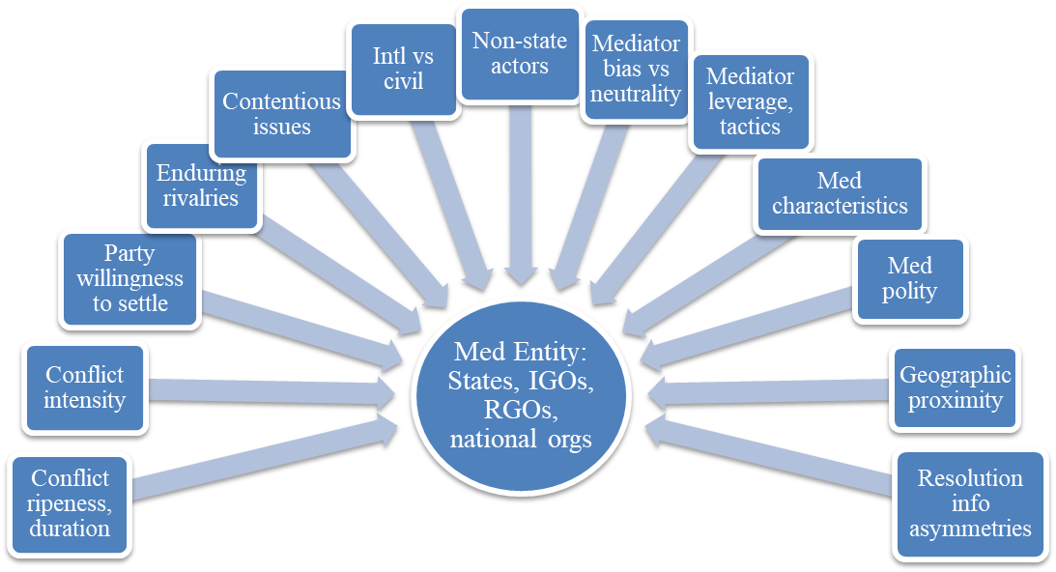
Figure 1-1: Flow of How Macrolevel Factors Impact Mediation Outcome
Individual Mediators
Mediation Outcome

2008; Melin & Svensson 2009). Furthermore, mediation is financially costly, albeit though not as costly as war or peacekeeping. Mediators may be asked to engage in subsequent meetings with the same parties or to remain in the conflict area for a protracted time as “the probability of success [in sustaining peace] increases to the extent the same mediator participates in subsequent mediations” (Greig & Regan 2008, p.765). Personnel and living costs can grow for both the mediating and negotiating parties, making the financial burden too difficult to sustain over the long term for some states or groups, especially rebel groups. Thus, it is prudent to know what other third-party factors may contribute to timely, lasting resolutions versus those factors that can impede the peace process.
Existing Research on the Microlevel
Some literature in the field has noted the potential impact of individual mediators on the mediation process. For example, both practitioners and researchers seem to agree one factor that exists both at the macrolevel and the microlevel and can affect mediation outcomes is bias. When mediation was formalized by the United Nations, the international organization called on John W. Burton of Australia to write the initial guidelines for international mediators. Burton, an International Relations professor regarded by some as the founder of peace science research (Dunn 1995; Steinmeyer 2017), believed in conflict provention, “taking steps to remove sources of conflict…to promote conditions in which collaborative and valued relationships control behavior” (Dunn 1995, p.203). He felt this could be partially accomplished through formalized alternative dispute resolution (ADR) and professional mediators that exhibited neutrality towards negotiating parties in hostile situations (Burton & Duke 1990).
Burton’s concepts have largely been adopted as practice in Western mediation. However, scholars still debate whether neutrality is always appropriate in mediation or if mediator bias can sometimes be beneficial. Those that support professional neutrality argue mediators should be impartial towards disputants and largely unfamiliar with the local conditions of the conflict or the parties involved prior to negotiations. Too much knowledge could bias them towards certain resolution outcomes (Jackson 1952; Northredge & Donelan 1971; Burton & Dukes 1990; Beber 2012). Conversely, some scholars have suggested biased mediators are better able to gain combatants’ trust and can be more effective when they are biased towards weaker or conciliatory parties in a conflict (Rauchhaus 2006; Kydd 2003; Svensson 2007, 2009).
Mediators can also credibly transfer information during negotiations to alleviate information asymmetries (Regan et al. 2009). Fearon (1995) suggests that during conflicts, parties have incentives to misrepresent their capabilities or resolve. To resolve conflictual situations, the transfer of information is key, especially to combatants, and can reduce the duration of civil wars as combatants may be more willing to transfer credible information to mediators than directly to their adversaries (Regan & Aydin 2006). Mediators have special skills that they can use to accomplish this information. At the macrolevel, process knowledge in the form of past mediation experience and colonial ties, and diplomatic knowledge in the form of diplomatic ties are effective in securing peace agreements (Keels et al. 2018). However, these factors have not yet been fully investigated on the microlevel. Perhaps the closest scholars have come to doing so is the insider-outsider debate. In this discussion, outsider mediators – entities and individuals external to the conflict area – are compared to insider mediators – those familiar with the culture and vulnerable to the conflict because they live in the conflict area (Roepstorff & Bernhard 2013). Lee and Hwee Hwee (2009) find that in areas of the work where communal ties are particularly important, like in Asia, insider mediators’ commonalities and connectedness with the disputing parties make them more trusted. This trust is key, especially when directive-manipulative strategies are used in the mediation process (Muldoon 1996).
In their review of theory development in mediation, taken from various fields including political science, legal studies, and sociology, Wall et al. (2001) point to several important findings concerning individual mediators. First, mediators’ ideologies, training, and rules of their practice strongly influence their selection of particular tactics and strategies. Inexperience can limit these techniques, but professional neutrality seems to have little effect on technique selection. Second, Western mediators tend to exert less pressure on the disputing parties than Eastern mediators. Third, mediators are limited in what they can offer by prohibitions from their mediating entity concerning compensation. Fourth, depending on the level of trust disputants have with the mediators or the level of disputants’ hostility with one another, mediators may caucus with them individually or utilize reflexive techniques like humor or understanding of their plight. They note Conlon, Carnevale, and Murnighan (1994) also found mediation goals can affect a mediator’s behavioral choices.
A fifth finding of Wall et al. (2001) is that mediators with high status will “be attended to, rather than ignored by, the disputants…[as] status gives the mediator control over resources so that the techniques of compensation, information gathering, and use of third parties can be employed” (p. 379). Bercovitch and Houston (1993) agree that “mediator rank is positively correlated with the settlement of disputes” (p.383), and Deutsch (1973) suggests mediators’ rank increases mediation power. This may be because those with higher status have a greater capability to bring resources to the table, which increases the likelihood of agreement (Touval 1998). Furthermore, because mediators have different resource availabilities, technical expertise, and social expertise, Svensson (2007) suggests it is prudent that mediators work in groups.
This is all importance guidance for the study of mediation, especially as the growth of the professional practice and the rising number of third-party entities engaging in mediation has compounded the issue of mediator selection (Crocker 2018; Wallensteen & Svensson 2014). A former mediator himself, Crocker (2018) suggests this trend has resulted in a free-for-all mediation arena where the lack of “gatekeepers” to create barriers of entry into the conflict-management space has resulted in a lack of discipline in the mediation process. Historically, most mediators have come from major power states and IGOs. However, mediators from regional organizations are indeed on the rise (Wallensteen & Svensson 2014). Plus, a number of non-governmental institutions like the International Peace Institute, the International Mediation Institute, and a variety of international professional schools – which train individuals either online or in person – are also trying to become go-to choices for disputants seeking conflict management options. Despite this growth, however, there remains a limited pool of senior professional mediators in the field, and these individuals are overloaded with a number of conflicts to mediate (Crocker 2018).
As the number of novice international and civil war mediators bourgeon and the small number of seasoned mediators retire, it has never been more important to determine what characteristics of individual mediators contribute to the likelihood of successful conflict resolutions. In the fields of sociology, business, psychology, and public administration, a variety of studies already exist on personal factors that can be used to determine which individuals are the best fit for particular jobs. However, in the field of conflict management where the consequences of failure carry far greater economic and humanitarian costs, our knowledge of the mediation profession is largely incomplete. Thus far, the previous literature has predominantly focused on macrolevel factors of mediating entities that are associated with conflict resolution success or failure, while studies of microlevel factors have been scant. While I have presented here some initial microlevel factors that have been considered in the study of third-party effect on mediation outcome, there is an insufficient understanding of how individual mediators may impact the mediation process for the better or worse. As displayed in Figure 1-2, I acknowledge that while macrolevel factors can indeed impact mediation outcomes, there is also more going on at the individual mediator microlevel that is also affecting the likelihood of mediation success. Thus, building off the insider-outsider debate and literature taken from the field of psychology on professional competencies and personality factors in negotiations, I will show in this research that several individual mediator factors in the form of mediator competency skills do affect the likelihood of achieving a mediation resulting in a full or partial peace agreement or ceasefire and that scholars in the field should continue investigations on how microlevel factors may serve as intervening variables in the mediation process.
Conclusion
Overall, the study of mediation is complex and filled with debate regarding the best mediating entities, strategies, and practices for securing peaceful resolutions to conflicts. In this chapter, I have discussed much regarding the background of the field of mediation and the literature that has been produced in attempt to identify how macrolevel mediator factors likely affect mediation outcome and how the effects can vary by conflict ripeness, type (civil versus interstate), intensity, main dispute issue, etc. I have also noted what scant research currently exists at the microlevel, which has only recently and insufficiently been explored despite repeated calls by some in the field for deeper analysis of how individual mediators may impact the outcome of mediation attempts. Such investigations are important for future policy considerations as both 1.) mediation
has become the predominant form of peacefully managing conflicts and 2.) more third-party entities have entered the field, with some of these newer players employing very diverse methods in their attempts to prepare individual mediators for conducting peace proceedings. Thus, I have introduced the question addressed in this study regarding how mediating states and organizations can choose the most effective individual mediator(s) to send to a conflict. I argue individual mediators’ knowledge, know-how, and behavior competencies can impact the likelihood of mediation success and should therefore be

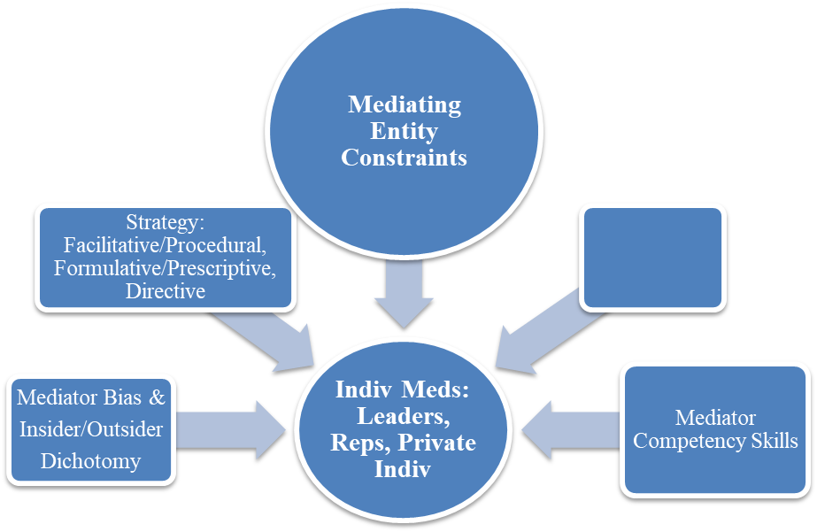

Figure 1-2: Flow of How Microlevel Factors Impact Mediation Outcome
Mediation Outcome

considered when third-party entities are choosing who to send to the peace table.
In the remaining chapters, I present my research as follows. Chapter Two outlines my theory on how the concept of competency skills is related to mediation and presents my hypotheses regarding how those competencies may influence mediation outcomes. Specifically, I argue that knowledge competency is captured by one’s theoretical learning gained through education and training. For mediators, training can occur in three major forms – formal, religious, or military. I argue in conflicts between Western states, that mediators with formal training will have a greater likelihood of mediation success. However, in conflicts where disputants place emphasis on social connections (namely Asia, the Middle East, and Africa, as well as civil conflicts) mediators with religious training will have a greater likelihood of mediation success, which I attribute to their “insider” connections to the community. On the other hand, I propose that mediators with military training will have a greater likelihood of mediation failure due to their regard as non-neutral outsiders. (However, this last supposition is debunked in the qualitative findings of this research.)
I then turn to a discussion of know-how competency, which is learning obtained through practice and experience. I present how mediators add to this competency through experience in previous conflict mediations and by spending more “time on the ground” during mediation proceedings, learning about factors surrounding the conflict, gaining greater understanding of the disputants, and developing a better comprehension of the players and communities affected. I hypothesize that the greater a mediator’s prior experience, represented by his number of previous conflict mediations, the greater his likelihood of mediation success in subsequent conflicts. Also, because small state representatives have more financial and political support from their governments to remain on the ground longer in peace proceedings, I argue they are more likely to achieve mediation success than leaders of large states. The latter group I use as I comparison due to 1.) leaders division of time with other duties relevant to their position, and 2.) previous assumptions that more powerful actors are more effective mediators (Gelpi 1999) and mediations with leverage being more desirable to negotiating parties (Grieg & Diehl 2012). I then extend my argument to hypothesize that representatives, in general, are more likely to achieve mediation success than the leaders of their respective entity types.
Next, I outline how behavior competency may be measured using the HEXACO taxonomy of personality traits that measure honesty-humility (H), emotionality (E), extraversion (X), agreeableness (A), conscientiousness (C), and openness to experience (O). I hypothesize that positive dimensions of the honesty-humility, extraversion, agreeableness, conscientiousness, and openness to experience personality traits, which can be linked to an increase in behavior competency skills, increase the likelihood of mediator success. I then end the chapter with a discussion of how team mediations combine competencies and argue that the more mediators involved in a mediation, the more likely a mediation will be successful. Additionally, group mediations in which at least one person has previous mediation experience are more likely to be successful than mediation teams in which all mediators lack previous experience.
In Chapter Three, I describe the research design of my mixed methods approach to this study. I further describe my quantitative methods, dataset, and variables used in my regression analysis, as well as my qualitative data collection process from my own surveys and interviews, recorded mediator interviews and panels, and first-hand, written accounts by mediators or those present at mediation occurrences. I also note important updates to the ICM dataset that other conflict management researches may find useful and acknowledge the limitations of the sample of mediators in my qualitative study. In Chapter Four, I present my findings on know-how competency from a quantitative analysis of some transformed variables from the ICM dataset. Though I argue in previous chapters why the definition of mediation “success” should include ceasefires as successful mediation outcomes in addition to full and partial settlements, for comparative purposes with other conflict mediation research that constrain success to full and partial settlements only, I also include logistical regression results on this stricter definition of success. Concerning mediator experience, a pattern emerges in the full models (containing mediations for all conflicts) and the high-intensity models that mediators with experience in 1-8 previous conflicts are more likely to achieve a ceasefire, partial settlement, or full settlement over those with no experience. Groups with at least one experienced mediator are also more likely to have successful mediation outcomes than those with no previous experience. However, especially, in low-intensity conflicts, mediators with experience in nine or more previous conflict mediations have a negative effect on mediation outcome. Additional data analyses reveal the high number of mediation failures by four U.N. Secretary Generals may be behind these unusual results. When comparing the success of mediators in leader versus representative roles, the findings also support that small state representatives are indeed more likely to achieve mediation success than large state leaders. Moreover, representatives of entities tend to have higher percentages of mediation success that the leaders of their same entity types save for third-party RGOs. Taken together, these findings support that individual know-how competency has a largely positive impact on mediation success.
In Chapter Five, I present the findings from the qualitative portion of my study that utilizes survey responses, interviews, videoed discussions by mediators, and first-hand accounts to reinforce my quantitative findings on know-how competency and investigate the impact of knowledge and behavior competencies on mediation outcomes. Concerning knowledge competency, I find a more complex situation emerges in regard to mediator training, complicating my original assumptions. Some mediators have no formal training. For those that do, the training provided by mediating entities is highly diverse, and in the opinion of interviewees, runs the gamut from very useful to being of little value in practice. Contrary to my original hypotheses, I find military-trained mediators often have positive effects on both the management and organization of mediation. Additionally, their knowledge of weapons and military craft is often regarded as useful in drafting resolutions of what armaments each disputant demanded to keep or would allow the other(s) to retain as part of a peace deal. On the other hand, I found views regarding the aptitude of religiously trained mediators were lackluster or of minimal positivity on mediation proceedings but that such mediators may be effective in conflict reconciliation and extending the duration of peace following formalized agreements. Within this chapter, I also note my qualitative findings on know-how competency greatly reinforce the positive effect of experience on mediation outcomes. Additionally, I offer qualitative support for my hypothesis that representatives are often more successful than leaders from their respective entities primarily due to time spent on the ground forming (non-biased) connections with disputant parties, establishing trust, and developing a keen understanding of all the facets of a conflict. I also note other interesting third-party factors that interviewees said affect disputants’ attitudes toward individual mediators. As for behavior competency, I report traits associated with the positive sides of the honesty-humility, agreeableness, and openness to experience dimensions of the HEXACO taxonomy are often noted as being important characteristics of successful conflict mediators. The positive side of the conscientiousness dimension is also influential, but I find subjects believe mediators possessing traits from either side of the extraversion dimension are often successful.
Finally, in Chapter Six, I offer my conclusions and note important policy and practice implications for mediating entities. I also include considerations for future areas of research. Given additional revelations from my qualitative research, I particularly suggest the need for studies on mediator acceptance and cultural fit. Furthermore, I acknowledge the need for qualitative expansion of this research to more mediators, especially those from Eastern cultures, but note that hopefully this research has laid the justification for extensive examination of microlevel factors that impact mediation outcome.

A THEORY OF MEDIATOR COMPETENCY SKILLS

It is reasonable to assume conflict mediation research should not limit itself to only investigating how factors associated with mediating entities impact the outcomes of mediation proceedings. We must also investigate how to choose the best mediator(s) to send to the negotiating table. Are some skills more important that others? What personality traits are most conducive to achieving conciliation between dissident parties? These are important answers to answer. In this study, I argue that higher mediator competencies attained through several factors lead to higher likelihoods of success in both international and civil conflict mediation. These factors are: Knowledge, Know-how, and Behavior. These competency skills, rooted in previous research, can help us understand the likelihood of successful mediation. In this chapter, I first discuss the overall theory, then delve into each competency skill and how each can influence mediation efficacy.
When individuals are engaged in social interactions, personal factors play off one another. Differences in gender, age, ethnicity, language, personality, interests, profession, and religions, to name a few, can all have bearing on whether those interactions turn out to be positive or negative. The same goes for the high-stakes arena of conflict mediation. Mediators must rely on their professional competency skills gained from training and experience, but also influenced by their personalities, in order build a rapport with the disputants. Former Under Secretary of State and Career Ambassador Stephen Mull (2019) along with former Finnish President, UN diplomat, and renowned peace mediator Martti Ahtisaari (2008) both state that mediator skills and personalities do matter in conducting successful mediation proceedings. Honesty, integrity, trustworthiness, and fairness are key in guiding negotiating parties to ceasefires or peace settlements, as is creativeness in finding solutions on which the disputants can agree.
The field of Human Relations has utilized vast research on organizational theories to test how to optimize professional performance in a variety of occupations. Key to that research are human competency skills which the literature has summed into three categories – Knowledge, Know-how, and Behavior. The competency category of Knowledge includes a person’s cognitive processes, education, and training, and is associated with that person’s ability to communicate and reason, as well as comprehend new or updated theoretical processes. Conversely, Know-how is “learning by doing” or the practical knowledge gained through practice and experience. Finally, Behavior includes a person’s traits, talents, and qualities that spur how he acts and reacts to certain conditions and/or interacts with different people (Russo 2016).
Though some work in applied psychology has explored competency skills, specifically in relation to negotiations between dissident parties (Smolinski and Xiong 2020; McClelland 1973; Mansfield 2006), in the field of conflict mediation research, we have lacked similar organizational studies that identify how to optimize individual mediator performance. However, we can reasonably assume mediators also need competency skills to overcome negotiator resistance in mediation proceedings. Therefore, a study on these competency categories as they specifically apply to mediation is highly important to improving the process of peace talks and consequently, saving many lives through an increase in the pacific settlement of hostilities. This study takles these issues, arguing that….To conduct such a study, though, one would need to first identify what individual mediator factors are applicable to Knowledge, Know-how, and Behavior. In the next sections of this chapter, I attempt to identify and classify these factors, which collectively contribute to what I term, specifically for the field of conflict mediation, as mediator competency skills. I establish hypotheses for how each factor is likely to affect conflict mediation outcomes.
Knowledge
The competency category of Knowledge is comprised of theoretical learning gained through education and training, as well as a person’s abilities to reason and communicate.
This competency category can largely be measured through 1.) whether a mediator has engaged in mediation training, which occurs in three major forms – formal training, religious training, and military training, and 2.) whether a mediator has background knowledge of the conflict and/or disputants. Interestingly for the practice, however, these two ways to acquire knowledge can sometimes be at odds with one another because of the very nature of Western formal training. In this section, I discuss the reasons why certain forms of training within the Knowledge category can influence how successful mediation can be. These forms of training are formal/Westernized, religious, and military training. Each type of training has characteristics that make it more or less likely for mediation to succeed in certain circumstances, discussed below.
What is often regarded as formal training is largely based upon Australian peace negotiator John W. Burton’s Alternative Dispute Resolution (ADR) guidelines for mediation that suggest mediators should be unbiased third-parties that maintain professional neutrality towards any and all disputants in a conflict (Burton and Dukes 1990). After being adopted by the United Nations, Burton’s ADR guidelines for formal mediation training spread to many Western states and regional organizations, as well as mediating nongovernmental organizations (NGOs) that resided inside those areas. Thus, formal training became associated with Westernized mediation, which in turn, expanded the concept of professional neutrality to recommend mediators should have little to no knowledge of the disputants and the background of the conflict prior to engaging in mediation proceedings. Instead, mediators should “discover” this knowledge during the mediation process. They should also have no social ties to the negotiating parties. By exhibiting such professional neutrality, mediators would guard against bias.
However, research on the insider-outsider dichotomy in mediation has revealed cultures that place emphasis on social connections, like in Asia, Africa, and the Middle East, have tended to regard such professional neutrality with great skepticism (Billings-Yun 2009; Roepstorff and Bernhard 2013). To them, these “outsider” mediators who profess to have no relations to any of the dissidents may instead have hidden biases and agendas. Thus, these cultures are more accepting of “insider” mediators, mediators with pre-existing ties to one or both negotiating parties, for two main reasons. First, the mediators’ biases are known. Second, their social connections legitimize them similar to how a mediator’s degrees/education and professionalization may legitimize him in Western states.
Previous literature has argued that mediators can use their insider knowledge to better establish trust with negotiating parties (Muldoon 1996) and mediating entities with diplomatic and process knowledge of the disputants are more adept at credibly transferring information, leading to greater likelihood of mediation success (Wiegand et al 2019). Because this insider-outsider dichotomy and the link between diplomacy knowledge and mediation success has been recently investigated in these and other studies, I do not test the direct effect a mediator’s background knowledge of the conflict and disputants has on conflict mediation outcome. Instead, I accept these arguments that mediator knowledge can have a positive effect on achieving peace settlements or ceasefires. However, I argue cultural expectations of individual mediators’ closeness to the disputants and the profession of mediation can create regional differences with regard to formal mediation training, and this difference centers around the element of professional neutrality.
While the concept of professional neutrality in Westernized formal training has led to the adoption of using outside mediators to avoid bias against negotiating parties, I consider this stance to verge on the extreme. Better knowledge of disputants can alleviate information asymmetries (Regan et al. 2009), and through credible transfer of information, reduce the duration of conflicts, particularly in civil wars (Regan & Aydin 2006). Mediator knowledge of the parties in a conflict can also help thoughtful mediators better understand each disputant’s fundamental needs, resistances to peace, and sticking points, which can aid in overcoming resistance to the peace process.
Instead, when testing how the relation between formal training and the likelihood of mediation success, I argue the primary focus should be on that training type’s original mandate of professional neutrality. Through Western legal traditions, Western states have established expectations that mediators are to be professionally neutral. Thus, those mediators with formal training should be better adept to conduct mediation proceedings in a manner that is both acceptable and expected by Western disputants. On the other hand, social cultures often regard professionality neutrality with great skepticism (Lee and Hwee Hwee 2009). Similar legal traditions that mandate professional neutrality in mediation have often not been established in those cultures. Thus, disputant parties often see mediators who claim to be “professionally neutral” as hiding their true allegiances and agendas. Instead, they often prefer to know a mediator’s bias, which can be established through communal connections, and again, these communal connections are key to mediator legitimacy more so than legal degrees or certifications of formal training. It is for these reasons that I also look at the impact of religious training and military training with regards to mediation as both embrace their own concepts that can differ from those promoted by Westernized formal training. First, mediators with religious training often draw on value-based connections with disputants that appeal to their own worldview. With legitimate knowledge and acceptance of a community’s religious texts and belief systems, they have more interpretive authority of those texts than “outsider” mediators. Using religious concepts, they can make faith-based principles behind reconciliation more palatable and authentic to the disputants (Peace Insight 2017), and even if their specific faith may be somewhat dissimilar, local priests, rabbis, imams, and sheikhs can still appeal to remaining religious commonalities.
Religious mediators can also draw on their background knowledge of the negotiating parties to better assess the emotional and physical needs of those communities. Plus, their “insider” ties with social cultures through their faith-based communal networks give these mediators the legitimacy, credibility, and respect that is needed to guide such negotiating parties through the peace process. These faith-based ties often additionally extend to larger religious NGOs and regional networks, and through these, religious mediators also have access to large amounts of human and financial resources that can help aid in relief, mitigating the effects of poverty, hunger, and need for medical attention (Democratic Progress Institute 2012).
On the other hand , military training of mediators varies by country and has a somewhat different agenda than the other two types of mediation training. Around the world, many state militaries offer mediation training that primarily seems to be reserved for officers (Druckman et al. 1997). Depending upon the state, though, these militaries may embrace ADR concepts of professional neutrality, as do U.S. and Australian forces (Wood 2013-2014), or their military mediation training may utilize very different concepts. Departing from ADR, they may emphasize knowledge of the language of the disputants or of the genesis and underlying issues of the conflict. They may also see the sacrifice of neutrality as a minor obstacle to overcome as long as trustworthiness and credibility have been established (Druckman et al. 1997).
What remains common is that military training of mediation centers around how the military should interact with local actors in order to best achieve peace. This training can focus on humanitarian and governance needs, as well as conflict analysis, conflict prevention, peace enforcement, peacebuilding, etc., (African Union Mission in Somalia 2015). However, it can also blur the instructional lines between serving as a third-party mediator versus a primary party-negotiator in the conflict who might need to deescalate hostilities. In the former, military training still calls for a mediator to maintain the goals of his constituents (e.g., establishing peace) while also preserving his own goals, like ensuring the safety of his troops. Thus, mediators are encouraged to increase their own strength, as they would in a primary-party role, and use it to reduce one or both disputants’ strength and/or to leverage them. However, this may come with the cost of encouraging retaliation and directly involving the mediator’s forces in the conflict as a primary-party (Druckman et al. 1997).
It is for these reasons that regardless of a military mediator’s attempt to learn the language or background knowledge of the disputants and the conflict, he will probably be seen by the local community as an “outsider” that is most likely not neutral. Thus, I expect mediators with military training to have a negative effect on the likelihood of mediation success, regardless of the region of the world or whether it is an interstate versus civil conflict. Although training increases one’s Knowledge competency skills and in conflict situations can improve how military members diffuse and overcome hostilities, formally trained mediators and religious mediators are more prone to achieving ceasefires or peace settlements, with regional caveats for each.
Based on the logic of the above discussion about mediator training, I expect that:
H(1): In conflicts between Western states, mediators with formal training will have a greater likelihood of mediation success.
H(2): In conflicts where disputants place emphasis on social connections, (conflicts in Asia, the Middle East, and Africa) and especially in civil conflicts, mediators with religious training will have a greater likelihood of mediation success.
H(3): In all regions, mediators with military training will have a greater likelihood of mediation failure.
Know-How
The competency category of know-how relates to learning obtained through practice and experience. Like knowledge, increases in know-how competency skills can be dependent on a person’s intelligence and ability to process information acquired. Know-how differs from knowledge competency in that the former is practical in nature, while the latter is theoretical. While theoretical education can prepare one for a later job, say in a supervisory role, few people would argue that even the best coursework can fully equip them for all the nuanced decisions and difficulties they may face in a career. Through “learning by doing,” however, a supervisor may come to know the common pitfalls to avoid, how the specific wording or nonverbal communications he tends to use may be misinterpreted, how to adapt to and overcome unusual challenges that may not have been covered in his theoretical preparation, how to best respond to changes in the emotional climate or attitudes of the people with whom he is working etc. The same goes for mediators.
Another way to think about Know-how is what is learned from past interactions, or past experience. For example, it was through practice adapting to unusual challenges that Dr. Ralph Bunche, mediator in the first Arab-Israeli Conflict, repeatedly redrew the territorial division lines in the Negev Desert until both parties were satisfied with the settlement. On the other hand, President Jimmy Carter would learn through almost failure in the 1978 Camp David Accords how to best handle state leaders with highly hostile attitudes to one another. After mistakenly placing President Begin of Egypt and President Sadat of Israel in the same room and witnessing the heated exchanges that threatened to breakdown the talks, Carter quickly adapted his strategies. He separated the parties and took the lead on drafting and revising proposals, enticing the parties with foreign aid, and threatening leverage until a peace treaty was fully realized the following year (Berenji 2016). In another example, Richard Holbrooke used his experience in tackling easier issues first with parties in the Bosnian war to foster trust and credibility. He had also learned through previous interactions with the press, while attempting to build his own reputation and power, how to utilize publicity to secure gains achieved in the mediation proceedings. Like Carter, Holbrooke found it beneficial to conduct one-on-one meetings with the disputants, controlling the flow of information between all parties engaged in the peace process, and simplifying negotiations by reducing the involvement of certain international actors (Karčić 2016).
In most careers, experience is valued and becomes an important consideration in hiring or when deciding whether to increase a subordinate’s responsibilities. However, in the field of conflict mediation, experience was strangely a factor that was not given much thought. Babbitt & Susskind (1992) noted that, save for the UN Secretary General, many mediators had historically only been used in one or two mediations. Moreover, leaders or diplomats who lacked any experience were often asked to serve in mediation roles simply because they were acceptable to both negotiating parties. Complicating matters, easy mechanisms also did not exist for mediators to transfer the learning they gained through their experiences onto new individuals in this service (Bercovitch 1992). Though “experience as a mediator is the most important asset a neutral inventor has to offer (Babbitt & Susskind 1992, p.46),” professionalization of career mediators through mediation institutes has only been a more recent development.
Thus, I argue that experience matters for individual mediators. Some are good at their jobs, improve with time, and are thus used or requested again. For others, though, the role of conflict mediator may not be a good fit. However, I caution against only considering the number of a mediator’s past successful experiences as predictive of his future likelihood of mediation success. While one can learn to replicate positive methods from previous successful mediations, a mediator can also learn through failure what tactics to change when dealing with subsequent conflicts.
Additionally, it is important to note repeated mediation failures at the individual level cannot always be blamed entirely on the mediator. Some mediators may be limited by how much political support they have from their overseeing mediating entity. Particularly with states, if a diplomat or other government official has been reluctantly appointed to a position for political reasons and through that position will serve as a mediator, his suggestions for peace deals may be rejected by the government leader or other superiors. For example, President Carter reluctantly appointed Cyrus Vance to the post of Secretary of State. While Vance would go on to be a successful mediator in the Middle East, he was at odds with Carter and Carter’s friend U.S. National Security Advisor Zbigniew Brzezinski on how to approach peace deals and nuclear treaties with the Soviet Union. Vance favored closer relations with the Soviets to deescalate Cold War tensions while Zbigniew lobbied for a harder stance (Brinkley 2002). If the U.S. through Vance had led mediations in which the Soviet Union was a disputant party, Vance’s recommendations would likely have been rejected by the Carter Administration.
With these considerations in mind, I assert that past experience in mediation increases one’s know-how competency skills, giving a mediator a greater tactical “toolkit” to draw from concerning what strategies to replicate, avoid, or change in future peace talks. Therefore:
H(4): The more experience a mediator has, the greater his likelihood of mediation success in subsequent conflicts.
An interesting connection also occurs between one’s job rank and experience concerning “time on the ground.” Previous mediation data collected in Bercovitch’s Interstate Conflict Management (ICM) dataset (2002) delineates between mediators who are leaders or representatives of states, regardless of the entity for which they are mediating (IGO, NGO, state, etc.). What is important is that mediators who are representatives of governments tend to, on average, have a greater ability to spend more time on the ground mediating conflicts than do government leaders because of domestic demands to which the latter must also attend. Case studies on parliamentary democracies versus presidential democracies as third-party mediators reveal that parliamentary small states tend to have higher likelihoods of mediation success; the parliamentary government structure avoids executive-legislative partisan divisions over the state budget, and thus, they are better able to commit financial resources needed to leave mediators on the ground longer in foreign peace talks (Todhunter 2018). Time on the ground equates with increased experience with and understanding of the disputant parties.
On the other hand, leaders of third-party entities must often split their time dealing with various conflicts, administrative tasks, and diplomacy efforts. Some must also simultaneously manage the needs of their domestic or international audience, as well as command their armed forces. This allows for little ability to focus much time to mediating one dispute, let alone spending weeks or months on the ground learning all of facets of the conflict, disputants, communal needs, territorial divisions, etc. Moreover, though they may have the most “carrots and sticks” to offer in mediation, large government leaders – as defined by the ICM data set using the Cox-Jacobson Scale Ratings for State Size- seem the least likely to be able to develop a strong know-how competency in all the nuances of a conflict in which their country would only be involved as a third party. The relative weights of their states in the global system are related to their countries’ resources, capabilities, economic and military influence, etc. Thus, the sheer complexity and breadth of the political needs within their systems again limit their personal ability to focus on any single commitment or obligation that is not directly related to their country’s or their own political survival.
In comparison, IGO leaders also have a great breadth of political obligations, possibly also making them struggle to focus on one conflict. However, the U.N. places large focus on conflict management efforts and takes on the greatest number of mediations in which an IGO serves as the mediating entity with Secretary Generals, like Kofi Annan or U Thant, having mediated numerous conflicts. Thus, IGO leaders would seem to have a slightly better ability than large state leaders to devote time to leading conflict mediations.
Finally, leaders of RGOs and small states would seemingly have smaller scopes of foreign commitments than IGOs and large states. Also, Todhunter’s (2018) research suggested small states may be developing specialties in conflict mediations. Therefore, went considering a mediator’s ability to develop mediation know-how skills through spending great lengths of time on the ground working on a specific conflict, I argue that large state leaders, despite their great access to leverage, will have a lower rate of success than small state representatives, as both the latter’s role and the commitment of many small states to financial and political support of mediation allows for small state representatives to spend longer times on the ground developing know-how competency skills.
Therefore, I hypothesize at the individual level that:
H(5): Representatives of small states are more likely to achieve mediation success than leaders of large states.
And more loosely, due to an average representative’s likely ability to devote longer time than a leader of his entity focusing on a particular conflict:
H(6): Representatives, in general, are more likely to achieve mediation success than leaders of their respective entity types.
Of course, in some mediations, representatives may also pave through initial mediation rounds for government leaders to step in and conduct final peace talks that draw increased domestic and foreign publicity. However, in other conflicts, particularly many civil wars, disputants may prefer to avoid publicity during the mediation proceedings. They may fear challenges from other domestic groups or political adversaries if they appear weak and willing to cave to demands. Therefore, I expect the results of H(6) to be complex and somewhat contextual.
Behavior
The third type of competency that could influence mediation success is Behavior. Both the fields of psychology and human relations have conducted extensive research on the connections between personality and performance. For human relations, studies have often focused on how to match the right employee personality factors to particular jobs. Therefore, these studies vary in which personality attributes, taxonomies, and measures are best for targeted careers under investigation (Russo 2016). On the other hand, psychology has laid excellent groundwork for understanding the link between disputant personality factors in negotiations and negotiation outcome. Summing up numerous early articles in the field, Hermann & Kogan (1977) provide the significant connections listed in Table 2-1. Given these findings, it is reasonable to expect that if such significant
connections exist between negotiator personality factors and the likelihood of those individuals cooperating in negation proceedings, similar investigations should occur for how mediator personality factors impact mediation proceedings.
Mediators’ personalities can affect the mediation strategies they prefer and how active or passive they choose to be at the mediation table. Differences in these Behavioral competency skills can also lead to variations in how adept mediators may be at performing certain tasks, integrating new knowledge and skills, learning from the lessons of experience, and empathizing with divergent worldviews. In turn, these skills impact the range of options mediators may present during peace talks or which objectives they prioritize (Bercovitch 1992).
However, in his assessment of Nelson Mandela, Lieberfeld (2003) relates that the literature on mediator personality traits is “scanty, largely noncumulative, and mainly derived from the organization, rather than international or intergroup, context (p.232).” Building from Margaret Hermann and colleague’s “personality-at-a-distance” (PAD) methodology in psychology, Lieberfeld attempted to use analysis of primary biographical sources to identify important traits that made Mandela a successful mediator. Such methods, however, are not conducive to a larger scale analysis of dozens or more mediators that could better discover commonalities amongst them. Instead, this objective could be better attained through surveys and interviews of current and former mediators.
Table 2-1: Connections Between Negotiator Personality Factors and Cooperation in Negotiations
PERSONALITY FACTOR | AFFECT ON COOPERATION
Increase in ANXIETY | Less likely to cooperate
Decrease in AUTHORITARIANISM | More likely to cooperate
Increase in COGNITIVE COMPLEXITY | More likely to cooperate
Increase in TENDENCY TOWARDS CONCILIATION vs. BELLIGERENCE | More likely to cooperate
Increase in DOGMATISM (connected to need for superior’s approval & support) | More likely to cooperate
Increase in RISK-AVOIDANCE | More likely to cooperate
Increase in SELF-ESTEEM | Less likely to cooperate
Increase in SUSPICION | Less likely to cooperate

Like Ahtisaari and Mull, experienced mediators have sound knowledge of personality factors that can positively or negatively impact mediators’ interactions with disputants. Thus, much can be revealed by questioning them. Numerous interviews and accounts of current or former mediators have helped shed light on some of the personality factors they deem, from their experiences, as being important to mediation success. They include the following: creativity in problem-solving, trustworthiness / ability to build trust, self-confidence, firmness/ authoritativeness, honesty, fairness, ability to empathize, good judgment, analyticity, ability to communicate, charisma, sense of humor, patience, etc. (Mull 2019; Democratic Progress Institute 2012; Ahtisaari 2008, Lieberfeld 2003). To date, though, a more comprehensive survey of multiple mediators’ views on the impact of personality traits on mediation success does not exists.
I attempt to remedy this absence of data by collecting survey and interview responses from current or former mediators using the HEXACO model of personality traits as my base. Created by Ashton et al. (2004), the HEXACO taxonomy of personality traits have similarities with the “Big Five” personality traits often studied in psychology, but the HEXCO model includes an added dimensional assessment of Honesty-Humility, which has been suggested by previous mediators to be important traits for successfully conducting peace talks. Furthermore, because of the inclusion of the Honesty-Humility spectrum, the HEXACO taxonomy is commonly employed in analyses on workplace behavior (Ashton & Lee 2008) and typically used in place of the Big Five. Because of cultural limitations, though, on personality trait studies and the translations of certain traits into other languages (De Raad et al. 2010), I limit my surveys to English speaking respondents. However, this approach is justifiable for this piece of research I am primary concerned with policy recommendations concerning best practices in mediation for the United States, either when it serves as the mediating entity or participates in mediations through IGOs, NGOs, private individuals, etc. Where possible, though, I offer some comparisons of English-fluent mediator responses from outside entities.
Because many mediators are not allowed to talk about specific details of mediations in which they have participated, it would be difficult to connect a mediator’s own personality to his success rate without also asking the mediator to identify which conflicts he has mediated. Plus, through their involvement in the mediation and mediator training processes, these individuals can have important information on best practices from peace talks conducted by others that would be limited by a simple self-assessment. Therefore, I instead ask them to identify, from their experiences and knowledge, what mediator personality traits they deem can have a positive or negative effect on achieving ceasefires and peace settlements. Through interviews, I also allow them to expand upon these claims in more specific detail. The traits I offer in the surveys are ones associated with each of the six dimensions of the HEXACO taxonomy, and where other traits are offered in open responses or interviews, I attempt to categorize these to the best of my abilities. The six dimensions of the HEXACO taxonomy are as follows:
- Honesty-Humility (H)
  - Positive dimension – loyalty, honesty, sincerity, faithfulness, etc.
  - Negative dimension – slyness, greediness, hypocrisy, deceitfulness, etc.
- Emotionality (E)
  - Positive dimension – bravery, toughness/firmness, self-confidence, independence, etc.
  - Negative dimension – fearfulness, anxiousness, oversensitivity, sentimentality, etc.
- Extraversion (X)
  - Positive dimension – extroversion, outgoingness, sociability, cheerfulness, etc.
  - Negative dimension – introversion, shyness, reservation, passiveness, etc.
- Agreeableness (A)
  - Positive dimension – tolerance, agreeableness, patience, gentleness, etc.
  - Negative dimension – stubbornness, ill-temperament, belligerence, etc.
- Conscientiousness (C)
  - Positive dimension – organization, thoroughness, carefulness, discipline, etc.
  - Negative dimension – negligence, laziness, irresponsibleness, absent-mindedness, etc.
- Openness to Experience (O)
  - Positive dimension – creativeness, innovativeness, intellectualness, unconventionality, etc.
  - Negative dimension – unimaginativeness, conventionality, shallowness, etc.

Ashton & Lee (2008) report that negative/low scores for honesty-humility and conscientiousness are associated with delinquent and counterproductive employees, as well as those who often engage in criminal behavior. Moreover, low honesty-humility scores are associated with social dominance orientation, which is a strong predictor of preference for aggressive wars. Thus, Ashton & Lee suggest “political leaders having low levels of H would be particularly likely to instigate conflicts, both beyond and within their national boundaries” (p.1959). In a separate study, Amistand et al., (2018) linked positive scores of honesty-humility, openness to experience, and extraversion to more positive experiences between participants in pairwise negotiations. Considering that peace mediation also tends to involve many drafts of resolutions as one attempts to guide disputing parties to a common agreement, I argue successful mediators would also likely possess positive traits in the agreeableness dimension related to patience.
Therefore, I expect that:
H(7): Positive traits within Honesty-Humility, Extraversion, Agreeableness, Conscientiousness, and Openness to Experience, linked to an increase in behavior competency skills, increase the likelihood of mediator success.
However, what shall be of more interest is which positive and negative traits mediators believe most impact mediation proceedings. I expect that trustworthiness, creativeness (in problem solving), patience, firmness, and extroversion will rank the highest in conducting successful peace talks while deceitfulness, unimaginativeness, negligence, ill-temperament, and shyness will have the most negative effects on overcoming negotiators’ resistance to compromises.
Team Mediations – A Combination of Competencies
A common occurrence in peace talks is the use of multiparty mediation. In this type of proceedings, multiple mediators intervene in the conflict simultaneously, sequentially, or as part of a “composite” actor, like the United Nations. Because they often hail from different states, members of multiparty teams have their own constraints, priorities, and objectives that can complicate the peace process. (Crocker et al. 1999a). However, through combined efforts, groups of mediating entities may be able to better exert pressure on negotiating parties through promises of sanctions, aid, support, etc., from multiple states. Crocket et al. (1999b) suggest that multiparty medication can increase the likelihood of conflicting objectives, but mediation parties can also capitalize on their comparative advantages and differing strengths to “gain entry to the parties to the dispute, create leverage, and propel the negotiation process forward (p. 41).”
If one extends this concept to the microlevel, similar arguments can be made concerning individual mediators. Though there may be more personalities to deal with in the mediation process, multiple individual mediators can bring together a combination of their Knowledge, Know-how, and Behavior competency skills to complement each other. In an area where one mediator is weak, another may be strong. A common occurrence today is to combine insider mediators with outsider mediators in multiparty mediation teams. Religious leaders and/or those with communal connections can build trust with disputants through their social influence and offer assistance through local or religious networks. While outsider mediators may also have access to aid, they can additionally bring professionalism and pressure through their training techniques to overcome resistance. Moreover, where some mediators lack experience, others may have formidable practice in mediating previous conflicts and thus be better equipped at guiding novice mediators through common difficulties encountered in the peace process. An increase in mediators should overall increase the competencies skills of the mediation team with the caveat that some mediators may possess differing negative Behavior/personality traits. In mediators with strong personalities, these negative traits could greatly hinder peace efforts if left unchecked. However, such traits are likely to be more detrimental to the proceedings if a mediator with poor Behavior competencies was operating alone. Instead, in multiparty mediation teams, another mediator may be able to bring talks back on track by taking the lead in the proceedings and alternating out who is at the table. Therefore, I propose:
H(8): The greater the number of mediators involved in a mediation, the more likely the mediation will be successful.
H(9): Mediation teams in which at least one person has previous mediation experience are more likely to be successful than mediation teams in which all mediators lack previous experience.
Taken together, these hypotheses support my overall theory that an increase in mediator competency skills in Knowledge, Know-how, and the positive qualities of Behavior lead to higher likelihoods of mediation success. More individual level factors may indeed be discoverable that fall under these competency categories. However, through this research I attempt to establish the theory linking mediator competency skills to mediation outcome. I provide initial bases to test each category through the factors of experience, mediation rank/position, formal training, military training, religious training, and personality traits, but I hope this work will serve as a basis of investigation on the impact of individual mediators to which others may continue to add. Through this process, I also hope the field of conflict management may come to a better understanding of best practices in mediation, and through this study be greater equipped to make policy recommendations on the mediator selection process.

RESEARCH DESIGN

In this research design chapter of this work, I first explain my parallel mixed methods approach for the overall study. Second, I identify and explain the primary data source for the quantitative study – Bercovitch’s (2002) Interstate Conflict Management (ICM) dataset, noting new discoveries with the dataset that were previously missing or misreported in the corresponding codebook. Third, I discuss my unit of analysis, the dependent variables, the independent variables, and the control variables for the quantitative analysis. Fourth, I identify limitations of the ICM dataset for testing some of my hypotheses and instead note how individual mediator factors related to these hypotheses can instead be investigated through qualitative analysis. I also explain the collection process and sources for the surveys, interviews, documents, and videos utilized in the qualitative analysis portion of this study and detail how the personality traits investigated in these sources fit within the HEXACO model. Fifth and finally, I describe the diversity of the pool of individual mediators in this study and note limitations in collecting information on mediators and mediation proceedings.
Methodological Approach
The impact of some mediator competency skills on conflict mediation outcome can be examined through the transformation of quantitative data collected as part of the Interstate Conflict Mediation (ICM) data set. Know-how competency is attained through practice and experience, and data already exists that records the number of prior conflict mediations which a mediator has led. Furthermore, previous case study research by Todhunter (2018) has revealed mediators who are small state representatives have financial and political support from their governments to remain on the ground longer during peace processes. Logically, this practice allows them time to become more steeped in the nuances and backgrounds of both the disputants and the conflict itself. One may conjecture that they would also have time to develop meaningful relationships and build trust with the parties.
Arguably, too, representatives from most mediating entities should have a greater ability than the leaders of their respective entities to commit time to their conflict assignments. This assumption is logical simply because of the nature of leadership positions. Leaders must juggle a multitude of other administrative, diplomatic, public, and/or military tasks. Therefore, unless they have a pre-existing knowledge of a particular conflict or disputant, or unless a conflict was highly salient to their domestic or international audience, other job demands would likely make it difficult to have time to focus on one dispute. Pre-existing data on the job position of mediators is also available to test whether representatives are more successful at mediating conflicts than leaders, and specifically, what categories of representatives are most effective.
On the other hand, though, little information exists, especially public information, regarding the training mediators undertake prior to engaging in conflict mediations. Some entities, like the United Nations, United States Institute of Peace (USIP), and Swiss Peace, are known to have their own training programs. The U.S. military also trains its officers in mediation strategies in case there is a need to deescalate conflicts, especially local ones (Asquith). Furthermore, the Catholic Church and even some popes have engaged in international and civil conflict mediations. However, few can explain, except for those who have actually engaged in conflict mediation, 1.) what mediation training looks like, 2.) whether the knowledge competencies gained from mediation training are effective or essential in mediating peace settlements, and 3.) whether some types of training are more effective than others.
Additionally, unless one is employed for a mediating entity, it would be nearly impossible to directly test how a peace mediator’s behavioral competencies impact the outcome of conflict management attempts. Researchers in the field of Psychology have crafted laboratory experiments to examine how the personalities of volunteers interact when they are paired together in negotiation simulations. However, it is difficult to replicate the high stakes scenarios and conflict backgrounds of disputants, or the complex number of individuals and interactions taking place at the mediation table, in a laboratory setting. Furthermore, if a researcher was to receive both permission and enough volunteer mediators for personality test studies, the researcher would also be unable to connect that information with much of the confidential proceedings of actual peace talks.
Therefore, research on individual mediator competency skills is best matched with a mixed methodological approach. Bercovitch and Jackson (2009) also recommended assessing mediation outcomes subjectively and objectively. While quantitative assessment can be utilized to measure the likely effect one’s know-how competencies, in the form of previous experience and job position that allows more time to become familiar with all aspects of a conflict, have on the outcome of a mediation proceeding, it is difficult to objectively assess the impact of knowledge or behavioral competencies. However, mediators can subjectively explain, through interviews, panel discussions, survey responses, and written first-hand accounts, their opinions on how effective they believe particular types of training are in equipping one with the skills needed to navigate disputants through intractable issues in conflicts to the point of reaching peace agreements. Additionally, they can offer their insights on what personality aspects of other mediators they have seen be helpful versus harmful to keeping mediation proceedings on track and guiding disputants to some form of resolution. Moreover, they can clarify if and why ceasefires, partial agreements, and full agreements should all be seen as successful mediation outcomes.
Mahoney and Goertz (2006) established a strong argument for the value of both quantitative and qualitative approaches, noting how they could complement one another. Through utilizing both methods, one can determine if the results of a quantitative analysis make sense in the practical environment or whether an unseen, interacting or correlated element is at play. Such combination of qualitative and quantitative paradigms has been explicitly defined by Creswell (2015) as being a mixed methods, versus multimethod, approach as the former integrates the two approaches and “draws interpretations based on the combined strengths of both sets of data to understand research problems” (p.1) while the latter utilizes multiple methods from only one paradigm. Additionally, Manaf and Azzman (2017) note that the strengths of each paradigm “will compensate the weakness of the other [paradigm] so they provide a more comprehensive and complete set of data” (p. 25).
Mixed methods allow researchers to utilize different methods to examine separate inquiry components in a study, extending the investigatory range of the research and enhancing the credibility of the findings (Greene et al., 1989; Bryman 2006). Additionally, one is able to test several aspects of a single question or combine separate but related quantitative and qualitative questions (Schoonenboom & Johnson 2017). My overall study utilizes the latter expansion purpose of mixed methods to investigate all three types of mediator competencies. However, within my specific study of know-how competency, I employ both quantitative and qualitative methods to triangulate whether the job position and prior experience of a mediator impact mediation outcomes. Thus, the research proceeds with a parallel mixed methods design.
Quantitative Data Analysis
The ICM dataset provides a wealth of variables from over 1,990 conflict management attempts. At the time his codebook was written for the ICM data, Bercovitch noted that his dataset covered 309 disputes over the years 1945 to 1995. However, my research determined his dataset actually contains 333 disputes with the 24 additional disputes providing an extra 231 mediation attempts. Disputes 310-333 are not identified in the Conflict List in the ICM Codebook appendix. Thus, for these disputes, I noted the conflict start date and identity of the negotiating parties. I then cross referenced that information with Bercovitch and Fretter’s (2014) Regional Guide to International Conflict and Management from 1945 to 2003. Through this process, I was able to identify the conflict associated with dispute numbers 310-333 and deduce that the ICM data actually includes some conflict management observations through the year 2003 instead of ending in 1995 as priorly noted in the codebook.
The ICM data contains observances for various types of conflict management attempts that include mediation, arbitration, negotiation, multilateral conferences, and referral to international institutions. Though Bercovitch (2002) says in his codebook that there are 1,990 mediation cases in the data, aside from 204 rejected offers, this number is incorrect due to updates in the dataset. In actuality, there are 2,777 mediation attempts and 228 rejected offers over the full list of 333 disputes Bercovitch recorded through the year 2003. In my analysis of the ICM data for this research, I only utilize the 2,777 cases where mediation specifically occurred. This research questions why, once mediation is accepted, it either fails or succeeds. Though I do acknowledge potential causes for the rejection of mediators, I leave quantitative analysis of these cases where mediation was rejected to future research.
Additionally, the Bercovitch data records some information on mediator position, experience, and group experience. It also notes whether conflicts were international or civil disputes, the number of fatalities for each conflict, the primary type of conflict (ethnic, territorial, economic, ideological, etc.), and the time of duration for each conflict in months. Morphing of these variables allow me to test the impact of individual mediator’s know-how competency skills, gained through experience and longer time on the ground (allowed more to representatives than leaders of many mediating entities by the nature of their jobs), on the outcome of each mediation attempt. I am able to conduct these tests while also parsing the data by conflict intensity, measured through fatalities, and controlling for conflict type, conflict duration, and the presence of a territorial dispute. However, a measurement of my independent variables requires some morphing of the data.
Unit of Analysis
For the ICM data set, my unit of analysis is mediation occurrence. Contrary to the smaller number of observations listed in the affiliated codebook, the ICM data records 5,066 conflict management attempts. Under the conflict management type variable (cm3), these attempts are coded as: no conflict management activity (0), mediation (1), negotiation (2), arbitration/adjudication (3), referral to international organization (4), and multilateral conference (5). I drop all other observations except for those coded as mediation. Within the remaining 3,005 observations, the ICM variable outcome (cm14) lists the possible outcomes of each conflict management attempt as: no management (0), offered only (1), unsuccessful (2), ceasefire (3), partial agreement (4), and full agreement (5). The scope of this work is only concerned with mediation offers that have been accepted. Though I offer some speculations regarding why mediation offers may be rejected, the factors that impact such decisions often occur at the macrolevel – in other words, at the level of the mediating entity – are beyond the manageable scope of this study. Additionally, once a mediation offer has been accepted, the macrolevel factors are already in place in regard to the mediating entity, and thus, more attention can shift to the impact the individual mediator has on the peace talks. Of course, such analysis does not negate that negotiating parties also bring their own skill sets, personalities, and biases to the table, which mediators must rely upon their own competencies to navigate, where at all possible.
Once only accepted offers of mediation are considered, 2,777 observations remain in the dataset, which I term mediation occurrences. At least one mediation occurrence, in which negotiating parties accepted a third-party offer to mediate, was present in 198 (59.46%) of the conflicts recorded in the ICM dataset through 2003. Moreover, multiple mediations could have occurred within a single conflict, as suggested by the 2,777 observations. 46 (23.35%) of the mediated conflicts only had one mediation occurrence while three conflicts had over 100 mediation occurrences – the Angola-South African Intervention and Civil War from 1975-1995 with 106 mediations, the Nagorno Karabakh Conflict between Azerbaijan and Armenia from 1990 to present with 109 mediations at the time the ICM dataset was last updated in 2003, and the Yugoslavian Civil War (or The Balkans War) from 1989 to 2000 with 276 mediation attempts. In conflicts with multiple mediation attempts, the final mediation occurrence may not be the only one that results in a ceasefire or settlement.
Dependent Variables – Two Models
When only instances of mediation occurrences are considered, the ICM data categorizes the conflict management outcome as unsuccessful, ceasefire, partial settlement, or full settlement. Each type of outcome can occur multiple times within a single dispute. For example, in the Liberia – Sierra Leone Intervention and Sierra Leone Civil War, there were 5 mediated ceasefires, 25 partial settlements, and 26 full settlements, aside from the 36 mediation occurrences that were unsuccessful. The numbers and percentages of each outcome type for all 2,777 mediation occurrences are reported in Figure 3-1. While 55% of all mediation occurrences from 1945-2003 were unfruitful, 45% resulted in a ceasefire or settlement.
However, it is important to note there is a difference in the ICM data between the outcome of an individual mediation attempt and the final, overall outcome of the entire conflict. Conflict outcomes are noted as resulting in victory, having lapsed, or being ongoing, abated, partially settled, or fully settled. The breakdown of final conflict outcomes for all 198 conflicts with at least one mediation occurrence are displayed in Figure 3-2.
To assess the success of mediation attempts, one might argue that only the final outcome of a conflict should be considered. Yet, Bercovitch & Jackson (2009) caution against this. Instead, they note mediations can be successful when they open dialogue between disputants or reduce or cease violence. Along the way to a final conflict outcome, parties may engage in multiple types of conflict management attempts. They may also agree to temporary ceasefires or sign settlements only to resume hostilities at a later date. Peace is a process that, like war, is rarely straightforward. Thus, it is important for each mediation attempt to be judged on its discrete outcome. Moreover, if one were to instead utilize the final conflict outcome to assess the success of all mediation attempts for that conflict, the findings would be misleading and incorrectly weighted. For example, the 35 mediations that occurred during the Nambian Independence Struggle (1966-1990) would all be categorized as the conflict resulting in “full settlement” though 27 individual mediation occurrences were reported as being unsuccessful, three as

Figure 3-1: Outcome of All Mediation Occurrences in the ICM Dataset

Figure 3-2: Final Conflict Outcome of All Conflicts with at Least One Mediation Occurrence

ceasefires, four as partial settlements, and one as a full settlement. Moreover, the final mediation occurrence in the series was a ceasefire.
Overall, then, it is logical that the mediation outcome variable in the ICM data is more appropriate for data assessment than the final conflict outcome variable when quantitatively assessing the effectiveness of mediations. Many mediation researchers, though, further simplify mediation outcomes in terms of success or failure. Gartner & Melin (2009) note that often these researchers particularly equate success with disputants reaching a full or partial agreement. However, Gartner & Melin caution “achieving a limited agreement” like a ceasefire “in a previously intractable conflict may be no less significant than the achievement of a full settlement in a more tractable dispute” (p.3). Bercovitch & Gartner (2006b) also agree that a ceasefire, even a temporary one, can be classified as a mediation success. Therefore, to address both camps of thought, I analyze two dichotomous, dependent variables – success and strict success. For the variable success in Model 1, I code all mediation outcomes that result in ceasefire, partial settlement, and full settlement as “1.” All unsuccessful mediation outcomes are coded as “0.” For the variable strict success in Model 2, I only code mediation outcomes that resulted in a settlement, either full or partial, as “1.” All unsuccessful mediations and mediations that resulted in ceasefires are coded as “0.”
Additionally, a concern in mediation analysis is selection bias. Since mediation is costly and time-consuming, disputing parties often prefer to resolve low-intensity disputes on their own where they may retain more control of the conflict management process and avoid ruptured relationships with any mediating entities if peace talks fail. However, when bilateral negotiations have failed or the conflicts are highly intense or complex, disputants are more likely to engage in mediation (Latour 1976; Bercovitch & Gartner 2006b). Consequently, mediators tend to receive the toughest disputes. Therefore, one must address selection effects in mediation analyses “because it is reasonable to expect that, rather than selecting cases for mediation randomly, disputants and third parties tie their decisions to mediate to the chances for its success” (Bercovitch & Gartner 2006b, p.343). Though this analysis only examines the success of mediators once disputants and third-party entities have agreed to mediate a conflict, I acknowledge third-party entities may be more inclined to send their best, or top-ranked, mediators to resolve the worst cases.
With these considerations, I follow Bercovitch & Gartner’s methodological advice for addressing selection effects. I subdivide each of my models into two analyses – one for high-intensity conflicts with 10,000+ fatalities and one for low-intensity conflicts with less than 10,000 fatalities – to distinguish the toughest cases from those disputes that are less challenging. I utilize information on the raw number of fatalities recorded for each conflict in the ICM data to parse out my cases based on intensity and forgo using the categorical variable for fatalities (grouped) from that dataset as I identified multiple miscoding incidents where the wrong category was coded given the raw number of fatalities reported. For example, when only examining mediation occurrences in the ICM data, there are 119 observations that report a raw fatality number of 10,000. 94 of these are listed in the ICM fatalities (grouped) variable as falling into the 5001-10,000 category. 25 are listed as falling into the 10,000+ category. Therefore, I created my own dichotomous variable for intensity to parse out the observations and assigned a 1 for “high-intensity” to all mediation occurrences for conflicts with 10,000 or more fatalities. For conflicts with 9,999 or less fatalities, I assigned a 0 for “low-intensity.” There were no mediation occurrences with missing information on intensity. Figure 3-3 details the number of mediation occurrences for low-intensity conflicts versus high-intensity conflicts that are included in the quantitative analysis.
Independent Variables
Mediator Experience: The ICM Codebook (2002) classifies mediation experience according to the number of international or civil conflict mediations an individual mediator has previously conducted. It is a categorical variable with the following categories: no previous experience, 1-2 previous mediations, 3-4 previous mediations, 5-6 previous mediations, 7-8 previous mediations, 9+ previous mediations, unknown mediation experience, not applicable, and “at least 1 experienced mediator in group/pair” (p.128). All instances of “not applicable” were dropped when only mediation occurrences were retained in the cleaned dataset.
Utilizing the preexisting data, I create a new variable mediator experience. I treat instances of “unknown mediation experience” as missing. I also recode instances of group mediation as missing as it is not defined how many previous mediations group members conducted. This recoding allows me to treat mediator experience as an ordered categorial variable. Aside from these changes, I utilize the same categories as the ICM mediator experience (cm21) variable as no further specifics are given concerning the exact number of previous mediations. Additionally, there are 1,680 mediators or mediator

Figure 3-3: Conflict Intensity of Mediation Occurrences
(for conflicts commencing 1945-2003)

combinations in the ICM dataset. The team of researchers around the creation of the dataset took care to record changes in previous experience when individual mediators participated on different combinations of teams or solo. Thus, this study is reliant on their data as correctly reidentifying all previous instances of experience for an integer variable is not manageable for this study. The total number of mediations conducted by a mediator at each experience level is given in Figure 3-4. While 59% to 81% of each category of observations are for individual mediators, deeper analysis of the available data reveals occasional instances of pair or group mediators are included. Where pairs or groups of mediators are acting together as leads in the mediation occurrence, the experience of the most veteran mediator is reported.
Group Experience: To avoid losing information from the vaguer group category of “at least 1 experienced mediator in group/pair” in the ICM mediator experience (cm21), I also create a binary variable experienced or not for instances of group mediation with at least one season mediator. I code all instances in which at least mediator in the group had any experience as a 1 and keep all instances of no experience as a 0. I did this to retain the influence of experienced mediators in groups, even though Bercovitch does not designate the specific number of previous mediations the experienced mediator(s) in the group has/have conducted. To protect against collinearity issues with this experienced or not variable, I do not run the mediator experience variable in the same models as experienced or not.
Mediator Position: The ICM data has a categorical variable “mediator rank” that includes 11 options of mediator positions: leader of an IGO, leader of a large state, leader

Figure 3-4: Number of Mediation Occurrences with Mediator at This Previous Experience Level (excludes experienced group Mediations)

of a small state, leader of a regional organization, national organization, private individual, representative of an IGO, representative of a large state, representative of a regional organization, representative of a small state, and mediator unspecified. After dropping the observations where there was no mediation, I created a new categorical variable mediator position to investigate if certain mediator positions are more successful than others. I run several analyses on this variable holding different categories as the base. Within this new categorical variable, there were no longer any observations where the mediator was unspecified. For instances of group mediation, the highest lead mediator position in each mediation occurrence was reported.
Table 3-1 compares the total number of mediations led by a mediator holding that position. I include numbers and percentages for all mediations, followed by similar statistics parsed out by conflict intensity type since my primary models in the empirical analysis are also parsed out in this manner. A comparison of the percentages of total in Table 3-1 and Figure 3-5 for all mediations, low-intensity only, and high-intensity only reveal there is little difference between what rank and position of mediator takes on low-intensity versus high-intensity conflicts. Therefore, the impact of mediator position on the dependent variables should not be erroneously related to a higher percentage of, for example, large government leaders taking on high-intensity versus low-intensity conflict mediations. The mediator position category with the greatest percentage difference between those leading low-intensity versus high-intensity conflict mediations is “representative of an IGO.” While 28.07% of high-intensity mediations were conducted by a representative of an IGO, only 18.13% of low-intensity mediations were led by those IGO representatives. Additionally, within all mediation occurrences, representatives of IGOs and representatives of large governments tend to lead the most mediations. On the other hand, mediators holding positions with national organizations tend to mediate the fewest conflicts, followed by either leaders of RGOs or private individuals. Leaders of large governments also only tend to mediate only around 3% of mediations, whether they are high- or low-intensity.
Control Variables
Many analyses of mediation outcomes include controls for conflict intensity. Because I follow Bercovitch & Gartner’s (2006b) suggestion for splitting my models into separate analyses of high-intensity versus low-intensity conflicts, I only control for intensity in the full models that include all conflicts and in the alternative models included in the Appendix where conflicts are instead separated based on whether they were civil or interstate disputes. Initial regressions were also completed where models were separated by both high- versus low-intensity and civil versus interstate categories. Specifically, I ran analyses on the following four models that failed when parsed out in this dual manner: 1.) high-intensity-civil disputes, 2.) high-intensity-interstate disputes,
3.) low-intensity-civil disputes, and 4.) low-intensity-interstate disputes. The regression analyses for these analyses dropped certain categories of the mediator position variable or the control for territorial disputes due to low case numbers and perfect predictions of failure.
Models parsed out by conflict intensity seemed to both contain the most interesting results and best reflect the findings of the full models where all conflicts are
Table 3-1: Category of Highest Mediator Position For All Mediation Occurrences
 | All Mediations |  | Low-Intensity Only |  | High-Intensity Only
 | Freq. | Percent | Freq. LI | Percent | Freq. HI | Percent
Med Position
Private Individual | 76 | 2.74% | 19 | 2.11% | 57 | 3.05%
National Org | 49 | 1.77% | 15 | 1.67% | 34 | 1.82%
Rep RGO | 367 | 13.25% | 149 | 16.57% | 218 | 11.66%
Leader RGO | 62 | 2.24% | 24 | 2.67% | 38 | 2.03%
Rep IGO | 688 | 24.85% | 163 | 18.13% | 525 | 28.07%
Leader IGO | 198 | 7.15% | 81 | 9.01% | 117 | 6.26%
Rep Small Gov | 300 | 10.83% | 101 | 11.23% | 199 | 10.64%
Rep Large Gov | 661 | 23.87% | 210 | 23.36% | 451 | 24.12%
Leader Small Gov | 275 | 9.93% | 107 | 11.90% | 168 | 8.98%
Leader Large Gov | 93 | 3.36% | 30 | 3.34% | 63 | 3.37%
Total | 2769 | 100.00% | 899 | 100.00% | 1870 | 100.00%

Figure 3-5: Category of Highest Mediator Position as a Percentage
of Total Mediation Occurrrences

taken together. When conflict type - interstate versus civil dispute - was included as a control within the high- and low-intensity models, the results showed little variation. Thus, I maintained the decision to include fatalities as a control in my full models that included both high- and low-intensity conflicts, but in the models that are separated by intensity, I drop this control to avoid correlation issues. Information for fatalities is taken from the raw number of fatalities for each conflict listed in the ICM dataset. This is a continuous variable, though many numbers are rounded. For conflicts, losses range from 0 to 3,000,000. I also elect to utilize the raw number rather than the ICM categorical variable where fatalities are grouped from 0-500, 501-1000, 1001-5000, 5001-10,000, and 10,000+ as there are instances where the wrong category is reported for the observation given the raw number of fatalities.
Within all of my models, though, I do include common conflict mediation controls for territorial disputes, conflict duration, and post-Cold War disputes. First, territorial conflicts are deemed as highly intractable and difficult to resolve. Therefore, they tend to last longer and be more difficult to mediate (Clayton & Dorussen 2021; Clayton 2013; Hensel 2001; Hensel et al., 2008). To control for this effect, I create the dichotomous variable territorial dispute and code it as 1 for any conflicts in which the core issue was a territorial or sovereignty dispute. All other conflicts, I code as 0. Second, previous research has noted that the longer a conflict endures, the more difficult it is to resolve (Clayton 2013). Thus, I include a control for duration that is drawn from the “duration raw” variable in the ICM data. This is a continuous variable that reports the length of the conflict’s duration in months.
Another confounding factor that can impact mediation results is whether the mediation occurred during the post-Cold War era. Prior to the end of the Cold War, the great power rivalry between the United States and the Soviet Union extended hostilities between many disputants, making ceasefires and peace settlements more difficult to achieve. In the post-Cold War era, though, mediation has become a more common practice, and an increase in peacekeeping efforts has aided mediators in terminating hostilities (Clayton & Dorussen 2021; Clayton 2013). Therefore, I create the variable post-Cold War and code conflicts as 1 if the dispute began in the year 1991 or afterwards. Those conflicts that occurred from 1945 to 1990, I code as 0.
Qualitative Data Analysis
Information identifying whether individual mediators have completed formal, military, or religious mediation training is not recorded in conflict management data sets, thus disallowing researchers to statistically test 1.) what form of these knowledge competency sources best equip mediators for resolving disputes, and 2.) whether mediators with knowledge competency skills gained through any current form of training have a higher probability of securing a peace agreement than those without training. Also, no scientific personality evaluations of actual peace mediators are available (or at least they have not been made publicly available). While some private businesses and sectors of the government already utilize such evaluations to determine if job applicants’ demeanors are good matches for certain positions, little is known concerning which mediator traits are most beneficial or detrimental to helping hostile parties overcome intractable issues.
Moreover, even if quantitative data were to be gathered today that profiled individual mediator demographics, training/educational backgrounds, etc., researchers would have much difficulty reporting which mediators were connected to what conflict management attempts and outcomes. In the modern era, parties involved in international and civil conflict mediations are often bound by strong confidentiality agreements that greatly limit discussion of particular mediation proceedings or the microlevel actors involved. Therefore, further study of the impact of mediator competencies on conflict management outcomes is well-suited for a qualitative investigation that allows mediators to share their experience and opinions regarding what microlevel skills/characteristics seem to positively or negatively influence mediation outcome. Information collected from this qualitative investigation can also help triangulate the effect of know-how competency skills, in the form of mediator experience and position, and offer greater understanding of the causal relationship identified in the quantitative analysis. Additionally, it may provide future research considerations to explore or reveal issues within the variables and theory.
To qualitatively analyze how mediator experience, training, characteristics, and personality traits may contribute to mediation success or failure, I designed an original survey and conducted interviews with those in the field. Because of the confidentiality of many conflict mediation proceedings, it was very difficult to locate details regarding the individual mediators that were involved in specific conflicts from the year 2000 onwards. Furthermore, because many mediators have other primary jobs, they often do not identify as a peace or conflict mediator on professional bio pages or websites such as LinkedIn and Twitter. Also, a large number of those who professionally identify as “mediators” are attorneys who mediate civil cases, particularly those related to family law and corporate disputes with domestic or international businesses. Therefore, great care was taken in recruiting peace mediators that fit one of the following criteria: 1.) I had met them in professional settings and knew their prior involvement in conflict mediation; 2.) They were vetted and referred by another conflict mediator; or 3.) They were professionally linked to a mediating entity and had identified expertise in mediating peace settlements for interstate or civil conflicts.
In the ICM data, about 22.68% of mediations through 2003 were conducted by leaders of countries, IGOs, and RGOs while 4.5% of mediations were conducted by private individuals. Former heads of state are frequently listed in this latter group. Current or former leaders of states, IGOs, and RGOs are extremely difficult to access, though I did attempt a few interview requests through various foundations to which they were linked. These requests were unfruitful. Thus, my interview and survey responses were solely conducted with representatives of governments, IGOs, RGOs, and national organizations, as well as private individuals. To avoid having to obtain special prior permission from mediating entities, I also promised the respondents I would not purposely link them to their mediating entity though they could use their own professional discretion in commenting on the training, mediator selection processes, and procedures they knew about with various entities. I also charged them to use professional judgment in discussing any details of mediated conflicts, especially regarding what was or was not confidential to the proceedings, as examples of claims they were trying to make.
Overall, I found members of the mediation community were far more willing to agree to interviews than they were to complete a survey. While I was still able to collect feedback on open-ended survey questions, low returns limited me from conducting logistical regression analyses on original quantitative data I was trying to collect concerning which mediator personality traits (and linked HEXACO dimensions) respondents considered to have the most positive influence on mediation success versus the most negative influence. Namely, my survey questioned 46 traits that were associated with the six dimensions of the HEXACO taxonomy. I asked the respondents to consider if a mediator possessed a trait, how strong of a positive impact (scale of 1 to 5) or negative impact (scale of 1 to 5) the trait might have on the likelihood of achieving a ceasefire, partial settlement, or full settlement. These traits are listed in Table 3-2 with their associated HEXACO dimension. Most traits in my survey were taken directly from the ones originally listed in Ashton et al.’s (2004) HEXACO model. A few traits, however, I added to the assessment, and utilized the facet-level scales of the HEXACO model to pair the remaining traits to the correct HEXACO dimension (Lee & Ashton 2009). The only trait where I had a further question was “unperceptive.” Arguments could have been made regarding applicability to Emotionality, Conscientiousness, and Openness to Experience. However, I ultimately decided on the negative Conscientiousness dimension as Lee & Ashton (2009) note those with negative scores in Conscientiousness “make decisions on impulse with little reflection.” This seemed the
Table 3-2: HEXACO Dimension and Paired Personality Traits from this Study
HEXACO Dimension | Positive Dimension Traits in Study | Negative Dimension Traits in Study
Honesty-Humility (H) | honest, sincere, fair, modest/unassuming | hypocritical, sly/deceitful, boastful, pompous, pretentious
Emotionality (E) | tough, brave/bold, empathetic/sensitive, emotionally stable | fearful/anxious, oversensitive
Extraversion (X) | extroverted/social, cheerful, outgoing, self-assured | quiet/reserved, introverted, passive, shy
Agreeableness (A) | patient, peaceful/agreeable, gentle, lenient | stubborn, short-tempered, impatient, inflexible
Conscientiousness (C) | organized, thorough, disciplined | negligent, lazy, absentminded, irresponsible, unperceptive
Openness to Experience (O) | creativity in problem solving, intellectual, innovative, unconventional | unimaginative, conventional

most appropriate conceptual connection to unperceptiveness in mediation, which I characterize as a lack of reflection on what tactics and techniques did or did not work past mediations.
Still, because so few mediators were willing to participate in the survey, I had to instead rely on other methods of collecting personality trait input. Due to the frequent confidentiality agreements that limit mediators from disclosing the conflict mediations in which they participated, both my survey and interview questions were worded to be opinion-based. Thus, I asked several questions regarding which individual mediator personality traits and characteristics they believed, from their professional experience, positively or negatively influenced mediation proceedings. Interview questions were directly built from survey questions
To expand my qualitative data, I also collected information from numerous recorded mediator panels and interviews that were conducted by entities including the International Mediation Institute (IMI), the International Peace Institute (IPI), and the Crisis Management Initiative (CMI) Finland – Martti Ahtisaari Peace Foundation. These panels and interviews focused on discussing the traits of effective mediators (especially master mediators), how peace can best be achieved in mediation, the professionalization of mediation through training, and/or details of how specific mediation attempts either succeeded or went awry. Therefore, parts of the discussions were inline with information I was trying to collect from current or former mediators through my survey and interviews. Where information shared applied to any of my survey or interview questions, I transcribed the direct quotes from the mediators in the recordings. In a similar form, I also collected information from lead mediators’ autobiographies and mediation guides or first-hand assessments by fellow mediators and support staff who were present at the mediation proceedings. Regarding the latter, executive summaries of interviews collected through the Oral Histories Project at the United States Institute of Peace (and available online) served as an invaluable source of information, especially those on The Sudan Experience Project and the Iraq Provincial Reconstruction Teams. Also, these methods allowed me to include some primary source information from former states and IGO leaders.
Altogether, I was able to obtain information from first-person accounts of over 28 interstate and civil conflict mediators. Most were willing to be identified in this research, but six chose for their identity to remain confidential while still allowing for some demographic information to be shared to reflect diversity in the population of respondents. At least 25% of the mediators in this study openly identified as female. Also, at least one respondent was professionally open in identifying as a member of the LGBTQ+ community. In light of the U.N.’s Women, Peace and Security initiative and similar initiatives by some other mediating entities, especially those in the West, to actively include more diversity on mediation teams, this information was important for exploring diverse mediator perspectives regarding individual acceptance by negotiating parties.
To be clear, the research for this study focuses on mediation outcomes once mediation has been accepted. However, as the findings of my study reveal, sometimes negotiating parties only agree to mediation after the lead individual mediator for the proceedings has been identified. More often, though, negotiating parties agree to mediation by a meeting entity before a lead mediator or mediation team is selected. Depending upon the mediating entity’s modus operandi, it may then accept requests for a particular microlevel mediator or else choose the individual it regards as the best fit for the conflict. The entity may also have a policy of negotiating with the disputants concerning which lead mediator or members of mediation teams are acceptable. On the other hand, the entity or the individual lead mediator may be stalwart in including the exact mix of people they want on their mediation team. Though disputants may now have officially accepted an offer by the entity to mediate, the third-party’s policies and preferences regarding its mediators and mediation teams may derail some peace talks.
Because I was unable to officially interview institutional representatives concerning their institution’s practices without prior approval by the institutions, both because of Institutional Review Boards limitations and because mediators are bound by confidentiality from revealing certain organizational/state practices, I was unable to capture clearer knowledge of how institutions select particular representative-level mediators to lead a conflict. Occasionally, leaders of mediating entities may offer to lead peace talks themselves, as was the case of U.S. President Donald Trump with the Israel-Palestinian conflict or UN Secretary General Kofi Annan in Kenya 2007 Election Crisis. However, when it comes to representatives, Brown (2016) reveals that the selection process of individual mediators for the UN does take into consideration one’s field of expertise. International expert rosters exist. Some mediators are internal to the UN, and some are external. Internal UN mediators are often trained by the UN and have local expertise, but their selection also depends on “their background, involvement with community affairs and the respect they have gained in their community” (p.). What is important to note is that a focus is often on a mediator’s standing within his/her own community. Also, some respondents in this study lamented the great lack of consideration by mediating entities of the “cultural fit” for individual mediators to particular conflicts. In other words, little consideration is often given regarding matching an individual mediator’s personal profile – nationality, race, ethnicity, gender, language skills, etc. – to what type of mediator will be most culturally accepted by the disputants in a conflict. This consideration can have particular weight in some parts of the world, such as in the case when the mediator and one party speak a common language, but the mediator and the other disputant(s) do/does not.
Within this study, the individual mediators also varied in age, primary profession, experience, training, country of professional origin, and type of entity/entities with which they are affiliated. Some were early in their post-graduate careers while others were mid-career or retirees. Some of the mediators were career diplomats, which may or may not have retired to adjunct positions with universities or opening their own NGOs. Others were career mediators or full-time professors, and several were engaged with various entities in training mediators. Their training methods, experiences, programs, and philosophies varied greatly, which allowed for valuable insights regarding how the professionalization of mediation differs from region to region and state to state, etc. Most of the mediators were, or had been at some point, affiliated with an IGO. However, several had also been official representatives for their states in mediation proceedings, and a few were either strictly affiliated with NGOs or had left an IGO to work for an NGO. Particularly, most whose primary careers were in mediation worked for NGOs.
Finally, the countries of professional origin for mediators in this study were identified to help reinforce this study contains a variety of cultural perspectives. Their countries included the United States, the United Kingdom, South Africa, Germany, Guatemala, Columbia, Finland, Pakistan, Switzerland, Peru, Singapore, Ghana, The Netherlands, and Kenya. One also identified professionally as “European,” in general. Primarily, mediators hailed from the United States, the U.K., the European Union (E.U.), and states in Africa or Latin America. Thus, a limitation of this study is that there was no participation from mediators in post-Soviet states and the Middle East and limited participation from mediators in Asian states. Particularly, the lack of inclusion of Chinese or Russian mediators is of concern as both states have been frequently involved in conflict management attempts. The absence of responses from “insider” mediators in the Middle East also creates an informational gap regarding cultural expectations in mediation. Particularly, this one was an area where religious mediators were expected to be highly valued because of their social connections and spiritual authority. Consequently, to understand cultural expectations of negotiating parties in the Middle East and mediating parties in China, this study is largely reliant on the testaments of mediators from other parts of the world.

QUANTITATIVE DATA ANALYSIS

In this Quantitative Data Analysis chapter of this work, I first describe the division of my four models and report the results of my logistical regression, predictive margins tests, and average marginal effects. I note areas of significance with my independent variables that test mediator position and experience as measures of know-how competency in mediation. Second, I follow this with further tables and discussion that investigate curious findings within the independent variables. I especially note the confounding issue of mediator experience having a positive effect on achieving a ceasefire and/or settlement until one has experience in 9+ mediations, at which point a negative effect occurs. I offer additional information from the data that may clarify why the variable behaves in this manner. Third, I offer my conclusions regarding the findings of the quantitative analyses conducted in this chapter.
Empirical Analysis
Through quantitative analysis, I was able to conduct an initial examination of the effect of individual mediator experience, group experience, and mediator position on the likelihood of achieving a peace settlement. For Model 1 and Model 2, logistical regressions were performed on the dependent variable success, which counts ceasefire, partial, and full peace agreements as all being indicative of successful mediation outcomes. Model 1 examines the effect of individual mediator experience and mediator position on the dependent variable. However, in Model 2, the mediator experience variable is excluded, and instead, group experience is assessed for mediation occurrences where group mediation took place. For Model 3 and Model 4, I repeat the same process, but instead utilize strict success as my dependent variable, counting only partial and full agreements as indicative of successful mediation outcomes.
Within each of the four models, I report the results of logistical regressions and average marginal effects on all mediation occurrences (full model), mediation occurrences for low-intensity conflicts only (submodel A), and mediation occurrences for high-intensity conflicts only (submodel B). I also only control for fatalities in the full model to avoid any correlations with the parsing out of the data between low-intensity and high-intensity conflicts in the submodels. Also, where mediator experience is analyzed, I use “no previous mediation experience” as my base category. For all examinations in these initial models of mediator position, “leader of large gov” is my base category, though I report the results of further analyses in the Appendix where other positions are held as the base.
In between my logistical regression table and average marginal effects table for each model, I also report the predicted probabilities for my independent variables. Further investigations of the independent variables are reported in the Appendix. There I include logistical regressions on submodels that are parsed out by conflict type – civil versus interstate – instead of by intensity. However, the findings for the intensity submodels are more revealing and do not drop categories of the mediator position variable as the conflict type models are sometimes prone to do.
For Model 1 in Table 4-1, mediator experience in 1-2 previous mediations or 3-4 previous mediations is statistically significant and positive, indicating potential support for Hypothesis 4 that the more experience a mediator has, the greater his likelihood of mediation success in subsequent conflicts. Of course, in Model 1, success is categorized as a ceasefire, partial, or full agreement. Interestingly, the statistical significance of this finding holds for the high-intensity submodel (Model 1B). In Model 1, those with experience in 1-2 previous mediations have a .07 average marginal effect of achieving mediation success over those with no previous mediation experience. Those with experience in 3-4 previous mediations have a .08 average marginal effect. Within the high-intensity Model 1B, these average marginal effects both hold at .08. Statistical significance for these categories of mediator experience is lost when analysis is confined to low-intensity conflicts (Model 1A). For low-intensity conflicts, only the mediator experience category of “9+ previous mediations” is statistically significant. Curiously, it is also negative, and the results of the average marginal effects analysis (-.15) suggest those with this level of experience are less likely to achieve a peace agreement than those without any experience.
For both the full Model 1 and the high-intensity Model 1B, the variable mediator position has some positive and statistically significant categories. First, those mediators holding positions with national organizations are more likely to achieve mediation success than the base category of leaders of large governments. For Model 1, the average marginal effect is .16, and for Model 1B, the average marginal effect is much higher at .34. Leaders of regional governments (.15 and .18) and representatives of small governments (.18 and .24) also have positive and statistically significant average marginal effects on success over leaders of large governments. However, only in high intensity conflicts do representatives of IGOs (.15) and leaders of small governments (.14) have a statistically significant effect on success over leaders of large governments. Interestingly, though, no statistically significant categories appear in mediator position for low-intensity conflicts when holding leaders of large governments as the base. Together, these findings lend quantitative support to Hypothesis 5 and the assumption that representatives of small states are more likely to achieve mediation success than leaders of large states, which I argued was due to the ability to spend more time on the ground to become rooted in the background of the conflict and develop connections with the disputants, thus increasing one’s know-how competency. Moreover, mediators for national organizations, representatives of IGOs, and representatives of small governments all fall within this category of “representatives” that have higher average marginal effects on success than large state leaders. Missing, however, are representatives of RGOs, but findings from the qualitative piece of this investigation may reveal other issues at play with RGOs. What is interesting, though, is the additional positive effect of leaders of RGOs and small governments over leaders of large governments in achieving mediation success in high-intensity conflicts, which support early conjectures that leaders of these entities may be able to devote more time to mediation of particular conflicts than large state leaders. Again, the qualitative piece of this study may reveal further insights into these statistical outcomes.
One other outcome to note in this regression are the variations in which control variables are significant. For low-intensity conflicts, the presence of a territorial dispute is significant and positive, potentially indicating disputants seeking mediation in low-intensity conflicts for disputes over a territorial/sovereignty issue are more likely to agree to ceasefires, partial settlements, or full settlements. Duration of the conflict also has a significant and positive effect on mediation success in low-intensity conflicts. On the other hand, in mediation occurrences for high-intensity conflicts, only the control variable post-Cold War – indicating a conflict that began in 1991 or later – is statistically significant and positive. For the full Model 1, post-Cold War and conflict duration also remain positive and statistically significant while the number of fatalities has a negative, statistically significant affect on the dependent variable. The average marginal effects for duration and fatalities, though, are very small.
When looking at the graphs for the predictive margins for mediator experience – Figures 4-1 thru 4-6 – much of the previous findings are reinforced. However, when examining the predictive margins for mediator position, a few noteworthy observations emerge. While much overlap exists regarding the predicted success of the various categories in Model 1, representatives of small governments seem to almost entirely outperform representatives of large governments, leaders of large governments, representatives of IGOs, and representatives of RGOs. Additionally, mediators for national organizations and leaders of RGOs seem to have the widest spread when it comes their predicted probabilities of success, potentially indicating good fit as mediators for some conflicts but poor fit for mediating other conflicts.
Table 4-1: Logistical Regression – Success (with mediator experience variable)
 | Model 1 |  | Model 1A |  | Model 1B
 |  |  | Low-Intensity |  | High-Intensity
Med Exp
No Prev Meds | 0 | (.) | 0 | (.) | 0 | (.)
1-2 Prev Meds | 0.297** | (2.53) | 0.139 | (0.63) | 0.354** | (2.48)
3-4 Prev Meds | 0.332** | (2.04) | 0.332 | (1.07) | 0.344* | (1.76)
5-6 Prev Meds | 0.238 | (1.14) | 0.582 | (1.36) | 0.173 | (0.69)
7-8 Prev Meds | 0.313 | (1.24) | 0.289 | (0.60) | 0.238 | (0.77)
9+ Prev Meds | -0.182 | (-1.14) | -0.668** | (-2.04) | 0.0598 | (0.31)
Med Position
Private Ind | 0.405 | (1.15) | -0.329 | (-0.50) | 0.628 | (1.44)
National Org | 0.669* | (1.67) | -0.921 | (-1.18) | 1.459*** | (2.85)
Rep Regional | 0.336 | (1.20) | 0.485 | (1.04) | 0.300 | (0.81)
Leader Reg | 0.621 | (1.64) | 0.188 | (0.29) | 0.809* | (1.70)
Rep Inter | 0.387 | (1.46) | -0.272 | (-0.59) | 0.659* | (1.90)
Leader Inter | 0.353 | (1.16) | 0.166 | (0.33) | 0.502 | (1.25)
Rep Small G | 0.766*** | (2.66) | 0.192 | (0.40) | 1.032*** | (2.76)
Rep Large G | 0.308 | (1.16) | 0.353 | (0.81) | 0.338 | (0.97)
Leader Small G | 0.449 | (1.58) | -0.0334 | (-0.07) | 0.621* | (1.66)
Leader Large G | 0 | (.) | 0 | (.) | 0 | (.)
CVs
Terrdisp | 0.251 | (1.45) | 0.525** | (2.17) | -0.386 | (-1.37)
Postcold | 0.486*** | (4.11) | 0.0897 | (0.48) | 0.720*** | (3.98)
Duration | 0.000887** | (2.04) | 0.00329*** | (3.01) | 0.000570 | (1.01)
Fatal | -2.70 e-07*** | (-2.91)
Constant | -0.963*** | (-3.64) | -0.544 | (-1.25) | -1.283*** | (-3.65)
Observations | 2052 |  | 644 |  | 1408
Pseudo r2:  Log likelihood: | 0.0217  -1371.2996 |  | 0.0507  -423.38862 |  | 0.0258  -925.73374
t statistics in parentheses
* p < 0.10, ** p < 0.05, *** p < 0.01

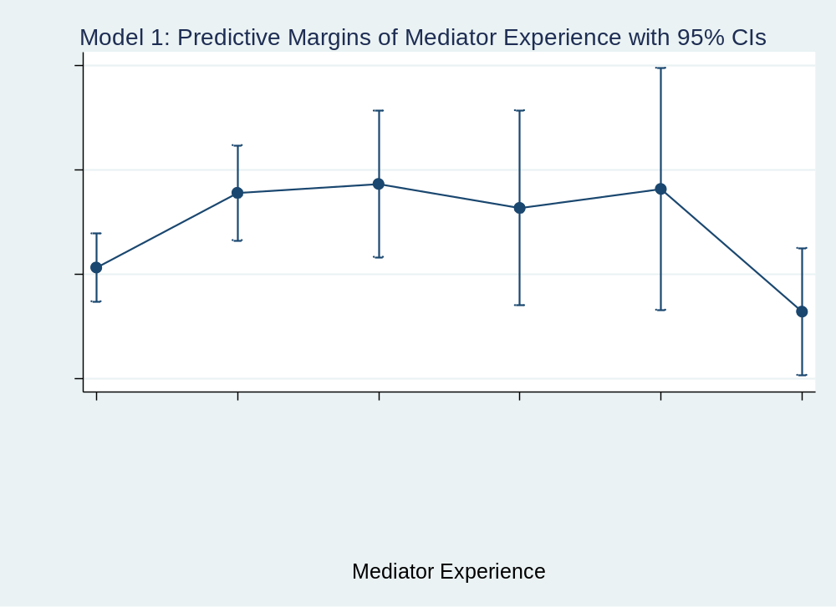
Figure 4-1: Model 1 Predictive Margins – Mediator Experience

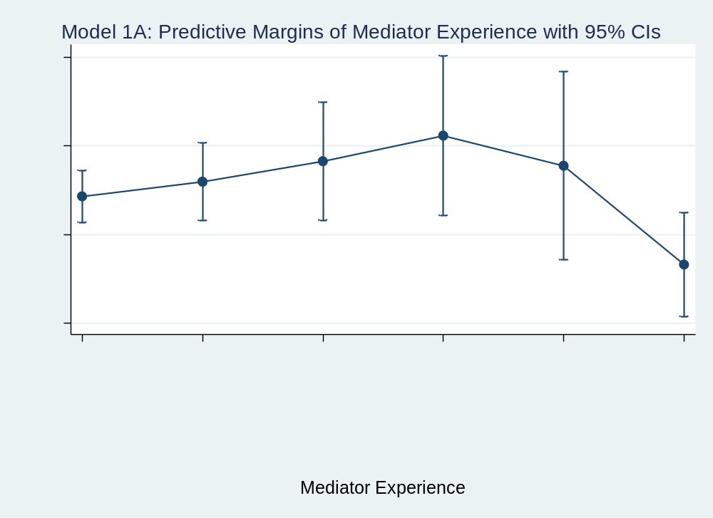
Figure 4-2: Model 1A Predictive Margins – Mediator Experience

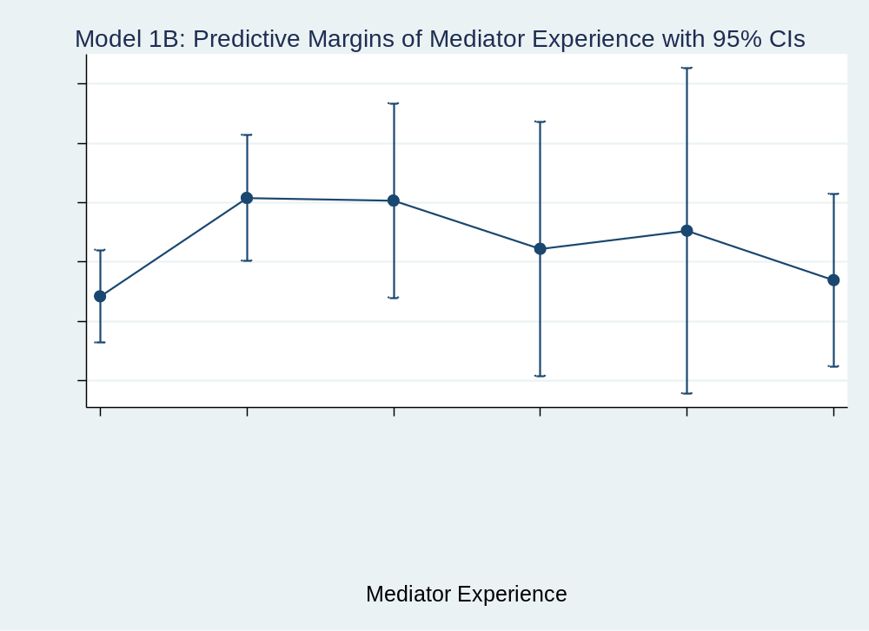
Figure 4-3: Model 1B Predictive Margins – Mediator Experience

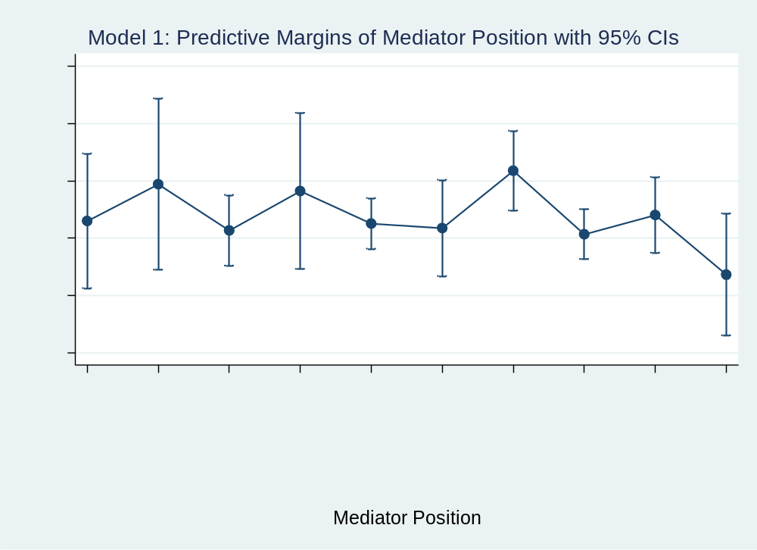
Figure 4-4: Model 1 Predictive Margins - Mediator Position

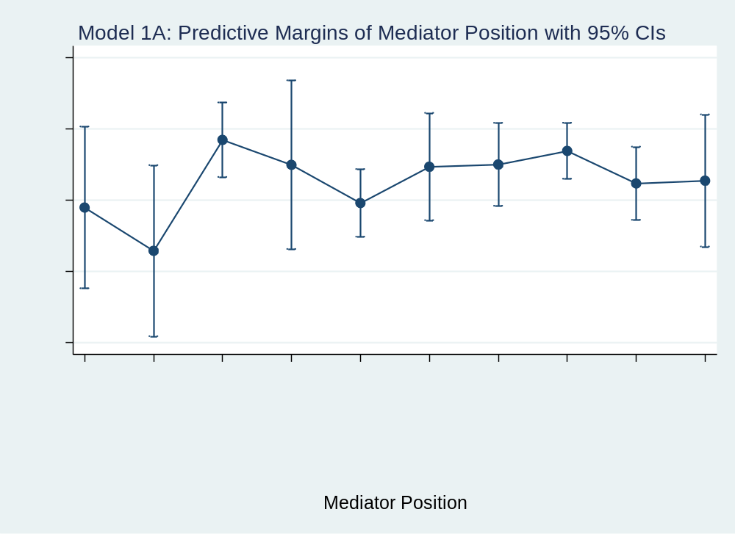
Figure 4-5: Model 1A Predictive Margins - Mediator Position
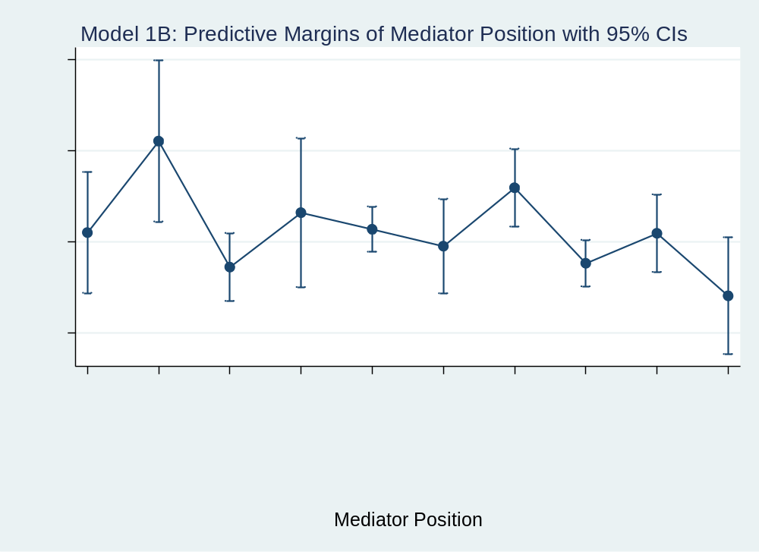
Figure 4-6: Model 1B Predictive Margins - Mediator Position

Table 4-2: Average Marginal Effects on Success (with mediator experience variable)
 | Model 1 |  | Model 1A  Low-Intensity |  | Model 1B  High-Intensity
Med Exp
No Prev Meds | 0 | (.) | 0 | (.) | 0 | (.)
1-2 Prev Meds | 0.0716** | (2.53) | 0.0333 | (0.63) | 0.0828** | (2.48)
3-4 Prev Meds | 0.0801** | (2.03) | 0.0794 | (1.08) | 0.0806* | (1.74)
5-6 Prev Meds | 0.0572 | (1.13) | 0.137 | (1.41) | 0.0400 | (0.69)
7-8 Prev Meds | 0.0753 | (1.22) | 0.0690 | (0.61) | 0.0552 | (0.76)
9+ Prev Meds | -0.0422 | (-1.15) | -0.154** | (-2.13) | 0.0136 | (0.31)
Med Position
Private Ind | 0.0933 | (1.16) | -0.0756 | (-0.50) | 0.139 | (1.47)
National Org | 0.157* | (1.68) | -0.197 | (-1.27) | 0.340*** | (3.04)
Rep Regional | 0.0768 | (1.23) | 0.114 | (1.04) | 0.0631 | (0.84)
Leader Reg | 0.145* | (1.65) | 0.0443 | (0.29) | 0.183* | (1.72)
Rep Inter | 0.0888 | (1.51) | -0.0628 | (-0.59) | 0.146** | (2.08)
Leader Inter | 0.0809 | (1.18) | 0.0391 | (0.33) | 0.109 | (1.29)
Rep Small G | 0.181*** | (2.78) | 0.0453 | (0.40) | 0.237*** | (3.02)
Rep Large G | 0.0701 | (1.20) | 0.0833 | (0.81) | 0.0716 | (1.02)
Leader Small G | 0.104 | (1.62) | -0.00783 | (-0.07) | 0.137* | (1.75)
Leader Large G | 0 | (.) | 0 | (.) | 0 | (.)
CVs
Terrdisp | 0.0596 | (1.45) | 0.122** | (2.20) | -0.0898 | (-1.37)
Postcold | 0.115*** | (4.18) | 0.0209 | (0.48) | 0.168*** | (4.07)
Duration | 0.000211** | (2.05) | 0.000766*** | (3.09) | 0.000133 | (1.01)
Fatal | -6.43e-08*** | (-2.93)
Observations | 2052 |  | 644 |  | 1408
t statistics in parentheses
* p < 0.10, ** p < 0.05, *** p < 0.01

In mediation for high-intensity conflicts, both representatives of small governments and national organizations seem to outperform representatives of RGOS, IGOs, and large governments, as well as leaders of large governments. On the other hand, within low-intensity conflicts, representatives of RGOs and large governments seem to overall have higher predicted probabilities for success than representatives of IGOs and mediators for national organizations. These initial outcomes suggest there might be differences in what types of mediators are better fits for low-intensity versus high-intensity conflicts.
In Model 2, the variable mediator experience is dropped to avoid collinearity issues with an assessment of the dichotomous group experience variable experienced or not. When groups or pairs of mediators with at least one person experienced in mediation are compared to those with no previous experience, there is a positive and strongly significant effect of experience on mediation success in both the full Model 2 (.13) and in the high-intensity Model 2B (.17), which reinforces Hypothesis 9 that mediation teams in which at least one person has previous mediation experience are more likely to be successful than mediation teams in which all mediators lack previous experience. However, significance for group experience is lost in the low-intensity Model 2A, potentially indicating unusual circumstances may be at play with mediations of low-intensity conflicts.
For mediator position, representatives of small governments continue to have a positive and statistically significant effect over leaders of large governments in both the full Model 2 (.17) and in mediations for high-intensity conflicts (.22), further reinforcing that representatives of small states are more likely to achieve mediation success than leaders of large states. When the model is parsed out by intensity, no mediator positions are significant for mediation occurrences in low-intensity conflicts, but mediators with national organizations or representatives of IGOs display a positive effect on mediation success over leaders of large governments, though the outcome is weakly significant. The former has an average marginal effect of .26 over large government leaders, and the latter has an average marginal effect of .17. Within the average marginal effects results, very slight differences in estimations also cause the private individual mediator position to appear to have a positive and statistically significant average marginal effect over large government leaders of .21.
Within the predictive margins graphs, there is a clear difference between the probabilities of success for experienced groups versus those with no previous experience in both Model 2 and high-intensity Model 2B. However, overlap occurs with Model 2A, reinforcing a lack of statistical significance for the variable with occurrences of mediations in low-intensity conflicts. With the mediator position variable, the graphs reveal further differences between the various categories for position. In Model 2, the representatives of small governments category slightly overlaps with the leaders of large governments category, weakening the statistical significance of the difference between these categories. On the other hand, the graph for Model 2A reveals a significant and positive difference in the likelihood of mediation success for representatives of RGOs, leaders of RGOs, and representatives of large governments over mediators from national organizations when mediating low-intensity conflicts.
Table 4-3: Logistical Regression - Success (with group experience variable)
 | Model 2 |  | Model 2A |  |  |  | Model 2B
Group Exp
No Prev Exp | 0 | (.) | 0 |  | (.) |  | 0 |  | (.)
1+ Exp Med In  Group/Pair | 0.513*** | (3.94) | 0.291 |  | (1.21) |  | 0.712*** |  | (4.50)
Med Position
Private Ind | 0.573 | (1.28) | -0.0307 |  | (-0.04) |  | 0.889 |  | (1.63)
National Org | 0.216 | (0.39) | -1.719 |  | (-1.35) |  | 1.123* |  | (1.70)
Rep Regional | 0.410 | (1.16) | 0.468 |  | (0.65) |  | 0.238 |  | (0.56)
Leader Reg | 0.724 | (1.55) | 0.849 |  | (0.97) |  | 0.484 |  | (0.82)
Rep Inter | 0.526 | (1.55) | -0.174 |  | (-0.24) |  | 0.747* |  | (1.91)
Leader Inter | 0.556 | (1.17) | 0.673 |  | (0.67) |  | 0.576 |  | (1.06)
Rep Small G | 0.714** | (1.98) | 0.0463 |  | (0.06) |  | 0.934** |  | (2.20)
Rep Large G | 0.278 | (0.82) | 0.164 |  | (0.23) |  | 0.220 |  | (0.56)
Leader Small G | 0.523 | (1.45) | 0.00190 |  | (0.00) |  | 0.530 |  | (1.26)
Leader Large G | 0 | (.) | 0 |  | (.) |  | 0 |  | (.)
CVs
Terrdisp | 0.183 | (0.82) | 0.386 |  | (1.33) |  | -0.450 |  | (-1.10)
Postcold | 0.357** | (2.32) | -0.167 |  | (-0.71) |  | 0.647*** |  | (2.61)
Duration | 0.000154 | (0.29) | 0.00506*** |  | (3.47) |  | -0.000394 |  | (-0.57)
Fatal | -1.76e-07 | (-1.50)
Constant | -0.877*** | (-2.58) | -0.531 |  | (-0.77) |  | -1.053*** |  | (-2.63)
Observations | 1344 |  | 446 |  |  |  | 898
Pseudo r2:  Log likelihood: | 0.0172  -909.73723 |  | 0.0394  -296.95982 |  |  |  | 0.0334  -592.79435
t statistics in parentheses
* p < 0.10, ** p < 0.05, *** p < 0.01

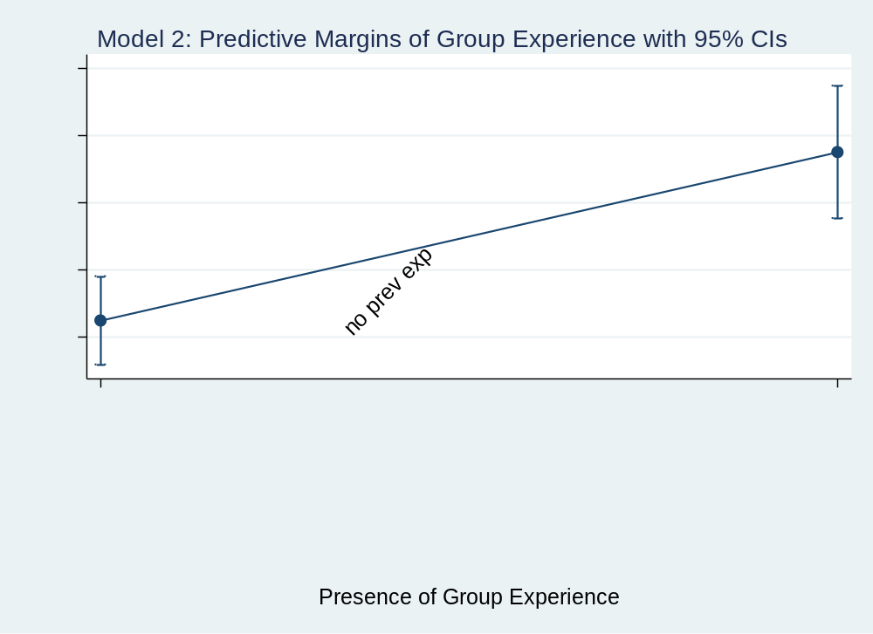
Figure 4-7: Model 2 Predictive Margins - Group Experience

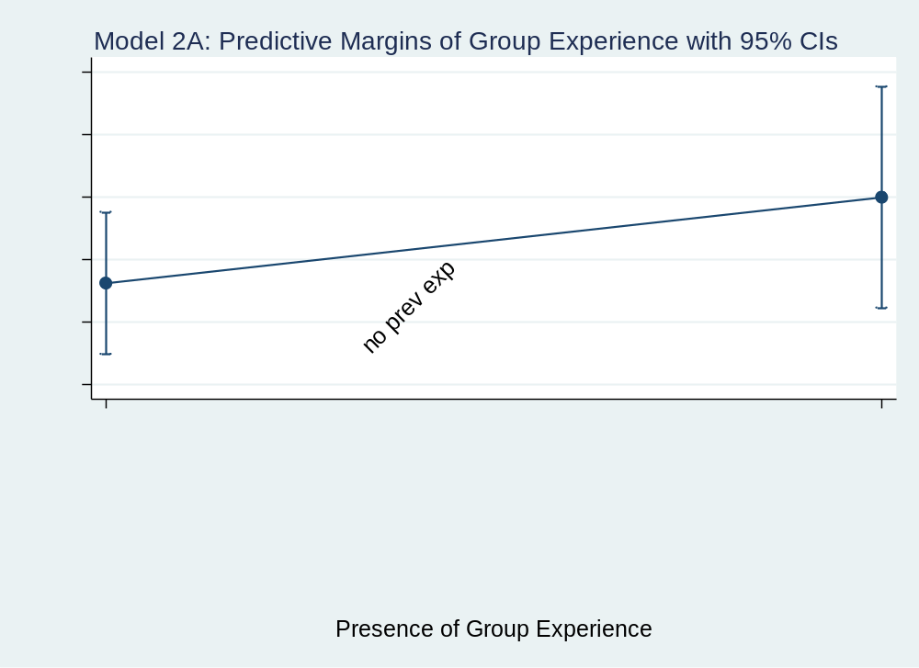
Figure 4-8: Model 2A Predictive Margins - Group Experience

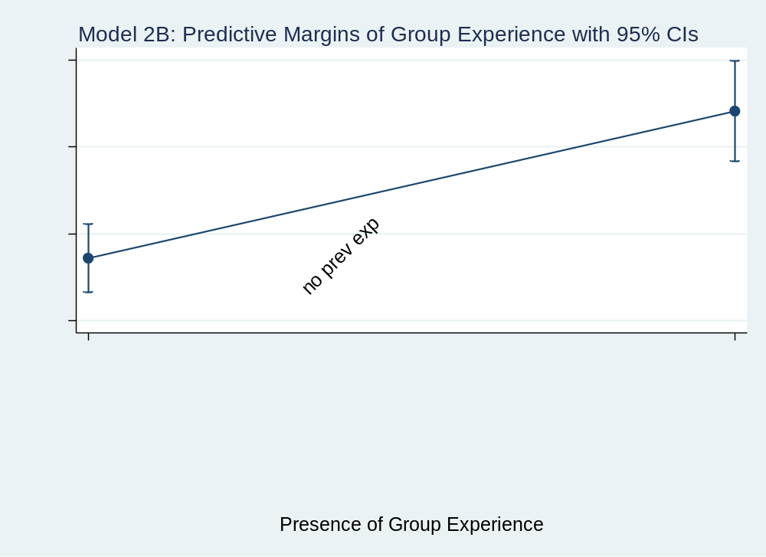
Figure 4-9: Model 2B Predictive Margins - Group Experience

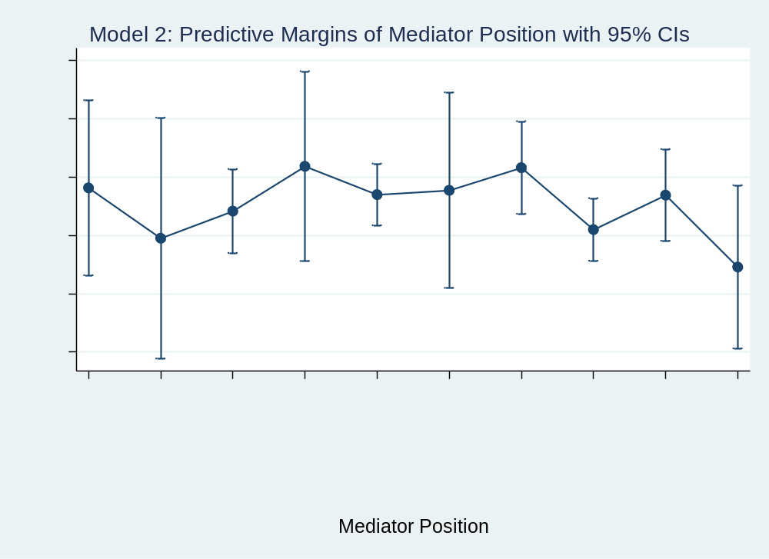
Figure 4-10: Model 2 Predictive Margins - Mediator Position

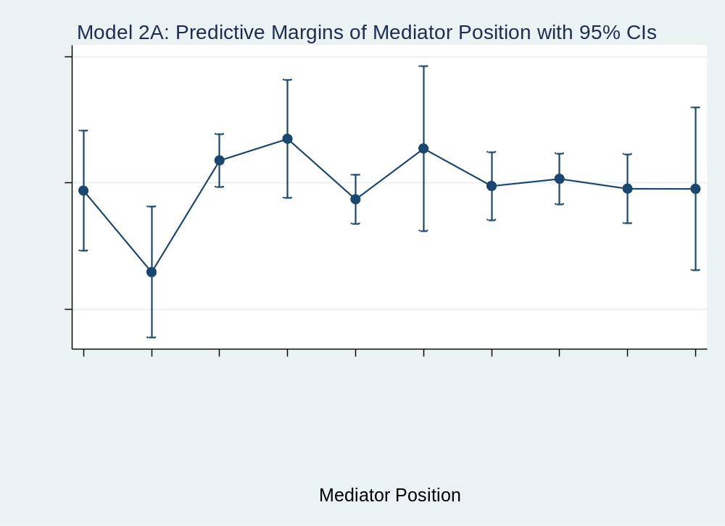
Figure 4-11: Model 2A Predictive Margins - Mediator Position

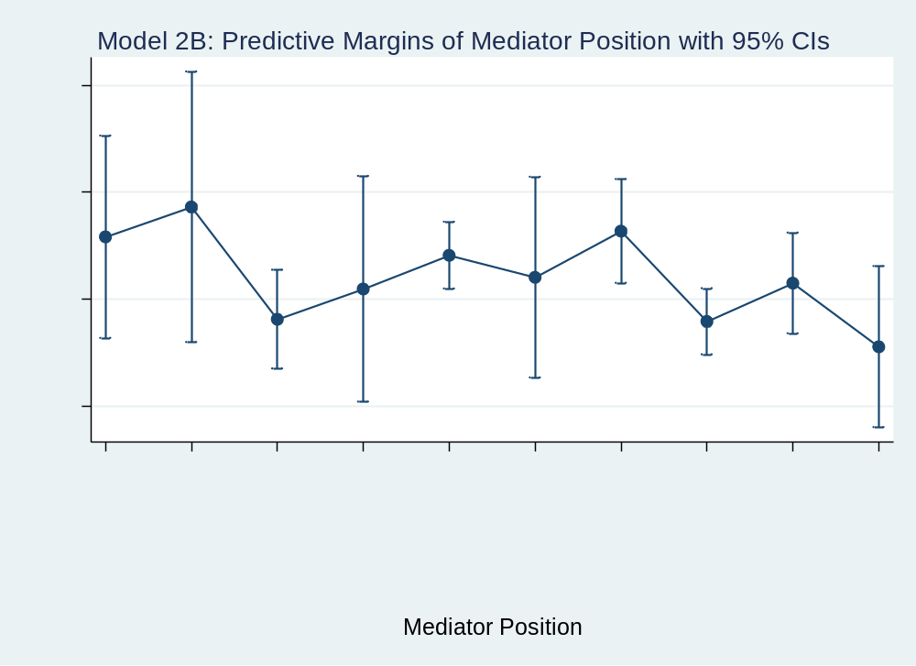
Figure 4-12: Model 2B Predictive Margins - Mediator Position

Table 4-4: Average Marginal Effects on Success (with group experience variable)
 | Model 2 |  | Model 2A |  | Model 2B
Group Exp
No Prev Exp | 0 | (.) | 0 | (.) | 0 | (.)
1+ Exp Med In  Group/Pair | 0.125*** | (3.99) | 0.0687 | (1.22) | 0.169*** | (4.60)
Med Position
Private Ind | 0.136 | (1.30) | -0.00741 | (-0.04) | 0.206* | (1.66)
National Org | 0.0494 | (0.39) | -0.330 | (-1.57) | 0.262* | (1.74)
Rep Regional | 0.0958 | (1.19) | 0.112 | (0.65) | 0.0515 | (0.57)
Leader Reg | 0.173 | (1.58) | 0.198 | (0.98) | 0.108 | (0.82)
Rep Inter | 0.124 | (1.63) | -0.0416 | (-0.24) | 0.171** | (2.06)
Leader Inter | 0.131 | (1.18) | 0.160 | (0.68) | 0.130 | (1.06)
Rep Small G | 0.170** | (2.08) | 0.0112 | (0.06) | 0.216** | (2.36)
Rep Large G | 0.0641 | (0.84) | 0.0397 | (0.23) | 0.0475 | (0.57)
Leader Small G | 0.123 | (1.50) | 0.000459 | (0.00) | 0.119 | (1.31)
Leader Large G | 0 | (.) | 0 | (.) | 0 | (.)
CVs
Terrdisp | 0.0442 | (0.82) | 0.0915 | (1.34) | -0.105 | (-1.11)
Postcold | 0.0865** | (2.34) | -0.0397 | (-0.71) | 0.151*** | (2.65)
Duration | 3.72e-05 | (0.29) | 0.00120*** | (3.67) | -9.21e-05 | (-0.58)
Fatal | -4.26e-08 | (-1.51)
Observations | 1344 |  | 446 |  | 898
t statistics in parentheses
* p < 0.10, ** p < 0.05, *** p < 0.01

For Model 2B, representatives of small governments and representatives of IGOs have significant and positive differences in the likelihood of mediation success over representatives of large governments. There is also only slight overlap of representatives of small governments over representatives of RGOs with the former tending to have higher predicted probabilities of success. Within all three models, private individuals, mediators for national organizations, leaders of RGOs, leaders of IGOs and leaders of large governments also have wide variations in their predicted likelihood of success. This finding may indicate that while representatives have time to focus on building their know-how competency skills regarding the conflicts and disputants, the amount of time leaders may have to focus on a particular conflict can vary as can their pre-existing familiarity with the disputants and parties.
Again, for Model 3, 3A, 3B and Model 4, 4A, and 4B, the dependent variable of success was replaced with strict success. Ceasefires are coded as 0, along with unsuccessful mediations as both being failures. Only full or partial agreements count as resulting in successful mediation occurrences. Now, when logistical regressions are conducted for mediator experience and mediator position, the outcomes are less interesting. In both Model 3 and high-intensity Model 3B, mediators with experience in 1-2 previous mediations are the only category that is statistically different from those without mediation experience. The average marginal effects for this category over mediators with no previous mediation experience is .05 for Model 3 and .06 for Model 3B. None of the categories for mediator experience are statistically significant in low-intensity Model 3A. Mediator position also does not return any statistically significant regression results for Model 3 and Model 3A. However, for Model 3B, leaders of small governments (.16), leaders of IGOs (.14), representatives of IGOs (.14), and mediators for national organizations (.22) seem to have statistically significant and positive effects on the likelihood of strict success over leaders of large governments. More investigation on this finding is reported in the qualitative analysis portion of this research.
Within the predictive margins graphs for mediator experience, overlap occurs on all categories of experience with the full Model 3 and both submodels 3A and 3B. Thus, much predictive power is lost concerning this variable when ceasefires are not counted as mediation successes as repeatedly recommended by Bercovitch and many conflict mediating entities. With mediator position, only the predictive margins for Model 3B have significant results. Representatives of IGOs have significantly higher likelihoods of achieving partial or full agreements than representatives and leaders of large governments. On the other hand, mediators from national organizations and leaders of small governments slightly overlap with leaders of large governments, reducing the likelihood that the statistical significance of the regression analysis will hold.
Taken together with all previous models, though, a pattern is beginning to emerge with the mediator position variable. Specifically, mediators for national organizations tend to have lower predicted probabilities of success in low-intensity conflict mediations but higher predicted probabilities of success in high-intensity conflict mediations. Conversely, representatives of RGOs and large governments tend to have lower predicted probabilities of success in mediations for high-intensity conflicts, but higher probabilities
for success in low-intensity conflicts. Routinely, though, representatives of small
Table 4-5: Logistical Regression - Strict Success (with mediator experience variable)
 | Model 3 |  | Model 3A |  |  |  | Model 3B
Med Exp
No Prev Meds | 0 | (.) | 0 | (.) |  |  | 0 | (.)
1-2 Prev Meds | 0.221* | (1.81) | 0.0994 | (0.45) |  |  | 0.278* | (1.86)
3-4 Prev Meds | 0.244 | (1.45) | 0.385 | (1.24) |  |  | 0.206 | (1.00)
5-6 Prev Meds | 0.0353 | (0.16) | 0.516 | (1.24) |  |  | -0.115 | (-0.42)
7-8 Prev Meds | 0.215 | (0.82) | 0.167 | (0.35) |  |  | 0.124 | (0.38)
9+ Prev Meds | -0.168 | (-1.00) | -0.533 | (-1.59) |  |  | 0.0214 | (0.11)
Med Position
Private Ind | 0.172 | (0.46) | -0.651 | (-0.95) |  |  | 0.567 | (1.17)
National Org | 0.369 | (0.89) | -1.008 | (-1.29) |  |  | 1.097** | (2.04)
Rep Regional | 0.151 | (0.51) | 0.0128 | (0.03) |  |  | 0.308 | (0.74)
Leader Reg | 0.543 | (1.39) | 0.226 | (0.34) |  |  | 0.761 | (1.47)
Rep Inter | 0.274 | (0.98) | -0.577 | (-1.25) |  |  | 0.742* | (1.90)
Leader Inter | 0.454 | (1.42) | 0.0694 | (0.14) |  |  | 0.753* | (1.70)
Rep Small G | 0.268 | (0.88) | -0.402 | (-0.83) |  |  | 0.659 | (1.57)
Rep Large G | 0.115 | (0.41) | -0.0772 | (-0.18) |  |  | 0.336 | (0.85)
Leader Small G | 0.434 | (1.46) | -0.294 | (-0.63) |  |  | 0.822** | (1.97)
Leader Large G | 0 | (.) | 0 | (.) |  |  | 0 | (.)
CVs
Terrdisp | 0.368** | (2.09) | 0.611** | (2.54) |  |  | -0.284 | (-0.94)
Postcold | 0.660*** | (5.45) | 0.349* | (1.84) |  |  | 0.813*** | (4.33)
Duration | 0.00150*** | (3.35) | 0.00341*** | (3.14) |  |  | 0.00150** | (2.56)
Fatal | -2.59e-07*** | (-2.62)
Constant | -1.295*** | (-4.66) | -0.645 | (-1.48) |  |  | -1.853*** | (-4.69)
Observations | 2052 |  | 644 |  |  |  | 1408
Pseudo r2:  Log likelihood: | 0.0237  -1285.6767 |  | 0.0476  -415.79425 |  |  |  | 0.0245  -848.41728
t statistics in parentheses
* p < 0.10, ** p < 0.05, *** p < 0.01

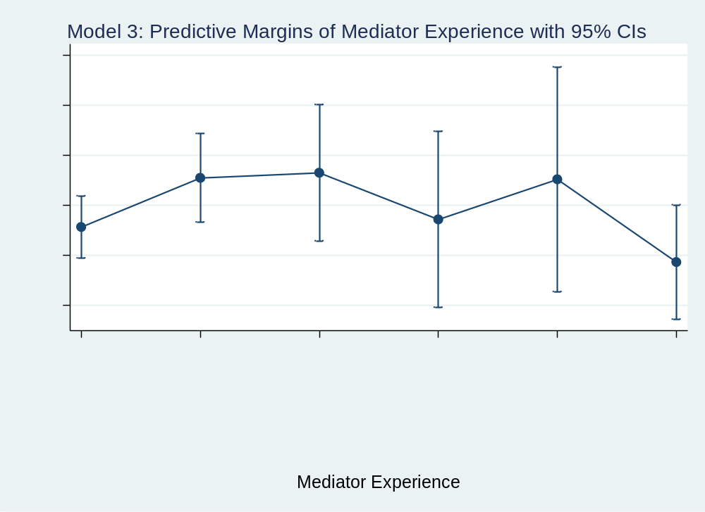
Figure 4-13: Model 3 Predictive Margins - Mediator Experience

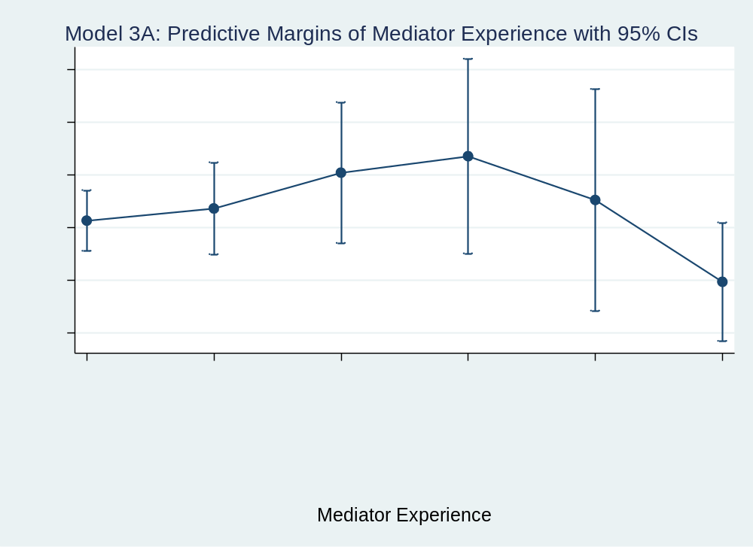
Figure 4-14: Model 3A Predictive Margins - Mediator Experience

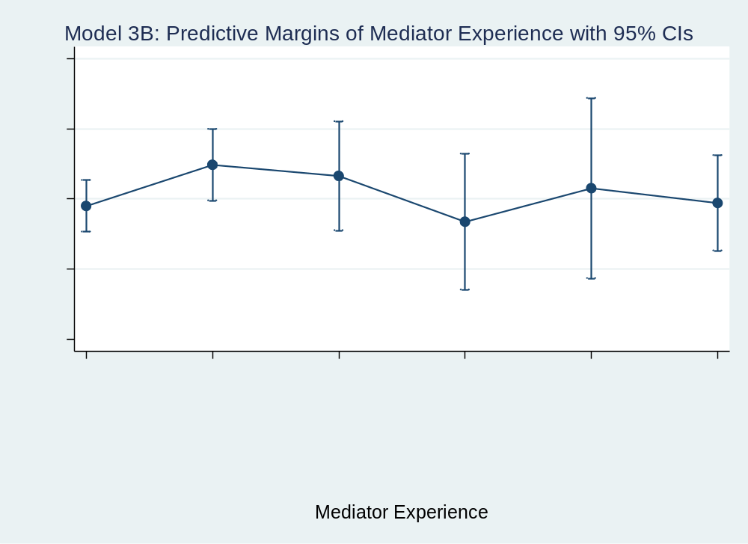
Figure 4-15: Model 3B Predictive Margins - Mediator Experience

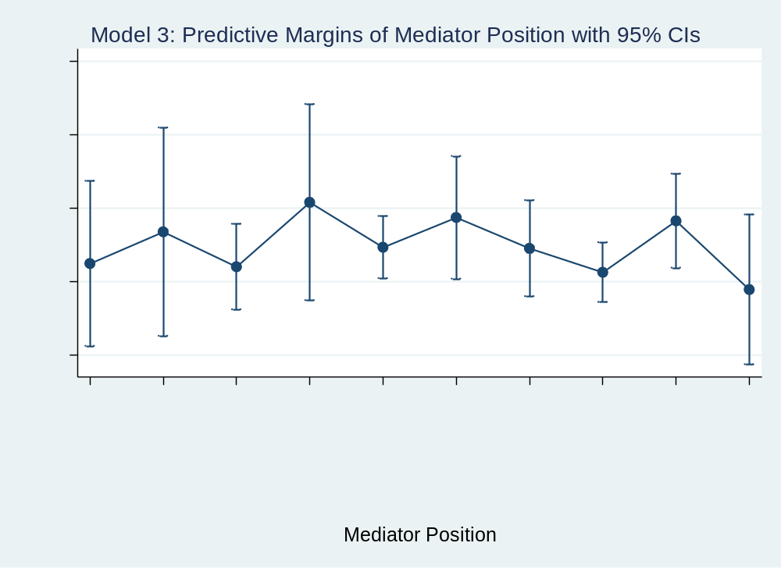
Figure 4-16: Model 3 Predictive Margins - Mediator Position

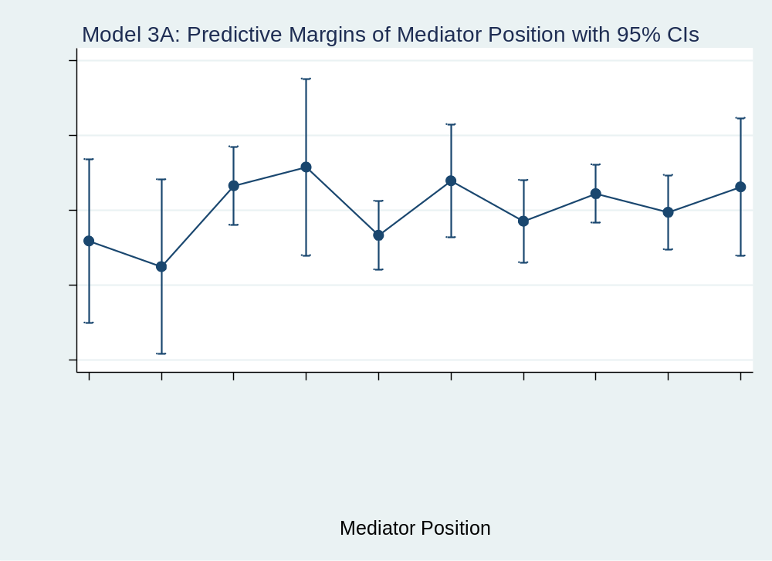
Figure 4-17: Model 3A Predictive Margins - Mediator Position

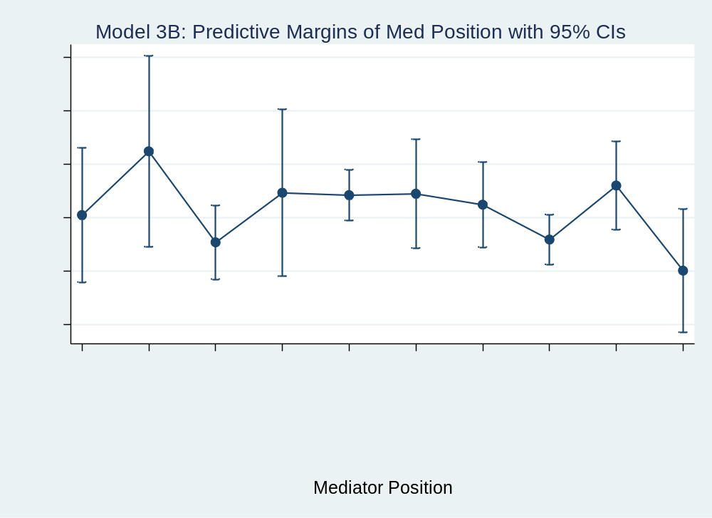
Figure 4-18: Model 3B Predictive Margins - Mediator Position

Table 4-6: Average Marginal Effects on Strict Success
(with mediator experience variable)
 | Model 3 |  | Model 3A |  | Model 3B
Med Exp
No Prev Meds | 0 | (.) | 0 | (.) | 0 | (.)
1-2 Prev Meds | 0.0491* | (1.79) | 0.0232 | (0.44) | 0.0587* | (1.84)
3-4 Prev Meds | 0.0542 | (1.42) | 0.0910 | (1.24) | 0.0429 | (0.98)
5-6 Prev Meds | 0.00761 | (0.16) | 0.122 | (1.24) | -0.0224 | (-0.42)
7-8 Prev Meds | 0.0476 | (0.80) | 0.0392 | (0.35) | 0.0254 | (0.37)
9+ Prev Meds | -0.0350 | (-1.01) | -0.116* | (-1.67) | 0.00431 | (0.11)
Med Position
Private Ind | 0.0355 | (0.46) | -0.144 | (-0.98) | 0.104 | (1.19)
National Org | 0.0787 | (0.88) | -0.213 | (-1.40) | 0.224** | (2.04)
Rep Regional | 0.0312 | (0.52) | 0.00300 | (0.03) | 0.0530 | (0.77)
Leader Reg | 0.119 | (1.38) | 0.0530 | (0.34) | 0.146 | (1.47)
Rep Inter | 0.0577 | (1.02) | -0.129 | (-1.23) | 0.142** | (2.21)
Leader Inter | 0.0983 | (1.46) | 0.0163 | (0.14) | 0.144* | (1.82)
Rep Small G | 0.0562 | (0.91) | -0.0916 | (-0.83) | 0.124* | (1.72)
Rep Large G | 0.0236 | (0.42) | -0.0180 | (-0.18) | 0.0582 | (0.92)
Leader Small G | 0.0937 | (1.52) | -0.0677 | (-0.63) | 0.160** | (2.20)
Leader Large G | 0 | (.) | 0 | (.) | 0 | (.)
CVs
Terrdisp | 0.0802** | (2.10) | 0.139*** | (2.59) | -0.0587 | (-0.94)
Postcold | 0.144*** | (5.60) | 0.0792* | (1.86) | 0.168*** | (4.44)
Duration | 0.000326*** | (3.39) | 0.000775*** | (3.24) | 0.000311*** | (2.58)
Fatal | -5.65e-08*** | (-2.63)
Observations | 2052 |  | 644 |  | 1408
t statistics in parentheses
* p < 0.10, ** p < 0.05, *** p < 0.01

governments tend to have higher predicted probabilities of success in both types of conflicts. Leaders of large governments, though, tend to have lower overall likelihoods of mediation success or strict success in mediations for high-intensity conflicts when compared to most all other mediator position categories, which lends support to Hypothesis 5 that representatives of small states are more likely to achieve mediation success than leaders of large states, which I attributed to the latter group probably having major difficulties with know-how competency skills as they are unable to spend much time on the ground in mediations.

In Model 4 and Model 4B, group experience reemerges as having a strongly significant and positive effect on mediation outcome, even when success is only measured by achieving a full or partial peace settlement. The average marginal effects on strict success for a group having at least one experienced mediation versus having no one with previous mediation experience is .10 for Model 4 and .14 for high-intensity Model 4B. Again, though, the low-intensity model here has no findings of statistical significance regarding experience. As for mediator position, the only category with statistical significance is national organization mediator in Model 4B. The statistical significance is weak, but the predicted average marginal effect is .28 over leaders of large governments.
The predictive margins graphs for experienced or not in Model 4 and Model 4B support the findings of the logistical regressions for these models that group experience has positive and statistically different results from no previous experience when it comes to predicted probability of achieving a full or partial settlement. As for mediator position, there are a few items of interest. First, in Model 4A, leaders of RGOs only have a slight
Table 4-7: Logistical Regression - Strict Success (with group experience variable)
 | Model 4 |  | Model 4A |  | Model 4B
Group Exp
No Prev Exp | 0 | (.) | 0 | (.) | 0 | (.)
1+ Exp Med In  Group/Pair | 0.445*** | (3.31) | 0.301 | (1.22) | 0.615*** | (3.72)
Med Position
Private Ind | 0.372 | (0.80) | -0.308 | (-0.36) | 0.633 | (1.10)
National Org | 0.354 | (0.63) | -1.792 | (-1.40) | 1.269* | (1.89)
Rep Regional | 0.109 | (0.30) | -0.115 | (-0.16) | -0.0122 | (-0.03)
Leader Reg | 0.725 | (1.52) | 0.584 | (0.67) | 0.524 | (0.86)
Rep Inter | 0.328 | (0.93) | -0.633 | (-0.88) | 0.605 | (1.46)
Leader Inter | 0.409 | (0.84) | 0.647 | (0.64) | 0.366 | (0.64)
Rep Small G | 0.407 | (1.09) | -0.402 | (-0.54) | 0.624 | (1.40)
Rep Large G | 0.111 | (0.31) | -0.0713 | (-0.10) | 0.0182 | (0.04)
Leader Small G | 0.373 | (1.00) | -0.385 | (-0.52) | 0.439 | (0.99)
Leader Large G | 0 | (.) | 0 | (.) | 0 | (.)
CVs
Terrdisp | 0.187 | (0.82) | 0.488* | (1.67) | -0.819* | (-1.70)
Postcold | 0.455*** | (2.87) | 0.000312 | (0.00) | 0.659** | (2.54)
Duration | 0.000701 | (1.29) | 0.00552*** | (3.77) | 0.000277 | (0.39)
Fatal | -1.70e-01 | (-1.37)
Constant | -1.163*** | (-3.29) | -0.626 | (-0.90) | -1.396*** | (-3.29)
Observations | 1344 |  | 446 |  | 898
Pseudo r2:  Log likelihood: | 0.0144  -863.89407 |  | 0.0448  -289.06837 |  | 0.0311  -551.57002
t statistics in parentheses
* p < 0.10, ** p < 0.05, *** p < 0.01

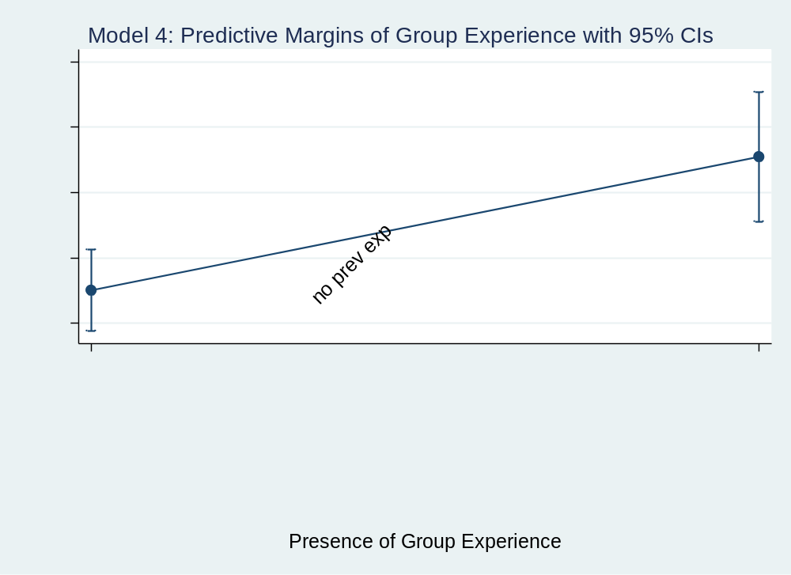
Figure 4-19: Model 4 Predictive Margins - Group Experience

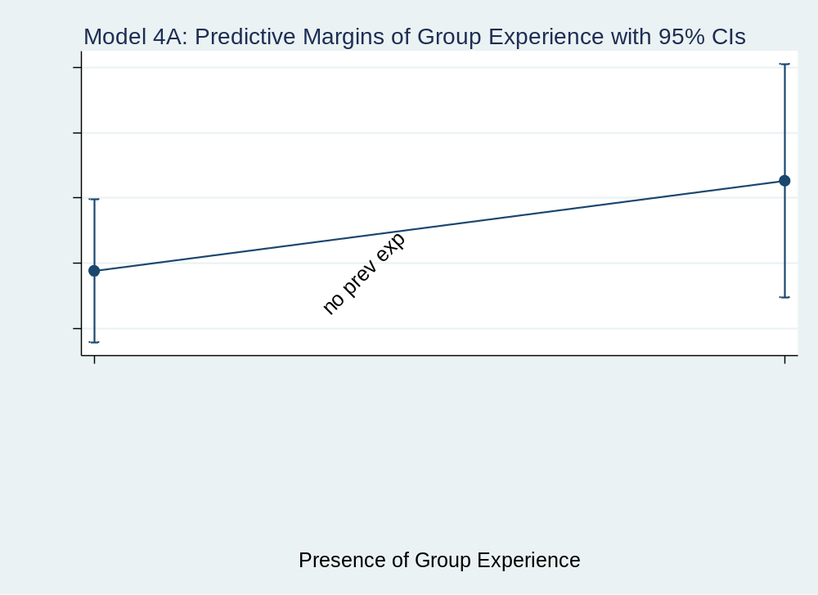
Figure 4-20: Model 4A Predictive Margins - Group Experience

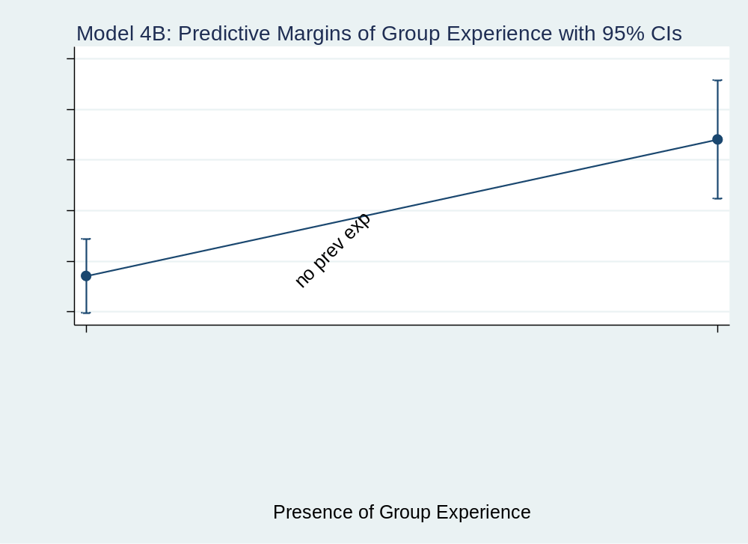
Figure 4-21: Model 4B Predictive Margins - Group Experience

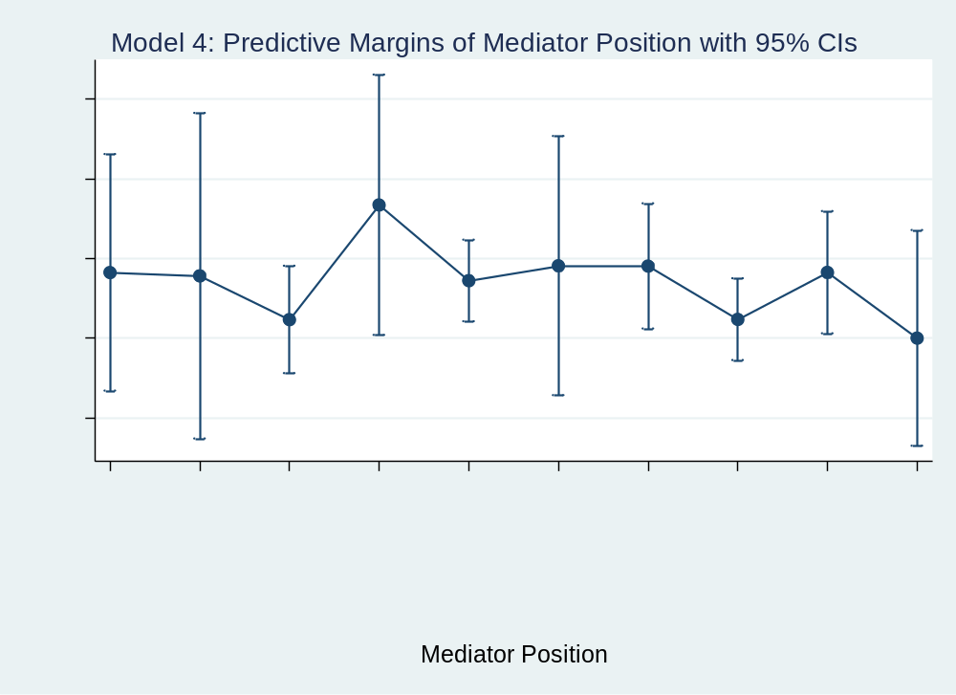
Figure 4-22: Model 4 Predictive Margins - Mediator Position

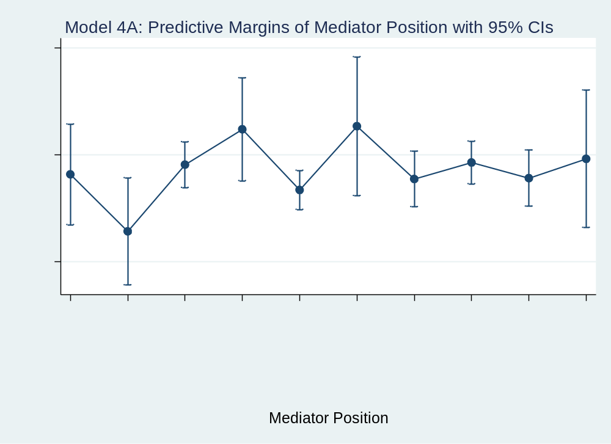
Figure 4-23: Model 4A Predictive Margins - Mediator Position

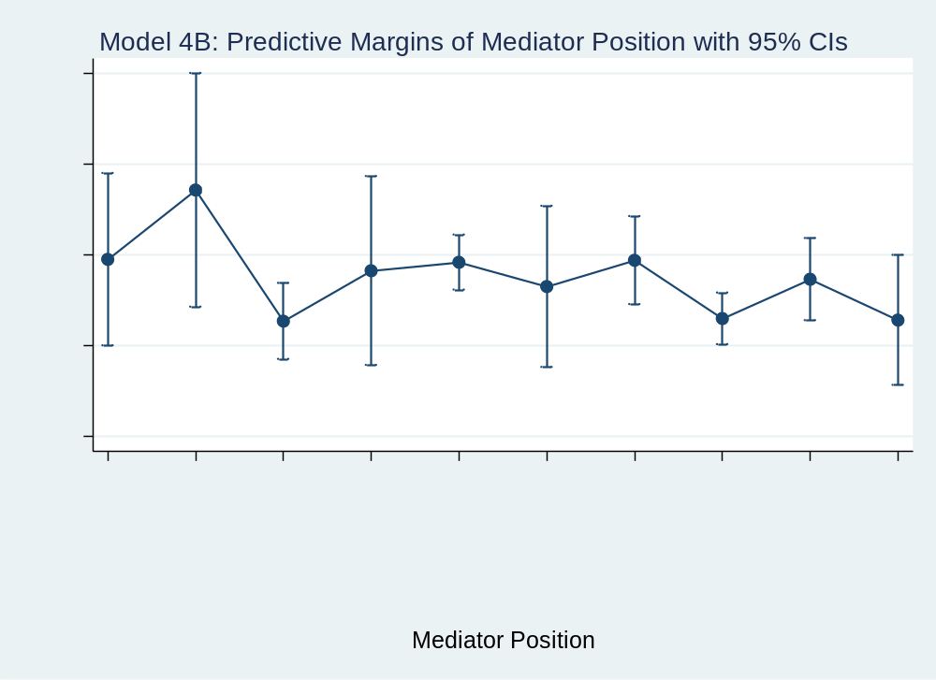
Figure 4-24: Model 4B Predictive Margins - Mediator Position

Table 4-8: Average Marginal Effects on Strict Success (with group experience variable)
 | Model 4 |  | Model 4A |  | Model 4B
Group Exp
No Prev Exp | 0 | (.) | 0 | (.) | 0 | (.)
1+ Exp Med In  Group/Pair | 0.102*** | (3.29) | 0.0691 | (1.23) | 0.135*** | (3.70)
Med Position
Private Ind | 0.0822 | (0.80) | -0.0729 | (-0.36) | 0.134 | (1.10)
National Org | 0.0779 | (0.62) | -0.340 | (-1.64) | 0.287* | (1.90)
Rep Regional | 0.0232 | (0.30) | -0.0274 | (-0.16) | -0.00228 | (-0.03)
Leader Reg | 0.167 | (1.54) | 0.138 | (0.68) | 0.109 | (0.84)
Rep Inter | 0.0720 | (0.98) | -0.146 | (-0.85) | 0.128 | (1.61)
Leader Inter | 0.0906 | (0.84) | 0.153 | (0.65) | 0.0740 | (0.64)
Rep Small G | 0.0902 | (1.13) | -0.0944 | (-0.54) | 0.132 | (1.49)
Rep Large G | 0.0235 | (0.32) | -0.0171 | (-0.10) | 0.00342 | (0.04)
Leader Small G | 0.0824 | (1.04) | -0.0906 | (-0.51) | 0.0899 | (1.04)
Leader Large G | 0 | (.) | 0 | (.) | 0 | (.)
CVs
Terrdisp | 0.0421 | (0.82) | 0.112* | (1.69) | -0.174* | (-1.71)
Postcold | 0.103*** | (2.90) | 0.0000714 | (0.00) | 0.140*** | (2.58)
Duration | 0.000158 | (1.29) | 0.00126*** | (4.02) | 5.88e-05 | (0.39)
Fatal | -3.83e-08 | (-1.38)
Observations | 1344 |  | 446 |  | 898
t statistics in parentheses
* p < 0.10, ** p < 0.05, *** p < 0.01

overlap with mediators for national organizations, the latter of which is a category with high variance in predicted probability margins of strict success. Second, in Model 4B, the predicted probability margins for strict success for representatives of IGOs is statistically different and more positive than the predicted probability margins for representatives of RGOs and large governments. Third, representatives of small governments follow the same trend as representatives of IGOs, but there is slight overlap with representatives of RGOs and large governments. Fourth, the predicted probability margins for national organization mediators only slightly overlaps with representatives of large governments and is more positive. Again, the former tends to have a large variance, so this outcome for national organization mediators is possibly noteworthy.
After reviewing all the models, it is also important to where control variables held. The presence of a territorial dispute significant for all mediation occurrences in low-intensity conflicts and tended to have a positive effect on the likelihood of mediation success or strict success in those low-intensity models. However, it was only a significant control for Model 4B in the high-intensity models. Interestingly, though, the presence of a territorial dispute in high-intensity conflicts had a negative relationship with mediation outcome. In the full models, territorial dispute was significant and positive for Model 3.
The control for conflicts that commenced after the end of the Cold War, postcold, was significant and positive for all full Models 1, 2, 3, and 4, as well as for all high-intensity models. It was mostly insignificant, though, for low-intensity models with the except of very slight significance in Model 3A. Conflict duration had a positive and highly significant effect on mediation success or strict success for all four low-intensity models, possibly indicating growing weariness among disputants concerning hostilities and either a desire to avoid conflict escalation or a lack of willingness to escalate the conflict further. It also had a positive and significant effect on mediation outcome for full Model 1 and Model 3. Finally, the control for fatalities was only significant for full Model 1 and Model 3 that tested mediator position. Where significant, the raw number of fatalities had a negative, but very small impact on the likelihood of achieving success or strict success.
To further examine the nuances in the data regarding mediator position, I created Figures 4-25 through 4-30. For Figure 4-25, I crosstabulated the number of unsuccessful versus successful mediation outcomes for each mediator position using the dependent variable success. I then calculated the percent of unsuccessful versus successful mediation outcomes for each position and reported those in Figure 4-26. This information is useful in that it first reveals what mediator positions conduct the most mediations. Figure 4-25 shows that representatives of IGOs, followed by representatives of large governments have taken on the most conflict mediations with 688 and 661, respectively. Behind them, representatives of RGOs mediated 367 conflicts, representatives of small governments mediated 300, and leaders of small governments mediated 275. The bottom half of the data included leaders of IGOs with 198 mediations, leaders of large governments with 93, private individuals with 76, leaders of RGOs with 62, and national organizations with 49. However, when the percent of unsuccessful versus successful mediations for each mediation position is examined in Figure 4-26, representatives of small governments have the highest percentage of success at 54.00%. Leaders of RGOs are second at 50.00%, and leaders of small governments are third at 48.73%. Leaders of large governments have the worst success rates at only 37.63%. Leaders of IGOs and private individuals are only slightly better at 38.38% and 39.47%, respectively.
Taken together, this information indicates that, as a whole, representatives engage in more mediations than leaders. However, within small governments, leaders and representatives seemed fairly equivalent in the number of mediations they lead, though the latter has a higher percentage of success. Additionally, though leaders of RGOs have only taken on a small number of mediations, they seem to be at least 10% more successful than large government leaders and private individuals, that also have low numbers of mediation occurrences. Interestingly, in the past, leaders of IGOs like the United Nations have famously been involved in mediating major conflicts. Some, like Kofi Annan, have even been regarded as master mediators due to their adeptness at negotiating peace agreements. This makes the low mediation success rates of IGO leaders highly interesting. Also, when comparing representatives to leaders for each type of entity represented in the mediator position variable, representatives of IGOs percentage of success was 7.11 percentage points higher than leaders of IGOs. Likewise, representatives of small governments outperformed their leaders (54.00% to 48.73%), as did representatives of large governments (42.66%) when compared to leaders of large governments (37.63%). Only with RGOs did the leaders achieve higher percentages of success than the representatives (50.00% to 44.96%). Taken together, this information further supports Hypothesis 5 that representatives of small states are more likely to achieve mediation success than leaders of large states. It also lends partial support to

Figure 4-25: Number of Unsuccessful vs Successful Mediation Occurrences for Each Mediator Position

Figure 4-26: Percentage of Unsuccessful vs Successful for All Mediations by Each Mediator Position

Hypothesis 6 that representatives, in general, are more likely to achieve mediation success than leaders of their respective entity types.
A common supposition concerning individual mediators and mediation outcome is that mediators of higher rank, particularly leaders, may simply be called in to mediate final peace agreements once representatives have conducted much of the labor of the mediation process. Therefore, I also created Figures 4-27 through 4-30 to compare the number and percentage of each type of agreement mediators at that rank have secured. While Figure 4-27 and Figure 4-28 include all mediations, Figure 4-29 only reports mediation outcomes for low-intensity conflicts whereas Figure 4-30 reports mediation outcomes for high-intensity conflicts.
When looking at all mediation attempts by mediators in each, particular mediation position, leaders of small governments have the highest percent of mediation occurrences that end in full agreements (11.64%) followed by representatives of small governments (9.00%). Mediators for national organizations and leaders of RGOs have the highest percentage of mediations that end in partial agreements, 34.69% and 33.87% respectively. However, representatives of small governments at 16.67% and representatives of RGOs at 12.26% have the highest percentages of mediations that end in ceasefires.
Successful mediations for each position most often tend to result in partial agreements, not ceasefires as some might think. Also, when comparing ceasefires to full agreements, only in small governments does it seem that representatives may be laying the groundwork for leaders to secure full agreements as small government representatives mediate a higher percentage of ceasefires than full agreements while the reverse is true for small government leaders. As for the lowest percentages in each category, mediators for national organizations (2.04%), private individuals (3.95%), leaders of large governments (4.30%), and leaders of IGOs (4.55%) are lowest in reaching full agreements. Representatives of RGOs (24.25%), private individuals (26.32%), and leaders of large governments (26.88%) are at the bottom with partial agreements. Finally, leaders of IGOs (3.54%), leaders of large governments (6.45%), and leaders of small governments (6.91%) have the small percentages of mediation outcomes that result in ceasefires.
If the mediation outcome results are parsed out between low-intensity and high-intensity conflicts, several interesting changes emerge regarding mediator position and outcome. One of the more intriguing results, however, may be that in low-intensity conflicts, mediators for national organizations are unsuccessful in 80% of mediations occurrences, but in high-intensity conflicts, this percentage falls to 41.18% as they secure more ceasefires, partial agreements and full agreements. On the other hand, representatives and leaders of RGOs, representatives of large governments, and leaders of both large and small governments all have a more difficult time of achieving successful mediation outcomes in high-intensity conflicts.
Returning to Hypothesis 5, when mediation occurrences are parsed by conflict intensity, representatives of small governments continue to achieve more ceasefires and settlements than leaders of large governments. Moreover, in low-intensity conflicts, only mediators for national organizations, leaders of IGOs, and private individuals have lower

Figure 4-27: Number of Each Mediation Outcome for Each Mediator Position

Figure 4-28: Percentage of Each Mediation Outcome for All Mediations by Each Mediatior Position (All Mediations)
Figure 4-29: Percentage of Each Mediation Outcome for All Mediations by Each Mediator Position (Low-Intensity Only)

Figure 4-30: Percentage of Each Mediation Outcome for All Mediations by Each Mediator Position (High-Intensity Only)

percentages of success than leaders of large governments, and in high-intensity conflicts, leaders of large governments have the lowest percentages of all. Furthermore, only in RGOs do representatives have higher percentages of being “unsuccessful” than the respective leaders for that category. In IGOs, small governments, and large governments, representatives outperform their leaders in achieving positive mediation outcomes in both low-intensity and high-intensity. This information lends partial support to Hypothesis 6 that representatives, in general, are more likely to achieve mediation success than leaders of their respective entity types. It also gives strong support to the idea that know-how competency does impact mediation outcome as the differing duties of representative’s and leader’s jobs allow representatives more “time on the ground” to become steeped in first-hand knowledge of a conflict, its disputants, and the needs or demands of other affected players and communities.
One other detail that is important to note in the findings of these analyses is the difficulty of predicting the effect the categorical mediator experience variable will have on the likelihood of success. Specifically, I noted that sometimes the categories of 1-2 previous mediations or 3-4 previous mediations had positive and statistically significant effects on the likelihood of mediation success. However, particularly with low-intensity conflicts, mediators with experience in 9+ previous mediations are associated with a negative effect on mediation outcome. A deeper investigation into this issue revealed two important issues. First, when tabulating the original ICM variable for mediator experience (cm21) with the variable for the numbers of mediators acting in a particular mediation occurrence (cm18), there are frequent instances of pair or group mediations that are not confined to the “group experience” category as reported in Table 4-9.
To, as best as possible, eliminate any confounding effects of differing mediator interests, I ran additional analyses on mediator experience variable for both success and strict success and limited my cases to those with only one reported lead mediator. The average marginal effects for these analyses are reported in Table A-5 and Table A-6 in the Appendix as Model 7/A/B and Model 8/A/B, along with the predictive margins graphs for full Model 7 and full Model 8. While mediator experience in Model 8 has little predictive power over strict success, the statistical significance for mediator experience is finally teased out in Model 7. All categories of previous mediator experience, save for 9+ previous mediations, display statistical significance and have positive average marginal effects over mediations conducted by mediators with no previous experience. Statistical significance is maintained with the 1-2 previous mediations and 3-4 previous mediations categories in the high-intensity Model 7B, while the 5-6 previous mediations category is statistically significant in the low-intensity Model 7A. In my opinion, this reveals a potential coding issue in the ICM data that may be causing the ICM experience variable, and my derived mediator experience variable, to pick up the effects of mediator numbers or mediators with similar versus different interests.
I also did a deeper investigation of the data in attempt to discover why experience with 9+ previous mediations was having a potentially negative effect on mediation success, especially in low-intensity conflicts, when compared to those with no previous experience. For all mediators with experience in 9+ previous mediations, I isolated their
Table 4-9: Tabulation of ICM Mediator Experience Variable
vs. Mediator Number Variable
Number of Mediators Acting
ICM Mediator Exp | One Med | Two Meds -Same Interests | Two Meds-Diff Interests | Group Meds-Same Interests | Group Meds-Diff Interests | Total
No Prev | 532 | 57 | 44 | 155 | 116 | 904
1-2 Prev | 317 | 11 | 18 | 72 | 43 | 461
3-4 Prev | 140 | 4 | 5 | 27 | 15 | 191
5-6 Prev | 80 | 1 | 5 | 16 | 5 | 107
7-8 Prev | 54 | 2 | 6 | 6 | 2 | 70
9+ Prev | 251 | 7 | 19 | 21 | 10 | 308
Group Exp | 46 | 50 | 38 | 191 | 112 | 437
Total | 1420 | 132 | 135 | 488 | 303 | 2478

third-party identity codes and crosstabulated these with their outcomes for success. Then, in Table 4-10, I listed any mediators with 5 or more failures. Important information emerged. Those mediators with 9+ mediation experiences and the top four greatest number of mediation failures were all UN Secretary Generals. They include General Perez de Cueller (35 fails), Dr. Boutros Boutros-Ghali (17 fails), Dr. Kurt Waldheim (14 fails), and U Thant (11 fails). All four individuals are classified as leaders of IGOs, and this mediator position has a particularly low percentage of mediation success. Furthermore, 20 of Gen Perez de Cueller’s 35 failures occurred in low-intensity conflicts, as did 11 of Dr. Kurt Waldheim’s and 5 of U Thant’s. The number of mediations for low-intensity conflicts is small in comparison to the number of mediations for high-intensity conflicts, so these failures have a lot of impact on the connection between mediator experience and mediation outcome.
Conclusions
The overall results on the quantitative analysis portion of this research strongly support the argument that small government representatives are more likely to achieve mediation success than large government leaders. Also, representatives, in general, are more likely to achieve mediation success than large government leaders. The theory behind this is that the other job duties of large government leaders disallow them from spending longer time on the ground than representatives, especially those from small state governments who, as a few previous case studies by Todhunter (2018) have suggested, tend to have financial and political support from their states to physically remain in mediation settings for lengthy periods working on peace agreements. Such time
Table 4-10: Mediators with 9+ Prev Mediation Experience by Largest Numbers of Failures
Third Party code | Identity | Failure | % Fail | Success | % Succ | Total
113 | UN Sec Gen Perez de Cueller | 35 | 64.81% | 19 | 35.19% | 54
427 | UN Sec Gen Dr. Boutros Boutros-Ghali | 17 | 68.00% | 8 | 32.00% | 25
54 | UN Sec Gen Dr. Kurt Waldheim | 14 | 70.00% | 6 | 30.00% | 20
53 | UN Sec Gen U Thant | 11 | 91.67% | 1 | 8.33% | 12
93 | Jimmy Carter, US Pres/Priv Indv | 10 | 66.67% | 5 | 33.33% | 15
1481 | Julius Nyerere (Former President of Tanzania) | 8 | 50.00% | 8 | 50.00% | 16
837 | Yasushi Akashi (UN Sec-Gen's special rep to Bosnia) | 6 | 75.00% | 2 | 25.00% | 8
322 | Conf on Security & Cooperation in Europe (CSCE) | 5 | 100.00% | 0 | 0.00% | 5
528 | Lord Owen (EC Mediator); Cyrus Vance | 5 | 62.50% | 3 | 37.50% | 8
767 | Alioune Blondin Beye (UN Special Rep to Angola) | 5 | 55.56% | 4 | 44.44% | 9
823 | Lord Owen; Thorvald Stoltenberg (UN mediator) | 5 | 83.33% | 1 | 16.67% | 6

devotion allows for greater understanding of a conflict and its disputants, thus increasing one’s know-how competencies as know-how is, essentially, “learning by doing” or experience. Further reinforcing this argument is the finding that all mediators who serve as representatives for their entities, save those associated with RGOs, have historically tended to have higher percentages of successful mediation outcomes that the leaders of their organizations. Representatives should reasonably have more time and abilities than their respective entity leaders to become experts in particular conflicts as their attention is usually not being fragmented across multiple conflicts, the administrative duties of leadership, and sometimes, the multiple political demands of one’s domestic or international audience.
Quantitative analysis of the pre-existing data on mediator experience, though, offers mixed results. Within high-intensity conflicts, trends do emergence that suggest mediators with experience in 1-2 or 3-4 previous mediations have a statistically significant higher probability of achieving success in mediation than those with no experience. Beyond those categories of previous experience, the effect becomes murky. Moreover, experience was often insignificant in low-intensity models, save for a negative effect that is associated with experience in 9+ previous mediations. This latter effect, though, may be explained by large numbers of mediation failures in low-intensity conflicts that were mediated by four UN Secretary Generals – U Thant, Dr. Kurt Waldheim, Dr. Boutros Boutros-Ghali, and General Perez de Cueller – who all fell within the 9+ previous mediations category for mediator experience.
As noted, though, a confounding issue in the ICM data may be affecting the findings regarding mediator experience. Initially, the ICM categories for its own mediator experience variable seems to confine all pair/team mediations to either the category of “no previous experience” or the category of “at least one experienced mediator in pair/team.” However, deeper investigation of the data through crosstabulations with a mediator number variable revealed that sometimes pairs or groups of mediators were included in experience variable categories that seemed to be defined for individual mediators only. This was problematic as, occasionally, the pairs or groups were recorded as having divergent interests. To avoid potentially intermingling effects from contentious pairing of mediators, I performed extra measures to isolate out the individual mediator cases and reran the data. Previous experience then became significant for most all categories in the full and high-intensity models. The 9+ mediations category was not statistically significant, but still remained negative, again likely being influenced by failure rates of IGO leaders, particularly those from the United Nations.
The variable for group experience, again indicated by at least one experienced mediator on a team, remained statistically significant in all full and high-intensity models, whether success or strict success was utilized as the dependent variable. Since mediation occurrences for high-intensity conflicts made up a little over two-thirds of the observations in the full models, this reported effect offers strong indications that teams of mediators which contain at least one veteran mediator are important to resolving high-intensity conflicts. Specifically, they have a .17 average marginal effect over those with no prior mediation experience on the likelihood of reaching a ceasefire, partial settlement, or full settlement. When the data was instead parsed out by civil versus interstate conflict mediations, and a control was included for conflict intensity, group experience again remained statistically significant for achieving ceasefires or settlements in both types of disputes. Since most mediations today are conducted through team mediations, this is a particularly important finding for informing mediation policies and practices.
Concerning the models themselves, it is worthy to note the analyses of this study further reinforce the greater predictive power of separating conflicts by high-intensity or low-intensity disputes when assessing what effect variables may have on conflict mediation outcomes. This division was originally suggested by Bercovitch and Gartner (2006b) utilizing a 10,000+ fatalities threshold. Moreover, they emphasized the importance of successfully mediating high-intensity conflicts as disputants are more likely to seek mediation in these cases, they greatly outnumber low-intensity cases, and they are more difficult to resolve. Thus, any statistically significant factors that increase the likelihood of achieving ceasefires or settlements in such cases are highly important to the study of conflict mediation. Moreover, deep research into the sequencing of mediation outcomes also supported many previous arguments that ceasefires should be designated as successful mediation results in conflict management research (Bercovitch & Jackson 2009; Gartner & Melin 2009; Bercovitch & Gartner 2006a; Bercovitch & Gartner 2006b; Bercovitch & Lee 2003) .
Finally, it is also important to caution against hasty analysis of the ICM dataset. As explained throughout this quantitative analysis chapter, much reliable information exists within the dataset. However, there are also places where variable categories can be misleading without thorough knowledge of the data. Some conflicts exist between variables that must be corrected prior to analysis (i.e., those involving mediator numbers, conflict years, group/categorical number of fatalities, etc.). Positively, though, 24 additional disputes (nearly +8%) exist within the data than reported in the latest version of the ICM codebook, offering a great number of additional conflict management observations for analysis. Still, because of the limitations of the data and possibly arguments that may arise concerning the certainty of the variables, I turn to a qualitative investigation of mediator competencies to both reinforce my quantitative findings on mediator know-how and to also investigate the impact of mediator knowledge and behavioral competencies on peace mediations.

QUALITATIVE DATA ANALYSIS

While the previous quantitative analysis chapter of this work provided a good start for analyzing the impact of mediator competency skills, namely know-how competency, on the outcome of conflict mediations, there are microlevel factors that cannot be assessed from any current pooled observations. Therefore, in this chapter, I report my qualitative findings concerning the influence of various knowledge, know-how, and behavior competency skills on mediation proceedings and outcomes. Concerning knowledge competency, I explain how the qualitative findings on military mediator training fail my original hypothesis while formal and religious training produce inconclusive results, the former due to wide variances in the curriculum and education expectations/requirements, the latter due to occasional lack of true training, respected authority, or cultural acceptance. On the other hand, with know-how competency skills, I note my qualitative findings both reflect and help explain the quantitative relationships discovered between mediator experience or position and mediation outcome. I then turn to a discussion of the analysis on behavior competency. I find the qualitative data reinforces the positive sides of the honesty-humility, agreeableness, and openness to experience dimensions of the HEXACO taxonomy are considered important to mediation success, as was the positive side of the conscientiousness dimension in some cases. However, contrary to a portion of my hypothesis, mediators on both sides of the extraversion dimension were often regarded as successful, and the positive dimensions of emotionality were sometimes noted as important to resolution. Next, I offer reinforcement of the quantitative findings on group experience and note limits to the relationship between the number of mediators involved and successful mediation outcome. I end with a short discussion of other findings and considerations from my qualitative study before offering my conclusions.
Knowledge Competency
Formal Training
Originally, I assumed from my knowledge of the previous literature in the field that formal mediation training would largely be related to mediators possessing legal degrees and/or being trained in alternative dispute resolution (ADR) techniques - established by John W. Burton and vastly utilized in Western mediation. This informed the expectations for my Hypothesis 1, that in conflicts between Western states, mediators with formal training will have a greater likelihood of success. In the West, one’s professional authority is partially established through educational attainment and training certificates (Lee and Hwee Hwee 2009). Within mediation, there is an expectation of “professional neutrality” or non-bias, especially as this is one of the tenants of ADR methods. However, findings from interviews revealed great variation in formal training expectations and programs in the West.
For example, within the United States, little emphasis is sometimes placed on formal training. The U.S. Department of State, a primary supplier of state level mediators, tried to establish a training program in the early 2010s, but the program did not materialize. Moreover, the Carter Center, an NGO that is often engaged in mediation support, does not offer formal training. Instead, Swiss Peace has tended to be a frequent training entity for those U.S. mediators interested in either enhancing their skills or obtaining a certificate. For other interested individuals, the United States Institute of Peace (USIP) does promote an online training program. However, its new mediation content is commonly regarded as more theoretical than practical, thus offering little true preparation for the field. Overall, in person, formal training programs are largely absent in the United States outside of university settings. Thus, when U.S. mediators were asked about the content of formal training or where to receive it, typically after a pause of thought, places like Harvard’s Program on Negotiation (PON) or the Fletcher School at Tuft’s University were mentioned. Ambassador Susan Page noted that training is important for major figures without experience. However, when asked about conflict mediation training options, she mentioned the UN and then conceded, “I know there are a lot of Master’s programs in Conflict Resolution and Peace Studies. I do think they are very useful and helpful, especially when there are kinds of simulations…but none of these people ever get jobs as mediators.”
On the other hand, in many European countries, mediation training is routine and taken seriously. As EU mediator and conflict resolution researcher Dr. Andrea Hartmann-Piraudeau revealed, U.S. mediators may occasionally have legal degrees, earned prior to rising through the political ranks. In Germany, the educational and career pathway to becoming a mediator is intentionally separated from any legal tracks. Mediators are not lawyers, and those in the two fields differ in their conceptual thinking. Moreover, mediators in Germany are required to have at least 200 hours of training prior to practicing. They are also legally bound to only utilize facilitative approaches. It is a breach of the law to offer options or solutions. This differs from Chinese mediation, which is very formulative/prescriptive with solutions being offered. Thus, disputants seek conflict managers that use either the facilitative or formulative strategy they prefer. Similarly, in Europe, Norway, Finland, and Switzerland have implemented thinktanks and conflict resolution organizations, both within their own countries and internationally. Career mediators gather information and also do conflict analysis. Norway itself has also developed specialized mediator training on ceasefires, while the Swedish have developed the Folke Bernadotte Academy. Overall, though, the consensus from several interviewees was that Swiss Peace and the UN were known for having the best formal mediation training programs with numerous specialized courses, which include High-Level Mediation, Specialist - Ceasefire Mediation, Specialist – Gender and Mediation, and at different points, Specialist – Natural Resource Mediation. Often when RGOs seek formal training, they also turn to the UN. However, much UN training is by invitation only and targets multilateral or state-level practitioners.
While the consensus from several subjects was that formal training, typically from the UN, one of the previously named European programs, or some higher-level U.S. Master’s programs, were effective and important in properly preparing one to lead mediations, there is a lack of consistency in both formal training and professionalization in the field. Several NGOs or national organizations, such as the International Mediation Institute (IMI) have attempted to professionalize mediation, but the number of mediators without any formal mediation training is still very high. Mediators tend to be diplomats, government officials, and former government officials or people who have achieved high level positions in international organizations. They tend to not have any background in mediation, though they may be very skilled at negotiating. However, as Dr. Joyce Neu, mediator, mediation expert advisor, and Founding Executive Director for the Joan B. Kroc Institute for Peace and Justice at the University of San Diego, put it, “Negotiation is not the same as mediation. The two are very different skills. Mediation requires stepping back and listening to others.” Neu says this lack of professionalization issue is what partially prompted the UN in recent years to create its Standby Team of Mediation Experts, made up mostly of young professionals with degrees in peace studies and conflict resolution. Nevertheless, an ongoing concern is that assignments to the team are only one-year in length with all of the experts being replaced each year.
Lamenting that he had argued for almost 25 years for mediation to become a formally-trained profession, Dr. Laurie Nathan, mediator and Director of the Mediation Program at Kroc Institute for International Peace, Notre Dame University, repeated a military analogy he often shares with others:
You would never appoint a colonel, a captain, or a major - you would never appoint a general without taking into account her temperament, her experience, her competence, and her skills. I mean, we would be insane. At no level of the armed forces would you make an appointment or promotion without taking into account those factors, but we’re appointing senior mediators all the time, ignoring that stuff.
In one of the most revealing insights on the impact of formal training on mediation outcome, Dr. Nathan noted he and other very experienced mediators often train UN Special Representatives of the Secretary-General (SRGs), Heads of Mission, etc., in a 5-day simulation. They work with attendees on tactical skills and techniques. However, the impact of the training on subsequent mediation success is largely dependent upon the temperament of the trainee. Says Nathan:
Some of them are fantastic and some are just really terrible. You wouldn’t want them to mediate a fight between your dog and your cat. I mean…even though we have modeled mediation and we have very senior practitioners in the room giving them advice, some of them are just useless. As a very experienced trainer, I am convinced that mediation is part science and part art. You can teach the science, but you can’t teach the art. Art is a matter of temperament, and whether you look in your own family or the workplace or the UN or the mediation community itself, there are some of us that hate conflict and run away. We go into flight mode. There are others that go into fight mode. And there are others that are natural temperament peacemakers. Roughly one-quarter or less of the people in the senior UN Mediation training course are natural mediators. And at least one-quarter of them will never, ever be competent mediators. This is my impression based on a lot of training, for a long time, in many parts of the world. Is this taken into account when senior mediators are appointed? Absolutely not. And when senior mediators make a hash of it, and are generally renown for making a hash of it, do they get reappointed to the next case? Yep, they do.

With all of this information on formal training considered, I find insufficient support for Hypothesis 1 that in conflicts between Western states, mediators with formal training will have a greater likelihood of mediation success. This hypothesis, however, might have received at least partial support if I had not constrained the scope geographically. On the other hand, the analysis of “formal training” was too wide and should have been narrowed to assessing the impact of particular training programs, like the United Nations, Swiss Peace, the Folke Bernadotte Academy, or others, and to comparing their training content, perceived value of the program, etc. Despite the inconclusive results, though, on the effectiveness of formal training, it is important to note that disputing parties in many parts of the world have held Western or European mediation as superior. Said Ambassador Page, “I’ve seen times where a country has felt they are considered ‘less than’ if they receive African experts. [They] believe Europeans or ‘whites’ have had better training, access to resources, and status.” Therefore a stigma exists with some disputants that they are being slighted by not “receiving the best” if third-party IGO, like the UN, assign a non-Western mediator. Additionally, Deborah Masucci, global expert in alternative dispute resolution (ADR) and Honorary Director of the International Mediation Institute, revealed that IMI conducted an internal survey on the potential credentialing of mediators and found that while US mediators were split on “whether certification would improve mediator performance,” 70% believe it would increase respect for mediation, and 80% of mediators were willing to become credentialed. This led IMI to conclude there was a need for mediation certifications or qualifications to ensure disputants of the quality of mediators.
In conclusion, although there is no support for my hypothesis about formal training helping with mediation success, the insights into the complexity and ambiguity of formal training in mediation is fruitful for several reasons. First, the information obtained from the interviews demonstrates the lack of universal training, even to some degree at the UN and among states that are highly involved in mediation, such as the U.S. and several European states. Second, there is a wide call among mediators to professionalize the practice of peace mediation. However, such recommendation comes with the understanding that in some states, those who receive graduate educations in mediation will likely never be appointed (under current political conditions) as a state-level mediator or IGO or RGO representative mediator without first becoming a nationally elected official and/or diplomat. Third, the data collected prompts the need for future comparative research on formal training offered by various entities to determine if certain training programs are more effective and thus, should be emulated and/or form the basis for mediator education in a professionalized field. Fourth, from current findings, small states in Western Europe seem to be leading the way on providing and requiring formal training of mediators. Though respondents noted particularly strong programs at some U.S. universities, the degree programs there are not yet being pushed in the United States as a requisite for mediators officially representing the US. Fifth, there is debate regarding whether the profession of mediation and any required content background for the field should branch off the legal field or be separated from it. Again, such divergence on thought allows for interesting future explorations regarding the advantages and disadvantages of separating mediation from the legal profession.
Religious Training
Another area where I anticipated clearer results was in analyzing the impact of religious training on mediation outcome. While this qualitative study had low participants from Asia and none from the Middle East, I hoped more respondents could comment on whether inclusion on mediation teams of local religious leaders with social connections to the community was helpful in resolving non-Western conflicts, particularly in the Middle East. Many respondents had not experienced team interactions with local religious leaders. However, Dr. Nathan shared the South Sudan Council of Churches (SSCC) had been “very effective mediators at the local level” during the Sudan crisis. “They are one of the most credible actors. Though they are split by the same factors that caused the civil war, they are arguably the least partisan and the least ethnized of all non-governmental actors. But can they mediate a civil war? No.” Nathan attributed this limitation to the SSCC’s lack of experience, stature, capacity, and resources. While such actors might have success with local demands and disputes, “when the level of a conflict reaches a certain intensity, [the disputants] are going to have external states or external multilateral organizations [mediating], and that’s the fight we see over and over again. It’s the fight to lead the mediation. Is it the African Union or the UN?”
On the other hand, in some countries, religious organizations are excluded from mediating conflicts. For example, in Turkey, it is illegal for religious leaders to engage in mediation because it is a secular state; a mediator must have legal background. In Columbia, on the other hand, religious entities are not excluded from participating in conflict resolutions, but they cannot utilize a religious approach. Mediator and trainer Juan Carlos Lucero, J.D. has lived in Columbian communities amongst embroiled disputants and trained religious leaders in his home country of Guatemala. When asked what effect religiously trained mediators had on mediation outcome, were they more or less likely to resolve a dispute, Lucero offered a comparison between religiously “trained” mediating groups – one in Columbia and one in Guatemala. In the former, a Catholic Church organization was not actively engaged in the mediation talks. However, they were highly effective local partners that helped guide the community towards healing and peace. Said Lucero:
They were very good with reconciliation processes and helping parties deal with their grievances from the war, and that created the scenario for us to then deal with conflict mediation. You cannot jump directly to conflict mediations in post-war scenarios if the people still have those kinds of deep griefs. The community perceived them as a good entity and wanted to work with them. The main thing I liked in Columbia is that they did not bring any religious elements into the proceedings because in Columbia you cannot [do that]….So they said, “We will talk about God himself but not a Catholic approach of God.”
I had a different experience training [various] Evangelical religious leaders in Guatemala, and they have had all sorts of troubles because they didn’t receive any [prior formal] training in conflict mediation, but their communities perceived them as mediators. So, they usually made the mistakes of giving people advice in how to solve their conflicts, and then their own community blamed them for the consequences of that advice. So [formal] training is important.

Overall, there was only a small number of respondents that could comment on the effectiveness of religiously trained mediators. Additionally, with this sample of participants, I was unable to capture information regarding the social connection effect of “insider” religious mediators in Asia and the Middle East save for learning that religious leaders are not allowed to mediate in secular Turkey. However, the information on local religious organizations in Columbia and Sudan seem to support that religiously trained mediators can be effective local level mediators or reconciling partners (who work alongside mediators) in low-intensity, more localized disputes. Of particular interest is the role they can play in potentially helping communities work through post-conflict grievances by guiding disputants to the point of “forgiveness” of the adversarial party/parties. Speculatively, such local mediation partnerships could increase peace endurance.
Taken together, the very limited data partially supports Hypothesis 2 that in conflicts where disputants place emphasis on social connections, (conflicts in Asia, the Middle East, and Africa) and especially in civil conflicts, mediators with religious training will have a greater likelihood of mediation success – meaning a greater likelihood than those with no training. However, I acknowledge this hypothesis should be modified to also include Latin America. Moreover, the conflict scope should be limited to low-intensity conflicts, but I stop short of suggesting civil disputes only as religious leaders may be effective in helping resolve local border skirmishes in some regions. Additionally, there is strong potential that better results could be produced from examining local religious mediators’ effects on either on peace endurance after mediation or a shortening of mediation duration before success rather than the mediation outcome itself.
There were two other takeaways from the responses that have contributed to broadening our understanding of the role of religious training, despite the lack of support for my hypothesis about this factor. First, in my original hypothesis, I had not thought to include potential social connections of religious mediators to local communities in Latin America. Thus, this in an area of future expansion for testing. Second, similar to the findings for formal training, there is a need to either further narrow the category of “religious training” to a particular denomination, religion, etc., or else compare the group mediation outcomes to one another. With the latter option, studies on religiously trained mediators could also be narrowed geographically. What emerges is that different religions, denominations, and institutions have different expectations regarding what mediator “training” looks like for their faith. The Catholic Church and its Popes have been occasional mediators in international and civil conflicts, and seem to be more formalized in their approach to mediation. On the other hand, there is a tendency by some groups to self-declare expertise as peace mediators despite lack of either true institutionalized or external training, such as the Evangelical leaders in Guatemala. Those in this latter category can especially face blame and potentially dangerous backlash for poor formulative suggestions.
Military Training
A surprising and much clearer connection, than formal or religious training, to mediation success emerged with military training. Originally, in Hypothesis 3, I had expected that in all regions, mediators with military training will have a greater likelihood of mediation failure. Evidence from the qualitative data consistently opposed this assumption. Military trained officers from various locations were often utilized in mediations for: 1.) their abilities to help organize and manage complex mediations with lots of actors, and 2.) their expert knowledge of weapons and military craft jargon and expertise, which aids in drafting highly important armament language in any peace agreement. Mediator Kenny Gluck illustrated how military officers could be especially useful in the management phase of mediation, particularly when attempting to draft written agreements. Said Gluck:
There were certain issues that the parties were raising about some of the definitional questions – direct and indirect fire, weaponry, permissible and impermissible activities [especially regarding] the range of different types of weaponry…the category of weapon or unit which you’re allowed to move or not allowed to move.

Having a military trained mediator on the team helped parties know exactly what they were agree to and exactly what requests they wanted to make regarding agreements on combat positions and assets. Further said he thought it was important to have “military officers talking to military officers,” especially as military trained mediators have an understanding of types of military units and weaponry.
Vern Hockney, who served in the US Army for five years and did a tour in Iraq before attending a Master’s program on conflict resolution and mediation said military training can create an “instant brotherhood” with others who have military backgrounds. Particularly in referencing those with experience in the Israel Defense Forces (IDF), he said that brotherhood connection “transcends religious and national boundaries.” Hockney placed the combatants he often encountered into three categories – the “very right-wing conservative and militaristic,” the liberalistic who “believed in peace at all costs,” and those “who were entirely disenfranchised because of the conflict.” Said Hockney, “Being in the military really helped me to understand the more extreme views that people can hold.”
Hockney’s classmate Mike Duerr, an 11-year officer in the U.S. army who did three tours in Iraq and one tour in Afghanistan, attested “I think with my experiences in Iraq and Afghanistan, I didn’t realize how much conflict resolution and a lot of mediation I would be doing over there.” For him, those with military experience often have a “mutual understanding of what it means to wear the uniform.” They can relate to others with military backgrounds, and that similar experience spurs conversations. Says Duerr, the sentiment is “Yeah, we get where you come from, and we understand how that affects one person doing those things.”
While sometimes military officers find themselves serving as local mediators within conflicts, various respondents in this study shared military trained mediators are often formally used as support mediators on a team unless they have served, or are currently serving, in a diplomatic or political position. In the latter case, they may then take on the role of lead mediator. However, lead mediators often highly value the skills of support mediators with military training and rely upon them as Juan Carlos Lucero reinforced with an example from a previous mediation experience:
Two colleagues were with me – one a police officer and one a military officer. They understood mediation though they were not interested in conducting it themselves. They were very good at reading the room and understanding when the context was appropriate for mediation…or if something had changed in the scenario and we needed to change the approach or try another day. I think it is very good to have a team with different kinds of profiles. [Their help] became particularly useful when proceedings became more intense.

Another issue that military trained mediators seem to be very adept at handling is instituting structures within groups were either weak or no structures exist. Says Gluck,
When you’re dealing with very weak militaries – very weakly structured, incoherent groups – you…need to put in structures which replace the chain of command of a military unit so you can deal with the various levels,...the bigshots often outside of the country,…all the midlevel and low-level commanders who need to be brought online.

For Gluck, those with military training understood these structures and were also good at managing the complexity of all the various staff, groups, and teams involved in mediating various elements of a conflict. Said Gluck, the idea that mediators simply mediate is often a fallacy. In one conflict mediation series in which he was involved, Gluck said,
[The mediation team] had 17 peace processes going on around the country – local-intercommunal issues, local-religious issues, local land issues, local issues with different armed factions which need to be mediated locally, but [a mediator is] also the head of a peacekeeping mission. You’re supervising a mixed military-civilian activity, which is doing a lot more than just mediating. We were helping set up the new army. We were helping train the police. We were helping set up administrative structures. And we were conducting military operations. So, the mediation is one piece of the puzzle.

In considering this insight, Gluck’s assertion that mediators “need a lot of managerial skills…to manage a large number of processes and relationships” makes sense. For the respondents who had insights on working with mediators with military backgrounds, mediators who were military trained, current or former officers often exhibited such ability to manage and coordinate numerous groups and mediation efforts that were happening simultaneously. Moreover, it was been suggested that in conflict situations where a range of experts is needed, it is often particularly important to have a person with military expertise on the mediation team.
There were also no reported instances of military-trained mediators being rejected by combatants for possessing such a background, though currently active members are often preferred by combatants to retirees, and some NGOs avoid dealing with military entities because of NGOs’ typical aversion to violence. Said one interviewee in an interview project collected by the United States Institute of Peace:
One of the recommendations that was made to [the mediation team] was that the deputy team leader should be an active duty officer, not a civil affairs specialist, and he should be from the kinetic side; this is especially true in a combat environment, or an environment where active combat is still the norm or combat operations are underway. They will respect a fellow combat officer who is in the role of deputy team leader [of the mediation]. They will simply group a civil affairs officer (and those tend to be, of course, reservists)…as part of the civilian team. So, one of the recommendations made was to try to have the number two, a military officer, as an active duty deputy.

In some cases, combatants also expressed positive support of a mediator’s military background connection if it was regarded that the military from that mediator’s country had offered them support or protection as some point in the past. Regardless, though, the presence of a lower-level (or lead) military officer in a kinetic conflict seemed to help underscore a representative-rank lead mediator’s strength as he is perceived to have the support of a state military behind him, perhaps serving as either a leveraged threat if a peace agreement is not made or a promise to hold the disputant(s) on the other side of the conflict accountable if they break any agreement.
No studies on the effectiveness of the application to military training to mediation have previously been conducted, and the topic is very rarely noted in recorded mediator panels or interviews. However, within the mediator accounts gathered for this study and others reported in the United States Institute of Peace’s transcribed interviews, there is consistent reinforcement that military-trained mediators, whether they are lead mediators or support staff, are often highly useful in: 1.) managing and coordinating complex mediation processes, 2.) establishing structure where little or no structure exists – both in trying to form cohesive disputant group structures and civil society structures, 3.) personally connecting with those disputants who also have combat experience, 4.) drafting combat- or military-specific language in agreements regarding the limitations of combat, and/or 5.) serving as a guarantor of a representative-level mediator’s legitimacy to enforce peace. Moreover, it is not unlikely for officers within state military units to have previous experience conducting localized mediations during their military tours.
Know-How Competency
Mediator Experience
Recalling from the quantitative data in Chapter Three, mediator experience produced frequent, statistically significant results in the full models of all conflict mediations and in the high-intensity conflict models. This effect became clearer when potential noise from pair/group mediators, especially those with differing goals/interests, was removed from the mediator experience variable by limiting observations to individual mediators only. Previous experience in 1-2, 3-4, 5-6, and 7-8 mediations all seemed to have positive effects on the likelihood of achieving a ceasefire, partial agreement, or full agreement when compared to mediators with no previous experience. However, especially within low-intensity conflict models, mediators with experience in 9+ previous mediations had a negative effect on the likelihood of mediation success with occasional statistical significance when compared to the base category of no previous mediations. On the other hand, with group mediations, those groups with at least one experienced mediator had strongly significant and higher predicted probabilities of mediation success over groups with no experienced mediator. Some interesting nuances were exhibited in the data, but results of the qualitative assessment of mediator experience mostly supported the positive impact of prior experience on mediation success.
Though he trains others in mediation, Juan Carlos Lucero shared, “Mediation is not something that can be learned in the class. It is something that really needs to be experienced.” Noting that he learned a lot of “beautiful theory” that sounded very logical in his Master’s program, he continued to explain, “The problem is conflicts are not logical. That is the main element you need to learn is the emotional element of the conflict…and that requires a lot of experience. The main thing I learned…is not to intervene that much in the [mediation] process” even when the conflict sometimes felt that it was escalating in front of him. In his opinion, he had learned through experience that some emotions between disputants had to come out and then be worked through in the mediation.
Almost every respondent highlighted experience as essential for becoming a better mediator. According to Dr. Joyce Neu, “Experience allows us to know who the true parties are in a conflict.” Respondents also noted that all previous mediation experiences are important, not just the successful ones. Said Andrea Hartmann-Piraudeau, “The more experience [one has], the easier it becomes. You learn from your faults, but you have to evaluate your own mediation performance in past experiences.” This last element was especially important for Dr. Laurie Nathan:
[Mediators’ future success] depends on the individual. It depends on how open and reflective they are to learning. I see this…[with] senior resource people who are super experienced mediators who have been in many, many cases, and some of them are utterly unreflective…and I think, did you not learn anything? Because you are not communicating or learning from your experience.
Others are learning all the time, and they are learning from their own mistakes more importantly than from success. It’s more important that you remember what you shouldn’t be doing, what didn’t work than what did work. I mean we fail more often than we succeed, so to paying attention to reasons for failure is very important….Mere repetition or frequency in itself doesn’t generate learning. You’ve got to be open to learning, and if you are, you get better with experience.

For Nathan, experience often interacted with one’s personality. Those that analyzed previous experiences, or the lessons from training, and applied that knowledge to future mediation attempts became better and better mediators. Conversely, others’ personalities and idiosyncrasies doomed them to endlessly repeat the same mistakes. Therefore, while much of the findings support Hypothesis 4 that the more experience a mediator has, the greater his likelihood of mediation success in subsequent conflicts, I do concede there is likely an interacting personality and/or intelligence factor that allows some to apply the lessons of the past while others are incorrigible. Gluck also lent support to this hypothesis by offering the counterfactual that mediation failure is often associated with a lack of experience. Thus, an interesting future test of the quantitative data might be to combine all categories of previous experience and test the new category against those with no experience.
Finally, concerning the unusual negative effect of the “9+ previous mediations” category on mediation success, qualitative findings shed additional light on the issue of numerous mediation failures by IGO mediators, namely UN leaders, that was discussed at the end of Chapter Three. Neu explained many third-party entities and individual mediators often have the option of choosing not to offer their mediating services to a particular conflict; they may know they are not the best mediator match for the conflict. “For example, NGOs don’t have to get involved. However, the UN has no choice, especially after everyone else fails. As a result, Neu was often sent to unfamiliar places and had to call the UN desk once she arrived to even get information on who the parties were in the conflict and who would be present during the peace talks. During one of these information requests on Somalia, the UN desk person for Somalia sent her a five-year old article from Life magazine that reviewed the background of Somalia. There were no available memos, no preferred online links for current information on the conflict. Says Neu, “That was typical of most of our deployments. Many of us went out without any knowledge.”
According to Neu, the UN is very understaffed and overworked, which she
illustrated with a story of seeing the same two men working back-to-back on the peace process in the Democratic Republic of the Congo, Somalia peace talks in Djibouti, and post-electoral violence in Kenya. If numerous occurrences of overwork and scant preparation are then coupled with the UN often being a mediator of last resort for conflicts that other third-parties refuse, this phenomena could be at the bottom of the negative mediator experience effect for the 9+ previous mediations. Otherwise, the qualitative data is in line with the quantitative findings and largely supports both Hypothesis 4 (previously discussed in this section), and Hypothesis 9 that mediation teams in which at least one person has previous mediation experience are more likely to be successful than mediation teams in which all mediators lack previous experience. While respondents did not specifically discuss the contribution of one person’s experience to an otherwise inexperienced team, most had routinely been part of team mediations and discussed how combined expertise aided their efforts.
Mediator Position
Information at the end of the previous section helped draw connections between the qualitative findings and any higher percentages of unsuccessful mediations for IGOs in the quantitative data. However, the qualitative information did not shed much additional light on the hypotheses regarding mediator position. Instead, findings from the respondents mostly offered important considerations for future research and/or treatment of the data. In trying to parse out this information, I first focus my discussion on any noted differences concerning disputant choice of third-party mediating. I then discuss any findings about mediator rank before attempting to draw connections between the two.
Concerning choice of third-party entities, the first takeaway is that today, IGOs tend to dominate mediations. These conflict management attempts occur primarily through special envoys of the UN. However, as one interviewee revealed, there can also be frequent issues with forum shopping, which he attributed to potential issues with some third-party mandates. For example, UN special envoys have their own mandates, whereas independent mediators are not as restricted and are better able to work on the interests of their own parties versus the interests of who they represent. Thus, there could be important considerations for which parties today opt to seek out independent mediators and whether there are specific third-party mandates they are trying to avoid.
Second, during the Covid pandemic, most all Track I diplomacy efforts moved online. Some disputing parties continued to seek out the prestige of high-level mediators / mediating entities. However, Track II diplomacy in the form of back channel (a.k.a., “insider” or “home grown”) mediators became the primary source for peace mediation. There is great interest in the mediation and research community regarding how this move online will impact mediation efforts in the long run, especially regarding: 1.) Will disputants’ preference changes for mediators (both at the macrolevel and microlevel) be permanent? Moreover, will some mediators continue to grow/decrease in popularity among disputants? 2.) Will moves online exclude certain disputing parties from the peace table, especially in civil wars? 3.) Will moves online exclude certain minorities from inclusion at the peace table, especially due to increased ability to forum shop, lack of technological access, or decreased protection? and 4.) Will the reduction of mediation costs due to moves online increase the number of disputing parties that are willing to seek mediation? Moreover, will the lower-cost online option of mediation cause permanent preference changes for in-person versus virtual mediation? The answers to all of these questions are having on-going and shifting impacts on what entities and levels of mediators are engaged in certain conflict mediation cases, as well as the success/failure rate of mediation efforts.
Overall, takeaways from interviewees reflected mixed views concerning whether state and multilateral entities, especially the UN, still dominate conflict mediation efforts,or how the Covid pandemic upset this dominance as more disputants sought Track II mediators. Additionally, while many acknowledged conflict mediation is difficult, most seemed passionate about the performance outcomes of their entity types versus other entity types when it came to the particular kinds of cases they believe their entity was more adept to handle – for example, NGOs or private individuals and low-level disputes, state or IGO entities and high-intensity conflicts or conflicts in which one of the disputants was a government, certain European states or NGOs and conflicts in which disputants preferred facilitative strategies, etc.
On the other hand, there were clear and important takeaways regarding both the salience and constraints of mediator rank. First, in an autobiographical guide for fellow conflict managers, mediator and Dutch Member of the Second Chamber Sven Koopmans expressed the great limitations associated with utilizing state leaders as chief mediators in peace talks. Noting their lack of expertise in professional mediation efforts, he explained additional constraints they faced:
A Head of State, Foreign Minister, or Secretary-General is likely to be too busy with other things to be able to concentrate sufficiently on a mediation process that lasts more than a few days. They may also lack the willingness to “get their hands dirty” with detailed strategizing and planning, doing hands-on negotiations with non-State actors, listening to civil society, conducting shuttle diplomacy, and managing a mediation team…. It is therefore important to select a dedicated and professional mediator to do the work.

In a panel with Koopmans discussing the same guide, mediator Robert Dann echoed the need for mediators to have time to focus on and understand conflicts. For him, “trench work” is of great importance as the “skill of the mediator to go into…the trenches of each of the parties and be with them” while also still maintaining the confidence of the other party. Thus, he suggested to have true knowledge about conflict as a mediator, one had to “go live among people who are in conflict…and to know what it’s actually like to be with rebels.” For Neu, another important practice of good mediators is taking the time to thoroughly research a conflict and understand a conflict beforehand.
From these accounts, it can be gathered that expert practitioners commonly believe good mediators spend a lot of time both preparing for and engaging in a particular conflict resolution effort, or at least they do so as long as their mediating entity allows it. Moreover, in recent decades, time needed to properly prepare for and conduct mediations has likely risen as peace efforts today are increasingly characterized by multiple, extremely divided actors and non-coherent groups. All of this discussion reinforces my theory that third-party representatives should likely experience more mediation success than the leaders of their respective entitiesdue to their greater average ability to spend longer time “on the ground” learning and understanding a conflict whereas entities leaders are limited due to the other responsibilities of their positions. If this is the case, then why do current leaders engage in mediation?
Koopmans suggests “very often people see peace negotiation as something you can also do….Many people want to do it, to be a Kofi Annan and win the Nobel Peace Prize.” On the other hand, Nathan and Hartmann-Piraudeau point to political hierarchy and its resulting expectations. Says Nathan, rebel groups “are not insisting that the mediator be a president,” though rebels “would never object because to have a president taking them seriously…just elevates their status and self-esteem.” Moreover, civil society simply prefers competent mediators, whether they are junior or senior level, that take them seriously. The issue mainly lies with state governments, though Hartmann-Piraudeau adds certain cultures, usually outside of Europe, also have particular expectations regarding political hierarchy; in these, status, titles, and formal qualifications can be important. State governments, however, are consistently rank-orientated. Explains Nathan:
Where [a] government is involved, the president of that country will not talk to anyone other than a president or former president. The UN is probably the exception here. The UN Secretary General usually does not appoint presidents or former presidents, partly because they would outrank him, and then he loses his need to make sure they are accountable to him. But the regional bodies appoint ministers, foreign ministers, former ministers, presidents, former presidents [to conflicts involving states] – and again, that’s because the conflict has reached such a level of intensity and severity that that attribute is helpful even though they are not always competent mediators. So, I think there’s always the expectation on the part of government parties to a conflict that you match rank with rank. A [mediating entity] sends a minister to talk to a minister, a president talk to a president…or former president. You hold your status if you’re a former.

Nathan concedes with preventative diplomacy, though, exceptions do occur. Parties sometimes want to avoid a high-profile leader to avoid creating alarm or exacerbating tensions. Therefore, sometimes an envoy is sent, or an ambassador-level representative of the UN or an RGO. State parties are often especially receptive of UN Secretary General appointed representatives when normally a president, prime minister, or foreign minister mediator might have been required. Nathan attributes this to state leaders’ knowledge that behind that mediator “sits the Secretary General and the Security Council, and the Security Council has enforcement powers. You don’t want to [anger] the UN Security Council. That’s just more trouble than it’s worth.” Gluck notes one downside, though, to the UN use of diplomatic representatives in mediation “is the diplomatic culture. Diplomats are not suited to negotiating a range of issues,” and again considering the multiple, extremely divided actors that more often characterize mediations today than in the past, the ability to handle diverse issues is pertinent.
Altogether, the qualitative findings offer some support to Hypothesis 6 that representatives, in general, are more likely to achieve mediation success than leaders of their respective entity types. I attribute this to discussions presented by subjects here regarding the great time requirements mediators need to fully immerse themselves in the knowledge, background, understanding, and work of a conflict and peace process, especially those today that often have multiple disputants. As explained by Dann, because of the other competing duties of their jobs, leaders rarely have such time availabilities. Specifically, though, the percentage of mediation successes for UN representative-level mediators may be negatively impacted by case overload, insufficient support staff, and diplomatic culture. Success percentages for both UN leaders and representatives may also be affected by the UN serving as a mediator-of-last-resort for conflict management requests rejected by other parties. When compared to the quantitative findings from Chapter Three regarding the poor success rates for leaders of large state, this qualitative information helps explain why leaders of IGOs may be less successful than leaders of large governments in low-intensity conflicts where the UN may be a mediator of last resort while, on the other hand, explaining why leaders of IGOs may be more successful than leaders of large governments in high-intensity conflicts where they likely have more frequent backing of the Security Council when needed to end major fatality conflicts.
On the other hand, the current qualitative findings are in need of more specificity to justify Hypothesis 5 that representatives of small states are more likely to achieve mediation success than leaders of large states. Again, representatives, in general, likely have more time than leaders to specifically commit to researching and mediating a conflict. Beyond this, higher success rates for small state representatives may also be associated with increased commitment by multiple, small European states to do a combination of the following 1.) financially and politically support longer time on the ground for mediators, which was noted as important by several European mediators in this study, 2.) build strong mediation training programs as discussed in the subsection on Knowledge competency, and 3.) professionalize the field of mediation through conflict management research institutions and academies. Regardless, within this mediator position comparison of success rates, there remains a lot of interesting quantitative and qualitative data to explore.
Behavior Competency
Much information was collected regarding subjects’ thoughts on how mediator personality affected the likelihood of mediation success. Of course, this assumes discussion of the lead mediator(s) in conflict management efforts. For many, personality was seen as a highly salient microlevel factor that largely determined one’s abilities to creatively problem solve, overcome disputant objections, reduce hostilities at the peace table, and personally apply the lessons of past mediation successes and failures to adapt one’s mediation tactics and techniques. This last factor was deemed as a major interacting element with mediator experience as those who could apply the lessons of the past were much more effective mediators than those who could not.
Highlighting the importance of personality fit for the role, Koopmans advised a mediator’s personality should be taken into consideration during the [individual mediator] selection process as particular personalities can work in some contexts but not in others. Others suggested that being a mediator “has to be part of your identify and daily habits.” Though some parts of mediation could be learned, much predisposition to being a good mediator was tied to one’s personality. This begs the question, though, of what specific personality traits do characterize good mediators? Moreover, are there particularly bad traits that make one ill-suited for mediation?
To determine the answers to these questions, I utilize the HEXACO model laid out in the beginning of this chapter, I list quotes from mediators by their respective HEXACO dimensions, first listing all those that are associated with the positive side of the dimension and then listing those associated with the negative side. I then bold personality aspects that correspond to the matching HEXACO dimension. However, some quotes are repeated more than once if they contained personality factors matching multiple HEXACO dimensions. I then follow the listed quotes with a discussion of my findings.

HEXACO Dimension and Paired Personality Traits – Quotes for Positive Side of Scale
Honesty-Humility (H) - honest, sincere, fair, modest/unassuming:
- “Empathy – cognitive and emotional – is hugely important because that’s how you build a relationship with the parties and you enhance the parties’ cooperation with you the mediator if they trust you, and they are more than likely to trust you if you have established an empathetic relationship.”
- “I would say also sensibility and partly humility. You need to have your ego in check. You are not responsible for violence, and you are not responsible for peace. The parties are. Whether there is war or not. Whether there are peace negotiations or not. Whether there is an agreement or not. Whether the agreement, if there is one, is implemented depends on the conflict parties vastly more than on you. If you have either too insecure an ego or too exaggerated an ego and you think it all rests on you, you are going to mess this thing up, and the parties will see you as a fool.” Also, listening.”
- “The best mediator is someone who the parties trust. It’s not someone who has gone through a 50-hour training course or who speaks the mediation language, but it’s someone who they can trust to help them resolve their disputes.”
- “Trust-building in the mediator(s) is hugely important to the process.”
- “Mediators should be perceived as trustworthy, impartial (while adhering to the principles of the Charter) and authoritative. Good listening and problem-solving skills are indispensable, as is the capacity to understand parties’ motivations/concerns. The ability to communicate effectively and to give honest feedback is crucial, as are patience, persistence, creativity and willingness to take the initiative. Mediators should have a high tolerance for criticism and stress. Skill at handling the media and the ability to build a network of political and financial support for the process are also important, along with an understanding of the importance of working closely with the rest of the UN system so that a mediator’s efforts are part of a broad approach to the country and region.”

Emotionality (E) - tough, brave/bold, empathetic/sensitive, emotionally stable:
- “Empathy – cognitive and emotional – is hugely important because that’s how you build a relationship with the parties and you enhance the parties’ cooperation with you the mediator if they trust you, and they are more than likely to trust you if you have established an empathetic relationship.”
- “The strength of character of General Sumbeiywo as the lead mediator. All of the other states tried to take credit for it. This was the U.S. led peace negotiations, but it was not U.S. led. It was EGOT led, and it was driven by them. He had the courage to stand up to the international community at different times.”
- “Mediators need a deep understanding of the parties - not removed from the parties or conflicts. Being diplomatic, listening, having good processes, being a good advisor. Every context is so unique.”

Extraversion (X) - extroverted/social, cheerful, outgoing, self-assured:
- “The perfect mediator is someone who is supremely self-confident combined with being self-effacing, modest and humble - Kofi Annan - because you don’t want the mediator to be a bully or come across as a bully. But you also don’t want a conflict party to think they can bully the mediator. Kofi Annan is soft-spoken, gentle, and sweet. When you meet him, you know you can’t bully Kofi Annan or manipulate him, but he is not trying to bully you.”
- “As a mediator, you have to be a good listener. The success of a mediator will ultimately be a function of their skillset and characteristics. These characteristics include relentless intensity, or passion, because mediation is hard and the odds of success are very low. Cross-cultural interest in other people, cultures, and countries is important. Knowledge of history and language is key. The ability to listen and an insatiable curiosity is important.”
- “Mediators should be perceived as trustworthy, impartial (while adhering to the principles of the Charter) and authoritative. Good listening and problem-solving skills are indispensable, as is the capacity to understand parties’ motivations/concerns. The ability to communicate effectively and to give honest feedback is crucial, as are patience, persistence, creativity and willingness to take the initiative. Mediators should have a high tolerance for criticism and stress. Skill at handling the media and the ability to build a network of political and financial support for the process are also important, along with an understanding of the importance of working closely with the rest of the UN system so that a mediator’s efforts are part of a broad approach to the country and region.”

Agreeableness (A) - patient, peaceful/agreeable, gentle, lenient:
- “We say mediators do not argue with parties. Listen to them. Be empathetic, but do not argue.”
- “You need a hell of a lot of patience.”
- “The perfect mediator is someone who is supremely self-confident combined with being self-effacing, modest and humble - Kofi Annan - because you don’t want the mediator to be a bully or come across as a bully. But you also don’t want a conflict party to think they can bully the mediator. Kofi Annan is soft-spoken, gentle, and sweet. When you meet him, you know you can’t bully Kofi Annan or manipulate him, but he is not trying to bully you.”
- “Patience is hugely important because there is never a quick solution, and the pressure for a quick solution is intense when people are dying in large numbers. Your ambassadors want a quick result, and you can’t give them a quick result, so patience is essential.”
- “Nonviolent communication is very important to me.”
- “Mediators should be perceived as trustworthy, impartial (while adhering to the principles of the Charter) and authoritative. Good listening and problem-solving skills are indispensable, as is the capacity to understand parties’ motivations/concerns. The ability to communicate effectively and to give honest feedback is crucial, as are patience, persistence, creativity and willingness to take the initiative. Mediators should have a high tolerance for criticism and stress. Skill at handling the media and the ability to build a network of political and financial support for the process are also important, along with an understanding of the importance of working closely with the rest of the UN system so that a mediator’s efforts are part of a broad approach to the country and region.”

Conscientiousness (C) - organized, thorough, disciplined:
- “To be aware of one’s own biases is very important. To be aware of one’s own personal strengths. It’s not only a question of tactical and strategic, success and failure. It’s also personality. You may be really good with rebels and not as good with governments or the other way around. So to be thinking about yourself and how those things affect you - that unquestionably makes for a great mediator.”
- “I would say also sensibility and partly humility. You need to have your ego in check. You are not responsible for violence, and you are not responsible for peace. The parties are. Whether there is war or not. Whether there are peace negotiations or not. Whether there is an agreement or not. Whether the agreement, if there is one, is implemented depends on the conflict parties vastly more than on you. If you have either too insecure an ego or too exaggerated an ego and you think it all rests on you, you are going to mess this thing up, and the parties will see you as a fool.” Also, listening.”
- “He used different techniques he had never be trained on in particular. He was the son of a chief and watch his father and uncles with community disputes. He was kind of a natural and with his military background, he had specific knowledge. He had intel background and had specific knowledge of all these different sides. But he also knew when to turn on the charm, when to play a little bit dumb, and when to hammer his fist on the table, and that worked extremely well. But he also allowed the parties to rant - a controlled rant.” He also took the time to break things down – the meaning of words and terms and what they meant to the parties.”
- “Mediators need a deep understanding of the parties - not removed from the parties or conflicts. Being diplomatic, listening, having good processes, being a good advisor. Every context is so unique.”
- “As a mediator, you have to be a good listener. The success of a mediator will ultimately be a function of their skillset and characteristics. These characteristics include relentless intensity, or passion, because mediation is hard and the odds of success are very low. Cross-cultural interest in other people, cultures, and countries is important. Knowledge of history and language is key. The ability to listen and an insatiable curiosity is important.”
- With “modern mediations…which are quite large, multilevel, and multiple processes…you need a lot of managerial skills.”
- “A factor too often overlooked is managerial and organizational ability. This combination of characteristics is rare, and thus, over the years there have been few mediators who are repeatedly successful, like Kofi Annan and Marti Ahtisaari.”
- “Mediators should also be able to discern parties’ true interests and needs. It also helps to have background knowledge on the conflict’s history, the social culture, and the geographical and political landscape of the conflict. Mediators must be good listeners.”
- “Mediators should be perceived as trustworthy, impartial (while adhering to the principles of the Charter) and authoritative. Good listening and problem-solving skills are indispensable, as is the capacity to understand parties’ motivations/concerns. The ability to communicate effectively and to give honest feedback is crucial, as are patience, persistence, creativity and willingness to take the initiative. Mediators should have a high tolerance for criticism and stress. Skill at handling the media and the ability to build a network of political and financial support for the process are also important, along with an understanding of the importance of working closely with the rest of the UN system so that a mediator’s efforts are part of a broad approach to the country and region.”

Openness to Experience (O) - creativity in problem solving, intellectual, innovative, unconventional:
- “You have to use what you have to your advantage. One woman said when she first goes into a conflict, she goes to the hairdresser because that’s where you get all the talk. You get all the scuttlebutt [about the conflict]. For me, I always talk to the drivers. The drivers know everything. You use what you can to glean information.”
- “One of the most significant or important traits for a mediator you will not see in mediator training manual or mediator courses is political judgment – excellent, brilliant political judgment. There you are standing in the middle of a civil war, and it has nothing to do with mediation skills or tactics or techniques. It’s understanding of international and regional politics, domestic and local politics. [It’s] understanding how to play the politics…in the velocity and ferocity of violence, where you the mediator are not resorting to violence. [That is] where you see real difference among mediators.”
- “He used different techniques he had never be trained on in particular. He was the son of a chief and watch his father and uncles with community disputes. He was kind of a natural and with his military background, he had specific knowledge. He had intel background and had specific knowledge of all these different sides. But he also knew when to turn on the charm, when to play a little bit dumb, and when to hammer his fist on the table, and that worked extremely well. But he also allowed the parties to rant - a controlled rant.” He also took the time to break things down – the meaning of words and terms and what they meant to the parties.”
- “As a mediator, you have to be a good listener. The success of a mediator will ultimately be a function of their skillset and characteristics. These characteristics include relentless intensity, or passion, because mediation is hard and the odds of success are very low. Cross-cultural interest in other people, cultures, and countries is important. Knowledge of history and language is key. The ability to listen and an insatiable curiosity is important.”
- “The art of being a good mediator is to have some sort of strategy which you change…all the time, but to have a North Star that you are moving
towards…and that each action you take is moving towards a particular goal.”
- “Mediators need to have the skill of being creative in coming up with solutions or ways to move the process forward.”
- “Mediation skill, experience and knowledge, as well as extensive political skill and judgement are essential.”
- “Mediators should be perceived as trustworthy, impartial (while adhering to the principles of the Charter) and authoritative. Good listening and problem-solving skills are indispensable, as is the capacity to understand parties’ motivations/concerns. The ability to communicate effectively and to give honest feedback is crucial, as are patience, persistence, creativity and willingness to take the initiative. Mediators should have a high tolerance for criticism and stress. Skill at handling the media and the ability to build a network of political and financial support for the process are also important, along with an understanding of the importance of working closely with the rest of the UN system so that a mediator’s efforts are part of a broad approach to the country and region.”

HEXACO Dimension and Paired Personality Traits – Quotes for Negative Side of Scale
Honesty-Humility (H) - hypocritical, sly/deceitful, boastful, pompous, pretentious:
- “Arrogance, self-righteousness, preaching, scolding, sense of superiority concerning the conflict or values.”
- “Don’t combine the reality with moral judgment. Pushing the process too much is harmful. Also, inability to have silence or passing judgment.”
- “Negative characteristics for me are a lack of neutrality, lack of seriousness, not being smart enough, not being interested enough, insufficient experience.”

Emotionality (E) - fearful/anxious, oversensitive:
N/A

Extraversion (X) - quiet/reserved, introverted, passive, shy:
N/A

Agreeableness (A) - stubborn, short-tempered, impatient, inflexible:
- “Don’t combine the reality with moral judgment. Pushing the process too much is harmful. Also, inability to have silence or passing judgment.”

Conscientiousness (C) - negligent, lazy, absentminded, irresponsible, unperceptive:
- “Don’t combine the reality with moral judgment. Pushing the process too much is harmful. Also, inability to have silence or passing judgment.”
- “Negative characteristics for me are a lack of neutrality, lack of seriousness, not being smart enough, not being interested enough, insufficient experience.”

Openness to Experience (O) - unimaginative, conventional:
N/A
Discussion of HEXACO Findings
In assessing both positive and negative sides of the HEXACO dimensions, I find the following:
Honestly-Humility: Trustworthiness was a frequently mentioned aspect of good mediators within this dimension, and the surrounding language used by respondents gave this trait a lot of weight. They believed this trait translated into parties’ willingness to cooperate with someone they viewed as an honest broker. Additionally, one respondent mentioned that mediators should have the perception of impartiality, which falls into like with Western ADR beliefs concerning non-bias in mediation. Another noted honest feedback was crucial to the peace process. While, overall, respondents did not offer many thoughts regarding traits on the negative side of the HEXACO dimensions, more comments were made concerning the Honesty-Humility dimension than any other. Specifically, respondents cautioned that poor mediators were ones characterized by a judgmental nature, arrogance, lack of neutrality, self-righteousness, sense of superiority, and preaching, or scolding.
Emotionality: In these quotes, strength of character was noted as a positive trait. However, in conversations with mediators, the importance of this trait could be further deduced from discussions of some master mediators like Kofi Annan. Cognitive and emotional empathy was also noted along with a deep understanding of the parties. Both of these could also be well connected with the mention of a diplomatic nature. No negative side traits were mentioned for this dimension.
Extraversion: One respondent suggested that good mediators had supreme confidence (while also remaining humble) and was resistant to bullying. Another noted that mediators should possess relentless intensity and passion to offset the negativity of both dealing with conflict and low mediation success rates. Tolerance for stress and criticism was also included in this category as it partially regards the ability to remain positive in highly contentious situations. Another respondent mentioned the importance of communicating effectively, skillfully handling the media, and possessing the ability to building a network of political and financial support. No negative side traits were mentioned for this dimension. Furthermore, it is important to note that several respondents believed both introverted and extraverted individuals could be successful mediators. The main consideration regarding this was simply fitting the right person (and mediator personality) to the right conflict.
Agreeableness: Patience was a frequently mentioned trait in this category with one respondent noting it as essential. Additionally, it was noted mediators should be nonargumentative, modest, and humble. I again include the mention of good mediators possessing a high tolerance for stress and criticism as here, I focus on the criticism element and one’s ability to resist arguing with disputants or maintain committed to nonviolent communication. On the negative side of the dimension, only one trait to avoid was noted – pushiness with the mediation process, which also reflects the common call for patience.
Conscientiousness: A variety of personality factors were mentioned that fell within this dimension. Noted most frequently, though, was a willingness to listen to the parties. Such attention to detail regarding parties’ grievances allowed one to discern parties trues interests, need, motivations, and concerns. Great awareness, attention to detail, organization, and sensibility were all regraded as important traits. Respondents believed mediators should also be aware of both their own biases and strengths. A wide expanse of knowledge was regarded as useful, which I note here in the behavioral competency section as here, the personality trait truly being discussed is the ability to both synthesize various background knowledge and apply it to the peace process or else use it for greater understanding of the parties and to be a good advisor. Finally, one respondent noted that some of the greatest master mediators, who were repeatedly successful, possessed excellent managerial and organization abilities. On the negative side of this dimension, respondents noted poor mediators were those that were unable to have silence during proceedings. They were also individuals that lacked the seriousness, interest, or smarts to properly lead the mediation process.
Openness to Experience: Within this category, respondents regarded problem-solving skills, creativity or adaptability in solution making, and excellent/extensive political judgment as being vital traits of highly effective mediators. Like in the previous category, a wide range of knowledge was also important here as respondents connected it with a mediator’s ability to transform that knowledge into more innovative solutions to complex problems. Moreover, the ability to adapt one’s demeanor to the situation was described here as a superior mediator trait/skill possessed by General Sumbeiywo. However, various recounts of other highly-regarded
mediators like Kofi Annan, Ralph Bunche, Martti Ahtisaari, etc., suggest they could also adapt both their strategies and their demeanors as situations called for it. No negative side traits were mentioned for this dimension.
Altogether, respondents placed the greatest emphasis in discussion on mediator traits within the positive-side of the Honesty-Humility (H), Agreeableness (A), Conscientiousness (C), and Openness to Experience (O) dimensions of the model, thought they also noted a few traits in the Emotionality (E) and Extraversion (X) dimensions. The traits that were most frequently mentioned by respondents included different forms of trustworthiness (H-dimension), patience (A-dimension), non-argumentativeness (A-dimension), attentiveness (C-dimension), and creativity in problem solving (O-dimension). Here, though, I equate being a good listener with attentiveness. Other traits that respondents believed set apart master mediators from good mediators were empathy (E-dimension) self-assuredness within one’s problem-solving capabilities (E-dimension), resilience to negativity and criticism (A-dimension), discernment with parties’ interests and motivations (C-dimension), being organized with one’s process and the parties (C-dimension), strategic nature (O-dimension), innovativeness with solutions (O-dimension), and good judgment (O-dimension).
On the negative side of the model, respondents cautioned against traits in the Honesty-Humility (H), Agreeableness (A), Conscientiousness (C) dimensions only. The greatest emphasis was placed on avoiding negative traits within the Honesty-Humility (H) dimension like arrogance, being judgmental, and biasedness. The second greatest emphasis was given to avoidance of traits within the Conscientiousness (C-dimension) like lack of focus, inattentiveness, and unperceptiveness. Within the Agreeableness (A-dimension), a respondent cautioned against pushiness. Concerning lack of comments on the other realms, here again I note that a few respondents agreed mediators could be either socially extraverted or introverted, as long as that personality trait was matched to the conflict.
Together, my findings lend partial support to Hypothesis 7 that positive traits within Honesty-Humility, Extraversion, Agreeableness, Conscientiousness, and Openness to Experience, linked to an increase in behavior competency skills, increase the likelihood of mediator success. Respondents had strong consensus that a mediators’ personalities were largely tied to their effectiveness in conflict management. Within the dimensions of the HEXACO model, though, less emphasis was placed on the Extraversion dimension. Moreover, in the negative dimensions, respondents only noted avoidance of traits withing the Honesty-Humility, Agreeableness (A), and Conscientiousness (C) realms. These findings are consistent with Ashton & Lee’s (2008) research on low scores of Honesty-Humility and Conscientiousness being associated with delinquent and counterproductive employees, political leaders that instigate conflict, and social dominance orientation. However, while Amistand et al., (2018) agree traits within the Honesty-Humility and Openness to Experience dimensions are characteristic of positive pairwise negotiations, my findings are somewhat inconsistent regarding their additional emphasis on the Extraversion dimension. This variance makes sense, though, in the differing social roles of negotiators versus mediators within conflict management attempts. Specifically, instead of always verbally contributing to peace talks, it is also important, as many respondents noted, for mediators to be good listeners. The importance of delineating between what personality traits are effective for negotiators and which are most effective for mediators is underscored by a point made by mediator Kenny Gluck who noted in both academia and in mediation training, often “we fail to distinguish knowledge of mediation from knowledge of negotiation.”
Overall, the findings on behavior competency reveal a lead mediator’s personality is highly important to the success of mediation efforts, especially regarding avoiding rejection by disputants. A mediator’s personality, especially exhibited through the trait of attentiveness, also interacts with his ability to apply the lessons gained from training and experience. The subjects in this research often regarded a mediator’s ability to build trust with negotiating parties as paramount to keeping peace talks on track. On the other hand, argumentativeness or a judgmental nature towards any disputant could quickly lead to dismissal of the mediator and potentially, the third-party entity from the conflict management attempt. Mediators who have an organized, managerial nature are regarded as especially beneficial for leading peace efforts in highly complex conflicts. Both patience and creativity in problem-solving were also regarded as highly important skills as mediation can take “hundreds and hundreds of hours” and require a lot of imaginative solutions in order for the mediator to ultimately reach an agreement that is acceptable to all parties. Finally, in reminiscing their experiences with those they regarded as highly exceptional mediators, the subjects in this study often described an adaptive type of personality – someone who could turn on the charm or play dumb, be pacific or thump their fists on the table, exhibit great patience or threaten to walk away from the mediation table if the disputants refused to follow the rules.
Team Mediation – Combination of Competencies
Within the Know-How section of this chapter, I have already presented evidence supporting Hypothesis 9 that mediation teams in which at least one person has previous mediation experience are more likely to be successful than mediation teams in which all mediators lack previous experience. Therefore, I do not repeat the findings and support here. Instead, I turn to a brief discussion of the findings on the impact of mediator number on mediation outcome.
Mediators within this study were quick to point out the growing demands on conflict managers today regarding increased mediation complexity often due to higher number of disputants and needs now represented in single peace processes. Mediations are now “very multitrack, multifaced, and very messy.” Said mediator and former U.S. Assistant Secretary of State Dr. Chester Crocker, “There are more demands on mediators, and those mediators must have additional skillsets that cover a broader range of topics to handle these changes.” Thus, mediation teams have expanded to include various experts on the contentious policies and issues within a conflict. For example, when human rights violations are part of a dispute, mediator Dr. Juan Diaz-Prinz recommended having a person on the mediation team that specializes in transitional justice. Another mediator recounted that during the Sudanese Comprehensive Peace Agreement, lead mediator General Sumbeiywo brought in additional experts from specialties that were not already represented on the team. These included experts on land use knowledge of indigenous systems. In other mediations, experts on Islamic banking were recruited. “It was actually written into the rules of the mediation that whatever experts were needed could be allowed on the mediation team.”
In the information collected from various sources for this study, there did not seem to be an issue with the inclusion of additional experts on a mediation team, as needed. Instead, the issue appeared when there was no clear lead mediator in a peace negotiation. Mediator Teresa Whitfield cautioned that when there is not “a single, empowered, and recognized mediator” leading the peace talks, the process can get very complicated. Therefore, the UN has held discussions regarding whether a clear lead mediator needs to be designated in each mediation effort. Koopmans noted that such a designation of a lead mediator was one of the reasons why peace talks in Kenya were effective. Kofi Annan had both the initiative and international support to announce he was taking the lead and all other mediators were to follow him. This greatly contrasted with peace efforts in Syria as “everyone was pulling in different directions.”
Crocker reinforced this summation, noting, “A real coalition mediation is very tough to do.” He added that in the past, Kofi Annan only agreed to work on mediations, like in Kenya, if others “got out of the way.” Crocker also believed a clear person needs to be in charge in mediations even if other third-parties are involved. He said, “My concern is collective mediation, if such a thing exists, tends to blunt strategy and ultimately dilute responsibility….It encourages forum shopping and encourages the fragmentation of political parties….It’s best to have a focal point.”
This lack of focus and a clear lead was what occurred during the 1994 Bosnian War mediation. Neu recollected nine mediators were involved at any particular time, with five mediators being part of the contact group – the UK, the US, France, Germany, and Russia. Also involved were the Secretary General, the general in charge of peacekeeping operations, and two mediators representing the Organization for Security and Cooperation in Europe. During this time, the Carter Center got a call from the President of Bosnia’s office asking for someone to be sent as they did not know exactly who they were supposed to be talking to as lead. Confusion stemmed from thinking an agreement had been reached with the contact group through the German ambassador only for that person then to be replaced by the UK ambassador, who proposed a different solution. Over 20 years later, Neu argues the situation has still not improved. “There needs to be a lead on these teams. You can have multiple mediators, but there has to be agreement on who is actually leading the mediation.” If this does not occur, then the process becomes more problematic, some topics might not be discussed, and parties struggle even more with detailing exactly what demands or concessions they are seeking. However, despite these decades-old lessons, blurring of the lines between mediating parties still frequently occurs today.
Taken together, this information offers mixed support and rejection of my Hypotheses 8 that the greater the number of mediators involved in a mediation, the more likely the mediation will be successful. It is now evident the hypothesis must be conditional . As I theorized, group mediations conducted with multiple mediators and specialists do indeed benefit from a combination of competencies. However, a caveat should have been included in Hypothesis 8 to instead say, “In a mediation with a clearly designated lead mediator, the greater the number of additional support mediators involved, the more likely the mediation will be successful.” Moreover, the qualitative findings reported in this section could also lead to further quantitative tests regarding the effect a clearly designated lead mediator has on the probability of mediation success over a mediation in which there is no clearly designated lead. Further research should include analysis of the role of whether there is a clear leader of the mediation team, the position of the leader, and his or her status, along with the overall number and makeup of other mediators on the team. A deeper diver into the how the team is initially composed and adapted over time can also be a fruitful exercise.
Conclusions
The overall results of the qualitative portion of this research do lend support to the argument that mediator knowledge, know-how, and behavior competencies have important effects on the likelihood of mediation success. From the findings discussed within this chapter, mediator experience and personality likely stand out as the two greatest factors in an individual mediator’s effectiveness. However, it is noted throughout the chapter that interactions also occur between all three competencies. Particularly, though, one’s personality can interact with experience resulting in either an individual being able to discern and apply the lessons of past mediation successes and failures or else being doomed to repeat the same mistakes in subsequent peace talks. An interview with one mediator and trainer revealed that even in high-level, senior mediations, such personality divides exist. He estimated that roughly one-quarter of his trainees were able to discern lessons from prior experience and adapt their tactics and techniques in a brilliant manner. However, roughly one-quarter of trainees lacked this competence, and yet in cases mediated by IGOs, they were frequently appointed to additional mediation cases despite prior failure.
Similarly, one’s behavior competency can affect one’s ability to apply knowledge gathered from research on conflicts, disputants, cultures, history, and languages, etc. Moreover, a low presence of positive Openness to Experience traits could make one uneager to explore such amassing of knowledge in the first place. Therefore, when analyzing the effect of mediators’ knowledge or know-how competencies on mediation outcome, it is important to consider potentially interacting effects with their behavior competency skills. This is an area where further research can be conducted.
Specifically, within the category of knowledge competency, however, I found in this qualitative study strong support for military training having a positive impact on an individual mediator’s likelihood of success. Mediators often utilized managerial and organizational skills gained from this training to coordinate complex groups of mediation teams, invited specialists, and multiple disputants. Moreover, knowledge regarding the language of military/combatant assets, vantage points, weapons, and craft was extremely beneficial in drafting concessions or allowances between disputants.
On the other hand, mediators with religious training had mixed effectiveness. A major issue in the variety of outcome was a lack of uniformity (especially as compared to military training which often has high uniformity). Some faith organizations and denominations were consistent and educated in their practices, such as the Catholic Church in Columbia. On the other hand, groups that lacked true training but self-declared as experts, like the Evangelical leaders in Guatemala, not only were highly ineffectual, but they also sometimes suffered from putting themselves in danger of disputant or communal blame and backlash. In some contexts, though, local religious mediators provided grief support towards conflict reciliation. This seemed to be a particularly useful aspect of religious mediation training in countries that allow non-secular mediators. Limitations to the study were noted, though, as the lack of respondents from the Middle East and Eastern Europe, plus low numbers of Asian respondents limited me from exploring more of how some religious “insider” mediators may provide local access and acceptance in socially connected, non-Western cultures.
Finally, the effect of formal mediator training was difficult to assess due to the great variance in programs, lack of uniformity of curriculum, and differing mediating strategies supported. Respondents frequently lamented the need for a professionalization of the field and pointed towards formal mediator training programs with the UN or Swiss Peace as some of the best available. They believed the knowledge gathered from these programs were very useful to increasing the likelihood of mediation success as long as the taught tactics and techniques were actually applied. University graduate programs, on the other hand, had mixed support. Several in the United States were noted as being very useful except that the students produced from these programs would likely never work in conflict mediation due to the political limitations around much of the practice. On the other hand, some university programs in Europe were heralded as excellent places for both training and research while other programs were deemed too theoretical and of little practical value. Regardless, though, European graduates had greater access to professional careers in the field as some countries in Europe strongly delineate between the fields of law and mediation and require a high number of formal training hours before one can declare himself as a mediator.
Turning to know-how competencies, I found clear and strong support that mediator experience is important in securing positive mediation outcomes. A caveat was offered, though, that some mediators had little or no competency in applying the lessons of experience from previous mediations. Because they were still utilized again and again (especially by IGOs) in other conflicts despite their higher failure rates, it was speculated that this might be having an effect on the quantitative data. Caution was given, though, that often good mediators learned more from past failures than past successes, so research should resist only looking at mediators past success rates.
The qualitative findings for mediator position, though, were limited in comparison to the quantitative data. Evidence was given to support that effective mediation requires great time commitments, both in research preparation for a conflict and in time spent on the ground connecting with disputants and understanding all the nuances of a conflict. Therefore, many respondents offered strong cases for why third-party leaders were vastly limited from making the same time commitments due to the other duties of their position. This supported my supposition that representatives would likely be better equipped to mediate conflicts and thus, have higher percentages of success. However, respondents noted that strict political hierarchies exist and often, with state parties in disputes, leaders will only talk to other current or former leaders or to UN Secretary General appointed representatives. Hence, representative level mediators, except former leaders or those appointed by the UN, are limited in the cases they may mediate. On the other hand, current leaders are limited by the time constraints of their other job duties. Both factors, therefore, impact the success-failure rates for the various positions.
Behavioral competency was noted as being highly important, in its own right and in combination with other competencies. The latter I have already discussed. Taken separately, though, I found personality traits from the positive side of the Honesty-Humility (H), Agreeableness (A), Conscientiousness (C), and Open to Experience (O) dimensions of the HEXACO model of personality were the most frequently mentioned by respondents as being important to mediation success. Specifically identified by respondents as key to an individual mediator’s success were: trustworthiness, patience, non-argumentativeness, attentiveness (“good listener”), and creativity in problem-solving. Beyond these, some respondents noted which further defined master mediators were elements of: empathy, self-assuredness, resilience to negativity/criticism, discernment with parties’ interests and motivations, organization, strategic nature, innovativeness with solutions, and good judgment. Negative traits for Open to Experience (O) were not mentioned by respondents as linked to mediation failure. However, they did offer some insight from the Honesty-Humility (H), Agreeableness (A), and Conscientiousness (C) dimensions, which included: arrogance, being judgmental, biasedness, lack of focus, inattentiveness, unperceptiveness, and pushiness.
Finally, regarding team mediations, the qualitative evidence from know-how competencies continued to support the importance of mediator experience on a mediation team. However, concerning mediator number, the respondents place much emphasis on the need for a clear designated lead mediator. While combined competencies from the inclusion of other mediators and specialists on mediation teams was identified by multiple respondents as being very useful in previous mediations, this usefulness was dependent upon strong, singular leadership from the top. Otherwise, especially given the increased complexity and number of disputant parties often involved in mediation today, multiple heads on a mediation team can both increase disputants’ confusion and their likelihood to forum shop.
Taken together, what has become clear in the findings of this study is that many mediating bodies do not have strong appointment processes in place for selecting the best lead mediator to mediate a particular conflict. Yet, those who have served in the field, and especially as mediator trainers, lament that both proper selection processes and a professionalization of the field are highly needed. The disputants in conflicts frequently have extensive experience (often in combat), training, charisma, and/or knowledge that has enabled them to rise to leadership positions in their roles, and the subjects of this study regarded it as highly irresponsible for mediating entities to send in mediators to lead peace talks who often did not possess the personality and experience the task required.
Of the three forms of mediator competency skills, knowledge competency was given the least emphasis, but this was likely due to inconsistency in formal training programs and the almost inability of religious mediators to lead peace talks if conflicts spread geographically beyond the local level or grew too much in intensity. If attempts were to be made to professionalize mediation, some subjects often pointed to the United Nations or Swiss Peace for training programs to adopt while others passionately noted training programs associated with NGOs. Altogether, many were basically passionate for the training programs which they had completed or served in as a trainer themselves. On the other hand, though, there was strong consensus that military-trained mediators were very consistent assets in mediation attempts, either as lead mediators or as deputy mediators with specific military expertise. When considering that most conflicts today, especially civil conflicts, are highly messy with multiple actors, some of which may not be structured groups, one’s managerial skills, that either were gained as an officer in the military or naturally possessed prior to promotion, are very effective in coordinating complex, multilevel peace efforts. The emphasis on these same managerial and organizational skills are reflected in the findings on behavior competency. Moreover, the empathetic connections military-trained mediators are able to make with combatant parties in a conflict may help establish that the mediator possesses other highly important traits of trust, empathy, and nonjudgmental nature.
Again, the subjects of this research regarded a mediator’s ability to apply the lessons gained from his knowledge, experience, and even research on the conflict and disputants as highly reliant on his personality. Especially at question was whether he possessed the ability to learn from past experience or simulations and adapt the lessons of both previous successes and failures, but especially failures. Experience, however, was nevertheless regarded as highly important with subjects noting that mediators should serve as support members before ever taking the lead on conflict mediations. While some noted the exceptional mediator skills of former UN Secretary General Kofi Annan, very often they regarded leaders of states and IGOs as not possessing the ability to commit the time needed to properly lead a mediation attempt as one attempt can take hundreds of hours over multiple months. Representatives, on the other hand, recounted how they or others invested a great deal of time getting to know the disputants, often living amongst them and gathering information and needs requests from various sectors of the affected populations.
Another factor that was not investigated in this study but began to emerge, though, was the concept of cultural fit of a mediator to a conflict. As was noted by many respondents, individual mediators are frequently selected by mediating entities, often without the approval of disputants, after the third-party mediator for a conflict has been accepted by the disputants. However, sending the wrong mediator who, even inadvertently, offends one of the disputant groups can derail talks from the start. This offense may be a cultural misstep or involve the mediator’s personality if he exhibits arrogance, unfairness, inattentiveness, or pushiness. However, sometimes it may involve the mediator speaking to one disputant party, especially a state in a civil war, in a common language but not being able to communicate with one or more of the other parties in a common language. Mediators in some countries can also, albeit rarely, be rejected on the basis of gender or sexual preference. Additionally, a mediator’s nationality may positively identify him with the negotiating parties as “one of us” or lead to rejection if there is a particular negative connection the disputant party has with the mediator’s country of origin, either currently or in the past. Ultimately, however, these findings continue to emphasize the need to continue investigating how microlevel factors indeed impact mediation success and potentially interact with macrolevel factors.

CONCLUSIONS, IMPLICATIONS, & FUTURE RESEARCH

The objective of this dissertation has been to investigate the impact of an individual mediator’s competencies, in the form of knowledge, know-how, and behavior, to determine what effects, if any, individual mediator have on conflict mediation outcome. If effects were determined, then this would lend support to the need for: 1.) further academic studies of microlevel (individual) mediator factors, and 2.) policy recommendations regarding the selection and training of mediators engaged in conflict management efforts. The quantitative and qualitative findings of this study, analyzed through a mixed methods approach, support the assumption presented in this dissertation that individual mediator competencies do indeed impact the likelihood of whether an interstate or civil conflict mediation attempt will result in a ceasefire, partial agreement, or full agreement.
Concerning knowledge competency, I have identified connections between military trained mediators and greater effectiveness in positive mediation outcomes, primarily due to their organizational and managerial skills to coordinate complex networks of parties and their needs, as well as their knowledge of specialized military and weapons jargon and tactical concepts that aid in the drafting of peace agreements. While respondents in the study advocated for the importance of formal training, I, however, found the terminology for both “formal” and “religious” training needs to be more specific or categorical to properly assess. Within this, though, UN and Swiss Peace training were routinely mentioned by mediators as both effective and highly necessary to the likelihood of achieving successful mediation results. Other training institutions, especially in Europe, also offered promise in their training results, but the findings regarding these and non-Western training programs were limited by the backgrounds of the respondents in my study. However, I express this with the caveat that multiple respondents noted the high-value placed by many disputants on Western mediation institutions. There was some mention, though, of some disputants seeking formulative/prescriptive mediation from China, and this needs to be further investigated.
As for religious training, again, this definition was too broad. However, within this group, Catholic organizations were noted as having some established expectations towards proper mediation procedures, and thus, have been effective in Latin America. Some Evangelical leaders in Latin America have also begun to seek out training. This type of training, though, proposes great possibilities for future study. In some regions of the world, religious “insider” mediators may provide access to and authority in local communities or disputant groups, particularly in cultures that place high value on social connections. On the other hand, in many societies that allow for non-secular mediators, those with religious training may be especially adept in aiding with conflict reconciliation measures that lead to longer durations of peace.
Within my investigation of know-how competency, I found strong support for the impact of mediator experience on future mediation success with the caveat that some mediators’ personalities, to a greater or lesser extent, could interact with their ability to learn from those prior experiences, whether they were successes or failures. Concerning mediator position, I also found that representatives of IGOs, small states, and large states have higher likelihoods of mediation success than leaders of their respective third-party entities. The qualitative findings from my respondents were in line with my theory that representatives routinely have greater time availability than leaders to commit to researching a conflict and being “on the ground” with disputants learning their needs and grievances while helping guide to acceptable peace deals. However, despite this difference in likelihood of success and ability to commit time to disputants’ needs, strict expectations of political hierarchy still abound. Thus, most of the time, when states are parties to disputes, state leaders will only interact with mediators that are current or former state leaders or UN Secretary General appointed representatives. This knowledge provides interesting possibilities for how to assess conflict mediation outcomes in the future, especially in the quantitative comparison of success rates of different mediator positions and the qualitative investigation of what types of cases each mediator position is most successful in mediating. Moreover, researchers could also look at why certain disputants seek certain types of third-party mediating entities as there may be attempts to avoid the constraint of mediator mandates.
The investigation of behavior competency was both highly informative and important. One of the biggest takeaways from this study was how an individual mediator’s behavior can interact with the effectiveness of their knowledge or know-how competencies to contribute to greater or lesser likelihoods of mediation success. Here is where prescriptive policy may begin regarding the selection of those most suited for mediation, as well as those most suited for particular conflicts. Utilizing the HEXACO model of personality, I found personality traits from the positive side of the Honesty-Humility (H), Agreeableness (A), Conscientiousness (C), and Open to Experience (O) dimensions were often regarded by mediation practitioners as key to an individual mediator’s success. Specific traits they noted as essential were: trustworthiness, patience, non-argumentativeness, attentiveness (“good listener”), and creativity in problem-solving. Beyond these essential traits, possession of the following could lead to even greater mediation success: empathy, self-assuredness, resilience to negativity/criticism, discernment with parties’ interests and motivations, organization, strategic nature, innovativeness with solutions, and good judgment. On the other hand, negative traits to be avoided were only noted in the Honesty-Humility (H), Agreeableness (A), and Conscientiousness (C) dimensions and included: arrogance, being judgmental, biasedness, lack of focus, inattentiveness, unperceptiveness, and pushiness.
Finally, in investigating team mediations, I found that again, the presence of an experienced mediator on a team increased a mediation team’s likelihood of mediation success. Regarding the number of mediators, though, additional team members and specialists led to a greater combination of competencies for problem-solving specific areas of dispute between parties that required specialized knowledge, such as natural resource access, oil rights, transitional justice, or indigenous land use. Conversely, an increase in the number of mediators could be detrimental to mediation success if a clear, strong lead mediator was not designated, especially given the increased complexity of mediations today. Non-designation of a lead was also associated with forum-shopping.

Further Implications and Future Considerations
Returning to the consideration of the interaction between microlevel and macrolevel mediator factors presented in Chapter One of this research and illustrated in Figure 1-1 and Figure 1-2, I find that a strict focus on macrolevel mediator factors in analyzing the impact of a third-parties on conflict mediation success is insufficient. Indeed, macrolevel factors may affect both mediation outcome and whether a mediation is even accepted in the first place. On the other hand, most often, offers by third parties to mediate conflicts have already been accepted before individual mediators – the agents of the third parties – are sent to the conflict to initiate peace talks. Elements of their person, however, can affect whether they are likewise initially accepted. A mediator’s nationality, gender, sexual orientation, or negative personality traits (i.e., dishonesty, belligerence, unfairness, judgmental behavior, etc.) can result in early rejection and mediation failure, as can intentional or unintentional cultural offenses. Personality traits in the form of behavior competency were investigated in this study, but evidence gathered from the qualitative analysis portion of the research reveal these other areas mentioned that should be investigated further as an analysis on “cultural fit” of an individual mediator to a conflict.
Another interacting issue of concern is that some mediating entities may have better selection, vetting, and training processes in place for mediators while other entities fail to consider the importance of these processes and instead assign mediators based on their political or diplomatic backgrounds versus true mediation abilities. On the other hand, their selection processes may instead be weaker because they equate being a good negotiator with being a good mediator. However, as respondents suggested, the negotiating expertise diplomats and politicians possess is often in negotiating with other states, which often have formalized structures in place. Few have either prior experience on mediation teams or extensive knowledge of nonstate group behavior within conflict management attempts. This translates to a lack of ability to successfully conclude mediations when there are disputant parties with weak or no structure. Therefore, this helps explain why the control variable of conflict type (interstate vs civil conflict) is still significant at the microlevel of analysis.
Also concerning control variables, the whole split of the quantitative data into low-intensity and high-intensity conflicts, or else the control for fatalities in the full model, resulted in mediator experience and position often being salient in high-intensity disputes versus rarely salient in low-intensity cases. If civil versus interstate conflicts are tabulated with conflict intensity, 398 interstate conflict mediation occurrences and 503 civil conflict mediation occurrences were low-intensity, so the number of observations is not vastly different. On the other hand, for high-intensity conflicts, 377 were interstate and 1,499 were civil. Civil conflicts are much more likely to be high-intensity (about 74.9% of civil disputes), whereas only 48.6% of interstate disputes are high-intensity. If mediation success is also tabulated with conflict intensity, 455 low-intensity mediation occurrences resulted in success and 446 in failure, so the numbers were nearly even. On the other hand, 1,076 mediation attempts for high-intensity conflicts ended in failure and 800 ended in mediation success. Thus, high-intensity conflicts are more difficult to mediate to successful conclusions than low-intensity conflicts (42.6% versus 50.5%). Within these high-intensity conflicts, though, an unusual find emerges. Civil disputes are often regarded as messier and more difficult to resolve than interstate disputes. However, 45.5% of mediation occurrences for high-intensity civil conflicts resulted in success while only 31.3% of mediation occurrences for high-intensity interstate conflicts resulted in success.
Why do these differences occur? Within the quantitative data, mediated civil conflict disputes showed the most frequent start dates in the mid-1970s, late 1980s, 1990, and 1998. On the other hand, mediated interstate disputes most frequently began 1962-1967, 1979-1983, and 1990. While there are some differences in conflict start dates for civil versus interstate disputes, there does not seem to enough of a difference for mediation methods to rapidly advance, contributing to the greater likelihood of success for one conflict type over another. Thus, instead the answer for why a greater percentage of high-intensity civil conflict mediations are successfully concluded may instead lie in the type of mediating body and the rank of mediator that often mediates these conflicts. For example, both mediators for national organizations and representative-level mediators for small governments have higher success rates than failure rates in mediation attempts for high-intensity civil conflict mediation occurrences (60.6% and 56.6%). Conversely, with high-intensity interstate conflicts, no entity type has a greater success rate than failure rate. However, if mediator positions with less than 10 mediation occurrences are excluded, representatives of IGOs and leaders of large states have the highest percentages of success (35.8% and 38.0%). If mediator experience is instead examined, those mediators with no previous experience are far less likely to achieve success with high-intensity interstate conflict mediations (17.9%) than with high-intensity civil conflict mediations (42.7%). Therefore, in high-intensity civil conflict mediations, the likelihood of mediation success may have less to do with a mediator’s experience than the mediator being the representative of a small government. This assumption is reinforced by case study discussions presented by Todhunter (2018), and may also be linked to several frequent, third-party, small states in Europe 1.) giving greater attention to formalized mediator training, and 2.) financially and politically supporting small state representatives in spending longer time on the ground both learning about and mediating conflicts. Additionally, these states may employ different mediation tactics than IGOs or large states, which may rely more on leverage but also may deal with more intractable conflicts. Future opportunities exist for deeper dives and case studies into what kinds of conflicts each type of entity and rank of mediator most frequently mediate (and mediate successfully).
On a separate note, while high-intensity conflicts are more difficult to mediate than low-intensity conflicts, this is especially true with those conflicts that are also territorial disputes. 60.0% of mediation attempts for low-intensity territorial disputes resulted in mediation success in the ICM data, but only 36.7% of high-intensity ones were successful. Within the first group, leaders of RGOs and representatives of RGOs are particularly adept at resolving low-intensity territorial disputes (100% success and 68% success) while leaders and representatives of IGOs have some of the lowest success rates. Conversely, within the second group, only leaders of IGOs are more likely to experience mediation success (52.6%) than failure (47.4%). Here, what may possibly be occurring is that difficult to resolve, high-intensity territorial disputes may garner the attention of the international community and the United Nations. If these conflicts are particularly more intense and threaten to spillover into other countries, the UN Secretary General may step in to mediate the conflict himself and may utilize the leverage of the Security Council to heavily push disputants towards a peace settlement or ceasefire.
Policy Implications
Overall, there are a few, main policy recommendations I would make from the conclusions of this study. They are as follows:
- There is an overwhelming need to professionalize the field of mediation, which has been echoing by many mediators, both in this study and beyond. Proper training can greatly support mediation efforts while lack of training can be detrimental to both disputants and the mediators themselves who self-proclaim to be mediation experts.
- Consistent, well-researched mediation training programs should be established, or access expanded to those already deemed as highly effective. Proper techniques and tactics must be learned and applied to increase effectiveness in ending interstate and civil hostilities, especially high-intensity ones that cause major losses of life, or to prevent low-intensity conflicts from escalating.
- Third-party entities should establish selection processes to best match an individual mediator to a conflict. Much care should be taken regarding what training the mediator has received, his/her experience, and his/her personality. Mediation trainers, especially those with the UN or Swiss Peace, may be helpful in identifying which mediation trainees are truly adept and ready to lead conflict management attempts versus those that should no longer be utilized due to poor effectiveness (not actual mediation failure rates).
- Exploration of lessons from military training could be encouraged to determine what knowledge might be useful in incorporating into formal mediation training programs. Mediating entities could also continue to investigate the benefits of utilizing military-trained mediators in kinetic conflicts, as well as in conflicts that are highly complex with multiple parties. Military-trained mediators may be especially useful in their abilities to establish connections with combatant negotiating parties and to manage large numbers of multilateral, multilevel peace efforts. Inclusion of mediators with military expertise on mediation teams could also be a requirement when agreements will need to include military or armament language.
- Future research should also explore whether and how religiously trained mediators may be effective in increasing peace duration through conflict reconciliation efforts (that is, if such mediators are allowed in particular states and cultures).
- It is of highest importance to identify one lead mediator for each conflict mediation attempt. True collaboration of paired leads rarely exists, and the failure to designate a single, clear lead mediator frequently results in mediation failure and disputants engaging in forum shopping.

Next Steps and What is Still Unknown
Now that the importance of investigating microlevel mediation factors has been established, much remains to be researched. As identified in Chapter Five, discussion emerged in the qualitative interviews of this study regarding the cultural fit of the mediator to a conflict. More also remains to be examined regarding the mediating entity selection process for mediators. Little is also known regarding how mediator training and expectations differ in Russia, China, and the Middle East. Furthermore, the ICM data set and codebook is in need of both some revisions and almost 20 years of conflict mediation updates. However, the question of how a team may go about updating the data through the 2020s is difficult to answer in a time where 1.) more information on conflict mediation proceedings has been labeled as confidential, 2.) many mediations can and do now take place online, especially since the onset of the Covid pandemic, 3.) a growing number of mediating entities present options for negotiating parties, and 4.) conflict mediations now often involve multiple peace talks happening with multiple actors and entities at the same time. In actuality, it may be highly difficult to gather quantitative data on modern mediation attempts, but qualitative research, especially in the form of further interviews and analysis of recorded talks and panels, provides a promising alternative.
Many recorded mediator panels also exist on the topic of women in mediation. The role of women in conflict resolution efforts has become a popular topic in international relations, and an investigation of the specific mediation challenges faced by women, as well as a discussion of the communal arenas where they have access but males do not will provide for an interesting assessment of gender access and inclusion in peace talks. Such an investigation could also be expanded to an assessment of mediators who are professionally open in their identity as members of the LGBTQI+ community. Stories relayed by the subjects in the qualitative investigation of this research also revealed that one’s nationality, ethnicity/race, and language may be causes for either rejection or warm acceptance by one or all disputants in a conflict. Together, such personal factors of gender, sexual preference, nationality, ethnicity/race, and language should be investigated regarding individual mediator acceptance, whether that acceptance or rejection occurs prior to or after disputant acceptance of the mediating body. More instances of individual mediator rejection after a mediating body has been selected for conflict management will continue to emphasize the importance of choosing the right mediator for a conflict.
Finally, more work remains to be done in the studies of mediator knowledge, know-how, and behavioral competency. However, what is beginning to emerge is the potential for a principal-agent effect between the macrolevel and microlevel mediator factors as the individual mediator, the agent, conducts actions on behalf of the mediating entity, the principal. While the agent is constrained by the directions of the principal mediator, the success of the principal is likewise constrained by the competency skills and other individual characteristics of the agent. Therefore, each one’s effectiveness is partially limited by the factors of the other. This understanding is important because mediation is costly, both for the disputants and the mediating entity. Thus, there is great research and policy value in better understanding how macrolevel and microlevel mediator factors either singularly or interactively affect the outcome of peace efforts. Mediating entities would also do well to apply insights on what criteria best match mediators to certain conflicts, whether it is prior experience, shared language, specific ethnicity/race, nationality, personality, military or formal training credentials, gender, etc. However, this dissertation only provides a start down that road of discovery with the establishment of the saliency of mediator (microlevel) competency skills and the defended assertion that who is sent to mediate a conflict does indeed matter.

LIST OF REFERENCES

African Union Mission in Somalia. Dec 2015. “AMISOM Trains Senior Officers on Mediation, Negotiation, and Humanitarian Intervention.” http://amisom-au.org/2015/12/amisom-trains-senior-officers-on-mediation-negotiation-and-humanitarian-intervention/ .
Ahtisaari, Martti. 2008. “Martti Ahtisaari on: What is a Good Mediator?” Filmed in Helsinki, Finland for Crisis Management Initiative. YouTube video. https://youtu.be/QmnA3lVDItQ .
Ashton, Michael and Kibeom Lee. 2008. “The HEXACO Model of Personality Structure and the Importance of the H Factor.” Social and Personality Psychology Compass, 2(5): 1952-1962.
Ahston, Michael, Kibeom Lee, Marco Perugini, Piotr Szarota, Reinout de Vries, Lisa Di Blas, Kathleen Boies, and Boele De Raad. 2004. “A Six-Factor Structure of Personality-Descriptive Adjectives: Solutions from Psycholexical Studies in Seven Languages.” Journal of Personality and Social Psychology, 86(2): 356-366.
Amistand, Clark, Patrick D. Dunlop, Ryan Ng, Jeromy Anglim, and Ray Fells. 2018. “Personality and Integrative Negotiations: A Hexaco Investigation of Actor, Partner, and Actor-Partner Interaction Effects on Objective and Subjective Outcomes.” European Journal of Personality, 32(4): 427-442.
Anonymous. 2020. “Interview with Anonymous Mediator.” Interview by Erin V. Rowland. 22 May 2020.
Asquith, Anthony. 2018. “Mediation in Iraq.” Paper presented at the annual meeting of the Southern Political Science Association, January. New Orleans, Louisiana.
Assefa, Hiskias. 1987. Mediation of Civil Wars: Approaches and Strategies. Boulder, CO: Westview Press.
Babbitt, Eileen and Lawrence Susskind. 1992. "Overcoming the Obstacles to Effective Mediation of International Disputes." In Mediation in International Relations: Multiple Approaches to Conflict Management, eds. Jacob Bercovitch and Jeffrey Rubin, London: Macmillan/St. Martin's Press.
Beardsley, Kyle. 2008. “Agreement Without Peace? International Mediation and Time Inconsistency Problems.” American Journal of Political Science, 52(4): 723-740.
Beber, Bernd. 2012. “International Mediation, Selection Effects, and the Question of Bias.” Conflict Management and Peace Science, 29(4): 397-424.
Bell, J. Bowyer. 1972. “Assassination in International Politics.” International Studies Quarterly, 16(1): 59-82.
Ben-Dror, Elad. 2016. Ralph Bunche and the Arab-Israeli Conflict: Mediation and the UN, 1947-1949. New York: Routledge.
Bercovitch, Jacob. 1992. "The Structure and Diversity of Mediation in International Relations." In Mediation in International Relations: Multiple Approaches to Conflict Management, eds. Jacob Bercovitch and Jeffrey Rubin, London: Macmillan/St. Martin's Press.
Bercovitch, Jacob. 1997. “Mediation in International Conflict: An Overview of Theory, A Review of Practice.” Peacemaking in International Conflict: Methods and Techniques. Eds., Zartman, I. William and J. Lewis Rasmussen. Washington, D.C.: United States Institute of Peace Press, p. 125-154.
Bercovitch, Jacob. 2002. International Conflict Management Data Set. Christchurch, New Zealand: University of Canterbury.
Bercovitch, Jacob. 2007. “Mediation in International Conflicts: Theory, Practice and Developments.” Peacemaking in International Conflict. Ed., Zartmann, I. William. Washington, D.C.: U.S. Institute of Peace Press.
Bercovitch, Jacob. 2009. “Mediation and Conflict Resolution.” In The SAGE Handbook of Conflict Resolution. Eds., Bercovitch, Jacob, Victor Kremenyuk, and I. William Zartman. Thousand Oaks, CA: Sage Publications, 340-357.
Bercovitch, Jacob and Judith Fretter. 2004. Regional Guide to International Conflict Management from 1945 to 2003. Washington, D.C.: CQ Press.
Bercovitch, Jacob, and Scott Sigmund Gartner. 2006a. “Empirical Studies in International Mediation: Introduction to a Special Issue of International Interactions.” International Interactions, 32(4): 319-328.
Bercovitch, Jacob and Scott Gartner. 2006b. “Is There Method in the Madness of Mediation? Some Lessons for Mediators from Quantitative Studies of Mediation.” International Interactions, 32(4): 329-354.
Bercovitch, Jacob and A. Houston. 1993. “Influence of Mediator Characteristics and Behavior on the Success of Mediation in International Relations.” International Journal of Conflict Management, 4: 297-321.
Bercovitch, Jacob and Richard Jackson. 2009. Conflict Resolution in the Twenty-first Century. Ann Arbor: University of Michigan Press.
Bercovitch, Jacob and Su-Mi Lee. 2003. “Mediating International Conflicts: Examining the Effectiveness of Directive Strategies.” The International Journal of Peace Studies, 8(1): 1-17.
Berenji, Shahin. 2016. "Jimmy Carter's Role in Securing Middle East Peace." E-International Relations. https://www.e-ir.info/2016/04/21/the-camp-david-accords-jimmy-carters-role-in-securing-middle-east-peace/ .
Billings-Yun, Melanie. 2009. “Trust and Mediation.” In An Asian Perspective on Mediation, eds. Joel Lee and Teh Hwee. Singapore: Academy Publishing.
Böhmelt, Tobias. 2010. “The Effectiveness of Tracks of Diplomacy Strategies in Third-Party Interventions.” Journal of Peace Research, 47(2): 167-178.
Böhmelt, Tobias. 2016. “The Importance of Conflict Characteristics for the Diffusion of International Mediation.” Journal of Peace Research, 53(3): 378-391.
Brinkley, Douglas. 29 Dec 1992. “The Lives They Lived; Out of the Loop.” The New York Times Magazine.
Brown, Kevin. 2016. “Mediation in the United Nations.” Revista de Mediación, 9(1, e2): 1-7.
Bryman, Alan. 2006. “Integrating Quantitative and Qualitative Research: How Is It Done?” Qualitative Research, 6:97-113.
Burton, John, and Frank Dukes. 1990. Conflict: Practices in Management Settlement & Resolution. New York: St. Martin's Press.
Clayton, Govinda. 2013. “Relative Rebel Strength and the Onset and Outcome of Civil War Mediation.” Journal of Peace Research, 50(5): 609-622.
Clayton, Govinda and Han Dorussen. 2021. "The Effectiveness of Mediation and Peacekeeping for Ending Conflict." Journal of Peace Research. Online First. https://doi.org/10.1177/0022343321990076.
Conlon, D.E., P.J. Carnevale, and J. K. Murnighan. 1994. “Intravention: Third-Party Intervention with Clout.” Organizational Behavior and Human Decision Processes, 57: 387-410.
Creswell, J.W. 3015. A Concise Introduction to Mixed Methods Research. Thousand Oaks, CA: Sage.
Crocker, Chester and Alvaro de Soto. 2013. “Alvaro de Soto Conversation Series: Chester Crocker.” YouTube video, 1:39:15. Posted by Columbia SIPA, 6 Dec 2013. < https://youtu.be/cNbUGXFyY-c>.
Crocker, Chester, Fen Hampson, and Pamela Aall. 1999a. "Introduction." In Herding Cats: Multiparty Mediation in a Complex World. Washington, D.C.: United States Institute of Peace.
Crocker, Chester, Fen Hampson, and Pamela Aall. 1999b. "Multiparty Mediation and the Conflict Cycle." In Herding Cats: Multiparty Mediation in a Complex World. Washington, D.C.: United States Institute of Peace.
Cunningham, David E, Kristian Skrede Gleditsch, and Idean Salehyan. 2009. “It Takes Two: A Dyadic Analysis of Civil War Duration and Outcome.” Journal of Conflict Resolution, 53(4): 570-597.
Cunningham, David E. Kristian Skrede Gleditsch, and Idean Salehyan. 2013. “Non-State Actors in Civil War: A New Dataset.” Conflict Management and Peace Science, 30(5): 516-531.
Democratic Progress Institute. Nov 2012. "Civil Society Mediation in Conflict Resolution." http://www.democraticprogress.org/wp-content/uploads/2012/12/Civil-Society-Mediation-in-Conflict-Resolution.pdf .
DeRaad, Boele, Boris Mlačić, A. Timothy Church, Marcia Katigbak, Fritz Ostendorf, Martina, Hřebíčková, Lisa Di Blas, and Zsófia Szirmák. 2010. "Only Three Personality Factors Are Fully Replicable Across Languages: Reply to Ashton and Lee." Journal of Research in Personality, 44(4): 442-445.
DeRouen, Karl R. 2016. Civil War Mediation Data Set. Tuscaloosa, AL: University of Alabama.
DeRouen, Karl R. and Jacob Bercovitch. 2012. “Trends in Civil War Mediation.” Peace and Conflict 2012. Eds., Hewitt, Joseph J., Jonathan Wilkenfeld, and Ted Robert Gurr. Boulder, CO: Paradigm, 59-70.
Deutsch, Morton. 1973. The Resolution of Conflict: Constructive and Destructive Processes. New Haven, CT: Yale University Press.
Deutsch, Morton. 1990. “Sixty Years of Conflict.” International Journal of Conflict Management, 1(3): 237-263.
Diaz-Prinz, Juan. 2020. “Dr Juan Diaz – Peace Mediation.” YouTube video, 57:08. Posted by International Mediation Institute. 13 June 2020. <https://youtu.be/ 3BbnsGjwgfs>.
Dorussen, Han, Erik Gartzke, and Oliver Westerwinter. 2016. “Networked International Politics: Complex Interdependence and the Diffusion of Conflict and Peace.” Journal of Peace Research, 53(3): 283-291.
"Dr. Chester A. Crocker." 2021. ISD.Georgetown.edu. Accessed Online 03 August 2021. <https://isd.georgetown.edu/profile/chester-a-crocker/>.
Druckman, Daniel, Jerome E. Singer, and Harold Van Cott, Eds. 1997. Enhancing Organizational Performance. Washington, D.C.: National Academy Press.
Dunn, David J. 1995. “Review: Articulating an Alternative: The Contribution of John Burton.” Review of International Studies, 21(2): 197-208.
Evans, Gareth. 2014. "Foreward." Gevans.org. Accessed 3 August 2021. <http:// www.gevans.org/opeds/PeckForewordGE17iv14.pdf>.
Fearon, James D. 2004. “Why Do Some Civil Wars Last So Much Longer Than Others?” Journal of Peace Research, 41(3): 275-301.
Fortna, Virginia Page. 2008. Does Peacekeeping Work? Shaping Belligerents’ Choices After Civil Wars. Princeton, NY: Princeton University Press.
Fortna, Virginia Page. 2009. “Where Have All the Victories Gone? Peacekeeping and War Outcomes.” Paper presented at the annual meeting of the American Political Science Association, Toronto, Canada.
Gartner, Scott S. 2011. “Signs of Trouble: Regional Organization Mediation and Civil War Agreement Durability.” Journal of Politics, 73(2): 380-390.
Gartner, Scott S. 2014. "Third-Party Mediation of Interstate Conflicts: Actors, Strategies, Selection, and Bias." Arbitration Law Review, 6(1): 269-294.
Gartner, Scott S. and Molly M. Melin. 2009. "Assessing Outcomes: Conflict Management and the Durability of Peace." In The SAGE Handbook of Conflict Resolution. Eds., Bercovitch, Jacob, Victor Kremenyuk, and I. William Zartman. Thousand Oaks, CA: Sage Publications, 564-579.
Gelpi, Christopher. 1999. “Alliances as Instruments of Intra-Allied Control.” Imperfect Unions: Security Institutions Over Time and Space. Eds., Haftendorn, Helga, Robert O. Keohane, and Celeste A. Wallander. Oxford: Oxford University Press, p. 107-139.
Ghosn, Faten. 2010. “Getting to the Table and Getting to Yes: An Analysis of International Negotiations”. International Studies Quarterly, 54(4):1055-1072.
Gluck, Kenny. 2021. “Interview with Kenny Gluck.” Interview by Erin V. Rowland. 18 May 2021.
Greaves, William. (Director/Writer). 2001. Ralph Bunche: An American Odyssey. [Documentary]. United States: William Greaves Productions. PBS.
Greene, Jennifer C., Valerie J. Caracelli, and Wendy F. Graham. 1989. "Toward a Conceptual Framework for Mixed-Method Evaluation Designs." Educational Evaluation and Policy Analysis, 11:255-274.
Greig, J. Michael. 2005. “Stepping into the Fray: When Do Mediators Mediate?” American Journal of Political Science, 49(2): 249-266.
Grieg, J. Michael and Paul F. Diehl. 2012. International Mediation. Cambridge: Polity.
Greig, Michael J, and Patrick M Regan. 2008. “When Do They Say Yes? An Analysis of the Willingness to Offer and Accept Mediation in Civil Wars.” International Studies Quarterly, 52(4): 759-81.
Gurses, Mehmet, Nicholas Rost, and Patrick McLeod. 2008. “Mediating Civil War Settlements and the Duration of Peace.” International Interactions 34(2): 129-155.
Hare, A. Paul. 1992. “Informal Mediation by Private Individuals.” Mediation in International Relations. Eds. Jacob Bercovitch and Jeffrey Z. Rubin. New York: St. Martin’s Press, Inc. Pp. 52-63. Print.
Hartmann-Piraudeau, Andrea. 2021. “Interview with Dr. Andrea Hartmann-Piraudeau.” Interview by Erin V. Rowland. 18 May 2021.
Heller, Joseph. 1995. The Stern Gang: Ideology, Politics, and Terror 1940-1949. New York: Routledge.
Hensel, Paul R. 2001. "Contentious Issues and World Politics: The Management of Territorial Claims in the Americas, 1816-1992." International Studies Quarterly, 45(1): 81-109.
Hensel, Paul R., Sara McLaughlin Mitchell, Thomas E. Sowers, II, and Clayton L. Thyne. 2008. "Bones of Contention: Comparing Territorial, Maritime, and River Issues." Journal of Conflict Resolution, 52(1): 117-143
Hermann, Margaret G. and Nathan Kogan. 1977. “Effects of Negotiators’ Personalities on Negotiating Behavior.” Negotiations. Ed., Daniel Druckman. Beverly Hills: Sage Publications, p. 247-274.
Hermann, Margaret G., Thomas Preston, Baghat Korany, and Timothy M. Shaw. 2001. “Who Leads Matters: The Effects of Powerful Individuals.” International Studies Review, 3(2): 83-131.
Hockney, Vern and Michael Duerr. 2016. "Why I Study Conflict Resolution." Conflict Resolution and Mediation Program at Tel Aviv University, 27 March 2016. YouTube video, 4:20. <https://youtu.be/YTgBYrH1-Qw>.
Interview #11. 2005. "Iraq Experience Project." By Larry Lesser. USIP.org. 11 April 2005. < https://www.usip.org/sites/default/files/file/resources/collections/ histories/afghanistan/11.pdf>.
Interview #30. 2006. "Sudan Experience Project." By W. Haven North. USIP.org. 17 October 2006. <https://www.usip.org/sites/default/files/file/resources/collections/ histories/sudan/30.pdf>.
Interview #71. 2008. "Iraq PRT Experience Project." By W. Haven North. USIP.org. 10 November 2008. < https://www.usip.org/sites/default/files/file/resources/ collections/histories/iraq_prt/71.pdf>.
Jackson, Elmore. 1952. Meeting of Minds: A Way to Peace through Mediation. New York: McGraw-Hill.
Jennings, L., M. Hanson, T.M. Skovholt, & T. Grier. 2005. “Searching for Mastery.” Journal of Mental Health Counseling, 27: 19-31.
Jewish Virtual Library - A Project of American-Israeli Cooperative Enterprise (AICE). 2021. "Modern History of Israel: The Assassination of Count Bernadotte." Accessed 25 May 2021, https://www.jewishvirtuallibrary.org/the-assassination-of-count-bernadotte.
"Juan Diaz-Prinz, PhD." 2021. USIP.org. Accessed Online 03 August 2021. <https:// www.usip.org/people/juan-diaz-prinz-phd>.
Karčić, Hamza. 2016. "Camp David and Dayton: Comparing Jimmy Carter and Richard Holbrooke as Mediators." International Negotiation, 22: 1-32.
Keels, Eric, Erin Rowland, and Krista Wiegand. 2020. "Third-Party Knowledge and Success in Civil War Mediation." The British Journal of Politics and International Relations.
Kelman, Herbert C. 1992. “Informal Mediation by the Scholar/Practitioner.” Mediation in International Relations. Eds., Bercovitch, Jacob and Jeffrey Z. Rubin. New York: St. Martin’s Press, Inc., p. 64-96.
“Kofi Annan Takes Over Kenya Mediation.” 2008. CBSNews, The Associated Press. 10 Jan. 2008. <https://www.cbsnews.com/news/kofi-annan-takes-over-kenya-mediation-10-01-2008/>.
Koopmans, Sven. 2018. Negotiating Peace: A Guide to the Practice, Politics, and Law of International Mediation. Oxford: Oxford University Press.
Koopmans, Sven, Stef Blok, Teresa Whitfield, and Robert Dunn. 2018. “Negotiating Peace: A Guide to International Mediation.” YouTube video, 1:22:38. Posted by International Peace Institute, 12 Oct 2018. < https://youtu.be/1MsNW9PhJA0>.
Kydd, Andrew. 2003. “Which Side Are You On? Bias, Credibility, and Mediation.” American Journal of Political Science, 47(4): 597-611.
LaTour, Stephen, Pauline Holden, Laurens Walker, and John Thibaut. 1976. “Some Determinants of Preferences for Modes of Conflict Resolution.” Journal of Conflict Resolution, 20(4): 319-356.
Lee, Kibeom and Michael Ashton. 2009. "Scale Descriptions." The HEXACO Personality Inventory - Revised. Online. <http://hexaco.org/scaledescriptions>.
Lucero, Juan Carlos. 2021. “Interview with Juan Carlos Lucero, JD.” Interview by Erin V. Rowland. 26 June 2021.
Lupu, Yonatan. 2013. “The Informative Power of Treaty Commitment: Using the Spatial Model to Address Selection Effects.”
Lux, Jonathan and Lee Wai-Pong. 2020. “Jonathan Lux and Lee Wai-Pong on Co-Mediation: East Meets West.” YouTube video, 1:03:45. Posted by International Mediation Institute, 29 May 2020. <https://youtu.be/uTW6LzRa4MA>.
Lyman, Princeton N. 2004. "Ralph Bunche's International Legacy: The Middle East, Congo, and United Nations." The Journal of Negro Education, 73(2): 159-170.
Macintyre, Donald. 2011. "Israel's Forgotten Hero: The Assassination of Count Bernadotte - and the Death of Peace." The Independent. 23 October 2011.
Mahoney, James and Gary Goertz. 2006. "A Tale of Two Cultures: Contrasting Quantitative and Qualitative Research." Political Analysis, 14: 227-249.
Mattheai, Louise E. 1908. “The Place of Arbitration and Mediation in Ancient Systems of International Ethics.” The Classical Quarterly, 2(4): 241-264.
Manaf, Aini Maznina A. and Tengku Sitis Aisha Tenku Mohd Azzman. 2015. "Mixed Method in Political Communication Research: The Study of Media Usage and Voting Behavior as a Case Analysis." Journal of Social Sciences and Humanities, Special Issue 1: 24-33.
Masucci, Deborah. 2016. “Mediation as a Profession.” YouTube video, 3:02. Posted Mediator Academy, 12 July 2016. < https://youtu.be/qJwzklc-5ks>.
Masucci, Deborah and Laura Kaster. 2019. “Mediator Credentialing Conversation with Deborah Masucci and Laura Kaster.” YouTube video, 36:19. Posted by International Mediation Institute. 17 June 2019. <https://youtu.be/nBhb1i0aReU>.
Melander, Erik, Frida Möller, and Magnus Ӧberg. 2009. “Managing Intrastate Low-Intensity Armed Conflict 1993-2004: A New Dataset.” International Interactions, 35(1): 58-85.
Melin, Molly and Isak Svensson. 2009. “Incentives for Talking: Accepting Mediation in International and Civil Wars.” International Interactions, 35(3): 249-271.
"Mike Duerr, MA." 2021. StudentVeterans.org. Accessed Online 03 August 2021. <https://studentveterans.org/team/mike-duerr/>.
Muldoon, Brian. 1996. The Heart of Conflict. New York: G.P. Putnam’s Sons.
Mull, Stephen. 2019. Talk, Howard Baker Center at the University of Tennessee, Knoxville, Tennessee.
Nathan, Laurie. 1999. “When Push Comes to Shove: The Failure of International Mediation in African Civil Wars.” Track Two, 8(2): 1-23.
Nathan, Laurie. 2021. “Interview with Dr. Laurie Nathan.” Interview by Erin V. Rowland. 30 April 2021.
Neu, Joyce. 2017. “Blurring the Lines in International Mediation.” YouTube video, 1:00:53. Posted by Maxwell School of Syracuse University, 27 Oct 2017. < https:// youtu.be/17j2ymQ4ZSs>.
Nzongola-Ntalaja, Georges. 2010. "Ralph Bunche, Patrice Lumumba, and the First Congo Crisis." In R.A. Hill and E.J. Keller (Eds.), Trustee for the Human Community: Ralph J. Bunche, the United Nations, and the Decolonization of Africa. Athens, OH: Ohio University Press.
Northredge, F.S. and Michael Donelan. 1971. International Disputes: The Political Aspects. London: Europa.
Olson, Marie and Frederic Pearson. 2002. “Civil War Characteristics, Mediators, and Resolution.” Conflict Resolution Quarterly, 19(4): 421-445.
Page, Susan. 2021. “Interview with former Ambassador Susan Page.” Interview by Erin V. Rowland. 5 July 2021.
Peace Insight. 28 Mar 2017. "Religion in Mediation: A Different Perspective." https://www.peaceinsight.org/blog/2017/03/religion-mediation-different-perspective/ .
Peck, Connie, ed. 2010. “A Manual for UN Mediators: Advice from UN Representatives and Envoys.” Geneva, Switzerland: United Nations Institute for Training and Research (UNITAR).
Princen, Thomas. 1992. “Mediation by a Transnational Organization: The Case of the Vatican.” Mediation in International Relations. Eds., Bercovitch, Jacob and Jeffrey Z. Rubin. Houndmills, UK: The Macmillan Press, Ltd., p. 149-175.
Rauchhaus, Robert W. 2006. “Asymmetric Information, Mediation, and Conflict Management.” World Politics 58(2): 207-241.
Raven, B.H. 1990. “Political Applications of the Psychology of Interpersonal Influence and Social Power.” Political Psychology, 11(3): 493-520.
Regan, Patrick M. and Aysegul Aydin. 2006. “Diplomacy and Other Forms of Intervention in Civil Wars.” Journal of Conflict Resolution, 50(5): 736-756.
Regan, Patrick M. Richard W. Frank, and Aysegul Aydin. 2009. “Diplomatic Interventions and Civil War: A New Dataset.” Journal of Peace Research 46(1): 135-146.
Reid, Lindsay. 2015. “Finding a Peace That Lasts: Mediation Leverage and the Durable Resolution of Civil Wars.” Journal of Conflict Resolution, 61(7): 1401-1431.
Richardson, Louise. 2007. What Terrorists Want: Understanding the Enemy, Containing the Threat. New York: The Random House Publishing Group.
Ridley, Charles R., Debra Mollen, and Shannon M. Kelly. 2011. “Beyond Microskills: Toward a Model of Counseling Competence.” The Counseling Psychologist, 39(6): 825-864.
Roepstorff, Kristina and Anna Bernhard. 2013. “Insider Mediation in Peace Processes: An Untapped Resource?” Security and Peace 31(3): 163-169.
Rosenne, Shabtai. 1990. "Bunche at Rhodes: Diplomatic Negotiator" in Rivlin, ed. Ralph Bunche. New York: Holmes & Meier Pub.
Rubin, Jeffrey Z. 1992. “International Mediation in Context.” Mediation in International Relations. Eds., Bercovitch, Jacob and Jeffrey Z. Rubin. New York: St Martin’s, p. 249-272.
Russo, Dario. 2016. "Competency Measurement Model." European Conference on Quality in Official Statistics. Madrid.
Schelling, Thomas C. 1960. The Strategy of Conflict. Cambridge: Harvard University Press. Kindle edition.
Schoonenboom, Judith and R. Burke Johnson. 2017. "How to Construct a Mixed Methods Research Design." Kölner Zeitschrift für Soziologie und Sozialpsychologie, 69(Suppl 2): 107-131.
Shlaim, Avi. 1987. "Britain and the Arab-Israeli War of 1948." Journal of Palestine Studies, 16(4): 50-76.
Sisk, Timothy D. 2009. International Mediation in Civil Wars: Bargaining with Bullets. London: Routledge.
Smith, Anthony. 1986. “Conflict and Collective Identity: Class, Ethnicity, and Nation.” International Conflict Resolution. Eds., E.D. Azar and J. Burton. Boulder, Co: Reiner.
Standfield, Catriona.2020. "The Women, Peace and Security Agenda in United Nations Mediation." International Feminist Journal of Politics, 22: p.629-651.
Steinmeyer, John Kenneth. 2017. An Examination of John Burton’s Method of Conflict Resolution and Its Application to the Israeli-Palestinian Conflict. University of South Florida. MA Thesis.
Streufert, Siegfried and Susan C. Streufert. 1968. “Leadership in Negotiations and the Complexity of Conceptual Structure.” Journal of Applied Psychology, 52(3): 218-223.
Sun, Wenhan. 2018. "Ralph Bunche: UN Mediator in Palestine." YouTube. 21 May 2018. Online. http://www.youtube.com/watch?v=3Te03vRaZd0.
Sveen, Asle. 2006 "Ralph Bunche: UN Mediator in the Middle East, 1948-1949." NobelPrize.org. Nobel Prize Outreach. <https://www.nobelprize.org/prizes/peace/ 1950/bunche/article/>.
"Sven Koopmans." 2021. LinkedIn.org. Accessed Online 03 August 2021. <https:// www.linkedin.com/in/sven-koopmans-112407/>.
Svensson, Isak. 2007. “Bargaining, Bias and Peace Brokers: How Rebels Commit to Peace.” Journal of Peace Research, 44(2): 177-194.
Svensson, Isak. 2009. “Who Brings Which Peace? Neutral versus Biased Mediation and Institutional Peace Arrangements in Civil Wars.” Journal of Conflict Resolution, 53(3): 446-469
Svensson, Isak and Peter Wallensteen. 2010. The Go-Between: Jan Eliasson and the Styles of Mediation. Washington, D.C.: U.S. Institute of Peace Press.
Terris, Lesley, and Zeev Maoz. 2005. “Rational Mediation: A Theory and a Test.” Journal of Peace Research, 42(5): 563-583.
Todhunter, James. 2018. "Domestic Institutional Structure as a Credible Commitment in Mediation. Presentation, Southern Political Science Association 2018 Annual Conference, New Orleans, Louisiana.
Touval, Saadia. 1975. “Biased Intermediaries: Theoretical and Historical Considerations.” Jerusalem Journal of International Relations, 1(1): 51-69.
Touval, Saadia. 1996. “Coercive Mediation on the Road to Dayton.” International Negotiation, 1:547-570.
Touval, Saadia. 1998. “Mediation by International Organizations in the Former Yugoslavia.” Paper presented at the annual meeting of the International Association for Conflict Management, June. College Park, Maryland.
Touval, Saadia and I. William Zartman. 1985. “Introduction: Mediation in Theory.” International Mediation in Theory and Practice. Eds., Touval, Saadia and I. William Zartman. Boulder, CO: Westview, p. 7-17.
United Nations, Charter of the United Nations, 24 October 1945, 1 UNTS XVI, available at: https://www.refworld.org/docid/3ae6b3930.html [accessed 25 May 2021]
U.S. Department of State - Office of the Historian, Foreign Service Institute. 2016. "The Arab-Israeli War of 1948." Accessed 25 May 2021, https://history.state.gov/milestones/1945-1952/arab-israeli-war.
Waage, Hilde Henriksen. 2011. "The Winner Takes All: The 1949 Island of Rhodes Armistice Negotiations Revisited." The Middle East Journal, 65(2): 279-304.
Wall, James A., Jr., John B. Stark, and Rhetta L. Standifer. 2001. “Mediation: A Current Review and Theory Development.” The Journal of Conflict Resolution, 45(3): 370-391.
Wallensteen, Peter and Isac Svensson. 2014. “Talking Peace: International Mediation in Armed Conflict.” Journal of Peace Research, 51(2): 315-327.
Walter, Barbara F. 2002. Committing to Peace: The Successful Settlement of Civil Wars. Princeton: Princeton University Press.
Walter, Barbara F. 2009. “Bargaining Failures and Civil War.” Annual Review of Political Science, 12: 243-61.
Wiegand, Krista. 2014. “Mediation in Territorial, Maritime and River Disputes.” International Negotiations, 19(2): 343-370.
Wilkenfeld, Jonathan, Kathleen Young, Victor Asal, and David Quinn. 2003. “Mediating International Crises: Cross National and Experimental Perspectives.” Journal of Conflict Resolution, 47(3): 279-301.
Wilkenfeld, Jonathan, Kathleen Young, David Quinn, and Victor Asal. 2005. Mediating International Crises. New York: Routledge.
Wilson, Maya, David R. Davis, and Amanda Murdie. 2016. “The View from the Bottom: Networks of Conflict Resolution Organizations and International Peace.” Journal of Peace Research, 53(3): 442-458.
Wood, Clint Dallas. 2013-2014. "Mediation in the United States Armed Forces." American Journal of Mediation, 7.
Zartman, I. William. 2000. “Ripeness: The Hurting Stalemate and Beyond.” International Conflict Resolution after the Cold War. Eds., Stearn, Paul C. and Daniel Druckman. Washington, D.C.: National Academy Press, p. 225-250.
Zartman, I. William and Saadia Touval. 1996. “International Mediation in the Post Cold War Era.” Managing Global Crises. Eds., Crocker, Chester, Fen Osler Hampson and Pamela R. Aall. Washington, D.C.: USIP Press, p.445-462.

Appendix

Table A-6-1: Logistical Regression - Success (with mediator experience variable)
 | Model 5 |  | Model 5A |  | Model 5B
Med Exp
No Prev Meds | 0 | (.) | 0 | (.) | 0 | (.)
1-2 Prev Meds | 0.297** | (2.53) | 0.177 | (1.30) | 0.619** | (2.56)
3-4 Prev Meds | 0.332** | (2.04) | 0.282 | (1.51) | 0.436 | (1.25)
5-6 Prev Meds | 0.238 | (1.14) | 0.180 | (0.71) | 0.463 | (1.17)
7-8 Prev Meds | 0.313 | (1.24) | 0.189 | (0.64) | 0.670 | (1.29)
9+ Prev Meds | -0.182 | (-1.14) | -0.269 | (-1.48) | 0.122 | (0.33)
Med Position
Private Ind | 0.405 | (1.15) | 0.0907 | (0.22) | 1.522* | (1.86)
National Org | 0.669* | (1.67) | 0.453 | (1.01) | 0.485 | (0.46)
Rep Regional | 0.336 | (1.20) | 0.141 | (0.42) | 0.706 | (1.33)
Leader Reg | 0.621 | (1.64) | 0.297 | (0.67) | 1.117 | (1.47)
Rep Inter | 0.387 | (1.46) | 0.248 | (0.79) | 0.384 | (0.72)
Leader Inter | 0.353 | (1.16) | 0.255 | (0.69) | 0.533 | (0.92)
Rep Small G | 0.766*** | (2.66) | 0.681** | (2.01) | 0.615 | (1.02)
Rep Large G | 0.308 | (1.16) | 0.133 | (0.42) | 0.601 | (1.17)
Leader Small G | 0.449 | (1.58) | 0.153 | (0.45) | 1.009* | (1.77)
Leader Large G | 0 | (.) | 0 | (.) | 0 | (.)
CVs
Terrdisp | 0.251 | (1.45) | -0.434 | (-0.83) | 0.566** | (2.57)
Postcold | 0.486*** | (4.11) | 0.453*** | (3.29) | 0.479 | (1.49)
Duration | 0.000887** | (2.04) | 0.00110** | (2.15) | -0.000996 | (-0.91)
Fatal | -2.70 e-07*** | (-2.91) | -1.98 e-07* | (-1.92) | -8.11e-07*** | (-2.63)
Constant | -0.963*** | (-3.64) | -0.730** | (-2.29) | -1.379*** | (-2.68)
Observations | 2052 |  | 1523 |  | 529
Pseudo r2:  Log likelihood: | 0.0217  -1371.2996 |  | 0.0192  -1026.4041 |  | 0.0676  -328.42403
t statistics in parentheses
* p < 0.10, ** p < 0.05, *** p < 0.01

Table A-6-2: Average Marginal Effects on Success (with mediator experience variable)
 | Model 5 |  | Model 5A |  | Model 5B
Med Exp
No Prev Meds | 0 | (.) | 0 | (.) | 0 | (.)
1-2 Prev Meds | 0.0716** | (2.53) | 0.0430 | (1.29) | 0.136** | (2.56)
3-4 Prev Meds | 0.0801** | (2.03) | 0.0686 | (1.50) | 0.0945 | (1.22)
5-6 Prev Meds | 0.0572 | (1.13) | 0.0437 | (0.70) | 0.100 | (1.14)
7-8 Prev Meds | 0.0753 | (1.22) | 0.0460 | (0.64) | 0.148 | (1.24)
9+ Prev Meds | -0.0422 | (-1.15) | -0.0633 | (-1.50) | 0.0254 | (0.33)
Med Position
Private Ind | 0.0933 | (1.16) | 0.0213 | (0.22) | 0.330* | (1.94)
National Org | 0.157* | (1.68) | 0.109 | (1.01) | 0.0961 | (0.44)
Rep Regional | 0.0768 | (1.23) | 0.0333 | (0.42) | 0.144 | (1.43)
Leader Reg | 0.145* | (1.65) | 0.0710 | (0.67) | 0.238 | (1.48)
Rep Inter | 0.0888 | (1.51) | 0.0590 | (0.80) | 0.0748 | (0.75)
Leader Inter | 0.0809 | (1.18) | 0.0608 | (0.70) | 0.106 | (0.95)
Rep Small G | 0.181*** | (2.78) | 0.165** | (2.07) | 0.124 | (1.06)
Rep Large G | 0.0701 | (1.20) | 0.0314 | (0.42) | 0.121 | (1.27)
Leader Small G | 0.104 | (1.62) | 0.0361 | (0.46) | 0.213* | (1.90)
Leader Large G | 0 | (.) | 0 | (.) | 0 | (.)
CVs
Terrdisp | 0.0596 | (1.45) | -0.104 | (-0.83) | 0.122*** | (2.63)
Postcold | 0.115*** | (4.18) | 0.109*** | (3.34) | 0.104 | (1.50)
Duration | 0.000211** | (2.05) | 0.000265** | (2.16) | -0.000215 | (-0.91)
Fatal | -6.43e-08*** | (-2.93) | -4.77e-08* | (-1.93) | -0.000000175*** | (-2.68)
Observations | 2052 |  | 1523 |  | 529
t statistics in parentheses
* p < 0.10, ** p < 0.05, *** p < 0.01

Table A-6-3: Logistical Regression - Success (with group experience variable)
 | Model 6 |  | Model 6A |  | Model 6B
Group Exp
No Prev Exp | 0 | (.) | 0 | (.) | 0 | (.)
1+ Exp Med in  Group/Pair | 0.513*** | (3.94) | 0.417*** | (2.69) | 0.653** | (2.53)
Med Position
Private Ind | 0.573 | (1.28) | 0.217 | (0.42) | 1.557 | (1.53)
National Org | 0.216 | (0.39) | -0.109 | (-0.19) | 0 | (.)
Rep Regional | 0.410 | (1.16) | -0.118 | (-0.29) | 1.381* | (1.67)
Leader Reg | 0.724 | (1.55) | -0.184 | (-0.32) | 2.462** | (2.35)
Rep Inter | 0.526 | (1.55) | 0.266 | (0.69) | 0.958 | (1.16)
Leader Inter | 0.556 | (1.17) | 0.400 | (0.72) | 1.052 | (1.01)
Rep Small G | 0.714** | (1.98) | 0.582 | (1.42) | 0.798 | (0.90)
Rep Large G | 0.278 | (0.82) | 0.0944 | (0.24) | 0.735 | (0.88)
Leader Small G | 0.523 | (1.45) | 0.231 | (0.57) | 0.948 | (1.07)
Leader Large G | 0 | (.) | 0 | (.) | 0 | (.)
CVs
Terrdisp | 0.183 | (0.82) | -0.734 | (-1.03) | 0.422 | (1.50)
Postcold | 0.357** | (2.32) | 0.393** | (2.23) | -0.308 | (-0.68)
Duration | 0.000154 | (0.29) | 0.000343 | (0.56) | -0.00328** | (-2.07)
Fatal | -1.76e-07 | (-1.50) | -4.28e-08 | (-0.32) | -8.53e-07** | (-2.09)
Constant | -0.877*** | (-2.58) | -0.576 | (-1.48) | -1.400* | (-1.72)
Observations | 1344 |  | 988 |  | 355
Pseudo r2:  Log likelihood: | 0.0172  -909.73723 |  | 0.0147  -672.86138 |  | 0.1122  -213.46226
t statistics in parentheses
* p < 0.10, ** p < 0.05, *** p < 0.01

Table A-6-4: Average Marginal Effects on Success (with group experience variable)
 | Model 6 |  | Model 6A |  | Model 6B
Group Exp
No Prev Exp | 0 | (.) | 0 | (.) | 0 | (.)
1+ Exp Med in  Group/Pair | 0.125*** | (3.99) | 0.102*** | (2.72) | 0.141** | (2.51)
Med Position
Private Ind | 0.136 | (1.30) | 0.0530 | (0.42) | 0.315* | (1.67)
National Org | 0.0494 | (0.39) | -0.0261 | (-0.19) | 0 | (.)
Rep Regional | 0.0958 | (1.19) | -0.0282 | (-0.28) | 0.276** | (2.02)
Leader Reg | 0.173 | (1.58) | -0.0437 | (-0.32) | 0.501*** | (2.84)
Rep Inter | 0.124 | (1.63) | 0.0650 | (0.70) | 0.182 | (1.35)
Leader Inter | 0.131 | (1.18) | 0.0982 | (0.72) | 0.203 | (1.05)
Rep Small G | 0.170** | (2.08) | 0.143 | (1.44) | 0.148 | (0.98)
Rep Large G | 0.0641 | (0.84) | 0.0229 | (0.25) | 0.135 | (1.00)
Leader Small G | 0.123 | (1.50) | 0.0564 | (0.57) | 0.180 | (1.19)
Leader Large G | 0 | (.) | 0 | (.) | 0 | (.)
CVs
Terrdisp | 0.0442 | (0.82) | -0.179 | (-1.03) | 0.0879 | (1.51)
Postcold | 0.0865** | (2.34) | 0.0960** | (2.25) | -0.0642 | (-0.68)
Duration | 0.0000372 | (0.29) | 8.37e-05 | (0.56) | -0.000683** | (-2.12)
Fatal | -4.26e-08 | (-1.51) | -1.04e-08 | (-0.32) | -1.78e-07** | (-2.12)
Observations | 1344 |  | 988 |  | 355
t statistics in parentheses
* p < 0.10, ** p < 0.05, *** p < 0.01

Table A-6-5: Average Marginal Effects on Success (with mediator experience variable)
 | Model 7 |  | Model 7A  Low-intensity |  | Model 7B  High-intensity
Med Exp
No Prev Meds | 0 | (.) | 0 | (.) | 0 | (.)
1-2 Prev Meds | 0.0848** | (2.43) | 0.0327 | (0.51) | 0.0959** | (2.32)
3-4 Prev Meds | 0.0817* | (1.73) | 0.0236 | (0.25) | 0.0997* | (1.82)
5-6 Prev Meds | 0.117* | (1.96) | 0.235* | (1.92) | 0.101 | (1.50)
7-8 Prev Meds | 0.159** | (2.24) | 0.167 | (1.18) | 0.141* | (1.69)
9+ Prev Meds | -0.0252 | (-0.59) | -0.0657 | (-0.79) | 0.0102 | (0.20)
Med Position
Private Ind | 0.134 | (1.48) | -0.0587 | (-0.33) | 0.201* | (1.92)
National Org | 0.147 | (1.26) | -0.182 | (-1.01) | 0.392*** | (2.74)
Rep Regional | 0.0636 | (0.80) | 0.266* | (1.69) | 0.0759 | (0.83)
Leader Reg | 0.0957 | (1.01) | 0.0565 | (0.35) | 0.134 | (1.15)
Rep Inter | 0.0733 | (1.13) | -0.0940 | (-0.84) | 0.178** | (2.26)
Leader Inter | 0.0520 | (0.70) | -0.0694 | (-0.56) | 0.135 | (1.47)
Rep Small G | 0.133* | (1.79) | -0.0126 | (-0.10) | 0.238*** | (2.63)
Rep Large G | 0.0107 | (0.17) | 0.0355 | (0.32) | 0.0381 | (0.49)
Leader Small G | 0.0685 | (0.97) | -0.0482 | (-0.42) | 0.140 | (1.59)
Leader Large G | 0 | (.) | 0 | (.) | 0 | (.)
CVs
Terrdisp | 0.0243 | (0.49) | 0.0870 | (1.29) | -0.104 | (-1.36)
Postcold | 0.0715* | (1.93) | 0.0173 | (0.31) | 0.117** | (2.11)
Duration | 0.000173 | (1.48) | 0.000667** | (2.28) | -1.13e-05 | (-0.07)
Fatal | -7.43e-08*** | (-2.86)
Observations | 1372 |  | 429 |  | 943
t statistics in parentheses
* p < 0.10, ** p < 0.05, *** p < 0.01

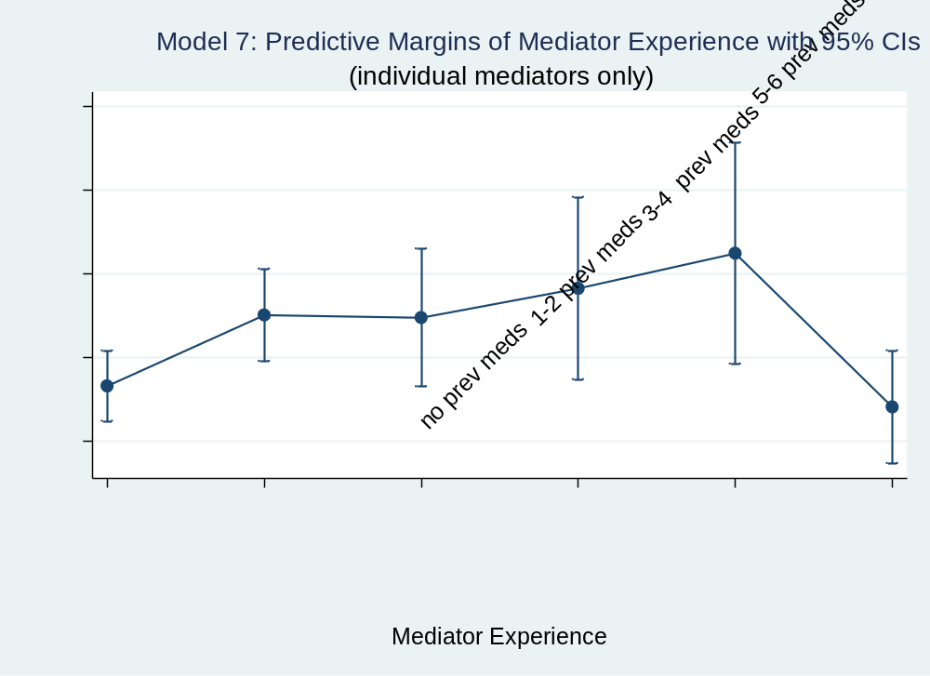
Figure A-6-1: Model 7 Predictive Margins - Mediator Experience

Table A-6: Average Marginal Effects on Strict Success (with mediator experience
 | Model 8 |  | Model 8A |  | Model 8B
Med Exp
No Prev Meds | 0 | (.) | 0 | (.) | 0 | (.)
1-2 Prev Meds | 0.0548 | (1.64) | 0.0226 | (0.37) | 0.0639 | (1.63)
3-4 Prev Meds | 0.0386 | (0.87) | -0.0285 | (-0.33) | 0.0649 | (1.25)
5-6 Prev Meds | 0.0476 | (0.85) | 0.253** | (2.00) | 0.0155 | (0.25)
7-8 Prev Meds | 0.0931 | (1.35) | 0.0757 | (0.54) | 0.0837 | (1.06)
9+ Prev Meds | -0.0150 | (-0.37) | -0.0434 | (-0.54) | 0.00859 | (0.18)
Med Position
Private Ind | 0.0674 | (0.77) | -0.160 | (-0.95) | 0.179* | (1.86)
National Org | 0.0694 | (0.62) | -0.186 | (-1.03) | 0.263* | (1.84)
Rep Regional | 0.0324 | (0.42) | 0.130 | (0.79) | 0.1000 | (1.22)
Leader Reg | 0.0824 | (0.89) | 0.0567 | (0.36) | 0.119 | (1.13)
Rep Inter | 0.0408 | (0.65) | -0.171 | (-1.56) | 0.179*** | (2.58)
Leader Inter | 0.0653 | (0.90) | -0.0887 | (-0.73) | 0.179** | (2.14)
Rep Small G | -0.00897 | (-0.13) | -0.145 | (-1.19) | 0.102 | (1.29)
Rep Large G | -0.0255 | (-0.41) | -0.0830 | (-0.77) | 0.0583 | (0.86)
Leader Small G | 0.0887 | (1.29) | -0.0812 | (-0.71) | 0.191** | (2.41)
Leader Large G | 0 | (.) | 0 | (.) | 0 | (.)
CVs
Terrdisp | 0.0641 | (1.41) | 0.127** | (1.99) | -0.0665 | (-0.91)
Postcold | 0.112*** | (3.27) | 0.0766 | (1.41) | 0.123** | (2.40)
Duration | 0.000336*** | (3.11) | 0.000811*** | (2.94) | 0.000244* | (1.77)
Fatal | -6.21e-08** | (-2.48)
Observations | 1372 |  | 429 |  | 943
t statistics in parentheses
* p < 0.10, ** p < 0.05, *** p < 0.01

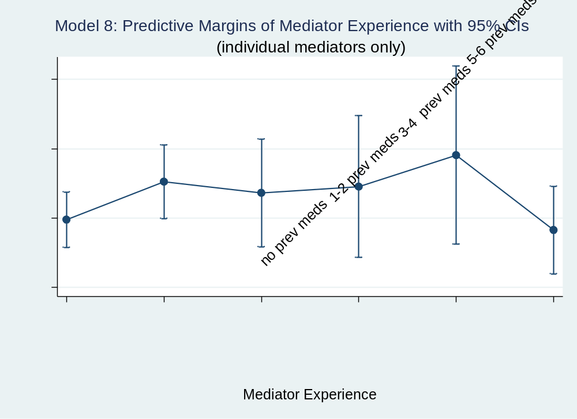
Figure 6-2: Model 8 Predictive Margins - Mediator Experience

SUPPLEMENTAL MATERIALS 1

Interview Questions
The Impact of Individual Mediator Competency Skills
on International and Civil Conflict Mediation

This interview will take approximately 30 minutes to 1 hour. You may stop at any time. You may skip any questions you do not want to answer or are limited from answering by your position as a current or former mediator. Please use your professional discretion in disclosing any details of specific mediation cases in your responses.
At any time in this interview, you may also tell me if you wish to remain anonymous on any or all responses to questions in this interview and prefer to select a pseudonym that will be used in lieu of your name for those responses.

- A mediator’s state/region of professional origin is important to this study as mediators from different areas of the world provide diverse insights into mediation expectations. If you feel comfortable disclosing it, what is/are your countries of professional origin?

- Thinking about negotiating parties in mediations, do dissidents have different expectations for the mediation process in different areas of the world? If so, how do those expectations differ from region to region or country to country?

- Are there factors that sometimes limit how well negotiating parties accept a mediator? For example, gender, nationality, religion, etc.? If so, in what ways do these factors cause a mediator to more likely be accepted or rejected? Can you think of any factors other than the ones mentioned?

- Sometimes state leaders serve as mediators in conflict mediation proceedings. When in the mediation process do these individuals tend to get involved? In some conflicts, are negotiators resistant to having highly public figures serve as mediators? If so, why?

- Some research studies have argued that mediators should be professionally neutral towards negotiating parties. This is the basis for Western Alternative Dispute Resolution (ADR) training used by the United Nations. Do negotiating parties tend to accept that mediators are professional neutral or do they not believe this? How does this acceptance of professional neutrality difference by region, conflict, culture, etc.?

- Are mediators with military mediation training or religious training more or less likely to be successful in certain conflicts or conflict areas? Please explain.

- Data suggests that many mediators have only ever mediated 1 or 2 conflicts. Do you think past experience in mediations can affect how successful a mediator is likely to be in reaching a ceasefire or settlement in a new conflict mediation? What role do you think past mediation experience plays in how likely a mediator is to successfully reach a ceasefire or settlement in a new conflict mediation?

- The data also shows that many mediators who have been involved in 9+ previous mediated conflicts have lower success rates than those that have previously mediated only 1 to 4 conflicts. Do you have any thoughts on why these very experienced mediators may have lower likelihoods of success?

- What mediator personality factors/traits are most important for successful mediations? Why?

- Given your professional knowledge of conflict mediations, are there any other individual mediator characteristics or skills you think can have a strong positive or negative effect on the mediation proceedings or outcome of the mediation? If so, how?

- How important is selecting the right individual mediator for the mediation process to achieving a ceasefire or peace settlement?

- How could mediator training be improved?

- Is there anything else you wish researchers and policymakers (who lack actual mediation experience) better understood about the mediation process, especially concerning selecting, training, equipping, and/or debriefing individual mediators?

SUPPLEMENTAL MATERIALS 2

Interview Questions
The Impact of Individual Mediator Competency Skills
on International and Civil Conflict Mediation

The following survey will take 15-20 minutes. You may stop at any time. You may also skip any questions you do not want to answer. All of your responses will be anonymous.
When you are finished, click on the “Submit Survey Responses” at the bottom of the page. You will then be taken to a screen where you will be asked if you are willing to be contacted for a follow-up interview. If you are willing to be contacted, please select “YES, I am interested in being interviewed” enter your contact information on the next page. Your contact information will not be linked to your survey responses. If you do not wish to be contacted, select “NO, I am not interested in being interviewed” or simply close your browser.

This information helps identify reports from underrepresented populations of mediators
- What is your age?
- 21-30 years old
- 31-40 years old
- 41-50 years old
- 51-60 years old
- 61-70 years old
- 71-85 years old
- I do not wish to respond.

- What is your nationality? (You may enter “I do not wish to respond.”)

- Would you like to identify as anything more specific concerning ethnicity, race, or religion? If so, please enter the information in the box. Otherwise, continue on to the next question.

- What gender do you identify as professionally? (This question is being asked because of recent attempts to utilize female and openly LGBTQ+ mediators in conflicts to increase mediator diversity and/or to help better represent marginalized populations.)
- Male
- Female
- Openly identifies as LGBTQ+
- I do not wish to respond

In the remainder of the survey, you will encounter questions that ask about mediator ACCEPTANCE by negotiating/disputant parties and questions that ask how certain factors increase the LIKELIHOOD OF ACHIEVING A SUCCESSFUL MEDIATION OUTCOME at the end of the mediation proceedings, with a successful mediation outcome being defined as a ceasefire, partial settlement, or full settlement. Please respond to these questions to the best of your ability, but do not include any information that should not be disclosed by your job requirements as a current or former mediator.

MEDIATOR ACCEPTANCE

- Thinking back to your experience as a mediator, what effect does speaking a common language with none, one, or both of the negotiating parties have on the negotiation process? Is there a difference in the way mediators are accepted if they can speak the language of one party versus the languages of both parties?

- Thinking back to your experience as a mediator, does a mediator’s personal nationality play a role in how well he/she is accepted by one or both negotiating parties in conflicts? If so, how?

- Thinking back to your experience as a mediator, does a mediator’s ethnicity tend to play a role in how well he/she is accepted by one or both negotiating parties in conflicts? If so, how?

- Thinking back to your experience as a mediator, does a mediator’s gender play a role in how well he/she is accepted by one or both negotiating parties in conflicts? If so, how? Consider males, females, and those that may openly identify as LGBTQ.

- Sometimes, mediators who openly represent a religion or religious entity are brought in to help mediate a conflict, often as part of a mediation team. Thinking back to your experience as a mediator, does a mediator’s personal religious affiliation play a role in how well he/she is accepted by one or both negotiating parties in conflicts? If so, how?

- What other personal factors do you think most positively influence the degree to which mediators are accepted by one or both negotiating parties?

- What other personal factors do you think most negatively influenced the degree to which you were accepted by one or both negotiating parties?

LIKELIHOOD OF ACHIEVING A SUCCESSFUL MEDIATION OUTCOME

- How much effect do you think a mediator’s personality has on the mediation process? (Check one.)
- Very strong
- Strong
- Neutral
- Weak
- Very weak

- Look at all of the following possible personality traits a mediator may possess. From your experiences, which traits do you think positively contribute to the likelihood a mediator will achieve a ceasefire, partial settlement, or full settlement with the negotiating parties? (Check ALL appropriate boxes.)
 Honest
 Sensitive
 Extraverted/social
 Patient
 Organized
 Creativity in problem-solving
 Fairness
 Tough
 Cheerful
 Peaceful/agreeable
 Thorough
 Intellectual
 Innovative
 Organized
 Lenient
 Outgoing
 Brave/bold
 Modest/Unassuming
 Sincere
 Boastful
 Tough
 Emotionally stable
 Quiet/reserved
 Gentle
 Stubborn
 Disciplined
 Negligent
 Unconventional
 Unimaginative
 Pompous
 Hypocritical
 Pretentious
 Fearful/anxious
 Sly/deceitful
 Self-assured
 Oversensitive
 Introverted
 Passive
 Shy
 Short-tempered
 Impatient
 Inflexible
 Lazy
 Absent-minded
 Irresponsible
 Unimaginative
 Conventional
 Unperceptive

14. Which 5 of these potential mediator personality traits do you think have the most positive effect on the likelihood of achieving a ceasefire, partial settlement, or full settlement with negotiating parties?

15. Look at all of the following possible personality traits a mediator may possess. From your experiences, which traits do you think contribute to the likelihood a mediator will fail to achieve a ceasefire, partial settlement, or full settlement with the negotiating parties? (Check ALL appropriate boxes.)
 Honest
 Sensitive
 Extraverted/social
 Patient
 Organized
 Creativity in problem-solving
 Fairness
 Tough
 Cheerful
 Peaceful/agreeable
 Thorough
 Intellectual
 Innovative
 Organized
 Lenient
 Outgoing
 Brave/bold
 Modest/Unassuming
 Sincere
 Boastful
 Tough
 Emotionally stable
 Quiet/reserved
 Gentle
 Stubborn
 Disciplined
 Negligent
 Unconventional
 Unimaginative
 Pompous
 Hypocritical
 Pretentious
 Fearful/anxious
 Sly/deceitful
 Self-assured
 Oversensitive
 Introverted
 Passive
 Shy
 Short-tempered
 Impatient
 Inflexible
 Lazy
 Absent-minded
 Irresponsible
 Unimaginative
 Conventional
 Unperceptive

16. Which 5 of these potential mediator personality traits do you think have the most negative effect on the likelihood of achieving a ceasefire, partial settlement, or full settlement with negotiating parties?

Vita

Erin Rowland is from Etowah, Tennessee. She graduated from Middle Tennessee State in 2004 with a B.S. in International Relations before earning her Secondary Education Teaching Certification in English. After serving as an English and Creative Writing teacher for six years at Central High School of Knoxville, Erin earned both her Master’s in Public Policy and Administration and Doctor of Philosophy in Political Science degrees from the University of Tennessee. Her research interests include U.S. security policies (domestic and international), foreign policy (conflict management, corruption, and foreign aid), street-level bureaucracy, and best practices in teaching political science. Currently, she is an Instructor at Eastern Illinois University where her husband Brian Carlin is the Business and Ticket Manager for the EIU Athletic Department. They are parents to one of the smartest and happiest little boys ever, Beckett Carlin.

Author’s interview with Dr. Laurie Nathan, Charleston, IL, April 2021.
. In a study of this magnitude, the latter abilities are difficult to assess in current or former mediators without specifically conducting intelligence testing on these individuals. However, there are elements of intelligence and communication that can instead be more reasonably estimated using mediator feedback on personality traits. Therefore, I reserve further discussion of reasoning and communication to the section on Behavior as this study is not concerned with a comparison of the competency categories’ effects on mediation success but instead how the individual factors in these categories impact the likelihood of success.
I again set these limitations aside for the discussion on Behavior.
See Appendix.
More information on this is noted in my findings.
Author’s interview with an anonymous U.S. mediator, Knoxville, TN, May 2020.
Author’s interview with mediator and mediation trainer Juan Carlos Lucero, J.D., Knoxville, TN, June 2021. Mr. Lucero has a Masters in Conflict Mediation and Peacebuilding from the Universidad de Cádiz, a Masters in Judicial Negotiation and Law from Universidad Franciso Marroquín, and a law degree from Universidad de San Carlos de Guatemala. He served as a field officer for the United Nations in Latin America and has mediation experience in Guatemala and Columbia in various capacities. He is a mediation trainer for NGOs and has worked extensively in training local mediators to mediate civil disputes. Some of his trainees have included faith-based mediation organizations in Latin America. He is currently studying Arabic in Egypt to extend his mediation services to civil disputes in the Middle East.
Author’s interview with an anonymous U.S. mediator, Knoxville, TN, May 2020.
Author’s interview with former U.S. Ambassador Susan Page, Knoxville, TN, July 2021. Ambassador Page is a professor of international diplomacy at the University of Michigan with a law degree from Harvard Law School. She has been a Special Adviser on Rule of Law to the UN Secretary General and a Special Representative of the Secretary General to Haiti. She was also the first U.S. Ambassador to South Sudan and has served on mediation teams in Africa.
Author’s interview with Dr. Andrea Hartmann-Piraudeau, Knoxville, TN, July 2021. Dr. Hartmann-Piraudeau is an expert in conflict resolution research and has professionalized training in international mediation through the International Mediation Institute. She is a mediator with extensive knowledge of mediation training and mediation expectations in the European Union and beyond. She is the Managing Director of the International Mediator Campus. Dr. Hartman-Piraudeau has a PhD in Economy and Social Science from the University of Hohenheim where she researched on the effects in negotiation and mediation. She also has a Master’s in Mediation from Fern Universität in Hagen.
Ibid.
Ibid.
Dr. Joyce Neu in a recorded talk. “Blurring the Lines in International Mediation.” YouTube video, 1:00:53. Posted by Maxwell School of Syracuse University, 27 Oct 2017. < https://youtu.be/ 17j2ymQ4ZSs>. Dr. Neu is a founder and senior associate at Facilitating Peace. She has extensive peacemaking, peacebuilding, and mediation experience in Africa, Asia, and Europe. She is also a specialist on gender inclusion in peace processes. She has also served as Team Leader of the United Nations Standby Team of Mediation Experts and as Senior Associate Director for the Conflict Resolution Program at The Carter Center.
Author’s interview with mediator Kenny Gluck, Charleston, IL, May 2021. Mr. Gluck is a professor at Columbia University in the City of New York. He has been a Deputy Special Representative of the Secretary General in Central African Republic, a Special Envoy for Yemen, and a Chief of Staff for the African Union – UN Mediation Team. He has also worked as Director of Operations for Doctors Without Borders.
Author’s interview with Dr. Laurie Nathan, Charleston, IL, April 2021. Dr. Nathan is a professor at the Kroc Institute for International Peace Studies at the University of Notre Dame where he runs the mediation program. Dr. Nathan has extensive experience training mediators from across the globe and has served as a Senior Mediation Advisor for the United Nations. At the University of Pretoria in South Africa, he was the director for the Centre for Mediation in Africa, and he also directed the Centre for Conflict Resolution at the University of Cape Town.
Ibid.
Again, I acknowledge here a lack of greater information on mediation training and practices in Asia, the Middle East, and Eastern Europe.
Dr. Joyce Neu in a recorded talk. “Blurring the Lines in International Mediation.” YouTube video, 1:00:53. Posted by Maxwell School of Syracuse University, 27 Oct 2017. < https://youtu.be/17j2ymQ4ZSs>.
Ibid
Author’s interview with Dr. Laurie Nathan, Charleston, IL, April 2021.
Author’s interview with Dr. Laurie Nathan, Charleston, IL, April 2021.
Author’s interview with former Ambassador Susan Page, Knoxville, TN, July 2021.
Deborah Masucci in a recorded talk with Laura Kaster. “Mediator Credentialing Conversation with Deborah Masucci and Laura Kaster.” YouTube video, 36:19. Posted by International Mediation Institute. 17 June 2019. <https://youtu.be/nBhb1i0aReU>. Ms. Masucci has a legal degree from New York Law School and is the past Chair of the Board of Directors for the International Mediation Institute. She is an independent mediator and arbitrator for Masucci ADR.
Author’s interview with Dr. Laurie Nathan, Charleston, IL, April 2021.
Author’s interview with Dr. Laurie Nathan, Charleston, IL, April 2021.
Author’s interview with Dr. Andrea Hartmann-Piraudeau, Knoxville, TN, July 2021.
Author’s interview with Juan Carlos Lucero, J.D., Knoxville, TN, June 2021.
Interview with Juan Carlos Lucero, J.D., Knoxville, TN, June 2021.
See the International Conflict Management (ICM) codebook by Bercovitch (2002) for the list identifying third-party mediators.
Author’s interview with Kenny Gluck, Charleston, IL, May 2021.
Author’s interview with Kenny Gluck, Charleston, IL, May 2021.
Ibid.
Vern Hockney with Michael Duerr in a recorded interview. 2016. “Why I Study Conflict Resolution.” YouTube video, 4:20. Posted by the Conflict Resolution and Mediation Program at Tel Aviv University. 27 March 2016. <https://www.youtube.com/watch?v=YTgBYrH1-Qw>. Mr. Hockney was a forward observer in the United States Army for 5 years and completed one 15-month tour in Iraq. Afterwards, he chose to attend the Conflict Resolution and Mediation Master’s program at Tel Aviv University.
Michael Durr with Vern Hockney in a recorded interview. 2016. “Why I Study Conflict Resolution.” YouTube video, 4:20. Posted by the Conflict Resolution and Mediation Program at Tel Aviv University. 27 March 2016. <https://www.youtube.com/watch?v=YTgBYrH1-Qw>. Mr. Durr is a retired United States Army officer who served for 11 years and often conducted military mediations as part of his job. He completed three tours in Iraq and one in Afghanistan. Currently, he is also “a visiting lecturer for the International Graduate Program on Conflict Resolution and Mediation at Tel Aviv University and the Middle East Training Team for the Bosserman Center for Conflict Resolution at Salisbury University” which is “certified by the United Nations Institute for Training and Research UNITAR” (“Mike Duerr, MA” 2021, para. 3). He has a Bachelor’s degree in International Relations from the Virginia Military Institute (“Mike Duerr, MA” 2021).
Author’s interview with Juan Carlos Lucero, J.D., Knoxville, TN, June 2021.
Ibid.
Author’s interview with Kenny Gluck, Charleston, IL, May 2021.
Ibid.
Author’s interview with Kenny Gluck, Charleston, IL, May 2021.
Interview #30 collected by W. Haven North for the United States Institute of Peace’s Oral Histories: The Sudan Experience Project (USIP), October 2006. <https://www.usip.org/sites/default/files/file/resources/ collections/histories/sudan/30.pdf>. The interviewee was a former U.S. State Department officer and current lawyer and member of the United Nations Development Programme that was asked by a former supervisor at the U.S. State Department to serve on the mediation team as a technical legal advisor for the Comprehensive Peace Agreement in Sudan (Interview #330 2006).
Interview #11 collected by Larry Lesser for the USIP-ADST’s Oral Histories: Afghanistan Provincial Reconstruction Team project, April 2005. <https://www.usip.org/sites/default/files/file/resources/ collections/histories/afghanistan/11.pdf>. The interviewee was a military veteran and employee of the U.S. State Department who worked as a political officer with the Provincial Reconstruction Team Army Civil Affairs Unit to mediate peace in Afghanistan between 2004-2005 (Interview #11 2005).
Interview #71 collected by W. Haven North for the USIP’s Iraq Provencial Reconstruction Team (PRT) Experience Project, November 2008. <https://www.usip.org/sites/default/files/file/resources/collections /histories/ iraq_prt/71.pdf>. The interviewee was a USIP representative who served on several PRTs in Iraq in 2007-2008 before becoming a Director of Programs at USIP (Interview #71 2008).
Interview #11 collected by Larry Lesser for the USIP-ADST’s Oral Histories: Afghanistan Provincial Reconstruction Team project, April 2005. <https://www.usip.org/sites/default/files/file/resources/ collections/ histories/afghanistan/11.pdf>
Interview #71 collected by W. Haven North for the USIP’s Iraq Provencial Reconstruction Team (PRT) Experience Project, November 2008. <https://www.usip.org/sites/default/files/file/resources/collections/ histories/ iraq_prt/71.pdf>
Author’s interview with Juan Carlos Lucero, J.D., Knoxville, TN, June 2021.
Ibid.
Dr. Joyce Neu in a recorded talk. “Blurring the Lines in International Mediation.” YouTube video, 1:00:53. Posted by Maxwell School of Syracuse University, 27 Oct 2017. < https://youtu.be/17j2ymQ4ZSs>.
Author’s interview with Kenny Gluck, Charleston, IL, May 2021.
Author’s interview with Dr. Laurie Nathan, Charleston, IL, April 2021.
Ibid.
Dr. Joyce Neu in a recorded talk. “Blurring the Lines in International Mediation.” YouTube video, 1:00:53. Posted by Maxwell School of Syracuse University, 27 Oct 2017. < https://youtu.be/ 17j2ymQ4ZSs>.
Ibid.
Ibid.
Dr. Joyce Neu in a recorded talk. “Blurring the Lines in International Mediation.” YouTube video, 1:00:53. Posted by Maxwell School of Syracuse University, 27 Oct 2017. < https://youtu.be/ 17j2ymQ4ZSs>.
Further mention is reserved for later discussion, but as a reminder, the two hypotheses regarding mediator position are: H(5): Representatives of small states are more likely to achieve mediation success than leaders of large states; and H(6): Representatives, in general, are more likely to achieve mediation success than leaders of their respective entity types.
Author’s interview with an anonymous U.S. mediator, Knoxville, TN, May 2020.
Ibid.
Ibid.
Dr. Juan Diaz-Prinz in a recorded talk and presentation given to the International Mediation Institute. “Dr Juan Diaz – Peace Mediation.” YouTube video, 57:08. Posted by International Mediation Institute. 13 June 2020. <https://youtu.be/3BbnsGjwgfs>. “Dr. Juan Diaz-Prinz is a senior expert on Mediation and dialogue at the U.S. Institute of Peace. He is a mediator, trainer, and facilitator” who has worked “in the Officer of the International Mediator in Bosnia and Herzegovina (1998-2004) and then co-founded the CSSP: Berlin Center for Integrative Mediation” (“Juan Diaz-Prinz, PhD” 2021, para. 1). He also founded the European Institute of Peace for mediatEUr and trains mediators through online platforms (“Juan Diaz-Prinz, PhD” 2021).
Author’s interview with Dr. Laurie Nathan, Charleston, IL, April 2021.
Dr. Juan Diaz-Prinz in a recorded talk and presentation given to the International Mediation Institute. “Dr Juan Diaz – Peace Mediation.” YouTube video, 57:08. Posted by International Mediation Institute. 13 June 2020. <https://youtu.be/3BbnsGjwgfs>.
Author’s interview with Juan Carlos Lucero, J.D., Knoxville, TN, June 2021.
Author’s interview with Dr. Laurie Nathan, Charleston, IL, April 2021.
Author’s interview with Dr. Andrea Hartmann-Piraudeau, July 2021.
Sven Koopmans in written advice gathered from first-hand mediation experience and included in his guide. 2018. Negotiating Peace: A Guide to the Practice, Politics, and Law of International Mediation. Oxford: Oxford University Press. Dr. Koopmans is a European Union Special Representative for the Middle East Peace Process and a former Member of Parliament (Tweede Kamer der Staten-Generaal) for The Netherlands. He was also a Senior Mediation Expert on the Mediation Standby Team for the UN Department of Political Affairs and the Special Envoy for Syria. He also consulted as a Senior Advisor on the Guyana-Venezuela Controversy. Koopmans holds a legal degree and a PhD in international law from the University of Oxford. His specialties include European law, international law, and diplomatic dispute settlement (“Sven Koopmans” 2021).
Robert Dann in a recorded panel with Stef Blok, Sven Koopmans and Teresa Whitfield. “Negotiating Peace: A Guide to International Mediation.” YouTube video, 1:22:38. Posted by International Peace Institute, 12 Oct 2018. < https://youtu.be/1MsNW9PhJA0>. Dann has served as a Political Advisor to the Special Envoy of the UN Secretary-General for Syria, Stefan de Mistura. He is also a former Chief of the UN Mediation Support Unit (MSU).
Ibid.
Dr. Joyce Neu in a recorded talk. “Blurring the Lines in International Mediation.” YouTube video, 1:00:53. Posted by Maxwell School of Syracuse University, 27 Oct 2017. < https://youtu.be/17j2ymQ4ZSs>.
Here I am referencing Dr. Joyce Neu’s previously discussed account of case overload and understaffing at the UN.
Author’s interview with Kenny Gluck, Charleston, IL, May 2021.
Constrained to large states, small states, IGOs, and RGOs, as is line with the mediator position variable ICM (2002) data.
Sven Koopmans in a recorded panel with Stef Blok, Teresa Whitfield, and Robert Dann. “Negotiating Peace: A Guide to International Mediation.” YouTube video, 1:22:38. Posted by International Peace Institute, 12 Oct 2018. < https://youtu.be/1MsNW9PhJA0>.
Author’s interview with Dr. Laurie Nathan, Charleston, IL, April 2021.
Author’s interview with Dr. Andrea Hartmann-Piraudeau, Knoxville, TN, July 2021.
Ibid.
Author’s interview with Dr. Laurie Nathan, Charleston, IL, April 2021.
Author’s interview with Dr. Laurie Nathan, Charleston, IL, April 2021.
Sven Koopmans in a recorded panel with Stef Blok, Teresa Whitfield and Robert Dann. “Negotiating Peace: A Guide to International Mediation.” YouTube video, 1:22:38. Posted by International Peace Institute, 12 Oct 2018. < https://youtu.be/1MsNW9PhJA0>.
Robert Dann in a recorded panel with Stef Blok, Sven Koopmans and Teresa Whitfield. “Negotiating Peace: A Guide to International Mediation.” YouTube video, 1:22:38. Posted by International Peace Institute, 12 Oct 2018. < https://youtu.be/1MsNW9PhJA0>. Also, Dr. Joyce Neu in a recorded talk. “Blurring the Lines in International Mediation.” YouTube video, 1:00:53. Posted by Maxwell School of Syracuse University, 27 Oct 2017. < https://youtu.be/17j2ymQ4ZSs>.
Author’s interview with Dr. Laurie Nathan, Charleston, IL, April 2021.
Sven Koopmans in written advice gathered from first-hand mediation experience and included in his guide. 2018. Negotiating Peace: A Guide to the Practice, Politics, and Law of International Mediation. Oxford: Oxford University Press.
Author’s interview with Juan Carlos Lucero, J.D., Knoxville, TN, June 2021.
Robert Dann in a recorded panel with Sven Koopmans, Stef Blok, and Teresa Whitfield. “Negotiating Peace: A Guide to International Mediation.” YouTube video, 1:22:38. Posted by International Peace Institute, 12 Oct 2018. < https://youtu.be/1MsNW9PhJA0>.
Author’s interview with Dr. Laurie Nathan, Charleston, IL, April 2021.
Author’s interview with Dr. Laurie Nathan, Charleston, IL, April 2021.
Deborah Masucci in a recorded interview. “Mediation as a Profession.” YouTube video, 3:02. Posted Mediator Academy, 12 July 2016. < https://youtu.be/qJwzklc-5ks>.
Dr. Juan Diaz-Prinz in a recorded talk and presentation given to the International Mediation Institute. “Dr Juan Diaz – Peace Mediation.” YouTube video, 57:08. Posted by International Mediation Institute. 13 June 2020. <https://youtu.be/3BbnsGjwgfs>.
Dr. Connie Peck, ed., in a manual written and edited for other practicing UN mediators. 2010. “A Manual for UN Mediators: Advice from UN Representatives and Envoys.” Geneva, Switzerland: United Nations Institute for Training and Research (UNITAR), p.13. Dr. Peck is the founder and Former Principal Coordinator for the UNITAR-IPI Programme in Peacemaking and Preventative Diplomacy and the UNITAR Programme for Briefing and Debriefing Special Representatives and Envoys of the Secretary-General. Peck was an early advocate for the need for “institutional memory” in mediation at the UN, and this manual condenses the most important takeaways from her interviews collected from Special Representatives of the UN Secretary General (Evans 2014).
Author’s interview with Dr. Laurie Nathan, Charleston, IL, April 2021.
Author’s interview with former Ambassador Susan Page, July 2021.
Author’s interview with an anonymous U.S. mediator, Knoxville, TN, May 2020.
Author’s interview with Dr. Laurie Nathan, Charleston, IL, April 2021.
Dr. Chester Crocker in a recorded conversation with Alvaro de Soto. “Alvaro de Soto Conversation Series: Chester Crocker.” YouTube video, 1:39:15. Posted by Columbia SIPA, 6 Dec 2013. < https://youtu.be/cNbUGXFyY-c>. Dr. Crocker is a professor of strategic studies at Georgetown University’s Institute for the Study of Diplomacy. He is a past Chairman of the Board for USIP and a former U.S. Assistant Secretary of State for African Affairs. He was a lead mediator in peace talks for the Namibia independence efforts and Cuba’s withdrawl from Angola. He has also been a staff officer on the National Security Council and the Central for Strategic and International Studies (CSIS)’s Director of African Studies (“Dr. Chester A. Crocker” 2021).
Dr. Connie Peck, ed., in a manual written and edited for other practicing UN mediators. 2010. “A Manual for UN Mediators: Advice from UN Representatives and Envoys.” Geneva, Switzerland: United Nations Institute for Training and Research (UNITAR), p.13.
Author’s interview with Dr. Laurie Nathan, Charleston, IL, April 2021.
Author’s interview with Kenny Gluck, Charleston, IL, May 2021.
Author’s interview with Dr. Laurie Nathan, Charleston, IL, April 2021.
Author’s interview with Kenny Gluck, Charleston, IL, May 2021.
Author’s interview with Juan Carlos Lucero, J.D., Knoxville, IL, June 2021.
Dr. Connie Peck, ed., in a manual written and edited for other practicing UN mediators. 2010. “A Manual for UN Mediators: Advice from UN Representatives and Envoys.” Geneva, Switzerland: United Nations Institute for Training and Research (UNITAR), p.13.
Author’s interview with Dr. Laurie Nathan, Charleston, IL, April 2021.
Ibid.
Author’s interview with former Ambassador Susan Page, Knoxville, TN, July 2021.
Author’s interview with an anonymous U.S. mediator, Knoxville, TN, May 2020.
Dr. Chester Crocker in a recorded conversation with Alvaro de Soto. “Alvaro de Soto Conversation Series: Chester Crocker.” YouTube video, 1:39:15. Posted by Columbia SIPA, 6 Dec 2013. < https://youtu.be/cNbUGXFyY-c>.
Author’s interview with Kenny Gluck, Charleston, IL, May 2021.
Sven Koopmans in written advice gathered from first-hand mediation experience and included in his guide. 2018. Negotiating Peace: A Guide to the Practice, Politics, and Law of International Mediation. Oxford: Oxford University Press, p.39.
Ibid.
Dr. Connie Peck, ed., in a manual written and edited for other practicing UN mediators. 2010. “A Manual for UN Mediators: Advice from UN Representatives and Envoys.” Geneva, Switzerland: United Nations Institute for Training and Research (UNITAR), p.13.
Author’s interview with former Ambassador Susan Page, Knoxville, TN, July 2021.
Author’s interview with Dr. Laurie Nathan, Charleston, IL, April 2021.
Author’s interview with former Ambassador Susan Page, Knoxville, TN, July 2021.
Dr. Chester Crocker in a recorded conversation with Alvaro de Soto. “Alvaro de Soto Conversation Series: Chester Crocker.” YouTube video, 1:39:15. Posted by Columbia SIPA, 6 Dec 2013. < https://youtu.be/cNbUGXFyY-c>.
Robert Dann in a recorded panel with Sven Koopmans, Stef Blok, and Teresa Whitfield. “Negotiating Peace: A Guide to International Mediation.” YouTube video, 1:22:38. Posted by International Peace Institute, 12 Oct 2018. < https://youtu.be/1MsNW9PhJA0>.
Teresa Whitfield in a record panel with Sven Koopmans, Stef Blok, and Robert Dann. “Negotiating Peace: A Guide to International Mediation.” YouTube video, 1:22:38. Posted by International Peace Institute, 12 Oct 2018. < https://youtu.be/1MsNW9PhJA0>. Ms. Whitfield is the Director of the Policy and Mediation Division at the UN Department of Political and Peacebuilding Affairs. She is also a Senior Adviser and liaison to the UN for the Centre for Humanitarian Dialogue and a research fellow at New York University. Her research specialties are on mediation, peacemaking, and armed groups.
Dr. Connie Peck, ed., in a manual written and edited for other practicing UN mediators. 2010. “A Manual for UN Mediators: Advice from UN Representatives and Envoys.” Geneva, Switzerland: United Nations Institute for Training and Research (UNITAR), p.13.
Ibid.
Author’s interview with Dr. Laurie Nathan, Charleston, IL, April 2021.
Author’s interview with Juan Carlos Lucero, J.D., Knoxville, TN, June 2021.
Author’s interview with an anonymous U.S. mediator, Knoxville, TN, May 2020.
Author’s interview with Juan Carlos Lucero, J.D., Knoxville, TN, June 2021.
Ibid.
Author’s interview with Dr. Laurie Nathan, Charleston, IL, April 2021.
Author’s interview with Kenny Gluck, Charleston, IL, May 2021.
Author’s interview with Kenny Gluck, Charleston, IL, May 2021.
Ibid.
Teresa Whitfield in a record panel with Sven Koopmans, Stef Blok, and Robert Dann. “Negotiating Peace: A Guide to International Mediation.” YouTube video, 1:22:38. Posted by International Peace Institute, 12 Oct 2018. < https://youtu.be/1MsNW9PhJA0>.
Dr. Chester Crocker in a record conversation with Alvaro de Soto. “Alvaro de Soto Conversation Series: Chester Crocker.” YouTube video, 1:39:15. Posted by Columbia SIPA, 6 Dec 2013. < https://youtu.be/cNbUGXFyY-c>.
Dr. Juan Diaz-Prinz in a recorded talk and presentation for the International Mediation Institute. “Dr Juan Diaz – Peace Mediation.” YouTube video, 57:08. Posted by International Mediation Institute. 13 June 2020. <https://youtu.be/3BbnsGjwgfs>.
Author’s interview with former Ambassador Susan Page, Knoxville, TN, July 2021.
Ibid.
Teresa Whitfield in a recorded panel with Sven Koopmans, Stef Blok, and Robert Dann. “Negotiating Peace: A Guide to International Mediation.” YouTube video, 1:22:38. Posted by International Peace Institute, 12 Oct 2018. < https://youtu.be/1MsNW9PhJA0>.
Ibid.
Sven Koopmans in a recorded panel with Stef Blok, Teresa Whitfield, and Robert Dann. “Negotiating Peace: A Guide to International Mediation.” YouTube video, 1:22:38. Posted by International Peace Institute, 12 Oct 2018. < https://youtu.be/1MsNW9PhJA0>.
Sven Koopmans in a record panel with Stef Blok, Teresa Whitfield, and Robert Dann. “Negotiating Peace: A Guide to International Mediation.” YouTube video, 1:22:38. Posted by International Peace Institute, 12 Oct 2018. < https://youtu.be/1MsNW9PhJA0>.
Dr. Chester Crocker in a record conversation with Alvaro de Soto. “Alvaro de Soto Conversation Series: Chester Crocker.” YouTube video, 1:39:15. Posted by Columbia SIPA, 6 Dec 2013. < https://youtu.be/cNbUGXFyY-c>.
Ibid.
Dr. Chester Crocker in a record conversation with Alvaro de Soto. “Alvaro de Soto Conversation Series: Chester Crocker.” YouTube video, 1:39:15. Posted by Columbia SIPA, 6 Dec 2013. < https://youtu.be/cNbUGXFyY-c>.
Dr. Joyce Neu in a recorded talk. “Blurring the Lines in International Mediation.” YouTube video, 1:00:53. Posted by Maxwell School of Syracuse University, 27 Oct 2017. < https://youtu.be/17j2ymQ4ZSs>.
Dr. Joyce Neu in a recorded talk. “Blurring the Lines in International Mediation.” YouTube video, 1:00:53. Posted by Maxwell School of Syracuse University, 27 Oct 2017. < https://youtu.be/17j2ymQ4ZSs>.
Sven Koopmans in a record panel with Stef Blok, Teresa Whitfield, and Robert Dann. “Negotiating Peace: A Guide to International Mediation.” YouTube video, 1:22:38. Posted by International Peace Institute, 12 Oct 2018. < https://youtu.be/1MsNW9PhJA0>.
Ibid.
Author’s interview with Dr. Laurie Nathan, Charleston, IL, April 2021.
Author’s interview with Juan Carlos Lucero, J.D., Knoxville, TN, June 2021.

