Effects of Folate Availability on

Expression of Adipocyte Metabolic Genes

Via Modulation of DNA Methylation

A Dissertation Presented for the
Doctor of Philosophy
Degree
The University of Tennessee, Knoxville

Julia Stair Gouffon

August 2012

Dedication
This work is dedicated first and foremost to my wonderful parents, for without them I would not exist, nor would I have developed an insatiable appetite for learning and discovery. Secondly, to my husband and son, Chuck and Ben, for patiently foregoing dinners, a clean home and enduring my stress induced mood swings. Thirdly, I thank my extended family, siblings, nephews and nieces, for taking time to entertain and take care of Ben.
My heartfelt thanks to the members of the Department of Nutrition in particular, Dr. Whelan for hiring me to run the Affymetrix Core Lab and giving me leave to pursue this degree. Of course, I could not have done this work without the extremely patient guidance of Dr. Michael Zemel. I thank him for letting me follow my own ideas and taking months to get experiments done that would take a full-time student a week. Also, I am most thankful to the nutrition office staff for providing me friendship, food, chocolate and emotional support over the many years. I have been blessed to have several friends who have urged me on during this process and I am so grateful to have them.

Acknowledgements
I thank Dr. Michael Zemel, Dr. Joseph Bartges, Dr. Karla Matteson and Dr. Jason Collier for taking time out of their busy schedules and serving on my committee. Their comments, criticisms and suggestions have made me a better researcher. I thank Dr. Jay Whelan for allowing me to pursue this degree while running the Affymetrix Core Lab. Thanks so much to Megan Johnstone for helping me with my cell cultures and work.

Abstract
Epigenetic modifications serve as a means of intermediate gene expression control and nutritional inputs may modify methylation patterns in regulatory regions of genes. Therefore, we proposed that folate availability affects adipocyte development and metabolism through impacting the one-carbon cycle and subsequent DNA methylation patterns. Accordingly, we sought to determine if the methylation level of CpG islands could be influenced in adipocytes and if so, how this might affect gene expression in mature adipocytes. We treated adipocytes with 0 to 0.9 millimolar [mM] folate, the methyl donor S-adenosylmethionine (SAMe) and the methylation inhibitor, 5-aza-2-deoxycitidine (2-DC) during adipocyte differentiation and the maturation process. Lipogenesis was measured by accumulation of oil red O and lipolysis was quantified by a glycerol release assay. Methylated regions of adipocyte genomic DNA were evaluated using a methylation-specific antibody and hybridized against a Nimblegen whole genome CpG island array to identify targets for expression analysis. RNA was obtained and genes involved in adipocyte differentiation, one-carbon metabolism, lipogenesis and lipolysis were quantified using RT-PCR. We found that low folate levels or inhibition of DNA methylation by 2-DC decreased CpG methylation, thus increasing gene expression in some genes. Surprisingly, SAMe similarly increased gene expression and decreased global CpG methylation. Low folate increased lipid accumulation and subsequent lipolysis. Exposure to folate during the critical differentiation process had a greater impact on lipogenesis and lipolysis than did folate exposure during maturation.

Table of Contents
Chapter 1 Introduction 1
Chapter 2 Literature Review 6
Background 6
Epigenetics and DNA Methylation 7
Experimental Models of Epigenetically Induced Obesity 9
Folate Availability and Propensity for Obesity: A possible link 11
Adipose Tissue Composition 13
Adipocyte Determination and Differentiation 14
Adipocytes and Energy Metabolism 16
Role of Adipocytes in Development of Obesity and Metabolic Diseases 17
Chapter 3 Experimental Investigations 18
Abstract 19
Introduction 20
Materials and Methods 22
Experimental Design 22
Adipocyte Growth Conditions 24
Triglyceride accumulation 24
Lipolysis 25
CyQUANT Cellular Proliferation Assay 25
Methylated CpG Island Recovery Assay 25
Total RNA Extraction 26
Reverse Transcriptase Polymerase Chain Reaction 27
Statistical Analysis of Data 29
Results 29
Cellular Proliferation 29
Triglyceride Accumulation 31
Lipolysis 33
Overall Adipocyte Phenotype 35
DNA CpG Methylation 37
Gene Expression 45
Discussion 55
Conclusions 60
Chapter 4 Conclusions 62
List of References 68
Appendix 73
Vita 77

List of Tables
Table 1 Life Technologies/Applied Biosystems TaqMan ® Probe Assays for RT-PCR 28
Table 2 Adipocyte response relative to adipocytes differentiated and matured under standard folate conditions. 63
Table 3 DNA, triglyceride and lipolysis estimates 73
Table 4 RT-PCR Results…………………………………………………………………………………………………………………………….74

List of Figures
Figure 1a. methylation status of IAP region effects coat color and Figure 1b. mice exposed to folate diet are lean and brown 3
Figure 2 . Experimental Design 23
Figure 3 DNA estimates graphical and tabular views for mean and standard deviations (n=4) 30
Figure 4 Triglyceride accumulation graphical and tabular views for mean and standard deviations (n=4) 32
Figure 5 Lipid release graphical and tabular views for mean and standard deviations (n=4) 34
Figure 6 Oil Red O images of Day 7 post-differentiation of 3T3L1s 36
Figure 7a. Hormone Sensitive Lipase DNA Methylation in Promoter Regions 38
Figure 7 b. Fatty Acid Synthase Gene DNA Promoter Methylation 39
Figure 7 c. Glucose Transport 4 Gene DNA Promoter Methylation 40
Figure 7 d. Leptin Gene DNA Promoter Methylation 41
Figure 7e. Methylene Tetrahydrofolate Reductase Gene DNA Promoter Methylation 42
Figure 7 f. Peroxisome proliferator activated receptor Gene DNA Promoter Methylation 43
Figure 7g. Peroxisome proliferator activated receptor gamma co-activator 1 alpha Gene DNA Promoter Methylation 44
Figure 8 a. DNA Methyltransferase 1 gene expression levels as measured by RT-PCR. 46
Figure 8 b. Fatty acid synthase gene expression levels as measured by RT-PCR. 47
Figure 8 c. Folate receptor 1 gene expression levels as measured by RT-PCR. 48
Figure 8 d. Glucose transporter 4 gene expression levels as measured by RT-PCR. 49
Figure 8 e. Hormone sensitive lipase gene expression levels as measured by RT-PCR. 50
Figure 8 f. Leptin gene expression levels as measured by RT-PCR. 51
Figure 8 g. Mthfr gene expression levels as measured by RT-PCR. 52
Figure 8 h. Pparγ gene expression levels as measured by RT-PCR. 53
Figure 8 i. Pgc-1α gene expression levels as measured by RT-PCR. 54

List of Abbreviations
Deoxyribonucleic acid (DNA), Ribonucleic acid (RNA), SAMe (S-adenosylmethionine), DNA methyltransferase 1 (Dnmt1), fatty acid synthase (Fasn), folate receptor 1 (Folr1), glucose transporter 4 (Glut4), hormone sensitive lipase (Lipe), leptin (Lep), methylenetetrahydrofolate reductase (Mthfr), peroxisome proliferation activated receptor gamma (Pparγ), Pparγ coactivator 1 alpha (Pgc-1α), Hank’s Balanced Salt Solution (HBSS), Dulbecco’s Modified Medium (DMEM)

Chapter 1 Introduction
Obesity, defined as having a body mass index (BMI) exceeding 30 kg/m², has become a global epidemic, significantly increasing morbidity and mortality associated with medical conditions such as Type II diabetes (T2D), hypertension, cardiovascular disease and some cancers (1). The prevalence has nearly tripled for adolescence during the past two decades according to a report by the Office of the Surgeon General (2). The report cites an obesigenic environment wherein an excess of calories are consumed with a concurrent decrease in caloric expenditure as the primary causal factor in the rapid climb of obesity rates. However, genetic factors clearly contribute to the phenomenon as well as evidenced by adoption studies wherein adopted children’s adiposity and fat distribution is more similar to their biological parents than their adoptive parents (3). Over the past decade, genome wide association studies have tried to link specific gene anomalies with obesity but, with a few exceptions such as gene mutations (ex. melanocortin 4 receptor deficiency), or imprinting disorders (ex. Prader-Willi syndrome) and polymorphic genes (ex. peroxisome proliferative activated receptor-γ SNPs), an overwhelming direct link has yet to be made to explain differences in lipid storage and energy expenditure (3).
As the primary depot for lipid storage in the body, adipose tissue was long thought to be merely a storage vessel for excess triglycerides, but it is now understood to influence chronic disease through release of cytokines which can increase chronic inflammation. Adipocyte hypertrophy results in an increase in the release of inflammatory cytokines and a decrease in anti-inflammatory cytokines; thus, decreasing adipocyte size, while increasing adipocyte numbers may decrease the chronic disease risk associated with subclinical inflammation (4).
Recent work with stem cells and pluripotent cells, including pre-adipocytes, has shown that nutrient and hormonal balance can effect cellular differentiation and may ultimately be directive for deeming the cell type, a concept known as developmental plasticity (5). This cellular flexibility may allow for sensing environmental conditions during cellular development in utero, but may be problematic when the external environmental conditions do not match those seen during initial development. It has been proposed that nutritional mismatch may be a causative agent for future disease development (6). The Dutch Hunger Winter during World War II yielded evidence that poor maternal nutrition resulted in increased incidence of obesity, CVD and diabetes in adult males. This study and others gave rise to the “Thrifty Phenotype Hypothesis” that proposes metabolic programming of the fetus during development in a nutrient poor environment in utero prepares the fetus for a post-natal environment that is similarly nutrient poor. However, when the post-natal environment is rich in nutrients, increased risk for obesity and metabolic syndrome may ensue (7). Recent data suggest that epigenetic changes appear to be involved in this environmental sensing of nutritional status. Epigenetic changes involve changes to the genome structure that do not include DNA base pair differences, for example, DNA methylation of cytosine residues. A critical component of DNA methylation is the ability to create S-adenosylmethionine (SAMe), the primary methyl donor in the body. Dietary folate is involved in the creation SAMe through the one-carbon metabolism pathway. Folate is converted to 5’ methyltetrahydrofolate which donates a single carbon to homocysteine to create methionine which in turn is necessary for the formation of SAMe.
This research is based on the premise that deficiency in folate may affect DNA methylation and thus adipocyte development by causing hyperproliferation and increased lipogenesis.
Epigenetic changes can also involve modification to histone proteins which are important in maintaining chromatin structure and packaging. Non-coding small interfering RNAs can also have an epigenetic influence on gene expression. Both of these mechanisms are responsible for providing rapid and fluid changes to the genome. Longer-term effects can be supplied by methylation of cytosine residues in the DNA sequence context of CpG sites which are often located in the promoter regions of genes. Originally it was thought methylation of cytosine residues in the promoter region would reduce gene expression. It has subsequently been found, that methylation of cytosine residues can also serve to attract transcription factors to a promoter region and in some cases may actually increase gene expression. One of the first examples of methylation affected gene expression was observed in A^{vy} (viable yellow agouti) mice (8). In this animal model, there is a transposable element inserted upstream of the transcriptional start site of the agouti gene. This region contains CpG islands which can be methylated to varying degrees. Phenotypic changes occur depending on the level of methylation of the CpG islands. When the CpG site is unmethylated, the agouti expression results in yellow obese mice. As shown below, the phenotype switches to a dark brown, lean mouse with addition of methyl donor supplementation to the diet (folic acid, Vit. B12, choline and betaine) (9) . The phenotype was linked to the degree of methylation in the CpG island upstream of the agouti gene. These results suggest nutrient intake has the potential to effect adipocyte development.
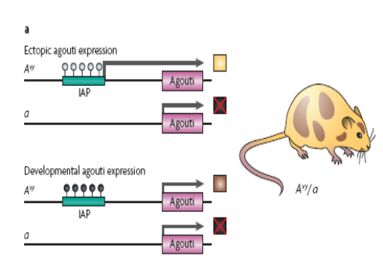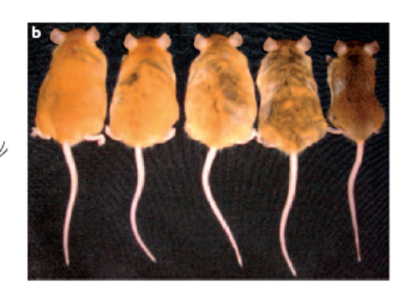
Figure 1 a. methylation status of IAP region effects coat color and Figure 1 b. mice exposed to folate diet are lean and brown (far right)(10).
Metabolic plasticity has been shown to depend on early nutritional status, with maternal diet influencing the phenotype and long-term disease potential in offspring (11-13). For example, feeding a protein restricted (PR) diet to rats during pregnancy was found to be associated with metabolic dysregulation in the offspring fed a high fat diet during the pubertal period. While, supplementation of the mother’s PR diet with folic acid during pregnancy reduced metabolic deregulation in the offspring, supplementation of the offspring diet with high folate during the pubertal period, did not affect the phenotype or epigenotype induced by the PR diet (14). The researchers concluded the offspring phenotype was set prior to the juvenile-pubertal stage. Human data supporting metabolic plasticity is exhibited in children born before and after maternal weight loss by bariatric surgery. Children born after maternal weight loss have a lower risk for obesity than do their siblings born before maternal weight loss, an effect attributed to improved intra-uterine environment (15-16).
Other studies indicate that the differentiation and lipid metabolism of adipocytes may depend on the level of methylation occurring in the upstream promoter region of genes. For example, in 3T3-L1 mouse pre-adipocytes there are two CpG sites which are highly methylated in the promoter region of the GLUT4 gene, which become highly demethylated in mature adipocytes (17). Furthermore, a change in methylation status is reflected in the development of adipocytes from stem cells carried through to senescence (18). Beyond genes directly involved in adipocyte development and metabolism, other genes have been found to have epigenetic impacts on the genome. For example, the obesity associated FTO gene could have a role in nucleic acid demethylation (19).
Several key compounds are necessary for the manufacturing of S-adenosyl methionine (SAMe), the primary methyl donor. Choline, methionine, betaine, vitamin B12 and folate all play a role in one-carbon metabolism and the cycling between SAMe and homocysteine. This is a complex pathway, and the most research to date has been on folate supplementation when a correlation was made between increased folate consumption and a decrease in the incidence of neural tube defects (NTDs). Although a direct cause for the reduction in NTD has not been determined, in 1992, the US Public Health Services and Institute of Medicine (IOM) recommended that all women of childbearing age should consume a supplement containing 400 µg of folic acid daily to prevent NTDs. Unfortunately, compliance was found to be low (~ 29%), therefore, in 1996, the Food and Drug Administration (FDA) mandated that by 1998 all cereal grain products sold in the US must be fortified with folic acid (140 µg folic acid per 100 gm of grain). According to 2004 data, NTDs have decreased an estimated 30% since the fortification program began (20). Yet, the long-term implications of folic acid supplementation are not yet known. Folate sufficiency has been associated with a lower risk of some cancers such as esophageal, stomach and ovarian cancer. However, it has also been suggested that excess folate may promote tumor initiation (21). It is most likely that there is a U-shaped response from folate where too much or too little is problematic. Therefore, more work is necessary to understand the ramifications of folate inadequacy and excesses, particularly during early cellular development and maturation. To that end, this research is focused on the effect of folate availability during differentiation and maturation on adipocyte lipid storage and release in light of DNA methylation. It is hoped we might gain a better understanding of how folate adequacy might ultimately affect obesity risk.

Chapter 2 Literature Review

Background
Obesity is a disease state resulting from an imbalance between energy intake and energy expenditure. Excess calories create a positive energy balance with the excess energy stored in the form of triglycerides in adipose tissue and carbohydrates in the form of glycogen in muscle tissue. This increase in adiposity can contribute to hypertension, dyslipidemia, Type 2 diabetes, coronary heart disease, stroke, gallbladder disease, osteoarthritis, sleep apnea and respiratory problems, and increased risk of some types of cancer (breast, endometrial and colon) (22). In the last few decades, the prevalence of obesity in the United States, (defined in adults as a body mass index greater than 30 kg/m²) has increased from 15% to nearly 33% in adults age 20-74 (23). The number of overweight children ages 2-19 has increased from 5% to 19% (23-29). One of the national health objectives put forth in Healthy People 2010 was to reduce the prevalence of overweight individuals to 15% by 2010 (30). Unfortunately, we fell far short of the goal as data from 2008 estimated adult obesity at 34% and childhood obesity at 17% (31). The results show that Americans are not meeting the recommended intake for fruits, vegetable and whole grains. For example, the target for dark green or orange vegetables was 50% of total daily caloric intake, but consumption has been maintained since 1994 at a dismal 4%. Whole grain intake has remained similarly low at an average of 3%. In addition, approximately 80% of Americans do not get the recommended amounts of physical activity. New guidelines set forth in Healthy People 2020 include a 10% reduction in obesity levels in both adults and children. The guidelines include recommendations for increasing access to healthy foods and decreasing access to high fat, high caloric foods for children. There are specific targets for increasing fruits and vegetables, whole grains, calcium and iron consumption, but no targets set for folate consumption (31). In order to accomplish a reduction in obesity, we must gain a better understanding of the causes of obesity.
There are many contributing factors to the obesity epidemic. The first factor is the energy imbalance created from consuming more dietary energy than is expended in physical activity. The average number of calories consumed per day has increased with a concurrent decline in caloric expenditure over the past few decades (32). Genetics also play a significant role contributing an estimated 30% to 70% of heritability for obesity risk (1). However, genome wide association studies looking at single nucleotide polymorphisms (SNPs) and other gene mutations have failed to find many strong genetic links. A few genes have been associated with increased risk for obesity. For example, variants of the FTO gene which encodes the fat mass and obesity associated protein correlates with obesity risk (19). The fidelity of DNA replication is high and typically has a very low mutation rates, approximately 1 mistake per 100 to 1000 base pairs (33-34). Therefore changes in DNA at the gene sequence level are unlikely to be the cause for the rapid increase in obesity during the last few decades. During this time, the prevalence of obesity in offspring of obese parents has increased dramatically as well, possibly showing a non-polymorphic genetic link. With this in mind, what could be driving genetic changes?

Epigenetics and DNA Methylation
It has been recently shown that modifications to the bases of DNA sequence can affect the regulation and expression of genes (35). Furthermore, these modifications can be either inherited by offspring or changed over the course of one’s lifetime. The modifications are known as epigenetic or “above” the genetic code changes. There are three categories of epigenetic changes; 1) methylation of nucleic acid residues, for example, methylation of cytosines in the CpG sequence context, 2) chromatin modification by histones via acetylation, methylation, phosphorylation, ubiquitylation, or sumoylation and 3) non-coding RNAs (36) . While any of these three epigenetic changes could be responsible for an increase in obesity rates, methylation of cytosine residues has been implicated in having the potential for successful modulation through nutritional interventions (37-40). Furthermore, it has been suggested that epigenetic regulation of pre-adipocytes occurs on multiple levels and is responsible for determining the rate and fate of the differentiation process (41).
One of the best understood mechanisms for epigenetic change is alteration in DNA methylation patterns created by the addition or subtraction of a methyl group to the 5-carbon position of the cytosine residues in the CpG dinucleotide. Methylation of CpG residues in the regulatory regions of genes typically acts to suppress expression of a gene. Conversely, hypomethylation in regulatory regions may increase expression of a gene. DNA methylation is important for silencing imprinted genes, X-chromosome inactivation and silencing retrotransposons. Once a cell has determined a specific DNA methylation pattern, the methylated sites are inherited by daughter cells during cell division. In this manner, quickly dividing cell lines are more prone to impacts caused from changes to their methylation patterns. Methylation of DNA is largely established during embryogenesis and early in post-natal life by DNA methyltransferases (Dnmts). Shortly following fertilization, maternal and paternal DNA is demethylated followed by global methylation just prior to blastocyst implantation by two de novo methyltransferases, Dnmt3a and Dnmt3b. During this time, approximately 70% of CpGs are methylated with lineage specific methylation of tissue specific genes occurring (42). Methylation continues throughout prenatal development and into early post-natal life. It is generally conserved throughout life with the exception of exposure to environmental perturbations and some loss of methylation during aging. For example, the gene encoding the enzyme phosphoenolpyruvate carboxykinase (PEPCK) is methylated during early embryogenesis, but undergoes progressive demethylation during development. Dnmt1 serves as the maintenance DNA methyltransferase and copies hemimethylated DNA marks. It is recruited to the DNA by histone deacetylase 1 and 2, Suv39 and E2H2, suggesting that chromatin structure plays a role in determining methylation patterns and vice versa (43).
DNA methyltransferases deliver methyl groups from the primary methyl donor S-adenosylmethionine (SAMe) to the cytosine residues, reducing SAMe to S-adenosylhomocysteine (SAH) in the process, which is in turn converted to homocysteine. 5’ Methyl tetrahydrofolate combines with homocysteine in the presence of B12, to form methionine, which is in turn used to generate S-adenosylmethionine, thus completing the cycle. Central to the one carbon pathway is the availability of the co-factors, in particular, folic acid derived from dietary sources. Folic acid is converted to tetra-hydro folate (THF) by dehydrotetrahydrofolate reductase (DHFR). Then THF is reduced to 5’,10’-methylene tetrahydrofolate, which acts as a methyl donor for the enzyme thymidylate synthase which converts deoxyuridine monophosphate to thymidine monophosphate. Folate in the form of 10-formyl tetrahydrofolate is also necessary for purine biosynthesis. Alternatively, 5’10’-methylene THF can be converted to 5’ methyl THF by methylene tetrahydrofolate reductase (MTHFR) in the presence of niacin and riboflavin. Polymorphisms in the MTHFR gene (677C>T) can reduce the ability of this enzyme to function effectively and may shunt folate in the direction of DNA and RNA biosynthesis versus SAMe generation, thus reducing global DNA methylation (44-46). Therefore, it is clear that perturbations in the one-carbon cycle have the ability to impact not only DNA and RNA biosynthesis, but also DNA methylation.

Experimental Models of Epigenetically Induced Obesity
Epigenetic research has shown that aberrant DNA methylation patterns are present in many disease states such as cancer and other genetic diseases. Early life environment is critical to the creation of DNA methylation patterns. The first evidence of the impact of nutrient deficiency on imprinted gene expression was from mouse embryos grown in Whitten’s media with no amino acid supplementation that exhibited biallelic expression of imprinted gene H19, while embryos given amino acid supplementation showed monoallelic expression of H19 (47). Similarly, human embryos cultured by in vitro fertilization (IVF) have a higher risk of developing Angelman’s Syndrome and Beckwith Weideman Syndrome by decreased methylation of the normally imprinted genes UBE3a, H19 and IGF2 (48-49). In 1996, Insulin growth factor 2 (IGF2) was shown to be differentially methylated in human populations and that differential “imprinting” was responsible for somatic growth (50). Computational studies suggest that perhaps 150 or more human genes may be capable of being modified in such a manner, including the insulin growth factor 2 receptor (IGF2R) and the transcriptional binding site, CCAAT-enhancer-binding protein (C/EBP), which has strong implications for possible impacts of aberrant methylation on obesity (51).
In animal studies, rat dams fed protein restricted (PR) diets had pups with increased cardio-metabolic disease. The pups had increased glucocorticoid receptor and PEPCK expression with a concurrent increase in gluconeogenesis. They also had decreased expression of 11β- hydroxysteroid dehydrogenease Type II (14, 52-54). The rat pups had higher levels of tri-acyl glycerol and non-esterified fatty acids in their blood stream. Furthermore, it was shown that genes involved in lipid homeostasis were affected in the rat pups with increased expression of acetyl co-A carboxylase and fatty acid synthase. In the liver, PPARα and it’s target, acyl CoA oxidase, were increased, while PPARγ in adipose tissue had reduced expression. The changes in gene expression were linked to changes in the level of gene promoter methylation levels. The pregnant rats fed a PR diet had increased blood levels of homocysteine, which negatively regulates Dnmt1. Folic acid has been shown to increase Dnmt1 levels, thus differences in the nutrients involved in the one-carbon metabolic pathway provide a link between maternal diet and epigenetic regulation of genes.
Researchers fed various constituents of the one-carbon metabolic pathway (folate, choline, and B12) to A^{vy} (variable yellow agouti) mice to study the potential for perturbations in the pathway to effect phenotype (8). There is a transposable element inserted upstream of the transcriptional start site of the agouti gene. This region contains CpG islands which can be methylated to varying degrees (Figure 1A) (7). They showed that phenotypic changes occur depending on the level of methylation of the CpG islands. When the CpG site is unmethylated, the agouti expression results in yellow obese mice. The phenotype switches to a dark brown, lean mouse with addition of methyl donor supplementation to the diet (Figure 1B) (7). Surprisingly, these phenotypic traits can be passed on trans-generationally through at least three subsequent generations (40).

Folate Availability and Propensity for Obesity: A possible link
Data acquired from a period known as the Dutch Hunger Winter, a famine which occurred in German occupied Netherlands during 1944-1945, revealed the importance of maternal diet on adult children’s health. The average caloric intake dropped to an average of 400 calories per day. Children conceived during this time had increased risk of developing schizophrenia and heart disease as adults. Furthermore, the timing of exposure to low caloric intake was shown to impact risk. Fetuses exposed to the famine during the first trimester had increased risk relative to those fetuses exposed to low caloric intake after the first trimester. Children conceived during the famine showed decreased methylation of imprinted regions of IGF2 and as adults were more at risk for developing obesity (55).
Godfrey et al found that the level of promoter methylation at birth of several genes including, retinoid X receptor alpha (RXRA) and endothelial nitric oxide synthase (eNOS) was associated with a child’s fat mass at age 9 years of age (56). Since folate is critical to one carbon metabolism and production of S-adenosylmethionine, it is possible that low folate exposure in utero, could affect promoter methylation and ultimately lead to increased risk for obesity. The Thrifty Phenotype Hypothesis suggests a nutrient deficient diet in utero sets up a person for increased risk to obesity when a high nutrient diet is encountered post-natally, because the genes have been “programmed” for a nutrient deficient environment (57). Tamashiro et al, suggest there is a U-shaped relationship between birth weight and adult fat mass, such that low birth weight or large birth weight predisposes one to increased fat mass as children and adults (7). Despite having a positive energy balance and food intake, obesity has been characterized by micronutrient deficiency (58). Han et al found that obese subjects in a South Korean population had significantly lower serum folate levels than did underweight subjects. Furthermore, in this population those women with high pre-pregnancy BMI had increased risk for pre-term delivery and children born with low birth weight (59). Stern et al found differences in folic acid absorption and metabolism between obese women and non-obese woman of child bearing years. They concluded that women with a BMI >30 kg/m² require an additional 350 micrograms of folic acid per day to achieve a folate status similar to women in the lowest BMI category.
In 1998, the U.S. Federal Drug Administration began requiring enrichment of all cereal grain products with folic acid, after it was determined that serum folate levels >15.9nmol/L and red blood cell >906 nmol/L are needed to reduce neural tube defects. Analysis of National Health Nutrition Examination Survey (NHANES) data acquired from 1988 to 2004 revealed a statistically significant increase in the survey population’s serum folate levels when comparing pre-folate fortification (1988-1994) to post-folate fortification (2003-2004). Mean serum folate levels increased two-fold from 11.4 nmol/L to 26.9 nmol/L and the erythrocyte folate concentration increased from 375 nmol/L to 590 nmol/L(60). Dietrich et al estimate the prevalence of low serum folate (<7 nmol/L) has decreased significantly since the introduction of fortification, from approximately 25% to around 1% (51). It is clear that a segment of the U.S. population prior to 1998 had sub-optimal levels of folate and this could have affected the promoter methylation of their genes, as well as that of their offspring. Alternatively, folic acid may in itself improve lipolysis as shown by Lam et al in studies with obese/diabetic mice given folic acid supplementation. They found that folic acid did not increase basal level lipolysis, but enhanced β-adrenergic receptor mediated lipolysis when adrenaline was administered. Activation of β-adrenergic receptors induces phosphorylation of hormone sensitive lipase and stimulates lipolysis through cAMP-PKA-dependent signaling pathway (61).
The process by which the body maintains a constant predefined range of body weight has been termed the Adipostat by Patrick Tounian (62). He suggests one must be constitutionally predisposed to obesity before an obesegenic environment causes one to become obese. He cites studies in which obese children’s bodies seem to actively resist attempts at weight loss by stimulating appetite and reducing energy expenditure in order to maintain body weight. Could folate be a mechanism by which the adipostat is set and controlled?

Adipose Tissue Composition
Adipose tissue was long thought to merely a storage site for excess energy. Now it is recognized as an endocrine organ excreting cytokines active in immune function, leptin which helps to control appetite, estrogen and resistin (63). Adipose tissue comes in two forms, white adipose tissue (WAT) and brown adipose tissue (BAT). While WAT serves as an energy storage vessel, BAT helps to disperse energy when necessary (64). White adipose tissue is distributed throughout the body and around organs, but typically is compartmentalized into subcutaneous or visceral regions. Of the two types, visceral fat has a higher association with metabolic diseases and diabetes. Visceral fat adipocytes are typically smaller in size than those in subcutaneous fat and the cells contain less lipid. Despite being smaller, visceral fat cells have a faster lipolytic rate and secrete more cytokines (65).
Two factors determine the total fat mass in humans, 1) total adipocyte numbers and 2) adipocyte size. Research has shown that the total number of fat cells remains constant in adulthood in both lean and obese individuals, even after weight loss (66). The number (hyperplasia) of fat cells one will have seems to be set in early childhood or adolescence. The ability of adipocytes to increase in size (hypertrophy) remains throughout adulthood and is ultimately responsible for total fat mass (66). Each year an estimated 10% of adipocytes will die and be replaced with new cells (66). Since mature adipocytes do not usually divide, new adipocytes are derived from a pool of pre-adipocytes.

Adipocyte Determination and Differentiation
There are two main steps in the development of mature adipocytes from mesenchymal stem cells (MSCs). MSCs have the capacity to differentiate into myotubes, adipocytes, chondrocytes or osteocytes. Determination is the first step wherein MSCs are pushed onto the adipocyte path by becoming a pre-adipocyte cell, and the second step is differentiation. A complex cascade of events occurs during differentiation and terminal differentiation involving selective silencing and activation of genes at specific time-points via binding of transcription factors, histone and acetylation modifications as well as phosphorylation activation and deactivation events and has been reviewed extensively (67), (68), (69), (41).
Commitment of the fibroblastic MSC to the pre-adipocyte path in vitro involves bone morphogenetic proteins (BMPs) such as Bmp4 which has been show to stimulate the differentiation of MSC into adipocytes. The cells move from a fibroblastic shape to a more spherical morphology created by changes in extracellular matrix and cytoskeletal components as expression of adipogenic transcription factors increases including CCAAT/Enhancer binding protein- α (C/EBP α) and peroxisome proliferator-activated receptor-γ (PPARγ).
In the 3T3L1 murine adipocyte cell line, the differentiation process can be divided into 3 stages; 1) growth arrest 2) mitotic clonal expansion and 3) terminal differentiation. The first stage of the differentiation process occurs 48 hours after cells have exited the cell cycle. This is often attributed to, but necessarily due to, contact inhibition. Primary rat pre-adipocytes plated at low density in serum-free media have been shown to differentiate without contact inhibition (67). Exit from the cell cycle has been linked to changes in extracellular matrix (ECM) proteins. After growth arrest, the addition of insulin, isobutylmethylxanthine (IBMX) and dexamethasone (DEX) will induce adipocytes to differentiate. This cocktail stimulates the insulin/IGF-1, c-AMP and glucocorticoid signaling pathways. The transcription factor families CCAT/enhancer binding proteins (C/EBPβ and C/EBPδ) levels begin to increase within 1 to 4 hours after stimulation. The cells will reenter the cell cycle and begin mitotic clonal expansion the second step in differentiation. C/EBPβ becomes hyperphosphorylated through the action of MAPK and SK3β. This in turn stimulates the transcription of C/EPBα, peroxisome proliferator activated receptor (PPAR)-γ, adipocyte determination and differentiation factor (ADD-1), and the sterol regulatory element binding protein (SREBP)1c. After day 2, C/EBPα begins to accumulate and is phosphorylated by Cyclin D-3/CDK complex. This causes an inhibitory effect on the cells and they are prompted to exit the cell cycle. PPARγ up regulates the expression of GOS2 and the cyclin dependent kinase inhibitor, p21, further directing the cell to exit the cell cycle. PPARγ also down regulates the serine-threonine phosphatase, PP2A, which inactivates the E2F-DP complex by dephosphorylation. By day 7 post-differentiation, most adipocytes have fully matured. The enzymes involved in lipid metabolism and glucose uptake as well as the adipocyte production of cytokines and hormones are fully activated (67).
The adipocyte differentiation process is accompanied by changes in genome-wide DNA methylation status (70). Treatment of 3T3-L1s with the DNA methyltransferase inhibitor, 5-aza-2’deoxycytidine, at a 1 micromolar concentration inhibited differentiation and lipid accumulation. However, the magnitude of the effect was dependent on the timing of exposure to the inhibitor. For example, pre-adipocyte (-2 to 0 days) exposure to the inhibitor decreased accumulation of lipid by 40% relative to a no treatment control. While exposure to the inhibitor during the late stage of differentiation (0 to 2 days) did not affect lipid accumulation. These results suggest that DNA methylation is involved in the differentiation process of 3T3-L1s. Furthermore, evaluation of both CpG and non-CpG regions upstream, within or downstream of exonic regions, found that methylation levels changed depending on whether the adipocyte was growing, confluent, post-confluent or mature. This non-static nature of DNA methylation was shown for several genes including Lep and Glut4. The authors concluded that some DNA methylation changes are transient events, which are dynamic and not static, and this is a common mechanism in differentiation of somatic tissues and not restricted to early embryo development (70).

Adipocytes and Energy Metabolism
Adipocytes are the primary storage site for excess energy in the form of triglycerides. The process of lipogenesis begins as free fatty acids (FFA) are liberated from lipoprotein-triglycerides by lipoprotein lipase. Upon entering the cell, the FFA are esterified to a glycerol-3-phophate and stored as lipid droplets. Triglycerides can also be synthesized by de novo lipogenesis from acetyl-CoA by the enzymes fatty acid synthase (FASN) and acyl-CoA- carboxylase (ACC). Although in whole body system de novo lipogenesis is thought to play a minor role in triglyceride storage (71).
When adipocytes are in a fasted state, the triglyceride stores are released as FFA in the process called lipolysis. This process may use three different lipases to cleave the FFA from it’s glycerol backbone: adipose triglyceride lipase (ATGL), hormone-sensitive lipase (HSL) and monoglyceride lipase (MGL). ATGL typically cleaves triglycerides and HSL prefers diglycerides. Catecholamines can stimulate lipolysis by activating the β1 and β2 adrenergic receptors. This stimulated the G receptor proteins to activate adenylate cyclase, which in turn causes an increase in c-AMP. This causes a downstream activation of cAMP-dependent protein kinase-A (PKA) which phosphorylates and activates enzymes such as HSL. The most potent inhibitors of lipolysis are insulin and IGF. They interact with the insulin signaling pathway to activate 3-phosphoinositide-dependent protein kinase (PDK1) and protein kinase C (PKC). The pathway ultimately leads to degradation of cAMP and PKA activity (72).

Role of Adipocytes in Development of Obesity and Metabolic Diseases
White adipose tissue has been shown to play a major role in the development of diseases through secretion of adipocytokines, hormones and free fatty acids (FFAs). Adipocytes are the major storage depot for triglycerides in the body and disturbances in lipid turnover and FFA mobilization is associated with obesity and metabolic disease (73). Increased triglyceride breakdown is associated with obesity. Excess white adipose tissue is also associated with decreased catecholamine stimulated lipolysis. People with the same fat mass can vary substantially in the number of fat cells they possess. Adipose tissue hypertrophy, characterized by a few very large fat cells, as opposed to hypercellularity which is characterized by a large number of cells, is a risk factor for metabolic disorders. Of note, not all obese individuals develop obesity related disorders because they are able to maintain normal adipose tissue function (73). There may be a genetic predisposition to fat cell phenotype, small cell type as in visceral tissues or larger cell type found in subcutaneous fat, and this predisposition may lie in the methylation status of the cells.
Although many studies have suggested a correlation between methyl donor availability to effect DNA methylation and subsequent gene expression, direct studies in adipocytes to assess the impact of either limiting folate or providing excess folate on adipocyte lipid metabolism have yet to be done. Furthermore, the effects of folate on differentiation versus post-differentiation lipid metabolism have not yet been studied. Therefore we sought to add to the body of knowledge through designing experiments that would assess the ability of folate to effect DNA methylation and to understand if timing of the exposure ultimately makes a difference in the ability of the adipocyte to store and release lipids.

Chapter 3 Experimental Investigations
To be submitted to the Journal of Nutrition
Folate Levels During 3T3L1 Adipocyte Differentiation Have Sustained Impact on Lipogenesis and Lipolysis¹

Julia S. Gouffon ^{2,3}, Megan E. Johnstone², Michael B. Zemel^{2,3}
² Department of Nutrition, ³Department of Comparative and Experimental Medicine, University of Tennessee, Knoxville, Tennessee, 37996

Abbreviations used:
Deoxyribonucleic acid (DNA), Ribonucleic acid (RNA), S-adenosylmethionine (SAMe), DNA methyltransferase 1 (Dnmt1), fatty acid synthase (Fasn), folate receptor 1 (Folr1), glucose transporter 4 (Glut4), hormone sensitive lipase (Lipe), leptin (Lep), methylenetetrahydrofolate reductase (Mthfr), peroxisome proliferation activated receptor gamma (Pparγ), Pparγ coactivator 1 alpha (Pgc-1α), Hank’s Balanced Salt Solution (HBSS), Dulbecco’s Modified Medium (DMEM)

Abstract
Background/Aim: Epigenetic modifications serve as a means of intermediate gene expression control, and nutritional inputs may modify methylation patterns in regulatory regions of genes. Therefore, we proposed that specific nutrient availability of folate would affect adipocyte development and metabolism through impacting the one-carbon cycle and subsequent DNA methylation patterns. Accordingly, we sought to determine if the methylation level of CpG islands could be influenced in adipocytes and if so, how this might affect gene signaling in mature adipocytes. Methods: We treated adipocytes with 0 to 0.9 mM folate, the methyl donor S-adenosylmethionine (SAMe) or a methylation inhibitor, 5-aza-2-deoxycitidine (Decitibine) during adipocyte differentiation and the maturation process. Lipogenesis was measured by accumulation of oil red O and lipolysis was quantified by a glycerol release assay. RNA was obtained and genes involved in adipocyte differentiation, one-carbon metabolism, lipogenesis and lipolysis were quantified using RT-PCR. Methylated regions of adipocyte genomic DNA were evaluated using a methylation-specific antibody and hybridized against a Nimblegen whole genome CpG island array. Results: Differentiation under folate depleted conditions increased lipid accumulation and enhanced lipolysis driven by increased expression of fatty acid synthase (Fasn), glucose transporter 4 (Glut 4) and hormone sensitive lipase (Lipe). Exposure to increased levels of folate or SAMe post-differentiation enhanced this effect. Adipocytes differentiated under high folate levels had lower levels of leptin (Lep) under low folate maturation conditions than adipocytes differentiated under standard conditions. Adipocytes differentiated under standard conditions exposed during maturation to depleted folate, decitibine or SAMe had decreased global CpG methylation relative to standard conditions including the promoter regions of Fasn, Glut 4, Lipe and Lep. Conclusions: Promoter methylation in key metabolic regulatory genes was impacted by exposure to folate deficient conditions resulting in increased lipogenesis and lipolysis. The level of folate exposure during adipocyte differentiation had greater impact on lipolysis and lipogenesis than did folate exposure during maturation.

Introduction
Recent work with stem cells and pluripotent cells, including adipocytes, has shown that nutrient and hormonal balance can affect cellular differentiation and ultimately be directive for deeming the cell type, a concept known as developmental plasticity(74). This cellular flexibility may allow for sensing environmental conditions during cellular development in utero, but may be problematic when the external environmental conditions do not match those seen during initial development. It has been proposed that nutritional mismatch may be a causative agent for future disease development (6). The Dutch Hunger Winter during World War II yielded evidence that poor maternal nutrition resulted in increased incidence of obesity, CVD and diabetes in adult males. This study and others gave rise to the “Thrifty Phenotype Hypothesis” that proposes metabolic programming of the fetus during development in a nutrient poor in utero environment prepares for a post-natal environment that is similarly nutrient poor, however, when the post natal environment is rich in nutrients, metabolic syndrome ensues (7). Recent data suggest that epigenetic changes appear to be involved in this environmental sensing of nutritional status.
Metabolic plasticity has been shown to depend on early nutritional status with maternal diet, influencing the phenotype and long-term disease potential of offspring (11-13). The strongest human data supporting this hypothesis are from children born before and after maternal weight loss by bariatric surgery: children born after maternal weight loss have a lower risk for obesity than do their siblings born before maternal weight loss, an effect attributed to improved intra-uterine environment (15-16).
Other studies indicate that the differentiation and lipid metabolism of adipocytes may depend on the level of methylation occurring in the upstream promoter region of key regulatory genes. For example, 3T3-L1 mouse preadipocytes exhibit varying levels of methylation in the promoter region of the Glut4 gene during differentiation into mature adipocytes (17). Furthermore, a change in methylation status is reflected in the development of adipocytes from stem cells carried through to senescence (18). Similar mechanism may be operative in adipocyte differentiation, and several metabolic genes could be affected by the amount of methyl donors in the diet during critical developmental stages.
Several key compounds are necessary for the manufacturing the primary methyl donor in the body, S-adenosyl methionine (SAMe). Choline, methionine, vitamin B12 and folate play a role in one-carbon metabolism and the cycling between SAMe and homocysteine. In 1996, the U.S. government implemented fortification of cereal grains with folic acid (140 µg folic acid per 100 gm of grain) (75). Long-term implication or impacts of folic acid supplementation are not yet known.
Since folate is involved in one-carbon cycling and a critical component for DNA methylation reactions, we sought to understand how the addition of folate might affect adipocytes through changing the methylation of CpG residues in the promoter regions of genes involved in lipolysis and lipogenesis. We proposed that CpG methylation status affects the transcription of metabolic genes; thus increasing folate levels would increase methylation of lipid metabolism regulatory genes thereby decreasing overall lipid accumulation in adipocytes. Conversely, decreasing folate levels would decrease methylation, thereby increasing lipid storage.
To test this hypothesis, we differentiated pre-adipocytes under folate depleted, standard folate and high folate conditions. The adipocytes were matured under folate depleted, standard folate, high folate, superphysiological levels of folate, SAMe or 5-aza-2-deoxycitidine. After one week of treatment, the cells were assayed for total lipid storage and lipid release. RNA was acquired to measure gene expression levels and DNA promoter methylation was assayed using methylation microarray analysis (MIRA) (76). We sought to determine if epigenetic methylation patterns either proximal or distal to promoter regions of metabolic gene involved in fatty acid oxidation, lipolysis, lipogenesis, glycolysis, and gluconeogenesis are set during the differentiation process of adipocytes or if they can be manipulated after differentiation in mature adipocytes.

Materials and Methods

Experimental Design
Adipocytes were differentiated under one of 3 conditions: 1) folate depleted, whereby the only folate available was that which was stored during colony expansion and trace amounts from fetal bovine serum, 2) standard Dulbecco’s Modified Eagle Medium (DMEM) containing 9 µM folate, and 3) high folate conditions, DMEM supplemented with additional folate to a total concentration of 90 µM folate. Following differentiation each group was subdivided into six post-differentiation treatments. The first three treatments consisted of the aforementioned groups: 1) folate depleted, 2) standard DMEM, 3) high folate as well as 4) supraphysiological folate containing 900 µM folate, 5) 2 µM decitabine and 6) 100 µM S-adenosylmethionine. Small amounts of amendment stocks were aliquoted into dark storage tubes and stored at -20°C to prevent freeze/thawing and potential degradation of amendments. Cells were treated every other day for one week post-differentiation with media made with freshly thawed amendments. The experimental design overview is show in Figure 2 .
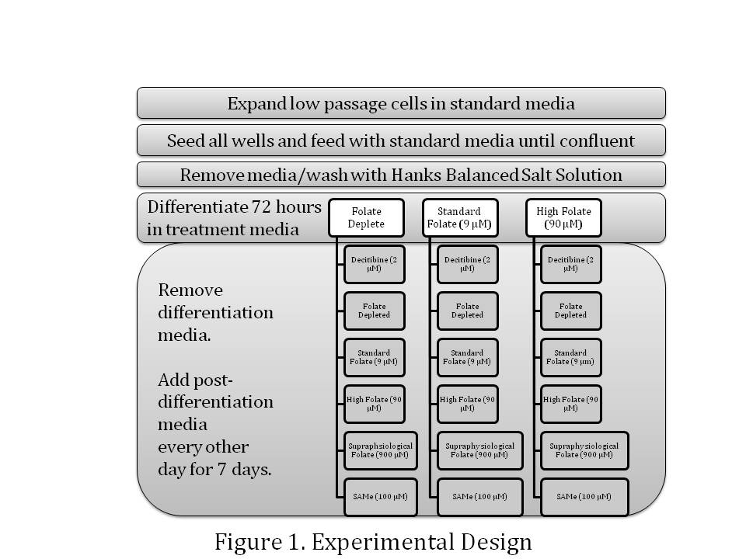

Figure 2 Experimental Design

Adipocyte Growth Conditions
Early passage number (<5) murine 3T3-L1 preadipocytes (ATCC # CL-173) were expanded in Dulbecco’s Modified Eagle Medium (DMEM containing 4 mg/L Folic Acid) according to the standard ATCC protocol. Preadipocytes were harvested after removing DMEM and washing with Hanks Balanced Salts Solution (HBSS) and trypsinization. After centrifugation to remove HBSS and trypsin, cells were resuspended in DMEM and equal cell numbers (verified by hemocytometry counts) were transferred into 24-well plates. Once cells were confluent, the DMEM was removed and cells were washed with HBSS. One of 3 media types was placed over the cells; 1) folate reduced DMEM, 2) standard DMEM (folate free base with 4mg/L folate added and 10% FBS), 3) folate excess DMEM (folate free base with 40 mg/L folate added and 10% FBS). Cells were acclimated to the new media for 1 day before addition of treatment media consisting of 6 types; 1) folate free DMEM with 10% FBS , 2) Standard DMEM 9 uM Folate, 3) folate excess DMEM 90 uM Folate, 4) supraphysiological folate DMEM 900 uM Folate 5) 100 µM S-adenosylmethionine (SAMe) in a folate free base with 10% FBS, 6) 2 µM 5-aza-2-deoxycytidine (2DC) in a folate free base with 10% FBS. Treatment media was changed every 2 days with folate, SAMe and 2DC additions made to base media from freezer stocks just prior to feeding cells to ensure limited degradation of compounds. Cells were treated for seven days post differentiation to gather data during a transitional time, i.e. cells were not fully matured or static in lipid acquisition.

Triglyceride accumulation
On day seven post-differentiation, adipocytes were washed with 1X PBS and formalin fixed. A solution of Oil Red O was added to the cells and allowed to stain the cells, followed by a wash with water (4 x) to remove any unbound stain. Cells were imaged using a microscope and documented by photography. Addition of 100% isopropanol eluted the Oil Red O from the cells. The optical density of 200 ul aliquots was determined at a wavelength of 540 nm using a Promega GloMax® plate reader (Promega Corp., Madison, WI. USA).

Lipolysis
Lipolysis (lipid release) was determined by a glycerol release assay (77). On day seven, cell media was changed four hours prior to the start of the glycerol release assay to ensure that cells were not in a starved state prior to induction of the assay. A series of glycerol standards ranging from 0 to 1 mM was prepared in KRB/BSA buffer. Samples or standards were added to reaction mixtures (1:4 volumes) consisting of hydrazine buffer (Sigma-Aldrich), β-nicotinamide-adenine dinucleotide (Sigma-Aldrich) and glycerol dehydrogenase (Sigma-Aldrich). The NADH produced was measured using a Promega GloMax® plate reader (Promega Corp., Madison, WI. USA) and compared to the standard glycerol curve. Lipolysis data was normalized to cellular DNA content because experiments showed treatments affected cell size, thus protein level (data not shown).

CyQUANT Cellular Proliferation Assay
DNA content was measured per directed by the CyQUANT assay (Life Technologies, Grand Island, NY, USA). Cells were lysed in CyQuant GR dye/cell lysis buffer and compared to a DNA standard curve created from lambda DNA. Sample fluorescence was measured using a Promega GloMax® plate reader (Promega Corp., Madison, WI. USA). The standard dilution series generated a linear curve from which the DNA content of each sample was determined.

Methylated CpG Island Recovery Assay
On day seven post-differentiation, cells were lysated in RIPA (Sigma Aldrich) buffer and the genomic DNA was prepared using a Proteinase K/ hot phenol extraction method followed by ethanol precipitation (78). The concentration, purity and quality of each DNA extract were assessed by with a ND-1000 spectrophotometer (NanoDrop Technologies, Inc., Del. USA). Samples with an A260/A230 ratio less than 1.5 were not included in subsequent analyses.
The methylated portions of the genomic DNA from mature adipocytes were isolated using a MethylCollector Ultra Kit (Active Motif, Carlsbad, CA) which uses the MIRA assay (76). In brief, genomic DNA was fragmented using Mse I. The fragmentation was visualized using the Agilent Bioanalyzer DNA7500 Series II assay. The DNA was captured with a His tagged MBD2/MBD3L1 protein complex which binds any methylated DNA. Both methylated and non-methylated DNA was captured utilizing the MethylCollector column and buffer system. Methylated DNA was labeled with Cy5 and the non-methylated DNA was labeled with Cy3 using a Dual-Color Labeling kit per manufacturer’s directions (Roche Nimblegen, Inc. Madison, WI). The Cy5 and Cy3 labeled DNA was hybridized to a NimbleGen Mouse DNA Methylation 385K RefSeq Promoter array as prescribed in the NimbleGen DNA Methylation Analysis Guide (Roche Nimblegen, Inc. Madison, WI). This array was designed using the UCSC Mus musculus Build 8 Reference Sequences database with coverage 2000 bp upstream and 500 bp downstream of each gene promoter region and covering 19,489 transcript regions. The area of genomic DNA with enhanced methylation regions was determined using Roche DEVA software.

Total RNA Extraction
RNA was isolated from adipocytes at day 7 post-differentiation using Ambion’s ToTALLY RNA isolation kit (Ambion, Inc. Austin, TX) as directed. The concentration, purity and quality of each RNA extract were assessed by with a ND-1000 spectrophotometer (NanoDrop Technologies, Inc., Del. USA). Samples with an A260/A230 ratio less than 1.5 were not included in subsequent analyses.

Reverse Transcriptase Polymerase Chain Reaction
DNA methyltransferase (Dnmt1), Fatty acid synthase (Fasn), Folate receptor 1 (Folr1), Glucose transporter 4 (Glut4), Hormone sensitive lipase (Lipe), Leptin (lep), Methylenetetrahydrofolate reductase (Mthfr), Peroxisome proliferation activated receptor gamma (Pparγ) and Pparγ co-activator receptor alpha (Pgc-1α) were quantified by real-time reverse transcriptase polymerase chain reaction (RT-PCR) using a 7300 Real-Time PCR system with TaqMan probes listed in Table 1 on following page.
A pooled sample containing all samples at (10 ng/ul) was prepared and serially diluted to provide a relative standard curve against which all samples were compared. RNA template was added to a reaction mix prepared as directed using TaqMan Core Reagent Kit (Applied Biosystems, Foster City, CA, USA). All samples and standards were run on the same plate for each gene analyzed allowing for direct calculation of relative quantities. Standard cycling parameters were followed except for an initial hold at 48°C for 30 minutes followed by a hold at 95° for 10 minutes prior to the cycling start. Data was acquired after 15 cycles and the concentration of each sample was calculated during linear amplification as compared to the response of the relative standard curve.

Gene ID | Gene Name | TaqMan Probe ID
Dnmt1 | DNA methyltransferase | Mm01151065_g1
Fasn | Fatty acid synthase | Mm00662319_m1
Folr1 | Folate receptor 1 | Mm00433355_m1
Lep | Leptin | Mm0043759_m1
Lipe | Hormone sensitive lipase | Mm0095359_m1
Mthfr | Methylenetetrahydrofolate reductase | Mm0487784_m1
PGC1α | PPARgamma coactivator 1 alpha | Mm00447189_g1
PPARγ | Peroxisome proliferation activated receptor gamma | Mm00440945_m1
Glut 4 | Glucose transporter 4 | Mm00436615_m1

Table 1 Life Technologies/Applied Biosystems TaqMan ® Probe Assays for RT-PCR

Statistical Analysis of Data
For triglyceride accumulation, lipolysis, and RT-PCR each treatment had 4 biological replicates. The MIRA assay was performed as a screening procedure, so no statistical analysis was performed. Replicate samples were statistically analyzed by 2-way ANOVA with concurrent pair-wise contrasts made between treatments using Partek Genomics Suite Statistical Software (St. Louis, MO).

Results

Cellular Proliferation
Since cells varied in size after treatment, cellular proliferation was measured by DNA content using the CyQuant Assay. The mean DNA quantities are shown in Figure 3 and Table 3(Appendix) for each treatment. Cells differentiated under folate depleted conditions and exposed to decitibine, folate depleted or standard folate conditions during maturation had significantly less DNA than cells differentiated under standard or high folate conditions exposed to similar treatments post-differentiation (p<0.05). Increasing folate levels post-differentiation in these cells helped them to recover to proliferation levels similar to those seen in cells differentiated under standard or high folate levels. There were no statistically significant differences in DNA quantity between cells differentiated under standard folate levels matured under folate depleted, standard folate or high folate conditions. For cells differentiated under high folate levels, experiencing folate depleted conditions caused a significant increase in proliferation as did exposure to SAMe (p<0.05).
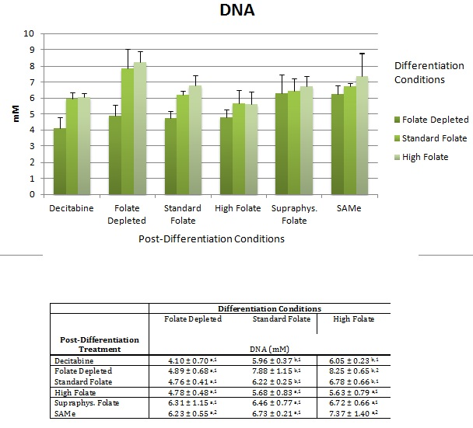

Figure 3 DNA estimates graphical and tabular views for mean and standard deviations (n=4)
1. Non-matching letter superscripts in each row denote significant difference (p<0.05)
2. Non-matching numerical superscripts in each column denote significant difference (p<0.05)

Triglyceride Accumulation
Triglyceride accumulation is shown in Figure 4 and Table 3 (Appendix). Despite having lower cell numbers, the cells differentiated under folate depleted conditions exposed to folate depleted conditions during maturation accumulated ~30% more than cells differentiated under standard or high folate conditions with similar post-differentiation treatments (p<0.005). Exposure to decitibine during the post-differentiation period enhanced triglyceride accumulation in folate depleted cells. Conversely, cells differentiated under high folate conditions, then matured under folate depleted conditions acquired 40% less triglyceride than those differentiated under folate depleted conditions (p<0.005) and 14% less than those differentiated under standard conditions (p<0.005). As previously shown, high folate conditions during differentiation induced cellular proliferation, but this was not accompanied by an increase in lipid accumulation if cells were exposed to folate depleted or standard levels of folate during the maturation period. However, increasing folate levels during maturation modestly, but significantly, increased lipid accumulation in high folate differentiated cells (p<0.05).
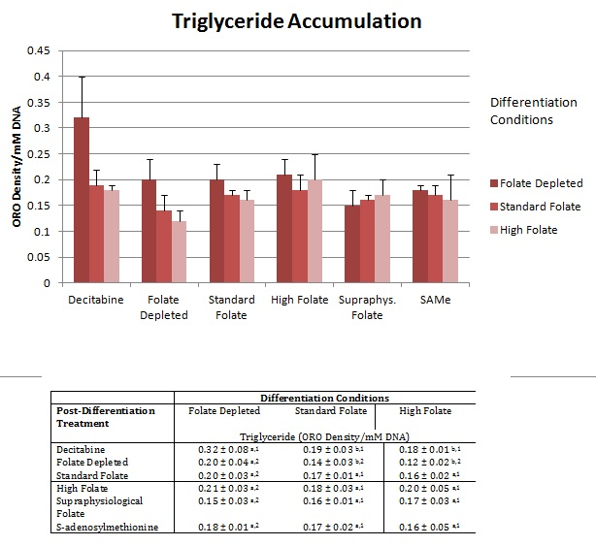

Figure 4 Triglyceride accumulation graphical and tabular views for mean and standard deviations (n=4)
1. Non-matching letter superscripts in each row denote significant difference (p<0.05)
2. Non-matching numerical superscripts in each column denote significant difference (p<0.05)

Lipolysis

In general, the level of lipolysis for each of the treatments reflected the amount of triglyceride stores available for release as shown in Figure 5 and Table 3 (Appendix). Furthermore, lipolysis decreased in a dose dependent manner with the level of folate exposure during differentiation, i.e. folate depleted cells had two to three times the level of lipolysis compared to standard or high folate differentiated cells. Exposure to high folate conditions during differentiation blunted lipolysis by up to 50% relative to standard conditions (p<0.05). Surprisingly, exposure to decitibine or SAMe during the maturation phase significantly increased lipolysis in the cells differentiated under standard or high folate conditions (p<0.0%). Increasing folate during maturation, decreased the level of lipolysis an average of 55% in folate depleted differentiated cells (p<0.05), 27% in standard differentiated cells and 18% in high folate differentiated cells.
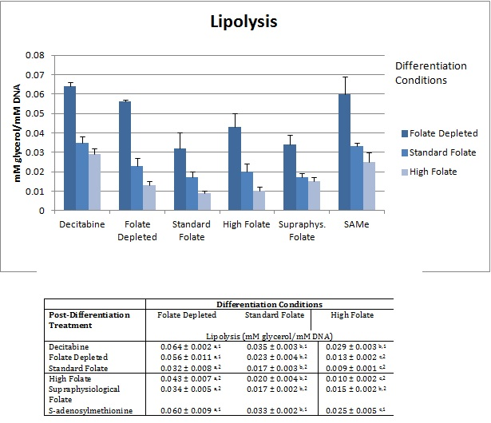

Figure 5 Lipid release graphical and tabular views for mean and standard deviations (n=4)
1. Non-matching letter superscripts in each row denote significant difference (p<0.05)
2. Non-matching numerical superscripts in each column denote significant difference (p<0.05)

Overall Adipocyte Phenotype
Adipocytes were imaged using an Oil Red O stain 7 days post-differentiation as shown in Figure 6. This time-point was selected to capture adipocytes at a non-static point in lipid filling (data not shown). Cells differentiated under folate deplete conditions were much smaller and fewer in numbers than cells grown under standard or high folate conditions. Addition of folate during the post-differentiation period increased cell numbers to levels exceeding that seen in fat cells differentiated under standard or high folate conditions (hyperplasia). Folate depleted fat cells acquired more lipid per cell than did fat cells grown under standard or high folate conditions. In addition, these cells released a greater amount of lipid stores under non-stimulated lipolysis. Adipocytes differentiated and matured under high folate conditions were more numerous, but did not retain as much lipid per cell. These cells also yielded less lipid release during non-stimulated lipolysis. Treatment with Decitibine created fewer fat cells relative to standard conditions. But these cells acquired statistically more triglycerides than cells grown under standard folate or high folate conditions. Cells differentiated under high folate were more numerous and slightly larger than cells differentiated under standard or folate depleted conditions. Despite this fact, the cells stored less triglyceride on a per cell basis and as a result released less lipid during non-stimulated lipolysis.

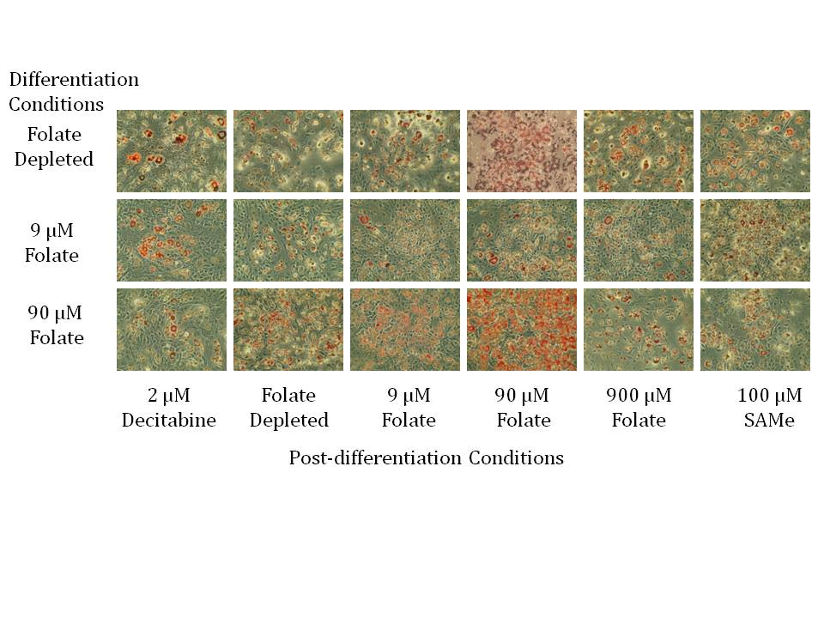

Figure 6 Oil Red O images of Day 7 post-differentiation of 3T3L1s

DNA CpG Methylation
Analysis was performed on cells differentiated under standard folate conditions then exposed to folate depleted, standard folate, decitibine or SAMe during the maturation period. As expected for CpG Island methylation was decreased globally in the folate depleted and decitibine treated cells relative to standard conditions as seen in Figure 7 (a-g) as follows. The track on the top shows the CpG islands highlighted in red. Below that track is the transcription start site track which contains one or two blue dots representing the site. Next, is the primary transcript track highlighting the entire length of the transcript. The treatment tracks for 2DC, standard folate, SAMe and low folate follow with dots representing the level of methylation at each CpG residue. Dots above the line represent hypermethylation and dots below the line infer hypomethylation. Adipocytes grown under standard conditions showed the most variability in their CpG methylation track lines. While those matured under 2DC and low folate had the most repressed methylation levels. Quite unexpectedly, methylation decreased on a global level in the cells given SAMe. However, some specific CpG sites had increased methylation relative to the standard conditions which could affect transcriptional binding in SAMe treated cells.

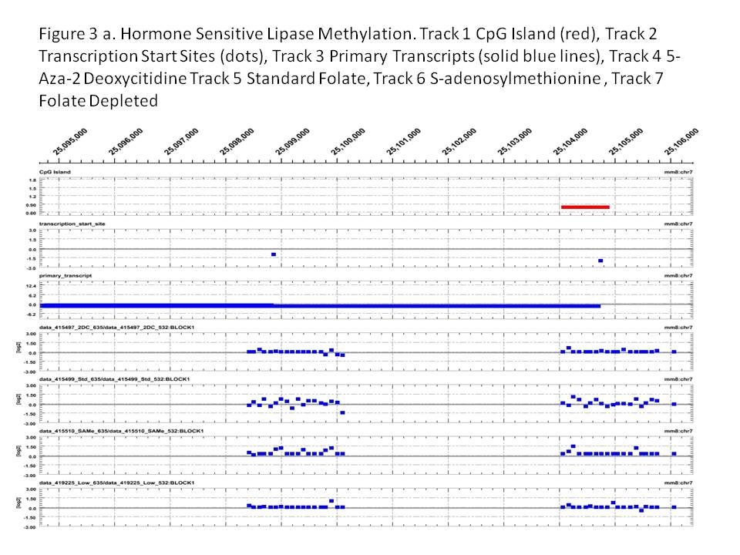

Figure 7 a. Hormone Sensitive Lipase DNA Methylation in Promoter Regions

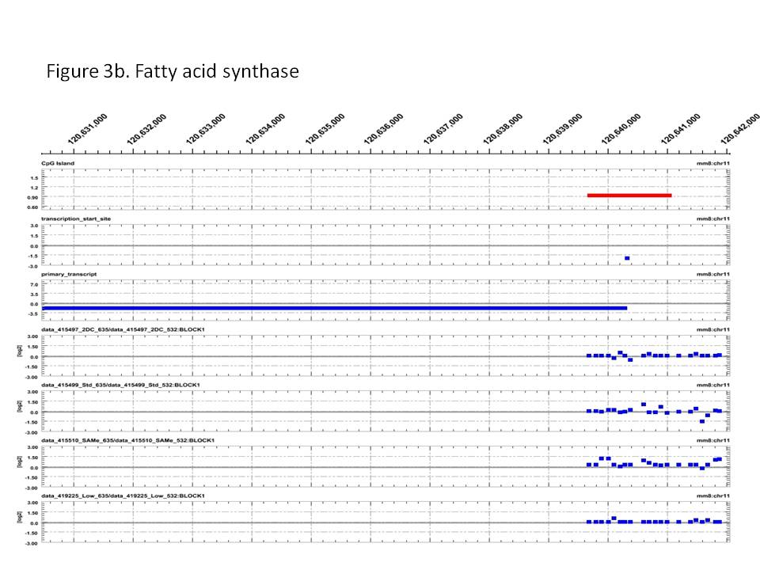

Figure 7 b. Fatty Acid Synthase Gene DNA Promoter Methylation

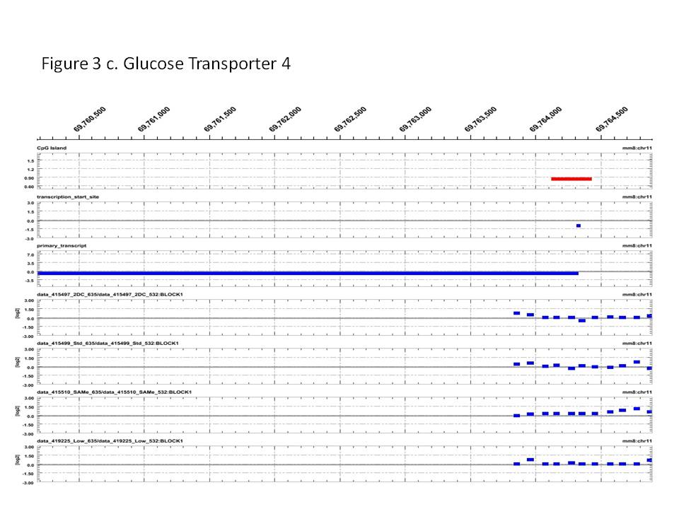

Figure 7 c. Glucose Transport 4 Gene DNA Promoter Methylation

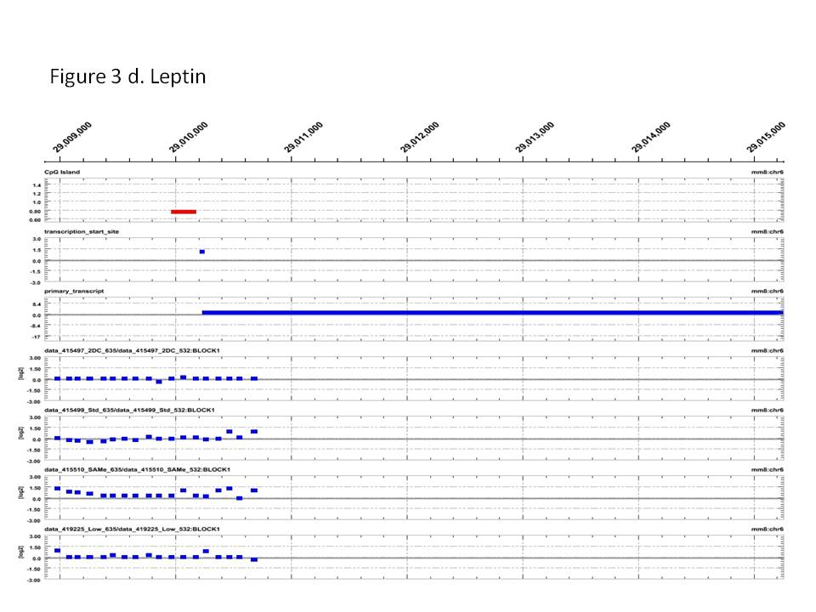

Figure 7 d. Leptin Gene DNA Promoter Methylation

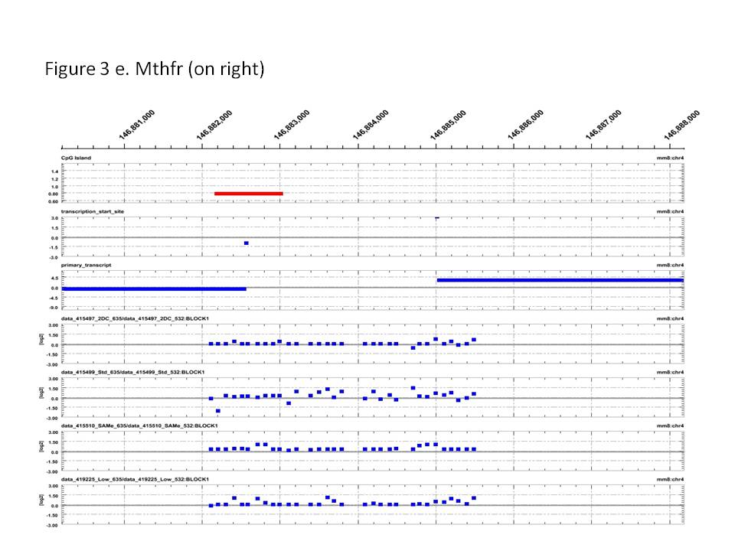

Figure 7e. Methylene Tetrahydrofolate Reductase Gene DNA Promoter Methylation

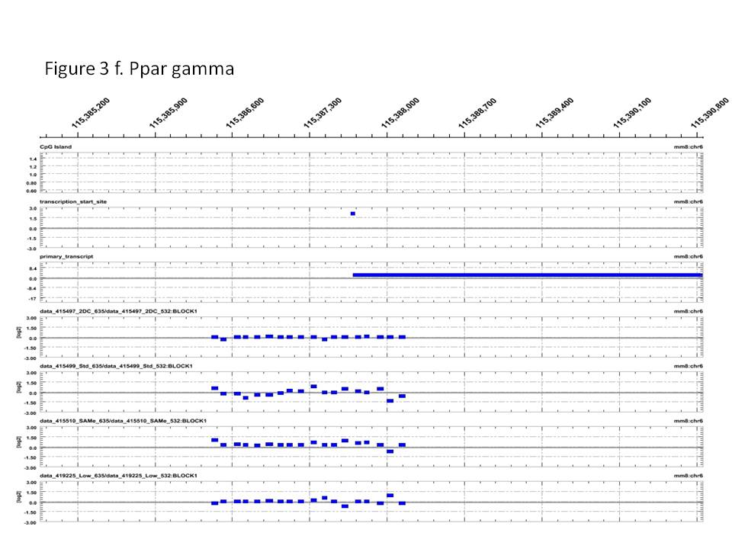

Figure 7 f. Peroxisome proliferator activated receptor Gene DNA Promoter Methylation

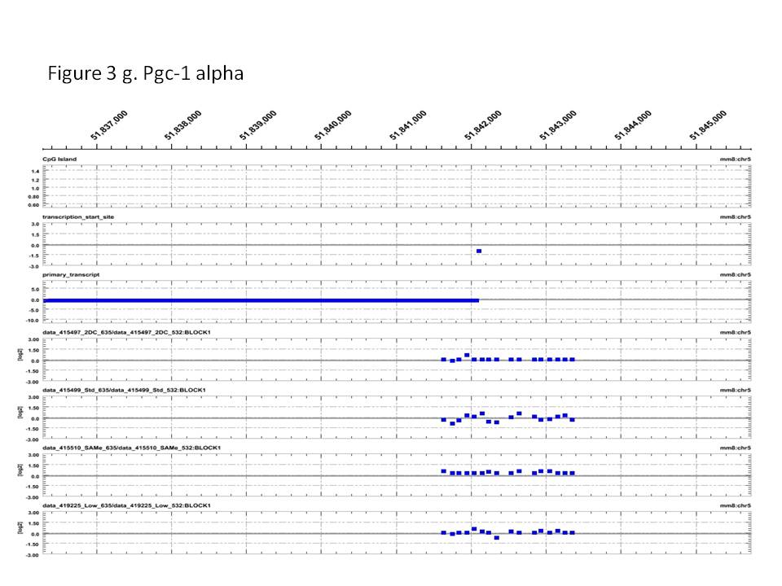

Figure 7g. Peroxisome proliferator activated receptor gamma co-activator 1 alpha Gene DNA Promoter Methylation

Gene Expression
As shown in Figure 7 a, DNA methyltransferase 1 levels did not change significantly in cells exposed to decitibine, folate depleted or standard folate conditions during maturation irrespective of differentiation conditions. For cells exposed to high folate or supraphysiological levels of folate during maturation, the amount of Dnmt1 mRNA decreased with folate exposure during the differentiation condition. Cells differentiated under folate depleted conditions in general had increased levels for Dnmt1 as folate levels increased during the maturation phase whereas cells differentiated under high folate decreased the level of Dnmt1 transcripts as folate levels increased during the maturation phase. For cells differentiated under standard conditions, the level of Dnmt1 tended to stay constant with folate exposure except in the supraphysiological folate treatment group which was significantly higher (p<0.05). Interestingly, SAMe exposure significantly increased Dnmt1 in the folate depleted and standard folate differentiation groups, but not in the high folate differentiated group (p<0.05). Decitibine treatment yielded Dnmt1 levels similar to that seen in folate depleted treatments for all differentiation groups.

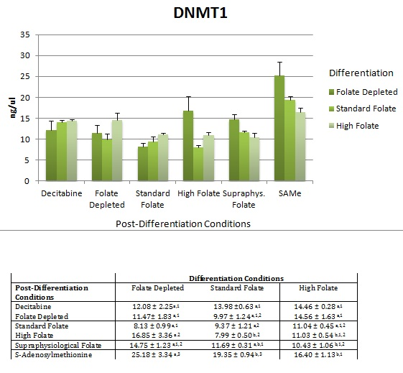

Figure 8 a. DNA Methyltransferase 1 gene expression levels as measured by RT-PCR. The table below the graph contains the average with standard deviation. Statistical analysis by 2-way ANOVA (n=4). Non-matching letters indicate a significant difference in differentiation conditions and non- matching numerals indicated a significant difference in post-differentiation conditions.

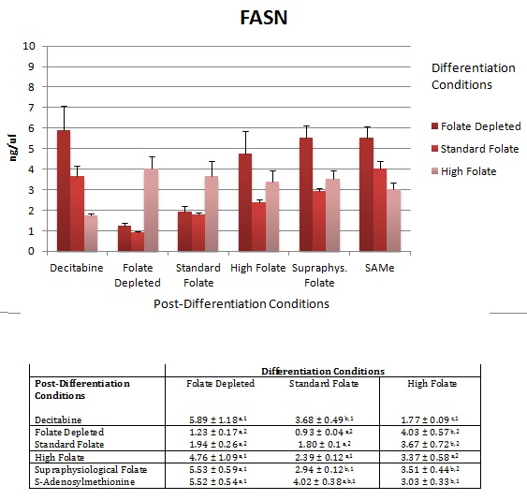
High folate levels during differentiation resulted in increased fatty acid synthase transcripts relative to cells differentiated under folate depleted or standard folate levels for those matured under folate depleted or standard folate levels (p<0.05). Conversely, for cells differentiated under high folate levels, Fasn levels decreased in cells exposed to supraphysiological folate or SAMe during the post-differentiation period relative to similar treatments in the folate depleted differentiation cells (p<0.05). For cells differentiated under folate depleted conditions, increasing folate levels post-differentiation resulted in increased Fasn expression (p<0.05). A similar trend was seen in those cells differentiated under standard folate conditions (p<0.05), but not in high folate conditions.
Figure 8 b. Fatty acid synthase gene expression levels as measured by RT-PCR. The table below the graph contains the average with standard deviation. Statistical analysis by 2-way ANOVA (n=4). Non-matching letters indicate a significant difference in differentiation conditions and non- matching numerals indicated a significant difference in post-differentiation conditions.

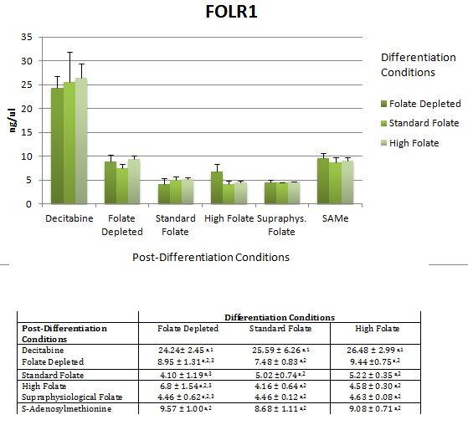
Folate receptor 1 (folr1) levels were significantly higher in cells exposed to decitibine during the maturation period (p<0.050, but did not significantly differ with respect to folate exposure during the differentiation period. For cells differentiated under standard or high folate levels, no significant difference was shown in post-differentiation treatments except in the decitibine group which was three fold up-regulated (p<0.05). Cells differentiated under folate depleted conditions showed a two fold increase in folr1 expression under folate depleted conditions during the post-differentiation period (p<0.05). In general, SAMe treatments had folr1 levels similar to those seen in the folate depleted maturation groups irrespective of folate differentiation levels.
Figure 8 c. Folate receptor 1 gene expression levels as measured by RT-PCR. The table below the graph contains the average with standard deviation. Statistical analysis by 2-way ANOVA (n=4). Non-matching letters indicate a significant difference in differentiation conditions and non- matching numerals indicated a significant difference in post-differentiation conditions.
Expression of glucose transporter 4 seem to be tightly controlled as gene expression levels did not vary much with folate exposure either during differentiation or post-differentiation with the following exceptions. Cells differentiated and matured under folate depleted conditions had 60%, 58% and 38% less Glut4 expression than cells differentiated under folate depleted conditions and matured under supraphysiological, high folate and standard folate conditions respectively, (p<0.05). Glut4 expression in cells differentiated under folate deplete conditions, but matured under supraphysiological and high folate was significantly higher than in cells differentiated under standard or high folate (p<0.05).
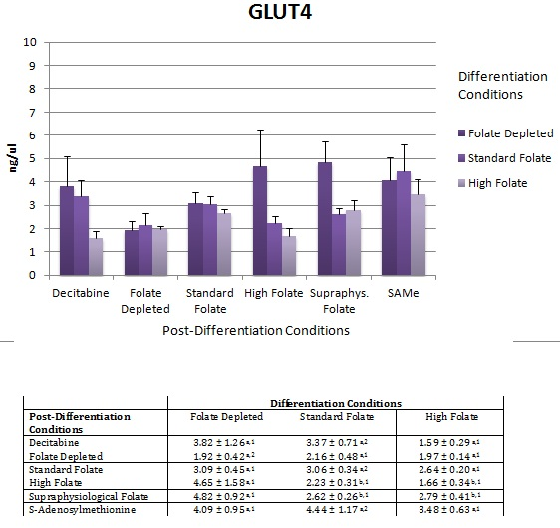
Figure 8 d. Glucose transporter 4 gene expression levels as measured by RT-PCR. The table below the graph contains the average with standard deviation. Statistical analysis by 2-way ANOVA (n=4). Non-matching letters indicate a significant difference in differentiation conditions and non- matching numerals indicated a significant difference in post-differentiation conditions.

Cells differentiated under folate depleted conditions had significantly lower levels of hormone sensitive lipase (lipe) when exposed to folate depleted conditions during the post-differentiation period (p<0.05). Cells differentiated under standard folate conditions had significantly lower levels of hormone sensitive lipase when exposed to high or supraphysiological levels of folate during the maturation period (p<0.05).
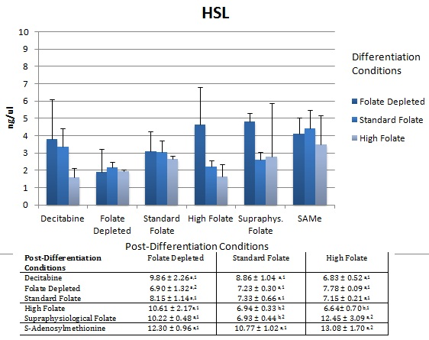
Figure 8 e. Hormone sensitive lipase gene expression levels as measured by RT-PCR. The table below the graph contains the average with standard deviation. Statistical analysis by 2-way ANOVA (n=4). Non-matching letters indicate a significant difference in differentiation conditions and non- matching numerals indicated a significant difference in post-differentiation conditions.

Leptin results showed high variability, but in general the level of folate given during differentiation did not significantly change the leptin levels. However cells exposed to folate depleted conditions post-differentiation tended to have lower levels of lep expression (p<0.05). Decitibine treatment after differentiation significantly increased lep levels particularly in those cells differentiated under folate depleted conditions (p<0.05) and in cells differentiated under standard folate conditions (p<0.05), but not in cells differentiated under high folate conditions.
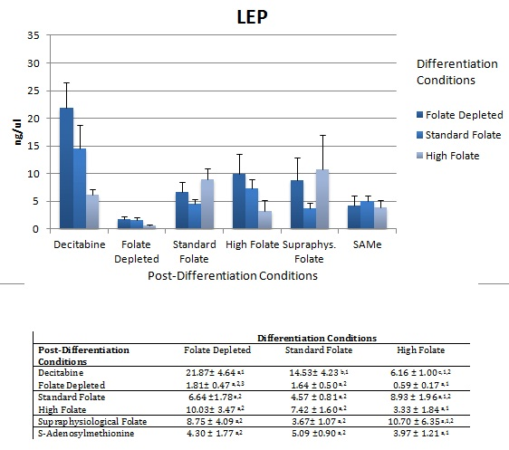
Figure 8 f. Leptin gene expression levels as measured by RT-PCR. The table below the graph contains the average with standard deviation. Statistical analysis by 2-way ANOVA (n=4). Non-matching letters indicate a significant difference in differentiation conditions and non- matching numerals indicated a significant difference in post-differentiation conditions.

Methylenetetrahydrofolate reductase levels were constant for cells differentiated under standard folate conditions regardless of post-differentiation treatment. Exposure to high folate during the differentiation period significantly increased Mthfr transcript levels for all cells given folate depleted, standard folate, or high folate media during maturation (p<0.05). Cells differentiated under folate depleted conditions given high or supraphysiological levels of folate during maturation had significantly higher levels of Mthfr (p<0.05). However, in cells exposed to folate depleted conditions during differentiation, exposure to either decitibine or SAMe during maturation did not significantly increase Mthfr levels. Cells exposed to high folate during differentiation had significantly higher levels of Mthfr when exposed to folate depleted conditions during maturation (p<0.05), while exposure to supraphysiological levels of folate during maturation, significantly decreased Mthfr in this differentiation group (p<0.05). 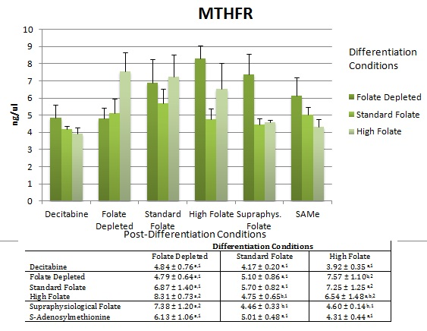
Figure 8 g. Mthfr gene expression levels as measured by RT-PCR. The table below the graph contains the average with standard deviation. Statistical analysis by 2-way ANOVA (n=4). Non-matching letters indicate a significant difference in differentiation conditions and non- matching numerals indicated a significant difference in post-differentiation conditions.
Peroxisome proliferation activated receptor γ (PPARγ) levels increased in the group differentiated under high folate conditions for all folate treatments during the maturation period relative to those differentiated under folate depleted or standard folate conditions except for decitibine and SAMe treatment where the PPARγ levels decreased. The level of PPARγ mirrored the level of proliferation in the cells. Conversely exposure to decitibine or SAMe significantly increased PPARγ in cells differentiated under folate depleted and standard folate conditions, but not in cells differentiated under high folate conditions (p<0.05). 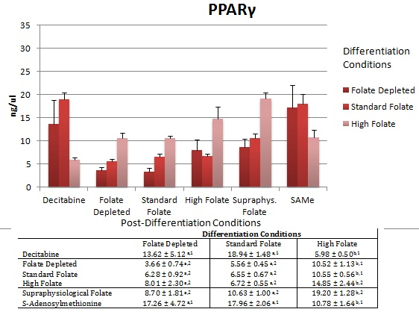
Figure 8 h. Pparγ gene expression levels as measured by RT-PCR. The table below the graph contains the average with standard deviation. Statistical analysis by 2-way ANOVA (n=4). Non-matching letters indicate a significant difference in differentiation conditions and non- matching numerals indicated a significant difference in post-differentiation conditions.

Pgc1α results were highly variable, but the mRNA levels significantly decreased in cells differentiated under folate depleted or standard folate conditions, exposed to folate depleted media during maturation (p<0.05). Restoring folate to high or supraphysiological levels during maturation caused increased Pgc1α expression in cells differentiated under folate depleted conditions (p<0.05). 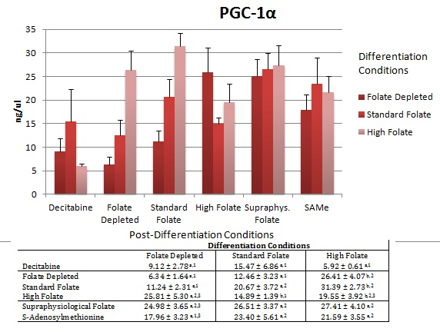
Figure 8 i. Pgc-1α gene expression levels as measured by RT-PCR. The table below the graph contains the average with standard deviation. Statistical analysis by 2-way ANOVA (n=4). Non-matching letters indicate a significant difference in differentiation conditions and non- matching numerals indicated a significant difference in post-differentiation conditions.

Discussion
We sought to determine how folate exposure during the differentiation and maturation process of adipocytes would affect adipocyte number and size as well as lipid storage and release. Exposing adipocytes to very low levels of folate prior to differentiation caused a reduction in cell numbers as measured by DNA while increasing folate during differentiation had the opposite effect. Conversely, exposing preadipocytes to high levels of folate prior to differentiation, followed by exposure to low levels of folate during maturation, caused hyperproliferation of cells. Yet, despite the reduction in cell number, the folate deficient adipocytes stored more triglycerides in each cell and became larger in size, while those exposed to high folate during differentiation and low folate during maturation stored less lipid per cell.
Lipolysis levels were closely linked to the triglyceride stores accumulated in the cells. Consequently, adipocytes exposed to folate depleted conditions during differentiation and maturation had the highest levels of triglycerides stored and highest amount of lipids released. Adipocytes given high levels of folate during differentiation and low levels of folate during maturation had smaller lipid stores and thus fewer lipids released.
Peroxisome proliferation activated receptor gamma (PPARγ) is a member of the nuclear receptor family and is activated by anti-diabetic drugs such as thiazolidinediones (TZDs). PPARγ can stimulate adipocyte differentiation and PPARγ heterozygous mice have been shown to have smaller adipocytes and less fat along with insulin resistance (79). Familial Partial Lipodystrophy (LPL) has been linked in humans to heterozygous mis-sense mutations in the PPARγ gene. LPL patients have variable levels of insulin resistance including diabetes, hypertension and hypertriglyceridemia (80). Our RT-PCR results showed less PPARγ gene expression in the adipocytes differentiated under low folate conditions and matured under low folate conditions, while increasing folate during the maturation period caused an increase in PPARγ. Exposure to high folate levels during differentiation greatly increased expression of PPARγ even in cells given low folate levels during the maturation period. Surprisingly, exposure to 5-aza-2-deoxycitidine after high folate differentiation greatly suppressed PPARγ expression.
Kang et al found the proximal CpG sites of long CpG islands in human adipocytes were consistently unmethylated. However, they also found transitional CpGs were differentially methylated in PPARγ (81). We utilized the microarray based MIRA assay to look at methylation in these transitional CpGs not associated with a CpG Island. In adipocytes exposed to standard folate conditions during differentiation, but matured under folate deplete conditions, standard folate, high folate or exposed to 5-aza-2 deoxycitidine, we found PPARγ gene expression was nearly similar for all maturation conditions except for the 5-aza-2 deoxycitidine treatment which increased PPARγ expression nearly 3 fold. In comparing the MIRA tracks, we can see that while the folate deplete, standard folate, high folate CpGs are mostly unmethylated, there are a few methylated CpGs, whereas for the 5-aza-2DC track no CpG sites were methylated (Figure 3 g).
Researchers at the Karolinska Institute recently demonstrated that no effect on lipolysis rate was observed when lipolysis was expressed per lipid weight of cell, but when lipolysis was expressed per number of fat cells, lipolysis was significantly higher in large adipocytes when compared to small adipocytes (69). They attributed this effect in part to increased protein expression of hormone-sensitive lipase, adipose triglyceride lipase and perilipin in the large adipocytes (82). They proposed that enhanced lipolytic capacity may link adipocyte hypertrophy to the risk of developing Type 2 diabetes. In our study, cells differentiated under folate depleted conditions were significantly fewer in number when matured under folate depleted conditions. Despite being fewer in number, these cells appeared to be larger in size (see Figure 2). They acquired greater triglyceride stores and had more lipids released during lipolysis. These cells had less fatty acid synthase, glucose transporter 4, hormone sensitive lipase, leptin, Mthfr, PPARg, and PGC1-α gene expression than cells differentiated under folate depleted conditions which received standard, high or supraphysiological folate during maturation. Folate receptor 1 and Dnmt1 were elevated in cells differentiated under folate depleted conditions. Folate depletion during differentiation was shown to globally reduce methylation in the promoter regions of these genes, but several methylation sites were maintained. The up-regulation of the folate receptor and Dnmt1 may be a compensatory mechanism for these cells to maintain methylation sites.
While the majority of lipids stored in adipocytes come from dietary intake, these cells can also utilize carbohydrates in de novo lipogenesis. Because of the high energy cost associated with de novo lipogenesis, it has been thought to be a minor component in energy balance equations. Fatty acid synthase is responsible for catalyzing the conversion of acetyl Co-A and Malonyl Co A to palmitate and has been used as a marker of de novo lipogenesis. In our system, FAS was up-regulated in adipocytes differentiated under folate depleted conditions then exposed to high folate conditions during maturation. Glut4 expression was similarly up-regulated under these conditions. Coupled with the triglyceride accumulation data this is evidence that de novo lipogenesis may play a major role in lipid accumulation in these cells. Adipocytes differentiated under high folate conditions exposed to high folate during maturation also had elevated FAS levels, but this was not concurrent with elevated Glut4 expression or increased triglyceride accumulation. Under these circumstances, de novo lipogenesis may not play a major role in lipid accretion.
It has been proposed that methylation sensitive transcription factors contribute to Glut4 gene regulation (17). It has been shown that the Glut4 promoter has two highly methylated CpG sites in preadipocytes which become demethylated in adipocytes. Three other CpG sites are demethylated in both the preadipocytes and adipocytes. In our system, under standard conditions, the fully mature adipocytes, had slight methylation at 2 CpG sites that was maintained when cells were matured under folate depleted or SAMe, but not 2-DC. However, the level of Glut 4 gene expression did not statistically change under any maturation exposures.
Spalding et al found leptin deficiency in obese persons despite them having increased adipocyte numbers (66). Leptin deficiency can increase appetite and lower energy expenditure. In our system, adipocytes matured under high folate conditions, then exposed to folate depleted conditions during maturation had leptin levels approximately 1/3 the amount seen in adipocytes differentiated under standard or folate depleted conditions despite having more cells numbers. The leptin gene is methylated in preadipocytes, but becomes hypomethylated during adipogenesis(83). We found under standard folate differentiation conditions slight hypomethylation in a few CpGs, but hypermethylation on the more proximal end. Exposure to folate depleted conditions during maturation, blunted this affect, while SAMe exposure increased methylation. Leptin expression did not seem to correlate with the amount of CpG methylation.
PPAR γ co-activator receptor 1-alpha (PGC-1α) is a master regulator of mitochondrial functions, glucose and fat oxidation and gluconeogenesis. Maternal pregestational BMI has been shown to be associated with the level of methylation in the promoter region of PGC-1α in newborns (84). Hypermethylation of PGC-1α promoter in non-CpG islands along with reduced mitochondrial content has been found in Type 2 diabetic patients (85). We found adipocytes differentiated and matured under folate depleted conditions had 69% less PGC-1α gene expression than did adipocytes differentiated under standard conditions. Exposure to high folate conditions during maturation rescued folate depleted differentiated adipocytes to normal levels of PGC-1α gene expression. This could indicate the potential for impaired mitochondrial function as well as faulty glucose and fat oxidation in folate depleted fat cells. Adipocytes differentiated and matured under standard conditions had a wide range of methylated and demethylated CpGs. Exposure to folate depleted conditions during maturation reduced both methylation and demethylation levels and could be responsible for limiting transcription factor binding to the promoter site as PGC-1α was reduced by a third in these cells.
Not surprisingly, the folate receptor 1 was up-regulated two-fold in the folate depleted conditions and five-fold up-regulated in the 5-aza-2DC treatments. Of some surprise was the up-regulation of the folate receptor 1 in the SAMe treatments in cells differentiated under folate depleted conditions, suggesting that despite supplementation during the maturation period with the end methyl donor, cells still sensed a need for folate. Folate one-carbon metabolism has been shown to localize into cytoplasmic and organelle spaces, but a mechanism for active transport into the nucleus has not been found. It has been suggested that all forms of folate may be taken up into the nucleus during cellular replication after dissolution and reformation of the nucleus (86). Mitochondrial carriers for SAMe have been found, but not specific membrane carriers (87). Since SAMe was added exogenously to the cells it might not have been transported into the nucleus preventing the methylation of DNA. . This would explain how the adipocytes differentiated under standard conditions, yet matured under SAMe would have decreased methylation as shown by the MIRA assay. Dnmt1 mRNA was up-regulated 2-fold in SAMe matured cells under the standard differentiation conditions this could be a compensatory mechanism. The level of MTHFR gene transcription did not significantly change for cells differentiated under standard folate conditions, but it did marginally increase for cells differentiated under folate depleted conditions then matured under high folate conditions.

Conclusions
Data from this study suggest the potential early developmental importance of obtaining sufficient folate levels for the prevention of obesity by highlighting the potential problems that may result from a disparity between folate levels during the differentiation period versus folate levels during the maturation period. Exposure to folate deficient environments during early adipocyte development appears to greatly reduce adipocyte numbers yet increase lipid accumulation. Increasing folate during the maturation period serves to increase the adipocyte numbers, but not the amount of lipid stored. Therefore, once differentiation has occurred, one cannot ameliorate the problem of low lipid storage caused by either inadequate fat cell numbers or lipid accretion in cells differentiated under folate depleted conditions. The marked increase in lipolysis per cell number under folate deficient conditions demonstrates that these cells can rapidly release their lipids and is likely a function of the expanded lipid stores in these cells however this could exacerbate the problem of lipid spillover into plasma in whole systems(88). Finally, markers of de novo lipogenesis seems to be stimulated in the adipocytes differentiated under folate depleted conditions when compared to those exposed to high folate during maturation. Adipocyte differentiated under high folate conditions and subsequently matured under folate depleted conditions had drastically reduced levels of leptin gene expression which, if translated into protein levels, could be responsible for dysregulation of appetites in whole systems. Although the majority of adipogenesis occurs during early development, an estimated 10% of adipocytes die and are replaced each year from a pre-adipocyte pool (66), thus providing an opportunity to impact metabolism through providing optimal folate levels during differentiation and maturation throughout life.
The MIRA assay allowed us to look at global methylation events without the biases occurred from bis-sulfate conversion, PCR amplification and sequencing. We were able to detect increases in global hypomethylation under folate limiting conditions in cells that were differentiated under standard folate conditions indicating that de novo methylation events occur in cells post-differentiation. However, we were not able to assess the folate depleted differentiation treatments versus the high folate differentiation treatments using the MIRA assay. The addition of the master methyl donor s-adenosylmethionine surprisingly did not increase DNA methylation perhaps in part to the inability of the SAMe to be transported into the nucleus. Another limitation of the study is we measured markers of de novo lipogenesis but did not directly measure lipogenesis. However, to our knowledge, this is the first in-vitro study to look at the effects of limiting folate during differentiation and maturation of adipocytes.
It is clear that exposure to folate deficiency during differentiation of adipocytes has lasting ramifications on total number of fat cells and the size of fat cells. These cells become programmed to store more triglyceride per cell than fat cells differentiated under standard or high folate conditions. If one considers a whole body system composed of fat cells with this phenotype exposed to a high fat diet, the system would have limited capacity to store excess lipid. Furthermore, these cells exhibit an increased lipolytic capacity, meaning they rapidly release stored lipid. This could lead to dsylepidemia. Exposing cells differentiated under low folate to high folate during maturation, increased the cell numbers, but not the size. The result would be more storage capacity for a whole system. Conversely, adipocytes differentiated under high folate conditions, then matured under low folate conditions exhibited increased lipolysis perhaps by increased gene expression of hormone sensitive lipase and signs of de novo lipogenesis. These cells also had increased leptin expression despite having fewer cell numbers in culture. In light of this research, future studies on obesity, dyslipidemia and T2D would do well to incorporate folate status and epigenetic information into the characterization of patients.

Chapter 4 Conclusions
Studies on adipocyte metabolism in vitro have been based on standard folate concentrations during differentiation from pre-adipocytes to mature adipocytes. In whole body systems, folate concentrations are often lacking or suboptimal during differentiation and maturation. Alternatively, excessive folate may be encountered during initial development of the fat cell. The level of folate obtained during the maturation phase of the fat cell may be very high, merely adequate or lacking. This research was designed to study the effect of varying folate levels on the adipocyte metabolism. By altering the levels of folate given during the differentiation period and the maturation period, we found that the amount given to the cell during the differentiation period was more significant than that given during the maturation period. That is to say the amount of folate “sensed” during differentiation played a greater role in determining the adipocyte phenotype than did the amount of folate “sensed” during the maturation period. By comparing four conditions relevant to the standard condition, we can find trends, as shown in Table 2, that may relate to adipocyte cell types we see in vitro.

Table2 Adipocyte response relative to adipocytes differentiated and matured under standard folate conditions.

 |  | Maturation Conditions
 |  | Low Folate | High Folate
Differentiation Conditions | Low Folate | Fewer Cell numbers | Greater Cell Numbers
Differentiation Conditions | Low Folate | Decreased PPARγ gene expression | (hyperplasia without hypertrophy)
Differentiation Conditions | Low Folate | Greatly Decreased Pgc1α gene expression | 2x more PPARγ gene expression
Differentiation Conditions | Low Folate | Decreased Glut4 gene expression | More Triglyceride Stored per cell
Differentiation Conditions | Low Folate | Decreased Fasn gene expression | Increased Fasn gene expression
Differentiation Conditions | Low Folate | 2x more lipolysis per cell | Less Lipolysis per cell
Differentiation Conditions | Low Folate | Increased Folr1 gene expression | Increased Folr1 gene expression
Differentiation Conditions | High Folate | Fewer Cell numbers | No change in Cell Numbers
Differentiation Conditions | High Folate | 2x more Lep gene expression | (Hypertropy without hyperplasia)
Differentiation Conditions | High Folate | Increased Fasn gene expression | 2x more PPARγ gene expression
Differentiation Conditions | High Folate | 2x more lipolysis per cell | Less Lipolysis per cell
Differentiation Conditions | High Folate | Increased Lipe gene expression | Decrease in Glut4 gene expression
Differentiation Conditions | High Folate | Increase Mthfr gene expression

First let us look at the comparison between adipocytes differentiated and matured under low folate conditions versus those grown under standard conditions. First the low folate condition produces far less fat cells than does the standard media conditions and the cells are smaller in size. This is not surprising considering folate is necessary for manufacturing DNA building blocks. We see a down regulation of many genes including PPARγ, PGC-1a, Glut4 and Fasn. The decrease seen in the adipogenesis marker PPARγ further supports the reduction in cell number. A very large decrease in Pgc1-α predicts that these cells may have less capacity to generate mitochondria. Down regulation of two markers of de novo lipogenesis, Fasn and Glut4 may indicate that this mode of triglyceride production is limited. A visual inspection of the cells by Oil Red O staining reveals that although there are fewer cells present, each is packed full of lipid. Because each cell has acquired a massive store of triglyceride, there is a 2 fold increase in the amount of lipid released during unstimulated lipolysis. We see an up-regulation of Folr1, which indicates these cells are trying to scavenge any folate possible. Low folate during differentiation and maturation would create a situation of few, small fat cells that scavenge any triglyceride available, but would also readily release these energy stores when needed. When this fat cell type encounters a high fat diet, the fat cells would take up as much fat as possible, but due to their limited numbers, the system would not have much capacity for storage. If the high fat diet was continued the system would be forced to find alternative places for fat storage, such as muscle and other organs creating a dyslipidemic situation.
Next, we will consider adipocytes differentiated under low folate conditions, then matured under high folate conditions. Increasing folate during the maturation level yields a higher number of cells, but they are still smaller in size than those grown under standard conditions, a situation of hyperplasia without hypertrophy. These cells had a 2 fold increase in expression of PPARγ, which concurs with the increased cell numbers. The cells also had an increase in Fasn gene expression relative to standard conditions and they stored more triglyceride on a per cell basis. However, these fat cells had less un-stimulated lipolysis than did the cells grown under standard condition despite having more numbers and more triglyceride stored. These cells had increased expression of the Folr1 indicating a continued drive by these cells to sequester folate. If we challenged these cells with a high fat diet, how would they handle it? We propose that given the greater cell numbers, these cells would be better equipped to store excess lipid than cells differentiated and matured under folate depleted conditions. However, their ability to release triglycerides for energy when needed is reduced as compared to cells grown under standard conditions.
Adipocytes differentiated under high folate conditions, then matured under low folate had fewer cell numbers than adipocytes grown under standard conditions. These cells had a 2 fold increase in lipolysis on a per cell basis. Unlike cells differentiated and matured under total folate depleted conditions, cells differentiated under high folate conditions had increased Fasn gene expression. They also had an increase in hormone sensitive lipase gene expression which may play a role in the increase in lipolysis. These cells had an increase in Mthfr which may be a compensatory mechanism for the low folate situation seen during maturation in cells programmed under high folate conditions. Surprisingly, these cells had a two fold increase in leptin gene expression, despite having fewer cell numbers than standard growth conditions. This could indicate a situation where the adipocytes are signaling to the whole body that the environment is high in nutrients, despite being low in nutrients.
Finally, we will consider adipocytes differentiated and matured under high folate conditions. There was no statistically significant change in cell numbers under this condition; however, the cells were visually larger than cells grown under standard conditions (data not shown). This indicates a situation of hypertrophy without hyperplasia. These cells had a 2 fold increase in PPARγ gene expression relative to the standard growth conditions. Despite being larger in size these cells did not have more triglyceride stores. We harvested and tested the cells after 7 days to acquire data during a non-static period. When visualizing these cells with Oil Red O lipid stain, one could see the lipid partitioning to the outer edges of the cells, leaving a void in the center presumable that could be filled if given enough time. These cells also had down regulation of the Glut4 gene relative to the standard conditions. If challenged by a high fat diet, how would these cells react? We propose they would have sufficient cellular volume to handle the excess lipid stores.
The amount of folate available to adipocytes directly affects the ability of these cells to maintain DNA methylation. While folate exposure during initial stages of differentiation has sustained effects on transcription of genes involved in lipogenesis, lipolysis and metabolism, folate concentration seen by the cell during later stages also affect rates. In total, the differences in folate concentration experienced between the two stages ultimately determines the size, lipid content and rate of lipid release. Normally, experiments in adipocytes are carried out in cells exposed to standard folate conditions both during the initial and later stages of differentiation. The literature base contains papers largely written under these conditions. Some genes such as hormone sensitive lipase and fatty acid synthase are not highly expressed under these conditions in adipocytes. But in cells exposed to low folate during the initial stages of differentiation, these two genes are highly up-regulated. Furthermore, the gene expression level of HSL increased as the amount of folate increased during the maturation process. HSL is known to be stimulated by catecholamines perhaps through a cAMP dependent protein kinase (89). Oral folic acid supplementation was shown to increase the effects induced by beta adrenergic receptor activation in diabetic/obese mice(61). Although the authors of the study did not investigate the mechanism by which folic acid sensitized the cAMP-PKA dependent pathway, they hypothesize that folic acid supplementation may prevent PKA inactivation or enhance the phosphorylation of hormone sensitive lipase by PKA. Our results suggest that folic acid supplementation may directly affect the expression of the hormone sensitive lipase gene by modulating the methylation pattern of the CpGs and affect transcription factor binding.
Development from a single egg into hundreds of different cell types is initiated by global demethylation followed by methylation. DNA methyltransferases faithfully transcribe methylation marks onto daughter cells. Cellular differentiation of stem cells involves not only DNA demethylation, but also methylation of multiple genome wide loci. This process is not restricted to early embryo development, but also occurs in differentiation of somatic tissues. Not all DNA methylation changes which occur during differentiation are epigenetically inherited. DNA methylation during differentiation may temporally regulate gene transcription during the differentiation process. For example, the promoter regions of Lep and Glut4 are methylated during early adipocyte differentiation, but become hypomethylated during later stages of differentiation(83),(17). Even the upstream region of Dnmt1 is differentially methylated during the specific developmental stages (90). Differentiation of 3T3L1s adipocytes is associated with genome-wide epigenetic changes, and the status of methylation and demethylation is maintained or changed depending on the stage of differentiation and genomic loci (70). DNA methylation changes are not only unidirectional methylation/demethylation events, but also transient, indicating that the epigenetic change is dynamic rather than static.
Our research shows that the DNA methylation marks are not only an indication of origin, but also a product of nutritional status during the time of differentiation and as well as maturation of the cell. Furthermore, folate availability modulates DNA methylation marks via the one carbon cycle and SAMe production. Having sufficient folate levels during adipocyte differentiation is critical to the development of sufficient numbers of adipocytes capable of properly storing and releasing triglycerides and for proper hormonal signaling. Future studies of obesity should include monitoring epigenetics of adipocytes to better define their phenotype and metabolic capacity in light of gene regulation.

List of References

1. A. Bell, A. Walley, P. Froguel, Nature Review Genetics 6, 221 (2005).
2. The Surgeon General's call to action to prevent and decrease overweight and obesity. Office of the S. General, Ed., (U.S. Dept. of Health and Human Services, Public Health Service, Washington, DC, 2001).
3. M. Power, J. Schulkin, in The Evolution of Obesity (The Johns Hopkins University Press, Baltimore, 2009), pp. 292-317.
4. H. Tilg, A. R. Moschen, Nat Rev Immunol 6, 772 (Oct, 2006).
5. P. D. Gluckman et al., Proceedings of the National Academy of Sciences of the United States of America 104, 12796 (Jul, 2007).
6. P. D. Gluckman, M. A. Hanson, T. Buklijas, F. M. Low, A. S. Beedle, Nature Reviews 5, 401 (2009).
7. K. L. K. Tamashiro, T. H. Moran, Physiology & Behavior 100, 560 (2010).
8. D. C. Dolinoy, J. R. Weidman, R. A. Waterland, R. L. Jirtle, Environmental Health Perspectives 114, 567 (Apr, 2006).
9. R. L. Jirtle, M. K. Skinner, Nat Rev Genet 8, 253 (Apr, 2007).
10. D. C. Dolinoy, R. Das, J. R. Weidman, R. L. Jirtle, Pediatr Res 61, 30R (May, 2007).
11. K. M. Aagaard-Tillery et al., J Mol Endocrinol 41, 91 (2008).
12. C. Campoy et al., Nutr. Hosp. 23, 584 (Nov-Dec, 2008).
13. J. Cox, S. Williams, K. Grove, R. H. Lane, K. M. Aagaard-Tillery, American Journal of Obstetrics and Gynecology 201, 281.e1 (2009).
14. G. C. Burdge et al., J Nutr 139, 1054 (Jun, 2009).
15. J. G. Kral et al., Pediatrics 118, e1644 (Dec, 2006).
16. J. Smith et al., J Clin Endocrinol Metab 94, 4275 (Nov, 2009).
17. N. Yokomori, M. Tawata, T. Onaya, Diabetes 48, 685 (1999).
18. A. Noer, A. Boquest, P. Collas, BMC Cell Biology 8, 18 (2007).
19. T. Gerken et al., Science 318, 1469 (2007).
20. A. E. Beaudin, P. J. Stover, Birth Defects Research Part C: Embryo Today: Reviews 81, 183 (2007).
21. C. D. Davis, E. O. Uthus, Exp. Biol. Med. 229, 988 (2004).
22. C. Junien, P. Nathanielsz, Obesity Reviews 8, 487 (Nov, 2007).
23. C. L. Ogden, K. M. Flegal, M. D. Carroll, C. L. Johnson, JAMA 288, 1728 (Oct 9, 2002).
24. K. M. Flegal, M. D. Carroll, C. L. Ogden, L. R. Curtin, JAMA 303, 235 (Jan 20, 2010).
25. K. M. Flegal, M. D. Carroll, C. L. Ogden, C. L. Johnson, JAMA 288, 1723 (Oct 9, 2002).
26. K. M. Flegal, C. L. Ogden, M. D. Carroll, Nutr Rev 62, S144 (Jul, 2004).
27. A. A. Hedley et al., JAMA 291, 2847 (Jun 16, 2004).
28. C. L. Ogden, M. D. Carroll, L. R. Curtin, M. M. Lamb, K. M. Flegal, JAMA 303, 242 (Jan 20, 2010).
29. C. L. Ogden et al., JAMA 295, 1549 (Apr 5, 2006).
30. M. J. Tate, S. Patrick, J Am Diet Assoc 100, 300 (Mar, 2000).
31. “Healthy People 2020” (U.S. Department of Health and Human Services, Washington, D.C., 2011).
32. S. R. Karasu, T. B. Karasu, The gravity of weight : a clinical guide to weight loss and maintenance. (American Psychiatric Pub., Washington, DC, ed. 1st, 2010), pp. xxvi, 492 p.
33. C. F. Baer, M. M. Miyamoto, D. R. Denver, Nat Rev Genet 8, 619 (Aug, 2007).
34. C. F. Baer, PLoS Biol 6, e52 (Feb, 2008).
35. R. Holliday, Epigenetics 1, 76 (Apr-Jun, 2006).
36. R. Holliday, J Genet 81, 1 (Apr, 2002).
37. C. Junien, C. Gallou-Kabani, A. Vige, M. S. Gross. (2005), pp. S19-S28.
38. C. Junien, C. Gallou-Kabani, A. Vige, M. S. Gross, M S-Medecine Sciences 21, 396 (Apr, 2005).
39. J. C. Mathers, Forum Nutr 60, 42 (2007).
40. R. A. Waterland, Nutrition Reviews 66, S21 (2008).
41. M. M. Musri, R. Gomis, M. Parrizas, Biochem Cell Biol 85, 397 (Aug, 2007).
42. P. A. Jones, G. Liang, Nat Rev Genet 10, 805 (2009).
43. F. Fuks, W. A. Burgers, A. Brehm, L. Hughes-Davies, T. Kouzarides, Nat Genet 24, 88 (Jan, 2000).
44. H. J. Blom, G. M. Shaw, M. den Heijer, R. H. Finnell, Nat Rev Neurosci 7, 724 (Sep, 2006).
45. P. M. Ueland, R. Rozen, MTHFR polymorphisms and disease. Medical intelligence unit (Landes Bioscience : Eurekah.com, Georgetown, Tex., 2005), pp. 210 p.
46. N. M. J. Van der Put, H. W. M. Van Straaten, F. J. M. Trijbels, H. J. Blom, Exp. Biol. Med. 226, 243 (2001).
47. A. S. Doherty, M. R. Mann, K. D. Tremblay, M. S. Bartolomei, R. M. Schultz, Biol Reprod 62, 1526 (Jun, 2000).
48. G. F. Cox et al., Am J Hum Genet 71, 162 (Jul, 2002).
49. M. R. DeBaun, E. L. Niemitz, A. P. Feinberg, Am J Hum Genet 72, 156 (Jan, 2003).
50. I. M. Morison, D. M. Becroft, T. Taniguchi, C. G. Woods, A. E. Reeve, Nat Med 2, 311 (1996).
51. P. P. Luedi et al., Genome Research 17, 1723 (2007).
52. K. A. Lillycrop, E. S. Phillips, A. A. Jackson, M. A. Hanson, G. C. Burdge, J Nutr 135, 1382 (Jun, 2005).
53. K. A. Lillycrop et al., Br J Nutr 103, 1711 (Jun, 2010).
54. K. A. Lillycrop, Proc Nutr Soc 70, 64 (Feb, 2011).
55. T. J. Roseboom et al., Molecular and Cellular Endocrinology 185, 93 (2001).
56. K. M. Godfrey et al., Diabetes 60, 1528 (May, 2011).
57. D. J. P. Barker, Journal of Internal Medicine 261, 412 (2007).
58. O. Garcia, K. Long, J. Rosado, Nutrition Reviews 67, 559 (2009).
59. Y. S. Han, E. H. Ha, H. S. Park, Y. J. Kim, S. S. Lee, Int J Obes 35, 570 (2011).
60. M. Dietrich, C. J. Brown, G. Block, J Am Coll Nutr 24, 266 (Aug, 2005).
61. T. Y. Lam et al., Exp. Biol. Med. 234, 1047 (2009).
62. P. Tounian, Annals of Nutrition Metabolism 58, (2011).
63. M. E. F. Vázquez-Vela, N. Torres, A. R. Tovar, Archives of Medical Research 39, 715 (2008).
64. M. a. J. S. Power, in The Evolution of Obesity, M. L. P. a. J. Shulkin, Ed. (The Johns Hopkins University Press, Baltimore, 2009), pp. 244-265.
65. F. Giorgino, American Journal of Physiology - Endocrinology And Metabolism 297, E975 (November 1, 2009, 2009).
66. K. e. a. Spalding, Nature Letters 453, 783 (2008).
67. F. M. Gregoire, C. M. Smas, H. S. Sul, Physiol Rev 78, 783 (Jul, 1998).
68. J. K. Sethi, A. J. Vidal-Puig, J Lipid Res 48, 1253 (Jun, 2007).
69. S. Gesta, Y.-H. Tseng, C. R. Kahn, Cell 131, 242 (2007).
70. H. Sakamoto et al., Biochem Biophys Res Commun 366, 360 (Feb 8, 2008).
71. P. Arner et al., Nature 478, 110 (2011).
72. D. A. Roncari, H. Wang, K. S. Desai, Can J Biochem 58, 201 (Mar, 1980).
73. I. Dahlman, P. Arner, Prog Mol Biol Transl Sci 94, 39 (2010).
74. P. D. Gluckman, M. A. Hanson, International Journal of Obesity 32, S62 (Dec, 2008).
75. S. H. Zeisel, Am J Clin Nutr 89, 673S (2009).
76. T. Rauch, H. Y. Li, X. Wu, G. P. Pfeifer, Cancer Research 66, 7939 (2006).
77. L. H. Boobis, R. J. Maughan, Clinica Chimica Acta 132, 173 (1983).
78. S. Joseph, J. Sambrook, Molecular cloning : a laboratory manual. E. F. Fritsch, T. Maniatis, Eds., (Cold Spring Harbor, N.Y. : Cold Spring Harbor Laboratory, Cold Spring Harbor, N.Y., 1987).
79. M. Takahashi, Y. Kamei, O. Ezaki, Am J Physiol Endocrinol Metab 288, E117 (Jan, 2005).
80. A. K. Agarwal, A. Garg, Annu Rev Genomics Hum Genet 7, 175 (2006).
81. M.-I. Kang et al., Journal of Cellular Biochemistry 102, 224 (2007).
82. J. Laurencikiene et al., Journal of Clinical Endocrinology and Metabolism 96, (2011).
83. N. Yokomori, M. Tawata, T. Onaya, Diabetologia 45, 140 (2002).
84. C. Gemma et al., Obesity 17, 1032 (2009).
85. R. Barrès et al., Cell Metabolism 10, 189 (2009).
86. P. J. Stover, M. S. Field, Advances in Nutrition 4, 325 (2011).
87. A. D. Acro, S. Satrustegui, Cellular Molecular Life Science 62, 2204 (2005).
88. R. H. Unger, Trends Endocrinol Metab 14, 398 (Nov, 2003).
89. M. Fortier et al., Am J Physiol Endocrinol Metab 287, E282 (Aug, 2004).
90. A. Slack, N. Cervoni, M. Pinard, M. Szyf, Eur J Biochem 264, 191 (Aug, 1999).

Appendix

Table 3 DNA, triglyceride and lipolysis estimates, mean ± standard deviation (n=4 per group)
 | Differentiation Conditions
 | Folate Depleted | Standard Folate | High Folate
Post-Differentiation Treatment | DNA (mM)
Decitabine | 4.10 ± 0.70 ^{a,1} | 5.96 ± 0.37 ^{b,1} | 6.05 ± 0.23 ^{b,1}
Folate Depleted | 4.89 ± 0.68 ^{a,1} | 7.88 ± 1.15 ^{b,1} | 8.25 ± 0.65 ^{b,2}
Standard Folate | 4.76 ± 0.41 ^{a,1} | 6.22 ± 0.25 ^{b,1} | 6.78 ± 0.66 ^{b,1}
High Folate | 4.78 ± 0.48 ^{a,1} | 5.68 ± 0.83 ^{a,1} | 5.63 ± 0.79 ^{a,1}
Supraphysiological Folate | 6.31 ± 1.15 ^{a,1} | 6.46 ± 0.77 ^{a,1} | 6.72 ± 0.66 ^{a,1}
S-adenosylmethionine | 6.23 ± 0.55 ^{a,2} | 6.73 ± 0.21 ^{a,1} | 7.37 ± 1.40 ^{a,2}
 | Triglyceride (ORO Density/mM DNA)
Decitabine | 0.32 ± 0.08 ^{a,1} | 0.19 ± 0.03 ^{b,1} | 0.18 ± 0.01 ^{b,1}
Folate Depleted | 0.20 ± 0.04 ^{a,2} | 0.14 ± 0.03 ^{b,2} | 0.12 ± 0.02 ^{b,2}
Standard Folate | 0.20 ± 0.03 ^{a,2} | 0.17 ± 0.01 ^{a,1} | 0.16 ± 0.02 ^{a,1}
High Folate | 0.21 ± 0.03 ^{a,2} | 0.18 ± 0.03 ^{a,1} | 0.20 ± 0.05 ^{a,1}
Supraphysiological Folate | 0.15 ± 0.03 ^{a,2} | 0.16 ± 0.01 ^{a,1} | 0.17 ± 0.03 ^{a,1}
S-adenosylmethionine | 0.18 ± 0.01 ^{a,2} | 0.17 ± 0.02 ^{a,1} | 0.16 ± 0.05 ^{a,1}
 | Lipolysis (mM glycerol/mM DNA)
Decitabine | 0.064 ± 0.002 ^{a,1} | 0.035 ± 0.003 ^{b,1} | 0.029 ± 0.003 ^{b,1}
Folate Depleted | 0.056 ± 0.011 ^{a,1} | 0.023 ± 0.004 ^{b,2} | 0.013 ± 0.002 ^{c,2}
Standard Folate | 0.032 ± 0.008 ^{a,2} | 0.017 ± 0.003 ^{b,2} | 0.009 ± 0.001 ^{c,2}
High Folate | 0.043 ± 0.007 ^{a,2} | 0.020 ± 0.004 ^{b,2} | 0.010 ± 0.002 ^{c,2}
Supraphysiological Folate | 0.034 ± 0.005 ^{a,2} | 0.017 ± 0.002 ^{b,2} | 0.015 ± 0.002 ^{b,2}
S-adenosylmethionine | 0.060 ± 0.009 ^{a,1} | 0.033 ± 0.002 ^{b,1} | 0.025 ± 0.005 ^{c,1}

1. Non-matching letter superscripts in each row denote significant difference (p<0.05)
2. Non-matching numerical superscripts in each column denote significant difference (p<0.05)

 | Differentiation Conditions
 | Folate Depleted | Standard Folate | High Folate
Post-Differentiation Conditions
 | DNA methyltransferase 1
Decitabine | 12.08 ± 2.25^{a,1} | 13.98 ±0.63 ^{a,1} | 14.46 ± 0.28 ^{a,1}
Folate Depleted | 11.47± 1.83 ^{a,1} | 9.97 ± 1.24 ^{a,1,2} | 14.56 ± 1.63 ^{a,1}
Standard Folate | 8.13 ± 0.99 ^{a,1} | 9.37 ± 1.21 ^{a,2} | 11.04 ± 0.45 ^{a,1,2}
High Folate | 16.85 ± 3.36 ^{a.2} | 7.99 ± 0.50 ^{b,2} | 11.03 ± 0.54 ^{b,1,2}
Supraphysiological Folate | 14.75 ± 1.23 ^{a,1,2} | 11.69 ± 0.31 ^{a,b,1} | 10.43 ± 1.06 ^{b,1,2}
S-Adenosylmethionine | 25.18 ± 3.34 ^{a,3} | 19.35 ± 0.94 ^{b,3} | 16.40 ± 1.13 ^{b,1}
 | Fatty acid synthase
Decitabine | 5.89 ± 1.18 ^{a,1} | 3.68 ± 0.49 ^{b,1} | 1.77 ± 0.09 ^{c,1}
Folate Depleted | 1.23 ± 0.17 ^{a,2} | 0.93 ± 0.04 ^{a,2} | 4.03 ± 0.57 ^{b,2}
Standard Folate | 1.94 ± 0.26 ^{a,2} | 1.80 ± 0.1 ^{a,2} | 3.67 ± 0.72 ^{b,2}
High Folate | 4.76 ± 1.09 ^{a,1} | 2.39 ± 0.12 ^{a,1} | 3.37 ± 0.58 ^{a,2}
Supraphysiological Folate | 5.53 ± 0.59 ^{a,1} | 2.94 ± 0.12 ^{b,1} | 3.51 ± 0.44 ^{b,2}
S-Adenosylmethionine | 5.52 ± 0.54 ^{a,1} | 4.02 ± 0.38 ^{a,b,1} | 3.03 ± 0.33 ^{b,1}
 | Folate receptor 1
Decitabine | 24.24± 2.45 ^{a,1} | 25.59 ± 6.26 ^{a,1} | 26.48 ± 2.99 ^{a,1}
Folate Depleted | 8.95 ± 1.31 ^{a,2,3} | 7.48 ± 0.83 ^{a,2} | 9.44 ±0.75 ^{a,2}
Standard Folate | 4.10 ± 1.19 ^{a,3} | 5.02 ±0.74 ^{a,2} | 5.22 ± 0.35 ^{a,2}
High Folate | 6.8 ± 1.54 ^{a,2,3} | 4.16 ± 0.64 ^{a,2} | 4.58 ± 0.30 ^{a,2}
Supraphysiological Folate | 4.46 ± 0.62 ^{a,2,3} | 4.46 ± 0.12 ^{a,2} | 4.63 ± 0.08 ^{a,2}
S-Adenosylmethionine | 9.57 ± 1.00 ^{a,2} | 8.68 ± 1.11 ^{a,2} | 9.08 ± 0.71 ^{a,2}
 | Glucose transporter, member 4
Decitabine | 3.82 ± 1.26 ^{a,1} | 3.37 ± 0.71 ^{a,2} | 1.59 ± 0.29 ^{a,1}
Folate Depleted | 1.92 ± 0.42 ^{a,2} | 2.16 ± 0.48 ^{a,1} | 1.97 ± 0.14 ^{a,1}
Standard Folate | 3.09 ± 0.45 ^{a,1} | 3.06 ± 0.34 ^{a,2} | 2.64 ± 0.20 ^{a,1}
High Folate | 4.65 ± 1.58 ^{a,1} | 2.23 ± 0.31 ^{b,1} | 1.66 ± 0.34 ^{b,1}
Supraphysiological Folate | 4.82 ± 0.92 ^{a,1} | 2.62 ± 0.26 ^{b,1} | 2.79 ± 0.41 ^{b,1}
S-Adenosylmethionine | 4.09 ± 0.95 ^{a,1} | 4.44 ± 1.17 ^{a,2} | 3.48 ± 0.63 ^{a,1}
 | Hormone sensitive lipase
Decitabine | 9.86 ± 2.26 ^{a,1} | 8.86 ± 1.04 ^{a,1} | 6.83 ± 0.52 ^{a,1}
Folate Depleted | 6.90 ± 1.32 ^{a,2} | 7.23 ± 0.30 ^{a,1} | 7.78 ± 0.09 ^{a,1}
Standard Folate | 8.15 ± 1.14 ^{a,1} | 7.33 ± 0.66 ^{a,1} | 7.15 ± 0.21 ^{a,1}
High Folate | 10.61 ± 2.17^{a,1} | 6.94 ± 0.33 ^{b,2} | 6.64± 0.70 ^{b,1}
Supraphysiological Folate | 10.22 ± 0.48 ^{a,1} | 6.93 ± 0.44 ^{b,2} | 12.45 ± 3.09 ^{a,2}
S-Adenosylmethionine | 12.30 ± 0.96 ^{a,1} | 10.77 ± 1.02 ^{a,1} | 13.08 ± 1.70 ^{a,2}

Table 4 RT-PCR Results
1. Non-matching letter superscripts in each row denote significant difference (p<0.05)
2. Non-matching numerical superscripts in each column denote significant difference (p<0.05)

 | Differentiation Conditions
 | Folate Depleted | Standard Folate | High Folate
Post-Differentiation Conditions
 | Leptin
Decitabine | 21.87± 4.64 ^{a,1} | 21.87± 4.64 ^{a,1} | 21.87± 4.64 ^{a,1}
Folate Depleted | 1.81± 0.47 ^{a,2,3} | 1.81± 0.47 ^{a,2,3} | 1.81± 0.47 ^{a,2,3}
Standard Folate | 6.64 ±1.78 ^{a,2} | 6.64 ±1.78 ^{a,2} | 6.64 ±1.78 ^{a,2}
High Folate | 10.03± 3.47 ^{a,2} | 10.03± 3.47 ^{a,2} | 10.03± 3.47 ^{a,2}
Supraphysiological Folate | 8.75 ± 4.09 ^{a,2} | 8.75 ± 4.09 ^{a,2} | 8.75 ± 4.09 ^{a,2}
S-Adenosylmethionine | 4.30 ± 1.77 ^{a,2} | 4.30 ± 1.77 ^{a,2} | 4.30 ± 1.77 ^{a,2}
 | Methylenetetrahydrofolate reductase
Decitabine | 4.84 ± 0.76 ^{a,1} | 4.84 ± 0.76 ^{a,1} | 4.84 ± 0.76 ^{a,1}
Folate Depleted | 4.79 ± 0.64 ^{a,1} | 4.79 ± 0.64 ^{a,1} | 4.79 ± 0.64 ^{a,1}
Standard Folate | 6.87 ± 1.40 ^{a,1} | 6.87 ± 1.40 ^{a,1} | 6.87 ± 1.40 ^{a,1}
High Folate | 8.31 ± 0.73 ^{a,2} | 8.31 ± 0.73 ^{a,2} | 8.31 ± 0.73 ^{a,2}
Supraphysiological Folate | 7.38 ± 1.20 ^{a,2} | 7.38 ± 1.20 ^{a,2} | 7.38 ± 1.20 ^{a,2}
S-Adenosylmethionine | 6.13 ± 1.06 ^{a,1} | 6.13 ± 1.06 ^{a,1} | 6.13 ± 1.06 ^{a,1}
 | Peroxisome proliferation activated receptor γ
Decitabine | 13.62 ± 5.12 ^{a,1} | 13.62 ± 5.12 ^{a,1} | 13.62 ± 5.12 ^{a,1}
Folate Depleted | 3.66 ± 0.74 ^{a,2} | 3.66 ± 0.74 ^{a,2} | 3.66 ± 0.74 ^{a,2}
Standard Folate | 6.28 ± 0.92 ^{a,2} | 6.28 ± 0.92 ^{a,2} | 6.28 ± 0.92 ^{a,2}
High Folate | 8.01 ± 2.30 ^{a,2} | 8.01 ± 2.30 ^{a,2} | 8.01 ± 2.30 ^{a,2}
Supraphysiological Folate | 8.70 ± 1.81 ^{a,2} | 8.70 ± 1.81 ^{a,2} | 8.70 ± 1.81 ^{a,2}
S-Adenosylmethionine | 17.26 ± 4.72 ^{a,1} | 17.26 ± 4.72 ^{a,1} | 17.26 ± 4.72 ^{a,1}
 | Pparγ co-activator receptor
Decitabine | 9.12 ± 2.78 ^{a,1} | 9.12 ± 2.78 ^{a,1} | 9.12 ± 2.78 ^{a,1}
Folate Depleted | 6.34 ± 1.64 ^{a,1} | 6.34 ± 1.64 ^{a,1} | 6.34 ± 1.64 ^{a,1}
Standard Folate | 11.24 ± 2.31 ^{a,1} | 11.24 ± 2.31 ^{a,1} | 11.24 ± 2.31 ^{a,1}
High Folate | 25.81 ± 5.30 ^{a,2,3} | 25.81 ± 5.30 ^{a,2,3} | 25.81 ± 5.30 ^{a,2,3}
Supraphysiological Folate | 24.98 ± 3.65 ^{a,2,3} | 24.98 ± 3.65 ^{a,2,3} | 24.98 ± 3.65 ^{a,2,3}
S-Adenosylmethionine | 17.96 ± 3.23 ^{a,1,3} | 23.40 ± 5.61 ^{a,2} | 21.59 ± 3.55 ^{a,2}
Table 4 RT-PCR Results Continued

Vita
Julia graduated from the University of TN in 1991 with dual Bachelor of Science degrees in Microbiology. She began working for the Distinguished Scientist, Dr. David C. White at the Institute for Applied Microbiology (IAM) performing microbial community analysis using signature lipid biomarker (SLB) assays. Over the next 5 years, Julia attended Hewlett Packard courses in gas chromatography and mass spectroscopy to learn theory, maintenance and troubleshooting of these instruments and returned to UT for Analytical Chemistry and Physical Biochemistry classes. During her time at IAM, Julia was involved in hundreds of projects and trained visiting scientist from all over the globe SLB analysis.
In 1996 Julia returned to UT in Dr. Gary Saylor’s lab to obtain her Master’s degree in Microbiology. She developed a 16S Ribosomal RNA analysis to identify various microbial populations in soil samples utilizing a nylon membrane macroarray approach. Her work was funded by a Westinghouse Fellowship for Novel research.
After completing her Master’s degree, Julia worked briefly organizing Dr. Steven Wilhelm’s new lab at UTK, then at Shaw Engineering’s lab performing environmental assessments for bioremediation feasibility studies before taking a post-master’s position at the Oak Ridge National Laboratory’s Environmental Sciences Division working with Dr. Jizhong Zhou. There she became a team member developing cDNA microarrays for the Department of Energy’s Whole Genome Project for Shewanella onendiensis and Rhodoseudomonas palustrus. The project involved tracking hundreds of samples through primer design, PCR amplification, resultant products, clones and sequencing. For this project, Julia helped in the development of the PRIMEGENS program for high-throughput primer design and wrote robotic scripts for the MWG Research and Biomek liquid handlers as well as the Cartesian Array Printer. During this time she also learned how to run the ABI 3700 capillary sequencer.
Dr. David White’s group recruited Julia back to IAM when her post-master’s was finished at ORNL. She took over as lead on an NIH project to study the formation of oral biofilms utilizing anaerobic growth chambers and specially designed flow through slides. The biofilms were imaged using a confocal laser microscope system (CLM). Julia took a year hiatus from academic research to tour over 100 other laboratories in Eastern Tennessee as a sales representative for Fisher Scientific. This gave Julia access to pharmaceutical, environmental, food and biotechnology labs during which time she was exposed to a very wide assortment of various types of equipment and experimental assays. She also learned the business aspect of science, marketing, sales and pricing.
In January of 2004, Julia was hired to oversee the new Affymetrix Core Lab Facility in the Nutrition Department at UTK. She noted that many of the research projects investigating diseases involved similar pathways and particular genes. In 2007, she enrolled in the Comparative and Experimental Medicine program to gain greater insight into the potential meaning of the microarray results. Dr. Michael Zemel agreed to serve as a mentor and allow Julia the flexibility needed to both continuing her Affymetrix work along with her own research into interactions with ones nutritional environment and the genetic basis for metabolic disease states. After watching a NOVA program on Dr. Randy Jirtle’s work, Julia decided to look at the effects of folate on DNA methylation in adipocyte development.

