Harlan County, Kentucky in a Post-Coal America: A Case Study

Karli Ailshie
Undergraduate Honors Thesis, University of Tennessee Knoxville
Dr. Sara Easler
March 11, 2022

Abstract
Modern trends have shifted towards a focus on renewable energy sources and away from nonrenewable energy such as fossil fuels. This has left many coal mining communities in difficult situations as primary employers and sources of revenue are being closed. This research is a case study showing how Harlan County, Kentucky has been impacted by a loss of coal mining and explores its attempts to recover economically. It also examines how similar communities have reacted to similar situations, offering potential models for Harlan County to consider in an effort to achieve economic revitalization. This research demonstrates that there is no one set example for how Harlan County should move forward, and only time will tell if its current economic revitalization strategy will be successful.

Keywords: Harlan County, Kentucky, Southeastern Kentucky, coal mining, coal miners, economic revitalization, Appalachia, economic strategy

Table of Contents
Abstract……………………………………………………………………………………ii
List of Figures………………………………………………………….………………….v
Chapter 1: Introduction………………………………………………………….………...1
Chapter 2: Literature Review………………………………………………………..….…3
Harlan County History………………………………………………………….…3
Decline of Coal Mining in Harlan County…………………………………..….…6
Regulatory Action………………………………………………………….…….10
Harlan County Economy…………………………………………………………12
Harlan County Opportunities…………………………………………………….13
Policy History and Background………………………………………………….16
Examples for Examination……………………………………………………….21
Chapter 3: Methods
Rationale for Selected Method…………………………………..…………….…24
Rationale for Selected Sample…………………………………………………...24
Research Design………………………………………………………….………26
Credibility, Transferability, Dependability, Confirmability……………………..31
Positionality…………………………………………………………………...…32
Limitations………………………………………………………….……………33
Chapter 4: Results…………………………………………….……………………….…35
Laura Adkission – Harlan Convention & Tourist Commission Interview………35
Cole Raines – One Harlan Interview…………………………………………….37
Data Analysis………………………………………………………….…………40
Threats to Industry………………………………………………………….……41
Chapter 5: Conclusion………………………………………………………….………...43
Connections to Literature Review……………………………………………….43
Biden Administration Assistance………………………………………………...44
Comparison to Examples for Examination………………………………………45
Recommendations for Future Research………………………………………….45
Closing Remarks………………………………………………………….……...46
Works Cited………………………………………………………….…………………..48
Appendix A: Interview Questions…………………………………………………….…58
Appendix B: Interview Solicitation Script……………………………………………….60
Appendix C: Interview Consent Form…………………………………………………...61

List of Figures
Figure 1: Harlan County Class I Railroad…………………………………………………………4
Figure 2: Harlan County Coal Mine Employment, 2000-2016………………………..……….…6
Figure 3: Harlan County Coal Production, 1880-2016……………………………………………8
Figure 4: U.S. coal consumption by major end users, 1950-2020………………………………...9
Figure 5: Historical Population – Harlan County………………………………………………..12
Figure 6: 100 Mile Radius of Harlan County……………………………………………………14
Introduction
“If somebody wants to build a coal-fired power plant, they can. It’s just that it will bankrupt them” (Martinson, 2012, para. 3). These words were spoken by then-President Barak Obama in 2012, stating that under his environmental and energy policies such businesses’ electricity rates would “skyrocket” (Martinson, 2012, para. 3). In the subsequent administration, President Donald Trump took issue with Obama’s “war on coal” and declared in 2020 that “the coal industry is back” (Lipton, 2020, paras. 4, 105). Current President Joe Biden has admitted that there is job instability in coal mining and publicly advised coal miners to “learn to code” (Kelley, 2019, para. 1).
Despite changing political agendas regarding coal as an energy source, renewable energy is growing in prominence in the United States (DeSilver, 2020). In fact, there was less coal used in the United States in 2020 than at any point since 1949 (U.S. Energy Information Administration (USEIA), 2021). Coal is primarily used to generate electricity, but historically, it had applications in the “industrial, transportation, residential, and commercial sectors” (USEIA, 2021, para. 1).
A dependency on coal has plagued many parts of Appalachia. Coal was everything to Harlan County, Kentucky throughout most of the 1900s but has been declining since 2011 which left the community to struggle financially (Mosley, n.d., slide 3; Kentucky Energy and Environment Cabinet (KYEEC), 2017). In 2020, the United States Federal Government spent around $13,635,514 in food stamps assistance to Harlan County residents or about $508 per capita (Davis, 2021; National Association of Counties (NACo), 2020; Porter, 2018). This figure will be larger for the coming year as the federal government is increasing monthly food stamp payments (Davis, 2021). In the same year, Harlan County residents received approximately $51,650,748 total in disability benefits or about $1,925 per capita (Davis, 2021; Porter, 2018; U.S. Social Security Administration (USSSA), 2022). These estimates exclude a multitude of other forms of government assistance that the community receives such as Medicare, Medicaid, housing assistance, and general welfare payments. American taxpayers are footing the bill for Harlan County’s economic issues because Harlan County is struggling to recover from the loss of the coal mining industry.
What were the economic impacts of coal on Harlan County? What strategies may they employ for success? This research is a case study which seeks to understand the progression and loss of coal mining in Harlan County, Kentucky and determine potential methods by which the county could recover economically. The current actions taken by Harlan County are evaluated as well as actions taken by other areas struggling with similar issues. This research explores whether Harlan County’s current economic revitalization strategy is sufficient to move past coal mining or if another strategy should be considered.
Literature Review
Harlan County History
Harlan County was an isolated mountain area in southeastern Kentucky for over one hundred years (Cressey, 1949). People living in this area survived by creating most of their needed goods through farming (Cressey, 1949). The nearest railroad was a two-day wagon journey away, and this was the only source of access to goods manufactured outside Harlan County (Cressey, 1949). Cattle and timber were exported out of Harlan County on the Cumberland River, which was the primary source of income for residents of the area (Cressey, 1949).
This way of life changed in 1911 when “the Industrial Revolution came to Harlan” (Cressey, 1949, p. 390). A railroad was constructed which reached the Cumberland River, and coal mines were built which produced one million tons of coal annually by 1914 (Cressey, 1949). The location of the CSX railroad throughout Harlan County is shown in Figure 1. This industry dominated the local workforce by 1940 when over 70% of the county’s men worked in mining (Cressey, 1949). It also contributed heavily to an almost seven time increase in the population of Harlan County (Cressey, 1949). The influx of coal mining into southeastern Kentucky was felt more intensely than other areas in the region (Cressey, 1949).
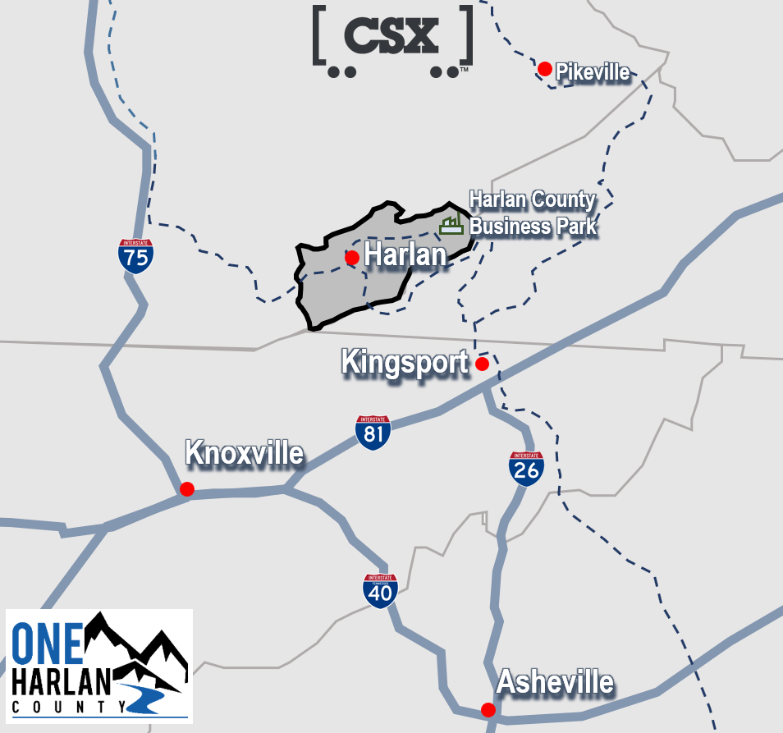
Figure 1: Harlan County Class I Railroad (Harlan County EDA, 2022b)

Not all change brought on by the mining industry was positive. Harlan County miners grew dissatisfied with being paid less than miners elsewhere and not having permanent jobs at the mines (Hevener, 2002). Tensions between miners and mine operators thus escalated to major heights in the early 1930s as miners in Harlan County sought union membership to secure higher wages and increased job security (Hevener, 2002). Miners in Harlan County were being paid less than miners in northern states and were being subjected to periods of irregular employment or unemployment (Hevener, 2002). This attempt at unionization led to a conflict now famously known as Bloody Harlan (Hevener, 2002). Operators were adamantly against the unionization of their mines and hired deputy sheriffs to keep union organizers out of the county and specifically off company property (Hevener, 2002). Miners frequently disrespected these deputy sheriffs which escalated to an ambush in 1931 (Hevener, 2002). Three deputies were killed and two were injured in this attack led by miners against the officers (Hevener, 2002, p. 28). In retaliation, “deputies killed, wounded, beat, and spied on union organizers and members to defend themselves, to punish the unionists for suspected crimes, and to compel respect” (Hevener, 2002, p. 28). The conflict between the two groups continued until the National Guard was called in (Hevener, 2002). This war between operators and miners continued for nine years and caused a total of 11 deaths (Hevener, 2002). News of the rift spread nationwide as it became labeled “Bloody Harlan” (Hevener, 2002, p. 30).
Labor conflicts in Harlan County did not stop with Bloody Harlan. Rather, this was just the beginning. The Brookside strike occurred in the 1970s as miners once again sought workers’ rights through unionization (Boles, 2019). This strike lasted over a year and was successful in allowing miners to renegotiate their labor contracts (Boles, 2019).
These conflicts in Harlan County have continued, even until as recently as 2019. Blackjewel, LLC filed for bankruptcy in July of that year (James & Puckett, 2019). This company owned coal mines in Harlan County, and its bankruptcy greatly impacted residents (James & Puckett, 2019). It failed to pay miners for weeks of work (James & Puckett, 2019). Its bankruptcy structure caused miners to not be able to access their 401ks and health benefits (James & Puckett, 2019). This left many miners and their families in financial ruin as their bank accounts turned negative (James & Puckett, 2019).
Miners, their families, and other members of the community protested Blackjewel’s actions by standing on railroad tracks in Harlan County to prevent coal that they mined for free from leaving the county. Police eventually forced protestors to step away from the tracks, allowing for the trains to pass. Protests continued elsewhere. Kopper Glo, a mining company based out of Knoxville, TN, bought out many of Blackjewel’s properties and pledged to cover $450,000 of wages the company had failed to pay (Boles, 2019). This was however only around 35% of what was owed to employees. Kopper Glo also pledged to rehire many Blackjewel employees (Boles, 2019).
Decline of Coal Mining in Harlan County
Harlan County reached its peak coal mine employment in 1941 with a total of 16,795 people working in coal mines (KYEEC, 2017). This number has since declined by around 95% and now sits at about 452 coal mine employees (KYEEC, 2017; KYEEC, 2021). This decline started in late 2011-early 2012 and has continued since (KYEEC, 2017). This trend is reflected in Figure 2. However, it is important to note that over the last year, coal mining employment in Harlan County has increased by a staggering 24.86% (KYEEC, 2021).

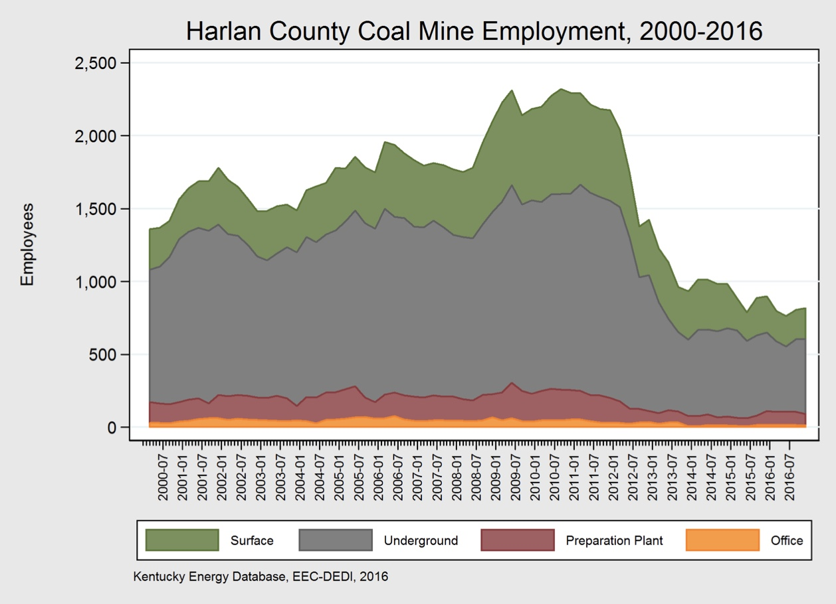
Figure 2: Harlan County Coal Mine Employment, 2000-2016, (KYEEC, 2017)

In 1942, shortly after Harlan County experienced record high coal mine employment, the county experienced is highest production levels with 15.6 million tons of coal being produced in this year (KYEEC, 2017). Since the county began mining, over one billion tons of coal have been produced (KYEEC, 2017). This is equal to 10.4% of all of the coal that has ever been mined in Kentucky (KYEEC, 2017). The production levels of Harlan County are conveyed in Figure 3 which seem to follow the same trends as coal mining employment.
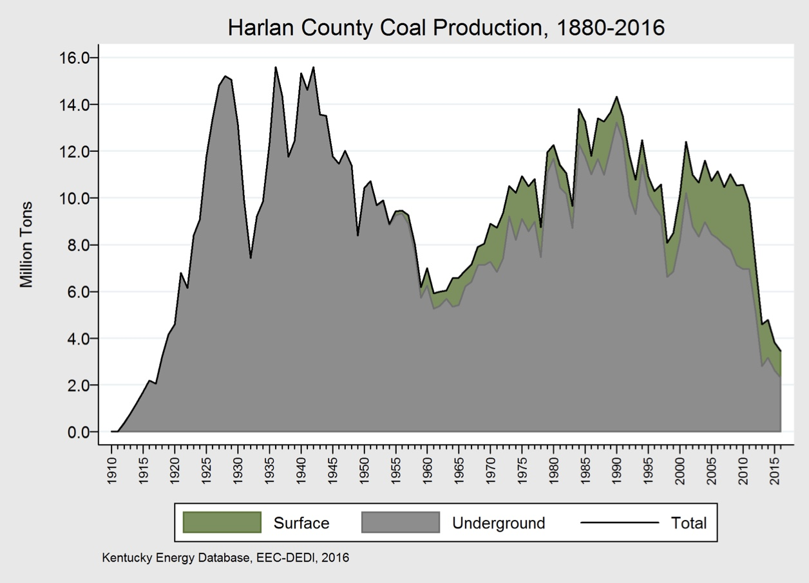
Figure 3: Harlan County Coal Production, 1880-2016 (KYEEC, 2017)

Trends away from coal mining are not a new concept. The industry that was once at the core of Harlan County began to search for other alternatives in the 1980s amid global competition and intense American regulations (Beaver & Hansell, 2014).
In one generation, Harlan County went from having double the number of coal miners than any other county in eastern Kentucky in 1930 to experiencing a major “bust” (Sewell, 2019, p. 2334). As the availability of jobs decreased, the population of the county decreased. Reaching its peak population in 1940 with around 75,300 residents, it is now around 26,831, the lowest since Harlan County started recording its population in 1920 and down by 8.36% in the last ten years alone (NACo, 2020). Many people moved to Harlan County to work in the coal industry around the 1940s, but their children found that there was no work to be found in the area in the 1960s and 1970s (Sewell, 2019).
These population movements have largely followed the rise and fall of the coal industry - people moved into Harlan County to work in coal and out of the county when it lacked opportunities in coal (Knigge, 2018). These shifts are shown in Figure 4.
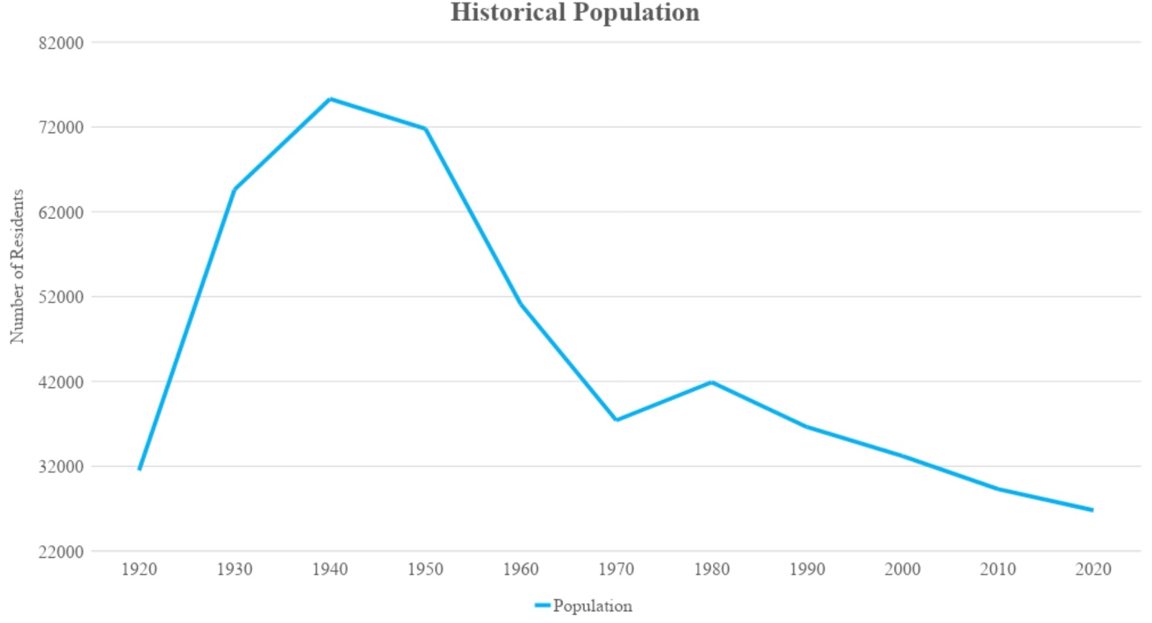
Figure 4: Historical Population – Harlan County adapted from (NACo, 2020, figure 1)
The U.S. Census Bureau’s 2015-2019 estimates show that only 38.1% of the Harlan County population over 16 years of age is in the civilian workforce compared to the national average of 68.0% (United States Census Bureau (USCB), 2021a; USCB, 2021b). Those who do work experience an average commute of 23.5 minutes, suggesting that many are leaving their hometown or county to work (USCB, 2021b). Further, the median household income in Harlan County in 2019 was $26,478 (USCB, 2021b). This is quite low compared to the national average of $69,560 (Shrider, et al., 2021). Twenty-eight percent of the Harlan County population was in poverty in 2020 (USCB, 2021b). To be labeled as impoverished in 2020, a family of four needed to make less than $26,200 a year (U.S. Department of Health and Human Services, 2020). This is also a staggering statistic when compared to the national poverty rate of 11.4% that same year (Shrider, et al., 2021).
Regulatory Action
Shelly Biesel, cultural-ecological anthropology PhD candidate at the University of Georgia, found that by 2020, Appalachian Kentucky had lost around ten thousand jobs in the coal industry since 2010 (Biesel, 2020). This decline has been attributed to competition with natural gas and a political movement away from coal which started under the Obama administration and has been referred to as the “war on coal” (Biesel, 2020, p. 7). This alleged war, labeled that by politicians, referred to actions taken by the Obama administration against the coal industry which would result in “fewer jobs and higher energy costs for Americans” (Revesz & Lienke, 2016, p. 13).
Environmental policies have repeatedly shifted as presidential administrations change. The Clinton Administration attempted to establish strict environmental initiatives in 1998 by signing the Kyoto Protocol which was not ratified by the Senate (“Biden returns,” 2021). This protocol required that developed nations reduce their greenhouse gas emissions in order to minimize the effects of global warming (Lau, et al., 2012). The subsequent George W. Bush Administration supported the Senate’s moves in blocking the adaptation of the Kyoto Protocol and failed to take the same strict approach to environmental policy as that of the previous administration (“Biden returns,” 2021).
The Obama Administration, which entered the Paris Agreement in 2015, enacted many other environmental policies that put coal at risk (Tollefson, 2017). Such policies included fuel efficiency standards for new vehicles and emissions restrictions for coal fired plants which effectively barred their construction (“Obama’s green,” 2014).
To meet the requirements of the Paris Agreement, the United States has virtually no option besides phasing out coal mining in order to mitigate climate change (Egli et al., 2020). This agreement, which went into effect in 2016, strives to keep the average global temperature from exceeding 1.5-2 degrees Celsius higher than preindustrial levels (González-Eguino, et al., 2017). To achieve this goal, greenhouse gas emissions must be reduced which nearly requires complete movement away from fossil fuels such as coal (González-Eguino, et al., 2017). Though the agreement does not explicitly require a movement away from coal, this substance emits the most carbon dioxide of any fuel (González-Eguino, et al., 2017). Therefore, the use of coal will make it extremely difficult to meet the goal of the Paris Agreement (González-Eguino, et al., 2017). This shift away from coal has also been aided by a decrease in the price of alternative, more renewable energy options (Egli et al., 2020).
The Trump Administration pulled the United States out of the Paris Agreement in 2017 and enacted more pro-coal policies (Tollefson, 2017). This move fulfilled a campaign promise and appealed to many coal supporters that helped elect then-President Trump to office in 2016 (Tollefson, 2017). This administration pursued a “coal revival” to reverse the effects of the previous administration’s anti-coal policies (Wang, et al., 2018, para. 1).
On his first day in office, President Biden signed the United States back into the Paris Agreement (“Biden returns,” 2021). He also set new emissions guidelines, reversing Trump Administration policies that set weak environmental standards (“Biden returns,” 2021). Figure 5 conveys how coal consumption trends have changed over time with today’s levels closely resembling those of the 1960s. Coal consumption has been decreasing since the early 2000s as other energy sources replace coal.
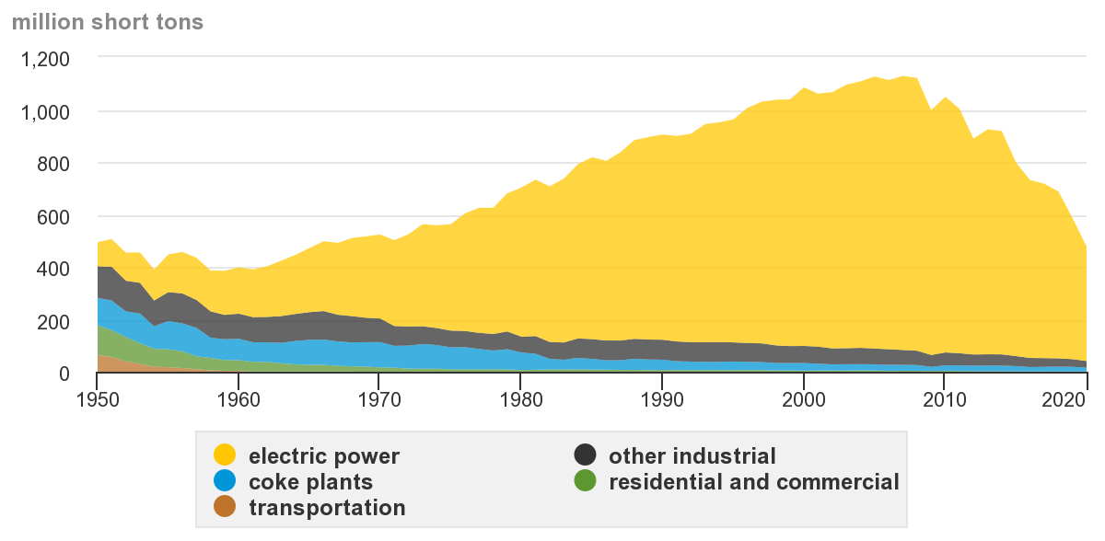
Figure 5: U.S. coal consumption by major end users, 1950-2020 (USEIA, 2020)

Harlan County Economy
A presentation by Dan Mosley, current Judge Executive of Harlan County, housed on the National Association of Counties website reveals that the county began to struggle as the coal industry left. He states that, “coal was everything in our economy” and there was “no backup industry” (Mosley, n.d., slide 3). As coal mining was the predominant industry in the area for many years, people in the community feared diversification into other industries as they had concerns about whether the coal industry workforce could adapt to work elsewhere (Mosely, n.d., slide 3).
The Harlan County economy still has not recovered from this loss of industry. In 2020, the county’s unemployment rate was a staggering 11.9% (NACo, 2020). To put this number into perspective, the United States national average unemployment rate has not exceeded that value (with the exception of April and May 2020 in the wake of the coronavirus pandemic) since the Bureau of Labor and Statistics began recording this statistic in the late 1940s (U.S. Bureau of Labor and Statistics (USBLS), 2020).
Eduardo Porter, economics reporter for the New York Times, discovered that “Harlan County residents rely on government programs more than pretty much anybody else” (2018, para. 5). The Bureau of Economic Analysis has found that this county is the fifth most dependent in the country on federal programs with around 56% of its income coming from federal assistance (Porter, 2018). Approximately 13% of the county receives disability assistance and around 35% are on food stamps (Porter, 2018). In 2020, the United States Federal Government spent around $2,433 in food stamps and disability payments alone to each Harlan County resident. (Davis, 2021; NACo, 2020; Porter, 2018; USSSA, 2022). These statistics show that government assistance, rather than organic economic activity, now accounts for the largest portion of Harlan County’s income.
Harlan County Opportunities
Strategic Geographic Location
Despite having some negative factors that may deter businesses from Harlan County, the area has multiple attributes that could make it attractive to businesses. Harlan County has a centralized location within the United States. Lexington, Pikeville, Kingsport, Knoxville, and Asheville are all within 100 miles of the county (Harlan County EDA, 2022b). There are four small airports within this radius: Tucker-Guthrie Memorial Airport, Pike County Regional Airport, Tri-Cities Regional Airport, and Blue Grass Airport (Harlan County EDA, 2022b). Interstates 75, 81, and 26 are all in close proximity to the county, though none runs directly through it (Harlan County EDA, 2022b). Figure 6 displays Harlan County’s proximity to these transportation options. The county does however have Class I rail infrastructure with CSX’s Cumberland Valley line running through it (Harlan County EDA, 2022b). Half of the American population lives within 500 miles of Harlan County, and a little under half a million people live within 50 miles (Harlan County EDA, 2022b).
The strategic location of Harlan County means there are great opportunities for the county. Close proximity to multiple airports and interstates would allow businesses easy access to many markets. Half of the United States population is within 500 miles of Harlan County, which should be an attractive quality to prospective businesses (Harlan County EDA, 2022b).
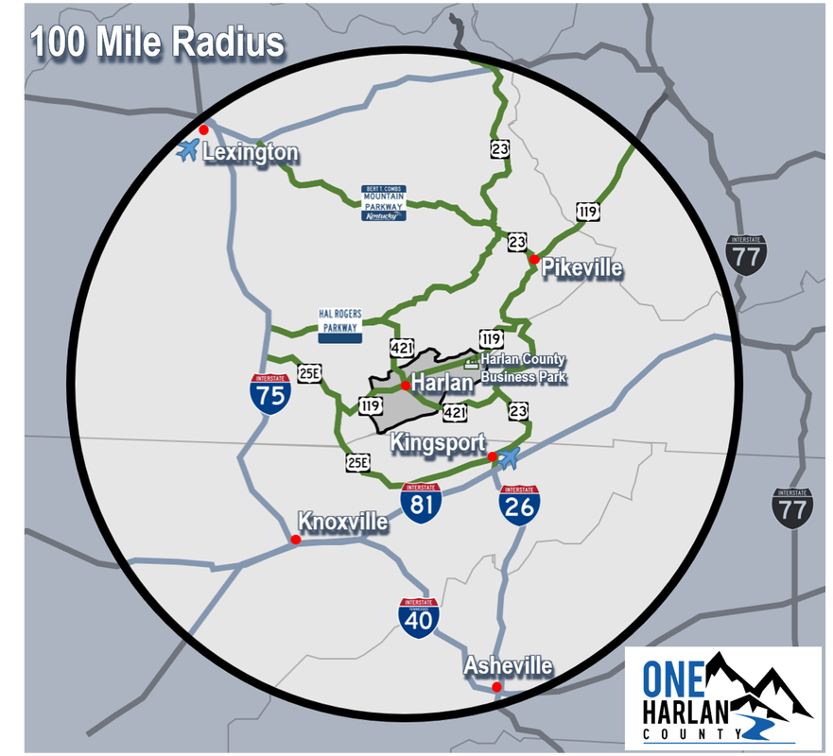
Figure 6: 100 Mile Radius of Harlan County (Harlan County EDA, 2022b)
Harlan County Business Park
The Harlan County Business Park is a recent community investment with the hope of the site becoming a major employer for the county (Kentucky Cabinet for Economic Development (KCED), 2022). Organized and managed by the Harlan County local government, it targets automotive and aerospace suppliers to open facilities there (KCED, 2022). This park exists on top of an abandoned coal mine and has 140 acres available for business development (KCED, 2022).
One lot within the park has already been certified as Kentucky Build Ready which means that the state has confirmed that a business can open an operation on this site at minimum risk (Harlan County EDA, 2022a). Other criteria for being “Build Ready” include “a building pad that would allow for the construction of a building with a minimum size of 50,000 square feet and expandable to 100,000 square feet, Environmental Phase I, Geotechnical Study, Archaeological & Historical Site Assessment, and Stream and Wetlands Mitigation” as well as “agreements with utility providers ensuring their capacity to serve an industrial tenant and agreements to complete any required infrastructure updates” and “preliminary design and construction plans for an industrial building to be constructed on the pad” (Harlan County EDA, 2022a, para. 2).
The existence of this business park would signal to businesses considering opening operations in Harlan County that the county is dedicated to attracting businesses. This is positive as businesses do not want to open operations in areas not interested in adapting to or investing in new businesses. Another major attraction of this business park is that it would drastically reduce the time and money required to build a facility in Harlan County. All pre-build work has already been completed; all the business would need to do is start constructing its building.
Harlan County Schools
There are two school systems in Harlan County: Harlan County Independent Schools and Harlan County Public Schools (Harlan County EDA, 2022b). Harlan County Independent Schools is in the top ten school systems in the state of Kentucky (Harlan County EDA, 2022b). This school system offers an intimate educational experience in the city of Harlan and boasts that over 85% of students are involved in an extracurricular activity (Harlan County EDA, 2022b). Harlan High School was ranked the 19th best high school in Kentucky in 2020 (Harlan Independent Schools, 2022). Harlan Elementary, Middle, and High Schools were academic team district champions in 2021 (Harlan Independent Schools, 2022). Harlan High School also offers free dual enrollment classes for its students (Harlan Independent Schools, 2022).
Harlan County Public Schools is tasked with educating the rest of the county’s children who are not able to attend Harlan Independent Schools or because they choose not to (Harlan County EDA, 2022b). Harlan County High School educates 1300 students each year and is focused on bringing students into the 21st century in order to prepare them for the modern job market (Harlan County High School, 2022).
These facts convey that there are educational opportunities available in Harlan County. The local school systems, specifically Harlan County Independent Schools, are high achieving. This should also be attractive to prospective businesses as they will want to employ educated individuals.
Policy History and Background
Educational Policies
Current Educational Landscape.
Much of Harlan County does not seem to be educated in the conventional sense. The U.S. Census Bureau estimates that in 2019, 72.8% of adults over the age of 25 in Harlan County had a high school diploma or GED and only 10.8% of the same group had a bachelor’s degree (USCB, 2021b). The United States as a whole reached its highest high school attainment rate two years previously with 90% of adults over 25 years of age holding such a degree (Jordan, 2017). Thirty-four percent of United States adults in the same age group held a bachelor’s degree in 2017 (Jordan, 2017), three times that of Harlan County.
The educational struggles of Harlan County were only exacerbated with the onset of the coronavirus pandemic which disrupted in-person education worldwide. Kevin McElrath of the U.S. Census Bureau reports that almost 93% of households with children in school had to partake in distance education due to the coronavirus pandemic (McElrath, 2020). Virtual learning places children without computers or internet access at a distinct disadvantage as they are unable to participate in school. Only 77% of Harlan County households had a computer in 2019, and only 66.8% had internet access (USCB, 2021b). Therefore, much of this community was shut off from virtual education and work opportunities.
Work Ready Kentucky Scholarship Program.
In efforts to promote post-secondary education, the State of Kentucky has launched the Work Ready Kentucky Scholarship Program which is paid for by the Kentucky Lottery (Work Ready Scholarship Program (WRSP), 2022). Through this program, students can earn up to 60 hours of school credit without having to pay for tuition (WRSP, 2022). These hours can be put towards a four-year degree, a two-year degree, or a certification (WRSP, 2022). The eligibility requirements for this program are straightforward: applicants must be a Kentucky resident, hold a high school diploma or be working towards a GED, and cannot already have any college degree (WRSP, 2022). The full tuition scholarship can be applied at the Kentucky Community and Technical College System as well as many four-year universities within the state (WRSP, 2022).
Southeast Kentucky Community and Technical College has a campus in Harlan, Kentucky and is a member of the Kentucky Community and Technical College System (Kentucky Community & Technical College System (KCTCS), 2022). This campus hosts many technical programs including “welding, auto body repair, medical assisting, and electrical technology” (KCTCS, 2022). It also contains the Kentucky Coal Academy (KCA) which works alongside coal companies to produce “highly skilled, safe, and knowledgeable miners who are aware of and can cope with health, safety, and production hazards inherent in the process of mining (KCTCS, 2022). This means that Harlan County residents with a high school diploma or GED are eligible to attend a community and technical college in their home county for free to learn any of these skills.
The Kentucky Coal Academy was created in 2005 and has since provided training at four different KCTCS locations to a total of over 109,000 miners (Kentucky Coal Academy (KCA), 2016). Despite coal companies leaving Harlan County, the KCA opened a new Mine Training Facility at the KCTCS Harlan campus in 2017 (KCA, 2016). The KCA brags the “largest mine simulator fleet in the world” with programs across the four KCTCS campuses (KCA, 2016, para. 7).
Hiring Our Miners Everyday (H.O.M.E).
The Appalachian Regional Commission (ARC) has created numerous Partnerships for Opportunity and Workforce and Economic Revitalization (POWER) grants to assist communities in Appalachia that have been impacted by a loss of the coal industry (Appalachian Regional Commission (ARC), 2022). In eastern Kentucky, funding from a POWER grant has been utilized to create the Hiring Our Miners Everyday (H.O.M.E.) program (Diersing, 2021). This program is targeted at out of work miners, their spouses, and companies that will hire former miners (Hiring Our Miners Everyday (H.O.M.E.), n.d.). When a miner loses his or her job, this person and his or her spouse can contact H.O.M.E. to help them through the process of unemployment (H.O.M.E., n.d.). H.O.M.E. will then provide services which may include on-the-job training at a new company, classroom training for basic skills or some sort of certification/licensing, a skilled apprenticeship, or other forms of assistance (H.O.M.E., n.d.). The organization communicates with businesses to determine how former miners should be trained and helps to aid them in the transition out of unemployment (H.O.M.E., n.d.).
Economic Policies
Economic policies of an area have the ability to attract new industries and business into a community. They also have the potential to push new investors to consider operating in other areas where they will be taxed less, face fewer regulations, or have easier access to a workforce. Harlan County’s economic policies therefore have the potential to help the community move past the loss of coal mining. However, they also very well could cause companies to steer clear of the area. The community’s policies also dictate how much money the local government will receive from taxation and therefore be able to invest back into the county.
Business Licensing.
The process for opening a business in Kentucky has been simplified into seven steps outlined by the Kentucky One Stop Business Portal (Commonwealth of Kentucky, 2022). These steps include choosing a name and structure, registering your business, getting tax ID numbers, understanding insurance requirements, understanding licenses and permits, understanding employer responsibilities, and identifying regulations for your business (Commonwealth of Kentucky, 2022). Each of these steps must be completed before a business is allowed to operate within the state (Commonwealth of Kentucky, 2022). Depending on the type of business, federal, operational, and environmental licenses may be needed (Commonwealth of Kentucky, 2022). The State of Kentucky requests that businesses consult their local government to determine if local licenses or permits are needed (Commonwealth of Kentucky, 2022). No Harlan County website shares any information as to whether businesses are required to obtain local licenses or permits before becoming operational. This lack of easily available information would cause difficulties for businesses considering opening operations in Harlan County.
General Business Taxes.
All businesses are subject to federal taxes and may be subject to Kentucky state taxes depending on the type of business (Commonwealth of Kentucky, 2022). There are three forms of additional county-level taxation that Harlan County is able to utilize in order to generate revenue from citizens: property tax, insurance tax, and occupational tax (Perkins, 2019). Harlan County does not have an insurance tax, a tax waged on insurance policies, or an occupational tax, a tax businesses are required to pay on earnings (Perkins, 2019). This would be attractive to businesses considering opening operations in Harlan County as it minimizes the tax dollars the business can expect to pay.
However, every town within Harlan County has a property tax with four of its towns ranking as the four highest property tax rates in southeastern Kentucky ​​(Perkins, 2019). The 2018 property tax rates for Harlan County towns per $100 of assessed property value were: Benham – 50 cents, Harlan – 47.2 cents, Evarts – 41.5 cents, Cumberland – 40 cents, Loyall – 35 cents, and Lynch – 24 cents ​​(Perkins, 2019). As Harlan County has no occupational tax, businesses do not face any additional local taxes by operating within the county ​​(Perkins, 2019). Though Harlan County appears to have an attractive tax structure due to its lack of occupational or insurance taxes, businesses would still need to be strategic in selecting a town to operate in to avoid excessive property taxes.
Coal Severance Tax.
Kentucky created a coal severance tax in 1972 which taxed coal produced and processed in the state (World Resources Institute (WRI), 2021). Only about 7.6% of these funds went to coal producing communities with the remainder being allocated to the state of Kentucky, so this tax was restructured in 1992 to allocate half of these tax funds to eligible coal producing communities (WRI, 2021). This money was originally only to be used on activities that promote industrial activity but has since expanded into other educational and social programs within coal mining communities (WRI, 2021).
Eastern Kentucky coal mining counties such as Harlan County were found to spend around half of their coal severance funds on paying towards debt instead of investing it in the future of the economy, as the money was supposed to be used for (Associated Press, 2021). Harlan County has recently been spending its coal severance money on repaying old debts such as bonds used to build a local jail (Associated Press, 2021). Jason Bailey who serves as the executive director of the Kentucky Center for Economic Policy in Berea states that these communities lack an adequate long-term strategy for coal severance funds (Associated Press, 2021). This tax money is entirely dependent on the amount of coal produced in Kentucky (WRI, 2021). Therefore, as coal production decreases, communities are given less money to invest in their economy (WRI, 2021). This suggests that coal mining communities must make wise investments now as they will likely lose the opportunity to make any investments in the future.
Examples for Examination
Emphasis on Tourism
The small town of Nucla, Colorado was heavily reliant on its coal plant from its opening in 1959 until it was forced to shut down in 2019 (Krupnick, 2021). This plant was scheduled to close in 2022 but ran out of coal, forcing it to close earlier (Krupnick, 2021). This sudden departure left the town in an uncertain position as the plant had provided “nearly half the tax revenue to the region” (Krupnick, 2021, para. 2).
Nucla leaned on tourism and small businesses to help the community rebound (Krupnick, 2021). The town implemented pro-small business tax breaks and financial incentives that have led to the inception of over 100 small businesses being created in the area (Krupnick, 2021). Nucla has also sought to capitalize on its natural beauty through tourism as a way to revitalize its economy (Krupnick, 2021). Singletracks, an online biking community and informational website, reports that Nucla is planning to build around 50 miles of bike trails in conjunction with other nearby towns (Miller, 2022). These trails will not be completed until around 2024, but they show a move by the Nucla area to be the “next Colorado bike destination” (Miller, 2022, title).
The Nucla-Naturita Area Chamber of Commerce shares that its mission is to, “promote existing businesses and industry within the area, to [promote] the Nucla-Naturita area in whole as a [destination] for vacationing…” (Nucla-Naturita Area Chamber of Commerce, 2022, para. 1). This conveys how the area has recovered from a loss of coal by leaning on small businesses and tourism (Krupnick, 2021).
Emphasis on Industry
Kemmerer, WY is a coal mining and power producing town that has relied on this industry for over 100 years (McCombs & Gruver, 2022). As the town has faced the loss of the coal industry, residents have become concerned with how to move forward economically (McCombs & Gruver, 2022). These concerns were abated in November when TerraPower, a nuclear power company owned by Bill Gates, announced it would be opening operations in Kemmerer (McCombs & Gruver, 2022). This plant is hiring many employees of the Kemmerer coal plant which is in the process of closing (McCombs & Gruver, 2022). Many residents have shown excitement regarding the opening of this nuclear plant, and the town is already seeing economic benefits from preparation for this plant even though it is not set to open until 2028 (McCombs & Gruver, 2022).
Failure to Adapt
Blue Heron, KY exists as an example of how Harlan County should not react to the loss of coal mines. Blue Heron’s mines were operational from 1937 until 1962 when the Stearns Coal and Lumber Company left the town (U.S. Department of the Interior (USDOI), 2022). The town then failed to adapt to the loss of coal (USDOI, 2022). Buildings were torn down or abandoned, leading to complete decay of Blue Heron (USDOI, 2022). Today, this town exists as a National Park Service location where visitors can tour recreations of Blue Heron in its coal mining days (USDOI, 2022). This serves as an example for what Harlan County is working against. Failure to adapt after coal mines leave threatens collapse into a ghost town (USDOI, 2022).

Methods
Rationale for Selected Method
The selected method of study for this research is a case study. A case study involves the study of a case within its actual and current context or setting (Yin, 2014). In order to develop a deep understanding of the case, one must rely upon multiple streams of qualitative data which may include interviews, observations, documents, and audio-visual material (Creswell & Poth, 2016). The analysis of the case typically ends with “conclusions formed by the researcher about the overall meaning delivering from the case” which are general lessons learned from the case (Creswell & Poth, 2016, p. 98).
A case study was chosen due to its ability to facilitate a deep examination of Harlan County fueled by qualitative data (Creswell & Poth, 2016). The purpose of this research was to identify what economic and educational policies would best help Harlan County, Kentucky succeed economically in a post-coal mining society. However, in order to understand the current situation, one must understand the time progression of Harlan County and how the town has changed over time. This constitutes the need for a case study (Creswell & Poth, 2016). This case study will outline how Harlan County has changed over time as coal mining has become less prevalent in society which will give insight into how the community can rebound economically. Suggestions for how to recover from this loss of industry cannot be given until a full analysis of the community is conducted (Creswell & Poth, 2016).
Rationale for Selected Sample
This research was always intended to examine how coal mining communities are recovering from a loss of industry. It was important to the researcher for the selected sample to be in the middle of a transition away from coal. This means that the community needed to have experienced a loss of coal mining, but not a complete loss. A community that has already entirely lost coal has no time to make decisions that could lessen this impact. It is fully experiencing the consequences of its leaders’ actions and lacks time to make adjustments. Conversely, a community that has not lost any coal mining has not experienced the urgency of a loss of industry. It also may never experience this loss. Therefore, a community experiencing a loss of coal mining but still having some coal mining is the ideal sample as its strategies for overcoming the loss can be examined and adjusted before the full loss is experienced.
Southern Appalachia was the area of interest as it has a distinct culture not found in other areas of the United States. Coal mining communities, as opposed to other kinds of mining, were to be examined as this type of mining has a distinct cultural element not present in communities participating in other forms of mining. Coal mining also experiences the greatest amount of volatility due to political manipulations of regulating and deregulating the industry as presidential administrations shift. These restrictions narrowed the potential areas for examination down to a few counties in Southeastern Kentucky including Pike County, Perry County, Harlan County, and Leslie County.
It was also important that the area being examined be relevant in the coal industry. Pike, Harlan, and Perry counties were found to have the highest coal mining employment and production in their region (KYEEC, 2017). Pike County has mined the most coal of any county in Kentucky with Harlan trailing in second place (KYEEC, 2017). These findings narrowed the options to Pike County and Harlan County.
Harlan County was found to have a history of coal mining labor disputes leading to intense conflicts which made it appealing. It has also been referenced in pop culture as the setting for FX’s Justified and the subject of the many times recorded country song “You’ll Never Leave Harlan Alive” (Stone, 2016). These distinguishing factors singled out Harlan County as the sample for examination.
Research Design
The intent of this study is to identify how a decline of coal mining has affected Harlan County economically and how the community can act to rebound from this decline. The boundaries of the case were predetermined before a case study was selected as the study method. Harlan County, Kentucky from the early 1900s until now (March 2022) will be examined. Next, one must develop procedures for how data will be collected (Creswell & Poth, 2016).
The procedures for data collection are outlined below in this document. This case will be analyzed using a holistic analysis of the situation and an analysis of themes (Creswell & Poth, 2016). This will allow for the case to be examined as a whole by identifying certain themes that are the most important to understand (Creswell & Poth, 2016). The last step of a case study is to report the lessons learned from the study (Creswell & Poth, 2016).
Data Sources
Primary and secondary historical and demographic data was gathered from online resources such as Google Scholar, University of Tennessee Knoxville OneSearch, and Google where specific keywords were identified. A priori terms which were search terms defined prior to the research being conducted were: Harlan County, Harlan County coal mining, coal mining in Appalachia, Harlan County coal mine leaving, and future of coal mining. Posteriori terms which were defined after the research began were: Harlan County economic policy, Harlan County educational policy, Harlan County economy, Harlan County unemployment, Harlan County new businesses, Harlan County Chamber of Commerce. Numerous articles were accessed from these platforms which were published in various journals pertaining to Appalachian and economic studies. These peer-reviewed articles were classified as reliable. Reliable information is information that the most accurate and up to date information available on a topic. Unreliable information was accessed on some local government websites and was determined to be unreliable because it lacked full information or conflicted other more reliable sources.
Additional secondary information was gathered using the same keywords in searches utilizing Google’s primary search engine. These searches revealed an assortment of data from government and other websites. United States Federal Government websites were classified as reliable. These were useful as they shared census data, economic data, and energy data. Other websites were classified as reliable if the information they shared was not contradicted by other sources.
These searches also led the researcher to examine multiple Harlan County government websites. These were found to have questionable reliability as they often lacked relevant information or only supplied dated information. For example, examining Harlan County websites failed to inform the researcher of the structure of Harlan County government. No information was available regarding the Harlan mayor with the exception of an email address. In some situations, Harlan County government website information was the only information available.
The remaining data was primary research gathered from interviews with members of the Harlan County community. Target interview candidates were the head of or an employee of the Harlan County Mayor’s Office, Loyall Mayor’s Office, Harlan County Fiscal Court, Harlan County Tourist and Convention Commission, and Harlan County Chamber of Commerce. These individuals were chosen because of their unique perspective into the Harlan County community. Employees of the Harlan County Mayor’s office see Harlan County’s issues through a political lens. They are charged with fixing economic issues and are therefore aware of problems in the community. A small town within Harlan County, Loyall, has its own Mayor (Staff Reports, 2018). This office will similarly view issues from a political lens, wanting to make improvements for the sake of reelection and pleasing constituents. The Harlan County Fiscal Court is Harlan County’s governing body, similar to a Board of County Commissioners (Harlan County Judge Executive, 2020). Its members offer a unique perspective into more narrow areas of Harlan County and may also provide insight into recent political history of Harlan County.
However, nongovernmental actors are also important to hear from. Employees of the Tourist and Convention Commission understand the tourism of the area and can give insights into how the area has changed over time as they are knowledgeable the events and attractions of the County. Lastly, employees of the Chamber of Commerce have a deep understanding of the businesses in Harlan County and are responsible for trying to attract new businesses. An employee of the Tourist and Convention Commission would be beneficial to speak with as they are aware of why businesses are attracted to and hesitant to operate in Harlan County.
No other groups or individuals were selected because the ones listed above were thought to each give a unique perspective into the issues of Harlan County that the average citizen would not have. Only individuals with official, public jobs were selected for invitations to interview. Although many other members of the community could provide gainful insights, they would be from the perspective of a private individuals. The jobs held by these individuals allow them to understand the events and issues the county is dealing with in more detail than the average citizen. The purpose of this study is to examine more public information, so private county residents were not included in these interviews.
Data Collection Procedures
Interviews were solicited by emailing the mayors’ offices, Tourist and Convention Commission, and Chamber of Commerce. Each email included a description of this research as well as a waiver each person must sign which would allow the researcher to use their quotes in the research outcomes. Interviews were conducted on Zoom and were recorded per the consent form. Notes from each interview were taken digitally. Questions differed depending on the person being interviewed while some questions were the same for all interviews. Appendix A lists all interview questions. Interviews were conducted for the purpose of gaining an understanding of the community experience of living in Harlan County while coal mining is becoming less prevalent. No individual information was solicited from these interviews, only details of their very public roles and experiences as a member of the community. These individuals were interviewed as representatives of the community, not as private individuals.
Interview Solicitation
Each of the five offices outlined in the methods was first contacted through the UT Vault system. The email was copied and pasted from the interview solicitation found in Appendix B and had the consent form found in Appendix C attached. The UTK portal allows for secure transfer of documents, as was requested by the Institutional Review Board (IRB). No office replied to this initial outreach.
The offices were then contacted via phone call. Initial contact with the Harlan County Visitor’s Center revealed that employees would be willing to be interviewed but were out of town. This phone call also revealed that the official title of this office is the Harlan Tourist & Convention Commission, as it will be referred to henceforth. A follow up phone call with this office resulted in an interview with employee Laura Adkisson, which is further discussed below.
The Harlan County Judge Executive’s office was contacted by phone. This office shared that they would consider the interview opportunity and be in touch if they were interested in participating. The office never reached out. A follow up email was sent to the Judge Executive, Dan Mosley, only sharing the interview solicitation message. No response was received from the Judge Executive.
The Harlan County Chamber of Commerce was contacted by phone, but no answer was received. A voicemail message was left with this office which was an almost exact read of the interview solicitation. Cole Raines, Executive Director of One Harlan, reached out soon after to schedule an interview. Though he is not technically employed by the Chamber of Commerce, his work for One Harlan is closely related to this office as it is the Economic Development Agency for the county. The results of his interview are detailed below.
The town of Loyall Mayor’s Office was contacted by phone. This office subsequently declined to participate in the interview. No phone number could be located for the Harlan County Mayor’s Office, so this office was not able to be contacted by phone.
Security of Information
All research and notes were stored on a password protected Google Drive account accessed only through a 2018 MacBook Pro or 2020 HP Desktop computer. Both devices are password protected and used only by the researcher. Both have updated software and no history of viruses or any other security issues. All interviews were recorded on Zoom and downloaded to the University of Tennessee’s OneDrive Cloud immediately following the interview. None of the devices in question have had any previous history of security issues and are all in excellent working condition with passwords protecting all important information stored therein. After this research process is complete, the interview recordings will be deleted.
Institutional Review Board Approval
This research design was submitted to the University of Tennessee Institutional Review Board (IRB) for approval. This step was taken so that the researcher could gain the university’s approval to conduct interviews for this research. This department verified that the proposed interviews were in accordance with university and legal guidelines. The IRB requested the researcher implement data protection procedures to protect the individuals being interviewed. After resubmitting for approval multiple times, this project was approved by the IRB on December 15, 2022.
Credibility, Transferability, Dependability, and Confirmability
Qualitative research, though useful in many respects, lacks a component of validity present in quantitative research. This is partly due to the common agreement among qualitative researchers that there is not perfect, unbiased knowledge to be gained about all parts of the world (Tierney & Clemens, 2011). However, just because this research cannot be perfect does not mean it cannot be trusted and utilized. Qualitative research has been found to be highly reliable because of its ability to provide accurate, though not faultless, descriptions of reality (Tierney & Clemens, 2011).
Given the nature of this research, it is important to discuss the internal validity of qualitative research. This refers to “the degree to which a researcher is justified in concluding that an observed relationship is causal” (Johnson, 1997, p. 282). This can be effectively done in qualitative research assuming a researcher takes certain precautions. First, the researcher must ensure that a change in the dependent variable is due to a change in the independent variable rather than some other confounding variable. A qualitative researcher should be skeptical of their own work, listing potential factors outside of the presumed causal relationship that could have wielded the same results. These rival theories should be addressed which may require that additional data be collected (Johnson, 1997). By taking these steps, qualitative research can have strong internal validity. Though qualitative research may not achieve the same level of internal validity as quantitative research, it is still valuable research and can have strong internal validity.
The researcher attempted to ensure that this research maintained strong internal validity by examining not only the dependent and independent variables, but other factors as well so that the researcher could be confident in the relationship between dependent and independent variables. The economy of Harlan County was examined, as was the loss of coal mining. However, the researcher made sure to examine other aspects of the community in order to confirm that the loss of coal was correlated with a decline in the economy of the county.
Positionality
Positionality refers to the concept that “all observers may attain only a partial or incomplete comprehension of the world due to their embedded and inevitable positionality within any particular province of spatial-temporal reality” (Williams, 2014, p. 75). This means that every person has their own set of unavoidable biases, including the researcher of this project. However, knowing some details about the researcher will help give the reader a reference point and help the reader be able to recognize any biases that may have been present in this research.
The researcher is a life-long resident of Southern Appalachia who has always viewed the people in coal mining communities, coal miners in particular, as being extremely hard-working individuals. The researcher is a senior at the University of Tennessee with limited world knowledge and is completely removed from the community of evaluation, Harlan County. The researcher was made aware of issues facing coal mining communities over the summer of 2020 while watching the Hulu documentary Hillbilly in which the voting habits and economies of Kentucky coal mining communities was examined. During this same time period, the researcher started listening to bluegrass music containing references to the struggles of coal miners. These experiences led the researcher to further examine the issues facing coal mining communities and begin this research.
Some biases can be detected from these characteristics of the researcher listed above. As the researcher is an outsider to the Harlan County community, the researcher will likely not be able to fully understand the area. The researcher conducted extensive research in order to counteract this and spoke with community members in order to gain a better understanding of Harlan County. The researcher finds this community interesting and therefore is biased in its favor. It has therefore been critical to minimize such biases when evaluating both Harlan County and other communities’ policies. However, it must be noted that the researcher’s knowledge of Harlan County is limited to information gained from researching. The researcher has no firsthand knowledge of the community other than the experiences gained in this research.
Limitations
Case studies are limited because they lack the ability to make causal inferences since alternative explanations cannot be ruled out (Simon & Goes, 2013). Additionally, this case study only reflects the behavior and experiences of Harlan County which may make the findings not applicable to other communities facing similar issues (Simon & Goes, 2013). This does not mean that findings could not be generalized, there would just need to be more research conducted that would directly provide links between multiple communities before generalization could be made (Simon & Goes, 2013).
Another limitation of this research may come from interviewing Harlan County residents. It is likely that these individuals will have biases that will lead them to suggest that Harlan County has been performing well economically which will make it difficult to understand the impact certain policies are actually having on this community. On the other hand, these individuals may be overly critical of the community because it is their home. This would result in underestimating the effectiveness of policies because of a strong desire to see certain outcomes.
The limited number of interviews further limits this research. Only two perspectives were gained, so it is likely that there are ways of thinking not represented by the interviews. This combined with the lack of updated (or in some cases, any) information on Harlan County government websites means that there is still much about the community that the researcher failed to learn. Given that the researcher faced difficulties understanding who was in certain community leadership roles like mayor, it is likely that other information gained from Harlan County websites may not have been accurate.
Results
Interviews were conducted in order to gain primary data regarding Harlan County and its economic revitalization efforts. These interviews portrayed multiple themes for further examination and conveyed a few threats to industry. The themes and threats were then fully examined as the main takeaways from these interviews.
Laura Adkisson – Harlan Tourist & Convention Commission Interview
Standard Question Responses
Laura Adkisson is the Downtown Development and Event Coordinator for City of Harlan Tourism and has been in this role for three and a half years. Her interview was conducted via Zoom on January 31, 2022. Her work involves attracting visitors and supporting businesses already present in Harlan County. She is also involved in the revitalization and development of the downtown area. Her office seeks to achieve these goals by matching property owners with prospective business owners, giving grants for downtown businesses to update their facades, and promoting and marketing businesses through tourism.
Adkisson shared that she believes Harlan County would be a good place for businesses to open for many reasons. The area has reasonable property costs. Additionally, the community is pushing to bring businesses in. Harlan County also has a skilled workforce. This skilled workforce is made up of coal miners who have been displaced. There are many skills and trades learned in coal mining that are highly applicable to other industries such as electricians, engineering, and machinists. She shared a quote from a community leader that basically stated that coal miners have spent their careers underground to support their families, so imagine how dedicated these people would be to your business.
Geographically, Harlan County also has potential to be good for businesses. There is already much land cleared for mining operations that would be an adequate location for factories or other industrial operations. There is also a Build Ready site that the county has spent years developing that has everything a business needs to get started.
Adkisson shared that businesses do have some hesitations about opening operations in Harlan County. The county is remote and mountainous which can pose difficulties. One disadvantage of Harlan County being remote is that it currently lacks reliable high speed internet access. However, the county government is currently working to address that issue.
The history of coal mining is quite evident in Harlan County. The Portal 31 Mine Exhibit is a once operational mine that visitors can now travel into as a tourist attraction. The county also boasts the Kentucky Coal Mining Museum which is located in what used to be a coal company store. Adkisson stated that coal mining “permeates the culture” of Harlan County. The highest honor the county can bestow on someone is the honor of being an honorary Harlan County coal miner, conveying how the community still values coal mining.
Adkisson shared that since coal mining began to leave the community in around 2012, citizens have become more open to exploring new opportunities. While residents do not want a new lifestyle that would belittle or erase coal heritage, many see the need to push forward. People want to continue living in Harlan County as this is where their families are from. Therefore, it is important to diversify opportunities in the area.
Harlan Tourist & Convention Commission Question Responses
Harlan County’s main attraction for tourism is its vast outdoor nature areas. The typical demographic for travelers is males aged 25-55 in middle to upper socioeconomic classes. These tourists often come with an array of outdoor vehicles like ATVs for off road entertainment. Another common group of tourists is researchers studying Harlan County or coal mining.
Adkisson conveyed that the loss of coal mining helped the community embrace tourism. The reliable work and decent pay provided by coal jobs discouraged residents from trying new things, but now people have nothing to lose. This has encouraged them to open a shop or restaurant that they had always thought about.
The City of Harlan currently funds its tourism offices through hotel and restaurant taxes. They are investing in this industry in non-monetary ways by considering local ordinances that would benefit the industry. One such example is how the city government is currently considering making downtown Harlan ATV friendly so that tourists can go riding off roads and then take their vehicles downtown to shop or eat.
Other Interesting Information
The interview with Laura Adkisson also revealed interesting details regarding the structure of Harlan County government. The structure of the Harlan County government was not available online. It was assumed that there was a Harlan County Mayor as well as a mayor in some of the towns within the county. Adkisson shared that there is actually no Harlan County Mayor. There are six town mayors within the county, but no mayor over the whole county. The Judge Executive operates in somewhat of a county mayor role.
This meant that the outreach to the Harlan County Mayor’s office was flawed, as no such office existed. An online search was conducted to find contact information for the Harlan Mayor’s Office. This office was emailed through UT Vault, and no response was received. No phone number was available online for this office.
Cole Raines – One Harlan Interview
Standard Question Responses
Cole Raines is the Executive Director of One Harlan, a public/private partnership between the Harlan County government and local businesses. He has been in this position since June 2021 where he previously served as Interim Executive Director for two months. His interview was conducted via Zoom on February 4, 2022.
Raines shared that his office is focused on two main areas to attract new businesses to Harlan County: the creation of the Harlan County Business Park and improving the quality of life within the county. The Harlan County Business Park has been several years in the making and includes a Build Ready site. Surveys have already been conducted on this site, so an interested business is able to hit the ground running and build its business immediately. Harlan County has the only Build Ready site east of Interstate 75 and south of Interstate 64.
Quality of life is being improved primarily by improving broadband access. The county was able to acquire a little under $2 million from the Appalachian Regional Commission for this project which was matched by the Harlan County government for $400,000. The total investment being made in this project is around $2.4 million.
Raines feels that Harlan County is a good place for business to come because of its outdoor opportunities, low cost of living, interest in new industries, skilled workforce, and access to major markets. The area contains Black Mountain which is the highest point in Kentucky. It also includes both the Pine Mountain Range and Cumberland Mountain Range as well as part of the Cumberland River.
Harlan County has a low cost of living when compared to many other areas. The community has shown a great interest in attracting new industries and has a skilled workforce to supply these industries. This skilled workforce comes from coal mining where workers have had to learn many industrial skills. While stereotypes have painted coal miners as being unskilled, this is simply untrue. The location of Harlan County in relation to interstates, highways, and railroads gives the community easy access to many major markets throughout the eastern United States.
However, despite these attraction factors, there are some reservations businesses seem to have about moving to Harlan County. Some of this revolves around the perception of coal miners as being unskilled and lazy which is not reality. Additionally, there are some infrastructure concerns about U.S. 119 which is the main road in and out of Harlan County. This road has four lanes everywhere except Harlan County, Bell County (bordering Harlan County), and parts of Letcher County (also bordering Harlan County) which could pose difficulties for transporting supplies or finished goods.
Raines shared that the history of coal mining is still present in Harlan County today as coal mining is still an active industry. Coal is at a ten year high which led to the hiring of 200 new miners in Harlan County last year. More coal trucks are driving around town than there has been in recent years, but there is an apprehension around the community regarding the coal industry. Many recognize that this boom will not last forever and feel a sense of urgency about transitioning to new opportunities.
Harlan County, like many other similar counties, has relied on its Coal Severance Tax but is aware that this money may soon go away. Residents therefore want to utilize this current coal boom as a way to move forward and away from coal mining. “Diversification” is a buzz word around town as the community is ready for a new heavy industry but also wants to promote smaller businesses as well.
One Harlan/Chamber of Commerce Question Responses
Interest has been shown in the Harlan County Business Park which is located near a former coal mine. A serious prospective client was in talks with the park around two years ago when it became aware that its two options for heating its facilities were propane and coal. The company did not wish to use coal for environmental reasons. Propane was three times the cost of natural gas, which the company wished to use to heat its facilities. However, the Harlan County Business Park lacked natural gas hookups.
Funding has since been acquired to pay for natural gas services to the park. A $1 million grant from the government was attained as well as a match of $400,000 from the local government. Designs are being created this year for the project which will be constructed next year.
To attract new businesses, Raines believes that Harlan County should continue doing what it is doing, specifically investing in quality of life improvements like cell and internet service. Major selling points for Harlan County are the low cost of living and highly skilled workforce.
Data Analysis
Multiple themes were identified throughout both interviews. These themes were important topics that both interviewees found relevant enough to bring up in the interview. These themes also had connections to previous historical secondary research conducted by the researchers.
The first identified theme is that of isolation. Both interviewees discussed how Harlan County is geographically and technologically isolated from outside locations. From a tourism perspective, this is beneficial as tourists often look for remote locations in which to vacation. From a business perspective, this is harmful as businesses need to be connected to other communities to effectively sell services and goods.
Another theme is that of the Harlan County Business Park. Both interviewees identified this county investment as a way that the community believes that it will attract businesses. The researcher had discovered this park through Internet research but was unsure of its importance in the community. Because both interviewees knew about the park and found it to be a promising investment, it is evident that the park is a prevalent topic within the community.
Tourism also appeared to be a major theme of the interviews. Both of the interviewees referenced the natural beauty of Harlan County as an attractive element for tourists. Like the Harlan County Business Park, tourism was also identified as a way that the community can recover economically. Each interviewee mentioned different ways that the county is investing in tourism monetarily.
The most important theme of the interviews was that of pride. Both interviewees had lived in Harlan County for many years and seemed to view the community with respect and admiration. This feeling seemed to also apply to coal mining. The interviews revealed that coal mining is still very prevalent in the lives of Harlan County residents as they remember themselves or their loved ones mining, go work in the mines currently, or reflect upon the dedication and work required to be a coal miner. Harlan County is not looking to forget about coal mining. Rather, the community is proud of its heritage.
Threats to Industry
Two major threats to industry that arose from the interviews were issues regarding image and isolation. The image of Harlan County is often flawed causing outsiders to see the community as being full of unskilled workers. This is true in the conventional sense as coal miners are not stereotypically “skilled” workers. However, one cannot discount the expertise these individuals have gained from working in coal mines. This experience has caused them to learn about electricity, hydraulics, and a number of other topics that are transferable to other industries.
Harlan County is isolated from other areas both geographically and technologically. The county lacks interstate and airport access. It is in a mountainous area which has led to issues with telephone and internet access. Businesses want to be connected to areas. Businesses want to be able to ship goods easily. Businesses want to be able to connect with other people to conduct business. Therefore, isolation is a great threat Harlan County faces when trying to attract new industries.

Conclusion
Harlan County is taking its own unique approach to dealing with its loss of the coal mining industry. Comparisons to other similar communities lend other potential strategies for Harlan County to explore, as do recent policies implemented by the Biden Administration. All of these factors could contribute to Harlan County’s economic revitalization plan.
Connections to Literature Review
There were some distinct parallels between topics brought up by interviewees and the review of current literature. One area, however, that was not discussed during the interviews was educational policies. Neither of the individuals interviewed ever explicitly mentioned education as a way to impact the economic situation in Harlan County. However, Cole Raines did mention that improving the quality of life for the area could help attract businesses.
A sentiment discovered in the literature review that appeared again in both interviews is that Harlan County had too much focus on one industry with coal and now values the importance of diversity of industries (Mosley, n.d.). All sources are in agreement that coal mining was the predominant industry in the community for years. When it started to leave, the county was put in a tough situation. Now, Harlan County wants to ensure that they are not put in this same situation again. The county wants to attract diverse industries and not rely on just one source of employment like it did for so many years.
The coal severance tax was discussed in both the literature review and in the interview with Cole Raines. This is a tax on coal produced in an area which goes back to the area where the coal was produced. Harlan County has been heavily reliant on this tax for many years. As coal production is expected to decrease, Harlan County can expect to receive less money from this tax. This means that the county must act now to invest coal severance tax funds in economic development or risk not being able to make those investments in the future.
Both interviews discussed the importance of the Harlan County Business Park as an avenue for attracting new industries to Harlan County. Along with this, Cole Raines brought up the proximity that Harlan County has to larger markets. These factors together show that Harlan County is primed to attract businesses and dedicated to this task.
Biden Administration Assistance
Current Biden Administration policies have the potential to be of benefit to Harlan County. The National Telecommunications and Information Administration has created three grant programs to give rural areas access to broadband (The United States Government (USA), 2021). These grants total $1.5 billion dollars (USA, 2021). This program could be applied to help Harlan County end its partial technological isolation from the world. The Department of Transportation’s Rebuilding American Infrastructure with Sustainability and Equity (RAISE) grants give funding for infrastructure projects (USA, 2021). The Biden Administration has claimed to be focused on these needs in energy communities, meaning Harlan County would be especially favored for such a grant to improve local infrastructure like roads (USA, 2021). This could help ease the threat of geographic isolation as it could potentially pay for U.S. 119 to be widened to a four-lane road through Harlan County.
Another Biden policy that Harlan County could take advantage of is the Department of Interior’s Office of Surface Mining, Reclamation, and Enforcement’s annual reclamation grants (USA, 2021). There are $152.2 million of these grants available for coal mine reclamation projects (USA, 2021). Harlan County could use this money to develop additional abandoned mines for future use by other businesses.
Comparison to Examples for Examination
Harlan County is not strictly following a pattern set by any of these examples. Harlan is not focusing solely on tourism, industry, or giving up. Rather, Harlan is approaching economic revitalization with a mix of approaches.
Harlan is investing in tourism as was made evident through the interview with Laura Adkisson. The county is trying to capitalize on its natural beauty and resources to attract visitors. It is putting tax money towards a dedicated tourism center and is considering passing ordinances that would improve tourism in the area. With this emphasis on tourism comes an emphasis on small businesses as these are vital to supporting local tourism.
Harlan is also investing in industry. The existence of the Harlan County Business Park is evidence that the county wants to attract new industry to the area. However, Harlan County is skeptical of taking an approach like the example above. Harlan County does not want to enter another situation where the county is almost fully reliant on one industry again. Rather, the county wants to push for diversity in industries and opportunities so that residents are better protected in the future from the comings and goings of companies.
Most importantly, Harlan County is not on track to be a Blue Heron. Harlan County has not given up since coal began to leave. Instead, this county has shown resilience and dedication as it tries to figure out how to move forward. Though the county is certainly not booming economically, it is not a ghost town. It is doing its best to move forward so that residents can enjoy life in Harlan County for years to come.
Recommendations for Future Research
There are still many areas related to this research that should be further examined. It would be interesting to see if the struggles coal mining communities are facing as coal mines leave are comparable to the struggles other communities face as other primary/sole industry companies leave. The companies and/or industries that are still purchasing coal should be examined so that one could gain a deeper understanding of how business level coal purchases are trending. Additional cultural research could also be conducted to determine the effects of a loss of coal mining on the perception of identity in former coal mining communities to determine if job loss from coal mining impacts individuals in a more negative way than other forms of job loss.
Closing Remarks
Time will tell if Harlan County’s mixed approach to economic revitalization will work as the county is currently seeking economic revitalization through tourism, industry, and small businesses. A focus on tourism worked for Nucla. A focus on industry worked for Kemmerer. Doing nothing failed for Blue Heron.
At this time, no one approach is necessarily succeeding for Harlan County. That is not to say that this will not happen. Perhaps Harlan County will soon become a major ATV destination. A business may decide tomorrow to build a plant at the Harlan County Business Park. Both of these situations could happen. However, it is not certain which, if any, of these situations will succeed.
Harlan County is currently succeeding at trying to diversify its economy. This could turn out great if one or multiple areas of the economy begin to blossom. It could also be an issue if this diversification strategy has caused the county to not invest enough into one particular segment. However, once again, there is no certainty as to if this will succeed.
There is one thing Harlan County is doing right in dealing with its current situation. It is trying. It has not given up. Based on interactions and conducted interviews, it does not appear that surrender is an option Harlan County is willing to consider.

Works Cited
Appalachian Regional Commission (ARC). (2022). ARC’s POWER Initiative.
Appalachian Regional Commission. Retrieved February 17, 2022, from https://www.arc.gov/arcs-power-initiative/.
Associated Press. (2021, December 26). Some counties using coal severance to pay past debts …
U.S. News. Retrieved February 17, 2022, from https://www.usnews.com/news/best-states/kentucky/articles/2021-12-26/some-counties-using-coal-severance-to-pay-past-debts.
Beaver, Patricia, and Tom Hansell. “Documenting and Engaging Communities in Appalachia
and Wales: Life After Coal.” Practicing Anthropology, vol. 36, no. 4, Society for Applied Anthropology, 2014, pp. 19–24.
Biden returns US to Paris climate agreement. (2021, January 21). Country Report: United States, NA.
Biesel, S. A. (2020). When disinformation makes sense: Contextualizing the war on coal in
Appalachian Kentucky. Economic Anthropology, 8(1), 7–21.
Boles, S. (2019, August 9). "Bloody Harlan" Revisited: Blackjewel miners draw on labor history while facing uncertain future. Ohio Valley ReSource. Retrieved March 2, 2022, from https://ohiovalleyresource.org/2019/08/09/bloody-harlan-revisited-blackjewel-miners-draw-on-labor-history-while-facing-uncertain-future/.
Commonwealth of Kentucky. (2022). Start My Business. Kentucky One Stop Business Portal.
Retrieved February 17, 2022, from https://onestop.ky.gov/start/Pages/default.aspx.
Cressey, P. F. (1949). Social Disorganization and Reorganization in Harlan County, Kentucky.
American Sociological Review, 14(3), 389–394.
Creswell, J. W., & Poth, C. N. (2016). Qualitative inquiry and research design: Choosing among
five approaches. Sage publications: Thousand Oaks.
Davis, S. (2021, August 22). The 42 million Americans who receive SNAP benefits are set to get
$36 more a month. NPR. Retrieved February 18, 2022, from https://www.npr.org/2021/08/22/1030099959/the-42-million-americans-who-receive-snap-benefits-are-set-to-get-36-more-a-mont.
DeSilver, D. (2020, January 15). Renewable energy is growing fast in the U.S., but fossil fuels
still dominate. Pew Research Center. Retrieved February 18, 2022, from https://www.pewresearch.org/fact-tank/2020/01/15/renewable-energy-is-growing-fast-in-the-u-s-but-fossil-fuels-still-dominate/.
Diersing, A. (2021, June 7). Apprenticeships: Retraining Programs for Dislocated Miners.
Occupational Licensure Policy. Retrieved February 17, 2022, from https://licensing.csg.org/apprenticeships-retraining-programs-for-dislocated-miners/
Dunn, W. N. (2016). Public Policy Analysis ( 5th ed.). Routledge Francis & Taylor Group.
Egli, F., Schmid, N., & Schmidt, T. (2020). Electoral response to the decline of coal mining in
the United States. SSRN Electronic Journal. https://doi.org/10.2139/ssrn.3710589
González-Eguino, M., Olabe, A., & Ribera, T. (2017). New Coal-Fired Plants Jeopardise Paris
Agreement. Sustainability, 9(2), 168.
Harlan County EDA. (2022a). Harlan County Business Park. Harlan County EDA. Retrieved
February 17, 2022, from https://www.harlancountyeda.com/harlan-county-business-park.
Harlan County EDA, (2022b). Overview. Harlan County EDA. (2022). Retrieved February 17,
2022, from https://www.harlancountyeda.com/overview.
Harlan County Judge Executive. (2020). Local County Officials Information. Harlan County
Judge-Executive. Retrieved October 12, 2021, from http://judge-executive.harlanonline.net/about.htm.
Harlan County High School. (2022). Harlan County High. Retrieved February 18, 2022, from
http://www.harlan.k12.ky.us/hchs/index.html.
Harlan Independent Schools. (2022). Retrieved February 17, 2022, from
https://www.harlan-ind.k12.ky.us/.
Hevener, J. W. (2002). Which side are you on?: The Harlan County Coal Miners, 1931-39.
University of Illinois Press: Champagne.
Hiring Our Miners Everyday (H.O.M.E.). (n.d.). H.O.M.E. Retrieved February 17, 2022, from
https://static1.squarespace.com/static/5f469e58ad0c96761b4eba42/t/5f4ea8f76769ff22f9585174/1598990584891/Hiring+Our+Miners+Everyday+%28HOME%29.pdf.
James, C., & Puckett, W. (2019, July 19). ‘No pay, we stay’; protesting miners in Harlan County are not going anywhere. https://www.wymt.com. Retrieved March 2, 2022, from https://www.wymt.com/content/news/Unpaid-miners-want-answers-as-train-carries-coal-away-from--513348141.html.
Johnson, R. B. (1997). Examining the validity structure of qualitative research. Education,
118(2), 282.
Jordan, J. (2017, December 14). High school completion rate is highest in U.S. history.
census.gov. Retrieved February 17, 2022, from https://www.census.gov/newsroom/press-releases/2017/educational-attainment-2017.html.
Kelley, A. (2019, December 31). Biden tells coal miners “to “learn to code”. The Hill. Retrieved
February 18, 2022, from https://thehill.com/changing-america/enrichment/education/476391-biden-tells-coal-miners-to-learn-to-code.
Kentucky Cabinet for Economic Development (KCED). (2022). Harlan County Business Park.
KYOZ. Retrieved February 17, 2022, from https://www.kyoz.org/industrial/harlan-county-business-park-2/.
Kentucky Coal Academy (KCA). (2016, February 22). Ky Coal Academy shows off New Mine Training Facility. https://www.wbko.com. Retrieved February 28, 2022, from https://www.wbko.com/content/news/KY-Coal-Academy-shows-off-new-mine-training-facility-369707991.html.
Kentucky Community & Technical College System (KCTCS). (2022). Campuses. Southeast
Kentucky Community & Technical College. Retrieved February 17, 2022, from https://southeast.kctcs.edu/about/campuses/.
Kentucky Energy and Environment Cabinet (KYEEC). (2017). Kentucky Coal Facts. Kentucky Energy and Environment Cabinet. Retrieved March 2, 2022, from https://eec.ky.gov/Energy/Coal%20Facts%20%20Annual%20Editions/Kentucky%20Coal%20Facts%20-%2017th%20Edition%20(2017).pdf.
Kentucky Energy and Environment Cabinet (KYEEC). (2021). Kentucky Quarterly Coal Report (2021-Q4). Kentucky Energy and Environment Cabinet. Retrieved March 2, 2022, from https://eec.ky.gov/Energy/News-Publications/Quarterly%20Coal%20Reports/2021-Q4.pdf.
Knigge, M. (2018, September 16). Poverty is winning the war in reality-based Eastern Kentucky.
DW.COM. Retrieved February 17, 2022, from https://www.dw.com/en/poverty-is-winning-the-war-in-reality-based-eastern-kentucky/a-45311970-1.
Krupnick, M. (2021, November 26). What happens when America’s coal plants die? The
Guardian. Retrieved February 24, 2022, from https://www.theguardian.com/environment/2021/nov/26/what-happens-when-americas-coal-plants-die.
Lau, L. C., Lee, K. T., & Mohamed, A. R. (2012). Global warming mitigation and renewable energy policy development from the Kyoto Protocol to the copenhagen accord—a comment. Renewable and Sustainable Energy Reviews, 16(7), 5280–5284.
Lipton, E. (2020, October 5)‘. 'the coal industry is back,' trump proclaimed. it wasn't. The New
York Times. Retrieved February 18, 2022, from https://www.nytimes.com/2020/10/05/us/politics/trump-coal-industry.html.
Martinson, E. (2012, April 5). Uttered in 2008, still haunting obama. POLITICO.
Retrieved February 18, 2022, from https://www.politico.com/story/2012/04/uttered-in-2008-still-haunting-obama-in-2012-074892.
McCombs, B., & Gruver, M. (2022, January 18). In tiny Wyoming town, Bill Gates bets big on
Nuclear power. AP NEWS. Retrieved February 24, 2022, from https://apnews.com/article/climate-technology-business-wyoming-bill-gates-19a36eb0bd65e0999d26c0cc122f6158.
McElrath, K. (2020, August 26). Nearly 93% of households with school-age children report
some form of distance learning during COVID-19. census.gov. Retrieved February 17, 2022, from https://www.census.gov/library/stories/2020/08/schooling-during-the-covid-19-pandemic.html.
Miller, M. (2022, January 12). Naturita and Nucla Strive to be Next Colorado Bike Destination
With Aggressive Trail Plan. Singletracks Mountain Bike News. Retrieved February 24, 2022, from https://www.singletracks.com/mtb-trails/naturita-and-nucla-strive-to-be-next-colorado-bike-destination-with-aggressive-trail-plan/.
Mosley, D. (n.d.). Transforming the Harlan County Ky Economy - Naco. Transforming the
Harlan County Ky Economy. Retrieved February 4, 2022, from https://www.naco.org/sites/default/files/documents/Transforming%20the%20Harlan%20County%20Ky%20Economy.pdf.
National Association of Counties (NACo), (2020). Harlan County, KY. NACo. Retrieved
February 17, 2022, from
https://www.naco.org/county-profile/21095.
Nucla-Naturita Area Chamber of Commerce. (2022). Nucla-Naturita Area Chamber of
Commerce. NNACC. Retrieved February 24, 2022, from https://www.nucla-naturita.com/.
Obama's green gamble; Climate policy and the future of coal. (2014, June 7). The
Economist, 411(8890), 31(US).

Perkins, E. (2019, October 17). Harlan council approves a lower tax rate for 2019. Harlan
Enterprise. Retrieved February 17, 2022, from https://www.harlanenterprise.net/2019/10/15/harlan-council-approves-a-lower-tax-rate-for-2019/.
Porter, E. (2018, December 21). Where government is a dirty word, but its checks pay the bills.
The New York Times. Retrieved February 17, 2022, from https://www.nytimes.com/2018/12/21/business/economy/harlan-county-republican-welfare.html.
Revesz, R., & Lienke, J. (2016). Struggling for air : Power plants and the war on coal. Oxford
University Press, Incorporated: New York.
Sewell, A. A. (2019). In deep: The boom and bust of the coal mining industry through the eyes
of Black Appalachians. Ethnic and Racial Studies, 42(13), 2333–2338.
Shrider, E. A., Kollar, M., Chen, F., & Semega, J. (2021, September 14). Income and Poverty in
the United States: 2020. census.gov. Retrieved February 17, 2022, from https://www.census.gov/library/publications/2021/demo/p60-273.html.
Simon, M. K., & Goes, J. (2013). Scope, limitations, and delimitations.
Staff Reports. (2018, November 7). Meadors wins Harlan Mayor race. Harlan Enterprise.
Retrieved October 12, 2021, from https://www.harlanenterprise.net/2018/11/06/meadors-wins-harlan-mayor-race/.
Stone, M. A. (2016). "You'll never leave Harlan alive": Using FX's "Justified" to form a cultural
understanding of crime in Harlan County, Kentucky (Order No. 10113171). Available from ProQuest Dissertations & Theses Global; Sociological Abstracts. (1794656345). https://utk.idm.oclc.org/login?url=https://www.proquest.com/dissertations-theses/youll-never-leave-harlan-alive-using-fxs/docview/1794656345/se-2?accountid=14766.
The United States Government (USA). (2021, April 23). Fact sheet: Biden administration
outlines key resources to invest in coal and Power Plant Community Economic Revitalization. The White House. Retrieved February 25, 2022, from https://www.whitehouse.gov/briefing-room/statements-releases/2021/04/23/fact-sheet-biden-administration-outlines-key-resources-to-invest-in-coal-and-power-plant-community-economic-revitalization/.
Tierney, W. G., & Clemens, R. F. (2011). Qualitative Research and Public Policy: The
Challenges of Relevance and Trustworthiness. In Higher Education: Handbook of Theory and Research (pp. 57–83). Springer Netherlands. https://doi.org/10.1007/978-94-007-0702-3_2.
Tollefson, J. (2017). Trump pulls United States out of Paris climate
agreement. Nature, 546(7657). https://link.gale.com/apps/doc/A494740578/AONE?u=tel_a_utl&sid=bookmark-AONE&xid=063c052b.
U.S. Department of Health and Human Services. (2020). 2020 Poverty Guidelines. Assistant Secretary for Planning and Evaluation. Retrieved February 28, 2022, from https://aspe.hhs.gov/topics/poverty-economic-mobility/poverty-guidelines/prior-hhs-poverty-guidelines-federal-register-references/2020-poverty-guidelines.
U.S. Bureau of Labor Statistics (USBLS). (2020, May 13). Unemployment rate rises to record
high 14.7 percent in April 2020. U.S. Bureau of Labor Statistics. Retrieved February 17,
2022, from https://www.bls.gov/opub/ted/2020/unemployment-rate-rises-to-record-high-14-point-7-percent-in-april-2020.htm?view_full.
U.S. Department of the Interior (USDOI). (2022). Blue Heron. National Parks Service. Retrieved
February 24, 2022, from https://www.nps.gov/biso/learn/historyculture/blueheron.htm.
U.S. Energy Information Administration (USEIA). (2021, June 2). Coal explained. Retrieved
February 18, 2022, from https://www.eia.gov/energyexplained/coal/use-of-coal.php.
U.S. Social Security Administration (USSSA). (2022). Facts. Social Security. Retrieved
February 18, 2022, from https://www.ssa.gov/disabilityfacts/facts.html.
U.S. Census Bureau (USCB). (2021a, July 1). U.S. Census Bureau QuickFacts. U.S. Census Bureau. Retrieved March 1, 2022, from https://www.census.gov/quickfacts/fact/table/US/PST045221.
United States Census Bureau (USCB). (2021b, July 1). U.S. Census Bureau QuickFacts: Harlan
County, Kentucky. census.gov. Retrieved February 17, 2022, from
https://www.census.gov/quickfacts/harlancountykentucky.
Wang, Q., Li, S., & Li, R. (2018). Will trump's coal revival plan work? - comparison of results based on the optimal combined forecasting technique and an extended IPAT forecasting technique. Energy, 169, 762–775.
Williams, D. R. (2014). Making sense of “place”: Reflections on pluralism and positionality in
place research. Landscape and Urban Planning, 131, 74–82.
Work Ready Scholarship Program (WRSP). (2022). Work Ready Scholarship Program.
workreadykentucky.com. Retrieved February 17, 2022, from https://workreadykentucky.com/
World Resources Institute (WRI). (2021, May 25). Kentucky, USA: A Coal Mining Tax
Supporting Economic Diversification in Appalachia. World Resources Institute. Retrieved February 17, 2022, from https://www.wri.org/just-transitions/kentucky
Yin, R.K. (2014). Case study research: Design and method (4th ed.). Thousand Oaks, CA: Sage.

Appendix A: Interview Questions
Standard Questions:
- What is your current job title and how long have you worked in this position?
- What steps has your office taken to attract businesses to the Harlan County area?
- Why do you think Harlan County would be a good place for new businesses to open?
- What reservations do businesses have about opening operations in Harlan County?
- How is the history of coal mining still present in Harlan County?
- How do residents feel about coal mines leaving Harlan County?
- How easily do you think residents could adjust to working in non-coal related industries?
Governmental Questions
- What policies have you considered to improve the economy of Harlan County?
- What is keeping you from implementing these policies?
- Do you feel that Harlan County has improved during your time in office, and if so, why?
- Are there currently any conflicts between Harlan County and town level policies?
Visitor’s Center Questions
- What is the typical demographic profile of visitors coming to Harlan County?
- How has the rise and fall of coal mining impacted tourism in Harlan County?
- Is the community investing in tourism?
Chamber of Commerce Questions
- How has the construction of Harlan County’s new Business Park impacted the community?
- Has the Business Park helped to bring in new businesses?
- What more can Harlan County do to bring in new businesses and support already established businesses?
- What are the main selling points you all refer to when trying to attract new businesses to the area?

Appendix B: Interview Solicitation Script
Good Afternoon insert name of office,

My name is Karli Ailshie, and I am a senior at the University of Tennessee Knoxville. I am writing my undergraduate honors thesis on Harlan County and am specifically researching how it has been impacted economically by a decline in coal mining. I would love to interview someone in your office regarding this topic as part of my research. The interview would be no longer than one hour and would take place over Zoom. This interview will not be recorded without the interviewee’s permission, and they will have the opportunity to read over and edit/delete any section of my final project that includes information from that interview. If you have any questions, please feel free to contact me. I have attached an interview consent form for your reference which will need to be filled out before the interview can take place. Please send this completed form back to me through the UTK Vault. I look forward to hearing from you.

Best,
Karli Ailshie

Appendix C: Interview Consent Form
Consent for Research Participation
Research Study Title: Harlan County, Kentucky in a Post-Coal America: A Case Study
Researcher(s): Karli Ailshie, University of Tennessee, Knoxville
Sara Easler, University of Tennessee, Knoxville

Why am I being asked to be in this research study?
We are asking you to be in this research study to gain a deeper understanding of the shared experience of living in Harlan County while coal mining becomes less prevalent in society.

What is this research study about?
The purpose of the research study is to understand how a decrease in coal mining has impacted Harlan County and to find ways that Harlan County and similar communities can rebound from this loss of industry.

How long will I be in the research study?
If you agree to be in the study, your participation will last for 1 hour.

What will happen if I say “Yes, I want to be in this research study”?
If you agree to be in this study, we will ask you to participate in a one hour survey containing questions about your public job as well as how certain events have impacted Harlan County, in your opinion.

What happens if I say “No, I do not want to be in this research study”?
Being in this study is up to you. You can say no now or leave the study later.

What happens if I say “Yes” but change my mind later?
Even if you decide to be in the study now, you can change your mind and stop at any time.
If you decide to stop before the study is completed, any information gathered from you will be discarded and it will be like you never participated in the study at all. You may skip any questions you wish.

Are there any possible risks to me?
There is no more risk from taking part in this interview than is experienced in everyday life.

Are there any benefits to being in this research study?
We do not expect you to benefit from being in this study. Your participation may help us to learn more about Harlan County. We hope the knowledge gained from this study will benefit others in the future.

What will happen to my information after this study is over?
We will not share your research data with other researchers. This consent form will be stored for three years and then deleted in accordance with UTK policy.

Will I be paid for being in this research study?
You will not be paid for being in this study.

Will it cost me anything to be in this research study?
It will not cost you anything to be in this study.

What else do I need to know?
About 7 people will take part in this study. This will ensure a small group that is representative of various perspectives of the Harlan County community. By signing this consent form, you are consenting to the Zoom interview having its audio and video recorded. This recording will be stored until March 11, 2022 and then deleted. Direct quotes may be used in my research. If a quote from you is used, you will be identified by your name and position in my research. You will be sent the excerpt from my research where your quote is being used so that you can approve this statement or make changes as necessary. This transfer of documents will occur over UTK Vault. This approval process will occur no later than the end of February 2022.

Who can answer my questions about this research study?
If you have questions or concerns about this study, or have experienced a research related problem or injury, contact the researchers,
Karli Ailshie
kailshie@vols.utk.edu
423-327-1008

Dr. Sara Easler
seasler@utk.edu
865-974-5078
For questions or concerns about your rights or to speak with someone other than the research team about the study, please contact:
Institutional Review Board
The University of Tennessee, Knoxville
1534 White Avenue
Blount Hall, Room 408
Knoxville, TN 37996-1529
Phone: 865-974-7697
Email: utkirb@utk.edu

STATEMENT OF CONSENT
I have read this form and the research study has been explained to me. I have been given the chance to ask questions and my questions have been answered. If I have more questions, I have been told who to contact. By signing this document, I am agreeing to be in this study and have my interview recorded. I understand that things I say in the interview may be quoted in the final research and if so, will be identifiable by my name and position. I will receive a copy of this document after I sign it.

Name of Adult Participant Signature of Adult Participant Date

