Table of Contents

1 Results 4
1.1 Assessing the activity of R67 DHFR and/or Quad4 clones in the presence of increasing osmolality in vivo 4
1.1.1 Construction of R67 DHFR-pKTS and Quad4-pKTS 4
1.1.2 Determining the tetracycline concentration required for confluent growth in E. coli DH5α and/or E. coli LH-18 (ΔFolA::Kan) 6
1.1.2.1 What is the tetracycline concentration required to induce sufficient R67 DHFR and/or Quad4 production to allow TMP resistance in E. coli DH5α? 6
1.1.2.2 What is the tetracycline concentration required to induce sufficient R67 DHFR and/or Quad4 production to allow confluent growth of E. coli LH-18 (ΔFolA::Kan) on Bonner-Vogel minimal media? 9
1.1.3 Effect of osmolality on the ability of the R67 DHFR and/or Quad4 pKTS clones to provide TMP resistance to E.coli DH5α cells 13
1.1.4 Effect of osmolality on the ability of R67 DHFR and/or Quad4-pKTS clones to rescue E.coli LH-18 to prototrophy 17
1.2 Can osmotic stress affect the in vivo activity of folC? 21
1.2.1 E. coli: SF2 (F- folC strA) a mutant strain with a lower activity of folC 21
1.2.2 Effect of osmolality on the function of folC 23
1.2.3 Effect of osmolality on the function of folC 24
1.3 Cloning Methylenetetrahydrofolate Reductase into the pKTS plasmid 27
1.3.1 Designing a primer, PCR amplification and cloning into pCR 2.1 TOPO TA vector 27
1.3.2 Construction of the metF-pKTS plasmid 30
1.3.3 Assessing the growth pattern of E. coli JW3913-1 (∆metF::kan) 31
1.3.4 What is the tetracycline concentration required to induce sufficient production of MTHFR to allow complementation of E. coli JW3913-1 (∆metF::kan)? 33
1.4 Initial experiments to explore the effect of in vivo osmotic stress on serine hydroxymethyl transferase activity 35
1.4.1.1 Designing a primer, PCR amplification and cloning into the pCR 2.1 TOPO TA vector 35
1.4.1.2 Construction of the glyA-pKTS plasmid 38
1.4.1.3 Assessing the growth pattern of E. coli JW2535-1 (∆glyA::kan) 41
1.4.1.4 What is the tetracycline concentration required to induce production of sufficient SHMT to rescue E. coli JW2535-1 (∆glyA::kan) to prototrophy? 42
1.5 Beginning steps to clone the dihydropteroate synthase gene into the pKTS plasmid 44
1.5.1 Assessing the quality of the folP clone and assessing the cloning sites in the gene 44

Table of figures
Figure 1-1 Restriction enzyme digested DNA. 5
Figure 1-2 Tetracycline dependent R67 DHFR and/or Quad4 production on M9 media 8
Figure 1-3 The growth pattern of FolA knockout strain E. coli LH-18. 9
Figure 1-4 Tetracycline dependent R67 DHFR and/or Quad4 production. 12
Figure 1-5 Effect of osmolality on E. coli DH5α viability. 15
Figure 1-6 Effect of osmolality on R67 DHFR and/or Quad4 activity rescuing E. coli DH5α from TMP. 17
Figure 1-7 Effect of osmolality on E. coli LH-18 viability. 19
Figure 1-8 Effect of osmolality on R67 DHFR and/or Quad4 activity rescuing E. coli LH-18 to prototrophy. 20
Figure 1-9 The growth pattern of folC mutant strain E. coli SF2. 22
Figure 1-10 effect of increasing osmolality on the growth of E. coli SF2 24
Figure 1-11 effect of increasing osmolality on E. coli SF2 on BV minimal media with optimal methionine concentration. 26
Figure 1-12 metF PCR product. 29
Figure 1-13 NdeI and XhoI digest metF-pCR 2.1 and pKTS. 31
Figure 1-14 The growth pattern of metF mutant strain E. coli E. coli JW3913-1 (∆metF::kan) 32
Figure 1-15 Tetracycline dependent metF production. 34
Figure 1-16 glyA PCR product 37
Figure 1-17 NdeI and XhoI digest glyA 38
Figure 1-18 partially digested glyA 40
Figure 1-19 The growth pattern of glyA mutant strain E. coli SF2 41
Figure 1-20 Tetracycline dependent glyA production. 43
Figure 1-21 NdeI and XhoI digested folP 45

Results
We propose that increased osmolality will titrate the activity of folate pathway enzymes. This hypothesis can perhaps be probed genetically via restoration of prototrophy to the appropriate knockout strains. A challenge to this approach is controlling the enzyme turnover rate and/or protein production level [1]. To address these issues, the gene for the enzyme of interest was cloned into a controllable pKTS vector [1] [2]. This plasmid was transformed into a knockout E. coli strain and osmotic stress titrations were performed.

Assessing the activity of R67 DHFR and/or Quad4 clones in the presence of increasing osmolality in vivo

Our first gene of interest was R67 DHFR. This target was selected as we previously performed osmotic stress titrations of the Y69L mutant clone. At that time, the activity of the wt R67 DHFR clone was too high to titrate in vivo. To decrease the concentration of active enzyme as well as the protein stability, our first step was cloning the R67 DHFR gene into the pKTS plasmid. An additional tandem array of 4 fused R67 DHFR genes (named Quad4) was also cloned into pKTS.

Construction of R67 DHFR-pKTS and Quad4-pKTS

The pKTS vector has NdeI and XhoI cloning sites for gene insertion. This vector was sent to us with a chorismate mutase insert. To facilitate cloning of R67 DHFR and Quad4 genes into pKTS, synthetic genes with NdeI and XhoI restriction enzyme recognition sequences at the 5’ and 3’ ends of the genes were synthesized by GenScript. These constructs were sent to us as clones in the pUC57 vector. Prior to constructing the desired plasmids, the R67 DHFR-pUC57, Quad4-pUC57, and chorismate mutase-pKTS DNA were transformed into DH5α and colonies were selected on YT agar media with 200 μg ampicillin/ml. Four to six colonies were grown in YT liquid media with 200 μg ampicillin/ml. Next, the plasmid DNA of individual colonies was extracted and the DNA was confirmed via DNA sequencing.

Then, the plasmid DNA encoding R67 DHFR, Quad4, and pKTS were double digested with NdeI and XhoI. The DNA was separated on a 1% agarose gel Figure 1-1(below), which also removed the restriction enzymes. The correct sized DNA fragments for the R67DHFR or/and Quad4 genes were excised from the gel, cleaned and ligated into pKTS. The ligation mixture was transformed into E. coli DH5α and plated on YT agar media with 200 μg ampicillin/ml. After overnight cell growth, single colonies were inoculated into YT broth with 200 μg/ml ampicillin. After overnight cell growth, the plasmid DNA was extracted and the R67 DHFR-pKTS or/and Quad4-pKTS clones were verified by sequencing.

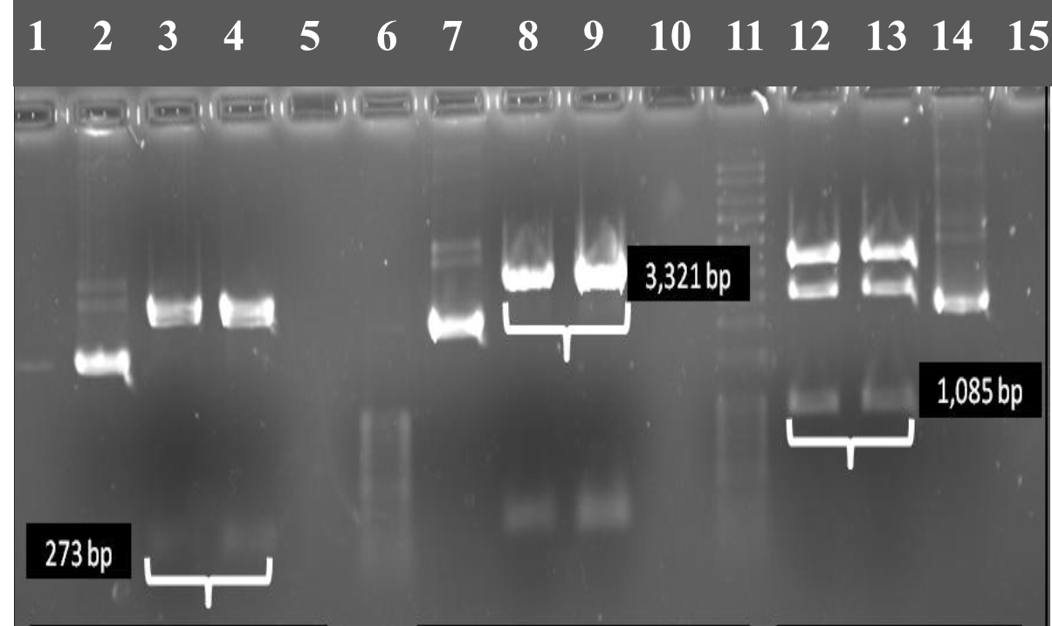
Figure 1-1 Restriction enzyme digested DNA.Lane2: uncut R67 DHFR-pUC57, Lane 3 and 4: NdeI and XhoI digested clone, insert size= 273bp. Lane7: uncut chorismate mutase-pKTS, Lane 8 and 9: NdeI and XhoI digested clone (3,321 bp). Lane 12 and 13: NdeI and XhoI digested Quad4-pUC75 clone, insert size 1,085 bp, Lane14 uncut Quad4-pKTS. Uncut and cut DNA samples were separated on a 1% agarose gel. DNA ladders are also shown in lane 6 and 11 (100 bp and 1000 bp plus, respectively). Brackets show the bands used in cloning.

Determining the tetracycline concentration required for confluent growth in E. coli DH5α and/or E. coli LH-18 (ΔFolA::Kan)

What is the tetracycline concentration required to induce sufficient R67 DHFR and/or Quad4 production to allow TMP resistance in E. coli DH5α?

To determine the minimum tetracycline concentration required to obtain confluent cell growth of DH5α carrying R67 DHFR-pKTS and/or Quad4-pKTS, cells were plated on M9 minimal media without antibiotics or with 200 μg ampicillin/ml, 20 μg/ml TMP and various concentrations of tetracycline (Control: no antibiotic, 10, 25, 50, 75, 100, 200 and 500 ng/ml ng tetracycline/ml). Each plate was examined for three days (the third day plate images are shown in Figure 1-2 (below). After 24 hours, confluent cell growth was observed on the control plate, but E. coli DH5α (control) did not grow on M9 minimal plate with antibiotics. E.coli DH5α carrying R67 DHFR-pKTS and/or Quad4-pKTS showed incremental cell growth that correlates with the tetracycline concentration added to induce expression from the P_{tet} promoter. Cells carrying the R67 DHFR-pKTS clone showed confluent cell growth with 200 μg ampicillin/ml, 20 μg TMP/ml, and 2.00 ng tetracycline/ml, while Quad4-pKTS showed confluent cell growth at 0.40 ng tetracycline/ml Figure 1-2 (below)

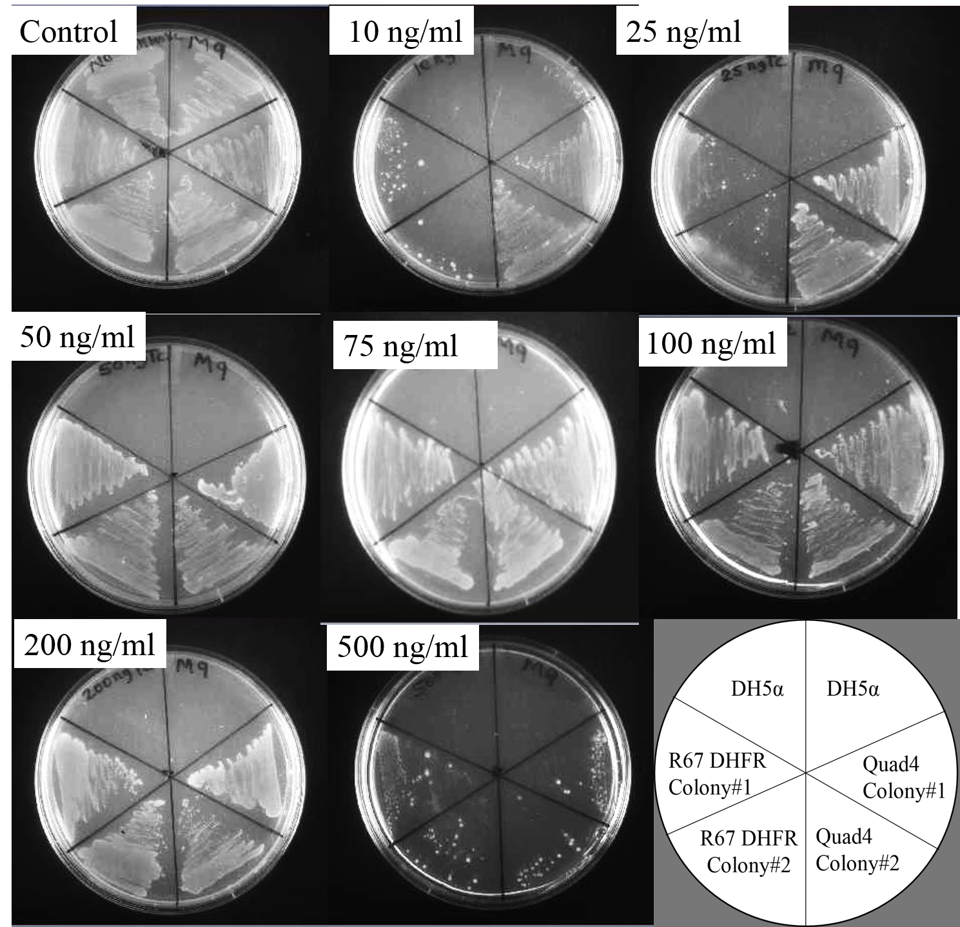
Figure 1-2 Tetracycline dependent R67 DHFR and/or Quad4 production on M9 media.The optimal tetracycline concentration required to induce the P_{tet} promoter to produce sufficient DHFR to support confluent cell growth was determined from the tetracycline dependent cell growth pattern of E. coli DH5α carrying R67 DHFR-pKTS and Quad4-pKTS. Cells were plated on M9 minimal media with 200 μg ampicillin/ml, 20 μg/ml TMP and various concentrations of tetracycline (10, 25, 50, 75, 100, 200 and 500 ng/ml). Confluent cell growth was achieved at 2.00 to 12.00 ng tetracycline/ml for E. coli DH5α carrying R67 DHFR-pKTS, while confluent cell growth was achieved at 0.40 to 8.00 ng tetracycline/ml for E. coli DH5α carrying Quad4-pKTS. The need for a slightly higher concentration of tetracycline for a confluent growth in the R67 DHFR-pKTS clone is likely related to 4 SsrA tags associated with tetrameric R67 DHFR vs. 1 SsrA tag associated with monomeric Quad4. The cartoon in the lower right shows how the constructs are streaked on the plates.

What is the tetracycline concentration required to induce sufficient R67 DHFR and/or Quad4 production to allow confluent growth of E. coli LH-18 (ΔFolA::Kan) on Bonner-Vogel minimal media?

Prior to tetracycline titration, we evaluated the growth pattern of the E. coli LH-18 (∆folA::kan) strain which is auxotrophic for folate end products [3]. The cells were grown in YT liquid media with 20 µg kanamycin /ml plus 50 µg thymidine /ml. The next day, cells were streaked on Bonner-Vogel (BV) minimal agar supplemented with folate end products (30 μg adenine/ml, 10 μg pantothenate/ml, 50 μg glycine/ml, and 50 μg methionine/ml). Kanamycin (25 μg/ml) was also added to select for the deletant strain. Cells were also plated on BV minimal media (lacking the Fol end product supplements) plus kanamycin. The plates were incubated at 37 ºC. After 24 hours, cell growth was observed on BV supplemented media, but cells did not grow on BV minimal media. The 48 hour plate image is shown in Figure 1-3(below). The results are consistent with previous studies that this strain is auxotrophic for folate end products.

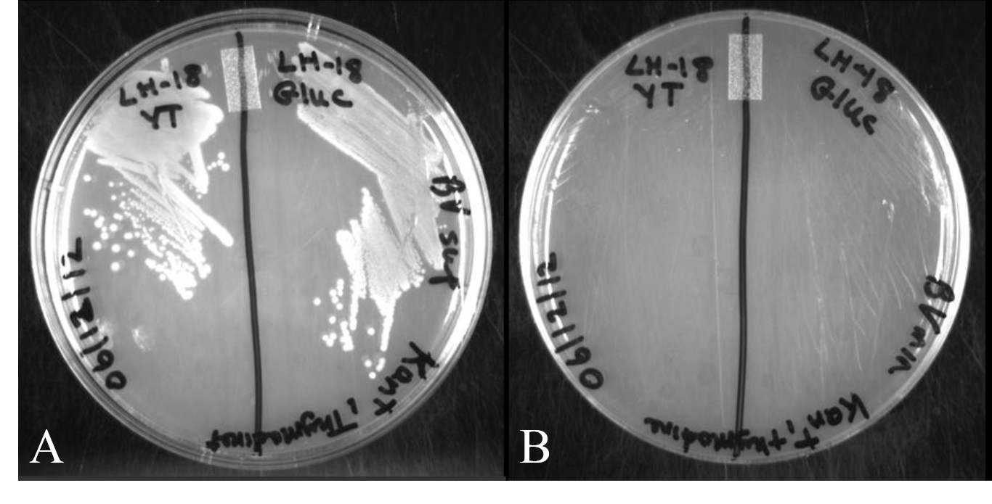
Figure 1-3 The growth pattern of FolA knockout strain E. coli LH-18.Screening E. coli LH-18 in BV supplemented (Panel A) and BV minimal media (Panel B). LH-18 grew on the supplemented media but did not grow on the minimal media. The 48 hour plate image is shown.

To determine the minimum tetracycline concentration required to obtain confluent growth of E. coli LH-18 carrying R67 DHFR–pKTS or Quad4-pKTS, cells were plated on BV minimal media with 25 μg kanamycin/ml, 200 μg ampicillin/ml, and various concentrations of tetracycline (10, 25, 50, 75, 100, 200 and 500 ng/ml ng tetracycline/ml). As a control, E. coli LH-18 and E. coli LH-18 carrying R67 DHFR–pKTS or Quad4-pKTS were plated on BV supplemented media containing 25 μg kanamycin/ml. Each plate was examined for three days (the third day plate image is shown in Figure 1-4(below) After 24 hours, confluent cell growth was observed on the control plate. E. coli LH-18 carrying R67 DHFR-pKTS and/or Quad4-pKTS showed an incremental cell growth pattern that correlated with the tetracycline concentration. Similar to the pattern observed in E. coli DH5α cells carrying the pKTS cloned enzymes (see Figure 2), E. coli LH-18 carrying Quad4-pKTS showed confluent cell growth at 0.40 ng tetracycline/ml Figure 1-4 (below). The R67 DHFR-pKTS clone showed confluent growth at slightly higher tetracycline concentrations (e.g. 30 ng tetracycline/ml).

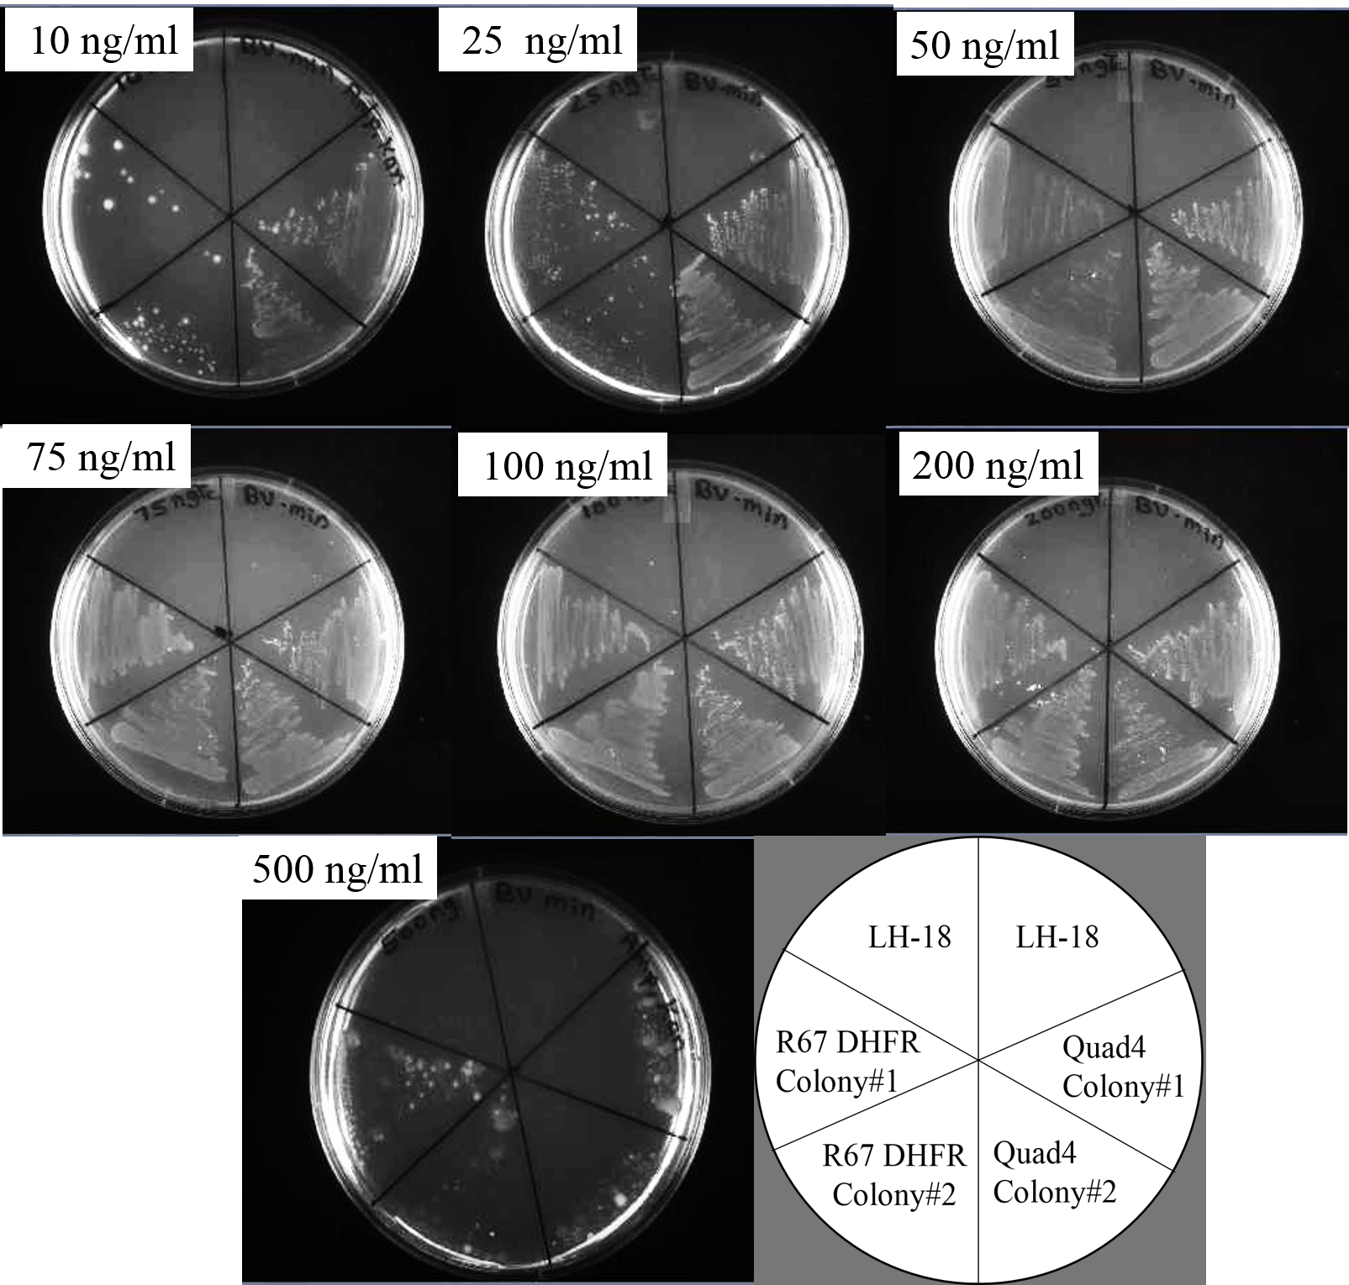
Figure 1-4 Tetracycline dependent R67 DHFR and/or Quad4 production.The optimal tetracycline concentration required to induce the P_{tet} promoter to support confluent cell growth was determined from the tetracycline dependent cell growth pattern of E. coli LH-18 carrying R67 DHFR-pKTS and Quad4-pKTS clones. Cells were plated on BV minimal media containing 200 μg ampicillin/ml, 25 μg/ml kanamycin and various concentrations of tetracycline (10, 25, 50, 75, 100, 200 and 500 ng/ml tetracycline/ml). Confluent cell growth was achieved at 75 to 200 ng tetracycline/ml for E. coli LH-18 carrying R67 DHFR-pKTS, while a confluent cell growth was achieved from E. coli LH-18 carrying Quad4-pKTS starting from 10 up to 200 ng tetracycline/ml. The cartoon on the lower right shows how the constructs are streaked on the plates.

Effect of osmolality on the ability of the R67 DHFR and/or Quad4 pKTS clones to provide TMP resistance to E.coli DH5α cells

External osmotic stress causes cytoplasmic water loss which can slows and/or stop bacterial cell growth, depending on the osmolality. To examine the effect of increasing external osmotic pressure on the growth of E. coli DH5α, cells were plated on M9 media without antibiotic and increasing sorbitol concentrations. The osmolalities were 0.54, 0.79, 1.07, 1.28, 1.64, 1.90, and 2.42 Osm Figure 1-5 (below) . This control was used to assess the osmotolerance of the host bacteria where the media would no longer support bacteria survival and growth. The cell growth pattern for DH5α cells carrying R67 DHFR and Quad4-pKTS clones was also examined. Cells grew until an osmolality of >1.9 Osmol was reached. This is similar to the observation of Cayley et al., where E. coli cell growth stopped at ~ 1.95 Osmol.

To assess the effect of increasing osmolality on the function of R67 DHFR and/or Quad4 in vivo, E.coli DH5α carrying R67 DHFR-pKTS and/or Quad4-pKTS clones were plated on M9 minimal media containing 200 μg ampicillin/ml, 20 μg TMP/ml and 8.0 ng tetracycline/ml with added sorbitol. Osmolality was increased by addition of 0 to 1.50 M of sorbitol in 0.25 M increments. The resulting osmolalities were 0.45, 0.78, 0.81, 1.28, 1.60, 1.93, and 2.29 Osm. The activity of EcDHFR was inhibited with TMP. Ampicillin was used for vector selection. Based on the tetracycline titration results, 4 ng tetracycline/ml was selected Figure 1-5 (below).

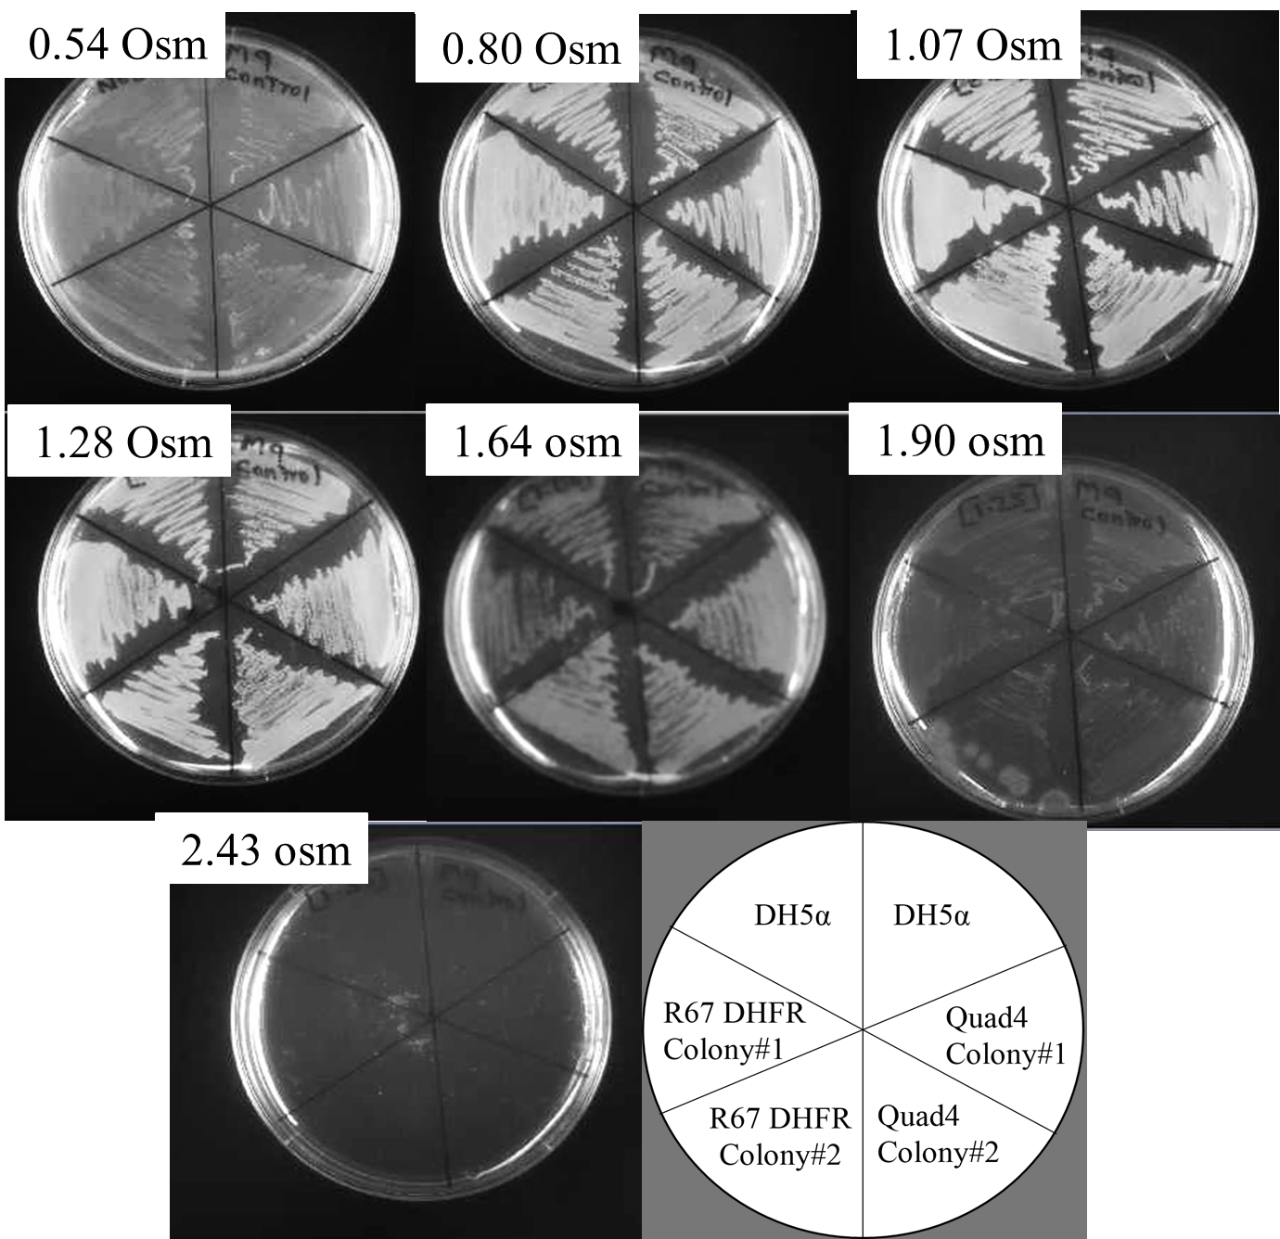
Figure 1-5 Effect of osmolality on E. coli DH5α viability.
An assessment of the ability of E. coli DH5α carrying R67 DHFR-pKTS or/and Quad4-pKTS to grow in the presence of increasing concentration of sorbitol. The cells were plated on M9 minimal medium without antibiotics and different concentrations of sorbitol were added. The plates possessed the following osmolality: 0.54, 0.79, 1.07, 1.28, 1.64, 1.90, and 2.43 Osm. Confluent bacterial growth was observed up to 1.90 Osm. Cell growth was not observed on M9 media possessing a high osmolality (2.42 Osm), suggesting loss of free water in the cytoplasm and cessation of growth. The lower right cartoon shows the pattern of cells streaked on the plates.

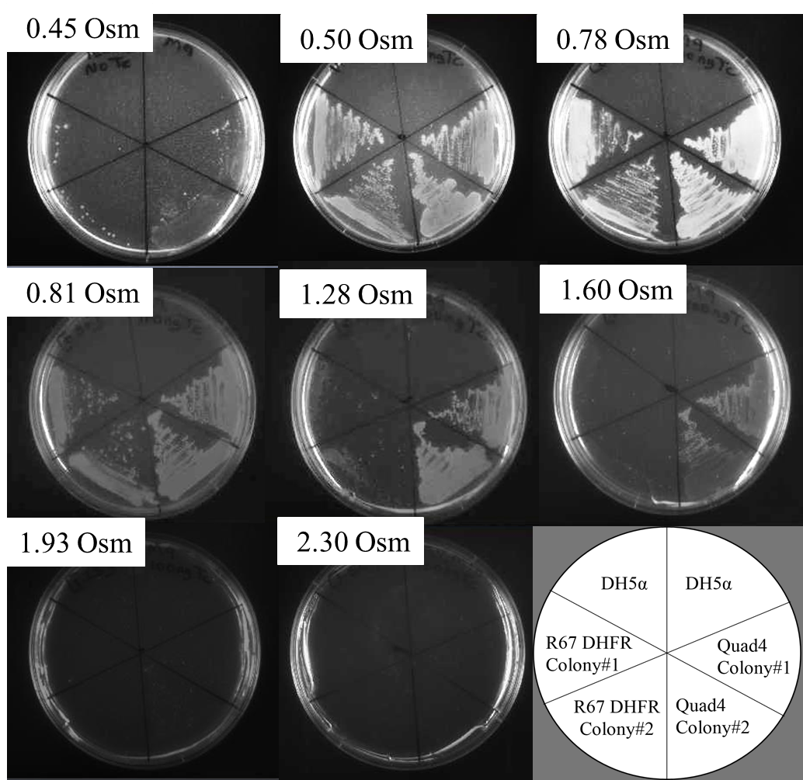
Figure 1-6 Effect of osmolality on R67 DHFR and/or Quad4 activity rescuing E. coli DH5α from TMP.Assessing the ability of R67 DHFR and/or Quad4 cloned genes to provide TMP resistance to host E. coli DH5α. M9 media was used; added antibiotics included 200 μg ampicillin/ml, 20 μg TMP/ml and 8.0 ng tetracycline/ml. Increasing sorbitol concentrations gave an osmolality range of 0.45 to 2.29 Osm. The R67 DHFR-pKTS clone supported confluent E. coli DH5α growth on M9 agar media with 0.45, 0.78, and 0.81 Osm. On the other hand, the Quad4-pKTS clone supported confluent E. coli DH5α growth on M9 media with 0.45, 0.78, 0.81, 1.28, and 1.60 Osm. The lower right cartoon shows how the various cultures are streaked on the plates.

Effect of osmolality on the ability of R67 DHFR and/or Quad4-pKTS clones to rescue E.coli LH-18 to prototrophy

Our first set of cell growth assays assessed how increasing osmolality affected the ability of R67 DHFR and/or Quad4 to provide TMP resistance. Since antibiotic resistance could be titrated, a further assay could probe for effects on DHFR activity. This was addressed by using an E. coli strain, LH18, where the folA gene has been removed and replaced with a kanamycin resistance gene (ΔfolA::kan). For the cell to grow, it either requires addition of folate end products to the media or transformation with a DHFR gene into the mutant strain [3].

A positive control monitored growth of cells on BV supplemented media. E. coli LH-18, LH-18 carrying R67 DHFR-pKTS or Quad4-pKTS all showed confluent growth on 0.55, 0.77, 1.06, 1.34, and 1.50 Osm media. Bacterial growth was slightly decreased in 1.50 Osm conditions. LH-18 did not grow on 2.12, and 2.32 Osm plates Figure 1-7(below).The latter observation suggested that with this level of external osmotic stress, the bacterium no longer has free cytoplasmic water and growth ceases.

To probe the effects of increased osmolality on DHFR activity supplied by the R67 DHFR and Quad4-pKTS clones, osmotic stress conditions were applied to LH18 (ΔfolA::kan). BV minimal media was used with added sorbitol to achieve 0.52, 0.85, 1.04, 1.37, 1.68, 2.10, and 2.23 Osm conditions Figure 1-8 (below). The R67 DHFR clone rescued LH-18 on BV minimal plates possessing osmolality of 0.50, 0.85, and 1.04 Osm, however cell growth on the 1.04 Osm plate was sparse. The Quad4-pKTS construct rescued the E.coli LH-18 cells on BV minimal media possessing osmolality of 0.50, 0.85, 1.04, 1.37 and 1.68 Osm. Confluent cell growth was observed on the first four plates, but cell growth on the 1.68 Osm plate was sparse.

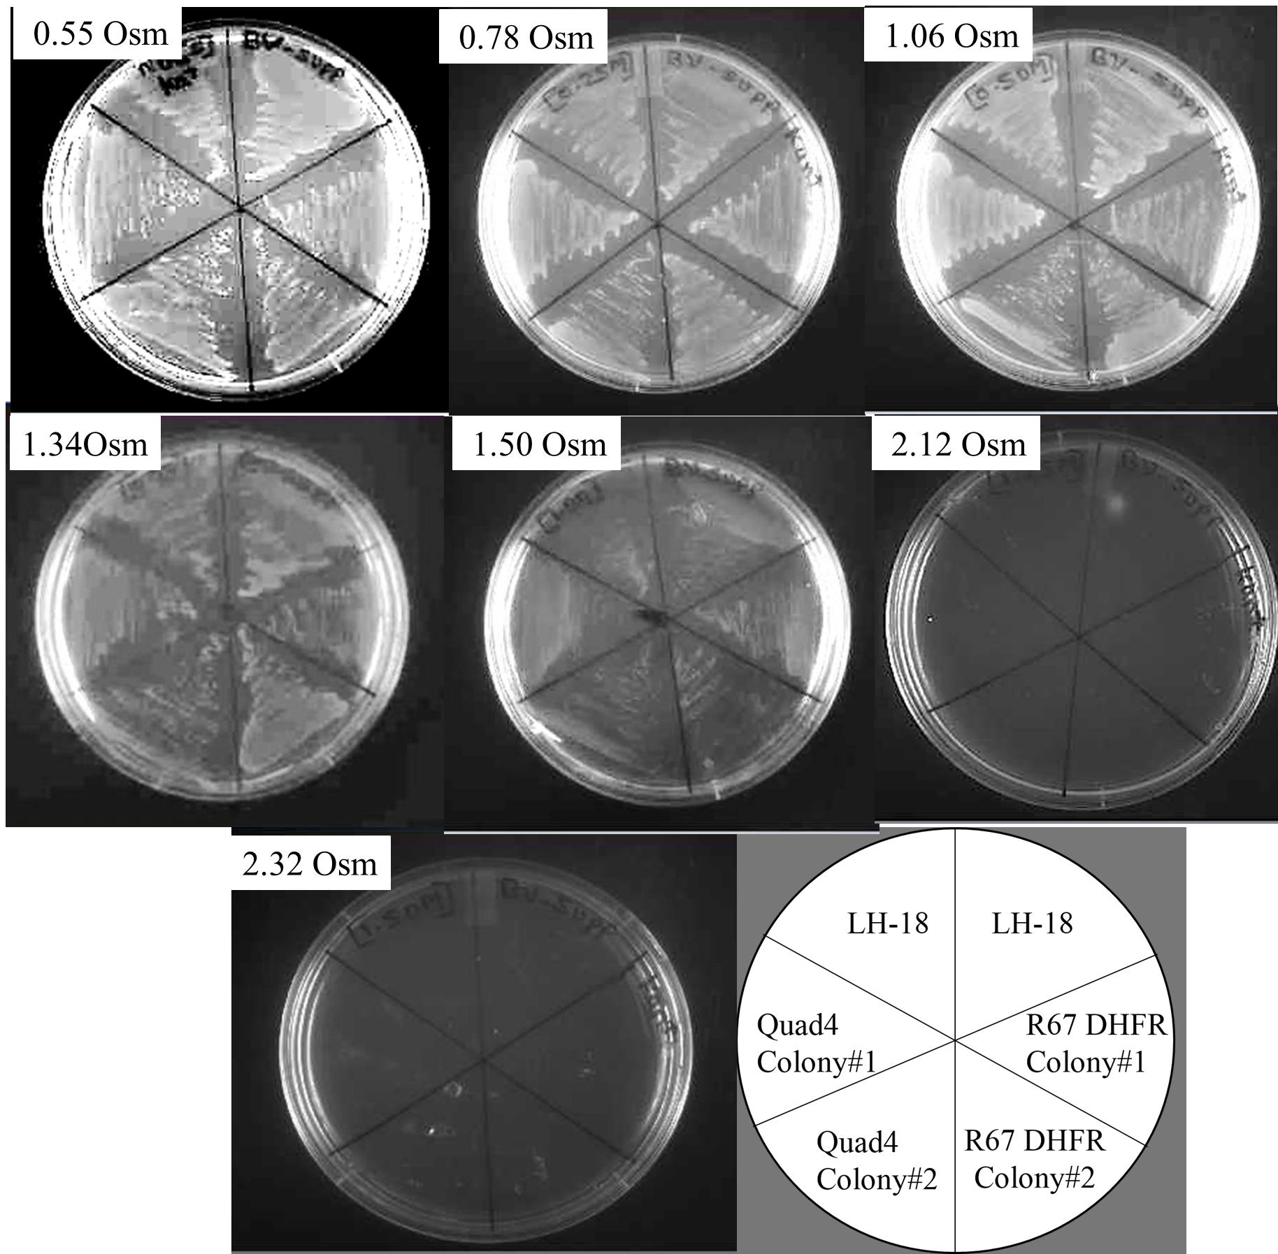
Figure 1-7 Effect of osmolality on E. coli LH-18 viability.The ability of E. coli LH-18, and E. coli LH-18 carrying R67 DHFR-pKTS or/and Quad4-pKTS clones to grow in the presence of increasing concentrations of sorbitol was assessed on BV supplemented media. Added folate end products are 3.03 mg adenine /ml, 1.0 mg pantothenate/ml, and 50 mg glycine /ml with 50 μg thymidine/ml. 25 µg kanamycin/ml was added to select for the ΔfolA::kan lesion. Sorbitol addition led to plates possessing osmolalities of 0.55, 0.77, 1.06, 1.34, 1.50, 2.12, and 2.32 Osm. Confluent bacterial growth was observed until 1.50 Osm. E. coli LH-18 did not grow on BV supplemented plates with an osmolality of ≥ 2.12 Osm, suggesting no free cytoplasmic water was present which blocked cell growth. The lower right cartoon shows how the various cultures are streaked on the plates.

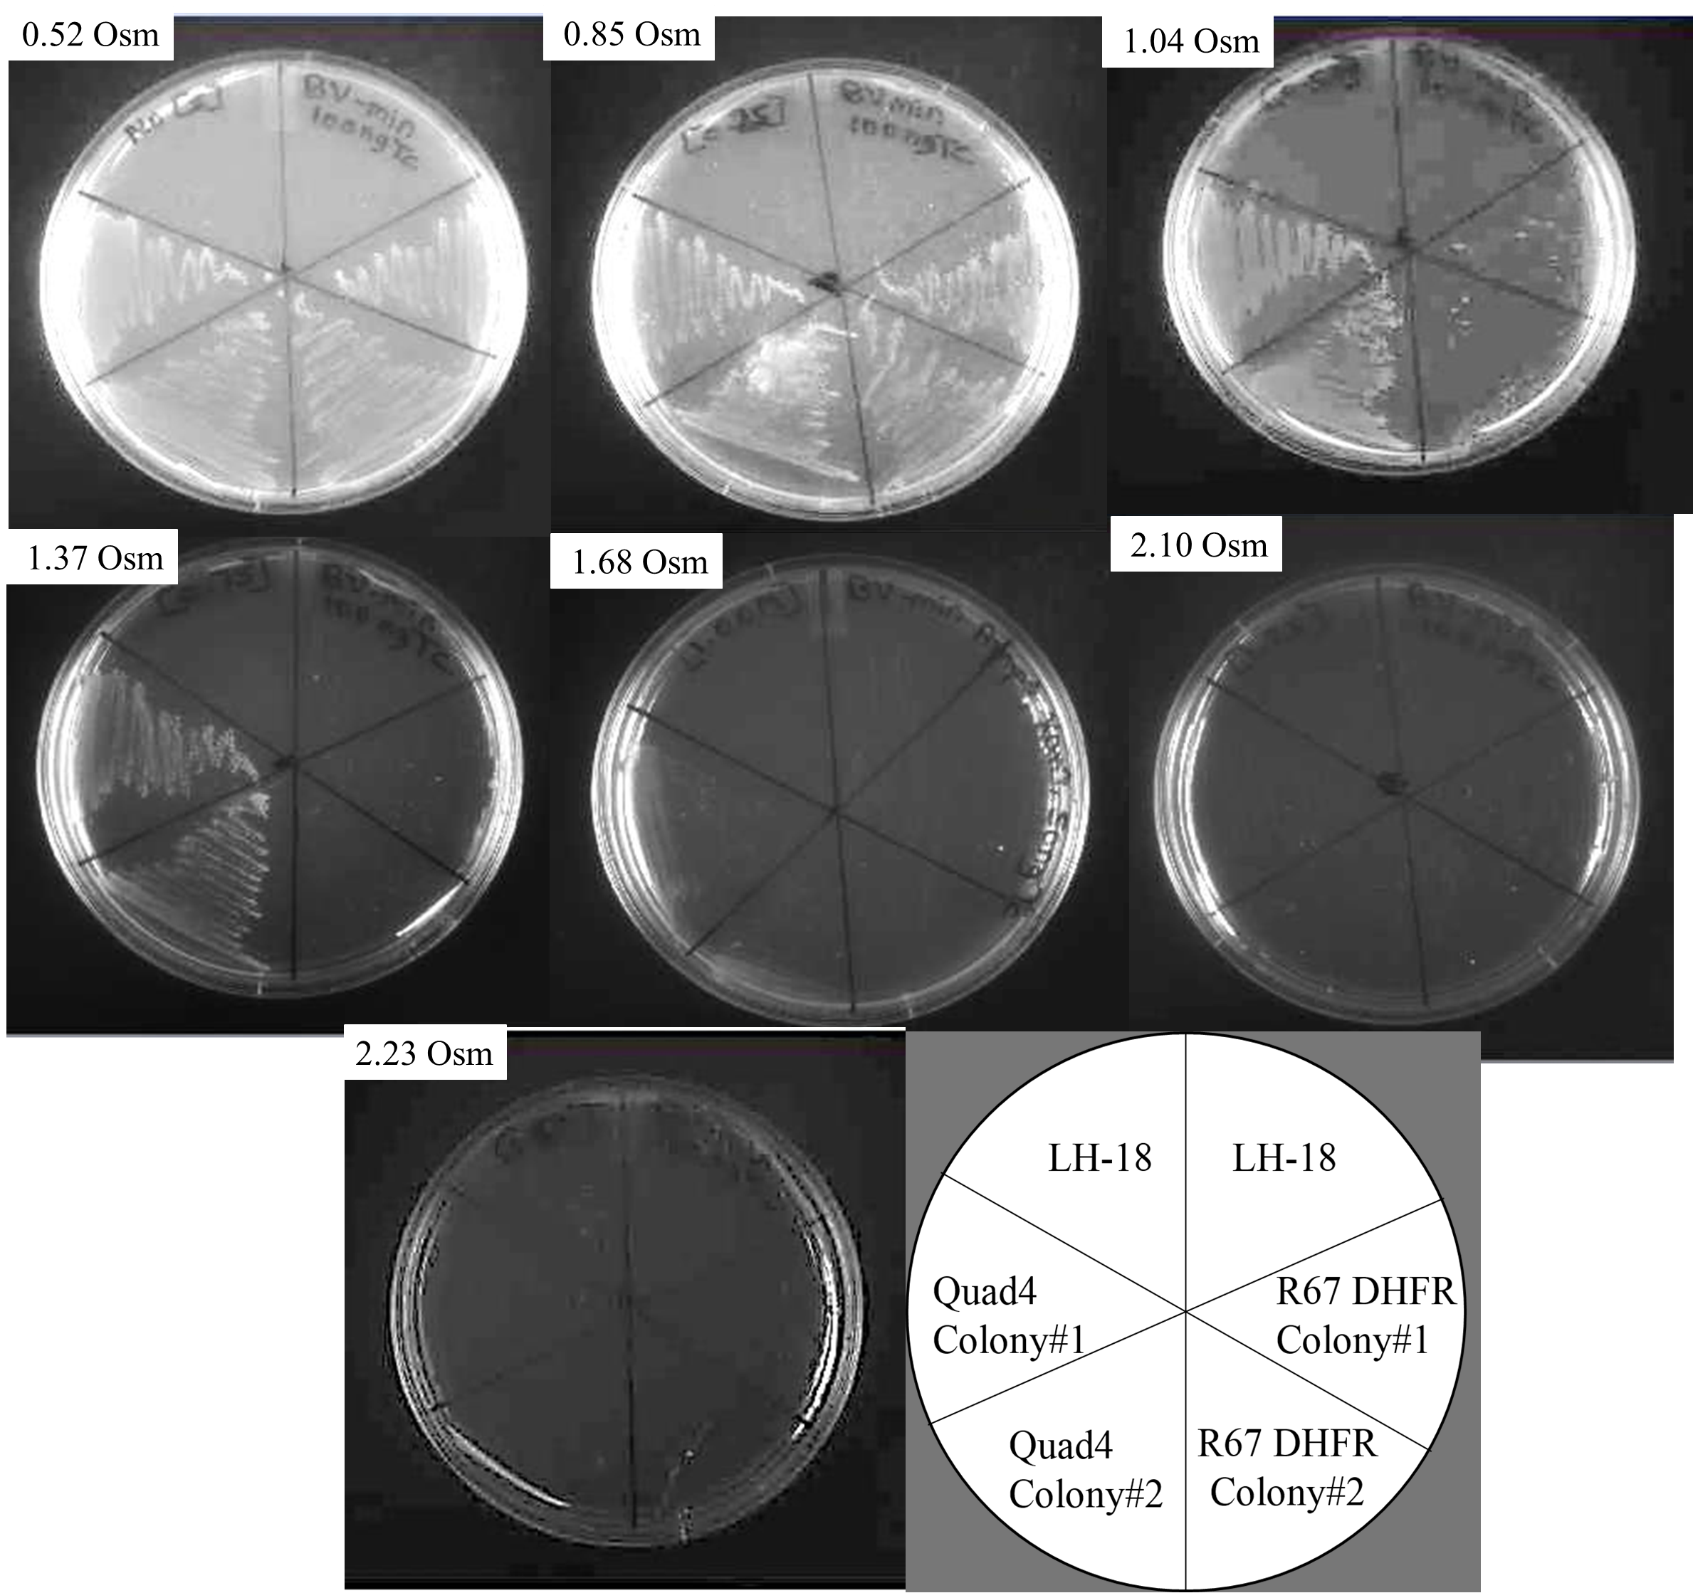
Figure 1-8 Effect of osmolality on R67 DHFR and/or Quad4 activity rescuing E. coli LH-18 to prototrophy.The ability of R67 DHFR or/and Quad4-pKTS clones to rescue LH-18 from folate end product auxotrophy was assessed on BV minimal media containing 200 μg ampicillin/ml, 25 µg kanamycin/ml, 8 ng tetracycline/ml and sorbitol additions such that the osmolality was 0.52, 0.85, 1.04, 1.37, 1.68, 2.10, and 2.23 Osm. The R67 DHFR-pKTS clone rescued LH-18 on BV minimal plates with 0.50, 0.85, and 1.04 Osm, however cell growth on the 1.04 Osm plate was sparse. The Quad4-pKTS clone rescued LH-18 on BV minimal plate possessing osmolalities of 0.50, 0.85, 1.04, 1.37 or 1.68 Osm. Confluent cell growth was observed on the first four plates, but cell growth on 1.68 Osm plate was sparse. The lower right cartoon shows how the various cultures are streaked on the plates.

Two measures of DHFR activity are its ability to confer TMP resistance upon host bacteria and its ability to rescue a DHFR knockout strain from Fol end product auxotropy. As shown in Figures 6 and 8, both of these in vivo assays show sensitivity to increasing osmotic pressure, with loss of cell growth under high osmolalities. Control titrations with media lacking TMP or with supplemented media (Figure 1-5 and Figure 1-7 (above)) indicate that the cells can grow to higher osmolalities. This difference in growth suggests that DHFR activity can be titrated in vivo. These observations are also consistent with the in vitro assays of Chopra et al. [2] where addition of osmolytes weakens binding of substrate to DHFR and decreases the overall activity of the enzyme under limiting substrate conditions.

Can osmotic stress affect the in vivo activity of folC?

Continue probing our hypothesis that osmolytes will interact with many folate redox states and shift the equilibria towards the free species, we next examine the effect of increasing osmolality on the function of folylpolyglutamate synthase (FPGS), the product of the folC gene. This enzyme adds L-glutamate to dihydropteroate; it also extends the glutamate tail of THF using a γ-linkage. Both THF and 10-formyl-THF are FPGS substrates.

E. coli: SF2 (F⁻ folC strA) a mutant strain with a lower activity of folC

A previous study by the Bognar lab has reported two folC mutant strains of E. coli: SF2 (F- folC strA) and SF4 (F- folC strA recA TnI0:srlC) [4]. These strains carry a G925A mutation in the folC chromosomal gene [4] that corresponds to an A309T amino acid change in the protein. This mutant protein displays a 30 fold increase in K_{M} for 10-CHO-THF, a 60 fold increase in the K_{M} for glutamate, a 10 fold increase in the K_{M} for ATP and a 200 fold increase in the K_{M} for dihydropteroate [4][5]. The reduced FPGS activity results in the absolute requirement for methionine in the growth media; added glycine further increases the growth rate [5]. Since the activity of this mutant strain is already compromised, we asked if the FPGS activity of the SF2 strain could be titrated by osmotic pressure.

The parent strain of SF2, known as MG1655, grew on both BV minimal and supplemented plates without and with complementation. SF2 can grow on BV supplemented plates, but not on BV minimal plates Figure 1-9 (below). Transformation of SF2 by plasmids carrying the wt FolC gene allows growth on BV minimal plates. The plasmids were pAC5 and pPM103-FolC (see Table 2 in the Materials and Method section). These cell growth pattern confirmed the methionine and glycine auxotrophy of SF2 and the ability of the clones to rescue the strain to prototrophy. In addition, the similar cell growth pattern of the parent strain with and without the folC clone suggests that having multiple copy of the folC gene is not detrimental to the cell.

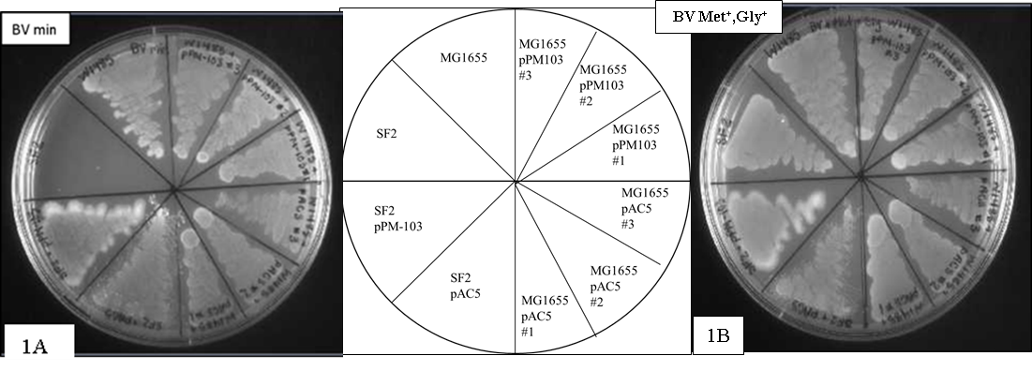
Figure 1-9 The growth pattern of folC mutant strain E. coli SF2.Assessing E. coli SF2 and E. coli MG1655 (SF2 parent strain) growth patterns on BV minimal (Panel A) and BV supplemented with 50 μg methionine/ml and 50 μg glycine/ml plates (Panel B). E. coli SF2 did not grow on BV minimal media.. However, both SF2 carrying a functional folC gene and the parent strain can grow on BV minimal and supplemented plates. Moreover, E. coli MG1655 without and with a high copy number plasmid carrying the folC gene showed similar growth patterns. This result suggests an increased activity of FPGS is not detrimental to the cells. The middle panel shows how the various cultures are streaked on the plates.

Effect of osmolality on the function of folC

On BV media supplemented with excess methionine and glycine/ml

Next, we asked if an increasing in vivo osmolality could impact the ability of the SF2 strain to grow on BV supplemented media. i.e. if osmolytes weakly interact with dihydropteroate and/or tetrahydrofolate based substrates, this can weaken their binding to FPGS and potentially titrate the activity of the A309T mutant enzyme. Since loss of FPGS activity is lethal to the cell [7], this could block cell growth. This hypothesis was tested by plating SF2 and SF2 carrying pAC5 and/or pPM103-FolC plasmids as well as the MG1655 parent strain without and with the pAC5 and/or pPM103-FolC plasmids on BV media supplemented with 50 μg methionine/mL and 50 μg glycine/mL. As described above, the osmolality of the media was gradually increased via sorbitol in 0.25 M increments from 0 to 1.50 M. Also to stimulate FPGS protein synthesis that is controlled by the Lac promoter in the pAC5 plasmid, 1 mM IPTG was added Figure 1-10 (below). The parent MG1655 strain transformed with either pAC5 or pPM103-FolC allowed confluent growth until 1.25 M sorbitol was reached. Cell growth ceased in the presence of 1.50 M sorbitol Figure 1-10 (below). On the other hand, SF2 and SF2 transformed with either pAC5 or pPM103-FolC plasmids grew confluently until 0.75 M sorbitol. Cell growth for the SF2 strain was decreased in the presence of 1.00 M sorbitol and completely ceased in the presence of 1.25 M sorbitol Figure 1-11 (below).

The differences in cell growth pattern between the parent strain and SF2 carrying a functional folC gene (Figure 2) were unexpected. If the difference between the parent strain and SF2 is only the presence of the A309T mutation in the folC gene, we assumed the wildtype clone would complement for the lost activity and allow cell growth under higher osmotic stress.

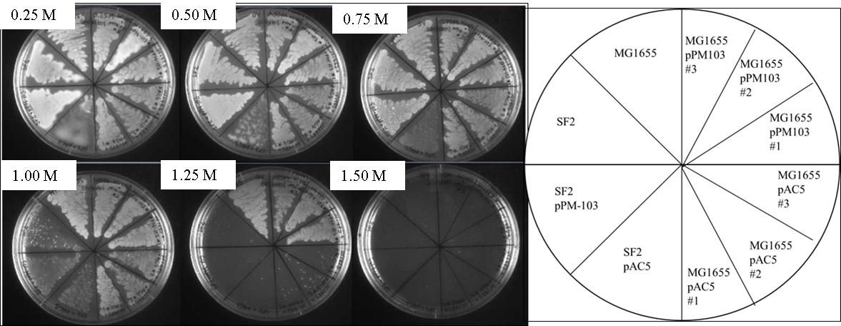
Figure 1-10 effect of increasing osmolality on the growth of E. coli SF2. Assessing the effect of increasing osmolality on the growth of E. coli SF2 (F⁻ folC strA) with and without complementation for methionine auxotrophy by transformation with pAC5 and pPM103-FolC plasmids. Several controls involved E. coli MG1655, the parent strain of SF2. MG1655 was also transformed with pAC5 and pPM103-FolC plasmids. All cultures were streaked on BV minimal media supplemented with 50 μg methionine/mL and 50 μg glycine/mL with various concentrations of sorbitol (0.25 M, 0.50 M, 0.75 M, 1.00 M, 1.25 M or 1.50 M). E. coli MG1655 and E. coli MG1655 carrying pPM103-FolC showed confluent growth until 1.25 M sorbitol and stopped growing in 1.50 M sorbitol. E. coli MG1655 carrying the pAC5 plasmid showed confluent growth until 1.00 M and sparse cell growth on 1.25 M sorbitol plate while cell growth ceased on 1.50 M sorbitol.

On BV media supplemented with optimal concentration of methionine

In another series of experiments, we asked if decreasing the methionine and/or glycine concentration from an optimal level would increase the pressure on the enzyme to function under increasing osmotic pressure and allow an osmotic pressure titration of FPGS activity. The methionine concentration ranged from 0 to 50 µg methionine/ml with 50 µg glycine /ml. Minimal growth of SF2 was observed on a BV media supplemented with 7.46 µg methionine /ml (data not shown). Then, the various cultures were plated on BV media supplemented with the minimal 7.46 µg methionine /ml and 50 µg glycine/mL and the osmolality of the media was titration via sorbitol addition. Interestingly, the cell growth patterns of the parent strain and the parent strain carrying three different plasmid were able to show confluent growth up to 1.25 M sorbitol osmolality. The cell growth was slightly decreased under 1.50 M sorbitol osmolality Figure 1-11 (below). On the other hand, SF2 with and without complementation showed confluent growth up to 1.00 M sorbitol osmolality and the cell was decreased under 1.25 m and completely stopped under 1.50 M osmolality. While SF2 growth stops earlier than MG1655 in the sorbitol series, its behavior is not rescued by addition of a plasmid carrying the FPGS gene. These results suggest that other mutations may be present in the SF2 strain to make it more sensitive to osmotic stress. As SF2 was created by treating MG1655 with ethylmethane sulfonate [5], this seems possible. Our inability to titrate FPGS activity by osmotic stress indicates either that FPGS is not sensitive to osmotic pressure or that the FPGS activity is still sufficient to rescue the cell. A next step would clone the FPGS into pKTS and transform this construct into a folC knockout strain. This construct could then be tested.
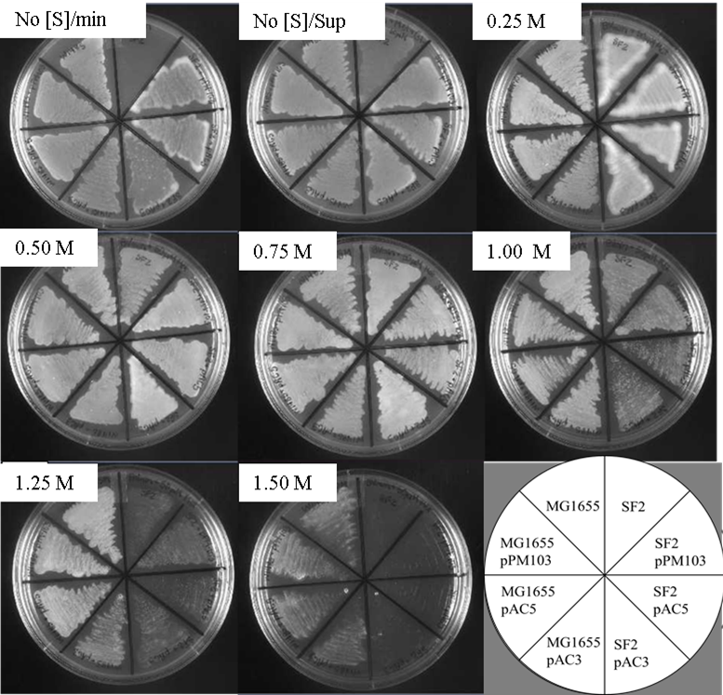
Figure 1-11 effect of increasing osmolality on E. coli SF2 on BV minimal media with optimal methionine concentration. Assessing the effect of increasing osmolality on the growth of E. coli MG1655 and SF2 strains. Both strains were transformed with a functional folC gene carried in pPM103 or pAC5 plasmids. Cultures were streaked on BV minimal media supplemented with 7.46 µg methionine/ml and 50 μg glycine/ml with various concentrations of sorbitol (0.25 M, 0.50 M, 0.75 M, 1.00 M, 1.25 M or 1.50 M) and 1 mM IPTG. MG1655 or MG1655 carrying the pPM103-FolC or pAC5 plasmid showed confluent growth until 1.25 M sorbitol and stopped growing under 1.50 M sorbitol concentration. However, both SF2 and SF2 carrying pPM103-FolC and/or pAC5 showed decreased growth in the presence of 1.25 M sorbitol and completely stopped growing in the presence of 1.50 M sorbitol. The bottom right panel shows how the various cultures are streaked on the plates.

Cloning Methylenetetrahydrofolate Reductase into the pKTS plasmid

The next enzyme to be cloned into the pKTS plasmid was methylenetetrahydrofolate reductase (MTHFR). This enzyme catalyzes the reduction of 5, 10-methylene-THF to 5-methyl-THF using NAD(P)H as a cofactor [8, 9]. If osmolytes weakly interact with 5, 10-methylene-THF, as predicted in the introduction of this thesis, we may be able to titrate the ability of MTHFR to rescue an auxotrophic strain to prototrophy by increasing the level of osmotic stress. This section describes initial experiments that construct the metF-pKTS plasmid and examine the auxotrophy of the JW3913-1 (∆metF:: kan) strain. Experiments are ongoing in the lab to determine the effect of increasing concentration of osmolytes on the activity of MTHFR by the ability of the metF-pKTS plasmid to rescue E. coli JW3913-1 (∆metF:: kan) to prototrophy.

Designing a primer, PCR amplification and cloning into pCR 2.1 TOPO TA vector

A clone of the MTHFR gene was a gift from Dr. Elizabeth Trimmer from Grinnell College.
Her pCAS-30 clone is a derivative of the pET2-3b plasmid [8]. To assess the quality of the DNA and cloning sites of the gene, the DNA was transformed, selected and sequenced with T7 and T7 terminator primers. The sequence alignment results showed the metF open reading frame was cloned between XbaI and XhoI sites. A sequence encoding a C-terminal His₆ tag was present. To introduce an NdeI restriction sequence via PCR a forward primer that adds a NdeI restriction sequence was used along with a primer near the T7 terminator site. Primers were designed as described in the Material and Methods section of this thesis (Table 5). The primers were synthesized by Invitrogen, Carlsbad, CA.

Next, for the purpose of adding an ‘A’ overhang into the PCR product of metF which would enable cloning in the TOPO TA pCR 2.1 (Invitrogen) vector, Taq polymerase was used. The PCR product is shown in Figure 1-12 (below) The PCR product was cleaned with the GeneJET PCR Purification Kit (Thermo Scientific), cloned into the TOPO TA vector and transformed into TOP10 E. coli cells. Cells were plated on YT agar with 50 µg kanamycin /ml. Use of the X-gal blue/white colony screening technique allowed selection of six white colonies. These cells were individually grown in YT liquid media, the plasmid DNA was mini prepped and sequenced with M13 Forward and M13Reverse primers. Five correct colonies were found.

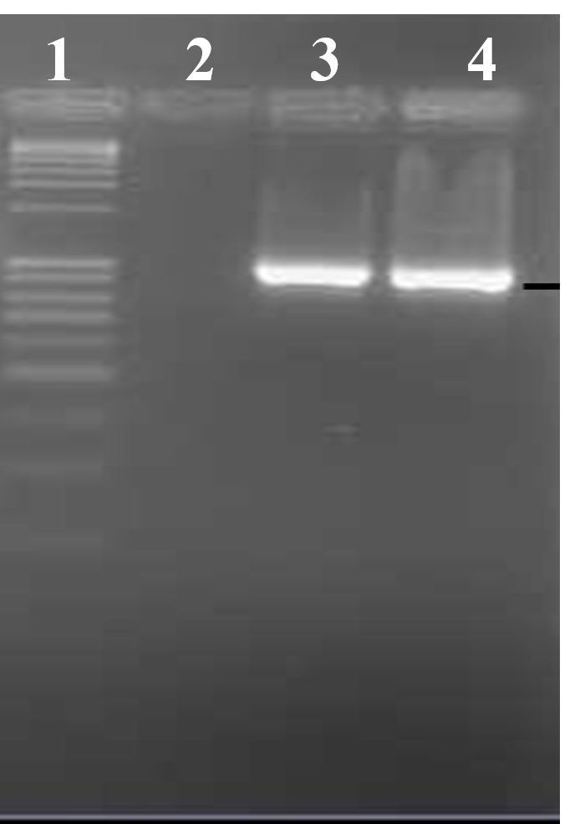
Figure 1-12 metF PCR product. PCR amplification of the metF gene. Primer sequences are given in the Materials and Methods section. An Nde1 restriction site was introduced at the 5’ end of the gene. The expected length of the PCR product was 891 bp. The PCR product was electrophoresed on a 1% agarose gel. Lane 1:1Kb plus DNA ladder and Lanes 3 and 4: the PCR product of metF of expected size.

Construction of the metF-pKTS plasmid

To clone the metF gene into pKTS, a correct metF-pCR 2.1 clone and the pKTS-chorismate mutase plasmid were double digested with NdeI and XhoI restriction enzymes. The DNAs were separated on a 1% agarose gel Figure 1-13 (below). The correct sized DNA fragments for the metF gene and the pKTS plasmid were excised from the gel and ligated with T4 DNA ligase (TaKaRa). The ligation mixture was transformed into the E. coli (∆metF::kan) strain. This strain is auxotrophic for methionine, thus it will grow only on minimal media supplemented with methionine or when complemented with a plasmid carrying a functional metF gene. The ligation mixture was transformed into JW3913-1 (∆metF::kan) and the cells plated on either YT agar with 200 μg/ml ampicillin , 25 μg/ml kanamycin/ml and µg methionine/ml or BV minimal agar with 200 μg/ml ampicillin and 25 μg/ml kanamycin/ml, and 80 ng/ml tetracycline. The next day, tiny colonies started to appear on the YT plates and within 48 hours, colonies developed. On BV minimal media, colonies started to appear after 48 hours. After 48 hours, six colonies from the YT plate were selected and individually inoculated into YT broth with 200 μg/ml ampicillin. After overnight growth, the plasmid DNA was extracted and the insert sequence was identified by DNA sequencing with T7 and T7 terminator primers.

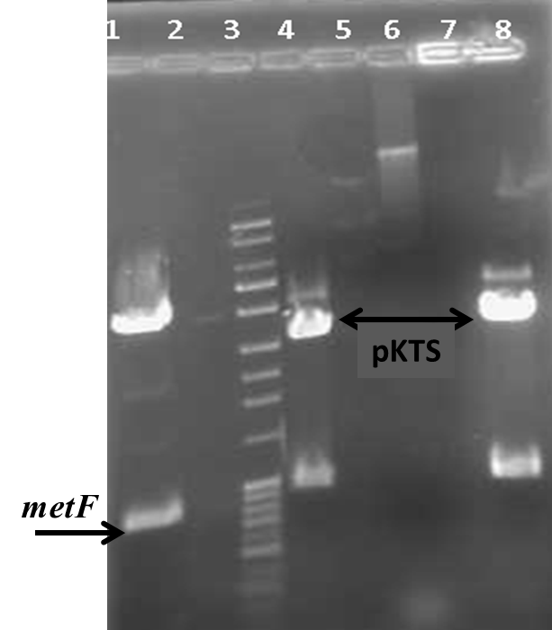
Figure 1-13 NdeI and XhoI digest metF-pCR 2.1 and pKTS. Restriction enzyme digested metF-pCR 2.1 and pKTS-chorismate mutase. The plasmids were digested with NdeI and XhoI and the DNA fragments were electrophoresed in a 1% agarose gel. Lane1: metF-pCR 2.1, Lane3, 1,000 bp plus DNA ladder, Lanes 4 and 8, pKTS vector with a chorismate mutase gene insert. The correct DNA fragments are shown by the arrow: metF ~891 bp and pKTS ~3.9 kb.

Assessing the growth pattern of E. coli JW3913-1 (∆metF::kan)

To characterize the growth pattern of E. coli JW3913-1 (∆metF:: kan), the cells were grown in YT liquid media with 25 μg kanamycin/mL and 50 µg methionine/ml. The next day, the cells were plated on BV agar supplemented with 50 μg methionine /ml and 25 µg kanamycin/mL or BV minimal media with 25 µg kanamycin/ml. The plates were checked for five consecutive days. Cell growth was observed on BV supplemented media after 24 hours, but E. coli JW3913-1 (∆metF::kan) did not grow on BV minimal media. The image of the plate at 48 hrs is shown in Figure 1-14 (below). This growth pattern confirmed that E. coli JW3913-1 (∆metF::kan) is auxotrophic for methionine.

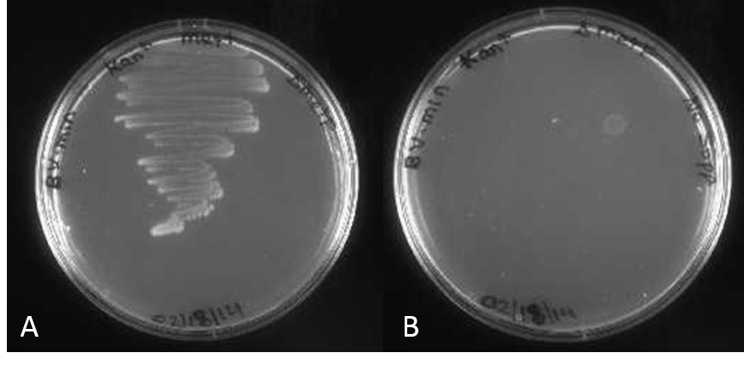
Figure 1-14 The growth pattern of metF mutant strain E. coli E. coli JW3913-1 (∆metF::kan). Screening E. coli JW3913-1 (∆metF::kan) for growth on BV minimal and supplemented media. BV minimal media was described in the Materials and Methods section and BV supplemented media has 50 g methionine/ml added to allow the knockout strain to grow.

What is the tetracycline concentration required to induce sufficient production of MTHFR to allow complementation of E. coli JW3913-1 (∆metF::kan)?

To determine the minimum tetracycline concentration that will allow confluent cell growth of E. coli JW3913-1 (∆metF::kan) , several cell stocks carrying the metF-pKTS plasmid were grown in a YT liquid media with 200 μg ampicillin/ml and 25 μg kanamycin/ml. Next the cells were plated on BV minimal media with 200 μg ampicillin/ml, 25 μg kanamycin/ml and various concentrations of tetracycline (10, 25, 50, 75, 100, 200 and 500 ng/ml ng tetracycline/ml). The plates were examined for three days. After 18 hours, confluent cell growth was observed (the second day plate image is shown in Figure 1-15 (below). Sparse cell growth was observed on BV media with no tetracycline and 10 ng tetracycline/ml. Confluent growth was obtained on the plates with 25 to 200 ng tetracycline/ml. Cell growth became sparse on a 500 ng tetracycline/ml plates Figure 1-15(below).

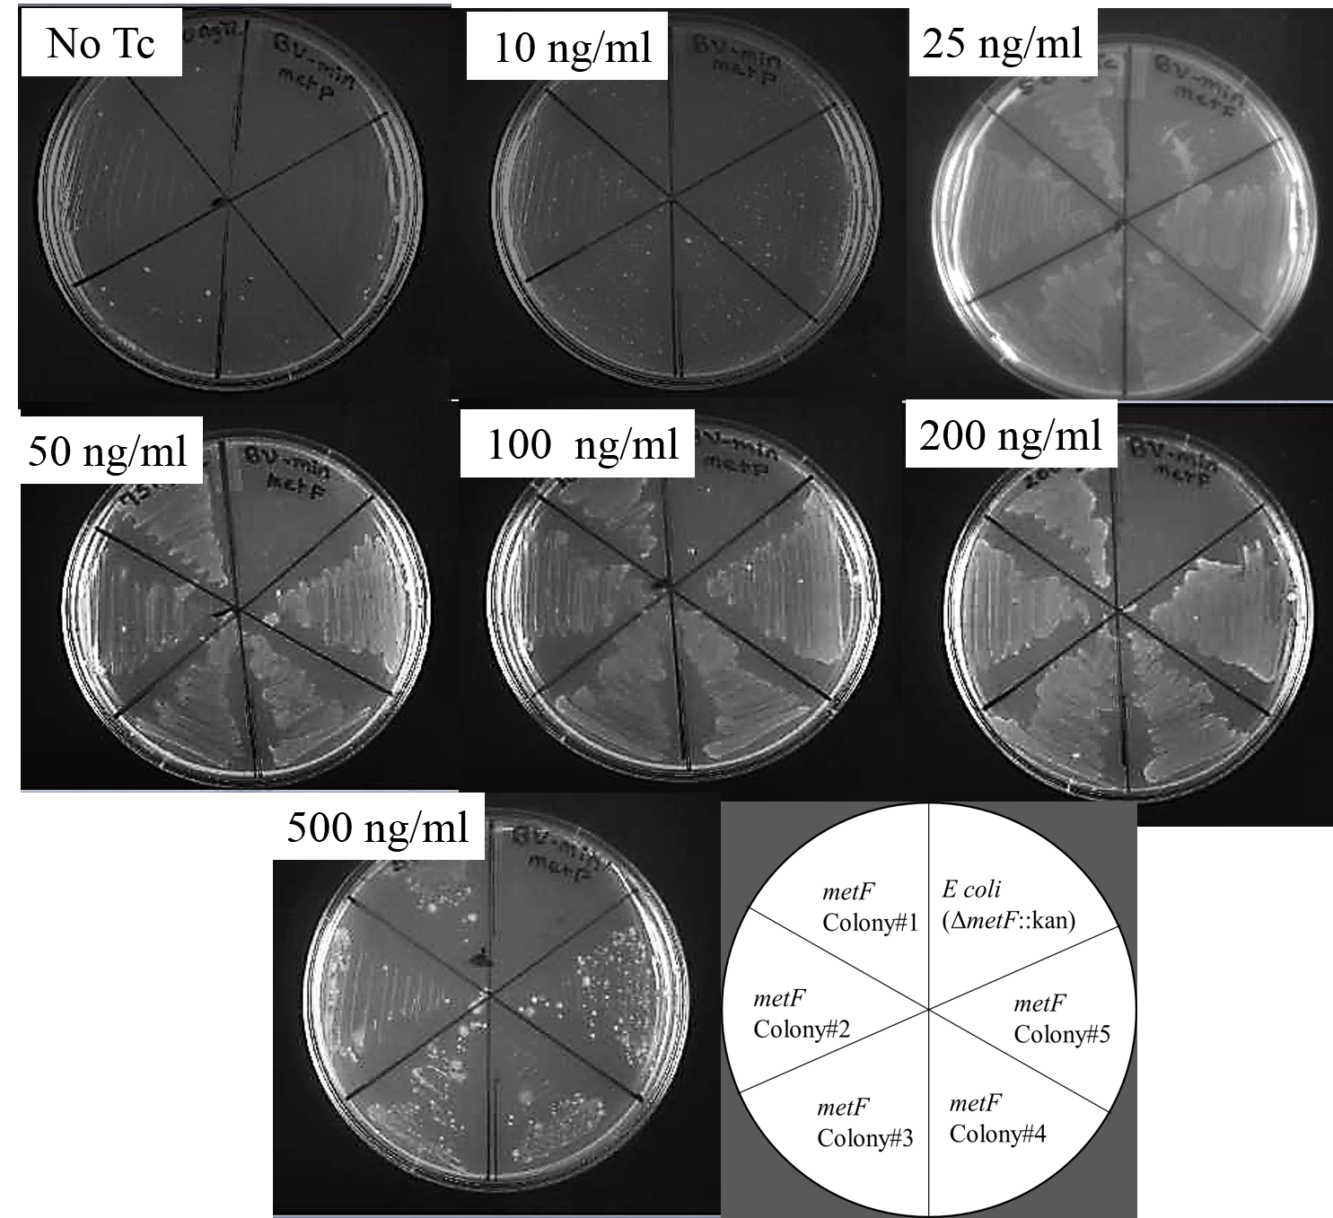
Figure 1-15 Tetracycline dependent metF production. Screening E. coli JW3913-1(∆metF::kan) carrying the metF-pKTS plasmid. The cells were grown on BV minimal media and the concentration of tetracycline that allowed cell growth was monitored. Confluent cell growth was observed at concentrations ≥ 25 ng tetracycline/ml. The highest tetracycline concentration (500 ng/ml) showed punctate growth, suggesting the concentration was too high. The bottom right panel shows how the various cultures are streaked on the plates.

Initial experiments to explore the effect of in vivo osmotic stress on serine hydroxymethyl transferase activity

The next folate pathway enzyme we considered was serine hydroxymethyl transferase (SHMT). This enzyme is encoded by the glyA gene and the protein catalyzes the reversible conversion of serine and tetrahydrofolate to glycine and 5,10-methylene tetrahydrofolate [10]. If osmolytes preferentially interact with either THF and/or 5, 10-methylene tetrahydrofolate, increasing the osmolyte concentration in vivo would weaken the catalytic efficiency of the enzyme. To test this hypothesis, the glyA gene was cloned into pKTS. Experiments are ongoing in the lab to determine the effect of increasing concentration of osmolytes on the activity of SHMT by the ability of glyA-pKTS to rescue E. coli JW 2535-1 (Δgly::kan) to prototrophy.

Designing a primer, PCR amplification and cloning into the pCR 2.1 TOPO TA vector

We obtained the E. coli glyA gene cloned in the pBlueScript KS vector from Roberto Contestible. The DNA was transformed into E. coli DH5α and plated on YT agar with ampicillin. After overnight growth, five colonies were selected and grown, the plasmid DNA was purified and sequenced with M13 Forward and M13 reverse primers. The open reading frame of the glyA gene was cloned between PstI and BamI cloning sites. Next, to introduce NdeI and XhoI restriction sequence via PCR, primers were designed. The primer sequences are given in the Materials and Methods section. The primers were synthesized by Invitrogen (Carlsbad, CA).

Next, for the purpose of adding an ‘A’ overhang into the PCR product of glyA that would enable cloning using the TOPO TA kit (Invitrogen), Taq polymerase was used . The PCR product is shown in Figure 1-16 (below). The PCR product was cleaned with the GeneJET PCR Purification Kit (Thermo Scientific), cloned into the TOPO TA vector and transformed into TOP10 E. coli cells. Half of the transformed cells were plated on YT agar with 50 µg kanamycin /ml. The other half of the transformed cell mixture was plated on agar containing X-gal and IPTG for blue/white screening. Eight individual white clones were grown in YT liquid media, the plasmid DNA extracted and the DNA sequenced with M13F/M13Rev primers. Five correct clones were identified.

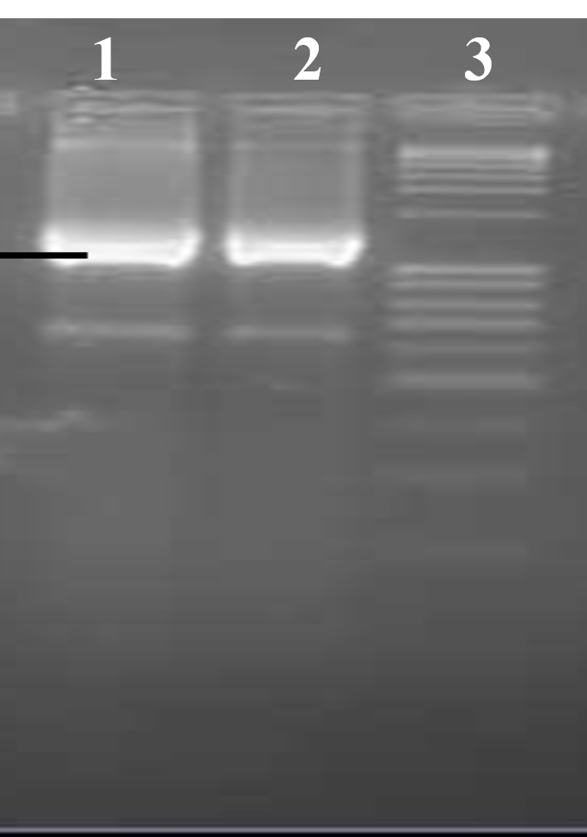
Figure 1-16 glyA PCR product. Introduction of Nde1 and Xho1 restriction enzyme sites into the glyA gene by PCR amplification. The primer pair specific to glyA that enabled addition of NdeI and XhoI sites was used to amplify the coding region of glyA (1,254 bp). The PCR product was electrophoresed on a 1% agarose gel. Lanes 1 and 2: glyA PCR product and Lane 3: 1Kb plus DNA ladder. The PCR product appears in the position expected for its size.

Construction of the glyA-pKTS plasmid

The next step was to digest the correct glyA-pCR2.1 clone with NdeI and XhoI and separate the fragments on a 1% agarose gel see Figure 1-17(below). The double digest of glyA-pCR2.1 revealed three bands. The top band was about 3.9 kb, which is the size of TOPO plasmid pCR2.1 vector. The bottom two bands were approximately 900 bp and 300 bp. Assessment of the glyA sequence found an internal XhoI site at 906 bp which suggested the ~ 900 bp and ~300 bp fragments came from the glyA insert.
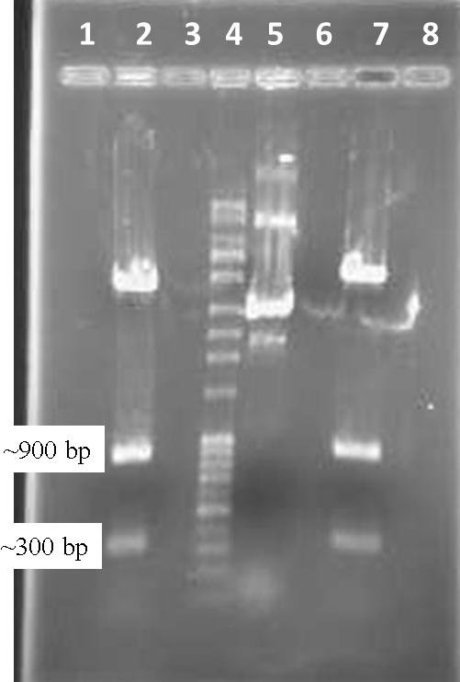
Figure 1-17 NdeI and XhoI digest glyA. Digestion of glyA-pCR 2.1 by NdeI and XhoI and separation on an agarose gel. Lanes 2 and 7: double digested glyA-pCR 2.1, Lane 4: 1 kb plus DNA ladder, and Lane 5: Uncut glyA-pCR 2.1. The double digested glyA-pCR 2.1 plasmid released ~3.9 bp, 900 bp and 300 bp fragments. The 3.9 bp fragment corresponded to the pCR 2.1 vector. However instead of an ~1.2 bp glyA fragment, ~ 900 bp and 300 bp fragments were detected. The lack of the correct sized glyA fragment led to noticing the presence of an internal XhoI site at 906 bp position that cut glyA into 906 bp and 348 bp fragments.

Two commonly utilized techniques to obtain a complete DNA fragment from a vector carrying multiple undesired restriction sites are digesting the vector using a partial digest and/or changing the undesired restriction enzyme recognition site via site specific mutagenesis technique. For the latter, codon redundancy could allow use of an alternative DNA sequence which does not change the protein sequence.

After assessing our options, we elected to use the partial digestion protocol by Bloch and Grossmann [11]. Briefly, ~ 9 µg glyA-pCR 2.1 plasmid DNA was re-suspended in 90 µL sterile milli-Q H₂O. Then, we added 1X CutSmart™ buffer (NEB) and 3U of NdeI enzyme and incubated the sample at 37 ºC for 1 hour. After an hour, the sample was kept on ice and transferred into five sterile eppendorf tubes labeled one to five with the following order and volume: Tube1: 30 µL , Tube 2: 20 µL, Tube 3: 20 µL, Tube 4: 20 µL , and Tube 5: 10 µL. Next, 3U of XhoI was added in to the first tube and gently mixed. Then, 10 µL sample was transferred, mixed and again a10 µL sample was transferred to the next tube. In other words a 10 µL sample was serially diluted until the 5th tube. Finally, the tubes were incubated at 37 ºC for 30 minutes. Immediately after removing the samples from the incubator, each sample was loaded on a 1% agarose gel and separated. The electrophoresed DNA sample image is shown in Figure 1-18(below).

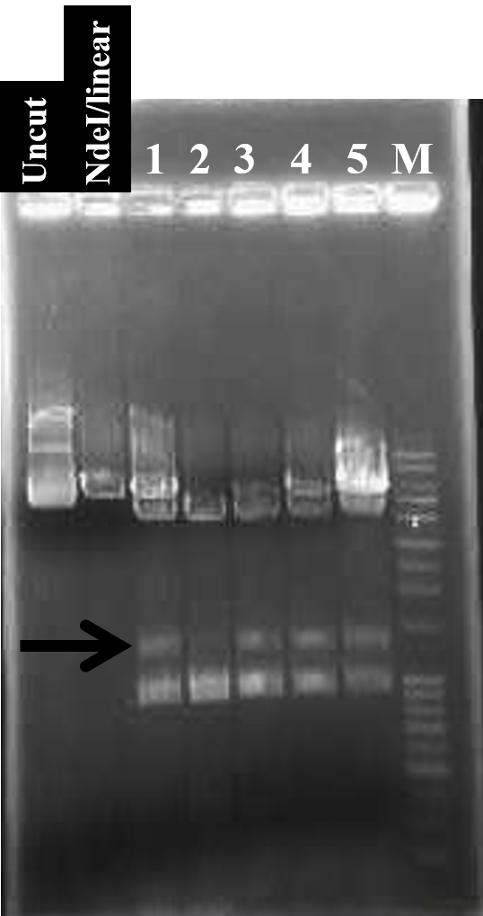
Figure 1-18 partially digested glyA. The glyA-pCR 2.1 vector was fully digested with NdeI and partially digested with XhoI. Fragments were separated on a 1% agarose gel. Lane 1: Uncut glyA-pCR 2.1, Lane 2: NdeI digested glyA-pCR 2.1, Lanes 3 to 7 (partial digest tubes numbered 1 to 5) partially digested glyA-pCR 2.1, and Lane 8:1 kb plus DNA ladder. Lane 1 shows supercoiled glyA-pCR 2.1, Lane 2 shows the approximate size of vector plus insert, which is ~ 5,000 bp. Lanes 4 to 7: from partially digested NdeI digest glyA-pCR 2.1, an additional partial digest band was found, shown by the arrow. The size of the top fragment was between 4,000- 5,000 bp. The next fragment was slightly lower than the 1,500 bp marker. And the bottom DNA fragment was ~1,000 bp. Since the middle fragment (black arrow) was closer to the expected glyA size of 1,254 bp, the DNA from all five lanes was excised and used for cloning.

Assessing the growth pattern of E. coli JW2535-1 (∆glyA::kan)

After receiving E. coli JW2535-1 (∆gly::kan) from the Coli Genetic Stock Center, we tested it for glycine and serine auxotrophy [12]. The cells were grown in YT liquid media with added 50 µg glycine /ml, 50 µg serine /ml, and 25 μg kanamycin/ml. The overnight culture was streaked on BV agar media supplemented with 50 µg glycine /ml, 50 µg serine /ml, and 25 μg kanamycin/mL and/or BV minimal media with 25 µg kanamycin/ml. The plates were incubated at 37 ºC and checked for five consecutive days. After 24 hours, cell growth was observed on BV supplemented media, but cells did not grow on BV minimal media for two days. Slight cell growth was observed after 72 hours. The image for 48 hours growth is shown in Figure 1-19(below). These results suggest that E. coli JW2535-1 (∆glyA::kan) is auxotrophic for glycine and serine.

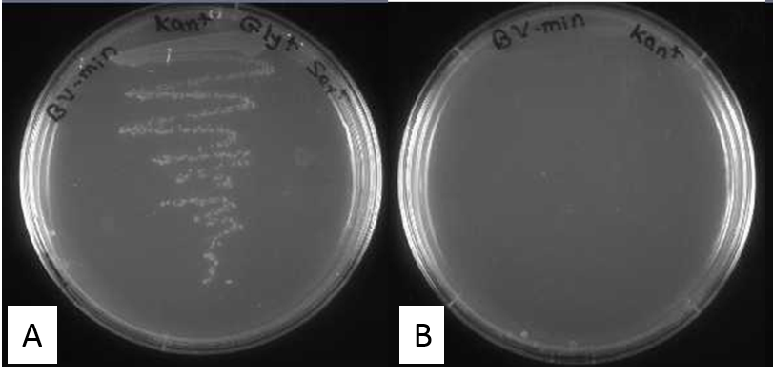

Figure 1-19 The growth pattern of glyA mutant strain E. coli SF2.Screening the growth of E. coli JW2535-1 (ΔglyA::kan) in BV minimal (Panel B) and supplemented media (Panel A). E. coli JW2535-1 (ΔglyA::kan) did not grow on the BV minimal media (right), but it did grow on BV media supplemented with glycine and serine (left).

What is the tetracycline concentration required to induce production of sufficient SHMT to rescue E. coli JW2535-1 (∆glyA::kan) to prototrophy?

To determine the minimum tetracycline concentration that allows confluent cell growth of E. coli JW2535-1 carrying the glyA-pKTS plasmid, cells were grown in YT liquid media with 200 μg ampicillin/ml and 25 μg kanamycin/ml. Next the cells were plated on BV minimal media with 200 μg ampicillin/ml, 25 μg kanamycin/ml and various concentrations of tetracycline (10, 25, 50, 75, 100, 200 and 500 ng tetracycline/ml). The plates were examined for four days. After 48 hours, confluent cell growth was observed. An image for growth at 72 hours is shown in Figure 1-20 (below). Confluent growth was obtained on the plates with 10 to 100 ng tetracycline/ml, but the cell growth became sparse on 200 and 500 ng tetracycline/ml plates.

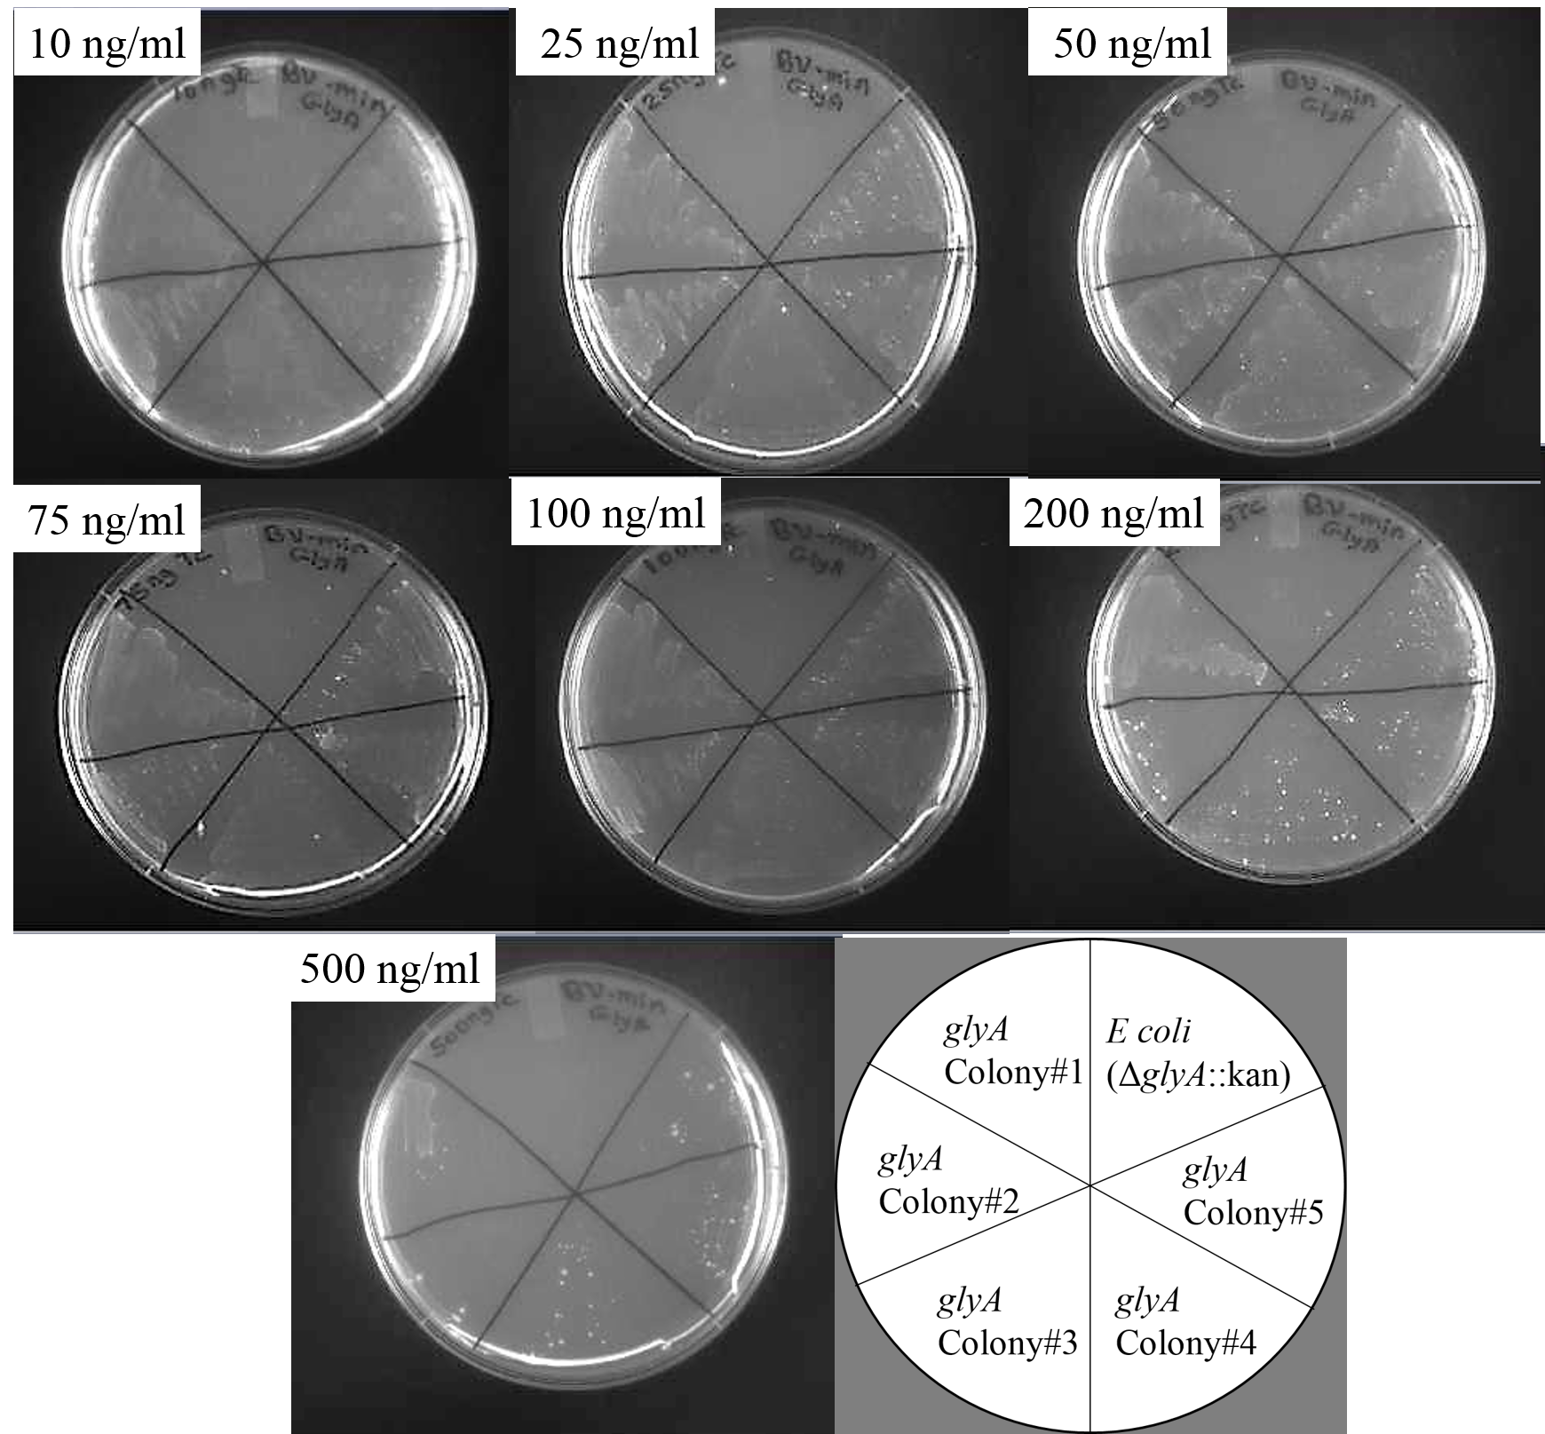
Figure 1-20 Tetracycline dependent glyA production.The optimal tetracycline concentration required to induce production of sufficient SHMT to rescue E. coli JW2535-1 (ΔglyA::kan) carrying the pKTS-glyA plasmid from glycine and serine auxotrophy was determined. Increasing concentrations of tetracycline were added to BV minimal media containing 200 μg ampicillin/ml, 25 μg/ml kanamycin. Confluent cell growth was achieved on plates with 10-100 ng tetracycline/ml. However, tetracycline dependent cell growth differences were not strong. The bottom right panel shows how the various cultures are streaked on the plates.

Beginning steps to clone the dihydropteroate synthase gene into the pKTS plasmid

Dihydropteroate synthase (DHPS) is encoded by the folP gene. The protein catalyzes the formation of 7,8-dihydropteroate by linking 6-hydroxymethyl-7,8-dihydropterin pyrophosphate (H₂PtPP) and ρ-aminobenzoic acid (pABA). If osmolytes preferentially interact with either substrate, the catalytic efficiency of DHPS is predicted to decrease. As an initial step to test this hypothesis, we obtained a folP-pUC19 clone and the knockout E. coli strain (ΔfolP::kan) from Dr. Swedberg [13]. Progress was made as described below.

Assessing the quality of the folP clone and assessing the cloning sites in the gene

The plasmid DNA received from Dr. Swedberg was sequenced using M13 forward and M13 reverse primers. The sequence alignment show the folP open reading frame was cloned between HindIII and BamI cloning sites of pUC19. To introduce an NdeI restriction site sequence via PCR, a primer was designed as described in the Materials and Methods section. While the primers worked as sequencing primers, several attempts to PCR amplify the gene were not successful.

As an alternate strategy, we decided to design a “pessimal” DNA sequence encoding folP. As codon optimization is a frequent strategy to increase protein production, we took the opposite approach and designed a “worst” sequence to minimize protein production. The sequence design was done in collaboration with Mike Gilchrist from the Ecology and Evolutionary Biology department [14] [15]. The resulting sequence was synthesized by GenScript. The construct was sent to us as a folP gene inserted in the pET 3a plasmid using the NdeI and XhoI restriction enzyme sites. This construct was transformed into DH5α cells. Individual colonies were selected on YT agar media with 200 μg ampicillin/ml. Four colonies were grown up, the plasmid DNA extracted and the DNA sequenced.

In an initial experiment, the plasmid DNA of folP-pET 3a was double digested with NdeI and XhoI. The DNAs were separated on a 1% agarose gel (Figure E1). The correct sized DNA fragments was excised. However ligation and transformation reactions did not yield colonies. This is an ongoing project in the lab.

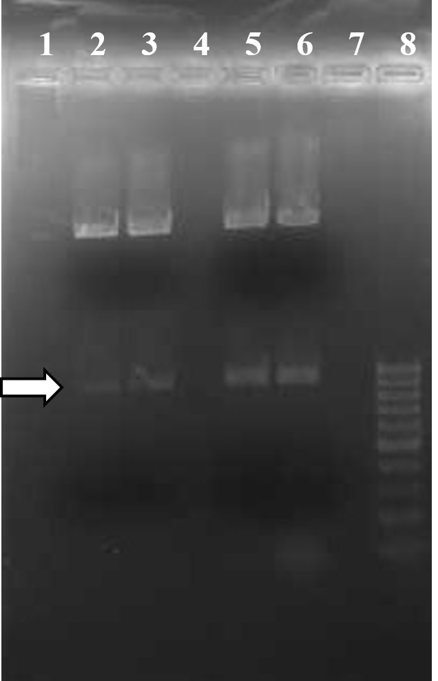
Figure 1-21 NdeI and XhoI digested folP. Digestion of folP-pET 3a DNA by NdeI and XhoI. The reaction was electrophoresed in a 1% agarose gel. Lanes 2, 3, 5 and 6 : digested folP-pET 3a, Lane 8: 1,00 bp DNA ladders, Lanes 2, 3, 5 and 6 showed the expected DNA fragment size (849 bp) for folP digestion by NdeI and XhoI. The arrow shows the band of interest.

Reference
1. Neuenschwander, M., et al., A simple selection strategy for evolving highly efficient enzymes. Nat Biotechnol, 2007. 25(10): p. 1145-7.
2. Chopra, S., et al., A balancing act between net uptake of water during dihydrofolate binding and net release of water upon NADPH binding in R67 dihydrofolate reductase. J Biol Chem, 2008. 283(8): p. 4690-8.
3. Howell, E.E., P.G. Foster, and L.M. Foster, Construction of a dihydrofolate reductase-deficient mutant of Escherichia coli by gene replacement. J Bacteriol, 1988. 170(7): p. 3040-5.
4. Keshavjee, K., C. Pyne, and A.L. Bognar, Characterization of a mutation affecting the function of Escherichia coli folylpolyglutamate synthetase-dihydrofolate synthetase and further mutations produced in vitro at the same locus. J Biol Chem, 1991. 266(30): p. 19925-9.
5. Ferone, R., et al., Isolation and characterization of an E. coli mutant affected in
dihydrofolate- and folylpolyglutamate-synthetase,. Chemistry and biology of pteridines. de
Gruyter, Berlin., 1983: p. 585-589.
6. Butz, M., et al., An N-terminal protein degradation tag enables robust selection of highly active enzymes. Biochemistry, 2011. 50(40): p. 8594-602.
7. Pyne, C. and A.L. Bognar, Replacement of the folC gene, encoding folylpolyglutamate synthetase-dihydrofolate synthetase in Escherichia coli, with genes mutagenized in vitro. J Bacteriol, 1992. 174(6): p. 1750-9.
8. Sheppard, C.A., E.E. Trimmer, and R.G. Matthews, Purification and properties of NADH-dependent 5, 10-methylenetetrahydrofolate reductase (MetF) from Escherichia coli. J Bacteriol, 1999. 181(3): p. 718-25.
9. Trimmer, E.E., et al., Folate activation and catalysis in methylenetetrahydrofolate reductase from Escherichia coli: roles for aspartate 120 and glutamate 28. Biochemistry, 2001. 40(21): p. 6216-26.
10. J. Neel Scarsdale, et al., Crystal Structure at 2.4 AÊ Resolution of E. coli Serine
Hydroxymethyltransferase in Complex with Glycine
Substrate and 5-Formyl Tetrahydrofolate. J. Mol. Biol., 2000. 296: p. 155 - 168.
11. Bloch, K.D. and B. Grossmann, Digestion of DNA with restriction endonucleases. Curr Protoc Mol Biol, 2001. Chapter 3: p. Unit3 1.
12. Baba, T., et al., Construction of Escherichia coli K-12 in-frame, single-gene knockout mutants: the Keio collection. Mol Syst Biol, 2006. 2: p. 2006 0008.
13. Swedberg, G., S. Ringertz, and O. Skold, Sulfonamide resistance in Streptococcus pyogenes is associated with differences in the amino acid sequence of its chromosomal dihydropteroate synthase. Antimicrob Agents Chemother, 1998. 42(5): p. 1062-7.
14. Shah, P. and M.A. Gilchrist, Explaining complex codon usage patterns with selection for translational efficiency, mutation bias, and genetic drift. Proc Natl Acad Sci U S A, 2011. 108(25): p. 10231-6.
15. Agashe, D., et al., Good codons, bad transcript: large reductions in gene expression and fitness arising from synonymous mutations in a key enzyme. Mol Biol Evol, 2013. 30(3): p. 549-60.

