Revisiting the stoichiometry and binding sites of PAI-1 in complex with vitronectin: VN a potential mediator of PAI-1:PAI-1 interactions?

Sierra Sorter
Honor Thesis
Mentor: Dr. Cynthia Peterson
April 28, 2015

Abstract
Plasminogen activator inhibitor-1 (PAI-1) functions in the fibrinolysis system as an inhibitor of both urokinase type plasminogen activators (uPA) and tissue type plasminogen activators (tPA).
These are both activators of the zymogen, plasminogen, which forms plasmin upon activation. As a result, PAI-1 has been implicated in various disease states to include coronary thrombosis, fibrosis, cancer metastasis and the metabolic syndrome. In both plasma and the extracellular matrix, PAI-1 can be found in complex with vitronectin and this complex mediates many of the effects associated with disease pathology. The most recently published models describe a 4:2 PAI:VN stoichiometry with two PAI-1 binding sites on vitronectin.
This study builds upon unpublished contrast variation small-angle neutron scattering data collected by the Peterson lab which suggests a single, more extensive PAI-1 binding site on VN and the self-association of PAI-1 while in the VN/PAI-1 complex. This model retains the 4:2 stoichiometry described by the previous model. This study monitors the self-association of PAI-1 in the VN/PAI-1 complex by first designing a vitronectin binding deficient mutant, R101A, M110A, Q123A (RMQ) PAI-1. This mutant was then analyzed using an ELISA based assay in order to determine the ability of wild type PAI-1 to mediate an interaction between vitronectin and RMQ PAI-1.

Introduction
Plasminogen activator inhibitor-1 (PAI-1), a serine protease inhibitor (serpin), functions in the extracellular matrix as an inhibitor of plasminogen activators, which include urokinase type plasminogen activators and tissue type plasminogen activators (uPA and tPA). The inhibition of plasminogen activators prevents the conversion of plasminogen, a zymogen, to plasmin. In the fibrinolytic process, plasmin solubilizes fibrin blood clots. Thus, PAI-1 acts as an inhibitor in the fibrinolysis cascade and is responsible for regulating the breakdown of fibrin clots in an anti-fibrinolytic manner.
PAI-1 is unique within the serpin family for its conformational flexibility; three different conformations have been described. The first is the active, inhibitory form of PAI-1 that forms covalent interactions with both tPA and uPA. The second form is the latent, non-reactive form that the active form converts to following a short half-life of about 1-2 hours at 37⁰C (Blouse, Dupont et al. 2009). The final conformation of PAI-1 acts as a non-inhibitory substrate towards its target proteases. Both tPA and uPA cleave this third conformation of PAI-1 (Van De Craen, Declerck et al. 2012).
Functions mediated by PAI-1 include a regulatory function in thrombolysis and tissue remodeling, to include angiogenesis, wound healing, and cancer metastasis (Declerck and Gils 2013). These additional functions are largely mediated by the interaction between PAI-1 and vitronectin, a glycoprotein found in circulation and other various mammalian tissues. This interaction affects the functionality of both proteins. For example, PAI-1 in complex with vitronectin gains inhibitory activity towards protein C and other proteases, to include thrombin(Schroeck, Arroyo de Prada et al. 2002). In addition, the VN/PAI-1 interaction regulates cellular motility because PAI-1 binds to the somatomedin B (SMB) domain of vitronectin, which blocks the interaction of vitronectin with cell-surface integrins and urokinase-type plasminogen activator receptor (uPAR) thereby increasing cellular motility (Zhou, Huntington et al. 2003). The affinity of PAI-1 for the SMB domain of vitronectin drops 100-fold when the inhibitor reacts with target proteases such as uPA (Zhou, Huntington et al. 2003). Clinical studies have revealed a correlation between high circulating levels of active PAI-1 and a poor prognosis in cancer patients that can be attributed to the role of PAI-1 in the motility and vascularization of cancer cells (Czekay, Wilkins-Port et al. 2011). Interestingly, elevated levels of uPA also correlate with a poor prognosis despite its effect of reducing PAI-1 affinity for vitronectin. This suggests that uPA and PAI-1 levels are not simple antagonists towards the formation of the VN/PAI-1 complex and several hypotheses are currently under study (Zhou, Huntington et al. 2003)
In vivo, most circulating PAI-1 is found in complex with vitronectin. While PAI-1 is inherently unstable, the PAI-1/VN interaction localizes and stabilizes PAI-1 by increasing its half-life approximately 2-4 fold (Gibson, Baburaj et al. 1997). The conversion of PAI-1 to its latent form, which has reduced affinity for vitronectin, is accomplished by the spontaneous insertion of the reactive center loop (RCL) into the main β-sheet of PAI-1; however, binding across the E and F helices of PAI-1 to vitronectin’s somatomedin B (SMB) domain slows down the generation of latent PAI-1 as shown by figure 1 (Zhou, Huntington et al. 2003).

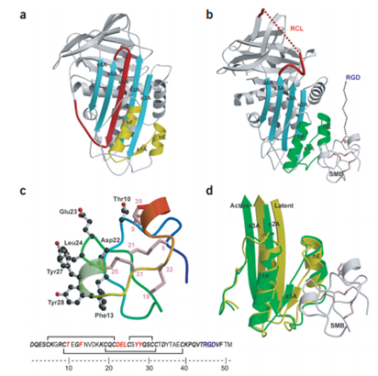
Figure 1. a) Latent PAI-1. Note insertion of reactive center loop (red) and the subsequent conformational change in the binding site for SMB domain (yellow). B) VN/PAI-1 complex. The SMB domain is shown bound to regions comprising helix E, strand 1A, and helix F (green). c) SMB domain (blue at N terminus to red at C terminus). Residues with side chains contacting PAI-1 (red). d) Compares the active (green) and latent (yellow) conformations of PAI-1 to model conformational changes at binding surface. (Figure adapted from Zhou et al.)

Increased stabilization of PAI-1 within the VN/PAI-1 complex can be attributed to conformational changes of the shutter region (which constitutes the central parts of s3A and s5A and the N-terminal part of α-helix B) and s5A shown in figure 2. Both of these regions are structurally important because they modulate the spontaneous insertion of the RCL.
The composition of the VN/PAI-1 complex has not yet been fully elucidated, but is of great value towards the development of a pharmaceutical therapy to potentially treat cardiovascular disease and cancer. Many previous studies assumed a 1:1 interaction between PAI-1 and vitronectin at the SMB domain of VN. An alternate model proposed the simultaneous binding of two PAI-1 molecules at two separate binding sites on vitronectin (Minor, Schar et al. 2005). This was further supported by a study in which a vitronectin mutant lacking the SMB domain was generated and shown capable of binding to PAI-1, although with decreased affinity (Schar, Blouse et al. 2008). There are various proposed regions for this secondary binding site’s location within vitronectin. Some labs have proposed that the secondary binding site is located in vitronectin’s C terminal domain (Lynn, Heller et al. 2005). However, unpublished data from the Peterson lab has pointed to this secondary binding site location residing in the intrinsically disordered domain (IDD) of vitronectin. The secondary binding site within PAI-1 was characterized at alpha helices D and E (Schar, Jensen et al. 2008).

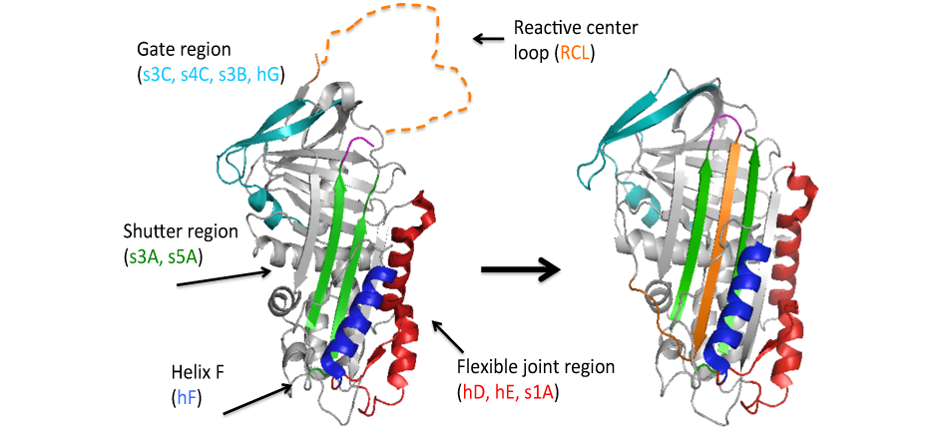
Figure 2. Representation of PAI-1 with key regions of importance highlighted and labeled and the reactive center loop drawn in for clarification. (Adapted from Buuci et al. in press)

Figure 3. Representation of PAI-1 with key regions of importance highlighted and labeled and the reactive center loop drawn in for clarification. (Adapted from Buuci et al. in press)

Although most PAI-1 in circulation is found in a 1:1 complex with vitronectin, studies have demonstrated the self-association of vitronectin while in complex with PAI-1 in a 2:1 stoichiometry (Blouse, Dupont et al. 2009). In the tissue, vitronectin and PAI-1 have been shown to form oligomeric complexes. It was demonstrated that the VN/PAI-1 interaction permits vitronectin to not only self-associate, but also take on distinctly new functional capabilities (Minor and Peterson 2002). For example, binding of PAI-1 to VN interferes with VN binding to various integrins, to include αvβ3 (Lopez-Alemany, Redondo et al. 2003). Analytical ultracentrifugation studies showed that the VN/PAI-1 complex has a relative molecular mass of 324,000 ± 14,0000 (Podor, Shaughnessy et al. 2000). This allows for two models with different stoichiometry. The first model involves three PAI-1 molecules associated with three vitronectin molecules and the second involves four PAI-1 molecules associated with two vitronectin molecules(Podor, Shaughnessy et al. 2000). When considering the two binding sites described on VN and also that free VN was observed during ultracentrifugation experiments in which the PAI-1:VN ratio was 1:1, the second model was investigated more closely. This model is illustrated by figure 3.
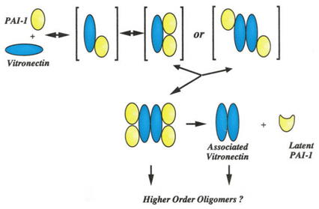
Unpublished contrast variation Small Angle Neutron Scattering (cvSANS) data from our lab suggested the 2:1 binding model previously described might require further refinement.
Figure 3. A schematic representation of various VN/PAI-1 complexes formed. Demonstrates PAI-1 binding and subsequent vitronectin self-association. A 2:1 stoichiometry is also modeled below; however this previous study assumes PAI-1 binding at two sites on vitronectin. This paper proposes a single, more extensive PAI-1 binding site on VN. (Adapted from Podor et al.)

Interestingly, the data from these experiments demonstrates the self-association of PAI-1 while in complex with vitronectin. Our lab then hypothesized that the secondary binding site on VN provides a more extensive binding site for one PAI-1 molecule, while the second PAI-1 molecule in complex has no direct association with VN. A previous study also described the possibility of a single, more extensive binding site on vitronectin and lends further support to our hypothesis (Blouse, Dupont et al. 2009).
In order to test this hypothesis further, we have generated a VN binding deficient PAI-1 mutant (RMQ PAI-1), shown in figure 4, based upon previous studies that sought to characterize the VN binding domain located on PAI-1. A triple mutant PAI-1 variant, R101A-M110A-Q123A (RMQ), was designed based upon a previous study by Jensen et. al (Jensen, Durand et al. 2004) Before the construction of this mutant by Jensen and colleagues, Q123K was widely used to characterize the physiological and pathophysiological functions of the VN/PAI-1 complex (Lawrence, Berkenpas et al. 1994). Compared to wild type PAI-1, the Q123K mutant has 10-fold reduced binding affinity towards VN (Jensen, Durand et al. 2004). However, the RMQ mutant displays no measurable binding affinity towards VN and unperturbed protease inhibitory activity (Jensen, Durand et al. 2004). The RMQ mutant is therefore superior in studies utilizing a VN binding deficient PAI-1 mutant in attempts to better characterize the VN/PAI-1 complex. The study of our hypothesis with the use of the RMQ mutant will provide a better understanding of the VN/PAI-1 complex.
The RMQ mutant was generated through repeated rounds of site directed mutagenesis, transformation, expression, and purification of the mutant protein. Following this, Enzyme-linked Immunosorbent assays (ELISAs) were carried out to determine whether WT PAI-1 is capable of mediating an interaction between RMQ PAI-1 and VN as show in figure 5. These assays were used to determine the effect of these mutations on PAI-1 and VN binding
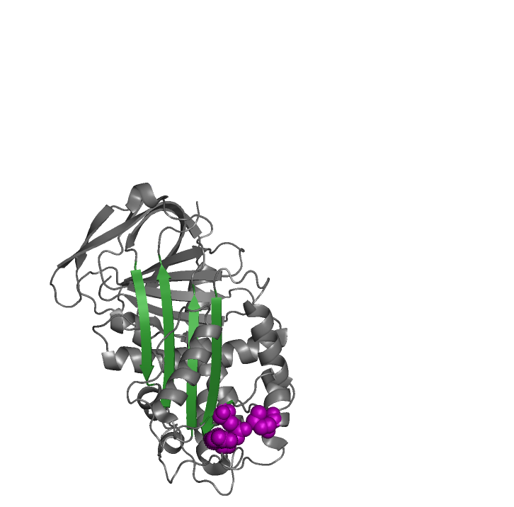
Figure 4. Structure of PAI-1 with the mutagenized residues highlighted in purple. The central beta sheet is also highlighted, in green, for orientation purposes. Figure generated using PyMol with PDB structure: 3Q03 chain B.
R101A
M110A
Q123A
.

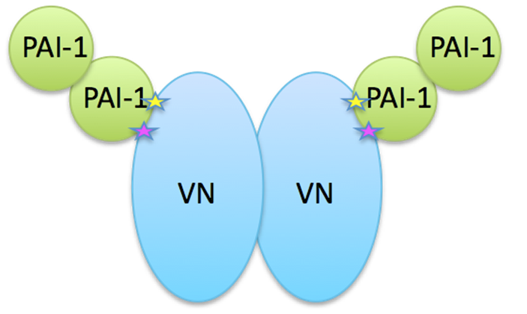

Figure 5. Hypothesized binding interaction between VN (blue), and PAI-1 (light green). Proteins shown to interact in a 4:2 stoichiometry with one PAI-1 interacting with vitronectin at both the primary and secondary binding sites (shown as yellow and purple stars).

Methods
The PAI-1 amino acid numbering system used throughout is based upon the following N-terminal sequence determination: V 1-H4-H5. Furthermore, WT PAI-1 was expressed and purified in Escherichia coli and human VN was purified from plasma purchased from Tennessee Blood Services as described in Thompson, Goswami et al. 2011.

Mutagenesis
Polymerase Chain Reaction (PCR) based oligonucleotide directed site specific mutagenesis was used in order to generate the PAI-1 mutant. The QuickChange Multi Site-Directed Mutagenesis Kit from Agilent was used to incorporate mutations at each of the three sites: R101A, M110A, and Q123A (Wang, 1999). Primers (see table 1) were constructed so that, aside from single point mutations, they were otherwise complementary to the template strand of the PAI-1 gene. Table 2 contains the reagents and volumes used in these reactions. The reagents shown in table 2 were assembled on ice. Following an immediate transfer to a thermal cycler machine the reagents were then heated and cooled according to the cycle parameters outlined in table 3.
After the PCR reaction was completed, a DPN-1 digest was done in order to digest methylated, template, DNA. A volume of 1µl DPN-1 was added to the PCR product which was then incubated at 37⁰C for 1 hour following which the product was stored at 4⁰C.
Primer Name | Primer Sequence
R101A forward | CGTCCAGGCGGATTTGAAGCTG
R101A reverse | CAAACCCGCCTGGACGAAGATCG
M110A forward | GGCTTCGCCCCACTTC
M110A reverse | GTGGGGCGCGAAGCCCTGGACC
Q123A forward | GGTCAAGGCAGTGGACTTTCAG
Q123 reverse | GTCCACTGCCTTGACCGTGCTCCGG

Table 1: Primer sequences used for site directed mutagenesis
Reagent | Volume for one reaction  = 50 µl total
10x Taq buffer | 5 µl
Template DNA | 1 µl
R101A Forward primer | 1 µl
R101A Reverse primer | 1 µl
M110A Forward primer | 1 µl
M110A Reverse primer | 1 µl
Q123A Forward primer | 1 µl
Q123A Reverse primer | 1 µl
dNTPs | 1 µl
Quick Solution | 3 µl
dd H₂O | 33 µl
PFU ultra | 1 µl

Table 2. Reagents used in PCR reaction carried out to generate the RMQ mutant
PCR Cycle Parameters
 |  | Temp | Time (min:sec)
 |  | 95°C | 1:00
 |  | 95°C | 0:50
X18 |  | 60°C | 0:50
 |  | 68°C | 8:00
 |  | 68°C | 7:00
 |  | 4°C | ∞

Table 3. PCR Cycle Parameters

Transformation
The DPN-1 digested PCR product was transformed into DH5α cells. A PCR product volume of 5 µl was added to a 20uL aliquot of DH5α cells and allowed to incubate for 5 minutes on ice. Next, the cells were heat shocked at 42⁰C for 30 seconds and then transferred to ice for 2 minutes. Super Optimal broth with Catabolite repression (SOC) media was added to the cell aliquot at a volume of 300 µl and this mixture was allowed to shake at 37⁰C for 1 hour. Following this growth period, 100uL of the cells were then plated on agar plates containing 50ug/mL kanamycin and Lysogeny Broth (LB) and incubated at 37⁰ overnight. Colonies were then selected from the plates and grown in liquid LB and kanamycin overnight. The following day plasmid DNA was purified using the Wizard Plus SV Miniprep kit. The kit’s protocol was adhered to with two exceptions; the washing step using 750 µl wash solution was done twice and during the elution step, a volume of 37⁰C, 60 µl nuclease free water was added rather than 100 µl. Lastly, DNA sequencing of the purified plasmid was carried out in order to ensure the incorporation of all three mutations. The sample with the highest DNA concentration was then used in the expression process.

Expression
The mutagenized plasmids were transformed into Rosetta 2 (DE3) PLys cells using the same transformation protocol described above and plated on agar plates containing both kanamycin (Kan) and chloramphenicol (Cam). Following an overnight incubation at 37⁰C, small starter cultures were created using a single colony added to a mixture of 12mL Terrific Broth (TB), 50ug/mL Kan, and 34ug/mL Cam. These cultures were then allowed to incubate at 30⁰C while shaking at 230 rpm overnight. The small starter cultures were then subcultured into four 1 L volumes of TB, 100 µl Kan, and 100 µl Cam. During the large cultures’ growth at 30⁰C/230 rpm, optical density (OD) was regularly measured. After the OD at 600nm reached 0.8 absorbance units, the temperature was lowered to 15⁰C until the OD reached 1.0. At this point, Isopropyl β-D-1 thiogalactopyranoside (IPTG) was added to each of the four cultures to a final concentration of 1mM. Since expression of the gene of interest was under lac operon control, addition of IPTG allows active transcription of the lac operon (Berg, 2007). After initiating induction, cultures were incubated at 15⁰C overnight while shaking. The following day cultures were centrifuged and the subsequent cell pellet frozen at -80⁰C for future use.

Purification
All purification steps were carried out at 4⁰C. Both wild type PAI-1 and mutants were purified using the same method. First, a sulfopropyl (SP) sepharose column was used with the following buffer solution: 50 mM sodium phosphate, 1 mM EDTA, and 80 mM ammonium sulfate. The protein was eluted from this column using an 80mM – 500mM ammonium sulfate gradient. The A₂₈₀ of the elutions was taken and fractions containing PAI-1 were pooled. This pool was dialyzed into 4L of 50 mM sodium phosphate, 20 mM imidazole, and 500 mM sodium chloride overnight to remove the EDTA.
Next, the PAI-1 pool was passed over a nickel-charged chelating sepharose column for immobilized metal affinity (IMAC) with the following buffer solution: 50 mM sodium phosphate, 20 mM imidazole, and 500 mM sodium chloride. PAI-1 was eluted from this column with a 20mM – 120mM imidazole gradient. The A₂₈₀ of the elutions was taken and fractions containing PAI-1 were pooled and concentrated to ~4mL.
Finally, the proteins were injected onto a gel filtration column (S-100) sephacryl and separated by size. The A₂₈₀ of the elutions was again taken and fractions containing PAI-1 were pooled and analyzed on an SDS-PAGE gel and western blotting in order to verify the purification process.

ELISAs
The standards described in Thermo Scientific Pierce Assay Development Technical Handbook were used to develop the methods we carried out to conduct Enzyme Linked Immunosorbant Assays (ELISAs) (Thermo Fischer, 2011). Vitronectin, the coating enzyme, was diluted to a concentration of 1 µg/mL in the coating buffer, which consisted of 0.2 M sodium carbonate at pH 9.4. Into each well, 50 µl of the coat protein mixture was added and allowed to incubate overnight at 4⁰C. The following day, the entire plate was washed three times with a volume of 200 µL washing buffer, which consisted of 0.02 M tris, and 0.15 M sodium chloride at pH 7.4. A volume of 300 µL blocking buffer was then added to each well and allowed to incubate covered at room temperature for 1 hour. The blocking buffer consisted of 0.02 M tris, 0.15 M sodium chloride, 0.01% tween 20, and 2%w/v BSA at pH 7.4. ELISA samples were then prepared and serially diluted prior to loading 50uL of each dilution onto the plate. After samples were added, an incubation period of 30 minutes at room temperature followed. The wash step described above was again carried out. Next 50uL of the primary antibody (rabbit anti human PAI-1) diluted in blocking buffer at .2ug/mL was loaded on the plate and allowed to incubate for one hour. The plate was then washed as described previously and 50uL of the secondary antibody (goat anti rabbit – HRP conjugated) diluted identically to the primary antibody, was added to the plate and allowed to incubate for another hour.
After the secondary antibody incubation step, the plate was washed six times, and 50 uL of the TMB substrate developing reagent from Thermo Scientific was added to each well and allowed to incubate until color change had occurred (30s-5min). Once color change was enough for measurement, the reaction was stopped with 4M H₂SO_{4.} The absorbance at 450nm was then measured for each well using a plate reader and the data plotted for analysis.
A control ELISA was also carried out using the methods described above in order to analyze VN/WT PAI-1 and VN/RMQ affinity by coating PAI-1 and using a bunny anti human VN for the primary antibody. Additionally, in some cases, the PAI-1 was labeled with biotin and streptavidin-HRP was used in the place of primary and secondary antibodies at a concentration of .2ug/mL. Any other variations in the protocol will be noted in the results section. A basic schematic of the method used for these ELISAs is shown in figure 6.

Figure 4. Basic schematic of ELISA protocol. Concentrations of substrates and the substrates themselves were varied for different experiments. These variations are noted for the individual experiments.

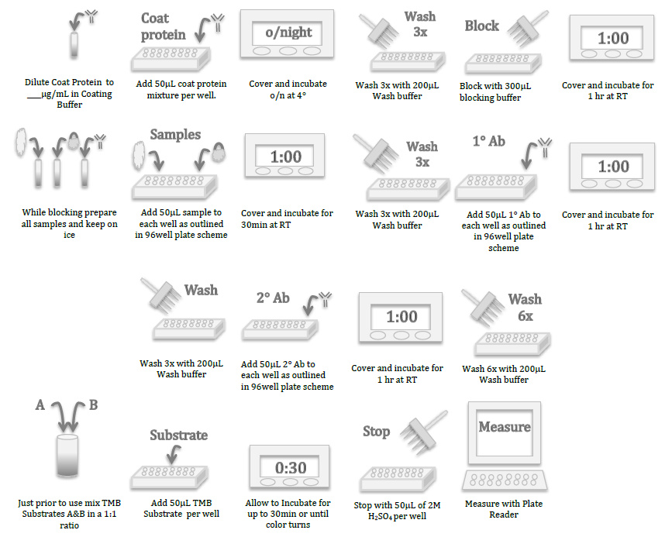
Figure 5. Basic schematic of ELISA protocol. Concentrations of substrates and the substrates themselves were varied for different experiments. These variations are noted for the individual experiments.

Results
Prior to the adoption of the RMQ mutant in these binding studies, the Peterson lab utilized a different binding deficient PAI-1 mutant (R115E, R118E, Q123K). In working with the RQ mutant prior to the work to generate and characterize the RMQ mutant, ELISA assays indicated that wild type (wt) PAI-1 was indeed able to mediate some sort of interaction between PAI-1 and VN. The data in figure 7 show that addition of wt PAI-1 allows for an increase in VN binding to the plate. RQ PAI-1 is unable to mediate a similar binding increase, instead remaining at a level equal to that of RQ:VN binding with no addition PAI-1 to facilitate an interaction (data not shown). However, this RQ mutant retained too much affinity for VN for the purposes of this study and the RMQ mutant was selected for further research.
In order to obtain quality plasmids containing the RMQ PAI-1 mutant, DNA purification methods had to be altered. As described in the methods section, additional wash steps were necessary to ensure clean DNA for sequencing and transformation. Once the new RMQ PAI-1 mutant was successfully expressed and purified, ELISAs were performed to optimize experimental conditions. Each ELISA was performed in duplicate and all data shown here is from individual ELISAs. Figure 8 contains a representative graph showing that the concentration of VN could be lowered to .25ug/mL with no significant change in signal from PAI-1 binding and the concentration of VN coat in further experiments was adjusted to .25ug/mL.
Next, buffer conditions were optimized. Previous to the RMQ PAI-1 experiments, a blocking buffer, commercially obtained from Thermo Scientific was used, and a sodium phosphate buffer was used for washing, as recommended in the Thermo Scientific Assay Handbook (Thermo Fischer, 2011). The assay results were inconsistent, and a Tris buffered Saline (TBS) system, used by previous lab members, was tested in comparison to the old system. Figure 9 contains a representative graph demonstrating that the Tris buffer system produced consistent results. Further experiments utilized the TBS system as outlined in the methods section.
Incubation time for the coat protein was tested in order to determine if coat incubation conditions could affect the binding assay. Results shown in figure 10 demonstrate that there is no significant difference between overnight incubation at 4°C compared to two hour incubation at room temperature. In further experiments, overnight coat incubation is used for convenience.

Figure 7: Wild-type (wt) PAI-1 appears to facilitate interaction between VN and the coated PAI-1 protein. The y-axis shows the absorbance units at 450nm, and the x-axis shows the concentration of sample added. All values shown are an average of two different wells in the plate. The concentration of the PAI-1 coat was 3.5 ug/mL. The purple closed circle line represents RQ PAI-1 being used as the protein coat with a 1:1 mixture of wt PAI-1 and VN being added during the sample step. The green closed circle line represents wt PAI-1 being used as the protein coat with a 1:1 mixture of wt PAI-1 and VN being added during the sample step. The blue closed diamond line represents RQ PAI-1 being used as the protein coat with a 1:1 mixture of RQ PAI-1 and VN being added during the sample step. The red closed diamond line represents wt PAI-1 being used as the protein coat with a 1:1 mixture of RQ PAI-1 and VN being added during the sample step.

.

Figure 8: Comparison of VN coat concentrations for optimization of ELISAs. The y-axis shows the absorbance units at 450nm, and the x-axis shows the concentration of sample added. All values shown are an average of two different wells in the plate. Blue filled diamond line represents VN coated on the plate at a concentration of .5ug/mL, and wt PAI-1 added as sample. Red filled square line represents VN coated on the plate at a concentration of .5ug/mL, and RMQ PAI-1 added as sample. Green filled triangle line represents VN coated on the plate at a concentration of .25ug/mL, and wt PAI-1 added as sample. Purple cross line represents VN coated on the plate at a concentration of .25ug/mL, and RMQ PAI-1 added as sample.

Figure 9: Tris Buffer system used for ELISA assay yields consistent quality data. VN was coated on the plate at a concentration of .25ug/mL. Blue filled diamond line represents VN coated on the plate and wt PAI-1 added as sample. Red filled square line represents VN coated on the plate and RMQ PAI-1 added as sample.

Figure 10: Coat incubation time tested to determine if it made a difference in PAI-1 VN binding. Blue filled diamond line represents VN coated on the plate and incubated at 4°C overnight with wt PAI-1 added as sample. Red filled square line represents VN coated on the plate and incubated at 4°C overnight with RMQ PAI-1 added as sample. Green filled triangle line represents VN coated on the plate and incubated at room temperature for two hours with wt PAI-1 added as sample. Purple cross line represents VN coated on the plate and incubated at room temperature for two hours with RMQ PAI-1 added as sample.

Following the optimization of the ELISA, VN was coated on the plate and PAI-1 was added as a sample. In order to differentiate between the wt PAI-1 that would mediate an interaction between VN and RMQ PAI-1, biotin labeled PAI-1 was generated by adding a biotin molecule to the P9 position of the reactive center loop. This biotin molecule allowed for detection using streptavidin rather than a primary antibody against PAI-1. The binding of biotin labeled PAI-1 to VN, shown in figure 11, is consistent with that of non –labeled PAI-1. However, no significant difference was observed between RMQ P9*biotin, and wild type + RMQ P9*biotin. This is in contrast to previous experiments like those shown in figure 7.
Causes for this lack of binding recovery when wt PAI-1 is added could be due to several factors. The Biotin labeling of the protein may have been inefficient. Controls could be performed by labeling fresh protein with biotin and repeating this experiment. Additionally, prior results demonstrating recovery of RMQ:VN interactions when PAI-1 was added were determined by measuring the presence of VN, not PAI-1. There could also be a difference in binding interactions when PAI-1 rather than VN is coated on the plate. These possibilities will need to be tested further to identify the proper experimental conditions for these experiments.

Figure 11: VN coated on plate at .25ug/mL, incubated overnight at 4°C. Samples added contained either, a single form of PAI-1, or a 1:1 mixture of wt PAI-1 and a biotin labeled PAI-1 (Biotin label added at the p9 position in the reactive center loop). Blue filled diamond line represents the addition of biotin labeled “wild type” PAI-1. Green filled triangle line represents the addition of biotin labeled “RMQ” PAI-1. Red filled square line represents the addition of wt PAI-1 and biotin labeled “wild type” PAI-1. Purple cross line represents the addition of wt PAI-1 and biotin labeled “RMQ” PAI-1.

Conclusion
Since elevated PAI-1 levels are a risk factor for a variety of disease states, particularly cardiovascular events like thrombosis, the creation of a human PAI-1 inhibitor has been pursued by pharmaceutical companies for years; however, no such pharmaceutical is currently available for clinical use. More insight into the VN/PAI-1 binding complex will be critically important in the successful design of such a target. In this endeavor researchers must also consider glycosylated versus non-glycosylated PAI-1 as well as the inherent differences in human and mouse PAI-1 in order to design a pharmaceutical that successfully targets human PAI-1 (Van De Craen, Declerck et al. 2012). This study aims to shed light on just one of these considerations – the stoichiometry and binding sites involved in the VN/PAI-1 complex. The design of a PAI-1 inhibitory drug will require a great deal of consideration for the disease effects mediated by the VN/PAI-1 complex. PAI-1 inhibitors can act by either converting PAI-1 to its latent form or the substrate-behaving form. To this end, researchers have tested monoclonal antibodies, low molecular weight compounds, peptides corresponding to PAI-1’s reactive center loop, and antisense oligonucleotides that inhibit PAI-1 synthesis (Gils, Stassen et al. 2002). For example, a murine study injected subjects fed a high-fat diet with a synthetic PAI-1 inhibitor, called PAI-039, which was then shown to reduce leptin, triglycerides, and plasma glucose in mice (Crandall, Quinet et al. 2006).This suggests that a PAI-1 inhibitor for human clinical use could also provide a successful therapy for cardiovascular disease and metabolic syndrome. The increasing incidence of both diabetes and obesity adds urgency to this endeavor.
Future members of the Peterson lab will carry out surface plasmon resonance (SPR) and additional ELISAs in order to further test the mutant and data which have been generated here. These future experiments will be able to further examine the stoichiometry of the PAI-1:VN complex in even more detail and will build on the work presented herein.

Works Cited
Berg JM, Tymoczko JL, Stryer L. Biochemistry. 6th edition. New York: W H Freeman; 2007.

Blouse, G. E., D. M. Dupont, C. R. Schar, J. K. Jensen, K. H. Minor, J. Y. Anagli, H. Gardsvoll,
M. Ploug, C. B. Peterson and P. A. Andreasen (2009). "Interactions of plasminogen
activator inhibitor-1 with vitronectin involve an extensive binding surface and induce mutual conformational rearrangements." Biochemistry 48(8): 1723-1735.

Crandall, D. L., E. M. Quinet, S. El Ayachi, A. L. Hreha, C. E. Leik, D. A. Savio, I. Juhan-Vague
and M. C. Alessi (2006). "Modulation of adipose tissue development by pharmacological inhibition of PAI-1." Arterioscler Thromb Vasc Biol 26(10): 2209-2215.

Czekay, R. P., C. E. Wilkins-Port, S. P. Higgins, J. Freytag, J. M. Overstreet, R. M. Klein, C. E.
Higgins, R. Samarakoon and P. J. Higgins (2011). "PAI-1: An Integrator of Cell Signaling and Migration." Int J Cell Biol 2011: 562481.

Declerck, P. J. and A. Gils (2013). "Three decades of research on plasminogen activator
inhibitor-1: a multifaceted serpin." Semin Thromb Hemost 39(4): 356-364.

Gibson, A., K. Baburaj, D. E. Day, I. Verhamme, J. D. Shore and C. B. Peterson (1997). "The
use of fluorescent probes to characterize conformational changes in the interaction between vitronectin and plasminogen activator inhibitor-1." J Biol Chem 272(8): 5112-5121.

Gils, A., J. M. Stassen, H. Nar, J. T. Kley, W. Wienen, U. J. Ries and P. J. Declerck (2002).
"Characterization and comparative evaluation of a novel PAI-1 inhibitor." Thromb Haemost 88(1): 137-143.

Jensen, J. K., M. K. Durand, S. Skeldal, D. M. Dupont, J. S. Bodker, T. Wind and P. A.
Andreasen (2004). "Construction of a plasminogen activator inhibitor-1 variant without measurable affinity to vitronectin but otherwise normal." FEBS Lett 556(1-3): 175-179.

Lawrence, D. A., M. B. Berkenpas, S. Palaniappan and D. Ginsburg (1994). "Localization of
vitronectin binding domain in plasminogen activator inhibitor-1." J Biol Chem 269(21): 15223-15228.

Lopez-Alemany, R., J. M. Redondo, Y. Nagamine and P. Munoz-Canoves (2003). "Plasminogen
activator inhibitor type-1 inhibits insulin signaling by competing with alphavbeta3 integrin for vitronectin binding." Eur J Biochem 270(5): 814-821.

Lynn, G. W., W. T. Heller, A. Mayasundari, K. H. Minor and C. B. Peterson (2005). "A model for
the three-dimensional structure of human plasma vitronectin from small-angle scattering measurements." Biochemistry 44(2): 565-574.

Minor, K. H. and C. B. Peterson (2002). "Plasminogen activator inhibitor type 1 promotes the
self-association of vitronectin into complexes exhibiting altered incorporation into the extracellular matrix." J Biol Chem 277(12): 10337-10345.

Minor, K. H., C. R. Schar, G. E. Blouse, J. D. Shore, D. A. Lawrence, P. Schuck and C. B.
Peterson (2005). "A mechanism for assembly of complexes of vitronectin and plasminogen activator inhibitor-1 from sedimentation velocity analysis." J Biol Chem 280(31): 28711-28720.

Podor, T. J., S. G. Shaughnessy, M. N. Blackburn and C. B. Peterson (2000). "New insights into
the size and stoichiometry of the plasminogen activator inhibitor type-1.vitronectin complex." J Biol Chem 275(33): 25402-25410.

Schar, C. R., G. E. Blouse, K. H. Minor and C. B. Peterson (2008). "A deletion mutant of
vitronectin lacking the somatomedin B domain exhibits residual plasminogen activator inhibitor-1-binding activity." J Biol Chem 283(16): 10297-10309.

Schar, C. R., J. K. Jensen, A. Christensen, G. E. Blouse, P. A. Andreasen and C. B. Peterson
(2008). "Characterization of a site on PAI-1 that binds to vitronectin outside of the somatomedin B domain." J Biol Chem 283(42): 28487-28496.

Schroeck, F., N. Arroyo de Prada, S. Sperl, M. Schmitt and M. Viktor (2002). "Interaction of
plasminogen activator inhibitor type-1 (PAI-1) with vitronectin (Vn): mapping the binding sites on PAI-1 and Vn." Biol Chem 383(7-8): 1143-1149.

“Thermo Scientific Pierce Assay Development Technical Handbook.” Thermo Fischer Scientific.
Version 2 (2011). Print.

Thompson, L. C., S. Goswami, D. S. Ginsberg, D. E. Day, I. M. Verhamme and C. B. Peterson
(2011). "Metals affect the structure and activity of human plasminogen activator inhibitor-1. I. Modulation of stability and protease inhibition." Protein Sci 20(2): 353-365.

Van De Craen, B., P. J. Declerck and A. Gils (2012). "The Biochemistry, Physiology and
Pathological roles of PAI-1 and the requirements for PAI-1 inhibition in vivo." Thromb
Res 130(4): 576-585.

Wang W, Malcolm BA. Two-stage PCR protocol allowing introduction of multiple mutations,
deletions and insertions using QuikChange™ site-directed mutagensis. BioTechniques 1999;26:680–682.

Zhou, A., J. A. Huntington, N. S. Pannu, R. W. Carrell and R. J. Read (2003). "How vitronectin
binds PAI-1 to modulate fibrinolysis and cell migration." Nat Struct Biol 10(7): 541-544.

