Insights into Steinernema carpocapsae-Xenorhabdus nematophila specificity and the role of adult nematode colonization

A Dissertation Presented for the
Doctorate of Philosophy
Degree
The University of Tennessee, Knoxville

Erin Jane Mans
August 2021

Acknowledgements:
I would like to thank Dr. Heidi Goodrich-Blair for her unending support and knowledge. I would also like to express my gratitude to my committee members Dr. Elizabeth Fozo, Dr. Todd Reynolds, and Dr. Liesel Schneider for their advice and help in completing my project. Finally, I would like to thank my lab mates who became a second family when I moved to Tennessee to pursue this degree. I would not have been able to reach this point without any of them.

Abstract:
The gut microbiota can provide the host with several benefits such as the production of secondary metabolites, essential amino acids, as well as the breakdown of food or protection from pathogens. The host in turn provides the microbiota with shelter and nutrients. Given the benefits that the host and microbiota receive from their association, humans and the microbiota have evolved mechanisms of selection and specificity to assure the proper symbionts colonize a host with high fidelity. Chapter two will explore mechanisms by which Xenorhabdus nematophila nematode intestinal localization (nil) genes interact with and adhere to the nematode intestinal cell surface at the anterior intestinal cecum (AIC). The AIC expresses a mucus lectin wheat germ agglutinin (WGA) is able to bind to, suggesting that the mucus contains N-acetylglucosamine and N-acetylmuramic acid. This mucus might be serving as mechanism of bacterial adherence or nutritional selection at either the adult of infective juvenile (IJ) life stages of the nematode. Along with providing the above benefits to each other, host and gut microbiota can impact and influence each other the bi-directional line of checmical communication called the gut-brain axis. The use of model systems to study host-microbiota interactions can provide insights, but such studies are complicated by the diversity and number of cells within the gut, making pinpointing the bacterial species responsible for a specific impact on the host difficult. Chapter three will demonstrate that S. carpocapsae females reared on lawns of X. nematophila rpoS::kan have significantly reduced egg laying compared to females reared on wild type X. nematophila lawns, and that egg laying in the females grown on mutant lawns will increase their egg laying with the addition of exogenous dopamine, suggesting that the X. nematophila mutants might be impacting the levels of neurotransmitters found in the nematode. This work attempts not only to better describe the ways that S. carpocapsae nematodes select for X. nematophila symbionts through the use of WGA-reactive material expressed at the site of colonization, but also how that selection as the plays a role in controlling S. carpocapsae female reproductive behaviors possibly through the gut-brain axis.

Table of Contents:
Chapter One: Principles of species specificity between hosts and symbionts and the role of symbiotic Xenorhabdus nematophila bacteria in various Steinernema carpocapsae nematode life stages 1
Abstract 2
The gut-brain axis 3
From the brain to the gut 8
Current and prospective models to study the gut brain axis 11
Nematodes as models to study the gut-brain axis 14
Steinernema-Xenorhabdus symbiosis 19
The Steinernema-Xenorhabdus life cycle and colonization site morphology
Xenorhabdus colonization sites in Steinernema nematodes 23
The X. nematophila nil gens are necessary for colonization of S. carpocapsae nematodes 24
Phenotyping of the X. nematophila sigma factor rpoS 27
Discussion 29
Chapter one references 32

Chapter Two: An intestinal surface glycan in Steinernema carpocapsae nematodes mediates interactions with Xenorhabdus nematophila bacteria 45
Abstract 46
Introduction 47
Results 52
The anterior intestinal surfaces of S. carpocapsae and S. scapterisci bind fluorescent conjugate wheat germ agglutinin with high frequency: 52
Unconjugated WGA can inhibit colonization of the AIC in S. carpocapsae and S. scapterisci, but not S. feltiae: 55
Addition of soluble NilC protein significantly increases bacterial AIC colonization frequency in S. carpocapsae nematodes: 59
nilC is necessary for or enhances nematode IJ receptacle and adult AIC colonization, respectively 63
Discussion 66
Materials and methods 73
Nematode propagation 73
Bacterial strain generation 73
Observation of the nematode AIC using a panel of fluorescent conjugate lectins 75
NilC protein and unconjugated UEA and WGA lectin competition assays 75
Expression and purification of NilC soluble domains 77
Statistical analysis 78
Chapter two references 80
Chapter two appendix 84
Chapter two supplemental figures 84

Chapter Three: Steinernema-Xenorhabdus as a model for gut-brain interactions; X. nematophila rpoS is necessary for egg laying behaviors in S. carpocapsae nematodes 88
Abstract 89
Introduction 90
Results 96
X. nematophila rpoS mutants do not colonize the anterior intestinal caecum of adult S. carpocapsae nematodes 96
Cultivation with the X. nematophila rpoS::kan mutant negatively impacts S. carpocapsae nematode egg laying behavior but not feeding behavior 99
Nematode colonization status influences egg laying behavior in a bacterial strain-dependent manner 102
Exogenous addition of the neurotransmitters dopamine and serotonin alter ovipositing behavior and restore egg laying of females grown on rpoS::kan lawns 104
The levels of neurotransmitters, serotonin and dopamine fluctuate within the insect cadaver throughout the infection cycle 110
Combinations of serotonin and dopamine have complex impacts on S. carpocapsae oviposition that is influenced by X. nematophila bacterial strain 115
Discussion 118
Materials and methods 121
Bacterial strain generation and growth Conditions: 121
Nematode rearing for behavioral assays: 121
Nematode egg laying behavioral assays: 124
Nematode basal bulb pumping behavioral assays: 124
Metabolomics analysis of whole G. mellonella waxworms: 125
Chapter three references: 126
Chapter three appendix: 131
Chapter three supplemental figures: 132

Chapter Four: Summary and future directions: X. nematophila specificity may be important to S. carpocapsae nematodes because X. nematophila has a role in behavior modification 138
Introduction 139
S. carpocapsae expressing WGA reactive material at the site of colonization as a form of nutritional selection 141
NilB as a secretion system way to move NilC to the cell surface 147
Biologically relevant levels of neurotransmitters might provide insight into S. carpocapsae oviposition 149
Does the rpoS::kan mutant alter male reproductive behaviors? 151
Is rpoS involved in modulating the shift of J1 juveniles to adults or
IJs? 155
Final thoughts 156
Chapter four references: 159
Vita………………………………………………………………………………………........162
List of Tables:

Chapter Two: An intestinal surface glycan in Steinernema carpocapsae nematodes mediates interactions with Xenorhabdus nematophila bacteria
Table 2.1: WGA lectin competes with bacteria for AIC localization, UEA lectin does not 58
Table 2.2: Purified NilC protein increases S. carpocapsae AIC colonization in both the WT and the SR1 mutant X. nematophila strains 62
Table 2.3: Bacterial strains and plasmids used in this study 74
Table 2.4: Fluorescent conjugate lectins and their sugar specificities 76
Chapter Three: Steinernema-Xenorhabdus as a model for gut-brain interactions; X. nematophila rpoS is necessary for egg laying behaviors in S. carpocapsae nematodes
Table 3.1: Strains and plasmids used in this study: 123

List of Figures:

Chapter One: Principles of species specificity between hosts and symbionts and the role of symbiotic Xenorhabdus nematophila bacteria in various Steinernema carpocapsae nematode life stages
Figure 1.1: The bidirectional gut-brain axis and main routes of communication and influence between the host and their microbiome 7
Figure 1.2: The general layout of a nematode nervous system 17
Figure 1.3: Life cycle of Steinernema-Xenorhabdus system and morphology of Xenorhabdus colonization sites 21
Figure 1.4: Schematic diagram of SR1 25

Chapter Two: An intestinal surface glycan in Steinernema carpocapsae nematodes mediates interactions with Xenorhabdus nematophila bacteria
Figure 2.1: Wheat germ agglutinin associates with the anterior intestinal caecum of Steinernema nematodes 53
Figure 2.1: WGA but not UEA significantly reduces colonization in S. carpocapsae (Sc) and S. scapterisci (Ss) nematodes 57
Figure 2.3: Purified NilC protein significantly increases the frequency of X. nematophila colonization of S. carpocapsae AIC colonization in both WT and ΔSR1 mutant X. nematophila cells 61
Figure 2.4: nilC is necessary for, or augments colonization of S. carpocapsae nematode IJs or adults, respectively 64
Figure 2.5: Model of X. nematophila nil genes interacting with the WGA reactive material found at the AIC 71
Chapter Two Appendix:
Supplemental Figure 2.i 84
Supplemental Figure 2.ii 86

Chapter Three: Steinernema-Xenorhabdus as a model for gut-brain interactions; X. nematophila rpoS is necessary for egg laying behaviors in S. carpocapsae nematodes
Figure 3.1: The lLife cycle of the Steinernema nematode 93
Figure 3.2: S. carpocapsae nematode colonization and egg laying on colonization deficient lawn compared to wild type lawns 97
Figure 3.3: Colonization status does not impact the egg laying behavior of females cultivated on indicated bacterial lawns: 105
Figure 3.4: Increasing levels of exogenous serotonin and dopamine increase egg laying in nematodes cultivated on ΔrpoS lawns relative to WT 107
Figure 3.5: Addition of neurotransmitters serotonin and dopamine does not alter the pharyngeal pumping behaviors of females cultivated on different bacterial lawns 108
Figure 3.6: Dopamine and serotonin levels change in the insect cadaver throughout the infection cycle 112
Figure 3.7: Levels of dopamine, its precursors and byproducts change over an infection cycle 114
Figure 3.8: Addition of different levels of dopamine and serotonin does alter the level of eggs laid in females S. carpocapsae nematodes grown on WT lawns, but not on rpoS mutant lawns 116
Chapter Three Appendix:
Supplemental Figure 3.i 131
Supplemental Figure 3.iii 132
Supplemental Figure 3.iii 135
Supplemental Figure 3.iv 136

Chapter Four Summary and future directions: X. nematophila specificity may be important to S. carpocapsae nematodes because X. nematophila has a role in behavior modification
Figure 4.1: The J1 juveniles S. carpocapsae nematode can undergo differential development into either an adult stage nematode, or an IJ stage 142
Figure 4.2: Interaction of nil genes with the WGA reactive material present in adult stage nematodes 144
Figure 4.3: Model and proposed experiment to determine if the development of IJs is precluded by mother endotokia matricida: 154

Chapter One: Principles of species specificity between hosts and symbionts and the role of symbiotic Xenorhabdus nematophila bacteria in various Steinernema carpocapsae nematode life stages

Erin Mans¹*, and Heidi Goodrich-Blair¹#
#corresponding author
¹Department of Microbiology, University of Tennessee-Knoxville

This chapter was written by Erin Mans and edited by Heidi Goodrich-Blair.

Abstract:
Humans and their gut microbiota regularly interact with each other through what is known as the gut-brain axis. This axis serves as a broad term that encompasses the various ways in which the host and microbiome can communicate with and impact each other. Emerging evidence suggests that native microbiota can impact host behaviors and moods, and dysregulation of the microbiota may contribute to various intestinal disorders. Causal evidence remains sparse however, and studies are complicated by the number of cells and different bacterial species found in the human gut that are not only interfacing with the host but also with each other. To facilitate exploration of the gut-brain axis, model systems, such as mice or zebra fish can be used instead. However, these systems can also be complicated by the complexity of the native bacteria a given host possesses. In contrast, each species of Steinernema nematode naturally associates with a single species of an intestinal bacterial colonizer, Xenorhabdus spp. that act as symbionts that aid in parasitizing insects. For instance, Steinernema carpocapsae nematodes associate with Xenorhabdus nematophila bacteria regardless of geographic origin. We are beginning to understand how X. nematophila colonizes S. carpocapsae, and bacterial colonization factors, such as the nematode intestinal localization (nil) genes have been identified. What is less well understood is the role of X. nematophila colonization on nematode physiology, development, and behavior. Preliminary data, based on observations of S. carpocapsae reared on different bacterial strains, suggest that X. nematophila influences adult S. carpocapsae egg laying behaviors. The Steinernema-Xenorhabdus system provides us with new opportunities to study the gut brain axis in a relatively simple, binary animal-bacterium association. This chapter will focus on what is known Steinernema-Xenorhabdus system, cover some of the broad impacts and model systems used to study the gut-brain axis and introduce the association between S. carpocapsae and X. nematophila as another way to study the gut-brain axis.

The Gut-Brain Axis
The human gastrointestinal (GI) tract contains a complex dynamic microbe population which can exert influence on the host both in homeostasis and disease. There are an estimated 10¹⁴ microorganisms that colonize the intestines (Gill et al., 2006). Collectively, these microbes are known as the microbiome. Over the last few decades, we have learned more about the interface between hosts and their associated gut microbiomes through what is known as the gut-brain axis. The gut-brain axis in this work will be defined as the bidirectional line of communication and interactions between the gut microbiome and the central nervous (CNS) or brain of the host. This can be direct or indirect, and can take place through chemical and nervous system pathways. Gut microbiome dysbiosis has been associated with several psychiatric and neurological pathologies including autism spectrum disorders, Parkinson’s disease, multiple sclerosis, and chronic pain (Cryan and Dinan, 2012; Park et al., 2009; Vuong and Hsiao, 2017; Sampson et al., 2016; Berer et al., 2011; Amaral et al., 2008).
The gut-brain axis may be a new target for therapeutics, but the network of communication between the host and the microbiome remains poorly understood. Although there is evidence that the gut-brain axis plays a role in health and disease, evidence of causality remains sparse. The use of experimentally tractable systems in which the gut-brain axis can be investigated in detail is beginning to fill this gap. For example, the gut microbiota are able to interact with the mucosal surface of mice through secretion of compounds or metabolites, or altering the levels of dietary compounds such as tryptophan that then feed into the neuroendocrine and neuroimmune pathways through the Vagus nerve (Bonaz et al. 2018, Bravo et al., 2011; Tolhurts et al., 2012; Wang et al., 2014; Singh et al., 2016). The host hypothalamus influences gut microbiome homeostasis through the neuroendocrine system. The neuroendocrine system releases hormones that impact reproduction, metabolism, eating and drinking behavior, energy utilization, osmolarity and blood pressure. The neuroimmune system involves electrophysiological and biochemical interactions between the nervous system and the immune system to protect neurons from pathogens (Rogers T.J., 2012; Gimsa et al., 2013).
The neuroimmune system has been studied extensively through model systems such as mice and frogs (Bloom, O., 2014). Commensal gut microbes have roles in autoimmunity, inflammation and immune cell trafficking (Wang et al., 2014; Ochoa-Repáraz et al., 2009; Ochoa-Repáraz et al., 2010; Benakis et al., 2010; Winek et al., 2016). In one study, germfree mice had slower responses to pathogens compared to mice with an intact microbiome, and also had slowed or compromised development of microglia, glial cells that acts as the main form of defense in the central nervous system (CNS) (Erny et al., 2015; Filiano et al., 2015). This same study showed that treatment of an adult mouse with antibiotics to reduce the microbiota caused microglia to revert to an immature status while the addition of short chain fatty acids (SCFAs, a product of bacterial fermentation of dietary fiber products), or addition of a native microbial community allowed maturation of the microglia. This has potential implications for humans that are put on antibiotic regiments over long periods of time for major operations such as organ transplants, loss of bacteria might impact the microglia and possibly the host CNS by extension.
Along with influencing the nervous system, gut microbes can also interact with the brain through modulating hormone levels in the endocrine system and cells lining the GI tract. Microbial derived molecules such as short chain fatty acids (SCFAs), secondary bile acids, and tryptophan metabolites interact primarily with enteroendocrine cells (EECs), enterochromaffin cells (ECCs) and the mucosal immune system (Bravo et al., 2011; Wikoff et al., 2009; Yano et al., 2015). These specialized cells are distributed throughout the gastrointestinal tract and produce ~20 types of signaling hormones in response to chemical or physical stimuli. These hormones can enter the bloodstream to produce a general response, or can act as local messengers (Rehfeld J. F., 1998; Solcia et al., 198; Furness et al., 2013). Once released these chemical cues can enter the bloodstream of the host and even reach the CNS, impacting host moods and behaviors. For example, microbial involvement in host mood modulation involves microbial metabolite secretion of bile acids or SCFAs can activate receptors on EEC cells and are involved in regulating satiety. Microbial SCFAs have been implicated as a signaling molecule that mediates the host-microbe interactions along the gut brain axis via EECs and ECCs. SCFAs are important for host energy harvest generated by microbial fermentation of dietary resistant and non-starch polysaccharides (Topping and Clifon, 2009). When fermentable fiber is unavailable or low, the microbes will feed on mucus glycans and use alternative, less energetically favorable sources of food, causing reduced SCFA production activity (Russel et al. 2011). Decreases in production of SCFAs induce changes in satiety (Fig. 1.1) and can contribute to the host displaying food seeking behaviors (Tolhurst et al., 2012; Samuel et al., 2008; Cani et al., 2009). This is one example of how the EECs and ECCs are involved in the regulation of food intake and digestion and are an example of the interactions taking place along the gut brain axis.
Another example of microbe gut-brain interaction is ECCs and the production of serotonin. Around 95% of serotonin is produced and stored in ECCs, while 5% is stored in the CNS (Nøhr et al. 2015). Serotonin plays a central role in GI motility and secretion, and there is likely selective pressure on the gut microbiota to act on this system to modulate their environment. Germfree mice have 2-fold lower serotonin levels in their plasma relative to mice colonized with their natural microbiome (Wikoff et al., 2009). Bacteria might be linked to serotonin and signaling through the serotonin precursor tryptophan. Tryptophan is an essential amino acid. Humans and other animals cannot produce it and must get it from either their diet or from their gut microbiota. Gut microbes can produce enzymes that catabolize tryptophan, which would in turn influence the levels of serotonin and thus influence the host behaviors (Roager and Licht, 2018). Serotonin is a neurotransmitter that is evolutionarily ancient and well preserved across mammals and is implicated in social behavior in humans (Crockett et al., 2009). One study found that tryptophan depletion in human volunteers caused serotonin levels to lower temporarily as they completed a novel task designed to obtain separate measures of motor response inhibition, punishment-induced inhibition, and
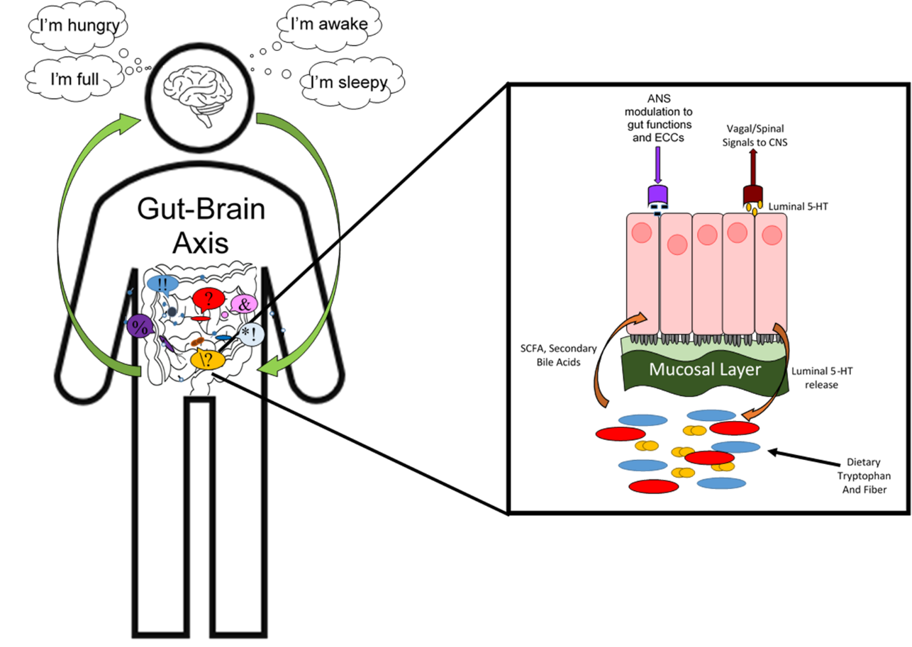

Figure 1.1: The bidirectional gut-brain axis and main routes of communication and influence between the host and their microbiome. The host sends signals via the autonomic nervous system (ANS) and enterochromaffin cells (ECC’s) which modulate the microbiome through gastrointestinal regulation by GI motility and secretion of mucus. The microbiota send signals via release of fermentation of dietary fiber products like short chain fatty acids (SCFAs) and secondary bile acids to influence the host epithelia to release luminal serotonin (5-HT) and neuroimmune cells to send signals to the central nervous system (CNS).

sensitivity to aversive outcomes. Compared to volunteers given a placebo treatment, volunteers with lowered serotonin were slower to respond under
punishment conditions compared with reward conditions and the severity of reduction in the punishment-induced inhibition activity was dependent on the degree to which tryptophan depletion reduced plasma tryptophan levels (Crockett et al., 2009). These findings suggested that in humans, serotonin is involved in aversive processing and behavioral inhibition.
Given that there is evidence that microbes can influence levels of serotonin in the host gut, and there is also evidence linking serotonin levels with changes to host behaviors, it is possible that the gut microbiota can influence host behaviors by altering the levels of hormones such as serotonin being produced in the gut. Yet despite the evidence linking the microbiota and the human nervous system, the neurobiological and electrophysiological mechanisms mediating these relationships remain unclear. The use of model systems, such as mice, or as we propose below, the Steinernema-Xenorhabdus system, can help us better understand these links.

From the brain to the gut
Stress, diet and other factors can have an impact on the microbiome (Aguilera and Martínez, 2013). For example, changes in diet can lead to rapid changes in the gut microbiota and even put the host at risk for disease (Durmic et al., 1998). Mice exposed to social distress through the placement of aggressive males into their cages had altered colonic mucosa-associated microbiota community profiles in as little as two hours post exposure (Bailey et al., 2011; Galley et al., 2014). In humans, infants born vaginally to mothers with higher stress levels (measured through cortisol) had altered microbiomes and increased likelihood of gastrointestinal symptoms and allergic reactions (Zijlmans et al., 2015). Among these studies there are numerous ones that link the overall physical and psychological health of the host to the microbiome.
Host impacts on the gut microbiome can also be mediated through the autonomic nervous system (ANS), which regulates unconscious bodily functions, such as acid production and fluid maintenance in the gut. These alterations to the gut environment in turn have impacts on the microbiota, such as altering the community profiles (Mayer, 2011). Direct physical changes in the gut can also alter the microbiota. For example, decreased volumes of fluid in the GI tract leads to decreased rate of food through the intestine and bacterial overgrowth within the gut (Van Felius et al., 2003). This would make sense as the increased exposure to food would contribute to exponential bacterial growth within the intestines, and decreased nutrients from the host would cause the bacteria to switch to other sources of nutrients, such as the host mucosal layer. Similarly, the quality and amount of mucus secreted within the intestines can impact the microbiome as well. Psychological stress of the host can lead to a less protective mucus layer through changes to the composition and size of the mucus being secreted (Da Silva et al., 2014; Rubio and Huang, 1992; Söderholm et al., 2002). Reduced or compromised mucus can lead to bacteria directly interacting with the host gut epithelia surface, contributing to disease, and as previously stated, microbes will feed on mucus in the absence of host dietary nutrients. If the composition or amount of secreted mucus is altered, this will in turn alter the microbiota that feeds on the mucus and alter the gene expression or composition of the community.
The brain also can have an impact on the microbiota through gut production and release of molecules such as catecholamines, serotonin and other hormones, cytokines from neurons, immune cells and ECCs (Lyte M., 1993; Mayer et al. 2014). One example of a host hormone that can alter the microbiota is melatonin. Secretion of the neurohormone melatonin in the human gut altered the swarming and motility of the commensal bacteria Enterobacter aerogenes, suggesting that even the proper maintenance of circadian rhythms of the host can impact the microbiome (Paulose et al., 2016; Thaiss et al., 2014). These signals can also be used by pathogens during infection. For example Campylobacter jejuni cultured with norepinephrine and then added to Caco-2 human colon adenocarcinoma cells exhibited ~10 times greater colonization than C. jejuni cells cultured without norepinephrine (Cogan et al., 2007).
The examples described above demonstrate how the host can have direct and indirect impacts on the microbiome. Diet, stress, sleep schedules, and any number of factors can contribute to the overall composition and function of the microbes within the gut. These gut microbes can in turn, alter host functions and health through expression of swarming or motility genes, the break down of host nutrients or the host mucosal lining, and the secretion of molecules and metabolites into the intestinal space. All of the above example demonstrate why furthering our understanding of how the host and microbiota interact and what signals they use to impact and influence each other is imperative for the betterment of human health both physically and cognitively. However, in depth molecular based studies are difficult and limited in humans. Models systems like mice, zebra fish, or nematodes allow researchers to manipulate the levels of various hormones, turn on or off nerve cells linked to the gut-brain axis, or manipulate immune cells involved in bacterial signaling. Each human can be thought of as a unique microbiome wherein they can consciously or unconsciously impact the microbiota both positively and negatively. Understanding how a host can impact their microbiota, which in turn will impact the host, will help improve human health and possibly help us understand human cognition in the future.

Current and prospective models to studying the Gut-Brain Axis
A model system is any plant or animal species that has been developed over many years to be an experimental tool to answer biological questions. Model systems are excellent for answering questions about the gut-brain axis and the host-microbe interactions (both virulent and mutualistic) that researchers could not feasibly ask in humans. Use of model systems also allows researchers to have more control over the subjects, controlling for things like sex, diet, environmental conditions and other factors that would not be allowed in human subjects. It is not an understatement to say that we owe a lot of our understanding of microbes and much of our modern medicine to model systems. There are a variety of model systems that have been used and this section will showcase some of those most commonly used to study the gut-brain axis as well as the advantages and disadvantages of each one. It will also put forward the use of Steinernema-Xenorhabdus as a possible system that can be used to study the gut-brain axis.
Among the extensively used models are germfree mice which are compared to mice with their native microbiome have provided insight into the influences of neurophysiology and behaviors such as cognition, sociability, anxiety, depression related addiction/rewards and eating (Luczynski et al., 2016; Warner, 2019). Researchers can control the composition of the mouse microbiota in various ways such as treating conventional mice with prebiotics (compounds that induce microbial growth), probiotics (live microorganisms that can provide benefits when consumed), fecal microbial transplant (FM), and broad spectrum antibiotics to deplete the microbiome. Mice also have the added benefit of being genetically manipulatable, allowing researchers to mutate specific genes and monitor the effects at will. The rat and the hamster are rodents also used to study the gut-brain axis. Rats have been used to study early life stress such as maternal separation, and the impact of these events on the brain and behaviors of the progeny. However, rats are not as genetically tractable as mice (Kelly et al., 2016; O’Mahony et al., 2011; Pusceddu et al., 2015). Hamsters have also been used to study gut microbiota, but mostly for the impacts of stress on the microbiome and how that affects the host in turn (El’Ansary et al., 2018; Partrick et al., 2018). All of these examples give researchers more control over the test subjects than if the subjects were humans.
Besides mammals, other systems also have been used to study the gut-brain axis. This can include species such as zebrafish, which are studied for the impacts their gut microbes can have on anxiety related behaviors and sociability (Borelli et al., 2016; Davis et al., 2016; Wang et al., 2016). They can also be controlled for sex, age, diet, and are genetically manipulatable like mice. Ants have been used to study social-social behaviors and horizontal transmission of the microbiota between conspecifics (of the same species) from an altered gut-microbiome and researchers can control for diet and infection (Key et al. 2014; Tragust et al., 2013). Fruit flies have also been used to study gut-brain interactions and allows researchers to study enteric bacteria influence on mating behavior (Chen et al., 2019; Damodaram et al., 2016; Padney nd Nichols, 2011; Sharon et al., 2010). Fruit flies are also genetically manipulatable, and can be controlled for age, sex, diet and much is known about their neurological pathways. For all of these systems however, the observed behaviors are not translatable to human behaviors and their GI tracts and systems are quite a bit different from humans, making drawing a direct parallel difficult. This demonstrates that it is not just “complex” neural systems as is seen in organisms such as humans and mice that can be manipulated or influenced by microbial derived signals and cues. The vast number and diversity of species that can be influenced by microbial derived molecules does suggest that there is a long history of microbes influencing host behaviors in various ways.
The alteration of host behaviors by microbes is also not limited to symbiotic bacteria, parasites can also impact host behaviors. The parasite Toxoplasma gondii’s native host is the domestic house cat, but T. gondii can infect other animals, such as humans and rats. When this parasite infects mice and rats, it causes atypical behaviors in those hosts. For example, rats that have been infected with this protozoan they will display less fear and are attracted to the smell of cat urine (Berdoy et al., 2000). This is believed to be caused by T. gondii altering host behaviors to make them easier for cat’s to catch and ingest so that T. gondii can re-associate or possibly colonize a new host, and continue its life cycle. Another example is in Wolbachia, the gram-negative endosymbiont of many arthropods and filarial nematodes. These bacteria are perhaps most famous for their manipulation of host development and reproduction including inducing cytoplasmic incompatibility between infected males and uninfected females (Zheng et al., 2011), as well as causing a female bias in the sex ratio, as it can only be transmitted by females (Rousset et al. 199; Southammer et al. 1993). There is also emerging evidence that Wolbachia can alter the Drosophila learning and memory capacity related gene, crebA, which encodes Cyclic-AMP response element binding protein A, which is involved in dendrite development in Drosophila (Bi et al., 2019; Iyer et al., 2013). Current evidence suggests Wolbachia uses microRNAs to manipulate host gene expression for efficient maintenance in Aedes aegypti mosquitoes (Zhang et. al., 2013).
These are just a few examples of the many ways researchers can use model systems to study the gut-brain axis. However, these studies can be time consuming and expensive, and there is the fact that most of these systems are colonized by a number of bacterial species, making pointing the bacterial species, or subset of species responsible for any observed changes a complicated task. The next sections will explore the use of nematodes, especially the Steinernema nematodes and their specific Xenorhabdus bacterial symbionts as a model system to study the gut brain axis in depth.

Nematodes as models of the gut-brain axis:
One of the premiere model systems in biology is the nematode C. elegans, the study of which has revealed fundamental principles in cell biology, development, cancer biology, aging, neurobiology, and other areas (Meneely et al., 2019). Indeed, C. elegans has one of the best studied nervous systems to date. The general structure of a nematode nervous system involves the nerve ring, the neural ganglia, and a dorsal and ventral nerve cord with connecting commissures that send processes from the ventral nerve cord (White et al. 1986; Durbin et al. 1987). In C. elegans, there are 302 neurons, 20 of which are in the pharynx, with its own nervous system, and the rest are found in the head and along the ventral nerve cord. The nerve ring consists of an axon made up of over half of the neurons in the animal, while the rest of the neuronal ganglia are distributed through the head and along the ventral nerve cord (Ware et al., 2975, White et al., 1986). The neurons in the head can be thought of as the “brain” of the nematode, while the neurons that run along the ventral nerve cord are connected to the dorsal nerve cord via junctions called commissures. There is a wealth of knowledge demonstrating that in C. elegans, just as in humans and other animals, microbes can send cues and influence behavior. For example, C. elegans can display an avoidance behavior in response to Pseudomonas aeruginosa, a pathogen of this nematode. Previously, it was shown that after 24 hours of exposure to P. aeruginosa nematode mothers learned to avoid the pathogen in subsequent encounters. Further, their progeny avoid the bacteria for up to four generations before returning to the naïve state and no longer avoiding the pathogen (Moore et al., 2019). Subsequent work found that the P. aeruginosa small RNAs induce this avoidance behavior and can be passed through the germ line of the mother nematodes through the TGF-β signaling in sensory neurons and the Piwi/Argonaute small RNA pathway (Kaletsky et al., 2019). This is an advantageous survival strategy as the progeny have increased chances of reaching adulthood if they are able to avoid this pathogen.
Extending from the success of C. elegans as a model organism, Steinernema nematodes may offer useful opportunities to study the gut-brain axis, based on its co-evolved and species-specific relationship with Xenorhabdus bacteria. Steinernema nematodes and Xenorhabdus bacteria are obligate soil dwelling symbionts that parasitize insects. This system has been used before to study a variety of topics in science, including insect virulence, evolution of hosts and symbionts, or the host-mutualist interface (Murfin et. al., 2015; Cao et. al., 2017; Chapuis et. al., 2011, Morran et. al., 2016). The only known internal colonizer of the Steinernema nematode is its Xenorhabdus bacterial symbiont; and this allows researchers to study the direct impacts of intestinal microbial colonizers without concern for possible bacterial cross talk. Steinernema nematodes can be raised and maintained inexpensively, and germfree in a lab setting. There are two main knowledge gaps that impede the adoption of the Steinernema-Xenorhabdus system as a model to elucidate molecular aspects of gut-brain communication. First, the Steinernema nematode nervous system has not been as studied in depth. However, while there is a massive diversity and subtle differences in nematodes found in nature, the general nervous system layout is similar across the phyla (Han et al., 2016). For example, one study found that C. elegans had ~57 neurons in the ventral nerve cord while Steinernema carpocapsae had ~76 in matched infective juvenile stages (Fig. 1.2). These and other subtle differences may have been due to the varied environments and feeding strategies employed by the nematode (Bumbarger et al., 2013). This study highlights that the investigation of Steinernema neurobiology will benefit from useful parallels that can be drawn from C. elegans, despite some distinctive characteristics between the two nematodes. The second gap in knowledge is that little is as yet known about the impact of Xenorhabdus bacteria on Steinernema behaviors. In my dissertation research, I help fill this gap by identifying a connection between Xenorhabdus bacteria and Steinernema egg laying behavior.

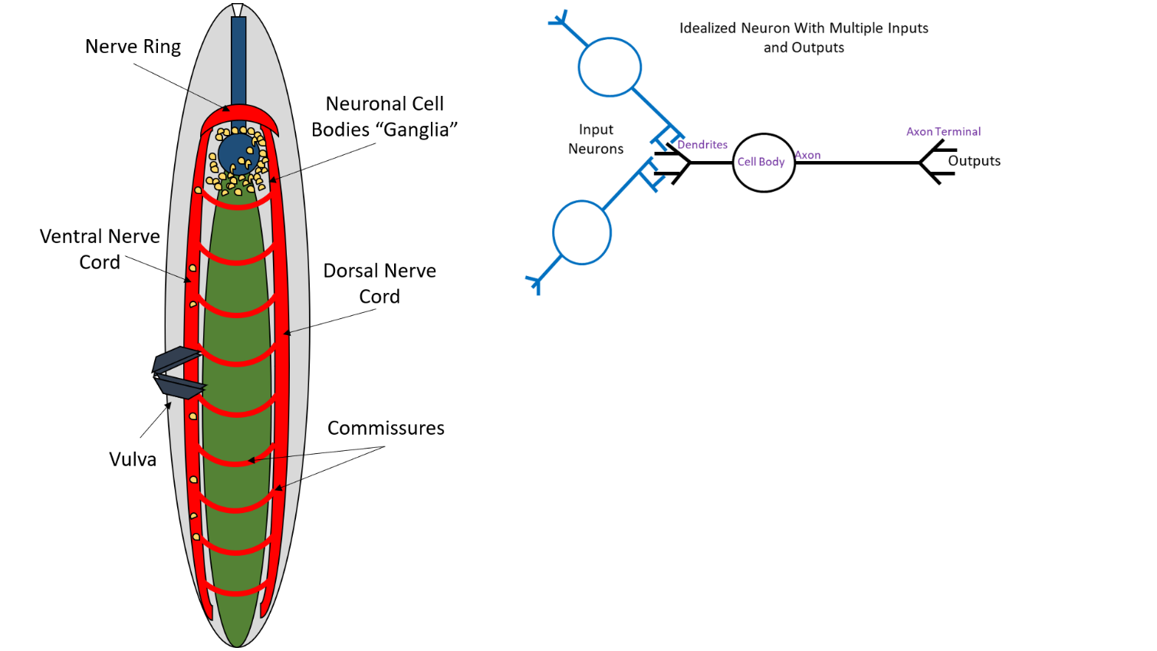
Figure 1.2: The general layout of a nematode nervous system. A) The nematode nervous system consists of a nerve ring and neuronal cell bodies or “ganglia” that serve as the nematode “brain”. There are also the ventral and dorsal nerve cords with commissures that send processes from the ventral nerve cord. B) Idealized neuron with signals moving from the dendrites of the input neurons, through the cell body, down the axon to the axon terminal and the output dendrite.

A
B

Nematode nervous systems control chemosensory and motor functions, including egg laying behavior. C. elegans egg laying circuitry occurs through a motor-
program involving specialized smooth muscle cells (White et al., 1986). When those muscles contract, the vulva opens and compresses the uterus so that eggs will be deposited into the environment. The smooth muscles will receive input for egg laying
from the hermaphrodite specific neurons (HSN) and ventral nerve cord hermaphrodite specific neurons (VC). HSNs are mostly presynaptic with three known neurotransmitters, serotonin (Horvitz et al., 1988; Desai et al., 1988) acetylcholine (Duerr et al., 2001) and some neuropeptides (Schinmann and Li, 1992; Kim and Li 1988). C. elegans are hermaphroditic meaning they can self-fertilize. In contrast, Steinernema females must be fertilized from a male of their species and do not have a hermaphroditic stage. While not covered in this work, future studies should characterize the egg laying circuitry of the Steinernema nematode as has been done with C. elegans, though current technology is limiting, as Steinernema do not have the same genetic manipulability as C. elegans. While much is known about the nervous system of the C. elegans nematode, the makeup and impact of the gut microbiota is not as well studied (Dirksen et al., 2016; Kumar et al., 2020).
Along with modulation through neurotransmitters, there are other environmental factors that can alter nematode egg laying. Factors such as vibration, salt levels in the environment, and importantly, food abundance can all influence C. elegans egg laying (Sawin, 1996; Horvitz et al., 1982; Trent, 1982). Observed increases in C. elegans egg-laying when food (bacteria) is abundant, compared to nutrient deplete conditions, may have evolved because this behavior ensures progeny have a readily available food source upon hatching, increasing their chances of survival.
In chapter three, I demonstrate that the nematode S. carpocapsae displays different egg-laying behaviors when cultivated with its wild type X. nematophila symbiont compared to a X. nematophila mutant lacking a global transcription factor, RpoS. I also present my findings that the neurotransmitters dopamine and serotonin can influence egg-laying behavior, and that the former can ameliorate the consequences of rpoS deletion. With this as a starting point, the Steinernema-Xenorhabdus system will allow us to ask fundamental questions about the gut-brain axis and how bacterial colonization and metabolism can directly impact host neurobiology and behavior.

The Steinernema-Xenorhabdus life cycle and colonization site morphology:
The Steinernema-Xenorhabdus system is notable in that most of the life stages of the nematode take place within an insect cadaver (Fig. 1.3A). Outside of the lab setting, the only Steinernema life stage that occurs outside the cadaver is the infective juvenile (IJ). IJs are a non-feeding, non-reproducing stage that remain inactive in the soil, likely in order to preserve energy and nutrients, until an insect passes by (Moyle and Kaya, 1981; Georgis and Poinar, 1983). Upon sensing an insect, IJs will enter through natural openings (mouth, anus, spiracles) and burrow into the insect’s tissues to reach the hemolymph (Poinar and Leutenegger, 1968; Wouts et al., 1980). Within the IJ the Xenorhabdus bacteria are found on and around a cluster of non-nucleated cells known as the intravesicular structure (IVS), which is itself within a non-constricted section of the gut called the receptacle at the anterior portion of the intestines (Fig. 3B) (Martens et al., 2005; Bird and Akhurst, 1983; Poinar, 1966; Snyder et al., 2007; Wouts, 1980). After reaching the hemolymph, the IJs will release their bacteria through defecation (Snyder et al., 2007). Once released into the insect hemolymph, Xenorhabdus bacteria suppress insect immunity and help kill the insect by releasing insecticidal toxins (Kim et al., 2005; Park et al., 2003; Park et al., 2007; Sergeant et al., 2006). Upon insect death, the bacteria break down the insect biomass for nutrients for themselves while the Steinernema nematodes are bacterivorous (Kaya and Gaugler, 1993; Mucci et al., 2021). All Xenorhabdus species tested so far can also produce compounds that prevent intervention of other opportunistic organisms such as fungus, other nematodes species, or other insects such as ants (Dreyer et al., 2018).
Within the newly infected insect, the IJs develop into the adult stage male and female nematodes that mate and lay eggs. Xenorhabdus bacteria are transferred horizontally, meaning that the newly hatched juveniles from the eggs will ingest bacteria in the insect tissues and some of these ingested cells will colonize. Juveniles and adults are colonized at the anterior intestinal cecum (AIC) at the epithelial cell surface at the base of the basal bulb, a cluster of muscle cells that pull food from the nematode’s environment into the intestine. The nematode develops through three additional juvenile stages (J2, J3, and J4) before molting into adults that mate and produce more eggs. After IJ infection there will be one (or possibly two depending on insect size) generation of nematodes that grow into adults that mate and lay more eggs, after which the following generation will develop into IJs (Chaston et al., 2013).
Evidence suggests that low nutrient availability and high nematode density induce a switch in the J1 juvenile toward development into IJs (Wang and Bedding, 1996; Popiel et al., 1989). On this developmental pathway, J1 juveniles develop into
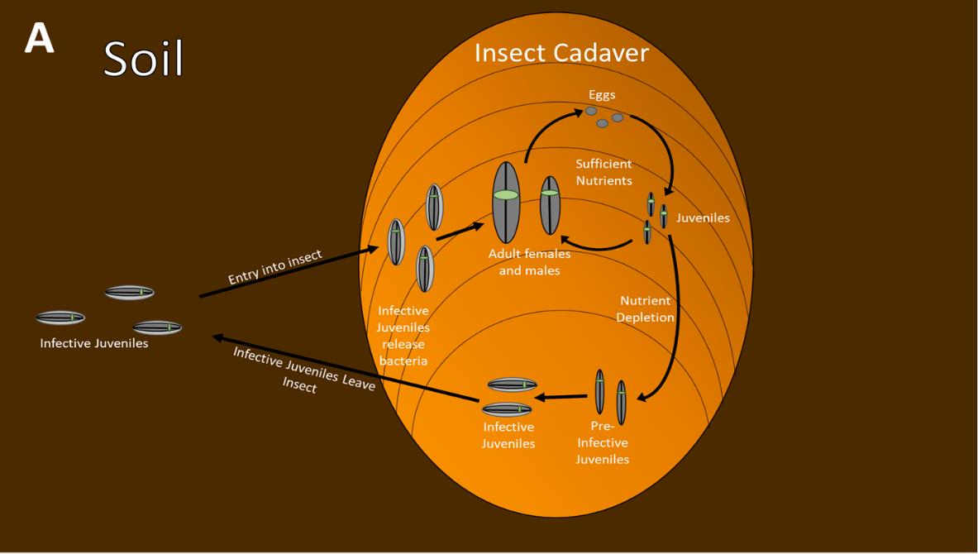
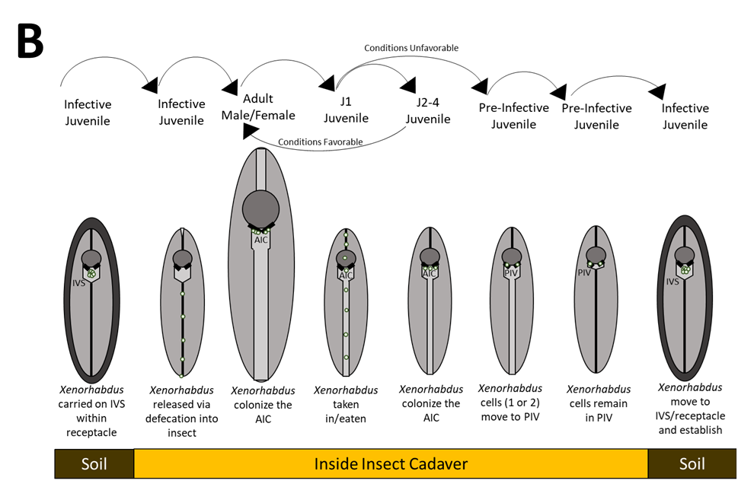
Figure 1.3: Life cycle of Steinernema-Xenorhabdus system and morphology of Xenorhabdus colonization sites. (A) Life cycle of the Steinernema-Xenorhabdus system within the insect cadaver. (B) Colonization sites of the nematodes depending on the life stage. In IJs Xenorhabdus is found on the intravesicular structure (IVS) in the receptacle. In adults and J2-J4 juveniles, the Xenorhabdus colonizes the anterior intestinal cecum (AIC). Finally, the Pre-IJ is colonized by one of two cells at the pharyngeal intestinal valve (PIV, black bars below basal bulb) before moving to the IVS and receptacle to make a fully formed IJ.

pre-IJs that have one or two bacterial cells within the pharyngeal-intestinal valve (PIV), a cluster of tightly knit cells directly below the basal bulb that link the nematode pharynx
and intestinal lumen (Chaston et al., 2013). The intestines of the pre-IJ constrict, while the bacteria remain in the PIV. Finally, the Pre-IJ forms a protective cuticle, and
the anterior portion of the intestine relaxes its constriction and the colonizing bacteria occupy and multiply within the receptacle of the now fully-formed IJ. IJs leave the insect cadaver and return to the soil until identifying and infecting a prospective insect host. While they have different names and overall morphologies, the AIC and receptacle do have a few traits in common, as will be described in the next section.
Insects provide the progeny of the infecting nematodes with a reliable food source, increasing fitness by increasing numbers and survival of progeny. Access to that food source is mediated by the bacterial symbiont, which is transmitted between insects in the nematode IJ receptacle, presumably through a process that involves selection through colonization of the PIV of the pre-IJ. However, the physiological or evolutionary function, if any, of bacterial colonization of the nematode AIC within the insect cadaver is not known. These nematodes will remain in the insect cadaver until their death and are not destined to transmit bacteria to another insect host. These nematodes ingest and digest bacteria as a food source to provide energy for development and reproduction, so sequestration of undigested bacteria in the anterior intestine comes at the expense of not using the energy that could be derived from those bacteria (Mucci, et al. 2021). In Chapter 3 I present my discovery that X. nematophila bacteria that colonize the AIC can influence S. carpocapsae host nematode egg-laying behavior.
Xenorhabdus colonization sites in Steinernema nematodes:
Steinernema juvenile and adult nematodes are colonized by and in close association with Xenorhabdus bacterial symbionts. Generally, Xenorhabdus colonizes tissues in the anterior pharyngeal-intestinal region, though the specific tissue and the site varies depending on the stage of nematode development. In pre-IJs destined to become IJs, Xenorhabdus colonizes a crypt-like structure within the PIV, a specialized set of cells that links the pharyngeal and intestinal lumina (Baldwin and Perry, 2004; Altun and Hall, 2005). In the IJ stage, the bacteria occupy the lumen between the two anterior intestinal cells (immediately posterior to the PIV), separated from the rest of the constricted intestinal tract by a plug (Snyder et al., 2007). In S. carpocapsae, this luminal space, known as the receptacle, contains a cluster of nematode-derived non-nucleated spherical bodies termed the intravesicular structure (IVS) to which colonizing X. nematophila cells can adhere. The IVS spheres are bathed in a mucus-like material that reacts with the lectin wheat germ agglutinin (WGA) that binds to the sugars N-acetylglucosamine (NAG) and N-acetylneuraminic acid (Martens and Goodrich-Blair, 2005). In developing juveniles and adult stages of S. carpocapsae nematodes, the entire intestine is open, and X. nematophila cells colonize the anterior intestinal caecum (AIC), the anterior surface of the intestine formed by intestinal epithelial cells. X. nematophila does not appear to adhere to any of the remaining posterior intestinal epithelial cells (Chaston et al., 2013). My work presented in chapter two demonstrated that in adult female and male nematodes, the AIC, and not other intestinal surfaces, expresses a WGA-reactive material.
Given that the WGA reactive material can be found at the AIC and receptacle of the S. carpocapsae nematodes, we hypothesize it might be involved in X. nematophila selection or colonization. This might occur through the mucus serving as an adherence factor for the bacterial cells, as a nutrient source, or both. S. carpocapsae pre-IJs carry one or perhaps two bacterial cells in their PIV, which we hypothesize to travel down to the receptacle of the developing IJ and establish within the space although this has yet to be proven (Chaston et al., 2013). The number of Xenorhabdus cells found within the receptacle of an IJ stage Steinernema nematode will vary depending on the species. For example, S. scapterisci has ~7 CFU/IJ of its X. innexi symbiont in comparison to S. carpocapsae which has an average of ~40 CFU/IJ X. nematophila when measured via grinding assay (Kim et al., 2017). The IJ stage of the nematode is non-feeding, which suggests that the nutrients the Xenorhabdus bacteria are using are provided by the hosts at these colonization sites. In fact, aposymbiotic nematodes raised under certain conditions can survive slightly longer than colonized S. carpocapsae nematodes raised under the same conditions (Mitani et al., 2007). Chapter two will investigate more in depth the possible role of the WGA reactive material in maintaining bacterial populations within the nematode.

The X. nematophila nil genes are necessary for colonization of S. carpocapsae nematodes:
The X. nematophila genome contains a 3.5-kb locus referred to as Symbiosis Region 1 (SR1) (Heungens et al., 2002) that contains the nematode intestinal localization (nil) genes (Fig. 1.4). This region was discovered using a signature tagged
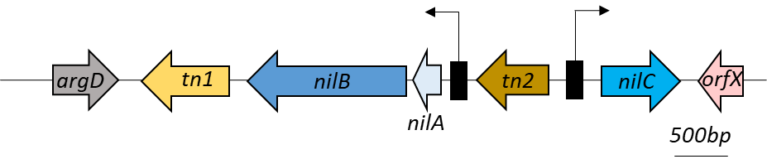
Figure 1.4: Schematic diagram of SR1. Diagram of the SR1 genome region including predicted ORFs (solid arrows). Boxes with attached arrows indicate promoters of nil genes. nilA and nilB share a promoter while nilC has a separate promoter. argD indicates a 3’ end truncated gene that is a homolog to E. coli acetylornithine aminotransferase. Finally, the ORFs that have sequence homology with transposases have been labeled tn1 and tn2 genome area including predicted ORFs (solid arrows).

transposon mutagenesis screen; a technique that allows multiple mutants, each distinguishable from the others by a unique sequence tag within the transposon, to be pooled for screening. A library of 3000 X. nematophila mutants were screened for those that were not represented among the bacteria colonizing S. carpocapsae IJs, detected based on loss of the unique sequence from the population. This screen gave rise to 15 colonization-deficient mutants including 5 with insertions in one of the SR1 locus nil genes, nilA, nilB or nilC. Insertions in nilA cause low, but detectable levels of colonization. nilA is predicted to encode a 90 amino acid (aa) inner membrane protein, but its effects on colonization are thought to be due to its co-transcription with nilB (Cowles et al., 2008). nilB encodes a ~466 aa outer membrane protein with homologs across many proteobacteria species (Heungens et al., 2002, Grossman et al., 2021). nilC encodes a 282-aa periplasm-oriented lipoprotein that can be expressed on the cell surface (Cowles and Goodrich-Blair, 2004, Dr. Mauer, PhD Dissertation, 2019). NilC does not have homologs in publicly available sequence databases.
SR1 is absent from the majority of Xenorhabdus species, and is found only in X. nematophila, X. innexi and X. stockiae, the symbionts of S. carpocapsae, S. scapterisci, and S. siamkayai respectively (Grossman et al., 2020). These nematodes are members of the same Steinernema clade (II), but X. nematophila is in a different clade than are X. innexi and X. stockiae (Lee and Stock, 2010; Grossman et al., 2021). This might suggest that the SR1 genes are horizontally acquired and adapted for symbiosis with the Clade II Steinernema species. When comparing the average G-plus-C content (43.3% G+C) the average G-plus-C content of the nil locus (35.7% G+C) was lower, and the nilAB portion of the locus was lower than that (30.7% G+C) (Cowles and Goodrich-Blair, 2008). This difference in the G+C content suggests that the nil genes were horizontally acquired by X. nematophila in the past and possibly co-opted from their original function to also serve as a factor in colonization factor in S. carpocapsae nematode hosts. Furthermore, the nil genes are sufficient to confer upon other Xenorhabdus species the ability to colonize S. carpocapsae nematodes at both the IJ and adult stages. Introduction of the SR1 locus into Xenorhabdus species (e.g., X. bovienii or X. szenterimaii) that neither encode SR1 nor colonize S. carpocapsae resulted in colonization proficiency, albeit at a lower level than X. nematophila (Cowles and Goodrich-Blair, 2008; Chaston et al., 2013). Taken together these results demonstrate the critical role that nil genes play in colonization of S. carpocapsae and their function as host-range specificity determinants.

Phenotyping of the X. nematophila sigma factor RpoS:
Another X. nematophila gene that plays a role in the ability of X. nematophila bacteria to colonize S. carpocapsae nematodes is rpoS, encoding a sigma factor, RpoS (σ³⁸ or σ^{S}). RpoS is a stationary phase and stress response sigma factor in E. coli (Lange and Hengge-Aronis, 1991). For example, E. coli rpoS mutants have survival defects in liquid culture compared to wild type E. coli with an intact rpoS gene (Lange and Hengge Aronis, 1991; McCann et al., 2991; Mulvey et al., 1990). In X. nematophila rpoS::kan mutants are colonization deficient in IJs (Vivas and Goodrich-Blair, 2001; Heungens et al., 2002) and in adult stage nematodes (Chapter 3) but its role in stress responses is less clear. Consistent with a role in oxidative stress response, X. nematophila rpoS mutant cells were also 4 to 7-fold more sensitive than wild type to exposure to 10mM H₂O₂. However, this was not a dramatic difference. Also, both X. nematophila wild type and the rpoS mutant died after several days of incubation in stationary phase, but the rpoS mutant actually persisted slightly longer, suggesting they actually may be better equipped for stationary phase survival (Vivas and Goodrich-Blair, 2001).
Along with general stress responses rpoS::kan mutants were observed for their role in mutualism when interacting with S. carpocapsae nematodes. When surface sterilized eggs were placed on lawns of X. nematophila rpoS::kan, the resulting IJ progeny were indistinguishable from those derived from X. nematophila wild type lawns. This result suggests that IJs develop normally on X. nematophila rpoS::kan mutants, indicating the RpoS status of X. nematophila does not influence this developmental pathway (Vivas and Goodrich-Blair, unpublished data). Finally, when injected into M. sexta larva, there was no significant difference of virulence between X. nematophila rpoS::kan relative to wild type, suggesting that rpoS is likely not involved in regulation of insect killing or toxin-encoding genes (Vivas and Goodrich-Blair, 2001).
When considering these data, it might suggest that rpoS involvement in colonization might be a response to possibly more stressful conditions of the receptacle of IJs, or the AIC of adult nematodes. This is likely the case with the IJ stage, where the nematode and symbiont could be waiting in the soil for months to infect another insect host. The IJ is likely providing the bacteria with food to maintain its symbionts within the receptacle, and the bacteria must be able to respond properly to starvation, or nutrient limitation stress. This might be explained as the PIV colonization stage serving as a sort of “test” where the nutrients are highly limited or not available and X. nematophila cells unable to properly regulate a response to this die out or are rejected from this space. Bacterial cells that survive are able to move on to the receptacle and possibly use host resources to maintain a population until the next insect host.
The reason the rpoS mutants are unable to colonize successfully in any life stage of S. carpocapsae remains unexplained. It is also unknown if similar mutations in other species, such as X. innexi (the symbiont of S. scapterisci) that also contains nil genes are similarly colonization deficient. The fact remains, however, that bacterial gene regulation seems to be playing a role in colonization and that just having a functional set of nil genes is not enough for successful colonization of S. carpocapsae nematodes. In chapter three I present my work demonstrating that S. carpocapsae displays altered reproductive behaviors in the presence of X. nematophila rpoS mutants relative to wild type suggesting that X. nematophila colonization could be important for the proper regulation of S. carpocapsae egg laying behavior.

Discussion:
Most plants and animals have evolved with their microbiome. They are colonized early in life, perhaps even in the embryonic stage, and will remain colonized for their entire lives if left alone. This is the same for humans, who are colonized by a multitude of bacterial species that can be found all over, but especially in the gastrointestinal tract (Thursby and Juge, 2017). Bacteria provide humans with a variety of benefits including breakdown of food, providing essential nutrients, and protection from pathogens. However, given the growing number of links between the gut microbiota and its impact on human health and behaviors there is a growing need for mechanistic studies focusing on host–microbe interactions.
Model systems, such as mice, rats, zebrafish and other systems are commonly used to understand the mechanisms of interfacing and signaling taking place between the host and the gut microbiome. Studies performed in mice have shown that a germfree mouse shows differences in behaviors such as cognition, sociability, anxiety, depression related addiction/rewards and eating when compared to mice colonized with their native microbiota (Luczynski et al., 2016; Warner, 2019). However, these studies can be time consuming and expensive, and there is the fact that similar to the C. elegans model, mouse models are colonized by a number of bacterial species, making pointing the bacterial species, or subset of species responsible for these changes a complicated task.
This chapter has attempted to draw connections between colonization and homeostasis of the gut microbiota and the ways this can impact host health and behaviors. Steinernema nematodes and Xenorhabdus bacteria can serve as a model system for studying the mechanistic aspects bacterial colonization. Chapter two will focus on the ways in which S. carpocapsae is recruiting and/or selecting for X. nematophila through expression of wheat germ agglutinin (WGA) reactive material at AIC, and that bacterial colonization can be inhibited with the addition of WGA lectin. It will also explore the possible role of X. nematophila nilC in bacterial colonization through the addition of purified NilC protein increasing bacterial colonization when added to symbiont free nematodes compared to nematodes treated with just bacterial symbionts. Chapter three will explore how changes to the X. nematophila gene regulation and ability to colonize the AIC can alter behavior of the colonized S. carpocapsae nematode host. Female nematodes reared on lawns of colonization-deficient rpoS::kan X. nematophila, but not ΔSR1 X. nematophila, lay significantly fewer eggs compared to females reared on wild type X. nematophila lawns. Further, the addition of exogenous dopamine, but not serotonin can raise egg laying to wild type levels in S. carpocapsae nematodes raised on rpoS::kan lawns. This suggests that proper bacterial gene regulation has an impact on nematode behaviors. Overall, this work puts forward the Steinernema-Xenorhabdus model system as a way to explore the gut-brain axis through study of the mechanistic interactions that lead to colonization and the impacts colonization can have on host behavior.

Chapter one resources:

Aguilera, M., Vergara, P., & Martínez, V. (2013). Stress and antibiotics alter luminal and wall-adhered microbiota and enhance the local expression of visceral sensory-related systems in mice. Neurogastroenterology and motility : the official journal of the European Gastrointestinal Motility Society, 25(8), e515–e529. https://doi.org/10.1111/nmo.12154

Akhurst R. J. (1983). Neoaplectana species: specificity of association with bacteria of the genus Xenorhabdus. Experimental parasitology, 55(2), 258–263. https://doi.org/10.1016/0014-4894(83)90020-6

Altun, ZF.; Hall, DH. Alimentary system, pharynx. (2009). [WWW document]. URL doi:10.3908/ wormatlas.1.3

Amaral, F. A., Sachs, D., Costa, V. V., Fagundes, C. T., Cisalpino, D., Cunha, T. M., Ferreira, S. H., Cunha, F. Q., Silva, T. A., Nicoli, J. R., Vieira, L. Q., Souza, D. G., & Teixeira, M. M. (2008). Commensal microbiota is fundamental for the development of inflammatory pain. Proceedings of the National Academy of Sciences of the United States of America, 105(6), 2193–2197. https://doi.org/10.1073/pnas.0711891105

Atuma, C., Strugala, V., Allen, A., & Holm, L. (2001). The adherent gastrointestinal mucus gel layer: thickness and physical state in vivo. American journal of physiology. Gastrointestinal and liver physiology, 280(5), G922–G929. https://doi.org/10.1152/ajpgi.2001.280.5.G922

Bailey, M. T., Dowd, S. E., Galley, J. D., Hufnagle, A. R., Allen, R. G., & Lyte, M. (2011). Exposure to a social stressor alters the structure of the intestinal microbiota: implications for stressor-induced immunomodulation. Brain, behavior, and immunity, 25(3), 397–407. https://doi.org/10.1016/j.bbi.2010.10.023

Baldwin, JG.; Perry, RN. (2004). Nematode morphology, sensory structure and function. In: Chen, ZX.; Chen, SY.; Dickson, DW., editors. Nematol Adv Persp. CABI; Cambridge, MA: p. 175-257.

Benakis, C., Brea, D., Caballero, S., Faraco, G., Moore, J., Murphy, M., Sita, G., Racchumi, G., Ling, L., Pamer, E. G., Iadecola, C., & Anrather, J. (2016). Commensal microbiota affects ischemic stroke outcome by regulating intestinal γδ T cells. Nature medicine, 22(5), 516–523. https://doi.org/10.1038/nm.4068

Berdoy, M., Webster, J. P., & Macdonald, D. W. (2000). Fatal attraction in rats infected with Toxoplasma gondii. Proceedings. Biological sciences, 267(1452), 1591–1594. https://doi.org/10.1098/rspb.2000.1182

Berer, K., Mues, M., Koutrolos, M., Rasbi, Z. A., Boziki, M., Johner, C., Wekerle, H., & Krishnamoorthy, G. (2011). Commensal microbiota and myelin autoantigen cooperate to trigger autoimmune demyelination. Nature, 479(7374), 538–541. https://doi.org/10.1038/nature10554

Bi, J., Zheng, Y., Wang, R. F., Ai, H., Haynes, P. R., Brownlie, J. C., Yu, X. Q., & Wang, Y. F. (2019). Wolbachia infection may improve learning and memory capacity of Drosophila by altering host gene expression through microRNA. Insect biochemistry and molecular biology, 106, 47–54. https://doi.org/10.1016/j.ibmb.2018.11.007

Bloom O. (2014). Non-mammalian model systems for studying neuro-immune interactions after spinal cord injury. Experimental neurology, 258, 130–140. https://doi.org/10.1016/j.expneurol.2013.12.023

Bravo, J. A., Forsythe, P., Chew, M. V., Escaravage, E., Savignac, H. M., Dinan, T. G., Bienenstock, J., & Cryan, J. F. (2011). Ingestion of Lactobacillus strain regulates emotional behavior and central GABA receptor expression in a mouse via the vagus nerve. Proceedings of the National Academy of Sciences of the United States of America, 108(38), 16050–16055. https://doi.org/10.1073/pnas.1102999108

Bonaz, B., Bazin, T., & Pellissier, S. (2018). The Vagus Nerve at the Interface of the Microbiota-Gut-Brain Axis. Frontiers in neuroscience, 12, 49. https://doi.org/10.3389/fnins.2018.00049

Borrelli, L., Aceto, S., Agnisola, C., De Paolo, S., Dipineto, L., Stilling, R. M., Dinan, T. G., Cryan, J. F., Menna, L. F., & Fioretti, A. (2016). Probiotic modulation of the microbiota-gut-brain axis and behaviour in zebrafish. Scientific reports, 6, 30046. https://doi.org/10.1038/srep30046

Brachman, R. A., Lehmann, M. L., Maric, D., & Herkenham, M. (2015). Lymphocytes from chronically stressed mice confer antidepressant-like effects to naive mice. The Journal of neuroscience : the official journal of the Society for Neuroscience, 35(4), 1530–1538. https://doi.org/10.1523/JNEUROSCI.2278-14.2015

Bumbarger, D. J., Riebesell, M., Rödelsperger, C., & Sommer, R. J. (2013). System-wide rewiring underlies behavioral differences in predatory and bacterial-feeding nematodes. Cell, 152(1-2), 109–119. https://doi.org/10.1016/j.cell.2012.12.013

Cani, P. D., Lecourt, E., Dewulf, E. M., Sohet, F. M., Pachikian, B. D., Naslain, D., De Backer, F., Neyrinck, A. M., & Delzenne, N. M. (2009). Gut microbiota fermentation of prebiotics increases satietogenic and incretin gut peptide production with consequences for appetite sensation and glucose response after a meal. The American journal of clinical nutrition, 90(5), 1236–1243. https://doi.org/10.3945/ajcn.2009.28095

Cao, M., Patel, T., Rickman, T., Goodrich-Blair, H., & Hussa, E. A. (2017). High Levels of the Xenorhabdus nematophila Transcription Factor Lrp Promote Mutualism with the Steinernema carpocapsae Nematode Host. Applied and environmental microbiology, 83(12), e00276-17. https://doi.org/10.1128/AEM.00276-17

Chapuis, É., Pagès, S., Emelianoff, V., Givaudan, A., & Ferdy, J. B. (2011). Virulence and pathogen multiplication: a serial passage experiment in the hypervirulent bacterial insect-pathogen Xenorhabdus nematophila. PloS one, 6(1), e15872. https://doi.org/10.1371/journal.pone.0015872

Chaston, J. M., Murfin, K. E., Heath-Heckman, E. A., & Goodrich-Blair, H. (2013). Previously unrecognized stages of species-specific colonization in the mutualism between Xenorhabdus bacteria and Steinernema nematodes. Cellular microbiology, 15(9), 1545–1559. https://doi.org/10.1111/cmi.12134

Chen, K., Luan, X., Liu, Q., Wang, J., Chang, X., Snijders, A. M., Mao, J. H., Secombe, J., Dan, Z., Chen, J. H., Wang, Z., Dong, X., Qiu, C., Chang, X., Zhang, D., Celniker, S. E., & Liu, X. (2019). Drosophila Histone Demethylase KDM5 Regulates Social Behavior through Immune Control and Gut Microbiota Maintenance. Cell host & microbe, 25(4), 537–552.e8. https://doi.org/10.1016/j.chom.2019.02.003

Cogan, T. A., Thomas, A. O., Rees, L. E., Taylor, A. H., Jepson, M. A., Williams, P. H., Ketley, J., & Humphrey, T. J. (2007). Norepinephrine increases the pathogenic potential of Campylobacter jejuni. Gut, 56(8), 1060–1065. https://doi.org/10.1136/gut.2006.114926

Cowles, C. E., & Goodrich-Blair, H. (2004). Characterization of a lipoprotein, NilC, required by Xenorhabdus nematophila for mutualism with its nematode host. Molecular microbiology, 54(2), 464–477. https://doi.org/10.1111/j.1365-2958.2004.04271.x

Cowles, K. N., Cowles, C. E., Richards, G. R., Martens, E. C., & Goodrich-Blair, H. (2007). The global regulator Lrp contributes to mutualism, pathogenesis and phenotypic variation in the bacterium Xenorhabdus nematophila. Cellular microbiology, 9(5), 1311–1323. https://doi.org/10.1111/j.1462-5822.2006.00873.x

Cowles, C. E., & Goodrich-Blair, H. (2008). The Xenorhabdus nematophila nilABC genes confer the ability of Xenorhabdus spp. to colonize Steinernema carpocapsae nematodes. Journal of bacteriology, 190(12), 4121–4128. https://doi.org/10.1128/JB.00123-08

Crockett, M. J., Clark, L., & Robbins, T. W. (2009). Reconciling the role of serotonin in behavioral inhibition and aversion: acute tryptophan depletion abolishes punishment-induced inhibition in humans. The Journal of neuroscience : the official journal of the Society for Neuroscience, 29(38), 11993–11999. https://doi.org/10.1523/JNEUROSCI.2513-09.2009

Cryan, J. F., & Dinan, T. G. (2012). Mind-altering microorganisms: the impact of the gut microbiota on brain and behaviour. Nature reviews. Neuroscience, 13(10), 701–712. https://doi.org/10.1038/nrn3346

Da Silva, S., Robbe-Masselot, C., Ait-Belgnaoui, A., Mancuso, A., Mercade-Loubière, M., Salvador-Cartier, C., Gillet, M., Ferrier, L., Loubière, P., Dague, E., Theodorou, V., & Mercier-Bonin, M. (2014). Stress disrupts intestinal mucus barrier in rats via mucin O-glycosylation shift: prevention by a probiotic treatment. American journal of physiology. Gastrointestinal and liver physiology, 307(4), G420–G429. https://doi.org/10.1152/ajpgi.00290.2013

Damodaram, K. J., Ayyasamy, A., & Kempraj, V. (2016). Commensal Bacteria Aid Mate-selection in the Fruit Fly, Bactrocera dorsalis. Microbial ecology, 72(3), 725–729. https://doi.org/10.1007/s00248-016-0819-4

Daneman, R., & Prat, A. (2015). The blood-brain barrier. Cold Spring Harbor perspectives in biology, 7(1), a020412. https://doi.org/10.1101/cshperspect.a020412

Davis, D. J., Bryda, E. C., Gillespie, C. H., & Ericsson, A. C. (2016). Microbial modulation of behavior and stress responses in zebrafish larvae. Behavioural brain research, 311, 219–227. https://doi.org/10.1016/j.bbr.2016.05.040

Desai, C., Garriga, G., McIntire, S. L., & Horvitz, H. R. (1988). A genetic pathway for the development of the Caenorhabditis elegans HSN motor neurons. Nature, 336(6200), 638–646. https://doi.org/10.1038/336638a0

Desai, M. S., Seekatz, A. M., Koropatkin, N. M., Kamada, N., Hickey, C. A., Wolter, M., Pudlo, N. A., Kitamoto, S., Terrapon, N., Muller, A., Young, V. B., Henrissat, B., Wilmes, P., Stappenbeck, T. S., Núñez, G., & Martens, E. C. (2016). A Dietary Fiber-Deprived Gut Microbiota Degrades the Colonic Mucus Barrier and Enhances Pathogen Susceptibility. Cell, 167(5), 1339–1353.e21. https://doi.org/10.1016/j.cell.2016.10.043

Desbonnet, L., Clarke, G., Shanahan, F., Dinan, T. G., & Cryan, J. F. (2014). Microbiota is essential for social development in the mouse. Molecular psychiatry, 19(2), 146–148. https://doi.org/10.1038/mp.2013.65

Desbonnet, L., Clarke, G., Traplin, A., O'Sullivan, O., Crispie, F., Moloney, R. D., Cotter, P. D., Dinan, T. G., & Cryan, J. F. (2015). Gut microbiota depletion from early adolescence in mice: Implications for brain and behaviour. Brain, behavior, and immunity, 48, 165–173. https://doi.org/10.1016/j.bbi.2015.04.004

Dirksen, P., Marsh, S. A., Braker, I., Heitland, N., Wagner, S., Nakad, R., Mader, S., Petersen, C., Kowallik, V., Rosenstiel, P., Félix, M. A., & Schulenburg, H. (2016). The native microbiome of the nematode Caenorhabditis elegans: gateway to a new host-microbiome model. BMC biology, 14, 38. https://doi.org/10.1186/s12915-016-0258-1

Duerr, J. S., Gaskin, J., & Rand, J. B. (2001). Identified neurons in C. elegans coexpress vesicular transporters for acetylcholine and monoamines. American journal of physiology. Cell physiology, 280(6), C1616–C1622. https://doi.org/10.1152/ajpcell.2001.280.6.C1616

Duncan, K., & Coggins, J. R. (1986). The serC-aro A operon of Escherichia coli. A mixed function operon encoding enzymes from two different amino acid biosynthetic pathways. The Biochemical journal, 234(1), 49–57. https://doi.org/10.1042/bj2340049

Durbin, R.M. (1987). Studies on the Development and Organization of the Nervous System of Caenorhabditis elegans. In. Cambridge University, Cambridge

Durmic, Z., Pethick, D. W., Pluske, J. R., & Hampson, D. J. (1998). Changes in bacterial populations in the colon of pigs fed different sources of dietary fibre, and the development of swine dysentery after experimental infection. Journal of applied microbiology, 85(3), 574–582. https://doi.org/10.1046/j.1365-2672.1998.853539.x

El-Ansary, A., Bacha, A. B., Bjørklund, G., Al-Orf, N., Bhat, R. S., Moubayed, N., & Abed, K. (2018). Probiotic treatment reduces the autistic-like excitation/inhibition imbalance in juvenile hamsters induced by orally administered propionic acid and clindamycin. Metabolic brain disease, 33(4), 1155–1164. https://doi.org/10.1007/s11011-018-0212-8

Erny, D., Hrabě de Angelis, A. L., Jaitin, D., Wieghofer, P., Staszewski, O., David, E., Keren-Shaul, H., Mahlakoiv, T., Jakobshagen, K., Buch, T., Schwierzeck, V., Utermöhlen, O., Chun, E., Garrett, W. S., McCoy, K. D., Diefenbach, A., Staeheli, P., Stecher, B., Amit, I., & Prinz, M. (2015). Host microbiota constantly control maturation and function of microglia in the CNS. Nature neuroscience, 18(7), 965–977. https://doi.org/10.1038/nn.4030

Fagarasan, S., Muramatsu, M., Suzuki, K., Nagaoka, H., Hiai, H., & Honjo, T. (2002). Critical roles of activation-induced cytidine deaminase in the homeostasis of gut flora. Science (New York, N.Y.), 298(5597), 1424–1427. https://doi.org/10.1126/science.1077336

Filiano, A. J., Gadani, S. P., & Kipnis, J. (2015). Interactions of innate and adaptive immunity in brain development and function. Brain research, 1617, 18–27. https://doi.org/10.1016/j.brainres.2014.07.050

Furness, J. B., Rivera, L. R., Cho, H. J., Bravo, D. M., & Callaghan, B. (2013). The gut as a sensory organ. Nature reviews. Gastroenterology & hepatology, 10(12), 729–740. https://doi.org/10.1038/nrgastro.2013.180

Galley, J. D., Nelson, M. C., Yu, Z., Dowd, S. E., Walter, J., Kumar, P. S., Lyte, M., & Bailey, M. T. (2014). Exposure to a social stressor disrupts the community structure of the colonic mucosa-associated microbiota. BMC microbiology, 14, 189. https://doi.org/10.1186/1471-2180-14-189

Gill, S. R., Pop, M., Deboy, R. T., Eckburg, P. B., Turnbaugh, P. J., Samuel, B. S., Gordon, J. I., Relman, D. A., Fraser-Liggett, C. M., & Nelson, K. E. (2006). Metagenomic analysis of the human distal gut microbiome. Science (New York, N.Y.), 312(5778), 1355–1359. https://doi.org/10.1126/science.1124234

Gimsa, U., Mitchison, N. A., & Brunner-Weinzierl, M. C. (2013). Immune privilege as an intrinsic CNS property: astrocytes protect the CNS against T-cell-mediated neuroinflammation. Mediators of inflammation, 2013, 320519. https://doi.org/10.1155/2013/320519

Goodrich-Blair H. (2007). They've got a ticket to ride: Xenorhabdus nematophila-Steinernema carpocapsae symbiosis. Current opinion in microbiology, 10(3), 225–230. https://doi.org/10.1016/j.mib.2007.05.006

Grossman, A. S., Mauer, T. J., Forest, K. T., & Goodrich-Blair, H. (2021). Description of a widespread bacterial secretion system with chemically diverse substrates. https://doi.org/10.1101/2020.01.20.912956

Han, Z., Boas, S., & Schroeder, N. E. (2016). Unexpected Variation in Neuroanatomy among Diverse Nematode Species. Frontiers in neuroanatomy, 9, 162. https://doi.org/10.3389/fnana.2015.00162

Heungens, K., Cowles, C. E., & Goodrich-Blair, H. (2002). Identification of Xenorhabdus nematophila genes required for mutualistic colonization of Steinernema carpocapsae nematodes. Molecular microbiology, 45(5), 1337–1353. https://doi.org/10.1046/j.1365-2958.2002.03100.x

Horvitz, H.R., Chalfie, M., Trent, C., Sulston, J.E., and Evans, P.D. (1982). Serotonin and octopamine in the nematode Caenorhabditis elegans. Science 216, 1012–1014.

Hsiao, E. Y., McBride, S. W., Hsien, S., Sharon, G., Hyde, E. R., McCue, T., Codelli, J. A., Chow, J., Reisman, S. E., Petrosino, J. F., Patterson, P. H., & Mazmanian, S. K. (2013). Microbiota modulate behavioral and physiological abnormalities associated with neurodevelopmental disorders. Cell, 155(7), 1451–1463. https://doi.org/10.1016/j.cell.2013.11.024

Hussa, E. A., Casanova-Torres, Á. M., & Goodrich-Blair, H. (2015). The Global Transcription Factor Lrp Controls Virulence Modulation in Xenorhabdus nematophila. Journal of bacteriology, 197(18), 3015–3025. https://doi.org/10.1128/JB.00272-15

Iyer, S. C., Ramachandran Iyer, E. P., Meduri, R., Rubaharan, M., Kuntimaddi, A., Karamsetty, M., & Cox, D. N. (2013). Cut, via CrebA, transcriptionally regulates the COPII secretory pathway to direct dendrite development in Drosophila. Journal of cell science, 126(Pt 20), 4732–4745. https://doi.org/10.1242/jcs.131144

Ivanov, I. I., Atarashi, K., Manel, N., Brodie, E. L., Shima, T., Karaoz, U., Wei, D., Goldfarb, K. C., Santee, C. A., Lynch, S. V., Tanoue, T., Imaoka, A., Itoh, K., Takeda, K., Umesaki, Y., Honda, K., & Littman, D. R. (2009). Induction of intestinal Th17 cells by segmented filamentous bacteria. Cell, 139(3), 485–498. https://doi.org/10.1016/j.cell.2009.09.033

Ji, D., Yi, Y., Kang, G. H., Choi, Y. H., Kim, P., Baek, N. I., & Kim, Y. (2004). Identification of an antibacterial compound, benzylideneacetone, from Xenorhabdus nematophila against major plant-pathogenic bacteria. FEMS microbiology letters, 239(2), 241–248. https://doi.org/10.1016/j.femsle.2004.08.041

Kaletsky, R., Moore, R., Parsons, L., Murphy, C. (2019) bioRxiv 697888; doi:https://dio.org/10.1101/697888

Kaya HK, Gaugler R. (1993). Entomopathogenic nematodes. Annu Rev Entomol, 38:181–206

Kelly, J. R., Kennedy, P. J., Cryan, J. F., Dinan, T. G., Clarke, G., & Hyland, N. P. (2015). Breaking down the barriers: the gut microbiome, intestinal permeability and stress-related psychiatric disorders. Frontiers in cellular neuroscience, 9, 392. https://doi.org/10.3389/fncel.2015.00392

Kelly, J. R., Borre, Y., O' Brien, C., Patterson, E., El Aidy, S., Deane, J., Kennedy, P. J., Beers, S., Scott, K., Moloney, G., Hoban, A. E., Scott, L., Fitzgerald, P., Ross, P., Stanton, C., Clarke, G., Cryan, J. F., & Dinan, T. G. (2016). Transferring the blues: Depression-associated gut microbiota induces neurobehavioural changes in the rat. Journal of psychiatric research, 82, 109–118. https://doi.org/10.1016/j.jpsychires.2016.07.019

Kay AD, Bruning AJ, van Alst A, Abrahamson TT, Hughes WO, Kaspari M. A carbohydrate-rich diet increases social immunity in ants. Proc Biol Sci 281: 20132374, 2014. doi:10.1098/rspb.2013.2374

Kim, K., & Li, C. (2004). Expression and regulation of an FMRFamide-related neuropeptide gene family in Caenorhabditis elegans. The Journal of comparative neurology, 475(4), 540–550. https://doi.org/10.1002/cne.20189

Kim, Y., Ji, D., Cho, S., & Park, Y. (2005). Two groups of entomopathogenic bacteria, Photorhabdus and Xenorhabdus, share an inhibitory action against phospholipase A2 to induce host immunodepression. Journal of invertebrate pathology, 89(3), 258–264. https://doi.org/10.1016/j.jip.2005.05.001

Kim, I. H., Aryal, S. K., Aghai, D. T., Casanova-Torres, Á. M., Hillman, K., Kozuch, M. P., Mans, E. J., Mauer, T. J., Ogier, J. C., Ensign, J. C., Gaudriault, S., Goodman, W. G., Goodrich-Blair, H., & Dillman, A. R. (2017). The insect pathogenic bacterium Xenorhabdus innexi has attenuated virulence in multiple insect model hosts yet encodes a potent mosquitocidal toxin. BMC genomics, 18(1), 927. https://doi.org/10.1186/s12864-017-4311-4

Kucharzik, T., Lügering, N., Rautenberg, K., Lügering, A., Schmidt, M. A., Stoll, R., & Domschke, W. (2000). Role of M cells in intestinal barrier function. Annals of the New York Academy of Sciences, 915, 171–183. https://doi.org/10.1111/j.1749-6632.2000.tb05240.x

Kumar, A., Baruah, A., Tomioka, M., Iino, Y., Kalita, M. C., & Khan, M. (2020). Caenorhabditis elegans: a model to understand host-microbe interactions. Cellular and molecular life sciences : CMLS, 77(7), 1229–1249. https://doi-org.proxy.lib.utk.edu/10.1007/s00018-019-03319-7

Morran, L. T., Penley, M. J., Byrd, V. S., Meyer, A. J., O'Sullivan, T. S., Bashey, F., Goodrich-Blair, H., & Lively, C. M. (2016). Nematode-bacteria mutualism: Selection within the mutualism supersedes selection outside of the mutualism. Evolution; international journal of organic evolution, 70(3), 687–695. https://doi.org/10.1111/evo.12878

Lange, R., & Hengge-Aronis, R. (1991). Identification of a central regulator of stationary-phase gene expression in Escherichia coli. Molecular microbiology, 5(1), 49–59. https://doi.org/10.1111/j.1365-2958.1991.tb01825.x

Lee, M. M., & Stock, S. P. (2010). A multigene approach for assessing evolutionary relationships of Xenorhabdus spp. (gamma-Proteobacteria), the bacterial symbionts of entomopathogenic Steinernema nematodes. Journal of invertebrate pathology, 104(2), 67–74. https://doi.org/10.1016/j.jip.2010.01.005

Lange, R., & Hengge-Aronis, R. (1991). Identification of a central regulator of stationary-phase gene expression in Escherichia coli. Molecular microbiology, 5(1), 49–59. https://doi.org/10.1111/j.1365-2958.1991.tb01825.x

Luczynski, P., McVey Neufeld, K. A., Oriach, C. S., Clarke, G., Dinan, T. G., & Cryan, J. F. (2016). Growing up in a Bubble: Using Germ-Free Animals to Assess the Influence of the Gut Microbiota on Brain and Behavior. The international journal of neuropsychopharmacology, 19(8), pyw020. https://doi.org/10.1093/ijnp/pyw020

Lyte M. The role of microbial endocrinology in infectious
disease. J Endocrinol 1993;137:343–345.

Macfarlane, S., & Dillon, J. F. (2007). Microbial biofilms in the human gastrointestinal tract. Journal of applied microbiology, 102(5), 1187–1196. https://doi.org/10.1111/j.1365-2672.2007.03287.x

Martens, E. C., Russell, F. M., & Goodrich-Blair, H. (2005). Analysis of Xenorhabdus nematophila metabolic mutants yields insight into stages of Steinernema carpocapsae nematode intestinal colonization. Molecular microbiology, 58(1), 28–45. https://doi.org/10.1111/j.1365-2958.2005.04742.x

Martens, E. C., & Goodrich-Blair, H. (2005). The Steinernema carpocapsae intestinal vesicle contains a subcellular structure with which Xenorhabdus nematophila associates during colonization initiation. Cellular microbiology, 7(12), 1723–1735. https://doi.org/10.1111/j.1462-5822.2005.00585.x

Martin, C. R., Osadchiy, V., Kalani, A., & Mayer, E. A. (2018). The Brain-Gut-Microbiome Axis. Cellular and molecular gastroenterology and hepatology, 6(2), 133–148. https://doi.org/10.1016/j.jcmgh.2018.04.003

Mayer E. A. (2011). Gut feelings: the emerging biology of gut-brain communication. Nature reviews. Neuroscience, 12(8), 453–466. https://doi.org/10.1038/nrn3071

Mayer, E. A., Savidge, T., & Shulman, R. J. (2014). Brain-gut microbiome interactions and functional bowel disorders. Gastroenterology, 146(6), 1500–1512. https://doi.org/10.1053/j.gastro.2014.02.037

Mauer, T. J. (2019). Investigating the distribution and function of the bacterial DUF560 superfamily of outer membrane proteins using 0RW1S34RfeSDcfkexd09rT2xenorhabdus1RW1S34RfeSDcfkexd09rT2 bacteria as a model (Order No. 22621910). Available from ProQuest Dissertations & Theses Global. (2305530535). Retrieved from https://utk.idm.oclc.org/login?url=https://www.proquest.com/dissertations-theses/investigating-distribution-function-bacterial/docview/2305530535/se-2?accountid=14766

McCann, M. P., J. P. Kidwell, and A. Matin. 1991. The putative s factor KatF has a central role in development of starvation-mediated general resistance in Escherichia coli. J. Bacteriol. 173:4188–4194.

Medzhitov R. (2007). Recognition of microorganisms and activation of the immune response. Nature, 449(7164), 819–826. https://doi.org/10.1038/nature06246

Meneely, P. M., Dahlberg, C. L., & Rose, J. K. (2019). Working with worms: Caenorhabditis elegans as a model organism. Current Protocols Essential Laboratory Techniques, 19, e35. doi: 10.1002/cpet.35

Moore, R. S., Kaletsky, R., & Murphy, C. T. (2019). Piwi/PRG-1 Argonaute and TGF-β Mediate Transgenerational Learned Pathogenic Avoidance. Cell, 177(7), 1827–1841.e12. https://doi.org/10.1016/j.cell.2019.05.024

Mucci, N. C., Jones, K. A., Cao, M., Wyatt, M. R., Foye, S., Kauffman, S., Taufer, M., Chikaraishi, Y., Steffan, S., Campagna, S., & Goodrich-Blair, H. (2021). Chemical ecology of an apex predator life cycle. https://doi.org/10.1101/2021.02.13.430781

Mulvey, M. R., J. Switala, A. Borys, and P. C. Loewen. 1990. Regulation of transcription of katE and katF in Escherichia coli. J. Bacteriol. 172:6713– 6720.

Murfin, K. E., Chaston, J., & Goodrich-Blair, H. (2012). Visualizing bacteria in nematodes using fluorescent microscopy. Journal of visualized experiments : JoVE, (68), 4298. https://doi.org/10.3791/4298

Murfin, K. E., Lee, M. M., Klassen, J. L., McDonald, B. R., Larget, B., Forst, S., Stock, S. P., Currie, C. R., & Goodrich-Blair, H. (2015). Xenorhabdus bovienii Strain Diversity Impacts Coevolution and Symbiotic Maintenance with Steinernema spp. Nematode Hosts. mBio, 6(3), e00076. https://doi.org/10.1128/mBio.00076-15

Nøhr, M. K., Egerod, K. L., Christiansen, S. H., Gille, A., Offermanns, S., Schwartz, T. W., & Møller, M. (2015). Expression of the short chain fatty acid receptor GPR41/FFAR3 in autonomic and somatic sensory ganglia. Neuroscience, 290, 126–137. https://doi.org/10.1016/j.neuroscience.2015.01.040

O'Mahony, S. M., Hyland, N. P., Dinan, T. G., & Cryan, J. F. (2011). Maternal separation as a model of brain-gut axis dysfunction. Psychopharmacology, 214(1), 71–88. https://doi.org/10.1007/s00213-010-2010-9

Obermeier, B., Daneman, R., & Ransohoff, R. M. (2013). Development, maintenance and disruption of the blood-brain barrier. Nature medicine, 19(12), 1584–1596. https://doi.org/10.1038/nm.3407

Ochoa-Repáraz, J., Mielcarz, D. W., Ditrio, L. E., Burroughs, A. R., Foureau, D. M., Haque-Begum, S., & Kasper, L. H. (2009). Role of gut commensal microflora in the development of experimental autoimmune encephalomyelitis. Journal of immunology (Baltimore, Md. : 1950), 183(10), 6041–6050. https://doi.org/10.4049/jimmunol.0900747

Ochoa-Repáraz, J., Mielcarz, D. W., Ditrio, L. E., Burroughs, A. R., Begum-Haque, S., Dasgupta, S., Kasper, D. L., & Kasper, L. H. (2010). Central nervous system demyelinating disease protection by the human commensal Bacteroides fragilis depends on polysaccharide A expression. Journal of immunology (Baltimore, Md. : 1950), 185(7), 4101–4108. https://doi.org/10.4049/jimmunol.1001443

Okumura, R., & Takeda, K. (2017). Roles of intestinal epithelial cells in the maintenance of gut homeostasis. Experimental & molecular medicine, 49(5), e338. https://doi.org/10.1038/emm.2017.20

Pandey, U. B., & Nichols, C. D. (2011). Human disease models in Drosophila melanogaster and the role of the fly in therapeutic drug discovery. Pharmacological reviews, 63(2), 411–436. https://doi.org/10.1124/pr.110.003293

Park, A. J., Collins, J., Blennerhassett, P. A., Ghia, J. E., Verdu, E. F., Bercik, P., & Collins, S. M. (2013). Altered colonic function and microbiota profile in a mouse model of chronic depression. Neurogastroenterology and motility : the official journal of the European Gastrointestinal Motility Society, 25(9), 733–e575. https://doi.org/10.1111/nmo.12153

Park, Y., Kim, Y., Putnam, S. M., & Stanley, D. W. (2003). The bacterium Xenorhabdus nematophilus depresses nodulation reactions to infection by inhibiting eicosanoid biosynthesis in tobacco hornworms, Manduca sexta. Archives of insect biochemistry and physiology, 52(2), 71–80. https://doi.org/10.1002/arch.10076

Park, Y., Herbert, E. E., Cowles, C. E., Cowles, K. N., Menard, M. L., Orchard, S. S., & Goodrich-Blair, H. (2007). Clonal variation in Xenorhabdus nematophila virulence and suppression of Manduca sexta immunity. Cellular microbiology, 9(3), 645–656. https://doi.org/10.1111/j.1462-5822.2006.00815.x

Partrick, K. A., Chassaing, B., Beach, L. Q., McCann, K. E., Gewirtz, A. T., & Huhman, K. L. (2018). Acute and repeated exposure to social stress reduces gut microbiota diversity in Syrian hamsters. Behavioural brain research, 345, 39–48. https://doi.org/10.1016/j.bbr.2018.02.005

Paulose, J. K., Wright, J. M., Patel, A. G., & Cassone, V. M. (2016). Human Gut Bacteria Are Sensitive to Melatonin and Express Endogenous Circadian Rhythmicity. PloS one, 11(1), e0146643. https://doi.org/10.1371/journal.pone.0146643

Poinar, G. O. (1966). The presence ofAchromobacter nematophilusinthe infective stage of a Neoaplectana sp. (Steinernematidae:Nematoda). Nematologica,12:105-108

Poinar, G. O., Jr, & Leutenegger, R. (1968). Anatomy of the infective and normal third-stage juveniles of Neoaplectana carpocapsae Weiser (Steinernematidae: Nematoda). The Journal of parasitology, 54(2), 340–350.

Popiel I, Grove DL, Friedman MJ. (1989). Infective juvenile formation in the insect parasite Steinernema
feltiae. Parasitol.; 99:77–81.

Poutahidis, T., Kearney, S. M., Levkovich, T., Qi, P., Varian, B. J., Lakritz, J. R., Ibrahim, Y. M., Chatzigiagkos, A., Alm, E. J., & Erdman, S. E. (2013). Microbial symbionts accelerate wound healing via the neuropeptide hormone oxytocin. PloS one, 8(10), e78898. https://doi.org/10.1371/journal.pone.0078898

Pusceddu, M. M., El Aidy, S., Crispie, F., O'Sullivan, O., Cotter, P., Stanton, C., Kelly, P., Cryan, J. F., & Dinan, T. G. (2015). N-3 Polyunsaturated Fatty Acids (PUFAs) Reverse the Impact of Early-Life Stress on the Gut Microbiota. PloS one, 10(10), e0139721. https://doi.org/10.1371/journal.pone.0139721

Rehfeld J. F. (1998). The new biology of gastrointestinal hormones. Physiological reviews, 78(4), 1087–1108. https://doi.org/10.1152/physrev.1998.78.4.1087

Rhee, S. H., Pothoulakis, C., & Mayer, E. A. (2009). Principles and clinical implications of the brain-gut-enteric microbiota axis. Nature reviews. Gastroenterology & hepatology, 6(5), 306–314. https://doi.org/10.1038/nrgastro.2009.35

Roager, H. M., & Licht, T. R. (2018). Microbial tryptophan catabolites in health and disease. Nature communications, 9(1), 3294. https://doi.org/10.1038/s41467-018-05470-4

Robertson, R. C., Seira Oriach, C., Murphy, K., Moloney, G. M., Cryan, J. F., Dinan, T. G., Paul Ross, R., & Stanton, C. (2017). Omega-3 polyunsaturated fatty acids critically regulate behaviour and gut microbiota development in adolescence and adulthood. Brain, behavior, and immunity, 59, 21–37. https://doi.org/10.1016/j.bbi.2016.07.145

Rogers T. J. (2012). The molecular basis for neuroimmune receptor signaling. Journal of neuroimmune pharmacology : the official journal of the Society on NeuroImmune Pharmacology, 7(4), 722–724. https://doi.org/10.1007/s11481-012-9398-4

Round, J. L., Lee, S. M., Li, J., Tran, G., Jabri, B., Chatila, T. A., & Mazmanian, S. K. (2011). The Toll-like receptor 2 pathway establishes colonization by a commensal of the human microbiota. Science (New York, N.Y.), 332(6032), 974–977. https://doi.org/10.1126/science.1206095

Rousset, F., Bouchon, D., Pintureau, B., Juchault, P., & Solignac, M. (1992). Wolbachia endosymbionts responsible for various alterations of sexuality in arthropods. Proceedings. Biological sciences, 250(1328), 91–98. https://doi.org/10.1098/rspb.1992.0135

Rubio, C. A., & Huang, C. B. (1992). Quantification of the sulphomucin-producing cell population of the colonic mucosa during protracted stress in rats. In vivo (Athens, Greece), 6(1), 81–84.

Russell, W. R., Gratz, S. W., Duncan, S. H., Holtrop, G., Ince, J., Scobbie, L., Duncan, G., Johnstone, A. M., Lobley, G. E., Wallace, R. J., Duthie, G. G., & Flint, H. J. (2011). High-protein, reduced-carbohydrate weight-loss diets promote metabolite profiles likely to be detrimental to colonic health. The American journal of clinical nutrition, 93(5), 1062–1072. https://doi.org/10.3945/ajcn.110.002188

Sampson, T. R., Debelius, J. W., Thron, T., Janssen, S., Shastri, G. G., Ilhan, Z. E., Challis, C., Schretter, C. E., Rocha, S., Gradinaru, V., Chesselet, M. F., Keshavarzian, A., Shannon, K. M., Krajmalnik-Brown, R., Wittung-Stafshede, P., Knight, R., & Mazmanian, S. K. (2016). Gut Microbiota Regulate Motor Deficits and Neuroinflammation in a Model of Parkinson's Disease. Cell, 167(6), 1469–1480.e12. https://doi.org/10.1016/j.cell.2016.11.018

Samuel, B. S., Shaito, A., Motoike, T., Rey, F. E., Backhed, F., Manchester, J. K., Hammer, R. E., Williams, S. C., Crowley, J., Yanagisawa, M., & Gordon, J. I. (2008). Effects of the gut microbiota on host adiposity are modulated by the short-chain fatty-acid binding G protein-coupled receptor, Gpr41. Proceedings of the National Academy of Sciences of the United States of America, 105(43), 16767–16772. https://doi.org/10.1073/pnas.0808567105

Savignac HM, Kiely B, Dinan TG, Cryan JF. Bifidobacteria exert strain-specific effects on stress-related behavior and physiology in BALB/c mice. Neurogastroenterol Motil 26: 1615–1627, 2014. doi:10.1111/nmo.12427.

Sawin, E.R. (1996) Genetic and Cellular Analysis of Modulated Behaviors in Caenorhabditis elegans, Massachusetts Institute of Technology, Cambridge, USA.

Schinkmann, K., & Li, C. (1992). Localization of FMRFamide-like peptides in Caenorhabditis elegans. The Journal of comparative neurology, 316(2), 251–260. https://doi.org/10.1002/cne.903160209

Sergeant, M., Baxter, L., Jarrett, P., Shaw, E., Ousley, M., Winstanley, C., & Morgan, J. A. (2006). Identification, typing, and insecticidal activity of Xenorhabdus isolates from entomopathogenic nematodes in United Kingdom soil and characterization of the xpt toxin loci. Applied and environmental microbiology, 72(9), 5895–5907. https://doi.org/10.1128/AEM.00217-06

Sharon, G., Segal, D., Ringo, J. M., Hefetz, A., Zilber-Rosenberg, I., & Rosenberg, E. (2010). Commensal bacteria play a role in mating preference of Drosophila melanogaster. Proceedings of the National Academy of Sciences of the United States of America, 107(46), 20051–20056. https://doi.org/10.1073/pnas.1009906107

Sicard, M., Le Brun, N., Pages, S., Godelle, B., Boemare, N., & Moulia, C. (2003). Effect of native Xenorhabdus on the fitness of their Steinernema hosts: contrasting types of interaction. Parasitology research, 91(6), 520–524. https://doi.org/10.1007/s00436-003-0998-z

Sicard, M., Brugirard-Ricaud, K., Pagès, S., Lanois, A., Boemare, N. E., Brehélin, M., & Givaudan, A. (2004). Stages of infection during the tripartite interaction between Xenorhabdus nematophila, its nematode vector, and insect hosts. Applied and environmental microbiology, 70(11), 6473–6480. https://doi.org/10.1128/AEM.70.11.6473-6480.2004

Singh, V., Roth, S., Llovera, G., Sadler, R., Garzetti, D., Stecher, B., Dichgans, M., & Liesz, A. (2016). Microbiota Dysbiosis Controls the Neuroinflammatory Response after Stroke. The Journal of neuroscience : the official journal of the Society for Neuroscience, 36(28), 7428–7440. https://doi.org/10.1523/JNEUROSCI.1114-16.2016

Snyder, H., Stock, S. P., Kim, S. K., Flores-Lara, Y., & Forst, S. (2007). New insights into the colonization and release processes of Xenorhabdus nematophila and the morphology and ultrastructure of the bacterial receptacle of its nematode host, Steinernema carpocapsae. Applied and environmental microbiology, 73(16), 5338–5346. https://doi.org/10.1128/AEM.02947-06

Söderholm, J. D., Yang, P. C., Ceponis, P., Vohra, A., Riddell, R., Sherman, P. M., & Perdue, M. H. (2002). Chronic stress induces mast cell-dependent bacterial adherence and initiates mucosal inflammation in rat intestine. Gastroenterology, 123(4), 1099–1108. https://doi.org/10.1053/gast.2002.36019

Solcia, E., Capella, C., Buffa, R., Usellini, L., Fiocca, R., Frigerio, B., Tenti, P., & Sessa, F. (1981). The diffuse endocrine-paracrine system of the gut in health and disease: ultrastructural features. Scandinavian journal of gastroenterology. Supplement, 70, 25–36.

Stouthamer, R., Breeuwer, J. A., & Hurst, G. D. (1999). Wolbachia pipientis: microbial manipulator of arthropod reproduction. Annual review of microbiology, 53, 71–102. https://doi.org/10.1146/annurev.micro.53.1.71

Snyder, H., Stock, S. P., Kim, S. K., Flores-Lara, Y., & Forst, S. (2007). New insights into the colonization and release processes of Xenorhabdus nematophila and the morphology and ultrastructure of the bacterial receptacle of its nematode host, Steinernema carpocapsae. Applied and environmental microbiology, 73(16), 5338–5346. https://doi.org/10.1128/AEM.02947-06

Tannock, G. W., & Savage, D. C. (1974). Influences of dietary and environmental stress on microbial populations in the murine gastrointestinal tract. Infection and immunity, 9(3), 591–598. https://doi.org/10.1128/IAI.9.3.591-598.1974

Thaiss, C. A., Zeevi, D., Levy, M., Zilberman-Schapira, G., Suez, J., Tengeler, A. C., Abramson, L., Katz, M. N., Korem, T., Zmora, N., Kuperman, Y., Biton, I., Gilad, S., Harmelin, A., Shapiro, H., Halpern, Z., Segal, E., & Elinav, E. (2014). Transkingdom control of microbiota diurnal oscillations promotes metabolic homeostasis. Cell, 159(3), 514–529. https://doi.org/10.1016/j.cell.2014.09.048

de Theije, C. G., Koelink, P. J., Korte-Bouws, G. A., Lopes da Silva, S., Korte, S. M., Olivier, B., Garssen, J., & Kraneveld, A. D. (2014.A). Intestinal inflammation in a murine model of autism spectrum disorders. Brain, behavior, and immunity, 37, 240–247. https://doi.org/10.1016/j.bbi.2013.12.004

de Theije, C. G., Wopereis, H., Ramadan, M., van Eijndthoven, T., Lambert, J., Knol, J., Garssen, J., Kraneveld, A. D., & Oozeer, R. (2014.B). Altered gut microbiota and activity in a murine model of autism spectrum disorders. Brain, behavior, and immunity, 37, 197–206. https://doi.org/10.1016/j.bbi.2013.12.005

Thursby, E., & Juge, N. (2017). Introduction to the human gut microbiota. The Biochemical journal, 474(11), 1823–1836. https://doi.org/10.1042/BCJ20160510
Tolhurst, G., Heffron, H., Lam, Y. S., Parker, H. E., Habib, A. M., Diakogiannaki, E., Cameron, J., Grosse, J., Reimann, F., & Gribble, F. M. (2012). Short-chain fatty acids stimulate glucagon-like peptide-1 secretion via the G-protein-coupled receptor FFAR2. Diabetes, 61(2), 364–371. https://doi.org/10.2337/db11-1019

Topping, D. L., & Clifton, P. M. (2001). Short-chain fatty acids and human colonic function: roles of resistant starch and nonstarch polysaccharides. Physiological reviews, 81(3), 1031–1064. https://doi.org/10.1152/physrev.2001.81.3.1031

Tragust, S., Mitteregger, B., Barone, V., Konrad, M., Ugelvig, L. V., & Cremer, S. (2013). Ants disinfect fungus-exposed brood by oral uptake and spread of their poison. Current biology : CB, 23(1), 76–82. https://doi.org/10.1016/j.cub.2012.11.034

Trent, C. (1982) Genetic and Behavioral Studies of the Egg-Laying System of Caenorhabditis elegans, Massachusetts Institute of Technology, Cambridge, USA.

Van Felius, I. D., Akkermans, L. M., Bosscha, K., Verheem, A., Harmsen, W., Visser, M. R., & Gooszen, H. G. (2003). Interdigestive small bowel motility and duodenal bacterial overgrowth in experimental acute pancreatitis. Neurogastroenterology and motility : the official journal of the European Gastrointestinal Motility Society, 15(3), 267–276. https://doi.org/10.1046/j.1365-2982.2003.00410.x

Vivas, E. I., & Goodrich-Blair, H. (2001). Xenorhabdus nematophilus as a model for host-bacterium interactions: rpoS is necessary for mutualism with nematodes. Journal of bacteriology, 183(16), 4687–4693. https://doi.org/10.1128/JB.183.16.4687-4693.2001

Vuong, H. E., & Hsiao, E. Y. (2017). Emerging Roles for the Gut Microbiome in Autism Spectrum Disorder. Biological psychiatry, 81(5), 411–423. https://doi.org/10.1016/j.biopsych.2016.08.024

Wang JX, Bedding RA. (1996). Population development of Heterorhabditis bacteriophora and Steinernema
carpocapsae in the larvae of Galleria mellonella. Fundam Appl Nematol, 19:363–367.

Wang, Y., Telesford, K. M., Ochoa-Repáraz, J., Haque-Begum, S., Christy, M., Kasper, E. J., Wang, L., Wu, Y., Robson, S. C., Kasper, D. L., & Kasper, L. H. (2014). An intestinal commensal symbiosis factor controls neuroinflammation via TLR2-mediated CD39 signalling. Nature communications, 5, 4432. https://doi.org/10.1038/ncomms5432
Wang, X., Zheng, Y., Zhang, Y., Li, J., Zhang, H., & Wang, H. (2016). Effects of β-diketone antibiotic mixtures on behavior of zebrafish (Danio rerio). Chemosphere, 144, 2195–2205. https://doi.org/10.1016/j.chemosphere.2015.10.120
Warner B. B. (2019). The contribution of the gut microbiome to neurodevelopment and neuropsychiatric disorders. Pediatric research, 85(2), 216–224. https://doi.org/10.1038/s41390-018-0191-9
Wikoff, W. R., Anfora, A. T., Liu, J., Schultz, P. G., Lesley, S. A., Peters, E. C., & Siuzdak, G. (2009). Metabolomics analysis reveals large effects of gut microflora on mammalian blood metabolites. Proceedings of the National Academy of Sciences of the United States of America, 106(10), 3698–3703. https://doi.org/10.1073/pnas.0812874106
Ware, R.W., Clark, D., Crossland, K. and Russell, R.L. (1975), The nerve ring of the nematode Caenorhabditis elegans: Sensory input and motor output. J. Comp. Neurol., 162: 71-110. https://doi.org/10.1002/cne.901620106
Winek, K., Engel, O., Koduah, P., Heimesaat, M. M., Fischer, A., Bereswill, S., Dames, C., Kershaw, O., Gruber, A. D., Curato, C., Oyama, N., Meisel, C., Meisel, A., & Dirnagl, U. (2016). Depletion of Cultivatable Gut Microbiota by Broad-Spectrum Antibiotic Pretreatment Worsens Outcome After Murine Stroke. Stroke, 47(5), 1354–1363. https://doi.org/10.1161/STROKEAHA.115.011800
White, J. G., Southgate, E., Thomson, J. N., & Brenner, S. (1986). The structure of the nervous system of the nematode Caenorhabditis elegans. Philosophical transactions of the Royal Society of London. Series B, Biological sciences, 314(1165), 1–340. https://doi-org.proxy.lib.utk.edu/10.1098/rstb.1986.0056

Wouts W. M. (1980). Biology, Life Cycle and Redescription of, Neoaplectana bibionis Bovien, 1937 (Nematoda: Steinernematidae). Journal of nematology, 12(1), 62–72.
Yano, J. M., Yu, K., Donaldson, G. P., Shastri, G. G., Ann, P., Ma, L., Nagler, C. R., Ismagilov, R. F., Mazmanian, S. K., & Hsiao, E. Y. (2015). Indigenous bacteria from the gut microbiota regulate host serotonin biosynthesis. Cell, 161(2), 264–276. https://doi.org/10.1016/j.cell.2015.02.047
Zhang, G., Hussain, M., O'Neill, S. L., & Asgari, S. (2013). Wolbachia uses a host microRNA to regulate transcripts of a methyltransferase, contributing to dengue virus inhibition in Aedes aegypti. Proceedings of the National Academy of Sciences of the United States of America, 110(25), 10276–10281. https://doi.org/10.1073/pnas.1303603110
Zheng, Y., Ren, P. P., Wang, J. L., & Wang, Y. F. (2011). Wolbachia-induced cytoplasmic incompatibility is associated with decreased Hira expression in male Drosophila. PloS one, 6(4), e19512. https://doi.org/10.1371/journal.pone.0019512
Zhou, X., Kaya, H. K., Heungens, K., & Goodrich-Blair, H. (2002). Response of ants to a deterrent factor(s) produced by the symbiotic bacteria of entomopathogenic nematodes. Applied and environmental microbiology, 68(12), 6202–6209. https://doi.org/10.1128/aem.68.12.6202-6209.2002
Zijlmans, M. A., Korpela, K., Riksen-Walraven, J. M., de Vos, W. M., & de Weerth, C. (2015). Maternal prenatal stress is associated with the infant intestinal microbiota. Psychoneuroendocrinology, 53, 233–245. https://doi.org/10.1016/j.psyneuen.2015.01.006

Chapter Two: An intestinal surface glycan in Steinernema carpocapsae nematodes mediates interactions with Xenorhabdus nematophila bacteria

Erin Mans¹*, Christian Escobar-Bravo², Katrina Forest², Heidi Goodrich-Blair¹#
#corresponding author
¹Department of Microbiology, University of Tennessee-Knoxville
²Department of Bacteriology, University of Wisconsin, Madison

Experiments were conducted by Erin Mans, with the exception of the generation of the soluble NilC protein used in experiment for Figure 2.3, which was designed and performed by Dr. Escobar Bravo of the Forest Lab of the University of Wisconsin Madison. Statistical Analysis using the GLIMMIX procedure was done with the help of Dr. Liesel Schneider of the Animal Sciences Department of at the University of Tennessee Knoxville. Erin Mans and Dr. Goodrich-Blair wrote the manuscript.

Abstract
Successful acquisition of microbial symbionts is a demonstrably advantageous event that occurs in most plants and animals. To increase the chance of a successful, healthy colonization by desired symbionts, hosts will often use a mechanism of selection. Understanding these molecular mechanisms and their consequences can be difficult however, and model systems can be useful tools for understanding these types of interactions between hosts and symbionts. The successful colonization of Xenorhabdus nematophila bacteria in the Steinernema carpocapsae nematode is essential for the life cycle of this mutualistic pair. One set of genes, the nematode intestinal localization (nil) genes are essential for X. nematophila colonization of the S. carpocapsae host. Of particular interest to this work are nilB, encoding an outer membrane protein that is involved in moving proteins across the outer membrane, and nilC, encoding a lipoprotein with no known homologs outside of NilC variants found in other Xenorhabdus species. X. nematophila colonizes the anterior intestinal cecum (AIC) of its S. carpocapsae nematode host. X. nematophila nil gene mutants have defects in this colonization. Here we demonstrate that the AIC surfaces of adult and juvenile stage nematodes express a WGA-reactive material. A role for this material in the X. nematophila colonization process is supported by the findings presented here that the addition of WGA can significantly inhibit bacterial colonization. This suggests that WGA can compete with X. nematophila for colonization binding sites at the AIC. In contrast, purified NilC protein can significantly increase X. nematophila colonization at the AIC in both wild type and ΔSR1. Our data are consistent with the model that surface or extracellular NilC can interact with nematode molecules present at the AIC surface for adherence, nutrition, or both. This suggests that the S. carpocapsae WGA-reactive material functions as a selective molecule for recruitment of specific X. nematophila symbionts.

Introduction
Most plants and animals have long-term associations with microbes (Berg et al., 2020). In the case of native symbionts, these relationships can be beneficial for both the host and the microbes that colonize them. The host can receive protection from pathogens and access to nutrients they could not break down or otherwise produce themselves. In exchange, microbes often are provided with benefits such as a protected environment, and resources from the host. Given how mutually beneficial these relationships are for both the host and the microbe, many have evolved mechanisms to find and associate with each other, transmitting specific symbionts through generations in evolutionary maintenance of the symbiosis. Transmission mechanisms can be broadly categories into two general types, horizontal and vertical. Vertical transmission occurs when the progeny directly inherit their symbionts from a parent. For example, Wolbachia is an intracellular bacterial parasite of arthropods. In Drosophila mauritiana flies, these parasites are transmitted to eggs where they persist through embryogenesis and eventually become incorporated in the precursors of the germ line leading to lifelong infections (Kose and Karr, 1995; Ferree et al., 2005; Fast et al., 2001). This method of transmission assures that symbionts are passed onto the next generation with high fidelity and vertically transmitted bacteria can have smaller genome sizes and are typically more dependent on their host than horizontally transferred bacteria (Fisher et al., 2017). In horizontal transmission, the host typically acquires the microbial symbionts from the environment an early stage in their development. A well-studied example of this is found in Vibrio fischeri and Euprymna scolopes (also known as the bobtail squid). The juvenile squid filters sea water through specialized organs that select the specific Vibrio fischeri symbiont from ~10⁹ bacterial species present in the marine environment (Ruby, 1996).
In either transmission strategy, the associations between the host and symbiont(s) are important for both partners. In some cases, these host-microbe associations are necessary for proper development and health of the host. For example, Aedes aegypti mosquitoes that are raised without their gut microbiota die in their first instar without molting, even with provision of a nutritionally complete diet (Coon et al., 2014; Wang et al., 2018). In humans, disruption of the gut microbiome, called dysbiosis, can result in loss of protection from pathogens and even improper regulation of the immune system (Bäumler, A. J., & Sperandio, V., 2016; Gensollen et al., 2016). We are still learning about how the gut microbiome impacts health in humans. This is complicated, however, by the number of bacterial cells and bacterial species diversity found in the human gut, with estimates indicating that nearly 10¹⁴ microbial cells can reside in the human GI tract. To facilitate exploration of molecular mechanisms underlying host-microbe interactions, model symbioses of hosts colonized by one or a few symbionts can be useful. Model organisms, such as A. aegypti mosquitoes, or D. mauritiana flies are examples of ways model systems have been used to study the interactions of hosts and their microbiome. Another example is the Steinernema-Xenorhabdus system in which the only known intestinal colonizer of the Steinernema nematode is its specific Xenorhabdus bacterial symbiont.
Steinernema are a species of entomopathogenic nematodes. They are an example of ambush predators that wait in the soil in a stage known as the infective juvenile (IJ) until an insect comes along whereupon they will infect the insect, release their Xenorhabdus symbionts and together nematode and bacteria will kill the insect (Poinar G. O. Jr 1966; Wouts W. M., 1984). Upon insect death the IJs will grow into adults that will mate and lay eggs that will hatch and also grow into adult males and females. This cycle will continue until the insect cadaver runs low on nutrients upon which the nematodes will switch from propagation to IJ formation in which the newly hatched juveniles develop into IJs that will leave the insect cadaver and wait in the soil for their next possible host (Popiel et al., 1989).
The Xenorhabdus symbionts also protect the insect cadaver from outside predation or stress. They protect the cadaver from other bacteria and fungi and there is evidence that the Steinernema are bacterivorous and so use X. nematophila as a source of nutrients within the insect (Sundar and Chang, 1993; Kaya and Gaugler, 1993, Mucci et al., 2021). Given that the health and fitness of both the host and symbiont are imperative for the survival of both species in this symbiosis, natural selection would act on traits to maximize the fidelity of transmission. In the case of S. carpocapsae nematodes, one of the factors that contribute to this fidelity are the nematode intestinal localization (nil) genes. The nil genes are found in a 3.5-kb gene locus called symbiosis region one (SR1) and are essential for X. nematophila colonization of S. carpocapsae nematodes (Heungens et al., 2002; Cowles et al. 2008). The gene nilA is predicted to encode a 90 amino acid (aa) inner membrane protein and nilC encodes a 282 amino acid, periplasmically-oriented lipoprotein that can be expressed on the cell surface (Cowles and Goodrich-Blair, 2004; Dr. Terra Mauer, PhD Thesis; unpublished data). Interestingly nilC has known homologs outside of two other Xenorhabdus species, X. innexi, and X. stockiae, the symbionts of S. scapterisci and S. siamkayai, respectively. This suggests they are factors that allow S. carpocapsae to select for symbionts within the cadaver which might carry other bacterial and possibly non-symbiont Xenorhabdus species. The gene nilB is predicted to encode a 466 amino acid, outer membrane protein that does have homologs across various families, but not in most Xenorhabdus species (Heungens et al., 2002; Grossman, 2020). Current data suggest that it is a secretion system that is being used to move NilC and possibly other molecules to the cell surface. Transfer of the SR1 gene locus containing these three nil genes is sufficient to allow for non-native Xenorhabdus species to colonize the receptacle and anterior intestinal caecum (AIC) of S. carpocapsae infective juvenile and adult nematodes, respectively (Cowles and Goodrich-Blair, 2008; Chaston et al., 2013). While it has been shown that the nil genes are sufficient and necessary for colonization of S. carpocapsae nematodes the exact mechanism used by these genes to facilitate colonization and establish within these spaces remains unknown.
One possibility is that X. nematophila are able to interact with molecules present on the intestinal surface of the S. carpocapsae nematode. Most animals have mucus lining their intestinal epithelia. This lining can be multipurpose, serving as a food source, interface, as well as a physical barrier between the host tissues and the microbiome (Russel et al., 2011; Atuma et al., 2001; Macfarlan and Dillon, 2007). Previous work had shown that within the IJ stage, there is a non-nucleated bundle of cells, referred to as the intravesicular structure (IVS) with which X. nematophila cells associate. The same work showed that this structure can be released from the IJ after exposure to insect hemolymph in a lab setting. Released IVS had reactivity to wheat germ agglutinin (WGA) (Martens et al. 2005), a lectin that binds N-acetylglucosamine (NAG), and N-acetylneuraminic acid. While this WGA-reactive material is mucus-like in appearance, the chemical composition has yet to be determined. Also, the study described above demonstrated WGA-reactive material associated with the IVS structure unique to the IJ stage of the nematode. The presence or absence of WGA-reactive-material at the site of adult colonization, the anterior intestinal cecum (AIC) remained unknown until this work. The intestinal location and appearance of the WGA reactive material in the nematode does point to the bacteria interacting with a mucus or mucus like material on the at the site of X. nematophila colonization (Martens et al., 2005).
To test if the S. carpocapsae adult AIC expresses glycans or mucus, I performed a series of assays using different fluorescent conjugate lectins. Of the lectins tested, WGA had the most consistent localization to the AIC. Also, WGA was able to compete with and significantly lower X. nematophila colonization in a lab setting. This, combined with its presence in other life stages, suggests that the material might be involved in X. nematophila colonization or establishment within these spaces. X. nematophila interaction with this material may be mediated through NilB and NilC. Current models indicate that NilB facilitates NilC exposure to the cell surface. The latter may be involved in adherence to or cleaving sugars from the WGA reactive material found within the AIC and IVS (Grossman et al., 2021).

Results:

The anterior intestinal surfaces of S. carpocapsae and S. scapterisci bind fluorescent conjugate wheat germ agglutinin with high frequency

To begin investigating the surface chemistry of the AIC bacterial colonization site, adult nematodes that had been raised in the presence or absence of their bacterial symbiont were treated with lectin fluorescent conjugates and observed by fluorescence microscopy for lectin binding to intestinal cell surfaces. Fluorescent conjugate wheat germ agglutinin (F-WGA, which reacts with N-acetyl glucosamine or N-acetyl neuraminic acid) localized specifically to the AIC in 80-100% of the observed S. carpocapsae and S. scapterisci nematodes (the symbionts of which encode NilB and NilC homologs), and 60% of S. feltiae nematodes (the symbiont of which lacks nil homologs) (Fig. 2.1B,C,D). F-WGA localization to the adult AIC occurred in both S. carpocapsae and S. scapterisci whether their bacterial symbionts (X. nematophila and X. innexi respectively) were present or not. S. feltiae, however, displayed more varied F-WGA localization to the AIC when raised with its X. bovienii symbiont than when raised without it. F-WGA localization to the AIC in S. carpocapsae remained the highest on days six and nine, staying ~80-100% of the population regardless of symbiont presence or absence (Supp. Fig. 2.iA, Supp. Fig 2.iiA). In S. scapterisci, 80-100% of the population had WGA localization on day 6 (Supp. Fig. 2.iB), but there was a drop in S. scapterisci nematodes raised without their symbionts on day 9 (Supp. Fig. 2.iiB). S. feltiae nematodes on day 6 had ~60-80% of the population (Supp. Fig. 2.iC) displaying F-WGA AIC localization, while day 9 saw more variance between the three replicates but a general range of 0-60% of the population (Supp. Fig. 2.iiC). Note that F-WGA did not bind to the bacteria alone (data
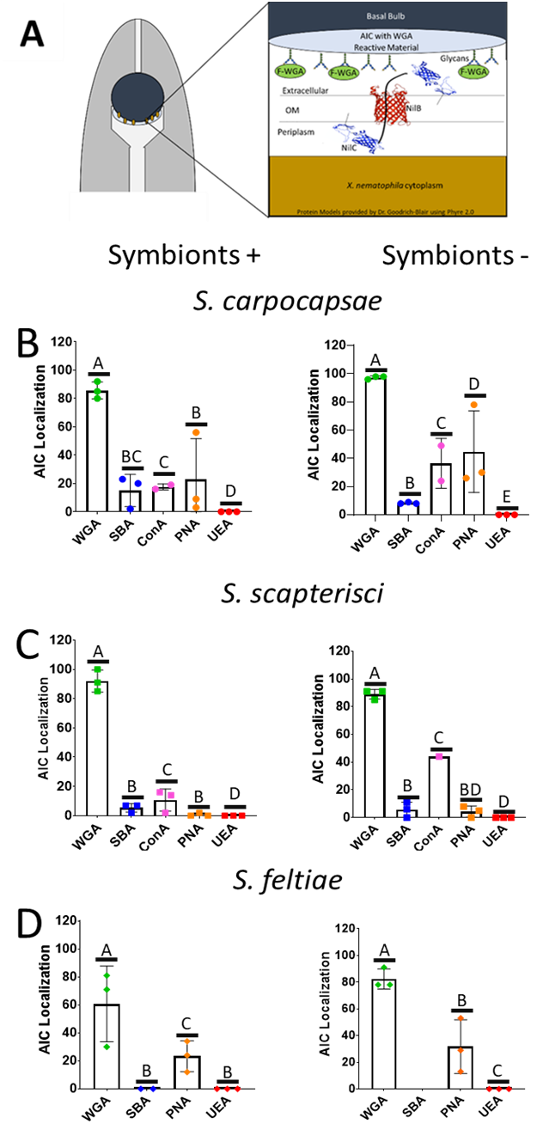

Figure 2.1.Wheat germ agglutinin associates with the anterior intestinal caecum of Steinernema nematodes. (A)

Model of F-WGA (fluorescent conjugate WGA) binding to the AIC of an adult S. carpocapsae nematode. S. carpocapsae (B), S. scapterisci (C), or S. feltiae (D) nematodes eggs were seeded onto plates with (Symbionts +) or without (Symbionts -) a lawn of the Xenorhabdus bacterial symbiont of that nematode, X. nematophila, X. innexi, and X. bovienii, respectively. Once the nematodes had reached adulthood, roughly 72 h, they were collected from the plates and exposed to fluorescent conjugate lectins: wheat germ agglutinin (WGA), soybean agglutinin (SBA), Concanavalin A (ConA), peanut agglutinin (PNA), and ulex europaeus agglutinin (UEA) for 24 h before observation by fluorescence microscopy for localization of the lectin with the anterior intestinal caecum. Each dot represents a population of 100 nematodes. Data were analyzed in Prism, using Tukey’s Multiple Comparisons One-Way ANOVA comparing the levels fluorescent conjugate lectin binding to the AIC of each of the lectins used. Significant (P<0.0001) differences occurred in the lectin binding, treatments with the same letter above each bar are not significantly different.

not shown). Taken together with published findings of WGA reactive material in IJs (Martens et al., 2005) these results demonstrate that in S. carpocapsae, both adult and infective juvenile stages express a WGA-reactive material in the tissues colonized by X. nematophila bacteria, suggesting that the material might play a role in recruitment and maintenance of the X. nematophila symbionts.
Other lectin fluorescent conjugates tested, which react with N-acetylgalactosamine (soybean agglutinin; SBA), mannose (concanavalin agglutinin; ConA), galactose (peanut agglutinin; PNA), and fucose (ulex europaeus agglutinin; UEA) displayed variable and low frequency binding to the AIC of S. carpocapsae nematodes (Fig. 2.1A). Compared to F-WGA the fluorescent lectins all displayed significantly lower association with the AIC in S. carpocapsae and S. scapterisci populations. There was one exception in S. scapterisci where on day 9 when raised without symbionts, F-ConA and F-SBA both associated with the AIC at significantly higher levels than did F-WGA (Supp. Fig. 2.iiB). This result suggests that the sugars to which the tested fluorescent conjugate lectins bind are either present at variable and low abundance, or are sequestered and unavailable for lectin binding.

Unconjugated WGA can inhibit colonization of the AIC in S. carpocapsae and S. scapterisci, but not S. feltiae.
Given that both F-WGA and the respective Xenorhabdus bacterial symbionts are able to bind to the AIC of both S. carpocapsae and S. scapterisci in the majority of the nematode population, we hypothesized that the WGA-reactive material might be important for colonization of their bacterial symbionts, as a binding ligand, a nutrient source, or both. We reasoned that if the WGA-reactive material is involved in colonization, that the addition of soluble WGA to adult nematodes would block bacterial interaction with the WGA-reactive material on the AIC surface. To test this idea we exposed adult nematodes simultaneously to unconjugated WGA and GFP expressing bacterial symbionts for 24 hours before monitoring by fluorescence microscopy the presence of bacterial colonization at the AIC. The presence of WGA significantly reduced the presence at the AIC of GFP expressing Xenorhabdus symbionts in both S. carpocapsae (P<0.0001) and S. scapterisci (P=0.0234) but not in S. feltiae (P=0.2289) when compared to a control that was exposed only to the GFP expressing bacterial symbionts (Fig. 2.2A, Table 2.1).
S. carpocapsae and S. scapterisci occupy the same nematode taxonomic clade, different from that of S. feltiae. All three Xenorhabdus symbionts, X. nematophila, X. innexi, and X. bovienii, respectively are members of different taxonomic clades within the Xenorhabdus genus (Lee & Stock; 2010; Grossman, 2020). Both X. nematophila and X. innexi, but not X. bovienii encode homologs of the nematode intestinal localization (nil) genes, nilB and nilC. X. nematophila nilB and nilC encode species specificity determinants that are necessary and sufficient for colonization of S. carpocapsae (Cowles & Goodrich-Blair; 2008). We considered the possibility that the Nil proteins are responsible for interaction with the AIC WGA-reactive material. We reasoned that if the Nil proteins were responsible for this interaction, then any Nil-independent adherence to the AIC would not be inhibited by WGA. To test this idea, we exposed S. carpocapsae nematodes to WGA and each of an isogenic pair of GFP-expressing X. nematophila strains with and without the nil locus (known as “symbiosis region 1” or SR1) (Heungens, 2002; Cowles, 2008; Chaston, 2013). Specifically, both strains carry an insertion-deletion mutation at the nil locus (ΔSR1) and at the attTn7 site downstream of glmS also have
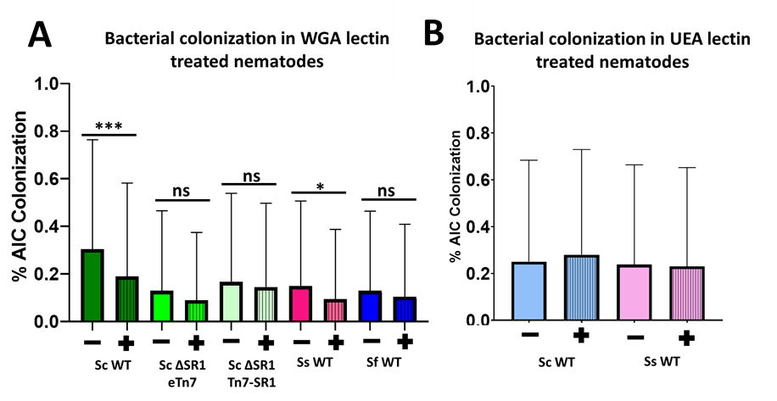
Figure 2.2: WGA but not UEA significantly reduces colonization in S. carpocapsae (Sc) and S. scapterisci (Ss) nematodes. Nematodes were cultivated on liver-kidney agar in the absence of their symbiont. Nematodes were incubated with the lectins wheat germ agglutinin (WGA) (A) or ulex europa agglutinin UEA (B) and GFP expressing bacterial symbionts. Analysis done using the GLIMMIX procedure. * indicates p<.005, *** indicates p<0.001, and ns indicates no significance found using this procedure.
ns
ns

Table 2.1: WGA lectin comp etes with bacteria for AIC localization, UEA lectin does not

Table 2.1: WGA lectin comp etes with bacteria for AIC localization, UEA lectin does not

Nematode/Bacteria | Lectin | Mean number of colonized nematodes per treatment | Total Nematodes Counted | P value  (GLIMMIX procedure)
S. carpocapsae/  X. nematophila | WGA- | 30.38% | 3639 | <0.001
S. carpocapsae/  X. nematophila | WGA+ | 18.96% | 3618 | <0.001
S. scapterisci/X. innexi | WGA- | 14.97% | 3910 | 0.0234
S. scapterisci/X. innexi | WGA+ | 9.44% | 3905 | 0.0234
S. feltiae/X. bovienii | WGA- | 12.86% | 2112 | 0.2289
S. feltiae/X. bovienii | WGA+ | 10.37% | 2162 | 0.2289
S. carpocapsae/ X. nematophila ΔSR1 eTn7 | WGA- | 12.95% | 3075 | 0.1478
S. carpocapsae/ X. nematophila ΔSR1 eTn7 | WGA+ | 8.92% | 3128 | 0.1478
S. carpocapsae/X. nematophila ΔSR1 attTn7::Tn7-SR1 | WGA- | 17.12% | 2961 | 0.1332
S. carpocapsae/X. nematophila ΔSR1 attTn7::Tn7-SR1 | WGA+ | 14.50% | 3055 | 0.1332
S. carpocapsae/X. nematophila | UEA- | 25.01% | 3113 | 0.0546
S. carpocapsae/X. nematophila | UEA+ | 27.98% | 2927 | 0.0546
S. scapterisci/X. innexi | UEA- | 23.76% | 1313 | .9833
S. scapterisci/X. innexi | UEA+ | 23.04% | 1393 | .9833

either an empty Tn7 transposon (eTn7) or Tn7-SR1. Unexpectedly, we found that neither strain colonized the AIC as well as wild type, preventing us from making conclusions regarding the impact of WGA specifically on Nil-mediated colonization. For both strains, we found no significant difference in colonization in the presence or absence of WGA. This may be that from the attTn7 site, expression is insufficient to promote colonization in this assay with its brief exposure between nematode and bacterium.
To address the possibility that the inhibition of WGA on wild type X. nematophila and X. innexi colonization is non-specific, we tested a second unconjugated lectin. We chose UEA because it did not display AIC adherence in any of the three species used in this study (Fig. 2.1B,C,D). S. carpocapsae and S. scapterisci nematodes were exposed to GFP expressing bacterial symbionts and unconjugated UEA concurrently for 24 h before being observed by fluorescence microscopy for bacterial colonization. Unconjugated UEA did not significantly influence the number of colonized nematodes observed compared to nematodes that were untreated (Fig. 2B, Table 2.2). Therefore, inhibition of colonization in S. carpocapsae and S. scapterisci is not a general characteristic of lectins. This supports the idea that WGA binding to either N-acetyl glucosamine or N-acetylneuraminic acid residues at the AIC surface blocks bacterial access to these sugars.

Addition of soluble NilC protein significantly increases bacterial AIC colonization frequency in S. carpocapsae nematodes.

Our data thus far indicate that the addition of WGA lectin can block wild type X. nematophila colonization of the AIC. NilC protein is expressed on the X. nematophila cell surface and may directly interact with the AIC epithelial surface (either with the WGA-reactive material or with other AIC surface molecules) (Chaston et al., 2013; Grossman et al., 2020). We tested the hypothesis that X. nematophila surface-exposed NilC interacts with molecules on the AIC surface, then addition of free, soluble NilC would inhibit bacterial interaction with the AIC (similar to our reasoning with WGA). To test this, we exposed nematodes (cultivated in the absence of their symbiont) to purified NilC protein and GFP expressing X. nematophila cells. S. carpocapsae nematodes were exposed to NilC protein provided by Dr. Escobar-Bravo of the Forest Lab at the Department of Bacteriology in the University of Wisconsin Madison along with either WT or ΔSR1 eTn7 X. nematophila cells. The data were analyzed using the GLIMMIX procedure, similar to the data analysis of lectin data, due to the binary (colonized vs uncolonized) nature of the data set. As above, we found that isogenic ΔSR1 X. nematophila strains with and without the nil locus at the attTn7 site colonized at similarly low levels in this assay, indicating that in this brief exposure period, the presence of nilB and nilC does not influence colonization of the AIC. Nematodes exposed to NilC exhibited significantly (S. carpocapsae WT P=0.0042, ΔSR1 P=0.0088) higher rates of colonization compared to nematodes exposed to just the GFP expressing symbionts (Fig. 2.3, Table 2.3).
There was no significant difference found between the ΔSR1 X. nematophila strain with the addition of NilC and either of the WT treatment groups. This suggests that exposure to the NilC protein was able to aid the mutant strain with colonization, rather than compete with the bacteria for binding to the AIC. This finding further suggests that NilC could be involved in X. nematophila interactions at the nematode AIC surface possibly through interactions with the mucosal layer.

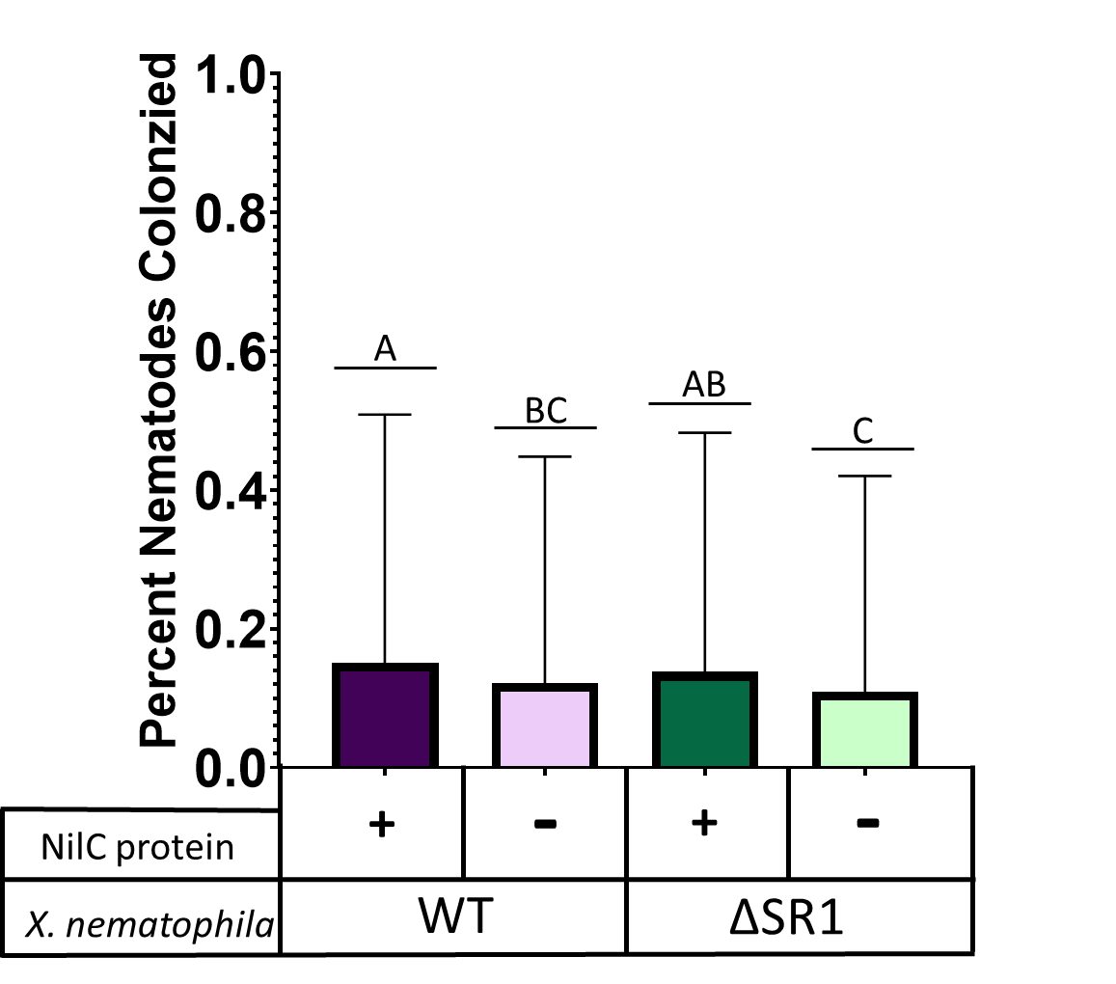
Figure 2.3: Purified NilC protein significantly increases the frequency of X. nematophila colonization of S. carpocapsae AIC colonization in both WT and ΔSR1 mutant X. nematophila cells. Surface sterilized S. carpocapsae eggs were collected and placed in beef liver-kidney agar plates before collection every day for six days and exposure to purified NilC protein and GFP expressing X. nematophila cells. Each assay was done with three biological replicates of X. nematophila cells. Analysis done using GLIMMIX procedure looking at the interactions colonization state of the nematode, and the interactions of NilC protein on that colonization state. Analysis found that there was significant interaction between the ability of the bacterial strain to colonize (WT, P=0.0042, ΔSR1 P=0.0088) and the addition of NilC protein.

Table 2.2: Purified NilC protein increases S. carpocapsae AIC colonization in both the WT and the SR1 mutant X. nematophila strains:
Nematode/Bacteria | Addition of Synthesized NilC protein | Percent Colonized | Total Counted | P-value between treatments using GLIMMIX Procedure
S. carpocapsae/ X. nematophila | NilC+ | 15.1% | 2172 | 0.0042
S. carpocapsae/ X. nematophila | NilC- | 12.2% | 2188 | 0.0042
S. carpocapsae/ X. nematophila ΔSR1 | NilC+ | 13.8% | 1922 | 0.0088
S. carpocapsae/ X. nematophila ΔSR1 | NilC- | 10.4% | 2102 | 0.0088

nilC is necessary for or enhances nematode IJ receptacle and adult AIC colonization, respectively
The concept that extracellular NilC promotes colonization of the AIC is consistent with published reports that the ΔSR1 mutant, which lacks both nilB and nilC, is defective in AIC colonization. In the IJ stage, both nilB and nilC are independently necessary for colonization (Cowles et al. 2008). However, the role of the individual nil genes in AIC colonization is unknown (Chaston et al., 2013). To further investigate the individual contributions of nil genes to AIC colonization, we used X. nematophila with individual Tn5 mutations in the nilA, nilB and nilC genes (Heungens, 2002). In each strain background, an empty Tn7 or a Tn7 carrying nilB under control of the P_{lac} promoter was introduced into the attTn7 site, to determine if constitutive NilB expression would be sufficient for colonization even in the absence of other nil genes. To enable microscopic assessment of colonization frequency each strain was engineered to express GFP.
As expected based on published data, nilB::Tn5 and nilC::Tn5 mutants did not colonize infective juvenile receptacles at a detectable frequency, while the nilA::Tn5 mutant colonized at detectable but reduced frequencies relative to the wild type control (Fig. 2.4B,C). However, constitutive expression of nilB did not significantly influence IJ receptacle colonization, indicating that under these conditions nilB is not expressed at high enough levels from the P_{lac} promoter to influence colonization (Fig. 2.4B). Consistent with the colonization phenotype of ΔSR1, in adult nematodes, the nilB::Tn5 mutant colonized at significantly lower levels than wild type, and the presence of P_{lac}-nilB increased colonization frequency significantly, indicating that in this environment the

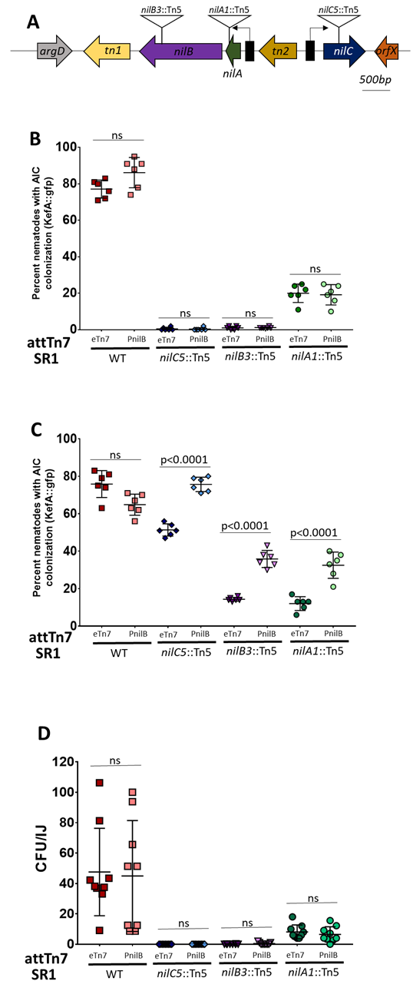

Figure 2.4: nilC is necessary for, or augments colonization of S. carpocapsae nematode IJs or adults, respectively.
(A) Schematic representation of the SR1 locus of X. nematophila, which encodes the genes (block arrows) nilA (purple), nilB (green), and nilC (blue) (block arrows). Promoter regions are shown as black boxes with bent arrows indicating direction of transcription. nilA and nilB are co-transcribed from the same promoter. X. nematophila strains tested had Tn5 transposon insertions (red box) disrupting one of the three nil genes, as represented by the nilB::Tn5 insertion shown in the schematic diagrams. In each Tn5 mutant, an empty (eTn7) or P_{lac}-nilB (PnilB) (Tn7-P_{lac}-nilB)-encoding Tn7 transposon conferring erythromycin resistance (ermR) was inserted at the attTn7. Surface sterilized S. carpocapsae nematode eggs were seeded onto bacterial treatment lawns and allowed to develop into (B) IJ’s or to the (C) adult stage before collection and microscopic observation for AIC (C) or receptacle (B) colonization by GFP expressing bacterial symbionts. Each assay was done in six biological replicates and analyzed via multiple T-tests between treatment groups. (D) CFU/IJ determined via grinding assay for each of the treatment groups.
levels of NilB expressed from P_{lac} are sufficient to confer colonization proficiency (Fig. 2.4C). Surprisingly, the nilC::Tn5 mutant, which does not colonize above the level of detection in IJs, was able to colonize the AIC of 60% of observed adult nematodes (compared to ~80% colonized by wild type and ~15% colonized by the nilB::Tn5 mutant). This indicates that for AIC colonization (but not IJ colonization) the presence of NilC is less critical than is the presence of NilB. Also surprisingly, constitutive expression of NilB in the nilC::Tn5 mutant rescued colonization to wild type levels, indicating that the attenuated colonization caused by a lack of NilC can be ameliorated by elevated expression of NilB. This further suggests that NilC is not necessary for but can augment colonization at the AIC, possibly through some interaction with NilB or the nematode host surface.

Discussion:
S. carpocapsae nematodes and their X. nematophila partners are obligate symbionts that in nature are both necessary for proper infection and killing of their insect prey. Since this partnership is essential for the evolutionary success of both the host and symbiont, there is selective pressure to ensure high fidelity recognition, association and transmission of cooperating partners. Previous work had established that over the developmental life cycle of the nematode, X. nematophila is specifically capable of colonizing discrete tissues of their S. carpocapsae nematode host: the AIC of developing juveniles and adult nematodes, the pharyngeal intestinal valve of pre-IJs, and the receptacle of the IJ stage of the nematode that transmits the bacteria between insect hosts (Chaston et al., 2013). This association is specific in terms of both the nematode tissue being colonized and in the bacterial species capable of associating with that tissue.
In this chapter, I helped uncover the molecular and histological features underlying this specificity. I demonstrated that, similar to S. carpocapsae IJ receptacles (Martens, 2005), the adult AIC expresses a WGA-reactive material. The involvement of this material in colonization is supported by my finding that addition of WGA, but not other lectins, can inhibit X. nematophila colonization. For this experiment, I developed a new colonization assay in which nematodes cultivated in the absence of their bacterial symbiont are exposed for a brief window of time to X. nematophila cells. While colonization rates in all three nematode species are lower than expected and previously published colonization rates, it should be noted that the route of colonization was very different for this assay. The experiments involving lectins were also distinct from prior colonization assays in which nematodes were cultivated throughout their developmental cycle on lawns of the test strain. This means that the bacterial cells being tested for colonization are in a very different physiological state (late stationary-phase, surface-grown, and nematode-exposed bacterial cells, versus hours-old, early stationary-phase, liquid-grown, nematode-naïve bacterial cells). Further, the bacteria have a limited time period in which to associate with the AIC surface. These technical differences might explain why the frequencies of colonization by wild type X. nematophila I observed in my assays (30% or lower of the population colonized) are much lower than levels reported previously (80% of the population or higher). One possibility that might explain how WGA (~38 kDa in size) is able to inhibit bacterial colonization is through steric hindrance by preventing the bacterial cells from gaining access to the host cell surface or by competing specifically for binding sites. However, this work combined with previous published data demonstrates that the specific tissues that are colonized by X. nematophila, but not surrounding intestinal tissue, express a WGA-reactive material, and that WGA can inhibit X. nematophila colonization of the AIC. These findings provide evidence that the S. carpocapsae nematode X. nematophila bacteria interaction includes recognition of nematode-derived glycans composed of the N-acetyl glucosamine or N-acetylneuraminic acid moieties to which WGA binds.
If specific S. carpocapsae derived glycans are interacting with X. nematophila to initiate or establish bacterial symbiont colonization, X. nematophila might possess a specialized and/or unique set of genes that are required for interacting with those nematode derived glycans. X. nematophila requires the presence of the SR1 gene locus to colonize the nematode AIC and receptacle. Therefore, the factors encoded by the SR1 genes nilA, nilB, and nilC are candidates for mediating the interactions with the WGA-reactive material expressed at these sites. NilB is an integral outer membrane protein with 7 surface exposed loops that are necessary for colonization, and NilC is an outer membrane lipoprotein that can be oriented in the periplasm or on surface depending on conditions (Mauer, Ph.D. thesis; Grossman, unpublished data). NilA is a small open reading frame that is predicted to encode an inner membrane protein (Heungens, 2002). Efforts to detect protein produced by this gene have been unsuccessful, leading to the conclusion that nilA mutations cause colonization defects due to their influence on downstream nilB expression (Cowles, 2008; Chaston, J., 2011). I reasoned that if the outer membrane localized proteins NilB and NilC interact with specific WGA-reactive glycans on the AIC surface, then any colonization achieved by the ΔSR1 mutant, despite its colonization defect relative to wild type, should be insensitive to the presence of WGA. Indeed, ΔSR1 X. nematophila cells colonized at similarly low levels regardless of the presence or absence of WGA. Surprisingly, the ΔSR1 complemented strain with the SR1 locus provided in trans at the attTn7 site also colonized at very low levels that were insensitive to the presence or absence of WGA. One possible explanation for this result is that attTn7 ectopic expression of NilB and NilC is insufficient to allow colonization in the short time period of exposure used in my assays (e.g., that cis-acting activating elements are missing) such that both the ΔSR1 mutant and the complement are phenotypically ΔSR1. This idea is supported by the fact that these strains behave as expected in standard colonization assays, with the ΔSR1 mutant displaying a colonization defect that is rescued by complementation by attTn7::Tn7-SR1 (Chaston et al., 2013).
The assay that I developed also provided an opportunity to test whether exogenous addition of NilC protein could influence colonization at the AIC. As mentioned above, NilC is an outer membrane tethered lipoprotein that can be either periplasmic or surface exposed. A non-lipidated (soluble) full-length, N-terminal his-tagged version of NilC was expressed and purified by collaborators (Dr. Escobar-Bravo and Dr. Katrina Forest). In the presence of this purified, ~30.6 kDa NilC protein, both the ΔSR1 mutant and the ΔSR1 attTn7::Tn7-SR1 complement strain displayed a significantly higher frequency of colonization in the population of nematodes. I interpret this to mean that NilC can promote colonization but not through direct binding to molecules on the AIC surface, since in the latter scenario I would have predicted binding interference similar to what was observed for WGA. Instead, my findings may suggest that at the AIC, NilC can promote some other aspect of colonization such as acquisition to nutrients or inducing a change in gene expression in either the nematode or the bacterium that increases colonization proficiency. Consistent with the nutrient acquisition concept, recent findings have established that NilB is a member of a family of proteins that mediate secretion of host-interaction protein effectors, many of which are involved in capturing host-sequestered metal (Grossman et al., 2021). Bioinformatics and structural modeling predict that NilC is an effector molecule that may rely on NilB for secretion (Grossman et al. 2021; Goodrich-Blair, unpublished observations). While the effector activity of NilC has not been elucidated, structural modeling shows weak similarity to sugar hydrolases, raising the possibility that NilC is a hydrolase that can cleave sugar residues from glycans, making them available for uptake and utilization by colonizing X. nematophila Fig. 2.5). This possibility is consistent with the findings that NilC augments colonization at the glycan-containing AIC surface, and that it is essential for colonization of the glycan-containing IJ receptacle. This was seen in the assay that compared nematodes raised on lawns of X. nematophila bacteria that contained mutations in individual nil genes in both adult and IJ stage S. carpocapsae nematodes. Notably, the latter colonization site is within the non-feeding transmission stage of the nematode, in which no new nutrient sources are available until a new insect host is infected. Although the individual nil gene mutants had p_{lacZ}-nilB insertions at the Tn7 site, the results suggest that developing rescues of nilA and nilC are necessary. As the data presented here is, we cannot definitely say that it was the nilC knockout that caused the decrease in colonization, as the strain lacked a compliment.
Future experiments should add these genes back to the nilA and especially the nilC knockout strains and perform the same assays. It is possible that NilC is only expressed on the cell surface when X. nematophila is colonizing. As mentioned, this

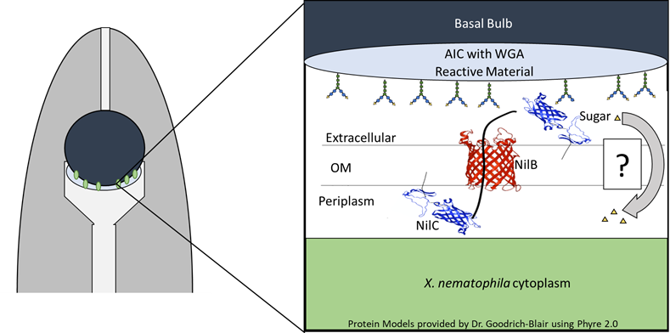
Figure 2.5: Model of X. nematophila nil genes interacting with the WGA reactive material found at the AIC. Model of the hypothetical interactions of NilC and NilB at the AIC. NilB moves the lipoprotein NilC (and possibly other molecules as well) through the outer membrane (OM) to the surface of the cell, where it cleaves a sugar found in the mucus-like material at the AIC cell surface. From there, the sugars are brought back into the cell either with NilC, or some other transport mechanisms to be processed for nutrient and energy by the cells to maintain the population within this space. Protein models were provided by Dr. Heidi Goodrich-Blair and were built using Phyre 2.0 program.

colonization is a rare event, and most X. nematophila cells will not colonize a nematode, as such, the need for NilC is necessary for colonization, but not necessary unless
the cell is given the chance to colonize. Thus it would be a waste of resources, and possibly a trigger for insect immunity for the bacterial cell to be constantly expressing a specific glycosyl-hydrolase on its cell surface. The expression of NilC might be highly regulated and only necessary when the bacterial cell has no other nutrients readily available, as might be the case in the AIC/IVS.
There is still more to learn about the expression of the nil genes at the AIC of the adult S. carpocapsae nematodes. This work attempted to learn more about the interface between the S. carpocapsae host and its X. nematophila symbiont. The exact function of the nil genes and their role in colonization remains unclear though this work has put forward that they are involved in a form of nutritional selection that allows them to use the resources provided by the host through its mucus to allow the bacterial cells to survive in this space. S. carpocapsae needs its partner to help it kill the insect, serve as a food source, and regulate itself properly to possibly send cues to modulate the nematode behavior, as chapter two will suggest. When an S. carpocapsae juvenile beginning to develop into an IJ, it will be colonized by one or two bacterial cells (Chaston et al., 2013). X. nematophila seems to go through a bottleneck event in which only a few bacterial cells will colonize the nematode, as such, it would be feasible that the host nematode would have measures in place to assure that a functional cell is able to colonize it to be carried to the next host and continue the species. For both partners in this symbiosis, it benefits the fitness of both partners for there to be some form of selective fitness for the X. nematophila cell.
Materials and Methods:
Nematode Propagation:
Initial nematodes used in this study were taken from the shared lab stocks to make personal stocks maintained through the entirety of the project. S. carpocapsae and S. feltiae nematodes were propagated through infection and water trapping of emerging IJs in Galleria mellonella (waxworms) and kept in 50mL tissue culture flasks for up to three months. S. scapterisci were propagated through store-bought crickets and also kept in culture flasks. Propagations occurred roughly every three months.

Bacterial Strain Generation:
To generate the GFP in the bacterial strains used in this study, GFP was integrated into the kefA site of X. nematophila cells with the use of E. coli S17 lambda pir strain that contained a plasmid pJMC001, which contains GFP from plasmid pURR25 inserted into pECM20. This E. coli strain was mated with X. nematophila cells and streaked onto selective plates containing antibiotics. Visibly fluorescent colonies were selected and re-streaked onto new antibiotic selective plates to confirm presence of GFP in X. nematophila cells. After the second round of selection, cells were grown in LB and stored in glycerol stocks at -80˚C.

Table 2.3: Bacterial Strains and Plasmids used in this Study:
Strain | Genotype | Plasmid | Antibiotic Resistance | Reference/Source
HGB800 | Xenorhabdus nematophila WT | NA | Amp | ATCC
HGB1681 | Xenorhabdus innexi WT | NA | NA | Chaston et al., 2013
HGB1699 | Xenorhabdus bovienii WT | NA | NA | Kim et al., 2017
HGB2018 | X. nematophila (HGB800), attTn7::Tn7/GFP | NA | Cm, Amp
HGB2171 | X. innexi (HGB 1681), attTn7::Tn7/GFP | NA | Amp, Kan | G.C. Smart Jr University of Florida; ATCC PTA-6826
HGB1865 | X. bovienii (HGB1699), attTn7::Tn7/GFP | NA | Kan | Chaston et al., 2013
HGB1430 | X. nematophila (HGB007), ΔSR1, kefA::GFP | NA | Amp, Kan, Chlor | Bhasin et al., 2012
HGB1431 | X. nematophila (HGB007), kefA::GFP | NA | Amp, Kan, Chlor | Chaston, Unpublished
HGB1508 | X. nematophila (HGB007), ΔSR1, kefA::GFP , eTn7 | NA | Amp, Kan, Chlor, Erm | Chaston et al., 2013
HGB1509 | X. nematophila (HGB007), ΔSR1, kefA::GFP, attTn7::Tn7/SR1 | NA | Amp, Kan, Chlor, Erm | Chaston et al., 2013
HGB1783 | E. coli S17-1 λpir | pJMC001 | Chlor | Bhasin et al.,2012
HGB2538 | X. nematophila (HGB1815), nilA1::Tn5, eTn7 | NA | Rif, Amp, Erm, Kan, Chlor | This Study
HGB2539 | X. nematophila (HGB1816), nilB3::Tn5, eTn7 | NA | Rif, Amp, Erm, Kan, Chlor | This Study
HGB2540 | X. nematophila (HGB1817) nilC5::Tn5, eTn7 | NA | Rif, Amp, Erm, Kan, Chlor | This Study
HGB2541 | X. nematophila (HGB1818), eTn7 | NA | Rif, Amp, Erm, Kan, Chlor | This Study
HGB2542 | X. nematophila (HGB1840) nilA1::Tn5, attTn7::Tn7/p_{lacZ}-nilB26-FLAG26 | NA | Rif, Amp, Erm, Kan, Chlor | This Study
HGB2543 | X. nematophila (HGB1841), nilB3::Tn5 attTn7::Tn7/p_{lacZ}-nilB26-FLAG26 | NA | Rif, Amp, Erm, Kan, Chlor | This Study
HGB2544 | X. nematophila (HGB1842), nilC5::Tn5, attTn7::Tn7/p_{lacZ}-nilB26-FLAG26 | NA | Rif, Amp, Erm, Kan, Chlor | This Study
HGB2545 | X. nematophila (HGB1843), attTn7::Tn7/p_{lacZ}-nilB26-FLAG26 | NA | Rif, Amp, Erm, Kan, Chlor | This Study

Observation of the nematode AIC using a panel of fluorescent conjugate lectins:
Nematode eggs were collected, and surface sterilized in a previously described protocol (Murfin et al., 2012). If nematode eggs were not immediately seeded onto treatment plates, they were stored in a sealed dish in dark LB for up to four days. Treatment plates with either bacterial symbiont lawns (See Table 2.4) or onto specialized media that can support nematode growth in the absence of their Xenorhabdus partners, beef liver kidney agar.
After the eggs had been placed on the plates, they were stored at 27°C in the dark for nine days. Every three days a fresh plate was selected from each treatment and the nematodes collected off the plates via pipetting of 1xPBS. Collected nematodes were placed in a 1.5 mL centrifuge tube and rinsed 3 additional times with more 1xPBS. After rinsing, as much liquid was removed from the tube and 200 µL of 1xpBS put back in to make the volume of each tube as similar as possible. After that, nematodes were given 2 µL of a of green fluorescein conjugate lectin (See Table 2.5) for a molar concentration of 27 mM. Tubes were wrapped in tinfoil to inhibit light bleaching and placed in an end over end mixer to be gently shaken overnight. After exposure to the lectins, nematodes were rinsed 3x to remove excess lectin before observation via fluorescence microscopy.

NilC protein and unconjugated UEA and WGA lectin competition assays:
Nematodes eggs were collected, and surface sterilized as previously described (Murfin et al., 2012) before being seeded onto beef liver and kidney agar plates to support growth without symbiont presence. After being seeded onto the plates they were stored in the dark at 27°C for up to nine days. Each day a fresh plate was selected, and
Table 2.4: Lectins used in this study and their sugar specificities:

Lectin | Full Name | Sugar Specificity | Conjugate
WGA | Wheat Germ Agglutinin | N-acetylglucosamine or N-acetylneurminic acid | Fluorescein (Green)
PNA | Peanut Agglutinin | Galactose | Fluorescein (Green)
ConA | Concanavalin A | Mannose | Fluorescein (Green)
SBA | Soybean Agglutinin | N-acetylgalactosamine | Fluorescein (Green)
UEA | Ulex europaeus agglutinin | Fucose | Fluorescein (Green)
UEA | Ulex europaeus agglutinin | Fucose | Unconjugated
WGA | Wheat Germ Agglutinin | N-acetylglucosamine or N-acetylneuraminic acid | Unconjugated

plates and placing them in a 1.5ml centrifuge tube. Nematodes were rinsed three times with an additional 1 mL of 1xPBS, and after the third rinse excess liquid was removed from the tubes. Nematodes were then given GFP expressing bacterial symbionts alone, or GFP expressing symbionts as well as 2.05 µL of unconjugated WGA, or 1.18 µL of unconjugated UEA to have a molar concentration of 27mM like that of F-WGA. For the assays involving synthesized NilC proteins, nematodes were either given GFP expressing bacterial symbionts alone, or GFP expressing symbionts and 3.36 µL of synthesized NilC to match the 27mM molar concentration of the unconjugated lectins. Nematodes were then wrapped in tinfoil and placed in on an end over end mixer to be gently shaken overnight. After exposure nematodes were rinsed 3 more times with 1 mL of additional 1xPBS to remove excess bacteria and observed via fluorescence microscopy.

Expression and purification of NilC soluble domain
NilC protein was provided by Dr. Escobar-Bravo of the Forest Lab at the University of Wisonsin Madison, Departement of Bacteriology. The nilC soluble domain (NilC22-282) was cloned into the vector pET-28a(+) with a N-terminal Hisx6 tag and TEV cleavage site. The vector was transformed into E. coli BL21(DE3). To express the NilC for purification, cells were grown at 37°C in LB media until OD600 was ~0.7, after which protein expression was induced by adding IPTG to a final concentration of 1 mM. Protein expression occurred overnight at 25˚C,
To purify the NilC-overnight cultures were pelleted and resuspended in Buffer A (50 mM Tris-HCl pH 8.0 containing 300 mM NaCl) before cell lysis proceeded by French press. The cell lysate was clarified by centrifugation at 25000x for 30 min at 8°C before being loaded into a 5 mL Ni-NTA column (Qiagen). The column was washed with 100 mL of Buffer A containing 50 mM imidazole. Protein elution was performed using Buffer A with 500 mM Imidazole. Fractions with target protein were pooled and mixed with TEV protease to remove His tag. The sample was dialyzed against Buffer A overnight before using a 1mL Ni-NTA column to remove the TEV protease. Fractions containing NilC were concentrated before loading into a Sephacryl S-100 HiPrep 16/60 column (GE) for size exclusion chromatography. This step was performed in 50 mM Tris-HCl pH 8.0 containing 150 mM NaCl.

Statistical Analysis
Statistical analysis was performed in consultation with Dr. Liesel Schneider (UTK, Animal Sciences Department). For WGA, UEA, and soluble NilC protein experiments, a GLIMMIX procedure (Schabenberger et al., 2005) as used to find statistical significance among the treatment groups by comparing multiple factors including addition of unconjugated WGA and bacteria, or bacteria alone, life stage of the nematode (male, female, juvenile), and day observed (six days total) that can contribute to colonization status in the assay, and to determine which had significant effects on the probability of a given nematode being colonized. GLIMMIX is useful for this because it fits statistical models to data with correlations or nonconstant variability and where the response might not necessarily be normally distributed. This model also assumes normal (or Gaussian) random effects. Statistical analyses were performed in SAS (Schabenberger et al., 2005) with data from multiple biological replicates combined and with each nematode treated as an individual data point (rather than by the replicates in which they were collected). Factors such as the day the experiment was performed (days post adding eggs to plates 1-7), treatment (presence of the lectin or not) and stage of the nematode (male, female, juvenile) were all considered to be contributing factors to colonization and analyzed using this procedure.

Chapter two references:

Atuma, C., Strugala, V., Allen, A., & Holm, L. (2001). The adherent gastrointestinal mucus gel layer: thickness and physical state in vivo. American journal of physiology. Gastrointestinal and liver physiology, 280(5), G922–G929. https://doi.org/10.1152/ajpgi.2001.280.5.G922

Bäumler, A. J., & Sperandio, V. (2016). Interactions between the microbiota and pathogenic bacteria in the gut. Nature, 535(7610), 85–93. https://doi.org/10.1038/nature18849

Berg, G., Rybakova, D., Fischer, D., Cernava, T., Vergès, M. C., Charles, T., Chen, X., Cocolin, L., Eversole, K., Corral, G. H., Kazou, M., Kinkel, L., Lange, L., Lima, N., Loy, A., Macklin, J. A., Maguin, E., Mauchline, T., McClure, R., Mitter, B., … Schloter, M. (2020). Microbiome definition re-visited: old concepts and new challenges. Microbiome, 8(1), 103. https://doi.org/10.1186/s40168-020-00875-0

Bhasin, A., Chaston, J. M., & Goodrich-Blair, H. (2012). Mutational analyses reveal overall topology and functional regions of NilB, a bacterial outer membrane protein required for host association in a model of animal-microbe mutualism. Journal of Bacteriology, 194(7), 1763–1776. https://doi.org/10.1128/JB.06711-11

Chaston, J. M. (2011). Host-association events and factors in a model animal-bacterial mutualism (Order No. 3501134). Available from ProQuest Dissertations & Theses Global. (928129290). Retrieved from https://utk.idm.oclc.org/login?url=https://www.proquest.com/dissertations-theses/host-association-events-factors-model-animal/docview/928129290/se-2?accountid=14766

Chaston, J. M., Murfin, K. E., Heath-Heckman, E. A., & Goodrich-Blair, H. (2013). Previously unrecognized stages of species-specific colonization in the mutualism between Xenorhabdus bacteria and Steinernema nematodes. Cellular microbiology, 15(9), 1545–1559. https://doi.org/10.1111/cmi.12134

Coon, K. L., Vogel, K. J., Brown, M. R., & Strand, M. R. (2014). Mosquitoes rely on their gut microbiota for development. Molecular ecology, 23(11), 2727–2739. https://doi.org/10.1111/mec.12771

Cowles, C. E., & Goodrich-Blair, H. (2008). The Xenorhabdus nematophila nilABC genes confer the ability of Xenorhabdus spp. to colonize Steinernema carpocapsae nematodes. Journal of bacteriology, 190(12), 4121–4128. https://doi.org/10.1128/JB.00123-08

Fast, E. M., Toomey, M. E., Panaram, K., Desjardins, D., Kolaczyk, E. D., and Frydman, H. M. (2011). Wolbachia enhance Drosophila stem cell proliferation and target the germline stem cell niche. Science 334, 990–992. doi: 10.1126/ science.1209609

Ferree, P. M., Frydman, H. M., Li, J. M., Cao, J., Wieschaus, E., and Sullivan, W. (2005). Wolbachia utilizes host microtubules and Dynein for anterior localization in the Drosophila oocyte. PLoS Pathog. 1:e14. doi: 10.1371/ journal.ppat.0010014

Fisher, R. M., Henry, L. M., Cornwallis, C. K., Kiers, E. T., & West, S. A. (2017). The evolution of host-symbiont dependence. Nature communications, 8, 15973. https://doi.org/10.1038/ncomms15973

Fones, H., & Preston, G. M. (2012). Reactive oxygen and oxidative stress tolerance in plant pathogenic Pseudomonas. FEMS microbiology letters, 327(1), 1–8. https://doi-org.proxy.lib.utk.edu/10.1111/j.1574-6968.2011.02449.x

Gensollen, T., Iyer, S. S., Kasper, D. L., & Blumberg, R. S. (2016). How colonization by microbiota in early life shapes the immune system. Science (New York, N.Y.), 352(6285), 539–544. https://doi.org/10.1126/science.aad9378

Gil-Turnes, M. S., & Fenical, W. (1992). Embryos of Homarus americanus are Protected by Epibiotic Bacteria. The Biological bulletin, 182(1), 105–108. https://doi.org/10.2307/1542184

Gordon HA, Pesti L. 1971. The gnotobiotic animal as a tool in the study of host microbial relationships. Bacteriol. Rev. 35:390–429

Grossman, A. S., Mauer, T. J., Forest, K. T., & Goodrich-Blair, H. (2021). Description of a widespread bacterial secretion system with chemically diverse substrates. https://doi.org/10.1101/2020.01.20.912956

Hackett KJ, Lynn DE, Williamson DL, Ginsberg AS, Whitcomb RF. Cultivation of the Drosophila sex-ratio spiroplasma. Science. 1986 Jun 6;232(4755):1253-5. doi: 10.1126/science.232.4755.1253. PMID: 17810745.

Hengge-Aronis R. (2002). Signal transduction and regulatory mechanisms involved in control of the sigma(S) (RpoS) subunit of RNA polymerase. Microbiology and molecular biology reviews : MMBR, 66(3), 373–395. https://doi.org/10.1128/mmbr.66.3.373-395.2002

Heungens, K., Cowles, C. E., & Goodrich-Blair, H. (2002). Identification of Xenorhabdus nematophila genes required for mutualistic colonization of Steinernema carpocapsae nematodes. Molecular microbiology, 45(5), 1337–1353. https://doi.org/10.1046/j.1365-2958.2002.03100.x

Imlay, J. A., & Linn, S. (1988). DNA damage and oxygen radical toxicity. Science (New York, N.Y.), 240(4857), 1302–1309. https://doi-org.proxy.lib.utk.edu/10.1126/science.3287616

Kaya HK, Gaugler R. Entomopathogenic nematodes. Annu Rev Entomol. 1993; 38:181–206.

Kim, I. H., Aryal, S. K., Aghai, D. T., Casanova-Torres, Á. M., Hillman, K., Kozuch, M. P., Mans, E. J., Mauer, T. J., Ogier, J. C., Ensign, J. C., Gaudriault, S., Goodman, W. G., Goodrich-Blair, H., & Dillman, A. R. (2017). The insect pathogenic bacterium Xenorhabdus innexi has attenuated virulence in multiple insect model hosts yet encodes a potent mosquitocidal toxin. BMC genomics, 18(1), 927. https://doi.org/10.1186/s12864-017-4311-4

Kose, H., and Karr, T. L. (1995). Organization of Wolbachia pipientis in the Drosophila fertilized egg and embryo revealed by an anti-Wolbachia monoclonal antibody. Mech. Dev. 51, 275–288. doi: 10.1016/0925-4773(95) 00372-X

Lee, M. M., & Stock, S. P. (2010). A multilocus approach to assessing co-evolutionary relationships between Steinernema spp. (Nematoda: Steinernematidae) and their bacterial symbionts Xenorhabdus spp. (gamma-Proteobacteria: Enterobacteriaceae). Systematic parasitology, 77(1), 1–12. https://doi.org/10.1007/s11230-010-9256-9

Lloyd, D. R., Carmichael, P. L., & Phillips, D. H. (1998). Comparison of the formation of 8-hydroxy-2'-deoxyguanosine and single- and double-strand breaks in DNA mediated by fenton reactions. Chemical research in toxicology, 11(5), 420–427. https://doi-org.proxy.lib.utk.edu/10.1021/tx970156l

Martens, E. C., Heungens, K., & Goodrich-Blair, H. (2003). Early colonization events in the mutualistic association between Steinernema carpocapsae nematodes and Xenorhabdus nematophila bacteria. Journal of bacteriology, 185(10), 3147–3154. https://doi.org/10.1128/jb.185.10.3147-3154.2003

Martens, E. C., & Goodrich-Blair, H. (2005). The Steinernema carpocapsae intestinal vesicle contains a subcellular structure with which Xenorhabdus nematophila associates during colonization initiation. Cellular microbiology, 7(12), 1723–1735. https://doi.org/10.1111/j.1462-5822.2005.00585.x

Macfarlane, S., & Dillon, J. F. (2007). Microbial biofilms in the human gastrointestinal tract. Journal of applied microbiology, 102(5), 1187–1196. https://doi.org/10.1111/j.1365-2672.2007.03287.x

Mitani, D. K., Kaya, H. K., & Goodrich-Blair, H. (2004). Comparative study of the entomopathogenic nematode, Steinernema carpocapsae, reared on mutant and Wild-type Xenorhabdus nematophila. Biological Control, 29(3), 382-391. doi:10.1016/j.biocontrol.2003.07.005

Murfin, K. E., Chaston, J., & Goodrich-Blair, H. (2012). Visualizing bacteria in nematodes using fluorescent microscopy. Journal of visualized experiments : JoVE, (68), 4298. https://doi.org/10.3791/4298

Nardon P, Grenier AM. 1991. Serial endosymbiosis theory and weevil evolution: the role of symbiosis. In Symbiosis as a Source of Evolutionary Innovation, ed. L Margulis, R Fester, pp. 381–409. Cambridge, MA: MIT Press

Pickard, J. M., & Chervonsky, A. V. (2015). Intestinal fucose as a mediator of host-microbe symbiosis. Journal of immunology (Baltimore, Md. : 1950), 194(12), 5588–5593. https://doi.org/10.4049/jimmunol.1500395

Poinar, G. O. 1966. The presence of Achromobacter nematophilus in the infective stage of a Neoaplectana sp. (Steinernematidae: Nematoda). Nematologica 12:105–108.

Popiel, I., D. L. Grove, and M. J. Friedman. 1989. Infective juvenile formation in the insect parasitic nematode Steinernema feltiae. Parasitology 99:77– 81

Ruby E. G. (1996). Lessons from a cooperative, bacterial-animal association: the Vibrio fischeri-Euprymna scolopes light organ symbiosis. Annual review of microbiology, 50, 591–624. https://doi.org/10.1146/annurev.micro.50.1.591

Russell, W. R., Gratz, S. W., Duncan, S. H., Holtrop, G., Ince, J., Scobbie, L., Duncan, G., Johnstone, A. M., Lobley, G. E., Wallace, R. J., Duthie, G. G., & Flint, H. J. (2011). High-protein, reduced-carbohydrate weight-loss diets promote metabolite profiles likely to be detrimental to colonic health. The American journal of clinical nutrition, 93(5), 1062–1072. https://doi.org/10.3945/ajcn.110.002188

Schabenberger, Oliver. (2005). Introducing the GLIMMIX Procedure for Generalized Linear Mixed Models. Proceedings of the Thirtieth Annual SAS users Group International Conference.

Shroff KE, Meslin K, Cebra JJ. 1995. Commensal enteric bacteria engender a self-limiting humoral mucosal immune response while permanently colonizing the gut. Infect. Immun. 63:3904–13

Smith HW, Crabb WE. 1961. The faecal bacterial flora of animals and man: its development in the young. J. Pathol. Bacteriol. 82:53–66

Sundar, L., & Chang, F. N. (1993). Antimicrobial activity and biosynthesis of indole antibiotics produced by Xenorhabdus nematophilus. Journal of general microbiology, 139(12), 3139–3148. https://doi.org/10.1099/00221287-139-12-3139

Vivas, E. I., & Goodrich-Blair, H. (2001). Xenorhabdus nematophilus as a model for host-bacterium interactions: rpoS is necessary for mutualism with nematodes. Journal of bacteriology, 183(16), 4687–4693. https://doi.org/10.1128/JB.183.16.4687-4693.2001

Wang, X., Liu, T., Wu, Y., Zhong, D., Zhou, G., Su, X., Xu, J., Sotero, C. F., Sadruddin, A. A., Wu, K., Chen, X. G., & Yan, G. (2018). Bacterial microbiota assemblage in Aedes albopictus mosquitoes and its impacts on larval development. Molecular ecology, 27(14), 2972–2985. https://doi.org/10.1111/mec.14732

Wouts, W. M. 1984. Nematode parasites of Lepidopterans, p. 655–696. In W. R. Nickle (ed.), Plant and insect nematodes. Marcel Dekker, New York, N.Y.

Xu, J., & Hurlbert, R. E. (1990). Toxicity of Irradiated Media for Xenorhabdus spp. Applied and environmental microbiology, 56(3), 815–818. https://doi-org.proxy.lib.utk.edu/10.1128/AEM.56.3.815-818.1990

Chapter Two Appendix:

Chapter 2 Supplemental Figures:

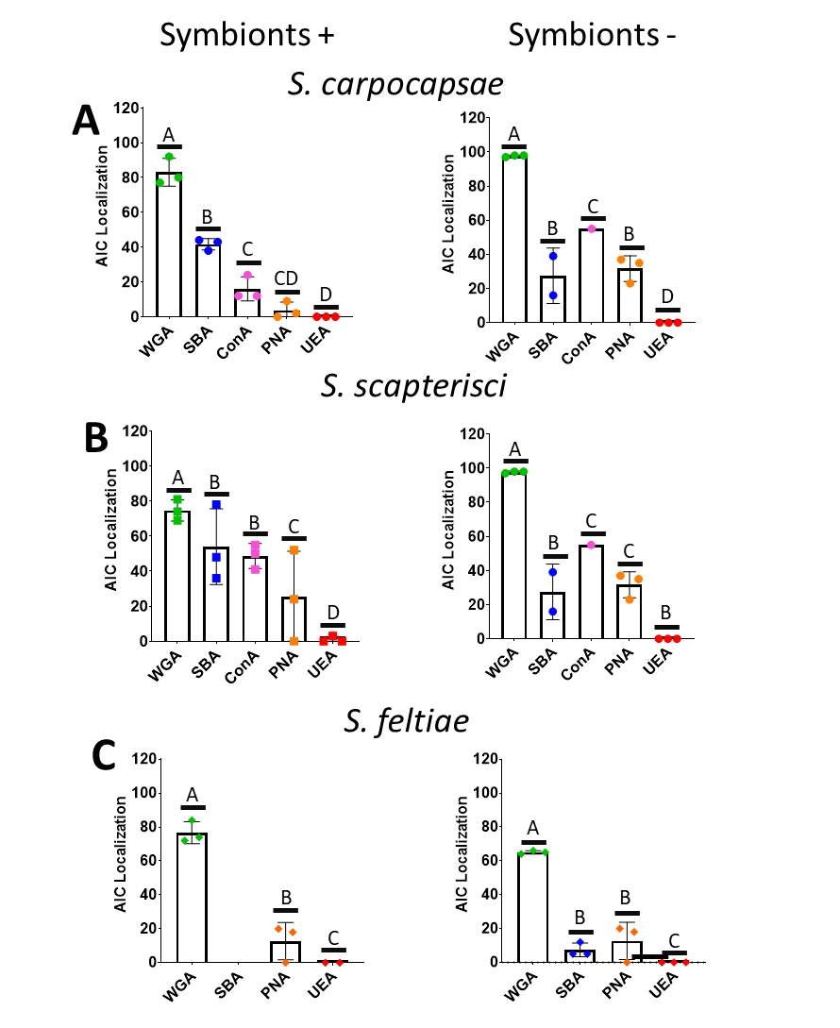

Supplemental Figure 2.i:
Surface sterilized S. carpocapsae and S. scapterisci eggs were placed onto plates containing either lawns of their bacterial symbionts (X. nematophila and X. innexi respectively) or onto beef liver and kidney agar plates to support growth with no lawns. Nematodes were collected from plates via pipetting of 1xPBS and placed into 1.5 mL centrifuge tubes before being rinsed an additional 3x with 1xPBS to remove bacteria. Excess liquid was removed and 200 µL of fresh 1xPBS was added along with 4 µL of ConA. Tubes were wrapped in foil and placed in an end over end mixer for 24 hours before being collected, rinsed 3x with 1xPBS to remove excess lectins and observed via fluorescence microscopy. S. carpocapsae nematodes had low lectin localization to the AIC in most treatments (around 20-60%) -though the highest rates were found when the symbionts were not present, suggesting that perhaps this glycan is expressed more when symbionts are not present. S. scapterisci was similar to S. carpocapsae with rates that were closer to 20% on average though some groups reached around 60%. Unlike S. carpocapsae the higher rates were not associated with any particular treatment, suggesting that either this glycan is always being expressed or there are as of yet unknown expression cues at the AIC. Data analysis was done using Tukey’s Multiple Comparisons One-Way ANOVA (p<0.0001). Columns that share a letter are not significantly different, columns that do not share a letter are significantly different.

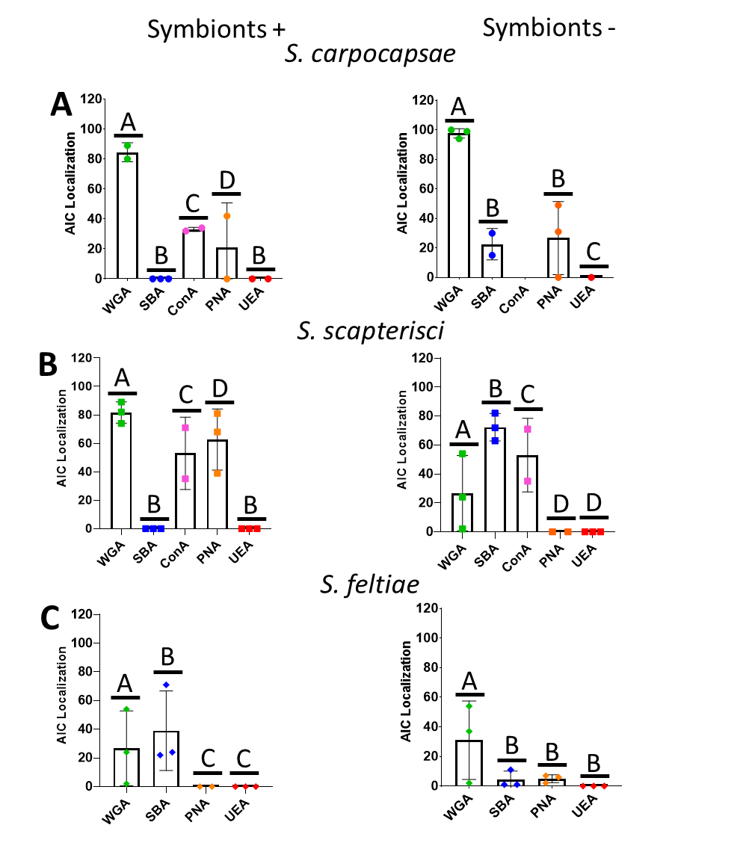
Supplemental Figure 2.ii:

Surface sterilized S. carpocapsae and S. scapterisci eggs were placed onto plates containing either lawns of their bacterial symbionts (X. nematophila and X. innexi respectively) or onto beef liver and kidney agar plates to support growth with no lawns. Nematodes were collected from plates via pipetting of 1xPBS and placed into 1.5 mL centrifuge tubes before being rinsed an additional 3x with 1xPBS to remove bacteria. Excess liquid was removed and 200 µL of fresh 1xPBS was added along with 4 µL of ConA. Tubes were wrapped in foil and placed in an end over end mixer for 24 hours before being collected, rinsed 3x with 1xPBS to remove excess lectins and observed via fluorescence microscopy. S. carpocapsae nematodes had low lectin localization to the AIC in most treatments (around 20-60%) -though the highest rates were found when the symbionts were not present, suggesting that perhaps this glycan is expressed more when symbionts are not present. S. scapterisci was similar to S. carpocapsae with rates that were closer to 20% on average though some groups reached around 60%. Unlike S. carpocapsae the higher rates were not associated with any particular treatment, suggesting that either this glycan is always being expressed or there are as of yet unknown expression cues at the AIC. Data analysis was done using Tukey’s Multiple Comparisons One-Way ANOVA (p<0.0001). Columns that share a letter are not significantly different, columns that do not share a letter are significantly different.

Chapter Three: Steinernema-Xenorhabdus as a model for gut-brain interactions; X. nematophila rpoS is necessary for egg laying behaviors in S. carpocapsae nematodes

Erin Mans¹*, Nicholas C. Mucci^{1,2}, Liesel Schneider³, and Heidi Goodrich-Blair¹#
#corresponding author
¹Department of Microbiology, University of Tennessee-Knoxville
²Genome Science and Technology Program, University of Tennessee-Knoxville
³Department of Animal Sciences, University of Tennessee-Knoxville

Experiments were conducted by Erin Mans, with the exception of the generation and analysis of the metabolomics data in figure 3.6 and 3.7. For these data, generation and homogenization of the infected waxworms was performed by Sarah Kauffman of the Goodrich-Blair lab of UTK, mass spectrometry the homogenized waxworms was performed by Katarina Jones of the Campagna Lab of UTK, and data analysis was performed by Nicholas Mucci of the Goodrich-Blair lab of UTK. Statistical analysis of the figures was done with the help of Dr. Liesel Schneider of the Animal Sciences Department of at the University of Tennessee Knoxville. Erin Mans and Dr. Goodrich-Blair wrote the manuscript.

Abstract:
The gut-brain axis is a broad term that refers to the multitude of ways that the host and their gut microbiome interface and influence each other through chemical and molecular signals (Rhee et al., 2009). The gut-microbiome contributes to host tissue development and maturation through the supplying of essential nutrients (Gordon and Pesti, 1971; Shroff et al.,1995; Smith and Crabb, 1961). It also is linked with various diseases including several psychiatric and neurological pathologies including autism spectrum disorders, Parkinson’s disease, multiple sclerosis, and chronic pain (Cryan and Dinan, 2012; Park et al., 2009; Vuong and Hsiao, 2017; Sampson et al., 2016; Berer et al., 2011; Amaral et al., 2008). In this study we use the naturally occurring association between Steinernema carpocapsae nematodes and their association with a mutualistic symbiotic bacterium, Xenorhabdus nematophila to interrogate the gut-brain axis. We show that oviposition by adult female S. carpocapsae nematodes is inhibited by experimental association with X. nematophila mutants lacking the RpoS sigma factor, relative to association with wild type X. nematophila. Further, we show that S. carpocapsae oviposition frequency is modulated in a concentration-dependent manner by the neurotransmitters, dopamine and serotonin and that the former can rescue the oviposition defect caused by association with an X. nematophila rpoS mutant. These results suggest that X. nematophila influences nematode behaviors in an RpoS-dependent manner, and establishes the S. carpocapsae-X. nematophila binary system as an easily observable, naturally-occurring system in which to study the gut-brain axis.

Introduction:
The gut-brain axis refers to the bi-directional connections between the nervous system and intestinal functions, including those of the gut-associated microbiota (Rhee et al., 2009). Disrupted signaling or alterations in either the nervous system or the gut microbiome can contribute to gut disorders such as irritable bowel syndrome (Mayer E. A., 2001; Rhee et al., 2009). Furthermore, the gut microbiota has been linked to a number of psychiatric and neurological pathologies including autism spectrum disorders, Parkinson’s disease, multiple sclerosis, and chronic pain (Cryan and Dinan, 2012; Park et al., 2009; Vuong and Hsiao, 2017; Sampson et al., 2016; Berer et al., 2011; Amaral et al., 2008). Yet, while evidence exists that the microbiota can be a factor in these diseases, causal and mechanistic evidence is sparse. The microbiome can also impact host moods and behaviors. For instance, gnotobiotic or germ-free animals have slowed or disrupted tissue development caused by deficiencies in essential nutrients normally provided by gastrointestinal symbionts (Gordon and Pesti, 1971; Shroff et al.,1995; Smith and Crabb, 1961). Furthermore, germ-free mice have higher levels of 5-hydroxytryptamine (5-HT; the neurotransmitter serotonin) and its breakdown product 5-hydroxyindoleactic acid (5-HIAA) in their hippocampus, increased motor activity and decreased anxiety-like behaviors compared to mice raised with their microbiota intact (Clarke et al., 2013; Diaz et al., 2011).
In invertebrate systems, the microbiome can also impact host behaviors. C. elegans displays avoidance behaviors after exposure to pathogenic P. aeruginosa and can even pass this memory on to its progeny for up to 4 generations (Moore et al., 2019, Kaletsky et al., BioRxiv). Wolbachia, an intracellular parasite of many arthropod species, has shown to alter learning and memory capacity related genes in infected Drosophila flies compared to those uninfected (Bi et al., 2019; Iyer et al., 2013). T. gondii infected rats have been shown to display less fear behavior and be attracted to cat urine, thus making them easier targets for the parasite’s native host (Berdoy et al., 2000). These and more studies suggest that the presence or absence of the microbiota, whether they are mutualistic or pathogenic can have a significant impact on the host health, development, and behavior.
Based on this breadth of gut microbial influence on profound and systemic aspects of host physiology and behavior, it is critical to better understand the underlying mechanisms by which the gut microbiota and the central nervous system (CNS) communicate with each other. Current literature indicates that this communication is mediated by neuroimmune and neuroendocrine pathways along vagal and spinal nerves (Bravo et al., 2011; Tolhurst et al., 2012; Wang et al., 2014; Singh et al., 2016), with signaling molecules including short-chain fatty acids, secondary bile acids, and tryptophan metabolites which are secreted into the gut and interface with the luminal epithelia (Bravo et al., 2011; Wikoff et al., 2009; Yano et al., 2015). It is not clear yet if bacteria are capable of specific and direct CNS signaling or if their influence on the nervous system is indirect via stimulation of host intestinal cells that then send signals to the brain along the vagal or spinal route (Bravo et al., 2011; Goehler et al., 2005). In turn, host animals primarily influence their intestinal microbiota through the autonomic nervous system (ANS). This can include processes such as ANS-dependent release of fluids into the gut that can rapidly alter the microbial environment (Mayer E. A. 2011). The host can also release molecules such as catecholamines, serotonin, or cytokines into the gut all of which can have a direct and indirect impact the microbiota (Lyte M., 1993; Mayer et al. 2014). In an ANS-independent process, microbiome composition changes with host melatonin levels, implicating host circadian rhythms on the microbiota (Paulose et al., 2016; Thaiss et al., 2014).
Understanding underlying mechanisms of communication between the CNS and gut microbiota in mammalian and vertebrate models is complicated by the diversity and complexity of the microbiota. Invertebrate hosts that associate with relatively few specific microbes can offer experimentally tractable and higher-throughput opportunities to investigate the gut-brain axis, particularly with respect to discovering bacterial effectors of host CNS modulation. Here we establish the association of Steinernema nematodes and their intestinal Xenorhabdus symbionts as a model to understand the gut-brain axis in a highly evolved and naturally occurring mutualistic association. Steinernema nematodes dwell in soil environments and are entomopathogenic, infecting, killing, and sexually reproducing within insects (Fig. 3.1). The soil-dwelling stage, known as the infective juvenile (IJ) carries its Xenorhabdus symbiont in the luminal pocket of the anterior intestine known as the receptacle, and once released into the insect environment Xenorhabdus bacteria contribute to insect killing, nematode reproduction, and defense against competitors (Poinar G. O. Jr 1966; Wouts W. M., 1984). Once the insect has been killed the IJ stage nematode develop into adult male and females that mate and lay eggs. These eggs are the only known life stage of the Steinernema nematode that is not known to be colonized by Xenorhabdus. The eggs will hatch and grow into more adult males and females which will also mate
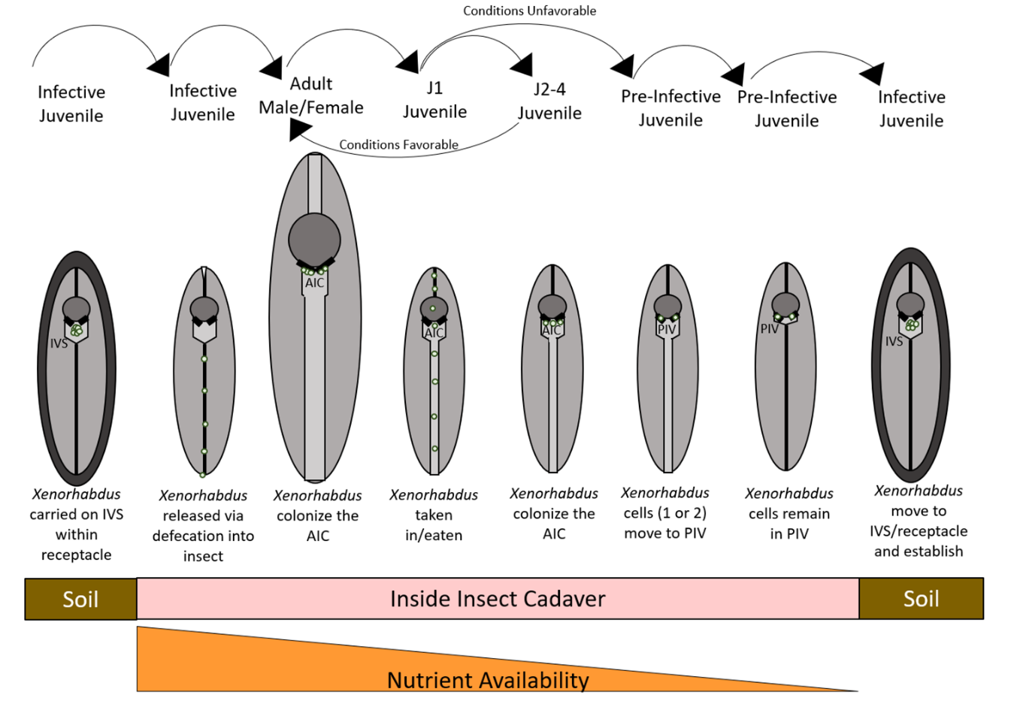
Figure 3.1: The Life cycle of the Steinernema nematode. Steinernema nematodes start in the soil as infective juvenile (IJ) stage with bacteria colonizing the intravesicular structure (IVS). Once they infect an insect they will travel to insect hemolymph and Xenorhabdus symbionts through defecation before killing the insect. From there they will grow into adult males and females that are colonized at the anterior intestinal cecum (AIC). These adults will mate and lay eggs and when conditions are favorable (sufficient nutrients) the hatched J1 juveniles will grow into J2-J4 juveniles before reaching adult males and females that will mate and lay more eggs. When conditions become unfavorable (nutrients run low in the insect tissues) the J1 juveniles will develop into Pre-IJ that are colonized at the pharyngeal intestinal valve (PIV) before developing into IJ’s that will constrict their intestines, form a cuticle and have the bacteria move from the PIV to the IVS. From there they will leave the insect cadaver and wait in the soil for the next potential insect to infect.

and lay eggs. This cycle will repeat two to three times within the insect cadaver after which the next generation of nematodes will hatch and develop into a special stage after J1 known as “pre-IJ”. These pre-IJ stage nematodes will associate with their bacterial symbiont, constrict their intestines and develop a thick protective cuticle before leaving the cadaver and waiting in the soil for another insect to parasitize (Popiel et al., 1989).
One of the advantages to using the Steinernema-Xenorhabdus system is that in the lab they can be reared outside of the insect and the bacteria are genetically manipulatable, allowing for direct observation of the colonization status of the nematode through insertion of GFP into Xenorhabdus. The physical association between Steinernema and Xenorhabdus has been best studied in the Steinernema carpocapsae-Xenorhabdus nematophila association (Poinar et al., 1966; Goodrich-Blair, H., 2007). In addition to X. nematophila receptacle colonization of infective juvenile stage nematodes noted above, X. nematophila also colonizes the anterior intestinal caecum (AIC) of juvenile and adult nematodes developing in the insect cadaver, and the pharyngeal intestinal valve of pre-infective juveniles prior to development into the receptacle-colonized infective juvenile. At all of these sites, colonization is species specific: only X. nematophila and no other Xenorhabdus species (which colonize their own nematodes hosts), can occupy these sites within S. carpocapsae nematodes. While colonization of the infective juvenile is essential for X. nematophila transmission to a new insect host, the functional consequences of colonization in juvenile and adult anterior intestinal caeca are less clear. X. nematophila are the primary food source of S. carpocapsae nematodes (Mucci et al., 2021). This indicates that while some X. nematophila cells progress through the intestine and are digested, other cells are selectively retained and protected from digestion in the anterior intestine, where they may be influencing host physiology.
Early observations of S. carpocapsae-X. nematophila associations indicated that in the absence of the bacterial symbionts, nematode attempts to reproduce were rare (Poinar G. O. Jr 1966). This prompted us to investigate if X. nematophila residents of the adult female AIC modulate host behaviors. This goal was facilitated by the availability of AIC-colonization-deficient X. nematophila bacterial mutants on which we can cultivate S. carpocapsae nematodes. X. nematophila ΔSR1 mutants lack a 4kb locus containing the nematode intestinal localization (nil) genes necessary for receptacle, PIV, and AIC colonization of S. carpocapsae (Heungens et al., 2002; Cowles et al., 2008; Chaston et al., 2013). Current evidence indicates that NilB is an outer membrane protein that facilitates the surface exposure of one or more other proteins, including NilC. NilC is a lipoprotein hypothesized to be involved in nutrient acquisition (Grossman et al., 2021). The other colonization deficient mutant strain of X. nematophila was rpoS::kan. These mutants lack expression of the RpoS/σ^{S} sigma factor that in E. coli is associated with general and stationary phase stress responses (Lang et al., 1991). Consistent with a similar role in X. nematophila, an rpoS::kan null mutant displayed decreased survival after exposure to the osmotic stressor hydrogen peroxide and starvation (Vivas et al., 2001). X. nematophila rpoS mutants are defective in colonizing the infective juvenile stage of S. carpocapsae nematodes (Vivas and Goodrich-Blair, 2001; Heungens et al., 2002), though its impact on AIC colonization has not been assessed.
In the current study we compared nematodes cultivated with each of these colonization-defective mutants or with wild type and assessed two common behaviors: pharyngeal pumping and egg-laying. We show that cultivation with X. nematophila rpoS mutants cause significantly reduced S. carpocapsae egg laying that can be rescued by exogenous addition of the neurotransmitter dopamine.

Results:
X. nematophila rpoS mutants do not colonize the anterior intestinal caecum of adult S. carpocapsae nematodes
X. nematophila rpoS mutants are unable to colonize the intestinal receptacle of the infective juvenile stage of S. carpocapsae nematodes, and this colonization defect can be rescued by expression of rpoS on a multi-copy plasmid (Vivas et al., 2001; Heungens et al., 2002). Subsequent to those observations, it was discovered that X. nematophila can colonize the anterior intestinal caecum (AIC) of adult males, females, and the four (non-infective) juvenile stages (Chaston et al., 2013). To test if rpoS is required for AIC colonization, we assayed the frequency of AIC colonization by GFP-expressing X. nematophila strains: a rpoS::kan mutant, wild type and these strains carrying an ectopic genomic copy of the wild type rpoS allele at the attTn7 site (Vivas, unpublished).
Nematodes grown on these bacterial lawns were collected at the adult stage for observation by fluorescence microscopy to detect the GFP-expressing bacterial strains adherent to the AIC. Significant differences (P<0.0001) were found between the nematodes cultivated on the different bacterial lawns. As expected, the ΔSR1::kan strain displayed a significantly reduced frequency (28%) of AIC colonization relative to

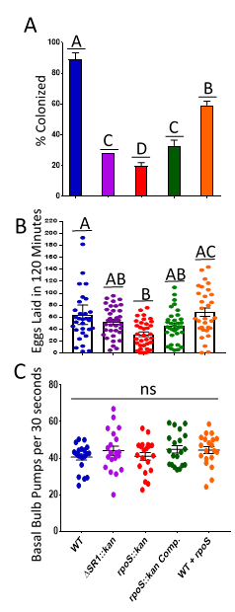

Figure 3.2: S. carpocapsae nematode colonization and egg laying on colonization deficient lawn compared to wild type lawns. A) X. nematophila ΔrpoS is colonization deficient in adult AIC and is partially restored with attTn7::Tn7-rpoS complementation (P<0.0001).
Nematode eggs were grown on GFP expressing bacterial lawns and collected via pipetting before observation for GFP expressing bacteria at the AIC via fluorescence microscopy. Experiments were performed with three biological replicates of 100 nematodes each. Significant differences found using One-Way ANOVA. B) Nematodes cultivated with X. nematophila ΔrpoS lay fewer eggs than those cultivated with wild type bacteria (P <0.0001) Using Tukey’s Multiple Comparisons One-Way ANOVA). Adult nematodes were transferred to wells containing 200 µl of 1XPBS from lawns of the strains indicated and observed by light microscopy for the number of eggs laid after two hours of incubation for six biological replicates performed with 6 nematodes per replicate. Non-laying females were removed from the data pool due to concerns of being non-gravid at the time of observation. Significance was found between the nematodes reared on these lawns using One-Way ANOVA. C) Nematodes cultivated on different X. nematophila strains do not have significant differences in basal bulb pumps per 30 seconds. Adult nematodes were transferred from lawns of the strains indicated via pipetting with 1XPBS to NGM plates and observed for the number of pharyngeal pumps for 30 seconds via light microscopy. Statistical analysis was performed using Tukey’s Multiple Comparisons One-Way ANOVA and no significant differences among treatments was identified.

wild type (89%), consistent with previous findings (Fig. 3.2A) (Chaston et al., 2013). We also observed a significant AIC colonization defect of the X. nematophila rpoS::kan mutant, which colonized only ~20% of observed nematodes. AIC colonization by the rpoS::kan mutant carrying the attTn7::Tn7-rpoS in genome complement was significantly higher than the rpoS mutant (33%) but did not achieve wild type levels (Fig. 3.2A). In fact, the presence of the attTn7::Tn7-rpoS allele appeared to reduce AIC colonization even in wild type (59%) suggesting that disruption of the attTn7 site or the ectopic presence of the rpoS genomic region at this site might be detrimental to colonization. The complement construct includes the nlpD gene upstream of rpoS as well as the predicted promoter, so strains carrying this complement construct are merodiploid for nlpD. The nlpD gene is predicted to encode murein hydrolase activator which mediates septal murein cleavage between the mother and daughter cells during cell division (Tidhar et al., 2009). An extra copy of nlpD might disrupt membrane physiology during the cell division and the altered cell morphology or membrane integrity may negatively impact the ability of X. nematophila to colonize the AIC.
With two X. nematophila AIC-colonization defective mutants rpoS::kan and ΔSR1, each with a distinctive molecular function (transcription factor versus surface colonization factors), we next explored the potential impacts of AIC colonization on the host by examining if the presence of bacteria at the AIC alters nematode host behaviors.

Cultivation with the X. nematophila rpoS::kan mutant negatively impacts S. carpocapsae nematode egg laying behavior but not feeding behavior
To begin addressing the possibility that AIC colonization and the status of the nematode intestine have an impact on nematode behaviors, we performed assays to measure reproduction and feeding behaviors of nematodes grown on lawns of rpoS::kan and ΔSR1::kan colonization-defective mutants and compared them to nematodes grown on lawns of wild type X. nematophila. We monitored reproduction by examining both egg laying and egg retention in adult females after co-cultivation with colonization-deficient or wild type, colonization proficient bacteria. Each individual female was removed from the bacterial lawn, paralyzed and observed by light microscopy for the number of eggs retained in the gonads. One hundred females in each of three biological replicates were counted for a total of three hundred females in each treatment. Females grown on lawns of X. nematophila rpoS::kan retained a total of ~29K eggs, 1.7-fold and significantly more eggs relative to those grown on wild type X. nematophila (~17K eggs) (Supp. Fig. 3.i). Unexpectedly, we found that this difference in egg-retention was not a general phenotype of nematodes reared on colonization-defective mutants, as there were no significant differences in eggs retained by females between the ΔSR1::kan (~16K eggs) and wild type X. nematophila treatment groups. while the rpoS::kan-derived nematodes retained 1.8-fold and significantly more eggs than did the ΔSR1::kan mutant.
To assess egg laying behavior, gravid female nematodes were collected and placed individually into 200 μL of 1X PBS in a 96-well plate. Nematodes were incubated to allow egg laying to occur for two hours before observing by light microscopy to assess the number of eggs in the media. The data were analyzed using a standard Tukey’s Multiple Comparison’s One-Way ANOVA, which found a significant effect of strain on egg laying (P<0.001). A multivariate GLIMMIX ANOVA also found that the bacterial lawns the females were cultivated on did impact egg laying but only when each biological replicate was analyzed separately due to variance between the replicates (Bio. Rep. 1 P=0.0244; Bio. Rep. 2 P=0.0010; Bio. Rep. 3 P=0.0004). Females cultivated on rpoS::kan lawns laid an average of 31.6 eggs, which was significantly lower than nematodes cultivated with wild type X. nematophila which laid an average of 57.1 eggs (Figure 3.2B). The females grown on the rpoS::kan attTn7::Tn7-rpoS complement strain laid an average of 44.7 eggs, which was not significantly different from either the wild type or rpoS::kan mutant treatments, suggesting a partial rescue of egg laying similar to the AIC colonization phenotype. Finally, nematodes from the ΔSR1::kan and wild type with attTn7::Tn7-rpoS treatments laid an average of 52.7 and 60.7 eggs, respectively, neither of which was significantly different from either wild type or the rpoS mutant, representing an intermediate egg-laying phenotype of these strains. These data suggest that X. nematophila might influence nematode host egg laying in an rpoS-dependent manner. To confirm these observations, female nematodes also were cultivated on a second set of X. nematophila rpoS mutants. These mutants are in a different X. nematophila strain background (HGB081;AN6/1) and were generated through random transposon mutagenesis versus site directed homologous recombination relative to those described above (Vivas, 2001; Heungens, 2002). We found that females reared on X. nematophila rpoS1::Tn5 and rpoS2::Tn5 laid significantly (P=0.003, One-Way ANOVA) fewer eggs compared to their wild type parent (HGB081) providing further evidence that there is a causal relationship between rpoS mutations and S. carpocapsae egg laying defects (Fig. 3.iii).
To assess if the X. nematophila rpoS::kan mutant differentially affects other nematode behaviors we assessed feeding as indicated by pharyngeal pumping rate. Bacterivorous nematodes, such as Caenorhabditis elegans and S. carpocapsae take in food by pulling bacteria from their environment into the intestine through the pumping of the basal bulb (Doncaster, 1962, Seymour et al., 1983). When a nematode completes a cycle of synchronous contraction and relaxation of the basal bulb this is called a “basal bulb pump”. A common way to measure nematode feeding is to count how many times a nematode performs these basal bulb pumps in a given amount of time (Raizen et al., 2012).
To measure feeding, we transferred nematodes grown on the different bacterial lawns before transfer to secondary plates for observation via microscopy. Female nematodes were chosen on the plates and the number of basal bulb pumps per 30 seconds were counted. There were no significant differences found using Tukey’s Multiple Comparisons One-Way ANOVA looking at the effect of the bacterial lawn on basal bulb pumps per 30 seconds (P= 0.4235). This suggests that the X. nematophila rpoS::kan bacterial strain is causing a specific change to nematode behavior (egg laying) and not a general one. However, these data raised the question of the observed changes in egg laying behavior are due to a lack of colonization at the AIC of the nematodes, because rpoS::kan bacteria colonize at a much lower rate than WT, or if the rpoS::kan mutant cells were altering nematode behaviors from the nematode intestine.

Nematode Colonization Status Influences Egg Laying Behavior in a Bacterial Strain-Dependent Manner
X. nematophila ΔSR1::kan and rpoS::kan mutants have defects in colonizing the S. carpocapsae AIC (Fig. 3.2A) (Chaston et al., 2013). Further, the egg-laying phenotypes of nematodes derived from different bacterial strains correlates with the colonization frequency (compare Fig. 3.2A to 3.2B). To more precisely measure if the colonization status of an individual nematode (e.g. whether it has bacteria colonizing the AIC or not) impacts its egg laying behavior, we observed individual nematodes by fluorescence microscopy and scored them based on their colonization status before quantifying egg-laying over a 2 hour window before counting.
Unexpectedly, in this series of experiments the average number of eggs laid by nematodes, whether colonized or not did not differ depending on bacterial treatment. One possible explanation for this difference is that our previous data examined nematode populations as a whole, with higher ratios of colonized nematodes among the wild-type derived nematodes relative to either rpoS::kan or ΔSR1::kan, whereas in this analysis the ratios of colonized vs. uncolonized were kept fixed for all nematodes regardless of bacterial treatment. We also considered the possibility that these data were impacted by the presence of non-gravid, non-ovipositing females, the latter group of which may have been damaged during transfer. We reanalyzed the data with these animals excluded (Supp. Fig. 3ii).
We next analyzed if the colonization status influences the numbers of eggs laid by ovipositing females (excluding non-ovipositing females). Overall, using the GLIMMix procedure we found that there were no significant interactions between colonization status, bacterial treatment, and egg-laying behavior (Fig. 3.3A). However, paired Student’s T-tests found that there was a significant difference (p=0.0091) in egg-laying behavior between colonized females that were grown on the WT versus rpoS::kan lawns (Fig. 3.3B). Females colonized with WT X. nematophila laid an average of 61 eggs in 120 minutes, while the rare females colonized with X. nematophila rpoS::kan laid an average of 36 eggs in 120 minutes. However, uncolonized females laid similar (non-significantly different) numbers of eggs regardless of the bacterial treatment: wild type (average of 42 eggs/120 min) versus rpoS::kan (average of 37 eggs/120 min) (Fig. 3.3C). These data suggest that colonization at the AIC may enhance the ability of wild type bacteria to modulate egg-laying behavior, but that even in rare occurrences of rpoS::kan mutant adherence to the AIC, these mutant bacteria fail to elicit the same behavioral response as wild type AIC-adherent bacteria.

Exogenous addition of the neurotransmitters dopamine and serotonin alter ovipositing behavior and restore oviposition of females grown on rpoS::kan lawns
Taken together the data described above provide evidence that X. nematophila symbionts can alter nematode host behavior. In the nematode C. elegans, neurotransmitters such as serotonin or dopamine, and their receptors mediate behavioral signaling (Rand et al., 1997). Indeed, the addition of exogenous serotonin or dopamine can raise nematode oviposition back to WT levels (Brewer et al., 2019). To determine if serotonin and dopamine similarly alter S. carpocapsae behavior, we quantified nematode egg-laying (Fig. 3.4) and pharyngeal pumping (Fig. 3.5) phenotypes in nematodes exposed to varying concentrations of dopamine or serotonin. Adult female S. carpocapsae nematodes grown on different bacterial strain lawns before being exposed to increasing concentrations of neurotransmitters for 2 hours displayed significant (dopamine, P=0.0057; serotonin, P=0.0465)) altered oviposition
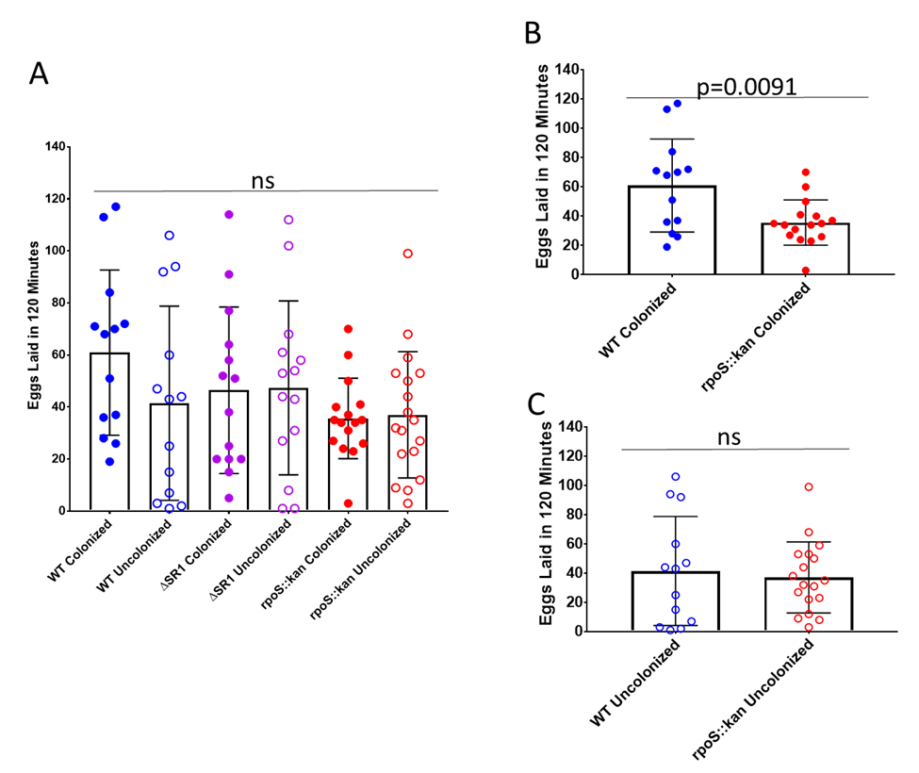
Figure 3.3: Colonization status does not impact the egg laying behavior of females cultivated on indicated bacterial lawns. Adult female nematodes collected from indicated bacterial lawns before sorting based on the presence of absence of GFP-expressing bacteria at the AIC. Nematodes were then each placed in an individual microtiter dish well. After 120 minutes of incubation, the nematode was removed and eggs that had been laid within the well were counted using light microscopy. Three biological replicates were performed with six nematodes per replicate. Data was analyzed using GLIMMIX which accounted for variation in the replicates and interactions of colonization status and bacterial strains on egg laying. Non-laying and non-gravid females were removed from final counts. A) Statistical analysis was performed using GLIMMix ANOVA procedure, which found no significant differences between the interactions of colonization status of the females on the different bacterial lawns. B) Welch’s Student’s T-test determined that there was significant a significant difference between the WT colonized and rpoS::kan colonized groups. C) Welch’s Student T-test determined there were no significant differences between the WT uncolonized and rpoS::kan uncolonized groups.

(Fig. 3.4) but not pharyngeal pumping (Fig. 3.5) relative to control treatments without neurotransmitter. Overall, consistent with its effect on C. elegans oviposition (Schafer and Kenyon, 1995) dopamine had a dose-dependent negative effect on oviposition of S. carpocapsae derived from wild-type lawns, with a maximal ~2-fold-reduction relative to the control (Fig. 3.4Bi). Similarly, serotonin concentrations were inversely correlated with a S. carpocapsae oviposition (Fig. 3.4Ai), but this is in contrast to the influence of serotonin on C. elegans oviposition, where it increases the numbers of eggs laid (Hobson et al., 2006) suggesting S. carpocapsae may respond differently than C. elegans to serotonin.
We next examined if the bacterial strain from which the S. carpocapsae nematodes had been cultivated influenced their subsequent behavior in response to exogenous neurotransmitter. As expected, the numbers of eggs laid by rpoS::kan-derived nematodes in the no-neurotransmitter control treatment were lower than observed in wild-type-derived nematodes (compare control treatments of Fig. 3.4 panels A.i vs. A.iii and B.i vs. B.iii), while the ΔSR1::kan-derived nematodes laid similar numbers of eggs as wild-type-derived nematodes in control treatments (compare control treatments of Fig. 3.4 panels A.i vs. A.v and B.i vs. B.v). Also consistent with the data thus far, ectopic rpoS at the attTn7 site partially rescued the egg-laying defect, particularly in the dopamine control samples (in Fig. 3.4A and 4B compare the control treatments in panels iii and iv).
Similar to nematodes from the wild type bacterial treatment, serotonin and dopamine addition caused a reduction in the numbers of eggs laid by females from the

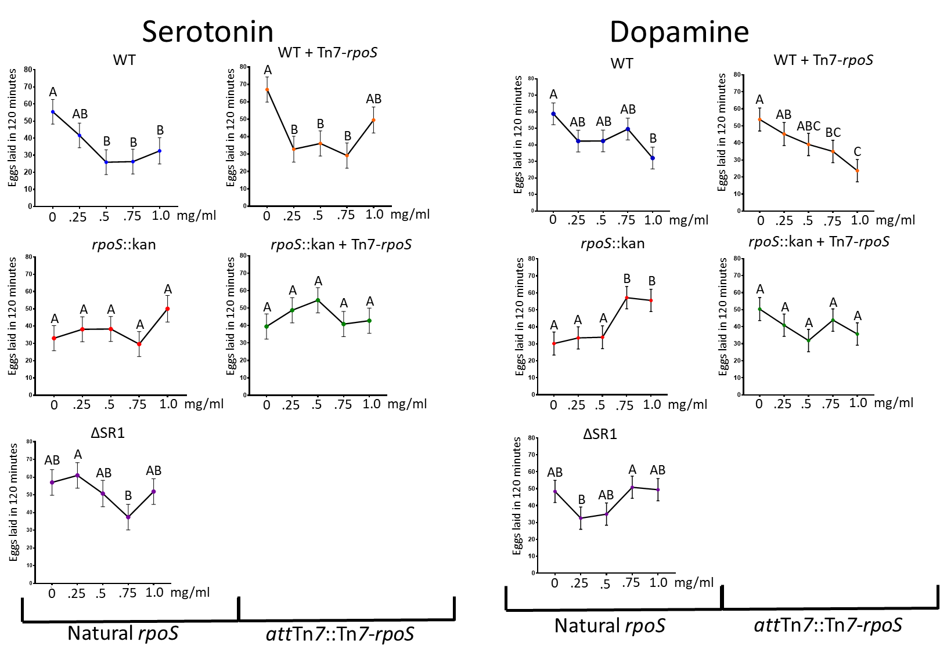
Figure 3.4: Increasing levels of exogenous serotonin and dopamine increase egg laying in nematodes cultivated on ΔrpoS lawns relative to WT. Individual gravid females from lawns of bacterial treatment indicated at the top of each set of graphs were placed in a well containing A) serotonin or B) dopamine at the concentrations indicated on the X-axis. Females were exposed to these neurotransmitters for two hours before the number of eggs laid was counted in each well using light microscopy. Assays performed with three biological replicates containing six females each. Data analyzed using Two-Way ANOVA looking at the interaction between bacterial lawns and increasing dopamine (P=0.0057) and serotonin (P=0.0465) concentrations. Each group of nematodes raised on a different bacterial strain lawn was also analyzed in the ANOVA for the effect of different concentrations of dopamine or serotonin on egg laying. Groups that share a letter are not significantly different while groups that do not share a letter are significantly different.

A
B
eTn7
eTn7

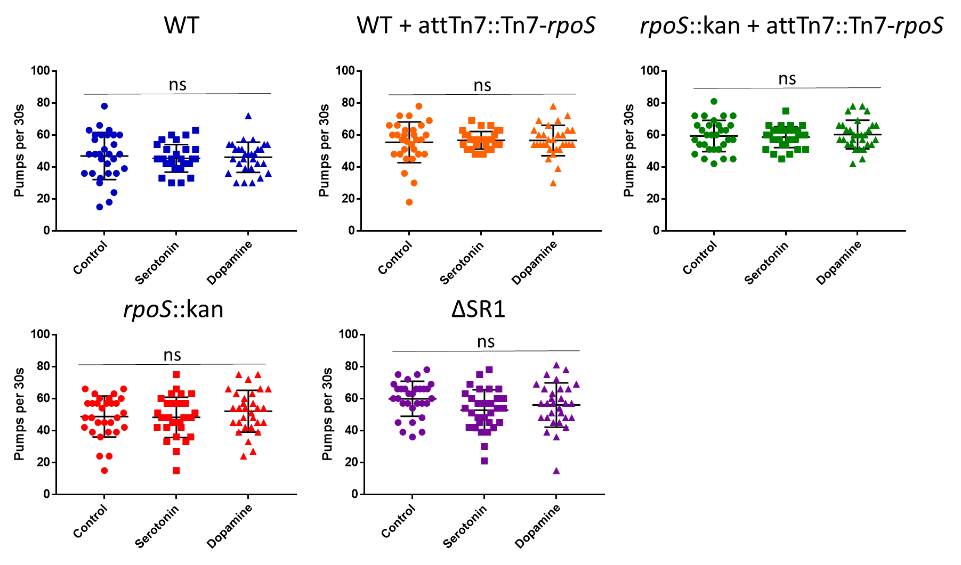
Figure 3.5: Addition of neurotransmitters serotonin and dopamine does not alter the pharyngeal pumping behaviors of females cultivated on different bacterial lawns. Adult nematodes were collected from indicated bacterial lawns via pipetting with 1XPBS and transferred to three separate NGM plates. Nematodes were incubated with either 1mg/mL of serotonin, 1mg/mL of dopamine, or 1xPBS for 15 minutes. After incubation females were observed for 10 seconds for pharyngeal pumps. All tests were performed on three biological replicates with three nematodes per replicate. Tukey’s Multiple Comparisons One-Way ANOVA revealed no significant differences between the serotonin/dopamine treatments and the control.

ΔSR1::kan treatment, but the magnitude of the effect was not as striking (1.6-fold reduction maximum) and higher doses of neurotransmitter had less effect than
intermediate doses (Fig. 3.4Av, 4Bv). In contrast, the egg-laying behavior of nematodes from the rpoS::kan mutant treatment was not significantly altered by the addition of serotonin (Fig. 3.4Aiii) and the overall trend was relatively stable, or increasing, numbers of eggs laid with increasing serotonin concentrations, inverse to the effect of this neurotransmitter on wild-type-derived nematodes.
Dopamine addition did have a significant effect on the rpoS-derived nematodes and was inverse to the effect on wild-type-derived nematodes: at the highest concentrations of dopamine the rpoS-derived nematodes laid higher numbers of eggs relative to the no-neurotransmitter control (Fig. 3.4Biii). Indeed, the addition of 0.75 or 1 mg/ml dopamine rescued the egg-laying defect of the rpoS-derived nematodes to the same level as control-treated wild-type-derived nematodes (Fig. 3.4Biii). This effect of dopamine rescue was not seen in nematodes derived from X. nematophila rpoS::kan mutant strain carrying the attTn7-Tn7-rpoS allele (Fig. 3.4Biv). This suggests that the levels of neurotransmitters the females are exposed to is very important for egg laying behaviors. Too much, as is the case with wild type and the females will lay fewer eggs. However, as is the case with the females grown on rpoS::kan lawns, if the balance of neurotransmitters has possibly been thrown off by the bacteria then the addition of exogenous dopamine and serotonin can restore that behavior.
Unlike egg laying behaviors, regardless of bacterial treatment, the addition of serotonin and dopamine to the nematodes did not alter basal bulb pumps at the highest concentrations used in this study (Fig. 3.5). Nematodes incubated for 15 minutes in 1mg/ml of either dopamine or serotonin before observation showed no significant difference among the treatment groups between the bacterial lawns. There were significant differences, however, among the nematodes grown on the lawns in general (Supp. Fig. 3.ii). Interestingly, when separated out this way, the wild type seems to have the lowest number of basal bulb pumps-suggesting that the normal state of the nematode is not rapid basal bulb feeding at the adult stage of the nematode life cycle. Regardless, the lack of dramatic impacts of dopamine and serotonin on basal bulb pumping indicates the effects of these neurotransmitters on egg-laying behaviors do not result from general effects on overall nematode physiology, and that oviposition and feeding behaviors may not be linked as they are in C. elegans.

The levels of neurotransmitters, serotonin and dopamine fluctuate within the insect cadaver throughout the infection cycle
Given the changing effects of dopamine and serotonin on egg-laying behavior depending on their concentrations when added exogenously, we examined their relative levels during a natural infection over a life cycle. The majority of the S. carpocapsae-X. nematophila life cycle takes place within an insect cadaver. In a laboratory infection of the insect Galleria mellonella, the infection can be roughly divided into three “stages” (Fig. 3.6) an “early stage” of ~24-48 hours (red zone of infection in Fig. 3.6A), in which IJ’s infect and kill the insect with the help of X. nematophila symbionts (Nguyen et al.,1992), a “middle stage” (yellow zone of infection in Fig. 3.6A) of ~7 days in which the bacteria first consume the insect and the nematodes then consume the bacteria and reproduce through 1-2 generations, and a “late stage” (green zone of infection in Fig. 3.6A) in which nutrient depletion and increasing nematode population drives development of the bacterial-colonized IJ stage that emerges from the insect over ~6 days from the insect cadaver. Like other nematodes, S. carpocapsae exhibits a behavior known as endotokia matricida, or bagging, in which eggs are not laid but rather hatch within and consume the mother (Trent et al., 1983).
Trophic analysis supports that bagging occurs within a natural infection, since nematodes occupy a trophic level that indicates cannibalism (Mucci, 2021). In the nematode Heterorhabditis bacteriophora, endotokia matricida is an obligate process for transmission of the bacterial symbiont, Photorhabdus luminescens to progeny IJ nematodes (Ciche et al., 2008). This route of transmission creates evolutionary selective pressure for bacterial inhibition of oviposition during late stages of reproduction when nutrients are limiting and IJ development is occurring. Our in vitro data described above indicates that bacterial modulation of dopamine and serotonin levels could be one route by which this inhibition could occur. To begin to understand how dopamine and serotonin levels fluctuate over a natural infection we analyzed a previously obtained metabolomics data set (Mucci et al., 2021) or the relative levels over time of both neurotransmitters and the intermediates in their biosynthesis and breakdown.
We found that dopamine was present throughout the life cycle at 2 to 5 log higher levels than serotonin, that levels of both neurotransmitters were significantly higher in infected relative to uninfected insects and fluctuated over the life cycle. Within an infected insect there were three major peaks of dopamine and its precursor tyrosine: on first day of infection, immediately after insect death, on day 8 of infection, when hatched

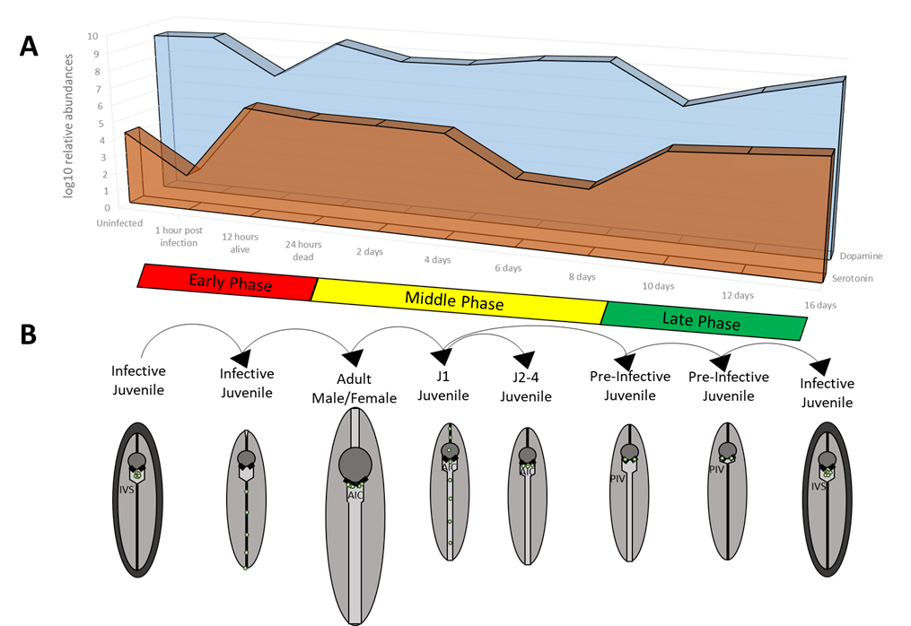
Figure 3.6: Dopamine and serotonin levels change in the insect cadaver throughout the infection cycle. A) Galleria were infected with WT S. carpocapsae and X. nematophila. At each time point galleria were selected from the plates and flash frozen before being homogenized and sent for metabolomics analysis using mass spectrometry using pre-set standards for each metabolite. Statistical analysis done using MetabAnalyst 4.0. Metabolite concentrations were calculated and run through a log10 scale for this figure. B) Suggested model for life stages of the nematodes within the insect cadaver. With the idea of females laying eggs synchronously to assure that the next generation develops to adulthood or leaves the insect at roughly the same time.

juvenile nematodes begin developing into infective juveniles, and on day 16 of infection when large numbers of IJs had already emerged from the cadaver (Fig. 3.7B).
Considering that levels of dopamine and dopamine byproducts were changing over the course of the infection cycle, we hypothesized that X. nematophila might be able to produce molecules that can catabolize dopamine and alter levels of the neurotransmitter within the nematode. Two genes in particular, hpaB and hpcB (marked by red arrows in Fig. 3.7A) were found to be negatively regulated by rpoS via microarray (Mucci et al., 2021). This suggested to us that X. nematophila might be involved in modulating the synthesis and catabolism of dopamine within the nematode.
Two breakdown products of dopamine, 3,4-dihydroxyphenylacetic acid (DOPAC) and Homovanillic acid (HVA), had elevated levels at time points between day 10 and 16, indicating the day 8 peak of dopamine may be followed by its conversion to these products. Given the inhibitory effect of dopamine on oviposition of S. carpocapsae nematodes cultivated with wild type X. nematophila, these data may indicate that at late-middle and late stages of infection, endotokia matricida is promoted by peaking levels of dopamine. Within dead insects, serotonin levels remained relatively steady except for a trough at days 6 and 8, when dopamine levels were peaking.

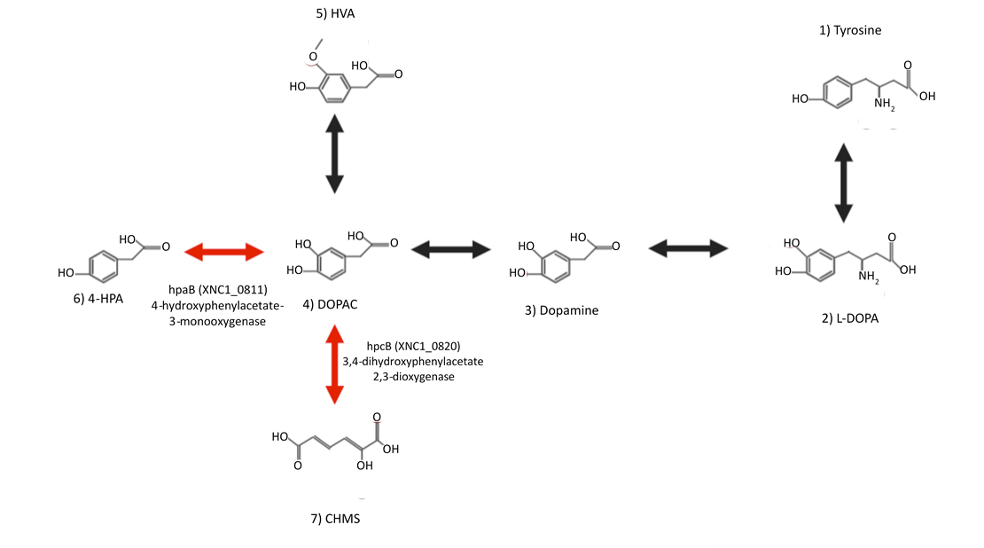
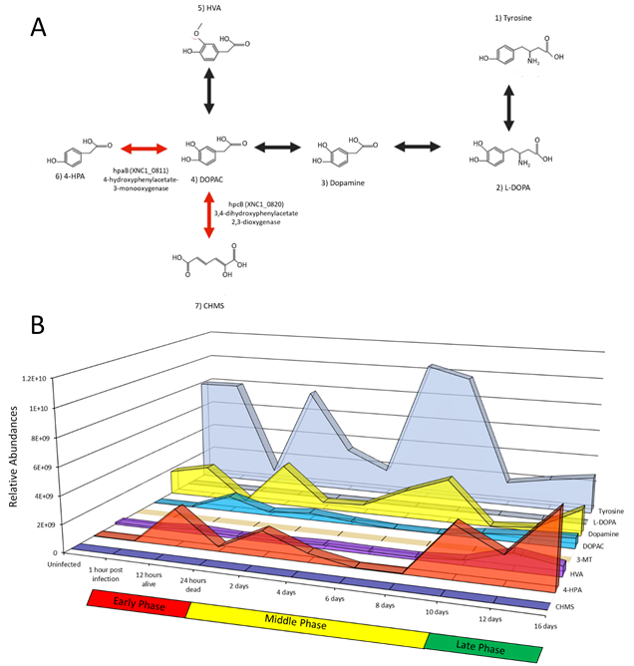
Figure 3.7: Levels of dopamine, its precursors and byproducts change over an infection cycle. (A) Dopamine is in a class of neurotransmitters known as catecholamines. It is synthesized from the amino acid tyrosine and can be broken down into various other compounds. Microarray analysis revealed that two genes were negatively regulated by RpoS (red arrows) suggesting that RpoS may be involved in gene regulation that can impact the amount of available dopamine/DOPAC found in the insect cadaver. Image made using BioRender™. (B) Relative abundances of the products of the dopamine pathway over the course of an infection cycle. Statistical analysis was performed using MetaboAnalyst 4.0. Samples were normalized before processing through MetaboAnalyst based on the insect weight. Data was log transformed and pareto scaling was applied. Two-way ANOVA and Tukey post-hoc tests were completed by taking individual time point metabolite concentrations and comparing their means to the uninfected insect model and each other.

A
B
Combinations of serotonin and dopamine have complex impacts on S. carpocapsae oviposition that is influenced by X. nematophila bacterial strain
Our observation that a peak in dopamine levels and a trough of serotonin levels occurs at days 8-10 of an infection, when IJs are forming, led us to test the influence on egg-laying of combinations of the two neurotransmitters. Female nematodes were placed in individual wells with combinations of dopamine:serotonin of 0:0, 1:1 (2 mg/ml total), 5:1 (6 mg/ml total), 1:5 (6 mg/ml total) or 5:5 mg/ml (10 mg/ml total). After 2 hours of incubation, nematodes were paralyzed with levamisole and the number of eggs in the wells counted. Data were analyzed using both Tukey’s Multiple Comparison’s One-Way ANOVA and GLIMMIX, both of which assessed interactions between the bacterial lawns and drug concentrations to egg laying. Tukey’s found that there was significant impact of bacterial lawn both for the control (Fig. 3.8A, P=0.0003) and impact of the drug when compared between groups on the same bacterial lawns (WT P<0.0001; rpoS::kan, P=0.0001; WT-081, P<0.0001; RpoS1::Tn5, P=0.0499; RpoS2::Tn5, P=0.0499). GLIMMIX also found that there was a significant impact on egg laying from the bacterial lawn the nematodes were cultivated on (P=0.0004) and the impact of neurotransmitter treatment (P<0.0001). However, GLIMMIX found there were no significant interactions between the lawns the nematodes were grown on and the impact of the level of neurotransmitter the nematodes were exposed to during egg laying.
For nematodes derived from either wild type lawn, a dopamine:serotonin 1:1 or 5:5 mg/ml treatment (equal concentrations of both, at either relatively ‘low’ or ‘high’ levels) were not significantly different from the controls in which no neurotransmitters had been added (Fig. 3.8B, C) when using Tukey’s One-Way ANOVA. This was

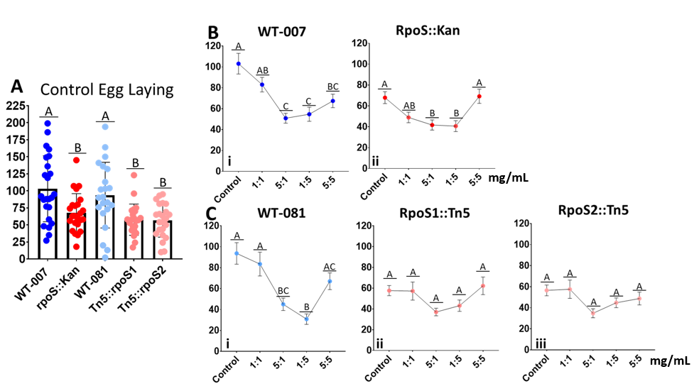
Figure 3.8: Addition of different levels of dopamine and serotonin does alter the level of eggs laid in females S. carpocapsae nematodes grown on WT lawns, but not on rpoS mutant lawns. (A) Comparison of egg laying in S. carpocapsae females on different X. nematophila rpoS mutant lawns or their wild type parent strain. Analysis done using Tukey’s Multiple Comparisons One-Way ANOVA. (B, C) Comparison between females raised on X. nematophila lawns before being exposed to different ratios of dopamine:serotonin in mg/µL and allowed to lay eggs. Data analyzed using Tukey’s Multiple Comparisons One-Way ANOVA. Three biological replicates were used, with either technical replicates each. Female nematodes were discounted if they laid no eggs, or if they had been damaged or bagged during the two-hour period in which they were exposed to the treatments.

surprising, since a 1 mg/ml dose of either dopamine or serotonin alone did cause a reduction in oviposition, and indicates that the relative ratios of the neurotransmitters influence oviposition. This particularly interesting given the change in ratio that occurs at day 8 of infection caused by a drop in serotonin and a rise in dopamine levels.
In the females reared on the rpoS::kan mutant X. nematophila, the addition of dopamine and serotonin in combination had less of an impact on egg laying when compared to their controls. Compared to dopamine on its own, which did significantly raise egg laying in the rpoS::kan derived nematodes, the addition of dopamine and serotonin in the 1:5 and 5:1 mg/ml concentrations negatively impacted the egg laying of the species further. While the nematodes derived from the rpoS1::Tn5 and rpoS2::Tn5 strains were unaffected by the addition of any of the neurotransmitter combinations, though the trends were similar to the effects on rpoS::kan derived nematodes. These findings demonstrate that relatively high concentrations of dopamine and serotonin in combination cannot rescue egg laying in rpoS-mutant-derived nematodes. The difference in impacts of dopamine:serotonin combinations between the wild-type-derived and rpoS-mutant-derived nematodes may indicate that the altered oviposition behavior of the latter group may be due to altered ratios of both neurotransmitters within the nematode. However, the data were not significant when using stricter statistical analyses suggests that there are other, as yet unknown factors that are possibly contributing to high levels of variability in oviposition of the female nematodes in these different test conditions.

Discussion:
We have shown that by raising female S. carpocapsae nematodes on lawns of colonization-deficient X. nematophila rpoS::kan we can significantly reduce their egg laying behavior compared to females raised on wild type lawns. We have also shown that addition of exogenous dopamine to the females raised on X. nematophila rpoS::kan is able to restore the egg laying to wild type levels. Growing female nematodes on different bacterial lawns also had a significant impact on basal bulb pumping behavior, but we are unable to explain currently why the females grown on WT and rpoS::kan are significantly different than females grown on ΔSR1::kan, rpoS::kan + attTn7::Tn7-rpoS and WT + attTn7::Tn7-rpoS lawns. Further, the addition of either serotonin or dopamine did not significantly impact the feeding behaviors of the nematodes from any of the lawns. This might suggest that egg laying and feeding behaviors are controlled by different neural pathways in S. carpocapsae.
We have shown that the levels of dopamine and serotonin change throughout the course of an infection cycle, and that the ratios of neurotransmitters is important for proper nematode egg laying behaviors. These data suggest that the levels of dopamine and serotonin in relation to each other might be important signals for the nematode to signal shifts in behaviors during the infection cycle. Future studies should investigate egg-laying behavior in response to biologically relevant levels of dopamine and serotonin, based on analysis of levels found in the insect cadaver at different points over an infection cycle. Our study emphasized dopamine and serotonin, but other major neurotransmitters such as acetylcholine, gamma-aminobutyric acid (GABA), glutamate, histamine, may be involved in S. carpocapsae behaviors, including oviposition and feeding and should be investigated for their effects.
The work has shown there might be branching developmental path for laid and unlaid eggs. The insect cadaver’s tissues are the primary source of nutrients for the bacteria during an infection. During the early and middle stage of the infection, both the nematode and bacteria are propagating within these tissues. At this time, it might be more likely that a newly hatched juvenile that has been deposited into the insect tissues will easily encounter bacteria and rapidly become colonized. These insect tissue nutrients, obviously, are not unlimited. In the late stage, it is likely that the amount of available nutrients within the cadaver have begun to run low or become highly limited and the bacteria start to die out, making the chances of a juvenile that hatches in what is left of the tissues encountering bacteria to colonize it lower. However, if the female nematode retains her eggs, they will hatch within her (endotokia matricida). The resulting juveniles will encounter the bacteria that the mother contains within her intestines, as well as the bacteria that successfully colonized her. This can serve as another route of transmission and increases the odds of the juveniles being colonized by the X. nematophila cells that provided fitness benefits to the mother.
Given this potential fitness benefit of egg retention, endotokia matricida may be a normal part of the nematode development cycle. In the nematode species Heterorhabditis bacteriophora, IJ development occurred exclusively from eggs that had hatched inside the mother; those that hatched outside the mother developed through the normal juvenile moltings (Ciche et al., 2008). In adult H. bacteriophora nematodes, the Photorhabdus luminescens symbiont forms a biofilm on the posterior intestinal surfaces, and it is these bacteria that colonize the developing infective juveniles. Similar processes may be occurring during endotokia matricida in S. carpocapsae, though the location of colonization and other mechanistic details are different.
The behavioral observations made in this study were performed exclusively on S. carpocapsae females. There is evidence that changes to the microbiota can affect a host in a sex dependent manner (Clarke et al., 2013). The influence of X. nematophila on male behaviors such as partner seeking and copulation (Lewis et al., 2002) should be investigated in future studies.
Within every human gut there is a unique and different population of organisms that include bacteria, archaea, viruses, and protozoa that outnumber the human cells in the body by roughly a factor of ten (Sekirov et al. 2010). These associations can start as early as infancy and can persist throughout life. Past research has focused on how the symbionts interact with a host in either a harmful or beneficial way. One way the symbionts can interact with and influence hosts is through modulation of neurotransmitters. In Providencia bacteria, which colonize C. elegans, bacterially produced tyramine in the nematode gut is converted to octopamine by the nematode. Octamine then can influence nematode sensory neurons and alter food seeking behaviors to induce the nematode to seek out more Providencia bacteria (Alkema et al., 2005; O’Donnel et al., 2020). This behavior may increase nematode gut colonization by and dispersal of Providencia, which is mutually beneficial for both species. In humans, bacteria modulate serotonin levels through catabolism of gut tryptophan, a serotonin precursor (Roager and Licht, 2018). Overall, there are a growing number of links between microbiome dysregulation and host disease, and evidence that these connections occur through microbial and host influences on neurotransmitter levels. Invertebrate systems, such as C. elegans and S. carpocapsae nematodes offer an inexpensive and technically tractable experimental system to investigate such phenomena. The C. elegans nervous system has been studied in depth and was the first multicellular organism to have its genome fully sequenced (White et al., 1986; C. elegans Sequencing Consortium, 1998). However, understanding of the interactions between C. elegans and its microbiome are still in their infancy, and like mice and humans, this microbiome is somewhat complex and variable (Dirksen et al., 2016). In contrast, the Steinernema-Xenorhabdus relationship is one of obligate, evolutionary stable, and binary mutualism. The work reported here indicates that it has the potential to reveal molecular mechanisms by which bacteria influence complex animal behavior.

Materials and Methods:
Bacterial Strains Generation and Growth Conditions
X. nematophila strains used included ATCC1960 and isogenic rpoS::kan (HGB151) and ΔSR1 (HGB 1430) mutants (Vivas, unpublished; Huegens et al. 2002, Chaston, unpublished). E. coli strains used were S17-λpir containing the pTn7rpoS+ plasmid, and helper strain BW 23474 for conjugations (Bao, 1991; Haldimann, 2001). To make the pTn7rpoS+ plasmid, a 2.3 kb KpnI-Xbal fragment containing rpoS and 450 bp of the upstream gene nlpD was polymerase chain reaction (PCR) amplified from the genome of X. nematophila ATCC 19061 and cloned into pTOPO to create pTOPrpoS1 (Vivas and Goodrich-Blair, 2001). After ligation, the plasmid was introduced into E. coli S17-λpir through electroporation. Strains with attTn7::Tn7-rpoS were generated by tri-parental mating using the plasmid containing donor strain E. coli S17-λpir, helper strain E. coli BW34474, and X. nematophila WT, rpoS::kan, or ΔSR1 to generate strains with two copies of rpoS, a complement strain, and a strain lacking the nil genes but with two copies of rpoS. After mating, strains were streaked onto antibiotic plates to confirm presence of Tn7 insertion, from these plates colonizes were selected and re-streaked onto additional antibiotic plates to confirm presence of insertion. Additionally, both parent strains and the strains with rpoS at the Tn7 site were conjugated with a second E. coli S17-λpir that contained the pJMC001 plasmid that contains kefA::GFP (Bhasin et al., 2012). After conjugation, strains were streaked and re-streaked onto antibiotic-containing plates and confirmed to have GFP using fluorescence microscopy.

Nematode Egg Laying Behavior Assays:
Surface sterilized S. carpocapsae nematode eggs were placed on LA plates containing bacterial lawns for ~4 days or until females were gravid. To quantify the number of eggs retained within a female, nematodes were collected from the lawns
and paralyzed with levamisole before being mounted on slides and observed via light microscopy for the number of eggs within the gonads. To observe egg laying behavior, individual females were picked from the bacterial lawns and placed in 200µL of 1XPBS that contained differing concentrations of neurotransmitters, dopamine or serotonin. Females were given two hours to lay eggs in solution before the number of eggs within each well was counted. To compare eggs laid to eggs retained, after females were given two hours to lay they were paralyzed with levamisole and mounted on slides for

Strain | Parent | Genotype/Relevant Characteristics | Plasmids | Reference/Source
HGB627 | NA | S17-1 lambda-pir pro, res⁻ hsdR17 (rK⁻ mK⁺) recA⁻ with an integrated RP4-2-Tc::Mu-Km::Tn7, Tp^{r} | pTn7rpoS+ | Unpublished (Vivas)
HGB1783 | NA | S17-1 lambda-pir | pJMC001 | (Bhasin, 2012)
HGB2423 | NA | E. coli BW23474 Δ(argF-lac)169 ΔuidA4::pir-116 recA1 rpoS396(Am) endA9(del-ins)::FRT  rph-1 hsdR514 rob-1 creC510 | pUX-BF13 | (Bao, 1991; Haldimann, 2001)
HGB800 | NA | X. nematophila ATCC 19061, 2003 |  | (Chaston, 2011)
HGB081 | NA | X. nematophila AN6/1 Rif^{R} |  | (Heungens, 2002)
HGB2546 | HGB081 | kefA::P_{lacZ}-GFP |  | This study
HGB323 | HGB081 | rpoS1::Tn5Kan |  | (Heungens, 2002)
HGB2547 | HGB323 | rpoS1::Tn5Kan kefA:: P_{lacZ} -GFP |  | This Study
HGB324 | HGB081 | rpoS2::Tn5Kan |  | (Heungens, 2002)
HGB2548 | HGB324 | rpoS2::Tn5Kan kefA:: P_{lacZ} -GFP |  | This Study
HGB007 | NA | X. nematophila ATCC 19061, 1996 |  | (Vivas, 2001)
HGB1431 | HGB007 | kefA::lacZ_{p}-GFP |  | Unpublished (Chaston)
HGB2549 | HGB1431 | attTn7::Tn7-rpoS kefA::P_{lacZ}-GFP |  | This study
HGB151 | HGB007 | rpoS3::kan |  | (Vivas, 2001)
HGB699 | HGB151 | rpoS3::kan kefA::P_{aphA}–Super-Glo GFP |  | This study
HGB2550 | HGB699 | rpoS3::kan kefA:: P_{lacZ} -GFP attTn7::Tn7-rpoS |  | This Study
HGB777 | HGB007 | ΔnilA-nilC)7::kan (ΔSR1::kan) |  | (Cowles, 2004)
HGB1430 | HGB777 | ΔnilA-nilC)7::kan (ΔSR1::kan) kefA::lacZ_{p}-GFP |  | (Bhasin,2012)
Table 3.1 Strains and Plasmids used in this study:

observation of eggs within the gonads as well as having the number of eggs within the wells counted.

Nematode Basal Bulb Pumping Behavior Assay
Surface sterilized S. carpocapsae nematode eggs were placed on LA plates containing bacterial lawns a d grown for ~4 days before observation. Females were then collected via spotting of 1XPBS onto the plates to ease transfer to nematode growth medium (NGM) plates for observation. On the NGM plates nematodes were either observed directly for basal bulb pumping, or incubated for ~15 minutes with either additional 1X PBS as a control, 1 mg/mL serotonin, or 1 mg/mL dopamine. After 15 minutes female nematodes were observed for ten seconds and the number of basal bulb pumps was counted.

Metabolomics Analysis of Whole G. mellonella waxworms
G. mellonella waxworms were placed in 6 x 1.5 cm petri dishes containing filter paper inoculated with 1 mL of 10 IJ/µL of S. carpocapsae IJ stage nematodes carrying their WT X. nematophila symbionts. At each time point a waxworm was collected for a total of 5 biological replicates per time point. After being collected the worms were flash frozen in a dry-ice ethanol bath and stored at -80°C. Nematode processing for mass spectrometry and analysis is described in (Mucci et al., 2021). Statistical analysis was performed using MetaboAnalyst 4.0. Samples were normalized before processing through MetaboAnalyst based on the insect weight. Data were log transformed and pareto scaling was applied. Two-way ANOVA and Tukey post-hoc tests were completed by taking individual time point metabolite concentrations and comparing their means to the uninfected insect model and each other. Student t-tests were performed by comparing uninfected samples to each time phase (early, middle, and late infection).

Chapter three references:

Alkema, M. J., Hunter-Ensor, M., Ringstad, N., & Horvitz, H. R. (2005). Tyramine Functions independently of octopamine in the Caenorhabditis elegans nervous system. Neuron, 46(2), 247–260. https://doi-org.proxy.lib.utk.edu/10.1016/j.neuron.2005.02.024

Amaral, F. A., Sachs, D., Costa, V. V., Fagundes, C. T., Cisalpino, D., Cunha, T. M., Ferreira, S. H., Cunha, F. Q., Silva, T. A., Nicoli, J. R., Vieira, L. Q., Souza, D. G., & Teixeira, M. M. (2008). Commensal microbiota is fundamental for the development of inflammatory pain. Proceedings of the National Academy of Sciences of the United States of America, 105(6), 2193–2197. https://doi.org/10.1073/pnas.0711891105

Berdoy, M., Webster, J. P., & Macdonald, D. W. (2000). Fatal attraction in rats infected with Toxoplasma gondii. Proceedings. Biological sciences, 267(1452), 1591–1594. https://doi.org/10.1098/rspb.2000.1182

Berer, K., Mues, M., Koutrolos, M., Rasbi, Z. A., Boziki, M., Johner, C., Wekerle, H., & Krishnamoorthy, G. (2011). Commensal microbiota and myelin autoantigen cooperate to trigger autoimmune demyelination. Nature, 479(7374), 538–541. https://doi.org/10.1038/nature10554

Bi, J., Zheng, Y., Wang, R. F., Ai, H., Haynes, P. R., Brownlie, J. C., Yu, X. Q., & Wang, Y. F. (2019). Wolbachia infection may improve learning and memory capacity of Drosophila by altering host gene expression through microRNA. Insect biochemistry and molecular biology, 106, 47–54. https://doi.org/10.1016/j.ibmb.2018.11.007

Bravo, J. A., Forsythe, P., Chew, M. V., Escaravage, E., Savignac, H. M., Dinan, T. G., Bienenstock, J., & Cryan, J. F. (2011). Ingestion of Lactobacillus strain regulates emotional behavior and central GABA receptor expression in a mouse via the vagus nerve. Proceedings of the National Academy of Sciences of the United States of America, 108(38), 16050–16055. https://doi.org/10.1073/pnas.1102999108

Brewer, J. C., Olson, A. C., Collins, K. M., & Koelle, M. R. (2019). Serotonin and neuropeptides are both released by the HSN command neuron to initiate Caenorhabditis elegans egg laying. PLoS genetics, 15(1), e1007896. https://doi.org/10.1371/journal.pgen.1007896

C. elegans Sequencing Consortium (1998). Genome sequence of the nematode C. elegans: a platform for investigating biology. Science (New York, N.Y.), 282(5396), 2012–2018. https://doi.org/10.1126/science.282.5396.2012

Carabotti, M., Scirocco, A., Maselli, M. A., & Severi, C. (2015). The gut-brain axis: interactions between enteric microbiota, central and enteric nervous systems. Annals of gastroenterology, 28(2), 203–209.

Cecchini, D. A., Laville, E., Laguerre, S., Robe, P., Leclerc, M., Doré, J., Henrissat, B., Remaud-Siméon, M., Monsan, P., & Potocki-Véronèse, G. (2013). Functional metagenomics reveals novel pathways of prebiotic breakdown by human gut bacteria. PloS one, 8(9), e72766. https://doi.org/10.1371/journal.pone.0072766

Chaston, J. M., Murfin, K. E., Heath-Heckman, E. A., & Goodrich-Blair, H. (2013). Previously unrecognized stages of species-specific colonization in the mutualism between Xenorhabdus bacteria and Steinernema nematodes. Cellular microbiology, 15(9), 1545–1559. https://doi.org/10.1111/cmi.12134

Clarke, G., Grenham, S., Scully, P., Fitzgerald, P., Moloney, R. D., Shanahan, F., Dinan, T. G., & Cryan, J. F. (2013). The microbiome-gut-brain axis during early life regulates the hippocampal serotonergic system in a sex-dependent manner. Molecular psychiatry, 18(6), 666–673. https://doi.org/10.1038/mp.2012.77

Cowles, C. E., & Goodrich-Blair, H. (2008). The Xenorhabdus nematophila nilABC genes confer the ability of Xenorhabdus spp. to colonize Steinernema carpocapsae nematodes. Journal of bacteriology, 190(12), 4121–4128. https://doi.org/10.1128/JB.00123-08

Diaz Heijtz, R., Wang, S., Anuar, F., Qian, Y., Björkholm, B., Samuelsson, A., Hibberd, M. L., Forssberg, H., & Pettersson, S. (2011). Normal gut microbiota modulates brain development and behavior. Proceedings of the National Academy of Sciences of the United States of America, 108(7), 3047–3052. https://doi.org/10.1073/pnas.1010529108

Dinan, T. G., Stilling, R. M., Stanton, C., & Cryan, J. F. (2015). Collective unconscious: how gut microbes shape human behavior. Journal of psychiatric research, 63, 1–9. https://doi.org/10.1016/j.jpsychires.2015.02.021

Dirksen, P., Marsh, S. A., Braker, I., Heitland, N., Wagner, S., Nakad, R., Mader, S., Petersen, C., Kowallik, V., Rosenstiel, P., Félix, M. A., & Schulenburg, H. (2016). The native microbiome of the nematode Caenorhabditis elegans: gateway to a new host-microbiome model. BMC biology, 14, 38. https://doi.org/10.1186/s12915-016-0258-1

Doncaster, C.C., 1962. Nematode feeding mechanisms. 1. observations on rhab-ditis and pelodera. Nematologica 8, 313–320, http://dx.doi.org/10.1163/187529262X00125

Duerr JS. Antibody staining in C. elegans using "freeze-cracking". J Vis Exp. 2013 Oct 14;(80):50664. doi: 10.3791/50664. PMID: 24145964; PMCID: PMC3940349.

Goehler, L. E., Gaykema, R. P., Opitz, N., Reddaway, R., Badr, N., & Lyte, M. (2005). Activation in vagal afferents and central autonomic pathways: early responses to intestinal infection with Campylobacter jejuni. Brain, behavior, and immunity, 19(4), 334–344. https://doi.org/10.1016/j.bbi.2004.09.002

Goodrich-Blair H. (2007). They've got a ticket to ride: Xenorhabdus nematophila-Steinernema carpocapsae symbiosis. Current opinion in microbiology, 10(3), 225–230. https://doi.org/10.1016/j.mib.2007.05.006

Gordon HA, Pesti L. 1971. The gnotobiotic animal as a tool in the study of host microbial relationships. Bacteriol. Rev. 35:390–429

Grossman, A. S., Mauer, T. J., Forest, K. T., & Goodrich-Blair, H. (2021). Description of a widespread bacterial secretion system with chemically diverse substrates. https://doi.org/10.1101/2020.01.20.912956

Hobson, R. J., Hapiak, V. M., Xiao, H., Buehrer, K. L., Komuniecki, P. R., & Komuniecki, R. W. (2006). SER-7, a Caenorhabditis elegans 5-HT7-like receptor, is essential for the 5-HT stimulation of pharyngeal pumping and egg laying. Genetics, 172(1), 159–169. https://doi.org/10.1534/genetics.105.044495

Heungens, K., Cowles, C. E., & Goodrich-Blair, H. (2002). Identification of Xenorhabdus nematophila genes required for mutualistic colonization of Steinernema carpocapsae nematodes. Molecular microbiology, 45(5), 1337–1353. https://doi.org/10.1046/j.1365-2958.2002.03100.x

Iyer, S. C., Ramachandran Iyer, E. P., Meduri, R., Rubaharan, M., Kuntimaddi, A., Karamsetty, M., & Cox, D. N. (2013). Cut, via CrebA, transcriptionally regulates the COPII secretory pathway to direct dendrite development in Drosophila. Journal of cell science, 126(Pt 20), 4732–4745. https://doi.org/10.1242/jcs.131144

Kaletsky, R., Moore, R., Parsons, L., Murphy, C. (2019) bioRxiv 697888; doi:https://dio.org/10.1101/697888

Lange, R., & Hengge-Aronis, R. (1991). Identification of a central regulator of stationary-phase gene expression in Escherichia coli. Molecular microbiology, 5(1), 49–59. https://doi.org/10.1111/j.1365-2958.1991.tb01825.x

Lewis, E. E., Barbarosa, B., & Gaugler, R. (2002). Mating and Sexual Communication by Steinernema carpocapsae (Nemata: Steinernematidae). Journal of nematology, 34(4), 328–331.

Lyte M. The role of microbial endocrinology in infectious disease. J Endocrinol 1993;137:343–345.

Martens, E. C., Heungens, K., & Goodrich-Blair, H. (2003). Early colonization events in the mutualistic association between Steinernema carpocapsae nematodes and Xenorhabdus nematophila bacteria. Journal of bacteriology, 185(10), 3147–3154. https://doi.org/10.1128/jb.185.10.3147-3154.2003

Martens, E. C., Russell, F. M., & Goodrich-Blair, H. (2005). Analysis of Xenorhabdus nematophila metabolic mutants yields insight into stages of Steinernema carpocapsae nematode intestinal colonization. Molecular microbiology, 58(1), 28–45. https://doi.org/10.1111/j.1365-2958.2005.04742.x

Mayer E. A. (2011). Gut feelings: the emerging biology of gut-brain communication. Nature reviews. Neuroscience, 12(8), 453–466. https://doi.org/10.1038/nrn3071

Mayer, E. A., Savidge, T., & Shulman, R. J. (2014). Brain-gut microbiome interactions and functional bowel disorders. Gastroenterology, 146(6), 1500–1512. https://doi.org/10.1053/j.gastro.2014.02.037

Moore, R. S., Kaletsky, R., & Murphy, C. T. (2019). Piwi/PRG-1 Argonaute and TGF-β Mediate Transgenerational Learned Pathogenic Avoidance. Cell, 177(7), 1827–1841.e12. https://doi.org/10.1016/j.cell.2019.05.024

Mucci, N. C., Jones, K. A., Cao, M., Wyatt, M. R., Foye, S., Kauffman, S., Taufer, M., Chikaraishi, Y., Steffan, S., Campagna, S., & Goodrich-Blair, H. (2021). Chemical ecology of an apex predator life cycle. https://doi.org/10.1101/2021.02.13.430781

Murfin KE, Chaston J, Goodrich-Blair H. Visualizing bacteria in nematodes using fluorescent microscopy. J Vis Exp. 2012 Oct 19;(68):4298. doi: 10.3791/4298. PMID: 23117838; PMCID: PMC3490300.

Nguyen, K. B., & Smart, G. C. (1992). Life Cycle of Steinernema scapterisci Nguyen &Smart, 1990. Journal of nematology, 24(1), 160–169.

O'Donnell, M. P., Fox, B. W., Chao, P. H., Schroeder, F. C., & Sengupta, P. (2020). A neurotransmitter produced by gut bacteria modulates host sensory behaviour. Nature, 583(7816), 415–420. https://doi-org.proxy.lib.utk.edu/10.1038/s41586-020-2395-5

Park, A. J., Collins, J., Blennerhassett, P. A., Ghia, J. E., Verdu, E. F., Bercik, P., & Collins, S. M. (2013). Altered colonic function and microbiota profile in a mouse model of chronic depression. Neurogastroenterology and motility : the official journal of the European Gastrointestinal Motility Society, 25(9), 733–e575. https://doi.org/10.1111/nmo.12153

Paulose, J. K., Wright, J. M., Patel, A. G., & Cassone, V. M. (2016). Human Gut Bacteria Are Sensitive to Melatonin and Express Endogenous Circadian Rhythmicity. PloS one, 11(1), e0146643. https://doi.org/10.1371/journal.pone.0146643

Poinar, G. O. 1966. The presence of Achromobacter nematophilus in the infective stage of a Neoaplectana sp. (Steinernematidae: Nematoda). Nematologica 12:105–108.

Popiel, I., D. L. Grove, and M. J. Friedman. 1989. Infective juvenile formation in the insect parasitic nematode Steinernema feltiae. Parasitology 99:77– 81

Raizen, D., Song, B. M., Trojanowski, N., & You, Y. J. (2012). Methods for measuring pharyngeal behaviors. WormBook : the online review of C. elegans biology, 1–13. https://doi.org/10.1895/wormbook.1.154.1

Ramakrishna B. S. (2013). Role of the gut microbiota in human nutrition and metabolism. Journal of gastroenterology and hepatology, 28 Suppl 4, 9–17. https://doi.org/10.1111/jgh.12294

Rand JB, Nonet ML. Neurotransmitter Assignments for Specific Neurons. New York, NY: Cold Spring Harbor Laboratory Press; 1997.

Rhee, S. H., Pothoulakis, C., & Mayer, E. A. (2009). Principles and clinical implications of the brain-gut-enteric microbiota axis. Nature reviews. Gastroenterology & hepatology, 6(5), 306–314. https://doi.org/10.1038/nrgastro.2009.35

Roager, H. M., & Licht, T. R. (2018). Microbial tryptophan catabolites in health and disease. Nature communications, 9(1), 3294. https://doi.org/10.1038/s41467-018-05470-4

Sampson, T. R., Debelius, J. W., Thron, T., Janssen, S., Shastri, G. G., Ilhan, Z. E., Challis, C., Schretter, C. E., Rocha, S., Gradinaru, V., Chesselet, M. F., Keshavarzian, A., Shannon, K. M., Krajmalnik-Brown, R., Wittung-Stafshede, P., Knight, R., & Mazmanian, S. K. (2016). Gut Microbiota Regulate Motor Deficits and Neuroinflammation in a Model of Parkinson's Disease. Cell, 167(6), 1469–1480.e12. https://doi.org/10.1016/j.cell.2016.11.018

Sawin, E. R., Ranganathan, R., & Horvitz, H. R. (2000). C. elegans locomotory rate is modulated by the environment through a dopaminergic pathway and by experience through a serotonergic pathway. Neuron, 26(3), 619–631. https://doi.org/10.1016/s0896-6273(00)81199-x

Schafer, W. R., & Kenyon, C. J. (1995). A calcium-channel homologue required for adaptation to dopamine and serotonin in Caenorhabditis elegans. Nature, 375(6526), 73–78. https://doi.org/10.1038/375073a0

Sekirov, I., Russell, S. L., Antunes, L. C., & Finlay, B. B. (2010). Gut microbiota in health and disease. Physiological reviews, 90(3), 859–904. https://doi.org/10.1152/physrev.00045.2009

Seymour MK, Wright KA, Doncaster CC (1983) The action of the anterior feeding apparatus of Caenorhabditis elegans (Nematoda: Rhabditida). J Zool 201:527–539

Shroff KE, Meslin K, Cebra JJ. 1995. Commensal enteric bacteria engender a self-limiting humoral mucosal immune response while permanently colonizing the gut. Infect. Immun. 63:3904–13

Singh, V., Roth, S., Llovera, G., Sadler, R., Garzetti, D., Stecher, B., Dichgans, M., & Liesz, A. (2016). Microbiota Dysbiosis Controls the Neuroinflammatory Response after Stroke. The Journal of neuroscience : the official journal of the Society for Neuroscience, 36(28), 7428–7440. https://doi.org/10.1523/JNEUROSCI.1114-16.2016

Smith HW, Crabb WE. 1961. The faecal bacterial flora of animals and man: its development in the young. J. Pathol. Bacteriol. 82:53–66

Thaiss, C. A., Zeevi, D., Levy, M., Zilberman-Schapira, G., Suez, J., Tengeler, A. C., Abramson, L., Katz, M. N., Korem, T., Zmora, N., Kuperman, Y., Biton, I., Gilad, S., Harmelin, A., Shapiro, H., Halpern, Z., Segal, E., & Elinav, E. (2014). Transkingdom control of microbiota diurnal oscillations promotes metabolic homeostasis. Cell, 159(3), 514–529. https://doi.org/10.1016/j.cell.2014.09.048

Tidhar, A., Flashner, Y., Cohen, S., Levi, Y., Zauberman, A., Gur, D., Aftalion, M., Elhanany, E., Zvi, A., Shafferman, A., & Mamroud, E. (2009). The NlpD lipoprotein is a novel Yersinia pestis virulence factor essential for the development of plague. PloS one, 4(9), e7023. https://doi.org/10.1371/journal.pone.0007023

Tolhurst, G., Heffron, H., Lam, Y. S., Parker, H. E., Habib, A. M., Diakogiannaki, E., Cameron, J., Grosse, J., Reimann, F., & Gribble, F. M. (2012). Short-chain fatty acids stimulate glucagon-like peptide-1 secretion via the G-protein-coupled receptor FFAR2. Diabetes, 61(2), 364–371. https://doi.org/10.2337/db11-1019

Trent, C., Tsuing, N., & Horvitz, H. R. (1983). Egg-laying defective mutants of the nematode Caenorhabditis elegans. Genetics, 104(4), 619–647.

Vuong, H. E., & Hsiao, E. Y. (2017). Emerging Roles for the Gut Microbiome in Autism Spectrum Disorder. Biological psychiatry, 81(5), 411–423. https://doi.org/10.1016/j.biopsych.2016.08.024

Vivas, E. I., & Goodrich-Blair, H. (2001). Xenorhabdus nematophilus as a model for host-bacterium interactions: rpoS is necessary for mutualism with nematodes. Journal of bacteriology, 183(16), 4687–4693. https://doi.org/10.1128/JB.183.16.4687-4693.2001

Wang, Y., Telesford, K. M., Ochoa-Repáraz, J., Haque-Begum, S., Christy, M., Kasper, E. J., Wang, L., Wu, Y., Robson, S. C., Kasper, D. L., & Kasper, L. H. (2014). An intestinal commensal symbiosis factor controls neuroinflammation via TLR2-mediated CD39 signalling. Nature communications, 5, 4432. https://doi.org/10.1038/ncomms5432

White, J. G., Southgate, E., Thomson, J. N., & Brenner, S. (1986). The structure of the nervous system of the nematode Caenorhabditis elegans. Philosophical transactions of the Royal Society of London. Series B, Biological sciences, 314(1165), 1–340. https://doi-org.proxy.lib.utk.edu/10.1098/rstb.1986.0056

Wikoff, W. R., Anfora, A. T., Liu, J., Schultz, P. G., Lesley, S. A., Peters, E. C., & Siuzdak, G. (2009). Metabolomics analysis reveals large effects of gut microflora on mammalian blood metabolites. Proceedings of the National Academy of Sciences of the United States of America, 106(10), 3698–3703. https://doi.org/10.1073/pnas.0812874106

Wouts, W. M. 1984. Nematode parasites of Lepidopterans, p. 655–696. In W. R. Nickle (ed.), Plant and insect nematodes. Marcel Dekker, New York, N.Y.

Yano, J. M., Yu, K., Donaldson, G. P., Shastri, G. G., Ann, P., Ma, L., Nagler, C. R., Ismagilov, R. F., Mazmanian, S. K., & Hsiao, E. Y. (2015). Indigenous bacteria from the gut microbiota regulate host serotonin biosynthesis. Cell, 161(2), 264–276. https://doi.org/10.1016/j.cell.2015.02.047

Chapter three appendix:
Chapter three supplementary figures:
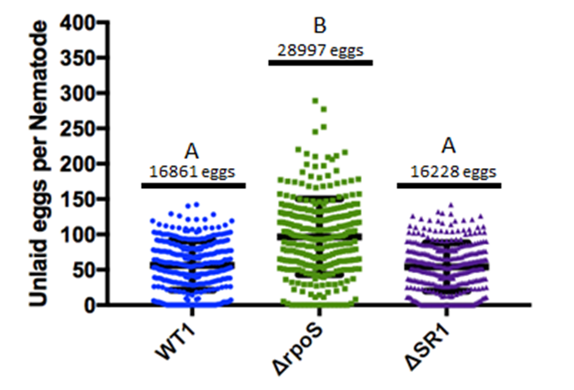
WT
rpoS::kan
ΔSR1::kan

Supplemental Figure 3.i: Females were grown on bacterial lawns until gravid before being collected and paralyzed with levamisole. After which they were observed for the number of eggs within the gonads via light microscopy. Tukey’s Multiple Comparisons One-Way ANOVA revealed a significant different between the females grown on WT/ΔSR1 lawns and the females grown on rpoS. These females retained nearly twice as many eggs as the other two treatment groups.
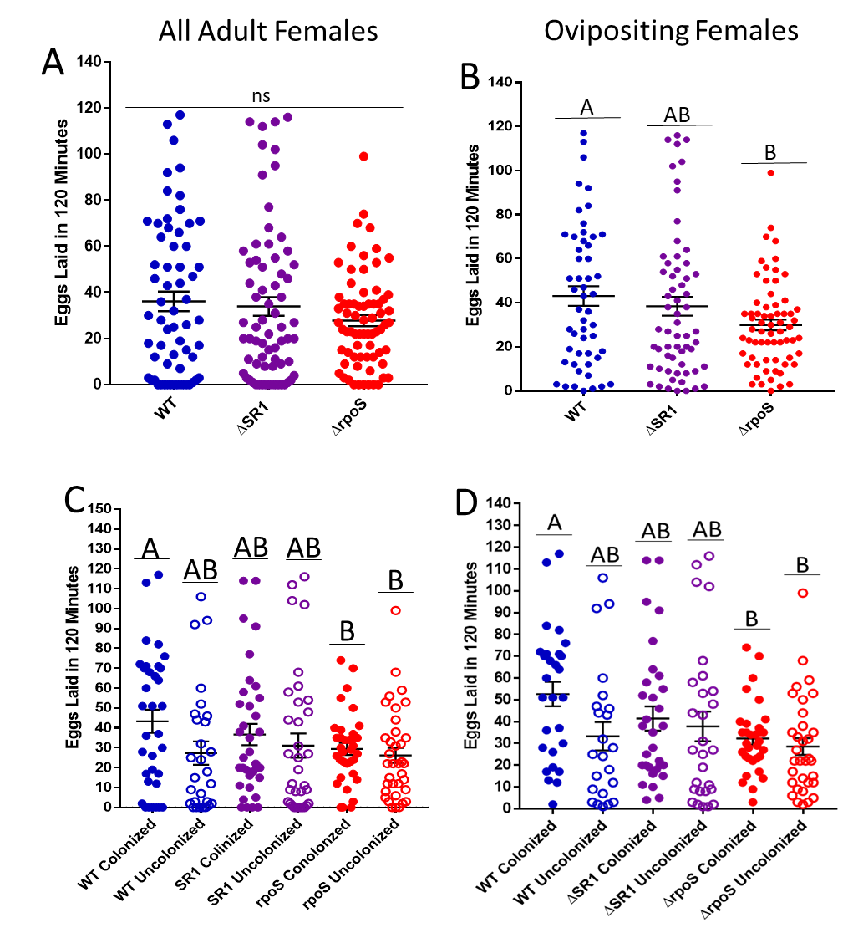
Supplemental Figure 3.ii: Colonization status is important for nematodes reared on X. nematophila WT lawns, but not ΔSR1 or ΔrpoS.

Females grown on GFP expressing bacterial lawns before being pipetted onto NGM plates and observed for colonization via GFP at the AIC. After colonization status was checked females were placed into individual wells in 96 well plates containing 200µL of 1XPBS buffer solution for 2 hours after which the number of eggs in each well were counted. Experiment done with three biological replicates and analyzed using Tukey’s Multiple Comparison One-Way ANOVA. A) Colonized vs colonized females on WT lawns have noticeable but not significant difference in the average eggs laid that is not seen in ΔSR1 or ΔrpoS groups. In this experiment, there were females that did not lay eggs in the two hours allotted for laying. Females might have not been gravid, or been unable to lay after being picked and placed in the wells. No statistical differences were found among the groups using Tukey’s Multiple Comparison One-Way ANOVA. B) Significant difference between WT and ΔrpoS when colonized and uncolonized groups are combined when non-layers are removed. When combining the data for comparison to previous data, Tukey’s Multiple Comparison One-Way ANOVA reveals that if the non-layers are removed there is a significant difference in egg laying between females reared on WT and ΔrpoS, with the females reared on ΔSR1 falling somewhere in between which is consistent with previous data. C) No significant difference found between egg laying in colonized vs uncolonized females when non-layers are present. While the pattern of egg laying is similar, when non-laying females are included in the data there is no significant difference found between the groups using GLIMMIX ANOVA. This might be due to a skew in the data, wherein we altered the total number of colonized and uncolonized females that would be selected for each group. There were females colonized by ΔSR1 and ΔrpoS X. nematophila and fewer colonized by WT that were selected for laying. This suggests that colonization is more important for egg laying behaviors, and that the rate of colonization is important on a population wide level. D) No significant difference found between egg laying in colonized vs uncolonized females when non-layers are removed. Nematodes analyzed using GLIMMIX ANOVA to compare the groups.

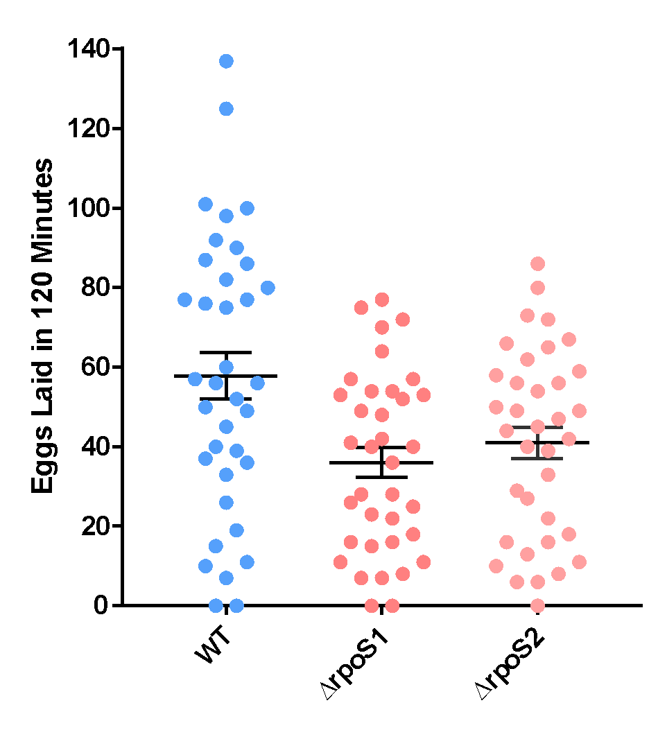

A
B
B
Supplemental Figure 3.iii: Female S. carpocapsae nematodes reared on lawns of ΔrpoS1::Tn5 and rpoS::Tn5 lay significantly (P=0.003) fewer eggs than those reared on WT lawns. Nematodes grown to adulthood on indicated lawns before being picked from the lawns and placed in individual 200 µL of 1XPBS in 96 well plates and incubated for two hours. The number of eggs in each well were counted and recorded. Three biological replicates were performed with twelve females each. Data analyzed using Tukey’s Multiple Comparison’s One-Way ANOVA.

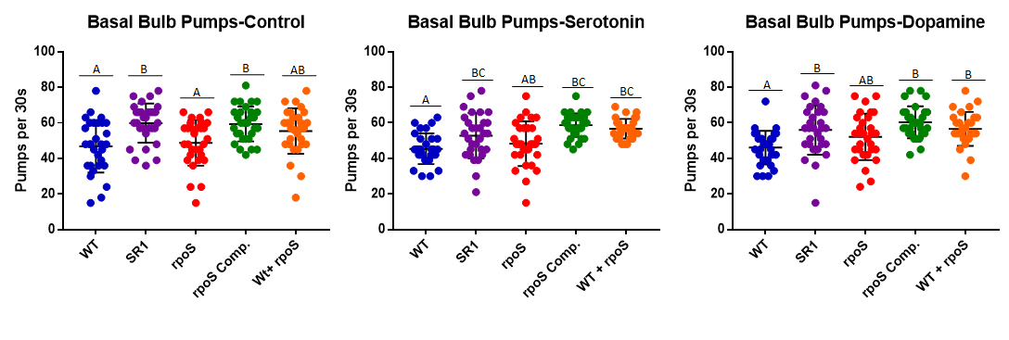
Supplemental Figure 3.iv: Nematodes were grown on GFP-expressing bacterial lawns before being pipetted onto NGM plates. Nematodes were then exposed to 1mg/mL serotonin or dopamine for 15 minutes before females were observed for basal bulb pumps per 10 seconds. This was multiplied by 3 to give 30 pumps per second. Finally, One-Way ANOVA was performed after the groups had been serrated by treatment to look for significant differences among them. Trends here are more consistent with bacterial lawn being the factor, and not the neurotransmitter treatment.

Supplemental Table 3.i: Female S. carpocapsae nematodes raised on WT lawns lay more and retain fewer eggs compared to females raised on X. nematophila ΔrpoS mutant lawns.
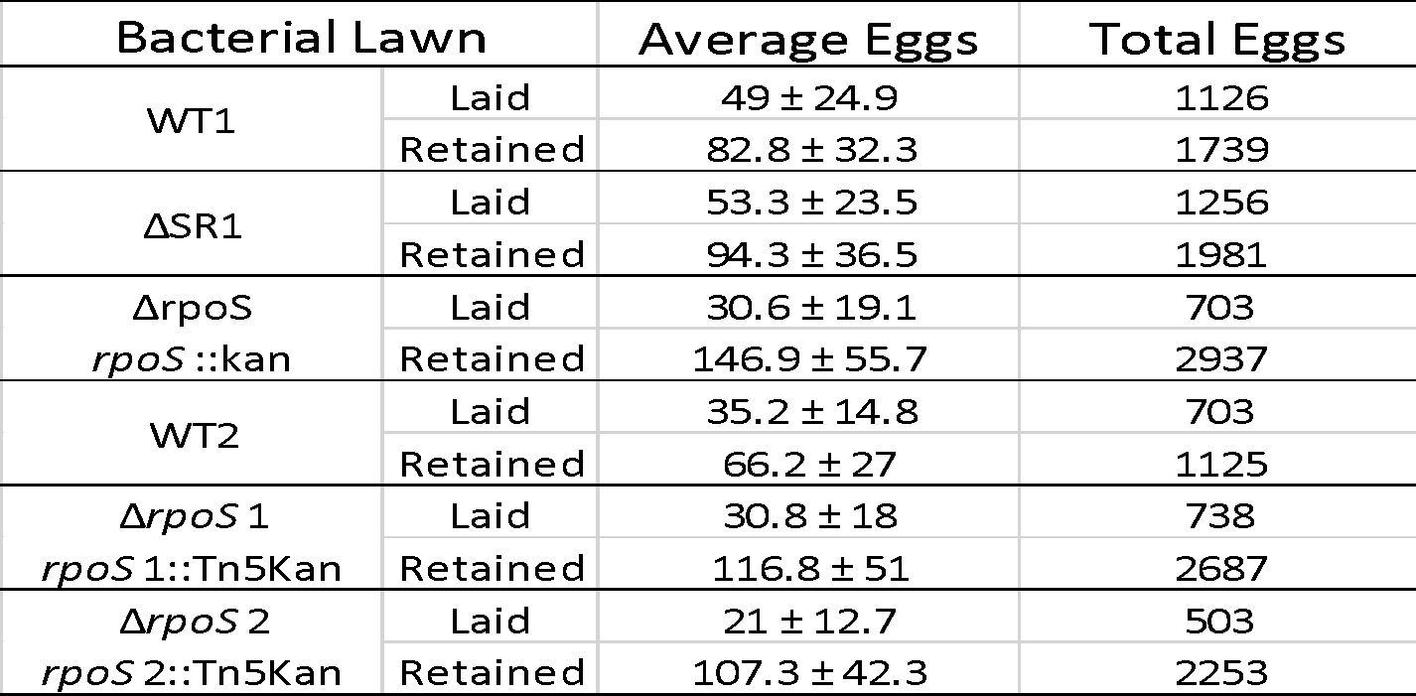

S. carpocapsae nematodes were seeded onto X. nematophila bacterial lawns and grown to adulthood. After becoming gravid females were selected from the plates and placed in 200 µL 1xPBS in 96 well plates. Females were incubated in the 1xPBS for two hours and allowed to lay eggs before being paralyzed with levamisole and the eggs in their wells counted. After counting eggs in the wells, nematodes were individually mounted the eggs retained within the gonads counted. Experiment done with three biological replicates, with eight females each. Non-laying females or damaged females were removed from the data set Some timing issues were present in this assay as some plates had females developing faster than others and eggs were present on the plates at the time of collection for counting which may muddle the results.

Chapter Four Summary and Future Directions:
Xenorhabdus nematophila modulation of behavior in the nematode host Steinernema carpocapsae may drive selectivity and specificity between these two symbionts.

Erin Mans¹*, and Heidi Goodrich-Blair¹#
#corresponding author
¹Department of Microbiology, University of Tennessee-Knoxville

This chapter was written by Erin Mans and edited by Heidi Goodrich-Blair.

Introduction:
In nature, Steinernema nematodes and their Xenorhabdus partners are rarely found without each other, and a Steinernema IJ that lacks a Xenorhabdus symbiont when leaving the insect cadaver could be considered a dead end. Subsequent infection killing, and protection of the cadaver from predation would not be possible without Xenorhabdus (Park et al., 2003; Zhou et al., 2002; Ji et al., 2004; Mucci, 2021). Along with the IJ, the adult stage S. carpocapsae nematode is also reliably colonized by X. nematophila, and that like the IJ stage (Martens et al., 2005) there is WGA-reactive material at the site of colonization. Chapter two demonstrated that WGA, which binds N-acetylglucosamine and N-acetylneuramic acid had localized to the AIC in significantly more S. carpocapsae nematodes in a population than any other lectin tested, and that WGA lectin could negatively impact X. nematophila colonization when exposed concurrently with X. nematophila bacterial cells over a 24 hour period, something that was not observed when using a second lectin, UEA. While soluble NilC protein was able to significantly raise the number of colonized nematodes in a population. We hypothesize that NilB protein is a secretion system that moves NilC to the surface (Grossman, 2021) so that NilC can interact with the WGA reactive material found at the AIC and in the receptacle of the S. carpocapsae nematodes. NilC is involved in binding to and/or cleaving very specific sugars present in the WGA reactive material at the site of colonization to be used as a nutrient source for the Xenorhabdus bacteria. X. nematophila cells that cannot cleave sugars from the WGA-reactive material in the receptacle lose what might their only food source and will starve, while functional cells are able to utilize the sugars and maintain a population until the IJ is able to infect the next insect.
From the perspective of the necessity to carry a symbiont from one insect cadaver to another as is seen in the IJ stage, an adult S. carpocapsae nematode can be considered a dead end. Adult stage nematodes will die within the cadaver as only IJs leave the insect to return to the soil. Also, the adult nematode likely needs to allocate resources that otherwise could have gone to progeny production or host fitness, to the bacteria in some form to maintain the population. Yet the adult stage retains a population of X. nematophila bacteria at the AIC, which suggests that the bacterial colonization is also necessary at this stage. Chapter three demonstrated that X. nematophila does impact S. carpocapsae egg laying behaviors through direct observation of a colonization deficient rpoS::kan mutant bacterial strain causing changes to the female nematodes’ behavior when they are raised on mutant lawns compared to females raised on wild type lawns. Chapter three also demonstrated that addition of exogenous dopamine was able to increase egg laying back to levels like that of females raised on wild type lawns. This suggests that X. nematophila rpoS::kan mutant bacteria might be able to impact egg laying through modulation of the neurotransmitter levels within the nematode. Metabolomics data also shows that the levels of the neurotransmitters dopamine and serotonin are changing throughout the course of an infection cycle (Mucci et al., 2021) though it is unclear if this is caused by X. nematophila impacting them in some way, or if S. carpocapsae is altering expression of these neurotransmitters without the influence of X. nematophila.
These observations and previous work done in the Steinernema-Xenorhabdus system suggest that X. nematophila impact on S. carpocapsae behaviors may be driving selection and specificity between the pair. Chapter one listed a few of the various ways the microbiota can influence the host, as well as the benefits and hurdles that human and model systems such as mice and zebra fish present for research. This work aims to put forward the Steinernema-Xenorhabdus system as another type of model system that can be used to study the gut-brain axis through exploring the ways the host and symbiont select for each other in chapter two, and the implications selection in the adult stage nematode in chapter three. The following sections will explore possible future experiments and current models for selection and impacts of the gut-brain axis in the S. carpocapsae-X. nematophila pair.

S. carpocapsae expressing WGA reactive material at the site of colonization as a form of nutritional selection

As previously mentioned, an S. carpocapsae IJ that lacks a population of X. nematophila can be considered a dead end. During IJ formation, an alternate J2 stage (Fig. 4.1) called the Pre-IJ holds a one or two X. nematophila cells within the pharyngeal intestinal valve (PIV) and excludes other bacteria (Bird and Akhurst, 1983; Chaston et al., 2013). With such a small percentage of cells able to move with the nematode to the next host, it’s possible that the PIV serves as a sort of selection for X. nematophila. During the formation of the IJ, the Xenorhabdus cells will leave the PIV and enter the receptacle where WGA reactive material can be found. Only cells that can utilize nutrients provided by the IJ host, are able to survive in this space and defective cells die off. So it is imperative that the X. nematophila cells within the receptacle be equipped to
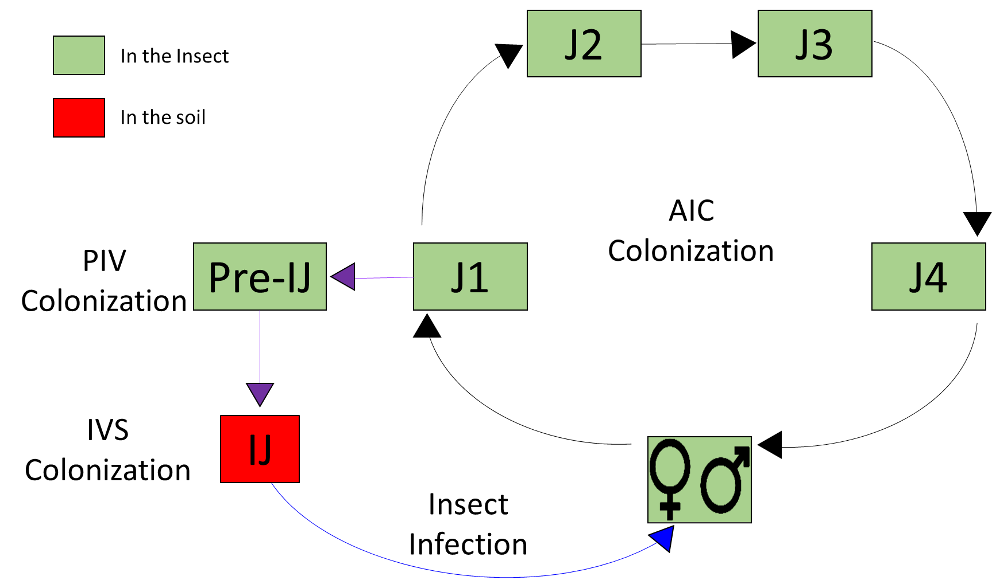
Figure 4.1: The J1 juveniles S. carpocapsae nematode can undergo differential development into either an adult stage nematode, or an IJ stage. J1 juveniles hatch from the egg stage and either develop into J2-J4 juveniles before reaching adulthood and mating to lay more eggs (black arrows), or developing into an alternate J2 stage, known as the Pre-IJ and then and alternate J3, stage known as the IJ (purple arrows). The exact trigger for the two paths a J1 juveniles can take are not known, and there has been no evidence that a J1 juvenile can revert to this phase once it has started either of these development paths. The IJ will then wait in the soil to infect a new insect (blue arrow) and after successful invasion and killing, the IJ will grow into an adult stage nematode that will mate with other nematodes to lay eggs that will hatch as J1 juveniles, repeating the cycle.

handle this nutrient limited period as the IJ waits to infect the next host. IJ’s can last in the soil without food for a number of months, which means that any bacterial replication or outgrowth within the receptacle is likely dependent upon the sugars and other essential nutrients being expressed in the WGA reactive material by the nematode host during this time. Evidence suggests that the IJs are providing the bacteria with resources at a cost to themselves, as axenic IJs maintained in lab will live longer than IJs carrying their bacterial symbionts under the same conditions (Mitani et al., 2002). Similarly to the IJ, the adult stage S. carpocapsae nematode also expresses WGA-reactive material at the AIC. Though we currently do not know if this WGA-reactive material has the same chemical makeup at the AIC and in the receptacle, the fact that the material is being expressed at similar sites is interesting.
Another shared characteristic of these two colonization sites is that they both require the nil genes for successful colonization (Fig. 4.2A). A lack of the nil genes will make X. nematophila colonization deficient and adding the nil genes to another non-native Xenorhabdus species, such as X. szentermaii, is sufficient for colonization (Chaston et al., 2013). Chapter two demonstrated that NilC protein is differentially necessary for X. nematophila colonization between the adult and IJ. This leads in to the hypothesis that X. nematophila NilB moves NilC to the cell surface, and NilC is involved in nutrient acquisition through the cleaving of sugars in the WGA-reactive material, or that NilC is involved in adhesion to the AIC cell surface (Fig. 4.2B).
Chapter two demonstrated that the addition of soluble NilC protein was able to significantly increase bacterial colonization, even in ΔSR1 X. nematophila cells which lack a nilC gene. If NilC protein was serving solely as a form of anchor that bound to
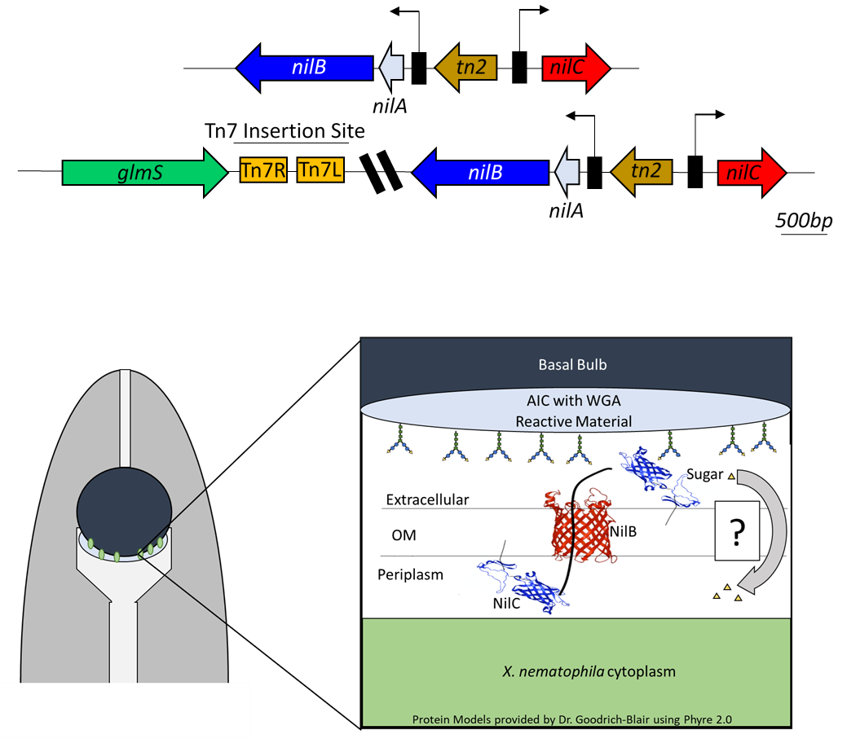
Figure 4.2: Interaction of nil genes with the WGA reactive material present in adult stage nematodes. Diagram of the SR1 genome region including predicted ORFs (solid arrows). Boxes with attached arrows indicate promoters of nil genes. nilA and nilB share a promoter while nilC has a separate promoter. glmS encodes a Glutamine--fructose-6-phosphate aminotransferase. Finally, the ORFs that have sequence homology with transposase has been labeled tn2 genome area including predicted ORFs (solid arrows).

B
A

the AIC possibly through the WGA reactive material, then we would not expect to see a drop in the number of colonized nematodes as the protein competed with X. nematophila for colonization sites, similar to what was observed when using the WGA lectin. Instead an increase in colonization was observed suggesting that NilC protein was somehow able to help bacterial colonization. This might also explain why the nilC::Tn5 mutant was able to survive within the AIC of adult stage nematodes, but not the IJ stage. The IJ stage is non-feeding so X. nematophila cells unable to produce the NilC necessary to cleave sugars within the receptacle would starve while in the adult stage, X. nematophila cells that lack NilC might be able to survive off of what the nematode eats as they are located within the intestine and might have some access to those nutrients as well.
One issue with the nilC::Tn5 mutant and resulting data is that the nilC mutant lacks a proper complement. The “rescue” generated for that experiment had a attTn7::P_{lac}nilB insertion instead. Complicating this is the concern that a functional copy of nilC at the Tn7 site might present a problem. The Tn7 insertion site is a well-known site used in a broad range of molecular and genetic experimentation in bacteria, and is commonly used in the Goodrich-Blair lab. However, its unique location and function might present a problem if our hypothesis of NilC involvement in glycan cleavage is correct. The Tn7 insertion site is adjacent to the glmS gene. This gene encodes for an enzyme called glutamine-fructose-6-phosphate aminotransferase, which catalyzes fructose-6-phosphate and glutamine to form GlcN6P, a compound essential for cell wall biosynthesis (Winkler et al., 2004). Complements for nilC mutations at this site might run into issues of the stability of the cell walls, as NilC protein might cleave the glycans that glmS catalyzes for the cell wall, leading to the cell being less stable. Though this is only a theory, it is something that should be considered when designing complements, there is always the option of plasmids which have worked for other non-nil gene colonization deficient mutants in the past (Vivas and Goodrich-Blair, 2001).
Currently we have no concrete proof of what NilC protein could be doing in the AIC, and are hypothesizing based on the data provided in this body of work, as well as the data being provided by previous members of the lab as well and Alex Grossman. We also do not know by what mechanism the cleaved sugars are being brought back into the X. nematophila cell if they are serving as a nutrient source for the bacterial cells, though it is likely the sugars are being taken up by a phosphotransferase system (PTS). PTS systems catalyze the concomitant transport across the cell membrane and phosphorylation of carbohydrates (Jeckelmann and Erni, 2019). X. nematophila does have an established PTS system within its genome (Odile et al., 1988). Future experiments should explore the possibility of the X. nematophila PTS system as being responsible for sugar or carbohydrate uptake. One way to investigate it to generate mutants, knockouts of genes involved in the PTS system such as enzyme 1 (pstI), or HpR protein (ptsH). These two genes are involved in the first steps of the PTS system, they transfer of the phosphoryl group from phosphoenolpyruvate to the sugar before being taken up by the cell (Jeckelmann and Erni, 2019). Another set of genes of interest could be the genes crr and pstG, which are membrane bound permeases involved in sugar specificity so a knockout in one of or the other genes might provide insight into which might be interacting with the sugars found at the AIC. I hypothesize that if the PTS system of X. nematophila is taken out, that X. nematophila cells will be unable to colonize the receptacle of IJ’s, as they are no longer able to take in the sugars cleaved by NilC protein. In adult stage nematodes, we might see somthing similar to the nilC::Tn5 mutant, in which the bacterial cells might still be able to survive on nutrients being taken in by the adult. However, compared to nematode populations grown on wild type lawns, colonization of PTS knockout mutants will be significantly reduced. Further proving that the uptake of sugars being provided by the nematode at the site of colonization serves as form of nutritional selection for X. nematophila cells. The following section will focus on the possible mechanism that gets NilC protein to the surface of the cell, the protein NilB.

NilB as a secretion system way to move NilC to the cell surface

Previous work identified nilB as being essential for S. carpocapsae nematode colonization, and that knocking it out would cause a colonization deficient phenotype in IJ stage nematodes (Heungens et al., 2002; Cowles and Goodrich-Blair, 2008). This work has shown that the same happens in adult stage S. carpocapsae nematodes as well, when knocked out with a Tn5 insertion mutation, the adult and IJ stage are not colonized, however attTn7::P_{lac}-nilB does rescue colonization in the adult stages, though not to wild type levels. This suggests nilB is essential for S. carpocapsae colonization of both the adult AIC and the IJ receptacle, and that it is highly regulated. New data suggests that NilB protein is acting is a novel secretion system, moving lapidated proteins involved in nutrient acquisition to the cell surface (Grossman et al., 2020). There is also evidence that NilB moves NilC to the cell surface (Mauer, 2019) though this event seems to be highly regulated (Mauer, PhD dissertation, unpublished data).
NilB is a surface exposed β-barrel outer membrane protein and is a homologue of the domain of unknown function (DUF 560) protein family (Grossman et al. 2021; Heungens and Goodrich-Blair 2002). This family of proteins was discovered in Neisseria meningitidis, a human pathogen. N. meningitis contain what is known as surface lipoprotein assembly modulator, or SLAM machinery. These SLAM’s contain the DUF 560 β-barrel and are required for the presentation of certain lipoproteins that capture the metal carrying compounds used by hosts to sequester nutrients from bacteria as a form of fighting the bacterial infection (Hooda et al., 2016; Hooda et al., 2017). In X. nematophila, NilB is involved in maintaining the bacterial population at the site of colonization and could be a selection factor for the X. nematophila cells with NilB being involved in acquisition of nutrients being provided by the nematode host at the site of colonization. A sequence similarity network revealed that these DUF560 domains were sorted into ten clusters and can be found across a wide variety of bacterial species and environments (Grossmen et al., 2021). Alex Grossman will continue to explore the possibility of NilB being a part of a newly recognized and novel secretion system that has been found in bacteria. Not only will this provide us with valuable information about the protein domain that nilB belongs to, but it will also provide further insights into NilB involvement in colonization.
The nil genes are essential for successful colonization of the S. carpocapsae nematode. Transfer of the SR1 gene locus to another Xenorhabdus species can confer the ability to colonize an S. carpocapsae nematode (Chaston et al, 2013). Although not the only genes that have been shown to be necessary for colonization (Huegens et al., 2002, Vivas and Goodrich-Blair, 2001), they are some of the most studied in this system. If NilB is indeed a secretion system moving lipidated proteins (like NilC) involved in nutrient acquisition being presented by the nematode host, this could serve as a form of nutritional selection meant to exclude other bacteria. This selection might have formed because of the necessity of the IJ stage carrying healthy and functional X. nematophila cells to the next insect cadaver, but that would not explain the same type of selection being necessary in the adult stage nematode, which will live and die in the insect cadaver. Emerging evidence, however, demonstrates that X. nematophila rpoS::kan mutant bacteria can impact female S. carpocapsae behaviors. This suggests that X. nematophila might be impacting S. carpocapsae behaviors, through the gut brain axis, either at the site of colonization (which is in the intestines) or within the gut of the nematode.

Biologically relevant levels of neurotransmitters might provide Insight into S. carpocapsae oviposition
Chapter thee demonstrated that by growing female S. carpocapsae nematodes on lawns of rpoS::kan X. nematophila bacteria, there is a significant drop in the number of eggs laid over two hours. Addition of exogenous dopamine, however, can restore the egg laying behaviors back to levels of females grown on wild type lawns (Fig. 3.4), while addition of dopamine and serotonin did not alter basal bulb pumping (Fig. 3.5). Suggesting under the conditions used in this study the dopamine had a specific effect on an aspect of reproductive behavior in the nematodes and not a universal one. Finally, addition of dopamine and serotonin in equal parts did not affect or had less of an effect to the egg laying behaviors of the females so long as the ratio of dopamine:serotonin were similar (Fig. 3.8). Based on this data, we hypothesize that X. nematophila might be impacting the levels of neurotransmitters in the nematodes and altering nematode reproductive behaviors, possibly to modulate which development path a J1 juvenile will take (adult of IJ formation), as will be explored in the following section.
Metabolomic analysis via mass spectrometry of G. monella waxworms infected with S. carpocapsae and wild type X. nematophila bacteria demonstrated that levels of neurotransmitters do change significantly during the early, middle and late stage infection (Fig. 3.6). One future experiment might involve infecting waxworms with S. carpocapsae nematodes and X. nematophila rpoS::kan. There is already evidence that S. carpocapsae nematodes do complete at least one round of propagation as there is IJ emergence from the waxworm cadaver (Vivas and Goodrich-Blair, 2001). I predict that the waxworms infected with the rpoS::kan mutant cells will have different levels of neurotransmitters such as dopamine and serotonin, as well as their byproducts and precursors, compared to the waxworms infected with wild type cells. This would further prove that X. nematophila can impact S. carpocapsae nematodes through modulation of neurotransmitters.
Another experiment to perform would be to expose gravid females to different levels of biologically relevant neurotransmitters serotonin and dopamine based on the already established metabolomics data and observe for changes to egg laying behavior. This could be done by taking the average for the early middle and late stage levels of dopamine and serotonin and exposing females using assays like those in chapter three. It would also be interesting, however, to compare individual days for example, day 8 where dopamine and serotonin are very different, and day 10 where the two are much more similar. If the egg laying phenotypes are similar to the patterns observed in chapter three when comparing the ratios of the two neurotransmitters, this would further support the hypothesis that the changing levels of neurotransmitters impact nematode behaviors as the nematode shift from middle to late stage infection.
The inside of the insect cadaver is a dynamic and changing environment for both the nematode and the bacteria. One thing that is still not understood is the molecular trigger that determines if J1 juveniles will develop in J2-J4 juveniles and eventually adults, or the alternate J2 (Pre-IJ), J3 (IJ) pathway (Bird and Akhurst 1983). Factors such as population density within the cadaver, or nutrient depletion are known to cause the shift of IJ formation and leave the insect, but the exact mechanism for either developmental path remains unknown (Wang and Bedding, 1996; Popiel et al., 1989). I hypothesize that X. nematophila cells within the insect tissues sense the depletion of nutrients within an insect cadaver. As the nematodes continue eating the bacteria the bacteria within the gut use as yet unknown chemical cues, or molecules that are taken up through the nematode intestine that can alter the levels of neurotransmitters found in the host. This impacts their egg laying behavior and possibly triggers the shift from the J1 juveniles from developing into adults to IJs instead.

Is rpoS involved in modulating the shift of J1 juveniles to adults or IJ’s?
We know that rpoS is involved in general stress responses in species such as E. coli, and in X. nematophila (Vivas and Goodrich-Blair, 2001). Data suggests that the rpoS::kan mutant strain is slightly but not significantly more virulent than the wild type and that the nematodes can complete their reproductive cycle in a waxworm that contains X. nematophila rpoS::kan. The IJ’s that emerged from an insect cadaver infected with X. nematophila rpoS::kan not colonized, however, meaning they would be a dead end in nature. Complementation through a plasmid can lead to successful IJ colonization (Vivas and Goodrich-Blair, 2001), but the study did not make it clear if the colonization rescued IJs are able to retain their symbionts as long as WT, or if IJ behaviors or gene expression were altered in some way. Data in chapter three demonstrated that X. nematophila rpoS::kan mutants can alter S. carpocapsae egg laying behaviors.
While this work was focused on adult nematodes, Dr. Mengyi Cao in the Sternberg Lab at California Institute of Technology grew S. carpocapsae nematodes from eggs on lawns of either wild type or X. nematophila rpoS::kan bacteria until IJs emerged. She then performed transcriptomics on both IJ groups to look for differences in gene expression (Cao, M., unpublished data). The genes were then grouped into “gene ontology” or GO term bins depending upon their known phenotypes or characteristics. Among the genes that were being differentially expressed were genes involved in reproductive processes and behaviors, as well as oviposition. This is interesting because the IJ stage is non-reproductive. Suggesting that X. nematophila rpoS gene regulation can have long lasting impacts on host behaviors. Further work is being done to better characterize the GO terms and repeated experiments should provide more insight into the positive or negative impact rpoS::kan lawns had on IJ gene transcription.
When considering that the rpoS::kan lawns did have an impact on the non-reproducing, non-feeding IJ stage nematode, closer attention might need to be paid to female reproductive behaviors beyond egg laying, and the possible implications that laying or retaining eggs could have for the progeny of the female nematode. One study found that in Heterorhabditis bacteriophora, another entomopathogenic nematode species, IJ development occurs via intrauterine hatching and subsequent female bagging (Ciche et al., 2008). It is possible that the rpoS::kan lawns are increasing the rate of bagging in the S. carpocapsae females being reared on these lawns. S. carpocapsae females might retain their eggs rather than laying them in order to provide the progeny with a meal, possibly in the late stage, nutrient limited insect cadaver, and access to bacterial symbionts at the AIC assuring at least a few of the progeny will have access to successful colonizers that can pass on to the next possible insect host. This might also serve as a trigger for the development of IJs rather than adults. This work was able to observe these phenotypes as the nematodes were paralyzed with levamisole after 120minutes of egg laying to assure that there would be no more eggs laid during the counting process.
One possible way to test this theory is to compare the development of juveniles that are laid and hatch outside of the mother, and juveniles that hatch within the mother during endotochia matricida. A suggested assay might be to pick and place a confirmed gravid female from a population of nematodes and isolate her by placing her on a second, identical bacterial lawn that contains no other nematodes (Fig. 4.3). Lawns should be wild type X. nematophila, rpoS::kan mutants, and perhaps ΔSR1 as a control for the lack of rpoS::kan colonization. After placement, every few hours (suggested two
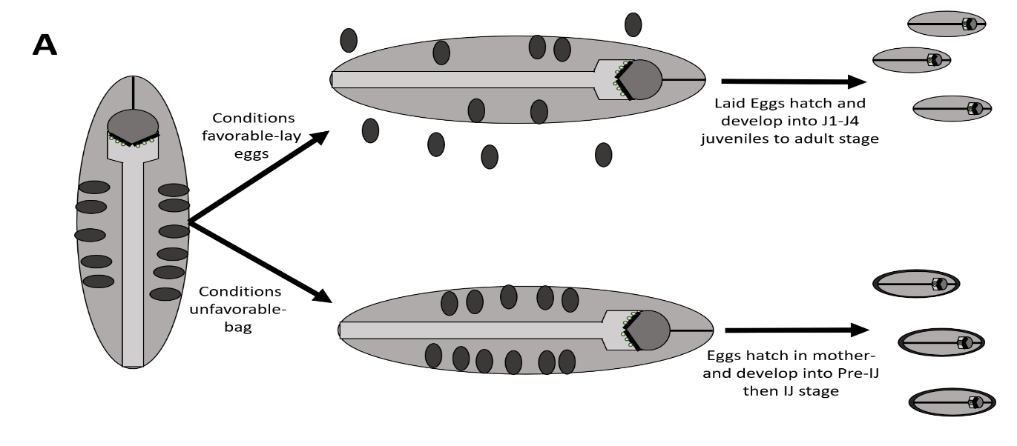
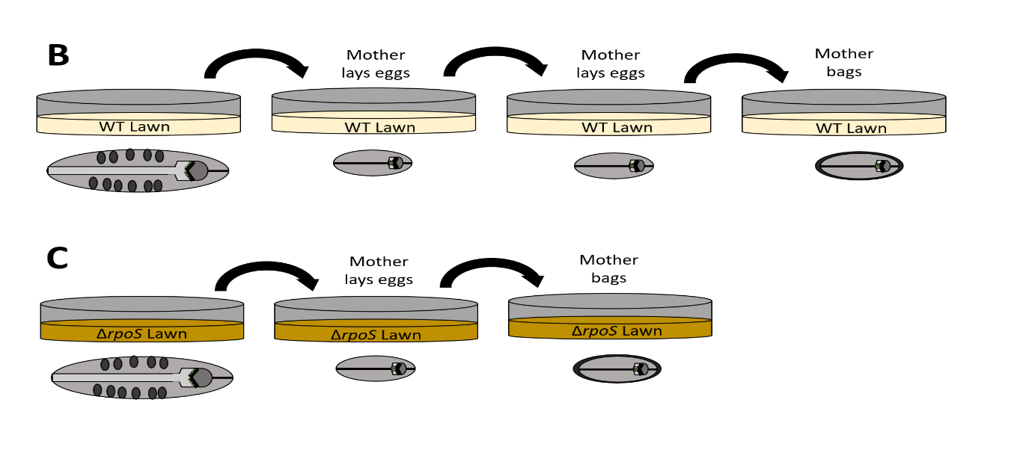
Figure 4.3: Model and proposed experiment to determine if the development of IJ’s is precluded by mother endotochia matricida. A) Proposed model of IJ development trigger. Eggs laid into the insect tissues will be more likely to develop into J1-J4 stage nematodes, while the eggs that hatch inside the mother when she bags are more likely to develop into Pre-IJ’s and then IJ’s. B) Experiment to determine if the progeny of a mother that laid eggs vs a mother that bags will develop into adults or IJ’s. This experiment allows us to test the bacterial treatments, and the laid vs withheld eggs for each.

to four hours, although the number of nematodes being tested, and timing of gravid females might affect this) the female would be transferred from lawn to lawn until
she either stops laying or bags. The resulting juveniles could be observed for development into either adults or IJs. I predict that the females reared on the rpoS::kan lawns will bag faster than females reared on wild type or ΔSR1 lawns. Additionally juveniles that hatch when the mother bags will have a higher rate of development into IJ stage nematodes compared to juveniles that are laid on bacterial lawns overall.
This assay, and all of chapter three focused on the impact of X. nematophila on female nematodes. Steinernema species do have designated males and females and no males were observed for changes in behaviors in any of the assays in chapter three. Male S. carpocapsae, like females, are colonized by X. nematophila as well. It is possible that X. nematophila can impact the male reproductive behaviors. The following section will address a few behaviors that might be affected in S. carpocapsae males.

Does the rpoS::kan mutant alter male reproductive behaviors?
Unlike C. elegans, which are hermaphroditic and can self-fertilize, Steinernema nematodes have distinct males and females. This means that to successfully propagate within the insect cadaver, there needs to be at least one male and female of the same Steinernema species. Male S. carpocapsae nematode reproductive behaviors were not observed during this study but can be just as important as female behaviors. For example, males have what is known as “female seeking behaviors”. One study found that when placed on plates containing S. carpocapsae female nematodes, 80% of S. carpocapsae males would head towards the females on the plates after a short, 1-5 minute period of time (Lewis et al., 2002). The same study also determined that males were attracted to unmated females but not mated ones. In C. elegans males that lack the ability to express serotonin, males did not display “tail turning”, part of a vulva seeking behavior pre-copulation (Loer et al., 1993). This suggests that the levels of neurotransmitters can impact male reproductive behaviors and further suggests that male behaviors should be observed for changes both using rpoS::kan mutant bacteria, and using exogenous dopamine and serotonin.
Currently, we do not know what signals the S. carpocapsae males are receiving from the females to determine these behaviors. One experiment might involve performing a similar assay as was done in Lewis et al., 2002. Males might be grown on lawns of either X. nematophila rpoS::kan mutant bacterial lawns or wild type lawns and then transferred to plates containing female nematodes and observed for female seeking behaviors. Another interesting experiment might involve observing the interactions of males or females raised on an rpoS::kan mutant lawn with partners raised on a wild type lawn. It’s possible that if rpoS::kan bacterial mutants are altering the levels of neurotransmitters or modulating the nematode behavior, we might see a reduced rate of successful copulation and progeny production in males and females that have come from different lawns compared to males and females reared on similar bacterial lawns.

Final Thoughts:
X. nematophila colonizes S. carpocapsae nematodes at almost every stage of the life cycle. IJs will need to maintain a small population of the bacteria in their receptacle to carry to the next insect host. Chapter three demonstrated that X. nematophila rpoS::kan bacterial are able to impact egg laying behaviors, although the ability of X. nematophila to colonize did not seem to have an impact and it is more likely the bacterial mutants in the gut are what is causing changes in nematode behaviors. Combined, this work presents the possibility that X. nematophila can influence the nematode host through the gut brain axis. The already established links between the gene regulation of the gut microbiota and the health and behaviors of the host suggests that there could be a similar link between Xenorhabdus and Steinernema. We theorize that the modulation of behavior in the nematode host may drive selectivity and specificity between the two symbionts. The gene dysregulation of the rpoS::kan mutants established a noticeable egg laying deficient phenotype and rpoS::kan mutants are unable to colonize S. carpocapsae nematodes meaning that they will not be carried to the next insect host by IJs. The WGA reactive material and use of nil genes to survive in a nutrient limited environment might be serving a form of genetic bottleneck event where only functional, healthy symbionts are selected and passed to the next insect host with the new generation of IJs to the exclusion of mutants that might have been generated when propagating in the insect tissues during the infection cycle.
Hosts must be able to find and select for their bacterial symbionts in some way. These symbionts provide the host with a range of benefits and are important for the modulation of host behaviors through the gut brain axis. This work has attempted to show that the Steinernema-Xenorhabdus system is an excellent model for continued study of the impacts of the gut-brain axis on a molecular level as well demonstrate that the host has mechanisms of selection in place to increase the chance of colonization by a healthy symbiont via nutrient limitation at the site of colonization. There is still more work to be done investigating the ways the gut microbiota can impact a host, and what molecular mechanisms they are using to achieve this. It is my hope that Steinernema nematodes and their Xenorhabdus symbionts can be used to answer some of those questions moving forward.

Chapter four references:

Albertson, D. G., & Thomson, J. N. (1976). The pharynx of Caenorhabditis elegans. Philosophical transactions of the Royal Society of London. Series B, Biological sciences, 275(938), 299–325. https://doi.org/10.1098/rstb.1976.0085

Avery, L., & You, Y. J. (2012). C. elegans feeding. WormBook : the online review of C. elegans biology, 1–23. https://doi.org/10.1895/wormbook.1.150.1

Bird A.F., Akhurst R.J., (1983). The nature of the intestinal vesicle in nematodes of the family Steinernematidae. International Journal for Parasitology 13:599-606

Brunianská, M., Fagerholm, H. P., & Moravec, F. (2007). Structure of the pharynx in the adult nematode Anguillicoloides crassus (Nematoda: Rhabditida). The Journal of parasitology, 93(5), 1017–1028. https://doi.org/10.1645/GE-1127R.1

Chaston, J. M., Murfin, K. E., Heath-Heckman, E. A., & Goodrich-Blair, H. (2013). Previously unrecognized stages of species-specific colonization in the mutualism between Xenorhabdus bacteria and Steinernema nematodes. Cellular microbiology, 15(9), 1545–1559. https://doi.org/10.1111/cmi.12134

Ciche, T. A., Kim, K. S., Kaufmann-Daszczuk, B., Nguyen, K. C., & Hall, D. H. (2008). Cell Invasion and Matricide during Photorhabdus luminescens Transmission by Heterorhabditis bacteriophora Nematodes. Applied and environmental microbiology, 74(8), 2275–2287. https://doi.org/10.1128/AEM.02646-07

Cowles, C. E., & Goodrich-Blair, H. (2008). The Xenorhabdus nematophila nilABC genes confer the ability of Xenorhabdus spp. to colonize Steinernema carpocapsae nematodes. Journal of bacteriology, 190(12), 4121–4128.
https://doi.org/10.1128/JB.00123-08
Grossman, A. S., Mauer, T. J., Forest, K. T., & Goodrich-Blair, H. (2020). Description of a widespread bacterial secretion system with chemically diverse substrates. doi:10.1101/2020.01.20.912956
Heungens, K., Cowles, C. E., & Goodrich-Blair, H. (2002). Identification of Xenorhabdus nematophila genes required for mutualistic colonization of Steinernema carpocapsae nematodes. Molecular microbiology, 45(5), 1337–1353. https://doi.org/10.1046/j.1365-2958.2002.03100.x

Hooda, Y., Lai, C. C., Judd, A., Buckwalter, C. M., Shin, H. E., Gray-Owen, S. D., & Moraes, T. F. (2016). Slam is an outer membrane protein that is required for the surface display of lipidated virulence factors in Neisseria. Nature microbiology, 1, 16009. https://doi.org/10.1038/nmicrobiol.2016.9

Hooda, Y., Lai, C., & Moraes, T. F. (2017). Identification of a Large Family of Slam-Dependent Surface Lipoproteins in Gram-Negative Bacteria. Frontiers in cellular and infection microbiology, 7, 207. https://doi.org/10.3389/fcimb.2017.00207

Ji, D., Yi, Y., Kang, G. H., Choi, Y. H., Kim, P., Baek, N. I., & Kim, Y. (2004). Identification of an antibacterial compound, benzylideneacetone, from Xenorhabdus nematophila against major plant-pathogenic bacteria. FEMS microbiology letters, 239(2), 241–248. https://doi.org/10.1016/j.femsle.2004.08.041

Jeckelmann, J. M., & Erni, B. (2019). Carbohydrate Transport by Group Translocation: The Bacterial Phosphoenolpyruvate: Sugar Phosphotransferase System. Sub-cellular biochemistry, 92, 223–274. https://doi.org/10.1007/978-3-030-18768-2_8

Kim, I. H., Aryal, S. K., Aghai, D. T., Casanova-Torres, Á. M., Hillman, K., Kozuch, M. P., Mans, E. J., Mauer, T. J., Ogier, J. C., Ensign, J. C., Gaudriault, S., Goodman, W. G., Goodrich-Blair, H., & Dillman, A. R. (2017). The insect pathogenic bacterium Xenorhabdus innexi has attenuated virulence in multiple insect model hosts yet encodes a potent mosquitocidal toxin. BMC genomics, 18(1), 927. https://doi.org/10.1186/s12864-017-4311-4

Lewis, E. E., Barbarosa, B., & Gaugler, R. (2002). Mating and Sexual Communication by Steinernema carpocapsae (Nemata: Steinernematidae). Journal of nematology, 34(4), 328–331.

Loer, C. M., & Kenyon, C. J. (1993). Serotonin-deficient mutants and male mating behavior in the nematode Caenorhabditis elegans. The Journal of neuroscience : the official journal of the Society for Neuroscience, 13(12), 5407–5417. https://doi.org/10.1523/JNEUROSCI.13-12-05407.1993

Martens, E. C., Russell, F. M., & Goodrich-Blair, H. (2005). Analysis of Xenorhabdus nematophila metabolic mutants yields insight into stages of Steinernema carpocapsae nematode intestinal colonization. Molecular microbiology, 58(1), 28–45. https://doi.org/10.1111/j.1365-2958.2005.04742.x

Mitani, D. K. 2002. Master's thesis. University of California—Davis, Davis, Calif.

North, R. A., Horne, C. R., Davies, J. S., Remus, D. M., Muscroft-Taylor, A. C., Goyal, P., Wahlgren, W. Y., Ramaswamy, S., Friemann, R., & Dobson, R. (2018). "Just a spoonful of sugar...": import of sialic acid across bacterial cell membranes. Biophysical reviews, 10(2), 219–227. https://doi.org/10.1007/s12551-017-0343-x

Odile M.M. Bouvet, Patrick A.D. Grimont, (1988). Evolutionary divergence of enterobacterial genes coding for the glucose phosphotransferase system components, FEMS Microbiology Letters, Volume 56, Issue 2, Pages 145–149, https://doi.org/10.1111/j.1574-6968.1988.tb03167.x

Park, Y., Kim, Y., Putnam, S. M., & Stanley, D. W. (2003). The bacterium Xenorhabdus nematophilus depresses nodulation reactions to infection by inhibiting eicosanoid biosynthesis in tobacco hornworms, Manduca sexta. Archives of insect biochemistry and physiology, 52(2), 71–80. https://doi.org/10.1002/arch.10076

Popiel I, Grove DL, Friedman MJ. (1989). Infective juvenile formation in the insect parasite Steinernema feltiae. Parasitol.; 99:77–81.

Strauch O., Stossel S., Ehlers R-U. (1994). Culture conditions define automictic or amphimictic reproduction in entomopathogenic rhabditid nematodes of the genus Heterorhabditis. Fundam. appl. Nematol., 17(6), 575-582

Vivas, E. I., & Goodrich-Blair, H. (2001). Xenorhabdus nematophilus as a model for host-bacterium interactions: rpoS is necessary for mutualism with nematodes. Journal of bacteriology, 183(16), 4687–4693. https://doi.org/10.1128/JB.183.16.4687-4693.2001

Wang JX, Bedding RA. (1996). Population development of Heterorhabditis bacteriophora and Steinernema
carpocapsae in the larvae of Galleria mellonella. Fundam Appl Nematol, 19:363–367.

Winkler, W. C., Nahvi, A., Roth, A., Collins, J. A., & Breaker, R. R. (2004). Control of gene expression by a natural metabolite-responsive ribozyme. Nature, 428(6980), 281–286. https://doi.org/10.1038/nature02362

Zenner, A. N., O'Callaghan, K. M., & Griffin, C. T. (2014). Lethal fighting in nematodes is dependent on developmental pathway: male-male fighting in the entomopathogenic nematode Steinernema longicaudum. PloS one, 9(2), e89385. https://doi.org/10.1371/journal.pone.0089385

Zhou, X., Kaya, H. K., Heungens, K., & Goodrich-Blair, H. (2002). Response of ants to a deterrent factor(s) produced by the symbiotic bacteria of entomopathogenic nematodes. Applied and environmental microbiology, 68(12), 6202–6209. https://doi.org/10.1128/aem.68.12.6202-6209.2002

Vita
Erin Mans was born in Marinette Wisconsin and lived there until she was accepted to the University of Wisconsin Madison where she got her bachelor’s Degree in in Medical Microbiology and Immunology. She enjoyed her time on the Varsity Women’s Rowing team and drinking beer on the Terrace by Lake Mendota. She was accepted into the Goodrich-Blair lab as a Masters Student in Microbiology and moved down to the University of Knoxville with Dr. Goodrich-Blair. There, she changed her program to the PhD track. She is very happy and grateful to have earned her PhD here at UTK, as her backup plan was to shred her credit cards, go off the grid, and live in the mountains as a hermit.

