Group Level Anti-Predator Behaviors in a Warming World

A Thesis Presented for the
Bachelor of Science
Degree
The University of Tennessee, Knoxville

Lillian M. Para
December 2024
Group Level Anti-Predator Behaviors in a Warming World
Lillian M. Para¹, Maëlle Lefeuvre², and Elizabeth P. Derryberry¹
¹Department of Ecology and Evolutionary Biology, University of Tennessee, Knoxville, USA
²Institute of Environmental Sciences, Jagiellonian University, Poland

Abstract
As global temperatures rise, many species must adjust their behaviors to mitigate fitness consequences. Tree swallows (Tachycineta bicolor), known for their aggressive anti-predator behaviors, serve as a model to investigate how environmental stressors like temperature influence defensive strategies. This study examined the effects of air temperature on mobbing behaviors and vocalizations in adult tree swallows during nest defense. Using a repeated-measures design, simulated predator experiments were conducted on 50 nest boxes, comparing responses on cooler and warmer days. Lower intensity approaches declined significantly on warmer days, while higher intensity dives remained consistent, suggesting a potential shift toward more energetically efficient defensive strategies. Additionally, vocalization rates declined significantly on warmer days, suggesting a need for energy conservation. These findings highlight the nuanced effects of temperature on complex behaviors, emphasizing the importance of breaking down behaviors into their individual components to better evaluate how organisms adjust their behavioral responses to environmental stressors like rising temperatures.
Keywords: Cavity-nesting, Climate change, Temperature, Nest defense, Mobbing, Alarm calls

Introduction
As global temperatures rise and heatwaves become increasingly frequent and intense, many animal populations face significant threats (IPCC, 2021). To cope with these changes, individuals of some species move to new locations, resulting in shifts in species’ geographic ranges toward higher latitudes and elevations (Chen et al., 2011; Hickling et al., 2006; Wilson et al., 2007). However, not all species can shift their ranges quickly enough, as their movement is limited by dispersal capabilities and other constraints (Schloss et al., 2012). Behavior, often the first line of defense against thermal stress (Huey et al., 2012; Muñoz, 2022), can buffer some effects of rising temperatures, but these strategies have limits and may fail under extreme conditions. Consequently, rising temperatures can negatively impact critical behaviors such as cognition (Conradie et al., 2019; Soravia et al., 2023), mate selection (Leith et al., 2021), and parental care (Vincze et al., 2017), all of which are vital to fitness. Understanding how temperature influences behavior is therefore essential for predicting the consequences of climate change for species persistence.
Anti-predator behaviors, particularly mobbing, are one class of behaviors that could be impacted by rising temperatures. Anti-predator behaviors are critical for defending resources, such as food and offspring, with the intensity of these behaviors directly influencing fitness outcomes (Lima, 2009; Teunissen et al., 2020). Mobbing, an extreme form of anti-predator behavior, involves groups of individuals actively approaching and harassing a predator to drive it away (Flasskamp, 1994). Beyond deterring predators, mobbing also serves to communicate information about the predator’s type and risk level to nearby individuals (Graw & Manser, 2007; Griesser, 2009; Templeton et al., 2005). The costs and benefits of mobbing vary depending on factors such as the number of participants, predator type, and environmental conditions. Despite its importance, little research has investigated how temperature might influence the intensity or occurrence of mobbing behavior (Abolins-Abols & Ketterson, 2017; Dugatkin & Godin, 1992; Dutour et al., 2016). This gap in knowledge highlights the need for research on how environmental factors, such as temperature, modulate mobbing and other anti-predator behaviors.
Tree swallows (Tachycineta bicolor) serve as a useful model to investigate how temperature affects mobbing behavior. Unlike most bird species that are shifting their ranges northward in response to warming climates (Niven et al., 2009), tree swallows are expanding south into warmer regions (Siefferman et al., 2023; Wright et al., 2019). This southward movement suggests that tree swallows may possess traits or behaviors that enable them to cope successfully with higher temperatures. Previous research has shown that adult tree swallows modify several behaviors in response to temperature changes, including advancing clutch initiation in warmer springs (Ardia et al., 2006; Shipley et al., 2020; Zipf, 2021), increasing incubation time in warm, dry conditions (Coe et al., 2015), and reducing foraging rates in high heat (Tapper et al., 2020). However, some behaviors, such as nest feathering (Holland & Shutler, 2018) and first egg date (FED; Sockman & Courter, 2018), appear to be unaffected by temperature.
Despite extensive documentation of mobbing and other aggressive behaviors in tree swallows, the role of individual components of mobbing behavior—particularly movement behaviors—remains largely unexplored or even defined (George et al., 2022, 2024; Winkler, 1992). These components are critical to understanding how the intensity and nature of mobbing might shift with environmental conditions. Whether mobbing, a key strategy in nest defense (Robertson et al., 1992; Winkler, 1992; Winkler, 1994; Leighton, 2004), is influenced by temperature remains an open question. Furthermore, the thermal sensitivity of specific components of mobbing, such as flight patterns and vocalizations, has yet to be investigated.
Here, we examine how temperature affects mobbing behaviors in adult tree swallows. Using a repeated-measures design, we exposed nest boxes to a simulated predator on two occasions within a week, recording both movement behaviors and vocalizations directed at the predator. We hypothesized that higher air temperatures would lead to changes in defensive activity and vocalizations due to thermoregulatory costs. Specifically, we predicted that (1) mobbing intensity would decrease on hotter days compared to cooler days for the same nest box, and (2) defensive activity and vocalizations would decline as air temperatures increased over the breeding season. By examining these predictions, this research aims to reveal how rising temperatures influence interspecific interactions, offering insights into the potential fitness consequences for species in a warming world.

Methods
Study System
Tree swallows are an obligate secondary cavity-nesting species known for their synchronous breeding and mobbing behaviors (Lessard et al., 2014). Tree swallows will defend not only their nest but also neighboring nests from predators (Winkler, 1994; Leighton, 2004), a behavior with potential fitness consequences (Bērziņš et al., 2010; Lima, 2009). Their ready use of standardized nest boxes makes them ideal for experimentation (Male et al., 2006). This system allows for observations of how mobbing behavior varies with environmental factors such as temperature.
General Methods
This study was conducted during the 2023 breeding season, from May to July, at the East Tennessee AgResearch and Educational Center (ETREC) Plant Sciences Unit in eastern Tennessee (35° 53’ N, 83° 57’ W). The site is approximately 212 square acres and consists of open agricultural land interspersed with deciduous forest, bordering the Tennessee River. A total of 99 nest boxes were installed across five areas with different habitat conditions: Weather Station (WS), open grassland; Lower Hill (LH), open grassland; Upper Hill (UH), open grassland exposed to more wind; River Edge (RE), open grassland along the river edge; River Point (RP); mixed grassland and deciduous forest. Each box was equipped with predator deterrents to minimize predation risks unrelated to the study.
Nest boxes were checked every two days during the breeding season to determine the first egg day (FED) and clutch size, assuming one egg is laid per day (Dunn & Winkler, 1999; Winkler & Allen, 1996). Experiments were conducted within one week of clutch completion, using a repeated-measures design. Each nest box was tested twice—once on a warmer day and once on a comparatively cooler day within the same week but separated by at least one day. Experiments were completed on 50 nest boxes, resulting in 100 trials. Trials occurred between 10:00 and 12:00 h, with a 15-minute buffer on either side. At the end of the experiment, females were captured to confirm their age, identity, and nesting status. No experiments resulted in nest abandonment.
Temperature data were obtained from the on-site NOAA weather station. Air temperatures during trials ranged from 18°C to 26°C, with higher temperatures generally occurring later in the breeding season. Trials were not run on rainy days.
Experimental Design and Behavioral Data Collection
To simulate a predator threat, we used a crow decoy, which is ecologically relevant as a natural predator of tree swallows. American crows (Corvus brachyrhynchos) typically prey on tree swallow eggs during incubation (Chalfoun et al., 2002; Haskell et al., 2001), and were regularly observed near nest boxes at this site.
Behavioral data collection focused on two aspects of mobbing: movement behaviors and vocalizations. Movement behaviors were described by the observer into a voice recorder on a mobile phone. Vocalizations were recorded using Sennheiser microphones and Marantz PMD661MKII recorders mounted on a tripod approximately three meters from the nest box.
Trials began when the observer approached the nest box and flushed the female by clapping softly. The crow decoy was then installed atop the nest box using wire. The observer retreated to approximately 20 meters from the box, marking the start of the trial by saying “go” into the microphone. The latency for the first tree swallow to initiate defense (mobbing) was measured with a stopwatch. If a bird began defending during the installation, latency time was recorded as zero.
Trials lasted five minutes. The number of birds involved was noted every 30 seconds. At the end of the trial, the observer approached the box, declared “stop” into the microphone, and removed the decoy and recording equipment. The observed again retreated 20m from the box and recorded the time taken for the female to return and resume incubation, capped at 15 minutes.
Movement Behaviors
Movement behaviors were categorized into two primary types: diving and approaching. Diving was characterized by a V-shaped flight path, where the bird accelerated quickly toward the decoy within 1 m, before sharply veering away, often accompanied by a ticking vocalization (George et al., 2022, 2024; Winkler, 1992). Approaching was characterized by a U-shaped or flatter flight path, with the bird flying toward the decoy more slowly but also within 1 m (George et al., 2022, 2024). We also observed and recorded other movement behaviors, including hovering and direct contact with the decoy. These other behaviors occurred too infrequently to analyze separately.
Vocalizations
Tree swallow vocalizations during mobbing consisted of three distinct call types: shrieks, ticks, and rasps, though the most frequent is shrieks. Shrieks are short-duration calls (approximately 0.1s) given at varied frequencies though typically at 4-6 kHz and often repeated in succession (alarm call, Robertson et al., 1992; shriek call, Sharman et al., 1994). Shrieks warn and recruit individuals (to the mob) and are often given by parents of the threatened nest (Robertson et al., 1992; Philips et al., 2019). Shrieks may indicate to the predator that it has been noticed (Robertson et al., 1992).
Statistical Analysis/Procedures
We included 92 of the 100 completed trials in the final analyses. Eight trials were excluded from analysis due to one or more of the following reasons: interference by nearby nesting Eastern bluebirds (Sialia sialis), the crow decoy falling off of the box during the trial, failed recordings, or other predator presence.
We accounted for mob size by calculating a metric termed “behaviors/mob”. The five-minute audio recording was binned in 30-second increments and the average number of birds active from the start and end of each bin was taken. Since the number of birds active was not recorded at the start of a trial, the first bin was assigned a weight of 0.5, and the mob size was averaged by dividing the number of birds active at the end of the bin by 2. All bird active values were summed and divided by 9.5 to generate mob size. The total number of behaviors (e.g., dives, approaches, hovers, direct contact) was divided by mob size to yield behaviors/mob. This process was repeated separately for the total number of dives and approaches.
We counted the total number of vocalizations (shrieks) between start and end time and then divided this value by the total number of trial seconds. Vocalizations were given only by the social male of the nestbox and so did not need to be scaled by mob size.
All statistical analyses were conducted in R (v4.4.1; R Core Team, 2024). We ran model selection for each of the five response variables: behaviors/mob, dives/mob, approaches/mob, intensity, and total vocalizations (v1.48.4; Bartoń, 2024; Burnham and Anderson 2002). Fixed effects considered included temperature (or treatment) and area as well as a random effect of nest box: Behavior ~ temperature + area + (1|box). We compared the AICs of the models with and without observer as a random effect; including observer did not improve the models so we did not include it. We examined the fixed effect of temperature as a categorical effect and as a continuous measure in separate models. Models were compared using the Akaike Information Criterion corrected for small sample sizes (AICc) which weights the ability of the model to predict the observed data against the number of parameters (Akaike, 1973). Models were averaged and the significance of terms was evaluated using an alpha of 0.05. We report AICc values, term weights, and significance.

Results
We assessed the effect of temperature on the behaviors of tree swallows in response to a simulated nest predator. We found that birds approached a predator less often on warmer days when temperature was considered as a continuous variable but not as a categorial variable (Table 1; conditional ß = -0.22, conditional p < 0.02). Birds also produced fewer vocalizations on warmer days, when temperature was considered as a categorical but not as a continuous variable (Table 1; conditional ß = -0.21; conditional p < 0.044). The null model was the top model for all other behaviors (Table 1). Model selection tables for all models considered are provided in Tables S1-S10.

Discussion
We found partial support for the hypothesis that temperature influences anti-predator mobbing behavior in tree swallows. Higher temperatures were associated with a significant reduction in approaches—a lower-intensity mobbing behavior—while dives, a more aggressive and potentially more effective response, remained consistent (Figure 1). Vocalizations also significantly decreased on hotter days, suggesting temperature effects on both the mob and heavily invested parents (Figure 2). While mobbing behavior, in general, does not appear affected by temperature in this southern population of tree swallows, there is some indication of subtle shifts in the components of mobbing behavior in response to temperature.
Mobbing is energetically costly
We saw both movement and communication behaviors affected by temperature. While the energetics of mobbing behaviors remain unstudied (Carlson & Griesser, 2022), movement and communication behaviors involved in mobbing, such as flight, have been shown to be energetically costly (Nudds & Bryant, 2000; Stoddard & Salazar, 2011). Increased activity generally raises a bird’s heat load, and reducing flights is more likely to decrease thermal stress. Additionally, movement behaviors often require birds to leave shaded areas, exposing them to solar radiation. However, this explanation seems unlikely in our system, as most individuals were already active in open areas foraging before trials began. These findings suggest that the energetic demands of flight and vocalization, rather than exposure to solar radiation, are the primary reason for the effect of temperature on both movement and communication behaviors.
The effect of temperature on both movement and vocal behaviors may be explained by changes in how the mob collectively performs these behaviors. Movement behaviors reflect the actions of the mob, which includes individuals drawn from the surrounding area toward the nest during mobbing events, whereas vocalizations are produced primarily by the parents. On warmer days, less-invested individuals within the mob may reduce their participation in energetically costly movement behaviors. As a result, parents, who are more invested in nest defense, may take on a greater share of these movement behaviors, potentially leading to decreased vocal activity. While movement behaviors may be directly influenced by temperature, communication behaviors may be indirectly affected as a consequence of these shifts in collective mob behavior. Testing this idea further would require identifying specific individuals within the mob and their contributions to these behaviors.
Some but not all movement behaviors involved in mobbing are affected by temperature
We found that tree swallows appear to prioritize and differentially invest in movement behaviors at higher temperatures. Specifically, dives seem to be a more targeted and aggressive response to nest predators compared to approaches, due to their increased speed and accompanying ticking vocalizations. On warmer days, mobbing individuals appear to prioritize dives and invest less in approaches, suggesting a shift toward the most effective behaviors under thermal stress (Figure 1). Previous studies in other taxa have shown that sharp, fast movements, such as displayed in dives, can have high energetic costs (Frith, 1990). This raises questions about the consequences of this behavioral sift for tree swallows. For instance, while prioritizing dives may enhance predator deterrence, it remains unclear whether this strategy is truly more effective, particularly at higher temperatures, as our predator was a model decoy.
The effectiveness of anti-predator behaviors could be further investigated by examining nest success. For example, are nests at higher temperatures more vulnerable to predation due to changes in nest defense behaviors? Or is the shift to fewer approaches not of consequence? Importantly, our results emphasize that analyzing all aggressive behaviors in a single category, as done in some prior studies, would overlook these subtle yet significant shifts in behavior. Such nuances, when aggregated, could have meaningful consequences for predator deterrence and nest success. Altogether, the distinct effects of temperature on approaches and dives underscore the importance of dissecting complex behaviors into their individual components, as each may be subject to different constraints and trade-offs.
Acoustic communication is affected by temperature
We found that tree swallows produced significantly more shrieks on cold days than on hot days (Figure 2). This pattern has also been observed in other species (Cordonnier et al., 2023). Producing fewer vocalizations on hotter days can allow for thermoregulatory behaviors (Luther & Danner, 2016) and can conserve energy (Stoddard & Salazar, 2011), which could explain our trend. We would also expect that individuals may be able to recruit more on cold days than hot days due to increased vocalizations. However, we saw no difference in intensity across temperatures, suggesting that while shrieks may serve to recruit individuals to the mob, they may not be a good explainer of mob size. The observed consistency in recruitment despite fewer calls could suggest other subtle shifts in vocalization behaviors not analyzed. Decreased calls could also be to decrease predation risk. Studies have found that longer-lasting mobbing calls result in increased nest predation, suggesting long-term consequences to mobbing (Krama & Krams, 2005; Krams et al., 2007). It is possible that the combined heat stress and predator stress may be too costly to parents, and they may shift their vocalizations to limit the latter. Regardless of the mechanism, our results highlight the importance of short-term behavioral plasticity in tolerating thermal stress long term.
Behavioral trade-offs and fitness consequences
Our findings suggest potential fitness consequences underlying the observed behavioral trends. Reduced nest defense vigor, such as fewer approaches, may allow predators greater opportunity to access eggs, increasing predation risk. However, tree swallows may adjust their defensive strategies to prioritize more effective behaviors. As such, while there may be less variation in overall behavior, the defensive response is more aggressive (dives unlike approaches remain consistent even at higher temperatures). This aligns with findings in other species, such as male moustached warblers, which increased incubation efforts at higher temperatures to counteract elevated predation risk (Kleindorfer and Hoi, 2010). Behavioral buffering, such as maintaining or intensifying key defensive actions, may mitigate fitness costs associated with rising temperatures.
The use of behavioral buffering to combat fitness consequences of rising temperatures is supported by studies indicating that heat dissipation can enhance critical activities, such as foraging, under thermal stress (Speakman & Król, 2010; Tapper et al., 2020). Additional research could clarify the energetic trade-offs associated with nest defense at high temperatures. Our study was limited to a temperature range below 26.5°C due to geographic and temporal constraints, leaving the effects of more extreme conditions unexplored. Future work could replicate this experiment under higher temperature regimes or across latitudinal gradients to determine whether these patterns persist or if a threshold exists where defensive behaviors further decline.

Conclusion
Our study highlights the importance of analyzing complex behaviors by breaking them into their individual components to better understand the effects of rising temperatures. By examining movement and communication behaviors separately, we revealed differential responses to warmer temperatures, highlighting potential energetic costs associated with varying levels of investment in mobbing behavior. These findings suggest that even non-thermoregulatory behaviors may serve to buffer fitness consequences under high temperatures, enabling species to adjust to changing environmental conditions.
This work advances our understanding of how species interactions are altered in a warming world and emphasizes the value of fine-scale studies in uncovering subtle but significant behavioral shifts. Future research should further investigate how these changes influence fitness outcomes and explore thresholds where behavioral responses may no longer be sufficient to mitigate the impacts of increased temperatures.

Permits
The field studies did not involve endangered species. The University of Tennessee Knoxville Institutional Animal Care and Use Committee approved this research. The Federal Bird Banding Permit #23900 and the Tennessee Terrestrial Scientific Permit granted permission for this research. Site access was provided by the East Tennessee AgResearch and Education Center-Plant Sciences Unit.

Acknowledgments
Amy Luo and Graham Derryberry for statistical analysis support. Research funded by National Science Foundation REU and the University of Tennessee, Knoxville Office of Undergraduate Research and Fellowships. Todd Freeberg provided Sennheiser microphones. Todd Freeberg and Sebastian Stockmaier for discussion and comments on the manuscript as committee members. Site access was provided by the East Tennessee AgResearch and Education Center-Plant Sciences Unit. Site support from ETREC (BJ DeLozier and Cory Yurisic). Susie Cantonwine, Julia De Luis, Makenna Reilly, Lauren McDonald, Liz Pretorius, Alyssa Waltke, and Sam McCadams helped check boxes.

References
Abolins-Abols, M., & Ketterson, E. D. (2017). Condition explains individual variation in mobbing behavior. Ethology, 123(8), 495–502. https://doi.org/10.1111/eth.12625
Akaike, H. (1973). Information theory as an extension of the maximum likelihood principle. Á In: Petrov, BN and Csaki, F. In Second International Symposium on Information Theory. Akademiai Kiado, Budapest, pp. 276Á281.
Ardia, D. R., Cooper, C. B., & Dhondt, A. A. (2006). Warm temperatures lead to early onset of incubation, shorter incubation periods and greater hatching asynchrony in tree swallows Tachycineta bicolor at the extremes of their range. Journal of Avian Biology, 37(2), 137–142. https://doi.org/10.1111/j.0908-8857.2006.03747.x
Bartoń, K. (2014). MuMIn: Multi-model inference. R package version 1.48.4. http://CRAN.R-project.org/package=MuMIn
Bērziņš, A., Krama, T., Krams, I., Freeberg, T. M., Kivleniece, I., Kullberg, C., & Rantala, M. J. (2010). Mobbing as a trade-off between safety and reproduction in a songbird. Behavioral Ecology, 21(5), 1054–1060. https://doi.org/10.1093/beheco/arq104
Burnham, K. P., & Anderson, D. R. (2002). Model Selection and Multi-Model Inference: A Practical Information-Theoretic Approach. Springer.
Carlson, N. V., & Griesser, M. (2022). Chapter One - Mobbing in animals: A thorough review and proposed future directions. In S. Healy & J. Podos (Eds.), Advances in the Study of Behavior (Vol. 54, pp. 1–41). Academic Press. https://doi.org/10.1016/bs.asb.2022.01.003
Chalfoun, A. D., Thompson III, F. R., & Ratnaswamy, M. J. (2002). Nest Predators and Fragmentation: A Review and Meta-Analysis. Conservation Biology, 16(2), 306–318. https://doi.org/10.1046/j.1523-1739.2002.00308.x
Chen, I.-C., Hill, J. K., Ohlemüller, R., Roy, D. B., & Thomas, C. D. (2011). Rapid Range Shifts of Species Associated with High Levels of Climate Warming. Science, 333(6045), 1024–1026. https://doi.org/10.1126/science.1206432
Conradie, S. R., Woodborne, S. M., Cunningham, S. J., & McKechnie, A. E. (2019). Chronic, sublethal effects of high temperatures will cause severe declines in southern African arid-zone birds during the 21st century. Proceedings of the National Academy of Sciences, 116(28), 14065–14070. https://doi.org/10.1073/pnas.1821312116
Cordonnier, M., Ridley, A. R., Lengagne, T., & Dutour, M. (2023). The impact of high temperatures on bird responses to alarm calls. Behavioral Ecology and Sociobiology, 77(7), 82. https://doi.org/10.1007/s00265-023-03354-2
Dugatkin, L. A., & Godin, J.-G. J. (1992). Prey approaching predators: A cost-benefit perspective. Annales Zoologici Fennici, 29(4), 233–252.
Dunn, P. O., & Winkler, D. W. (1999). Climate change has affected the breeding date of tree swallows throughout North America. Proceedings of the Royal Society of London. Series B: Biological Sciences, 266(1437), 2487–2490. https://doi.org/10.1098/rspb.1999.0950
Dutour, M., Lena, J.-P., & Lengagne, T. (2016). Mobbing behaviour varies according to predator dangerousness and occurrence. Animal Behaviour, 119, 119–124. https://doi.org/10.1016/j.anbehav.2016.06.024
Flasskamp, A. (1994). The Adaptive Significance of Avian Mobbing V. An Experimental Test of the ‘Move On’ Hypothesis. Ethology, 96(4), 322–333. https://doi.org/10.1111/j.1439-0310.1994.tb01020.x
Frith, H. R. (1990). Energetics of fast-starts in northern pike, Esox lucius [University of British Columbia]. https://doi.org/10.14288/1.0100459
George, E. M., Weber, A. M., & Rosvall, K. A. (2024). Scope and adaptive value of modulating aggression over breeding stages in a competitive female bird. Behavioral Ecology, 35(4), arae042. https://doi.org/10.1093/beheco/arae042
George, E. M., Wolf, S. E., Bentz, A. B., & Rosvall, K. A. (2022). Testing hormonal responses to real and simulated social challenges in a competitive female bird. Behavioral Ecology, 33(1), 233–244. https://doi.org/10.1093/beheco/arab129
Graw, B., & Manser, M. B. (2007). The function of mobbing in cooperative meerkats. Animal Behaviour, 74(3), 507–517. https://doi.org/10.1016/j.anbehav.2006.11.021
Griesser, M. (2009). Mobbing calls signal predator category in a kin group-living bird species. Proceedings of the Royal Society B: Biological Sciences, 276(1669), 2887–2892. https://doi.org/10.1098/rspb.2009.0551
Haskell, D. G., Knupp, A. M., & Schneider, M. C. (2001). Nest predator abundance and urbanization. In J. M. Marzluff, R. Bowman, & R. Donnelly (Eds.), Avian Ecology and Conservation in an Urbanizing World (pp. 243–258). Springer US. https://doi.org/10.1007/978-1-4615-1531-9_11
Hickling, R., Roy, D. B., Hill, J. K., Fox, R., & Thomas, C. D. (2006). The distributions of a wide range of taxonomic groups are expanding polewards. Global Change Biology, 12(3), 450–455. https://doi.org/10.1111/j.1365-2486.2006.01116.x
Holland, E. R., & Shutler, D. (2018). Nest feathering responses by Tree Swallows (Tachycineta bicolor) to experimental warming. Journal of Ornithology, 159(4), 991–998. https://doi.org/10.1007/s10336-018-1568-6
Huey, R. B., Kearney, M. R., Krockenberger, A., Holtum, J. A. M., Jess, M., & Williams, S. E. (2012). Predicting organismal vulnerability to climate warming: Roles of behaviour, physiology and adaptation. Philosophical Transactions of the Royal Society B: Biological Sciences. https://doi.org/10.1098/rstb.2012.0005
Kleindorfer, S., & Hoi, H. (1997). Nest Predation Avoidance: An Alternative Explanation for Male Incubation in Acrocephalus melanopogon. Ethology, 103(8), 619–631. https://doi.org/10.1111/j.1439-0310.1997.tb00173.x
Krama, T., & Krams, I. (2005). Cost of mobbing call to breeding pied flycatcher, Ficedula hypoleuca. Behavioral Ecology, 16(1), 37–40. https://doi.org/10.1093/beheco/arh116
Krams, I., Krama, T., Igaune, K., & Mänd, R. (2007). Long-lasting mobbing of the pied flycatcher increases the risk of nest predation. Behavioral Ecology, 18(6), 1082–1084. https://doi.org/10.1093/beheco/arm079
Leighton, P. (2004). Use of different calls by tree swallows during group mobbing of predators. Blue Jay, 62(3). https://doi.org/10.29173/bluejay5990
Leith, N. T., Macchiano, A., Moore, M. P., & Fowler-Finn, K. D. (2021). Temperature impacts all behavioral interactions during insect and arachnid reproduction. Current Opinion in Insect Science, 45, 106–114. https://doi.org/10.1016/j.cois.2021.03.005
Lessard, A., Bourret, A., Bélisle, M., Pelletier, F., & Garant, D. (2014). Individual and environmental determinants of reproductive success in male tree swallow (Tachycineta bicolor). Behavioral Ecology and Sociobiology, 68(5), 733–742. https://doi.org/10.1007/s00265-014-1686-y
Lima, S. L. (2009). Predators and the breeding bird: Behavioral and reproductive flexibility under the risk of predation. Biological Reviews, 84(3), 485–513. https://doi.org/10.1111/j.1469-185X.2009.00085.x
Luther, D., & Danner, R. (2016). Males with larger bills sing at higher rates in a hot and dry environment. The Auk, 133(4), 770–778. https://doi.org/10.1642/AUK-16-6.1
Male, S. K., Jones, J., & Robertson, R. J. (2006). Effects of nest-box density on the behavior of Tree Swallows during nest building. Journal of Field Ornithology, 77(1), 61–66. https://doi.org/10.1111/j.1557-9263.2006.00006.x
Muñoz, M. M. (2022). The Bogert effect, a factor in evolution. Evolution, 76(s1), 49–66. https://doi.org/10.1111/evo.14388
Niven, D. K., Butcher, G. S., & Bancroft, G. T. (n.d.). Northward Shifts in Early Winter Abundance.
Nudds, R. L., & Bryant, D. M. (2000). The Energetic Cost of Short Flights in Birds. Journal of Experimental Biology, 203(10), 1561–1572. https://doi.org/10.1242/jeb.203.10.1561
R Core Team. (2024). R: A Language and Environment for Statistical Computing. R Foundation for Statistical Computing. http://www.R-project.org/
Robertson, R. J., Stutchbury, B. J., & Cohen, R. R. (1992). Tree Swallow. In Poole, A.F., Stettenheim, P., and Gill, F. B. (Ed.), Birds of North America. American Ornithologists Union and Academy of Natural Sciences of Philadelphia.
Schloss, C. A., Nuñez, T. A., & Lawler, J. J. (2012). Dispersal will limit ability of mammals to track climate change in the Western Hemisphere. Proceedings of the National Academy of Sciences, 109(22), 8606–8611. https://doi.org/10.1073/pnas.1116791109
Shipley, J. R., Twining, C. W., Taff, C. C., Vitousek, M. N., Flack, A., & Winkler, D. W. (2020). Birds advancing lay dates with warming springs face greater risk of chick mortality. Proceedings of the National Academy of Sciences, 117(41), 25590–25594. https://doi.org/10.1073/pnas.2009864117
Siefferman, L., Bentz, A. B., & Rosvall, K. A. (2023). Decoupling pioneering traits from latitudinal patterns in a north American bird experiencing a southward range shift. Journal of Animal Ecology, 92(6), 1149–1160. https://doi.org/10.1111/1365-2656.13907
Sockman, J., & Courter, J. (2018). The Impacts of Temperature, Precipitation, and Growing Degree-Days on First Egg Dates of Eastern Bluebird (Sialia sialis) and Tree Swallow (Tachycineta bicolor) in Ohio. The American Midland Naturalist, 180(2), 207–215. https://doi.org/10.1674/0003-0031-180.2.207
Soravia, C., Ashton, B. J., Thornton, A., & Ridley, A. R. (2023). High temperatures are associated with reduced cognitive performance in wild southern pied babblers. Proceedings of the Royal Society B: Biological Sciences, 290(2011), 20231077. https://doi.org/10.1098/rspb.2023.1077
Speakman, J. R., & Król, E. (2010). Maximal heat dissipation capacity and hyperthermia risk: Neglected key factors in the ecology of endotherms. Journal of Animal Ecology, 79(4), 726–746. https://doi.org/10.1111/j.1365-2656.2010.01689.x
Stoddard, P. K., & Salazar, V. L. (2011). Energetic cost of communication. Journal of Experimental Biology, 214(2), 200–205. https://doi.org/10.1242/jeb.047910
Tapper, S., Nocera, J. J., & Burness, G. (2020). Heat dissipation capacity influences reproductive performance in an aerial insectivore. Journal of Experimental Biology, 223(10), jeb222232. https://doi.org/10.1242/jeb.222232
Templeton, C. N., Greene, E., & Davis, K. (2005). Allometry of Alarm Calls: Black-Capped Chickadees Encode Information about Predator Size. Science, 308(5730), 1934–1937.
Teunissen, N., Kingma, S. A., & Peters, A. (2020). Predator defense is shaped by risk, brood value and social group benefits in a cooperative breeder. Behavioral Ecology, 31(3), 761–771. https://doi.org/10.1093/beheco/araa012
Vincze, O., Kosztolányi, A., Barta, Z., Küpper, C., Alrashidi, M., Amat, J. A., Argüelles Ticó, A., Burns, F., Cavitt, J., Conway, W. C., Cruz-López, M., Desucre-Medrano, A. E., dos Remedios, N., Figuerola, J., Galindo-Espinosa, D., García-Peña, G. E., Gómez Del Angel, S., Gratto-Trevor, C., Jönsson, P., … Székely, T. (2017). Parental cooperation in a changing climate: Fluctuating environments predict shifts in care division. Global Ecology and Biogeography, 26(3), 347–358. https://doi.org/10.1111/geb.12540
Wilson, R. J., Gutiérrez, D., Gutiérrez, J., & Monserrat, V. J. (2007). An elevational shift in butterfly species richness and composition accompanying recent climate change. Global Change Biology, 13(9), 1873–1887. https://doi.org/10.1111/j.1365-2486.2007.01418.x
Winkler, D. W. (1992). Causes and Consequences of Variation in Parental Defense Behavior by Tree Swallows. The Condor, 94(2), 502–520. https://doi.org/10.2307/1369222
Winkler, D. W., & Allen, P. E. (1996). The Seasonal Decline in Tree Swallow Clutch Size: Physiological Constraint or Strategic Adjustment? Ecology, 77(3), 922–932. https://doi.org/10.2307/2265512
Wright, H. C., Price, J. W., Trent, J. A., Soehren, E. C., & Rush, S. A. (2019). Southward Breeding Expansion of Tree Swallows in Alabama. Southeastern Naturalist, 18(4), 548–554. https://doi.org/10.1656/058.018.0404
Zipf, L. (2021). Effects of Climate, Habitat, and Conservation Management on an Aerial Insectivore, the Tree Swallow, and Its Insect Prey in Massachusetts, USA [Ph.D., Boston University]. https://www.proquest.com/docview/2552113021/abstract/F3DDFAD0DE44299PQ/1

Tables
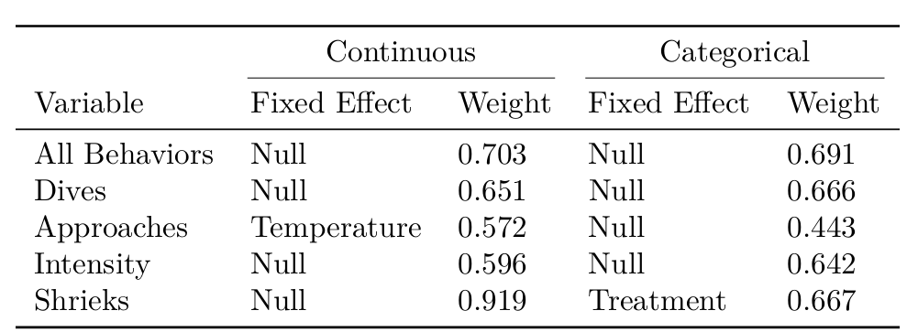
Table 1. Top model for each dependent variable

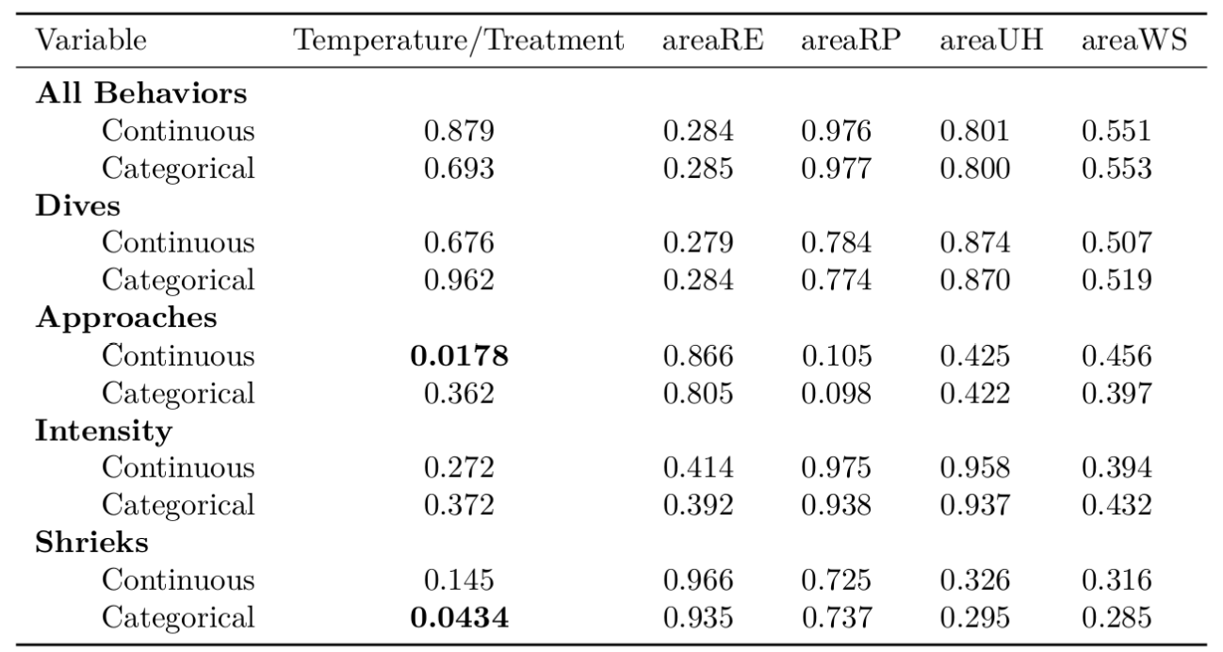
Table 2. P-values for each dependent variable for each fixed effect

Figures
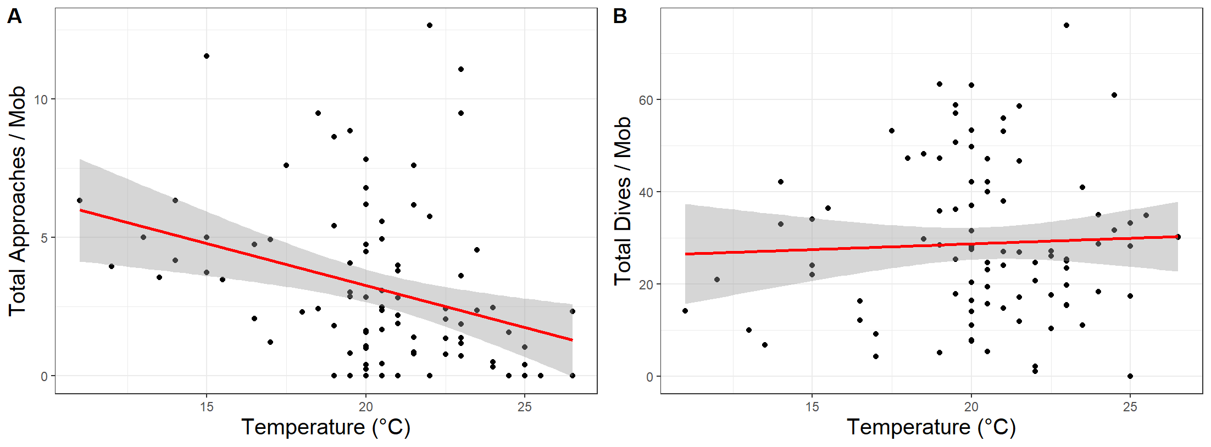
Figure 1. Correlation between air temperature and individual movement behaviors involved in mobbing. Birds gathered in a mob performed (A) fewer approaches on warmer days and (B) the same number of dives on warm as compared to cooler days within one week of clutch completion. Approaches are a less intense, U-shaped flight path whereas dives are a more intense, V-shaped flight path often accompanied by a vocalization directly over the head of the simulated predator.

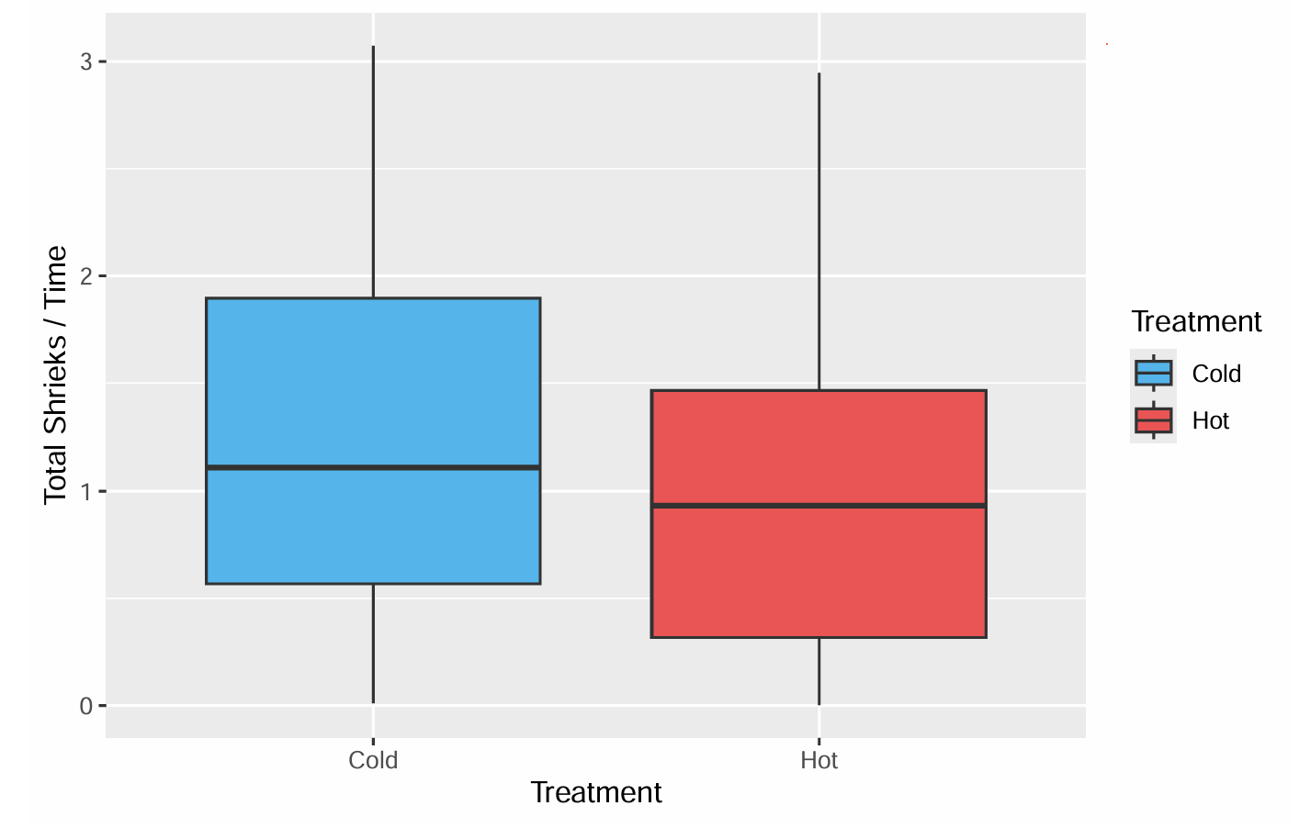
Figure 2. Correlation between treatment and individual vocalization behaviors involved in mobbing. Individual(s) gave more shrieks per second on cold days than on hot days within one week of clutch completion. Shrieks are short duration alarm calls often repeated in succession. Hot and cold treatments are separated by at least 0.5°C.

Supplementary Materials
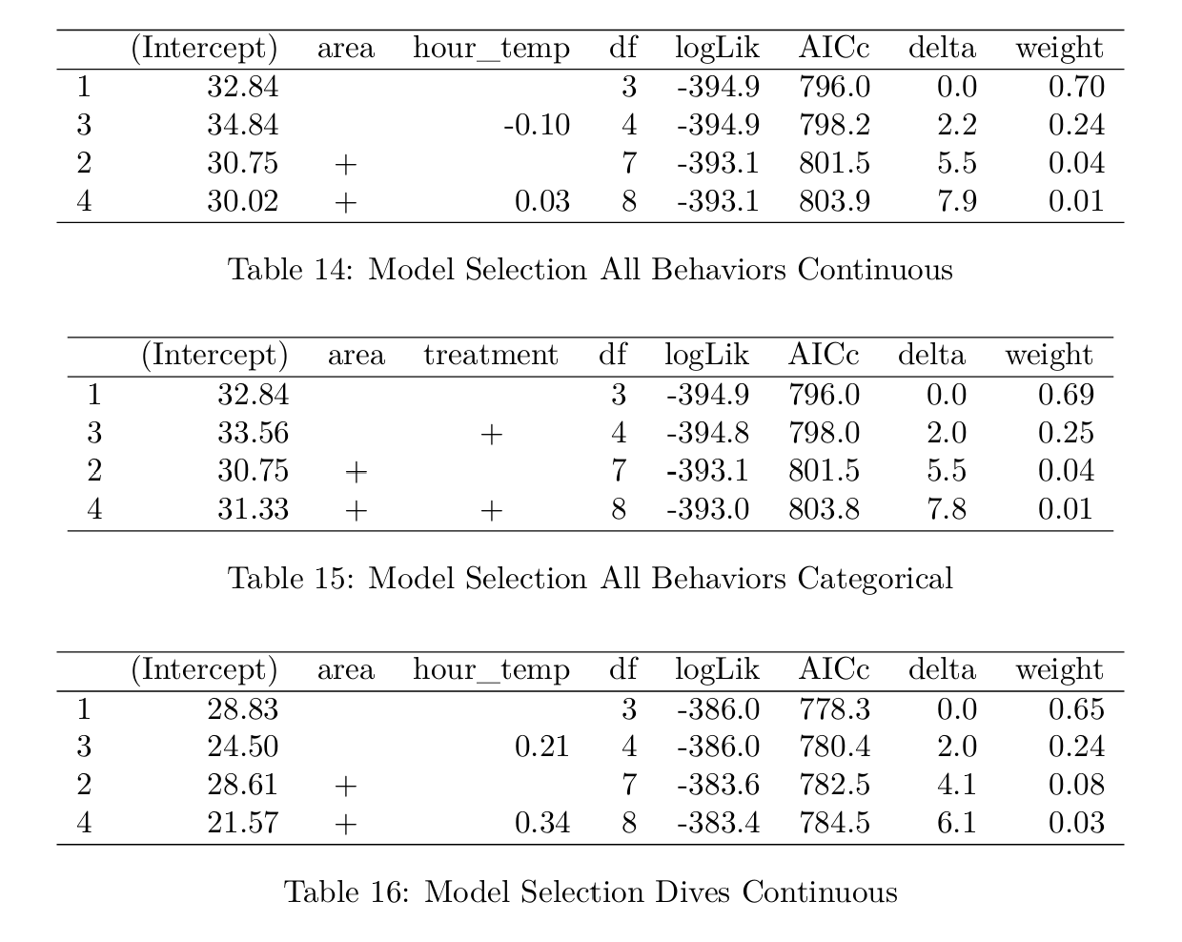
Supplementary Table 1. Model Selection for All Behaviors for Continuous Analysis
Supplementary Table 2. Model Selection for All Behaviors for Categorical Analysis
Supplementary Table 3. Model Selection for Dives for Continuous Analysis
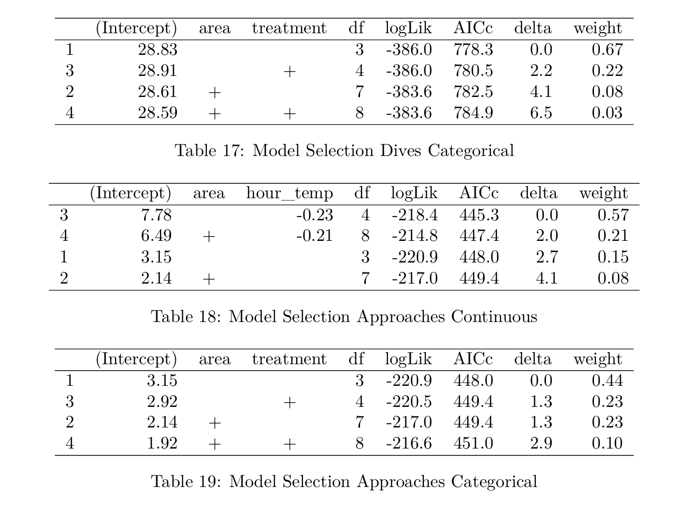
Supplementary Table 4. Model Selection for Dives for Categorical Analysis
Supplementary Table 5. Model Selection for Approaches for Continuous Analysis
Supplementary Table 6. Model Selection for Approaches for Categorical Analysis
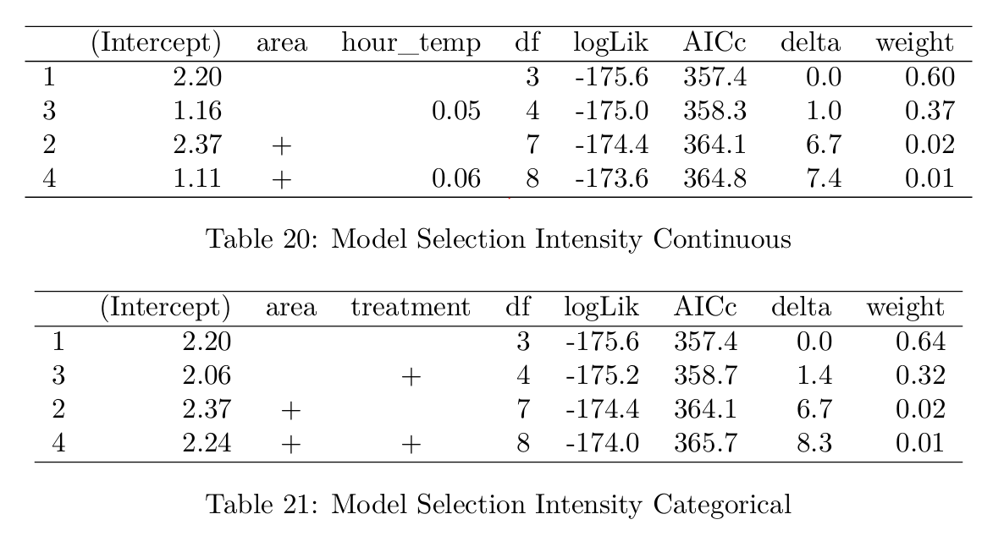
Supplementary Table 7. Model Selection for Intensity for Continuous Analysis
Supplementary Table 8. Model Selection for Intensity for Categorical Analysis
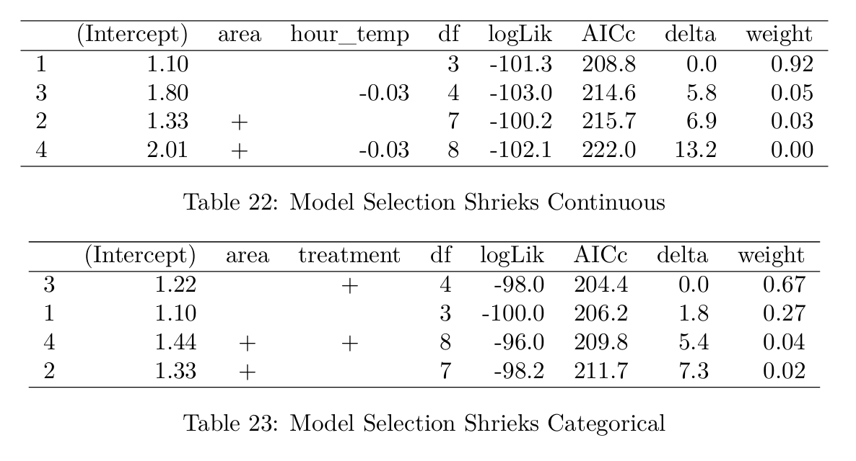
Supplementary Table 9. Model Selection for Shrieks for Continuous Analysis
Supplementary Table 10. Model Selection for Shrieks for Categorical Analysis

