The Role of Social Context
in the Production of Scientific Knowledge

Kristen Lynn Beard

The University of Tennessee, Knoxville
Chancellor’s Honors Program
Department of Philosophy

Undergraduate Thesis
Submitted December 8, 2014

Thesis Advisor:
Dr. Nora Berenstain
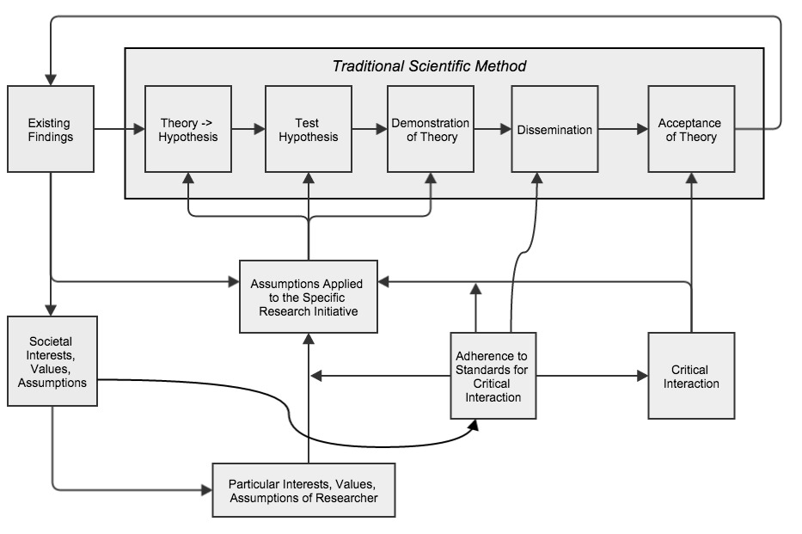
Model 1: The Influence of Social Context on the Scientific Method

Introduction:
Scientific Knowledge as Both Social and Rational
A person may believe that a certain theory is true and explain that he does so, for instance, because it is the best explanation he has of the facts or because it gives him the most satisfying world picture. This does not make him irrational, but I take it to be part of empiricism to disdain such reasons.
--Bas van Fraassen (1985, p.252)

Philosophical and sociological discussions about science have established a dichotomy between the rational and social aspects of the scientific production of knowledge; this is one of the arguments Helen Longino gives in her book Fate of Knowledge. Conversation taking place before Longino suggests that the rational and the social side of scientific inquiry are not compatible, and they cannot contribute to one another. She disagrees. Longino offers an account of the scientific method that is imbued with influence from social context, and at the same time contributes to the rational products of the scientific method.
I offer the process model shown above as an explicit demonstration of how social context influences the scientific method traditionally conceived; it complements a logical empiricist philosophy of science primarily, and therefore does not attempt to comment on other scientific methods, namely qualitative ones. My model is heavily influenced by Longino’s work, though it does not attempt to represent her theory exclusively. In addition to Longino, this model has been constructed from my own reflection on the process of scientific research, the helpful comments of my mentors and peers, and a variety of other literature that will come up as I explain each part of this model in the rest of this paper.
Scientific knowledge uses information derived not only from phenomena, but also information about the social context in which it is conducted. This paper offers an account of how this is the case.
The explanation for this model comes in four parts. Part I discusses what is meant by the “traditional” scientific method, used in the model above. Part II shows how this method requires the researcher to incorporate subjective assumptions in order to have the data support a specific theory. Part II also argues that these assumptions change depending on critical interaction with the scientific community, and they are moderated by the community’s standards for critical interaction. In Part III I explain how the values, interests, and assumptions of society influence the scientific process through the assumptions discussed in Part II, and thereby influence scientific knowledge. Finally, Part III discusses the implications for knowledge produced through this socialized scientific process.

Part I:
The Scientific Method Traditionally Conceived
Logical empiricism argues that the production of scientific information should be free from all cultural bias. To study a phenomenon, scientists execute a series of cognitive, rational procedures to operate on objective information gained from direct observation. Scientists integrate information related exclusively to the phenomenon of study in order to draw conclusions about that phenomenon. At most the scientist might also factor in some epistemic value like simplicity or explanatory power while constructing theories and hypotheses. Scientists take into account their own influence on the experiment only in so far as it allows them to account for human error. The roles of the researcher that take place outside of the lab (e.g. the scientist qua citizen, friend, ballroom dancer, environmental activist, etc.) should have no interference with one’s role as a scientist; such interference would qualify as bias, and would be considered a detriment to the results of one’s study. The main point of this view is that scientific knowledge can be objective as long as the scientific process is free from social or cultural influence; that is, the information used must not incorporate any particular perspective.
Historical figures who first contributed to the scientific method were largely of this same opinion, that social influence is a detriment to reliable knowledge. For instance,
Francis Bacon argues in his Novum Organum that nature and facts become tainted and distorted when interacting with humans; the more humans influence their own reporting of the facts, the less true it is; human interpretation and discourse leads to unclear, nonsensical conclusions about how the world is. Furthermore, if humans do impose their customs, cultural practices, and meanings onto science, they render it meaningless in doing so (1857-59, IV Novum Organum, para. 41, 43, 52, 59-60).
René Descartes also argues something similar in his Meditations on First Philosophy. He establishes a stance that common-sense “knowledge”, or groundless assumptions taught through socialization, is a hindrance to legitimate method of establishing knowledge.
Also Brand Blanshard’s Reason and Analysis offers four theses which taken together characterize the Logical Empiricist view of the scientific method (Banach); two of these especially support this traditional account of the scientific method given above. First is the “Verifiability Theory of Meaning,” which requires a “direct link between the atomic statements that formed the foundation of science and the bedrock of experience. All meaningful statements have to be either tautologous or directly verifiable in experience” (Banach). Second is the “Emotive Theory of Values,” which says that “all propositions that do not meet the verification criterion of meaning, and which aren't analytic, are not cognitively meaningful at all. They are merely expressions of emotion. Art, Ethics, Religion, and metaphysics fall into this category” (Banach).
It is an established view that scientific procedures should be purely rational and thereby filter out the influence of subjective considerations, such as the values and interests of a society or culture. This is for the sake of producing a certain kind of knowledge, namely objective fact that can transcend social context, including culture, geographical location, and even time.
There is a traditional expectation that knowledge produced by a scientific community will be, ideally: objective, universally true, and unchanging. The logical empiricist believes that the purpose of the scientific enterprise is to make progress toward absolute truth. The knowledge produced by this process is thought to be objectively factual, such that it does not incorporate subjective opinions, and also descriptive such that it makes no normative claims about how things ought to be.
Thomas Nagel describes what is meant by objectivity in his book, Mortal Questions:
“The attempt is made to view the world not from a place within it, or from the vantage point of a special life and awareness, but from nowhere in particular and no form of life in particular at all. The object is to discount for the features of our pre-reflective outlook that make things appear to us as they do, and thereby to reach an understanding of things as they really are” (1979, p.208).
This view of knowledge is also reflected in Bernard William’s book, Descartes, in which he says that in order to access “[human-] independent reality,” one must overcome “not just limitations on inquiry and hence of occasional error but ... any systematic bias or distortion or partiality in our outlook as a whole, in our representation of the world.” He calls this the “absolute conception of reality” (Williams, 1978, 66).
This same ideal for knowledge is evident in the historical writings of the founders of modern science; they portray scientific method as striving toward absolute, objective, and universal truth, and therefore away from cultural and social context. The way to establish such knowledge is by appealing only to information received through direct experience and deductive reasoning. (Longino 1990, p. 62, 85). For example, Isaac Newton expresses these sentiments about knowledge and method in his “Rules of Reasoning in Philosophy” (1953 p. 3-5).
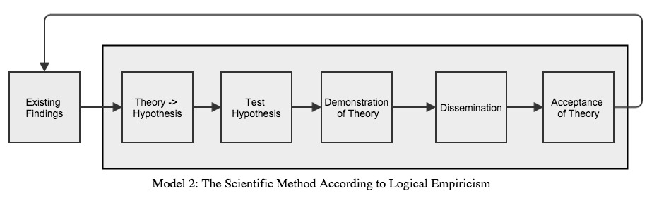
The following model portrays the scientific process as it is traditionally conceived in terms of the following steps:
Existing Findings are theories that have been produced and tested through the scientific method. They supply the theory (or data used to construct a new theory) that the researcher chooses to investigate.
The “Theory Hypothesis” stage is the point where the researcher chooses a theory from existing ones, or creates a theory from the existing data to put to the test.
[In the social sciences, the researcher typically begins their project with a theory that they want to test. They then develop falsifiable predictions in order to test some aspect of the theory. In the physical sciences, the researcher always begins with a hypothesis that they formulate to postulate some pattern they see in the existing findings. From this hypothesis they develop a falsifiable set of predictions.]
From this theory, the researcher uses deductive reasoning to derive a hypothesis that says what should be the case according to some aspect of the theory. In other words, the researcher forms explicit predictions of what observations they expect, given certain initial conditions. This process of logically determining what should be the case appears primarily in the work of Carl Hempel (1965).
Testing the hypothesis involves setting up the initial conditions that the theory suggests will produce some predicted outcome, followed by making observations to try and detect the presence of the previously-specified outcome.
Demonstration of Theory involves analysis and interpretation of the data to determine how it can inform the theory. First the scientist decides how the data supports the specific hypothesis, or prediction. Then the scientist decides whether they need to alter the hypothesis. Though not reflected in the model for sake of simplicity, the scientist might return to the “Theory Hypothesis” stage, revise the hypothesis, and conduct the experiment again until the data reflects something meaningful in the hypothesis that will contribute to the theory.
If the scientific community finds it to be a valuable contribution, the project advances to dissemination. This stage involves the publication of the theory, so that the scientific community can engage with it in their own research. Dissemination begins the evaluation of the research to determine how it measures up to the criteria for knowledge listed above.
Finally, when the community determines that the theory helps their set of knowledge to advance toward absolute truth, the theory becomes “accepted”, indoctrinated into the common set of beliefs.
This concludes Part I and the account of how the traditional scientific method produces knowledge.

Part II:
The Role of Assumptions, Critical interaction, and Standards
The purpose of Part II is to introduce and explain the role of assumptions in the production of scientific knowledge. Assumptions are considerations for interests and values that exist outside the direct observations of the phenomenon under investigation. Part II argues that these assumptions are a necessary component of any explanation of phenomena. Therefore it is impossible for a theory to be constructed from only direct observation; all theories reach beyond evidence and into subjective claims. This argument is largely based on Chapter Six of Longino’s Fate of Knowledge (2002), and it takes intentional liberties of its own, as well. “Critical interaction” (Longino’s term) of a research project with the scientific community affects what kinds of assumptions can be incorporated into the research. Also the standards for critical interaction moderate this relationship between theoretical assumptions and critical interaction with the scientific community. These considerations now become part of the model as follows:
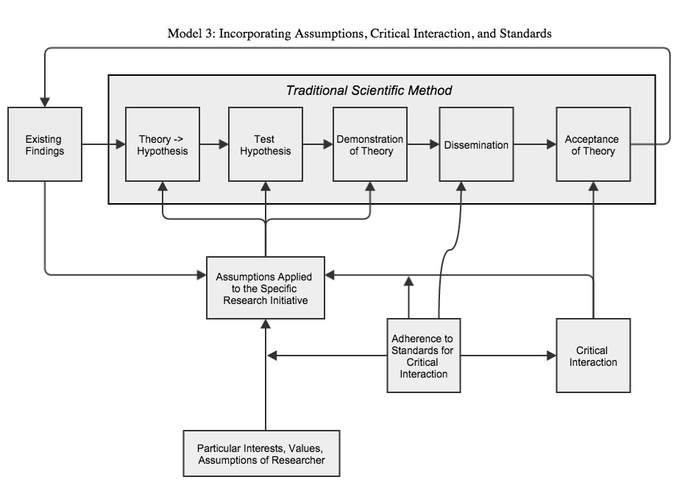
Assumptions, values, and interests influence many of the researcher’s decisions throughout the research process. This subjective content helps the researcher to choose a phenomenon and hypothesis to study; how to implement and test the hypothesis; and how to interpret the data. Assumptions have an influence over the choice of phenomenon and hypothesis because nothing in the existing findings themselves will determine what kind of project will best serve the researcher’s interests.
Assumptions have an influence over how the researcher tests the hypothesis, as well. This point is supported by the literature that argues that researchers inevitably make observations and collect data through the lens of some theoretical preconceptions; according to these arguments, purely objective and unbiased observation is a myth.
Kuhn provides one of the most influential arguments for theory-laden observation in his 1962 book, The Structure of Scientific Revolutions. One of his points is that concepts that describe observations change in their meaning depending on the scientific perspective of the observer. Terms such as “mass” or “temperature” describe something different in the system of thermodynamics than they do in material engineering (Reiss and Sprenger).
Longino agrees that theory-laden observation is unavoidable, and such influence can cause the researcher’s arguments to be circular. But she points out that circularity is an issue only if the theory that influences the data-taking is the same theory as that which the data is supposed to inform. That is, the research is circular if it assumes the viability of a theory while taking the data, and then uses that data to say something about the viability of that same theory. So to avoid circularity, the theoretical assumptions that influence data-taking should not constitute the theory under investigation (Longino 2002, p.126).
Next to discuss is probably the most controversial claim of Part II: that subjective assumptions are a necessary part of interpreting data so that the data informs a specific hypothesis and theory. The researcher must incorporate some assumptions when formulating a hypothesis to make predictions, as well as in the interpretation of data. The following is an explanation of why the scientific method requires a subjective influence.
The requirement for the bulk of this influence can be explained by the underdetermination of theory by observation. Underdetermination makes assumptions necessary in order to choose one hypothesis among multiple empirically equivalent ones, and to interpret data (Stanford).
John Stuart Mill explained underdetermination quite effectively in System of Logic, where he writes:
“Most thinkers of any degree of sobriety allow, that an hypothesis…is not to be received as probably true because it accounts for all the known phenomena, since this is a condition sometimes fulfilled tolerably well by two conflicting hypotheses...while there are probably a thousand more which are equally possible, but which, for want of anything analogous in our experience, our minds are unfitted to conceive” ([1867] 1900, p.328).
There are two main types of underdetermination. Both affect how one interprets the data to make conclusions about the hypothesis.
Holist underdetermination occurs because the researcher “can never subject an isolated hypothesis to experimental test, but only a whole group of hypotheses; when the experiment is in disagreement with his predictions, what he learns is that at least one of the hypotheses constituting this group is unacceptable and ought to be modified; but the experiment does not designate which one should be changed” (Duhem [1914] 1954, p.187).
In this sense of underdetermination, the researcher has already incorporated a host of “auxiliary hypotheses”, or practical assumptions, that have not been tested by themselves but rather taken for granted while the primary hypothesis is tested (Stanford).
According to Mary Hesse, this Duhemian underdetermination shows why certain considerations that come from outside the scientific process must play a role in the researcher’s choice of hypothesis. She claims that “it is only a short step from this philosophy of science to the suggestion that adoption of such criteria [for choosing a hypothesis], that can be seen to be different for different groups and at different periods, should be explicable by social…factors” (1980, p.33).
The overall point of holist underdetermination is that every procedure used to test a single hypothesis actually tests an entire set of beliefs. In light of the data alone, the researcher cannot determine whether one or more of the auxiliary beliefs or the hypothesis itself has been proven or disproven. Hesse asserts that the researcher must supplement the empirical data with non-scientific beliefs in order to interpret it. (1980, p.33).
Contrastive underdetermination is the second variety of underdetermination, in which some theories are empirically equivalent to others. In this case any amount of evidence that supports some theory might also support other theories just as well; thus any given pool of data can support multiple theories equally well (Stanford). So one chooses by incorporating assumptions and values into the decision.
This paper takes the position that not only are collections of current evidence insufficient to determine the superior validity of only one theory; evidence is in principle insufficient to do so. That is, it does not suppose that the condition of underdetermination might change with improved access to data. This is simply an assumption of this paper, in light of the fact that the model above rests more on principles than the contingent state of the human ability to access certain information [Need more support for this argument. Just a sentence or two].
Therefore the researcher must use more than just empirical data as a criterion for choosing a specific hypothesis. It is necessary to incorporate relevant values, assumptions, and perhaps even interests that correspond with particular hypotheses.
Two aspects of research as part of a scientific community influence these assumptions and determine which ones make it to the theory that is disseminated and accepted as knowledge. These are critical interaction with the community and standards for this interaction within the community.
Most critical interaction consists of an appeal to the scientific community for feedback on one’s research, occurring before official dissemination. This ranges from discussing one’s theory with colleagues, to the formal review process before publication.
Critical interaction with a scientific community determines which assumptions make it into the theories of an individual research project. The scientific community critiques and removes any subjective assumptions of the individual theory that do not align with its own set of assumptions underlying the established set of existing findings. Likewise, the subjective assumptions that match those of the community can pass through the dissemination and acceptance stages to be integrated as objective knowledge (Longino 1990, p.62-82).
There is also critical interaction with a community after dissemination, as the community determines whether to accept a theory into its existing findings or not. At that point it has already advised the researcher on how to revise any idiosyncratic assumptions of the project. The response of the researcher to this advice, as in how much they revise their assumptions to align with the community’s, affects how the community will receive the theory in the end, and whether it will be accepted.
Longino offers a set of standards for this process of critical interaction that if upheld by the community, will optimize its effectiveness in critiquing the assumptions of individual researchers. Her standards would enhance mainly two qualities in the community’s criticism: (1) representation of the diversity of qualified opinions in the scientific community, and (2) clarity and usefulness of the feedback provided.
These four criteria consist of: “(i) There must be recognized avenues for the criticism of evidence, of methods, and of assumptions and reasoning; (ii) there must exist shared standards that critics can invoke; (iii) the community as a whole must be responsive to such criticism; (iv) intellectual authority must be shared equally among qualified practitioners” (1990, p.76; and 2002 p.128-135).
These standards become established in a community much in the same way that knowledge is established in a community. Gilbert describes this process of establishing collective belief as “letting the belief stand” (1987).
The degree to which a community adheres to these standards affects every step of the knowledge production process, either directly or indirectly; the influence of these standards is represented in the model above, namely: (1) standards moderate the influence of critical interaction on assumptions of a project; (2) they influence which research projects are approved for dissemination; (3) perhaps most importantly, they affect which assumptions the scientist incorporates into the research initially. It will help to elaborate on each of these points:
(1): The community’s adherence to standards influences their critical interaction directly, and it therefore controls the link between critical interaction and assumptions. That is, the community’s ability to communicate their collective feedback to the researcher will influence the effect of their critique on the subjective assumptions of the research. Thus the relationship between the researcher’s subjective assumptions and those of the community is moderated by the community’s adherence to Longino’s standards.
(2): The adherence to standards as a whole determines which researchers get a voice in the scientific community. That voice consists largely in who and what gets published, i.e. disseminated.
(3): Standards affect which personal assumptions the researcher chooses to include in the research initially. The mere existence of those standards leads the researcher to think ahead of time how the community will receive their assumptions. Thus the community’s adherence to Longino’s standards moderates which assumptions initially make it into the research initiative.
From the texts and arguments referenced above surfaces a prevalent belief that open criticism and testing of theories in a community of researchers will eventually lead them to objective truths. But such standards and procedures cannot eliminate subjective values and assumptions if those assumptions dominate the beliefs of the entire scientific community. The process provides no mechanism for identifying such beliefs, nor is it clear if such a mechanism could be introduced.
This interaction between the individual and the scientific community eliminates any idiosyncratic assumptions of the researcher. However this does not mean that the individual’s research is therefore objective. Any values or assumptions that match those of the scientific community, regardless of their lack of empirical validity, will remain part of the research as it passes through dissemination, and on to becoming accepted as knowledge (Longino 1990, p.224). Longino calls this the “myth of value neutrality”.

Part III:
Social Influence on Assumptions and Standards for Critical Interaction
The primary goal of this paper is to show that most of the subjective values and assumptions introduced in Part II come from the researcher’s social context.
The goal of Part III is simply to offer a wide range of social values, interests, and assumptions that influence the assumptions described in Part II, in order to demonstrate the role of social context in the production of scientific knowledge. The full model that incorporates this social influence appears at end of Part III. What follows is basically a list of interests, values, and assumptions that are influenced by society, and that influence scientific theories. I separate these interests and assumptions into two categories: those pertaining to research as a social and practical enterprise, and those pertaining to the phenomena being researched.
First are the interests connected to the practice of research as a social and practical enterprise:
- Professional Advancement
The prospects of obtaining future research opportunities for the individual researcher can influence their design and execution of their project. The future research potential of a theory can influence how the community receives the research, as well; a project with a highly practical research topic that offers potential for others in the community to continue with the research is likely to be received favorably, for instance (Rouse, 1987). Also along the lines of professional advancement are the interests of professional superiors and research sponsors. Clearly, the researcher will aim to please those who allow her to do her job in the first place.
- Implications of the Research
Researchers also have a vested interest in the implications of their results. They are influenced by what the research might motivate people to do, what they think is the most desirable outcome, and how the knowledge they produce will reflect on their personal values and assumptions associated with the phenomenon itself.
Longino uses an example of research on the biological sex differences: this research topic has implications for the innate behaviors and abilities of men and women. Clearly this research topic interacts with personal values and interests of most, if not all, people (Longino 1990, p.103-32).
Another example can be found in physics research. For example a new neutrino detection experiment called WATCHMAN has direct implications for national security, energy resources, and perhaps even human impact on the environment (Lucibella). All of these things are heavily laden with values. In fact, it seems difficult to locate a research project that does not involve implications that people value. Valuable implications are the point of doing research. These values inform the assumptions that supplement observation, discussed in Part II.
This is closely related to a claim made by the “strong programme” in the sociology of the scientific knowledge: Barnes (1977), for instance, attributes social interests with a causal role, as catalysts for the production of knowledge.
- Practical Consequences of Incorrect Theory
Scientists never know for sure whether a hypothesis is true, but they have to assess the relative weight of the evidence to determine whether to accept the hypothesis as true. The consequences of getting it wrong drive the assessment. Therefore values are involved in the formulation of hypotheses in this way(Rudner, 1953).
An appropriate quote comes from Kincaid, Dupre, and Wylie:
“When the science is used to make public policy decisions, such errors lead to clear nonepistemic consequences. If one is to weigh which errors are more serious, one will need to assign values to the various likely consequences. ... Thus value becomes an important, although not determining factor in making internal scientific choices” (Kincaid, Dupre, Wylie).
Hospital emergency rooms provide a useful example: they avoid as much as possible false negatives (rejection of a true hypothesis) for the price of a high rate of false positives (acceptance of a false hypothesis) in order to avoid neglecting sick people. Also, the “innocent until proven guilty” judicial system tries to avoid false positives for price of accepting higher rate of false negatives (Uebel).
- Roles of the Scientist in Society
In his book, Scholarship Revisited: Priorities of the Professoriate, Ernest Boyer (1990) discusses the changing roles of researchers throughout history and how they relate to society. This sheds light on the fact that the purpose of research changes with society and so the scientist must guide their research accordingly.
Second, there is another kind of assumption that relates to the content of the theory itself. As a note, these types of assumptions tend to be more controversial in the social sciences than in the natural sciences: assumptions in the social sciences can have ethical consequences if, for instance, they portray some social groups in a negative light, or give meaning to meaningless constructs. Some consider “race” to be an example of the latter. While critical interaction often identifies these kinds of unfavorable assumptions, it can be very difficult to identify and reject them if standards for critical interaction are not rigorous enough, or if the scientific community as a whole accepts them as true. These types of assumptions from everyday life about people, structure of society, even existence of truth can be absorbed through socialization and easily go unrecognized.
Methodological assumptions also pertain to the content of the theory, such as the adequacy and completeness of measures one uses to identify theoretical constructs in observations. Society and culture can influence methodological assumptions about the definition of a construct, for instance in whether it is favorable for a person to exhibit a construct (such as intelligence).
Less controversial is the use of epistemic values to supplement the empirical data of one’s research, including external and internal validity—which encompass values of generalizability, internal consistency, and precision—simplicity, explanatory power, and testability. These may be social in nature and contextually dependent for their value. Van Fraassen supports this point in saying that,
“When a theory is advocated, it is praised for many features other than empirical adequacy and strength: it is said to be mathematically elegant, simple, of great scope, complete in certain respects: also of wonderful use in unifying our account of hitherto disparate phenomena, and most of all, explanatory” (van Fraassen, 1980, p.87).
The researcher implements assumptions into their research using various socially-influenced considerations like those listed here.
Social context influences not only assumptions that contribute to a researcher’s theory, hypothesis, and observation stages of the process; it also contributes to the community’s standards of critical interaction. Simply put, the structure and prevalence of academic opportunities influence which people tend to be successful in research careers, enough to play a role in critical interaction. This includes availability of education, socio-economic status, bias in the hiring process, etc.
The degree of social influence in research might depend on the area of study, for instance there may be more social influence on assumptions within the social sciences versus hard sciences. But I hope to have established that social context influences all scientific research to some degree, given the necessity of subjective assumptions and the extensive set of values associated with the social enterprise of research itself.
I offer as a final consideration the implications of this model for the nature of knowledge itself. It is of crucial importance to emphasize that the social influence on the scientific method does not interfere with the rational nature of scientific knowledge, though it does interfere with its objective, universal, and permanent nature. Instead of describing knowledge by these last three terms, with the ideal being absolute truth, knowledge should rather be described as “plural, partial, and provisional” (Longino 2002, p.207), in light of its social origins. To describe societies and their practices as objective, universal, or permanent would signify a gross misunderstanding of history and people in general. Therefore the same applies for descriptions of scientific knowledge in so far as its formative assumptions originate from social context.

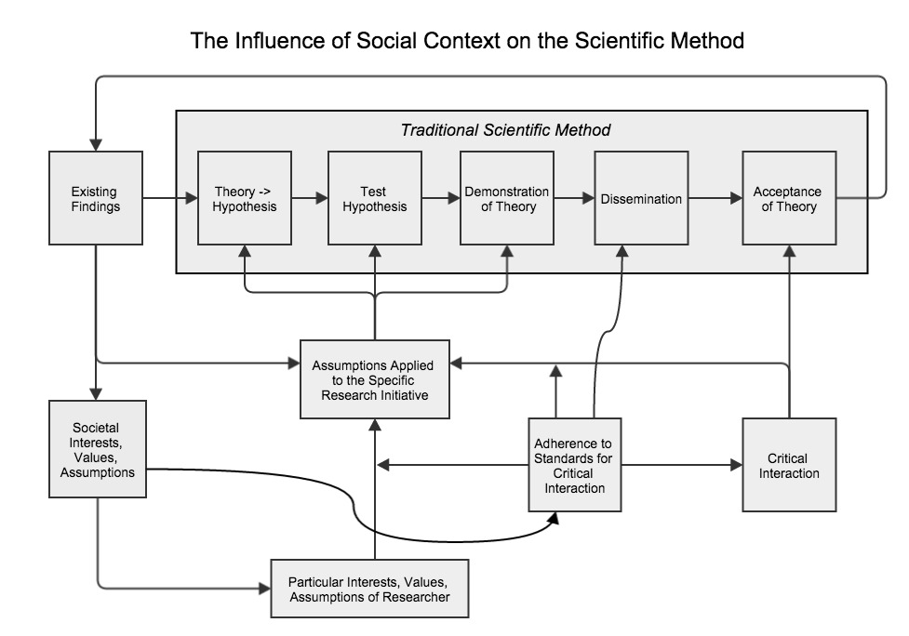

Works Cited

Banach, David. "The Logical Empiricist Interpretation of Scientific Method." The Logical Empiricist Interpretation of Scientific Method. St. Anselm College, 2006. Web. 06 Dec. 2014. <http://www.anselm.edu/homepage/dbanach/logemp.htm>.

Barnes, Barry. Interests and the Growth of Knowledge. London: Routledge and K. Paul, 1977. Print.

Blanshard, Brand. Reason and Analysis. La Salle, IL: Open Court Pub., 1962. Print.

Boyer, Ernest (1990), Scholarship Revisited: Priorities of the Professoriate, Carnegie Foundation for the Advancement of Learning: Princeton, NJ, 1-41.

Descartes, René. Meditations on First Philosophy. Trans. Donald Cress. N.p.: Hackett, 1993. Print. Hackett Classics.

Duhem, P., [1914] 1954, The Aim and Structure of Physical Theory, trans. from 2nd ed. by P. W. Wiener; originally published as La Théorie Physique: Son Objet et sa Structure (Paris: Marcel Riviera & Cie.), Princeton, NJ: Princeton University Press.

Gilbert, Margaret. "Modelling Collective Belief." Synthese 73.1 (1987): 185-204. Web.
Hempel, C., 1965, Aspects of Scientific Explanation and Other Essays in the Philosophy of Science, New York: Free Press.

Hesse, M., 1980, Revolutions and Reconstructions in the Philosophy of Science, Brighton: Harvester Press.

Kincaid, Harold, John Dupré, and Alison Wylie. "Rejecting the Ideal of Value-Free Science." Value-free Science?: Ideals and Illusions. Oxford: Oxford UP, 2007. 119-39. Print.

Longino, Helen E. Science as Social Knowledge: Values and Objectivity in Scientific Inquiry. Princeton, NJ: Princeton UP, 1990. Print.
----------. The Fate of Knowledge. Princeton, NJ: Princeton UP, 2002. Print.

Lucibella, Michael. "Neutrinos and National Security." Neutrinos and National Security. American Physical Society, n.d. Web. 08 Dec. 2014. <http://www.aps.org/publications/apsnews/201404/neutrinos.cfm>.

Mill, J. S., [1867] 1900, A System of Logic, Ratiocinative and Inductive, Being a Connected View of the Principles of Evidence and the Methods of Scientific Investigation, New York: Longmans, Green, and Co.

Nagel, Thomas. Mortal Questions. Cambridge: Cambridge UP, 1992. Print.

Reiss, Julian and Sprenger, Jan, "Scientific Objectivity", The Stanford Encyclopedia of Philosophy (Fall 2014 Edition), Edward N. Zalta (ed.), URL = <http://plato.stanford.edu/archives/fall2014/entries/scientific-objectivity/>.

Rouse, Joseph. Knowledge and Power: Toward a Political Philosophy of Science. Ithaca: Cornell UP, 1987. Print.

Rudner, Richard. "The Scientist Qua Scientist Makes Value Judgments." Philosophy of Science 20.1 (1953): 1. Web.

Stanford, Kyle, "Underdetermination of Scientific Theory", The Stanford Encyclopedia of Philosophy (Winter 2013 Edition), Edward N. Zalta (ed.), URL = <http://plato.stanford.edu/archives/win2013/entries/scientific-underdetermination/>.

Uebel, Thomas. "Values and Objectivity in Social Science." Lecture 10, PHIL30022: Philosophy of Social Science. University of Manchester, Manchester, U.K. Lecture.

van Fraassen, B., 1980, The Scientific Image, Oxford: Oxford University Press.

-----------. 1985, “Empiricism in the Philosophy of Science”, in Churchland and Hooker 1985, pp. 245–308.

Williams, Bernard. Descartes: The Project of Pure Enquiry. Atlantic Highlands, NJ: Humanities, 1978. Print.

I would like to thank Dr. David Schumann and Dr. Nora Berenstain for their generous mentorship and numerous helpful comments, the latter provided also by my colleagues in MKT 611: Theoretical Foundations.
David Schumann provided the point that standards affect the researcher’s decisions long before receiving critiques from the community.

